

Proteomics in ulcerative colitis

PhD Dissertation

Dr Arash Assadsangabi, MD, MRCP (UK), MRCP (Gastroenterology)

Departments of Gastroenterology & Liver Unit, Royal Hallamshire Hospital; Surgical Oncology, University of Sheffield,
Sheffield, UK

March 2020

Table of Contents
Abstract 5
List of Abbreviations 6
Chapter 1: Introduction* 11
A brief overview of inflammatory bowel disease and its pathogenesis 11
Keratins and its role in IBD 14
Proteomics 18
Proteomic techniques 20
Mass spectrometry (MS) and related techniques 21
Proteomics in Inflammatory Bowel Disease Research 27
Conclusion 57
Chapter 2: Aims of the study 60
Chapter 3: Methodology and experimental details 63
3.1 Experimental materials 63
3.2 Protocol for cytoskeletal insoluble and soluble protein fractionations 65
3.3 Sample quality control (QC): Method development leading up to in-gel proteolysis protocol for detergent removal and iTRAQ pooling process for soluble proteome investigation 66
3.3.1 iTRAQ pooling process 67
3.3.2 In-gel proteolysis 68
3.4 Protein assays 69
3.5 iTRAQ (8-plex) labeling 69
3.6 Hydrophilic Interaction Liquid Chromatography (HILIC) 70
3.7 Tandem mass spectrometry (MS/MS) Analysis 71
3.8 iTRAQ data analysis 71
3.9 Western blotting and dot blotting techniques 72
3.10 Proteome Profiler Antibody Array 74
3.11 Statistical methods 75
Chapter 4: Exploring proteomics in active UC mucosa 76
4.1 Introduction 79
4.1.1 Study Aims: 80
4.2 Methods 80
3.2.1 Investigation of epithelial keratin alterations in ACT, INACT and control groups 80
4.2.2 Investigation of pSer73 K8 alterations in ACT, INACT and control groups 81
4.2.3 Investigation of candidate biomarkers of UC disease activity 81
4.2.4 Orthogonal validation and cross-validation of target proteins with immunoblotting 85
4.3 Results 87
3.3.1 Epithelial keratins alterations in ACT versus INACT relative to normal controls 87
4.3.2 pSer73 K8 alterations in ACT, INACT and control groups 91
4.3.3 Soluble iTRAQ analysis outcome comparing ACT and INACT relative to normal controls 97
4.3.3.1 ACT versus INACT analysis 97
4.3.3.2 ACT versus Controls analysis 100
4.3.3.3 INACT versus Controls analysis 105
4.3.3.4 Biomarker discovery 107
4.3.3.5 Orthogonal validation and cross-validation of candidate biomarkers of UC disease activity 108
4.4 Discussion and Conclusion 115
Chapter 5: Exploring proteomics in long-standing UC in remission 123
5.1 Introduction 126
5.1.1 Study Aims 126
5.2 Methods 127
5.2.1 Investigation of epithelial keratin alterations in LSPC, ROUC and control groups 127
5.2.2 Investigation of candidate biomarkers of UC disease evolution 128
5.2.3 Orthogonal validation and cross-validation with immunoblotting 131
5.3 Results 133
5.3.1 Epithelial keratins alterations in LSPC and ROUC relative to controls 133
5.3.2 Soluble iTRAQ analysis outcome comparing LSPC and ROUC relative to controls 137
5.3.2.1 LSPC versus ROUC analysis 137
5.3.2.2 LSPC versus controls analysis 140
5.3.2.3 Biomarkers discovery 142
5.3.2.4 Orthogonal validation and cross-validation of candidate biomarkers of UC disease evolution 143
5.4 Discussion and Conclusion 150
Chapter 6: Exploring predictive biomarkers of relapse in ulcerative colitis 157
6.1 Introduction 159
6.1.1 Study aims 159
6.2 Methods 160
6.2.1 Orthogonal validation and cross-validation with immunoblotting 163
6.3 Results 165
6.3.1 Soluble iTRAQ analysis outcome comparing ER versus NR relative to controls 165
6.3.1.1 ER versus NR analysis 165
6.3.1.2 ER versus controls analysis 167
6.3.1.3 Biomarkers discovery 168
6.3.1.4 Orthogonal validation and cross-validation of candidate biomarkers predictive of UC future disease activity 170
6.4 Conclusion 174
Chapter 7: Investigating keratin 8 protein bands from ACT and INACT in insoluble proteome fraction 180
7.1 Introduction 183
Study aims 183
7.2 Methods 183
7.3 Results 185
7.4 Discussion and Conclusion 194
Chapter 8: Final discussion and conclusion on general study findings 196
Appendix 1. Cytoskeletal isolation from biopsies 202
Appendix 2. Cytoskeletal extractions from cells 205
Appendix 3. Buffer exchange and sample cleaning process prior to iTRAQ analysis 207
References 216

Abstract

Inflammatory bowel disease (IBD) is a chronic inflammatory illness of the gastrointestinal tract. It follows a relapsing and remitting pattern throughout the course of the disease. The two major types of IBD are Ulcerative colitis (UC) and Crohn’s disease (CD). Despite recent advances in decoding the pathophysiology of IBD, many questions regarding the disease pathogenesis and the complex interactions between the putative contributors including genetic susceptibility, immunological dysregulation, role of commensal bacteria and various environmental factors remain unanswered. Furthermore, there are limited available prognostic indicators of disease activity and cancer progression in IBD.
Proteins can be considered the main functional units of cells as almost all intracellular physiological functions as well as inter-cellular interactions are dependent on them. Proteomics (the study of the whole set of proteins that can be encoded by the genome of an organism or a cell) provides the opportunity to evaluate the cellular biological system at the functional level. Understanding of the proteome composition and alterations will yield new insights into IBD pathogenesis as well as identification of candidate biomarkers of disease activity, mucosal healing and cancer progression.
The aim of this body of work is to investigate proteomics alterations in UC in search of biomarker discovery and further delineation of the disease pathophysiology.

List of Abbreviations

Anti TNF-α – Anti-tumour necrosis factor-α
ASCA – Anti–Saccharomyces Cerevisiae Antibody
5-ASA – 5-Aminosalicylic Acid
ACN – Acetonitrile
BSA – Bovine Serum Albumin
CD – Crohn’s Disease
CD – Cluster of Differentiation
CON – Controls
CAC – Colitis Associated colorectal Cancer
DNA – Deoxy-ribo-Nucleic Acid
DAI – Disease Activity Index
DLD1 – Dihydro-Lipoamide Dehydrogenase 1
2-D PAGE – 2-Dimensional Poly-Acrylamide Gel Electrophoresis
EGTA – Ethylene Glycol-bis(beta-aminoethyl ether)-N,N,N',N'-Tetra Acetic Acid
EMBL-EBI – European Molecular Biology Laboratory-European Bioinformatics Institute
ER – Early relapsers
FIBA – fibrinogen-α
FA – Formic Acid
FFPE – Formalin Fixed Paraffin Embedded
F1-4 – Fraction 1-4
GDP – Guanosine-Diphosphate
GuHCL – Guanidine hydrochloride
GC – Gas Chromatography
GWA – Genome-Wide Association
Hpa2 – Haptoglobin α2
HDL – High detergent buffer
HiPPR – High protein and peptide recovery
HRP – Horseradish Peroxidase
HPLC – High-Performance Liquid Chromatography
IBD – Inflammatory Bowel Disease
IL – Interleukin
IF – Intermediate Filament
IFNγ – Interferon γ
IEC – Intestinal Epithelial Cell
iTRAQ – Isobaric tags for Relative and Absolute Quantification
IHC – Immuno-Histo-Chemistry
INACT – (proximal) Inactive Colitis
kDa – kilo Dalton
K – Keratin
LC – Liquid Chromatography
LMP2 – Low Molecular Mass Protein 2
LMW – Low Molecular Weight
LDH – Low Detergent Buffer
LC ESI/Q-TOF-MS – Liquid Chromatography-Electrospray Ionization-Quadrupole-Time of Flight-Mass Spectrometry
LSPC – Long-standing Pancolitis
LPS – Lipopolysaccharide
MS – Mass Spectrometry
MRM – Multiple Reaction Monitoring
mRNA – messenger RNA
MRP8 – Myeloid-Related Protein 8
MOPS – 3-(N-morpholino) propanesulfonic acid
MALDI-TOF-MS – Matrix-Assisted Laser Desorption Ionisation- Time of Flight-Mass Spectrometry
MS/MS – Tandem Mass Spectrometry
MMTS – Methyl Methanethiosulfonate
MCF-7 – Michigan Cancer Foundation-7
NR – Non-Relapsers
NMR – Nuclear Magnetic Resonance
NADPH – Nicotinamide Adenine Dinucleotide Phosphate
NICE – National institute for health and Care Excellence
NFκB – Nuclear Factor kappa-light-chain-enhancer of activated B cell
PF4 – Platelet aggregation Factor 4
p-ANCA – Perinuclear Antineutrophil Cytoplasmic Antibody
PDMP – Platelet-Derived Micro-Particle
PCA – Principal Component Analysis
PLS-DA – Partial Least Squares-Discriminant Analysis
PMF – Peptide Mass Fingerprinting
PVDF – Polyvinylidene Difluoride
PHB – Prohibitin
Pefabloc – 4-(2-Aminoethyl)-benzolsulfonylfluorid-hydrochloride
PSC – Primary Sclerosing Cholangitis
PBS – Phosphate Buffered Saline
RNA – Ribo-Nucleic Acid
RNAi – RNA interference
Rho GDI α – Rho GDP-dissociation Inhibitor α
ROUC – Recent-Onset Ulcerative Colitis
SELDI-TOF-MS – Surface Enhanced Laser Desorption Ionization-Time of Flight-Mass Spectrometer
SDS – Sodium Dodecyl Sulfate
SCX – Strong Cation Exchange
SOCS – Suppressor of Cytokine Signaling
STAT – Signal Transducer and Activator of Transcription
TCA – Trichloro-Acetic acid
TCEP-HCl – Tris (2-Carboxyethyl) Phosphine Hydrochloride
TEAB – Triethylammonium Bicarbonate
TBST – Tris-Buffered Saline with Tween 20
Triton X-100 – 4-(1,1,3,3-Tetramethylbutyl)phenyl-polyethylene glycol
tRNA – transfer RNA
TCR signalling – T-cell receptor signalling
UC – Ulcerative Colitis
WB – Western Blotting

Chapter 1: Introduction*

*This Chapter has been published in the Gastroenterology Research and Practice journal as a review article, titled “Application of Proteomics to Inflammatory Bowel Disease Research: Current Status and Future Perspectives” in January 2019 (1).

A brief overview of inflammatory bowel disease and its pathogenesis

Inflammatory bowel diseases (IBD) are idiopathic, chronic conditions of unknown aetiology with an inflammatory gut response to unidentified triggers. It encompasses two distinct disease categories, ulcerative colitis (UC) and Crohn’s disease (CD), both characterised by periods of remission and relapse.
In UC the mucosal inflammation affects the rectum with variable proximal colonic involvement and almost always in a continuous fashion. Although it only affects the colon, total colitis can be associated with a ‘backwash’ ileitis. Acute UC commonly presents with bloody diarrhoea, faecal urgency and abdominal pain. Acute inflammatory infiltration (lamina propria neutrophils and eosinophils, neutrophils in crypts and lamina propria), crypt abscesses, mucin depletion, crypt architectural changes, crypt destruction, and erosion or ulceration and basal plasmacytosis have been described as microscopic alteration during UC disease activity (2-4).
CD is characterised by discontinuous areas of trans-mural inflammation. Although it can involve any part of the gastrointestinal tract, terminal ileum and proximal colon are more frequently affected. Common presentation of CD is a combination of abdominal pain, diarrhoea and weight loss. It can lead to complications such as fistulae, abscesses, sinus tracts and strictures. Main histological features defining Crohn’s disease activity include epithelial damage, architectural changes, mononuclear or polymorphonuclear cells in the lamina propria and epithelium, trans-mural inflammation, presence of erosions/ulcers and granulomata (2, 5).
IBD is most common in Northern Europe and North America with a prevalence of approximately 400 per 100,000 of the general population in the UK (6, 7). Low incidence areas include southern Europe, Asia and most developing countries, although the rate of the disease is on the rise on these regions (7). In a recent systematic review, there has been a global rise in the incidence rate of IBD in children in both developed and developing nations. Men and women are affected similarly. There is a bimodal age of presentation with an initial peak in the second and third decades of life followed by another peak in the sixth decade (8).
Although the exact pathogenesis of IBD is still unknown, interplay of over-exaggerated immune response to an otherwise normal microbial gut flora, genetic susceptibility and various environmental factors has been proposed to its development:
Genetic susceptibility: So far, over 200 gene susceptibility loci have been implicated in IBD through Genome-wide association (GWA) (a genetic epidemiology approach of many common genetic variants in the whole DNA sets or genomes of many individuals to examine whether any particular variant is associated with a trait) studies (9); although this explains significant genetic influence in the pathophysiology of the disease, heritability was found in only 25% of these studies (10). Hence other drivers must play significant part in the IBD pathogenesis.
Environment: A large list of environmental factors have been proposed to have influence in the pathogenesis of IBD such as smoking (11), diet (12, 13), medications (14), exercise (15, 16), air pollution (17), breast feeding (18), excessive sanitation during infancy (19), and psychological stress (20). The evidence for environmental triggers in IBD has recently been reviewed in detail with focus on the complex interactions between the exposome, genome, immune system, and microbiome, concluding that the gut microbiome is central to the pathogenesis of IBD (21).
Luminal microbiome: Dysbiosis (disturbance in the population of normal gut bacterial content) plays an important part in the pathogenesis of IBD. There are about 1100 prevalent bacterial species in the normal human gut microbiome with each individual harbouring at least 160 such species (22). A significant reduction in butyrate producing-bacteria and increase in microorganisms with mucin degradation capacity have been observed in the gut microbiome of patients with IBD (23-25). There is significant interest in the gut microbiome, with recent findings suggesting that mucosa-associated microbiota changes in Crohn’s disease are more marked than faecal changes (26). Whether dysbiosis is a primary or secondary event in IBD progression remains unclear.
Mucosal barrier: Mucous layer is the first line of mechanical defence against commensal luminal bacteria. It consists of inner and outer layers, which are formed by the polymerisation of gel-forming mucins secreted by Goblet cells (27). In normal physiological circumstances, the inner layer is sterile, but the outer layer is populated by commensal bacteria (27). Quantitative changes in mucin secretion as well as structural changes in mucin's glycoprotein core with the sulfation and sialylation of mucin's oligosaccharide residues, which lends to diminished functionality of the mucous barrier, have been reported in IBD (28).
The next mechanical line of defence against bacterial invasion is the intestinal epithelium, which includes enterocytes, Goblet cells (mucin production) and Paneth cells (𝛼-defensins production) (27). Intestinal epithelial cells (IECs) play a crucial role in the maintenance of tolerance toward luminal antigens and commensal microbiota as well as in activation of innate and adaptive immune responses (29). Impaired epithelial barrier leading to increased intestinal permeability has been observed in CD and UC (30).

Immunological triggers: Recent GWA and immunological studies have confirmed the important role of both innate and adaptive immunity in the pathophysiology of IBD. The innate immune response is mediated by a variety of different cell types such as epithelial cells, neutrophils, dendritic cells, monocytes, macrophages and natural killer (NK) cells (31). Innate immunity is generally initiated by the recognition of microbial antigens via pattern recognition receptors including toll-like receptors (TLRs) on the cell surface and NOD-like receptors in the cytoplasm (32). It is shown that behaviour of these cells mediating innate immunity together with expression and function of both TLRs and NOD proteins are altered significantly in patients with IBD (10, 33-37).
Adaptive immunity delivers a highly specific immune response and is dependent on the types of T-cells. Th1 cells, triggered by IL-12, promote IFN-γ production, whereas Th2 cells induce IL-4, IL-5 and IL-13 release (38). Th17 cells induce production of IL-17A, IL-17F, IL-21
and IL-22; They are in turn activated by a combination of IL-6, transforming growth factor (TGF)-β, and IL-23 (39). On the other hand, Tregs cells regulate inflammatory response by producing inhibitory cytokines, such as IL-10, IL-35, and TGF-β which in turn regulate proliferation and cytokine production of both Tregs and T effector cells (40). Furthermore, Treg cells induce cytolysis of antigen-presenting cells and T effector cells (40).
CD is long known to be mediated by Th1-mediated immune response as opposed to UC, which triggers a Th2-mediated response (41-43). Th17-mediated pro-inflammatory response via IL23/IL17 pathway as well as ineffective anti-inflammatory Treg-mediated response has been recently shown to be contributory in IBD pathogenesis (44, 45). On the other hand, the role of innate mucosal immunity such as epithelial barrier integrity, microbial sensing, autophagy and unfolded protein response is becoming more evident in regulating an appropriate inflammatory response in IBD (27, 46). Altered patterns of cytokine production from the innate and adaptive immune cells (such as TNF-α, IL-1, IL-6, IL-4, IL-5, IL10, TGF-β, IL-13, IL-12, IL-17, IL-18, IL-23) are in turn responsible for continuation of intestinal inflammation and associated symptoms, as well as extra-intestinal manifestations of IBD (47, 48).
In conclusion, it seems like a disturbance in the normal homeostasis between the intestinal barrier cells (including epithelial, mesenchymal and immune cells) and commensal intestinal microbiota in a genetically susceptible host plays a central role in the pathogenesis of IBD (49).

Keratins and its role in IBD

The cytoskeleton is a dynamic scaffolding structure within the cytoplasm of animal cells. It comprises of microfilaments (MF), microtubules (MT), and intermediate filaments (IF) (50). Most eukaryotic cells have cytoskeletal system consisting of IF, albeit with variable level of complexity. The IFs are further divided to five subtypes based on amino acid sequences and protein structure (51). Types I–IV constitute cytoplasmic IFs, and type V, the lamins, generate the nucleoskeletal IF proteins (52, 53). Keratins are the largest subgroup of IF proteins and are particularly unique due to their high molecular diversity (54). They play a major functional role in the integrity and mechanical stability of epithelial cells and, via cell–cell contacts, within the epithelial tissues (55). Furthermore, various regulatory functions have been attributed to these proteins (56-58). The keratin gene family consists of the highest number of members in humans with 54 distinct functional genes (59). Keratins are classified as type I and type II proteins (54). They are composed of polymerised dimers of a type I (acidic) and type II (neutral or basic) keratin (51). They initially assemble as heterodimers of one type I and one type II keratin monomer; heterodimers join to form antiparallel tetramers, which in turn rapidly assemble into end-to-end, generating nanofilaments that are ∼10 nm thick (60, 61). A keratin protein consists of a central α-helical rod domain, flanked by non-helical head and tail regions that contain majority of phosphorylation sites (62, 63).
The IF cytoskeleton is interlinked with MF and MT cytoskeletons both mechanically and functionally (64, 65). Inside the cell they thread through the nucleus, span across the cytoplasm with attachment to the cytoplasmic plaques of the epithelial cell–cell junctions, the desmosomes (58).
The profile of keratin expression is specific to the particular epithelium (51). Keratin proteins can be divided into three functional groups: ‘simple’ keratins, expressed in embryonic and one-layered epithelia such as liver and intestine; stratified or ‘barrier’ keratins, expressed in multi-layered stratified squamous epithelia such as the epidermis of the skin; and the harder ‘structural’ keratins, which form hair and nail (55, 66). The simple epithelial keratins comprise of K7-8, K18-20 and K23 (67); although the main keratins composition within the intestinal epithelium is K8, K18 and K19 (68). In stratified epithelia, the main keratins include K5-6, K14 and K16 (66). Lastly, structural keratins mainly comprise of K71–K75 and K25–K28 (69).
There is growing evidence towards an association of keratins in IBD pathogenesis (51). K8 and K18 form a bond with cytoplasmic domain of TNF receptor 2 (TNFR2) to moderate TNF-induced, Jun NH2-terminal kinase intracellular signalling and NFkB activation (70). In addition, normal and malignant epithelial cells lacking in K8 and K18 were found to be 100 times more sensitive to TNF mediated cell death (70, 71).
Colonic keratins may have a role in regulating electrolyte transport, likely by targeting ion transporters to their cellular compartments (72). In a study by Toivola et al., K8 null mice were noted to have diarrhoea and significantly higher stool water content compared with K8 wild type mice; this was despite finding of normal tight junction permeability and paracellular transport in the two groups(72). In comparison with wild type mice, K8-null mice distal colon showed decreased short circuit current and net Na absorption associated with net Cl secretion, blunted intracellular Cl/HCO₃-dependent pH regulation, hyperproliferation and enlarged goblet cells, partial loss of the membrane-proximal markers H,K-ATPase-β and F-actin, increased and redistributed basolateral anion exchanger (AE) AE1/2 protein, and redistributed Na-transporter ENaC-γ (72). Habtezion et al. showed development of chronic spontaneous Th2-type colitis in K8-null mice due to a primary epithelial rather than immune cell defect, which was amenable to antibiotic therapy; this finding suggests that luminal bacteria and/or their ensuing inflammatory response may promote the observed protein mis-targeting (73). The mis-targeted ion transporters may be responsible in providing an environment for altered composition of bacteria to thrive, which in turn stimulate the colitis (51).
Dysregulation of tight junction barrier integrity has been linked to IBD progression (74). A disruption of intestine epithelial barrier function could result in the permeation of luminal noxious molecules, which in turn could disturb the homeostasis of the mucosal immune response (74, 75). K1 is detected constitutively within the normal intestinal epithelium (76). Using IHC, RT-PCR and Western blot on colonic tissues from IBD and normal controls, Dong et al. showed that K1 down-regulation was correlated with the progression of IBD; in addition Over-expression of K1 attenuated tight junction disruption induced by IL-1β in Caco-2 compared with control cells (77). Wang et al. studied the effects of IL-6 on keratin expression and its implications on the intestinal mucosal barrier function (78). Using a combination of Caco2-BBE cell line and IL-6 null mice, they demonstrated that IL-6 regulates the colonic expression of K8, K18 as well as K8 serine phosphorylation; furthermore they showed that K8/K18 mediates barrier protection via IL-6 influence under conditions where intestinal barrier is compromised (78).
A recent published study by our group (which includes part of my thesis) exploited subcellular fractionation technique to identify differential expression of IF in UC patients at differing risk for colorectal cancer (79). We separated the IF fraction from the whole colonic mucosa lysate and employed iTRAQ workflow followed by selective validation of significant differential proteins using immunoblotting and IHC. Acute inflammation resulted in reduced K8, K18, K19 and vimentin (VIM) compared to controls and non-inflamed proximal mucosa; reduced levels of IF–associated proteins were also seen in UC with PSC and UC with dysplasia; furthermore, increased levels of K8, K18, K19 and VIM in longstanding pancolitis in remission were noted relative to controls and recent-onset colitis in remission (79). Increased expression of VIM may suggest morphological colonic tissue remodelling and architectural alterations, reflecting the chronic relapsing/remitting course of the disease as a consequence of accumulated damage during each active phase (80, 81). Vimentin (VIM) is one of the members of type III IF proteins, which is considered to be the predominant IF protein in mesenchymal cells. Due to this property, it is often used as a marker of epithelial-to-mesenchymal transition in cancer research. VIM functions in cell motility, maintenance of cell shape, and endurance of mechanical stress of mesenchymal cells (328). In a recent report by Ippolito et al. increased transmural fibrotic thickening of the colonic tissues in long-standing UC as well as vascular remodelling in the form of full-thickness angiogenesis in both recent-onset and long-standing active UC was reported (329), in line with our findings showing up-regulation of VIM in INACT relative to normal controls. We proposed a model for the pathogenesis of colitis-associated colorectal cancer (CAC) whereby acute inflammation reduces keratin levels and affects mucosal IF protein integrity which lags behind apparent clinical, microscopic and endoscopic recovery; persistent failure of such recovery may be a significant contributing factor to the pathogenesis of CAC (79). In this thesis, I will further explore the role of keratins in IBD.

Biomarker Discovery in IBD
There is considerable interest and benefit to the use of biomarkers for diagnosis and management of IBD. A biomarker is defined by the National Institutes of Health Biomarkers Definitions Working Group as “a characteristic that is objectively measured and evaluated as an indicator of normal biological processes, pathogenic processes, or pharmacologic responses to a therapeutic intervention” (82). For IBD, biomarkers are of value in diagnostic and prognostic purposes with the potential to identify treatment strategies for disease management. Biomarkers to assess intensity of inflammation are also of value, as are those indicating disease course and associated complications (83). Furthermore, risk stratification of subjects with a history of IBD into those likely to relapse and those who will remain quiescent remains a significant challenge. Risk and benefit assessment in IBD treatment is also a major issue especially as the disease behaviour is unpredictably variable amongst patients; therefore, a reliable predictive biomarker would be very beneficial in stratifying aggressive immunosuppressive treatments to patients at high risk of severe relapses, while avoiding potential harmful drug exposure to those with more indolent disease course (83-85). Protein molecular biomarkers or panels of biomarkers to form “biomarker signatures” are particularly popular for non-invasive testing. Proteomics enables biomarker discovery by providing methods for identification and quantification of proteins and thus comparative profiling of complex biological samples.

Proteomics

The term “proteomics” is a portmanteau of protein and genomics and was coined in 1997 in analogy with genomics (86). The proteome is the entire set of proteins that can be expressed by a genome in a cell. Proteomics encompasses studies for the identification of all proteins as well as their function and structure. After genomics and transcriptomics, proteomics is the next step in the biological systems’ information flow. In contrast to the genome, which is more or less static in all cells of a given species, the proteome varies between cells and over time. The dynamic nature of proteins makes proteomics a complex area to study. The number of human genes is about 30,000 to 35,000 (87). These genes can be transcribed to about 20,000 to 25,000 non-redundant proteins (87); but considering genetic diversity between separate individuals, alternate RNA splicing, process of protein maturation/proteolysis events and various post-transcriptional modifications (such as phosphorylation, glycosylation, acetylation, ubiquitination, methylation, prenylation), number of unique human proteins rises to many millions (87). Amongst many challenges proteomics studies face such as structural and functional identification of each protein, one of the early problems is how to name all of these protein variations.
Several description methods have been proposed in the literature including “protein forms”, “protein isoforms”, “protein species”, “protein variants” and “protein mod-forms” each with certain limitations for precise and conclusive nomenclature(88). For example, a widely used “protein isoform” terminology refers only to genetic differences and not to variation at the protein level (89). Likewise, the terms “protein species” and “protein variants” do not discriminate between proteins originating from different genes and those originating from a single gene (88). Smith et al. has recently proposed the term “proteoform” be used to designate all of the different molecular forms in which the protein product of a single gene can be found, including changes due to genetic variations, alternatively spliced RNA transcripts and post-translational modifications (PTM) (88). This latter gene-centric terminology seems to have simplified protein variation nomenclature, but protein products of multigene families still need to be classified on the basis of sequence identity (for example, >90%, >99% and so on) (88).
The biological impact of the specific genes and effects on transcription will ultimately be at the level of protein and protein pathways. Proteomics is an important component of functional genomics, as it enables evaluation of mature gene expression and its function. A proteomic approach enables evaluation of changes or patterns of change in the total set of proteins expressed in a cell or tissue sample set by identifying and relatively quantifying the proteins present.
A general workflow applied in nearly all proteomics studies includes sample selection, protein extraction, protein or peptide preparation, protein/peptide separation, protein/peptide identification and quantification, and statistical treatment of the quantitative data obtained and the interpretation of the results using bioinformatics (90, 91). To date, there is no one method for proteomic analysis. In order to reduce the complexity of the proteomic investigation cellular compartmentalisation has been proposed (87); these smaller cellular compartments are sometimes referred to as “secretome” (investigation of secreted proteins in bodily fluids or cell culture supernatants), “cell surface proteome”, “phosphoproteome” and ‘‘interactome” (investigation of the set of protein-protein interactions taking place in a cell).
Briefly, identification of proteins in proteomics occurs through the analysis of (i) intact proteins or (ii) protein fragments termed “top-down” and “bottom-up” approaches, respectively. Top-down proteomic approaches are particularly suited to analysis of different protein products encoded by a single gene protein, namely proteoforms. Generating an inventory of human proteoforms and multi-proteoform complexes poses significant technical challenges as outlined by Naryzhny (92). Bottom-up proteomics achieves protein identification by analysis of peptide fragments generated by proteolytic digestion of intact proteins and has been widely employed. Proteomics offers a versatile toolkit of analytical techniques. Top-down and bottom-up proteomic analyses yield complementary information. There are two core technologies employed in proteomic analysis: protein separation and analysis using mass spectrometry for protein identification, characterisation, and quantification. For more information, there are review articles that provide an overview of commonly used proteomic techniques and workflows (93, 94).

Proteomic techniques

The discovery of high throughput techniques has revolutionised proteomics field. For clinical proteomics, the commonly used quantitative proteomic methodologies are “gel-based” polyacrylamide gel electrophoresis (PAGE) and two-dimensional difference gel electrophoresis (2DE), and “gel-free” isotope-tagging/labelling technologies including iTRAQ (isobaric tags for relative and absolute quantification), SILAC (stable isotope labelling with amino acids in cell culture), and so-called label-free quantification (95). In general, gel-free methods can address many of the shortcomings of gel-based approaches, which is tedious and inefficient in resolving proteins that are low abundant, insoluble, or large (200 kDa) (96). Protein identification from 2DE gels requires excision of individual protein spots of interest and processing for identification by MS, often based on peptide mass fingerprinting (measurement of peptide mass (mass/charge)) or MSMS analysis whereby peptides are fragmented to provide amino acid sequence and or posttranslational modification (PTM) information. Proteins are processed by proteolytic digestion to generate peptides; information from peptides is integrated to the protein level. Gel-free separation of proteins is performed at the peptide level, for technical reasons since peptide separation is more amenable to high throughput in the liquid phase than for proteins. High-performance liquid chromatography (HPLC) techniques are employed, typically reversed-phase HPLC. For complex samples, typically peptides, fractionation employs an additional HPLC step prior to reversed-phase HPLC, termed 2D-HPLC, using a different, orthogonal separation chemistry. In this case, an HPLC or UPLC method is selected to exploit different physico-chemical properties of peptides, e.g., charge or hydrophobicity, to achieve greater sample fractionation than can be achieved by reversed-phase HPLC alone, to boost the number of peptides and thus proteins identified in a sample. Such additional fractionation is typically performed off-line prior to LC-MS or MS/MS analyses. I will delve further into the details of these proteomic methodologies later in this chapter.
Proteomic techniques can be divided to two groups (87):
(1) Discovery proteomics: “unbiased” or “hypothesis-free” methods where the target protein(s) is unidentified and the focus is on global protein profiling to identify differences between samples. These methods are particularly useful tools for biomarker discovery when potentially thousands of unknown proteins are to be investigated. Two-dimensional poly acrylamide gel electrophoresis (2DE) and liquid chromatography (LC) are amongst the common tools used in separation of a large amount of proteins followed by mass spectrometry- (MS-) based techniques for relative quantification of proteins.
(2) “Targeted” techniques where the protein(s) of interest is already known. These methods commonly use sensitive antibodies with high affinity for target proteins. They include protein or tissue microarray and western blotting (WB) techniques. High-throughput LC-MS methods include selected reaction monitoring (SRM) of a predefined series of precursor/product ion pairs termed transitions that are specific to the protein analyte. When SRM is applied to investigate multiple transitions, this method is referred to as multiple reaction monitoring (MRM). A further development of parallel reaction monitoring (PRM) can also be utilized as a targeted technique, especially for confirmatory data, which provided alternatives to traditional antibody-based methods.
The utility of quantitative proteomics, discovery, and targeting, for diagnosis and therapy of human disease, is reviewed by Cifani and Kentsis (97).

Mass spectrometry (MS) and related techniques

MS is a sensitive analytical technique that involves the study of ionised substances in the gaseous form and can be used to: determine their molecular weights, quantify known materials in the absolute and relative terms, identify structural characterisation of unknown compounds within a mixture, and elucidate their structural and chemical properties. The technique simply converts a given sample to gaseous ions to measure each ion’s mass-to-charge (m/z) ratio and relative abundance.
Despite many available variations in current mass spectrometers, they all consist of a sample ionisation chamber, a mass analyser and ion detector. In addition, there is usually a heralding inlet system coupled with the mass spectrometer such as liquid chromatography (LC) or gas chromatography (GC) (in the case of compounds analysis), or in fact a direct (solids) probe (if a single substance being analysed), which carries out the initial mixture separation prior to its step-wise introduction to the MS instrument for ionisation.
The choice of ionisation method very much depends on the nature of sample being analysed and particularly whether it is thermo-labile or volatile. There are numbers of ionisation methods such as Electron Impact (EI), Chemical Ionisation (CI), Electrospray Ionisation (ESI), and Matrix Assisted Laser Desorption Ionisation (MALDI), which should be carefully chosen depending on the properties of the mixture being investigated. For example, if a sample is thermo-resistant and relatively volatile, ionisation techniques such as EI or CI can be used. In the case of thermo-labile samples such as peptides and proteins, soft ionisation techniques should be considered. Electrospray (ESI) with continuous ion source and Matrix Assisted Laser Desorption (MALDI) with pulsed ionisation are two of the most common soft ionisation methods in current use (98, 99). Surface-enhanced laser desorption/ionisation (SELDI) is another soft ionisation technique used for investigation of protein mixtures, which is considered as a variation to MALDI method (100).
Following ionisation of a gaseous substance, the ions are given a kinetic energy via an acceleration chamber prior to leading them into the mass analyser. Similar to the ionisation step, there are various available mass analysers such as Time-of-Flight (TOF), Ion Trap (IT), Orbitrap, Quadruple (Q), and Tandem MS (MS/MS) analysers. Each of these methods including combination thereof takes into account many specific physical properties of an ion such as weight, charge, speed, duration of time from entering to exiting the analyser (also known as retention time or TOF), curve of direction (also known as fragmentation pattern), and characteristics of the electric charge being applied to the system at any given time, in order to measure m/z ratio.
The final step is calculating mass-to-charge ratio as well as detecting relative intensity (abundance) of ions via a sensitive ion detector coupled with a computer. Current mass spectrometers make use of a number of ion detectors in their system such as Electron Multipliers, Faraday Cups, Photographic Plates, Scintillation Counter, etc (101).
The MS system is coupled with a computer to translate output data from the ion detector together with corresponding information form the mass analyser in to graphs for the detected ions according to their m/z and relative intensities. The raw data will be used to identify, quantify, and/or compare analytes being investigated using proteomics soft-wares and bioinformatics. A typical schematic representation of MS is shown in Figure 1.

Sample inlet

Data analysis
Ion detector
Ion sorting mass analyser
Gaseous ionisation phase
MS components
Relative intensity
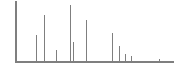
m/z ratio
Mass spectrum
Figure 1. Schematic representation of mass spectrometry (MS) components.

It is important to emphasise that many evolved variation of these techniques in a new generation of mass spectrometers in multistage fashion such as hybrid quadrupole time-of-flight [Q-Q-TOF] and tandem time-of-flight [TOFTOF] instruments are also available (98, 99).
Current development of quantitative proteomic approaches has facilitated the MS application to biomarker discovery for various diseases (96). These developments make use of various protein separation methods coupled with MS technology to produce an effective workflow towards proteome identification and quantification. As mentioned earlier, the commonly used comparative quantitative proteomic methodologies are either gel-based, gel-free or more recently label-free techniques.
The gel-based methods incorporate 2-dimensional polyacrylamide gel electrophoresis (2D-PAGE), or 2D fluorescence difference gel electrophoresis (2D-DIGE) in their workflow in order to separate proteins according to their weight and charge prior to MS-assisted protein identification. As protein samples comparison are carried out on one gel in 2D-DIGE ( as opposed to 2D-PAGE where there is a potential gel-to-gel variation), this method yields a more precise and reliable quantification data of relative protein abundance (102). However, spots often contain more than one protein and hence it may be difficult to decipher which protein alteration is responsible for the observed intensity variation; furthermore gel-based methods are confined to certain limitations such as restricted dynamic range, difficulty handling hydrophobic proteins, and difficulty detecting proteins with extreme molecular weights and isoelectric points (102). A schematic representation of 2D-PAGE method is shown in Figure 2.


Separation in first dimension by charge
pH 10.0
pH 4.0
pH 10.0
pH 4.0
Protein mixture
Isoelectric focusing

Separation in second dimension by size

SDS electrophoresis

Figure 2. Two-stage process during 2-dimensional sodium dodecyl sulfate polyacrylamide gel electrophoresis (2-D-SDS-PAGE) with proteins separation in first dimension by charge and in second dimension by size differences; adapted from Fray (103).

The development of gel-free labelling methods has provided the opportunity to compare wide range of proteins in complex compounds without the limitations associated with gel-based methods. In general, gel-free methods can address many of the shortcomings of gel-based approaches, which is labour intensive and inefficient in resolving proteins that are low abundant, insoluble, or large (200 kDa) (96). Labelling methods make use of the fact that different stable isotopes of the same substance have exactly the same physical and chemical properties except for different molecular weights (MW). Therefore, isotope-labelled molecules functions as internal standards or relative references for proteins comparison (102). The gel-free isotope-tagging/labelling techniques include ICAT (isotope-coded affinity tagging), SILAC (stable isotope-labelling with amino acids in cell culture), ¹⁵N/ ¹⁴N metabolic labelling, ¹⁸O/ ¹⁶O enzymatic/proteolytic labelling, Isotope Coded Protein Labelling (ICPL), Tandem Mass Tags (TMT), and iTRAQ (stable isotope-tagged amine-reactive reagents) (104, 105). The protein separation step in the gel-free methodologies is commonly replaced by various available high performance liquid chromatography (HPLC) techniques, such as normal phase, reversed phase HPLC. The iTRAQ workflow will be discussed in detail in Chapter 2.
There are potential limitations with labelling quantitative methods including increased time and complexity of sample preparation, requirement for higher sample concentration, expensive reagents, incomplete labelling and the requirement for specific quantification software (102); therefore, the advent of label-free quantitative proteomics give the promise of complementary alternative methods to achieve faster, cleaner, and simpler quantification results (106, 107).
In label-free quantitative methods, each sample is separately prepared and subjected to individual LC-MS/MS runs. Protein quantification is generally based on two categories of measurements: the first step is the measurements of ion intensity changes such as peptide peak areas or peak heights in chromatography; the second is based on the spectral counting of identified proteins after MS/MS analysis. Peptide peak intensity or spectral count is measured for individual LC-MS/MS or LC/LC-MS/MS runs and changes in protein abundance are calculated via a direct comparison between different analyses (102). In general, label-free MS-based relative quantification is achieved by comparing chromatographic peak intensity of the same peptide or the spectral count of the same protein between each LC-MS/MS (or LC/LC-MS/MS) run (108-111). Furthermore, this method has also been exploited for calculating absolute protein abundance using Protein Abundance Index (PAI) (defined as the number of identified peptides divided by the number of theoretically observable tryptic peptides for each protein)(112), exponentially modified PAI (emPAI, the exponential form of PAI minus one)(113). Other proposed variation of the label-free method include (but not limited to) Top 3 Protein Quantification (T3PQ) (calculated as the mean of the three highest peptides areas measured for each protein)(114), intensity-Based Absolute Quantification (iBAQ) (corresponds to the sum of all the peptides intensities divided by the number of observable peptides of a protein)(115), the sum of the MS intensities normalised by the MW (also known as MS1 over MW) (116) and the spectral counting normalised by the MW (also known as MS2 over MW)(117). The MS1 over MW and MS2 over MW are obtained by dividing the sum of peptides intensities or the sum of MS/MS events for the peptides of a protein by its MW, respectively (118).

Proteomics in Inflammatory Bowel Disease Research

GWA studies have advanced our understanding of strong genetic association in IBD over the recent years, with over 200 IBD susceptibility loci/genes discovered to date (9, 119). As mutations, chromosomal instability, and epigenetic modifications do not necessarily contribute to physiological cell homeostasis, genetic studies need to be complemented by the study of proteome (i.e. proteomics) in order to accurately evaluate end products of gene expression and their effects in a given state (120). Furthermore, studies of mRNA expression levels (i.e. transcriptomics) do not necessarily correspond to protein expression or disease state (120-122). There have been both poor and satisfactory reports comparing transcriptome and proteome studies in terms of correlations outcome between the mRNA and protein concentration and turnover (123-125). Proteomics analysis provides a representation of biologic processes at their level of occurrence, and offers a better knowledge of the physiologic and pathologic states of an organism (126).
In this review, I have endeavoured to collate all published studies on IBD incorporating newer high-throughput proteomic techniques, through comprehensive electronic search using “PubMed” website search from 2000 to 2018, with extra ad hoc reports from older seminal papers in the subject. The search criteria included combination of “proteomics,” “mass spectrometry,” and/or “protein array” with “IBD,” “UC,” “Crohn’s disease,” “Crohn’s colitis,” and/or “colitis” (last accessed 29th September 2018).

Overview of Recent Proteomic Research in IBD

Biofluid Proteomics in IBD
Biofluids and excrements including faeces, plasma, ascites fluid, urine, and saliva allow convenient sampling modalities for biomarkers and patient screening that are indicative of underlying immuno-pathophysiological changes and therefore are important sources of interest for proteomic analysis (96). Plasma proteomics comprises identification, quantification, and further investigation of plasma/serum proteome in terms of their functions and interactions, both in health and in disease. It therefore encompasses investigation of secretome, exosome, and cellular proteins released as part of apoptotic vesicles. Its relative ease of sample collection and corresponding representation of pathophysiological changes in humans have made plasma proteomics a rapidly expanding area of interest in biomarker discovery, recommended for its stability relative to serum by the Human Proteome Organization (127). Studies in IBD have focused on serum proteomics which represents a different form of the blood sample to plasma: serum is derived from blood that has coagulated, fibrin clots blood cells, and related coagulation factors are separated from serum by centrifugation. For plasma analysis, an anticoagulant such as EDTA or heparin is added before the removal of blood cells. The presence of fibrinogen and other clotting factors in plasma results in a higher protein concentration than serum (128). These differences in the sample matrix require consideration when performing biomarker discovery study or evaluating the clinical use of biomarkers (129). Complete profiling of such complex biological samples is still unachievable due to the presence of a high concentration of few proteins and requires depletion; in particular, albumin, immunoglobulins, serotransferrin, and haptoglobin represent more than 99% of the total serum and plasma proteins and interfere with the detection of less abundant proteins, limiting the analytical efficiency of LCMS/ MS. Therefore, their removal is essential to making low-abundant species detectable; a range of immune-affinity reagents are available, as reviewed by Pisanu et al. (130).

Human Studies on Biofluids
Meuwis et al. investigated the sera of patients with IBD, healthy controls, and inflammatory controls (other than IBD) in order to compare the proteome profile specific for each condition. Using surface enhanced laser desorption ionization-time of flight-mass spectrometer (SELDI-TOF-MS) technology (131), they successfully purified and identified four acute-phase reactant proteins as potential biomarkers of disease activity including platelet factor 4 (PF4), haptoglobin α2 (Hpα2), fibrinogen-α chain (FIBA), and myeloid-related protein 8 (MRP8), two of which (PF4 and Hpα2) were further confirmed through standard methods. These are all known proteins of acute phase inflammation, but their differential distribution amongst patient groups could help to discriminate IBD from controls (131). PF4 belongs to the CXCL chemokine family also known as chemokine (C-X-C motif) ligand 4 (CXCL4), produced mainly by megakaryocytes and released at the injury site when activated (132-134). Haptoglobin (Hp) is a multimeric serum protein and is generally used as a marker of inflammation and haemolysis; the molecule consists of 2α and 2β subunits connected by disulphide bridges. Two haplotypes of Hpα (α1 and α2) exist, which give rise to phenotypes Hpα 1-1, Hpα 1-2, and Hpα 2-2. Meuwis et al. demonstrate that the Hpα2 subunit is independent of Hpα1 and β suggesting this as a new biomarker specific for IBD (131). Further work by Vanuytsel et al. identified human zonulin (an important physiological modulator of para-cellular intestinal permeability) as prehaptoglobin-2 (pre-HPα2), a protein which is previously regarded as simply the inactive precursor for HPα2 (135). Allele HPα2 and genotype HPα 2-2 have been shown to be overrepresented in different immune diseases like rheumatoid arthritis (RA), systemic lupus erythematosus
(SLE), and type 1 diabetes and in patients with IBD relative to healthy controls (135-139). MRP8 and MRP14 are two abundant cytoplasmic proteins of phagocytes that function as endogenous activators of Toll-like receptor 4 and thereby amplify phagocyte activation during inflammation upstream of TNF-α–dependent effects (140). MRP8, which is the active component of the MRP8-MRP14 complex, induces intracellular translocation of myeloid differentiation primary response protein 88 and activation of interleukin-1 receptor– associated kinase-1 and NF-κB, resulting in an elevated expression of TNF-α (140). MRP8 is also part of the calprotectin complex, a biomarker of clinical endoscopic and disease activity in IBD when quantified in the stool (141).
In order to assess responders and non-responders to infliximab therapy in CD before and after the treatment, Meuwis et al. exploited serum proteomic profiling using SELDI-TOF-MS technology in a subsequent study, which showed a positive correlation between PF4 and nonresponse to infliximab therapy in a post hoc analysis (142).
Kanmura et al. investigated the sera isolated from patients with UC (both active and inactive), CD, colon cancer, infectious colitis, and normal control in an attempt to discover biomarkers of disease activity specific to each disease state. They employed protein array technology by coupling the ProteinChip system with SELDI-TOF/MS for serum protein profiling (143). They identified that 3 increased in abundance proteins, namely, human neutrophil peptides 1-3 (HNP 1-3) (antimicrobial peptides from α-defensin groups of proteins secreted by neutrophils and phagocytes), in the serum of active UC patients in comparison to the rest of the patients’ subgroups including UC in remission, CD, infectious colitis, and healthy controls. They further confirmed these data using enzyme-linked immunosorbent assays (ELISA) and proposed HNP 1-3 as new biomarkers of UC disease activity (143).
To investigate biomarkers specific for children with IBD, Vaiopoulou et al. compared sera of adults and children with CD using 2DE followed by MALDI-TOF-MS and further validation by western blotting (144). Ceruloplasmin (the acute-phase plasma protein produced by activated macrophages is a ferroxidase enzyme with bacteriocidal activity (145)) and apolipoprotein B-100 (APOB) were significantly overexpressed in children, whereas clusterin (a glycoprotein with anti-apoptosis effect) (146) was found to be significantly overexpressed in adults with CD (144). They further confirmed the differential expression of ceruloplasmin and clusterin with western blotting. Overexpression of clusterin may reflect the age-related change in the level of this protein irrespective of CD pathogenesis, as shown by Ignjatovic et al. (147). The increase in abundance of APOB in this study contradicts a previous report by Koutroubakis et al., which showed a lower level of this protein in serum from a group of adult patients with CD relative to controls (148). Whether this new finding in a child population suggests an alternative activation pathway is unknown, although the IL-6 stimulatory effect on the level of APOB mRNA levels (149) and its elevated serum levels in the adult and child population with IBD (150, 151) may explain overexpression of APOB in this study.
Hatsugai et al. investigated peripheral blood mononuclear cell proteins from a cohort of 17 UC and 13 CD patients using 2DE and discriminant analysis (orthogonal partial least squares-discriminant analysis or OPLS-DA) with subsequent quantitative MALDI-TOF MS/MS analysis in a search for a differential proteome signature between UC and CD (152). They identified a model of 58 protein spots, which could discriminate between UC and CD with good performance for differentiation (R2 = 0 948) and prediction of the diseases (Q2 = 0 556). They further successfully identified 11 out of 58 protein spots by MS/MS analysis, which were assigned to seven kinds of proteins including Annexin A6 (ANXA6), peroxiredoxin 2 (PRDX2), a/b-hydrolase domain-containing protein 14B (ABHD14B), cyclophilin A (peptidyl isomerase A, PPIA), carbonic anhydrase 2 (CA2), beta actin (ACTB), and protein S100A9
(S100A9). ANXA6, PRDX2, ABHD14B, and PPIA were increased in the UC patients compared to the CD patients, of which the increase in PRDX2, ABHD14B, and PPIA was statistically significant. In contrast, CA2, ACTB, and S100A9 were found to be decreased in abundance in the UC patients compared to the CD patients, of which only the decrease in ACTB was statistically significant (152). Four of the identified proteins were found to be associated with inflammation and oxidation/reduction (PPIA, S100A9, PRDX2, and CA2), and the remaining three were associated with the formation of the cytoskeleton (ACTB), endocytotic trafficking (ANXA6), and activation of transcription (ABHD14B). They did not match their protein spot analysis for different stages of UC/CD disease activity from the outset; hence, their proposed model based on a wide disease activity index range (SCCAI range 4-15 for UC and IOIBD score range 0-6 for CD) makes this discriminatory tool less predictable and reproducible.
Gazouli et al. investigated differential serum protein levels corresponding to the degree of infliximab responsiveness in a small group of CD patients using 2DE and MALDI-TOF-MS proteomic methods (153). They identified a panel of increased-in-abundance proteins in the primary infliximab nonresponsive group including apolipoprotein A-I (APOA1), apolipoprotein E (APOE), complement C4-B (CO4B), plasminogen (PLMN), serotransferrin (TRFE), beta-2-glycoprotein 1 (APOH), and clusterin (CLUS) in comparison to the infliximab-induced remission group. They further confirmed CLUS and APOA1 overexpression in the primary non-responder group by WB. Moreover, leucine-rich alpha-2-glycoprotein (A2GL), vitamin D-binding protein (VTDB), alpha-1B-glycoprotein (A1BG), and complement C1r subcomponent (C1R) were significantly increased in abundance in the serum of the infliximab-induced remission group as compared to the baseline pre-infliximab treatment serum (153). It should be noted that this was a single-centre study with limited patient number and no further confirmation of the results in an independent group of patients.
In order to evaluate the specific changes in serum peptide abundance, Nanni et al. fractionated low molecular weight (LMW) serum proteins with a 10kDa cut-off from patients with clinically active CD (n = 15; CDAI > 150) and healthy controls (n = 48) and utilised a reversed-phase nano-LC ESI/Q-TOF MS approach combined with targeted MS/MS analysis (154). Fibrinopeptide A (FPA) (a peptide released from fibrinogen during clotting of the blood), peptides from complement 3 protein (C3) and its fragment (C3F), and peptides from apolipoprotein A-IV were identified as the peptides whose concentration mostly increases in CD in this study. Previous studies have demonstrated the anti-inflammatory effect of apolipoprotein A-IV in DSS-induced murine colitis in vivo (155) and considered it as an independent predictor of disease activity in patients with IBD (156). Although the differential LC–MS analysis was performed only on the LMW proteome enriched during the pre-analytical step, all the identified proteins in the study had a MW much higher than 10 kDa (154). Therefore, they proposed a specific exoprotease activity in CD that involves pro-coagulant peptides as substrates (fibrinopeptide A) and postulated that platelet-derived microparticles (PDMPs) may contain yet unidentified exopeptidase enzymes with pro-inflammatory properties (154).

Animal Studies on Biofluids
In a murine model of IBD using interleukin-10 knockout (IL-10−/−) mouse, Viennois et al. performed a longitudinal study of circulating serum proteins using 2D GE and MALDI-TOF/TOF MS (157). Female IL-10−/− mice were monitored for colitis development for 15 weeks: at weaning (day 30) (no colitis), 15 weeks post-weaning (day 135) (severe colitis), and at an intermediate time point (day 93) (mild colitis). They identified and further confirmed (via WB or ELISA) a panel of 12 protein biomarkers, which could differentiate serum samples in mid to late-stage IL-10−/− mice from early non-inflamed IL-10−/− mice. The proteins were involved in a range of biological processes such as gene expression, glycosylation, signal transduction, metabolism, cell differentiation, translation, phosphorylation, immune response, protein denaturation, aging, and menopause. Of note, alpha-1-B glycoprotein (A1BG) was also decreased, whereas haptoglobin (HP), pregnancy zone protein (PZP), and hemopexin (HPX) were increased throughout the colitis progression in IL-10−/− mice. Peroxiredoxin 2 (PRDX2) was transiently increased during mild colitis development, whereas transferrin (TF) was only increased later in severe colitis mice.
In order to compare the IL-10−/− chronic colitis model to a model of acute colitis, the above confirmed biomarkers were trialled in a DSS mouse model of acute colitis; PZP and PRDX2, previously found to be increased in colitic IL-10−/− mice, were not altered in mice treated with DSS, suggesting that these markers are specific to a chronic inflammatory state. A1BG was observed to be decreased after DSS treatment, and HP and HPX were drastically increased, showing that A1BG, HP, and HPX were altered in the same way as was previously observed in colitic IL-10−/− mice. To investigate the specificity of these biomarkers to intestinal inflammation, they further explored these proteins in a model of extra-intestinal inflammation with collagen antibody-induced arthritis (CAIA). The overall outcome showed that PZP, COL1A1, and PRDX2 were specific to intestinal inflammation development with PZP and PRDX2 being specific to the IL10−/− model. The serum amyloid P-component and transthyretin were specific to the development of arthritic inflammation, whereas HP, inter-alpha trypsin inhibitor heavy chain4 (ITIH4), HPX, complement component 3 (C3), and A1BG were found to have an altered level in any inflammatory conditions.

Tissue (Cell) Proteomics in Inflammatory Bowel Disease
The application of cellular proteomics in IBD has been investigated in several studies using surgical or endoscopic colonic tissue biopsies, as well as cultured colonic cell lines (158).

Human Studies Using Tissues
Distinguishing UC and Crohn’s colitis in clinical settings may be important as this may affect the medical and surgical management plan – particularly when considering pan-proctocolectomy and ileo-anal pouch surgery in a colitic patient. The differentiation can be very difficult despite all available clinical, radiological, endoscopic, and histological criteria; consequently, about 15% of colitic patients are being labeled as “indeterminate colitis” due to inconclusive investigation outcomes and change of diagnosis from UC to Crohn’s colitis occurs in another 15% following colectomy (159).
In an attempt to discover a more sensitive differentiating diagnostic tool between Crohn’s colitis (CC) and UC, M’Koma et al. investigated the ability of histology-directed MALDI-MS to determine the proteomic patterns between each group in a pilot study (159). They compared uninflamed versus inflamed submucosa in UC and CC groups separately using MALDI-MS to determine whether this method can distinguish inflammation in each group. They then compared the proteomic outcomes from inflamed submucosa in UC and CC, uninflamed submucosa in UC and CC, and inflamed mucosa in the two groups to determine whether this method could distinguish UC and CC. They utilised a histology-directed protein profiling previously described (160) in order to separate inflamed and uninflamed areas in mucosa and submucosa accordingly. Pairwise comparative analyses of the clinical groups obtained from MALDI-MS (comparing the discrete protein peaks in each group) were able to distinguish CC and UC specimens by profiling the colonic submucosa only (159). They did not identify the potential discriminatory proteins in MS spectral peaks. Furthermore, the small sample size of 51 patients (n = 24CC and n = 27UC) made the estimation of statistical significance of the intergroup differences suboptimal.
Using the same histology-directed MALDI-MS methodology, the group recently analysed histologic layers of 62 confirmed IBD tissues (26 from CC and 36 from UC) in order to distinguish between UC and CC (161). A total of 1257 spectra from 62 total IBD cases were used for statistical analysis of the mucosa. Out of 312 total peaks in the averaged spectra, 114 were found to have Wilcoxon rank-sum p values of less than 0.05 (161). A support vector machine algorithm consisting of 25 peaks was able to discriminate spectra from CC and UC with 76.9% spectral accuracy when using a leave-20%-out confirmation of the results. The application of the model to the entire dataset resulted in an accurate classification of 19/26 CC patients and 36/36 UC patients when using a 2/3 correct cut-off
(161). Whether this discriminatory methodology can be used to differentiate UC from CC in patients with indeterminate colitis needs further investigation, as none of the patients recruited in this study previously had an equivocal diagnosis.
In a pilot study by Shkoda et al., IEC purified from colonic and ileal regions of surgically resected tissues in UC (n = 6) and CD (n = 6) were compared to normal-looking tissue from colon cancer patients (n = 6) (162). 2D SDS-PAGE analysis was combined with peptide mass fingerprinting via MALDI-TOF MS. Amongst the proteins found with differential expression in both UC and CD groups, statistical significance was reached for 4 proteins including L-lactate dehydrogenase, carbonyl reductase (NADPH prostaglandin E2 reductase), keratin 19, and the Rho-GDP dissociation inhibitor R (Rho GDI α) (162). Western blotting further confirmed the MS data regarding induced expression of Rho GDI α in inflamed mucosa from both patient groups in comparison to control, but this overexpression was also observed in the mucosa from patients with sigmoid diverticulitis suggesting that this latter change in Rho GDI α overexpression is probably due to inflammation rather than the IBD-specific process (162). They further compared inflamed colonic mucosa to the non-inflamed mucosa in two separate UC patients. Although there was a significant variation between the number of differentially expressed proteins (28 versus 3), the most significant changes in protein expression were detected for Annexin A2 and programmed cell death protein 8 in these two patients. Lactate dehydrogenase is a cellular tissue enzyme that catalyses the conversion of pyruvate (the end product of glycolysis) to lactate in hypoxic states and hence is a general marker of tissue injury and damage. Increased carbonyl reductase (an oxidoreductase enzyme utilising NADP/NAD as cofactor) expression is also suggestive of increased oxidative burst in the colonic mucosa during inflammation (163). Rho GDI (a modulator of Rho-GTPase family of enzymes (164)) complexed with RhoA has recently been shown to be involved in NFκB activation cascade (165). Annexin A2 is a pleotropic protein from the calcium-dependent phospholipid-binding protein family that orchestrates a growing spectrum of biologic processes including involvement in cellular growth and in signal transduction pathways (166). In a recent study by Zhang et al. published in Chinese language (the abstract is available in English), annexin A2 expression has been shown to be upregulated in inflamed UC mucosa in comparison to normal control using immunohistochemistry technique followed by Q-PCR to confirm mRNA over-expression of annexin A2 (167). The programmed cell death protein 8 otherwise known as caspase 8 has been shown to control necroptosis of paneth cells and potentially the death of intestinal epithelial cells in patients with Crohn's disease and hence to participate in mucosal inflammation process (168). The use of normal-looking colon tissues from colon cancer patients as a control group may cause potential spurious results considering previous study by Polley et al., which indicated that protein expression in the apparently normal colonic mucosal field is modified in individuals with neoplastic lesions at sites distant from the lesion, indicative of a field defect (169).
In order to explore the protein profile in UC, Fogt et al. deployed proteomic analysis (2-D PAGE followed by LC-MS/MS) on surgically resected colonic tissue from 5 patients with active UC comparing active resected mucosa/submucosa to the uninvolved grossly normal mucosa of the UC patients (170). Increased abundance of proteins in the active UC tissues that are mainly involved in inflammation and repair were found including Proto-cadherins (a subtype of cadherin superfamily of proteins involved in cell adhesion and cell-cell interaction process and linked to the retention of the monolayer morphology of proliferating cells (171, 172)), α-1 antitrypsin (a protease inhibitor and acute-phase response protein (173)), tetratricopeptide repeat domains (associated with heat shock proteins (174)), caldesmon (Caldesmon is a calmodulin-binding protein; calmodulin is a in turn a regulator of gap junction channels (175)) and mutant desmin. The presence of mutated desmin (a type III intermediate filament) was confirmed by western immunoblotting. The authors hypothesized the possibility that desmin mutation may be a primary or secondary feature in the pathogenesis of UC, although it could also represent a random mutation in a high turn-over cell population (170). In a recent genetic analysis study by Avitzur et al., tetratricopeptide repeat domains 7A mutations has been linked to very early onset IBD as a result of severe apoptotic enterocolitis due to defects in enterocytes and T cells (176).
Hsieh et al. used 2-D PAGE and MALDI-TOF-MS for peptide mass fingerprinting (PMF) analysis in colonic tissue biopsies from 4 patients with active chronic UC, 3 patients with infectious colitis and 5 normal individuals to explore differentially expressed proteins in UC (177). They identified 19 distinct proteins including 13 decreased-in-abundance and 6 increased-in-abundance proteins in the active compartment of the UC mucosa. Of the 13 decreased-in-abundance proteins in the active UC colonic mucosa, eight were either the mitochondrial component proteins or proteins directly involved in oxidation/phosphorylation (177). These results were confirmed using immunoblotting analyses and immunohistochemical (IHC) studies. They further compared active distal UC mucosa with proximal normal-looking inactive mucosa in two patients using similar proteomics analysis and observed relatively similar protein expression pattern between inactive UC mucosa and normal colonic mucosa except for down-regulation of prohibitin (PHB) (the major component protein of the mitochondrial inner membrane) in inactive UC mucosa similar to active distal UC compartment. The authors hypothesised the pivotal role of mitochondrial dysfunction in the pathogenesis of UC (177). PHBs are members of a highly conserved protein family that are found in multiple cellular compartments including the mitochondria, nucleus, and the plasma membrane (178). Nuclear and mitochondrial PHBs are thought to be involved in cellular differentiation, anti-proliferation, morphogenesis, cellular survival (through the Ras-Raf-MEK-Erk pathway), and in particular maintaining the functional integrity of the mitochondria and protecting cells from various stresses (178). Using a yeast two-hybrid method, Bacher et al. identified PHB as a binding partner for annexin A2 and α-actinin, which further attribute their interactions with members of the cytoskeletal proteins (179).
In order to characterise the differential proteins associated with inflamed mucosa in active UC, Poulsen et al. investigated tissue biopsies from active distal UC patients using 2D-GE and MALDI-TOF MS technology (180). They compared the whole lysate extract isolated from active rectal UC mucosa and reciprocal inactive proximal mucosa from the same patient groups and identified 222 statistically significant protein spots using image analysis. Protein profiles from different colonic regions of normal control individuals were assessed to ensure the differential proteins concentrations are not inherently location-specific. The data showed generally similar proteomic signature in rectum and left colon flexure except for alpha-enolase and hydroxymethylglutaryl–CoA synthase, which had differential protein levels between rectum and left colon flexure in both patients and normal control individuals suggesting the two latter proteins are position markers rather than disease markers (180). Principal component analysis (PCA) grouped non-inflamed samples separately from the inflamed samples suggesting a distinctive proteomic signature of the colon mucosa in acute UC. A total of 43 individual protein spots were identified and further assigned to 33 individual proteins as more than one isoform was available for several of the proteins; these protein included those involved in energy metabolism (triosephosphate isomerase, glycerol-3-phosphate-dehydrogenase, alpha enolase and L-lactate dehydrogenase B-chain, isocitrate dehydrogenase, inorganic pyrophosphatase, enoyl-CoA hydratase), , and in oxidative stress (superoxide dismutase, thioredoxins and selenium binding protein)(180). The authors hypothesised that different protein profiles of several glycolytic enzymes and other proteins involved in energy may indicate inflammation associated alterations in energy metabolism in UC patients, which could in turn be related to malfunction of the utilisation of n-butyrate (the preferred source of energy for colonocytes in the distal colon (181)). They further postulated that the observed lowered enoyl-CoA hydratase in inflamed tissue might infer impaired fatty acid oxidation; the state of energy-deficiency is further strengthened by change in the glycolytic pathway reflected as a higher expression of glycolytic enzymes in inflamed mucosa (180).
In an attempt to find specific biomarkers in IBD including its subtypes, Han et al. investigated small numbers of patients with active (n=4) and inactive (n=4) UC, active (n=3) and inactive (n=3) CD, inflammatory polyps associated with UC (n=2) as well normal controls (n=3) using label-free LC-MS analysis (182). They suggested 3 proteins, including bone marrow proteoglycan (PRG2), L- plastin 1 (LCP1), and proteasome activator subunit 1 (PSME1) as potential biomarkers for active CD; following comparison to other published data, they further summarised certain upregulated proteins in active UC patients relative to normal controls including Tau tubulin kinase 2 (TTBK2), spectrin repeat containing nuclear envelope 2 (SYNE2), succinate CoA ligase 2, GDP-forming subunit (SUCLG2), periostin (POSTN), as well as other proteins that are upregulated in both active UC and CD relative to normal tissues including fibrinogen, calprotectin (S100A8), myeloperoxidase (MPO), neutrophil defensin-1 (DEFA1B and DEFA1) (182). It is worth mentioning that the differentiation between active and inactive UC/CD in this study was on the basis of clinical and endoscopic findings. The number of patients included in the study was another limitation of the study. PRG2 comprises the crystalloid core of the eosinophil granule, which has cytotoxic and microbicidal activities (183). The protein has been shown to enhance natural killer cell activity (184). A preform of PRG2 also acts as a proteinase inhibitor, reducing the activity of pregnancy-associated plasma protein-A (PAPPA) (185). LCP1, one of three isoforms of plastin protein family, is constitutively expressed at high levels in haemopoietic cell types as well as many types of solid tissue malignant cells (186, 187). As a leukocyte-specific protein, LCP1 cross-links actin filaments into tight bundles, increasing the stability of actin-based structures such as podosomes and lamellipodia (188). PSME1 is a multicatalytic proteinase complex that cleaves peptides in an ATP/ubiquitin-dependent process (ubiquitin-proteasome system) (189). It may also harbour a regulatory role on the Rho GTPase activity (190).
Further investigation by Bennike et al. used a label-free (LFQ) proteomic analysis to compare UC to normal biopsies (n = 10, for each) and identified proteins with statistically significant altered abundance in the UC biopsies to be from neutrophils and associated with the formation of neutrophil extracellular traps (NETs) (191). An increased abundance of neutrophils and the presence of neutrophil extracellular traps were confirmed by microscopy and the presence of extracellular DNA present in the UC colon tissue, suggesting stimulation of innate immunity (191), since NETS form part of the first line of immune defence (192).
In order to investigate differential proteomic changes in UC and tuberculous colitis (TC), Kwon et al. examined colonic tissues from these two groups (n=6 in each group) in comparison to normal controls (n=6) using 2-DE and MALDI-TOF/TOF MS technology (193). Of the over 1000 proteins isolated, mutant β-actin, α-enolase and Charcot-Leyden crystal proteins were found to be differentially expressed in these colitides relative to normal controls. In particular, α-enolase was significantly over-expressed in TC compared with normal tissue, but under-expressed in UC relative to control, suggesting α-enolase as a candidate biomarker for differential diagnosis of TC and UC (193). Previous studies have shown upregulation of α-enolase mRNA levels in IBD (194) and down-regulation at the protein level in UC (195), which may in turn be partly related to over-expression of α-enolase reactive antibodies found in 10-50% of patients with UC (194, 196). Although the study suggested recruiting patients with active colitis, severity of disease activity was not quantified. Moreover, there was no cross-validation of the findings on a new set of tissue samples in these cohorts.
To identify molecular signatures in UC, Zhao et al. compared intestinal mucosa from 12 UC patients with 12 normal controls using comparative proteomic analysis with 2-DE and MALDI TOF/TOF MS (195). A total of 26 unique differential proteins were identified, including 12 up-regulated and 14 down-regulated in UC group. A differential protein cluster, consisting of 11 proteins (including Cdc42, vimentin, annexinA2, HSP90B1, LSP1, GRP78, and cathepsin D that were up-regulated in UC; and HSF2, galectin-3, VDAC-1 and MAWBP that were down-regulated) involved in p38 mitogen activated protein kinase (MAPK) pathway was deduced and validated by Western blot. Furthermore, three proteins elicited from the protein cluster (phosphorylated p38, MAWBP and galectin-3) were analysed by IHC on 58 UC and 60 normal tissue samples. Increased expression of P-p38 and down-regulated MAWBP and galectin-3 were detected in active UC compared to normal samples (195); hence they concluded that P38 MAPK pathway might be involved in UC disease activity. This observation has also been previously shown in a DSS-induced experimental colitis murine model (197). Others have proposed that the regulation of TNF-alpha, a key mediator in the inflammatory process in IBD, is interconnected with MAPK pathways (198).
Brentnall et al. applied quantitative proteomics technique using LC MS/MS and iTRAQ labelling to study the protein expression of UC neoplastic progression (199). They compared the proteomes of both dysplastic and non-dysplastic mucosa from UC patients with high-grade dysplasia or cancer (UC progressors; n=5 in each) to the colonic mucosa of UC patients who were dysplasia-free (UC non-progressors; n=5) and normal non-UC colon (n=5) in order to investigate possibility of field defect at the proteome level. They identified differential protein expression relating to mitochondria, oxidative activity and calcium-binding proteins are associated with UC neoplastic progression. Network analysis discovered that Sp1 and c-myc proteins might play roles in UC early and late stages of neoplastic progression, respectively. Two up-regulated mitochondrial proteins in the UC progressor groups, namely CPS1 and S100P, were further validated by IHC experiment on 17 tissue samples. The S100 proteins are a multi-gene calcium-binding family comprising 20 known human members with a broad range of intracellular and extracellular functions, including regulation of protein phosphorylation and enzyme activity, calcium homeostasis, regulation of cytoskeletal components and regulation of transcriptional factors (200). A previous study by Fuentes et al. suggested that S100P is over-expressed in colon cancer relative to normal tissue and that S100P stimulates colon cancer cell growth, migration, Erk phosphorylation, and NFkB activation in vitro (201). CPS1 is a mitochondrial enzyme involved in the urea cycle and expressed mainly in intestinal epithelial and liver cells; it detoxifies ammonia and, together with other enzymes of the urea cycle, is the de novo source of arginine (199). Variations in the supply of arginine, due to alterations in urea cycle function, affect the production of nitric oxide (202). Nitric oxide, in turn, can cause DNA damage, laxity in DNA repair, and is associated with inflammation associated cancers (203). In this study, they proposed that the proteome of the non-dysplastic mucosa from the progressors group was more akin to the proteome of high-grade dysplasia, than it was to the non-dysplastic mucosa of non-progressors group, and concluded that there are changes in protein expression early in the neoplastic progression, before the histologic changes become evident in the epithelial cells.
In the search for objective biomarkers of dysplasia in UC, the collaborators from the same group (May et al.) investigated individual rectal and colonic epithelial fractions from UC patients with dysplasia or cancer (UC progressors) compared to similar samples from patients with no dysplasia/cancer (UC nonprogressors) in a label-free MS experiment coupled with HPLC (204). Mitochondrial proteins, cytoskeletal proteins, RAS superfamily, proteins relating to apoptosis, and metabolism were the important protein pathways differentially expressed in the nondysplastic and dysplastic tissues of UC progressors, suggesting their importance in UC neoplastic progression. They further validated two differentially expressed mitochondrial proteins including TNF receptor-associated protein 1 (TRAP1), which displayed increased IHC staining in UC progressors (in both dysplastic and nondysplastic tissue), and CPS1, which showed a statistically significant difference in IHC staining between the nonprogressor and progressor groups (204). TRAP1 is a mitochondrial heat shock protein involved in protection against oxidative stress and apoptosis. Previous studies have also showed increased expression of TRAP1 in colorectal carcinoma (205).
In order to identify disease-specific autoantigens in CD, Zhou et al. applied imunoproteomics techniques using a combination of 2-D PAGE, WB and MALDI MS on surgically obtained mucosal lesions from 8 active CD patients (206). A mixed serum samples from the same CD patients was used as primary antibody source for detection of autoantigens in the colonic tissue. The adjacent normal looking mucosa on each patient was used as control to identify over-expressed protein spots on each gel. They identified 6 differentially expressed protein spots including prohibitin, calreticulin, apolipoprotein A-I, intelectin-1, protein disulphide isomerase, and glutathione s-transferase Pi. Prohibitin and glutathione s-transferase over expression in the mucosal lesion of active CD patients relative to the neighbouring normal mucosa was further validated with WB on 4 separate CD patients (206). Small number of CD patients together with lack of controlled patients and follow up data were the main limitations of this study.

Cell Line Studies
Araki et al. compared UC-associated cancer and sporadic colon cancer cell lines using proteomic analysis with 2D GE and LC-MS/MS in the search for differentially expressed proteins in the two groups and found a higher expression of heat shock protein of 47kDa (HSP47) in UC-associated cancer cell lines (207). IHC validation of the result on 63 UC-associated lesions and 81 sporadic colon tumour lesions confirmed significantly higher levels of HSP47 in UC-associated colon cancers than in sporadic counterparts, the expression increasing with a progression of neoplastic lesions. HSP47 co-expression with type I collagen in the cytoplasm was further confirmed by double immunofluorescence staining of cell lines (207). HSP47 is a collagen-binding, stress-inducible protein localised in the ER that participates in the intracellular processing, folding, assembly, and secretion of procollagens, especially in collagen-secreting cells, such as fibroblasts (208). In tissue, although HSP47 was found to be expressed in both epithelial and stromal cells within cancers, only the former showed an increase with progression to greater malignancy (207).

Barceló-Batllori et al. evaluated homogenates from DLD-1 colorectal adenocarcinoma cells (as in-vitro IBD model) before and after exposure to IFN-γ, IL-6 and IL-1 and utilised 2-D PAGE together with MALDI-TOF-MS in a search for cytokine regulated proteins in intestinal epithelial cells (IEC) in IBD (209). Amongst several identified proteins in the in-vitro model (including tryptophanyl-tRNA synthetase, indoleamine-2,3-dioxygenase, heterogeneous nuclear ribonucleoprotein JKTBP, interferon-induced 35kDa protein, proteasome subunit LMP2 and arginosuccinate Synthetase), overexpression of indoleamine-2,3-dioxygenase (IDO) was confirmed in the purified IEC from IBD patients in comparison to normal mucosa (209). Indoleamine 2,3 dioxygenase-1 (IDO1), which is well-characterised in the gut, is the first and rate limiting step in tryptophan catabolism along the kynurenine pathway (210). IDO expression has been linked with immune tolerance at the maternal-foetal interface via suppression of T cell proliferation in a seminal work by Munn et al. (211, 212). Matteoli et al. later observed that CD103+ gut dendritic cells expressing IDO1 support regulatory T-cell conversion while suppressing Th1/Th17 differentiation to promote oral tolerance and limit gut inflammation (213). IDO1 expression is stimulated by inflammatory cytokines including IFNγ, TNFα and IL1-B (210). Consistent with this, IDO1 is one of the highly upregulated genes in human IBD (214).

Animal Models
Liu et al. studied alteration of lymphocytic protein profiles in a rat model of 2,4,6-trinitrobenzene sulfonic acid- (TNBS-) induced colitis (215). After extracting proteins from the harvested lymphocytes 7 days post-TNBS/ethanol colitis induction, they compared protein spots on 2-D PAGE in lymphocytes from colitic and control rats using PDQuest 2D-image-analysis followed by identification of differentially expressed protein spots using MALDI-TOF-MS. The identified differentially expressed proteins were further validated with Real-time RT-PCR. Altered proteins with at least two-fold difference (total of 26 including 17 up-regulated and 9 down-regulated proteins) were involved in the regulation of the cell cycle, cell proliferation and signaling transduction (up-regulated NDPKs and E2N), inflammation (up-regulated MRP-14), apoptosis (up-regulated IL-12 p40; down-regulated proteasome activator complex subunit 2, CARD and PYD domain containing protein) and metabolic/oxidative stress response (up-regulated ATP-citrate synthase, phosphoglycerate mutase, dismutase) activities, as well as others (215). Nucleoside-diphosphate kinase (NDPK) catalyses the phosphorylation of nucleoside diphosphate to nucleoside triphosphate; it confers protection from cell death by Bax and alters the cellular levels of several antioxidant enzymes including Gpx5 (215, 216). Ubiquitin-Conjugating Enzyme (E2N) plays a role in the error-free DNA repair pathway and contributes to the survival of cells after DNA damage (215). Its action has been linked to the regulation of activating transcription factor 2 (ATF2) and NF-kappa B transcriptional activator precursor p105, which are in turn essential players in lymphocytes activation (217, 218). Myeloid-related protein (MRP)-8 (S100A8) and MRP-14 (S100A9) are members of the S100 family of calcium-modulated proteins that regulate myeloid cell function and control inflammation (219). Proteasome activator complex subunit 2 is implicated in immuno-proteasome assembly and required for efficient antigen processing (215). IL-12 p40 is a pro-inflammatory cytokine with important role in innate and adaptive immunity (220, 221). The protein is encoded by IL12B gene, which is a susceptibility loci in CD and UC (222, 223). Caspase activation and recruitment domain (CARD) and pyrin domain (PYD) containing proteins promote caspase-mediated apoptosis predominantly through the activation of caspase 9 (215). The key structural scaffold for inflammasome (play a role in host defense against microbial pathogens and gut homeostasis) assembly is composed of filaments of PYD and CARD in the sensor, adaptor and effector components (224). Dismutase delivers copper to copper-zinc superoxide dismutase (215).
The decrease of pro-apoptosis proteins and the increase of anti-apoptosis proteins shown in this study may contribute to the inhibition of the lymphocyte apoptosis, which subsequently result in the over-activation of lymphocytes in colitis rats. Lymphocyte homeostasis/apoptosis is pivotal in orchestrating efficient immune responses and avoiding autoimmunity (225). Liu et al. raised concern about some limitations in the study including difficulty analysing some membrane proteins and low-abundance proteins by 2-D PAGE, as well as poor reproducibility and variations of spots intensity observed with silver staining as previously described (226).
In a murine model of CD using multidrug resistance targeted mutation (Mdr1a−/−) mice, Barnett et al. investigated the effect of polyphenol-rich green tea extract (GrTP) on the inflamed mouse colon transcriptome and proteome (227). Transcriptomic data (whole genome microarray) and the proteomic analysis 2DE/LC-MS technique were performed in parallel on the same samples. Integration of the data show reduced abundance of transcripts and proteins associated with immune and inflammatory response as well as fibrinogenesis pathways and increased abundance of those associated with xenobiotic metabolism pathways in response to GrTP (227). Increased abundance of peroxisome proliferator-activated receptor-α (PPAR-α) and decrease in signal transducer and activator of transcription 1 (STAT-1) protein abundance appeared to be the two key modulatory effects in response to GrTP in Mdr1a−/− mice. Dietary intake of polyphenols derived from green tea was demonstrated to ameliorate intestinal inflammation in the colon of a mouse model of CD and therefore may play a part in an overall IBD treatment regimen (227).
PPARs are ligand-activated transcription factors of the nuclear hormone receptor superfamily (228). PPARs play essential roles in the regulation of cellular proliferation and differentiation, atherosclerosis, inflammation, metabolism, infertility, tumourigenesis and demyelination (229-231). PPAR-α is expressed at high levels in organs with significant catabolism of fatty acids and is also shown to have a role in controlling colonic inflammation and mucosal tissue homeostasis (228, 232, 233). In addition to important role of NFκB and MAPK inflammatory pathways in IBD, many cytokines exert their intracellular signalling by activating the JAK/STAT pathway (234). Over-expression and activation of STAT1, has previously been linked to IBD relapse (235). The beneficial effects of GrTP in this study could be due to specific anti-inflammatory effect of the compound on this particular genetic defect of IBD mouse model (Mdr1a−/−).

Organelle Proteomics (Subproteomics) in IBD
Complexity and abundance of proteins with very variable concentrations and dynamic range have a significant impact in the sensitivity of cellular proteomic methodologies (158). Subcellular fractionation and proteomics (subproteomics) are an ideal adjunct for reducing cellular sample complexity; it can combine current proteomic methodology for enrichment and analysis of intracellular organelles and low-abundance multiproteins (236).
Subcellular fractionation involves disruption of the cellular assembly (homogenisation) followed by fractionation of the homogenate to different subgroups, based on their physical properties, by using differential centrifugation disruption; moreover, quality control methods including quantitative western blotting (targeting specific organelle marker proteins) and qualitative/morphological analysis (electron microscopy) can ensure optimal subcellular fractionation of interest (236). Although absolute subcellular compartment purification is not possible due to co-fractionation of particles with similar physical characteristics, this method is a powerful adjunct to the proteomic analysis (236, 237).

Cell Line Studies on Organelles
One of the early reports of organelles proteomic application cells was by Fialka et al., who
coupled subcellular fractionation with 2D PAGE, immunoblotting and micro-sequencing for investigation of endosomal proteome as method for analysis of epithelial cells (238).

Human Studies Using Subcellular Fractions
O’Morain et al. carried out subcellular fractionation on rectal biopsies taken from patients with UC, Crohn’s colitis, CD with no rectal involvement as well as normal controls by homogenizing samples in isotonic sucrose followed by sucrose density gradient centrifugation (239). The gradient fractions and tissue homogenates were then assayed for marker enzymes for the plasma membrane (5'nucleotidase), mitochondria (malate dehydrogenase), peroxisomes (catalase), cytosol (lactate dehydrogenase), lysosomes (N-acetyl-beta-glucosaminidase), and endoplasmic reticulum (neutral-alpha-glucosidase); they found selective and specific alterations in the principal subcellular organelles, especially the plasma membrane, lysosomes, and mitochondria in IBD (239).
In a comparative study exploring differential protein expressions in cellular compartments of IEC (nuclei, membranes, cytosols) in CD patients versus control, Nanni et al. isolated epithelial cells from surgically resected colonic tissue using a previously validated method (240) and utilised mono-dimensional gel electrophoresis (1DGE) combined with label-free nano-LC ESI/QTOF MS followed by targeted MS/MS analysis (241). Annexin A1 (a nuclei membrane protein regulating of phospolipase A2 activity) and malate dehydrogenase (a mitochondrial and cytosolic enzyme involved in the citric acid cycle as well as malate-aspartate shuttle(242)) were decreased in abundance in CD patients in comparison to controls. Protein increases were identified in each of the subcellular fractions. Examples include ubiquitin, tryptase precursor, heat shock 70kDa protein-5, and ATP synthase beta. Increased levels of ubiquitin in the nuclear fraction were proposed to reflect increased activity of IECs, consistent with increased levels of ATP synthase subunit beta in the membrane fraction (241). Heat shock 70kDa protein-5 is a multifunctional protein that participates in protein folding and calcium homeostasis and serves as an essential regulator of ER stress response (243). This protein was increased in abundance in the membrane fraction of CD patients, as might be expected due to its role in the protection of the intestinal epithelium (241). Tryptase (a serine protease also known as mast cell tryptase) has been shown to play an important role in acute DSS-induced colitis in mice (244).
Most of the proteins found in this study were similar to those found in the earlier differential protein profiling study on IECs from IBD patients using 2-D PAGE/MS methodology (162), thereby confirming these results. Heat shock proteins (Hsp) are considered chaperone proteins involved in folding process of other cellular proteins(245). Their expressions are increased in abundance in response to intracellular stresses including hyperthermia, ischemia/reperfusion, oxygen radicals, heavy metals, ethanol, and amino acid analogues (245). Although up-regulation of Hsp70 seems to be a natural response to inflammation as per Nanni et al., a previous study by Hu et al. contradicts this finding by showing that inducible Hsp expression (Hsp25/27 and Hsp70) are translationally (but not transcriptionally) decreased in abundance via phosphorylation and inactivation of eukaryotic initiation factor-2α (eIF-2α) in active IBD (246).

Secretome
Profiling and identification of active serine proteases secreted by the colonic mucosa of control and IBD patients was performed using a MS-based functional proteomic analysis to monitor availability of enzyme active sites in colonic tissues from CD or UC patients. The study employed activity-based probes, chemical proteomic tools, which possess a reactive group to mimic enzymatic substrate and covalently bind active proteases. Biotinylation of the ABP allows selective avidin-based affinity capture of the ABP-enzyme target, which is identified by MS and post-tryptic digestion to generate peptides for LC-MS/MS analysis.
Seven serine proteases including cathepsin G, plasma kallikrein, plasmin, tryptase, chymotrypsin-like elastase 3A, thrombin, and aminopeptidase B were identified, of which cathepsin G and thrombin were overactive in IBD patient samples compared to healthy controls (247). These data are consistent with the earlier study by Dabek et al. reporting the increased presence of cathepsin-G in faeces of UC patients (248).

Intermediate Filaments
Intermediate filaments (IF) are one of the main components of the human cell cytoskeleton, which mainly consist of keratins (K). Keratins may have a role in the pathophysiology of IBD.
Utilisation of subcellular fractionation techniques in an investigative study on the role of keratins in IBD have been described earlier in this chapter.

A brief description of each of the reviewed proteomic studies is provided in Table 1.

Table 1. High throughput proteomics studies in IBD
Proteomics studies in IBD | References | Analytical technique(s) | Type of study (Cell line, animal, human) | Significant finding(s)
Biofluid proteomics | Meuwis et al. 2007 (131) | SELDI-TOF-MS | Human | Identification of PF4, MRP8, FIBA and Hpa2 as potential biomarkers of disease activity in IBD
 | Meuwis et al. 2008 (142) | SELDI-TOF-MS | Human | Positive correlation between PF4 level and nonresponse to infliximab therapy in CD
 | Kanmura et al. 2009 (143) | Protein array technology coupling ProteinChip system with SELDI-TOF/MS | Human | Identification of 3 up-regulated proteins (HNP 1-3) in the serum of active UC patients as new biomarkers of UC disease activity
 | Hatsugai et al. 2010 (152) | 2D-GE, discriminant analysis (OPLS-DA) & MALDI-TOF MS/MS | Human | Identification of a panel of proteins that could discriminate between UC and CD including ANXA6, PRDX2, ABHD14B, cyclophilin A, CA2, ACTB and S100A9
 | Gazouli et al. 2013 (153) | 2DE & MALDI-TOF-MS | Human | Identification of a panel of up-regulated proteins in the primary infliximab non-responsive patients including: APOA1, APOE, CO4B, PLMN, TRFE, APOH, CLUS in comparison to infliximab-induced remission patients
 | Vaiopoulou et al. 2015 (144) | 2D-GE & MALDI-TOF-MS | Human | Over-expression of caeruloplasmin and apolipoprotein B-100 (APOB) in children, and clusterin in adults with CD
 | Viennois et al. 2015 (157) | 2D GE & MALDI-TOF/TOF MS | Murine | Identification of altered expression of proteins specific to: intestinal inflammation development (PZP, COL1A1, PRDX2), IL10−/− murine model inflammation (PZP, PRDX2), arthritic inflammation development (serum amyloid P-component and transthyretin), and non-specific inflammation (HP, ITIH4, HPX, C3, A1BG)
 | Townsend et al. 2015 (249) | iTRAQ labelling and ESI-MS/MS | Human | Identifying 12 proteins (A2M, LDHB, CAPNS1, MBL2, APOB, CD5L, ALB, FLNA, SCGB1A1, BRDT, CTSD, PSMA7, CP, OIT3, F2, TNXA) differentiating stricturing CD from CD without stricture with AUC value >0.9.
 | Heier et al. 2016 (250) | Aptamer-based SOMAscan protein microarray, and qRT-PCR for miRNAs | Human | Identification of 18 differential proteins (SERPINA1, IGFBP2, IGFBP1, RETN, CCL2, P4HB, CNDP1, CDH3, CCL25, SPOCK2, ADGRE2, CHRDL1, IFNA2, NCAM1, AGT, IgM, CNTF, CD36) and three miRNAs (miR-146a, miR-320a, and miR-146b) responsive to both prednisone and infliximab therapy in IBD; furthermore, 5 proteins (APOE, C1r, and RTN4, APOB and AFM) appeared to be exclusive steroid-specific markers of response.
 | Zhang et al. 2016 (251) | Weak cationic magnetic beads combined with MALDI-TOF-MS | Human | Presenting a diagnostic model comprising of four protein peaks (M/Z 4964, 3029, 2833, 2900) to distinguish CD patients compared to controls (specificity and sensitivity: 96.7% and 96.7%, respectively), a diagnostic model comprising four protein peaks (M/Z 3030, 2105, 2545, 4210) to distinguish intestinal TB patients compared to controls (specificity and sensitivity: 93.3% and 95.2%, respectively), and finally a differential diagnostic model comprising three potential biomarkers protein peaks (M/Z 4267, 4223, 1541) to distinguish CD and intestinal TB patients (specificity and sensitivity: 76.2% and 80.0%, respectively). Two of these protein peaks successfully purified and identified including M/Z 2900 (appetite peptide) from the diagnostic model between CD and controls, and M/Z 1541 (Lysyl oxidase-like 2) from the differential diagnostic model between CD and intestinal TB.
 | Wasinger et al. 2016 (252) | LC-MS/MS (LTQ-FT MS) together with Peptide Quantitation by MRM | Human | Evaluation of the enriched low mass plasma proteome (<25 kDa) led to the discovery of serum markers of UC disease activity (SPP24 and AMBP) and active CD (SPP24) compared to IBD patients in remission and healthy controls, as well as serum markers differentiating UC and CD (GUC2A, CHGB). Furthermore, SPP24 was a marker of IBD compared to controls.
 | Zheng et al. 2017(253) | LC-MS/MS | Human | Identification of 8 upregulated proteins in salivary exosomes of patients with active IBD relative to controls including TKT, TLN1, WDR1, NUCB2, BASP1, PSMA7, PSMB7, IGHV4OR. PSMA7 upregulation was further validated by WB.
 | Andersson et al. 2017 (254) | Proximity Extension Assay (PEA) | Human | Identification of 17 and 12 differentially-expressed proteins in patients with CD and UC compared to healthy controls, respectively, detected from a panel of 91 pre-selected inflammatory proteins within the assay. Using univariate comparisons, 16 of 17 CD-associated proteins and 8 of 12 UC-associated proteins were validated in the replication cohort.  FGF-19 was the only discriminatory protein between CD and UC using univariate comparison.
 | Di Narzo et al. 2017 (255) | Aptamer-based SOMAscan protein microarray, followed by proteomic-QTL mapping | Human | Observation of 32 CD and 130 UC aging-associated proteomic traits; top significant age-related proteins included FSH, albumin, Siglec-7, MMP-7, APO E, XTP3A, CNDP1, Laminin, SPARCL1, CNTN2, IGFBP-1, PDGF-BB, CCL28, SGTA, CTAP-III. Furthermore, using a genome wide genotype-protein association study (proteomic QTLs) in a cohort of 51 CD patients, 41 distinct proteins showed evidence of association with a nearby (cis) SNP at 10% FDR. Serum protein levels of MST1 were found to be regulated by SNP rs3197999 (an accepted GWAS locus for IBD).
 | Yau et al. 2017 (256) | Label-free LC-MS/MS followed by immunoblotting and multiple reaction monitoring (MRM) | Human | Identification of 76 differential serum proteins in complicated CD versus uncomplicated CD during discovery (MS phase), annotating to pathways of epithelial barrier homeostasis. In verification phase, a serology panel (consisting of desmoglein-1, desmoplakin, and fatty acid-binding protein 5) distinguished complicated CD from all other groups (uncomplicated CD, Th1/17 pathway inflammation controls (RA), IBD controls (UC), and healthy controls) and discriminated complication in CD (70% sensitivity and 72.5% specificity at score ≥1.907, AUC = 0.777, p = 0.007). An MRM assay secondarily confirmed increased FABP5 levels in complicated CD (p < 0.001). In a longitudinal subanalysis-cohort, FABP5 levels were stable over a two-month period with no behavioural changes (p = 0.099).
Tissue proteomics | Barcelo-Batllori et al. 2002 (209) | 2D PAGE & MALDI-TOF-MS | Human & Cell line | Upregulation of indoleamine-2,3-dioxygenase in the purified IEC from IBD patients relative to normal controls
 | Hsieh et al. 2006 (177) | 2-D PAGE and MALDI-TOF-MS | Human | Identification of 19 altered proteins expression (13 down-regulated and 6 up-regulated) in the active compartment of UC mucosa relative to control Altered regulation of mitochondrial proteins raising possibility of mitochondrial dysfunction in UC
 | Liu et al. 2007 (215) | 2-D PAGE, MALDI-TOF-MS & Real-time RT-PCR | Murine | Alteration of a series of apoptosis-related proteins (up-regulated IL-12 p40 and down-regulated CARD, PYD domain containing protein, proteasome activator complex subunit 2), proteins involved in cell growth, differentiation and signal transduction (up-regulated NDPKs and E2N), Inflammatory factors (up-regulated MRP-14) and metabolism/oxidative stress response related proteins (up-regulated ATP-citrate synthase, phosphoglycerate mutase, dismutase) in lymphocytes from murine colitis model
 | Shkoda et al. 2007 (162) | 2D SDS PAGE & MALDI-TOF MS | Human | Identification of several differentially expressed proteins in the IEC from active IBD patients relative to controls (including L-lactate dehydrogenase, NADPH prostaglandin E2 reductase, keratin 19, and Rho GDI α)
 | Fogt et al. 2008 (170) | 2-D PAGE & LC-MS/MS | Human | Identification of increased expression of proteins that are mainly involved in inflammation and repair (proto-cadherins , α-1 antitrypsin, tetratricopeptide repeat domains , caldesmon and mutant desmin) in the active UC tissue relative to the inactive proximal mucosa
 | Brentnall et al. 2009 (199) | HPLC, Q-TOF MS/MS & iTRAQ labelling | Human | Identification of differential protein expression relating to mitochondria (CPS1 and S100P) associated with UC neoplastic progression
 | Araki et al. 2009 (207) | 2D GE and LC-MS/MS | Human & Cell line | Identification of over-expression of HSP47 in UC-associated cancer relative to sporadic colon cancer tissues
 | May et al. 2011 (204) | label-free LTQ-Orbitrap hybrid MS coupled with HPLC | Human | Identification of two differentially expressed mitochondrial proteins (TRAP1, CPS1) associated with UC neoplastic progression, which was found in both dysplastic and non-dysplastic tissues
 | Zhao et al. 2011 (195) | 2-DE & MALDI TOF/TOF MS | Human | Detecting p-P38 up-regulation and MAWBP/galectin-3 down-regulation in active UC compared to normal controls; Proposing P38 MAPK pathway involvement in UC disease activity
 | M’Koma et al. 2011 (159) | Histology-directed MALDI-MS (tissue imaging) | Human | Discriminatory colonic submucosa proteomics profile between UC and Crohn’s colitis via investigation of MS spectral peaks
 | Poulsen et al. 2012 (180) | 2D-GE & MALDI-TOF MS together with PCA analysis | Human | Identification of 33 individual proteins with altered expression in the active UC mucosa relative to proximal inactive mucosa including: proteins involved in energy metabolism (triosephosphate isomerase, glycerol-3-phosphate-dehydrogenase, alpha enolase and L-lactate dehydrogenase B-chain) and in oxidative stress (superoxide dismutase, thioredoxins and selenium binding protein)
 | Kwon et al. 2012 (193) | 2-DE & MALDI-TOF/TOF MS | Human | Identification of 3 proteins with altered expression in UC and tuberculous colitis (TC) (mutant β-actin, α-enolase, Charcot-Leyden crystal) relative to control; Suggesting α-enolase as a candidate biomarker for differential diagnosis of TC and UC
 | Barnett et al. 2013 (227) | 2D-GE & LC-MS | Murine | Reduced abundance of proteins associated with immune and inflammatory response as well as fibrinogenesis pathways, and increased abundance of those associated with xenobiotic metabolism pathways in response to GrTP
 | Seeley et al. 2013 (161) | Histology-directed MALDI-MS (tissue imaging) | Human | Identification of a support vector machine algorithm consisting of 25 peaks able to differentiate spectra from CC and UC with 76.9% spectral accuracy
 | Han et al. 2013 (182) | Label-free LC-MS | Human | Suggestion of 3 proteins as potential biomarkers for active CD, including: PRG2, LCP1, and PSME1
 | Zhou et al. 2013 (206) | 2D PAGE, WB and MALDI MS | Human | Identification of 6 differentially expressed proteins (prohibitin, calreticulin, apolipoprotein A-I, intelectin-1, protein disulphide isomerase, and glutathione s-transferase Pi) in active CD mucosa relative to the adjacent normal-looking mucosa.
 | Bennike et al.  2015 (191) | Label-free (LFQ)  proteomic analysis | Human | Comparing UC to normal biopsies identified proteins with statistically significant altered abundance in the UC biopsies to be from neutrophils and associated with the formation of neutrophil extracellular traps (NETs) suggesting stimulation of innate immunity.
 | Rukmangadachar et al. 2016 (257) | iTRAQ labelling and nano-LC-ESI MS/MS | Human | Identification of 63 differentially-expressed proteins in the colonic mucosa of patients with CD and intestinal TB in at least one set of iTRAQ experiment, from which 11 proteins were differentially expressed in more than one set of iTRAQ experiments. None of these proteins could be validated in the subsequent IHC experiment.
 | Giannogonas et al. 2016 (258) | iTRAQ labelling and LC- MS/MS | Murine & cell line | Observation of sustained activation of autophagy in the Crh −/− mouse colon at baseline and its further induction by DSS, as depicted by increased formation of LC3 II (which was only partially corrected by normalisation of the corticosterone levels of the Crh −/− mice), indicating a direct Crh deficiency-dependent effect on autophagy. These data were validated by WB, IHC and RT-PCR.
 | Starr et al. 2017 (259) | SILAC-based approach for relative quantification coupled with SCX fractionation and HPLC-ESI-MS/MS | Human | Identification of a panel of five proteins (FABP5, NAMPT, UGDH, LRPPRC, PPA1) to distinguish control from IBD-affected tissue biopsies with an AUC of 1.0 (95% CI 0.99 to1.0); a second panel of 12 proteins (HADHB, SEC61A1, SND1, LAP3, LTA4H, MT2, SLC25A1, HNRNPH3, TF, ECH1, TFRC, B2M) segregated inflamed CD from UC with an AUC of 0.95 (95% CI 0.86 to1.0). Furthermore, applying both panels to the validation cohort resulted in accurate classification of 95.9% (IBD from control) and 80% (CD from UC) of patients.  118 proteins were identified to have correlation with the severity of disease, four of which were components of the two panels, including NAMPT, HNRNPH3, PPA1 and MT2.
 | Moriggi et al. 2017 (260) | 2D-DIGE and MALDI-TOF MS; Isotope coded protein labelling (ICPL) coupled with HPLC  MaXis hybrid UHR-QTOF | Human | Identifying increased keratins, vimentin, and focal adhesion kinase 7 together with decreased vinculin, de-tyrosinated α-tubulin in quiescent UC compared to controls; increased levels of collagen type VI alpha 1 chain, tenascin-C and vimentin were seen in inflamed UC compared to controls. Decreased levels of tenascin C, de-tyrosinated α-tubulin, vinculin, FAK, and Rho-associated protein kinase 1 (ROCK1) together with increased vimentin were seen in quiescent CD compared to controls; increased levels of COL6A1, vimentin and integrin alpha were seen in active CD. Using ICPL methodology, decrease in the tricarboxylic acid cycle enzymes as well as short/branched chain specific acyl-CoA dehydrogenase, fatty acid synthase, proliferator-activated receptors alpha, and proliferator-activated receptors gamma were seen in quiescent UC; on the other hand, increased levels of glycerol-3-phosphate dehydrogenase, pyruvate dehydrogenase E1 component subunit beta, NADH dehydrogenase [ubiquinone] iron-sulfur protein 3, and 4-trimethylaminobutyraldehyde dehydrogenase, together with decreased dihydrolipoyl dehydrogenase were seen in quiescent CD. Identification of activated macro-autophagy activated in UC suggested by increased levels of p62, HSC70, major vault protein, myosin heavy chain 9.
Organelles proteomics | O'Morain et al. 1985 (239) | 2D PAGE &MS | Human | Identification of specific alterations in the principal subcellular organelles, especially the plasma membrane, lysosomes, and mitochondria in IBD in comparison to control
 | Nanni et al. 2009 (154) | 1D-GE & nano-LC ESI/Q-TOF-MS with targeted MS/MS analysis | Human | Identification of certain down-regulated (annexin A1, malate dehydrogenase) and upregulated (different histones and ubiquitin in the nuclear fraction; tryptase alpha-1 precursor in the cytosolic fraction; ATP synthase subunit beta and heat shock 70 kDa protein-5 in the fraction containing membranes) proteins in CD patients relative to controls
 | Nanni et al. 2009 (241) | LC ESI/Q-TOF-MS with targeted MS/MS analysis | Human | Suggestion of a specific serum exoprotease activity with proinflammatory properties in CD
 | Corfe et al. 2015 (261) | HPLC, ESI/Q-TOF MS-MS & iTRAQ labelling | Human | Reduced levels of K8, K18, K19 and vimentin (VIM) in acute distal UC mucosa compared to controls and non-inflamed proximal mucosa Reduced levels of IF–associated proteins in UC with PSC and UC with dysplasia Increased levels of K8, K18, K19 and VIM in longstanding pancolitis in remssion relative to controls and recent-onset colitis in remission.
 | Wong et al. 2016 (262) | 2DE & MALDI–TOF/TOF MS | Murine | Identification of 56 differentially expressed proteins in serum exosomes of DSS treated mice in comparison to control mice, majority of which were acute-phase proteins and immunoglobulins; furthermore DSS-treated serum exosomes could activate naive RAW264.7 murine macrophages through MAPK signalling and trigger a proinflammatory response.

Conclusion

The human proteome surpasses the human genome by several orders of magnitudes with regard to complexity, dynamic range, and diagnostic capability (120). New proteomic high-throughput technologies together with advances in bioinformatics science provide a great opportunity for exploring complex human conditions such as autoimmune disease and cancer. Despite many advances in understanding the IBD disease process over the past decade, mainly due to Human Genome Project and knockout gene techniques in animal model studies, the exact pathogenesis of IBD remains elusive.
The combination of a very large number of cellular proteins with highly variable concentration together with their susceptibility to enzymatic degradation and precipitation makes proteomics a challenging area of investigation. Nevertheless, careful sample selection, meticulous attention during fractionation of proteins, development of more specific subproteomic techniques to diminish the masking effect of high abundance proteins while enhancing the detection rate of low abundance ones, and fine-tuning of proteomic methodology together with future proteomic technology developments can improve protein uptake and reproducibility.
Proteomic technologies combined with bioinformatics analysis are very useful yet underexploited tools in exploring complex disease processes such as IBD in terms of delineating its pathophysiology, as well as discovering key biomarkers of disease activity/remission, optimising risk stratification for tailored individualized treatment, and revealing non-invasive predictors of evolution to CAC.
Improved biomarkers remain an unmet need in inflammatory bowel disease (IBD) (263). The use of biomarker panels has higher discriminatory ability than that of single protein markers. As an example, Starr et al. identified two biomarker panels for paediatric patients to differentiate ascending colon biopsies of CD from healthy control patients and UC from CD (259). These biomarkers have recently been further confirmed in intestinal mucosal–luminal interface aspirates and stool. In terms of clinical translation, a key finding from this study is that the biomarkers demonstrate transferable results in stool samples providing a scope for non-invasive sampling for biomarker analysis samples (264). Regulatory authorities have mandated the use of patient-reported outcomes for inclusion as an outcome measure in inflammatory bowel disease trials. However, as recently noted by Khanna et al., it is likely that CRP and FCP will continue the usage in clinical trials as a secondary end point or to stratify baseline disease severity; non-invasive biomarkers are yet to replace endoscopy review data (265). In terms of personalised medicine, it is important to understand the translatability and variability of individual biomarkers for development of
tools such as quantitative system pharmacology models to predict individual response (266). Development in sample fractionation and MS technologies are providing step change to research in personalised medicine (267). These include high-throughput fractionation systems with minimal handling and sample loss (268, 269). Also, new MS developments
such as BoxCar data acquisition (270) and parallel accumulation–serial fragmentation (271) can yield high coverage and dynamic range, for example, 90% coverage of the proteome of a human cancer cell line (>6200 proteins) (270, 271). The biomarker field is however developing, but work is still required to translate biomarkers from proteomic analysis to clinical utility.

Future Perspectives
Depositing and mining data from the proteomic repositories such as the PRoteomics IDEntifications (PRIDE) database and archive has the potential to enable integration of interrelated IBD studies, systematic review, and the meta-analysis of the raw data. These data can then be linked to different pathway/protein interaction databases such as “Reactome” and “String” to further enhance our knowledge on the complex pathophysiology of IBD. This cycle is of course interactive and could lend into the possibility of discovering new cellular pathways as well as new functional roles for existing proteins, which can be further confirmed through targeted methodologies. An example of the value is the study of Kirov et al. who analysed the proteomics raw data deposited to the ProteomeXchange Consortium via the PRIDE ProteomXchange repository with the dataset identifier PXD001608 (272). The findings of the(ir) initial publication (Bennike et al. (191)) were developed further by integrating published transcriptome data which indicated compensatory regulation at transcription levels of the ECM proteins. Key protein changes were confirmed by immunoblot analysis (272). In terms of integrating omic data sets, there are two methods of data integration: horizontal and vertical meta-analyses which integrate multiple data sets of a similar type or of different types, e.g., transcriptomics and genomics (273). Integrating datasets require careful assessment of compatibility (sample type, data format, and clinical metadata). For omic data sets, similar considerations apply with the added caveat that corresponding time points may not be appropriate as changes in mRNA are not necessarily concurrent or in the same direction of change to proteomic or metabolomics data.
It is increasingly recognised that proteoforms of individual proteins, arising from the combination of sequence variants and posttranslational modifications (including cleavage products), can be altered in level with respect to the specific disease state (79, 274). This requires more exploration in IBD and the application of top-down methods as exemplified by analysis of specific proteoforms associated with Alzheimer’s disease (275).
In terms of biomarker panels, biomarkers can be molecules other than proteins; an example is mitochondrial (mt) DNA which is a potential mechanistic biomarker, with mtDNA-TLR9 proposed as a therapeutic target in IBD (276). N-Formylated peptides were also identified by MS in this same study of intestinal mucosal mitochondrial damage and mtDNA release in active IBD. IgG Fc-glycosylation status has also been proposed for biomarker purposes (277).
In terms of clinical translation, state-of-the-art MS instrumentation is often more suited to research than clinical labs, but portable rapid nanosensing and monitoring platforms are coming online, as exemplified for detection and quantification of two tuberculosis-specific biomarkers (CFP-10 and ESAT-6) in blood samples (278). Novel assays such as the proximity extension assay (PEA) enable rapid sample profiling which utilises the high sensitivity and specificity of polymerase chain reaction. This one-step, multiplex protein quantification method uses a pair of DNA oligonucleotides linked to antibodies directed to the target protein.
The value of the approach has been demonstrated for detection of colorectal neoplasias (279) which has been applied to develop serum biomarker signatures for IBD, as part of the
IBD Character Consortium (https://cordis.europa.eu/project/rcn/106191/reporting/en). In general, MS methods can complement traditional antibody-based methods and provide an alternative where antibodies are not available with potential for multiplex analysis for monitoring multiple proteins/sample that arises from discovery-based experiments: from proteomics, transcriptomics, and metaproteomics.

Chapter 2: Aims of the study

Proteomics technologies combined with bioinformatics analysis are very useful yet underexploited tools in exploring complex disease processes such as IBD in terms of delineating its pathophysiology, as well as discovering key biomarkers of disease activity/remission, optimising risk stratification for tailored individualised treatment, and revealing noninvasive predictors of evolution to CAC.
In the following chapters, I have made use of current knowledge and state-of-the-art technologies in proteomic research, to expand our understanding of IBD with specific focus on UC disease and in particular biomarker discovery. I have combined state-of-the-art proteomics technology with a novel sample selection process and study design in order to investigate two poorly explored areas of IBD research including expanding our understanding of UC proteome alteration during the course of the disease, as well as exploring proteomic biomarkers predictive of future disease activity.
The aim of this body of work is to investigate proteomics alterations in UC in carefully phenotyped cohorts of patients in the four studies outlined below. In each cohort, the experiments are carried out separately on insoluble as well as soluble proteome. The logic is to ensure keratins alterations, which are mainly insoluble, are judiciously explored; on the other hand, small-size polar functional proteins in various cellular compartments, which are mainly water soluble, can be more accurately quantified in this fashion by minimising the masking effects of highly abundant structural insoluble proteins using this anticipatory compartmentalisation. The work is carried out in the following stages:
Study 1: Exploring proteomics in active UC mucosa (ACT) relative to proximal inactive mucosa (INACT) as well as normal controls
In the first part, I validate and cross-validate insoluble keratins alterations in the ACT phenotype relative to INACT and controls using independent low through-put immunoblotting methodology (primary aim). This work is carried out as a follow up study on a previous high-throughput iTRAQ data by our group in this subgroup of patient.
I explore keratins alterations in the soluble proteome in these patient cohorts with UC using iTRAQ-based and immunoblotting methodologies, to be able to investigate the fate of total keratins in these UC phenotypes (secondary aim).
I also look at the effect of K8 phosphorylation at the Ser73 protein site and resultant changes in K8 solubilisation during UC disease activity (secondary aim).
In the second part, I measure the changes in soluble protein expression in areas of active UC compared to proximal/uninflamed mucosa in the same patients in search of biomarkers of UC disease activity (primary aim). There have been previous attempts in delineating the proteomic signature of UC disease activity from both serum and whole lysate colon tissue extracts (125, 127, 144, 149); but, there has been no study exploring differential soluble proteome fractions from colonic biopsies in ACT relative to INACT and control groups. Therefore, this work could identify important candidate proteins and target molecules.
The secondary aim is to identify activated inflammatory pathways in active UC.
Study 2: Exploring proteomics in long-standing UC mucosa in remission (LSPC) relative to recent-onset UC mucosa in remission (ROUC) as well as normal controls
There has been no previous study exploring differential soluble proteome fractions comparing changes in long-standing colitis with colitis of recent onset, which might contribute to a higher risk of CAC.
In the first part of this study, I validate and cross-validate insoluble keratins alterations in the LSPC phenotype relative to ROUC and controls using independent low through-put immunoblotting methodology (primary aim). Likewise, the work is carried out as a follow up study on a previous high-throughput iTRAQ data by our group in this subgroup of patient.
I explore keratins alterations in the soluble proteome in these patient cohorts with UC using iTRAQ-based and subsequent immunoblotting, to be able to clarify the fate of total keratins in these UC phenotypes (secondary aim).
In the second part of the study, I explore soluble proteomic profile alterations that may develop in long-term UC in the search of candidate target proteins of UC disease evolution (primary aim).
The secondary aim is to identify altered inflammatory pathways representative of UC disease evolution.
Study 3: Prospective proteomics analysis of UC colonic mucosa in remission to explore predictive molecular pathways and associated candidate biomarkers of future disease activity
Although there have been previous attempts in delineating the proteomic signature of UC disease activity from both serum and whole lysate colon tissue extracts (131, 143, 159, 170), for the first time in this project, a novel proteomics approach linked to clinical outcomes was utilised in a cohort of carefully selected UC patients in disease remission in order to explore predictor biomarkers of disease relapse.
I undertake a pilot study to investigate whether certain proteomic signature profiles or (panel of) biomarker(s) during remission in ulcerative colitis is associated with future disease relapse (primary aim).
The secondary aim is to identify altered pathways either stimulating early UC relapse or else protective against the disease recurrence.
Study 4: An exploratory study investigating characteristics of keratin 8 protein bands together with the co-migrated protein populations in electrophoresed isoelectric columns from ACT and INACT in insoluble proteome fraction
My research group has previously shown reduced keratin 8 phosphorylation in active UC tissues using western blotting against pSer23 K8 and pSer431 K8 of the pooled IF samples (280). A series of immunoreactive bands against K8 in ACT and INACT was observed from 54 to 37 kD on SDS-PAGE. These bands potentially represent different K8 proteoforms.
The primary aim of this study is to investigate the K8 proteoforms, which may attribute to differential mobility down the isoelectric column and to compare differential K8 PTM in ACT and INACT mucosa.
The secondary aim is to look at the co-migrated proteins alongside each band in the ACT and INACT groups to explore altered pathways associated with UC disease activity.

Chapter 3: Methodology and experimental details

3.1 Experimental materials
The initial study to investigate expression of insoluble keratins within the colonic mucosa in patients with UC (which was previously carried out by my research group) was approved by South Yorkshire Research Ethics Committee (Reference number: 10/H1310/21). Substantial amendments were sought to investigate soluble proteomics in the same cohort of patients using already collected colonic samples. The study recruitment and execution timeline were extended until August 2016, in order to collect more biopsy samples for validation purposes. This substantial amendment was approved on 7th August, 2013 (protocol reference: STH15550, Version 1.1). The patients were notified in advance of their endoscopy procedure through formal letter accompanied by patient information document (which had been approved by the ethics committee). Written informed consent was obtained from all participants prior to their endoscopy procedures. Overall patient participation following the invitation was 95% during my extended recruitment period from August 2013 onwards (only 1 patient out of 21 invitees refused to participate).
This body of work has been carried out on colonic mucosa biopsies obtained from histologically proven adult UC patients (age 18-75 years) at differing risk for CAC and at variable stages of disease activity as well as healthy controls. The samples were collected endoscopically from 2010-2015 from patients in the out-patient clinics, elective endoscopy lists or in-patient wards at the Royal Hallamshire Hospital, Sheffield, UK. Healthy controls were patients undergoing lower GI endoscopic examination, who had normal endoscopic and histological appearance of the colonic mucosa. Endoscopic biopsies were collected from the colon using Radial JawTM 4 biopsy forceps (Boston Scientific Corporation, Massachusetts, USA) with the average biopsy width and depth of 3.3 mm and 2.6 mm, successively. All biopsies were snap frozen in liquid nitrogen and stored at -80◦C (for proteomic analyses) immediately after acquisition; further biopsies were formalin-fixed for future immunohistochemical assessment. IF fraction samples from MCF-7 cell lines were provided by Ms Joanna Chowdry, laboratory technician at University of Sheffield, and used as internal control for orthogonal validation of the proteomics study.
Exclusion criteria for sample collection during endoscopy were as follows:
1. Patients unable to give signed informed consent
2. Non-correctable coagulopathy (prothrombin time > 12 seconds / platelet count < 90 x 109/L)
3. Pregnant patient
4. Inadequate bowel preparation
5. Severe colitis or toxic dilatation of the colon or clinical condition where colectomy is highly likely
6. Patients with a diagnosis of indeterminate colitis, Crohn’s disease
7. Frail individuals unable to tolerate a lower GI endoscopy
8. Previous surgery for colitis
Four-fifth of the biopsy samples utilised in this study were collected and stored in our team’s sample repository by my predecessor prior to initiation of my work (n= 100); the further one-fifth of the colon tissue biopsies were carefully obtained similarly through regular weekly colonoscopic procedures at the Royal Hallamshire hospital endoscopy unit by myself (n=20). The tissue samples were collected from the rectum and sigmoid colon regions. In case of UC disease activity, further tissue biopsies were collected from the proximal endoscopically inactive colon regions in the same patients for direct comparison.
Clinical assessment of UC disease activity at the time of endoscopy was carried out using disease activity index (DAI)/Mayo scoring system, previously described (281).
Endoscopic assessment of UC disease activity was carried out throughout the recruitment process using Baron’s endoscopy scoring system (282).

Histological assessment of UC disease activity was performed by single pathologist using Histology Activity Index previously described by Gupta et al. (283).

Relevant clinical and para-clinical information for all the recruited patients and controls from the date of UC diagnosis until August 2015 were collected. The information included: demographic data, UC disease onset, number of relapses, previous as well as current medications at the time of index endoscopy, UC disease activity status at the time of index endoscopy up to 36 months post index endoscopy, last UC disease activity prior to the index endoscopy in those patients in UC disease remission, further investigations following the index endoscopy, surgical history, further disease complications, and comorbidities. The participants were carefully stratified into the following groups based on disease duration and UC activity:
- Recent-onset colitis in remission (≤5 years) (ROUC) (n=20)
- Longstanding pancolitis in remission (≥20 years) (LSPC) (n=26)
- Intermediate UC in remission (5-20 years) (n=24)
- Active UC (n=34)
- Healthy controls (CON) (n=20)
A 36-month period of post-index endoscopy clinical follow up allowed further stratification of the UC patients in remission to:
- Early relapsers (clinically active UC ≤6 months following the index endoscopy) (ER)
- Non-relapsers (no clinically active UC up 36 months following the index endoscopy) (NR)

3.2 Protocol for cytoskeletal insoluble and soluble protein fractionations
Colonic biopsies were fractionated using a combination of mechanical and chemical steps by a process of homogenization and centrifugation to yield the soluble (F1) and insoluble cytoskeleton fraction (F4), as previously described (61, 284). Low and high detergent buffers (LDB and HDB) were used during this process; the constituents in LDB and HDB as well as step-by-step fractionation process are described in Appendix 1. Briefly, bead lysis method using soft tissue homogenizing CK14-2 ml Precellys tubes (Precellys, Cat. No.: KT03961-1-003.2) was carried out. Single colon tissue biopsy was placed in each Precellys tube and 300 µl LDB was added, respectively. The mixture was homogenised in Precellys machine (Precellys® 24, Bertin Technologies) at 6000 rpm, 30 secs, 2 cycles. The lysate was transferred to pre-labelled F4 lo-bind Eppendorf tube and centrifuged for 5 mins at 4°C (spin 596 g i.e. at 2200 rpm using Hettich MIKROTM 22R, RAD 110 mm). The supernatant was transferred to pre-labelled lo-bind F1 Eppendorf tube. The pellet was washed with 200 µl LDB by inverting gently a couple of times and further centrifuged for 5 mins at 4°C (spin 596 g). The supernatant was discarded and F4 tube was placed on ice. The pellet was re-suspended in 200 µl HDB by aspirating/vortexing, then Incubated on ice for 10 mins. Further centrifugation was carried out for 10 mins at 4°C (spin 10,024 g i.e. at 9020 rpm using Hettich MIKROTM 22R, RAD 110 mm) followed by supernatant transfer to a pre-labelled F3a Eppendorf tube (high salt soluble fraction). Further 200 µl HDB was added to the remaining pellet and centrifuged for 10 min at 4°C (spin 10,024 g). The supernatant was transferred to a pre-labelled F3b Eppendorf tube. The remaining pellet is cytoskeleton proper (insoluble Fraction 4). This pellet was resuspended/dissolved in 100 µl 4M guanidine hydrochloride (GuHCl) (Sigma-Aldrich, Dorset, UK) dissolved in triethyl ammonium bicarbonate buffer (TEAB) at a pH of 8.5 (Sigma-Aldrich, Dorset, UK), as previously described (285). Each tube was frozen and stored at -80°C to be used accordingly.
Extraction of insoluble IFs from MCF-7 was undertaken similarly except for the initial bead-assisted lysis. The detailed method is provided in Appendix 2.

3.3 Sample quality control (QC): Method development leading up to in-gel proteolysis protocol for detergent removal and iTRAQ pooling process for soluble proteome investigation
In order to remove detergents and other LC-MS incompatible molecules from small volume samples of soluble proteome prior to iTRAQ workflow, several established removal techniques were tried. Triton X-100 (Sigma-Aldrich, USA) (a nonionic polyoxyethylene surfactant commonly used as a component of cell lysis buffers) and Pefabloc (Roche Diagnostics, Switzerland) (4-(2-Aminoethyl)-benzenesulfonyl fluoride hydrochloride) (an irreversible serine protease inhibitor), which were used for our cell lysis/protein fractionation process, were identified as the main potentially interfering molecules for soluble MS study: Triton X-100 would interfere with the protein preparation whereas Pefabloc would interfere with iTRAQ labeling. The methods tried sequentially included Milipore spin column/buffer exchange (Amicon, Merck Milipore, UFC500324), high protein and peptide recovery (HiPPR) (Thermo Scientific, 88305-7) detergent removal using spin columns, and finally in-gel proteolysis (see Appendix 3 for the sequential detailed process of optimal method development). In summary, the first method (Milipore spin column/buffer exchange) showed significant protein loss during the cleaning and buffer exchange process and hence abandoned. The second method (HiPPR) was unable to remove Pefabloc from the buffer solution effectively and therefore disregarded. The final method (in-gel proteolysis) successfully removed the interfering chemicals proteins with no significant protein loss and hence was taken forward as the optimal detergent removal methodology (see Appendix 3). The idea was to entrap the protein solutions in a polyacrylamide gel matrix, wash out detergents, salts, and chaotropic agents, and perform in-gel digestion. It is worth mentioning that following the in-gel proteolysis of a test protein sample, as part of my rigorous QC, the trypsin-digested solution was subjected to a test MS evaluation to further confirm optimal peptide/protein retrieval (see Appendix 3).

3.3.1 iTRAQ pooling process
A total of 7 to 10 F1 samples from individual patients on each group was pooled in line with ideal number for iTRAQ pooling as previously described (95). A volume equivalent to 50 µg from each F1 samples in every group intended for iTRAQ analysis was pooled. The total volumes and protein amounts in the 8 pooled samples are tabulated in Table 2.
Table 2. iTRAQ pooled samples’ total weight, volume and concentration
iTRAQ pooled samples | Total weight (µg) | Total volume (µL) | Total concentration (mg/mL)
Early relapsers  (Pool of 7 samples) | 350 | 229.1 | 1.5
Non-relapsers  (Pool of 7 samples) | 350 | 249.7 | 1.4
CON1  (Pool of 7 samples) | 350 | 260.5 | 1.3
CON2  (Pool of 7 samples) | 350 | 237.6 | 1.5
ACT  (Pool of 10 samples) | 500 | 285 | 1.7
INACT  (Pool of 10 samples) | 500 | 413.3 | 1.2
LSPC  (Pool of 10 samples) | 500 | 357 | 1.4
ROUC  (Pool of 8 samples) | 400 | 273.8 | 1.5
A volume corresponding to 100 µg of protein was separated for iTRAQ analysis as per below (Table 3); all volumes were equalised by adding TEAB in accordance with the highest volume amongst the 8 groups for standardisation of both volume and protein concentration.

Table 3. Calculated volumes for each pooled sample equating to 100 µg together with corresponding equalising TEAB volume.
iTRAQ groups | Volume equal to 100μg | Volume TEAB required to be added for standardisation
Early relapsers | 65.5 μl | 17.2 μl
Non-relapsers | 71.3 μl | 11.3 μl
CON1 | 74.4 μl | 8.2 μl
CON2 | 67.9 μl | 14.8 μl
ACT | 57 μl | 25.6 μL
INACT | 82.7 μl | 0
LSPC | 71.4 μl | 11.3 μl
ROUC | 68.5 μl | 14.2 μl

3.3.2 In-gel proteolysis
A total of 100 μg (82.66 μl) from each iTRAQ groups were used. Disulfide bonds in each protein solution were reduced with 5 µl of 88 mM TCEP (equates to 5 mM in final solution) and reversibly blocked with 5 µl of 185 mM MMTS (equates to 10 mM in final solution); the protein solution was further mixed thoroughly with 100 µl of 40% acrylamide (equates to 20% acrylamide in final solution). A total of 8.1 µl of 10% APS and 3.2 µl of TEMED were added to set the gel. The mixture was immediately vortexed, then centrifuged so that the liquid was collected at the bottom of the tube prior to polymerisation. It was left to completely polymerize for 20 min. The gel plugs from each pooled samples were removed from the tubes sequentially and diced into small pieces (2mm x 2mm x 2mm). After 6 washes with TEAB in 50% acetonitrile (ACN) (washing solution) (1:1; TEAB: neat ACN to achieve 50% ACN final solution), the gel pieces were dried in neat acetonitrile; acetonitrile was then removed prior to trypsin digestion. A total of 1 µg (2 µl) trypsin from 0.5 µg /µl trypsin stock solution in 50 mM acetic acid (PROMEGA) was used for every 20 µg protein digestion. 10 µl of the trypsin stock solution (for 100µg total protein in each gel) was added to the gel pieces; the gel pieces were covered with TEAB (100-200 µl) and incubated at 37 °C for 18 hours.
In order to extract the peptides, the digest solutions from each pooled samples were transferred to a new tube sequentially. The peptides were extracted from the gel pieces by adding 50-100 µl (or enough volume to cover all the gel pieces) of 50% ACN / 0.1% FA (equivalent volume of neat ACN with 2% FA (1:1) for achieving this concentration); further extraction was aided by sonication bath. This solution was transferred to a new tube with the digest solution. The peptide extraction process was repeated from the remaining gel by adding 50-100 µl (or enough volume to cover all the gel pieces) of neat ACN / 0.1% FA and aided by sonication bath. This latter solution was again transferred to the previous tube containing the digest solution. The combined extracts were evaporated in a vacuum concentrator prior to the iTRAQ analysis.

3.4 Protein assays
Protein content was determined using Bradford protein assay reagent (BioRad, UK) and 96-well microplate. Absorbance at 595nm was measured against standard bovine serum albumin (BSA) curves (0-2.1 ug/well) using Multi-detection Reader (Bio-Tek, Synergy, USA). BSA was selected as a representative protein.

3.5 iTRAQ (8-plex) labeling
The fraction 1 (F1) (soluble proteome fraction) obtained from individual colon biopsy samples were pooled into the respective eight groups being investigated, as described in Chapter 4, 5 & 6. Isopropanol (50 μl) was added separately to the 8 iTRAQ reagents (113-119, 121) (Applied Biosystems, Warrington, UK). The digested peptides in each group were then iTRAQ-labeled with 8-plex iTRAQ reagents according to manufacturers’ protocols (Applied Biosystems, CA, USA), as previously published (286).
The reagents were added to the trypsin digested sample groups as per the following order:
113: Active disease (ACT)
114: Inactive disease proximally (INACT)
115: Recent onset UC (ROUC)
116: Long standing pancolitis (LSPC)
117: Control 1 (CON1)
118: Early relapsers (ER)
119: Non relapsers (NR)
121: Control 2 (CON2)

iTRAQ labeled samples were incubated at room temperature for 2 hours followed by pooling in a 1:1 ratio. The pooled mixture was dried in a vacuum centrifuge (Eppendorf Concentrator 5301) and reconstituted in 90 μl of 20% acetonitrile (ACN) and 0.1% formic acid (FA); the pH of the solution was adjusted to 2. This reconstituted peptide mixture underwent sonication followed by centrifugation to remove insoluble material.

3.6 Hydrophilic Interaction Liquid Chromatography (HILIC)
Peptide fractionation was performed on an U3000 HPLC system (Thermo, Hemel Hempstead, UK), using a 200 mm PolyHYDROXYETHYL-A (5 μm, 4.6 mm ID, 200 Å, PolyLC) analytical HILIC column. Samples were loaded on a 45 min isocratic transfer flow-through at 500 μl/min to remove non/low interaction analytes (HILIC transfer buffer A: 80% MeCN, 10 mM ammonium formate, pH 3.0). Enriched hydrophilic bound samples were eluted with elution buffer B (HILIC: 5% MeCN, 10 mM ammonium formate, pH 5.0; using a 3 step linear gradient at 0% B (10 minutes), 0–60% B (30 min) and 60–100% B (5 min) at 500 μl/min. The column was isocratically eluted for a further 10 min in 100% B and finally re-equilibrated in 100% transfer buffer A for a total run time of 66 minutes. Chromatography was monitored in situ using ultraviolet trace at 280 nm via Dionex ultraviolet detector module.

3.7 Tandem mass spectrometry (MS/MS) Analysis
An Ultimate 3000 capillary nano-LC (Thermo, Hemel Hempstead, UK) HPLC (high performance liquid chromatography) system was interfaced in tandem to provide reverse phase HPLC on line to a QSTAR® XL hybrid MS/MS System (ABSciex, Foster City, USA). Vacuum dried fractions obtained following offline separation techniques were re-suspended in loading buffer containing 3% acetonitrile (Sigma-Aldrich, Dorset UK) and 0.1% trifluoroacetic acid (Sigma-Aldrich, Dorset UK), and were injected and captured into a 0.3 x 5 mm trap column (3 μm C18 Dionex-LC Packings). An automated binary gradient set at a flow of 300 nL/min from 95% buffer A (3% acetonitrile, 0.1% formic acid), to 35% buffer B (97% acetonitrile, 0.1% formic acid) over 90 min, followed by a 5 min ramp to 95% buffer B (with isocratic washing for 10 min) was used to elute samples trapped in the columns onto a 0.075 x 150 mm analytical column (3 μm C18 Dionex-LC Packings). The mass spectrometer was set to perform data acquisition in the positive ion mode. Survey scans (350−1200 m/z) were acquired with up to two dynamically excluded precursors selected for MS/MS (m/z 65−1600). The collision energy range was raised to 20% higher than needed 4 unlabeled peptides to overcome the stabilising effect of the basic N-terminal derivative and to achieve equivalent fragmentation, as recommended by ABSciex and as described by Ross et al., 2004.

3.8 iTRAQ data analysis
The mass spectrometric data was collected and analysed, as previously described (285, 287, 288). Briefly, MS/MS data generated from the QSTAR® XL was first converted to generic mascot generic format (MGF) peak lists using the mascot.dll embedded script (version 1.6 release no. 25) coupled with Analyst QS v. 1.1 (Applied Biosystems, Sciex; Matrix Science). Further processing of the data was undertaken using an in-house Phenyx searching algorithm cluster (binary version 2.6; Geneva Bioinformatics SA) at the ChELSI Institute, University of Sheffield, against the Homo sapiens UniProt protein knowledgebase to derive peptide sequence and hence protein identification. Parameters for searching were set up as: MS tolerance: 0.4; MS/MS tolerance: peptide tolerance 0.4 Da, charge +2 and +3, +4; minimum peptide length, Z-score, maximum p-value and AC score: 6, 5, 10⁻⁶ and 6, respectively; and enzymes used for searching: trypsin with one missed cleavages permitted. Modifications were applied accordingly to the software as: 8-plex iTRAQ mass shifts (1144 Da, K and R-term); and methylthiol (146 Da) and oxidation of methionine (116 Da). The results were then exported to Excel for further analyses. These data were searched within the reversed Homo sapiens database to estimate the false-positive rate (289). Peptides identifications at 2% false discovery rate were accepted. A minimum of 2 peptides was set for protein identification; isotopic correction was applied accordingly. A total of 257 unique proteins were identified. The iTRAQ reporter ion intensities were exported. Protein quantifications were obtained by computing the geometric means of the reporters' intensities. Median correction was subsequently applied to every reporter in order to compensate for systematic errors, e.g. if a sample happened to have been loaded at a largely different total concentration. The reporters' intensities, in each individual MS/MS scan, were also median corrected using the same factors, with the rationale that if the total concentration of a sample A is half that of another sample B, the intensities of sample A's reporter have to be doubled to allow for a fair comparison. Student’s t-test applied to determine alterations in protein level between samples, used these corrected intensities; since these were carried out for every protein and because of the multiple times each test was performed, the threshold (α=1%) used for significance was corrected for data mining. This workflow has been developed in house (287).

3.9 Western blotting and dot blotting techniques
Validation of proteins targeted by iTRAQ and subsequent cross-validation on new set of proteins was carried out by western blot/dot blot analyses. This was carried out following protein separation by SDS - PAGE for western blot to separate proteins prior to transfer from gel to membrane; otherwise, in the case of dot blot analysis, samples are applied directly to the membrane i.e. without SDS-PAGE.
Samples containing 1 μg of proteins were transferred to PVDF membrane (Millipore Corporation, Bedford, MA) through a 24-hole dot blotter (Hybri-slot manifold/BR). The amount of protein required for membrane transfer in dot blotting technique was optimised in try-and-error fashion i.e. 5μg, 3μg, 2μg and 1μg protein transferred sequentially with 1μg protein transfer giving the best visual outcome following antibody probing. The membrane was blocked overnight at 4C with 0.05% Tris-Buffered Saline with Tween 20 (TBST), pH 8.0 (Sigma- Aldrich, St Louis, MO, USA) and 5% w/v bovine serum albumin (BSA, Sigma-Aldrich, St Louis, MO, USA). After washing of the membrane with 0.05% TBST×3, it was probed with the appropriate primary antibody for 1hr room temperature. Optimal primary antibody concentrations were similarly identified for each antibody by try-and-error fashion taking into account the manufacturers’ recommended concentrations. Washing sequence with 0.05% TBST was repeated followed by further probing with the secondary antibody conjugated to horseradish peroxidase (HRP) in 5% milk/0.05% TBST (1 in 2000 concentration) for 1hr room temperature and further washing sequence with 0.05% TBST. Blots were visualised with enhanced chemiluminescence reagent (ECL, GE Healthcare Life Sciences, Little Chalfont, UK). Images were recorded and densitometry analysis of the fluorescence intensity was carried out using ‘GeneSNAP’ and ‘GeneTools’ software from Syngene (Syngene, Cambridge, UK). Individual bands of interest were selected manually and their densities were calculated. The software was used to automatically correct for any background signal activity.
The following primary and secondary antibodies were used in this study (Table 4).
Table 4. List of antibodies used for Western blotting throughout the study. Ms:Mouse; Rb:Rabbit; Gt:Goat; mAb:monoclonal antibody; pAb:polyclonal antibody.
Antibodies | Specifics | Lot | Company
Primary
Anti-K8 | Ms mAb to K8 [M20] (ab9023) | 919637, GR36117-5, 877917 | abcam
Anti-pSer73 K8 | Rb mAb to K8 phosphor-Serine 73 (pSer73 K8) [E431-2] (ab32579) |  | abcam
Anti-K18 | Ms mAb to K18  [C-04] (ab668) | 944110 | abcam
Anti-K19 | Ms mAb to K19  (ab7754) | GR6781-1 | abcam
Anti-K10 | Rb mAb to K10 [EP1607IHCY] (ab76318) | GR202189-3 | abcam
Anti-GPA33 | Rb mAb to GPA33 [EPR4240] (ab108938) | GR54651-10 | abcam
Anti-MRP8 | Rb mAb to MRP-8  [EPR3554](ab92331) | GR196390-8 | abcam
Anti-CA2 | Rb mAb to carbonic anhydrase 2 [EPR5195] (ab124687) | GR80214-11 | abcam
Anti-TRX | Rb pAb to thioredoxin  (ab185329) | GR160196-10; GR160196-12 | abcam
Anti-pP38 | Rb pAb to antiactive phospho-P38 (pTGpY)  (Ref: V121A) | 0000099891 | Promega
Anti-IGHA1 | Rb pAb to immunoglobulin heavy constant alpha 1  (PA5-14361) | QG2049394 | ThermoFisher Scientific
Secondary
Rb anti-Ms-HRP | Conjugated rabbit anti-mouse IgG secondary polyclonal antibody-HRP  (Ref: P0260) | 00060893 | Dako, Glostrop, Denmark
Gt anti-Rb-HRP | Conjugated goat anti-rabbit IgG secondary polyclonal antibody-HRP  (Ref: P0448) | 20017525 | Dako, Glostrop, Denmark

3.10 Proteome Profiler Antibody Array
In order to explore the cause of differential K8 phosphorylation at Ser73 protein site, human phosphor-MAPK array kit (R&D systems, Cat. No. ARY002B) was used, as per manufacturer’s guideline. Briefly, the pooled ACT, INACT and control samples were mixed with a cocktail of biotinylated phospho-specific detection antibodies provided and incubated with the array membrane (spotted in duplicate with capture antibodies to specific target proteins). Captured proteins were visualised using chemiluminescent detection reagents and ‘GeneSNAP’ and ‘GeneTools’ software from Syngene (Syngene, Cambridge, UK).

3.11 Statistical methods
The data have been presented as median and range, where indicated. Differences between groups were evaluated with the parametric (Unpaired t-test) or nonparametric (Mann–Whitney U) test. Post-hoc analyses of validated differential proteins between the comparison cohorts were carried out using binary logistic and multinomial logistic regression models. Survival analysis for prospective identification of early relapsers and non-relapsers amongst the UC patients in remission at the time of index endoscopy was carried out using the Cox regression test. Statistical significance was defined as P‹ 0.05. We used SPSS Statistics software package (version 20; SPSS, Armonk, NY) and GraphPad prism (version 6; San Diego, California) for our analysis. iTRAQ workflow analyses and associated statistical process were outlined in section 2.8. R-statistics software was also used for computing and visualising principle component analysis (PCA) for all the identified proteins from the soluble iTRAQ workflow experiment.
Pathway analyses of the identified proteins from the iTRAQ workflow were carried out entirely through the Reactome V62; this pathway database performs an enrichment test to determine whether any Reactome pathways are enriched in the submitted data, i.e. does the list represent the proteins within a specific pathway more than would be expected if the set were random?, together with a binomial test to calculate the probability. The p-values are automatically corrected for multiple testing during Reactome analysis (using Benjamini-Hochberg procedure) that arises from evaluating the submitted list of identifiers against every pathway. Only entities FDR ≤0.05 and p value ≤0.05 were considered as statistically significant during pathway analysis. These latter data was further scrutinised taking into account the number of entities found in the study compared with the number of entities in each pathway, collectively.

Chapter 4: Exploring proteomics in active UC mucosa

Abstract

Introduction and aims: Ulcerative colitis (UC) is a chronic inflammatory disorder of unknown etiology. Biomarker discovery in UC can help in its diagnosis and treatment. The aim of this study is to validate insoluble keratins alterations in inflamed mucosa from patients with active colitis (ACT) relative to un-inflamed proximal colonic mucosa of same patients (INACT) and controls. Furthermore, the changes in soluble protein expression in ACT compared to INACT are explored in search of biomarkers of UC disease activity.
Methods: IF and soluble protein fractions were extracted from rectal biopsies in ACT and INACT (n=16). IF and soluble protein fractions were similarly extracted from the rectal colonic regions of normal individuals (n=11) as internal controls. Immunoprobing was performed for identification and relative quantification of epithelial keratins and selected soluble target markers, sequentially. In the second part of the study, 34 ACT/INACT and 17 controls were included for soluble proteomic analysis. The pooled samples were subjected to nano-liquid chromography and tandem mass spectrometry (LC-MS/MS) as per standard “isobaric tags for relative and absolute quantitation” (iTRAQ) workflow methodology. All significant protein signals were subjected to orthogonal validation with immunoblotting.
Results: Median relative K8 levels were significantly lower in ACT relative to INACT in both soluble (p=0.02) and insoluble (p=0.0009) proteome fractions. The relative level of pSer73 K8 was higher in ACT relative to both INACT and normal controls mucosa only in the soluble proteome (p=0.001).
Soluble proteome analyses between ACT, INACT and controls revealed a series of up-regulated and down-regulated proteins. Selected proteins were explored for biomarker discovery exercise. Down-regulated CA2 (p=0.0001) and GPA33 (p=0.006), and up-regulated IGHA1 (p=0.0001), MRP8 (p=0.002), K10 (p=0.0001), and TRX (p=0.008) were observed in ACT relative to normal controls. When comparing ACT and INACT, CA2 (p=0.0001) and GPA33 (p=0.02) were down-regulated, whereas MRP8 (p=0.002) was up-regulated.
Conclusion: This work confirms reduced expression of colonic epithelial keratins in active UC, which may have applicability as a marker of disease activity; whether this is a cause or effect of background inflammation needs to be investigated. The proof-of-the-concept study has provided several novel potential biomarkers of UC disease activity which should be independently validated in future studies.

Significance of this study
- What is already known on this subject?
Keratins are the largest subgroup of IF proteins with high molecular diversity. Keratins alterations may play a role in the pathophysiology of UC.
There have been previous attempts in delineating proteomics signature of UC disease activity from both serum and whole lysate colon tissue extracts; but to our knowledge there has been no study in exploring differential soluble proteome fraction from colonic biopsies in this group of patients.
Proteins alterations during UC disease activity have been previously utilised as biomarkers; however the search for more specific Biomarkers of UC flare is ongoing.
- What are the new findings?
Reduced expression of epithelial keratins in active colonic mucosa relative to un-inflamed proximal areas was identified in UC patients.
Phosphorylation at the Ser73 protein site induced relative increase in K8 solubilisation with increased levels of pSer73-K8 in ACT relative to INACT.
Down-regulated CA2 and GPA33, as well as up-regulated IGHA1, MRP8, and K10 were observed in ACT relative to normal controls.
Metabolism of carbohydrates and vesicle-mediated transport were the two possible discriminatory activated cellular pathways in ACT relative to INACT and controls.
- How might it impact on clinical practice in the foreseeable future?
This work confirms reduced expression of colonic epithelial keratins in active UC, which may have applicability as a marker of disease activity; whether this is a cause or effect of background inflammation needs to be investigated.
The proof-of-the-concept study has provided several novel potential biomarkers (CA2, GPA33, IGHA1, K10) of UC disease activity which should be independently validated in future studies.

4.1 Introduction
Biomarker discovery in inflammatory bowel disease (IBD) is a rapidly growing and exciting field of research with the aim of identifying markers of disease activity and deep remission, optimising risk stratification for tailored individualised treatment, as well as revealing noninvasive predictors of evolution to colitis-associated colorectal cancer (CAC). Recent advances in proteomic methodology and in bioinformatics have given us the opportunity to investigate complex cellular and subcellular interactions. Cellular proteins can be divided into soluble and insoluble fraction.
The soluble fraction from colonic tissue lysate includes the majority of functional, enzymatic, catalytic and transcriptional proteins, which in turn orchestrate inflammatory pathways at a cellular level during disease.
Insoluble proteins mainly comprise cytoskeletal proteins, of which intermediate filaments (IF) play an important part. These latter proteins are mainly consist of keratins (K) (290). K8, K18 and K19 constitute the main keratins in the intestinal epithelial cells. Keratins alteration may play a role in the pathophysiology of UC (see Chapter 1 for more detailed review). K8 Ser-73 phosphorylation plays an important role in keratin filament re-organisation and their interaction with signalling molecules (291-293). The phosphorylation of Ser-73 K8 is catalysed directly by p38 mitogen-activated protein kinase (291, 294). Stress, apoptosis, and mitosis induce phosphorylation of human K8 at Ser-73 in tissues and cultured cells in a relatively conserved motif of the protein ((68)NQSLLSPL) (291, 295). Keratins maintain a balance between insoluble filamentous state and soluble form. In normal physiologic state, about 5% of the keratin pool exists in a soluble state (252); this balance can be disturbed by multiple factors including cellular stress and presence of post-translational modifications (PTM) (208, 253). As keratin filaments are considered the bulk of insoluble epithelial proteome, we focused only on keratins during insoluble proteome fraction exploration.
In a recent proteomics experiment by our group using iTRAQ-based analysis on IF fraction of colonic tissue samples obtained from patients with carefully phenotyped UC, decreased insoluble keratins fold change in inflamed rectal mucosa of patients with active UC (ACT) relative to reciprocal uninflamed/inactive proximal mucosa of patients with active UC (INACT) and control iTRAQ groups were shown (296).

4.1.1 Study Aims:
In the first part, I validate and cross-validate insoluble keratins alterations in the ACT phenotype relative to INACT and controls using independent low through-put immunoblotting methodology (primary aim). This work is carried out as a follow up study on a previous high-throughput iTRAQ data by our group in this subgroup of patient.
I explore keratins alterations in the soluble proteome in these patient cohorts with UC using iTRAQ-based and immunoblotting methodologies, to be able to investigate the fate of total keratins in these UC phenotypes (secondary aim).
I also look at the effect of K8 phosphorylation at the Ser73 protein site and resultant changes in K8 solubilisation during UC disease activity (secondary aim).
In the second part, I measure the changes in soluble protein expression in areas of active UC compared to proximal/uninflamed mucosa in the same patients in search of biomarkers of UC disease activity (primary aim). There have been previous attempts in delineating the proteomic signature of UC disease activity from both serum and whole lysate colon tissue extracts (125, 127, 144, 149); but, there has been no study exploring differential soluble proteome fractions from colonic biopsies in ACT relative to INACT and control groups. Therefore, this work could identify important candidate proteins and target molecules.
The secondary aim is to identify altered inflammatory pathways in active UC.

4.2 Methods
For details on experimental materials, sample collection process and inclusion/exclusion criteria, see Chapter 3.

3.2.1 Investigation of epithelial keratin alterations in ACT, INACT and control groups
IF and soluble protein fractions were extracted from rectal biopsies (n=16) in patients with active colitis as well as endoscopically and histologically un-inflamed proximal colonic mucosa (n=16) of same patients using tissue fractionation methodology, previously explained in Chapter 3.2. This included tissue samples from the previously pooled patients for the insoluble iTRAQ exploration (297) for validation (n=9), as well as in a new patient cohort with active UC for cross-validation (n=7). IF and soluble protein fractions were similarly extracted from the rectal colonic regions of normal individuals (n=11) as internal controls.
Each sample was dot-blotted on a membrane followed by immunoprobing for identification and quantification of epithelial keratins sequentially (for technical details, see Chapter 3.9). A control MCF-7 sample was included in all immunoblots to allow normalisation between sample groups. Relative Keratins quantity for each dot- blotted sample was inferred by determining its signal intensity relative to the MCF-7 keratins signal intensity measured in turn by densitometry.

4.2.2 Investigation of pSer73 K8 alterations in ACT, INACT and control groups
Similar IF and soluble protein extraction, and subsequent immunoblotting process were carried out on colonic tissue samples from selected ACT, INACT and control groups (for technical details, see Chapter 3.2 & 3.9). The dot-blotted membranes were probed with pSer73 K8 Ab. The membranes were then stripped from Ab and re-probed with total K8 Ab in order to measure percentage of Ser73 phosphorylation relative to the background K8.
Proteome profiler antibody arrays for human phosphor-MAPK (R&D systems, Cat. No. ARY002B) were used to further explore the cause of altered Ser73 K8 phosphorylation, as described in Chapter 3.10. In view of high volume of protein amount required for this array, sample pooling from ACT, INACT and controls groups were used to explore the feasibility of this methodology. F1 were extracted from rectal biopsies in ACT (n=13), INACT (n=13) and controls (n=13) samples, as previously described in Chapter 3.2. Each sample was quantified using Bradford assay (see Chapter 3.4). A total of 10μg protein from each sample was pooled in each group corresponding to 130μg of proteins in ACT, INACT and CON groups.
Furthermore, individual samples from ACT (n=12), INACT (n=12) and controls (n=12) groups were probed with active (phosphorylated) P38 (pP38) (for technical details, see Chapter 3.9).

4.2.3 Investigation of candidate biomarkers of UC disease activity
As part of a larger soluble proteomics analysis, 34 patients with clinical, endoscopic and histological features of active UC were included in the active colitis arm. Seventeen patients with normal endoscopy and histology, who underwent lower GI endoscopy, comprise the control arm. Demographic data on sex, age, disease extent, concomitant medication and comorbidities prior to biopsy has been collected for all patients (Table 5).
In line with standard iTRAQ workflow practice (298-301) and to ensure sufficient amounts of protein for analysis, pooling of colonic tissue samples was performed (for technical details, see Chapter 3.3.1). A total of 10 selected age, sex and medication-matched colonic tissue samples from the rectal biopsies from patients with active UC (ACT) and proximal biopsies from endoscopically and histologically inactive colon from the same patients (INACT), as well as two sets of 7 rectal biopsies from normal controls, were pooled. It is worth mentioning that two separate pooled control groups were included to optimise bioinformatics comparison analysis during pathway investigation.
The soluble proteome fraction was extracted using previously described methodology (285) (for technical details, see Chapter 3.2). Cleaning and buffer exchange was carried out on all the samples prior to pooling in order to ensure iTRAQ compatibility, as previously described in Chapter 3.3.2. Following standard protein quantification in each sample group and pooling, these proteins were enzymatically digested to generate proteolytic peptides in order to be labelled with iTRAQ reagents. The final mixture of all the labelled samples was subjected to nano-liquid chromography and tandem mass spectrometry (LC-MS/MS) as per standard “isobaric tags for relative and absolute quantitation” (iTRAQ) workflow methodology, also described in detail in Chapter 3.5-3.8 (302). The final iTRAQ proteomics outcome was subjected to bioinformatics scrutiny and database mining using several biological databases for exploring protein characteristics (UniProt), functional association (STRING), and pathway analysis (Reactome). All significant outcomes were subjected to orthogonal validation and cross-validation with immunoblotting.

Table 5. Demographic data on the subgroup of patients included in ACT versus INACT experiment. Anti-TNF: Anti -tumour necrosis factor α; 6MP: 6-mercaptopurine; AZA: azathioprine; MTX: methotrexate.

Study cohort | Number of patients | Age (+/-SD) | Histology activity index | Baron’s endoscopy activity score | Gender | Anti-TNF / Immunomodulator use up to a year prior to index endoscopy |  | Disease extent
 |  |  |  |  |  | Anti-TNF | Immunomodulators | Disease extent
Active UC | 34 | Mean: 45 (+/-15)  Median: 42 | Range:  0-3 | Range:  0-3 | Male: 16  Female: 18 | 0 | 1 (ciclosporin)  5 (6MP)  1 (MTX)  2 (AZA) | Lt sided: 21  Extensive: 13
Controls | 17 | Mean: 57 (+/-9)  Median: 59 | 0 | 0 | Male: 6  Female: 11 | None |  | N/A

A schematic overview of our proteomics workflow is summarised in Figure 3.
Normal controls Arm n=17
Inactive UC Arm; n=66
Active UC Arm; n-34

100 UC patients selected
Included in the study; n=61
Excluded; n=5

ACT; n=34
INACT; n=34
IR; n=10

NR; n=43
CON1; n=8
ER; n=8
CON2; n=9
ROUC; n=12
LSPC; n=21
Seven to ten age, sex & medication-matched patients’ colonic samples will be pooled from each of the above groups and tagged with a reciprocal iTRAQ label for comparative study


iTRAQ 121
iTRAQ 117
iTRAQ 119
iTRAQ 114
iTRAQ 116
iTRAQ 115
iTRAQ 118
iTRAQ 113

Intensity
Pooling
Analysis by LC-MS/MS for protein quantification
M/Z
Database searching for protein identification;
Bioinformatics for pathway analysis and recognition;
Orthogonal validation using antibody-based methods

Figure 3. A simplified flow chart of the intended methodology in ACT versus INACT comparison experiment including sample collection process and subsequent iTRAQ workflow.NR=UC non-relapsers (during 36 months follow up), IR=UC intermediate relapsers (between 6-36 months of follow up), ER=UC early relapsers (in the first 6 months), ACT=active UC, INACT=proximal inactive mucosa from active UC, ROUC=recent-onset UC in remission, LSPC=long-standing pancolitis in remission, CON=controls.

4.2.4 Orthogonal validation and cross-validation of target proteins with immunoblotting
Candidate biomarkers were initially identified on the basis of relative fold change differences of about 2 or more between the study groups. They were scrutinised and finally chosen for orthogonal analysis on the basis of antibody availability and their role in known inflammatory pathways involved in UC. Serial immunoblottings on selected proteins for orthogonal validation were run, as described in Chapter 3.9. After each immunoblotting, the membrane was Coomassie stained to ensure equal protein loading in all wells. A workflow of validation process is shown in Figure 4.

B
A
ACT included in iTRAQ pooling
Reciprocal INACT included in iTRAQ pooling
Normal controls included in iTRAQ pooling
MCF-7 sample

Independent ACT not used in iTRAQ pooling process
Reciprocal independent INACT not used in iTRAQ pooling process
Normal controls included in iTRAQ pooling
MCF-7 sample

Fractionation process
Soluble fraction (F1)
Soluble fraction (F1)

Insoluble fraction (F4)
Insoluble fraction (F4)
Immunoblotting comparing ACT versus INACT were carried out separately in each of the above four fractions against the differentially expressed proteins identified from iTRAQ workflow
C
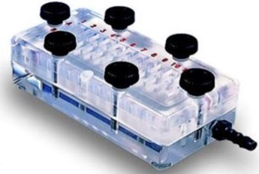
24-hole dot blotter
 | 1 | 2 | 3 | 4 | 5 | 6 | 7 | 8 | 9 | 10 | 11 | 12
A
B
D
Secondary Ab conjugated with HRP
Chemiluminescent detection signal
Enzyme substrate
Primary Ab
Protein spot
PVDF membrane

Figure 4. A flow chart of orthogonal validation (A) and cross-validation (B) in ACT versus INACT showing the type and process protein comparison. A schematic representation of 24-hole dot blotter is shown here (C). Protein samples are loaded in each spot and transferred to PVDF membrane underneath; they are blotted with the required primary and secondary antibody before visualisation with enhanced chemiluminescence reagent (D). Densitometry analysis of the fluorescence intensity is carried out using ‘GeneSNAP’ and ‘GeneTools’ software (not shown here). For the full description of the dot blotting process, see Chapter 3.9. ACT: inflamed rectal mucosa of patients with active UC. INACT: reciprocal uninflamed/inactive proximal mucosa of patients with active UC. HRP: horseradish peroxidase. PVDF: polyvinylidene difluoride.

4.3 Results

3.3.1 Epithelial keratins alterations in ACT versus INACT relative to normal controls
Previously pooled individual patient’s colonic tissue samples in ACT, INACT and control groups were compared using immunoblotting. Median age in ACT/INACT and control patients were 39 and 62, respectively (p=0.03). Median Baron’s endoscopy score in ACT and INACT biopsy samples were 2 (range 2-3) and 0 (range 0-1), respectively. Median histological activity index in ACT and INACT were 2 (range 1-3) and 0 (range 0). Median disease duration was 5 years in the cohort. Median relative insoluble K8/K18/K19 levels from the ACT were significantly lower than those from the INACT mucosa: K8 (p=0.02), K18 (p=0.03) and K19 (p=0.02). The results are shown in Figure 5.
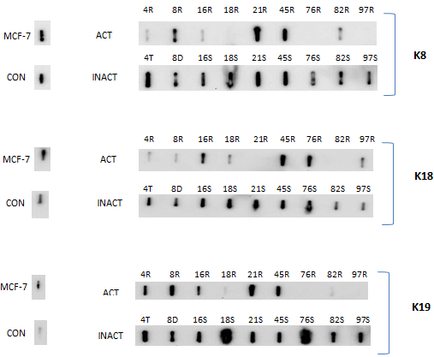
Figure 5. Immunoblotting for K8, 18 and 19 comparing insoluble fractions from individual colonic biopsies of patients with active colitis (ACT) and the reciprocal un-inflamed proximal inactive mucosa (INACT) previously pooled for insoluble iTRAQ study.MCF-7 cell line as well as rectal biopsy from a single normal individual (Nl) was used as controls.

Soluble proteome from the same individual samples were investigated using immunoblotting against K8. Similarly, median relative soluble K8 levels from the ACT were lower than those from the INACT mucosa (p=0.02) (Figure 6). This observation was further corroborated from soluble proteome iTRAQ analysis on the same patient groups’ comparison (Table 10).
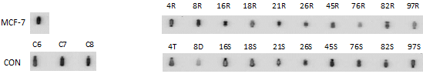
Figure 6. Immunoblotting for K8 comparing soluble fractions from individual colonic biopsies of patients with active colitis (ACT) and the reciprocal un-inflamed proximal inactive mucosa (INACT) previously pooled for insoluble iTRAQ study.MCF-7 cell line as well as rectal biopsy from a single normal individual was used as controls.

Epithelial keratins alteration was confirmed in independent colonic tissue samples from ACT and INACT for external validation. The experiments were carried out separately in F4 and F1 proteome for subsequent direct comparison. In this new cohort, median age in ACT/INACT and control patients were 43 and 58, respectively (p=0.052). Median Baron’s endoscopy score in ACT and INACT biopsy samples were 2 (range 2-3) and 0 (range 0-1), respectively. Median histological activity index in ACT and INACT were 2 (range 1-3) and 0 (range 0-1); median disease duration was 6 years.
Median relative IF K8/K18 levels from ACT were significantly lower than INACT: K8 (p=0.01) and K18 (p=0.03). Median relative IF K19 protein level difference between the two groups did not reach statistical significance (p=0.27) (Figure 7). Similarly, median relative soluble K8 levels from the ACT were lower than those from the INACT mucosa (p=0.02) (Figure 8).
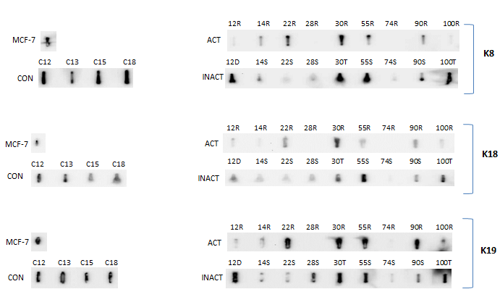
Figure 7. Immunoblotting for K8, 18 and 19 comparing insoluble fractions from individual colonic biopsies of patients with active colitis (ACT) and the reciprocal un-inflamed proximal inactive mucosa (INACT) from independent sample groups, not previously pooled for iTRAQ study. R: rectal sample; D: Descending colon sample; T: Transverse colon sample; MCF-7 cell line as well as rectal biopsy from a single normal individual were used as controls.
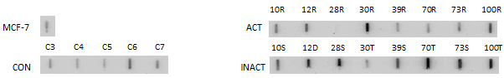
Figure 8. Immunoblotting for K8 comparing soluble fractions from individual colonic biopsies of patients with active colitis (ACT) and the reciprocal un-inflamed proximal inactive mucosa (INACT) from independent sample groups, not previously pooled for iTRAQ study. MCF-7 cell line as well as rectal biopsy from a single normal individual was used as controls.

The outcome data from both validation and cross-validation experiments for the relative K8 levels in F4 and F1 proteomes were combined, successively; the results show similar trends with median relative K8 levels significantly lower in ACT relative to INACT in both soluble (p=0.02) and insoluble (p=0.0009) proteome fractions (Figure 9).

Figure 9. Merged data form previously pooled as well as independent patient samples from ACT, INACT and control cohort groups. The data is shown separately for F1 and F4 fractions. Solid circles represent previously pooled samples; hollow circles represent independent patient sample groups.

In order to investigate whether the lower relative epithelial keratin levels is due to reduced protein expression/degradation or the effect of severe epithelial denudation in ACT mucosa relative to INACT, all the tissue samples with UC histology index of 3 (indicating the presence of erosion or ulceration) were excluded followed by repeat analysis (Figure 10). These analyses suggest reduced relative total K8 expression/degradation as a result of active inflammation relative to the un-inflamed proximal mucosa in UC.
Figure 10. Merged data form previously pooled as well as independent patient samples from ACT, INACT and control cohort groups excluding severe colitis patients. The data is shown separately for F1 and F4 fraction. Solid circles represent previously pooled samples; hollow circles represent independent patient sample groups.

Western blotting was performed on the previously pooled ACT, INACT and control samples (n=9 in each pooled sample group). The results represent a wide range of distribution from 50 to 37 kD, which is visually different between ACT and INACT, as per Figure 11 (For further analysis of K8 bands in ACT and INACT, please see Chapter 7).

50-
kB
MCF-7 CON ACT INACT

37-
50-
IF
kB
MCF-7 CON ACT INACT

37-
S
Figure 41. Western blotting on the pooled samples, used for insoluble (IF) and soluble (S) iTRAQ experiments.

K8 is more abundant in INACT and CON samples with associated wider isoforms variation in comparison to ACT. This is seen in both IF and soluble fractions. Furthermore, this K8 bands observation suggests relatively higher concentration of insoluble as compared to soluble K8 isoforms with lower molecular weight (MW) in ACT.

4.3.2 pSer73 K8 alterations in ACT, INACT and control groups
The relative level of pSer73 K8 was higher in ACT relative to both INACT and normal controls mucosa in the soluble (F1) proteome (Figure 12). All results were expressed relative to total K8 to further ensure the observed alterations are true reflection of pSer73 K8 levels.
70R 73R 81R 8R 16R 82R 21R 30R 45R

MCF-7
70T 73S 81D 8D 16S 82S 21S 30T 45S
C18 C19 C20 C21 C22
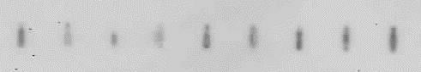
CON
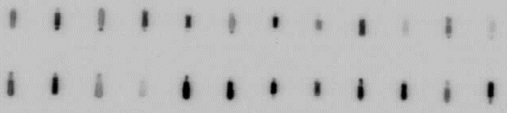
Background K8
Figure 52. Relative levels of pSer73 K8 in soluble proteome extracted from ACT, INACT and control patient sample cohorts. The relative phosphorylation levels of K8 on the Ser73 site of the protein are corrected with the total background relative soluble K8 levels.

The total relative level of phosphorylated K8 (pSer73 K8) was low in insoluble (F4) in comparison to soluble proteome as evidenced by lower immuno-reactive signals on the membranes. There was no difference between the insoluble levels of pSer73 K8 in ACT and INACT patient samples groups (Figure 13).

MCF-7

CON
70T 73S 81D 8D 16S 82S 21S 30T 45S
70R 73R 81R 8R 16R 82R 21R 30R 45R
C18 C19 C20 C21 C22

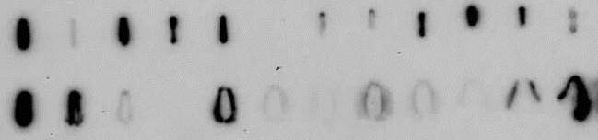
Background K8
Figure 63. Relative levels of pSer73 K8 in insoluble proteome extracted from ACT, INACT and control patient sample cohorts. The relative phosphorylation levels of K8 on the Ser73 site of the protein is corrected with the total background relative IF K8 levels.

Next, possible pSer73 K8 alterations between INACT and normal controls were explored in a new experiment. The results showed increase in the relative level of pSer73 K8 in INACT mucosa compared to normal controls (Figure 14).

MCF-7
8S 12D 14S 16S 21S 26A 30T 70T 73S 81D 82S

C11 C12 C13 C15 C16 C17 C18 C19 C20 C21 C22

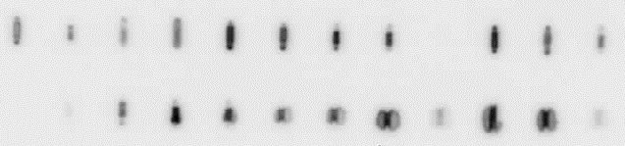
Background K8
Figure 74. Relative levels of pSer73 K8 in soluble proteome extracted from INACT and control patient sample cohorts. The relative phosphorylation levels of K8 on the Ser73 site of the protein are corrected with the total background relative soluble K8 levels.

The experiment was repeated for the insoluble proteome. Similar to ACT and INACT comparison, the total relative level of pSer73 K8 was low in insoluble relative to soluble proteome as evidenced by lower immuno-reactive signals on the membranes. Likewise, there was no difference between the insoluble levels of pSer73 K8 in INACT and control patient samples groups (Figure 15).
MCF-7
8S 12D 14S 16S 21S 26A 30T 70T 73S 81D 82S

C11 C12 C13 C15 C16 C17 C18 C19 C20 C21 C22

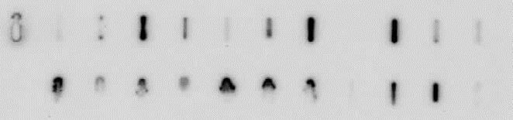
Background K8
Figure 15. Relative levels of pSer73 K8 in insoluble proteome extracted from INACT and control patient sample cohorts. The relative phosphorylation levels of K8 on the Ser73 site of the protein are corrected with the total background relative insoluble K8 levels.

MAPK protein array was performed on pooled samples from ACT, INACT and control patients. The experiment was carried out according to the manufacturer’s recommendation initially (Figure 16). As there were very low signals from all MAPK pathway proteins in the array, the experiment was repeated with 4 times more protein amount (as compared to the manufacturer’s recommendation) in each group to maximise target signals. The repeat experiment showed similar low signals from the pathway proteins.
The protein array membranes post-enhanced chemiluminescences (ECL) are shown below:

Second experiment
First experiment
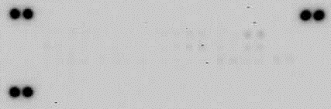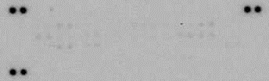
CON
CON
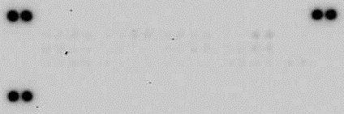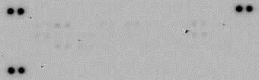
ACT
ACT
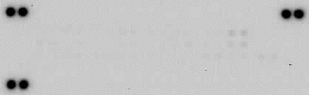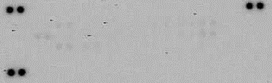
INACT
INACT
Figure 16. Two experiments with Proteome ProfilerTM Array for human phospho-MAPK pathway post-ECL for pooled samples from normal controls (CON), ACT and INACT. Despite increasing the protein concentration 4 times the recommended manufacturer’s advice, the protein target signals are still very weak.
In order to investigate further the possible effect of MAPK pathway proteins on the observed pSer73 K8 alterations and ensure weak signals from the phosphor-MAPK array kit on target spots was not due to sample protein deterioration, immunoblotting was carried out using activated (phosphorylated) P38 (pP38) on INACT and normal control sample groups. Although the experiment did not show differential levels of pP38 in INACT versus normal controls, it ruled out possibility of sample deterioration as a cause of MAPK protein array failure (Figure 17).
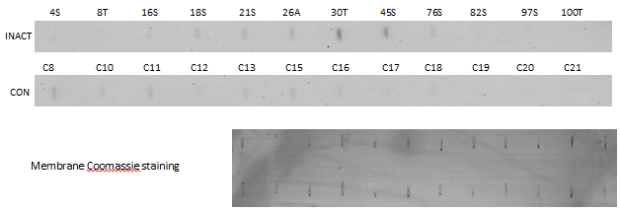
Figure 17. Relative levels of pP38 in soluble proteome extracted from INACT and control patient sample cohorts. The relative pP38 levels are corrected with the total background protein amount using Coomassie staining of the membrane.

4.3.3 Soluble iTRAQ analysis outcome comparing ACT and INACT relative to normal controls
In the second part of the study, the pooled soluble proteome from ACT to INACT and normal controls was initially compared in a hypothesis-generating exploratory proteomics analysis.

4.3.3.1 ACT versus INACT analysis
The comparison of soluble proteome in ACT to INACT mucosa was carried out. The differentially expressed upregulated and down-regulated proteins in ACT relative to INACT are summarised in Tables 6&7.
Table 6. Upregulated proteins in ACT relative to INACT (Reference INACT). General data regarding each protein’s gene name, length and mass was extracted from UniProt database on 26/01/2016. Fold change and p-value for each protein were directly extracted from the iTRAQ analysis. (Sequence) Length indicates the number of amino acids in the canonical sequence. (Molecular) Mass in Daltons (Da), calculated from the full precursor canonical sequence.
Protein name(s) | Accession No | Gene names | Length | Mass | Fold change | p-value
Ig alpha-1 chain C region | P01876 | IGHA1 | 353 | 37655 | 3.09 | 0.000232
Protein S100-A8 (Calgranulin-A) (Calprotectin L1L subunit) | P05109 | MRP8 | 93 | 10835 | 2.84 | 9.35E-05
Heat shock cognate 71 kDa protein (Heat shock 70 kDa protein 8) | P11142 | HSPA8 | 646 | 70898 | 2.46 | 0.009112
Endoplasmin (94 kDa glucose-regulated protein) (GRP-94) | P14625 | HSP90B1 | 803 | 92469 | 2.15 | 2.54E-05
GTP-binding nuclear protein Ran (Androgen receptor-associated protein 24) (GTPase Ran) (Ras-like protein TC4) (Ras-related nuclear protein) | P62826 | RAN; ARA24 | 216 | 24423 | 2.08 | 0.007775
Pyruvate kinase PKM | P14618 | PKM | 531 | 57937 | 1.84 | 0.001034
Dolichyl-diphosphooligosaccharide--protein glycosyltransferase subunit 1 | P04843 | RPN1 | 607 | 68569 | 1.84 | 0.004108
Actin, cytoplasmic 1 (Beta-actin) | P60709 | ACTB | 375 | 41737 | 1.83 | 6.29E-06
Glyceraldehyde-3-phosphate dehydrogenase (GAPDH) | P04406 | GAPDH | 335 | 36053 | 1.7 | 8.53E-06
Coronin-1A (Coronin-like protein A) | P31146 | CORO1A | 461 | 51026 | 1.58 | 0.00558
Fructose-bisphosphate aldolase A | P04075 | ALDOA | 364 | 39420 | 1.51 | 0.000204
Transitional endoplasmic reticulum ATPase (TER ATPase) | P55072 | VCP | 806 | 89322 | 1.51 | 0.003262
Keratin, type II cytoskeletal 1 | P04264 | KRT1 | 644 | 66039 | 1.4 | 0.001674
Protein disulfide-isomerase A6 (Endoplasmic reticulum protein 5) (Thioredoxin domain-containing protein 7) | Q15084 | PDIA6 | 440 | 48121 | 1.39 | 0.003156
Alpha-enolase | P06733 | ENO1 | 434 | 47169 | 1.31 | 0.002432
Heterogeneous nuclear ribonucleoprotein A3 (hnRNP A3) | P51991 | HNRNPA3 | 378 | 39595 | 1.31 | 0.002718

Table 7. Down-regulated proteins in ACT relative to INACT (Reference INACT).General data regarding each protein’s gene name, length and mass was extracted from UniProt database on 26/01/2016. Fold change and p-value for each protein were directly extracted from the iTRAQ analysis. (Sequence) Length indicates the number of amino acids in the canonical sequence. (Molecular) Mass in Daltons (Da), calculated from the full precursor canonical sequence.
Protein name(s) | Accession No | Gene name | Length | Mass | Fold change | p-value
Fatty acid-binding protein, liver | P07148 | FABP1 | 127 | 14,208 | 0.18 | 3.269E-07
Carbonic anhydrase 2 | P00918 | CA2 | 260 | 29,246 | 0.32 | 0.0003812
Calcium-activated chloride channel regulator 1 | A8K7I4 | CLCA1 | 914 | 100,226 | 0.32 | 0.0009791
Keratin, type II cytoskeletal 8 | P05787 | KRT8 | 483 | 53,704 | 0.42 | 2.895E-10
Keratin, type I cytoskeletal 19 | P08727 | KRT19 | 400 | 44,106 | 0.42 | 9.772E-07
Keratin, type I cytoskeletal 20 | P35900 | KRT20 | 424 | 48,487 | 0.44 | 0.0011849
Creatine kinase B-type | P12277 | CKB | 381 | 42,644 | 0.51 | 0.0085565
Hemoglobin subunit delta | P02042 | HBD | 147 | 16,055 | 0.52 | 0.0002084
Keratin, type I cytoskeletal 18 | P05783 | KRT18 | 430 | 48,058 | 0.53 | 9.558E-05
Selenium-binding protein 1 | Q13228 | SELENBP1 | 472 | 52,391 | 0.55 | 0.0032792
LIM domain and actin-binding protein 1 | Q9UHB6 | LIMA1 | 759 | 85,226 | 0.56 | 0.0027158
Serum albumin | P02768 | ALB | 609 | 69,367 | 0.70 | 1.151E-07
ATP synthase subunit alpha, mitochondrial | P25705 | ATP5A1 | 553 | 59,751 | 0.71 | 0.0037224
Myosin regulatory light chain 12A | P19105 | MYL12A | 171 | 19,794 | 0.72 | 0.006029
Galectin-4 (Gal-4) | P56470 | LGALS4 | 323 | 35,941 | 0.76 | 0.0081371
Hemoglobin subunit alpha | P69905 | HBA1 | 142 | 15,258 | 0.77 | 0.0009146
Hemoglobin subunit beta | P68871 | HBB | 147 | 15,998 | 0.79 | 2.587E-05
Neuroblast differentiation-associated protein AHNAK (Desmoyokin) | Q09666 | AHNAK | 5890 | 629,101 | 0.80 | 6.341E-05

The significant possible altered pathways in the ACT relative to INACT, investigated via Reactome analysis (for more details of Reactome-V62 statistical analyses, please see Chapter 3.11), are shown in Table 8. Although metabolism of carbohydrates, vesicle-mediated transports, keratinisation, innate immune system and transport of small molecules show significant p-value and FDR, only erythrocyte pathways seem significantly altered when P value, FDR, the number of entities found in comparison to the number of entities in each pathway are taken into consideration collectively.

Table 8. Possible discriminatory pathways in ACT relative to INACT (entities FDR ≤0.05 and p value ≤0.05). Data extracted from Reactome database on 16/01/2018.
Pathway name | #Entities found | #Entities total | Entities pValue | Entities FDR | Mapped Gene name | Mapped entities accession No
Erythrocytes take up oxygen and release carbon dioxide | 3 | 8 | 2.67E-06 | 4.38E-04 | HBB; HBA1; CA2 | P68871;P69905;P00918
Glycolysis | 5 | 76 | 4.89E-06 | 4.38E-04 | ENO1; PKM; GAPDH; ALDOA | P06733;P14618-2;  P14618-1;P04406;P04075
O2/CO2 exchange in erythrocytes | 3 | 12 | 8.94E-06 | 4.38E-04 | HBB; HBA1; CA2 | P68871;P69905;P00918
Erythrocytes take up carbon dioxide and release oxygen | 3 | 12 | 8.94E-06 | 4.38E-04 | HBB; HBA1; CA2 | P68871;P69905;P00918
Glucose metabolism | 5 | 96 | 1.50E-05 | 5.85E-04 | ENO1; PKM; GAPDH; ALDOA | P06733;P14618-2;  P14618-1;P04406;P04075
Formation of the cornified envelope | 5 | 129 | 6.08E-05 | 0.002 | KRT8; KRT19; KRT20; KRT18; KRT1 | P05787;P08727;P35900;P05783;  P04264
Binding and Uptake of Ligands by Scavenger Receptors | 5 | 129 | 6.08E-05 | 0.002 | HBB; HSP90B1; ALB; IGHA1; HBA1 | P68871;P14625;P02768;P01876;  P69905
Gluconeogenesis | 3 | 34 | 1.94E-04 | 0.005 | ENO1; GAPDH; ALDOA | P06733;P04406;P04075
Scavenging of heme from plasma | 4 | 99 | 3.03E-04 | 0.006 | HBB; ALB; IGHA1; HBA1 | P68871;P02768;P01876;P69905
Keratinization | 5 | 217 | 6.67E-04 | 0.013 | KRT8; KRT19; KRT20; KRT18; KRT1 | P05787;P08727;P35900;P05783;  P04264
Neutrophil degranulation | 7 | 480 | 8.07E-04 | 0.014 | HSPA8; PKM; S100A8; HBB; ALDOA; VCP; KRT1 | P11142;P14618;P05109;P68871;  P04075;P55072;P04264
Protein methylation | 2 | 17 | 0.001 | 0.023 | HSPA8; VCP | P11142;P55072
Metabolism of carbohydrates | 5 | 279 | 0.002 | 0.030 | ENO1; PKM; GAPDH; ALDOA | P06733;P14618-2;  P14618-1;P04406;P04075

The interactions between these altered (upregulated (n=16) and down-regulated (n=18)) proteins in ACT relative to INACT are shown in Figure 18. Two proteins were subsequently excluded (LIMA1 and AHNAK), as they were orphan nodes within the network with no association to other proteins in the group. This is a qualitative analysis of the whole dataset using STRINGS (a database of known and predicted protein interactions to determine protein interacting networks (PIN) represented by the data set). Three principle PINs emerged in this analysis, with clusters around pyruvate kinase (PKM), haemoglobin subunits (HBA, HBB, HBD), and the keratin components (K8, K18, K19).
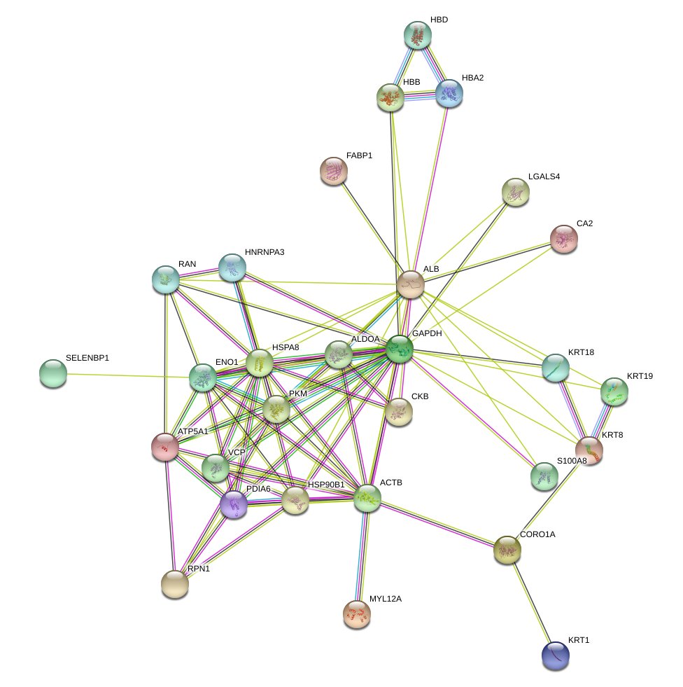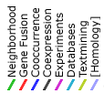
O2/CO2 exchange in erythrocytes
Cytoskeleton
Metabolism (of carbohydrates)

Figure 18. Protein–protein interaction (PPI) network view summarising the network of predicted associations between differentially expressed proteins in ACT relative to INACT(orphan nodes not shown), and indicating proteins interlinked with clusters around metabolism of carbohydrates (solid line), cytoskeleton (dashed line) and O2/CO2 exchange of erythrocytes (long-dashed line). Data accessed from STRING 10.5 database on 01/10/2017.

4.3.3.2 ACT versus Controls analysis
Next, soluble proteome between ACT and controls was assessed. The differentially expressed upregulated and down-regulated proteins in ACT relative to normal controls are summarised in Tables 9&10.

Table 9. Upregulated proteins in ACT relative to normal controls. General data regarding each protein’s gene name, length and mass was extracted from UniProt database on 26/01/2016. Fold change and p-value for each protein were directly extracted from the iTRAQ analysis. (Sequence) Length indicates the number of amino acids in the canonical sequence. (Molecular) Mass in Daltons (Da), calculated from the full precursor canonical sequence.
Protein name(s) | Accession No | Gene name | Length | Mass | Fold change | p-value
Protein S100-A9 (Calprotectin L1H subunit) | P06702 | S100A9 | 114 | 13,242 | 8.79 | 0.0096655
Protein S100-A8 (Calgranulin-A) (Calprotectin L1L subunit) | P05109 | S100A8 | 93 | 10,835 | 8.51 | 0.0003137
Ig alpha-1 chain C region | P01876 | IGHA1 | 353 | 37,655 | 2.96 | 0.0006442
Endoplasmin (94 kDa glucose-regulated protein) (GRP94) | P14625 | HSP90B1 | 803 | 92,469 | 2.17 | 2.29E-08
Coronin-1A (Coronin-like protein A) | P31146 | CORO1A | 461 | 51,026 | 2.07 | 0.0036904
Heat shock protein HSP 90-beta | P08238 | HSP90AB1 | 724 | 83,264 | 1.94 | 8.666E-05
Thioredoxin domain-containing protein 5 (Endoplasmic reticulum resident protein 46) | Q8NBS9 | TXNDC5 | 432 | 47,629 | 1.93 | 0.0035737
Pyruvate kinase PKM | P14618 | PKM | 531 | 57,937 | 1.69 | 0.0065074
Ribosome-binding protein 1 | Q9P2E9 | RRBP1 | 1410 | 152,472 | 1.56 | 6.245E-05
78 kDa glucose-regulated protein (GRP-78) (Endoplasmic reticulum lumenal Ca(2+)-binding protein grp78) | P11021 | HSPA5 | 654 | 72,333 | 1.54 | 0.0001296
Alpha-enolase 1 | P06733 | ENO1 | 434 | 47,169 | 1.54 | 4.967E-05
78 kDa glucose-regulated protein (GRP-78) (Endoplasmic reticulum lumenal Ca(2+)-binding protein grp78) | P11021 | HSPA5 | 654 | 72,333 | 1.54 | 0.0001296
Glyceraldehyde-3-phosphate dehydrogenase | P04406 | GAPDH | 335 | 36,053 | 1.49 | 4.345E-06
Protein disulfide-isomerase | P07237 | P4HB | 508 | 57,116 | 1.44 | 0.0014491
Tropomyosin beta chain | P07951 | TPM2 | 284 | 32,851 | 1.38 | 1.415E-06
Protein disulfide-isomerase A3 (Endoplasmic reticulum resident protein 57) | P30101 | PDIA3 | 505 | 56,782 | 1.25 | 0.0035828
Vimentin | P08670 | VIM | 466 | 53,652 | 1.21 | 0.0003086

Table 10. Down-regulated proteins in ACT relative to normal controls. General data regarding each protein’s gene name, length and mass was extracted from UniProt database on 26/01/2016. Fold change and p-value for each protein were directly extracted from the iTRAQ analysis. (Sequence) Length indicates the number of amino acids in the canonical sequence. (Molecular) Mass in Daltons (Da), calculated from the full precursor canonical sequence.
Protein name(s) | Accession No | Gene name | Length | Mass | Fold change | p-value
Creatine kinase B-type | P12277 | CKB | 381 | 42,644 | 0.24 | 0.000101
Carbonic anhydrase 2 | P00918 | CA2 | 260 | 29,246 | 0.31 | 1.944E-05
Keratin, type I cytoskeletal 19 | P08727 | KRT19 | 400 | 44,106 | 0.41 | 3.005E-07
Heat shock protein beta-1 | P04792 | HSPB1 | 205 | 22,783 | 0.42 | 0.0025587
Tropomyosin alpha-1 chain | P09493 | TPM1 | 284 | 32,709 | 0.45 | 5.848E-09
Haemoglobin subunit delta | P02042 | HBD | 147 | 16,055 | 0.46 | 2.625E-08
Thioredoxin | P10599 | TRX | 105 | 11,737 | 0.53 | 0.0024568
Calcium-activated chloride channel regulator 1 | A8K7I4 | CLCA1 CACC1 | 914 | 100,226 | 0.55 | 0.0062554
Selenium-binding protein 1 | Q13228 | SELENBP1 | 472 | 52,391 | 0.59 | 0.0018748
Haemoglobin subunit beta | P68871 | HBB | 147 | 15,998 | 0.60 | 1.667E-14
Keratin, type II cytoskeletal 8 | P05787 | KRT8 | 483 | 53,704 | 0.61 | 4.678E-09
Haemoglobin subunit alpha | P69905 | HBA1 | 142 | 15,258 | 0.63 | 3.533E-11
ATP synthase subunit alpha, mitochondrial | P25705 | ATP5A1 | 553 | 59,751 | 0.63 | 0.0010534
Neuroblast differentiation-associated protein | Q09666 | AHNAK | 5890 | 629,101 | 0.65 | 1.159E-05
Serum albumin | P02768 | ALB | 609 | 69,367 | 0.68 | 3.565E-10
Myosin regulatory light chain 12A | P19105 | MYL12A | 171 | 19,794 | 0.69 | 0.0020246
Keratin, type I cytoskeletal 20 | P35900 | KRT20 | 424 | 48,487 | 0.71 | 0.0071713
Keratin, type I cytoskeletal 18 | P05783 | KRT18 | 430 | 48,058 | 0.76 | 2.949E-05
Filamin-A (FLN-A) | P21333 | FLNA | 2647 | 280,739 | 0.78 | 3.721E-05

The interactions between these altered (upregulated (n=17) and down-regulated (n=19)) proteins in ACT relative to normal controls, using STRINGS, are shown in Figure 19. Two proteins were subsequently excluded (CLCA, IGHA1), as they were orphan nodes within the network. Four principle PINs emerged in this analysis, with clusters around Thioredoxin (TXN)/ Protein disulfide-isomerase A3 (PDIA3), haemoglobin subunits (HBA, HBB, HBD), Tropomyosin (TPM1, TPM2, TPM3), and keratin components (K8, K18, K19).

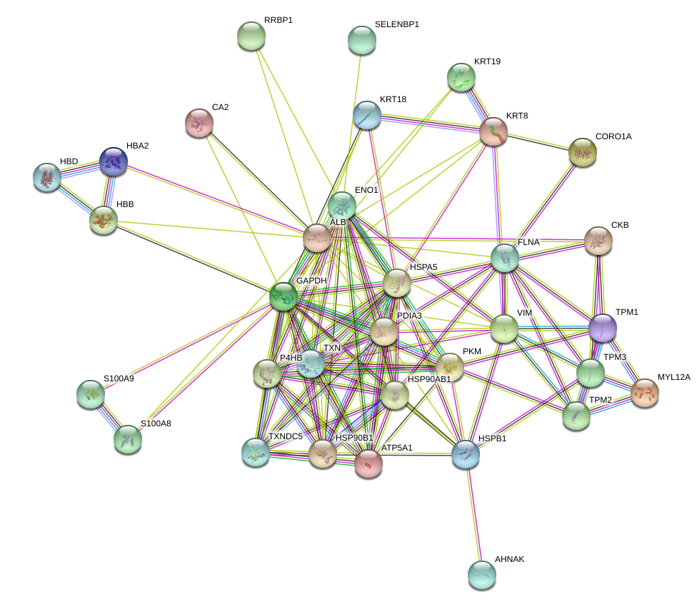
Metabolism (of carbohydrates)
Muscle contraction
Cytoskeleton
O2/CO2 exchange in erythrocytes
Figure 19. Protein–protein interaction (PPI) network view summarising the network of predicted associations between differentially expressed proteins in ACT relative to control groups(orphan nodes not shown), and indicating proteins interlinked with clusters around metabolism of carbohydrates (solid line), muscle contraction (square dot line), cytoskeleton (long dash-dot line) and O2/CO2 exchange of erythrocytes (long dash line). Data accessed from STRING 10.5 database on 01/10/2017.

The statistically significant altered pathways in the ACT relative to controls were investigated in Table 11. Although transport of small molecules, muscle contraction, metabolism of carbohydrates, vesicle-mediated transport, antimicrobial peptides, TLR cascades, unfolded protein response, NLR signalling pathways, keratinisation and cellular responses to stress show significant p-value and FDR, only erythrocyte and antimicrobial pathways seem significantly altered when P value, FDR, the number of entities found in comparison to the number of entities in each pathway are taken into consideration collectively.

Table 11. Possible discriminatory pathways in ACT relative to normal controls (entities FDR ≤0.05 and p value ≤0.05). Data extracted from Reactome database on 16/01/2018.
Pathway name | #Entities found | #Entities total | Entities pValue | Entities FDR | Mapped Gene name | Mapped entities
Erythrocytes take up oxygen and release carbon dioxide | 3 | 8 | 3.15E-06 | 3.27E-04 | HBB; HBA; CA2 | P68871;P69905;P00918
Smooth Muscle Contraction | 4 | 35 | 6.85E-06 | 3.27E-04 | TPM1; TPM3; MYL12A; TPM2 | P09493;P06753;P19105;P07951
Striated Muscle Contraction | 4 | 36 | 7.65E-06 | 3.27E-04 | VIM; TPM1; TPM3; TPM2 | P08670;P09493;P06753;P07951
O2/CO2 exchange in erythrocytes | 3 | 12 | 1.05E-05 | 3.27E-04 | HBB; HBA; CA2 | P68871;P69905;P00918
Erythrocytes take up carbon dioxide and release oxygen | 3 | 12 | 1.05E-05 | 3.27E-04 | HBB; HBA; CA2 | P68871;P69905;P00918
Binding and Uptake of Ligands by Scavenger Receptors | 5 | 129 | 7.94E-05 | 0.002 | HBB; HSP90B1; ALB; IGHA1; HBA | P68871;P14625;P02768;P01876;  P69905
Glycolysis | 4 | 76 | 1.38E-04 | 0.003 | ENO1; PKM; GAPDH | P06733;P14618-2;P14618-1;P04406
Metal sequestration by antimicrobial proteins | 2 | 6 | 2.05E-04 | 0.004 | S100A9; S100A8 | P06702;P05109
Glucose metabolism | 4 | 96 | 3.34E-04 | 0.006 | ENO1; PKM; GAPDH | P06733;P14618-2;P14618-1;P04406
Scavenging of heme from plasma | 4 | 99 | 3.75E-04 | 0.006 | HBB; ALB; IGHA1; HBA | P68871;P02768;P01876;P69905
ATF6 (ATF6-alpha) activates chaperone genes | 2 | 10 | 5.65E-04 | 0.008 | HSPA5; HSP90B1 | P11021;P14625
Muscle contraction | 5 | 205 | 6.66E-04 | 0.009 | VIM; TPM1; TPM3; MYL12A; TPM2 | P08670;P09493;P06753;P19105;  P07951
ATF6 (ATF6-alpha) activates chaperones | 2 | 12 | 8.10E-04 | 0.010 | HSPA5; HSP90B1 | P11021;P14625
The NLRP3 inflammasome | 2 | 13 | 9.48E-04 | 0.010 | TXN; HSP90AB1 | P10599;P08238
Formation of the cornified envelope | 4 | 129 | 0.001 | 0.010 | KRT8; KRT19; KRT20; KRT18 | P05787;P08727;P35900;P05783
Regulation of TLR by endogenous ligand | 2 | 19 | 0.002 | 0.018 | S100A9; S100A8 | P06702;P05109
Inflammasomes | 2 | 21 | 0.002 | 0.022 | TXN; HSP90AB1 | P10599;P08238
Neutrophil degranulation | 6 | 480 | 0.006 | 0.041 | S100A9; TXNDC5; PKM; S100A8; HBB; HSP90AB1 | P06702;Q8NBS9;P14618;P05109;  P68871;P08238
Post-translational protein phosphorylation | 3 | 107 | 0.006 | 0.041 | HSP90B1;ALB; P4HB | P14625;P02768;P07237
Gluconeogenesis | 2 | 34 | 0.006 | 0.041 | ENO1; GAPDH | P06733;P04406
Keratinization | 4 | 217 | 0.006 | 0.041 | KRT8; KRT19; KRT20; KRT18 | P05787;P08727;P35900;P05783

4.3.3.3 INACT versus Controls analysis
Finally, soluble proteomes between INACT and controls were assessed. The differentially expressed upregulated and down-regulated proteins in INACT relative to controls are summarised in Tables 12&13.
Table 12. Upregulated proteins in INACT relative to normal controls. General data regarding each protein’s gene name, length and mass was extracted from UniProt database on 26/01/2016. Fold change and p-value for each protein were directly extracted from the iTRAQ analysis. (Sequence) Length indicates the number of amino acids in the canonical sequence. (Molecular) Mass in Daltons (Da), calculated from the full precursor canonical sequence.
Protein name(s) | Accession No | Gene name | Length | Mass | Fold change | p-value
Protein S100-A8 (Calprotectin L1L subunit) | P05109 | S100A8 | 93 | 10,835 | 3.11 | 0.0015339
Protein S100-A9 (Calprotectin L1H subunit) | P06702 | S100A9 | 114 | 13,242 | 3.06 | 2.347E-05
Calcium-activated chloride channel regulator 1 | A8K7I4 | CLCA1 | 914 | 100,226 | 1.80 | 0.000979
Tropomyosin beta chain | P07951 | TPM2 | 284 | 32,851 | 1.52 | 4.891E-05
Lamin-B2 | Q03252 | LMNB2 | 620 | 69,948 | 1.46 | 0.000864
Rho GDP-dissociation inhibitor 2 | P52566 | ARHGDIB | 201 | 22,988 | 1.39 | 0.0012726
Ubiquitin carboxyl-terminal hydrolase 17-like protein 3 | A6NCW0 | USP17L3 | 530 | 59,536 | 1.33 | 0.0001434
Myosin-14 (Myosin heavy chain 14) | Q7Z406 | MYH14 | 1995 | 227,871 | 1.28 | 0.0081717
Protein disulfide-isomerase A3 | P30101 | PDIA3 | 505 | 56,782 | 1.25 | 0.0039433
Vimentin | P08670 | VIM | 466 | 53,652 | 1.21 | 0.0004378

Table 13. Down-regulated proteins in INACT relative to normal controls. General data regarding each protein’s gene name, length and mass was extracted from UniProt database on 26/01/2016. Fold change and p-value for each protein were directly extracted from the iTRAQ analysis. (Sequence) Length indicates the number of amino acids in the canonical sequence. (Molecular) Mass in Daltons (Da), calculated from the full precursor canonical sequence.
Protein name(s) | Accession No | Gene name | Length | Mass | Fold change | p-value
Creatine kinase B-type | P09493 | CKB | 381 | 42,644 | 0.50 | 0.0032587
Transgelin (22 kDa actin-binding protein) | P68871 | TAGLN | 201 | 22,611 | 0.72 | 6.444E-05
Tropomyosin alpha-3 chain | P06753 | TPM3 | 285 | 32,950 | 0.79 | 2.347E-05
Tropomyosin alpha-1 chain | P09493 | TPM1 | 284 | 32,709 | 0.79 | 0.0001017
Hemoglobin subunit beta | P21333 | HBB | 147 | 15,998 | 0.79 | 0.0026647
Filamin-A (Actin-binding protein 280) | P12277 | FLNA | 2647 | 280,739 | 0.82 | 0.0005822

The interactions between these differential (upregulated (n=10) and down-regulated (n=6)) proteins in INACT relative to normal controls are shown in Figure 20. Six proteins were subsequently excluded (CLCA, TAGLN, HBB, LMNB2, ARHGDIB, USP17L3), as they were orphan nodes within the network. One principle PIN emerged in this analysis, with clusters around TPMs/Vimentin (VIM).

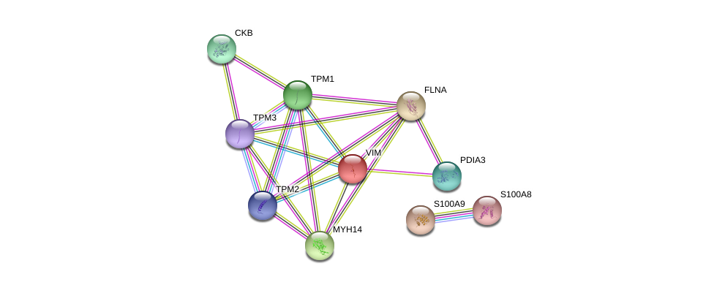
Muscle contraction
Innate immune system
Figure 208. Protein–protein interaction (PPI) network view summarising the network of predicted associations between differentially expressed proteins in ACT relative to control groups(orphan nodes not shown), and indicating proteins interlinked with clusters around muscle contraction (solid line), and innate immune system (square-dot line). Data accessed from STRING 10.5 database on 01/10/2017.

The statistically significant altered pathways in the INACT relative to controls were summarised in Table 14. Although muscle contraction, antimicrobial peptides, TLR cascades and signalling by Rho GTPases show significant p-value and FDR, only antimicrobial peptides pathway may show alteration in this category when P value, FDR, the number of entities found in comparison to the number of entities in each pathway are taken into consideration collectively.

Table 14. Possible discriminatory pathways in INACT relative to normal controls (entities FDR ≤0.05 and p value ≤0.05). Data extracted from Reactome database on 27/01/2016.
Pathway name | #Entities found | #Entities total | Entities pValue | Entities FDR | Mapped Gene names | Mapped entities
Striated Muscle Contraction | 4 | 36 | 1.50E-07 | 1.01E-05 | TPM1; TPM3; TPM2; VIM | P08670;P09493;P06753;P07951
Smooth Muscle Contraction | 3 | 35 | 1.41E-05 | 4.66E-04 | TPM1; TPM3; TPM2 | P09493;P06753;P07951
Metal sequestration by antimicrobial proteins | 2 | 6 | 3.09E-05 | 6.80E-04 | S100A9; S100A8 | P06702;P05109
Muscle contraction | 4 | 205 | 1.38E-04 | 0.002207 | TPM1; TPM3; TPM2; VIM | P08670;P09493;P06753;P07951
Regulation of TLR by endogenous ligand | 2 | 19 | 3.07E-04 | 0.003987 | S100A9; S100A8 | P06702;P05109
RHO GTPases activate PAKs | 2 | 21 | 3.74E-04 | 0.004114 | MYH14; FLNA | P21333;Q7Z406

4.3.3.4 Biomarker discovery
Target proteins were initially identified on the basis of relative fold change differences of about 2 or more between the study groups. They were scrutinised and finally chosen for orthogonal analysis on the basis of antibody availability and their role in known inflammatory pathways involved in UC (Table 15&16). Using this decision tree algorythm, the following proteins were finally chosen for orthogonal validation and biomarker discovery: Ig alpha-1 chain C region (IGHA1), Protein S100-A8 (MRP8), Carbonic anhydrase 2 (CA2), Thioredoxin (TRX). Cell surface A33 antigen (GPAA33) was further added for the validation study, as this protein showed significant fold change of 0.29 (p=0.007) between ACT and pooled control 1. Although cytokeratin 10 (K10) did not have significant fold change difference between the compared groups, due to antibodies availability, this protein was also included for biomarker discovery.
Table 15. Candidate biomarkers - ACT versus normal controls.
Upregulated | Accession No |  | Fold change | Downregulated | Accession No | Fold change
Protein S100-A9 |  | P06702 | 8.79 | Creatine kinase B-type | P12277 | 0.24
Protein S100-A8 |  | P05109 | 8.51 | Carbonic anhydrase 2 | P00918 | 0.31
Ig alpha-1 chain C region |  | P01876 | 2.96 | Keratin, type I cytoskeletal 19 | P08727 | 0.41
Endoplasmin |  | P14625 | 2.17 | Heat shock protein beta-1 | P04792 | 0.42
Coronin-1A |  | P31146 | 2.07 | Tropomyosin alpha-1 chain | P09493 | 0.45
 |  |  |  | Haemoglobin subunit delta | P02042 | 0.46
 |  |  |  | Thioredoxin | P10599 | 0.53

Table 16. Candidate biomarkers - INACT versus normal controls.
Up-regulated | Accession No | Fold change | Down-regulated | Accession No | Fold change
Protein S100-A8 | P05109 | 3.11 | Creatine kinase B-type | P12277 | 0.5
Protein S100-A9 | P06702 | 3.06

4.3.3.5 Orthogonal validation and cross-validation of candidate biomarkers of UC disease activity

Selected proteins for orthogonal validation were quantified with immunoblotting in the previously pooled cohort for iTRAQ study, as well as independent cohorts of patient samples from similar corresponding groups.

The results for CA2 in both pooled and independent groups of patient samples from ACT and INACT cohort are shown in Figure 20. In line with iTRAQ outcome, relative CA2 level was lower in ACT compared to both INACT (p=0.0001) and normal control groups (p=0.0001).

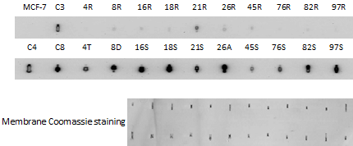
A

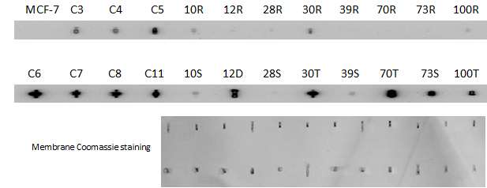
B
C
Figure 21. Selected ACT, INACT and control groups were immunoblotted against CA2 including: previously pooled patient cohorts (A), independent patient cohort (B), as well as merged data form these two groups (C). Each patient and control is given a unique anonymised number. Each patient’s active rectal sample is immunoblotted against the corresponding inactive proximal colonic mucosa for direct comparison. A control MCF-7 sample is included in the immunoblot to allow normalisation between sample groups. Relative CA2 concentration for each dot-blot is inferred by determining its signal intensity relative to the MCF-7 CA2 signal intensity, measured in turn by densitometry. Membrane Coomassie staining is performed to confirm equal protein amount in each dot-blot space. C=control; R=Rectum (ACT); S=sigmoid (INACT); D=Descending (INACT); T=Transverse (INACT); A=Ascending (INACT).
The results for GPA33 in both pooled and independent groups of patient samples from ACT and INACT cohort are shown in Figure 22. Relative GPA33 level was lower in ACT compared to both INACT (p=0.02) and normal control groups (p=0.006).
A
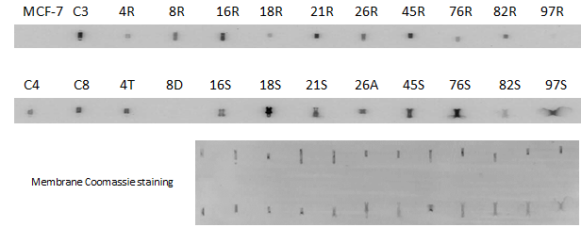
B
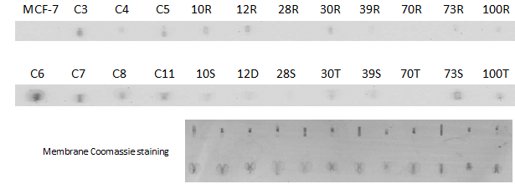
C
Figure 22. Selected ACT, INACT and control groups were immunoblotted against GPA33 including: previously pooled patient cohorts (A), independent patient cohort (B), as well as merged data form these two groups (C). Each patient and control is given a unique anonymised number. Each patient’s active rectal sample is immunoblotted against the corresponding inactive proximal colonic mucosa for direct comparison. A control MCF-7 sample is included in the immunoblot to allow normalisation between sample groups. Relative GPA33 concentration for each dot-blot is inferred by determining its signal intensity relative to the MCF-7 GPA33 signal intensity, measured in turn by densitometry. Membrane Coomassie staining is performed to confirm equal protein amount in each dot-blot space. C=control; R=Rectum (ACT); S=sigmoid (INACT); D=Descending (INACT); T=Transverse (INACT); A=Ascending (INACT).

The results for IGHA1 in both pooled and independent groups of patient samples from ACT and INACT cohort are shown in Figure 23. In line with iTRAQ outcomes, relative IGHA1 level was higher in ACT compared to normal control groups (p=0.0001). Furthermore, relative IGHA1 level was higher in INACT compared to normal controls (p=0.004).
A
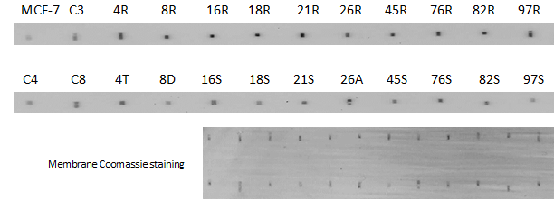
B
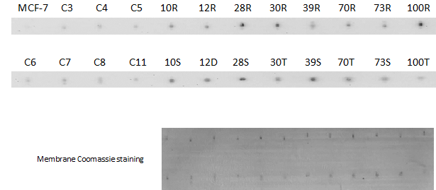
C
Figure 93. Selected ACT, INACT and control groups were immunoblotted against IGHA1 including: previously pooled patient cohorts (A), independent patient cohort (B), as well as merged data form these two groups (C). Each patient and control is given a unique anonymised number. Each patient’s active rectal sample is immunoblotted against the corresponding inactive proximal colonic mucosa for direct comparison. A control MCF-7 sample is included in the immunoblot to allow normalisation between sample groups. Relative IGHA1 concentration for each dot-blot is inferred by determining its signal intensity relative to the MCF-7 IGHA1 signal intensity, measured in turn by densitometry. Membrane Coomassie staining is performed to confirm equal protein amount in each dot-blot space. C=control; R=Rectum (ACT); S=sigmoid (INACT); D=Descending (INACT); T=Transverse (INACT); A=Ascending (INACT).

The results for MRP8 in both pooled and independent groups of patient samples from ACT and INACT cohort are shown in Figures 24. In line with iTRAQ outcomes, relative MRP8 level was higher in ACT compared to both INACT (p=0.002) and normal control groups (p=0.002). Furthermore, relative MRP8 level was higher in INACT compared to normal controls (p=0.004).

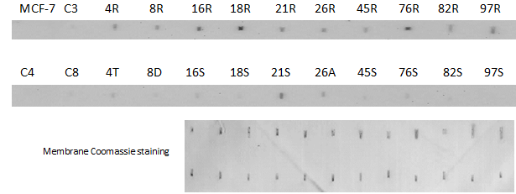
A
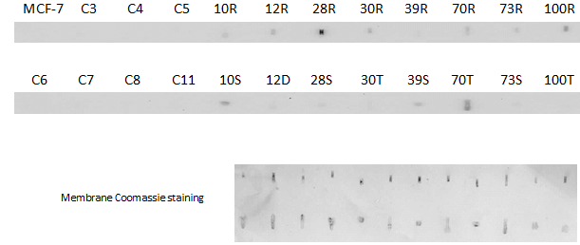
B
C
Figure 104. Selected ACT, INACT and control groups were immunoblotted against MRP8 including: previously pooled patient cohorts (A), independent patient cohort (B), as well as merged data form these two groups (C). Each patient and control is given a unique anonymised number. Each patient’s active rectal sample is immunoblotted against the corresponding inactive proximal colonic mucosa for direct comparison. A control MCF-7 sample is included in the immunoblot to allow normalisation between sample groups. Relative MRP8 concentration for each dot-blot is inferred by determining its signal intensity relative to the MCF-7 MRP8 signal intensity, measured in turn by densitometry. Membrane Coomassie staining is performed to confirm equal protein amount in each dot-blot space. C=control; R=Rectum (ACT); S=sigmoid (INACT); D=Descending (INACT); T=Transverse (INACT); A=Ascending (INACT).
The results for TRX in both pooled and independent groups of patient samples from ACT and INACT cohort are shown in Figure 25. Relative TRX level was higher in ACT compared to normal controls (p=0.008). Furthermore, relative TRX level was higher in INACT compared to normal controls (p=0.05).
A
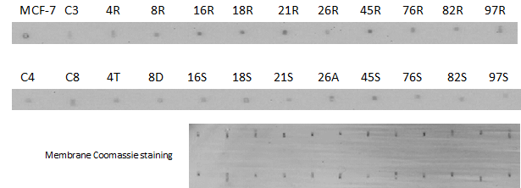
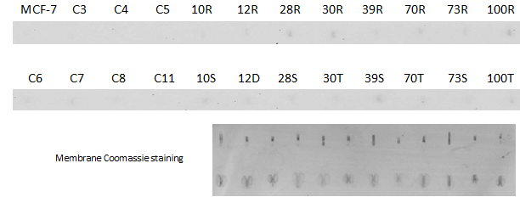
B
C
Figure 115. Selected ACT, INACT and control groups were immunoblotted against TRX including: previously pooled patient cohorts (A), independent patient cohort (B), as well as merged data form these two groups (C). Each patient and control is given a unique anonymised number. Each patient’s active rectal sample is immunoblotted against the corresponding inactive proximal colonic mucosa for direct comparison. A control MCF-7 sample is included in the immunoblot to allow normalisation between sample groups. Relative TRX concentration for each dot-blot is inferred by determining its signal intensity relative to the MCF-7 TRX signal intensity, measured in turn by densitometry. Membrane Coomassie staining is performed to confirm equal protein amount in each dot-blot space. C=control; R=Rectum (ACT); S=sigmoid (INACT); D=Descending (INACT); T=Transverse (INACT); A=Ascending (INACT).

The results for K10 in both pooled and independent groups of patient samples from ACT and INACT cohort are shown in Figure 26. Relative K10 level was higher in ACT compared to normal controls (p=0.0001). Furthermore, relative K10 level was higher in INACT compared to normal controls (p=0.0001).

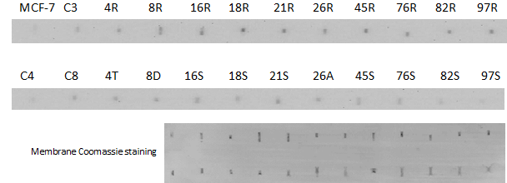
A
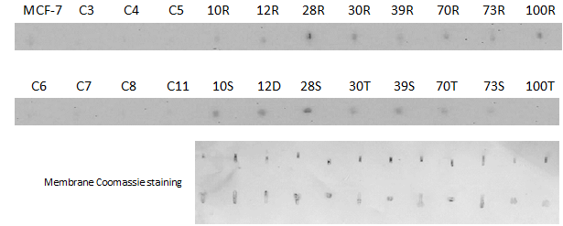
B
C
Figure 126. Selected ACT, INACT and control groups were immunoblotted against K10 including: previously pooled patient cohorts (A), independent patient cohort (B), as well as merged data form these two groups (C). Each patient and control is given a unique anonymised number. Each patient’s active rectal sample is immunoblotted against the corresponding inactive proximal colonic mucosa for direct comparison. A control MCF-7 sample is included in the immunoblot to allow normalisation between sample groups. Relative K10 concentration for each dot-blot is inferred by determining its signal intensity relative to the MCF-7 K10 signal intensity, measured in turn by densitometry. Membrane Coomassie staining is performed to confirm equal protein amount in each dot-blot space. C=control; R=Rectum (ACT); S=sigmoid (INACT); D=Descending (INACT); T=Transverse (INACT); A=Ascending (INACT).
The outcome of the above orthogonal validation experiments are summarised in Table 17.

Table 17. Summary of the orthogonal validation experiments in ACT, INACT and normal controls cohorts demonstrating the over-expressed and under-expressed proteins amongst the comparison groups. ACT: Active UC mucosa; INACT: Proximal inactive UC mucosa; CON: normal controls.
 | ACT relative to INACT | ACT relative to CON | INACT relative to CON
Over-expressed proteins | MRP8 | TRX, IGHA1, MRP8, K10 | IGHA1, MRP8, TRX, K10
Under-expressed proteins | CA2, GPA33 | CA2, GPA33 | -

During post-hoc analysis, binary regression was carried out in a block fashion. The Omnibus Tests of Model Coefficients used to check that the new model is an improvement over the baseline model (a model with no predictors), showed significant result (chi-square= 36.498, df= 6, p<0.000) with Cox and Snell R square=0.728 and Nagelkerke R square=1.0 for all target markers combined; however, the overall odd ratio for the model was not statistically significant.

4.4 Discussion and Conclusion

In the first part of this study, reduced expression of epithelial keratins in the active colonic mucosa relative to the un-inflamed proximal tissue was identified in UC patients. These outcome results were shown in our soluble and insoluble iTRAQ proteomics experiments, and validated both internally and independently through immunoblotting. K8 was chosen as a representative of changes seen in the epithelial keratins especially as our results were most prominent for this protein. Furthermore, as keratin filaments in simple epithelial cells are arranged as heteropolymers of K8 and K18 (303), the K8 trend of alterations should mirror that of K18 in colon tissues. The relative total reduction of K8 in active UC mucosa seems to be independent of epithelial denudation secondary to mucosal ulceration during severe UC disease activity, even though this effect could potentially contribute to the relative epithelial keratins reduction in severe inflammation.
In order to observe the K8 distribution including its isoforms/proteoforms and post-translational modifications (PTM) along the isoelectric protein bands, western blotting was performed on the previously pooled ACT, INACT and control samples. The K8 bands observation suggested relatively higher concentration of insoluble K8 isoforms with lower molecular weight (MW) during ACT relative to INACT. This could be due to either different K8 proteoforms in ACT versus INACT mucosa. Either way, this observation confirmed the immunoblotting outcomes on individual samples, which showed relatively lower levels of K8 in ACT compared to INACT in both soluble and insoluble fractions of the proteome.
Increased relative K8 solubilisation due to phosphorylation at the Ser73 site of the protein was observed. Furthermore pSer73 K8 showed relative increased levels in ACT compare to INACT in the soluble proteome. This observation is supported by previous study by Ridge et al., who demonstrated that shear stress in lung alveolar epithelial cells causes K8 disassembly and increased solubilisation, in turn regulated by protein kinase C delta-mediated phosphorylation of K8 at Ser73 site (304). Interestingly, higher relative levels of pSer73K8 were also observed in INACT mucosa relative to normal controls in the soluble proteome, which could be due to field defect in histologically normal proximal mucosa.
During investigation of possible inflammatory pathway responsible for alteration in the level of pSer73 K8, MAPK protein array was carried out on pooled samples from ACT, INACT and control patients. Inconclusive low signals were observed from the pathway proteins within the array, likely due to the incompatibility between the buffer in the array and our protein lysate buffer (as this protein array was only standardised for cell culture and not human tissues). One way of potentially addressing the buffer compatibility issue in our tissue samples is to fractionate all samples in the recommended manufacturer’s buffer from the outset, which unfortunately was not possible due to unavailability of fresh (unfractionated) colonic samples. Therefore, the observed field changes in phosphorylation of Ser73 K8 in INACT mucosa relative to normal controls should further be explored in the future (See below).
In the second part of the study, soluble proteome in ACT, INACT and normal controls were investigated in the search of altered pathways involved in UC disease activity and associated tissue biomarkers.
The comparison of soluble proteome in ACT to INACT mucosa was carried out in order to investigate altered pathways triggering overt inflammation. Only erythrocyte pathways seem significantly altered when P value, FDR, the number of entities found in comparison to the number of entities in each pathway are taken into consideration collectively.
This finding is supported by previous evidence on the role of epithelial oxygen tension in intestinal inflammation and resolution in IBD; intestinal epithelium has a dynamic and rapid fluctuation in cellular oxygen tension, which is dysregulated in IBD (305). Using staining techniques to visualise hypoxic foci, substantial increase in hypoxia is observed in mouse models of colitis throughout the mucosa (306).
Likewise, soluble proteome between ACT and controls was compared to explore further altered cellular pathways in active UC. Only erythrocyte and antimicrobial pathways seem significantly altered when P value, FDR, the number of entities found in comparison to the number of entities in each pathway are taken into consideration collectively.
The role of “metal sequestration by antimicrobial proteins” pathway in UC could be posited from the use of calprotectin as a biomarker of IBD disease activity, which has been extensively studied in the field (307-309). The antimicrobial activity by the human innate immune system halts pathogen growth and proliferation by sequestering critical nutrients (310). This “nutritional immunity” is a very early level of defence against microbial invasion (311, 312). Invading microbes utilise metal ions such as Fe2+, Mn2+, and Zn2+ for many of their proteins involved in cellular metabolism; by sequestrating these metal ions, immune cells limit their access to pathogens (310). This limitation leads to a “fight over metals” at the host pathogen interface (311, 313). Exclusive to vertebrates, S100 proteins are Ca²⁺ binding small polypeptides responsible for cell proliferation, signal transduction, differentiation, cell cycle regulation, and transcription (314). In humans, several members of the S100 family of proteins sequester transition metal ions following secretion into the extracellular space during infection (311, 315). In particular, S100A8 and S100A9 sequester Fe²⁺, Mn²⁺, Zn²⁺, and Ni²⁺ (316-318).
Interactions analyses of altered proteins, using STRINGS, in ACT versus INACT and ACT versus controls identified clusters around pathways for metabolism of carbohydrates, muscle contraction, cytoskeleton as well as O2/CO2 exchange of erythrocytes.

Increased carbohydrates metabolism is likely to be secondary to high energy demand during active inflammation; but whether disturbance in metabolism of carbohydrates could trigger UC disease activity needs to be investigated in an independent study. Previous study by Vermeulen et al. demonstrated strong sero-reactivity as well as colonic tissue mRNA upregulation of proteins involved in the glycolysis including aldolase A, phosphoglycerate mutase, alpha-enolase, triose-phosphate isomerase, malate dehydrogenase and pyruvate kinase, which is triggered by hypoxia through the transcription factor HIF-1 (319). Upregulated carbohydrate metabolism has recently been shown in an independent study by Poulsen et al (180) (see Chapter 1).
Decrease in smooth muscle contraction in inflammation has been previously demonstrated in a murine study by Alkahtani et al. (320), in line with our findings, which showed alterations in levels of TPM1-3 and MYL12A associated with smooth muscle contraction. The role of tropomyosin (TPM) isoform 5 and its altered expression in UC disease activity has been previously investigated (321, 322); it is suggested that colonic epithelial surface expression of TPM5 is facilitated by a colon epithelial cell membrane associated protein (CEP); CEP acts as a chaperone for the trans-migration of TPM5 to the surface, which in turn acts as an autoantigen in UC. TPM5-specific IgG autoantibody in sera from UC patients triggers C3b deposition and destruction of colonic epithelial cells, suggesting a direct pathogenic effect (321, 322).
Finally, soluble proteomes between INACT and controls were assessed to investigate potential differential proteins in the histologically normal-looking proximal mucosa in active UC, which may be activated, albeit at the cellular level, and may lend to target biomarker discovery. Only antimicrobial peptides pathway, ut supra, show alteration in this category when P value, FDR, the number of entities found in comparison to the number of entities in each pathway are taken into consideration collectively. Interactions analysis in this group identified clusters around pathways for muscle contraction and innate immune system.

Over the past several years the goal of IBD therapy has shifted from symptom management to suppressing mucosal inflammation. This is due to the fact that symptoms can be misleading at times and lead to two important errors; first, symptoms may be present in up to 20% of patients with IBD with no significant mucosal inflammation (323-325). Secondly, symptoms may be under-reported in this group of patients with subsequent progression to complications and missed window of opportunity for effective intervention (325). Conventional methods for objective assessment of mucosal inflammation include ileocolonoscopy, cross-sectional imaging, and barium studies. However, while widely accepted as representing the state of bowel inflammation, endoscopy and imaging have notable limitations of cost, inconvenience, and invasiveness, making these modalities unsuitable for frequent monitoring of patients with IBD (325). With this renewed focus on the state of bowel inflammation as a guide to therapy has come a resurgent interest in biomarkers of inflammation.
Biomarker is a measurable indicator of the severity or presence of a particular disease state or a group of closely related diseases, which can be found in blood, other body fluids, or tissues. An ideal biomarker that is rapid, convenient, non-invasive, inexpensive, standardised, reproducible, stable, precise and accurate in reflecting the state of bowel inflammation in IBD would greatly assist in the management of these patients (325). Furthermore, different cut-off thresholds may optimise performance of the same biomarker assay, depending upon the clinical scenario (326). Blood, stool, urine and volatile gas markers have all been explored as indicators of intestinal inflammation in IBD, and although none has been universally adopted, some have been well-characterised. Serum C-reactive protein (CRP) and faecal calprotectin are among the best-studied non-invasive biomarkers of inflammation in IBD (325). It is certain that biomarkers of inflammation will attain growing importance in the clinic as we strive for more specific, sensitive, responsive and cost-effective markers to aid in the management of patients with IBD.

During orthogonal validation in search of tissue biomarkers discovery, down-regulated CA2 and GPA33, and up-regulated IGHA1, MRP8, K10, and TRX were observed in ACT relative to normal controls. When comparing ACT and INACT, CA2 and GPA33 were down-regulated, whereas MRP8 were up-regulated.
Post-hoc analysis in an attempt to provide an optimal panel of tissue biomarkers indicative of acute UC and to add statistical power to the differential target biomarkers did not reach a statistical significance. One plausible explanation for the this discrepancy is limited number of patients in each of 6 dependent variables required for running the logistic regression, which in turn creates type II error.
To explore further the pathophysiological significance of the discovered biomarkers as well as review the current knowledge about the links between these proteins and IBD, the gene ontology (GO) for each of these proteins is presented here:
Carbonic anhydrases (CA) are a group of isoenzymes, which catalyse the reversible conversion of carbon dioxide into bicarbonate, but their precise physiological role and the consequences of their dysfunction are mostly unknown (327). CA2 is one of fourteen forms of human CA isoforms. Oral administration of CA1 has been shown to induced antigen-specific immune tolerance by generating Foxp3(+)CD4(+)CD25(+) Tregs and inhibiting Th17 cells in a murine colitis model (328). Although our study demonstrated down-regulation of CA2 in active colitis relative to INACT and normal controls for the first time, increased serum anti-carbonic anhydrase II antibodies has been shown in other forms of autoimmune conditions (329).
Glycoprotein 33 (GPA33) is a cell surface antigen that is expressed in normal human colonic and small bowel epithelium and >95% of human colon cancers, but absent from most other human tissues (330, 331). Upon specific mAb binding to the A33 surface antigen, the antibody–antigen complex is getting endocytosed and sequestered in cytoplasmic vesicles (332). Due to its high specificity, GPA33 has been used to deliver chemotherapeutic agents to colon cancer cells for over a decade (333, 334).
Immunoglobulin A (IgA) has two distinct subclasses in humans named IgA1 and IgA2 with variable concentration depending on the site of release. Locally synthesised secretory IgA (SIgA) is the predominant and most abundant Ig in the human mucosal surfaces, which is mainly in the form of a dimeric compound; each IgA monomer in turn has two fragment antibody (Fab) regions for attachment to antigens and one fragment crystalisable (Fc) region for mediating effector mechanisms (335, 336). IgA1 chain C region (IGHA1) or Fc region is exerting its effect via attachment to Fc alpha receptors on the cell surface (337). SIgA is instrumental in maintaining the intestinal bacterial homeostasis (338, 339). As well as neutralising intraluminal pathogens, SIgA is acting as a selective transporter of the bound antigens back into the intestinal Peyer’s patches as part of orchestrating an immunomodulatory response (340-342).
Migration inhibitory factor-Related Protein (MRP8) together with its binding partner, MRP14, are members of the calcium-binding S100 protein family (343). They are considered the most abundant cytoplasmic proteins of neutrophils and monocytes, which are specifically released during phagocytic activation during inflammation and have shown to induce inflammatory prothrombotic response in endothelial cells in vitro (343-345).
In contrast to the extracellular environment where most cysteine residues in proteins form disulphide bonds, inside the cell is generally a reducing space with most cysteine residues being kept reduced (346, 347). One of the most efficient reducing systems involves thioredoxin (TRX), which is ubiquitous antioxidant enzyme with multivalent cellular roles such as redox homeostasis (348), modulating inflammatory response (349) and regulating programmed cell death via denitrosylation (350, 351).
This proof-of-the-concept study has provided several novel potential biomarkers of UC disease activity (K10, TRX, IGHA1, GPA33, CA2), which should be further independently validated in a larger adequately powered prospective cohort prior to their exploitation as biomarkers. The study should be primarily carried out in patients with active UC, but other inflammatory bowel conditions such as CD, colorectal cancer, and infective colitis together with normal controls should be included for comparative analysis.
Power calculation to achieve statistical power of 80% and α≤0.05 extracting standardised difference and effect size from the current study requires sample size of n=20 for K10 and TRX, as well as n=15 for MRP8, IGHA1, GPA33, CA2 (subject:control ratio= 1). Of course considering MRP8 (calprotectin) is an already established biomarker of IBD disease activity it will not need further validation.
Confirmatory analysis on K8 proteoforms and differential PTMs expression in active UC can be explored simultaneously (see chapter 7.4). This will be carried out using GelCMS (352), where all gel bands were excised and analysed by HDMS^{E} (see Chapter 7.2 for more details on this methodology). Complete endoscopic and histological assessment should be carried out prior to biomarker testing for accurate correlation. Colonic biopsies and stool samples should be collected. By simultaneous assessment of stool samples, not only each biomarker concentration could be measured, but also its protein stability for use as a clinical marker of disease activity can be evaluated. Each biomarker should then be assessed in mild, moderate and severe UC patients compared to normal controls. This will enable us to calculate the range for different inflammatory Burden.

Chapter 5: Exploring proteomics in long-standing UC in remission

Abstract

Introduction and aims: Patients with longstanding colitis are at an increased risk of development of dysplasia and colitis-associated colorectal cancer (CAC). Currently, we do not have a reliable predictive biomarker of disease evolution towards CAC. The aim of the study is to validate insoluble keratins alterations in the colonic mucosa from patients with long-standing UC (LSPC) relative to those with recent-onset UC (ROUC) and controls. Furthermore, soluble proteomic profile alterations in long-term UC were explored in the search of candidate target proteins of UC disease evolution.
Methods: IF and soluble protein fractions were extracted from rectal biopsies in patients with LSPC (n=18) and ROUC (n=16), as well as the rectal colonic regions of normal individuals. Immunoprobing was performed for identification and relative quantification of epithelial keratins and selected soluble target markers, sequentially. In the second part of, colonic biopsies from LSPC (n=21), ROUC (n=16) and controls (n=17) were included for soluble proteomic analysis. The pooled samples were subjected to nano-liquid chromography and tandem mass spectrometry (LC-MS/MS) as per standard “isobaric tags for relative and absolute quantitation” (iTRAQ) workflow methodology. All significant protein signals were subjected to orthogonal validation with immunoblotting.
Results: Median relative K8 levels were significantly higher in LSPC relative to ROUC in insoluble (p=0.0005) but not soluble (p=0.52) proteome fractions suggesting relative total K8 level is increased in LSPC compared to ROUC.

Soluble proteome analyses between LSPC, ROUC and controls revealed a series of up-regulated and down-regulated proteins. Selected proteins were explored for biomarker discovery exercise. Down-regulated CA2 (p=0.005), and up-regulated IGHA1 (p=0.03) and TRX (p=0.03) were observed in LSPC relative to normal controls. When comparing LSPC with ROUC, IGHA1 (p=0.001), TRX (p=0.005) and MRP8 (p=0.0004) were down-regulated.
Conclusion: This proof-of-the-concept study has provided several new potential biomarkers representative of longstanding UC. Taken together with the known increased risk of CAC in this group of patients, these markers may represent predictive biomarkers of UC disease evolution towards CAC, which should be further validated in future studies. Whether restoration of K8 in LSPC is a cause or effect of long remission needs to be further investigated. In other words, whether K8 restoration with the observed isoforms distribution could further be exploited as a sign of relative mucosal stability and prolong remission is yet to be evaluated.

Significance of this study
- What is already known on this subject?
Patients with longstanding UC are at increased risk for developing dysplasia and colitis-associated cancer (CAC). Currently we do not have a reliable predictive biomarker of disease evolution.
K8 perturbation within the hepatocytes has been linked to development of hepatocellular carcinoma and other liver diseases; but the role of K8 in longstanding UC is unknown.
- What are the new findings?
We showed relative increased expression of epithelial keratins in LSPC compared to ROUC.
Down-regulated CA2 and up-regulated IGHA1 and TRX in LSPC relative to normal controls were found. Furthermore TRX, IGHA1, and MRP8 were down-regulated in LSPC relative to ROUC.
- How might it impact on clinical practice in the foreseeable future?
This proof-of-the-concept study has provided several new potential biomarkers (CA2, IGHA1, TRX) representative of longstanding UC. Taken together with the known increased risk of CAC in this group of patients, these markers may represent predictive biomarkers of UC disease evolution towards CAC, which should be further validated in future studies.
Whether restoration of K8 in LSPC is a cause or effect of long remission needs to be further investigated. In other words, whether K8 restoration with the observed isoforms distribution could further be exploited as a sign of relative mucosal stability and prolong remission is yet to be evaluated.

5.1 Introduction

Patients with longstanding colitis are at an increased risk of development of dysplasia and colitis-associated colorectal cancer (CAC) (32). Although CAC accounts for only 2% of colorectal cancer, it is responsible for 15% of IBD-related mortality (33). Established risk factors include longstanding disease (34), extent of disease (35), onset in childhood (34), associated primary sclerosing cholangitis (PSC) (36), prolonged chronic inflammatory load (37, 38) and severity of inflammation (39). Currently, we do not have a reliable predictive biomarker of disease evolution towards CAC.
As previously mentioned in Chapter 4, the soluble fraction from colonic tissue lysate includes the majority of low abundant functional, enzymatic, catalytic and transcriptional proteins, which in turn orchestrate inflammatory pathways at a cellular level during disease. Insoluble proteins mainly comprise more highly abundant structural proteins. Hence in this chapter, the same methodology was adopted for separate exploration of insoluble and soluble proteome within colonic tissues.
In addition to playing a role in UC, derangements of K8 have been implicated in the earliest stages of carcinogenesis: analysis of the morphologically normal fields around colorectal adenoma identified 15 proteins whose expression was upregulated (169). There is clear in vivo evidence to suggest that K8 is essential to epithelial homeostasis and perturbation of function may result in precancerous conditions including both inflammatory bowel disease and predisposing fields. Therefore keratins, as abundant epithelial proteins, have great potential to be further explored as a biomarker UC disease evolution. In the investigation of insoluble proteome fraction, keratins as the main constituent of this fraction were explored.

5.1.1 Study Aims
In a recent proteomics experiment by our group using iTRAQ-based analysis on IF fraction of colonic tissue samples obtained from patients with carefully phenotyped UC, increased insoluble keratins fold change in long-standing pancolitis (LSPC) relative to recent-onset UC (ROUC) iTRAQ groups were shown (261).
In the first part of this study, I validate and cross-validate insoluble keratins alterations in the LSPC phenotype relative to ROUC and controls using independent low through-put immunoblotting methodology (primary aim). Likewise, the work is carried out as a follow up study on a previous high-throughput iTRAQ data by our group in this subgroup of patient.
I explore keratins alterations in the soluble proteome in these patient cohorts with UC using iTRAQ-based and subsequent immunoblotting, to be able to clarify the fate of total keratins in these UC phenotypes (secondary aim).
In the second part of the study, I explore soluble proteomic profile alterations that may develop in long-term UC in the search of candidate target proteins of UC disease evolution (primary aim).
The secondary aim is to identify altered inflammatory pathways representative of UC disease evolution.

5.2 Methods
For details on experimental materials, sample collection process and inclusion/exclusion criteria, see Chapter 3.

5.2.1 Investigation of epithelial keratin alterations in LSPC, ROUC and control groups
IF and soluble protein fractions were extracted from rectal biopsies in patients with LSPC and ROUC using tissue fractionation methodology previously explained in Chapter 3. IF and soluble protein fractions were similarly extracted from the rectal colonic regions of normal individuals as internal controls. The tissue samples were selected from the similar patients previously pooled for the insoluble iTRAQ exploration (297) for validation (LSPC, n=10; ROUC, n=8), as well as in new patient groups for cross-validation (LSPC, n=8; ROUC, n=8). Similar to chapter 4, K8 was chosen as a representative of changes seen in the epithelial keratins.
Each sample was dot-blotted on a membrane followed by immunoblotting for identification and quantification of epithelial keratins sequentially (for technical details, see Chapter 3.9). A control MCF-7 sample was included in all immunoblots to allow normalisation between sample groups. Relative Keratins concentration for each dot- blotted sample was inferred by determining its signal intensity relative to the MCF-7 keratins signal intensity measured in turn by densitometry.

5.2.2 Investigation of candidate biomarkers of UC disease evolution
As part of a larger soluble proteomics analysis, 66 patients in clinical, endoscopic and histological remission at index endoscopy were included in the remission arm. Seventeen patients with normal endoscopy and histology, who underwent lower GI endoscopy, comprise the control arm. Five patients, including three patients who died and two who had total proctocolectomy due to underlying dysplasia during the 3-year follow up, were subsequently excluded from the study. Of the remaining 61 UC patients in remission, 21 patients with longstanding pancolitis (≥20 years) (LSPC) and 12 patients with recent onset colitis (≤5 years) (ROUC), both in clinical, endoscopic and histological remission, were included as a subgroup from the remission arm, in order to investigate soluble protein alterations contributing to increased risk of CACRC in long-term UC. Demographic data on sex, age, disease extent, concomitant medication and comorbidities and duration of remission prior to biopsy has been collected for all patients (Table 18).
In line with standard iTRAQ workflow practice (298-301) and to ensure sufficient amounts of protein for analysis, pooling of colonic tissue samples was performed (for technical details, see Chapter 3.3.1). A total of 10 selected age, sex and medication-matched colonic tissue samples from the rectal biopsies from each LSPC and ROUC groups in remission (to explore corresponding soluble protein alterations, which may contribute to increased risk of CACRC in LSPC), as well as two sets of 7 rectal biopsies from normal controls, were pooled. It is worth emphasising that two separate pooled control groups were included to optimise bioinformatics comparison analysis during pathway investigation.
The soluble proteome fraction was extracted using previously described methodology (285) (for technical details, see Chapter 3.2). Cleaning and buffer exchange was carried out on all the samples prior to pooling in order to ensure iTRAQ compatibility, as previously described in Chapter 3.3.2. Following standard protein quantification in each sample group and pooling, these proteins were enzymatically digested to generate proteolytic peptides in order to be labelled with iTRAQ reagents. The final mixture of all the labelled samples was subjected to nano-liquid chromography and tandem mass spectrometry (LC-MS/MS) as per standard “isobaric tags for relative and absolute quantitation” (iTRAQ) workflow methodology, also described in detail in Chapter 3.5-3.8 (302). The iTRAQ proteomics outcome was subjected to bioinformatics scrutiny. We used previously employed bioinformatics-based software analysis of the proteomics data, incorporating metadata by multivariate statistical analysis for added value. Bioinformatic software was used for identification of proteins, by mapping proteins identified to be of interest in the study on to known networks. All significant outcomes were subjected to orthogonal validation and cross-validation with immunoblotting. A schematic overview of our proteomics workflow is summarised in Figure 27.

Normal controls Arm n=17
Inactive UC Arm; n=66
Active UC Arm; n-34

100 UC patients selected
Included in the study; n=61
Excluded; n=5

INACT; n=34
IR; n=10

NR; n=43
CON1; n=8
ACT; n=34
ER; n=8
CON2; n=9
ROUC; n=12
LSPC; n=21
Seven to ten age, sex & medication-matched patients’ colonic samples will be pooled from each of the above groups and tagged with a reciprocal iTRAQ label for comparative study

iTRAQ 121
iTRAQ 117
iTRAQ 119
iTRAQ 114
iTRAQ 116
iTRAQ 115
iTRAQ 118
iTRAQ 113

Intensity
Pooling
Analysis by LC-MS/MS for protein quantification
M/Z
Database searching for protein identification;
Bioinformatics for pathway analysis and recognition;
Orthogonal validation using antibody-based methods

Figure 137. A simplified flow chart of the intended methodology in LSPC versus ROUC comparison experiment including sample collection process and subsequent iTRAQ workflow; NR=UC non-relapsers (during 36 months follow up), IR=UC intermediate relapsers (between 6-36 months of follow up), ER=UC early relapsers (in the first 6 months), ACT=active UC, INACT=proximal inactive mucosa from active UC, ROUC=recent-onset UC in remission, LSPC=long-standing pancolitis in remission, CON=controls.

Table 18. Demographic data on the subgroup of patients included in LSPC versus ROUC experiment. Anti-TNF: Anti -tumour necrosis factor α; 6MP: 6-mercaptopurine; AZA: azathioprine; MTX: methotrexate.

Study cohort | Number of patients | Age (+/-SD) | Histology activity index | Baron’s endoscopy activity score | Gender | Anti-TNF / Immunomodulator use up to a year prior to index endoscopy |  | Disease extent
 |  |  |  |  |  | Anti-TNF | Immunomodulator | Disease extent
LSPC in remission | 22 | Mean: 64 (8+/-)  Median: 64 | Range:  0-1 | Range:  0-1 | Male: 16  Female: 6 | 0 | 2 (AZA)  2 (6MP) | Lt sided: 0  Extensive: 22
ROUC in remission | 12 | Mean: 45 (+/-14)  Median: 45 | Range:  0-1 | Range:  0-1 | Male: 6  Female: 6 | 0 | 1 (AZA)  1 (6MP) | Lt sided: 7  Extensive: 5
Controls | 17 | Mean: 57 (+/-9)  Median: 59 | 0 | 0 | Male: 6  Female: 11 | None |  | N/A

5.2.3 Orthogonal validation and cross-validation with immunoblotting
Candidate biomarkers were initially identified on the basis of relative fold change differences of about 2 or more between the study groups. They were scrutinised and finally chosen for orthogonal analysis on the basis of antibody availability and their role in known inflammatory pathways involved in UC. Serial immunoblottings on selected proteins for orthogonal validation were run, as described in Chapter 3.9. After each immunoblotting, the membrane was Coomassie stained to ensure equal protein loading in all wells. A workflow of validation process is shown in Figure 28.
B
A
LSPC included in iTRAQ pooling
ROUC included in iTRAQ pooling
Normal controls included in iTRAQ pooling
MCF-7 sample

Independent LSPC not used in iTRAQ pooling process
Independent ROUC not used in iTRAQ pooling process
Normal controls included in iTRAQ pooling
MCF-7 sample

Fractionation process
Soluble fraction (F1)
Soluble fraction (F1)

Insoluble fraction (F4)
Insoluble fraction (F4)
Immunoblotting comparing LSPC versus ROUC were carried out separately in each of the above four fractions against the differentially expressed proteins identified from iTRAQ workflow
C
24-hole dot blotter
 | 1 | 2 | 3 | 4 | 5 | 6 | 7 | 8 | 9 | 10 | 11 | 12
A
B
D
Secondary Ab conjugated with HRP
Chemiluminescent detection signal
Enzyme substrate
Primary Ab
Protein spot
PVDF membrane

Figure 28. A flow chart of orthogonal validation (A) and cross-validation (B) in LSPC versus ROUC showing the type and process protein comparison. A schematic representation of 24-hole dot blotter is shown here (C). Protein samples are loaded in each spot and transferred to PVDF membrane underneath; they are blotted with the required primary and secondary antibody before visualisation with enhanced chemiluminescence reagent (D). Densitometry analysis of the fluorescence intensity is carried out using ‘GeneSNAP’ and ‘GeneTools’ software (not shown here). For the full description of the dot blotting process, see Chapter 3.9. LSPC: patients with longstanding pancolitis in remission. ROUC: patients with recent-onset UC in remission. HRP: horseradish peroxidase. PVDF: polyvinylidene difluoride.

5.3 Results

5.3.1 Epithelial keratins alterations in LSPC and ROUC relative to controls
Previously pooled individual patient’s rectal tissue samples in LSPC, ROUC and control groups were compared using immunoblotting. IF fractions were extracted from individual biopsies in patients with LSPC in clinical, endoscopic and histological remission (n=10) and ROUC also in remission (n=8). Median age in LSPC and ROUC patients were 62 and 31, respectively (p=0.0002). Median interval (months) from last relapse to the index endoscopy in LSPC and ROUC was 31 and 1 months, respectively. Median Baron’s endoscopy score in both LSPC and ROUC biopsy samples were 0 (range 0-1). Median histological activity index in LSPC and ROUC were 0 (range 0) and 0 (range 0-1), respectively. Median disease duration in LSPC and ROUC groups were 27 (range 21-42) and 1.5 (range 0-4) years in this cohort, respectively.
Median relative insoluble K8/K18/K19 levels from the LSPC were significantly higher than those from the ROUC mucosa: K8 (p=0.001), K18 (p=0.002) and K19 (p=0.021). The results are shown in Figure 29.

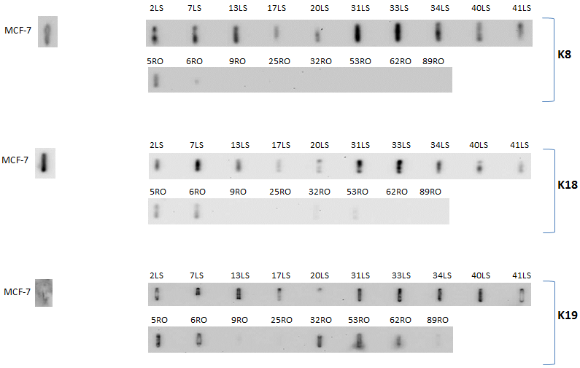
Figure 29. Immunoblotting for K8, 18 and 19 comparing individual colonic biopsies from insoluble fraction in patient samples with LSPC and ROUC previously pooled for insoluble iTRAQ experiment. MCF-7 cell line was used as control. LS=LSPC; RO=ROUC.

Soluble proteome from the same individual samples were investigated using immunoblotting against K8. Median relative soluble K8 levels from the LSPC were not different to those from the ROUC mucosa (p=0.82) (Figure 30). It is important to emphasise that no differential K8 fold change was observed in the soluble proteome iTRAQ analysis between LSPC and ROUC groups either.

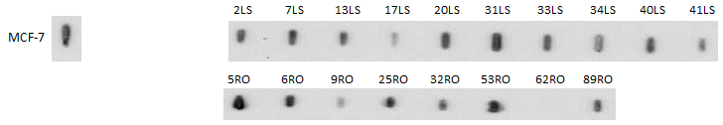
Figure 30. Immunoblotting for K8 comparing individual colonic biopsies from soluble fraction in patient samples with LSPC and ROUC previously pooled for insoluble and soluble iTRAQ experiments. MCF-7 cell line was used as control. LS=LSPC; RO=ROUC.

External validation between LSPC (n=8) and ROUC (n=8) was performed. The experiments were carried out separately in F4 and F1 proteome for subsequent direct comparison. In this new cohort, median age in LSPC and ROUC patients were 60 and 33, respectively (p=0.0002). Median Baron’s endoscopy score in both LSPC and ROUC biopsy samples were 0 (range 0-1). Similarly, median histological activity index in both LSPC and ROUC were 0 (range 0-1). Median disease duration in LSPC and ROUC groups was 29 (range 20-38) and 1.5 (range 1-3) years in this cohort, respectively. Median interval (months) from last relapse to the index endoscopy in LSPC and ROUC was 32 and 2, respectively.
Median relative IF K8 levels from LSPC were significantly higher than ROUC (p=0.003). Again, median relative soluble K8 levels did not reach statistical significance in the two groups (p=0.42) (Figure 31).
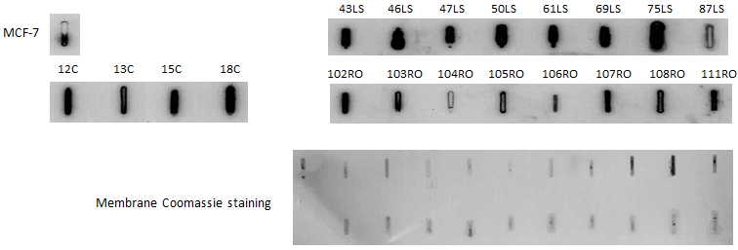
A
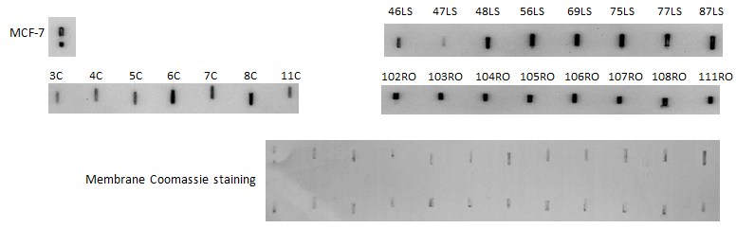
B
Figure31. Immunoblotting for K8 comparing individual colonic biopsies from insoluble (A) and soluble (B) fractions in patient samples with LSPC and ROUC, independently selected for external validation of iTRAQ results. Each patient and control is given a unique anonymised corresponding number. A control MCF-7 sample is included in the immunoblot to allow normalisation between sample groups. The relative K8 levels are corrected with the total background protein amount using Coomassie staining of the membrane. Membrane Coomassie staining is performed to confirm equal protein amount in each dot-blot space. C=control; LS: longstanding pancolitis in remission; RO: Recent-onset UC in remission.

The outcome data from both validation and cross-validation experiments was combined for the relative K8 levels in F4 and F1 proteomes, separately. Not surprisingly, the results show similar trend with median relative K8 levels significantly higher in LSPC relative to ROUC in IF (p=0.0005), but not for soluble (p=0.52) proteome fractions (Figure 32).
Figure 32. Merged data form previously pooled as well as independent patient samples from LSPC and INACT cohort groups. The data is shown separately for F1 and F4 fraction. Solid circles represent previously pooled samples; hollow circles represent independent patient samples. LSPC: longstanding pancolitis in remission; ROUC: recent-onset UC in remission.

Considering the observed trend in both soluble and insoluble fraction, it could be concluded that the relative total K8 level is increased in LSPC compared to ROUC.
Western blotting was performed on the previously pooled LSPC, ROUC and control samples. The results represent a wide range of distribution from 54 to 37 kD, which is different between LSPC and ROUC (Figure 33).
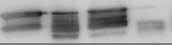
37-
54-
IF
MCF-7 CON LSPC ROUC
kD
kD
MCF-7 CON LSPC ROUC

37-
54-
S
Figure 33. Western blotting on the pooled samples, used for insoluble (IF) and soluble (S) iTRAQ experiments.

The K8 bands observation, shown above, suggests that there are relatively higher levels of K8 proteoforms with higher MW (around 50 kD) in both soluble and insoluble fraction in LSPC; conversely, there are relatively higher levels of K8 proteoforms with lower molecular weights (MW) (around 37kD) in both soluble and insoluble fractions in ROUC.
Furthermore it confirms the immunoblotting outcomes on individual samples, which showed relatively higher levels of K8 in LSPC compared to ROUC in IF but not in soluble fraction of the proteome.

5.3.2 Soluble iTRAQ analysis outcome comparing LSPC and ROUC relative to controls
In the second part of the study, pooled soluble proteome from LSPC to ROUC and normal controls was compared.

5.3.2.1 LSPC versus ROUC analysis
Soluble proteome in LSPC to ROUC mucosa was compared. The differentially expressed proteins are summarised in Tables 19&20.

Table 19. Upregulated proteins in LSPC relative to ROUC (Reference ROUC). General data regarding each protein’s gene name, length and mass was extracted from UniProt database on 26/01/2016. Fold change and p-value for each protein were directly extracted from the iTRAQ analysis. (Sequence) Length indicates the number of amino acids in the canonical sequence. (Molecular) Mass in Daltons (Da), calculated from the full precursor canonical sequence.
Protein name(s) | Accession No | Gene name | Length | Mass | Fold change | p-vlaue
Keratin, type I cytoskeletal 10 | P13645 | KRT10 | 584 | 58827 | 2.18 | 0.0002687
Keratin, type II cytoskeletal 1 | P04264 | KRT1 | 644 | 66039 | 1.86 | 6.296E-05
Cell surface A33 antigen | Q99795 | GPA33 | 319 | 35632 | 1.65 | 0.0075968
Tropomyosin alpha-3 chain | P06753 | TPM3 | 285 | 32950 | 1.63 | 0.0008743
Galectin-4 | P56470 | LGALS4 | 323 | 35941 | 1.63 | 0.002439
Tropomyosin alpha-1 chain | P09493 | TPM1 | 284 | 32709 | 1.52 | 0.0013481
Galectin-3 | P17931 | LGALS3 | 250 | 26152 | 1.48 | 0.0039583
Malate dehydrogenase | P40926 | MDH2 | 338 | 35503 | 1.41 | 0.009707

Table 20. Down-regulated proteins in LSPC relative to ROUC (Reference ROUC). General data regarding each protein’s gene name, length and mass was extracted from UniProt database on 26/01/2016. Fold change and p-value for each protein were directly extracted from the iTRAQ analysis. (Sequence) Length indicates the number of amino acids in the canonical sequence. (Molecular) Mass in Daltons (Da), calculated from the full precursor canonical sequence.
Protein name(s) | Accession No | Gene name | Length | Mass | Fold change | p-value
Protein S100-A8 | P05109 | S100A8 | 93 | 10835 | 0.24 | 0.002173
Histone H1.5 | P16401 | H1F5 | 226 | 22580 | 0.37 | 0.005011
Heterogeneous nuclear ribonucleoprotein L | P14866 | HNRNPL | 589 | 64133 | 0.43 | 0.005011
Histone H1.3 | P16402 | H1F3 | 221 | 22350 | 0.56 | 0.000726
Annexin A6 | P08133 | ANXA6 | 673 | 75873 | 0.71 | 0.006511
Endoplasmin | P14625 | HSP90B1 | 803 | 92469 | 0.77 | 0.000554
Glyceraldehyde-3-phosphate dehydrogenase | P04406 | GAPDH | 335 | 36053 | 0.79 | 0.002915
Filamin-A | P21333 | FLNA | 2647 | 280739 | 0.8 | 0.002528

The statistically significant altered pathways in the LSPC relative to ROUC are shown in Table 21. Although Muscle contraction, apoptosis, cellular senescence, generic transcription pathway and carbohydrates metabolism show significant p-value and FDR, none of these pathways seem significantly altered when P value, FDR, the number of entities found in comparison to the number of entities in each pathway are taken into consideration collectively.

Table 21. Possible discriminatory pathways in LSPC relative to ROUC (entities FDR ≤0.05 and p value ≤0.05). Data extracted from Reactome database on 16/01/2018.
Pathway name | #Entities found | #Entities total | Entities pValue | Entities FDR | Mapped Gene names | Mapped entities
Smooth Muscle Contraction | 3 | 35 | 1.73E-05 | 0.001 | TPM1; TPM3; ANXA6 | P09493;P08133;P06753
Apoptosis induced DNA fragmentation | 2 | 13 | 1.65E-04 | 0.004 | H1F3; H1F5 | P16402;P16401
Activation of DNA fragmentation factor | 2 | 13 | 1.65E-04 | 0.004 | H1F3; H1F5 | P16402;P16401
Formation of Senescence-Associated Heterochromatin Foci (SAHF) | 2 | 16 | 2.49E-04 | 0.004 | H1F3; H1F5 | P16402;P16401
Gluconeogenesis | 2 | 34 | 0.001 | 0.014 | GAPDH; MDH2 | P40926;P04406
Striated Muscle Contraction | 2 | 36 | 0.001 | 0.014 | TPM1; TPM3 | P09493;P06753
Apoptotic execution phase | 2 | 52 | 0.003 | 0.023 | H1F3; H1F5 | P16402;P16401
Muscle contraction | 3 | 205 | 0.003 | 0.024 | TPM1; TPM3; ANXA6 | P09493;P08133;P06753
DNA Damage/Telomere Stress Induced Senescence | 2 | 61 | 0.003 | 0.024 | H1F3; H1F5 | P16402;P16401
RUNX2 regulates genes involved in differentiation of myeloid cells | 1 | 5 | 0.007 | 0.043 | LGALS3 | P17931
Glucose metabolism | 2 | 96 | 0.008 | 0.043 | GAPDH; MDH2 | P40926;P04406
Metal sequestration by antimicrobial proteins | 1 | 6 | 0.009 | 0.043 | S100A8 | P05109

The interactions between altered proteins (upregulated (n=8) and down-regulated (n=8)) in LSPC relative to ROUC are shown in Figure 34. Two proteins were subsequently excluded (GPA33 and ANXA6), as they were orphan nodes within the network with no association to other proteins in the group. Two principle PINs emerged in this analysis, with clusters around Glyceraldehyde-3-phosphate dehydrogenase (GAPDH), and TPMs (TPM1, TPM3).
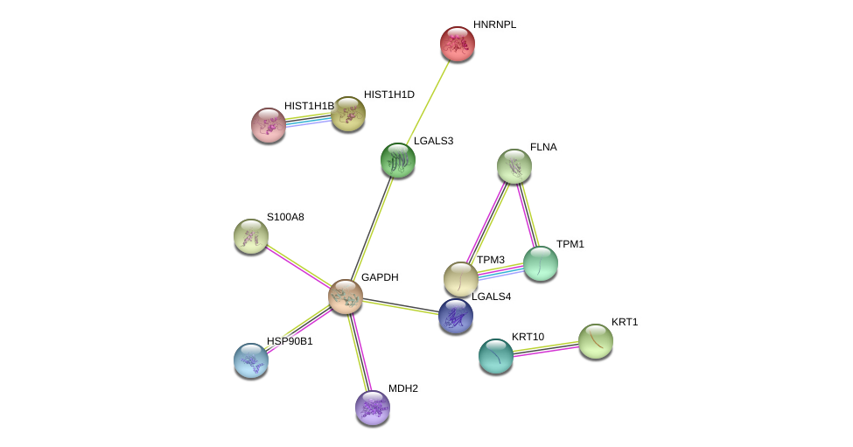
Metabolism
Muscle contraction

Figure 34. Protein–protein interaction (PPI) network view summarising the network of predicted associations between differentially expressed proteins in LSPC relative to ROUC(orphan nodes not shown), and indicating proteins interlinked with clusters around metabolism (solid line), and muscle contraction (square-dot line). Data accessed from STRING 10.5 database on 01/10/2018.

5.3.2.2 LSPC versus controls analysis
The soluble proteomes between LSPC and controls were compared. The differentially expressed upregulated and down-regulated proteins in LSPC relative to controls are summarised in Tables 22&23.
Table 22. Upregulated proteins in LSPC relative to normal controls. General data regarding each protein’s gene name, length and mass was extracted from UniProt database on 26/01/2016. Fold change and p-value for each protein were directly extracted from the iTRAQ analysis. (Sequence) Length indicates the number of amino acids in the canonical sequence. (Molecular) Mass in Daltons (Da), calculated from the full precursor canonical sequence.
Protein name(s) | Accession No | Gene name | Length | Mass | Fold change | p-vlaue
Keratin, type I cytoskeletal 10 | P13645 | KRT10 | 584 | 58,827 | 1.53 | 8.25E-05
Keratin, type I cytoskeletal 18 | P05783 | KRT18 | 430 | 48,058 | 1.48 | 0.001735
Ig gamma-1 chain C region | P01857 | IGHG1 | 330 | 36,106 | 1.36 | 0.000359
Keratin, type II cytoskeletal 79 | Q5XKE5 | KRT79 | 535 | 57,836 | 1.23 | 0.006555
Tropomyosin beta chain | P07951 | TPM2 | 284 | 32,851 | 1.06 | 0.001086

Table 23. Down-regulated proteins in LSPC relative to normal controls. General data regarding each protein’s gene name, length and mass was extracted from UniProt database on 26/01/2016. Fold change and p-value for each protein were directly extracted from the iTRAQ analysis. (Sequence) Length indicates the number of amino acids in the canonical sequence. (Molecular) Mass in Daltons (Da), calculated from the full precursor canonical sequence.
Protein name(s) | Accession No | Gene name | Length | Mass | Fold change | p-vlaue
Hemoglobin subunit beta | P68871 | HBB | 147 | 15998 | 0.76 | 0.00929
Transgelin (22 kDa actin-binding protein) | Q01995 | TAGLN | 201 | 22611 | 0.77 | 0.001585
Filamin-A | P21333 | FLNA | 2647 | 280739 | 0.78 | 0.00027
Neuroblast differentiation-associated protein | Q09666 | AHNAK | 5890 | 629101 | 0.80 | 3.67E-06
Actin, cytoplasmic 1 (Beta-actin) | P60709 | ACTB | 375 | 41737 | 0.85 | 0.006746

The statistically significant altered pathways in the LSPC relative to normal controls are shown in Table 24. Although Cell junction organisation and keratinisation show significant p-value and FDR, none of these pathways seem significantly altered when P value, FDR, the number of entities found in comparison to the number of entities in each pathway are taken into consideration collectively.

Table 24. Possible discriminatory pathways in LSPC relative to normal controls (entities p value and FDR ≤0.05). Data extracted from Reactome database on 16/01/2018.
Pathway name | #Entities found | #Entities total | Entities pValue | Entities FDR | Mapped Gene names | Mapped entities
Cell-extracellular matrix interactions | 2 | 18 | 1.19E-04 | 0.008 | ACTB; FLNA | P60709;P21333
Formation of the cornified envelope | 3 | 129 | 1.80E-04 | 0.008 | KRT79; KRT10; KRT18 | Q5XKE5;P13645;P05783
Keratinization | 3 | 217 | 8.23E-04 | 0.026 | KRT79; KRT10; KRT18 | Q5XKE5;P13645;P05783
Cell junction organization | 2 | 92 | 0.002992 | 0.054 | ACTB; FLNA | P60709;P21333
Cell-Cell communication | 2 | 130 | 0.005865 | 0.054 | ACTB; FLNA | P60709;P21333

The interactions between altered proteins (upregulated (n=5) and down-regulated (n=5)) in LSPC relative to normal controls are shown in Figure 35. One protein was subsequently excluded (IGHG1), as it was an orphan node within the network. Two principle PIN’s emerged in this analysis, with clusters around β-Actin (ACTB) and TPM2, as well as keratins.

Cell junction organisation
Keratinisation
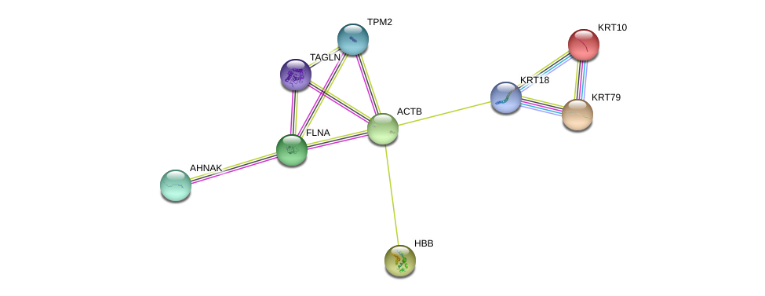
Figure 35. Protein–protein interaction (PPI) network view summarising the network of predicted associations between differentially expressed proteins in LSPC relative to control groups(orphan nodes not shown), and indicating proteins interlinked with clusters around cell junction organisation (solid line) and keratinisation (square-dot line). Data accessed from STRING 10.5 database on 01/10/2018.

5.3.2.3 Biomarkers discovery
Target proteins were initially identified on the basis of relative fold change differences of about 2 or more between the study groups. They were scrutinised and finally chosen for orthogonal analysis on the basis of antibody availability and their role in known inflammatory pathways involved in UC. Table. Using this decision tree algorythm, the following proteins were chosen for orthogonal validation and biomarker discovery: Ig alpha-1 chain C region (IGHA1), Protein S100-A8 (MRP8), Cell surface A33 antigen (GPA33), and cytoskeletal keratin 10 (K10). Although carbonic anhydrase 2 (CA2) and thioredoxin (TRX) did not have significant fold change differences between the compared groups, due to antibodies availability, these proteins were also included for biomarker discovery.

5.3.2.4 Orthogonal validation and cross-validation of candidate biomarkers of UC disease evolution
Selected proteins for orthogonal validation were quantified with immunoblotting in the previously pooled cohort for iTRAQ study, as well as independent cohorts of patient samples from similar corresponding groups.

The results for CA2 in both pooled and independent groups of patient samples from LSPC and ROUC cohorts are shown in Figure 36. Relative CA2 level was lower in LSPC compared to normal control groups (p=0.005).
A
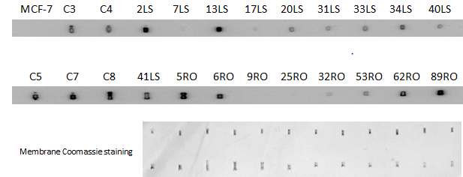
B
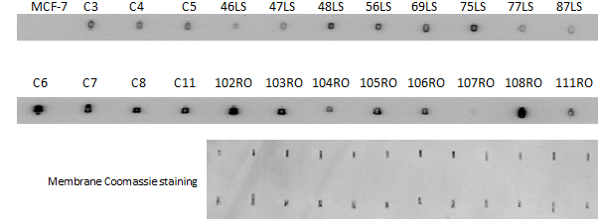
C
Figure 36. Selected LSPC, ROUC and control groups were immunoblotted against CA2 including: previously pooled patient cohorts (A), independent patient cohort (B), as well as merged data form these two groups (C). Each patient and control is given a unique anonymised corresponding number. A control MCF-7 sample is included in the immunoblot to allow normalisation between sample groups. Relative CA2 concentration for each dot-blot is inferred by determining its signal intensity relative to the MCF-7 CA2 signal intensity, measured in turn by densitometry. Membrane Coomassie staining is performed to confirm equal protein amount in each dot-blot space. C=control; LS: longstanding pancolitis in remission; RO: Recent-onset UC in remission.

The results for GPA33 in both pooled and independent groups of patient samples from LSPC and ROUC cohort are shown in Figure 37. No statistical difference was found in relative GPA33 level amongst the compared groups.
A
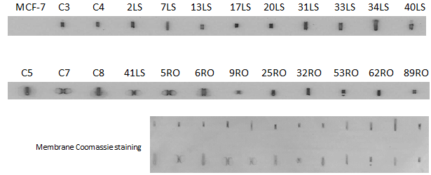
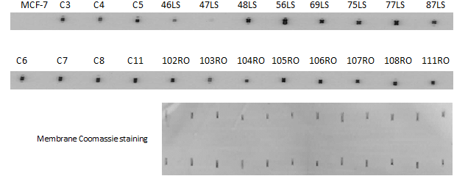
B
C
Figure 37. Selected LSPC, ROUC and control groups were immunoblotted against GPA33 including: previously pooled patient cohorts (A), independent patient cohort (B), as well as merged data form these two groups (C). Each patient and control is given a unique anonymised corresponding number. A control MCF-7 sample is included in the immunoblot to allow normalisation between sample groups. Relative GPA33 concentration for each dot-blot is inferred by determining its signal intensity relative to the MCF-7 GPA33 signal intensity, measured in turn by densitometry. Membrane Coomassie staining is performed to confirm equal protein amount in each dot-blot space. C=control; LS: longstanding pancolitis in remission; RO: Recent-onset UC in remission.

The results for IGHA1 in both pooled and independent groups of patient samples from LSPC and ROUC cohort are shown in Figure 38. Relative IGHA1 level was higher in ROUC compared to both LSPC (p=0.001) and normal controls (p=0.0001). Furthermore, relative IGHA1 level was higher in LSPC compared to normal controls (p=0.03). All these outcomes remained statistically significant when the outliers were excluded (data not shown).
A
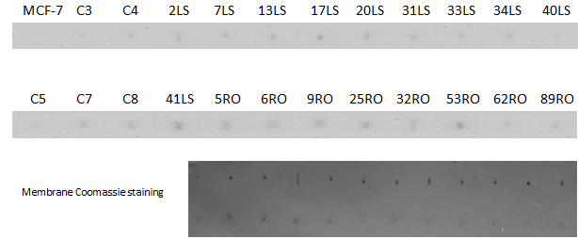
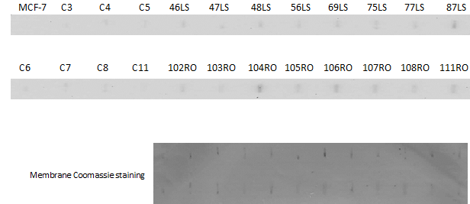
B
C
Figure 38. Selected LSPC, ROUC and control groups were immunoblotted against IGHA1 including: previously pooled patient cohorts (A), independent patient cohort (B), as well as merged data form these two groups (C). Each patient and control is given a unique anonymised corresponding number. A control MCF-7 sample is included in the immunoblot to allow normalisation between sample groups. Relative IGHA1 concentration for each dot-blot is inferred by determining its signal intensity relative to the MCF-7 IGHA1 signal intensity, measured in turn by densitometry. Membrane Coomassie staining is performed to confirm equal protein amount in each dot-blot space. C=control; LS: longstanding pancolitis in remission; RO: Recent-onset UC in remission.
The results for K10 in both pooled and independent groups of patient samples from LSPC and ROUC cohort are shown in Figure 39. Relative K10 level was higher in ROUC compared to normal controls (p=0.006). All these outcomes remained statistically significant when the outliers were excluded (data not shown).
A
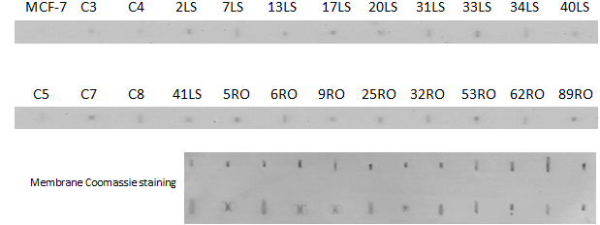
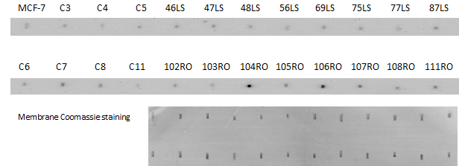
B
C
Figure 39. Selected LSPC, ROUC and control groups were immunoblotted against K10 including: previously pooled patient cohorts (A), independent patient cohort (B), as well as merged data form these two groups (C). Each patient and control is given a unique anonymised corresponding number. A control MCF-7 sample is included in the immunoblot to allow normalisation between sample groups. Relative K10 concentration for each dot-blot is inferred by determining its signal intensity relative to the MCF-7 K10 signal intensity, measured in turn by densitometry. Membrane Coomassie staining is performed to confirm equal protein amount in each dot-blot space. C=control; LS: longstanding pancolitis in remission; RO: Recent-onset UC in remission.
The results for MRP8 in both pooled and independent groups of patient samples from LSPC and ROUC cohort are shown in Figure 40. In line with the iTRAQ outcomes, relative MRP8 level was higher in ROUC compared to both LPSC (p=0.0004) and normal controls (p=0.0002). All these outcomes remained statistically significant when the outliers were excluded (data not shown).

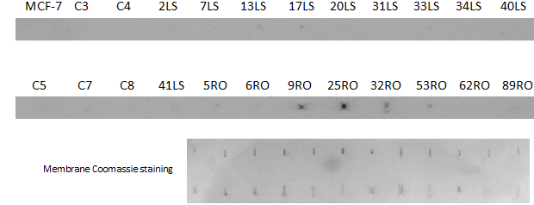
A

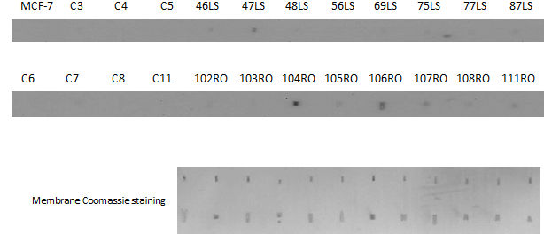
B
C
Figure 40. Selected LSPC, ROUC and control groups were immunoblotted against MRP8 including: previously pooled patient cohorts (A), independent patient cohort (B), as well as merged data form these two groups (C). Each patient and control is given a unique anonymised corresponding number. A control MCF-7 sample is included in the immunoblot to allow normalisation between sample groups. Relative MRP8 concentration for each dot-blot is inferred by determining its signal intensity relative to the MCF-7 MRP8 signal intensity, measured in turn by densitometry. Membrane Coomassie staining is performed to confirm equal protein amount in each dot-blot space. C=control; LS: longstanding pancolitis in remission; RO: Recent-onset UC in remission.
The results for TRX in both pooled and independent groups of patient samples from LSPC and ROUC cohort are shown in Figure 41. Relative TRX level was higher in ROUC compared to both LSPC (0.005) and normal controls (p=0.0001). Furthermore, relative TRX level was higher in LSPC compared to normal controls (p=0.03).

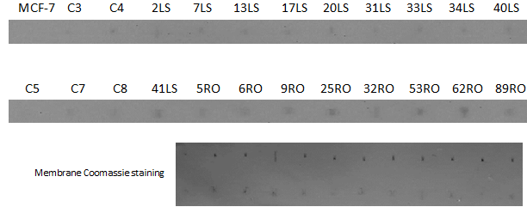
A
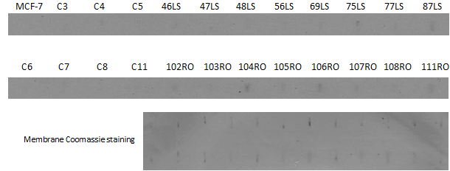
B
C
Figure 41. Selected LSPC, ROUC and control groups were immunoblotted against TRX including: previously pooled patient cohorts (A), independent patient cohort (B), as well as merged data form these two groups (C). Each patient and control is given a unique anonymised corresponding number. A control MCF-7 sample is included in the immunoblot to allow normalisation between sample groups. Relative TRX concentration for each dot-blot is inferred by determining its signal intensity relative to the MCF-7 TRX signal intensity, measured in turn by densitometry. Membrane Coomassie staining is performed to confirm equal protein amount in each dot-blot space. C=control; LS: longstanding pancolitis in remission; RO: Recent-onset UC in remission.

The outcome of the above orthogonal validation experiments are summarised in Table 25.

Table 25. Summary of the orthogonal validation experiments in LSPC, ROUC and normal controls cohorts demonstrating the over-expressed and under-expressed proteins amongst the comparison groups. LSPC: Long-standing pancolitis in remission; ROUC: Recent-onset colitis in remission; CON: normal controls.
 | LSPC relative to ROUC | LSPC relative to CON | ROUC relative to CON
Over-expressed proteins | - | IGHA1, TRX | K10, IGHA1, GPA33, MRP8, TRX
Under-expressed proteins | IGHA1, MRP8, TRX | CA2 | -

During post-hoc analysis, binary regression was carried out in a block fashion. The Omnibus Tests of Model coefficients used to check that the new model is an improvement over the baseline model, showed significant result (chi-square= 30.698, df= 6, p<0.000) with Cox and Snell R square=0.595 and Nagelkerke R square=0.794 for all target markers combined; however, only the odd ratio for CA2 reached statistical significance (OR=1.0, p=0.039, 95% CI [1.0, 1.0]), albeit with insignificant CI.

5.4 Discussion and Conclusion

In the first part of this study, relative increased expression of epithelial keratins in LSPC was shown compared to ROUC in the insoluble proteome fraction. These outcome results were consistent with the previous insoluble iTRAQ proteomics experiment (261). Similar relative trend during analysis of the soluble proteome fraction was not observed, also in line with the soluble iTRAQ experiment presented in this chapter. These outcome results were internally validated and further independently confirmed through immunoblotting. Considering K8 relative levels in both soluble and insoluble proteome fractions, it is therefore concluded that the total K8 relative levels should be higher in colonic epithelial cells during LSPC compared to the levels in ROUC. Relative lower total K8 levels in ROUC could be explained as the by-product of recent acute inflammation in this cohort, which lags behind histologic restoration, as median time from the last UC relapse to index endoscopy in both ROUC cohorts was 1.5 month and hence not enough time for complete structural repair. In contrast the LSPC group had significantly longer period of remission prior to index endoscopy (median: 32 months) (p‹0.01).

In order to observe the K8 distribution range along the isoelectric bands, western blotting was performed on the previously pooled LSPC, ROUC and control samples. The K8 bands observation suggested that there are relatively higher levels of K8 proteoforms with higher MW (around 50 kD) in both soluble and insoluble fraction in LSPC; conversely, there are relatively higher levels of K8 proteoforms with lower molecular weights (MW) (around 37kD) in both soluble and insoluble fractions in ROUC. This could be either due to different forms of K8 proteoforms and/or in fact as a result of higher relative percentage of PTMs in LSPC compared to ROUC. Whether restoration of K8 in LSPC is a cause or simply the effect of long remission needs to be further investigated. In other words, whether K8 restoration with the observed isoform distribution could further be exploited as a sign of relative mucosal stability and prolong remission, is yet to be investigated in future studies.

In the second part of the study, we investigated soluble proteome in LSPC, ROUC and normal controls in the search of altered pathways involved in UC disease evolution and associated tissue biomarkers.
The comparison of soluble proteome in LSPC versus ROUC mucosa was carried out in order to investigate altered pathways involved in UC disease evolution; none of these pathways seem significantly altered when P value, FDR, the number of entities found in comparison to the number of entities in each pathway are taken into consideration collectively. Amongst the proteins involved in the pathways, up-regulation of TPM1, TPM3 and MDH2 with down-regulation of ANXA6, GAPDH, H1F3 and H1F5 were identified.
The roles of TPM1-3 involved in muscle contraction in UC were discussed in detail in chapter 4. The other intracellular protein with purported role in endocytosis through involvement in budding of the clathrin-coated pits is annexin6 (353). Annexin belongs to a group of calcium-dependent phospholipid-binding proteins, which contains a distinct amino acid repeat sequence called an annexin repeat (354, 355). It is worth mentioning that the role of annexin1 in tissue repair and immunomodulation in UC during inflammation is well documented (356, 357). Although altered expression of serum ANXA6 was previously suggested as a discriminatory biomarker between UC and CD (152), our study is the first to show its down-regulation in LSPC compared to ROUC.
Linker histone H1 is a structural component of chromatin, which includes 11 different members with 7 somatic subtypes (H1.1 to H1.5, H1.0 and H1X), 3 testis-specific subtypes (H1t, H1T2 and HILS1) and 1 oocyte-specific subtype (H1oo) (358, 359). Previous study by Eggena et al. suggested a COOH-terminal epitope on the histone H1 as a target protein for monoclonal UC-associated pANCA marker antibody (360), which in turn is a predominant serum marker of UC (361). We observed down-regulation of H1F3 and H1F5 in LSPC compared to ROUC.
Galectin 3 and 4 are members of β-galactoside-binding lectin family of proteins (362). Galactin 3 has been associated to a diverse regulatory functions critical in cancer biology including apoptosis, metastasis, immune surveillance, molecular trafficking, mRNA splicing, gene expression, and inflammation (363). Likewise, upregulation of Galectin 4 has been linked with several solid tumour progression and metastasis including CRC (364). In our study, we found upregulation of Galectin 3 and 4 in LSPC compared to ROUC.
Increased carbohydrates metabolism is likely to be secondary to high-energy demand during active inflammation; but whether disturbance in metabolism of carbohydrates could trigger UC disease activity needs to be investigated in an independent study. Previous study by Vermeulen et al. demonstrated strong sero-reactivity as well as colonic tissue mRNA upregulation of proteins involved in the glycolysis including aldolase A, phosphoglycerate mutase, alpha-enolase, triose-phosphate isomerase, malate dehydrogenase and pyruvate kinase, which is triggered by hypoxia through the transcription factor HIF-1 (319).

Likewise, the comparison of soluble proteome in LSPC versus controls was carried out to investigate altered pathways involved in UC disease evolution; none of these pathways seem significantly altered when P value, FDR, the number of entities found in comparison to the number of entities in each pathway are taken into consideration collectively. Amongst the proteins involved in these pathways, down-regulation of ACTB and FLNA in LSPC was identified.
Epithelial-to-mesenchymal transition (EMT) is a phenomenon that allows the transformation of adherent epithelial cells within an organised tissue into independent fibroblastic cells possessing migratory properties, which seems to be closely involved in the pathogenesis of colorectal cancer (CRC) (365). Barrier dysfunction with disruption of intestinal epithelial tight junction, adherens junction and actin cytoskeleton plays an important role in the pathogenesis of UC (366, 367). Together with a well-stablished higher risk of CRC in long-term UC (368), our data points towards differential role of cell junction pathways and its possible transformation in LSPC relative normal controls. In particular, two differentially expressed proteins (ACTB and FLNA) were involved in these pathways. Furthermore, in a study on epithelial normal murine mammary gland (NmuMG) cells, Gay et al. showed that RefilinB/FLNA complex controls formation of a new perinuclear actin network that accompanies nuclear shape changes during EMT (369).
Beta actin (ACTB) is an abundant and highly conserved cytoskeletal protein that plays critical roles in cell migration, cell division, embryonic development, wound healing, immune response and gene expression (370). The eukaryotic cytoskeleton contains three main types of cytoskeletal filaments: microfilaments, intermediate filaments, and microtubules (371-373). Microfilaments, also called actin filaments (ACT), are composed of linear polymers of actin subunits that form the thinnest filaments of the cytoskeleton (374). The ACT filament is a polar macromolecule characterised by the elongation of one filament end coupled with shrinkage at the other (374). This dynamic interplay generates force and causes net movement of the intervening strand (375). ACT filaments also act as tracks for the movement of myosin molecules that attach to the microfilament and "walk" along them (376). In addition, ACT cytoskeleton plays a crucial role for immune functions, orchestrating numerous cellular processes including cell proliferation and differentiation, apoptosis, migration, and cellular signalling (377-379). They cross-link into bundles to form the dynamic actin cytoskeletal network, which is in turn finely tuned by multiple families of cytoskeletal proteins (380), called actin binding proteins (ABPs). These latter rather diverse family of proteins account for approximately 25% of the total cellular proteins (381) . These proteins typically share a conserved, α-actinin-like F-actin binding domain (ABD) (382-384).
Filamin A (FLNA), also called actin-binding protein 280 (ABP-280), is a widely expressed 280-kD actin-binding protein that regulates reorganisation of the actin cytoskeleton by interacting with integrins, transmembrane receptors complexes and second messengers (385). Cell motility, adhesion, polarisation and division depend on dynamic regulation of the actin cytoskeleton (386). FLNA gene on Xq28 encodes the FLNA protein. The protein was first identified as a non-muscle actin filament cross-linking protein, which participates in the anchoring of membrane proteins for the actin cytoskeleton and provides a scaffold for a wide range of cytoplasmic and nuclear signaling proteins (374, 387). Mutations and aberrant expression of FLNA have been reported in human genetic diseases and several types of cancer (374, 386) FLNA has been associated with actin as a cytoskeleton regulator (388). In general, filamins act as scaffolding molecules by facilitating protein–protein interactions and influencing protein cellular localisation (388). It has been proposed that over-expression of full-length FLNA has a tumour-promoting effect when localised in the cytoplasm, whereas cleaved forms of FLNA localised in the nucleus, acts as a suppressor of tumour growth and metastasis (388).
Transgelin is another abundant cytoskeletal actin binding protein of the calponin family, which affects dynamics of the actin structure via stabilisation of actin filaments (389). Transgelin superfamily of actin cross-linking proteins includes transgelin-1 (also known as smooth muscle protein 22𝛼, SM22𝛼), transgelin-2 (SM22𝛽), and transgelin-3 (NP25) (390-392). Main body of evidences suggest that transgelin acts as a tumour suppressor with its lost expression in prostate, breast and colon cancers (381, 393). Furthermore, more recent data regarding transgelin-2, the only transgelin family member present in leukocytes (394), links its biochemical properties and physiological roles in the immune system. This small ABP regulates cytoskeletal actin dynamics and stabilises immune synapses that form when antigen-recognising T cells meet antigen-presenting cells (APCs) or macrophages phagocytose infected bacteria (394-397). Several studies have suggested the feasibility of transgelin-2 as an endogenous factor to enhance T cell function, thereby boosting the antitumor response of cytotoxic T cells for immune cell therapy (381).
Neuroblast differentiation-associated protein (AHNAK) is a scaffolding nucleoprotein of uncertain functionality (398); one of the recent functions attributed to AHNAK is its role as part of the multi-step process of tumour cell metastasis (399, 400). Mutations of the APC gene play a crucial role in the early development of colorectal cancer in human and animal murine studies (401, 402). Interestingly, upregulation of AHNAK gene has been demonstrated in a novel method of identifying cooperative genes for the APC mutation in early colon carcinogenesis in mice, which further suggest the importance of cytoskeletal function in APC-related tumorigenesis (402).
Previous studies suggest deregulation of FLNA, ACTB, transgelin and AHNAK in colorectal cancer (370, 388, 393, 402-406). In our LPSC cohort, all of these proteins were down-regulated. Whether the colon tissue expressions of FLNA, ACTB, transgelin and AHNAK can be exploited as biomarkers for disease progression towards CRC needs to be further investigated in a prospective study (See below).

During orthogonal validation in search of tissue biomarkers of disease evolution, we showed down-regulated CA2, and up-regulated IGHA1 and TRX in LSPC relative to normal controls. Furthermore TRX, IGHA1 and MRP8 were down-regulated in LSPC relative to ROUC. The GO for these target proteins has previously explored in chapters 1&4.
Post-hoc regression analysis in an attempt to provide an optimal panel of tissue biomarkers indicative of UC disease evolution and add statistical power to the differential target biomarkers was not statistically significant. A possible explanation for the lack of statistical significance is limited number of patients in each of 6 dependent variables required for running this logistic regression, which in turn creates type II error.
In conclusion, this proof-of-the-concept study has provided several new potential biomarkers predictive of UC disease evolution (IGHA1, MRP8, TRX), which should be further independently validated in a larger adequately powered prospective cohort. This follow up study should be primarily carried out in patients with LSPC, ROUC (both in remission for at least 2 months or more), UC patients with dysplasia in remission and UC patients with cancer together with normal controls.
Power calculation to achieve statistical power of 80% and α≤0.05 extracting standardised difference and effect size from the current study requires us to obtain sample size of n=20 for IGHA1 and TRX, and MRP8 (subject:control ratio= 1).
Complete endoscopic and histological assessment should be carried out prior to biomarker testing for accurate correlation. Colonic biopsies and stool samples should be collected. The LSPC patients (without dysplasia) should then be followed up prospectively in order to assess any predictive or protective markers of disease evolution towards dysplasia or cancer.

Chapter 6: Exploring predictive biomarkers of relapse in ulcerative colitis

Abstract

Introduction and aims: Risk stratification of subjects with a history of IBD into those likely to relapse and those who will remain quiescent continues to be a significant challenge. The aim of this study is to investigate whether certain proteomic signature profiles or (panel of) biomarker(s) during remission in ulcerative colitis is associated with future disease relapse.
Methods: Sixty-one patients in clinical, endoscopic and histological remission at index endoscopy were included, of whom 8 had clinical relapse of UC within 6 months from the index endoscopy (Early relapsers), and 43 patients had no clinical symptoms of relapse within the 3-year follow-up period (Non relapsers). Total of 17 normal controls were also included. The pooled samples were subjected to nano-liquid chromography and tandem mass spectrometry (LC-MS/MS) as per standard “isobaric tags for relative and absolute quantitation” (iTRAQ) workflow methodology. All significant protein signals were subjected to orthogonal validation with immunoblotting.
Results: Soluble proteome analyses between ER, NR and controls revealed a series of up-regulated and down-regulated proteins. Selected proteins were explored for biomarker discovery exercise. Down-regulated GPA33 (p=0.009) and up-regulated IGHA1 (p=0.0008) were observed in ER relative to normal controls. When comparing ER with NR, GPA33 (p=0.02) was down-regulated, whereas, K10 (P=0.04), TRX (p=0.001) and IGHA1 (p=0.001) were up-regulated.
Conclusion: A panel of biomarkers predictive of future disease activity in UC has been found in this proof-of-the-concept study, which should be validated in future studies.

Significance of this study
- What is already known on this subject?
Reliable predictive biomarkers would be very beneficial in stratifying aggressive immunosuppressive therapy to IBD patients at high risk of severe relapse, whilst avoiding potential harmful drug exposure to those with more indolent disease course.
There are various clinical and endoscopic parameters associated with more aggressive IBD disease course; but to date, no biomarker is available in predicting the risk of future disease relapse in UC.
- What are the new findings?
Downregulated GPA33 and upregulated IGHA1 in early relapsers (ER) were observed relative to normal controls. TRX, K10, and IGHA1 were upregulated in ER relative to non-relapsers (NR).
Smooth muscle contraction was amongst possible discriminatory activated cellular pathways in ER relative to NR.
- How might it impact on clinical practice in the foreseeable future?
A panel of biomarkers (GPA33, IGHA1, TRX, K10) predictive of future disease activity has been found which should be validated in future studies.

6.1 Introduction

Risk stratification of subjects with a history of IBD into those likely to relapse and those who will remain quiescent continues to be a significant challenge (85). Risk and benefit assessment in IBD treatment is also a major issue especially as the disease behaviour is unpredictably variable amongst patients; therefore a reliable predictive biomarker would be very beneficial in stratifying aggressive immunosuppressive treatments to patients at high risk of severe relapses, whilst avoiding potential harmful drug exposure to those with more indolent disease course (40-42). Complexity and abundance of proteins with very variable concentrations and dynamic range has significant impact in the sensitivity of cellular proteomics methodologies (158). Investigating the whole cell lysate may mask important inflammatory markers of UC disease activity only present in low concentrations. Cellular fractionation and proteomics is an ideal platform for reducing cellular sample complexity (236). Considering majority of low abundant functional, enzymatic, catalytic and transcriptional proteins exist within soluble proteome, we concentrated in exploring soluble this fraction in the search for candidate biomarkers predictive of future disease activity. Although there have been previous attempts in delineating the proteomic signature of UC disease activity from both serum and whole lysate colon tissue extracts (131, 143, 159, 170), for the first time in this project we utilised a novel proteomics approach linked to clinical outcomes in a cohort of carefully selected UC patients in disease remission in order to explore predictor biomarkers of disease relapse.

6.1.1 Study aims
I undertake a pilot study to investigate whether certain proteomic signature profiles or (panel of) biomarker(s) during remission in ulcerative colitis is associated with future disease relapse (primary aim).
The secondary aim is to identify activated pathways either stimulating early UC relapse or else protective against the disease recurrence.

6.2 Methods
For details on experimental materials, sample collection process and inclusion/exclusion criteria, see Chapter 3.
Sixty-six patients in clinical, endoscopic and histological remission at index endoscopy were included in the remission arm as part of a larger proteomic study. Seventeen patients with normal endoscopy and histology, who underwent lower GI endoscopy, comprise the control arm. In the patients with UC, details of subsequent relapse have been retrieved from the follow-up records. Five patients, including three patients who died and two who had total proctocolectomy due to underlying dysplasia during the 3-year follow up, were subsequently excluded from the study. Of the remaining 61 UC patients in remission, 8 had clinical relapse of UC within 6 months from the index endoscopy (Early relapsers). Forty-three patients had no clinical symptoms of relapse within the 3-year follow-up period (Non relapsers). Demographic data on sex, age, disease extent, concomitant medication and comorbidities and duration of remission prior to biopsy was collected for all patients (Table 26).

Table 26. Demographic data on patients included in the ER versus NR experiment. Anti-TNF: Anti -tumour necrosis factor α; 6MP: 6-mercaptopurine; AZA: azathioprine; MTX: methotrexate.
Study cohort  (M=months) | Number of patients | Age (+/-SD) | Gender | Anti-TNF / Immunomodulator use up to a year prior to index endoscopy |  | Disease extent
 |  |  |  | Anti-TNF | Immunomodulators | Disease extent
Early relapsers (≤6 M) | 8 | Mean: 47 (+/-11)  Median: 45 | Male: 4  Female: 4 | 1 | 1 (6MP)(same patient on Anti-TNF)  1 (MTX) | Lt sided: 4  Extensive: 4
Non relapsers (up to 36 M) | 43 | Mean: 62 (+/-10)  Median: 65 | Male: 30  Female: 13 | 0 | 5 (AZA)  4 (6MP) | Lt sided: 9  Extensive: 34
Controls | 17 | Mean: 57 (+/-9)  Median: 59 | Male: 6  Female: 11 | None |  | N/A

In line with standard iTRAQ workflow practice (298-301) and to ensure sufficient amounts of protein for analysis, pooling of colonic tissue samples was performed (for technical details, see Chapter 3.3.1). A total of 7 to 10 selected age, sex and medication-matched rectal tissue biopsies from early relapsers and non-relapsers groups, as well as normal controls were pooled. Two separate pooled control groups were included to optimise comparison analysis.
The soluble proteome fraction was extracted using previously validated methodology (285) (for technical details, see Chapter 3.2). Cleaning and buffer exchange was carried out on all the samples prior to pooling in order to ensure iTRAQ compatibility, as previously described in Chapter 3.3.2. Following standard protein quantification in each sample group and pooling, these proteins were enzymatically digested to generate proteolytic peptides in order to be labelled with iTRAQ reagents. The final mixture of all the labelled samples was subjected to nano-liquid chromography and tandem mass spectrometry (LC-MS/MS) as per standard “isobaric tags for relative and absolute quantitation” (iTRAQ) workflow methodology, also described in detail in Chapter 3.5-3.8 (302). The iTRAQ proteomics outcome was subjected to bioinformatics scrutiny. A previously employed bioinformatics-based software analysis of the proteomics data was used, incorporating metadata by multivariate statistical analysis for added value. Protein biomarkers were categorised by correlation with each of the clinical groups. Bioinformatics software was used for identification of protein and transcription factor networks, by mapping proteins identified to be of interest in the study on to known networks. All significant outcomes were subjected to orthogonal validation with western blotting. A schematic overview of the proteomics workflow is summarised in Figure 42.

Normal controls Arm n=17
Inactive UC Arm; n=66
Active UC Arm; n-34

100 UC patients selected
Excluded; n=5
Included in the study; n=61

INACT; n=34
IR; n=10

NR; n=43
CON1; n=8
ACT; n=34
ER; n=8
CON2; n=9
ROUC; n=12
LSPC; n=21
Seven age, sex & medication-matched patients’ colonic samples will be pooled from each of the above groups and tagged with a reciprocal iTRAQ label for comparative study

iTRAQ 121
iTRAQ 117
iTRAQ 119
iTRAQ 116
iTRAQ 115
iTRAQ 118
iTRAQ 114
iTRAQ 113

Intensity
Pooling
Analysis by LC-MS/MS for protein quantification
M/Z
Database searching for protein identification;
Bioinformatics for pathway analysis and recognition;
Orthogonal validation using antibody-based methods

Figure 42. A simplified flow chart of the intended methodology including sample collection process and subsequent iTRAQ workflow.NR=UC non-relapsers (during 36 months follow up), IR=UC intermediate relapsers (between 6-36 months of follow up), ER=UC early relapsers (in the first 6 months), ACT=active UC, INACT=proximal inactive mucosa from active UC, ROUC=recent-onset UC in remission, LSPC=long-standing pancolitis in remission, CON=control.

6.2.1 Orthogonal validation and cross-validation with immunoblotting
Candidate biomarkers were initially identified on the basis of relative fold change differences of about 2 or more between the study groups. They were scrutinised and finally chosen for orthogonal analysis on the basis of antibody availability and their role in known inflammatory pathways involved in UC. Considering there were only 7 ER patients in the cohort all of whom included in the pooling process, validation exercise were alternatively carried out with the same ER patients against the pooled (NRp) and independent (NRu) NR patients. Serial immunoblottings on selected proteins for orthogonal validation were run, as described in Chapter 3.9. After each immunoblotting, the membrane was Coomassie stained to ensure equal protein loading in all wells.
A workflow of validation process is shown in Figure 43.

A
ER included in iTRAQ pooling
NR included in iTRAQ pooling (NRp), as well as NR patients not used in iTRAQ pooling process (NRu)
Normal controls included in iTRAQ pooling, as well as independent normal controls not used in iTRAQ pooling
MCF-7 sample

Fractionation process

Soluble fraction (F1)
Immunoblotting comparing ER versus NR were carried out for soluble fraction against the differentially expressed proteins identified from iTRAQ workflow
B
24-hole dot blotter
 | 1 | 2 | 3 | 4 | 5 | 6 | 7 | 8 | 9 | 10 | 11 | 12
A
B
C
Secondary Ab conjugated with HRP
Chemiluminescent detection signal
Enzyme substrate
Primary Ab
Protein spot
PVDF membrane

Figure 43. A flow chart of orthogonal validation and cross-validation (A) in ER versus NR showing the type and process of protein comparison. A schematic representation of 24-hole dot blotter is shown here (B). Protein samples are loaded in each spot and transferred to PVDF membrane underneath; they are blotted with the required primary and secondary antibody before visualisation with enhanced chemiluminescence reagent (C). Densitometry analysis of the fluorescence intensity is carried out using ‘GeneSNAP’ and ‘GeneTools’ software (not shown here). For the full description of the dot blotting process, see Chapter 3.9. ER: Early relapsers. NRp: Non-relapsers included in the iTRAQ pooling process. NRu: Independent non-relapsers. HRP: horseradish peroxidase. PVDF: polyvinylidene difluoride.

6.3 Results

The clinical rate of disease relapse in the cohort of 61 patients with UC in remission at the time of index endoscopy is shown below over 3 years of follow up (Figure 44).

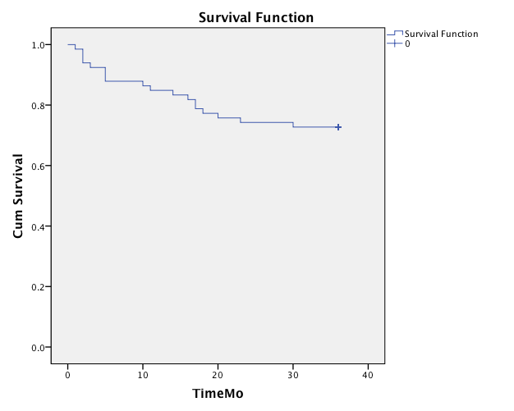
Figure 44. Survival analysis stratified over 3-year study period on all UC patients in remission, included in the experiment, at the time of index endoscopy. Time to relapse is shown in this graph.

6.3.1 Soluble iTRAQ analysis outcome comparing ER versus NR relative to controls
Median age of pooled ER and NR patients were 44 and 59, respectively (p=0.06). Pooled soluble proteome from ER to NR and normal controls were compared here as follows:

6.3.1.1 ER versus NR analysis
The soluble proteome in ER to NR mucosa were compared. The differentially expressed upregulated and down-regulated proteins in ER relative to NR are summarised in Tables 27&28.

Table 27. Upregulated proteins in ER relative to NR (Reference NR). General data regarding each protein’s gene name, length and mass was extracted from UniProt database on 26/01/2016. Fold change and p-value for each protein were directly extracted from the iTRAQ analysis. (Sequence) Length indicates the number of amino acids in the canonical sequence. (Molecular) Mass in Daltons (Da), calculated from the full precursor canonical sequence.
Protein name(s) | Accession No | Gene name | Length | Mass | Fold change | p-vlaue
Tropomyosin beta chain | P07951 | TPM2 | 284 | 32851 | 2.66 | 1.32E-05
Keratin, type I cytoskeletal 10 | P13645 | KRT10 | 584 | 58827 | 1.94 | 0.000293
Calponin-1 | P51911 | CNN1 | 297 | 33170 | 1.60 | 0.001176
Filamin-C | Q14315 | FLNC | 2725 | 291022 | 1.54 | 0.007516
Tropomyosin alpha-3 chain | P06753 | TPM3 | 285 | 32950 | 1.45 | 0.000202
Transgelin | Q01995 | TAGLN | 201 | 22611 | 1.42 | 0.000329
Keratin, type II cytoskeletal 1 | P04264 | KRT1 | 644 | 66039 | 1.39 | 0.006984
Cystatin-B | P04080 | CSTB | 98 | 11140 | 1.34 | 0.001712
Myosin-11 | P35749 | MYH11 | 1972 | 227339 | 1.22 | 0.001721
Filamin-A | P21333 | FLNA | 2647 | 280739 | 1.16 | 0.005634
Tropomyosin alpha-1 chain | P09493 | TPM1 | 284 | 32709 | 1.14 | 4.52E-07

Table 28. Down-regulated proteins in ER relative to NR (Reference NR).General data regarding each protein’s gene name, length and mass was extracted from UniProt database on 26/01/2016. Fold change and p-value for each protein were directly extracted from the iTRAQ analysis. (Sequence) Length indicates the number of amino acids in the canonical sequence. (Molecular) Mass in Daltons (Da), calculated from the full precursor canonical sequence.
Protein name(s) | Accession No | Gene name | Length | Mass | Fold change | p-vlaue
Cell surface A33 antigen | Q99795 | GPA33 | 319 | 35632 | 0.25 | 0.0006402
Selenium-binding protein 1 | Q13228 | SELENBP1 | 472 | 52391 | 0.68 | 0.009158
Trifunctional enzyme subunit alpha, mitochondrial | P40939 | HADHA | 763 | 83000 | 0.82 | 0.0032036

The interactions between these altered (upregulated (n=11) and down-regulated (n=3)) proteins in ER relative to NR are shown in Figure 45. Four proteins were subsequently excluded (GPA33, HADHA, SELENBP1, and CSTB), as they were orphan nodes within the network with no association to other proteins in the group. Two principle PINs emerged in this analysis, with clusters around Myosin-11 (MYH11) and TPM3.

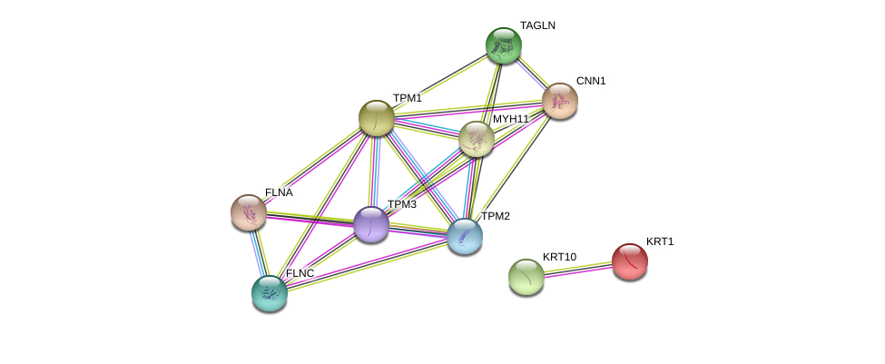
Cytoskeleton
Muscle contraction
Figure 45. Protein–protein interaction (PPI) network view summarising the network of predicted associations between differentially expressed proteins in ER relative to NR(orphan nodes not shown), and indicating proteins interlinked with clusters around muscle contraction (solid line), and cytoskeleton (square-dot line). Data accessed from STRING 10.5 database on 01/10/2018.

6.3.1.2 ER versus controls analysis
Soluble proteome was assessed between ER and controls. The differentially expressed upregulated and down-regulated proteins in ER relative to controls are summarised in Tables 29&30.
Table 29. Upregulated proteins in ER relative to normal controls. General data regarding each protein’s gene name, length and mass was extracted from UniProt database on 26/01/2018. Fold change and p-value for each protein were directly extracted from the iTRAQ analysis. (Sequence) Length indicates the number of amino acids in the canonical sequence. (Molecular) Mass in Daltons (Da), calculated from the full precursor canonical sequence.
Protein name(s) | Accession No | Gene name | Length | Mass | Fold change | p-vlaue
Keratin, type I cytoskeletal 10 | P13645 | KRT10 | 584 | 58827 | 2.49 | 1.85E-05
Keratin, type II cytoskeletal 79 | Q5XKE5 | KRT79 | 535 | 57836 | 1.75 | 0.005112
Keratin, type II cytoskeletal 8 | P05787 | KRT8 | 483 | 53704 | 1.50 | 0.00084
Keratin, type II cytoskeletal 1 | P04264 | KRT1 | 644 | 66039 | 1.44 | 3.84E-05
Keratin, type I cytoskeletal 18 | P05783 | KRT18 | 430 | 48058 | 1.44 | 0.007015
Keratin, type I cytoskeletal 19 | P08727 | KRT19 | 400 | 44106 | 1.37 | 7.3E-05
Ubiquitin carboxyl-terminal hydrolase 17-like protein 3 | A6NCW0 | USP17L3 | 530 | 59536 | 1.28 | 0.005085

Table 30. Down-regulated proteins in ER relative to normal controls. General data regarding each protein’s gene name, length and mass was extracted from UniProt database on 26/01/2018. Fold change and p-value for each protein were directly extracted from the iTRAQ analysis. (Sequence) Length indicates the number of amino acids in the canonical sequence. (Molecular) Mass in Daltons (Da), calculated from the full precursor canonical sequence.
Protein name(s) | Accession No | Gene name | Length | Mass | Fold change | p-vlaue
Haemoglobin subunit alpha | P69905 | HBA1 | 142 | 15,258 | 0.66 | 0.00332
Creatine kinase B-type | P12277 | CKB | 381 | 42,644 | 0.72 | 0.000261
Haemoglobin subunit beta | P68871 | HBB | 147 | 15,998 | 0.74 | 0.005122

The interactions between these differential (upregulated (n=7) and down-regulated (n=3)) proteins in ER relative to normal controls are shown in Figure 46. Two proteins were subsequently excluded (USP17L3, CKB), as they were orphan nodes within the network. One principle PIN emerged in this analysis, with clusters around K8.
Cytoskeleton

Figure 14. Protein–protein interaction (PPI) network view summarising the network of predicted associations between differentially expressed proteins in ER relative to control groups(orphan nodes not shown), and indicating proteins interlinked with cluster around cytoskeleton (solid line). Data accessed from STRING 10.5 database on 01/10/2017.

6.3.1.3 Biomarkers discovery
Target proteins were initially identified on the basis of relative fold change differences of about 2 or more between the study groups. They were scrutinised and finally chosen for orthogonal analysis on the basis of antibody availability and their role in known inflammatory pathways involved in UC (Table 31&32). Using this decision tree algorithm, the following proteins were chosen for orthogonal validation and biomarker discovery: cell surface A33 antigen (GPAA33), and cytoskeletal keratin 10 (K10). Protein S100-A8 (MRP8) was further added for the validation study, as this protein showed significant fold change of 5.87 (p= 0.003) between ER and pooled control 2. Although Ig alpha-1 chain C region (IGHA1), carbonic anhydrase 2 (CA2), and thioredoxin (TRX) did not have significant fold change differences between the compared groups, due to antibodies availability these proteins were also included as exploratory exercise.
Table 31. Candidate biomarkers - ER versus NR.
Up-regulated | Accession No | Fold change
Tropomyosin beta chain | P07951 | 2.66
Keratin, type I cytoskeletal 10 | P13645 | 1.94

Down-regulated | Accession No | Fold change
Cell surface A33 antigen | Q99795 | 0.25

Table 32. Candidate biomarkers - ER versus normal controls.
Up-regulated | Accession No |  | Fold change
Keratin, type I cytoskeletal 10 | P13645 | 2.49

 | Down-regulated | Accession No | Fold change
 | Hemoglobin subunit alpha | P69905 | 0.66

6.3.1.4 Orthogonal validation and cross-validation of candidate biomarkers predictive of UC future disease activity

The results for GPA33 in both pooled and independent groups of patient samples from ER and NR cohort are shown in Figure 47. In line with the iTRAQ outcomes, relative GPA33 level was lower in ER compared to normal control groups (p=0.009). Furthermore, relative GPA33 level was lower in ER compared to NR (p=0.02).

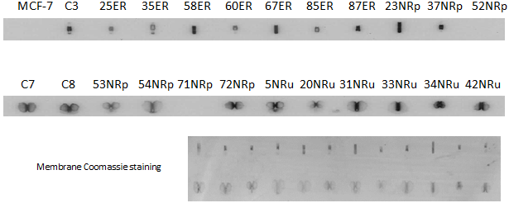
Figure 47. Patient samples from previously pooled cohorts of ER, NR (NRp) and controls, as well as independent group of NR (NRu) were immunoblotted against GPA33. Each patient and control is given a unique anonymised corresponding number. A control MCF-7 sample is included in the immunoblot to allow normalisation between sample groups. Relative GPA33 concentration for each dot-blot is inferred by determining its signal intensity relative to the MCF-7 GPA33 signal intensity, measured in turn by densitometry. Membrane Coomassie staining is performed to confirm equal protein amount in each dot-blot space. C=Control; ER: Early relapsers; NR: Non-relapsers.

The results for IGHA1 in both pooled and independent groups of patient samples from ER and NR cohort are shown in Figure 48. Relative IGHA1 level was higher in ER compared to both NR (p=0.001) and normal control groups (p=0.0008).
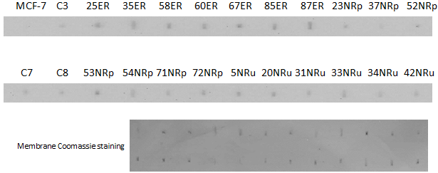
Figure 48. Patient samples from previously pooled cohorts of ER, NR (NRp) and controls, as well as independent group of NR (NRu) were immunoblotted against IGHA1. Each patient and control is given a unique anonymised corresponding number. A control MCF-7 sample is included in the immunoblot to allow normalisation between sample groups. Relative GPA33 concentration for each dot-blot is inferred by determining its signal intensity relative to the MCF-7 GPA33 signal intensity, measured in turn by densitometry. Membrane Coomassie staining is performed to confirm equal protein amount in each dot-blot space. C=Control; ER: Early relapsers; NR: Non-relapsers.
The results for K10 in both pooled and independent groups of patient samples from ER and NR cohort are shown in Figure 49. In line with the iTRAQ outcomes, relative K10 level was higher in ER compared to NR (p=0.04). The outcomes remained statistically significant when the outliers were excluded (data not shown).
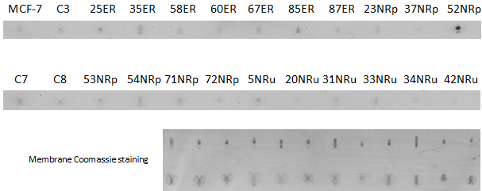
Figure 159. Patient samples from previously pooled cohorts of ER, NR (NRp) and controls, as well as independent group of NR (NRu) were immunoblotted against K10. Each patient and control is given a unique anonymised corresponding number. A control MCF-7 sample is included in the immunoblot to allow normalisation between sample groups. Relative GPA33 concentration for each dot-blot is inferred by determining its signal intensity relative to the MCF-7 GPA33 signal intensity, measured in turn by densitometry. Membrane Coomassie staining is performed to confirm equal protein amount in each dot-blot space. C=Control; ER: Early relapsers; NR: Non-relapsers.
The results for MRP8 in both pooled and not-pooled groups of patient samples from ER and NR cohort are shown in Figures 50. In line with iTRAQ outcomes, no significant change in expression of MRP8 was seen in the comparison groups.
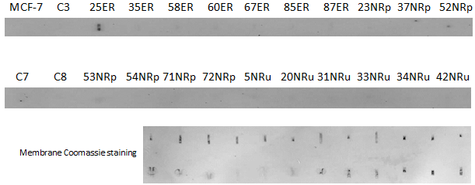
Figure 50. Patient samples from previously pooled cohorts of ER, NR (NRp) and controls, as well as independent group of NR (NRu) were immunoblotted against MRP8. Each patient and control is given a unique anonymised corresponding number. A control MCF-7 sample is included in the immunoblot to allow normalisation between sample groups. Relative GPA33 concentration for each dot-blot is inferred by determining its signal intensity relative to the MCF-7 GPA33 signal intensity, measured in turn by densitometry. Membrane Coomassie staining is performed to confirm equal protein amount in each dot-blot space. C=Control; ER: Early relapsers; NR: Non-relapsers.

The results for TRX in both pooled and not-pooled groups of patient samples from ER and NR cohort are shown in Figures 51. Relative TRX level was higher in ER compared to NR (p=0.001).
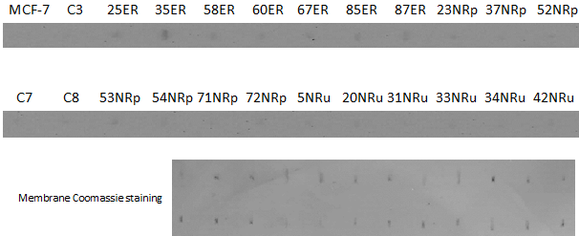
Figure 51. Patient samples from previously pooled cohorts of ER, NR (NRp) and controls, as well as independent group of NR (NRu) were immunoblotted against TRX. Each patient and control is given a unique anonymised corresponding number. A control MCF-7 sample is included in the immunoblot to allow normalisation between sample groups. Relative GPA33 concentration for each dot-blot is inferred by determining its signal intensity relative to the MCF-7 GPA33 signal intensity, measured in turn by densitometry. Membrane Coomassie staining is performed to confirm equal protein amount in each dot-blot space. C=Control; ER: Early relapsers; NR: Non-relapsers.
The results for CA2 in both pooled and not-pooled groups of patient samples from ER and NR cohort are shown in Figures 52. In line with iTRAQ outcomes, no significant change in expression of CA2 was seen in the comparison groups.
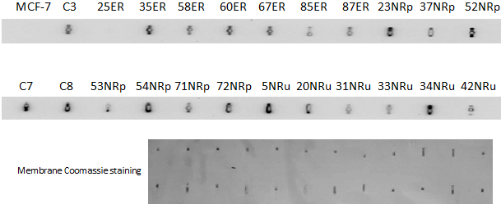
Figure 52. Patient samples from previously pooled cohorts of ER, NR (NRp) and controls, as well as independent group of NR (NRu) were immunoblotted against CA2. Each patient and control is given a unique anonymised corresponding number. A control MCF-7 sample is included in the immunoblot to allow normalisation between sample groups. Relative GPA33 concentration for each dot-blot is inferred by determining its signal intensity relative to the MCF-7 GPA33 signal intensity, measured in turn by densitometry. Membrane Coomassie staining is performed to confirm equal protein amount in each dot-blot space. C=Control; ER: Early relapsers; NR: Non-relapsers.

The outcome of the above orthogonal validation experiments are summarised in Table 33.

Table 33. Summary of the orthogonal validation experiments in ER, NR and normal controls cohorts demonstrating the over-expressed and under-expressed proteins amongst the comparison groups.ER: Early relapsers; NR: Non-relapsers; CON: normal controls.
 | ER relative to NR | ER relative to CON | NR relative to CON
Over-expressed proteins | TRX, K10, IGHA1 | IGHA1 | -
Under-expressed proteins | GPA33 | GPA33 | -

For post-hoc analysis, binary regression analysis was carried out in a block fashion. The Omnibus Tests of Model Coefficients used to check that the new model is an improvement over the baseline model (a model with no predictors), showed significant result (chi-square= 25.898, df= 6, p<0.000) with Cox and Snell R square=0.726 and Nagelkerke R square=1.0 for all target markers combined; however, the overall odd ratios for the model were not statistically significant.

6.4 Conclusion

Risk stratification of patients with IBD in remission in order to decide on initiation, continuation or even discontinuation of therapy remains an important challenge (40-42). This becomes even more essential when considering high heterogeneity of IBD with different disease evolution profile and unequal response to treatment (407, 408). This hinders disease management because patients with aggressive disease are undertreated by conventional ‘step-up’ therapy (in which treatment is gradually escalated in response to refractory or relapsing disease) whilst those with more indolent disease would be exposed to unnecessary treatment-related toxicity if a more aggressive ‘top-down’ approach was indiscriminately used (409).
Historically, there are a range of clinical parameters associated with more severe disease course in UC (410, 411) and CD (412, 413) with variable sensitivity and specificity. More recently, gene expression profiling on circulating CD8+ T cells of patients with UC and CD identified analogous CD8+ T cell transcriptional signatures that divided them into 2 otherwise indistinguishable subgroups including one with more aggressive (IBD1) versus other more indolent (IBD2) disease course (85). The group have since developed a whole blood qPCR classifier for prediction of disease course in patients with IBD from diagnosis (414). The clinical effectiveness of this biomarker is being evaluated in a multicentre, randomised trial (409).
Despite investigation into the prognostic value of clinical, genetic and serological markers, well-validated prognostic tools for IBD that can reliably predict the disease course remain a major obstacle (409). Indeed, a recent priority setting partnership group, tasked with identifying major areas of unmet need in IBD research, designated the need to develop markers to guide treatment for individual patients as the most important unmet need in IBD (415).

In order to address this clinical concern, soluble proteome was investigated in ER, NR and normal controls in the search of tissue biomarkers predictive of future UC disease activity.
At the same time exploratory interactions analyses were run, using STRINGS, in the search of discriminatory altered pathways and associated target biomarkers heralding early relapse.
Interactions analyses of altered proteins in ER versus NR identified clusters around the pathways for cytoskeleton and muscle contraction. Amongst the proteins involved in these pathways, up-regulation of TPM1-3, MYH11, FLNA and FLNC, together with down-regulation of HADHA were observed in ER compared to NR. These proteins were not assessed during biomarker discovery process in view of modest fold change.
Myosins belong to a large family of actin-based molecular motor proteins, which contain actin- and ATP-binding sites in their conserved catalytic head domains (416, 417). They are involved in a range of cellular functions such as transport membranous organelles transport, organisation of actin filaments, mitotic spindle regulation and gene transcription (418). Recent reports suggest a link between myosin-9B variants and increased intestinal permeability in CD patients (419). Furthermore, myosin-10 and myosin-2A functions have been linked to epithelial barrier homeostasis (420, 421). Myosin Heavy Chain 11 (MYH11) deregulation was shown to be associated to human intestinal neoplasia (422); but so far, there has been no report on a link between this protein and early relapse. For the first time in our study, we have shown upregulation of MYH11 in ER relative to NR.
Calponin belongs to a family of actin filament-associated calcium-binding proteins, which inhibits the actin-activated myosin ATPase (423, 424). Down-regulation of vascular calponin-1 (CNN1) has been demonstrated in the peripheral region of colon cancer tissues in association with tumour progression, lymphatic invasion, vascular invasion and recurrence (425). Conversely, CNN2 up-regulation was observed in acute experimental murine colitis from colonic muscle strips (320). In our study, we found over-expression of CNN1 in ER relative to NR for the first time.
Mitochondrial trifunctional protein (MTP) is a heterotrimeric protein, which catalyses three of the four chain-shortening reactions in the mitochondrial β-oxidation of long-chain fatty acids (426). It consists of four α and four β subunits (426). In this study, we have shown down-regulation of trifunctional enzyme subunit α (HADHA) in ER relative to NR, which may suggest the role of mitochondrial fatty acid β-oxidation and its deregulation in early UC relapse.
Selenium is an essential trace element, which is incorporated into proteins as selenocysteine and accepted as the 21st amino acid (encoded by the UGA codon) (427). Serum selenium has been previously correlated inversely with UC and Crohn’s disease activity (428, 429). There are many reports linking selenoproteins to modulation of inflammation (430, 431). In a recent study by Wang et al., down-regulation of selenium binding protein 1 (SELENBP1) was demonstrated in CRC samples, which seemed to be regulated by histon modification (432). Here for the first time, we showed down-regulation of SELENBP1 in ER relative to NR.
Cystatin-B (CSTB) belongs to a family of cysteine protease inhibitors. Recent studies have shown an anti-inflammatory effect from helminthic cystatin on murine colitis (433, 434). Here, we have shown up-regulation of CSTB in ER relative to NR. Our finding does not necessarily contradict the anti-inflammatory effect of CSTB, as the observed over-expression could well be a secondary protective response to the impending inflammation in ER.
Interactions analyses of altered proteins in ER versus controls identified single cluster around the pathway for cytoskeleton, which may suggest a possible role for keratins in early relapse of UC; having said, due to the design of this study being primarily towards biomarkers exploration, no conclusion can be made in this regard.

During orthogonal validation in search of candidate tissue biomarkers, we demonstrated down-regulated GPA33 and up-regulated IGHA1 in ER relative to normal controls. TRX, K10 and IGHA1 were upregulated whereas GPA33 were downregulated in ER relative to NR, respectively. No ideal target biomarkers found in NR relative to normal controls. The GO for these target proteins has previously explored in chapters 1&4.
Post-hoc regression analysis in an attempt to provide an optimal panel of tissue biomarkers predictive of early relapse in UC and to add statistical power to the differential target biomarkers did not reach a statistical significance. A plausible explanation for the this discrepancy is limited number of patients in each of 6 dependent variables required for running the logistic regression, which in turn creates type II error.
This proof-of-the-concept study has provided several new potential biomarkers predictive of future disease activity (TRX, IGHA1, K10, GPA33), which should be further independently validated in a larger adequately powered prospective cohort.
Although this study is the first report on the possible role of K10 alteration in UC, the likely involvement of keratins have been discussed in detail in Chapter 1. Whether over-expression of K10 in ER patients is a primary reflection of cellular structural instability or secondary effect of early subclinical inflammation needs to be investigated in the future.
Glycoprotein 33 (GPA33) is a cell surface antigen that is expressed in normal human colonic and small bowel epithelium and >95% of human colon cancers, but absent from most other human tissues (330, 331). Upon specific mAb binding to the A33 surface antigen, the antibody–antigen complex is getting endocytosed and sequestered in cytoplasmic vesicles (332). One hypothesis is that decreased expression of GPA33 in ER interferes with endocytosis and subsequent clearance of yet unknown antigen(s) via endosomal-lysosomal system, which triggers epithelial inflammation. Other plausible hypothesis is that presentation of certain luminal antigen(s), which are carried through the intestinal epithelial cells by GPA33, to the antigen-presenting cells in the extracellular medium are affected; this in turn impairs appropriate and measured immune response, which is required for maintaining a normal colonic homeostasis.
One of the most efficient reducing systems involves thioredoxin (TRX), which is ubiquitous antioxidant enzyme with multivalent cellular roles such as redox homeostasis (348), modulating inflammatory response (349) and regulating programmed cell death via denitrosylation (350, 351). It is possible that the oxidative stress that accompanies chronic inflammation contributes to the early UC relapse. Thioredoxin interacting protein (TXNIP), expression of which is induced by various types of stress including oxidative stress, is a negative regulator of thioredoxin (435). Takahashi et al. showed that TXNIP expression in active UC colonic mucosa specimens was significantly lower than that in normal tissues (436), which further supports our findings. Taken together, these observations suggest that redox regulation may be involved in the inflammatory processes in the colonic mucosa of UC patients.
Immunoglobulin A (IgA) has two distinct subclasses in humans named IgA1 and IgA2 with variable concentration depending on the site of release. Locally synthesised secretory IgA (SIgA) is the predominant and most abundant Ig in the human mucosal surfaces, which is mainly in the form of a dimeric compound; each IgA monomer in turn has two fragment antibody (Fab) regions for attachment to antigens and one fragment crystalisable (Fc) region for mediating effector mechanisms (335, 336). IgA1 chain C region (IGHA1) or Fc region is exerting its effect via attachment to Fc alpha receptors on the cell surface (337). SIgA is instrumental in maintaining the intestinal bacterial homeostasis (338, 339). As well as neutralising intraluminal pathogens, SIgA is acting as a selective transporter of the bound antigens back into intestinal Peyer’s patches as part of orchestrating an immunomodulatory response (340-342). The increased expression of IGHA1 could likely be a secondary effect of heightened immune reaction heralding overt inflammation in UC.

As mentioned in Chapter 5, an ideal biomarker should be rapid, convenient, non-invasive, inexpensive, standardised, reproducible, stable, precise and accurate in reflecting the state of bowel inflammation in IBD (325). The future study will be designed as accuracy study. Although there is no gold standard diagnostic test to predict UC disease activity in the future, the outcome of the index biomarker test result(s) will be directly compared with objective evidence of future disease activity i.e. standard of truth.
The trial population will be a cohort of patients (age 18-75) with UC in remission for at least 2 months together with normal controls. Exclusion criteria will include patients who are unable to give signed informed consent, frail individuals unable to tolerate a lower GI endoscopy, non-correctable coagulopathy (prothrombin time > 12 seconds / platelet count < 90 x 109/L), and pregnant patients.
Power calculation to achieve statistical power of 80% and α≤0.05 extracting standardised difference and effect size from the current study requires us to obtain sample size of n=20 for GPA33, TRX, K10 as well as n=15 for IGHA1 (subject:control ratio= 1).
Complete endoscopic and histological assessment will be carried out at the time of enrolment. Colonic biopsies and stool samples will be collected; this way the protein concentration and stability for each biomarker can be evaluated for faecal samples simultaneously. The patients are then followed up every 6 months for 3 years in order to assess for clinical signs of UC recurrence. The requirement and choice of further objective assessment of UC relapse (i.e. endoscopic/histologic, serologic, radiologic, and/or stool testing) will be decided by the responsible physician according to the current clinical practice standard.
The severity of recurrence will be correlated with the index level of each biomarker during UC remission status. Pre-test probability, specificity, sensitivity, positive/negative predictive values, and likelihood ratio for positive/negative results will be calculated together with cut-off values between a negative and a positive result on the basis of this proof-of-concept study. In order to select appropriate cut-off points to be used for each candidate biomarker, ROC curve will be explored.

Chapter 7: Investigating keratin 8 protein bands from ACT and INACT in insoluble proteome fraction

Abstract

Introduction and aims: Keratins may play a role in UC pathogenesis. K8 exists in a range of proteoforms; but distribution of K8 proteoforms have never been assessed in active UC. The aim of this study was to investigate the K8 proteoforms, which may attribute to differential mobility down the isoelectric column and to compare differential K8 PTM in ACT and INACT mucosa.
Methods: K8 proteoforms were investigated using label-free MS of gel bands in the IF fraction from two pooled colonic samples extracted from rectal biopsies in patients with active colitis (ACT) as well as the two reciprocal pooled biopsies from endoscopically and histologically uninflamed proximal mucosa (INACT) in the same patients. Pooled IF fractions were resolved by SDS-PAGE. Immunoblot analysis using K8 specific antibodies revealed a series of immunoreactive bands. LC/MS-MS analyses were run on a SYNAPT G2-Si HDMS mass spectrometer operated in data-independent analysis (DIA) coupled with ion mobility (HDMS^{E}).
Results: A single major band (R1) was visible in the region of the gel corresponding to the molecular weight of K8 in the ACT electrophoresis column. In contrast, the INACT sample had a series of bands visible in the column (S1, S2, S3, S4, S5). A large population of proteins were identified to be co-migrated with cytoskeletal keratins in each selected band. The findings showed substantially reduced complexity of K8 proteoforms in active UC. Furthermore, higher relative level of K8 PTMs were observed in higher molecular weights (MW) relative to lower MW band regions, which could at least partly be explained by the added relative weight of these PTMs on K8 proteins i.e. larger proteoform molecules may allow for more PTM sites.
New discriminatory K8 phosphorylation and acetylation sites were identified in the analysed IF fraction of ACT relative to INACT including unique phosphorylation and acetylation sites in the active (pSer34, AcLys122, AcLys158, AcLys325) and inactive (pSer432) UC mucosa, whilst pSer24 and AcLys108 PTM sites were shared between the two groups.
Conclusion: Several new phosphorylation and acetylation sites on K8 protein were identified, which may have applicability as biomarkers of disease activity pending further external validation.

Significance of this study
- What is already known on this subject?
Proteoforms refer to all of the different molecular forms in which the protein product of a single gene can be found, including changes due to genetic variations, alternatively spliced RNA transcripts and post-translational modifications (PTM).
Keratins exist in a range of proteoforms; but distribution of K8 proteoforms have never been assessed in active UC.
- What are the new findings?
The findings showed substantially reduced complexity of K8 proteoforms in active UC. Furthermore, higher relative level of K8 PTMs were observed in higher molecular weights (MW) relative to lower MW band regions, which could at least partly be explained by the added relative weight of these PTMs on K8 proteins i.e. larger proteoform molecules may allow for more PTM sites.
New discriminatory K8 phosphorylation and acetylation sites were identified in the analysed IF fraction of the active UC mucosa relative to reciprocal proximal inactive mucosa including unique phosphorylation and acetylation sites in the active (pSer34, AcLys122, AcLys158, AcLys325) and inactive (pSer432) UC mucosa, whilst pSer24 and AcLys108 PTM sites were shared between the two groups.
How might it impact on clinical practice in the foreseeable future?
Several new phosphorylation and acetylation sites on K8 protein (pSer34, AcLys122, AcLys158, AcLys325) were identified, which may have applicability as biomarkers of disease activity pending further external validation.

7.1 Introduction

Intermediate filaments (IF) are one of the main components of the human cell cytoskeleton. K8, K18 and K19 are the principle IF proteins in colonic epithelial cells. Alterations in keratin function are implicated in ulcerative colitis (UC) development. Our research group have previously shown reduced keratin 8 phosphorylation in active UC tissues using western blotting against pSer23 K8 and pSer431 K8 of the pooled IF samples (280). A series of immunoreactive bands on K8 protein were observed in ACT and INACT from 54 to 37 kD during SDS-PAGE immunoblotting. It is postulated that these bands could represent different K8 proteoforms.

Study aims
The primary aim of this study is to investigate the K8 proteoforms, which may attribute to differential mobility down the isoelectric column and to compare differential K8 PTM in ACT and INACT mucosa.
The secondary aim is to look at the co-migrated proteins alongside each band in the ACT and INACT groups to explore activated pathways associated with UC disease activity.

7.2 Methods

The existence of K8 proteoforms and associated PTMs were investigated using label-free mass spectrometry (MS) of gel bands in the IF fraction from two colonic sets of samples extracted from rectal biopsies in patients with active colitis (ACT) as well as the two reciprocal biopsies from endoscopically and histologically uninflamed proximal colonic mucosa (INACT) in the same patients. Each colonic biopsy samples were fractionated to obtain the insoluble fraction using our previously validated methodology (285). Pooled insoluble proteins (IF fraction) from the two groups were resolved by SDS-PAGE. Immunoblot analysis using K8 specific antibodies revealed a series of immunoreactive bands (Coomassie blue-stained gel is shown in Figure 53). A single major band (R1) was visible in the region of the gel corresponding to the molecular weight of K8 in the ACT electrophoresis column. In contrast, the INACT sample had a series of bands visible in the column (S1, S2, S3, S4, S5).
Considering immunoreactive bands are not always the protein against which the antibody was raised, these bands were followed up to determine if the immunoreactive bands were in fact K8 proteoforms. Individual bands (R1, S1-S5) were excised from the gel, proteolytically digested with trypsin and analysed using label-free mass spectrometry (MS) (437), in collaboration with Waters Ltd. LC/MS-MS analyses were run on a SYNAPT G2-Si HDMS mass spectrometer operated in data-independent analysis (DIA) coupled with ion mobility (HDMS^{E}). Label-free analysis using HDMS^{E} provides an additional dimension of separation, based on collision cross-section data (molecular size and shape) in addition to mass/charge measurements of peptides. The technique enables isomer separation, plus elimination of interferences, to generate cleaner spectra to aid protein database searching thus providing the opportunity for characterisation of proteins present in the individual gel bands. Given that PTM tend to occur in low stoichiometry, DIA approaches over the benefit of capturing all peptides and their fragments, whereas data dependent analysis (DDA) approaches fragments with just the most intense precursor ions.
Data processing and database searching was performed using Progenesis QI software. Each sample was run in duplicate. Proteins were identified and quantified between samples by reference to an internal standard (rabbit phosphorylase digest) spiked into the sample at time of analysis.
Validation and comparative analyses on proteins identified from each band were carried out using Scaffold (version Scaffold-4.3.2) software, where protein and peptide Identification thresholds were set at 95% with minimum number of peptides required for protein identification set at 2. Interestingly, large population of proteins were identified to be co-migrated with cytoskeletal keratins in each selected band. The extracted UniProt accession numbers for the protein population in each group were further subjected to bioinformatics scrutiny using a combination of UniProtKB, Reactome and STRING proteomics analysis tools.

ACT INACT
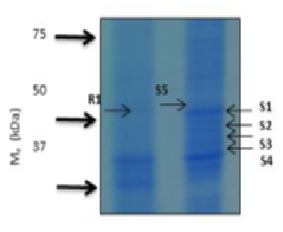
Figure 53. Label free analysis of selected gel bands for analysis of K8 proteoforms. R1: extracted band from ACT; S1-S5: extracted bands from INACT.

7.3 Results

K8 peptides were identified in all gel bands analysed. PTMs in K8 were relatively more prevalent in the excised bands from the higher molecular weight (MW) areas with relative gradual reduction in PTMs in the lower MW areas extracted from the INACT mucosa (S1 towards S4). The relative total level of K8 recovery was reduced in ACT (R1 band) as well as from S1-S5 in INACT (Figure 54).

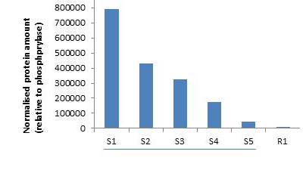
Figure 54. Relative K8 recovery in each extracted band in the experiment. R1: extracted band from ACT; S1-S5: extracted bands from INACT.

All peptides
Psty peptides
AcK peptides
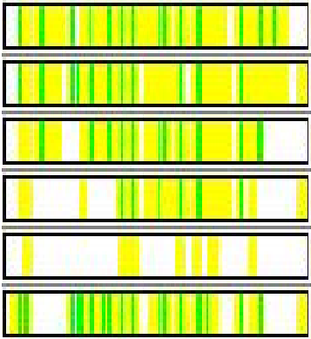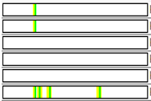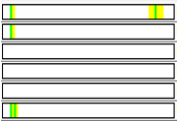
S1
S2
S3
S4
S5
R1

Figure 55. The de-convoluted peptide maps of K8 for each band. The yellow regions correspond to identified peptides; the green spots correspond to PTMs on K8 protein. AcK: Acetylation of Lysine; pSTY: phosphorylation of Serine, Threonine or Tyrosine.
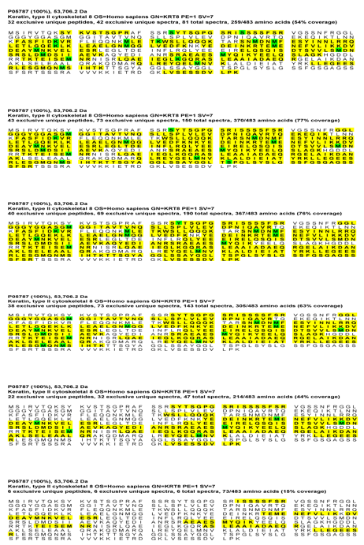
S5
S4
S3
S21
S1
R1
Figure 56. Mapping of K8 sequence coverage in each excised bands. The yellow regions correspond to identified peptides; the green spots correspond to PTMs on K8 protein. Peptides are shown in yellow and modified PTM residues (oxidised methione, acetylated lysine or phosphoserine) highlighted in green.

Comparing the K8 PTM sites between S1 and R1, revealed unique phosphorylation and acetylation sites in the active (pSer³⁴, AcLys¹²², AcLys¹⁵⁸, AcLys³²⁵) and inactive (pSer⁴³²) UC mucosa, whilst pSer²⁴ and AcLys¹⁰⁸ PTM sites were shared between the two groups (Figures 55&56).
Whilst all bands excised contained keratin 8, this was not the predominant protein species in all cases. Co-migrated protein populations identified in each band from the ACT (R1 band) and INACT (S1-S5 bands) groups were analysed using Scaffold viewer programme (v4.4.1.1). Proteins unique to each band as well as those shared, were stratified according to their UniProt accession numbers (Table 34). Schematic representation for the number of proteins shared and unique in each category is shown in the Venn diagram in Figure 57. Furthermore, proteins unique to S1 and R1 bands as well as those shared, were stratified separately for further pathway analyses (Table 35).
Table 34. A list of shared and unique proteins in S1-S5 bands using UniProt accession number.
Band number | Total | UniProt accession number
S1, S2, S3, S4, S5 | 16 | P08670, P30101, P00761, P04264, P02533, P68363, P17661, P00489, P35908,  P05787, P00924, P02768, P60709, P00330, P13645, P35527
S1, S2, S3, S4 | 6 | P35900, P68104, Q9Y6R7, P68032, P68371, P68366
S1, S2, S3, S5 | 2 | P07437, P08238
S1, S2, S4, S5 | 1 | P13647
S1, S3, S4, S5 | 2 | P02538, P14625
S2, S3, S4, S5 | 1 | P07900
S1, S2, S3 | 7 | Q13838, Q9BQE3, P11217, Q16181, P07355, Q15084, P49821
S1, S2, S4 | 3 | P11678, P81605, P05026
S1, S4, S5 | 1 | P01876
S2, S3, S4 | 1 | P05783
S2, S3, S5 | 1 | P02545
S1, S2 | 8 | Q8NBS9, Q9GZM7, Q13885, Q13509, P50995, Q07960, Q9BUF5, P06576
S1, S3 | 1 | Q9BVA1
S1, S4 | 2 | P01857, O75795
S1, S5 | 1 | P12035
S2, S3 | 19 | P60842, P26641, P49411, P54868, P20073, P31930, P39656, O00303, P61158,  Q9Y6N5, P38919, P17980, P20700, P55084, Q8NFW8, O60506, Q9UQ80, Q03252, P50395
S2, S4 | 1 | P41219
S2, S5 | 1 | P13646
S3, S4 | 1 | Q15233
S4, S5 | 2 | P19013, P27797
S1 | 12 | P51648, P50502, Q9Y230, P25705, Q9NVA2, O00232, P02679, P41091, Q71U36, P19971, P36957, Q13418
S2 | 3 | P06733, Q16543, O43852
S3 | 8 | P48735, Q92597, Q14240, P61978, Q15435, O75356, P22695, P07954
S4 | 26 | P23381, P50990 , P50991 , P17844 , P78371 , P15311 , P49257 , Q02252 , P62191 , Q07065 , Q9UMS4 , Q99832 , P10809 , P51884 , P08727 , P07237 , P21397 , Q01518 , Q96HN2 , P09622 , O75131 , O75351 , P29350 , Q53EL6 , O60701 , P40227
S5 | 4 | P02675, P12111, P08133, P05164

Table 35. UniProt accession numbers for the identified unique and shared proteins in R1 and S1 bands.
Uniprot ID numbers for proteins unique in R1 | Uniprot ID numbers for proteins unique in S1 | Uniprot ID numbers for proteins shared between S1&R1
O60701, P00367, P02675,  P09622, P13646, P14868,  P27797, P30837, P34897,  P43490, P78371, Q02252,  Q16851, Q96HN2, Q96KP4, Q9UMS4, Q9Y265, Q9Y512 | O00232, P02679, P07355,  P11217, P12035, P14625,  P19971, P36957, P41091,  P49821, P50502, P51648,  P81605, Q07960, Q13418,  Q13838, Q15084, Q16181,  Q71U36, Q8NBS9, Q9BQE3, Q9GZM7, Q9NVA2, Q9Y230 | O75795, P00330, P00489, P00761,  P00924, P01857, P01876, P02533, P02538, P02768, P04264, P05026, P05787, P06576, P07437, P08238, P08670, P11678, P13645, P13647, P17661, P25705, P30101, P35527, P35900, P35908, P50995, P60709, P68032, P68104, P68363, P68366, P68371, Q13509, Q13885, Q9BUF5, Q9BVA1, Q9Y6R7

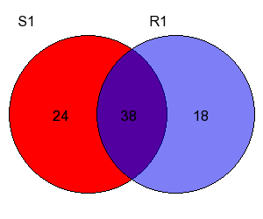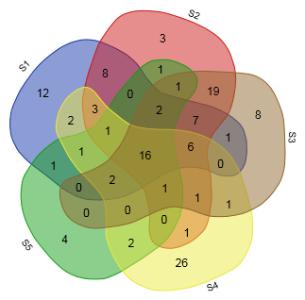
A
B
Figure 57. Venn diagrams comparing number of shared identified proteins in R1&S1 (A) and S1-S5 (B) bands.

Population of proteins unique to R1 band relative to S1 and vice versa were further investigated. These protein populations are summarised in Tables 36&37.

Table 36. Description of proteins unique to R1 relative to S1 band; data extracted from UnipProt on 20/01/2016. (Sequence) Length indicates the number of amino acids in the canonical sequence. (Molecular) Mass in Daltons (Da), calculated from the full precursor canonical sequence.
Protein name(s) | Accession No | Gene name | Length | Mass
UDP-glucose 6-dehydrogenase | O60701 | UGDH | 494 | 55,024
Glutamate dehydrogenase 1, mitochondrial | P00367 | GLUD1 | 558 | 61,398
Fibrinogen beta chain | P02675 | FGB | 491 | 55,928
Dihydrolipoyl dehydrogenase, mitochondrial | P09622 | DLD | 509 | 54,177
Keratin, type I cytoskeletal 13 | P13646 | KRT13 | 458 | 49,588
Aspartate--tRNA ligase, cytoplasmic | P14868 | DARS | 501 | 57,136
Calreticulin (CRP55) (Calregulin) | P27797 | CALR | 417 | 48,142
Aldehyde dehydrogenase X, mitochondrial | P30837 | ALDH1B1 | 517 | 57,206
Serine hydroxymethyltransferase, mitochondrial | P34897 | SHMT2 | 504 | 55,993
Nicotinamide phosphoribosyltransferase | P43490 | NAMPT | 491 | 55,521
T-complex protein 1 subunit beta | P78371 | CCT2 | 535 | 57,488
Methylmalonate-semialdehyde dehydrogenase | Q02252 | ALDH6A1 | 535 | 57,840
UTP--glucose-1-phosphate uridylyltransferase | Q16851 | UGP2 | 508 | 56,940
Adenosylhomocysteinase 3 (AdoHcyase 3) | Q96HN2 | AHCYL2 | 611 | 66,721
Cytosolic non-specific dipeptidase | Q96KP4 | CNDP2 | 475 | 52,878
Pre-mRNA-processing factor 19 | Q9UMS4 | PRPF19 | 504 | 55,181
RuvB-like 1 | Q9Y265 | RUVBL1 | 456 | 50,228
Sorting and assembly machinery component 50 homolog | Q9Y512 | SAMM50 | 469 | 51,976

The interactions between proteins found in R1 band relative to S1 are shown in Figure 58. One principle PIN emerged in this analysis, with cluster around Cytosolic non-specific dipeptidase (CNDP2)/ mitochondrial dihydrolipoyl dehydrogenase (DLD).

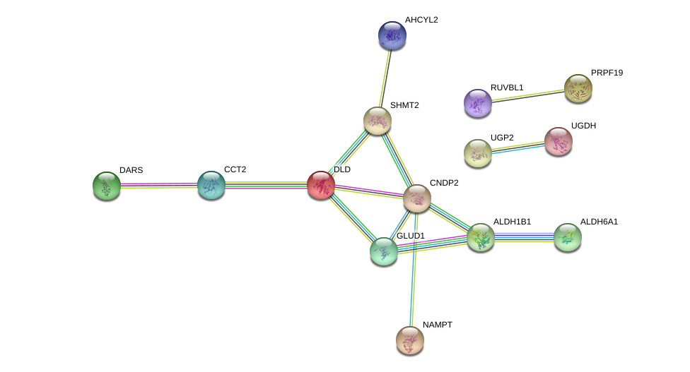
Metabolism
Figure 58. Protein–protein interaction (PPI) network view summarising the network of predicted associations between differentially expressed proteins in R1 relative to S1 (orphan nodes not shown), and indicating proteins interlinked with cluster around metabolism (solid line). Data accessed from STRING 10.5 database on 01/10/2018.

Table 37. Description of proteins unique to S1 relative to R1 band; data extracted from UnipProt on 20/01/2016. (Sequence) Length indicates the number of amino acids in the canonical sequence. (Molecular) Mass in Daltons (Da), calculated from the full precursor canonical sequence.
Protein name(s) | Accession No | Gene name | Length | Mass
26S proteasome non-ATPase regulatory subunit 12 | O00232 | PSMD12 | 456 | 52,904
Fibrinogen gamma chain | P02679 | FGG | 453 | 51,512
Annexin A2 | P07355 | ANXA2 | 339 | 38,604
Glycogen phosphorylase, muscle form | P11217 | PYGM | 842 | 97,092
Keratin, type II cytoskeletal 3 | P12035 | KRT3 | 628 | 64,417
Endoplasmin | P14625 | HSP90B1 | 803 | 92,469
Thymidine phosphorylase | P19971 | TYMP | 482 | 49,955
Dihydrolipoyllysine-residue succinyltransferase component of 2-oxoglutarate dehydrogenase complex, mitochondrial | P36957 | DLST | 453 | 48,755
Eukaryotic translation initiation factor 2 subunit 3 | P41091 | EIF2S3 | 472 | 51,109
NADH dehydrogenase | P49821 | NDUFV1 | 464 | 50,817
Hsc70-interacting protein | P50502 | ST13 | 369 | 41,332
Fatty aldehyde dehydrogenase | P51648 | ALDH3A2 | 485 | 54,848
Dermcidin | P81605 | DCD | 110 | 11,284
Rho GTPase-activating protein 1 | Q07960 | ARHGAP1 | 439 | 50,436
Integrin-linked protein kinase | Q13418 | ILK | 452 | 51,419
Spliceosome RNA helicase | Q13838 | DDX39B | 428 | 48,991
Protein disulfide-isomerase A6 | Q15084 | PDIA6 | 440 | 48,121
Septin-7 | Q16181 | Sep-07 | 437 | 50,680
Tubulin alpha-1A chain | Q71U36 | TUBA1A | 451 | 50,136
Thioredoxin domain-containing protein 5 | Q8NBS9 | TXNDC5 | 432 | 47,629
Tubulin alpha-1C chain | Q9BQE3 | TUBA1C | 449 | 49,895
Tubulointerstitial nephritis antigen-like | Q9GZM7 | TINAGL1 | 467 | 52,387
Septin-11 | Q9NVA2 | Sep-11 | 429 | 49,398
RuvB-like 2 | Q9Y230 | RUVBL2 | 463 | 51,157

The interactions between proteins found uniquely in S1 band relative to R1 are shown in Figure 59. Three principle PINs emerged in this analysis, with clusters around RuvB-like 2 (RUVBL2), dihydrolipoyllysine-residue succinyltransferase component of 2-oxoglutarate dehydrogenase complex (DLST) and NADH dehydrogenase (NDUFV1).

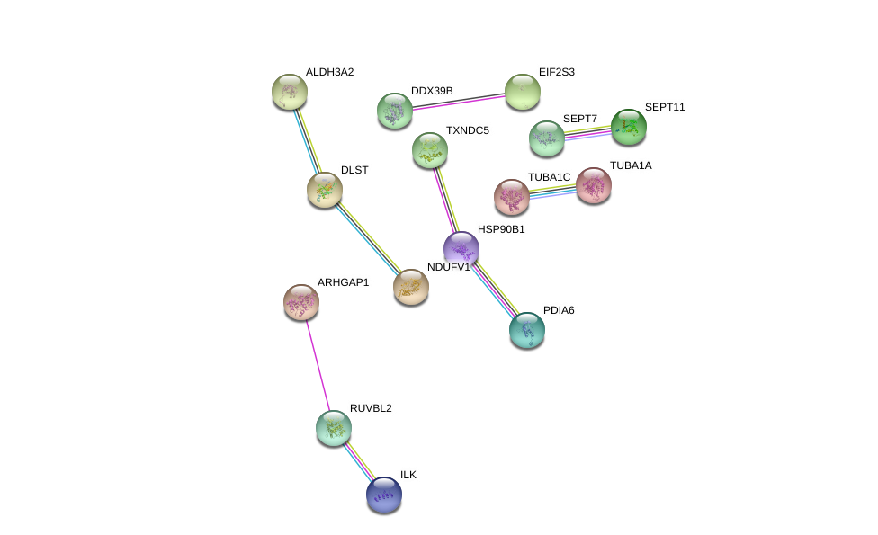
Metabolism of aminoacid
Pyruvate metabolism and TCA cycle
Cell cycle
Figure 59. Protein–protein interaction (PPI) network view summarising the network of predicted associations between differentially expressed proteins in R1 relative to S1(orphan nodes not shown), and indicating proteins interlinked with clusters around metabolism of amino-acid (solid line), cell cycle (dash-dot line) and pyruvate metabolism/TCA cycle (long dash-dot line). Data accessed from STRING 10.5 database on 01/10/2018.

Table 38. Possible discriminatory pathways unique to R1 band (entities FDR ≤0.05 & p value ≤0.05). Data extracted from Reactome database on 16/01/2018.
Pathway name | #Entities found | #Entities total | Entities pValue | Entities FDR | Mapped Gene names | Mapped entities
Formation of the active cofactor, UDP-glucuronate | 2 | 3 | 1.13E-05 | 0.002 | UGDH; UGP2 | O60701;Q16851
Biological oxidations | 4 | 223 | 4.07E-04 | 0.017 | UGDH; CNDP2; ALDH1B1; UGP2 | O60701;Q96KP4;P30837;Q16851
Metabolism | 10 | 2110 | 6.27E-04 | 0.017 | UGDH; NAMPT; CNDP2; ALDH1B1; ALDH6A1; DARS; GLUD1; UGP2; DLD; SHMT2 | O60701;P43490;Q96KP4;P30837;Q02252;P14868;P00367;Q16851;P09622;P34897
Branched-chain amino acid catabolism | 2 | 23 | 6.50E-04 | 0.017 | ALDH6A1; DLD | Q02252;P09622
Glucuronidation | 2 | 24 | 7.07E-04 | 0.017 | UGDH; UGP2 | O60701;Q16851
Phase II - Conjugation of compounds | 3 | 110 | 7.23E-04 | 0.017 | UGDH; CNDP2; UGP2 | O60701;Q96KP4;Q16851

The statistically significant altered pathways unique to R1 is summarised in Table 38. Although biological oxidation, and metabolism of amino-acids show significant p-value and FDR, only ‘Formation of the active cofactor, UDP-glucuronate’ pathway seem significantly altered when P value, FDR, the number of entities found in comparison to the number of entities in each pathway are taken into consideration collectively.
None of the pathways reached statistical significance during analysis of co-migrated protein populations in S1 relative R1 (data not shown).

7.4 Discussion and Conclusion

The study showed substantially reduced complexity of K8 proteoforms in active colitis. In contrast, multiple immunoreactive K8 bands extracted from INACT mucosa were associated with variable degree of K8 PTMs. Specifically, relative degree of oxidation reduced from S1 to S4, no acetylation was seen in S3-S5 and only one phosphorylation site was detected on S2 band at the tyr³⁵. Furthermore, no forms of K8 PTM were found in S5. Hence overall, higher relative level of K8 PTMs were observed in higher MW relative to lower MW band regions, which could at least partly be explained by the added relative weight of these PTMs on K8 proteins i.e. heavier proteoform molecules may allow for more PTM sites.
The study further revealed new discriminatory K8 phosphorylation and acetylation sites (pSer³⁴, AcLys¹²², AcLys¹⁵⁸, AcLys³²⁵) in the analysed IF fraction of the active UC mucosa relative to reciprocal proximal inactive mucosa, which may have applicability as biomarkers of disease activity, pending further external validation both between ACT and INACT as well as ACT and normal controls. Whether differential expression of pSer⁴³²K8 in INACT mucosa relative to ACT bears protective effect on K8 molecule and in turn mucosal stability needs further investigation. On the other hand this latter phosphorylation site may indicate field defect in INACT mucosa, which again reuquires future analysis.

In order to further explore candidate biomarkers and associated differential molecular pathways specific to active mucosa in UC (ACT) relative to proximal inactive mucosa (INACT), comparative analysis of co-migrated protein populations between the two groups was carried out. This investigation suggested possible differential cellular pathways associated with each band. In particular amino-acids metabolism, protein folding activity and biological oxidation were differentially activated in ACT relative to INACT. There are few limitations to this study; there were a range of bands detected by Coomassie blue staining, of which only a subset were analysed. A more comprehensive analysis could have been obtained by using GelCMS (352), where all gel bands were excised and analysed by HDMS^{E}. This was not possible at the time, as there was limitation with instrument time only for the agreed bands of interest. Furthermore, the IF sample amount was limited, so the experiment could not be repeated using the data dependent analysis workflows. Therefore, although the exploratory pathway analyses discovered discriminatory cellular pathways specific to the studied band areas, the proteins identified are from selected gel bands rather than the whole gel lane, hence it is not a comprehensive analysis of the sample in each category. Lastly, only the insoluble proteome fraction was studied in this experiment and considering substantial amount of functional cellular activities occur in the soluble proteome, the pathway analyses are deemed inconclusive on the basis of this investigation.
To address these limitations, a future adequately powered experiment should be carried out in patients with active UC. Power calculation to achieve statistical power of 80% and α≤0.05 extracting standardised difference and effect size from the current study requires sample size of n=15. Confirmatory analysis on K8 proteoforms and differential PTMs expression in active UC can be explored using GelCMS and analysed by HDMS^{E}, as described above (also see Chapter 4.4).

Chapter 8: Final discussion and conclusion on general study findings

In this body of work, investigations were divided into analyses of colonic mucosa in insoluble and soluble proteomes within a carefully phenotyped population of UC patients in order to gain insight into proteomic alterations specific to each stage of UC disease being studied. This proteome compartmentalisation provided a more precise platform for exploring each division, as majority of IF are in the insoluble proteome; moreover this method significantly reduced the masking effect of highly abundant structural proteins on the functional soluble proteome. Insoluble proteome was first explored in each category in order to investigate alterations in IF proteins and associated PTMs in UC. Later on, the soluble proteome was examined to explore functional protein alterations in UC. At the same time, the effect and degree of IF solubilisation was investigated at each UC disease stage under study.
For the first time, relative reduction in epithelial K8 level during UC disease activity was shown compared to proximal inactive mucosa as well as normal controls. Previous murine studies have pointed towards the causative effect of K8 absence and associated inflammation (438); but whether these changes are the effect of underlying inflammation or as part of the pathogenesis of UC inflammation in human, needs further investigation. Irrespective of keratins role in the pathophysiology of UC, this K8 alteration can be further exploited as a biomarker of disease activity; this provides an opportunity for developing a K8 stool assay for this purpose in the future (See Chapter 4.4 for further information on possible study design).
Relative increase in soluble pSer73 K8 levels was demonstrated in ACT relative to INACT; considering previous reports on the role p38 MAPK activation during phosphorylation of K8 at the Ser73 site (291, 294), this study further reaffirms MAPK pathway activation in the active UC mucosa. Interestingly, the relative soluble pSer73 K8 level was higher in INACT compared to normal controls, which suggests field change in normal-looking UC colonic mucosa. The pSer73 K8 detection rate was very low in the insoluble proteome, which shows the effect of Ser73 phosphorylation on K8 solubilisation. Considering previous cell culture as well as human tissue studies (291-295), further exploration into the exact role of MAPK pathway in phosphorylation of K8 at the Ser73 site in UC colonic mucosa during disease activity can be carried out in a future independent study. Unfortunately due to the presumed incompatibility between the buffer in the MAPK array and our existing protein lysate buffer, I was not able to carry out this study conclusively. Hence fresh colonic tissue samples should be acquired for patient with active UC using the manufacturer’s recommended buffer from the outset. At the same time, investigation of feasibility of pSer73 K8 protein as another biomarker of UC disease activity can be exploited.
Relative increase in K8 level in LSPC was shown compared to ROUC. The relative lower K8 levels in ROUC could be explained by recent acute inflammation in this cohort, which lags behind histologic restoration and complete cytoskeletal repair. In contrast, the LSPC group had significantly longer period of remission prior to index endoscopy in our cohort (p‹0.01). Whether restoration of K8 in LSPC is a cause or simply the effect of deep remission needs to be further investigated. This could be done by comparing prospective LSPC and ROUC patients both in more sustained remission of at least 2 months or more (See Chapter 5.4 for possible study design). Moreover K8 restoration with a certain pattern of K8 isoform distribution (as observed in Chapter 5.3) should be further investigated for possible sign of relative mucosal stability and prolong remission. This finding may have implications in UC screening programme if future prospective studies confirm the protective effect of keratins restoration in colonic epithelial cells against recurrent inflammation and cancer.
Functional enrichment or pathway analyses were carried out routinely during UC soluble proteome investigations using high-throughput biological data from iTRAQ workflow in hypothesis-generating attempt. Over-Representation Analysis (ORA) were performed using Reactome database. To overcome inherent limitation with ORA methods regarding assumption of independency between each pathway as opposed to interaction and overlaps (439), subsequent Pathway-Topology Based (PTB) analysis using String database was carried out.
Multiple over-expressed and under-expressed differential proteins as well as possible associated discriminatory molecular pathways were identified. They have already been extensively discussed in Chapters 4-7. In this chapter, only the wider application of these findings for optimal candidate biomarkers is discussed. It is worth mentioning that there have been previous attempts in defining the proteomic signature of UC disease activity from both serum and whole lysate colon tissue extracts (131, 143, 159, 170); but there has been no study exploring differential soluble proteome fractions from colonic biopsies in active UC, or comparing changes in patients with long-standing colitis as opposed to those with colitis of recent onset, which may contribute to a higher risk of CACRC. Moreover, for the first time, a novel proteomics approach linked to clinical outcomes was utilised in a cohort of carefully selected UC patients in disease remission in order to explore predictive biomarkers of disease relapse in a hypothesis-generating exercise.
Principle component analysis (PCA) on the identified discriminatory proteins from the iTRAQ study singled out ACT and ER cohorts as distinct groups, which further signifies the importance of proteomics investigations in these groups (Figure 60 & 61). In particular, it demonstrates that early future relapse in UC patients in remission can be predicted using the identified discriminatory proteins. The predictive value of a panel of biomarkers was explored in Chapter 6.3 (also see next paragraph); however, the overall odd ratios for the model were not statistically significant indicating that we cannot reliably use it for predicting UC disease activity based on our data, which could be explained by limited number of patients leading to type II error.

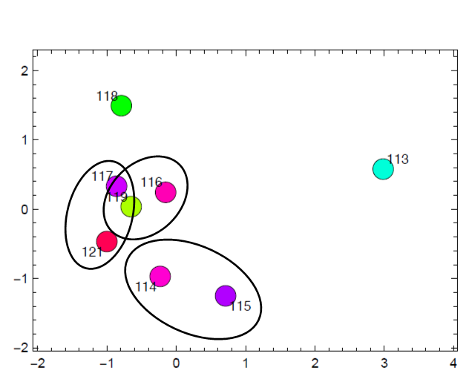
Figure 60. Principal component analysis for ITRAQ groups-Soluble proteomics study.

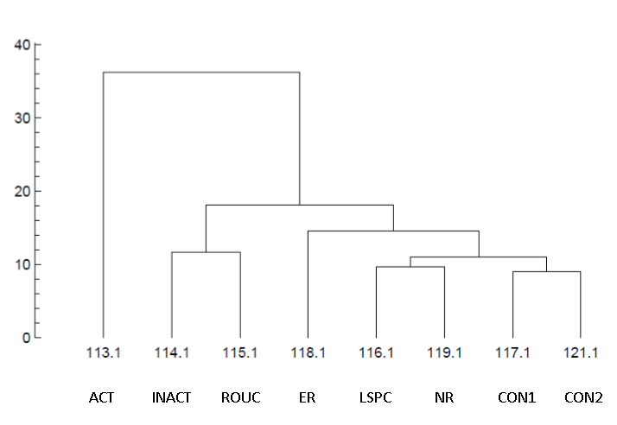

Figure 61. Dendogram for iTRAQ components-Soluble proteomics study.

In an attempt to discover candidate biomarkers predictive of UC disease activity in the future, for the first time in this thesis, a panel of upregulated and down-regulated proteins was presented specific to ER group relative to NR (Chapter 6.3). Further outcome validation was carried out independently during candidate biomarker discovery, which showed that over-expression of K10, IGHA1 and TRX, as well as under-expression of GPA33 can discriminate early UC relapse from those with long-term sustained remission. Considering this study was a proof-of-concept investigation, future validation of these predictive biomarkers should be performed prospectively in adequately powered cohort of UC patients in remission (See Chapter 6.4 for possible future study design). The outcomes have potential significant impact for risk stratification in UC patients during disease remission in terms of therapeutic options and follow up schedules.
In the search for biomarkers of UC disease activity, a panel of upregulated and down-regulated proteins specific to ACT mucosa was shown relative to the normal controls (Chapter 4.3). Independent validation of the iTRAQ outcomes verified under-expression of CA2 and GPA33, as well as over-expression of IGHA1, MRP8 and K10 as potential candidate tissue biomarkers of UC disease activity. Out of these 5 proteins, only MRP8 is currently exploited as a stool biomarker of IBD disease activity (440), with CA2 having previously been identified as a discriminatory biomarker between CD and UC (152). Interestingly, over-expression of IGHA1, MRP8, TRX and K10 were observed in INACT compared to the normal controls, which further suggests field change in the area of proximal UC mucosal inactivity. A possible future study design has been described previously in Chapter 4.4.
Finally, a panel of upregulated and down-regulated proteins specific to LSPC was demonstrated relative to ROUC (Chapter 5.3). These outcomes were validated independently during candidate biomarker discovery which showed under-expression of IGHA1, MRP8 and TRX as possible biomarkers of disease evolution. Furthermore, overexpression of K10, IGHA1, GPA33, MRP8 and TRX were observed in ROUC mucosa compared to the normal controls. However, as mentioned earlier in the case of IF investigation, these proteins alterations in expression could simply be the effect of recent inflammation in the case of ROUC cohort at the cellular level with possible associated proteome perturbation in spite of complete histologic remission, especially as directional changes in two of the proteins (IGHA1, MRP8) in this latter cohort was similar to the identified biomarkers of disease activity, described earlier. Therefore, these results should be further validated in the future in a cohort of ROUC patients in a longer period of disease remission relative to LSPC patients (See Chapter 5.4).
There were some limitations to our body of work. Firstly, due to limited numbers of patients in our cohort, cross-validation of data had limited statistical power; in particular, cross-validation was not possible in ER group (Chapter 6.3). Furthermore I was not able to reach a statistical significance for any of the identified biomarker panels described earlier. Considering the nature of my study as a proof-of the-concept, future studies should be adequately powered to overcome this shortcoming. Secondly, we used QSTAR® XL MS as part of our iTRAQ workflow, which may have affected the limited number of identified over-represented proteins (n=257) in our dataset. As a result, the outcome of pathway analyses should be interpreted with caution in view of limited number of found protein entities in each category. To minimise the effect of limited protein discovery, only pathways with both p-value and FDR of ≤0.05 were scrutinised taking in to account the number of entities found in comparison to the total number of entities within a given pathway.

In conclusion, this thesis demonstrated the value of proteomics studies together with bioinformatics tools in delineating potential discriminatory molecular pathways as well as candidate biomarkers in UC. A novel proteomics methodology for exploring colonic mucosa in UC was introduced together with a unique study design in the case of predictive biomarker discovery.
It is important to bear in mind that in the pursuit of ideal protein biomarker, a variety of factors need to be considered including stability of the protein in terms of longer half-life, sensitivity/specificity, easy detectability in bodily fluid/stool, and proportionality according to disease activity. Since this study was carried out as proof-of-concept, the biomarker panels for each UC disease category should be externally validated in an adequately powered prospective study in the first stage prior to selection of ideal biomarkers. Considering the large amount of hypotheses this body of work have produced, it is hoped that this study could pave the way for setting up more in-depth experiments in the near future.

Appendix 1. Cytoskeletal isolation from biopsies

Low detergent duffer LDB (10ml – enough for 50 biopsies)
- 5ml HPLC grade water
- 500µl 10x PBS
- 500µl 1M Mops (pH7) (Sigma) 2.09g/10ml water, use HCl to pH.
- 100µl 1M MgCl2 (Sigma) 2.03g/10ml water
- 200µl 100mM Pefabloc (Roche Diagnostics)
- 100µl 100mM EGTA (Sigma)
- 150µl 10% Triton X-100 (Sigma)
Make up to 10ml with water
Phosphatase Inhibitor:
- PI Cocktail 2 (P5726) 10µl/ml buffer
- 200 mM Sodium β glycerophosphate 10µl/ml buffer (2mM final)
- 200mM Sodium pyrophosphate decahydrate 10µl/ml buffer (2mM final)
- 1M Sodium fluoride 10µl/ml buffer (10mM final)

High detergent buffer (HDB) (10ml ice cold – enough for 50 biopsies)
- 5ml HPLC grade water
- 500µl 10x PBS
- 500µl 1M Mops (pH7) (Sigma)
- 100µl 1M MgCl2 (Sigma)
- 200µl 100mM Pefabloc (Roche Diagnostics)
- 1ml 10% Triton X-100 (Sigma)
- 2ml 5M NaCl (2.92g/10ml H2O, aliquot 10x1ml, freeze)
Make up to 10ml with water
Phosphatase Inhibitor:
- PI Cocktail 2 (P5726) 10µl/ml buffer
- 200 mM Sodium β glycerophosphate 10µl/ml buffer (2mM final)
- 200mM Sodium pyrophosphate decahydrate 10µl/ml buffer (2mM final)
- 1M Sodium fluoride 10µl/ml buffer (10mM final)
Add 20µl Benzonase Nuclease (Novagen) just before use (2µl/ml)
4M Guanidine HCl in TEAB (0.38g/ml - make just before use T7408-100ml
Bead lysis
Keep on ice as much as possible.
*Precellys tubes: 1x pk50 CK14 ceramic beads

1. Pre-label Precellys tubes and four sets 1.5ml lo-bind Eppendorfs (F1, F3a, F3b, F4)
2. Place each biopsy in respective Precellys tube
3. Add 300µl LDB
4. Homogenise sample in Precellys machine at 6000rpm, 30secs, 2cycles (20 sec rest)
Turn on Precellys Machine in FU26 (switch at back):
Slot tubes in rotor (balanced) and Place inner white lid over samples
Check correct program
Ensure lid firmly closed and press ‘valid’ to start
5. Place tubes on ice and transfer lysates to pre-labelled F4 lo-bind tubes
6. Spin 596g, 5mins, 4°C, Sigma 3-16k Centrifuge
7. Transfer supernatant to pre-labelled F1 tubes (soluble, extractable membrane proteins)
8. Wash pellet with 200µl LDB by inverting gently a couple of times
9. Spin 596g, 5mins, 4°C
10. Discard supernatant, place tubes on ice
11. Add benzonase nuclease to HDB on ice (2µl/ml of buffer)
12. Re-suspend pellet in 200µl HDB by aspirating/vortexing
13. Incubate on ice, 10min
14. Spin 10,024g, 10min, 4°C
15. Transfer supernatant to pre-labelled F3a tubes (high salt soluble fraction)
16. Add 200µl to remaining pellet
17. Spin 10,024g, 10min, 4°C
18. Transfer supernatant to pre-labelled F3b tubes
19. Remaining pellet is cytoskeleton proper- insoluble Fraction 4
20. Resuspend Pellet in 100µl 4M Guanidine in TEAB
21. Freeze all tubes at -80°C (perform Peirce clean up before protein assay)

Appendix 2. Cytoskeletal extractions from cells

Low detergent buffer (enough for 2 x T75)
- 1ml molecular grade water
- 100µl 10x PBS
- 100µl 1M Mops (pH7) (Sigma) 2.09g/10ml water, use HCl to pH.
- 20µl 1M MgCl2 (Sigma) 2.03g/10ml water
- 40µl 100mM Pefabloc (Roche)
- 20µl 100mM EGTA (Sigma)
- 30µl 10% Triton X-100 (Sigma)
Make up to 2ml with water (+0.69ml) in small Sterilin.

High detergent buffer (enough for 2 xT75)
- 1ml molecular grade water
- 100µl 10x PBS
- 100µl 1M Mops (pH7) (Sigma)
- 20µl 1M MgCl2 (Sigma)
- 40µl 100mM Pefabloc (Roche)
- 200µl 10% Triton X-100 (Sigma)
Make up to 2ml with water (+0.54ml) in small Sterilin.
(Add 4µl Benzonase nuclease (Novagen) just before use (-20))

Wash buffer (enough for 2 x T75)
- 19.95ml PBS
- 40µl 1M MgCl2
- 10µl 100mM Pefabloc
- 5M NaCl: 2.92g/10ml water (aliquot 10 x 1ml and store at -20°C)

Method
1. Prepare wash buffer and leave at 37°C
2. Prepare Low and High detergent buffers with benzonase nuclease on standby.
3. 5M NaCl on ice, and large ice bucket for flasks.
4. Label eppendorfs: Fraction 1 – 4 in duplicate for each cell line as will be retaining 100µl of each fraction prior to next spin.
5. Remove media from cells
6. Wash with 3ml warm wash buffer (x3)
7. Add 1ml low detergent buffer, agitate gently to ensure flask is covered, room temp.
8. After 60-90 secs, remove buffer to labelled eppendorf on ice.
9. Spin 13,000rpm, 30 secs.
10. Retain supernatant: FRACTION 1 (MEMBRANE BOUND SOLUBLE PROTEIN)
11. Place flask on ice.
12. Add 4µl benzonase nuclease to high detergent buffer and mix gently.
13. Add 1ml high detergent buffer to flask, ensure even cover. Incubate on ice 10 mins.
14. Add 250µl ice cold 5M NaCl to flask, pipette gently to wash flask and detach cytoskeletons.
15. Gently aspirate cells and transfer to labelled eppendorf:
FRACTION 2 (ENTIRE CYTOSKELETAL FRACTION)
16. Retain 100µl of suspension at -80°C for later gel analysis
17. Centrifuge eppendorf at 10,000g 10mins 4°C
18. Retain supernatant: FRACTION 3 (HIGH SALT SOLUBLE FRACTION)
19. Add 300µl of 10 M urea buffer to pellet: FRACTION 4 (CYTOSKELETON PROPER).

Appendix 3. Buffer exchange and sample cleaning process prior to iTRAQ analysis

Two reagents were identified that potentially interfere with MS reagents including 0.15% Triton X-100 (Sigma-Aldrich, USA) (a detergent that interferes with trypsin digestion) and 100mM 4-(2-Aminoethyl)-benzenesulfonyl fluoride hydrochloride (Pefabloc) (Roche Diagnostics, Switzerland) (a protease inhibitor containing free amine that interferes with iTRAQ labeling). In an attempt to separate these interfering molecules from our F1 buffer solutions, the following stepwise methods were tried, sequentially:

- Millipore spin column sample concentration and clean-up

Introduction and aim
Triton X-100 is a nonionic polyoxyethylene surfactant commonly used as a component of cell lysis buffers. Pefabloc (4-(2-Aminoethyl)-benzenesulfonyl fluoride hydrochloride) is an irreversible serine protease inhibitor. Both these agents were used for our cell lysis/protein fractionation process (see appendix 1&2). As these molecules potentially interfere with the protein preparation (Triton X-100) and iTRAQ labeling (Pefabloc) prior to MS study, they should be removed from our buffer solution effectively. The following method was therefore attempted as the first trial.

Method
Two F1 representative samples (UC061 & UC068) extracted from colonic tissue biopsies (similar to our study sample materials) were used. Protein concentration was identified for each sample prior to clean-up process using Bradford assay (UC61: 1.78mg/ml & UC68: 2.78mg/ml). The samples were first concentrated using Millipore spin columns with 3 K mol weight cut off membrane. A total of 100μg protein was then separated from the total volume in each sample. They were buffer exchanged by repeated addition of 1M Tetraethylammonium bromide (TEAB) (iTRAQ buffer) buffer. Following clean up and buffer exchange, both samples were quantified with Bradford assay again. To confirm and clarify the accuracy of protein exchange and the amount of protein loss during the buffer exchange process, 10micrograms and 20micrograms of both samples pre & post buffer exchange were run in a gel followed by Coomassie blue staining. A 10% resolving for 2 gels were prepared; the samples were loaded and separated in the gel via electrophoresis followed by Coomassie blue staining as previously described.

Result
Bradford assay pre and post clean-up and buffer exchange showed significant protein loss during this process ((UC61: no protein quantified & UC68: 0.94mg/ml); it is worth mentioning that during the process of buffer exchange the UC61 sample (milipore) broke in the centrifuge machine hence there was possible significant protein loss due to a technical problem in one of the trial samples. The results are summarized in Table 1 and Figure 1.

Table 1. Protein concentration before/after clean-up and buffer exchange process using Millipore spin column
 | Pre (mg/ml) | Post (mg/ml)
UC061 | 1.78 | Nil
UC068 | 2.78 | 0.94

kDa

M A B C D A' B' C' D'
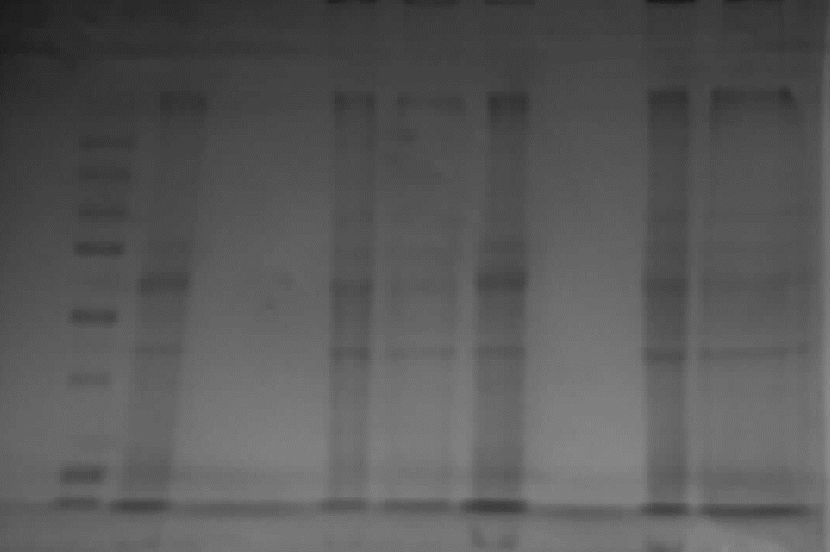
10
15
25
37
75
100
150
250
Figure 1. Coomassie blue staining of two trial soluble fraction samples (UC061 & UC068) before/after clean-up and buffer exchange process using Millipore spin column. M= molecular-weight marker; A=10μg protein load -UC061 prior to clean-up and buffer exchange; B=10μg protein load -UC061 after clean-up and buffer exchange (arbitrary as 0mg/ml concentration); C=10μg protein load -UC068 prior to clean-up and buffer exchange; D=10μg protein load -UC068 after clean-up and buffer exchange; A'=20 10μg protein load -UC061 prior to clean-up and buffer exchange; B'=20μg protein load -UC061 after clean-up and buffer exchange (arbitrary as 0mg/ml concentration);C'=20μg protein load -UC068 prior to clean-up and buffer exchange; D'=20μg protein load -UC068 after clean-up and buffer exchange.

- HiPPR detergent removal using spin columns

Introduction and aim
Detergents and surfactants are needed for solubilisation, stabilisation and disaggregation of proteins and protein complexes; however as mentioned above, some of these detergents (441) may interfere with mass spectrometric analysis. Thermo Scientific high protein and peptide recovery (HiPPR) detergent removal resin boasts to remove commonly used ionic, nonionic and zwitterionic detergents such as Triton X-100 from samples with low protein concentration (441). Therefore we tried this method with the aim of removing one of the culprit interfering molecules (Triton-100) to examine the amount of protein loss during the process.
Method
Two F1 samples (UC61: 1.78mg/ml & UC68: 2.78mg/ml) previously quantified and used for the Millipore clean-up and buffer exchange method (chapter 4.1.3.1) were tried. A total of 50μl from each sample was used for the detergent removal process. One part sample (50μl) to one part settled resin (100μl of 50% slurry) was used as per manufacturer’s recommendation. The exact method described by the Thermo-Scientific website and instruction was followed (441). Briefly, 2x100μl detergent removal resin were added to two micro spin columns and were centrifuged for a minute at 1500 x g for removal of the storage buffer. 2x100μl TEAB were then added to each tube as equilibration buffer; they were centrifuged at 1500 x g for a minute and flow-through were discarded. TEAB washing step was repeated for two additional times. 50μl of each trial samples was added to the micro spin columns and the mixtures were incubated for 10 minutes at room temperature. They were then centrifuged at 1500 x g for 2 minutes to collect the detergent-free samples.
A total volume equivalent to 10μg from each of the samples prior to the detergent removal process (UC061: 5.59μl & UC068: 3.58μl) and exactly the same volumes from the post-detergent removal collection for each were used for Coomassie blue staining.
Result
Protein bands prior and following the HiPPR detergent removal method for both samples showed very similar density in Coomassie blue staining (Figure 2).

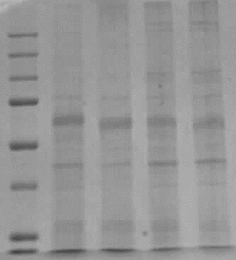
kDa

10
15
25
37
75
100
150
250
M A B C D
Figure 2. Coomassie blue staining of two trial soluble fraction samples (UC061 & UC068) before and after HiPPR detergent removal method; M= molecular-weight marker; A=10μg protein load -UC061 (5.59μl) prior to the HiPPR detergent removal method; B=5.59μl volume from UC061 sample after the HiPPR detergent removal method (assuming there has been no protein loss during the process, it would equate to 10μg of protein); C=10μg protein load -UC068 (3.58μl) prior to the HiPPR detergent removal method; D=3.58μl volume from UC068 sample after the HiPPR detergent removal method (assuming there has been no protein loss during the process, it would equate to 10μg of protein).

Conclusion
HiPPR detergent removal method has proved to be efficient in removing one of the interfering molecules (Triton X-100) from the buffer solution with very minimal protein loss during the process; however the other interfering molecule, i.e. Pefabloc is still an issue for down-stream analysis due to the presence of free amine in its molecule, which in turn interferes with iTRAQ labeling.

- Detergent removal via In-gel proteolysis
Introduction and aim
This method will be tried to remove detergents and other LC-MS incompatible molecules from small-volume samples subsequent to lack of success with the previous two methods already described. The idea is to entrap the protein solution in a polyacrylamide gel matrix, wash out detergents, salts, and chaotropic agents, and perform in-gel digestion.
Methods
In the first phase, two sets of two BSA samples, one in 30μl LDB and the other in 30μl TEAB buffer were used in this trial in order to compare pre- and post-washing protein retrieval. LDB and TEAB solutions with no added BSA were also included in order to compare Coomassie-stained gel colours accordingly. The test samples were as per below:
- 6µg BSA in 30µl LDB (A1) & 5µg BSA in 30µl TEAB (A2)
- 6µg BSA in 30µl LDB (B1) & 5µg BSA in 30µl TEAB (B2)
- 30µl LDB (X) & 30µl TEAB (Y)
Disulfide bonds in the protein solution were reduced with 5mM TCEP. They were reversibly blocked with 10mM MMTS. The protein solutions were thoroughly mixed thereafter with 20% acrylamide. 10% APS and TEMED were added to each sample for setting the gel. The mixtures were vortexed, then centrifuged so that the liquids were collected at the bottom of the tube. They were then left to be completely polymerised for another 20 min. The resulting gel plugs were removed from the tube and diced using a scalpel in all test samples. A total of 6 washes with TEAB in 50% acetonitrile (washing solution) was performed on test samples A1, A2, as well as X, followed by drying of the gel pieces in neat acetonitrile. Following this washing step, all the test sample gels were Coomassie-stained followed by visual comparison between A1, B1, and X/Y as well as A2, B2, and X/Y. To further ensure no significant protein loss had occurred during the washing step, the discarded washing solutions were assayed for protein content; although this did not show any protein content, 2x30µl of the washing solutions were added to a gel followed by Coomassie staining.
In the second phase, 100μg BSA sample in 30μl LDB was used to check for peptide retrieval at the MS level. Similar steps were followed as per above up to 6 washes with TEAB in 50% acetonitrile and drying of the gel pieces in neat acetonitrile. The acetonitrile was then removed prior to the gel digestion with trypsin.
A stock solution of 0.5mg/ml trypsin in 50mM acetic acid and TEAB was made by adding 20μg trypsin vial (Promega, USA) to 5μl of 50mM acetic acid and 35μl of TEAB (in general 1μg trypsin is required for every 20μg protein digestion). A total of 10μl enzyme solution was added to the gel pieces in the tube followed by TEAB addition to fully cover the gel; it was incubated at 37°C for 8-24hrs.
The digested mixture was transferred to a new tube. In order to extract the peptides from the mixture, 50-100μl of 50% acetonitrile (ACN) solution containing 0.1% formic acid (FA) (enough volume to cover all the gel pieces) was added to the tube; sonication bath was used to aid peptide extraction from the gel solution. This solution was transferred to a new tube with the digested solution and the process was repeated one more time with of neat ACN in 0.1% FA. The combined extracts were evaporated in a vacuum concentrator.
Results
Visual comparison between A1, B1, and X/Y as well as A2, B2, and X/Y are shown in figure 3.

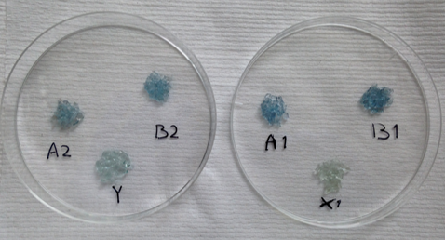
Figure 3. Visual comparison of Coomassie-stained gels from test samples pre- and post-wash in both LDB and TEAB buffer solution. A1: BSA in LDB buffer/post-wash; B1: BSA in LDB buffer/pre-wash; A2: BSA in TEAB buffer/post-wash; B2: BSA in TEAB buffer/pre-wash; X: LDB buffer in gel as control; Y: TEAB buffer in gel as control.

To further ensure no significant protein loss had occurred during the washing step, the discarded washing solutions from A1 and A2 gels were assayed for protein content; although they did not show any protein contents, 30µl from each of the washing solutions were added to a gel followed by Coomassie staining. No staining was observed in the gel, as shown in figure 4.

kDa

250

150

100

75

37

25

15

10
LM A A'
Figure 4. Coomassie stain on the two remnant washing solution to check for any possible protein loss. LM: lane marker; A: post-A1 gel wash solution; A’: post-A2 gel wash solution.

Finally, to ensure optimal peptide retrieval from the final extract, MS was run on this test sample as part of the MS QC. The results are shown in figure 5.

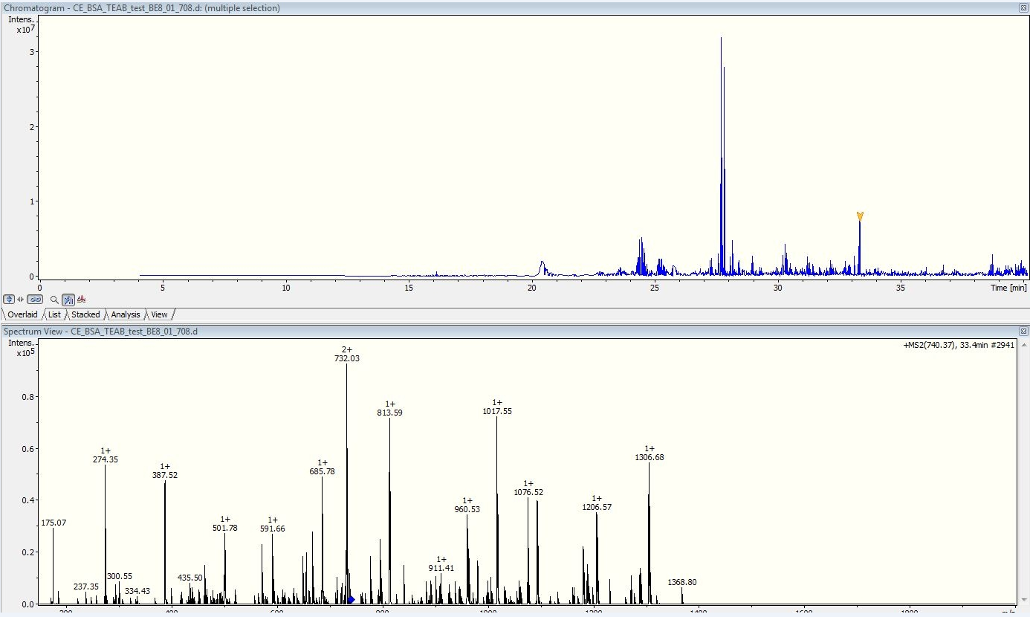
A

B
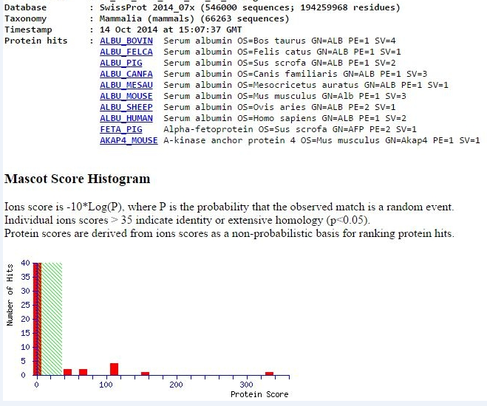

Figure 5. Chromatogram and spectrum view of the BSA test sample in TEAB buffer following in-gel proteolysis during mass spectrometry is shown in A. Protein hits from the retrieved peptides using Swissprot database is shown in B.

References

1. Assadsangabi A, Evans CA, Corfe BM, Lobo A. Application of Proteomics to Inflammatory Bowel Disease Research: Current Status and Future Perspectives. Gastroenterol Res Pract. 2019;2019:1426954.
2. Bryant RV, Winer S, Spl T, Riddell RH. Systematic review: Histological remission in inflammatory bowel disease. Is 'complete' remission the new treatment paradigm? An IOIBD initiative. Journal of Crohn's & colitis. 2014;8(12):1582-97.
3. Geboes K, Riddell R, Ost A, Jensfelt B, Persson T, Lofberg R. A reproducible grading scale for histological assessment of inflammation in ulcerative colitis. Gut. 2000;47(3):404-9.
4. Riley SA, Mani V, Goodman MJ, Dutt S, Herd ME. Microscopic activity in ulcerative colitis: what does it mean? Gut. 1991;32(2):174-8.
5. D'Haens GR, Geboes K, Peeters M, Baert F, Penninckx F, Rutgeerts P. Early lesions of recurrent Crohn's disease caused by infusion of intestinal contents in excluded ileum. Gastroenterology. 1998;114(2):262-7.
6. Rubin GP, Hungin AP, Kelly PJ, Ling J. Inflammatory bowel disease: epidemiology and management in an English general practice population. Alimentary pharmacology & therapeutics. 2000;14(12):1553-9.
7. Loftus EV, Jr. Clinical epidemiology of inflammatory bowel disease: Incidence, prevalence, and environmental influences. Gastroenterology. 2004;126(6):1504-17.
8. Andres PG, Friedman LS. Epidemiology and the natural course of inflammatory bowel disease. Gastroenterology clinics of North America. 1999;28(2):255-81, vii.
9. Liu JZ, van Sommeren S, Huang H, Ng SC, Alberts R, Takahashi A, et al. Association analyses identify 38 susceptibility loci for inflammatory bowel disease and highlight shared genetic risk across populations. Nature genetics. 2015;47(9):979-86.
10. Zhang YZ, Li YY. Inflammatory bowel disease: pathogenesis. World J Gastroenterol. 2014;20(1):91-9.
11. Birrenbach T, Bocker U. Inflammatory bowel disease and smoking: a review of epidemiology, pathophysiology, and therapeutic implications. Inflammatory bowel diseases. 2004;10(6):848-59.
12. O'Toole A, Korzenik J. Environmental triggers for IBD. Current gastroenterology reports. 2014;16(7):396.
13. Leslie WD, Miller N, Rogala L, Bernstein CN. Vitamin D status and bone density in recently diagnosed inflammatory bowel disease: the Manitoba IBD Cohort Study. The American journal of gastroenterology. 2008;103(6):1451-9.
14. Ananthakrishnan AN, Higuchi LM, Huang ES, Khalili H, Richter JM, Fuchs CS, et al. Aspirin, nonsteroidal anti-inflammatory drug use, and risk for Crohn disease and ulcerative colitis: a cohort study. Annals of internal medicine. 2012;156(5):350-9.
15. He C, Bassik MC, Moresi V, Sun K, Wei Y, Zou Z, et al. Exercise-induced BCL2-regulated autophagy is required for muscle glucose homeostasis. Nature. 2012;481(7382):511-5.
16. Khalili H, Ananthakrishnan AN, Konijeti GG, Liao X, Higuchi LM, Fuchs CS, et al. Physical activity and risk of inflammatory bowel disease: prospective study from the Nurses' Health Study cohorts. BMJ (Clinical research ed). 2013;347:f6633.
17. Kaplan GG, Hubbard J, Korzenik J, Sands BE, Panaccione R, Ghosh S, et al. The inflammatory bowel diseases and ambient air pollution: a novel association. The American journal of gastroenterology. 2010;105(11):2412-9.
18. Klement E, Cohen RV, Boxman J, Joseph A, Reif S. Breastfeeding and risk of inflammatory bowel disease: a systematic review with meta-analysis. The American journal of clinical nutrition. 2004;80(5):1342-52.
19. Gent AE, Hellier MD, Grace RH, Swarbrick ET, Coggon D. Inflammatory bowel disease and domestic hygiene in infancy. Lancet. 1994;343(8900):766-7.
20. Mawdsley JE, Rampton DS. Psychological stress in IBD: new insights into pathogenic and therapeutic implications. Gut. 2005;54(10):1481-91.
21. Ananthakrishnan AN, Bernstein CN, Iliopoulos D, Macpherson A, Neurath MF, Ali RAR, et al. Environmental triggers in IBD: a review of progress and evidence. Nat Rev Gastroenterol Hepatol. 2018;15(1):39-49.
22. Qin J, Li R, Raes J, Arumugam M, Burgdorf KS, Manichanh C, et al. A human gut microbial gene catalogue established by metagenomic sequencing. Nature. 2010;464(7285):59-65.
23. Joossens M, Huys G, Cnockaert M, De Preter V, Verbeke K, Rutgeerts P, et al. Dysbiosis of the faecal microbiota in patients with Crohn's disease and their unaffected relatives. Gut. 2011;60(5):631-7.
24. Martinez C, Antolin M, Santos J, Torrejon A, Casellas F, Borruel N, et al. Unstable composition of the fecal microbiota in ulcerative colitis during clinical remission. The American journal of gastroenterology. 2008;103(3):643-8.
25. Meconi S, Vercellone A, Levillain F, Payre B, Al Saati T, Capilla F, et al. Adherent-invasive Escherichia coli isolated from Crohn's disease patients induce granulomas in vitro. Cellular microbiology. 2007;9(5):1252-61.
26. Subramanian S, Ekbom A, Rhodes JM. Recent advances in clinical practice: a systematic review of isolated colonic Crohn's disease: the third IBD? Gut. 2017;66(2):362-81.
27. Geremia A, Biancheri P, Allan P, Corazza GR, Di Sabatino A. Innate and adaptive immunity in inflammatory bowel disease. Autoimmun Rev. 2014;13(1):3-10.
28. Boltin D, Perets TT, Vilkin A, Niv Y. Mucin function in inflammatory bowel disease: an update. J Clin Gastroenterol. 2013;47(2):106-11.
29. Rodríguez-Feo JA, Puerto M, Fernández-Mena C, Verdejo C, Lara JM, Díaz-Sánchez M, et al. A new role for reticulon-4B/NOGO-B in the intestinal epithelial barrier function and inflammatory bowel disease. Am J Physiol Gastrointest Liver Physiol. 2015;308(12):G981-93.
30. Salim SY, Söderholm JD. Importance of disrupted intestinal barrier in inflammatory bowel diseases. Inflamm Bowel Dis. 2011;17(1):362-81.
31. Medzhitov R, Janeway C. Innate immunity. N Engl J Med. 2000;343(5):338-44.
32. Abreu MT, Fukata M, Arditi M. TLR signaling in the gut in health and disease. J Immunol. 2005;174(8):4453-60.
33. Marks DJ, Harbord MW, MacAllister R, Rahman FZ, Young J, Al-Lazikani B, et al. Defective acute inflammation in Crohn's disease: a clinical investigation. Lancet. 2006;367(9511):668-78.
34. Bonen DK, Ogura Y, Nicolae DL, Inohara N, Saab L, Tanabe T, et al. Crohn's disease-associated NOD2 variants share a signaling defect in response to lipopolysaccharide and peptidoglycan. Gastroenterology. 2003;124(1):140-6.
35. Wehkamp J, Harder J, Weichenthal M, Schwab M, Schäffeler E, Schlee M, et al. NOD2 (CARD15) mutations in Crohn's disease are associated with diminished mucosal alpha-defensin expression. Gut. 2004;53(11):1658-64.
36. Abraham C, Cho JH. Functional consequences of NOD2 (CARD15) mutations. Inflamm Bowel Dis. 2006;12(7):641-50.
37. Takatori H, Kanno Y, Watford WT, Tato CM, Weiss G, Ivanov II, et al. Lymphoid tissue inducer-like cells are an innate source of IL-17 and IL-22. J Exp Med. 2009;206(1):35-41.
38. Korn T, Bettelli E, Oukka M, Kuchroo VK. IL-17 and Th17 Cells. Annu Rev Immunol. 2009;27:485-517.
39. Zhou L, Ivanov II, Spolski R, Min R, Shenderov K, Egawa T, et al. IL-6 programs T(H)-17 cell differentiation by promoting sequential engagement of the IL-21 and IL-23 pathways. Nat Immunol. 2007;8(9):967-74.
40. Silva FA, Rodrigues BL, Ayrizono ML, Leal RF. The Immunological Basis of Inflammatory Bowel Disease. Gastroenterol Res Pract. 2016;2016:2097274.
41. Cobrin GM, Abreu MT. Defects in mucosal immunity leading to Crohn's disease. Immunological reviews. 2005;206:277-95.
42. Targan SR, Karp LC. Defects in mucosal immunity leading to ulcerative colitis. Immunological reviews. 2005;206:296-305.
43. Rosen MJ, Karns R, Vallance JE, Bezold R, Waddell A, Collins MH, et al. Mucosal Expression of Type 2 and Type 17 Immune Response Genes Distinguishes Ulcerative Colitis From Colon-Only Crohn's Disease in Treatment-Naive Pediatric Patients. Gastroenterology. 2017;152(6):1345-57.e7.
44. Geremia A, Jewell DP. The IL-23/IL-17 pathway in inflammatory bowel disease. Expert review of gastroenterology & hepatology. 2012;6(2):223-37.
45. Wallace KL, Zheng LB, Kanazawa Y, Shih DQ. Immunopathology of inflammatory bowel disease. World journal of gastroenterology : WJG. 2014;20(1):6-21.
46. Hosomi S, Kaser A, Blumberg RS. Role of endoplasmic reticulum stress and autophagy as interlinking pathways in the pathogenesis of inflammatory bowel disease. Current opinion in gastroenterology. 2015;31(1):81-8.
47. Neurath MF. Cytokines in inflammatory bowel disease. Nature reviews Immunology. 2014;14(5):329-42.
48. Sanchez-Munoz F, Dominguez-Lopez A, Yamamoto-Furusho JK. Role of cytokines in inflammatory bowel disease. World J Gastroenterol. 2008;14(27):4280-8.
49. Baumgart DC, Carding SR. Inflammatory bowel disease: cause and immunobiology. Lancet. 2007;369(9573):1627-40.
50. Ku NO, Zhou X, Toivola DM, Omary MB. The cytoskeleton of digestive epithelia in health and disease. Am J Physiol. 1999;277(6 Pt 1):G1108-37.
51. Majumdar D, Tiernan JP, Lobo AJ, Evans CA, Corfe BM. Keratins in colorectal epithelial function and disease. Int J Exp Pathol. 2012;93(5):305-18.
52. Schweizer J, Bowden PE, Coulombe PA, Langbein L, Lane EB, Magin TM, et al. New consensus nomenclature for mammalian keratins. J Cell Biol. 2006;174(2):169-74.
53. Kim S, Coulombe PA. Intermediate filament scaffolds fulfill mechanical, organizational, and signaling functions in the cytoplasm. Genes Dev. 2007;21(13):1581-97.
54. Coulombe PA. The Molecular Revolution in Cutaneous Biology: Keratin Genes and their Associated Disease: Diversity, Opportunities, and Challenges. J Invest Dermatol. 2017;137(5):e67-e71.
55. Haines RL, Lane EB. Keratins and disease at a glance. J Cell Sci. 2012;125(Pt 17):3923-8.
56. Magin TM, Vijayaraj P, Leube RE. Structural and regulatory functions of keratins. Exp Cell Res. 2007;313(10):2021-32.
57. Oshima RG. Intermediate filaments: a historical perspective. Exp Cell Res. 2007;313(10):1981-94.
58. Uitto J, Richard G, McGrath JA. Diseases of epidermal keratins and their linker proteins. Exp Cell Res. 2007;313(10):1995-2009.
59. Wu DD, Irwin DM, Zhang YP. Molecular evolution of the keratin associated protein gene family in mammals, role in the evolution of mammalian hair. BMC Evol Biol. 2008;8:241.
60. Hatzfeld M, Weber K. The coiled coil of in vitro assembled keratin filaments is a heterodimer of type I and II keratins: use of site-specific mutagenesis and recombinant protein expression. J Cell Biol. 1990;110(4):1199-210.
61. Herrmann H, Kreplak L, Aebi U. Isolation, characterization, and in vitro assembly of intermediate filaments. Methods in cell biology. 2004;78:3-24.
62. Omary MB, Ku NO, Tao GZ, Toivola DM, Liao J. "Heads and tails" of intermediate filament phosphorylation: multiple sites and functional insights. Trends Biochem Sci. 2006;31(7):383-94.
63. Weber K, Geisler N. The structural relation between intermediate filament proteins in living cells and the alpha-keratins of sheep wool. EMBO J. 1982;1(10):1155-60.
64. Svitkina TM, Verkhovsky AB, Borisy GG. Plectin sidearms mediate interaction of intermediate filaments with microtubules and other components of the cytoskeleton. J Cell Biol. 1996;135(4):991-1007.
65. Goldman RD, Chou YH, Prahlad V, Yoon M. Intermediate filaments: dynamic processes regulating their assembly, motility, and interactions with other cytoskeletal systems. FASEB J. 1999;13 Suppl 2:S261-5.
66. Moll R, Franke WW, Schiller DL, Geiger B, Krepler R. The catalog of human cytokeratins: patterns of expression in normal epithelia, tumors and cultured cells. Cell. 1982;31(1):11-24.
67. Omary MB, Ku NO, Strnad P, Hanada S. Toward unraveling the complexity of simple epithelial keratins in human disease. J Clin Invest. 2009;119(7):1794-805.
68. Ku NO, Toivola DM, Zhou Q, Tao GZ, Zhong B, Omary MB. Studying simple epithelial keratins in cells and tissues. Methods Cell Biol. 2004;78:489-517.
69. Moll R, Divo M, Langbein L. The human keratins: biology and pathology. Histochem Cell Biol. 2008;129(6):705-33.
70. Caulin C, Ware CF, Magin TM, Oshima RG. Keratin-dependent, epithelial resistance to tumor necrosis factor-induced apoptosis. The Journal of cell biology. 2000;149(1):17-22.
71. Inada H, Izawa I, Nishizawa M, Fujita E, Kiyono T, Takahashi T, et al. Keratin attenuates tumor necrosis factor-induced cytotoxicity through association with TRADD. J Cell Biol. 2001;155(3):415-26.
72. Toivola DM, Krishnan S, Binder HJ, Singh SK, Omary MB. Keratins modulate colonocyte electrolyte transport via protein mistargeting. J Cell Biol. 2004;164(6):911-21.
73. Habtezion A, Toivola DM, Butcher EC, Omary MB. Keratin-8-deficient mice develop chronic spontaneous Th2 colitis amenable to antibiotic treatment. J Cell Sci. 2005;118(Pt 9):1971-80.
74. Lee SH. Intestinal permeability regulation by tight junction: implication on inflammatory bowel diseases. Intest Res. 2015;13(1):11-8.
75. Turner JR. Intestinal mucosal barrier function in health and disease. Nat Rev Immunol. 2009;9(11):799-809.
76. Miao J, Niu J, Wang K, Xiao Y, Du Y, Zhou L, et al. Heat shock factor 2 levels are associated with the severity of ulcerative colitis. PLoS One. 2014;9(2):e88822.
77. Dong X, Liu Z, Lan D, Niu J, Miao J, Yang G, et al. Critical role of Keratin 1 in maintaining epithelial barrier and correlation of its down-regulation with the progression of inflammatory bowel disease. Gene. 2017;608:13-9.
78. Wang L, Srinivasan S, Theiss AL, Merlin D, Sitaraman SV. Interleukin-6 induces keratin expression in intestinal epithelial cells: potential role of keratin-8 in interleukin-6-induced barrier function alterations. J Biol Chem. 2007;282(11):8219-27.
79. Corfe BM, Majumdar D, Assadsangabi A, Marsh AM, Cross SS, Connolly JB, et al. Inflammation decreases keratin level in ulcerative colitis; inadequate restoration associates with increased risk of colitis-associated cancer. BMJ Open Gastroenterol. 2015;2(1):e000024.
80. Mitsuhashi J, Mikami T, Saigenji K, Okayasu I. Significant correlation of morphological remodeling in ulcerative colitis with disease duration and between elevated p53 and p21 expression in rectal mucosa and neoplastic development. Pathology international. 2005;55(3):113-21.
81. Okayasu I, Yoshida T, Mikami T, Hana K, Yokozawa M, Araki K, et al. Mucosal remodeling in long-standing ulcerative colitis with colorectal neoplasia: significant alterations of NCAM+ or alpha-SMA+ subepithelial myofibroblasts and interstitial cells. Pathology international. 2009;59(10):701-11.
82. Group. BDW. Biomarkers and surrogate endpoints: preferred definitions and conceptual framework. Clin Pharmacol Ther. 2001;69(3):89-95.
83. Jess T, Riis L, Vind I, Winther KV, Borg S, Binder V, et al. Changes in clinical characteristics, course, and prognosis of inflammatory bowel disease during the last 5 decades: a population-based study from Copenhagen, Denmark. Inflamm Bowel Dis. 2007;13(4):481-9.
84. Solberg IC, Vatn MH, Hoie O, Stray N, Sauar J, Jahnsen J, et al. Clinical course in Crohn's disease: results of a Norwegian population-based ten-year follow-up study. Clin Gastroenterol Hepatol. 2007;5(12):1430-8.
85. Lee JC, Lyons PA, McKinney EF, Sowerby JM, Carr EJ, Bredin F, et al. Gene expression profiling of CD8+ T cells predicts prognosis in patients with Crohn disease and ulcerative colitis. J Clin Invest. 2011;121(10):4170-9.
86. James P. Protein identification in the post-genome era: the rapid rise of proteomics. Q Rev Biophys. 1997;30(4):279-331.
87. Lawrance IC, Klopcic B, Wasinger VC. Proteomics: an overview. Inflammatory bowel diseases. 2005;11(10):927-36.
88. Smith LM, Kelleher NL, Proteomics CfTD. Proteoform: a single term describing protein complexity. Nat Methods. 2013;10(3):186-7.
89. Schlüter H, Apweiler R, Holzhütter HG, Jungblut PR. Finding one's way in proteomics: a protein species nomenclature. Chem Cent J. 2009;3:11.
90. Feng JT, Shang S, Beretta L. Proteomics for the early detection and treatment of hepatocellular carcinoma. Oncogene. 2006;25(27):3810-7.
91. Vaiopoulou A, Gazouli M, Theodoropoulos G, Zografos G. Current advantages in the application of proteomics in inflammatory bowel disease. Digestive diseases and sciences. 2012;57(11):2755-64.
92. Naryzhny S. Inventory of proteoforms as a current challenge of proteomics: Some technical aspects. J Proteomics. 2018.
93. Altelaar AF, Munoz J, Heck AJ. Next-generation proteomics: towards an integrative view of proteome dynamics. Nat Rev Genet. 2013;14(1):35-48.
94. Zhang Y, Fonslow BR, Shan B, Baek MC, Yates JR. Protein analysis by shotgun/bottom-up proteomics. Chem Rev. 2013;113(4):2343-94.
95. Westbrook JA, Noirel J, Brown JE, Wright PC, Evans CA. Quantitation with chemical tagging reagents in biomarker studies. Proteomics Clin Appl. 2015;9(3-4):295-300.
96. Alex P, Gucek M, Li X. Applications of proteomics in the study of inflammatory bowel diseases: Current status and future directions with available technologies. Inflammatory bowel diseases. 2009;15(4):616-29.
97. Cifani P, Kentsis A. Towards comprehensive and quantitative proteomics for diagnosis and therapy of human disease. Proteomics. 2017;17(1-2).
98. Cravatt BF, Simon GM, Yates JR, 3rd. The biological impact of mass-spectrometry-based proteomics. Nature. 2007;450(7172):991-1000.
99. Domon B, Aebersold R. Mass spectrometry and protein analysis. Science (New York, NY). 2006;312(5771):212-7.
100. Tang N, Tornatore P, Weinberger SR. Current developments in SELDI affinity technology. Mass Spectrom Rev. 2004;23(1):34-44.
101. Khatri N, Gupta A, Taneja R, Ajay B, Prashant B. A review on mass spectrometry detectors. International Research Journal of Pharmacy. 2012;10(3):33-42.
102. Zhu W, Smith JW, Huang CM. Mass spectrometry-based label-free quantitative proteomics. J Biomed Biotechnol. 2010;2010:840518.
103. Fray T. Biology 750 "Molecular Biophysics"-VII. Electrophoresis: San Diego State University. 1998.
104. Chaerkady R, Pandey A. Applications of proteomics to lab diagnosis. Annual review of pathology. 2008;3:485-98.
105. Chen X, Sun L, Yu Y, Xue Y, Yang P. Amino acid-coded tagging approaches in quantitative proteomics. Expert review of proteomics. 2007;4(1):25-37.
106. Patel VJ, Thalassinos K, Slade SE, Connolly JB, Crombie A, Murrell JC, et al. A comparison of labeling and label-free mass spectrometry-based proteomics approaches. J Proteome Res. 2009;8(7):3752-9.
107. Old WM, Meyer-Arendt K, Aveline-Wolf L, Pierce KG, Mendoza A, Sevinsky JR, et al. Comparison of label-free methods for quantifying human proteins by shotgun proteomics. Mol Cell Proteomics. 2005;4(10):1487-502.
108. Chelius D, Bondarenko PV. Quantitative profiling of proteins in complex mixtures using liquid chromatography and mass spectrometry. J Proteome Res. 2002;1(4):317-23.
109. Bondarenko PV, Chelius D, Shaler TA. Identification and relative quantitation of protein mixtures by enzymatic digestion followed by capillary reversed-phase liquid chromatography-tandem mass spectrometry. Anal Chem. 2002;74(18):4741-9.
110. Washburn MP, Wolters D, Yates JR. Large-scale analysis of the yeast proteome by multidimensional protein identification technology. Nat Biotechnol. 2001;19(3):242-7.
111. Liu H, Sadygov RG, Yates JR. A model for random sampling and estimation of relative protein abundance in shotgun proteomics. Anal Chem. 2004;76(14):4193-201.
112. Rappsilber J, Ryder U, Lamond AI, Mann M. Large-scale proteomic analysis of the human spliceosome. Genome Res. 2002;12(8):1231-45.
113. Ishihama Y, Oda Y, Tabata T, Sato T, Nagasu T, Rappsilber J, et al. Exponentially modified protein abundance index (emPAI) for estimation of absolute protein amount in proteomics by the number of sequenced peptides per protein. Mol Cell Proteomics. 2005;4(9):1265-72.
114. Silva JC, Gorenstein MV, Li GZ, Vissers JP, Geromanos SJ. Absolute quantification of proteins by LCMSE: a virtue of parallel MS acquisition. Mol Cell Proteomics. 2006;5(1):144-56.
115. Schwanhäusser B, Busse D, Li N, Dittmar G, Schuchhardt J, Wolf J, et al. Global quantification of mammalian gene expression control. Nature. 2011;473(7347):337-42.
116. Nickell S, Beck F, Scheres SH, Korinek A, Förster F, Lasker K, et al. Insights into the molecular architecture of the 26S proteasome. Proc Natl Acad Sci U S A. 2009;106(29):11943-7.
117. Sha Z, Brill LM, Cabrera R, Kleifeld O, Scheliga JS, Glickman MH, et al. The eIF3 interactome reveals the translasome, a supercomplex linking protein synthesis and degradation machineries. Mol Cell. 2009;36(1):141-52.
118. Fabre B, Lambour T, Bouyssiéa D, Menneteau T, Monsarrata B, Burlet-Schiltz O, et al. Comparison of label-free quantification methods for the determination of protein complexes subunits stoichiometry EuPA Open Proteomics: Elsevier; 2014. p. 82-6.
119. Jostins L, Ripke S, Weersma RK, Duerr RH, McGovern DP, Hui KY, et al. Host-microbe interactions have shaped the genetic architecture of inflammatory bowel disease. Nature. 2012;491(7422):119-24.
120. Rocken C, Ebert MP, Roessner A. Proteomics in pathology, research and practice. Pathology, research and practice. 2004;200(2):69-82.
121. Verma M, Kagan J, Sidransky D, Srivastava S. Proteomic analysis of cancer-cell mitochondria. Nature reviews Cancer. 2003;3(10):789-95.
122. Wulfkuhle JD, Liotta LA, Petricoin EF. Proteomic applications for the early detection of cancer. Nature reviews Cancer. 2003;3(4):267-75.
123. Futcher B, Latter GI, Monardo P, McLaughlin CS, Garrels JI. A sampling of the yeast proteome. Mol Cell Biol. 1999;19(11):7357-68.
124. Gygi SP, Rochon Y, Franza BR, Aebersold R. Correlation between protein and mRNA abundance in yeast. Mol Cell Biol. 1999;19(3):1720-30.
125. Lian Z, Kluger Y, Greenbaum DS, Tuck D, Gerstein M, Berliner N, et al. Genomic and proteomic analysis of the myeloid differentiation program: global analysis of gene expression during induced differentiation in the MPRO cell line. Blood. 2002;100(9):3209-20.
126. Cristea IM, Gaskell SJ, Whetton AD. Proteomics techniques and their application to hematology. Blood. 2004;103(10):3624-34.
127. Omenn GS, States DJ, Adamski M, Blackwell TW, Menon R, Hermjakob H, et al. Overview of the HUPO Plasma Proteome Project: results from the pilot phase with 35 collaborating laboratories and multiple analytical groups, generating a core dataset of 3020 proteins and a publicly-available database. Proteomics. 2005;5(13):3226-45.
128. Bowen RA, Remaley AT. Interferences from blood collection tube components on clinical chemistry assays. Biochem Med (Zagreb). 2014;24(1):31-44.
129. Incamps A, Saez-Boiteau C, Tiede SL, Rebillard P, Schulte J, Vialaret J, et al. Impact of biological matrix on inflammatory protein biomarker quantification based on targeted mass spectrometry. Bioanalysis. 2018;10(17):1383-99.
130. Pisanu S, Biosa G, Carcangiu L, Uzzau S, Pagnozzi D. Comparative evaluation of seven commercial products for human serum enrichment/depletion by shotgun proteomics. Talanta. 2018;185:213-20.
131. Meuwis MA, Fillet M, Geurts P, de Seny D, Lutteri L, Chapelle JP, et al. Biomarker discovery for inflammatory bowel disease, using proteomic serum profiling. Biochemical pharmacology. 2007;73(9):1422-33.
132. Bikfalvi A. Platelet factor 4: an inhibitor of angiogenesis. Semin Thromb Hemost. 2004;30(3):379-85.
133. Slungaard A. Platelet factor 4: a chemokine enigma. Int J Biochem Cell Biol. 2005;37(6):1162-7.
134. Stoeckle MY, Barker KA. Two burgeoning families of platelet factor 4-related proteins: mediators of the inflammatory response. New Biol. 1990;2(4):313-23.
135. Vanuytsel T, Vermeire S, Cleynen I. The role of Haptoglobin and its related protein, Zonulin, in inflammatory bowel disease. Tissue Barriers. 2013;1(5):e27321.
136. Levy AP, Asleh R, Blum S, Levy NS, Miller-Lotan R, Kalet-Litman S, et al. Haptoglobin: basic and clinical aspects. Antioxid Redox Signal. 2010;12(2):293-304.
137. Dayan L, Levy AP, Blum S, Miller-Lotan R, Melman U, Alshiek J, et al. Haptoglobin genotype and endothelial function in diabetes mellitus: a pilot study. Eur J Appl Physiol. 2009;106(4):639-44.
138. Langlois MR, Delanghe JR. Biological and clinical significance of haptoglobin polymorphism in humans. Clin Chem. 1996;42(10):1589-600.
139. Pavón EJ, Muñoz P, Lario A, Longobardo V, Carrascal M, Abián J, et al. Proteomic analysis of plasma from patients with systemic lupus erythematosus: increased presence of haptoglobin alpha2 polypeptide chains over the alpha1 isoforms. Proteomics. 2006;6 Suppl 1:S282-92.
140. Vogl T, Tenbrock K, Ludwig S, Leukert N, Ehrhardt C, van Zoelen MA, et al. Mrp8 and Mrp14 are endogenous activators of Toll-like receptor 4, promoting lethal, endotoxin-induced shock. Nat Med. 2007;13(9):1042-9.
141. Vermeire S, Van Assche G, Rutgeerts P. Laboratory markers in IBD: useful, magic, or unnecessary toys? Gut. 2006;55(3):426-31.
142. Meuwis MA, Fillet M, Lutteri L, Maree R, Geurts P, de Seny D, et al. Proteomics for prediction and characterization of response to infliximab in Crohn's disease: a pilot study. Clin Biochem. 2008;41(12):960-7.
143. Kanmura S, Uto H, Numata M, Hashimoto S, Moriuchi A, Fujita H, et al. Human neutrophil peptides 1-3 are useful biomarkers in patients with active ulcerative colitis. Inflammatory bowel diseases. 2009;15(6):909-17.
144. Vaiopoulou A, Gazouli M, Papadopoulou A, Anagnostopoulos AK, Karamanolis G, Theodoropoulos GE, et al. Serum protein profiling of adults and children with crohn disease. Journal of pediatric gastroenterology and nutrition. 2015;60(1):42-7.
145. Samygina VR, Sokolov AV, Bourenkov G, Petoukhov MV, Pulina MO, Zakharova ET, et al. Ceruloplasmin: macromolecular assemblies with iron-containing acute phase proteins. PLoS One. 2013;8(7):e67145.
146. Zhang H, Kim JK, Edwards CA, Xu Z, Taichman R, Wang CY. Clusterin inhibits apoptosis by interacting with activated Bax. Nat Cell Biol. 2005;7(9):909-15.
147. Ignjatovic V, Lai C, Summerhayes R, Mathesius U, Tawfilis S, Perugini MA, et al. Age-related differences in plasma proteins: how plasma proteins change from neonates to adults. PLoS One. 2011;6(2):e17213.
148. Koutroubakis IE, Malliaraki N, Vardas E, Ganotakis E, Margioris AN, Manousos ON, et al. Increased levels of lipoprotein (a) in Crohn's disease: a relation to thrombosis? Eur J Gastroenterol Hepatol. 2001;13(12):1415-9.
149. Yokoyama K, Ishibashi T, Yi-qiang L, Nagayoshi A, Teramoto T, Maruyama Y. Interleukin-1beta and interleukin-6 increase levels of apolipoprotein B mRNA and decrease accumulation of its protein in culture medium of HepG2 cells. J Lipid Res. 1998;39(1):103-13.
150. Bross DA, Leichtner AM, Zurakowski D, Law T, Bousvaros A. Elevation of serum interleukin-6 but not serum-soluble interleukin-2 receptor in children with Crohn's disease. J Pediatr Gastroenterol Nutr. 1996;23(2):164-71.
151. Nancey S, Hamzaoui N, Moussata D, Graber I, Bienvenu J, Flourie B. Serum interleukin-6, soluble interleukin-6 receptor and Crohn's disease activity. Dig Dis Sci. 2008;53(1):242-7.
152. Hatsugai M, Kurokawa MS, Kouro T, Nagai K, Arito M, Masuko K, et al. Protein profiles of peripheral blood mononuclear cells are useful for differential diagnosis of ulcerative colitis and Crohn's disease. J Gastroenterol. 2010;45(5):488-500.
153. Gazouli M, Anagnostopoulos AK, Papadopoulou A, Vaiopoulou A, Papamichael K, Mantzaris G, et al. Serum protein profile of Crohn's disease treated with infliximab. J Crohns Colitis. 2013;7(10):e461-70.
154. Nanni P, Levander F, Roda G, Caponi A, James P, Roda A. A label-free nano-liquid chromatography-mass spectrometry approach for quantitative serum peptidomics in Crohn's disease patients. J Chromatogr B Analyt Technol Biomed Life Sci. 2009;877(27):3127-36.
155. Musrati RA, Kollárová M, Mernik N, Mikulásová D. Malate dehydrogenase: distribution, function and properties. Gen Physiol Biophys. 1998;17(3):193-210.
156. Rappas M, Niwa H, Zhang X. Mechanisms of ATPases--a multi-disciplinary approach. Curr Protein Pept Sci. 2004;5(2):89-105.
157. Viennois E, Baker MT, Xiao B, Wang L, Laroui H, Merlin D. Longitudinal study of circulating protein biomarkers in inflammatory bowel disease. Journal of proteomics. 2015;112:166-79.
158. Roda G, Caponi A, Benevento M, Nanni P, Mezzanotte L, Belluzzi A, et al. New proteomic approaches for biomarker discovery in inflammatory bowel disease. Inflammatory bowel diseases. 2010;16(7):1239-46.
159. M'Koma AE, Seeley EH, Washington MK, Schwartz DA, Muldoon RL, Herline AJ, et al. Proteomic profiling of mucosal and submucosal colonic tissues yields protein signatures that differentiate the inflammatory colitides. Inflamm Bowel Dis. 2011;17(4):875-83.
160. Chaurand P, Schwartz SA, Billheimer D, Xu BJ, Crecelius A, Caprioli RM. Integrating histology and imaging mass spectrometry. Anal Chem. 2004;76(4):1145-55.
161. Seeley EH, Washington MK, Caprioli RM, M'Koma AE. Proteomic patterns of colonic mucosal tissues delineate Crohn's colitis and ulcerative colitis. Proteomics Clin Appl. 2013;7(7-8):541-9.
162. Shkoda A, Werner T, Daniel H, Gunckel M, Rogler G, Haller D. Differential protein expression profile in the intestinal epithelium from patients with inflammatory bowel disease. J Proteome Res. 2007;6(3):1114-25.
163. Lih-Brody L, Powell SR, Collier KP, Reddy GM, Cerchia R, Kahn E, et al. Increased oxidative stress and decreased antioxidant defenses in mucosa of inflammatory bowel disease. Dig Dis Sci. 1996;41(10):2078-86.
164. Dovas A, Couchman JR. RhoGDI: multiple functions in the regulation of Rho family GTPase activities. Biochem J. 2005;390(Pt 1):1-9.
165. Kim HJ, Kim JG, Moon MY, Park SH, Park JB. IkappaB kinase gamma/nuclear factor-kappaB-essential modulator (IKKgamma/NEMO) facilitates RhoA GTPase activation, which, in turn, activates Rho-associated KINASE (ROCK) to phosphorylate IKKbeta in response to transforming growth factor (TGF)-beta1. The Journal of biological chemistry. 2014;289(3):1429-40.
166. Luo M, Hajjar KA. Annexin A2 system in human biology: cell surface and beyond. Seminars in thrombosis and hemostasis. 2013;39(4):338-46.
167. Zhang Z, Zhao X, Lv C, Li C, Zhi F. [Annexin A2 expression in intestinal mucosa of patients with inflammatory bowel disease and its clinical implications]. Nan fang yi ke da xue xue bao = Journal of Southern Medical University. 2012;32(11):1548-52.
168. Becker C, Watson AJ, Neurath MF. Complex roles of caspases in the pathogenesis of inflammatory bowel disease. Gastroenterology. 2013;144(2):283-93.
169. Polley AC, Mulholland F, Pin C, Williams EA, Bradburn DM, Mills SJ, et al. Proteomic analysis reveals field-wide changes in protein expression in the morphologically normal mucosa of patients with colorectal neoplasia. Cancer research. 2006;66(13):6553-62.
170. Fogt F, Jian B, Krieg RC, Wellmann A. Proteomic analysis of mucosal preparations from patients with ulcerative colitis. Molecular medicine reports. 2008;1(1):51-4.
171. Okazaki N, Takahashi N, Kojima S, Masuho Y, Koga H. Protocadherin LKC, a new candidate for a tumor suppressor of colon and liver cancers, its association with contact inhibition of cell proliferation. Carcinogenesis. 2002;23(7):1139-48.
172. Suzuki ST. Structural and functional diversity of cadherin superfamily: are new members of cadherin superfamily involved in signal transduction pathway? Journal of cellular biochemistry. 1996;61(4):531-42.
173. Kushner I, Mackiewicz A. Acute phase proteins as disease markers. Disease markers. 1987;5(1):1-11.
174. Stahl M, Ludwig D, Fellermann K, Stange EF. Intestinal expression of human heat shock protein 90 in patients with Crohn's disease and ulcerative colitis. Digestive diseases and sciences. 1998;43(5):1079-87.
175. Zou J, Salarian M, Chen Y, Veenstra R, Louis CF, Yang JJ. Gap junction regulation by calmodulin. FEBS letters. 2014;588(8):1430-8.
176. Avitzur Y, Guo C, Mastropaolo LA, Bahrami E, Chen H, Zhao Z, et al. Mutations in tetratricopeptide repeat domain 7A result in a severe form of very early onset inflammatory bowel disease. Gastroenterology. 2014;146(4):1028-39.
177. Hsieh SY, Shih TC, Yeh CY, Lin CJ, Chou YY, Lee YS. Comparative proteomic studies on the pathogenesis of human ulcerative colitis. Proteomics. 2006;6(19):5322-31.
178. Chowdhury I, Thompson WE, Thomas K. Prohibitins role in cellular survival through Ras-Raf-MEK-ERK pathway. Journal of cellular physiology. 2014;229(8):998-1004.
179. Bacher S, Achatz G, Schmitz ML, Lamers MC. Prohibitin and prohibitone are contained in high-molecular weight complexes and interact with alpha-actinin and annexin A2. Biochimie. 2002;84(12):1207-20.
180. Poulsen NA, Andersen V, Moller JC, Moller HS, Jessen F, Purup S, et al. Comparative analysis of inflamed and non-inflamed colon biopsies reveals strong proteomic inflammation profile in patients with ulcerative colitis. BMC gastroenterology. 2012;12:76.
181. Roediger WE. The colonic epithelium in ulcerative colitis: an energy-deficiency disease? Lancet. 1980;2(8197):712-5.
182. Han NY, Choi W, Park JM, Kim EH, Lee H, Hahm KB. Label-free quantification for discovering novel biomarkers in the diagnosis and assessment of disease activity in inflammatory bowel disease. Journal of digestive diseases. 2013;14(4):166-74.
183. McGrogan M, Simonsen C, Scott R, Griffith J, Ellis N, Kennedy J, et al. Isolation of a complementary DNA clone encoding a precursor to human eosinophil major basic protein. The Journal of experimental medicine. 1988;168(6):2295-308.
184. Yoshimatsu K, Ohya Y, Shikata Y, Seto T, Hasegawa Y, Tanaka I, et al. Purification and cDNA cloning of a novel factor produced by a human T-cell hybridoma: sequence homology with animal lectins. Molecular immunology. 1992;29(4):537-46.
185. Overgaard MT, Haaning J, Boldt HB, Olsen IM, Laursen LS, Christiansen M, et al. Expression of recombinant human pregnancy-associated plasma protein-A and identification of the proform of eosinophil major basic protein as its physiological inhibitor. The Journal of biological chemistry. 2000;275(40):31128-33.
186. Lin CS, Chen ZP, Park T, Ghosh K, Leavitt J. Characterization of the human L-plastin gene promoter in normal and neoplastic cells. The Journal of biological chemistry. 1993;268(4):2793-801.
187. Klemke M, Rafael MT, Wabnitz GH, Weschenfelder T, Konstandin MH, Garbi N, et al. Phosphorylation of ectopically expressed L-plastin enhances invasiveness of human melanoma cells. International journal of cancer Journal international du cancer. 2007;120(12):2590-9.
188. Morley SC. The actin-bundling protein L-plastin: a critical regulator of immune cell function. International journal of cell biology. 2012;2012:935173.
189. Ciechanover A, Stanhill A. The complexity of recognition of ubiquitinated substrates by the 26S proteasome. Biochimica et biophysica acta. 2014;1843(1):86-96.
190. Guan R, Xu X, Chen M, Hu H, Ge H, Wen S, et al. Advances in the studies of roles of Rho/Rho-kinase in diseases and the development of its inhibitors. European journal of medicinal chemistry. 2013;70:613-22.
191. Bennike TB, Carlsen TG, Ellingsen T, Bonderup OK, Glerup H, Bøgsted M, et al. Neutrophil Extracellular Traps in Ulcerative Colitis: A Proteome Analysis of Intestinal Biopsies. Inflamm Bowel Dis. 2015;21(9):2052-67.
192. Delgado-Rizo V, Martínez-Guzmán MA, Iñiguez-Gutierrez L, García-Orozco A, Alvarado-Navarro A, Fafutis-Morris M. Neutrophil Extracellular Traps and Its Implications in Inflammation: An Overview. Front Immunol. 2017;8:81.
193. Kwon SC, Won KJ, Jung SH, Lee KP, Lee DY, Park ES, et al. Proteomic analysis of colonic mucosal tissue from tuberculous and ulcerative colitis patients. The Korean journal of physiology & pharmacology : official journal of the Korean Physiological Society and the Korean Society of Pharmacology. 2012;16(3):193-8.
194. Vermeulen N, Arijs I, Joossens S, Vermeire S, Clerens S, Van den Bergh K, et al. Anti-alpha-enolase antibodies in patients with inflammatory Bowel disease. Clinical chemistry. 2008;54(3):534-41.
195. Zhao X, Kang B, Lu C, Liu S, Wang H, Yang X, et al. Evaluation of p38 MAPK pathway as a molecular signature in ulcerative colitis. Journal of proteome research. 2011;10(5):2216-25.
196. Roozendaal C, Zhao MH, Horst G, Lockwood CM, Kleibeuker JH, Limburg PC, et al. Catalase and alpha-enolase: two novel granulocyte autoantigens in inflammatory bowel disease (IBD). Clinical and experimental immunology. 1998;112(1):10-6.
197. Hollenbach E, Neumann M, Vieth M, Roessner A, Malfertheiner P, Naumann M. Inhibition of p38 MAP kinase- and RICK/NF-kappaB-signaling suppresses inflammatory bowel disease. FASEB journal : official publication of the Federation of American Societies for Experimental Biology. 2004;18(13):1550-2.
198. Waetzig GH, Seegert D, Rosenstiel P, Nikolaus S, Schreiber S. p38 mitogen-activated protein kinase is activated and linked to TNF-alpha signaling in inflammatory bowel disease. Journal of immunology (Baltimore, Md : 1950). 2002;168(10):5342-51.
199. Brentnall TA, Pan S, Bronner MP, Crispin DA, Mirzaei H, Cooke K, et al. Proteins That Underlie Neoplastic Progression of Ulcerative Colitis. Proteomics Clinical applications. 2009;3(11):1326.
200. Salama I, Malone PS, Mihaimeed F, Jones JL. A review of the S100 proteins in cancer. European journal of surgical oncology : the journal of the European Society of Surgical Oncology and the British Association of Surgical Oncology. 2008;34(4):357-64.
201. Fuentes MK, Nigavekar SS, Arumugam T, Logsdon CD, Schmidt AM, Park JC, et al. RAGE activation by S100P in colon cancer stimulates growth, migration, and cell signaling pathways. Diseases of the colon and rectum. 2007;50(8):1230-40.
202. Mitchell S, Ellingson C, Coyne T, Hall L, Neill M, Christian N, et al. Genetic variation in the urea cycle: a model resource for investigating key candidate genes for common diseases. Human mutation. 2009;30(1):56-60.
203. Wink DA, Ridnour LA, Hussain SP, Harris CC. The reemergence of nitric oxide and cancer. Nitric oxide : biology and chemistry / official journal of the Nitric Oxide Society. 2008;19(2):65-7.
204. May D, Pan S, Crispin DA, Lai K, Bronner MP, Hogan J, et al. Investigating neoplastic progression of ulcerative colitis with label-free comparative proteomics. Journal of proteome research. 2011;10(1):200-9.
205. Costantino E, Maddalena F, Calise S, Piscazzi A, Tirino V, Fersini A, et al. TRAP1, a novel mitochondrial chaperone responsible for multi-drug resistance and protection from apoptotis in human colorectal carcinoma cells. Cancer letters. 2009;279(1):39-46.
206. Zhou Z, Liu H, Gu G, Wang G, Wu W, Zhang C, et al. Immunoproteomic to identify antigens in the intestinal mucosa of Crohn's disease patients. PloS one. 2013;8(12):e81662.
207. Araki K, Mikami T, Yoshida T, Kikuchi M, Sato Y, Oh-ishi M, et al. High expression of HSP47 in ulcerative colitis-associated carcinomas: proteomic approach. British journal of cancer. 2009;101(3):492-7.
208. Razzaque MS, Taguchi T. The possible role of colligin/HSP47, a collagen-binding protein, in the pathogenesis of human and experimental fibrotic diseases. Histology and histopathology. 1999;14(4):1199-212.
209. Barcelo-Batllori S, Andre M, Servis C, Levy N, Takikawa O, Michetti P, et al. Proteomic analysis of cytokine induced proteins in human intestinal epithelial cells: implications for inflammatory bowel diseases. Proteomics. 2002;2(5):551-60.
210. Ciorba MA. Indoleamine 2,3 dioxygenase in intestinal disease. Current opinion in gastroenterology. 2013;29(2):146-52.
211. Munn DH, Shafizadeh E, Attwood JT, Bondarev I, Pashine A, Mellor AL. Inhibition of T cell proliferation by macrophage tryptophan catabolism. The Journal of experimental medicine. 1999;189(9):1363-72.
212. Munn DH, Zhou M, Attwood JT, Bondarev I, Conway SJ, Marshall B, et al. Prevention of allogeneic fetal rejection by tryptophan catabolism. Science (New York, NY). 1998;281(5380):1191-3.
213. Matteoli G, Mazzini E, Iliev ID, Mileti E, Fallarino F, Puccetti P, et al. Gut CD103+ dendritic cells express indoleamine 2,3-dioxygenase which influences T regulatory/T effector cell balance and oral tolerance induction. Gut. 2010;59(5):595-604.
214. Ferdinande L, Demetter P, Perez-Novo C, Waeytens A, Taildeman J, Rottiers I, et al. Inflamed intestinal mucosa features a specific epithelial expression pattern of indoleamine 2,3-dioxygenase. International journal of immunopathology and pharmacology. 2008;21(2):289-95.
215. Liu BG, Cao YB, Cao YY, Zhang JD, An MM, Wang Y, et al. Altered protein profile of lymphocytes in an antigen-specific model of colitis: a comparative proteomic study. Inflamm Res. 2007;56(9):377-84.
216. Takacs-Vellai K, Vellai T, Farkas Z, Mehta A. Nucleoside diphosphate kinases (NDPKs) in animal development. Cellular and molecular life sciences : CMLS. 2015;72(8):1447-62.
217. Firestein R, Feuerstein N. Association of activating transcription factor 2 (ATF2) with the ubiquitin-conjugating enzyme hUBC9. Implication of the ubiquitin/proteasome pathway in regulation of ATF2 in T cells. The Journal of biological chemistry. 1998;273(10):5892-902.
218. Orian A, Whiteside S, Israel A, Stancovski I, Schwartz AL, Ciechanover A. Ubiquitin-mediated processing of NF-kappa B transcriptional activator precursor p105. Reconstitution of a cell-free system and identification of the ubiquitin-carrier protein, E2, and a novel ubiquitin-protein ligase, E3, involved in conjugation. The Journal of biological chemistry. 1995;270(37):21707-14.
219. Croce K, Gao H, Wang Y, Mooroka T, Sakuma M, Shi C, et al. Myeloid-related protein-8/14 is critical for the biological response to vascular injury. Circulation. 2009;120(5):427-36.
220. Uhlig HH, McKenzie BS, Hue S, Thompson C, Joyce-Shaikh B, Stepankova R, et al. Differential activity of IL-12 and IL-23 in mucosal and systemic innate immune pathology. Immunity. 2006;25(2):309-18.
221. Langrish CL, McKenzie BS, Wilson NJ, de Waal Malefyt R, Kastelein RA, Cua DJ. IL-12 and IL-23: master regulators of innate and adaptive immunity. Immunological reviews. 2004;202:96-105.
222. Franke A, McGovern DP, Barrett JC, Wang K, Radford-Smith GL, Ahmad T, et al. Genome-wide meta-analysis increases to 71 the number of confirmed Crohn's disease susceptibility loci. Nature genetics. 2010;42(12):1118-25.
223. Anderson CA, Boucher G, Lees CW, Franke A, D'Amato M, Taylor KD, et al. Meta-analysis identifies 29 additional ulcerative colitis risk loci, increasing the number of confirmed associations to 47. Nature genetics. 2011;43(3):246-52.
224. Lu A, Wu H. Structural mechanisms of inflammasome assembly. The FEBS journal. 2015;282(3):435-44.
225. Stokkers PC, Hommes DW. New cytokine therapeutics for inflammatory bowel disease. Cytokine. 2004;28(4-5):167-73.
226. Lopez MF, Berggren K, Chernokalskaya E, Lazarev A, Robinson M, Patton WF. A comparison of silver stain and SYPRO Ruby Protein Gel Stain with respect to protein detection in two-dimensional gels and identification by peptide mass profiling. Electrophoresis. 2000;21(17):3673-83.
227. Barnett MP, Cooney JM, Dommels YE, Nones K, Brewster DT, Park Z, et al. Modulation of colonic inflammation in Mdr1a(-/-) mice by green tea polyphenols and their effects on the colon transcriptome and proteome. The Journal of nutritional biochemistry. 2013;24(10):1678-90.
228. Michalik L, Auwerx J, Berger JP, Chatterjee VK, Glass CK, Gonzalez FJ, et al. International Union of Pharmacology. LXI. Peroxisome proliferator-activated receptors. Pharmacological reviews. 2006;58(4):726-41.
229. Belfiore A, Genua M, Malaguarnera R. PPAR-gamma agonists and their effects on IGF-I receptor signaling: Implications for cancer. PPAR research. 2009;2009:830501.
230. Berger J, Moller DE. The mechanisms of action of PPARs. Annual review of medicine. 2002;53:409-35.
231. Feige JN, Gelman L, Michalik L, Desvergne B, Wahli W. From molecular action to physiological outputs: peroxisome proliferator-activated receptors are nuclear receptors at the crossroads of key cellular functions. Progress in lipid research. 2006;45(2):120-59.
232. Azuma YT, Nishiyama K, Matsuo Y, Kuwamura M, Morioka A, Nakajima H, et al. PPARalpha contributes to colonic protection in mice with DSS-induced colitis. International immunopharmacology. 2010;10(10):1261-7.
233. Riccardi L, Mazzon E, Bruscoli S, Esposito E, Crisafulli C, Di Paola R, et al. Peroxisome proliferator-activated receptor-alpha modulates the anti-inflammatory effect of glucocorticoids in a model of inflammatory bowel disease in mice. Shock (Augusta, Ga). 2009;31(3):308-16.
234. Pedersen J, Coskun M, Soendergaard C, Salem M, Nielsen OH. Inflammatory pathways of importance for management of inflammatory bowel disease. World journal of gastroenterology : WJG. 2014;20(1):64-77.
235. Schreiber S, Rosenstiel P, Hampe J, Nikolaus S, Groessner B, Schottelius A, et al. Activation of signal transducer and activator of transcription (STAT) 1 in human chronic inflammatory bowel disease. Gut. 2002;51(3):379-85.
236. Huber LA, Pfaller K, Vietor I. Organelle proteomics: implications for subcellular fractionation in proteomics. Circulation research. 2003;92(9):962-8.
237. Huber LA. Is proteomics heading in the wrong direction? Nat Rev Mol Cell Biol. 2003;4(1):74-80.
238. Fialka I, Pasquali C, Lottspeich F, Ahorn H, Huber LA. Subcellular fractionation of polarized epithelial cells and identification of organelle-specific proteins by two-dimensional gel electrophoresis. Electrophoresis. 1997;18(14):2582-90.
239. O'Morain C, Smethurst P, Levi J, Peters TJ. Subcellular fractionation of rectal biopsy homogenates from patients with inflammatory bowel disease. Scandinavian journal of gastroenterology. 1985;20(2):209-14.
240. Mayer L, Shlien R. Evidence for function of Ia molecules on gut epithelial cells in man. The Journal of experimental medicine. 1987;166(5):1471-83.
241. Nanni P, Mezzanotte L, Roda G, Caponi A, Levander F, James P, et al. Differential proteomic analysis of HT29 Cl.16E and intestinal epithelial cells by LC ESI/QTOF mass spectrometry. Journal of proteomics. 2009;72(5):865-73.
242. Musrati RA, Kollarova M, Mernik N, Mikulasova D. Malate dehydrogenase: distribution, function and properties. General physiology and biophysics. 1998;17(3):193-210.
243. Shi W, Xu G, Wang C, Sperber SM, Chen Y, Zhou Q, et al. Heat shock 70-kDa protein 5 (Hspa5) is essential for pronephros formation by mediating retinoic acid signaling. J Biol Chem. 2015;290(1):577-89.
244. Hamilton MJ, Sinnamon MJ, Lyng GD, Glickman JN, Wang X, Xing W, et al. Essential role for mast cell tryptase in acute experimental colitis. Proceedings of the National Academy of Sciences of the United States of America. 2011;108(1):290-5.
245. De Maio A. Heat shock proteins: facts, thoughts, and dreams. Shock (Augusta, Ga). 1999;11(1):1-12.
246. Hu S, Ciancio MJ, Lahav M, Fujiya M, Lichtenstein L, Anant S, et al. Translational inhibition of colonic epithelial heat shock proteins by IFN-gamma and TNF-alpha in intestinal inflammation. Gastroenterology. 2007;133(6):1893-904.
247. Denadai-Souza A, Bonnart C, Tapias NS, Marcellin M, Gilmore B, Alric L, et al. Functional Proteomic Profiling of Secreted Serine Proteases in Health and Inflammatory Bowel Disease. Sci Rep. 2018;8(1):7834.
248. Dabek M, Ferrier L, Roka R, Gecse K, Annahazi A, Moreau J, et al. Luminal cathepsin g and protease-activated receptor 4: a duet involved in alterations of the colonic epithelial barrier in ulcerative colitis. Am J Pathol. 2009;175(1):207-14.
249. Townsend P, Zhang Q, Shapiro J, Webb-Robertson BJ, Bramer L, Schepmoes AA, et al. Serum Proteome Profiles in Stricturing Crohn's Disease: A Pilot Study. Inflamm Bowel Dis. 2015;21(8):1935-41.
250. Heier CR, Fiorillo AA, Chaisson E, Gordish-Dressman H, Hathout Y, Damsker JM, et al. Identification of Pathway-Specific Serum Biomarkers of Response to Glucocorticoid and Infliximab Treatment in Children with Inflammatory Bowel Disease. Clin Transl Gastroenterol. 2016;7(9):e192.
251. Zhang F, Xu C, Ning L, Hu F, Shan G, Chen H, et al. Exploration of Serum Proteomic Profiling and Diagnostic Model That Differentiate Crohn's Disease and Intestinal Tuberculosis. PLoS One. 2016;11(12):e0167109.
252. Wasinger VC, Yau Y, Duo X, Zeng M, Campbell B, Shin S, et al. Low Mass Blood Peptides Discriminative of Inflammatory Bowel Disease (IBD) Severity: A Quantitative Proteomic Perspective. Mol Cell Proteomics. 2016;15(1):256-65.
253. Zheng X, Chen F, Zhang Q, Liu Y, You P, Sun S, et al. Salivary exosomal PSMA7: a promising biomarker of inflammatory bowel disease. Protein Cell. 2017;8(9):686-95.
254. Andersson E, Bergemalm D, Kruse R, Neumann G, D'Amato M, Repsilber D, et al. Subphenotypes of inflammatory bowel disease are characterized by specific serum protein profiles. PLoS One. 2017;12(10):e0186142.
255. Di Narzo AF, Telesco SE, Brodmerkel C, Argmann C, Peters LA, Li K, et al. High-Throughput Characterization of Blood Serum Proteomics of IBD Patients with Respect to Aging and Genetic Factors. PLoS Genet. 2017;13(1):e1006565.
256. Yau YY, Leong RWL, Pudipeddi A, Redmond D, Wasinger VC. Serological Epithelial Component Proteins Identify Intestinal Complications in Crohn's Disease. Mol Cell Proteomics. 2017;16(7):1244-57.
257. Rukmangadachar LA, Makharia GK, Mishra A, Das P, Hariprasad G, Srinivasan A, et al. Proteome analysis of the macroscopically affected colonic mucosa of Crohn's disease and intestinal tuberculosis. Sci Rep. 2016;6:23162.
258. Giannogonas P, Apostolou A, Manousopoulou A, Theocharis S, Macari SA, Psarras S, et al. Identification of a novel interaction between corticotropin releasing hormone (Crh) and macroautophagy. Sci Rep. 2016;6:23342.
259. Starr AE, Deeke SA, Ning Z, Chiang CK, Zhang X, Mottawea W, et al. Proteomic analysis of ascending colon biopsies from a paediatric inflammatory bowel disease inception cohort identifies protein biomarkers that differentiate Crohn's disease from UC. Gut. 2017;66(9):1573-83.
260. Moriggi M, Pastorelli L, Torretta E, Tontini GE, Capitanio D, Bogetto SF, et al. Contribution of Extracellular Matrix and Signal Mechanotransduction to Epithelial Cell Damage in Inflammatory Bowel Disease Patients: A Proteomic Study. Proteomics. 2017;17(23-24).
261. Corfe BM, Majumdar D, Assadsangabi A, Marsh AMR, Cross SS, Connolly JB, et al. Inflammation decreases keratin level in ulcerative colitis; inadequate restoration associates with increased risk of colitis-associated cancer. BMJ Open Gastro. 2015;2:e000024.
262. Wong WY, Lee MM, Chan BD, Kam RK, Zhang G, Lu AP, et al. Proteomic profiling of dextran sulfate sodium induced acute ulcerative colitis mice serum exosomes and their immunomodulatory impact on macrophages. Proteomics. 2016;16(7):1131-45.
263. Day AS, Leach ST, Lemberg DA. An update on diagnostic and prognostic biomarkers in inflammatory bowel disease. Expert Rev Mol Diagn. 2017;17(9):835-43.
264. Deeke SA, Starr AE, Ning Z, Ahmadi S, Zhang X, Mayne J, et al. Mucosal-luminal interface proteomics reveals biomarkers of pediatric inflammatory bowel disease-associated colitis. Am J Gastroenterol. 2018;113(5):713-24.
265. Khanna R, Narula N, Feagan BG. The Role of Biomarkers in Clinical Trials of Inflammatory Bowel Disease. Inflamm Bowel Dis. 2018.
266. Rogers KV, Bhattacharya I, Martin SW, Nayak S. Know Your Variability: Challenges in Mechanistic Modeling of Inflammatory Response in Inflammatory Bowel Disease (IBD). Clin Transl Sci. 2018;11(1):4-7.
267. Nice E. Challenges for omics technologies in the implementation of personalized medicine. Expert Review of Precision Medicine and Drug Development. 2018;3(4):229–31.
268. Kulak NA, Geyer PE, Mann M. Loss-less Nano-fractionator for High Sensitivity, High Coverage Proteomics. Mol Cell Proteomics. 2017;16(4):694-705.
269. Bache N, Geyer PE, Bekker-Jensen DB, Hoerning O, Falkenby L, Treit PV, et al. A novel LC system embeds analytes in pre-formed gradients for rapid, ultra-robust proteomics. Mol Cell Proteomics. 2018.
270. Meier F, Geyer PE, Virreira Winter S, Cox J, Mann M. BoxCar acquisition method enables single-shot proteomics at a depth of 10,000 proteins in 100 minutes. Nat Methods. 2018.
271. Meier F, AD B, S K, Koch H, Lubeck M, Krause M, et al. Online parallel accumulation – serial fragmentation (PASEF) with
a novel trapped ion mobility mass spectrometer. bioRxiv. 2018.
272. Kirov, S, Sasson A, Zhang C, Chasalow S, Dongre A, et al. Degradation of the extracellular matrix is part of the pathology of
ulcerative colitis. bioRxiv. 2018.
273. Nehme, A, Awada Z, Kobeissy F, Mazurier F, Zibara K. Coupling Large-Scale Omics Data for deciphering Systems Complexity. . In: Rajewski N, Jurga S, Barciszewski J, editors. Systems
Biology: Springer; 2018. p. 153-72.
274. Piras C, Soggiu A, Greco V, Cassinotti A, Maconi G, Ardizzone S, et al. Serum protein profiling of early and advanced stage Crohn's disease. EuPA Open Proteomics. 2014;3:48-59.
275. Schmit PO, Vialaret J, Wessels HJCT, van Gool AJ, Lehmann S, Gabelle A, et al. Towards a routine application of Top-Down approaches for label-free discovery workflows. J Proteomics. 2018;175:12-26.
276. Boyapati RK, Dorward DA, Tamborska A, Kalla R, Ventham NT, Doherty MK, et al. Mitochondrial DNA Is a Pro-Inflammatory Damage-Associated Molecular Pattern Released During Active IBD. Inflamm Bowel Dis. 2018;24(10):2113-22.
277. Šimurina M, de Haan N, Vučković F, Kennedy NA, Štambuk J, Falck D, et al. Glycosylation of Immunoglobulin G Associates With Clinical Features of Inflammatory Bowel Diseases. Gastroenterology. 2018;154(5):1320-33.e10.
278. Mohd Bakhori N, Yusof NA, Abdullah J, Wasoh H, Md Noor SS, Ahmad Raston NH, et al. Immuno Nanosensor for the Ultrasensitive Naked Eye Detection of Tuberculosis. Sensors (Basel). 2018;18(6).
279. Thorsen SB, Lundberg M, Villablanca A, Christensen SL, Belling KC, Nielsen BS, et al. Detection of serological biomarkers by proximity extension assay for detection of colorectal neoplasias in symptomatic individuals. J Transl Med. 2013;11:253.
280. Majumdar D, Evans C, Corfe BM, Lobo AJ. Alteration in mucosal keratin 8 level, phosphorylation and relative ratio to vimentin associate with development of colitis-associated cancer. Gut. 2013;62:A40.
281. Schroeder KW, Tremaine WJ, Ilstrup DM. Coated oral 5-aminosalicylic acid therapy for mildly to moderately active ulcerative colitis. A randomized study. The New England journal of medicine. 1987;317(26):1625-9.
282. Baron JH, Connell AM, Lennard-Jones JE. VARIATION BETWEEN OBSERVERS IN DESCRIBING MUCOSAL APPEARANCES IN PROCTOCOLITIS. British medical journal. 1964;1(5375):89-92.
283. Gupta RB, Harpaz N, Itzkowitz S, Hossain S, Matula S, Kornbluth A, et al. Histologic inflammation is a risk factor for progression to colorectal neoplasia in ulcerative colitis: a cohort study. Gastroenterology. 2007;133(4):1099-105; quiz 340-1.
284. Achtstaetter T, Hatzfeld M, Quinlan RA, Parmelee DC, Franke WW. Separation of cytokeratin polypeptides by gel electrophoretic and chromatographic techniques and their identification by immunoblotting. Methods in enzymology. 1986;134:355-71.
285. Majumdar D, Rosser R, Havard S, Lobo AJ, Wright PC, Evans CA, et al. An integrated workflow for extraction and solubilization of intermediate filaments from colorectal biopsies for proteomic analysis. Electrophoresis. 2012;33(13):1967-74.
286. Stensjo K, Ow SY, Barrios-Llerena ME, Lindblad P, Wright PC. An iTRAQ-based quantitative analysis to elaborate the proteomic response of Nostoc sp. PCC 7120 under N2 fixing conditions. Journal of proteome research. 2007;6(2):621-35.
287. Pham TK, Roy S, Noirel J, Douglas I, Wright PC, Stafford GP. A quantitative proteomic analysis of biofilm adaptation by the periodontal pathogen Tannerella forsythia. Proteomics. 2010;10(17):3130-41.
288. Ow SY, Salim M, Noirel J, Evans C, Rehman I, Wright PC. iTRAQ underestimation in simple and complex mixtures: "the good, the bad and the ugly". Journal of proteome research. 2009;8(11):5347-55.
289. Drake PJ, Griffiths GJ, Shaw L, Benson RP, Corfe BM. Application of high-content analysis to the study of post-translational modifications of the cytoskeleton. Journal of proteome research. 2009;8(1):28-34.
290. Kopf-Maier P, Muhlhausen SK. Changes in the cytoskeleton pattern of tumor cells by cisplatin in vitro. Chemico-biological interactions. 1992;82(3):295-316.
291. Ku NO, Azhar S, Omary MB. Keratin 8 phosphorylation by p38 kinase regulates cellular keratin filament reorganization: modulation by a keratin 1-like disease causing mutation. The Journal of biological chemistry. 2002;277(13):10775-82.
292. He T, Stepulak A, Holmstrom TH, Omary MB, Eriksson JE. The intermediate filament protein keratin 8 is a novel cytoplasmic substrate for c-Jun N-terminal kinase. The Journal of biological chemistry. 2002;277(13):10767-74.
293. Woll S, Windoffer R, Leube RE. p38 MAPK-dependent shaping of the keratin cytoskeleton in cultured cells. The Journal of cell biology. 2007;177(5):795-807.
294. Menon MB, Schwermann J, Singh AK, Franz-Wachtel M, Pabst O, Seidler U, et al. p38 MAP kinase and MAPKAP kinases MK2/3 cooperatively phosphorylate epithelial keratins. The Journal of biological chemistry. 2010;285(43):33242-51.
295. Liao J, Ku NO, Omary MB. Stress, apoptosis, and mitosis induce phosphorylation of human keratin 8 at Ser-73 in tissues and cultured cells. The Journal of biological chemistry. 1997;272(28):17565-73.
296. Majumdar D, Evans C, Corfe B, Lobo A. Quantitative Proteomic Analysis of Intermediate Filament Profile in Ulcerative Colitis Reveals Increased Levels of Keratins 8, 18 and 19 in Patients With Longstanding Pan Colitis Which are Reduced With Development of Dysplasia. Gastroenterology. 2012;142(5):S-636.
297. Majumdar D, Evans C, Corfe B, Lobo A. Alteration in Mucosal Keratin 8 Level, Phosphorylation and Relative Ratio to Vimentin Associate with development of Colitis-Associated Cancer. Gut. 2013.
298. Gan CS, Chong PK, Pham TK, Wright PC. Technical, experimental, and biological variations in isobaric tags for relative and absolute quantitation (iTRAQ). Journal of proteome research. 2007;6(2):821-7.
299. Karp NA, Huber W, Sadowski PG, Charles PD, Hester SV, Lilley KS. Addressing accuracy and precision issues in iTRAQ quantitation. Molecular & cellular proteomics : MCP. 2010;9(9):1885-97.
300. Song X, Bandow J, Sherman J, Baker JD, Brown PW, McDowell MT, et al. iTRAQ experimental design for plasma biomarker discovery. Journal of proteome research. 2008;7(7):2952-8.
301. Zhou C, Simpson KL, Lancashire LJ, Walker MJ, Dawson MJ, Unwin RD, et al. Statistical considerations of optimal study design for human plasma proteomics and biomarker discovery. Journal of proteome research. 2012;11(4):2103-13.
302. Ross PL, Huang YN, Marchese JN, Williamson B, Parker K, Hattan S, et al. Multiplexed protein quantitation in Saccharomyces cerevisiae using amine-reactive isobaric tagging reagents. Molecular & cellular proteomics : MCP. 2004;3(12):1154-69.
303. Waseem A, Lane EB, Harrison D, Waseem N. A keratin antibody recognizing a heterotypic complex: epitope mapping to complementary locations on both components of the complex. Experimental cell research. 1996;223(2):203-14.
304. Ridge KM, Linz L, Flitney FW, Kuczmarski ER, Chou YH, Omary MB, et al. Keratin 8 phosphorylation by protein kinase C delta regulates shear stress-mediated disassembly of keratin intermediate filaments in alveolar epithelial cells. The Journal of biological chemistry. 2005;280(34):30400-5.
305. Shah YM. The role of hypoxia in intestinal inflammation. Mol Cell Pediatr. 2016;3(1):1.
306. Karhausen J, Furuta GT, Tomaszewski JE, Johnson RS, Colgan SP, Haase VH. Epithelial hypoxia-inducible factor-1 is protective in murine experimental colitis. J Clin Invest. 2004;114(8):1098-106.
307. Brookes MJ, Whitehead S, Gaya DR, Hawthorne AB. Practical guidance on the use of faecal calprotectin. Frontline Gastroenterol. 2018;9(2):87-91.
308. Heida A, Park KT, van Rheenen PF. Clinical Utility of Fecal Calprotectin Monitoring in Asymptomatic Patients with Inflammatory Bowel Disease: A Systematic Review and Practical Guide. Inflamm Bowel Dis. 2017;23(6):894-902.
309. Reenaers C, Bossuyt P, Hindryckx P, Vanpoucke H, Cremer A, Baert F. Expert opinion for use of faecal calprotectin in diagnosis and monitoring of inflammatory bowel disease in daily clinical practice. United European Gastroenterol J. 2018;6(8):1117-25.
310. Wang Q, Aleshintsev A, Bolton D, Zhuang J, Brenowitz M, Gupta R. Ca(II) and Zn(II) Cooperate To Modulate the Structure and Self-Assembly of S100A12. Biochemistry. 2019;58(17):2269-81.
311. Kehl-Fie TE, Skaar EP. Nutritional immunity beyond iron: a role for manganese and zinc. Curr Opin Chem Biol. 2010;14(2):218-24.
312. Hood MI, Skaar EP. Nutritional immunity: transition metals at the pathogen-host interface. Nat Rev Microbiol. 2012;10(8):525-37.
313. Weinberg ED. Nutritional immunity. Host's attempt to withold iron from microbial invaders. JAMA. 1975;231(1):39-41.
314. Donato R, Cannon BR, Sorci G, Riuzzi F, Hsu K, Weber DJ, et al. Functions of S100 proteins. Curr Mol Med. 2013;13(1):24-57.
315. Zackular JP, Chazin WJ, Skaar EP. Nutritional Immunity: S100 Proteins at the Host-Pathogen Interface. J Biol Chem. 2015;290(31):18991-8.
316. Nakashige TG, Zygiel EM, Drennan CL, Nolan EM. Nickel Sequestration by the Host-Defense Protein Human Calprotectin. J Am Chem Soc. 2017;139(26):8828-36.
317. Corbin BD, Seeley EH, Raab A, Feldmann J, Miller MR, Torres VJ, et al. Metal chelation and inhibition of bacterial growth in tissue abscesses. Science. 2008;319(5865):962-5.
318. Hayden JA, Brophy MB, Cunden LS, Nolan EM. High-affinity manganese coordination by human calprotectin is calcium-dependent and requires the histidine-rich site formed at the dimer interface. J Am Chem Soc. 2013;135(2):775-87.
319. Vermeulen N, Vermeire S, Arijs I, Michiels G, Ballet V, Derua R, et al. Seroreactivity against glycolytic enzymes in inflammatory bowel disease. Inflammatory bowel diseases. 2011;17(2):557-64.
320. Alkahtani R, Mahavadi S, Al-Shboul O, Alsharari S, Grider JR, Murthy KS. Changes in the expression of smooth muscle contractile proteins in TNBS- and DSS-induced colitis in mice. Inflammation. 2013;36(6):1304-15.
321. Das KM, Bajpai M. Tropomyosins in human diseases: ulcerative colitis. Advances in experimental medicine and biology. 2008;644:158-67.
322. Ebert EC, Geng X, Bajpai M, Pan Z, Tatar E, Das KM. Antibody to tropomyosin isoform 5 and complement induce the lysis of colonocytes in ulcerative colitis. The American journal of gastroenterology. 2009;104(12):2996-3003.
323. Peyrin-Biroulet L, Reinisch W, Colombel JF, Mantzaris GJ, Kornbluth A, Diamond R, et al. Clinical disease activity, C-reactive protein normalisation and mucosal healing in Crohn's disease in the SONIC trial. Gut. 2014;63(1):88-95.
324. Rutgeerts P, Sandborn WJ, Feagan BG, Reinisch W, Olson A, Johanns J, et al. Infliximab for induction and maintenance therapy for ulcerative colitis. N Engl J Med. 2005;353(23):2462-76.
325. Sands BE. Biomarkers of Inflammation in Inflammatory Bowel Disease. Gastroenterology. 2015;149(5):1275-85.e2.
326. Jones J, Loftus EV, Panaccione R, Chen LS, Peterson S, McConnell J, et al. Relationships between disease activity and serum and fecal biomarkers in patients with Crohn's disease. Clin Gastroenterol Hepatol. 2008;6(11):1218-24.
327. Adeva-Andany MM, Fernandez-Fernandez C, Sanchez-Bello R, Donapetry-Garcia C, Martinez-Rodriguez J. The role of carbonic anhydrase in the pathogenesis of vascular calcification in humans. Atherosclerosis. 2015;241(1):183-91.
328. Mori K, Yamanishi H, Ikeda Y, Kumagi T, Hiasa Y, Matsuura B, et al. Oral administration of carbonic anhydrase I ameliorates murine experimental colitis induced by Foxp3-CD4+CD25- T cells. Journal of leukocyte biology. 2013;93(6):963-72.
329. Alver A, Mentese A, Karahan SC, Erem C, Keha EE, Arikan MK, et al. Increased serum anti-carbonic anhydrase II antibodies in patients with Graves' disease. Experimental and clinical endocrinology & diabetes : official journal, German Society of Endocrinology [and] German Diabetes Association. 2007;115(5):287-91.
330. Heath JK, White SJ, Johnstone CN, Catimel B, Simpson RJ, Moritz RL, et al. The human A33 antigen is a transmembrane glycoprotein and a novel member of the immunoglobulin superfamily. Proceedings of the National Academy of Sciences of the United States of America. 1997;94(2):469-74.
331. Garinchesa P, Sakamoto J, Welt S, Real F, Rettig W, Old L. Organ-specific expression of the colon cancer antigen A33, a cell surface target for antibody-based therapy. International journal of oncology. 1996;9(3):465-71.
332. Daghighian F, Barendswaard E, Welt S, Humm J, Scott A, Willingham MC, et al. Enhancement of radiation dose to the nucleus by vesicular internalization of iodine-125-labeled A33 monoclonal antibody. Journal of nuclear medicine : official publication, Society of Nuclear Medicine. 1996;37(6):1052-7.
333. Welt S, Ritter G, Williams C, Jr., Cohen LS, John M, Jungbluth A, et al. Phase I study of anticolon cancer humanized antibody A33. Clinical cancer research : an official journal of the American Association for Cancer Research. 2003;9(4):1338-46.
334. Ciprotti M, Chong G, Gan HK, Chan A, Murone C, MacGregor D, et al. Quantitative intratumoural microdistribution and kinetics of (131)I-huA33 antibody in patients with colorectal carcinoma. EJNMMI research. 2014;4:22.
335. Woof JM, Russell MW. Structure and function relationships in IgA. Mucosal immunology. 2011;4(6):590-7.
336. Mathias A, Pais B, Favre L, Benyacoub J, Corthesy B. Role of secretory IgA in the mucosal sensing of commensal bacteria. Gut microbes. 2014;5(6):688-95.
337. Mkaddem SB, Christou I, Rossato E, Berthelot L, Lehuen A, Monteiro RC. IgA, IgA receptors, and their anti-inflammatory properties. Current topics in microbiology and immunology. 2014;382:221-35.
338. van der Waaij LA, Limburg PC, Mesander G, van der Waaij D. In vivo IgA coating of anaerobic bacteria in human faeces. Gut. 1996;38(3):348-54.
339. Cebra JJ, Periwal SB, Lee G, Lee F, Shroff KE. Development and maintenance of the gut-associated lymphoid tissue (GALT): the roles of enteric bacteria and viruses. Developmental immunology. 1998;6(1-2):13-8.
340. Cerutti A, Chen K, Chorny A. Immunoglobulin responses at the mucosal interface. Annual review of immunology. 2011;29:273-93.
341. Rey J, Garin N, Spertini F, Corthesy B. Targeting of secretory IgA to Peyer's patch dendritic and T cells after transport by intestinal M cells. Journal of immunology (Baltimore, Md : 1950). 2004;172(5):3026-33.
342. Favre L, Spertini F, Corthesy B. Secretory IgA possesses intrinsic modulatory properties stimulating mucosal and systemic immune responses. Journal of immunology (Baltimore, Md : 1950). 2005;175(5):2793-800.
343. Foell D, Roth J. Proinflammatory S100 proteins in arthritis and autoimmune disease. Arthritis and rheumatism. 2004;50(12):3762-71.
344. Frosch M, Strey A, Vogl T, Wulffraat NM, Kuis W, Sunderkotter C, et al. Myeloid-related proteins 8 and 14 are specifically secreted during interaction of phagocytes and activated endothelium and are useful markers for monitoring disease activity in pauciarticular-onset juvenile rheumatoid arthritis. Arthritis and rheumatism. 2000;43(3):628-37.
345. Viemann D, Strey A, Janning A, Jurk K, Klimmek K, Vogl T, et al. Myeloid-related proteins 8 and 14 induce a specific inflammatory response in human microvascular endothelial cells. Blood. 2005;105(7):2955-62.
346. Collet JF, Messens J. Structure, function, and mechanism of thioredoxin proteins. Antioxidants & redox signaling. 2010;13(8):1205-16.
347. Gilbert HF. Molecular and cellular aspects of thiol-disulfide exchange. Advances in enzymology and related areas of molecular biology. 1990;63:69-172.
348. Holmgren A. Thioredoxin. Annual review of biochemistry. 1985;54:237-71.
349. Nakamura T, Nakamura H, Hoshino T, Ueda S, Wada H, Yodoi J. Redox regulation of lung inflammation by thioredoxin. Antioxidants & redox signaling. 2005;7(1-2):60-71.
350. Benhar M, Forrester MT, Hess DT, Stamler JS. Regulated protein denitrosylation by cytosolic and mitochondrial thioredoxins. Science (New York, NY). 2008;320(5879):1050-4.
351. Ravi D, Muniyappa H, Das KC. Endogenous thioredoxin is required for redox cycling of anthracyclines and p53-dependent apoptosis in cancer cells. The Journal of biological chemistry. 2005;280(48):40084-96.
352. Lundby A, Olsen JV. GeLCMS for in-depth protein characterization and advanced analysis of proteomes. Methods Mol Biol. 2011;753:143-55.
353. Lin HC, Sudhof TC, Anderson RG. Annexin VI is required for budding of clathrin-coated pits. Cell. 1992;70(2):283-91.
354. Smythe E, Smith PD, Jacob SM, Theobald J, Moss SE. Endocytosis occurs independently of annexin VI in human A431 cells. The Journal of cell biology. 1994;124(3):301-6.
355. Morgan RO, Martin-Almedina S, Iglesias JM, Gonzalez-Florez MI, Fernandez MP. Evolutionary perspective on annexin calcium-binding domains. Biochimica et biophysica acta. 2004;1742(1-3):133-40.
356. Leoni G, Neumann PA, Kamaly N, Quiros M, Nishio H, Jones HR, et al. Annexin A1-containing extracellular vesicles and polymeric nanoparticles promote epithelial wound repair. The Journal of clinical investigation. 2015;125(3):1215-27.
357. Babbin BA, Laukoetter MG, Nava P, Koch S, Lee WY, Capaldo CT, et al. Annexin A1 regulates intestinal mucosal injury, inflammation, and repair. Journal of immunology (Baltimore, Md : 1950). 2008;181(7):5035-44.
358. Izzo A, Schneider R. The role of linker histone H1 modifications in the regulation of gene expression and chromatin dynamics. Biochimica et biophysica acta. 2015.
359. Izzo A, Kamieniarz K, Schneider R. The histone H1 family: specific members, specific functions? Biological chemistry. 2008;389(4):333-43.
360. Eggena M, Cohavy O, Parseghian MH, Hamkalo BA, Clemens D, Targan SR, et al. Identification of histone H1 as a cognate antigen of the ulcerative colitis-associated marker antibody pANCA. Journal of autoimmunity. 2000;14(1):83-97.
361. Zholudev A, Zurakowski D, Young W, Leichtner A, Bousvaros A. Serologic testing with ANCA, ASCA, and anti-OmpC in children and young adults with Crohn's disease and ulcerative colitis: diagnostic value and correlation with disease phenotype. The American journal of gastroenterology. 2004;99(11):2235-41.
362. Ahmed H, Guha P, Kaptan E, Bandyopadhyaya G. Galectin-3: a potential target for cancer prevention. Trends in carbohydrate research. 2011;3(2):13-22.
363. Ruvolo PP. Galectin 3 as a guardian of the tumor microenvironment. Biochimica et biophysica acta. 2016;1863(3):427-37.
364. Helwa R, Ramadan M, Abdel-Wahab AA, Knappskog S, Bauer AS. Promoter SNPs rs116896264 and rs73933062 form a distinct haplotype and are associated with galectin-4 overexpression in colorectal cancer. Mutagenesis. 2015.
365. Zhu QC, Gao RY, Wu W, Qin HL. Epithelial-mesenchymal transition and its role in the pathogenesis of colorectal cancer. Asian Pacific journal of cancer prevention : APJCP. 2013;14(5):2689-98.
366. Samak G, Chaudhry KK, Gangwar R, Narayanan D, Jaggar JH, Rao R. Calcium/Ask1/MKK7/JNK2/c-Src signalling cascade mediates disruption of intestinal epithelial tight junctions by dextran sulfate sodium. The Biochemical journal. 2015;465(3):503-15.
367. Lerner A, Matthias T. Changes in intestinal tight junction permeability associated with industrial food additives explain the rising incidence of autoimmune disease. Autoimmunity reviews. 2015;14(6):479-89.
368. Eaden JA, Abrams KR, Mayberry JF. The risk of colorectal cancer in ulcerative colitis: a meta-analysis. Gut. 2001;48(4):526-35.
369. Gay O, Gilquin B, Nakamura F, Jenkins ZA, McCartney R, Krakow D, et al. RefilinB (FAM101B) targets filamin A to organize perinuclear actin networks and regulates nuclear shape. Proceedings of the National Academy of Sciences of the United States of America. 2011;108(28):11464-9.
370. Guo C, Liu S, Wang J, Sun MZ, Greenaway FT. ACTB in cancer. Clinica chimica acta; international journal of clinical chemistry. 2013;417:39-44.
371. Wickstead B, Gull K. The evolution of the cytoskeleton. J Cell Biol. 2011;194(4):513-25.
372. Doherty GJ, McMahon HT. Mediation, modulation, and consequences of membrane-cytoskeleton interactions. Annu Rev Biophys. 2008;37:65-95.
373. Boggiano JC, Fehon RG. Growth control by committee: intercellular junctions, cell polarity, and the cytoskeleton regulate Hippo signaling. Dev Cell. 2012;22(4):695-702.
374. Yue J, Huhn S, Shen Z. Complex roles of filamin-A mediated cytoskeleton network in cancer progression. Cell Biosci. 2013;3(1):7.
375. Galkin VE, Orlova A, Egelman EH. Actin filaments as tension sensors. Curr Biol. 2012;22(3):R96-101.
376. Dominguez R, Holmes KC. Actin structure and function. Annu Rev Biophys. 2011;40:169-86.
377. Goley ED, Welch MD. The ARP2/3 complex: an actin nucleator comes of age. Nat Rev Mol Cell Biol. 2006;7(10):713-26.
378. Chhabra ES, Higgs HN. The many faces of actin: matching assembly factors with cellular structures. Nat Cell Biol. 2007;9(10):1110-21.
379. Beemiller P, Jacobelli J, Krummel MF. Integration of the movement of signaling microclusters with cellular motility in immunological synapses. Nat Immunol. 2012;13(8):787-95.
380. Otto JJ. Actin-bundling proteins. Curr Opin Cell Biol. 1994;6(1):105-9.
381. Jo S, Kim HR, Mun Y, Jun CD. Transgelin-2 in immunity: Its implication in cell therapy. J Leukoc Biol. 2018;104(5):903-10.
382. Van Troys M, Vandekerckhove J, Ampe C. Structural modules in actin-binding proteins: towards a new classification. Biochim Biophys Acta. 1999;1448(3):323-48.
383. Matsudaira P. Modular organization of actin crosslinking proteins. Trends Biochem Sci. 1991;16(3):87-92.
384. Low SH, Mukhina S, Srinivas V, Ng CZ, Murata-Hori M. Domain analysis of alpha-actinin reveals new aspects of its association with F-actin during cytokinesis. Exp Cell Res. 2010;316(12):1925-34.
385. Sasaki E, Byrne AT, Phelan E, Cox DW, Reardon W. A review of filamin A mutations and associated interstitial lung disease. Eur J Pediatr. 2019;178(2):121-9.
386. Robertson SP. Filamin A: phenotypic diversity. Curr Opin Genet Dev. 2005;15(3):301-7.
387. Stossel TP, Hartwig JH. Interactions between actin, myosin, and an actin-binding protein from rabbit alveolar macrophages. Alveolar macrophage myosin Mg-2+-adenosine triphosphatase requires a cofactor for activation by actin. The Journal of biological chemistry. 1975;250(14):5706-12.
388. Savoy RM, Ghosh PM. The dual role of filamin A in cancer: can't live with (too much of) it, can't live without it. Endocrine-related cancer. 2013;20(6):R341-56.
389. Dvorakova M, Nenutil R, Bouchal P. Transgelins, cytoskeletal proteins implicated in different aspects of cancer development. Expert review of proteomics. 2014;11(2):149-65.
390. Shapland C, Hsuan JJ, Totty NF, Lawson D. Purification and properties of transgelin: a transformation and shape change sensitive actin-gelling protein. J Cell Biol. 1993;121(5):1065-73.
391. Stanier P, Abu-Hayyeh S, Murdoch JN, Eddleston J, Copp AJ. Paralogous sm22alpha (Tagln) genes map to mouse chromosomes 1 and 9: further evidence for a paralogous relationship. Genomics. 1998;51(1):144-7.
392. Ren WZ, Ng GY, Wang RX, Wu PH, O'Dowd BF, Osmond DH, et al. The identification of NP25: a novel protein that is differentially expressed by neuronal subpopulations. Brain Res Mol Brain Res. 1994;22(1-4):173-85.
393. Assinder SJ, Stanton JA, Prasad PD. Transgelin: an actin-binding protein and tumour suppressor. The international journal of biochemistry & cell biology. 2009;41(3):482-6.
394. Na BR, Kim HR, Piragyte I, Oh HM, Kwon MS, Akber U, et al. TAGLN2 regulates T cell activation by stabilizing the actin cytoskeleton at the immunological synapse. J Cell Biol. 2015;209(1):143-62.
395. Akber U, Na BR, Ko YS, Lee HS, Kim HR, Kwon MS, et al. Phytocomponent 4-hydroxy-3-methoxycinnamaldehyde ablates T-cell activation by targeting protein kinase C-θ and its downstream pathways. Int Immunopharmacol. 2015;25(1):130-40.
396. Kim HR, Lee HS, Lee KS, Jung ID, Kwon MS, Kim CH, et al. An Essential Role for TAGLN2 in Phagocytosis of Lipopolysaccharide-activated Macrophages. Sci Rep. 2017;7(1):8731.
397. Na BR, Kwon MS, Chae MW, Kim HR, Kim CH, Jun CD, et al. Transgelin-2 in B-Cells Controls T-Cell Activation by Stabilizing T Cell - B Cell Conjugates. PLoS One. 2016;11(5):e0156429.
398. Davis TA, Loos B, Engelbrecht AM. AHNAK: the giant jack of all trades. Cellular signalling. 2014;26(12):2683-93.
399. Yilmaz M, Christofori G. EMT, the cytoskeleton, and cancer cell invasion. Cancer metastasis reviews. 2009;28(1-2):15-33.
400. Jia Z, Barbier L, Stuart H, Amraei M, Pelech S, Dennis JW, et al. Tumor cell pseudopodial protrusions. Localized signaling domains coordinating cytoskeleton remodeling, cell adhesion, glycolysis, RNA translocation, and protein translation. The Journal of biological chemistry. 2005;280(34):30564-73.
401. Powell SM, Zilz N, Beazer-Barclay Y, Bryan TM, Hamilton SR, Thibodeau SN, et al. APC mutations occur early during colorectal tumorigenesis. Nature. 1992;359(6392):235-7.
402. Tanaka M, Jin G, Yamazaki Y, Takahara T, Takuwa M, Nakamura T. Identification of candidate cooperative genes of the Apc mutation in transformation of the colon epithelial cell by retroviral insertional mutagenesis. Cancer science. 2008;99(5):979-85.
403. Dydensborg AB, Herring E, Auclair J, Tremblay E, Beaulieu JF. Normalizing genes for quantitative RT-PCR in differentiating human intestinal epithelial cells and adenocarcinomas of the colon. American journal of physiology Gastrointestinal and liver physiology. 2006;290(5):G1067-74.
404. Tian ZQ, Shi JW, Wang XR, Li Z, Wang GY. New cancer suppressor gene for colorectal adenocarcinoma: filamin A. World journal of gastroenterology. 2015;21(7):2199-205.
405. Rubie C, Kempf K, Hans J, Su T, Tilton B, Georg T, et al. Housekeeping gene variability in normal and cancerous colorectal, pancreatic, esophageal, gastric and hepatic tissues. Molecular and cellular probes. 2005;19(2):101-9.
406. Blanquicett C, Johnson MR, Heslin M, Diasio RB. Housekeeping gene variability in normal and carcinomatous colorectal and liver tissues: applications in pharmacogenomic gene expression studies. Analytical biochemistry. 2002;303(2):209-14.
407. Peyrin-Biroulet L, Loftus EV, Colombel JF, Sandborn WJ. The natural history of adult Crohn's disease in population-based cohorts. Am J Gastroenterol. 2010;105(2):289-97.
408. Solberg IC, Lygren I, Jahnsen J, Aadland E, Høie O, Cvancarova M, et al. Clinical course during the first 10 years of ulcerative colitis: results from a population-based inception cohort (IBSEN Study). Scand J Gastroenterol. 2009;44(4):431-40.
409. Parkes M, Noor NM, Dowling F, Leung H, Bond S, Whitehead L, et al. PRedicting Outcomes For Crohn's dIsease using a moLecular biomarkEr (PROFILE): protocol for a multicentre, randomised, biomarker-stratified trial. BMJ Open. 2018;8(12):e026767.
410. Louis E, Belaiche J, Reenaers C. Do clinical factors help to predict disease course in inflammatory bowel disease? World J Gastroenterol. 2010;16(21):2600-3.
411. Peyrin-Biroulet L, Panés J, Sandborn WJ, Vermeire S, Danese S, Feagan BG, et al. Defining Disease Severity in Inflammatory Bowel Diseases: Current and Future Directions. Clin Gastroenterol Hepatol. 2016;14(3):348-54.e17.
412. Loly C, Belaiche J, Louis E. Predictors of severe Crohn's disease. Scand J Gastroenterol. 2008;43(8):948-54.
413. Beaugerie L, Seksik P, Nion-Larmurier I, Gendre JP, Cosnes J. Predictors of Crohn's disease. Gastroenterology. 2006;130(3):650-6.
414. Lee J, Biasci D, Noor N, McKinney E, Ahmad T, Lewis N, et al. Profile trial: predicting outcomes for crohn’s disease using a molecular biomarker. Gut. 2017;66:A22–3.
415. Hart AL, Lomer M, Verjee A, Kemp K, Faiz O, Daly A, et al. What Are the Top 10 Research Questions in the Treatment of Inflammatory Bowel Disease? A Priority Setting Partnership with the James Lind Alliance. J Crohns Colitis. 2017;11(2):204-11.
416. Heissler SM, Sellers JR. Various themes of myosin regulation. Journal of molecular biology. 2016.
417. Hartman MA, Spudich JA. The myosin superfamily at a glance. Journal of cell science. 2012;125(Pt 7):1627-32.
418. Woolner S, Bement WM. Unconventional myosins acting unconventionally. Trends in cell biology. 2009;19(6):245-52.
419. Prager M, Durmus T, Buttner J, Molnar T, de Jong DJ, Drenth JP, et al. Myosin IXb variants and their pivotal role in maintaining the intestinal barrier: a study in Crohn's disease. Scandinavian journal of gastroenterology. 2014;49(10):1191-200.
420. Liu KC, Jacobs DT, Dunn BD, Fanning AS, Cheney RE. Myosin-X functions in polarized epithelial cells. Molecular biology of the cell. 2012;23(9):1675-87.
421. Ivanov AI, Bachar M, Babbin BA, Adelstein RS, Nusrat A, Parkos CA. A unique role for nonmuscle myosin heavy chain IIA in regulation of epithelial apical junctions. PloS one. 2007;2(7):e658.
422. Alhopuro P, Phichith D, Tuupanen S, Sammalkorpi H, Nybondas M, Saharinen J, et al. Unregulated smooth-muscle myosin in human intestinal neoplasia. Proceedings of the National Academy of Sciences of the United States of America. 2008;105(14):5513-8.
423. Wu KC, Jin JP. Calponin in non-muscle cells. Cell biochemistry and biophysics. 2008;52(3):139-48.
424. Winder SJ, Allen BG, Clement-Chomienne O, Walsh MP. Regulation of smooth muscle actin-myosin interaction and force by calponin. Acta physiologica Scandinavica. 1998;164(4):415-26.
425. Yanagisawa Y, Takeoka M, Ehara T, Itano N, Miyagawa S, Taniguchi S. Reduction of Calponin h1 expression in human colon cancer blood vessels. European journal of surgical oncology : the journal of the European Society of Surgical Oncology and the British Association of Surgical Oncology. 2008;34(5):531-7.
426. Rector RS, Payne RM, Ibdah JA. Mitochondrial trifunctional protein defects: clinical implications and therapeutic approaches. Advanced drug delivery reviews. 2008;60(13-14):1488-96.
427. Hatfield DL, Gladyshev VN. How selenium has altered our understanding of the genetic code. Molecular and cellular biology. 2002;22(11):3565-76.
428. Mortensen PB, Abildgaard K, Fallingborg J. Serum selenium concentration in patients with ulcerative colitis. Danish medical bulletin. 1989;36(6):568-70.
429. Andoh A, Hirashima M, Maeda H, Hata K, Inatomi O, Tsujikawa T, et al. Serum selenoprotein-P levels in patients with inflammatory bowel disease. Nutrition (Burbank, Los Angeles County, Calif). 2005;21(5):574-9.
430. Kudva AK, Shay AE, Prabhu KS. Selenium and inflammatory bowel disease. American journal of physiology Gastrointestinal and liver physiology. 2015;309(2):G71-7.
431. Speckmann B, Steinbrenner H. Selenium and selenoproteins in inflammatory bowel diseases and experimental colitis. Inflammatory bowel diseases. 2014;20(6):1110-9.
432. Wang N, Chen Y, Yang X, Jiang Y. Selenium-binding protein 1 is associated with the degree of colorectal cancer differentiation and is regulated by histone modification. Oncology reports. 2014;31(6):2506-14.
433. Wang S, Xie Y, Yang X, Wang X, Yan K, Zhong Z, et al. Therapeutic potential of recombinant cystatin from Schistosoma japonicum in TNBS-induced experimental colitis of mice. Parasites & vectors. 2016;9(1):6.
434. Khatri V, Amdare N, Tarnekar A, Goswami K, Reddy MV. Brugia malayi cystatin therapeutically ameliorates dextran sulfate sodium-induced colitis in mice. Journal of digestive diseases. 2015;16(10):585-94.
435. Yodoi J, Nakamura H, Masutani H. Redox regulation of stress signals: possible roles of dendritic stellate TRX producer cells (DST cell types). Biol Chem. 2002;383(3-4):585-90.
436. Takahashi Y, Masuda H, Ishii Y, Nishida Y, Kobayashi M, Asai S. Decreased expression of thioredoxin interacting protein mRNA in inflamed colonic mucosa in patients with ulcerative colitis. Oncol Rep. 2007;18(3):531-5.
437. Rodriguez-Suarez E, Whetton AD. The application of quantification techniques in proteomics for biomedical research. Mass spectrometry reviews. 2013;32(1):1-26.
438. Baribault H, Penner J, Iozzo RV, Wilson-Heiner M. Colorectal hyperplasia and inflammation in keratin 8-deficient FVB/N mice. Genes Dev. 1994;8(24):2964-73.
439. García-Campos MA, Espinal-Enríquez J, Hernández-Lemus E. Pathway Analysis: State of the Art. Front Physiol. 2015;6:383.
440. Foell D, Wittkowski H, Ren Z, Turton J, Pang G, Daebritz J, et al. Phagocyte-specific S100 proteins are released from affected mucosa and promote immune responses during inflammatory bowel disease. The Journal of pathology. 2008;216(2):183-92.
441. Thermoscientific. HiPPR Detergent Removal Resin, Columns and Plates.

