
The University of Sheffield
Department of Landscape

Children’s Relationships with their Outdoor Living Space: an example of Orphanage Children in Kerman, Iran

Maryam Mani
March 2020

I dedicated this PhD Thesis to
my beautiful, selfless and devoted Mother,
my supportive siblings (Parvin, Pooran, Zary, Mohammad) and sister and brothers’ in-law (Akram, Hossein, Ali, Omid),
my beloved father, who watches over me from above.

ABSTRACT
The focus of this study is on orphans who spend a significant part of their lives in orphanages. The impact of physical settings on children’s happiness and satisfaction as well as their development is a significant issue, so it is important to find out orphans’ view about their physical surrounding environment and its restorative quality and their needs in relation to the orphanage outdoor spaces to support their activities and aesthetic preferences. Thus exploring a relationship between children's satisfaction, perceived restorative potential and their preferred design features of the orphanage outdoor spaces, is the aim of this research.
A total of 126 children, both boys and girls, aged between 7 and 17 years from three private orphanages in Kerman, Iran, as well as children’s mentors participated in this research. The outdoor space of these orphanages was big, medium and small in size.
A new, multi-method approach called ‘Jourchin’ method was developed using different forms of data collection, including observation, semi-structured interview, drawing and photography to achieve a holistic and comprehensive result. A valid and reliable ‘Perceived Restorativeness Scale (PRS)’ was developed and used with the orphans to measure the restorative potential of the orphanages’ outdoor space based on children’s perception.
Children’s use of the orphanage outdoor space, different types of activities and play that children engage in the outdoor space, their interaction with landscape elements of these environments, as well as their favourite places, along with children’s perception, satisfaction and preferences of the outdoor space of their living environment were investigated in this study.
Conducting this research in addition to increase the body of knowledge by adding more comparative data relating to the outdoor space of the orphanages, especially in the context of Iran, can also help the development of children and improving their physical and mental health by suggesting some recommendations related to improving restorative quality of the orphanages’ outdoor spaces.
Maryam Mani

Conference Attended During PhD

“New developed PRS to be used in orphanage open space”. Presented at 8th annual Sheffield Institute for International Development (SIID) Postgraduate Conference, 2nd and 3rd May 2017.

Acknowledgment

I would like to thank a number of people who have helped me out tremendously in preparation of my thesis.
I would like to extend my gratitude to the Faculty of Social Sciences of the University of Sheffield for providing the funds for this study in the form of a faculty scholarship.
I am privileged to have been supported by Helen Woolley, my first supervisor, and Nicola Dempsey, my second supervisor, whom provided me with enormous support, guidance and encouraged me throughout this process.
I would also like to thank the managers of the orphanages that I have visited, for allowing me to involve them into this study.
I am also grateful to the children at the orphanages for their contribution and time they have shared with me
I would like to thank Jean Russell for her tremendous help with the analysis and statistic.
I reserve very special thanks and appreciation to Katalin Sultani, my best friend, for her support, caring, and love.
I would like to thank Mr. Shahi, one of the mentors, for his contribution to this study.
I would also like to thank all Department of Landscape staff, especially Helen Morris, Paul Buck, Denise Hall and Emma Shaw, who have given me a great support during my PhD.
TABLE OF CONTENT

CHAPTER 1: INTRODUCTION…..…………….…..………………………………1
1.1 Introduction 1
1.2 Research Gap 2
1.3 Aims, Objectives and Research Questions 3
1.4 Overview of This Study 5
CHAPTER 2: LITERATURE REVIEW 7
2.1 Introduction 7
2.2 Open Space: its Benefits and Advantages 9
2.2.1 Open Spaces in Iran 10
2.3 The Restorative Potential of Open Spaces 12
2.4 Children and Open Space 17
2.5 Children’s Play 19
2.5.1 Types of Play 20
2.5.2 The Importance and Benefits of Play 23
2.5.3 Lack of Play 26
2.6 Factors which Influence Children’s Declining Use of Open Spaces 27
2.6.1 Adult Control 28
2.7 Factors which Facilitate Children’s Use of Open Spaces 30
2.8 Preferences and Satisfaction Level 31
2.9 Orphanages, Orphans and Caregivers 33
2.10 Summary 35
CHAPTER 3: METHODOLOGY 37
3.1 Introduction 37
3.2 Methods, Data Gathering and Analysis 40
3.2.1 Observation and Behaviour Mapping 40
3.2.1.1 Time, Duration, and Frequencies of Observation 46
3.2.1.2 Age 47
3.2.1.3 Developing Observational Mapping Tool 47
3.2.2 Semi-Structured Interview 49
3.2.3 Subject-Produced Drawing 50
3.2.4 Photo-Elicitation 51
3.2.5 Perceived Restorativeness Scale 53
3.2.5.1 Developing Perceived Restorative Potential Measurement 58
3.2.5.2 Likert Scale 70
3.3 Ethical Review of the Research 71
3.4 Data Collection Process 73
3.4.1 Observation Procedures 73
3.4.2 Interview Procedures 74
3.4.3 Subject-Produced Drawing Procedures 75
3.4.3.1 Some of the Children’s Drawings 76
3.4.4 Photo-Elicitation Procedures 77
3.4.4.1 Some Photo of Children Photography Process 78
3.5 Disadvantages of the Chosen Methods 79
3.6 Pilot Study 80
3.6.1 Reflection on Time Management 81
3.6.2 Reflection on Observation and Behaviour Mapping 81
3.6.3 Reflection on Interview 81
3.6.4 Reflection on Subject Produced Drawing 82
3.6.5 Reflection on Photo-Elicitation 82
3.6.6 Reflection on Children Motivation to Take Part in This Research 83
3.7 Summary 83
CHAPTER 4: CASE STUDIES AND SITE CHARACTERISTICS 85
4.1 Site Selection 85
4.2 Population of This Study 86
4.3 Orphanage 1 87
4.3.1 Pictures from the outdoor space of Orphanage 1 89
4.4 Orphanage 2 91
4.4.1 Pictures from the outdoor space of girls centre of Orphanage 2 93
4.4.2 Pictures from the outdoor space of boys centre of Orphanage 2 94
4.5 Orphanage 3 95
4.5.1 Pictures from the outdoor space of Orphanage 3 96
CHAPTER 5: RESULTS OF THE INTERVIEW 99
5.1 Introduction 99
5.2 Participant Characteristics 100
5.3 Children’s Play 102
5.4 Orphanage Outdoor Space 112
5.5 Children’s Activity and Play 121
5.6 Children’s Happiness and Satisfaction 125
5.7 Children’s Preferences 149
5.8 Summary 161
CHAPTER 6: RESULTS OF THE DRAWINGS, PHOTOGRAPHY, OBSERVATION & PERCEIVED RESTORATIVE SCALE 163
6.1 Introduction 163
6.2 Mapping Observations 164
6.2.1 Orphanage 1 165
6.2.1.1 Blocks 1 and 2 165
6.2.1.2 Block 3 168
6.2.1.3 Block 4 171
6.2.2 Orphanage 2 175
6.2.3 Orphanage 3 182
6.3 Children’s Drawing 186
6.4 Children’s Photography 190
6.4.1 Children’s Liked Photos 191
6.4.2 Children’s Disliked Photos 199
6.5 Perceived Restorativeness Scale 206
6.5.1 Descriptive Analysis of Items in the PRS Scale 206
6.5.2 Factor Analysis 207
6.5.3 Testing the Reliability and Validity of PRS 209
6.5.4 Restorative Analysis 210
6.6 Summary 212
CHAPTER 7: AGE, GENDER AND ORPHANAGE: CONSIDERING THE RELATIONSHIP BETWEEN THE THREE VARIABLES AND THE RESEARCH OBJECTIVES 215
7.1 Introduction 215
7.2 Children’s Use of Outdoor Space 215
7.2.1 Types of Activity and Play 217
7.2.1.1 Relationship between the ‘Types of play’, the Gender and the Age group of the children 218
7.2.1.2 Relationship between the ‘Types of Play’ and the ‘Orphanage’ 221
7.3 Children’s Happiness about the Outdoor Space of their Orphanage 222
7.3.1 Relationship between ‘Feeling Happy’, the Gender and the Age Group of Children 222
7.3.2 Relationship between Children ‘Feeling Happy’ and the ‘Orphanages’ 223
7.4 Children’s Satisfaction with Orphanage Outdoor Space 224
7.4.1 Children Liking the Outdoor Space 224
7.4.2 Children’s Feelings about Outdoor Space 226
7.5 Children Preferences 229
7.6 Restorative Potential of the Outdoor Space 231
7.7 Summary 233
CHAPTER 8: CONCLUSION 235
8.1 Introduction 235
8.2 Overview of the Research Findings and the Ways Reflect the Research Aims 236
8.2.1 Types of Play and Activities children engage in within outdoor spaces of orphanages (Research question 1) 237
8.2.2 Children’s interactions with landscape elements of orphanage outdoor space (Research question 2) 239
8.2.3 Children’s feelings, likes/dislikes and satisfaction about existing orphanage outdoor spaces (Research question 3 and 4) 240
8.2.4 Children’s preferences regarding landscape elements in outdoor space (Research question 5) 242
8.2.5 Children’s preferences regarding outdoor space (Research question 6) 242
8.2.6 The Restorative potential of the orphanage outdoor space based on the viewpoints of children (Research question 7) 244
8.2.7 Relationship between the restorative potential of the orphanage outdoor space and children’s satisfaction (Research question 8) 244
8.3 ‘Jourchin’ Approach 245
8.4 Limitation of the Study 247
8.5 Recommendation 248
8.6 Future Research 250
APPENDIX 1 253
APPENDIX 2 255
APPENDIX 3 263
APPENDIX 4 265
APPENDIX 5 267
APPENDIX 6 269
APPENDIX 7 271
APPENDIX 8 275
APPENDIX 9 279
APPENDIX 10 283
APPENDIX 11 285
APPENDIX 12 287
BIBLIOGRAPHY 293

LIST OF TABLES

Table (3.1): Research questions and related methods of data collection ..39
Table (3.2): Behaviour codes and characteristics of different methods 45
Table (3.3): PRS Scale comparison of different studies 56
Table (3.4): Step one of developing perceived restorative potential measurement 59
Table (3.5): Step two of developing perceived restorative potential measurement 62
Table (3.6): Step three of developing perceived restorative potential measurement 66
Table (3.7): Step four of developing perceived restorative potential measurement 68
Table (3.8): Step five of developing perceived restorative potential measurement 70
Table (5.1): Frequency table of gender, age group and educational level of the children 100
Table (5.2): Duration of stay for children in the orphanages 102
Table (5.3): How do children think about the importance of play? 105
Table (5.4): Benefits of play 106
Table (5.5): Types of play differences from viewpoint of children in terms of their gender 108
Table (5.6): Why do you play outdoor most of the time? 110
Table (5.7): Why do you play indoor most of the time? 111
Table (5.8): Other locations that children play outside of the orphanage 112
Table (5.9): Do you have view from bedroom to the yard? 112
Table (5.10): What is the view? 114
Table (5.11): Do you like the view? 114
Table (5.12): With who do you go outdoor? 118
Table (5.13): When do children play outdoor? 118
Table (5.14): Why do you usually go to the outdoor environment of your living place? 121
Table (5.15): Children’s favourite activity at the outdoor space of their living environment 122
Table (5.16): What activity do children do in outdoor space? 123
Table (5.17): Types of play children play in the orphanage outdoor space 124
Table (5.18): Places in the orphanages that children feel comfortable 126
Table (5.19): Why do children feel comfortable in some places in the orphanages? 128
Table (5.20): Places in the orphanages that children feel uncomfortable 130
Table (5.21): Why do children feel uncomfortable in some places in the orphanages? 131
Table (5.22): To what reason children had good feeling about their living outdoor space? 136
Table (5.23): Children’s play facilities at orphanage open space 139
Table (5.24): Why new equipment would make children enjoy using the outdoor space? 142
Table (5.25): Why new landscape elements would make children enjoy using the outdoor space? 146
Table (5.26): What is your favourite place in the outdoor space of your living environment? 149
Table (5.27): Why do children prefer some places in outdoor environment of their living place? 151
Table (5.28): What do children like about the outdoor space of other orphanages where they have been there or seen? 154
Table (5.29): What do children dislike about the outdoor space of other orphanages where they have been there or seen? 157
Table (5.30): If the space were to be redesigned what changes would you like to see? 158
Table (5.31): If the space was changed would you like to participate the work? 160
Table (6.1): Results of the subject produced drawing 187
Table (6.2): Colour used by children in their drawings 189
Table (6.3): Sample descriptive 206
Table (6.4): Description of PRS items and preference items 207
Table (6.5): Component Matrix (to be added to table of variables analysed) 208
Table (6.6): Selecting items for the scale 209
Table (6.7): Means and Standard Errors for each orphanage 210
Table (6.8): Spearman Correlations between PRS and the preference scales for the different orphanages 211
Table (7.1): Relationship between ‘type of play’ and ‘gender’ 219
Table (7.2): Relationship between ‘type of play’ and ‘age group’ 220
Table (7.3): Relationship between ‘type of play’ and ‘orphanages’ 221
Table (7.4): Relationship between ‘feeling happy’ and ‘gender’ 223
Table (7.5): Relationship between ‘feeling happy’ and ‘age group’ 223
Table (7.6): Relationship between ‘feeling happy’ and ‘orphanages’ 223
Table (7.7): Relationship between ‘liking outdoor space’ and ‘gender’ 224
Table (7.8): Relationship between ‘liking the outdoor space’ and ‘age group’ 225
Table (7.9): Relationship between ‘liking the outdoor space’ and ‘orphanages’ 225
Table (7.10): Relationship between ‘feelings’ and ‘gender’ 226
Table (7.11): Relationship between ‘feelings’ and ‘age group’ 227
Table (7.12): Relationship between ‘feelings’ and ‘orphanages’ 228

LIST OF BAR CHARTS

Bar chart (5.1): Gender distribution in each orphanage 101
Bar chart (5.2): Age group distribution in each orphanage 101
Bar chart (5.3): Like playing based on gender 103
Bar chart (5.4): How important is play for you? 104
Bar chart (5.5): Do you think play is different for different children? 107
Bar chart (5.6): Play differences from viewpoint of children in terms of their gender 107
Bar chart (5.7): Where do you play most of the time? 109
Bar chart (5.8): View from bedroom to the yard based on orphanages 113
Bar chart (5.9): Liking the view based on children responses in three orphanages 115
Bar chart (5.10): Children’s responses about using the yard with permission based on gender differences 115
Bar chart (5.11): Children’s responses about using the yard with permission based on three orphanages 116
Bar chart (5.12): Children’s responses about using the yard without permission based on gender differences 117
Bar chart (5.13): Children’s responses about using the outdoor space without permission based on three orphanages 117
Bar chart (5.14): Do you go with anyone else to the orphanage outdoor space? 118
Bar chart (5.15): How long do you spend in the outdoor space? 119
Bar chart (5.16): Spending time in the outdoor space based on children’s responses from three orphanages 119
Bar chart (5.17): Are there any places in your living environment where you feel comfortable? 126
Bar chart (5.18): Are there any places in your living environment where you feel uncomfortable? 129
Bar chart (5.19): Children feeling when they are in orphanage outdoor space based on their gender 132
Bar chart (5.20): Children’s feeling when they are in orphanage outdoor space based on age group 133
Bar chart (5.21): children’s feeling when they are in orphanage outdoor space based on three orphanages 133
Bar chart (5.22): How do you feel about your living outdoor space? 134
Bar chart (5.23): How do you feel about your living outdoor space? (based on gender) 135
Bar chart (5.24): How do you feel about your living outdoor space? (based on age group) 135
Bar chart (5.25): Gender differences in liking outdoor space of their living environments 137
Bar chart (5.26): Children’s age differences in liking outdoor space of living environments 138
Bar chart (5.27): Liking outdoor space based on children in three orphanages 138
Bar chart (5.28): Children enjoy using the outdoor space with new equipment based on their gender 140
Bar chart (5.29): Children enjoy using the outdoor space with new equipment based on their age group 141
Bar chart (5.30): Children enjoy using the outdoor space with new equipment based on three orphanages 141
Bar chart (5.31): Children enjoy using the outdoor space with new landscape elements based on their gender 144
Bar chart (5.32): Children enjoy using the outdoor space with new landscape elements based on their age group 144
Bar chart (5.33): Children enjoy using the outdoor space with new landscape elements based on three orphanages 145
Bar chart (5.34): How would you rate the quality and existing conditions of outdoor space? 148
Bar chart (5.35): How would you rate the quality and existing conditions of outdoor space? 148
Bar chart (5.36): Liking another orphanage outdoor space based on gender 152
Bar chart (5.37): Liking another orphanage outdoor space based on age group 152
Bar chart (5.38): Liking another orphanage outdoor space based on three orphanages 153
Bar chart (5.39): Disliking another orphanage outdoor space based on gender 155
Bar chart (5.40): Disliking another orphanage outdoor space based on age group 155
Bar chart (5.41): Disliking another orphanage outdoor space based on three orphanages 156
Bar chart (6.1): Gender distribution of children who participated in the subject produced drawing method in each orphanage 186

LIST OF FIGURES

Figure (3.1): The concept of ‘Jourchin’ approach 38
Figure (3.2): A 12 year old girl’s drawing of the Orphanage 2 76
Figure (3.3): A 11 year old girl’s drawing of the Orphanage 3 76
Figure (4.1): Location of Kerman on the map of Iran 85
Figure (4.2): Map of orphanage 1 88
Figure (4.3): Map of Orphanage 2- Girl’s centre 92
Figure (4.4): Map of orphanage 2- Boy’s centre 92
Figure (4.5): Map of orphanage 3 95
Figure (8.1): Overview of the results of the children’s preferences in the ‘Jourchin’ approach 246

LIST OF CHARTS

Chart (2.1): The linkage between the main subjects and sub-categories considered in this study 8

LIST OF WORD CLOUD

Word cloud (6.1): Liked photos by all children 192
Word cloud (6.2): First priority liked photo by all children 192
Word cloud (6.3): Second priority liked photo by all children 193
Word cloud (6.4): Third priority liked photo by all children 193
Word cloud (6.5): Liked photos by boys 194
Word cloud (6.6): Liked photos by girls 195
Word cloud (6.7): Liked photos of the 7-9 year old age group 195
Word cloud (6.8): Liked photos of the 10-11 year old age group 196
Word cloud (6.9): Liked photos of the 12-14 year old age group 196
Word cloud (6.10): Liked photos of the 15-17 year old age group 197
Word cloud (6.11): Liked photos by children in Orphanage 1 197
Word cloud (6.12): Liked photos by children in Orphanage 2 198
Word cloud (6.13): Liked photos by children in Orphanage 3 198
Word cloud (6.14): Disliked photos by all children 199
Word cloud (6.15): First priority disliked photo by all children 200
Word cloud (6.16): Second priority disliked photo by all children 200
Word cloud (6.17): Third priority disliked photo by all children 201
Word cloud (6.18): Disliked photos by boys 201
Word cloud (6.19): Disliked photos by girls 202
Word cloud (6.20): Disliked photos by the 7-9 year old age group 202
Word cloud (6.21): Disliked photos by the 10-11 year old age group 203
Word cloud (6.22): Disliked photos by the 12-14 year old age group 203
Word cloud (6.23): Disliked photos by the 15-17 year old age group 204
Word cloud (6.24): Disliked photos by children in Orphanage 1 204
Word cloud (6.25): Disliked photos by children in Orphanage 2 205
Word cloud (6.26): Disliked photos by children in Orphanage 3 205

LIST OF MAPPING

Mapping (6.1): Spring observation of the children in Block 1 and 2 of
Orphanage 1 166
Mapping (6.2): Summer observation of children in Block 1 and 2 of Orphanage 1 167
Mapping (6.3): Autumn observation of children in Block 1 and 2 of Orphanage 1 167
Mapping (6.4): Winter observation of children in Block 1 and 2 of Orphanage 1 168
Mapping (6.5): Spring observation of children in Block 3 of Orphanage 1 169
Mapping (6.6): Summer observation of children in Block 3 of Orphanage 1 170
Mapping (6.7): Autumn observation of children in Block 3 of Orphanage 1 170
Mapping (6.8): Winter observation of children in Block 3 of Orphanage 1 170
Mapping (6.9): Spring observation of children in Block 4 of Orphanage 1 173
Mapping (6.10): Summer observation of children in Block 4 of Orphanage 1 173
Mapping (6.11): Autumn observation of children in Block 4 of Orphanage 1 174
Mapping (6.12): Winter observation of children in Block 4 of Orphanage 1 174
Mapping (6.13): Spring observation of children in Orphanage 2 177
Mapping (6.14): Summer observation of children in Orphanage 2 178
Mapping (6.15): Autumn observation of children in Orphanage 2 180
Mapping (6.16): Winter observation of children in Orphanage 2 182
Mapping (6.17): Spring observation of children in Orphanage 3 184
Mapping (6.18): Summer observation of children in Orphanage 3 184
Mapping (6.19): Autumn observation of children in Orphanage 3 185
Mapping (6.20): Winter observation of children in Orphanage 3 185

CHAPTER 1
INTRODUCTION

1.1 Introduction
Today, people's perceptions and values are recognized as the main indicators of quality of life, so that the impact of these indicators on individual happiness is larger than the impact of external indicators, such as the economic conditions of life (Ghorbani et al. 2012). In addition, the quality of the preferences of young people lives is strongly tied to the physical settings around them (Gearin 2008). Recently, there has been a growing awareness about the impact of the physical or built environment on human health (Jackson 2003). Given the fact that children are also deeply affected by their surrounding physical environment, but unfortunately, less attention is paid to the needs of children in urban designs (Gharahbeiglu 2007).
Many studies have been conducted in various fields of psychology, geography, landscape architecture and other disciplines that help to better understand the use of outdoor spaces by children and obstacles that children have with regards to the use of these spaces. An important message from one of the studies is that we should let the children teach us (Keat et al. 2009).
Therefore, in this study we attempt to do this by letting the children tell us their preferences, as well teach us how we can design their environment based on their desires in order to make these places more useful and appealing to them. The focus of this study is on children living in orphanages. Children who live in orphanages spend significant part of their lives in these places. Hence, it can be argued that they have important experiences and opinions regarding their living environments. It is important to find out the orphans’ view about their physical surrounding environment and their needs in relation to spaces to support their activities and aesthetic preferences.
In addition to being physically attractive, we need to also consider the environment in terms of its restorative capacity and the ways it can be psychologically appealing to children. Hence, another issue considered in this research is the examination of the restorative potential of the orphanage's outdoor space in terms of children’s view. One of the methods to achieve restorative qualities of environment is to ask people’s perception about that environment. A valid measurement scale or instrument like ‘Perceived Restrictiveness Scale (PRS)’ can also be utilised to measure such qualities based on underlying theories, such as ‘Attention Restoration Theory (ART)’ (Kaplan & Kaplan 1989; Ulrich et al. 1991).
Based on the study environment and the age group of the children, the previous scales were not suitable for evaluating the study environment. As a result, the researcher developed a new scale to be used in the current study, a scale which is fully discussed in chapter three.
1.2 Research Gap
The reason this topic was chosen for this research is that according to the literature, mental health problems continued to increase within the orphanage sample (Ahmad et al. 2005). Although plenty has been written about the link between contact with nature and improved mental health, wellbeing and satisfaction, the majority of published literature originates from countries such as the United States, Australia, United Kingdom, Norway, and Serbia, but not in Iran. Moreover, this existing evidence base compellingly implies that nature has a positive impact on people emotionally and physically in many places. For instance, the immediate, nearby natural setting has been shown to play an important role in human well-being, particularly in the contexts of hospitals, prisons, and residential settings (Kaplan & Kaplan 1989; Ulrich 1984; Verderber 1986). In contrast, there has been surprisingly little research on the psychological benefits of the design of outdoor spaces in orphanages. Also, the restorative potential of these spaces based on viewpoint of children has not been studied so far.
Since, first, the comparative data for Iran is virtually non-existent and more empirical research is required to explore the benefits of nature on both adults and children in this country; second, more research on orphans who are vulnerable children that are usually ignored in some societies, are needed to be done; and third, there is a lack of study especially on the orphanage outdoor spaces in order to evaluate orphans’ perception, preferences and satisfaction; hence, the motivation to do this study was raised to cover the gap of this knowledge.
Addressing this gap, in this study three orphanages have been chosen from Kerman, one of the big cities in Iran, to find out children’s perception and satisfaction about the outdoor space of the orphanages, as well as evaluating restorative quality of these spaces from the viewpoint of children. The inclusion of both genders (boys and girls) was also aimed in the research design because according to Woolley (2008), sometimes there are differences between girls and boys about how they experience and perceive their outdoor environments. In the following we will expand the aims of the study.
1.3 Aims, Objectives and Research Questions
The programme of this study has five aims: first, to investigate children’s use of outdoor space of their living environment, second, to examine orphans’ happiness and satisfaction with the existing outdoor space in their living environment; third, to document the orphans’ preferences regarding their outdoor spaces; forth, to evaluate the restorative value of the orphanage outdoor space from the viewpoints of the orphans based on Attention Restoration Theory; and fifth, to explore the relationship between satisfaction of children and perceived restorative potential of their orphanage outdoor space. Based on the articulated aims listed above, the following research questions have been constructed to support the aims of this research:
Q1: What kind of activities and play do children engage in in the orphanage outdoor space?
Q2: Do children interact with any landscape elements when they use the orphanage outdoor space?
Q3: What do the children like/dislike about the orphanage outdoor space?
Q4: Are children satisfied by the existing outdoor space?
Q5: Which elements of landscape do children prefer the most to have in the orphanage outdoor space?
Q6: What are children’s preferences regarding their living environment’s outdoor space?
Q7: How do orphans evaluate the restorative potential of their orphanage’s outdoor space, using the terms set out in the restorative environment theory?
Q8: What is the relationship between the children’s satisfaction and the perceived restorative potential of their orphanage’s outdoor space?
Table (3.1) in chapter three, specifies which of the research questions relates to the aims of this study more precisely. These aims will be met by providing answers to these questions.
The following objectives are therefore necessary to deliver knowledge that can be used to provide answers:
Obj1: To document the use, as well as the activities and play engaged in, of the orphanage outdoor space by children.
Obj2: To document orphans’ interaction with landscape elements in the orphanage outdoor space.
Obj3: To evaluate orphans’ likes/dislikes and their satisfaction level regarding their orphanage’s outdoor space.
Obj4: To examine children’s preferences about the outdoor space of their living environment.
Obj5: To assess the perceived restorative potential of the orphanage outdoor space from the viewpoints of orphans - based on the restorative environment theory.
Obj6: To appraise the relationship between the level of children’s satisfaction and their perceived restorative potential of the orphanage outdoor space.
Finally, based on the summing up of the results of this study, efforts are being made to make suggestions for future design and planning with the aim of improving outdoor space of the orphanages in terms of restorative potential and based on the interests and preferences of the children.
1.4 Overview of This Study
The study begins with an overview of previous research related to open space and its benefits and advantages, children’s play and activities in open spaces, factors which facilitate or influence children’s declining use of open spaces, children’s satisfaction and preferences regarding outdoor space, as well as restorative potential of open spaces and the importance of connectedness to nature for children, especially for more emotionally sensitive children, like orphans.
The literature along with methods that are used in this study as well as the analysis of obtained data, will be used to explore and refine the aims. Orphans in three orphanages were invited to be involved in the research.
In the third chapter, the methods used in this study were reviewed and explained and in sum, a new multi-method approach of combining these methods, has been proposed. Finally, in the fifth and sixth chapters, the results of the collected data are analysed and the relationships between the variables are discussed in chapter seven. In the final chapter, the overall conclusion of this study, along with the limitations of this research and also the suggestion for further studies in this area are presented.

CHAPTER 2
LITERATURE REVIEW

2.1 Introduction
This research has reviewed the relevant literature which relates to the research questions, research design and the methods that are utilised in this research. To reiterate, the purpose of this study is to investigate orphanages’ outdoor spaces and their restorative potential based on orphans’ perspectives as well as their levels of satisfaction and preferences for the outdoor space. As such, the literature of this study is divided into eight main subjects in order to cover all aspects of the purpose of the study. The first section relates to the main theme of this research which is open space and its benefits and advantages. This section covers different topics including places which can be considered as open spaces and the advantages of these settings. Since the research case study is located in Iran, some studies regarding open spaces in Iran are also reviewed in order to explore the similarities and differences, if any, in the use of open space compared to global uses and understandings. Following this, the literature related to the restorative potential of the open space environments, as one of the benefits of open spaces, is reviewed in the next section. This subject is expanded by providing information regarding restorative environments and the existing theory in this area. Topics related to children, as an important group in society who benefit from open spaces, is also considered in section 2.4 of this chapter. Moreover, as ‘play’ is one of the activities that children usually engage in in outdoor environments, the next section of this chapter conducts a review of some of the literature regarding ‘children’s play’, with sub sections related to ‘types of play’, ‘the importance of play’ and ‘lack of play’. Moreover, the two main sections considers factors influencing children’s declining use and facilitation of open space. The eighth and ninth sections of this chapter are dedicated to the children’s ‘preferences and satisfaction’ – they also provide definitions of orphans and orphanages according to previous studies conducted in this field. The links between the main subjects and their sub-categories that are considered and evaluated in this study are shown in chart 2.1.

Preference
Children
Adults
Orphans
Open space in Iran
Adult’s control
Types of Play
Satisfaction
Who?
Home garden
Orphanage
(Outdoor space)
School yard
Children’s Play
Open space
Where?
Street

Park
Benefits of play
Lack of play
Forest and mountains

Benefits?
Restorativeness
Socialize
Hospitals
Schools
Physical activity

Fresh weather
Park and gardens
Work places
Prisons
Residential areas

Chart (2.1): The linkage between the main subjects and sub-categories considered in this study
2.2 Open Space: its Benefits and Advantages
Since years ago, people are increasingly confined within an industrial and urbanized environment, and they are progressively alienated from nature (Ryzhikov 1992). Recently, there has been growing awareness regarding the impact of physical or built environment on human health (Jackson 2003). People who live in urban areas have to deal with environmental demands such as crowds, noise, pollution, etc. and these factors can induce boredom, exhaustion and mental fatigue (Rohde & Kendle 1994). In this regard, as Baum (1999) stated, healthy communities should supply different occasions for people to encounter and interact with both formal and informal environments, and so, settings and interventions with the potential to benefit the mental health of total populations are needed (Maller et al. 2005).
Urban open space is considered an environment which benefits the urban population both physically and psychologically. The term ‘urban open space’ includes a wide range of land uses such as urban parks, forests, green space (e.g., golf courses and sports fields), undeveloped land, and agricultural land found on the outskirts of cities. Open space offers a number of valuable services to the urban population – examples being recreational opportunities, aesthetic pleasure, environmental and agricultural functions (e.g., micro-climate stabilisation, water retention, and water purification) (Brander & Koetse 2010). Regarding the importance of open spaces and people’s preferences, a study in British Columbia found that more than half of people over 18 years stated that the outdoor recreation is “very important” to them and 84 percent stated that the outdoor recreation is at least “some important” to them (Outdoor Recreation Council of British Columbia, 1990).
In relation to benefits of open space, researchers have concluded that active and passive contact with outdoor environments can, for instance, enhance positive affect, reduce psychophysiological arousal and renew ability to perform duties that require concentration (Bringslimark et al. 2009).
There is increasing support for the notion of regeneration of public open spaces, especially creating different kinds of interlinked spaces that could result in restorative probability due to enhancing social interaction and positive psychological responses. A further important aspect is connectivity that allows each space to be meaningful on its own but not to the degree where it is regarded as isolated. This can be achieved by examining people's experience of “moving through space” and analysing what they emphasised out of “proximity or location, direction or continuity, transition or change” (Thwaites et al. 2005).
Since the case studies of this research are located in Iran, the following section is an overview of the definition of open space in this context and its function – a necessary discussion in order to have a better view of this topic in this country.
2.2.1 Open Spaces in Iran
In developing countries and in the Third World cities, because of population growth, open spaces for children have become limited and smaller by transforming open spaces into high rise apartments (Gharahbeiglu 2007). Parks, in Iran, by providing an environment with different settings, support various activities to be used by different users (Ramezani & Said 2013). The types and definition of Iranian urban parks, which are categorized into five types, according to Majnonian (1996), Ghorbani (2009) and Breuste and Rahimi (2015), are as follows:
- Pocket parks: mini parks or vest-pocket parks are a type of urban open spaces which are small in size (0.5 ha or less) with a radius of 200 meters of accessibility of residential areas that are scattered in urban environments to serve the immediately local population with limited facilities compared to neighbourhood park. In fact, this type of park is available when there is no opportunity of neighbourhood parks. But they have some of the neighbourhood parks characteristics.
- Neighbourhood parks: these are also small parks which are between Pocket parks and neighbourhood parks in terms of their size (usually more than 0.5 ha and less than 2 ha) with a radius of 600 meters of accessibility of residential areas. These parks provide similar amenities to pocket parks and community parks within a walking distance of residential areas. They usually have a playground and the main users are children and their parents.
- Community parks: these parks should be easily accessible by all residents and provide facilities for more than one neighbourhood but not for the whole city. Their size varies between 2 ha to 4 ha with the radius of 1200 meters of accessibility of residential areas. They have more sport and recreational facilities compared to pocket and neighbourhood parks.
- Regional parks: they, in fact, are considered as major parks in urban areas and are bigger than community parks in terms of the size the radius of accessibility of residential areas is about 2500 meters. They provide a range of amenities and spaces for sport and recreation to a wide range of users and groups of people who live in several neighbourhoods.
- City parks: these parks are considered as major parks with a wide range of recreation and sports facilities for all urban residents. They are large scale (more than 10 ha) and well known to urban dwellers. Their accessibility is within 30 min drive or more.
Availability of urban parks in Iranian cities helps to improve ‘mental health’ as well as ‘social communication’ by providing ecological services (Breuste & Rahimi 2015). A study of the visitors to four major parks in Tehran, the capital of Iran, showed that all people of all ages in Iran, similar to other places in the world, understand the importance of nature and its benefits for the development of their mental, psychological and social status. People said that they go to the park to stay away from pollution and use fresh and healthy weather, reduce depression and gain vitality, to escape from boredom and increase their efficiency, walking and having fun with their family and friends and company with other people and, last but not least, to escape from the monotony of life and the joy of collective life (Khosravaninezhad et al. 2011). Some of these reasons are similar to the results of the study of Ghorbani et al. (2012) which is conducted in natural and recreational place of Oun-Ebn-Ali in Tabriz, Iran. Based on their research, people use the natural places to escape ‘from pressure of everyday life and to achieving peace, watching the nature, doing sport and meeting friends’.
Overall, parks directly or indirectly increase the quality of urban life (Khosravaninezhad et al. 2011). However, factors such as lack of tree shade, street furniture or inappropriate accessibility, affect the use of the natural spaces by people and reduces the number of parks users (Ghorbani et al. 2012). So improving the quality of recreational places and natural spaces by ‘increasing natural attractions, recreational furniture, good accessibility and distribution of furniture in different parts of the site’ (Ghorbani et al. 2012), as well as developing and expanding of parks and green spaces in urban areas and also parks in neighbourhoods and upgrading their recreational facilities (Khosravaninezhad et al. 2011), should be considered to increase people's willingness to use parks and natural places in urban areas not only in Iran but in all countries around the world.
Given that open space has a positive impact on the users psychologically, its restorative potential can be considered as one of its benefits, especially those spaces which incorporate nature. Further, since the restoration of space is one of the main subjects of this study, this topic will be further discussed in the next section.
2.3 The Restorative Potential of Open Spaces
The advantages that people can derive from contact with nature and plants have been discussed for thousands of years (Whitehouse et al. 2001). The results of many studies have shown that people are attached to natural settings not only for material needs such as food, water, shelter, etc. but also for psychological, emotional, and mental needs (Friedmann & Thomas 1995; Frumkin 2001; Katcher & Beck 1987; Wilson 1984; Wilson 2001). Examining positive psychological reactions to nature, it can include feeling of pleasure, continuous interest, calm mindfulness along with decreased negative feelings, such as anxiousness and ire (Rohde & Kendle 1994). Aspects of nature, for example, water, trees, grass, rocks, sky, birds and flowers were suggested as particularly helpful (Olds 1989).
Significant correlation between well-being (WB) and connectedness with nature (CN) was found in a study by Cervinka et al. (2011) with 547 people aged 15 to 87 from public places or in private homes, by addressing people’s emotional connection to nature and considering the role of CN in the prediction of well-being (WB) across different age groups. The relationship between the average times used for nature-based recreation and emotional wellbeing was considered by Korpela et al. (2014). They also tried to find whether this relationship is mediated through restorative experiences, social company, and perceived duration of the most recent nature-based recreation visit. The data of this study were collected by a random sampling of Finns aged 15-74 years from the Finnish national outdoor recreation demand inventory (LVVI) which is a large survey study measuring outdoor recreation in Finland by using internet survey or mail. Korpela et al. (2014) found that there is a relationship between self-reported participation in nature-based recreation and emotional well-being. They also found the evidence that showed the importance of restorative experiences but not social company, and perceived duration of the most recent nature-based recreation, as a mediator in the relationship between the participation in nature-based recreation and emotional well-being.
Investigating psychological and restorative impact of park and urban environment on 12 runners (6 male and 6 female) aged between 26 and 46 (mean age=39.7) showed that generally running, itself, reduced anger and anxiety/ depression. However, park compared to the urban environment did not have any significant impact on this reduction on both male and female participants, but based on the runners’ reports, parks were more restorative than urban settings and the runners preferred parks for running compared to urban and built environments. The two environments differed in terms of the amount of greenery, presence of water, traffic noise, surrounding building and availability of people (Bodin and Hartig 2003). Another study evaluated the restorative experience of different subjects from five various settings which are “industrial zone, housing, city streets, hills, lakes” by showing ten coloured pictures of these environments. Finally the study demonstrated that hills and lakes were more restorative places than housing and city streets. ‘Industrial zone had the lowest PRS score’ (Pasini et al. 2014).
People prefer to view natural environment rather than the built environment (Kaplan & Talbot 1988; Talbot & Kaplan 1984; Talbot & Kaplan 1991; Talbot & Kaplan 1986). In this regard, Ulrich (1979) also found that the positive mood effect of subjects who viewed slides of nature increased while this positive mood effect decreased in subjects who viewed urban areas.
Viewing nature is a significant form of engaging with it, so that, most of the enjoyment that people get from nature is from nature observation, and much of this observation happens, not by only being in nature, but also by looking out a window (Kaplan & Kaplan 1989). This type of observation lets the mind becomes helpless and prepares a situation for reflection. It can also help to meliorate from mental fatigue. “Mental fatigue” is a term mentioned by Stephen Kaplan (1987) and occurs from an intensive concentration or pleasant or unpleasant directed attention that results in a worn-out mental state with indications such as irritability and a lack of concentration. According to Herzog et al. (1997) increasing irritability and capability to make mistakes or cause accidents, and decreasing ability to concentrate and solve problems are symptoms of mental fatigue.
Some evidence also indicates that nature often helps recovery from the stress associated with modern, urban, industrial life (Lewis 1992). Therapeutic effect of natural view is increasingly perceived in stressful environments like “hospitals, nursing homes, remote military sites, space ships, and space stations” (Lewis 1996). In these types of settings, as well as windowless offices, viewing nature is important to relieve stress and improve well-being (Leather et al. 1998; Lewis 1996).
A study conducted by Ulrich (1984) found that patients, who underwent gall bladder surgery, got better quicker, were less time in hospital, had better assessment of nurses, needed fewer painkillers, and had fewer postoperative complications with a natural view, compared to those who had an urban scene view from their window. A research that was done in prison stated that natural view from cell window is related to lower frequency of stress symptoms in prisoners, such as headaches, digestive illnesses, and also with fewer sick calls overall by prisoners (Moore 1981).
Taking a test of university students showed that the students with a natural view got better on the test compared to those who did not have a natural view (Tennessen & Cimprich 1995).
Another study found that employers of windowless offices were four times more likely to select outdoor environment or natural view photographs or posters than those who worked in windowed offices (Heerwagen & Orians 1986). In this regard, Kaplan and Kaplan (1989) also stated that workers who had access to nature with a view of trees and flowers perceived lower levels of job stress and were more satisfied with their jobs compared to those who could only see built environments from their window. Moreover, employees with natural view reported fewer illnesses and headaches. Another similar study showed that negative affect of job stress reduced by viewing of natural elements like trees and other kind of vegetation (Leather et al. 1998).
Another study has examined the impact of “four simulated drives (drives with forest/rural scenery, drives along the outside of golf courses, drives through urban scenes, and drives through mixed roadside scenery”), on drivers who drove immediately after mildly stressful events. Results showed that drivers who drove on nature-dominated road experienced quicker recovery from stress and higher immunization to further stress than drivers who viewed artefact dominated roads (Parsons et al. 1998).
The studies mentioned above are examples of restorative benefits of natural view and natural environment or any settings that contains natural factors. In conclusion, view of nature especially those including water, had a useful effect on people’s psychological state (Ulrich 1981). Therefore, being in nature helps to improve psychological well-being, as well as reducing the stresses associated with urban living, and promoting physical health (Ulrich et al. 1993).
Few studies tried to investigate negative effect of nature, if any, as well as positive effect. For instance, McMahan and Estes (2015) examined the negative and positive effects separately of being briefly exposed to nature. They based their research on the expectation that such exposure increases positive affect and lessens negative impact. Their findings were in line with this hypotheses and they concluded that “nature improves emotional well-being by increasing positive affect and, to a lesser extent, decreasing negative affect” (p. 516). Further studies that take individual differences into consideration show similar results such as Mayer and Frantz (2004) and Nisbet et al. (2011) suggesting that being connected to nature produces positive effects in positive association, while it generates negative affect in negative association.
The positive and negative affect schedule was also utilised by Mayer et al. (2009, study 1) to examine both, positive and negative state affects in groups of students. One of the groups walked 15 minute in nature, while the other group walked 15 minutes in urban settings. Similarly to past research results, the findings showed a number of psycho-logical benefits. Those who walked in nature reported a greater number of positive emotions compared to their counterparts who walked in urban settings. Positive affect is described by feeling enthusiastic, engaged and alerted, while negative affect is associated with feelings of distress, such as anger, nervousness, guilt, worry, disgust and contempt. Both of the groups reported similarly low levels of negative emotions. Further findings also revealed that those who walked in nature experienced greater ability for reflection compared to their urban counterparts. It is, however, suggested that greater effect on attentional capacity by being exposed to nature did not correlate positively with positive affect.
Some theories argue that the benefits do not only derive from nature but may also be derived from aspects of nature which can be found in other environments. One of these theories is Affective Arousal Approach. This theory focuses on the fact that the usefulness of nature can be derived from positive emotions that are elicited in us, and that any calm and peaceful environment will have similar benefits (Mehrabian & Russell 1974)
There are also two other theories which argue that nature itself is the cause of nature’s restorative abilities. One of these theories is Attention Restoration Theory by Stephan Kaplan (Kaplan 1995). Kaplan believes that nature itself is inherently attractive and fascinating that this attracts our involuntary attention. Involuntary attention requires little or no effort and is restorative because in this workaday world, people need to actively focus their attention most of the time or always. This focused attention causes fatigue. Results of mental fatigue, such as impulsivity, inaccuracy, incivility and irritability, can be serious. So the natural environment provides a setting for involuntary attention and people are gradually refreshed by being there. Based on Attention Restoration Theory (ART) (Kaplan & Kaplan 1989), stress reduction and mental fatigue recovery can be achieved by what are known as restorative settings. ART asserts that a restorative environment has four components: being away that implies an environment which is separate physically or conceptually from everyday environment, extent that implies a setting which has sufficient content and structure to occupy the mind for a long enough period of time to allow directed attention to rest, fascination that implies settings that can hold one’s attention effortlessly, and compatibility that signifies a setting with a good fit between one’s inclinations or purpose and the kinds of activities supported, encourage or demanded by the setting.
Another theory is the Evolutionary Approach (Ulrich et al. 1993; Ulrich et al. 1991) which states that nature is necessary for restoration. Nature may be one of the few places that is fascinating. However, the basic thesis of this evolutionary approach is that humans have grown in nature for over two million years, and for only a small fraction of this time we have lived in cities. Therefore we have genetically adapted more with nature than the built environment. Being in nature is like going home, genetically. We are where we belong, where we fit in, and this is very restorative.
Kaplan's perspective is a cognitive approach that examines the restoration of our capability for attention. Ulrich's view suggests an effective approach proposing nature's positive impact on human beings. Different psychological views unveil a greater issue regarding the "relative primacy of affect and cognition (Zajonc 1980). But both theories agree with the idea that nature itself provides restorative benefits to us. As a conclusion, we can say that, open spaces may directly impact on mental health through the restorative benefits that arise from contact with nature (Herzog et al. 1997; Kaplan 1995), as well as by providing places for individuals to meet and socialize (Burke 2005; Semenza 2003).
So far, we have discussed two of the main aspects of this study - the benefits of open spaces and their restorative potential - through some specific examples. Another aspect that this study focuses on is the children’s use of such spaces. Understanding what outdoor activities children engage in in open spaces, where they interact with on a daily basis, and what are their preferences for these settings, is a main issue that this study tries to address. Thus, in the next section we will review the studies on children-open space interaction.
2.4 Children and Open Space
Without exception, children, as well as adults, gain benefit from open spaces but in a different way. Many studies have been conducted about spaces where children spend their time. According to Simkins and Thwaites (2008), social development of children is largely influenced by random spaces that occur in their everyday environment contributing greatly to their well-being, which is why the lack of utilisation of outdoor environment is considered a significant issue with long term ramifications.
Since meeting and talking with friends is important for children’s play and their sense of identity development, so there are places that provide conditions for children outside the home and school environment. These locations, although may seem trivial from the perspective of adults, include some important elements that are known as a gathering points like a lamppost which is very meaningful for play and to strengthen friendships of children. (Burke 2005). As an example in this regard, according to Burke’s observation, a quiet street with parked cars on both sides, is not designed as a play space for children but had become a place for a traditional game called Kirby which is named and played by children ever since roads started to be constructed with raised kerbs (Burke 2005). Although open spaces in front of the house were not designed or equipped with play equipment or natural elements, but, from the viewpoint of children, they had different physical features that provided a wide range of activities to do with their creativity for children (Ramezani & Said 2013).
Therefore, ‘play space’ is referred to any environment that a child chooses to play (Woolley & Lowe 2013). According to Brown (2003), a sound quality playwork environment is such a setting that is completely adapted to children.
Playgrounds and play spaces are other settings that provide a place for children to play. Woolley (2003) asserts that all children regardless of their age can benefit from well-designed and adequately maintained open spaces, such as parks, playing fields and playgrounds. Children will learn how to handle social challenges and navigate counterpart relationships on the playground (Milteer et al. 2012). In this regard, Woolley and Lowe (2013) showed that playgrounds that are more naturally designed, will provide more play opportunities compared to play spaces in Kit, Fence, Carpet (KFC) style which has been the traditional approach while containing contemporary influence. In other words, KFC play spaces have the lowest play value and play spaces with more natural design approach have the greatest play value.
As is obvious, children do various activities outside of the home boundaries like in their schools or public open spaces and most of these activities are called ‘play’ by adults (Woolley 2008). As Sutton-Smith (2001) stated play has spatial variation as well as temporal diversity. For instance, active play, defined by Brockman et al. (2011) to the children in their study, was doing any activity in outdoor environments that is not planned by adults. The main themes related to children’s perception of fun in active free play from the perspective of Japanese children were ‘socializing’, ‘achievement’, ‘emotion (such as feeling excited and adventure)’ and ‘freedom’ (Lee et al. 2015).
The focus of this study is not on children's play as something goal-oriented but more as an everyday activity that children usually engage in in open spaces. Consequently, children’s play and its related topics such as play benefits, types of play and also the impact of lack of play on children will be reviewed in the following section.
2.5 Children’s Play
“All children have a right to play. This has been ordained for years in the United Nations Convention on the Rights of the Child (Article 31)” (cited in Malone & Tranter 2003, p. 89). A survey of children’s attitudes which is run by the Finland Ombudsman for children (cited in Whitebread et al. 2012, p. 38) reported "children express the view that the right to play is a very important right. They relate it to having fun, to being with friends and also to being a child”.
There is much ambiguity available among scholars regarding theoretical statements about what play is, and this ambiguity has been a source of concern for leading researchers in the field of children's play (Sutton-Smith 2001). He identifies seven ‘rhetorics’ and suggests they are not necessarily compatible. The ambiguity, which is an outcome of the seven ‘rhetorics’, does not engage concisely with human factors, cultural and traditional principals which are influenced by nature, nurture and diversity of each sociological influence acting on a given plurality of innate and inherent underlying causes and effect.
Play is not just a physical activity but also an educational process through which the abilities like problem solving or creative thinking will be developed and increased in children by doing, searching, finding and figuring out, failing and defeating without being taught. Also children’s play becomes more integrated with increasing age (Malone & Tranter 2003). According to Brown and Webb (2005), children evolve and acquire new skills while they play and in this regard, playwork ensures that all possible obstacles to the play process are pinpointed and eliminated, while enriched surroundings for children's play are created (Brown & Webb 2005).
A study by challenging general opinion expressed by parents, teachers, grandparents and their concern about the conditions of modern childhood, provided a picture of urban children of the 21st century which is opposite to public opinion of adults. It actually pointed that despite numerous obstacles in adult contemporary-oriented environments, children’s play is similar to what was known as the play for the past generation in the UK and across the world (Burke 2005). However, the manner in which children play is part of a widespread collection of behaviours that have been passed down from generation to generation (Lever 1976).
Through playing and moving children can learn about the world. They enjoy taking part in activities and games (Eldar & Ayvazo 2009). Regarding the difference between ‘play’ and ‘game’, based on the definition provided by Lever (1976), play is “a cooperative interaction that has no explicit goal, no end point, and no winners” (p. 481), while formal games that are competitive interactions, in addition to having a set of rules to achieve the goal, have also the clear endpoint and winner. Based on this definition, she mentioned that some of the children’s activities may be placed in these two categories. For example, riding a bicycle is a play but bicycle racing is considered as a game. 65 percent of boys’ activities and 35 % of girls’ activities reported in their diaries were formal games that shows “girls played more than boys and boys gamed more than girls” (Lever 1976, p. 482).
Various studies classified play in different categories, depending on the nature of play, its benefits, the number of participants etc. that will be considered in the following section.
2.5.1 Types of Play
There are different types of play categories considered in previous studies. Sutton-Smith (2001), in his book, has mentioned various forms of play or play experience along with many examples. In order to avoid creating any kind of defect in definitions and examples, they are listed below as shown in the book.
“Mind or subjective play: dreams, daydreams, fantasy, imagination, ruminations, reveries, Dungeons and Dragons, metaphors of play, and playing with metaphors.
Solitary play: hobbies, collections, (model trains, model airplanes, model power boats, stamps), writing to pen pals, building models, listening to records and compact discs, constructions, art projects, gardening, flower arranging, using computers, watching videos, reading and writing, novels, toys, travel, Civil War reenactments, music, pets, readings, woodworking, yoga, antiquing, flying, auto racing, collecting and rebuilding cars, sailing, driving, astrology, bicycling, handicrafts, photography, shopping, backpaching, fishing, needle work, quilting, bird watching, crosswords, and cooking.
Playful behaviours: playing tricks, playing around, playing for time, playing up to someone, playing a part, playing down to someone, playing upon words, making a play for someone, playing upon others as in tricking them, playing hob, putting something into play, bringing it into play, holding it in play, playing fair, playing by the rules, being played out, playing both ends against the middle, playing one’s cards well, playing second fiddle.
Informal social play: joking, parties, cruising, travel, leisure, dancing, roller-skating, losing weight, dinner play, getting laid, potlucks, malls, hostessing, babysitting, Saturday night fun, rough and tumble, creative anachronism, amusement parks, intimacy, speech play (riddles, stories, gossip, jokes, nonsense), singles clubs, bars and taverns, magic, ham radio, restaurants, and the Internet.
Vicarious audience play: television, films, cartoons, concerts, fantasy-lands, spectator sports, theatre, jazz, rock music, parades (Rose Bowl, mummers’, Thanksgiving) beauty contests, stock-car racing, Renaissance festivals, national parks, comic books, folk festivals, museums, and virtual reality.
Performance play: playing the piano, playing music, being a play actor, playing the game for the game’s sake, playing New York, playing the fishes, playing the horses, playing Iago, play voices, play gestures, playbills, playback, play by play, player piano, playgoing, playhouses, playlets.
Celebrations and festivals: birthdays, Christmas, Easter, Mother’s Day, Halloween, gifting, banquets, roasts, weddings, carnivals, initiations, balls, Mardi Gras, Fastnacht, Odunde.
Contests (games and sports): athletics, gambling, casinos, horses, lotteries, pool, touch football, kite fighting, golf, parlor games, drinking, the Olympics, bullfights, cockfights, cricket, Buzkashi, poker, gamesmanship, strategy, physical skill, chance, animal contests, archery, arm wrestling, board games, card games, martial arts, gymnastics.
Risky or deep play: Caving, hang gliding, kayaking, rafting, snowmobiling, orienteering, snowballing, and extreme games such as bungee jumping, windsurfing, sport climbing, skateboarding, mountain biking, kite skiing, street luge, ultra-running, and sky jumping” (Sutton-Smith 2001, P. 4).
Regarding children’s development, researchers have divided play into three main categories and Malone and Tranter (2003) summarized them in their study as follows:
- Physical/motor skill development-play: activities such as running, jumping, climbing, swinging, or generally “playing on fixed structures, participating in structured games, using free equipment” (p. 91) fall into this category. These activities help to improve the ‘’coordination, bone and muscle growth, strength, agility and endurance’’ which are required for child’s health and his future life.
- Social development-play: activities in which children play with peers and others, collaborate and contribute, respect each other’s' views, negotiate and express opinions, feelings and their needs “without the constant mediation of an adult” (p. 91) , like talking, daydreaming, moving without purpose, watching others or even staring at one place, have been placed in this category. At a time when the child is building his/her identity these activities cause emotional and social growth.
- Cognitive development-play: activities that cause discovering and developing children’s understanding of the natural environment and their physical and social surroundings such as “building or making things with loose materials, observing and interacting with nature, exploring environment, engaging in imaginative activities” (p. 91). Such a discovery and experience makes children familiar with the patterns and life systems and interact with them. Generally, types of play like role plays, drama, and fantasy, imaginative and creative play fall into this category (Malone & Tranter 2003).
Related to social participation level of children in play (Parten 1933), plays are divided into four categories based on the member-forming structure and children's participation.
- Solitary Play: children play more than one meter apart from the rest or back to the rest. They often participate in different activities compared to others and have little attention to the behaviour of other children.
- Parallel Play: in this type of play, although children are close to others or in the company of others but usually play independently and do not play with their companions.
- Associated Play: children participate together in a similar activity while communicating with each other and exchanging material, without having a specific purpose to follow.
- Cooperative Play: it is said to plays in which children participate in a social activity by forming a group and following a specific and common goal.
An alternative classification system by Hughes and Melville (2002) are: ‘communication play’, ‘creative play’, ‘deep play’, ‘dramatic play’, ‘exploratory play’, ‘fantasy play’, ‘imaginative play’, ‘locomotor play’, ‘mastery play’, ‘object play’, ‘recapitulative play’, ‘role play’, ‘rough and tumble play’, ‘social play’, ‘socio-dramatic play’ and ‘symbolic play’.
There are also four play categories defined by Woolley and Armitage (2006) which are ‘play with high verbal content’, ‘play with high imaginative content’, ‘play with high physical content’ and ‘less structured play (including walking, talking, sitting, and watching)’.
To conclude, there are multiple kinds of play as described above. These categories were based on the form of play, the developmental impact on children and the level of participation. Another issue which should also be considered is the importance and benefits of play. As such, it is reviewed in the next section.
2.5.2 The Importance and Benefits of Play
Play is important for child’s development and for society as a whole. Both children and the community will benefit from play. Some of these benefits from the time of playing and others are realized in later times (Woolley 2008). According to her, “play provides opportunities for the development of social skills, such as negotiation; language and comprehension; the promotion of physical activity, mobility and improved mental health; social and environmental learning; art and culture; and socialisation and citizenship” (Woolley 2008, p. 4). Therefore, play is essential to the social, emotional, cognitive, and physical well-being of children from early childhood (Milteer et al. 2012).
In fact, play may be an especial way to enhance physical activity levels in children and, thus, could be included as a main strategy in addressing the obesity epidemic (Cleland & Venn 2010). In addition to physical health benefits, active play adds a contribution to development of ‘imagination’ (Malone & Tranter 2003); ‘creativity’ (Burdette & Whitaker 2005; Malone & Tranter 2003; Milteer et al. 2012); ‘cooperation’ and ‘communication and negotiate with others’ (Malone & Tranter 2003; Milteer et al. 2012); ‘interpersonal problem solving ability’ (Burdette & Whitaker 2005; Malone & Tranter 2003); ‘overcome challenges’ (Milteer et al. 2012); and ‘personal responsibility’ (Malone & Tranter 2003) as well as ‘informal social engagement without adults’ affection’ (Burdette & Whitaker 2005).
Regarding the learning benefits, Malone and Tranter (2003) also stated that play is not just a physical activity but also an educational process through which the abilities like problem solving or creative thinking will be developed and increased in children by doing, searching, finding and figuring out, failing and defeating without being taught.
There is a difference between girls and boys in their entertainment and play patterns. This difference causes the development of specific social skills and their capacities which are important for the functioning of different roles in adulthood. For more explanation of this topic, Lever indicated that boys’ games may help them to perform successfully in a broad range of work environments in new communities. In addition to independence, boys will learn how to develop the necessary organizational skills to coordinate the activities of various groups and people as well as experience in role-bounded circumstance and judging quarrels. On the other hand, girls' games may prepare them to be emotionally and socially skilful in order to become great mothers and wives (Lever 1976).
Children will be taught leadership and group skills through play that may be useful in learning about life (Milteer et al. 2012). Moreover, play contributes to development of healthy brain (Chudacoff 2007; Tamis‐LeMonda et al. 2004). Play also helps children to make relationships. It allows them to learn how to share, discuss and solve problems, and to learn self-advocacy when needed (McElwain & Volling 2005).
In addition to the benefits described above, play therapy is also a benefit of play that is considered in some researches. Play has a powerful therapeutic value for a child with emotional and/or behaviour problems (Schaefer 1980).
For example, a study conducted by Chari et al. (2013) illustrated the benefits and feasibility of play therapy in pediatric oncology with a 4 years old girl, diagnosed with Acute Lymphoblastic Leukemia by showing that non-directive play therapy caused better adjustment to illness related stressors, enhanced general mental well-being, enhanced coping, and promoted normalization with this child. Also, an evidenced-based research on two boys who were affected by Hurricane Katrina, resulted that play therapy has become an accepted approach in working with traumatised children who are affected by natural disasters and present issues including fears, anxieties, and avoidance (Dugan et al. 2010).
Besides that, a study by Shoaakazemi et al. (2012) showed the significant effect of group play therapy on reduction of separation anxiety disorder in children in post-test and follow up stage among 20 children 7-9 years old children in Tehran, Iran.
Fifteen clinically useful play therapy techniques were described in a study conducted by Hall et al. (2002). These techniques were effective, enjoyable, inexpensive, and easy to implement and were appropriate for 4–12-year-old children and cover an extensive variety of play approaches (e.g., art, fantasy, sensorimotor, and game play). The chosen techniques address a number of pertinent presenting problems such as depression, anxiety, impulsivity, distractibility, and noncompliance (Hall et al. 2002).
So according to the literature mentioned above about the importance and benefits of play, it can be concluded that, play is an essential component in a child’s life and must be a source that is present in all times and in all environments for children, and those who communicate with children as part of their work must be skilled in the use of play techniques (Hall & Reet 2000). In addition to matters related to the importance of play in children's lives and despite the growing knowledge that active play has a significant role to enhance children’s physical activity (Brockman et al. 2011), the consequences of lack of play may be substantial.

2.5.3 Lack of Play
Deprivation of play and the lack of play opportunities from the life of children, due to the wide range of disadvantages, can be a disaster not only for the children but also for the families as well as for the community (Brown & Patte 2013). Hughes (2003) explains that play deprivation is a product of either a deep-rooted loss of neurological reciprocal action with the surroundings or an obsessive, unpredictable interaction.
Therefore, due to the lack of knowledge about the influence of this restriction on children’s active play, the chances of children to involve in active play and to benefit from the social and emotional challenges that active play gives them are limited (Carver et al. 2008).
Children who live in poverty in the United States often experience socioeconomic barriers which prevent them from having play time as their right, and it affects their healthy social-emotional development from early childhood. Therefore, all children regardless of their socioeconomic status have the right to have safe places to play regularly to increase developmental skills such as communication, negotiation, problem-solving, and leadership skills and decreases the occurrence of lifelong health disparities (Milteer et al. 2012).
Up to this section, we have reviewed studies related to open spaces and their importance and benefits, and considered how children, like adults, enjoy and gets benefits of these spaces. Moreover, play was also mentioned as one of the activities that children engage in in open space. Types of play were also discussed in terms of form, level of participants as well as the developmental function they incite within children. Next, we highlighted the importance of play and the benefits it has for the children, as well as considering what disadvantages can emerge if there is a lack of play. Since this study focuses on children's use of open space, in the next section, we will look at factors that make children less likely to use outdoor space, as well as the reverse factors which make it easier for them. As children's satisfaction and preferences for outdoor space are other objectives of this study, knowing these factors from the children's point of view is especially important as it can affect their level of satisfaction and preferences for the outdoor space they interact with.
2.6 Factors which Influence Children’s Declining Use of Open Spaces
Unfortunately, current children do not often play outdoors compared to former generations (Hillman 2006; Valentine & McKendrck 1997), because nowadays, children have more structured life by having after school classes or restriction at home compared to children of a generation ago who played with their friends in the neighbourhood after their school times (McBride 2012). Besides that, recent evolvement of commercial playgrounds (McKendrick 2000), such as soft play centres, theme parks and soft play annexes of pubs pose further challenge to children's willingness of utilizing open spaces (Woolley 2008).
Restriction of children’s independent access to traditional play spaces including local parks and streets by adults (Karsten 2005) is another reason that prevents children from using open space, and this restriction is largely stimulated by safety concerns, such as road traffic and stranger danger (Valentine & McKendrck 1997) or worries about the adequacy of available facilities (Woolley 2006). These reasons plus encroaching wildlife from mountain lions to virus-bearing mosquitoes that are sensationalized by the media, caused that many of today's parents, unlike earlier generations, see the outdoors as a dangerous place. Therefore adults have scared children of the woods, nature and outdoors (Louv 2005). However, many of these fears like fear of abduction and murder by strangers are more exaggerated by the media than they are in reality (Valentine 1996).
To investigate the factors influencing children’s outdoor active free play, a study was conducted on 60 elementary school children (30 boys and 30 girls) aged 9-11 years in two groups of active and inactive children in Japan. Japanese children in this study pointed to ‘busy schedule’ as the primary barriers of their active free play from their perspective. In this regard, they reported that “doing school work at recess, learning other skills after school, and working on their homework at home” (p. 338) make them busy to have no time spending outdoor to play. Additions to busy schedule factor, weather, health and lack of playmates were other constraining factors of active free play (Lee et al. 2015). In another research, by qualitative method, Brockman et al. (2011) on total of 77 (28 boys and 49 girls), 10-11 years old children selected from four primary schools in Bristol, UK, the results showed that factors that limited children from active play were parental constraints and children’s perceived constraints (Brockman et al. 2011).
As mentioned in these studies, adult restriction is one of the factors that reduce children’s usage of open space. Adults tend not to appreciate places and objects to the extent that children may enjoy them, which is the result of the daily routine adults are pressured by (Simkins & Thwaites 2008). For instance, according to McBride (2012), logistical barriers and time limitation are the factors counted by mothers, who worked part-time or full-time, that are hindering them to take their children out. But we also need to bear in mind that although home environment, especially the bedroom or yard, offers more play opportunities for children compared to last generation, but at the same time causes less active physically interact with the material world.
2.6.1 Adult Control
Something that children experience during play or in their playing environment, is the adults’ control. Today's children are more deprived by their parents to roam freely in outdoor settings compared with their past generation, because of the risks available in these environment (Burke 2005). The prominence of this adult control, driven by adult constructs and fears, has been elevated in recent years in Western societies, resulting in a level of limitation as to children being allowed to utilise public open spaces, which tendency is more prominent in urban areas (Woolley 2008).
Although, based on the DCMS (2003) (cited in Woolley 2008), adult supervision of children's play may aid enjoyable playtime, but, to develop children's independence, they need to feel themselves in play spaces on their own. However, because of less safety and accessibility of play areas, parents feel that they should be available in these places while their children are playing (Gharahbeiglu 2007). This direct adults’ control was shown on children’s photography and paintings in the study of Gharahbeiglu (2007). This adult control can also effect children’s type of play. About the differences between girls and boys related to the impact of parent’s belief on their play, Lever (1976) pointed out that due to parent’s belief that masculine nature needs to act in rough and tumble manner, American parents have always encouraged their sons to attend team sports. Because in their view, organized competition is the best way to discharge excess energy of boys. While this does not apply in the case of girls, in parents’ view. They believe that as girls are frail and less invasive so serious competition is not enjoyable for them. Instead, because of maternal instincts, girls prefer to play with dolls and household related pretend plays. However, the structural elements of such play are not given necessary attention by the parents neglecting the inherent lesson in games (Lever 1976).
In light of this, we understand that the influence of adults and their effect on children's play and their use of open spaces is an important issue which can cause a lack of play and contact with nature in children.
Lack of contact with nature, and decreasing the opportunity for children’s play in an open space due to being scary, not appealing and inappropriate nature of these environments for children, caused a new disorder, called ‘nature deficit disorder’ introduced by Richard Louv in his bestselling book entitled: Last Child in the Woods (2005). He believes that deprivation of contact with nature because of staying indoors and play computer games, is detrimental and lets children vulnerable to a broad range of unhealthy consequence.
The symptoms of ‘nature deficit disorder’ are: decreasing in use of the senses, attention difficulties, lack of creativity and curiosity, physical and psychological disorders (such as obesity, depression and bullying), as well as ignoring domestic plants and animals and reducing sense of community (Louv 2005). According to Louv (2005), nature therapy may reduce symptoms of attention-deficit disorder (ADD) or Attention Deficit Hyperactivity Disorder (ADHD). Hence, he reasoned that the children need more active outdoor play and physical contact with nature, and due to that, he described many hands-on environmental education (EE) initiatives such as ‘create nature preschool’, ‘green the schoolyards’, ‘bring nature to the classroom’, ‘create nature-based community classrooms’, etc. (Louv 2009).
Some of the most intriguing studies are being conducted by the Human-Environment Research Laboratory at the University of Illinois, where researchers have discovered that children as young as 5 showed a significant reduction in the symptoms of attention deficit/hyperactivity disorder when they engaged with nature (Kuo & Faber Taylor 2004).
Therefore, parents can raise children's play by providing enough time, proper conductive space and also much less monitoring for children's autonomous activities. In this way, children can meet their mental and physical needs and expand their social network as well as developing their social, cognitive, and artistic skills, and also their creativity, and imagination (Bishop et al. 2001).
2.7 Factors which Facilitate Children’s Use of Open Spaces
Maller (2009) describes direct engagement with nature as interaction that takes place between children and nature provided entities. She adds that it seems schools play an important role in children's access to nature and providing structured and unstructured activities. By considering activities involving hands-on contact with nature, to find the effect of having natural elements in the school environment on the mental health and well-being of the children, Maller (2009) concluded that adults in education industry perceived that there are benefits such as sense of achievement, self-confidence, self-esteem, stress relief, physical activity, freedom to discover and explore, to children’s mental, emotional and social health from activities involving hands-on contact with nature at school.
In this regard, improved play surroundings hold the key for prospective developmental advancements in children, by making a number of different activities and objects available to them, yet allowing them to make their own decisions when they are presented with opportunities to make their choices (Brown 2014).
From Japanese children’s perspective, setting schedule to play, having access to equipment and playground as well as holding special events can help them to facilitate outdoor active free play (Lee et al. 2015). The results of another study showed that factors that motivate children to engage in active play were as follows: socialising (social aspects of active play), preventing boredom, physical and mental health benefits, and feeling sense of freedom. Two factors such as neighbourhood play space and technology (by owning and using a mobile phone to keep in touch with their parents) were factors that facilitated children’s active play. The base of an approach to enhance active play in children and overall physical activity could be formed by the strategies that build on these factors (Brockman et al. 2011).
To develop child-friendly places in urban neighbourhoods such as “formally designed parks, informal leftover open spaces, well designed private precincts (PPs) around apartments, and safe street in local area (SILA) as well as schools, sport complexes (SCs)” (p. 11), improving the quality of these physical environments should be considered as well (Ramezani & Said 2013). However, planning and designing community spaces from the perspective of children to create opportunities for children to play regardless, necessarily taking into account adult interests and their concerns, is a challenge for adult planners of these spaces. Because, interests of children to utilise these open spaces can be hindered by taking into account certain adults' concerns at the planning stage, such as the untidiness of trees and shrubs obstructing clear views of children (Burke 2005).
2.8 Preferences and Satisfaction Level
Different locations are preferred for various reasons. For instance, some people opt for a socially active and engaging place, whilst others may prefer a certain location because of its restorative advantage. It adds to the modern architectural process of town and landscape design by placing more emphasis on the quality of the settings, as opposed to the simple arrangement of a home. (Thwaites & Simkins 2005).
Generally, in housing area, satisfaction and preference totally depend on the resident (Gifford 2002). Residential satisfaction may vary for different parts or qualities (e.g. beauty, lighting, spaciousness) of a residence and the relationship between these qualities and their use by the residence (e.g. lighting for a party versus lighting for washing dishes) (Canter 1983). Personal characteristics (demography such as age and stage of life, socio economic status, gender and social role; personality; values; expectations; comparisons with other housing; and hopes for the future), social (neighbours, norms, the shape of privacy, security and social interaction), cultural as well as physical factors influence the preferences and satisfaction of the residence (Gifford 2002).
Physical characteristic of a residence has also an important influence on people's preferences and satisfaction. These physical features for Gifford (2002) include: housing form (e.g. single family apartment, etc.), architectural style (e.g. farmhouse, saltbox, colonial), interior (e.g. size, room arrangement, colours, walls, etc.), and outdoor areas (gardens, patios).
When apartment residents could see more natural scenery compared to more built environment, they had increased well-being and greater neighbourhood satisfaction. This satisfaction was even more when residents could see a few trees compared to viewing of large open spaces (Kaplan 2001). Similarly, results from a study by Kearney (2006) found that having a view of natural settings (specially forests and landscaping) enhanced residents’ neighbourhood satisfaction and suggested that higher-density living, including high-rise living, could be more acceptable if the residents have a natural view.
Maintaining children’s satisfaction is as important as for adults, especially in regards to the spaces that children interact with. Understanding what children prefer can affect their level of satisfaction of the space. For instance, unlike adults who preferred clean, tidy, managed and in good order landscapes without having or impeded by too many objects, details, or elements, (Nassauer 2011), children prefer and value wild, expansive and rugged places covered by clusters of plants with more adventure and mystery of hiding places, opportunities to escape supervision, digging, climbing and utilising loose physical objects for building dens, (Mjaavatn 2013, cited in Gundersen et al. 2016).
Children prefer in setting with more natural element, because this types of setting can provide different opportunities activities, exploration, and free unstructured play (Fjørtoft 2001; Zamani 2016) without adult’s control and supervision (Korpela et al. 2002; Moore 1990).
Regarding developing of a city park or physical environments, children’s (as part of the society) need should also be considered (Ramezani & Said 2013). That is, how children value the outdoors as a child-friendly environment, and what attributes these environments have based on viewpoint of children. Ramezani and Said (2013) conducted semi-structured interviews with 106 middle childhood children (ages 6–12) in an urban neighbourhood in Shiraz, Iran. Results showed that a child-friendly neighbourhood environment consists of diverse places that children use to meet their different needs. For instance, places close to home, because of familiarity and a sense of belonging with them, were considered as place friendly in the eyes of children. ‘Natural elements’, ‘functional opportunities’ and ‘potential affordances of the environment (social and physical affordances)’, and ‘proximity to home’ were the attributes of places which were nominated as a child-friendly environment by Iranian children (Ramezani & Said 2013).
As a conclusion, children’s needs and preferences are an important issue that should be considered in the design of children's environments in order to enhance their level of satisfaction.
The subjects of the current research are orphans who live a significant portion of their lives in orphanages, thus making the latter their primary residential setting. This study intends to do research on the outdoor space of the orphanages, therefore, several studies that have been conducted on orphans and orphanages have been reviewed in the following section to set the context for this specific setting.
2.9 Orphanages, Orphans and Caregivers
Orphans are classified as children who cannot receive sufficient support from their family due to lack of at least one of their parents, in most cases their father (Jacobi 2009). Since fostering and adoption are not yet available or not acceptable in some countries, orphanages are often used as places of refuge for children who have lost their parents due to war, disaster, or other reasons (Aboud et al. 1991; Johnson et al. 1992). However, although such environments can provide a positive and safe alternative to an abusive and unsafe family or community, they cannot provide individualised and family nurturing (McKenzie 1998).
In developing countries, caring for large numbers of children in an orphanage is very difficult work. Although the physical needs of the children are met, play is often ignored. Studies have documented that children in such environments suffer from severe psychomotor retardation (Taneja et al. 2002). Some studies have suggested that the adverse environmental conditions experienced by children living in orphanages, for example, insufficient childcare training and child neglect can have a negative impact on those children’s cognitive, psycho-motor, language and social development (Fries & Pollak 2004; Nalven 2005). The negative impact of institutional rearing is well documented. Poor supervision, lack of stimulation and lack of a consistent caregiver contribute to negative outcomes among children in these institutions (Rutter et al. 2001).
Thabet and Thabet (2007) conducted a study to establish the level of emotional problems among 115 children aged 9-16 years who were living in two orphanages in the Gaza Strip. By using previous standardised mental health measures administered to the children and their main carers, they found that the children showed high rates of anxiety, depressive and post-traumatic stress reactions. Similarly, another study in Iraqi Kurdistan showed that children in orphanages demonstrated more mental health problems, especially post-traumatic stress reactions, compared to children in foster care (Ahmad & Mohamad, 1996).
In a study conducted on war orphans in Eritrea, the researchers found that organizational and staff attitudes in the orphanage affect the emotional wellbeing of the children (Wolff & Fesseha 1998; Wolff & Fesseha 2005). Children who live in an environment where all employees participate in decision-making and confidence is encouraged through interaction with the staff, have shown lower levels of anxiety than those who live in an environment with fixed rules and programmes and impersonal staff-child interactions (Thabet & Thabet 2007).
Based on the above literature, the orphanages can function as a kind of residential environment for orphans who live in these places. As the studies show, orphans often suffer mental health problems, making their preferences and level of satisfaction regarding their living environment important issues. When outdoor space is designed based on their preferences, it can help improve their health and wellbeing. These settings could be more useful if their restorative potential is made clear. As such, this study tries to investigate orphans’ satisfaction about their outdoor space as well as evaluating their preferences. The restorative potential of outdoor spaces from the viewpoint of children will also be considered in order to have a better view as to how to improve a setting so that it could have more benefit for its users physically and psychologically.

2.10 Summary
This chapter reviewed past studies of concepts related to the aims of this study. The purpose of the current research is to investigate the use of orphanages’ outdoor space by children and its impact on them, as well as addressing children's satisfaction with the orphanages’ outdoor space and their preferences, and ultimately evaluating the restorative potential of this space.
The importance of open space and its benefits on physical and mental health are well documented. It is obvious that children, as well as adults, benefit and take advantages of open space. Children use open spaces to play, socialize while developing their skills and abilities to solve interpersonal problems and overcome challenges.
In this regard, there are some factors, such as availability of natural elements, facilities and proximity to home (Ramezani & Said 2013) to help children to use more outdoor space. However, time limitation, school curriculum, safety issues, worries about adequate facilities, and adult’s control are some factors that make children less likely to use outdoor space, compared to trends that were acceptable a generation ago. This lack of contact with nature caused a new disorder called nature deficit disorder by Richard Louv (2005) and makes children vulnerable to a broad range of unhealthy consequence, like lack of attention, creativity and curiosity, as well as physical and mental illnesses.
Therefore, it is suggested that children need more active outdoor play and physical contact with nature to get more restorative benefits. A number of studies on the restorative potential of open spaces have been mentioned in section 2.3 of this chapter.
Open space of the orphanages and their restorative potential are the main focus of this research. Since children who live in orphanages typically spend a significant part of their lives in these places, therefore, it is important to acknowledge and understand how children perceived the outdoor space of their orphanages in terms of its potential for restoration.
Furthermore, it is critical to provide a setting which supports children’s activities and aesthetic preferences to increase their level of satisfaction from their living environment.
In order to find a relationship between children’s satisfaction and the restorative quality of orphanages’ outdoor space, this research evaluated the restorative potential of these spaces from the viewpoint of children and investigated their perceptions and satisfaction rate.
In this regard, four hypotheses were raised. The first hypothesis deemed that the space may be restorative but not satisfactory, while the second considered its contrary (satisfying but not restorative). The third hypothesis supposed the possibility for the space to be both restorative and satisfactory and the fourth hypothesis suggested the space to be neither restorative nor satisfactory. To address these hypotheses and research questions discussed in chapter one, the various methods and research progress are discussed in the following chapters.

CHAPTER 3
METHODOLOGY

3.1 Introduction
This research is based on the hypothesis that there is a relationship between children's satisfaction and the perceived restorative potential of the outdoor spaces of orphanages. Further, children’s general preferences, as well as their preferred design features for the orphanages’ outdoor environments in which they live, is also evaluated. This chapter details the research methods used to address the aims and objectives of the study. Consequently, this research has tried to implement appropriate methods based on previous studies and literature in this area.
Various methods of data collection including observation and mapping, the semi-structured interview, subject-produced drawing, and photo elicitation, have been used in this study. A new Perceived Restorativeness Scale (PRS) which is used to evaluate the restorative potential of the outdoor space is also developed and the process behind this is discussed in this chapter.
As understanding children’s preferences is one of the main aims of this research, all of the above methods (except the PRS) are utilised to address this objective. The observation is not directly used to evaluate children’s preferences, but despite this it somehow reveals what children prefer based on the ways they use the outdoor space. These methods which address children preferences are presented via an integrated approach called the ‘Jourchin’ approach. This is an illustrative model which captures the integrated nature of the multi-method approach, the idea and the name of which stems from the nature of the puzzle and its synonym in Persian languages. ‘Jourchin’, is a Persian word that is synonymous with puzzle in English. As the premise of the puzzle is to arrange and place together pieces so that an image can be viewed correctly and completely, this approach is innovatively designed by the researcher so that the different methods of data collection can obtain a concise result in the form of an image. The concept of the ‘Jourchin’ approach is indicated in figure (3.1).

Figure (3.1): The concept of ‘Jourchin’ approach
Children’s use of the orphanage outdoor space, different types of activities that children do in the outdoor space, as well as children interaction with landscape elements of these environments are addressed by observing and behaviour mapping methods. Moreover, interview question set was designed to investigate children’s experiences, perspective and their satisfaction about the outdoor space of their living environment and to find their preferences as well as suggestions for its improvement. Interview question set also provided information about orphans’ likes and dislikes regarding the orphanage outdoor space.
Appropriate methods of subject produced drawing and photography by children as a research tool have added greater depth to the interview results by providing information about children’s preferences, their likes and dislikes and the types of landscape elements that they would most prefer to have in the orphanage outdoor space. A new Perceived Restorative Potential Scale with likert scale questions also helped us to evaluate the restorative quality of the orphanage outdoor space from the viewpoints of the children and to compare the results with children’s happiness and satisfaction.
The relationship between research questions and various methods of data collection can be seen in table 3.1.
Table (3.1): Research questions and related methods of data collection
Aims | Research Questions | Methods
Aim 1: To investigate children’s use of outdoor space of their living environment. | Q1: What kind of activities and play do children engage in in the orphanage outdoor space? | Observation  &  Interview
 | Q2: Do children interact with any landscape elements when they use the orphanage outdoor space? | Observation
Aim 2: To examine orphans’ happiness and satisfaction with the existing outdoor space in their living environment. | Q3: What do the children like/dislike about the orphanage outdoor space?  Q4: Are children satisfied by the existing outdoor space? | Interview
Aim 3: To document the orphans’ preferences regarding their outdoor spaces. | Q5: Which elements of landscape do children prefer the most to have in the orphanage outdoor space?  Q6: What are children’s preferences regarding their living environment’s outdoor space? | Interview  Subject produced drawing  Photography
Aim 4: To evaluate the restorative value of the orphanage outdoor space from the viewpoints of the orphans based on Attention Restoration Theory. | Q7: How do orphans evaluate the restorative potential of their orphanage’s outdoor space, using the terms set out in the restorative environment theory? | Likert scale questionnaire (PRS)
Aim 5: To explore the relationship between satisfaction of children and perceived restorative potential of their orphanage open space. | Q8: What is the relationship between the children’s satisfaction and the perceived restorative potential of their orphanage’s outdoor space? | Interview  &  Likert scale questionnaire (PRS)
3.2 Methods, Data Gathering and Analysis
Both qualitative and quantitative approaches are drawn upon and used for the collection and analysis of data. Children who live in three orphanages in Kerman were invited to be involved in this research. The research data consists of satisfaction and preferences of orphans as expressed in verbal, picture and graphic responses, and also restorative data gathered through the PRS scale questionnaire, which is developed by the researcher based on previous PRS scales. To achieve the objectives of this study and to answer the research questions, the following methods are developed.
3.2.1 Observation and Behaviour Mapping
The first and second objectives of this study are addressed by means of observation (Clark & Moss 2011; Coplan et al. 2014; Fanger et al. 2012; Hart 1979; Yildiz 2012) and behaviour mapping methods that are explained as follows.
In order to understand children’s activities, play and their interaction with landscape elements in the orphanage outdoor space, direct observation and mapping technique were proposed. Observation, as a central method for collecting data, is identified by Flick (2014) to provide the basis for much methodological discussion. According to Sharman et al. (2007), observation can also be used to plan play areas and learning environments, which can be very useful for practitioners in the play work field.
Just observing children is not a useful and productive method and a structure for observation is needed to understand what will be observed and where the observation should take place. In order to understand the usage of landscape elements in orphanage outdoor space by orphans, this research has used behaviour mapping, as well as observation.
Behaviour mapping is a non-subjective method that aims to provide information on elements and concepts associated with built environment by observing relevant behaviour (Cosco et al. 2010). Behaviour mapping was used as a direct observation method in the study of Cosco et al. (2010) to establish a link between outdoor environmental characteristics (form and content) and the physical activity level of children by recording children’s location on a paper map. Gender, behaviour setting type (which are dramatic play area, gathering area, open area, pathway, play equipment, porch/transition and sand play) and physical activity level was also recorded by using a handheld computer in their study.
Study of Cosco et al. (2010) is similar to Bower et al. (2008) who tried to determine the relationship between the childcare environment and physical activity behaviour of preschool children. Their focus was on unique aspects of the childcare environment (social and physical). The difference between these two studies is that Cosco et al. (2010) considered the physical activity levels of children and its relationship with environmental settings, but Bower et al. (2008) investigated the physical activity behaviour of children by using EPAO (The Environment and Policy Assessment and Observation) assessment. In the study of Bower et al. (2008), the social and physical aspects of the environment were assessed by using the EPAO and also the physical activity behaviour of children aged 3 to 5 was assessed by using direct observation in 20 childcare centres. The physical activity behaviour of the EPAO consists of eight subscales (Table 3.2). This method categorizes the environment based on providing physical activity. However, for the current study it was decided to consider all the features available in the open space of the orphanages, not only the settings which support physical activity.
To measure the physical activity levels of children, Cosco et al. (2010) used the Child Activity Rating Scale (CARS) developed by Puhl et al. (1990). The CARS rating system categorised physical activity into five levels of ‘stationary-no movement’, ‘stationary-with movement’, ‘translocation-slow/easy’, ’translocation-medium’, ‘moderate and translocation-fast’ and ‘very fast/strenuous’; based on the measurements of energy expenditure to examine actual physical movement and supposed energy of the activity with regards to the generic definitions of each level. Three codes of these physical activity levels categorised by CARS, which are sedentary, light, and MVPA-Moderate and vigorous physical activity, were selected by Cosco et al. (2010) to be used in their study. In their study, the observers recorded ratings of physical activity levels of 192 children minute by minute into a portable computer for approximately 10-12 hours per/day per child and for 1-4 times in a year over a 12-month-period. They showed the level of physical activity of each child on a paper map with light grey (sedentary), medium grey (light activity) and black (MVPA).
In addition to the above, McKenzie et al. (2006), McKenzie et al. (2000) and McKenzie et al. (1991) developed three observational systems which are BEACHES, SOPLAY and SOPARC to measure physical activity.
The BEACHES (Behaviours of Eating and Activity for Children’s Health Evaluation System) is an integrated observation system designed to code children’s physical activity, eating behaviour and related environmental events simultaneously. This method can be used in different situations and environment such as home, schools and other settings (McKenzie et al. 1991). Volunteer families with children aged 4 to 8 years in San Diego County participated in this study. Observations were conducted in both, a child’s home and in school, one day per week for 8 consecutive weeks. The set of 10 dimension of BEACHES (environment, physical location, activity level, eating behaviour, interactor, antecedents, prompted event, child response, consequences, and event receiving consequences) were utilised that are indicators allowing for concurrent evaluation of many factors that can have influence on behaviour typologies of children, such as eating and physical activity or that can be focused upon when aspiring change in health related programs (McKenzie et al. 1991).
SOPLAY (System for Observing Play and Leisure Activity in Youth), as another observational study, was used by McKenzie et al. (2000) to consider the physical activity level of adolescent (both boys and girls- grade 6-8) and associated environmental characteristics during leisure-time periods in 24 middle schools in Southern California over a 20-week-period. SOPLAY was devised to facilitate the assessment of physical activity engagement of a group in a particular environment, hence not allowing for individualised appraisal, which is a major limitation of this system (McKenzie et al. 2000). This system is based on momentary time sampling technique to yield a valid behavioural sample. They coded the physical activity of each individual as ‘sedentary’, ‘walking’ and ‘very active’. The SOPLAY activity codes have been used in BEACHES. Similar to BEACHES, this method can be used in a range of settings including indoor and outdoor environments, such as parks and playgrounds.
Similar to SOPLAY, the System for Observing Play and Recreation in Communities (SOPARC) is another creditable and achievable tool for evaluating physical activity along with relevant contextual data in communal environment, and was developed by McKenzie et al. (2006). Compared to SOPLAY, this study was conducted on a larger scale and in a community setting. SOPARC used the same physical activity codes as SOPLAY. Data was collected in 8 large parks in Los Angeles during four 1-hour-observation-period in each park. Compared to prior school version, SOPARC accomplishes to be superior in terms of being able to evaluate more diverse and open activity environment that occurs in communities; also it allows for classifying and coding participants into certain categories, such as age and ethnicity (McKenzie et al. 2006).
The other direct observation system called the Observational System for Recording Physical Activity in Children-Preschool Version (OSRAC-P) was developed by Brown et al. (2006) to document behavioural profile of physical activeness in young children along with elaborate, relevant and related information regarding the environment and social context. The OSRAC-P has eight observational categories which are activity level codes, activity type codes, and location codes with their subcategories. It has been used with 3-5 year old children in three preschool environments; some of the OSRAC-P categories may not be relevant for other age groups (Brown et al. 2006).
Behaviour mapping of children’s play is one of the multiple methods of data collection that Malone and Tranter (2003) used in their study to examine the school grounds as a site for play and environmental learning. Fifty children aged 8 to 10 at five Australian primary schools participated in this research. Each child’s activity and social interaction over the recess and lunch play periods were recorded in a behaviour mapping schedule.
The goals of observation in the current study are to record children’s types of activity and play and their social interaction as well as their interacting with landscape elements in outdoor space of their living environment and their movement and location during the observations. For this purpose, the current research considered and compared play behaviour codes of the Malone and Tranter (2003) study with play categories of the Woolley and Armitage (2006) study and play types of the Hughes and Melville (2002) research, to integrate a holistic set of codes for play types (see Table 3.2). Due to apparent similarities between some of the play types it seemed difficult for the observer to decide which category is suitable for the child’s play during observation. For example ‘communication play’ and ‘social play’ and also ‘fantasy play’ and ‘role play’ seemed to be similar for the observer at the time of observation. Moreover three types of play categories in the study of Woolley and Armitage (2006), which are ‘play with high verbal content’, ‘play with high imaginative content’, and ‘play with high physical content’ are similar to ‘verbally interacting with others’, ‘imaginative activity’, and ‘playing with free equipment or on fixed environment’ respectively from the study of Malone and Tranter (2003). The other play type in study of Woolley and Armitage (2006) which is ‘less structured play, including walking, sitting, and watching’ considered under physical activity codes in current research. Finally, the play behaviour codes of Malone and Tranter (2003) were used in the current study with the condition that, if the observer viewed another type of play during the observation period, then the play categories of Hughes and Melville (2002) can be used for analysis.
The social interaction codes in the study of Malone and Tranter (2003) were added to the behaviour mapping of the current research as well (Table 3.2). As the plan of observation for the current study was to observe each child individually, so three codes of Malone and Tranter (2003) which were related to group interaction (two people, small group, and large group) were also removed from the social interaction codes of this research.
Table (3.2) shows the comparison between studies in terms of setting categories, type of activity, activity level, types of play, social interaction, area condition and area surface.
Table (3.2): Behaviour codes and characteristics of different methods
Setting categories | Type of activity | Activity level | Types of play | Social interaction | Area condition | Area surface
Cosco and Moore et al (2010)  Dramatic play area(s)  Gathering area(s)  Open area(s)  Pathway  Play equipment  Porch/transition  Sand play  EPAO (Bower’s et al., 2008)  Active opportunities  Sedentary opportunities  Portable play environment  Fixed play environment  Sedentary environment  Staff behaviours  Physical activity training and education  Physical activity policies  BEACHES (McKenzie et al., 1991)  Inside home  Outside home  Outside general  Playground/play space  Inside school  Cafeteria  Outside school  School play space  SOPLAY (McKenzie, 2006b) and SOPARC (McKenzie et al., 2006b)  Court Space  Play space  Field  Pool  Weight room  Gymnasium  Multipurpose room/Auditorium  OSRAC-P (Brown et al., 2006)  Inside  Outside  Transition | SOPLAY (McKenzie, 2006b)  Physical activity codes for secondary schools:  0.no specific activity (sit, stand, walk)  1.aerobics (dance, step aerobics)  2.baseball/softball  3.basketball  4.dance (ballet, country, line)  5.football  6.gymnastics  7.martial arts (judo, karate)  8.racquet sports (tennis, badminton)  9.soccer  10.swimming  11.volleyball  12.weight training/lifting  13.playground games (e.g., tetherball, 4-square)  14.none of the activities above (e.g., track)  Alternative physical activity codes for young children:  0. no specific activity (sit, stand, walk)  1.fitness/aerobics (dance/step aerobics)  2.baseball/softball  3.basketball/volleyball  4.dance/gymnastics  5.soccer/football  6.climbing/sliding  7.jumping games  8.manipulative games/racquet activities  9.sedentary games/activities  10.none of the other ten categories  11.tag/chasing games  SOPARC (McKenzie et al., 2006b)  Fitness Related Codes:  aerobics (dance/step aerobics) fitness stations  jogging/running walking  strengthening exercises (pull ups)  Sport Related Codes:  baseball basketball cheer leading  dance football gymnastics  handball horseshoes soccer  tennis/racquet tetherball volleyball  Active Game Related Codes:  climbing/sliding jumping (rope, hoops, hop scotch)  tag/chasing games manipulatives/racquet activities  Sedentary Related Codes:  artwork chess/checkers/cards lying down  reading picnicking (food involved) standing  sitting  OSRAC-P (Brown et al., 2006)  Climb Dance Jump/skip Lie down Pull/push Rough and tumble Ride Rock Roll  Run Sit/squat Stand  Swim Swing Throw  Walk Other | CARS (Puhl et al., 1990)  Stationary-no movement  Stationary-with movement  Translocation-slow/easy  Translocation- medium/moderate  Translocation- fast, very fast/strenuous  Cosco and Moore et al (2010)  Sedentary  Light  MVPA  EPAO (Bower’s et al., 2008)  Mean activity level  Sedentary  MVPA (moderate and vigorous physical activity)  BEACHES (McKenzie et al., 1991)  Lying down  Sitting  Standing  Walking  Very active  SOPLAY (McKenzie, 2006b) and SOPARC (McKenzie et al., 2006b)  Sedentary  Walking  Vigorous  OSRAC-P (Brown et al., 2006)  -Stationary or motionless with no major limb movement or major joint movement  -Stationary with easy movement of limb(s) or trunk without translocation  -Slow-easy movement (translocation at a slow and easy pace)  -Moderate movement (translocation at a moderate pace)  -Fast movement (translocation at a fast or very fast pace) | Hughes and Melville (2002)  Communication play  Creative play  Deep play  Dramatic play  Exploratory play  Fantasy play  Imaginative play  Locomotor play  Mastery play  Object play  Recapitulative play  Role play  Rough and tumble play  Social play  Socio-dramatic play  Symbolic play  Malone and Tranter (2003)  Self-focused  Inside physical environment  Observing others  Verbally interacting with others  Constructing activity  Close interaction with natural environment  Exploring environment  Imaginative activity  Playing with free equipment  Playing on fixed structure  Participating structured team game  Observing participant  Moving between locations  Changing activity  Other  Woolley and Armitage (2006)  Play with high verbal content  Play with high imaginative content  Play with high physical content  Less structured play (including walking, talking, sitting, and watching) | Solitary play  Parallel play  Associated play  Co-operative play | SOPLAY (McKenzie, 2006b)  A= area is accessible  U=Area is usable for physical activity  S= Area is supervised by designated school or adjunct personnel  O= Organized physical activity  E = Equipment provided by the school or other agency is present  SOPARC (McKenzie et al., 2006b)  Accessible= area is accessible to the public  Usable = area is usable for physical activity  Equipped = equipment (e.g., balls, jump ropes) provided by the park is present during the scan  Supervised = area is supervised by designated park or adjunct personnel  Activity Organized= an organized physical activity is occurring in the scan area  Dark = area has insufficient lighting to permit active play. Observers  should not enter a target area unless there is sufficient lighting.  Empty = there are no individuals present during the scan. | SOPLAY  (McKenzie, 2006b) and  SOPARC  (McKenzie et al., 2006b)  sand  dirt  gravel  mats  cement  grass  carpet  tile  water  wood  other (specify, e.g., tarmac)

3.2.1.1 Time, Duration, and Frequencies of Observation
According to McKenzie et al. (1991) identifying and clarifying the adequate number and length of observational periods are crucial in order to obtain a satisfactory sample of behaviour when utilizing direct observations.
Therefore, the time and duration of observation can vary between different studies. For instance, in the study conducted by Cosco et al. (2010), each observer collected four maps during the observation session in the morning outdoor playtime. The first centre session took 55 minutes (13 minutes per map) and the second centre session took 46 minutes (11 minutes per map). In total, eight behaviour maps were collected per session (four per observer).
Observations in the study of McKenzie et al. (1991) lasted maximum 20 minutes during lunch time and maximum 30 minutes during the recess period in school over one day per week for eight consecutive weeks. Observers focused on the target child for a 25-second-observation-interval and then had 35 seconds to record data codes into an inexpensive lap-held computer. Recording each observation cycle took one minute. In their study, children were observed for 90 min during evening home visits.
In another observational study, thirteen children were observed in their homes on three occasions for 1.5 hour each (three 30 minute long observations). Home visits took place on two week nights between 5:00 p.m. and 8:00 p.m. and one Saturday between 9:00 a.m. and 2:00 p.m. Children were observed nine times, in total 4.5 hours per child (McIver et al. 2009).
Direct observation that was used to assess physical activity with the Children’s Activity Rating Scale (CARS) took up to 12 hours from 7:00 am to 7:00 pm for up to 4 days per year for 3 consecutive years (Baranowski et al., 1993). Moreover, Brown et al. (2006) used a momentary time sampling observation with a 5-second-observation-interval and 25 second-coding-interval for each child. Also, Malone and Tranter (2003) recorded five observations for each child during recess and 10 during lunch at two minutes intervals.

3.2.1.2 Age
The other aspect of behaviour mapping and observation tool to consider is the age group of participants. Related to the age of children, the previous studies involved participants with different age groups. For instance, Veitch et al. (2008) involved children aged 8–12 years to complete behavioural maps of the local neighbourhood and a brief survey in their research.
Another study conducted by Sanoff and Coates (1971) used different age groups for their observation, which are as follows: infant (under 2), preschool (3-5), young child (6-9), adolescent (10-13), teenager (14-18) and adult (19 and over). As another example, Bower et al. (2008) observed all activities of children aged 3 to 5 years of age utilising the Environment and Policy Assessment and Observation (EPAO) instrument. Also, a sample of 191 three and four year-old-children were observed for up to four times in the course of a year (Baranowski et al. 1993).
It is clear from the above studies, the time and duration of observations, as well as the age group of observed participants were different and it depended on the nature of the study and also the researcher of each study.
In the following section and based on the above literature, the process of the developing observational mapping tool for the current study is described.
3.2.1.3 Developing Observational Mapping Tool
All the above methods and studies served as a model to refine the mapping tool for the current research. Adopting some of the codes that were introduced by different researchers seemed plausible; but developing a new set of codes for this study was required to be more relevant to orphanages’ outdoor space. The researcher developed an observational mapping tool by reviewing, selecting, revising other observational systems based on previous case studies and provided integration observational categories and codes in physical activity level, types of activity, types of play, location, area condition, and surface area (Appendix 1). Selected items from different studies are highlighted in red colour in table 3.2. The item selection was based on the nature of orphanages in Iran and the types of play or activities available for children who live in such environments. For example, activities such as horseshoes, soccer and tetherball are not played in orphanages in Iran because of the lack of suitable area, space and equipment. Considering children’s interaction with landscape features was one of the goals of this research. Some landscape elements that are likely to be available in orphanages outdoor space were also included as separate categories on the observational mapping sheet. The landscape features code consisted of ‘water features, trees, flowers, shrubs, fence, signs, shelters, benches, walls, drinking fountains, litter bins, lights, etc.’ The observation data sheet also included starting time, temperature and weather conditions. Such as sunny, part cloudy, cloudy, light rain and heavy rain, to record children’s behaviour at different time of the day and in different weather conditions (Appendix 1).
During non-participant observation, the observer observed orphans without interacting with them. Children were observed individually using a focal child approach (Fanger et al. 2012) in which a particular child’s behaviour was observed to record the path of the child’s moving, his/her level of activity and type of play or activity as well as recording any interaction with landscape elements.
One year observation period was planned for this study due to the desire to observe children’s behaviour, their activities and contact with landscape features in different seasons and weather conditions, in order to generate comprehensive findings.
Regarding the frequency of observation, each child was observed once per season (four times a year). All four observations of each child were recorded on one prepared behaviour mapping data sheet. As “four observation sessions were needed to estimate adequately a child’s physical activity” (Klenges 1984, cited in McKenzie et al. 1991), so the number of observations per child in this study were adequate to generate holistic findings.
The time of observation was not specified exactly because it depended on the leisure time as determined for the children in each orphanage. In each observation, the information was recorded in two minutes for each child. One minute to observe child’s activities and fill out the observational mapping sheet; and one minute to record the child’s location and movement when playing or moving at the outdoor space by drawing lines on the map of the outdoor space of the orphanage.
The first, third, fourth and fifth objectives will be addressed by interview questionnaire (Hart 1979; Hart 1997; Simkins 2008; Sowman 2013; Eggenberger & Nelms 2007; Yildiz 2012) that is explained as follows.
3.2.2 Semi-Structured Interview
Interviews are a widely used method in qualitative research (Bryman 2012) and can be used as a tool for community environmental research projects (Hart 1997). Semi-structured interviews (Eggenberger & Nelms 2007; Simkins 2008; Sowman 2013) are used to gather information from both children and adults. “Semi-structured interviews are based on a set of prepared, mostly open-ended questions, which guide the interview and the interviewer. This interview guide should be applied flexibly and leave room for the interviewees’ perspective and topics in addition to the questions. The format of the interviewees’ contributions basically comprises statements and answers” (Flick 2014, p. 197).
As an example, looking at three studies conducted in the UK in relation to children and youth opinions about their schools, Ghaziani (2012) developed a questionnaire in her study by extracting different key issues from these three studies and dividing them into six categories namely ‘interior’, ‘comfort and control’, ‘activity spaces’, ‘facilities’, ‘nature and outdoors’ and ‘exterior’ with their subcategories. For choosing a simple rating scale she used a 4-point scale (1=does not matter, 2=nice to have, 3=important, and 4=essential). Her questionnaire had an open section for adding new comments by children. Based on the findings in relation to the utilisation of questionnaires, Ghaziani (2012) found that questionnaires with more visual parts as well as the inclusion of other children’s views, along with an open section for further comments by respondents, can be seen more interesting for children to complete.
In this study, using the semi-structured interview was a suitable method in order to examine what children like/dislike about their outdoor environments, their preferences and to develop an understanding of children’s perception of outdoor space. The interview question set included open ended questions, scale questions and questions with visual aspects specifically for the children. The book of Hart (1979) entitled “Children’s experience of place” was helpful in selecting some of the interview questions related to the following issues: the spaces that children play in the most whether indoor or outdoor, other outdoor spaces children go, outdoor spaces that children frequently visit, and changes that can be made to improve the outdoor space environment for the children.
The interview question set layout was related to issues such as: children like or dislike the outdoor space of their orphanage and their feelings about being in outdoor space; reasons for using outdoor space; favourite outdoor environments. The interview question set consisted of 53 questions which were divided in nine sections. The first section was related to demographic characteristics of respondents such as their age, gender, grade of their study, and the length of time they stay in orphanage. The other sections named ‘play’, ‘about the orphanage open space’, ‘ownership’, ‘favourite and uncomfortable places in outdoor environment’, ‘activity’, ‘play at orphanage’, ‘other outdoor environments’ and ‘overall’ respectively (Appendix 2). All the questions were selected carefully to address the research question.
The forth objective will be addressed by drawing (Clark & Moss 2011; Hart 1997; Simkins 2008; Sowman 2013) and photography methods (Anthamatten et al. 2013; Carnahan 2006; Clark & Moss 2011; Close 2007; Dennis et al. 2009; LaDonna & Venance 2011; Lomax 2012; Morrow 2001) that are explained as follows.
3.2.3 Subject-Produced Drawing
Subject-produced drawings can be important tools for visual researchers by offering rich descriptive data. By this way, individual’s understanding of a particular idea or subject will be evoked. As the conclusion should not rely only on the researcher’s interpretation, discussing with the author of the drawing to produce a descriptive data along with other sources of data, such as image elicitation, the interview will enhance the validity of the interpretation of data (Ganesh 2011). This method can provide more reliable information about children’s environment compared to the traditional interview techniques (Hart 1997). Young children perceive pictures simply to be a language that enables them to transmit an idea. They create pictures to achieve the conveyance of ideas (Barnes 1892). This method has a potential to be used as a useful descriptive and analytical tool (Ganesh 2011).
In order to examine what children most prefer to have in outdoor space of their living environment in terms of landscape elements, features or any other items, the subject-produced drawing technique was used in this project. This method enables even children who are not literate to put their ideas down on paper.
The children were asked to draw anything they like and wish to have in their open space on a prepared plan of their orphanage. They were free to put these elements anywhere they like within the outdoor space map. They were told that they can also remove any existing element that they do not like and prefer not to have that element in the outdoor space by adding a cross line on them. Moreover, children were told that they can write the name of subject that they want to put on the map, if they think their drawing is not good or they cannot draw the thing that they want to draw.
To achieve integrated results, subject-produced drawing is combined with descriptive, written responses regarding the drawing, and also other methods of data collection such as interviews, photo-elicitation and mapping.
3.2.4 Photo-Elicitation
Photo-elicitation is an effective way to focus on specific positive and negative aspects of people’s surroundings (Hart 1997). Photo-elicitation is viewed as an accepted component in a social scientist's repertoire and is becoming widely recognised in a range of multifaceted investigations (Lapenta 2011). This method of interview can provide a “deep and interesting talk” (Harper 2002, p. 23) between the interviewer and the respondent, and the meaning of the images can be interpreted and explored in such conversation (Banks 2001; Collier & Collier 1986; Harper 2002; Lapenta 2005; Pink 2006).
Photo-elicitation interview is an effective way for the researchers to gain good understanding of people’s lives, opinions, knowledge and behaviour (Lapenta 2011). Using photographs during interviews, was first explained by Collier (1957) and called “photo interviewing”. In the photo-elicitation interview, the pictures may be taken of the subjects’ world by the researcher (Harper 1987; Harper & Faccioli 2000) or have been selected by the researcher (Epstein et al. 2006; Lapenta 2005) or suggested by one or more informants (Pink 2013) or might be taken or selected by interviewees themselves for the specific aims of the interview, which called ‘reflexive photography’ or ‘autodriven photo elicitation’ (Clark 1999; Harper 1987).
By selecting the same images and subjects, the researcher can assess understanding and perception of the respondents in different levels and compare the results and interpretations with other interviews or other studies that used the same or similar pictures. On the other hand, pictures selected or made by the respondent or with cooperation of the researcher from places or subjects that are meaningful and significant to them, show the respondents’ world from their own viewpoint. Moreover, the researchers’ bias in selecting specific pictures or subjects is reduced utilising this approach (Lapenta 2011). Another advantage of respondent-based collection of images is that the images can be used as a sample to aid and review findings conveyed by standard quantitative methods, such as surveys (Heisley & Levy 1991).
Researchers, who want to use photo-elicitation, should consider three basic questions suggested by Epstein et al. (2006) to make key decisions regarding the research structures:
Who is going to take or select the pictures to be used in the interview?
What is the content of the pictures going to be?
Where are the pictures going to be used and how?
Based on the above literature, this study used photo elicitation interview (Anthamatten et al. 2013; Carnahan 2006; Dennis et al. 2009; LaDonna & Venance 2011; Stockall 2013). Although, the images have often been taken or selected by the researcher to use in photo-elicitation interview (Lapenta 2011), in the current research the pictures were taken by children.
Children of all ages were taken to different open spaces outside of the orphanages to do photography. They were asked to take pictures with digital cameras from the places and landscape elements that they liked/disliked the most when they went to the outdoor environments such as parks or countryside. Children were not told exactly how many pictures to take. When all pictures were printed, the children were asked to select the best and the worst pictures from their photos and explain why they took a picture and why they liked/disliked the picture.
In the next section, the sixth objective will be addressed by the Perceived Restorativeness Scale (PRS) and based on the Attention Restoration Theory (ART), and explained as follows.
3.2.5 Perceived Restorativeness Scale
Perceived Restorativeness Scale (PRS) is a tool that was first developed by Hartig et al. (1996) and its reliability and validity was measured by conducting four studies with different methodological strategies (this scale is shown in Appendix 3).
In study 1, Hartig et al. (1996) chose eight sites “according to a two (natural vs. build) by two (outdoor vs. indoor) by two (high vs. low restorativeness) scheme” (p. 7) and all of these eight sites were known to participants. A number of 115 undergraduate students (American, 58 female) from the University of California campus or nearby were involved in this study. 39 students visited all eight sites. In addition to the present version of the Perceived Restorativeness Scale (PRS), further environmental measures were also utilised in their study. One of these measures was the Küller Semantic Scale (KSS) by Küller (1972), Küller (1979) which included 36 individual words (7-point scale, 1=Slightly, 7=Very) to show how well words like large, open, lavish, etc. can demonstrate the given setting. The KSS scale measures eight factors of Pleasantness, Complexity, Unity, Enclosedness, Potency, Affection and Originality. The Zuckerman Inventory of Personal Reactions (ZIPPERS) introduced by Zuckerman (1977) to measure emotional feeling experienced by individuals using a 5-point-scale (1=Not at all, 5=Very much), was another measurement used in the study of Hartig et al. (1996) and Hartig et al. (1997b) and it consisted of 12 items to assess Positive Affect, Sadness, Attentiveness, Fear Arousal, and Anger/Aggression. It was an on-site evaluation which means that when the subjects arrived at the site they were asked to see the surrounding for few minutes. Then they were asked to complete the ZIPPER, PRS, and KSS scales respectively.
Study 2 was a comparison between obtained assessment value in natural environment and simulated videos from the same places. A group of undergraduate students of the same university in study 1, were randomly selected to evaluate natural setting (n=43) or simulated setting (n=52). Each simulated video was captured in eye level (without sound because of the poor quality of the recording) and showed a slow walking through a calm place which last 5 minutes. This evaluation conducted in groups of 4 to 9 persons in a large room with a large screen TV. The subjects, after observing the videos, were assessed by the ZIPPERS, PRS, and KSS scales respectively, while imagine themselves in that environment. Initial multivariate analysis and factor analysis were used to evaluate each site. The results showed that evaluation of different sites with simulated method did not have a distinct change with those gained on-site.
In study 3, 75 undergraduate students (Swedish, 37 female) from Umea University were asked to evaluate 5 sites (the central square of Umea due to familiarity with that place and the same four sites which used in study 1 and 2 but by brief photographic slides). Participants of this study had some familiarity with the four sites compared to those who attended in study 1 and 2. Each site was presented by 8 coloured slides. In this study the assessment was done by ZIPPERS and PRS. The KSS was not used. At first, students were asked to imagine the Umea central square and assess the place by filing out the questionnaire. They were then asked to evaluate four simulated sites by showing them pictures. In sum, the results of this study despite the differences of participants’ nationality, their awareness of place, time and methods of presentation were also consistent with study 1 and 2.
Participants of study 4, were 78 undergraduate students (Finnish, 49 female) from the University of Tampere in Finland, who evaluated seven sites. The aim of this study was to compare sites’ evaluation “despite differences in subject’s characteristics and the circumstances of the evaluation task”. One of the sites was Tampere’s central square because of the subjects’ familiarity, and two other sites were the favourite and unpleasant places based on participants’ choices. The rest were the same sites used in study 1 and 2. The result of this study was also consistent with the other three studies.
All these four studies identified that the PRS version used in the study of Hartig et al. (1996) and Hartig et al. (1997b) was a useful measure to evaluate restorative quality of environments.
The perceived restorativeness scale (PRS) was slightly revised by Hartig et al. (1997a) to remove uncertain selected words and to add value to the PRS by answering raised questions. So, they added 15 new items to the previous PRS scale to provide better target structures to develop that scale (This revised version of the PRS is given in the Appendix 4).
There are some studies which used PRS scale in their studies either using the original scale by Hartig et al. (1997a) and Hartig et al. (1996) or amending the scale’s items based on their research base. For instance, the perceived restorativeness scale (PRS) by Hartig et al. (1997a) is used in the study of Bodin and Hartig (2003) which included 24 items with an 11-point likert scale (0=Not at all and 10=completely). Another study by Peschardt and Stigsdotter (2013) used on-site PRS scale questionnaire which was drawn from the study of Bodin and Hartig (2003) to evaluate the perceived restorative potential of nine small public urban green spaces (SPUGS) from the viewpoint of both average users and most stressed users. In total 686 (59.3%) subjects of 1157 potential respondents evaluated the PRS of SPUGS. Its superiority compared to other studies, is that the respondents answered the questions based on their understanding and experience of the moment from the place not through photos or videos.
Another version of the PRS scale was developed to a shorter scale with only 11 items by Pasini et al. (2014) to make it more user friendly and to save time as well as considering “psychometric properties” of the scale that the other studies did not take into account when applying this scale. Their scales consisted of 3 items for ‘being away’, 3 items for ‘fascination’, and 5 items for ‘extent (coherence, 3 items and Scope, 2 items)’. The ‘compatibility’ factor was not included in their PRS-11 scale. Regarding explanation of removing ‘compatibility’ factor, Pasini et al. (2014) stated that “from our exploratory analysis and from our review of the literature it turns out that the “compatibility” items have not added a separate factor in any convincing way (Hartig et al. 1997a; Pals et al. 2009; Pasini & Berth 2007)” (P. 294). The mode of presentation was with ten coloured pictures “ranged from totally natural to totally built environments”.
The comparison between different studies which used and developed or revised the PRS scale is shown in table (3.3).
Table (3.3): PRS Scale comparison of different studies

 | Validation of a Measure of Perceived Environmental Restorativeness  (Hartig et al.)  A measure of restorative quality in environments  (Hartig, Korpela, et al.) | Further Development of a Measure of Perceived Environmental Restorativeness  (Hartig, Kaiser, et al.) | Why do preferences differ between scene types?  (Purcell et al.) | Does the outdoor environment matter for psychological  restoration gained through running?  (Bodin & Hartig) | How to Measure The Restorative Quality of Environments: The PRS-11  (Pasini et al.) | Perceived Restorative Components: A Scale for Children  (Bagot) | Amendments to the perceived restorative components scale for children (PRCS-C II)  (Bagot et al.) | How does Psychological Restoration Work in Children? An Exploratory Study  (Berto et al.)
Year | 1996, 1997 | 1997 | 2001 | 2003 | 2014 | 2004 | 2007 | 2015
No. of items | 16 | 26 | 26  + 1 familiarity judgment and two measures of preference | 24  + 2 preference items | 11 | 23 | 16 | 17  + one item measuring environmental preference
Being away | 2 | 5 | 6 | 5 | 3 | 7  (3= for physical  4= for psychological)
Fascination | 5 | 8 | 7 | 5 | 3 | 5
Extent | Coherence=4 | 4 | 7 (Coherence=4 Scope=3) | 8 | 5 (Coherence=3 Scope=2) | 6
Compatibility | 5 | 9 | 6 | 6 | - | 5
Likert Scale | 7-point scale  (0 = Not at all,  6 = Completely) | 7-point scale  (0 = Not at all,  6 = Completely) | 11-point  0 = Not at all;  10 = Completely | 11-point  0 = Not at all;  10 = Completely | 11-point  0 = Not at all,  6 = Rather much,  10 = Completely | 5-point  0 = Not at all,  1= A little,  2 = Sometimes,  3 = A lot,  4 = Completely |  | 5-point  0= Completely  disagree”,  4=Completely agree
subject population | Study 1: n = 115 American students; (58 female, 57 male)  Study 2: n=95 American students (69.5% female)  Study 3: n=75 Swedish students (37 female, 38 male)  Study 4: n=78 Finnish students (49 female, 29 male) | 488 (44.4% male) | 100 Italian university students  (50 males and 50 females) | 12 Swedish runner  6 male 6 female | 330  230 Italian  100 Canadian (English speakers  (55.7% female) | 225 Australian primary school children  (112 boys, 113 girls) | 595 children | 48 Italian primary school children (19 males, 29 females)
age | Undergraduate students | 17-50 years  M= 21.4 years | 18-29 years  M= 22 years | 26 - 46 years  M = 39.7 | 18 – 45 years  M=23.5 | 8 - 11 years  M = 9.93 | 8 - 11 years | 9-11 years  M= 9.93
presentation mode | on-site, video, photographic slides,  remembered/ imagined | being there or in a lecture hall by projecting a colour slide of the marsh onto a large screen | The 5 scene types (industrial zone, houses, city streets, hills, and lakes) were presented to the participants. | on-site questionnaire  field experiment with environment (park, urban) | colour photographs of five environmental categories: Industrial zone, housing, city streets, hills, lakes. | two familiar, everyday environments- school  playground and school library | One familiar everyday environment: school  playground | Being in three different environments  1) a built environment: the classroom  2) a mixed environment with both artificial and natural elements: the school playground  3) a totally natural environment: an alpine wood after a walk
Why developed? | To develop a valid and reliable instrument to measure restorative potential of the environment. | ‘’Initial PRS development studies raised questions about item characteristics and a potentially related lack of correspondence between PRS indicators and the constructs set out in attention restoration theory’’  To address the primary question which concerns the factor structure of the instrument. |  | To measure restorative qualities perceived in the two environments (park and urban area) by runners. | the psychometric properties of the scale have not been  established in a definitive way | -To develop and evaluate a measure of restorative components appropriate for the use with children.  -The current study reports the initial development and psychometric validation of  the PRCS-C  -To assess the level of restorative components within the environments | -To address the limitations of the preliminary study:  1. strengthen the Extent factor  2. conduct a factor analysis with a larger sample. | -To verify any differences in the PRS in the three conditions.  -This study can be considered the first attempt to encompass children’s perception of restorativeness with a self-report instrument, though the author was more interested in verifying the psychometric characteristics of the scale used rather than their ability to discriminate the restorative value of places.
How developed? |  |  |  | Restorative qualities perceived in the two  environments were measured with the PRS (PRS; Hartig, Kaiser, &  Bowler, 1997). The version we used consists of 24 statements that tap the constructs in ART (Kaplan, 1995). | Seventeen items were selected from the original 26-item version of Hartig et al.’s (1997a) and Pasini et al.’s  (2009), and in some cases modified, using the cognitive interview technique (Willis, 2005) and recommendations from previous research. | The initial item pool that formed the basis of the PRCS-C was drawn from previously published adult measures. Items were adapted for children, from both the RCS by Laumann et al. (2001) and the PRS by Hartig et al. (1997b). |  | The (PRS-ch) is a scale we tailored for school children [48]. It is based on the ART [4] and on the adult version of the PRS [27,44].
Weaknesses | ‘’Only small number of environments were evaluated in each study and by rather small sample’’.  -The population of these study was only university students  -Raised new questions or left key questions unanswered about its factor structure and have prompted critical comments on the construction of some items. |  |  |  | Evaluated by English and Italian only | They did not consider younger children bellow 8 years or over 11 years old. |  | It doesn’t clearly show the number of items under each factor. So, there is a potential that someone make a misstate to discriminant.  They did not consider younger children bellow 9 years old.
Strengthens | The sites selected for  evaluation differed on theoretically relevant dimensions so that the  PRS’s sensitivity to meaningful differences among environments could be tested.  It has given some indication of reliability and validity for the PRS, | Considering use of words in another language |  | respondents’ answers reflected their immediate experience of the SPUGS (small public urban green spaces) | -Develop a shorter version of the PRS  to make it more suitable for use in research contexts where time is limited  -Saving time  -Eestablish the psychometric properties of the items and overall scale in a more robust way. | -Assessment of two familiar environments may help to have a more valid and reliable result.  -Comparative study.  Comparing two settings: the school playground and the school library  -The measure can distinguish between different types of environments.  -The measure can detect differences across different groups of people. |  | It considered children’s perspective.  Comparative study.  Comparing three settings:  1) the classroom  2) the school playground  3) an alpine wood
What is difference? | Further revisions should strengthen these capabilities. | -Providing better target structures to develop the scale by adding 15 new items  -Revising previously used items, and applying confirmatory factor analysis to test different models relating PRS indicators to theoretical constructs. | Each scene was judged on the 29 items making up the PRS together with a familiarity judgment and two measures of preference: the extent of liking for the place and preference relative to all other places where the individual had been. | Respondents indicate the degree to which  the given statement applies to the experience they have had in the given environment | “Compatibility” items have not loaded onto a separate factor in any convincing way. | Being away factor divided to two separate factors:  Physical and Psychological  To ensure children’s responses were directly related to the environments of  interest, the survey included more specific phrasing than has been used with adult samples. |  | It is used for children.  The sentences are easier to understand.  It has 5-point scale

3.2.5.1 Developing Perceived Restorative Potential Measurement
Based on preliminary considerations, the utilisation of the initial scale as well as the scales used in other studies, were not suitable for the current research. Taking past studies into consideration, it was decided that a new scale would be developed considering the context of this study, and the subjects who were orphans aged between 7 and 17 years old. The development of the new scale was carried out in five phases.
Initially, five studies by Bodin and Hartig (2003), Hartig et al. (1997a), Hartig et al. (1996), Hartig et al. (1997b) and Pasini et al. (2014) were selected. The PRS scale of these studies that were used for the adults aged over 17, were put together. Then similar items were selected along with other items that were revised or added by the authors of these studies and were also added to the selected similar items. This process is explained in table 2 by showing the selected items in green colour, and the removed ones in black with a line through them. At this stage, there were nine items for ‘being away’, 10 items for both ‘fascination’ and ‘extent’ and 11 items for ‘compatibility’ altogether. Then, based on the setting of this research, which was orphanages’ open space, the subjects who were children aged between 7 and 17 years old, and also taking into consideration the country of the case study, the researchers selected some of the items and removed others that did not seem to be suitable for this study, such as “coming here helps me get relief from unwanted demands on my attention” (Hartig et al. 1997a) (being away), “there is a great deal of distraction” (Hartig et al. 1997a; Hartig et al. 1996; Hartig et al. 1997b) (coherence-extent), “there are landmarks to help me get around” and “I could easily form a mental map of this place” Hartig et al. (1997a) (compatibility). By removing some items, five items from ‘being away’, seven items from ‘fascination’, five items from ‘extent’ and four items from ‘compatibility’ were selected to consider in the next step. The selected items are shown in green colour in table (3.4).

Table (3.4): Step one of developing perceived restorative potential measurement
 | Step 1: putting all items together
Being away | Being here is an escape experience.  (It is an escape experience)  Spending time here gives me a break from my day-to-day routine.  (Spending time here gives me a good break from my day-to-day routine.)  It is a place to get away from it all.  Being here helps me to relax my focus on getting things done.  Coming here helps me to get relief from unwanted demands on my attention.  Places like that are a refuge from nuisances.  To get away from things that usually demand my attention I like to go to places like this  To stop thinking about the things that I must get done I like to go to places like this.  when I am here I feel no requirement to concentrate
Fascination | This place has fascinating qualities.  (The setting is fascinating)  (Places like that are fascinating)  My attention is drawn to many interesting things (here)  (In places like this my attention is drawn to many interesting things)  I want to get to know this place better.  (I would like to get to know this place better)  There is much to explore and discover here.  (I want to explore the area)  there is much to discover and look at here  I want to spend more time looking at the surroundings.  (I would like to spend more time looking at the surroundings)  This place is boring.  There is nothing worth looking at here.  In places like this it is hard to be bored  what happens here really captures my interest
Extent (Coherence, scope) | There is too much going on. (Coherence)  It is a confusing place. (Coherence)  There is a great deal of distraction. (Coherence)  It is chaotic here. (Coherence)  There is a clear order in the physical arrangement of places like this (Coherence)  In places like this it is easy to see how things are organised.  (It is easy to see how things are organized) (Coherence)  In places like this everything seems to have its proper place.  (everything here seems to have a proper place) (Coherence)  That place is large enough to allow exploration in many directions (Scope)  In places like that there are few boundaries to limit my possibility for moving about (Scope)  I experience this place as very large (extent)
Compatibility | I can do things I like here.  I have a sense that I belong here.  I have a sense of oneness with this setting.  Being here suits my personality.  I can find ways to enjoy myself here.  (I could find ways to enjoy myself in a place like this)  It is easy to find my way around here.  I could easily form a mental map of this place.  There are landmarks to help me get around.  I can easily navigate here.  being here is consistent with my personal desires’  Being here fits with my personal inclinations

In the next step, Professor Hartig, who developed the first PRS scale was contacted by email. Professor Hartig (T. Hartig 2016, personal communication, 3 June) mentioned that “the measurement of perceived restorative quality as inspired by attention restoration theory (ART) has been complicated by the proliferation of different measures, including revisions of the Perceived Restorativeness Scale by me and alternative measures by other researchers that make use of more or less modified versions of the original PRS items plus different items”. He suggested that his new scale could be utilised as well. The scale that was sent in an email, included five items under ‘being away’ and five items under ‘fascination’ categories (Appendix 5). Consequently these items were added to the selected items from the first step for further consideration and comparison.
Purcell et al. (2001) also used the Perceived Restorativeness Scale that they obtained by personal commination from Prof. Hartig in July 1997. These two scales, as shown in table 3.5, differed in having extend and compatibility subscales. Moreover, the ‘Being away’ and ‘Fascination’ subscales in Purcell’s study, had one (“when I am here I don’t have to focus on things that I’m not really interested in”) and two (“this place is large enough to allow exploration in many directions”, “it is hard to be bored here”) more items respectively compared to the new items suggested by Hartig in the current study. Hence we replaced similar items with Hartig’s new item from Purcell’ scale (are shown in Blue colour in table 3.5) and kept the rest of them for further consideration.
After considering Hartig’s new scale, three items were removed immediately. These were “following what is going on here really holds my interest”, “this place is a refuge from unwanted distractions” and “I experience few demands for concentration when I am here”. The researchers found that these items might be difficult for children to understand, especially after their translation into Persian language (Table 3.5). The item “spending time here gives me a break from my day-to-day routine” was also removed because it was found to be a repetition.
Some items in the study of Purcell et al. (2001) such as “when I am here I don’t have to focus on things that I’m not really interested in”; “it is hard to be bored here”; “it seems like this place goes on forever”; “this place has the quality of being a whole world to itself”; “there is a clear order in the physical arrangement of this place”; “the things and activities I see here seem to fit together quite naturally”; “this place does not place demands on me to act in a way I would not choose”; were removed, because the researchers found that they were not suitable and understandable for children in the current research. Also, some items, such as “I can find my way around here without trouble” or “this place is large enough to allow exploration in many directions” were removed due to their better suitability for larger spaces unlike the sites of this study.
Additionally, there were some items in Hartig’s new items, such as “this is a place to get away from the things that usually demand my attention” and “being here helps me to stop thinking about the things that I must get done”, which are similar in meaning and only differ structure wise from these items: “It is a place to get away from it all”; “to stop thinking about the things that I must get done I like to go to places like this” and “being here helps me to relax my focus on getting things done”. These were noted in the previously selected items in step 1. Thus, we preferred to keep all these items at this stage and decided to select the best sentences in the next steps, after comparing all items with different scales. This process was performed for all sub scales at this stage.
The item “this place is fascinating” was advantageous to “it is hard to be bored here”, because it was related to being in a ‘boring’ state and it was opposite to the word ‘fascination’, so it was preferable to use the item, which carried a more positive meaning. Due to this reason, the item “this place is boring”, which derived from the previous step, was also removed at this stage.
The items “this place is large enough to allow exploration in many directions” was not a suitable item to be used in this study because the outdoor space of the orphanages were not very large to explore, therefore this sentence was deemed more appropriate for studies that evaluated larger spaces, such as parks or forests.
Under ‘extent’ category, as the item: “everything here seems to have a proper place” was exactly repeated on an adult scale, so this sentence was deleted. Three items, which are “it seems like this place goes on forever”, “this place has the quality of being a whole world to itself” and “the things and activities I see here seem to fit together quite naturally” from study of Purcell et al. (2001) were also removed because it was difficult to transfer them to apprehensible Persian sentences. In addition, another two items were removed as well because the researchers realized that these sentences would not be so clear and would not make sense to children after their translation into Persian language. These two sentences were “there is a clear order in the physical arrangement of this place” and “it is easy to see here how things are organized”. For this reason, only one of the seven items was selected from the study of Purcell et al. (2001) for the next step. “There is too much going on” was also removed from the adults’ scale because it seemed that it was a confusing sentence to translate. Consequently four items under the ‘extent’ category were chosen for the next step.
For the last category, ‘compatibility’, only one item from the study of Purcell et al. (2001) was selected for the next step. Items, such as “I can find my way around here without trouble”, “being here fits with my personal inclinations” and “this place does not place demands on me to act in a way I would not choose” from the study of Purcell et al. (2001) deemed difficult for children to understand based on the settings of the current research. Therefore, these items were removed. The rest of the items were kept for the next step to compare with other selected items from the studies mentioned above, and also three other scales which were developed for children (Bagot 2004; Bagot et al. 2007; Berto et al. 2015).
Table (3.5): Step two of developing perceived restorative potential measurement
 | Step 2: Adding Hartig suggestion and Purcell et all (2001) to selected items in previous step
Being away | Being outdoor is an escape experience.  Spending time here gives me a break from my day-to-day routine.  It is a place to get away from it all.  Being here helps me to relax my focus on getting things done.  To stop thinking about the things that I must get done I like to go to places like this.  Hartig’s new items:  This place is a refuge from unwanted distractions.  I experience few demands for concentration when I am here.  Spending time here gives me a break from my day-to-day routine.  This is a place to get away from the things that usually demand my attention.  Being here helps me to stop thinking about the things that I must get done.  Purcell et al. (2001)  This place is a refuge from unwanted distractions  Spending time here gives me a break from my day to day routine  This is a place to get away from the things that usually demand my attention  Being here helps me to stop thinking about the things that I must get done  I experience few demands for concentration when I am here  When I am here I don’t have to focus on things that I’m not really interested in
Fascination | This place has fascinating qualities. (The setting is fascinating)  My attention is drawn to many interesting things here.  I would like to get to know this place better  There is much to explore and discover here.  I would like to spend more time looking at the surroundings  This place is boring.  There is nothing worth looking at here.  Hartig’s new items:  - This place is fascinating.  - Following what is going on here really holds my interest.  - This place awakens my curiosity.  - There is much to explore and discover here.  - My attention is drawn to many interesting things here.  Purcell et al. (2001)  This place is fascinating  Following what is going on here really holds my interest  This place is large enough to allow exploration in many directions (Scope and Fascination)  This place awakens my curiosity  My attention is drawn to many interesting things here  It is hard to be bored here  There is much to explore and discover here
Extent (Coherence, scope) | There is too much going on. (Coherence)  It is a confusing place. (Coherence)  It is chaotic here. (Coherence)  everything here seems to have a proper place (Coherence)  In places like that there are few boundaries to limit my possibility for moving about (Scope)  Purcell et al. (2001)  There are few hard boundaries here to limit my possibilities for moving about (Scope and compatibility)  It seems like this place goes on forever (Scope)  This place has the quality of being a whole world to itself (Scope)  There is a clear order in the physical arrangement of this place (Coherence)  The things and activities I see here seem to fit together quite naturally (Coherence)  It is easy to see here how things are organized (Coherence)  Everything here seems to have a proper place (Coherence)
Compatibility | I can do things I like here.  I have a sense that I belong here.  I can find ways to enjoy myself here.  It is easy to find my way around here.  Purcell et al. (2001)  This place does not place demands on me to act in a way I would not choose  There is little here to prevent me from doing what I would choose to do  Being here fits with my personal inclinations  It is easy to do what I want here  I can find my way around here without trouble  The activities that it is possible for me to do here are activities I enjoy

In phase 3, three other studies by Bagot (2004), Bagot et al. (2007) and Berto et al. (2015), which were developed and utilised the PRS scale for children, were also considered in the current research. A study conducted by Bagot et al. (2007) further amended the previous scale of Bagot (2004) by removing one item, namely “I can do all the things that can be done in the school ground”, and adding two new items, that were “the school ground is boring” and “I think all of the different areas of the school ground are like lots of little school grounds joined together”. As these studies worked with children, the sentences in PRS were found to be more suitable compared to the PRS scale, which was utilised for adults. However, there were still items which were not suitable for children in the current research. Such item was “in this place I think about other things, not every day things” that was used in the study of Berto et al. (2015). This item could be confusing for children after translating it to Persian. In the preliminary review, the first two items under being away subscale that were used by Bagot et al. (2007); “being in the school ground, I feel as though I am in different surroundings than when I am in the classroom” and “when I am in the school ground, it feels as though I am in a different place than in the classroom” that looked similar to each other; plus “when I am in the school ground, I do different things than in the classroom” were deleted because these sentences were used to compare two places (school ground and classroom), while in this study there was only one place, namely the outdoor space of the orphanages. The other three items, which are “when I am in the school ground, I feel free from all the things teachers want me to do”, “when I am in the school ground, I am away from things I must do” and “when I am in the school ground, I feel free from schoolwork and class time” were almost identical and conveyed the same concept. Instead of these items, the following item from the adult PRS scale was preferred “spending time here gives me a break from my day-to-day routine”.
This process continued for items under the ‘fascination’ sub scale. Similarly to the previous step, in terms of a place being interesting, the item “this place is fascinating” from the adult scale was preferable to “this place is interesting”. This was because after translating it into Persian, it transmitted a better concept to children. Additionally, as both items “in this place I don’t get bored”, and “the school ground is boring” were related to the state of being bored, which was the opposite of being ‘fascinated’ as it was explained previously, these were also omitted. “This place is big enough to be explored” was not a suitable item either to the size of the outdoor spaces of the orphanages that was discussed in the previous step. Also, “there is much to explore and discover here” from the adults’ scale was a better alternative to “in this place there are lots of things to discover” and “there are lots of things to discover in the school ground” from the children scale developed by Berto et al. (2015) and Bagot et al. (2007). All three items from the study of Bagot et al. (2007) were removed in this step. Two items: “I can do many different things in one part of the school ground” and “I do different things in different areas of the school ground” were not suitable, and “I think all of the different areas of the school ground are like lots of little school grounds joined together” were not related to the current study.
For the last category, ‘compatibility’, both items from the study of Berto et al. (2015) were selected for the next step. It was also noted that the remaining item, “the activities that it is possible for me to do here are activities I enjoy” from the scale of Purcell et al. (2001) from the previous step; and two items from Bagot et al. (2007); “the things I want to do can be done in the school ground” and “the things I like to do can be done in the school ground” could imply very similar meaning especially when translated into Persian. For this reason, the decision was made to draw up a new sentence of “this place gives me the opportunity to do activities that I like” instead.

Table (3.6): Step three of developing perceived restorative potential measurement
 | Step 3: Comparing PRS scales for children
Being away | Berto et al. (2015)  - In this place I don’t think at my worries.  In this place I think about other things, not everyday things.  In this place I can relax mentally and physically.  In this place I don’t think about things I have to do.  In this place nobody tells me what to do or think.  Bagot et al. (2007)  - Being in the school ground, I feel as though I am in different surroundings than when I am in the classroom  When I am in the school ground, it feels as though I am in a different place than in the classroom.  When I am in the school ground, I do different things than in the classroom.  When I am in the school ground, I feel free from all the things teachers want me to do.  When I am in the school ground, I am away from things I must do.  When I am in the school ground, I feel free from schoolwork and class time.
Fascination | Berto et al. (2015)  - This place is interesting  In this place interesting things happen.  This place awakens my curiosity.  In this place there are lots of things that awaken my curiosity.  In this place I don’t get bored.  In this place I only think about things I like.  This place is big enough to be explored.  In this place there are lots of things to discover.  Bagot et al. (2007)  - There are many things in the school ground that I find fascinating.  There are lots of interesting things to look at in the school ground  There are lots of things to discover in the school ground  There are lots of interesting places in the school ground  The school ground is boring.
Extent (Coherence, scope) | Berto et al. (2015)  - In this place everything seems to have its own place.  In this place everything is just where it should be.  Bagot et al. (2007)  - I can do many different things in one part of the school ground.  I do different things in different areas of the school ground  I think all of the different areas of the school ground are like lots of little school grounds joined together.
Compatibility | Berto et al. (2015)  - In this place it is easy to see what’s around me.  In this place I am free to play, run and move.  Bagot et al. (2007)  - The things I want to do can be done in the school ground  - The things I like to do can be done in the school ground

In step 4, the researchers tried to consider and compare all selected items from both, adult and children scales of the studies mentioned above. As shown in table 3.7, step two and three were combined together resulting in a total of 35 items (being away, 11 items; fascination, 11 items; extent, 6 items; and compatibility, 7 items). In this step, this study aimed to select the best items to achieve a good PRS scale for evaluating perceived restorativenesss potential of the outdoor space of the orphanages from the viewpoint of orphans. For this purpose inappropriate or similar items were removed, then relevant and appropriate items from both adult and children scales were chosen to be considered in the next step.
By comparing items for both, adults and children, this study utilised more items from the children scales if there were similarities with the adult version. For example, “being outdoor is an escape experience” and “it is a place to get away from it all” could be replaced with “in this place I don’t think at my worries”, which was rather similar in meaning and it was related to children. Or, “in this place I don’t think about things I have to do” from the PRS scale of Berto et al. (2015) was a better alternative for both items “being here helps me to relax my focus on getting things done” and “to stop thinking about the things that I must get done I like to go to places like this”. Also, “this place is fascinating” from the adults scale was a better choice compared to “this place has fascinating qualities”. A further item that was deemed unsuitable was “this place awakens my curiosity” therefore it was replaced by the item “in this place there are lots of things that awaken my curiosity” from the PRS scale of Berto et al. (2015), which was a scale for children and so on.
Under fascination sub scale, the items, “I would like to get to know this place better” and “there is much to explore and discover here”, were also removed due to not being suitable for the current study. This was because the orphanages that were considered here, were residential living places for orphans, so they knew and understood their living environment well, especially their outdoor environment, which was not so large and they did not need to know or explore these places. These sentences would be more suitable for larger spaces, such as urban parks that are utilised by people occasionally as opposed to living there all the time. In this step, the number of items were reduced to 22.

Table (3.7): Step four of developing perceived restorative potential measurement
 | Step 4: Combining step 2 and step 3
Being away | - Being outdoor is an escape experience. (adult)  - Spending time here gives me a break from my day-to-day routine. (adult)  - It is a place to get away from it all. (adult)  - Being here helps me to relax my focus on getting things done. (adult)  - To stop thinking about the things that I must get done I like to go to places like this. (adult)  - This is a place to get away from the things that usually demand my attention. (adult)  - Being here helps me to stop thinking about the things that I must get done. (adult)  - In this place I don’t think at my worries. (children)  - In this place I can relax mentally and physically. (children)  - In this place I don’t think about things I have to do. (children)  - In this place nobody tells me what to do or think. (children)
Fascination | - This place has fascinating qualities. (adult)  - The setting is fascinating. (adult)  - My attention is drawn to many interesting things here. (adult)  - I would like to get to know this place better. (adult)  - There is much to explore and discover here. (adult)  - I would like to spend more time looking at the surroundings. (adult)  - There is nothing worth looking at here. (adult)  - This place awakens my curiosity. (adult & children)  - In this place there are lots of things that awaken my curiosity. (children)  - In this place I only think about things I like. (children)  - There are many things in the school ground that I find fascinating. (children)
Extent (Coherence, scope) | - It is a confusing place. (Coherence) (adults)  - It is chaotic here. (Coherence) (adults)  - Everything here seems to have a proper place (Coherence) (adults)  - There are few hard boundaries here to limit my possibilities for moving about (Scope and compatibility) (adults)  - In this place everything seems to have its own place. (children)  - In this place everything is just where it should be. (children)
Compatibility | - I can do things I like here. (adults)  - I have a sense that I belong here. (adults)  - I can find ways to enjoy myself here. (adults)  - It is easy to find my way around here. (adults)  - This place gives me the opportunity to do activities that I like. (adults and children)  - In this place it is easy to see what’s around me. (children)  - In this place I am free to play, run and move. (children)

In the final process of developing a new version of the PRS, the authors went one step further and looked at the items deeper to select the best ones. First, the word ‘yard’ was used instead of ‘this place’ in the current research. The word ‘yard’ was deemed more suitable and understandable for children who participated in this study based on its translation to Persian language, compared to other words such as ‘open space’ or ‘outdoor environment’ Iranian people use the word ‘yard’ for the open space of their home instead of ‘garden’, which is used more commonly in Britain and some other countries. While both words can have the same meaning in some countries, in Iran they have different meanings and they are used to refer to two separate areas. Another change is that two items which were “in this place I can relax mentally and physically” and “in this place nobody tells me what to do or think”, were divided into two parts. The reasoning was that, for instance child may relax mentally but not physically or vice versa. Similar to that, one child may want to say that someone may tell him what to do; but nobody tells him what to think. By separating these two items, an option was provided to the children to choose the best scale based on providing clear understanding without confusing them by mixing two different words in one sentence. This could be noted as a possible weakness of the PRS scale of Berto et al. (2015).
The item “spending time here gives me a break from my day-to-day routine” was a more suitable option compared to “in this place I don’t think about things I have to do”, because the first sentence referred to everything in general, not specifically to those certain occurrences that children should do, such as writing homework or an assignment. Additionally, “in this place I only think about things I like” was also removed because it was more about the thinking process as opposed to the environment.
By comparing two other items under fascination category, which were “there are many things in the school ground that I find fascinating” and “there are many objects here that attract my attention”, the authors decided to keep the second option because the word ‘attention’ could be used for both beautiful and less beautiful objects, not only fascinating commodities .
The item “I have a sense that I belong here” was more about place attachment and compatibility, therefore this item was also removed during the final process.
Table (3.8): Step five of developing perceived restorative potential measurement
 | Step 5: Selecting the best items from step 4
Being away | - In this place I don’t think at my worries. (children)  - In this place I don’t think about things I have to do. (children)  - In this place I can relax mentally and physically. (children)  - In this place nobody tells me what to do or think. (children)  - Spending time here gives me a break from my day-to-day routine (adult & children)
Fascination | - This place is fascinating (adult & children)  - In this place there are lots of things that awaken my curiosity. (children)  - In this place I only think about things I like. (children)  - I would like to spend more time looking at the surroundings (adult)  - There is nothing worth looking at here. (adult)  - There are many things in the school ground that I find fascinating. (children)  - There are many objects here that attract my attention.
Extent (Coherence, scope) | - In this place everything is just where it should be. (children)  - Everything here seems to have a proper place (Coherence) (adults and children)  - It is chaotic here. (it is a chaotic in here) (this place is a chaotic place)  - It is a confusing place. (Coherence) (adults)  - There are few hard boundaries here to limit my possibilities for moving around. (scope) (adult & children)
Compatibility | - In this place I am free to play, run and move. (children)  - In this place it is easy to see what’s around me. (children)  - I have a sense that I belong here. (adults)  - I can find ways to enjoy myself here. (adults)  - This place gives me the opportunity to do activities that I like (children)
So after careful consideration, a new PRS scale was formulated for this study with 18 items. Six items for ‘being away’, five items for ‘fascinating’, three items for ‘extent’ and four items for ‘compatibility’. The preference item “I like this place” that used by Berto et al. (2015) and “I prefer this yard over all other places I have ever been (such as park, school yard, home’s yard)” were also used in the current study.
3.2.5.2 Likert Scale
Likert scale questions used as a rating scale for responses, are useful for determining the prevalence of an attitude, opinion, knowledge or behaviour. As an instance, Jamieson (2004) has used Likert-type rating scales to measure students’ views of various educational interventions. According to Cohen et al. (2000) cited by Jamieson (2004), ‘Likert scales are commonly used to measure attitude, providing a range of responses to a given question or statement. Typically, there are 5 categories of response, from (for example) 1=strongly disagree to 5=strongly agree, although there are arguments in favour of scales with 7 or with an even number of response categories’. For scaled questions, it is important to include a “neutral” category (“Neither Agree nor Disagree”).
This study, in comparison to previous PRS development studies which involved evaluation of several sites, is expected to differ in perceived restorative potential by involving evaluation of only one site, similar to the study of Hartig et al. (1997a). The Perceived Restorativeness Scale described by Hartig et al. (1997a) consisted of 26 items designed to tap into the being away, fascination, coherence, and compatibility components of the space. In current study, all the orphans filled out a questionnaire containing the new developed PRS (Appendix 6) based on study of Hartig et al. (1997a) which was translated into Persian (Appendix 7). Responses were made by using a 7-point scale to indicate the extent to which the given statement describes children’s experience in the orphanage open space (0=Not at all; 6=Completely). The questionnaire was also revised based on the requirements of this study. So, according to Wilson and Conroy (2001), “to help younger children understand the Likert scales, a response sheet with five faces expressing great happiness, happiness, no emotion, unhappiness and crying was shown to the children. After a question was asked, the child pointed to the face that best expressed his/her feelings” (Wilson & Conroy 2001, p. 10), the current study, used 5-point Likert scale (strongly disagree, disagree, not sure, agree and strongly agree) which was shown in both words and emoji symbols (Appendix 7).
3.3 Ethical Review of the Research
Ethical issues are important especially for research involving children and young people. The University of Sheffield (2011) operates an ethical review system for all research involving human participant. To reduce or eliminate risk, the university considers all research involving children under the age of 18 years as high risk and requires researchers to provide assurances that no harm will come to either the participants or themselves and that informed consent will be obtained from all participants. The study should respect the rights and reputation of others. Some of the issues relating to research questions that should be considered are as follows:
The researcher approached three orphanages and invited them to be involved in current research. Permission was granted from the orphanages’ manager, mentors and children to undertake different methods. To gain the consent, the researcher explained as much information as possible about the study and methods of data collection beforehand which took a remarkable amount of time. However participation and consent by children is not entirely under their control, because adults and their mentors usually make the initial decision regarding children’s participation. Information sheets and children’s consent forms were prepared in both English and Persian and are shown in Appendix 8 to 11 respectively.
As planned with the orphanage’s manager, data collection was conducted separately with different age group of children based on their schedule and free time. At first, the aim of this study and different methods of collection were fully explained to children.
During each observation, children were supervised by at least one adults whether their mentor or the observer at all the time.
To do the interview, children should be agree to take part in the interview. Approval from mentors was required to ensure that the child is capable of understanding the questions. Children were informed that they would not have to be interviewed if they do not want and they can stop the interview at any time. The permission was gained from children as well as their mentors to make notes when they answered the questions. They were also told that they feel free to have a break, pause, and say ‘I do not want to talk about that’, or ‘let’s stop now’, at any time during the interview.
During the photography process, however, children were asked not to put themselves at risk when taking photos, it should be noted that children’s mentors as well as researcher monitored them during photography process to minimise any possible risk. To prevent any damage, loss or being stolen, children were ask and supervised to keep the camera strap around the neck during the whole period of photography. In terms of the safeguarding, children were supervised all the times by the researcher and their mentors to prevent them from any harm or abuse by other children or people in public spaces. Children who had difficulties taking photos themselves were supported by the researcher or their mentor to take the photo(s).
In subject produce drawing process, similar to other data collection methods, children were not forced to do that if they were not interested in it and it was totally optional.
The information such as name of the orphanage and name of the child was ignored during the analysis for anonymity. Afterwards, the children were given a thank you gift for their participation in current study
The ethics application of this study was prepared for and approved by the Ethic of Department of Landscape on behalf of the University of Sheffield Research Ethics Committee.
3.4 Data Collection Process
3.4.1 Observation Procedures
In this stage, a detailed map of the orphanage outdoor space was produced by the researcher of each orphanage by measuring the outdoor space to identify different areas of the outdoor space for each orphanage. In this regards, the researcher walked throughout the entire orphanage outdoor space to indicate precisely each area and also any play equipment that is available for children on the map.
To provide mapping information sheet for each child, name of the orphanage, name and age of the child was written on the mapping sheet and this sheet was kept safe for all four observations in four seasons. Each child had one mapping data sheet for all four season observation. The information such as name of the orphanage and name of the child will be ignored during the analysis for anonymity and only the age of children will be used for analysis part only.
Prior to the start of observations, observation materials such as stopwatch, map of the orphanage and a pen were prepared. The observer arrived at the orphanage at least 15 minutes prior to the children’s play time. The date, time of the observation and the weather condition were also recorded on a piece of paper to be written on each child’s behavioral mapping sheet later. Children’s name was written on each map to distinguish each observation which should be recorded on each child’s mapping behavioural sheet after completing all observations for all children and kept for next observation that should be done on the following season.
When the play time of the children started, the observer selected each child one by one to observe. The name and age of each child may be clear to the observer due to familiarity of the researcher with the children during the other data collection process or she asked this information from children’s mentor or their friend in the case of not remembering the name and age of children. Then, child’s activity was observed for one minute and the information was recorded in the observational mapping sheet by the observer at the same time. After that, the next one minute observation started straight away. For the next one minute observation, child’s location and movement was recorded on the map by drawing lines which show the direction of child’s movement in the open space. The observation was completed before the leisure time of children which was arranged by their mentors, ends.
3.4.2 Interview Procedures
Permission for the children to participate in the interview was obtained from the manager of the orphanages, as well as from the mentors and the children themselves. Approval from mentors was required to ensure that the child is capable of understanding the questions. The children informed that they would not have to be interviewed if they do not want and they can also stop answering questions at any time.
Additionally, the initial decision was to record the interview by using a digital audio recorder while writing the answers in the interview question set. Voice recording may be helpful during the keying data to the computer if there is something missing. This method was tried with the first group of children from one of the orphanages. But, another orphanage did not allow audio recording. Therefore the researcher decided not to continue voice recording during conducting interview.
During the interview, in the case of younger children, the researcher asked the interview questions to each individual child and wrote the answers in each question set. Due to time constraints, the interviews of older children was carried out in different way. While each child wrote the answers individually, they did so in groups of two or three. This means that two or three children (preferably the same age) were invited to one of the orphanage rooms which was allocated by the mentor, and children were given the question set. Then the researcher read the questions one by one and asked them to write their answers on it. When all the children responded, the next question was read to them. If after reading a question, any of the children had any questions or the question seemed vague for them, the researcher provided further explanation to them about the specific question.
All data obtained from interview question set were input to the SPSS software for analysis and finding the relationship between the variables by different statistical methods such as Chi-Square.
3.4.3 Subject-Produced Drawing Procedures
The required materials were few and simple. Children were provided with a prepared plan of the orphanage outdoor space on a sheet of paper (A4 or A3, depend on the size of the orphanages outdoor space), a pencil with an eraser, sharpener and coloured pencils. As the colour pencils offered 12 colours, children were told that they could write the name of a colour if is not available in colour pencil or if they were familiar with mixing colour, they could do so to produce their preferred colours. Children were asked to complete their drawing for about one hour but they were not forced to finish it during this time and they were given more time if they needed. Children in group of 10 (maximum) were invited to do this task.
After the children completed their drawings, a face to face interview was conducted with them and they were asked what they drew in their drawings and some notes were put on their drawing by the researcher. The subjects drawn in the drawings were entered to the SPSS software for analysis. Some of the drawings drawn by the children are shown in the following section.

3.4.3.1 Some of the Children’s Drawings
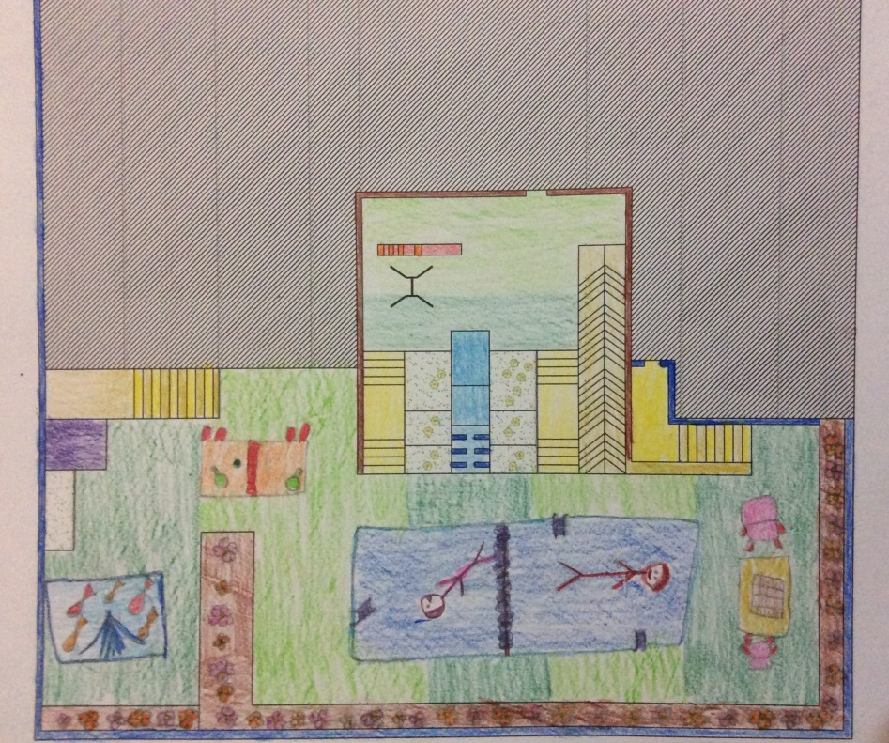
Figure (3.2): A 12 year old girl’s drawing of the Orphanage 2
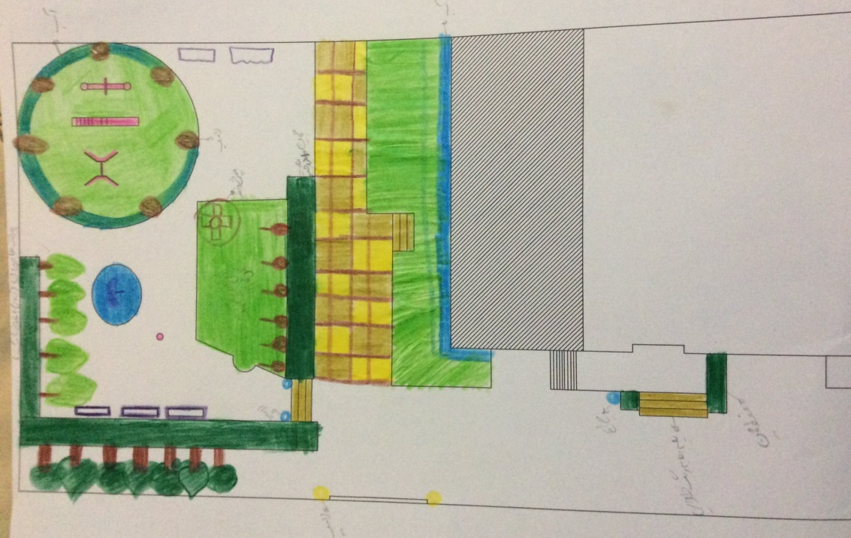
Figure (3.3): A 11 year old girl’s drawing of the Orphanage 3

3.4.4 Photo-Elicitation Procedures
During the photography process, children were divided into groups of maximum 18 (due to the limited number of cameras) and after training them regarding how to handle the cameras and take pictures, the cameras were distributed among the children in each group. The name of each child was written on each camera.
Children were taken to different open spaces outside of the orphanages to do photography. Children aged 8 to 10 of Orphanage 1 were taken to a pocket park which had a greenhouse close to that. Children visited and photographed of the greenhouse as well. Children aged 11 to 15 of Orphanage 1 were taken to a neighbourhood park in the city. Children aged 15 to 17 of Orphanage 1 were taken to the national forest of Kerman as a half day trip. Girls and boys children of Orphanage 2 were taken to a regional park and a community park in the city respectively. Children of Orphanage 3 were taken to another city park in Kerman.
When the children arrived at the specified places, they were asked to take pictures from anywhere and of anything in the outdoor environment that they like/dislike the most. It should be noted that children’s mentors as well as researcher monitored them to minimise any possible risk. Children were guided by the researcher or their mentors when they faced with any question or problem such as technical problem with working with camera, during the photography process. Children were not told exactly how many pictures to take. However they were asked to try to take up to 15 to 20 photos but again they were not forced to do so and they could take more or less than that number during the time that they had the camera. Moreover, they were asked not to put themselves at risk when taking photos. After that, the cameras were collected and all the pictures were printed. Then the researcher returned the printed pictures to children and asked them to choose the best and the worst pictures from their collection and number them in order based on their preference (for example, number 1, for the best and the worst selected picture and so on) then pass them to the researcher. Then, children answered why they took a picture and why they liked/disliked the picture. The same process was repeated with each group of children.
After completing photo elicitation process, all photo and their explanation were imported into the Nvivo software for further analysis. The analysis process and its results are described in section 6.3 in chapter 6. In the following, some photos of children photography process are shown.
3.4.4.1 Some Photo of Children Photography Process
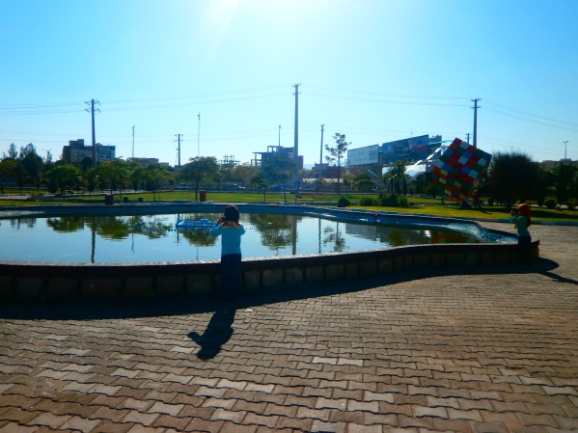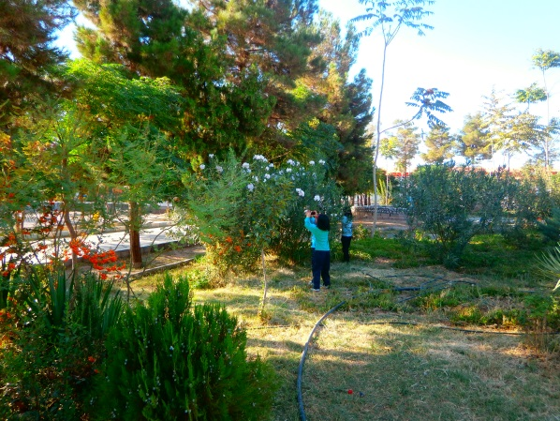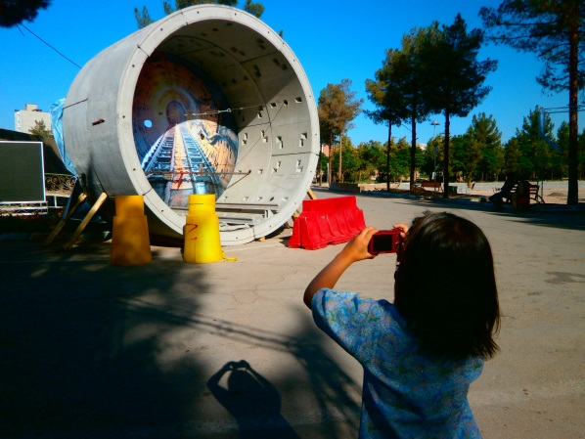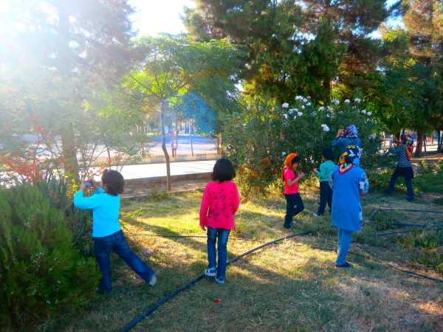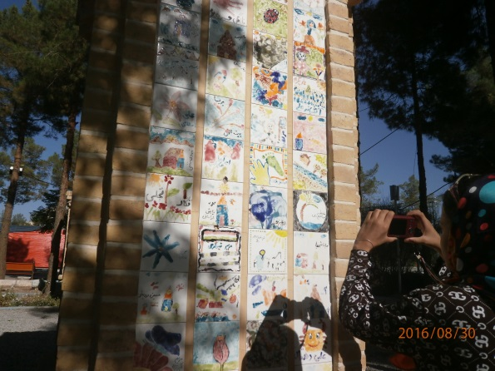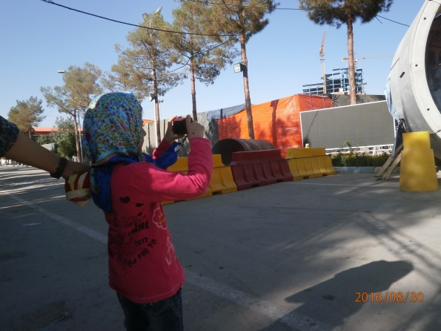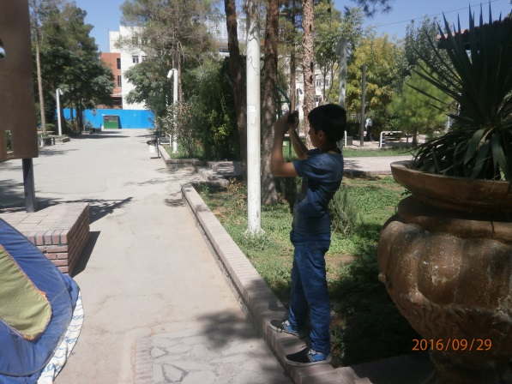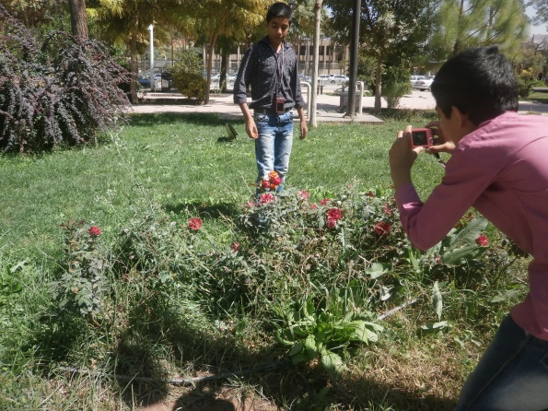
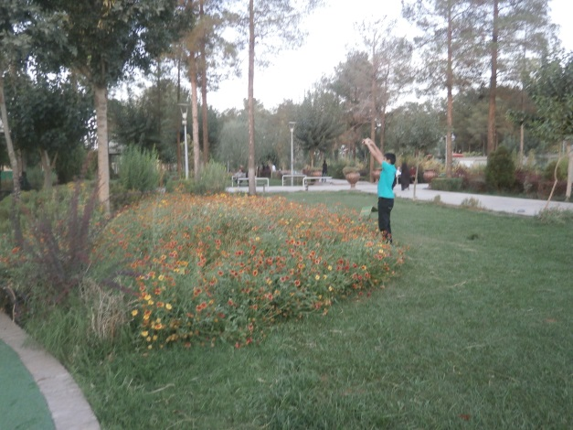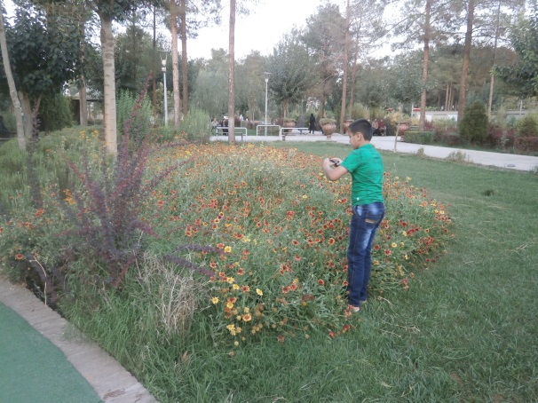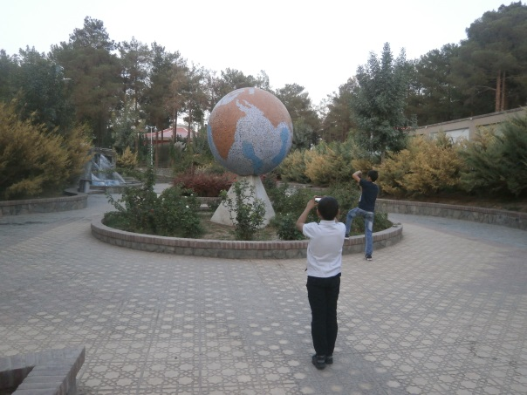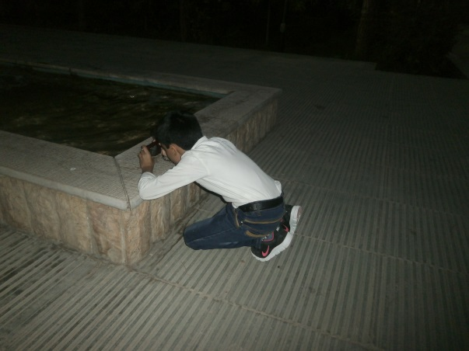

3.5 Disadvantages of the Chosen Methods
Various methods and techniques are available for researchers when conducting a research with children. In this study, the researcher tried to choose methods which match the research questions of the study as well as respect limitations of time and resources, participants’ characteristics and cultural and physical setting. However, there may be some disadvantages of the methodology chosen in this research.
For instance, using photography can be challenging due to giving sense of freedom to children in using camera while researchers may not have any control over what photographs might be taken (Barker & Weller 2003). Moreover children might not use the camera properly, and they might be liked to take photos of what they would like to keep as a picture thereafter (Punch 2002). Additionally, there may be ethical concerning about taking photographs of people without their consent. Also not all children engage in the same way with this method. Some children may have higher level of confidence and more experience in utilising cameras and enjoy this activity, while there may be a risk of losing camera, struggling to find suitable objects, feeling embarrassed about photography skills in others which leads to take very few pictures by some children (Barker & Weller 2003).
In using drawings techniques with children, there is also some issue. For instance drawings is not always considered a fun experience for all of the children especially older children. In addition to that, using this method in small setting like class rooms can be easily seen and copied by participant (Leonard 2006). Although in designing interview questionnaires researcher tried to use a ‘child-friendly’ format, but it may still need a certain level of literacy; and it is not easy for all children to communicate well in writing. According to Hill (1997) ‘many young people find questionnaires irrelevant or difficult to complete’. Younger children may answer a question, even if they do not know it very well. Finally, children’s responses may be biases due to ‘social desirability’, ‘context effects’ and ‘acquiescence bias’ (Scott 2000). There are also some other techniques which considered to be used in current research but rejected duo to the children’s culture and characteristics, setting and time limitation of this study. These methods include: focus group interview, photovoice, diaries and other life narrative techniques, and participant observation.
3.6 Pilot Study
The pilot study was carried out in order to explore the methods and determine the limitations and any changes which could be made for the main study. Following the initial development, the researcher tested some methods include: observation, interview, subject produce drawing and photo elicitation, in one of the orphanages (Orphanage 1). There is no reflection on the use of the PRS tool, because it was not developed completely before the pilot study was done.
Doing the pilot study helped the researcher for further revision of data collection process and any changes to be done if necessary and as needed. For instance, if the observer viewed unexpected activities or play behaviours during the observation that were not included in behavioural mapping sheet, these can be added to the codes of the mapping tool later based on the importance of that activity or action.

3.6.1 Reflection on Time Management
During the pilot study, it was found that arrangement of the time to do each type of methods was totally depended on the children’s free time and not on the researcher’s schedule alone. So, the pilot study showed that to save the time, the researcher should be in touch with all orphanages every day to find their children’s free time for that day or the next day. Therefore the previous plan which was to complete data collection for one orphanage then start with another one was changed based the experience of pilot study. The researcher realized that data collection should be done in all orphanages simultaneously based on their children’s free time. Therefore, to use time in an efficient way, during the actual data collection all the orphanages were contacted at the same time on a daily basis. Doing this allowed the researcher to find out which children in which orphanage would be available to conduct the data collection.
3.6.2 Reflection on Observation and Behaviour Mapping
At the first step, the process of the observation was to observe all children during one observation interval. But, during the pilot study, the observer realized that this is not a good way of observing because, the orphanage outdoor space was not big, and there maybe is a risk of children being recorded more than once. By observing each child separately this error would be eliminated. Thus, this was done in the observation period, with each child being observed separately before the observation of another child began. In this way, the researcher could ensure that all children were observed.
3.6.3 Reflection on Interview
Regarding the interview questions, during the pilot study, the researcher realized that some of the questions led to similar answers. As a result, these questions were removed from the interview question set to save the time and energy of both the children and the researcher during the subsequent interview process. Additionally, one of the questions was not understandable by young children, so it was also removed. Doing pilot study showed that children might become tired during the interview due to the number of questions. Although children did not complain about that and they were happy to answer the questions, but fatigue could be seen on some of their faces by the interviewer. Therefore, reducing some questions (the ones which were not completely understood or were similar to other questions which led to the same answers) would help this situation when conducting the actual interview with children in all orphanages.
3.6.4 Reflection on Subject Produced Drawing
Initially, for this part of data collection, it was decided to give the provided map and colour pencils to children to keep them for one week to have enough time to complete their drawings. But on the first impression, this idea was rejected. Because some of the children did not complete their drawings even after one week. Also young children destroyed or lost the given colour pencils. By understanding these issues during the pilot study, during the subsequent data collection, the researcher asked the children to do this task under her supervision. After the children had completed the drawing, the researcher collected everything (coloured pencils, pens, rubbers, sharpeners) and kept them to use with the next group of children.
Moreover, as the provided plan of the orphanage could not be easily understood and could be complicated for very young children, the researcher decided to provide blank sheets of white paper for them. They were asked to draw anything that they would like to have in their outdoor space for the main data collection. In this way, children could draw their orphanage ground and they can show the elements of the orphanage outdoor space or add new elements that they like. This will give an indication of the elements that will be considered by the children as most important, or prevalent in their orphanage outdoor space.
3.6.5 Reflection on Photo-Elicitation
In the pilot study, the researcher decided to give cameras to the children when they had planned to go on a trip to another city for ten days. As it was not possible for the researcher to follow the children in their trip, so all the cameras were given to their mentors. Based on the mentors’ report, they kept all the cameras in a safe place during the trip and only gave them to the children when they were in outdoor places such as a park or the seaside. This was not a good way, because there was no perfect supervision on the children to use cameras, as the researcher has heard that some children took pictures for other children. Unfortunately two of the cameras were also broken during their trip due to less supervision on the children while they were taking photos. Hence, it was concluded that the cameras would only be given to children during short trips, for example a one day trip. Moreover, the researcher accompanied the children as far as possible to help them take photos for the main data collection, especially younger children. Therefore, the photography process was done in this way in order to eliminate or reduce any errors in terms of the objects being photographed (not people) and to avoid damage to the cameras.
3.6.6 Reflection on Children Motivation to Take Part in This Research
Eventually, during the pilot study, the researcher realized that the children, especially younger children, need motivation to take part in this research. Because they always asked about availability of any gift for them if they do their job completely and well. This issue was also discussed with supervisors and it was finally arranged to give each child a thank you gift after finishing all the data collecting processes. Different gifts were considered for children in different ages groups. Younger children were given dolls, coloured pencils, a notebook, pencils, erasers and a sharpener; and older children who were high school students, were given a memory flash as a courtesy and to show appreciation of their participation in this study.
3.7 Summary
As this chapter showed, different methods of data collection are needed to undertake research with children as a participant of a study in order to have a holistic and reliable results. How children take part in a research and how they understand the concept of different methods is an important issue. Some of the research methods are suit to use by adults and may not be appropriate for children while there are some methods which may be specifically designed to be undertaken by children.
Therefore, research design and its procedure are considered as an important part of the research, so that selecting the right methods or tools for data collection, analysis and interpretation of data can help the researcher to be ensure the findings that answer the research aim and questions. Thus, to address the objectives and research questions clarified in chapter one, observations and mapping, the semi-structured interview, subject produced drawings, photo elicitation and Perceived Restorativeness Scale were used in this study.
The ‘Jourchin’ approach which is a multi-method approach was also designed by the researcher to be used in an illustrative way to reveal the children’s preferences about their outdoor space in their living environment. The ‘Jourchin’ approach consisted of four of the above methods, except the PRS. A new PRS was also developed to evaluate the perceived restorative potential of the outdoor spaces of the orphanages from the children’s perspective. In this chapter the research tools, their development and their implementations were described.

CHAPTER 4
CASE STUDIES AND SITE CHARACTERISTICS

4.1 Site Selection
The orphanages considered for this study are located in Kerman, Iran (Figure 4.1). Kerman is the capital city of Kerman Province and is one of the largest cities of Iran in terms of area. At the 2016 census, its population was 738,724 making it the 10th most populous city of Iran. The reason for choosing Kerman is the familiarity of the researcher with the city and the ease of access to secondary data compared to other cities, especially the capital city of Iran. There are 10 orphanages in Kerman. Eight of these are private and two are government run. The selection of orphanages is not based on random sampling but on the agreement of each orphanage to be involved. At the first attempt, five orphanages were invited to be involved in this research. After the first visit to the orphanages, one of them was removed from the study due to a lack of outdoor space. After gaining permission from the rest of the orphanages, this research began with four orphanages. After doing the first observation of children, one of the orphanages decided not to continue. Therefore the research continued with three orphanages.
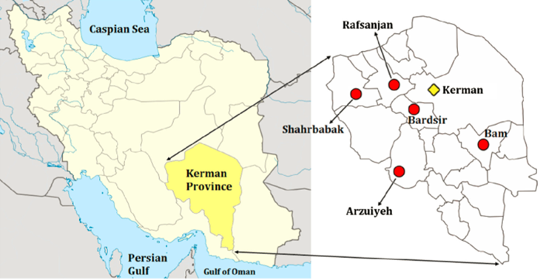
Figure (4.1): Location of Kerman on the map of Iran
4.2 Population of This Study
The population of this study consists of 126 orphans aged between 7 and 17 years from three orphanages, which are called Orphanage ‘1’, ‘2’ and ‘3’. The aim of this study was to involve all orphans.
Orphanage 1 and Orphanage 2 are larger in terms of the size of the building and the number of children who live there compared to Orphanage 3. Orphanage 1 consists of 53 boys, Orphanage 2 consists of 16 boys and 21 girls, and orphanage 3 consists of 28 girls. Regarding the size of outdoor space of these orphanages, Orphanage 1, 2 and 3 have large, medium and small outdoor space respectively.
Each orphanage has a manager who works in a separate building (Orphanage 1) or has a room inside the orphanage (Orphanage 2 and 3) and is responsible for administration. There are also mentors who live with the children on a shift basis and their role is more taking care of and supervising the orphans. Orphanage 1 and Orphanage 2 have chefs and other staff for different activities, such as cooking or cleaning. In Orphanage 3, these activities are divided between the mentors and the children.
The orphans have different family backgrounds. Some of them have no parents, some have lost one of their parents due to death or imprisonment. Some orphans have a parent with drug addictions who are unable to afford family expenses. That is the reason why the Welfare Organization of Iran sends such children to orphanages to be cared for.
Orphans, who have a family member, whether one of their parents, older brothers and/or sisters or aunts or uncles, are allowed to visit them at weekends or holidays.
Orphans go to different schools in the city depending on their age and gender, and also attend different extracurricular classes such as music, English, drawing, handicrafts, different sports classes etc., depending on each child’s interest. Some of the classes are compulsory to all children, such as computer technology, English and/or calligraphy classes. Further details on each orphanage and a number of photographs are provided in the following sections.

4.3 Orphanage 1
The orphanage was established in 1916 (1295 in Persian calendar) and it is Kerman's oldest orphanage. In the past, however, its structure and location were different, and its area was about 80 meters in 200 meters. It had two or three large garden and a public bathroom. Nowadays, the old place operates as a museum, cinema and library; and the new orphanage is built close to the original one. The new centre is a complex that includes primary school, gym, a college, orphanage office building, prayer room and dormitory. These different parts are shown in the map of this orphanage (Figure 4.2). The dormitories are almost modern dormitories, which have private bathrooms. This is a private orphanage intended for boys only. The girls' centre is located in the city of Bam, 194 km (about 120 miles) from Kerman city, and approximately there are 45 girls are currently residing in this centre. The age of the girls in the centre varies between seven years old and the age they marry. Due to the distance and location of the girls’ centre and because of the lack of time the participation of girls was not possible in this study.
At the boys' centre, 53 boys between the ages of 6 and 18 live there at the time of this study. This centre has four blocks. Two blocks are for younger children aged 6 to 8 and 8 to 11. One block is for children aged 11 to 15, and the other one is for older children aged 15 to 18, who study in secondary school. The children of the centre go to school in the city every day and return to the centre after school. According to one of the managers of the orphanage, this centre is different from other orphanages in terms of management, administrative structure, established time, children's accommodation space (place of residence of children) and the way of education and training. Some pictures of this orphanage are shown in following section.
This orphanage has large, different sections of outdoor spaces in different parts of the complex but children play in the back of the dormitory blocks, which is an empty field, or in the school yard which has volleyball and badminton fields, or in the outdoor space in front of the office building which has football and basketball fields. There is also a concrete table tennis available in the outdoor space in front of the office building. These are places that children are allowed to use and play in the outdoor space of this orphanage. There are a lot of gardens with trees or bushes and also a small pool available in the outdoor space. Figure 4.2 shows the map of this orphanage and also some pictures of the outdoor space of this centre are shown in section 4.3.1.
Figure (4.2): Map of Orphanage 1

4.3.1 Pictures from the outdoor space of Orphanage 1
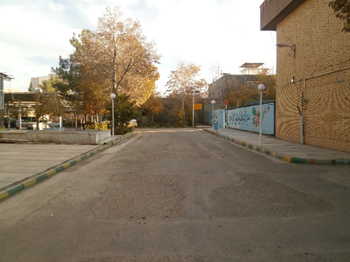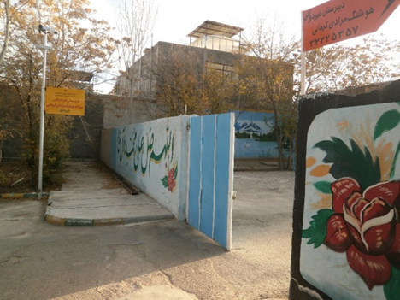
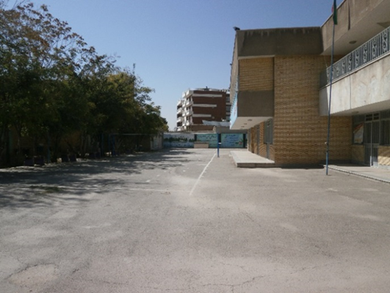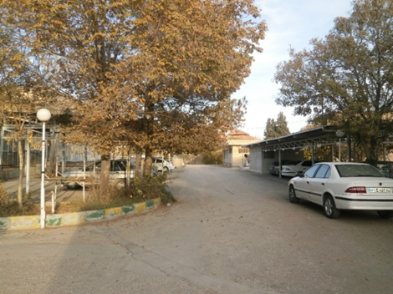
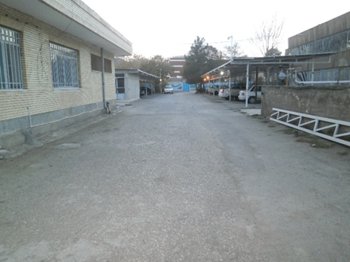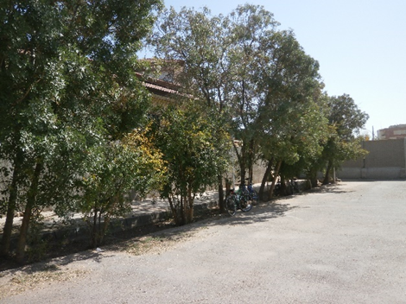
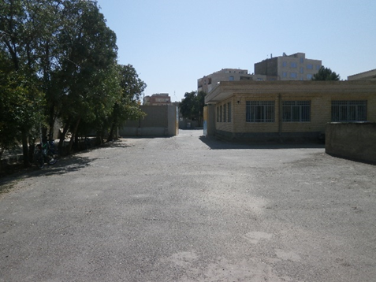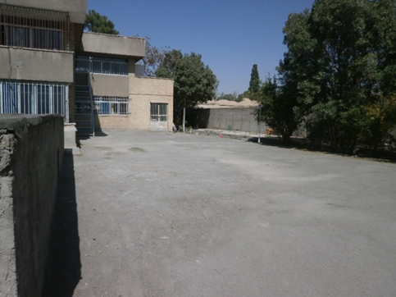

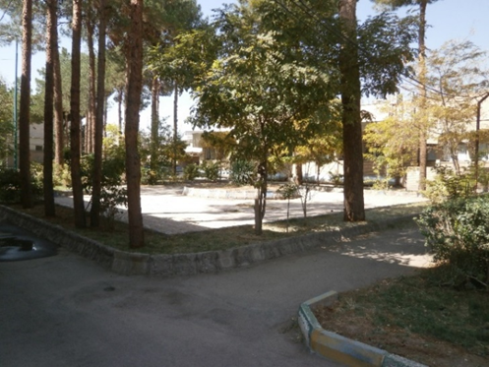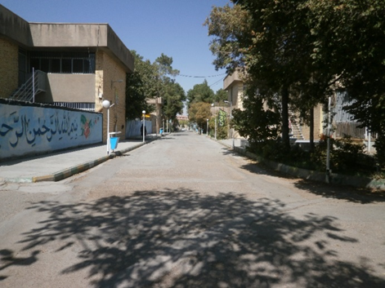
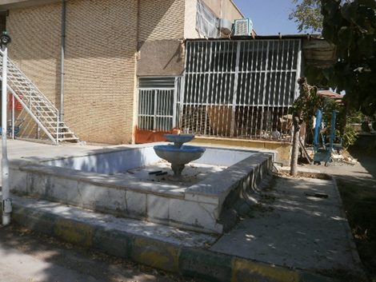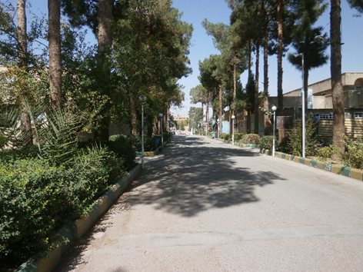
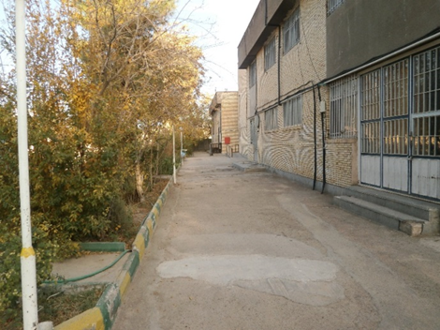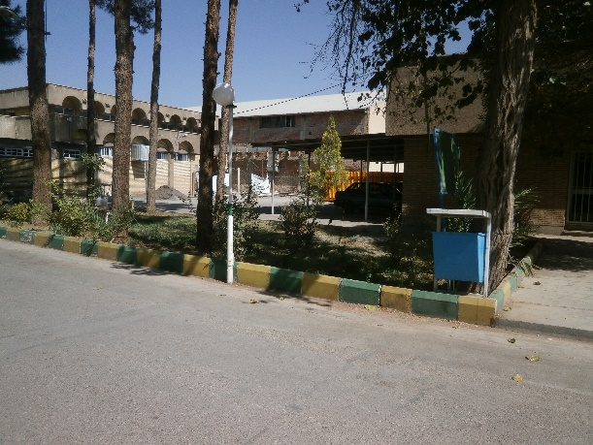
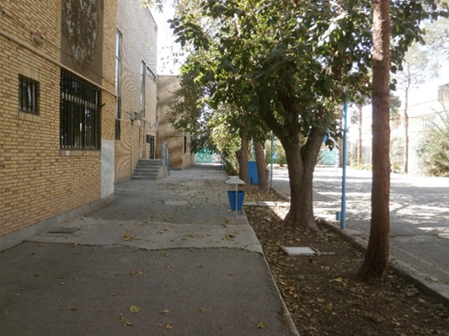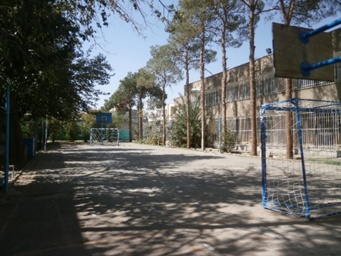

4.4 Orphanage 2
17
The orphanage includes boys’ and girls' centres, and the buildings are located in two parts of Kerman. There are 21 girls aged between 2 and 17 in the girls' centre, and there are 16 boys aged between 7 and 17 in the boys' centre. The children of both centres aged between 7 and 17 participated in this research.
The girls' centre is a new two-story building and its interior is like a large house which includes rooms, a big kitchen at the underground, and a small kitchen, big hall and bathrooms in each floor. The first floor is for younger children. The office area of both centres is also a large room adjacent to the entrance door of this building. Older children's rooms, as well as the library and computer room are located on the second floor. The orphanage manager's room who is called “Mamani”, a Persian synonym of mother in English, by the children is also on this floor.
The centre has a fairly large yard designed on two levels. In the lower part of the yard, which has recently been renovated, there are a swing and a slide, and its surface is artificial turf. The upper part of the yard is divided into two parts by a small garden. The smaller part, which is near to the yard’s door is sometimes used to park the car of the centre. In the larger part there is a volleyball net. Beside the walls of the yard there is a garden with a width of about 50 cm. The two portions of the yard are connected by a ramp and a staircase and separated by a short fence with a door made of iron. Figure 4.3 shows the map of the girls’ centre of the Orphanage 2. Also some pictures of the outdoor space of this centre are shown in section 4.4.1.
The boys' centre of the Orphanage 2 is actually a relatively small three-story house. This centre has an entrance door that opens to the yard. On the ground floor there are a kitchen and a gym. The second floor is for younger children and the third floor is for older children. Each floor includes children’s rooms, mentor’s room, bathroom and a small hall. The yard of this centre is very small so there is not enough space for children to play. The boys go to the girls' centre at the end of the week (but not every weekend) to play in the outdoor space of that centre and spend their time with “Mamani” and the girls. Figure 4.4 shows the map of the boys’ centre of the Orphanage 2.
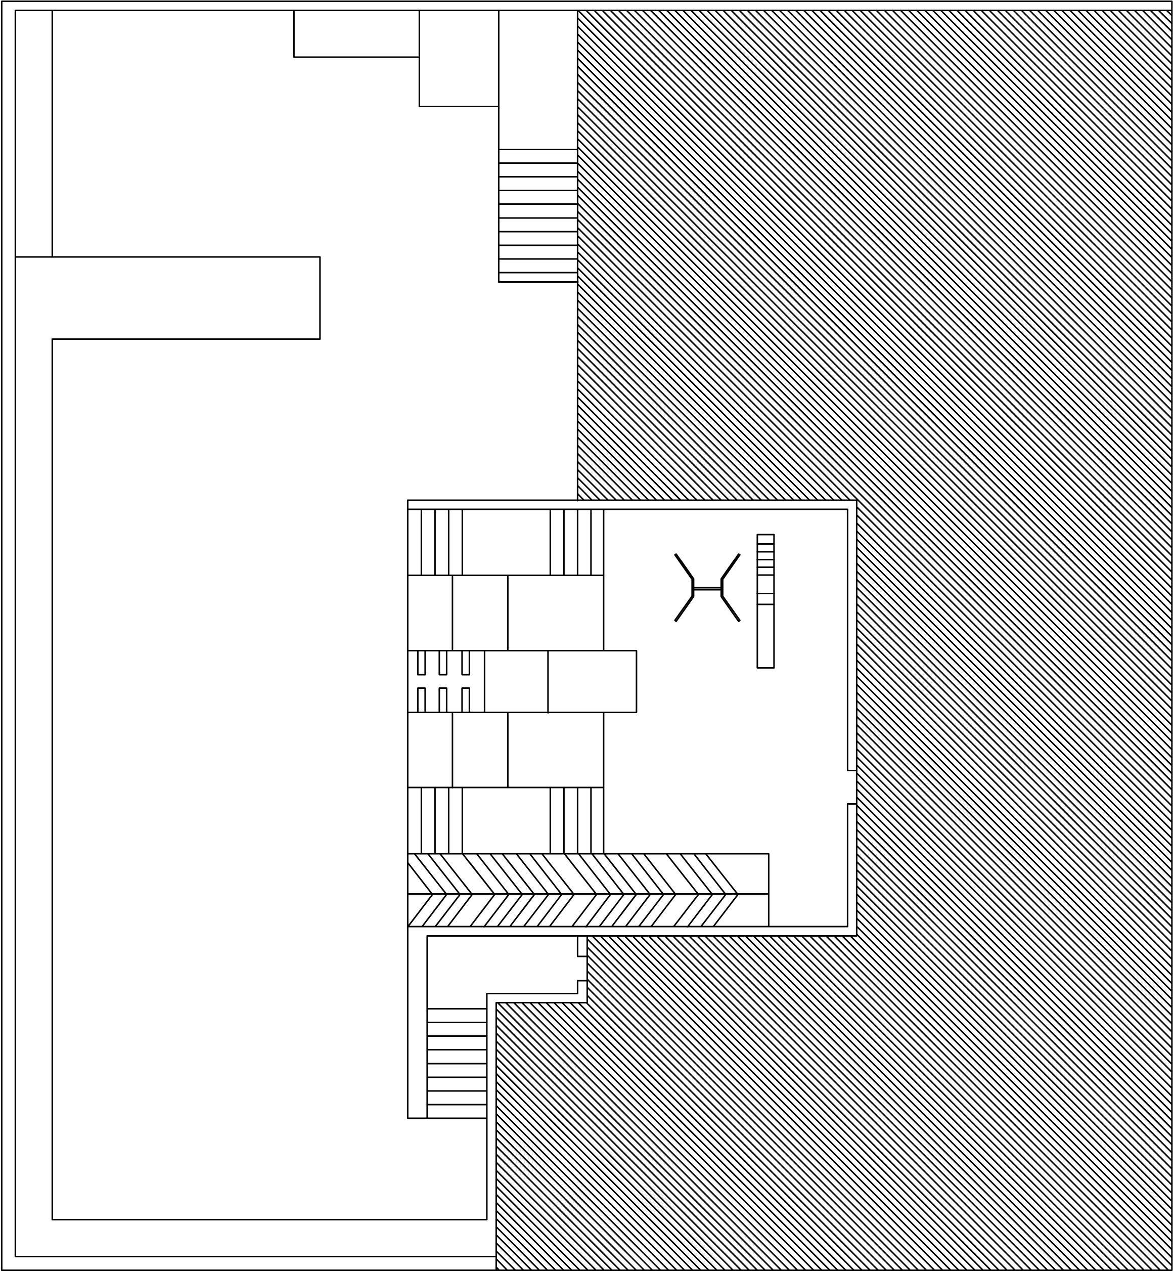
Figure (4.3): Map of Orphanage 2- Girl’s centre
Figure (4.4): Map of orphanage 2- Boy’s centre

4.4.1 Pictures from the outdoor space of girls centre of Orphanage 2
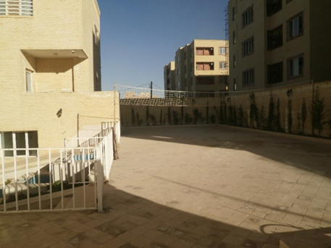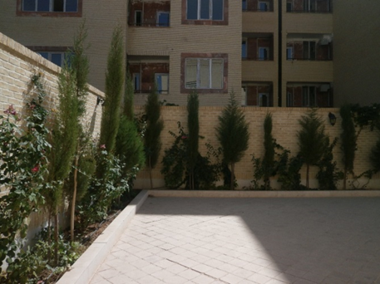
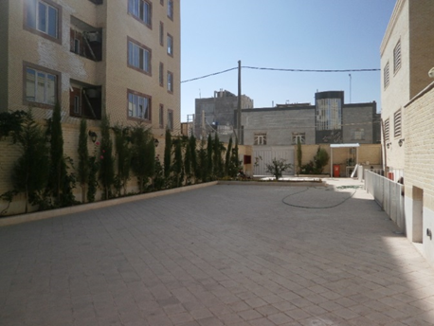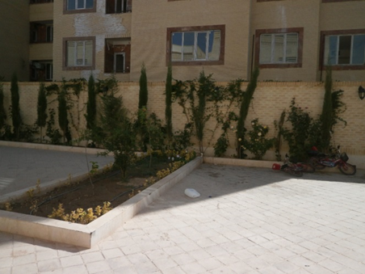
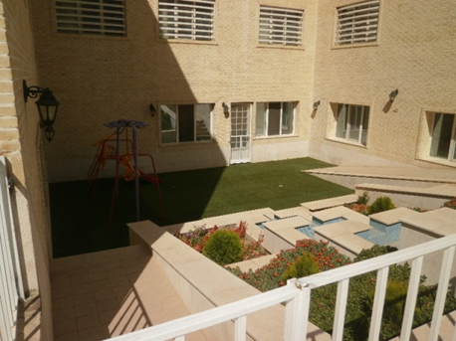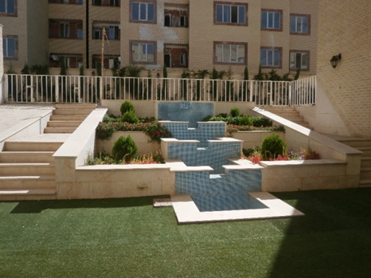
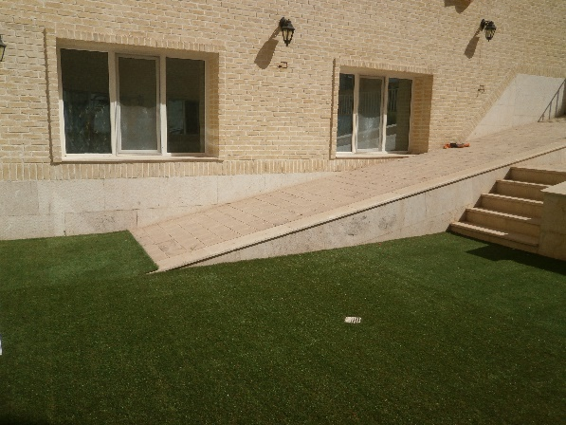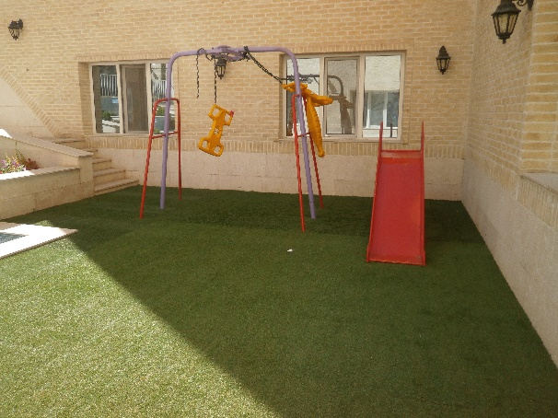

4.4.2 Pictures from the outdoor space of boys centre of Orphanage 2
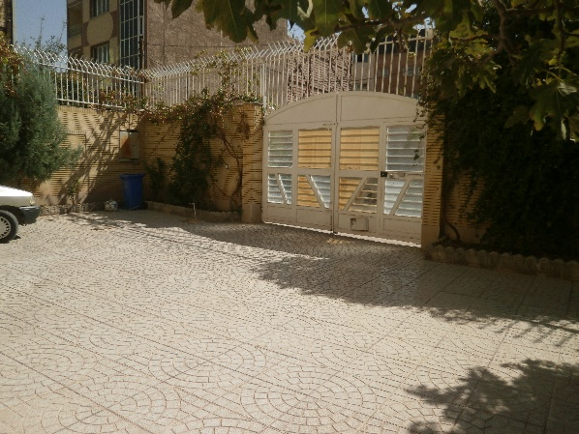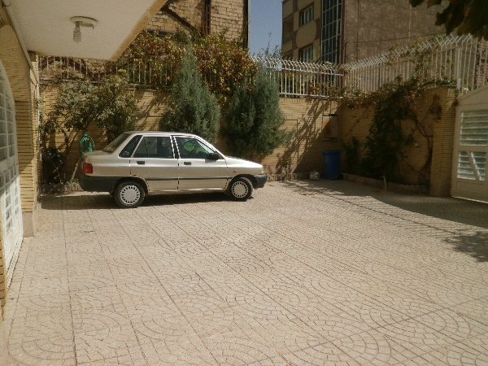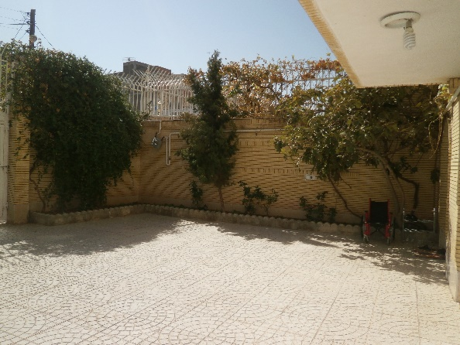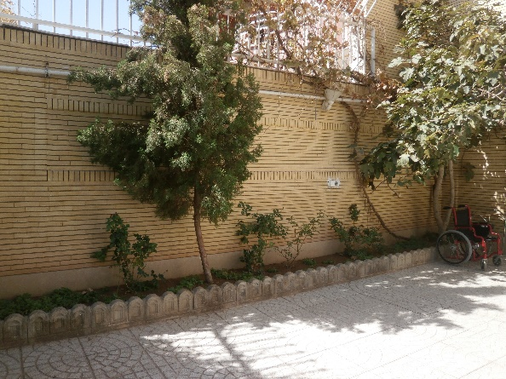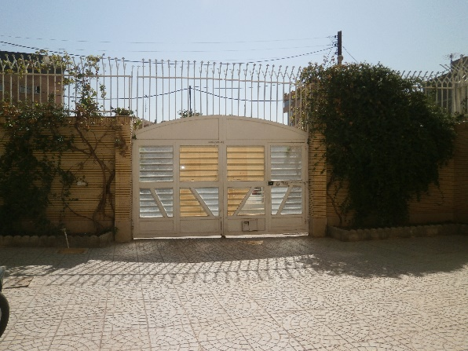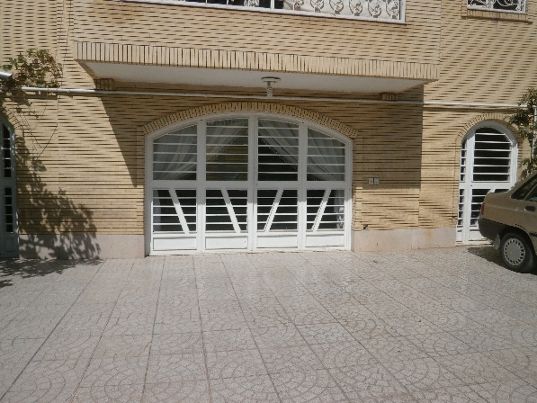

4.5 Orphanage 3
Orphanage 3 is a girls' centre and 28 girls, aged 6 to 18 years old with their mentor, live in this orphanage. The centre has a single storey building and an average outdoor space in size. The interior of the building is relatively large and includes children’s room, one kitchen, two big halls, two bathrooms, a room for storing equipment and a manager’s room (called the office by children).
The courtyard of the centre has several gardens with playground equipment such as swing, one slide and one see-saw. There is also a pool in the yard close to the playground equipment. This play area is surrounded by gardens and this part is covered by a surface of small stones. At the corner of the yard, the small space between the wall and the garden, there is a car which is always parked there. There is also a large platform section in the yard behind the windows of the rooms. This platform is linked to the ground level of the yard by stairs. The map of the Orphanage 3 is shown in figure 4.5 and some pictures of the outdoor space of this centre are also shown in section 4.5.1.
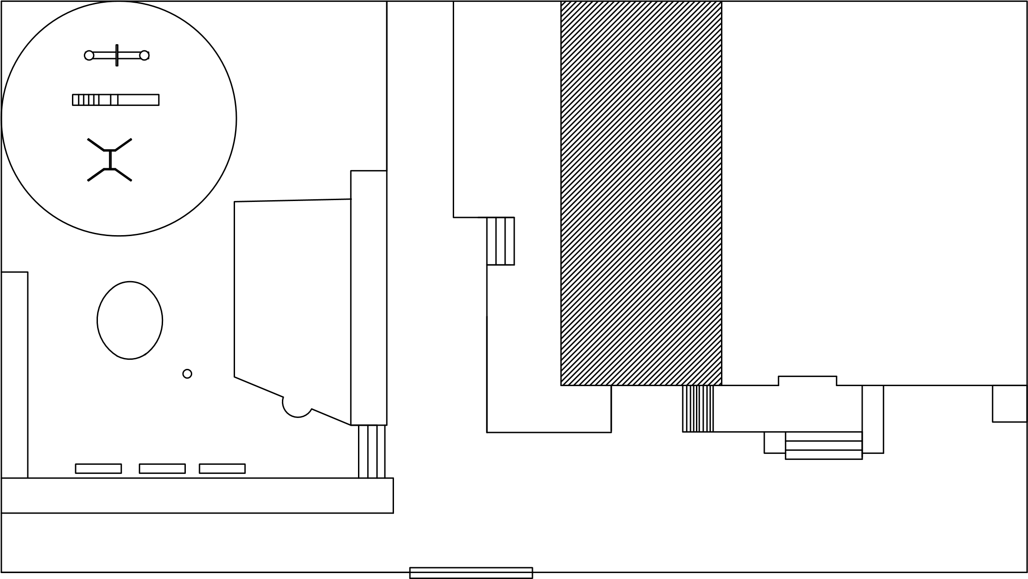
Figure (4.5): Map of Orphanage 3

4.5.1 Pictures from the outdoor space of Orphanage 3
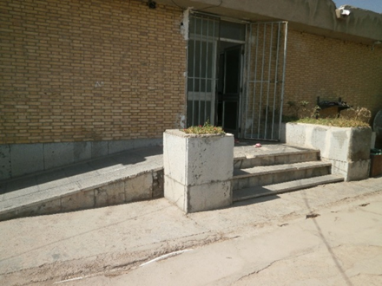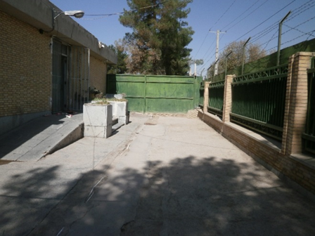
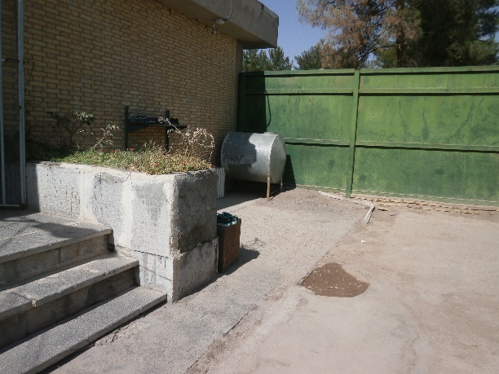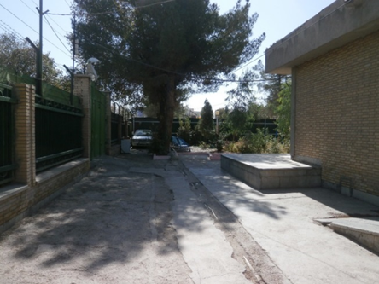
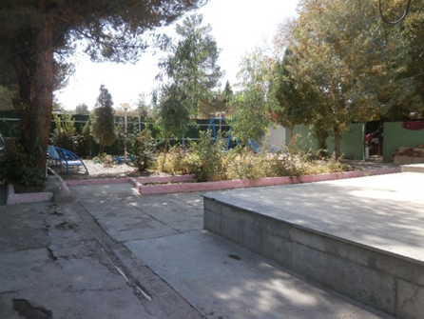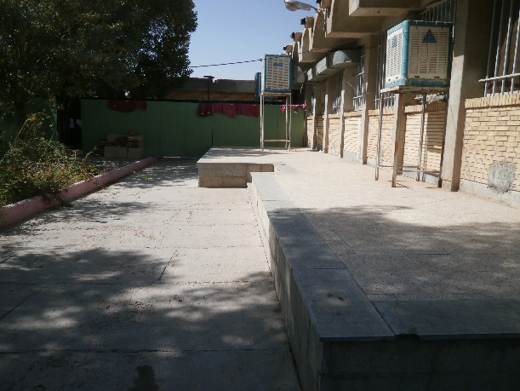
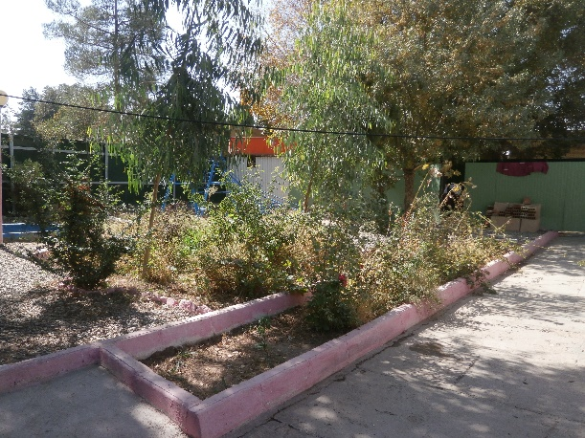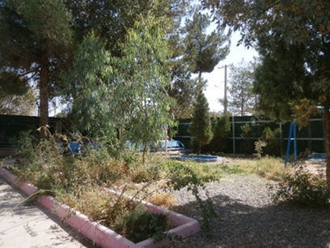
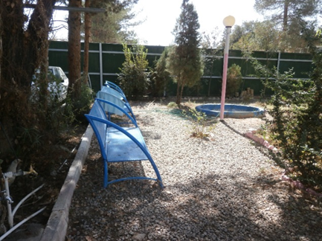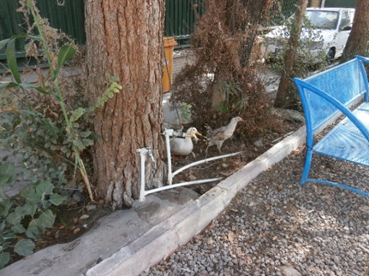
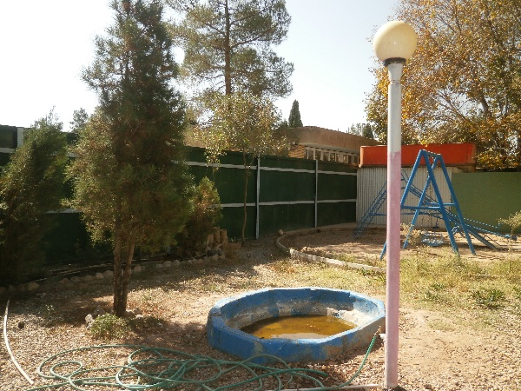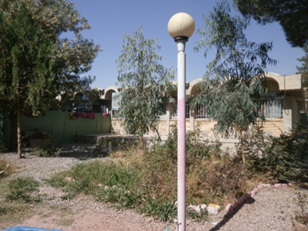
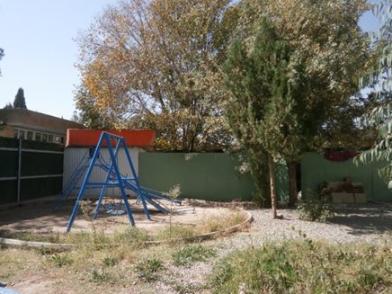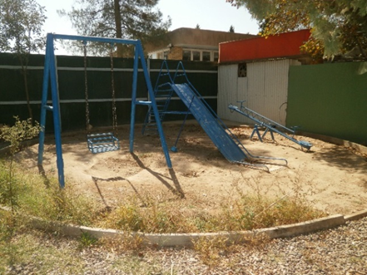
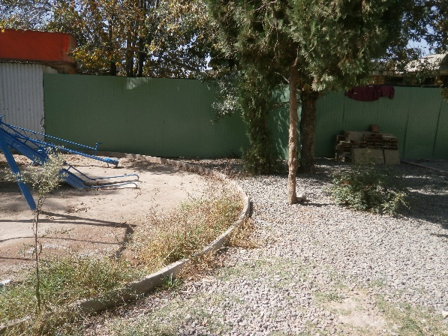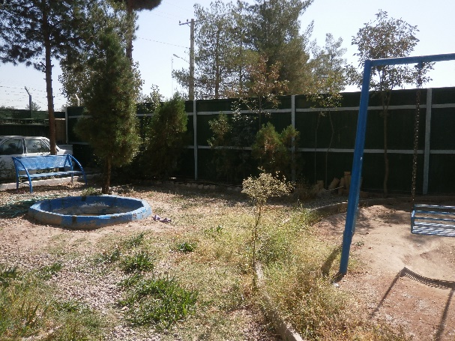

CHAPTER 5
RESULTS OF THE INTERVIEW

5.1 Introduction
In this chapter, the preliminary results of the interview question set are shown in tables and bar charts along with related analysis.
The interview question set (Appendix 2) included different sections which mapped a clear path for the children to follow. However, in order to complete the analysis, a set of questions from the interview question set were placed together as a way of addressing the aims and research questions of this study. In order to carry out the analysis of the interview questions, the ‘frequencies’ and ‘multiple response sets’ analysis were completed by utilising the IBM SPSS Statistics (Version 25). In this chapter, we referred to three orphanages which were selected to participate in this study, as Orphanage 1 (boys), Orphanage 2 (both boys and girls) and Orphanage 3 (girls) and they are shown by blue, green and red colour respectively in the results.
This chapter is divided into different sections based on the aims and objectives of the research. Participant characteristics is discussed in the first section. In the following two sections, children’s perceptions of play as well as their orphanage outdoor space were evaluated. The types of activity and play that children engage in or would like to engage in in the orphanage outdoor space is discussed in section 5.5. The children’s happiness and satisfaction levels as well as their preferences, as the two main objectives of this research, were addressed in sections 5.6 and 5.7 respectively. Finally, an overall view of the results of the interview is summarised in the last section.

5.2 Participant Characteristics
A total of 118 of 126 children agreed to participate in this part of the research. As shown in table (5.1), 58.5 percent of the participating population were boys and 41.5 percent were girls. The age of the children varied from 7 to 17 (mean age = 12.3) years old. They were then categorized and divided into four age groups; the frequency of each group is also illustrated in table (5.1). Most of the children (33.1%) were placed in group 15-17 years old. Gender and age group distribution in three orphanages are shown in bar chart (5.1) and bar chart (5.2). Children study in primary and secondary schools and frequencies of their level of education are also shown in table (5.1).
Table (5.1): Frequency table of gender, age group and educational level of the children
Variable | Description | Frequency | Valid Percent
Gender  Valid 118  Missing 0 | Boy  Girl | 69  49 | 58.5  41.5
Age group  Valid 118  Missing 0 | 7-9 years  10-11 years  12-14 years  15-17 years | 29  23  27  39 | 24.6  19.5  22.9  33.1
level of education  Valid 118  Missing 0 | P1 (Primary1)  P2  P3  P4  P5  P6  S1 (Secondary1)  S2  S3  S4  S5  S6  work | 5  12  15  16  8  8  5  13  16  7  8  1  4 | 4.2  10.2  12.7  13.6  6.8  6.8  4.2  11.0  13.6  5.9  6.8  .8  3.4
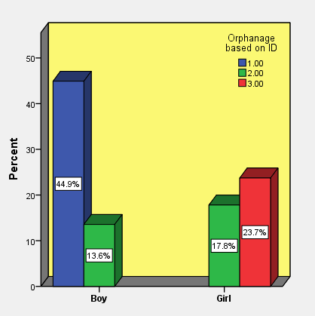
Bar chart (5.1): Gender distribution in each orphanage
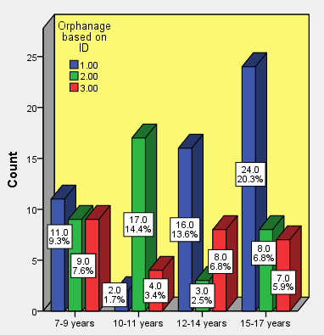
Bar chart (5.2): Age group distribution in each orphanage
Children’s duration of stay in orphanages is shown in table (5.2). Based on the information obtained from the children, 67.3 percent of children lived in the orphanages more than three years and 7.1 percent resided in orphanages for less than one year. The fact that most children had lived in the orphanages for more than three years can be considered a good thing because they had a solid comprehension of their living environment, something which could be invoked in the interview.
Table (5.2): Duration of stay for children in the orphanages
Description | Frequency | Valid Percent
< 1 year  1-3 years  > 3 years  Valid 113  Missing 5 | 8  29  76 | 7.1  25.7  67.3

5.3 Children’s Play
This section begins with an analysis of the interview questions related to play and children’s perception of play. Despite children’s play not being the main focus of this study, playing as a type of activity that is done in outdoor environments is, meaning that the interview question set included some questions about play and children’s perception of play, as well as types of play and the importance and benefits of play. These questions targeted the perspectives of children as a way of directing their minds when conducting the interview. In this section the results of children’s interest to play and the importance and benefits of play from their perspectives, along with the consideration of children’s play for different gender and age group, are presented. Children’s comments about places where they play more, whether indoor or outdoor of the orphanages, as well as other places that they play apart from the orphanage outdoor space, are discussed here.
According to the response of the children, 87.3 percent of children liked playing and of these 52.5 percent were boys and 34.7 percent were girls (Bar chart 5.3). Only 5.1 percent (usually older children) answered ‘no’ when they were asked ‘do you like playing?’, and 7.6 percent answered ‘both yes and no’ which was situation-dependent to them. As bar chart (5.3) shows, boys enjoyed playing more than girls. This result may be due to the higher number of boys than girls in this study. Thus, in general we can say that there is not much difference in regard to gender when it comes to children’s desire to play and the extent they enjoy playing. Moreover, when children were asked who they play with most of the time, 68.2 percent of children answered that they play with their friends and 21.5 percent mentioned that they play with other children and 5.6 percent pointed that they play alone.
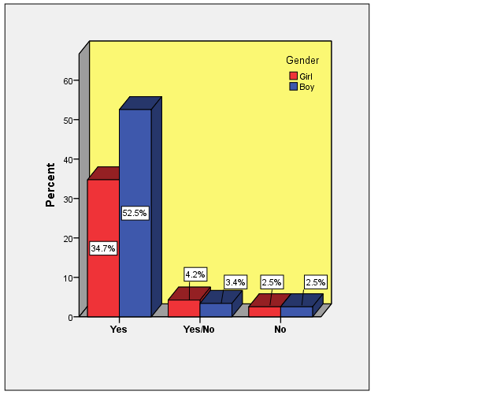
Bar chart (5.3): Like playing based on gender
Regarding the importance of the play from the viewpoint of children, as bar chart (5.4) displays, play was ‘very important’ for 36.6 percent of children and was ‘less important’ and ‘not important’ for 24.8 percent and 21.4 percent of children respectively. As shown, there is not a huge difference between these scales, something which indicates that just as playing can be very important for some children, it can also be trivial for others. The age of children can play a role in this regard. Usually older children more frequently opted for ‘less important’ or ‘not important’ compared to younger ones. Also, the importance of play for a small number of children (3.4 percent) depended on the type of game. The reasons provided by the children regarding these scales (very important to not important) and the importance of play are shown in table (5.3).
‘Being healthy and happy’; ‘preventing boredom; ‘being entertained’ and ‘having fun’, were some of the main reasons given by the children who mentioned that play is very important to them. ‘Not liking playing’ and ‘studying’ are two of the main reasons that caused a few of the children to claim that play is not important to them. Some mentioned that play is only for younger children which is why it is not important to them.
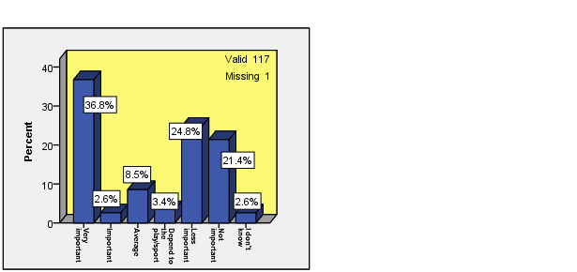
Bar chart (5.4): How important is play for you?

Very important | Important | Average | Depend to the play/sport | Less important | Not important
Because:  - I always like to play (I like playing) (2)  - I like playing very much (3), for example when I get bored I go and paly jump rope, or making craft  - Play is an exercise and makes the man healthy and happy  - Fill our free time  - We get more entertained (2)  - Happiness. exercise is also good but games entertained us, we can be happy  - I like football and sport  - I play and get happy  - I play in my free time and have fun (get entertained)  - I usually play football because it is an exercise (sport)  - If we do not play we get depressed, playing causes happiness  - It brings me much happiness (It makes the human being happy) (2)  - It gives energy to the person and It is useful for health  - It is (very) fun (3)  - It is good for health (2)  - It makes us healthy and happy  - Lose weight, get strong  - My arms get stronger  - My mind becomes free  - Not be impatient, have fun  - Play is very good, we play with our friends  - The anger will disappear during play and it is more happiness and fun  - Not be boredom  - When I get bored I go and play  - I don't know | Because:  - I do not upset my friends for example for playing volleyball  - I like basketball very much  - I don't know | Because:  - I'm not always thinking about the game, sometimes I'm thinking of school and sometimes thinking of other things  - Sometimes I play with somebody and we have very fun, but sometimes not  - I am at work most of the time so I do not have play time  - It depends to time and our study., for example we play more in summer  - Sometime can’t be bothered to play  - The game is not too much good nor too little good, playing in moderation is good  - We should study our lessons  - I don't know | Because:  - I like sport and I feel sense of peace  - I love football class and I attend to anything related to football  - It depends to which one of my friends be there and how my mood is. | Because:  - I do not have much interest (I'm not interested in playing) (2)  - I cannot play because of my hand (his hand was broken)  - It is not very important for me sometimes makes me bored  - Maybe I have lesson to study or less time to play  - We have lessons to study and if we don't study our teacher will be angry  - We just play  - I can’t be bothered to play  - I am not in a mood of play a lot  - I do not interested in any games except volleyball  - I do not like playing very much (3)  - I do not want play takes my time  - I don’t like to play and I hate playing  - I have lesson to study (2)  - I have lessons to study, but it is important in summer, because it is vacation  - I like handy craft more  - I like playing but I should study beside that  - I should study, and do other things, I like play more but not (not possible, or I can't)  - I sometimes play and sometimes not  - I'm boredom  - It is not very important to me at all, I don't like playing very much  - We should study, and do our homework  - I don't know | Because:  - It is not important  - I think that I become a child  - The lessons are more important to me  - I am not a child to play  - I do not like playing a lot (2)  - I don't have any friend  - I don't like game very much because they are repeated for me  - I hate playing, I like chess  - I have to study my lessons (We have lesson to study) (2)  - I like to improve my study, so I study first, when we have exam, I get ready for exam  - It affects the study, I will not get mark 20  - It depends on my mood, if I am in a right mood then I go to play otherwise not  - It is not very fun  - It is nothing in my viewpoint, just time passes  - Playing is for children only  - I don't know
Table (5.3): How do children think about the importance of play?

From the children’s point of view, the most benefit that they got from playing was ‘fun and entertainment’ (32.7%), following by ‘social benefit’ and ‘mental benefit’ which were placed at the same level (29.1%). Also, a high percentage of the answers were allocated to ‘exercise’ (27.3%) as another benefit of play based on children’s believes. The number of responses were approximately equal to the benefits mentioned above. The benefits such as ‘having healthy body (physically)’ (11.8%), ‘getting relax and rest’ (10.9%) and ‘learning benefits’ (8.2%) placed in the next level according to the viewpoint of the children (Table 5.4). As these results show, some of these benefits are the same as the reasons given by the children who said that playing was very important to them. Therefore, the level of importance given to play can depend on the benefits that the children receive.
Table (5.4): Benefits of play
 | Orphanage
 | 1 | 2 | 3 | Total
 | Count (%) | Count (%) | Count (%) | Count (%)
Fun/Entertainment | 12 (25.0%) | 15 (42.9%) | 9 (33.3%) | 36 (32.7%)
Social Benefit | 10 (20.8%) | 13 (37.1%) | 9 (33.3%) | 32 (29.1%)
Mental Benefit | 16 (33.3%) | 11 (31.4%) | 5 (18.5%) | 32 (29.1%)
Exercise | 10 (20.8%) | 11 (31.4%) | 9 (33.3%) | 30 (27.3%)
Healthy Body (physically) | 12 (25.0%) | 0 (0.0%) | 1 (3.7%) | 13 (11.8%)
Learning | 6 (12.5%) | 2 (5.7%) | 1 (3.7%) | 9 (8.2%)
Relax/Rest | 7 (14.6%) | 3 (8.6%) | 2 (7.4%) | 12 (10.9%)
No Benefit | 1 (2.1%) | 1 (2.9%) | 1 (3.7%) | 3 (2.7%)
I Don't Know | 6 (12.5%) | 4 (11.4%) | 3 (11.1%) | 13 (11.8%)
Regarding the play differences in terms of gender and age contrast from the perspective of children, 66.1 percent pointed to the existence of such differences, while almost half that number (30.4%) said there was no difference between boys and girls, neither in different age groups (Bar chart 5.5). Play differences from the viewpoint of children in terms of their gender is also shown in bar chart (5.6) and table (5.5). Based on that, 36.5 percent of boys and near to 30 percent of girls said ‘yes’ to the question ‘do you think play is different for different children?’.
According to the children, ‘participating in a structural team game’ or ‘playing football’ are the kinds of play that boys usually engage in, while ‘volleyball’ or some of the ‘group play with a ball’ (like ‘Haft-Sang’ and ‘Dodgeball’) are mostly played by girls.
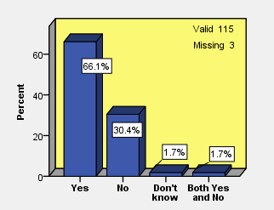
Bar chart (5.5): Do you think play is different for different children?
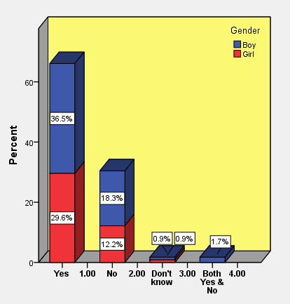
Bar chart (5.6): Play differences from viewpoint of children in terms of their gender
Table (5.5): Types of play differences from viewpoint of children in terms of their gender
 | Girls | Boys | Boys and Girls | No Difference | Don’t know
 | Count (%) | Count (%) | Count (%) | Count (%) | Count (%)
Locomotor play | 3 (33.3%) | 4 (44.4%) | 2 (22.2%) | 0 (0.0%) | 0 (0.0%)
Rough and Tumble | 0 (0.0%) | 1 (100.0%) | 0 (0.0%) | 0 (0.0%) | 0 (0.0%)
Participating structural team game | 0 (0.0%) | 17 (40.5%) | 25 (59.5%) | 0 (0.0%) | 0 (0.0%)
Football | 0 (0.0%) | 41 (100.0%) | 0 (0.0%) | 0 (0.0%) | 0 (0.0%)
Volleyball | 18 (78.3%) | 3 (13.0%) | 2 (8.7%) | 0 (0.0%) | 0 (0.0%)
Basketball | 1 (25.0%) | 2 (50.0%) | 1 (25.0%) | 0 (0.0%) | 0 (0.0%)
Handball | 1 (50.0%) | 1 (50.0%) | 0 (0.0%) | 0 (0.0%) | 0 (0.0%)
Futsal | 0 (0.0%) | 1 (100.0%) | 0 (0.0%) | 0 (0.0%) | 0 (0.0%)
Dodgeball (Vasati) | 5 (83.3%) | 1 (16.7%) | 0 (0.0%) | 0 (0.0%) | 0 (0.0%)
Haftsang (a kind group play with ball) | 4 (100.0%) | 0 (0.0%) | 0 (0.0%) | 0 (0.0%) | 0 (0.0%)
Play with free equipment (jump rope, ball, bicycle, ..) | 1 (33.3%) | 2 (66.7%) | 0 (0.0%) | 0 (0.0%) | 0 (0.0%)
Thinking game (brain teaser, chess, ...) | 4 (100.0%) | 0 (0.0%) | 0 (0.0%) | 0 (0.0%) | 0 (0.0%)
Socio-Dramatic play | 3 (37.5%) | 0 (0.0%) | 5 (62.5%) | 0 (0.0%) | 0 (0.0%)
Playing on fixed structure (playground equipment) | 4 (100.0%) | 0 (0.0%) | 0 (0.0%) | 0 (0.0%) | 0 (0.0%)
Play with technology | 1 (100.0%) | 0 (0.0%) | 0 (0.0%) | 0 (0.0%) | 0 (0.0%)
Object Play, Play with toys (rattles, doll, Lego, cars, cards..) | 0 (0.0%) | 0 (0.0%) | 2 (100.0%) | 0 (0.0%) | 0 (0.0%)
Other responses | 7 (77.8%) | 0 (0.0%) | 2 (22.2%) | 0 (0.0%) | 0 (0.0%)
No difference | 0 (0.0%) | 0 (0.0%) | 0 (0.0%) | 2 (100.0%) | 0 (0.0%)

When the children were asked where they play most of the time (whether indoor or outdoor) at the orphanage, 59 percent of children responded that they play outdoor, 35 percent answered that they play indoor and six percent of children answered both indoor and outdoor. These results are shown based on gender in a bar chart (5.7).
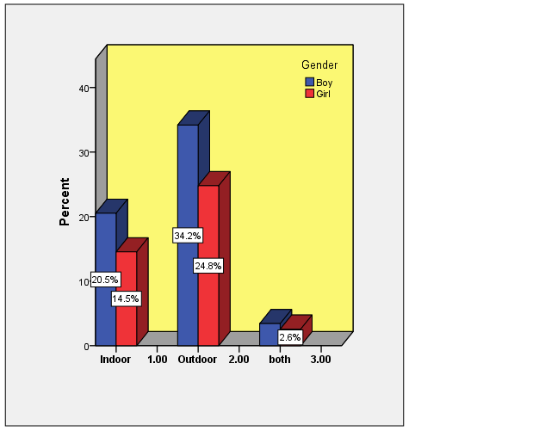
Bar chart (5.7): Where do you play most of the time?
According to table (5.6), ‘bigger space’ (35.6%) was the main reason for playing outdoors among children, who responded that they play outdoors most of the time. ‘Different types of play opportunities’ (23.3%) was the next reason of playing outdoor most of the time. It means that children found that there are more playing options in the yard compared to inside of the building. Also, ‘availability of play facilities’ (9.6%) and ‘the probability of damaging to the building if they play inside’ (9.6%) as well as ‘outside is better place to play’ (8.2%) and ‘it is more fun outside’ (6.8%) were the other reasons why children answered that they play outdoor most of the time. The other reasons mentioned by children, as well as division of responses based on three orphanages are shown in table (5.6).

Table (5.6): Why do you play outdoor most of the time?
 | Orphanage
 | 1 | 2 | 3 | Total
 | Count (%) | Count (%) | Count (%) | Count (%)
Landscape elements (stones, branches, ...) | 1 (2.6%) | 0 (0.0%) | 0 (0.0%) | 1 (1.4%)
Damages to the building or facilities | 6 (15.4%) | 1 (6.3%) | 0 (0.0%) | 7 (9.6%)
Play facilities | 0 (0.0%) | 2 (12.5%) | 5 (27.8%) | 7 (9.6%)
Bigger space | 15 (38.5%) | 4 (25.0%) | 7 (38.9%) | 26 (35.6%)
Types of play. There is opportunity to play other games | 10 (25.6%) | 4 (25.0%) | 3 (16.7%) | 17 (23.3%)
We can play more comfortable | 1 (2.6%) | 0 (0.0%) | 1 (5.6%) | 2 (2.7%)
Clean weather/Fresh air | 1 (2.6%) | 2 (12.5%) | 0 (0.0%) | 3 (4.1%)
Diversity | 1 (2.6%) | 0 (0.0%) | 0 (0.0%) | 1 (1.4%)
More fun | 2 (5.1%) | 1 (6.3%) | 2 (11.1%) | 5 (6.8%)
It affect mentally (Joy, Happiness, ..) | 1 (2.6%) | 1 (6.3%) | 0 (0.0%) | 2 (2.7%)
Yard is pleasant | 1 (2.6%) | 0 (0.0%) | 0 (0.0%) | 1 (1.4%)
Outside is Better (inside is not a place to play, outside is a place to play) | 4 (10.3%) | 1 (6.3%) | 1 (5.6%) | 6 (8.2%)
We can make noise outside | 3 (7.7%) | 1 (6.3%) | 0 (0.0%) | 4 (5.5%)
Depend to adult (mentors), (Not allowed to play inside, or adults tell us go out) | 1 (2.6%) | 1 (6.3%) | 1 (5.6%) | 3 (4.1%)
I like open space/ I dislike closed space | 0 (0.0%) | 1 (6.3%) | 0 (0.0%) | 1 (1.4%)
Risk of Injury | 1 (2.6%) | 0 (0.0%) | 0 (0.0%) | 1 (1.4%)
Can be with other children (all children are together) | 1 (2.6%) | 2 (12.5%) | 1 (5.6%) | 4 (5.5%)
I don't know | 2 (5.1%) | 1 (6.3%) | 2 (11.1%) | 5 (6.8%)
Among children who responded that they play inside more, 27.3 percent of them cited the weather condition as a reason for not playing outdoor most of the time. For example, the weather is too cold or too warm or sunny, and not good to play outdoor. The other reasons, such as ‘indoor is bigger (outdoor is small or full, not enough space to play outside)’, ‘more availability of indoor play facilities’, ‘the opportunity to play with other children (children are all together, talk, laugh ...)’ and ‘indoor is good place to play’ with equal percentage of 11.4%, were named by children who answered that they play indoor more compared to the outdoor environment of the their orphanages. Table (5.7) shows the reasons that caused the children to play indoor most of the time based on their viewpoints. Two children named other reasons when they were asked ‘where do you play most of the time?’. One child said: ‘indoor is very good, children are annoying in the yard’ and one boy said: ‘I play guitar inside the building’.
Table (5.7): Why do you play indoor most of the time?
 | Orphanage
 | 1 | 2 | 3 | Total
 | Count (%) | Count (%) | Count (%) | Count (%)
More indoor play facilities | 1 (8.3%) | 2 (9.5%) | 2 (18.2%) | 5 (11.4%)
Outdoor weather condition (cold/warm/sunny) | 4 (33.3%) | 4 (19.0%) | 4 (36.4%) | 12 (27.3%)
Indoor is bigger (Outdoor is small or full, not enough space to play outside) | 0 (0.0%) | 4 (19.0%) | 1 (9.1%) | 5 (11.4%)
Because of types of play (type of play allows us to play inside) | 1 (8.3%) | 2 (9.5%) | 1 (9.1%) | 4 (9.1%)
Indoor is good place to play | 1 (8.3%) | 3 (14.3%) | 1 (9.1%) | 5 (11.4%)
I like inside more | 0 (0.0%) | 0 (0.0%) | 1 (9.1%) | 1 (2.3%)
Damage (for example breaking glass of the yard's door, ...) | 0 (0.0%) | 2 (9.5%) | 0 (0.0%) | 2 (4.5%)
More fun | 0 (0.0%) | 3 (14.3%) | 0 (0.0%) | 3 (6.8%)
Play with children (children are all together, talk, laugh, ...) | 1 (8.3%) | 3 (14.3%) | 1 (9.1%) | 5 (11.4%)
Lack of time | 2 (16.7%) | 0 (0.0%) | 0 (0.0%) | 2 (4.5%)
Not allowed to go out/ having schedule to go outside | 1 (8.3%) | 1 (4.8%) | 0 (0.0%) | 2 (4.5%)
I don't know | 2 (16.7%) | 3 (14.3%) | 1 (9.1%) | 6 (13.6%)
Other responses | 2 (16.7%) | 0 (0.0%) | 0 (0.0%) | 2 (4.5%)

From these results we can conclude that children prefer to play in bigger areas which have more play facilities and opportunities; thus for children in this research, the outdoor spaces of the orphanages provide this opportunity to a greater extent than indoor environments. Playing indoors can be restricted or limited to certain games due to the rules and regulations of the orphanage. However, indoors is also a good place to play from the perspective of some children, something which could be due to bigger indoor spaces compared to those outdoors (this depends on the size of the orphanage). Further, in bad weather conditions, children have no choice but to play indoors. This usually happens in cities like Kerman, which has dry and hot weather particularly in the summer.
Moreover, aside from the orphanages’ outdoor spaces, children named other places that they also play in. Based on the results shown in table (5.8), other outdoor environments outside of the orphanage that children played were ‘school yard’ (87.8%) (the most), ‘park and urban green spaces’ (37.4%), ‘the yard of parent’s, family’s or friend’s house and other centres’ (32.2%), ‘some places like street, alley, on the way to school, side walk’ (7.0%) and ‘natural environment such as countryside, mountain, etc.’ (4.3%) (the least) respectively.
Table (5.8): Other locations that children play outside of the orphanage
 | Orphanage
 | 1 | 2 | 3 | Total
 | Count (%) | Count (%) | Count (%) | Count (%)
Park & urban green space | 18 (36.0%) | 8 (21.6%) | 17 (60.7%) | 43 (37.4%)
School yard | 37 (74.0%) | 37 (100.0%) | 27 (96.4%) | 101 (87.8%)
Parent, family, friend and other centres’ yards | 13 (26.0%) | 17 (45.9%) | 7 (25.0%) | 37 (32.2%)
Street, alley, on the way to school, side walk | 5 (10.0%) | 3 (8.1%) | 0 (0.0%) | 8 (7.0%)
Natural environment | 2 (4.0%) | 2 (5.4%) | 1 (3.6%) | 5 (4.3%)
No where | 3 (6.0%) | 1 (2.7%) | 0 (0.0%) | 4 (3.5%)

5.4 Orphanage Outdoor Space
In this section the questions about the orphanages’ outdoor spaces are analysed. During the interview, children were asked questions about whether they have view from their bedroom to the orphanage outdoor space, what the view was, and whether they liked or disliked the view. Children were also asked about when and how often they used the open space (with or without permission) and also how long they usually spent there. The results of this part of the survey are shown in the following bar graphs and tables. As table (5.9) and bar chart (5.8) show, 88.1 percent of children mentioned that they have view from their bedrooms to the orphanage outdoor space. 39 percent of the responses were related to Orphanage 1, 26.3 percent and 22.9 percent were related to Orphanage 2 and 3 respectively.
Table (5.9): Do you have view from bedroom to the yard?
Description | Frequency | Valid Percent
Yes  No  Valid 118  Missing 0 | 104  14 | 88.1  11.9
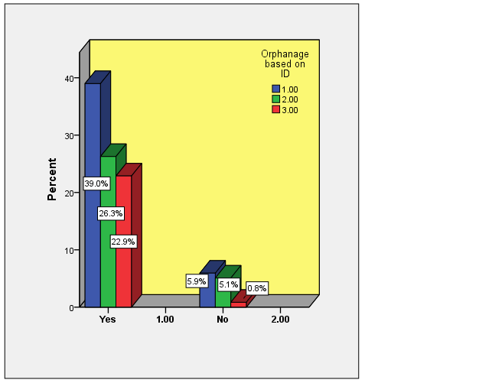
Bar chart (5.8): View from bedroom to the yard based on orphanages

When children were asked ‘what the view is’, most of the children pointed to a ‘tree’ (48.1%) as their view from their bedrooms’ window. Some of the children said that they could see the ‘yard, outdoor space, dormitory environment’ (37.7%), and some of them pointed to a ‘building’ (34.9%) and a ‘car’ (20.8%) (which usually parked at the orphanage outdoor space, whether in parking (Orphanage 1) or at the corner of the yard (Orphanage 3)) as the things that they usually see from their bedrooms’ window. Children’s responses and the results based on three orphanages are shown in table (5.10).

Table (5.10): What is the view?
 | Orphanage
 | 1 | 2 | 3 | Total
 | Count (%) | Count (%) | Count (%) | Count (%)
Yard, open space, dormitory environment | 12 (25.0%) | 10 (32.3%) | 18 (66.7%) | 40 (37.7%)
Backyard | 0 (0.0%) | 7 (22.6%) | 2 (7.4%) | 9 (8.5%)
School, school yard | 2 (4.2%) | 0 (0.0%) | 0 (0.0%) | 2 (1.9%)
Building | 23 (47.9%) | 14 (45.2%) | 0 (0.0%) | 37 (34.9%)
Wall, window, door, roof, balcony,... | 2 (4.2%) | 9 (29.0%) | 2 (7.4%) | 13 (12.3%)
Light | 2 (4.2%) | 1 (3.2%) | 0 (0.0%) | 3 (2.8%)
Flower | 3 (6.3%) | 3 (9.7%) | 6 (22.2%) | 12 (11.3%)
Tree | 33 (68.8%) | 3 (9.7%) | 15 (55.6%) | 51 (48.1%)
Garden/Plant/Green/Leaf | 2 (4.2%) | 3 (9.7%) | 1 (3.7%) | 6 (5.7%)
Water/pool | 2 (4.2%) | 0 (0.0%) | 3 (11.1%) | 5 (4.7%)
Sky (Moon, Sun, Stars) | 5 (10.4%) | 6 (19.4%) | 6 (22.2%) | 17 (16.0%)
Birds, cats, ... | 1 (2.1%) | 2 (6.5%) | 0 (0.0%) | 3 (2.8%)
Street/ Alley /Traffic light/ shops, airport | 0 (0.0%) | 6 (19.4%) | 2 (7.4%) | 8 (7.5%)
Parking | 16 (33.3%) | 0 (0.0%) | 0 (0.0%) | 16 (15.1%)
Play space, football field, volleyball field, ... | 2 (4.2%) | 1 (3.2%) | 9 (33.3%) | 12 (11.3%)
People | 5 (10.4%) | 2 (6.5%) | 1 (3.7%) | 8 (7.5%)
Car | 14 (29.2%) | 8 (25.8%) | 0 (0.0%) | 22 (20.8%)
Some equipment (water tank, cooler, water tab, cloth hanging rope, ruined washing machine, chair, rubbish- Frippery) | 3 (6.3%) | 6 (19.4%) | 2 (7.4%) | 11 (10.4%)
Regarding whether children liked or disliked their bedrooms’ view, 62.3 percent of children responded ‘yes’ they like the view and 17.5 percent said ‘no’ they do not. 18.4 percent of children were ‘indifferent’ about their view (Table 5.11). These results are also shown based on the children’s responses in all three orphanages (Bar chart 5.9).
Table (5.11): Do you like the view?
Description | Frequency | Valid Percent
Yes  No  Indifferent  Yes/No | 71  20  21  2 | 62.3  17.5  18.4  1.8
Valid 114
Missing 4

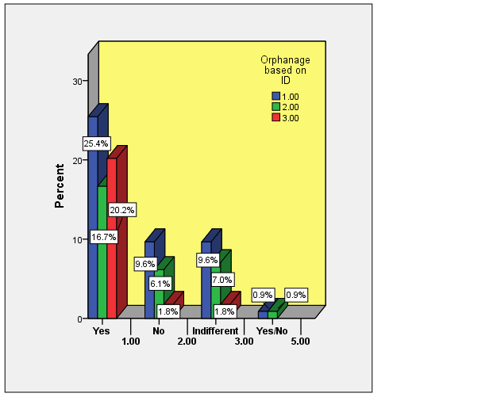
Bar chart (5.9): Liking the view based on children responses in three orphanages
The overall answers about how often children utilised the orphanages’ outdoor spaces, 36.2 percent of children said they were allowed to use the outdoor space ‘every day’, and nearly the same number (33.6%) reported that they used the outdoor space ‘once a week’ with permission, while 19 percent of children mentioned ‘twice a week’. Children’s responses about using the outdoor space with permission based on gender differences as well as different orphanages are shown in bar chart (5.10) and bar chart (5.11) respectively.
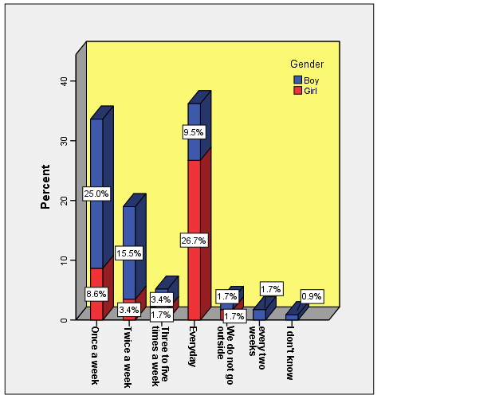
Bar chart (5.10): Children’s responses about using the yard with permission based on gender differences
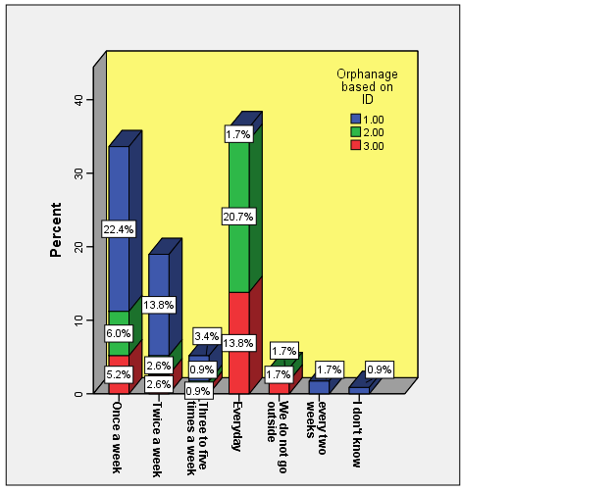
Bar chart (5.11): Children’s responses about using the yard with permission based on three orphanages
Regarding children’s use of the outdoor space without permission, 62.1 percent of children replied they ‘don’t go out’ to the yard without permission and among this percentage, 43 percent were boys and 35.3 percent of the responses were from children in Orphanage 1. About 20 percent of children said they go to the outdoor space ‘everyday’ without permission from their mentors, aunt or uncles; and majority of them were girls and most of the responses were from the children who lived in orphanage 2 (Bar chart 5-12 and 5-13). Therefore, as the charts show, girls in Orphanage 2 and 3 mentioned more they use the outdoor space on a daily basis without permission. Of course, this relates more to older children who usually do not need supervision when they are in the outdoor space of the orphanage. Younger children, however, need supervision and permission to use the outdoor space. Also, boys need permission to use the outdoor space, something which may relate to the fact that they need supervision while they are in the yard, particularly younger ones.
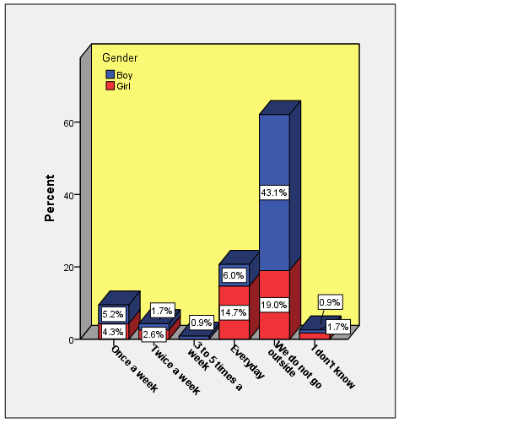
Bar chart (5.12): Children’s responses about using the yard without permission based on gender differences
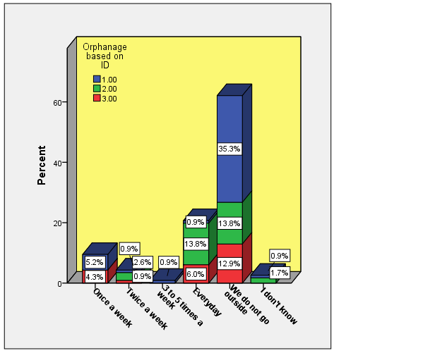
Bar chart (5.13): Children’s responses about using the outdoor space without permission based on three orphanages
The majority of children (80.5%) responded ‘yes’ when they were asked ‘do you go with anyone else to the outdoor space of your living environment?’ (Bar chart 5.14), and most of them (56.2%) mentioned that they usually went out with their friends (Table 5.12). Three children said that they went with children but they also replied that “if I am angry then I go alone and write poetry” or “I like loneliness a lot” and one child responded “if there is nobody, I go alone”.
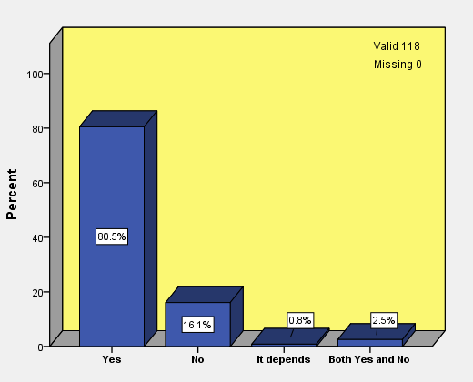
Bar chart (5.14): Do you go with anyone else to the orphanage outdoor space?
Table (5.12): With who do you go outdoor?
 | Orphanage
 | 1 | 2 | 3 | Total
 | Count (%) | Count (%) | Count (%) | Count (%)
Alone | 4 (8.0%) | 4 (12.9%) | 1 (4.2%) | 9 (8.6%)
Children | 23 (46.0%) | 10 (32.3%) | 6 (25.0%) | 39 (37.1%)
Friends | 23 (46.0%) | 18 (58.1%) | 18 (75.0%) | 59 (56.2%)
Aunt/ Uncle/ Mentor | 8 (16.0%) | 6 (19.4%) | 0 (0.0%) | 14 (13.3%)
My brother/sister | 0 (0.0%) | 0 (0.0%) | 1 (4.2%) | 1 (1.0%)
Other responses | 3 (6.0%) | 0 (0.0%) | 0 (0.0%) | 3 (2.9%)
One of the questions was about the time that children spent playing in the orphanage outdoor space. Based on children’s responses, the most time children spent playing in orphanage outdoor space was on ‘school holiday’s afternoon’ (65.8%) followed by ‘weekends afternoon’ (59.0%) and ‘weekday’s afternoon’ (51.3%) (Table 5.13).
Table (5.13): When do children play outdoor?
 | Orphanage
 | 1 | 2 | 3 | Total
 | Count (%) | Count (%) | Count (%) | Count (%)
Weekdays Morning | 2 (3.8%) | 4 (11.1%) | 0 (0.0%) | 6 (5.1%)
Weekdays Midday | 8 (15.1%) | 16 (44.4%) | 5 (17.9%) | 29 (24.8%)
Weekdays Afternoon | 29 (54.7%) | 19 (52.8%) | 12 (42.9%) | 60 (51.3%)
Weekends Morning | 18 (34.0%) | 9 (25.0%) | 2 (7.1%) | 29 (24.8%)
Weekends Midday | 8 (15.1%) | 11 (30.6%) | 13 (46.4%) | 32 (27.4%)
Weekends Afternoon | 30 (56.6%) | 25 (69.4%) | 14 (50.0%) | 69 (59.0%)
School Holidays Morning | 22 (41.5%) | 9 (25.0%) | 10 (35.7%) | 41 (35.0%)
School Holidays Midday | 18 (34.0%) | 9 (25.0%) | 10 (35.7%) | 37 (31.6%)
School Holidays Afternoon | 32 (60.4%) | 23 (63.9%) | 22 (78.6%) | 77 (65.8%)
No response | 2 (3.8%) | 0 (0.0%) | 0 (0.0%) | 2 (1.7%)
In addition, one hour was the most frequent period of time spent in the yard that was reported by about 30 percent of children and this amount of time was approximately the same in all three orphanages (Bar chart 5.15 and Bar chart 5.16).
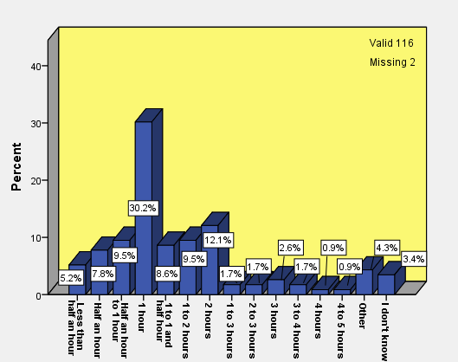
Bar chart (5.15): How long do you spend in the outdoor space?
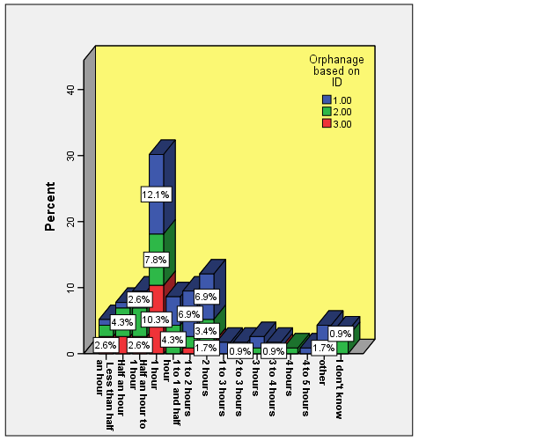
Bar chart (5.16): Spending time in the outdoor space based on children’s responses from three orphanages
In general, according to the children’s report, the most time that they spent in the orphanage’s outdoor spaces was during the afternoons on school holidays, the afternoons on weekends and occasionally the afternoons on weekdays. To note, they use the outdoor space of their orphanage once a week for at least one hour and with permission. Girls were reported to use the yard daily and with permission more so than boys, and a greater percentage of the boys reported that they would not go to the yard without permission. This shows that the use of the orphanage’s outdoor space by children depends on whether they gain permission from their mentors. A small percentage of children go to the outdoor space every day without permission, with most of them coming from orphanage 2. As the researcher also found out during the observation period, children are allowed to go to the outdoor space all together or in a group; their mentors usually decide on whether this is possible or not, as well as the time and duration they get to spend outside. This is why most of the children reported they usually go outdoors with their friends.
When children were asked why they usually go to the outdoor environment of their living place, 66.7 percent responded they went to the outdoor space to ‘play, being entertained, having fun and recreation’ and 17.1 percent pointed to ‘mental rehabilitation’ reason, for example to be happy or calm, etc., and 15.4 percent reported that they used the outdoor space to ‘enjoy weather and getting fresh air and the sun’. The other reasons and the distribution of answers among orphanages are shown in table (5.14). Only four children provided different reasons. For example, one child said “when we are alone we go to the yard”, another one said: “because I can be alone with myself and think. Sometimes I go out for thinking”. Two other answers were: “to fill our free time” and “to play, to learn (volleyball, basketball, and jump rope, for example I learned to skate”. One child pointed to “for variety”.

Table (5.14): Why do you usually go to the outdoor environment of your living place?
 | Orphanage
 | 1 | 2 | 3 | Total
 | Count (%) | Count (%) | Count (%) | Count (%)
Play/ Entertainment/ Fun/ Recreation | 35 (67.3%) | 23 (62.2%) | 20 (71.4%) | 78 (66.7%)
Mental rehabilitation (happy, calm, ..) | 10 (19.2%) | 5 (13.5%) | 5 (17.9%) | 20 (17.1%)
Enjoy weather, fresh air, sun | 10 (19.2%) | 6 (16.2%) | 2 (7.1%) | 18 (15.4%)
Walk/Run | 0 (0.0%) | 2 (5.4%) | 2 (7.1%) | 4 (3.4%)
Bigger space/ Open space/ go out from closed area | 2 (3.8%) | 2 (5.4%) | 1 (3.6%) | 5 (4.3%)
View nature/ It has green space | 2 (3.8%) | 1 (2.7%) | 2 (7.1%) | 5 (4.3%)
Exercise | 4 (7.7%) | 0 (0.0%) | 1 (3.6%) | 5 (4.3%)
Get rid of tired/ Rest/ Get energy | 3 (5.8%) | 2 (5.4%) | 2 (7.1%) | 7 (6.0%)
Thinking/ Studying | 0 (0.0%) | 1 (2.7%) | 1 (3.6%) | 2 (1.7%)
I like there | 1 (1.9%) | 0 (0.0%) | 0 (0.0%) | 1 (0.9%)
To do some work (hanging or collecting washed cloths, watering flowers, cleaning the yard, ..) | 0 (0.0%) | 1 (2.7%) | 2 (7.1%) | 3 (2.6%)
other | 0 (0.0%) | 3 (8.1%) | 1 (3.6%) | 4 (3.4%)
I don't know | 2 (3.8%) | 4 (10.8%) | 1 (3.6%) | 7 (6.0%)
As documented, children of this study use outdoor space for different reasons, with the central reason being to play and have fun. Following this result, in the next section, the research tries to address the study’s first aim (1) by analysing the questions related to children’s activity and play in orphanage’s outdoor spaces.
5.5 Children’s Activity and Play
As the definition of play and what constitutes a game is different within each activity, two types of questions relating to activity and play are included in the interview question set. Questions related to children’s activities and play in the outdoor space of the orphanages distributed throughout the interview question set (Appendix 2). There are, however, different favourite activities reported by children that they like to do in orphanages’ outdoor space, but based on the results, the most favourite activity named by the children is ‘football’ (%32.7) followed by ‘group play with or without ball’ and ‘volleyball’ (17.7%). About 11 percent of children used general word ‘play’ as their activity (Table 5.15). Some children named other activities such as: playing guitar, climbing the wall, animal husbandry, playing chess, fighting (as play and kidding), cleaning the prayer room, slip on ramp, play with butterfly, Kung-Fu, playing with doll, water spray the yard and lamp wiring.
Table (5.15): Children’s favourite activity at the outdoor space of their living environment
 | Orphanage
 | 1 | 2 | 3 | Total
 | Count (%) | Count (%) | Count (%) | Count (%)
Play | 4 (7.8%) | 5 (14.3%) | 4 (14.8%) | 13 (11.5%)
Socializing with children (talking, kidding, laughing, ...) | 3 (5.9%) | 0 (0.0%) | 0 (0.0%) | 3 (2.7%)
Thinking/ Studying/ Looking around | 2 (3.9%) | 1 (2.9%) | 2 (7.4%) | 5 (4.4%)
Play alone | 1 (2.0%) | 0 (0.0%) | 0 (0.0%) | 1 (0.9%)
Group play without ball | 5 (9.8%) | 8 (22.9%) | 7 (25.9%) | 20 (17.7%)
Group play with ball | 5 (9.8%) | 4 (11.4%) | 7 (25.9%) | 16 (14.2%)
Football | 26 (51.0%) | 11 (31.4%) | 0 (0.0%) | 37 (32.7%)
Volleyball | 5 (9.8%) | 11 (31.4%) | 4 (14.8%) | 20 (17.7%)
Basketball | 2 (3.9%) | 0 (0.0%) | 0 (0.0%) | 2 (1.8%)
Handball | 2 (3.9%) | 0 (0.0%) | 0 (0.0%) | 2 (1.8%)
Badminton | 2 (3.9%) | 0 (0.0%) | 0 (0.0%) | 2 (1.8%)
Exercise | 0 (0.0%) | 4 (11.4%) | 3 (11.1%) | 7 (6.2%)
Cycling | 1 (2.0%) | 1 (2.9%) | 0 (0.0%) | 2 (1.8%)
Running | 4 (7.8%) | 2 (5.7%) | 1 (3.7%) | 7 (6.2%)
Walking | 4 (7.8%) | 0 (0.0%) | 2 (7.4%) | 6 (5.3%)
Play with playground equipment | 0 (0.0%) | 0 (0.0%) | 6 (22.2%) | 6 (5.3%)
Planting flowers | 1 (2.0%) | 0 (0.0%) | 0 (0.0%) | 1 (0.9%)
Watering plants | 1 (2.0%) | 1 (2.9%) | 0 (0.0%) | 2 (1.8%)
Jump rope, Ring, Skate | 2 (3.9%) | 3 (8.6%) | 1 (3.7%) | 6 (5.3%)
Nothing | 1 (2.0%) | 3 (8.6%) | 0 (0.0%) | 4 (3.5%)
Others responses | 7 (13.7%) | 4 (11.4%) | 2 (7.4%) | 13 (11.5%)
I don't know | 2 (3.9%) | 0 (0.0%) | 0 (0.0%) | 2 (1.8%)

However, regarding the activities children do in reality in the orphanage outdoor space, the majority of responses pointed to ‘play’ (56.5%), especially ‘group play with ball’ (24.3%), such as ‘football’ (14.8%) and ‘volleyball’ (13.9%) that were the games that children played most of the time when they were in the orphanage outdoor space. ‘Walking or hanging around the outdoor space’ (9.6%), ‘socializing (like talking, confabulate, kidding, laughing, joying’ (9.6%), ‘group play without ball’ (7.0%), ‘running or race’ (6.1%), and ‘gardening (like planting flower, watering flower, trees, garden, etc.)’ (6.1%) are other activities that children usually do when using the outdoor space of their orphanages (Table 5.16). Among the responses, three children pointed to some activities such as ‘eating nutrition’, ‘singing lyric’, ‘sabotage, or taking a piece of wood and hitting the tree but not causing damage to the tree’, when they are outside.
Table (5.16): What activity do children do in outdoor space?
 | Orphanage
 | 1 | 2 | 3 | Total
 | Count (%) | Count (%) | Count (%) | Count (%)
Play | 25 (48.1%) | 25 (69.4%) | 15 (55.6%) | 65 (56.5%)
Group play without ball | 1 (1.9%) | 5 (13.9%) | 2 (7.4%) | 8 (7.0%)
Group play with ball | 13 (25.0%) | 9 (25.0%) | 6 (22.2%) | 28 (24.3%)
Football | 13 (25.0%) | 3 (8.3%) | 1 (3.7%) | 17 (14.8%)
Volleyball | 7 (13.5%) | 8 (22.2%) | 1 (3.7%) | 16 (13.9%)
Basketball | 3 (5.8%) | 0 (0.0%) | 0 (0.0%) | 3 (2.6%)
Handball | 0 (0.0%) | 1 (2.8%) | 0 (0.0%) | 1 (0.9%)
Play with playground equipment | 0 (0.0%) | 0 (0.0%) | 3 (11.1%) | 3 (2.6%)
Gardening (Planting flower, Watering flower, trees, garden, etc.) | 1 (1.9%) | 5 (13.9%) | 1 (3.7%) | 7 (6.1%)
Doing some work (cleaning, Hanging washed cloths...) | 0 (0.0%) | 2 (5.6%) | 4 (14.8%) | 6 (5.2%)
Walking/ Hanging around the yard | 8 (15.4%) | 1 (2.8%) | 2 (7.4%) | 11 (9.6%)
Running, Race | 2 (3.8%) | 2 (5.6%) | 3 (11.1%) | 7 (6.1%)
Exercise | 1 (1.9%) | 0 (0.0%) | 3 (11.1%) | 4 (3.5%)
Mental health (happy, get rid of bored...) | 0 (0.0%) | 0 (0.0%) | 2 (7.4%) | 2 (1.7%)
Socialize (Talking, Confabulate, Kidding, Laughing, Joying | 7 (13.5%) | 2 (5.6%) | 2 (7.4%) | 11 (9.6%)
Looking at surrounding | 1 (1.9%) | 0 (0.0%) | 0 (0.0%) | 1 (0.9%)
Fresh air | 0 (0.0%) | 1 (2.8%) | 0 (0.0%) | 1 (0.9%)
Rest | 1 (1.9%) | 0 (0.0%) | 0 (0.0%) | 1 (0.9%)
Skate, Jump rope, Flying kite | 0 (0.0%) | 5 (13.9%) | 1 (3.7%) | 6 (5.2%)
Thinking (about myself, my mistakes, ...) | 1 (1.9%) | 2 (5.6%) | 0 (0.0%) | 3 (2.6%)
Listen to music, Play musical instruments, etc. | 4 (7.7%) | 0 (0.0%) | 0 (0.0%) | 4 (3.5%)
Study | 0 (0.0%) | 0 (0.0%) | 3 (11.1%) | 3 (2.6%)
Sitting | 0 (0.0%) | 1 (2.8%) | 2 (7.4%) | 3 (2.6%)
Play with my phone | 2 (3.8%) | 0 (0.0%) | 0 (0.0%) | 2 (1.7%)
Other responses | 1 (1.9%) | 2 (5.6%) | 0 (0.0%) | 3 (2.6%)
Responses relating to the types of play or games that children do when they are in the orphanage outdoor space and the rate of participation and interest of children in these types of plays, are shown in the table (5.17). Based on the information provided by the children, 78 percent of children participated in structured team games, such as football (55.1%), volleyball (44.1%), basketball (5.1%), badminton (4.2%) and handball (0.8%). About 23 percent of children played in group games with balls and close to this number of children played in group games without balls (20.3%). Also, 10.2 percent of children were interested to play on fixed structured apparatus such as playground equipment. The majority of children who participated in structured team games were boys who lived in Orphanage 1 (92.5%), and the majority of children who played in group games with ball and played on fixed structured apparatus, like playground equipment, were girls who lived in Orphanage 3 (39.3%).
Table (5.17): Types of play children play in the orphanage outdoor space
 | Orphanage
 | 1 | 2 | 3 | Total
 | Count (%) | Count (%) | Count (%) | Count (%)
Participating structured team games | 49 (92.5%) | 32 (86.5%) | 11 (39.3%) | 92 (78.0%)
football  volleyball  basketball  handball  badminton | 47 (88.7%)  21 (39.6%)  6 (11.3%)  1 (1.9%)  3 (5.7%) | 16 (43.2%)  22 (59.5%)  0 (0.0%)  0 (0.0%)  0 (0.0%) | 2 (7.1%)  9 (32.1%)  0 (0.0%)  0 (0.0%)  2 (7.1%) | 65 (55.1%)  52 (44.1%)  6 (5.1%)  1 (0.8%)  5 (4.2%)
Group games with ball | 9 (17.0%) | 8 (21.6%) | 11 (39.3%) | 28 (23.7%)
Group games without ball (Amo-Zanjir Baf, Gorg Bazi,...) | 6 (11.3%) | 9 (24.3%) | 9 (32.1%) | 24 (20.3%)
Playing on fixed structure (playground equipment) | 0 (0.0%) | 1 (2.7%) | 11 (39.3%) | 12 (10.2%)
Thinking Game (chess, ...) | 1 (1.9%) | 0 (0.0%) | 0 (0.0%) | 1 (0.8%)
Physical activity play or Locomotor play (exercise, running, ...) | 2 (3.8%) | 2 (5.4%) | 4 (14.3%) | 8 (6.8%)
Playing with free equipment (jump rope, ring, cycling, skate, ...) | 2 (3.8%) | 6 (16.2%) | 1 (3.6%) | 9 (7.6%)
Other responses | 2 (3.8%) | 0 (0.0%) | 0 (0.0%) | 2 (1.7%)
As mentioned above, two types of questions about the activity were asked to the children. One question focused on their favourite activity that they would like to do in outdoor space and the other about the activities that they can do in reality. A variety of activities were named by the children and all were subsequently categorised. Playing football was deemed the most favourable activity that the children both like to do and that they actually can do it in outdoor space, especially in Orphanage 1 as a football field is available there. Volleyball and group play with ball were other activities that the children named as both their favourite that they wished to do and as activities that they currently have the opportunity to do; this was notably the case in Orphanage 2 (which has a volleyball field) and Orphanage 3. However, there are some other activities which the children deemed favourites but which they cannot do due to restrictions (rules and regulations) or due to a lack of facility or opportunity. The type of play that children engage in can thus be different in each orphanage due to the availability of facilities. For example, participating in a structural team game is played in all three orphanages. Football however, is played more in Orphanage 1 and volleyball is played in both Orphanage 1 and 2. Basketball and handball are played only in Orphanage 1 because they have a basketball ring and a handball net. Playing on fixed structures such as playground equipment occurs in Orphanage 3 due to the availability of this equipment. Hereby, it can be concluded that the types of play and activities that children engage in within orphanage outdoor space depends directly on the available opportunities and facilities.
5.6 Children’s Happiness and Satisfaction
The interview question set included some questions which measured the children’s level of happiness and satisfaction about both their living environment and outdoor environment in their orphanage. Firstly, comfortable and uncomfortable places in the orphanage were investigated from the children’s point of view. Section five of the interview question set was related to places in the orphanages where children feel comfortable or uncomfortable when they are in these places as well as their favourite places in their living environment whether inside the building or in the outdoor space of the orphanage.
When children were asked ‘are there any places in your living environment where you feel comfortable?’, most of the children answered ‘yes’ (90.5%) and only few of them (6.0%) answered ‘no’ (Bar chart 5.17). In this regard, 52.4 percent of children who answered ‘yes’, pointed to ‘my room’ as a comfortable place in their living environment. 14.3 percent of children named some places inside the building such as ‘library, manager's room, kitchen, music class and etc’. 21.9% of children said they feel comfortable in the outdoor space of their living environment and few of the children mentioned they feel comfortable when they are near landscape features such as trees, pool or playground equipment (3.8%) (Table 5.18).
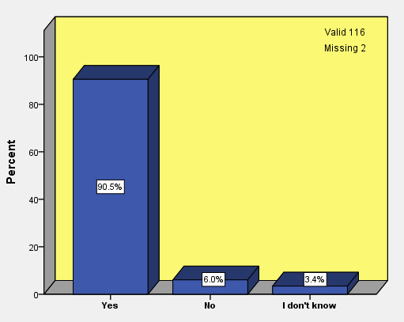
Bar chart (5.17): Are there any places in your living environment where you feel comfortable?
Table (5.18): Places in the orphanages that children feel comfortable
 | Orphanage
 | 1 | 2 | 3 | Total
 | Count (%) | Count (%) | Count (%) | Count (%)
My Room | 21 (45.7%) | 24 (72.7%) | 10 (38.5%) | 55 (52.4%)
Outdoor Space | 12 (26.1%) | 3 (9.1%) | 8 (30.8%) | 23 (21.9%)
Hall | 3 (6.5%) | 5 (15.2%) | 2 (7.7%) | 10 (9.5%)
Inside Building (Library, Manager's room, Kitchen, music class, ...) | 5 (10.9%) | 6 (18.2%) | 4 (15.4%) | 15 (14.3%)
Landscape elements (near trees, playground equipment, pool, ...) | 3 (6.5%) | 0 (0.0%) | 1 (3.8%) | 4 (3.8%)
Balcony | 3 (6.5%) | 0 (0.0%) | 0 (0.0%) | 3 (2.9%)
Everywhere | 1 (2.2%) | 3 (9.1%) | 4 (15.4%) | 8 (7.6%)
Others places (green house, a place to be alone, ...) | 4 (8.7%) | 0 (0.0%) | 0 (0.0%) | 4 (3.8%)
The reasons described by children regarding some places with high percentage of responses that children felt comfortable when they were there, are listed in table (5.19).
The above results indicate that for the majority of children there are places in the orphanage where they feel more comfortable (depending on each child). For example, as is shown in the results, almost half of the children experience the feeling of comfort in their rooms because it is both quiet and a place to rest. They also stated that they can do things like studying, homework, drawing, listening to music and other similar activities in their rooms.
The outdoor space of the orphanage was also cited by a number of children as a place where they feel comfortable. This is due to the experience of a larger space and fresh air – leading them to feel freer when they are outdoors. They also said that they can play, exercise and have fun there. From their perspective, each outdoor space is a beautiful place that has flowers and trees; a place that they feel comfortable due to their close proximity to the natural elements and other landscape features such as water ponds.

Table (5.19): Why do children feel comfortable in some places in the orphanages?
My Room | Outdoor Space | Inside Building (Library, Manager's room, Kitchen, music class, ...) | Hall | Landscape elements (near trees, playground equipment, pool, ...)
Because:  - I rest there (11), I sleep there (4)  - I feel comfortable (9) there.  - I can play (4) with children  - there is less noise (4) of children  - There is absolute silence (2) in these places during the resting time  - There is no noise during nights  - It is calm and quiet  - Nobody is there (3)  - I can be alone there, I am alone in the room most of the time  - Listen to music (2) when I am alone,  - It is sometimes good for loneliness. No one comes into my room. (me and my friend have same room)  - I find good feeling, being alone is also very good  - I can do anything in my room (2)  - I can do my jobs easily in my room  - I can study with feeling and without noise  - I do all my works most of the time,  - I can write my tasks and study very well  - there is not loud sound (voice), nobody talks, I study easier  - I like to be with my friend and if she is out, I like loneliness, I like my wardrobe/locker  - My stuff is there, anywhere my stuff is. For example if I get bored I look at my stuff.  - I will get rid of sadness (the sadness will not remain with me)  - I go there and organize (clean) my commode  - It is for myself, I confabulate with my friend  - Most of the children come to the room and we talk and laugh  - we can draw  - It is beautiful place  - The beds are soft  - I can sleep near radiators,  - I don't know | Because:  - It is beautiful place  - The yard has free air (fresh air)  - The weather is very good,  - We can breathe instead of football  - The space is bigger and I can be free  - Empty spaces in the yard: because it is silent, I can think, the nerves are more relaxed (comfortable)  - Fun, exercise  - I become happy  - It has beautiful flowers and trees  - It is quiet  - It is silence there and there is less noise  - The weather is good compared to inside the block, there is noise of children in the block  - The wind hits us, we feel that we are in the park  - The wind brushes on your face and you are comfortable  - Watching birds, sit somewhere, lean, use fresh air  - We are more free there  - We can play (2) there  - We can work and use phone, because the mentor is not there  - I don't know | Because:  - Beautiful place  - Confabulating with Mamani is a pleasure  - It has window, we open the window for air circulation, turn on radiators, put the things to prevent from missing  - Inside is good  - There is absolute silence in these places  - The kitchen is big  - I like its space  - It has a big table so we can play  - It is good, very big  - Nobody is there  - library: study book, watching TV  - We can play, we can pray with God  - We can sit on stationary bicycle, and rest | Because:  - It is big, the rug is comfortable  - We can sit (2), stand, walk (2) and eat there  - I don't get bored  - None of the children goes there, we go there to bring things (tools)  - We watch TV (4), we are with children  - There is TV, and we can do anything we want in the Hall  - we can draw, play | Because:  - I like sparrows’ voice  - Near the palm tree: it is not on others eye.  - I don't know

Regarding places where children felt uncomfortable, children in response to ‘are there any places in your living environment where you feel uncomfortable?’, both answers ‘yes’ and ‘no’ were almost equal, so that 54.8 percent of children believed that there are places in their living environment that they feel uncomfortable when they are there, and 43.5 percent reported that there is not a single place where they feel uncomfortable in their living environment (Bar chart 5.18).
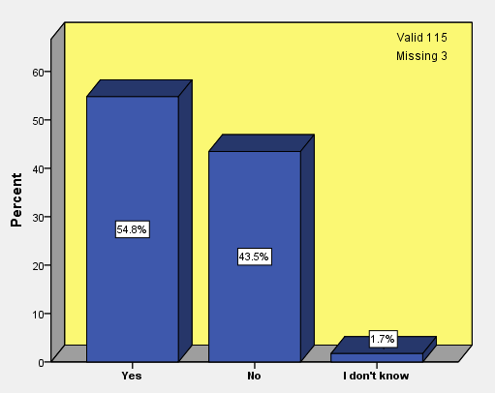
Bar chart (5.18): Are there any places in your living environment where you feel uncomfortable?

As table (5.20) indicates, 41.9 percent of children felt uncomfortable in some places inside the building such as kitchen, gym or mentor’s office (room). Some of the children (22.6%) found the outdoor space as an uncomfortable place, and close to the same number of children (19.4%) reported that they feel not comfortable in the hall of the orphanage which is the place where children gather and watch TV. According to some children, noise is the main reason that they do not comfortable in the hall.
Table (5.20): Places in the orphanages that children feel uncomfortable
 | Orphanage
 | 1 | 2 | 3 | Total
 | Count (%) | Count (%) | Count (%) | Count (%)
Rooms, bedrooms | 2 (5.6%) | 0 (0.0%) | 3 (23.1%) | 5 (8.1%)
Outdoor space | 9 (25.0%) | 3 (23.1%) | 2 (15.4%) | 14 (22.6%)
Hall | 5 (13.9%) | 1 (7.7%) | 6 (46.2%) | 12 (19.4%)
Inside building (kitchen, gym, office, ...) | 16 (44.4%) | 8 (61.5%) | 2 (15.4%) | 26 (41.9%)
Busy places whether noisy or chaotic (with children for example inside the TV room, children noise, in a chaotic place, busy parts, | 2 (5.6%) | 0 (0.0%) | 2 (15.4%) | 4 (6.5%)
Everywhere (the whole environment) | 1 (2.8%) | 1 (7.7%) | 0 (0.0%) | 2 (3.2%)
Other places (the room which there is none of my things there, in front of the security, anywhere which is warm: beside radiators) | 3 (8.3%) | 1 (7.7%) | 0 (0.0%) | 4 (6.5%)

The reasons of feeling uncomfortable in some places with high percentage of responses described by children are shown in table (5.21).
As the results show, half of the children stated that there are places in the orphanage which make them feel uncomfortable, while the other half did not acknowledge that such places exist. The children named places like halls, kitchens, mentors’ offices and gyms as crowded and noisy places which make them feel uncomfortable when they are there. Spaces that are small was given as another reason that caused children to feel uncomfortable. Some children also said they do not feel comfortable in outdoor spaces due to the loud noises of other children playing, them being untidy or unclean, and the lack of facilities such as drinking water fountains and seating areas.
By comparing the data, we can conclude that outdoor spaces can be comfortable places for some children, but they can also make others feel uncomfortable while they are there. This depends on the view of the individual child, notably their mood and expectations.
Table (5.21): Why do children feel uncomfortable in some places in the orphanages?
Inside building (kitchen, gym, office, ...) | Outdoor space | Hall
Because:  - Children make noise and sometimes I get headaches  - It is very small, and children are talking near the kitchen's door  - It looks like industrial kitchens  - Mentor’s assistant always tells us to do this or that  - The mentor always advise you (tell you what to do what don't do)  - The mentor does not allow us if we want to call someone (family) or be in contact with somebody  - The noise of children does not allow us to watch movie and to sleep (noise annoys)  - There are much noise, it is busy, many people commute to  - I don't like here  - I don't like the colour of walls. it does not give a good sense of feeling  - It is a closed space (area) (2)  - It is not suitable to study, when we are doing something, then somebody comes and destroy it, for example I am writing then one of the children hit my hand and then says I was playing.  - It (space) is very tight (2)  - Nobody goes in or out there  - Put ourselves in pressure (push ourselves a lot)  - Sometimes it is poky  - there is no peace (calm) (2), there is children noise  - They don't let us to go in. I don't like that  - We cannot play and we cannot walk  - When we go there we have to go out soon  - Younger children annoying while we are playing | Because:  - It is unclean  - There is stone there (because it is stone)  - When I stand there and other children play with ball, the ball hits my face  - When we are there, we are tired, thirsty, and sweat  - Children makes noise and annoy me  - Children make a lot of noise  - have a cold  - It is dark and it has fox  - It is on the eyes of others  - The air is polluted (air or yard?)  - there are much noise of children, children scream a lot when they want to play  - There is much noise  - I don't know | Because:  - Nobody plays with me, they do not turn on TV  - Children are always there and screaming (2)  - Children make noise  - Children run and sometimes scream in the hall  - children annoying  - Nobody is there, we cannot sit and be comfortable, most of the children are in their rooms  - The noise of children annoy us when we want to watch movie  - The noise of children is a trouble when we want to study and do the homework  - There is much noise (3) there, it annoys me, especially in the afternoon when Fani children come back, they have a lot of energy  - I don't know

In the following section, the children's perceptions and feelings about their outdoor space will be examined. Based on bar chart (5.19) to (5.21), in response to the question: ‘how do you usually feel when you are in open space?’; 62.7 percent of children said they feel very happy when they are in the orphanage outdoor space, 38.1 percent of the respondents are boys and 22.9 percent of children who feel very happy are in the 7-9 years age group; 29.7 percent of this population lived in Orphanage 1.
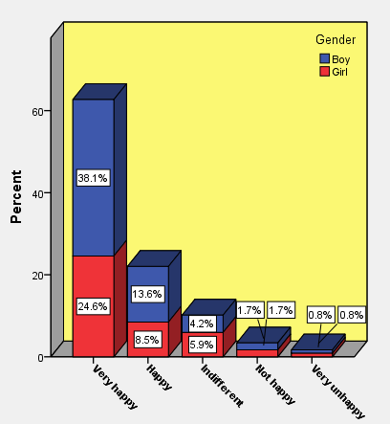
Bar chart (5.19): Children feeling when they are in orphanage outdoor space based on their gender
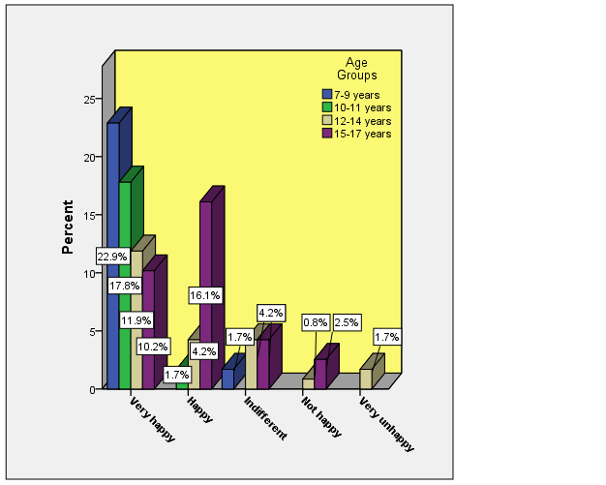
Bar chart (5.20): Children’s feeling when they are in orphanage outdoor space based on age group
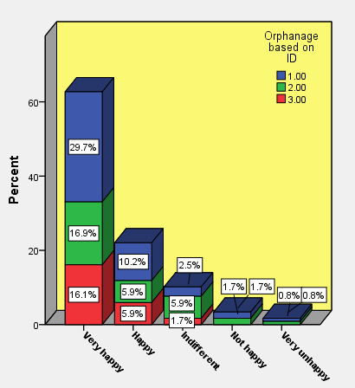
Bar chart (5.21): children’s feeling when they are in orphanage outdoor space based on three orphanages
When children were asked about their feelings about the outdoor space of their orphanage, nearly 60 percent of children mentioned they have a good feeling about their living outdoor space and of that amount 37.4 percent are boys and 21.7 percent are girls. Also this amount is divided almost equally among all age groups of children, with a little more difference in 7-9 years old age group (Bar charts 5.22 to 5.24).
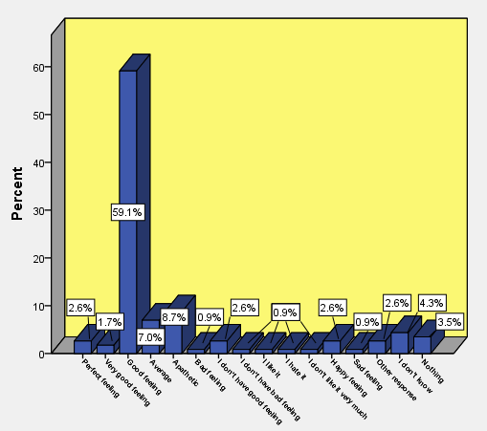
Bar chart (5.22): How do you feel about your living outdoor space?
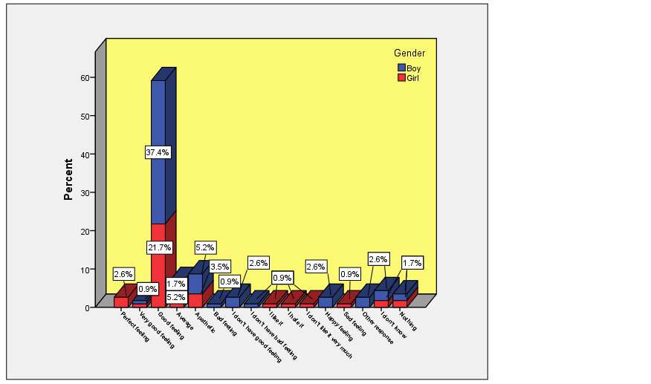
Bar chart (5.23): How do you feel about your living outdoor space? (based on gender)
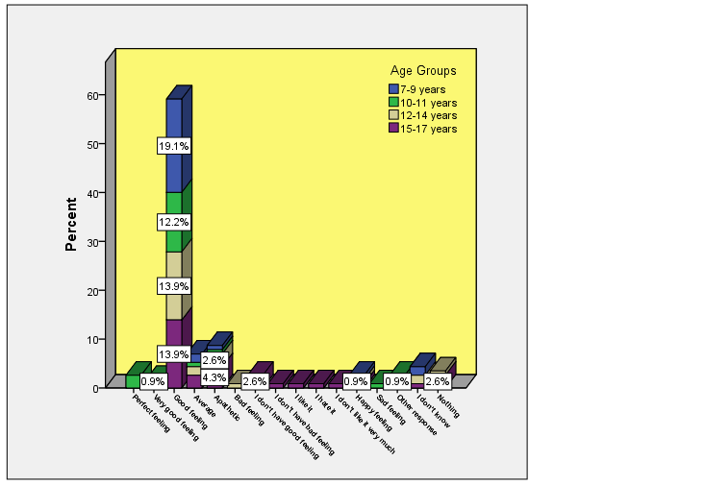
Bar chart (5.24): How do you feel about your living outdoor space? (based on age group)
The children’s reasons of having a good feeling about the outdoor space of the orphanages are listed in the table (5.22). Children described that they can play in the outdoor space, they feel happy and comfortable when they are there as well as getting fresh air. Some of the children also pointed that the outdoor space is an open space which is big and beautiful and has flowers and trees.
Table (5.22): To what reason children had good feeling about their living outdoor space?
I have good feeling because:
- It has flower (3), tree (2) and pool
- It is beautiful (3), pleasant place
- It has good things (2), equipment
- It is small
- It is big (3) or very big (2)
- The yard is an open space (2) (for example inside is poky but the outside is an open space compared to the inside which is a closed space)
- To view scenery (2)
- The weather is good (2), very good (4), I use fresh air
- We can play (15) comfortable with other children (5) and enjoy
- I can exercise (2)
- I feel happy (5), calm, peace, comfortable (3)
- I am with my friends and I am not sad anymore, sometimes when I huff with my friends I go to the yard alone
- When we are in the yard we do not miss, and are not upset
- When we go out, our mood will be changed (from bad to good)
- When we study and get tired we go out with other children and our mood changes
- I relaxed there
- I think we are in the park
- The yard causes that I am not boredom (2)
- It is good for fun (2)
- There are everything in the yard, there are all games
- We go out and walk, and confabulate with children
- When I come back from leave of absence, I go to the yard with other children and get a good feeling
- I walk and look at sky
- I can plan about my future
- Because the part (area) that we play located in office area which is near to our block and we can see our block from there and if one of the children wants to go into the block we will see him and call him to come and play with us
- I don't know
Accordingly, in terms of the children’s happiness about the outdoor space of their living environment, more than half of the children said they had good feelings about it; this feeling was the same among girls and boys and also between children of different age groups. These positive feelings are dependent upon a number of reasons, such as the size of the space, its aesthetic appeal and the existence of natural elements such as flowers, plants and trees.
However, in regard to the feelings that children experience when in the yard, more than half of the children reported that they feel very happy when they are outside. This level of happiness is usually higher in younger children than in other age groups.
To evaluate children’s satisfaction levels, questions about liking the outdoor space, the existing facilities, and their opinions about adding new equipment, were included in the interview question set. In the following section, these questions will be analysed. When children were asked ‘do you like the outdoor space of your living environments?’, almost half of the participants (47.5%) liked the outdoor space of their living environment ‘very much’. 20.3 percent of this population fell into the age group of 7-9 years old and 27.1 percent of them were boys and 20.3 percent of them were girls. Among the children who answered that they liked the outdoor space very much, 22.9 percent lived in Orphanage 1. 24.6 percent of all the children who provided answer to this question, mentioned that they neither liked nor disliked their orphanage outdoor space. Most of them were boys (16.1%) of whom all fell into 15-17 years age group. Few children pointed to dislike their outdoor space (2.5%) or disliked it very much (2.5%); most of them were boys and fell into the 12-14 years age group. As bar chart (5.26) shows the age group of 7-9 years and 10-11 years did not choose the option of ‘dislike the outdoor space very much’ (Bar graphs 5.25 to 5.27).
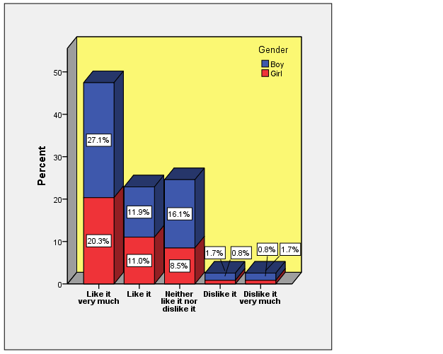
Bar chart (5.25): Gender differences in liking outdoor space of their living environments
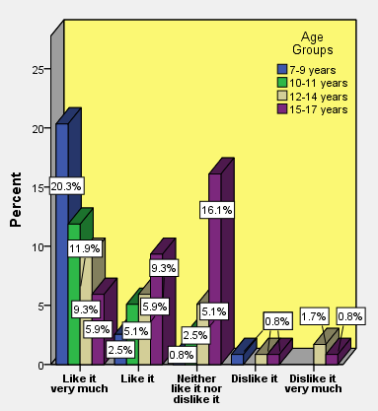
Bar chart (5.26): Children’s age differences in liking outdoor space of living environments
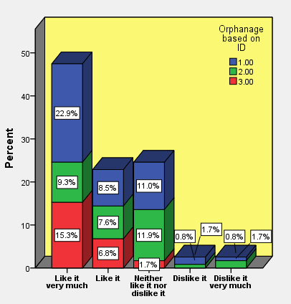
Bar chart (5.27): Liking outdoor space based on children in three orphanages
Therefore, regarding liking outdoor space, half of the children said that they like the outdoors very much, with younger children continuing to make up the largest percentage of this number. This view was almost the same for boys and girls, but older children and especially the boys, had a different view. They neither like the outdoor space nor dislike it. Also, a small number of children, including a larger percentage of boys and older age groups (12-14 years old) did not like the outdoor space of their living environment. As the existing play facilities can influence the level of satisfaction of children, so in section seven of the interview question set, children were asked about their play facilities in the outdoor space of their living environment as well as what a good play area was like in their opinion. Regarding play facilities at the orphanage’s outdoor space, 49.6 percent of children answered the play facilities are good, and 15.9 percent said it is less and not enough. There are other comments among the responses. One child said: “play facility is very good and I can say that everything is available”. Another child mentioned that “play facilities for younger children should be more”. One of the children commented: “in terms of good or bad it is not good. For example the volleyball net is not good, volleyball ground is asphalt. In terms of less or more, it is good”. The results of this question are shown in table (5.23). Therefore, more than half of the children are happy and satisfied about existing play facilities in the outdoor space of their orphanage. However, adding new equipment could play a role in this level of satisfaction which we will discuss below.
Table (5.23): Children’s play facilities at orphanage open space
 | Orphanage
 | 1 | 2 | 3 | Total
 | Count (%) | Count (%) | Count (%) | Count (%)
Very good | 3 (6.0%) | 1 (2.9%) | 0 (0.0%) | 4 (3.5%)
Good | 25 (50.0%) | 18 (51.4%) | 13 (46.4%) | 56 (49.6%)
Very bad | 1 (2.0%) | 0 (0.0%) | 0 (0.0%) | 1 (0.9%)
Not good | 0 (0.0%) | 1 (2.9%) | 0 (0.0%) | 1 (0.9%)
Enough | 1 (2.0%) | 5 (14.3%) | 2 (7.1%) | 8 (7.1%)
A lot | 2 (4.0%) | 3 (8.6%) | 1 (3.6%) | 6 (5.3%)
Less (not enough) | 11 (22.0%) | 3 (8.6%) | 4 (14.3%) | 18 (15.9%)
Should be better | 4 (8.0%) | 0 (0.0%) | 2 (7.1%) | 6 (5.3%)
Should be more | 4 (8.0%) | 0 (0.0%) | 3 (10.7%) | 7 (6.2%)
Average | 0 (0.0%) | 1 (2.9%) | 0 (0.0%) | 1 (0.9%)
I have no idea | 0 (0.0%) | 0 (0.0%) | 3 (10.7%) | 3 (2.7%)
Nothing | 0 (0.0%) | 2 (5.7%) | 0 (0.0%) | 2 (1.8%)
Others | 3 (6.0%) | 0 (0.0%) | 0 (0.0%) | 3 (2.7%)
I don't know | 0 (0.0%) | 2 (5.7%) | 3 (10.7%) | 5 (4.4%)
During the interview and following the questions related to happiness and satisfaction, when children were asked whether new equipment would make them enjoy using the outdoor space, the majority of children (about 84 percent) replied ‘yes’ (Bar charts 5.28 to 5.30) and children reasoned that new equipment would help them enjoy using outdoor space based on their viewpoint (Table 5.24). Based on children’s reports, ‘availability of new, better and more play equipment’ (16.5%) and ‘using or playing with equipment (like swinging, slip on slide, playing in balls pool)’ (22.7%) are the most reasons from the viewpoint of children that make them enjoy using the outdoor space with new equipment (Table 5.24).
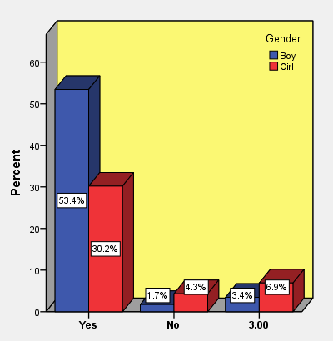
Bar chart (5.28): Children enjoy using the outdoor space with new equipment based on their gender
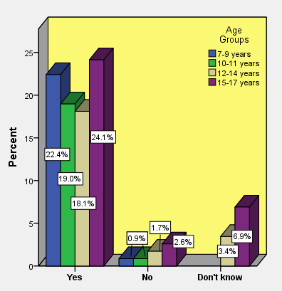
Bar chart (5.29): Children enjoy using the outdoor space with new equipment based on their age group
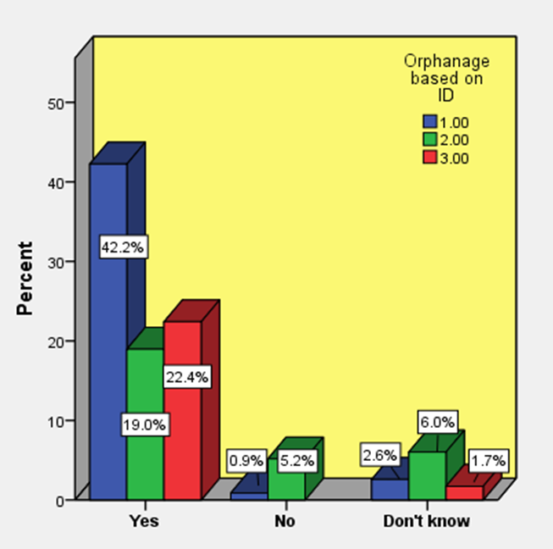
Bar chart (5.30): Children enjoy using the outdoor space with new equipment based on three orphanages
Table (5.24): Why new equipment would make children enjoy using the outdoor space?
 | Orphanage
 | 1 | 2 | 3 | Total
 | Count (%) | Count (%) | Count (%) | Count (%)
New, better and more play equipment | 8 (16.3%) | 3 (13.6%) | 5 (19.2%) | 16 (16.5%)
play more sports | 4 (8.2%) | 0 (0.0%) | 0 (0.0%) | 4 (4.1%)
More fun or recreation | 5 (10.2%) | 1 (4.5%) | 0 (0.0%) | 6 (6.2%)
Play equipment are good for children | 0 (0.0%) | 0 (0.0%) | 2 (7.7%) | 2 (2.1%)
Provide more play, game opportunity, new games, can play any games | 5 (10.2%) | 3 (13.6%) | 1 (3.8%) | 9 (9.3%)
Use or play with equipment (swinging, slip on slide, balls pool) | 10 (20.4%) | 7 (31.8%) | 5 (19.2%) | 22 (22.7%)
Being or playing with children | 1 (2.0%) | 1 (4.5%) | 3 (11.5%) | 5 (5.2%)
Enjoy more, good time | 2 (4.1%) | 1 (4.5%) | 0 (0.0%) | 3 (3.1%)
We can play better | 0 (0.0%) | 1 (4.5%) | 1 (3.8%) | 2 (2.1%)
New environment | 1 (2.0%) | 2 (9.1%) | 0 (0.0%) | 3 (3.1%)
Green Environment | 1 (2.0%) | 0 (0.0%) | 0 (0.0%) | 1 (1.0%)
Gives good feeling, not boredom or tired, more comfortable, be in peace.. | 5 (10.2%) | 1 (4.5%) | 0 (0.0%) | 6 (6.2%)
Fill our free time | 0 (0.0%) | 0 (0.0%) | 1 (3.8%) | 1 (1.0%)
more beautiful, attractive, | 0 (0.0%) | 2 (9.1%) | 0 (0.0%) | 2 (2.1%)
Children will be happier | 5 (10.2%) | 0 (0.0%) | 0 (0.0%) | 5 (5.2%)
Using outdoor space more | 1 (2.0%) | 1 (4.5%) | 1 (3.8%) | 3 (3.1%)
Bigger space | 0 (0.0%) | 2 (9.1%) | 0 (0.0%) | 2 (2.1%)
Better space, better place to play | 3 (6.1%) | 0 (0.0%) | 2 (7.7%) | 5 (5.2%)
Children will like it, interested in | 1 (2.0%) | 0 (0.0%) | 4 (15.4%) | 5 (5.2%)
Diversity, current play equipment are repetitive | 5 (10.2%) | 1 (4.5%) | 1 (3.8%) | 7 (7.2%)
children should be more careful (take care of it) | 1 (2.0%) | 0 (0.0%) | 0 (0.0%) | 1 (1.0%)
More active, our activities will be more | 1 (2.0%) | 1 (4.5%) | 0 (0.0%) | 2 (2.1%)
More cleaner | 0 (0.0%) | 0 (0.0%) | 3 (11.5%) | 3 (3.1%)
I don't know | 6 (12.2%) | 2 (9.1%) | 4 (15.4%) | 12 (12.4%)
Other responses | 2 (4.1%) | 0 (0.0%) | 1 (3.8%) | 3 (3.1%)
Some of the interesting reasons mentioned by some of the children were: “I play with new equipment if other children do not play with me, but if I hate them (the equipment) I will sit at a corner”, “because the previous equipment are repetitive and we can play with these (new equipment)”, “children play with new equipment and don't play football anymore”. Among the answers, one child said: “because I thought that I turn back to a new life” and another child said: “it is good for first few days, it is useful (but it does not have any advantage for me because I should leave the centre this year)”. One child also mentioned that: “for example body building equipment would help us to build our body and when children are playing football, I do not regret and I can play with play equipment”.
There were also children whose answers to the above question were negative. Six children, replied ‘no’ to the question ‘would new equipment make you enjoy using the outdoor space?’ and their reasons are as follows:
One child said: “I don't like playing and also I don't like busy outdoor space”, he thought that by adding new equipment the outdoor space of the orphanage would become too crowded. One of them did not know why she would not enjoy new equipment. Another child believed that “the outdoor space is beautiful right now without any changes”. One boy said: “it depends on the equipment. If there is something that I like, I go to use the space, if not I don't go”. Also installing new equipment was not important to two of the children so that one of them said: “it is not important to me that those equipment be there or not; or it is beautiful or not”.
As can be seen, children's views are dependent on different factors. Overall, we can conclude that although the children above stated that they are now relatively satisfied with the current situation and the facilities they have in outdoor space, they nonetheless stated that adding new items would generate a newer, better environment with more play opportunities. Ultimately, this would make the space more enjoyable for them and increase their levels of satisfaction.
However, this view was almost the same among children of all ages. Interestingly, the children in the 15-17 year old age group, who had previously stated they do not like or dislike the outdoor space, agreed with a higher percentage that new equipment could make the outdoor space more enjoyable.
Children were then asked a similar question about the effect of adding natural elements and landscape features to the outdoor spaces. Regarding adding new landscape elements to the outdoor space of the orphanages, 84.3 percent of children replied ‘yes’ to the question: ‘would new landscape elements make you enjoy using the outdoor space?’. 52.2 percent of the respondents are boys (Bar chart 5.31) and 26.1 percent fall into the 15-17 years old age group (Bar chart 5.32).
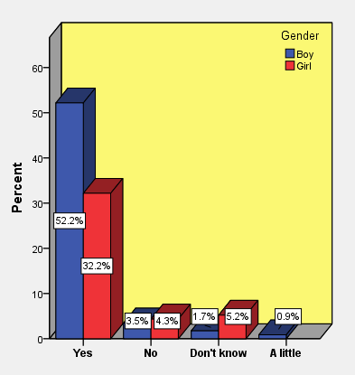
Bar chart (5.31): Children enjoy using the outdoor space with new landscape elements based on their gender
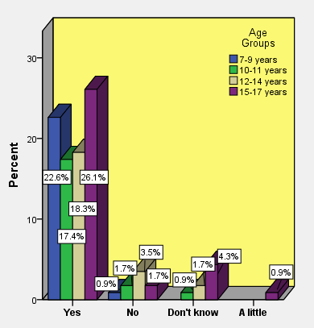
Bar chart (5.32): Children enjoy using the outdoor space with new landscape elements based on their age group
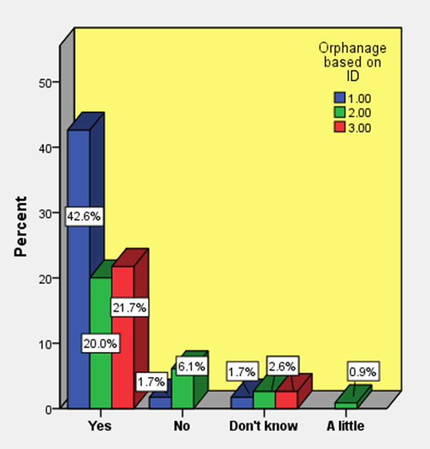
Bar chart (5.33): Children enjoy using the outdoor space with new landscape elements based on three orphanages
The reasons reported by children regarding why new landscape elements would make them enjoy using the outdoor space, are shown in table (5.25). As it is shown in the table, the most reason is ‘liking landscape elements’ (26.3%) (tree, flowers, pool, fountains, etc.), and the way of utilising these elements such as smelling flowers, or using the shade of the trees. For example on child said: “if there are fruit trees then we can pick the fruit and eat, it is fun, using the shade of tree as well”. Also 22.1 percent of children mentioned new landscape elements would make their outdoor space ‘more beautiful’, and ‘enjoyable and pleasant environment’ (13.7%).

Table (5.25): Why new landscape elements would make children enjoy using the outdoor space?
 | Orphanage
 | 1 | 2 | 3 | Total
 | Count (%) | Count (%) | Count (%) | Count (%)
It is good | 2 (4.3%) | 2 (8.7%) | 0 (0.0%) | 4 (4.2%)
Enjoyable, pleasurable (pleasant) environment | 7 (14.9%) | 4 (17.4%) | 2 (8.0%) | 13 (13.7%)
Better Environment | 1 (2.1%) | 0 (0.0%) | 0 (0.0%) | 1 (1.1%)
More beautiful | 11 (23.4%) | 3 (13.0%) | 7 (28.0%) | 21 (22.1%)
Green environment | 2 (4.3%) | 0 (0.0%) | 0 (0.0%) | 2 (2.1%)
Beautiful view, better view | 5 (10.6%) | 1 (4.3%) | 2 (8.0%) | 8 (8.4%)
I love nature, natural environment | 2 (4.3%) | 1 (4.3%) | 1 (4.0%) | 4 (4.2%)
Children like it | 1 (2.1%) | 0 (0.0%) | 2 (8.0%) | 3 (3.2%)
Clean air, better air | 3 (6.4%) | 0 (0.0%) | 0 (0.0%) | 3 (3.2%)
New environment, diversity | 1 (2.1%) | 1 (4.3%) | 1 (4.0%) | 3 (3.2%)
Diversity | 3 (6.4%) | 1 (4.3%) | 0 (0.0%) | 4 (4.2%)
Children do water play | 2 (4.3%) | 2 (8.7%) | 1 (4.0%) | 5 (5.3%)
Like landscape elements | 10 (21.3%) | 10 (43.5%) | 5 (20.0%) | 25 (26.3%)
Good feeling, getting more peace | 6 (12.8%) | 0 (0.0%) | 2 (8.0%) | 8 (8.4%)
More Fun | 1 (2.1%) | 0 (0.0%) | 1 (4.0%) | 2 (2.1%)
Attractive environment | 0 (0.0%) | 1 (4.3%) | 0 (0.0%) | 1 (1.1%)
Take care of them, not damaging them | 1 (2.1%) | 3 (13.0%) | 2 (8.0%) | 6 (6.3%)
I don't know | 3 (6.4%) | 0 (0.0%) | 2 (8.0%) | 5 (5.3%)
Other responses | 4 (8.5%) | 3 (13.0%) | 4 (16.0%) | 11 (11.6%)
Some of the children pointed to some other reasons which are as follows:
- The outdoor turns to natural state,
- If there is a suitable place and the person feels comfortable and also there is no other people commute from the outside of the orphanage or it is very less, then our spirit will be happy, people like nature
- Because you would think that you are in the park.
- But not too busy, because we may damage the plants while walking.
- The yard would be more open, more beautiful, it does not have limitation in terms of equipment
- The nature is better, the colour of the outdoor space will be changed in general.
- The flower is a gift of God
- Flower: yes, but pool: no (pool: children like to do water play and then if they run fast, they will get cold)
- Because we can put fish into the pool
- Because I go there and walk, we would not play anymore because the flowers would be damaged and broken.
- For sitting and play
- Gives good feeling, we always want to be there, we don't want to get away from it.
- Flower: yes, makes pleasant space, water and fountain: no, because I don't like water or rain or anything similar
Few children replied ‘no’ to the question ‘would new landscape elements make you enjoy using the outdoor space?’ and their reasons are as follows: one child said: “I use the outdoor space just when I feel sad, and I have nothing to do with flowers and plants”, three of the children mentioned: “I do not like these things”, "not very interesting” and “the outdoor space is good like as it is now”. One young boy said: “we cannot go there, we will get wet in the water!”. One girl had very negative view and she said: “it is ridiculous”. Occupying the space and making the outdoor spaces smaller was another reasons that two of the children from Orphanage 2 pointed to. They said: “the landscape elements will occupy the outdoor space” and “the space will be taken and we cannot play there, flowers may be hit”. One child did not agree about water and fountain and he mentioned “because I don't like water or rain or something similar”. Last but not least, one child did not know why she would not like having landscape element in their outdoor space.
According to the above results, for most of the children, adding natural elements and new equipment to the outdoor space can have a positive effect on making the outdoor space more beautiful and enjoyable for children. Again, children in the 15-17 year age group have a higher percentage of positive responses.
The last section of the interview questions was designed to assess the overall satisfaction of children regarding the outdoor space of their living environment. In general, most of the children rated ‘very good’ to the quality and existing conditions of the outdoor space in their living environment (Bar chart 5.34). This assessment is illustrated in bar chart (5.35) based on the classification of the three orphanages.
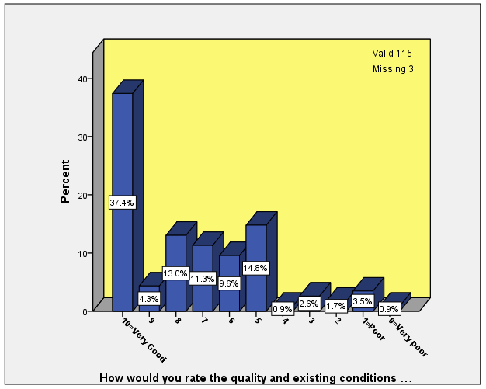
Bar chart (5.34): How would you rate the quality and existing conditions of outdoor space?
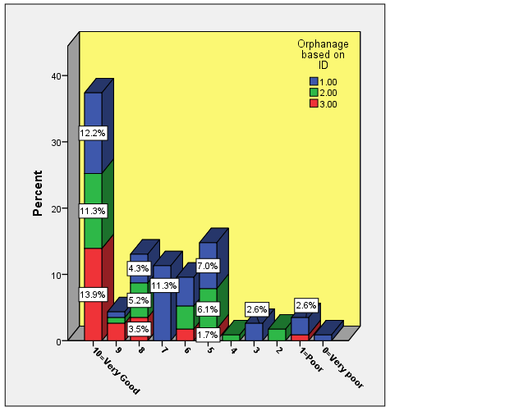
Bar chart (5.35): How would you rate the quality and existing conditions of outdoor space?

5.7 Children’s Preferences
In this section, the analysis completed on the questions about children's preferences is examined. Children were asked questions about their favourite places within the outdoor space of their orphanage as well as other orphanages if they had experienced any. They were also asked about what they like or dislike about those places. Finally, they were asked what changes they would like to see in the outdoor space of their living environment. As table (5.26) shows, the majority of responses to the question: “what is your favourite place in the yard?”; were ‘football field and volleyball field’ (28.4%). Children’s other most favourite places of the yard were as follows: ‘play space (or playground equipment part of the yard)’ (12.9%), ‘beside trees’ (9.5%), ‘backyard or back of the building’ (8.6%) and ‘around the pool and fountain’ (7.8%). ‘The dirty ground (soil area) at the back of the parking’ and ‘a place which has more view (scenery) and back of the prayer room (after praying)’ were the two other responses of two children.
Table (5.26): What is your favourite place in the outdoor space of your living environment?
 | Orphanage
 | 1 | 2 | 3 | Total
 | Count (%) | Count (%) | Count (%) | Count (%)
Middle of the yard, end of the yard, corner of the yard | 3 (5.8%) | 5 (13.9%) | 1 (3.6%) | 9 (7.8%)
Backyard/ back of the building (dormitory) | 9 (17.3%) | 0 (0.0%) | 1 (3.6%) | 10 (8.6%)
Play space, Play equipment part | 0 (0.0%) | 0 (0.0%) | 15 (53.6%) | 15 (12.9%)
Around or near the volleyball net, basketball ring, football goal. | 1 (1.9%) | 2 (5.6%) | 0 (0.0%) | 3 (2.6%)
Around the pool or fountain | 1 (1.9%) | 6 (16.7%) | 2 (7.1%) | 9 (7.8%)
Benches | 0 (0.0%) | 0 (0.0%) | 4 (14.3%) | 4 (3.4%)
By the garden | 2 (3.8%) | 6 (16.7%) | 0 (0.0%) | 8 (6.9%)
Beside trees | 3 (5.8%) | 4 (11.1%) | 4 (14.3%) | 11 (9.5%)
Beside flowers | 1 (1.9%) | 4 (11.1%) | 1 (3.6%) | 6 (5.2%)
Bright places | 1 (1.9%) | 0 (0.0%) | 0 (0.0%) | 1 (0.9%)
Places without people movement | 1 (1.9%) | 0 (0.0%) | 0 (0.0%) | 1 (0.9%)
Football field, Volleyball field | 30 (57.7%) | 3 (8.3%) | 0 (0.0%) | 33 (28.4%)
Lower level of the yard | 0 (0.0%) | 3 (8.3%) | 0 (0.0%) | 3 (2.6%)
Upper level of the yard | 0 (0.0%) | 4 (11.1%) | 0 (0.0%) | 4 (3.4%)
On the stairs | 0 (0.0%) | 1 (2.8%) | 0 (0.0%) | 1 (0.9%)
Everywhere | 2 (3.8%) | 2 (5.6%) | 3 (10.7%) | 7 (6.0%)
No Where | 2 (3.8%) | 2 (5.6%) | 0 (0.0%) | 4 (3.4%)
Other | 2 (3.8%) | 0 (0.0%) | 0 (0.0%) | 2 (1.7%)
I don't know | 1 (1.9%) | 1 (2.8%) | 1 (3.6%) | 3 (2.6%)
The reasons of choosing these places as children’s favourite places in outdoor spaces of the orphanages described in table (5.27).
Table (5.27): Why do children prefer some places in outdoor environment of their living place?
Football field, Volleyball field | Play space, Play equipment part | Beside trees | Backyard/ back of the building
Because:  - All children come there and we play (3)  - All of the children like football, I like it very much as well  - We are in the football field most of the time  - I like volleyball (2) more and there is volleyball field  - I play football with other children, We can play football (3)  - It has football goal (3) and we can play better and we do not have to put stone as a gate, the field has border line, and it has a place at the back of the field that young children can play there  - It is beautiful  - Nobody is there so I can listen to Quran with headphone  - We can play better and laugh with other children  - We can play Yek zarb-Do zarb and football and any other game there. we can play basketball as well  - gather with children and play football  - I like football (3) more  - I like playing  - It has facilities, we have not to put brick instead of football goals  - It is a big space and it has berry tree  - It is an open space  - It is better compared to other places (spaces)  - It is less busy, walking there  - It is not in the eye of others.  - It is not poky  - We can play inside them, running, but we cannot do that on soil and ruined ground  - We laugh, we are happy, we give energy to each other  - We play volleyball there  - When children want to play I go and play with them, we are more comfortable here and other parts do not have play space  - I don't know | Because:  - There are equipment there (2)  - I like it  - I like to go and swinging every day  - I like to go there always and play with swing  - I (we) can play (2)  - I play with the equipment (2)  - It gives such a good feeling to person  - It is beautiful  - It is very good  - There is more play equipment, when I use See-saw the wind hits my face  - We get entertained  - We play with our friends  - When I swinging the wind hit my face | Because:  - Its nature is clean, neat and I enjoy more  - We stand under the tree shade so we do not get dark skin  - I get sense of peace  - It has sunshade (2) when it is sunny  - It is beautiful  - It is not in the eye of others.  - Fruit  - They have beautiful shade  - I don't know (2) | Because:  - It has tree  - It is (so) good (2) and we are more free  - Its building and its yard are good.  - Its field is bigger, it has space to play  - There is nothing there, if we shoot the ball, balls do not go up on the building or do not go inside the dormitory.  - We can play basketball  - When we want to drink water we can go inside the building, I like its trees  - I don't know

Section eight of the interview question set is related to questions about the outdoor space of other orphanages. In this regards, when children were asked whether they have been, or have seen another orphanage outdoor space that they really liked; about half of the children said ‘yes’. Bar charts (5.36) to (5.38) show the difference between yes and no responses of children to this question, based on the gender of the children, their age group and in all three orphanages.
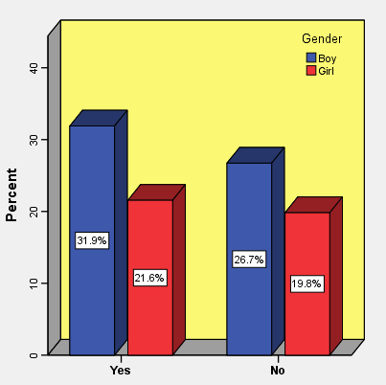
Bar chart (5.36): Liking another orphanage outdoor space based on gender
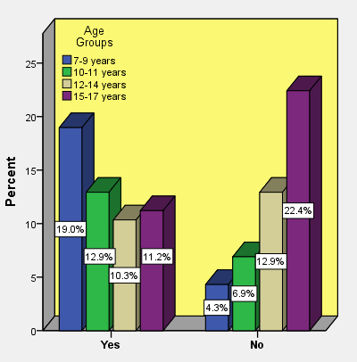
Bar chart (5.37): Liking another orphanage outdoor space based on age group
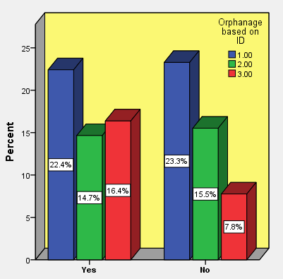
Bar chart (5.38): Liking another orphanage outdoor space based on three orphanages
In response to what you liked from that environment, different responses were made by the children. As table (5.28) shows, most of the children pointed to the availability of playground equipment in another orphanage, as the main reason of their preference of the other environment. Children pointed to some kind of playground equipment such as ‘attached swings, inflated slide, savoy slide, stable horse’. Also, some children reported that orphanages had ‘bigger space’ (27.1%) or ‘more trees’ (16.9%).
In describing some of the reasons, children referred to, ‘the existence of football goal’ or ‘border line around the football field’. Regarding the maintenance, one child mentioned that people who lived in another orphanage always took care of it, and the flowers were not faded. In relation to social life, two children reported that sometimes staff cooked in the yard, made jokes with children and made them laugh. Three other responses also described by children which are as follows: ‘fruits on tree’, “it was like here, does not have toys” and also “it had nothing special, I was there for 6 years and always played in one place. There were more children and we played with children”.

Table (5.28): What do children like about the outdoor space of other orphanages where they have been there or seen?
 | Orphanage
 | 1 | 2 | 3 | Total
 | Count (%) | Count (%) | Count (%) | Count (%)
I liked its yard | 0 (0.0%) | 0 (0.0%) | 1 (5.6%) | 1 (1.7%)
Bigger space | 2 (8.3%) | 8 (47.1%) | 6 (33.3%) | 16 (27.1%)
the rooms was bigger | 0 (0.0%) | 0 (0.0%) | 1 (5.6%) | 1 (1.7%)
Beautiful | 0 (0.0%) | 1 (5.9%) | 0 (0.0%) | 1 (1.7%)
Flower | 3 (12.5%) | 1 (5.9%) | 1 (5.6%) | 5 (8.5%)
Tree | 6 (25.0%) | 2 (11.8%) | 2 (11.1%) | 10 (16.9%)
Garden | 2 (8.3%) | 0 (0.0%) | 0 (0.0%) | 2 (3.4%)
Lawn field | 1 (4.2%) | 1 (5.9%) | 0 (0.0%) | 2 (3.4%)
It was Green | 0 (0.0%) | 0 (0.0%) | 1 (5.6%) | 1 (1.7%)
Landscape features (fountain, stone, bench, statue...) | 2 (8.3%) | 3 (17.6%) | 1 (5.6%) | 6 (10.2%)
Playground equipment | 10 (41.7%) | 6 (35.3%) | 9 (50.0%) | 25 (42.4%)
Bicycle | 3 (12.5%) | 1 (5.9%) | 3 (16.7%) | 7 (11.9%)
pool | 1 (4.2%) | 0 (0.0%) | 1 (5.6%) | 2 (3.4%)
Swimming pool | 0 (0.0%) | 0 (0.0%) | 2 (11.1%) | 2 (3.4%)
Football field | 2 (8.3%) | 2 (11.8%) | 0 (0.0%) | 4 (6.8%)
Volleyball field | 1 (4.2%) | 0 (0.0%) | 0 (0.0%) | 1 (1.7%)
Basketball field | 0 (0.0%) | 2 (11.8%) | 0 (0.0%) | 2 (3.4%)
Sport facilities (ball, table tennis, jump rope, basketball ring,...) | 0 (0.0%) | 3 (17.6%) | 1 (5.6%) | 4 (6.8%)
Its social life | 1 (4.2%) | 1 (5.9%) | 0 (0.0%) | 2 (3.4%)
Animal status | 1 (4.2%) | 0 (0.0%) | 1 (5.6%) | 2 (3.4%)
Animal | 2 (8.3%) | 0 (0.0%) | 0 (0.0%) | 2 (3.4%)
Everything, everywhere | 2 (8.3%) | 1 (5.9%) | 2 (11.1%) | 5 (8.5%)
Maintenance was good | 0 (0.0%) | 0 (0.0%) | 1 (5.6%) | 1 (1.7%)
Others | 2 (8.3%) | 0 (0.0%) | 1 (5.6%) | 3 (5.1%)
I don't know | 1 (4.2%) | 0 (0.0%) | 0 (0.0%) | 1 (1.7%)

Also, in response to whether there is any orphanage where children have been to or have seen there that they did not like its outdoor space; about 66 percent of children replied ‘no’. Refer to bar charts (5.39) to (5.41) to find the differences between the responses of children to this question based on their gender and age group in all three orphanages.
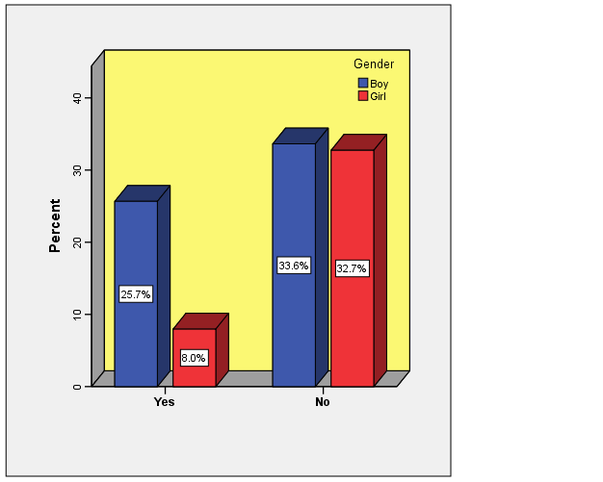
Bar chart (5.39): Disliking another orphanage outdoor space based on gender
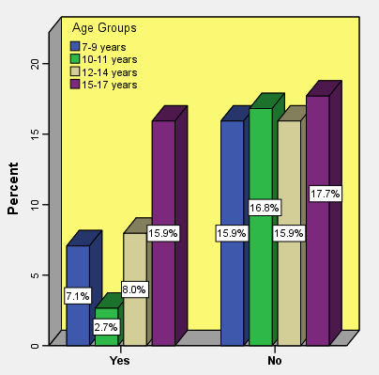
Bar chart (5.40): Disliking another orphanage outdoor space based on age group
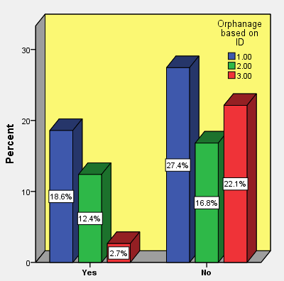
Bar chart (5.41): Disliking another orphanage outdoor space based on three orphanages

The most common reason named by children that made them dislike or even hate another orphanage’s outdoor space was ‘small outdoor space’ or ‘no outdoor space’ (54.1%) because they could not play as they reported. However, in the view of a 17 year old boy, the size of the place did not matter. He mentioned that the orphanage was very big with different facilities and he did not like that space when he was there (he was a child when he lived there). Another 17 years old boy mentioned “I didn’t like the whole centre. It was like a prison!” (Table 5.29). Five other responses are also as follows: “it had fence”, “it was a repeated place (it was not like here that its environment has different spaces)”, “there was no guard at the play area”, “it had young children's play equipment (like swing, slide)” and “I don't know. I do not like other yards except this one which I am in. I am attached to this yard”.

Table (5.29): What do children dislike about the outdoor space of other orphanages where they have been there or seen?
 | Orphanage
 | 1 | 2 | 3 | Total
 | Count (%) | Count (%) | Count (%) | Count (%)
It had small yard or no yard | 10 (50.0%) | 9 (64.3%) | 1 (33.3%) | 20 (54.1%)
it was big, or a little big | 2 (10.0%) | 1 (7.1%) | 0 (0.0%) | 3 (8.1%)
Old, or corrupted | 0 (0.0%) | 2 (14.3%) | 0 (0.0%) | 2 (5.4%)
It was poky | 0 (0.0%) | 1 (7.1%) | 0 (0.0%) | 1 (2.7%)
Ugly | 1 (5.0%) | 0 (0.0%) | 0 (0.0%) | 1 (2.7%)
Empty | 2 (10.0%) | 0 (0.0%) | 0 (0.0%) | 2 (5.4%)
Soil, dusty | 2 (10.0%) | 0 (0.0%) | 0 (0.0%) | 2 (5.4%)
Ruined swing (play equipment) | 0 (0.0%) | 1 (7.1%) | 0 (0.0%) | 1 (2.7%)
Had rubbish | 1 (5.0%) | 0 (0.0%) | 0 (0.0%) | 1 (2.7%)
It was simple | 0 (0.0%) | 0 (0.0%) | 1 (33.3%) | 1 (2.7%)
No trees or less plants (flower, tree, flower pots...) | 2 (10.0%) | 0 (0.0%) | 0 (0.0%) | 2 (5.4%)
No lawn or grass | 0 (0.0%) | 1 (7.1%) | 0 (0.0%) | 1 (2.7%)
Some natural landscape (it had stone, thorn) | 1 (5.0%) | 0 (0.0%) | 0 (0.0%) | 1 (2.7%)
Its yard surface | 1 (5.0%) | 0 (0.0%) | 0 (0.0%) | 1 (2.7%)
It had some animals like sheep, chicken, | 1 (5.0%) | 0 (0.0%) | 0 (0.0%) | 1 (2.7%)
I did not like (I hated) its whole environment (whether inside or outside) | 5 (25.0%) | 0 (0.0%) | 0 (0.0%) | 5 (13.5%)
Others | 2 (10.0%) | 3 (21.4%) | 0 (0.0%) | 5 (13.5%)
It had nothing | 0 (0.0%) | 0 (0.0%) | 3 (100.0%) | 3 (8.1%)
I don't know | 0 (0.0%) | 1 (7.1%) | 0 (0.0%) | 1 (2.7%)

The above data shows that the football and volleyball fields (in Orphanage 1) and the playground area (in Orphanage 3) are the children’s favourite places because they provide an opportunity for play. Further, a percentage of children in all three orphanages preferred places close to trees to receive shade.
Half of the children who had seen the outdoor spaces of the other orphanages, liked the larger space, as it had more trees and playground equipment. There were also orphanages where the children did not like the outdoor space because it was small or they had no outdoor space at all. This was due to the fact that these spaces did not provide children with the opportunity to play. Of course, as mentioned above, the children also reported other reasons for their dislike of these spaces.
In the following, children were asked what changes they would like to see if the outdoor space of their living environment is to be redesigned. In this regard, they offered many different suggestions. According to table (5.30), higher percentages of the responses are dedicated to ‘play equipment (whether adding or improving)’ (29.4%), ‘more flowers and trees and plants’ (26.6%), ‘sport facilities (whether improving, repairing or adding)’ (17.4%), ‘larger space’ (13.8%) and ‘pool’ (11.9%).
Table (5.30): If the space were to be redesigned what changes would you like to see?
 | Orphanage
 | 1 | 2 | 3 | Total
 | Count (%) | Count (%) | Count (%) | Count (%)
Bigger space | 3 (5.9%) | 10 (30.3%) | 2 (8.0%) | 15 (13.8%)
More Flowers and trees and plants | 16 (31.4%) | 5 (15.2%) | 8 (32.0%) | 29 (26.6%)
Bigger garden | 0 (0.0%) | 1 (3.0%) | 1 (4.0%) | 2 (1.8%)
Be green | 2 (3.9%) | 0 (0.0%) | 1 (4.0%) | 3 (2.8%)
Play equipment (whether adding or improving) | 13 (25.5%) | 8 (24.2%) | 11 (44.0%) | 32 (29.4%)
Lawn | 7 (13.7%) | 1 (3.0%) | 0 (0.0%) | 8 (7.3%)
Taller wall | 1 (2.0%) | 4 (12.1%) | 0 (0.0%) | 5 (4.6%)
Pool | 3 (5.9%) | 5 (15.2%) | 5 (20.0%) | 13 (11.9%)
Fountain | 0 (0.0%) | 2 (6.1%) | 1 (4.0%) | 3 (2.8%)
Drinking fountain | 2 (3.9%) | 0 (0.0%) | 0 (0.0%) | 2 (1.8%)
Sitting area | 4 (7.8%) | 0 (0.0%) | 2 (8.0%) | 6 (5.5%)
Sport Facilities (sport fields and other sport facilities whether improving, repairing, adding) | 15 (29.4%) | 4 (12.1%) | 0 (0.0%) | 19 (17.4%)
Bicycle, bicycle path | 1 (2.0%) | 0 (0.0%) | 3 (12.0%) | 4 (3.7%)
Play facilities (ball, badminton racket, ...) | 4 (7.8%) | 1 (3.0%) | 0 (0.0%) | 5 (4.6%)
Swimming pool | 1 (2.0%) | 0 (0.0%) | 1 (4.0%) | 2 (1.8%)
Ground surface changing or improvement (for ex. remove stones...) | 3 (5.9%) | 2 (6.1%) | 3 (12.0%) | 8 (7.3%)
small animals such as birds, fish, butterflies ... | 1 (2.0%) | 1 (3.0%) | 1 (4.0%) | 3 (2.8%)
Remove parking or car | 1 (2.0%) | 0 (0.0%) | 1 (4.0%) | 2 (1.8%)
Some construction work | 2 (3.9%) | 1 (3.0%) | 3 (12.0%) | 6 (5.5%)
Maintenance | 1 (2.0%) | 0 (0.0%) | 2 (8.0%) | 3 (2.8%)
Make it beautiful (decorate it, make it better, being beautiful, put beautiful statues) | 1 (2.0%) | 1 (3.0%) | 2 (8.0%) | 4 (3.7%)
Keep it Clean | 2 (3.9%) | 1 (3.0%) | 2 (8.0%) | 5 (4.6%)
Good facilities | 2 (3.9%) | 0 (0.0%) | 1 (4.0%) | 3 (2.8%)
Places for some activities | 1 (2.0%) | 1 (3.0%) | 0 (0.0%) | 2 (1.8%)
Nothing | 1 (2.0%) | 3 (9.1%) | 0 (0.0%) | 4 (3.7%)
Other responses | 2 (3.9%) | 2 (6.1%) | 0 (0.0%) | 4 (3.7%)
I don't know | 7 (13.7%) | 4 (12.1%) | 3 (12.0%) | 14 (12.8%)

Children desired to have more playground equipment in their outdoor space. In this regard, some of them referred to playground equipment such as one big swing with two attached swings, a merry go round, two slides and an inflatable slide!
Adding or improving the badminton field, separating the basketball field from the football field, installing net for the football goal or changing the football goals are some of the sports facilities that the children referred to. Also, one child suggested changing the place of the football field, because there are houses at the back of the field and when they shoot the ball, it might end up in neighbouring houses. A 15 years old boy had another suggestion. He said: “drawing border line for the field, adding fence around the field to not let the ball goes out of the field during play”. Another child asked for “a sheltered area for table tennis” and his reason is that “when it rains the table will not destroyed and children can play”. Another 15 years old boy offered a “beach soccer”!
Some of the Maintenance works listed by children include: repairing curbs, making the facade of the building in a happy way, painting play equipment in different colours as well as painting chairs and the yard’s door, fixing the ground that had been dug up and also improving the backyard which is destroyed a little.
Moreover, children pointed to some construction works, such as ‘making the curb higher because those are at the same level with the ground and the ball passes from them’, ‘reducing the slope of the ramp’, ‘changing the place of swing and slide because that place is repetitive’, ‘installing wall around the playground and put door for that’, ‘making stream (raceway)’ and also ‘removing swing and put pool instead of that’.
Some children wanted places for some activities, such as a place for practicing music, body building and exercise, or a place for guests (for instance a place for meeting family), and one 13 years old boy pointed to a place for killing sheep!.
The reason for a nine-year-old girl to plant flowers is that flowers cause butterflies gather around them. Also, an eight-year-old girl, suggested the idea of planting pomegranate tree because she liked its fruit. There are also four other responses which were not in any of the above categories and they are as follows: “I want to see changes in pool and the school yard (which is part of Orphanage 1 complex)”,”parking for the cars (which does not disturb the game)”, “the number of water taps to irrigate the trees are a lot and they make trouble while we are playing, because the ball hits the taps”, and finally one child said: “it is good right now. If we change it, it will be a new thing and I don't like”.
Finally when children were asked if the outdoor space of their living environment is to change, would they be interested in collaborating?, and about 87 percent of children replied ‘yes’ to this question (Table 5.31).
Table (5.31): If the space was changed would you like to participate the work?
 | Frequency | Valid percent
Yes  No  a little  I am not here anymore  I did not think about that  Valid 112  Missing 6 | 97  11  2  1  1 | 86.6  9.8  1.8  .9  .9

To provide a general conclusion in terms of children's preferences, the results of this section (as well as others) have shown that children prefer to have a larger space with more play facilities (i.e. a playground for younger children and sports fields and recreational facilities for older children). Further, they would also like more natural elements such as trees, plants and flowers to be placed in their orphanage’s outdoor space.

5.8 Summary
This chapter focused on the results obtained from the interview question set, one of the methods of the ‘Jourchin’ approach which this study adopts. This method aimed to answer the research questions which investigated children’s use of outdoor space in their living environment, their level of happiness and satisfaction about the existing outdoor space, and their preferences regarding outdoor space.
As shown in table (3.1), the semi-structured interview aimed to answer the six specifically designed research questions. Raw data was analysed, and the results were shown in tables and graphs. According to the results of the interview question set, regarding children’s play and activities that they usually do in outdoor space, children mentioned that they participate in structural team games such as football and volleyball, group games with or without a ball, and also activities like running, walking or hanging around the outdoor space, climbing the wall, fighting (as play and kidding around), socialising (talking, laughing), gardening, eating snacks, singing, etc. Children also reported that they play on fixed structural apparatus like playground equipment, yet this was only the case when the equipment was available. Therefore, we realised that the type of play that children engage in can be different in each orphanage due to the availability of facilities.
Turning to the children’s levels of happiness and satisfaction, the majority of children stated that they are very happy when in the orphanage’s outdoor space and that they have good feelings when occupying it. To note, there was no significant difference between the gender and age group of the children. According to the results, the children’s good feelings depended on some of the qualities of the outdoor space like the size, its aesthetic appeal, and the existence of natural elements such as flowers, plants and trees.
Also, more than half of the children said they were happy and satisfied about their existing play facilities in their orphanage’s outdoor space. However, according to the children, adding new equipment would increase their levels of satisfaction as it would make the space newer, better and provide more play opportunities. The children’s viewpoint is also the same regarding adding natural elements to the outdoor space. For most of the children, adding natural elements as well as adding new equipment would have a positive effect on their satisfaction as it would make the outdoor space more beautiful and enjoyable for them.
In addition, regarding children’s preferences, the results showed that children prefer larger spaces with more natural elements and play facilities such as playground equipment for younger children and sports fields and facilities for older ones.
In the next chapter, data collected by other methods in the ‘Jourchin’ approach will be analysed and discussed.

CHAPTER 6
RESULTS OF THE DRAWINGS, PHOTOGRAPHY, OBSERVATION & PERCEIVED RESTORATIVE SCALE

6.1 Introduction
As discussed in chapter three, drawings and photographs done by the children, as well as researcher observations, have been chosen as the methods which are mobilised to answer certain research questions.
In this chapter, the preliminary results which relate to the analysis of the children’s drawings, photographs, observations and perceived restorative scale, are shown in tables, bar charts, graphs and maps. The analytical methods and software used are as follows:
Descriptive statistics were carried out on all the data gathered. The children’s drawings were analysed manually and the frequency of the variables was calculated using IBM SPSS Statistics (Version 25). In order to analyse the children’s photographs, word query analysis was carried out using QSR Nvivo Project software. Furthermore, observation analysis along with the route of the children’s movements on the map, were drawn using Adobe Creative Cloud Illustrator CC (2017.1.0). The results of the Perceived Restorativeness Scale is also shown in the last section of this chapter. In order to check the dimensionality of the scale, PCA was carried out on 18 items of the PRS. Cronbach’s alpha was used to assess the consistency of the scale and to remove items that did not contribute to the study. The scale was calculated by summing up the remaining items. One way in which ANOVA was utilised was when the differences between outdoor spaces (yards) at the different orphanages were explored. Kruskal-Wallis was used to assess the differences between the two preference ratings. Finally, Spearman’s correlations were used to assess the association between the PRS and the two preference ratings both overall and for each yard. In the following section, the data gathered for each of these methods are analysed and discussed.
6.2 Mapping Observations
As table (3.1) in chapter three shows, the method of observation is used to answer research questions 1 and 2. Question 1 focuses on the activities and play children engage in in orphanage outdoor space; some of the results are also obtained through the semi-structured interview, as shown in the previous chapter. Question 2 considers the children’s interaction with landscape elements. The observation method was chosen as a way of recording the activities, play and interactions.
In this section, the results of the observations are examined in relation to the orphans’ uses of outdoor space in the orphanages. Observations were conducted over a period of one year, with each season recorded separately. At first, it was planned to observe the activities of all the children when they were using outdoor space, but in actuality this was not possible due to the fact that not all children were present at the time of observation because of their absence or lack of interest to go out at that time. Therefore the data was recorded of only those children who used the outdoor space at the time of observation.
To input the data into a computer, each child was assigned a specific colour when drawing the children’s movement on the map. In doing this, we could track the movement or the way that the outdoor space was utilised by the child during all four seasons. The arrow indicates the direction of the child’s movement and the dots (for example in Mapping 6.2) show that the specific child had no movement during the time of their observation. This means that they may have been sitting or standing at the time of observation.
In the following section, the results of the observations in each orphanage are discussed.

6.2.1 Orphanage 1
In Orphanage 1, the children live in four separate blocks based on their age groups. Two blocks are for younger children aged 6 to 8 and aged 8 to 11. One block is for children aged 11 to 15, and the other is for older children age 15 to 17 years old. Since the children live in separate blocks, observations of each age group were done separately. These are discussed in the following sub-sections.
6.2.1.1 Blocks 1 and 2
Younger children (aged 6 to 11) who live across the two blocks, usually go to the orphanage’s outdoor space together. The two blocks included 27 children at the time of observation. Of that number, 21 children were observed in spring, 18 children in summer, 24 children in autumn and 22 children in winter. A total of 85 observations were recorded for these two groups of children. Of these, 12 children were observed in each of the four seasons. The rest of the children were either observed in three seasons (nine children) or two seasons (four children) or just one season (two children). The result of these observations are shown in the observation mappings (6.1) to (6.4).
At the time of observation, it was noted that the children of these two blocks usually played football when they went to the outdoor space to play. Different types of activities were observed; aside from football which was the most dominant play activity among children, activities such as playing with balls in small groups or in pairs, running or walking around the field, standing, sitting or lying down (observed in one or two cases) on the surface or small platform, talking with each other or playing alone, standing close by or leaning/climbing on a tree, hanging on a bar, sitting on the stairs, cutting the branches of trees (this happened very rarely), eating snacks, hitting a piece of grass that had sprung out of the ground with their foot (this was only observed once), and walking beside the wall or around parked cars in the outdoor space. All of these activities were common in all four seasons. Flying a kite was one activity that was only observed in winter. This may be due to the windy weather in autumn and winter.
As the mapping (6.1) shows, in the spring observation, all children were centralised at the back of the building area, where there is easy access to the building. Children could go inside the building anytime they wanted during their outdoor play time. This area of the outdoor space unfortunately did not have any specific equipment. While children played football together in this area, there was no football goal available and children used stones to make a pretend gate. As it is shown in the map, only one child was walking alone behind the trees and he did not engage in any type of play.
During summer, children were taken to the football field in another part of the orphanage’s outdoor space. This area, which is located between the office and school buildings, has a proper (small-scale) football field, with football goals. However, the gates did not have nets at the time of observation. Despite this, children preferred playing here as it was more structured. As mapping (6.2) shows, all children were playing in the middle of the field. Only two of the children were sitting on the curbs at both sides of the field (the blue and green dots on the map), and one child did not play with others (red line on the map).
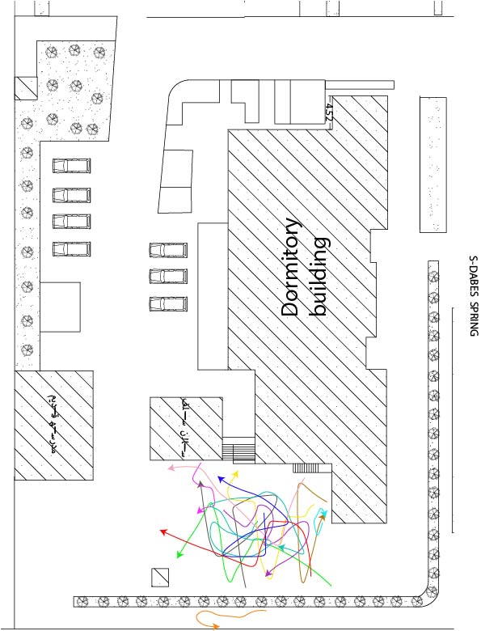
Mapping (6.1): Spring observation of the children in Block 1 and 2 of Orphanage 1
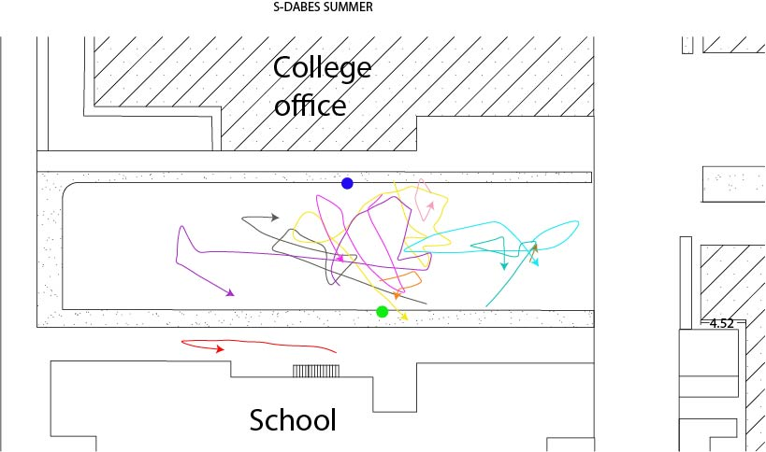
Mapping (6.2): Summer observation of children in Block 1 and 2 of Orphanage 1
In the autumn and winter observations, as shown in mapping (6.3) and (6.4), children played at the back of the building area. Similar to the other times, most of the children played football and only a few of them were not included in others’ play. Instead they walked around the area to entertain themselves.
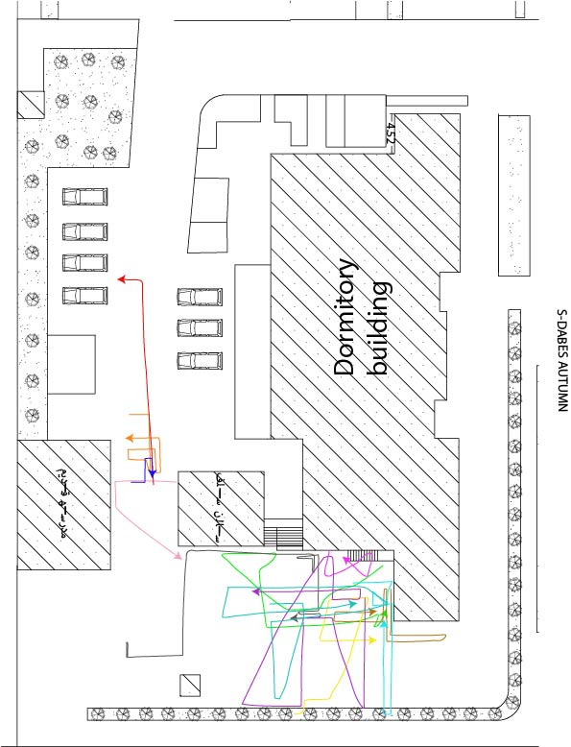
Mapping (6.3): Autumn observation of children in Block 1 and 2 of Orphanage 1
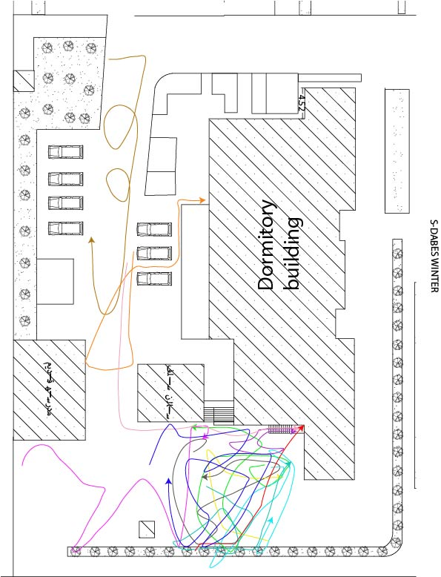
Mapping (6.4): Winter observation of children in Block 1 and 2 of Orphanage 1

6.2.1.2 Block 3
There were 22 children in age group 11 to 15 who lived in block 3 at the time of the study. Of these, 22 children were observed in spring, 14 children in summer, 19 children in autumn and 18 children in winter. A total of 73 observations were done. Among them, there were only 12 children who have an observation record during all four seasons. To generate a clear analysis, the observations of these 12 children are only shown in mapping (6.5) to (6.8).
Similar to children in blocks 1 and 2, playing football was the most dominant activity. The only difference was that the children of this block played more professionally compared to those younger children. They played in the football field in the orphanage’s outdoor space, which had a borderline and football goals (without nets). The observations showed that when the children played football, they also engaged in activities like running, kicking or passing the ball, walking (occasionally), standing or throwing the ball, talking to each other and shouting and laughing (occasionally).
In the spring and summer observations, aside from playing football, two children played badminton (purple and yellow line on the left side of the mapping (6.5)). Further, two other children were alone and did not involve themselves with others. During the observation in summer, two children also played with the ball together and one child swung on a bar.
In each of the four seasons’ observations, there were also children who did not engage with group or team activities. Two children stood or sat on a curb around the football field and watched others’ play while they were eating snacks (blue and pink dot on the mapping 6.6 and 6.8 respectively). Two or three children were whistling or singing during the time they were observed.
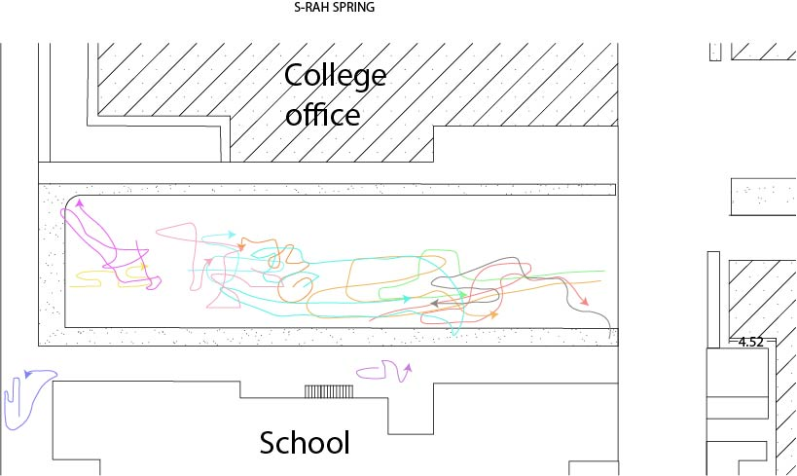
Mapping (6.5): Spring observation of children in Block 3 of Orphanage 1
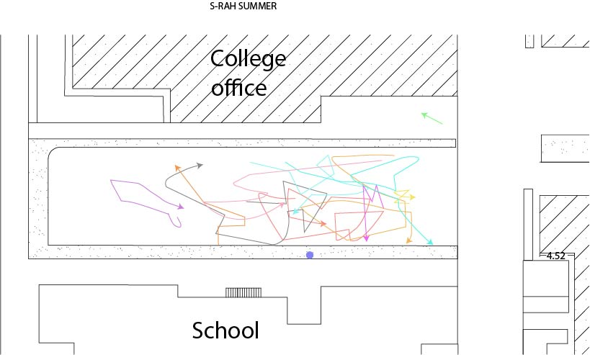
Mapping (6.6): Summer observation of children in Block 3 of Orphanage 1
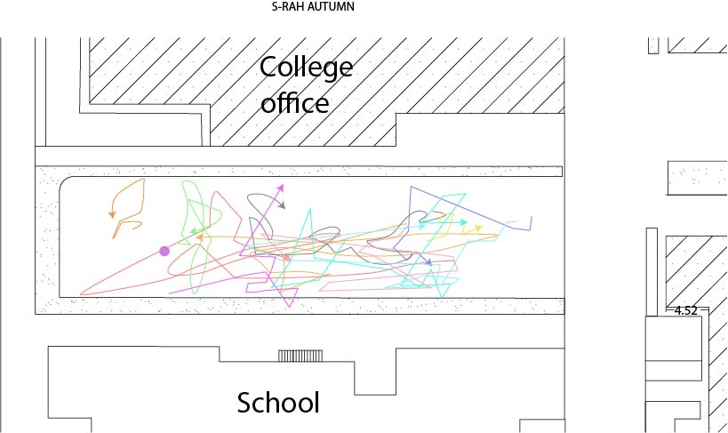
Mapping (6.7): Autumn observation of children in Block 3 of Orphanage 1
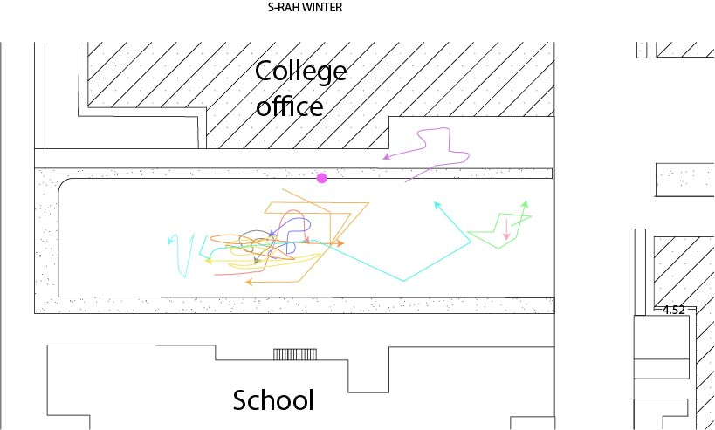
Mapping (6.8): Winter observation of children in Block 3 of Orphanage 1

6.2.1.3 Block 4
At the time of observation, 19 children aged 15-18 lived in Orphanage 1’s block 4. Of this population, 11 children were observed in spring, 14 children were observed in summer, 18 children in autumn and 12 children in winter. A total of 55 observations were done. Among them, there were only 7 children who were observed in all four seasons (Mapping 6.9 to Mapping 6.12). Again, the same colour was used for each orphan as a way of recording their observations on the map.
In terms of the play and activities that the children from block 4 did during the observation period, in addition to football, volleyball was also favoured. In spring, they played football using the orphanage’s football field (Mapping 6.9). As it is shown on the map, all children were centralized to the middle of the field and all were involved in playing.
In summer, some of the children played football and three of them played volleyball (green, red and brown lines at the right side of mapping 6.10). During the observations in autumn and winter, the children played volleyball in the school yard where there was a volleyball field with a border line and volleyball net (Mappings 6.11 and 6.12). As the mappings show, all the children played in the middle of the space, where the volleyball net was located. Only one child (pink line on both maps) preferred to be alone and entertained himself during both observations.
Activities, such as running, kicking or passing the ball, walking, standing or throwing the ball, talking to each other and sometimes shouting and laughing were observed among children while they were playing football. Other similar activities such as stepping, jumping, hitting the ball, talking and laughing were recorded while children were playing volleyball.
Except for the activities mentioned above, other activities were also observed at the time of observation but they were not recorded on the maps because those children were not included in the observations conducted during all seasons. These activities are as follows: in the spring observation, there was a child who picked berries from a tree. In summer, one child cycled around the field or other parts of the orphanage’s outdoor space. In autumn, two children played badminton and one child ate a pomegranate fruit. On one occasion, the ball went up to the top of the school’s roof when the children were playing volleyball and one of the boys went up on ladders to bring the ball down. This also happened during the winter observation. During the same observation, the ball went to the top of a tree and fell into the neighbour’s house. When this happened, the game temporarily stopped.
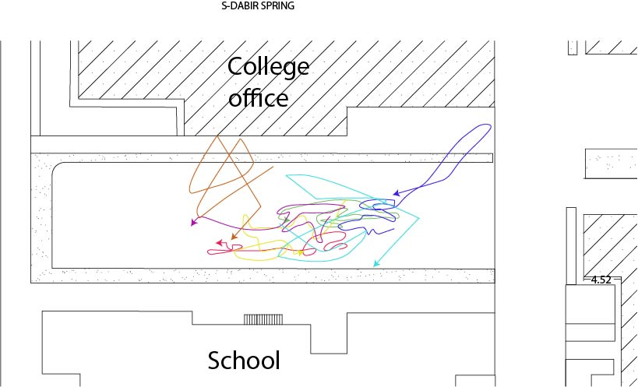
Mapping (6.9): Spring observation of children in Block 4 of Orphanage 1
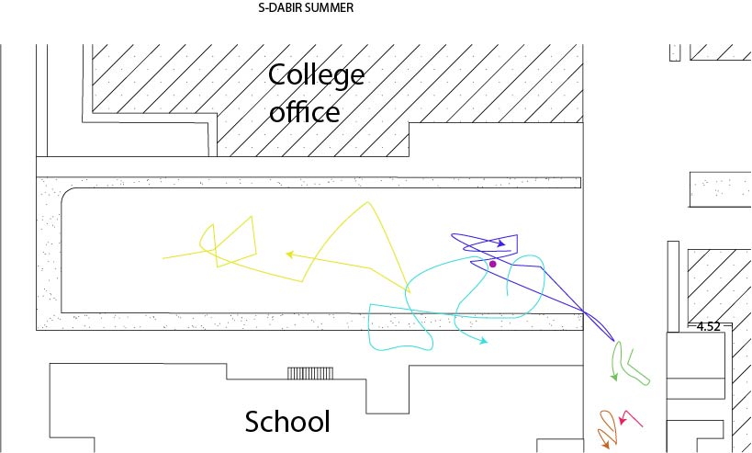
Mapping (6.10): Summer observation of children in Block 4 of Orphanage 1

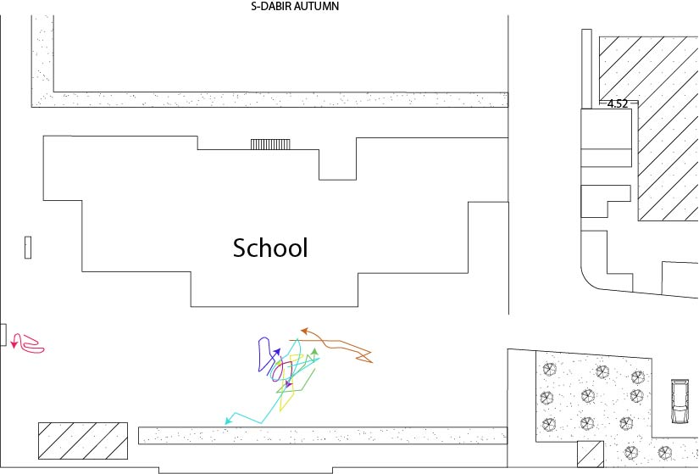
Mapping (6.11): Autumn observation of children in Block 4 of Orphanage 1
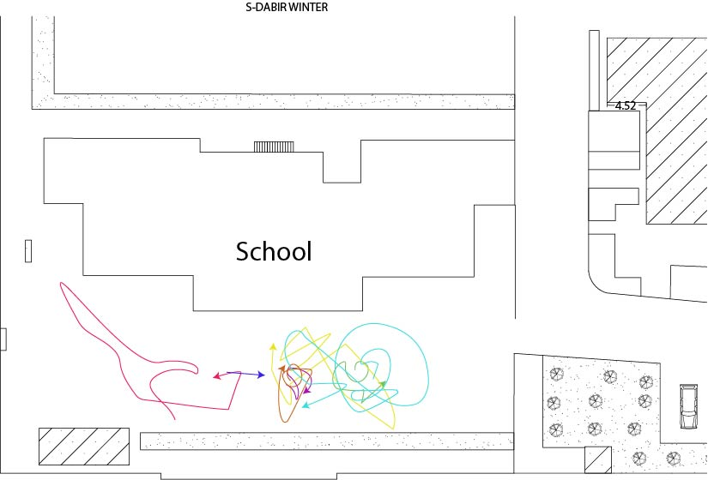
Mapping (6.12): Winter observation of children in Block 4 of Orphanage 1
In general, the observations recorded in Orphanage 1 shows that football was the most common play that children engage in in outdoor space. However, younger children have less structured games compared to those of older children. Walking, running, talking, etc., are other activities that were also observed during the game. Unstructured playing with ball by younger children, as well as volleyball and badminton played by older children, are other activities recorded in this orphanage during the observation period.
In terms of the children’s interaction with landscape elements, observations show that children lean on trees to take a rest, climb on trees for fun, cut the branches of trees to play with, and pick the fruits from the trees. Further, the curb around the field was used by children to sit or stand.
Mirroring Orphanage 1, these types of activities and children’s interactions with landscape elements are also observed in the two other orphanages. The results of this are shown in the following sections.
6.2.2 Orphanage 2
As explained in chapter four, Orphanage 2 included centres for boys and girls which were spread across two separate buildings. As the outdoor space of the boys centre was very small, mentors normally took the boys to the girls centre to play in their outdoor space. This also allowed them to meet the girls and other mentors as well as ‘Mamany’ (the orphanage manager). For every seasonal observation, the observer tried to coordinate timings with the centre so that both groups of boys and girls were present together. However, in practice this did not manifest due to the limited time of the researcher and the scheduling of the centres. Subsequently, observations for boys and girls were not recorded for all seasons for this orphanage (boys were observed in autumn and winter only).
Based on our records, out of the 22 girls who lived in this orphanage at the time of observation, 11 girls were observed in spring, 10 girls were observed in summer, 17 girls in autumn and 16 girls in winter. A total of 54 observations were completed for the girls and among them, there were only 4 girls who were observed in all four seasons. There were seven, six and five girls who had three, two and one observations/observation respectively.
Among the 15 boys, 13 boys were observed in autumn and 14 boys were observed in winter. As mentioned above, there were no observations for boys in spring and summer. Among this number of observations, 12 boys were observed in both autumn and winter, and three of the boys only had one observation.
A total of 81 observations were completed for Orphanage 2. Since the number of children observed in each of the four seasons was very limited, the decision was made to record all of the children who were observed in all four seasons in this orphanage. As it is shown in mapping (6.13) to (6.16), to record the children into the software a warm-colour spectrum was utilised for the observations of the girls and a cold-colour spectrum for observations of the boys. Again, the same colour was used for each child to record their observations onto the map.
Regarding the activities that were observed, children of this centre played group games with a ball, such as volleyball, or games without a ball like High-Tig and jump rope.
In spring, girls played together with and without a ball. They played catch and run, during which they ran, stood on the stairs, went up and down the stairs, jumped, walked, and sat on the ground. They also talked, shouted, argued, objected and clapped when they played. A few children played group play with a ball. Two girls sat or stood on the curb around the garden and another girl played with a ball. They caught and threw the ball to each other. One girl was observed while she was jumping, singing, hopping and watching other girls. Another child went to a bush, touched it and stood close by it. As it shown on mapping (6.13), although the lower part of the yard had playground equipment, all children played in the upper level of the yard. This was because the two sections of the yard were separated by a short metal fenced wall with a gate. At the time of observation the gate was locked and the children could not go over the fence without the permission of their mentor. It should be noted that the playground equipment was installed in the outdoor space of this orphanage in spring. Since the first observations began in the autumn, there is no play equipment recorded in the autumn and winter maps.
In the spring observation, as mapping (6.13) shows, children were centralised in the middle of the outdoor space, a place they played High-Tig. As can be seen on the map, children used the curb of the garden around the yard while playing High-Tig. They also used the curb to sit and rest.
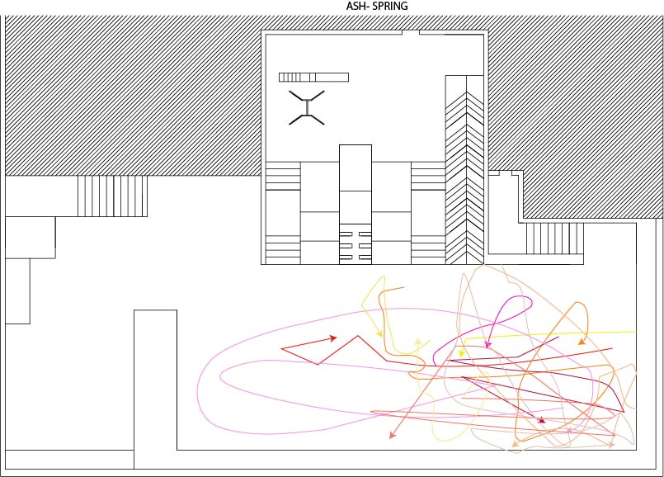
Mapping (6.13): Spring observation of children in Orphanage 2

In summer, as is shown in mapping (6.14), few children went to the outdoor space to play. When they did, some of them played jump rope together. It functioned like a competition with them all counting while one girl jumped. When she got tired, she passed the rope to the next person and stood at the side or sat on the edge of the garden to rest. The game repeated in this manner. A few of the children watched the others while they played. They either stood or sat on the ground or by the edge of the garden. One of the girls was seen counting by herself.
There was one girl who played by herself. She threw the ball into the air and caught it again, repeating the action. Another girl stood beside the wall on the stairs and listened to music while watching the other children. Sometimes she talked to others. She went down the stairs as she wanted to sit on the edge of the garden. She ended up climbing up the stairs and went inside the building. One of the children walked past a flower in the garden and looked at it. Then she returned and stood under the shade; after a few minutes, she took over the rope from her friend to play. As seen on the map, less activity happened during the summer observation.
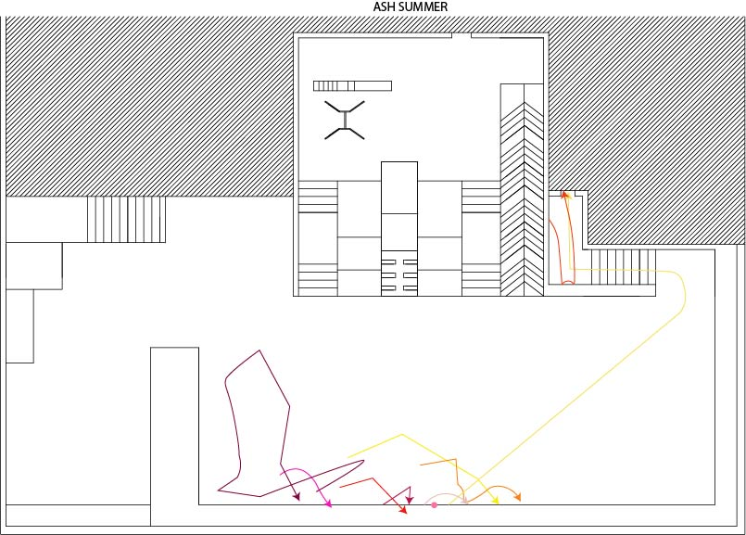
Mapping (6.14): Summer observation of children in Orphanage 2
As stated above, in the autumn observations (Mapping 6.15), both girls and boys participated. Some of the boys and girls played volleyball together at the time of the observation. One of the children with physical disabilities also played with them. When they played, as seen in the children’s previous group games whether in this centre or in the other two orphanages, activities like running, standing, catching the ball or throwing it, stepping forward or backward, shooting the ball with their feet, hitting and passing the ball, or sometimes pulling or pushing each other, were observed among the children. They also talked, shouted, argued, laughed, and watched the games of other players during play time.
Among the observed children, there were a few girls who did not participate in any group play. There was one girl who walked by the wall or the rail guard and leaned against it. She then took the ball, walked a few steps, passed the ball to another child, and went back to the rail guard again to lean on it and watch the other children. Another girl played with a face mask with her friend. Sometimes she walked around the yard, looked at the ground and sometimes leaned against the rail guard and watched the other children. One girl jumped while she held the rail guard or went up and down the step on the rail guard. She also occasionally talked to her friend or sang loudly.
Two of the girls played jump rope, taking it in turns. At the beginning, one of them played with a jump rope in her hand while she spoke to the others, explaining how to play. Then she started to play jump rope and was seen whispering before she sat down when her friend took over the game.
There was a girl who stood close to the rail guard, then walked a few steps and stopped again. She had a piece of chocolate. She was then seen climbing up the stairs into the building and again going down the stairs. Another girl took a few steps towards the wall then stopped, leaned against the wall and talked with one of her friends while watching the others. Further, there was a girl who stood close to the rail guard and watched the other children while sometimes opening and closing the rail guard’s door.
Among the boys who did not participate in ball group play, there were a few who did different activities. For example, one boy wrestled (as play) with his older friend, then he went towards the garden and sat by the edge of it. After that he decided to go to the field to play with the others. He called on the children while he took a few steps. One boy played volleyball a little and then sat on the edge of the garden and rested while watching the others. Another boy watched others’ game while he was leaning on the rail guard. At times he opened the rail guard’s door.
There was also a boy who sat on the edge of the garden and watched the others. When the ball reached him, he passed it back to the children. He then stood up and walked to the other part of the yard and leaned against the rail guard, all the while keeping watch on the others. One of the boys who had a broken arm, just stood at a corner laughing while watching the other children’s play.
A few boys tried to run and catch each other. As is seen in mapping (6.15), they went up and down the ramp or ran around the yard. Sometimes they stood beside the wall or window to lean against them. They also talked or called each other while they played. They used the rail guard to lean against while watching children play volleyball.
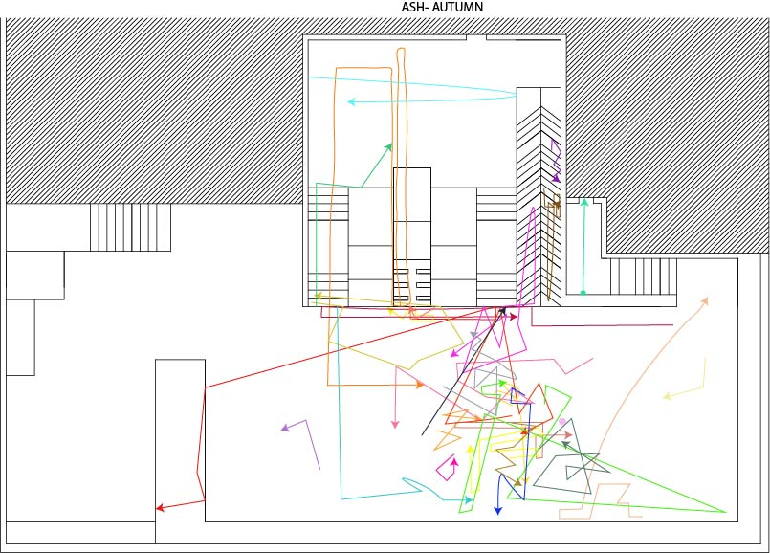
Mapping (6.15): Autumn observation of children in Orphanage 2

In the winter observation (mapping 6.16), about 10 younger girls played volleyball with an inflatable plastic beach ball. During their play, the ball went out into the alley via the orphanage wall three times. When this happened, one of the children screamed a little. They then changed their play to football, using the same ball. As before, activities such as running, walking or stepping forward/backward, standing, following the ball, watching the ball, catching, throwing or hitting the ball were observed among children. Three girls ate nuts while they played.
There was one girl who stood on the top of the stairs next to the stair railings and read a book, while at the same time speaking loudly to the other children. She then closed her book and proceeded to another part of the yard. One girl took her friend’s clothes and walked behind her while they sang and walked around the yard. Another girl stood next to the wall and watched the others; she then proceeded to sit on the edge of the garden and eat snacks. Another girl was also seen sitting on the edge of the garden watching other children. One girl ran and went up the ramp to join a group of children who played with the ball. She also talked with her mentor. One older girl, who usually did not go to the yard according to one of the children, stood next to the wall near the building’s entrance with two boys and did not do any special activity. She talked a little then headed back into the building.
Five or six boys participated in a group game with a ball. A few boys did other activities. For instance, one boy ate nuts and watched others’ games. He then went close to the building and talked with someone inside the building through a window. After this, he went back to the playing field, stood next to the rail guard and held his hand on it. He suddenly screamed: ‘goal’, then ran and took the ball and dribbled.
Another boy who played with others, stood on the edge of the garden for a few seconds and then again went back to the field and walked around. One boy stood close to the rail guard and watched. He then walked along the rail guard and sat on a chair and continued watching the children.
One boy stood at the edge of the garden and waited for the game to start. He talked, ran and kicked the ball. Another boy sat near the wall next to another child. He then went up the stairs and stood there to watch the other children. He then sat on the stair railing while continuing to watch the children. He did not play because his shoes were not suitable for the game. There was another boy who was seen talking with his mentor while standing and looking at the mentor’s book. Then he ran towards the others and waited for the game to start. He also jumped a few times. These observations are shown in mapping (6.16). As can be seen, the children went all around the upper yard but not the lower level of the yard because the access gate was closed.
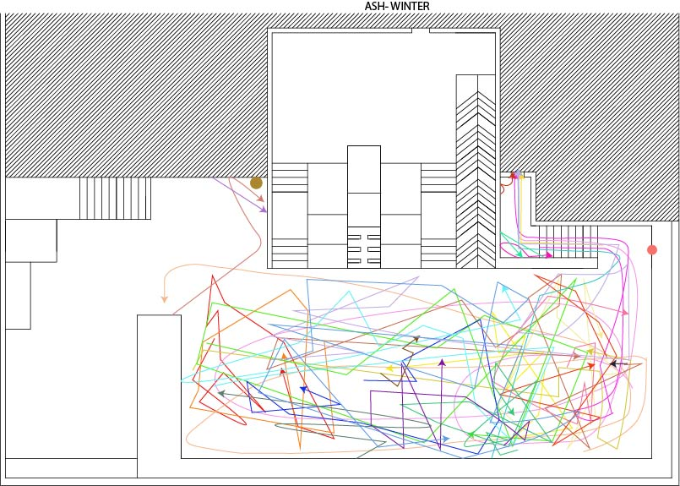
Mapping (6.16): Winter observation of children in Orphanage 2
The types of play and activities that were observed in Orphanage 2 included group play with a ball (such as volleyball or football) and group play without a ball like High-Tig and jump rope. Activities such as socialising, running, walking and in some cases, wrestling, were also seen during the observation period. In terms of children’s interaction with landscape elements, children used steps, stairs, the edge of the garden and the walls as a high point while playing High-Tig. They also used the rail guard and the edge of the garden to lean, sit, stand or rest. Some of the children also looked at the flowers or plants during the observation. This suggests that natural elements are also attractive to them.
6.2.3 Orphanage 3
A total number of 28 girls lived in Orphanage 3 at the time of the observation. Of that number, 28 children were observed in spring, 16 children in summer, 28 children in autumn and 9 children in winter. A total of 81 observations were completed. Out of all of the girls who were observed, only eight children were observed in all four seasons. The rest of the girls were either observed in three seasons (six children) or two seasons (six children) or just one season (eight children).
Similar to Orphanage 1, each child was assigned a specific colour at the time of drawing lines on the computer in order to show their movements or the ways they utilised the yard in all four seasons. The results of these observations are shown in observation mappings (6.17) to (6.20).
During times of observation, it was noted that girls usually played group games, such as run and catch (played in spring), ‘Haft-sang’ (played in summer, autumn and winter) or ‘Vasati’ (played in summer for a short time only). During these play times, activities like running, walking, jumping, standing, talking to or calling each other, arguing, laughing, sometimes screaming, clapping and cheering, climbing the stairs, sitting on or jumping from the platform, watching others while playing, occasionally pulling or pushing each other, catching or throwing the ball, were recorded in each observation. In each season, children played in groups with a ball or they played alone (or both). There were also a few children who played with the playground equipment, either the swing, slide or seesaw at the time of the observation.
Aside from the activities mentioned above, some other activities were also seen in different seasons. For instance, in spring, two girls used the tap to drink water and clean their clothes. In summer, there was one child who walked alone, another who played with a duck (took it and put in on the parked car at the corner of the yard) and one child who tried to climb up the slope of the slide. In autumn, one child played with a piece of wood; another girl hopped around and then took a basket and put a ring in it. A few girls utilised the curb around the garden to stand on during their group play or when they were alone. In winter, two of the girls played with pinecones individually. They constantly threw their cones to the ground. Another child was observed while she played alone. She took a water hose, poured water into the pond while at the same time standing and talking to the other children. One child leaned against the wall and watched the others and another one swung while standing on it.
As the observation mappings below show, children used all the outdoor space, whether inside the garden, playing with playground equipment or using the steps or platform while they played. The outdoor space of this orphanage did not have a big flat space and the space could be a little busy in terms of availability of different objects such as the pond, plants and bushes, playground equipment, platforms, and benches. The latter could serve the children well, but removing them could also make the space bigger in order for children to play freely.
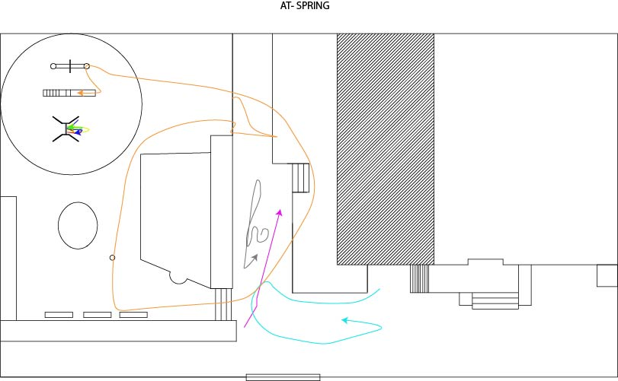
Mapping (6.17): Spring observation of children in Orphanage 3
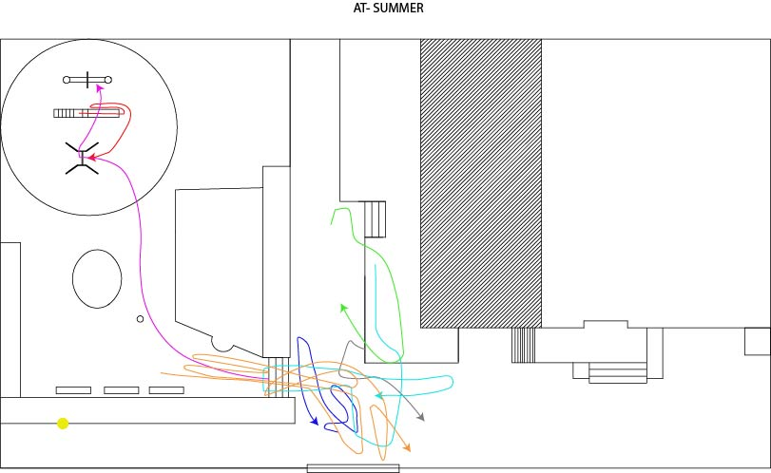
Mapping (6.18): Summer observation of children in Orphanage 3
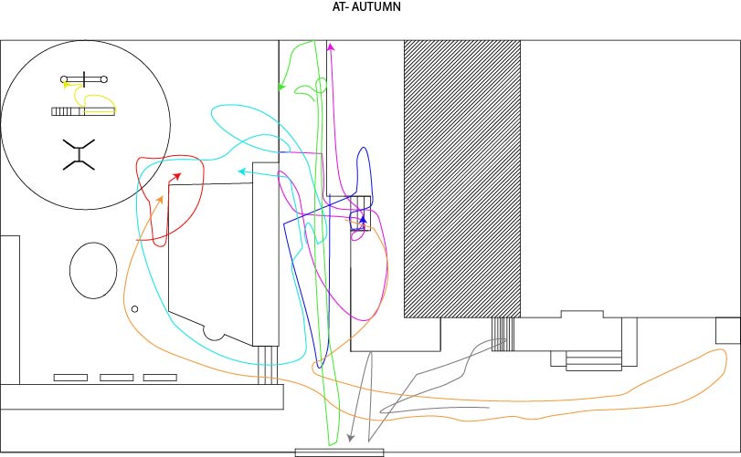
Mapping (6.19): Autumn observation of children in Orphanage 3
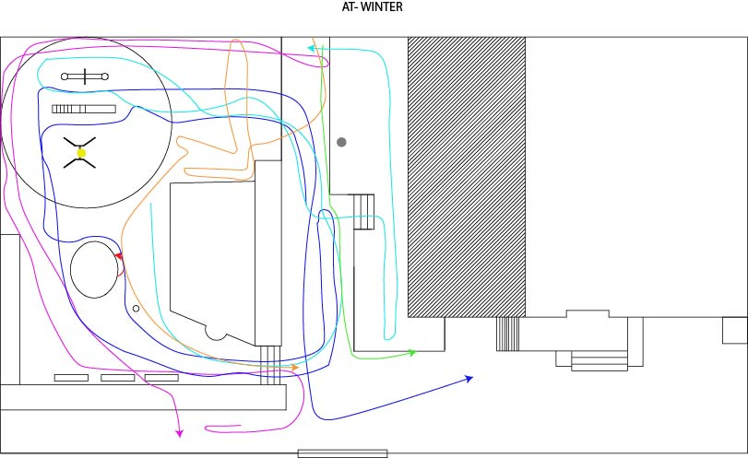
Mapping (6.20): Winter observation of children in Orphanage 3
In general, the children in this orphanage, the same as those in the other two orphanages, played group games with and without a ball. Some of the group games included ‘run and catch’, ‘Haft Sang (seven stones)’ and ‘Vasati’. Activities such as running, walking, jumping from the stairs and platforms, talking, laughing and socialising were also observed among children during the observations. In terms of children’s interaction with landscape elements, children were seen playing with pieces of wood, pinecones, using the tap to drink water or pour water into the pond. As there is playground equipment in the outdoor space of this orphanage, children were also seen playing with the equipment on most occasions. They leaned against the wall and also played with a duck which was in their outdoor space. Therefore, as landscape elements were available in this orphanage’s outdoor space, children used them both consciously and unconsciously.
6.3 Children’s Drawing
In this section, the results of the analysis of the children’s drawings are shown. With this method, this research aimed to document the children’s preferences for the outdoor space of their living environment. A total number of 80 children (51 boys and 29 girls) participated in this part of the data collection. The children were asked to design and put any item they wanted to have in their outdoor space on the map of the outdoor space of the orphanage. Bar chart (6.1) shows the gender distribution of children who participated in the subject produced drawing method in each orphanage.
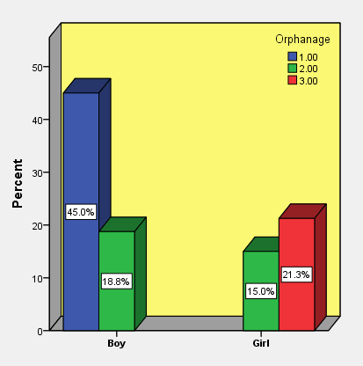
Bar chart (6.1): Gender distribution of children who participated in the subject produced drawing method in each orphanage
There were plenty of objects drawn by children, making it difficult to sort them into main categories. Table (6.1) shows the items that were drawn or written by the children on the map of the outdoor space of their orphanage.
Table (6.1): Results of the subject produced drawing
 | Orphanage
 | 1 | 2 | 3 | Total
 | Count (%) | Count (%) | Count (%) | Count (%)
Soil ground, Soil field | 3 (8.3%) | 0 (0.0%) | 0 (0.0%) | 3 (3.8%)
Pergola with climbing plants, flower, leaves | 0 (0.0%) | 1 (3.7%) | 1 (5.9%) | 2 (2.5%)
Alcove, sun shade | 0 (0.0%) | 2 (7.4%) | 0 (0.0%) | 2 (2.5%)
House, building (dormitory), room, playing room | 7 (19.4%) | 1 (3.7%) | 0 (0.0%) | 8 (10.0%)
Parts of the building | 3 (8.3%) | 1 (3.7%) | 0 (0.0%) | 4 (5.0%)
Vehicles (cars, motorcycle, bicycle, trash transporter, truck and tier, airplane...) | 5 (13.9%) | 1 (3.7%) | 0 (0.0%) | 6 (7.5%)
Some stuff | 5 (13.9%) | 2 (7.4%) | 0 (0.0%) | 7 (8.8%)
Security stuff | 1 (2.8%) | 1 (3.7%) | 1 (5.9%) | 3 (3.8%)
Toys (car toys, like remote car (boys)) | 3 (8.3%) | 1 (3.7%) | 0 (0.0%) | 4 (5.0%)
Water tab | 1 (2.8%) | 1 (3.7%) | 1 (5.9%) | 3 (3.8%)
Water mill | 0 (0.0%) | 0 (0.0%) | 2 (11.8%) | 2 (2.5%)
Pavement or path | 0 (0.0%) | 1 (3.7%) | 3 (17.6%) | 4 (5.0%)
Green Space | 3 (8.3%) | 1 (3.7%) | 0 (0.0%) | 4 (5.0%)
Yard | 1 (2.8%) | 0 (0.0%) | 0 (0.0%) | 1 (1.3%)
Environment (sun, cloud, rain, snow, snowman, rainbow, sea, mountain, thunderstorms, water, forest) | 10 (27.8%) | 1 (3.7%) | 0 (0.0%) | 11 (13.8%)
Socialising (with themselves, friends, mother, sister, a person, children) | 7 (19.4%) | 1 (3.7%) | 0 (0.0%) | 8 (10.0%)
A place to keep balls, toys | 2 (5.6%) | 4 (14.8%) | 0 (0.0%) | 6 (7.5%)
Parking | 5 (13.9%) | 3 (11.1%) | 0 (0.0%) | 8 (10.0%)
Indoor Facilities (shops, cinema, three-dimensional cinema, theatre, bowling, weightlifting equipment, a room for religious ceremonies, laundry, etc.) | 11 (30.6%) | 0 (0.0%) | 0 (0.0%) | 11 (13.8%)
Small animals (fish, birds, crow, cats, dogs, butterfly, etc.) | 9 (25.0%) | 8 (29.6%) | 9 (52.9%) | 26 (32.5%)
A place for younger children to play | 4 (11.1%) | 0 (0.0%) | 1 (5.9%) | 5 (6.3%)
Remove stones, thistles | 0 (0.0%) | 0 (0.0%) | 3 (17.6%) | 3 (3.8%)
Remove playground equipment | 0 (0.0%) | 5 (18.5%) | 2 (11.8%) | 7 (8.8%)
Remove garden, flowers, trees | 0 (0.0%) | 10 (37.0%) | 0 (0.0%) | 10 (12.5%)
Change flower types | 0 (0.0%) | 0 (0.0%) | 1 (5.9%) | 1 (1.3%)
Remove parking, car | 3 (8.3%) | 0 (0.0%) | 0 (0.0%) | 3 (3.8%)
Colourful wall, stair, ramp, doors, curbs, ... | 0 (0.0%) | 15 (55.6%) | 9 (52.9%) | 24 (30.0%)
Fence or Separator wall | 0 (0.0%) | 3 (11.1%) | 0 (0.0%) | 3 (3.8%)
Colourful landscape features | 0 (0.0%) | 14 (51.9%) | 10 (58.8%) | 24 (30.0%)
Playground Equipment, Park, amusement park (with playing equipment like, motors, Electric car, horse) | 16 (44.4%) | 10 (37.0%) | 11 (64.7%) | 37 (46.3%)
Swing, twin swing | 13 (36.1%) | 3 (11.1%) | 1 (5.9%) | 17 (21.3%)
Slide | 12 (33.3%) | 4 (14.8%) | 0 (0.0%) | 16 (20.0%)
Seesaw | 0 (0.0%) | 3 (11.1%) | 0 (0.0%) | 3 (3.8%)
Merry-go-round | 0 (0.0%) | 5 (18.5%) | 7 (41.2%) | 12 (15.0%)
Trampoline | 1 (2.8%) | 3 (11.1%) | 0 (0.0%) | 4 (5.0%)
Inflatable Slide | 1 (2.8%) | 0 (0.0%) | 2 (11.8%) | 3 (3.8%)
Light | 1 (2.8%) | 3 (11.1%) | 6 (35.3%) | 10 (12.5%)
Bench, seating area | 0 (0.0%) | 3 (11.1%) | 3 (17.6%) | 6 (7.5%)
Garden, fruit garden, soil garden | 5 (13.9%) | 3 (11.1%) | 0 (0.0%) | 8 (10.0%)
Flowers, Flower Pot | 12 (33.3%) | 15 (55.6%) | 13 (76.5%) | 40 (50.0%)
Tree (pomegranate tree,..) | 16 (44.4%) | 10 (37.0%) | 9 (52.9%) | 35 (43.8%)
Climbing Plants | 0 (0.0%) | 1 (3.7%) | 0 (0.0%) | 1 (1.3%)
Plants | 0 (0.0%) | 2 (7.4%) | 0 (0.0%) | 2 (2.5%)
Lawn/ Grass | 11 (30.6%) | 9 (33.3%) | 11 (64.7%) | 31 (38.8%)
Pool, Water fountain | 9 (25.0%) | 13 (48.1%) | 12 (70.6%) | 34 (42.5%)
Sport field or facilities | 28 (77.8%) | 16 (59.3%) | 0 (0.0%) | 44 (55.0%)
Football  Volleyball  Basketball  Handball  Futsal  Tennis  Badminton  Table tennis  Skate field  Hopscotch  Kong-Fu mat or field  fixed sport equipment, Gymnastics high bar  Chess Table | 18 (50.0%)  17 (47.2%)  9 (25.0%)  3 (8.3%)  2 (5.6%)  1 (2.8%)  2 (5.6%)  2 (5.6%)  1 (2.8%)  2 (5.6%)  0 (0.0%)  1 (2.8%)  0 (0.0%) | 10 (37.0%)  7 (25.9%)  2 (7.4%)  0 (0.0%)  2 (7.4%)  0 (0.0%)  0 (0.0%)  3 (11.1%)  0 (0.0%)  0 (0.0%)  2 (7.4%)  1 (3.7%)  2 (7.4%) | 0 (0.0%)  0 (0.0%)  0 (0.0%)  0 (0.0%)  0 (0.0%)  0 (0.0%)  0 (0.0%)  0 (0.0%)  0 (0.0%)  0 (0.0%)  0 (0.0%)  0 (0.0%)  0 (0.0%) | 28 (35.0%)  24 (30.0%)  11 (13.8%)  3 (3.8%)  4 (5.0%)  1 (1.3%)  2 (2.5%)  5 (6.3%)  1 (1.3%)  2 (2.5%)  2 (2.5%)  2 (2.5%)  2 (2.5%)
Swimming pool | 14 (38.9%) | 13 (48.1%) | 0 (0.0%) | 27 (33.8%)
Indoor swimming pool  Outdoor swimming pool | 8 (22.2%)  0 (0.0%) | 11 (40.7%)  1 (3.7%) | 0 (0.0%)  0 (0.0%) | 19 (23.8%)  1 (1.3%)
Sauna and Jacuzzi | 0 (0.0%) | 1 (3.7%) | 0 (0.0%) | 1 (1.3%)
Water Slide and diving board | 0 (0.0%) | 3 (11.1%) | 0 (0.0%) | 3 (3.8%)
Green House | 8 (22.2%) | 0 (0.0%) | 0 (0.0%) | 8 (10.0%)
Ball pool | 3 (8.3%) | 1 (3.7%) | 1 (5.9%) | 5 (6.3%)
Toilet | 2 (5.6%) | 0 (0.0%) | 2 (11.8%) | 4 (5.0%)
Drinking water fountain | 1 (2.8%) | 0 (0.0%) | 2 (11.8%) | 3 (3.8%)
Ball | 2 (5.6%) | 3 (11.1%) | 0 (0.0%) | 5 (6.3%)
Some amendments | 0 (0.0%) | 6 (22.2%) | 0 (0.0%) | 6 (7.5%)

Some of the other items that the children drew or wrote included ‘traffic light, hand saw, refrigerator, cooler, paint cans, flag of Iran, drying rack, a ground cloth to sit on and eat food, water mill, dog house, kite (balloon)’. Parts of the building, stairs, chimneys with smoke (drawn by younger children), windows, and an electric door were also drawn by some of the children.
The children mentioned some amendments/corrections in their drawings. These included: ‘changing the place of the swing and slide, removing the stairs and pool, covering the wall to prevent banging in to it, removing the water reservoir and power house, changing the surrounding wall to concrete and making the surrounding wall higher’.
Some security items, such as an electric fence, a camera or a hidden camera were also named by a few children in their drawings. Further, some special sport fields were seen in the children’s drawings, such as a skate field (by an eight year old boy), a beach volleyball field (by a 17-year-old boy) and a football field with soil (a 15-year-old girl).
The most frequent colours used by children in their drawings were light green and light blue (81.2%) as well as red (79.7%). Table (6.2) shows the different colours used by the children across the three orphanages, as well as in total. They mostly chose green to colour the natural elements in their drawings, something which suggests that the children have interest in and preference for, more natural elements.
Table (6.2): Colour used by children in their drawings
 | Orphanage
 | 1 | 2 | 3 | Total
 | Count (%) | Count (%) | Count (%) | Count (%)
Pink | 11 (35.5%) | 13 (59.1%) | 10 (62.5%) | 34 (49.3%)
Light Green | 22 (71.0%) | 20 (90.9%) | 14 (87.5%) | 56 (81.2%)
Dark Green | 18 (58.1%) | 14 (63.6%) | 9 (56.3%) | 41 (59.4%)
Yellow | 23 (74.2%) | 15 (68.2%) | 9 (56.3%) | 47 (68.1%)
Purple | 8 (25.8%) | 13 (59.1%) | 7 (43.8%) | 28 (40.6%)
Black | 6 (19.4%) | 4 (18.2%) | 4 (25.0%) | 14 (20.3%)
Red | 24 (77.4%) | 20 (90.9%) | 11 (68.8%) | 55 (79.7%)
Light Blue | 22 (71.0%) | 21 (95.5%) | 13 (81.3%) | 56 (81.2%)
Dark Blue | 12 (38.7%) | 12 (54.5%) | 7 (43.8%) | 31 (44.9%)
Brown | 20 (64.5%) | 14 (63.6%) | 11 (68.8%) | 45 (65.2%)
Orange | 15 (48.4%) | 13 (59.1%) | 5 (31.3%) | 33 (47.8%)
Gold | 19 (61.3%) | 17 (77.3%) | 5 (31.3%) | 41 (59.4%)

In terms of the children’s preferences, as the above results show, the higher percentage of the responses referred to having a sports field; a football and a volleyball field were mentioned by children in Orphanage 1 and 2. Following that, there was a preference reported by children in all three orphanages to have flowers and flower pots, trees, lawns and grass as natural elements. Playground equipment, as well as the availability of water features such as a pool and a water fountain were noted by all orphanages, while children in orphanages 1 and 2 also mentioned a preference for a swimming pool. In addition to that, children in Orphanages 2 and 3, preferred to see some maintenance work occur, such as adding colour to the wall, stairs, ramp, doors, curbs, and the landscape features. When they talked about colouring, they did not just mean adding colour to the elements, but also making the space more beautiful by using different colours and wall paintings. Last but not least, a few children in all three orphanages also pointed to the preference of having small animals like fish, birds, crows, cats, dogs, butterflies, etc. in the outdoor space of their orphanage. As the results of the children’s drawing show, the children prefer landscape features (whether softscapes or hardscapes) the most.
Aside from drawing, photography was also used as another method to evaluate the children’s preferences. This is discussed in the next section.
6.4 Children’s Photography
Photographs, taken by the children, were also used to find out which elements of landscape they would prefer to have in their orphanage outdoor space. In total, 82 children (51 boys and 31 girls) agreed to participate in the photography process. This agreement was based on the permission of the children’s mentors and how much free time they had (dependent on their schedules). It should be noted that this method was more interesting to the children compared to the other methods of data collection in this study. The children took a total number of 1966 photos. They took photos of the things they liked and the things they disliked in public areas outside of the orphanages; areas that the children have been taken to visit especially for this photography task. After the photography process was completed and the photographs were printed, the children engaged in a photo elicitation process whereby they were asked to separate the photos they liked from those they did not like. This divided them in two categories (1598 liked photos and 368 disliked photos). They were then asked to prioritise the photos, for instance the most-liked photo labelled number 1 and so on. The same process was repeated for the disliked photos. The children had no limits in regard to prioritisation. The largest number of photos were taken by a seven year old girl (72 photos, 59 liked, 13 disliked) and a 14 year old boy (72 photos, 40 liked, 32 disliked) both from Orphanage 2. The lowest number of photos were taken by a 14 year old boy (two photos, one liked, one disliked) from Orphanage 1. After completing the photo elicitation process, all photos and their explanations were imported into Nvivo software. During the first attempt, all information for each photo was typed into Nvivo. However, the results of the word query analysis were not precise or accurate, as it showed all the words in the sentence, which was not the goal of the analysis. In the next attempt, all information and the reasons for each photo were removed and replaced with the main subject of the photo that the children had pointed out in the photo elicitation process. The word query analysis was then complete. Some of the liked and disliked photos taken by the children are presented in Appendix 12.
In the following sub-sections, the results of the liked and disliked photos based on the Nvivo word query analysis are shown. The results are based on differences in the age and gender of the children across the three orphanages. Moreover, the three most liked photos and the three most disliked ones are also shown.
6.4.1 Children’s Liked Photos
All the liked photos selected by all the children are shown in word cloud (6.1). This word cloud shows flowers followed by tree, leaves and statue, as the main items that children liked the most and took pictures of. Word cloud (6.2) to (6.4) show the three priorities of the children in the liked photos category. As the results show, flowers, trees and leaves have the largest number of selected photos among the top three priorities.

Word cloud (6.1): Liked photos by all children
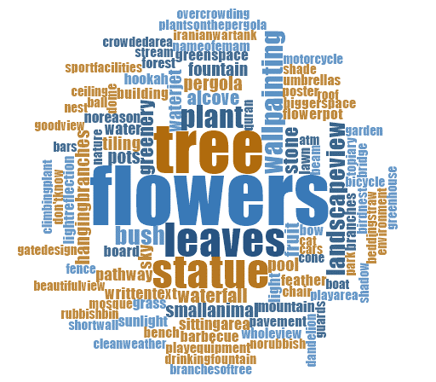
Word cloud (6.2): First priority liked photo by all children
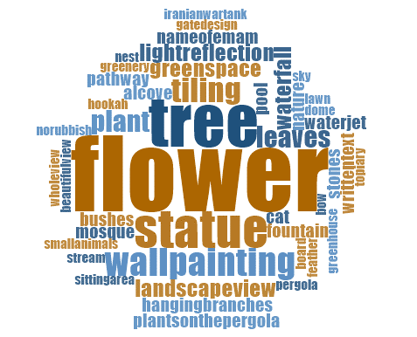

Word cloud (6.3): Second priority liked photo by all children
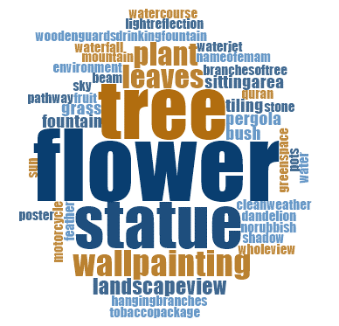
Word cloud (6.4): Third priority liked photo by all children
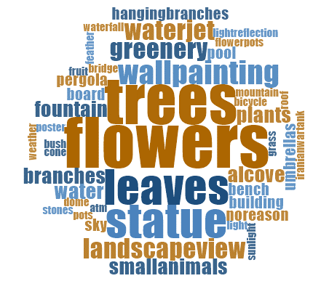
As the results show, the children showed interest in natural elements such as flowers (the most), trees, leaves of plants, and also landscape features like statues and wall paintings. Small animals were also included as the third priority within the liked photos.
In terms of gender differences, the following results show that the boys liked pictures that were taken of the flowers, followed by the statues in open spaces along with the trees and leaves (both of trees and plants) (Word cloud 6.5). The girls liked the trees the most followed by the flowers and the leaves (Word cloud 6.6).
Word cloud (6.5): Liked photos by boys
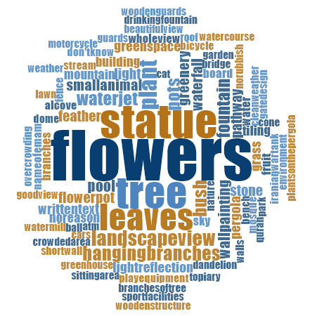

Word cloud (6.6): Liked photos by girls
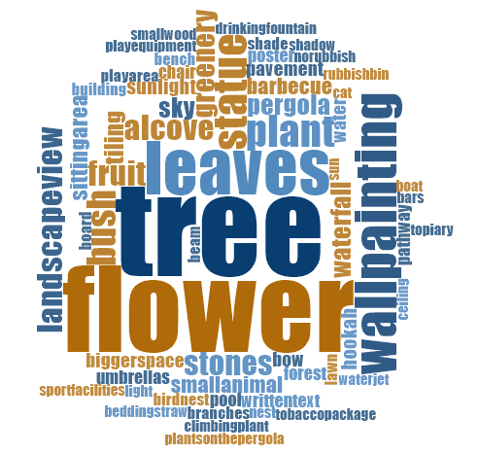
The differences between the different age groups in relation to the liked photos are shown in word cloud (6.7) to (6.10). The 7-9 year olds and the 12-14 year old age group of children liked the photos of the flowers the most, followed by leaves of the plants as well as statues, while the 10-11 year olds and the 15-17 year old age group of children liked the photos of trees followed by flowers, leaves of the plants, and statues.
Word cloud (6.7): Liked photos of the 7-9 year old age group
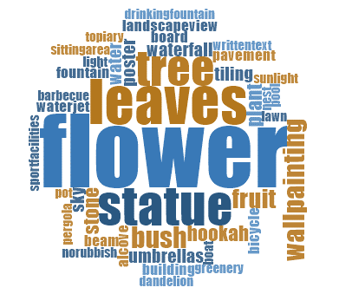
Word cloud (6.8): Liked photos of the 10-11 year old age group
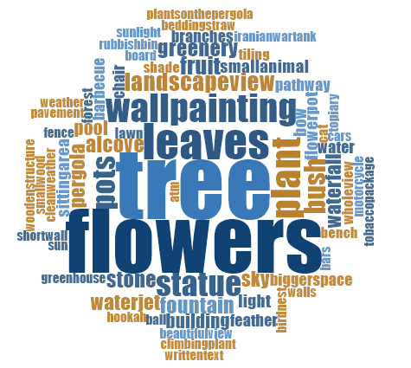
Word cloud (6.9): Liked photos of the 12-14 year old age group
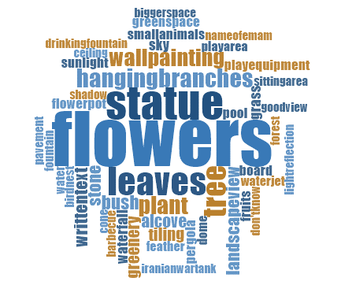

Word cloud (6.10): Liked photos of the 15-17 year old age group
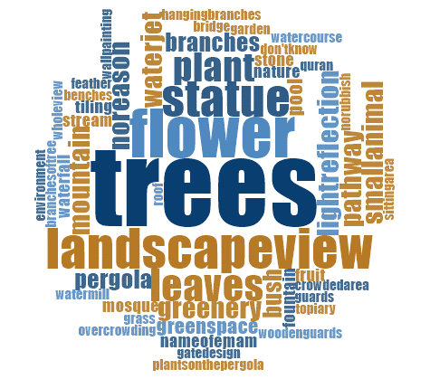
Finally, the liked photos that were taken and selected by the children across the three orphanages are shown in word clouds (6.11) to (6.13). These word clouds show, interestingly, that children in Orphanage 1 and 2 liked flowers followed by a statue, trees and the leaves of the plants respectively; while children in Orphanage 3 showed that their liked objects were trees (the most), then a wall painting, flowers, and the leaves of the plants.
Word cloud (6.11): Liked photos by children in Orphanage 1
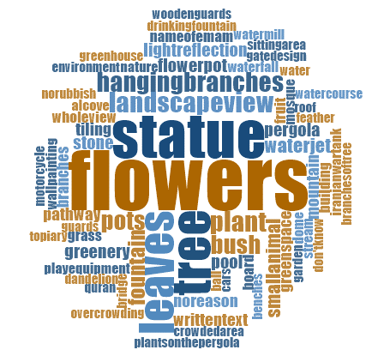
Word cloud (6.12): Liked photos by children in Orphanage 2
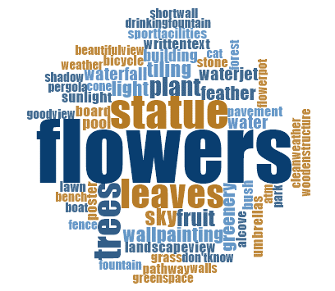
Word cloud (6.13): Liked photos by children in Orphanage 3
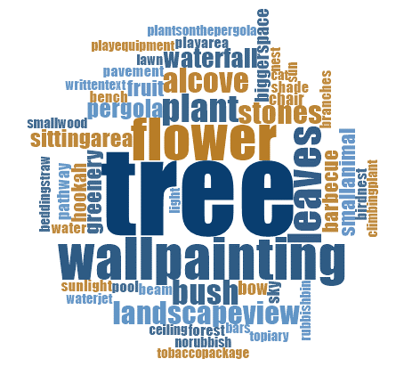
This section concludes that children are more interested in natural elements, such as flowers, trees, plants and the leaves of plants, compared to other items in open spaces. Further items such as a statue and a wall painting were also listed as things which attracted children to open spaces.
6.4.2 Children’s Disliked Photos
Regarding the photos that children took of things that they did not like in the outdoor environments, most of the photos showed rubbish left by people in nature. This can also be seen in the first and second of the selected photos whereby the children prioritised their most disliked photos (word cloud 6.14 to 6.16). Trees are followed by the leaves of plants, flowers, and plants were prioritised as the third disliked object in the photos selected by children (word cloud 6.17). The main reason for this was due to them disliking the type or form of the trees or plants, meaning that some children did not like some forms or types of plants in the open spaces.
Word cloud (6.14): Disliked photos by all children
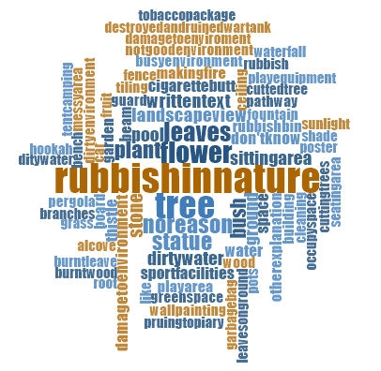

Word cloud (6.15): First priority disliked photo by all children

Word cloud (6.16): Second priority disliked photo by all children


Word cloud (6.17): Third priority disliked photo by all children
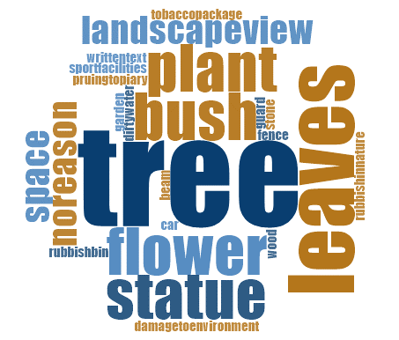
The same results were seen among the boys and girls; boys selected photos which showed rubbish in nature as their most disliked photos (Word cloud 6.18), and girls selected photos which showed trees and the leaves of plants, as well as a few photos related to rubbish in nature (Word cloud 6.19). The reason for the girls’ selection was related to the form and type of trees or leaves which they disliked, as mentioned above.
Word cloud (6.18): Disliked photos by boys
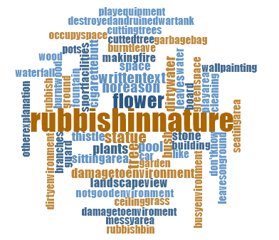
Word cloud (6.19): Disliked photos by girls
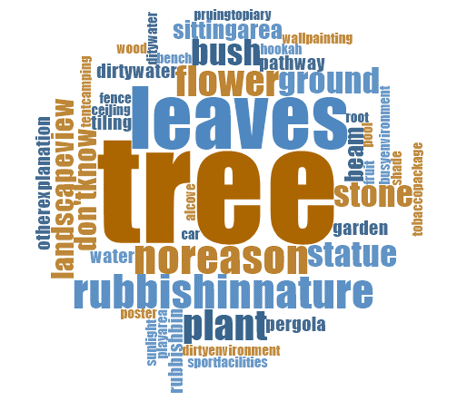
Differences between the four age groups of children in relation to the photos that they did not like are shown in word clouds (6.20) to (6.23). Most of younger children who were in the 7-9 year old age group chose photos that they took of flowers because of the colour, shape or type of flower that they disliked. Trees and leaves were selected next. Most of the children in the other age groups however, identified rubbish in nature as their most disliked object in outdoor environments.
Word cloud (6.20): Disliked photos by the 7-9 year old age group
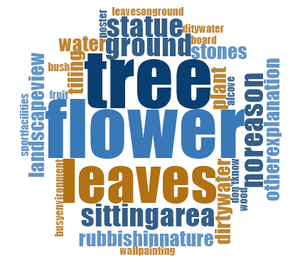
Word cloud (6.21): Disliked photos by the 10-11 year old age group

Word cloud (6.22): Disliked photos by the 12-14 year old age group


Word cloud (6.23): Disliked photos by the 15-17 year old age group

In this section, the differences between the selected disliked photos by children across all three orphanages is shown. According to word clouds (6.24) and (6.25), most of the children who lived in Orphanage 1 and 2 also selected photos which showed rubbish in nature as their most disliked photos. The majority of the children who lived in Orphanage 3 chose photos of trees as their most disliked photos (word cloud 6.26). This selection was due to the form or type of trees which were not deemed interesting by the children.
Word cloud (6.24): Disliked photos by children in Orphanage 1

Word cloud (6.25): Disliked photos by children in Orphanage 2

Word cloud (6.26): Disliked photos by children in Orphanage 3
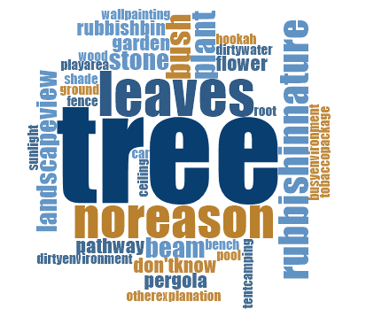
To conclude, most of the children did not like to see rubbish in nature. From their perspective, rubbish means not only damage to the environment, but also a way to make the outdoor space less inviting. Moreover, some types of trees, flowers or plants, due to their shape or form, were not attractive to some of the children.
6.5 Perceived Restorativeness Scale
6.5.1 Descriptive Analysis of Items in the PRS Scale
A sample of 107 children was collected from the three orphanages. In Orphanage 2, a mixed gender orphanage, 35 children provided answers to the PRS questionnaire; in Orphanage 3, a girls orphanage, 20 children answered the questionnaire and at Orphanage 1, a boys orphanage, 52 children answered the PRS questionnaire. Breakdowns by gender, grade and age descriptive statistics are provided in table (6.3).
The description of items in the PRS validation and checking variables are also shown in table (6.4). The descriptive analysis showed that the scores of items covered the full range from 1 to 5 with means ranging from 2.16 to 4.55 and standard deviations from 0.85 to 1.52. Item 15 “in the yard I am free to play, run and move” had the highest score and the smallest standard deviation, meaning that it is negatively skewed because many children answered ‘agree’ or ‘strongly agree’.
Table (6.3): Sample descriptive
 |  | Orphanage 2 |  |  | Orphanage 3 |  |  |  | Orphanage 1 |  |  | Total
 |  | Count | % |  | Count |  | % |  | Count | % |  | Count |  | %
Gender | Boy | 15 | 42.9% |  | 0 |  | 0.0% |  | 52 | 100.0% |  | 67 |  | 62.6%
Gender | Girl | 20 | 57.1% |  | 20 |  | 100.0% |  | 0 | 0.0% |  | 40 |  | 37.4%
Gender | Total | 35 | 100.0% |  | 20 |  | 100.0% |  | 52 | 100.0% |  | 107 |  | 100.0%
Grade | P1 | 3 | 12.5% |  | 0 |  | 0.0% |  | 0 | 0.0% |  | 3 |  | 6.4%
Grade | P2 | 0 | 0.0% |  | 0 |  | 0.0% |  | 1 | 33.3% |  | 1 |  | 2.1%
Grade | P3 | 4 | 16.7% |  | 3 |  | 15.0% |  | 2 | 66.7% |  | 9 |  | 19.1%
Grade | P4 | 1 | 4.2% |  | 3 |  | 15.0% |  | 0 | 0.0% |  | 4 |  | 8.5%
Grade | P5 | 5 | 20.8% |  | 8 |  | 40.0% |  | 0 | 0.0% |  | 13 |  | 27.7%
Grade | P6 | 0 | 0.0% |  | 1 |  | 5.0% |  | 0 | 0.0% |  | 1 |  | 2.1%
Grade | S1 | 0 | 0.0% |  | 1 |  | 5.0% |  | 0 | 0.0% |  | 1 |  | 2.1%
Grade | S2 | 1 | 4.2% |  | 0 |  | 0.0% |  | 0 | 0.0% |  | 1 |  | 2.1%
Grade | S3 | 2 | 8.3% |  | 2 |  | 10.0% |  | 0 | 0.0% |  | 4 |  | 8.5%
Grade | S4 | 5 | 20.8% |  | 0 |  | 0.0% |  | 0 | 0.0% |  | 5 |  | 10.6%
Grade | S5 | 3 | 12.5% |  | 2 |  | 10.0% |  | 0 | 0.0% |  | 5 |  | 10.6%
Grade | S6 | 0 | 0.0% |  | 0 |  | 0.0% |  | 0 | 0.0% |  | 0 |  | 0.0%
Grade | work | 0 | 0.0% |  | 0 |  | 0.0% |  | 0 | 0.0% |  | 0 |  | 0.0%
Grade | Total | 24 | 100.0% |  | 20 |  | 100.0% |  | 3 | 100.0% |  | 47 |  | 100.0%
 |  | Mean | S.D | N |  | Mean | S.D | N | Mean | S.D | N |  | Mean | S.D | N
Age |  | 13.86 | 3.16 | 14 |  | 12.00 | 2.81 | 20 | 16.40 | 1.07 | 10 |  | 13.59 | 3.13 | 44

Table (6.4): Description of PRS items and preference items
 | N | Minimum | Maximum | Mean | Std. Deviation
In the yard I can relax mentally | 107 | 1.00 | 5.00 | 3.9439 | 1.13961
In the yard, nobody tells me what to do | 107 | 1.00 | 5.00 | 3.3084 | 1.33467
In the yard, I don’t think about my worries | 106 | 1.00 | 5.00 | 3.2264 | 1.39580
In the yard I can relax physically | 107 | 1.00 | 5.00 | 3.9065 | 1.16985
In the yard, nobody tells me what to think | 107 | 1.00 | 5.00 | 4.0280 | 1.16115
Spending time in the yard gives me a break from my day-to-day routine | 107 | 1.00 | 5.00 | 3.6355 | 1.44974
The yard is fascinating | 106 | 1.00 | 5.00 | 3.9057 | 1.24616
In the yard there are lots of things that awaken my curiosity | 107 | 1.00 | 5.00 | 3.1869 | 1.52421
I would like to spend more time in the yard looking at the surroundings | 107 | 1.00 | 5.00 | 3.4673 | 1.32692
There are many objects in the yard that attract my attention | 107 | 1.00 | 5.00 | 3.2710 | 1.36375
In the yard, there is nothing worth looking at | 107 | 1.00 | 5.00 | 2.8879 | 1.40972
In the yard everything seems to have a proper place | 107 | 1.00 | 5.00 | 3.4673 | 1.28355
The yard is a confusing place | 107 | 1.00 | 5.00 | 2.1589 | 1.22974
There are few hard boundaries in the yard which limit my possibilities for moving around | 106 | 1.00 | 5.00 | 3.1038 | 1.33044
In the yard I am free to play, run, and move | 107 | 1.00 | 5.00 | 4.5514 | .84935
In the yard it is easy to see what’s around me | 107 | 1.00 | 5.00 | 4.0467 | 1.04053
I can find ways to enjoy myself in the yard | 106 | 1.00 | 5.00 | 3.9717 | 1.09942
The yard gives me the opportunity to do activities that I like | 107 | 1.00 | 5.00 | 3.9626 | 1.14863
Preference items
I like this yard | 107 | 1.00 | 5.00 | 4.1589 | 1.11719
I prefer this yard over all other places I have ever been | 107 | 1.00 | 5.00 | 2.5234 | 1.51935

6.5.2 Factor Analysis
The principle component scree plot supported a single dimension within the data (figure shown below). This dimension explained 20.2% of the variation in the data but with a wide range of loadings from “The yard is fascinating” (0.663) to “The yard is a confusing place” (-0.139) (see table 6.5).
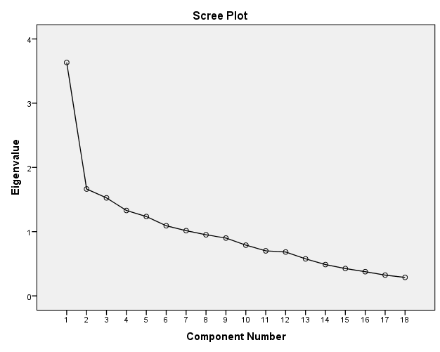

Table (6.5): Component Matrix (to be added to table of variables analysed)
 | Component
 | 1
The yard is fascinating | .663
In the yard I can relax mentally | .600
In the yard there are lots of things that awaken my curiosity | .597
I can find ways to enjoy myself in the yard | .585
There are many objects in the yard that attract my attention | .528
I would like to spend more time in the yard looking at the surroundings | .497
In the yard everything seems to have a proper place | .491
The yard gives me the opportunity to do activities that I like | .481
In the yard I can relax physically | .454
In the yard it is easy to see what’s around me | .431
In the yard I am free to play, run, and move | .422
Spending time in the yard gives me a break from my day-to-day routine | .414
In the yard, there is nothing worth looking at | -.369
In the yard, I don’t think about my worries | .295
In the yard, nobody tells me what to do | .290
In the yard, nobody tells me what to think | .198
There are few hard boundaries in the yard which limit my possibilities for moving around | .171
The yard is a confusing place | -.139

6.5.3 Testing the Reliability and Validity of PRS
Cronbach’s alpha was used to check that items were adding to the scale (Table 6.6). The item “the yard is a confusing space” was removed which increased the alpha from 0.738 to 0.744. Furthermore, the item “there are few hard boundaries in the yard which limit my possibilities for moving around” was also removed, increasing the alpha to 0.747. All further increases in the alpha made through removing items would have been marginal, therefore 16 variable cases were agreed upon. Based on this result, the number of items in the scale can be reduced to 16 from 18.
Table (6.6): Selecting items for the scale
 | alpha if item deleted
 | 18 item | 17 item | 16 item
In the yard I can relax mentally | 0.715 | 0.723 | 0.725
In the yard, nobody tells me what to do | 0.733 | 0.741 | 0.745
In the yard, I don’t think about my worries | 0.736 | 0.743 | 0.746
In the yard I can relax physically | 0.726 | 0.731 | 0.735
In the yard, nobody tells me what to think | 0.736 | 0.743 | 0.748
Spending time in the yard gives me a break from my day-to-day routine | 0.728 | 0.734 | 0.739
The yard is fascinating | 0.706 | 0.713 | 0.718
In the yard there are lots of things that awaken my curiosity | 0.714 | 0.719 | 0.721
I would like to spend more time in the yard looking at the surroundings | 0.721 | 0.727 | 0.73
There are many objects in the yard that attract my attention | 0.723 | 0.727 | 0.728
There is something worth seeing in the yard | 0.729 | 0.739 | 0.74
In the yard everything seems to have a proper place | 0.723 | 0.73 | 0.733
Not a confusing place | 0.744
There are few hard boundaries in the yard which limit my possibilities for moving around | 0.743 | 0.752
In the yard I am free to play, run, and move | 0.728 | 0.736 | 0.743
In the yard it is easy to see what’s around me | 0.724 | 0.733 | 0.735
I can find ways to enjoy myself in the yard | 0.717 | 0.725 | 0.729
The yard gives me the opportunity to do activities that I like | 0.723 | 0.73 | 0.734
 | overall alpha
 | 0.738 | 0.744 | 0.747

6.5.4 Restorative Analysis
There were significant differences in the rating of yards by the children for the PRS. (p=0.017) shows that Orphanage 3 scored significantly higher than Orphanage 2 (mean difference=0.432, s.e.=0.154, p=0.17) and Orphanage 1 (mean difference=0.357, s.e.=0.145, p=0.041). There was no evidence of different ratings of the yards by children for either “I like this yard” or “I prefer this yard over all other places I have ever been”.
Table (6.7): Means and Standard Errors for each orphanage
 | N | Mean | Std. Error
Orphanage 2 | 35 | 3.5696 | .09480
Orphanage 3 | 20 | 4.0017 | .12283
Orphanage 1 | 52 | 3.6447 | .07558
Total | 107 | 3.6869 | .05486
The new PRS was moderately correlated (0.580, p<0.001) with the statement “I like this yard” and a weak correlation (0.310, p<0.001) was seen with “I prefer this yard over all other places I have ever been”. The correlations for the individual orphanages are shown in table (6.8). For Orphanage 2 the PRS was moderately correlated with their ratings of “I like this yard”, however, no correlation was detected with “I prefer this yard over all other places I have ever been”. The PRS for Orphanage 3 showed that there were signs of a tendency for a weak correlation with “I like this yard” but again no correlation with “I prefer this yard over all other places I have ever been”. Finally, for Orphanage 1, a moderate correlation was seen with “I like this yard” and a weak correlation with “I prefer this yard over all other places I have ever been”.

Table (6.8): Spearman Correlations between PRS and the preference scales for the different orphanages
Orphanage |  |  |  | I like this yard | I prefer this yard over all other places I have ever been
Orphanage 2 | Spearman's rho | PRS Scale | Correlation Coefficient | .663** | .149
Orphanage 2 | Spearman's rho | PRS Scale | Sig. (2-tailed) | .000 | .394
Orphanage 2 | Spearman's rho | PRS Scale | N | 35 | 35
Orphanage 3 | Spearman's rho | PRS Scale | Correlation Coefficient | .403 | -.114
Orphanage 3 | Spearman's rho | PRS Scale | Sig. (2-tailed) | .078 | .632
Orphanage 3 | Spearman's rho | PRS Scale | N | 20 | 20
Orphanage 1 | Spearman's rho | PRS Scale | Correlation Coefficient | .550** | .380**
Orphanage 1 | Spearman's rho | PRS Scale | Sig. (2-tailed) | .000 | .005
Orphanage 1 | Spearman's rho | PRS Scale | N | 52 | 52
Dealing with the matter of age was made complicated by the fact that the ages of the children at the various orphanages varied. Overall there was a negative correlation with age (r= -0.529, p<0.001) but there were also differences in scoring between orphanages. When split by orphanage and gender, slightly lower correlations were recorded (Orphanage 2 (Boy)= -0.249, Orphanage 3= -0.3793 and Orphanage 1= -0.346). However, only Orphanage 3 was found to be borderline significant (p= 0.086). That being said, when analysed as a covariate, so as to make an adjustment by orphanage, we obtained that the age overall f (1,40)= 4.779 p= 0.035 saw a decrease in PRS of -0.61 per year of age. This indicates that older children are less likely to rate the restorative nature of the environment highly. In Orphanage 2, which includes both genders, there was no significant difference in gender (t(33)=1.199, p=0.329).

6.6 Summary
This chapter focused on the results obtained from the observations, subject produced drawings, photo elicitation and Perceived Restorativeness Scale, all of which were methods used in the ‘Jourchin’ method put forward in this study. From the observation method, this study aimed to investigate the children’s use of the outdoor space of their orphanage, as well as their interaction with the existing landscape elements. By implementing subject produced drawings and children’s photography, this research aimed to document the children’s preferences regarding their outdoor space and to find out which elements of landscape that children prefer to have in the outdoor space of their living environment. Moreover, the restorative potential of the orphanage outdoor space from the viewpoint of children was also evaluated by the PRS scale.
In this chapter, the data collected through all of these methods was analysed and the results were shown in tables and graphs. From these results, it can be concluded to some extent that the various methods used in the ‘Jourchin’ approach provided almost identical results. This indicates that different methods of the ‘Jourchin’ approach are well aligned when arranged and implemented together.
As the observation results show, children mostly use the outdoor space to play. Regarding their type of play, children participated in group play with or without a ball. Engaging in games such as football, volleyball, badminton, ‘Haft-Sang’ and ‘Vasati’, was dependent on their age and the available play facilities in the outdoor space of their orphanage. In Orphanage 3, children were also observed playing with playground equipment. In terms of children’s activities, running, walking, talking, socialising, and eating snacks, were also recorded at the time of observation. It was seen in the observations that the children liked to play more compared to interacting with landscape elements. However, there were a few children seen playing with a piece of wood, stones, pinecones, as well as those who were seen touching flowers or bushes. They also used hardscapes such as curbs, walls, stairs, etc. to lean, sit, or rest on – they also occasionally used them as a high point when playing some games like ‘High-Tig’.
In terms of the children’s preferences regarding their outdoor space, as the results of the children’s drawing and photography show, children would prefer to have sport fields (i.e. football or volleyball fields) as these are the most common play activities that they do in their outdoor space. Having flowers or flower pots, more trees, lawns and grass as natural elements are also children’s preferences in all three orphanages. Further, playground equipment, water features such as pools and water fountains, maintenance work such as colouring the wall, stairs, ramp, doors, curbs, and the landscape features, as well as wall paintings, were also included by the children in their preferences. Children wanted to see their outdoor space become more beautiful by using different colours and having wall paintings. Like the results of the children’s drawing, the photography results also showed that children prefer landscape features (whether softscapes or hardscapes) the most. According to the photography results, children showed more interest in natural elements such as flowers (the most), trees, leaves of plants, and also some hardscape features like statues and wall paintings. Small animals were also included in the third priority of their liked photos which were also seen in the preferences within the children’s drawings.
Another method covered in this chapter is the Perceived Restorativeness Scale, used to evaluate the restorative potential of the outdoor space of the orphanage. As a new PRS was developed based on the subjects and the context of this research, the reliability and validity of the scale was tested in last section of this chapter. Based on this analysis, two items “the yard is a confusing space” and “there are few hard boundaries in the yard to limit my possibilities for moving around” were removed from the scale. Therefore, the number of items in the scale was reduced to 16 from 18 in order to be a valid and reliable scale.
The results of the PRS show that the outdoor spaces of all three orphanages were restorative from the children’s viewpoint. However, the children in Orphanage 3 showed more restorative potential towards their outdoor space compared to the other two orphanages. The results also indicated that older children are less likely to rate the restorative nature of the environment highly.
So far, the results from the different methods of the ‘Jourchin’ approach have been analysed and discussed in this chapter as well as in chapter five. The next chapter documents and discusses the relationship between three variables: the children’s age, gender and assigned orphanage. This relationship will be related to the aim of this research, as well as to the results of other studies.

CHAPTER 7
AGE, GENDER AND ORPHANAGE: CONSIDERING THE RELATIONSHIP BETWEEN THE THREE VARIABLES AND THE RESEARCH OBJECTIVES

7.1 Introduction
To answer the research questions of this study, a number of both qualitative and quantitative methods were implemented. These methods included: the semi-structured interview, observation and mapping, subject produced drawing, photo elicitation, and perceived restorativeness scale – all of which implemented the multi-method ‘Jourchin’ approach. Following the results chapters which were dedicated to analysing the raw data, this chapter relates the main aims of this study with the three independent variables (age, gender, and orphanage). Moreover, the relationship between these variables will be discussed using the perspectives of both the researcher and those found in other studies. The main aims raised in this study are: children’s use of outdoor space, the types of play and activities children do in outdoor space, children’s level of satisfaction and preferences about the outdoor space of their orphanages, and the restorative potential of orphanages’ outdoor space.
7.2 Children’s Use of Outdoor Space
Based on the results of chapter five, children in their interview mentioned that they use different parts of the orphanage, both indoor and outdoor, depending on their needs. For example, regarding the place of play at the orphanages, more than half of the children reported that they play more in the outdoor space of their orphanage compared to indoors. This answer was more common among children in Orphanage 1 (boys only), with their main reason for choosing the outdoor space to play in most of the time being because it is a bigger space and thus gives more opportunity to play different games and activities. Children who chose the indoor space to play, noted that the weather is the main reason that causes them to play indoors more. For instance, very hot weather in summer and cold weather in winter.
The orphanages’ outdoor space plays a vital role for the children who live in these places. Based on the results of this study, the majority of children use the outdoor space of their living environment to ‘play, get entertained, have fun and for recreation’ followed by ‘mental rehabilitation’, because they reported that being in the outdoor space makes them happy or calm. ‘Enjoying the weather and having fresh air and sun’ is another factor that causes children to use outdoor space.
Regarding children’s favourite places in the outdoor space of their orphanage, for the majority of children the ‘football field and volleyball field’ were chosen as favourite places. Children chose the football and volleyball field as their favourite place because they like playing football and volleyball the most. Further, they have the opportunity for better play there due to the availability of the football goal in Orphanage 1 and the volleyball net in Orphanages 1 and 2, as well as the border lines and other facilities. For other children who do not play football or volleyball, they indicated that they walk or socialise with other children (i.e. talking, laughing, kidding, etc.).
Other favourite places are ‘play space (or playground equipment)’, ‘beside trees’, ‘backyard or back of the building’ and ‘around the pool and fountain’. Those children who liked the play spaces more, pointed to the availability of the playground equipment which allows them to play on them, have fun and get more entertained. As White (1997) also stated, playgrounds provide multiple uses as well as continuous exciting play and independent play for children. In correlation with this statement, this independent play was also seen during observations in the current study; those children who were not interested in getting involved in the play of others, used the playground equipment to keep themselves entertained.
Some of the children who liked nature, the shade and the fruit from the trees, have been allocated ‘beside trees’ as their favourite places in the outdoor space of their living environment.
It can be concluded that children’s main use of orphanages' outdoor spaces is to play in the same way as in other open spaces. This means that children see any open space as a place to play freely, a statement that other studies have identified in regard to the way children play in different spaces within the built environment (Christensen & O'Brien 2003; Hart 1979; McKendrick 2000; Moore 1990; Woolley 2007). Some of these spaces, like playgrounds, are designed for children’s play while some are not. However, children see still the potential of playing in these spaces regardless of whether they were designed for them (Gibson 2014). Based on the children’s report found in Burke’s study (2005), places to play included school yards or open spaces between buildings as well as indoors at home or school, places of play which are similar to those reported by the children in this study. Therefore, whether the outdoor spaces of the orphanages are designed for children's play or not, they still function as places where they can play.
7.2.1 Types of Activity and Play
According to the results of chapters five and six, most of the activities that children do in the orphanage outdoor space are those which involve playing, especially ‘group play with ball’ such as ‘football’ and ‘volleyball’ which were found to be the games that children play most of the time. ‘Walking or hanging around the outdoor space’, ‘socialising (i.e. talking, confabulating, kidding, laughing, enjoying’, ‘group play without ball’, ‘running or racing’, and ‘gardening (such as planting flowers, watering flowers, trees, the garden, etc.)’ are other activities that children usually do when using the outdoor space of their living environment.
Participating in structured team games such as football or volleyball is the most frequent type of play children engage in the orphanage outdoor space, based on the children’s interview. This finding was also seen during the observation process. Some other group games with a ball are also played by children in the outdoor spaces of the orphanages, games which are categorised as ‘playing with free equipment’ as mentioned by Malone and Tranter (2003). These types of play would also be considered physical and social forms of play, which are the same as those main forms of play (physical, intellectual and social/ emotional) identified by Woolley (2008) in the school environment. The relationship between the types of play and the gender and age of the children are shown in the following sections.
7.2.1.1 Relationship between the ‘Types of play’, the Gender and the Age group of the children
Since the variables examined in this section and the following sections are placed into multinomial (categorical) variables, as a way of comparing and correlating them, Chi-Square testing is applied. Therefore, in order to see whether there is a difference between the types of play and the gender of the children, Chi-Square testing is applied and the results are summarised in table (7.1). The findings show that more boys tended to participate in structured games (i.e. football, basketball) which are more competitive, while girls tended to play activities without a ball and playing around fixed structures more. This result is consistent with the results of Lever’s study. Based on Lever’s definition, play is “a cooperative interaction that has no explicit goal, no end point, and no winners” (p. 481), while formal games are competitive interactions, which, in addition to having a set of rules to achieve a goal, they also have a clear endpoint and winner. Based on this definition, Lever noted that some of the children’s activities can be placed in these two categories. According to her, 65 percent of boys’ activities and 35 percent of girls’ activities reported in their diaries, were formal games which showed that “girls played more than boys and boys gamed more than girls” (Lever 1976, p. 482). Whitebread et al. (2012), related this difference to the framing of gender in different cultures. According to them, “in cultures in which there is rigid separation between adult male and female roles, boys and girls are prepared for these roles through the toys and games provided, with boys play often being more competitive, physical and dangerous and girls play being more focused on their future domestic role, involving play with household objects, such as pots and pans, tea-sets, and dolls” (p. 11). Similar to the findings in this current study, Ramezani and Said (2013) also observed that girls were skating and boys were playing football in the neighbourhood park of their study. For other types of play there is no significant difference between boys and girls in the current research.

Table (7.1): Relationship between ‘type of play’ and ‘gender’
 | Boys | Girls | Pearson Chi-Square Value  ($x^{2}$) | Asymptotic Significance (2-sided)  ($ρ$)
Participating in structured team games | 62 (89.9%) | 30 (61.2%) | 13.672 | <0.001
Football | 59 (85.5%) | 6 (12.2%) | 62.158 | <0.001
Volleyball | 27 (39.1%) | 25 (51.0%) | 1.643 | 0.200
Basketball | 6 (8.7%) | 0 (0.0%) | 4.489 | 0.034
Handball | 1 (1.4%) | 0 (0.0%) | 0.716 | 0.397
Badminton | 3 (4.3%) | 2 (4.1%) | 0.005 | 0.944
Group games with a ball | 13 (18.8%) | 15 (30.6%) | 2.194 | 0.139
Group games without a ball | 8 (11.6%) | 16 (32.7%) | 7.843 | 0.005
Playing on fixed structure (playground equipment) | 0 (0.0%) | 12 (24.5%) | 18.811 | <0.001
Thinking Game (chess, ...) | 1 (1.4%) | 0 (0.0%) | 0.716 | 0.397
Physical activity play or Locomotor play (exercise, running, ...) | 3 (4.3%) | 5 (10.2%) | 1.555 | 0.212
Playing with free equipment (jump rope, ring, cycling, skate, ...) | 3 (4.3%) | 6 (12.2%) | 2.536 | 0.111
Other responses | 2 (2.9%) | 0 (0.0%) | 1.445 | 0.229
Based on the results of the Chi-Square testing, there is also a significant difference between age groups and some types of play, as such that participating in structured games and playing volleyball are more frequently reported as being played by older children (15-17 years old children) while playing in group games without a ball and playing on fixed structures such as playground equipment, are more frequently played by younger children. As Malone and Tranter (2003) stated, this finding also shows that children’s play becomes more integrated with the increase of age. This applies to the past generation too. As Opie and Opie (1959) indicated, games such as chasing, hide-and-seek, throwing and catching etc. are played more by younger children while older children played more intellectual games like board and card games, electronic and computer games, and sporting activities.
As the results of the current study show, for the other types of play there is no significant difference between the age groups of the children (Table 7.2). For instance, playing football, similar to this study’s results, Ramezani and Said (2013) observed that 10–12 year old boys played football in one part of the neighbourhood park while younger children territorialised a lower level area and played football there. Similar results were observed in the current research, as both younger and older boys (mostly in Orphanage 1) were more likely to play football; the only difference between these two age groups was found in how the game was played and the rules set during the game. However, Whitebread et al. (2012) have stated that younger children are more interested in games with roles and in most cases, they invent them themselves. Interestingly, in this current study, it was also seen that younger children (of both genders) invented rules when they played in outdoor space.
Table (7.2): Relationship between ‘type of play’ and ‘age group’
 | 7-9  years | 10-11 years | 12-14 years | 15-17 years | Pearson Chi-Square Value  ($x^{2}$) | Asymptotic Significance (2-sided)  ($ρ$)
Participating in structured team games | 19 (65.5%) | 12 (52.2%) | 22 (81.5%) | 39 (100.0%) | 22.739 | <0.001
Football | 17 (58.6%) | 9 (39.1%) | 15 (55.6%) | 24 (61.5%) | 3.172 | 0.366
Volleyball | 5 (17.2%) | 5 (21.7%) | 14 (51.9%) | 28 (71.8%) | 25.948 | <0.001
Basketball | 2 (6.9%) | 1 (4.3%) | 1 (3.7%) | 2 (5.1%) | 0.330 | 0.954
Handball | 0 (0.0%) | 0 (0.0%) | 1 (3.7%) | 0 (0.0%) | 3.399 | 0.334
Badminton | 0 (0.0%) | 0 (0.0%) | 2 (7.4%) | 3 (7.7%) | 4.117 | 0.249
Group games with a ball | 4 (13.8%) | 10 (43.5%) | 5 (18.5%) | 9 (23.1%) | 6.953 | 0.073
Group games without a ball | 9 (31.0%) | 9 (39.1%) | 5 (18.5%) | 1 (2.6%) | 14.721 | 0.002
Playing on fixed structure (playground equipment) | 6 (20.7%) | 6 (26.1%) | 0 (0.0%) | 0 (0.0%) | 17.364 | 0.001
Thinking Game (chess, ...) | 0 (0.0%) | 0 (0.0%) | 0 (0.0%) | 1 (2.6%) | 2.043 | 0.564
Physical activity play or Locomotor play (exercise, running, ...) | 5 (17.2%) | 1 (4.3%) | 1 (3.7%) | 1 (2.6%) | 6.738 | 0.081
Playing with free equipment (jump rope, ring, cycling, skate, ...) | 4 (13.8%) | 2 (8.7%) | 3 (11.1%) | 0 (0.0%) | 5.288 | 0.152
Other responses | 0 (0.0%) | 0 (0.0%) | 2 (7.4%) | 0 (0.0%) | 6.857 | 0.077

7.2.1.2 Relationship between the ‘Types of Play’ and the ‘Orphanage’
According to table (7.3) and the obtained results of the interview and observation, some types of play such as participating in structured team games like football, are played more in Orphanage 1, while playing on fixed structures (like playground equipment) is seen in Orphanage 3. This difference can be due to the availability of specific play facilities in each orphanage. For instance, in Orphanage 3, children have access to playground equipment while Orphanage 1 has sport fields available. In the last season of the observation, the researcher observed that a swing and slide were installed in the lower level of the outdoor space in Orphanage 2. However, the access gate to that part of the outdoor space was locked at the time of observation. Since the new equipment was added at the end of the period of data collection, the effect of it is not clear in the results.
Table (7.3): Relationship between ‘type of play’ and ‘orphanages’
 | Orphanage |  |  | Pearson Chi-Square Value  ($x^{2}$) | Asymptotic Significance (2-sided)  ($ρ$)
 | 1 | 2 | 3 | Pearson Chi-Square Value  ($x^{2}$) | Asymptotic Significance (2-sided)  ($ρ$)
Participating in structured team games | 49 (92.5%) | 32 (86.5%) | 11 (39.3%) | 32.424 | <0.001
Football | 47 (88.7%) | 16 (43.2%) | 2 (7.1%) | 52.284 | <0.001
Volleyball | 21 (39.6%) | 22 (59.5%) | 9 (32.1%) | 5.597 | 0.061
Basketball | 6 (11.3%) | 0 (0.0%) | 0 (0.0%) | 7.753 | 0.021
Handball | 1 (1.9%) | 0 (0.0%) | 0 (0.0%) | 1.237 | 0.539
Badminton | 3 (5.7%) | 0 (0.0%) | 2 (7.1%) | 2.484 | 0.289
Group games with a ball | 9 (17.0%) | 8 (21.6%) | 11 (39.3%) | 5.168 | 0.075
Group games without a ball | 6 (11.3%) | 9 (24.3%) | 9 (32.1%) | 5.431 | 0.066
Playing on fixed structure (playground equipment) | 0 (0.0%) | 1 (2.7%) | 11 (39.3%) | 34.242 | <0.001
Thinking Game (chess,etc.) | 1 (1.9%) | 0 (0.0%) | 0 (0.0%) | 1.237 | 0.539
Physical activity play or Locomotor play (exercise, running, ...) | 2 (3.8%) | 2 (5.4%) | 4 (14.3%) | 3.364 | 0.186
Playing with free equipment (jump rope, ring, cycling, skate, ...) | 2 (3.8%) | 6 (16.2%) | 1 (3.6%) | 5.645 | 0.059
Other responses | 2 (3.8%) | 0 (0.0%) | 0 (0.0%) | 2.495 | 0.287

7.3 Children’s Happiness about the Outdoor Space of their Orphanage
Regarding the children’s feeling about the outdoor space, the majority reported that they feel very happy when they are in the outdoor space of the orphanage. This majority was compiled by mostly boys in the 7-9 year old age group who live in Orphanage 1. Based on the results of this research it can be concluded that making children happy is one of the benefits of having outdoor space in orphanages. This benefit can be considered in conjunction with mental health benefits of outdoor space. According to Woolley (2003), social, physical and mental health, environmental and economic are all considered beneﬁts of urban open space. To note, passive and active children’s play are identified under the sub themes of social beneﬁts (Woolley 2006).
7.3.1 Relationship between ‘Feeling Happy’, the Gender and the Age Group of Children
The results of the Chi-Square, which sought to find the relationship between the two variables of feeling happy and the gender of the children is indicated in table (7.4). Based on the obtained results, boys feeling happy is not significantly different from when girls experience it. Therefore, both boys and girls feel happy about their orphanage outdoor space. That being said, according to table (7.5), feeling happy about the outdoor space of the orphanages is significantly different among the children’s age groups. As a result, older children are less likely to report feeling very happy about their outdoor space. Younger children of both genders may have a lower level of expectation than older children, something which may make them more adaptable to their surroundings. In turn, they can be happy about the environment they interact with because they can find the ways to enjoy that setting. Older children, however, may want the environment around them to have certain features so that they can better adapt themselves.

Table (7.4): Relationship between ‘feeling happy’ and ‘gender’
 | Boys | Girls | Pearson Chi-Square Value  ($x^{2}$) | Asymptotic Significance (2-sided)  ($ρ$)
Very happy | 45 (65.2%) | 29 (59.2%) | 1.840 | 0.765
Happy | 16 (23.2%) | 10 (20.4%) | 1.840 | 0.765
Indifferent | 5 (7.2%) | 7 (14.3%) | 1.840 | 0.765
Not happy | 2 (2.9%) | 2 (4.1%) | 1.840 | 0.765
Very unhappy | 1 (1.4%) | 1 (2.0%) | 1.840 | 0.765
Table (7.5): Relationship between ‘feeling happy’ and ‘age group’
 | 7-9  years | 10-11 years | 12-14 years | 15-17 years | Pearson Chi-Square Value  ($x^{2}$) | Asymptotic Significance (2-sided)  ($ρ$)
Very happy | 27 (93.1%) | 21 (91.3%) | 14 (51.9%) | 12 (30.8%) | 50.530 | <0.001
Happy | 0 (0.0%) | 2 (8.7%) | 5 (18.5%) | 19 (48.7%) | 50.530 | <0.001
Indifferent | 2 (6.9%) | 0 (0.0%) | 5 (18.5%) | 5 (12.8%) | 50.530 | <0.001
Not happy | 0 (0.0%) | 0 (0.0%) | 1 (3.7%) | 3 (7.7%) | 50.530 | <0.001
Very unhappy | 0 (0.0%) | 0 (0.0%) | 2 (7.4%) | 0 (0.0%) | 50.530 | <0.001

7.3.2 Relationship between Children ‘Feeling Happy’ and the ‘Orphanages’
Children feeling happy about the outdoor space of their orphanages is not significantly different among the orphanages (Table 7.6). Therefore, the level of happiness in children about the outdoor space in all three orphanages are quite similar, and overall children are happy with the existing outdoor space of their orphanage. This feeling may affect the level of satisfaction in children; subsequently the next section will consider children’s satisfaction in relation to age and gender in all three orphanages.
Table (7.6): Relationship between ‘feeling happy’ and ‘orphanages’
 | Orphanage |  |  | Pearson Chi-Square Value  ($x^{2}$) | Asymptotic Significance (2-sided)  ($ρ$)
 | 1 | 2 | 3 | Pearson Chi-Square Value  ($x^{2}$) | Asymptotic Significance (2-sided)  ($ρ$)
Very happy | 35 (66.0%) | 20 (54.1%) | 19 (67.9%) | 7.158 | 0.520
Happy | 12 (22.6%) | 7 (18.9%) | 7 (25.0%) | 7.158 | 0.520
Indifferent | 3 (5.7%) | 7 (18.9%) | 2 (7.1%) | 7.158 | 0.520
Not happy | 2 (3.8%) | 2 (5.4%) | 0 (0.0%) | 7.158 | 0.520
Very unhappy | 1 (1.9%) | 1 (2.7%) | 0 (0.0%) | 7.158 | 0.520

7.4 Children’s Satisfaction with Orphanage Outdoor Space
The amount the children like and have feelings towards the outdoor space of their orphanage can be reflected in their level of satisfaction. In the current research, these two variables were evaluated through the results of the children’s interview. According to the results obtained in chapter five, close to half of the participants (an almost equal amount of boys and girls), liked the outdoor space of their living environment very much. Further, half of that amount were children in the 7-9 year old age group. The highest percentage of children who liked their outdoor space very much lived in Orphanage 1. Nearly 60 percent of children mentioned that they have a ‘good feeling’ about their living outdoor space with two thirds of them being boys. This amount is divided almost equally among all the age groups; however, there was a slight difference in the 7-9 year old age group. This shows that younger children have more positive feeling about outdoor space compared to older children. In the following section, the relationship between these two dependent variables (liking and feeling about the outdoor space of the orphanages) and three independent variables (gender, age group and orphanage) will be evaluated.
7.4.1 Children Liking the Outdoor Space
In order to find out the relationship between children ‘liking the outdoor space’ of their orphanage and their ‘gender’, Chi-Square testing was implemented. The results of the Chi-Square shows that there is no significant difference between these two variables. This means that in this study, both boys and girls like the outdoor space of their orphanage. Perhaps this is why both genders feel happy about their outdoor space, as mentioned above. These two variables can relate because when children like the outdoor space, it causes them to feel happy too.
Table (7.7): Relationship between ‘liking outdoor space’ and ‘gender’
 | Boys | Girls | Pearson Chi-Square Value  ($x^{2}$) | Asymptotic Significance (2-sided)  ($ρ$)
Like it very much | 32 (46.4%) | 24 (49.0%) | 1.287 | 0.864
Like it | 14 (20.3%) | 13 (26.5%) | 1.287 | 0.864
Neither like it nor dislike it | 19 (27.5%) | 10 (20.4%) | 1.287 | 0.864
Dislike it | 2 (2.9%) | 1 (2.0%) | 1.287 | 0.864
Dislike it very much | 2 (2.9%) | 1 (2.0%) | 1.287 | 0.864
Although there is no significant difference between liking the outdoor spaces of the orphanages and the gender of children, there is, however a significant difference between liking the outdoor space and the age group of the children (Table 7.8). The older a child is, the less likely they are to like the outdoor space very much. Again, a similar result of feeling happy was obtained from both older and younger children. As is obvious, liking an environment and feeling happy towards that environment are correlated.
Table (7.8): Relationship between ‘liking the outdoor space’ and ‘age group’
 | 7-9  years | 10-11 years | 12-14 years | 15-17 years | Pearson Chi-Square Value  ($x^{2}$) | Asymptotic Significance (2-sided)  ($ρ$)
Like it very much | 24 (82.8%) | 14 (60.9%) | 11 (40.7%) | 7 (17.9%) | 39.066 | <0.001
Like it | 3 (10.3%) | 6 (26.1%) | 7 (25.9%) | 11 (28.2%) | 39.066 | <0.001
Neither like it nor dislike it | 1 (3.4%) | 3 (13.0%) | 6 (22.2%) | 19 (48.7%) | 39.066 | <0.001
Dislike it | 1 (3.4%) | 0 (0.0%) | 1 (3.7%) | 1 (2.6%) | 39.066 | <0.001
Dislike it very much | 0 (0.0%) | 0 (0.0%) | 2 (7.4%) | 1 (2.6%) | 39.066 | <0.001
As table (7.9) shows, children liking the outdoor space does not significantly differ among the three orphanages.
Table (7.9): Relationship between ‘liking the outdoor space’ and ‘orphanages’
 | Orphanage |  |  | Pearson Chi-Square Value  ($x^{2}$) | Asymptotic Significance (2-sided)  ($ρ$)
 | 1 | 2 | 3 | Pearson Chi-Square Value  ($x^{2}$) | Asymptotic Significance (2-sided)  ($ρ$)
Like it very much | 27 (50.9%) | 11 (29.7%) | 18 (64.3%) | 14.196 | 0.077
Like it | 10 (18.9%) | 9 (24.3%) | 8 (28.6%) | 14.196 | 0.077
Neither like it nor dislike it | 13 (24.5%) | 14 (37.8%) | 2 (7.1%) | 14.196 | 0.077
Dislike it | 2 (3.8%) | 1 (2.7%) | 0 (0.0%) | 14.196 | 0.077
Dislike it very much | 1 (1.9%) | 2 (5.4%) | 0 (0.0%) | 14.196 | 0.077

7.4.2 Children’s Feelings about Outdoor Space
Similar to the variable of how much the children liked the outdoor space, boys’ feelings about the outdoor space of their orphanage is not significantly different from the feelings of girls. As table (7.10) shows, about 63 percent of boys and 53 percent of girls had good feelings about the outdoor space of their living environment.
Table (7.10): Relationship between ‘feelings’ and ‘gender’
 | Boys | Girls | Pearson Chi-Square Value  ($x^{2}$) | Asymptotic Significance (2-sided)  ($ρ$)
Perfect feelings | 0 (0.0%) | 3 (6.4%) | 22.273 | 0.101
Very good feelings | 1 (1.5%) | 1 (2.1%) | 22.273 | 0.101
Good feelings | 43 (63.2%) | 25 (53.2%) | 22.273 | 0.101
Average | 2 (2.9%) | 6 (12.8%) | 22.273 | 0.101
Apathetic | 6 (8.8%) | 4 (8.5%) | 22.273 | 0.101
Bad feelings | 1 (1.5%) | 0 (0.0%) | 22.273 | 0.101
I don't have good feelings | 3 (4.4%) | 0 (0.0%) | 22.273 | 0.101
I don't have bad feelings | 1 (1.5%) | 0 (0.0%) | 22.273 | 0.101
I like it | 0 (0.0%) | 1 (2.1%) | 22.273 | 0.101
I hate it | 0 (0.0%) | 1 (2.1%) | 22.273 | 0.101
I don't like it very much | 0 (0.0%) | 1 (2.1%) | 22.273 | 0.101
Happy feeling | 3 (4.4%) | 0 (0.0%) | 22.273 | 0.101
Sad feeling | 0 (0.0%) | 1 (2.1%) | 22.273 | 0.101
Other response | 3 (4.4%) | 0 (0.0%) | 22.273 | 0.101
I don't know | 3 (4.4%) | 2 (4.3%) | 22.273 | 0.101
Nothing | 2 (2.9%) | 2 (4.3%) | 22.273 | 0.101
There is also no significant differences between the feelings children had about the outdoor space of the orphanages and their age group. Based on the results shown in table (7.11) children of all ages had good feelings about the outdoor space of their living environment.

Table (7.11): Relationship between ‘feelings’ and ‘age group’
 | 7-9  years | 10-11 years | 12-14 years | 15-17 years | Pearson Chi-Square Value  ($x^{2}$) | Asymptotic Significance (2-sided)  ($ρ$)
Perfect feelings | 0 (0.0%) | 3 (13.6%) | 0 (0.0%) | 0 (0.0%) | 50.922 | 0.252
Very good feelings | 0 (0.0%) | 1 (4.5%) | 0 (0.0%) | 1 (2.6%) | 50.922 | 0.252
Good feelings | 22 (78.6%) | 14 (63.6%) | 16 (59.3%) | 16 (42.1%) | 50.922 | 0.252
Average | 2 (7.1%) | 1 (4.5%) | 2 (7.4%) | 3 (7.9%) | 50.922 | 0.252
Apathetic | 1 (3.6%) | 1 (4.5%) | 3 (11.1%) | 5 (13.2%) | 50.922 | 0.252
Bad feelings | 0 (0.0%) | 0 (0.0%) | 1 (3.7%) | 0 (0.0%) | 50.922 | 0.252
I don't have good feelings | 0 (0.0%) | 0 (0.0%) | 0 (0.0%) | 3 (7.9%) | 50.922 | 0.252
I don't have bad feelings | 0 (0.0%) | 0 (0.0%) | 0 (0.0%) | 1 (2.6%) | 50.922 | 0.252
I like it | 0 (0.0%) | 0 (0.0%) | 0 (0.0%) | 1 (2.6%) | 50.922 | 0.252
I hate it | 0 (0.0%) | 0 (0.0%) | 0 (0.0%) | 1 (2.6%) | 50.922 | 0.252
I don't like it very much | 0 (0.0%) | 0 (0.0%) | 0 (0.0%) | 1 (2.6%) | 50.922 | 0.252
Happy feeling | 1 (3.6%) | 0 (0.0%) | 1 (3.7%) | 1 (2.6%) | 50.922 | 0.252
Sad feeling | 0 (0.0%) | 1 (4.5%) | 0 (0.0%) | 0 (0.0%) | 50.922 | 0.252
Other response | 0 (0.0%) | 1 (4.5%) | 1 (3.7%) | 1 (2.6%) | 50.922 | 0.252
I don't know | 2 (7.1%) | 0 (0.0%) | 2 (7.4%) | 1 (2.6%) | 50.922 | 0.252
Nothing | 0 (0.0%) | 0 (0.0%) | 1 (3.7%) | 3 (7.9%) | 50.922 | 0.252

Based on the results of the Chi-Square, there is a significant difference between the ‘feelings’ of children and which ‘orphanage’ they live in (Table 7.12). Children living in Orphanages 1 and 3 are more likely to have ‘good feelings’ about their outdoor environment.

Table (7.12): Relationship between ‘feelings’ and ‘orphanages’
 | Orphanage |  |  | Pearson Chi-Square Value  ($x^{2}$) | Asymptotic Significance (2-sided)  ($ρ$)
 | 1 | 2 | 3 | Pearson Chi-Square Value  ($x^{2}$) | Asymptotic Significance (2-sided)  ($ρ$)
Perfect feelings | 0 (0.0%) | 0 (0.0%) | 3 (11.1%) | 49.083 | 0.015
Very good feelings | 1 (1.9%) | 1 (2.8%) | 0 (0.0%) | 49.083 | 0.015
Good feelings | 34 (65.4%) | 16 (44.4%) | 18 (66.7%) | 49.083 | 0.015
Average | 0 (0.0%) | 6 (16.7%) | 2 (7.4%) | 49.083 | 0.015
Apathetic | 3 (5.8%) | 5 (13.9%) | 2 (7.4%) | 49.083 | 0.015
Bad feelings | 1 (1.9%) | 0 (0.0%) | 0 (0.0%) | 49.083 | 0.015
I don't have good feelings | 3 (5.8%) | 0 (0.0%) | 0 (0.0%) | 49.083 | 0.015
I don't have bad feelings | 1 (1.9%) | 0 (0.0%) | 0 (0.0%) | 49.083 | 0.015
I like it | 0 (0.0%) | 1 (2.8%) | 0 (0.0%) | 49.083 | 0.015
I hate it | 0 (0.0%) | 1 (2.8%) | 0 (0.0%) | 49.083 | 0.015
I don't like it very much | 0 (0.0%) | 1 (2.8%) | 0 (0.0%) | 49.083 | 0.015
Happy feeling | 3 (5.8%) | 0 (0.0%) | 0 (0.0%) | 49.083 | 0.015
Sad feeling | 0 (0.0%) | 0 (0.0%) | 1 (3.7%) | 49.083 | 0.015
Other response | 3 (5.8%) | 0 (0.0%) | 0 (0.0%) | 49.083 | 0.015
I don't know | 2 (3.8%) | 3 (8.3%) | 0 (0.0%) | 49.083 | 0.015
Nothing | 1 (1.9%) | 2 (5.6%) | 1 (3.7%) | 49.083 | 0.015

Based on the above assessments, boys and girls are not different when it comes to liking and having feelings about the outdoor space of their orphanage. Moreover, children in different age groups all have good feelings about the outdoor space; however, younger children liked the outdoor space more than older children. This result can be due to younger children having more interest in playing and doing physical activity in outdoor space compared to older ones. This interest was also seen during the observation -younger children tended to go out and play in outdoor space more than older children.
To compare orphanages in terms of children liking the outdoor space, there is no difference between the orphanages and the children’s ability to like the outdoor space. However, that being said, children who live in Orphanages 1 and 3 have more good feelings about outdoor space compared to Orphanage 2. This result can be due to Orphanage 1 having a larger outdoor space and more sports facilities and Orphanage 3 having playground equipment and more trees and plants.
However, the children’s overall assessment of the orphanages’ outdoor space is ‘very good’ based on the results shown in chapter five. According to the bar chart (5.34) in chapter five, 37 percent of children rated the outdoor environment of their living environment as ‘very good’, a rating which is evenly distributed among all three orphanages. We can therefore conclude that more children are satisfied about the existing conditions of their outdoor space than not. Although based on the results of the interview, photo elicitation and children’s drawing, children prefer to see some changes in their orphanage outdoor space in order to enjoy it more and enhance their positive feelings when in those places. These preferences for change will be discussed more in next section.
7.5 Children Preferences
According to the analysis and findings, it can be concluded that children prefer places where they feel comfortable, as well as places they like and places that give them good feelings.
In the case studies of this research, there are some places inside the orphanages’ building such as the kitchen, the gym, the mentor’s office and the hall, which make children feel uncomfortable. Subsequently, there are also some place inside the orphanages which children reported they feel more comfortable in, such as their rooms, the library, the manager's room, the kitchen, music class and etc.
From the perspectives of the children, outdoor space is both comfortable and uncomfortable. Some of the children said they feel comfortable in the outdoor space of their living environment due to reasons like the outdoors is bigger space to play, they can exercise and have fun, and they can get fresh air. Further, a few of the children mentioned they feel comfortable when they are close to landscape features such as trees, the pool or playground equipment.
This study found that adding new equipment as well as new landscape features will likely cause children in all age groups (of both genders) to have an increased level of enjoyment when using outdoor space due to the availability of more new and better play equipment; their enjoyment will also likely increase if more trees, flowers, pools, fountains, etc. are added. As a result, children can use or play with new equipment (like swinging, slip and slide, playing in a ball pool) and also landscape features (such as smelling flowers, or using the shade or the fruit from the trees). Some of the children described that new landscape elements will make their orphanage outdoor space ‘more beautiful’, ‘enjoyable’ and ‘pleasant’ which is a diversity quality of the natural elements. This result is consistent with the results from White and Stoecklin (1998) who pointed out that natural environments create diversity, a lack of artificiality, and the sense of unfinished eternality. According to Woolley (2003) creating the various opportunities (like walking, seeing, thinking) that natural environments provide for people, will make the natural environment feel valuable to them. The current research also showed that this applies to children in all age groups (of both genders).
Children who participated in Ghaziani (2012)’s study, mentioned that ‘a view of nature’, ‘access to the landscape’, as well as outdoor spaces that are defined by the elements and those which look ‘interesting and versatile’ are ‘quite important’ issues under the ‘nature and outdoors’ category. This is supported by the finding of current study.
In this study, natural elements like flowers, trees, grass, and lawns as well as green spaces, are also seen as one of the most important children's preferences in the photos taken by children and also in the children’s drawings. As shown in the results found in chapter six, natural elements of the outdoor environment were the things that children liked and photographed the most. Also, in their drawings (after the sports facilities), flowers, playground equipment and trees are the next categories respectively to gain a high percentage among children’s interests. Consistent with this result, although natural environments still garner the most value by some children in the study of Elsley (2004), formal play and sports fields are preferred by most children (Korpela et al. 2002; Loukaitou-Sideris 2003; Min & Lee 2006).
In this regard, Gharahbeiglu (2007) also observed that children’s drawings of their desirable environments were full of natural elements, which is consistent with the results of this study. However, the ‘nature and outdoors’ category was the least important category for the children in the study of Ghaziani (2012), which is the opposite of the findings of the current research.
In regard to children’s preferences, the results of the children's drawing and photo elicitation, correspond to the interview question set. The results of interview questions also show that children (mostly in Orphanages 1 and 3) prefer to have play equipment (whether adding or improving) in their outdoor space the most, followed by having more flowers, trees and plants (mostly in Orphanage 1). Having sport facilities (sport fields and other sport facilities whether improving, repairing, adding) are the children’s third priority.
Hence in general, and based on the above findings, environments with more greenery, play equipment and sport facilities are child friendly environments which children prefer the most. Consistent with this finding, Ramezani and Said (2013) found that ‘natural elements’, ‘functional opportunities’ and ‘potential affordances of the environment (social and physical affordances)’, and ‘proximity to home’ were the attributes of places where were nominated as child-friendly environments by Iranian children. Additionally, Kelz and her colleagues also mentioned that positive effects can be created from improving greenery, sporting, and seating features, however the “strongest impacts were expected to be caused by the increase in greenery” (p. 133) (Kelz et al. 2013).
7.6 Restorative Potential of the Outdoor Space
The restorative perception varies depending on the setting and degree of its naturalisation. Accordingly, to evaluate the restorative potential of the orphanages’ outdoor space by children, a new version of the Perceived Restorativeness Scale for children (PRS) has been adapted and developed in order to assess the restorative value of the orphanage outdoor space. The PRS measures the children’s perception of the restorative value of their familiar everyday environments.
The results of current study show that older children are less likely to rate the restorative nature of the environment while Bagot (2004) found no differences between younger and older children when comparing factor scores for two environments (the library and the playground). This difference between the result of two studies in terms of the age of children, as Bagot (2004) noted in her study, can be explained by age range. To expand, children with a limited age range (8-11 years in Bagot (2004)’s study) would experience the environment more similarly compared to those with a larger age range (7-17 years in the current study).
There was also no agreement between the results of this study and Bagot (2004)’s regarding gender differences when perceiving the restorative potential of an environment. Comparing results between boys and girls across environments showed that the library was more interesting for girls than the playground, and the playground had lower restoration potential for girls than boys. In the current study, the only outdoor space of Orphanage 2 could be used by both genders and there was no significant differences between boys and girls when they were evaluating the restorative potential of the space.
Moreover, the scale was correlated to how much children liked the outdoor space and their preferences in regard to that, which are the general indicators of PRS to ensure it conceptually matches. In this regard, the results of the developed PRS scale for this study show that the outdoor space of all three orphanages is restorative based on the viewpoints of children, regardless of gender. However, children who lived in Orphanage 3 (girls only) perceived that their outdoor space was more restorative than the other two orphanages. We can thus conclude that the orphanage scoring higher in terms of restorative potential may be due to the facilities available for children such as playground equipment and its natural components such as trees, stones, shrubs and greener spaces at that orphanage, as opposed to the gender of the child scoring.
Similar results to this was found in a study by Kelz et al. (2013) which considered the perspectives of 133 students aged 13-15 years old in Austria in regard to the redesigning of the school yard with the aim of enhancing children’s contact with nature and their physical activities. It was found that adding more green components such as shrubs and pot plants around seating areas, wooden chairs, tables and benches, cotton seating pillows, as well as providing some sport features likes tennis tables, volleyball and soccer fields as well a as drinking fountain helped the children generate more restorative potential of the new environment. In this study, the restorative value seemed to decrease with age. This is reflected in other results such as the fact that children tended to be more negative about playing outside as they got older.

7.7 Summary
This chapter reflected on the results of this study regarding the gender and age group of children as well as differences between the orphanages. Therefore, the main objectives of the study were compared between three variables: age, gender and orphanage.
In investigating the first aim of this study (children’s use of outdoor space), more than half of the children reported that they play in the outdoor space of their living environment more than indoors due to it having a bigger space and more opportunity to play different games and activities, as well as offering a chance to enjoy the weather and get some fresh air and mental rehabilitation. The majority of children, especially younger children, feel very happy when they are in the outdoor space of their orphanage. Importantly, there is no difference between boys and girls in terms of feeling happy.
Regarding the types of activities and play that children do in the outdoor space of their orphanage, findings show that boys tend to participate in structured games like football and basketball more, while girls and younger children tend more to do more group games without a ball and play around the fixed structures such as playground equipment. Older children participate more in structured team games such as football or volleyball.
When examining the children’s level of happiness and satisfaction regarding the existing outdoor space of their orphanage (second aim), it was found that children in all three orphanages regardless of gender, liked the outdoor space of their living environment very much and have ‘good feelings’ about it. While children of all ages have good feelings about the outdoor space of their living environment, older children are less likely to like it very much.
The children’s overall assessment of the orphanages’ outdoor space is ‘very good’ in all three orphanages, allowing us to conclude that the majority of children are satisfied with the existing conditions of their outdoor space. However, based on the children’s report when addressing their preferences (the third aim of the current research), adding new equipment or new landscape features will cause children in all age groups (of both genders) to have more enjoyment when in outdoor space due to the availability of more new and better play equipment and the fact that they liked landscape elements such as trees, flowers, pool, fountains, etc. From the children’s perspective, the orphanage environment will be ‘more beautiful’, ‘enjoyable’ and ‘pleasant’ with a new and diverse quality of natural elements. Further, children prefer to see more flowers, trees, grass, and lawns as well as green space in the outdoor space of their orphanage. They also revealed these preferences in their photos and drawings as well. Additionally, children also prefer to have sports facilities and playground equipment in their outdoor space.
Given these results and based on the evaluation of the restorative potential of the orphanages (fourth aim), the external environment of all three orphanages is restorative. Children are also satisfied with the existing conditions of the outdoor space of their living environment. Therefore, according to the third hypothesis, the outdoor spaces of the orphanages are both restorative and satisfactory from the viewpoint of children. However, we also have to consider that by taking into account the children's preferences and increasing their level of satisfaction, they will perceive the outdoor space of their orphanage to have more restorative potential.

CHAPTER 8
CONCLUSION

8.1 Introduction
Children who live in orphanages typically spend a significant part of their lives in these places. Due to this, the importance of understanding how they perceive their physical surroundings, as well as the level of satisfaction generated from their living environment, is critical towards providing a setting which supports their activities and aesthetic preferences. Thus, this research investigated children’s perceptions and satisfaction rate as well as their preferences regarding the outdoor spaces of orphanages. Further, it evaluated the restorative quality of these spaces from the viewpoint of children in order to find a relationship between these variables (as based on four existing hypotheses). The first hypothesis deems that the space may be restorative but not satisfactory, while the second considers the opposite (restorative but satisfying). The third hypothesis considers the possibility for the space to be both restorative and satisfactory and the fourth neither restorative nor satisfactory.
To begin testing the above hypotheses, some studies were primarily identified as relative to the concepts that this research has reviewed in the literature chapter. After this and the subsequent process which reviewed different methods, an integrated approach called the ‘Jourchin’ approach was innovated in order to address the research questions of this study. This approach is centred on an illustrative model which aims to capture the integrated nature of a multi-method approach. The ‘Jourchin’ approach, used to show a holistic view of children’s preferences, consists of different methods; the observation and mapping technique, the semi-structured interview, subject produced drawing, and photo-elicitation. As is clear in table (3.1) found in chapter three, each research question is addressed by one, two or three of the cited methods.
In order to accurately document the orphans’ activities and play as well as their interaction with the landscape element within the orphanage’s outdoor space, observation and mapping techniques were applied. A question set was designed to conduct the semi-structured interview with orphans; it sought to evaluate children’s satisfaction level and preferences about outdoor space, and consider the types of activities and play children usually engage in within outdoor space. The latter was also evaluated through the observation. To have accurate and comprehensive results, subject produced drawing and photo elicitation techniques were also applied to examine orphans’ preferences. Additionally, a new PRS scale was also developed to evaluate restorative potential of orphanage outdoor space from the viewpoint of children.
This chapter presents a general overview of the results obtained from this study and how they reflect the research aims and objectives. The limitations of this study are also discussed and recommendations and suggestions for future research are given.
8.2 Overview of the Research Findings and the Ways Reflect the Research Aims
This study was conducted in order to investigate five aims:
- To investigate orphans’ uses of the outdoor spaces located in their living environments
- To examine the orphans’ happiness and satisfaction with the existing outdoor spaces in their living environments
- To document the orphans’ preferences about their outdoor spaces
- To evaluate the restorative value of the orphanages’ open spaces from the viewpoint of the orphans (based on Attention Restoration Theory)
- To explore the relationship between the satisfaction of children and the perceived restorative potential of open spaces within orphanages.
To address the above aims and objectives, eight research questions were developed and an integrated multi-method approach called ‘Jourchin’ was applied to three orphanages located in Kerman city, Iran. The participants of this study were 126 orphans who at the time of research lived in these orphanages. This number is representative of both genders and contains those aged between seven to seventeen years old.
In the following section, the research will draw conclusions from the results of this study and demonstrate how they reflect the aims and research questions.
8.2.1 Types of Play and Activities children engage in within outdoor spaces of orphanages (Research question 1)
This research investigated children’s use of the outdoor space located within their living environment. As observed during the observation period, the use of the outdoor space was related to factors such as the timetable of the children’s schedule, mentors’ desires and permission, and also weather conditions. In general, based on the obtained results, ‘play’ was one of the most frequent activities that children engaged in within orphanage outdoor space – a fact which is both unsurprising and obvious. However, the types of play and activities engaged in by children varies as they are dependent on the opportunities provided by that specific space. In this study, children used the word ‘play’ to refer to the most common activity that they usually engage in in the outdoor space of their living environment. It is important to know the types of play and activities that children enter into, because it can relate to the outdoor space in each orphanage. This is why one of the research questions attempted to find out the types of play and activities that children engage in within orphanage outdoor space by conducting interviews with, and observations of, children.
Based on the interview analysis, most of the children who participated in this study, regardless of their age and gender, liked playing. According to the children, play prevents them from getting depressed or bored. Further, the children believed that play provides them with entertainment as well as educational, physical, social and mental benefits. Moreover, play was considered ‘very important’ for younger children but ‘less important’ and ‘not important’ from the viewpoint of older children. This was dependent on the type of play, which was mentioned by a small number of children. Further, the majority of children believed play to mean different things when related to the child’s gender and age.
This study found that more than half of the children play in the outdoors spaces of the orphanages, because it provides not only a bigger space but also different types of play opportunities compared to when inside the building. Based on the children’s responses, they usually go to outdoor spaces for ‘playing, getting entertained, having fun and recreation’ as well as for ‘mental rehabilitation’ ensuring a ‘healthy body’ and ‘enjoying weather…fresh air and sun’. This clearly demonstrates the importance of outdoor spaces within orphanages. Children also played in other outdoor environments outside of the orphanage, such as school yards (the most frequent), parks and urban green spaces, yards of parents, family or friend’s houses and other centres.
Regarding types of play and activities that children engage in within orphanage outdoor space the, this research found that children participated in structured team games such as football (which was mostly played in Orphanage 1) and volleyball (played in both Orphanages 1 and 2), both of which were reported in interviews and seen during observations. They also played basketball and handball, although this was only reported in the interviews. Children also played group ball games as well as group games without balls. Further to note is that some of the children were interested in playing with fixed equipment like playground structures. The majority of children who participated in structured team games were boys who live in Orphanage 1; while the majority of children who played in group games with a ball and also played on fixed structures like playground equipment were girls who live in Orphanage 3.
Apart from play, ‘walking or hanging around the outdoor space’, ‘socializing (through activities such as talking, confabulate, kidding, laughing, joking)’, ‘running or racing’ are other activities that children pointed to in interviews and were seen by the observer during the observation period. As observations showed, some outside activities such as ‘eating nutrition’, ‘singing lyric’, ‘sabotage, or taking a piece of wood and hitting the tree but not causing damage to the tree’, were noted to occur while children were using outdoor spaces. However, few children pointed to these activities in their interviews.
There are some differences between what children reported in their interview and what was seen during the observation. In their interview, children pointed to some activities or play such as ‘gardening (i.e. planting flowers, watering flowers, engaging with trees, greenery, etc.), and cycling or skating, (either as their favourite activity or as an activity that occurs within orphanage outdoor space), but they were not seen in observations. This may have been the case for two reasons: first, due to the time of the observation which was done once per season (perhaps at that particular time, children engaged in other types of activities) and second, it may be due to restrictions (rules and regulations) or a lack of facility or opportunity in their orphanage.
However, in general, it can be concluded that the types of play and activities that children engage in depends directly on the available opportunities and facilities that each orphanage can provide to support children’s use of outdoor space.
8.2.2 Children’s interactions with landscape elements of orphanage outdoor space (Research question 2)
Children’s interactions with landscape elements were examined through observation. Landscape elements such as trees, bushes, flowers (in spring), small gardens surrounded by curbs around the outdoor space, iron fences, concrete platforms, stairs and slopes were available in the three orphanages. Some children, as opposed to all, were found to interact with them during their play in outdoor space. For instance, children used the trees to stand under for shade or to lean on while resting during their play. Children looking at, standing close to or even touching flowers or bushes inside the garden were also observed. On rare occasions, climbing trees, cutting branches of trees, or picking berries from trees, were also seen. One child was also seen hitting a piece of grass on the ground with their foot.
Children also interacted with hardscapes in a number of ways: sitting or lying down on the ground’s surface or small platform; sitting on a chair or bench; hanging on the bar of the football goal and swinging (in Orphanage 1); sitting, standing or going up and down the stairs; jumping from the stairs or platform; using the stair railing to sit on or sometimes play with; standing or sitting on a curb located nearby the gardens or sport fields to rest or to watch other children’s games; using the curb as a component of their play by standing on it during a group game (as seen in ‘High-Tig’ which was mostly played by girls in Orphanage 3). They were also found to walk alongside the wall or the rail guard, as well as standing close to it and leaning on them. Other observations of children interacting with hardscape elements included jumping while they hold the rail guard, or going up and down the steps on the rail guard, opening and closing the rail guard’s door and running up and down ramps.
There were also children in Orphanage 3 who played with playground equipment, whether utilising the swings, slides or see-saw. Children in all three orphanages also used some landscape elements such as stones, pieces of wood and pinecones to play with alone or in a group. Regarding the water elements, especially in warm and dry seasons, children used the tap water to drink water, clean their cloths, and pour water into the pond (as observed in Orphanage 3) via a water hose. Lastly to mention, there were two ducks in Orphanage 3 which a few children interacted and played with.
All that is mentioned above indicates that children are consciously and intentionally, as well as potentially unknowingly, interacting with the landscape elements in their surroundings. As shown by the results obtained from other methods, children prefer to have more landscape elements like trees and flowers in outdoor spaces. Thus, increasing landscape elements and improving the quality of them will likely increase children’s interactions with those elements which would in turn be more beneficial to them.
8.2.3 Children’s feelings, likes/dislikes and satisfaction about existing orphanage outdoor spaces (Research question 3 and 4)
As described in chapter 3, interviews with children were used to answer research questions three and four. Based on the obtained results, this study ascertained that children’s favourite activities were ‘playing football’, ‘volleyball’ and ‘group play with/without ball’. These choices could be due to the facilities needed for these types of games were more readily available to children. However, play facilities within orphanage outdoor spaces were considered good from the viewpoint of almost half the children, however some of them felt them less than good and some not enough. For example, one of the children mentioned that play facilities for younger children need to be made better. To one child play facilities were felt to be good in terms of quantity but not in regard to quality.
There were a number of places in outdoor spaces that were considered to be favourites for children: the ‘football field and volleyball field’, ‘play space (or playground equipment)’, ‘beside trees’, ‘backyard or back of the building’, and ‘around the pool and fountain’. As the results show, near to half of younger participants of both genders liked the outdoor space of their living environment very much. However, there are a few numbers of children who emphasised their dislike of the outdoor space, most of which were teenage boys. Although, this can be due to changes in mood, attitude, and preferences of adolescents, as well as differences in expectations in younger and older children. It can still be concluded that improving the design of the outdoor space based on the preferences of children and adolescents can encourage them to use outdoor space more.
In order to examine orphans’ happiness and satisfaction with the existing outdoor spaces in their living environments, this study found that most of the children regardless of their gender, felt very happy when they are in outdoor space. However, younger children were more likely to report their feelings of happiness in regard to outdoor space. Alongside this, more than half of children (majority of which were boys), regardless of their age group, had a good feeling about their living outdoor space because, as they described, they can play in the outdoor space, they can feel happy and comfortable when they are there and they can enjoy the fresh air. Some of the children also pointed out that outdoor space is an open space which is big and beautiful and has flower and trees.
From the viewpoint of children, after their room, outdoor space made them feel most comfortable in the orphanage. A few of them mentioned that they feel comfortable when they are close to landscape features such as trees, a pool or playground equipment. However, for a small number of children, the outdoor space of their orphanage is an uncomfortable place. This may link back to the different perceptions children had about their surroundings and their mentality. Similarly, some of their reasons were related to maintenance of the outdoor space.
In general, most of the children rated ‘very good’ to the quality and existing conditions of open space in their living environment. It can therefore be concluded that in general, children are satisfied by the existing conditions of their outdoor space. However, as the results show, their level of satisfaction could be enhanced by making the space better through adding new equipment and landscape elements.
8.2.4 Children’s preferences regarding landscape elements in outdoor space (Research question 5)
This research question is addressed by three aspects of the ‘Jourchin’ approach: the interview, children’s drawing and children’s photography. The results of the interviews show that children believed that adding new landscape elements to the outdoor spaces of the orphanages will generate more enjoyment for children using outdoor space and make it more beautiful. These results are mostly seen in answers by children in Orphanage 1. Subsequently, natural elements of the outdoor environment such as flowers, trees, grass, lawns and green spaces, were seen as one of the most important preferences for children in all three orphanages – as seen in both the photos taken by children and their drawings. Additionally, admiring landscape elements (whether trees, flowers, pools, fountains, etc.), and using these elements (for example smelling flowers or using the trees for shade) were pinpointed by children as key factors when deciding their preferences for new landscape elements. Also, in the children’s view, new landscape elements will make their outdoor space more beautiful, enjoyable and pleasant.
Notably, there were very few children who had the opposite opinion in this regard. However, two girls in orphanage suggested that they would prefer making their outdoor space larger than taking up the space with landscape elements. This shows that they prefer a larger area to play instead of a place dominated by trees and flowers.
Therefore, in the design of orphanage outdoor space, it should be taken into account that larger spaces with an increase in natural landscape elements can be seen as more attractive to children who live there.
8.2.5 Children’s preferences regarding outdoor space (Research question 6)
Research question 6 was answered by evaluating orphans’ preferences about their outdoor spaces using interviews and drawings methods. The research found that new equipment can make children in all three orphanages better enjoy their use of outdoor space due to the availability of new, better and more play equipment to utilise or play with. As is shown in table (5.24) in chapter five, there are different responses in regard to this, as detailed by the children.
The children who had seen or been in other orphanages, liked the availability of playground equipment the most, while also liking bigger spaces and more trees, good condition of the sport fields and good maintenance of those environments. Children disliked or even hated other orphanages which had no outdoor spaces; even those which had small outdoor spaces were not liked as they were considered not big enough for them to play.
Therefore, the findings show that children prefer bigger spaces, play equipment and natural elements from places that they have seen or been to. These results were also seen in their drawings. After natural elements (flowers, trees), sports facilities and playground equipment received the highest percentage of interest by the children in their drawings. There were also plenty of other objects such as small animals (for example, butterflies), maintenance work, pools and water fountains etc. which were drawn by the children.
In general, children offered many different suggestions regarding changes that they would like to see in their outdoor space. These included: having play equipment whether adding or improving (children in Orphanage 1 preferred to have play equipment and children in Orphanage 3 preferred to improve or maintain existing equipment as well as have new ones), more flowers, trees and plants (mostly seen in answers by children in Orphanage 1), sport facilities (whether improving, repairing or adding) (this was preferred the most by children in Orphanage 1, and surprisingly, children in Orphanage 3 did not point to this because there is no sport fields available in this orphanage), pools (preferred by children in all three orphanages) and some maintenance works like repairing curbs, painting play equipment in different colours as well as painting the environment (preferred by children in three orphanages). Children in Orphanage 2 preferred to have a larger space as they thought the existing outdoor space is not big enough. This was especially true for boys who lived in another building which had a very small yard – meaning that they usually went to the girls’ centre to use the outdoor space. However, this factor was not pointed out by children in Orphanage 1 and 3, as their existing space was deemed big enough, with only a few thinking the opposite.
Based on the results and the children’s comments, it can be concluded that it would be better to ask children first about the equipment that is being installed, the designs being implemented and the renovations that are undertaken before they become part of their environments.
8.2.6 The Restorative potential of the orphanage outdoor space based on the viewpoints of children (Research question 7)
Children’s perception of the restorative potential of outdoor spaces in orphanages was also tested by a new developed PRS scale in this study. In this regard, this study found that the outdoor spaces of all three orphanages were restorative based on the viewpoint of children. However, the children who lived in Orphanage 3 (girls only) perceived that their outdoor space was more restorative than the two other orphanages. Notably, no significant difference was found between boys and girls. Thus, this suggests that increased orphanage scores may be due to facilities such as playground equipment and access to green spaces (which are available in Orphanage 3), rather than the gender of the child. Equally restorative value seemed to decrease with age. This is reflected in other results which showed that children tended to be more negative about playing outside as they got older. It was also obvious during the observation period that older children, particularly older girls, did not have a willingness to go to the outdoor space.
8.2.7 Relationship between the restorative potential of the orphanage outdoor space and children’s satisfaction (Research question 8)
Overall the satisfaction rate of children in regards to outdoor space was high, as they rated ‘very good’ to the quality and existing conditions of the outdoor spaces in their living environments. This means that, in general, children are satisfied by their orphanage outdoor space. It further shows that from the children’s perspective, all three orphanages’ outdoor spaces were considered to have restorative potential. Therefore, the third hypothesis is accepted by the current research, as it was shown that the space is both restorative and satisfactory from the viewpoint of children.
However, while as an overall conclusion the outdoor spaces of all three orphanages were restorative in nature, the research still indicates that children’s preferences and ways of enhancing their satisfaction should be taken into account, in order to achieve an increase in the restorative quality of outdoor spaces in orphanages. Children’s preferences, such as having greener environments, play and sport facilities as well as opportunities, will help them to develop their play and positively affect their satisfaction rate of their living outdoor space.
8.3 ‘Jourchin’ Approach
Since children's preferences can play a significant role in how spaces are designed for children, especially those spaces that children interact with more during the day (like orphanages), one of the main objectives of this study was to investigate this factor.
Taking a general look at the results of the ‘Jourchin’ approach, it was found that along with the availability of play or sport facilities (as playing is an essence of childhood), children were also interested in natural landscape elements such as flowers, trees and plants and they liked to see these elements in their surrounding environments. This result was seen in all methods of the ‘Jourchin’ approach, i.e. in photography, the interview and in the drawing. It was also seen in the observations. It was clear that children mostly used the outdoor space to play, but it was also observed that children interacted with landscape elements as well while they were in outdoor space; for example they played with pieces of wood, stones, pinecones; they touched flowers or bushes; they leaned onto or sat under trees to rest and use of their shade. Particularly in places with hot and dry weather, the availability of more trees and natural elements can make the space more pleasant. Consequently, most of the children, regardless of gender, age group and orphanage, mentioned that they enjoy using the outdoor space when it has new landscape elements because the space becomes more enjoyable, pleasant and beautiful.
Figure (8.1) shows an overall view of the ‘Jourchin’ approach, illustrating the results of the children’s preferences.
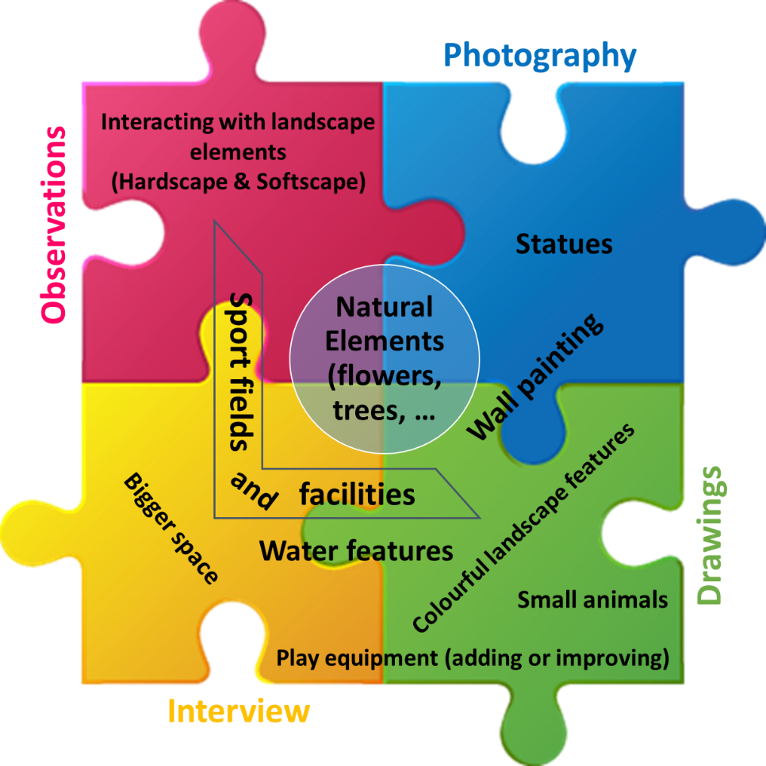
Figure (8.1): Overview of the results of the children’s preferences in the ‘Jourchin’ approach
In some instances, bringing together two methods of the ‘Jourchin’ approach helped to grasp an overall picture. For instance, ‘sport fields and facilities’ as well as ‘playground equipment’ and ‘water features’ are other things found within the children’s preferences; these can be seen in both the drawing method and in the interview component of the ‘Jourchin’.
It is true that in putting together different pieces of the ‘Jourchin’ approach, a comprehensive picture of the children’s interests is formed. However, it cannot be denied that each individual method reveals other images and understandings. This ultimately helps to create a beautiful image. For instance, having a bigger space was one of the factors that was pointed out in the interview piece of the ‘Jourchin’ approach. According to the responses obtained from the children, they wanted a bigger space because it provided a better opportunity to play. Also, ‘small animals’ like butterflies, birds, fish or dogs, and ‘some maintenance work’ were also factors which were found in the drawing piece of the ‘Jourchin’ approach.
8.4 Limitation of the Study
Some of the issues and limitations of this study have been discussed in section 3.5 within the methodology chapter. Here however, the three main limitations of this research are described.
Time was one of the most important limitations of this study. Because of children’s schedules and timetables, as well as their school time and extracurricular classes, the timing of this study did not go according to the predetermined schedule. The time of the data collection had to be adjusted in accordance with the children's free time. This issue combined with the number of data collection methods, led to spending more time in the field than was expected by the researcher for this study.
The second limitation was the lack of equal numbers of children in each method of data collection due to some of specific circumstances; for example due to the permission of the mentor, or the reluctance of children to participate in some of the data collection methods. For instance, some of the children, especially older ones, did not like to do drawings. Similarly, one group of girls aged 12 to 17 from Orphanage 2 could not participate in the photography process because their mentor would not allow them to. When the mentor was asked about this refusal, they said it was: “because they did not cooperate in drawing process”.
As this is a study with a multi-method approach, an equal number of children in each method, as well as ensuring the same children participated in all methods, would allow for even better results. It would also have been better to have the same number of children in terms of gender in each age group.
Due to government policy in Iran, the participation of government run orphanages in this study was not possible. To do so, governmental orphanages need an official letter from the Welfare Organization of Iran. This organization, out of principal, does not agree to any research being undertaken by any researcher from outside of the organization, meaning that they did not issue this official letter to the researcher. For this reason, all three orphanages involved in this study were private, and the permission for this research was issued directly from the management of each orphanage.
8.5 Recommendation
This research considered children’s preferences and satisfaction rates about the outdoor spaces of orphanages, as well as evaluating the restorative potential of these settings based on a newly developed scale. Based on the research process and obtained findings this study contributes towards helping designers, planners, practitioners, decision makers as well as managers and caretakers of the orphanages by suggesting some recommendations that can benefit the physical and psychological restoration of those children who live in orphanages.
Playing in outdoor space is a top priority and preference for those children using outdoor space in the orphanages. Further, the fact that play has an important role in the development of children, indicates that by providing an appropriate play environment with adequate outdoor facilities can be beneficial for children. As seen in the findings, some children refused to utilise outdoor space due to the lack of good quality play opportunities or boredom. Therefore, for the case studies of this research, it is suggested that outdoor space would be more attractive if we take into account children’s preferences. For example, adding playground equipment and improving the sport fields and facilities in Orphanage 1, making the space larger by removing some unnecessary items (for example a parked car at one side of the yard) would give children the opportunity to play more freely in Orphanages 2 and 3, and adding or improving play equipment reported by children in Orphanage 3, would make these spaces more interesting to children.
Although, different activities like ‘football, volleyball, group play with or without a ball’ were the most favoured activities of children occupying outdoor space, there were other activities such as: playing guitar, climbing the wall, caring for animals, playing chess, fighting (as play and kidding), slipping on ramps, playing with butterflies, Kung-Fu, playing with dolls, water spraying the yard, etc. which were reported by children for this research. This indicates that children who are of different ages and genders like to use outdoor space in different ways. Hence, if the orphanages in this study made some changes to their outdoor spaces, they would provide suitable environments for children in each age group, with regard to differences in gender. Doing this would increase the chances of children using outdoor spaces as well as increase the level of satisfaction; this would lead to an increase in the perception of the restorative potential of these orphanages, which is the goal of this study.
Additionally, the climate conditions are a problem in some cities, especially those in hot and dry areas such as the case study of this research (Kerman City). Therefore, this should be taken into consideration during the design process of outdoor spaces in these cities. Some children regarded weather conditions as a reason for not playing outdoors some of the time – this indicates that there is a need to provide elements to combat this, such as creating more shaded areas by installing canopies and increasing the number of trees. Doing this will be beneficial in supporting children in their engagement of outdoor play in orphanages located in areas with hot and dry climate conditions. This may result in children using outdoor space more rather than staying in their room or inside the building.
It should also be noted that landscape elements, whether natural elements or hardscapes, will also make the space more attractive to children. Adding more flowers, trees, and plants primarily in Orphanage 1 and adding or improving the water features such as the pool in Orphanages 2 and 3, can, as reported by children, enhance their level of satisfaction and make the space more pleasant for them. As was seen during the observations, even small hardscapes such as curbs, platforms, ramps or walls, will be interacted with by children during their play or sometimes when they want to have a break or rest during their play. However, it will be much better if those elements are made colourful as this will make the space more interesting for children.
Therefore, as a general conclusion, redesigning the outdoor spaces of the orphanages based on children’s preferences, no matter how small, might have a great impact on children both physically and psychologically as it will generate more potential for restoration.
Moreover, there should also be a regular plan and schedule for outdoor space use available to children. This will allow children to be aware of their opportunities to be outside and play, enabling them to have fun and take advantage of the allotted time.

8.6 Future Research
Surprisingly, there has been little research into the psychological benefits of the design or redesign of outdoor spaces of orphanages, as well as the restorative potential of these environments, especially in Iran. Conducting more research in this area can help to better understand children’s perceptions, their uses of outdoor spaces and the obstacles that children have in regard to the use of these spaces which affect their satisfaction.
Therefore, more research should be conducted in this area to increase the body of knowledge. Adding more comparative data relating to the outdoor spaces of the orphanages and providing recommendations for future design and planning of the orphanages’ outdoor spaces can potentially support the development of children who live in these environments around the world. It can possibly improve their physical and mental health, as well as impacting the future of the society and its sustainability.
The researcher suggests that future research seeks to examine children's preferences and their level of satisfaction as well as evaluating their perception of the restorative potential of the space. This should be done before and after designing and modifying the space on the basis of the children's preferences. Doing this will allow the changes in satisfaction and perceived restorative potential of children to be compared before and after applying children’s preferences.
As different policies operate in different cities or countries, if the time of the study allows, it would enhance the research if it was conducted in different places to allow for a comparison of the results.
Acknowledging the issues above is a step forward towards generating further informed research in this area.

APPENDIX 1
Observation and mapping data sheet
Orphanage ID
Child’s name |  | Age:
No of observation | 1 | 2 | 3 | 4
Date:
Period:
Morning | Noon | Afternoon | Evening | Morning
Start time:
Area type:
1. Dramatic play area(s) 2. Gathering area(s) 3. Open area(s) 4. Pathway 5. Play equipment 6. Sand play 7. Portable play env. 8. Fixed play environment 9. Playground 10. Court Space 11. Play space 12. Field
Area Condition:
A= area is accessible D= Dark Emt= Empty U=Area is usable for physical activity
S= Area is supervised by designated school or adjunct personnel
O= Organized physical activity is occurring in the area
E = Equipment provided by the school or other agency is present
Surface Area:
1. Sand 2. Dirt 3. Gravel 4. Mats 5. Cement 6. Grass
7. Carpet 8. Tile 9. Water 10. Wood 11. Asphalt 12. other
Types of activity*:
Level of Activity**:
Play:
Types of play:
SF= Self-focused IP= Inside physical environment O= Observing others
VI= Verbally interacting with others CO= Constructing activity IE= Close interaction with natural env.
EE= Exploring environment IA= Imaginative activity FE= Playing with free equipment
FS= Playing on fixed structure TG= Participating structured team game OP= Observing participant
ML= Moving between locations CA= Changing activity O= Other
Social interaction:
Solitary play- plays alone no reference to others
Parallel play-alongside others, uses available materials, no influence on other
Associated play- play with others engaged in similar activity. Communication and materials exchanged no overall goal to activity
Co-operative play- group of children organized themselves with a specific goal in mind. i.e., team game, drama
Landscape features:
water features, trees, flowers, shrubs, fence, signs, shelters, benches, walls, drinking fountains, litter bins, lights
Comments:

*Types of activity
Fitness Related Codes:
Aerobics (dance/step aerobics), fitness stations, jogging/running, strengthening exercises (pull ups), walking, weight training/lifting
Sport Related Codes:
Basketball, Football, Handball, Volleyball, Racquet sports (tennis, badminton), martial arts (judo, karate), Gymnastics, cheer leading, Dance, Swimming
Active Game Related Codes
Climbing/sliding, jumping (rope, hoops, hop scotch), manipulative games, tag/chasing games, none of the activities above (e.g., track)
Sedentary Related Codes
No specific activity (sit, stand, walk), sedentary games/activities, artwork, chess/checkers/cards, lying down, picnicking (food involved), reading, standing, sitting
Other activities
Playground games (e.g., tetherball, 4-square), Pull/push, Rough and tumble, Ride, Rock, Roll, Swing, Throw

**Level of Activity:

Sedentary
1. Stationary-no movement (Stationary or motionless with no major limb movement or major joint movement) (lying down, sitting, standing)
2. Stationary-with movement (Stationary with easy movement of limb(s) or trunk without translocation)
Moderate
3. Translocation-slow/easy (Slow-easy movement (translocation at a slow and easy pace)) (walking). Translocation- medium/moderate (Moderate movement (translocation at a moderate pace)), (Running, jogging)
4. Translocation- fast, very fast/strenuous (Fast movement (translocation at a fast or very fast pace)), (Running, jogging)
5. Very active-MPVA (moderate and vigorous physical activity) (wrestling with a peer, pedalling a moving tricycle or bicycle or stationary bike, skipping, hopping)

APPENDIX 2
Interview Questions for children

1. What grade are you in? ……………………………..
2. How long have you been in this orphanage?
Less than 1 month Less than 1 year 1 to 3 years More than 3 years

Play
3. Do you like playing? …………..…………………………………...………………
4. Who do you play with?...............................................................................................
5. Where do you play most of the time?
Indoor, why? ........................................................................................................
……………………………………….……………………………………………….
Outdoor, why? …….…………………………………………………………….
……………………………………………………………………………………….
6. Which places do you most like to be when you are alone? Why?
……………………………………………………………………………………………………………………………………………………………………………………
7. What do you do when you are playing outdoors at you living environment? …………………………….………………………….……………………………….
…………………………………………………………………………………………
8. When do you usually play outdoors?
Morning Midday Afternoon
Weekdays
Weekends
School Holidays

9. Where else do you play outdoors? (at school, on way/back from school, outside the orphanage)
……………………………………………………………………………………………………………………………………………………………………………………
10. How important is play for you? …………………………………………………………………………………………
Why? ….……………………………………………………………………………………...
…………………………………………………………………………………………
11. What benefits do you think you get from play? (Probes: social, fun, exercise, meet friends, relax)
……………………………………………………………………………………………………………………………………………………………………………………
12. Do you think it is different for different children? (Probes: girls/boys, age, different era)
……………………………………………………………………………………………………………………………………………………………………………………

About orphanage open space:
13. Do you have the view from your bedroom to the orphanage open space?
Yes No
14. What is the view from your bedroom? …………………………………………………………………………………………
15. Do you like the view from your bedroom window?
Yes, why? …....…………………………………………………………….
No, why? ........................................................................................................
Indifferent .......................................................................................................
16. How often are you allowed to use the open space? (with permission and supervised)
Once a week Twice a week
Three to five times a week Everyday

17. How often do you use the open space? (without control or permission)
Once a week Twice a week
Three to five times a week Everyday
18. How long do you spend there? …………………………………………..………..

19. Why do you usually go to outdoor environment of your living place?
……………………………………………………………………………………………………………………………………………………………………………………
20. What is your favourite place in the outdoor environment of your living place? …………………………………………………………………………………………
Why?……………………………………………………………………………………………………………………………………………………….…………………
21. How do you usually feel when you are in the outdoor environment of your living place?

22. Do you go with anyone else to this outdoor environment of your living place?
Yes, Who? ……………….
No
23. What do you do in the outdoor space?
……………………………………………………………………………………………………………………………………………………………………………………
24. Do you like the open space of your living environment?
Like it very much Like it Neither like it nor dislike it
Dislike it Dislike it very much
25. What are the three main things you like about this open space?
…………………………………………………………..
……………………………………………………………
……………………………………………………………
Can you rank them in order?
26. What are the three main things you dislike about this open space?
……………………………………………………………
……………………………………………………………
……………………………………………………………
Can you rank them in order?

Ownership
27. How do you feel about your living outdoor space? why?
…………………………………………………………………………………………………………………………………………………….……………………………
28. Who do you think looks after the outdoor space? ………………………………………………….……………………………………
29. Who keeps it clear and clean? ………………………………..………………………………………………………
30. Do you think it is important to take care of the outdoor space? Why?
……………….…………………………………………………………………………………………………………………………………………….…………………

Favorite and uncomfortable places in outdoor environment
31. Can you tell me, in order, what are your favorite places in your living environment? (whether inside or outside) Why these are your favorite places? …………………………………………………………………………………………
…..………………………………………..………………………………………….
32. Are there any places in your living environment where you feel comfortable (inside or outside)?
Yes, Where are they? …………………………………………………………
Can you describe why you feel comfortable in these places?..............................
………………………………………………………………………………................
No
33. Are there any places in your living environment where you don’t feel comfortable (inside or outside)?
Yes, Where are they? ……………………………………………………..….
Can you describe why you don’t feel comfortable in these places?....................
........................................................................................................................................
No
34. Can you name any places in your outdoor environment where you are not allowed to go? …………………………………………………………………………………………Why do you think you are not allowed to go there? ………………………………………….……………………………………………
Do you go there? …………………………
Would you like to be allowed to go there? Why?
………………………………………………………………………………….

Activity
35. What is your favorite outdoor activity at the outdoor space?
……………………………………………………………………………………………………………………………………………………………………………………
36. Are there outdoor activities you would like to do at open space but can’t?
Yes, Where are they?.............................................................................................
Why can’t you?…………………………………………………………………
No
37. Are there outdoor activities other children do that you would like to join in but can’t?
Yes, What are they?..............................................................................................
Why can’t you join in? …………………………………………………………
No
38. Would you like to go outside in:
Yes No we are allowed to we are not allowed to
Snow
Wind
Hot weather Cold whether
Rain Sunny

Play at orphanage
39. What do you think about play facilities available for you and your friends at your living outdoor space?…………………………………………………………………
…………………………………………………………………………………..……

40. Would new equipment make you enjoy using the outdoor space?
Yes, why?...........................................................................................................
No, why?............................................................................................................
Don’t know
41. Would new landscape elements (such as vegetation, fountains, …) make you enjoy using the outdoor space?
Yes, why?...........................................................................................................
No, why?............................................................................................................
Don’t know
42. What makes a good play area in your opinion? Why? Examples?
..……………………………………………………………………..……………………………………………………………………………………………………………

Other outdoor environments:
43. What are your favourite outdoor environments?
……………………………………………………………………………………………………………………………………………………………………………………
44. Why are they your favourite outdoor environment?
……………………………………………………………………………………………………………………………………………………………………………………
45. Are there any outdoor spaces apart from your living area where you like or feel very comfortable?
Yes, where is it? ………………….
Which spaces?.....................
Are you allowed to go? ………………….
When do you usually go there? ……………………
What is special about that place? ………………………
No
46. Have you ever been to any outdoor place that you really liked?
…………………………………………………………………………………………………………………………………………………………………..………………Where was that? …………………………………………………………………………………………
Why did you like most about this place? ……………………………………………………………….………………………..
…………………………………………………………………………………………
47. Have you ever been to or seen another orphanage where you really liked the outdoor space?
Yes, what did you like about it?.....................................................................
.........................................................................................................................
No
48. Have you ever been to or seen another orphanage where you really disliked the outdoor space?
Yes, What didn’t you like?..............................................................................
.........................................................................................................................
No

Overall:
49. Overall, how would you rate the quality and existing conditions of open space in your living environment?
Poor Very Good
1 2 3 4 5 6 7 8 9 10
50. If the space were to be improved what changes would you like to see?
……………………………………………………………………………………………………………………………………………………………………………………
51. Do you want to tell me anything else about the outdoor environment that we haven’t already mentioned? ……..…………………………………………………………………………………………………………………………………………………….…………………….
52. If in the future were to be changed the space was changed would you like to participate the work? ……..……………………………………………………………….………………………………………………………………………..………………………………….
53. What do you think you could do?............................................................................
........................................................................................................................................THANK YOU VERY MUCH FOR YOUR HELP

APPENDIX 3
The Perceived Restorativeness Scale developed by Hartig et al. (1996, 1997)
Being Away
It is an escape experience.
Spending time here gives me a good break from my day-to-day routine.
Fascination
The setting has fascinating qualities.
My attention is drawn to many interesting things.
I would like to get to know this place better.
I want to explore the area. (In Study 2 this item was replaced by the item below.)
There is much to explore and discover here.
I would like to spend more time looking at the surroundings.
Coherence (Extent)
There is too much going on.
It is a confusing place.
There is a great deal of distraction.
It is chaotic here.

Compatibility
I can do things I like here.
I have a sense that I belong here.
I have a sense of oneness with this setting.
Being here suits my personality.
I could find ways to enjoy myself in a place like this.

APPENDIX 4
The revised Perceived Restorativeness Scale by Hartig, Kaiser, and Bowler (1997)
The items are grouped by subscale membership (Being Away, Fascination, Coherence, and Compatibility, respectively):
1. Being here is an escape experience. *
2. Spending time here gives me a break from my day-to-day routine. †
3. It is a place to get away from it all.
4. Being here helps me to relax my focus on getting things done.
5. Coming here helps me to get relief from unwanted demands on my attention.
6. This place has fascinating qualities. *
7. My attention is drawn to many interesting things. *
8. I want to get to know this place better. †
9. There is much to explore and discover here. *
10. I want to spend more time looking at the surroundings. †
11. This place is boring. (-)
12. The setting is fascinating.
13. There is nothing worth looking at here. (-)
14. There is too much going on. (-) *
15. It is a confusing place. (-) *
16. There is a great deal of distraction. (-) *
17. It is chaotic here. (-) *
18. Being here suits my personality. *
19. I can do things I like here. *
20. I have a sense that I belong here. *
21. I can find ways to enjoy myself here. †
22. I have a sense of oneness with this setting. *
23. There are landmarks to help me get around. ‡
24. I could easily form a mental map of this place. ‡
25. It is easy to find my way around here. ‡
26. It is easy to see how things are organized. ‡
Notes:
(-) an item for which the value must be reversed in coding; (*) the item is from the earlier PRS and is in its original form; (†) the item is from the earlier PRS but is in a revised form; (‡) the item was designed to represent legibility.

APPENDIX 5
‘’Being away’’ and ‘’Fascination’’ items suggested by Professor Hartig in an informal contact by email.
"How much does this statement apply to my experience in this place?"
To indicate your answer, circle one of the numbers on the scale beside it. A sample of the scale with verbal descriptions for the values is given below.
0 -------1------- 2 ------- 3 ------- 4 ------- 5 ------- 6 ------- 7 ------- 8 ------- 9 ------- 10
Not Very Rather Rather Very Completely
at all little little much much

Being Away items
This place is a refuge from unwanted distractions. 0 – 1 – 2 – 3 – 4 – 5 – 6 – 7 – 8 – 9 – 10
I experience few demands for concentration 0 – 1 – 2 – 3 – 4 – 5 – 6 – 7 – 8 – 9 – 10
when I am here.
Spending time here gives me a break from my 0 – 1 – 2 – 3 – 4 – 5 – 6 – 7 – 8 – 9 – 10
day-to-day routine.
This is a place to get away from the things that 0 – 1 – 2 – 3 – 4 – 5 – 6 – 7 – 8 – 9 – 10
usually demand my attention.
Being here helps me to stop thinking about the 0 – 1 – 2 – 3 – 4 – 5 – 6 – 7 – 8 – 9 – 10
things that I must get done.
Fascination items
This place is fascinating. 0 – 1 – 2 – 3 – 4 – 5 – 6 – 7 – 8 – 9 – 10
Following what is going on here really 0 – 1 – 2 – 3 – 4 – 5 – 6 – 7 – 8 – 9 – 10
holds my interest.
This place awakens my curiosity. 0 – 1 – 2 – 3 – 4 – 5 – 6 – 7 – 8 – 9 – 10
There is much to explore and discover here. 0 – 1 – 2 – 3 – 4 – 5 – 6 – 7 – 8 – 9 – 10
My attention is drawn to many interesting 0 – 1 – 2 – 3 – 4 – 5 – 6 – 7 – 8 – 9 – 10
things here.

APPENDIX 6
Final developed PRS scale for current research
Being away
- In the yard I can relax mentally.
- In the yard, nobody tells me what to do.
- In the yard, I don’t think at my worries.
- In the yard I can relax physically.
- In the yard, nobody tells me what to think.
- Spending time in the yard gives me a break from my day-to-day routine.

Fascination
- The yard is fascinating.
- In the yard there are lots of things that awaken my curiosity.
- There are many objects in the yard that attract my attention.
- I would like to spend more time in the yard looking at surroundings.
- In the yards, there is nothing worth looking at.

Extend (scope, coherence)
- In the yard everything seems to have a proper place (coherence)
- The yard is a confusing place (coherence)
- There are few hard boundaries in the yard to limit my possibilities for moving around (scope)

Compatibility
- In the yard I am free to play, run, and move.
- In the yard it is easy to see what’s around me
- I can find ways to enjoy myself in the yard.
- The yard gives me the opportunity to do activities that I like.

Preference
- I like this yard.
- I prefer this yard over all other places I have ever been. (such as park, school yard, home’s yard)

APPENDIX 7
Persian version of PRS scale used in data collection:
تا چه حد جمله های زیر تجربه تو را در حیاط توصیف می کنند:
- در حیاط می توانم به لحاظ روانی آرامش پیدا کنم.
کاملا مخالفم   | مخالفم   | مطمئن نیستم   | موافقم   | کاملا موافقم  
- در حیاط ، هیچ کس به من نمی گوید چه کار کنم.
کاملا مخالفم | مخالفم | مطمئن نیستم | موافقم | کاملا موافقم
- در حیاط ، من به نگرانی هایم فکر نمی کنم.
کاملا مخالفم | مخالفم | مطمئن نیستم | موافقم | کاملا موافقم
- در حیاط می توانم به لحاظ جسمی آرامش پیدا کنم.
کاملا مخالفم | مخالفم | مطمئن نیستم | موافقم | کاملا موافقم
- در حیاط هیچ کس به من نمی گوید به چه چیزی فکر کنم.
کاملا مخالفم | مخالفم | مطمئن نیستم | موافقم | کاملا موافقم
- وقت گذراندن در حیاط برای من زنگ تفریحی است در روال عادی زندگی روزمره.
کاملا مخالفم | مخالفم | مطمئن نیستم | موافقم | کاملا موافقم
- حیاط جذاب است.
کاملا مخالفم | مخالفم | مطمئن نیستم | موافقم | کاملا موافقم
- در حیاط ، چیزهای زیادی وجود دارد که کنجکاوی من را بیدار می کند.
کاملا مخالفم | مخالفم | مطمئن نیستم | موافقم | کاملا موافقم

- من مایلم وقت بیشتری را در حیاط صرف نگاه کردن به اطراف کنم.
کاملا مخالفم | مخالفم | مطمئن نیستم | موافقم | کاملا موافقم
- اشیاء زیادی در حیاط وجود دارد که توجه مرا جلب می کند.
کاملا مخالفم | مخالفم | مطمئن نیستم | موافقم | کاملا موافقم
- در حیاط، هیچ چیزی نیست که ارزش دیدن داشته باشد.
کاملا مخالفم | مخالفم | مطمئن نیستم | موافقم | کاملا موافقم
- به نظر می رسد که در حیاط همه چیز مکان مناسبی دارد.
کاملا مخالفم | مخالفم | مطمئن نیستم | موافقم | کاملا موافقم
- حیاط یک مکان گیج کننده است.
کاملا مخالفم | مخالفم | مطمئن نیستم | موافقم | کاملا موافقم
- موانع سخت اندکی در حیاط وجود دارد که امکان حرکت کردن مرا در اطراف محدود کند.
کاملا مخالفم | مخالفم | مطمئن نیستم | موافقم | کاملا موافقم
- در حیاط من آزادم که بازی کنم ، بدوم و حرکت کنم.
کاملا مخالفم | مخالفم | مطمئن نیستم | موافقم | کاملا موافقم
- در حیاط ، دیدن انچه اطراف من هست آسان است.
کاملا مخالفم | مخالفم | مطمئن نیستم | موافقم | کاملا موافقم
- من می توانم راه هایی برای لذت بردن در حیاط پیدا کنم.
کاملا مخالفم | مخالفم | مطمئن نیستم | موافقم | کاملا موافقم
- حیاط به من فرصتی می دهد تا فعالیت هایی را که دوست دارم انجام دهم.
کاملا مخالفم | مخالفم | مطمئن نیستم | موافقم | کاملا موافقم
- من این حیاط را دوست دارم.
کاملا مخالفم | مخالفم | مطمئن نیستم | موافقم | کاملا موافقم
- من این حیاط را به همه ی مکان های دیگری که تا کنون بوده ام ترجیح می دهم ( از جمله پارک ، حیاط مدرسه ، حیاط خانه).
کاملا مخالفم | مخالفم | مطمئن نیستم | موافقم | کاملا موافقم

APPENDIX 8
The information sheet about the methods and data collection process provided for children.
Information Sheet for children
Dear participant;
You are being invited to take part in a research project. Before you decide it is important for you to understand why the research is being done and what it will involve. Please take time to read the following information carefully and discuss it with others if you wish. Ask us if there is anything that is not clear or if you would like more information. Take time to decide whether or not you wish to take part. Thank you for reading this.
Aim of the research:
The aim of this study is to investigate the your happiness and satisfaction with the existing open space in your living environment; and to document your preferences about orphanage open spaces; also to evaluate the restorative value of the orphanage open space from the viewpoints of you.
I would appreciate your help in finding out your satisfaction about orphanage open space and perceived its restorative potential, and also your feeling about where you live.
Taking part in the research is entirely voluntary and it is up to you to decide whether or not to take part. You may stop being involved at any time without penalty or loss of benefits.
If you do decide to take part you will be given this information sheet to keep and be asked to sign a consent form. You can still stop at any time without it affecting any benefits that you are entitled to in any way. You do not have to give a reason.
Interview:
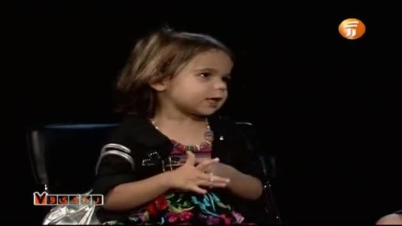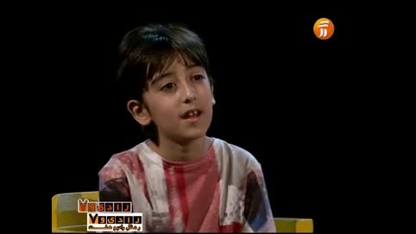
Picture 1 Picture 2
The interview will be used to gather your opinion of what open space is; what you like/dislike about your orphanage open space in your viewpoint. Interviews will be based on a set of prepared questions to gather information from you.
Each interview may take about 20 minutes to be done. I would like to use audio recordings of your answers because it make easier for me to refer to it at any time to review the answers during the research. The audio recording will be used only for analysis and for my thesis, conference presentations and academic papers. No other use will be made of them without your written permission, and no one outside the project will be allowed access to the original recordings.
Self-Mapping drawing:
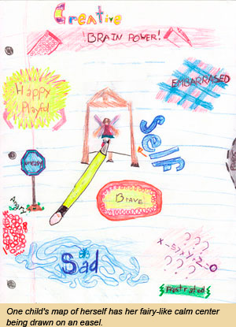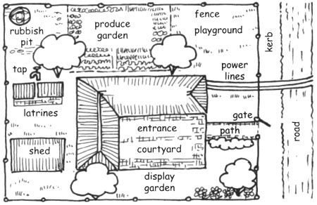
Picture 3 Picture 4
In order to examine which elements of landscape you most prefer in the outdoor environments. You will be asked to draw a plan of the outdoor environment of the orphanage. You will be asked to draw the things you would like to see in the orphanage open space and you wish to have in this place. You will be able to complete it in a number of sessions on different days, which will give you the opportunity to reflect on your daily environment during your work and play and record this additional information on your maps.
Taking photographs:
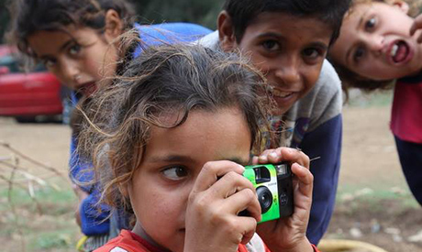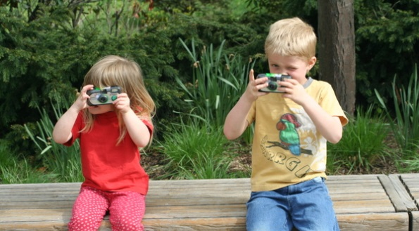
Picture 5 Picture 6
You will also be asked to take pictures with disposable cameras from anywhere and of anything in the open spaces that you like/dislike the most.
Focus group interviews:
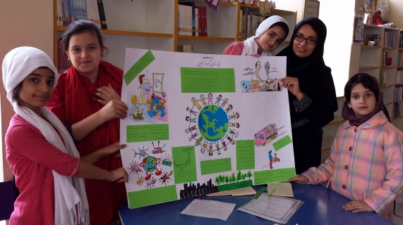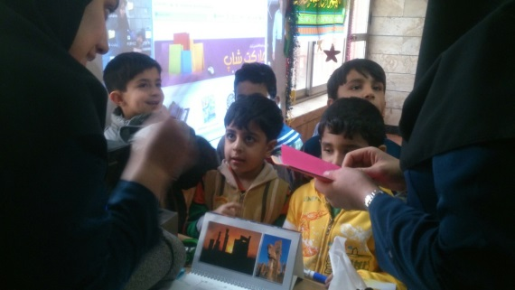
Picture 7 Picture 8
The researcher will conduct focus group interviews with you and your friends in a same age in order to assist with interpretation of your drawings, photographs and written descriptions.
Questionnaire:
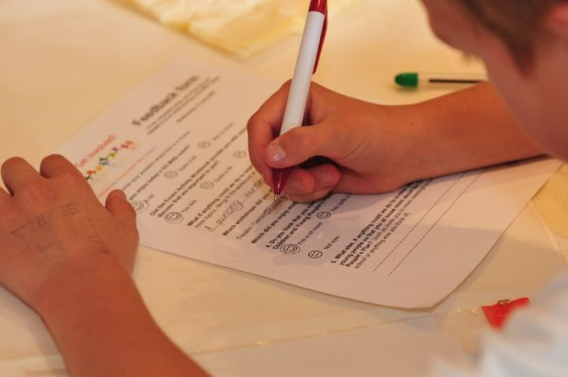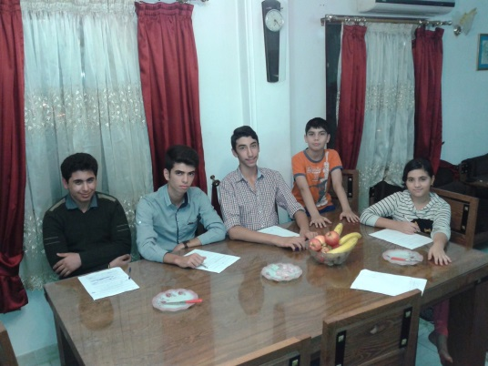
Picture 9 Picture 10
You will complete a questionnaire containing the questions related to the restorative value of the orphanage open space.
There are no immediate benefits for you to participate in this project, but it is hoped that you have some fun during this period yourself and with your friends.
The results of this research can be important to provide recommendations for future design and planning of the orphanages. All the information that we collect about you during the course of the research will be kept strictly confidential. You will not be able to be identified in any reports or publications.
Use of information
The information collected in this research project will be used for my thesis. It will also be used for papers and journals and conferences. The information may be used in future research.
This project has been ethically approved via Landscape department’s ethics review procedure from the University of Sheffield.
As you may know, surveys require a good response rate so that the result can be understood properly. Therefore, I would greatly appreciate your participation in this survey.
If you have any question about this study, please call me with this number: 09133971973
If you wish to obtain further information about the project you can contact me or my supervisor with the information provided below.
If you wish to raise a complaint you can contact my supervisor, Prof. Helen Woolley
Thank you very much for your cooperation and participation.
Maryam Mani (Researcher)
Email: mmani1@sheffield.ac.uk
Helen Woolley (supervisor)
Email: h.woolley@sheffield.ac.uk
Picture 1: Source: http://www.aparat.com/v/hSGfi/%D9%85%D8%B5%D8%A7%D8%AD%D8%A8%D9%87_%D8%B1%D8%A7%D9%85%D8%A8%D8%AF_%D8%AC%D9%88%D8%A7%D9%86_%D8%A8%D8%A7_%D8%B3%D9%87_%DA%A9%D9%88%D8%AF%DA%A9_%D9%86%D8%A7%D8%B2_%D9%88_%D8%A8%D8%A7%D8%B9%D8%B4%D9%82 available on 29/01/15
Picture 2: source: http://www.aparat.com/v/XKV5Z/%DA%AF%D9%81%D8%AA%DA%AF%D9%88_%D8%A8%D8%A7_%DA%A9%D9%88%D8%AF%DA%A9%D8%A7%D9%86.%D8%B1%D9%88%D8%AD%D8%A7%D9%86 available on 29/01/15
Picture 3: Source: http://www.ittakesachild.net/calmcore.html available on 29/01/15
Picture 4: Source: http://www.fao.org/docrep/009/a0218e/A0218E05.htm available on 29/01/15
Picture 5: Source: http://english.ahram.org.eg/NewsContent/5/25/121460/Arts--Culture/Visual-Art/Syria-refugee-children-depict-joy,-pain-in-photos.aspx available on 29/01/15
Picture 6: Source: http://www.barefootkitchenwitch.com/the_barefoot_kitchen_witc/gratitude/ available on 29/01/15
Picture 7: Source: http://koudakan.blogfa.com/post/2 available on 29/01/15
Picture 8: Source: http://drhesabi-pish.arakus.ir/ available on 29/01/15
Picture 9: Source: http://www.essex.gov.uk/education-schools/Pages/Default.aspx available on 29/01/15
Picture 10: Source: http://www.tilar-sportgroup.com/?p=8345 available on 29/01/15
APPENDIX 9
The information sheet about the methods and data collection in Persian.
برگه اطلاعات برای کودکان و نوجوانان
شرکت کننده ی گرامی:
شما برای شرکت در یک پروژه تحقیقاتی دعوت شده اید. قبل از تصمیم گیری مهم است که بدانید چرا این تحقیق انجام می شود و شامل چه چیزی می شود. لطفا برای مطالعه دقیق اطلاعات زیر وقت بگذارید و در صورت تمایل در مورد آن با دیگران بحث کنید. اگر چیزی روشن نیست و یا اگر مایلید اطلاعات بیشتری داشته باشید از ما بپرسید. برای تصمیم گیری در مورد اینکه شرکت کنید یا خیر وقت بگذارید. برای مطالعه این مطالب از شما متشکرم.
هدف پژوهش:
هدف این پژوهش بررسی شادی و رضایت شما از فضای باز موجود در محیط زندگی شما و سندسازی اولویت های شما در مورد فضاهای باز محیط زندگی تان و نیز ارزیابی ارزش ترمیمی این فضا ها (حیاط) از دیدگاه شما می باشد.
من از کمک شما در پی بردن به رضایت شما از فضای باز محیط زندگی تان و درک پتانسیل ترمیمی آن و همچنین احساس تان در مورد جایی که زندگی می کنید، قدردانی می کنم.
شرکت در این پژوهش کاملا اختیاری است و به شما بستگی دارد که تصمیم بگیرید شرکت کنید یا نه. شما می توانید در هر زمان بدون جریمه یا خسارت به منافع کناره گیری کنید.
اگر تصمیم به مشارکت گرفتید این برگه اطلاعات به شما داده می شود تا آن را نزد خود نگه دارید و از شما خواسته می شود تا فرم رضایت نامه را امضا کنید. شما همچنان می توانید در هر زمان بدون تاثیر بر منافعی که در هر حال مستحق آن هستید کناره گیری کنید و لازم نیست دلیلی ارائه کنید.
مصاحبه :
شکل 2 شکل 1
مصاحبه برای جمع آوری نظرات شما در مورد اینکه فضای باز چیست؟ و شما چه چیزهایی را در مورد فضای سبز محیط زندگی تان دوست دارید یا دوست ندارید؟ مصاحبه ها براساس یک سری پرسش های آماده برای جمع آوری اطلاعات از شما صورت می گیرد.
هر مصاحبه ممکن است حدود 20 دقیقه طول بکشد. من مایلم از ضبط شنیداری پاسخ های شما استفاده کنم زیرا در طول تحقیق رجوع به آنها در هر زمان برای بررسی پاسخ ها برایم آسان تر است. ضبط صداها تنها برای تحلیل و پایان نامه ی من، ارائه کنفرانس و مقالات علمی استفاده خواهد شد. بدون رضایت کتبی شما هیچ استفاده ی دیگری از آنها نخواهد شد و هیچ کس خارج از پروژه اجازه دسترسی به صداهای ضبط شده اصلی را ندارد.
کشیدن و نقاشی بر روی نقشه:
شکل 4 شکل 3
به منظور بررسی اینکه شما کدام یک از عوامل منظر را در محیط های بیرونی ترجیح می دهید، از شما خواسته خواهد شد تا نقشه ای از محیط بیرونی (حیاط) محل زندگی تان رسم کنید. از شما خواسته می شود که چیز هایی را که دوست دارید در فضای باز محل زندگی تان ببینید و مایلید در این مکان داشته باشید رسم کنید. می توانید آن را در چند جلسه در روزهای مختلف تکمیل کنید که این فرصت را به شما می دهد که در طول کار و بازی تان در مورد محیط روزمره تان فکر کنید و این اطلاعات اضافی را روی نقشه تان رسم کنید.
گرفتن عکس :
شکل 6 شکل 5
همچنین از شما خواسته می شود که با دوربین های دیجیتال از هرجا و هر چیزی که در فضای باز بیشتر دوست دارید یا بدتان می آید عکس بگیرید.

مصاحبه ی گروهی :
شکل 8 شکل 7
محقق، مصاحبه های گروهی ای را با شما و دوستان هم سن تان اجرا می کند تا به تفسیر نقشه ها، عکس ها و توصیف های نوشتاری شما کمک کند.
پرسشنامه:
شکل 10 شکل 9
شما یک پرسشنامه را تکمیل خواهید کرد که حاوی سوالات مربوط به ارزش ترمیمی فضای باز محل زندگی تان میباشد.
شرکت در این پروژه هیچ منفعت آنی ای برای شما ندارد اما امید است که شما در طول این دوره به تنهایی و با دوستانتان کمی سرگرم شوید.
نتایج این تحقیق می تواند برای ارائه ی توصیه هایی برای طرح آینده و طرح ریزی خانه های کودکان و نوجوانان مهم باشد. همه اطلاعاتی که ما در طول جریان تحقیق در مورد شما جمع آوری می کنیم کاملا محرمانه نگه داشته خواهند شد. شما در هیچ یک از گزارشات یا نشریات شناسایی نخواهید شد.
استفاده از اطلاعات:
اطلاعات جمع آوری شده در این پروژه ی تحقیقاتی برای پایان نامه ی من استفاده خواهند شد. این اطلاعات همچنین برای مقالات، مجلات و کنفرانس ها مورد استفاده قرار می گیرند. این اطلاعات ممکن است در تحقیقات آینده نیز به کار روند.
این پروژه به لحاظ اخلاقی از طریق روند بررسی اخلاقیات بخش معماری منظر از دانشگاه تایید شده است.
همانطور که ممکن است بدانید، پژوهش ها مستلزم یک روش پاسخگویی خوب هستند به طوری که نتایج به طور مناسب قابل درک باشند. بنابراین، من خیلی از مشارکت شما در این پژوهش قدردانی می کنم.
اگر هر سوالی در مورد این مطالعه داشتید، لطفا با این شماره با من تماس بگیرید: 09133971973
اگر مایلید اطلاعات بیشتری در مورد پروژه بدست بیاورید، می توانید با من یا ناظر من با اطلاعات ارائه شده در زیر تماس بگیرید.
اگر مایلید که شکایتی مطرح کنید، می توانید با ناظر من پروفسور هلن وولی تماس بگیرید.
به خاطر همکاری و مشارکت شما بسیار متشکرم.
مریم مانی ( محقق ) هلن وولی ( ناظر)
ایمیل: mmani1@sheffield.ac.uk ایمیل : h.woolley@sheffield.ac.uk

APPENDIX 10
Children consent form published by the University of Sheffield.

Children Consent Form

Title of Research Project: The relationship between satisfaction of children and perceived restorative potential of orphanage open space in Kerman, Iran

Name of Researcher: Maryam Mani

Orphanage identification code:

Participant Identification Number for this project:

- I confirm that I have read and understand the information sheet dated
explaining the above research project and I have had the opportunity
to ask questions about the project.

- I understand that my participation is voluntary and that I am free to
Withdraw at any time without giving any reason and without there being any negative consequences. In addition, should I not wish to answer any particular question or questions, I am free to decline.
- I understand that my responses will be kept strictly confidential.

- I give permission for the audio recording to take place during interview.

- I give permission for members of the research team to have access to
my anonymised responses. I understand that my name will not be linked with the
research materials, and I will not be identified or identifiable in the
report or reports that result from the research.
- I understand that the photograph taken by me and the drawings will be used in future Researcher’s thesis, conference presentation and published paper.

- I agree for the data collected from me to be used in future research.

- I agree to take part in the above research project.

________________________ ________________ ____________________
Name of Participant Date Signature
(or legal representative)

_________________________ ________________ ____________________
Name of person taking consent Date Signature
(if different from lead researcher)
To be signed and dated in presence of the participant

_________________________ ________________ ____________________
Lead Researcher Date Signature
To be signed and dated in presence of the participant
Copies:

Once this has been signed by all parties the participant should receive a copy of the signed and dated participant consent form, the letter/pre-written script/information sheet and any other written information provided to the participants. A copy of the signed and dated consent form should be placed in the project’s main record (e.g. a site file), which must be kept in a secure location.

APPENDIX 11
A sample of consent form from one child in Persian. The name of the child is covered due to anonymity.
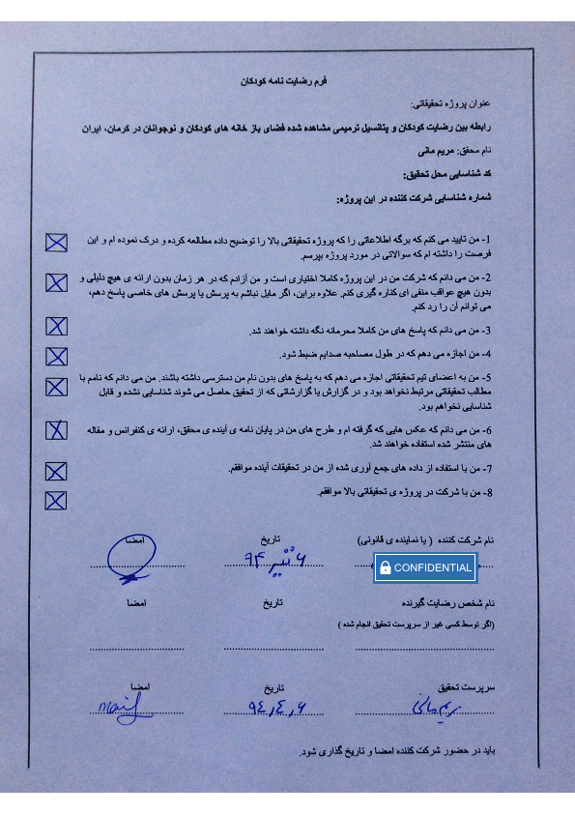

APPENDIX 12
Some of the liked photos taken by children
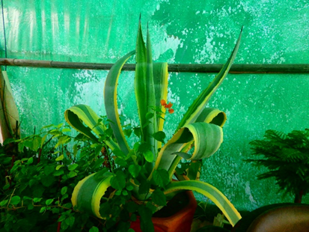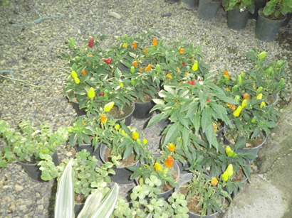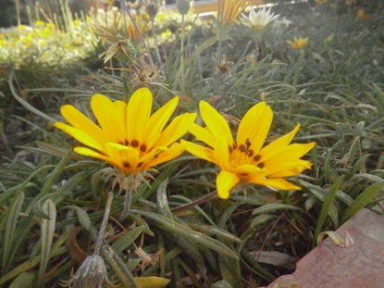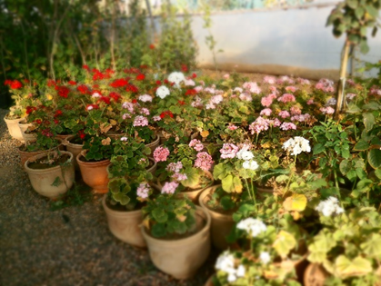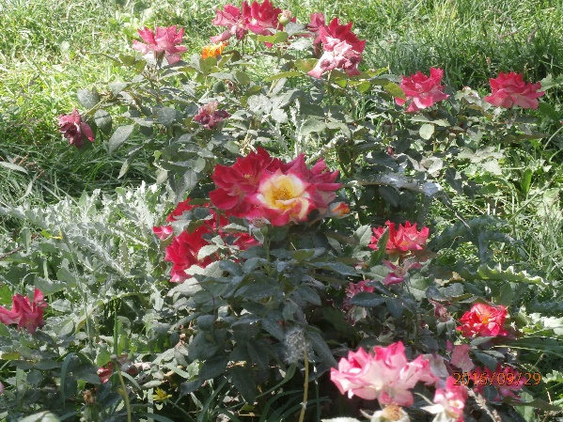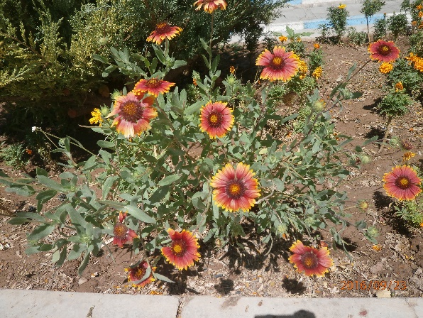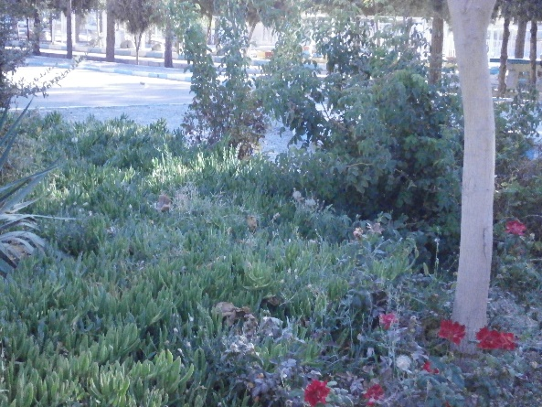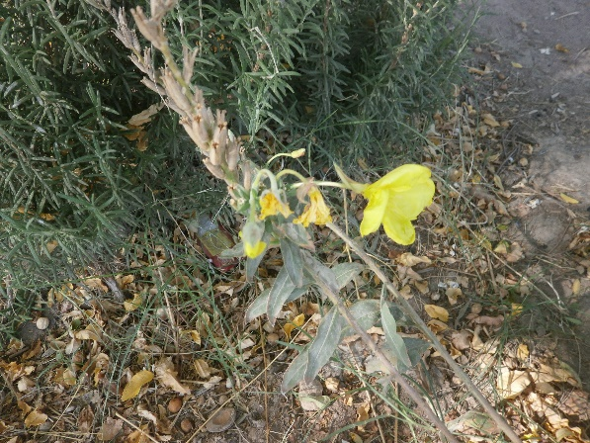
Flowers
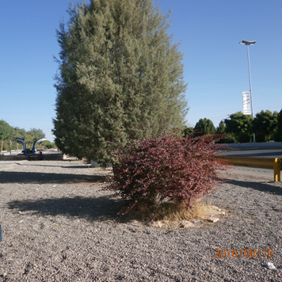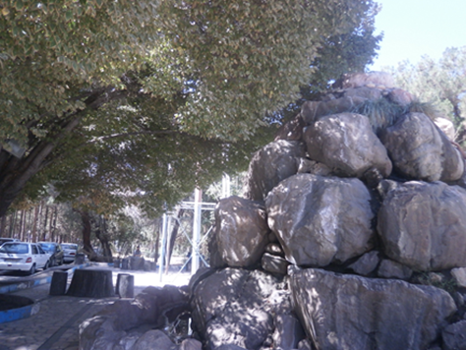
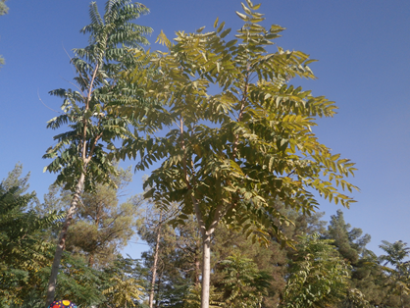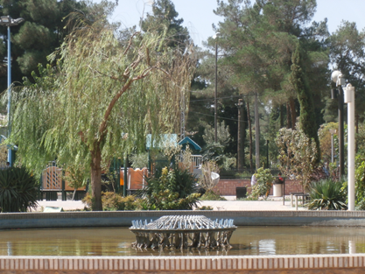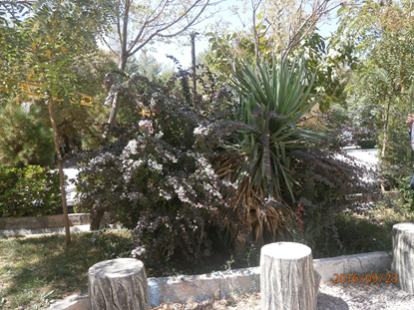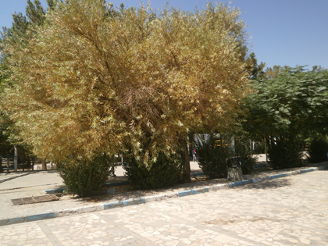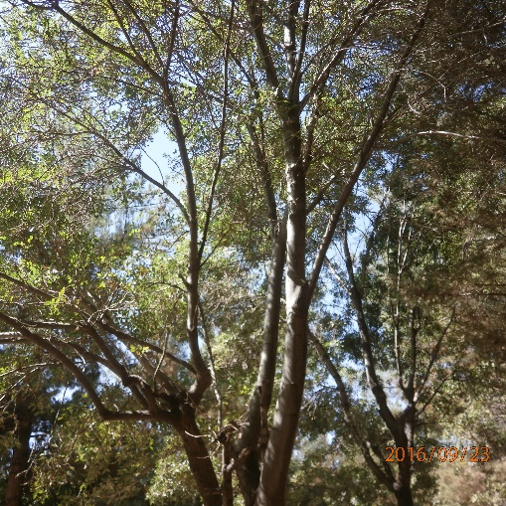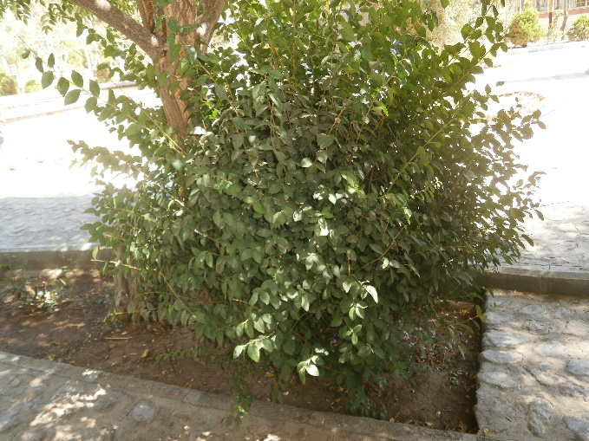
Tree
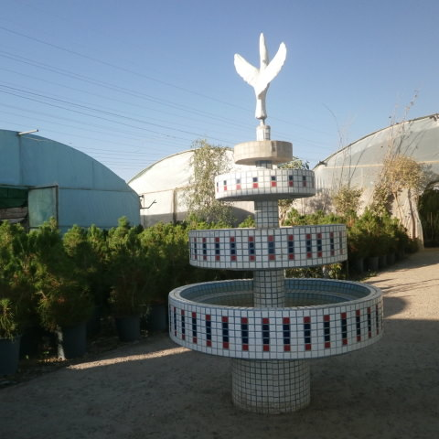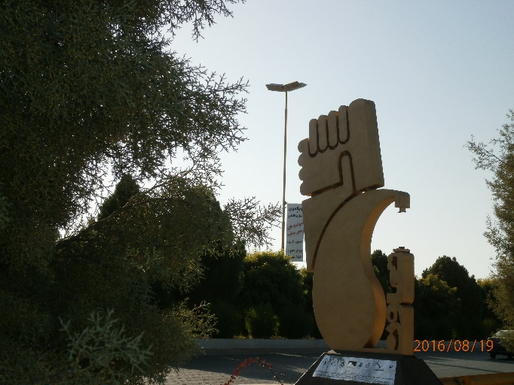
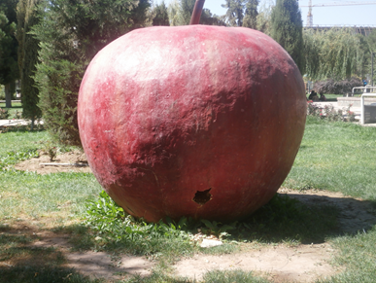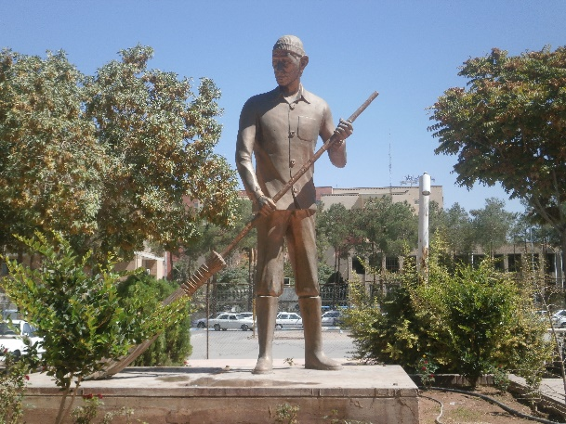
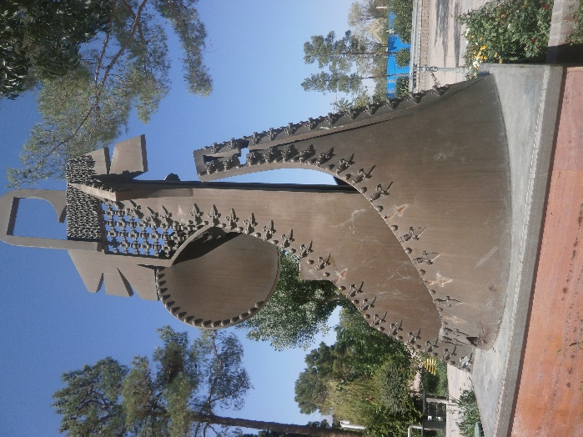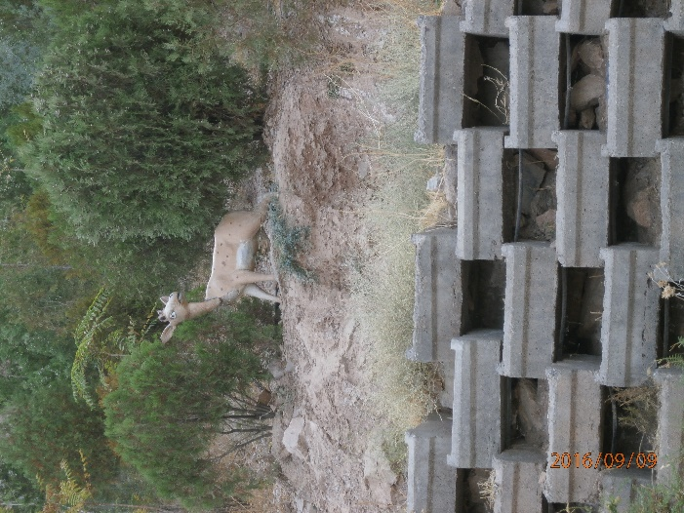

Statue

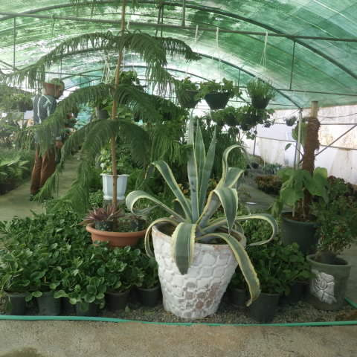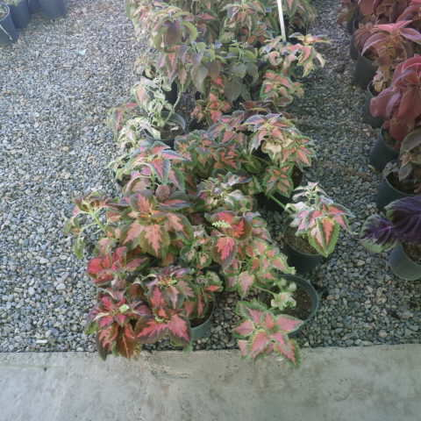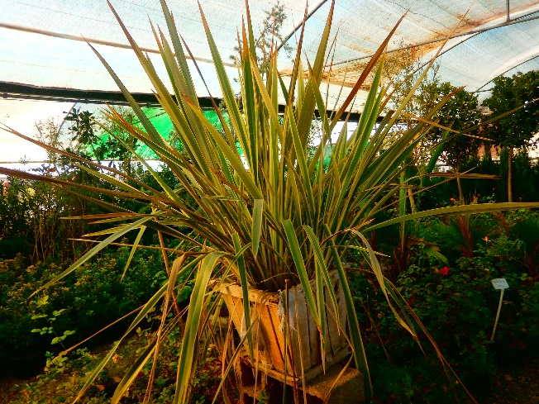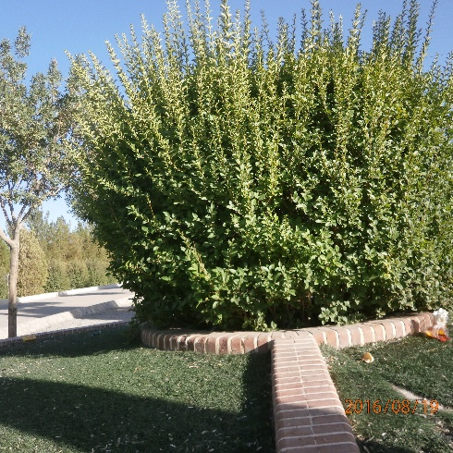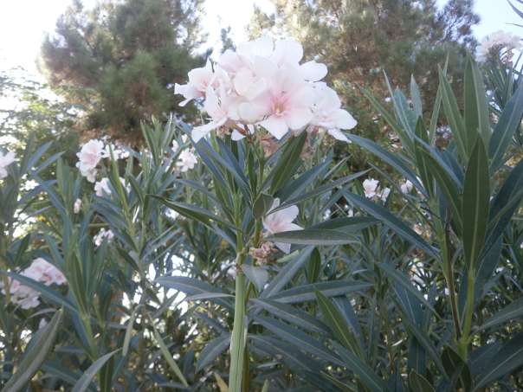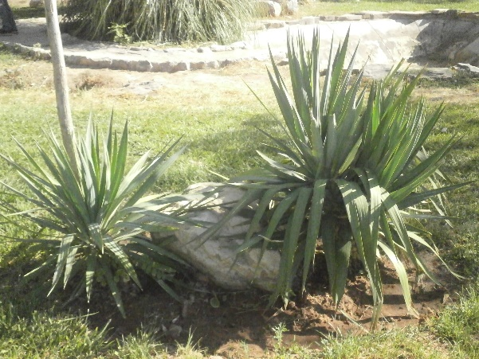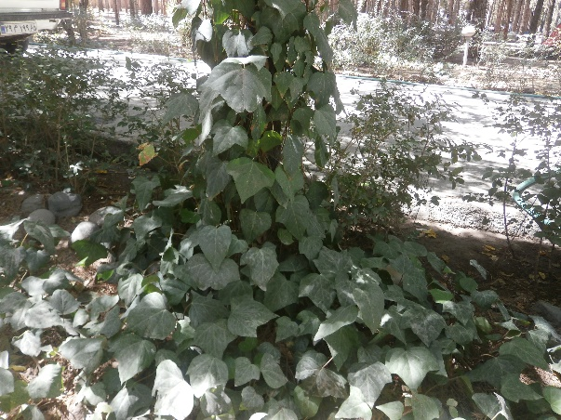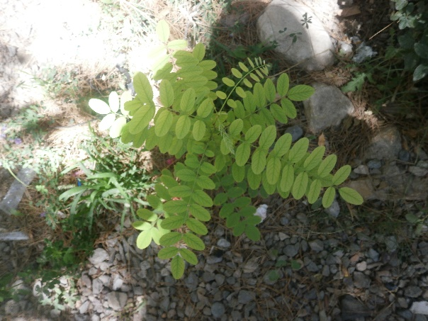
Leaves
Some of the disliked photos taken by children
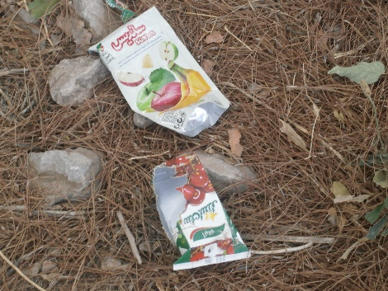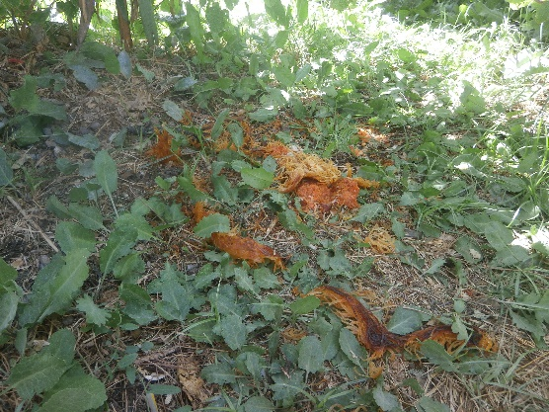
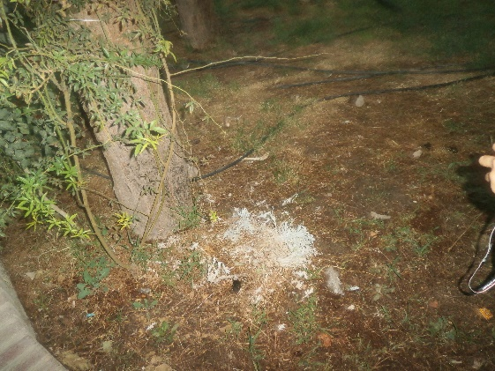
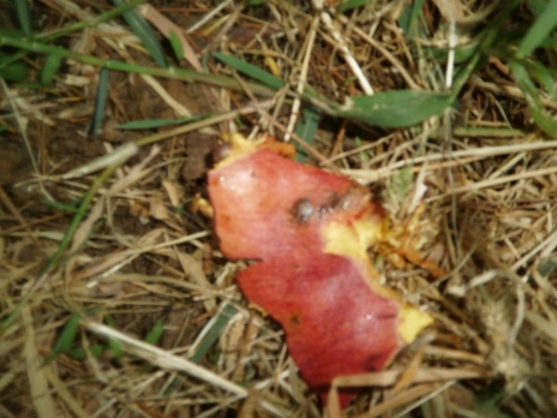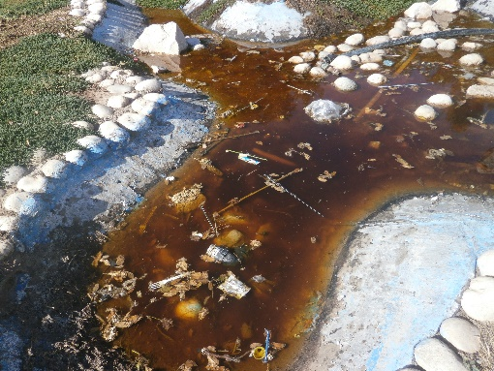
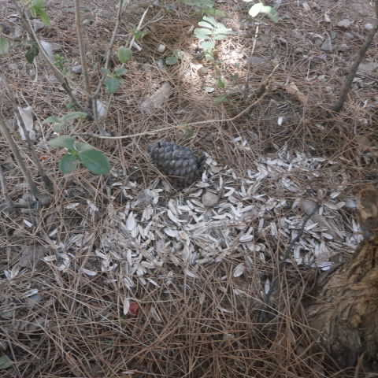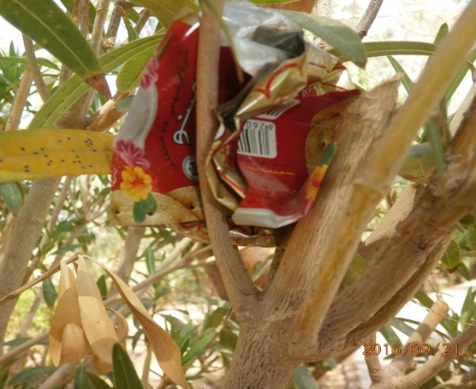
Rubbish in nature
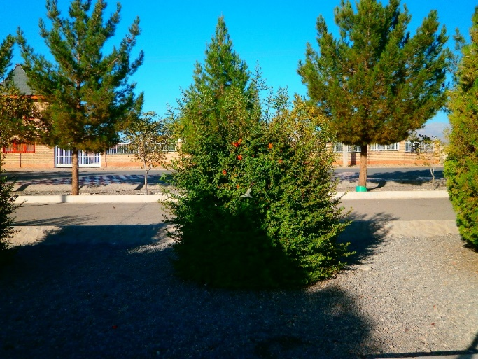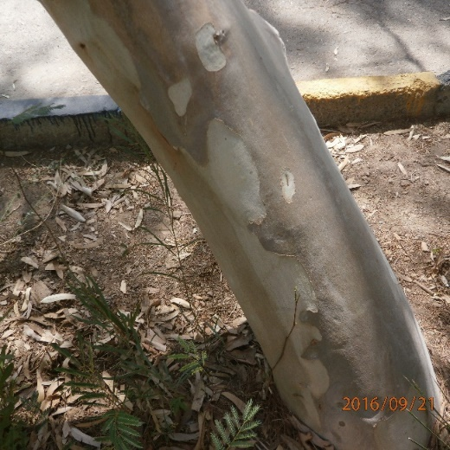
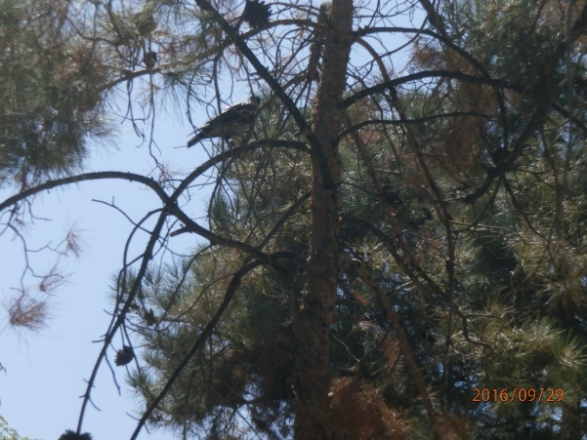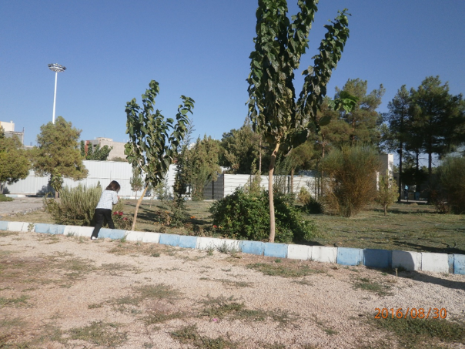
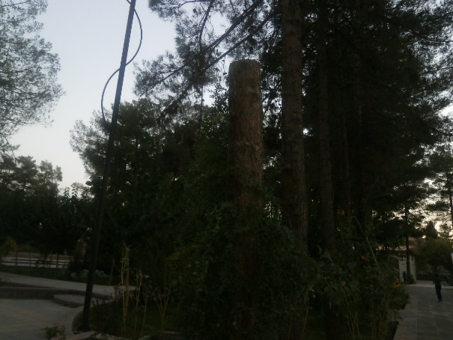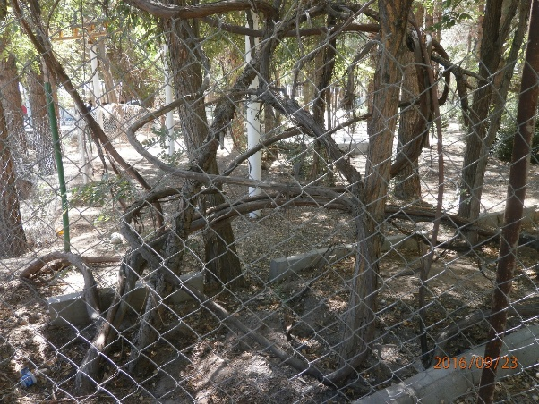
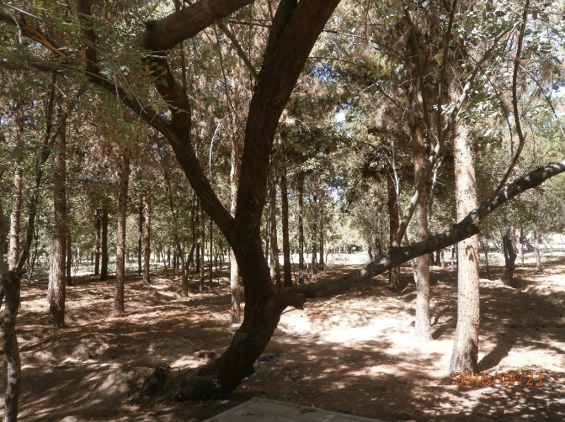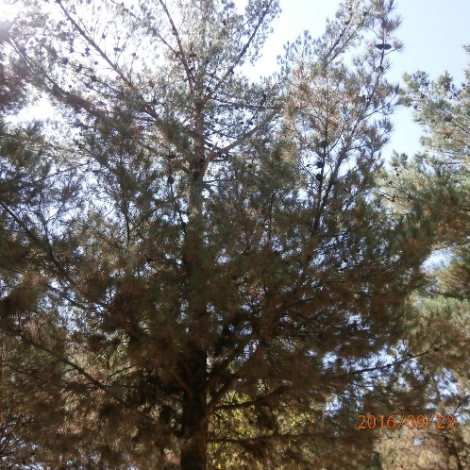
Tree
BIBLIOGRAPHY

Aboud, F. et al., (1991). Intellectual, social and nutritional status of children in an Ethiopian orphanage. Social Science & Medicine. 33, 1275-1280.
Ahmad, A. and Mohamad, K., (1996). The socioemotional development of orphans in orphanages and traditional foster care in Iraqi Kurdistan. Child Abuse & Neglect. 20, 1161-1173.
Ahmad, A., et al., (2005). A 2‐year follow‐up of orphans’ competence, socioemotional problems and post‐traumatic stress symptoms in traditional foster care and orphanages in Iraqi Kurdistan. Child: Care, health and development. 31, 203-215.
Anthamatten, P., Wee, B. S.-C. and Korris, E., (2013). Exploring children’s perceptions of play using visual methodologies. Health Education Journal. 72, 309-318.
Bagot, K. L. (2004). Perceived restorative components: A scale for children. Children Youth and Environments. 14, 107-129.
Bagot, K. L., Kuo, F. E. and Allen, F. C., (2007). Amendments to the perceived restorative components scale for children (PRCS-C II). Children Youth and Environments. 17, 124-127.
Baranowski, T. et al., (1993). Observations on physical activity in physical locations: Ager gender, ethnicity, and month effects. Research quarterly for exercise and sport. 64, 127-133.
Barker, J. and Weller, S., (2003). “Is it fun?” Developing children centred research methods. International journal of sociology and social policy. 23, 33-58.
Banks, M., (2001). Visual Methods in Social Research [electronic resource]. London: SAGE Publications.
Barnes, E., (1892). A study on children's drawings. The Pedagogical Seminary. 2, 455-463.
Baum, F., (1999). The role of social capital in health promotion: Australian perspectives. Health Promotion Journal of Australia: Official Journal of Australian Association of Health Promotion Professionals. 9, 171.
Berto, R., Pasini, M. and Barbiero, G., (2015). How does Psychological Restoration Work in Children? An Exploratory Study. Journal of Child and Adolescent Behavior.
Bishop, J. C., Curtis, M. and Opie, I., (2001). Play today in the primary school playground: Life, learning and creativity. Open University Press Buckingham.
Bodin, M. and Hartig, T., (2003). Does the outdoor environment matter for psychological restoration gained through running? Psychology of Sport and Exercise. 4, 141-153.
Bower, J. K. et al., (2008). The childcare environment and children’s physical activity. American journal of preventive medicine. 34, 23-29.
Brander, L. M., and Koetse, M. J., (2011). The value of urban open space: Meta-analyses of contingent valuation and hedonic pricing results. Journal of environmental management. 92(10), 2763-2773.
Breuste, J. and Rahimi, A., (2015). Many public urban parks, but who profits from them? The example of Tabriz, Iran. Ecological Processes. 4, 6.
Bringslimark, T., Hartig, T. and Patil, G. G., (2009). The psychological benefits of indoor plants: A critical review of the experimental literature. Journal of Environmental Psychology. 29, 422-433.
Brockman, R., Jago, R. and Fox, K. R., (2011). Children's active play: self-reported motivators, barriers and facilitators. BMC public health. 11, 461.
Brown, F., (2003). Compound flexibility: the role of playwork in child development. Playwork theory and practice. 51-65.
Brown, F., (2014). The healing power of play: Therapeutic work with chronically neglected and abused children. Children. 1, 474-488.
Brown, F. and Patte, M., (2013). Rethinking children's play. London: Bloomsbury Publishing plc.
Brown, F. and Webb, S., (2005). Children without play. Journal of Education. 35, 139-158.
Brown, W. H. et al., (2006). Assessing preschool children's physical activity: the Observational System for Recording Physical Activity in children-preschool version. Research quarterly for exercise and sport. 77, 167-176.
Bryman, A., (2012). Social Research Methods. Oxford University Press.
Burdette, H. L. and Whitaker, R. C., (2005). Resurrecting free play in young children: looking beyond fitness and fatness to attention, affiliation, and affect. Archives of pediatrics & adolescent medicine. 159, 46-50.
Burke, C., (2005). “Play in Focus”: Children Researching Their Own Spaces and Places for Play. Children Youth and Environments. 15, 27-53.
Canter, D., (1983). The Purposive Evaluation of Places A Facet Approach. Environment and behavior. 15, 659-698.
Carnahan, C. R., (2006). Photovoice: Engaging children with autism and their teachers. Teaching Exceptional Children. 39, 44-50.
Carver, A., Timperio, A. and Crawford, D., (2008). Playing it safe: The influence of neighbourhood safety on children's physical activity—A review. Health & place. 14, 217-227.
Cervinka, R., Röderer, K. and Hefler, E., (2011). Are nature lovers happy? On various indicators of well-being and connectedness with nature. Journal of health psychology. 17, 379-388.
Chari, U., Hirisave, U. and Appaji, L., (2013). Exploring play therapy in pediatric oncology: a preliminary endeavour. The Indian Journal of Pediatrics. 80, 303-308.
Christensen, P. and O'Brien, M., (2003). Children in the city: Home neighbourhood and community. Routledge.
Chudacoff, H. P., (2007). Children at play: An American history. NYU Press.
Clark, A. and Moss, P., (2011). Listening to young children: The mosaic approach. Jessica Kingsley Publishers.
Clark, C. D., (1999). The autodriven interview: A photographic viewfinder into children's experience. Visual Studies. 14, 39-50.
Cleland, V. and Venn, A., (2010). Encouraging physical activity and discouraging sedentary behavior in children and adolescents. Journal of Adolescent Health. 47(3), 221-222.
Close, H., (2007). The use of photography as a qualitative research tool: With reference to her own study of children with long-term conditions, Helen Close considers whether photography as a research method can be both valuable and ethical. Nurse researcher. 15, 27-36.
Cohen, L., Manion, L. and Morrison, K., (2000). Research methods in education. London, Routledge.
Collier, J., (1957). Photography in anthropology: a report on two experiments. American anthropologist. 59, 843-859.
Collier, J. and Collier, M., (1986). Visual anthropology: Photography as a research method. UNM Press.
Coplan, R. J., Ooi, L. L. and Rose-Krasnor, L., (2014). Naturalistic observations of schoolyard social participation: Marker variables for socio-emotional functioning in early adolescence. The Journal of Early Adolescence. 35, 628-650.
Cosco, N. G., Moore, R. C. and Islam, M. Z., (2010). Behavior mapping: a method for linking preschool physical activity and outdoor design. Medicine & Science in Sports & Exercise. 42, 513-519.
Dennis, S. F. et al., (2009). Participatory photo mapping (PPM): Exploring an integrated method for health and place research with young people. Health & place. 15, 466-473.
Department for Culture Media and Sport (DCMS), (2003). Getting Serious About Play. London: DCMS.
Dugan, E. M., Snow, M. S. and Crowe, S. R., (2010). Working with children affected by Hurricane Katrina: two case studies in play therapy. Child and Adolescent Mental Health. 15, 52-55.
Eggenberger, S. K. and Nelms, T. P., (2007). Family interviews as a method for family research. Journal of advanced nursing. 58, 282-292.
Eldar, E. and Ayvazo, S., (2009). Educating through the physical–rationale. Education and Treatment of Children. 32, 471-486.
Elsley, S., (2004). Children's experience of public space. Children & Society. 18, 155-164.
Epstein, I. et al., (2006). Photo elicitation interview (PEI): Using photos to elicit children's perspectives. International journal of qualitative methods. 5, 1-11.
Fanger, S. M., Frankel, L. A. and Hazen, N., (2012). Peer exclusion in preschool children's play: Naturalistic observations in a playground setting. Merrill-Palmer Quarterly. 58, 224-254.
Fjørtoft, I., (2001). The natural environment as a playground for children: The impact of outdoor play activities in pre-primary school children. Early childhood education journal. 29, 111-117.
Flick, U., (2014). An introduction to qualitative research. Sage.
Friedmann, E. and Thomas, S. A., (1995). Pet ownership, social support, and one-year survival after acute myocardial infarction in the Cardiac Arrhythmia Suppression Trial (CAST). The American journal of cardiology. 76, 1213-1217.
Fries, A. B. W. and Pollak, S. D., (2004). Emotion understanding in postinstitutionalized Eastern European children. Development and psychopathology. 16, 355-369.
Frumkin, H., (2001). Beyond toxicity: human health and the natural environment. American journal of preventive medicine. 20, 234-240.
Ganesh, T. G., (2011). Children-produced drawings: An interpretive and analytic tool for researchers. The SAGE handbook of visual research methods. 214-240.
Gearin, E., (2008). The kindered community: Using a child's perspective to improve urban planning and evaluate neighborhood friendliness. University of Southern California.
Gharahbeiglu, M., (2007). Children's interaction with urban play spaces in Tabriz, Iran. Visual Studies. 22, 48-52.
Ghaziani, R., (2012). An Emerging Framework for School Design Based on Children's Voices. Children, Youth and Environments. 22, 125-144.
Ghorbani, R., (2009). Assessing Park Deficiency in Tabriz Urban Areas.
Ghorbani, R., Ebrahimpour, A. and Noshad, S., (2012). Motivational Modeling in Developing of Urban Fringe Recreational Places an Approach for Improving the Quality of Life Case Study: Recreational Place of Oun-Ebn-Ali, Tabriz, Iran. Procedia Environmental Sciences. 13, 297-306.
Gibson, J. J., (2014). The ecological approach to visual perception: classic edition. Psychology Press.
Gifford, R., (2002). Environmental psychology: Principles and practice. Optimal books Colville, WA.
Gundersen, V. et al., (2016). Children and nearby nature: A nationwide parental survey from Norway. Urban Forestry & Urban Greening. 17, 116-125.
Hall, C. and Reet, M., (2000). Review: Enhancing the state of play in children's nursing. Journal of Child Health Care. 4, 49-54.
Hall, T. M., Kaduson, H. G. and Schaefer, C. E., (2002). Fifteen effective play therapy techniques. Professional Psychology: Research and Practice. 33, 515.
Harper, D., (1987). Working knowledge: Skill and community in a small shop. University of Chicago Press.
Harper, D., (2002). Talking about pictures: A case for photo elicitation. Visual studies. 17, 13-26.
Harper, D. and Faccioli, P., (2000). “Small, silly insults,” mutual seduction and misogyny the interpretation of Italian advertising signs. Visual Studies. 15, 23-49.
Hart, R., (1979). Children's experience of place. Irvington.
Hart, R. A., (1997). Children's participation: The theory and practice of involving young citizens in community development and environmental care. Routledge.
Hartig, T., Kaiser, F. G. and Bowler, P. A., (1997a). Further development of a measure of perceived environmental restorativeness. Institutet för bostads-och urbanforskning.
Hartig, T. et al., (1996). Validation of a measure of perceived environmental restorativeness. University of Göteborg, Department of Psychology.
Hartig, T. et al., (1997b). A measure of restorative quality in environments. Scandinavian housing and planning research. 14, 175-194.
Heerwagen, J. H. and Orians, G. H., (1986). Adaptations to windowlessness: A study of the use of visual decor in windowed and windowless offices. Environment and Behavior. 18, 623-639.
Heisley, D. D. and Levy, S. J., (1991). Autodriving: A photoelicitation technique. Journal of consumer Research. 18(3), 257-272.
Herzog, T. R. et al., (1997). Reflection and attentional recovery as distinctive benefits of restorative environments. Journal of environmental psychology, 17, 165-170.
Hill, M., (1997). Participatory research with children. Child & family social work. 2, 171-183.
Hillman, M., (2006). Children's rights and adults' wrongs.
Hughes, B., (2003). Play deprivation, play bias and playwork practice. Playwork–theory and practice. Open University Press, Philadelphia. 66-80.
Hughes, B. and Melville, S., (2002). A Playworker's Taxonomy of Play Tips. PlayEducation. Organisation.
Jackson, R. J., (2003). The impact of the built environment on health: an emerging field. American Public Health Association. 1382-1384.
Jamieson, S., (2004). Likert scales: how to (ab) use them. Medical education. 38, 1217-1218.
Jacobi, J., (2009). Between charity and education: orphans and orphanages in early modern times. Paedagogica Historica. 45, 51-66.
Johnson, D. E. et al., (1992). The health of children adopted from Romania. Jama. 268, 3446-3451.
Kaplan, R., (2001). The nature of the view from home: Psychological benefits. Environment and behavior. 33, 507-542.
Kaplan, R. and Kaplan, S., (1989). The experience of nature: A psychological perspective, CUP Archive.
Kaplan, R. and Talbot, J. F., (1988). Ethnicity and preference for natural settings: A review and recent findings. Landscape and Urban Planning. 15, 107-117.
Kaplan, S., (1995). The restorative benefits of nature: Toward an integrative framework. Journal of environmental psychology. 15, 169-182.
Kaplan, S., (1987). Mental fatigue and the designed environment. Environmental Design Research Association.
Karsten, L., (2005). It all used to be better? Different generations on continuity and change in urban children's daily use of space. Children's Geographies. 3, 275-290.
Katcher, A. H. and Beck, A. M., (1987). Health and caring for living things. Anthrozoös. 1, 175-183.
Kearney, A. R., (2006). Residential development patterns and neighborhood satisfaction: Impacts of density and nearby nature. Environment and Behavior. 38, 112-139.
Keat, J. B., Strickland, M. J. and Marinak, B. A., (2009). Child Voice: How Immigrant Children Enlightened Their Teachers with a Camera. Early Childhood Education Journal. 37, 13-21.
Kelz, C., Evans, G. W. and Röderer, K., (2013). The restorative effects of redesigning the schoolyard: A multi-methodological, quasi-experimental study in rural Austrian middle schools. Environment and Behavior. 47(2), 119-139.
Khosravaninezhad, S., Abaszadeh, Z., Karimzadeh, F. and Zadehbagheri, P., (2011). Parks and an Analysis of their Role in Improving the Quality of Urban Life, Using Seeking-Escaping Model. Case Study: Tehran Urban Parks. na.
Klenges, R. C., (1984). The FATS: An observational system for assessing physical activity in children and associated parent behavior. Behavioral Assessment.
Korpela, K. et al., (2014). Analyzing the mediators between nature-based outdoor recreation and emotional well-being. Journal of Environmental Psychology. 37, 1-7.
Korpela, K., Kyttä, M. and Hartig, T., (2002). Restorative experience, self-regulation, and children's place preferences. Journal of environmental psychology. 22, 387-398.
Küller, R., (1972). A semantic model for describing perceived environment.
Küller, R., (1979). A semantic test for use in cross-cultural studies. Man-Environment Systems. 9, 253-256.
Kuo, F. E. and Faber Taylor, A., (2004). A potential natural treatment for attention-deficit/hyperactivity disorder: evidence from a national study. American journal of public health. 94, 1580-1586.
LaDonna, K. and Venance, S., (2011). P5. 4 Photovoice: Using an innovative qualitative research method to capture the experiences of individuals with myotonic dystrophy (DM1). Neuromuscular Disorders. 21, 724-725.
Lapenta, F., (2005). The image as a form of sociological data: a methodological approach to the analysis of photoelicited interviews. Goldsmiths College (University of London).
Lapenta, F., (2011). Some theoretical and methodological views on photo-elicitation. The Sage handbook of visual research methods. 201-213.
Leather, P. et al., (1998). Windows in the workplace sunlight, view, and occupational stress. Environment and behavior. 30, 739-762.
Lee, Y., Takenaka, K. and Kanosue, K., (2015). An understanding of Japanese children’s perceptions of fun, barriers, and facilitators of active free play. Journal of Child Health Care. 19, 334-344.
Leonard, M., (2006). Children's drawings as a methodological tool: reflections on the eleven plus system in Northern Ireland. Irish Journal of Sociology. 15, 52-66.
Lever, J., (1976). Sex Differences in the Games Children Play. Social Problems. 23, 478-487.
Lewis, C. A., (1996). Green nature/human nature: the meaning of plants in our lives. University of Illinois Press.
Lewis, C. A., (1992). Effects of plants and gardening in creating interpersonal and community well-being. Role of Horticulture in Human Well-being and Social Development: A National Symposium. Timber Press, Arlington, Virginia. 55-65.
Lomax, H. J., (2012). Shifting the focus: children's image-making practices and their implications for analysis. International Journal of Research & Method in Education. 35, 227-234.
Loukaitou-Sideris, A., (2003). Children's common grounds: a study of intergroup relations among children in public settings. Journal of the American Planning Association. 69, 130-143.
Louv, R., (2005). Last child in the woods: Saving our children from nature-deficit disorder. Algonquin books.
Louv, R., (2009). Do our kids have nature-deficit disorder. Educational Leadership. 67, 24-30.
Majnonian, H., (1996). Parks, Green spaces, and Promenades. Parks and Green Spaces Org press, Tehran.
Maller, C. et al., (2005). Healthy nature healthy people:‘contact with nature’as an upstream health promotion intervention for populations. Health promotion international. 21, 45-54.
Maller, C. J., (2009). Promoting children's mental, emotional and social health through contact with nature: a model. Health Education. 109, 522-543.
Malone, K. and Tranter, P., (2003). “Children's Environmental Learning and the Use, Design and Management of Schoolgrounds. Children Youth and Environments. 13, 87-137.
Mayer, F. S. and Frantz, C. M., (2004). The connectedness to nature scale: A measure of individuals’ feeling in community with nature. Journal of environmental psychology. 24, 503-515.
Mayer, F. S. et al., (2009). Why is nature beneficial? The role of connectedness to nature. Environment and behavior. 41, 607-643.
McBride, D. L., (2012). Children and Outdoor Play. Journal of Pediatric Nursing. 27, 421-422.
Mcelwain, N. L. and Volling, B. L., (2005). Preschool children's interactions with friends and older siblings: relationship specificity and joint contributions to problem behavior. Journal of Family Psychology. 19, 486.
McIver, K. L. et al., (2009). Assessing children's physical activity in their homes: The observational system for recording physical activity in children‐home. Journal of applied behavior analysis. 42(1), 1-16.
McKendrick, J. H., (2000). The geography of children: an annotated bibliography. Childhood. 7, 359-387.
McKenzie, R., (1998). Neglected solutions, orphanages may be preferable over foster families. National Review. 18, 1-5.
McKenzie, T. L. et al., (2006). System for Observing Play and Recreation in Communities (SOPARC): reliability and feasibility measures. Journal of Physical Activity and Health. 3, S208-S222.
McKenzie, T. L. et al., (2000). Leisure-time physical activity in school environments: an observational study using SOPLAY. Preventive medicine. 30, 70-77.
McKenzie, T. L. et al., (1991). BEACHES: an observational system for assessing children's eating and physical activity behaviors and associated events. Journal of applied behavior analysis. 24, 141-151.
Mcmahan, E. A. and Estes, D., (2015). The effect of contact with natural environments on positive and negative affect: A meta-analysis. The Journal of Positive Psychology. 10, 507-519.
Mehrabian, A. and Russell, J. A., (1974). An approach to environmental psychology. The MIT Press.
Milteer, R. M., Ginsburg, K. R. and Mulligan, D. A., (2012). The importance of play in promoting healthy child development and maintaining strong parent-child bond: Focus on children in poverty. Pediatrics. 129, e204-e213.
Min, B., and Lee, J., (2006). Children's neighborhood place as a psychological and behavioral domain. Journal of Environmental Psychology. 26, 51-71.
Mjaavatn, P., (2013). Hva har barn lyst til å gjøre ute. What do children like to do outside, 29-44.
Moore, E. O., (1981). A prison environment's effect on health care service demands. Journal of Environmental Systems. 11, 17-34.
Moore, R. C., (1990). Childhood's domain: play and place in child development. MIG communications.
Morrow, V., (2001). Using qualitative methods to elicit young people's perspectives on their environments: some ideas for community health initiatives. Health education research. 16, 255-268.
Nalven, L., (2005). The impact of early orphanage life on development. Valley Kireker Center for Child Development Available from http://www. valleyhealth. com/adoption. aspx.
Nassauer, J. I., (2011). Care and stewardship: From home to planet. Landscape and Urban Planning. 100, 321-323.
Nisbet, E. K., Zelenski, J. M. and Murphy, S. A., (2011). Happiness is in our nature: Exploring nature relatedness as a contributor to subjective well-being. Journal of Happiness Studies. 12, 303-322.
Olds, A. R., (1989). Nature as healer. Children's Environments Quarterly.
Opie, I. A. and Opie, P., (1959). The lore and language of schoolchildren. Clarendon Press.
Pals, R. et al., (2009). Development of the PRCQ: A measure of perceived restorative characteristics of zoo attractions. Journal of Environmental Psychology. 29, 441-449.
Parten, M. B., (1933). Social play among preschool children. The Journal of Abnormal and Social Psychology. 28, 136.
Parsons, R. et al., (1998). The view from the road: Implications for stress recovery and immunization. Journal of environmental psychology. 18, 113-140.
Pasini, M. and Berth, R., (2007). Una scala per la misura della restorativeness dei luoghi. Quaderni DiPav. 20, 87-102.
Pasini, M. et al., (2014). How to Measure the Restorative Quality of Environments: The PRS-11. Procedia - Social and Behavioral Sciences. 159, 293-297.
Peschardt, K. K. and Stigsdotter, U. K., (2013). Associations between park characteristics and perceived restorativeness of small public urban green spaces. Landscape and Urban Planning. 112, 26-39.
Pink, S., (2006). Doing visual ethnography. Sage.
Pink, S., (2013). Doing visual ethnography. Sage.
Puhl, J. et al., (1990). Children's Activity Rating Scale (CARS): description and calibration. Research Quarterly for Exercise and Sport. 61, 26-36.
Punch, S., (2002). Research with children: the same or different from research with adults? Childhood. 9, 321-341.
Purcell, T., Peron, E. and Berto, R., (2001). Why do preferences differ between scene types? Environment and behavior. 33, 93-106.
Ramezani, S. and Said, I., (2013). Children's nomination of friendly places in an urban neighbourhood in Shiraz, Iran. Children's Geographies. 11, 7-27.
Rohde, C. and Kendle, A., (1994). Human Well-Being, Natural Landscapes and Wildlife in Urban Areas a Review.
Rutter, M. L., Kreppner, J. M. and O'Connor, T. G. 2001. Specificity and heterogeneity in children's responses to profound institutional privation. The British Journal of Psychiatry. 179, 97-103.
Ryzhikov, A., (1992). Nature and Man: Psychological Problems of Alienation. Journal of Russian & East European Psychology. 30, 37-44.
Sanoff, H. and Coates, G., (1971). Behavioral mapping: An ecological analysis of activities in a residential setting. International Journal of Environmental Studies. 2, 227-235.
Schaefer, C. E., (1980). Play therapy. Emotional disorders in children and adolescents. Springer.
Scott, J., (2000). Children as respondents: The challenge for quantitative methods. Research with children. Routledge.
Semenza, J. C., (2003). The intersection of urban planning, art, and public health: the Sunnyside Piazza. American Journal of Public Health. 93, 1439-1441.
Sharman, C., Cross, W. and Vennis, D., (2007). Observing children and young people. Continuum.
Shoaakazemi, M. et al., (2012). The effect of group play therapy on reduction of separation anxiety disorder in primitive school children. Procedia-Social and Behavioral Sciences. 69, 95-103.
Simkins, I. M., (2008). The development of the INSIGHT METHOD: a participatory approach for primary school children to reveal their place experiences. University of Sheffield.
Simkins, I. and Thwaites, K., (2008). Revealing the hidden spatial dimensions of place experience in primary school-age children. Landscape Research. 33, 531-546.
Sowman, L., (2013). Towards a Landscape of Well-Being. Landscape, Well-Being and Environment, London and New York: Routledge. 53-71.
Stockall, N., (2013). Photo-elicitation and visual semiotics: A unique methodology for studying inclusion for children with disabilities. International Journal of Inclusive Education. 17, 310-328.
Sutton-Smith, B. (2001). The ambiguity of play. Harvard University Press.
Talbot, J. F. and Kaplan, R., (1984). Needs and fears: the response to trees and nature in the inner city. Journal of Arboriculture. 10, 222-228.
Talbot, J. F. and Kaplan, R., (1991). The benefits of nearby nature for elderly apartment residents. The International Journal of Aging and Human Development. 33, 119-130.
Talbot, J. F. and Kaplan, S., (1986). Perspectives on wilderness: Re-examining the value of extended wilderness experiences. Journal of Environmental Psychology. 6, 177-188.
Tamis-LeMonda, C. S. et al., (2004). Fathers and mothers at play with their 2‐and 3‐year‐olds: contributions to language and cognitive development. Child development. 75, 1806-1820.
Taneja, V. et al., (2002). ‘Not by bread alone’: impact of a structured 90‐minute play session on development of children in an orphanage. Child: care, health and development. 28, 95-100.
Tennessen, C. M. and Cimprich, B., (1995). Views to nature: Effects on attention. Journal of environmental psychology. 15, 77-85.
Thabet, L. and Thabet, A. A. M., (2007). Mental health problems among orphanage children in the Gaza Strip. Adoption & Fostering. 31, 54-62.
Thwaites, K., Helleur, E. and Simkins, I., (2005). Restorative urban open space: Exploring the spatial configuration of human emotional fulfilment in urban open space. Landscape Research. 30, 525-547.
Thwaites, K. and Simkins, I., (2005). Experiential landscape place: exploring experiential potential in neighbourhood settings. Urban Design International. 10, 11-22.
Ulrich, R., (1984). View through a window may influence recovery. Science, 224, 224-225.
Ulrich, R. S., (1979). Visual landscapes and psychological well‐being. Landscape research. 4, 17-23.
Ulrich, R. S., (1981). Natural versus urban scenes: Some psychophysiological effects. Environment and behavior. 13, 523-556.
Ulrich, R. S., Kellert, S. R. and Wilson, E. O., (1993). Biophilia, biophobia, and natural landscapes. The biophilia hypothesis. 7, 73-137.
Ulrich, R. S. et al., (1991). Stress recovery during exposure to natural and urban environments. Journal of environmental psychology. 11, 201-230.
Valentine, G., (1996). Children should be seen and not heard: the production and transgression of adults’ public space. Urban Geography. 17, 205-220.
Valentine, G. and McKendrck, J., (1997). Children's outdoor play: exploring parental concerns about children's safety and the changing nature of childhood. Geoforum. 28, 219-235.
Veitch, J., Salmon, J. and Ball, K., (2008). Children's active free play in local neighborhoods: a behavioral mapping study. Health education research. 23, 870-879.
Verderber, S., (1986). Dimensions of person-window transactions in the hospital environment. Environment and behavior. 18, 450-466.
White, R., (1997). ‘Sometimes, You Just Gotta Make Mud Pies Children’s Adventure Play Gardens.’’. White Hutchinson Leisure & Learning Group [cited 27 May 2006]. Available from http://www. whitehutchinson. com/leisure/articles/84. shtml.
White, R. and Stoecklin, V., (1998). Children's outdoor play & learning environments: Returning to nature. Accessed June. 11, 2004.
Whitebread, D. et al., (2012). The importance of play. Brussels: Toy Industries of Europe.
Whitehouse, S. et al., (2001). Evaluating a children's hospital garden environment: Utilization and consumer satisfaction. Journal of environmental psychology. 21, 301-314.
Wilson, E. O., (1984). Biophilia Harvard university press. Cambridge, Massachusetts.
Wilson, E. O., (2001). The ecological footprint. Vital Speeches. 67, 274-281.
Wilson, L. and Conroy, J., (2001). Satisfaction of children in out-of-home care. Family foster care in the next century.
Wolff, P. H. and Fesseha, G., (1998). The orphans of Eritrea: Are orphanages part of the problem or part of the solution? American Journal of Psychiatry. 155, 1319-1324.
Wolff, P. H. and Fesseha, G., (2005). The orphans of Eritrea: what are the choices? American Journal of Orthopsychiatry. 75, 475-484.
Woolley, H., (2003). Urban open spaces. Taylor & Francis.
Woolley, H., (2006). Freedom of the city: Contemporary issues and policy influences on children and young people's use of public open space in England. Children's Geographies. 4, 45-59.
Woolley, H., (2007). Where do the children play? Proceedings of the Institution of Civil Engineers-Municipal Engineer. Thomas Telford. 89-95.
Woolley, H., (2008). Watch this space! Designing for children's play in public open spaces. Geography Compass. 2, 495-512.
Woolley, H. and Armitage, M., (2006). Inclusion of disabled children in primary school playgrounds. Jessica Kingsley Publishers.
Woolley, H. and Lowe, A., (2013). Exploring the relationship between design approach and play value of outdoor play spaces. Landscape Research. 38, 53-74.
Yildiz, S. A., (2012). A Qualitative Analysis of School Concept on Primary School Students. Educational Sciences: Theory and Practice. 12, 623-626.
Zajonc, R. B., (1980). Feeling and thinking: Preferences need no inferences. American psychologist. 35, 151.
Zamani, Z., (2016). ‘The woods is a more free space for children to be creative; their imagination kind of sparks out there’: exploring young children’s cognitive play opportunities in natural, manufactured and mixed outdoor preschool zones. Journal of adventure education and outdoor learning. 16, 172-189.
Zuckerman, M., (1977). Development of a situation-specific trait-state test for the prediction and measurement of affective responses. Journal of Consulting and clinical psychology. 45, 513.

Haft-Sang, or Seven Stone, is a game involving a ball and a pile of flat stones, generally played between two teams in a large outdoor area. A member of one team (the seekers) throws a tennis ball at a pile of stones to knock them over. The seekers then try to restore the pile of stones while the opposing team (the hitters) throws the ball at them. If the ball touches a seeker, that seeker is out and the team the seeker came from continues, without the seeker. A seeker can always safeguard themselves by touching an opposite team member before the ball hits them.
Eid al-Adha ('Feast of the Sacrifice'), also called the "Sacrifice Feast", is the second of two Muslim holidays celebrated worldwide each year, and considered the holier of the two. It honours the willingness of Ibrahim (Abraham) to sacrifice his son, as an act of obedience to God's command. Before Abraham sacrificed his son, God provided a male goat to sacrifice instead. In commemoration of this, an animal is sacrificed and divided into three parts: one third of the share is given to the poor and needy; another third is given to relatives, friends and neighbours; and the remaining third is retained by the family (source: https://en.wikipedia.org/wiki/Eid_al-Adha).

