

**Application of RNA Chemical Modifications to Modulate**

**RNAi in Insects**

By: John David Howard

A thesis submitted in partial fulfilment of the

requirements for the degree of

Doctor of Philosophy

September, 2019

The University of Sheffield

Faculty of Engineering, Department of Chemical & Biological Engineering

**Supervisors:**

Prof Mark Dickman

**Department of**

**Chemical & Biological Engineering**

**University of Sheffield**

Dr David Portwood

**Syngenta**

**Jealott’s Hill International Research Centre**

**Bracknell, Berkshire**

Dr Stephen Brown

**Department of**

**Biomedical Science**

**University of Sheffield**

Dr Peter Kilby

**Syngenta**

**Jealott’s Hill International Research Centre**

**Bracknell, Berkshire**

**Declaration of Originality and Disclaimer**

In accordance with the University regulations, I hereby declare that this thesis has been composed solely by myself, and has not been submitted in part or in whole for any other degree or personal qualification. It is entirely my own work, other than one replicate of one live insect feeding assay conducted by our collaborators at Syngenta in Ghent (credited in the text) using dsRNA samples I synthesised in Sheffield.

Opinions expressed in this thesis are not necessarily endorsed by Syngenta.

# Acknowledgements

Firstly, I would like to say a huge thank you my academic supervisors Prof Mark Dickman and Dr Stephen Brown for all the general guidance, support and training they have provided throughout my PhD, and for their advice on and proof reading of the thesis. I would also like to thank my industrial supervisors Dr Peter Kilby and Dr David Portwood for their valuable input from an alternative industry perspective, as well as Duncan Oliver, Wendy Maddelein and countless other people from Syngenta’s research centre in Ghent, for their help and expertise on live insect assays. Thanks must also go to Syngenta and BBSRC for providing the funding for the project.

I would also like to thank all my colleagues in the SRSF and the Dickman Group, for their additional support and for improving the working environment immeasurably. It’s been a privilege to be part of two labs that are so friendly and welcoming.

I’d further like to thank my parents, family and friends for their past and continued support. On many occasions they were there exactly when needed when the biology inevitably went wrong, even though they maybe weren’t quite sure what the problem was. Thanks to all the folks from Medic’s Choir and climbing in particular, for helping distract me with fun things when times got tough.

Finally, very special mentions and very special thanks must go to the most special of friends. Without the support of Christina Vanhinsbergh, Josie McQuillan, Hannes Maib, Jonny Coates, Aragorn Jones and Hannah Regan, this thesis might not exist. Thank you all for every second of this rollercoaster ride, and love to you all!



# Abstract

Global agriculture loses over $100 billion of produce annually to crop pests such as insects. Many of these crop pests either have no current means of control, or have developed resistance against traditional chemical pesticides. Therefore, there is currently significant demand to develop new types of insecticide, capable of overcoming issues with resistance, or lack of target species selectivity. Long dsRNA based biocontrols are emerging as a novel alternative for sustainable insect management strategies. Long dsRNA based biocontrols are capable of inducing RNA interference (RNAi) in insects resulting in knockdown of a target mRNA and therefore reduced levels of its protein product. Targeting of the mRNA for a protein essential to the growth and survival of the insect results in mortality of the target insect. Therefore long dsRNA based biocontrols are emerging as novel species-specific insecticides. This approach has successfully been demonstrated for a wide range of target mRNAs and target species.

A major barrier to the technology, is degradation of the dsRNA by nucleases in the environment and within the insect before it can induce RNAi. Therapeutic siRNAs and DNA antisense oligonucleotides are ineffective in whole organism mammalian systems unless they contain chemically modified nucleotides which prevent their degradation in the bloodstream by extracellular nucleases, as well as improving delivery and transport of the siRNA or DNA oligo. It was hypothesised that such chemical modifications could improve the nuclease resistance of dsRNA based biocontrols, increasing their efficacy in insects.

In this study, I have optimised the synthesis and purification of long dsRNA containing a range of different chemical modifications including phosphorothioate, 2’-fluoro and 5-hydroxymethyl. The effects of chemical modifications of the long dsRNA were studied both *in vitro* and *in vivo*. The results showed for the first time that dsRNA containing phosphorothioate modifications demonstrated increased resistance to stink bug salival nucleases. In addition, both phosphorothioate and 2’-fluoro modified dsRNAs demonstrated increased RNAi efficacy in *Drosophila* cell cultures. Furthermore, the effects of the chemical modification of long dsRNA on RNAi efficacy were also studied in live insects in both southern green stink bug using injection assays, and in western corn rootworm using feeding assays. The results showed that the chemically modified long dsRNA resulted in successful RNAi in live insects as measured by insect mortality. However, no increase in RNAi efficacy was observed compared to unmodified dsRNA. To our knowledge this is the first time that RNAi has successfully been triggered by chemically modified dsRNA in insect cells or live insects.

These results provide further insight into the effects of chemical modifications of dsRNA based biocontrols. It is anticipated that these results will provide important information for developing new alternative dsRNA based biocontrols with improved nuclease resistance and RNAi efficacy.

Acknowledgements 5

Abstract 7

Abbreviations and Acronyms 14

List of figures and tables 20

1 Introduction and literature review 25

1.1 Background and aims 25

1.2 Introduction to RNA interference (RNAi) 29

1.2.1 Introduction and history of RNAi 29

1.2.2 Mechanism and natural functions of RNAi 30

1.2.3 Applications of RNAi triggers in biological science 34

1.2.3.1 Application of triggering RNAi as a functional genomics tool 34

1.2.3.2 Application of RNAi triggers as therapeutic agents 35

1.2.3.3 Application of RNAi triggers in agriculture 35

1.3 A review of the application of unmodified dsRNA to induce RNAi in insects 37

1.3.1 Introduction 37

1.3.2 Uptake of dsRNA in insects 38

1.3.3 Delivery of dsRNA to insects 41

1.3.3.1 Delivery of purified dsRNA to insects orally by feeding 42

1.3.3.2 Production and delivery of dsRNA by plants and microorganisms 43

1.4 A review of chemical modifications applied to siRNAs and oligonucleotides for medical and functional genomics research 45

1.4.1 Introduction 45

1.4.2 Nucleic acid backbone chemical modifications 46

1.4.3 Nucleic acid base chemical modifications 49

1.4.4 Naturally occurring nucleic acid chemical modifications 50

1.5 Discussion and research project scope and aims based literature review 51

2 Materials and Methods 55

2.1 Chemicals, reagents and equipment 55

2.2 Production and analysis of dsRNA 56

2.2.1 PCR of DNA templates 56

2.2.2 Synthesis of ss/dsRNA 59

2.2.3 Glucosylation of 5-hydroxymethyl deoxycytidine/cytidine dsDNA and dsRNA 60

2.2.4 Gel analysis of PCR and IVT products 60

2.2.5 Purification of ss/dsRNA 61

2.2.6 Annealing of ssRNAs to dsRNA 61

2.2.7 Ion pair reverse phase high performance liquid chromatography (IP RP HPLC) analysis of RNA 61

2.3 Interaction of dsRNA with processing and degrading insect nucleases 62

2.3.1 Stink bug salival nuclease degradation assay 62

2.3.2 Gel band quantification analysis 63

2.3.3 Dicer processing assays 63

2.3.3.1 RNase III assay 63

2.3.3.2 *Giardia* Dicer assay 63

2.4 *In vitro* analysis of RNAi using modified dsRNA in insect cells 63

2.4.1 General cell culture 63

2.4.2 Reporter plasmid preparation 63

2.4.3 Luciferase assays 64

2.4.4 Statistical analysis 66

2.5 *In vivo* analysis of RNAi using modified dsRNA in live insects 66

2.5.1 Insect rearing, 66

2.5.2 Stink bug injection assays 66

2.5.3 WCR diet plate feeding assay 67

2.5.4 WCR soil feeding assay 67

2.5.5 Stink bug feeding assays 68

3 Synthesis of unmodified and chemically modified long dsRNA for RNAi studies 71

3.1 Abstract 71

3.2 Introduction 72

3.3 Results and Discussion 74

3.3.1 Selection of dsRNA sequences 74

3.3.2 Production of DNA templates by polymerase chain reaction (PCR) for synthesis of ssRNA and dsRNA by *in vitro* transcription (IVT) 76

3.3.3 Synthesis of phosphorothioate (PS) containing ssRNA and dsRNA by IVT 80

3.3.4 Optimisation of synthesis of phosphorothioate RNA by IVT 85

3.3.4.1 Comparison of T7 and SP6 RNA polymerase for the synthesis of phosphorothioate ssRNA and dsRNA 85

3.3.4.2 Optimisation of IVT reactions for synthesis of phosphorothioate ssRNA and dsRNA 88

3.3.4.3 Synthesis and analysis of dsRNA with phosphorothioate modifications in one or both strands by annealing ssRNAs synthesised in separate IVT reactions 89

3.3.5 Optimisation of the synthesis of long dsRNA containing 2’-fluoro (2’F) modifications by IVT 91

3.3.6 Synthesis of 5-hydroxymethyl (HMr/HMd) and Glucosyl-5-hydroxymethyl (Gluc-HMd) DNA and RNA 94

3.3.7 Quantification of unmodified and chemically modified dsRNA by UV spectrophotometry 99

3.4 Conclusions 102

4 Studying the effects of dsRNA chemical modifications on the activity of insect nucleases 105

4.1 Abstract 105

4.2 Introduction 106

4.3 Results and discussion 110

4.3.1 Studying the effects of dsRNA chemical modifications on the activity *in vitro* of Dicer enzymes 110

4.3.1.1 Studying the effects of dsRNA chemical modifications on the activity of bacterial RNase III 110

4.3.1.2 Studying the effects of dsRNA chemical modifications on the activity of *Giardia intestinalis* Dicer 113

4.3.1.3 Discussion of results of *in vitro* Dicer assays in the context of RNase III and *Giardia* Dicer mechanisms 115

4.3.2 Investigating the resistance of chemically modified dsRNA to degradation by insect nucleases 122

4.3.2.1 Optimisation of stink bug salival nuclease dsRNA degradation assay 122

4.3.2.2 Investigating the resistance of chemically modified dsRNA to degradation by nucleases present in stink bug saliva 123

4.4 Conclusions 131

5 *In vitro* analysis of RNAi efficacy of chemically modified dsRNA in *Drosophila* Kc167 cells 135

5.1 Abstract 135

5.2 Introduction 136

5.2.1 Overview 136

5.2.2 Dual luciferase reporter system 137

5.3 Results and discussion 140

5.3.1 Method development and troubleshooting 140

5.3.2 Quantitative comparative analysis of RNAi efficacy of phosphorothioate (PS) dsRNA in *Drosophila* Kc167 cells 144

5.3.2.1 Analysis of the effects on RNAi of non-targeting phosphorothioate dsRNA in *Drosophila* Kc167 cells 144

5.3.2.2 Analysis of the effect on RNAi of targeting phosphorothioate dsRNA in *Drosophila* Kc167 cells 147

5.3.3 Quantitative comparative analysis of RNAi efficacy of 2’-fluoro (2’F) dsRNA in *Drosophila* Kc167 cells 150

5.3.4 Quantitative comparative analysis of RNAi efficacy of 5-Hydroxymethyl (HMr) dsRNA in *Drosophila* Kc167 cells 152

5.3.5 Comparison of reproducibility of results for a single dsRNA across replicate experiments 155

5.3.6 Comparison of RL values to determine cytotoxicity of dsRNA chemical modifications, and examine increased FL/RL values at low dsRNA concentrations 157

5.4 Conclusions 160

6 *In vivo* analysis of RNAi efficacy of chemically modified dsRNA in live insects 165

6.1 Abstract 165

6.2 Introduction 166

6.3 Results and discussion 169

6.3.1 Production and analysis of dsRNA probes 169

6.3.2 Analysis of RNAi efficacy of chemically modified dsRNA delivered by injection in stink bug 170

6.3.3 Analysis of RNAi efficacy of orally delivered chemically modified dsRNA in stink bug and WCR 172

6.3.3.1 WCR feeding mortality assay overview 172

6.3.3.2 WCR dsRNA diet plate feeding assay optimisation 172

6.3.3.3 RNAi efficacy of chemically modified dsRNA using a WCR diet plate feeding assay 173

6.3.3.4 RNAi efficacy of 1PS and 2PS modified dsRNA using a WCR diet plate feeding assay 181

6.3.3.5 WCR soil feeding assay 184

6.3.3.6 SGSB feeding mortality assay and supporting injection assay 187

6.4 Conclusions 192

7 Conclusions and Future Work 195

Appendix 1 206

Appendix 2 211

Appendix 3 214

References 215

# Abbreviations and Acronyms

A260 Absorbance at 260 nm

ACN Acetonitrile

AFM Atomic force microscopy

Ago-1 Argonaute-1

Ago-2 Argonaute-2

Ago-3 Argonaute-3

Ago-4 Argonaute-4

AMP Adenosine monophosphate

ATP Adenosine triphosphate

bp Base pair(s)

*Bt* *Bacillus thuringiensis*

*C. elegans* *Caenorhabditis elegans*

CPB Colorado potato beetle (*Leptinotarsa decemlineata*)

CTP Cytidine triphosphate

D Aspartic acid

dATP deoxyadenosine triphosphate

D-Coe D-Coelenterazin

dCTP deoxycytidine triphosphate

Dcr-1 Dicer-1

Dcr-2 Dicer-2

DDT Dichlorodiphenyltrichloroethane

DGRC *Drosophila* Genomics Resource Centre

dGTP deoxyguanosine triphosphate

D-Luc D-Luciferin

*D. melanogaster Drosophila melanogaster* (fruit fly)

DNA Deoxyribonucleic acid

DNase Deoxyribonuclease

dNTP Deoxynucleotide triphosphate

Dome Domeless

*Drosophila Drosophila melanogaster* (fruit fly)

ds Double stranded

dsRBD Double stranded RNA binding domain

dsRNA Double stranded RNA

DTT Dithiothreitol

dTTP Deoxythymidine triphosphate

DUF Domain of unknown function

*D. v. virgifera Diabrotica virgifera virgifera* (Western corn rootworm)

E Glutamic acid

EC50 Half maximal effective concentration

*E. coli Escherichia coli*

EDTA Ethylenediaminetetraacetic acid

endoND Endoribonuclease domain

esiRNA Endoribonuclease-prepared siRNA

EPA Environmental Protection Agency (US)

EtBr Ethidium bromide

2’F 2’-Fluoro

FBS Foetal bovine serum

FDA Food and Drug Administration (US)

FL Firefly luciferase (luminescence)

FLuc Firefly luciferase dsRNA

GC (content) Guanosine/cytidine content

gDNA Genomic DNA

GFP (EGFP) Green fluorescent protein

*Giardia Giardia intestinalis*

*G. intestinalis Giardia intestinalis*

Gluc-HMdC Glucose hydroxymethylcytidine

GTP Guanosine triphosphate

HEPES 4-(2-hydroxyethyl)-1-piperazineethanesulfonic acid

HIV Human immunodeficiency virus

5-HM 5-Hydroxymethyl

HMr 5-Hydroxymethyl(ribo)nucleotide

HMd 5-Hydroxymethyldeoxyribonucleotide

hp Hairpin

HPLC High performance liquid chromatography

hr/hrs Hour(s)

*H. sapiens Homo sapiens* (Human)

IP Ion pair

IP RP HPLC Ion pair reverse phase high performance liquid chromatography

IVT *In vitro* transcription (reaction)

JAK Janus kinase

kb Kilobase(s)

L Leucine

L1/2 Larval stage 1/2

LARII Luciferase assay reagent II

LNA Locked nucleic acid

mAU Milli absorbance units

Mg2+ Magnesium ion (divalent)

MgCl2 Magnesium chloride

Min(s) Minute(s)

Mini-III Mini RNase III

mi-RISC miRNA RISC (RISC formed with an miRNA)

miRNA Micro RNA

ml Millilitre

mM Millimolar

Mn2+ Manganese ion (divalent)

MnCl2 Manganese chloride

2’-MOE 2’-Methoxyethyl

n Number of replicates **or** desired/expected length of nucleic acid

N2 Nymphal stage 2

NaCl Sodium chloride

Nanodrop Nanodrop UV spectrophotometer

ng nanogram

nl nanolitre

ns Not significant

nt Nucleotide(s)

NT Not tested

NTP Nucleotide triphosphate

2’-OH 2’-Hydroxyl

Oligo Oligonucleotide

2’-O-Me 2’-Methoxy

O/N Overnight

P P value

PAZ Piwi-Argonaute-Zwille

PBS Phosphate buffered saline

PCR Polymerase chain reaction

pDNA Plasmid DNA

Pen-Strep Penicillin-Streptomycin

piRNA Piwi-interacting RNA

PLB Passive lysis buffer

pre-miRNA Precursor miRNA

pri-miRNA Primary miRNA

PS Phosphorothioate

PTGS Post-transcriptional gene silencing

Q Glutamine

RBM RNA binding motif

REase RNAi efficiency-related nuclease

RdRP RNA-dependent RNA polymerase

*Renilla Renilla reniformis* (Sea pansy)

Rep Replicate

RISC RNA-induced silencing complex

RL *Renilla* luciferase (luminescence)

RNA Ribonucleic acid

RNAi RNA interference

RNase Ribonuclease

RP Reverse phase

rRNA Ribosomal RNA

S Serine

SD Standard deviation

sec(s) Second(s)

SEM Standard error of the mean

SGSB Southern green stink bug (*Nezara viridula*)

SID Systemic RNAi defective (receptor)

si-RISC siRNA RISC (RISC formed with an siRNA)

siRNA Short interfering RNA

SN2 Substitution nucleophilic bimolecular (reaction)

SP6 SP6 RNA polymerase

SPE Solid phase extraction

SR-CI Scavenger receptor class C, type I

sRNA Small RNA

SRSF Sheffield RNAi Screening Facility

ss Single stranded

ssRNA Single stranded RNA

ss-siRNA Single stranded short interfering RNA

STAT(92E) Signal transducer and activator of transcription

T Threonine

T4-BGT T4 Phage β-glucosyltransferase

T7 T7 RNA polymerase

T7R&D T7 RNA and DNA polymerase

TAE Tris-Acetate-EDTA (buffer)

TEAA Triethylammonium acetate

tRNA Transfer RNA

T-test Student’s T-test

U Unit of protein

UDPG Uridine diphosphate glucose

Un Unmodified

UNA Unlocked nucleic acid

Unmod Unmodified

Upd Unpaired

UTP Uridine triphosphate

UV Ultraviolet

µg Microgram

µl Microlitre

µM Micromolar

vsiRNAs Virus-derived siRNAs

WCR Western corn rootworm (*Diabrotica virgifera virgifera*)

w/v Weight per volume (percentage)

# List of figures and tables

**Figures**

Figure 1.1 An example of protection of potato plants from insect pests (Colorado potato beetle) using a dsRNA based biocontrol. 26

Figure 1.2 Schematic of the miRNA and siRNA RNAi pathways in insects. 30

Figure 1.3 Proposed route of dsRNA from application to RNAi. 38

Figure 1.4 Structural formulae of common nucleic acid chemical modifications. 45

Figure 3.1 Structure of chemically modified nucleotides and nucleotide triphosphates. 72

Figure 3.2 Schematic illustration of strategies for dsRNA synthesis using *in vitro* transcription. 74

Figure 3.3 Synthesis of DNA templates using PCR and dsRNA using *in vitro* transcription. 76

Figure 3.4 Ion pair reverse phase HPLC analysis of unmodified dsRNA. 78

Figure 3.5 Nomenclature of chemically modified dsRNAs. Nomenclature of chemically modified dsRNAs. 80

Figure 3.6 Synthesis of phosphorothioate modified long dsRNA using IVT 82

Figure 3.7 Optimisation of the synthesis of phosphorothioate ssRNA and dsRNA. 85

Figure 3.8 Synthesis of phosphorothioate dsRNA by annealing complimentary unmodified and phosphorothioate ssRNA. 89

Figure 3.9 Synthesis and optimisation of 2’-fluoro modified long dsRNA. 92

Figure 3.10 Synthesis and analysis of DNA and RNA containing 5-Hydroxymethyl and Glucosyl-5-Hydroxymethyl modified deoxyribonucleotides and ribonucleotides. 95

Figure 3.11 Synthesis of 5-hydroxymethyl modified long dsRNA. 97

Figure 3.12 Quantification of unmodified and phosphorothioate modified dsRNA by IP RP HPLC. 99

Figure 4.1 Schematic illustration of the domain architecture and mechanism of Dicer and RNase III family enzymes. 107

Figure 4.2 Processing of unmodified and chemically modified dsRNA to esiRNAs by bacterial RNase III. 110

Figure 4.3 Processing of unmodified and chemically modified dsRNA to siRNAs by *Giardia* ‘PowerCut’ Dicer. 113

Figure 4.4 Schematic Representation of RNase III-dsRNA Interactions. 117

Figure 4.5 Optimisation of insect saliva nuclease assay. 123

Figure 4.6 Salival nuclease stability assay to determine the resistance of phosphorothioate dsRNA to degradation by stink bug salival nucleases. 125

Figure 4.7 Salival nuclease stability assay to determine the resistance of 2’-fluoro dsRNA to degradation by stink bug salival nucleases. 126

Figure 4.8 Salival nuclease stability assay to determine the resistance of 5-hydroxymtheyl dsRNA to degradation by stink bug salival nucleases. 127

Figure 4.9 Summary graph of key data from figures 4.6 & 4.7. 128

Figure 5.1 Luciferase assay reporter system and interaction with the *Drosophila* JAK/STAT pathway. 137

Figure 5.2 Selection and validation of dsRNAs and dsRNA concentrations for *in vitro* analysis of RNAi with chemically modified dsRNA. 141

Figure 5.3 *In vitro* analysis of the effects of phosphorothioate dsRNA modifications on RNAi in insect cells. 145

Figure 5.4 *In vitro* analysis of the effects of phosphorothioate dsRNA modifications on RNAi in insect cells across a range of dsRNA concentrations. 148

Figure 5.5 In vitro analysis of the effects of 2’-fluoro dsRNA modifications on RNAi in insect cells across a range of dsRNA concentrations. 150

Figure 5.6 *In vitro* analysis of the effects of 5-hydroxymethyl dsRNA modifications on RNAi in insect cells across a range of dsRNA concentrations. 153

Figure 5.7 Comparison of reproducibility of luciferase assay results for unmodified FLuc dsRNA. 155

Figure 5.8 Analysis of the cytotoxicity of phosphorothioate, 2’-fluoro and 5-hydroxymethyl dsRNA modifications to insect cells. 156

Figure 6.1 Optimisation and proof of principal for *in vivo* RNAi assays in insects using chemically modified dsRNA. 170

Figure 6.2 WCR survival feeding assay using chemically modified dsRNA (1). 175

Figure 6.3 Summary of WCR survival feeding assay using chemically modified dsRNA (1). 176

Figure 6.4 WCR survival feeding assay using chemically modified dsRNA (2). 178

Figure 6.5 Summary of WCR survival feeding assay using chemically modified dsRNA (2). 179

Figure 6.6 Overall summary of WCR survival feeding assays using chemically modified dsRNA. 180

Figure 6.7 Summary of WCR survival feeding assay using 1PS and 2PS chemically modified dsRNA. 182

Figure 6.8 WCR survival soil feeding assay using 1PS and 2PS chemically modified dsRNA. 185

Figure 6.10 Stink bug survival feeding and injection assays using phosphorothioate modified dsRNA. 189

**Tables**

Table 3.1 Target and control dsRNAs used in RNAi assays in insect cells (see chapter 5). 73

Table 3.2 Target and control dsRNAs used in RNAi assays in live insects (see chapter 6). 73

Table 3.3 Yields of unmodified and phosphorothioate Dome11 dsRNA synthesised by IVT using T7 RNA polymerase. Yields are based on a 20 µl IVT reaction purified by SPE with a single elution of 50 µl of nuclease free water, and concentration measured by Nanodrop UV spectrophotometer. 81

Table 5.1 dsRNAs and concentrations used in the dual luciferase assay in figure 5.2 b. 139

Table 5.2 dsRNAs and concentrations used in the dual luciferase assay in figure 5.2 c. 140

Table 5.3 dsRNAs and concentrations used in the dual luciferase assay in figure 5.2 d. FLuc and F59C6.5 data identical to figure 5.2c. 142

Table 5.4 dsRNAs and concentrations used in the dual luciferase assay in figure 5.3 a & b. 144

Table 5.5 dsRNAs and concentrations used in the dual luciferase assay in figure 5.3 c. 146

Table 5.6 dsRNAs and concentrations used in the dual luciferase assay in figure 5.4. 147

Table 5.7 dsRNAs and concentrations used in the dual luciferase assay in figure 5.6 149

Table 5.8 dsRNAs and concentrations used in the dual luciferase assay in figure 5.6. 152

Table 5.9 Luciferase assay data points with average normalised FL/RL values significantly greater than 1.0. 157

Table 6.1 A list of all unmodified and chemically modified target dsRNAs used in live insect assays. Chemical modifications given as “guide-passenger” (antisense-sense). 168

Table 6.2 The list of unmodified and chemically modified dsRNAs used in the stink bug injection assay shown in figure 6.1b. 169

Table 6.3 The list of unmodified and chemically modified dsRNAs used in the WCR diet feeding assay shown in figure 6.1 d & e. 172

Table 6.4 The list of unmodified and chemically modified dsRNAs used in the WCR diet feeding assay shown in figures 6.2 & 6.3. 173

Table 6.5 The list of unmodified and chemically modified dsRNAs used in the WCR diet feeding assay shown in figure 6.7. 181

Table 6.6 The list of unmodified and chemically modified dsRNAs used in the WCR soil feeding assay shown in figure 6.8. 184

Table 6.7 The list of unmodified and chemically modified dsRNAs used in the stink bug feeding assay shown in figure 6.9a. 187

Table 6.8 The list of unmodified and chemically modified dsRNAs used in the stink bug feeding assay shown in figures 6.9 b-e. 188

Table 6.9 The list of unmodified and chemically modified dsRNAs used in the stink bug injection assay shown in figure 6.9 f. 188

Chapter 1

Introduction and Literature Review

# Introduction and literature review

## Background and aims

In the 1954 book “The Pests of Fruits and Hops” (Massee, 1954), R.P. Tew wrote the following in his contributing chapter on insecticides: “…it is recognised that in so far as ‘blunderbuss’ or ‘kill-all’ chemicals do not afford real solutions to pest-control problems, collaborative research should be directed towards the development of chemicals rather more specific in action than the extremely potent, but non-selective, materials which are at present employed. …Whether the development of chemicals possessing such selectivity must remain a pipe-dream or can be made a reality remains to be seen.” Here the author is discussing small molecule pesticides: arsenic compounds, lime-sulphur, nicotine, and the broad category of cyclic chlorinated hydrocarbons which includes the now-infamous DDT, all feature in the treatise, representing some of the limited (and environmentally problematic) tool box of available pesticides at the time.

The author continues: “Success in such a venture might quite well result in the adoption, as plant protectants, of chemicals markedly different in nature and properties from those at present in use.” In an era where the future availability of semi-specific small molecule insecticides did not seem certain, little could the author have realised quite how different the molecules currently under investigation as pesticides on the cutting edge of research, more than 60 years later, would turn out to be. While small molecules are still the primary insecticides used, and research into new compounds continues, the revolution in the genetic and molecular manipulation of living cells that has occurred since R.P. Tew pondered the future of insecticides, has opened the way for several new classes of biological insecticide.

There are several major drivers for the development of new pesticides, chief among which is the economic cost of pest damage to agriculture, and particularly the increasing cost due to increasing pesticide resistance (Gould, Brown and Kuzma, 2018), with pest damage resulting in over $100 billion worth of damage annually. Insects already consume anywhere from 5 to 20% of major grain crops (Deutsch *et al.*, 2018). Incidences of pesticide resistance have dramatically and relentlessly increased since the 1950s (Whalon, Mota-Sanchez and Hollingworth, 2008), and the spread of the natural range of resistant insects, such as Colorado potato beetle, with climate change threatens to magnify the amount of crop damage done by these insects (Bebber, 2015). Just a one degree Celsius rise in temperatures could increase the total losses of rice, corn and wheat alone by 10-25 %, with a two degree Celsius rise resulting in approximately 213 million tons of lost produce (Deutsch *et al.*, 2018). In conjunction with an ever expanding world population, there is therefore not only the threat of economic loss, but the looming spectre of mass starvation.

Another related major driver for the development of new pesticides, is the need for thriving populations of pollinator species such as bees, which are currently being decimated by climate change (CaraDonna, Cunningham and Iler, 2018), and viral infections leading to colony collapse disorder (Cox-Foster *et al.*, 2007; Cox-Foster and vanEngelsdorp, 2009), as well as some limited evidence of issues arising from use of existing pesticides (Tsvetkov *et al.*, 2017). There is therefore a requirement for new classes of pesticide that can both overcome pesticide resistance of target species by utilising new mechanisms of inducing mortality, and are species-specific, thereby avoiding causing harm to beneficial pollinator species such as bees.

Beyond the use of traditional small molecule pesticides as a ‘chemical’ method of pest control, an alternative ‘biological’ method of pest control utilising *Bacillus thuringiensis* (*Bt*) toxin genes engineered into transgenic crop strains has been utilised for some time. However many important insect pest species are not susceptible to this method of control, while other previously susceptible species have developed resistance to *Bt* toxins (Gordon and Waterhouse, 2007)

The journey of pesticides since the end of the second world war has therefore been approximately as follows. Previous highly toxic inorganic pesticides were replaced with effective, broad spectrum, but environmentally harmful organic pesticides such as DDT which became available in 1944 (Davies, Field and Williamson, 2012). Organochlorine pesticides such as DDT were subsequently replaced with less harmful organophosphorus pesticides (Nicolopoulou-Stamati *et al.*, 2016). Increasing resistance to DDT which has continued to grow (Karunaratne *et al.*, 2007) has also prompted the development of highly effective insecticides such as synthetic pyrethroids, however resistance to these compounds has also emerged (Davies, Field and Williamson, 2012). Other types of pesticides such as neonicotinoids introduced in the 1990s, have been engaged in an arms race with resistant pests, with resistance to one type developing as other derivatives and analogues are generated by researchers (Thany, 2010). The first major shift in the endless pesticides arms race came with the harnessing of insecticidal toxin proteins from *Bacillus thuringiensis* (*Bt*) bacteria. The first insecticidal *Bt* protein was cloned and sequenced in 1981, and in the intervening years 993 *Bt* toxin genes have been cloned and classified (as of March, 2019) (Xiao and Wu, 2019). These genes can be transformed into crop strains in order to impart resistance to pests, or the toxins can be purified into a sprayable product. However, now even this new method of pest control is losing efficacy due to the development of resistance (Tabashnik, Brévault and Carrière, 2013). Once again, a complete shift in the method of killing crop pests is required, and RNA based biocontrols have been proposed as the paradigm shift required to tackle safety and specificity issues with previous classes of pesticide (Gordon and Waterhouse, 2007), and to potentially get ahead of pesticide resistance. While highly selective pesticides are already in use, RNA-based biocontrols have the potential to increase specificity to the species level.

Long double stranded RNA (dsRNA) insecticides are RNA based biocontrols capable of inducing RNA interference (RNAi) of the mRNA for a target insect protein critical to survival of the insect, and has been proposed as a solution (Vogel *et al.*, 2019). The first successful studies demonstrating proof-of-principle for this technology took place over ten years ago (Baum *et al.*, 2007; Mao *et al.*, 2007) and in the intervening years research has been undertaken demonstrating the possibility of using this technology for a bewildering number of targets and insect species (Dong and Friedrich, 2005; Li *et al.*, 2013; San Miguel and Scott, 2015; Vyas *et al.*, 2017; Christiaens *et al.*, 2018; Mogilicherla, Howell and Palli, 2018). In many species the technology has been demonstrated to be highly effective, inducing poor health and mortality of target insects fast enough to significantly protect crop plants from being defoliated (see figure 1.1).

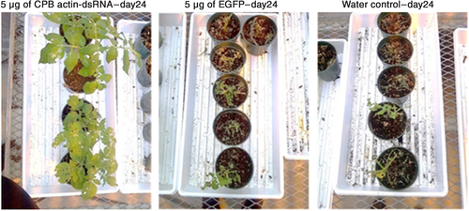

Figure 1.1 An example of protection of potato plants from insect pests (Colorado potato beetle) using a dsRNA based biocontrol.

The consumption of plant foliage is drastically reduced on plants treated with CPB actin‐dsRNA compared with the EGFP-dsRNA and water controls. After the treatments had dried, five, two and two second‐instar CPB larvae per plant were added to plants treated with actin‐dsRNA, EGFP and water respectively. Seven days later, all larvae were removed and the same numbers of new second instars were added per plant. Seven days later, ten, four and four second‐instar larvae were added. The plants treated with CPB actin‐dsRNA had minimal damage and continued to grow, while the controls were almost completely defoliated. Reproduced with permission from Miguel and Scott (2015).

Thus far in the research of RNA based biocontrols as a pest control method, the active molecules used have been long dsRNA molecules of a few hundred base pairs, with entirely natural nucleotides. In contrast, therapeutic short interfering RNAs (siRNAs) and DNA antisense oligonucleotides are ineffective in whole organism mammalian systems unless they contain a large number of chemically modified nucleotides which prevent their degradation in the bloodstream by extracellular nucleases (Soutschek *et al.*, 2004), as well as improving delivery and transport of the siRNA (Shen and Corey, 2018a). Long dsRNAs are naturally uptaken by many species of insects and insect cells, via standard cellular uptake mechanisms (see section 1.3.2) and readily used by the insects’ RNAi machinery, whereas long non-viral dsRNA results in cytotoxicity when applied to mammalian cells (Cordell-Stewart and Taylor, 1973; Gantier and Williams, 2007). Conversely, siRNAs are effective in both insect and mammalian cells, but require a transfection reagent to enter insect cells, which negates the advantage of spontaneous uptake of naked dsRNA by insect cells (Xiao *et al.*, 2015) which is required for a safe, efficacious and cost-effective final dsRNA based biocontrol insecticide product. The present study was therefore limited to long dsRNAs as the effector molecules for RNAi in insects.

Long dsRNA based insecticides can be degraded by nucleases, either in the environment (e.g. in soil (Dubelman *et al.*, 2014), or in the bodily fluids of the target insect (Peng *et al.*, 2018). Some insect orders such as Lepidoptera demonstrate greater nuclease degradation of dsRNA *in vivo* than others (Guan *et al.*, 2018), and nuclease degradation of dsRNA is a major barrier to successful triggering of RNAi by ingestion of dsRNA in insects. The hypothesis was that if chemical modifications increase the stability of siRNAs such that they become efficacious in mammalian systems, then chemical modifications might similarly increase the stability of long dsRNAs – which are already efficacious – to environmental and insect nucleases, thus reducing the dose of dsRNA required to achieve high mortality of a target pest insect on a crop.

To our knowledge, no results on the effect of chemically modified long dsRNA in insect cell cultures or live insects (discounting unmodified dsRNAs conjugated to other molecules for delivery) have been published. Reviewed below are details of the RNAi mechanism, the use of unmodified dsRNA as an insecticide, and the use of chemical modifications of siRNAs and antisense oligonucleotides in non-insect systems. All of these areas give insights into the types of chemical modifications that may be incorporated into long dsRNA for use in insect systems, without compromising RNAi efficacy.

## Introduction to RNA interference (RNAi)

### Introduction and history of RNAi

The destruction or translational inhibition of endogenous mRNAs associated with specific host genes, by an RNA-protein complex, guided by double stranded RNA (dsRNA) complimentary to the target mRNA – either foreign or endogenous – is termed RNA interference (RNAi) and was discovered by Fire, Mello and co-workers (Fire *et al.*, 1998) for which they were awarded the 2006 Nobel Prize for Physiology or Medicine (Hopkin, 2006). The awarding of the prize reflects the importance RNAi has come to play both as a tool in genetics, and as a pathway to be exploited to numerous ends in fields that include medicine and agriculture.

The mechanism now called RNAi was originally discovered in plants where it was termed posttranscriptional gene silencing (PTGS) (van der Krol *et al.*, 1988; Ketting and Plasterk, 2000) and later known as co-suppression in plants and quelling in fungi (Cogoni and Macino, 1997). Fire, Mello and co-workers discovered RNAi in the nematode *Caenorhabditis elegans*, building on the work of others who had studied related phenomena in *C. elegans*, crowning the nematode as the first species to be found to exhibit PTGS/co-suppression outside the kingdom Plantae, with the phenomenon being discovered in the fungi *Neurospora crassa* shortly thereafter (Cogoni and Macino, 1997, 1999). Tentative links were made between what were considered separate phenomena at the time, and the mechanism was suggested to be identical across the kingdoms considered thus far (Ketting and Plasterk, 2000). RNAi is now known to be widespread among eukaryotes (Baulcombe, 2004; Russell, 2010). It principally involves the post-transcriptional regulation of gene expression, though has been implicated in a range of other cellular processes. These include antiviral defence in insects (van Rij *et al.*, 2006; Aliyari and Ding, 2009) and plants (Aliyari and Ding, 2009; Carbonell and Carrington, 2015), as well as silencing of transposons (Czech and Hannon, 2016), and heterochromatin formation (Kim, Han and Siomi, 2009). Different variants of the pathway have evolved for sub-specialisms (see below).

Focussing on the gene regulatory and antiviral pathways, it was not originally clear that dsRNA was required for robust RNAi to occur. Initially it was considered that single stranded (ss) antisense RNA simply blocked the action of endogenous RNA by Watson-Crick base pairing to the endogenous RNA, thus blocking the action of the translational machinery (Fire *et al.*, 1998), and single stranded preparations of both sense and antisense RNA were indeed found to produce moderate interference (Fire *et al.*, 1991; Guo and Kemphues, 1995). Investigations were also conducted into the effect of sense-antisense mixtures, which produced interference of two or more orders of magnitude greater than single strand preparations alone. It was hypothesised that a sense-antisense mixture might form dsRNA, and this was confirmed by electrophoresis (Fire *et al.*, 1998). It was later established that single stranded RNA (ssRNA) does in fact regulate transcription as only one strand of the dsRNA forms the final RNA-induced silencing complex (RISC), however dsRNA allows cellular RNAi machinery to produce a more robust silencing effect than ssRNA precursors (Russell, 2010) with the additional complimentary ‘passenger’ strand protecting the targeting ‘guide’ strand.

These initial findings suggested a more complex mechanism for RNAi than simple blocking of translational machinery. It was later determined that a complex of proteins termed a RISC is responsible for the sequence-specific nuclease activity which results in the degradation of target mRNA (Hammond *et al.*, 2000).

### Mechanism and natural functions of RNAi

RNAi in eukaryotes is induced by non-coding small regulatory RNAs that are separated into two major categories; micro RNAS (miRNAs) and short interfering RNAs (siRNAs) (see figure 1.2). miRNAs are encoded in the genome and produced from a pri-miRNA precursor in the nucleus prior to being exported to the cytoplasm in order to effect RNAi (see figure 1.2 a), whereas siRNAs are produced by the processing of longer dsRNAs in the cytoplasm (Grimm, 2009; Russell, 2010) (see figure 1.2 b). Both miRNAs and siRNAs are around 21-23 nucleotides in length. The first miRNA and its regulatory function was discovered long before the RNAi mechanism was understood (Lee, Feinbaum and Ambros, 1993; Wightman, Ha and Ruvkun, 1993).

miRNAs are initially expressed in 5’ capped and 3’ polyadenylated tail form, with a hairpin structure at one end known as a primary miRNA transcript or pri-miRNA (Han *et al.*, 2004). The cap and polyadenylated tail are both removed by the endonuclease Drosha and its accessory protein (known as Pasha in *Drosophila*) (Tomari and Zamore, 2005) to leave a 3’ overhang of two nucleotides; this construct is known as pre-miRNA. The pre-miRNA is conveyed to the cytoplasm, where the hairpin structure is removed by the ribonuclease III (RNase III) enzyme Dicer and its accessory protein (known as Loquacious in *Drosophila*) to leave miRNA (Fukunaga and Zamore, 2012). Long dsRNA siRNA precursors may or may not contain a hairpin construct, but are rendered to an siRNA essentially identical to an miRNA by Dicer and its accessory protein, which remove any hairpin structures present and then divide the dsRNA into siRNAs with 3’ two nucleotide overhangs. While the structure of mature siRNAs and miRNAs are essentially identical, a key difference is that miRNAs usually target sequences in 3’ UTRs of mRNAs, whereas siRNAs usually target coding sequences.

A third major variant of the pathway exists involving single stranded Piwi-interacting RNAs or piRNAs, though this is termed RNA silencing rather than RNA interference, and the biogenesis of piRNAs is Dicer-independent (Vagin *et al.*, 2006) and distinct from siRNAs and miRNAs. piRNAs themselves also have very different in structure from miRNAs and siRNAs, as they are formed from a 26 nucleotide single stranded precursor that is processed into a single stranded 21 nt piRNA with a 2’-O-Me modification at the 3’ end (Simon *et al.*, 2011). Further consideration of the piRNA pathway is beyond the scope of the project.

Figure 1.2 Schematic of the miRNA and siRNA RNAi pathways in insects.

(a) Schematic demonstrating the insect miRNA pathway. Pri-miRNA is transcribed from the genome, cleaved to form a hairpin pre-miRNA by Drosha and Pasha, and the hairpin loop removed by Dicer-1. The mature miRNA complexes with Argonaute-1 and other RNA-induced silencing complex (RISC) components to form a pre-RISC. The passenger strand of the miRNA is then unwound and discarded, leaving the active mi-RISC. The mi-RISC targets and binds complimentary mRNA and prevents translation of the protein product either by translational repression or target mRNA cleavage. (b) Schematic demonstrating the insect siRNA pathway. Long dsRNA is cleaved to form siRNAs by Dicer-2. The mature siRNA complexes with Argonaute-2 and other RNA-induced silencing complex (RISC) components to form a pre-RISC. The passenger strand of the siRNA is then unwound and discarded, leaving the active si-RISC. The si-RISC targets and binds complimentary mRNA and prevents translation of the protein product by target mRNA cleavage or translational repression.

Though there are several variations on the RNAi pathway, both within and between species, the general mechanism involves a longer double stranded RNA precursor being trimmed to a functional siRNA or miRNA with two nucleotide 3’ overhangs and 5’ phosphate groups (Elbashir *et al.*, 2001; Elbashir, Lendeckel and Tuschl, 2001) by one of a class of RNase III enzymes collectively called Dicer (Bernstein *et al.*, 2001). The trimming process is therefore known as ‘Dicing’.

Interestingly *Drosophila* (Lee, Nakahara, John W. Pham, *et al.*, 2004) and other arthropods (Sparks *et al.*, 2014), have two Dicer paralogs, Dicer-1 and Dicer-2 whereas there is only one mammalian Dicer (Hammond, 2005; Kandasamy and Fukunaga, 2016). Dicer-1 processes pre-miRNAs to miRNAs, whereas Dicer-2 processes long dsRNA to siRNAs. Both Dicers lack the ability to process the substrate of the other, however they appear to have somewhat distinct but also partly duplicated roles in formation of si-RISCs (Lee, Nakahara, John W. Pham, *et al.*, 2004). While Dicers in insects have two roles, one in processing of miRNA/siRNA precursors, and one in RISC assembly and loading (Lee, Nakahara, John W. Pham, *et al.*, 2004), current evidence suggests Dicer is dispensable for RISC loading both *in vivo* and *in vitro* in mammalian systems (Betancur and Tomari, 2012), though this has been debated in the past (Doi *et al.*, 2003).

Dicer-1 produces miRNAs between around 22 and 24 nucleotides (nt) in length, whereas siRNAs produced by Dicer-2 are almost entirely 21 nt in length (Lee, Nakahara, John W. Pham, *et al.*, 2004) and are produced with high fidelity at this length. This specific length is thought arise from the 5’ phosphate of the dsRNA anchoring in a binding pocket in the PAZ domain of Dicer-2, which results in the RNase III domains’ active sites – where the dsRNA is cut – being exactly 21 nt along the length of the duplex assuming the duplex is in A-form (Kandasamy and Fukunaga, 2016).

Following processing of the long dsRNA precursor to a short RNA (sRNA), the remainder of the RNAi mechanism is similar, regardless of whether the RNAi machinery is presented with an miRNA or siRNA (collectively “short RNA” or sRNA), though with a few differences. Firstly, miRNAs can induce silencing by either perfect or imperfect pairing with their target mRNAs resulting in blocking of translation as well as target mRNA degradation, whereas siRNAs usually achieve silencing through perfect pairing, though off-target effects due to imperfect pairing can occur (Snead *et al.*, 2013). The final proteins to join the complex are also slightly different depending on whether the miRNA or siRNA pathway is being considered.

The next step involves the complexation of the sRNA or sRNA-Dicer-accessory protein construct with a protein from the Argonaute family of proteins (Ago-1/Ago-2) (Hammond, 2005) and its accessory proteins to form the pre-RISC, in a mechanism which may or may not involve Dicer depending on the species (Betancur and Tomari, 2012). In insects, Ago-1 acts on the miRNA pathway, whereas Ago-2 acts on the siRNA pathway. Both Ago-1 and Ago-2 in insects have additional RNase H activity and are termed ‘Slicer’ (Liu *et al.*, 2004; Song *et al.*, 2004). The Argonaute protein discards one of the siRNA/miRNA strands – the passenger strand – and remains bound to the guide strand. Depending on the particular Argonaute protein involved and the species, a selection of further proteins may also be bound to the ssRNA-Argonaute ribonucleoprotein complex. This final ribonucleoprotein complex is known as the RNA-induced silencing complex or RISC (Redfern *et al.*, 2013). Individual RISC complexes may be sub-classified as si-RISCs or mi-RISCs depending on whether the initial Dicer product incorporated was an siRNA or miRNA respectively. The RISC then uses the ssRNA as a guide to bind partially complementary (miRNAs) or fully complementary (siRNAs) mRNAs by Watson-Crick base pairing to prevent translation. This may be simply by translational repression of the target mRNA caused by the RISC physically inhibiting movement of the Ribosome along the mRNA, and translocation of the complex to a P-body for degradation (Eulalio *et al.*, 2007), or by active cleavage of the mRNA by Slicer activity (Hammond, 2005; Rivas *et al.*, 2005). Either route results in the blocking of translation of the target mRNA, preventing protein synthesis.

Insects – using *Drosophila* as an example – have three canonical Argonautes (Ago), Ago-1, Ago-2 and Ago-3 which are specialised to use miRNAs, siRNAs and piRNAs as their guides respectively (Okamura *et al.*, 2004; Höck and Meister, 2008). There are also two further Argonaute family proteins in *Drosophila* that do not bear the Argonaute name; these are Piwi and Aubergine. Ago-3, Piwi, and Aubergine are responsible for the silencing of mobile transposable genetic elements (transposons) in germ line cells, with Piwi and Aubergine largely binding piRNAs that are antisense to transposons, and Ago-3 binding piRNAs that are predominantly sense piRNAs (Brennecke *et al.*, 2007).

Humans have four canonical Argonautes (Ago-1 to Ago-4) and several additional Argonaute family Hiwi/Hili proteins (Azlan, Dzaki and Azzam, 2016). The widest variety of Argonautes are found in plants and nematodes, with *Arabidopsis thaliana* having 10 (Ago-1 to Ago-10/Zwille), the rice *Orzya sativa* having a bewildering 18 different Argonautes (Höck and Meister, 2008; Singh and Pandey, 2015), and *C. elegans* having 27 (Tolia and Joshua-Tor, 2007). The wide range of Argonautes in some species is essentially irrelevant here. The *Drosophila* Argonaute paralogs, Ago-1 and Ago-2, are specialised to deal with miRNAs and siRNAs respectively (Okamura *et al.*, 2004), whereas in mammals Ago-1, Ago-2, Ago-3 and Ago-4 can all incorporate both miRNAs and siRNAs into RISCs (Betancur and Tomari, 2012). The particular RNAi pathway we are concerned with utilising here is the pathway involving Argonaute-2 (Ago2) and Dicer-2 processing, using long dsRNA as an initial substrate.

The Ago-2/Dicer-2 RNAi pathway exists as an antiviral defence mechanism in insects (van Rij *et al.*, 2006), in lieu of the adaptive immune system that mammals have. dsRNAs may arise naturally in insect cells from: viruses with dsRNA genomes; from viruses with +ssRNA genomes where +ssRNA genomes anneal to -ssRNA viral mRNA produced as a precursor to producing viral proteins (Weber *et al.*, 2006); or from DNA viruses where overlapping sense and antisense transcripts combine (Bronkhorst and van Rij, 2014). All of these sources of viral dsRNA lead to the production by Dicer-2 cleavage of a pool of viral siRNAs (vsiRNAs) capable of targeting RNA virus genomes for degradation by the Ago-2 RNAi pathway. Insects, including *Drosophila* and mosquitoes, also have a mechanism for amplifying vsiRNAs by reverse transcribing defective viral genomes and then transcribing vsiRNAs from the resulting DNA (Poirier *et al.*, 2018); the Dicer-2 helicase domain is believed to be involved in this process.

Long dsRNA insecticides effectively hijack the Ago-2/Dicer-2 RNAi pathway, such that instead of targeting viral genomes/transcripts for destruction, the RNAi machinery of the insect is turned against its own transcripts, which are then targeted for destruction by the RISC. Insecticidal dsRNAs are selected such that they target mRNAs whose knockdown is lethal to the insect. This results in mortality, usually accompanied by prior stunting of growth (Baum *et al.*, 2007; Mao *et al.*, 2007; San Miguel and Scott, 2015) which has the additional benefit of preventing insects reaching sexual maturity and thus limits the wider population of the species.

By further restricting the criteria for insecticidal dsRNA target regions to regions of the target mRNA that have low sequence homology to the equivalent gene – or indeed, any other gene – in other species, the dsRNA based biocontrol can be highly selective (Whyard, Singh and Wong, 2009). Previously published results have demonstrated reduced susceptibility of southern corn rootworm and Colorado potato beetle to a dsRNA based biocontrol targeting western corn rootworm (Baum *et al.*, 2007).

### Applications of RNAi triggers in biological science

The aim of this project is the use of dsRNA used to trigger RNAi, as a highly selective alternative to chemical pesticides, however the triggering of RNAi for other applications such as functional genomics and as a therapeutic method, and the research that has been undertaken in these areas, may provide important clues as to how to overcome the challenges that stand between the current position of research, and putting RNA-based pesticides in to practice.

#### Application of triggering RNAi as a functional genomics tool

The first major application of RNAi was as a tool for determining gene function, by knocking down an mRNA in a model organism and observing the resulting phenotype in order to determine the function of the gene. This process has been more or less fully completed for both *C. elegans* and 12 major species of *Drosophila*; the roughly 20,000 protein coding genes of *C. elegans* have been probed by RNAi, as has every known Drosophila gene, with around 10-25% of knockdowns having an obvious phenotype, with the function of others being revealed by searching for genes relating to particular systems (Russell, 2010).

The same process is now being conducted to characterise gene function in organisms with few existing genetic tools in order to probe their possible use as future model organisms (Perrimon, Ni and Perkins, 2010) and to study alternative developmental systems such as the anterior-posterior patterning of the long germ band patterned wasp *Nasonia vitripennis* compared to the short germ band patterned *Drosophila* (Lynch and Desplan, 2006). siRNA knockouts are now routinely used in a variety of organisms in the fields of molecular biology, cell biology and genetics, to study the function of pathway components (Müller *et al.*, 2005; Neumann *et al.*, 2006; Saleh, Ronald P. van Rij, *et al.*, 2006; Boutros and Ahringer, 2008; Conrad and Gerlich, 2010; Horn, Sandmann and Boutros, 2010; Fisher *et al.*, 2012b; Saleh *et al.*, 2014; Billmann *et al.*, 2016; Vissers *et al.*, 2016).

#### Application of RNAi triggers as therapeutic agents

Application in a therapeutic context is perhaps the most naturally obvious practical application of RNAi, though many of the challenges to be overcome in order to use RNAi in a therapeutic capacity are equally applicable to developing it for use as a viable alternative to pesticides.

Most siRNA based therapeutics currently in development target: viral infections including HIV (Castanotto and Rossi, 2009); macular degeneration, cancer and more generally “malignant transformation of cells” (Grimm, 2009); cardiovascular disease (Perrimon, Ni and Perkins, 2010); and neurodegenerative diseases (Sah, 2006) such as Lou Gehrig’s disease and Parkinson’s disease (Castanotto and Rossi, 2009). As with the application of RNAi to pest control, the major challenges in medical application are delivery method, stability *in vivo*, and prevention of off-target effects (Zimmermann *et al.*, 2006; Perrimon, Ni and Perkins, 2010).

Chemical modifications have also been suggested as a method of modulating the efficacy of RNAi therapeutics, much as they have been mooted as a way of improving RNAi pesticides (Perrimon, Ni and Perkins, 2010), particularly as a way of increasing resistance to degradation by ribonucleases generally using phosphorothioate, 2’-O-methyl and 2’-fluoropyrimidine nucleotides at certain positions in the siRNA (Castanotto and Rossi, 2009). See section 1.4 for a full discussion of the use of chemical modifications in modulating RNAi activity.

#### Application of RNAi triggers in agriculture

There are three major possible applications for dsRNA in agriculture. Firstly, the improvement of crop strains themselves to resist disease, to increase their nutritional value, or to remove toxins to make thus far inedible plants potential crops (Perrimon, Ni and Perkins, 2010). Secondly, as a combative therapeutic agent against diseases that threaten crops and beneficial insects – remediation of the collapse of European honeybee populations due to Israeli acute paralysis virus (IAPV) is a particular example of how RNAi might be used in this way (Cox-Foster and vanEngelsdorp, 2009). Finally, as is the focus of the present investigation, as a species-specific method of destroying insect crop pest infestations (Baum *et al.*, 2007; Mao *et al.*, 2007).

The concept of using dsRNA based pesticides as an alternative to chemical pesticides has been around for many years, though the first proof of concept came with two landmark studies in 2007 (Baum *et al.*, 2007; Mao *et al.*, 2007). Prior to this, most attention had been focused on producing transgenic crop strains that would express dsRNA targeted against their natural pests and protect themselves, though this approach had yielded little success (Gordon and Waterhouse, 2007).

Baum and co-workers used a dsRNA feeding assay to screen western corn rootworm (WCR) larvae for essential genes, and discovered 14 genes whose knockdown was lethal. The dsRNA targeted against part of the WCR gene for the midgut enzyme vacuolar ATPase was selected for further study and produced in transgenic corn, which resisted WCR infestation to a degree comparable to current transgenic crops modified to resist infestation. The WCR dsRNA was also tested on southern corn rootworm larvae and Colorado potato beetle larvae for species specificity. As expected it was found that “mortality declined with decreasing sequence identity between the WCR genes and their orthologs in the other species, indicating that RNAi induction was potentially very selective” (Gordon and Waterhouse, 2007).

Mao and co-workers used the cotton bollworm in their work, a moth whose larvae are a major pest for a wide variety of crops including tomatoes, cotton and chick peas. The cotton plant produces a natural universal insecticide called gossypol, which the cotton bollworm neutralises by breaking it down with the enzyme, cytochrome P450 monooxygenase. Mao et al used dsRNA targeted against this protein to reduce the cotton bollworm’s tolerance to gossypol.

Caution must also be exercised in using RNAi effects targeted against allelochemicals such as gossypol as insects often have multiple families of proteins targeted against these natural insecticides, and this has been suggested to have been a factor in the rise of pesticide resistance (Feyereisen, 2006; Gordon and Waterhouse, 2007).

## A review of the application of unmodified dsRNA to induce RNAi in insects

### Introduction

Aspects of the RNAi process in insects have been discovered as a result of research into the use of dsRNA as an insecticide, though significant insights have come from investigation in other areas as well, such as insect anti-viral RNAi responses (Schuster, Miesen and van Rij, 2019), or functional genomics studies in insect species (Fisher *et al.*, 2012a). Insecticidal applications also extend beyond crop protection to the neutralisation of insects species which are vectors of human, animal or plant pathogens (Whitten *et al.*, 2016; Airs and Bartholomay, 2017) such as mosquitoes.

Beyond the use of traditional small molecule pesticides as a ‘chemical’ method of pest control, an initial successful ‘biological’ method utilising *Bacillus thuringiensis* (*Bt*) toxins, either as a sprayable insecticide, or with *Bt* toxin genes engineered into transgenic crop strains, has been effective. However many important insect pest species are not susceptible to this method of control, while other previously susceptible species have developed resistance to *Bt* toxins (Gordon and Waterhouse, 2007). This and the drivers discussed in section 1.1 above, have lead to investigation of dsRNA based biocontrols. The wide range of targets and insects investigated (also see above) have revealed there are significant differences between the susceptibility of different insect orders and species to RNAi.

Coleopteran insects demonstrate the most robust RNAi response, while Lepidoptera for example, represent the lower extremity of insect RNAi efficacy. However, many other insect orders beside Coleoptera demonstrate robust RNAi responses including Orthoptera (grasshoppers, locusts and crickets) (Dong and Friedrich, 2005; Wynant *et al.*, 2015), Hymenoptera (bees, wasps, ants and saw flies) (Amdam *et al.*, 2003; Yoshiyama, Tojo and Hatakeyama, 2013; Zhang, Zhang and Han, 2016), and Blattodea (cockroaches and termites) (Martín *et al.*, 2006). Some orders, Diptera and Hemiptera in particular, demonstrate great variability in RNAi efficacy depending on factors such as delivery method of the dsRNA (Cooper *et al.*, 2019). Examples of successful RNAi experiments in both Hemiptera (true bugs) (Hughes and Kaufman, 2000; Mogilicherla, Howell and Palli, 2018), and Diptera (flies) (Kennerdell and Carthew, 1998; Misquitta and Paterson, 1999) have been demonstrated however.

A number of factors have been proposed as contributing to the significantly reduced efficacy of RNAi triggered by oral dsRNA exposure in Lepidoptera compared to other orders. Lepidoptera have a high pH in the midgut lumen capable of degrading dsRNA, and the goblet cells responsible for producing the high pH are one of the most alkaline biological systems known (Dow, 1992; Terenius *et al.*, 2011). A potent nuclease termed RNAi efficiency-related nuclease (REase) only found in Lepidoptera, is responsible for significant degradation of dsRNA in insect cells (Guan *et al.*, 2018). Most insects exhibit an upregulation of the RNAi genes Dicer-2 and Argonaute-2 in response to uptake of dsRNA (Garbutt and Reynolds, 2012; Lozano *et al.*, 2012). However, this response is reduced in Lepidoptera compared to other insects (Bellés, 2010), and upregulation of the REase protein in response to detection of dsRNA is faster than the upregulation of Dicer-2 (Guan *et al.*, 2018).

Shukla *et al.*, directly compared several factors affecting RNAi efficiency after ingestion of dsRNA between Coleoptera and Lepidoptera, such as dsRNA uptake, dsRNA degradation and processing of dsRNA to siRNAs (Shukla *et al.*, (2016)). The results showed that cells of both insect orders efficiently uptake dsRNA. However, while coleopteran cells process the dsRNA to siRNAs, the dsRNA in lepidopteran cells remains in the endosomes and is not processed into siRNAs.

Certain species of Lepidoptera do demonstrate successful induction of RNAi, though many of these successful studies utilise delivery methods other than ingestion of naked dsRNA. These include injection of dsRNA into embryos (Quan, Kanda and Tamura, 2002), and expression of hairpin RNAs in plants ingested by the insects (Mao *et al.*, 2007). Successful RNAi responses triggered by dsRNA have been demonstrated in many other insect orders, as reviewed above.

Factors such as delivery of dsRNA, nuclease resistance of dsRNA, uptake of dsRNA and RNAi efficacy of dsRNA all impact the overall efficacy of a dsRNA based biocontrol. All of these factors are liable to be affected by dsRNA chemical modifications. How efficacious chemically modified dsRNA will be at inducing RNAi in any insect order is unknown, and results from assays in one order or system, such as in *Drosophila* cell lines (Diptera), may not be in agreement with results from assays in live insects from other orders, as is the case for unmodified dsRNA. Understanding of the background on uptake and delivery of unmodified dsRNA in insects (reviewed below) is therefore critical. Research into nuclease resistance of dsRNA is reviewed in the introduction to chapter 4.

### Uptake of dsRNA in insects

While many lab techniques utilising RNAi in insects rely on injection of dsRNA (Misquitta and Paterson, 1999; Quan, Kanda and Tamura, 2002; Amdam *et al.*, 2003; Dong and Friedrich, 2005; Mogilicherla, Howell and Palli, 2018), a dsRNA based biocontrol must be ingested orally in order to function successfully. Following ingestion, uptake of dsRNA by the insect is an essential step for a dsRNA based biocontrol to work, and differences in uptake between different insect species may be a leading cause of differences in RNAi efficiency of exogenous dsRNA in insects (Huvenne and Smagghe, 2010). For a dsRNA insecticide to work effectively the target insect must be capable of spontaneously transporting dsRNA from its gut lumen into gut epithelial cells, and preferably out into its hemolymph and other tissue types for a systemic response (see figure 1.3).

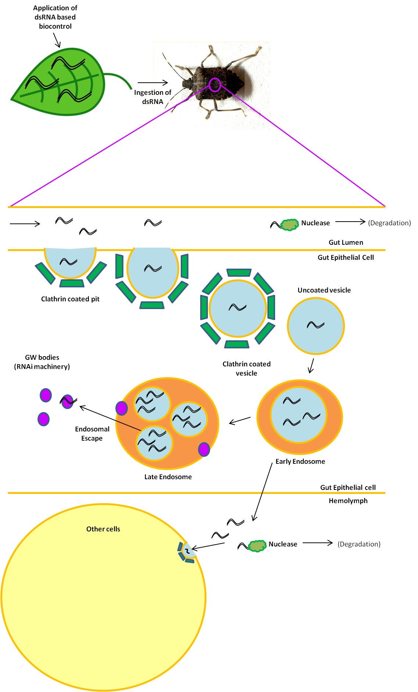

Figure 1.3 Proposed route of dsRNA from application to RNAi.

Schematic demonstrating the ingestion of a dsRNA based biocontrol by an insect, followed by uptake of the dsRNA from the gut lumen by endocytosis. dsRNA may then escape the endosome to induce RNAi in GW bodies, or be trafficked to other cells to elicit RNAi there.

The major uptake mechanism responsible for entry of dsRNA into insect cells is scavenger receptor-mediated endocytosis (see figure 1.3), and this has been confirmed experimentally for a range of insect models including *Drosophila* S2 cells (Ulvila *et al.*, 2006), the red flour beetle *Tribolium castaneum* (Xiao *et al.*, 2015), and the desert locust *Schistocerca gregaria* (Wynant *et al.*, 2014). The *Drosophila melanogaster* scavenger receptors SR-CI and Eater account for more than 90% of dsRNA uptake by S2 cells (Ulvila *et al.*, 2006; Huvenne and Smagghe, 2010).

There is a length requirement for the dsRNA to be effectively uptaken, with naked delivery of siRNAs and short dsRNAs to S2 cells resulting in low RNAi efficiency, with mRNA knockdown dropping rapidly from 80% for a 50 bp dsRNA to less than 60% for a 31 bp dsRNA, and there being no clear difference from a control dsRNA for a 21 bp targeting siRNA (Saleh, Ronald P van Rij, *et al.*, 2006). In the same study, the highest levels of knockdown were only achieved by dsRNAs over 200 bp. Studies in live Colorado potato beetles revealed a slightly greater length requirement, determining that 297 bp dsRNA resulted in greater mortality (96%) than a 208 bp dsRNA (35%) (Miguel and Scott, 2015). dsRNAs shorter than 208 bp showed no mortality after seven days, though did result in a failure of the larvae to mature, with a 102 bp dsRNA preventing 55% of larvae from molting to the fourth instar larval stage. A 50 bp dsRNA did not prevent any of the larvae reaching fourth instar stage, though resulted in a reduced average weight of 51.7 mg compared to the average of 70.1 mg for the control group.

While the initial uptake mechanism of dsRNA in insects has been investigated, the cellular machinery required for a systemic response in insects is not fully understood (Joga *et al.*, 2016). It is known that insect systemic RNAi does not function by the same mechanism as *C. elegans* systemic RNAi. *C. elegans* dsRNA uptake and subsequent systemic RNAi involves transport of dsRNA by two sets of multispan transmembrane proteins termed SID-receptors (Huvenne and Smagghe, 2010; Joga *et al.*, 2016). SID-2 receptors transport dsRNA from the gut lumen into gut epithelial cells, and SID-1 receptors relay the dsRNA on to neighbouring cells (Whangbo and Hunter, 2008; McEwan, Weisman and Hunter, 2012). Most insects have *sid-1* but not *sid-2* genes, although the insect *sid-1* genes are not necessarily orthologues of C. elegans *sid-1* and are closer to other *C. elegans* genes(Joga *et al.*, 2016). There are suggestions these “SID-like” genes may have a minor role in dsRNA uptake in some insects including western corn rootworm (Cooper *et al.*, 2019), but they have been determined to not be essential (Tomoyasu *et al.*, 2008). Some insects lack anything resembling SID genes altogether, yet still exhibit robust uptake of dsRNA. For example, sequencing of the transcriptome of the brown marmorated stink bug (*Halyomorpha halys*) revealed a lack of genes for SID or SID-like proteins (Sparks *et al.*, 2014). It has also been suggested but not investigated, that SID-like proteins may facilitate escape of dsRNA from endosomes (Cooper *et al.*, 2019).

Furthermore, our understanding of systemic RNAi is hindered by a lack of knowledge regarding how uptake mechanisms of dsRNA differ between different tissue types (Cooper *et al.*, 2019). Various reports from different insect species have suggested different potential mechanisms for systemic RNAi in insects. These include nanotube-like structures observed in *Drosophila* cell cultures which allow short distance transport of dsRNA as well as components of the RISC between nearby cells (Karlikow *et al.*, 2016). A second mechanism, also demonstrated in *Drosophila*, implicates hemocyte-derived exosome-like vesicles in systemically spreading antiviral siRNAs derived from dsRNAs via the hemolymph (Tassetto, Kunitomi and Andino, 2017). Lipophorin proteins also bind dsRNA in insect hemolymph (Wynant *et al.*, 2014), though the exact role these proteins play in transport of dsRNA is unknown, and they may either enhance or hinder RNAi, depending on whether they are involved in uptake of dsRNA or in sequestering it (Cooper *et al.*, 2019). How the potential methods of systemic RNAi observed in *Drosophila* fit together, and whether these mechanisms exist in other species is also not known (Vogel *et al.*, 2019).

Furthermore, *C. elegans* also has an RNAi amplification system, whereby secondary siRNAs are synthesised by an RNA-dependent RNA polymerase (RdRP) system to prolong the RNAi effect (Joga *et al.*, 2016). Insects lack this RdRP, however, recently an amplification system has been discovered in insects linked to the antiviral RNAi pathway, involving the helicase domain of Dicer-2 (Poirier *et al.*, 2018).

Based on the endocytosis uptake mechanism of orally delivered dsRNA, the list of possible ways of delivering dsRNA to an insect is narrowed (see below). It should be noted that while dsRNA insecticides have been developed to overcome issues of resistance with traditional small molecule pesticides, the major issue of resistance to dsRNA insecticides discovered so far is with uptake. A study into the possibility of resistance to dsRNA insecticides in western corn rootworm successfully developed a population of insects resistant to the DvSnf dsRNA-expressing maize, and determined that resistance was due to reduced uptake of dsRNA from the gut lumen (Khajuria *et al.*, 2018). If the mechanistic reason for this could be determined, a double RNAi approach of perturbing the insect’s uptake mechanism with one dsRNA prior to delivering a second insecticidal dsRNA might be possible.

### Delivery of dsRNA to insects

dsRNA has successfully been orally delivered to insects in a number of ways. The methods broadly categorise as foliar application of dsRNA (produced by *in vitro* transcription, cell-free methods or in microorganisms), production and delivery of dsRNA in the crop, or production and delivery in microorganisms. Furthermore, successful methods of foliar application include application of: naked dsRNA (Miguel and Scott, 2015; Gogoi *et al.*, 2017), formulated dsRNA (Christiaens *et al.*, 2018), liposome encapsulated dsRNA (Castellanos *et al.*, 2019), nanoparticle-bound siRNAs (Thairu *et al.*, 2017), and dsRNA loaded onto clay nanosheets (Mitter *et al.*, 2017). Successful examples of delivery of dsRNA in microorganisms includes delivery in yeast (Murphy *et al.*, 2016), delivery in *E. coli* (Garcia *et al.*, 2015; Kim *et al.*, 2015).

#### Delivery of purified dsRNA to insects orally by feeding

Previous work has shown that a number of species of major crop pest can be killed by RNAi effects due to dsRNA delivered by a feeding strategy, including major crop pests such as western corn rootworm, southern corn rootworm (Baum *et al.*, 2007), cotton bollworm (Mao *et al.*, 2007) and Colorado potato beetle (Miguel & Scott, 2015).

Direct foliar application of dsRNA targeted against Colorado potato beetles has recently been investigated ( Miguel and Scott, 2015). The work of Miguel and Scott showed that a foliar application of a solution of actin dsRNA in tap water was stable for at least 28 days, would not wash off due to rainfall, and was effective as a pesticide against Colorado potato beetles. In terms of overall tackling of an infestation, potato plants treated with the actin dsRNA were protected from the larvae for four weeks, and as effectively protected as treated plants after one, two or three weeks. Larvae on dsRNA treated leaves did not continue feeding beyond three days (see figure 1.1).

The study also contemplated the possibility of using dsRNA taken up in water by the roots into the leaves of the potato plants to achieve the same effect. This application of the dsRNA resulted in 23% mortality, with 49% failing to molt to fourth instar larvae, and significant loss of weight gain – 24-25% compared to the control groups. This suggests that uptake by roots into leaves is effective, but less so than foliar application.

A feeding strategy utilising pure dsRNA has yet to successfully induce RNAi effects in *Drosophila* (Whyard, Singh and Wong, 2009; McEwan, Weisman and Hunter, 2012), limiting the suitability of the most common insect model species as a suitable model for RNA based biocontrol research. It currently appears that a feeding strategy using pure untreated dsRNA will not result in RNAi induction in *Drosophila* as it will in some other species of insect, even for an RNAi target located in gut tissue, if the dsRNA is delivered purely in a water solution (Whyard, Singh and Wong, 2009). A single example exists of RNAi induction in *Drosophila* by means of soaking dechorionated embryos in a dsRNA solution (Eaton, Fetter and Davis, 2002) though the mechanism of uptake is unclear and this method is not suitable for delivery of an insecticide. Delivery of dsRNA by feeding has been successfully achieved however, by means of encapsulating the dsRNA in a transfection reagent (Lipofectamine 2000 being most effective) prior to feeding, though the effect was limited to the midgut cells alone likely due to the lack of SID-like receptors in *Drosophila* midgut cells (Whyard, Singh and Wong, 2009) and therefore possible lack of exocytosis of the dsRNA from these cells. The lack of systemic effect limits the RNAi targets available for knockdown by a feeding strategy to targets in midgut epithelial cells. A possible feeding strategy that has not yet been tested is supplementing the diet of *Drosophila* with a transgenic yeast or *E. coli* strain modified to express the relevant dsRNA, though this method has been successful in other species (Kim *et al.*, 2015; Abrieux and Chiu, 2016).

Delivery of siRNAs to insects by complexing the siRNAs with cationic polymers has been explored (Lee *et al.*, 2013), as has complexing siRNAs with N-acetylgalactosamine (K. Nair *et al.*, 2014) and lipid formulations (Vaishnaw *et al.*, 2010) though this is largely outside the scope of the current project.

#### Production and delivery of dsRNA by plants and microorganisms

Early research into dsRNA based insecticides utilised the idea of producing dsRNA insecticides in the crop plants themselves (Mao *et al.*, 2007). Mao and co-workers achieved silencing of the P450 gene in cotton bollworms fed on *Arabidopsis thaliana* modified to produce the relevant dsRNA – long hairpin (hp) RNA in this case – and genetically modified to remove the plant’s Dicer-like enzymes. This suggests that where previous attempts at RNAi through plant-based dsRNA expression failed, this was simply because the dsRNA was not expressed at a high enough rate to prevent it mostly being ‘diced’ by plant Dicer enzymes before being consumed by insects feeding on the plant (Gordon and Waterhouse, 2007). Increasing the rate of hpRNA production in transgenic crop lines might therefore create a workable method for plant-based dsRNA bicontrols. Modifying crop lines to lack Dicer-like enzymes opens the plants to invasion by dsRNA viruses, therefore caution is required.

The work of Baum et al and Mao et al opened up the possibility of modifying crop strains to protect themselves through RNAi by producing dsRNA targeted against their major insect pests. A strain of corn expressing the dsRNA DvSnf7 which targets western corn rootworm (Bachman *et al.*, 2016a; Tan, Steven L Levine, *et al.*, 2016) is the first RNAi inducing product approved by the US Environmental Protection Agency (US EPA, 2017). Unlike *Bt* toxins, dsRNA insecticides can be engineered to be highly selective using bioinformatic design tools (Whyard, Singh and Wong, 2009), and the selectivity and lack of effects in non-target insects has been demonstrated for DvSnf7 (Bachman *et al.*, 2016a).

The other strategy under investigation for RNA based biocontrols is the foliar application of dsRNA, either in its raw form, or through the foliar application of yeast or *E. coli* modified to express the dsRNA. A previous study has demonstrated that heat-inactivated *E. coli* expressing insecticidal dsRNA resulted in high mortality of beet armyworm through feeding, but resulted in no detectable colonies when plated on standard LB agar plates (Kim *et al.*, 2015) which may be enough evidence to abate concerns by regulators about releasing transgenic organisms into the environment.

Different strategies are being pursued simultaneously, with research into genetically modifying crop strains to produce dsRNA *in vivo* (Bachman *et al.*, 2016b; Tan, Steven L. Levine, *et al.*, 2016) being conducted, whilst other research groups are exploring the production of dsRNA by *in vitro* transcription (San Miguel and Scott, 2015; Huang *et al.*, 2019), or in microorganisms which are subsequently inactivated and then applied to the surface of the crop (Zhu *et al.*, 2011). These methods have been shown to be successful strategies for inducing RNAi in both insects and nematodes in a lab setting (Timmons, Court and Fire, 2001; Kim *et al.*, 2015; Vatanparast and Kim, 2017). Heat-inactivated yeast expressing a dsRNA insecticide have also been demonstrated to be successful in killing larvae of mosquitoes, as a possible measure against this common malaria vector (Mysore *et al.*, 2017). dsRNA produced in *E. coli* which are subsequently heat-inactivated has also been demonstrated to successfully induce RNAi in fish cells (Garcia *et al.*, 2015) and this technique may have applications outside of insecticides, such as viral or parasite control.

The concept of production of dsRNA insecticides in microorganisms has been extended to the suggestion that they could be simultaneously produced and delivered in live microorganisms capable of symbiotically colonising the insect gut (Whitten *et al.*, 2016). This requires the choice and subsequent engineering of a suitable microbe strain, as the *E. coli* strains commonly used for dsRNA production may induce an immune reaction. However, bacterial species such as *Rhodococcus rhodnii* that is a natural symbiont of blood-sucking triatomine insects may be more suitable.

Expression of dsRNA targeted against insect pests by crop plants themselves, foliar application of formulated dsRNA, or foliar application of microorganisms containing insecticidal dsRNA, all appear viable potential methods of inducing RNAi effects in the pests, leading to mortality, and thus are all potentially viable methods of controlling infestation.

## A review of chemical modifications applied to siRNAs and oligonucleotides for medical and functional genomics research

### Introduction

Common nucleic acid chemical modifications generally fall into one of three categories, either backbone modifications which subdivide into those located on the phosphate or those located on the ribose/deoxyribose groups, or base modifications. Multiple modifications are also often found in concert together within the same molecule (Lima *et al.*, 2012; Schirle *et al.*, 2016; Shen and Corey, 2018b) based on rational design rules to maximise the efficacy of the siRNA or oligonucleotide. Chemical modifications are also naturally found in some nucleic acids in some systems. These topics are briefly reviewed individually below.

Improving silencing efficacy and stability of siRNAs and antisense oligonucleotides by means of chemical modification of the nucleotides has received considerable study in a variety of organisms and cell types, particularly *C. elegans* and mammalian cells. Chemical modification of nucleic acids pre-dates the discovery of RNAi, with studies being undertaken prior to the discovery of RNAi in 1998 in to the ability of 2’-modified nucleic acids to be enzymatically synthesised by T7 RNA polymerase (Conrad *et al.*, 1995), as well as creating a mosaic of both DNA and RNA. This work focused on 2’-O-methyl NTPs, which have later been utilised in the context of RNAi, along with other 2’ modified NTPs (see below). Many of the siRNA and antisense oligonucleotide drugs approved for use in clinical trials are heavily chemically modified (Shen and Corey, 2018a). As unmodified dsRNA insecticides and chemically modified siRNA drugs have both been given regulatory approval, the chances are that given sufficient research to confirm the safety of a chemically modified dsRNA insecticide, it would be likely to gain regulatory approval as well.

As discussed above, nuclease degradation of dsRNA is a major barrier to successfully triggering RNAi in insects through oral application of the dsRNA, and chemically modifications have been shown to improve nucleic acid resistance against mammalian nucleases. However, there has been little investigation of chemically modified siRNAs or dsRNA in *Drosophila* or insects as unmodified long dsRNA is already efficacious for RNAi, and naked siRNAs cannot be uptaken by insects. RNAi can be induced by siRNAs in *Drosophila* cell lysate (Elbashir *et al.*, 2001) and the same study tested 2’-deoxy and 2’-O-Me modified siRNAs. However, to our knowledge, no studies have examined the efficacy of chemically modified siRNAs or dsRNA in whole cell or whole organism insect systems. The literature on chemically modified siRNAs and antisense oligonucleotides for use in mammalian, *C. elegans*, and other non-insect systems is therefore a solid basis from which to select chemical modifications which may modulate the RNAi efficacy of long chemically modified dsRNA in insects.

### Nucleic acid backbone chemical modifications

The majority of backbone chemical modifications incorporated into siRNAs for research in mammalian and other systems have been either phosphorothioate modifications or 2’ ribose modifications, including 2’-fluoro, 2’-O-methyl, 2’-amino and locked nucleic acid (LNA) modifications. These chemical modifications have been utilised repeatedly in research in mammalian and other systems (Parrish *et al.*, 2000; Braasch *et al.*, 2003; Dande *et al.*, 2006; Bramsen *et al.*, 2009; Lima *et al.*, 2012) and are shown in figure 1.4. 2’-amino modifications failed to be compatible with RNAi machinery and so are omitted (Parrish *et al.*, 2000).

Figure 1.4 Structural formulae of common nucleic acid chemical modifications.

Structural diagrams demonstrating common nucleic acid chemical modifications (of RNA in this case) previously used to modulate RNAi in mammalian or other systems.

Unfortunately, there are many contradictory studies in the literature utilising chemically modified siRNAs. For example, an early study conducted on knockdown of the *unc-22* gene in *C. elegans* showed that phosphorothioate modifications to A, C or G residues resulted in full interference, whereas dsRNA with phosphorothioate U residues resulted in slightly reduced interference activity (Parrish *et al.*, 2000). siRNAs with two bases or more fully replaced by phosphorothioate modified bases became unstable in vitro and did not survive long enough to be used in an assay (Parrish *et al.*, 2000). However, siRNAs partly or fully substituted with phosphorothioate linkages were shown to result in high levels of mRNA knockdown in human HeLa cells (Braasch *et al.*, 2003). Phosphorothioate linkages in the RNA backbone are believed to reduce cleavage by nucleases and increase half-life *in vivo* (Braasch *et al.*, 2003) and also increase binding to serum proteins, reducing rates of clearance and improving bioavailability (Geary, Yu and Levin, 2001; Braasch *et al.*, 2003). While minimal substitution is tolerated by RNAi machinery, there is evidence that in some systems extensive phosphorothioate substitution is toxic to cells (Amarzguioui *et al.*, 2003).

dsRNA with 2’ modifications have demonstrated mixed results, with 2’-deoxy and 2’-amino modifications showing decreases in RNA interference (Parrish *et al.*, 2000) especially when incorporated into the guide strand rather than the passenger strand. However, multiple 2’-deoxynucleotide substitutions at the 3’ end of siRNAs are tolerated in *Drosophila* cell lysate (Elbashir *et al.*, 2001). It was proposed that this was due to residues in the centre of siRNAs being more important for sequence specific target recognition and cleavage than those towards the 3’ and 5’ ends of the strands. Elbashir et al also proposed that the position of the target mRNA cleavage site is defined from the 5’ end of the guide siRNA rather than the 3’ end. DNA-RNA hybrids have also been found to lack RNAi activity in *C. elegans* (Parrish *et al.*, 2000).

On the other hand, 2’-fluoro modifications were found to be compatible with RNAi machinery in *C. elegans* and resulted in comparable mRNA knockdown when one of the four nucleotides was replaced by a 2’-fluoro analogue in either the passenger strand or guide strand (Parrish *et al.*, 2000). siRNAs with two of the four nucleotides replaced by 2’-fluoro analogues (2’-FC and 2’-FU) in either the guide strand, passenger strand, or both strands were also found to have comparable RNAi efficacy to unmodified siRNAs in human HeLa cells (Chiu and Rana, 2003). 2’-deoxy and 2’-amino modifications reduce the helical A form character of siRNAs whereas 2’-fluoro modifications do not, and this has been proposed as a reason for the difference in RNAi efficacy between these modifications (Cummins *et al.*, 1995; Lesnik and Freier, 1995; Parrish *et al.*, 2000)

Some modifications were originally concluded to be unviable for RNAi, such as 2’-O-methyl modifications (Elbashir *et al.*, 2001; Braasch *et al.*, 2003), however siRNAs with various combinations of phosphorothioate, 2’-O-methyl and even 2’-O-MOE (O(CH2)2OCH3) modifications confined to the end two or three residues at either or both the 3’ and 5’ end of either or both the passenger and guide strands produced siRNAs both “2-4 fold more potent and 13-18 fold more stable than unmodified siRNAs” (Dande *et al.*, 2006).

Further studies also suggested that wider 2’-O-Me modification of the passenger strand was tolerated, where previous evidence had suggested it was not, though the reasons for this were not immediately determined (Kraynack and Baker, 2006). More recent evidence suggests 2’-O-Me modifications are more widely tolerated by RNAi machinery than previously thought, and 2’-O-Me modification of large sections of the guide strand is possible whilst retaining full RNAi activity (Iribe *et al.*, 2017), however universal substitution abolishes silencing (Braasch *et al.*, 2003). 2’-O-Me modifications have a strong thermal stability effect, increasing the duplex melting temperature of an siRNA by up to 1 °C per modification (Gaynor, Campbell and Cosstick, 2010).

It has also been found that using unlocked nucleic acid (UNA) modifications which reduce RNAi efficacy when included in central positions of either strand of an siRNA or the 5’ position of the guide strand, can favour incorporation of the anti-sense (guide) strand into the RISC when incorporated in the 5’ end of the sense (passenger) strand of siRNAs (Bramsen *et al.*, 2009; Nicholas M. Snead *et al.*, 2013).

The effect of locked nucleic acid (LNA) modifications of siRNAs on RNAi efficacy has also been tested. Early results were mixed, with similar numbers of LNA modifications in both strands resulting in high or low RNAi efficacy depending on distribution (Braasch *et al.*, 2003). Further work determined that siRNAs with LNA modifications in the 3′ overhangs were as functional as unmodified siRNAs, and the 5′ end of the passenger strand could also be modified without reducing RNAi efficacy (Elmén *et al.*, 2005). The same study found that an LNA modification at the 5′ end of the guide strand significantly reduced RNAi efficacy. However, an siRNA with both a 5’ guide strand LNA as well as a 3′ passenger strand LNA recovered some RNAi activity and RNAi activity was recovered even further if there was also a 5′ passenger strand LNA modification. LNA modifications elsewhere in the guide strand were well tolerated, other than at positions 10, 12 and 14. The target mRNA cleavage site is between positions 10 and 11 so the reduced activity may be due to LNA modifications at these positions affecting the conformation of the catalytic site of Argonaute (Elmén *et al.*, 2005). LNA modifications have a significant effect on duplex thermal stability, and an siRNA duplex with a fully LNA modified passenger strand could have a melting temperature of over 95 °C. Whether a helicase would be capable of unwinding such a stable duplex is questionable, yet such duplexes retain full RNAi activity (Braasch *et al.*, 2003). It has been hypothesised that it may be that RISCs formed with LNA:RNA siRNA duplexes remove the passenger strand by cleaving it in the same manner as a target mRNA in order to form the active RISC, rather than by unwinding it by a helicase mechanism.

Phosphorothioate modifications appear especially promising and in fact the majority of single-stranded oligonucleotide therapeutics currently under investigation are phosphorothioate-based (Shen and Corey, 2018a). However, phosphorothioate siRNAs behave differently depending on stereochemistry of the phosphorothioate groups (Jahns *et al.*, 2015a) and so investigations into producing stereochemically pure phosphorothioate oligonucleotides are being conducted. Every phosphorothioate linkage can exist as two different stereoisomers; a fully phosphorothioate-linked single stranded oligonucleotide containing 20 nucleotides can therefore exist as 220 (1,048,576) different stereoisomers, which presents an enormous challenge. However it has been suggested that a higher number of R (rather than S) linkages improves siRNA potency (Jahns *et al.*, 2015a).

A recent interesting development has been the use of single stranded short interfering RNAs (ss-siRNAs) to induce RNAi in mice (Lima *et al.*, 2012). These ss-siRNAs were found to be active and most potent when containing the following modifications: a fully phosphorothioate-linked ss-siRNA; a 5’ terminal phosphonate analogue; a 2’-methoxyethyl (2’-MOE) nucleotide at the 5’ terminus to protect against exonuclease activity; two 2’-MOE nucleotides at the 3’ terminus; alternating 2’-F and 2’-O-Me modifications for the rest of the chain. These ss-siRNAs consisting of entirely modified nucleotides were able to invoke RNAi *in vivo* in mice.

Promising modifications which merited further study were therefore: phosphorothioate modifications, which improve the RNAi effect by increasing binding of dsRNAs to serum proteins, thus reducing their clearance rate and increasing in vivo half life (Geary, Yu and Levin, 2001) as well as increasing nuclease resistance (Chiu and Rana, 2003; Jahns *et al.*, 2015a); and 2’-fluoro modifications which are tolerated by RNAi machinery (Braasch *et al.*, 2003) and also increase nuclease resistance of nucleic acids in some systems (Chiu and Rana, 2003).

### Nucleic acid base chemical modifications

The current literature on chemical modifications to the bases themselves presents a bewildering array of possible chemistries (Peacock *et al.*, 2011b). It is interesting to note however that work on the effects of base modifications on RNAi has been conducted since shortly after the discovery of RNAi, as exemplified by the work of (Parrish *et al.*, 2000).

Chemical modifications that significantly affect hydrogen bonding for Watson-Crick base pairing can both reduce RNAi efficacy, such as changing the 2-NH2 group of guanosine to 2-H (changing guanosine to inosine) reduce RNAi efficacy, or have little effect on RNAi efficacy, such as 4-thio modifications on uracil (Parrish *et al.*, 2000). Modifications on non-hydrogen bonding groups can similarly either reduce RNAi efficacy, or have little effect. For example 5-bromo modifications to uracil are well tolerated, but 5-iodo modifications to uracil result in reduced RNAi efficacy, particularly when these modifications are included in the guide strand (Parrish *et al.*, 2000).

A study into the effects of many different kinds of base modifications to siRNAs determined that most either had no effect on RNAi efficacy or reduced RNAi efficacy, with no clear improvements for any of the modifications tested (Peacock *et al.*, 2011a). Base modifications were not generally considered for investigation as part of this project as their effects are generally less well understood than those of backbone chemical modifications.

### Naturally occurring nucleic acid chemical modifications

Many nucleic acids in natural systems contain non-canonical chemically modified nucleotides. This is an important point to consider, as drawing attention to this prevents chemically modified nucleic acids being regarded as highly “synthetic” by the general public, and may therefore aid in the acceptance of the use of chemically modified dsRNA insecticides. Examples of chemical modifications of nucleic acids found in nature include the following.

Methylation of DNA and RNA is a common naturally occurring nucleic acid epigenetic chemical modification. Principally DNA methylation is a method of repressing gene transcription (Jin, Li and Robertson, 2011), and RNA methylation is a method of post-transcriptional gene expression regulation (Yue, Liu and He, 2015; Shi, Wei and He, 2019).

Partially phosphorothioate-modified DNA has been found to occur naturally in *Streptomyces lividans* (Karwowski, 2015). piRNAs contain 2’-O-Me modifications at their 3’ end (Saito *et al.*, 2007; Simon *et al.*, 2011). T4 phages use Glucosyl 5-hydroxymethyl cytosine modifications to protect their DNA from host cell nucleases (Shi *et al.*, 2017; Vlot *et al.*, 2018). Chemical modifications of rRNA are implicated in the specialisation of ribosomes, particularly 2’-O-Me modifications, and pseudouridine modifications (Sloan *et al.*, 2017; Guo, 2018), which also have a role in stabilisation of rRNA secondary structure.

## Discussion and research project scope and aims based literature review

The selection of RNA modifications shortlisted to be tested for their effects on RNAi efficacy when incorporated into dsRNA, were obtained by consulting the literature on the use of RNA modifications for siRNAs or antisense oligonucleotides in *C. elegans* or human/mammalian systems for medical or functional genomics applications (reviewed in section 1.4 above). Commonly used nucleic acid modifications subdivide into three major categories: 1) RNA backbone phosphate group modifications, for example phosphorothioate (Parrish *et al.*, 2000; Braasch *et al.*, 2003; Jahns *et al.*, 2015b), or boranophosphate (Hall *et al.*, 2006); 2) backbone ribose sugar ring modifications, almost exclusively of the functional group of the 2’ carbon, which include 2’-fluoro (Braasch *et al.*, 2003; Muhonen *et al.*, 2007), 2’-O-Me (Braasch *et al.*, 2003; Kraynack and Baker, 2006; Dua *et al.*, 2011; Iribe *et al.*, 2017), 2’-deoxy (DNA bases) (Elbashir *et al.*, 2001; Iribe *et al.*, 2017), and locked/unlocked nucleic acid (LNA/UNA) (Campbell and Wengel, 2011; Nicholas M. Snead *et al.*, 2013; Chang *et al.*, 2016a; Iribe *et al.*, 2017); 3) modifications of the bases themselves, of which a bewildering array are available covering many different types of functional group and many different positions within the four RNA bases (Parrish *et al.*, 2000; Chiu and Rana, 2003; Peacock *et al.*, 2011a).

A shortlist of chemical modifications was compiled to attempt inclusion of in dsRNA during enzymatic synthesis, covering all three classes (see figures 1.4 and 3.1):

* Phosphate modifications: Phosphorothioate (PS)
* Ribose modifications: 2’deoxyfluoro (2’F), DNA bases (see HMdC below)
* Base modifications: hydroxymethyl cytodine (HMrC) (see figure 3.1 b), hydroxymethyl deoxycytidine (HMdC) (also technically a ribose modification) (see figure 3.1 c), glucosylated hydroxymethyl deoxycytidine (Gluc HMdC) (see figure 3.1 d)

Phosphorothioate modifications and 2’-fluoro modifications were chosen as they are widely utilised, increase nuclease stability of some nucleic acids, and have straightforward rules for their effects on RNAi efficacy in mammalian and *C. elegans* systems, compared to modifications such as 2’-O-Me and LNA. As few base modifications of siRNAs lead to improved RNAi efficacy, these modifications were generally not considered, however 5-hydroxymethyl modifications were selected as a base modification to test, based on their role in increasing nuclease resistance of phage DNA in host cells (see section 3.3.6).

dsRNA containing phosphorothioate (PS) modifications is of particular interest, for a number of reasons. PS modifications are the most common nucleic acid modification used elsewhere, including siRNAs and antisense DNA oligonucleotides (Shen and Corey, 2018b), and there is a great deal of evidence suggesting that in mammalian whole-organism systems they greatly increase the stability of nucleic acids in the bloodstream (Chiu and Rana, 2003; Jahns *et al.*, 2015b). Secondly, synthesis of PS dsRNA is relatively simple and can be achieved with a standard T7 RNA polymerase (Ueda *et al.*, 1991), with a moderate drop in incorporation efficiency with each additional nucleotide replaced by a PS analogue (Stovall *et al.*, 2014). Furthermore, phosphate molecules are a direct precursor for nucleotide biosynthesis in cells (Lane and Fan, 2015), and thiophosphate has been shown to be tolerated in cell media (Frayne, 2016). In contrast, the precursor to ribose rings is glucose, and many glucose analogues are metabolically inactive (Niccoli *et al.*, 2017). This means the large scale production of insecticidal dsRNA in microorganisms (Abrieux and Chiu, 2016) – one of the methods that could be used to produce sufficient quantities for field application – could potentially use modified thiophosphate containing media to incorporate thiophosphate groups during nucleic acid synthesis, whereas ribose or base modifications cannot be so easily incorporated on an industrial scale.

The size of the dsRNAs required for efficient RNAi in insects has an effect on how chemical modifications can be incorporated. Naked delivery of siRNAs and short dsRNAs to insect cells or insects result in low RNAi efficiency, with mRNA knockdown dropping rapidly from 80% for a 50 bp dsRNA for shorter dsRNAs, and the highest levels of knockdown only achieved by dsRNAs over 200 bp for S2 cells (Saleh, Ronald P van Rij, *et al.*, 2006). In some species longer dsRNAs are required for successful silencing in live insects, for example dsRNAs of around 300 bp are needed for high levels of mortality in Colorado potato beetle (San Miguel and Scott, 2015). Long dsRNAs are therefore the active molecule for RNA based insecticides. siRNAs are usually synthesised sequentially by a solid phase method which adds one nucleotide at a time to the growing RNA chain (Jahns *et al.*, 2015b), and allows for particular chemically modified nucleotides to be added at certain positions along the siRNA. This method is impractical and costly for the long dsRNAs required for dsRNA based insecticides, therefore enzymatic synthesis is the most practical synthesis method (Conrad *et al.*, 1995) (discussed further in section 3.2). However, enzymatic synthesis of dsRNA limits the inclusion of chemical modifications to replacing all of one nucleotide with a chemically modified analogue throughout the dsRNA molecule, thereby limiting control over the combination and location of chemical modifications within the final active siRNAs derived from the dsRNA. Many chemically modified siRNAs contain a wide range of different chemical modifications at certain positions (Lima *et al.*, 2012; Schirle *et al.*, 2016; Shen and Corey, 2018a) and the same fine-scale control of the location of dsRNA chemical modifications is impractical in insects.

It has previously been determined that the presence of modifications in only one of the two strands of an siRNA can affect the RNAi activity of the probe. A good example of this is the presence of unlocked nucleic acid (UNA) residues in the 5’ end of only the passenger strand of an siRNA reducing the chances of the passenger strand being incorporated into the RISC complex, therefore favouring the RNAi-active antisense guide strand being incorporated, and increasing the number of active RISC complexes available to induce mRNA knockdown for an equivalent dose of unmodified siRNA (Snead *et al.*, 2013). The difference in RNAi efficacy of dsRNA with chemical modifications in one strand or both strands was therefore a further factor for investigation. Many later assays required the use of dsRNA with modifications in only one of the two strands, which therefore had to be produced as separate ssRNAs in separate reactions, and then later annealed to give the final dsRNA (see section 3.3.2).

As Dicer is thought to be redundant for loading of pre-formed exogenous siRNAs into RISCs (Betancur and Tomari, 2012), and is not required to process them in any way from a precursor, whether Dicer processes chemically modified siRNAs has never previously been a factor in determining if modifications are tolerated in mammalian systems for RNAi. However, studies of the cleavage of some chemically modified RNA by the less complex Dicer-like RNase III enzyme have been carried out previously (Nicholson *et al.*, 1988). As the current project utilises long dsRNA precursors that need to be processed by Dicer to active siRNAs, and as Dicer has a role in RISC formation in insects, the tolerance of Dicer for chemical modifications is a key point for consideration and investigation.

It was required that we establish that modified long dsRNAs could be efficiently enzymatically synthesised for subsequent use for RNAi in insect cells or live insects; this issue is examined in chapters 3. The ability of Dicer – a key protein in the RNAi machinery – to process chemically modified dsRNA was also examined, and this is covered in chapter 4. Many RNA chemical modifications result in an increase in nuclease resistance which allows the RNA to survive degradation by nucleases, in order to be used for RNAi. This is a key mechanism by which a chemically modified dsRNA might demonstrate improved RNAi efficacy in insects. The effect of chemical modifications on the resistance of nucleic acid to insect nucleases is not known, and so this was also investigated in chapter 4. Finally, as previously discussed, it is not known how efficacious for RNAi chemically modified dsRNA will be overall in insects, and therefore the RNAi efficacy of chemically modified dsRNA in insect cells and whole live insect systems is the critical point for consideration. Establishing that chemically modified dsRNAs could induce RNAi in insect cells was examined in chapter 5. Whether or not an improvement in mRNA knockdown through RNAi in live insects due to increased nuclease resistance from RNA modifications could be detected was investigated and details of this form chapter 6.

Chapter 2

Materials and Methods

# Materials and Methods

## Chemicals, reagents and equipment

|  |  |  |
| --- | --- | --- |
| **Chemicals, reagents, and kits** | **Company** | **Product Code** |
| Acetic Acid | VWR | 20102.320 |
| Acetonitrile | Fisher Scientific | A/0626/17 |
| Agarose | Bioline | BIO-41025 |
| Ammonium acetate | Sigma | A1542 |
| Ammonium sulfate | Sigma | A4915 |
| AMP | Sigma Life Sciences | A1752 |
| Ampicillin sodium salt | Alfa Aesar | J63807 |
| ATP | Sigma | A2383 |
| D-Coe Mix | Apollo Scientific |  |
| D-Luc Mix | Apollo Scientific |  |
| DNA primers | IDT, Eurofins |  |
| DTT | Sigma | 10708984001 |
| Dual luciferase assay kit | Promega | E1910 |
| Durascribe T7 in vitro transcription Kit | Epicentre (Now Lucigen) | DS010925 |
| Effectene transfection kit | Qiagen | 301427 |
| Ethanol | Fluka | 02860 |
| Ethylenediaminetetraacetic acid | Sigma | 324503 |
| Ethidium Bromide | Sigma | E1510 |
| Wizard Genomic DNA extraction kit | Promega | A1120 |
| HEPES | Sigma Life Sciences | H3375 |
| 5-hydroxymethyl dCTP | Bioline | BIO-39046 |
| 5-hydroxymethyl CTP | TriLink | N-1087 |
| GeneRuler 100 bp Ladder | Thermo Fisher | SM1553 |
| Isopropanol | Fluka | 24137 |
| MEGAscript T7 in vitro transcription Kit | Ambion/Invitrogen/Thermo Fisher | AM1334 |
| Mini/Midi prep kits | Qiagen | 27104/12143 |
| Nuclease-free water | Ambion/Thermo Fisher | AM9939 |
| Rp/Sp α-thio NTPs | TriLink | K-1002 |
| Sp α-thio NTPs | Biolog | A040/G015/U003 |
| PB Buffer | Qiagen | 19066 |
| KAPA2G PCR master mix | KAPA Biosystems | KK5102 |
| KAPA2G PCR kit | KAPA Biosystems | KK5008 |
| Phosphate buffered saline | Thermo Fisher | BR0014G |
| PowerCut Dicer kit | Thermo Fisher | F-602S |
| RNA loading dye II | Ambion | AM8546G |
| Shortcut RNase III kit | NEB | M0245S |
| Sodium chloride | Sigma | S9888 |
| Triethylammonium acetate | Fluka | 90357-500ML |
| Tris base | Sigma | 648310-M |
| Triton X-100 | Sigma Life Sciences | T8787 |

|  |  |  |
| --- | --- | --- |
| **Cell culture medium and supplements** | **Company** | **Product Code** |
| Foetal bovine serum (FBS) | Sigma Life Sciences | F2442 |
| Hyclone CCM3 Medium | GE Life Sciences | SH30065 |
| LB Agar | MP Biomedicals | 11383259 |
| LB Broth | Sigma Life Sciences | L3522 |
| M3 Medium | Caisson | SSL01 |
| Pen-Strep | Lonza | 17-602E |
| Schneider’s Drosophila Medium | Gibco | 21720001 |
| Sf9 Medium | Gibco | 10902088 |
| Yeast Extract | Sigma Life Sciences | Y1625 |
| Bacteriological Peptone | Fisher Scientific | 10404013 |

|  |  |  |
| --- | --- | --- |
| **Equipment** | **Company** | **Model/Catalogue Number** |
| Weighing balance | Kern | ABT320-4NM |
| Heating Block | Techne | DB-3A |
| Heated ultrasonic bath | Fisher Scientific | 11718029 |
| Centrifuge | Eppendorf | 5424 |
| Nanodrop Spectrophotometer | Fisher Scientific | ND-2000 |
| Thermal cycler (PCR) | Applied Biosystems | 4375786 |
| UV transilluminator | UVP | UV/White |
| FAS-Digi | Geneflow | NGFG09/G5-0744 |
| Camera | Lumix | DMC-GF7 (Included with FAS-Digi |
| Vortex mixer | Fisher Scientific | 11726744 |
| pH meter | Mettler Toledo | F20/F30 |
| Gel apparatus | Bio-rad, Embi Tec | Various |
| Power supplies | Bio-rad, Embi Tec | Various |
| Incubator Shaker | SciQuip | SQ-4030 |
| HPLC Ultimate 3000 | Dionex | U3000 |
| HPLC Agilent 1100 | Agilent | 1100 |
| Column oven | Transgenomic | L7300 |
| RP-1S reverse phase HPLC column | Thermo Fisher | 064297 |
| Varioskan Flash Plate Reader | Thermo Scientific | N06354 |
| Nanoinjector | Eppendorf, Drummond | Femtojet, Nanoject III |

## Production and analysis of dsRNA

### PCR of DNA templates

For the Jak/STAT pathway Stat and Dome probes, the initial template used in the first round of PCR was genomic DNA extracted from *Drosophila* S2R+ cells using a Promega Wizard Genomic DNA Purification Kit and following the kit. F59C6.5 PCRs used existing PCR product from a library plate as starting material. Targets A, B and C DNA templates, and control GFP DNA templates used plasmids provided by Syngenta as the starting point for PCR.

Two rounds of PCR we used to generate templates with either a single RNA polymerase binding site for ssRNA templates, or two RNA polymerase binding sites for dsRNA templates, using primers with either no polymerase promoter, a T7 polymerase promoter, or an SP6 polymerase promoter.

PCR was performed using 12.5 µl KAPA2G Fast PCR mastermix, containing reaction buffer, MgCl2, dNTP mix and DNA polymerase; 1 µl of initial DNA template (approximately 10-50 ng); 1.25 µl each of 10 µM forward and reverse primers (IDT) (see table below); and PCR grade water to 25 µl.

5-Hydroxymethyl deoxycytidine dsDNA was synthesised by PCR using the KAPA2G Fast PCR kit by combining, 5 µl of 5X reaction buffer, 0.5 µl of 10 mM dNTP dilutions from 100 mM dNTP stock solutions (Promega), including 5-hydroxymethyl dCTP from a 100 mM stock solution (Bioline), and 0.2 µl KAPA2G Fast DNA polymerase (0.2 U); 1 µl of initial DNA template (approximately 10-50 ng); 1.25 µl each of 10 µM forward and reverse primers (IDT) (see table below); and PCR grade water to 25 µl.

|  |  |  |  |
| --- | --- | --- | --- |
| ***Drosophila* cell assay dsRNAs** | | | |
| **Target** | **dsRNA** | **Primer Type** | **Primer Sequence** |
| stat92e | Stat 3 | Forward -Spacer+ Linker | GGTGGCGCCCCTAGATGGGTGACCAGTCCATTTTCGT |
| Reverse -Spacer+ Linker | GGCGACGCCCGCTGATACGGTCCTTTACATTCTGGGA |
| Stat 4 | Forward -Spacer+ Linker | GGTGGCGCCCCTAGATGTGTTGCACCTCGTACAGCTC |
| Reverse -Spacer+ Linker | GGCGACGCCCGCTGATAGTGGCCCTAAAGTTCAACGA |
| dome | Dome 11 | Forward -Spacer+ Linker | GGTGGCGCCCCTAGATGGATATCGGACATCTTGCGGT |
| Reverse -Spacer+ Linker | GGCGACGCCCGCTGATACGGGCAGGAACCTATCCTAT |
| Dome 14 | Forward -Spacer+ Linker | GGTGGCGCCCCTAGATGGCTCCCGATCCATTTCGCTC |
| Reverse -Spacer+ Linker | GGCGACGCCCGCTGATAAGCGGAGGCATCGTGTGCAC |
| Firefly luciferase | FLuc | Forward - Linker | AGAGATACGCCCTGGTTCCT |
| Reverse - Linker | CATCGACTGAAATCCCTGGT |
| T7 Promoter | | Forward - T7 + Spacer | TAATACGACTCACTATAGGGTGGCGCCCCTAGATG |
| Reverse - T7 + Spacer | TAATACGACTCACTATAGGGCGACGCCCGCTGATA |
| SP6 Promoter | | Forward – SP6 + Spacer | ATTTAGGTGACACTATAGGGTGGCGCCCCTAGATG |
| Reverse – SP6 + Spacer | ATTTAGGTGACACTATAGGGCGACGCCCGCTGATA |

RNA polymerase binding sites – Red; Spacer sequences – Black; Linker for target region – Blue.

|  |  |  |
| --- | --- | --- |
| **Live insect assay dsRNAs** | | |
| **dsRNA** | **Primer Type** | **Primer Sequence** |
| Target A | Forward – T7 | GCGTAATACGACTCACTATAGGACTTTAACAGGGAAGACCATCACC |
| Reverse – T7 | GCGTAATACGACTCACTATAGGTTCTCAATTGTATCAGATGGCTCTACTTCCAAGGTAATG |
| Forward – Blunt | GACTTTAACAGGGAAGACCATCACC |
| Reverse – Blunt | TTCTCAATTGTATCAGATGGCTCTAC |
| Target B | Forward – T7 | GCGTAATACGACTCACTATAGGATAGAAGTTGAACCATCTGATACTATTGAG |
| Reverse – T7 | GCGTAATACGACTCACTATAGGAGTGATGGTCTTTCCAGTTAGTGTCTTG |
| Forward – Blunt | ATAGAAGTTGAACCATCTGATACTATTGAG |
| Reverse – Blunt | AGTGATGGTCTTTCCAGTTAGTGTCTTG |
| Target C | Forward – T7 | GCGTAATACGACTCACTATAGGCACCCACAGCTTCTGAAGCT |
| Reverse – T7 | GCGTAATACGACTCACTATAGGCCAAGGTACCATCAATTTG |
| Forward – Blunt | CACCCACAGCTTCTGAAGCT |
| Reverse – Blunt | GCCAAGGTACCATCAATTTG |
| GFP | Forward – T7 | GCGTAATACGACTCACTATAGGAGATACCCAGATCATATGAAACGG |
| Reverse – T7 | GCGTAATACGACTCACTATAGGCAATTTGTGTCCAAGAATGTTTCC |
| Forward – Blunt | AGATACCCAGATCATATGAAACGG |
| Reverse – Blunt | CAATTTGTGTCCAAGAATGTTTCC |

The reactions were carried out using a Verti 96-well Thermal Cycler (Applied Biosystems) using the cycling protocol in the table below.

|  |  |  |
| --- | --- | --- |
| **Temperature (°C)** | **Time** | **Cycles** |
| 95 | 3 mins | 1X |
| 95 | 15 secs | 30X |
| 60 | 15 secs |
| 72 | 3 secs |
| 72 | 1 min | 1X |
| 4 | ∞ | 1X |

The final PCR product was purified using a Qiagen QIAquick PCR Purification Kit following the kit protocol. This clean PCR product was used as the DNA template for the subsequent IVT reaction.

### Synthesis of ss/dsRNA

The amplified DNA (described in section 2.2.1) was used as the template for subsequent *in vitro* transcription reactions in conjunction Ambion MEGAscript T7 IVT kit (ThermoFisher). 2 µl of each the 75 mM NTPs, 2 µl of 10X reaction buffer, 0.1-0.3 µg DNA template (unless otherwise stated) and 2 µl MEGAscript T7 polymerase were added and reactions made up to 20 µl with nuclease-free water. Reactions were incubated at 37 °C for 2-16 hours. RNA synthesised using MEGAscript SP6 polymerase was synthesised by using the same quantities of the MEGAscript SP6 kit (Ambion) and 50 mM NTPs from the kit.

For synthesis of phosphorothioate (PS) dsRNA IVT reactions were performed as described however the NTPs were replaced with Sp α thiophosphate NTP analogues (Biolog) or an Rp/Sp mix of α thiophosphate NTP analogues (TriLink). 2 µl of unmodified 75 mM NTP was replaced by 5 µl of 10 mM Sp α thiophosphate NTP, or 2 µl 100 mM Rp/Sp α thiophosphate NTP. For comparisons of dsRNA yields between reactions with Sp α thiophosphate NTPs and reactions with Rp/Sp α thiophosphate NTPs, the amounts of NTPs used are given in the table below.

|  |  |  |
| --- | --- | --- |
| **Unmodified NTPs** | **Rp/Sp α-thio NTPs** | **Sp α-thio NTPs** |
| 75 mM stock | 100 mM stock  (50 mM Sp actually available to T7 polymerase) | 10 mM stock  (All available to T7 polymerase) |
| 0.66 µl each | 1 µl each | 5 µl each |
| 2.5 mM final concentration | 2.5 mM final concentration | 2.5 mM concentration |

For synthesis of 5-hydroxymethyl dsRNA IVT reactions were performed as described, however 2 µl of the corresponding 75 mM NTP was replaced by 2 µl of 100 mM 5-hydroxymethyl-5’-triphosphate (e.g. 5-hydroxymethyl-CTP) (TriLink).

2’-Fluoro ssRNA was produced by IVT using the Durascribe T7 IVT kit (Epicentre). 0.2-1 µg of purified PCR product DNA template (unless otherwise stated) was used per 20 µl reaction, along with 2.0 µl of each the 50 mM NTPs or 2’-fluoro-NTPs, 2 µl of 10X reaction buffer, 2 µl of 100 mM DTT and 2 µl Durascribe T7 polymerase and reactions made up to 20 µl with nuclease-free water. Reactions were incubated at 37 °C for 4-16 hours.

5-Hydroxymethyl deoxycytidine dsRNA was synthesised as described for 2’-fluoro ssRNA, replacing 2 µl of 50 mM NTPs with 1 µl of 100 mM 5-Hydroxymethyl-dCTP.

### Glucosylation of 5-hydroxymethyl deoxycytidine/cytidine dsDNA and dsRNA

Glucosylation of 5-hydroxymethyl deoxycytidine dsDNA and attempted glucosylation reactions of dsRNA were carried out using T4 Phage β-glucosyltransferase (T4-BGT) (NEB). 10-200 ng of 5-hydroxymethyl deoxycytidine DNA was combined with 5 µl of 10X reaction buffer, 25 µl of 2 mM UDP-Glucose (NEB), 1 µl of T4-BGT (10 U) and reactions made up to 50 µl with nuclease-free water. Reactions were incubated at 37 °C for 1 hour.

### Gel analysis of PCR and IVT products

DNA and RNA were analysed on 1.2 % (w/v) agarose gel made from LE agarose powder (Cleaver Scientific) dissolved in 1 X TAE running buffer diluted in MilliQ water from a 50 X stock (see below). Gels were run on an Embi Tec Run One Electrophoresis Cell containing 1X TAE at 100 V. 2-4 µl of sample were added to 2 µl of gel loading buffer (Ambion) and 4-6 µl of nuclease free water (Sigma Aldrich), alongside a 100 bp ladder (NEB or Thermo). Gels to confirm production of nucleic acid were stained by adding 0.5 µl Midori Green Direct (Nippon Genetics) to each sample lane. Quantitative gels were post-stained using ethidium bromide dissolved in 1X TAE. Midori stained gels were visualised using a FAS-Digi visualise with a Lumix digital camera. Ethidium stained gels were visualised on a BioRAD Gel Doc EZ Imager with a UV transilluminator.

50X Tris-Acetate-EDTA (TAE) solution (1L): 242 g Tris base (Fisher Scientific), 57.1 ml glacial acetic acid (Fisher Scientific), 100 ml of 0.5 M EDTA (Fluka).

### Purification of ss/dsRNA

Where RNase T1 was used, 1 µl of 1 U/µl RNase T1 (Thermo Fisher) was added. 1 µl of TURBODNase was added (Ambion MEGAscript kit) per 20 µl of completed ss/dsRNA IVT reaction mixture, and reactions incubated at 37 °C for 20 mins to remove DNA template. The digested mixture was then purified by solid phase extraction (SPE) with silica columns, using components from a Qiagen QIAquick PCR Purification Kit. The reaction was mixed with 500 µl buffer PB, 50 µl isopropanol (Sigma) and 50 µl 5 M NaCl (Sigma), then applied to a silica column (Qiagen or Epoch Life Sciences) and centrifuged at 13,000 rpm for a minute (note, all further centrifuge steps were done for the same duration at the same speed). The flow-through was discarded and the column washed with 750 µl of buffer PE, then centrifuged a second time to dry. Finally, the column was transferred to a fresh microcentrifuge tube, and RNA eluted with between 50 and 200 µl of nuclease-free water. Quantification was performed using a Nanodrop 2000 UV visible spectrophotometer (Thermo Fisher Scientific). Extinction coefficients used for different nucleic acids are given in the table below.

|  |  |  |
| --- | --- | --- |
| Nucleic Acid Type | Extinction Coefficient (µg/ml)-1 cm-1 | Concentration (µg/ml)  If A260 value = 1 |
| dsDNA | 0.020 | 50 |
| ssRNA | 0.025 | 40 |
| dsRNA | 0.021 | 46.52* |

*Determined in (Nwokeoji, Kilby, *et al.*, 2017).

### Annealing of ssRNAs to dsRNA

In cases where dsRNA was produced by annealing separately transcribed ssRNAs, equal quantities of ssRNAs (1-300 µg) purified by SPE were combined, along with 10X PBS and nuclease-free water to give a 1X PBS dsRNA solution. The mixture was heated to 85 °C for 2-4 mins and then allowed to cool to room temperature naturally.

### Ion pair reverse phase high performance liquid chromatography (IP RP HPLC) analysis of RNA

Samples were analysed by IP RP HPLC on a passivated Agilent 1100 series HPLC using a Proswift RP-1S Monolith column (50 mm x 4.6 mm I.D. ThermoFisher). Chromatograms were generated using UV detection at a wavelength of 260 nm. The chromatographic analysis was performed using the following conditions:

Buffer A: 0.1 M triethylammonium acetate (TEAA) pH 7.0 (Fluka), 0.1 % acetonitrile (ACN) (ThermoFisher)

Buffer B: 0.1 M TEAA pH 7.0, 25 % ACN

RNA/DNA was analysed using the following gradient (gradient 1). Gradient starting at 20% buffer B to 30% in 1 minute, followed by a linear extension to 70% buffer B over 11.5 minutes, then extended to 100% buffer B over 1 minute, held at 100% buffer B for 2 minutes, reduced to 20% in 0.1 minutes and held at 20% for 4.5 minutes at a flow rate of 0.75 ml/min at 50 or 75 °C, with temperature controlled by an external column oven (Transgenomic). Quantification of RNA was done using an UltiMate 3000 HPLC (Thermo Fisher) using a 20 µl loop.

## Interaction of dsRNA with processing and degrading insect nucleases

### Stink bug salival nuclease degradation assay

To collect saliva, feeding sachets were produced by vacuum pumping parafilm over a 96 well plate. The resulting indentations over each well were loaded with 25 µl Sf-900 insect cell culture media (Gibco). Plates were sealed and placed over 96 well mesh bottom plates containing one N2 southern green stink bug (SGSB, *Nezara viridula*) nymph per well. After three days the remaining saliva-containing Sf9 media was extracted by syringe. The collected media was pooled and stored at -20°C until required.

Pure saliva-containing Sf9 media was successively diluted 1:3 in MilliQ water across rows of a 96 well plate, down to 1:729, plus a water only control row for each dsRNA tested. Two replicates were set up for each dsRNA, with one whole set of replicates in each of two separate plates. 20 µl of 130 ng/µl (2.6 µg) of aqueous dsRNA solution per dsRNA was loaded into the wells and the plates sealed. Plates were incubated at room temperature on a shaker plate. 20 µl samples were collected for each combination of dsRNA and saliva-media dilution at 2, 4 and 6 hours and after overnight incubation (approximately 16 hours). Collected samples were dispensed into fresh 96 well PCR plates containing gel loading dye, and stored at -20 °C until thawed for gel electrophoresis analysis. Samples were analysed on 1% (w/v) agarose gels stained with GelRed (Biotium) and visualised on a BioRAD Gel Doc EZ Imager with a UV transilluminator. Results were given as ‘relative dsRNA stability index’.

$$Relative dsRNA stability index= \frac{Band intensity of dsRNA incubated with saliva media}{Band intensity of dsRNA incubated with water}$$

$$E.g. Relative dsRNA stability index= \frac{9,500}{10,000}=0.95$$

### Gel band quantification analysis

Quantification of gel bands was perfomed with Fiji (ImageJ) image analysis software using the in-built gel band quantification tool.

### Dicer processing assays

#### RNase III assay

1 U (0.5 µl) (unless otherwise stated) RNaseIII (NEB Short Cut RNase III), was combined with 1 µl of 10X reaction buffer, 1 µl of 10X MnCl2, 1 µg of dsRNA and reactions made up to 10 µl with nuclease free water. Reactions were incubated at 37 °C for 20 mins (unless otherwise stated).

#### *Giardia* Dicer assay

1 U (1 µl) *Giardia intestinallis* PowerCut Dicer (ThermoFisher), was combined with 1 µl 5X reaction buffer, 1 µg of dsRNA and reactions made up to 5 µl with nuclease free water. Reactions were incubated at 37 °C for 16 hours (unless otherwise stated).

## *In vitro* analysis of RNAi using modified dsRNA in insect cells

### General cell culture

*Drosophila* S2R+ cells were cultured in Schneider’s *Drosophila* Medium (1X) (Gibco) substituted with 10% FBS (Sigma) and 1% Pen-Strep (Lonza). *Drosophila* Kc167 cells were cultured in Hyclone CCM3 Insect Media (GE Life Sciences) containing 1% Pen-Strep (Lonza). Kc167 cells were thawed in media further supplemented with 10% FBS (Sigma Life Sciences), then once established, serum-free CCM3 media with Pen-Strep was used for subsequent amplification of the culture, and in assays. Cells were cultured in T75 flasks (Thermo Scientific) and were passaged as required based on confluency.

### Reporter plasmid preparation

Plasmids stocks were prepared from existing stocks in Invitrogen Subcloning Efficiency DH5α competent *E. coli* grown on selective LB agar (MP Biomedicals LLC) plates with 100 µg/µL ampicillin (Alfa Aesar). 10-50 ng of DNA was mixed with 100 µl of DH5α cell stock, and incubated on ice for 30 mins, followed by heat shock at 42 °C for 20 seconds, and a final incubation on ice for 2 minutes. 900 µl of pre-warmed LB media (Sigma Life Sciences) was added to the reaction mixture, and incubated at 37 °C for 1 hour on a shaker plate. 200 µl of transformed *E. coli* solution was spread on a selective agar plate and incubated overnight at 37 °C. Single colonies were selected for a second round of selection on plates at the same conditions. Single colonies were used to inoculate 200 ml of LB media with 1 mg/ml ampicillin and incubated overnight at 37 °C on a shaker plate. Cultures were subsequently spun down at 3,000 rpm for 5 minutes, the supernatants decanted and the pellets frozen at -20 °C.

The plasmids were extracted from the frozen pellets using a Qiagen Plasmid Midi Prep Kit, following the kit protocol, with the variation of all centrifuge steps being conducted at 7,000 rpm for 15 minutes. The plasmids were ultimately re-suspended in 300 µl of nuclease free water (Sigma Aldrich) and frozen at -20 °C until use.

### Luciferase assays

**Original Version**

*Drosophila* Kc167 cells from a stock were seeded at around 60-70 % confluence in a T75 flask the day prior to transfection. A Qiagen Effectene Transfection Reagent kit was used as per the kit protocol, scaled to treat a T75 flask as equivalent to a 75 mm dish, with each well receiving: 225 µl of buffer from the kit, 12 µl of enhancer, 45 µl of Effectene and a total of 1.5 µg of plasmid DNA. The 1.5 µg of plasmid DNA consisted of 375 ng of the Renilla luciferase plasmid, 750 ng of the 6x2xDraf plasmid, 225 ng of the Upd plasmid, and 150 ng pAc5.1.

The buffer, enhancer and pDNA were combined, vortexed and incubated at room temperature for 5 minutes. Effectene was added, and the mixture vortexed and incubated at room temperature for 8 minutes, then topped up to a total volume of 1.5 ml with fresh cell culture media. The media in the T75 flask was replaced with 7 ml of fresh media and the 1.5 ml of reaction solution, swirled gently to ensure mixing and then incubated at 25 °C overnight.

dsRNA probes were dispensed into an empty 96 well plate, which was then transformed into two 384 well plate replicates using a Hamilton pipetting robot, with each 96 well plate well being copied four-fold in each plate, with identical wells arranged in square groups of four, to give 8 technical replicates for each concentration of each dsRNA. Each well contained the appropriate treatment of dsRNA diluted in 5 µl of nuclease-free water.

The day after transfection, the total quantity of cells required for a final seeding density of around 15,000 cells per well of a 384-well plate plus 30 % excess was removed and mixed with the appropriate volume of fresh serum-free M3 media (Caisson). 15 µl of cell suspension was seeded per well and plates incubated at 25 °C for 1 hour. An additional 15 µl of full serum-containing media was added per well, and the plates were sealed and incubated at 25 °C for 3 days.

See below for the contents of each of the buffers used in the following step. The media was aspirated from all the wells, 10 µl of lysis buffer added to each well, and the plate left for 10 minutes for the cells to lyse. 15 µl of Firefly Luciferase (FL) Reagent was added to each well and the plate fluorescence was read using a Varioskan Flash plate reader (Thermo Scientific). 15 µl of Renilla Luciferase Reagent was then added, and the plate re-read with the filter applied.

BL buffer: 20 ml of 1 M HEPES (Sigma Life Sciences), 0.4 ml of 0.5 M EDTA (Fluka Analytical) 0.132 ml of 1 M phenyl acetic acid (Sigma), 0.28 ml of 100 mM oxalic acid. Made up to 400 ml with distilled water.

B2 buffer: 4.15 ml of 1 mM DTT (Sigma), 3.3 ml of 100 mM ATP (Sigma Life Sciences), 100 µl of 100 mM AMP (Sigma Life Sciences). Made up to 10 ml with distilled water.

Lysis buffer: 19.3 ml of BL buffer, 0.7 ml of 10% Triton X-100 (Sigma Life Sciences)

Firefly Luciferase (FL) Reagent: 35.48 ml of BL buffer, 3.02 ml of B2 buffer, 980 µl of distilled water, 520 µl of D-Luc mix (Apollo Scientific).

Renilla Luciferase (RL) Reagent: 35.40 ml of BL buffer, 3.02 ml B2 buffer, 980 µl of distilled water, 620 µl of D-Coe mix (Apollo Scientific).

**New Version**

*Drosophila* Kc167 cell cultures were amplified and transfected with the dual luciferase assay reporter plasmids as described above, in Hyclone CCM3 media without Pen-Strep.

dsRNAs were dispensed into 96 well plates, with 6 wells providing technical replicates for each combination of dsRNA and concentration. Each well contained the appropriate treatment of dsRNA diluted in 20 µl of nuclease-free water. Edge wells of plates were filled with water and left unused in order to guard against plate edge effects.

The day after transfection the transfection media was aspirated, and the total quantity of cells required for a final seeding density of 40,000 cells per well of a 96-well plate, was removed and resuspended with enough fresh serum-free CCM3 media to provide a final well volume of 100 µl. Cells were dispensed into the dsRNA-containing plates, sealed and centrifuged for 1 min at 2,000 rpm to encourage adherence of cells to the well bottoms. The plates were then incubated at 25 °C for 4 days to allow RNAi knockdown of the target to occur.

The dual luciferase assay was performed using the Dual-Luciferase Reporter Assay System kit (Promega). A 1X solution of passive lysis buffer (PLB) was prepared from 5X concentrate. The Luciferase Assay Reagent II or LARII (FL reagent), and the Stop&Glo Reagent (RL reagent) were mixed with the buffers provided in the kit and then the solutions diluted 1:2 in MilliQ water. Plates were centrifuged for 2 mins at 2,000 rpm to ensure adherence of loose cells, then media was aspirated from all the wells, leaving 10 µl of residual media per well. 20 µl 1X PLB was added to each well and plates incubated at room temperature for 15 minutes. 100 µl of LARII dilution was added to each well and the fluorescence of each well (FL values) was read using a Varioskan Flash plate reader (Thermo Scientific) with a pre-reading 10 sec shake step. 100 µl of Stop&Glo dilution was then added to each well, and the plate re-read with the filter applied (RL values).

### Statistical analysis

Unpaired T-test analysis of luciferase assay data was performed using GraphPad Prism software. Dose curves were generated by non-linear regression analysis using a dose-response inhibition variable slope curve, also using Graphpad Prism software.

## *In vivo* analysis of RNAi using modified dsRNA in live insects

### Insect rearing,

Western corn rootworm (*Diabrotica virgifera virgifera*) were reared in trays containing corn plants at 26 °C with 65% relative humidity on a light:dark regimen of 16 hrs:8 hrs. Southern green stink bug (*Nezara viridula*) were reared on runner beans at 26 °C with 50% relative humidity on a light:dark regimen of 16 hrs:8 hrs.

### Stink bug injection assays

N2 nymph stage insects were fixed on microscope slides with their undersides exposed using double sided tape, injected in the abdomen, and then liberated again using cooking oil. Insects were transferred to a sealed dish containing a single runner bean, with one dish per condition. The injection day was designated day 0; on day 1 all deceased insects were removed and the initial scoring done. It was assumed all mortality in the first day was the result of damage incurred during injection and not from RNAi. Mortality was scored over subsequent days and recorded.

The first injection assay (section 6.3.2) used an Eppendorf EDOS 5222 injector and solutions of dsRNA at concentrations of 700 ng/ul. With this system the injection volume was variable depending on insect size. The second injection assay (section 6.3.3.6) used a Drummond Nanoject III Programmable Nanoliter Injector to deliver a fixed dose of 10 nl of a 1 µg/µl dsRNA solution per insect.

### WCR diet plate feeding assay

WCR larvae were fed on artificial diet for the duration of the assay, prepared as detailed below, with 500 µl of diet set in the bottom of each well of a 48 well plate. Aqueous dsRNA solutions prepared using MilliQ water and purified and annealed dsRNAs in 1X PBS, were applied to the diet surface and plates dried in a lamina flow hood. Approximately two larvae were seeded per well, and the plate sealed, with air holes in the film to allow air exchange with the wells. Initial mortality was scored at the end of day zero. Mortality was scored each subsequent day for seven days.

WCR Artificial Diet For 1.2 L: 19.3 g of agar was dissolved in 1.2 L of autoclaved MilliQ water. 36.6 g of wheat germ, 43 g of casein and 12.3 g of Wesson salt mix sieved into agar. Corn leaf powder ground for 10 minutes in a tissuelyser (Qiagen) on maximum frequency and 8.4 g sieved into diet mix. 43 g of sucrose, 18.3 g of alpha cellulose, 2 g of vanderzant modification vitamin mixture, 1.33 g of nipagin (methylparaben preservative) and 0.83 g of sorbic acid added to diet mix. The following were weighed using an analytical balance and added to the diet: 83 mg of cholesterol, 170 mg Aureomycin (chlortetracycline), 170 mg rifampicin, 170 mg chloramfenicol, and 67 mg nystatin. Finally 330 µl linseed oil, and 6.6 ml of 10% (w/v) KOH were added.

### WCR soil feeding assay

For each combination of dsRNA chemistry and concentration, two wells of a 48 well plate were dedicated. Plates were set up in duplicate for each combination of dsRNA chemistry and concentration, to give two time points, with one set of plates having corn rootworm larvae applied on day 0 (week 0), another set of plates had larvae applied on day 7 (week 1). Each plate had two wells each containing a base layer of 300 µl of agar, with 370 mg of Stein soil (live defined soil comprising a third each clay, silt, and sand) on top to which was applied 50 µl of dsRNA solution containing the appropriate dose of dsRNA (15, 5, 1.7 and 0.6 µg per well). Control plates with a 15 µg treatment of negative control unmodified GFP dsRNA, and a water only dsRNA-free negative control were also set up.

130 L1 larvae were applied to each of the two wells for a total of 260 insects per combination of dsRNA, concentration, and time point. The week 1 plates were incubated in WCR rearing conditions from day 0 onwards along with the day 0 plates. After the application of insects to each plate at each of the time points, insects were left in the soil for 24 hours, then extracted from the soil and live larvae transferred into 48 well diet plates as used for the corn rootworm diet plate feeding assay (section 2.5.3), with 2 to 4 larvae dispensed into each well. After each day where insects were transferred (days 1 and 8) mortality was scored over subsequent days for seven days. Survival data for each time point was normalised to the number of surviving larvae upon transfer from soil to diet plates (days 1 and 8).

### Stink bug feeding assays

For the first feeding assay (figure 6.9 a) dsRNA solutions were produced at a concentration of 0.5 µg/µl in 15 % w/v sucrose solution with 4% food dye. These solutions were dispensed into a feeding sachet with 20 µl per well, and 16 N2 SGSB fed on each condition in a 96 well mesh bottom plate as described above for saliva nuclease collection. After 3 days the insects were transferred to dishes containing runner beans, and initial mortality scored. Mortality was then scored from days 3 to 13 and survival statistics calculated.

For the second feeding assay assay (figure 6.9 b) dsRNA solutions were produced at a concentration of 1 µg/µl in 15 % w/v sucrose solution with 4% food dye. These solutions were dispensed into a feeding sachet with 25 µl per well, and N2 SGSB fed on each condition in a 96 well mesh bottom plate as described above. After 4 days the insects were transferred to dishes containing runner beans, and initial mortality scored. Mortality was then scored from days 4 to 13 and survival statistics calculated.

Chapter 3

Synthesis of unmodified and chemically modified long dsRNA for RNAi studies

# Synthesis of unmodified and chemically modified long dsRNA for RNAi studies

## Abstract

In order to produce long chemically modified dsRNAs for subsequent use in RNAi assays in insect cell cultures and live insects, or for *in vitro* assays, efficient methods are required to synthesise the chemically modified long dsRNA. In this chapter I have focussed on optimising *in vitro* transcription methods using phage RNA polymerases (T7 or SP6 RNA polymerases) in conjunction with a range of chemically modified nucleoside triphosphates to generate chemically modified dsRNAs.

In this chapter a range of chemically modified dsRNAs were successfully synthesised including dsRNA containing phosphorothioate, 2’-fluoro and 5-hydroxymethyl modifications. Optimisation of the *in vitro* transcription reactions for each type of chemically modified dsRNA was performed by varying a number of parameters including; the RNA polymerase used, DNA template concentration, and chemically modified NTP analogues. In addition, two alternative strategies were employed to generate the chemically modified dsRNA. One strategy involved synthesising the corresponding ssRNAs in separate *in vitro* transcription reactions followed by annealing to form dsRNA. Alternatively synthesis of the corresponding dsRNA was performed in a single *in vitro* transcription reaction. Optimisation of the *in vitro* transcription reactions enabled the required quantities of the chemically modified dsRNA for a wide range of different dsRNAs to be generated for the downstream RNAi studies.

For downstream quantitative RNAi studies, it is important that the chemically modified dsRNA has been correctly annealed, purified, and accurately quantified. Therefore, following synthesis of chemically modified dsRNA, a range of analytical approaches were used including gel electrophoresis and ion pair reverse phase chromatography, in order to analyse and validate the synthesis of the chemically modified dsRNA. Phosphorothioate, 2’-fluoro and 5-hydroxymethyl dsRNAs with various levels of chemical modification were successfully synthesised, purified, and quantified for downstream RNAi studies in insect cells and live insects.

## Introduction

In order to produce long chemically modified dsRNAs for downstream RNAi studies, efficient synthesis methods are required. The efficiency and yield of the dsRNA production methods is particularly crucial when preparing the large quantities of dsRNA required for live insect feeding experiments, where many hundreds of micrograms are required.

Unmodified or chemically modified siRNAs are usually produced by solid phase synthesis, and this method is effective for 21 nucleotide siRNAs (Jahns *et al.*, 2015b). However, this approach is costly and inefficient for long RNAs. Enzymatic synthesis methods involving phage RNA polymerases such as T7 or SP6 RNA polymerases, are widely used to successfully synthesise long RNAs both *in vitro* and *in vivo* (Ueda *et al.*, 1991; Nwokeoji, Kung, *et al.*, 2017) including chemically modified long RNAs (Ueda *et al.*, 1991; Conrad *et al.*, 1995; Meis and Chen, 2002; Stovall *et al.*, 2014). Therefore, this method was chosen for the production of unmodified and chemically modified long RNAs.

However, whilst the method has previously been demonstrated to be successful, there were challenges to be overcome in order to synthesise the chemically modified RNAs. RNA polymerases demonstrate reduced incorporation efficiency of chemically modified/non-natural nucleotide triphosphates (NTPs) compared to their unmodified NTP counterparts (Chelliserrykattil and Ellington, 2004). In addition, in order to analyse the effects of the chemical modifications on RNAi efficacy using quantitative RNAi studies, it is important that all dsRNAs generated are purified and accurately quantified. Therefore, for quantification of nucleic acids using Nanodrop UV spectrophotometry, it is important that the dsRNA produced via *in* *vitro* transcription is purified prior to UV spectrophotometry, in order to remove unincorporated NTPs and ssRNA/DNA contaminants that will affect accurate quantification. In addition, following synthesis of the chemically modified dsRNA, it is important to further characterise the dsRNA to validate the presence of the chemical modifications in the final RNA product, and assess the purity of the dsRNA following any downstream purifications. Ion pair reverse phase high performance liquid chromatography (IP RP HPLC) was selected as an analytical technique as this method has previously been validated for analysis of RNA (Azarani and Hecker, 2001; Nwokeoji, Kung, *et al.*, 2017).

In this Chapter, a range of dsRNAs were selected to be synthesised for use in RNAi assays in both insect cell cultures and live insects (see Chapters 5 and 6). This chapter describes the process of selecting suitable dsRNAs for use in the RNAi assays, and the generation of DNA templates that were used in subsequent *in vitro* transcription reactions to produce the dsRNA. In addition, optimisation of the synthesis of a range of chemically modified ssRNAs and dsRNAs by IVT was performed. This chapter focuses on synthesis of dsRNA containing a range of RNA chemical modifications (see section 1.5). These included phosphorothioate (PS) modifications of the phosphodiester backbone, 2’-fluoro (2’F) modifications of the ribose sugar, and 5-hydroxymethyl/glucosylated hydroxymethyl nucleobase modifications (see figure 3.1). Finally, all dsRNAs generated were purified and analysed using both gel electrophoresis and ion pair reverse phase HPLC prior to quantification using Nanodrop UV spectrophotometry.

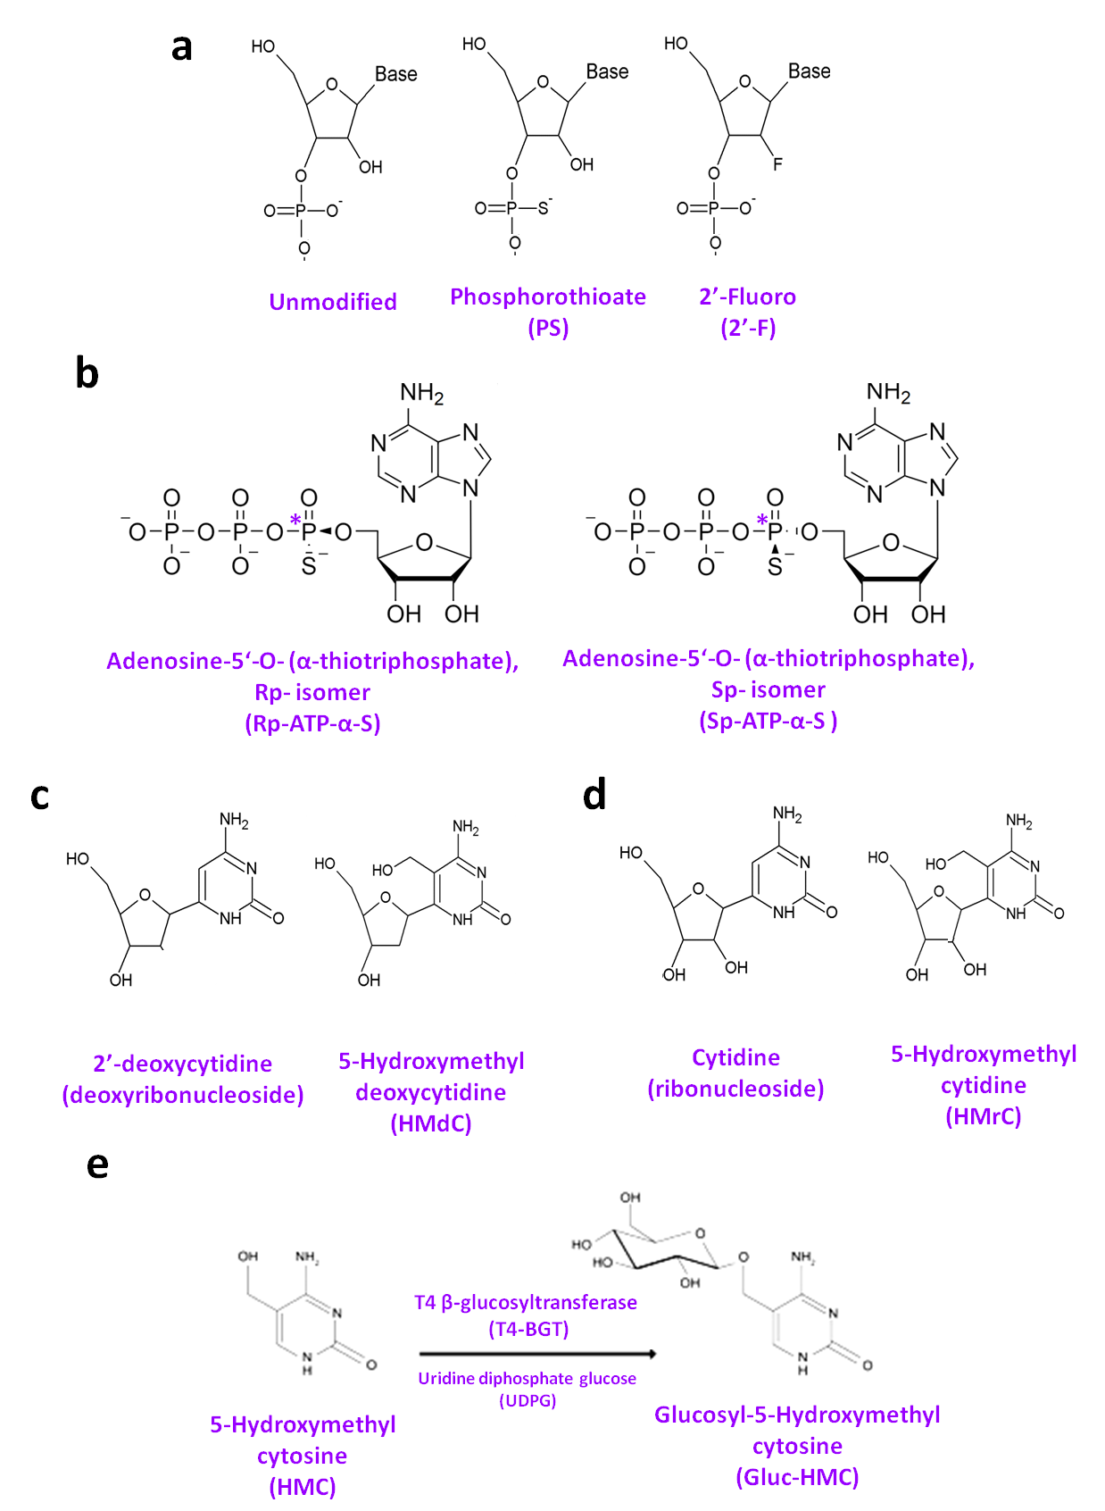

Figure 3.1 Structure of chemically modified nucleotides and nucleotide triphosphates.

(a) Unmodified ribose-phosphate backbone unit and ribose-phosphate chemical modifications. (b) Rp and Sp diasterioisomers of Adenosine-5‘-O- (α-thiotriphosphate). The Sp diasterioisomer is the substrate utilised by RNA polymerases. Phosphorus atoms marked * are chiral centres. (c) 2’-deoxycytidine and chemically modified 5-Hydroxymethyl 2’-deoxycytidine. (d) Cytidine and chemically modified 5-Hydroxymethyl cytidine (e) Reaction converting 5-Hydroxymethyl cytosine to Glucosyl-5-hydroxymethyl cytosine by T4 β-glucosyltransferase (T4-BGT) enzyme and uridine diphosphate glucose (UDPG) substrate.

## Results and Discussion

### Selection of dsRNA sequences

A range of dsRNAs were selected for use in downstream RNAi assays in insect cell cultures (see chapter 5) and live insects (see chapter 6). dsRNAs used in cell culture assays are listed in table 3.1 and those used in live insect assays are listed in table 3.2. These dsRNAs were selected from a shortlist to cover a range of dsRNA lengths and a range of different targets. Stat3, Stat4 and Dome11 are dsRNA sequences previously validated by the DGRC (*Drosophila* genomics Resource Centre). Dome14 was designed based on level of GC content and length. FLuc is a dsRNA previously designed and validated by the Sheffield RNAi Screening Facility (SRSF). F59C6.5 was chosen due to its low sequence homology with any *Drosophila* genes, or the reporters used. GFP dsRNA could not be used as a negative control for cell assays as the Upd ligand used as part of the cell assay reporter system (see section 5.2.2) has a GFP tag.

Table 3.1 Target and control dsRNAs used in RNAi assays in insect cells (see chapter 5).

|  |  |  |
| --- | --- | --- |
| **dsRNA Probe Name** | **Target Gene (Species)** | **Length** |
| Stat3 | *stat92e* (*D. melanogaster*) | 286 bp |
| Stat4 | *stat92e* (*D. melanogaster*) | 416 bp |
| Dome11 | *domeless* (*D. melanogaster*) | 401 bp |
| Dome14 | *domeless* (*D. melanogaster*) | 337 bp |
| FLuc | Firefly luciferase *ppyluc1* (*Photinus pyralis*) | 401 bp |
| F59C6.5 | F59C6.5, ortholog of *ndufb10* (*C. elegans*) | 513 bp |

Table 3.2 Target and control dsRNAs used in RNAi assays in live insects (see chapter 6).

|  |  |  |
| --- | --- | --- |
| **dsRNA Probe Name** | **Target Species** | **Length** |
| Target A | *Nezara viridula* | 512bp |
| Target B | *Diabrotica vergifera vergifera* | 228bp |
| Target C | *Nezara viridula* | 206bp |
| GFP | *Aequorea Victoria* | 258 bp |

In this study two alternative methods of producing dsRNA in conjunction with *in vitro* transcription reactions were used. One method involved using a single DNA template with two RNA polymerase promoters (in opposite directions) in order to produce dsRNA in a single IVT reaction (see figure 3.2 a). The other method involved the synthesis of each corresponding ssRNA strand of the dsRNA in two separate IVT reactions. In this case the DNA template contains only a single RNA polymerase promoter (see figure 3.2 b). This approach was required for production of dsRNAs with chemical modifications in only one strand (either the passenger or guide strand).

Figure 3.2 Schematic illustration of strategies for dsRNA synthesis using *in vitro* transcription.

(a) Schematic of dsRNA synthesis using a single IVT reaction. PCR 1: Primers partially overlapping with the target region of the gene of interest, and with a non-complimentary linker region amplify the dsRNA target region by PCR to form an intermediate DNA product (PCR 1 DNA product). PCR 2: Primers consisting of an RNA polymerase promoter sequence joined to a sequence complimentary to the linker region amplify the target region by PCR, whilst simultaneously incorporating the RNA polymerase promoter to give the final IVT template DNA (PCR 2 DNA product) capable of being transcribed by RNA polymerase. IVT: *In vitro* transcription (IVT) using PCR 2 DNA product as a template yields dsRNA capable of targeting the mRNA of interest by RNAi. (b) Schematic of dsRNA synthesis by annealing ssRNAs produced from separate IVT reactions. PCR 1: Primers partially overlapping with the dsRNA target region of the target gene, and with a non-complimentary linker region amplify the dsRNA target region by PCR to form an intermediate DNA product (PCR 1 DNA product). PCR 2: A single primer consisting of an RNA polymerase promoter sequence joined to a sequence complimentary to the linker region is used in conjunction with the opposite primer from PCR 1 (without an RNA polymerase promoter) to amplify the target region by PCR whilst simultaneously incorporating the RNA polymerase promoter to give the final IVT template DNA (PCR 2 DNA product) capable of being transcribed by T7 RNA polymerase. IVT: *In vitro* transcription (IVT) using PCR 2 DNA products as a templates yields complimentary ssRNAs. These are annealed in 1X PBS by heat-cooling, resulting in dsRNA capable of targeting the mRNA of interest by RNAi.

### Production of DNA templates by polymerase chain reaction (PCR) for synthesis of ssRNA and dsRNA by *in vitro* transcription (IVT)

DNA templates for dsRNAs targeting the Jak/STAT pathway for use in dual luciferase assays (see chapter 5) were created by PCR from gDNA extracted from *Drosophila* S2R+ cells. The gDNA was used as the template for the first of two successive rounds of PCR; the first (PCR 1) to amplify the dsRNA sequence from the gDNA, and the second (PCR 2) for the addition of two antiparallel T7 or SP6 RNA polymerase promoters, one on each strand at opposite ends of the DNA template. This enabled transcription of both ssRNA strands simultaneously from a single DNA template to generate the dsRNA (see figure 3.2 a). In addition, DNA templates were also synthesised using a similar PCR strategy to generate DNA templates that contain only a single T7/SP6 promoter enabling synthesis of the corresponding ssRNAs (see figure 3.2 b). Gel electrophoresis analysis of the DNA templates generated via PCR for Dome11 from *Drosophila* gDNA is shown in figure 3.3 a & b.

Initial work focused on the production of the unmodified dsRNAs for use in RNAi assays in *Drosophila melanogaster* cells (Stat3, Stat4, Dome11, and Dome14), and the positive and negative control probes (FLuc and F59C6.5). This enabled the screening of their RNAi activity prior to synthesising the chemically modified dsRNAs (see section 5.3.1). The dsRNAs synthesised for testing in downstream RNAi assays were initially produced by single *in* *vitro* transcription (IVT) reactions from a DNA template *via* the method shown in figure 3.2 a. Following amplification of the DNA templates (see figure 3.3 a), the unmodified dsRNAs (Stat3, Stat4, Dome11, Dome14, FLuc and F59C6.5) were synthesised using a single IVT reaction, treated with DNase to remove the DNA template and analysed by agarose gel electrophoresis (see Figure 3.3 c). The results demonstrate the successful synthesis of dsRNA using this approach.

In addition, complimentary ssRNAs were synthesised in separate IVT reactions prior to annealing of the ssRNAs to form the dsRNA (see figure 3.2 b). This approach was required for production of dsRNAs with chemical modifications in only one strand (either the passenger or guide strand). An example of an IVT of Dome11 ssRNA generated from the DNA templates (figure 3.3 b) is shown in figure 3.3 d. The results show the successful synthesis of the Dome11 ssRNA (passenger and guide strands). As the analysis was performed using native agarose gel electrophoresis, the resulting ssRNA often appears as a more smeared band compared to the previously generated dsRNA. To further confirm the product produced by IVT using a DNA template with only one RNA polymerase promoter site was ssRNA not dsRNA, the product was incubated with both DNase (to remove template DNA) and RNase T1 in the absence or presence of 0.5 M NaCl (to remove ssRNA) and analysed by agarose

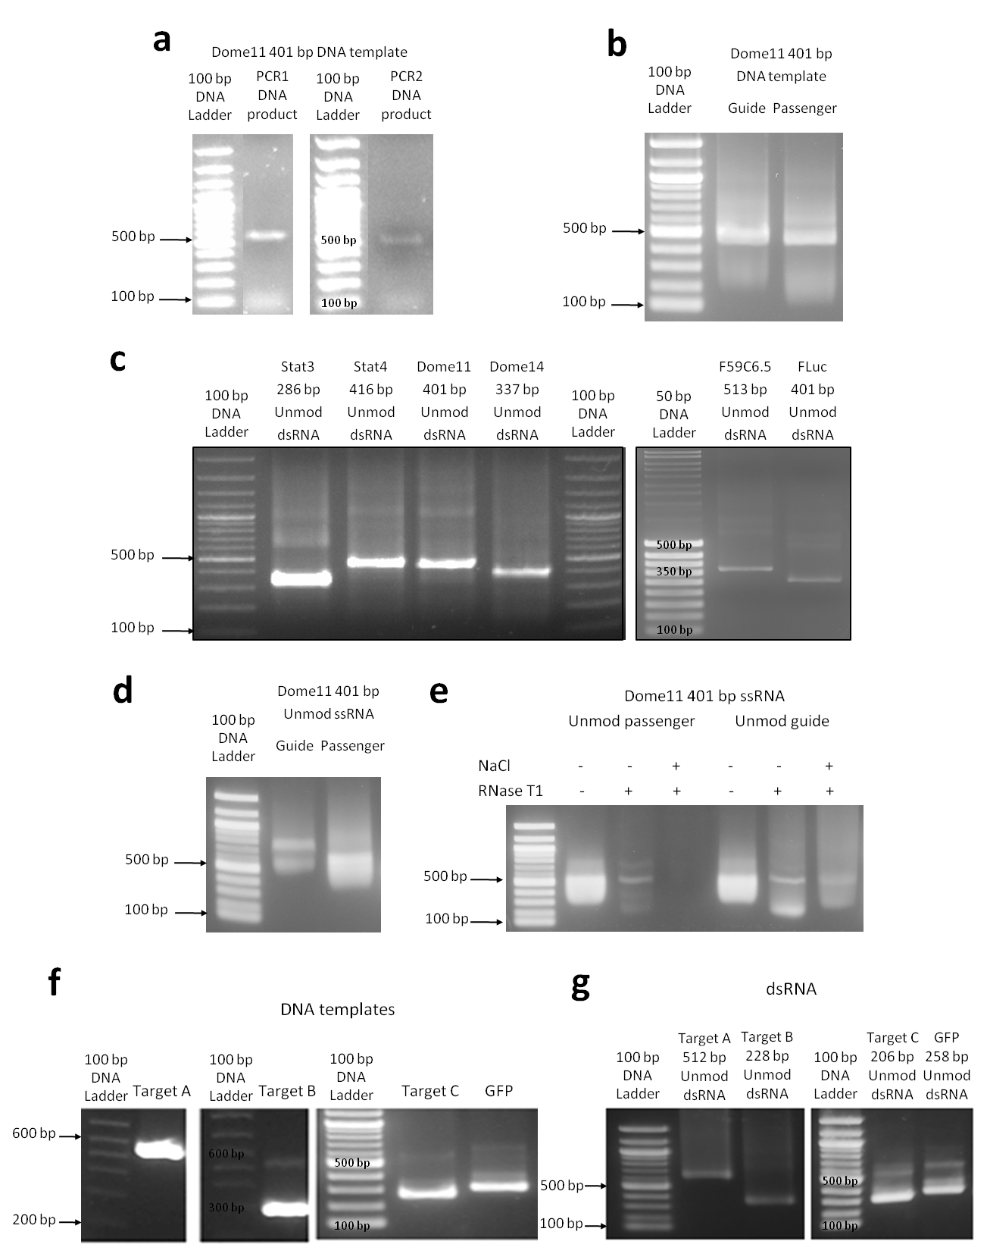

Figure 3.3 Synthesis of DNA templates using PCR and dsRNA using *in vitro* transcription.

(a) Gel electrophoretograms of the Dome11 DNA template for synthesis of dsRNA generated by two stage PCR. (b) Gel electrophoretogram of DNA templates for Dome11 guide strand and passenger strand ssRNAs. (c) Gel electrophoretograms of unmodified dsRNAs of various lengths synthesised by IVT using T7 RNA polymerase. The dsRNAs migrate differently to their corresponding sized dsDNA in the DNA ladder (d) Gel electrophoretograms of unmodified Dome11 guide strand and passenger strand ssRNAs produced by IVT using T7 RNA polymerase (e) Gel electrophoretogram of Dome11 ssRNA incubated with RNase T1, in the presence/absence NaCl. (f) Gel electrophoretogram of DNA templates for Target A, Target B, Target C and GFP dsRNAs generated by two stage PCR. (g) Gel electrophoretogram of unmodified Target A, Target B, Target C and GFP dsRNAs generated by two synthesised by IVT using T7 RNA polymerase.

gel electrophoresis. The results are shown in figure 3.4 e. and demonstrate that in the presence of RNase T1 the RNA is degraded and therefore no dsRNA was present.

The synthesis of dsRNAs (Target A, Target B, and Target C) for use in RNAi assays in live insects (see chapter 6) had previously been validated for RNAi activity by Syngenta, along with validation of the GFP dsRNA as a non-targeting negative control. Template DNA was prepared by PCR as described above; in this case the initial PCR template material was plasmid DNA (pDNA) rather than gDNA. The plasmids were supplied by Syngenta and the DNA templates for the dsRNAs were produced by a single round of PCR using primers with appropriate T7 RNA polymerase promoter sequences (see section 2.2.1). Gel electrophoresis analysis of the DNA templates for control GFP dsRNA and targets A, B and C and subsequent IVT reactions to generate the unmodified dsRNA are shown in figure 3.3 f & g and demonstrate the successful synthesis of dsRNAs (Target A, Target B, Target C, and GFP). In addition the corresponding ssRNAs (passenger and guide) for Target A-C were also prepared using IVT as previously described for Dome11.

Following successful IVT synthesis of all the unmodified ss/dsRNAs (as confirmed by gel electrophoresis), further analysis of the dsRNA was performed using IP RP HPLC. IP RP HPLC analysis can be performed under both native (50 °C) and denaturing conditions (75 °C) and enables the high resolution, rapid analysis of RNA. Moreover, this approach can rapidly separate ssRNA from dsRNA (Nwokeoji, Kung, *et al.*, 2017) and therefore provides a method to analyse the purity of the dsRNA synthesised in the IVT reactions by indicating DNA template and unincorporated NTP contaminants, and confirm the correct annealing of the dsRNA from the corresponding ssRNAs.

An example of IP RP HPLC analysis of the Dome11 RNA is shown in figure 3.4. Following IVT to make the Dome11 dsRNA, the dsRNA was purified using solid phase extractions (SPE) prior to HPLC analysis. The results are shown in figure 3.4 a & b and demonstrate that following purification a significant reduction in the injection peak is observed, demonstrating the successful removal of salts and contaminating NTPs from the IVT reactions. IP RP HPLC analysis of the Dome11 dsRNA and ssRNA following SPE is shown in figure 3.4 c. The Dome11 ssRNAs demonstrate shorter retention times than Dome11 dsRNA. When equal amounts of the complimentary Dome11 ssRNAs were mixed and annealed, the IP RP HPLC chromatogram demonstrates that they formed the corresponding dsRNA with a similar retention time to the equivalent Dome11 dsRNA produced directly in a single IVT reaction. In addition the analysis of the Dome11 dsRNA produced directly in a single IVT reaction also reveals that no excess ssRNA was present (see figure 3.3a)

A selection of the unmodified dsRNAs synthesised were also purified by incubation with DNase followed by SPE, and analysed by IP RP HPLC in non-denaturing conditions at 50 °C. The results are

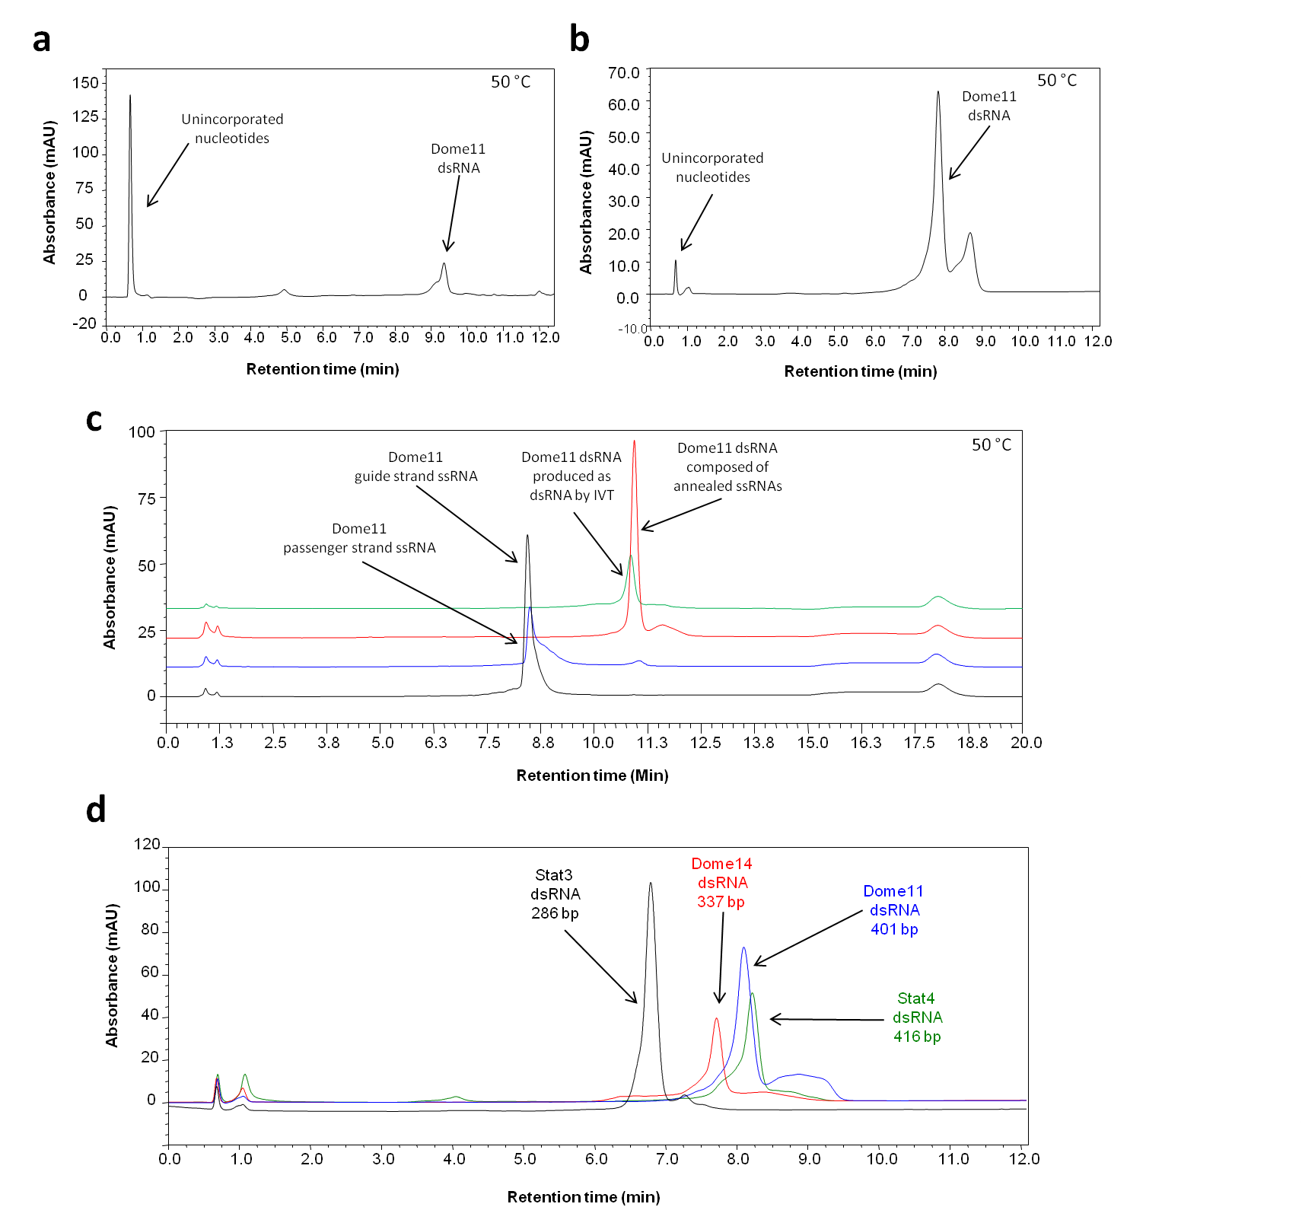

Figure 3.4 Ion pair reverse phase HPLC analysis of unmodified dsRNA.

(a) Chromatogram of unpurified Dome 11 dsRNA generated via IVT (b) Chromatogram of purified Dome 11 dsRNA using SPE demonstrating the removal of the salts/unincorporated NTPs. (c) Chromatogram of purified Dome 11 ssRNAs produced by IVT, dsRNA produced by annealing equal amounts of complementary ssRNAs and Dome 11 dsRNA generated in a single IVT reaction. The annealed ssRNAs produce dsRNA with the same retention time as the dsRNA produced directly by IVT. No excess ssRNA was observed following annealing of the complimentary ssRNAs. (d) Chromatogram of purified unmodified dsRNAs of a range of sizes. The results demonstrate size based separation and purity of the dsRNA. No major impurities or ssRNA were observed. All samples were analysed in non-denaturing conditions at 50 °C using gradient 1, in conjunction with UV detection at 260 nm.

shown in figure 3.4 d and demonstrate that the dsRNAs elute as expected in order of their corresponding size, with the shortest dsRNA having the earliest retention time. The results also confirm the purity of the dsRNA and demonstrate that no significant impurities including unincorporated NTPs or ssRNA are present in the dsRNA.

In summary, a range of dsRNAs were successfully synthesised using either a single IVT reaction or via two IVT reactions to generate the corresponding ssRNAs prior to annealing to produce dsRNA. Analysis of the dsRNA was performed using agarose gel electrophoresis and IP RP HPLC, which enables verification of the dsRNA produced and the presence of any contaminating ssRNA. Moreover, following purification using solid phase extraction methods and IP RP HPLC analysis, the successful removal of NTPs and other contaminants was demonstrated which is essential prior to accurate downstream quantification using UV spectrophotometry (see section 3.3.7).

### Synthesis of phosphorothioate (PS) containing ssRNA and dsRNA by IVT

Following the successful synthesis of the unmodified dsRNA required for the downstream RNAi assays, further work focussed on synthesising the corresponding dsRNA with a range of chemical modifications. T7 RNA polymerase has previously been demonstrated to successfully incorporate alpha-thio nucleotide triphosphates (α-thio NTPs) (see figure 3.1 b) to generate phosphorothioate (PS) RNA (Ueda *et al.*, 1991), and was therefore selected to initially synthesise phosphorothioate dsRNA.

In order to synthesise phosphorothioate containing RNA, a range of IVT reactions were performed where nucleotide triphosphates (NTPs) were replaced by their corresponding α-thio NTPs. In order to ascertain if each of the four NTPs could be individually replaced by their corresponding α-thio NTPs, four IVT reactions to produce Dome11 dsRNA were set up as an example, each with a different one of the four NTPs replaced by their corresponding α-thio NTP. Six further IVT reactions were also set up, each with two of the four NTPs replaced by their corresponding α-thio NTPs, in order to determine if dsRNAs could be synthesised incorporating every combination of two α-thio NTPs. The nomenclature used to describe the resulting chemically modified RNA following IVT using the chemically modified NTPs is shown in figure 3.5. dsRNA produced in IVT reactions with one of the four NTPs replaced by an α-thio NTP was referred to as 1PS dsRNA and dsRNA produced in IVT reactions with two of the four NTPs replaced by their corresponding α-thio NTPs was referred to as 2PS. dsRNAs produced by annealing an unmodified ssRNA to a phosphorothioate-containing ssRNA (for example, 2PS ssRNA) were referred to as Un-2PS

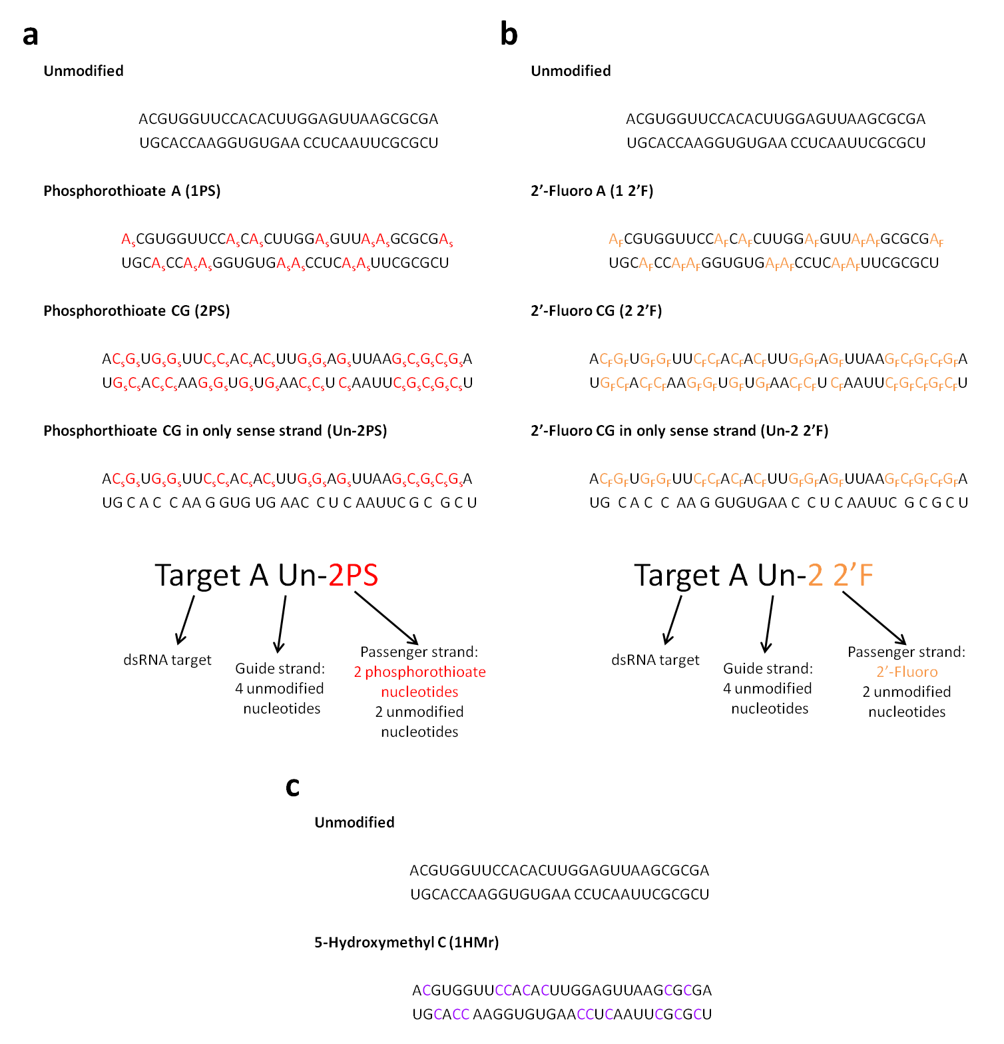

Figure 3.5 Nomenclature of chemically modified dsRNAs. Nomenclature of chemically modified dsRNAs.

(a) Illustration of nomenclature for phosphorothioate (PS) dsRNA example. Phosphorothioate linkages shown as “s”. dsRNAs synthesised in IVT reactions with one NTP replaced by an alpha-thio NTP analogue are referred to as 1PS. dsRNAs synthesised in IVT reactions with two NTPs replaced by alpha-thio NTP analogues are referred to as 2PS. dsRNAs with modifications in one strand are referred to as “Un-2PS”, “2PS-Un” etc., with the format “guide strand-passenger strand”. (b) Illustration of nomenclature for 2’-fluoro (2’F) dsRNA. 2’-fluoro modifications shown as “F” (c) Illustration of nomenclature for 5-hydroxymethyl (HMr) dsRNA. 5-hydroxymethyl C residues shown as “C”.

or 2PS-Un, with the format “guide strand-passenger strand” (see figure 3.5 a). The same nomenclature was used for other chemically modified dsRNAs e.g. 1 2’F, 2 2’F, 1HMr and so forth (see figure 3.5 b & c).

The reactions were incubated for 12 hours at 37 °C, prior to addition of DNase and analysis using gel electrophoresis (see figure 3.6 a). The results demonstrate that all possible combinations of 1PS and 2PS dsRNA can be successfully synthesised. Following purification by SPE as previously described, the yield of dsRNA from each reaction was determined using a Nanodrop UV spectrophotometer, and the results are presented in table 3.3. The results demonstrate similar yields for all 1PS dsRNAs, and similar yields were obtained for all 2PS dsRNAs. There is a reduction in yield of dsRNAs as increasing numbers of α-thio NTP are included in the IVT reactions, highlighting the reduced efficiency of incorporation of α-thio NTPs by T7 RNA polymerase. The IVT reactions were later repeated with a shorter incubation time of 4 hours and reaction yields were similar (data not shown). In addition, attempts were made to synthesise dsRNA containing 3PS and 4PS dsRNA (three or all four NTPs replaced with α-thio NTPs). However a significant reduction in yield was obtained (data not shown).

Table 3.3 Yields of unmodified and phosphorothioate Dome11 dsRNA synthesised by IVT using T7 RNA polymerase. Yields are based on a 20 µl IVT reaction purified by SPE with a single elution of 50 µl of nuclease free water, and concentration measured by Nanodrop UV spectrophotometer.

|  |  |  |
| --- | --- | --- |
| **dsRNA Type** | **Modified Base(s)** | **Yield (µg)** |
| Unmod | / | 106.6 |
| 1PS | A | 17.6 |
| C | 15.3 |
| G | 15.4 |
| U | 16.2 |
| 2PS | AC | 9.4 |
| AG | 5.8 |
| AU | 8.3 |
| CG | 13.4 |
| CU | 12.0 |
| GU | 7.2 |

Initial analysis of the PS dsRNA using gel electrophoresis was used to further validate the incorporation of the phosphorothioate modifications. Dome11 dsRNA contains different amounts of each of the four nucleotides, and therefore the PS modified dsRNAs contain different numbers of PS modifications. In order to negate effects due to the differing number of each nucleotide, all four 1PS dsRNAs were mixed in equal quantities into a pool of mixed 1PS dsRNAs. The 2PS dsRNAs were pooled likewise. The unmodified dsRNA, 1PS dsRNA mixture and 2PS dsRNA mixture were subsequently analysed by gel electrophoresis (see figure 3.6 b). The results demonstrated that a small shift in electrophoretic migration of the PS dsRNA was observed, with an increase electrophoretic migration compared to the corresponding unmodified dsRNA.

PS modified nucleic acids have also previously been demonstrated to have different retention times in comparison to unmodified nucleic acids when analysed by either reverse phase (Xie *et al.*, 2012) or ion exchange HPLC (Iwamoto *et al.*, 2017). In order to further confirm that the dsRNAs

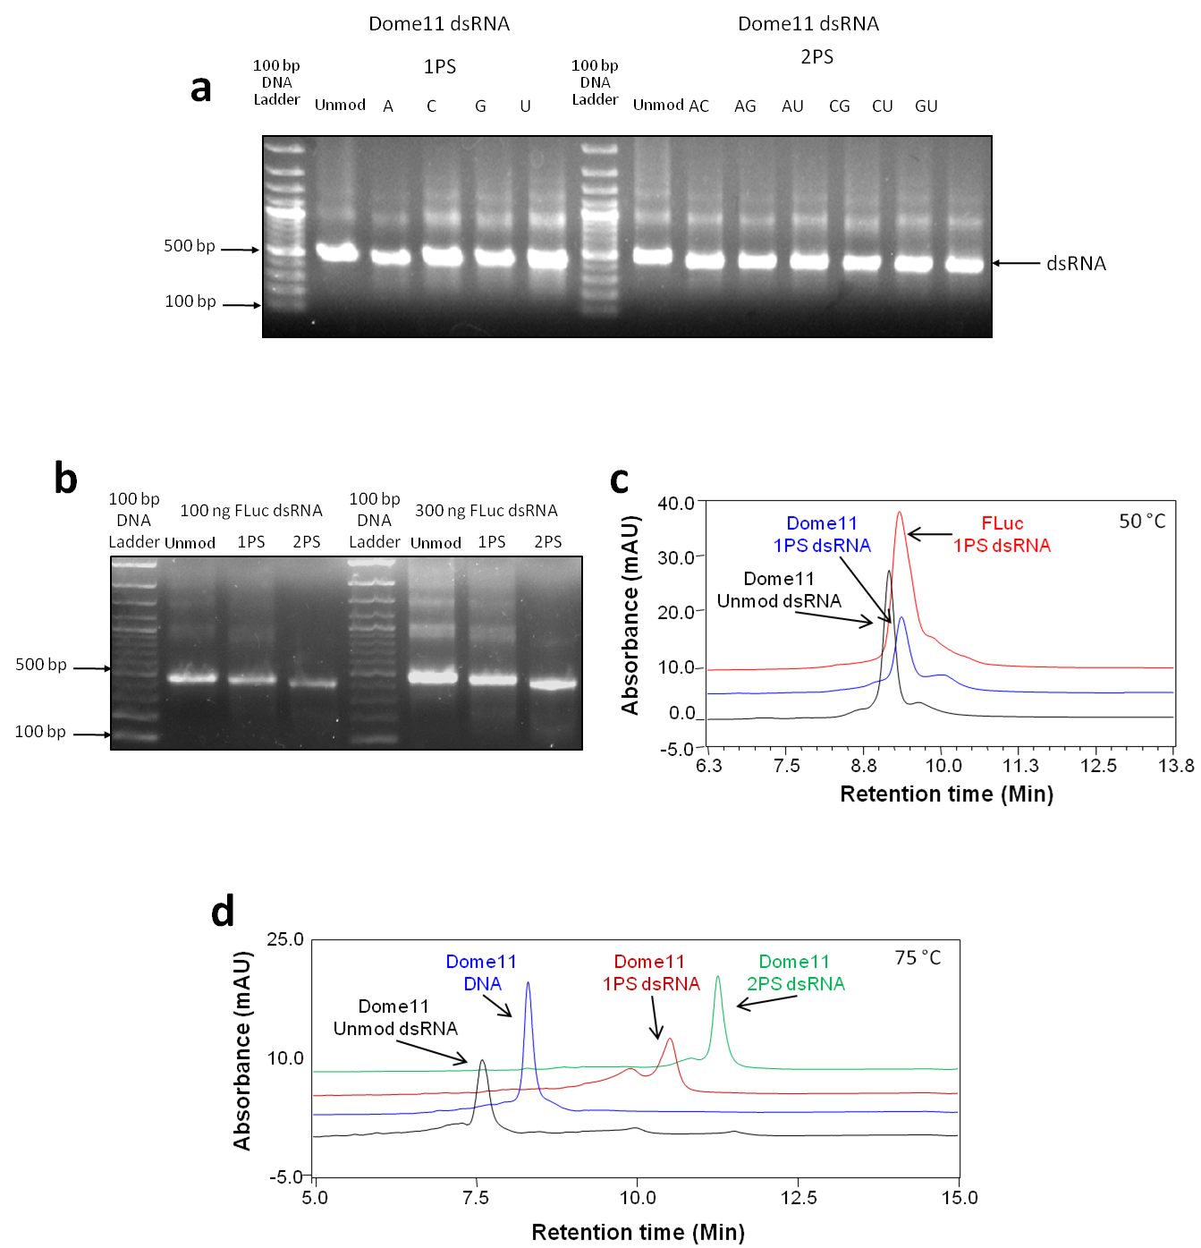

Figure 3.6 Synthesis of phosphorothioate modified long dsRNA using IVT

(a) Gel electrophoretogram of all combinations of 1PS and 2PS Dome11 dsRNA synthesised by IVT using T7 RNA polymerase. (b) Gel electrophoretogram of 100 ng and 300 ng of unmodified, 1PS and 2PS FLuc dsRNA demonstrating variation in electrophoretic mobility of the phosphorothioate dsRNA. (c) Chromatogram of Dome11 unmodified and 1PS dsRNA, and FLuc 1PS dsRNAs, analysed in non-denaturing conditions at 50 °C using gradient 1. Results show small shift in retention time of the phosphorothioate dsRNA. (d) Chromatogram demonstrating hydrophobicity-based separation of Dome11 unmodified, 1PS and 2PS dsRNAs, and Dome11 DNA template, analysed in denaturing conditions at 75 °C using gradient 1. Results show a larger shift in retention time of the phosphorothioate ssRNA generated from the corresponding dsRNA than for duplex phosphorothioate dsRNA.

synthesised contained the PS modifications, the dsRNAs were analysed by IP RP HPLC. Dome11 unmodified and 1PS dsRNA were analysed, along with FLuc 1PS dsRNA (see figure 3.6 c). FLuc and Dome11 are both 401 bp in length. The results of the HPLC analysis in non-denaturing conditions at 50 °C demonstrate a small increase in retention time of the PS modified dsRNA compared to the unmodified dsRNA. Dome11 and FLuc are identical in length but have different sequences, and the FLuc 1PS dsRNA eluted at the same time as Dome11 1PS dsRNA. These results are consistent with the expected increase in hydrophobicity of the PS modified dsRNA and therefore further validate the incorporation of the PS modifications. Shifts in retention time between the dsRNAs were also quite small, with a retention time range of only approximately 1 minute, consistent with small changes in electrophoretic migration. IP RP HPLC was also carried out under denaturing conditions at 75 °C to analyse the corresponding ssRNAs from the dsRNA. The results are shown in figure 3.6 d and demonstrate clearer differences in the retention time of the PS ssRNAs generated from the duplex dsRNA. Consistent with previous observations, increasing the PS content in the ssRNA results in increase retention time due to the increased hydrophobicity of the RNA, enabling clear validation of the synthesis of 1PS and 2PS dsRNA using IVT.

Phosphorothioate dsRNA analysed by IP RP HPLC in non-denaturing conditions did not demonstrate a clear retention time shift compared to unmodified dsRNA, which was unexpected given the difference in hydrophobicity between orthophosphate and thiophosphate. Using NMR spectroscopy to study unmodified and phosphorothioate variants of a hairpin (hp) RNA containing double stranded, unpaired single stranded, and hairpin loop single stranded regions, it has been shown that in ssRNA, phosphodiester linked bases intercalate and stack into the RNA helix (Smith and Nikonowicz, 2000). In contrast, phosphorothioate-linked bases in an ssRNA bulge were shown to protrude into the major groove, and the phosphorothioate-linked bases in an ssRNA loop showed changes in backbone conformation as well. However, phosphorothioate-linked bases in double stranded regions had similar conformations to phosphodiester linked bases (Smith and Nikonowicz, 2000). Therefore it is likely that the PS and unmodified dsRNA adopt very similar conformations, and the PS modifications cause little difference in the interaction with the ion pair reagent/stationary phase therefore having little effect on the retention time. In contrast, the altered conformation of PS ssRNA compared to unmodified ssRNA, is likely to significantly alter interactions with the ion pair reagent/stationary phase, which may explain why a much greater shift in retention time between unmodified and PS ssRNA is observed, than between unmodified and PS dsRNA.

### Optimisation of synthesis of phosphorothioate RNA by IVT

Previous results demonstrated the successful synthesis and validation of dsRNA containing one and two PS nucleotide analogues. However, the yield obtained from the IVT reactions was lower compared to the unmodified dsRNA. Therefore, further optimisation of the IVT reactions was performed in an attempt to improve yield, and generate PS modified dsRNA with PS modifications in either the passenger or guide strand using IVT.

#### Comparison of T7 and SP6 RNA polymerase for the synthesis of phosphorothioate ssRNA and dsRNA

Initial work focused on comparing two RNA polymerases: T7 and SP6. T7 and SP6 RNA polymerases each require a different promoter sequence on the DNA template in order to bind to the template and initiate transcription. Therefore, in order to compare the activity of the polymerases, separate DNA templates with either T7 or SP6 polymerase promoter sequences were generated by PCR for Dome11 as an initial example (see figure 3.7 a). The polymerases were initially compared and optimised for their efficacy in synthesising unmodified dsRNA in a single IVT reaction, prior to comparison and optimisation of phosphorothioate RNA synthesis. To compare baseline yield of the polymerases, IVT reactions were carried out for both of the polymerases using 100 ng of the appropriate DNA template. Reactions were incubated at 37 °C for an equal length of time (approximately 12 hours) prior to the addition of DNase, and analysed using gel electrophoresis (see figure 3.7 b, left panel). The results demonstrate a high yield of dsRNA using T7 polymerase. In contrast, the SP6 polymerase demonstrated a significantly lower yield of dsRNA. This was unexpected as the manufacturer quotes similar expected yields for both the T7 and SP6 polymerases (80-100 and 50-80 µg respectively) for a 1.9 kb control RNA (Ambion, 2012).

Further optimisation was performed by both increasing the amount of template DNA and NTP concentration (see figure 3.7 b, right panel). However, no increase in the yield of dsRNA using SP6 polymerase was obtained. Therefore, further IVT reactions were performed to generate ssRNA in separate IVT reactions. To compare the yield of both ssRNA and dsRNA from T7 and SP6 polymerases, IVT reactions containing equal amounts (100 ng) DNA template were set up. Reactions were incubated for equal times (approximately 12 hours at 37 °C), and DNase treated prior to analysis by gel electrophoresis (see in figure 3.7 c). The results demonstrate that the yield of ssRNA using SP6 polymerase is greater than that for dsRNA. The yield of ssRNA using SP6 polymerase is also similar to the yield of ssRNA using T7 polymerase, and consistent with the expected yields stated by the manufacturer.

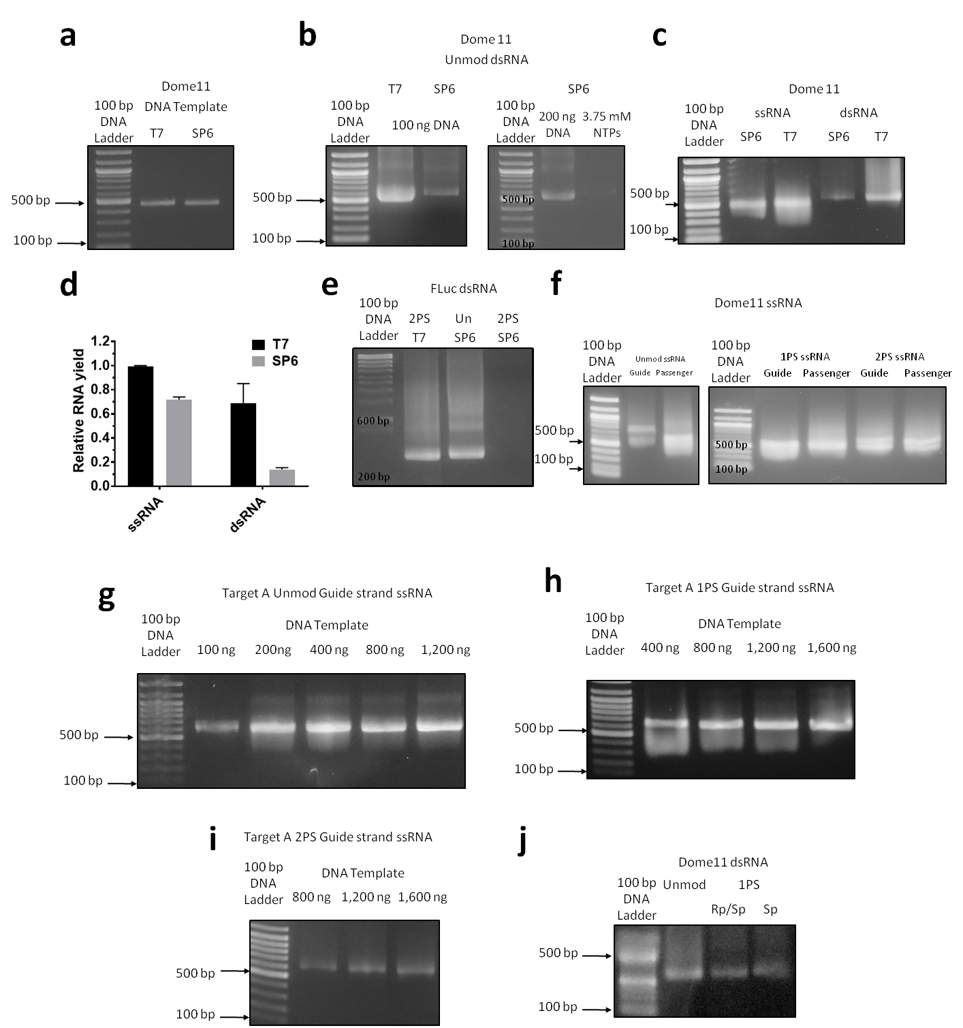

Figure 3.7 Optimisation of the synthesis of phosphorothioate ssRNA and dsRNA.

(a) Gel electrophoretogram of 100 ng of DNA templates for Dome11 dsRNA with T7 and SP6 RNA polymerase promoters. (b) Left panel: Gel electrophoretograms comparing the yield of unmodified Dome11 dsRNA produced by IVT using T7 and SP6 RNA polymerases with 3.75 mM and 2.5 mM NTPs respectively. 1:21 of IVT reaction was loaded. Right panel: dsRNA produced by IVT using SP6 RNA polymerase from 200 ng of DNA template using 2.5 mM NTPs, and from 100 ng of DNA template with 3.75 mM NTPs. (c) Gel electrophoretogram comparing the yield of unmodified Dome11 ssRNA and dsRNA produced by IVT using T7 or SP6 RNA polymerase from 100 ng of DNA template. 1:21 of IVT reaction was loaded. (d) Bar graph of gel band intensities showing mean and SEM. Gel band intensities quantified in Fiji (ImageJ) software, and presented as relative yield. Relative yield is individual gel band intensity values normalised to highest gel band intensity value, and normalised separately for ssRNA and dsRNA. T7 ssRNA n = 2, all others n = 3. (e) Gel electrophoretogram comparing yield of phosphorothioate (2PS) FLuc dsRNA produced by IVT using T7 or SP6 RNA polymerase from 100 ng of DNA template. FLuc unmodified dsRNA produced by SP6 polymerase is shown for reference. (f) Gel electrophoretogram of unmodified (left panel) and phosphorothioate (right panel) guide and passenger strand Dome 11 ssRNAs produced by IVT. (g-i) Gel electrophoretograms of optimisation of DNA template amounts for Target A guide strand synthesis by IVT using T7 RNA polymerase. (g) Unmodified ssRNA. (h) 1PS ssRNA. (i) 2PS ssRNA. (j) Gel electrophoretogram comparing synthesis of Dome11 1PS dsRNA by IVT using α-thio NTP (Rp and Sp diastereoisomers) or α-thio NTP (Sp diastereoisomer).

To confirm this result, T7 and SP6 ssRNA and dsRNA IVTs were repeated in triplicate following the same method. Equal amounts of each reaction were analysed by agarose gel electrophoresis. Band intensity was analysed using Fiji (ImageJ) image analysis software (see method, section 2.3.2). The replicate band intensities were normalised to the highest individual band intensities. This was performed separately for dsRNA and ssRNA band intensities to account for differences in staining intensity between ssRNA and dsRNA. The results are shown in figure 3.7 d and show that the yield of unmodified ssRNA is similar for T7 and SP6 polymerase, though moderately lower for SP6 polymerase. This was in agreement with the yields quoted by the manufacturer for T7 and SP6 polymerase of 80-100 and 50-80 µg respectively, for a 1.9 kb control RNA (Ambion, 2012). However, the T7 polymerase demonstrated increased yields for IVT reactions designed to produce dsRNA in a single IVT from a single template compared to SP6 polymerase.

In order to compare whether T7 or SP6 RNA polymerase would be the most efficient polymerase to use for production of PS dsRNA, IVT reactions were set up to compare the incorporation of α-thio NTPs. Both IVT reactions contained 100 ng of the appropriate DNA template, and had two of the four NTPs replaced by their corresponding α-thio NTPs. The control IVT reaction used the standard four NTPs. The IVT reactions were incubated for approximately 12 hours at 37 °C, prior to addition of DNase, and analysed by agarose gel electrophoresis (see figure 3.7 e). The results demonstrate that T7 polymerase successfully incorporated two α-thio NTPs to generate 2PS dsRNA consistent with previous observations. In contrast, there was no clear 2PS dsRNA product produced by SP6 polymerase, whereas the SP6 polymerase produced unmodified dsRNA in line with previous results. Further analysis was also performed in an approach to synthesise phosphorothioate ssRNA using SP6 RNA polymerase. IVTs were set up as previously described, however these reactions also failed to successfully synthesise phosphorothioate ssRNA (data not shown). Therefore, in summary these results demonstrate that T7 RNA polymerase was the optimal RNA polymerase for the incorporation of α-thio NTPs to generate PS modified RNA and was therefore selected as the polymerase to be used for future IVT reactions to synthesise PS dsRNA.

Following the successful synthesis of both 1PS and 2PS dsRNA (see figure 3.7 e) further IVT reactions were performed to synthesise phosphorothioate ssRNA using DNA template with only a single T7 promoter. Using this approach enables the synthesis of dsRNA with modifications in either only the passenger or only the guide strand. The analysis of the 1PS and 2PS Dome11 ssRNAs generated using IVT and analysed by gel electrophoresis is shown in figure 3.7 f. The results demonstrate that 1PS and 2PS ssRNA was successfully synthesised using T7 RNA polymerase. The successful incorporation of α-thio NTPs into the ssRNA was later confirmed by IP RP HPLC (see section 3.3.4.3 below).

#### Optimisation of IVT reactions for synthesis of phosphorothioate ssRNA and dsRNA

Further optimisation of IVT reactions using T7 RNA polymerase for the synthesis of PS RNA was performed by varying the amount of DNA template present in reactions. IVT reactions were set up with DNA concentrations ranging from 100 to 1,200 ng per reaction to synthesise unmodified ssRNA (examples are shown for Target A). The reactions were incubated at 37 °C for approximately 12 hours, then incubated with DNase to remove DNA template, prior to analysis by gel electrophoresis (see figure 3.7 g). The results demonstrate that the maximum yield of unmodified ssRNA was achieved with between 200 to 400 ng of DNA template. The experiment was repeated to synthesise 1PS ssRNA by IVT with DNA template concentrations ranging from 400 to 1,600 ng per reaction. The reactions were incubated at 37 °C for approximately 12 hours, incubated with DNase prior to analysis using gel electrophoresis (see figure 3.7 h). The results demonstrate that the maximum yield of 1PS ssRNA was achieved with between 800 to 1,200 ng of DNA template. The experiment was repeated to synthesise 2PS ssRNA by IVT with DNA concentrations ranging from 800 to 1,600 ng per reaction. The reactions were incubated at 37 °C for approximately 12 hours, incubated with DNase as before, then analysed by gel electrophoresis, (see figure 3.7 i). The results demonstrate that the maximum yield of 2PS ssRNA was achieved with 1,200 ng of DNA template.

These results show that the optimum amount of DNA template used in IVT reactions to generate unmodified ssRNA was approximately 300-400 ng per reaction. However the optimum amount of DNA template was higher (approximately 900-1,200 ng per reaction) for the synthesis of 1PS and 2PS ssRNA. The addition of higher concentrations of template may help in the synthesis of PS modified RNA where the incorporation efficiency of the α-thio NTPs is lower and the overall efficiency of transcription is reduced.

α-thio NTPs used in the synthesis of phosphorothioate RNA have Rp and Sp diastereoisomers, as the substitution of an oxygen for a sulphur atom on the alpha phosphate group introduces a chiral centre at the phosphorus atom of the alpha phosphate group (see figure 3.1 b). Only the Sp diastereoisomer is incorporated by T7 RNA polymerase (Griffiths, Potter and Eperon, 1987). In contrast, the Rp diastereoisomer is not a T7 RNA polymerase substrate. α-thio NTPs are available commercially as either mixtures of Rp and Sp diasterioisomers, or pure Sp (or pure Rp diasterioisomers). Where Rp/Sp diasterioisomers of α-thio NTPs are used in IVT reactions, the ratio of Rp:Sp is approximately 1:1 (TriLink Biotechnologies, 2016). Therefore, approximately half of the α-thio NTP added to an IVT reaction is not a substrate in the reaction. It is known that the Rp diastereoisomer is not a competitive inhibitor (Griffiths, Potter and Eperon, 1987), so an IVT reaction with both Rp and Sp diastereoisomers present should produce the same yield as an IVT reaction with only the Sp diastereoisomer, provided the concentration of the Sp diastereoisomer is the same in both reactions. In order to test this hypothesis and see if the yield of RNA is affected by the chiral purity of the α-thio NTP, three IVT reactions were set up to synthesise Dome11 unmodified and 1PS dsRNA. These comprised one reaction with four unmodified NTPs, one with three NTPs and only Sp diastereoisomer of the fourth α-thio NTPs, and one with three NTPs and a mix of Rp and Sp diastereoisomers of the fourth α-thio NTP. The concentrations of NTPs and fourth α-thio NTP in all IVT reactions were balanced to 2.5 mM (see table in section 2.2.2). The reactions were carried out using T7 RNA polymerase and 100 ng of DNA template in each reaction. Reactions were incubated at 37 °C for approximately 12 hours, prior to the addition of DNase and analysis using gel electrophoresis (see figure 3.7 j). The results demonstrate that approximately the same yield of Dome11 1PS dsRNA was produced independent of the chiral purity of the α-thio NTPs.

#### Synthesis and analysis of dsRNA with phosphorothioate modifications in one or both strands by annealing ssRNAs synthesised in separate IVT reactions

The synthesis of dsRNAs with chemical modifications in only one strand (in either the passenger or guide strand) was required in order to study their RNAi efficacy in insect cells or live insects. In order to produce such dsRNAs with mixed strand chemistry, separate unmodified and chemically modified complimentary ssRNAs were synthesised in separate IVT reactions, followed by subsequent annealing of the ssRNAs to form the final dsRNA. In order to do this, unmodified and chemically modified ssRNAs needed to be efficiently and fully annealed in various combinations into high quality dsRNA, with no ssRNA impurities remaining, in order to allow for accurate quantification of dsRNAs for use in subsequent RNAi experiments.

Unmodified and 1PS Dome11 ssRNAs previously synthesised by IVT (see section 3.3.3) were chosen as an example and analysed using IP RP HPLC (see figure 3.8 a). Complementary ssRNAs, where both strands had identical chemistry (two unmodified ssRNAs or two phosphorothioate ssRNAs), were initially annealed by mixing equal quantities of the ssRNAs in HPLC-grade water at room temperature. The subsequent analysis using IP RP HPLC is shown in figure 3.8 b, clearly

Figure 3.8 Synthesis of phosphorothioate dsRNA by annealing complimentary unmodified and phosphorothioate ssRNA.

All dsRNAs and ssRNAs are Dome 11. All samples were analysed using gradient 1 at 50°C unless otherwise stated. Baselines are offset to improve clarity of comparisons. (a) Chromatogram of co-injected unmodified ssRNA and phosphorothioate (1PS) ssRNA (injection amounts are not equal). (b) Chromatogram demonstrating that complementary unmodified ssRNAs fully anneal in water at room temperature, and complementary 1PS ssRNAs also anneal fully in water at room temperature (injection amounts are not equal). (c) Chromatogram demonstrating that an unmodified ssRNA and its complementary 1PS ssRNA only partially anneal when mixed in water at room temperature, with significant amounts of unannealed ssRNA remaining. The unmodified-1PS duplex dsRNA peak disappears when the sample is analysed in denaturing conditions at 75°C. (d) Chromatogram demonstrating that an unmodified ssRNA and its complementary 1PS ssRNA anneal fully at room temperature in PBS, leaving small quantities of any ssRNA that was present in excess. Heating the sample in 1X PBS to 85°C for 3 minutes followed by cooling to room temperature prior to analysis, results in a similar yield of dsRNA and degrades any remaining excess ssRNA.

demonstrating the ssRNAs fully annealed to form dsRNA, which has an increased retention time compared to the corresponding ssRNAs.

However, where equal amounts of an unmodified ssRNA and its complementary phosphorothioate ssRNA were mixed in water and analysed by IP RP HPLC, only partial annealing was observed (see figure 3.8 c, black chromatogram) with significant amounts of ssRNA remaining in the sample. The third peak observed was confirmed to be dsRNA by re-analysing the samples in denaturing conditions at 75°C, at which temperature the third peak was lost from the chromatogram due to the dsRNA duplex melting back to its constituent ssRNAs (figure 3.8 c, blue chromatogram f). It is unclear precisely why complementary strands with different chemistry do not spontaneously anneal in water, it may possibly be an artefact of how the difference of backbone conformation in phosphorothioate ssRNA (Smith and Nikonowicz, 2000) affects the thermodynamics of annealing, however this was not investigated further.

Therefore, to optimise the annealing of mixed chemistry ssRNAs to form dsRNA, equal quantities of the two ssRNAs were mixed in 1X PBS at room temperature and analysed by HPLC, and the results are shown in figure 3.8 d (blue chromatogram). The chromatogram consists of a large dsRNA peak, demonstrating successful annealing of ssRNAs to generate the dsRNA, with a small additional peak corresponding to potential excess of one of the ssRNAs. Additional heating of the sample to 85°C for 3 minutes, followed by natural cooling to room temperature also generated the dsRNA. In addition, degradation of the remaining ssRNA contaminants was observed (see figure 3.8 d, red chromatogram). The dsRNA duplexes formed also showed increased retention times compared to the two ssRNAs, as previously shown. In summary, a range of phosphorothioate-containing dsRNAs were synthesised, including dsRNA with PS modifications in the passenger strand, guide strand, or both.

### Optimisation of the synthesis of long dsRNA containing 2’-fluoro (2’F) modifications by IVT

The 2’-fluoro (2’F) functional group (see figure 3.1 a) has a smaller volume than the 2’-OH group of ribose sugars, although it is larger than the 2’-H group of deoxyribose sugars. T7 RNA polymerase is therefore unable to efficiently incorporate 2’-fluoro NTPs into dsRNA (Chelliserrykattil and Ellington, 2004). Therefore, a modified T7 polymerase capable of incorporating NTPs, dNTPs and 2’-modified NTPs was required for the enzymatic synthesis of 2’-fluoro RNA. A mutant T7 polymerase (T7R&DNA polymerase) capable of incorporating dNTPs and 2’-modified NTPs was selected to synthesise 2’-fluoro dsRNA (Chelliserrykattil and Ellington, 2004), and SP6 polymerase was also tested for its ability to synthesise 2’-fluoro modified RNA.

To compare baseline yield of the three polymerases (T7, SP6 and T7R&D), IVT reactions were initially carried out to synthesise unmodified Dome11 dsRNA in a single IVT reaction using 100 ng of the appropriate DNA template (see section 2.2.1). The T7 and SP6 DNA templates generated previously were used as templates for the IVT reactions. Reactions were incubated at 37 °C for an equal length of time (approximately 12 hours) prior to the addition of DNase and analysis using gel electrophoresis (see figure 3.9 a). The results demonstrate a high yield of dsRNA was obtained from the T7 polymerase, with a slightly lower yield for the T7R&D polymerase. This was expected as the T7 polymerase was an ultra high yield polymerase. The SP6 polymerase again demonstrated a significantly lower yield of dsRNA than the T7 polymerase, consistent with previous observations (see section 3.3.4.1).

Further work focused on using IVT reactions to produce 2’-fluoro modified dsRNA from a single DNA template in a single reaction. IVT reactions using T7R&D polymerase with 2’-fluoro CTP and 2’-fluoro UTP replacing CTP and UTP were set up. However, no dsRNA product was generated (see figure 3.9 b, lane 2). Further optimisation was unable to generate any significant 2’-fluoro modified dsRNA product using this approach. Therefore, an alternative approach was used to generate 2’-fluoro modified ssRNA in conjunction with T7R&D polymerase. IVT reactions with 2’-fluoro CTP and 2’-fluoro UTP replacing CTP and UTP were performed prior to analysis using gel electrophoresis (see figure 3.9 b, lane 3). These results demonstrate that 2’-fluoro modified ssRNA was successfully synthesised by T7R&D polymerase. Further IVTs reactions were carried using a single 2’-fluoro NTP replacing their corresponding NTP to generate 1 2’F ssRNA. The reactions were carried out as above, and analysed by gel electrophoresis (see figure 3.9 c), demonstrating that both 1 2’F and 2 2’F ssRNA could be successfully synthesised T7R&D polymerase.

In addition, an IVT reaction was carried out containing equal amounts of the DNA templates for each of the complimentary ssRNAs of FLuc dsRNA, in order to test if the 2’-fluoro ssRNAs could be synthesised and annealed into dsRNA in a single reaction (see figure 3.9 b, lane 4.) The results demonstrate that this method was also not successful in synthesising either ssRNA or dsRNA. The explanation for the synthesis of 2’-fluoro dsRNA in a single reaction failing is unclear. The reduced incorporation efficiency of 2’-fluoro NTPs may result in many abortive transcriptions, which is further hampered when two RNA polymerase molecules attempt to transcribe from opposite ends of the same DNA template molecule at the same time, therefore further reducing overall transcription. Both standard T7 and SP6 RNA polymerases were also tested, though neither successfully synthesised 2’-fluoro ssRNA or dsRNA (data not shown).

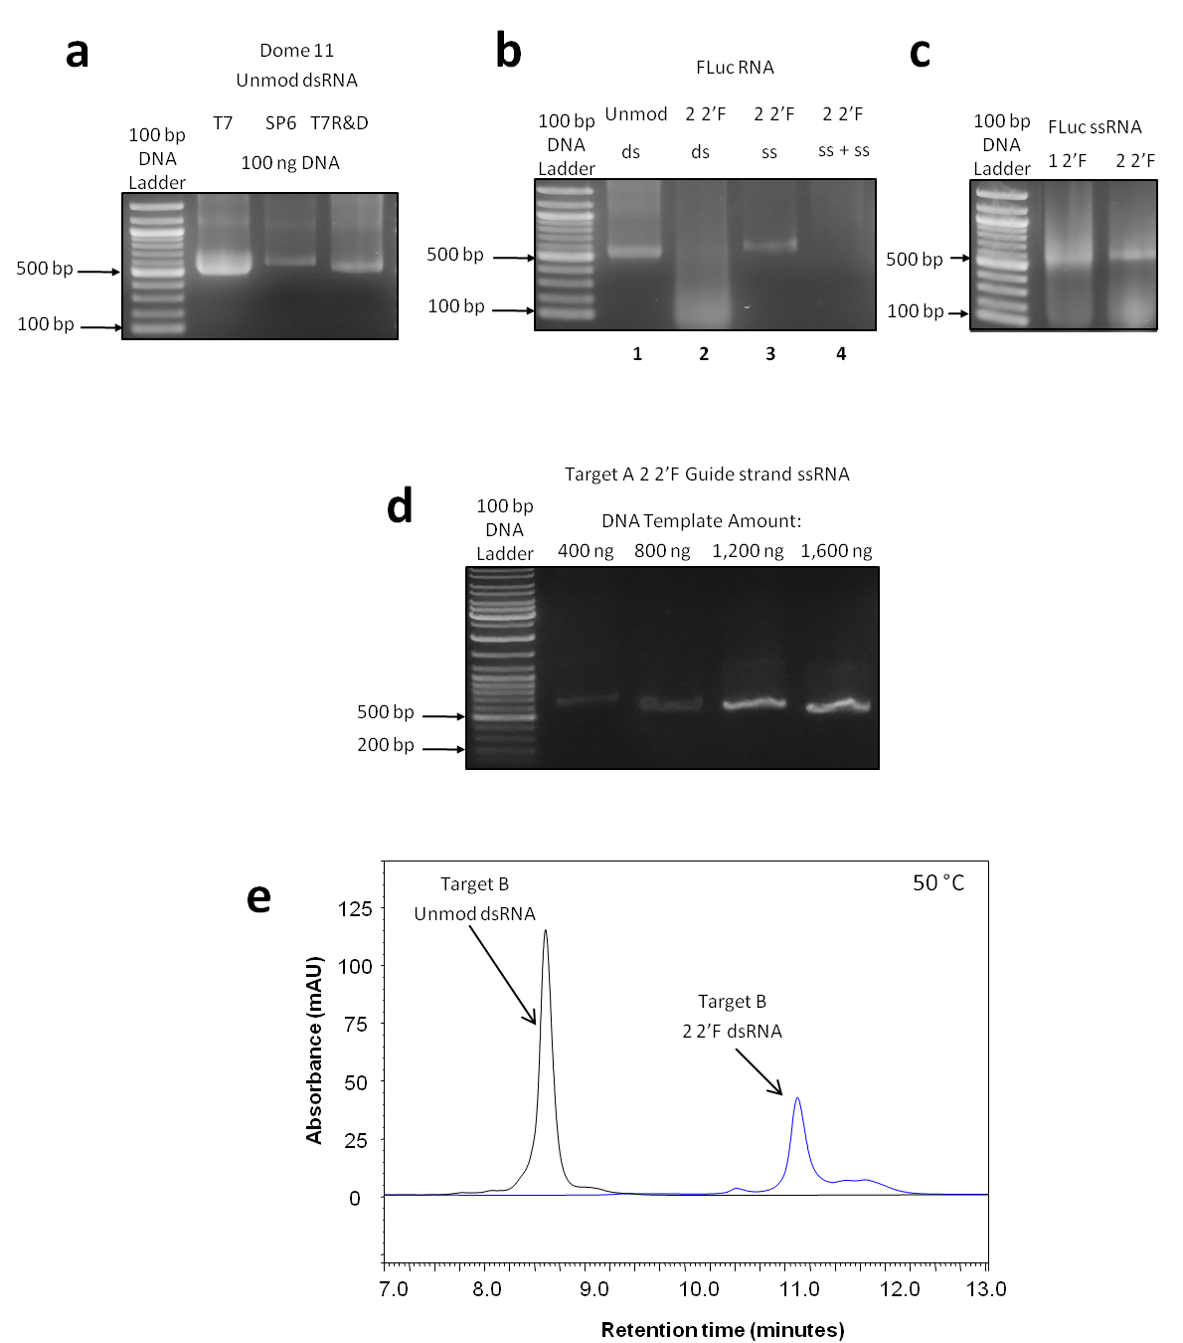

Figure 3.9 Synthesis and optimisation of 2’-fluoro modified long dsRNA.

(a) Gel electrophoretogram comparing yield of unmodified Dome11 dsRNA produced by IVT using T7, SP6, or T7R&DNA polymerase from 100 ng of DNA template with corresponding promoters.. 1:21 of each IVT reactions were analysed. dsRNA produced by IVT using T7, SP6 and T7R&DNA IVTs used 3.75, 2.5 and 2.5 mM NTPs respectively. (b) Gel electrophoretogram of unmodified, 2’F ssRNA and dsRNA synthesised by IVT using T7R&D polymerase from DNA template with either one or two T7 polymerase promoters. Lane 1: FLuc unmodified dsRNA synthesised from 100 ng of DNA template for dsRNA (two T7 promoters); Lane 2: FLuc 2 2’F IVT with 100 ng of DNA template for dsRNA (two T7 promoters); Lane 3: FLuc 2 2’F ssRNA synthesised from 100 ng of DNA template for ssRNA (one T7 promoter); Lane 4: FLuc 2 2’F IVT with 50 ng each of two DNA templates for complementary ssRNAs (each with one T7 promoter). The result show that 2’F modified RNA was only synthesised in IVT reactions using a DNA template to generate one ssRNA (c) Gel electrophoretogram of FLuc 1 2’F and 2 2’F ssRNA synthesised by IVT using T7R&D RNA polymerase. (d) Gel electrophoretogram of optimisation of DNA template amount for Target A guide strand synthesis using T7R&D polymerase. (f) Chromatogram of Target B unmodified and 2 2’F dsRNA generated by annealing of complimentary ssRNA and analysed in non-denaturing conditions at 50 °C using gradient 1. The results show a shift in retention time of the 2’-fluoro modified dsRNA compared to the unmodified dsRNA.

Optimisation of the amount of DNA template used in IVT reactions was carried out using T7 R&D polymerase to synthesise Target A 2’-fluoro modified ssRNA. Standard 20 µl IVT reactions were set up with DNA concentrations ranging from 400 to 1,600 ng per reaction. The reactions were incubated at 37 °C for approximately 12 hours, then analysed by gel electrophoresis (see figure 3.9 d). The results demonstrate the maximum yield of 2’-fluoro modified ssRNA was obtained using 1,200 ng and 1,600 ng of DNA template.

Following optimisation, complimentary unmodified 1 2’F and 2 2’F ssRNAs were successfully synthesised for all target dsRNAs required for downstream RNAi studies (chapters 5 and 6). After purification using DNase incubation and solid phase extraction (SPE), 2’-fluoro ssRNAs were annealed into 2’-fluoro dsRNAs for use downstream RNAi studies by mixing equal quantities of complimentary ssRNAs in 1X PBS and heat cooling as previously described for phosphorothioate dsRNAs. Target B unmodified and 2’-fluoro ssRNAs were synthesised and annealed by the same method and further analysis of the resulting dsRNA was performed using IP RP HPLC as previously described, to validate the purity of the dsRNA and incorporation of the 2’-fluoro modifications. An example of Target B unmodified and 2 2’F dsRNA is shown in figures 3.9 e. The results demonstrate that 2’-fluoro dsRNA demonstrates a clear shift in retention time compared to unmodified dsRNA. Unlike phosphorothioate dsRNA, the retention shift is seen for non-denaturing conditions, thus allowing for unmodified and 2’-fluoro dsRNA as well as ssRNA to be distinguished by HPLC analysis. Furthermore, the IP RP HPLC analysis also confirmed that no excess ssRNA remained followed annealing of the two complementary ssRNAs to generate the dsRNA for all target dsRNAs used in this study.

### Synthesis of 5-hydroxymethyl (HMr/HMd) and Glucosyl-5-hydroxymethyl (Gluc-HMd) DNA and RNA

T4 phages use glucosylated 5-hydroxymethyl deoxycytidine residues to protect their DNA from host restriction endonucleases when inside host cells (Vlot *et al.*, 2018) and therefore this modification has a proven function in preventing degradation of nucleic acids by nucleases *in vivo*. However, the synthesis of glucosyl-5-hydroxymethyl dsRNA has not previously been reported, and associated RNAi activity was unknown as far as could be ascertained from literature. Glucosyl-5-hydroxymethyl deoxycytidine DNA is synthesised by T4 phages by enzymatic addition of glucose moieties from the substrate uridine diphosphate glucose (UDPG) to 5-hydroxymethyl 2’-deoxycytidine (HMdC) residues in DNA (see figure 3.1 c) using the T4-β-glucosyltransferase (T4-BGT) enzyme (see figure 3.1 e). HMdCTP, UDPG and T4-BGT are all commercially available. 5-Hydroxymethyl and glucosyl-5-hydroxymethyl modifications were therefore selected as potential novel modifications to incorporate in dsRNA for use in RNAi studies.

As these modifications are usually found in DNA, 5-hydroxymethyl DNA was synthesised first. Dome11 DNA incorporating HMdC residues was synthesised by PCR as described in section 2.2.1, as an initial example, with deoxycytidine triphosphate (dCTP) replaced by a 5-hydroxymethyl 2’-deoxycytidine triphosphate analogue (HMdCTP). The DNA product was analysed by gel electrophoresis (see figure 3.10 a), and shows that HMdC DNA was successfully synthesised. The HMdC DNA was then converted into Gluc-HMdC DNA by enzymatic addition of glucose moieties from the substrate UDPG with the T4-BGT enzyme. The Gluc-HMdC DNA product was analysed by gel electrophoresis and the results are shown in figure 3.10 a & b. The results demonstrate a band shift between HMdC DNA and Gluc-HMdC DNA due to the change in electrophoretic migration, as a result of the successful addition of the large glucose moieties to the DNA. However, this band shift was only observed when both the HMdC DNA and Gluc-HMdC DNA had been purified by SPE prior to gel electrophoresis (see figure 3.10 b).

Following the successful synthesis of Gluc-HMdC DNA, the incorporation of HMdC into dsRNA using IVT, in conjunction with T7R&DNA polymerase, was performed by replacing CTP with HMdCTP in the reaction (see section 2.2.2). The reaction product was analysed by gel electrophoresis (see figure 3.10 c). The results demonstrate that a low yield of HMdC dsRNA was obtained. Addition of glucose moieties to HMdC dsRNA by T4-BGT was attempted next. The glucosylation reaction product and HMdC dsRNA were both purified by SPE, and analysed by gel electrophoresis. The results are shown in figure 3.10 d and demonstrate there was no clear band shift between the glucosylation reaction product and HMdC dsRNA, suggesting that the enzymatic addition of glucose moieties to HMdC dsRNA was unsuccessful.

It was unknown if 5-hydroxymethyl cytidine (HMrC) could be converted to Gluc-HMrC by T4-BGT. 5-Hydroxymethyl cytidine (HMrC) was incorporated into dsRNA by IVT using standard T7 RNA polymerase, with CTP substituted by HMrCTP (see figure 3.1 d). The IVT reaction product was analysed by gel electrophoresis and the results are shown in figure 3.10 e. The results demonstrate that good yields of HMrC dsRNA were obtained with very little difference in yield from unmodified dsRNA, demonstrating high incorporation efficiency of HMrCTP by T7 polymerase. Glucosylation of the HMrC-containing dsRNA was then attempted using the T4-BGT enzyme and UDPG as previously described. The resulting reaction product and the HMrC dsRNA were purified by SPE and analysed by gel electrophoresis (see figure 3.10 e). The results again show no clear band shift between the glucosylation reaction product and HMrC dsRNA, suggesting that the enzymatic addition of glucose moieties to HMrC dsRNA was unsuccessful. In summary, these results suggest that the T4-BGT

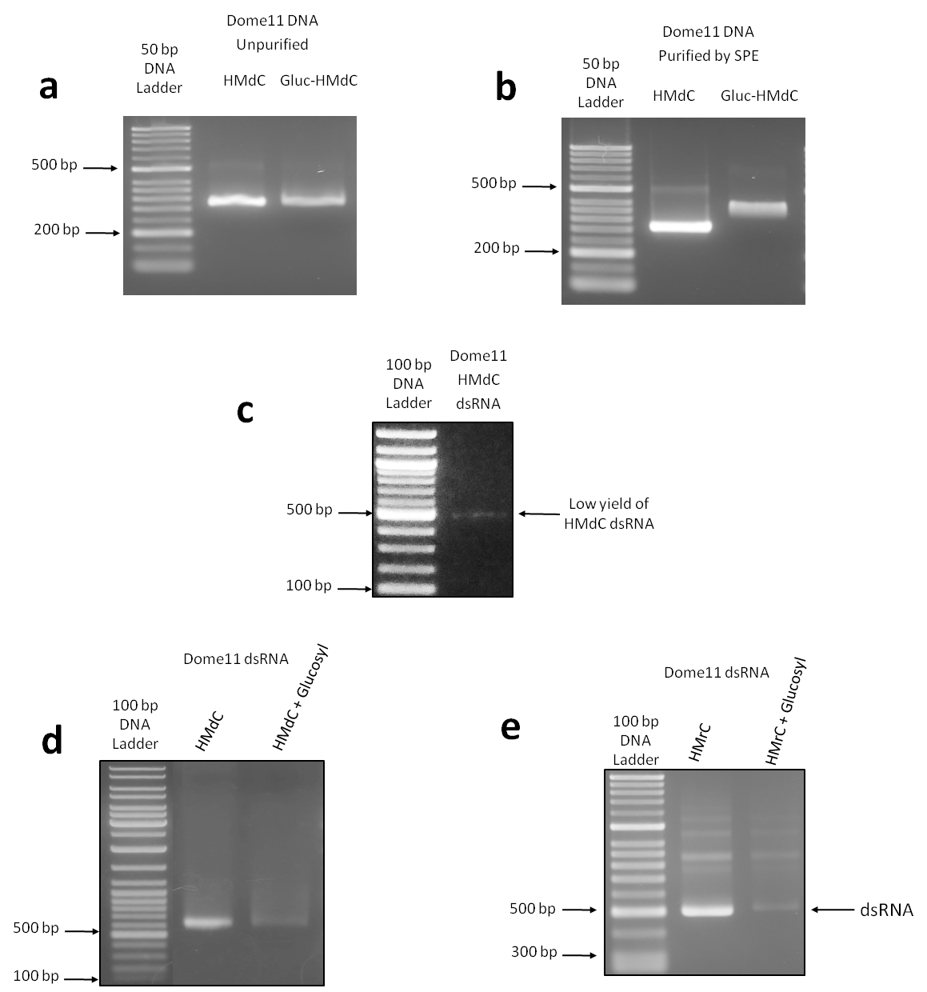

Figure 3.10 Synthesis and analysis of DNA and RNA containing 5-Hydroxymethyl and Glucosyl-5-Hydroxymethyl modified deoxyribonucleotides and ribonucleotides.

(a & b) Gel electrophoretograms of Dome11 HMdc DNA synthesised by PCR. Glucosylation reaction was performed by addition of Glucose-UDP and T4 β-glucosyltransferase (T4-BGT) enzyme. The resulting product was analysed with (a) no purification or (b) purification by solid phase extraction (SPE). The results demonstrate a clear band-shift following glucosylation of the HMdc DNA when the DNA is subsequently purified by SPE. (c) Gel electrophoretogram demonstrating low yield of Dome11 HMdC dsRNA produced by IVT from Dome11 DNA template using T7R&D polymerase. 1:20 of IVT reaction loaded. (d) Gel electrophoretogram of the glucosylation reaction of Dome11 HMdC dsRNA. No clear band shift for glucosylation was observed indicating HMdC dsRNA is not glucosylated by T4-BGT. (e) Gel electrophoretogram of glucosylation reaction of Dome11 HMrC dsRNA. No clear band shift was observed demonstrating that HMrC dsRNA is not glucosylated to Gluc-HMrC dsRNA by T4-BGT.

enzyme is not capable of glucosylating HMrC or HMdC residues is dsRNA, in the same manner as HMdC residues in dsDNA. This suggests that the T4-BGT enzyme cannot glucosylate RNA and requires a DNA substrate.

As 5-hydroxymethyl modifications alone without glucose moieties are capable of protecting phage DNA from degradation (Kutter and Wiberg, 1969), and HMr dsRNA could be readily synthesised by IVT, HMr dsRNA was selected as a chemical modification to study in downstream RNAi assays. As an example, FLuc 1HMr and 2HMr dsRNAs were synthesised by IVT reaction using T7 RNA polymerase, with CTP replaced by HMrCTP or UTP replaced by HMrUTP for 1HMr IVT reactions, and both CTP replaced by HMrCTP and UTP replaced by HMrUTP for 2HMr IVT reactions. The dsRNA was purified by incubation with DNase to remove DNA template, followed by SPE and analysis using gel electrophoresis. The results are shown in figure 3.11 a, and demonstrate that 1HMr and 2HMr dsRNA were successfully synthesised. 1HMr and 2HMr dsRNA IVT reactions had similar high yields to unmodified IVT reactions and therefore no further optimisation of synthesis was carried out. Target B unmodified and 1HMr dsRNAs were also synthesised by the same method, and further analysed by IP RP HPLC in non-denaturing conditions (50 °C), and the results are shown in figure 3.11 b. The results demonstrate that dsRNA containing 5-hydroxymethyl modifications does not demonstrate a clear shift in retention time compared to unmodified dsRNA when analysed in non-denaturing conditions.

FLuc unmodified, 1HMr and 2HMr dsRNAs were analysed by IP RP HPLC in denaturing conditions (75 °C) and the results are shown in figure 3.11 c. The results demonstrate that 1HMr and 2HMr dsRNA have identical retention times. In the case of 1HMr dsRNA, this was the case for dsRNA produced in IVT reactions with either CTP replaced by HMrCTP or with UTP replaced by HMrUTP. All of the 5-hroxymethyl dsRNAs (both 1HMr and 2HMr dsRNAs) demonstrated a slight reduction in retention time compared to unmodified dsRNA. 1HMr and 2HMr dsRNAs were subsequently generated for a wide range of the target dsRNAs required for downstream RNAi studies.

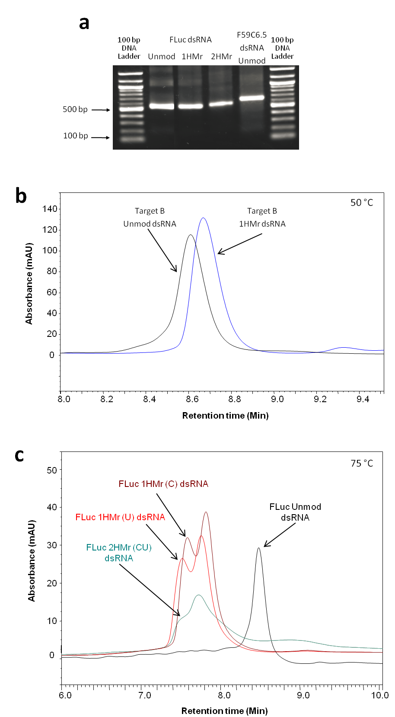

Figure 3.11 Synthesis of 5-hydroxymethyl modified long dsRNA.

(a) Gel electrophoretogram of Unmod, 1HMr and 2HMr dsRNA and unmodified control F59C6.5 dsRNA synthesised by IVT using T7 RNA polymerase. (b) Chromatogram of Target B unmodified and 1HMr dsRNA analysed in non-denaturing conditions at 50 °C using gradient 1. (c) Chromatogram of FLuc unmodified, 1HMr and 2HMr dsRNAs analysed in denaturing conditions at 75 °C using gradient 1.

### Quantification of unmodified and chemically modified dsRNA by UV spectrophotometry

Following synthesis of the chemically modified dsRNA, a major aim of this thesis is to study the effects of the dsRNA chemical modifications on RNAi efficacy. Therefore, it is important for downstream RNAi studies (see chapters 5 and 6) that accurate quantification of the dsRNA is performed. This enables accurate comparisons of one or more chemically modified dsRNAs and the equivalent unmodified dsRNA in RNAi studies.

Quantification of nucleic acids using Nanodrop UV spectrophotometry, enables the rapid quantification of the nucleic acid based on their absorbance at 260 nm. For quantification of nucleic acids using UV spectrophotometry, mass concentration values for an A260 value of 1 ((µg/ml)/A260) of 30 (µg/ml)/A260, 40 (µg/ml)/A260 and 50 (µg/ml)/A260, are commonly used for oligonucleotides, ssRNA and dsDNA, respectively. It has previously been determined that accounting for hypochromicity of dsRNA and neglecting effects due to the overall length of the dsRNA, an appropriate value to use for the mass concentration/A260 for dsRNA is 46.52 µg/mL/A260 (Nwokeoji, *et al.*, 2017). This value was therefore used for all dsRNA quantifications with Nanodrop UV spectrophotometry.

However, for accurate quantification of the dsRNA using UV spectrophotometry it is important that the dsRNA is purified prior to analysis. A significant absorbance at 260 nm could be due to unincorporated nucleotides from the IVT reaction and impurities such as abortive transcripts or excess ssRNA that is not annealed. Therefore it is critical for accurate UV quantification of the dsRNA that the excess unincorporated nucleotides are removed via SPE, and further analysis of the dsRNA is performed using gel electrophoresis and IP RP HPLC to ensure the dsRNA is relatively pure and free from large amounts of impurities such as excess ssRNA (see section 3.3.2). Therefore, following IVT and purification using SPE, further analysis was performed using gel electrophoresis and IP RP HPLC to validate the incorporation of chemical modifications (based on retention time differences to the unmodified dsRNA) and confirm the removal of unincorporated NTPs and the absence of excess ssRNA post annealing of the dsRNA (as shown in figure 3.4 c).

Following validation of the purity of the dsRNA using the above methods, UV spectrophotometry (Nanodrop) was used for quantification of the dsRNA for each dsRNA (see section 2.2.5). Subsequent to quantification of the dsRNA using UV spectrophotometry, further validation of the accuracy of the quantification was performed by analysing equal amounts of the dsRNAs by both gel electrophoresis and IP RP HPLC. Subsequent measurements of the band intensity and peak area corresponding to the dsRNA were performed for each of the different chemically modified dsRNAs to ensure accuracy of the UV spectrophotometry. It was expected that equal loadings of the dsRNA on

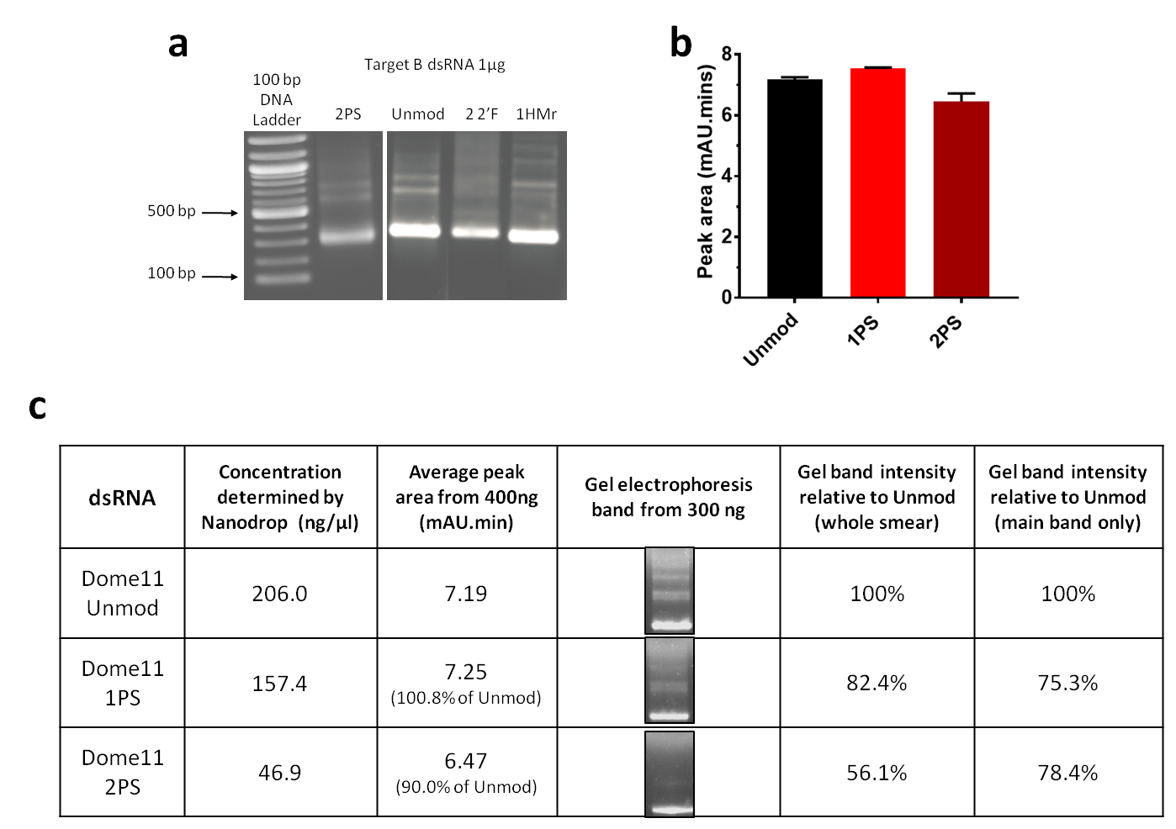

Figure 3.12 Quantification of unmodified and phosphorothioate modified dsRNA by IP RP HPLC.

(a) Gel electrophoretogram of 1 µg each of unmodified and chemically modified dsRNAs. (b) Bar graph of quantification of 400 ng of unmodified, 1PS and 2PS Dome11 dsRNA by full loop injection IP RP HPLC. Quantification by manual measurement of peak areas in Chromeleon software. Mean and SEM plotted, n = 2. (c) Table demonstrating an example of validation of Nanodrop quantification for FLuc unmodified, 1PS and 2PS dsRNA by comparing HPLC quantification from (b) with gel electrophoresis analysis. Gel band intensity quantified using Fiji (ImageJ) software.

the gel would result in equal staining intensity and injection of equal amounts of the dsRNA using IP RP HPLC would result in equal peak areas as measured by UV detection.

Based on Nanodrop concentration measurements, equal amounts of a range of unmodified and chemically modified Target B dsRNAs were analysed by gel electrophoresis and the results are shown in figure 3.12 a. The results show bands of approximately equal intensity for most dsRNAs, with 2PS dsRNA demonstrating a slight reduction in intensity. This reduction in band intensity for PS dsRNA had previously been seen elsewhere (see figure 3.6 b) and was further investigated by HPLC to ensure accurate quantification (see below). 2 2’F dsRNA demonstrates a slight reduction in staining intensity of the main band, but an increase in the intensity of the characteristic dsRNA smear seen above the main band. 1HMr dsRNA demonstrated equal main band and smear intensity to unmodified dsRNA.

An example of the comparison of peak area determined by IP RP HPLC and gel band intensity determined by gel electrophoresis with gel band quantification in Fiji (Image J) software for FLuc unmodified, 1PS and 2PS dsRNA is shown in figure 3.12 c. The results demonstrate that the peak areas determined by HPLC are similar for unmodified and phosphorothioate dsRNA, with unmodified and 1PS having virtually identical peak areas, and 2PS having a slightly reduced peak area equivalent to 90% that of unmodified dsRNA. The gel analysis also demonstrates the reduction in gel band intensity for increasing phosphorothioate content of the dsRNA, as previously seen. As the difference in gel band intensity is significantly greater than differences in HPLC quantification, this was thought to be an artefact of gel staining possibly due to the presence of the chemical modifications altering binding of the stain.

This comparison of IP RP HPLC and gel electrophoresis analysis for unmodified and chemically modified dsRNA was subsequently performed for all dsRNAs generated in this study, to validate the quantification using UV spectrophotometry prior to using dsRNA in cell, insect, or *in vitro* assays.

## Conclusions

To study the effects of chemical modifications of long dsRNA in downstream RNAi applications, a range of different chemically modified dsRNAs were synthesised using *in vitro* transcription, purified and quantified. Optimisation of enzymatic *in vitro* synthesis methods using phage RNA polymerases were performed, to produce either ssRNA in separate reactions prior to annealing of the dsRNA, or alternatively, to produce the dsRNA in a single IVT reaction.

dsRNAs containing phosphorothioate bonds were successfully synthesised by IVT using T7 RNA polymerase, by replacing either one or two NTPs with their corresponding α-thio NTP analogues in a single IVT reaction. Using this approach up to two out of the four NTPs could be replaced by α-thio NTPs whilst maintaining a reasonable yield of dsRNA. Phosphorothioate ssRNA could also be synthesised by the same method and annealed with complimentary phosphorothioate or unmodified ssRNA to produce various types of phosphorothioate dsRNA, where the modifications are present in either the passenger strand, guide strand, or both strands. Optimisations of the IVT reactions and annealing conditions were performed. In addition, further validation and analysis of the PS dsRNA was performed using IP RP HPLC to ensure correct annealing of the PS dsRNA.

Synthesis of dsRNA containing 2’-fluoro modifications required the use of a modified T7 RNA polymerase (T7R&D polymerase) in conjunction with replacement of CTP and UTP with 2’-fluoro CTP and 2’-fluoro UTP analogues in the IVT reaction. Interestingly, dsRNA containing 2’-fluoro modifications could not be synthesised in a single IVT reaction using this approach. However complimentary 2’-fluoro ssRNAs were successfully synthesised by IVT using a modified T7R&D polymerase, and successfully annealed with both 2’-fluoro and unmodified ssRNAs to produce dsRNA.

In addition to the above chemically modified dsRNA, dsRNA containing 5-hydroxymethyl modifications was successfully synthesised by IVT using standard T7 RNA polymerase, and high yields of dsRNA comparable to yields of unmodified dsRNA were achieved. IVT reactions were performed using HMrCTP and HMrUTP nucleotide analogues to replace CTP and UTP respectively. However it was not possible to enzymatically glucosylate the 5-hydroxymethyl dsRNA using T4-β-glucosyltransferase. An alternative approach was used involving IVT reactions with CTP replaced by 5-hydroxymethyl deoxycytidine triphosphate (HMdCTP) which was incorporated into dsRNA in low yields using T7R&D polymerase. However, this was also not a substrate for T4-β-glucosyltransferase. Therefore we were unable to prepare glucosylated dsRNA for downstream RNAi applications, but successfully synthesised dsRNA containing 5-hydroxymethyl modifications.

The synthesised chemically modified RNAs were subsequently purified by SPE and analysed by Nanodrop UV spectrophotometry (Nanodrop), gel electrophoresis, and ion pair reverse phase high performance chromatography (IP RP HPLC). Further validation and analysis of the dsRNA was performed using IP RP HPLC and gel electrophoresis. Using these methods enabled the verification of the presence of the chemical modifications in the RNA, the correct annealing of the ssRNA into dsRNA and the removal of impurities such as unincorporated NTPs, excess ssRNA, and DNA which could affect the accurate quantification of the dsRNA using UV spectrophotometry. Overall the quality of purified RNA was high, although some 2’-fluoro RNA retained moderate levels of contaminants, as revealed by the size of injection peaks when analysed by IP RP HPLC.

In summary, phosphorothioate, 2’-fluoro and 5-hydroxymethyl ssRNAs and dsRNAs for a number of different dsRNA targets were successfully synthesised, purified and quantified. The synthesis, purification and quantification methods described here were used to generate all the combinations of modified dsRNA subsequently used in insect cell and live insect RNAi assays.

Chapter 4

Studying the effects of dsRNA

chemical modifications on the activity

of insect nucleases

# Studying the effects of dsRNA chemical modifications on the activity of insect nucleases

## Abstract

The interaction of dsRNA with insect nucleases is critical to the efficacy of a dsRNA insecticide. The dsRNA must resist degradation by nucleases present in the saliva, gut secretions, and hemolymph of the insect as well as potential environmental nucleases, in order for enough copies of the dsRNA to be taken up by insect cells to induce RNAi mediated knockdown of the target mRNA. Once inside the cells of the insect, the endoribonuclease Dicer-2 must then process the long dsRNA into functional short siRNAs in order to form mature RISCs capable of inducing RNAi mediated knockdown of the target mRNA. A successful dsRNA insecticide must therefore be stable with respect to the first class of nucleases, but be readily processed by the Dicer-2 nuclease.

In this Chapter the effects of dsRNA chemical modifications (including dsRNAs with phosphorothioate, 2’-fluoro and 5-hydroxymethyl modifications) on the activity *in vitro* of bacterial RNase III, Dicer from *Giardia intestinalis* and nucleases present in the saliva from stink bugs were studied.

Phosphorothioate containing dsRNA demonstrated increased resistance to stick bug saliva in *in vitro* assays, highlighting the potential of this modification for improved RNAi efficacy in live insects. However, the *in vitro* assays also indicated this is a poor substrate for bacterial RNase III and *Giardia* Dicer and is not effectively processed into esiRNAs, which may reduce the RNAi efficacy *in vivo*. Although the 2’-fluoro and 5-hydroxymethyl dsRNA showed no increased resistance to nucleases present in the saliva from stink bugs *in vitro,* these dsRNA were effectively processed by bacterial RNase III into esiRNAs, suggesting they are likely substrates for Dicer-2 *in vivo*. Conversely, however all chemically modified dsRNAs were poor substrates for *Giardia* Dicer.

These results provide further insight into the effects of dsRNA chemical modifications on the activity of insect nucleases.

## Introduction

The interaction of dsRNA with two major classes of nucleases is crucial in determining the success or failure of a dsRNA insecticide. Firstly, the dsRNA must resist degradation by nucleases present in the saliva, gut secretions and hemolymph of the insect as well as environmental nucleases, in order for enough copies of the dsRNA to be uptaken by insect cells to induce RNAi-related knockdown of the target mRNA. Once inside individual cells of the insect, the second class of nucleases, the endoribonuclease Dicer-2, must then process the long dsRNA into short siRNAs in order to form mature RISCs capable of inducing RNAi-related knockdown of the target mRNA (Lee, Nakahara, John W Pham, *et al.*, 2004). A successful dsRNA insecticide must therefore be capable of resisting cleavage by the first class of nucleases, but be readily processed by the Dicer-2 nuclease. As these two classes of nucleases share some common mechanisms of action, this can be a delicate balance.

Loss of dsRNA by nuclease degradation reduces the efficacy of the initial dose of dsRNA applied to a crop, and therefore any method of avoiding losses has the potential to improve the target insect mortality level resultant from a given dose of dsRNA. Specific insect nucleases are a major barrier to successful insecticidal RNAi in a number of species (Lomate and Bonning, 2016; Guan *et al.*, 2018; Peng *et al.*, 2018). For example, stink bug saliva has been shown to have a high level of nuclease activity (Lomate and Bonning, 2016). As phloem feeding insects, stink bugs pierce the surface of the fruit or vegetable they are feeding on with their stylet and inject saliva to pre-digest a small internal region of the fruit or vegetable body, before then drawing up the partly digested fruit or vegetable pulp. This method of feeding is an advantage for studying the saliva and its constituent enzymes, as the insects readily express saliva, which can be collected. Stink bug salival nucleases were therefore chosen as the model with which to investigate if chemical modifications of the dsRNA could enhance dsRNA resistance to insect nucleases. Other degradation points such as degradation of dsRNA by nucleases present in soil (Dubelman *et al.*, 2014), degradation by exposure to UV radiation from the sun (San Miguel and Scott, 2015) and degradation by gut or hemolymph nucleases (Spit *et al.*, 2017a) are also factors in determining the amount of dsRNA which survives in order to be taken up by an insect and induce RNAi, however those factors have not been considered here.

Where a chemical modification prevents or slows degradation of dsRNA by nucleases, thereby increasing the stability of the dsRNA and the potential amount of the dsRNA to induce RNAi, it may also prevent Dicer from processing the long dsRNA to active siRNAs. Therefore, overall RNAi activity of a chemically modified dsRNA will be due to a combination of factors. Several of the chemical modifications examined here are known to increase resistance to nuclease degradationin mammalian or other systems, including: phosphorothioate modifications in chimeric oligonucleotides (Monia *et al.*, 1996)**,** phosphorothioate modifications in siRNAs (Chiu and Rana, 2003; Jahns *et al.*, 2015b); phosphorothioate modifications in antisense oligonucleotides (Stein, 1996); 2’-fluoro modifications in siRNAs, and phosphorothioate modifications in antisense ss-siRNAs (Chiu and Rana, 2003). It was therefore proposed to study the effect of a number of dsRNA chemical modifications on the activity of insect nucleases in stink bug saliva using *in vitro* assays, to determine if such modifications result in increased resistance to these nucleases in comparison to unmodified dsRNA.

Processing of long dsRNA into active siRNAs by Dicer is a key step in the insect Dicer-2/Argonaute-2 RNAi pathway related to insecticidal activity of dsRNA. As previously discussed (see section 1.2.2), subtle variation exists in Dicer structure between different Dicer paralogs in a single species, the equivalent homologs of Dicer in different insect species, and the equivalent Dicer between different classes of organism – for example insects, mammals and protozoans. This variation results in Dicer proteins collectively having a wide range of substrate and product specificity, as well as variation in specific sub-functions they carry out, due to a wide variety of domain architectures (see figure 4.1). The activity of one Dicer enzyme upon a dsRNA substrate may be very different to another Dicer acting on the same substrate. Dicer also acts in concert with other RNAi pathway proteins *in vivo* in many species, therefore results of *in vitro* assays may not entirely reflect how a dsRNA is processed *in vivo*.

Two commercially available, purified, non-insect Dicer/RNase III family enzymes were investigated for their ability to process chemically modified dsRNA. These consisted of the simple bacterial RNase III enzyme from *E. coli*, and a minimal Dicer from *Giardia intestinalis* (an intestinal parasite). Bacterial RNase III comprises a single RNase III domain, and a non-sequence specific dsRNA binding domain (dsRBD) (Gan *et al.*, 2006; Aliyari and Ding, 2009) (see figure 4.1 a). *Giardia* Dicer consists of two RNase III domains and a Piwi-Argonaute-Zwille (PAZ) domain (Macrae *et al.*, 2006) (see figure 4.1 a). It shares all of these domains with human Dicer and insect Dicer-2. However, these have increased domain complexity, with a canonical N-terminus dsRBD, a further atypical dsRBD formerly termed domain of unknown function (DUF) 283, and a C-terminus Helicase domain (Kandasamy and Fukunaga, 2016) (see figure 4.1 a). PAZ domains are responsible for binding the two nucleotide overhang of dsRNA substrates (Song *et al.*, 2003), dsRBD domains bind dsRNA mid-molecule across a minor-major-minor groove stretch of helix (Masliah, Barraud and Allain, 2013), RNase III domains act in pairs to cleave the dsRNA to form a new terminus with a two nucleotide overhang (Macrae *et al.*, 2006), and the helicase domain has various roles in different species, including successive processing of a dsRNA into multiple siRNAs without dissociation of Dicer

Figure 4.1 Schematic illustration of the domain architecture and mechanism of Dicer and RNase III family enzymes.

(a) Domain architecture of bacterial, *Giardia*, human and insect Dicer/RNase III family enzymes. DUF283 (Domain of unknown function 283) is known to be an atypical dsRNA binding domain. Human, *Drosophila* and other insects’ Dicers have similar domain architecture, however the size and sequence of the main functional domains, linking domains, and overall enzyme are different for each (domain sizes not to scale). (b) Cleavage mechanism of human/insect, *Giardia*, and bacterial Dicer/RNase III family enzymes. Dicer enzymes form internal psuedo-dimers between the RNase III domains to cut both dsRNA strands, whereas two separate bacterial RNase III monomers form a true dimer to cut both strands. Cut sites indicated by white arrows. Not to scale.

between steps (Cenik *et al.*, 2011), recognition of substrates other than long dsRNA such as pre-miRNA hairpins (Ma *et al.*, 2012), and as part of an siRNA amplification loop that forms part of the RNAi antiviral defence system of insects (Poirier *et al.*, 2018).

The two selected enzymes also have different binding mechanisms. Two separate RNase III molecules bind to the double stranded region of dsRNA via their dsRBDs, and bring their RNase III domains together to form a homodimer, which then cuts the dsRNA in a divalent metal ion-dependent mechanism, leaving a two nucleotide overhang (Sun, Pertzev and Nicholson, 2005; Nicholson, 2014). In contrast, *Giardia* Dicer binds to dsRNA at the single stranded two nucleotide overhang at the terminus via its PAZ domain, and its two RNase III domains form an internal pseudo-dimer which cleaves around 25 bp from the initial terminus (Macrae *et al.*, 2006).

RNase III and *Giardia* Dicer cleave dsRNA via the same mechanism, but bind dsRNA with different types of domain (Doyle, Jaskiewicz and Filipowicz, 2012; Nicholson, 2014). Therefore, any difference in processing of chemically modified dsRNA between the two enzymes is likely due to binding mechanism rather than cleavage mechanism. Insect Dicer-2 has domains responsible for both types of binding mechanism, and an RNase III domain used for dsRNA cleavage, therefore *in vitro* experiments with the bacterial RNase III and *Giardia* Dicer enzymes may provide further insight into the effect of the chemical modifications of dsRNA on the activity of insect Dicer-2.

A major aim of this chapter was to determine the ability of different RNase III/Dicer family enzymes to cleave a range of chemically modified dsRNAs into siRNAs. Functional insect Dicer-2 is not commercially available. However, both bacterial RNase III and *Giardia* Dicer are, and both share common domains with insect Dicer. *In vitro* assays were performed using unmodified, phosphorothioate, 2’-fluoro and 5-hydroxymethyl dsRNAs to determine the efficacy of processing of the chemically modified dsRNAs to endoribonuclease-prepared siRNAs (esiRNAs) by both enzymes.

## Results and discussion

### Studying the effects of dsRNA chemical modifications on the activity *in vitro* of Dicer enzymes

For insecticidal dsRNAs to be functional in insect cells, they must be capable of being processed into functional siRNAs by the Dicer-2 enzyme (Hammond, 2005). This processing may be affected by the presence of chemical modifications in the dsRNA. In order to examine the ability of Dicer enzymes to process chemically modified dsRNAs into esiRNAs, two different types of Dicer/RNase III family enzyme were used: bacterial RNase III, and *Giardia intestinalis* Dicer. These two enzymes bind and process dsRNA in distinct ways, as discussed above, and contain fewer functional domains than insect or mammalian Dicer enzymes (see figure 4.1). By studying the activity of bacterial RNase III and *Giardia intestinalis* Dicer on chemically modified dsRNA *in vitro*, it was proposed that this would provide further insight into the potential effect of such chemical modifications on insect Dicer-2 dsRNA processing *in vivo*.

#### Studying the effects of dsRNA chemical modifications on the activity of bacterial RNase III

Prior to testing the ability of RNase III to process chemically modified long dsRNA into esiRNAs, the *in vitro* assay was optimised using unmodified Target B dsRNA (all chemically modified dsRNAs subsequently tested were also Target B dsRNA). 1 µg of dsRNA was used in all reactions in conjunction with a series of 10 fold dilutions of ‘ShortCut’ RNase III. These reactions were run in duplicate, with the enzyme activity of one set of reactions being quenched instantly with EDTA, while the other set of reactions were incubated at 37 °C for 20 minutes followed by the enzyme activity being quenched by addition of EDTA. The reaction products were analysed by gel electrophoresis, alongside control dsRNA samples incubated in reaction buffer without RNase III (see figure 4.2 a).

The results demonstrate that the addition of 0.02 units (U) of RNase III failed to process the long dsRNA to esiRNAs at either of the time points. At the 20 minute time point, the addition of 0.2 U had started to generated esiRNAs as evidenced by the small amount of degradation of the long dsRNA. At 20 mins the addition of 2 U of enzyme had completely processed the dsRNA (as shown by the loss of the intact dsRNA). However, no esiRNAs were visible on the gel, likely due to over processing of the esiRNAs into even shorter length fragments which were not detected using gel electrophoresis. The analysis of the same amount of enzyme (2 U) quenched instantly (the 0 minute time point) resulted in processing of the dsRNA to esiRNAs. The initial dsRNA incubated in reaction buffer alone demonstrated no sign of degradation, indicating degradation/over-processing of the dsRNA was due to the RNase III enzyme. RNase III products may be as short as 11-15 bp (Nicholson, 2014). Online

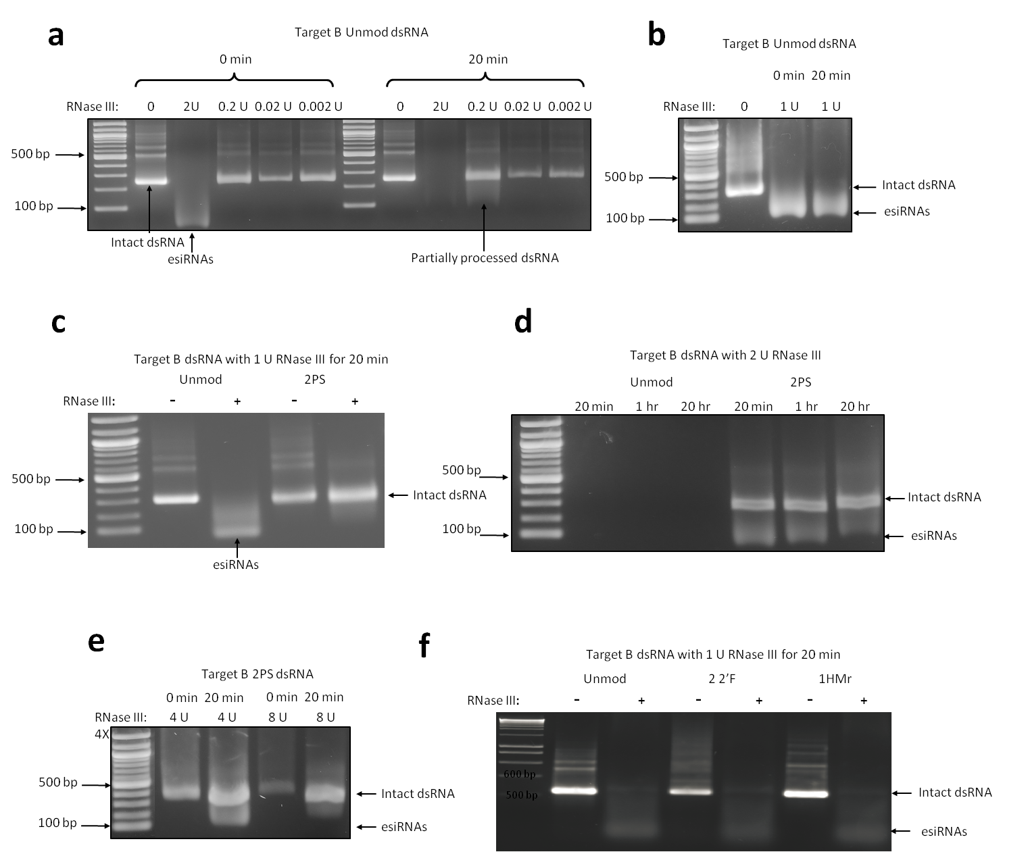

Figure 4.2 Processing of unmodified and chemically modified dsRNA to esiRNAs by bacterial RNase III.

(a) Gel electrophoretogram of unmodified Target B dsRNA incubated with various dilutions (2-0.002 units (U)) of RNase III for 0 mins or 20 min. (b) Gel electrophoretogram of unmodified Target B dsRNA incubated with 1 U of RNase III for 0 mins or 20 min. (c) Gel electrophoretogram of unmodified and 2PS Target B dsRNA incubated with 1 U RNase III for 20 min. (d) Gel electrophoretogram of unmodified and 2PS Target B dsRNA incubated with 2 U RNase III for 20 min, 1 hr or 20 hr. (e) Gel electrophoretogram of 2PS Target B dsRNA incubated with 4 or 8 U RNase III for either 0 mins or 20 min. (f) Gel electrophoretogram of unmodified 2 2’F and 1HMr Target B dsRNA incubated with 1 U of RNase III for 20 mins. All incubations were performed at 37 °C; 1 µg of Target B dsRNA was incubated with various amounts of RNase III; reactions were quenched by addition of EDTA. In each gel the intact dsRNA and processed esiRNAs are highlighted.

oligonucleotide calculators reveal that a 12 bp siRNA may have a melting temperature anywhere in the range of 22-48 °C depending on GC content, therefore short fragments may dissociate into ssRNA at an incubation temperature of 37 °C and be degraded.

Further optimisation of the RNase III assay was performed using 1 U of enzyme in two reactions with unmodified dsRNA. Once again, one reaction was quenched instantly with EDTA, and the other was quenched after incubation at 37 °C for 20 minutes. The reaction products were analysed by gel electrophoresis alongside long dsRNA (see figure 4.2 b). The results demonstrate that using 1 U of enzyme per microgram of dsRNA resulted in full processing of long dsRNA to esiRNAs almost instantaneously upon addition of the enzyme, but prevents the siRNAs being significantly over-

processed after a 20 minute incubation period.

To study the effects of chemical modification of dsRNA on RNase III activity, phosphorothioate dsRNA (2PS dsRNA) and unmodified dsRNA were incubated in reactions with 1 U of RNase III at 37 °C for 20 minutes, followed by EDTA quenching. The reaction products were analysed alongside the unprocessed long dsRNAs by gel electrophoresis and the results are shown in figure 4.2 c. The results demonstrate that the unmodified dsRNA was successfully processed to esiRNAs in line with previous results. In contrast, the 2PS dsRNA showed no significant cleavage of the dsRNA to esiRNAs (see figure 4.2 c) demonstrating the increased resistance of the phosphorothioate modified dsRNA to RNase III compared to unmodified dsRNA.

To further study the increased resistance of phosphorothioate modified dsRNA to RNase III activity, reactions were set up using twice the amount of RNase III enzyme as previously (2 U). Reactions were incubated at 37 °C for 20 minutes, 1 hour and 20 hours. The reactions were quenched at the appropriate time point by addition of EDTA, and reaction products analysed by gel electrophoresis (see figure 4.2 d). Consistent with previous data, the unmodified dsRNA completely degraded (esiRNAs also degraded) by the 20 minute time point, and therefore no bands corresponding to the intact long dsRNA and esiRNAs were observed. In contrast, the analysis shows the presence a band corresponding to the intact phosphorothioate dsRNA (2PS dsRNA) at all time points. However, the increased amount of enzyme resulted in the formation of small amounts of esiRNAs by the 20 minute time point. Incubation for 1 hour or 20 hours did not appear to increase processing of 2PS dsRNA to esiRNAs.

In order to see if increasing the amount of RNase III further increased the processing of 2PS dsRNA to esiRNAs, reactions were set up containing 4 U and 8 U of enzyme and reactions incubated at 37 °C for 0 minutes and 20 minutes prior to quenching with EDTA. The reaction products were analysed by gel electrophoresis and the results are shown in figure 4.2 e. The results demonstrate that neither concentration of the enzyme resulted in any instantaneous (0 minute time point) processing of 2PS dsRNA to siRNAs. After a 20 minute incubation the reaction with 4 U of enzyme produced some esiRNAs, though once again the majority of the 2PS dsRNA remained intact as long dsRNA. The amount of esiRNAs produced did not appear to increase compared to a 20 minute incubation with the 2 U of enzyme. The addition of 8 U of enzyme did not increase processing of long dsRNA compared to 4 U of enzyme, and appeared to degrade a proportion of the esiRNAs generated.

A reaction was set up using a different sample of the same 2PS dsRNA (Target B), as well as unmodified, Un-1PS, 1PS, and Un-2PS dsRNAs. Each dsRNA was incubated with 1 U of RNase III enzyme at 37 °C for 20 minutes. The reactions were quenched by addition of EDTA, and reaction products analysed by gel electrophoresis (see Appendix 3, figure A3.1). The results contradicted previous results and demonstrate that all the phosphorothioate-containing dsRNAs were processed efficiently to esiRNAs. Further investigation is therefore needed in order to compare different transcripts and dsRNA samples produced at different times, in order to determine with certainty whether dsRNA with phosphorothioate modifications is a good substrate for bacterial RNase III in all contexts.

2’-Fluoro and 5-hydroxymethyl dsRNAs were also tested as substrates for RNase III. Unmodified, 2 2’F and 1HMr dsRNA were incubated in reactions with a 1 U of RNase III at 37 °C for 20 minutes, followed by EDTA quenching as before. The reaction products were analysed alongside the unprocessed long dsRNAs by gel electrophoresis and the results are shown in figure 4.2 f. The results demonstrate that the unmodified dsRNA was successfully processed to esiRNAs in line with previous results. The 2 2’F and 1HMr dsRNAs were also fully processed into esiRNAs. 2’-Fluoro and 5-hydroxymethyl modifications do not therefore appear to effect the production of esiRNAs from bacterial RNase III. In contrast, phosphorothioate modifications appear to effect the activity RNase III. This may be related to either cleavage of the dsRNA or binding of the enzyme to the dsRNA prior to cleavage (see discussion below).

#### Studying the effects of dsRNA chemical modifications on the activity of *Giardia intestinalis* Dicer

Prior to testing the ability of *Giardia intestinalis* Dicer to process chemically modified long dsRNA into esiRNAs, the procedure was optimised using unmodified Target B dsRNA. 1 µg of dsRNA was used in all reactions prior to the addition of 1 U of ‘PowerCut’ Dicer enzyme and incubation at 37 °C for 16 hours, followed by the enzyme activity being quenched by addition of stop solution (see section 2.3.3.2). The reaction products were analysed by gel electrophoresis, alongside control dsRNA samples incubated in reaction buffer without Dicer, and the results are shown in figure 4.3 a. The results demonstrate that all of the long dsRNA was successfully processed by the enzyme to esiRNAs. No significant over-processing of esiRNAs to shorter fragments was observed. The long dsRNA incubated in reaction buffer without Dicer demonstrated no sign of degradation, indicating that processing of the dsRNA was due to the Dicer enzyme, and not general degradation due to incubation temperature or buffer environment.

A range of chemically modified long dsRNAs including phosphorothioate (2PS), 2’-fluoro (2 2’F) and 5-hydroxymethyl (1HMr) were tested as substrates for *Giardia* Dicer, alongside unmodified dsRNA as a control. The unmodified and chemically modified dsRNAs were incubated with 1 U of Dicer at 37 °C for 16 hours prior to quenching of the reaction with stop solution. The reaction products were analysed alongside the comparable unmodified or chemically modified long dsRNAs by gel electrophoresis, (see figure 4.3 b). The results demonstrate that the unmodified dsRNA was

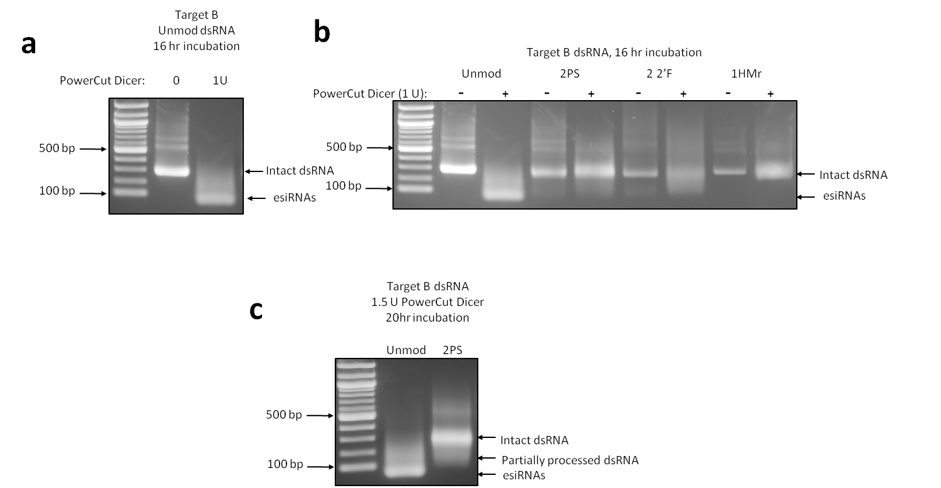

Figure 4.3 Processing of unmodified and chemically modified dsRNA to siRNAs by *Giardia* ‘PowerCut’ Dicer.

(a) Gel electrophoretogram of unmodified Target B dsRNA incubated with 1 unit (U) *Giardia* Dicer for 16 hr. (b) Gel electrophoretogram of unmodified , 2PS, 2 2’F and 1HMr Target B dsRNA incubated with 1 U *Giardia* Dicer for 16 hr. (c) Gel electrophoretogram of unmodified and 2PS Target B dsRNA incubated with 1.5 U *Giardia* Dicer for 20 hr. All incubations were performed at 37 °C; 1 µg of Target B dsRNA was incubated with various amounts of Dicer; reactions were quenched by addition of stop solution. In each gel the intact dsRNA and processed esiRNAs are highlighted.

fully processed to esiRNAs, in line with previous results. All of the chemically modified dsRNAs showed a reduced amount of esiRNA products from the reaction with *Giardia* Dicer compared to unmodified dsRNA, demonstrating the reduced activity of this enzyme on all the different chemically modified dsRNA substrates. 2’-Fluoro dsRNA demonstrated the most processing by the enzyme. However, some intact dsRNA remained, and very little of the products produced were esiRNAs, with the majority of products being dsRNA fragments shorter than the original dsRNA but longer than siRNAs. Phosphorothioate dsRNA demonstrated some processing by *Giardia* Dicer, but no significant amount of esiRNAs were produced. 5-hydroxymethyl dsRNA demonstrated band broadening, but again no clear signs of significant processing of the dsRNA to either esiRNAs or shorter dsRNA fragments.

Further analysis of *Giardia* Dicer activity was performed by increasing the amount of enzyme in order to increase the amount of processing of chemically modified dsRNAs to siRNAs by Dicer, and phosphorothioate (2PS) dsRNA was selected as an example. 2PS dsRNA was incubated with 1.5 U of Dicer for an increased time of 20 hours at 37 °C. Unmodified dsRNA was incubated in the same conditions as a control. The reactions were quenched after 20 hours by adding stop solution, and analysed by gel electrophoresis (see figure 4.3 c). The results demonstrate that the unmodified dsRNA was fully processed to esiRNAs. However, the increase in enzyme concentration and incubation time did not result in the generation of esiRNA products from the 2PS dsRNA.

#### Discussion of results of *in vitro* Dicer assays in the context of RNase III and *Giardia* Dicer mechanisms

Both RNase III and *Giardia* Dicer cleave dsRNA using similar RNase III domains (Nicholson, 2014). Therefore, the effects of the chemical modifications on cleavage would be expected to the same assuming binding of the dsRNA is not affected. Conversely, as both RNase III and *Giardia* Dicer cleave dsRNA in the same way, but bind dsRNA via different types of domain, any differences in processing of chemically modified dsRNA between the two enzymes is likely due to binding mechanism rather than cleavage mechanism. RNase III binds dsRNA in a non-sequence specific manner (Aliyari and Ding, 2009) along its length using a dsRNA binding domain (dsRBD). In contrast *Giardia* Dicer binds the terminus of dsRNA using a PAZ domain (Macrae *et al.*, 2006). The results obtained here therefore provide some information on the ability of dsRBD and PAZ domains to bind dsRNA in isolation. Insect Dicer-2 contains both types of domains (Kandasamy and Fukunaga, 2016) and therefore the ability of both types of domains to bind chemically modified dsRNA is relevant to how well Dicer-2 can bind the dsRNA overall. Insect Dicer-2 binds the 3’ overhang of the dsRNA with the PAZ domain, after which the rest of the protein is brought to lie along the length of the dsRNA, and the two RNase III domains form an internal pseudodimer which cleaves the dsRNA to release an siRNA (Sinha *et al.*, 2018). Sinha et al, also demonstrated that *Drosophila* Dicer-2 has a method of cleaving blunt-ended dsRNA by binding the blunt terminus via the helicase domain, locally unwinding the dsRNA and threading it through the helicase domain in an ATP-dependent process. Our results demonstrate that unmodified dsRNA IVT products are cleaved by *Giardia* Dicer. It has previously been demonstrated that products of *in vitro* transcription by T7 RNA polymerase may have up to three additional 5’ G residues, and 3’ overhangs of up to 12 additional nucleotides at the 3’ end (n + 12) as determined by RNAseq, with the n + 2 product being most abundant for high yield transcription reactions (Gholamalipour, Karunanayake Mudiyanselage and Martin, 2018). The study also proposed a mechanism by which T7 polymerase switches from the DNA to bind to the end of the RNA product and continues synthesis of further RNA using the initial RNA product as a template, in a process termed primer extension. This results in double-stranded hairpin regions at the end of single stranded transcripts, which will subsequently affect the binding of complimentary ssRNA transcripts into dsRNA, and how Dicer enzymes deal with the initial termini. However, it has previously been demonstrated that Giardia Dicer can process blunt-ended dsRNA, (Park *et al.*, 2011), despite the fact it contains only a PAZ domain and lacks dsRBD or helicase domains. RNase III domains alone are capable of cleaving dsRNA without other binding domains present, as seen with the Mini-III enzyme (Redko, Bechhofer and Condon, 2008) and a truncated form of *E. coli* RNase III lacking the dsRBD (Sun and Nicholson, 2001). It is therefore assumed *Giardia* Dicer relies on its RNase III domains for both binding and cleavage of the first esiRNA generated from the blunt terminus of IVT-produced dsRNA. The size specificity of *Giardia* Dicer is lost and a larger esiRNA is produced when it is presented with a blunt-ended substrate (Colmenares *et al.*, 2007). Presumably *Giardia* Dicer deals with IVT products which may or may not have hairpin loops at the termini in the same manner. More complex Dicer enzymes such as human Dicer can also cleave blunt ended dsRNAs by binding the dsRNA internally. There is an initial lag while this occurs, then once the first cut is made for each dsRNA molecule a 3’ overhang is generated at the new terminus, and the rest of the cleavage reactions of the dsRNA proceeds at the usual rate (Zhang *et al.*, 2002; Hammond, 2005).

Both of the tested enzymes contain RNase III domains (Aliyari and Ding, 2009), as does Dicer-2 (Hammond, 2005), therefore the ability of RNase III domains to cleave chemically modified dsRNA is also accounted for by the two model Dicer enzymes RNase III and *Giardia* Dicer, and the ability of both enzymes to cleave subsequently bound dsRNA should be similar. The results obtained using bacterial RNase III to cleave chemically modified dsRNA demonstrate that the enzyme can fully process 2’-fluoro and 5-hydroxymethyl dsRNAs to esiRNAs, however there is conflicting evidence as to whether the enzyme can effectively process phosphorothioate dsRNA and further investigation is required. RNase III binds dsRNA using a dsRBD. While some dsRBD recognise specific sequences (Stefl *et al.*, 2010) these domains primarily bind by recognising an A-form RNA helix with a helix(α1)-helix(α2)-loop(L2) motif that bind A-form RNA across a segment comprising two minor grooves flanking a major groove (Masliah, Barraud and Allain, 2013). The specific interactions that comprise this binding mechanism described in Masliah et al (2013) and Gan et al (2006), and reviewed below, partly explain how RNase III and Dicer might interact with chemically modified dsRNA.

RNase III molecules bind to dsRNA overall using four different RNA binding motifs (RBMs), two of which are on the dsRBD and two of which are on the RNase III domain (Gan *et al.*, 2006) (see figure 4.4 a). Gan et al determined that collectively the four RBMs form seven hydrogen bonds with 2’ hydroxyl groups. Four hydrogen bonds are formed by RBM1 alone which is on the dsRBD (see figure 4.4 b), and RBM 2 from the dsRBD forms a further hydrogen bond. RBMs 3 and 4 are located on the RNase III domain and form a further hydrogen bond each with 2’ hydroxyl groups. In total 49 hydrogen bonds, 11 salt bridges, and 23 water molecules facilitate interaction of RNase III with its dsRNA substrate, and as two thirds of these interactions involve the dsRBD, the dsRBD therefore dominates binding of the dsRNA.

The dsRBD α2 helix contains a sequence of exposed conserved residues, KKxAK. dsRBDs “achieve specific dsRNA recognition by making contacts to bases and ribose moieties located at two successive minor grooves and by contacting the phosphate backbone delimiting the intervening major groove” (Masliah, Barraud and Allain, 2013). Specifically, the amino groups of the three lysine residues (K), and the amide proton of the first lysine residue all interact with non-bridging oxygens of the dsRNA backbone in the major groove. This interaction is subtly different in the RNase III dsRBD as the third lysine is replaced by a glutamaic acid in that dsRBD, however there is an interaction with a third lysine located on the α1 helix which compensates. As this interaction is with non-bridging phosphate group oxygens, and these are the oxygen atoms of which one is replaced by a sulphur atom in phosphorothioate dsRNA, this suggests that the binding of the dsRBD to dsRNA may be affected at these sites by the phosphorothioate modifications, which could explain why some phosphorothioate dsRNA samples were poorly processed by RNase III, as hydrogen bonds involving sulphur atoms are weaker than those involving oxygen atoms, and therefore the binding of dsRBDs to phosphorothioate dsRNA is likely weaker than that to unmodified dsRNA.

There are also interactions of components of the α1 helix with bases, which can be either sequence non-specific or sequence specific, though it should be noted that these are always with hydrogen bonding groups, not the 5-carbon atom. This may explain why 5-hyroxymethyl modified dsRNA is processed well by RNase III.

The RNase III dsRBD, like many of these domains, contains a glutamate residue on the α1 helix, the carboxylic group of which hydrogen bonds with the 2’-OH group of a ribose sugar. There is a further 2’-OH group interaction on the L2 loop, where a conserved histidine residue forms one hydrogen bond between its carbonyl group and the 2’-OH group on one strand of the dsRNA, and another hydrogen bond between the imidazole and the 2’-OH of the previous ribose on the other strand of the dsRNA. This large number of interactions with the 2’ ribose group would suggest that binding of the dsRBD to 2’-fluoro modified dsRNA may be affected. Hydrogen bonds involving fluorine atoms are stronger than those involving oxygen atoms, suggesting that 2’-fluoro modifications may increase the strength of binding of dsRBDs to dsRNA compared to unmodified dsRNA. However it should also be noted that fluorine atoms are smaller than hydroxyl groups, therefore the hydrogen bond between the histidine residue and a 2’-fluoro group is longer than that between the histidine residue and a 2’-OH group. This increased bond length will weaken the hydrogen bond and so the effect of the increased electronegativity of fluorine compared to oxygen may be cancelled out. It is therefore likely that the RNase III dsRBD binds 2’-OH dsRNA and 2’-fluoro

Figure 4.4 Schematic Representation of RNase III-dsRNA Interactions.

(a) Left panel: The RNase III-dsRNA interactions observed for *Aquifex aeolicus*. The dimeric protein is shown as two rectangles labeled as “Subunit 1” (blue) and “Subunit 2” (red), and the four RBMs are shown as ellipsoids. The substrate is a stem-loop dsRNA with a 24 base pair double-stranded region. The scissile bonds are indicated with arrows, and the protein-interacting boxes in the dsRNA (proximal (P), middle (M), and distal (D) boxes) are outlined with rectangles and indicated with one-letter abbreviations. The nucleotide residues in the cleavage sites are numbered “R0”. The substrate (RNA 5) used in Gan et al (2006) and minimal dsRNA substrate are indicated with dashed lines. RBMs 1, 2, and 4 interact with the proximal, middle, and distal box of the dsRNA, respectively, whereas RBM 3 interacts with nucleotide residues R0 and R+1 of a single RNA strand. Right panel: Dicer-dsRNA interactions. In this panel, the left rectangle represents endoND1 (in blue) and the right rectangle represents endoND 2 and dsRBD (in red) of Dicer. (b) Binding of RBM 1 (1) to a dsRNA substrate. Dotted lines indicate hydrogen bonds between RBM 1 and the 2’ hydroxyls (in black) or between RBM 1 and the bases (in gray). Residues are represented by ball-and-stick models in atomic color scheme (carbon in black, nitrogen in blue, oxygen in red, and phosphorus in purple). (c) Interaction of RBM 3 (3) with a dsRNA substrate. (d) Stereoview showing the superposition of the cleavage site with (in blue) and without (in red) dsRNA bound. ‘endoND’ = RNase III domain. Reproduced from Gan et al (2006) with permission.

dsRNA approximately equally well, which is in line with RNase III being capable of binding and processing 2’-fluoro dsRNA.

RNase III domains can also cleave dsRNA, without the need for an attached dsRBD, and this is the case for the Mini-III enzyme (Redko, Bechhofer and Condon, 2008). Issues with phosphorothioate modifications to dsRNA sterically hindering the RNase III domain may therefore be a factor in preventing RNase III cleaving some phosphorothioate dsRNA, though further investigation with a variety of substrates is required.

The results obtained from using *Giardia* Dicer to cleave chemically modified dsRNA show that this Dicer enzyme did not effectively process any of the chemically modified dsRNA to siRNAs. Giardia Dicer lacks a dsRBD, and therefore binds dsRNA exclusively by a PAZ domain. The PAZ domain of *Giardia* Dicer specifically binds the 3’ two-base overhang at the end of a dsRNA substrate (Macrae *et al.*, 2006). Binding of the overhang to PAZ domains is a result of conserved residues located in the inter-subdomain cleft (Song *et al.*, 2003). An arginine residue is proposed to interact with phosphate groups, which may be affected by the presence of phosphorothioate modifications in the dsRNA if the overhanging bases have phosphorothioate modifications. There is also a stretch of conserved aromatic residues, removal of which disrupts binding of dsRNA with overhangs to the domain (Song *et al.*, 2003). It is suggested that these aromatic residues interact with the single-stranded overhanging bases of the dsRNA substrate by base stacking, which may be disrupted by the presence of either 2’-fluoro modifications in the ribose ring, or 5-hydroxymethyl modifications on the bases. 5-Hydroxymethyl modifications will also be exposed if they are on the two overhanging bases and may sterically hinder binding of the overhang. These proposed mechanisms for binding of dsRNA substrates to PAZ domains may explain why *Giardia* Dicer struggles to process 2’-fluoro and 5-hydroxymethyl modified dsRNA.

Though *Giardia* Dicer can process dsRNA by binding and cleaving internally without the need for PAZ domain binding (as in the case of blunt-ended dsRNA), cleavage of Dicer enzymes by internal binding is very slow (Zhang *et al.*, 2002). This may explain why the chemically modified dsRNAs incubated with *Giardia* Dicer demonstrate broadening of the gel band indicating very small amounts of dsRNA being cleaved. The chemical modifications may disrupt binding by PAZ, and therefore very slow internal processing of the dsRNA occurs. The long incubation time required to fully process the dsRNA at this rate would be far longer than the enzyme molecules are likely to survive at the incubation temperature, resulting in no full processing of the dsRNA, even after extended incubation periods.

Insect (and mammalian) Dicer enzymes contain both dsRBD and PAZ domains, as well as a further atypical dsRNA binding domain previously referred to as domain of unknown function (DUF) 283. Therefore, the effects of chemical modifications on the binding of dsRNA to insect Dicer, will be a combination of those seen for RNase III and *Giardia* Dicer, as well as other effects such as helicase domain binding, unwinding, and cleavage (Sinha *et al.*, 2018). Insect Dicer-2 presents an additional factor, as it has a unique phosphate binding pocket exclusive to Dicer-2 that binds the 5’-monophosphate of long dsRNA, and the effects of which are therefore not fully accounted for by the *Giardia* Dicer PAZ domain (Kandasamy and Fukunaga, 2016). Binding of insect Dicer-2 to dsRNA by the PAZ domain is therefore liable to be significantly affected by phosphorothioate modifications to the phosphate groups in particular. The RNase III domains of both enzymes also anchor the scissile phosphates with metal ions in a further type of binding interaction (Macrae *et al.*, 2006), which may also be affected by chemical modifications to the dsRNA substrate. Again, this interaction is likely to be affected more by phosphorothioate modifications than the other chemical modifications as the metal ions interact with the non-bridging oxygens or sulphurs of phosphodiester or phosphorothioate linkages (Sun, Pertzev and Nicholson, 2005).

An attempt was made to use commercially available recombinant human Dicer as an example of a complex Dicer enzyme containing both dsRBD and PAZ domains. However, the enzyme selected required further optimisation as it failed to cleave unmodified dsRNA when following the manufacturer’s protocol. No insect Dicer-2 enzymes are commercially available, however Dicer assays using insect cell lysate have been developed (see Further work, chapter 7).

Binding is one factor in the successful processing of dsRNA by RNase III/Dicer enzymes, however cleavage of the dsRNA substrate by the RNase III domains is naturally of great importance. RBMs 3 and 4 on the RNase III domain are thought to be primarily involved in recognition of RNA substrates, and selection of the scissile bond (Gan *et al.*, 2006). Dimerised RNase III molecules cooperate in order to cleave the dsRNA, with the RBM 3 of one RNase III unit selecting the scissile bond using a serine residue and a glutamic acid residue (see figure 4.4 c), and the RNase III domain of the other unit then cleaving one strand, and vice versa for cleavage of the second strand. The catalytic site for the cleavage of each strand is composed of five acidic amino acids (aspartic acid and glutamic acid) from one RNase III subunit, and an additional acidic residue (glutamic acid) from the other subunit, along with three nucleotides from the dsRNA, three water molecules and a divalent metal ion (Mg2+, Mn2+ etc.) (see figure 4.4 d). There is evidence for the interaction of a second additional metal ion (Stahley *et al.*, 2005a).

Phosphorothioate dsRNA was the only chemically modified dsRNA that demonstrated resistance to cleavage by both enzymes, however as previously stated, the RNase III incubation presented mixed results, therefore more investigation is required. Potential resistance of phosphorothioate dsRNA to cleavage by both enzymes tested may be due to the modification impeding binding of both enzymes by the two different binding mechanisms, but may be partly related to the modification affecting the cleavage mechanism of the RNase III domain(s) of the enzymes. The RNase III domain cleaves RNA in a mechanism involving two divalent metal ions and solvent water molecules, via an SN2 reaction which attacks the phosphodiester linkage between two nucleotides (Sun, Pertzev and Nicholson, 2005). One of the hydrogen bonds formed by one of the metal ions (usually an Mg2+ ion) during this process is to one of the non-bridging oxygen atoms of the phosphate group. Phosphorothioate linkages have a sulphur atom in place of one of the non-bridging oxygen atoms, therefore the cleavage mechanism may be affected by phosphorothioate modifications. As the catalytic site of the RNase III domain does not directly interact with the ribose sugar or bases, 2’-fluoro and 5-hydroxymethyl modifications are unlikely to directly affect the cleavage mechanism, however these modifications may affect how other parts of the RNase III domain interact with the dsRNA, resulting in the orientation of the dsRNA compared to the catalytic site being altered. As the RNase III enzyme did manage to cleave 2’-fluoro and 5-hyroxymethyl dsRNA, these affects are likely to be minimal. Whether the RNase III domain failing to cleave phosphorothioate linkages in dsRNA, or both dsRBD and PAZ domains being unable to bind phosphorothioate dsRNA is the reason for phosphorothioate dsRNA being resistant to *Giardia* Dicer – and potentially resistant to bacterial RNase III – remains unclear, and requires further validation. Previous evidence suggests bacterial RNase III can bind and cleave some phosphorothioate-containing substrates (Nicholson *et al.*, 1988). Truncated RNase III enzymes with no dsRBD, consisting of only the RNase III domain itself, are catalytically active (Redko, Bechhofer and Condon, 2008) and use of this “Mini-III” enzyme may shed light on this (see Further work, chapter 7). In summary, a range of chemically modified dsRNAs were tested as substrates for two simple RNase III/Dicer family enzymes. Which of the enzymes was capable of cleaving which of the chemically modified dsRNAs has provided insights on how well each of the dsRNAs is likely to be processed by the more complex insect Dicer-2, and whether issues with processing are likely to be due to binding or cleavage of the dsRNA. However, insect Dicer-2 also possesses the ability to bind blunt dsRNA via the helicase domain, and may use a similar mechanism to bind and process dsRNA where dsRNA chemical modifications interfere with PAZ domain binding.

It should also be noted that Argonaute proteins contain a PAZ domain (Song *et al.*, 2003), therefore issues with RNAi using chemically modified dsRNA may be due to poor binding of both Dicer-2 and Argonaute-2.

### Investigating the resistance of chemically modified dsRNA to degradation by insect nucleases

#### Stink bug saliva contains a wide variety of proteins from both the stink bug itself, and the plants that form its diet (Peiffer and Felton, 2014). It has very high nuclease activity which therefore results in degradation of ingested insecticidal dsRNA, which may affect RNAi-related knockdown of the target mRNA (Lomate and Bonning, 2016). Low stability of dsRNA in stink bug saliva is therefore a major barrier to the success of insecticidal dsRNA in this species. Several of the chemical modifications examined here are known to increase resistance to nuclease degradation (Monia *et al.*, 1996; Jahns *et al.*, 2015b; Shen and Corey, 2018a). Therefore it was proposed that chemical modifications of dsRNA could provide increased resistance to insect nucleases compared to unmodified dsRNA, and potentially demonstrate improved RNAi efficacy compared to unmodified dsRNA. As stink bug saliva was a potent, pertinent, and readily available source of insect nucleases this was used to study the effects of dsRNA chemical modifications on dsRNA degradation by insect nucleases.

#### Optimisation of stink bug salival nuclease dsRNA degradation assay

Stink bug saliva was determined as a relevant source of insect nucleases for use in determining potential differences in nuclease resistance between unmodified and chemically modified dsRNA. In order to collect stink bug saliva, feeding sachets were produced by vacuum pumping parafilm over a 96 well plate, loading the resulting indents with Sf9 insect media containing a range of antibiotics and fungicides to prevent infection by bacteria and fungus present on or in the insects, and sealing the media in place (see method section 2.3.1). The completed sachets were placed over the top of 96 well mesh bottom plates containing one N2 stink bug per well. The insects pierced the parafilm and fed from the media reservoirs, contaminating the Sf9 media with salival nucleases in the process. They were allowed to do this for three days before the remaining saliva-containing Sf9 media was extracted from the sachet by syringe. The collected media was pooled to homogenise the quantity and profile of salival nucleases present, and stored at -20°C until required.

Prior to studying the effects of dsRNA chemical modifications on degradation by insect salival nucleases, the assay was optimised. Six batches of stink bug saliva in Sf9 media were collected as detailed above. The level of nuclease activity in the saliva media, the concentration of saliva media used, and the incubation time used in the assay were all co-optimised by setting up an assay to compare the ability of the six batches of saliva media to degrade unmodified dsRNA, at a range of saliva media dilutions and two time points: 2 hours and overnight (O/N).

Samples of unmodified Target B dsRNA were added to a range of dilutions of each batch of saliva media as described in method section 2.3.1 and incubated at room temperature. Samples were taken at 2 hours and after overnight incubation, and analysed by agarose gel electrophoresis. The results are shown in figure 4.5, with results for each batch of saliva media arranged in approximate order of increasing nuclease activity. The results demonstrate that batch 1 had very low nuclease activity, as the intact dsRNA was observed across all dilutions of salival nuclease used. Batches 2-4 had similar moderate levels of nuclease activity, batch 5 had increased nuclease activity compared to batches 2-5, and batch 6 had the highest nuclease activity. The saliva media batches with moderate nuclease activity (batches 2-4) demonstrated significant amounts of intact dsRNA remaining for the lowest 4 of 7 media dilutions at 2 hours, and for 3 of the 7 media dilutions after overnight incubation. The saliva media batches with high nuclease activity (batches 5 and 6) demonstrated significant amounts of intact dsRNA for the lowest 3 of 7 media dilutions at 2 hours. The lowest 3 of 7 dilutions of batch 5 also contained significant amounts of intact dsRNA after overnight incubation, whereas only the lowest 2 of 7 dilutions of batch 6 contained significant amounts of intact dsRNA remained after overnight incubation (see figure 4.5).

Batch 5 of saliva media was selected for the main assay comparing the nuclease resistance of unmodified and chemically modified dsRNA, due to the high level of nuclease activity it demonstrated. The range of saliva media dilutions was validated as appropriate for use for the main assay as significant variation in dsRNA stability was seen across the dilution range. Identical saliva media dilutions also demonstrated significant differences in dsRNA stability between the 2 hour and overnight time points. These were therefore used as the first and last time points for the main assay, along with 4 hour and 6 hour time points.

#### Investigating the resistance of chemically modified dsRNA to degradation by nucleases present in stink bug saliva

In order to determine potential differences in nuclease resistance between unmodified and chemically modified dsRNA, a number of chemically modified dsRNAs were incubated with a range of dilutions of saliva media (batch 5), and samples removed for analysis at a number of time points.

The first row of a 96 well PCR plate was loaded with pure saliva media, and each subsequent row loaded with a 1:3 dilution of the previous row in water, down to a 1:729 dilution. A further row was dedicated to a water only control condition for each dsRNA to be tested. Two replicate sets of dilutions were set up for each dsRNA, with one whole set of replicates in each of two separate plates. Equal amounts (2.6 µg) of each of the dsRNAs were loaded into every well, and the plates

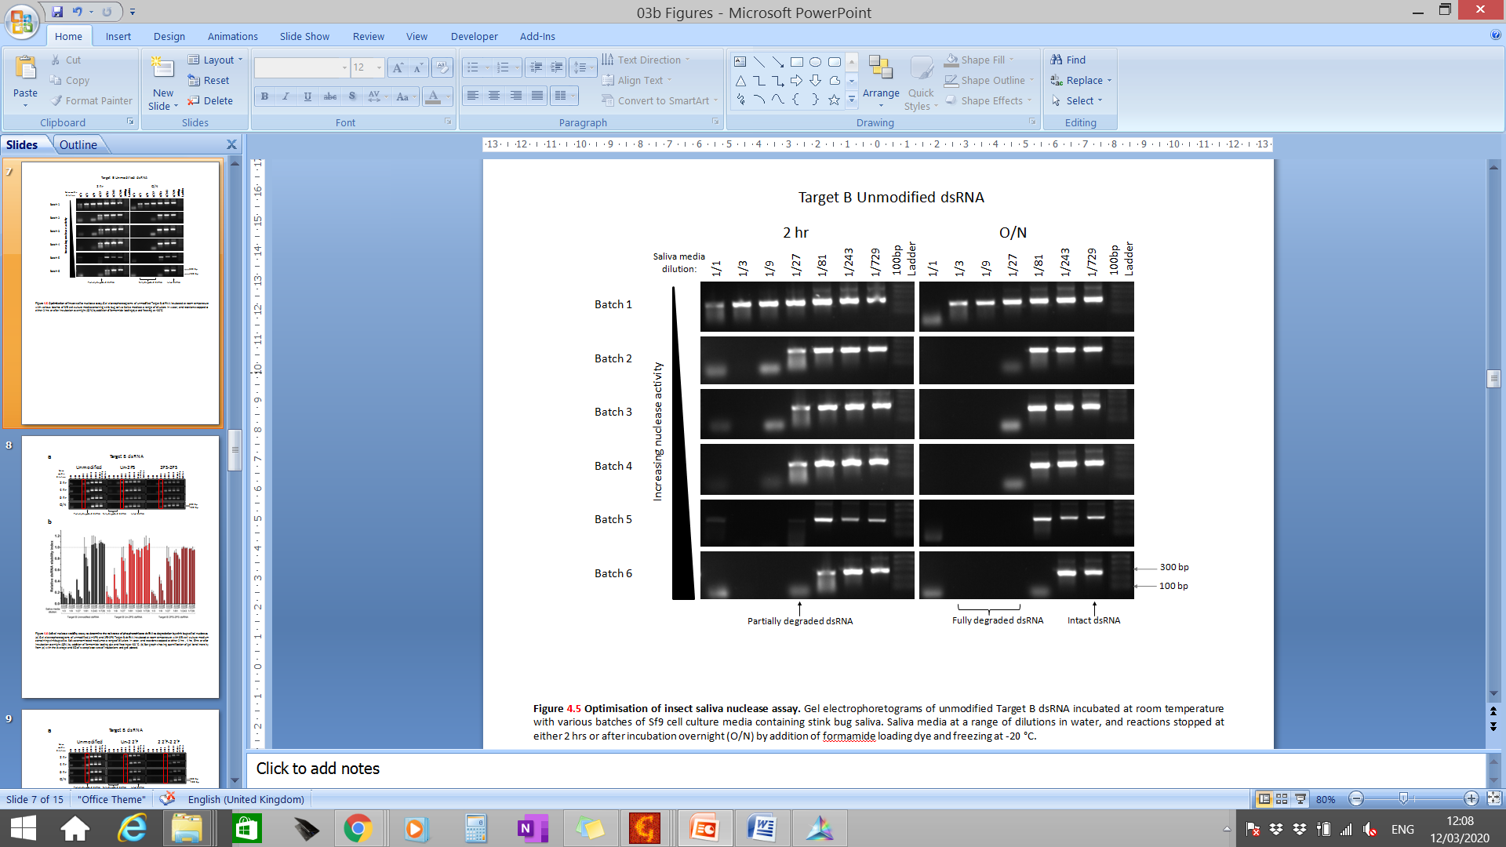

Figure 4.5 Optimisation of insect saliva nuclease assay.

Gel electrophoretograms of unmodified Target B dsRNA incubated at room temperature with various batches of Sf9 cell culture media containing stink bug saliva. Saliva media at a range of dilutions in water, and reactions stopped at either 2 hrs or after incubation overnight (O/N) by addition of formamide loading dye and freezing at -20 °C.

sealed and placed on a shaker plate to avoid sedimentation. The plates were incubated at room temperature, and samples were collected for each combination of dsRNA and saliva media dilution at 2, 4 and 6 hours, and a further sample collected after incubation overnight (O/N). Collected samples were dispensed into fresh 96 well PCR plates containing gel loading dye, and stored at -20°C until thawed for agarose gel analysis in order to prevent further nuclease degradation of the dsRNA.

The dsRNAs tested were all Target B dsRNAs and included: unmodified, Un-2PS, 2PS, Un-2 2’F, 2 2’F, 1HMr (see figure 3.1 for explanation of nomenclature). All replicates, time points and saliva media dilutions for all dsRNAs tested were analysed by gel electrophoresis (see figures 4.6 a, 4.7 a, 4.8 a). Gels were imaged, and the band intensity for each lane measured using Fiji (Image J) image analysis software (see method section 2.3.2). All dsRNA intensity was quantified, including partially degraded dsRNA fragments, which was used to reflect the non-degraded dsRNA in this analysis. This also reflects the fact that these fragments would likely still be efficacious for RNAi *in vivo*. The band intensities for each replicate of each time point and media dilution were normalised against the corresponding band intensity of the water only control band, to calculate the “Relative dsRNA stability index” (see section 2.3.1). The results are shown in figures 4.6 b, 4.7 b and 4.8 b as the average of the two replicates with the standard deviation (SD). The quantification of the pure saliva media conditions has been omitted from the results for clarity (see below).

The results demonstrate that there were clear differences in the nuclease stability of the unmodified and chemically modified dsRNAs. The differences in stability between dsRNAs are clearest at the 1/27 and 1/81 dilutions of saliva. The results show that phosphorothioate modified dsRNA shows increased nuclease resistance to stink bug salival nucleases compared to modified dsRNA. The differences in the 1/27 dilutions between all time points is highlighted by the red box in figure 4.6 a and shows the presence of intact dsRNA in the 2PS-2PS dsRNA across all time points. In contrast, intact unmodified dsRNA was only observed at the 2 hr time point. The 2’-fluoro modified dsRNA was less stable than unmodified dsRNA in the presence of stink bug salival nucleases. The differences between the 1/27 and particularly the 1/81 dilutions of saliva media highlighted in the red box in figure 4.7 a, show that at all time points the majority of the dsRNA has been degraded. However, intact dsRNA clearly remains at the 2-6 hr time points in the unmodified dsRNA. The 5-hydroxymethyl modified dsRNA showed little difference in stability compared to unmodified dsRNA (figure 4.8 a). A summary of the relative stability of the chemically modified dsRNA compared to the unmodified dsRNA for selected stink bug saliva media dilutions is presented in figure 4.9. The results highlight the increased relative stability of the phosphorothioate modified dsRNA compared to unmodified dsRNA.

2’-Fluoro modifications have previously been shown to increase resistance of nucleic acids to degradation by nucleases. ssRNA with 2’-fluoro cytidine (2’FC) and 2’-fluoro uridine (2’FU) residues has been shown to be more resistant than unmodified ssRNA to RNase A and the nucleases found on human skin (Meis and Chen, 2002), and siRNAs with 2’-FC and 2’-FU residues have been demonstrated to be more resistant than unmodified siRNAs to nucleases in HeLa cell extract (Chiu and Rana, 2003). In contrast, the results presented here (above) show that 2’-fluoro dsRNA was less stable than unmodified dsRNA when subjected to the particular range of nucleases present in stink bug saliva. Where 2’-fluoro modifications were only present in one strand, the dsRNA was correspondingly moderately less stable than unmodified dsRNA, though to a lesser degree than for dsRNAs with modifications in both strands. However, previous studies demonstrated 2’-fluoro chimeric oligonucleotides that were less stable than equivalents without 2’-fluoro modifications (Monia et al., 1996).

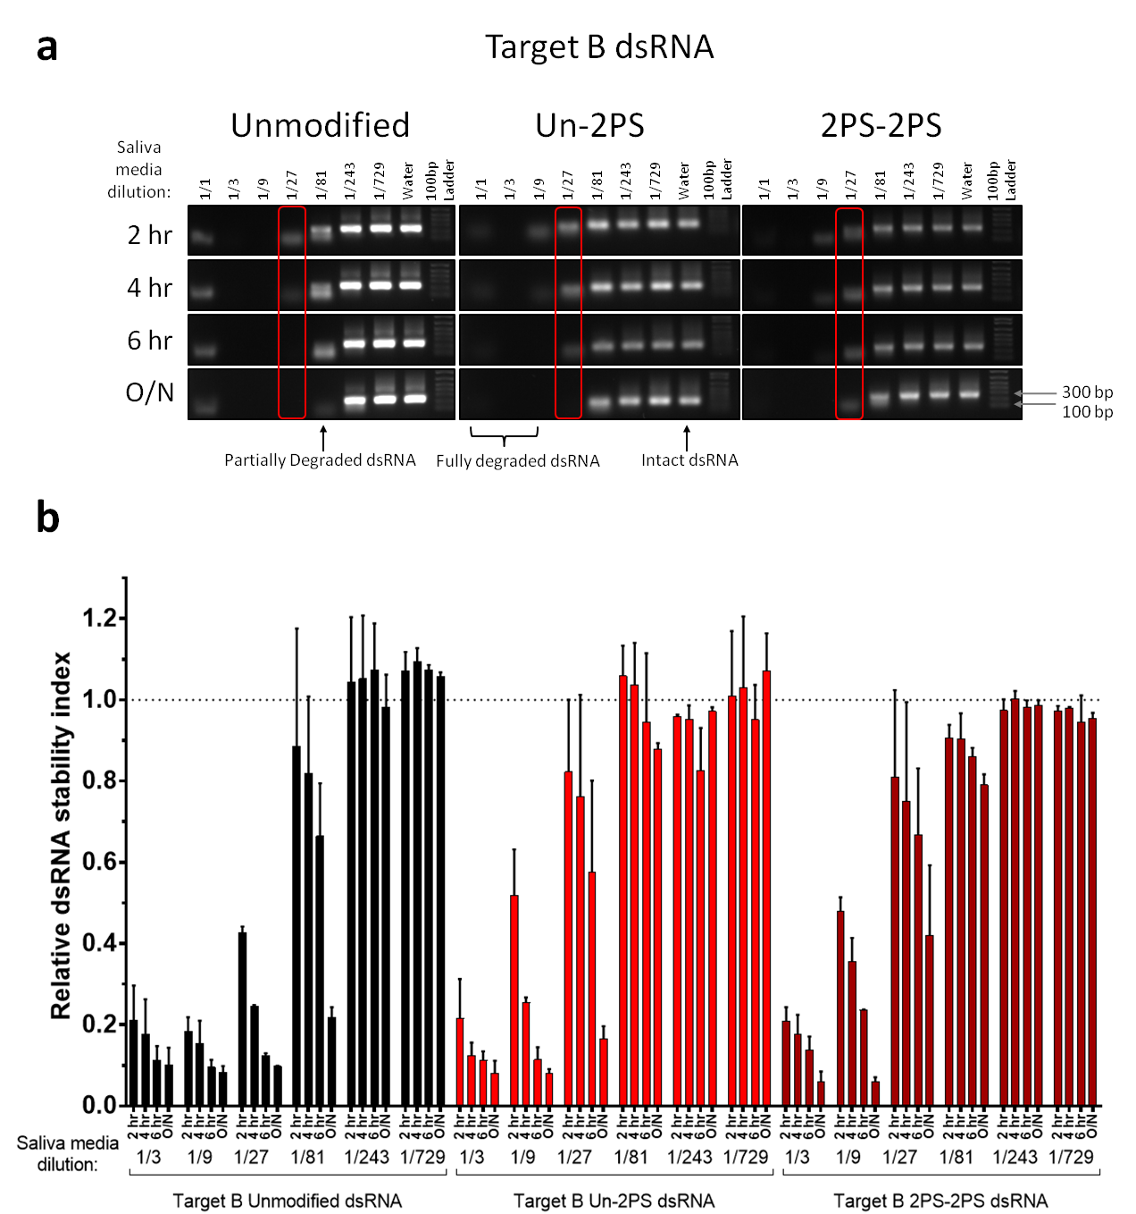

Figure 4.6 Salival nuclease stability assay to determine the resistance of phosphorothioate dsRNA to degradation by stink bug salival nucleases.

(a) Gel electrophoretograms of unmodified, Un-2PS and 2PS-2PS Target B dsRNA incubated at room temperature with Sf9 cell culture medium containing stink bug saliva. Saliva contaminated medium at a range of dilutions in water, and reactions stopped at either 2 hrs , 4 hrs, 6hrs or after incubation overnight (O/N) by addition of formamide loading dye and freezing at -20 °C. (b) Bar graph showing quantification of gel band intensity from (a) with the average and SD of two replicate sets of incubations and gels plotted.

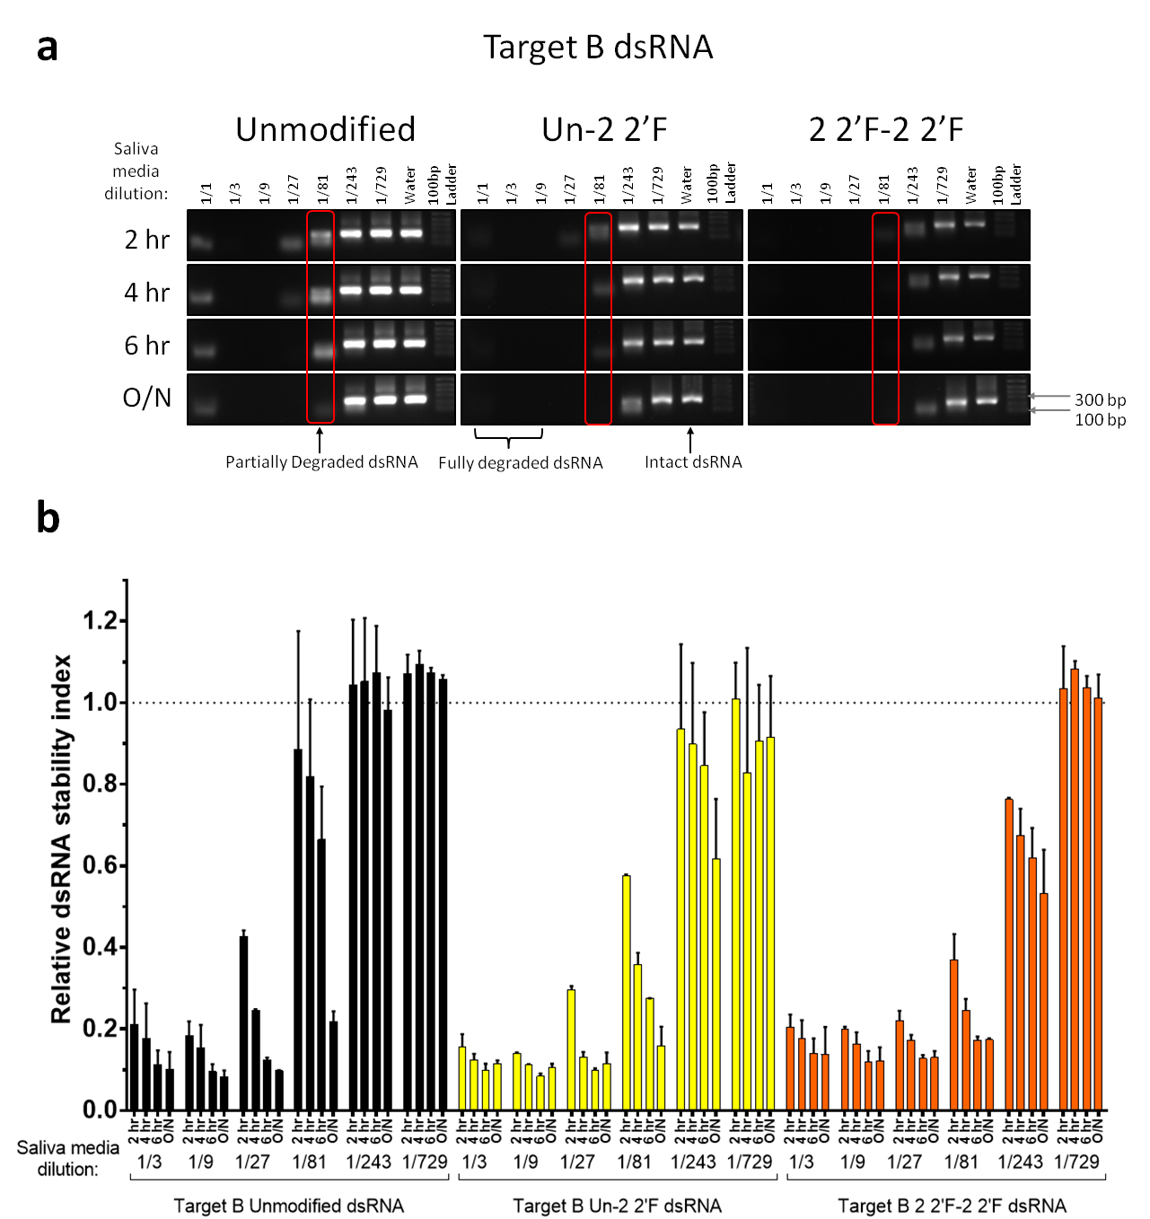

Figure 4.7 Salival nuclease stability assay to determine the resistance of 2’-fluoro dsRNA to degradation by stink bug salival nucleases.

(a) Gel electrophoretograms of unmodified, Un-2 2’F and 2 2’F-2 2’F Target B dsRNA incubated at room temperature with Sf9 cell culture medium containing stink bug saliva. Saliva contaminated medium at a range of dilutions in water, and reactions stopped at either 2 hrs , 4 hrs, 6hrs or after incubation overnight (O/N) by addition of formamide loading dye and freezing at -20 °C. (b) Bar graph showing quantification of gel band intensity from (a) with the average and SD of two replicate sets of incubations and gels plotted.

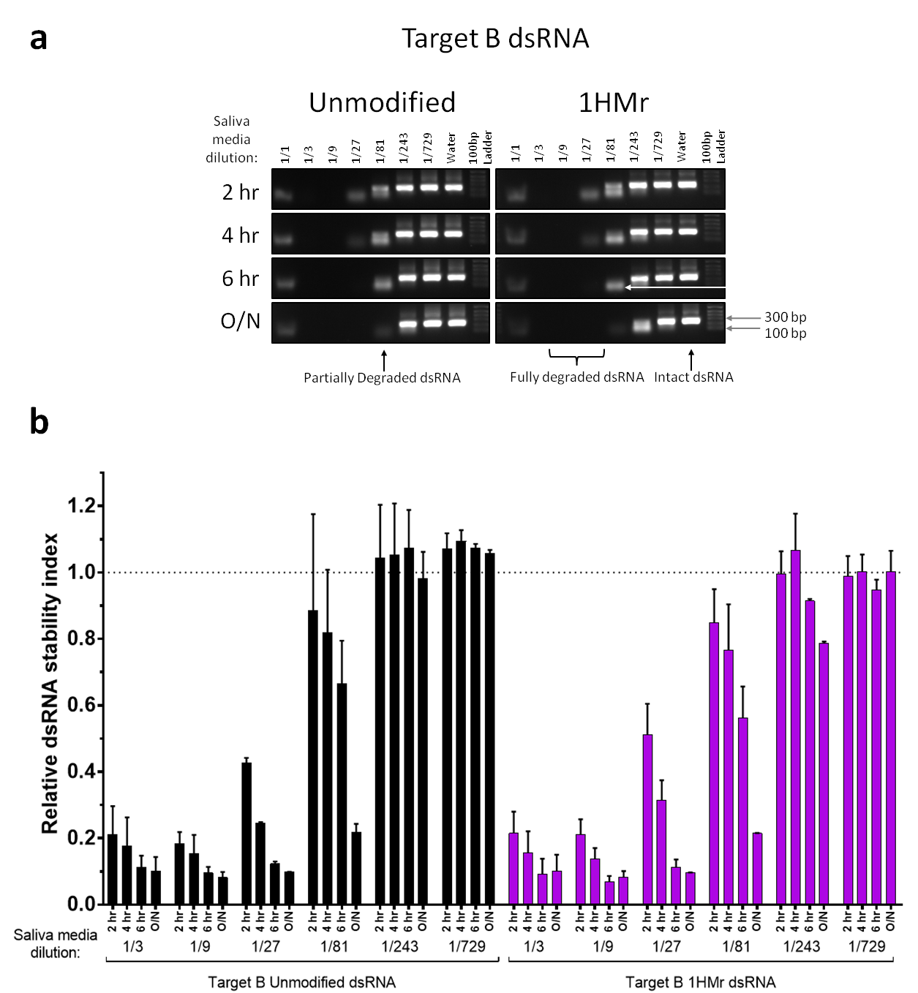

Figure 4.8 Salival nuclease stability assay to determine the resistance of 5-hydroxymtheyl dsRNA to degradation by stink bug salival nucleases.

(a) Gel electrophoretograms of unmodified and 1HMr Target B dsRNA incubated at room temperature with Sf9 cell culture medium containing stink bug saliva. Saliva contaminated medium at a range of dilutions in water, and reactions stopped at either 2 hrs , 4 hrs, 6hrs or after incubation overnight (O/N) by addition of formamide loading dye and freezing at -20 °C. (b) Bar graph showing quantification of gel band intensity from (a) with the average and SD of two replicate sets of incubations and gels plotted.

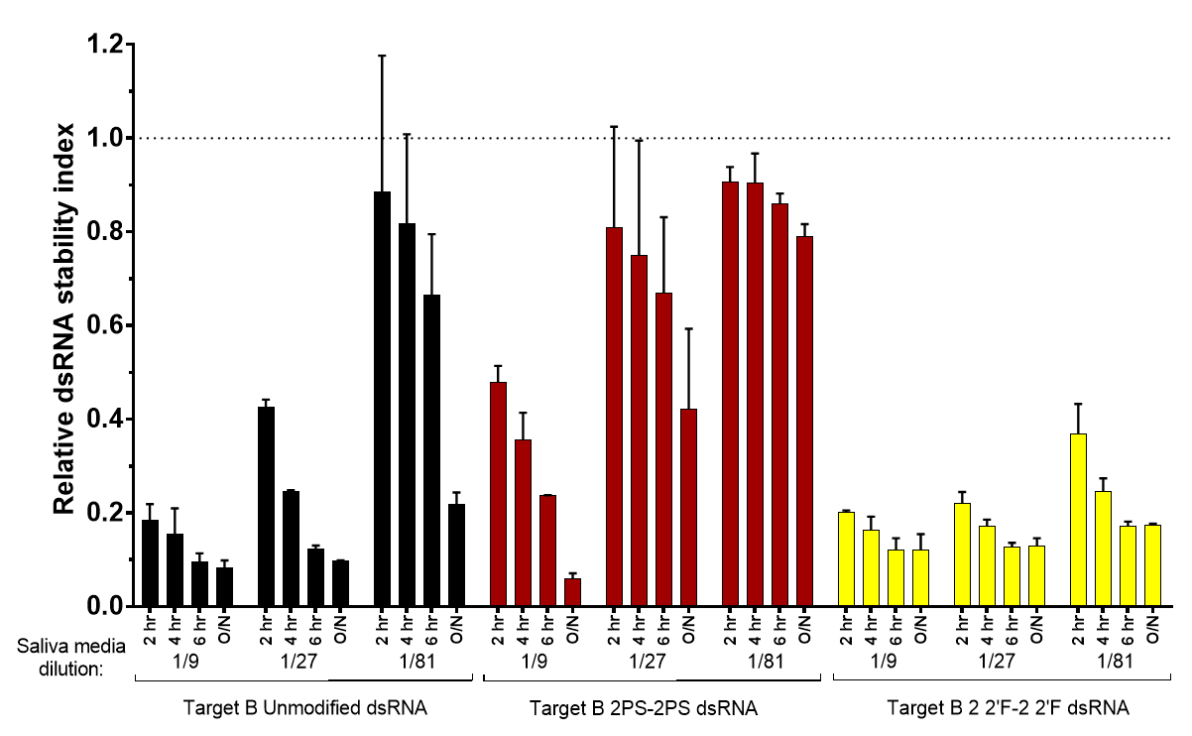

Figure 4.9 Summary graph of key data from figures 4.6 & 4.7.

Bar graph of quantification of gel band intensity of dsRNA incubated with saliva medium dilutions from figures 4.5 and 4.6, summarising the saliva medium dilutions where the clearest differences in dsRNA stability were seen for different chemical modifications. Average and SD of two replicate sets of incubations and gels plotted.

One further effect was noted; the dsRNA incubated in pure saliva media appeared to fragment as denoted by the loss of the main band in each case (figures 4.6 a, 4.7 a, 4.8 a), though the fragments were then protected from further degradation compared to the partly diluted saliva media conditions, where almost complete degradation was observed (for example the 1/3 dilution and in many cases the 1/9 dilution). The reason for this protection/lack of degradation is unclear.

The cleavage mechanism of RNase III/Dicer enzymes is an Mg2+ ion-dependent SN2 mechanism involving the phosphodiester bond (Campbell *et al.*, 2002; Stahley *et al.*, 2005b; Sun, Pertzev and Nicholson, 2005). In contrast, the cleavage mechanism of many more general RNases such as RNase A, involves the 2’-OH group of the ribose sugar, which is deprotonated (by a histidine residue in the case of RNase A) in order to induce the 2’ oxygen atom to engage in nucleophilic attack of the phosphorus atom. This in turn leads to the double bond between the phosphorus and one of the non-bridging oxygen atoms being broken, and the non-bridging oxygen atom interacting with a lysine residue prior to the double bond reforming, and the bond between the phosphorus atom and a bridging oxygen being broken in order to cleave the RNA backbone (Raines, 1998).

In the heterogeneous mixture of RNases present in stink bug saliva (exonucleases and endonucleases), overall degradation of dsRNA is likely due to a combination of cleavage by enzymes which directly attack the phosphodiester linkage (like RNase III/Dicer), enzymes which facilitate RNA hydrolysis via nucleophilic attack of the 2’-OH group (like RNase A), and potentially non-enzymatic degradation of the dsRNA by RNA hydrolysis too. These mechanisms involve the phosphate non-bridging oxygen atoms, and the 2’-OH ribose group, and are therefore most likely to be affected by phosphorothioate and 2’-fluoro modifications to the dsRNA which are located on these groups, and this is borne out by the data obtained in this chapter, with phosphorothioate and 2’-fluoro dsRNAs demonstrating clear differences in nuclease resistance compared to unmodified dsRNA. However, the reduced nuclease resistance of 2’-fluoro dsRNA compared to unmodified dsRNA remains unexpected.

In summary, a range of chemically modified dsRNAs were tested for their ability to withstand degradation by the heterogeneous mixture of RNase enzymes present in stink bug saliva. The results give some insight into which chemically modified dsRNAs are likely to have increased or reduced nuclease stability compared to unmodified dsRNA. This information is important for predicting which chemically modified dsRNAs might demonstrate increased resistance to insect nucleases in *in vivo* downstream RNAi applications.

## Conclusions

dsRNA molecules must avoid degradation by nucleases prior to reaching target sites and inducing a sustainable RNAi response. Nucleases present in the gut fluid, hemolymph, and saliva of different insects digest dsRNA, and may therefore negatively impact RNAi efficacy of dsRNA biopesticides. To study the effects of dsRNA chemical modifications on resistance of dsRNA against insect nucleases, phosphorothioate, 2’-fluoro and 5-hydroxymethyl dsRNAs were used *in vitro* to study their stability against insect nucleases present in insect saliva. In addition, the chemically modified dsRNAs were used as substrates for specific cleavage to esiRNAs by RNase III/Dicer enzymes and in each experiment compared to unmodified dsRNA. Both of these factors are potentially important in order for a dsRNA to be effective *in vivo*.

dsRNA with phosphorothioate modifications demonstrated increased resistance to stink bug salival nucleases, demonstrating the potential advantages of such chemical modifications in dsRNA biopesticides for improved RNAi efficacy. However, the results also showed that phosphorothioate modifications also reduced processing into functional esiRNAs by some RNase III/Dicer enzymes in some contexts. Therefore these modifications may potentially prevent Dicer-2 processing of the phosphorothioate long dsRNA into functional siRNAs and loading of the siRNA to Argonaute 2 *in vivo* and limiting their RNAi efficacy. The RNase III/Dicer enzymes tested here *in vitro*, have simpler domain architecture compared to their insect Dicer-2 counterparts, therefore how translatable the results obtained with these enzymes are to insect Dicer-2 is unclear.

2’-Fluoro modified dsRNA conversely demonstrated reduced resistance to degradation by stink bug salival nucleases. However, previous studies showed 2’-fluoro modifications increased stability of both siRNAs and ssRNA to mammalian nucleases (Chiu and Rana, 2003; Shen and Corey, 2018a), though there is also evidence they reduce nuclease stability of chimeric oligonucleotides (Monia *et al.*, 1996). Interestingly 2’-fluoro dsRNA modifications affected the ability of bacterial RNase III and *Giardia* Dicer processing of dsRNA to esiRNA differently. Bacterial RNase III effectively cleaved the dsRNA to esiRNAs similar to unmodified dsRNA. However, *Giardia* Dicer only partly cleaved 2’-fluoro dsRNA to esiRNAs. As insect Dicer shares domains found in both of these enzymes, it is unclear how well insect Dicer-2 will process 2’-fluoro modified dsRNA *in vivo*.

5-hydroxymethyl dsRNA demonstrated no clear difference in resistance to stink bug salival nucleases compared to unmodified dsRNA. Furthermore, the 5-hydroxymethyl dsRNA (similar to 2’-fluoro modified dsRNA) affected the ability of bacterial RNase III and *Giardia* Dicer to process to dsRNA to esiRNAs differently. Bacterial RNase III effectively cleaved the 5-hydroxymethyl dsRNA to esiRNAs similar to unmodified dsRNA. However *Giardia* Dicer only partly cleaved 5-hydroxymethyl dsRNA to esiRNAs.

Overall the results from this chapter showed that dsRNA with phosphorothioate modifications has increased resistance to stink bug salival nucleases, demonstrating the potential advantages of such chemical modifications in dsRNA biopesticides as an approach to increase RNAi efficacy. However, phosphorothioate dsRNA was a poor substrate for some RNase III/Dicer enzymes in some contexts, although investigation of phosphorothioate dsRNA processing by bacterial RNase III produced conflicting results and requires further investigation. In contrast, no significant increased stability in stink bug saliva was observed for 2’-fluoro and 5-hydroxymethyl dsRNA compared to unmodified dsRNA. These modified dsRNA were effectively processed to esiRNAs by bacterial RNase III but not by *Giardia* Dicer *in vitro*. Therefore although these studies have provided further insight into the effects of such modifications *in vitro* against insect nucleases, it is unclear how efficacious each of the dsRNAs will be for RNAi *in vivo* when other factors such as cellular uptake/transport and RISC assembly need to be taken into account. Investigating the ability of these chemically modified dsRNAs to induce RNAi both in insect cells and live insects is the subject of the subsequent two chapters.

Chapter 5

*In vitro* analysis of RNAi efficacy of chemically modified dsRNA in

*Drosophila* Kc167 cells

# *In vitro* analysis of RNAi efficacy of chemically modified dsRNA in *Drosophila* Kc167 cells

## Abstract

There is currently no published data on the RNAi efficacy of chemically modified long dsRNA in insect models. The aim of this chapter was to study the effects of dsRNA chemical modifications on RNAi *in vitro* in insect cells. *Drosophila melanogaster* Kc167 cells were selected as the model system and dsRNA containing a range chemical modifications was synthesised, including phosphorothioate (PS), 2’-fluoro (2’F) and 5-hydroxymethyl (HMr). The ability of dsRNAs containing these modifications to knockdown their target mRNA was quantified by a dual luciferase assay reporter system transfected into the cells.

Various unmodified dsRNAs were synthesised, tested, and demonstrated to be efficacious for RNAi in this system. Optimum concentration windows within which to observe differences in the level of RNAi-induced mRNA knockdown were also determined for this assay. The firefly luciferase-targeting dsRNA FLuc, was subsequently chosen for quantitative analysis of the effect of dsRNA chemical modifications on RNAi.

The chemical modifications used in this study were shown not to be cytotoxic in *Drosophila* Kc167 cells. Furthermore, quantitative analysis of the RNAi efficacy of the chemically modified dsRNAs using the dual luciferase reporter assay demonstrated that a number of chemically modified dsRNAs, including 1PS, 2PS and 1 2’F modified dsRNAs demonstrated greater RNAi efficacy compared to unmodified dsRNA. The EC50 of 2PS dsRNA was 2.8 ng, compared to 20.6 ng for unmodified dsRNA. The EC50 was 0.8 ng for 1 2’F dsRNA compared to 9.8 ng for unmodified dsRNA. T-test statistical analysis confirmed these dsRNAs did have improved RNAi efficacy compared to unmodified dsRNA. 1HMr modified dsRNA demonstrated equivalent RNAi efficacy to unmodified dsRNA, and 2HMr and 2 2’F dsRNA demonstrated reduced RNAi efficacy compared to unmodified dsRNA.

The results presented in this chapter demonstrate for the first time that chemically modified dsRNAs can be used for RNAi applications in *Drosophila melanogaster* Kc167 for RNAi applications. Based on the chemical modifications used in this study, the results show no significant loss of RNAi efficacy compared to unmodified dsRNA, therefore suggesting that these long dsRNAs can be successfully taken up by cells, and processed by Dicer-2 and RISC. Furthermore, a number of chemically modified dsRNAs showed improved RNAi efficacy, and can be potentially used as dsRNA biopesticides to target major crop pests.

## Introduction

### Overview

As far as we are aware, there is currently no published data on the RNAi efficacy of chemically modified long dsRNA in either *in vitro* or *in vivo* insect models. The aim of this chapter was to establish whether chemically modified dsRNA could induce RNAi in insect cells, and to study the effects of dsRNA chemical modifications on RNAi-induced knockdown levels. *Drosophila melanogaster* Kc167 cells were selected as the model system in which to assess the RNAi activity in insect cells of the various unmodified and chemically modified dsRNAs synthesised previously.

In order to ascertain changes in RNAi efficacy due to the presence of chemical modifications, the ability of the dsRNAs to knockdown their target mRNA was quantified by a dual luciferase assay reporter system. This method used luminescence produced by two luciferases – enzymes which catalyse light-producing reactions – as readouts (Marques and Esteves da Silva, 2009). The expression level of one of the luciferases present in cells – the firefly *Photinus pyralis* – correlates to the level of mRNA knockdown induced by the dsRNAs. Successful mRNA knockdown therefore results in a reduction in luminescence produced by this luciferase (FL), with dsRNAs that are more efficacious for RNAi reducing the luminescence more than less efficacious dsRNAs. A second luciferase from the sea pansy *Renilla reniformis*, produces a luminescence emission spectrum (RL) with a different peak wavelength, luminescence levels of which should be unaffected by the target dsRNAs and can therefore be used for normalisation of FL values. Full details of the reporter system are outlined in section 5.2.2 below.

Insects that exhibit RNAi from the ingestion of dsRNA uptake the dsRNA from their gut lumen by receptor-mediated endocytosis (Saleh, Ronald P van Rij, *et al.*, 2006; Xiao *et al.*, 2015; Yoon, Gurusamy and Palli, 2017), along with a possible alternative SID-like receptor mediated pathway (Huvenne and Smagghe, 2010) in the same manner as *C. elegans* (Price and Gatehouse, 2008). *Drosophila* cells in culture similarly uptake naked dsRNA via scavenger receptors such as Eater, which bind the dsRNA and initiate its uptake by receptor mediated endocytosis (Saleh, Ronald P. van Rij, *et al.*, 2006; Ulvila *et al.*, 2006). The absence of a transfection reagent for delivery of the dsRNA into the cells, prevents the ability of the transfection reagent to bind and facilitate the uptake of modified dsRNA being a factor in the efficacy of the dsRNA. Therefore, this represents a realistic model of the uptake of – and RNAi-induced knockdown by – dsRNA in the cells of live insects. It has previously been determined that siRNAs are not spontaneously uptaken by insect cells (Saleh, van Rij, *et al.*, 2006), and require a transfection reagent for delivery to cells, and therefore long dsRNA with modifications throughout their length formed the focus of the present investigation.

The degradation of dsRNAs inside insect cells, which is likely a factor in their ability to survive long enough to be incorporated into the RISC, and the variation in their nuclease stability due to the presence or lack of chemical modifications is taken into account by this model system. As the cells were cultured in serum-free media, the cell culture model does not account for degradation of the dsRNAs by extracellular nucleases in the gut lumen and hemolymph, however this factor was assessed separately in chapter 4. *Drosophila* cell cultures are regularly used for RNAi screens (Mohr, 2014; Shimizu *et al.*, 2014; Billmann *et al.*, 2016; Zhang *et al.*, 2016) and the requirements of the dsRNAs, culture and transfection conditions, and cellular dsRNA uptake and processing mechanisms are well understood.

The changes in RNAi activity as a result of RNA chemical modifications were assessed by the addition of a range of concentrations of unmodified dsRNA to cells grown in multi-well plates, and at the same time in separate wells, addition of the same concentrations of sequentially identical chemically modified dsRNA to cells. Knockdown of the target mRNA was assessed after a three to four day incubation period by measuring the level of luminescence produced by the protein translation product of the target mRNA.

### Dual luciferase reporter system

The reporter system used to quantitatively measure the knockdown efficacy of dsRNAs utilises the luminescence of the reaction catalysed by the firefly (*Photinus pyralis*) luciferase enzyme as a readout (FL). The promoter of the Firefly luciferase reporter gene contains a cluster of six binding sites for the dimer of the *Drosophila* STAT (Signal transducer and activator of transcription) protein STAT92E (figure 5.1 a) (Mukherjee, Schäfer and Zeidler, 2006), binding of which to the promoter induces luciferase transcription (Hombría and Brown, 2002; Mukherjee, Schäfer and Zeidler, 2006). A reduction in luminescence corresponds to successful RNAi-induced knockdown by a dsRNA, which can be achieved either by directly targeting the mRNA of the Firefly luciferase itself as an example of an exogenous gene target (figure 5.1 b), or by targeting a dsRNA to one of the components of the JAK/STAT signalling pathway that produces the STAT92E dimer, as an example of an endogenous gene target (see figure 5.1 c). A reduction in the number of STAT dimers available will decrease the level of activation of transcription of the firefly luciferase. The pathway ligand Unpaired (Upd) is the only pathway component with multiple isoforms in *Drosophila*, therefore targeting any single one of the other main pathway proteins Domeless (Dome) (Brown, Hu and Hombría, 2001), Hopscotch/Janus Kinase (JAK) or STAT92E (STAT) (Hammond, 2005) will result in comprehensive knockdown of the pathway signalling due to the lack of redundancy. The peak wavelength of the emission spectrum for firefly luciferase is 560 nm (figure 5.1 b & c) (Thorne, Inglese and Auld, 2010).

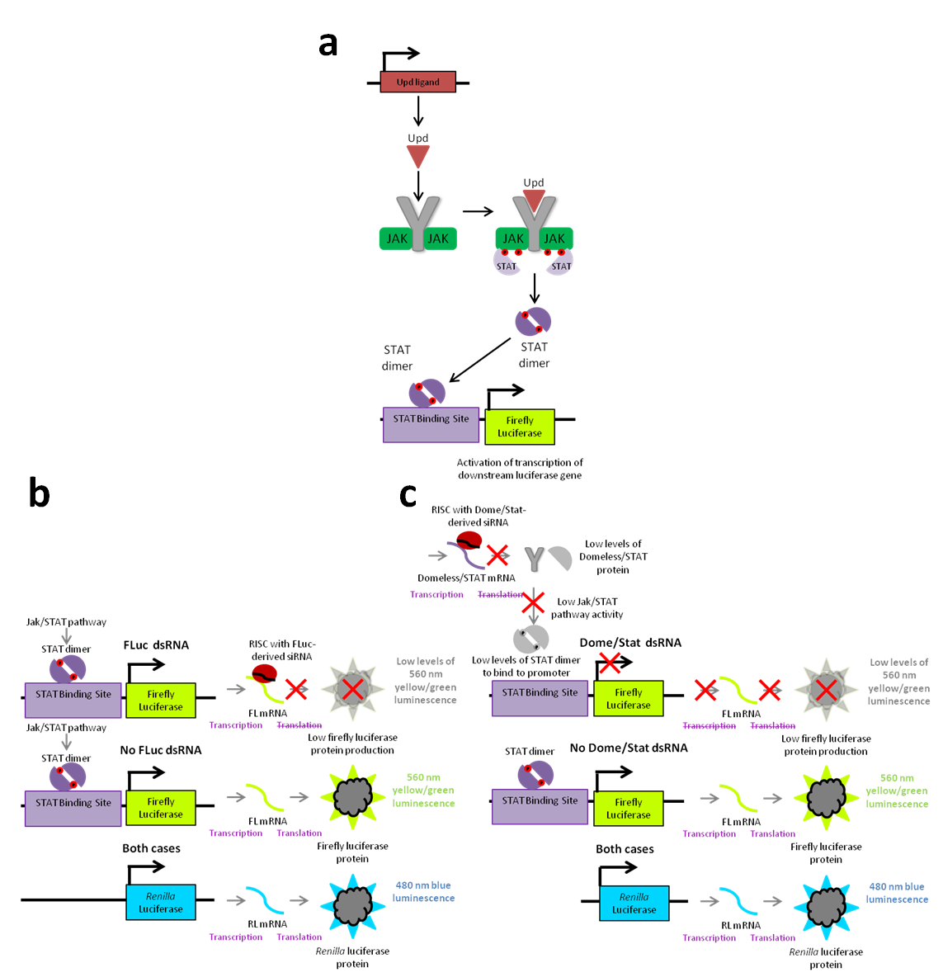

Figure 5.1 Luciferase assay reporter system and interaction with the *Drosophila* JAK/STAT pathway.

(a) Schematic of the *Drosophila* JAK/STAT pathway and link to the reporter system. (b) Schematic of the response of the reporter system to firefly luciferase dsRNA (FLuc). (c) Schematic of the response of the reporter system to STAT/Dome dsRNA.

A second luciferase from the sea pansy, *Renilla reniformis*, under the control of a constitutive Actin promoter, catalyses a different reaction which produces a luminescence (RL) emission spectrum with a peak wavelength of 480 nm (figure 5.1 b & c) (Thorne, Inglese and Auld, 2010). *Renilla* luciferase expression levels and luminescence are unaffected by RNAi-induced knockdown of Firefly luciferase or the *Drosophila* JAK/STAT pathway. Luminescence from this luciferase – RL – can therefore be used to normalise FL values in order to compensate for differences in cell seeding density or reporter plasmid transfection efficiency between different wells in the assay plate, as well as monitoring for possible cytotoxic effects of dsRNA, modifications, or contaminants present in the assay plates. Monitoring of RL values therefore serves to confirm that a difference in reduction in Firefly luciferase (FL) activity between different dsRNAs is due to RNAi-induced knockdown, and not an artefact of a poor transfection, an unhealthy cell culture, an error in the number of cells dispensed, or a cytotoxic contaminant in the dsRNA solution. The luminescence produced by the luciferases can be read by a plate reader, and the difference in peak wavelength allows luminescence produced by each luciferase to be distinguished from luminescence from the other.

The two luciferases and their respective promoters are situated on two separate plasmids; a third plasmid was also utilised in the luciferase assay, which consisted of the sequence for the JAK/STAT pathway ligand Upd under the control of a constitutive Actin promoter. The Upd plasmid provides an excess of the ligand in order to increase the level of JAK/STAT pathway activity in the cell culture (figure 5.1 a); this ensures that enough copies of the STAT dimer are produced to activate the transcription of Firefly luciferase such that the level of firefly luciferase – and therefore also the level of its subsequent RNAi-induced knockdown – are detectable. These three plasmids were transfected into *Drosophila* Kc167 cells one day prior to the start of each knockdown experiment.

Firefly luciferase luminescence values (FL) were normalised against *Renilla* luciferase luminescence values (RL), and the FL/RL values of dsRNAs were again normalised against the FL/RL values of control wells treated with water, giving results as an index between 0 (complete knockdown) and 1 (no detectable knockdown) plus or minus errors.

$$Normalised\left({FL}/{RL}\right) Fluorescence=\frac{{\left({FL}/{RL}\right)}_{dsRNA}}{{\left({FL}/{RL}\right)}_{No dsRNA control}}$$

All luciferase assays were conducted in *Drosophila melanogaster* Kc167 cell cultures. These were chosen over the more common S2 cell lines as there is data suggesting that Kc167 cells provide a better response to luciferase assays than S2/S2R+ cells (Müller *et al.*, 2005; Fisher *et al.*, 2012b). Kc167 cells were acquired from the DGRC at Harvard.

Both prior to and during the course of the main luciferase assay screening experiments, the method was developed and refined in order to overcome challenges including: the breakdown of a component of the homemade assay initially used; and issues with sensitivity, reagent dilution, and luminescence bleed between wells with the subsequent use of a proprietary kit version of the assay. These issues were successfully resolved and the chemically modified dsRNAs screened in order to reliably ascertain variation in their dose-dependent RNAi-induced knockdown efficacy.

## Results and discussion

### Method development and troubleshooting

An initial luciferase assay was carried out using unmodified dsRNAs in order to ascertain two key facts. Firstly, that both endogenous gene products in the JAK/STAT pathway – such as Domeless and STAT92E, and exogenous gene products – such as firefly luciferase, could be effectively knocked down in insect cells by the long dsRNAs selected, in order to validate these dsRNAs for further use in screening the effect of RNA modifications on RNAi in insect cells. Secondly to confirm a previous observation from literature that while long dsRNAs can effect RNAi from naked delivery without a transfection reagent, siRNAs do not (Saleh, Ronald P. van Rij, *et al.*, 2006).

Long dsRNAs targeting the STAT92E, Domeless, and Firefly luciferase mRNAs were selected (see chapter 3, table3.1). A negative control dsRNA (F59C6.5) targeting a *Caenorhabditis elegans* protein similar to human NADH dehydrogenase [ubiquinone] 1 beta subcomplex subunit 10, was selected. dsRNAs targeting each of these genes were produced, as well as mixed pools of siRNAs (esiRNAs) produced by digesting the long dsRNAs to siRNAs with bacterial RNase III (figure 5.2 a).

The assay was carried out in 384 well plate format, with 8 replicate wells for each dsRNA or esiRNA mixture, and 250 ng of RNA per well (see table 5.1). Previous data suggested that this concentration of dsRNA would induce the maximum level of RNAi-induced knockdown achievable (Horn, Sandmann and Boutros, 2010). Cells were incubated with dsRNA for 3 days, after which the cells were lysed and the substrates for the firefly and *Renilla* luciferases added sequentially. The luminescence produced by each reaction at its peak emission wavelength was measured separately in a Varioskan Flash plate reader (see section 2.4.3). The (FL/RL)Target/(FL/RL)No dsRNA control values are plotted in figure 5.2 b.

Table 5.1 dsRNAs and concentrations used in the dual luciferase assay in figure 5.2 b.

|  |  |  |
| --- | --- | --- |
| **dsRNA** | **Modification** | **Concentrations (ng)** |
| Stat3 | Unmodified (dsRNA) | 250 |
| Unmodified (esiRNA) | 250 |
| Dome11 | Unmodified (dsRNA) | 250 |
| Unmodified (esiRNA) | 250 |
| FLuc | Unmodified (dsRNA) | 250 |
| Unmodified (esiRNA) | 250 |
| F59C6.5 | Unmodified (dsRNA) | 250 |
| Unmodified (esiRNA) | 250 |

The results show that the endogenous gene product targeting long dsRNAs Stat3 and Dome11, as well as the exogenous gene-product-targeting long dsRNA FLuc, induced successful knockdown (see figure 5.2 b). The control long dsRNAs F59C6.5 did not induce knockdown. These results demonstrated that the targeting long dsRNAs were effective dsRNAs with which to screen the effect of RNA modifications on RNAi knockdown, and F59C6.5 dsRNA was an appropriate negative control for the system. None of the target esiRNAs induced significant RNAi knockdown, nor did the control F59C6.5 esiRNAs.

The next objective was the determination of the dose response of the cell culture model and reporter system, in order to determine the minimum amount of unmodified dsRNA required to achieve maximum RNAi-induced knockdown, and the concentration range of dsRNA in which most change in level of target protein knockdown with change in dsRNA concentration was detected. This information provides the optimum dsRNA concentration range to use to determine differences in RNAi efficacy between unmodified and modified dsRNA.

Unmodified targeting dsRNAs Stat3, Stat4, Dome11, Dome14 and FLuc, as well as the non-targeting control dsRNA F59C6.5 were tested at concentrations of 10, 100, 500 and 1,000 ng per well of a 384 well plate. A luciferase assay was carried out as described above for this range of dsRNAs and concentrations (see table 5.2). FL and RL luminescence values were quantified and normalised as previously and are shown in figure 5.2 c.

Table 5.2 dsRNAs and concentrations used in the dual luciferase assay in figure 5.2 c.

|  |  |  |
| --- | --- | --- |
| **dsRNA** | **Modification** | **Concentrations (ng)** |
| Stat3 | Unmodified | 10, 100, 500, 1,000 |
| Stat4 | Unmodified | 10, 100, 500, 1,000 |
| Dome11 | Unmodified | 10, 100, 500, 1,000 |
| Dome14 | Unmodified | 10, 100, 500, 1,000 |
| FLuc | Unmodified | 10, 100, 500, 1,000 |
| F59C6.5 | Unmodified | 10, 100, 500, 1,000 |

For all targeting dsRNAs, maximum observed RNAi-induced knockdown was achieved for 500 ng of dsRNA and no further knockdown was detected for 1,000 ng of dsRNA. The maximum level of RNAi-induced knockdown for this assay was approximately 80-90%. 100 ng of dsRNA per well resulted in more variation between the different dsRNAs tested, with FLuc and the STAT-targeting dsRNAs (Stat3 and Stat4) showing around 10% greater RNAi-induced knockdown than the Domeless-targeting dsRNAs (Dome11 and Dome14). All targeting dsRNAs showed 60% knockdown or more

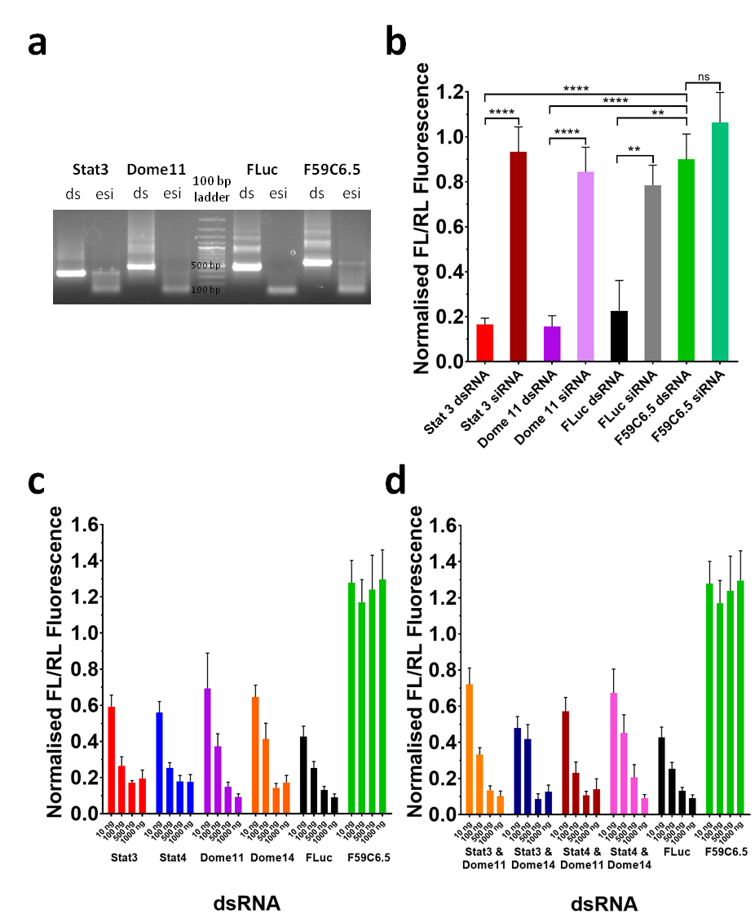

Figure 5.2 Selection and validation of dsRNAs and dsRNA concentrations for *in vitro* analysis of RNAi with chemically modified dsRNA.

(a) Agarose gel of long dsRNAs (ds) and esiRNAs (esi) generated by RNaseIII digestion of long dsRNAs Stat3 (286 bp), Dome11 (401 bp), FLuc (401 bp) and F59C6.5 (513 bp) for use in *Drosophila* cell RNAi assays. All esiRNAs are 18-25 bp. (b) Bar graph of luciferase assay results for RNAi knockdown by unmodified long dsRNA and unmodified esiRNAs in *Drosophila* Kc167 cells using 250 ng of targeting dsRNAs Stat 3, Dome11 and FLuc, and non-targeting control F59C6.5. RNAi knockdown is presented as ratios of firefly luciferase luminescence intensity (FL) to *Renilla* luciferase luminescence intensity (RL) normalised against control FL/RL values for wells containing no dsRNA. (c & d) Bar graphs of luciferase assay results demonstrating the dose response of RNAi knockdown by unmodified long dsRNAs alone (c) and in combination (d).

All dsRNA and esiRNA treatments 250 ng . Loss of fluorescence correlates to increasing knockdown. Mean and SEM are plotted (n=8). Stars denote significance as calculated by unpaired T-tests. ns = P > 0.05, * = P ≤ 0.05, ** = P ≤ 0.01, *** = P ≤ 0.001, **** = P ≤ 0.0001.

with the addition of 100 ng of dsRNA, similar to the addition of 10 ng of FLuc dsRNA. The Jak/STAT targeting dsRNAs Stat3, Stat4, Dome11 and Dome14 were moderately less effective than FLuc at concentrations of 10 ng per well, and resulted in approximately 30-45% RNAi-induced knockdown. This suggests that all the targeting dsRNAs tested are capable of inducing moderate levels of target protein knockdown at a concentration of 10 ng per 384 well. The non-targeting negative control dsRNA produced no detectable knockdown of the firefly luciferase reporter at any of the concentrations tested and, in fact, appeared to inflate FL readings resulting in FL/RL values above 1. The results of this assay suggested that dsRNA concentrations between 10 and 100 ng per well would show a rapid increase in RNAi-induced knockdown levels as dsRNA concentration increased. This window of concentrations was therefore selected for subsequent comparative dose response assays to compare the efficacy of modified dsRNA to that of unmodified dsRNA.

An assay was set up concurrently with the previous assay to determine if equal amounts of two dsRNAs each targeting two different target genes was as effective as the same total amount of a single dsRNA. i.e. would 50 ng of Stat3 dsRNA and 50 ng of Dome11 dsRNA in the same well result in the same level of RNAi-induced knockdown as 100 ng of either Stat3 or Dome11 dsRNA. The assay was setup as previously described, for the same range of concentrations, with each combination of one STAT dsRNA (Stat3 or Stat4) and one Domeless dsRNA (Dome11 or Dome14) (see table 5.3). The results are shown in figure 5.2 d.

Table 5.3 dsRNAs and concentrations used in the dual luciferase assay in figure 5.2 d. FLuc and F59C6.5 data identical to figure 5.2c.

|  |  |  |
| --- | --- | --- |
| **dsRNA** | **Modification** | **Concentrations (ng)** |
| Stat3 & Dome11 | Unmodified | 5 of each, 50 of each,  250 of each, 500 of each |
| Stat3 & Dome14 | Unmodified | 5 of each, 50 of each,  250 of each, 500 of each |
| Stat4 & Dome11 | Unmodified | 5 of each, 50 of each,  250 of each, 500 of each |
| Stat4 & Dome14 | Unmodified | 5 of each, 50 of each,  250 of each, 500 of each |
| FLuc | Unmodified | 10, 100, 500, 1,000 |
| F59C6.5 | Unmodified | 10, 100, 500, 1,000 |

Similar trends were observed for the combinations of dsRNAs as those seen for single dsRNAs. Concentrations of 500 and 1,000 ng of dsRNA again resulted in 80-90% knockdown, with little difference between the two concentrations. 100 ng of dsRNA resulted in RNAi knockdown levels in a range of approximately 65 to 75%. For the addition of 10 ng of dsRNA, RNAi-induced knockdown was between 30% and 50%, similar to that for single dsRNAs. The results demonstrate that there was no advantage to targeting two pathway components rather than just one for this reporter system and model system.

As the results in figure 5.2 had shown that there was no distinct difference in level of RNAi-induced knockdown of the reporter between dsRNAs targeting endogenous or exogenous targets, further screening was confined to the exogenous firefly luciferase target for simplicity, using the FLuc dsRNA. In order to improve the ease with which assays could be carried out to screen chemically modified dsRNAs, a kit assay by Promega was used to replace the assay method used previously. This reduced the manual work load of the assay, and overcame issues with reagent degradation over time. Initial work focused on optimising the assay using FLuc unmodified dsRNA in 96 well plates, with F59C6.5 dsRNA at the highest concentration only, and wells with no dsRNA as controls. Various combinations of dsRNA concentration range, luciferase substrate dilution, incubation time and plate types were tested and the results are shown in Appendix 1, figure A1.1. The optimised method used for subsequent assays to screen chemically modified dsRNA is described in section 2.4.3.

### Quantitative comparative analysis of RNAi efficacy of phosphorothioate (PS) dsRNA in *Drosophila* Kc167 cells

The first RNA chemical modification investigated was the phosphorothioate modification (see figure 3.1 a). Phosphorothioate modifications are the most widely used class of chemical modifications to improve the *in vivo* action of siRNA and DNA-oligonucleotide therapeutics in mammalian systems (Shen and Corey, 2018b), and were therefore the most promising chemical modification for use in modulating RNAi in insects.

#### Analysis of the effects on RNAi of non-targeting phosphorothioate dsRNA in *Drosophila* Kc167 cells

Prior to investigating the effects of phosphorothioate modifications on RNAi using targeted dsRNAs, an assay was carried out using non-targeting phosphorothioate dsRNA. This assay aimed to determine that phosphorothioate dsRNA is not cytotoxic by using dsRNA F59C6.5 – a sequence targeting a *C. elegans* gene with low sequence similarity to any *Drosophila* gene (see section 5.3.1 above) – containing phosphorothioate modifications. F59C6.5 dsRNA with one of the four nucleotides replaced throughout both strands by a phosphorothioate analogue (1PS) was synthesised, purified and analysed by the methods described in chapter 3 and sections 2.2.2-2.2.7. dsRNAs with phosphorothioate linkages at either A or C nucleotides were synthesised. These dsRNAs were tested in a dual luciferase assay using *Drosophila* Kc167 cell cultures transfected with the dual luciferase assay reporter plasmids and addition of dsRNA as previously described. Targeting unmodified FLuc dsRNA was tested in parallel, as well as unmodified non-targeting F59C6.5 dsRNA. 250 ng of each dsRNA per well was tested (see table 5.4).

Table 5.4 dsRNAs and concentrations used in the dual luciferase assay in figure 5.3 a & b.

|  |  |  |
| --- | --- | --- |
| **dsRNA** | **Modification** | **Concentrations (ng)** |
| FLuc | Unmodified | 250 |
| F59C6.5 | Unmodified | 250 |
| 1PS (A) | 250 |
| 1PS (C) | 250 |

The results of this assay are shown in figure 5.3 a. The unmodified dsRNA F59C6.5 did not result in knockdown of the firefly luciferase reporter and none of the tested phosphorothioate dsRNAs demonstrated a statistically significant difference from the unmodified dsRNA. The targeting FLuc dsRNA did result in robust RNAi knockdown of the luciferase reporter.

A cytotoxic dsRNA could result in both FL and RL values being reduced for a cell culture, thus resulting in no obvious change in FL/RL values. RL values are a measure of cell number, reporter transfection efficiency, and general cell culture health. Cells from a single transfected culture divided between separate wells containing a targeting and non-targeting dsRNA should produce similar RL values at the end of the assay, provided the wells have all been subjected to the same conditions (temperature etc.) during the course of the assay. RL values should also be unaffected provided none of the dsRNAs are cytotoxic, and the gene product knocked down does not affect cell metabolism, growth, or division. The presence of a cytotoxic dsRNA can be detected by a reduction in RL values for wells containing the dsRNA.

In order to determine if this was the case, the RL values of the phosphorothioate and unmodified F59C6.5 dsRNAs were compared, along with those of the unmodified FLuc targeting dsRNA (see figure 5.3 b). RL values between all the dsRNA conditions tested were similar and showed no statistically significant difference. Unmodified targeting dsRNA, unmodified non-targeting dsRNA, and phosphorothioate non-targeting dsRNA all demonstrated some replicates with outlying RL values, though the majority of replicate normalised RL values clustered around the value of 1.0. This indicates that phosphorothioate modifications in dsRNA do not have a significant cytotoxic effect. This result, in conjunction with the absence of any detectable RNAi-induced knockdown of the firefly

Figure 5.3 *In vitro* analysis of the effects of phosphorothioate dsRNA modifications on RNAi in insect cells.

Luciferase assay results for phosphorothioate (PS) and unmodified (Unmod) FLuc and F59C6.5 dsRNA. RNAi knockdown of a firefly luciferase reporter by FLuc dsRNA, is presented as ratios of firefly luciferase luminescence intensity (FL) to *Renilla* luciferase luminescence intensity (RL) normalised against FL/RL values for control conditions with no dsRNA. (a) Bar graph of luciferase assay results for RNAi knockdown of firefly luciferase by unmodified targeting and non-targeting control F59C6.5 dsRNA, and 1PS modified non-targeting control F59C6.5 dsRNA in *Drosophila* Kc167 cells. (b) Graph of normalised RL values for unmodified targeting dsRNA, and unmodified and 1PS non-targeting dsRNA – all relationships are non-significant. (c) Bar graph of luciferase assay results for RNAi knockdown of firefly luciferase by unmodified targeting and non-targeting control F59C6.5 dsRNA, and 1PS modified targeting FLuc dsRNA in *Drosophila* Kc167 cells.

In all graphs, mean and SEM are plotted (n=8), and 250 ng of dsRNA used per replicate. Stars denote significance as calculated by unpaired T-tests. ns = P > 0.05, * = P ≤ 0.05, ** = P ≤ 0.01, *** = P ≤ 0.001, **** = P ≤ 0.0001.

luciferase reporter by F59C6.5 phosphorothioate dsRNA (figure 5.3 a), suggests that any RNAi-induced knockdown effect detected by the reporter system for targeting phosphorothioate dsRNAs is due to genuine RNAi-induced knockdown and not an artefact of a cytotoxic effect.

#### Analysis of the effect on RNAi of targeting phosphorothioate dsRNA in *Drosophila* Kc167 cells

Testing of targeting phosphorothioate dsRNA began by determining if phosphorothioate dsRNA was capable of inducing RNAi in insect cells, and if there was any difference in the degree of effect depending on which nucleotides were replaced by phosphorothioate analogues.

To study the effects of phosphorothioate modifications of long dsRNA on RNAi in *Drosophila* Kc167 cells, an assay was set up to test a range of phosphorothioate-containing dsRNAs for RNAi efficacy. Four dsRNAs, each one with one of the four nucleotides replaced throughout by the corresponding phosphorothioate analogue (1PS), were synthesised alongside the unmodified dsRNA for both the endogenous target Dome11 dsRNA and the exogenous target FLuc dsRNA (see table 5.5). 250 ng of each dsRNA was incubated with cells transfected with the luciferase assay reporter plasmids for 4 days, prior to lysis and addition of the luciferase assay reagents as described in section 2.4.3.

Table 5.5 dsRNAs and concentrations used in the dual luciferase assay in figure 5.3 c.

|  |  |  |
| --- | --- | --- |
| **dsRNA** | **Modification** | **Concentrations (ng)** |
| FLuc | Unmodified | 250 |
| 1PS (A) | 250 |
| 1PS (C) | 250 |
| 1PS (G) | 250 |
| 1PS (U) | 250 |
| F59C6.5 | Unmodified | 250 |

The results are shown in figure 5.3 c, and demonstrate that FLuc unmodified and FLuc phosphorothioate dsRNAs all induce effective protein knockdown. There was no statistically significant difference in the level of RNAi-induced knockdown by unmodified and phosphorothioate dsRNA at this concentration of dsRNA. The results demonstrate that 1PS phosphorothioate dsRNA is capable of inducing RNAi-induced mRNA knockdown in Kc167 cells, and the 1PS dsRNAs were all equally effective irrespective of which of the four nucleotides was replaced by the phosphorothioate analogue.

Quantitative analysis of RNAi-induced knockdown was carried out with an assay using a wide range of dsRNA concentrations (1000 ng to 0.01 ng per well) in order to generate dose curves for unmodified, 1PS and 2PS FLuc dsRNA (see table 5.6). Unmodified F59C6.5 non-targeting dsRNA at 1000 ng per well was used as a control, along with controls with no dsRNA. Cells transfected with the luciferase reporter plasmids were incubated with dsRNA for 4 days, prior to lysis and addition of the luciferase assay reagents.

Table 5.6 dsRNAs and concentrations used in the dual luciferase assay in figure 5.4.

|  |  |  |
| --- | --- | --- |
| **dsRNA** | **Modification** | **Concentrations (ng)** |
| FLuc | Unmodified | 0.01, 0.1, 1, 10, 100, 1,000 |
| 1PS | 0.01, 0.1, 1, 10, 100, 1,000 |
| 2PS | 0.01, 0.1, 1, 10, 100, 1,000 |
| F59C6.5 | Unmodified | 1,000 |

The results for the assay are shown in figure 5.4 as normalised FL/RL values. The results show that at the highest concentration of 1 µg of dsRNA per well, all targeting FLuc dsRNAs were equally effective at inducing protein knockdown to a level highly statistically significant (p < 0.0001) from F59C6.5 control dsRNA (figure 5.4 a). Unmodified, 1PS and 2PS FLuc dsRNAs showed no statistically significant difference in efficacy from each other at this concentration. This suggested that if differences in efficacy were going to be detected, this would likely be at a lower concentration range.

The full dose curves from the experiment are shown in figure 5.4 b. It is immediately obvious from the dose curves that at the 1 ng to 100 ng concentration range there is a clear separation of the three curves, with 1PS dsRNA being more efficacious than unmodified dsRNA, and 2PS subsequently being more efficacious than 1PS dsRNA in this concentration range. At 10 ng of dsRNA, 2PS dsRNA is significantly more efficacious than unmodified dsRNA. 1PS dsRNA is not quite statistically significantly different from unmodified, though an unpaired T-test gives P values of 0.0649 and 0.0723 for 10 ng and 1,000 ng respectively, very close to the threshold for statistical significance at P = 0.05. Similarly at 100 ng the difference between unmodified and 2PS dsRNA is statistically significant, whereas the differences between unmodified and 1PS dsRNA, and between 1PS and 2PS dsRNA are not statistically significant.

The EC50 values were calculated from the dose curves. The results show that the EC50 more than halves from 20.6 ng for unmodified dsRNA to 7.6 ng for 1PS dsRNA, and more than halves again from 1PS dsRNA to 2.8 ng for 2PS dsRNA.

Figure 5.4 *In vitro* analysis of the effects of phosphorothioate dsRNA modifications on RNAi in insect cells across a range of dsRNA concentrations.

Luciferase assay results for phosphorothioate (PS) and unmodified (Unmod) FLuc dsRNA. RNAi knockdown of a firefly luciferase reporter by FLuc dsRNA, is presented as ratios of firefly luciferase luminescence intensity (FL) to *Renilla* luciferase luminescence intensity (RL) normalised against FL/RL values for control conditions with no dsRNA. (a) Bar graph of RNAi knockdown by 1 µg treatments of Unmod, 1PS and 2PS FLuc dsRNA against F59C6.5 control dsRNA. (b) Dose curves of normalised FL/RL values plotted against log of dsRNA dose per well in ng. EC50s are concentrations at which 50% RNAi knockdown occurs. Coloured stars denote statistical significance of the identically coloured point compared to unmodified dsRNA. Curves generated by non-linear regression analysis using a dose-response inhibition variable slope model in Graphpad prism software. (c) graph of individual normalised FL/RL values for the dose curves in figure b.

In all graphs, mean and SEM are plotted (n=6). Stars denote significance as calculated by unpaired T-tests. ns = P > 0.05, * = P ≤ 0.05, ** = P ≤ 0.01, *** = P ≤ 0.001, **** = P ≤ 0.0001. Full list of P values given in Appendix 1, figure A1.2.

Individual normalised FL/RL replicate values for the assay are shown in figure 5.4 c. The data shows that there is a greater spread of replicate values for lower concentrations of unmodified, 1PS, and 2PS dsRNAs, with replicates showing increasingly good agreement as concentration increases. Consequently, the smallest values of standard error of the mean were also found at the higher concentrations for all unmodified, 1PS, and 2PS dsRNAs, with great variation in the standard error values at lower concentrations (see Appendix 1, figure A1.3 a).

A previous assay using 1:10 dilutions of luciferase assay reagents, and a higher number of intermediate concentrations produced similar results, with a progressive increase in efficacy from unmodified, to 1PS to 2PS dsRNA across the middle of the concentration range of dsRNA tested (see Appendix 1, figure A1.4). However, using 1:10 dilutions of luciferase assay reagents on subsequent assays produced inconsistent results, and thus after some optimisation, the alternative method described in section 2.4.3 using 1:2 luciferase assay reagent dilutions was used for the main phosphorothioate dsRNA assay above (figure 5.4), and all subsequent assays.

### Quantitative comparative analysis of RNAi efficacy of 2’-fluoro (2’F) dsRNA in *Drosophila* Kc167 cells

In order to determine the effectiveness of 2’F dsRNA for RNAi in Kc167 cells, a luciferase assay was carried out to produce comparable dose curves of RNAi-induced knockdown for unmodified, 1 2’F, and 2 2’F FLuc dsRNA (see figure 3.5 for nomenclature). The range of dsRNA concentrations tested was identical to that used in the previous assay to generate phosphorothioate dsRNA dose curves (see table 5.7). Kc167 cells transfected with the reporter plasmids were incubated with dsRNA for 4 days as in the previous assay, prior to lysis and addition of the luciferase assay reagents. The results for the assay are shown in figure 5.5 as normalised FL/RL values.

Table 5.7 dsRNAs and concentrations used in the dual luciferase assay in figure 5.6

|  |  |  |
| --- | --- | --- |
| **dsRNA** | **Modification** | **Concentrations (ng)** |
| FLuc | Unmodified | 0.01, 0.1, 1, 10, 100, 1,000 |
| 1 2’F | 0.01, 0.1, 1, 10, 100, 1,000 |
| 2 2’F | 0.01, 0.1, 1, 10, 100, 1,000 |
| F59C6.5 | Unmodified | 1,000 |

Figure 5.5 In vitro analysis of the effects of 2’-fluoro dsRNA modifications on RNAi in insect cells across a range of dsRNA concentrations.

Luciferase assay results for 2’-fluoro (2’F) and unmodified (Unmod) FLuc dsRNA. RNAi knockdown of a firefly luciferase reporter by FLuc dsRNA, is presented as ratios of firefly luciferase luminescence intensity (FL) to Renilla luciferase luminescence intensity (RL) normalised against FL/RL values for control conditions with no dsRNA. (a) Bar graph of RNAi knockdown by 1 µg treatments of Unmod, 1 2’F and 2 2’F FLuc dsRNA against F59C6.5 control dsRNA. (b) Dose curves of normalised FL/RL values plotted against log of dsRNA dose per well in ng. EC50s are concentrations at which 50% RNAi knockdown occurs. Coloured stars denote statistical significance of the identically coloured point compared to unmodified dsRNA. Curves generated by non-linear regression analysis using a dose-response inhibition variable slope model in Graphpad prism software. (c) Graph of individual normalised FL/RL values for the dose curves in figure b.

In all graphs, mean and SEM are plotted (n=6). Stars denote significance as calculated by unpaired T-tests. ns = P > 0.05, * = P ≤ 0.05, ** = P ≤ 0.01, *** = P ≤ 0.001, **** = P ≤ 0.0001. Full list of P values given in Appendix 1, figure A1.2.

The results firstly show that at the highest dsRNA concentration of 1 µg per well, there is no significant difference between the RNAi efficacy of unmodified and 1 2’F dsRNA, with both dsRNAs resulting in a high level of RNAi-induced knockdown (90-95%) compared to the F59C6.5 control dsRNA (see figure 5.5 a). However, 2 2’F dsRNA demonstrates a significant reduction in RNAi efficacy compared to both unmodified and 1 2’F (p < 0.001 and p < 0.0001 respectively) modified dsRNA, with an RNAi-induced knockdown efficiency of approximately 85%.

The full dose curves from the experiment are shown in figure 5.6 b. The dose curve for 1 2’F dsRNA demonstrates an improvement in RNAi efficacy for the middle of the concentration range compared to unmodified dsRNA, with the difference being highly statistically significant at 10 ng of dsRNA. The difference at 1 ng is close to being statistically significant, with a P value of 0.0557. The individual values for each plate well shown in figure 5.5 c show a single outlying value that may prevent the difference between 1 ng of unmodified and 1 2’F dsRNA being statistically significant, therefore an increased number of replicates per concentration may lead to the difference becoming significant. The EC50 value of 1 2’F dsRNA is approximately 8 % of that for unmodified dsRNA, with EC50 values of 0.8 ng and 9.8 ng for 1 2’F dsRNA and unmodified dsRNA respectively.

2 2’F dsRNA demonstrated a moderate reduction in RNAi efficacy compared to unmodified dsRNA at high and low concentrations, with the difference being statistically significant at 1 ng and 1,000 ng. At middle concentrations of 10 and 100 ng 2 2’F dsRNA demonstrates RNAi efficacy equivalent to that of unmodified dsRNA. The EC50 value of 2 2’F dsRNA is 7.0 ng compared to 9.8 ng for unmodified dsRNA, and therefore relatively similar.

Individual normalised FL/RL values for the assay are shown in figure 5.5 c. The data shows that there is a greater spread of replicate values for lower concentrations of unmodified, 1 2’F, and 2 2’F dsRNAs, with replicates showing increasingly good agreement as concentration increases. Consequently, the smallest values of standard error of the mean were also found at the higher concentrations for unmodified, 1 2’F, and 2 2’F dsRNAs, with great variation in the standard error values at lower concentrations (see Appendix 1, figure A1.3 b).

### Quantitative comparative analysis of RNAi efficacy of 5-Hydroxymethyl (HMr) dsRNA in *Drosophila* Kc167 cells

In order to determine the effectiveness of HMr dsRNA for RNAi in Kc167 cells, a luciferase assay was carried out to produce comparable dose curves of RNAi-induced knockdown for unmodified, 1HMr, and 2HMr FLuc dsRNA. The range of dsRNA concentrations tested was identical to that used in the previous assays to generate phosphorothioate and 2’-fluoro dsRNA dose curves (see table 5.8). Kc167 cells transfected with the reporter plasmids were incubated with dsRNA for 4 days as in the previous assays, prior to lysis and addition of the luciferase assay reagents. The results for the assay are shown in figure 5.6 as normalised FL/RL values.

Table 5.8 dsRNAs and concentrations used in the dual luciferase assay in figure 5.6.

|  |  |  |
| --- | --- | --- |
| **dsRNA** | **Modification** | **Concentrations (ng)** |
| FLuc | Unmodified | 0.01, 0.1, 1, 10, 100, 1,000 |
| 1HMr | 0.01, 0.1, 1, 10, 100, 1,000 |
| 2HMr | 0.01, 0.1, 1, 10, 100, 1,000 |
| F59C6.5 | Unmodified | 1,000 |

The results firstly show that at the highest dsRNA concentration of 1 µg per well, there is no significant difference between the RNAi efficacy of unmodified and 1HMr dsRNA, with both dsRNAs resulting in a high level of RNAi-induced knockdown (90-95%) compared to the F59C6.5 control dsRNA (see figure 5.6 a). However, 2HMr dsRNA demonstrates a significant reduction in efficacy compared to both unmodified and 1HMr modified dsRNA, with an RNAi-induced knockdown efficiency of around 80%.

The full dose curves from the experiment are shown in figure 5.6 b. The dose curve for 1HMr dsRNA demonstrates no statistically significant difference in RNAi knockdown efficacy compared to unmodified dsRNA at any dsRNA concentration. The difference at 1 ng is close to being statistically significant, with a P value of 0.0988, and 1HMr dsRNA has a moderately higher mean value than unmodified dsRNA, indicative of reduced RNAi efficacy for 1HMr dsRNA compared to unmodified dsRNA. This may explain why there is some difference in the EC50 values, with values of 21.8 ng and 7.9 ng for unmodified and 1 HMr respectively. 2HMr dsRNA demonstrated a reduction in RNAi efficacy compared to unmodified dsRNA across the entire concentration range. The difference between the two is statistically significant at 1 ng, 100 ng, and 1,000 ng, and close to being statistically significant at 0.01 ng, with a P value of 0.0606. The EC50 value of 2HMr dsRNA (81.2 ng) is higher than that for unmodified dsRNA (9.8 ng).

Individual normalised FL/RL values for the assay are shown in figure 5.6 c. The data shows that there is a greater spread of replicate values for lower concentrations of unmodified and 1HMr dsRNAs, with replicates demonstrating increasingly good agreement as concentration increases. 2HMr dsRNA demonstrated a wide spread of values right across the concentration range, with close agreement between replicates only for 1,000 ng of dsRNA. The smallest values of standard error of the mean were also found at the higher concentrations for unmodified, 1HMr, and 2HMr dsRNAs, with great variation in the standard error values at lower concentrations, and particularly great variation in the 2HMr standard errors up until 100 ng of dsRNA (see Appendix 1, figure A1.3 c).

Figure 5.6 *In vitro* analysis of the effects of 5-hydroxymethyl dsRNA modifications on RNAi in insect cells across a range of dsRNA concentrations.

Luciferase assay results for 5-hydroxymethyl (HMr) and unmodified (Unmod) FLuc dsRNA. RNAi knockdown of a firefly luciferase reporter by FLuc dsRNA, is presented as ratios of firefly luciferase luminescence intensity (FL) to *Renilla* luciferase luminescence intensity (RL) normalised against FL/RL values for control conditions with no dsRNA. (a) Bar graph of RNAi knockdown by 1 µg treatments of Unmod, 1HMr and 2HMr FLuc dsRNA against F59C6.5 control dsRNA. (b) Dose curves of normalised FL/RL values plotted against log of dsRNA dose per well in ng. EC50s are concentrations at which 50% RNAi knockdown occurs. Coloured stars denote statistical significance of the identically coloured point compared to unmodified dsRNA. Curves generated by non-linear regression analysis using a dose-response inhibition variable slope model in Graphpad prism software. (c) Graph of individual normalised FL/RL values for the dose curves in figure b.

In all graphs, mean and SEM are plotted (n=6). Stars denote significance as calculated by unpaired T-tests. ns = P > 0.05, * = P ≤ 0.05, ** = P ≤ 0.01, *** = P ≤ 0.001, **** = P ≤ 0.0001. Full list of P values given in Appendix 1, figure A1.2.

### Comparison of reproducibility of results for a single dsRNA across replicate experiments

A comparison was made of the unmodified FLuc dsRNA dose curves from the PS, 2’F and HMr dual luciferase assays. The aim was to determine the reproducibility of results for the same dsRNA, across replicate experiments. This would enable inference of the reliability of differences between different dsRNAs for the previous screening assays. The 2’F and HMr assays were carried out concurrently, though with separate unmodified dsRNA dose curves for each assay. The PS assay was carried out at a separate time. The three unmodified FLuc dose curves are plotted in figure 5.7 a, with individual normalised FL/RL values given in figure 5.7 b.

The results show that the unmodified dsRNA dose curves from the 2’F and HMr assays conducted at the same time, are very similar. There is no statistically significant difference between the two data sets at any concentration. The unmodified dsRNA dose curve from the PS dsRNA assay showed statistically significant differences from the 2’F and HMr assay unmodified dsRNAs at the 100 ng and 1,000 ng concentrations, though not at any other concentrations.

The results demonstrate that the reproducibility of replicate results for the same dsRNA tested in multiple assays concurrently is excellent at high concentrations of dsRNA, and reasonable at lower concentrations, though there is less reproducibility between results for the same dsRNA tested in different assays conducted at different times. This suggests that where the results for chemically modified dsRNAs vary from unmodified dsRNAs in a single assay, these differences are likely to be accurate. However, direct comparison of results for dsRNAs between different assays should be made cautiously.

Even though the unmodified dsRNA dose curves from the 2’F and HMr dsRNA screens are in close agreement and show no statistical difference, their EC50 values of 9.8 ng and 21.8 ng respectively show variation. In contrast the unmodified dose curve from the PS dsRNA assay is statistically different from the 2’F and HMr screen unmodified dsRNA curves, yet has an EC50 value of 20.6 ng, which is in close agreement with the EC50 from the HMr screen unmodified dsRNA curve. The close agreement of the 2’F and HMr screen unmodified dsRNA dose curves suggests that statistical difference of mean values analysed by T-test is likely a more reliable measure of difference between dsRNA dose curves, and EC50 values are of limited reliability. This is discussed further below, in the context of FL/RL values above 1.0 at some dsRNA concentrations.

Figure 5.7 Comparison of reproducibility of luciferase assay results for unmodified FLuc dsRNA.

Comparison of reproducibility of luciferase assay results for unmodified (Unmod) FLuc dsRNA between the luciferase assays screening PS, 2’F and HMr dsRNA. RNAi knockdown of a firefly luciferase reporter by FLuc dsRNA, is presented as ratios of firefly luciferase luminescence intensity (FL) to *Renilla* luciferase luminescence intensity (RL) normalised against FL/RL values for control conditions with no dsRNA. Greater loss of fluorescence correlates to greater levels of RNAi knockdown. (a) Dose curves of normalised FL/RL values plotted against log of dsRNA dose per well in ng. (b) Individual normalised FL/RL values for the dose curves in figure a.

In all graphs, mean and SEM are plotted (n=6). Stars denote significance [need adding later] as calculated by unpaired T-tests. ns = P > 0.05, * = P ≤ 0.05, ** = P ≤ 0.01, *** = P ≤ 0.001, **** = P ≤ 0.0001.

### Comparison of RL values to determine cytotoxicity of dsRNA chemical modifications, and examine increased FL/RL values at low dsRNA concentrations

It was previously determined in section 5.3.2.1 above that 1PS dsRNA was not cytotoxic to *Drosophila* cells by using phosphorothioate modified non-targeting control F59C6.5 dsRNA. In order to determine that all PS, 2’F and HMr modified dsRNAs tested were not cytotoxic, the normalised RL values for concentrations of 1 µg of dsRNA from the luciferase assay dose curves above were examined, and the results are shown in figure 5.8. The results demonstrate that the normalised RL values for all unmodified and chemically modified dsRNAs are close to 1.0, and therefore none of the dsRNA chemical modifications are cytotoxic.

Figure 5.8 Analysis of the cytotoxicity of phosphorothioate, 2’-fluoro and 5-hydroxymethyl dsRNA modifications to insect cells.

Graphs of normalised RL values from the luciferase assay results for 1 µg of PS (a), 2’F (b), and HMr (c) FLuc dsRNAs compared to the unmodified FLuc and unmodified F59C6.5 controls. *Renilla* luciferase luminescence intensity (RL) normalised against RL values for control conditions with no dsRNA.

Data for the following dsRNAs and concentrations in each assay have an average normalised FL/RL value above 1.0 (table 5.9). For all of the assays, many of the lower concentrations of dsRNA with averages around or below 1.0 have individual replicate values that exceed 1.0. In some experiments, F59C6.5 dsRNA resulted in a similar effect. A normalised FL/RL value of 1.0 represents 0% knockdown, and is equivalent to the mean of the no dsRNA control. In theory data should therefore not have a value above 1.0, and values above 1.0 could be the result of either high FL values or low RL values.

Table 5.9 Luciferase assay data points with average normalised FL/RL values significantly greater than 1.0.

|  |  |  |
| --- | --- | --- |
| **Assay** | **dsRNA** | **Concentrations (ng) affected** |
| Phosphorothioate dose curve | FLuc Unmod | 0.1 |
|  | FLuc 1PS | 0.01, 0.1 |
|  | FLuc 2PS | 0.01, 0.1 |
| 2’-Fluoro dose curve | FLuc Unmod | 0.1 |
|  | FLuc 1 2’F | 0.01 |
|  | FLuc 2 2’F | 0.01, 0.1, 1 |
| 5-Hydroxymethyl dose curve | FLuc Unmod | 0.01 |
|  | FLuc 1HMr | 0.01, 0.1 |
|  | FLuc 2HMr | 0.01, 0.1, 1 |

In order to determine whether the high FL/RL values for the dsRNA concentrations listed in table 5.10 above were due to increased FL values or low RL values, the normalised RL values for all concentrations of dsRNA from the luciferase assay dose curves above were examined, and the results are shown in Appendix 1, figure A1.5. The results demonstrate that the normalised RL values for all unmodified and chemically modified dsRNAs at all concentrations are close to 1.0, and low dsRNA concentrations with high FL/RL values do not show significantly reduced RL values compared to other dsRNA concentrations. The high FL/RL values are therefore due to increased FL values at these concentrations, rather than reduced RL values.

In theory the normalised FL/RL data should not have a value above 1.0, and values above 1.0 suggest potential upregulation of the reporter by an unknown mechanism in response to low amounts of dsRNA. It is known that RNAi-related genes such as Dicer and Argonaute are upregulated in response to dsRNA (Garbutt and Reynolds, 2012; Lozano *et al.*, 2012). It may be possible a more global upregulation of genes takes place in response to non-targeting dsRNA, or concentrations of targeting dsRNA that are low enough to be ineffective for RNAi. Alternatively, the media may be deficient in nucleotides, and thus adding dsRNA may result in an increased amount of dsRNA-derived nucleotides, allowing the cells to upregulate their overall expression levels, whilst there is simultaneously not enough dsRNA present to be effective for RNAi. This would explain why for some dsRNAs the effect is not seen for the very lowest concentration of 0.01 ng but is seen for 0.1 ng, as 0.01 ng may not result in enough free nucleotides to cause an increase in cellular metabolism. In theory this would result in both firefly and *Renilla* luciferase expression levels increasing equally, and so the resultant difference in FL and RL values would cancel out, though the different promoters of the two luciferase reporters may result in different levels of upregulation of the reporter proteins.

It should be noted that as a result of these inflated FL/RL readings, several of the dose curves have maximum values greater than other dose curves from the same assay. For example, for the 2’fluoro assay, the 1 2’F dose curve has a maximum value greater than that of the unmodified dose curve at the lowest dsRNA concentration, though a similar minimum value as the unmodified dsRNA curve at the highest concentration (see figure 5.5). The maxima and minima of the 2 2’F curve are both greater than the corresponding values for the unmodified dsRNA curve. These shifts in the maxima and minima of some dose curves will affect the EC50 value, and therefore the information that can be inferred from the EC50 value has limitations. Statistical tests at specific concentrations are therefore more likely to be accurate in confirming differences in RNAi efficacy. An increased number of replicates may reveal that several dsRNAs have significant differences in RNAi efficacy at a greater number of concentrations.

## Conclusions

The aim of this chapter was to study the effects of dsRNA chemical modifications on RNAi *in vitro* in insect cells. *Drosophila melanogaster* Kc167 cells were used as a model system to successfully study the RNAi efficacy of a range chemically modified dsRNAs, including phosphorothioate (PS), 2’-fluoro (2’F) and 5-hydroxymethyl (HMr) dsRNAs, using a dual luciferase assay reporter system to quantify RNAi-induced knockdown.

While at the highest dsRNA concentration of 1 µg per well both 1PS and 2PS dsRNAs resulted in the same high level of knockdown as the equivalent amount of unmodified dsRNA, both 2 2’F and 2HMr dsRNA did not achieve maximum knockdown, despite being at concentrations above the dsRNA saturation concentration previously determined. 1 2’F and 1HMr dsRNAs however, resulted in equivalent knockdown to unmodified dsRNA at the 1 µg concentration, therefore suggesting that the total number of modifications tolerated within a dsRNA molecule differs depending on the type of modification.

Results from the present study demonstrated that 1PS dsRNAs were all equally effective irrespective of which of the four nucleotides was replaced by the phosphorothioate analogue. In *C. elegans* it has previously been determined that short dsRNA (26 bp) with uridine phosphorothioate analogue nucleotides, was less effective for RNAi than dsRNA with any of the other three nucleotides replaced by their phosphorothioate analogue (Parrish *et al.*, 2000). However, dsRNAs with A, C or G replaced by phosphorothioate analogues (1PS) were as effective as unmodified dsRNA. The results here demonstrate that insect cells demonstrate robust RNAi-induced knockdown as a result of all four 1PS dsRNAs, with no reduction in RNAi efficacy for PS U dsRNA. In mammalian cells, siRNAs (21 bp) with up to approximately half of their nucleotides replaced by phosphorothioate analogues have been demonstrated to be as effective for RNAi as unmodified siRNAs, whereas siRNAs containing all phosphorothioate linkages were active for RNAi but showed reduced efficacy (Braasch *et al.*, 2003). The study by Braasch et al. (2003), also concluded the reduction in RNAi activity for siRNAs with a high phosphorothioate content was related to the PS modified siRNAs accumulating in the nucleus, where there is no RISC activity. The results for insect cells are in line with the first observation, with 2PS dsRNA – which has approximately half of its total nucleotides replaced by phosphorothioate analogues – was as effective for RNAi as unmodified dsRNA, and more effective at some concentrations. Further data from mammalian cells indicates that phosphorothioate modification of the entirety of the seed region of the guide strand of an siRNA resulted in equal RNAi-induced knockdown to an unmodified siRNA (Iribe *et al.*, 2017), and this was demonstrated for a range of dsRNA concentrations in contrast to the studies by Braasch and Parrish which utilised only a single high concentration of siRNA.

Parrisch et al. (2000) also investigated 1 2’F long siRNAs (26 bp) with uridine residues replaced by a 2’-fluoro analogue in *C. elegans*, and determined it was equally active for RNAi compared to unmodified dsRNA. siRNAs with a small number (2 to 4) of 2’-fluoro modifications were investigated by Brassch et al. (2003) in mammalian cells and found to be equally active for RNAi compared to unmodified siRNAs, though greater numbers of 2’-fluoro modifications were not investigated. There is also data that indicates that both 2’-fluoro modification of the guide strand does not reduce activity across a range of siRNA concentrations (Prakash *et al.*, 2005), and that 2’-fluoro modifications in the passenger strand at the position where Argonaute 2 cleaves the passenger strand, may result in increased RNAi efficacy (Muhonen *et al.*, 2007). These results are in agreement with those presented here for insect cells, which demonstrate that 1 2’F dsRNA is as active for RNAi as unmodified dsRNA, and has increased activity at some concentrations.

The lower RNAi efficacy of 2HMr dsRNA was somewhat surprising as the modification is not on the backbone of the dsRNA but rather on the base itself, and therefore not in a position where either degrading nucleases or Dicer-2 cut long dsRNA (see figure 3.1 a). Looking at 5’-hydroxymethyl cytidine as an example, the 5’ position where the hydroxymethyl group is attached to the pyrimidine ring is also not one of the functional groups responsible for forming hydrogen bonds with guanosine residues in the opposite strand of the dsRNA. The hydroxyl group is also separated from the nearest functional group (4 NH2) by three carbon atoms (the 4 and 5 pyrimidine carbons, and the methyl carbon of the hyroxymethyl group), and from the nearest double bond by two carbon atoms (the 5 pyrimidine carbon, and the methyl carbon of the hyroxymethyl group), therefore does not participate in any resonance stabilisation that might affect the hydrogen bonding groups. However, there is evidence that while 5-methyl modifications increases the thermal stability of duplex nucleic acids, 5-hydroxymethyl modifications moderately reduce the thermal stability of duplex nucleic acids compared to unmodified nucleic acids (Thalhammer *et al.*, 2011; Xuan *et al.*, 2015), therefore the 5-hydroxymethyl modification may affect the unwinding and discarding of the passenger strand, or reduce the strength of binding between the ss-si-RISC and the target mRNA.

In dsDNA, 5-hydroxymethyl groups on 5-hydroxymethyl cytidine can extend into the grooves. Although dsRNA is an A form helix, while dsDNA is a B form helix, it is presumed that 5-hydroxymethyl groups in the dsRNA strand are also exposed, and may therefore impact on binding of the siRNAs derived from the dsRNA to Argonaute-2, through steric hindrance. It is also possible that the difference in knockdown seen in the cell culture experiment might be due to differences in uptake of the dsRNA into the cells by the receptors responsible, again due to altered binding by HMr dsRNA.

The similarity of 1HMr dsRNA to unmodified dsRNA may be the result of the HMr residues being dispersed enough to not significantly affect binding of dsRNA with scavenger receptors, Dicer-2 or Argonaute-2, which are required for uptake and processing of dsRNA to functional siRNAs. There may also be too few HMr modifications to significantly affect duplex stability, and therefore unwinding of the passenger strand and binding of the guide strand-RISC complex to the target mRNA are also not significantly affected.

The cleavage mechanism of RNase III enzymes (Sun, Pertzev and Nicholson, 2005), and many other nucleases (Mikkola, Lönnberg and Lönnberg, 2018), involves the lone pairs of electrons on the non-bridging oxygens in the phosphate group of a phosphodiester bond in the nucleic acid substrate coordinating with metal ions in order to facilitate binding of the nuclease to the substrate at certain amino acid residues. This orientates the nucleic acid substrate such that amino acid groups elsewhere on the nuclease can initiate the series of nucleophilic attack reactions that result in cleavage of the substrate. As one of the non-bridging oxygen atoms is replaced by a sulphur atom in phosphorothioate nucleic acid, it is reasonable to assume this may affect the activity of such nucleases. The 2’ hydroxyl group on the RNA ribose ring is also involved in the ‘in-line’ attack reaction that cleaves RNA substrates for some nucleases (Min *et al.*, 2007) (though not for RNase III/Dicer cleavage), therefore substitution of this oxygen by a fluorine atom in 2’-fluoro dsRNA is also likely to affect the efficiency of the cleavage mechanism. As cleavage of long dsRNA to siRNAs by Dicer-2, and resistance of dsRNA to more general nucleases are key factors determining RNAi efficacy, it is little surprise that PS and 2’F modifications have an effect on RNAi efficacy.

It was determined that using equal amounts (e.g. 50 ng each) of two dsRNAs to partially knockdown two different components of the same pathway by RNAi, was as effective at reducing the overall activity of the pathway, as twice the amount of a single dsRNA (e.g. 100 ng) targeting a single pathway component for RNAi-induced knockdown. Using 100 ng each of two dsRNAs to target two pathway components might result in a further increase in overall pathway activity reduction, however this requires more dsRNA to be generated. There is no advantage to using multiple gene targets when attempting to minimise the dsRNA needed to reduce the activity of a certain signalling pathway by RNAi for this model system.

The results presented in this chapter demonstrate for the first time that chemically modified dsRNAs can be used for RNAi applications in *Drosophila melanogaster* Kc167 cells. Based on the chemical modifications used in this study, the results show no significant loss of RNAi efficacy compared to unmodified dsRNA, therefore suggesting that these long dsRNAs can be successfully uptaken by cells, and processed by Dicer-2 and RISC. Furthermore, a number of chemically modified dsRNAs showed improved RNAi efficacy, and can be potentially used as dsRNA biopesticides to target major crop pests.

Chapter 6

*In vivo* analysis of RNAi efficacy of chemically modified dsRNA in live insects

# *In vivo* analysis of RNAi efficacy of chemically modified dsRNA in live insects

## Abstract

The aim of this chapter was to study the effects of chemical modifications of dsRNA in live Coleopteran and Hemipteran insects, as many insects in these orders are crop pests. It was hypothesised that increased nuclease resistance and improved uptake of the chemically modified dsRNA may lead to increased RNAi activity compared to unmodified dsRNA.

To study the effects of chemical modifications of dsRNA on RNAi activity, a range of chemically modified dsRNA (including phosphorothioate (PS), 2’-fluoro (2’F) and 5-hydroxymethyl (HMr)), were injected into southern green stink bugs *Nezara viridula* (Hemiptera), and fed to western corn rootworm (WCR) *Diabrotica virgifera virgifera* (Coleoptera) in diet plate or soil feeding assays. RNAi activity was assessed based on insect mortality in each of the assays.

The diet plate assay results show dsRNA with 2’F modifications in either strand but not both has almost equivalent RNAi activity to unmodified dsRNA in both stink bugs and WCR. dsRNA with PS modifications in the passenger strand or guide strand had equivalent activity to unmodified dsRNA when injected into stink bug. dsRNA with PS modifications in the passenger strand showed RNAi activity approximately equal to that of unmodified dsRNA in WCR, while dsRNA with PS modifications in the guide strand demonstrated reduced RNAi activity. PS or 2’F modifications in both strands of the dsRNA greatly abrogated RNAi activity in WCR. 1PS dsRNAs were also more active than 2PS dsRNAs, and dsRNA with 2PS modifications in both strands showed low to no RNAi efficacy. HMr dsRNA showed equivalent RNAi activity to unmodified dsRNA when fed to WCR.

PS dsRNAs fed to WCR in a soil feeding assay demonstrated similar efficacy ranking to that for PS dsRNAs in the diet plate assay. None of the PS dsRNAs demonstrated a reduction in loss of RNAi activity over time compared to unmodified dsRNA in soil.

In conclusion, the results show that a range of different chemically modified dsRNA resulted in efficient RNAi in southern green stink bugs and western corn rootworm using insect mortality assays. However, none of the chemically modified dsRNAs analysed showed an improvement in RNAi activity compared to unmodified dsRNA in the assays used. Clear distinctions in RNAi efficacy were observed depending on type, location, and quantity of chemical modifications present within the dsRNA. Therefore these results provide further mechanistic insight into the potential use of chemically modified dsRNA biopesticides.

## Introduction

RNAi efficiency between insects of different orders is known to vary. Coleopteran insects (beetles) demonstrate the most robust and systemic RNAi response (Tomoyasu *et al.*, 2008; Miller *et al.*, 2012). One of the first successful demonstrations of RNAi as a potential orally delivered insecticide was in a Coleopteran species, *Diabrotica virgifera virgifera* or western corn rootworm (WCR) (Baum *et al.*, 2007). In contrast, Lepidopteran insect species (butterflies and moths) demonstrate a very poor RNAi response (Shukla *et al.*, 2016a). A number of factors have been proposed as contributing to this. Lepidoptera have a high pH in the midgut lumen capable of degrading dsRNA, and the goblet cells responsible for producing the high pH are one of the most alkaline biological systems known (Dow, 1992; Terenius *et al.*, 2011). A potent nuclease termed RNAi efficiency-related nuclease (REase) only found in Lepidoptera, is responsible for significant degradation of dsRNA in insect cells (Guan *et al.*, 2018). Most insects exhibit an upregulation of the RNAi genes Dicer-2 and Argonaute-2 in response to uptake of dsRNA (Garbutt and Reynolds, 2012; Lozano *et al.*, 2012). However, this response is reduced in Lepidoptera compared to other insects (Bellés, 2010), and upregulation of the REase protein in response to detection of dsRNA is faster than the upregulation of Dicer-2 (Guan *et al.*, 2018).

Shukla *et al.*, directly compared several factors affecting RNAi efficiency between Coleoptera and Lepidoptera, such as dsRNA uptake, dsRNA degradation and processing of dsRNA to siRNAs (Shukla *et al.*, (2016)). The results showed that cells of both insect orders efficiently uptake dsRNA. However, while coleopteran cells process the dsRNA to siRNAs, the dsRNA in lepidopteran cells remains in the endosomes and is not processed into siRNAs.

Certain species of Lepidoptera do demonstrate successful RNAi, though many of these successful studies utilise delivery methods other than ingestion of naked dsRNA. These include injection of dsRNA into embryos (Quan, Kanda and Tamura, 2002), and expression of hairpin RNAs in plants ingested by the insects (Mao *et al.*, 2007). Successful RNAi responses triggered by dsRNA have been demonstrated in many other insect orders, as reviewed in section 1.3.1.

In order to compare the RNAi efficacy of chemically modified dsRNA to unmodified dsRNA, the Hemipteran insect southern green stink bug (SGSB) *Nezara viridula*, and the Coleopteran insect western corn rootworm (WCR) *Diabrotica virgifera virgifera* were selected as model organisms.

SGSB is thought to have originated in Africa but is now present worldwide, including the UK and USA, and its range appears to be spreading as climate change occurs (Tougou, Musolin and Fujisaki, 2009). A related species, the brown marmorated stink bug (BMSB) *Halyomorpha halys* which is endemic to China, Japan, Korea and Taiwan, though was inadvertently introduced to the USA around 20 years ago, has become a significant crop pest (Ghosh *et al.*, 2017; Mogilicherla, Howell and Palli, 2018), as well as a nuisance pest when swarms have entered homes. It is now also in danger of infesting Europe and South America.

Stink bugs are a highly versatile pest capable of sustaining themselves on a wide variety of different fruits and vegetables, making them a significant threat to agriculture. Stink bugs use a proboscis to penetrate the surface of fruit and vegetables, inject saliva in order to pre-digest the fruit or vegetable flesh, and then reuptake the pre-digested pulp (Ghosh *et al.*, 2017). The damage caused by this process leads to further damage to the fruit or vegetable from the environment and pathogens (Medrano, Esquivel and Bell, 2007). This type of feeding behaviour is noteworthy, because thus far in pest control research, dsRNA has largely been applied to the surfaces of leaves and fruits, where surface feeders will uptake it as part of their diet. Piercing sucking feeders like stink bugs are therefore at risk of being unaffected by surface applications of dsRNA, and some thought has to be given to the delivery method used.

Western corn rootworm, as the name implies, is a major pest of corn in the USA, with the larvae causing most of the damage compared to the adults, by feeding on the roots of the plants (Baum *et al.*, 2007). Individual plants may lose almost their entire root system to WCR larval feeding, resulting in poor water and nutrient supply to the rest of the plant, and opening the way for root rot pathogens. WCR was first observed in eastern Europe in Serbia in 1992 (Baca, 1994), and has since spread westward, as far as the UK.

Stink bugs and WCR are both highly damaging crop pests, demonstrating resistance to current pest control methods (Cullen *et al.*, 2013; Lavore *et al.*, 2018) and susceptibility to RNA based biocontrols (Baum *et al.*, 2007; Davis-Vogel *et al.*, 2018). They are therefore ideal models for testing the effects of chemical modifications of dsRNA on RNAi in insects, and are both potential targets for a future chemically modified RNAi biopesticide. For both species, nuclease degradation is possibly the greatest barrier to successful insecticidal RNAi, though at different points for each species. With regard to WCR, the major nuclease degradation point is in the soil feeding environment of the larvae (Dubelman *et al.*, 2014), whereas for stink bugs the major barrier is degradation by their own salival nucleases (Lomate and Bonning, 2016). The very different feeding behaviours of the two species also opens the possibility for testing the activity of the modified dsRNAs across a range of conditions. It should also be reiterated that the *Drosophila* cells used for cell screening belong to the order Diptera, whereas stink bugs and WCR belong to the orders Hemiptera and Coleoptera respectively. There was a reasonable chance therefore that the RNAi machinery of each order might have very different tolerances for various RNA modifications.

Two major types of assay were used to determine the effectiveness of unmodified and modified dsRNA in inducing mortality in stink bugs and WCR through RNAi: an injection assay to determine the resistance of dsRNA to hemolymphal nucleases and its ability to enter cells and effect an RNAi response, and feeding assays in order to determine the ability of dsRNA to negotiate the entire delivery pipeline from food source, through mouth and gut lumen, into the hemolymph, and finally into individual cells. The injection assay was performed on stink bug, and feeding assays were carried out on both stink bug and WCR. Two variants on feeding assays were used for WCR: a relatively controlled assay using dsRNA applied to an artificial diet, requiring low dsRNA doses, and good for screening dsRNA RNAi activity quickly; and a more realistic soil feeding assay which would be a closer mimic to the application of dsRNA insecticides to pests in the field, and thus requires a much higher dose of dsRNA to produce significant mortality levels.

Stink bugs are exopterygotes with larvae that look like the adults and externally developing wings. Their lifecycle consists of eggs hatching to produce first instar nymphs, followed by molting through a total of five nymphal instar stages (N1-N5) to produce adults which are sexually mature after 2 weeks. Saliva was collected from adults, and injection and feeding assays were carried out on second instar nymphs. WCR are endopterygotes that have distinct larval, pupal and adult stages. Their lifecycle consists of a protracted larval stage divided into three instars (L1-L3), though in practice there is little visual difference between instars other than a steady increase in size, followed by pupation from which the adult beetle hatches. Feeding assays were carried out using larvae in the L1/L2 stages.

Demonstrating that chemically modified dsRNA does in fact produce comparable or improved knockdown compared to unmodified dsRNA in an insect cell culture model is an important first step. However, the number of dsRNA uptake steps, and the number of nuclease degradation points (on the leaf surface, soil, or wider field environment, and in the target insect’s saliva, gut lumen, and hemolymph) between application of dsRNA and incorporation into the RISC is far fewer for a cell culture model than for live insects. There is already evidence from the nuclease resistance assays reported in chapter 4 that phosphorothioate modifications in particular show increased resistance to some insect nucleases. Previous results reported in chapter 5, have also demonstrated certain chemically modified dsRNAs have equal or improved RNAi activity compared to unmodified dsRNAs *in vitro* in a *Drosophila* cell culture model. The hypothesis is that differences in dsRNA uptake or stability due to chemical modifications in the dsRNA may have a greater effect on RNAi efficacy in live insects than in cell cultures, and the experiments conducted in this chapter aimed to determine if this was the case for the model insects selected.

## Results and discussion

### Production and analysis of dsRNA probes

In order to investigate RNAi knockdown in insects, three dsRNA target sequences were selected: Target A, Target B, and Target C (a shorter fragment of Target A). All three dsRNAs target the orthologues of a crucial, sequence conserved target mRNA with broad activity against multiple species. The combinations of chemically modified dsRNAs synthesised are summarised in table 6.1, along with which experiments they proceeded to be used in. DNA templates for the target dsRNAs were produced by PCR, using plasmids supplied by Syngenta as the starting material. RNA was transcribed from the DNA templates by IVT using T7 RNA polymerase, then purified and annealed to form dsRNA. The dsRNAs were quantified by Nanodrop spectrophotometry, and analysed by gel electrophoresis and IP RP HPLC, as described in chapter 3. Gel electrophoresis analysis of the DNA templates and unmodified dsRNAs for Targets A, B and C, is shown in figure 6.1 a. GFP dsRNA was used as a control, along with chemically modified GFP control dsRNA in some experiments.

Note that throughout this chapter N denotes number of replicate experiments, and n denotes number of insects used in a single replicate for a particular dsRNA and concentration.

Table 6.1 A list of all unmodified and chemically modified target dsRNAs used in live insect assays. Chemical modifications given as “guide-passenger” (antisense-sense).

|  |  |  |  |  |
| --- | --- | --- | --- | --- |
| **dsRNA Name** | **Principle Target Species** | **Length (bp)** | **Modification**  **(guide-passenger)** | **Assays** |
| Target A | Stink bug  (*Nezara viridula*) | 512 | Unmod | Injection, Feeding |
| Un-2PS | Injection, Feeding |
| 2PS-Un | Injection, Feeding |
| Un-2 2’F | Injection |
| 2 2’F-Un | Injection |
| Target B | Western corn rootworm  (*Diabrotica virgifera virgifera*) | 228 | Unmod | Diet feeding, Soil feeding |
| 1HMr-1HMr | Diet feeding |
| Un-1PS | Diet feeding, Soil feeding |
| 1PS-Un | Diet feeding |
| 1PS-1PS | Diet feeding, Soil feeding |
| Un-2PS | Diet feeding, Soil feeding |
| 2PS-Un | Diet feeding |
| 2PS-2PS | Diet feeding, Soil feeding |
| Un-2 2’F | Diet feeding |
| 2 2’F-Un | Diet feeding |
| 2 2’F-2 2’F | Diet feeding |
| Target C | Stink bug  (*Nezara viridula*) | 206 | Unmod | Injection, Feeding |
| Un-1PS | Feeding |
| 1PS-1PS | Injection, Feeding |
| Un-2PS | Feeding |
| 2PS-2PS | Feeding |

### Analysis of RNAi efficacy of chemically modified dsRNA delivered by injection in stink bug

In order to establish that chemically modified dsRNA was active for RNAi in insects, the first experiment carried out was an injection assay, using southern green stink bug (SGSB). The aim of the experiment was to determine whether chemically modified dsRNAs could induce RNAi of a target gene vital to survival, resulting in insect mortality. The relatively direct delivery method of injection removes dsRNA stability in saliva and gut juice, and dsRNA uptake efficiency of gut epithelial cells as factors, allowing RNAi efficiency of dsRNA to be examined in relative isolation from other factors.

An initial screen was carried out in SGSB to analyse the RNAi efficacy of a range of chemically modified Target A dsRNAs (table 6.2). SGSB N2 nymphal stage insects were injected by hand with 0.7 µg/µl dsRNA solutions containing non-toxic coloured dye, using borosilicate glass capillaries extruded into needles. The design of the injector results in an imprecise but high dose of dsRNA solution being delivered to insects, and therefore results are only semi-quantitative.

Table 6.2 The list of unmodified and chemically modified dsRNAs used in the stink bug injection assay shown in figure 6.1b.

|  |  |
| --- | --- |
| **dsRNA/Condition** | **Modification**  **(guide-passenger)** |
| Target A | Unmod |
| Un-2PS |
| 2PS-Un |
| Un-2 2’F |
| 2 2’F-Un |
| GFP | Unmod |
| No dsRNA (Dye only) | N/A |

Insects injected with dsRNA and control condition insects were transferred to sealed dishes containing a single runner bean, with one dish per condition. The injection day was designated day 0; on day 1 all deceased insects were removed and the initial scoring done. It was assumed all mortality in the first day was the result of damage incurred during injection and not from RNAi. Mortality was scored over five days, and the results are presented in figure 6.1b.

The results show that the modified dsRNAs containing PS and 2’F modifications in either the passenger strand (Un-2PS, Un-2 2’F) or the guide strand (2PS-Un, 2 2’F-Un) resulted in efficient RNAi in the insects when delivered directly by injection. Final survival percentages for all modified dsRNAs were similar to those for unmodified dsRNA. Although the data is only semi-quantitative, it suggests that RNAi-related mortality was detected later for the modified dsRNAs, compared to the unmodified dsRNA (see figure 6.1 b). The difference was especially pronounced around day three, with survival in the 60-80% range for the modified dsRNAs, compared to approximately 35% for the

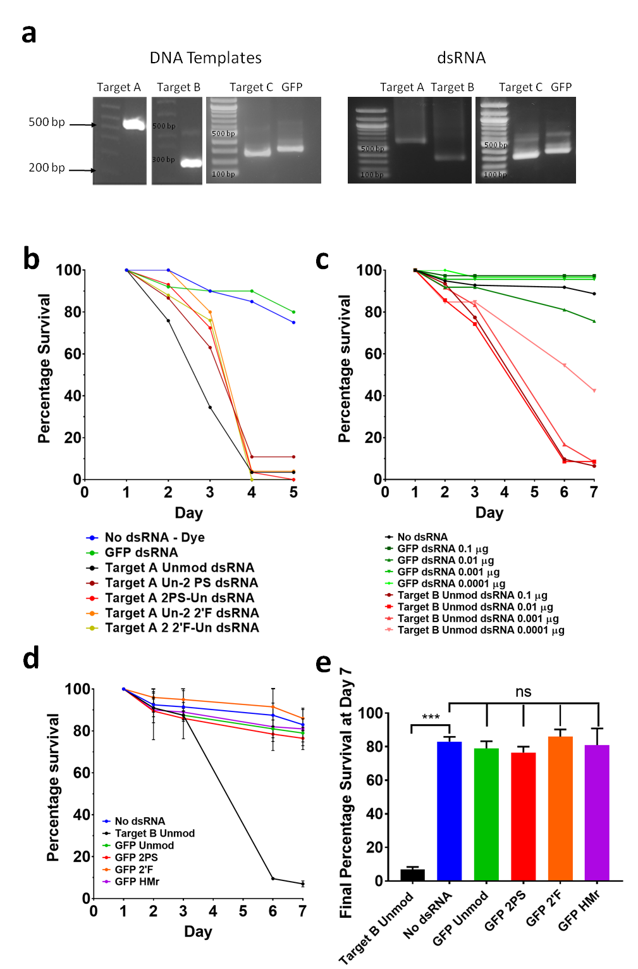

Figure 6.1 Optimisation and proof of principal for *in vivo* RNAi assays in insects using chemically modified dsRNA.

(a) Gel electrophoretogram of target and control dsRNAs utilised in live insect assays. (b) Stink bug injection assay. Second instar (N2) insects injected on the underside of the abdomen with dsRNA solution at a concentration of 0.7 µg/ µl. Mortality measured over 5 days and normalised to day 1. Day 1 post-injection survival n – Unmod: = 29; Un-2PS: = 46; 2PS-Un: = 29; Un-2 2’F: = 25; 2’F-Un: = 25; GFP dsRNA: = 50; Dye: = 20. (c) WCR optimisation plate feeding assay. WCR fed on an artificial diet containing dsRNA in well plates and mortality measured over 7 days. GFP n = 46, 41, 40, 45; Unmod n = 45, 47, 31, 41; No dsRNA insects n = 146. (d & e) WCR chemically modified GFP dsRNA plate feeding assay. Results plotted as mean and SD of two replicate assays (N=2). Stars denote significance as calculated by unpaired T-tests. ns = P > 0.05, *** = P ≤ 0.001. Target B Unmod n = 49, 53; GFP Unmod n = 50, 52; GFP 2PS n = 50, 54; GFP 2 2’F n = 48, 56; GFP 1HMr n = 49, 46; No dsRNA n = 97, 98. (d) Survival timecourse. (e) Day 7 survival.

unmodified dsRNA. By day four, insect mortality was similar for the unmodified and chemically modified dsRNAs.

In summary the results of the live insect assay demonstrate that the chemically modified dsRNAs were effective at producing RNAi knockdown in stink bug when delivered by injection. As a result of this finding, further experiments were performed to study the RNAi efficacy of a wider range of chemically modified dsRNAs when delivered orally to live insects.

### Analysis of RNAi efficacy of orally delivered chemically modified dsRNA in stink bug and WCR

#### WCR feeding mortality assay overview

Of the two model insects utilised here, WCR require a lower lethal dose of dsRNA compared to stink bugs, and can be handled in larger numbers due to the small size of their larvae. They are therefore ideal for conducting relatively quick screens of RNAi efficacy of the chemically modified dsRNAs, especially where limited amounts of dsRNA are available.

WCR larvae were fed on an artificial diet with dsRNA applied to the diet as an aqueous solution, in 48 well plates for the duration of the assay. At the end of day zero any initial mortality was scored. Mortality was scored each subsequent day for seven days and normalised to the survival of the first day. For each experiment a number of 48 well plates contained no dsRNA, a number were treated with GFP dsRNA as a negative control, and a number were treated with targeting dsRNA. Half a plate was treated with each combination of dsRNA type and dsRNA concentration, resulting in approximately 48 larvae in 24 wells per condition.

#### WCR dsRNA diet plate feeding assay optimisation

Optimisation of the assay was performed using unmodified Target B dsRNA in WCR. 48 well plates contained either unmodified Target B dsRNA, non-targeting GFP dsRNA, or no dsRNA. 24 replicate wells were used for each dsRNA condition, using a range of dsRNA concentrations (0.1, 0.01, 0.001 and 0.0001 µg per well for both Target B and GFP dsRNA), and 48 replicate wells for the no dsRNA condition. WCR larvae were seeded onto the plates and mortality scored daily as described above for seven days. Survival figures were normalised to day one survival numbers in order to negate most of the non-RNAi mortality associated with mishandling of corn rootworms during plate seeding. The results are shown in figure 6.1 c.

The results show that for Target B dsRNA RNAi-related mortality was evident by day three and increased significantly across days four to six, with some further minor mortality on day seven. Using dsRNA in the range of 0.1 to 0.001 µg per well resulted in very similar mortality profiles across the course of the assay, and resulted in final mortality of around 90% or around 10% survival (see figure 6.1 c). Addition of 0.0001 µg of dsRNA per well resulted in a significant reduction in mortality, resulting in a final day 7 survival rate of 42%. This suggests that the optimum amount of dsRNA to use in the assay is above 0.0001 µg, as below this concentration insecticidal activity starts to be reduced.

A factor to consider is the possible toxicity of the chemically modified dsRNA, independent of its RNAi efficacy. The toxicity of PS, 2’F and HMr RNA modifications in WCR were analysed by synthesising non-targeting GFP dsRNA containing these chemical modifications (table 6.3). The results from the diet plate feeding, assay using 0.1 µg of dsRNA per well and performed in duplicate, are shown in figure 6.1 d & e.

Table 6.3 The list of unmodified and chemically modified dsRNAs used in the WCR diet feeding assay shown in figure 6.1 d & e.

|  |  |
| --- | --- |
| **dsRNA/Condition** | **Modification**  **(guide-passenger)** |
| Target B | Unmod |
| GFP | Unmod |
| 2PS-2PS |
| 2 2’F-2 2’F |
| 1HMr-1HMr |
| No dsRNA | N/A |

The results show there was no statistically significant difference in insect mortality comparing the chemically modified GFP to unmodified GFP dsRNA or control larvae without dsRNA. In contrast, analysis of Target B dsRNA demonstrated high levels of insecticidal activity. The results indicate that the chemical modifications present in the dsRNAs used in this experiment are not toxic to the insects and result in no significant increase in mortality above the mortality for unmodified non-targeting dsRNA. These results are consistent with the previous RNAi experiments in *Drosophila* Kc167 cell culture (see section 5.3.6).

#### RNAi efficacy of chemically modified dsRNA using a WCR diet plate feeding assay

Following optimisation of the WCR dsRNA diet plate feeding assay using unmodified dsRNA, a range of chemically modified Target B dsRNAs (see table 6.4) were used in the mortality assays and compared to unmodified dsRNA.

Table 6.4 The list of unmodified and chemically modified dsRNAs used in the WCR diet feeding assay shown in figures 6.2 & 6.3.

|  |  |
| --- | --- |
| **dsRNA/Condition** | **Modification**  **(guide-passenger)** |
| Target B | Unmod |
| 1HMr-1HMr |
| Un-2PS |
| 2PS-Un |
| 2PS-2PS |
| Un-2 2’F |
| 2 2’F-Un |
| 2 2’F-2 2’F |
| GFP | Unmod |
| No dsRNA | N/A |

dsRNA concentrations of 1 and 0.01 µg per well were used, with half of a 48 well plate dedicated per concentration for each dsRNA as in the optimisation assay. These concentrations are both above the minimum dsRNA concentration for the assay that results in maximum mortality, as determined in the optimisation assay (figure 6.1 c). These concentrations were selected in order to ascertain which chemically modified dsRNAs had similar or different activity to unmodified dsRNAs. Non-targeting GFP dsRNA at a concentration of 1 µg per well was used as a control, along with wells with no dsRNA. WCR larvae were seeded onto the plates and mortality scored daily for seven days as described previously. Survival figures were normalised to day one survival numbers as before in order to negate most of the non-RNAi mortality associated with mishandling of rootworms during plate seeding, and the results are shown in figures 6.2.

Insect mortality across the seven day scoring period was consistent with the optimisation assay, with the majority of RNAi-associated mortality occurring between days 3 and 6. A summary of final day 7 survival percentages for insects fed on the different chemically modified dsRNAs are shown in figures 6.3.

The results for 5-hydroxymethyl (HMr) modified dsRNA are shown in figure 6.2 a as full survival curves. A summary of the final percentage survival is shown in figure 6.3. The results demonstrate that the presence of 5-hydroxymethyl (HMr) modifications in the dsRNA did not affect RNAi efficacy as measured by insect mortality, as the final percentage survival of HMr dsRNA treated insects was similar to those of unmodified dsRNA at the two concentrations tested (figure 6.3).

The results for the feeding assay using dsRNA with PS and 2’F modifications are shown in figures 6.2 b-d and 6.2 e-g respectively as survival curves, and are again summarised as final percentage survival in figure 6.3. These results demonstrate clear differences in survival profile and final percentage survival compared to the unmodified dsRNA. Moreover, differences in RNAi efficacy as measured by insect mortality were evident depending on whether the modifications were present in the guide (sense) or passenger (antisense) strand.

Feeding of the dsRNA with PS modifications present only in the passenger strand (Target B Un-2PS) resulted in a similar survival profile (figures 6.2 b) and final percentage survival (figure 6.3) to unmodified dsRNA at both of the concentrations tested. These results show that dsRNA with PS modifications in the passenger strand is effective at inducing RNAi knockdown. The results for insects fed dsRNA with PS modifications present only in the guide strand (Target B 2PS-Un) are shown in figure 6.2 c. 2PS-Un dsRNA showed no clear difference from the unmodified dsRNA at the higher concentration of 1 µg per well as measured by final percentage survival (see figures 6.3). However, the results did show a marked reduction in RNAi efficacy at the lower concentration of 0.01 µg per well compared to either the unmodified or sense strand modified dsRNA. This observation is in agreement with observations in mammalian systems, where chemical modifications are often better tolerated in the passenger strand than in the guide strand (Gaynor, Campbell and Cosstick, 2010).

The results for insects fed dsRNA with PS modifications in both strands (Target B 2PS-2PS) are shown in figures 6.2 d. and demonstrate that the presence of PS modifications in both strands further reduces the RNAi efficacy of the dsRNA, resulting in insect survival of approximately 35% and 75% for 1 and 0.01 µg of dsRNA per well respectively.

Therefore these results highlight differences in the RNAi efficacy of the dsRNA depending on the different combination of PS modifications in dsRNA used in the insect feeding assay in WCR.

The analysis of the dsRNA containing 2’F modifications is shown in figure 6.2 e-g, with results presented as survival curves. The final percentage survival data is summarised in figure 6.3. The results for dsRNA with 2’F modifications in both strands (Target B 2 2’F-2 2’F) show a similar trend to those observed for dsRNA with PS modifications in both strands. Target B 2 2’F-2 2’F dsRNA resulted in a significant loss of RNAi efficacy compared to either unmodified dsRNA or dsRNA with 2’F modifications in only one strand alone, at both concentrations (see figures 6.3).

The results show that insect mortality resulting from the higher dsRNA concentration of 1 µg per well was similar for dsRNA with modifications in just one strand (Target B Un-2 2’F, Target B 2 2’F-Un) and both of these modified dsRNAs showed similar RNAi efficacy to unmodified dsRNA at this concentration as measured by final percentage survival (see figures 6.3).

Figure 6.2 WCR survival feeding assay using chemically modified dsRNA (1).

(a) WCR modified HMr dsRNA plate feeding assay survival timecourse. WCR fed on an artificial diet containing dsRNA in well plates and mortality measured over 7 days. GFP n = 46, Unmod n = 46, 45, 1HMr-1HMr n = 45, 38, No dsRNA n = 48. (b-d) WCR modified PS dsRNA plate feeding assay survival timecourses. WCR fed on an artificial diet containing dsRNA in well plates and mortality measured over 7 days. GFP n = 46, Unmod n = 46, 45, Un-2PS n = 44, 45, 2PS-Un n = 45, 43, 2PS-2PS n = 47, 48, No dsRNA n = 48. (b) Survival timecourse, for Un-2PS dsRNA. (c) Survival timecourse for 2PS-Un dsRNA. (cd Survival timecourse for 2PS-2PS dsRNA. (e-g) WCR modified 2’F dsRNA plate feeding assay. WCR fed on an artificial diet containing dsRNA in well plates and mortality measured over 7 days. GFP n = 46, Unmod n = 46, 45, Un-2 2’F n = 42, 44, 2 2’F-Un n = 44, 50, 2 2’F-2 2’F n = 45, 48, No dsRNA n = 48. (e) Survival timecourse, for Un-2 2’F dsRNA. (f) Survival timecourse for 2 2’F-Un dsRNA. (g) Survival timecourse for 2 2’F-2 2’F dsRNA.

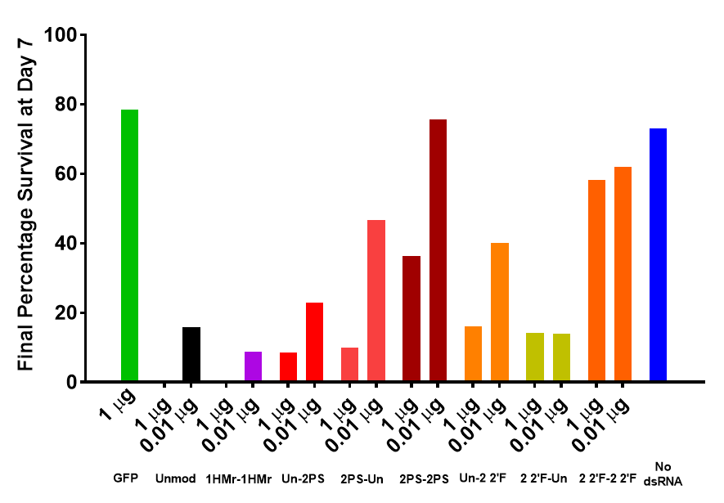

Figure 6.3 Summary of WCR survival feeding assay using chemically modified dsRNA (1).

Day 7 percentage survival summary data from the modified dsRNA WCR diet plate feeding assay in figure 6.2.

However, for the lower concentration (0.01 µg of dsRNA per well), the results suggest that dsRNA with 2’F modifications in the guide strand (Target B 2 2’F-Un) showed equivalent RNAi efficacy to the same concentration of unmodified dsRNA, with final survival at day 7 being approximately 15%. In contrast, the results show that at 0.01 µg of dsRNA per well, the dsRNA with 2’F modifications in the passenger strand (Target B Un-2 2’F) shows reduced RNAi efficacy, with a final survival of around 40% compared to approximately 20% for unmodified dsRNA. This appears to be the opposite trend to that for PS modifications, and confirmation/further investigation of this result was a major objective of the replicate assay below.

In order to validate the results from the first screen and to explore the relationship between the chemical modifications and RNAi efficacy at lower dsRNA concentrations, a second screen of the Target B modified dsRNAs covering a wider range of dsRNA concentrations, was carried out. For each dsRNA (table 6.4), 0.1, 0.01, 0.001 and 0.0001 µg per well were used, with half of a 48 well plate dedicated per condition as before. Target B 2PS-2PS and 2 2’F-2 2’F dsRNAs were only tested at the highest two concentrations, as the greatly reduced efficacy demonstrated in the first screen suggested lower concentrations would result in complete loss of activity. GFP dsRNA at all four concentrations and a no dsRNA diet only condition were also included as controls, as for the first screen. WCR larvae were seeded onto the plates and mortality scored daily as described previously for seven days.

Survival figures were normalised to day one survival numbers as before in order to negate most of the non-RNAi mortality associated with mishandling of rootworms during plate seeding. The normalised survival data is shown in figures 6.4 as survival curves, and summarised as final percentage survival in figure 6.5. The generalised pattern of mortality across the seven day scoring period was similar to the previous optimisation assay, with RNAi-related mortality occurring from day three onwards.

Overall the results were consistent with the first screen. The results for unmodified dsRNA are shown in figures 6.4 a. The results for HMr modified dsRNA are shown in figures 6.4 b. HMr modified dsRNA again demonstrated almost identical results to unmodified dsRNA when comparing final percentage survival (see figure 6.5).

The results for PS modified dsRNA are shown in figure 6.4 c-e as survival curves. The PS modified dsRNAs demonstrated similar results to the first screen. Analysis of the two highest dsRNA concentrations tested – 0.1 and 0.01 µg per well – showed the same trend of increasing RNAi efficacy: 2PS-2PS < 2PS-Un < Un-2PS < unmodified (see figure 6.5). At the lower two concentrations of 0.001 and 0.0001 µg per well, Target B Un-2PS and 2PS-Un dsRNAs showed a loss of RNAi activity compared to unmodified dsRNA, with survival of approximately 60% or above, compared to approximately 35% and 65% for 0.001 and 0.0001 µg of unmodified dsRNA respectively.

The results for 2’-F modified dsRNA are shown in figure 6.4 f-h as survival curves. The trends seen for 2’F dsRNAs in the first screen were also consistent with this replicate assay. The results show that for 2’F dsRNAs, the overall RNAi efficacy in the insect feeding assay using dsRNA with 2’F modifications in only one strand of dsRNA (Un-2 2’F, 2 2’F-Un) was equivalent to that of unmodified dsRNA, resulting in similar final insect mortality compared to unmodified dsRNA (summarised in figure 6.5). In contrast, the dsRNA with 2’F modifications in both strands (2 2’F-2 2’F) again showed a significant reduction in RNAi efficacy, with survival of 40% and 60% respectively for 0.1 and 0.01 µg of dsRNA.

Figure 6.4 WCR survival feeding assay using chemically modified dsRNA (2).

(a) WCR unmodified dsRNA plate feeding assay survival timecourse. WCR fed on an artificial diet containing dsRNA in well plates and mortality measured over 7 days. GFP n = 50, Unmod n = 47, 48, 54, 45, No dsRNA - Water n = 46, No dsRNA – PBS n = 38. (b) WCR modified HMr dsRNA plate feeding assay survival timecourse. WCR fed on an artificial diet containing dsRNA in well plates and mortality measured over 7 days. Survival timecourse for HMr dsRNA. GFP n = 50, Unmod n = 47, 1HMr-1HMr n = 53, 58, 46, 41, No dsRNA - Water n = 46, No dsRNA – PBS n = 38. (c-e) WCR modified PS dsRNA plate feeding assay. WCR fed on an artificial diet containing dsRNA in well plates and mortality measured over 7 days. GFP n = 50, Unmod n = 47, Un-2PS n = 49, 48, 51, 62, 2PS-Un n = 51, 52, 54, 60, 2PS-2PS n = 48, 36, No dsRNA - Water n = 46, No dsRNA – PBS n = 38. (c) Survival timecourse, for Un-2PS dsRNA. (d) Survival timecourse for 2PS-Un dsRNA. (e) Survival timecourse for 2PS-2PS dsRNA. (f-h) WCR modified 2’F dsRNA plate feeding assay. WCR fed on an artificial diet containing dsRNA in well plates and mortality measured over 7 days. GFP n = 50, Unmod n = 47, Un-2 2’F n = 52, 66, 38, 43, 2 2’F-Un n = 49, 58, 47, 48, 2 2’F-2 2’F n = 41, 46, No dsRNA - Water n = 46, No dsRNA – PBS n = 38. (f) Survival timecourse, for Un-2 2’F dsRNA. (cg Survival timecourse for 2 2’F-Un dsRNA. (h) Survival timecourse for 2 2’F-2 2’F dsRNA.

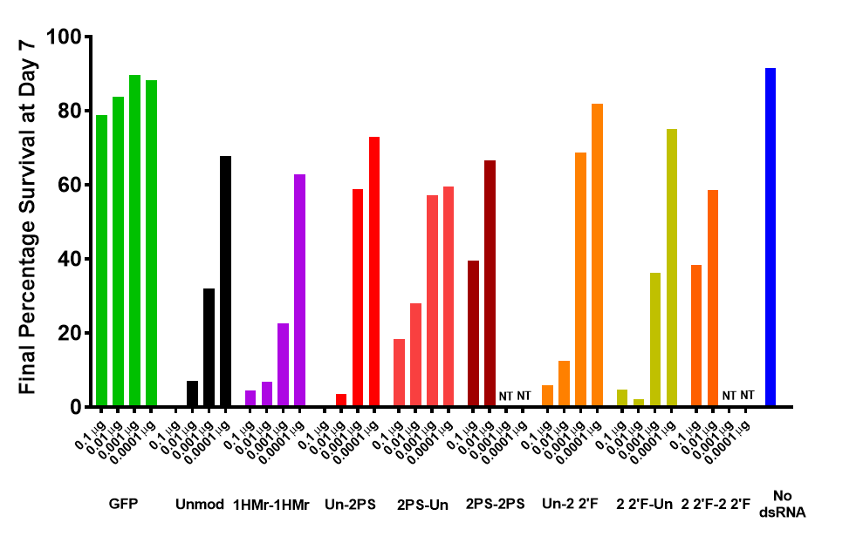

Figure 6.5 Summary of WCR survival feeding assay using chemically modified dsRNA (2).

Day 7 percentage survival summary data from the modified dsRNA WCR diet plate feeding assay in figure 6.4. Additional concentrations of GFP dsRNA also shown. GFP n = 50, 55, 47, 50. NT = “Not tested”.

dsRNAs were analysed at a concentration of 0.01 µg per well in both of the previous two screens, and the results are plotted together in figure 6.6. The RNAi efficacy of dsRNA with the 2’F modification in either the sense or antisense strand was similar to unmodified dsRNA, based on the results of the second screen. However, there was great variation in final day seven mortality between the two replicates for Un-2 2’F dsRNA, highlighting the semi-quantitative nature of the assay, and caution required when interpreting results. In contrast dsRNA with PS modifications in the guide strand resulted in reduced RNAi efficacy compared to phosphorothioate modifications in the passenger strand and unmodified dsRNA. These results together suggest that WCR RNAi machinery may be tolerant of some chemical modifications in only the guide or passenger strand, but more tolerant of other kinds of chemical modifications in either strand but not both.

The total amount of modifications in a dsRNA with both strands modified is approximately double that of a dsRNA with only one strand modified. However, the loss in RNAi efficacy from the presence of PS or 2’F modifications in both strands is not a summation of the effects of modifications in either strand alone. This suggests that the loss in RNAi efficacy may increase exponentially with the total amount of modifications in the dsRNA. This was investigated using PS modified dsRNA in section 6.3.3.4 below.

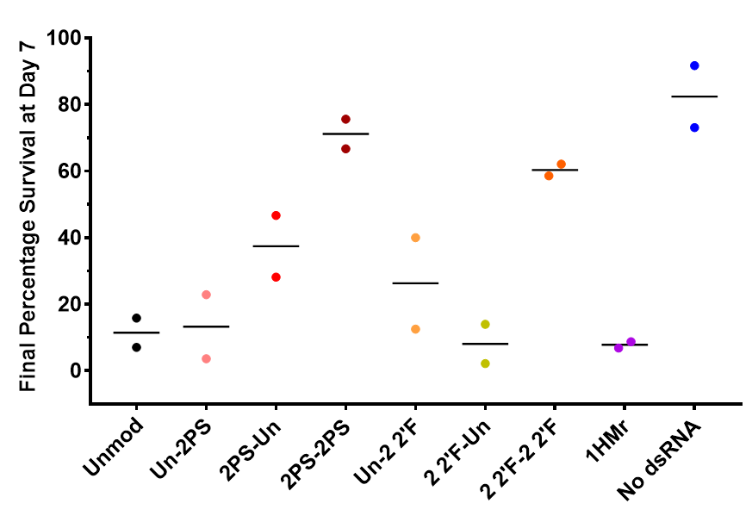

Figure 6.6 Overall summary of WCR survival feeding assays using chemically modified dsRNA.

WCR modified dsRNA plate feeding assay average of replicates of 0.01 µg from figures 6.3 and figure 6.5. Individual values are plotted along with mean. N =2, see figures 6.2 and 6.4 for n numbers of insects used in each replicate.

The results from the nuclease resistance assay in section 4.3.2.2 relating to 2’F modified dsRNA demonstrate a noted loss in nuclease resistance to stink bug salival nucleases upon inclusion of 2’F modifications in dsRNA compared to unmodified dsRNA. This led to the use of 2’F dsRNA in live insect assays being suspended, and the focus placed upon the more promising phosphorothioate modified dsRNAs, which have similar RNAi activity to 2’F dsRNA but show increased resistance to insect nucleases (section 4.3.2.2).

#### RNAi efficacy of 1PS and 2PS modified dsRNA using a WCR diet plate feeding assay

To further analyse the effects of PS modifications in a dsRNA molecule on RNAi efficacy, a varying number of α-thio NTPs were used during IVT reactions to generate dsRNA with varying number of PS linkages (see table 6.5). The total quantity of PS modifications in a dsRNA with a single nucleotide replaced by a phosphorothioate analogue throughout both strands (1PS-1PS) is likely to be approximately equal to the number of modifications in a dsRNA with two of the four nucleotides replaced by phosphorothioate analogues throughout only one strand (Un-2PS or 2PS-Un). Therefore analysis of a wider range of dsRNAs including Un-1PS, 1PS-Un and 1PS-1PS dsRNAs alongside the previously studied Un-2PS, 2PS-Un and 2PS-2PS dsRNAs (see table 6.5) in the WCR plate feeding assay would reveal more information about the RNAi efficacy of dsRNAs with a wider range of PS modifications.

Table 6.5 The list of unmodified and chemically modified dsRNAs used in the WCR diet feeding assay shown in figure 6.7.

|  |  |
| --- | --- |
| **dsRNA/Condition** | **Modification**  **(guide-passenger)** |
| Target B | Unmod |
| Un-1PS |
| 1PS-Un |
| 1PS-1PS |
| Un-2PS |
| 2PS-Un |
| 2PS-2PS |
| GFP | Unmod |
| No dsRNA | N/A |

For each dsRNA, 0.01 and 0.001 µg of dsRNA per well were used, in conjunction with GFP dsRNA and wells containing no dsRNA as controls. Once again half of a 48 well plate was dedicated per condition along with a whole plate of diet only control. WCR larvae were seeded onto the plates and mortality scored daily as described previously for seven days. Survival figures were again normalised to day one survival numbers as before in order to negate most of the non-RNAi mortality associated with mishandling of rootworms during plate seeding. Two replicate assays were performed. The first replicate was carried out by staff at Syngenta, Ghent, with dsRNA produced in Sheffield, and I carried out the second replicate.

The results are shown in figure 6.7 as final day 7 percentage survival, and in Appendix 2, figures A2.1 & A2.2 as full time courses. Replicates show good agreement on final day 7 percentage survival (figure 6.7), but demonstrate poor agreement on time points for some earlier days in the assay (Appendix 2, figures A2.1 & A2.2). Day 3 in particular showed wide variation between the two replicates, with RNAi-related mortality observed at this point for most dsRNAs in the first replicate, but not the second. Analysis of the results was therefore confined to the final average percentage survival on day 7 (see figure 6.7).

The results show that for both 1PS and 2PS dsRNAs, dsRNA with PS modifications in the passenger strand (Un-1PS, Un-2PS) showed increased RNAi activity compared to their respective counterparts with PS modifications in the guide strand (1PS-Un, 2PS-Un). However, only dsRNA with 1PS modifications in the passenger strand had similar RNAi efficacy compared to unmodified dsRNA; all other PS modified dsRNAs showed reduced RNAi efficacy compared to unmodified dsRNA. Furthermore, increasing the number of PS modifications in the sense strand resulted in reduced RNAi activity.

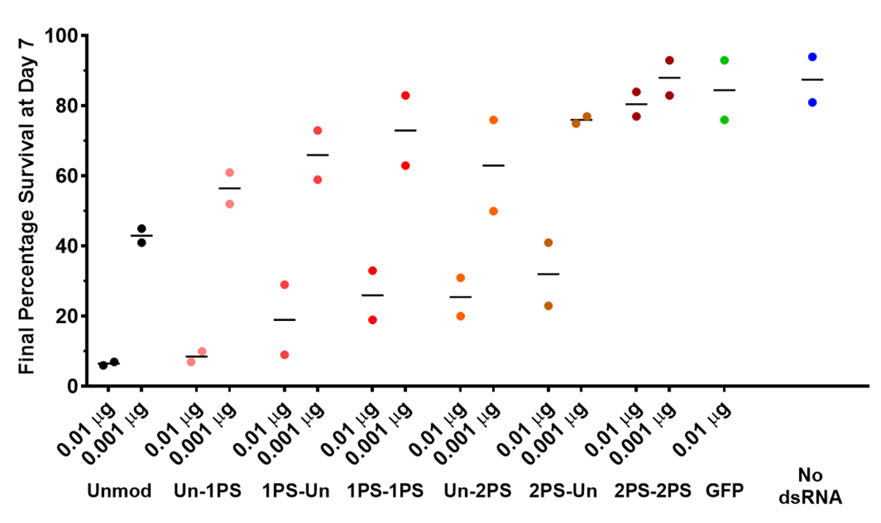

Figure 6.7 Summary of WCR survival feeding assay using 1PS and 2PS chemically modified dsRNA.

WCR 1PS & 2PS modified dsRNA plate feeding assay. The assay was repeated to give two replicate assays (N = 2). The day 7 survival results for the two sets of replicate results are plotted, with lines indicating the mean. The results of the two replicates are shown side by side as time courses in Appendix 2, figures A2.1 & A2.2, along with n numbers of insects used for each replicate.

2PS-2PS dsRNA was significantly less active than 2PS-Un dsRNA or any other targeting dsRNA, with activity being essentially lost for even the highest concentration of 0.01 µg per well. These results demonstrate a progressive decrease in RNAi activity due to the increasing number of PS modifications. The previous observations for 2PS modified dsRNA regarding the link between RNAi efficacy and which strand of the dsRNA contains PS modifications were also demonstrated to be true for 1PS modified dsRNA.

It was noted that the rank order of RNAi efficacy for the 2PS dsRNAs was the same as in the previous screens. However, the activity of the 2PS dsRNAs was lower compared to some previous experiments. For example, insects fed 0.01 µg per well of dsRNA with 2PS modifications in the passenger strand (Un-2PS) showed survival of around 20% and 30% in the two replicates from this experiment. The first screen had similar final insect survival of around 20% for this dsRNA concentration, however the replicate screen had insect survival of around only 5%. Un-2PS dsRNA also had moderately lower RNAi efficacy than unmodified dsRNA in this experiment, whereas previous experiments demonstrated approximately equivalent RNAi efficacy for Un-2PS and unmodified dsRNA. This suggests that some variation may occur between experiments, possibly due to factors such as slight variation in insect staging at the start of the experiment. Comparisons of survival figures between experiments should therefore be done cautiously, and comparisons within experiments are preferable, with comparisons between separate experiments being confined to the rank order of efficacy of the dsRNAs.

#### WCR soil feeding assay

Previous results in the WCR feeding screens conducted in diet plates, showed that although a number of phosphorothioate modified dsRNAs had similar RNAi efficacy compared to unmodified dsRNA, none demonstrated improved RNAi efficacy. Therefore, further experiments were performed to determine if the potential benefits in improved resistance of the PS modified dsRNA to environmental nucleases (based on improved resistance to insect nucleases demonstrated in section 4.3.2.2) impact on overall RNAi efficacy. As WCR larvae feed on the roots of corn plants, their feeding environment is the surrounding soil. Soil contains a variety of microorganisms, insects, and plant matter, all of which are sources of extra-cellular nucleases capable of degrading insecticidal dsRNA prior to it being ingested by the target insect. Protection against the activity of these nucleases by phosphorothioate modifications as seen for stink bug salival nucleases, could therefore ensure insecticidal phosphorothioate dsRNA would remain intact and active in the soil for a greater length of time compared to unmodified dsRNA.

In order to test the hypothesis that phosphorothioate dsRNAs would maintain their insecticidal activity in soil for longer than unmodified dsRNAs, unmodified and various phosphorothioate dsRNAs were tested in a soil feeding assay (see section 2.5.4). This assay involved the application of dsRNAs to a defined “live” soil containing naturally occurring live microorganisms, within which WCR larvae were then placed for around 24 hours. The larvae were then transferred to diet plates, and their mortality scored over the subsequent period of 7 days. The dsRNAs were also applied to a second set of soil samples at the start of the assay, which were then left to incubate at insect rearing conditions for 1 week. After the allotted time period, the soil in these plates was then seeded with WCR larvae, again for 24 hours, after which they were again transferred to diet plates (see section 2.5.3). The diet plate feeding assay had conclusively shown that phosphorothioate modifications in the guide (antisense) strand reduced the RNAi activity compared to unmodified dsRNA, and thus insecticidal activity of dsRNAs, therefore these dsRNAs were not used in this study. Modifications in both strands also reduced RNAi activity, however data from the stink bug salival nuclease stability assay indicated that modifications in both strands greatly increased nuclease stability compared to modifications in a single strand, or unmodified dsRNA (see section 4.3.2.2). dsRNAs with phosphorothioate modifications in both strands were therefore also used, as the increased stability of the dsRNA in the soil might be a greater contributing factor to overall insecticidal activity compared to any reduction of RNAi activity due to the chemical modifications. The list of dsRNAs tested in the assay is given in table 6.6.

Table 6.6 The list of unmodified and chemically modified dsRNAs used in the WCR soil feeding assay shown in figure 6.8.

|  |  |
| --- | --- |
| **dsRNA/Condition** | **Modification**  **(guide-passenger)** |
| Target B | Unmod |
| Un-1PS |
| 1PS-1PS |
| Un-2PS |
| 2PS-2PS |
| GFP | Unmod |
| No dsRNA | N/A |

The selected unmodified, 1PS and 2PS dsRNAs were analysed across a concentration range using 15, 5, 1.7 and 0.6 µg of dsRNA per soil sample. dsRNA was added to two soil samples for each concentration of each dsRNA.

The results are shown in figure 6.8 a-e as survival time courses, and summarised as final percentage survival in figure 6.8 f. The results demonstrate that for the week 0 time point dsRNAs at the lowest concentration of 0.6 µg per soil sample had no detectable insecticidal activity, with final day 7 mortality figures being similar to the negative control conditions. The highest concentration of 15 µg of dsRNA shows approximately equal survival at day 7 for unmodified dsRNA, dsRNA with 1PS or 2PS modifications in the passenger strand, and dsRNA with 1PS modifications in both strands, with reduced mortality for dsRNA with 2PS modifications in both strands. By day 7, mortality for Un-1PS dsRNA at concentrations of 5 µg per soil sample was similar to the mortality observed for the equivalent concentrations of unmodified dsRNA. The data for 1.7 µg of Un-1PS dsRNA shows a loss in activity compared to unmodified dsRNA, to the extent it demonstrated mortality figures that are comparable to the negative control conditions, whereas unmodified dsRNA retained some insecticidal activity for this concentration.

Un-2PS dsRNA also demonstrated similar insecticidal activity compared to unmodified dsRNA at 15 and 5 µg treatments, whilst again having lost almost all insecticidal activity for the 1.7 µg

Figure 6.8 WCR survival soil feeding assay using 1PS and 2PS chemically modified dsRNA.

WCR modified 1PS and 2PS dsRNA soil feeding assay, week 0 time point. WCR were left on soil containing dsRNA for 1 day, then transferred to diet plates and mortality measured until day 7. Number of insects used for each dsRNA concentration (L-R): No dsRNA n = 102; GFP dsRNA n = 117; Unmod n = 115, 119, 121, 112; Un-1PS n = 102, 116, 118, 113; 1PS-1PS n = 125, 116, 118, 113; Un-2PS n = 124, 114, 121, 116; 2PS-2PS n = 106, 121, 106, 120. (a) Survival timecourse for Unmod dsRNA. (b) Survival timecourse for Un-1PS dsRNA. (c) Survival timecourse for 1PS-1PS dsRNA. (d) Survival timecourse for Un-2PS dsRNA. (e) Survival timecourse for 2PS-2PS dsRNA. (f) Day 7 survival.

treatment. For 1PS dsRNA with modifications in both strands, the 15 and 5 µg treatments demonstrated a mild loss of insecticidal activity, and again the lower two concentrations demonstrated a full loss of activity. For 2PS dsRNA with modifications in both strands, all concentrations demonstrated a loss in activity compared to the other dsRNAs, with the lowest three concentrations losing activity entirely, and the 15 µg treatment only barely retaining insecticidal activity.

Overall ranking of the PS modified dsRNAs with 1PS and 2PS modifications in the passenger strand, and 2PS modifications in both strands, according to insecticidal activity – and therefore RNAi efficacy – is therefore virtually identical for the week 0 time point of this assay to that of the diet plate assay in section 6.3.3.3. However, dsRNA with 1PS modifications in both strands is less effective for RNAi than demonstrated in the plate assay in section 6.3.3.4 and has a different efficacy ranking than in that assay. Unmodified dsRNA has approximately equal RNAi activity to dsRNA with 1PS or 2PS modifications in the passenger strand at the highest two concentrations of 15 and 5 µg, which is in agreement with the feeding assay experiments in section 6.3.3.3, but not with the experiment in section 6.3.3.4.

Further experiments were performed where dsRNA was incubated with soil for 1 week prior to application of larvae. As all dsRNAs demonstrated no insecticidal activity at treatments of 0.6 µg for the week 0 time point, this concentration was not tested for activity with live insects at the week 1 time point. The assay for this time point therefore consisted of only 15, 5 and 1.7 µg treatments of each dsRNA.

The results are shown in Appendix 2, figure A2.3. The results demonstrated that no insecticidal activity remained for any of the dsRNAs tested at any concentration after incubation of the dsRNA in soil for 1 week. These results suggest that degradation of the dsRNA by nucleases in the soil had occurred, resulting in a loss of RNAi activity, though further studies are required to determine the stability of phosphorothioate dsRNA in soil compared to that of unmodified dsRNA. It is possible that at shorter timescales, some insecticidal activity may be retained for phosphorothioate dsRNA compared to unmodified dsRNA.

#### SGSB feeding mortality assay and supporting injection assay

It was previously shown that dsRNA containing PS modifications demonstrates increased resistance to nucleases present in stink bug saliva compared to unmodified dsRNA (see section 4.3.2.2). It was therefore hypothesised that the increased stability of the PS dsRNA (*in vitro*) may result in improved RNAi activity compared to unmodified dsRNA when ingested by stink bug. As the saliva assay demonstrated phosphorothioate-containing dsRNA was the only modified dsRNA more resistant to stink bug salival nucleases than unmodified dsRNA, this modification was selected for the stink bug feeding assays.

The corn rootworm feeding assays also suggest that, at least in that species, PS modifications in both strands reduce the RNAi activity of the dsRNA, therefore the two Target A dsRNAs with phosphorothioate modifications only in one strand (Un-2PS and 2PS-Un) were selected for testing in a stink bug feeding assay, as well as unmodified Target A dsRNA. The dsRNAs and conditions used in the assay are shown in table 6.7. GFP dsRNA was used as a non-targeting negative control, and sucrose solution without any dsRNA also used as a control.

Table 6.7 The list of unmodified and chemically modified dsRNAs used in the stink bug feeding assay shown in figure 6.9a.

|  |  |
| --- | --- |
| **dsRNA/Condition** | **Modification**  **(guide-passenger)** |
| Target A | Unmod |
| Un-2PS |
| 2PS-Un |
| GFP | Unmod |
| No dsRNA | N/A |

dsRNAs (0.5 µg/µl in 15 % w/v sucrose solution) were dispensed into a feeding sachet, and 16 N2 SGSB fed each of the conditions in a 96 well mesh bottom plate as previously described for saliva collection (see section 4.3.2.1). One insect each for the Unmodified dsRNA and sucrose conditions died during the course of day 0, reducing the total insects counted to 15 for these conditions.

After three days the insects were transferred to dishes containing runner beans, and initial mortality scored. Mortality was then scored from days 3 to 13 and survival percentages calculated. The results are shown in figure 6.9 a. The results show some initial mortality was observed for all groups of insects. However, mortality plateaued on day 6 of the assay, suggesting minimal mortality seen up to that point resulted from RNAi. The dsRNA concentration of 0.5 µg/µl may have been a factor, as an almost identical assay previously conducted by Syngenta, had seen mortality for a range of targets when the dsRNA solutions used were at a concentration of 1.0 µg/µl.

To aid production of modified dsRNA at a high enough yield to use 1.0 µg/µl in the feeding assay, several changes were made. A shorter dsRNA (Target C) was used to aid synthesis of dsRNA with phosphorothioate modifications. A wider range of modified dsRNAs was also selected, as detailed in table 6.8. Feeding on the dsRNA-sucrose solution was extended to four days.

Table 6.8 The list of unmodified and chemically modified dsRNAs used in the stink bug feeding assay shown in figures 6.9 b-e.

|  |  |
| --- | --- |
| **dsRNA/Condition** | **Modification**  **(guide-passenger)** |
| Target C | Unmod |
| Un-1PS |
| 1PS-1PS |
| Un-2PS |
| 2PS-2PS |
| GFP | Unmod |
| 2PS-2PS |
| No dsRNA | N/A |

The results of this feeding assay are shown in figure 6.9 b. The results highlight a number of potential issues with this assay, in particular the inability of the unmodified dsRNA to produce mortality significantly greater than control dsRNA. In addition, high mortality seen by day four for the 1PS-1PS and Un-2PS dsRNAs is significantly greater than typically observed for this assay. Therefore, further experiments were performed in order to investigate the issues with the assay.

A subset of the dsRNAs tested in the feeding assay, were analysed in a stink bug injection assay to determine their RNAi activity. An improved injection assay utilising a new micro-injection rig, allowed a more quantitative delivery of dsRNA, with 10 nl of 1.0 µg/µl dsRNA solution being delivered to each insect, resulting in a more precise study compared to the previous injection assay (see section 6.3.2). Insects were injected until there were approximately 30-40 insects that survived the injection process per dsRNA, and the data normalised to day one survival. The dsRNAs used in this study are shown in table 6.9, with the main aim of the assay to confirm and compare the activity of the unmodified and 1PS-1PS Target C dsRNAs used in the previous feeding assay.

Table 6.9 The list of unmodified and chemically modified dsRNAs used in the stink bug injection assay shown in figure 6.9 f.

|  |  |
| --- | --- |
| **dsRNA/Condition** | **Modification**  **(guide-passenger)** |
| Target C | Unmod |
| 1PS-1PS |
| GFP | Unmod |
| 2PS-2PS |
| No dsRNA | N/A |

The results are shown in figure 6.9 f. Both the unmodified and 1PS-1PS dsRNAs demonstrated high levels of RNAi activity, with unmodified dsRNA resulting in complete mortality. It is not clear why the same batch of unmodified dsRNA failed to produce a similar response in the previous feeding assay.

Figure 6.9 Stink bug survival feeding and injection assays using phosphorothioate modified dsRNA.

(a) Stink bug feeding assay survival timecourse. Second instar (N2) insects were fed for three days on a feeding sachet containing dsRNA at 0.5 µg/µl in 15% (w/v) sucrose solution, prior to transferral to feeding dishes, where mortality was measured until day 13. Unmod n = 15; Un-2PS n = 16; 2PS-Un n = 16; GFP n = 16; Sucrose n = 15. (b) Stink bug feeding assay survival timecourse. Second instar (N2) insects were fed for four days on a feeding sachet containing dsRNA at 1.0 µg/µl in 15% (w/v) sucrose solution, prior to transferral to feeding dishes, where mortality was measured until day 13. Unmod n = 32; Un-1PS n = 28; 1PS-1PS n = 32; Un-2PS n = 19; 2PS-2PS n = 30; GFP Unmod n = 32; GFP 2PS n = 19; Sucrose n = 32. (c) Stink bug feeding assay, comparison of percentage of insects showing evidence of feeding with percentage survival at day 4. Number of insects as in b. (d) Stink bug feeding assay, comparison of percentage of insects showing evidence of feeding with average amount of feeding per insect per condition, given by “Average feeding voracity” score. (e) Stink bug feeding assay, feeding voracity score for each insect in each condition, with average and SEM plotted. Number of insects as in b. (f) Stink bug injection assay using dsRNA samples from feeding assay. N2 insects were injected with 10 nl of dsRNA at 1.0 µg/µl, and mortality measured over 7 days and corrected to day 1 mortality. No dsRNA n = 29; GFP Unmod n = 37; GFP 2PS n = 37; Target C Unmod n = 37; Target C 1PS-1PS n = 39.

PS modified GFP dsRNA was also analysed to determine whether PS modifications were toxic to SGSB, which might explain the high levels of early mortality for PS dsRNAs in the feeding assay. Survival for insects injected with PS GFP dsRNA was above 80 % and therefore considered to be in the range of control mortality, suggesting PS modifications are not toxic to stink bugs (figure 6.9 f).

The plates used for the feeding assay were also examined. The dye in the dsRNA-sucrose solution was excreted by insects during their time feeding in the plate. The number of dye dots in each well as a result of feeding was counted as an estimate of the amount of feeding by insects in each condition. The feeding data is presented in figures 6.9 c-e.

The number of insects showing evidence of feeding is plotted alongside day four percentage survival in figure 6.9 c. The results show that for conditions with high levels of mortality, the percentage of insects showing evidence of feeding is higher than the percentage survival, suggesting many of the insects fed and the mortality is not due to starvation.

The data was also plotted as a “feeding voracity score” which represents the average number of dye dots per insect and is therefore an estimate of how much each insect fed. The number of insects showing evidence of feeding and the amount of feeding per insect positively correlate, as shown in figure 6.9 d. The insects also cluster together in their feeding behaviour, with insects fed on control dsRNA, no dsRNA or 2PS-2PS dsRNA (which was shown to have low insecticidal activity in the WCR plate feeding assay) showing higher amounts of feeding than the insects fed on targeting dsRNA (see figure 6.9 e). This may be a result of insects feeding on dsRNAs that exhibit high RNAi activity eating less as the RNAi effect begins to occur in the first few days and their health declines.

## Conclusions

In this Chapter I have used a range of chemically modified dsRNAs in conjunction with live insect feeding and injection assays to study their RNAi efficacy *in vivo*. The results from this chapter demonstrate that a wide range of chemically modified dsRNAs are active for RNAi in both western corn rootworm and stink bugs. Different levels of RNAi as measured by insect mortality were observed depending on the type of chemical modification, the number of chemical modifications in the dsRNA, and whether the modifications were present in the passenger strand, guide strand or in both strands of the dsRNA.

The first two WCR diet plate assay screens demonstrated that 1HMr dsRNA has equivalent RNAi efficacy to unmodified dsRNA. These results are in agreement with luciferase assay data (see section 5.3.4), which demonstrated 1HMr dsRNA had equivalent RNAi efficacy to unmodified dsRNA *in vitro* in *Drosophila* cells. This suggests that when only one base is replaced with a 5-hydroxymethyl analogue, the modification has no significant effect on dsRNA uptake or processing in insects.

2’-fluoro dsRNA with modifications in only one of the two strands was approximately equivalent in RNAi activity to unmodified dsRNA for both the WCR diet plate feeding assay and the stink bug injection assay. At certain concentrations, dsRNA with 2’F modifications in the passenger strand demonstrated a slight reduction in efficacy, though this was not consistent between experiments and at other concentrations. However, dsRNA with 2’F modifications in both strands demonstrated a consistent reduction in RNAi efficacy. This suggests that insect dsRNA uptake and RNAi machinery can compensate for changes in dsRNA shape or duplex stability caused by 2’F modifications when modifications are in only one strand, but cannot contend with 2’F modifications in both strands.

Phosphorothioate dsRNA showed a progressive loss of activity in WCR feeding assays when the modification content was increased from 1PS in one strand, through 1PS in both strands, to 2PS in one strand and finally 2PS in both strands, at which point almost all RNAi activity was lost. dsRNA with PS modifications in the guide strand was less effective for RNAi than dsRNA with PS modifications in the passenger strand. This rule held for 1PS and 2PS dsRNA. As the guide strand is the part of the dsRNA that eventually remains bound to Argonaute-2 to facilitate target mRNA recognition and binding, whereas the passenger strand is discarded, this result is not surprising. PS modifications in this strand may interfere to a greater extent with RISC assembly or mRNA binding than PS modifications in the passenger strand. dsRNAs with PS modifications in both strands were less effective again for RNAi. These rules were true for both the diet plate assay and the soil assay week 0 time point. dsRNA with 2PS modifications in either strand elicited equivalent RNAi knockdown to unmodified dsRNA in stink bugs when the dsRNA was injected, though the injection assay delivered a large overdose, and therefore at lower doses a difference in RNAi efficacy between the two dsRNAs may have been detected.

PS and 2’F modifications are located at different positions on the dsRNA backbone. 2’-fluoro groups are part of the ribose groups, whereas phosphorothioate modifications are part of the phosphate groups. Ribose and phosphate groups have different interactions with dsRNA uptake and processing machinery. Therefore, it is not altogether surprising that a dsRNA with PS modifications in one strand, and a dsRNA with 2’F modifications in the same strand will have different RNAi efficacies. For example, the RNase III domains of Dicer-2 cleave in a mechanism only involving the phosphate group, not the 2’-OH (or 2’F) group.

Some dsRNAs containing PS modifications were demonstrated to be effective for RNAi in insects by the WCR feeding and stink bug injection assays. It was also demonstrated that PS modifications were the only modification tested that increased dsRNA nuclease stability compared to unmodified dsRNA (see section 4.3.2.2). The dsRNAs containing PS modifications were therefore tested in a WCR soil feeding assay which deliberately introduced environmental degradation by soil nucleases as a factor in determining how effective the dsRNAs tested would be at inducing RNAi in insects. Previous studies have demonstrated that in various soil types, the majority of dsRNA is lost between 12 and 24 hours after application (Dubelman *et al.*, 2014). None of the phosphorothioate modified dsRNAs tested managed to extend the active life span of the dsRNA as an insecticide to 1 week, whereas current formulations under development are capable of extending the life span to this time point. It is possible that modified dsRNA might have greater stability to soil nucleases over a shorter time period, however this needs to be investigated further. The possible mild increase in stability due to the presence of RNA modifications might translate into a greater increase in stability when combined with an anti-nuclease formulation, though this would also require further experimentation to confirm or deny. If this could be demonstrated it would suggest insecticidal phosphorothioate dsRNA would remain intact and active in the soil for a greater length of time compared to unmodified dsRNA, thereby reducing the regularity of application required to maintain insecticidal activity in the treated plot. This would naturally be of great economic benefit to agriculturists.

In conclusion, the results show that a range of different chemically modified dsRNA resulted in efficient RNAi in southern green stink bugs and western corn rootworm using insect mortality assays. However, none of the chemically modified dsRNAs analysed showed an improvement in RNAi activity compared to unmodified dsRNA in the assays used. Clear distinctions in RNAi efficacy were observed depending on type, location, and quantity of chemical modifications present within the dsRNA. Therefore these results provide further mechanistic insight into the potential use of chemically modified dsRNA biopesticides.

Chapter 7

Conclusions and Further Work

# Conclusions and Future Work

**Conclusions**

dsRNA based biocontrols are emerging as a novel alternative to chemical pesticides for the control of crop pest insects (Baum *et al.*, 2007; Mao *et al.*, 2007; Petrick *et al.*, 2016). However, there are differences in RNAi efficacy between different insect orders and species due to variation in factors such as insect nuclease potency and upregulation (Guan *et al.*, 2018), physiological pH (Shukla *et al.*, 2016b), and dsRNA uptake and subsequent intracellular transport (Shukla *et al.*, 2016b). Resistance of dsRNA to degrading nucleases (Spit *et al.*, 2017b; Peng *et al.*, 2018), and successful processing of dsRNA by the insect Dicer-2 nuclease (Lee, Nakahara, John W. Pham, *et al.*, 2004) are key factors that also affect the efficacy of dsRNA based biocontrols.

The aim of this project was to synthesise a range of chemically modified dsRNAs and study the effects of these chemical modifications on nuclease activity and the RNAi efficacy both *in vitro* and *in vivo* in insects. This was with a view to using chemical modifications to improve the efficacy of dsRNA biocontrols. The results obtained during this project have demonstrated that long chemically modified dsRNAs which target insect mRNAs were successfully synthesised *in vitro* and purified (chapter 3). Furthermore, a number of the chemically modified dsRNAs resulted in altered resistance of the dsRNA to insect nucleases and altered ability to act as substrates for RNase III/Dicer enzymes compared to unmodified dsRNA (chapter 4). For the first time I have demonstrated that chemically modified dsRNAs are effective triggers for RNAi in a *Drosophila* (Diptera) insect cell line (Kc167 cells) (chapter 5), live southern green stink bug nymphs (Hemiptera) (chapter 6), and live western corn rootworm (WCR) larvae (Coleoptera) (chapter 6). The results also demonstrate that in the cell based assay, several of the chemically modified dsRNAs demonstrated improved RNAi activity compared to unmodified dsRNA, including 1PS, 2PS and 1 2’F modified dsRNAs. In addition, I have demonstrated for the first time the successful application of chemically modified dsRNA in live insect assays, where chemically modified dsRNAs induced RNAi, resulting in the mortality of the insects.

A range of phosphorothioate-containing dsRNAs were synthesised successfully by *in vitro* transcription (IVT) using T7 RNA polymerase, in sufficient quantities to use for a range of RNAi assays in insect cells and live insects. Initial studies demonstrated that phosphorothioate dsRNA demonstrated increased resistance against stink bug salival nucleases compared to unmodified dsRNA. These results for the first time demonstrate the ability to improve the stability of dsRNA biocontrols towards insect nucleases using phosphorothioate modifications. These results are in agreement with literature demonstrating increased resistance of phosphorothioate siRNAs to degradation by mammalian nucleases (Chiu and Rana, 2003).

The dsRNAs with either one (1PS) or two (2PS) of the four nucleotides replaced throughout both strands by a phosphorothioate analogue demonstrated improved mRNA knockdown compared to unmodified dsRNA in insect cells. In a live WCR larvae system, RNAi activity of 1PS dsRNA was approximately equal to that of unmodified dsRNA. However, 2PS dsRNA demonstrated a reduction in RNAi activity, resulting in almost total loss of observable RNAi-related mortality in WCR. This was despite 2PS dsRNA demonstrating increased resistance to insect nucleases. These findings were unexpected given the improved RNAi efficacy observed in *Drosophila* Kc167 cells and the increased resistance observed to insect nucleases as shown with the stink bug salival nucleases. Slightly higher activity was retained by 2PS dsRNA in assays where larvae and the dsRNA were incubated in soil, possibly as a result of increased nuclease resistance of the dsRNA to nucleases in the soil resulting in a higher final dose of 2PS dsRNA in the cells of the insect than unmodified dsRNAs or other dsRNAs with lower phosphorothioate contents.

However the results obtained also showed that phosphorothioate dsRNA (2PS) also acted as a poor substrate for a model *Giardia* Dicer, and may or may not also be a poor substrate for bacterial RNase III, which belongs to the same family of enzymes as Dicer. In contrast, the results from insect cell RNAi assays suggest that 2PS dsRNA is a good substrate for *Drosophila* Dicer-2, though this needs confirming experimentally.

The reduced RNAi efficacy of 2PS dsRNA in live insects may be due to the phosphorothioate modifications affecting a variety of factors such as cellular uptake, endosomal escape, Dicer-2 processing, or RISC assembly. It is unlikely to be related to background nuclease degradation as phosphorothioate dsRNA demonstrated increased resistance to degradation by insect nucleases. The most obvious explanation in conjunction with the *in vitro* RNase III/Dicer assays, which showed that the 2PS dsRNA is not processed efficiently to endoribonucleas-prepared siRNAs (esiRNAs) by some RNase III family enzymes, would be that WCR Dicer-2 is unable to process the 2PS dsRNA to siRNAs *in vivo*. However, results from insect cell RNAi assays suggest that 2PS dsRNA is a good substrate for *Drosophila* Dicer-2, though further experiments need to be performed to confirm this. While all insect Dicer-2 enzymes have the same basic domain architecture and many key residues are conserved, structural sections of Dicer proteins vary between different insect species (Singh *et al.*, 2017; Davis-Vogel *et al.*, 2018). WCR (*Diabrotica virgifera virgifera*) Dicer-2 is shorter than *Drosophila melanogaster* Dicer-2, and in particular has shorter RNase III domains and a shorter dsRNA binding domain (dsRBD) (Davis-Vogel *et al.*, 2018). These differences could result in WCR Dicer-2 being incapable of processing chemically modified dsRNA substrates which *Drosophila* Dicer-2 is capable of processing.

Further experiments using phosphorothioate modifications present in only the guide strand or passenger strand have provided further mechanistic insight into how insect RNAi machinery processes chemically modified dsRNAs. Phosphorothioate modifications in the guide strand alone (either 1PS-Un or 2PS-Un) also reduced RNAi efficacy in live insects compared to the equivalent level of chemical modification in the passenger strand alone (Un-1PS or Un-2PS). The reduction in RNAi efficacy for 2PS-Un dsRNA, for example, but not Un-2PS dsRNA in WCR suggests an issue related to RISC assembly, discarding of the passenger strand, and subsequent use of the guide strand to bind the mRNA target. This is in agreement with previous literature where mammalian RNAi machinery has demonstrated preferences for chemical modifications in one strand of an siRNA compared to the other, with siRNAs containing chemical modifications in the passenger strand usually demonstrating greater RNAi efficacy than those with chemical modifications in the guide strand (Kraynack and Baker, 2006; Nicholas M Snead *et al.*, 2013). An issue with Dicer-2 processing of phosphorothioate dsRNA may also contribute to reduced RNAi efficacy, which may explain why – for example – 2PS dsRNA (2PS-2PS) is less efficacious then 2PS-Un dsRNA.

There is clearly a difference in how phosphorothioate dsRNA modifications affect Dicer-2 processing and/or RISC assembly between insect orders as efficient RNAi is achieved using 2PS-2PS (2PS) dsRNA in *Drosophila* cells. dsRNA uptake may also be affected in different ways by chemically modified dsRNA between insect orders, or between a cell-based system and a live insect system. Further work is required to establish the reason for the difference in RNAi efficacy of phosphorothioate dsRNA between *Drosophila* cells and WCR larvae. However, the results obtained here suggest examining Dicer-2 processing and RISC assembly of the two species with chemically modified dsRNA *in vitro*, along with other additional assays may elucidate the mechanistic reason for the differences observed.

Significant optimisation of the IVT reactions was performed to successfully synthesise a range of 2’-fluoro modified dsRNAs. This process required the use of a mutant T7 polymerase, and the separate production of the constituent ssRNAs followed by annealing to form dsRNA. In this study successful RNAi using 2’-fluoro modified dsRNA was demonstrated in an insect system for the first time. dsRNA with one (1 2’F) of the four nucleotides replaced throughout both strands by a 2’-fluoro analogue demonstrated improved mRNA knockdown compared to unmodified dsRNA in *Drosophila* cells. dsRNA with two (2 2’F) of the four nucleotides replaced throughout both strands by a 2’-fluoro analogue also successfully induced RNAi in *Drosophila* cells, though demonstrated no significant improvement in RNAi efficacy compared to unmodified dsRNA.

In contrast however, 2 2’F dsRNA demonstrated poor RNAi efficacy in WCR larvae. 2’-Fluoro dsRNA (both 2 2’F-2 2’F and Un-2 2’F) also demonstrated reduced resistance to degradation by insect nucleases compared to unmodified dsRNA. This was unexpected given the improved nuclease resistance observed for 2’-fluoro dsRNA against mammalian nucleases (Chiu and Rana, 2003). This suggested reduced nuclease activity may have contributed to loss of RNAi activity. However, previous results were obtained from the use of stink bug nucleases, not WCR nucleases, therefore variation in nuclease structure and activity between species might result in differences in resistance of the same chemically modified dsRNA to nucleases from different species. However, further experiments with dsRNA containing 2’-fluoro modifications in only the passenger strand or the guide strand (Un-2 2’F and 2 2’F-Un) again offered further mechanistic insight, discounting this explanation.

Un-2 2’F and 2 2’F-Un dsRNAs both successfully induced RNAi in WCR larvae, with no significant difference in RNAi efficacy compared to unmodified dsRNA regardless of which strand the chemical modifications were in. This demonstrated that some 2’-fluoro-containing dsRNAs are capable of inducing RNAi in WCR, in agreement with literature for mammalian and *C. elegans* systems (Parrish *et al.*, 2000; Chiu and Rana, 2003).

The great difference in RNAi efficacy in WCR between dsRNA with 2’fluoro in only one strand, and dsRNA with 2’-fluoro modifications in both strands, may also be due to differences in Dicer-2 processing or RISC assembly. Additional *in vitro* assays examining the processing of 2 2’F dsRNA by bacterial RNase III and *Giardia* Dicer demonstrated 2 2’F dsRNA was successfully processed to siRNAs by RNase III, but not by *Giardia* Dicer, which both cut dsRNA via the same mechanism, but bind via different mechanisms. RNase III binds dsRNA with a dsRBD. *Giardia* Dicer binds via a PAZ domain, which binds the single-stranded 3’ overhang of dsRNA. This would tend to suggest that 2’-fluoro modifications may interfere with binding of dsRNA to PAZ domains present in both Dicer and Argonaute proteins in the RNAi pathway in insects. However, if Dicer-2 cannot bind a dsRNA terminus with its PAZ domain and is forced to bind internally using the dsRBD, processing of the dsRNA to siRNAs is greatly reduced (Hammond, 2005). As 2 2’F dsRNA was clearly processed successfully in *Drosophila* cells, the PAZ domain of *Drosophila* Dicer-2 must be able to bind 2 2’F dsRNA.

2’-Fluoro modifications may result in more general changes to dsRNA conformation or thermodynamics that affect Dicer and Argonaute binding. 2’-Fluoro modifications are known to improve base stacking in RNA (Patra *et al.*, 2012). Whilst 2’-fluoro modifications have negligible effects on the conformation of the dsRNA helix (Pallan *et al.*, 2011), they significantly increase duplex stability, as well as reducing hydration of the duplex (Pallan *et al.*, 2011). Changes in duplex stability may affect passenger strand unwinding and discarding during RISC formation. Argonaute-2 in some species may be able to overcome the increased duplex stability while in others it may not, again due to differences in Argonaute-2 structure and size between insect species (Davis-Vogel *et al.*, 2018). This may explain why 2 2’F dsRNA successfully induced RNAi in *Drosophila* cells but not in WCR larvae. Conversely, changes in duplex hydration may affect processing by some Dicer enzymes as binding and cleavage of dsRNA by RNase III/Dicer enzymes involves interactions with a large number of water molecules (Gan *et al.*, 2006). *Drosophila* Dicer-2 and bacterial RNase III can both successfully cleave 2 2’F dsRNA, whereas Giardia Dicer cannot. This supports the idea that some RNase III/Dicer family enzymes can process 2’-fluoro dsRNA, while others cannot. This may be due to differences in Dicer-2 binding and cleavage due to differences in hydration of the dsRNA, which may also explain why some 2 2’F dsRNA has reduced RNAi efficacy in WCR.

As with phosphorothioate dsRNA, dsRNA uptake may also be affected in different ways by different amounts of 2’-fluoro modifications between insect orders, or between a cell-based system and a live insect system. Further assays examining differences in Dicer-2 processing and RISC assembly with 2’-fluoro dsRNA between *Drosophila* and WCR would offer further insight into the origin of differences in RNAi efficacy of 2’-fluoro dsRNA between different insect species.

dsRNA with 5-hydroxymethyl modifications was also synthesised by IVT for use in insect RNAi assays, using T7 RNA polymerase. 5-Hydroxymethyl dsRNA (1HMr) demonstrated no increase in resistance to insect salival nucleases compared to unmodified dsRNA. RNAi using 5-hydroxymethyl modified dsRNA was subsequently demonstrated in an insect system for the first time. dsRNA with 1HMr modifications in both strands demonstrated RNAi efficacy equal to unmodified dsRNA in both *Drosophila* cells and WCR larvae. dsRNA with 2HMr modifications in both strands was also tested for RNAi activity in the cell culture model, and was found to have reduced RNAi activity.

There is evidence that while 5-methyl modifications increase the thermal stability of duplex nucleic acids, 5-hydroxymethyl modifications moderately reduce the thermal stability of duplex nucleic acids compared to unmodified nucleic acids (Thalhammer *et al.*, 2011; Xuan *et al.*, 2015), therefore the 5-hydroxymethyl modification may affect the unwinding and discarding of the passenger strand, or reduce the strength of binding between the ss-si-RISC and the target mRNA. This effect will increase with increasing numbers of 5-hydroxymethyl modifications, which may explain why in both *Drosophila* cells and WCR 1HMr dsRNA was effective for RNAi, whereas 2HMr dsRNA had a significantly different duplex stability which resulted in reduced RNAi activity as observed in *Drosophila* cells.

2HMr dsRNA may also have reduced RNAi efficacy in *Drosophila* cells due to issues with Dicer-2 processing or RISC assembly, as discussed for phosphorothioate and 2’-fluoro dsRNA. The RNAi efficacy of dsRNA with 5-hydroxymethyl modifications in only one strand or the other was not examined. Further RNAi assays with dsRNA containing 5-hydroxymethyl modifications in only one strand could offer insight into possible reasons for the reduced RNAi efficacy of 2HMr dsRNA in *Drosophila* cells. *In vitro* assays examining the processing of 1HMr dsRNA by bacterial RNase III and *Giardia* Dicer determined that 1HMr dsRNA was successfully processed by bacterial RNase III but not by *Giardia* Dicer, which may again indicate that 5-hydroxymethyl modifications affect Dicer processing in different ways between different species.

It is possible that the increased number of dsRNA transport steps between cells required for a potent RNAi effect in live insects is responsible for the difference in RNAi efficacy seen for some chemically modified dsRNAs between insect cells and live insects. A slight reduction in the ability of cells to uptake and transport a chemically modified dsRNA as a result of the altered chemistry, may have little effect in cell culture where there is only a single uptake step from the culture media to the cell cytoplasm. However, the repeated uptake events, intercellular transport and crossing of barriers required for a systemic effect in live insects may amplify the potential reduced ability of chemically modified dsRNA to be uptaken and trafficked by cells, resulting in a significant difference in the final RNAi efficacy across the whole insect. It is known that in cultured *Drosophila* cells, transport of dsRNA occurs between cells through microtubules (Karlikow *et al.*, 2016) or extracellular vesicles (Tassetto, Kunitomi and Andino, 2017). If these mechanisms occur in other insect species, and particularly if they occur in live insects is unknown (Vogel *et al.*, 2019). Endosomal escape of uptaken unmodified dsRNA is not thought to be an issue in Coleoptera (Shukla *et al.*, 2016b). However, there is evidence that PS siRNAs accumulate in the nucleus in mammalian systems (Braasch *et al.*, 2003), and therefore chemically modified dsRNAs may also accumulate in subcellular compartments in insect cells. How chemical modifications might affect endosomal escape and intracellular transport in insect systems requires further studies.

In summary, chemically modified dsRNAs including phosphorothioate, 2’-fluoro and 5-hydroxymethyl dsRNAs were successfully synthesised. All of the chemically modified dsRNAs tested demonstrated RNAi activity in *Drosophila* cells. Some chemically modified dsRNAs had improved RNAi efficacy in this system compared to unmodified dsRNA, however others had reduced efficacy. Many of the chemically modified dsRNAs tested in live WCR larvae also induced RNAi, however 2PS and 2 2’F modified dsRNAs that were highly efficacious in *Drosophila* cells had very low RNAi activity in WCR larvae.

In conclusion, chemically modified dsRNAs can be used to induce RNAi in insect cells and live insects, with some chemical modifications resulting in increased RNAi efficacy. This has applications for improving the activity of dsRNA based biocontrols, or improving mRNA knockdown in insect cell lines or live insects in lab settings. Further work is required in order to determine how chemically modified dsRNAs result in different RNAi efficacies in different insect species, or between cell-based and live insect systems, and which steps of the dsRNA uptake, trafficking and RNAi systems in insects are responsible for the differences observed. These additional insights could help in the potential future use of chemically modified dsRNA as an RNA based biocontrol. Knowledge of the RNAi efficacy of dsRNA with specific chemical modifications in specific insect species or environments (e.g. soil, leaves, fields, glass houses), would allow the optimisation of dsRNA based biocontrols to minimise dsRNA degradation, and maximise nuclease resistance and RNAi efficacy based on the specific target insect and application location. Improvements to the stability and efficacy of a dsRNA based biocontrol would potentially reduce the effective dose required, and increase the life of the biocontrol in the field. This would reduce the cost of dsRNA based biocontrols for agriculturalists, potentially leading to more widespread use of this more selective technology as an alternative to current small molecule insecticides.

**Further Work**

Luciferase assays in *Drosophila* cells demonstrated the increased efficacy of some phosphorothioate and 2’-fluoro-containing dsRNAs which implies *Drosophila* Dicer-2 and RISC can process these chemically modified dsRNAs. Additionally, nuclease degradation studies demonstrated that phosphorothioate dsRNA had increased resistance to insect salival nucleases compared to unmodified dsRNA. However, 2PS-2PS dsRNA demonstrated poor RNAi efficacy in a whole insect WCR larvae system. Further assays are required to determine if these differences are a result of RISC assembly, Dicer-2 processing, differences in these factors between the systems due to the difference in insect orders between Kc167 cells (diptera) and WCR larvae (coleoptera). In addition to RNAi assays in Kc167 cells, RNAi experiments in a Coleopteran cell line would determine if the reduced RNAi efficacy of some chemically modified dsRNAs in WCR was related to the difference in insect order, or was due to a difference between cell culture models and live insects. A Coleopteran Colorado potato beetle cell line Lepd-SL1 is available, and has previously been used for dual luciferase assays (Ogura *et al.*, 2012). Use of this cell line for luciferase assays as performed in Kc167 cells previously, would allow a direct comparison of RNAi efficacy of chemically modified dsRNA in cell lines of different insect orders.

RNAi assays in WCR larvae with chemically modified dsRNA with modifications in only the guide or passenger strand, demonstrated a difference in RNAi efficacy depending on which strand the modifications were located in. dsRNAs with chemical modifications in only one strand were not tested in *Drosophila* cell experiments. Additional luciferase assays with Un-2PS, 2PS-Un, Un-2 2’F and 2 2’F-Un dsRNAs in both Kc167 and Lepd-SL1 cells would add additional information about the differences in RNAi efficacy between different insect orders depending on which strand of a dsRNA chemical modifications are incorporated in. dsRNA with 5-hydroxymethyl modifications in only one strand or the other was also not tested for differences in RNAi efficacy in either *Drosophila* cells or live WCR larvae. Performing additional assays with dsRNA containing 5-hydroxymethyl modifications in only one strand or the other using the previous luciferase assay and feeding assay methodologies, would determine if this chemical modification also results in different RNAi efficacies depending on which strand the chemical modification is in.

2HMr dsRNA was also not tested in WCR larvae, and whether the results in live insects would be identical to those in insect cells – where 2HMr demonstrated reduced RNAi efficacy compared to unmodified dsRNA – would also add further information on potential differences between insect cell and live insect systems.

Several of the chemically modified dsRNAs which RNase III or *Giardia* Dicer failed to cleave into esiRNAs, successfully induced RNAi in *Drosophila* cells, live WCR, or both. Therefore these results suggest that these chemically modified dsRNAs are effectively processed by some insect Dicer-2 enzymes *in vivo*. It is therefore likely that results obtained on the processing of dsRNA by RNase III and *Giardia* Dicer *in vitro* are not comparable to insect Dicer-2. Dicer-2 processing assays have previously been conducted using *Drosophila* cell lysate (Haley, Tang and Zamore, 2003), and similar assays could be conducted with lysates of both *Drosophila* Kc167 cells and Colorado potato beetle Lepd-SL1 cells in order to examine the difference in Dicer-2 processing of chemically modified dsRNAs between different insect orders. Incubation of unmodified and chemically modified dsRNA in insect cell lysate with background nuclease activity inhibited, but retaining Dicer-2 activity, followed by analysis of the reaction mixtures by gel electrophoresis would indicate whether or not the respective insect Dicer-2 enzymes were capable of processing the chemically modified dsRNAs. Alternatively, recombinant insect Dicer-2 could be expressed in insect cells, and purified for use in similar *in vitro* assays.

Similarly, *in vitro* RISC assembly and target mRNA cleavage assays have previously been performed in *Drosophila* cell lysate (Kim, Lee and Carthew, 2007). Incubation of unmodified and chemically modified siRNAs in insect cell lysate, followed by a gel shift assay would indicate whether insect Argonaute-2/RISC components are capable of forming RISCs with chemically modified siRNAs, and if there are differences between insect orders. Additional incubation of a target mRNA, followed by quantification of intact target mRNA would indicate if the RISCs formed with chemically modified siRNAs were active for RNAi.

While assays involving model RNase III/Dicer enzymes such as bacterial RNase III or *Giardia* Dicer may not produce results comparable to insect Dicer-2, the differences in the ability of the two enzymes to process different chemically modified dsRNAs might give insights on other systems. Whether the RNase III domain failing to cleave phosphorothioate linkages in dsRNA, or both dsRBD and PAZ domains being unable to bind phosphorothioate dsRNA is the reason for phosphorothioate dsRNA being resistant to both RNase III and *Giardia* Dicer is unclear. However, truncated RNase III enzymes with no dsRBD, consisting of only the RNase III domain itself, are catalytically active (Redko, Bechhofer and Condon, 2008) and use of this “Mini-III” enzyme may shed light on this. Incubation of RNase III with phosphorothioate dsRNA also produced conflicting results regarding whether phosphorothioate dsRNA is a good RNase III substrate or not, and this requires further investigation with a variety of dsRNA substrates containing various levels of phosphorothioate modification. Human Dicer is also similar in structure to insect Dicer-2 and the ability of human Dicer to process chemically modified dsRNAs may give some indication of how insect Dicer-2 will process chemically modified dsRNAs, as well as being of general interest. Additional assays examining the ability of RNase III and *Giardia* Dicer to process dsRNA with chemical modifications in only one strand, may also clarify if differences in Dicer-2 processing are responsible for the differences in RNAi efficacy observed in WCR for dsRNAs with chemical modifications in the guide strand, passenger strand, or both.

The A-form helix structure of dsRNA is important for the recognition and successful processing of dsRNA by several RNAi pathway proteins (Li and Rana, 2012). Nanoscale atomic force microscopy (AFM) has recently been used in order to analyse dsRNA (Ares *et al.*, 2016) and DNA, allowing structures such as the major and minor grooves to be detected (Pang, Thierry and Dritschilo, 2015). AFM could potentially be used to determine if chemically modified dsRNA demonstrated any conformational shifts which might affect the ability of RNAi pathway proteins to process.

Combining the results already obtained with the suggested further experiments outlined above for both Kc167 and Lepd-SL1 cells, will allow greater insight into why differences in RNAi efficacy were observed for the same chemically modified dsRNA between *Drosophila* cells and WCR larvae. The results of the additional assays will be particularly useful in determining if differences in RNAi efficacy are due to insect order, or differences between cell culture models and live insects. *In vitro* Dicer-2 processing, RISC assembly, and RISC target mRNA cleavage assays would effectively allow each major step of the RNAi process to be studied in isolation, in order to determine which of these processes different chemically modified dsRNAs can successfully participate in in different insect orders.

Intracellular trafficking of dsRNAs between uptake and entry into the RNAi pathway may also be affected by chemical modifications. Assays using chemically modified dsRNA containing additional fluorescent tags could potentially be used in conjunction with fluorescence microscopy and molecular biology approaches to track the progress of chemically modified dsRNA to different sub-cellular compartments, and determine if the dsRNA is able to escape the endocytic trafficking system prior to lysosomal degradation, in order to enter the RNAi pathway (Dominska and Dykxhoorn, 2010).

In luciferase assays in insect cells, low concentrations of targeting dsRNA or the presence of non-targeting dsRNA, appeared to sometimes increase the intensity of the firefly luciferase reporter fluorescence, above the amount expected for no mRNA knockdown. It is known that RNAi-related genes are upregulated in response to dsRNA in insect cells (Garbutt and Reynolds, 2012). It is possible there is some sort of more general upregulation that occurs as a result of the presence of dsRNA, which leads to the increase in the reporter protein level. This could be investigated by comparing the RNAi effect observed over time for low concentrations of both targeting and non-targeting dsRNA. Alternatively this effect may be an artefact of insect cell based systems that is irrelevant for live insects. However, determining if this is the case may help to rule out this and similar artefacts when comparing results from insect cell culture assays to live insect assays.

A major aspect of improving the efficacy of dsRNA base biocontrols is increasing dsRNA resistance to degradation by insect and environmental nucleases. Results obtained here indicate that phosphorothioate dsRNA is more resistant to stink bug nucleases than unmodified dsRNAs, whilst 2’-fluoro dsRNA is less resistant to these nucleases than unmodified dsRNA. Further experiments into the resistance of different chemically modified dsRNAs to nucleases from a greater variety of insect species, as well as nucleases from different insect body fluids such as gut secretions and hemolymph, might indicate in which insect species certain dsRNA chemical modifications might have the greatest impact on RNAi efficacy.

Environmental factors such as degradation of dsRNA by soil nucleases and UV radiation from the sun may also be affected by dsRNA chemical modifications. Both stability of dsRNA in soil (Dubelman *et al.*, 2014) and UV degradation of dsRNA (San Miguel and Scott, 2015) have previously been investigated with unmodified dsRNA, and are factors which may affect the efficacy of a dsRNA based biocontrol in the field. Incubation of unmodified and chemically modified dsRNAs in soil, or in water contaminated with soil nucleases, followed by gel electrophoresis analysis would allow comparison of the effects of chemical modifications on dsRNA stability to nucleases in soil. Exposure of unmodified and chemically modified dsRNAs to UV radiation using a UV crosslinker, followed by gel electrophoresis analysis would allow comparison of the effects of chemical modifications on stability of dsRNA to UV radiation.

As PS modified dsRNA showed increased nuclease resistance to stink bug salival nucleases compared to unmodified dsRNA, there is the possibility that feeding of PS dsRNA to stink bugs might result in an increased RNAi effect and increased mortality compared to unmodified dsRNA. As the feeding assays attempted using PS modified dsRNA were unsuccessful, this remains to be fully tested, and is a priority for future work.

There is also the possibility that modified dsRNA might show improved stability and therefore improved RNAi activity over a shorter time scale than that tested in the WCR soil feeding assay. There is also the possibility that a formulation in conjunction with PS modifications could improve the stability and active lifetime of dsRNA in soil, though this would likely only be to a small degree and would not be industrially relevant.

Finally, the effects of other chemical modifications on RNAi efficacy in insects could also be examined using luciferase assays, live insect feeding assays, nuclease assays and *in vitro* assays previously described. Potential modifications for consideration include 2’-O-Me, locked nucleic acid (LNA), unlocked nucleic acid (UNA), as well as greater amounts of previously investigated chemical modifications, such as 3PS, 4PS, 3 2’F etc (Campbell and Wengel, 2011; Chang *et al.*, 2016b; Iribe *et al.*, 2017; Shen and Corey, 2018a).

# Appendix 1

**Figure A1.1 Optimisation of luciferase assays for *in vitro* analysis of the effects of chemically modified dsRNA on RNAi in insect cells.**

Luciferase assay results for optimisation of assay conditions using the Promega dual luciferase assay kit. Results are dose curves for unmodified FLuc dsRNA under various assay conditions. RNAi knockdown of a firefly luciferase reporter by FLuc dsRNA, is presented as ratios of firefly luciferase luminescence intensity (FL) to *Renilla* luciferase luminescence intensity (RL) normalised against FL/RL values for control conditions with no dsRNA. Greater loss of fluorescence correlates to greater levels of RNAi knockdown.(a & b) 0.25, 0.5, 5, 10, 20, 40 and 80 ng of dsRNA tested. n = 4 (c & d) 0.01, 0.1, 1, 10, 100, and 1,000 ng of dsRNA tested. n = 6 (a) Black plates, 1:4 luciferase assay reagent dilution, 3 day incubation. (b) White plates, 1:10 luciferase assay reagent dilution, 3 day incubation. (c) White plates, 1:2 luciferase assay reagent dilution, 4 day incubation, plate spin before media aspiration and cell lysis step. (d) White plates, 1:10 luciferase assay reagent dilution, 3 day incubation, plate spin before media aspiration and cell lysis step.

Mean and SEM plotted for all graphs.

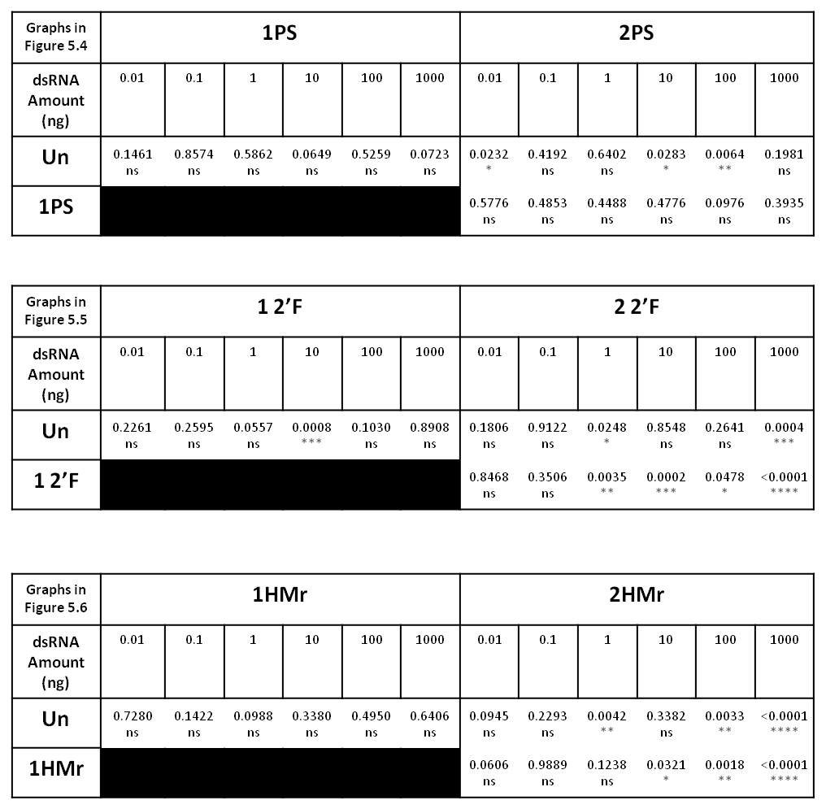

**Figure A1.2** Tables of all P values from T-tests for PS, 2’F and HMr dsRNA screening luciferase assays (figures 5.4-5.6).

Stars denote significance as calculated by unpaired T-tests. ns = P > 0.05, * = P ≤ 0.05, ** = P ≤ 0.01, *** = P ≤ 0.001, **** = P ≤ 0.0001.

**Figure A1.3 Variation of standard error of the mean (SEM) of normalised FL/RL values with concentration for unmodified and chemically modified dsRNAs.**

Variation of standard error of the mean (SEM) of normalised FL/RL values across the dsRNA concentration range for the luciferase assays screening PS, 2’F and HMr dsRNAs. Results are presented as SEM of FL/RL values for dsRNAs normalised against FL/RL values for control conditions with no dsRNA. (a) SEM for unmodified, 1PS and 2PS dsRNA. (b) SEM for unmodified, 1 2’F and 2 2’F dsRNA. (c) SEM for unmodified, 1HMr and 2HMr dsRNA. In all graphs, per combination of concentration and dsRNA n = 6.

**Figure A1.4 *In vitro* analysis of the effects of phosphorothioate dsRNA modifications on RNAi in insect cells across an alternative range of dsRNA concentrations.**

Luciferase assay results for phosphorothioate (PS) and unmodified (Unmod) FLuc dsRNA, using 1:10 luciferase assay reagent dilutions. RNAi knockdown of a firefly luciferase reporter by FLuc dsRNA, is presented as ratios of firefly luciferase luminescence intensity (FL) to *Renilla* luciferase luminescence intensity (RL) normalised against FL/RL values for control conditions with no dsRNA. Greater loss of fluorescence correlates to greater levels of RNAi knockdown. (a) Bar graph of RNAi knockdown by 200 ng treatments of Unmod, 1PS and 2PS FLuc dsRNA against F59C6.5 control dsRNA. (b) Dose curves of normalised FL/RL values plotted against log of dsRNA dose per well in ng. Concentrations per well of dsRNA tested: 0.4, 4, 20, 40, 80, 200 ng. EC50s are concentrations at which 50% RNAi knockdown occurs. Coloured stars denote statistical significance of the identically coloured point compared to unmodified dsRNA. Curves generated by non-linear regression analysis using a dose-response inhibition variable slope model in Graphpad prism software. (c) Graph of individual normalised FL/RL values for the dose curves in figure b.

In all graphs, mean and SEM are plotted (n = 6-9). Stars denote significance as calculated by unpaired T-tests. ns = P > 0.05, * = P ≤ 0.05, ** = P ≤ 0.01, *** = P ≤ 0.001, **** = P ≤ 0.0001.

**Figure A1.5 Analysis of variation of RL values with concentration for phosphorothioate, 2’-fluoro and 5-hydroxymethyl dsRNA modifications to insect cells.**

Graphs of normalised RL values from the luciferase assay results for all concentrations of PS (a), 2’F (b), and HMr (c) FLuc dsRNAs compared to the unmodified FLuc and unmodified F59C6.5 controls. *Renilla* luciferase luminescence intensity (RL) normalised against RL values for control conditions with no dsRNA. n = 6.

# Appendix 2

**Figure A2.1 WCR modified 1PS dsRNA plate feeding assay.**

WCR fed on an artificial diet containing dsRNA in well plates and mortality measured over 7 days. GFP Rep 1 n = 47, Rep 2 n = 50; Unmod Rep 1 n = 47, 43, Rep 2 n = 49, 54; Un-1PS Rep 1 n = 45, 52, Rep 2 n = 47, 49; 1PS-Un Rep 1 n = 48, 48, Rep 2 n = 46, 48; 1PS-1PS Rep 1 n = 48, 49, Rep 2 n = 50, 48; No dsRNA Rep 1 n = 96, Rep 2 n = 97; (a) Survival timecourse for Un-1PS dsRNA, replicate 1. (b) Survival timecourse, for 1PS-Un dsRNA, replicate 1. (c) Survival timecourse for 1PS-1PS dsRNA, replicate 1. (d) Survival timecourse for Un-1PS dsRNA, replicate 2. (e) Survival timecourse for 1PS-Un dsRNA, replicate 2. (c) Survival timecourse for 1PS-1PS dsRNA, replicate 2.

**Figure A2.2 WCR modified 2PS dsRNA plate feeding assay.**

WCR fed on an artificial diet containing dsRNA in well plates and mortality measured over 7 days. GFP Rep 1 n = 47, Rep 2 n = 50; Unmod Rep 1 n = 47, 43, Rep 2 n = 49, 54; Un-2PS Rep 1 n = 55, 54, Rep 2 n = 50, 42; 2PS-Un Rep 1 n = 44, 50, Rep 2 n = 49, 48; 2PS-2PS Rep 1 n = 49, 48, Rep 2 n = 46, 45; No dsRNA Rep 1 n = 96, Rep 2 n = 97; (a) Survival timecourse for Un-2PS dsRNA, replicate 1. (b) Survival timecourse, for 2PS-Un dsRNA, replicate 1. (c) Survival timecourse for 2PS-2PS dsRNA, replicate 1. (d) Survival timecourse for Un-2PS dsRNA, replicate 2. (e) Survival timecourse for 2PS-Un dsRNA, replicate 2. (c) Survival timecourse for 2PS-2PS dsRNA, replicate 2.

**Figure A2.3 WCR modified 1&2PS dsRNA soil feeding assay, week 1 time point.**

WCR were left on soil containing dsRNA for 1 day, then transferred to diet plates and mortality measured until day 7. GFP n = 124; Unmod n = 112, 126, 115; Un-1PS n = 109, 121, 124; 1PS-1PS n = 116, 121, 117; Un-2PS n = 120, 126, 117; 2PS-2PS n = 118, 125, 117; No dsRNA n = 119. (a) Survival timecourse for Unmod dsRNA. (b) Survival timecourse for Un-1PS dsRNA. (c) Survival timecourse for 1PS-1PS dsRNA. (d) Survival timecourse for Un-2PS dsRNA. (e) Survival timecourse for 2PS-2PS dsRNA.

# Appendix 3

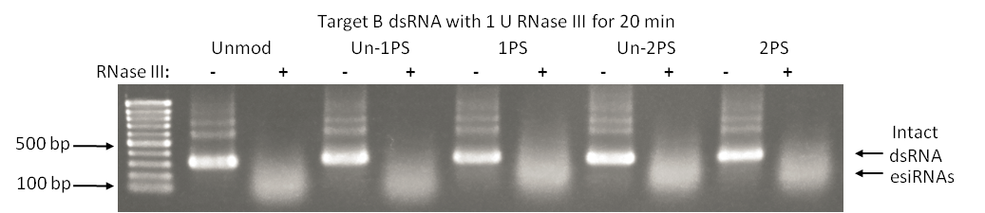

**Figure A3.1 Incubation of *E. coli* RNase III with a variety of phosphorothioate dsRNAs**

Gel electrophoretogram of Target B unmodified, Un-1PS, 1PS, Un-2PS and 2PS dsRNAs incubated with 1 U of E. coli RNase III at 37 C for 20 mins, followed by EDTA quenching of the reactions and agarose gel electrophoresis analysis. The successful cleavage of 2PS phosphorothioate dsRNA by RNase III demonstrated here, contradicts results presented in section 4.3.1.1, and further investigation is therefore required.

# References

Abrieux, A. and Chiu, J. C. (2016) ‘Oral delivery of dsRNA by microbes: Beyond pest control’, *Communicative and Integrative Biology*. Taylor & Francis, 9(6), pp. 1–4. doi: 10.1080/19420889.2016.1236163.

Airs, P. M. and Bartholomay, L. C. (2017) ‘RNA interference for mosquito and mosquito-borne disease control’, *Insects*, 8(1). doi: 10.3390/insects8010004.

Aliyari, R. and Ding, S.-W. (2009) ‘RNA-based viral immunity initiated by the Dicer family of host immune receptors.’, *Immunological reviews*. NIH Public Access, 227(1), pp. 176–88. doi: 10.1111/j.1600-065X.2008.00722.x.

Amarzguioui, M. *et al.* (2003) ‘Tolerance for mutations and chemical modifications in a siRNA’, *Nucleic Acids Research*, 31(2), pp. 589–595. doi: 10.1093/nar/gkg147.

Ambion (2012) *MEGAscript ® Kit User Guide*. Available at: http://tools.thermofisher.com/content/sfs/manuals/1330M_G.pdf (Accessed: 22 August 2019).

Amdam, G. V *et al.* (2003) ‘Disruption of vitellogenin gene function in adult honeybees by intra-abdominal injection of double-stranded RNA’, *BMC Biotechnology*. BioMed Central, 3(1), p. 1. doi: 10.1186/1472-6750-3-1.

Ares, P. *et al.* (2016) ‘High resolution atomic force microscopy of double-stranded RNA.’, *Nanoscale*, 8(23), pp. 11818–26. doi: 10.1039/c5nr07445b.

Azarani, A. and Hecker, K. H. (2001) ‘RNA analysis by ion-pair reversed-phase high performance liquid chromatography.’, *Nucleic acids research*. Oxford University Press, 29(2), p. E7. Available at: http://www.ncbi.nlm.nih.gov/pubmed/11139637 (Accessed: 4 December 2018).

Azlan, A., Dzaki, N. and Azzam, G. (2016) ‘Argonaute: The executor of small RNA function’, *Journal of Genetics and Genomics*. Elsevier Limited and Science Press, 43(8), pp. 481–494. doi: 10.1016/j.jgg.2016.06.002.

Baca, F. (1994) ‘New member of the harmful entomofauna of Yugoslavia, Diabrotica virgifera virgifera LeConte (Coleoptera, Chrysomelidae)’, *Zaštita Bilja*, 45(2), pp. 125–131. Available at: https://www.cabdirect.org/cabdirect/abstract/19951105412 (Accessed: 17 July 2019).

Bachman, P. M. *et al.* (2016a) ‘Ecological risk assessment for DvSnf7 RNA: A plant-incorporated protectant with targeted activity against western corn rootworm’, *Regulatory Toxicology and Pharmacology*. Elsevier Ltd, 81, pp. 77–88. doi: 10.1016/j.yrtph.2016.08.001.

Bachman, P. M. *et al.* (2016b) ‘Ecological risk assessment for DvSnf7 RNA: A plant-incorporated protectant with targeted activity against western corn rootworm’, *Regulatory Toxicology and Pharmacology*. Academic Press, 81, pp. 77–88. doi: 10.1016/J.YRTPH.2016.08.001.

Baulcombe, D. (2004) ‘RNA silencing in plants’, *Nature*, 431(7006), pp. 356–363. doi: 10.1038/nature02874.

Baum, J. A. *et al.* (2007) ‘Control of coleopteran insect pests through RNA interference’, *Nature Biotechnology*, 25(11), pp. 1322–1326. doi: 10.1038/nbt1359.

Bebber, D. P. (2015) ‘Range-Expanding Pests and Pathogens in a Warming World’, *Annual Review of Phytopathology*. Annual Reviews , 53(1), pp. 335–356. doi: 10.1146/annurev-phyto-080614-120207.

Bellés, X. (2010) ‘Beyond *Drosophila:* RNAi In Vivo and Functional Genomics in Insects’, *Annual Review of Entomology*, 55(1), pp. 111–128. doi: 10.1146/annurev-ento-112408-085301.

Bernstein, E. *et al.* (2001) ‘Role for a bidentate ribonuclease in the initiation step of RNA interference’, *Nature*, 409(6818), pp. 363–366. doi: 10.1038/35053110.

Betancur, J. G. and Tomari, Y. (2012) ‘Dicer is dispensable for asymmetric RISC loading in mammals.’, *RNA (New York, N.Y.)*. Cold Spring Harbor Laboratory Press, 18(1), pp. 24–30. doi: 10.1261/rna.029785.111.

Billmann, M. *et al.* (2016) ‘A genetic interaction map of cell cycle regulators’, *Molecular Biology of the Cell*, 27(8), pp. 1397–1407. doi: 10.1091/mbc.E15-07-0467.

Boutros, M. and Ahringer, J. (2008) ‘The art and design of genetic screens: RNA interference’, *Nature Reviews Genetics*, 9(7), pp. 554–566. doi: 10.1038/nrg2364.

Braasch, D. A. *et al.* (2003) ‘RNA Interference in Mammalian Cells by Chemically-Modified RNA †’, *Biochemistry*, 42(26), pp. 7967–7975. doi: 10.1021/bi0343774.

Bramsen, J. B. *et al.* (2009) ‘A large-scale chemical modification screen identifies design rules to generate siRNAs with high activity, high stability and low toxicity’, *Nucleic Acids Research*, 37(9), pp. 2867–2881. doi: 10.1093/nar/gkp106.

Brennecke, J. *et al.* (2007) ‘Discrete Small RNA-Generating Loci as Master Regulators of Transposon Activity in Drosophila’, *Cell*, 128(6), pp. 1089–1103. doi: 10.1016/j.cell.2007.01.043.

Bronkhorst, A. W. and van Rij, R. P. (2014) ‘The long and short of antiviral defense: small RNA-based immunity in insects’, *Current Opinion in Virology*. Elsevier, 7, pp. 19–28. doi: 10.1016/J.COVIRO.2014.03.010.

Brown, S., Hu, N. and Hombría, J. C. G. (2001) ‘Identification of the first invertebrate interleukin JAK/STAT receptor, the Drosophila gene domeless’, *Current Biology*, 11(21), pp. 1700–1705. doi: 10.1016/S0960-9822(01)00524-3.

Campbell, F. E. *et al.* (2002) ‘Pre-steady-state and stopped-flow fluorescence analysis of Escherichia coli ribonuclease III: insights into mechanism and conformational changes associated with binding and catalysis’, *Journal of Molecular Biology*. Academic Press, 317(1), pp. 21–40. doi: 10.1006/JMBI.2002.5413.

Campbell, M. A. and Wengel, J. (2011) ‘Locked vs. unlocked nucleic acids (LNA vs. UNA): contrasting structures work towards common therapeutic goals’, *Chemical Society Reviews*, 40(12), p. 5680. doi: 10.1039/c1cs15048k.

CaraDonna, P. J., Cunningham, J. L. and Iler, A. M. (2018) ‘Experimental warming in the field delays phenology and reduces body mass, fat content and survival: Implications for the persistence of a pollinator under climate change’, *Functional Ecology*. Edited by C. Williams. John Wiley & Sons, Ltd (10.1111), 32(10), pp. 2345–2356. doi: 10.1111/1365-2435.13151.

Carbonell, A. and Carrington, J. C. (2015) ‘Antiviral roles of plant ARGONAUTES’, *Current Opinion in Plant Biology*. Elsevier Ltd, 27(Dcl), pp. 111–117. doi: 10.1016/j.pbi.2015.06.013.

Castanotto, D. and Rossi, J. J. (2009) ‘The promises and pitfalls of RNA-interference-based therapeutics’, *Nature*, 457(7228), pp. 426–433. doi: 10.1038/nature07758.

Castellanos, N. L. *et al.* (2019) ‘Liposome encapsulation and EDTA formulation of dsRNA targeting essential genes increase oral RNAi-caused mortality in the Neotropical stink bug *Euschistus heros*’, *Pest Management Science*, 75(2), pp. 537–548. doi: 10.1002/ps.5167.

Cenik, E. S. *et al.* (2011) ‘Phosphate and R2D2 restrict the substrate specificity of Dicer-2, an ATP-driven ribonuclease.’, *Molecular cell*. Elsevier, 42(2), pp. 172–84. doi: 10.1016/j.molcel.2011.03.002.

Chang, W. *et al.* (2016a) ‘Systematic chemical modifications of single stranded siRNAs significantly improved CTNNB1 mRNA silencing’, *Bioorganic and Medicinal Chemistry Letters*. Elsevier Ltd, 26(18), pp. 4513–4517. doi: 10.1016/j.bmcl.2016.07.064.

Chang, W. *et al.* (2016b) ‘Systematic chemical modifications of single stranded siRNAs significantly improved CTNNB1 mRNA silencing’, *Bioorganic & Medicinal Chemistry Letters*, 26(18), pp. 4513–4517. doi: 10.1016/j.bmcl.2016.07.064.

Chelliserrykattil, J. and Ellington, A. D. (2004) ‘Evolution of a T7 RNA polymerase variant that transcribes 2′-O-methyl RNA’, *Nature Biotechnology*. Nature Publishing Group, 22(9), pp. 1155–1160. doi: 10.1038/nbt1001.

Chiu, Y.-L. and Rana, T. M. (2003) ‘siRNA function in RNAi: A chemical modification analysis’, *RNA*, 9(9), pp. 1034–1048. doi: 10.1261/rna.5103703.

Christiaens, O. *et al.* (2018) ‘Increased RNAi Efficacy in Spodoptera exigua via the Formulation of dsRNA With Guanylated Polymers’, *Frontiers in Physiology*. Frontiers, 9, p. 316. doi: 10.3389/fphys.2018.00316.

Cogoni, C. and Macino, G. (1997) ‘Isolation of quelling-defective (qde) mutants impaired in posttranscriptional transgene-induced gene silencing in Neurospora crassa’, *Proceedings of the National Academy of Sciences*, 94(19), pp. 10233–10238. doi: 10.1073/pnas.94.19.10233.

Cogoni, C. and Macino, G. (1999) ‘Gene silencing in Neurospora crassa requires a protein homologous to RNA-dependent RNA polymerase’, *Nature*, 399(6732), pp. 166–169. doi: 10.1038/20215.

Colmenares, S. U. *et al.* (2007) ‘Coupling of Double-Stranded RNA Synthesis and siRNA Generation in Fission Yeast RNAi’, *Molecular Cell*. Cell Press, 27(3), pp. 449–461. doi: 10.1016/J.MOLCEL.2007.07.007.

Conrad, C. and Gerlich, D. W. (2010) ‘Automated microscopy for high-content RNAi screening’, *The Journal of Cell Biology*, 188(4), pp. 453–461. doi: 10.1083/jcb.200910105.

Conrad, F. *et al.* (1995) ‘Enzymatic synthesis of 2’-modified nucleic acids: identification of important phosphate and ribose moieties in RNase P substrates.’, *Nucleic acids research*, 23(11), pp. 1845–53. Available at: http://www.pubmedcentral.nih.gov/articlerender.fcgi?artid=306953&tool=pmcentrez&rendertype=abstract.

Cooper, A. M. *et al.* (2019) ‘Molecular mechanisms influencing efficiency of RNA interference in insects’, *Pest Management Science*, 75(1), pp. 18–28. doi: 10.1002/ps.5126.

Cordell-Stewart, B. and Taylor, M. W. (1973) ‘Effect of viral double-stranded RNA on mammalian cells in culture: cytotoxicity under conditions preventing viral replication and protein synthesis.’, *Journal of virology*. American Society for Microbiology (ASM), 12(2), pp. 360–6. Available at: http://www.ncbi.nlm.nih.gov/pubmed/4795868 (Accessed: 29 January 2019).

Cox-Foster, D. L. *et al.* (2007) ‘A Metagenomic Survey of Microbes in Honey Bee Colony Collapse Disorder’, *Science*. American Association for the Advancement of Science, 318(5848), pp. 283–287. doi: 10.1126/SCIENCE.1146498.

Cox-Foster, D. and vanEngelsdorp, D. (2009) ‘Saving the honeybee.’, *Scientific American*, 300(4), pp. 40–7. doi: 10.1038/scientificamerican0409-40.

Cullen, E. M. *et al.* (2013) ‘Resistance to Bt Corn by Western Corn Rootworm (Coleoptera: Chrysomelidae) in the U.S. Corn Belt’, *Journal of Integrated Pest Management*. Narnia, 4(3), pp. 1–6. doi: 10.1603/IPM13012.

Cummins, L. L. *et al.* (1995) ‘Characterization of fully 2’-modified oligoribonucleotide hetero- and homoduplex hybridization and nuclease sensitivity.’, *Nucleic acids research*. Oxford University Press, 23(11), pp. 2019–24. doi: 10.1093/nar/23.11.2019.

Czech, B. and Hannon, G. J. (2016) ‘One Loop to Rule Them All: The Ping-Pong Cycle and piRNA-Guided Silencing’, *Trends in Biochemical Sciences*. Elsevier, 41(4), p. 324. doi: 10.1016/J.TIBS.2015.12.008.

Dande, P. *et al.* (2006) ‘Improving RNA interference in mammalian cells by 4’-thio-modified small interfering RNA (siRNA): effect on siRNA activity and nuclease stability when used in combination with 2’-O-alkyl modifications.’, *Journal of medicinal chemistry*, 49(5), pp. 1624–34. doi: 10.1021/jm050822c.

Davies, T. G. E., Field, L. M. and Williamson, M. S. (2012) ‘The re-emergence of the bed bug as a nuisance pest: implications of resistance to the pyrethroid insecticides’, *Medical and Veterinary Entomology*. John Wiley & Sons, Ltd (10.1111), 26(3), pp. 241–254. doi: 10.1111/j.1365-2915.2011.01006.x.

Davis-Vogel, C. *et al.* (2018) ‘Identification and comparison of key RNA interference machinery from western corn rootworm, fall armyworm, and southern green stink bug’, *PLOS ONE*. Edited by J. L. Jurat-Fuentes, 13(9), p. e0203160. doi: 10.1371/journal.pone.0203160.

Deutsch, C. A. *et al.* (2018) ‘Increase in crop losses to insect pests in a warming climate.’, *Science (New York, N.Y.)*. American Association for the Advancement of Science, 361(6405), pp. 916–919. doi: 10.1126/science.aat3466.

Doi, N. *et al.* (2003) ‘Short-Interfering-RNA-Mediated Gene Silencing in Mammalian Cells Requires Dicer and eIF2C Translation Initiation Factors’, *Current Biology*. Cell Press, 13(1), pp. 41–46. doi: 10.1016/S0960-9822(02)01394-5.

Dominska, M. and Dykxhoorn, D. M. (2010) ‘Breaking down the barriers: siRNA delivery and endosome escape.’, *Journal of cell science*. The Company of Biologists Ltd, 123(Pt 8), pp. 1183–9. doi: 10.1242/jcs.066399.

Dong, Y. and Friedrich, M. (2005) ‘Nymphal RNAi: systemic RNAi mediated gene knockdown in juvenile grasshopper’, *BMC Biotechnology*. BioMed Central, 5(1), p. 25. doi: 10.1186/1472-6750-5-25.

Dow (1992) ‘pH GRADIENTS IN LEPIDOPTERAN MIDGUT.’, *The Journal of experimental biology*, 172(Pt 1), pp. 355–375. Available at: http://www.ncbi.nlm.nih.gov/pubmed/9874748 (Accessed: 16 July 2019).

Doyle, M., Jaskiewicz, L. and Filipowicz, W. (2012) ‘Dicer Proteins and Their Role in Gene Silencing Pathways’, *The Enzymes*. Academic Press, 32, pp. 1–35. doi: 10.1016/B978-0-12-404741-9.00001-5.

Dua, P. *et al.* (2011) ‘Modified siRNA structure with a single nucleotide bulge overcomes conventional siRNA-mediated off-target silencing.’, *Molecular therapy : the journal of the American Society of Gene Therapy*. Elsevier, 19(9), pp. 1676–87. doi: 10.1038/mt.2011.109.

Dubelman, S. *et al.* (2014) ‘Environmental Fate of Double-Stranded RNA in Agricultural Soils’, *PLoS ONE*. Edited by G. Smagghe. Public Library of Science, 9(3), p. e93155. doi: 10.1371/journal.pone.0093155.

Eaton, B. A., Fetter, R. D. and Davis, G. W. (2002) ‘Dynactin Is Necessary for Synapse Stabilization’, *Neuron*, 34(5), pp. 729–741. doi: 10.1016/S0896-6273(02)00721-3.

Elbashir, S. M. *et al.* (2001) ‘Functional anatomy of siRNAs for mediating efficient RNAi in Drosophila melanogaster embryo lysate’, *EMBO Journal*, 20(23), pp. 6877–6888. doi: 10.1093/emboj/20.23.6877.

Elbashir, S. M., Lendeckel, W. and Tuschl, T. (2001) ‘RNA interference is mediated by 21- and 22-nucleotide RNAs’, *Genes & Development*. Cold Spring Harbor Laboratory Press, 15(2), pp. 188–200. doi: 10.1101/gad.862301.

Elmén, J. *et al.* (2005) ‘Locked nucleic acid (LNA) mediated improvements in siRNA stability and functionality.’, *Nucleic acids research*. Oxford University Press, 33(1), pp. 439–47. doi: 10.1093/nar/gki193.

Eulalio, A. *et al.* (2007) ‘P-body formation is a consequence, not the cause, of RNA-mediated gene silencing.’, *Molecular and cellular biology*. American Society for Microbiology Journals, 27(11), pp. 3970–81. doi: 10.1128/MCB.00128-07.

Feyereisen, R. (2006) ‘Evolution of insect P450’, *Biochemical Society Transactions*, 34(6), pp. 1252–1255. doi: 10.1042/BST0341252.

Fire, A. *et al.* (1991) ‘Production of antisense RNA leads to effective and specific inhibition of gene expression in C. elegans muscle.’, *Development (Cambridge, England)*, 113(2), pp. 503–14. Available at: http://www.ncbi.nlm.nih.gov/pubmed/1782862 (Accessed: 8 September 2019).

Fire, A. *et al.* (1998) ‘Potent and specific genetic interference by double-stranded RNA in Caenorhabditis elegans’, *Nature*, 391(6669), pp. 806–811. doi: 10.1038/35888.

Fisher, K. H. *et al.* (2012a) ‘Advances in genome-wide RNAi cellular screens: a case study using the Drosophila JAK/STAT pathway.’, *BMC genomics*, 13(1), p. 506. doi: 10.1186/1471-2164-13-506.

Fisher, K. H. *et al.* (2012b) ‘Advances in genome-wide RNAi cellular screens: a case study using the Drosophila JAK/STAT pathway’, *BMC Genomics*. BMC Genomics, 13(1), p. 506. doi: 10.1186/1471-2164-13-506.

Frayne, E. G. (2016) ‘Conserved mechanism of action of a phosphate analogue in cultured cells’, *Molecular and Cellular Biochemistry*. Springer US, 415(1–2), pp. 111–117. doi: 10.1007/s11010-016-2681-6.

Fukunaga, R. and Zamore, P. D. (2012) ‘Loquacious, a Dicer Partner Protein, Functions in Both the MicroRNA and siRNA Pathways’, *The Enzymes*. Academic Press, 32, pp. 37–68. doi: 10.1016/B978-0-12-404741-9.00002-7.

Gan, J. *et al.* (2006) ‘Structural Insight into the Mechanism of Double-Stranded RNA Processing by Ribonuclease III’, *Cell*. Cell Press, 124(2), pp. 355–366. doi: 10.1016/J.CELL.2005.11.034.

Gantier, M. P. and Williams, B. R. G. (2007) ‘The response of mammalian cells to double-stranded RNA.’, *Cytokine & growth factor reviews*. NIH Public Access, 18(5–6), pp. 363–71. doi: 10.1016/j.cytogfr.2007.06.016.

Garbutt, J. S. and Reynolds, S. E. (2012) ‘Induction of RNA interference genes by double-stranded RNA; implications for susceptibility to RNA interference’, *Insect Biochemistry and Molecular Biology*, 42(9), pp. 621–628. doi: 10.1016/j.ibmb.2012.05.001.

Garci­a, K. *et al.* (2015) ‘Inactivated E. coli transformed with plasmids that produce dsRNA against infectious salmon anemia virus hemagglutinin show antiviral activity when added to infected ASK cells’, *Frontiers in Microbiology*. Frontiers, 6, p. 300. doi: 10.3389/fmicb.2015.00300.

Gaynor, J. W., Campbell, B. J. and Cosstick, R. (2010) ‘RNA interference: a chemist’s perspective’, *Chemical Society Reviews*, 39(11), p. 4169. doi: 10.1039/b920362c.

Geary, R. S., Yu, R. Z. and Levin, A. A. (2001) ‘Pharmacokinetics of phosphorothioate antisense oligodeoxynucleotides.’, *Current opinion in investigational drugs (London, England : 2000)*, 2(4), pp. 562–73. Available at: http://www.ncbi.nlm.nih.gov/pubmed/11566019 (Accessed: 8 September 2019).

Gholamalipour, Y., Karunanayake Mudiyanselage, A. and Martin, C. T. (2018) ‘3′ end additions by T7 RNA polymerase are RNA self-templated, distributive and diverse in character—RNA-Seq analyses’, *Nucleic Acids Research*. Narnia, 46(18), pp. 9253–9263. doi: 10.1093/nar/gky796.

Ghosh, S. K. B. *et al.* (2017) ‘Double strand RNA delivery system for plant-sap-feeding insects’, *PLOS ONE*. Edited by D. Doucet. Public Library of Science, 12(2), p. e0171861. doi: 10.1371/journal.pone.0171861.

Gogoi, A. *et al.* (2017) ‘Plant insects and mites uptake double-stranded RNA upon its exogenous application on tomato leaves’, *Planta*. Springer Berlin Heidelberg, 246(6), pp. 1233–1241. doi: 10.1007/s00425-017-2776-7.

Gordon, K. H. J. and Waterhouse, P. M. (2007) ‘RNAi for insect-proof plants.’, *Nature biotechnology*, 25(11), pp. 1231–1232. doi: 10.1038/nbt1107-1231.

Gould, F., Brown, Z. S. and Kuzma, J. (2018) ‘Wicked evolution: Can we address the sociobiological dilemma of pesticide resistance?’, *Science (New York, N.Y.)*. American Association for the Advancement of Science, 360(6390), pp. 728–732. doi: 10.1126/science.aar3780.

Griffiths, A. D., Potter, B. V and Eperon, I. C. (1987) ‘Stereospecificity of nucleases towards phosphorothioate-substituted RNA: stereochemistry of transcription by T7 RNA polymerase.’, *Nucleic acids research*. Oxford University Press, 15(10), pp. 4145–62. doi: 10.1093/nar/15.10.4145.

Grimm, D. (2009) ‘Small silencing RNAs: State-of-the-art’, *Advanced Drug Delivery Reviews*, 61(9), pp. 672–703. doi: 10.1016/j.addr.2009.05.002.

Guan, R.-B. *et al.* (2018) ‘A nuclease specific to lepidopteran insects suppresses RNAi’, *Journal of Biological Chemistry*, 293(16), pp. 6011–6021. doi: 10.1074/jbc.RA117.001553.

Guo, H. (2018) ‘Specialized ribosomes and the control of translation’, *Biochemical Society Transactions*, 46(4), pp. 855–869. doi: 10.1042/BST20160426.

Guo, S. and Kemphues, K. J. (1995) ‘par-1, a gene required for establishing polarity in C. elegans embryos, encodes a putative Ser/Thr kinase that is asymmetrically distributed’, *Cell*, 81(4), pp. 611–620. doi: 10.1016/0092-8674(95)90082-9.

Haley, B., Tang, G. and Zamore, P. D. (2003) ‘In vitro analysis of RNA interference in Drosophila melanogaster’, *Methods*. Academic Press, 30(4), pp. 330–336. doi: 10.1016/S1046-2023(03)00052-5.

Hall, A. H. S. *et al.* (2006) ‘High potency silencing by single-stranded boranophosphate siRNA’, *Nucleic Acids Research*. Oxford University Press, 34(9), pp. 2773–2781. doi: 10.1093/nar/gkl339.

Hammond, S. M. *et al.* (2000) ‘An RNA-directed nuclease mediates post-transcriptional gene silencing in Drosophila cells’, *Nature*, 404(6775), pp. 293–296. doi: 10.1038/35005107.

Hammond, S. M. (2005) ‘Dicing and slicing’, *FEBS Letters*. John Wiley & Sons, Ltd, 579(26), pp. 5822–5829. doi: 10.1016/j.febslet.2005.08.079.

Han, J. *et al.* (2004) ‘The Drosha-DGCR8 complex in primary microRNA processing.’, *Genes & development*. Cold Spring Harbor Laboratory Press, 18(24), pp. 3016–27. doi: 10.1101/gad.1262504.

Höck, J. and Meister, G. (2008) ‘The Argonaute protein family.’, *Genome biology*. BioMed Central, 9(2), p. 210. doi: 10.1186/gb-2008-9-2-210.

Hombría, J. C. and Brown, S. (2002) ‘The Fertile Field of Drosophila JAK / STAT Signalling’, *Current Biology*, 12(02), pp. 569–575.

Hopkin, M. (2006) ‘RNAi scoops medical Nobel’, *Nature*. Nature Publishing Group. doi: 10.1038/news061002-2.

Horn, T., Sandmann, T. and Boutros, M. (2010) ‘Design and evaluation of genome-wide libraries for RNA interference screens.’, *Genome biology*. BioMed Central, 11(6), p. R61. doi: 10.1186/gb-2010-11-6-r61.

Huang, Z. Y. *et al.* (2019) ‘Genes important for survival or reproduction in *Varroa destructor* identified by RNAi’, *Insect Science*. John Wiley & Sons, Ltd (10.1111), 26(1), pp. 68–75. doi: 10.1111/1744-7917.12513.

Hughes, C. L. and Kaufman, T. C. (2000) ‘RNAi analysis of Deformed, proboscipedia and Sex combs reduced in the milkweed bug Oncopeltus fasciatus: novel roles for Hox genes in the hemipteran head.’, *Development (Cambridge, England)*, 127(17), pp. 3683–94. Available at: http://www.ncbi.nlm.nih.gov/pubmed/10934013 (Accessed: 17 July 2019).

Huvenne, H. and Smagghe, G. (2010) ‘Mechanisms of dsRNA uptake in insects and potential of RNAi for pest control: A review’, *Journal of Insect Physiology*. Elsevier Ltd, 56(3), pp. 227–235. doi: 10.1016/j.jinsphys.2009.10.004.

Iribe, H. *et al.* (2017) ‘Chemical Modification of the siRNA Seed Region Suppresses Off-Target Effects by Steric Hindrance to Base-Pairing with Targets.’, *ACS omega*. American Chemical Society, 2(5), pp. 2055–2064. doi: 10.1021/acsomega.7b00291.

Iwamoto, N. *et al.* (2017) ‘Control of phosphorothioate stereochemistry substantially increases the efficacy of antisense oligonucleotides’, *Nature Biotechnology*. Nature Publishing Group, 35(9), pp. 845–851. doi: 10.1038/nbt.3948.

Jahns, H. *et al.* (2015a) ‘Stereochemical bias introduced during RNA synthesis modulates the activity of phosphorothioate siRNAs’, *Nature Communications*. Nature Publishing Group, 6(May 2014), pp. 1–9. doi: 10.1038/ncomms7317.

Jahns, H. *et al.* (2015b) ‘Stereochemical bias introduced during RNA synthesis modulates the activity of phosphorothioate siRNAs’, *Nature Communications*. Nature Publishing Group, 6(1), p. 6317. doi: 10.1038/ncomms7317.

Jin, B., Li, Y. and Robertson, K. D. (2011) ‘DNA methylation: superior or subordinate in the epigenetic hierarchy?’, *Genes & cancer*. Impact Journals, LLC, 2(6), pp. 607–17. doi: 10.1177/1947601910393957.

Joga, M. R. *et al.* (2016) ‘RNAi efficiency, systemic properties, and novel delivery methods for pest insect control: What we know so far’, *Frontiers in Physiology*, 7(NOV), pp. 1–14. doi: 10.3389/fphys.2016.00553.

K. Nair, J. *et al.* (2014) ‘Multivalent N-Acetylgalactosamine-Conjugated siRNA Localizes in Hepatocytes and Elicits Robust RNAi-mediated Gene Silencing’, *Jacs*. doi: 10.1021/ja505986a.

Kandasamy, S. K. and Fukunaga, R. (2016) ‘Phosphate-binding pocket in Dicer-2 PAZ domain for high-fidelity siRNA production.’, *Proceedings of the National Academy of Sciences of the United States of America*. National Academy of Sciences, 113(49), pp. 14031–14036. doi: 10.1073/pnas.1612393113.

Karlikow, M. *et al.* (2016) ‘Drosophila cells use nanotube-like structures to transfer dsRNA and RNAi machinery between cells’, *Scientific Reports*, 6(1), p. 27085. doi: 10.1038/srep27085.

Karunaratne, S. H. P. P. *et al.* (2007) ‘Insecticide resistance in the tropical bedbug Cimex hemipterus’, *Pesticide Biochemistry and Physiology*. Academic Press, 88(1), pp. 102–107. doi: 10.1016/J.PESTBP.2006.09.006.

Karwowski, B. T. (2015) ‘The influence of phosphorothioate on charge migration in single and double stranded DNA: a theoretical approach’, *Physical Chemistry Chemical Physics*. The Royal Society of Chemistry, 17(33), pp. 21507–21516. doi: 10.1039/C5CP01382H.

Kennerdell, J. R. and Carthew, R. W. (1998) ‘Use of dsRNA-Mediated Genetic Interference to Demonstrate that frizzled and frizzled 2 Act in the Wingless Pathway’, *Cell*, 95(7), pp. 1017–1026. doi: 10.1016/S0092-8674(00)81725-0.

Ketting, R. F. and Plasterk, R. H. (2000) ‘A genetic link between co-suppression and RNA interference in C. elegans’, *Nature*, 404(6775), pp. 296–298. doi: 10.1038/35005113.

Khajuria, C. *et al.* (2018) ‘Development and characterization of the first dsRNA-resistant insect population from western corn rootworm, Diabrotica virgifera virgifera LeConte’, *PLOS ONE*. Edited by S. R. Palli. Public Library of Science, 13(5), p. e0197059. doi: 10.1371/journal.pone.0197059.

Kim, E. *et al.* (2015) ‘A transformed bacterium expressing double-stranded RNA specific to integrin β1 enhances Bt Toxin efficacy against a polyphagous insect pest, Spodoptera exigua’, *PLoS ONE*, 10(7), pp. 1–15. doi: 10.1371/journal.pone.0132631.

Kim, K., Lee, Y. S. and Carthew, R. W. (2007) ‘Conversion of pre-RISC to holo-RISC by Ago2 during assembly of RNAi complexes.’, *RNA (New York, N.Y.)*. Cold Spring Harbor Laboratory Press, 13(1), pp. 22–9. doi: 10.1261/rna.283207.

Kim, V. N., Han, J. and Siomi, M. C. (2009) ‘Biogenesis of small RNAs in animals’, *Nature Reviews Molecular Cell Biology*, 10(2), pp. 126–139. doi: 10.1038/nrm2632.

Kraynack, B. A. and Baker, B. F. (2006) ‘Small interfering RNAs containing full 2’-O-methylribonucleotide-modified sense strands display Argonaute2/eIF2C2-dependent activity.’, *RNA (New York, N.Y.)*. Cold Spring Harbor Laboratory Press, 12(1), pp. 163–76. doi: 10.1261/rna.2150806.

van der Krol, A. R. *et al.* (1988) ‘An anti-sense chalcone synthase gene in transgenic plants inhibits flower pigmentation’, *Nature*. Nature Publishing Group, 333(6176), pp. 866–869. doi: 10.1038/333866a0.

Kutter, E. M. and Wiberg, J. S. (1969) ‘Biological effects of substituting cytosine for 5-hydroxymethylcytosine in the deoxyribonucleic acid of bacteriophage T4.’, *Journal of virology*, 4(4), pp. 439–53. Available at: http://www.ncbi.nlm.nih.gov/pubmed/4309878 (Accessed: 22 August 2019).

Lane, A. N. and Fan, T. W. M. (2015) ‘Regulation of mammalian nucleotide metabolism and biosynthesis’, *Nucleic Acids Research*, 43(4), pp. 2466–2485. doi: 10.1093/nar/gkv047.

Lavore, A. *et al.* (2018) ‘Nezara viridula (Hemiptera: Pentatomidae) transcriptomic analysis and neuropeptidomics’, *Scientific Reports*. Nature Publishing Group, 8(1), p. 17244. doi: 10.1038/s41598-018-35386-4.

Lee, R. C., Feinbaum, R. L. and Ambros, V. (1993) ‘The C. elegans heterochronic gene lin-4 encodes small RNAs with antisense complementarity to lin-14.’, *Cell*. Elsevier, 75(5), pp. 843–54. doi: 10.1016/0092-8674(93)90529-y.

Lee, S. J. *et al.* (2013) ‘Structural modification of siRNA for efficient gene silencing’, *Biotechnology Advances*, 31(5), pp. 491–503. doi: 10.1016/j.biotechadv.2012.09.002.

Lee, Y. S., Nakahara, K., Pham, John W, *et al.* (2004) ‘Distinct roles for Drosophila Dicer-1 and Dicer-2 in the siRNA/miRNA silencing pathways.’, *Cell*, 117(1), pp. 69–81. Available at: http://www.ncbi.nlm.nih.gov/pubmed/15066283 (Accessed: 29 January 2019).

Lee, Y. S., Nakahara, K., Pham, John W., *et al.* (2004) ‘Distinct roles for Drosophila Dicer-1 and Dicer-2 in the siRNA/miRNA silencing pathways’, *Cell*, 117(1), pp. 69–81. doi: 10.1016/S0092-8674(04)00261-2.

Lesnik, E. A. and Freier, S. M. (1995) ‘Relative Thermodynamic Stability of DNA, RNA, and DNA:RNA Hybrid Duplexes: Relationship with Base Composition and Structure’, *Biochemistry*, 34(34), pp. 10807–10815. doi: 10.1021/bi00034a013.

Li, J. *et al.* (2013) ‘Advances in the use of the RNA interference technique in Hemiptera’, *Insect Science*, 20(1), pp. 31–39. doi: 10.1111/j.1744-7917.2012.01550.x.

Li, Z. and Rana, T. M. (2012) ‘Molecular mechanisms of RNA-triggered gene silencing machineries.’, *Accounts of chemical research*. American Chemical Society, 45(7), pp. 1122–31. doi: 10.1021/ar200253u.

Lima, W. F. *et al.* (2012) ‘Single-stranded siRNAs activate RNAi in animals’, *Cell*, 150(5), pp. 883–894. doi: 10.1016/j.cell.2012.08.014.

Liu, J. *et al.* (2004) ‘Argonaute2 Is the Catalytic Engine of Mammalian RNAi’, *Science*, 305(5689), pp. 1437–1441. doi: 10.1126/science.1102513.

Lomate, P. R. and Bonning, B. C. (2016) ‘Distinct properties of proteases and nucleases in the gut, salivary gland and saliva of southern green stink bug, Nezara viridula’, *Scientific Reports*. Nature Publishing Group, 6(1), p. 27587. doi: 10.1038/srep27587.

Lozano, J. *et al.* (2012) ‘Super-induction of Dicer-2 expression by alien double-stranded RNAs: an evolutionary ancient response to viral infection?’, *Development Genes and Evolution*. Springer-Verlag, 222(4), pp. 229–235. doi: 10.1007/s00427-012-0404-x.

Lynch, J. A. and Desplan, C. (2006) ‘A method for parental RNA interference in the wasp Nasonia vitripennis’, *Nature Protocols*, 1(1), pp. 486–494. doi: 10.1038/nprot.2006.70.

Ma, E. *et al.* (2012) ‘Coordinated Activities of Human Dicer Domains in Regulatory RNA Processing’, *Journal of Molecular Biology*, 422(4), pp. 466–476. doi: 10.1016/j.jmb.2012.06.009.

Macrae, I. J. *et al.* (2006) ‘Structural basis for double-stranded RNA processing by Dicer.’, *Science (New York, N.Y.)*. American Association for the Advancement of Science, 311(5758), pp. 195–8. doi: 10.1126/science.1121638.

Mao, Y. B. *et al.* (2007) ‘Silencing a cotton bollworm P450 monooxygenase gene by plant-mediated RNAi impairs larval tolerance of gossypol’, *Nature Biotechnology*, 25(11), pp. 1307–1313. doi: 10.1038/nbt1352.

Marques, S. M. and Esteves da Silva, J. C. G. (2009) ‘Firefly bioluminescence: A mechanistic approach of luciferase catalyzed reactions’, *IUBMB Life*, 61(1), pp. 6–17. doi: 10.1002/iub.134.

Martín, D. *et al.* (2006) ‘RNAi studies reveal a conserved role for RXR in molting in the cockroach Blattella germanica’, *Journal of Insect Physiology*, 52(4), pp. 410–416. doi: 10.1016/j.jinsphys.2005.12.002.

Masliah, G., Barraud, P. and Allain, F. H.-T. (2013) ‘RNA recognition by double-stranded RNA binding domains: a matter of shape and sequence.’, *Cellular and molecular life sciences : CMLS*. Inserm, 70(11), pp. 1875–95. doi: 10.1007/s00018-012-1119-x.

Massee, A. M. (1954) *The Pests of Fruit and Hops.* 3rd Editio. Letchworth: Crosby Lockwood & Son Ltd.

McEwan, D. L., Weisman, A. S. and Hunter, C. P. (2012) ‘Uptake of extracellular double-stranded RNA by SID-2.’, *Molecular cell*. Elsevier, 47(5), pp. 746–54. doi: 10.1016/j.molcel.2012.07.014.

Medrano, E. G., Esquivel, J. F. and Bell, A. A. (2007) ‘Transmission of cotton seed and boll rotting bacteria by the southern green stink bug (Nezara viridula L.)’, *Journal of Applied Microbiology*. John Wiley & Sons, Ltd (10.1111), 103(2), pp. 436–444. doi: 10.1111/j.1365-2672.2006.03262.x.

Meis, J. E. and Chen, F. (2002) ‘In Vitro Synthesis of 2’-Fluoro-Modified RNA Transcripts That Are Completely Resistant to RNase A Digestion Using the DuraScribeTM T7 Transcription Kit’, *Epicentre Forum*, 9(1), pp. 10–11. Available at: www.epicentre.com/durascribe.asp (Accessed: 22 August 2019).

Mikkola, S., Lönnberg, T. and Lönnberg, H. (2018) ‘Phosphodiester models for cleavage of nucleic acids.’, *Beilstein journal of organic chemistry*. Beilstein-Institut, 14, pp. 803–837. doi: 10.3762/bjoc.14.68.

Miller, S. C. *et al.* (2012) ‘Dissecting Systemic RNA Interference in the Red Flour Beetle Tribolium castaneum: Parameters Affecting the Efficiency of RNAi’, *PLoS ONE*. Edited by A. P. McGregor, 7(10), p. e47431. doi: 10.1371/journal.pone.0047431.

Min, D. *et al.* (2007) ‘“In-line attack” conformational effect plays a modest role in an enzyme-catalyzed RNA cleavage: a free energy simulation study.’, *Nucleic acids research*. Oxford University Press, 35(12), pp. 4001–6. doi: 10.1093/nar/gkm394.

Misquitta, L. and Paterson, B. M. (1999) ‘Targeted disruption of gene function in Drosophila by RNA interference (RNA-i): a role for nautilus in embryonic somatic muscle formation.’, *Proceedings of the National Academy of Sciences of the United States of America*. National Academy of Sciences, 96(4), pp. 1451–6. doi: 10.1073/pnas.96.4.1451.

Mitter, N. *et al.* (2017) ‘Clay nanosheets for topical delivery of RNAi for sustained protection against plant viruses’, *Nature Plants*. Nature Publishing Group, 3(2), p. 16207. doi: 10.1038/nplants.2016.207.

Mogilicherla, K., Howell, J. L. and Palli, S. R. (2018) ‘Improving RNAi in the Brown Marmorated Stink Bug: Identification of target genes and reference genes for RT-qPCR’, *Scientific Reports*. Nature Publishing Group, 8(1), p. 3720. doi: 10.1038/s41598-018-22035-z.

Mohr, S. E. (2014) ‘RNAi screening in Drosophila cells and in vivo.’, *Methods (San Diego, Calif.)*, 68(1), pp. 82–8. doi: 10.1016/j.ymeth.2014.02.018.

Monia, B. P. *et al.* (1996) ‘Nuclease resistance and antisense activity of modified oligonucleotides targeted to Ha-ras.’, *The Journal of biological chemistry*. American Society for Biochemistry and Molecular Biology, 271(24), pp. 14533–40. doi: 10.1074/jbc.271.24.14533.

Muhonen, P. *et al.* (2007) ‘RNA Interference Tolerates 2′-Fluoro Modifications at the Argonaute2 Cleavage Site’, *Chemistry & Biodiversity*, 4(5), pp. 858–873. doi: 10.1002/cbdv.200790073.

Mukherjee, T., Schäfer, U. and Zeidler, M. P. (2006) ‘Identification of Drosophila genes modulating Janus kinase/signal transducer and activator of transcription signal transduction.’, *Genetics*. Genetics Society of America, 172(3), pp. 1683–97. doi: 10.1534/genetics.105.046904.

Müller, P. *et al.* (2005) ‘Identification of JAK/STAT signalling components by genome-wide RNA interference.’, *Nature*, 436(7052), pp. 871–5. doi: 10.1038/nature03869.

Murphy, K. A. *et al.* (2016) ‘Ingestion of genetically modified yeast symbiont reduces fitness of an insect pest via RNA interference’, *Scientific Reports*. Nature Publishing Group, 6(1), p. 22587. doi: 10.1038/srep22587.

Mysore, K. *et al.* (2017) ‘Yeast interfering RNA larvicides targeting neural genes induce high rates of Anopheles larval mortality’, *Malaria Journal*. BioMed Central, 16(1), p. 461. doi: 10.1186/s12936-017-2112-5.

Neumann, B. *et al.* (2006) ‘High-throughput RNAi screening by time-lapse imaging of live human cells.’, *Nature methods*, 3(5), pp. 385–90. doi: 10.1038/nmeth876.

Niccoli, S. *et al.* (2017) ‘Non-radioactive 2-deoxy-2-fluoro-D-glucose inhibits glucose uptake in xenograft tumours and sensitizes HeLa cells to doxorubicin in vitro’, *PLOS ONE*. Edited by R. Moreno-Sanchez. Public Library of Science, 12(11), p. e0187584. doi: 10.1371/journal.pone.0187584.

Nicholson, A. W. *et al.* (1988) ‘Accurate in vitro cleavage by RNase III of phosphorothioate-substituted RNA processing signals in bacteriophage T7 early mRNA.’, *Nucleic acids research*. Oxford University Press, 16(4), pp. 1577–91. Available at: http://www.ncbi.nlm.nih.gov/pubmed/3279395 (Accessed: 4 January 2019).

Nicholson, A. W. (2014) ‘Ribonuclease III mechanisms of double-stranded RNA cleavage.’, *Wiley interdisciplinary reviews. RNA*. Wiley-Blackwell, 5(1), pp. 31–48. doi: 10.1002/wrna.1195.

Nicolopoulou-Stamati, P. *et al.* (2016) ‘Chemical Pesticides and Human Health: The Urgent Need for a New Concept in Agriculture.’, *Frontiers in public health*. Frontiers Media SA, 4, p. 148. doi: 10.3389/fpubh.2016.00148.

Nwokeoji, A. O., Kilby, P. M., *et al.* (2017) ‘Accurate Quantification of Nucleic Acids Using Hypochromicity Measurements in Conjunction with UV Spectrophotometry’, *Analytical Chemistry*, 89(24), pp. 13567–13574. doi: 10.1021/acs.analchem.7b04000.

Nwokeoji, A. O., Kung, A.-W., *et al.* (2017) ‘Purification and characterisation of dsRNA using ion pair reverse phase chromatography and mass spectrometry’, *Journal of Chromatography A*. Elsevier, 1484, pp. 14–25. doi: 10.1016/J.CHROMA.2016.12.062.

Ogura, T. *et al.* (2012) ‘Quantitative evaluation of the molting hormone activity in coleopteran cells established from the Colorado potato beetle, Leptinotarsa decemlineata’, *Pesticide Biochemistry and Physiology*. Academic Press, 104(1), pp. 1–8. doi: 10.1016/J.PESTBP.2012.06.009.

Okamura, K. *et al.* (2004) ‘Distinct roles for Argonaute proteins in small RNA-directed RNA cleavage pathways’, *Genes & Development*, 18(14), pp. 1655–1666. doi: 10.1101/gad.1210204.

Pallan, P. S. *et al.* (2011) ‘Unexpected origins of the enhanced pairing affinity of 2’-fluoro-modified RNA.’, *Nucleic acids research*. Oxford University Press, 39(8), pp. 3482–95. doi: 10.1093/nar/gkq1270.

Pang, D., Thierry, A. R. and Dritschilo, A. (2015) ‘DNA studies using atomic force microscopy: capabilities for measurement of short DNA fragments.’, *Frontiers in molecular biosciences*. Frontiers Media SA, 2, p. 1. doi: 10.3389/fmolb.2015.00001.

Park, J.-E. *et al.* (2011) ‘Dicer recognizes the 5’ end of RNA for efficient and accurate processing.’, *Nature*. NIH Public Access, 475(7355), pp. 201–5. doi: 10.1038/nature10198.

Parrish, S. *et al.* (2000) ‘Functional anatomy of a dsRNA trigger: differential requirement for the two trigger strands in RNA interference.’, *Molecular cell*, 6(5), pp. 1077–87. Available at: http://www.ncbi.nlm.nih.gov/pubmed/11106747 (Accessed: 15 August 2019).

Patra, A. *et al.* (2012) ‘2’-Fluoro RNA shows increased Watson-Crick H-bonding strength and stacking relative to RNA: evidence from NMR and thermodynamic data.’, *Angewandte Chemie (International ed. in English)*. NIH Public Access, 51(47), pp. 11863–6. doi: 10.1002/anie.201204946.

Peacock, H. *et al.* (2011a) ‘Chemical modification of siRNA bases to probe and enhance RNA interference.’, *The Journal of organic chemistry*. NIH Public Access, 76(18), pp. 7295–300. doi: 10.1021/jo2012225.

Peacock, H. *et al.* (2011b) ‘Chemiical modification of siRNA bases to probe and enhance RNA interference’, pp. 7295–7300.

Peiffer, M. and Felton, G. W. (2014) ‘Insights into the Saliva of the Brown Marmorated Stink Bug Halyomorpha halys (Hemiptera: Pentatomidae)’, *PLoS ONE*. Edited by F. Marion-Poll. Public Library of Science, 9(2), p. e88483. doi: 10.1371/journal.pone.0088483.

Peng, Y. *et al.* (2018) ‘Biochemical Comparison of dsRNA Degrading Nucleases in Four Different Insects’, *Frontiers in Physiology*. Frontiers, 9, p. 624. doi: 10.3389/fphys.2018.00624.

Perrimon, N., Ni, J. Q. and Perkins, L. (2010) ‘In vivo RNAi: today and tomorrow.’, *Cold Spring Harbor perspectives in biology*, 2(8), pp. 1–11. doi: 10.1101/cshperspect.a003640.

Petrick, J. S. *et al.* (2016) ‘Corrigendum to “Corn rootworm-active RNA DvSnf7: Repeat dose oral toxicology assessment in support of human and mammalian safety” (Regulatory Toxicology and Pharmacology (2016) 81 (57–68) (S0273230016301921) (10.1016/j.yrtph.2016.07.009))’, *Regulatory Toxicology and Pharmacology*. Elsevier Ltd, 82, p. 191. doi: 10.1016/j.yrtph.2016.09.001.

Poirier, E. Z. *et al.* (2018) ‘Dicer-2-Dependent Generation of Viral DNA from Defective Genomes of RNA Viruses Modulates Antiviral Immunity in Insects.’, *Cell host & microbe*. Elsevier, 23(3), pp. 353-365.e8. doi: 10.1016/j.chom.2018.02.001.

Prakash, T. P. *et al.* (2005) ‘Positional Effect of Chemical Modifications on Short Interference RNA Activity in Mammalian Cells’, *Journal of Medicinal Chemistry*, 48(13), pp. 4247–4253. doi: 10.1021/jm050044o.

Price, D. R. G. and Gatehouse, J. a. (2008) ‘RNAi-mediated crop protection against insects’, *Trends in Biotechnology*, 26(7), pp. 393–400. doi: 10.1016/j.tibtech.2008.04.004.

Quan, G. X., Kanda, T. and Tamura, T. (2002) ‘Induction of the white egg 3 mutant phenotype by injection of the double-stranded RNA of the silkworm white gene.’, *Insect molecular biology*, 11(3), pp. 217–22. Available at: http://www.ncbi.nlm.nih.gov/pubmed/12000640 (Accessed: 16 July 2019).

Raines, R. T. (1998) ‘Ribonuclease A’. American Chemical Society, 98(3), pp. 1045–1066. doi: 10.1021/CR960427H.

Redfern, A. D. *et al.* (2013) ‘RNA-induced silencing complex (RISC) Proteins PACT, TRBP, and Dicer are SRA binding nuclear receptor coregulators.’, *Proceedings of the National Academy of Sciences of the United States of America*. National Academy of Sciences, 110(16), pp. 6536–41. doi: 10.1073/pnas.1301620110.

Redko, Y., Bechhofer, D. H. and Condon, C. (2008) ‘Mini-III, an unusual member of the RNase III family of enzymes, catalyses 23S ribosomal RNA maturation in B. subtilis’, *Molecular Microbiology*, 68(5), pp. 1096–1106. doi: 10.1111/j.1365-2958.2008.06207.x.

van Rij, R. P. *et al.* (2006) ‘The RNA silencing endonuclease Argonaute 2 mediates specific antiviral immunity in Drosophila melanogaster.’, *Genes & development*. Cold Spring Harbor Laboratory Press, 20(21), pp. 2985–95. doi: 10.1101/gad.1482006.

Rivas, F. V *et al.* (2005) ‘Purified Argonaute2 and an siRNA form recombinant human RISC’, *Nature Structural & Molecular Biology*, 12(4), pp. 340–349. doi: 10.1038/nsmb918.

Russell, P. J. (2010) *iGenetics: A Molecular Approach*. Third Edition. San Francisco: Benjamin Cummings. Available at: https://www.amazon.com/P-J-Russells-iGenetics-Molecular-Hardcover/dp/B003ZOGGX8 (Accessed: 8 September 2019).

Sah, D. W. Y. (2006) ‘Therapeutic potential of RNA interference for neurological disorders’, *Life Sciences*, 79(19), pp. 1773–1780. doi: 10.1016/j.lfs.2006.06.011.

Saito, K. *et al.* (2007) ‘Pimet, the Drosophila homolog of HEN1, mediates 2’-O-methylation of Piwi- interacting RNAs at their 3’ ends’, *Genes & Development*, 21(13), pp. 1603–1608. doi: 10.1101/gad.1563607.

Saleh, M.-C., van Rij, Ronald P, *et al.* (2006) ‘The endocytic pathway mediates cell entry of dsRNA to induce RNAi silencing.’, *Nature cell biology*. NIH Public Access, 8(8), pp. 793–802. doi: 10.1038/ncb1439.

Saleh, M.-C., van Rij, Ronald P., *et al.* (2006) ‘The endocytic pathway mediates cell entry of dsRNA to induce RNAi silencing’, *Nature Cell Biology*, 8(8), pp. 793–802. doi: 10.1038/ncb1439.

Saleh, M. *et al.* (2014) ‘Analysis of cell-based RNAi screens’, *Epigenetics and Chromatin*. Nature Publishing Group, 7(1), pp. 1–6. doi: 10.1038/ncomms10368.

San Miguel, K. and Scott, J. G. (2015) ‘The next generation of insecticides: dsRNA is stable as a foliar-applied insecticide’, *Pest Management Science*, (February), p. n/a-n/a. doi: 10.1002/ps.4056.

Schirle, N. T. *et al.* (2016) ‘Structural Analysis of Human Argonaute-2 Bound to a Modified siRNA Guide’, *Journal of the American Chemical Society*. American Chemical Society, 138(28), pp. 8694–8697. doi: 10.1021/jacs.6b04454.

Schuster, S., Miesen, P. and van Rij, R. P. (2019) ‘Antiviral RNAi in Insects and Mammals: Parallels and Differences’, *Viruses*. Multidisciplinary Digital Publishing Institute, 11(5), p. 448. doi: 10.3390/v11050448.

Shen, X. and Corey, D. R. (2018a) ‘Chemistry, mechanism and clinical status of antisense oligonucleotides and duplex RNAs’, *Nucleic Acids Research*. Narnia, 46(4), pp. 1584–1600. doi: 10.1093/nar/gkx1239.

Shen, X. and Corey, D. R. (2018b) ‘Chemistry, mechanism and clinical status of antisense oligonucleotides and duplex RNAs’, *Nucleic Acids Research*. Oxford University Press, 46(4), pp. 1584–1600. doi: 10.1093/nar/gkx1239.

Shi, D.-Q. *et al.* (2017) ‘New Insights into 5hmC DNA Modification: Generation, Distribution and Function’, *Frontiers in Genetics*. Frontiers, 8, p. 100. doi: 10.3389/fgene.2017.00100.

Shi, H., Wei, J. and He, C. (2019) ‘Where, When, and How: Context-Dependent Functions of RNA Methylation Writers, Readers, and Erasers’, *Molecular Cell*. Elsevier, 74(4), pp. 640–650. doi: 10.1016/J.MOLCEL.2019.04.025.

Shimizu, H. *et al.* (2014) ‘Compensatory flux changes within an 1’endocytic trafficking network maintain thermal robustness of notch signaling’, *Cell*, 157(5), pp. 1160–1174. doi: 10.1016/j.cell.2014.03.050.

Shukla, J. N. *et al.* (2016a) ‘Reduced stability and intracellular transport of dsRNA contribute to poor RNAi response in lepidopteran insects’, *RNA Biology*. Taylor & Francis, 13(7), pp. 656–669. doi: 10.1080/15476286.2016.1191728.

Shukla, J. N. *et al.* (2016b) ‘Reduced stability and intracellular transport of dsRNA contribute to poor RNAi response in lepidopteran insects’, *RNA Biology*. Taylor & Francis, 13(7), pp. 656–669. doi: 10.1080/15476286.2016.1191728.

Simon, B. *et al.* (2011) ‘Recognition of 2′-O-Methylated 3′-End of piRNA by the PAZ Domain of a Piwi Protein’, *Structure*, 19(2), pp. 172–180. doi: 10.1016/j.str.2010.11.015.

Singh, I. K. *et al.* (2017) ‘Comparative analysis of double-stranded RNA degradation and processing in insects’, *Scientific Reports*. Nature Publishing Group, 7(1), p. 17059. doi: 10.1038/s41598-017-17134-2.

Singh, R. K. and Pandey, S. P. (2015) ‘Evolution of structural and functional diversification among plant Argonautes’, *Plant Signaling & Behavior*, 10(10), p. e1069455. doi: 10.1080/15592324.2015.1069455.

Sinha, N. K. *et al.* (2018) ‘Dicer uses distinct modules for recognizing dsRNA termini’, *Science*, 359(6373), pp. 329–334. doi: 10.1126/science.aaq0921.

Sloan, K. E. *et al.* (2017) ‘Tuning the ribosome: The influence of rRNA modification on eukaryotic ribosome biogenesis and function.’, *RNA biology*. Taylor & Francis, 14(9), pp. 1138–1152. doi: 10.1080/15476286.2016.1259781.

Smith, J. S. and Nikonowicz, E. P. (2000) ‘Phosphorothioate substitution can substantially alter RNA conformation’, *Biochemistry*, 39(19), pp. 5642–5652. doi: 10.1021/bi992712b.

Snead, Nicholas M *et al.* (2013) ‘5’ Unlocked Nucleic Acid Modification Improves siRNA Targeting.’, *Molecular therapy. Nucleic acids*. American Society of Gene & Cell Therapy, 2(7), p. e103. doi: 10.1038/mtna.2013.36.

Snead, Nicholas M. *et al.* (2013) ‘5′ unlocked nucleic acid modification improves siRNA targeting’, *Molecular Therapy - Nucleic Acids*, 2(May). doi: 10.1038/mtna.2013.36.

Song, J.-J. *et al.* (2003) ‘The crystal structure of the Argonaute2 PAZ domain reveals an RNA binding motif in RNAi effector complexes’, *NATURE STRUCTURAL BIOLOGY*, 10. doi: 10.1038/nsb1016.

Song, J.-J. *et al.* (2004) ‘Crystal Structure of Argonaute and Its Implications for RISC Slicer Activity’, *Science*, 305(5689), pp. 1434–1437. doi: 10.1126/science.1102514.

Soutschek, J. *et al.* (2004) ‘Therapeutic silencing of an endogenous gene by systemic administration of modified siRNAs’, *Nature*, 432(7014), pp. 173–178. doi: 10.1038/nature03121.

Sparks, M. E. *et al.* (2014) ‘Transcriptome of the Invasive Brown Marmorated Stink Bug, Halyomorpha halys (Stål) (Heteroptera: Pentatomidae)’, *PLoS ONE*. Edited by O. Mittapalli. Public Library of Science, 9(11), p. e111646. doi: 10.1371/journal.pone.0111646.

Spit, J. *et al.* (2017a) ‘Knockdown of nuclease activity in the gut enhances RNAi efficiency in the Colorado potato beetle, Leptinotarsa decemlineata, but not in the desert locust, Schistocerca gregaria’, *Insect Biochemistry and Molecular Biology*. Elsevier Ltd, 81, pp. 103–116. doi: 10.1016/j.ibmb.2017.01.004.

Spit, J. *et al.* (2017b) ‘Knockdown of nuclease activity in the gut enhances RNAi efficiency in the Colorado potato beetle, Leptinotarsa decemlineata , but not in the desert locust, Schistocerca gregaria’, *Insect Biochemistry and Molecular Biology*, 81, pp. 103–116. doi: 10.1016/j.ibmb.2017.01.004.

Stahley, M. R. *et al.* (2005a) ‘Structural Evidence for a Two-Metal-Ion Mechanism of Group I Intron Splicing’, *Science*. American Association for the Advancement of Science, 309(5740), pp. 1587–1590. doi: 10.1126/science.1114994.

Stahley, M. R. *et al.* (2005b) ‘Structural Evidence for a Two-Metal-Ion Mechanism of Group I Intron Splicing’, *Science*. American Association for the Advancement of Science, 309(5740), pp. 1587–1590. doi: 10.1126/science.1114994.

Stefl, R. *et al.* (2010) ‘The solution structure of the ADAR2 dsRBM-RNA complex reveals a sequence-specific readout of the minor groove.’, *Cell*. NIH Public Access, 143(2), pp. 225–37. doi: 10.1016/j.cell.2010.09.026.

Stein, C. A. (1996) ‘Phosphorothioate antisense oligodeoxynucleotides: questions of specificity’, *Trends in Biotechnology*. Elsevier Current Trends, 14(5), pp. 147–149. doi: 10.1016/0167-7799(96)20006-X.

Stovall, G. M. *et al.* (2014) ‘In vitro selection using modified or unnatural nucleotides.’, *Current protocols in nucleic acid chemistry*. NIH Public Access, 56, pp. 9.6.1-33. doi: 10.1002/0471142700.nc0906s56.

Sun, W. and Nicholson, A. W. (2001) ‘Mechanism of Action of *Escherichia coli* Ribonuclease III. Stringent Chemical Requirement for the Glutamic Acid 117 Side Chain and Mn 2+ Rescue of the Glu117Asp Mutant †’, *Biochemistry*, 40(16), pp. 5102–5110. doi: 10.1021/bi010022d.

Sun, W., Pertzev, A. and Nicholson, A. W. (2005) ‘Catalytic mechanism of Escherichia coli ribonuclease III: kinetic and inhibitor evidence for the involvement of two magnesium ions in RNA phosphodiester hydrolysis.’, *Nucleic acids research*. Oxford University Press, 33(3), pp. 807–15. doi: 10.1093/nar/gki197.

Tabashnik, B. E., Brévault, T. and Carrière, Y. (2013) ‘Insect resistance to Bt crops: lessons from the first billion acres’, *Nature Biotechnology*, 31(6), pp. 510–521. doi: 10.1038/nbt.2597.

Tan, J., Levine, Steven L., *et al.* (2016) ‘No impact of DvSnf7 RNA on honey bee ( *Apis mellifera* L.) adults and larvae in dietary feeding tests’, *Environmental Toxicology and Chemistry*. John Wiley & Sons, Ltd, 35(2), pp. 287–294. doi: 10.1002/etc.3075.

Tan, J., Levine, Steven L, *et al.* (2016) ‘No impact of DvSnf7 RNA on honey bee (Apis mellifera L.) adults and larvae in dietary feeding tests.’, *Environmental toxicology and chemistry*. Wiley-Blackwell, 35(2), pp. 287–94. doi: 10.1002/etc.3075.

Tassetto, M., Kunitomi, M. and Andino, R. (2017) ‘Circulating Immune Cells Mediate a Systemic RNAi-Based Adaptive Antiviral Response in Drosophila’, *Cell*, 169(2), pp. 314-325.e13. doi: 10.1016/j.cell.2017.03.033.

Terenius, O. *et al.* (2011) ‘RNA interference in Lepidoptera: An overview of successful and unsuccessful studies and implications for experimental design’, *Journal of Insect Physiology*. Pergamon, 57(2), pp. 231–245. doi: 10.1016/J.JINSPHYS.2010.11.006.

Thairu, M. W. *et al.* (2017) ‘Efficacy of RNA interference knockdown using aerosolized short interfering RNAs bound to nanoparticles in three diverse aphid species’, *Insect Molecular Biology*. John Wiley & Sons, Ltd (10.1111), 26(3), pp. 356–368. doi: 10.1111/imb.12301.

Thalhammer, A. *et al.* (2011) ‘Hydroxylation of methylated CpG dinucleotides reverses stabilisation of DNA duplexes by cytosine 5-methylation’, *Chemical Communications*. The Royal Society of Chemistry, 47(18), p. 5325. doi: 10.1039/c0cc05671e.

Thany, S. H. (2010) ‘Neonicotinoid insecticides: historical evolution and resistance mechanisms.’, *Advances in experimental medicine and biology*, 683, pp. 75–83. Available at: http://www.ncbi.nlm.nih.gov/pubmed/20737790 (Accessed: 16 September 2019).

Thorne, N., Inglese, J. and Auld, D. S. (2010) ‘Illuminating insights into firefly luciferase and other bioluminescent reporters used in chemical biology.’, *Chemistry & biology*. NIH Public Access, 17(6), pp. 646–57. doi: 10.1016/j.chembiol.2010.05.012.

Timmons, L., Court, D. L. and Fire, A. (2001) ‘Ingestion of bacterially expressed dsRNAs can produce specific and potent genetic interference in Caenorhabditis elegans’, *Gene*, 263(1–2), pp. 103–112. doi: 10.1016/S0378-1119(00)00579-5.

Tolia, N. H. and Joshua-Tor, L. (2007) ‘Slicer and the Argonautes’, *Nature Chemical Biology*, 3(1), pp. 36–43. doi: 10.1038/nchembio848.

Tomari, Y. and Zamore, P. D. (2005) ‘MicroRNA Biogenesis: Drosha Can’t Cut It without a Partner’, *Current Biology*. Cell Press, 15(2), pp. R61–R64. doi: 10.1016/J.CUB.2004.12.057.

Tomoyasu, Y. *et al.* (2008) ‘Exploring systemic RNA interference in insects: a genome-wide survey for RNAi genes in Tribolium’, *Genome Biology*, 9(1), p. R10. doi: 10.1186/gb-2008-9-1-r10.

Tougou, D., Musolin, D. L. and Fujisaki, K. (2009) ‘Some like it hot! Rapid climate change promotes changes in distribution ranges of *Nezara viridula* and *Nezara antennata* in Japan’, *Entomologia Experimentalis et Applicata*. John Wiley & Sons, Ltd (10.1111), 130(3), pp. 249–258. doi: 10.1111/j.1570-7458.2008.00818.x.

TriLink Biotechnologies (2016) *Certificate of analysis: (1-Thio)-ATP N-8005*. Available at: https://www.trilinkbiotech.com/cart/coa/N-8005-090904B-8.pdf (Accessed: 22 August 2019).

Tsvetkov, N. *et al.* (2017) ‘Chronic exposure to neonicotinoids reduces honey bee health near corn crops.’, *Science (New York, N.Y.)*. American Association for the Advancement of Science, 356(6345), pp. 1395–1397. doi: 10.1126/science.aam7470.

Ueda, T. *et al.* (1991) ‘Phosphorothioate-containing RNAs show mRNA activity in the prokaryotic translation systems in vitro.’, *Nucleic acids research*. Oxford University Press, 19(3), pp. 547–52. doi: 10.1093/nar/19.3.547.

Ulvila, J. *et al.* (2006) ‘Double-stranded RNA Is Internalized by Scavenger Receptor-mediated Endocytosis in *Drosophila* S2 Cells’, *Journal of Biological Chemistry*, 281(20), pp. 14370–14375. doi: 10.1074/jbc.M513868200.

US EPA, O. (2017) *EPA Registers Innovative Tool to Control Corn Rootworm*. Available at: https://www.epa.gov/newsreleases/epa-registers-innovative-tool-control-corn-rootworm (Accessed: 15 September 2019).

Vagin, V. V. *et al.* (2006) ‘A Distinct Small RNA Pathway Silences Selfish Genetic Elements in the Germline’, *Science*, 313(5785), pp. 320–324. doi: 10.1126/science.1129333.

Vaishnaw, A. K. *et al.* (2010) ‘A status report on RNAi therapeutics.’, *Silence*, 1(1), p. 14. doi: 10.1186/1758-907X-1-14.

Vatanparast, M. and Kim, Y. (2017) ‘Optimization of recombinant bacteria expressing dsRNA to enhance insecticidal activity against a lepidopteran insect, Spodoptera exigua’, *PLOS ONE*. Edited by E. Ling. Public Library of Science, 12(8), p. e0183054. doi: 10.1371/journal.pone.0183054.

Vissers, J. H. A. *et al.* (2016) ‘A Drosophila RNAi library modulates Hippo pathway-dependent tissue growth’, *Nature Communications*. Nature Publishing Group, 7, pp. 1–6. doi: 10.1038/ncomms10368.

Vlot, M. *et al.* (2018) ‘Bacteriophage DNA glucosylation impairs target DNA binding by type I and II but not by type V CRISPR–Cas effector complexes’, *Nucleic Acids Research*. Oxford University Press, 46(2), pp. 873–885. doi: 10.1093/nar/gkx1264.

Vogel, E. *et al.* (2019) ‘RNA Interference in Insects: Protecting Beneficials and Controlling Pests’, *Frontiers in Physiology*. Frontiers, 9, p. 1912. doi: 10.3389/fphys.2018.01912.

Vyas, M. *et al.* (2017) ‘Knock down of Whitefly Gut Gene Expression and Mortality by Orally Delivered Gut Gene-Specific dsRNAs’, *PLOS ONE*. Edited by Y. Zhang. Public Library of Science, 12(1), p. e0168921. doi: 10.1371/journal.pone.0168921.

Weber, F. *et al.* (2006) ‘Double-stranded RNA is produced by positive-strand RNA viruses and DNA viruses but not in detectable amounts by negative-strand RNA viruses.’, *Journal of virology*. American Society for Microbiology (ASM), 80(10), pp. 5059–64. doi: 10.1128/JVI.80.10.5059-5064.2006.

Whalon, M. E., Mota-Sanchez, D. and Hollingworth, R. M. (2008) *Global Pesticide Resistance in Arthropods*. Wallingford: CABI International. Available at: https://www.cabi.org/bookshop/book/9781845933531 (Accessed: 13 September 2019).

Whangbo, J. S. and Hunter, C. P. (2008) ‘Environmental RNA interference’, *Trends in Genetics*, 24(6), pp. 297–305. doi: 10.1016/j.tig.2008.03.007.

Whitten, M. M. A. *et al.* (2016) ‘Symbiont-mediated RNA interference in insects’, *Proceedings of the Royal Society B: Biological Sciences*, 283(1825), p. 20160042. doi: 10.1098/rspb.2016.0042.

Whyard, S., Singh, A. D. and Wong, S. (2009) ‘Ingested double-stranded RNAs can act as species-specific insecticides’, *Insect Biochemistry and Molecular Biology*. Elsevier Ltd, 39(11), pp. 824–832. doi: 10.1016/j.ibmb.2009.09.007.

Wightman, B., Ha, I. and Ruvkun, G. (1993) ‘Posttranscriptional regulation of the heterochronic gene lin-14 by lin-4 mediates temporal pattern formation in C. elegans’, *Cell*, 75(5), pp. 855–862. doi: 10.1016/0092-8674(93)90530-4.

Wynant, Niels *et al.* (2014) ‘Lipophorins can adhere to dsRNA, bacteria and fungi present in the hemolymph of the desert locust: A role as general scavenger for pathogens in the open body cavity’, *Journal of Insect Physiology*. Pergamon, 64, pp. 7–13. doi: 10.1016/J.JINSPHYS.2014.02.010.

Wynant, N. *et al.* (2014) ‘Scavenger receptor-mediated endocytosis facilitates RNA interference in the desert locust, *Schistocerca gregaria*’, *Insect Molecular Biology*, 23(3), p. n/a-n/a. doi: 10.1111/imb.12083.

Wynant, N. *et al.* (2015) ‘Drosha, Dicer-1 and Argonaute-1 in the desert locust: Phylogenetic analyses, transcript profiling and regulation during phase transition and feeding’, *Journal of Insect Physiology*. Pergamon, 75, pp. 20–29. doi: 10.1016/J.JINSPHYS.2015.02.010.

Xiao, D. *et al.* (2015) ‘Clathrin-dependent endocytosis plays a predominant role in cellular uptake of double-stranded RNA in the red flour beetle’, *Insect Biochemistry and Molecular Biology*. Pergamon, 60, pp. 68–77. doi: 10.1016/J.IBMB.2015.03.009.

Xiao, Y. and Wu, K. (2019) ‘Recent progress on the interaction between insects and Bacillus thuringiensis crops’, *Philosophical Transactions of the Royal Society B: Biological Sciences*. The Royal Society, 374(1767), p. 20180316. doi: 10.1098/RSTB.2018.0316.

Xie, X. *et al.* (2012) ‘Phosphorothioate DNA as an antioxidant in bacteria’, *Nucleic Acids Research*, 40(18), pp. 9115–9124. doi: 10.1093/nar/gks650.

Xuan, S. *et al.* (2015) ‘5-Hydroxymethylcytosine and 5-formylcytosine containing deoxyoligonucleotides: Facile syntheses and melting temperature studies’, *Bioorganic & Medicinal Chemistry Letters*. Pergamon, 25(6), pp. 1186–1191. doi: 10.1016/J.BMCL.2015.01.070.

Yoon, J.-S., Gurusamy, D. and Palli, S. R. (2017) ‘Accumulation of dsRNA in endosomes contributes to inefficient RNA interference in the fall armyworm, Spodoptera frugiperda’, *Insect Biochemistry and Molecular Biology*. Pergamon, 90, pp. 53–60. doi: 10.1016/J.IBMB.2017.09.011.

Yoshiyama, N., Tojo, K. and Hatakeyama, M. (2013) ‘A survey of the effectiveness of non-cell autonomous RNAi throughout development in the sawfly, Athalia rosae (Hymenoptera)’, *Journal of Insect Physiology*. Pergamon, 59(4), pp. 400–407. doi: 10.1016/J.JINSPHYS.2013.01.009.

Yue, Y., Liu, J. and He, C. (2015) ‘RNA *N* 6 -methyladenosine methylation in post-transcriptional gene expression regulation’, *Genes & Development*, 29(13), pp. 1343–1355. doi: 10.1101/gad.262766.115.

Zhang, H. *et al.* (2002) ‘Human Dicer preferentially cleaves dsRNAs at their termini without a requirement for ATP’, *The EMBO Journal*, 21(21), pp. 5875–5885. doi: 10.1093/emboj/cdf582.

Zhang, J., Zhang, Y. and Han, R. (2016) ‘The high-throughput production of dsRNA against sacbrood virus for use in the honey bee Apis cerana (Hymenoptera: Apidae)’, *Virus Genes*. Springer US, 52(5), pp. 698–705. doi: 10.1007/s11262-016-1346-6.

Zhang, Y. *et al.* (2016) ‘Tousled-like kinase mediated a new type of cell death pathway in Drosophila’, *Cell Death and Differentiation*, 23(1), pp. 146–157. doi: 10.1038/cdd.2015.77.

Zhu, F. *et al.* (2011) ‘Ingested RNA interference for managing the populations of the Colorado potato beetle, Leptinotarsa decemlineata’, *Pest Management Science*. John Wiley & Sons, Ltd, 67(2), pp. 175–182. doi: 10.1002/ps.2048.

Zimmermann, T. S. *et al.* (2006) ‘RNAi-mediated gene silencing in non-human primates.’, *Nature*, 441(7089), pp. 111–4. doi: 10.1038/nature04688.