
Developments of Magnetomotive Optical Coherence Tomography and Polarization-Sensitive Optical Coherence Tomography for Clinical Applications
Wei Li
Department of Electronic and Electrical Engineering
University of Sheffield
A thesis presented for the degree of
Doctor of Philosophy
2019

Abstract
There are two main aims in this project: (1) develop a contrast agent which can be tracked by our in-house phase-sensitive spectral domain (SD) OCT and commercial confocal fluorescence microscopy (CFM) simultaneously; (2) apply our in-house polarization-sensitive (PS) OCT to investigate birefringence and collagen alignment in the human cervix and assess its potential to characterise changes in extracellular matrix structure during pregnancy.

To realize the first aim, the SD-OCT was optimized to recover/improve its performance at first. Before the optimization, the SD-OCT had poor performance due to the shifting alignment resulted from the movements of its optical components by vibration and gravity. The optimized SD-OCT has a sensitivity of 81.4 dB and an axial and lateral resolution of 3.4 μm and 6.2 μm respectively. Then, the optimized SD-OCT system was adapted to magnetomotive OCT (MMOCT) to track magnetically labelled cells. A contrast agent, magnetic graphene quantum dot (MGQD), was synthesized by hydrothermally reducing and cutting graphene oxide-iron oxide sheet. The MGQD showed significant tuneable blue fluorescence and superparamagnetism, hence it can be used as a dual-modality tracer for CFM and MMOCT. 3T3 cells were labelled by the MGQD, and the MGQD labelled cells have been successfully localized and imaged by a commercial CFM and our in-house MMOCT system. As CFM and MMOCT are provide intracellular details and anatomical information respectively, hence a more comprehensive diagnosis can be achieved through the application of MGQD for cell tracking.

For the second aim, 20 cervical cross-sections from non-gravid women were interrogated by our in-house PS-OCT. Several algorithms have been applied to process and map the images of sample’s intensity, phase retardance, birefringence and depolarization using the data obtained from the PS-OCT. The physical information obtained from the PS-OCT is able to identify cervical epithelium, measure epithelial thickness and image the distribution of cervical collagen. Three-dimension orientation of collagen fibres in cervical samples was estimated by a conical beam scan protocol. Previous observation by X-ray diffraction was confirmed by our study which suggests that in the human cervix, collagen fibres adjacent to the endocervical canal and in the outermost area are mostly arranged longitudinally but in the middle area, fibres are predominantly circumferential with significant higher birefringence (p<0.05) than other areas. A significant increase in apparent birefringence of the middle area with age was identified, which is consistent with a study result by second harmonic generation and indicates a physiological re-modelling in the cervical collagen fibres as the reproductive function of the cervix diminishes. PS-OCT holds the potential to help us better understand cervical remodelling prior to birth pending the development of an in vivo probe.

Acknowledgement
I would like to thank my primary supervisor, Prof. Steve Matcher, for his great help and support and excellent guidance during my whole PhD study.
I am grateful to my secondary supervisor, Prof. Biqiong Chen, for her support and assistance on synthesis of nanoparticle.
I am grateful to Dr. Zenghai Lu, Dr. Xuesong Hu and Dr. Robert Byers for their support with optical alignment technique, explanation of optical coherence tomography system and programming and image processing techniques based on LabVIEW and MATLAB.
I would like to express my gratitude to Dr. Brenda Narice for her support with preparation of human sample in clinic.
I am also grateful to all staffs of tissue engineering laboratory for their kindly support with cell culture and cell labelling.
I would like to thank financial support from EPSRC and University of Sheffield.
I would like to thank my family especially my parents for their help in life.

List of Publications

Journal articles
- W. Li, W. Song, B. Chen, and S. J. Matcher, "Superparamagnetic graphene quantum dot as a dual‐modality contrast agent for confocal fluorescence microscopy and magnetomotive optical coherence tomography," J. Biophotonics 12, e201800219 (2019).
- W. Li, B. F. Narice, D. O. Anumba, and S. J. Matcher, "Polarization-sensitive optical coherence tomography with a conical beam scan for the investigation of birefringence and collagen alignment in the human cervix," Biomed. Opt. Express 10, 4190–4206 (2019).
- W. Song, X. Su, D. Gregory, W. Li, Z. Cai, and X. Zhao, "Magnetic Alginate/Chitosan Nanoparticles for Targeted Delivery of Curcumin into Human Breast Cancer Cells," Nanomaterials 8, 907 (2018).

Conference proceedings papers
- W. Li, B. F. Narice, D. O. Anumba, and S. J. Matcher, “In vitro characterization of collagen organization in the human cervix using polarization-sensitive optical coherence tomography (PS-OCT),” in Diseases in the Breast and Reproductive System V, 2019, vol. 10856, p. 1085603.
- W. Li, B. F. Narice, D. O. Anumba, and S. J. Matcher, “Polarization-sensitive swept-source optical coherence tomography for investigating depth, birefringence, depolarization and orientation of collagen structure of human cervix tissue,” in Optical Coherence Tomography and Coherence Domain Optical Methods in Biomedicine XXIII, 2019, vol. 10867, p. 108673H.
- W. Li and S. J. Matcher, "Novel magnetic graphene quantum dot as dual modality fluorescence/MMOCT contrast agent for tracking epithelial cells," in Reporters, Markers, Dyes, Nanoparticles, and Molecular Probes for Biomedical Applications IX (International Society for Optics and Photonics, 2017), Vol. 10079, p. 100790X.
- X. Hu, R. Maiti, J. Boadi, W. Li, M. J. Carré, R. Lewis, S. E. Franklin, and S. J. Matcher, "Optical coherence elastography for human finger-pad skin deformation studies," in Optical Elastography and Tissue Biomechanics III (International Society for Optics and Photonics, 2016), Vol. 9710, p. 97100C.
- B. F. Narice, W. Li, S. Matcher, and D. O. Anumba, "Polarisation-Sensitive Optical Coherence Tomography as a Potential Tool for Assessing the Orientation of Collagen Fibres in the Human Cervix.," in REPRODUCTIVE SCIENCES (SAGE PUBLICATIONS INC 2455 TELLER RD, THOUSAND OAKS, CA 91320 USA, 2019), Vol. 26, pp. 128A-128A.

Contents

Abstract 2
Acknowledgement 4
List of Publications 5
Journal articles………………………………………………………………………5
Conference proceedings papers……………………………………………………..5
Contents 7
List of Figures 14
Glossary of terms 17
1. Introduction and Literature Review…………………………………………..22
1.1 Introduction 22
1.2 Theory of Optical Coherence Tomography 23
1.3 Fourier-domain OCT 29
1.3.1 Resolution 30
1.3.2 Sensitivity 32
1.3.3 Sensitivity falloff 33
1.4 Magnetomotive OCT 34
1.4.1 Theory of phase-sensitive OCT 36
1.4.2 Theory of MMOCT 38
1.4.3 Contrast agents for MMOCT 41
1.4.4 Superparamagnetism 42
1.4.5 Applications of MMOCT 45
1.4.6 Development and applications of MMOCE 46
1.5 Polarization-sensitive OCT 48
1.5.1 Theory of PS-OCT 49
1.5.2 Clinical applications of PS-OCT 53
References………………………………………………………………………....58
2. Thesis Overview……………………………………………………………..67
References..……………………………………………………………………….69
3. Characterisation and Optimisation of an OCT system suitable for MMOCT Measurements……………………………………………………………………...70
3.1 Introduction 70
3.2 Methods 71
3.2.1 SD-OCT alignment 73
3.2.2 Optimization and Resampling 78
3.2.3 OCT image generation 84
3.2.4 Characterisation of SD-OCT 85
3.3 Results 87
3.3.1 Optical alignment 88
3.3.2 Optimization and resampling 88
3.3.3 Characteristics of SD-OCT 90
3.4 Discussion 94
3.4.1 Depth calibration 94
3.4.2 Lateral resolution 95
3.4.3 Axial resolution 96
3.4.4 Sensitivity 97
3.4.5 Displacement sensitivity 99
3.5 Conclusion 101
References………………………………………………………………………..103
4. Development and Testing of an MMOCT Instrument 104
4.1 Introduction 104
4.2 Methods 106
4.2.1 Setup of Magnetomotive OCT 106
4.2.2 Sample preparations 108
4.2.3 Magnetomotive OCT imaging 109
4.2.4 Elimination of false magnetomotive signal 112
4.2.5 Improving SNR of magnetomotive OCT imaging 115
4.3 Results 116
4.3.1 Magnetic field of MMOCT system 116
4.3.2 Negative control of MMOCT imaging 117
4.3.3 MMOCT images with different average filters 119
4.4 Discussion 122
4.4.1 Frequency-doubling effect of Magnetomotive signal 122
4.4.2 Influence factors of MMOCT signal 123
4.5 Conclusion 126
References………………………………………………………………………...127
5. Superparamagnetic Graphene Quantum Dot as a Dual-Modality Contrast Agent for Confocal Fluorescence Microscopy and Magnetomotive OCT……………...128
5.1 Summary 128
5.2 Introduction 129
5.3 Materials and methods 134
5.3.1 Synthesis of MGQD 134
5.3.2 Characterization of MGQD 135
5.3.3 Cell Culture and Labelling 136
5.3.4 Toxicity Test by MTT 137
5.3.5 CFM Imaging 137
5.3.6 Construction of MMOCT 139
5.3.7 MMOCT imaging 140
5.4 Results 141
5.4.1 MGQD Structure 141
5.4.2 Magnetic hysteresis curve of MGQD 142
5.4.3 Fluorescence of MGQD 144
5.4.4 Toxicity of MGQD 145
5.4.5 CFM imaging of MGQD 146
5.4.6 MMOCT imaging of MGQD 148
5.5 Discussion 151
5.5.1 Magnetism of MGQD for MMOCT imaging 151
5.5.2 Fluorescence of MGQD for CFM imaging 152
5.5.3 MGQD uptake by cells 153
5.5.4 Toxicity 154
5.5.5 Limitations and further studies 154
5.6 Conclusion 156
5.7 ACKNOWLEDGMENTS 156
References………………………………………………………………………...157
6. Polarization-Sensitive Optical Coherence Tomography with a conical beam scan for investigation of birefringence and collagen alignment in the human cervix ………………………………………………………………………………161
6.1 Summary 161
6.2 Introduction 162
6.3 Methods 165
6.3.1 Configuration of PS-OCT 165
6.3.2 Preparation of human cervical tissues 167
6.3.3 Scan geometries 168
6.3.4 PS-OCT image processing 171
6.3.5 H&E histology 174
6.3.6 Statistical analysis 174
6.4 Results and discussion 175
6.4.1 Intensity, retardance and birefringence images 175
6.4.2 Orientation of collagen fibre 177
6.4.3 H&E histology 185
6.4.4 Depolarization image 186
6.4.5 Benefits of PS-OCT for evaluating PTB 188
6.4.6 Statistical analysis of the results and en face imaging 188
6.5 Conclusion 192
6.6 Funding 192
References………………………………………………………………………...194
7. Conclusions and Future Work……………………………………………….198
7.1 Summary 198
7.2 Limitations, challenges and future work 199
References………………………………………………………………………...202
8. Appendix 203
8.1 Photograph of the test target for measuring the rate of sensitivity falloff……………………………………………………………………..203
8.2 Photograph of the sample stage for conical beam scan 203
8.3 MATLAB code for OCT image generation 204
8.4 MATLAB code for MMOCT image generation 208

List of Figures
1.1: Schematic of Michelson interferometer 24
1.2: Schematic of spectral-domain OCT 26
1.3: Illustration of Fourier process of Fourier-domain OCT 28
1.4: Schematic of swept-source OCT 29
1.5: 1951 USAF resolution test chart 32
1.6: The schematic of the imaging mechanism of MMOCT 40
1.7: The illustration of $M$ -$H$ curves for ferromagnetic and superparamagnetic materials 45
1.8: Schematic diagram of single-input-state bulk optics PS-OCT 53
2.1: Schematic diagram of the spectrometer-based Fourier Domain OCT 73
2.2: The diagram of light dispersed onto CCD pixels by a diffraction grating 78
2.3: Outcomes of detector arm optimization and resampling 82
2.4: The flow diagram of resampling process. 83
2.5: The flow diagram of the full process of OCT image generation 85
2.6: a) M-mode scan of plane mirror. b) the phase fluctuation as a function of time. c) the phase frequency spectrum resulting from FFT of phase fluctuation 87
2.7: Interference pattern of SD-OCT and its PSF under the condition that both SLD 1 and SLD 2 are running 90
2.8: a) The enface image of 1951 USAF test pattern obtained by our OCT system. b) The grey scale profile following the red line of Figure 2.8 a). 92
2.9: a) PSF after resampling. b) PSF before resampling 92
2.10: Predicted/theoretical sensitivity falloff and the true sensitivity falloff measured as a function of depth 93
2.11: B scan image of near infrared (NIR) detector card 98
2.12: a) M-mode scan of NIR detector card. b) the phase fluctuation as a function of time. c) the phase frequency spectrum resulting from FFT of phase fluctuation 101
3.1: The schematic of the custom-built MMOCT system 107
3.2: The flow chart of MMOCT imaging 111
3.3: a) the structure/intensity image of agar gel. b) the phase spectrum of the magnetomotive signal of only agar gel. c) the phantom of the 160 Hz magnetomotive signal 112
3.4: a) the structure/intensity image of infrared detection card on rigid aluminium plate. b) the phase spectrum of the magnetomotive signal of infrared detection card. c) the phantom of the 160 Hz magnetomotive signal 114
3.5: The physical image of electromagnet and its holding device in sample field of MMOCT 115
3.6: a) structure image of agar gel in 0.5 T of 80 Hz modulated magnetic field. b) the phase spectrum of the magnetomotive signal of agar gel. c) the phantom of the 160 Hz magnetomotive signal 118
3.7: The MMOCT and structure images of SPIO on agar gel with and without an average filter 122
3.8: The (normalised) magnetomotive force of SPIO excited by a sinusoidal magnetic field 123
3.9: a) structure image of 5.10 μg/cm² SPIO and agar gel in 0.5 T of 80 Hz modulated magnetic field. b) the phase spectrum of the magnetomotive signal of 5.10 μg/cm² SPIO on agar gel. c) the image of the 160 Hz magnetomotive signal. 125
4.1: Transmission electron microscopy images of magnetic graphene quantum dots (MGQDs) with magnifications of 30 000 (left) and 98 000 (right) 142
4.2: a) The magnetic hysteresis curves of magnetic graphene quantum dot (MGQD) and superparamagnetic iron oxide (SPIO); b) The magnetic susceptibilities of MGQD and SPIO in magnetic field of 100 to 10 000 Oe; c) The magnetic hysteresis curves of two different MGQDs, where the group 2 and group 1 indicate the MGQDs synthesised with and without nitrogen protection, respectively 143
4.3: Fluorescence spectra of magnetic graphene quantum dots (MGQDs) 145
4.4: The influence of magnetic graphene quantum dot (MGQD) in concentrations of 7, 13, 26, 52, 78 and 104 μg/mL on cell line viability of 3T3 cell line after 24 and 48 hours culture 146
4.5: The confocal fluorescence microscopy images of magnetic graphene quantum dot (MGQD) powder and MGQD labelled cells 148
4.6: The magnetomotive optical coherence tomography (MMOCT) images of MGQD labelled 3T3 cells and unlabeled 3T3 cells on agar gel 150
5.1: Schematic diagram of PS-OCT system 167
5.2: The diagram of uterus 168
5.3: a) Schematic diagram of a human cervix. b) Top view of cervical specimen with 9 scanning points. c) Axial direction of imaging within the cervical sample from the external to the internal os 169
5.4: The schematic diagram of sample stage for conical beam scan scheme. 170
5.5: The flow chart of signal processing for generating birefringence image and calculating the value of birefringence 173
5.6: PS-OCT images of human cervical tissue in middle area 177
5.7: The structural, retardance and birefringence images of a cervical sample 179
5.8: Real phase retardance images of human cervical tissue obtained by conical beam scan method and simulated retardance images using EJMC model. 184
5.9: Histological slides of three cervical specimens 186
5.10: PS-OCT images of a human cervical specimen in meddle area for analyzing depolarization of tissue 187
5.11: The en-face images of retardance and intensity (at 400 µm depth) 190
5.12: Averaged apparent birefringence of middle area as function of age 191

Glossary of terms
$∆_{p}λ$: the wavelength spacing between spectrometer’s pixels
${∆z}^{'}$: theoretical axial resolution of conventional microscopy
${∆z}_{0}$: the free-space path length difference between the reference arm and sample arm
$μ_{0}$: the magnetic permeability of vacuum
$μ_{r}$: relative permeability
$A_{0;H}(z)$: amplitude of the horizontal signal in PS-OCT
$A_{0;V}(z)$: amplitude of the vertical signals in PS-OCT
$B_{TDOCT}$: electronic detection bandwidth
$E_{r}\left(z_{r}\right)$: the Jones vector of reference beam in detection arm
$E_{s}\left(z\right)$: the Jones vector of the sample beam in detection arm
$I_{D}\left(k\right)$: the response current of detector as a function of wavenumber in OCT system
$I_{D}\left(λ\right)$: the response current of detector as a function of wavelength in OCT system
$I_{c}$: the coherence length of light
$J_{1}$: the Jones matrix of QWP in reference arm
$J_{2}$: the Jones matrix of QWP in sample arm
$J_{sample}$: the round-trip Jones Matrix of tissue
$M_{0}$: number of spectral channels of detection system and number of analog-to-digital sampling points in SD-OCT and SS-OCT respectively
$M_{d}$: the volume magnetization of tissue
$M_{p}$: the volume magnetization of magnetic particle
$M_{r}$: remnant magnetization
$P_{noise}$: the power of noise
$P_{sig}$: the collected sample power
$P_{signal}$: the power of signal
$Q_{m}$: the averaged Stokes vector element
$R_{R}$: power reflectivity of reference mirror
$R_{S0}$: the power reflectivity of sample layer at the depth of $z_{R}=z_{S_{n}}$
$R_{Sn}$: power reflectivity of sample, the subscript ‘n’ denoting the various depth of sample
$R_{g}$: the theoretical resolving power of grating
$S_{0}$: the spectrally integrated power of light source
$S_{TDOCT}R_{S}$: the power backscattered from the sample
$T_{R}$: the Fresnel reflection coefficients at the interface between air and sample surface:
$U_{m}$: the averaged Stokes vector element
$V_{m}$: the averaged Stokes vector element
$d_{0}$: the spot size on the objective lens exit pupil
$d_{g}$: the groove spacing of grating
$d_{i}$: the thickness of $i$th layer:
$f_{B}$: the frequency of the modulated magnetic field
$f_{B}$: the magnet modulation frequency in MMOCT
$f_{z}$: A-scan acquisition rate
$k_{{ez}_{i}}$: the axial component of the extraordinary wave vector of imaging
$k_{{oz}_{i}}$: the axial component of the ordinary wave vector of imaging
$k_{0}$: centre wave number of light source
$n_{e}$: refractive index of extraordinary beams
$n_{j}$: the refractive index of $j$th layer
$n_{o}$: refractive index of ordinary beams
$z_{S_{n}}$: the path length from the beam splitter to sample reflections, namely the path length of sample arm
$z_{R}$: the path length from the beam splitter to reference mirror, namely the path length of reference arm
$z_{r}$: the reference arm length
${δx}_{sens}$: theoretical displacement sensitivity of phase-sensitive OCT
$δ_{s}(z)$: phase retardance of sample
$θ_{c}$: angle between the direction of light propagation and the optic axis of the fibre, i.e. the c-axis in optical terminology
$θ_{s}$: sample’s fast axis orientation
$λ_{0}$: the centre wavelength of source
$φ$: phase of light
$ω$: the ratio of spectrometer’s spectral resolution (FWHM) to the wavelength spacing between CCD pixels
$φ_{0}$: mechanical phase lag
$φ_{R}\left(z\right)$: the reference arm phase function
$φ_{S}\left(z\right)$: the sample arm phase function
$χ_{m}$: the magnetic susceptibilities of magnetic particle
$∆z_{m}$: the minimum detectable displacement of object within sample
$∆x$: theoretical lateral resolution
$∆k$: spectral bandwidth of light source in unit of wavenumber
$∆k'$: the half-width of the spectrum at $1/e$ of maximum
$∆n$: apparent birefringence of specimen
$∆z$: the optical path difference between reference and sample beams
$∆z$: theoretical axial resolution of OCT
$∆φ$: the change of interferometric phase in OCT
3D: three-dimension
$A$: the maximum displacement of nanoparticle in the magnetic field
AMD: age-related macular degeneration
CCD: charge-coupled device
CFM: confocal fluorescence microscopy
CM: confocal microscopy
CT: X-ray computed tomography
DOP: spatially averaged degree of polarization:
DOPU: degree of polarization uniformity
EDTA: Ethylenediaminetetraacetic acid
EJMC: extended Jones Matrix calculus
FFT: Fast Fourier transform
FWHM: full width half maximum
GQD: graphene quantum dot
IL-LP: in-line linear polarizer
LP: linear polarizer
MGQD: magnetic graphene quantum dot
MMOCE: magnetomotive optical coherence elastography
MMOCT: magnetomotive optical coherence tomography
MR DTI: magnetic resonance diffusion tensor imaging
MRI: magnetic resonance imaging
NA: numerical aperture
ND filter: neutral density filter
NIR: near infrared
OCE: optical coherence elastography
OCT: optical coherence tomography
PBs: phosphate-buffered saline
PBS: polarization beamsplitter
PC: polarization controller
PMC: polarization-maintaining coupler
PMF: polarization-maintaining fibre
PSF: point spread function
PS-OCT: polarization-sensitive optical coherence tomography
PTB: preterm birth
QD: quantum dot
QWP: quarter wave plate
RNFL: retinal nerve fibre layer
RPE: retinal pigment epithelium
SD-OCT: spectral domain optical coherence tomography
SHG: second harmonic generation
SLD: super luminescent diode
SNR: sensitivity of OCT system, indicating the signal to noise ratio of a perfect reflector
SPIO: superparamagnetic iron oxide
SQUID: superconducting quantum interference device
SS-OCT: swept-source optical coherence tomography
STFT: short-time Fourier Transform
TD-OCT: time-domain optical coherence tomography
TEM: transmission electron microscopy
$χ$: volumetric magnetic susceptibility
$B$: overall magnetic induction
$F$: force.
$H$: magnetic field of strength
$I$: the intensity of signal
$M$: magnetization in material
$N$: total number of grooves under illumination
$P$: the signal-pass Jones matrix of sample
$Q$: the Stokes vector element
$QWP$: the jones Matrix of the quarter wave plate
$R(Ψ_{i})$: the rotation matrix that diagonalizes the Jones matrix of $i$th layer
$R(z)$: the sensitivity reduction as a function of depth
$R\left(z\right)$: the reflectivity of sample at various depth $z$
$S\left(k\right)$: the power spectral dependence of light source
$S$: stokes vector
$T$: the collection time of signal
$U$: the Stokes vector element
$V$: the Stokes vector element
$b$: depth of field, namely double the Rayleigh length
$d$: the maximum imaging depth of OCT
$f$: focal length of lens
$k$: wavenumber
$m$: the diffraction order
$n$: refractive index of specimen
$v$: transverse scan velocity
$z$: physical depth into sample or the path length in reference/sample arm.
$J$: the vector of current density
$Δλ$: spectral bandwidth of light source in unit of wavelength
$γ\left(z\right)$: coherence function, namely inverse Fourier transform of normalized Gaussian function
$δφ_{sens}$: the phase fluctuation
$δk$: the spectral channel bandwidth in unit of wavenumber
$δλ$: spectral resolution (FWHM) in unit of wavelength
$ε$: detector quantum efficiency
$λ$: wavelength
$ρ$: the responsivity of the detector (units amperes/watt)
$σ(φ)$: the standard deviation of phase

Introduction and Literature Review

Introduction
The PhD project was to develop functional Optical Coherence Tomography (OCT), including Magnetomotive OCT (MMOCT) and Polarization-sensitive (PS) OCT, and investigate their clinic applications. OCT is a non-invasive optical imaging modality to perform cross-sectional or three-dimensional imaging of biological tissue. The advantages of OCT are that high resolution to clearly visualize anatomical morphology of tissue, real-time imaging without any specimen process and easy integration into surgical instruments such as catheters, imaging probes and needles, while the main disadvantage is its limited image depth (1-2 mm) [1, 2]. As a consequence, OCT has been an FDA-approved modality for diagnosis in ophthalmology and cardiology. MMOCT and PS-OCT are evolved from OCT, and can characterise functional state of tissue beyond just structural characteristics. MMOCT is used to detect and localize magnetic particles within cells for cell tracking in vivo. PS-OCT measures birefringence in a tissue.

Our project goals include: (1) adapting our in-house phase-sensitive OCT system to MMOCT, (2) investigating and synthesizing a novel contrast agent for simultaneously tracking cells by MMOCT and fluorescence microscopy, (3) improving our in-house PS-OCT focused mostly on its data processing method, (4) applying PS-OCT to investigate human cervix assessing its potential to characterise changes in extracellular matrix structure during pregnancy.

Theory of Optical Coherence Tomography
OCT is an optical analog of B-mode ultrasound imaging, in which OCT takes advantage of near infrared light to record echo time delay instead of ultrasound. OCT is based on interferometry, shown in Figure 1.1. A low-coherence beam is split by a 50/50 beam splitter, traveling into both sample arm and reference arm; the beams in reference and sample arms are redirected back into the splitter by reference mirror and sample respectively; then, the two beams are recombined, propagating to a detector. An interference signal is detected by the detector only when the optical path difference of reference and sample beams is within the coherence length of light source [3]. We assume the device used to detect the interference is a square-law detector which generates a photocurrent in proportion to the square of the sum of the electric fields, and the response current of detector ($I_{D}\left(k\right)$) can be expressed as:
$$I_{D}\left(k\right)=\frac{ρ}{4}\left[S\left(k\right)\left[R_{R}+R_{S1}+R_{S2}+…\right]\right]+\frac{ρ}{2}\left[S(k)\sum_{n=1}^{N}{\sqrt{R_{R}R_{Sn}}(cos⁡[2k(z_{R}-z_{S_{n}})])}\right]+\frac{ρ}{4}\left[S(k)\sum_{n≠m=1}^{N}{\sqrt{R_{Sn}R_{Sm}}(cos⁡[2k(z_{Sn}-z_{Sm})])}\right] (1.1)$$
where $ρ$ is the responsivity of the detector (units amperes/watt), $k$ is wavenumber, $S\left(k\right)$ is the power spectral dependence of light source, $R_{R}$ and $R_{Sn}$ (n=1,2,3...) are power reflectivities of reference and sample respectively, the subscript ‘n’ denoting the various depth of sample and $z_{R}$ and $z_{S_{n}}$ are the path length from the beam splitter to reference mirror and sample reflections respectively [4].
Figure 1.1: Schematic of Michelson interferometer.

Early OCT, termed as time-domain OCT (TD-OCT), normally uses a single-channel photoreceiver to detect envelop of interference [5]. As the signal detected by a single-channel photoreceiver is independent of wavenumber ($k$), the detector current obtained by TD-OCT can be derived by integrating the equation (1.1) over $k$:
$$I_{D}\left(z_{R}\right)=\frac{ρ}{4}\left[S_{0}\left[R_{R}+R_{S1}+R_{S2}+…\right]\right]+\frac{ρ}{2}\left[S_{0}\sum_{n=1}^{N}{\sqrt{R_{R}R_{Sn}}e^{-{[(z_{R}-z_{S_{n}})]}^{2}{∆k}^{2}}\cos\left[{2k}_{0}(z_{R}-z_{S_{n}})\right]}\right] (1.2)$$
where $S_{0}$ is the spectrally integrated power of light source, defined as $S_{0}=\int_{0}^{∞}{S(k)dk}$ ($S\left(k\right)$ is assumed to be a Gaussian profile.) and $∆k$ and $k_{0}$ are spectral bandwidth and centre wave number of light source respectively [4]. The first term of equation (1.2), referred to as DC component, is independent of path length, proportional to the sum of reference and sample power reflectivities. The second term, named “fringe bursts”, is desired for TD-OCT imaging, since its result is determined by the path length difference between the sample reflector and reference arm $(z_{R}-z_{S_{n}}$). The envelope of the “fringe bursts” has a peak when the reference arm length equals sample arm length ($z_{R}-z_{S_{n}}=0$). The peak value is proportional to $\sqrt{R_{R}R_{S0}}$, where $R_{S0}$ is the power reflectivity of sample layer at the depth of $z_{R}=z_{S_{n}}$. In TD-OCT, the path length of reference arm ($z_{R}$) is repetitively scanned in time, the envelop of “fringe bursts” is used to reconstruct an internal sample reflectivity profile ($\sqrt{R_{S}(z_{S})}$) and the depth information of sample reflectivity can be obtained from the scanned reference arm length. The reflectivity of biological tissue ($\sqrt{R_{S}(z_{S})}$) depends on the refractive index of each layer ($n_{j}$), given by:
$$\sqrt{R_{S}(z_{S})}=\frac{n_{j+1}-n_{j}}{n_{j+1}+n_{j}} (1.3)$$
where the incident light perpendicular to each layer is assumed [3]. One cycle of reference arm scan generates an A-scan image. B-scans or cross-sectional images are produced by transversely scanning the specimen to constitute numerous A-scans.

Modern OCT system almost exclusively use Fourier-domain processing, termed as Fourier-domain OCT. Fourier-domain OCT obtains a wavenumber-dependent detector current using a spectrometer or swept-laser source [6]. Fourier-domain OCT based on spectrometer is called as spectral-domain OCT (SD-OCT), illustrated in Figure 1.2, where the path length of reference arm is constant and interference signal is detected by a spectrometer instead of a single-channel photoreceiver. The key components of spectrometer normally include a diffraction grating and a charge-coupled device (CCD). The diffraction grating is able to diffract light in different directions as a function of wavelength ($λ$). The CCD, acts as a detector array, to collect the detector current as a function of wavelength ($I_{D}\left(λ\right)$).
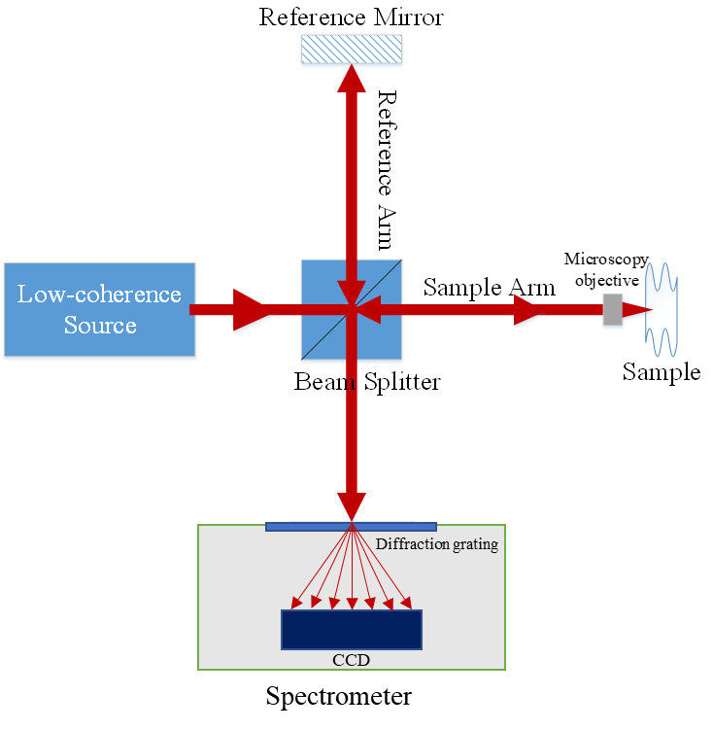
Figure 1.2: Schematic of spectral-domain OCT.

In SD-OCT setups, the CCD output will convert to $I_{D}\left(k\right)$, the current as a function of wavenumber, and the inverse Fourier transform of $I_{D}\left(k\right)$ will be used to estimate the sample field reflectivity profile, which is calculated as:
$$i_{D}\left(z\right)=\frac{ρ}{8}\left[{γ\left(z\right)[R}_{R}+R_{S1}+R_{S2}+…]\right]+\frac{ρ}{4}\left[γ\left(z\right)⊗\sum_{n=1}^{N}{\sqrt{R_{R}R_{Sn}}\left(δ\left[\left(z±2\left(z_{R}-z_{S_{n}}\right)\right)\right]\right)}\right]+\frac{ρ}{8}\left[γ\left(z\right)⊗\sum_{n≠m=1}^{N}{\sqrt{R_{Sn}R_{Sm}}\left(δ\left[\left(z±2\left(z_{Sn}-z_{Sm}\right)\right)\right]\right)}\right] (1.4)$$
$$= \frac{ρ}{8}\left[{γ\left(z\right)[R}_{R}+R_{S1}+R_{S2}+…]\right]+\frac{ρ}{4}\sum_{n=1}^{N}{\sqrt{R_{R}R_{Sn}}\left[γ\left[2\left(z_{R}-z_{S_{n}}\right)\right]+γ\left[-2\left(z_{R}-z_{S_{n}}\right)\right]\right]}+\frac{ρ}{8}\sum_{n≠m=1}^{N}{\sqrt{R_{Sn}R_{Sm}}\left[γ\left[2\left(z_{S_{n}}-z_{S_{m}}\right)\right]+γ\left[-2\left(z_{S_{n}}-z_{S_{m}}\right)\right]\right] (1.5)}$$
where $γ\left(z\right)$ is the coherence function, namely the inverse Fourier transform of a normalized Gaussian function [4]. The $γ\left(z\right)$ can be expressed as
$$γ\left(z\right)=e^{-{\left(z\right)}^{2}{∆k'}^{2}}\underset{↔}{F}S\left(k\right)=\frac{1}{∆k'\sqrt{π}}e^{-{\left[\frac{(k-k_{0})}{∆k'}\right]}^{2}} (1.6)$$
where $∆k'$ is the half-width of the spectrum at $1/e$ of maximum and $z$ is the path length [4]. The first, second and third term of equations (1.4) and (1.5) have been named DC term, cross-correlation term and auto-correlation term respectively. The output of equation (1.4) and (1.5) is exemplified in Figure 1.3. The desired internal sample reflectivity profile ($\sqrt{R_{S}(z_{S})}=\sum_{n=1}^{N}{\sqrt{R_{Sn}}δ[(z_{R}-z_{S_{n}})])}$) is contained in the cross-correlation term. The cross-correlation term is Hermitian symmetric resulting in complex conjugate artefacts [7]. In practice, due to complex conjugate artefacts, only the positive half-space is used to obtain A-scan [8]. The auto-correlation term will generate a series of weak artefacts in OCT phantom. According to the auto-correlation term, we can deduce that these artefacts originate from adjacent sample reflectors within a coherence length. The DC term causes a large artefactual signal in OCT phantom. Fortunately, this artefact can be easily eliminated by subtracting recorded reference-mirror signal from detected spectral interferometric signal.
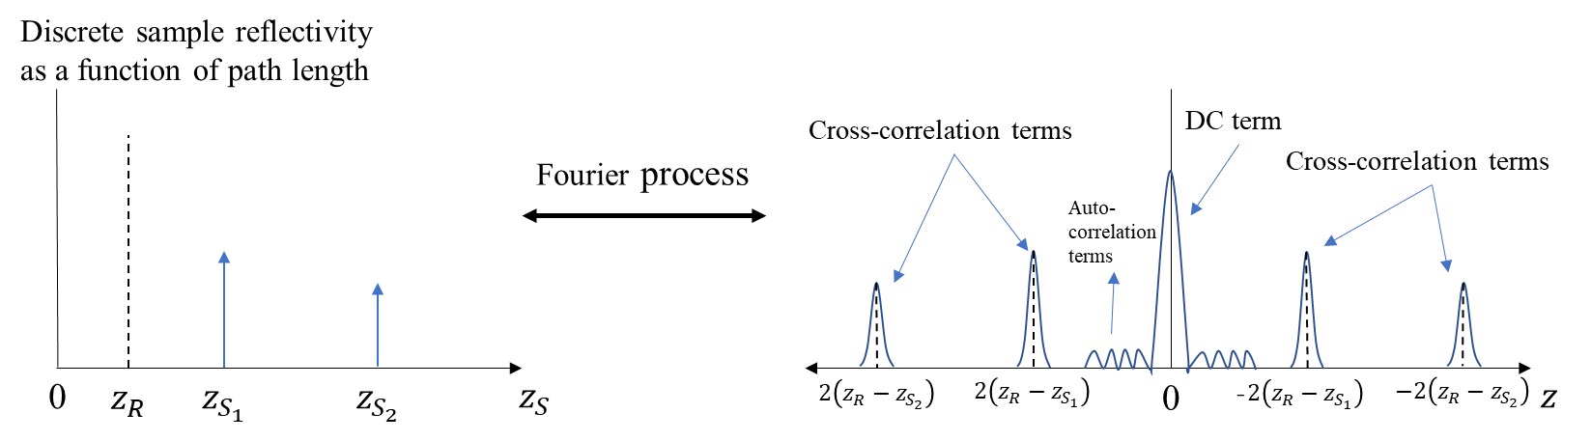
Figure 1.3: Illustration of Fourier process of Fourier-domain OCT.

Fourier-domain OCT that relies on a swept-laser source is named swept-source OCT (SS-OCT), illustrated in Figure 1.4 [9]. Like TD-OCT, SS-OCT uses a single-channel photodetector to capture photoelectric signals. However, in SS-OCT the reference mirror is fixed, and a swept-laser source is utilized instead of a broadband light source. The swept-laser source emits tuneable narrowband radiation with a wavenumber of $k$, and the current of photodetector ($I_{D}\left(k\right)$) in equation (1.1) is acquired by synchronously sweeping the wavenumber ($k$) and gathering each spectral component [10]. The signal processing of SS-OCT is same as SD-OCT; i.e., the internal sample reflectivity profile is obtained by the cross-correlation term of inverse Fourier transform of $I_{D}\left(k\right)$, shown as equation (1.4) and (1.5).

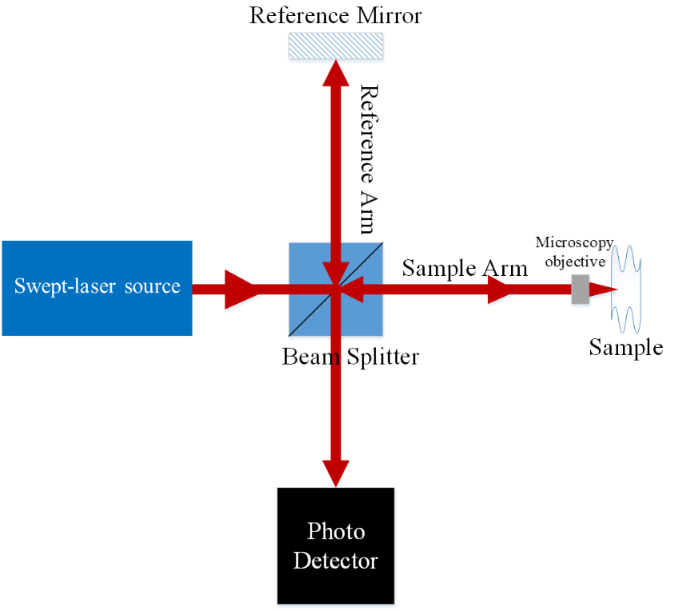
Figure 1.4: Schematic of swept-source OCT.

In this project, developments of MMOCT and PS-OCT are based on Fourier-domain OCT, i.e. SD-OCT and SS-OCT. Thus, the features of Fourier-domain OCT will be reviewed in section 1.3.

Fourier-domain OCT
The basic concept of SD-OCT or Fourier-domain OCT was first reported in 1995 [11]. Thereafter, the researches and industries of Fourier-domain OCT grew rapidly and gradually replaced traditional TD-OCT. Fourier-domain OCT has several key benefits which has evolved clinical applications of OCT. Firstly, in contrast of TD-OCT, Fourier-domain OCT has much higher acquisition rate because SD-OCT has no need of scanning the reference arm. It has been reported that the speed of A-scan acquisition of SD-OCT can be 73 times faster than TD-OCT, reaching speed of 34 microseconds per A-scan [12]. Secondly, the sensitivity of OCT has been significantly increased in Fourier-domain OCT. Compared with TD-OCT, a >100-fold increase in sensitivity of SD-OCT has been demonstrated [13]. The significant improvements of sensitivity and acquisition speed have made OCT implement high-speed volumetric imaging and real-time mapping of tissue in vivo [13, 14].

Resolution
Resolution, denoting the distance between distinguishable spots, is one of the key factors of OCT performance. Similar to conventional and confocal microscopy (CM), the theoretical lateral resolution of OCT ($∆x$) is determined by the focal spot size, namely the $1/e^{2}$ beam waist of a Gaussian beam. The lateral resolution can be expressed as:
$$∆x=\frac{4λ_{0}}{π}\frac{f}{d_{0}} (1.7)$$
where $λ_{0}$ is the centre wavelength of source, $f$ is the focal length of the lens and $d_{0}$ is the spot size on the objective lens exit pupil [15]. Since large numerical aperture (NA) corresponds to small focal length and large spot size on the objective lens, increase of NA of objective lens can improve lateral resolution of OCT. However, as a trade-off, increase of NA will decreases the image depth, which can be expressed as:
$$b=\frac{π{∆x}^{2}}{2λ_{0}} (1.8)$$
where $b$ is depth of field, namely double the Rayleigh length [16].

The axial resolution of OCT is independent of NA, determined by the coherence length of the light source. This is because the tissue structure along the axial direction is resolved by the cross-correlation amplitude/envelope of intensities returning from the reference and sample arms which depends on the coherence characteristics of the source when we assume that the tissue behaves as an ideal mirror [17]. In most OCT literatures, the full width half maximum (FWHM) of this correlation was defined as the axial resolution of OCT, equalling the coherence length ($I_{c}$) of light source. The light source with broader spectral bandwidth ($Δλ$) will produce better axial resolution, expressed as
$∆z=I_{c}≈{0.44{λ_{0}}^{2}}/{Δλ} \left(1.9\right)$
where the light source with Gaussian spectral distribution is assumed. In contrast, the axial resolution of conventional microscopy ($∆z^{'}$), such as confocal microscopy, mainly depends on NA and the wavelength due to the axial information about the tissue structure directly obtained from the optical signal a camera collects, expressed as:
$$∆z^{'}=1.4λ_{0}×\frac{n}{{NA}^{2}} (1.10)$$
Here, $n$ is refractive index of the specimen. Because the axial resolution of OCT can be improved by using lower coherence laser source, instead of increase of NA, OCT commonly uses low NA objective for long work distance, deeper imaging depth and a large field of view (FOV). An ultrahigh-resolution OCT is usually achieved by using a broad bandwidth light sources and a short wavelength source, i.e. 800 nm. A common cost-effective broad bandwidth source is multiplexed superluminescent diodes (SLDs), which consists of two or more SLDs to synthesize ultrabroad bandwidth light [16, 18, 19].

In practice, there are many other factors which can affect resolution of OCT. Significant factors include group velocity dispersion, spectral shape of light sources, chromatic and monochromatic aberration and polarization mismatch or dispersion [16]. Therefore, estimation of true resolution of OCT is quite complicated. A common method for measuring true lateral resolution is to use a resolution test slide with the 1951 USAF test pattern, shown in Figure 1.5. The true lateral resolution of OCT can be evaluated by seeking the largest bar that OCT cannot discern. The axial true resolution can be obtained by measuring the FWHM of point spread function. The lateral and axial resolutions of OCT can reach several microns which can easily differentiate tissue structure to offer anatomical information [16, 18].
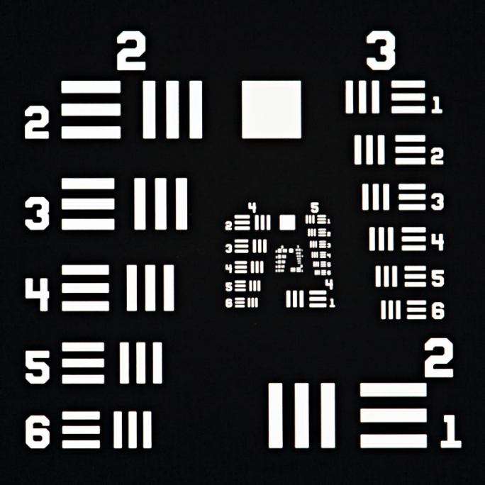
Figure 1.5: 1951 USAF resolution test chart (picture source: Thorlabs).

Sensitivity
In the OCT literature, sensitivity and signal to noise ratio (SNR) are usually interchangeable, which indicates the signal to noise ratio of a perfect reflector [4]. Several research groups have theoretically and experimentally proven that Fourier-domain OCT, including SD-OCT and SS-OCT, has 20-30dB higher sensitivity than TD-OCT [20-22]. It has been experimentally proved that the sensitivities of SD-OCT and SS-OCT can achieve >109dB and 121dB respectively [21, 23]. The relationship expression between sensitivities of TD-OCT, SD-OCT and SS-OCT can be expressed as following:
$${SNR}_{SDOCT}={SNR}_{SSOCT}=\frac{ρS_{TDOCT}R_{S}}{4eB_{TDOCT}}.M_{0}={SNR}_{TDOCT}.\frac{M_{0}}{2} (1.11)$$
where $S_{TDOCT}R_{S}$ denotes the power backscattered from the sample, $B_{TDOCT}$ is the electronic detection bandwidth and $M_{0}$ represents number of spectral channels of detection system and number of analog-to-digital sampling points in SD-OCT and SS-OCT respectively . It has been assumed that each spectral channel has equal power in equation (1.11). The sensitivities of SD-OCT and SS-OCT can be increased by a factor of $\frac{M_{0}}{2}$. The improvement factor of $M_{0}$ is attributable to all the backscattered signals at all depths being sampled simultaneously. The improvement is halved because only positive or negative signal is used, to remove complex conjugate artefacts. For a more realistic gaussian distribution on spectral channel, the SNRs of SD-OCT and SS-OCT are reduced by a factor of $\sim 2$ (which is not shown in equation 1.11) [4].

Sensitivity falloff
In SD-OCT, the spectral interferogram data is detected by a spectrometer. However, a realistic spectrometer has limited spectral resolution, since the array detector in spectrometer has finite pixels. The CCD array can detect an interference pattern, but the fringe visibility decreases at high fringe frequencies [23]. Equation (1.1) indicates that the high-frequency fringe corresponds to the interferogram signal which has large path difference between sample and reference arms. Thus, in practice, the sensitivity would decrease as the path difference of sample and reference arms increases. In other words, the sensitivity of OCT reduces as a function of depth, which is called sensitivity falloff.

In theory, the sensitivity reduction as a function of depth ($S(z)$) can be expressed as:
$$S\left(z\right)=\frac{\sin^{2}⁡(πz/2d)}{{(\frac{πz}{2d})}^{2}}\exp\left[-\frac{π^{2}ω^{2}}{8\ln{2}}{\left(\frac{z}{d}\right)}^{2}\right] (1.12)$$
where $d$ is the maximum imaging depth, $ω$ is the ratio of spectrometer’s spectral resolution (FWHM) ($δλ$) to the wavelength spacing between pixels ($∆_{p}λ$), i.e. $ω=δλ/∆_{p}λ$ [23, 24]. The maximum imaging depth is determined by centre wavelength of source ($λ_{0}$) and $∆_{p}λ$ [25]:
$$d=\frac{{λ_{0}}^{2}}{4∆_{p}λ} (1.13)$$
In SS-OCT, the finite linewidth of the swept source is regarded analogous to the finite spectral resolution. Then, the sensitivity falloff of SS-OCT can be theoretically analysed in the same way [21].

Magnetomotive OCT
MMOCT is a method of locating magnetic particles within tissue. Hence, in MMOCT, magnetic particles, such as superparamagnetic iron oxides (SPIOs) and microsphere encapsulating SPIO-containing ferrofluid, have been used as contrast agents for visualization and localization of labelled or targeted cells [26, 27]. MMOCT is implemented based on a phase-sensitive OCT which tracks induced motion of magnetic particles or ambient tissue deformation [28]. In MMOCT, cells or tissue are labelled with magnetic nanoparticles, and these nanoparticles are then actuated by an external alternating magnetic field. The magnetic nanoparticles inside sample lead to displacement change in adjacent tissue. As the displacement can be detected as a phase shift in phase-sensitive OCT signal, the modulated magnetic field causes phase modulation which can be extracted by a band-pass filter to localize these magnetic particles [29]. Because phase-sensitive OCT is capable of detecting nanoscale displacement, visualization of labelled or targeted cells can be implemented with low-density magnetic nanoparticles and relatively low intensity of magnetic field [28]. For example, it has been reported that the SPIO concentration as low as 2 nM is able to be detected using 0.08 T of magnetic field [28]. In contrast, magnetic resonance imaging (MRI) needs ×10-×100 higher magnetic field intensity (0.5-7 T) to probe SPIO labelled cells/tissue [30, 31]. The theoretical basis of MMOCT will be introduced in section 1.4.1.

Another attractive technology, optical coherence elastography (OCE), used to map local mechanical properties (including elasticity and stiffness) of tissue, shares many characteristics with MMOCT [32]. The basic principle of OCE is similar with MMOCT, which is that the sample deformation induced by a mechanical loading is measured by OCT, typically phase-sensitive OCT [32]. The mechanical property of a sample is estimated by a mechanical model, in which the measured displacement is used to estimate local elasticity throughout the sample. Many loading methods have been applied in OCE, mainly including compression [33-37], face acoustic wave [38, 39], acoustic radiation force [40-43], magnetomotive [44-46] and impulse air jet [47, 48]. The magnetomotive OCE (MMOCE) is considered as a variant of MMOCT, since the data acquisition method of MMOCT is similar with MMOCE’s. Both technologies employ embedded magnetic materials or particles within tissues and an external magnetic field to produce local displacements of tissue, and the local displacements were measured by a phase-sensitive OCT. However, the measured displacements are used to map the mechanical properties of sample, such as the Yong’s modulus of sample, in MMOCE rather than provide additional OCT contrast in MMOCT [32]. Due to the overlap between the MMOCT and MMOCE, the current state and applications of MMOCE are reviewed briefly as well in this section.

Theory of phase-sensitive OCT
The implementation of MMOCT imaging technique relies on phase-sensitive OCT capable of detecting nanoscale displacement. Many phase-sensitive OCT systems have been developed based on SD-OCT, since SD-OCT has comparatively lower phase noise than TD-OCT and SS-OCT [49-51]. The lower phase noise of SD-OCT is attributed to eliminating the phase noise generated from moving reference arm in TD-OCT [49] or k-trigger jitter in SS-OCT. In phase-sensitive OCT, the displacement of sample reflector can be measured by processing the phase of the interferometric signal. The interferometric phase is the difference between the sample arm phase function ($φ_{S}\left(z\right)$) and the reference arm phase function ($φ_{R}\left(z\right)$), which can be written as [52]:
$$φ_{S}\left(z\right)-φ_{R}\left(z\right)=2k{∆z}_{0} (1.14)$$
Here ${∆z}_{0}$ is the free-space path length difference between the two arms. Note that we assume the refractive indexes in both arms are 1. If successive scans are conducted with fixed reference arm, the displacement, namely relative position of a reflector, will be measured by monitoring the interferometric phase.

An additional advantage of SD-OCT is that the interferometric phase can be directly obtained during signal processing. In free space, the photocurrent of SD-OCT can be given by:
$$i\left(k\right)=\frac{1}{2}ρS\left(k\right)δk\left[R_{R}+\sum_{n}{R_{n}}+2\sqrt{R_{r}}\sum_{n}{\sqrt{R_{n}}\cos\left(2k\left[∆x_{n}+δx_{n}\right]\right)}\right] (1.15)$$
where $S\left(k\right)$ presents the source power spectral density, $δk$ is the spectral channel bandwidth and $∆x_{n}+δx_{n}$ presents the relative position of the $n$th reflector in sample arm [52]. Here, the two arguments of reflector position, $∆x_{n}$ and $δx_{n}$, denote an integral multiple of the discrete sampling interval in the spatial domain and subresolution deviations away from the sampling interval respectively [52]. The $∆x_{n}$ can be expressed as:
$$∆x_{n}=\frac{mπ}{∆k} (1.16)$$
where $m$ is any integer indexing elements in the spatial-domain A-scan array and $∆k$ is the bandwidth of source [52]. Fourier transformation of the $k$-domain signal is processed to obtain sample field reflectivity profile and the interferometric phase as following:
$$I_{signal}\left(2∆x_{n}\right)=\frac{ρS_{0}\sqrt{R_{R}R_{n}}}{2ef_{ascan}}E\left(2δx_{n}\right)\exp\left(jk_{0}2δx_{n}\right) (1.17)$$
where $E\left(2δx_{n}\right)$ is the autocorrelation term [52]. Thereinto, $k_{0}2δx_{n}$ is the interferometric phase. Note that, in equations of 1.4 and 1.5 which were used to explain imaging principle of SD-OCT, interferometric phase did not appear after Fourier transformation of $k$-domain signal because $δx_{n}$ was not considered previously. The physical displacement in the subresolution position can be computed as:
$$∆x\left(t\right)=\frac{λ_{0}}{4nπ}\left[phase\left[I_{signal}\left(2∆x,t\right)\right]-phase\left[I_{signal}\left(2∆x,t_{0}\right)\right]\right] (1.18)$$
where phase[.] is the phase operator, $t_{0}$ denotes an arbitrary reference time and $λ_{0}$ is the centre wavelength of source [49].

The phase sensitivity of SD-OCT is limited by the phase fluctuations in the system. In theory, the phase fluctuations could be generated from the random phase of the shot noise [52]. In the case of the shot noise $≪$ signal, the phase fluctuation $δφ_{sens}$ can be estimated as:
$$δφ_{sens}=\frac{2}{π}\sqrt{\frac{1}{{SNR}_{n}}} (1.19)$$
where ${SNR}_{n}$ is the signal-to-noise ratio of $n$th reflector in sample [52]. Low phase fluctuation is desired for phase-resolved imaging and MMOCT imaging.

Theory of MMOCT
MMOCT is usually established by bringing in a solenoid with a power supply in the sample arm of spectral-domain OCT, shown in Figure 1.6 [44]. The power supply usually provides a sinusoidal current to solenoid, causing a modulated sinusoidal magnetic field in the interrogated tissue. The magnetic field exerts local forces on the magnetic nanoparticles, and the local force ($F$) can be express as:
$F=\left(\left(M_{p}+M_{d}\right)· ∇\right)BV (1.20)$
where $M_{p}$ and $M_{d}$ are the volume magnetization of magnetic particle and tissue respectively and $V$ is the total volume [44]. The magnetically induced displacement ($∆Z\left(t\right)$) of nanoparticle in the sinusoidal magnetic field was expressed as [53]:
$$∆Z\left(t\right)=\frac{A}{2}\left(\sin{(2πf_{B}t+φ_{0}}\right)+1 (1.21)$$
Here, $A$ is the maximum displacement of nanoparticle in the magnetic field, $f_{B}$ is the frequency of the modulated magnetic field and $φ_{0}$ is the mechanical phase lag determined by viscosity of the medium. However, this formula has neglected the change of magnetic torque and the rotational motion of probe in the sinusoidal magnetic field. The actual mode of nanoparticle motion does not follow the equation (1.21). The details of nanoparticle motion and its signals will be discussed in the chapter 4 and 5.
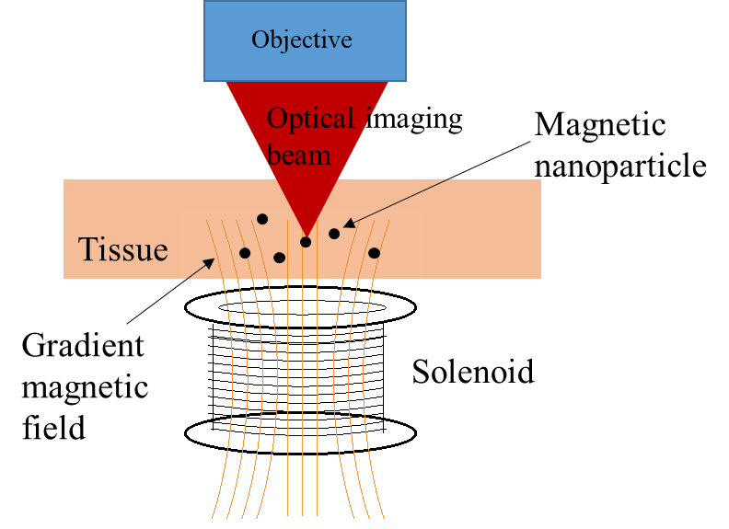
Figure 1.6: The schematic of the imaging mechanism of MMOCT, where the magnetic nanoparticles in a spatially-varying magnetic field cause z-axis displacement of magnetic nanoparticles and phase shift, and the magnetic nanoparticles can be localised by mapping the induced phase shift.

As discussed in 1.4.1, the motion of magnetic probe in the axial direction can be detected as the change of interferometric phase ($∆φ$) in SD-OCT, expressed as
$$∆φ=2〈k〉n∆z (1.22)$$
where $〈k〉$ is average wavenumber of light source and $n$ is refractive index of medium. The motion of magnetic probe induced by a sinusoidal current causes a phase shift with modulated frequency. The magnetomotive signal is extracted by a bandpass filter and used to localise the magnetic probe.

The main factors which affect the magnetomotive signal include elastic modulus of tissue, local particle concentration, (magnetic) properties of nanoparticle, frequency and strength of external magnetic field [54]. As expected, the high concentration of magnetic particles will trigger high intensity of signals [28].

Contrast agents for MMOCT
Magnetic micro- or nanoparticles have been extensively used as the contrast agents for MMOCT. Among different types of magnetic particles, SPIO is the most common contrast agent for MMOCT, and has been successfully used to label and visualize platelets [26, 44], macrophages [55], mammary tumour [56] and the digestive tract of the tadpole [29]. This is because SPIO has three obvious advantages. Firstly, the magnetic susceptibility of SPIO (approximately 1) is ~10⁵ times greater than human tissue’s (e.g. the magnetic susceptibilities of water and haemoglobin in blood cells are approximately -10⁻⁵ and <10⁻⁵ respectively [57]). Therefore, SPIO can provide evident magnetomotive signal above background signals from tissue itself. Secondly, SPIO is readily available since there are many well-developed synthetic methods and commercial providers [58]. Thirdly, SPIO has low toxicity and high biocompatibility in human body and has been clinically approved for use in several biomedical applications, such as the contrast agent of MRI and drug carrier [58, 59]. It has been reported that SPIO is safe and nontoxic at doses of 100 µg/ml or lower [59, 60].

Other more versatile magnetic particles have been developed for the contrast agents of MMOCT as well, and almost all these magnetic particles are based on the magnetically responsive components of iron oxides, mainly including magnetite (Fe₃O₄) and maghemite (γ-Fe₂O₃) [53, 56, 61-63]. For example, magnetite/maghemite core (with ~20 nm in diameter) was coated by a polymer with a hydrophilic COOH-terminated outer surface to prevent the aggregation of the nanoparticles in aqueous solution [53]. Dextran-coated iron oxide magnetic nanoparticles were conjugated with an anti-HER2 (human epidermal growth factor receptor 2) antibody to allow the magnetic nanoparticle to target the rat mammary tumour, and thereby the sites of rat mammary tumour were detected and imaged by MMOCT in vivo [56]. Agglomeration of magnetite surrounding by a fluorescent shell and a coating of dextran sulfate has been developed to label and track mesenchymal stem cells via both MMOCT and fluorescence microscopy [61]. Iron oxide encapsulated protein-shell microspheres have been fabricated for targeting and imaging tumour tissue via MMOCT with the potential for use in drug delivery; in this case, a type of ligand or antibody was added to the outer surface of the particle to target the over-expressed receptors of cancer tissue [62, 63]. A common property of all these contrast agents is superparamagnetism, since it plays a crucial role in MMOCT imaging. Therefore, the physics of superparamagnetism and its role in MMOCT are reviewed below.

Superparamagnetism
A magnetic material can be magnetized in a magnetic field of strength $H$ contributing its overall magnetic induction $B$, due to the realignment of magnetic dipole within the material. The magnetizability of material can be characterized by its volumetric magnetic susceptibility ($χ$), given as $χ=M/H$, where $M$ is the magnetization in the material. Magnetic materials are conventionally classified as paramagnets, diamagnets, ferromagnets, ferrimagnets and antiferromagnets, according to their volumetric magnetic susceptibility and the alignment of magnetic dipole in the materials.

Most materials are paramagnetic or diamagnetic materials, which exhibit a small positive or negative $χ$ falling in the ranges of 10⁻⁶ to 10⁻¹ and -10⁻⁶ to -10⁻³ respectively. The small negative $χ$ of diamagnetic material results from the interaction of an external magnetic field with the paired electrons in orbitals in an atom, termed as diamagnetism. Diamagnetism occurs in all matter, which indicates that a weak antiparallel magnetic moment is induced in an applied magnetic field, resulting in a repulsive force of magnetic field. For diamagnetic materials, the diamagnetism is the strongest effect. Paramagnetic materials exhibit a small positive $χ$, due to the existence of unpaired electrons. The spin of unpaired electrons causes permanent magnetic moments, and the permanent moment can be aligned parallel in an external magnetic field, leading to a parallel magnetic moment and an attractive force of magnetic field. Paramagnets have a net attraction, since the parallel moment is larger than the antiparallel moment from diamagnetism. The $χ$ of ferromagnets is 10⁴ times larger than paramagnets, because the magnetic moments in ferromagnets are strongly ordered and tend to be aligned parallel. In this case, a spontaneous magnetization presents in the ferromagnet even without an external field applied. In order to explain the ordered magnetic states, it is postulated that the small regions (termed as domains) within ferromagnets are each spontaneously magnetized, in which the strongly coupled atomic dipoles are formed due to the quantum mechanical exchange forces [64]. Furthermore, ferrimagnets and antiferromagnets also possess the strongly coupled atonic dipoles, but their coupled dipoles trend to arrange in nonparallel and antiparallel to each other, respectively.

Bulk ferromagnets, ferrimagnets and antiferromagnets have many domains with domains-walls in between, and the pinning of domain walls by defect sites causes a frictional force to resist the movement of domain wall and leads to hysteresis [65, 66]. The hysteresis can be experimentally observed as hysteresis loop in their $M$ -$H$ curves (shown in Figure 1.7 a)). When ferromagnetic or ferrimagnetic particles are small enough, typically <100 nm, the nanoparticles are considered as single-domain particles, in which all permanent magnetic moments are parallel to each other [67]. The single-domain nanoparticle is named superparamagnetic material, and its magnetic property is called superparamagnetism. One of the key characteristics of superparamagnetism is the anhysteretic $M$ -$H$ curve, shown in Figure 1.7 b), due to the absence of domain walls in superparamagnetic material. In Figure 1.7 b), the $M$ -$H$ curve is sigmoidal, and the $M$ is approximately linear with $H$ when $\left|M\right|≪$ saturation magnetization. Because of the linear relation, the sinusoidal magnetic field in MMOCT exerts a sinusoidal periodic force on the magnetic particle and leads to a sinusoidal motion of superparamagnetic particles in/on sample. Since Fourier transformation is used to convert the phase shift of magnetomotive signal to frequency domain during the signal processing of MMOCT, the sinusoidal motion (resulting in the sinusoidal waveform of the phase shift) is important to receive a clear Fourier frequency spectrum, and thereby helps us to obtain a reliable MMOCT image.
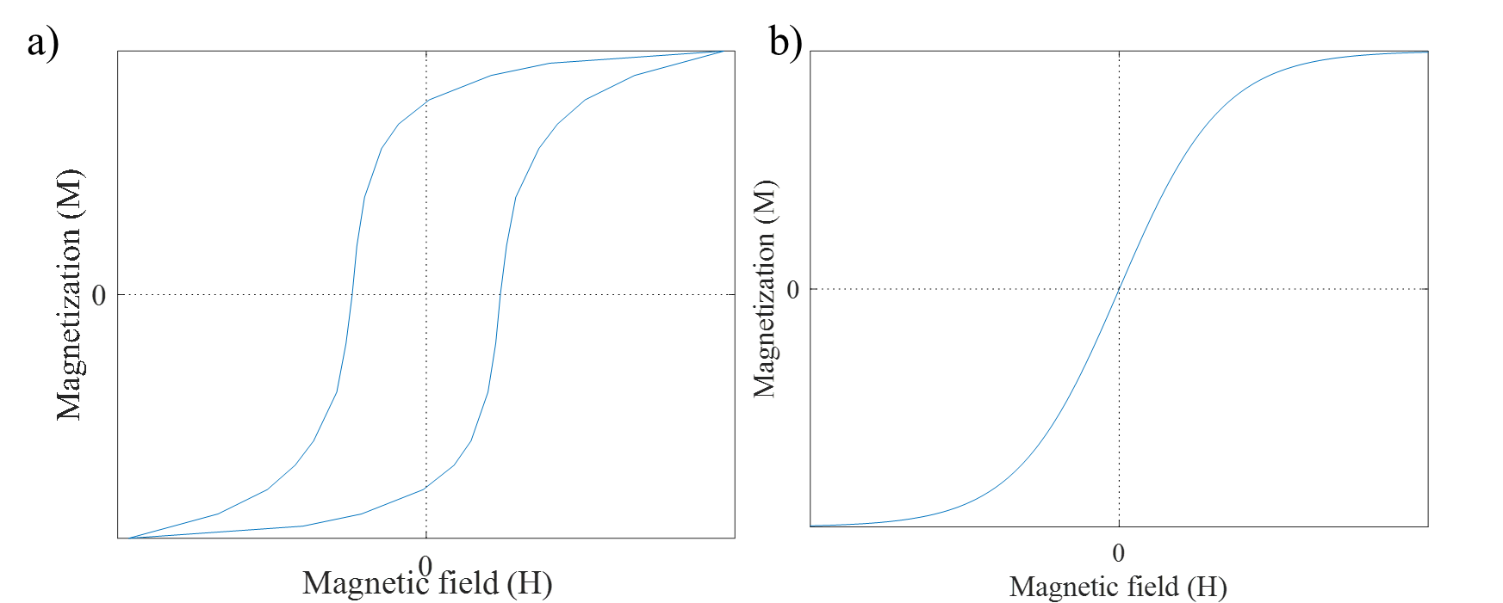
Figure 1.7: a), the illustration of $M$ -$H$ curve for the ferromagnetic materials, where the hysteresis loop is seen. b), the demonstration of $M$ -$H$ curve for superparamagnetic materials.

In this PhD project, a commercial SPIO (#637106, Sigma-Aldrich) and a synthetic magnetic nanoparticle, magnetic graphene quantum dot (MGQD), are used as the contrast agent of MMOCT, as both magnetic nanoparticles exhibit superparamagnetism.

Applications of MMOCT
MMOCT is potentially capable of tracking magnetically labelled cells. Therefore, MMOCT has the potential in the diagnoses of numerous diseases and quantifying pathological changes. For example, because vulnerable atherosclerotic plaques have abundant infiltrated macrophages, the localization of rabbit macrophages has been tracked using MMOCT for detecting vulnerable plaques, in which the macrophages largely phagocytose injected iron oxide nanoparticles, becoming magnetically labelled cells [68]. Another important application of MMOCT is to track magnetically labelled platelets for studying thrombosis and haemostasis, where the platelets are labelled with SPIO and the sites of vascular damage can be localized by MMOCT due to platelet adhesion [44]. MMOCT has also been used for diagnosis of rat breast cancer in a preclinical mammary tumour model; in this application, magnetic nanoparticles (dextran-coated iron oxide) are functionalized with antibody to target HER-2/neu receptors which are overexpressed in breast cancer cells; after injection of targeted magnetic nanoparticles, the mammary tumour can be visualized by MMOCT due to the accumulation of targeted magnetic nanoparticles in this site [56].

Development and applications of MMOCE
In MMOCE, magnetic nanoparticles or magnetizable metal implants were embedded into the tissue, and a phase-sensitive OCT was employed to detect the local tissue deformation actuated by an external magnetic field [44-46, 53, 69-74]. The mechanical properties, including viscoelasticity and Young’s modulus, have been evaluated by three methods [72]. In the first method, a steady magnetic field gradient was employed to exert a constant force on the magnetic material. When the magnetic field was switched on or off, the magnetic material was settled at a new position after underdamped oscillation. The OCT was used to detect the motion of magnetic material as a function of time, and the viscoelastic properties of sample can be evaluated using empirical rheological models, such as the Kelvin-Voigt and Maxwell models, based on the detected data [72]. The second method applied a frequency-varying magnetic field, such as a chirp, to exhibit the natural frequency of the sample [72]. In this method, the sample displacement was detected within the frequency-swept mechanical spectrum by OCT, and the largest displacement was observed at the natural frequency of sample [72]. The viscoelastic properties can be evaluated according to the relation between the natural frequency and the viscoelasticity in the rheological models [75]. In the third method, elastic wave propagating through sample was generated by actuated magnetic nanoparticles, and its group and phase velocities were measured by OCT to evaluate the mechanical properties [71].

MMOCE has been used to investigate various tissues and organs, including muscle, lung, liver and breast tissue [46, 53, 70, 71, 73]. It has been shown that MMOCE can differentiate elastically distinct regions within a tissue and provide the depth-resolved viscoelasticity distribution. For example, adipose and tumour tissues have been identified from normal tissue by MMOCE in excised human breast tissue due to their different natural frequency [73]. Therefore, MMOCE holds the potential to diagnose the disease which alters the mechanical properties of tissue, such as breast cancer, liver cirrhosis and prostate cancer, and delineate the boundaries of lesion [32]. Recently, high resolution phase-sensitive OCT has been developed to detect the displacement of magnetic particles on a nanoscale for the assessment of cell biomechanical properties, which may help the study of pathological state of cells [69].

However, MMOCE is very far from the requirements in clinical applications. So far, most researches about MMOCE focused on technical performances rather than clinical tests. There are two challenges to be addressed before the clinical trials. Firstly, a rigorous validation of technical performance needs to be developed. In most researches, the technical validations were achieved by imaging an artefact sample with a known heterogeneous mechanical property and comparing the heterogeneous phantom with real distribution. In this case, mechanical parameter quantification cannot be achieved because some factors which affect the mechanical properties, such as geometrical factors and anisotropic elastic modulus and viscosity, were neglected in the MMOCE [76]. More recently, a new computational model using the finite element method has been developed to simulate the results of MMOCE, and the mechanical parameters of sample could be quantitatively evaluated when the simulation results were close to MMOCE measurements [72, 74, 77]. Secondly, an accurate measurement of MMOCE requires relative high concentrations and homogeneous distribution of nanoparticle throughout the tissue, which is difficult to achieve for in vivo applications due to the aggregation of nanoparticle and influences of internal environment in human body [76].

Polarization-sensitive OCT
PS-OCT is a functional extension of OCT which can acquire not just the intensity but the polarization state of backscattered signal. Taking advantage of the additional information, PS-OCT can potentially differentiate tissues that are difficult to distinguish by general OCT. The tissue birefringence, diattenuation and depolarization have been successfully measured by PS-OCT because these light-tissue interactions generate polarization state changes [78]. The tissues with oriented fibre alignment, such as muscles and tendons, are one of the main imaging targets of PS-OCT [79]. These tissues are optically anisotropic material and can be classed as birefringent media, in which the light speed in these media depends on the polarization direction of electric field. PS-OCT is able to distinguish birefringent tissues and measure their phase retardation and birefringent fast axis [80-83]. In ophthalmology, the ocular structures which can be differentiated on the basis of birefringence include retinal nerve fibre layer, the sclera and the cornea [79]. The additional contrast has also been used to investigate skin, because evident birefringence has been observed in the stratum corneum of skin [84]. Depolarization is another important optical property of tissue provided by PS-OCT. Depolarization refers to the capacity of a medium to scramble the polarization of light. It has been found that tissue depolarization is positively correlated with the concentration of melanin granules [85]. Therefore, PS-OCT is an excellent tool to investigate distribution and pathology of melanin. In this section, the theory of PS-OCT will be discussed, and then its clinical or preclinical applications will be reviewed briefly.

Theory of PS-OCT
The core function of PS-OCT is to detect and map the polarization state of backscattered light. This function can be realized in different ways. For example, PS-OCT has been designed based on spectral or time domain OCT system, bulk or fibre optics etc [79, 80, 86, 87]. One purpose of our project is to develop and research a PS-OCT system based on our polarization-maintaining fibre-based SS-OCT. This review will only focus on the theory behind this system.

Similar to intensity-based OCT, most PS-OCT systems also use a Michelson interferometer to obtain depth-resolved information, but PS-OCT (in its earliest form) applies a single circularly polarized light, rather than light with random polarization, to interrogate tissue [81, 86, 88-91]. Additional information about the tissue, such as birefringent and depolarization, would be acquired by analysing the effect of tissue on the circularly polarized light. A schematic diagram of a bulk optics PS-OCT system is shown in Figure 1.8. A low-coherence source, e.g. superluminescent diode, emits a broadband light which is linearly polarized by a polarizer before propagating to a beam splitter. The beam splitter splits the polarized light into reference arm and sample arm. In the reference arm, the beam is reflected back toward the beam splitter at a reference mirror, and the light transits a quarter wave plate (QWP) oriented at 22.5° twice, both before and after the reflection. Due to the QWP, the linearly polarized beam is rotated 45° forming two equal orthogonal components which are vertical and horizontal to the transmission axis of light respectively. Assuming the linearly polarized light is vertical before passing through QWP, the Jones vector of reference beam ($E_{r}\left(z_{r}\right)$) in the detection arm would be written as [92]:
$E_{r}\left(z_{r}\right)=\frac{1}{2}J_{1}∙J_{1}∙\left(\begin{matrix}0 \\ 1\end{matrix}\right)=\frac{1}{2\sqrt{2}}\left(\begin{matrix}1 \\ 1\end{matrix}\right)∙exp⁡(-i2k_{0}z_{r})$ (1.23)
where $J_{1}$ is the Jones matrix of QWP in reference arm and $z_{r}$ is the reference arm length. Assuming that 50/50 beam splitter is used in the PS-OCT system, the beam splitter can reduce the field amplitude by a factor of 2, which gives the factor of $\frac{1}{2}$ in the equation 1.23.

In the sample arm, a QWP oriented at 45° is placed, by which the linearly polarized light is circularly polarized before the light enters into the sample. Circularly polarized light is used to illuminate the sample since circularly polarized light is able to measure retardation independent of the azimuthal orientation of birefringent sample [79]. Suppose that the sample is interrogated by a linearly polarized beam; no birefringence can be detected when the polarization direction is parallel to the fast or slow axis. The circularly polarized light backscattered by the sample passes through the QWP again and is redirected to the detection arm by the beam splitter. The Jones vector of the sample beam ($E_{s}\left(z\right)$) in the detection arm can be calculated as [78, 81, 93]:
$E_{s}\left(z\right)=\frac{1}{2}J_{2}∙J_{sample}\left(δ_{s}\left(z\right),θ_{s}\right)∙\sqrt{R\left(z\right)}∙J_{sample}\left(δ_{s}\left(z\right),θ_{s}\right)∙J_{2}∙\left(\begin{matrix}0 \\ 1\end{matrix}\right)$
$=\frac{\sqrt{R\left(z\right)}}{2}∙\left(\begin{matrix}\cos\left(δ_{s}\left(z\right)\right)\exp\left(-iδ_{s}\left(z\right)\right) \\ \sin\left(δ_{s}\left(z\right)\right)\exp\left(i\left(π-δ_{s}\left(z\right)-2θ_{s}\right)\right)\end{matrix}\right)∙exp⁡(-i2k_{0}z\overline{n})$ (1.24)
Here, $J_{2}$ is the Jones matrix of QWP in sample arm, $R\left(z\right)$ denotes the reflectivity of sample at various depth $z$, $\overline{n}$ is the average of refractive index of ordinary and extraordinary light. The factor of $\frac{1}{2}$ in equation 1.24 results from the amplitude reduction of beam splitter. The Jones matrix of sample ($J_{sample}\left(δ_{s}\left(z\right),θ_{s}\right)$) is a function of the sample retardation $δ_{s}\left(z\right)$ and sample’s fast axis orientation $θ_{s}$. Note that in this example, the sample is regarded as a homogenous linear retarder, which has constant fast axis orientation $θ_{s}$ and linear retardance along the $z$ direction. Hence $J_{sample}$ is transpose-symmetric.

In the detection arm of the interferometer, the reference and sample beams are recombined, and then separated by a polarizing beam splitter into horizontal and vertical components. The interference signals with a horizontal and a vertical polarization state are detected by two detection units respectively. The interference signal of horizontal and vertical polarization components ($A_{x,y}(z,∆z)$) can be written as [92]:
$A_{x,y}\left(z,∆z\right)=A_{0;x,y}(z,∆z)∙cos\left[φ_{x,y}(∆z)\right]$ (1.25)
Here, $A_{0;x,y}$ denotes the envelop of the interference signal and $φ_{x,y}(∆z)$ is the corresponding phase as a function of the optical path difference between reference and sample beams ($∆z$). The signal decomposed into its vertical and horizontal components can be expressed as [92]:
$A_{0;x}\left(z,∆z\right)=\frac{\sqrt{R(z)}}{2\sqrt{2}}∙cos\left[δ_{s}\left(z\right)\right]∙\left|γ(∆z)\right|$ (1.26)
$A_{0;y}\left(z,∆z\right)=\frac{\sqrt{R(z)}}{2\sqrt{2}}∙sin\left[δ_{s}\left(z\right)\right]∙\left|γ(∆z)\right|$ (1.27)
and
$φ_{x}\left(∆z\right)=2k_{0}∆z$ (1.28)
$φ_{y}\left(∆z\right)=2k_{0}∆z+π-2θ_{s}$ (1.29)
Here, $A_{0;x}\left(z,∆z\right)$and $A_{0;y}\left(z,∆z\right)$ are the envelopes of vertical and horizontal interference signal respectively, $φ_{x}\left(∆z\right)$ and $φ_{y}\left(∆z\right)$ are the phase of vertical and horizontal interference signal respectively and $γ(∆z)$ is the modulus of the complex degree of coherence of the interfering lights, which indicates the width or visibility of the interference fringe.

From equation 1.26-1.29, the sample reflectivity $R(z)$, the retardation $δ_{s}\left(z\right)$ and the fast axis orientation $θ_{s}$ can be calculated as [92]:
$R\left(z\right)∝{A_{0;x}\left(z\right)}^{2}+{A_{0;y}\left(z\right)}^{2}$ (1.30)
$δ_{s}\left(z\right)=arc \tan\left(\frac{A_{0;y}\left(z\right)}{A_{0;x}\left(z\right)}\right)$ (1.31)
$θ_{s}=(π-δφ)/2$ (1.32)
where $δφ$ is the phase difference of vertical and horizontal interference signal, $δφ=φ_{x}-φ_{y}$. Note that, for simplicity, $∆z$ dependence has been neglected in the derivation of formula 1.30-1.32 by assuming a coherence function of infinitesimal width. The sample retardation is one important parameter we desire. The birefringence ($∆n$), namely the difference of refractive indices along ordinary and extraordinary rays, can be derived from the retardation as follow:
$δ_{s}\left(z\right)=∆n∙z∙k_{0}$ (1.33)
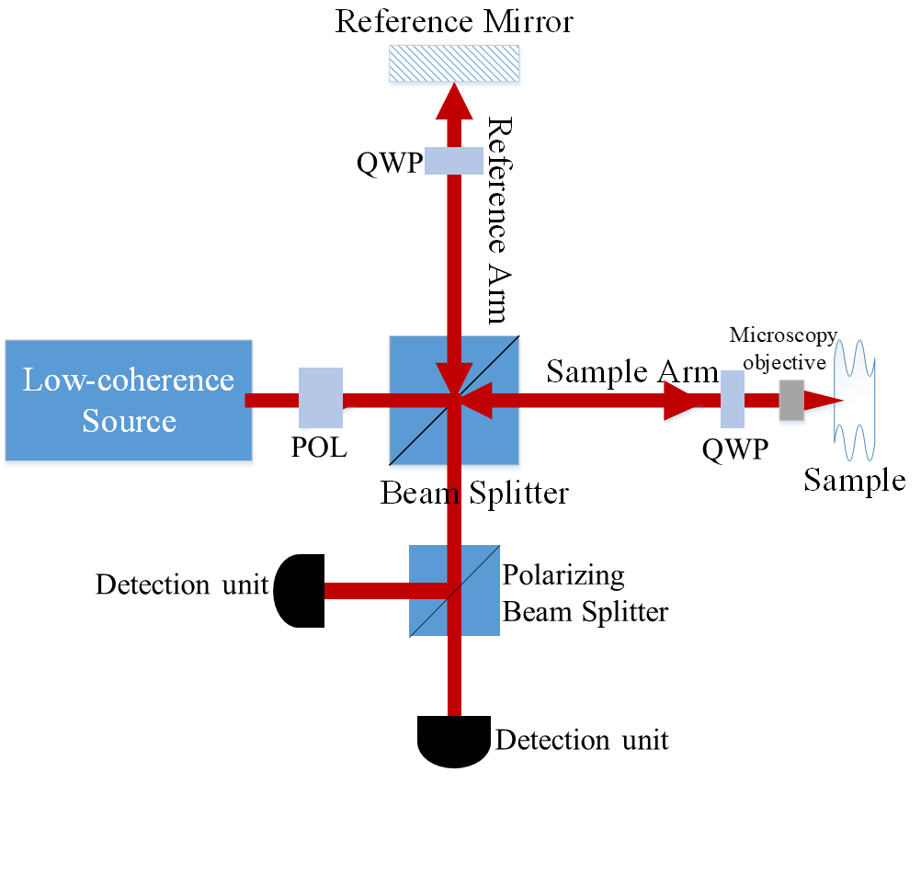
Figure 1.8: Schematic diagram of single-input-state bulk optics PS-OCT, where QWP and POL are quarter wave plate and linear polarizer respectively.

Clinical applications of PS-OCT

PS-OCT in ophthalmology
Since OCT is a standard diagnostic method in ophthalmology, PS-OCT which provides additional information of OCT was firstly considered as a tool to discern and quantify ocular structures. It has been reported that fibrous tissues such as the retinal nerve fibre layer (RNFL), the sclera and cornea show birefringence and the tissues containing melanin pigments including the retinal pigment epithelium (RPE), the pigment epithelium of the iris and the choroid exhibit depolarization [79]. Thereinto, investigating the polarization properties of RNFL using PS-OCT has been highlighted, as the birefringent properties of RNFL is a potential biomarker for early diagnosis of glaucoma [94-96]. Healthy RNFL shows evident birefringence because of its fibrous structure [97]. In glaucoma, the birefringence is reduced due to damage to the RNFL [92]. The reduced birefringence can be detected at the early stage of the disease in animal models [94], and would be likely measured before a human visual field loss is detected, because RNFL damage usually occurs prior to detectible visual field loss [98]. The research which has compared PS-OCT with scanning laser polarimetry, a successful glaucoma screening tool, have proven that PS-OCT is able to map out RNFL birefringence and retardation with reliable quality in vivo [96]. The measurements of depolarization via PS-OCT have been applied for quantifying the density of melanin pigment in the RPE and choroid [99]. The depolarization of RPE has drawn attention because the depolarization can be used to assess age-related macular degeneration (AMD), a common cause of irreversible vision loss. PS-OCT is capable of directly segmenting drusen which is the earliest indicators of AMD by thresholding retinal depolarization images [100]. In addition, PS-OCT can detect area and volume of drusen quantitively to help disease management [101]. PS-OCT can also be used to monitor the outcome of corneal crosslinking therapy, the evolution of filtering blebs after trabeculectomy and process of keratoconus etc [79].

PS-OCT in dentistry
PS-OCT has been employed to image human tooth since 1998 [102]. Human teeth primarily consist of dentin and enamel. The enamel is heavily mineralized calcium salts located along the outer surface of tooth, which has a highly ordered structure exhibiting negative birefringence [103]. Underneath the enamel, a bonelike tissue consisting of collagen fibres and the same mineral salts of enamel form the main part of teeth, namely the dentin [104]. Due to the optical anisotropy of collagen fibres and the regularly aligned tubules inside the dentin, the dentin normally exhibits positive birefringence [79, 103]. PS-OCT has been widely used to contrast the enamel, dentin and dentin-enamel junction [105-110]. Several researches have demonstrated that PS-OCT can provide the contrast of demineralized areas in dentin and enamel because of the evident depolarization of demineralized areas, which can be used to diagnose early carious lesions or monitor the demineralization process during the treatments of carious lesions [106, 107, 111-114]. Compared with conventional OCT, a notable advantage of PS-OCT is that the image artefacts found in healthy enamel intensity images were eliminated in PS-OCT images [105, 110]. The artefacts resulted from the birefringent material leading to mismatch between the polarization states of beams reflected from the sample and reference arms [110, 115]. This result implies that other birefringent materials, such as collagen and tendon, could also generate the artefacts in conventional OCT image, and PS-OCT is a feasible tool to image the birefringent tissue without the artefacts.

PS-OCT has also been used to study oral mucosa to identify oral early cancerous lesion [116-119]. It has been reported that oral cancerous lesion exhibited distinct collagen organization and epithelium thickness, resulting in different value and distribution of birefringence [116, 120]. For example, squamous cell carcinoma cancer, a form of oral cancer, at an early stage had much lower (~4 times) birefringence than normal tissue because tumour invasion altered the arrangement and density of collagen [116]. PS-OCT has successfully mapped the 3D depth-resolved birefringence of oral mucosa to assist in the diagnosis of oral cancerous lesion [119].

PS-OCT in fibrous and cancerous tissues
Besides the applications of PS-OCT in ophthalmology and dental imaging, PS-OCT has been widely used to determine the birefringence and structural organization of fibrous tissues involving nerves, muscles and collagen, ligament, tendons, cartilage, bones, blood vessels and intervertebral discs [92]. Skin is a good imaging target of PS-OCT, since skin consists of superficial layers of scattering structure and contains collagen, a birefringent tissue [82]. In dermatology, PS-OCT can be applied to identify burn depth and thereby assess the degree of injury, as the collagen is denatured and loses the birefringence at elevated temperatures [121]. According to the birefringence changes in burnt skin, a non-invasive and quantitative assessment of skin recovery can be achieved to help treatment. The similar methodology has also been applied to evaluate nerve integrity and myelination after injury [122] and scar type [123] etc.

PS-OCT has been used to identify and delineate basal cell carcinoma, one of the most common human malignancies, since basal cell carcinoma cause the damages of normal adnexal structures, destruction of collagen and retraction gaps filled with mucopolysaccharides [124]. In surgery to remove the tumour, the delineation of basal cell carcinoma is a significant clinical aid for ensuring complete tumour extirpation and avoiding unnecessary removal of healthy tissue [124]. Similarly, the tumour tissue in human esophagus, vocal fold, breast etc. can also be detected by PS-OCT based on the local destruction of collagen and associated reduction of birefringence [92].

The information about birefringence and structural orientation of the collagen fibres in articular cartilage and bovine intervertebral disc has been investigated in vitro using PS-OCT by our research group [125-131]. The research result for investigating intervertebral disc is in line with previous structural study by x-ray diffraction, proving that PS-OCT can quantify the birefringence properties of intervertebral disc and thereby characterise the orientation of the collagen fibrils in this disc [131]. It has been found that PS-OCT is capable of measuring the depth-resolved birefringence and the 3-D arrangement of collagen fibres in cartilage using a series of angle-dependant measurements [125, 127-129] or a conical beam scan scheme [126]. Due to the advantage of non-invasively imaging, PS-OCT is a tool holding the potential to measure the organization of collagen fibres in cartilage in vivo and study osteoarthritic changes in articular cartilage [129].

In this PhD project, PS-OCT was applied to assess human cervical tissue, because cervix contains abundant collagen and the collagen affects mechanical properties of cervix to ensure successful childbirth [132].

References:
[1] W. Drexler, "Optical coherence tomography: Technology and applications," in 2013 Conference on Lasers & Electro-Optics Europe & International Quantum Electronics Conference CLEO EUROPE/IQEC, 2013: IEEE, pp. 1-1.
[2] N. M. Fried and A. L. Burnett, "Novel methods for mapping the cavernous nerves during radical prostatectomy," Nature Reviews Urology, vol. 12, no. 8, p. 451, 2015.
[3] P. H. Tomlins and R. K. Wang, "Theory, developments and applications of optical coherence tomography," Journal of Physics D: Applied Physics, vol. 38, no. 15, p. 2519, 2005.
[4] J. A. Izatt, M. A. Choma, and A.-H. Dhalla, "Theory of optical coherence tomography," Optical Coherence Tomography: Technology and Applications, pp. 65-94, 2015.
[5] D. Huang et al., "Optical coherence tomography," science, vol. 254, no. 5035, pp. 1178-1181, 1991.
[6] Z. Yaqoob, J. Wu, and C. Yang, "Spectral domain optical coherence tomography: a better OCT imaging strategy," Biotechniques, vol. 39, no. 6, pp. S6-S13, 2005.
[7] M. Wojtkowski, A. Kowalczyk, R. Leitgeb, and A. Fercher, "Full range complex spectral optical coherence tomography technique in eye imaging," Optics letters, vol. 27, no. 16, pp. 1415-1417, 2002.
[8] O. Carrasco-Zevallos and J. A. Izatt, "Complex conjugate removal in ss optical coherence tomography," Optical Coherence Tomography: Technology and Applications, pp. 255-276, 2015.
[9] B. E. Bouma, G. J. Tearney, B. Vakoc, and S. H. Yun, "Optical frequency domain imaging," Optical Coherence Tomography: Technology and Applications, pp. 225-254, 2015.
[10] S. Chinn, E. Swanson, and J. Fujimoto, "Optical coherence tomography using a frequency-tunable optical source," Optics letters, vol. 22, no. 5, pp. 340-342, 1997.
[11] A. F. Fercher, C. K. Hitzenberger, G. Kamp, and S. Y. El-Zaiat, "Measurement of intraocular distances by backscattering spectral interferometry," Optics communications, vol. 117, no. 1-2, pp. 43-48, 1995.
[12] T. C. Chen et al., "Spectral domain optical coherence tomography: ultra-high speed, ultra-high resolution ophthalmic imaging," Archives of ophthalmology, vol. 123, no. 12, pp. 1715-1720, 2005.
[13] N. Nassif et al., "In vivo high-resolution video-rate spectral-domain optical coherence tomography of the human retina and optic nerve," Optics express, vol. 12, no. 3, pp. 367-376, 2004.
[14] B. Cense et al., "Ultrahigh-resolution high-speed retinal imaging using spectral-domain optical coherence tomography," Optics express, vol. 12, no. 11, pp. 2435-2447, 2004.
[15] J. G. Fujimoto, "Optical coherence tomography," Comptes Rendus de l'Académie des Sciences-Series IV-Physics, vol. 2, no. 8, pp. 1099-1111, 2001.
[16] W. Drexler, "Ultrahigh-resolution optical coherence tomography," Journal of biomedical optics, vol. 9, no. 1, pp. 47-75, 2004.
[17] J. M. Schmitt, "Optical coherence tomography (OCT): a review," IEEE Journal of selected topics in quantum electronics, vol. 5, no. 4, pp. 1205-1215, 1999.
[18] T. H. Ko et al., "Ultrahigh resolution optical coherence tomography imaging with a broadband superluminescent diode light source," Optics Express, vol. 12, no. 10, pp. 2112-2119, 2004.
[19] D. Adler et al., "Broadband light source based on quantum-well superluminescent diodes for high-resolution optical coherence tomography," Quantum Electronics, vol. 34, no. 10, p. 915, 2004.
[20] R. Leitgeb, C. Hitzenberger, and A. F. Fercher, "Performance of fourier domain vs. time domain optical coherence tomography," Optics express, vol. 11, no. 8, pp. 889-894, 2003.
[21] M. A. Choma, M. V. Sarunic, C. Yang, and J. A. Izatt, "Sensitivity advantage of swept source and Fourier domain optical coherence tomography," Optics express, vol. 11, no. 18, pp. 2183-2189, 2003.
[22] J. F. De Boer, B. Cense, B. H. Park, M. C. Pierce, G. J. Tearney, and B. E. Bouma, "Improved signal-to-noise ratio in spectral-domain compared with time-domain optical coherence tomography," Optics letters, vol. 28, no. 21, pp. 2067-2069, 2003.
[23] S. Yun, G. Tearney, B. Bouma, B. Park, and J. F. de Boer, "High-speed spectral-domain optical coherence tomography at 1.3 µm wavelength," Optics express, vol. 11, no. 26, pp. 3598-3604, 2003.
[24] J. F. de Boer, "Spectral/Fourier domain optical coherence tomography," Optical Coherence Tomography: Technology and Applications, pp. 165-193, 2015.
[25] G. Hausler and M. W. Lindner, "" Coherence radar" and" spectral radar"-new tools for dermatological diagnosis," Journal of biomedical optics, vol. 3, no. 1, pp. 21-31, 1998.
[26] A. L. Oldenburg et al., "Magnetic and contrast properties of labeled platelets for magnetomotive optical coherence tomography," Biophysical journal, vol. 99, no. 7, pp. 2374-2383, 2010.
[27] F. J.-J. Toublan, S. Boppart, and K. S. Suslick, "Tumor targeting by surface-modified protein microspheres," Journal of the American Chemical Society, vol. 128, no. 11, pp. 3472-3473, 2006.
[28] A. L. Oldenburg, V. Crecea, S. A. Rinne, and S. A. Boppart, "Phase-resolved magnetomotive OCT for imaging nanomolar concentrations of magnetic nanoparticles in tissues," Optics express, vol. 16, no. 15, pp. 11525-11539, 2008.
[29] A. L. Oldenburg, F. J.-J. Toublan, K. S. Suslick, A. Wei, and S. A. Boppart, "Magnetomotive contrast for in vivo optical coherence tomography," Optics Express, vol. 13, no. 17, pp. 6597-6614, 2005.
[30] J. S. Weinstein et al., "Superparamagnetic iron oxide nanoparticles: diagnostic magnetic resonance imaging and potential therapeutic applications in neurooncology and central nervous system inflammatory pathologies, a review," Journal of Cerebral Blood Flow & Metabolism, vol. 30, no. 1, pp. 15-35, 2010.
[31] C. Chambon, O. Clement, A. Le Blanche, E. Schouman-Claeys, and G. Frija, "Superparamagnetic iron oxides as positive MR contrast agents: in vitro and in vivo evidence," Magnetic resonance imaging, vol. 11, no. 4, pp. 509-519, 1993.
[32] B. F. Kennedy, K. M. Kennedy, and D. D. Sampson, "A review of optical coherence elastography: fundamentals, techniques and prospects," IEEE Journal of Selected Topics in Quantum Electronics, vol. 20, no. 2, pp. 272-288, 2013.
[33] K. M. Kennedy, C. Ford, B. F. Kennedy, M. B. Bush, and D. D. Sampson, "Analysis of mechanical contrast in optical coherence elastography," Journal of biomedical optics, vol. 18, no. 12, p. 121508, 2013.
[34] B. F. Kennedy, T. R. Hillman, R. A. McLaughlin, B. C. Quirk, and D. D. Sampson, "In vivo dynamic optical coherence elastography using a ring actuator," Optics express, vol. 17, no. 24, pp. 21762-21772, 2009.
[35] B. F. Kennedy, S. H. Koh, R. A. McLaughlin, K. M. Kennedy, P. R. Munro, and D. D. Sampson, "Strain estimation in phase-sensitive optical coherence elastography," Biomedical optics express, vol. 3, no. 8, pp. 1865-1879, 2012.
[36] K. M. Kennedy et al., "Quantitative micro-elastography: imaging of tissue elasticity using compression optical coherence elastography," Scientific reports, vol. 5, p. 15538, 2015.
[37] J. M. Schmitt, "OCT elastography: imaging microscopic deformation and strain of tissue," Optics express, vol. 3, no. 6, pp. 199-211, 1998.
[38] C. Li, G. Guan, X. Cheng, Z. Huang, and R. K. Wang, "Quantitative elastography provided by surface acoustic waves measured by phase-sensitive optical coherence tomography," Optics letters, vol. 37, no. 4, pp. 722-724, 2012.
[39] K. D. Mohan and A. L. Oldenburg, "Elastography of soft materials and tissues by holographic imaging of surface acoustic waves," Optics express, vol. 20, no. 17, pp. 18887-18897, 2012.
[40] W. Qi et al., "Phase-resolved acoustic radiation force optical coherence elastography," Journal of biomedical optics, vol. 17, no. 11, p. 110505, 2012.
[41] W. Qi et al., "Resonant acoustic radiation force optical coherence elastography," Applied Physics Letters, vol. 103, no. 10, p. 103704, 2013.
[42] X. Liang, M. Orescanin, K. S. Toohey, M. F. Insana, and S. A. Boppart, "Acoustomotive optical coherence elastography for measuring material mechanical properties," Optics letters, vol. 34, no. 19, pp. 2894-2896, 2009.
[43] G. Guan et al., "Quantitative evaluation of degenerated tendon model using combined optical coherence elastography and acoustic radiation force method," Journal of biomedical optics, vol. 18, no. 11, p. 111417, 2013.
[44] A. L. Oldenburg, G. Wu, D. Spivak, F. Tsui, A. S. Wolberg, and T. H. Fischer, "Imaging and elastometry of blood clots using magnetomotive optical coherence tomography and labeled platelets," Ieee Journal of Selected Topics in Quantum Electronics, vol. 18, no. 3, pp. 1100-1109, 2011.
[45] V. Crecea, A. L. Oldenburg, X. Liang, T. S. Ralston, and S. A. Boppart, "Magnetomotive nanoparticle transducers for optical rheology of viscoelastic materials," Optics express, vol. 17, no. 25, pp. 23114-23122, 2009.
[46] A. L. Oldenburg and S. A. Boppart, "Resonant acoustic spectroscopy of soft tissues using embedded magnetomotive nanotransducers and optical coherence tomography," Physics in Medicine & Biology, vol. 55, no. 4, p. 1189, 2010.
[47] Y.-P. Huang, Y.-P. Zheng, S.-Z. Wang, Z.-P. Chen, Q.-H. Huang, and Y.-H. He, "An optical coherence tomography (OCT)-based air jet indentation system for measuring the mechanical properties of soft tissues," Measurement science and technology, vol. 20, no. 1, p. 015805, 2008.
[48] D. Alonso-Caneiro, K. Karnowski, B. J. Kaluzny, A. Kowalczyk, and M. Wojtkowski, "Assessment of corneal dynamics with high-speed swept source optical coherence tomography combined with an air puff system," Optics express, vol. 19, no. 15, pp. 14188-14199, 2011.
[49] M. A. Choma, A. K. Ellerbee, C. Yang, T. L. Creazzo, and J. A. Izatt, "Spectral-domain phase microscopy," Optics letters, vol. 30, no. 10, pp. 1162-1164, 2005.
[50] D. C. Adler, R. Huber, and J. G. Fujimoto, "Phase-sensitive optical coherence tomography at up to 370,000 lines per second using buffered Fourier domain mode-locked lasers," Optics letters, vol. 32, no. 6, pp. 626-628, 2007.
[51] C. Joo, T. Akkin, B. Cense, B. H. Park, and J. F. De Boer, "Spectral-domain optical coherence phase microscopy for quantitative phase-contrast imaging," Optics letters, vol. 30, no. 16, pp. 2131-2133, 2005.
[52] M. A. Choma, A. Ellerbee, and J. A. Izatt, "Ultrasensitive Phase-Resolved Imaging of Cellular Morphology and Dynamics," Optical Coherence Tomography: Technology and Applications, pp. 1257-1287, 2015.
[53] R. John, E. J. Chaney, and S. A. Boppart, "Dynamics of magnetic nanoparticle-based contrast agents in tissues tracked using magnetomotive optical coherence tomography," IEEE Journal of Selected Topics in Quantum Electronics, vol. 16, no. 3, pp. 691-697, 2009.
[54] A. L. Oldenburg, B. E. Applegate, J. M. Tucker-Schwartz, M. C. Skala, J. Kim, and S. A. Boppart, "Molecular optical coherence tomography contrast enhancement and imaging," Optical Coherence Tomography: Technology and Applications, pp. 1429-1454, 2015.
[55] J. Oh, M. D. Feldman, J. Kim, H. W. Kang, P. Sanghi, and T. E. Milner, "Magneto‐motive detection of tissue‐based macrophages by differential phase optical coherence tomography," Lasers in Surgery and Medicine: The Official Journal of the American Society for Laser Medicine and Surgery, vol. 39, no. 3, pp. 266-272, 2007.
[56] R. John et al., "In vivo magnetomotive optical molecular imaging using targeted magnetic nanoprobes," Proceedings of the National Academy of Sciences, vol. 107, no. 18, pp. 8085-8090, 2010.
[57] H. Watarai and M. Namba, "Capillary magnetophoresis of human blood cells and their magnetophoretic trapping in a flow system," Journal of chromatography A, vol. 961, no. 1, pp. 3-8, 2002.
[58] M. Mahmoudi, S. Sant, B. Wang, S. Laurent, and T. Sen, "Superparamagnetic iron oxide nanoparticles (SPIONs): development, surface modification and applications in chemotherapy," Advanced drug delivery reviews, vol. 63, no. 1-2, pp. 24-46, 2011.
[59] N. Singh, G. J. Jenkins, R. Asadi, and S. H. Doak, "Potential toxicity of superparamagnetic iron oxide nanoparticles (SPION)," Nano reviews, vol. 1, no. 1, p. 5358, 2010.
[60] H. L. Karlsson, P. Cronholm, J. Gustafsson, and L. Moller, "Copper oxide nanoparticles are highly toxic: a comparison between metal oxide nanoparticles and carbon nanotubes," Chemical research in toxicology, vol. 21, no. 9, pp. 1726-1732, 2008.
[61] P. Cimalla et al., "Imaging of nanoparticle-labeled stem cells using magnetomotive optical coherence tomography, laser speckle reflectometry, and light microscopy," Journal of biomedical optics, vol. 20, no. 3, p. 036018, 2015.
[62] F. T. Nguyen, E. M. Dibbern, E. J. Chaney, A. L. Oldenburg, K. S. Suslick, and S. A. Boppart, "Magnetic protein microspheres as dynamic contrast agents for magnetomotive optical coherence tomography," in Molecular Probes for Biomedical Applications II, 2008, vol. 6867: International Society for Optics and Photonics, p. 68670F.
[63] R. John et al., "Targeted multifunctional multimodal protein-shell microspheres as cancer imaging contrast agents," Molecular Imaging and Biology, vol. 14, no. 1, pp. 17-24, 2012.
[64] A. H. Morrish, "The physical principles of magnetism," The Physical Principles of Magnetism, by Allan H. Morrish, pp. 696. ISBN 0-7803-6029-X. Wiley-VCH, January 2001., p. 696, 2001.
[65] Q. A. Pankhurst, J. Connolly, S. Jones, and J. Dobson, "Applications of magnetic nanoparticles in biomedicine," Journal of physics D: Applied physics, vol. 36, no. 13, p. R167, 2003.
[66] D. C. Jiles and D. L. Atherton, "Theory of ferromagnetic hysteresis," Journal of magnetism and magnetic materials, vol. 61, no. 1-2, pp. 48-60, 1986.
[67] G. C. Papaefthymiou, "Nanoparticle magnetism," Nano Today, vol. 4, no. 5, pp. 438-447, 2009.
[68] J. Oh et al., "Detection of macrophages in atherosclerotic tissue using magnetic nanoparticles and differential phase optical coherence tomography," Journal of biomedical optics, vol. 13, no. 5, p. 054006, 2008.
[69] V. Crecea, B. W. Graf, T. Kim, G. Popescu, and S. A. Boppart, "High resolution phase-sensitive magnetomotive optical coherence microscopy for tracking magnetic microbeads and cellular mechanics," IEEE Journal of Selected Topics in Quantum Electronics, vol. 20, no. 2, pp. 25-31, 2013.
[70] V. Crecea, A. Ahmad, and S. A. Boppart, "Magnetomotive optical coherence elastography for microrheology of biological tissues," Journal of biomedical optics, vol. 18, no. 12, p. 121504, 2013.
[71] A. Ahmad, J. Kim, N. A. Sobh, N. D. Shemonski, and S. A. Boppart, "Magnetomotive optical coherence elastography using magnetic particles to induce mechanical waves," Biomedical optics express, vol. 5, no. 7, pp. 2349-2361, 2014.
[72] P.-C. Huang et al., "Magnetomotive optical coherence elastography for magnetic hyperthermia dosimetry based on dynamic tissue biomechanics," IEEE Journal of Selected Topics in Quantum Electronics, vol. 22, no. 4, pp. 104-119, 2015.
[73] A. Ahmad, P.-C. Huang, N. A. Sobh, P. Pande, J. Kim, and S. A. Boppart, "Mechanical contrast in spectroscopic magnetomotive optical coherence elastography," Physics in Medicine & Biology, vol. 60, no. 17, p. 6655, 2015.
[74] A. Grimwood et al., "Elastographic contrast generation in optical coherence tomography from a localized shear stress," Physics in Medicine & Biology, vol. 55, no. 18, p. 5515, 2010.
[75] S. G. Adie, X. Liang, B. F. Kennedy, R. John, D. D. Sampson, and S. A. Boppart, "Spectroscopic optical coherence elastography," Optics express, vol. 18, no. 25, pp. 25519-25534, 2010.
[76] K. V. Larin and D. D. Sampson, "Optical coherence elastography–OCT at work in tissue biomechanics," Biomedical optics express, vol. 8, no. 2, pp. 1172-1202, 2017.
[77] Z. Han et al., "Analysis of the effects of curvature and thickness on elastic wave velocity in cornea-like structures by finite element modeling and optical coherence elastography," Applied physics letters, vol. 106, no. 23, p. 233702, 2015.
[78] C. K. Hitzenberger and M. Pircher, "MUW Approach of PS OCT," Optical Coherence Tomography: Technology and Applications, pp. 1103-1136, 2015.
[79] B. Baumann, "Polarization sensitive optical coherence tomography: a review of technology and applications," Applied Sciences, vol. 7, no. 5, p. 474, 2017.
[80] J. F. De Boer, T. E. Milner, M. J. Van Gemert, and J. S. Nelson, "Two-dimensional birefringence imaging in biological tissue by polarization-sensitive optical coherence tomography," Optics letters, vol. 22, no. 12, pp. 934-936, 1997.
[81] C. K. Hitzenberger, E. Götzinger, M. Sticker, M. Pircher, and A. F. Fercher, "Measurement and imaging of birefringence and optic axis orientation by phase resolved polarization sensitive optical coherence tomography," Optics express, vol. 9, no. 13, pp. 780-790, 2001.
[82] J. Zhang, S. Guo, W. Jung, J. S. Nelson, and Z. Chen, "Determination of birefringence and absolute optic axis orientation using polarization-sensitive optical coherence tomography with PM fibers," Optics Express, vol. 11, no. 24, pp. 3262-3270, 2003.
[83] S. Makita, M. Yamanari, and Y. Yasuno, "Generalized Jones matrix optical coherence tomography: performance and local birefringence imaging," Optics express, vol. 18, no. 2, pp. 854-876, 2010.
[84] M. Pircher, E. Goetzinger, R. Leitgeb, and C. K. Hitzenberger, "Three dimensional polarization sensitive OCT of human skin in vivo," Optics express, vol. 12, no. 14, pp. 3236-3244, 2004.
[85] B. Baumann et al., "Polarization sensitive optical coherence tomography of melanin provides intrinsic contrast based on depolarization," Biomedical optics express, vol. 3, no. 7, pp. 1670-1683, 2012.
[86] E. Götzinger, M. Pircher, and C. K. Hitzenberger, "High speed spectral domain polarization sensitive optical coherence tomography of the human retina," Optics express, vol. 13, no. 25, pp. 10217-10229, 2005.
[87] M. Yamanari, S. Makita, V. D. Madjarova, T. Yatagai, and Y. Yasuno, "Fiber-based polarization-sensitive Fourier domain optical coherence tomography using B-scan-oriented polarization modulation method," Optics Express, vol. 14, no. 14, pp. 6502-6515, 2006.
[88] M. R. Hee, D. Huang, E. A. Swanson, and J. G. Fujimoto, "Polarization-sensitive low-coherence reflectometer for birefringence characterization and ranging," JOSA B, vol. 9, no. 6, pp. 903-908, 1992.
[89] M. K. Al-Qaisi and T. Akkin, "Swept-source polarization-sensitive optical coherence tomography based on polarization-maintaining fiber," Optics express, vol. 18, no. 4, pp. 3392-3403, 2010.
[90] H. Wang, M. K. Al-Qaisi, and T. Akkin, "Polarization-maintaining fiber based polarization-sensitive optical coherence tomography in spectral domain," Optics letters, vol. 35, no. 2, pp. 154-156, 2010.
[91] M. Pircher, E. Goetzinger, R. Leitgeb, and C. K. Hitzenberger, "Transversal phase resolved polarization sensitive optical coherence tomography," Physics in Medicine & Biology, vol. 49, no. 7, p. 1257, 2004.
[92] J. F. De Boer, C. K. Hitzenberger, and Y. Yasuno, "Polarization sensitive optical coherence tomography–a review," Biomedical optics express, vol. 8, no. 3, pp. 1838-1873, 2017.
[93] J. F. De Boer, S. M. Srinivas, A. Malekafzali, Z. Chen, and J. S. Nelson, "Imaging thermally damaged tissue by polarization sensitive optical coherence tomography," Optics express, vol. 3, no. 6, pp. 212-218, 1998.
[94] B. Fortune, C. F. Burgoyne, G. Cull, J. Reynaud, and L. Wang, "Onset and progression of peripapillary retinal nerve fiber layer (RNFL) retardance changes occur earlier than RNFL thickness changes in experimental glaucoma," Investigative ophthalmology & visual science, vol. 54, no. 8, pp. 5653-5661, 2013.
[95] J. Dwelle et al., "Thickness, phase retardation, birefringence, and reflectance of the retinal nerve fiber layer in normal and glaucomatous non-human primates," Investigative ophthalmology & visual science, vol. 53, no. 8, pp. 4380-4395, 2012.
[96] S. Fialová et al., "Posterior rat eye during acute intraocular pressure elevation studied using polarization sensitive optical coherence tomography," Biomedical optics express, vol. 8, no. 1, pp. 298-314, 2017.
[97] X.-R. Huang and R. W. Knighton, "Microtubules contribute to the birefringence of the retinal nerve fiber layer," Investigative ophthalmology & visual science, vol. 46, no. 12, pp. 4588-4593, 2005.
[98] L. M. Zangwill and C. Bowd, "Retinal nerve fiber layer analysis in the diagnosis of glaucoma," Current opinion in ophthalmology, vol. 17, no. 2, pp. 120-131, 2006.
[99] B. Baumann et al., "Melanin pigmentation in rat eyes: in vivo imaging by polarization-sensitive optical coherence tomography and comparison to histology," Investigative ophthalmology & visual science, vol. 56, no. 12, pp. 7462-7472, 2015.
[100] E. Götzinger et al., "Retinal pigment epithelium segmentation by polarization sensitive optical coherence tomography," Optics express, vol. 16, no. 21, pp. 16410-16422, 2008.
[101] B. Baumann et al., "Segmentation and quantification of retinal lesions in age-related macular degeneration using polarization-sensitive optical coherence tomography," Journal of biomedical optics, vol. 15, no. 6, p. 061704, 2010.
[102] A. Baumgartner et al., "Optical coherence tomography of dental structures," in Lasers in dentistry IV, 1998, vol. 3248: International Society for Optics and Photonics, pp. 130-136.
[103] Y. Chen, L. Otis, D. Piao, and Q. Zhu, "Characterization of dentin, enamel, and carious lesions by a polarization-sensitive optical coherence tomography system," Applied optics, vol. 44, no. 11, pp. 2041-2048, 2005.
[104] Y.-S. Hsieh et al., "Dental optical coherence tomography," Sensors, vol. 13, no. 7, pp. 8928-8949, 2013.
[105] J. Walther et al., "In vivo imaging of human oral hard and soft tissues by polarization-sensitive optical coherence tomography," Journal of biomedical optics, vol. 22, no. 12, p. 121717, 2017.
[106] S. K. Manesh, C. L. Darling, and D. Fried, "Nondestructive assessment of dentin demineralization using polarization‐sensitive optical coherence tomography after exposure to fluoride and laser irradiation," Journal of Biomedical Materials Research Part B: Applied Biomaterials: An Official Journal of The Society for Biomaterials, The Japanese Society for Biomaterials, and The Australian Society for Biomaterials and the Korean Society for Biomaterials, vol. 90, no. 2, pp. 802-812, 2009.
[107] H. Tom, J. C. Simon, K. H. Chan, C. L. Darling, and D. Fried, "Near-infrared imaging of demineralization under sealants," Journal of biomedical optics, vol. 19, no. 7, p. 077003, 2014.
[108] D. Fried, J. Xie, S. Shafi, J. D. Featherstone, T. Breunig, and C. Q. Le, "Imaging caries lesions and lesion progression with polarization-sensitive optical coherence tomography," in Lasers in Dentistry VIII, 2002, vol. 4610: International Society for Optics and Photonics, pp. 113-124.
[109] J. Golde et al., "Detection of carious lesions utilizing depolarization imaging by polarization sensitive optical coherence tomography," Journal of biomedical optics, vol. 23, no. 7, p. 071203, 2018.
[110] B. W. Colston, U. S. Sathyam, L. B. DaSilva, M. J. Everett, P. Stroeve, and L. Otis, "Dental oct," Optics express, vol. 3, no. 6, pp. 230-238, 1998.
[111] M. H. Le, C. L. Darling, and D. Fried, "Automated analysis of lesion depth and integrated reflectivity in PS‐OCT scans of tooth demineralization," Lasers in Surgery and Medicine: The Official Journal of the American Society for Laser Medicine and Surgery, vol. 42, no. 1, pp. 62-68, 2010.
[112] T. Louie et al., "Clinical assessment of early tooth demineralization using polarization sensitive optical coherence tomography," Lasers in surgery and medicine, vol. 42, no. 10, pp. 898-905, 2010.
[113] H. Tom, K. H. Chan, C. L. Darling, and D. Fried, "Near‐IR image‐guided laser ablation of demineralization on tooth occlusal surfaces," Lasers in surgery and medicine, vol. 48, no. 1, pp. 52-61, 2016.
[114] A. M. Can, C. L. Darling, C. Ho, and D. Fried, "Non‐destructive assessment of inhibition of demineralization in dental enamel irradiated by a λ= 9.3‐µm CO2 laser at ablative irradiation intensities with PS‐OCT," Lasers in Surgery and Medicine: The Official Journal of the American Society for Laser Medicine and Surgery, vol. 40, no. 5, pp. 342-349, 2008.
[115] I. Hariri, A. Sadr, Y. Shimada, J. Tagami, and Y. Sumi, "Effects of structural orientation of enamel and dentine on light attenuation and local refractive index: an optical coherence tomography study," Journal of dentistry, vol. 40, no. 5, pp. 387-396, 2012.
[116] P. Sharma et al., "Human ex-vivo oral tissue imaging using spectral domain polarization sensitive optical coherence tomography," Lasers in medical science, vol. 32, no. 1, pp. 143-150, 2017.
[117] H.-Y. Lee, P.-H. Chen, T.-H. Lee, K.-W. Chang, and W.-C. Kuo, "Detection of oral early cancerous lesion by using polarization-sensitive optical coherence tomography: mice model," in Advanced Biomedical and Clinical Diagnostic and Surgical Guidance Systems XVI, 2018, vol. 10484: International Society for Optics and Photonics, p. 1048417.
[118] Y. Yoon et al., "In vivo wide-field reflectance/fluorescence imaging and polarization-sensitive optical coherence tomography of human oral cavity with a forward-viewing probe," Biomedical optics express, vol. 6, no. 2, pp. 524-535, 2015.
[119] J. Walther et al., "Depth-resolved birefringence imaging of collagen fiber organization in the human oral mucosa in vivo," Biomedical optics express, vol. 10, no. 4, pp. 1942-1956, 2019.
[120] S. Singh et al., "Recent advances in optical diagnosis of oral cancers: Review and future perspectives," Head & neck, vol. 38, no. S1, pp. E2403-E2411, 2016.
[121] M. C. Pierce, R. L. Sheridan, B. H. Park, B. Cense, and J. F. de Boer, "Collagen denaturation can be quantified in burned human skin using polarization-sensitive optical coherence tomography," Burns, vol. 30, no. 6, pp. 511-517, 2004.
[122] F. P. Henry et al., "In vivo optical microscopy of peripheral nerve myelination with polarization sensitive-optical coherence tomography," Journal of biomedical optics, vol. 20, no. 4, p. 046002, 2015.
[123] P. Gong et al., "Imaging of skin birefringence for human scar assessment using polarization-sensitive optical coherence tomography aided by vascular masking," Journal of biomedical optics, vol. 19, no. 12, p. 126014, 2014.
[124] J. Strasswimmer, M. C. Pierce, H. Park, V. Neel, and J. F. de Boer, "Polarization-sensitive optical coherence tomography of invasive basal cell carcinoma," Journal of biomedical optics, vol. 9, no. 2, pp. 292-299, 2004.
[125] D. K. Kasaragod, Z. Lu, J. Jacobs, and S. J. Matcher, "Experimental validation of an extended Jones matrix calculus model to study the 3D structural orientation of the collagen fibers in articular cartilage using polarization-sensitive optical coherence tomography," Biomedical optics express, vol. 3, no. 3, pp. 378-387, 2012.
[126] Z. Lu, D. Kasaragod, and S. J. Matcher, "Conical scan polarization-sensitive optical coherence tomography," Biomedical optics express, vol. 5, no. 3, pp. 752-762, 2014.
[127] Z. Lu, D. K. Kasaragod, and S. J. Matcher, "Optic axis determination by fibre-based polarization-sensitive swept-source optical coherence tomography," Physics in Medicine & Biology, vol. 56, no. 4, p. 1105, 2011.
[128] N. Ugryumova, S. V. Gangnus, and S. J. Matcher, "Three-dimensional optic axis determination using variable-incidence-angle polarization-optical coherence tomography," Optics letters, vol. 31, no. 15, pp. 2305-2307, 2006.
[129] N. Ugryumova, J. Jacobs, M. Bonesi, and S. J. Matcher, "Novel optical imaging technique to determine the 3-D orientation of collagen fibers in cartilage: variable-incidence angle polarization-sensitive optical coherence tomography," Osteoarthritis and cartilage, vol. 17, no. 1, pp. 33-42, 2009.
[130] N. Ugryumova, D. P. Attenburrow, C. P. Winlove, and S. J. Matcher, "The collagen structure of equine articular cartilage, characterized using polarization-sensitive optical coherence tomography," Journal of Physics D: Applied Physics, vol. 38, no. 15, p. 2612, 2005.
[131] S. J. Matcher, C. P. Winlove, and S. V. Gangnus, "The collagen structure of bovine intervertebral disc studied using polarization-sensitive optical coherence tomography," Physics in Medicine & Biology, vol. 49, no. 7, p. 1295, 2004.
[132] P. C. Leppert, "Anatomy and physiology of cervical ripening," Clinical obstetrics and gynecology, vol. 38, no. 2, pp. 267-279, 1995.

Thesis Overview
The overall goal of my PhD project was to develop and extend the applications of OCT technology in medical area particularly in clinical activities. Therefore, two functional enhancements to OCT were developed with the potential to enhance tissue contrast in clinical OCT imaging. One functional enhancement was to provide additional contrast to locate magnetic agent, namely MMOCT. The MMOCT was built based on our inhouse phase-sensitive OCT because phase-sensitive OCT could provide a great sensitivity to displacement measurement within tissue. However, the phase-sensitive OCT needed to be characterized and optimized before the building of MMOCT. The optimization and characterization of the phase-sensitive OCT are demonstrated in chapter 3, and the development and testing of MMOCT instrument are described in chapter 4. Because of the additional contrast MMOCT provided, MMOCT holds the potential for tracking magnetically labelled cells, which, in clinical scenarios, could be used to track stem cell for monitoring stem cell therapies, track and study the fate of cells in organs and identify sites of vulnerable atherosclerotic plaque or cancer tissue via targeted magnetic nanoprobes [1]. Therefore, a suitable magnetic probe is desired for the contrast agent of MMOCT. Although SPIO has been widely used as a contrast agent for MMOCT, SPIO can only be tracked by MMOCT and MRI with resolution at the micron scale. In this case, the intracellular details of targeted cells cannot be obtained due to the limited resolution. Therefore, a more versatile contrast agent, MGQD, was developed, which can be visualized by MMOCT and confocal fluorescence microscopy (CFM) simultaneously. By taking the advantages of nanometre resolution of CFM and large FOV (field of view) of MMOCT, both anatomical and intracellular information can be obtained with MGQD labelled cells to benefit the clinical application of MMOCT. The synthesis of MGQD and feasibility of using MGQD as a contrast agent for MMOCT and CFM are demonstrated in chapter 5.

The other functional enhancement of OCT was developed to provide additional information about the tissue responses of polarized light, termed as PS-OCT. PS-OCT is more mature as a clinical tool, which has been used to map the phase retardance, birefringence and depolarization of biological tissue [2]. The microstructure of anisotropic tissue, such as the orientations of collagen, muscle and tendon, has been explored based on the measured phase retardance or birefringence [3]. However, traditional PS-OCT researches were focused on the fields in ophthalmology, dermatology and neurology, and most PS-OCT systems only obtained relative fast axis orientation of tissue rather than the three-dimension (3D) orientation of tissue [4]. To extend the clinic applications of PS-OCT, PS-OCT was firstly employed in gynaecology and obstetrics to observe the microstructure of human cervical collagen in vitro, and a conical beam scan protocol was introduced to investigate the 3D orientation of cervical collagen. This experiment has been described in chapter 6, to prove that PS-OCT is an optional clinical tool to find the biomarker of spontaneous preterm birth.

Finally, the main findings in overall thesis, the limitations of this study and the future works of this protect were presented in chapter 7.

References:
[1] A. L. Oldenburg, R. L. Blackmon, and J. M. Sierchio, "Magnetic and plasmonic contrast agents in optical coherence tomography," IEEE Journal of Selected Topics in Quantum Electronics, vol. 22, no. 4, pp. 133-145, 2016.
[2] C. K. Hitzenberger and M. Pircher, "MUW Approach of PS OCT," Optical Coherence Tomography: Technology and Applications, pp. 1103-1136, 2015.
[3] B. Baumann, "Polarization sensitive optical coherence tomography: a review of technology and applications," Applied Sciences, vol. 7, no. 5, p. 474, 2017.
[4] J. F. De Boer, C. K. Hitzenberger, and Y. Yasuno, "Polarization sensitive optical coherence tomography–a review," Biomedical optics express, vol. 8, no. 3, pp. 1838-1873, 2017.

Characterisation and Optimisation of an OCT system suitable for MMOCT Measurements

Introduction
In the literatures (reviewed in chapter 1), magnetically induced tissue displacement has been identified as potential method of generating image contrast. Because of the differing mechanical properties of different tissue types, such as tumour/adipose tissue versus healthy tissue, the displacement image contrast has the potential to diagnose the disease that changes the mechanical properties of tissue (reviewed in section 1.4.6). It could also be used to identify the tissues that absorb specially designed magnetic particles, such as SPIO (reviewed in section 1.4) magnetic graphene quantum dot (shown in chapter 5). An OCT system with high phase stability and maximum sensitivity was required to reliably detect the tissue displacement. The OCT system also needed to be well characterised to quantify the minimum detectable displacement and evaluate system’s performance. Therefore, the aims of this chapter were to optimise and characterise our in-house phase-sensitive spectral domain (SD) OCT system to meet above requirements and then discuss the characteristics of the OCT system against the baseline requirement for the magnetomotive (MM) OCT imaging in this project.

In this chapter, the process and results of system optimisation were described at first. The optimization was achieved to make the phase sensitive SD-OCT have decent performance and the maximum sensitivity. After that, the characterisation of optimized system was demonstrated to obtain system’s sensitivity, resolution, phase stability and the minimal detectable displacement. Whether the SD-OCT system was suitable for measuring the tissue displacement in MMOCT imaging was determined in term of the measured characteristics.

Methods
The SD-OCT was initially developed by a former member of our research group, Dr Joseph Boadi. The principle and details of this SD-OCT system have been published in his journal publication and doctoral thesis [1, 2]. The advantages of this SD-OCT are ultra-high resolution and very stable phase sensitivity. Axial and lateral resolutions of 2.5 μm and 6.2 μm in air respectively were achieved in the SD-OCT. The phase sensitivity refers to the capability to detect any phase difference resulting from motion within the sample, which can be characterized by the phase stability of the system [3]. The phase stability of the SD-OCT was experimentally measured as the variance of the phase, namely standard deviation of the phase fluctuation of mirror, which was 522 μrad in the case of 20 kHz A-scan line rate [1]. Since ultralow phase variance is preferred for detecting the phase shift arising from motion within a sample, the minimum detectable displacement ($∆z_{m}$) of an object within a sample was computed as small as 0.37 Å according to the formula: $∆z_{m}=σ(φ)λ_{0}/4πn$ , where $σ(φ)$ is the standard deviation of the phase [1].

However, there were two important problems with this system. Firstly, the optical components in this system were not mechanically stable. Some key optical components such as charge coupled device (CCD) camera, optical grating and focus lens in detection arm and reference mirror were mounted on position-adjustable stages with inadequate fixation, and the positions of these components can be slightly moved by vibration and gravity. Consequently, over time, the sensitivity of the SD-OCT diminished. Secondly, the light source used in the SD-OCT was a 2×1 broadband super luminescent diode (SLD) (Broadlighter D890-HP, Superlum, Carrigtwohill, Ireland), but one of the SLD malfunctioned and can shut down suddenly without warning. Fortunately, the dual SLD source still can be used as a light source for our in-house SD-OCT, because the failed SLD, named as SLD 1, was used as auxiliary light and the other SLD, named as SLD 2, was the main light source which offered most power. As knocking out SLD 1 can change the spectrum of light source, two procedures of signal processing (e.g. resampling) corresponding to the two different light spectra, SLD 1 + SLD 2 and only SLD 2 respectively, are necessary to ensure continuous operation of the SD-OCT system.

To address these problems, the original OCT system was dismantled, and every system component was aligned and coupled again. When the maximum signal sensitivity and quantify OCT performance were achieved, every optical component was fixed as securely as possible. Then two procedures of signal processing based on the same architecture were programmed in LabView. The two programs used different sets of databases for resampling, which allowed SD-OCT to remain operational under the conditions of using SLD 1 + SLD 2 source and only SLD 2 source respectively. The methods of SD-OCT alignment and signal processing were discussed in this section.

SD-OCT alignment

Light source
The architecture of our SD-OCT system is based on a Michelson interferometer and has followed the original system built by Dr Joseph Boadi, shown in Figure 2.1 [1]. A dual SLD source (Broadlighter D890-HP, Superlum, Carrigtwohill, Ireland) with 890 nm centre wavelength and 150 nm bandwidth was used as the light source for the SD-OCT. The power of the light source was measured by a powermeter (PM100D, Thorlabs). The light passed through an optical isolator (OFR IO-SLD150-895 APC), to block the light reflected from the interferometer and thereby to protect the light source. The isolator can lead to loss of light power. The power loss was measured by the same powermeter.
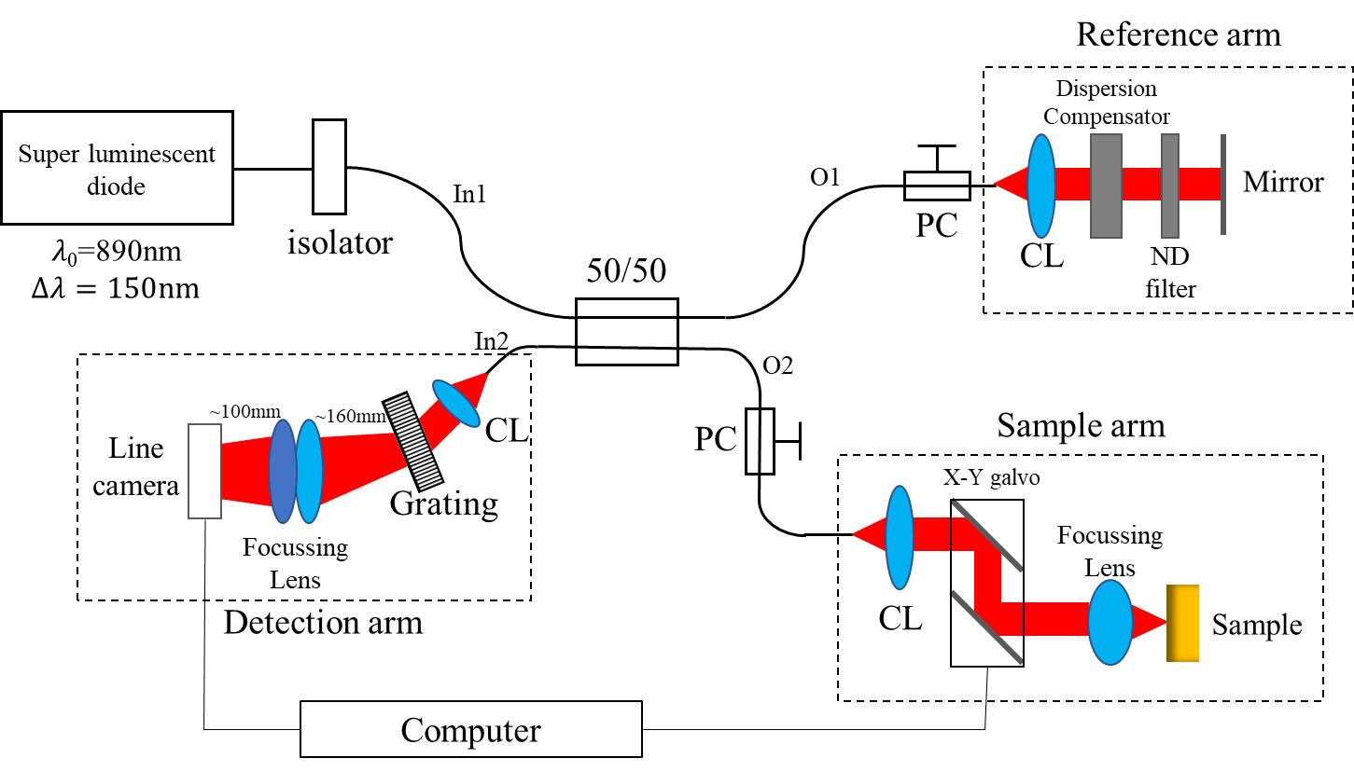
Figure 2.1: Schematic diagram of the spectrometer-based Fourier Domain OCT. CL denotes collimator.

Michelson interferometer
The beam of light source entered a fibre-based Michelson interferometer. The fibre used in the interferometer was Nufern 630-HP. In the interferometer, the beam was split into reference and sample arms by a 50/50 coupler (Gould fiber optics, 50:50, 2634154). Two manual polarization controllers (PC; General Photonics) were used to control the polarization state of light near the reference and sample arms respectively, before the light entered the reference and sample arms.

Reference arm
In the reference arm, a collimator (PAF-x-5-b, Thorlabs) was mounted on the fibre end to generate parallel light. Then, the beam transited through a dispersion compensator (Thorlabs, LSM02DC) and a variable neutral density filter (ND filter), and was reflected by a plane mirror. The dispersion compensator was used to compensate the chromatic dispersion resulting from the objective lens, namely the focussing lens in sample arm. The dispersion compensator had the same refractive index and thickness as the objective lens and can compensate the extra chromatic dispersion between the sample light and the reference light to prevent the degradation of the axial resolution of SD-OCT [1]. The role of ND filter was to attenuate the light reflected from the reference arm in order to avoid supersaturation of signal at the line camera and allow the output power of reference arm to be the same order of magnitude as the power from the sample arm.

Sample arm
In the sample arm, the same collimator was used to obtain parallel light. The collimated light was directed by a galvanometer system (Thorlabs, GVS002) with a pair of galvanometer scanners (TSH 22556-Y and TSH 22555-X). A data acquisition board (National Instrument) was used to provide the power of galvanometer system and to connect the galvanometer with a computer. The galvanometer was programmed and controlled by LabView software to achieve the function of volumetric scan. A Thorlabs’ telecentric scan lens (Thorlabs, LSM02-BB) was served as the objective lens for interrogation of sample. The objective lens has an effective focal length of 18 mm, working distance of 7.5 mm, 10× magnification, entrance pupil of 4 mm and spot size of ~9 μm (for a wavelength of 850 nm).

Spectrometer setup in the detection arm
The beam reflected by the plate mirror in the reference arm was recombined at the 50/50 coupler with the beam backscattered by a sample in the sample arm, and then the combined beam travelled into the detection arm. The detection arm was an in-house built spectrometer consisting of a collimator, a transmission grating (Wasatch Photonics, WP-1200/840-50.8) with 1200 l/mm, two identical focussing lenses with a focal length of 200 mm for each lens and a CCD line camera (Aviiva EV71YEM1GE2014-BA9) with 2048 CCD pixels.

After the light passed through the collimator, the collimated light struck the transmission grating at a 35° incidence angle, whereas the angle of the transmission grating needed to be adjusted slightly for obtaining better interferometric fringe during subsequent optimization procedure. The transmission grating with 1200 l/mm was used to disperse the light, and gave a centre wavelength diffraction angle of 29.81°, the minimum diffraction angle (θ_{min}) of 23.86° and the maximum diffraction angle (θ_{max}) of 35.76°, relative to grating normal, for the dispersed spectral range of 815-965 nm. The diffraction angles were calculated according to the grating equation [4]:
$mλ=d_{g}(sinα+sinβ)$ (2.1)
Here, $m$ is the diffraction order ($m=1$ for our application), $d_{g}$ is the groove spacing of grating, and $α$ and $β$ are the incident and diffracted angles respectively. The theoretical resolving power of grating ($R_{g}$) which refers to the capacity of grating to separate adjacent spectral lines of centre wavelength can be given by [4]
$R_{g}=\frac{λ}{δλ}=mN$ (2.2)
Here, $N$ is total number of grooves under illumination, and $δλ$ is the spectral resolution at central wavelength ($λ$). Since the collimated light in the detector arm has ~5 mm in diameter (measured by projecting the collimated light on an infrared detection card and getting the size of light spot with a ruler), the number of grooves ($N$) under illumination equates $5mm/cos (35°)×1200≈7300$. Substituting $m=1$, $N=7300$ and central wavelength of $λ=890 nm$ into equation 2.2 gives a resolving power ($R_{g}$) of 7300 and a central spectral resolution ($δλ$) of 0.12 nm.

Then, the dispersed light was focused on a 2048-pixel CCD line camera by two identical focusing lenses for sensing optical signal. The CCD pixels were rectangular with dimension of 14 μm by 28 μm. For the detector to adequately resolve the dispersed light, sufficient CCD pixels were needed to sample the diffraction-limited point spread function (PSF) and to achieve a spectral resolution of 0.12 nm. The least number of pixels required can be calculated as: $150 nm/0.12 nm=1250$ pixels, where the 150 nm is the bandwidth of the light source. The CCD camera we used had more pixels than the least number. The minimum length of focused spectrum on CCD line camera was $1250×14 μm=17.50 mm$ . Since the light was dispersed by the transmission grating with the angular spread $∆θ=35.76°-23.86°=11.90°$, the minimum distance ($F_{min}$) and the maximum distance ($F_{max}$) between the grating and the camera can be calculated respectively as:
$F_{min}=\frac{l_{min}}{2}/\tan{\frac{∆θ}{2}}$ (2.3)
$F_{max}=\frac{l_{max}}{2}/\tan{\frac{∆θ}{2}}$ (2.4)
Here, $l_{min}$ and $l_{max}$ are the minimum and maximum length of focused light on camera respectively. The equation 2.3 and 2.4 are illustrated in Figure 2.2. Substituting $l_{min}=17.50 mm$ and $l_{max}=2048×14 μm≈28.67 mm$ respectively, $F_{min}≈83.97 mm$ and $F_{max}≈137.57 mm$ were calculated. In order to focus the spectrum in the distance of 83.97-137.57 mm, two identical focusing lenses were utilized and combined forming a focusing lens with an effective focal length of 100 mm. A micrometre stage with X, Y, and Z travel and continuous rotation was used to move the CCD camera to ensure the position of these CCD pixels on the focal plane.
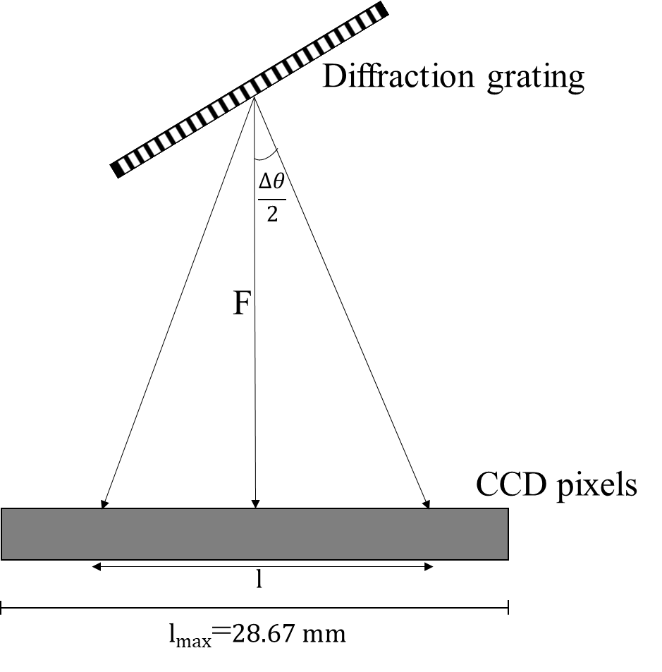
Figure 2.2: The diagram of light dispersed onto CCD pixels by a diffraction grating. $F$ is distance between the grating and the CCD camera. $l$ is the length of light on the camera.

Consequently, the in-house spectrometer was built as shown in Figure 2.1. In Figure 2.1, the distance between the centre of two lenses and the centre of the grating was ~160 mm. The line camera was located at ~100 mm from the centre of the two focusing lenses.

Optimization and Resampling
After all components of SD-OCT were aligned as Figure 2.1, the SD-OCT system was optimized for obtaining a clear interference fringe between the reference mirror and a sample and the maximum SNR of system. During the optimization, SLD2 was switched on and SLD1 was switched off. SLD1 was turned off because this SLD can shut down suddenly without warning.

Optimization for reference and sample arms
For the optimization of reference arm, the angle and position of reference mirror was adjusted to maximize the power returned from the reference arm. The light power returned from only reference arm was monitored at port In2 in Figure 2.1 by blocking the sample arm and removing the ND filter. Then, the light power returned from only sample arm was measured at port In2 in Figure 2.1 using an optical mirror as a test target by blocking the reference arm. The optical mirror surface needed to be placed at the focal plane of the objective lens for the largest power returned from the sample arm. When the XY galvo scanners, focusing lens and FiberPort collimator (PAF-x-5-b, Thorlabs) were fixed on mounts firmly in the sample arm, the only adjustable component was the built-in lens of the collimator with five degrees of freedom, including linear motion of the lens in X and Y, angular alignment for tip and tilt, and Z adjustment. The built-in lens of collimator and the optical mirror in sample arm were adjusted finely to get the maximum returned light power from the sample arm.

Detector arm optimization
The detector arm was optimized for a clear interference fringe pattern and the highest SNR by adjusting the collimator, grating, focusing lenses and line camera in the detector arm. During the optimization, an optical mirror was used as a test sample in the sample arm, and the interference fringe pattern and the SNR were monitored by LabVIEW. The interference fringe was read directly by the camera and an analogue to digital converter. The camera parameters have been set as: gain = -24 dB and exposure time = 50 μs.

The optical system optimization in the detector arm was performed as follows. Firstly, the reference mirror was translated to match the sample arm path length to the reference arm path length to within the coherence length of light source, and in this case an interference fringe can be found. ND filters were utilized to attenuate the light power in reference (NDC-50C-2-B variable ND filter, Thorlabs) and sample arms (AR coated absorptive ND filters for 650-1050 nm, Thorlabs) respectively when the camera’s CCD became oversaturated. The beams in the reference and sample arms passed through the ND filters with fixed incident angles due to the angular sensitivity of ND filter. For example, the beam in the sample arm was travelling perpendicular to the plane of ND filter. Secondly, the position and angle of collimator and grating were regulated to let the light fully disperse in the horizontal dispersion direction. In the circumstances, the grating grooves were aligned to be vertical. Thirdly, the focusing lenses were repositioned to allow total dispersed light to pass through with perpendicular incidence. Finally, the position of camera was adjusted for a clear interference fringe pattern, which can be achieved by regulating the camera 5 adjustable parameters, X Y Z direction, rotation and plane angle, to make the dispersed light fall onto the CCD pixels at the focal plane of the focusing lenses.

The SNR was obtained as follows. Firstly, the interference was Fourier transformed using Fast Fourier transform (FFT) algorithm, and the magnitude of FFT outcome, namely the modules of complex number, was squared. According to Figure 1.3 and equation 1.4 and 1.5, half squared modulus contained the power spectrum of sample field reflectivity profile. Thus, the power spectrum against path length or depth (z), shown in Figure 2.3 b), can be regarded as the PSF. Secondly, the SNR was calculated in term of the PSF as:
$SNR(dB)=10\log_{10}{\frac{P_{signal}}{P_{noise}}}$ (2.5)
Here, $P_{signal}$ and $P_{noise}$ are the powers of signal and noise respectively. Finally, a slight adjustment of the reference arm path length was done to reduce the path difference of reference and sample arms to close to zero. This is because the SNR of SD-OCT decreases as a function of the path difference between the reference and sample arms due to the finite resolution of the spectrometer, and the maximum SNR can be achieved once the path difference was zero according to equation 1.12. However, zero path difference produced no interference fringe and its FFT outcome became ambiguous and disordered, at this point. In Figure 2.3 b), for example, the largest applicable SNR has been found at the path difference of 0.26 mm. Two polarization controllers in the reference and sample arms respectively were also adjusted to increase the SNR by matching polarization state in both arms.

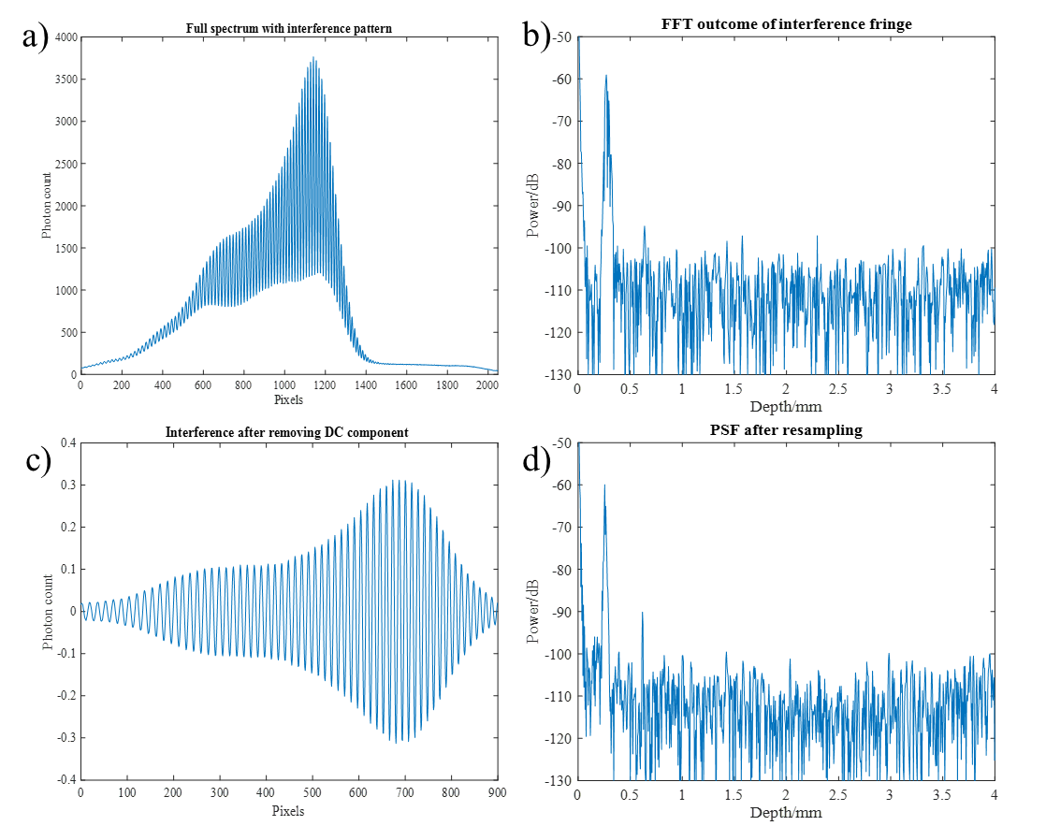
Figure 2.3: Outcomes of detector arm optimization and resampling. a) Interference pattern resulting from the optical mirror in sample arm and the reference mirror, measured with 2048-pixel CCD camera. b) PSF obtained by FFT of the interference fringe; note that the DC component has been removed in this spectrum. c) The interference after removing the DC component and capturing 900 pixels for resampling. d) the PSF after resampling. Note that the X axis has been scaled by 1 pixel =5.1 μm, according to the depth calibration in section 3.2.4.2.

Resampling
Resampling is generally used for improving the performance of SD-OCT. The resolution and SNR can be improved by the resampling. The overall process of our resampling is shown in Figure 2.4. There are three key steps in the process. First, remove the DC component of interference by subtracting reference power from the interference. The reference power was obtained by blocking the sample arm and saving the detected spectrum. Second, cut out the signal in which the interference fringe is weak. Third, transform the signal to be linear in wavenumber. Since the light was dispersed on aligned CCD pixels by a transmission grating, the detected signal had an approximate linear relation between the wavelength and pixel coordinates in term of equation 2.1. However, equation 1.1 indicates that the interference signal of OCT should be linear in wavenumber before FFT, and, in this case, the path length in FFT outcome is linear with the physical depth in sample field. Therefore, the transformation was required in the resampling process. The transformation was carried out by a digital method, called as zero crossing technique. Its working principle is that the points at which the cosine modulation crosses the zero axis are recorded to compute the minimal positive period of cosine modulation as a function of pixel coordinate. Then, the period versus pixel coordinate is plotted to interpolate the signal coefficient to being linear in wavenumber. The zero-crossing technique was implemented by a LabVIEW script written by our former group member, Dr. Zenghai Lu. Since a single reflection plane was placed in sample field for resampling, the period of cosine modulation should be invariant against pixel coordinate after resampling according to equation 1.1, which was used to check whether this technique was working.
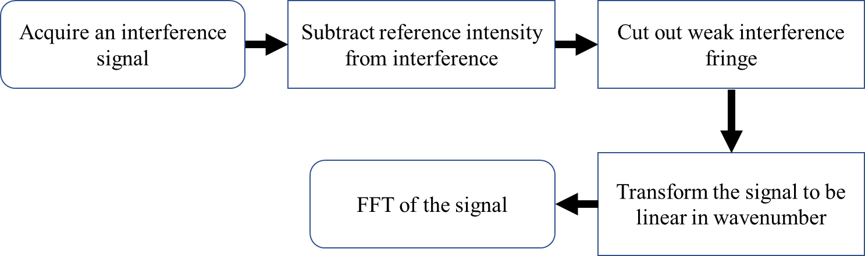
Figure 2.4: The flow diagram of resampling process.

OCT image generation
The process of OCT image generation is shown in Figure 2.5. Firstly, thousands of A scans were collected by the CCD camera with 20 kHz acquisition rate and 50 μs exposure time. The acquisition was controlled by a LabVIEW program. Note that the DC component in the raw data has been removed by the LabVIEW program before the data collection. Secondly, the raw data was read by MATLAB to extract spectral raw data, resample table data and stray light data. Thirdly, the stray light data was subtracted from the spectral raw data. Fourthly, the raw data was rescaled to the range of -0.5 to 0.5 by dividing the raw data by 2¹⁴. Fifthly, the raw data was multiplied by a Hann window to improve the signal clarity. Sixthly, the raw data was resampled by 1-D spline interpolation using the resample table data for conversion from k-space to w-space (frequency/wavenumber). Seventhly, the raw data of each A-scan was converted into a 1-D complex matrix by using FFT. Eighthly, the structural data, namely sample reflectivity profile, was obtained by the square of the complex modulus. Then, the structural data was converted into dB for image display. Before the structural image was displayed, its SNR was improved by averaging the structural data matrix in depth and lateral directions using a rectangular window and by removing the signal which was less than 0.1 dB. The depth and width of the average window were 2 and 4 pixels respectively. Finally, the B scan of OCT image was shown by ‘imagesc’ function of MATLAB. The MATLAB code used for the OCT image generation is shown in Appendix 8.3.
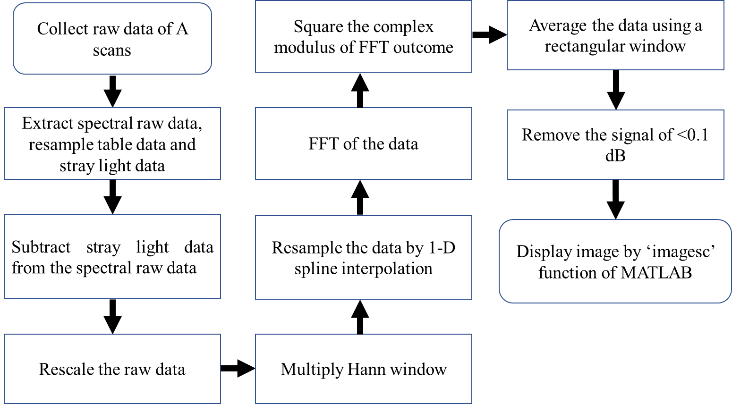
Figure 2.5: The flow diagram of the full process of OCT image generation.

Characterisation of SD-OCT

Lateral and axial resolutions
The true lateral resolution was checked by following the works described in section 1.3.1 using a resolution test slide with 1951 USAF test pattern (Edmund Optics, 1951 USAF). The test pattern was imaged by a volumetric scan which consists of 500×500 A-scans to formation of a 2×2 mm enface image. Note that, during the volumetric scan, a 25.4 dB ND filter was used in the sample arm to avoid oversaturation of the camera. The enface image containing useful information was captured by the OCT system. The axial resolution was measured based on the Rayleigh criterion. In other words, the full width at half maximum (FWHM) of PSF was regarded as the axial resolution.

Sensitivity, sensitivity falloff and depth calibration

Since, the sensitivity of system is equivalent to the SNR measured above, the measurement of sensitivity followed the same process of the SNR measurement. Briefly, a plane mirror was used as a test target in the sample arm, and the SNR was measured by the process described in section 3.2.2. The maximum measured SNR was regarded as the sensitivity of the system.

To measure the sensitivity falloff as a function of depth, the plane mirror was fixed with a double side tape on a sample holder, and the sample holder was mounted on a translation stage for height adjustment (shown in Appendix 8.1). The plane mirror was adjusted to be perpendicular to the axial direction of imaging. Then, the sensitivity falloff was measured by detecting the SNR of mirror as a function of image depth. For the depth calibration of OCT image, the physical distance per pixel in A-scan was calculated by dividing the movement distance of the plane mirror by the number of pixel shift in the corresponding PSF.

Phase sensitivity
The phase sensitivity of OCT system can be characterized by its phase fluctuation which was calculated as the standard deviation of phase [3, 5]. The phase fluctuation was measured by three steps. First, a M-mode scan with 1000 A scans was acquired by imaging a plane mirror using static galvanometer scanners, 20 kHz camera acquisition rate and 50 μs exposure time, shown in Figure 2.6 a). Second, the depth of 3.08 mm in the M-mode scan image was selected for extracting the phase value of each A scan due to the highest reflectivity at this depth. In Figure 2.6 a), the green dotted line was plotted on the M-mode scan image to present the depth selected for the acquisition of phase data. The phase value of each A scan was obtained by using the function of ‘angle’ in MATLAB and plotted as a function of time in Figure 2.6 b). Third, the standard deviation of phase in Figure 2.6 b) was computed with the function of ‘std’ in MATLAB.
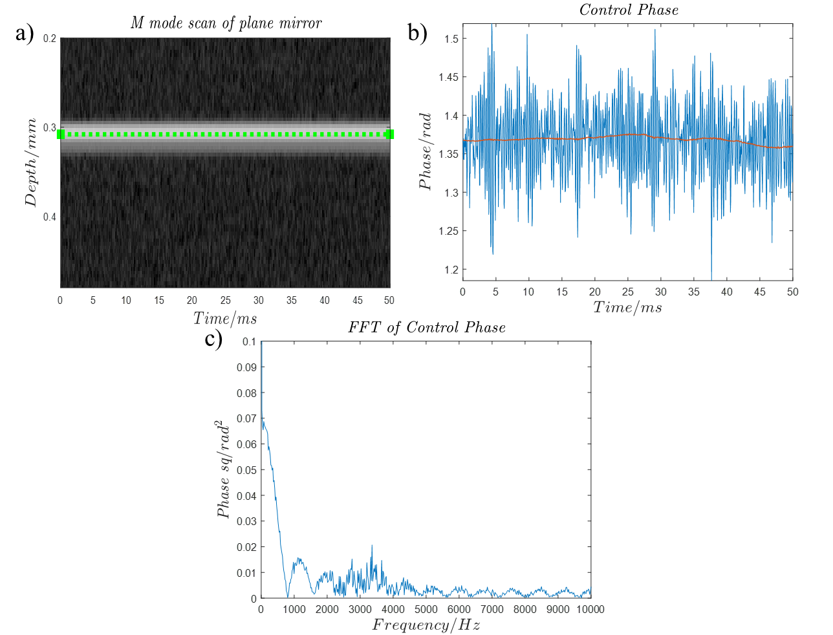
Figure 2.6: a) M-mode scan of plane mirror, generated by 1000 A scans at a single point, where green dotted line represents the depth selected for calculating phase sensitivity. b) the phase fluctuation as a function of time at the green dotted line; the red line is the noise floor of phase. c) the phase frequency spectrum resulting from FFT of phase fluctuation.

Results

Optical alignment
In order to evaluate the performance of our optical alignment, the output powers of the light source and the sample and reference arms were measured. The power of SLD 1 + SLD 2 was 5.1 mW, and the power of SLD 2 was 3.8 mW. The optical isolator in this system reduced the power of light by 53 %. The maximum light power returned from only the reference arm or the sample arm at port In2 was both 0.2 mW, in agreement with the estimated value: $3.8×\left(1-53\%\right)×50.13\%×\sim 50\%×50.13\%=0.22 mW$, where 3.8 was the output power of light source, $\left(1-53\%\right)$ was the reduction of isolator [1], the two terms of $50.13\%$ were the reduction of light traversing 50/50 coupler, and $\sim 50\%$ was the coupling loss. Therefore, the optical alignment was accomplished well.

Optimization and resampling
After the optimization of OCT system, an interference fringe pattern was obtained using an optical mirror as a test sample under the condition that only SLD 2 was running. The acquired interference has been shown in Figure 2.3 a), where the ND filter with the power reduction of 25.4 dB and a variable ND filter were used in the sample arm and the reference arm respectively. Figure 2.3 b) shows the PSF obtained from the optimized interference fringe without resampling. In Figure 2.3 b), the signal power was -59 dB and the averaged noise was -113 dB. Thus, the SNR was $-59+113+25.4=79.5dB$, where $25.4$ was the attenuation of the ND filter in the sample arm. Note that the power reduction of the ND filter in the reference arm was not counted because the SNR of SD-OCT mainly depends on the power backscattered from the sample arm rather than from the reference arm according to equation 1.11. In Figure 2.3 c), the DC component has been removed, and the pixels from 450 to 1350 in Figure 2.3 a) were extracted forming a cosine modulation for resampling. The PSF after resampling has been shown in Figure 2.3 d). In Figure 2.3 d), the signal and the averaged noise were -60 dB and -116 dB respectively. Therefore, the SNR was $-60+116+25.4=81.4$ dB, where $25.4$ resulted from the ND filter in the sample arm. The SNR, i.e. sensitivity, was increased 2 dB through the resampling.

In addition, the signal processing and resampling were also conducted under the condition that both SLD 1 and SLD 2 were running, shown in Figure 2.7. Figure 2.7 a) shows the interference pattern obtained with the optical mirror. In Figure 2.7 b), the DC component was removed and 1350 CCD pixels from 400 to 1750 in Figure 2.7 a) were captured for resampling. Figure 2.7 c) was the PSF resulting from the FFT of resampled interference fringe, where the signal and averaged noise were -47.46 dB and -113.75 dB respectively. Therefore, the SNR was $-47.46+113.75+25.4=91.69$ dB, where $25.4$ was the term of light attenuation of ND filter in the sample arm. In Figure 2.7 d), the PSF was zoomed in for displaying the signal of interest with main lobe and side lobes. It has shown that the addition of SLD 1 led to exacerbated side lobes.
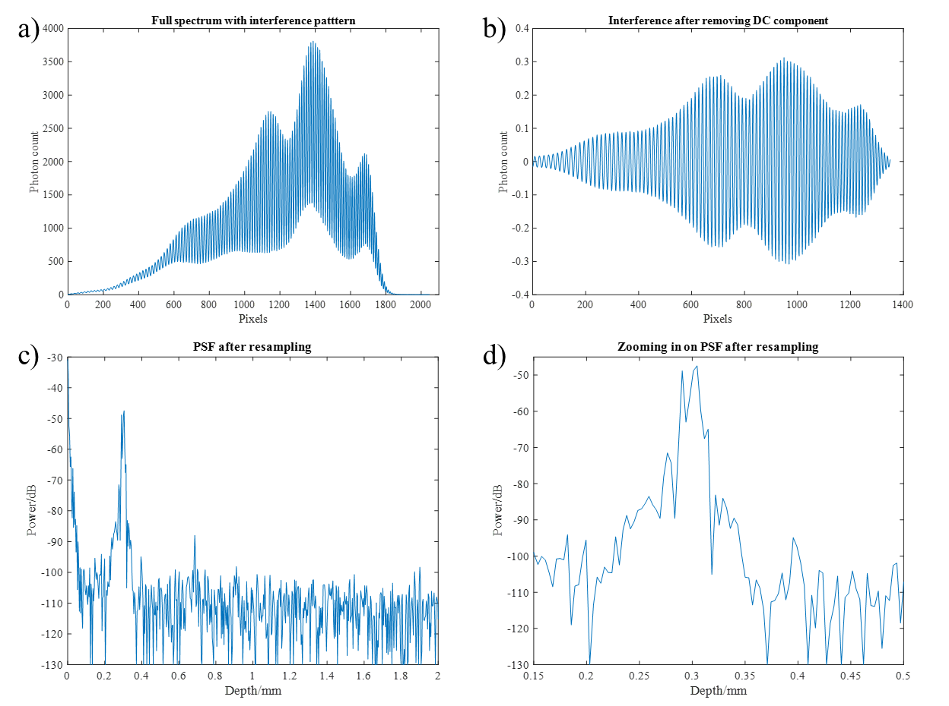
Figure 2.7: a) Interference pattern between the lights returned from the sample and reference arms respectively, under the condition that both SLD 1 and SLD 2 are running. b) The interference after removing the DC component and capturing 1350 pixels for resampling. c) PSF obtained by FFT of resampled interference fringe. d) Zoom in the PSF of interest to present main lobe and side lobes. Note that the X axis has been scaled by 1 pixel =3.5 μm, according to the result of a depth calibration.

Characteristics of SD-OCT

Lateral Resolution
The enface OCT image with 1951 USAF test pattern has been shown in Figure 2.8 a). In Figure 2.8 a), the elements in group 4 and 5 can be resolved by our system easily, and the minimal resolvable element was located in group 6. To determine which element was the minimal resolvable element, the grey scale profile of group 6 was plotted in Figure 2.8 b) by following the red line in Figure 2.8 a). In Figure 2.8 b), the red dashed lines represented the boundary of each element in which two peaks can be found to signify the bright regions on the test pattern. It was discovered that the two peaks were resolvable and evident in element 1, 2 and 3, but not for element 4 and 5. Thus, the smallest resolvable element was element 3 in group 6. The true lateral resolution of our system can be calculated by the following equations [6]:
$Resolution(lp/mm)=2^{G+(E-1)/6}$ (2.6)
$Resolution\left(mm\right)=\frac{1}{2×Resolution(lp/mm)}$ (2.7)
Here, the $G$ and $E$ are the group and element number of minimal resolvable element respectively. Substituting $G=6$ and $E=3$ into equation 2.6 and 2.7, a lateral resolution of 6.20 μm was obtained.
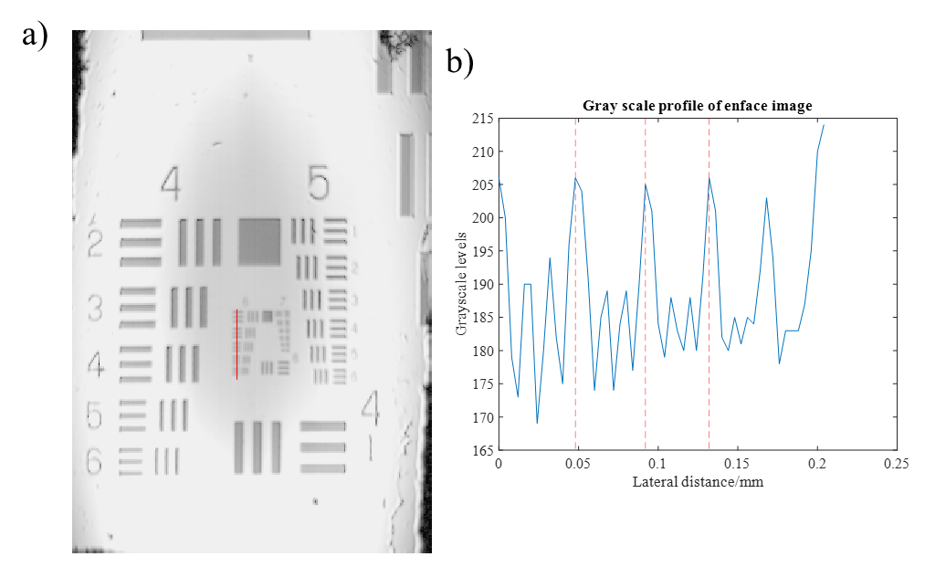
1
2
3
4
Figure 2.8: a) The enface image of 1951 USAF test pattern obtained by our OCT system. The displayed image area is 1.04×1.52 mm. b) The grey scale profile following the red line of Figure 2.8 a). The red dash lines denote the boundary of each element.

Axial resolution
In Figure 2.9, the half maximum of PSF was marked as red line, which was 3.01 dB lower than the vertex of PSF, and the green circles illustrated the positions of FWHM, located at the points of intersection between the red line and PSF. In Figure 2.9 a), the PSF after resampling has been shown and the FWHM of PSF was 3.4 μm. Therefore, the axial resolution of this system was 3.4 μm. For verifying the validity of the resampling, the PSF before resampling has been shown in Figure 2.9 b), and a red line denotes half maximum of PSF in the figure. In Figure 2.5 b), the FWHM, i.e. the axial resolution, was 14.2 μm. Therefore, the resampling has obviously improved the axial resolution of system.

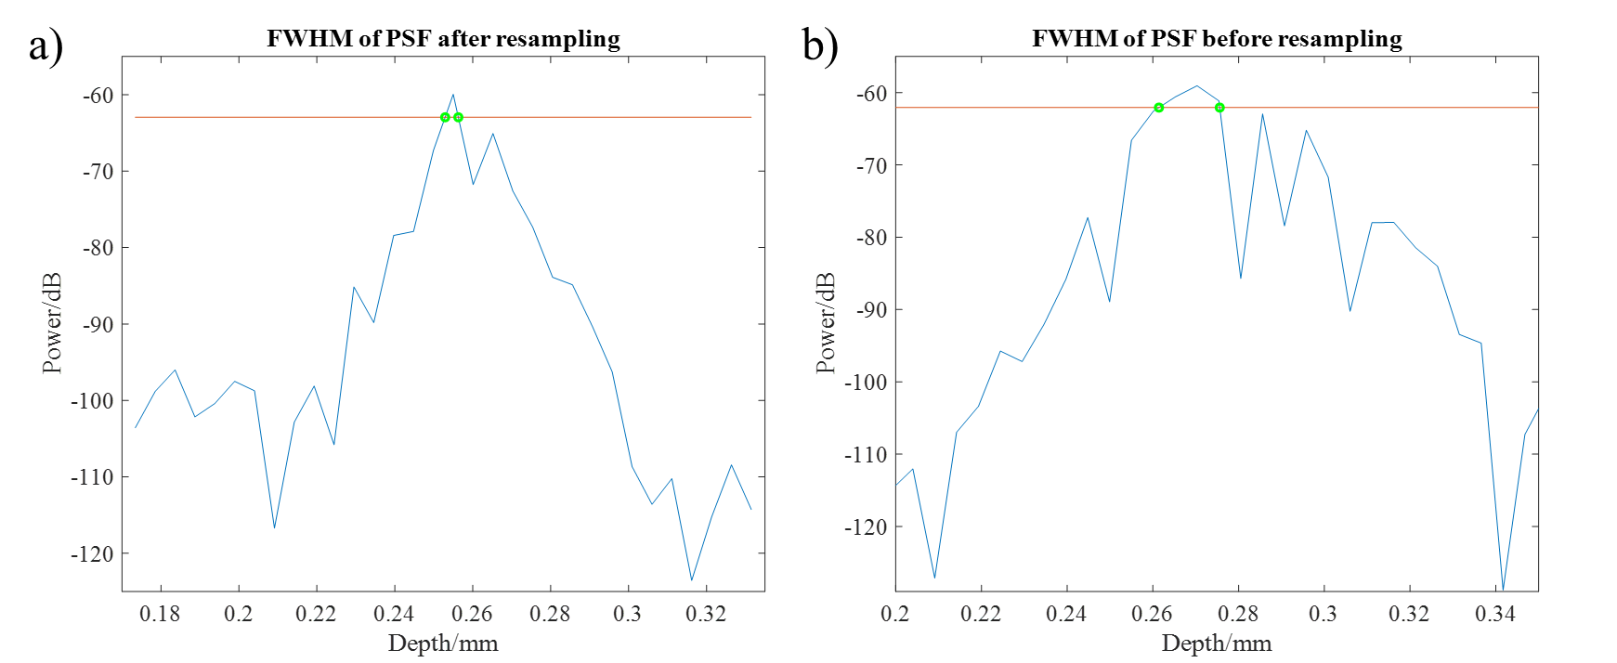
Figure 2.9: a) PSF after resampling. b) PSF before resampling. Red lines are half maximum of PSF. Green circles present the positions of FWHM.

Sensitivity
The sensitivity of this system was 81.4 dB for usage of SLD 2, and 91.69 dB for usage of both SLD 1 and SLD 2. The sensitivity falloff is shown as solid blue circles in Figure 2.10. The X axis has been scaled by 1 pixel=5.1 μm in Figure 2.10, as the addition of 2 mm depth led to the SNR peak moved 391 pixels on the X axis. In Figure 2.10, the measured sensitivity falloff was 22.01 dB/mm.
Figure 2.10: Predicted/theoretical sensitivity falloff (shown as red line) and the true sensitivity falloff measured as a function of depth (shown as solid blue circles).

Phase sensitivity and displacement sensitivity
The phase standard deviation of 0.0474 rad was gained in Figure 2.6 b). The displacement sensitivity (${δx}_{sens}$), namely minimal measurable displacement, can be expressed as [3, 7]:
${δx}_{sens}=\frac{λ_{0}}{4nπ}δφ_{sens}$ (2.8)
By equation 2.8, the real displacement sensitivity was calculated as:
${δx}_{sens}=\frac{890×0.0474}{4π}×{10}^{-9}=3.36×{10}^{-9}m$ (2.9)
In other words, the minimal measurable displacement of this system was 3.36 nm. Figure 2.6 c) has shown the phase frequency spectrum resulting from FFT of the phase fluctuation. There was a prominent frequency located near DC component and less than 600 Hz, but the amplitude was rather small, which was less than 0.1 rad².

Discussion

Depth calibration
It was found that the result of X-axis (depth) calibration in Figure 2.7 (1 pixel = 3.5 μm) was different from the result in Figure 2.3 (1 pixel = 5.1 μm). This was because the presence of 1 SLD in Figure 2.7 extended the interference pattern, and more pixels were used for resampling and FFT. According to the computing method of FFT in LabVIEW, a vector inputted into the FFT function outputs the same size of vector. Therefore, more pixels in the interference pattern used for the resampling and FFT caused more pixels outputted for presenting the same image depth in Figure 2.7 c). Thus, the physical distance (depth) per outputted pixel decreased.

The difference between the two X-axis calibration results caused great inconvenience for the OCT operation when SLD 1 was switched on or off frequently. An alternative scheme to avoid the inconvenience is that the presence or absence of SLD 1 shares the resampling database obtained from SLD 1+2. There is no much difference between the two-resampling schemes in theory, because the interpolated signal coefficient remains the same. However, compared with the system using separate resampling process, more unwanted interference signal was employed for OCT imaging when the shared resampling process was used for the absence of SLD 1, which slightly increased the noise of image. In practice, the increase of noise was barely perceptible, so the scheme of sharing the resampling process was acceptable when the SLD 1 needed to be repeatedly switched on or off.

Lateral resolution
According to equation 1.7, the lateral resolution of OCT is dependent on the centre wavelength of source ($λ_{0}$), the focal length of objective ($f$) and the spot size on the objective lens exit pupil ($d_{0}$). Substituting our system parameters of $λ_{0}=890 nm$, $f=17.95 mm$ and $d_{0}=4 mm$ into equation 1.7, a theoretical lateral resolution of 5.09 μm was calculated. The measured lateral resolution, 6.20 μm, is slightly larger than the theoretical lateral resolution, but still reasonable. Compared with the previous result measured by our former group member, Dr. Joseph Boadi [1], the lateral resolution remains unchanged as the architecture and components of system have not been changed.

Axial resolution
With equation 1.9 ($∆z≅{0.44{λ_{0}}^{2}}/{Δλ}$), the axial resolution of SD-OCT ($∆z$) depends on the spectral bandwidth of light ($Δλ$) and the wavelength ($λ_{0}$), unlike other common modalities in which the axial resolution is determined by the NA and light source wavelength in term of equation 1.10. In theory, the axial resolution of our system should be $0.44×\frac{{0.89}^{2}}{0.15}≈2.32$ μm (assume that the light source is a Gaussian spectrum in this equation), by substituting $λ_{0}=890$ nm and $Δλ=150$ nm.

The measured axial resolution, 3.4 μm, in Figure 2.9, is larger than the theoretical value (2.32 μm) and the practical value measured with both SLD 1 and SLD 2 by Dr. Joseph Boadi, 2.5± 0.3 μm [1]. Because of the obvious gap between our measured value and the theoretical value or the previous value, it is deduced that the decrease of axial resolution mainly results from the absence of SLD 1 leading to evident reduction of the spectral bandwidth of light ($Δλ$). The other factors that could sacrifice the axial resolution are chromatic and monochromatic aberration, group velocity dispersion, polarization mismatch and nonideal spectral shape of light source [8].

The supplement of SLD 1 can increase the spectral bandwidth of light in our experimental results, and in theory improve the axial resolution on the basis of equation 1.9. As expected, the interference fringe was distributed across a wider spectrum in Figure 2.7 a) compared with Figure 2.3 a). However, we did not obtain a better axial resolution by the addition of SLD 1. Our results indicated that the addition of SLD 1 led to the light source departing further from the ideal spectral shape (Note that Gaussian spectral shape is the ideal shape), which was able to cause deterioration of the system’s axial resolution due to the appearance of side lobes in PSF [8]. The exacerbated side lobes due to the addition of SLD 1 was demonstrated in Figure 2.7 d). Therefore, further and more complicate optimizations were needed to eliminate or alleviate the side lobes. Since, only SLD 2 was used as the light source of the OCT system in our later experiments, this problem has been ignored in this project.

Sensitivity
The measured sensitivity of 81.4 dB was over the minimum sensitivity required for biological imaging (80 dB) [9], and offered B scan images with high quality, shown in Figure 2.11. This quality met the requirement for developing a MMOCT to track superficial magnetically labelled cells in next experiments.

Figure 2.11: B scan image of near infrared (NIR) detector card with display area 4 mm × 1.8 mm, which was formed by combination of 1000 A scans. SLD 2 was used as light source affording sensitivity of 81.4 dB to system.

The addition of SLD 1 caused a significant increase of 10 dB SNR from 81.4 dB to 91.69 dB, and the SNR was comparable to the maximum SNR achieved by Dr. Joseph Boadi, 95 dB [1]. According to equation 1.11, the increase of SNR resulted from not only the power increment from the sample arm but also the increased number of analog-to-digital sampling points. When the noise of light source was assumed as a constant, it was calculated that the increase of 1.3 mW light power due to switching on the SLD 1 led to approximately 1 dB enhancement of SNR. Therefore, the increase of 10 dB SNR after switching on SLD 1 could be mainly because the addition of SLD 1 broadened the bandwidth of light source resulting in an increase of analog-to-digital sampling points, $M$.

Equation 1.12 reveals that there is a sensitivity falloff as a function of depth and the rate of falloff is determined by the spectrometer’s spectral resolution ($δλ$), the wavelength spacing between CCD pixels ($∆_{p}λ$) and centre wavelength of source ($λ_{0}$). Substituting our OCT system parameters: $δλ=0.12 nm$, $∆_{p}λ=\frac{100}{900}=0.11 nm$ (where 100 nm is the measured bandwidth of laser source when the only SLD2 is switched on, and 900 is the number of CCD pixel used for resampling.) and $λ_{0}=890 nm$ into equation 1.12 and 1.13, the sensitivity falloff ($R\left(z\right)$) can be expressed as:
$$R\left(z\right)={sinc}^{2}⁡(870z)\exp\left[-0.861{\left(870z\right)}^{2}\right] (2.10)$$
According to equation 2.10 and the measured sensitivity of this system, 81.4 dB, the sensitivity falloff of our system was predicted and plotted on the axis of image depth, shown as the red curve in Figure 2.10. Consequently, a sensitivity falloff rate of 3.96 dB/mm was predicted. The measured rate of sensitivity falloff, 22.01 dB/mm, was much larger than the predicted rate. This could be because the predicted rate did not take into account the loss of sample arm power due to the plane mirror off the focal plane of objective. Compared with other SD-OCT systems [10, 11], our system has higher rate of sensitivity falloff, which can be explained by the use of an objective with higher value of NA to pursue better lateral resolution. Higher NA resulted in a shorter work distance and a more rapid power loss of back-reflected light to objective as the plane mirror away from the focal plane of the objective.

Displacement sensitivity
The phase fluctuation of SD-OCT is approximately inversely proportional to the SNR of system according to equation 1.19 [3, 12]. After substituting 81.4 dB (the SNR obtained by the plane mirror in section 3.3.2) into equation 1.19, the minimal theoretical phase fluctuation ($δφ_{sens}$) was obtained as follow:
$δφ_{sens}=\frac{2}{π}\sqrt{\frac{1}{{10}^{81.4/10}}}=5.42×{10 }^{-5}(rads)$ (2.11)
Using equation 2.8, the theoretical displacement sensitivity of 3.84 pm was calculated. However, in reality, the displacement sensitivity became worse due to the influence of ambient vibrations, such as sound. The measured displacement sensitivity, 3.36 nm, was much larger than the theoretical value, probably due to the mechanical noise in the laboratory.

When a sample was placed in a modulated magnetic field, a larger prominent signal was observed in its phase frequency spectrum because the magnetic field can induce mechanical vibration of the metallic sample stage and sample. In Figure 2.12 a), a NIR detector card placed on a metallic stage in 0.5 T of 80 Hz modulated magnetic field was imaged by a M-mode scan with 5000 A scans. In the M-mode scan, the camera acquisition rate and exposure time were 1000 Hz and 50 μs respectively. The signal at the green dotted line (Depth=0.34 mm) in Figure 2.12 a) was used to plot the phase fluctuation in Figure 2.12 b). There is an evident undulation of phase in the range from -π to π. The phase frequency spectrum has been shown in Figure 2.12 c), in which a prominent signal with the amplitude of 0.2 rad² at near 160 Hz is observed. As the prominent frequency of phase, 160 Hz, is the double of modulation frequency of magnetic field, the 160 Hz signal is considered the result of the mechanical vibration induced by the magnetic field. The reason why the frequency of magnetomotive signal is the double modulation frequency can be explained by the paramagnetism of the metallic sample stage. The sample stage was made of a paramagnetic material, aluminium. An external magnetic field causes a net attraction with paramagnetic material due to alignment and flip of magnetic dipoles, which makes the force of sample stage depend on the square of the magnetic field. Similar phenomenon was also found and explained in more detail in later experiments. These results demonstrate that our SD-OCT is able to detect mechanical displacement of sample but the metallic components in the system can lead to false magnetomotive signal. The false magnetomotive signal means that the positive signal does not result from the intrinsic magnetic properties of sample but from the vibration of system itself. The false signal needs to be eliminated. The elimination of false single is discussed in the following chapter.
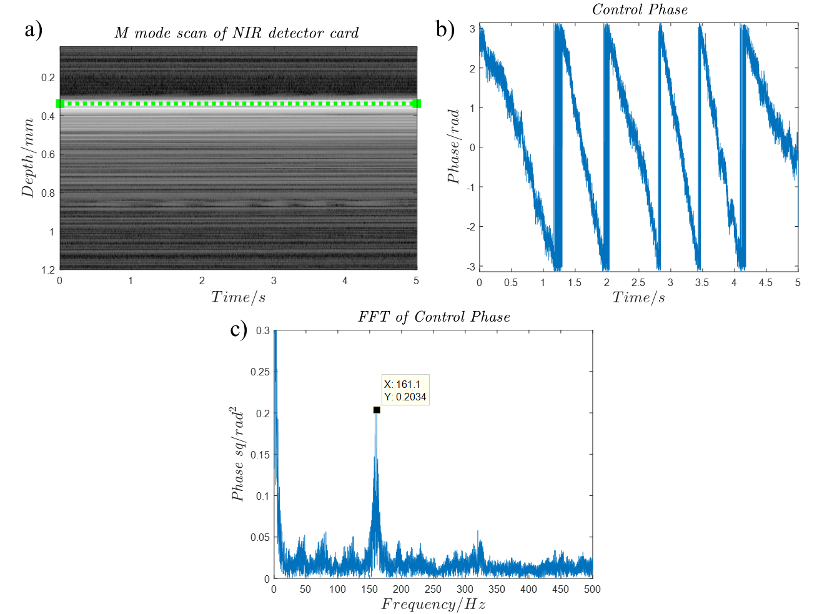
Figure 2.12: a) M-mode scan of NIR detector card, generated by 5000 A scans at a single point, where green dotted line represents the depth selected for calculating phase sensitivity. b) the phase fluctuation as a function of time at the green dotted line. c) the phase frequency spectrum resulting from FFT of phase fluctuation.

Conclusion
The phase-sensitive OCT previously developed by our group has been optimised, resampled and characterised. After the optimisation and resampling, the sensitivities of OCT reached 81.4 dB and 91.69 dB respectively, for only SLD 2 or SLD 1+2 running. The both situations met the minimal sensitivity requirement of biological imaging (80 dB). The OCT system with the absence of SLD 1 had a sensitivity falloff of 22.01 dB/mm, a lateral resolution of 6.20 μm, an axial resolution of 3.4 μm and a displacement sensitivity of 3.36 nm. This system was suitable for imaging superficial tissue due to the excellent resolution and overlarge sensitivity falloff rate. To ensure the continuity of the OCT operation, only SLD 2 was used as the laser source for next experiments.

References
[1] J. Boadi, "Clinical applications of ultra-high resolution and phase-sensitive optical coherence tomography," University of Sheffield, 2016.
[2] J. Boadi et al., "Imaging of 3D tissue-engineered models of oral cancer using 890 and 1300 nm optical coherence tomography," Современные технологии в медицине, vol. 7, no. 1 (eng), 2015.
[3] C. Joo, T. Akkin, B. Cense, B. H. Park, and J. F. De Boer, "Spectral-domain optical coherence phase microscopy for quantitative phase-contrast imaging," Optics letters, vol. 30, no. 16, pp. 2131-2133, 2005.
[4] C. A. Palmer and E. G. Loewen, Diffraction grating handbook. Newport Corporation New York, 2005.
[5] M. A. Choma, A. Ellerbee, and J. A. Izatt, "Ultrasensitive Phase-Resolved Imaging of Cellular Morphology and Dynamics," in Optical Coherence Tomography: Springer, 2008, pp. 757-785.
[6] M. Offroy, Y. Roggo, P. Milanfar, and L. Duponchel, "Infrared chemical imaging: Spatial resolution evaluation and super-resolution concept," Analytica chimica acta, vol. 674, no. 2, pp. 220-226, 2010.
[7] M. A. Choma, A. K. Ellerbee, C. Yang, T. L. Creazzo, and J. A. Izatt, "Spectral-domain phase microscopy," Optics letters, vol. 30, no. 10, pp. 1162-1164, 2005.
[8] W. Drexler, Y. Chen, A. D. Aguirre, B. Povazay, A. Unterhuber, and J. G. Fujimoto, "Ultrahigh Resolution Optical Coherence Tomography," Optical Coherence Tomography, ISBN 978-3-319-06418-5. Springer International Publishing Switzerland, 2015, p. 277, p. 277, 2015.
[9] Z. Yaqoob, J. Wu, and C. Yang, "Spectral domain optical coherence tomography: a better OCT imaging strategy," Biotechniques, vol. 39, no. 6, pp. S6-S13, 2005.
[10] S. Yun, G. Tearney, B. Bouma, B. Park, and J. F. de Boer, "High-speed spectral-domain optical coherence tomography at 1.3 µm wavelength," Optics express, vol. 11, no. 26, pp. 3598-3604, 2003.
[11] J. F. de Boer, "Spectral/Fourier Domain Optical Coherence Tomography," Optical Coherence Tomography, ISBN 978-3-319-06418-5. Springer International Publishing Switzerland, 2015, p. 165, p. 165, 2015.
[12] M. A. Choma, A. Ellerbee, and J. A. Izatt, "Ultrasensitive Phase-Resolved Imaging of Cellular Morphology and Dynamics," Optical Coherence Tomography: Technology and Applications, pp. 1257-1287, 2015.

Development and Testing of an MMOCT Instrument

Introduction
The SD-OCT described in the previous chapter was suitable for monitoring and studying superficial cells, because it had excellent resolutions. An appropriate application scenario was to investigate and improve the therapy efficacy of limbal epithelial stem cell deficiency (LESCD) [1].

LESCD is resulted from the damage of tissue in limbal region. The limbal corneal epithelial stem cells (LESCs) in the limbal region continuously divide and differentiate to replenish eye’s epithelium, so the damage of the LESCs can result in that the epithelium losses transparency and becomes a vascularised opaque layer [2]. Eventually, the LESCD causes visual loss and the uncomfortableness of eyes.

Cell or tissue transplantation is a common treatment strategy for LESCD [3]. The original therapy of LESCD was created through directly transplanting the LESCs onto the diseased eye [4]. Alternatively, the cells isolated from small biopsies were cultured to fabricate an epithelial sheet for graft [2]. In the case of unilateral LESCD, the transplanted cells were harvested from the fellow health eye normally [5]. As for the bilateral case, the transplanted cells can be cultured from the LESCs of relative or cadaver tissue and autologous oral mucosal epithelial cells [6]. The allograft has a poor long-term success rate, because the allogeneic cells suffer from immune rejection [3].

In order to improve the success rate of LESCD treatment, there are two challenges we face. Firstly, it is difficult to evaluate or compare the outcomes of the various treatments techniques, because the survival and distribution of transplanted cells cannot be measured definitely after the treatments [7]. Currently, the outcomes of LESC transplantations are evaluated usually by postoperative signs and symptoms, such as improvement in cornea transparency, visual acuity and the comfort of eye [2]. Secondly, the mechanism of cornea recovery after the treatment is still unclear. There are two assumptions to explain the mechanism of the graft which employs cultured cells. The cultured limbal cells in an epithelial sheet refill the limbal stem cell niche for a long term, or the cultured cells revitalize the patient’s own LESCs [2]. There is no direct evidence that proves the survival and distribution of grafted LESCs influences the improvement in clinical performance after surgery [7]. The technology that can identify and track the transplanted cells in vivo in real time is desired to overcome these challenges.

Our SD-OCT was adapted to a MMOCT system for the motivation of superficial cell tracking. The MMOCT system was designed to image and track magnetic nanoparticle labelled cells. In the MMOCT system, an alternating magnetic field was introduced in the sample position by an electromagnet. The alternating magnetic field generated periodic magnetically induced motions of magnetic probes in a sample, and the SD-OCT was programmed to detect the induced motions by the signal phase shift. The induced motions were used to locate and map the magnetic nanoparticle labelled cells. The details of the MMOCT construction and signal processing were discussed in this chapter.

Methods

Setup of Magnetomotive OCT
Note that part of the content in this section has been published in Journal of Biophotonics [8] and SPIE conference proceeding paper [9]. An in-house MMOCT system was constructed based on the SD-OCT system described in previous chapter. A homemade electromagnet, an amplifier (7224 DC-Enabled AC Amplifier, AE TECHRON) and a function generator (TENMA 72-6805) were introduced to the SD-OCT system to generate a sinusoidal magnetic field, shown in Figure 3.1. In our experiments, the function generator was adjusted for generating 80 Hz sinusoidal current. The current was enlarged to 1.0 A by the amplifier, then passing through the electromagnet. A sample was exposed to the magnetic field (1 cm away from the tip of core of electromagnet) when an image was acquired.

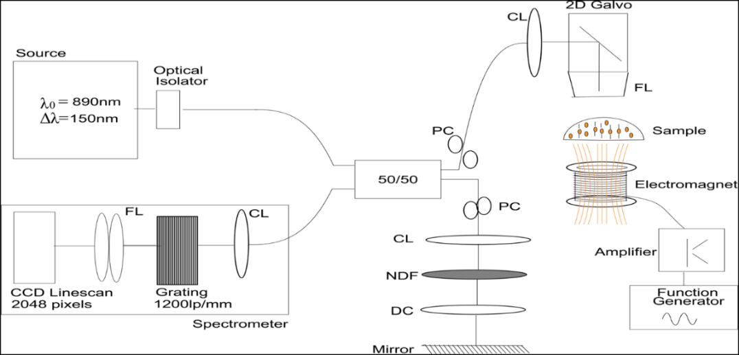
Figure 3.1: The schematic of the custom-built MMOCT system, where PC is polarization controller, CL is collimator, FL is focus lens DC is dispersion compensator, and NDF is neutral density filter. A dual super luminescent diode source (Broadlighter D890-HP; Superlum, Carrigtwohill, Ireland) emitting 890 nm of light with a bandwidth of 150 nm was used. The emitted beam passed through an optical fibre isolator (IO-F-SLD150-895; Thorlabs), and then was split into sample arm and reference arm by 50/50 coupler (Nufern 630-HP fibre; Gould Fiber Optics, Millersville, Maryland). The sample beam passed through a polarization controller (PolaRITETM; General Photonics, Chino, California) and a collimator (PAF-X-5-B; Thorlabs) before being deflected by galvo-mounted mirrors and focused by a telecentric OCT scan lens (LSM02-BB; Thorlabs). The reference beam passed through a collimator (PAF-X-5-B; Thorlabs) and a dispersion compensator (LSM02DC; Thorlabs) before being reflected by a fixed plane mirror, and its intensity was adjusted by an adjustable neutral density filter. The spectrometer in this system for detecting recombined sample and reference beams was made up of a 1200-line pair per millimetre diffraction grating (Wasatch Photonics, Inc., Durham, North Carolina) and 2048 pixel line scan camera (Aviiva, EV71yEM1GE2014-BA9, e2v, Chelmsford, United Kingdom). A homemade electromagnet, a functional generator (TENMA 72-6805) and an amplifier (7224 DC-Enabled AC Amplifier; AE TECHRON, Elkhart, Indiana) were introduced to generate a sinusoidal magnetic field at 80 Hz for inducing magnetomotive signal of sample. [8]

The electromagnet was made by following the procedure previously stated by our former group member, Dr Joseph Boadi [1]. In the electromagnet, a solenoid with 3 cm long and 1.8 cm diameter was used to generate a magnetic field. Copper wire was wound around a core with 1200 turns to form the solenoid. The core was made of a mild steel, which has a relative permeability ($μ_{r}$) of ~150 [10]. In addition, silicone grease was added on the solenoid to assist heat dissipation. In practice, the solenoid was difficult to work for long minutes because it was easy to overheat when an electric current passed through it.

Sample preparations
As agar gel was widely used to mimic tissue’s mechanical properties [11], SPIOs deposited on the surface of agar gel were used as the sample to simulate the transplanted magnetically labelled LESCs on a cornea.

Preparation of agar solution
2g of agar powder (A1296, SIGMA) was added into 200 mL distilled water. The agar was dissolved into water by repeatedly shaking and microwave heating. When the liquid became clear, the agar solution was stored in a fridge and became agar gel after cooling.

MMOCT sample preparation
The stock agar gel was heated by microwave heating. After the agar gel became liquid, 400 μL of agar solution was added into the centre of a metal ring (internal diameter=1cm). After the agar solution cooled down becoming gel, 0.2 g/L SPIO (#637106, diameters: 50-100 nm, Sigma-Aldrich) suspension was dropped on the surface of the agar gel.

Magnetomotive OCT imaging
The MMOCT samples were placed over the electromagnet, 1 cm above the top of the electromagnet, in an 80-Hz sinusoidal magnetic field with strength of 0.05 T. The scanning scheme for MMOCT imaging was implemented by successively scanning along the transverse dimension with a high degree of spatial oversampling and temporal oversampling, which must satisfy the following condition:
$f_{z}>2f_{B}>\frac{2v}{∆x}$ (3.1)
where $f_{z}$ is the A-scan acquisition rate, $f_{B}$ is the magnet modulation frequency, $∆x$ is transverse resolution and $v$ is transverse scan velocity [12]. The condition of $f_{z}>2f_{B}$ shows that the A-scans must be faster than twice the rate of $f_{B}$ to sample the magnetic field modulation and satisfy Nyquist criterion; the condition of $2f_{B}>\frac{2v}{∆x}$ ensures that the magnetomotive signal can be separated from the optical phase changes along the transverse direction [12]. In the experiment, an axial acquisition rate of 1 kHz and 5000 A-scans for 2 mm scan distance were applied, resulting in the transverse scan velocity $v$ of 0.4 mm/s and the signal spatially oversampled by a factor of ~8. Substituting $v=0.4$ mm/s, $∆x=6.20$ μm and $f_{z}=1000$ Hz into the condition 3.1, $500>f_{B}>64.5$ was calculated. Thus, 80 Hz magnetic modulation frequency was chosen to meet the condition in our experiments.

The flow diagram of this process has been shown in Figure 3.2. Firstly, a B scan (e.g. Figure 3.3 a)) was acquired with an axial acquisition rate of 1 kHz and 5000 A-scans for 2 mm scan distance. Secondly, the phase of the image signal was unwrapped to remove $2π$ ambiguity in the phase data. Thirdly, the phase change ($∆φ$) with respect to time was calculated through differentiating the unwrapped phase in the lateral direction of the B scan image. If a magnetic particle with permanent magnetism is in a sinusoidal magnetic field, the magnetically induced displacement of the particle will be a sinusoidal function in term of equation 1.21. This leads to a sinusoidal $∆φ$ according to equation 1.21 and 1.22, which can be expressed as
$∆φ=2〈k〉n×(\frac{A}{2}\left(\sin{(2πf_{B}t+φ_{0}}\right)+1)$ (3.2)
Here, $〈k〉$ is average wavenumber of light source, $n$ is refractive index of medium, $A$ is the maximum displacement of nanoparticle in the magnetic field and $φ_{0}$ is the mechanical phase lag determined by viscosity of the medium. Fourthly, the frequency spectrum of $∆φ$ (e.g. Figure 3.3 b)) was calculated by FFT of $∆φ$, and the $∆φ$ which has the same frequency as the vibrational frequency of magnetic nanoparticle (80 Hz or its harmonics for permanent magnet; 160 Hz or its harmonics for paramagnetic nanoparticles) was found by the frequency spectrum. Fifthly, the found $∆φ$ was extracted by a band-pass filter. The band-pass filter was a Butterworth filter, implemented by the MATLAB function of ‘butter’ with 5 filter order, shown in Figure 3.3 c). Finally, the amplitude of the filtered $∆φ$ (e.g. the cumulative amplitude of the filtered $∆φ$ is shown in Figure 3.3 d).) in each pixel was calculated by a bin size of 50 points (20 μm) short-time Fourier Transform (STFT), and the amplitudes were used to localize the positions of magnetic nanoparticles and form a MMOCT image, e.g. Figure 3.3 e). The MATLAB code used for the signal process can be found in Appendix 8.4.
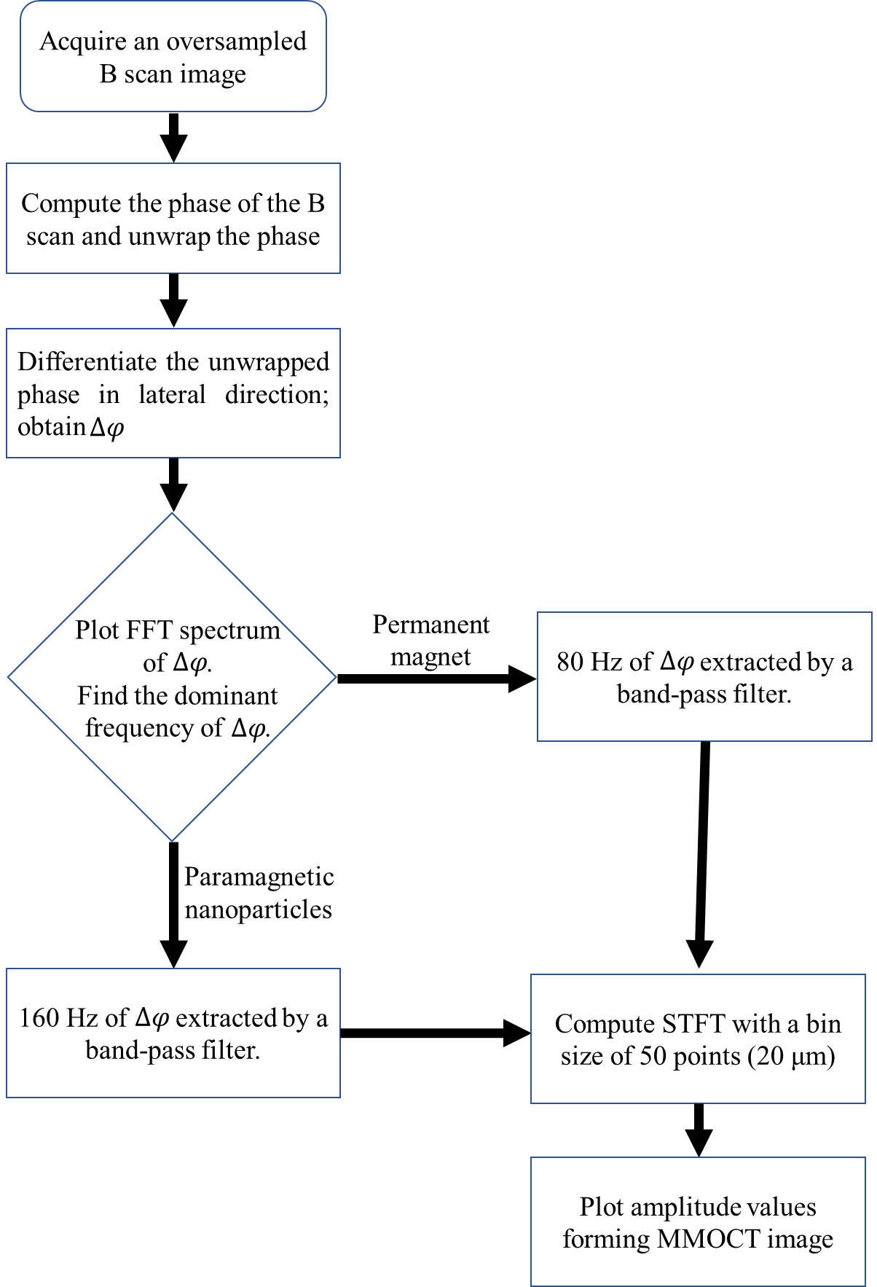
Figure 3.2: The flow chart of MMOCT imaging.

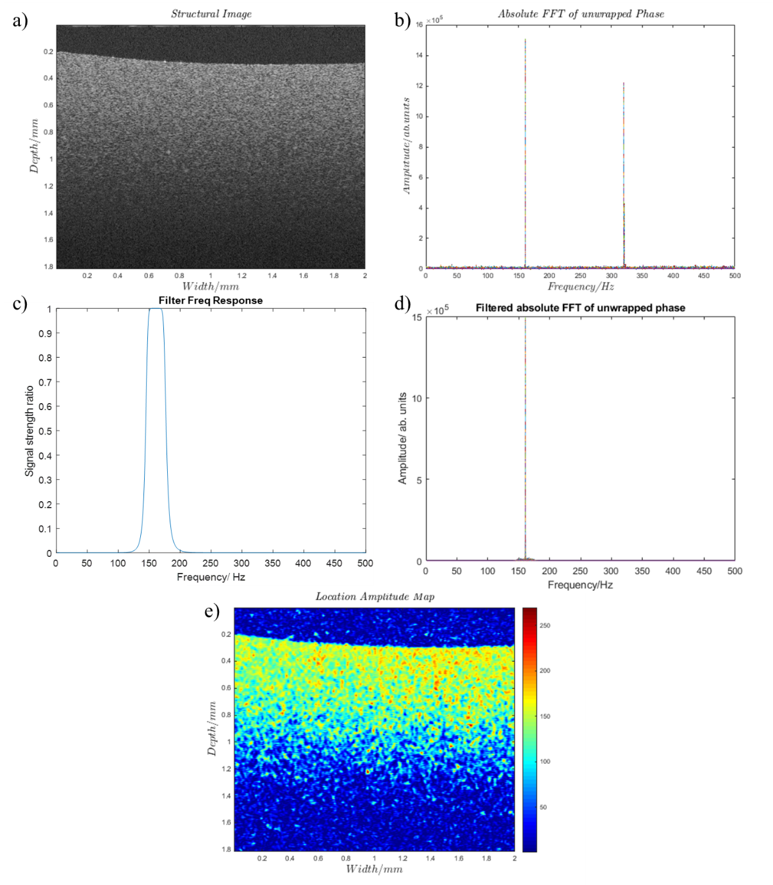
Figure 3.3: a) the structure/intensity image of agar gel. b) the phase spectrum of the magnetomotive signal of only agar gel. c) the frequency response of the bandpass filter used for extracting 160 Hz magnetomotive signal. d) the filtered magnetomotive signal. e) the phantom of the 160 Hz magnetomotive signal.

Elimination of false magnetomotive signal
In chapter 3, it has been shown that there was a false magnetomotive signal in our OCT system. In a MMOCT imaging, the false magnetomotive signal can result in a positive signal in a negative control. In other words, magnetically induced displacements within the sample can be detected, even when there is no magnetic particle within the sample. For example, in Figure 3.3, only agar gel was imaged in 0.5 T of 80 Hz modulated magnetic field by the MMOCT. Unexpectedly, two significant magnetomotive signals were detected at 160 Hz and 320 Hz (shown in Figure 3.3 b)). The magnetomotive signal at 160 Hz generated a false phantom in Figure 3.3 e) to indicate magnetically induced displacements within the sample. This error needed to be corrected by removing the false magnetomotive signal.

At first, it was proposed that the false magnetomotive signal resulted from an unstable metallic sample holder which caused mechanical vibration of sample without any magnetic particle. Thus, a stable rigid specimen holder was made by an aluminium plate. The aluminium is non-ferrous metal with non-magnetic property. Thus, it was expected that there was no magnetic force between the aluminium plate and the electromagnet. After usage of the aluminium plate, the MMOCT images of infrared detection card were obtained shown in Figure 3.4. Figure 3.4 a), b) and c) demonstrated the structure image of infrared detection card in 0.5 T of 80 Hz modulated magnetic field, the phase spectrum of magnetomotive signal and the phantom of 160 Hz magnetomotive signal respectively. However, in Figure 3.4 b), false magnetomotive signal did not disappear and became more complicated. The false signal was not removed in Figure 3.4 c). This might be because the aluminium plate was actually an alloy containing the elements with high magnetic susceptibility.
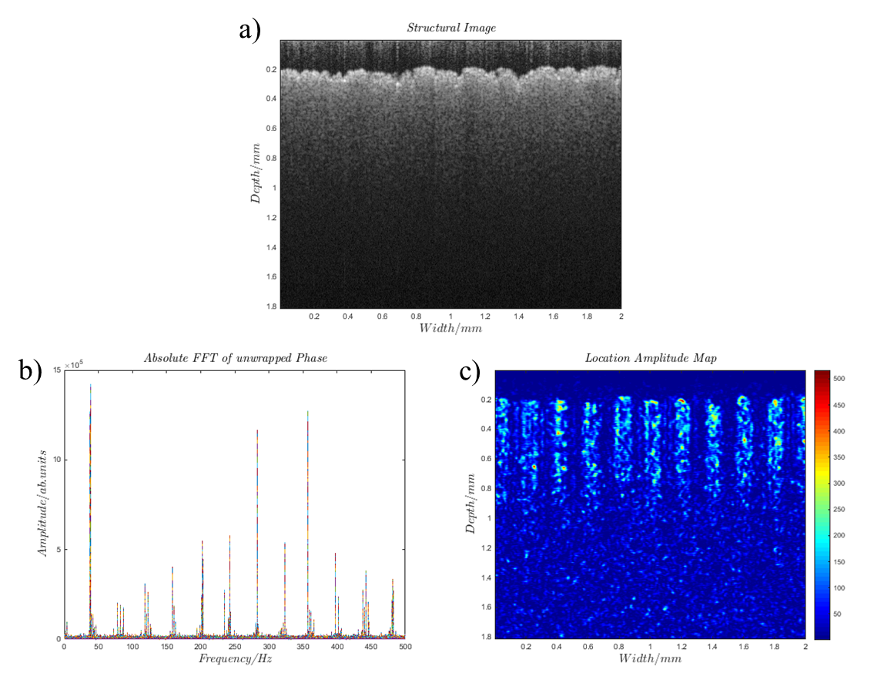
Figure 3.4: a) the structure/intensity image of infrared detection card on rigid aluminium plate. b) the phase spectrum of the magnetomotive signal of infrared detection card. c) the phantom of the 160 Hz magnetomotive signal.

Therefore, the aluminium plate was replaced by a plastic plate, and other components which can induce magnetic force with electromagnet were replaced by a low susceptibility material. All components located near the sample were checked using a permanent magnet to find out the component with high susceptibility, which was implemented by holding the permanent magnet by hand and feeling the magnetic force resulting from high-susceptibility materials. The replaced components included iron screws, the travel translation stage for adjusting the height of OCT objective and the electromagnet holder. In addition, the electromagnet was firmly fixed to avoid the phase shift of magnetic field, as shown in Figure 3.5. In Figure 3.5, two fixable trestles and a clamp were used to mount the electromagnet. The electromagnet was fixed on a rigid aluminium plate, and the rigid aluminium plate was fixed on our optical table with screws. An aluminium ring was used to help dissipate heat. Silicone grease was added between the solenoid and the aluminium ring to assist heat conduction.

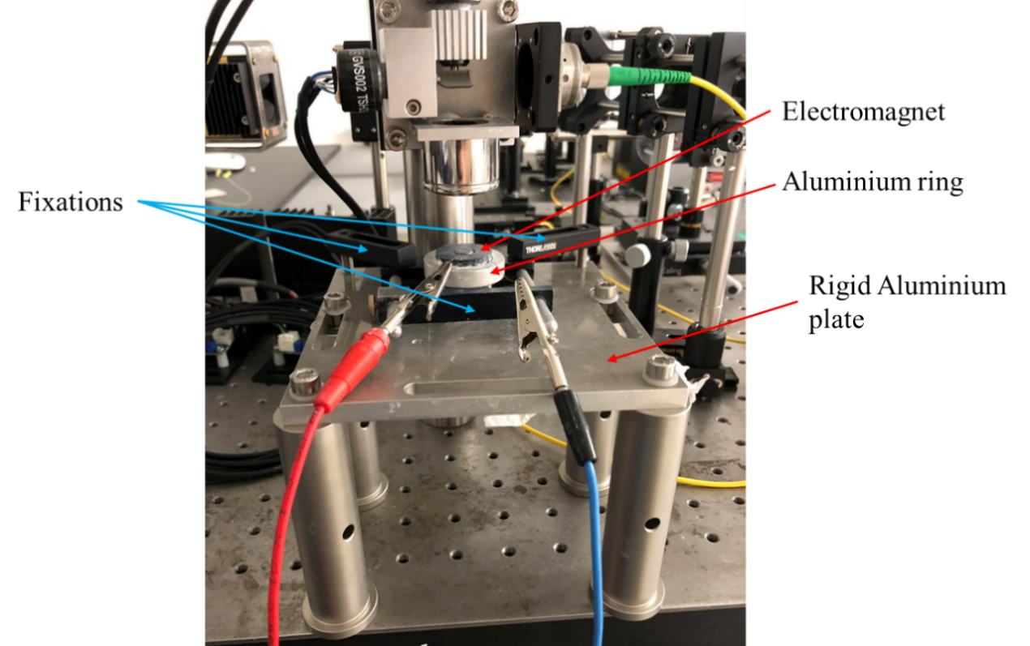
Figure 3.5: The physical image of electromagnet and its holding device in sample field of MMOCT.

Improving SNR of magnetomotive OCT imaging
SNR of MMOCT can be defined as the ratio of magnetomotive signal to the mean of the noise. After the elimination of the false magnetomotive signal, it was found that a moving average filter was necessary to improve the SNR of MMOCT. The moving average filter was used to $∆φ$ before the FFT of $∆φ$. Several MMOCT images with no average filter and 3-point, 10-point and 20-point average filters were acquired for comparison.

Results

Magnetic field of MMOCT system
It is assumed that our solenoid is a finite continuous solenoid and the $μ_{r}$ of core material is a constant. The ‘finite’ and ‘continuous’ mean the solenoid is a finite cylinder and the current is homogenously distributed on the surface of the solenoid, respectively. A magnitude of magnetic field inside the finite continuous solenoid can be estimated by the following formulas [13]:
$B=μ_{0}M\frac{μ_{r}h(L/w)}{μ_{r}h(L/w)}$ (3.3)
$h\left(α\right)=\frac{{\left(α^{2}-1\right)}^{\frac{3}{2}}}{α\cosh^{-1}\left(α\right)-{\left(α^{2}-1\right)}^{\frac{1}{2}}}-1$ (3.4)
Here, $μ_{0}$ is the magnetic permeability of vacuum, $M$ is the magnetization inside the solenoid, $α$ is the aspect ratio of solenoid $L/w$, and $L$ and $w$ are the length and width respectively. According to equation 3.3 and 3.4, the magnetic flux density ($\left|B\right|$) inside the solenoid depends on the aspect ratio of solenoid and is proportional to $\left|M\right|$ and $μ_{r}$. Since the magnetic field used in our MMOCT system is located directly above the core and near the edge of the core, we assume that the field strength in this area is approximately equal or is proportional to that inside the solenoid. Thus, the core of solenoid can increase the generated field strength for our MMOCT system because its relative permeability is much higher than that of air. The relationship between $M$ and the current density ($J$), can be expressed as [13]:
$J=∇×M$ (3.5)
As the current through the wire is proportional to $\left| J \right|$, the current is also proportional to $\left|M\right|$ and $\left|B\right|$. The linear relationship between the current and $\left| B \right|$ was used to predict the magnetic field strength in the sample field of MMOCT system when the solenoid was energized with different currents.

Because the electromagnet used in this project was same as the electromagnet made by Dr Joseph Boadi [1], we assume that both electromagnets had the same field strength. It has been measured with the Gaussmeter (GM05, Hirst) by Dr Joseph Boadi that 1.6 A of 80 Hz sinusoidal current in the electromagnet can produce a magnetic field of 0.08 T at the position of sample [1]. According to the linear relationship between the current and $\left| B \right|$, our electromagnet can produce 0.05 T sinusoidal magnetic field at 80 Hz in the sample area, when 1.0 A of 80 Hz sinusoidal current was employed.

Negative control of MMOCT imaging
After completing the steps described in section 4.2.4, the false magnetomotive signal was suppressed successfully, shown Figure 3.6. In Figure 3.6 a), the structure image of agar gel is shown, where agar gel was imaged by our MMOCT in 0.5 T of 80 Hz modulated magnetic field. In Figure 3.6 b), the phase frequency spectrum of magnetomotive signal is presented, in which there was no obvious prominent signal at any frequency. Two signal peaks at 320 Hz and 480 Hz (as marked in Figure 3.6 b)) were detected and identified as the false magnetomotive signals because the frequencies were the harmonic of the modulation frequency of magnetic field (80 Hz). The false magnetomotive signals were $3.5×{10}^{4}$ a.u. and $3.6×{10}^{4}$ a.u. at 320 Hz and 480 Hz respectively, which were much smaller than the previous results in Figure 3.3, and were of the same order of magnitude as the noise floor ($1.8×{10}^{4}$ a.u.). The false magnetomotive signal can be neglected since it cannot result in a misleading false phantom in the MMOCT image, shown in Figure 3.6 c).

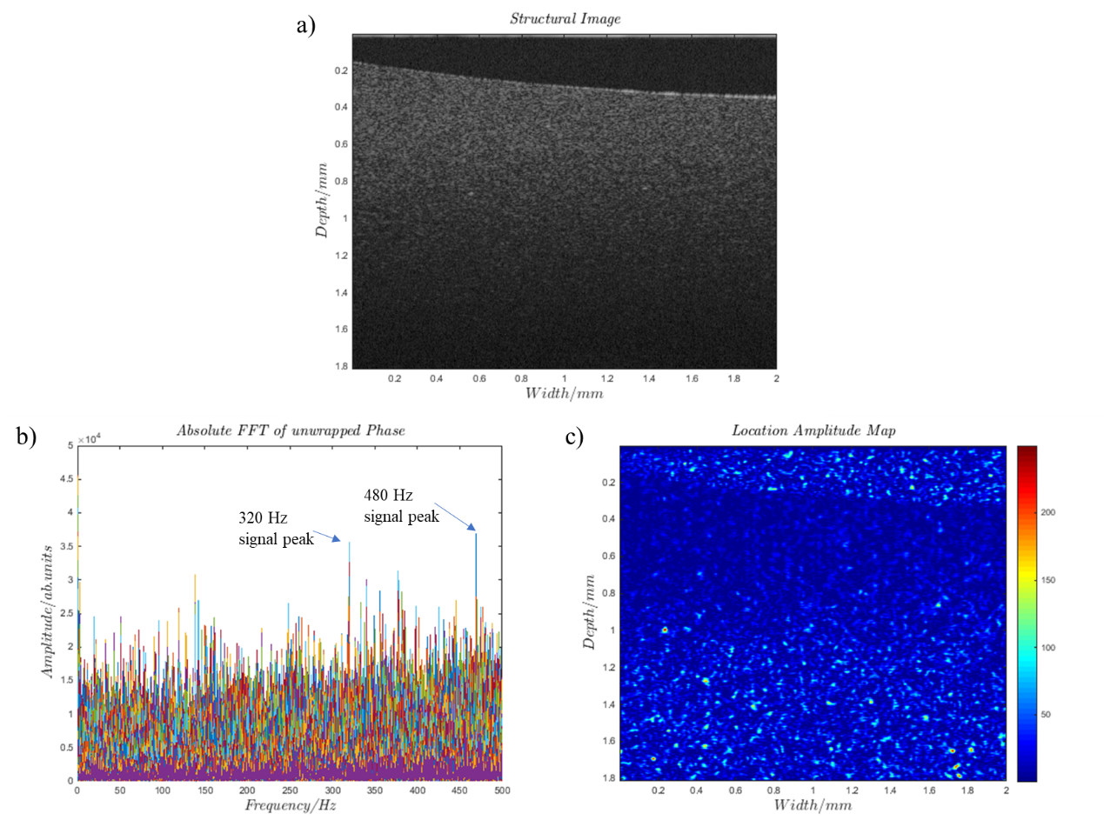
Figure 3.6: a) structure image of agar gel in 0.5 T of 80 Hz modulated magnetic field. b) the phase spectrum of the magnetomotive signal of agar gel. c) the phantom of the 160 Hz magnetomotive signal.

MMOCT images with different average filters
Figure 3.7 a) shows the intensity image of agar gel and SPIO nanoparticles, in which 50 uL of 1 mg/mL SPIO aqueous solution was loaded on the agar gel surface (the area of agar surface was equal to 0.785 cm²). As a result, the density of SPIO in the image is 63.7 ug/cm². The agar sample was placed in an 80 Hz sinusoidal magnetic field to exert a force on the SPIO and generate the modulated displacement of the SPIO nanoparticle. The modulated displacement was detected by the phase change ($∆φ$) of OCT signal, as described above.

In Figure 3.7 b), the detected frequency spectrum of phase change is shown, where the phase change with the frequency of 160 Hz (intensity =$1.29×{10}^{6}$ a.u.) is dominant when SPIO is in 0.05 T of 80 Hz sinusoidal magnetic field. It is proposed that SPIO in an alternating magnetic field can generate a dominant magnetomotive signal at the double frequency of magnetic field. The frequency-doubling effect was also observed by Oh et al [14].

The 160 Hz magnetomotive signal was extracted forming a MMOCT image of SPIO, shown in Figure 3.7 c). However, the magnetomotive signal of SPIO is not clear to perceive in the MMOCT image of Figure 3.7 c) due to too much image noise. Then, a 3-point moving average filter (kernel size: $3 \left(lateral\right)×1(axial)$) was applied to the image of phase change ($∆φ$) before FFT of $∆φ$. The average filter was moving laterally to suppress the noise of magnetomotive signal. As a result, the SNR of MMOCT was increased significantly. For example, the SNR of original image in Figure 3.7 b) is about $\frac{12.9×{10}^{5}}{1×{10}^{5}}=12.9$, and the SNR after application of the 3-point average filter in Figure 3.7 d) is about $\frac{11.8×{10}^{5}}{0.4×{10}^{5}}=29.5$. Consequently, the magnetomotive signal of SPIO became clearer in the MMOCT image of Figure 3.7 e). In this case, the magnetomotive signal can be used for localization of magnetic particle in clinical applications.

In Figure 3.7 f) and g), a 10-point average filter was applied, which causes a further increase of SNR and a more obvious magnetomotive signal. In Figure 3.7 h) and i), a 20-point average filter was applied. The SNR after application of the 20-point average filter was larger than the other’s SNR described above, and the magnetomotive signal of SPIO generated the most evident phantom in the MMOCT image (Figure 3.7 i)) compared with the other MMOCT images obtained so far. Nevertheless, it can be observed that there was a reduction of resolution in the MMOCT image of Figure 3.7 i). Therefore, there was a trade-off between the resolution of MMOCT and SNR. The increase of the kernel size of the average filter improved the SNR but reduced the image resolution. To improve the SNR, the 10-point average filter was applied for obtaining MMOCT images thereinafter.

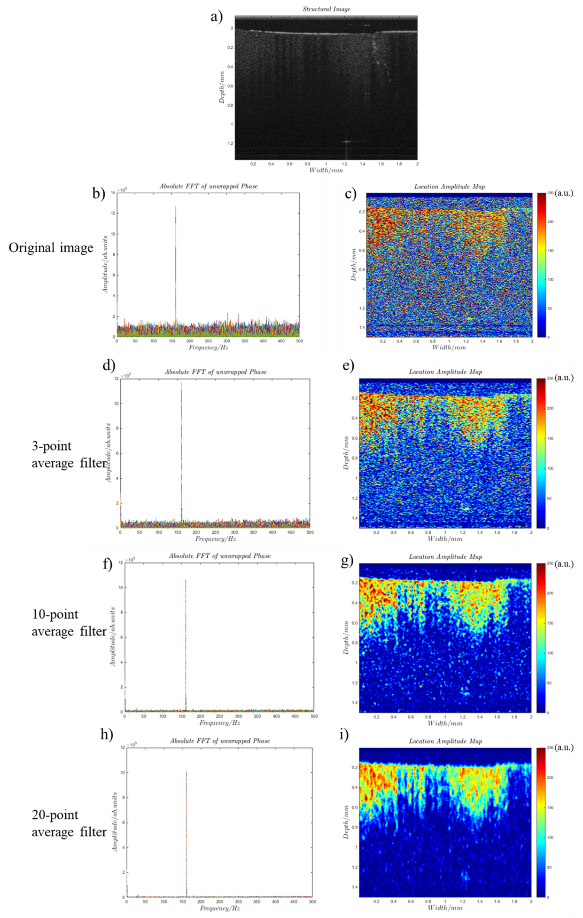
Figure 3.7: The MMOCT and structure images of SPIO on agar gel. a) the B-scan intensity/structure image of 63.7 μg/cm² SPIO on agar gel. b) the phase frequency spectrum of magnetomotive signal of SPIO without any average filter. c) the SPIO phantom results from MMOCT signal processing of 160 Hz magnetomotive signal. d) and e) are the same phase frequency spectrum and the same SPIO phantom in MMOCT image respectively after application of a 3-point average filter. f) and g) are the same phase frequency spectrum and the same SPIO phantom in MMOCT image respectively after application of a 10-point average filter. h) and i) are the same phase frequency spectrum and the same SPIO phantom in MMOCT image respectively after application of a 20-point average filter.

Discussion

Frequency-doubling effect of Magnetomotive signal
The frequency-doubling effect of magnetomotive signal has been observed in Figure 3.7. The reason of frequency doubling could be that the effect of superparamagnetism of SPIO is to make the force of SPIO depend on the square of the magnetic field. This effect can be explained by a vector equation as follows. The translative force vector of SPIO ($\vec{F}$) is parallel with the magnetic field vector ($\vec{B}$) and the axial direction of A scan (z), and the vector equation relative to these variates can be expressed as [8]:
$\vec{F}=V_{0}(M_{r}+\frac{χ_{m}}{μ_{0}}B_{z})\frac{∂\vec{B}}{∂z}$ (3.6)
where $V_{0}$is volume, $M_{r}$ is remnant magnetization and $χ_{m}$ is the magnetic susceptibilities of SPIO. The remnant magnetization is negligible due to the superparamagnetism of SPIO. The magnetomotive force is unidirectional because of the positivity of $χ_{m}$ and $B_{z}\frac{∂\vec{B}}{∂z}$. The square of the magnetic field, i.e. $B_{z}\frac{∂\vec{B}}{∂z}$ , is illustrated in Figure 3.8, in comparison with the modulation frequency. Figure 3.8 indicates that the frequency of magnetomotive response is the double of the modulation frequency due to the unidirectional magnetomotive force. Therefore, the oscillation of SPIO should have double the frequency of the magnetic field modulation.

Figure 3.8: The (normalised) magnetomotive force of SPIO excited by a sinusoidal magnetic field. Blue line: the applied sinusoidal waveform for the excitation; red line: the waveform of magnetomotive force.

Influence factors of MMOCT signal
Based on the principle of MMOCT, we can assume that the concentration and magnetism of magnetic particle, viscoelasticity of agar and the magnetic field are able to influence the magnetomotive signal because these factors alter the displacement of magnetic particle. According to equation 1.22, a larger displacement causes a larger change of interferometric phase and thereby generates a stronger magnetomotive signal. Therefore, it has been proposed that the concentration of magnetic particles on the agar surface is proportional to the intensity of magnetomotive signal with other conditions unchanged. In this case, the concentration of magnetic particles can be quantified after a calibration. However, the experiment for verifying this relation has failed. For instance, 5.10 μg/cm² SPIO on agar gel as a positive control was imaged by our MMOCT, shown in Figure 3.9. In Figure 3.9 b), the phase frequency spectrum shows that the magnetomotive signals at 160 Hz and 320 Hz are about 9.5×10⁵ a.u. and 2.5×10⁶ a.u respectively. Compared with the magnetomotive signal of 63.7 μg/cm² in Figure 3.7 (intensity = 1.3×10⁶ a.u. at 160 Hz and no magnetomotive signa at 320 Hz), the smaller concertation of SPIO, 5.10 μg/cm², yielded stronger magnetomotive signals unexpectedly.

In practice, the magnetomotive signal was very sensitive to ambient conditions. It has been found that the magnetomotive signal can be affected by lamplight, air drying of agar gel, position of image and temperature of solenoid. The lamplight can produce an extra signal at 100 Hz or its harmonics in our laboratory, which was also be found by Dr. Joseph Boadi [1]. Hence, our MMOCT system has been shielded by a black plastic shell to avoid the impact from lamplight. The air drying of agar gel can cause the alteration of viscoelastic properties of gel, leading to a change of displacement of magnetic particle within sample for a given B-field strength. A different image position has different magnitude and direction of magnetic field and different concentration of magnetic particles, due to inhomogeneous magnetic field and particle densities. The inhomogeneous concentration could be from the aggregation of magnetic particles due to the magnetic interaction. Both alterations of the magnetic field and the concentration can change the displacements of magnetic particles and the magnetomotive signal. As MMOCT imaging went on, the solenoid was heated due to a current through it. The temperature increase can cause a rise of resistance and reductions of current and magnetic field. Therefore, the displacements of particles were changed, and we had to increase voltage manually when the current was too small or resume the experiment after the solenoid was cooled down. This problem could be mitigated by using an amplifier to provide a constant current, rather than a constant voltage, to our electromagnet. However, we did not try to use the constant current source due to the limitation of equipment.
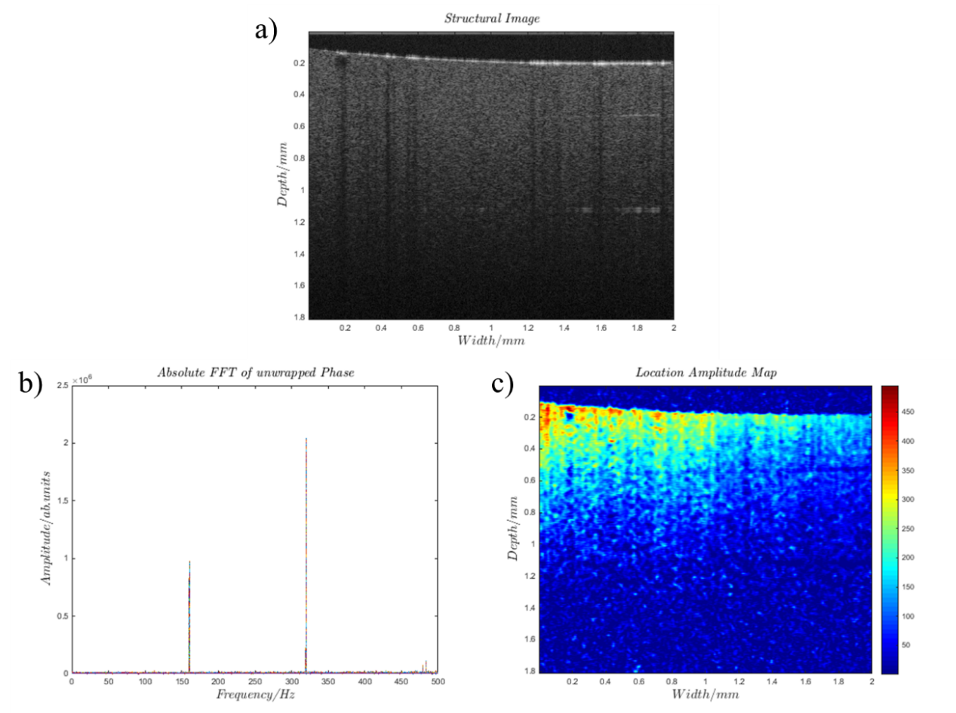
Figure 3.9: a) structure image of 5.10 μg/cm² SPIO and agar gel in 0.5 T of 80 Hz modulated magnetic field. b) the phase spectrum of the magnetomotive signal of 5.10 μg/cm² SPIO on agar gel. c) the image of the 160 Hz magnetomotive signal.

Conclusion
The influence factors described above made the quantitative analysis of magnetomotive signal difficult and the intensity of magnetomotive signal become unpredictable. Nonetheless, the MMOCT is capable of detecting the magnetic particles on the material having analogous mechanical properties to biological tissue, e.g. agar gel in this case. As a result, this MMOCT is ready to track magnetic particles on biological tissue for the next stage.

References
[1] J. Boadi, "Clinical applications of ultra-high resolution and phase-sensitive optical coherence tomography," University of Sheffield, 2016.
[2] A. J. Shortt, S. J. Tuft, and J. T. Daniels, "Corneal stem cells in the eye clinic," British medical bulletin, vol. 100, no. 1, pp. 209-225, 2011.
[3] S. M. Daya et al., "Outcomes and DNA analysis of ex vivo expanded stem cell allograft for ocular surface reconstruction," Ophthalmology, vol. 112, no. 3, pp. 470-477, 2005.
[4] P. Haamann, O. Jensen, and P. Schmidt, "Limbal autograft transplantation," Acta Ophthalmologica Scandinavica, vol. 76, no. 1, pp. 117-118, 1998.
[5] J. Vazirani et al., "Autologous simple limbal epithelial transplantation for unilateral limbal stem cell deficiency: multicentre results," British Journal of Ophthalmology, vol. 100, no. 10, pp. 1416-1420, 2016.
[6] T. P. Utheim, "Concise review: transplantation of cultured oral mucosal epithelial cells for treating limbal stem cell deficiency—current status and future perspectives," Stem Cells, vol. 33, no. 6, pp. 1685-1695, 2015.
[7] N. Genicio, J. G. Paramo, and A. J. Shortt, "Quantum dot labeling and tracking of cultured limbal epithelial cell transplants in vitro," Investigative ophthalmology & visual science, vol. 56, no. 5, pp. 3051-3059, 2015.
[8] W. Li, W. Song, B. Chen, and S. J. Matcher, "Superparamagnetic graphene quantum dot as a dual‐modality contrast agent for confocal fluorescence microscopy and magnetomotive optical coherence tomography," Journal of biophotonics, vol. 12, no. 2, p. e201800219, 2019.
[9] W. Li and S. J. Matcher, "Novel magnetic graphene quantum dot as dual modality fluorescence/MMOCT contrast agent for tracking epithelial cells," in Reporters, Markers, Dyes, Nanoparticles, and Molecular Probes for Biomedical Applications IX, 2017, vol. 10079: International Society for Optics and Photonics, p. 100790X.
[10] D. Jiles, "Magnetic properties and microstructure of AISI 1000 series carbon steels," Journal of Physics D: Applied Physics, vol. 21, no. 7, p. 1186, 1988.
[11] G. Lamouche et al., "Review of tissue simulating phantoms with controllable optical, mechanical and structural properties for use in optical coherence tomography," Biomedical optics express, vol. 3, no. 6, pp. 1381-1398, 2012.
[12] A. L. Oldenburg, V. Crecea, S. A. Rinne, and S. A. Boppart, "Phase-resolved magnetomotive OCT for imaging nanomolar concentrations of magnetic nanoparticles in tissues," Optics express, vol. 16, no. 15, pp. 11525-11539, 2008.
[13] L. Lerner, "Magnetic field of a finite solenoid with a linear permeable core," American Journal of Physics, vol. 79, no. 10, pp. 1030-1035, 2011.
[14] J. Oh et al., "Detection of macrophages in atherosclerotic tissue using magnetic nanoparticles and differential phase optical coherence tomography," Journal of biomedical optics, vol. 13, no. 5, p. 054006, 2008.

Superparamagnetic Graphene Quantum Dot as a Dual-Modality Contrast Agent for Confocal Fluorescence Microscopy and Magnetomotive OCT

Summary
A magnetic graphene quantum dot (MGQD) nanoparticle, synthesized by hydrothermally reducing and cutting graphene oxide-iron oxide sheet, was demonstrated to possess the capabilities of simultaneous confocal fluorescence and magnetomotive optical coherence tomography (MMOCT) imaging. This MGQD shows low toxicity, significant tuneable blue fluorescence and superparamagnetism, which can thus be used as a dual-modality contrast agent for confocal fluorescence microscopy (CFM) and MMOCT. The feasibility of applying MGQD as a tracer of cells is shown by imaging and visualizing MGQD labelled cells using CFM and our in-house MMOCT. Since MMOCT and CFM can offer anatomical structure and intracellular details, respectively, the MGQD for cell tracking could provide a more comprehensive diagnosis.

Note that the content in this chapter has been published in Journal of Biophotonics [1].

Introduction
Cell therapy can be defined as the therapy in which human or microbial cells are used as therapeutic entities to restore or improve the biological function of damaged tissue [2, 3]. The cell therapy is usually achieved by transplanting the therapeutic entities to a target organ [2]. It has been regarded as a new revolution in medicine and is being rapidly developed to treat diseases such as traumatic brain injury [4], ischaemic heart disease [5], stroke [6], diabetes [7] and limbal epithelial stem cell deficiency [8]. A major challenge for cell therapy is evaluation or comparison of therapy outcomes to determine the best cell type, route, site of transfer, dose, and frequency. A variety of non-invasive imaging techniques for tracking transplanted cells in vivo have been developed to address the challenge. The main imaging technologies developed for tracking cells are radionuclide, X-ray computed tomography (CT), magnetic resonance imaging (MRI) and optical imaging [9-12].

Each imaging technique has its own advantages and limitations. Radionuclide imaging techniques, such as single-photon emission computed tomography and positron emission tomography, visualize cells labelled with radioactive isotopes. These have excellent sensitivity, but their application has been limited by the radiation damage, short half-life of tracer and lack of anatomical information [13, 14]. CT can obtain anatomical images with a spatial resolution of around 50 μm, using heavy element materials, such as gold and bismuth, for cell tracking; hence concerns over the toxicity of the contrast agent have been raised [15, 16]. Another limitation of CT is that X-ray exposure may result in a risk of cancer and other damage tissue [17]. MRI possesses good spatial resolution (10-100 μm) [15]. The most common tracer for MRI is superparamagnetic iron oxide (SPIO) nanoparticles, which has been clinically approved because of the good biocompatibility [18, 19]. The main disadvantages of MRI are low sensitivity (i.e. low SNR) and long acquisition time [14]. High concentrations of magnetic nanoparticles in cells are required for tagging cells due to the low sensitivity [20].

Compared with other image techniques, optical imaging microscopies, such as wide-field microscopy, confocal microscopy (CM), multiphoton laser scanning microscopy and optical coherence tomography (OCT) have a lot of advantages, including cellular level resolution, high sensitivity, strong molecular specificity and non-ionizing radiation [21, 22]. The CM and multiphoton laser scanning microscopy have been widely applied to visualize intracellular details for molecular and cell biology, due to the excellent resolution [21]. However, optical imaging has limited signal penetration depth due to scattering and absorption of light in tissue. For example, CM and multiphoton microscopy provide imaging depths of 200 and 500 μm, respectively, while OCT can image to 1- to 2-mm depth, albeit with worse resolution (10 μm) [23]. As OCT can provide considerable imaging depth and good enough resolution to easily differentiate tissue structure, it has been clinically used for providing anatomical morphology of tissue in ophthalmology, cardiology and urology [23, 24]. In addition, OCT has features for low cost, portable system, high acquisition rate and easy integration into catheters, hand-held probes or needles; these features let OCT be ideal for intraoperative imaging [23]. Limitations of OCT include a lack of subcellular resolution and insensitivity to fluorescence emission.

Therefore, a contrast agent that could be utilized for diverse imaging modalities would offer more comprehensive information. In this chapter, a contrast agent for combined OCT and CM will be described, as it has the potential to provide both anatomical information and valuable intracellular details.

OCT is an optical analog of ultrasound imaging, in which the depth-resolved backscatter from a sample is measured from photon time-of-flight information, recorded indirectly using low-coherence interferometry [25]. The technique was originally implemented in the time-domain, but modern systems almost exclusively use Fourier-domain processing. Fourier-domain OCT (FD-OCT) does not require a mechanically scanned reference arm, allowing higher A-scan rates than time-domain OCT (TD-OCT). It has been shown that FD-OCT has a > 100-fold increase in sensitivity compared with TD-OCT [26].

Similar to CM, the lateral resolution of OCT is limited by the numerical aperture (NA) of objective, which is defined as $∆x=0.61λ/NA$, where $λ$ is the wavelength of light [27]. However, the axial resolution of OCT is determined by the coherence length of the light source. The light source with lower coherence length will produce better axial resolution, expressed as $∆z={I_{c}}/2≅{0.44λ^{2}}/{Δλ}$, where $Δλ$ is the bandwidth of light and $I_{c}$ is the coherence length of light [27]. Because the axial resolution of OCT can be improved by using lower coherence laser source, instead of increase of NA, OCT commonly uses low NA objective for long work distance, deeper imaging depth and a large field of view. In OCT, the specimen is usually illuminated using near-infrared light, because most tissues have a relatively low absorption compared to scattering at near-infrared wavelengths [25, 28].

Since the invention of OCT, various materials have been studied as potential contrast agent. The most common contrast agent is gold nanoparticles with various shapes, involving nanospheres, nanoshells, nanorods, and nanocages, which is attributed to its surface plasmon resonance effect causing strong size-dependent absorption or scattering at near-infrared wavelengths [25, 29]. Since the development of Spectroscopic OCT, dyes which have a strong absorption or scattering peak in the OCT spectral window also become an important contrast agent, such as indocyanine green and fluorescent microspheres [30, 31]. An approach of locating magnetic particles within tissue using MMOCT has been investigated for tracking magnetically labelled cells [32]. In this case, SPIO has become the most prevalent contrast agent because of its high magnetic susceptibility, good biocompatibility and easy preparation. It has been reported that ultralow concentrations of SPIO (27 μg/g) within tissue can be detected by MMOCT [33]. The combination of SPIO and MMOCT has been used to track macrophage and platelet, and diagnose breast cancer, atherosclerosis and thrombosis [25, 34-36].

Cell tracking by fluorescence microscopy relies on fluorescence tags to label and locate cells. Most fluorescence probes are either organic fluorophores or quantum dots (QDs). Research work on the QD has been pursued, because organic fluorophores suffer photobleaching and broad overlapping emission lines [11]. QDs are nano-scale nanocrystals, which show robust fluorescence due to the quantum confinement effect. The quantum confinement effect describes that the motion of randomly moving electron will be confined if the size of a particle is too small to be comparable to the wavelength of the electron [37]. The confinement of electrons results in discrete energy levels and increased electronic bandgaps which provide the necessary conditions for fluorescence.

QDs have many advantages over organic fluorophores, including size-tuneable light emission, broad excitation spectra with narrow emission spectra and 20 times brighter and 100 times more stable fluorescence [38, 39]. In earlier research, QDs composed of II-VI (eg, CdSe, CdS, CdTe) or III-V (eg, InP, InAs) alloys were developed for their excellent fluorescence [40-42]. However, the applications of these QDs in medicine have been limited by the potential toxicity from heavy metals [43]. QDs based on carbon (eg, carbon nanotubes, graphene) and silicon (eg, porous silicon nanoparticles) have been investigated to avoid usage of heavy metal; the results demonstrate that carbon- or silicon-based QDs have high biocompatibility and efficient fluorescence, thereby, facilitating biomedical applications [43, 44]. The high biocompatibility has been verified with in vitro and in vivo standard tests. The most common test method for quantitatively studying cytotoxicity in vitro is MTT (3-(4,5-dimethyl-2-thiazolyl)-2,5-diphenyltetrazolium bromide) assay, in which mitochondrial activity can be evaluated by the conversion of the tetrazolium salt, MTT, into formazan crystals [45]. The in vivo biocompatibility tests mainly include complete blood count, serum biochemistry analysis and histological analysis of tissues [46, 47]. The complete blood count and serum biochemistry analysis were achieved by detecting the effects of QDs on related blood indicators, such as red and white blood cell count, haemoglobin, haematocrit and platelet count, which were widely used to test immune-system responses and inflammatory reactions [46]. The histological analysis can directly present the inflammation and cell abnormality using a light microscopy to evaluate the impact of QDs on biological specimens [46, 47].

The benefits of QDs and SPIO for contrast agents have inspired us to investigate a hybrid QD and SPIO combination for CFM and MMOCT. A recent study shows that a hybrid of graphene and iron oxides, called MGQD, displays both fluorescence and superparamagnetism [48]. Its properties allow one to integrate CFM and MMOCT for the application of cell tracking, thereby possibly simultaneously offering anatomic structure and intercellular details for tissue. In this study, the feasibility of using synthesized MGQD as a contrast agent for MMOCT and CFM was be evaluated.

Materials and methods

Synthesis of MGQD
MGQD nanoparticles were synthesized following a previously reported method [48], with some modifications. First, graphene oxide was prepared from graphite by a modified Hummers method [49]. 0.2 g of graphene oxide was then added into 30 mL of distilled water, dispersed by sonication (60 Hz) for 1 hour using an ultrasonic bath. The pH value of the suspension was adjusted to 10 by addition of ammonium hydroxide (NH₄OH). 0.8 g of ferric chloride hexahydrate (FeCl₃-6H₂O, 97%) and 1.04 g of ferrous chloride tetrahydrate (FeCl₂-4H₂O, >99%) were dissolved into 27-mL distilled water. The ferric salt solution and graphene oxide suspension were mixed, and NH₄OH was added dropwise until the pH value reached 10. The mixture was stirred for 2 hours under nitrogen atmosphere, forming graphene oxide-iron oxide. The precipitate was then centrifuged and washed several times by water and ethanol until the supernatant became clear, to eliminate uncoated graphene oxide and ions. The graphene oxide-iron oxide was dispersed in 500-mL distilled water and autoclaved by a Parr Series 4000 autoclave at 200℃ for 10 hours, forming shattered reduced graphene oxide-iron oxide nanoparticles, namely MGQD. Then, residual chemicals in the MGQD suspension were removed by dialysis using Fisher Scientific Biodesign Dialysis tubing (molecular weight cut off = 3.5 kDa). Then, the MGQD was frozen in a freezer. The frozen MGQD was dried by freeze drying in a freeze dryer (FreeZone Triad Freeze Dry System, Labconco Co., USA). The dried MGQD was stored in a sealed container under cool and dry environment without direct sunlight. All chemicals used above were purchased from Sigma-Aldrich (St. Louis, Missouri).

Characterization of MGQD
Transmission electron microscopy (TEM) image of MGQD was achieved using an FEI Tecnai Biotwin 120-kV machine, operating at an accelerating voltage of 80 kV. The electron was emitted by a tungsten filament, and images were recorded on a Gatan Orius SC1000B bottom mounted camera with Gatan Digital Micrograph Software (Pleasanton, California). TEM sample was prepared by evaporating 10-μL diluted suspension (about 0.01 mg/mL) on a carbon film on 200 mesh copper grids. The magnetic hysteresis loop of MGQD was measured by Quantum Design MPMS-XL 5 superconducting quantum interference device (Quantum Design, San Diego, California) (SQUID). 0.016 g of MGQD powder was placed in SQUID, operating with a magnetic field between +20 000 Oe and −20 000 Oe at 37℃. The magnetic hysteresis loop of SPIO was measured as a control. Fluorescence spectra of MGQD were detected using PerkinElmer LS 55 fluorescence spectrometer (PerkinElmer, Waltham, Massachusetts). The samples of fluorescence spectrometer were prepared by diluting suspension to about 0.02 mg/mL.

Cell Culture and Labelling
Cell culture media were prepared by mixing 219-mL DMEM (i.e. Dulbecco's Modified Eagle Medium) + Glutamax (Sigma-Aldrich, D0819), 219-mL Ham's F12 (Sigma-Aldrich, N4888), 50-mL foetal calf serum (Sigma-Aldrich, F9665), 5-mL Penicillin (Sigma-Aldrich, P0781), 5-mL Fungizone (Sigma-Aldrich, A2942), 2.5-mL insulin (Sigma-Aldrich, 91077C) and 0.025-mL Epidermal Growth Factor (EGF) (Sigma-Aldrich, E5036). 3T3 cells (derivation of the 3T3 mouse fibroblast cell line) were cultured by adding 2.5 × 10⁵ cells and the 10 mL of medium into a T75 cell culture flask and putting the cell culture flask into an incubator until the cells attach and spread out on the bottom. During this time, the medium was renewed once every 2 days.

A series of concentration (0-100 μg/mL) of MGQD media were prepared by ultrasonically dispersing dried MGQD into culture media. After cell culture was completed, MGQD media were used to replace the original cell media for cell labelling. These cells and MGQD media were put into an incubator for 1 day. Then, the labelled cells were washed with phosphate-buffered saline (PBs) 5 times. 2.5 mL of trypsin–EDTA (Ethylenediaminetetraacetic acid) was dropped into flask to make the cells detach the flask. The solution of trypsin–EDTA and cells was added into 7.5-mL medium. The cells in the solution were separated by spinning at 1000 rpm for 5 minutes. Two-millilitre cell medium was added to the separated cells, and the number of cells was calculated by a haemocytometer. The haemocytometer is a device with a counting chamber for cell counting. The counting chamber consists of a rectangular indentation and a coverslip at top. The bottom of the chamber is engraved with a grid of perpendicular lines in the middle. To use the haemocytometer, the coverslip was used to cover the rectangular indentation to create the counting chamber. Then, 10-μL cell suspension was added into the chamber using a pipette to fill the chamber by capillary action. The number of cells in four sets of 16 squares at the four corners of the gridded area was counted directly using a microscopy with 10× objective. The cell counts for the 16 squares were averaged. The density of the cells in the cell suspension (cells/mL) was obtained by multiplying the averaged cell count by 10,000.

Toxicity Test by MTT
3T3 cells were seeded into 96-well plates containing 200 μL of Roswell Park Memorial Institute medium (RPMI medium, Lonza, Basel, Switzerland, BE12-918F) supplemented with 10% Foetal Bovine Serum (Thermo Fisher, Waltham, Massachusetts, 10 500 064), 1% Penicillin-Streptomycin (Lonza, DE17-603E) and 1% L-Glutamine (Lonza, 17-605F)). The cell seeding density was 5 × 10³ cells per well, and the cells were incubated overnight at 37℃ under 5% CO₂ atmosphere. Then, the cells were washed twice using PBs buffer and incubated with 200 μL of medium with various concentrations of MGQD. After 24 and 48 hours, 50 μL of 3-mg/mL MTT reagent was added into each well and the cells were incubated for another 3 hours. The supernatants were removed and 200 μL of dimethyl sulfoxide was added into each well. The absorbance of each well was measured by a plate reader (FLUOstar galaxy; BMG LABTECH, Ortenberg, Germany) using 570-nm wavelength.

CFM Imaging
Confocal imaging of MGQD powder and MGQD labelled cells was performed with an inverted Zeiss LSM 510 non-linear optical microscope. The microscope is equipped with a 30-mW Ar laser (458, 477, 488, and 514 nm), a 1.2-mW 543-nm He/Ne laser, a 5-mW 633-nm HeNe laser and a Coherent Chameleon femto-second pulsed laser (690-1040 nm) suitable for multiphoton imaging. The MGQD was imaged by two-photon excitation using the Coherent Chameleon femtosecond pulsed laser. A META multiwavelength detector was used to collect emitted light from a particular band. The META multiwavelength detector is the detector with multiple photomultiplier tubes. In the detector, the light was spread into its component wavelengths and detected by separate photomultiplier tubes.

A small quantity of MGQD powder was placed on a microscope slide for CFM imaging. The MGQD labelled cells were imaged twice. For the first measurement, MGQD labelled cells were fixed on a glass bottomed dish (Thermo Fisher, 150 680) using 3.7% paraformaldehyde (in PBs), and visualized directly using 690-nm exciting light. For the second measurement, the MGQD labelled cells were also fixed on a glass bottomed dish, and the F-actin and nucleus of cells were stained by diluted phalloidin-FITC (Fluorescein isothiocyanate) (0.2 μg/mL) and DAPI 4′,6-diamidino-2-phenylindole (1 μg/mL), respectively for highlighting cell shape. The stained cells were imaged using CW lasers with 4-nW power at 488-nm and 0.989-mW power at 700 nm. The 488-nm laser was used to excite fluorescence of phalloidin-FITC and image F-actin through a 500- to 550-nm filter. The two-photon fluorescence of DAPI and MGQD was excited by the 700-nm laser and imaged through a 435- to 485-nm filter and a 362- to 415-nm filter, respectively. A control experiment was conducted by imaging unlabelled cells in the same way. The laser powers used for fluorescence excitation were measured by an optical power meter (PM 400; Thorlabs, Newton, New Jersey). The primary aim of this section was to confirm whether the MGQD can be used as a contrast agent for tracking cells by CFM. The F-actin and nucleus of the labelled cells were stained and imaged to investigate the distribution of MGQD in or near the cells, and thereby to verify whether the MGQD can be absorbed by the cells.

Construction of MMOCT
An in-house MMOCT system was constructed based on a custom-built ultrahigh resolution spectral domain OCT system. The details and characteristics of the MMOCT have been described in chapter 3 and 4, shown in Figure 3.1. Here, the MMOCT architecture is introduced briefly, A dual super luminescent diode source (Broadlighter D890-HP, Superlum, Carrigtwohill, Ireland) with 890-nm centre wavelength and 150-nm bandwidth was used as the light source. The source beam was split into reference and sample beams by a 50/50 coupler. The sample beam was deflected by a pair of galvanometer scanners (TSH 22556-Y, Sunny Technology, Beijing, China and TSH 22555-X, Sunny Technology, Beijing, China) and focused on a sample by a focus lens (LSM02-BB; Thorlabs) with an effective focal length of 17.9 mm and a spot size of 9 μm. The galvanometer scanners allow the sample beam to achieve a volumetric scan of a sample. The reference beam was reflected by a plane mirror in the reference arm. A variable neutral density filter was placed into the reference arm for attenuating the reference beam. The sample and reference beams were recombined at the 50/50 coupler and propagate to an in-house built spectrometer. Because the optical path difference between the reference and sample beams is less than coherence length of light source, the interference of reference and sample beams was detected by the spectrometer. An A-scan was obtained by fast Fourier transform of the interference pattern, and 500 A-scans were used to construct a B-scan forming an image of width 2 mm. The A-scan acquisition rate was 1000 Hz. The axial and lateral resolutions of this system reached 3.4 and 6.2 μm, respectively, with a sensitivity of 91.69 dB.

A homemade electromagnet, an amplifier (7224 DC-Enabled AC Amplifier; AE TECHRON, Elkhart, Indiana) and a function generator (TENMA 72-6805) were introduced to the OCT system to generate a sinusoidal magnetic field. The sample was exposed to the magnetic field when image was acquired.

MMOCT imaging
Since agar gel has shown similar mechanical properties to soft tissue [50], agar was used to mimic human soft tissue in this experiment. The agar gel was prepared by shaking and microwave heating of 10 g/L agar solution. Since one of our clinical application areas is tracking transplanted corneal stem cells [51], MGQD labelled cells were deposited on the surface of agar gel for acquisition of MMOCT image.

The details of MMOCT-image acquisition and processing have been described in section 4.2.3. Here, their key parameters and processing methods are highlighted. An axial acquisition rate of 1 kHz and 5000 A-scans for 2-mm scan distance were applied, resulting in the transverse scan velocity $v$ of 0.4 mm/s. A magnetic modulation frequency of 80 Hz was chosen to meet the condition 2.16. The phase of each A-scan was unwrapped, and spatially localized frequency spectrum of the phase change was computed by a short-time Fourier transform (STFT). The magnetomotive signal of paramagnetic nanoparticles can appear at the double (or harmonic) of the field modulation frequency, that is 160 Hz (or its harmonic) and was thus extracted by a bandpass filter centred on 160 Hz (or harmonic). In our experiments, the dominated magnetomotive signal was chosen for the signal extraction and MMOCT imaging. The STFT window length was 50 points, corresponding to a lateral resolution of 20 μm.

Results

MGQD Structure
The morphology of synthesized MGQD has been investigated by TEM, shown in Figure 4.1. The MGQD is approximately a flat circular disc with around 15 nm of average diameter. The diameter of this MGQD is smaller than that of the MGQD reported by Justin et al [48], presumably because of the different graphene oxide powders and conditions used for synthesizing the MGQDs. Compared with other popular nanoparticles for cell labelling, for example, standard SPIO (with a diameter of 50-150 nm) [52] and commercial gold nanoparticles (with a diameter of 30-90 nm) [53], the size of MGQD is relatively small.

In Figure 4.1, it is expected that the light grey areas are uncovered graphene, while the dark grey regions result from iron oxide coated graphene. The TEM images suggest that the distributions of size, shape and coating area of iron oxides are uneven, and show the aggregation of MGQDs which possibly results from the magnetic interaction between particles.

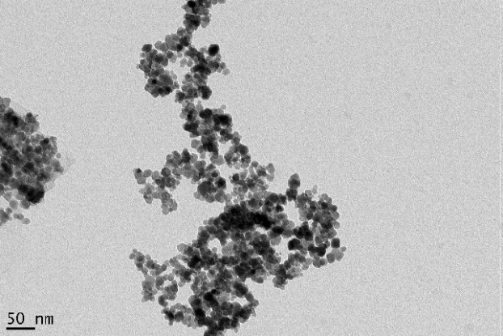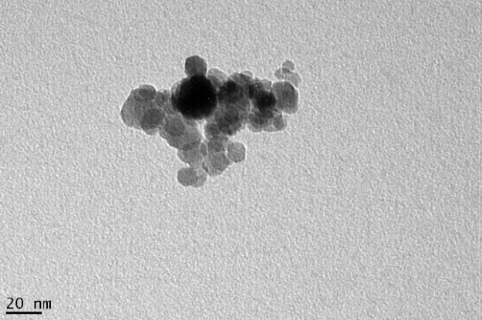
Coated graphene
Uncovered graphene
Figure 4.1: Transmission electron microscopy images of MGQDs with magnifications of 30 000 (left) and 98 000 (right), where the light black and dark black areas could be uncovered graphene and iron oxides coated graphene, respectively.

Magnetic hysteresis curve of MGQD
To quantify the magnetic properties of MGQD, the magnetic hysteresis curve of MGQD was measured using a SQUID magnetometer, and commercial SPIO nanoparticles (Sigma-Aldrich), which have been widely used as an MMOCT contrast agent, was also measured for comparison. Both results are shown in Figure 4.2 a). The saturation magnetization of MGQD is 41.7 emu/g, higher than the MGQD reported previously (7.31 emu/g) [48]. We have observed that preventing oxidation of Fe²⁺ by atmospheric oxygen both during the preparation of the ferrous iron solution and during the coprecipitation of magnetite can increase the saturation magnetization of MGQD significantly (shown in Figure 4.2 c)). We perform both of these steps under a 100% nitrogen atmosphere, which thus could explain our higher saturation magnetization. The absence of coercivity revealed in the magnetic hysteresis curves of MGQD and SPIO shows that both MGQD and SPIO are superparamagnetic.

The (bulk) magnetic susceptibilities ($χ$) and magnetization ($M$) are related by the following relationship:
$M=χH$ (4.1)
where $H$ is the magnetic field strength. The magnetic susceptibilities of MGQD and SPIO have been plotted in Figure 4.2 b). As expected, MGQD has lower magnetization and magnetic susceptibility than SPIO, since the mass ratio of iron oxides in MGQD is less than SPIOs. The magnetic susceptibilities of MGQDs are comparable to those of SPIOs in magnetic field of 100 to 10 000 Oe.
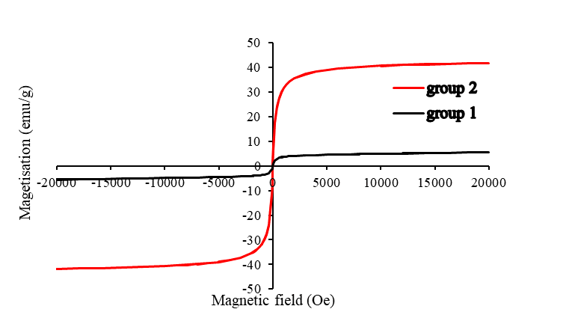
C
Figure 4.2: a) The magnetic hysteresis curves of MGQD and SPIO; the MGQD and SPIO have 41.7 and 75.2 emu/g of saturation magnetization, respectively. b) The magnetic susceptibilities of MGQD and SPIO in magnetic field of 100 to 10 000 Oe; magnetic susceptibilities of MGQD and SPIO decrease with increasing magnetic field strength; at the lowest field strength (100 Oe), the magnetic susceptibilities of MGQD and SPIO are 0.112 and 0.182, respectively; the magnetic susceptibilities of MGQD and SPIO are 0.027 and 0.050, respectively, at the highest field strength (1200 Oe). c) The magnetic hysteresis curves of two different MGQDs, where the group 2 and group 1 indicate the MGQDs synthesised with and without nitrogen protection, respectively; the saturation magnetization, acquired from the magnetic hysteresis curves, are 5.5 emu/g and 41.7 emu/g for the MGQDs of group 1 and group 2 respectively.

Fluorescence of MGQD
The fluorescence of MGQD has been investigated by a fluorescence spectrometer to initially assess whether the synthesized MGQD can be used as tracer in fluorescence microscope, shown in Figure 4.3. An absorption peak at 320 nm and an excitation peak at 360 nm were observed in Figure 4.3 a). The peak emission intensity of MGQD can be tuned by tuning the excitation wavelength, shown in Figure 4.3 b), which is the same as the comparable material, graphene quantum dot (GQD), synthesized by Pan et al [54]. Visible fluorescence with a peak at 415 nm was excited using 360-nm excitation.
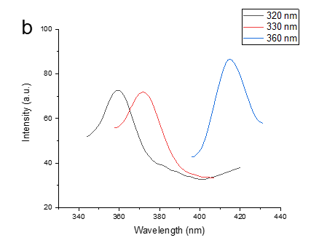
Figure 4.3: Fluorescence spectra of magnetic graphene quantum dots (MGQDs). a) The excitation wavelength vs emission wavelength, where the emission spectrum excited by 320 nm of light is shown as “Emission spectrum (320),” and the excitation spectrum of MGQD measured by a fixed wavelength at 360 nm is shown as “Excitation spectrum (360).” b) The emission spectrums of MGQDs excited by 320, 330 and 360 nm, respectively, showing excitation-dependent fluorescence behaviours of MGQDs.

Toxicity of MGQD
It is essential that nanoparticles for cell labelling have very low toxicity for cells. Hence, the effect of MGQD on 3T3 cell line has been tested by the MTT method, shown in Figure 4.4. The 3T3 cells in the media containing 0 to 104-μg/mL MGQDs retain more than 87% cell viability at 24- and 48-hours’ incubation times. In contrast, SPIO nanoparticles (100 μg/mL), which have been widely applied as a contrast agent for MRI, show a cell viability of 80% after 24-hours culture [55]. Therefore, MGQDs in concentration below 104-μg/mL display extremely low cytotoxic effects to 3T3 cells.
Figure 4.4: The influence of magnetic graphene quantum dot (MGQD) in concentrations of 7, 13, 26, 52, 78 and 104 μg/mL on cell line viability of 3T3 cell line after 24- and 48-hours culture. The measurements of cell viability for each group was repeated 8 times, and the measured results were averaged to present. The error bars present the standard deviations of results.

CFM imaging of MGQD
It has been shown that MGQD exhibits tuneable fluorescent behaviour within the excitation wavelength range of 320-360 nm. Hence, two-photon fluorescence of MGQD should be excitable by a laser with wavelength around 700 nm. The fluorescence of MGQD powder has been imaged by CFM using 740-nm excitation light, shown in Figure 4.5 a). A blue fluorescence signal was detected in the wavelength range 435 to 485 nm. The 3T3 cells labelled by incubation in 75-μg/mL MGQD medium for 24 hours have been visualized through CFM using 690-nm excitation light, shown in Figure 4.5 b). The MGQD was internalized into cells and can be recognized by its fluorescence signal in the CFM image. However, some aggregation of MGQD occurs and thereby inhibits a portion of fluorescence. In Figure 4.5 c), the 3T3 cells labelled by 15-μg/mL MGQD medium were imaged using 700-nm exciting light, where the cell nucleus (in red) and actin (in green) were stained by DAPI and phalloidin-FITC, respectively. The fluorescence signal of MGQD was observed within the cell nucleus and also attached to actin filaments in the range of 362- to 415-nm wavelength and highlighted in blue in Figure 4.5 c). There is no specific region where MGQD tends to aggregate. Figure 4.5 d) is the CFM image of unlabelled cells for negative control, in which blue fluorescence signal is not evident.
Figure 4.5: The confocal fluorescence microscopy images of MGQD powder and MGQD labelled cells, where MGQD, cell nucleus and actin are shown in blue, red and green, respectively. a) MGQD powder (×40 magnification, 1.2 NA) imaged using 3.75-mW 740-nm excitation light and 390- to 465-nm emission filter; b) 75-μg/mL MGQD labelled 3T3 cells (×20 magnification, 0.8 NA) imaged using 14.35-mW 690-nm excitation light and 543-nm transmission light, where the fluorescence of MGQD is obtained by 362- to 415-nm filter; c) 15-μg/mL MGQD labelled 3T3 cells (×40 magnification, 1.2 NA) imaged using 0.989-mW 700-nm and 4-nW 488-nm excitation lights, where the MGQD and DAPI are excited with 700-nm light, phalloidin-FITC is excited with 488-nm light and 362- to 415-nm, 435- to 485-nm and 500- to 550-nm filters are used to obtain the fluorescence of MGQD, DAPI of cell nucleus and phalloidin-FITC of actin, respectively; d) unlabelled 3T3 cells (×20 magnification, 0.8 NA) imaged using the same excitation lights and emission filters as c) for comparison. DAPI, 4′,6-diamidino-2-phenylindole; FITC, Fluorescein isothiocyanate.

MMOCT imaging of MGQD
MGQD labelled 3T3 cells were loaded on the surface of agar gel for MMOCT imaging, where the agar gel was utilized to mimic human soft tissue. An 80-Hz sinusoidal magnetic field generated by an electromagnet was applied for exerting force on MGQD and generating magnetomotive signal of MGQD. The translative force vector of MGQD ($\vec{F}$) was parallel with the magnetic field vector ($\vec{B}$) and the axial direction of A-scan ($z$), which can be expressed as:
$\vec{F}=V(M_{r}+\frac{χ_{m}}{μ_{0}}B_{z})\frac{∂\vec{B}}{∂z}$ (4.2)
where $M_{r}$ is remnant magnetization. The remnant magnetization was negligible due to the superparamagnetism of MGQD. The magnetomotive force was unidirectional because of the positivity of $χ_{m}$ and $B_{z}\frac{∂\vec{B}}{∂z}$. Therefore, the oscillation of MGQD should have double the frequency of the magnetic field modulation. The frequency spectrum of 35-μg/mL MGQD labelled cells on agar (density≈1.9×10⁵cell/cm²) has been detected by MMOCT, shown in Figure 4.6 b). A 320 Hz of magnetomotive signal (intensity≈7.9 × 10⁵ a.u.) is dominant rather than the expected oscillation frequency of 160 Hz. The second or higher harmonic frequencies could be generated from overlarge amplitude of particle displacement causing phase wrapping. In other words, the displacements of particles within the interval time of two successive samplings could be too large, leading to the phase change of interferometric signal greater than π. The dominant magnetomotive signal (320 Hz) was extracted using a bandpass filter for forming image of MGQD labelled cells, shown in Figure 4.6 c). The MGQD labelled cells were visualized successfully. However, it is apparent that the magnetomotive signal of MGQD can also be detected inside agar gel. This phenomenon could be explained by the MGQD diffusing into the agar gel, by the MGQD on the agar surface forming a shadow artefact beneath surface (similar to the “shower curtain” effect in OCT angiography) or the MGQD inducing a bulk vibration of agar. In Figure 4.6 d)–f), the same amount of unlabelled 3T3 cells on agar surface as the negative control was imaged in the same way. No magnetomotive signal was detected for the negative control, which confirms the magnetomotive signal resulting from the oscillation of MGQD.

ab.units
s
ab.units
s
Figure 4.6: The MMOCT images of MGQD labelled 3T3 cells and unlabelled 3T3 cells on agar gel. a) The original B-scan OCT image of 35-μg/mL MGQD labelled cells without MMOCT signal processing, where the cell intensity imaged is approximately 1.9 × 10⁵cell/cm²; b) the phase frequency spectrum of magnetomotive signal of MGQD labelled cells; c) the MGQD labelled cells phantom results from MMOCT signal processing of 320-Hz magnetomotive signal; d)–f) are the images and spectrum of unlabelled cells for negative control, which are original B-scan OCT image, phase frequency spectrum and MMOCT image, respectively. Here, the colour bar indicates the complex amplitude after STFT.

Discussion

Magnetism of MGQD for MMOCT imaging
The iron oxides on graphene were synthesized from co-precipitation of ferrous and ferric ions under alkaline condition, which can be exemplified by Fe²⁺ + 2Fe³⁺ + 8OH⁻ → Fe₃O₄ (magnetite) + 4H₂O [48]. This results in graphene oxide particles coated with magnetite. A hydrothermal reaction was then used to cut these particles, yielding nanometre-scale MGQD. The hydrothermal cutting also oxidized a fraction of the magnetite, transforming it into maghemite (γFe₂O₃) [56]. Therefore, the iron oxides containing a mixture of magnetite and maghemite were produced on the graphene surface [48]. The coated iron oxides can provide superparamagnetism of MGQD, and hence MGQD is a potential contrast agent for MMOCT.

Because the magnetomotive contrast in MMOCT is generated by an oscillation of magnetic nanoparticles in an alternating magnetic field, a relatively high magnetic susceptibility of nanoparticle is required for inducing sufficient translational force. The translational force ($F$) can be defined as
$\vec{F}=\frac{V\left(χ_{m}-χ_{0}\right)∇{|\vec{B}|}^{2}}{2μ_{0}}$ (4.3)
where $V$ is the particle volume, $χ_{m}$ and $χ_{0}$ are the magnetic susceptibilities of the particle and the tissue respectively, $B$ is magnetic flux density and $μ_{0}$ is the permeability of free space [32]. Our results show that the magnetic susceptibility of MGQD (>0.027) is much higher than human tissue ($|χ|\sim {10}^{-5}$) in magnetic field of 100 to 10000 Oe [32]. Hence, MGQD could be easily discriminated from human tissue and offer reliable performance as a contrast agent for MMOCT. Our results of MMOCT imaging have demonstrated that the MGQD can be detected and visualized by our MMOCT, which confirms that the MGQD can be used as a contrast agent for MMOCT.

Fluorescence of MGQD for CFM imaging
According to the TEM images of MGQD, the surface of MGQD can be divided into two different areas, namely iron oxides coated area and uncoated area. On the uncoated area, the graphene of MGQD exposes to air and can provide fluorescence because the graphene is small enough to have apparent quantum confinement effect. Small graphene, i.e. graphene quantum dot, is a well-known fluorescent material [48, 57].

Pan et al [54] have synthesized a GQD, which has a strong π → π* absorption peak at 320 nm and a blue photoluminescence or fluorescence at 430 nm. The GQD was formed by hydrothermal reduction of graphene oxide at 200℃. It is expected that our MGQD has the similar blue fluorescence because the MGQD was synthesized by reducing and cleaving iron oxide-graphene oxide sheets in the same way. As expected, an absorption peak for the MGQD is also observed at 320 nm in Figure 4.3. However, the excitation peak becomes 360 nm rather than 430 nm due to effect of the coated iron oxides and change of particle size. Our 360-nm excitation peak is also different from the MGQD synthesized previously (excitation peak 398 nm, diameter 41.8 nm) [48]. This might be because of the smaller size of our MGQD, which is expected to yield a larger band gap due to enhanced quantum confinement of the electrons [58]. Nevertheless, visible fluorescence can be excited from the MGQD, according to our results in Figure 4.3 b). Thus, the MGQD has the potential to be a contrast agent for CFM.

The results of CFM imaging in our experiments confirm that MGQD can be used as a contrast agent for CFM to track labelled cells. However, to excite observable fluorescence of MGQD, a relatively high power of exciting light was used, causing the overheat of labelled cells. Consequently, each CFM imaging must be completed within a short time to avoid the thermal damage of labelled cells. To overcome this limitation, the quantum yield of MGQD needs to be increased in future studies.

MGQD uptake by cells
The cellular uptake of MGQD found in our CFM images confirms that MGQD can be used for cell labelling. We assume that the MGQD uptake by cells occurred via an endocytosis mechanism, because the GQD which has a similar morphological structure with the MGQD was internalized into cells through an endocytosis mechanism [59]. Endocytosis is an energy-dependent uptake mechanism. The small size of MGQD could benefit MGQD uptake, since nanoparticles with small size could require less surface energy creation during the cellular internalization process [60]. MGQD within cell nucleus was also be found in the CFM images. The mechanism of how MGQD enters the cell nucleus is still unknown. It has been found that the similar particle, GQD, can also travel into cell nucleus [61]. We speculate that the ways of MGQD and GQD entering cell nucleus share the same mechanism. According to the speculation made by GQD’s research group [61], we assume that the mechanism of MGQD entering into cell nucleus is that the acidic pH in the endosomal compartments leads to MGQD becoming smaller in size and having negatively charged surfaces. The smaller size and negatively charged surface allow MGQD to enter the nucleus. However, further experiments are needed to validate the hypothesis.

Toxicity
Low toxicity is another condition of contrast agent for cell tracking. Our results show that the cytotoxicity of MGQD is extremely low in concentration below 104-μg/mL. For MMOCT and CFM imaging, the 3T3 cells were labelled by 24-hour culturing in medium containing MGQD in the concentration below 104 μg/mL, so MGQD is considered as a safe contrast agent for cell labelling. However, the toxicity test of MGQD is incomplete due to lack of in vivo biocompatibility tests.

Limitations and further studies

Aggregation
In Figure 4.5, the aggregation of MGQD is observed. The aggregation effect of MGQD could be a limitation for CFM application because the fluorescence intensity of MGQD can be reduced by the aggregation. MGQD tends to aggregate at high concentration, possibly due to the presence of weak remnant magnetization. To overcome this limitation, the MGQD can be steric stabilized, for example, by PEGylation to avoid the aggregation [62].

Complexity of MMOCT signal
MGQD has demonstrated its effectiveness as an MMOCT tracer, and low concentrations of MGQD can be used to label cells, while producing identifiable magnetomotive signal. In our experiments, the minimum useable MGQD concentration is 20 μg/mL. Quantitative analyses of MGQD uptake in cells using magnetomotive signal intensity are complicated, because the magnetomotive signal of MGQD is partially redistributed to its higher harmonics. The magnetomotive signal redistribution arises from phase wrapping, which could be prevented by using a higher line scan rate or lower magnetic field strength [63]. Further studies are needed to realize quantitative measurement of labelled cells with MMOCT.

Application scenario
In clinical research, the combination of MGQD and MMOCT could be used to track the transplanted cells during a cell therapy, particularly for LESCD therapy. In section 4.1, it has been introduced that the development of LESCD therapy is limited by lack of suitable modality for tacking transplanted stem cells on cornea. MMOCT is a great option because OCT is a mature diagnostic tool for ophthalmology. Compared with the conventional contrast agent of MMOCT, SPIO, MGQD could be a better choice because additional information (e.g. intracellular details) can be provided by imaging MQGD labelled cells via CFM. However, this research just initially proved the potential that MGQD is used as a contrast agent for MMOCT and CFM simultaneously. Further researches, including in vivo toxicity tests, optimizing the process of MGQD synthesis to improve quantum yield and decrease toxicity, animal tests and clinic trials, need to be conducted before the MGQD can used as a contrast agent in clinical practice.

Conclusion
MGQD nanoparticles were synthesized by hydrothermal reduction of iron oxide coated graphene oxide sheets. The MGQD shows up as a small round thin sheet (15 nm of average diameter) with low toxicity to cells, which allows MGQD to be easily internalized into cells for labelling. The iron oxides and graphene of MGQD can offer superparamagnetism and tuneable blue fluorescence simultaneously. These properties suggest that MGQD can be used as a dual-modality contrast agent for CFM and MMOCT. The MGQD labelled cells have been successfully tracked and visualized by a commercial CFM and our in-house MMOCT system. Application of MGQD for cell tracking could provide anatomical information via MMOCT and intracellular details via CFM, thereby achieving a more comprehensive diagnosis.

ACKNOWLEDGMENTS
We acknowledge financial support from Engineering and Physical Sciences Research Council grants EP/F020422/1 and EP/I018328/1.

References:
[1] W. Li, W. Song, B. Chen, and S. J. Matcher, "Superparamagnetic graphene quantum dot as a dual‐modality contrast agent for confocal fluorescence microscopy and magnetomotive optical coherence tomography," Journal of biophotonics, vol. 12, no. 2, p. e201800219, 2019.
[2] M. A. Fischbach, J. A. Bluestone, and W. A. Lim, "Cell-based therapeutics: the next pillar of medicine," Science translational medicine, vol. 5, no. 179, pp. 179ps7-179ps7, 2013.
[3] M. R. Bernsen, J. Guenoun, S. T. Van Tiel, and G. P. Krestin, "Nanoparticles and clinically applicable cell tracking," The British journal of radiology, vol. 88, no. 1054, p. 20150375, 2015.
[4] S. Gennai et al., "Cell-based therapy for traumatic brain injury," British journal of anaesthesia, vol. 115, no. 2, pp. 203-212, 2015.
[5] J. Tongers, D. W. Losordo, and U. Landmesser, "Stem and progenitor cell-based therapy in ischaemic heart disease: promise, uncertainties, and challenges," European heart journal, vol. 32, no. 10, pp. 1197-1206, 2011.
[6] Y. Luo, "Cell-based therapy for stroke," Journal of neural transmission, vol. 118, no. 1, pp. 61-74, 2011.
[7] C. Aguayo-Mazzucato and S. Bonner-Weir, "Stem cell therapy for type 1 diabetes mellitus," Nature Reviews Endocrinology, vol. 6, no. 3, p. 139, 2010.
[8] A. J. Shortt, S. J. Tuft, and J. T. Daniels, "Corneal stem cells in the eye clinic," British medical bulletin, vol. 100, no. 1, pp. 209-225, 2011.
[9] M. Srinivas et al., "Imaging of cellular therapies," Advanced drug delivery reviews, vol. 62, no. 11, pp. 1080-1093, 2010.
[10] M. Hoehn et al., "Cell tracking using magnetic resonance imaging," The Journal of physiology, vol. 584, no. 1, pp. 25-30, 2007.
[11] A. P. Alivisatos, W. Gu, and C. Larabell, "Quantum dots as cellular probes," Annu. Rev. Biomed. Eng., vol. 7, pp. 55-76, 2005.
[12] A. Astolfo et al., "In vivo visualization of gold-loaded cells in mice using x-ray computed tomography," Nanomedicine: Nanotechnology, Biology and Medicine, vol. 9, no. 2, pp. 284-292, 2013.
[13] A. K. Srivastava and J. W. Bulte, "Seeing stem cells at work in vivo," Stem Cell Reviews and Reports, vol. 10, no. 1, pp. 127-144, 2014.
[14] A. O'farrell, S. Shnyder, G. Marston, P. Coletta, and J. Gill, "Non‐invasive molecular imaging for preclinical cancer therapeutic development," British journal of pharmacology, vol. 169, no. 4, pp. 719-735, 2013.
[15] R. Weissleder and M. J. Pittet, "Imaging in the era of molecular oncology," nature, vol. 452, no. 7187, pp. 580-589, 2008.
[16] R. Bayford, T. Rademacher, I. Roitt, and S. X. Wang, "Emerging applications of nanotechnology for diagnosis and therapy of disease: a review," Physiological measurement, vol. 38, no. 8, p. R183, 2017.
[17] D. M. Mills, S. Tsai, D. R. Meyer, and C. Belden, "Pediatric ophthalmic computed tomographic scanning and associated cancer risk," American journal of ophthalmology, vol. 142, no. 6, pp. 1046-1053. e1, 2006.
[18] R. Jin, B. Lin, D. Li, and H. Ai, "Superparamagnetic iron oxide nanoparticles for MR imaging and therapy: design considerations and clinical applications," Current opinion in pharmacology, vol. 18, pp. 18-27, 2014.
[19] A. Taylor et al., "Assessing the efficacy of nano-and micro-sized magnetic particles as contrast agents for MRI cell tracking," PloS one, vol. 9, no. 6, 2014.
[20] S. M. Janib, A. S. Moses, and J. A. MacKay, "Imaging and drug delivery using theranostic nanoparticles," Advanced drug delivery reviews, vol. 62, no. 11, pp. 1052-1063, 2010.
[21] W. Du, Y. Wang, Q. Luo, and B.-F. Liu, "Optical molecular imaging for systems biology: from molecule to organism," Analytical and bioanalytical chemistry, vol. 386, no. 3, p. 444, 2006.
[22] C. Balas, "Review of biomedical optical imaging—a powerful, non-invasive, non-ionizing technology for improving in vivo diagnosis," Measurement science and technology, vol. 20, no. 10, p. 104020, 2009.
[23] N. M. Fried and A. L. Burnett, "Novel methods for mapping the cavernous nerves during radical prostatectomy," Nature Reviews Urology, vol. 12, no. 8, p. 451, 2015.
[24] J. E. R. de Carvalho, F. D. Verbraak, M. C. Aalders, C. J. van Noorden, and R. O. Schlingemann, "Recent advances in ophthalmic molecular imaging," survey of ophthalmology, vol. 59, no. 4, pp. 393-413, 2014.
[25] J. G. Fujimoto and W. Drexler, "Optical Coherence Tomography: Technology and Applications," ed: Springer, 2015.
[26] N. Nassif et al., "In vivo human retinal imaging by ultrahigh-speed spectral domain optical coherence tomography," Optics letters, vol. 29, no. 5, pp. 480-482, 2004.
[27] P. H. Tomlins and R. K. Wang, "Theory, developments and applications of optical coherence tomography," Journal of Physics D: Applied Physics, vol. 38, no. 15, p. 2519, 2005.
[28] F. F. Jobsis, "Noninvasive, infrared monitoring of cerebral and myocardial oxygen sufficiency and circulatory parameters," Science, vol. 198, no. 4323, pp. 1264-1267, 1977.
[29] A. Y. Gordon and A. Jayagopal, "Engineering of nanoscale contrast agents for optical coherence tomography," Journal of nanomedicine & nanotechnology, p. 004, 2014.
[30] C. Yang, L. E. McGuckin, J. D. Simon, M. A. Choma, B. E. Applegate, and J. A. Izatt, "Spectral triangulation molecular contrast optical coherence tomography with indocyanine green as the contrast agent," Optics letters, vol. 29, no. 17, pp. 2016-2018, 2004.
[31] J. Yi, J. Gong, and X. Li, "Analyzing absorption and scattering spectra of micro-scale structures with spectroscopic optical coherence tomography," Optics express, vol. 17, no. 15, pp. 13157-13167, 2009.
[32] A. L. Oldenburg, J. R. Gunther, and S. A. Boppart, "Imaging magnetically labeled cells with magnetomotive optical coherence tomography," Optics letters, vol. 30, no. 7, pp. 747-749, 2005.
[33] A. L. Oldenburg, V. Crecea, S. A. Rinne, and S. A. Boppart, "Phase-resolved magnetomotive OCT for imaging nanomolar concentrations of magnetic nanoparticles in tissues," Optics express, vol. 16, no. 15, pp. 11525-11539, 2008.
[34] J. Oh, M. D. Feldman, J. Kim, H. W. Kang, P. Sanghi, and T. E. Milner, "Magneto‐motive detection of tissue‐based macrophages by differential phase optical coherence tomography," Lasers in Surgery and Medicine: The Official Journal of the American Society for Laser Medicine and Surgery, vol. 39, no. 3, pp. 266-272, 2007.
[35] A. L. Oldenburg et al., "Magnetic and contrast properties of labeled platelets for magnetomotive optical coherence tomography," Biophysical journal, vol. 99, no. 7, pp. 2374-2383, 2010.
[36] R. John et al., "In vivo magnetomotive optical molecular imaging using targeted magnetic nanoprobes," Proceedings of the National Academy of Sciences, vol. 107, no. 18, pp. 8085-8090, 2010.
[37] N. Yefimov and S. Naboychenko, Handbook of non-ferrous metal powders: technologies and applications. Elsevier, 2009.
[38] I. L. Medintz, H. T. Uyeda, E. R. Goldman, and H. Mattoussi, "Quantum dot bioconjugates for imaging, labelling and sensing," Nature materials, vol. 4, no. 6, pp. 435-446, 2005.
[39] W. C. Chan and S. Nie, "Quantum dot bioconjugates for ultrasensitive nonisotopic detection," Science, vol. 281, no. 5385, pp. 2016-2018, 1998.
[40] Z. A. Peng and X. Peng, "Formation of high-quality CdTe, CdSe, and CdS nanocrystals using CdO as precursor," Journal of the American Chemical Society, vol. 123, no. 1, pp. 183-184, 2001.
[41] R. Xie, D. Battaglia, and X. Peng, "Colloidal InP nanocrystals as efficient emitters covering blue to near-infrared," Journal of the American Chemical Society, vol. 129, no. 50, pp. 15432-15433, 2007.
[42] X. Peng, J. Wickham, and A. Alivisatos, "Kinetics of II-VI and III-V colloidal semiconductor nanocrystal growth:“focusing” of size distributions," Journal of the American Chemical Society, vol. 120, no. 21, pp. 5343-5344, 1998.
[43] A. Das and P. T. Snee, "Synthetic developments of nontoxic quantum dots," ChemPhysChem, vol. 17, no. 5, pp. 598-617, 2016.
[44] J.-H. Park, L. Gu, G. Von Maltzahn, E. Ruoslahti, S. N. Bhatia, and M. J. Sailor, "Biodegradable luminescent porous silicon nanoparticles for in vivo applications," Nature materials, vol. 8, no. 4, pp. 331-336, 2009.
[45] J. Van Meerloo, G. J. Kaspers, and J. Cloos, "Cell sensitivity assays: the MTT assay," in Cancer cell culture: Springer, 2011, pp. 237-245.
[46] M. Nurunnabi et al., "In vivo biodistribution and toxicology of carboxylated graphene quantum dots," Acs Nano, vol. 7, no. 8, pp. 6858-6867, 2013.
[47] H.-J. Jian et al., "Super-cationic carbon quantum dots synthesized from spermidine as an eye drop formulation for topical treatment of bacterial keratitis," ACS nano, vol. 11, no. 7, pp. 6703-6716, 2017.
[48] R. Justin et al., "Photoluminescent and superparamagnetic reduced graphene oxide–iron oxide quantum dots for dual-modality imaging, drug delivery and photothermal therapy," Carbon, vol. 97, pp. 54-70, 2016.
[49] D. C. Marcano et al., "Improved synthesis of graphene oxide," ACS nano, vol. 4, no. 8, pp. 4806-4814, 2010.
[50] G. Lamouche et al., "Review of tissue simulating phantoms with controllable optical, mechanical and structural properties for use in optical coherence tomography," Biomedical optics express, vol. 3, no. 6, pp. 1381-1398, 2012.
[51] J. Boadi, V. Sangwal, S. MacNeil, and S. Matcher, "System for tracking transplanted limbal epithelial stem cells in the treatment of corneal stem cell deficiency," in Imaging, Manipulation, and Analysis of Biomolecules, Cells, and Tissues XIII, 2015, vol. 9328: International Society for Optics and Photonics, p. 93281D.
[52] D. L. Thorek and A. Tsourkas, "Size, charge and concentration dependent uptake of iron oxide particles by non-phagocytic cells," Biomaterials, vol. 29, no. 26, pp. 3583-3590, 2008.
[53] D. Mateo, P. Morales, A. Ávalos, and A. I. Haza, "Comparative cytotoxicity evaluation of different size gold nanoparticles in human dermal fibroblasts," Journal of Experimental Nanoscience, vol. 10, no. 18, pp. 1401-1417, 2015.
[54] D. Pan, J. Zhang, Z. Li, and M. Wu, "Hydrothermal route for cutting graphene sheets into blue‐luminescent graphene quantum dots," Advanced materials, vol. 22, no. 6, pp. 734-738, 2010.
[55] H.-C. Hsieh, C.-M. Chen, W.-Y. Hsieh, C.-Y. Chen, C.-C. Liu, and F.-H. Lin, "ROS-induced toxicity: exposure of 3T3, RAW264. 7, and MCF7 cells to superparamagnetic iron oxide nanoparticles results in cell death by mitochondria-dependent apoptosis," Journal of nanoparticle research, vol. 17, no. 2, p. 71, 2015.
[56] S. Laurent et al., "Magnetic iron oxide nanoparticles: synthesis, stabilization, vectorization, physicochemical characterizations, and biological applications," Chemical reviews, vol. 108, no. 6, pp. 2064-2110, 2008.
[57] S. Zhu et al., "Strongly green-photoluminescent graphene quantum dots for bioimaging applications," Chemical communications, vol. 47, no. 24, pp. 6858-6860, 2011.
[58] A. P. Alivisatos, "Semiconductor clusters, nanocrystals, and quantum dots," science, vol. 271, no. 5251, pp. 933-937, 1996.
[59] W. Shang et al., "The uptake mechanism and biocompatibility of graphene quantum dots with human neural stem cells," Nanoscale, vol. 6, no. 11, pp. 5799-5806, 2014.
[60] C. He, Y. Hu, L. Yin, C. Tang, and C. Yin, "Effects of particle size and surface charge on cellular uptake and biodistribution of polymeric nanoparticles," Biomaterials, vol. 31, no. 13, pp. 3657-3666, 2010.
[61] M. K. Kumawat, M. Thakur, R. B. Gurung, and R. Srivastava, "Graphene quantum dots for cell proliferation, nucleus imaging, and photoluminescent sensing applications," Scientific reports, vol. 7, no. 1, p. 15858, 2017.
[62] J. M. Harris and R. B. Chess, "Effect of pegylation on pharmaceuticals," Nature reviews Drug discovery, vol. 2, no. 3, p. 214, 2003.
[63] H. C. Hendargo, M. Zhao, N. Shepherd, and J. A. Izatt, "Synthetic wavelength based phase unwrapping in spectral domain optical coherence tomography," Optics express, vol. 17, no. 7, pp. 5039-5051, 2009.

Polarization-Sensitive Optical Coherence Tomography with a conical beam scan for investigation of birefringence and collagen alignment in the human cervix

Summary
By measuring phase retardance of cervical extracellular matrix, our in-house polarization-sensitive optical coherence tomography (PS-OCT) was shown to be capable of (1) mapping the distribution of collagen fibres in the non-gravid cervix, (2) accurately determining birefringence and (3) measuring the distinctive depolarization of the cervical tissue. A conical beam scan strategy was also employed to explore the three-dimension (3D) orientation of the collagen fibres in the cervix by interrogating the samples with an incident light at 45° and successive azimuthal rotations of 0-360°. Our results confirmed previous observations by X-ray diffraction suggesting that in the non-gravid human cervix, collagen fibres adjacent to the endocervical canal and in the outermost areas tend to arrange in a longitudinal fashion whereas in the middle area, they are oriented circumferentially. PS-OCT can assess the microstructure of the human cervical collagen in vitro and holds the potential to help us better understand cervical remodelling prior to birth pending the development of an in vivo probe.

Note that the content in this chapter has been published in Biomedical Optics Express [1].

Introduction
Preterm birth (PTB), defined as birth before 37 weeks of gestation, is a major cause of neonatal morbidity and mortality not because of congenital malformations worldwide. It accounts for more than 1 million deaths a year [2]. Across the world, there are more than 15 million preterm births every year, with prevalence rates in the range of 5% to 18% [3-5]. In the UK, approximately 8% of birth are preterm and in the US around 12% of babies are delivered before term [6, 7]. Although there are huge improvements in perinatal health, the incidence of PTB has continuously increased. Given the multifactorial etiology of PTB, diagnosis and prevention have proven difficult. However regardless of what triggers PTB, there seems to be common gradual changes in the stroma of the cervix. The cervix, which plays a key role in maintaining a pregnancy to term, has to remain closed throughout gestation so that the foetus can grow in utero [8]. However, for birth to occur, the cervix has to go through the process of shortening, softening and dilation. This remodelling process is crucial and essential for uterine contractions to lead to successful delivery [9, 10]. As PTB requires premature cervical remodelling, a deeper understanding of this process is vital for developing a more accurate screening tool for PTB [11]. Such tools may also facilitate better targeted clinical interventions. Cervical remodelling begins several weeks/months before parturition, but its exact timing and processes have not yet been fully characterized in humans, with most evidence stemming from studies on rodents [12]. Experiments for investigating rat and human cervical biopsy tissues in the late 1980s by X-ray diffraction revealed that collagen fibrils in the non-pregnant cervix displayed preferential orientations: around the endocervical canal and in the outermost area, collagen fibres were mostly arranged longitudinally, whereas in the middle area, fibres were predominantly circumferential [13]. This orientation pattern gradually fades away due to the cervical remodelling during pregnancy. Current evidence also suggests that cervical remodelling involves a change in the orientation, morphology and assembly rather than in collagen amount. However, current in vivo assessment of the remodelling of the cervix in women is confined to cervical length ultrasound measurement and digital examination approaches incapable of assessing the key molecular changes associated with extracellular matrix remodelling [10].

Several research imaging techniques have been employed to investigate cervical collagen microstructure, including X-ray diffraction, second harmonic generation (SHG) microscopy, magnetic resonance diffusion tensor imaging (MR DTI) and optical coherence tomography (OCT) [14-18]. However, none of these modalities has been successfully translated into the clinical setting due to inherent limitations to the technique. MR DTI, for example, is too slow for real-time processing; SHG holds limited imaging speed and does not perform well endoscopically, and OCT lacks accuracy to assess the collagen structure. An emerging technique, Full-field Mueller colposcopy, has also been developed for investigation of cervical microstructure [19-22]. This technique has been regarded as a potential alternative to the current screening methods, e.g. histological diagnoses, due to the advantages of low cost, rapid imaging with wide field images and ready endoscope [20]. However, the technique of Full-field Mueller colposcopy is not in the mainstream clinic yet, and cannot provide depth-resolved changes in tissue’s phase retardance, birefringence and relative fast axis orientation nor the thickness of the overlying epithelium.

PS-OCT is a functional extension of OCT, which has the potential to be an appropriate tool for investigation of cervix or cervical remodelling in clinical studies. This is because PS-OCT not only shares the advantages of OCT, including high resolution (4-20 μm), high-speed 3-D imaging and easy integration with a catheter or a hand-held probe, but it offers additional information such as the polarization state of backscattered optical light [23, 24]. The polarization state can be used to measure tissue’s depth-resolved phase retardance, birefringence and relative fast axis orientation, which allows PS-OCT to differentiate anisotropic tissues, such as collagen fibre, muscle and tendon, from other structures [25]. In 2008, Lee et al demonstrated that cervical intraepithelial cancer could be detected with a sensitivity (the percentage of true positives in all positive tests) of 94.7% and a specificity (the percentage of true negatives in all negative tests) of 71.2% by imaging human cervical biopsies using PS-OCT, but the sensitivity and specificity cannot be used to estimate the probability of disease in individual patients unless positive and negative predictive values are obtained by screening tests [26]. So far, we know so little about the feasibility of PS-OCT to assess changes in the orientation of cervical collagen [27].

In this study, we sought to assess whether PS-OCT was capable of detecting changes in the alignment of cervical collagen fibres in vitro. Cervical cross-sections obtained from uterine specimens of patients undergoing hysterectomy for benign gynaecological conditions were fully scanned with PS-OCT. Additionally, the 3D orientation of collagen in the samples was assessed using a conical beam scan protocol, originally developed for studying collagen alignment in articular cartilage [28].

Methods

Configuration of PS-OCT
Our in-house PS-OCT for this study was developed based on the method reported by Al-Qaisi et al [29]. This system and its characteristics have already been described in our previous paper [28]. Here, we provide concise summaries of the PS-OCT configuration and its principle. The schematic diagram of PS-OCT is shown in Figure 5.1. The light source of the system was a wavelength-swept laser (HSL-2000-10-MDL, Santec, Japan) with a centre wavelength of 1315 nm, a full width at half maximum of 128 nm, a wavelength scanning rate of 10 kHz and a duty cycle of 60%, which supplied an output power of 10 mW to system. The light emitted from the light source firstly passed through a polarization controller (PC) and an in-line linear polarizer (IL-LP) to yield linearly polarized light. Then, the polarized light entered a polarization-maintaining fibre (PMF) based Mach-Zehnder interferometer. In the Mach-Zehnder interferometer, the light was split into 10% of light for reference arm and 90% of light for sample arm by a 2×2 polarization-maintaining coupler (PMC1, OLCPLP-22-131-10-90-FA, Opto-link Corp., China). The PMC1 was aligned with the transmission axis of light to allow the light to be only coupled into the slow axis of PMF. The two beams were then directed into the reference and sample arms via two three-port polarization-maintaining circulators (OLCIR-P-3-131-300-90-FA, Opto-link Corp., China) respectively. In the reference arm, the light transited through a linear polarizer (LP) oriented at 45° to the slow axis of PMF, and was reflected back to circulator by a static plane mirror. As a result, the reference light subsequently entering into the detection arm had a polarizing angle of 45° with respect to the slow axis of PMF and equal intensity components in the horizontal and vertical directions of the slow axis of PMF. The light in the sample arm firstly travelled through a quarter wave plate (QWP, NT55-547, Edmund Optics, US) oriented at 45° to the slow axis of PMF, which produced a circularly polarized light for interrogation of sample. Then, the circularly polarized light transited through a galvanometer system (6215, Cambridge Technology, US) and a Thorlabs LSM03 OCT scanning lens ($f$= 36mm) sequentially, and was scattered by a sample. The galvanometer system, consisting of a pair of galvanometer scanners was used to achieve functions of B-scan and volumetric scan. The scanning lens was used to focus the light and generate a light spot with diameter of 25 μm in the focal plane. The light backscattered by the sample carrying sample’s information was recombined and interfered with the light from the reference arm at another 2×2 polarization-maintaining coupler (PMC2, OLCPL-P-22-131-50-90-FA, Opto-link Corp., China). PMC2 was equally split the light into two polarization beamsplitters (PBS, PBS-31-P-2-L-3-Q, NovaWave Techno., US). The PBS divided the combined light into horizontally and vertically polarized light. Two balanced detectors (1817-FC, New Focus, US) were used to detect the horizontally and vertically polarized lights respectively. The light signals were sampled by a 14-bit transient recorder (M2i.4022, Spectrum GmbH, Germany) at 20 MS/s for measuring and processing the interferences of horizontally and vertically polarized lights. Axial resolution of ~10μm in air has been characterized by an optical mirror in this PS-OCT system.

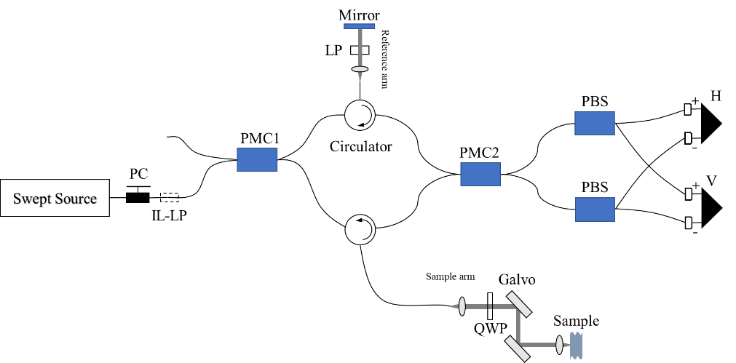
Figure 5.1: Schematic diagram of PS-OCT system, where PC is polarization controller, IL-LP is in-line linear polarizer, PMC is polarization maintaining coupler, QWP is quarter waveplate, PBS is polarization beamsplitter and H and V are balanced photo-detectors used to detect horizontally and vertically polarized optical signals, respectively. This diagram is modified from [28].

Preparation of human cervical tissues
The study was granted approval from the Yorkshire & Humber Committee of the UK National Research Ethics Service (REC Number 08/H1310/35) and the University of Sheffield (Registration number 160268520). Written consent was sought and obtained from all participants. Twenty non-gravid cervical samples were obtained from women undergoing vaginal, total abdominal or laparoscopic-assisted hysterectomy for benign conditions such as menorrhagia, prolapse or endometriosis. Clinical and demographic data including age, parity, previous mode of delivery, body mass index (BMI), indication for surgery, type of surgery, menopausal status and hormonal treatment was anonymized and coded for statistical analysis.

Cervical cross-sections approximately 20 mm thick were excised from the uterine specimen by a single operator, as illustrated shown in Figure 5.2, and soon after incubated in 0.1 mg/ml streptomycin, 0.25 µg/ml amphotericin B and 100 U/ml penicillin, and stored at -20°C on Human Tissue Authority (HTA) licensed premises until processing with PS-OCT. For PS-OCT scanning, the specimens were thawed in phosphate-buffered saline at room temperature, and then sealed in an optical-window cell culture dish (GWST-5040, WillCo-Dish) for imaging.

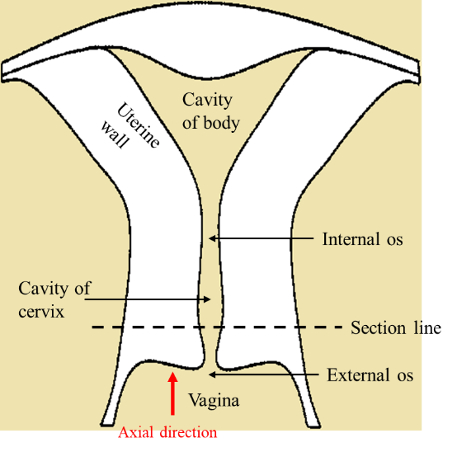
Figure 5.2: The diagram of uterus. The specimen was prepared by cutting along the section line. The red arrow denotes the axial direction of imaging in our experiments.

Scan geometries
Each specimen of cervical tissue was imaged using two different PS-OCT techniques. In the first protocol, a volumetric scan was achieved by combination of 1000 b-scans to produce a 3D image with x y z size of 4 by 4 by ~2.15 mm. The volumetric scan was repeated 9 times at different points, as shown in Figure 5.3 b). These points were retrieved from three different areas, arbitrarily labelled as centre area, middle area and edge area, consistent with the preferential orientation exhibited by the collagen fibres in the cervix as seen in Figure 5.3 a) [13, 17, 30]. The axial direction of imaging was from external os to internal os and perpendicular to surface of sample, shown in Figure 5.3 c).
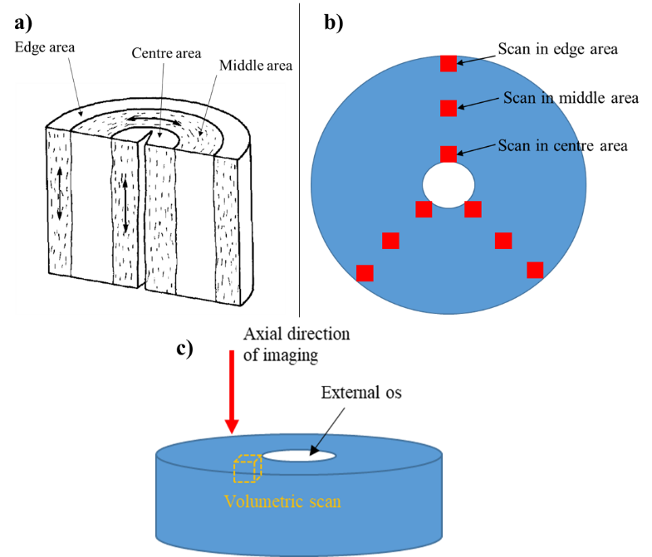
Figure 5.3: a) Schematic diagram of a human cervix, modified from Aspden (1988) [13]. The preferential orientation of collagen fibrils is shown as short dash in the three distinct cervical areas, named as centre, middle, and edge areas respectively. b) Top view of cervical specimen with 9 scanning points. c) Axial direction of imaging within the cervical sample from the external to the internal os.

The second scanning technique, which was used to evaluate the 3D orientation of cervical collagen, entailed the use of the so-called conical beam scan strategy previously described by our research group in the 3D characterization of collagen fibres in articular cartilage [28]. A schematic diagram of the conical beam scan is shown in Figure 5.4. A motorized rotation stage was synchronized to the A-scan data acquisition and mounted on a manual XYZ stage for position adjustment. A sample holder mounted on the rotation stage was then used to fix sample and fine tune position. The scanning light of PS-OCT struck the point where the rotation axis intersected sample surface at a 45° incidence angle. The photograph of the sample stage is shown in Appendix 8.2. The sample was imaged by acquiring successive B-scans with synchronized stage rotation. The successive B-scans were acquired every 1° as the motorized stage rotated the sample over 360°. In the 360 B-scans, the A-scans which had the same height of sample surface at the rotation axis were selected and plotted as a polar format, where the radial distance indicated the axial imaging depth. The polar format was then used to evaluate the 3D orientation of the cervical collagen as described in our reported method [28].

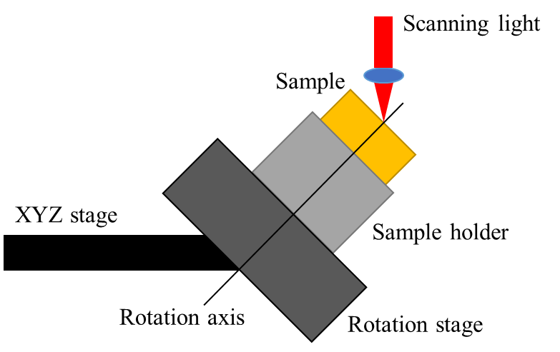
Figure 5.4: The schematic diagram of sample stage for conical beam scan scheme. The incident angle of scanning light is 45°. The incident light strikes the point where the rotation axis intersects sample surface. The specimen is imaged by successive B-scans with a synchronized motorized rotation stage, which obtain 360 B-scans spanning azimuthal angle of 1°-360° with an interval of 1°.

PS-OCT image processing
Our image processing was carried out in MATLAB. The retardance ($δ_{s}(z)$) image was calculated as $δ_{s}\left(z\right)=\arctan{(A_{0;V}(z)/A_{0;H}(z))}$, where $A_{0;V}(z)$ and $A_{0;H}(z)$ indicate the amplitudes of the vertical and horizontal signals respectively after the raw interference signals were resampled and transformed by FFT. The apparent birefringence of the specimen ($∆n$), which refers to the refractive index difference between the specimen ($n$) and the ordinary beams ($n_{o}$), namely $∆n=n-n_{o}$, was computed as:
$∆n=\frac{λ_{0}}{2π}\frac{dδ_{s}\left(z\right)}{dz}$ (5.1)
where $z$ is the physical depth into sample and $λ_{0}$ is the centre wavelength of the light source. The true birefringence, defined as $n_{e}-n_{o}$, can be expressed as following relationship [31]:
$∆n=n_{o}\left(\frac{n_{e}}{\sqrt{{n_{o}}^{2}+\cos^{2}\left(θ_{c}\right)\left({n_{e}}^{2}-{n_{o}}^{2}\right)}}-1\right)$ (5.2)
Here, $n_{e}$ is the extraordinary refractive index and $θ_{c}$ is angle between the direction of light propagation and the optic axis of the fibre, i.e. the c-axis in optical terminology. For obtaining more precise values of the apparent birefringence, the phase retardances of 10000 A-scans (arranged in an XY grid of size 100 by 100) at each depth within the sample were averaged, and plotted as a function of depth to get the retardance slope of the birefringent tissue, e.g. $dδ_{s}(z)/dz$. The slope was obtained by linear fitting method (shown in Figure 5.6 d)), and the birefringence values were calculated as illustrated in equation (5.1). To visualize apparent birefringence, a two-dimension birefringence image was mapped out by the derivative of the retardance versus axial image depth after the retardance B-scan was smoothed using a 50 by 50 median filter. The signal processing for calculating the value of the apparent birefringence and generating the birefringence image is shown in Figure 5.5.
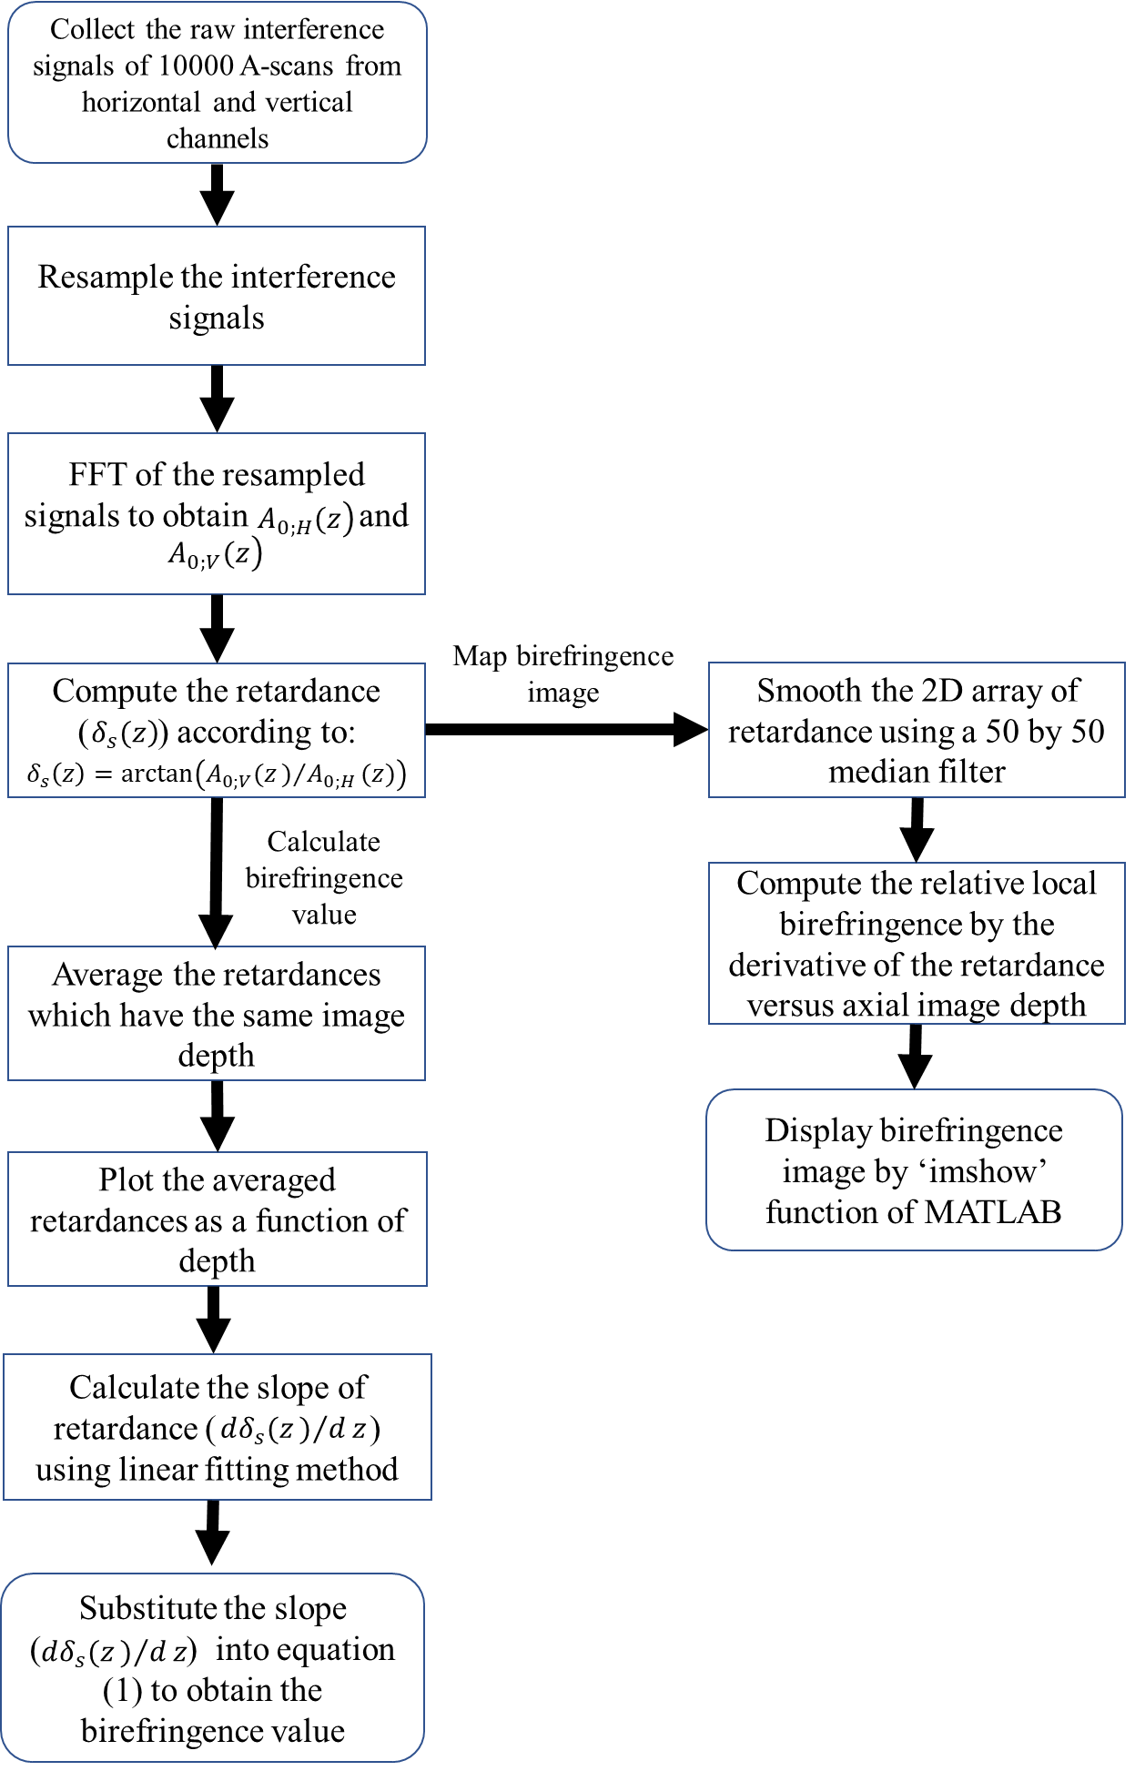
Figure 5.5: The flow chart of signal processing for generating birefringence image and calculating the value of birefringence.

The depolarization of tissue was quantified on the basis of the theory developed by Götzinger et al [32]. The degree of polarization uniformity (DOPU), which can be regarded as a spatially averaged degree of polarization (DOP), was quantified for evaluation of tissue depolarization. DOPU was processed as follows. Firstly, a thresholding procedure was applied to the intensity data ($I$), i.e. $I={A_{0;V}(z)}^{2}+{A_{0;H}(z)}^{2}$, for filtering out noise and low signal intensity. Secondly, the Stokes vector ($S$) was computed as [32]:
$S=\left(\begin{matrix}\begin{matrix}I \\ Q\end{matrix} \\ \begin{matrix}U \\ V\end{matrix}\end{matrix}\right)=\left(\begin{matrix}\begin{matrix}{A_{0;V}\left(z\right)}^{2}+{A_{0;H}\left(z\right)}^{2} \\ {A_{0;V}\left(z\right)}^{2}-{A_{0;H}\left(z\right)}^{2}\end{matrix} \\ \begin{matrix}2A_{0;V}\left(z\right)A_{0;H}\left(z\right)\cos{Δϕ} \\ 2A_{0;V}\left(z\right)A_{0;H}\left(z\right)\sin{Δϕ}\end{matrix}\end{matrix}\right)$ (5.3)
Where $I$, $Q$, $U$ and $V$ are Stokes vector elements, and then the Strokes vector elements were averaged by a 2D mean filter (a size of 15 by 6 pixels). Finally, the DOPU was processed in term of $DOPU=\sqrt{{Q_{m}}^{2}+{U_{m}}^{2}+{V_{m}}^{2}}$, where $Q_{m}$, $U_{m}$ and $V_{m}$ denote the averaged Stokes vector elements.

H&E histology
Three cervical specimens, previously scanned with PS-OCT, were then fixed with 3.7% formaldehyde and stained with a modified H&E technique in order to better visualize collagen fibres. Histological slides were subsequently assessed with an optical microscope (10X, LEICA DM750).

Statistical analysis
Collagen birefringence in the centre, middle and edge areas was compared using ANOVA with Bonferroni correction. The null hypothesis was that there was no difference of birefringence between the centre, middle and edge areas. The Bonferroni correction was used to compensate the bias resulting from multiple ANOVA tests. Collagen birefringence was also correlated with age, parity, mode of delivery, menopausal status and indication for surgery using Pearson’s correlation coefficient, ANOVA when the assumption of equality of variances was met and non-parametric Kruskall-Wallis when the Levene’s test was significant.

Results and discussion

Intensity, retardance and birefringence images
Whole in vitro cervical cross-sections were scanned with our in-house PS-OCT. We have included, as an example, intensity, retardance and birefringence images obtained from the middle region of one of the samples analysed, and shown how they were computed into precise numerical values (Figure 5.6). Here, the cumulative double-path phase retardance between the ordinary and extraordinary rays was mapped in the retardance image, and the derivative of the retardance was shown in the birefringence image to demonstrate local birefringence of sample. The intensity and retardance images were acquired using LABVIEW control software, shown in Figure 5.6 a) and b) respectively. In Figure 5.6 a), the intensity image resulting from the different scattering properties between various layers of tissue displays two discernible tissue layers. The superficial layer which presents comparatively lower intensity is assumed to be the cervical epithelium, and the deeper layer is the collagen content of the stroma. This assumption also enables to explain the retardance image, in which the cervical epithelium can be discerned as a blue band on the top due to its lack of birefringence. The thickness of the cervical epithelium can therefore be calculated immediately which could be of potential benefit in evaluating disorders such as cervical cancer [33] and the acquired human immunodeficiency syndrome [34]. Just underneath the epithelium layer, a significant increase of retardance is observed resulting from the birefringence of aligned collagen fibres. Compared with traditional modality, e.g. confocal fluorescence microscopy, which might cannot measure the epithelial thickness because the maximum imaging depth (<33 μm) is insufficient to cover all epithelial thickness [33], PS-OCT has much larger imaging depth (~800 μm) to readily measure the thickness of epithelium. In our experimental results, the retardance image has the advantage to differentiate the epithelial and collagen layers than intensity image, because a part of intensity images is featureless.

For generating a birefringence image, the gradient of retardance as a function of physical depth is computed after smoothing the retardance image using a median filter. The birefringence image is mapped out by the gradient of retardance, from which the collagen distribution can be inferred, shown in Figure 5.6 c). The precise value of apparent birefringence of collagen is evaluated with a linear fitting method, shown in Figure 5.6 d). In Figure 5.6 d), the retardance at each particular depth within sample is laterally averaged to reduce speckle noise and plotted as a function of depth. The slope of collagen retardance, namely $dδ_{s}(z)/dz$, is calculated by linear regression. The precise value of birefringence can be directly calculated from equation (5.1). In our example, the slope of the regression equation in Figure 5.6 d) is 2.48 rad/mm, and the value of collagen birefringence is $2.48/2π×1.315×{10}^{-3}≈0.52×{10}^{-3}$. Since the retardance increases linearly with depth within sample, it is expected that the birefringence of collagen stays constant with depth. Background noise is gradually dominated at the deeper depth, masking the linear increase of retardance.

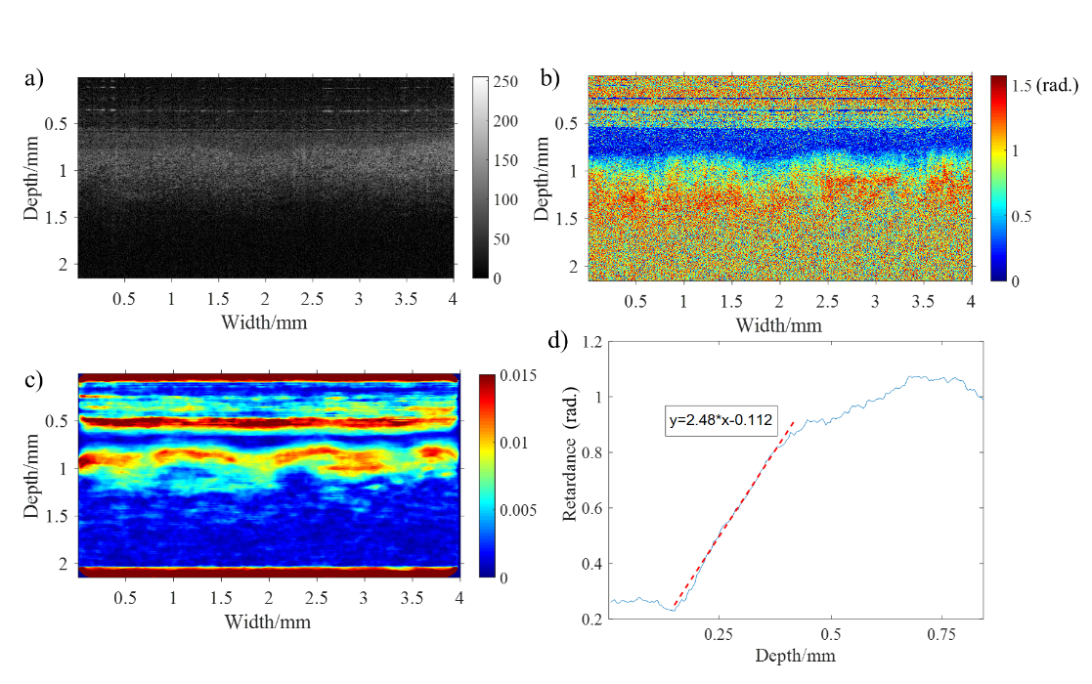
Figure 5.6. PS-OCT images of human cervical tissue in middle area: a) intensity image, b) retardance image, c) birefringence image (Note that the birefringence situated at sample surface layer is an artefact, because the rapid change of retardance between noise and sample surface can lead to a false birefringence signal.). d) the plot of averaged retardance as a function of depth (Red dashed: linear regression line of retardance for calculating birefringence of collagen).

Orientation of collagen fibre
The cervical birefringence measured so far refers to the so-called apparent birefringence, which depends on imaging direction relative to orientation of the collagen fibre. In contrast, true birefringence, defined as $n_{e}-n_{o}$, is independent of imaging direction and fiber orientation, and can be regarded as an intrinsic value of the tissue. The relationship between apparent birefringence and true birefringence can be presented as illustrated in equation (5.2). According to this equation, the apparent birefringence reaches its maximum value when the light propagation is perpendicular to the c-axis of fibre, and becomes zero when the light travels along the c-axis. Therefore, we can roughly estimate the orientation of the c-axis by finding the imaging direction which yields minimal birefringence. Histologically, the collagen within the human cervix is thought to be aligned vertically in the edge and centre areas, and circumferentially and horizontally in the middle area, shown in Figure 5.3 a) [13, 17, 30]. Thus, in normal PS-OCT measurements in which the imaging direction is perpendicular to the sample surface, it is expected that the apparent birefringence () will reach its maximum value in the middle area whereas in the centre and edge areas it will be close to 0. This expectation has been confirmed in our experimental results, shown in Figure 5.7. A set of b-scans obtained from one of the samples is displayed to exemplify how retardance and birefringence varies in the centre, middle and edge areas in Figure 5.7. In the middle area, retardance increases much more notably as a function of depth when compared with the centre and edge areas. Consistently, the collagen birefringence in the middle area is higher and much more obvious than in the centre and edge areas as seen in the birefringence images of Figure 5.7, allowing differentiation between the different cervical regions. However, the difference of birefringence between the centre, middle and edge areas is difficult to be identified through corresponding structural OCT images in Figure 5.7.
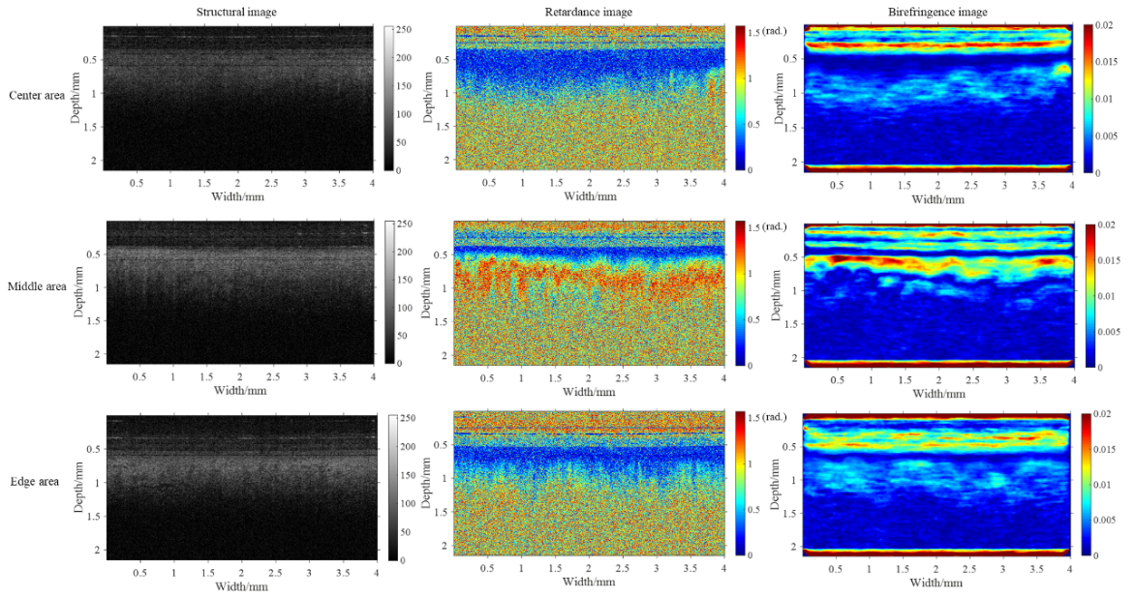
Figure 5.7: The structural, retardance and birefringence images of a cervical sample. Underneath sample surface, middle area has more evident birefringence and more significant increase of retardance as a function of depth than centre and edge areas.

A more accurate estimation of c-axis orientation has been realized by our group using variable incidence illumination directions to obtain a set of $∆n$ and $θ_{c}$ [31, 35, 36]. We assumed a value for $n_{o}$ and a positive uniaxial birefringent crystal structure for collagen fibre. The unknown polar orientation of collagen fibre and extraordinary refractive index ($n_{e}$) can be estimated by the simultaneous solution of a set of equation (5.2). In the simultaneous equations, $n_{o}$ is a known constant, $∆n$, measured by PS-OCT, is regarded as a known parameter, $n_{e}$ is an unknown constant, and $θ_{c}$ is an unknown dependent variable, depending on the unknown polar orientation of collagen fibre. However, this evaluation method was shown to be unsuitable for clinical application and in vivo measurements because it required controlling the illumination angle and solving the over-constrained problem to get $n_{e}$ and $θ_{c}$. In order to tackle these difficulties, our research group developed an alternative conical beam scan technique capable of determining the 3D orientation of the c-axis, and with potential for clinical endoscopic use [28]. This conical-beam method has the added benefit of modelling the variation of the c-axis versus depth if the sample has variable c-axis orientation in different layers [28]. Given these advantages, we have applied this specific conical-beam method to our cervical samples in order to assess the 3D orientation of the c-axis.

Using the conical beam, both the middle and centre area of cervical samples were scanned. Following the conical beam scan proposal described in section 6.3.3, 360 B-scans of the cervical sample were obtained with imaging directions of 45° incident polar angle and 1-360° azimuthal angles (with an interval of 1°) at each detecting point. The polar angle is defined as angle between the incident k-vector and normal direction of the sample surface. For the azimuthal angle, the sample surface is the reference plane, and the reference vector is the projected vector of initial light beam on the sample surface. Retardance images acquired by the conical beam scan in centre area are shown in Figure 5.8. For a crude approximation of the collagen orientation, a series of B-scans at 1°, 70°, 140°, 210°, 280° and 350° azimuthal angles have been cropped and combined in Figure 5.8 a). In Figure 5.8 a), the B-scans at 70°, 140° and 210° azimuthal angles have a more evident increase in retardance as a function of depth, i.e. birefringence, than at other incident angles, contrary to what we would expect from our previous knowledge about cervical collagen arrangement, and what stems from equation (5.2). This is because according to the classic model of the human cervix, collagen fibres in the centre area should be mainly arranged vertically [13]. As a consequence, the angle between the direction of light propagation and the c-axis, $θ_{c}$, should remain unchanged during conical beam scan, and the birefringence obtained from all of azimuthal angles should be roughly equal in theory. To explain this discrepancy, we hypothesized that the c-axis of the collagen fibre is actually oriented at a polar angle tilted away from the normal axis. The polar and azimuthal angles of collagen fibre can be estimated by comparing simulated results of retardance images and real results in polar format. The estimation process and results are shown in Figure 5.8 b), c) and d). 360 A-scans of phase retardance as a function of azimuthal angle are displayed in the traditional OCT format in Figure 5.8 b), where each A-scan is fetched from each B-scan one by one over the azimuthal angle from 1° to 360°. These A-scans are extracted by a semi-automatic program to ensure every extracted A-scan corresponds to the centre point of the plate rotation or close to the centre point. This program runs on the assumption that the only centre point of rotation has a constant altitude of sample surface in each B-scan due to the curved cervical surface. Therefore, the program is designed to find the 360 A-scans which have small variation of the surface altitude in each B-scan. The 360 A-scans are then converted to polar format, shown in Figure 5.8 c), where the circle centre and radius are sample surface and depth respectively. A simulated patterning of phase retardance in polar format is generated by a layered model based on the extended Jones Matrix calculus (EJMC) previously developed by our group [37], shown in Fig. 5.8 d).

The general process of EJMC is introduced briefly here. In the EJMC model, the sample of biological tissue is treated as a multi-layered structure, and each layer is considered as a linear retarder with a constant fast axis orientation. In this case, the signal-pass Jones matrix of sample ($P$) is the product of Jones matrices of individual layer, which can be expressed as:
$P=\prod_{i=m}^{1}{R\left(-Ψ_{i}\right)\left(\begin{matrix}e^{-ik_{{oz}_{i}}d_{i}} & 0 \\ 0 & e^{-ik_{{ez}_{i}}d_{i}}\end{matrix}\right)R\left(Ψ_{i}\right)}$ (5.4)
Here, $R(Ψ_{i})$ is the rotation matrix that diagonalizes the layer Jones matrix (i.e. defines the apparent fast-axis of the layer), $k_{{oz}_{i}}$ and $k_{{ez}_{i}}$ are the $z$component of the ordinary wave and extraordinary wave vectors, respectively, and $d_{i}$ is the thickness of $i$th layer. The details and formulas describing these terms (e.g. $R(Ψ_{i})$, $k_{{oz}_{i}}$ and $k_{{ez}_{i}}$) can be found in previous papers [38, 39]. In brief, the Extended Jones Matrix Calculus of Gu and Yeh [39] is used to calculate $R(Ψ_{i})$, $k_{{oz}_{i}}$ and $k_{{ez}_{i}}$ from the true birefringence of each layer, $n_{e}-n_{o}$, and the polar and azimuthal angles of the layer c-axis and k-vector in the $i$th layer. Therefore, when we assume that the interface between the different layers has negligible specular reflection, the round-trip Jones Matrix of tissue ($J_{sample}$) can be written as:
$J_{sample}=T_{R}P^{T}PT_{R^{'}}$ (5.5)
where $T_{R}$ and $T_{R^{'}}$ are the Fresnel reflection coefficients at the interface between air and sample surface. The light beam of PS-OCT (e.g. circularly polarized light) passing through individual layers of sample and then reflected back onto the detector can be modelled as:
$\left(\begin{matrix}A_{0;H}\left(z\right) \\ A_{0;V}\left(z\right)\end{matrix}\right)=R\left(45°\right)∙QWP∙R\left(-45°\right)∙J_{sample}∙\frac{1}{\sqrt{2}}\left(\begin{matrix}1 \\ i\end{matrix}\right)$ (5.6)
Here, $QWP$ denotes the Jones Matrix of the quarter wave plate in PS-OCT system. Consequently, the depth dependent retardance ($δ_{s}(z)$) of sample detected by PS-OCT can be calculated as: $δ_{s}\left(z\right)=\arctan{(A_{0;V}(z)/A_{0;H}(z))}$. The parameters of EJMC, including the ordinary refractive index, true birefringence and polar and azimuthal angles of collagen over the depth of the sample, can be set to find a simulated image which matches the pattern of the real image, and hence characterize 3D cervical collagen architecture. In our simulation, the sample has been divided into 40 layers over a total thickness of 1 mm.

The conical beam scans from the cervical centre and middle areas are illustrated in Figure 5.8 c) and e) respectively, and their corresponding simulation images are shown in Figure 5.8 d) and f) respectively, in which the red dash represents the azimuth of c-axis. The simulation image of Figure 5.8 d), for estimating orientation and properties of collagen in centre area, is generated with the following parameters: zero birefringence over the depth of 0-100 μm (corresponding to the cervical epithelium), the true birefringence value of $2×{10}^{-3}$ over the depth of 100-500 μm, the ordinary refractive index of 1.37 over whole depth, the constant collagen polar angle of 10° over the depth of 100-500 μm and the constant azimuthal angle of collagen over the depth of 100-500 μm. Therefore, we estimated that the collagen fibres which we detected at that point in the centre area were oriented at a polar angle of 10° tilted away from the normal axis. A similar approach was employed to assess the orientation of collagen fibres in the middle area as shown in Figure 5.8 e) and f). In this case, the depth of 0-200 μm had zero birefringence (corresponding to the thickness of cervical epithelium), and the collagen fibres had a fixed polar angle of 80° over the depth of 200-600 μm with true birefringence value of $1.3×{10}^{-3}$. We concluded that the fibres in the middle area were not strictly arranged in a circumferential fashion, which has roughly horizontal arrangement with deviation. In keeping with a previous SHG study [18], our observations further challenge the classical model of collagen arrangement in the human cervix, and suggest the existence of a more complex structure.
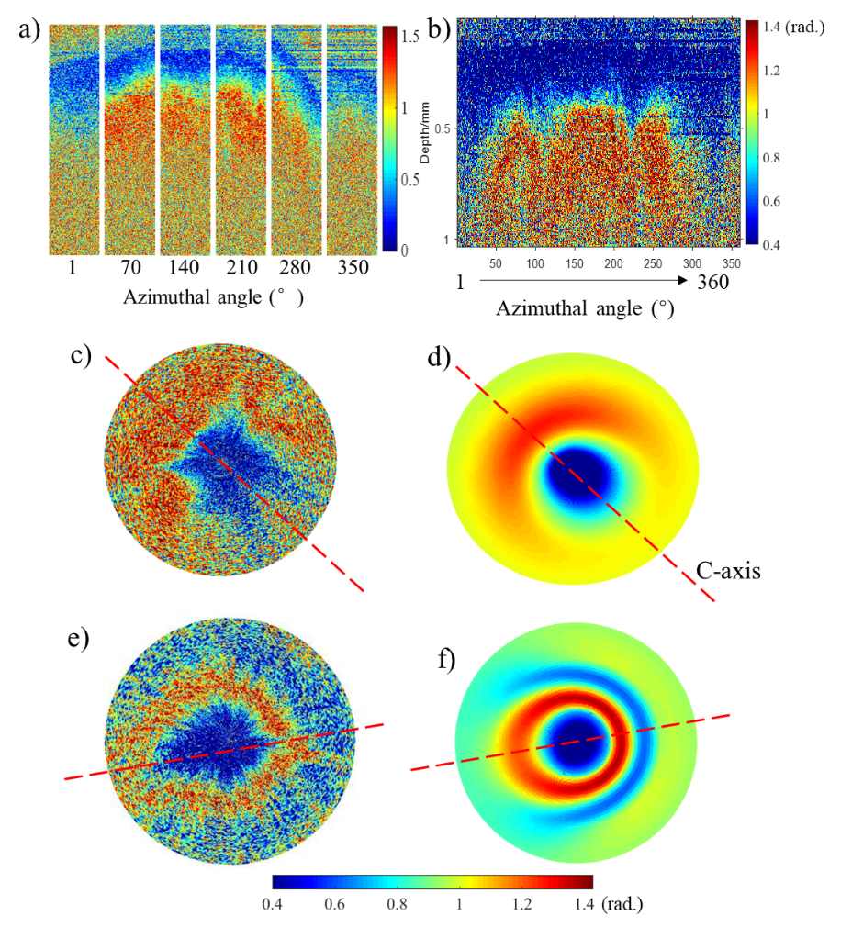
Figure 5.8: Real phase retardance images of human cervical tissue obtained by conical beam scan method and simulated retardance images using EJMC model. a): a series of B-scan retardance images in cervical centre area acquired with a 45° incidence angle and a various of azimuthal angles. 360 A-scans of phase retardance extracted from the same data set are represented as a function of azimuthal angles in entire range of 1-360° with interval of 1° in conventional OCT image display format b) and polar format c). The corresponding simulated result is shown as d). e): 360 A-scans of phase retardance obtained in middle area represented as polar format. f): corresponding simulated result of e). The red dashed line represents the azimuth of c-axis. Polar radius is 0.8 mm.

H&E histology
The histological slides of three cervical specimens which were previously scanned with PS-OCT are shown in Figure 5.9. When the histological slides were qualitatively reviewed by us, collagen fibres appeared more parallel aligned in the middle region, whereas in the edge and centre areas, cross-sections of collagen bundles were more evident. Consistent with our PS-OCT findings, the analysis of the histological slides suggests that collagen fibres in the middle area are more circumferentially organized whereas those adjacent to the endocervical canal and in the outermost areas are mainly arranged in a longitudinal fashion. In addition, various degrees of collagen polar angle, near 80°, have been observed in the middle area, shown in the central column of Figure 5.9, which confirms our conclusion obtained from conical beam scans.
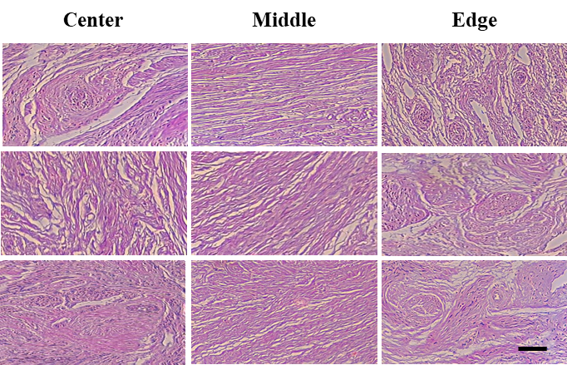
100 μm
Figure 5.9: Histological slides of three cervical specimens. The left, central and right columns are the histological slides acquired from the centre, middle and edge cervical area respectively (scale bar = 100 μm). The magnification is the same in each of the images.

Depolarization image
Polarization scrambling or loss of linear or circular polarization for tissue, termed as depolarization, can also be used in biomedical imaging to better discriminate between structures. PS-OCT is able to measure the depth-resolved depolarization of a sample using an equivalent parameter: DOPU [32]. Following the same computational algorithm as the one described in section 6.3.4, the DOPU of human cervical tissue can be measured and visualized as shown in Figure 5.10. At this particular tissue site, the structural B-scan (Figure 5.10 a)) shows negligible contrast between epithelium and stroma (c.f. the significantly better structural contrast seen in Figure 5.6 a)). In Figure 5.10 c), the DOPU of cervical tissue in the middle area is normalized in the range of 0-1, and displayed below a threshold of DOPU=0.5. Since the DOPU value indicates the correlation between the polarization state of speckle and adjacent speckles, the tissue prefers to preserve polarization if DOPU is close 1. Conversely, when the tissue has a high degree of depolarization, DOPU is near 0 [32]. The cervical epithelium has the DOPU value beyond the threshold, namely >0.5, in Figure 5.10 c). Therefore, a polarization preserving layer can be seen for the cervical epithelium. In Figure 5.10 d), the tissue depolarization is overlaid on the intensity image, and the opacity of red refers to the degree of depolarization. It is shown that the tissue with high depolarization corresponds to the collagen rich stromal layer which has obvious increase of retardance versus image depth in the retardance image (Figure 5.10 b)) and high birefringence.
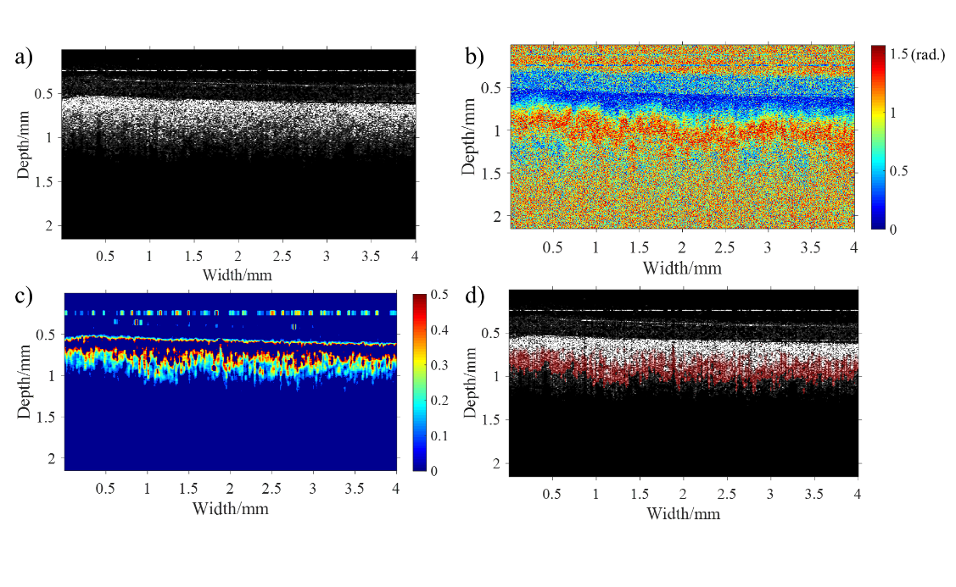
Figure 5.10: PS-OCT images of a human cervical specimen in middle area for analysing depolarization of tissue: a) Intensity image; b) retardance image; c) DOPU image displayed below a threshold of DOPU=0.5; d) the overlay of structures with DOPU in red in the intensity image. The opacity of red indicates the degree of depolarization.

The polarization preserving character of a tissue has been reported to depend on the size and density of the scatter, the polarization states of illumination light, transport albedo, the sample birefringence, the diattenuation and the optical properties of the surrounding medium [40-43]. Several studies have concluded that (1) the depolarization of tissue has shown to be proportional to the number of scattering events and transport albedo, and (2) birefringent tissue normally displays a higher degree of depolarization than non-birefringent tissue. Consistently, our experiments have shown that birefringent tissue, i.e. collagen fibres, has higher level of depolarization than non-birefringent tissue, i.e. cervical epithelium. In preclinical applications, the depolarization assessed with PS-OCT has been used to explore and identify carious lesions [44] and retinal pigment epithelium [32, 45-47] with promising results. DOPU has been shown to be an excellent indictor for detecting and quantifying natural pigment, such as melanin granules [25, 45, 46]. Thus, the tissue depolarization is another potential biomarker of PTB.

Benefits of PS-OCT for evaluating PTB
In summary, PS-OCT can directly measure a number of cervical parameters, including depth-resolved changes in intensity, phase retardance, birefringence, collagen orientation and depolarization. The depth-resolved information allows us to obtain additional biomarker information, such as the epithelial thickness and 3D cervical collagen architecture, which other modalities find difficult to provide. For example, Full-field Mueller colposcopy cannot measure the epithelial thickness and the out-of-plane fibre orientation, since it only gives us depth-wise average information. In addition, confocal fluorescence microscopy cannot provide equivalent information due to insufficient imaging depth as discussed in section 6.4.1. All these physical measurements could potentially become valuable biomarkers for evaluating PTB. However, to verify the feasibility of these measurements in clinical applications, statistically powered clinical trials of the different approaches and systematic reviews of the results are required.

Statistical analysis of the results and en face imaging
Twenty non-gravid cervixes were imaged with PS-OCT. The null hypothesis that all regions within the cervix would display a similar mean apparent birefringence was rejected (p<0.05). Post-hoc comparisons using the Bonferroni test indicated significantly higher values for the middle area when compared to the edge or the centre regions with an effect size of 33.4%. Two en-face retardance images of cervix from the centre and the edge regions respectively (at around 0.4 mm depth) have been included in Figure 5.11 as an example. In Figure 5.11 a), the en-face retardance image in the centre region has a distinct boundary between the centre and middle areas. In contrast, in Figure 5.11 b), no sharp boundary can be found between the middle and the edge regions. Therefore, according to the variation of retardance, PS-OCT is capable of discriminating the defined boundary of different cervical areas, but it is not clear that this boundary corresponds the real demarcation between the centre and middle areas. A comparison experiment needs to be conducted to confirm this. In the experiment, an identical area of the same sample between the centre and middle areas was detected by PS-OCT and other standard methods, such as X-ray diffraction, SHG and histology, to check the consistency of detected boundaries. The boundary between middle and edge areas could be vague perhaps because of dispersion, arbitrary orientation or degradation of collagen.
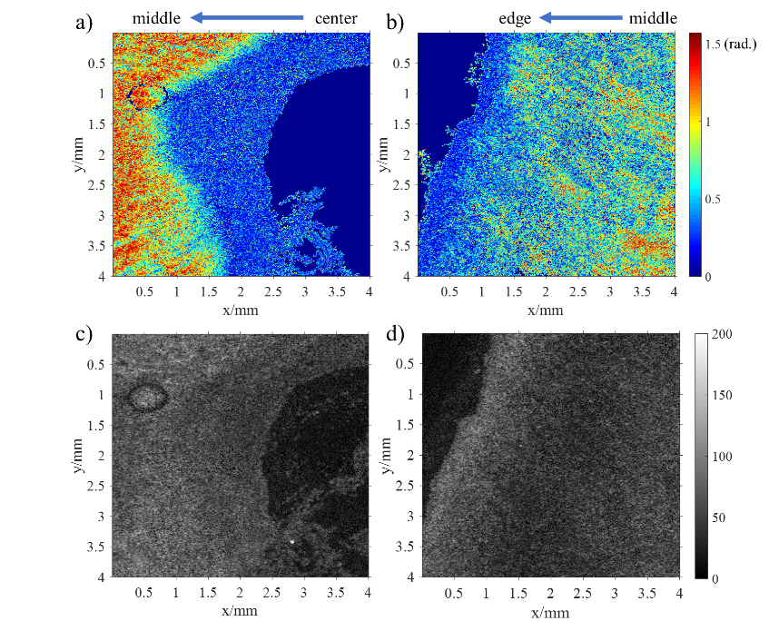
Figure 5.11: The en-face images of retardance and intensity (at 400 µm depth). a) and b) are the retardance images in centre and edge areas respectively. c) and d) are their corresponding intensity images in centre and edge areas respectively. 1000×952 pixels display the physical size of 4 by 4 mm in the images. Note that the noise has been suppressed by a median filter and a mask in these retardance images, and solid dark blue areas are masked out due to poor SNR.

When the apparent birefringence was assessed against the age of the participants using a 2-tailed Pearson’s correlation, a statistically significant difference was seen only for the middle region with a p-value of 0.039, whereas for the central and edge area the correlations were not significant (p=0.089 and p=0.625 respectively). In the middle region, apparent birefringence seemed to significantly increase with age, shown in Figure 5.12. Although the correlation between birefringence and age is relatively weak (which is a positive coefficient of 0.2), our observation is still quite relevant because for a start the samples were not particularly powered for this outcome and yet we attained some statistical significance. The increase of birefringence with age suggests a re-arrangement of collagen fibres after post-menopause consistent with our previous findings employing SHG [48].

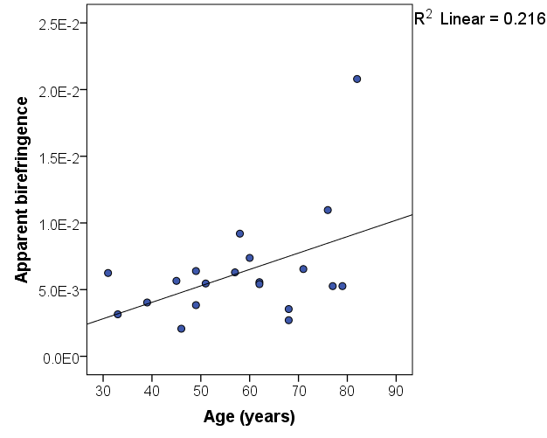
Figure 5.12: Averaged apparent birefringence of middle area as function of age.

No other statistically significant differences were found between birefringence and (1) parity, (2) previous mode of delivery, (3) BMI, (4) indication for surgery, or (5) type of surgery. However, as our study was exploratory in nature and not particularly powered for any of these outcomes, further research is needed before a firm conclusion can be reached between optical and physiological variation in the non-gravid human cervix.

Conclusion
To the best of our knowledge, this is the first study to ever report on the phase retardance, the birefringence, the orientation of c-axis and depolarization of collagen fibres in human non-gravid cervix using PS-OCT. We have been able to show some of the unique advantages of using PS-OCT to study the cervix, including its ability to (1) easily identify the cervical epithelium and measure epithelial thickness, (2) rapidly image the distribution of cervical collagen, (3) accurately determine birefringence, (4) estimate the 3D alignment of collagen fibres and (5) measure the distinctive depolarization of the cervical tissue. After interrogating 20 cervical cross-sections from non-gravid women using PS-OCT, we found a significant higher birefringence in the middle area compared with the centre and edge regions (p< 0.05). As previously seen in studies with SHG, we also identified a significant increase in the apparent birefringence of the middle area with age which could respond to a physiological re-modelling in the cervical collagen fibres as the reproductive function of the cervix diminishes. All in all, we have shown that PS-OCT is capable of assessing the arrangement of cervical collagen objectively and accurately. As probe of PSOCT can be easily integrated into a catheter or a hand-held probe, PS-OCT has potential to help us better understand cervical collagen remodelling prior to birth in vivo, hence to develop more timely identification and prevention of spontaneous PTB.

Funding
Engineering and Physical Sciences Research Council (EPSRC) (EP/F020422); Sheffield NHS Teaching Hospitals (the Jessop Wing Small Grant Scheme). This work was also supported by PhD scholarship of University of Sheffield.

References
[1] W. Li, B. F. Narice, D. O. Anumba, and S. J. Matcher, "Polarization-sensitive optical coherence tomography with a conical beam scan for the investigation of birefringence and collagen alignment in the human cervix," Biomedical optics express, vol. 10, no. 8, pp. 4190-4206, 2019.
[2] C. Howson, M. Kinney, and J. Lawn, "The global action report on preterm birth, born too soon. Geneva: March of Dimes, Partnership for Maternal, Newborn and Child Health, Save the Children," World Health Organisation, 2012.
[3] J.-A. Quinn et al., "Preterm birth: Case definition & guidelines for data collection, analysis, and presentation of immunisation safety data," Vaccine, vol. 34, no. 49, pp. 6047-6056, 2016.
[4] H. Blencowe et al., "Born too soon: the global epidemiology of 15 million preterm births," Reproductive health, vol. 10, no. 1, p. S2, 2013.
[5] H. M. Georgiou, M. K. Di Quinzio, M. Permezel, and S. P. Brennecke, "Predicting preterm labour: current status and future prospects," Disease markers, vol. 2015, 2015.
[6] D. Anumba and S. Jivraj, Antenatal Disorders for the MRCOG and Beyond. Cambridge University Press, 2016.
[7] W. P. Witt et al., "Preterm birth in the United States: the impact of stressful life events prior to conception and maternal age," American journal of public health, vol. 104, no. S1, pp. S73-S80, 2014.
[8] K. M. Myers et al., "The mechanical role of the cervix in pregnancy," Journal of biomechanics, vol. 48, no. 9, pp. 1511-1523, 2015.
[9] D. N. Danforth, "The morphology of the human cervix," Clinical obstetrics and gynecology, vol. 26, no. 1, pp. 7-13, 1983.
[10] H. Feltovich, T. J. Hall, and V. Berghella, "Beyond cervical length: emerging technologies for assessing the pregnant cervix," American journal of obstetrics and gynecology, vol. 207, no. 5, pp. 345-354, 2012.
[11] F. Facchinetti, P. Venturini, I. Blasi, and L. Giannella, "Changes in the cervical competence in preterm labour," BJOG: An International Journal of Obstetrics & Gynaecology, vol. 112, pp. 23-27, 2005.
[12] C. P. Read, R. A. Word, M. A. Ruscheinsky, B. C. Timmons, and M. S. Mahendroo, "Cervical remodeling during pregnancy and parturition: molecular characterization of the softening phase in mice," Reproduction, vol. 134, no. 2, pp. 327-340, 2007.
[13] R. M. Aspden, "Collagen organisation in the cervix and its relation to mechanical function," Collagen and related research, vol. 8, no. 2, pp. 103-112, 1988.
[14] M. Kirby, R. Aspden, and D. Hukins, "Determination of the orientation distribution function for collagen fibrils in a connective tissue site from a high-angle X-ray diffraction pattern," Journal of Applied Crystallography, vol. 21, no. 6, pp. 929-934, 1988.
[15] W. Yao, Y. Gan, K. M. Myers, J. Y. Vink, R. J. Wapner, and C. P. Hendon, "Collagen fiber orientation and dispersion in the upper cervix of non-pregnant and pregnant women," PloS one, vol. 11, no. 11, 2016.
[16] Y. Gan, W. Yao, K. M. Myers, J. Y. Vink, R. J. Wapner, and C. P. Hendon, "Analyzing three-dimensional ultrastructure of human cervical tissue using optical coherence tomography," Biomedical optics express, vol. 6, no. 4, pp. 1090-1108, 2015.
[17] S. Weiss et al., "Three‐dimensional fiber architecture of the nonpregnant human uterus determined ex vivo using magnetic resonance diffusion tensor imaging," The Anatomical Record Part A: Discoveries in Molecular, Cellular, and Evolutionary Biology: An Official Publication of the American Association of Anatomists, vol. 288, no. 1, pp. 84-90, 2006.
[18] L. M. Reusch et al., "Nonlinear optical microscopy and ultrasound imaging of human cervical structure," Journal of biomedical optics, vol. 18, no. 3, p. 031110, 2013.
[19] M. Kupinski et al., "Polarimetric measurement utility for pre-cancer detection from uterine cervix specimens," Biomedical optics express, vol. 9, no. 11, pp. 5691-5702, 2018.
[20] J. Rehbinder et al., "Ex vivo Mueller polarimetric imaging of the uterine cervix: a first statistical evaluation," Journal of biomedical optics, vol. 21, no. 7, p. 071113, 2016.
[21] J. Chue-Sang et al., "Use of Mueller matrix colposcopy in the characterization of cervical collagen anisotropy," Journal of biomedical optics, vol. 23, no. 12, p. 121605, 2018.
[22] J. Chue-Sang et al., "Use of Mueller matrix polarimetry and optical coherence tomography in the characterization of cervical collagen anisotropy," Journal of biomedical optics, vol. 22, no. 8, p. 086010, 2017.
[23] J. G. Fujimoto and W. Drexler, "Optical Coherence Tomography: Technology and Applications," ed: Springer, 2015.
[24] S. D. Giattina et al., "Assessment of coronary plaque collagen with polarization sensitive optical coherence tomography (PS-OCT)," International journal of cardiology, vol. 107, no. 3, pp. 400-409, 2006.
[25] B. Baumann, "Polarization sensitive optical coherence tomography: a review of technology and applications," Applied Sciences, vol. 7, no. 5, p. 474, 2017.
[26] S.-W. Lee et al., "Optical diagnosis of cervical intraepithelial neoplasm (CIN) using polarization-sensitive optical coherence tomography," Optics Express, vol. 16, no. 4, pp. 2709-2719, 2008.
[27] B. Timmons, M. Akins, and M. Mahendroo, "Cervical remodeling during pregnancy and parturition," Trends in Endocrinology & Metabolism, vol. 21, no. 6, pp. 353-361, 2010.
[28] Z. Lu, D. Kasaragod, and S. J. Matcher, "Conical scan polarization-sensitive optical coherence tomography," Biomedical optics express, vol. 5, no. 3, pp. 752-762, 2014.
[29] M. K. Al-Qaisi and T. Akkin, "Swept-source polarization-sensitive optical coherence tomography based on polarization-maintaining fiber," Optics express, vol. 18, no. 4, pp. 3392-3403, 2010.
[30] K. Myers, S. Socrate, D. Tzeranis, and M. House, "Changes in the biochemical constituents and morphologic appearance of the human cervical stroma during pregnancy," European Journal of Obstetrics & Gynecology and Reproductive Biology, vol. 144, pp. S82-S89, 2009.
[31] N. Ugryumova, J. Jacobs, M. Bonesi, and S. J. Matcher, "Novel optical imaging technique to determine the 3-D orientation of collagen fibers in cartilage: variable-incidence angle polarization-sensitive optical coherence tomography," Osteoarthritis and cartilage, vol. 17, no. 1, pp. 33-42, 2009.
[32] E. Götzinger et al., "Retinal pigment epithelium segmentation by polarization sensitive optical coherence tomography," Optics express, vol. 16, no. 21, pp. 16410-16422, 2008.
[33] M. C. Skala et al., "Multiphoton microscopy of endogenous fluorescence differentiates normal, precancerous, and cancerous squamous epithelial tissues," Cancer research, vol. 65, no. 4, pp. 1180-1186, 2005.
[34] J. V. Guimarães et al., "Thickness of the cervical epithelium of autopsied patients with acquired immunodeficiency syndrome," Annals of diagnostic pathology, vol. 11, no. 4, pp. 258-261, 2007.
[35] Z. Lu, D. K. Kasaragod, and S. J. Matcher, "Optic axis determination by fibre-based polarization-sensitive swept-source optical coherence tomography," Physics in Medicine & Biology, vol. 56, no. 4, p. 1105, 2011.
[36] N. Ugryumova, S. V. Gangnus, and S. J. Matcher, "Three-dimensional optic axis determination using variable-incidence-angle polarization-optical coherence tomography," Optics letters, vol. 31, no. 15, pp. 2305-2307, 2006.
[37] D. K. Kasaragod, Z. Lu, J. Jacobs, and S. J. Matcher, "Experimental validation of an extended Jones matrix calculus model to study the 3D structural orientation of the collagen fibers in articular cartilage using polarization-sensitive optical coherence tomography," Biomedical optics express, vol. 3, no. 3, pp. 378-387, 2012.
[38] P. Yeh, "Extended Jones matrix method," JOSA, vol. 72, no. 4, pp. 507-513, 1982.
[39] C. Gu and P. Yeh, "Extended Jones matrix method. II," JOSA A, vol. 10, no. 5, pp. 966-973, 1993.
[40] V. Sankaran, J. T. Walsh, and D. J. Maitland, "Comparative study of polarized light propagation in biologic tissues," Journal of biomedical optics, vol. 7, no. 3, pp. 300-307, 2002.
[41] S. Alali, A. Kim, N. Vurgun, M. F. Wood, I. A. Vitkin, and M. Ahmad, "Quantitative correlation between light depolarization and transport albedo of various porcine tissues," Journal of biomedical optics, vol. 17, no. 4, p. 045004, 2012.
[42] F. Shen, B. Zhang, K. Guo, Z. Yin, and Z. Guo, "The depolarization performances of the polarized light in different scattering media systems," IEEE Photonics Journal, vol. 10, no. 2, pp. 1-12, 2017.
[43] N. Lippok, M. Villiger, and B. E. Bouma, "Degree of polarization (uniformity) and depolarization index: unambiguous depolarization contrast for optical coherence tomography," Optics letters, vol. 40, no. 17, pp. 3954-3957, 2015.
[44] J. Golde et al., "Detection of carious lesions utilizing depolarization imaging by polarization sensitive optical coherence tomography," Journal of biomedical optics, vol. 23, no. 7, p. 071203, 2018.
[45] B. Baumann, E. Götzinger, M. Pircher, and C. K. Hitzenberger, "Measurements of depolarization distribution in the healthy human macula by polarization sensitive OCT," Journal of biophotonics, vol. 2, no. 6‐7, pp. 426-434, 2009.
[46] B. Baumann et al., "Polarization sensitive optical coherence tomography of melanin provides intrinsic contrast based on depolarization," Biomedical optics express, vol. 3, no. 7, pp. 1670-1683, 2012.
[47] N. Lippok, B. Braaf, M. Villiger, W. Y. Oh, B. J. Vakoc, and B. E. Bouma, "Quantitative depolarization measurements for fiber‐based polarization‐sensitive optical frequency domain imaging of the retinal pigment epithelium," Journal of biophotonics, vol. 12, no. 1, p. e201800156, 2019.
[48] B. F. Narice, N. H. Green, S. MacNeil, and D. Anumba, "Second Harmonic Generation microscopy reveals collagen fibres are more organised in the cervix of postmenopausal women," Reproductive Biology and Endocrinology, vol. 14, no. 1, p. 70, 2016.

Conclusions and Future Work

Summary
In this thesis, our in-house phase-sensitive SD-OCT system has been optimized and characterized to ensure the axial motion of magnetic particles can be detected by phase shift of signal. The SD-OCT was successfully adapted to MMOCT (a functional extension of OCT) by introducing an external magnetic field to induce the motion of magnetic particles on/within a soft material. The motion was detected by the SD-OCT to locate and track the magnetic particles, which implied that magnetic particles can be used as a contrast agent for our MMOCT to track magnetically labelled cells. It has been confirmed that SPIO can be visualized and located by our MMOCT system.

To expand the application of MMOCT, a new contrast agent of MMOCT, MGQD, has been synthesized to track MGQD labelled cells. The MGQD had superparamagnetism and fluorescence, which allow MGQD to be imaged and tracked by MMOCT and CFM simultaneously. Our experiments have verified that (1) MGQD was of low toxicity, (2) MGQD can be used to label cells by cellular internalization process and (3) MGQD can be recognized and located by MMOCT and CFM simultaneously. These results preliminarily prove that MGQD can be used to label and track cells in vivo using MMOCT and CFM. During a cell therapy, such as LESCD, the transplanted cells labelled by MGQD can be monitored with MMOCT and CFM simultaneously, and the MMOCT and CFM could provide anatomical information and intercellular details respectively, thereby giving us a more comprehensive diagnose to evaluate the outcome of therapy.

Another functional extension of OCT, PS-OCT, has also been studied for exploring its potential clinical applications. Twenty human cervical tissues have been investigated by our PS-OCT. Their phase retardance, birefringence and depolarization images were obtained by the PS-OCT. In addition, the 3D orientation of collagen fibre within cervical tissues was firstly measured by the PS-OCT with our conical beam scan scheme. It has been found that (1) PS-OCT is able to identify the cervical epithelium and measure epithelial thickness through retardance or birefringence image, (2) the distribution of cervical collagen can be imaged by PS-OCT, (3) the birefringence of cervical collagen can be accurately calculated by its phase retardance, (4) the birefringence of cervix adjacent to the endocervical canal and in the outermost area was significant smaller than the birefringence of the middle area, in agreement with our theoretical prediction, and (5) the birefringence of middle area increased with age, which verified our previous findings that a re-arrangement of cervical collagen fibres could occur after post-menopause [1].

Limitations, challenges and future work
The primary aim of this PhD project is to develop two functional enhancements to OCT: MMOCT and PS-OCT, and to promote the clinic applications of these techniques. The applications of MMOCT and PS-OCT have been expanded in this thesis. However, we are still far from real clinical applications of the developed techniques due to the limitations of our research.

For the MMOCT technique, two main limitations or challenges need to be overcome. Firstly, the behaviour of magnetomotive signal is still unclear. In our experiments, the amplitude and distribution of magnetomotive signal were irregular, and thereby the concentration of magnetic particles cannot be quantified in term of the intensity of magnetomotive signal. The unpredictable magnetomotive signal may cause a misinterpretation in clinical studies. Therefore, further research is needed to understand the signal behaviour. In the further research, the effects of the mechanical properties and geometrical factor of tissue, magnetic properties of particle, frequency and intensity of external magnetic field and signal processing methods on the magnetomotive signal need to be investigated. Secondly, our MMOCT imaging cannot run continuously for a long time because of the overheat of electromagnet, which causes inconvenience in clinical applications. Therefore, a new technique needs to be developed to provide a stable magnetic field for a long time.

The research about the MGQD for a contrast agent of MMOCT and CFM also has some limitations. Firstly, the toxicity test of MGQD was insufficient in our experiments. Only the cytotoxicity of MGQD was tested by MTT assay in vitro, which is not even close to the requirements of clinical applications. Further toxicity tests of the MGQD, including sensitization assays, irritation tests, genotoxicity, carcinogenesis bioassay, subchronic toxicity and preclinical safety tests, need to be conducted for clinical applications. Secondly, the aggregation of MGQD due to magnetic interaction can hinder the cell uptake of MGQD, reduce fluorescence intensity and affect cell behaviour. Therefore, the MGQD could be steric stabilized by coating a passivation agent, such as PEGylation, to inhibit the aggregation [2]. Thirdly, the synthesis of MGQD was inefficient due to the tedious steps of impurities removal. The synthesis process of MGQD needs to be modified and improved to adapt to the requirement of industrial production.

There are two main limitations in the study of human cervical tissue using PS-OCT. Firstly, the cervical tissue was imaged in vitro rather than in vivo, and our current OCT probe cannot be used for in vivo detection. To overcome this limitation, a mechanical design is required to integrate the probe into a specific catheter. The implementation of conical beam scan in the catheter could be a major challenge, because this type of research has not been done so far. Secondly, the sample quantity was inadequate for statistical analysis, which may cause biases or errors in our conclusions. Therefore, more samples need to be studied to affirm our conclusions in future study.

References
[1] B. F. Narice, N. H. Green, S. MacNeil, and D. Anumba, "Second Harmonic Generation microscopy reveals collagen fibres are more organised in the cervix of postmenopausal women," Reproductive Biology and Endocrinology, vol. 14, no. 1, p. 70, 2016.
[2] J. M. Harris and R. B. Chess, "Effect of pegylation on pharmaceuticals," Nature reviews Drug discovery, vol. 2, no. 3, p. 214, 2003.

Appendix

Photograph of the test target for measuring the rate of sensitivity falloff.
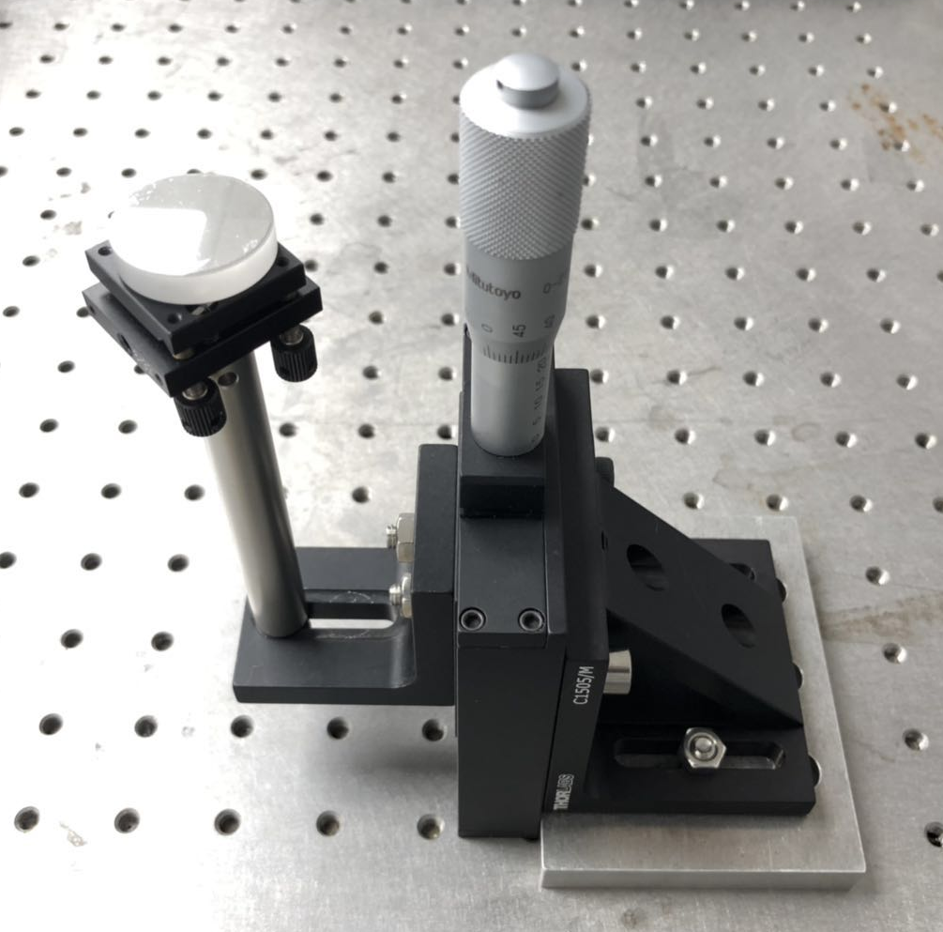
Figure 6.1: The photograph of the plane mirror fixed on a translation stage for sensitivity falloff measurement.

Photograph of the sample stage for conical beam scan
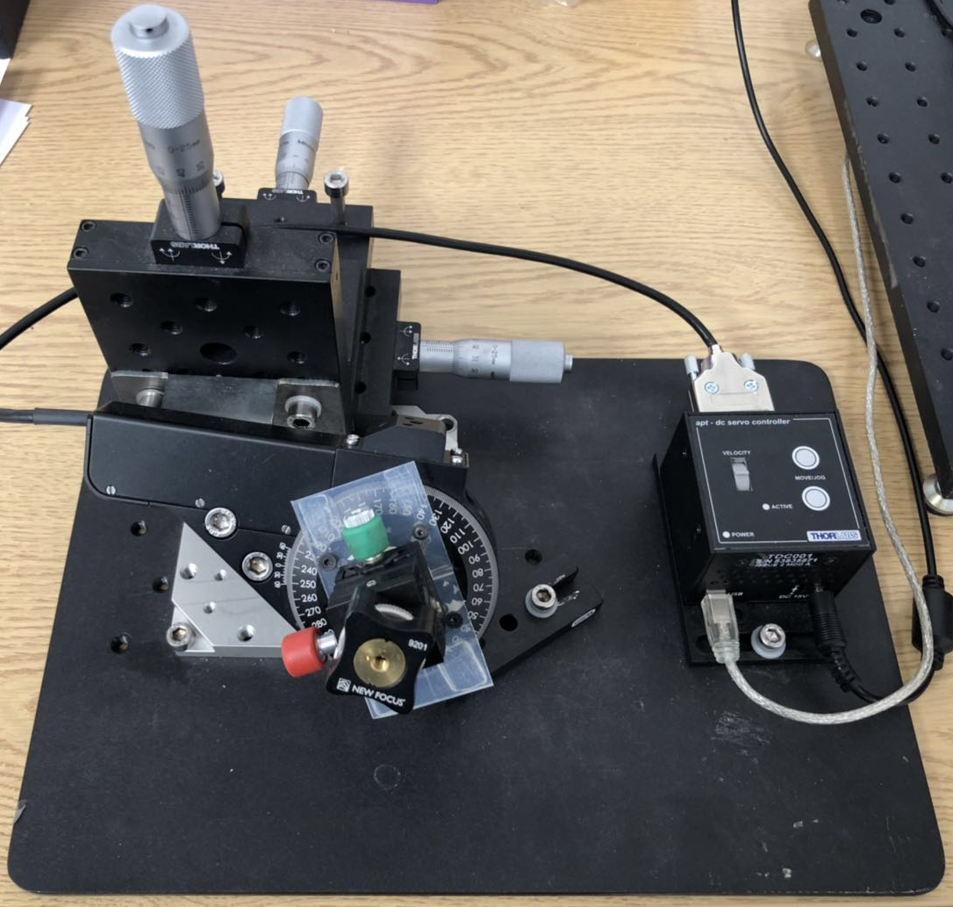
Figure 6.2: The photograph of the sample stage for conical beam scan scheme.

MATLAB code for OCT image generation
% Michelson Diagnostic system
close all
fclose all
clearvars -except Acq;
clc

%Ask for acqusition rate
prompt=' Enter Acquisition Rate /Hz: ';
Acq=input(prompt);

% ********************************************************
% [1] Parameter initialization
% ********************************************************

disp('* Parameter intitialization');

% default data folder ----
% PLease edit here according to your own data folder path ----

folder = 'C:\Documents and Settings\Owner\My Documents\LabVIEW Data';

% Scanning length <<xm>> should rewrite here
xm = 1; % width in mm

% zm/512 mm per pixel; IN AIR BUT should be changed when system changes *************
zm = 2.9638; % depth in mm in air

% Refractive index depending on your sample
n = 1.44;
treshold = 0.10;

% select save processed data or not
savedata = 0;

% Optical input channel as from MD detection board
channel = 1;

% Number of samples per A-scan, as selected in image4
Ascansamples = 1024;

% Kazai autocorrelation equation parameters
de = 2; % depth
wi = 4; % width

% Select .oct raw data file(s) to compute
clear RDfolder RDfilelist
[RDfile RDfolder] = uigetfile({'*.oct', 'MD raw data (oct)'; ...
'*.*', 'All files'}, 'Select .OCT raw data file to process', ...
folder, 'multiselect', 'off');
if eq(RDfolder,0)
% User press cancel - script interrupted
disp('* Window closed - script interrupted');
return
end

% ********************************************************
% [3] Compute the .oct file
% ********************************************************
for nn=1;

% Open selected file
fidOCT = fopen(fullfile(RDfolder, RDfile), 'r', 'b');
if fidOCT == -1
% Error in opening the file!
disp('*** File open error! - script interrupted');
return
end

% Read the first part of header (4 bytes: 'M', 'D', format version '2' and variant '0';
% and use them to match the image data; % see MD documentation for details)
H0 = fread(fidOCT, 2, '*char')';
H1 = fread(fidOCT, 2, 'int8')';
if ( (strcmp(H0,'MD') == 0) || (H1(1)~= 2) || (H1(2)~= 0) )
disp('*** The data file is not compatible with this script - please use the correct script. For assistance contace Zeng Lu');
return
end
clear H0 H1 % fseek(fidOCT, 4, 'bof');

% Read the content of the configuration string (data as in .ini file)
l = fread(fidOCT, 1, 'long'); % Length of configuration string
Hstring = fread(fidOCT, l, '*char')';

% Extract the averaging factor value
avgfac = str2double(Hstring(findstr('AveragingFactor=', Hstring)+length('AveragingFactor=')));

% Number of acquired slices: slices;
% - slices = 1 - single tomography
% - slices > 1 - multislices tomographies
slices = fread(fidOCT, 1, 'ushort') ;
if gt(slices, 1)
disp(['- multislices data; ', num2str(slices), ' slices']);
else
% disp('- single slice data');
end

% Read spectral table data
l = fread(fidOCT, 1, 'long'); % Length of spectral table data
ST = fread(fidOCT, l, 'long'); % Spectral table data

% Read resample table data
l = fread(fidOCT, 1, 'long'); % Length of resample table data
RT = fread(fidOCT, l, 'float'); % Resample data

% Read stray light data (4 channels)
l = fread(fidOCT, 1, 'long'); % Length of stray light channel 1
ch(:,1) = fread(fidOCT, l, 'short'); % Stray light channel 1 data
SL = ch(:,channel);
clear ch

% Read noise floor data (4 channels)
l = fread(fidOCT, 1, 'long'); % Length of noise floor channel 1
ch(:,1) = fread(fidOCT, l, 'float'); % Noise floor channel 1 data
NF = ch(:,channel);
clear ch

% Read data frame
c = fread(fidOCT, 1, 'long'); % no. of columns of raw data 2D array
% (# of acquired A-scans = # of A-scans per tomography * avgfac)
r = fread(fidOCT, 1, 'long'); % no. of rows of raw data 2D array (# of samples per A-scan)
RD0 = fread(fidOCT, [r c], 'short'); % raw data

for jj = 1:slices

if gt(slices,1);
disp(['- Computing slice no. ', num2str(jj)]);
end

RD = RD0(:,(jj-1) * c/slices +1 : jj * c/slices );

% NOTE: the function is defined in this script
RD = F_MDFresample(SL, ST, RT, RD, jj);

% Compute the (inverse) fft to transform the raw data signal from f-space (frequancy domain) into time domain
E = fft(RD);
xs = c/avgfac/slices;
zs = r;

% Taking first half of the data
E = E(1:r/2, :);
S = 10 * log10( abs(E).^2 );

if gt(avgfac, 1)
disp('- averaging the structural data...')
% Acquired (single) tomography with lateral galvo scan on and
% average factor > 1 as set in image4 (1 < Par.avgfac <= 5)
% => create a 3D matrix, each page represents a 2D acquried tomography (total pages: Par.avgfac)
F = zeros([size(S,1) size(S,2)/avgfac avgfac], 'double');
for aa = 1:col
for bb = 1:avgfac
F(:,aa,bb) = S(:, (aa-1).*avgfac + bb);
end
end
% NOTE: averaging single slice raw data according to Par.avgfac
% compute average data here after the fft
F = sum(F,3)./size(F,3);

else
% Acquired (single) tomography with lateral galvo scan on and average factor = 1 or
% (single) tomography with lateral galvo scan off and no matter the average factor value
% (because in this case all the A-scans are related to the same position on the sample)
F(:,:,1) = S(:,:);
end

% Select ROI, can be editted by user
zinf = 1;
zsup = zs/2;
xinf = 1;
xsup = xs;

% image scale
zz = linspace(0, 2*zm, zs)/n;
xx = linspace(0, 2*xm, xs);

zz = zz(zinf:zsup) - zz(zinf);
xx = xx(xinf:xsup) - xx(xinf);
zza = linspace(zz(1), zz(end)-zz(de), length(zz)-de);
xxa = linspace(xx(1), xx(end)-xx(wi), length(xx)-wi);

% Reduce data to selected ROI
S = F(zinf:zsup, xinf:xsup);
clear F;
% SNR improvement / smooth the image
S = F_SNRimprovement(S,de,wi,treshold);

% *****************************
% here 'S' is Structural image, i.e. REFLECTIVITY image
% use the data 'S', if analyse sample reflectivity property, before normalization && threholding
%
% normalization and threholding bellow are only for better
% visualization Structrual image
% ******************************

% Display single frame
xaxis=(1:size(E,2))*(2)/size(E,2);
yaxis=(1:size(E,1));
[val,surface]=max(S(10:end,500));
yaxis=yaxis-surface;
yaxis=yaxis*2.5e-3;
figure;imagesc(xaxis,yaxis,S);
xlabel('$$Width /mm$$','Interpreter','latex');
ylabel('$$Depth/mm$$','Interpreter','latex');
title('$$\textit{Structural Image}$$','Interpreter','latex')
set(findall(gcf,'type','text'),'fontSize',16,'Interpreter','latex');
colormap gray;
print('-dpng','-r72','Structure.png')
end
end

MATLAB code for MMOCT image generation
%Find Phase
angleE=angle(E);

%length of signal
len=size(angleE,2);

xx=linspace(1,(Acq/2),(len/2));

% %Unwrap 2pi
unwrapD=unwrap(angleE,[],2);

%max displacement
displacement= unwrapD.*((890e-9)/(4*pi*1.3));
maxDisp=max(max(displacement))

%differentiate to remove time independent phase
diffAngle=diff(unwrapD,1,2);
displacement= diffAngle.*((890e-9)/(4*pi*1.3));
maxDisp2=max(max(displacement))

%fft of unwrap phase this shows the freqs in phase
aFFT=((fft(diffAngle')));
aFFT=aFFT(1:len/2,:);
figure;plot(xx,(abs(aFFT)).^2);
title('$$\textit{Absolute FFT of unwrapped Phase}$$','Interpreter','latex');
xlabel('$$\textit{Frequency/Hz}$$','Interpreter','latex');
ylabel('$$Amplitude/ ab. units$$','Interpreter','latex');
set(findall(gcf,'type','text'),'fontSize',16,'Interpreter','latex');
print('-dpng','-r72','absoluteFFT80.png')

aFFTnoise=mean(mean(abs(aFFT(2000:end,:)).^2));

% % %filter out signal
% [b_cut a_cut]=butter(5,[0.13 0.19],'bandpass');%80hZ

[b_cut a_cut]=butter(5,[0.29 0.35],'bandpass'); %160Hz
% [b_cut a_cut]=butter(5,[0.46 0.52],'bandpass');%240Hz
% [b_cut a_cut]=butter(5,[0.79 0.85],'bandpass'); %400Hz
% [b_cut a_cut]=butter(5,[0.62 0.68],'bandpass'); %320Hz
% [b_cut a_cut]=butter(5,[0.93 0.99],'bandpass'); %480Hz
H=freqz(b_cut,a_cut,(len/2)); % freq response of filter
figure;plot(xx,abs(H))% see filter frequency response
title('Filter Freq Response');xlabel('Frequency/ Hz');

for nn=1:size(unwrapD,1);
phase_filtered(nn,:)=filter(b_cut,a_cut,diffAngle(nn,:));
end
figure; imagesc(phase_filtered);
title('Filter Phase Image');

yy=abs(fft(phase_filtered')).^2;

figure; plot(xx,(yy(1:(len/2),:))); title('Filtered absolute FFT of unwrapped phase');
xlabel('Frequency/Hz');
clear yy
% print('-dpng','-r72','FilterdabsoluteFFT.png')

%%%SLIDING WINDOW
win_width = 100; %Sliding window width
slide_incr = win_width; %Slide for each iteration

%windowing function
win = hamming((win_width +1), 'periodic');
%repeat window to fit all of data matrix
win=repmat(win,[1 size(phase_filtered,1)]);
%place window matrix onto GPU
win=gpuArray(win);

nfft=gpuArray(2^nextpow2(win_width));%fft length
X=gpuArray(phase_filtered); %place data on gpu
stft=gpuArray.zeros(size(phase_filtered,1),len-win_width-1); %preallocate final matrix on gpu

%windowing

h=waitbar(0,'wait...');

for ii = 1:(len-win_width-1);
waitbar(ii/(len-win_width-1),h,sprintf('%d',ii))
Xi=X(:,ii:ii+win_width);
Xi=Xi.*win';
temp=(abs(fft(Xi,nfft,2))).^2;

% stft(:,ii)=((temp(:,11)));%80
stft(:,ii)=((temp(:,22)));%160
% stft(:,ii)=((temp(:,14)));%100
% stft(:,ii)=((temp(:,32)));%240
% stft(:,ii)=((temp(:,42)));%320
% stft(:,ii)=((temp(:,53)));%400
% stft(:,ii)=((temp(:,66)));%480
end

close(h);

STFT=gather(stft);

figure;imagesc(xaxis,yaxis,STFT);
xlabel('$$Width /mm$$','Interpreter','latex');
ylabel('$$Depth/mm$$','Interpreter','latex');
title('$$\textit{Location Amplitude Map}$$','Interpreter','latex')
set(findall(gcf,'type','text'),'fontSize',16,'Interpreter','latex');
colormap jet
colorbar
print('-dpng','-r72','STFT80.png')
disp('DONE!!!')

