
THE UNIVERSITY OF SHEFFIELD

The Performance and Properties of Lime-Alumina Based Mould Powders during Continuous Casting of High-Aluminium Steels

Mustafa Seyrek

A thesis submitted in partial fulfilment of the requirements for the degree of Doctor of Philosophy

The University of Sheffield
Department of Materials Science and Engineering

January 2020
Sheffield, United Kingdom

The Performance and Properties of Lime-Alumina Based Mould Powders during Continuous Casting of High-Aluminium Steels

ABSTRACT
High-aluminium steels contain a significant amount of aluminium. The reaction between Al in the liquid steel and SiO₂ in lime-silica-based mould powders during the continuous casting process of high Al steel causes chemical compositional changes in the mould powders, subsequently affecting the surface quality of slabs. In order to solve the aforementioned problem, lime-alumina based mould powders have been developed which can lead to an increase in the surface quality of cast slabs by inhibiting molten steel/slag interaction. However, the mould slag tends to crystallise easily, which leads to a deterioration of the mould lubrication. In view of this aspect, it is important to develop and optimize lime-alumina based mould powders to meet the requirements of continuous casting of high-aluminium steels.

In this study, the changes in crystallinity, viscosity and melting temperature of lime-alumina-based mould powders with the addition of B₂O_{3,} TiO₂ and ZrO₂ and the effects of increasing the CaO/Al₂O₃ ratio have been observed through STA (Simultaneous Thermal Analysis), HSM (Hot Stage Microscopy), XRD (X-ray Diffraction), IPT (Inclined Plate Test) and rotational viscometry. The crystallisation behaviour of these mould powders were evaluated by generating CCT (continuous cooling transformation) diagrams. The changes in slag chemistry over time have also been analysed using XRF (X-ray fluorescence). Additionally, FactSage software and empirical models were used to calculate relevant thermo-physical properties of the mould powders.

The results of these analyses demonstrated that crystallinity of lime-alumina-based mould powder is suppressed while the melting temperature and viscosity are decreased by B₂O₃ additions. However, the addition of TiO₂ and CaO/Al₂O₃ tends to inhibit liquid steel/slag interaction and enhance the crystallisation of mould powders. Finally, it has been reported that 5%wt. ZrO₂ addition does not affect the thermodynamics of lime-alumina based slag system.

Keywords: High-Al steels, mould powder, C/A ratio, crystallinity, steel-slag interaction

ACKNOWLEDGEMENTS

The completion of this project has been one of the most significant challenges I have ever had to face. This thesis would not have been possible without the guidance, patience and support of following institutions and people. I would like to pay special thankfulness, warmth and appreciation to the persons below who made my research successful and assisted me at every point to cherish my goal.

First of all, I deeply acknowledge financial support from Ministry of National Education of Turkey for giving me the opportunity to study at the University of Sheffield. Without this funding, it was impossible to reach the goal.

I would like to express my deepest appreciation to my supervisor, Dr Richard Thackray, for the continuing support, guidance and encouragement of my PhD and for his contribution to my personal and professional development.

My sincere thanks also goes to Materials Processing Institute staff, who provided me an opportunity to access to the laboratory and research facilities at the Materials Processing Institute. In particular, I am heartily thankful to Dr Bridget Stewart and Dr Adam Hunt who have made available their support in a number of ways.

I would also like to thank all Department of Materials Science and Engineering staff especially Lisa Hollands, Claire Corkhill, Andrew Mould and Neil Hind, who have given me great support during my research.

I thank my fellow officemates in G8 for the stimulating discussions, for the sleepless nights we were working together before deadlines, and for all the fun we have had in the last four years.

Last but not the least, I would like to thank my family for supporting me spiritually throughout writing this thesis and my life in general.

TABLE OF CONTENTS
ABSTRACT III
ACKNOWLEDGEMENTS V
LIST OF FIGURES XI
LIST OF TABLES XIX
1. INTRODUCTION 23
2. LITERATURE REVIEW 29
2.1. High-Aluminium Steels 29
2.2. Mould Powders 31
2.2.1 History of Mould Powders 31
2.2.2. Mould Powder Functions 32
2.2.2.1 Thermal insulation 32
2.2.2.2 Prevention of Steel Meniscus from Oxidation 33
2.2.2.3 Lubrication of the Strand 34
2.2.2.4 Control of Heat Transfer 34
2.2.2.5 Impurity Entrapment 35
2.2.3 Structure, Basicity and Chemical Composition of Mould Powders 35
2.2.3.1 Selection of Mould Powders 40
2.2.3.2 Types of Mould Powders 42
2.2.3.2.1 Starter Powders 43
2.2.3.2.2 Exothermic Mould Powders 43
2.2.3.2.3 Fluoride-free Mould Powders 44
2.2.3.2.4 Non-Newtonian Mould Powders 45
2.2.3.2.5 Mould Powders for Casting of High-Al Steels 46
2.2.3.2.5.1 Strategies for Minimising Alumina Pick-up 47
2.2.3.2.5.2 Approaches to Produce New Powder for High Al-Steels 47
2.2.4 Infiltration of Mould Slag, Lubrication, Powder Consumption and Melting Rate 50
2.2.4.1 Lubrication and Mould Powder Consumption 51
2.2.4.2 Melting Rate 55
2.2.5 Thermo-physical Properties of Mould Powder 56
2.2.5.1 Crystallisation 56
2.2.5.1.1 Mould Powder Solidification 57
2.2.5.1.2 % Crystallinity 58
2.2.5.1.3 Crystallisation of Lime-Alumina Based Mould Powder 59
2.2.5.2 Viscosity 61
2.2.5.2.1 Estimation of Viscosity 62
2.2.5.2.2 Viscosity of Mould Powder for Casting of Aluminium Containing Steels 66
2.2.5.3 Heat Transfer 67
2.2.5.3.1 Horizontal Heat Transfer 67
2.2.5.3.2 Vertical Heat Transfer 68
2.2.5.3.3 Heat Transfer Behaviour of Lime-Alumina Based Mould Powders 69
2.2.6 Mould Powder Related Product Defects and Operational Problems 70
2.2.6.1 Longitudinal Cracking 70
2.2.6.2 Longitudinal Corner Cracking 70
2.2.6.3 Star Cracking 71
2.2.6.4 Sticker Breakouts 71
2.2.6.5 Slag and Gas Entrapment 72
2.2.6.6 Oscillation Marks and Transverse Cracking 73
3. EXPERIMENTAL APPARATUS AND METHODOLOGY 75
3.1 Materials 75
3.2 Methods for Measuring Crystallinity 76
3.2.1 Sample Preparation 76
3.2.1.1 Chemical Composition Variation in Slag Samples 77
3.2.2 Metallographic Determination 78
3.2.3 X-Ray Diffraction Measurements 78
3.2.4 % Crystallinity 80
3.3 Methods for Examination of Melting and Crystallisation behaviour 82
3.3.1 Hot Stage Microscopy 82
3.3.2 Simultaneous Thermal Analysis (STA) 84
3.4 Methods for Measuring Viscosity 85
3.4.1 Inclined Plane Test (IPT) 85
3.5.2 Rotational Viscometry 87
3.5.3 FactSage 89
3.5.4 Riboud Model 90
3.5.5 Urbain Model 90
3.5 Examination of Steel-Slag Interaction 92
3.5.1 X-ray Fluorescence Test 93
3.5.2 Inductively Coupled Plasma Mass Spectrometer (ICP-MS) 94
4. EFFECT OF CAO/AL₂O₃ RATIO ON PHYSICAL PROPERTIES OF CAO-AL₂O₃ BASED MOULD POWDERS 96
4.1. Materials 96
4.2. Result and Discussion 97
4.2.1. Effect of CaO/Al₂O₃ ratio on the % crystallinity of mould powder 97
4.2.2. Effects of CaO/Al₂O₃ ratio on the Crystallization Behaviour of the Mould Flux 104
4.2.3. Effect of CaO/Al₂O₃ ratio on the melting behaviour of mould powder 110
4.2.4. Effect of CaO/Al₂O₃ ratio on the viscosity of mould powder 112
4.2.5. Effect of CaO/Al₂O₃ ratio on the Steel-Slag Interaction 118
5. EFFECT OF TIO₂ AND ZRO₂ ON PHYSICAL PROPERTIES OF CAO-AL2O3 BASED MOULD POWDERS 122
5.1. Materials 122
5.2. Result and Discussion 124
5.2.1. Effect of TiO₂ and ZrO₂ on the crystallinity of mould powder 124
5.2.2. Effect of TiO₂ and ZrO₂ on the melting temperature of mould powder 128
5.2.3. Effect of TiO2 and ZrO2 on the viscosity of mould powder 130
5.2.4 Effect of TiO₂ Addition on the Steel-Slag Interaction 135
6. EFFECT OF B₂O₃ AND CAO/AL₂O₃ RATIO ON PHYSICAL PROPERTIES OF CAO-AL₂O₃ BASED MOULD POWDERS 137
6.1. Materials 137
6.2. Result and Discussion 139
6.2.1. Effect of B₂O₃ and CaO/Al₂O₃ ratio on the crystallinity of mould powder 139
6.2.2. Effect of B₂O₃ and CaO/Al₂O₃ ratio on the melting temperature of mould powder 145
6.2.3. Effect of B₂O₃ and CaO/Al₂O₃ ratio on the viscosity of mould powder 147
6.2.4 Effect of B₂O₃ and CaO/Al₂O₃ ratio on the steel-slag interaction 153
7.CONCLUSION 158
8.FURTHER WORK 162
REFERENCES 164
APPENDICES 187

LIST OF FIGURES
Figure 1 Schematic illustration of the process of continuous casing [3] 23
Figure 2 Comparison of current steel grades’ formability [33] 30
Figure 3 Schematic drawing shows that how (a) A gas bubble continues to rise when the meniscus length is short (b) A gas bubble is captured by the meniscus when the meniscus length is longer [7] 33
Figure 4 Schematic diagram of different layers formed by mould powder in the mould [38]. 33
Figure 5 Schematic illustration of vertical and horizontal heat transfer in the mould [40] 34
Figure 6 Structure of the SiO44- and silicate network [6] 37
Figure 7 Effect of CaO and MgO on the silicate network [4] 38
Figure 8 Break temperature as a function of mould powder viscosity [191] 41
Figure 9 Schematic drawing showing the viscosity of non-Newtonian mould powder as a function of shear rate [72] 46
Figure 10 CaO-Al₂O₃-SiO₂ ternary phase diagram [74] 48
Figure 11 Qs (Powder consumption in kg powder per tonne of steel) as a function of R (surface area/ volume) [12] 52
Figure 12 Schematic illustration showing horizontal heat flux and mould fraction as function of parameter $ηVc2ηVc2$ 53
Figure 13 Effect of casting speed on powder consumption [1] 55
Figure 14 Schematic illustration of (a) Glass transition and (b) Crystallisation from liquid [100] 57
Figure 15 Comparison between experimental viscosities and those estimated by Urbain and Riboud models by Yan et. al. [89]. 65
Figure 16 Schematic drawing of overall thermal resistance between steel shell and copper mould wall [12]. 68
Figure 17 Schematic representation of the standing wave formation [12]. 69
Figure 18 A normal steel shell formation and a distorted steel shell by sticking [1] 72
Figure 19 Schematic drawing of slag entrapment mechanism at high casting speed [121] 73
Figure 20 Oscillation marks on the steel surface [123] 74
Figure 21 Experimental flow chart for crystallinity measurements 76
Figure 22 Schematic illustration of X-ray Diffraction beam [126] 79
Figure 23 Global and Reduced area [127] 79
Figure 24 The %Crystallinity as a function of modified NBO/T ratio [53] 81
Figure 25 Misura 3.32 HSM heating Microscope in MPI 82
Figure 26 Schematic of Misura Heating Microscope 83
Figure 27 Thermal profile of heating microscope test 83
Figure 28 Idealised Simultaneous Thermal Analysis test results [132] 84
Figure 29 Thermal profile of CCT experiments 85
Figure 30 The experimental set-up of the Inclined Plane Test 86
Figure 31 Bahr VIS 403 HF rotational viscometer 87
Figure 32 Schematic diagram of experimental set-up for the rotational viscometer test 88
Figure 33 Schematic of steel-slag interaction test setup 93
Figure 34 Steel-slag interaction test sample on CAM position for small spot analysis 94
Figure 35 A schematic illustration of an Inductively Coupled Plasma Mass Spectrometer (ICP-MS) [142] 95
Figure 36 The % crystallinity in C-series mould powder as a function of C/A ratio 97
Figure 37 (a) Cross sectional images of C-series mould powders (b) Threshold analysis of C-series mould powder (crystal parts in green and glassy parts in blue). 98
Figure 38 The XRD patterns of C-series mould powders with different C/A ratio 100
Figure 39 X-ray diffraction pattern of lime-alumina based mould powders at different CaF₂ and B₂O₃ content: F0 (CaF₂= 20 wt pct, B₂O₃= 10 wt pct), F1 (CaF₂= 13 wt pct, B₂O₃= 10 wt pct), F2 (CaF₂= 6 wt pct, B₂O₃= 10 wt pct), F3 (CaF₂= 0 wt pct, B₂O₃= 10 wt pct), F4 (CaF₂= 0 wt pct, B₂O₃= 15 wt pct), F5 (CaF₂= 0 wt pct, B₂O₃= 20 wt pct) 102
Figure 40 The CaO-Al₂O₃-B₂O₃ ternary system [151] 103
Figure 41 CCT diagrams of mould powders with different C/A ratio: 104
Figure 42 Effect of ratio on initial crystallisation temperature at cooling rate of 15 ºC/min 106
Figure 43 Heat flow-temperature curves for the C-series lime-alumina based mould powder at the cooling rate of 5,10, 15 and 20 ºC/min 108
Figure 44 Sample pictures taken by the Hot Stage Microscopy camera for sintering, softening and melting temperatures of C1 powder 110
Figure 45 Effect of C/A ratio on the melting temperature of C-series mould powder 111
Figure 46 Effect of C/A ratio on viscosity which measured by the IPT method. 112
Figure 47 Viscosity of C-series mould powders estimated by FactSage software as a function of temperature 113
Figure 48 Viscosity-temperature curves of C1, C2 and C3 samples obtained by rotating bob viscometer 113
Figure 49 Comparison of measured and estimated viscosity of C-series mould powders at 1300 ºC. 114
Figure 50 Schematic of the various borate structural units and the depolymerizations of the slag system 115
Figure 51 Comparison between the measured (Inclined Plane Test) and calculated viscosities (Riboud and Urbain models) of mould powder listed in Table 11 117
Figure 52 Total aluminium content of steel change depending on C/A ratio on the 20 min of elapsed interaction time 118
Figure 53 Total manganese content of steel change depending on C/A ratio on the 20 min of elapsed interaction time 119
Figure 54 Total Boron content of steel change depending on C/A ratio on the 20 min of elapsed interaction time 120
Figure 55 The averages of measured % crystallinity in T-series mould powder as a function of TiO₂ addition with standard deviation bars 125
Figure 56 (a) Cross sectional images of T-series mould powders (b) Threshold analysis of C-series mould powder (crystal parts in green and glassy parts in blue). 126
Figure 57 The XRD patterns of T-series mould powders with different C/A ratio 127
Figure 58 Effect of TiO₂ and ZrO₂ addition on the melting temperature of T-series mould powder 129
Figure 59 The ribbons of T-series mould powder from the inclined plane test 130
Figure 60 Measured viscosities of CaO–Al₂O₃ based mould powder as a function of TiO₂ and ZrO₂ content at1300 ºC 131
Figure 61 Viscosity of T-series mould powders calculated by FactSage software as a function of temperature 132
Figure 62 Comparison of measured and estimated viscosity of T-series mould powders at 1300 ºC and those obtained by IPT and FactSage 133
Figure 63 Comparison between the measured (Inclined Plane Test) and calculated viscosities (Riboud and Urbain models) of mould powder listed in Table 13 134
Figure 64 Total Al, B and Mn content of steel change depending on TiO2 addition on the 20 min of elapsed interaction time 136
Figure 65 % Crystallinity obtained by X-Ray Diffraction in test samples with varying B₂O₃ content 139
Figure 66 (a) Cross sectional images of M-series mould powders (b) Threshold analysis of M-series, T1 and T6 mould powder (crystal parts in green and glassy parts in blue). 140
Figure 68 The XRD patterns of M-series mould powders with different C/A ratio and B₂O₃ content 143
Figure 69 Comparison of measured (X-Ray Diffraction measurement) and estimated (% Crystallinity model) crystallinity of M-series, T1 and T6 mould powders 144
Figure 70 Effect of B₂O₃ and C/A ratio on the melting temperature of M-series, T1 and T6 mould powders 145
Figure 71 FTIR spectra of CaO–SiO2–12Na2O–30Al2O3–B2O3 system as a function of B₂O₃ [195] 149
Figure 72 Effect of B₂O₃ addition on the estimated viscosity of mould powders with different C/A ratio at 1300 ºC 150
Figure 73 Viscosity-temperature curves of P-series, T1 and T6 mould powders calculated by FactSage software 151
Figure 74 Comparison of measured and estimated viscosity of P-series,T1 and T6 mould powders at 1300 ºC and those obtained by IPT and FactSage 152
Figure 75 Comparison between the measured (Inclined Plane Test) and calculated viscosities (Riboud and Urbain models) of mould powder listed in Table 16 152
Figure 76 Total change in the Al content of steel depending on B₂O₃ addition on the 20 min of elapsed interaction time 155
Figure 77 Change in the Mn content of steel depending on B₂O₃ addition on the 20 min of elapsed interaction time 156

LIST OF TABLES

Table 1 Typical chemical composition of mould powder [6] 36
Table 2 The effect of different chemical components on some properties of continuous casting mould powder [44] 36
Table 3 The advantages and disadvantages of powders and granules [53] 42
Table 4 An overview of conventional mould powder chemical compositions(Mass percent) [62] 43
Table 5 Chemical compositions of lime-alumina based mould powders which have been designed by different researchers (in weight percentage) 49
Table 6 Expected crystal types that form from mould powder elements [4]. 58
Table 7 Effect of addition of different components on the crystallisation of lime-alumina based mould powders 60
Table 8 Techniques used for measuring the viscosities of mould powders at high temperatures [114] 62
Table 9 Details of the models used to predict the viscosities of mould powders [114] 63
Table 10 Chemical compositions of the designed mould powders (in mass percent) [76] 77
Table 11 Chemical composition of the selected pre-melted mould powders (in mass percent) [76] 78
Table 12 Chemical composition of high-Al TRIP steel obtained from X-ray fluorescence 92
Table 13 Chemical composition of C-series mould powders (in weight percent) 96
Table 14 Chemical composition of C-series mould powder in molar% 96
Table 15 NBO/T ratio of C-series mould powders 101
Table 16 Temperature in ºC of T_{g}, T_{m} and T_{x} and values of K_{T} and K_{H} determine by using above slandered equations 109
Table 17 Chemical composition of T-series mould powders (in weight percent) 122
Table 18 Chemical composition of T-series mould powder in molar % 123
Table 19 The Metallographic and XRD % crystallinity values in T-series mould powder 125
Table 20 NBO/T ratio of T-series mould powders 128
Table 21 TiO₂ and ZrO₂ content of T-series mould powders and change in steel composition after steel-slag interaction test 135
Table 22 Chemical composition of M-series, T1 and T6 mould powders (in weight percent) 137
Table 23 Chemical composition of M-series, T1 and T6 mould powder in molar% 138
Table 24 The Metallographic and XRD % crystallinity values in M-series, T1 and T6 mould powders 142
Table 25 NBO/T ratio of M-series, T1 and T6 mould powders 144
Table 26 The measured and estimated viscosity values at 1300 ºC 147
Table 27 C/A ratio and B₂O₃ content of M and T-series mould powders and change in steel composition after the steel-slag interaction test 154

INTRODUCTION

Throughout the past few decades, the continuous casting process of steel has made significant progress and approximately 90% of the world steel is currently manufactured by continuous casting [1]. The primary reasons for choosing the process of continuous casting are higher efficiency, productivity and quality of product [2]. As illustrated in Figure 1, a ladle, a tundish, a SEN (submerged entry nozzle), a water-cooled copper mould and secondary cooling system all constitute the main parts of process of continuous casting.

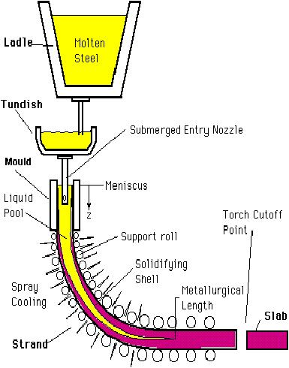

Figure 1 Schematic illustration of the process of continuous casing [3]

In this process, liquid metal flows from the ladle (a refractory coated container that is used to discharge liquid steel to the tundish) to the tundish (another refractory coated vessel which connects the ladle to the casting mould) and then through a SEN into the copper mould [1]. The submerged entry nozzle controls the liquid flow and provides a constant meniscus in the water-cooled mould. Mould powder is then added onto the molten metal in the mould. During the process of continuous casting, mould powder is consumed and new mould powder is consistently supplied to ensure that the liquid metal surface is at all times completely covered with powder [4]. The solidification process begins in the water-cooled copper mould and after further cooling via the secondary cooling system, the finished product is obtained as slabs or billets [1].

The mould powders are synthetic slags and they involve a mixture of oxides such as SiO₂, Al₂O₃, CaO, Na₂O along with C and F⁻ [5]. The primary functions of the mould powder are to lubricate the strand and control the mould heat transfer in the horizontal direction between the steel shell and water-cooled mould [6].

During continuous casting, the mould powder is added onto the liquid steel in the mould and the powder firstly forms as a sinter layer, then a mushy one and eventually forms a layer of liquid slag (see Figure 5). The liquid mould slag infiltrates between the strand and the oscillating mould and lubricates the steel shell. During the first contact of the liquid slag with the water-cooled mould a thin glassy solid slag film is formed subsequently, the glassy slag can partly crystallize. The heat that is transferred in the mould is controlled by the thickness and nature of the solid slag layer. The liquid slag film provides lubrication briefly while the solid slag film controls the heat transfer between the steel shell and mould [7]. Sufficient lubrication and the control of the horizontal heat transfer between the steel shell and mould are the main parameters that are used to obtain a better product quality but heat transfer in mould is controlled to avoid casting defects in general [4].

Continuous casting of steel is sometimes identified as a fragile process since many surface defects occur during the initial solidification of steel and these defects are generally related to mould powder performance. Longitudinal cracking, star cracks, oscillation marks, breakouts and chemical reactions between liquid steel and air are some of the operational problems arising during the process of continuous casting of steel [8].
Throughout the past decades, high-Al steels have been manufactured by the continuous casting process. It has been stated that, during continuous casting, high dissolved aluminium in the steels is apt to react with less stable oxides, such as SiO₂, MnO and FeO_{x} in the SiO₂-based mould powder. These reactions decrease the mould powder performance and cause operational problems, such as the sticking of mould powder to the water-cooled copper mould and the increase of cracking owing to lubrication difficulty. Research has been conducted to find a solution by optimising SiO₂-based mould powders. However, it is difficult to optimise lime-silica based mould powders for high-Al steels based upon the reactions between liquid slag and steel [9, 10].

In recent times, CaO-Al₂O₃ based mould powders have been developed for casting of high-Al steels. In these newly developed mould powders, SiO₂ is partly replaced by Al₂O₃ in order to prevent the reactions at the slag/steel interface. As a result, it has been stated that slag/steel interaction has been prevented and operational problems have been significantly decreased when using these new powders. However, the mould slag in these powders tends to crystallise easily and it can lead to variation in mould slag lubrication and heat transfer, which in turn causes a deterioration of the casting process and a decrease in the slab surface quality [11, 12, 13].

In order to improve the crystallisation behaviour of CaO-Al₂O₃ based mould powders, intensive effort has been made [14]. Fu et al. [13] studied the effect of lime/alumina ratio on crystallisation and the results show that the thickness of slag film varies according to the lime/alumina ratio. Zhao et al. [10] found that MnO could enhance the general heat transfer by promoting melting and preventing the crystallisation of the mould powder. Boxun et al. [15] pointed out that Li₂O and Na₂O in lime-alumina mould powders prevent the crystallisation of mould powder by decreasing the initial crystallisation temperature and increasing incubation time. Cheng et al. [11] stated that the crystallisation temperature of CaO-Al₂O₃ based mould powders decreased with the addition of B₂O₃. Finally, Huang et al. [9] reported that the viscosity and break temperature of mould powders decrease with the increase in B₂O₃ content.

During the various studies that have been carried out, the viscosity, crystallisation and melting behaviour of CaO-Al₂O₃-based mould powders, over a range of ratios, has not been systematically investigated. Therefore, it is important to study the regulation of CaO-Al₂O₃ mould powder for casting of high-Al steels.
A general approach for the development of lime-alumina based mould powders are that the C/A ratio has significant effect on slag crystallisation. Hence, it is important to determine the optimal C/A ratio by investigating the effects of compositional change on slag properties. There are a few studies [13, 16, 14] which have investigated the effects of C/A ratio on thermo-physical properties of lime-alumina based mould powders. These studies mainly focus on the crystallisation of mould powder with small changes in C/A ratio. Therefore, it is required to investigate the effect of a wide range of C/A ratios on thermo-physical properties of lime-alumina based mould powders.

On the other hand, it has been suggested that as the stability of SiO₂ is much lower than TiO_{2,} the reaction between steel and slag can be inhibited by an addition of TiO₂ [17]. It was investigated that the addition of TiO₂ could weaken the strength of the slag structure, resulting in a reduction in viscosity [18, 19, 20]. However, the effects of TiO₂ on crystallinity of lime-alumina based mould powders is still unclear.

Therefore, the aims of the current research are to:
- Evaluate physical properties such as crystallinity, viscosity and the melting trajectory of lime-alumina based mould powders with the addition of B₂O₃, TiO₂, ZrO₂ by controlling the CaO/Al₂O₃ ratio.
- Improve the understanding of the reactions that take place between the liquid slag and the liquid steel during casting of high-Al steels.

To achieve these objectives, 3 different series of lime-alumina based mould powders have been designed and produced. The M-series mould powders can be classified in two groups; the first three powders have a C/A ratio of 3.3 and the others have a C/A ratio of 5.5 with zero to fifteen weight percent B₂O₃ content. The C-series contains 5 different mould powders with varying C/A ratios of between 1 and 3. TiO₂ content is fixed at 0, 5,10 and 15 wt.% with a constant C/A ratio in the T-series of mould powders. All powders contain constant amounts of Li₂O and Na₂O to provide a multicomponent effect.

In this study, STA (Simultaneous Thermal Analysis), HSM (Hot Stage Microscopy), XRD (X-ray Diffraction), IPT (Inclined Plate Test) and Rotational Viscometer were used to reveal the crystallinity and viscosities of these lime-alumina based mould powders. The crystallisation behaviour of the mould powders was evaluated by generating CCT (continuous cooling transformation) diagrams. The changes in slag chemistry over time have also been analysed using XRF (X-ray fluorescence). Additionally, Fact Sage software and empirical models have been used to calculate and estimate various relevant thermo-physical properties of these mould powders.

LITERATURE REVIEW

2.1. High-Aluminium Steels

The global demand for reducing fuel consumption, reducing environmental impact and improving passenger safety in the automobile industry has required the development of new grades of steel. Steel has the capability of absorbing an impact, and thus can spread the effect of a crash. Steel requires considerable ductility for safety along with sufficient strength. Formability is another important required property for automobile steels due to the complex geometry of parts of vehicles [21, 22].

Advanced High Strength Steels (AHSS) have been gaining remarkable interest in the automobile industry due to their high tensile strength and formability. High-Aluminium steels is a significant class of AHSS and include TRIP (Transformation-induced plasticity), DP (Dual Phase) steel and TWIP (Twinning-induced plasticity) grades of steel [23, 24, 25]. The advantages of these new generation steels over other lightweight materials are weight reduction, lower fuel consumption, better crash performance, reduced environmental impact and material cost reduction.

It is possible to control the mechanical properties of steels through its chemical content, heat treatment and manufacturing route. Carbon plays a key role in the composition of AHSS by strengthening austenite through interstitial solid solution hardening and enhancing its stability. Apart from carbon, solute additions are used in AHSS in order to

- Improve the fraction of retained austenite
- Monitor cementite precipitation
- Enhance the hardness of ferrite
- Enhance the hardenability to avoid pearlite formation before the bainite reaction [21] [22].

A significant amount of aluminium is used in AHSS in order to enhance the mechanical properties and reduce the weight of the steel product [26, 27]{Lu, 2014 #2}. Aluminium is not only a very frequently used type of nonferrous metal but also a unique chemical element for alloying and in the de-oxidation of liquid steel during the steel making process. In the past decades, high-aluminium steels have been manufactured by a continuous casting process and aluminium contents in these steels varies from 0.5 wt.% to 2 wt. %. Aluminium in steel could also bring a variety of benefits for machining properties of steel owing to fine crystal grains [28, 29, 30, 31]. However, very small amount of Al is added to steel as a deoxidizer. Aluminium is also known as grain refiner for improved toughness as a certain amount of Al addition to steels results in fine grains [32]. The following diagram compares total elongation to tensile strength for today’s high strength steels.

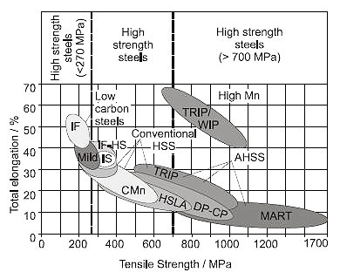
Figure 2 Comparison of current steel grades’ formability [33]

At the core of these new generation steels, microstructures are manipulated to obtain the desired mechanical properties. AHSS are multiphase steels containing hard phases of bainite, martensite or retained austenite diffused in a ductile ferrite matrix. The strengthening mechanisms of AHSS comprise solid solution and grain refinement strengthening, precipitation hardening and phase transformation to hard martensite from soft ferrite [24].
Grassel et al. [34] investigated properties of 20 Advanced High Strength Steel samples with Al content ranging from 1.8 to 3.9 wt.%. they concluded that the lightweight high Mn TRIP (transformation induced plasticity) steels and TWIP (twinning induced plasticity) steels present high flow stresses ranging 600 to 1100 MPa and large elongations (60-95%) even at very high strain rates of about 10³s⁻¹.

2.2. Mould Powders

Continuous casting mould powders (also known as mould fluxes) are synthetic slags added to the top of the liquid pool to enable the passage of the steel strand through the water-cooled copper mould. The surface quality of the steel product is extremely dependent on the performance of the mould powder in the continuous casting process. Mould powders control many features of the steel casting process and final quality such as production rate, surface quality, cleanliness, and defect formation [35, 36]. The main functions of mould powders are detailed in Section 2.2.2.

2.2.1 History of Mould Powders

The continuous casting process of steel is a highly successful process and the most common casting technique for steel [35, 36, 37]. Nowadays, the world’s steel production has reached 1.8 million tonnes per year and approximately 95% of world’s steel is manufactured by the process of continuous casting [38, 35]. The continuous casting process owes much of its success to the performance of the mould powder [39].

Mould powders were first introduced for ingot casting in Belgium in 1958 and then used in continuous casting processes in 1963. The first produced mould powders were based on fly ash which is a waste product from power stations and contains high amounts of Al₂O₃ and SiO₂ and unburnt carbon along with certain levels of CaO and FeO [39, 40].

In the early years, oil and carbonaceous materials have been used during the casting processes but mould powders were preferred over those as casting powders provide better thermal insulation for the liquid steel surface and absorb some impurities from steel. Furthermore, molten slag covers the liquid steel surface and creates a barrier between the atmosphere and molten steel which prevents steel from oxidation [39, 40].

Mould powders have been used for steel castings for over 60 years and the knowledge about how they work and perform has increased during this time. In the course of time, the efficiency of power stations increased therefore carbon content in fly ash has significantly decreased. Therefore, the fly ash-based mould powders have gradually been replaced by synthetic mould powders to be able to provide better quality control. However, fly ash-based mould powders are cheap and still widely used in ingot casting [39, 40, 41].

2.2.2. Mould Powder Functions

Mould powders have an essential and highly significant role in the continuous casting of steel and some of the major duties of mould powders are as follows:
- Thermal insulation
- Prevention of steel meniscus from oxidation
- Lubrication of the strand
- Control of heat transfer
- Impurity entrapment [7]

Lubrication of the strand and the control of mould heat transfer are the most important functions of mould powders. This is due to the fact that these two functions of the mould powder directly affect the surface quality of steel and the stability of the continuous casting process [6].

2.2.2.1 Thermal insulation

The mould powder must provide thermal insulation to avoid the premature solidification of the liquid steel surface. A good thermal insulation in the meniscus helps to reduce the severity of oscillation marks and can also decrease pinholes. As shown in Figure 3 the reduction of both the depth of oscillation mark and pinholes can be possible by decreasing the length of the meniscus hook [7].

Insufficient thermal insulation can cause some operational problems such as deep oscillation marks and breakouts [1]. In general, high thermal insulation is obtained by;
- Decreasing the size of the mould powder granules
- Increasing the thickness of the powder bed
- Introducing exothermic agents, such as Ca/Si

In addition, extruded granules provide higher thermal insulation than the spherical ones [7]. 3-6 % graphite is generally added in order to increase the thermal insulation of the mould powders [37].

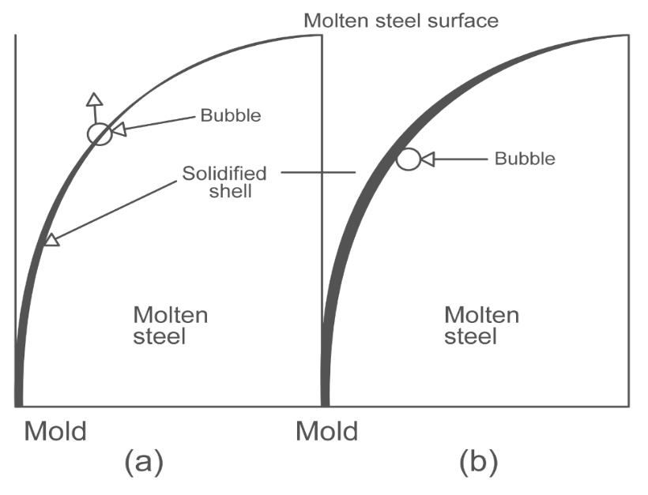
Figure 3 Schematic drawing shows that how (a) A gas bubble continues to rise when the meniscus length is short (b) A gas bubble is captured by the meniscus when the meniscus length is longer [7]

2.2.2.2 Prevention of Steel Meniscus from Oxidation

Continuous casting mould powder forms different layers on the liquid steel. An illustration of these layers is given in Figure 4. These layers constitute a barrier to protect the liquid steel meniscus from oxidation and entrap other gases such as nitrogen. Prevention of the steel from oxidation is obtained by the presence of an uninterrupted and continuous layer of molten slag inside the mould [1, 6].
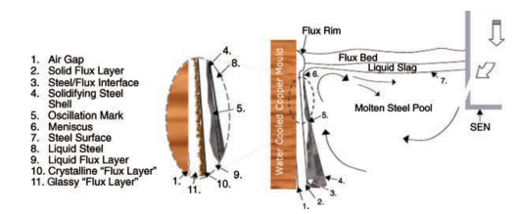

Figure 4 Schematic diagram of different layers formed by mould powder in the mould [38].

2.2.2.3 Lubrication of the Strand

The mould powder must provide lubrication between the solidified steel shell and the mould wall. It is important that liquid slag has good lubrication capacity since some operational problems such as star cracking (on page 71) can originate if the powder crystallizes entirely at the lower part of the mould thus causing lubrication to decrease substantially [7].

The lubrication capacity of mould powder depends on various factors, such as the viscosity and the solidification temperature. Better lubrication can be obtained if the viscosity or/ and melting temperature of powder is lower [39].

The lubrication of liquid slag can be affected by some other important process parameters, such as casting speed, submerged nozzle design and superheat temperature. If any defect happens on the liquid slag layer, sticker breakouts (on page 71) can potentially occur [1].

2.2.2.4 Control of Heat Transfer

Heat flux in the mould can be divided into two groups, namely horizontal and vertical heat flux. The horizontal heat flux has more influence on the cause of surface defects in a product. On the other hand, control of the vertical heat flux can reduce some operational problems, such as deep oscillation marks (on page 73) and pinholes [1]. Figure 5 illustrates a schematic drawing of vertical and horizontal heat transfer in the mould.

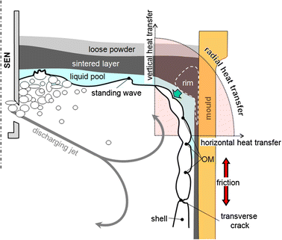
Figure 5 Schematic illustration of vertical and horizontal heat transfer in the mould [40]

The heat transfer in the mould is generally controlled by the gap between the steel shell and the water-cooled mould wall and this gap can make heat flux difficult to control. To be able to minimize this gap, constant and adequate liquid flux must be provided. Therefore, the melting properties of the mould powder must meet these requirements, and so the mould powder has to be carefully chosen for different steel grades [41].

2.2.2.5 Impurity Entrapment

The entrapment of inclusions by the powder at the liquid slag-metal interface is relatively important since some defects such as blisters, pinholes and slivers can appear [42]. The liquid slag layer on the meniscus enables the entrapment of inclusions, and it can be stated that the main duty of the liquid layer is to entrap alumina (Al₂O₃) inclusions. Al₂O₃ is produced as a result of the following reaction at the liquid slag- metal interface:

4 [Al] + (3 SiO₂ )_{(slag)} 2 (Al₂O₃) + 3 [Si] (1)
It can also be deduced that any increase in alumina will cause an increase in the slag viscosity and therefore change the solidification properties of the slag film, which in turn will affect the surface quality of the steel [6].

Entrapment of inclusions can be improved by using a powder with high (CaO/SiO₂) ratio, high Li₂O, CaF₂ and Na₂O or low TiO₂ and Al₂O₃ contents. Besides the larger size of inclusions can easily cross to the liquid slag- metal interface while it takes time for small particles to perform the same action [1].

2.2.3 Structure, Basicity and Chemical Composition of Mould Powders

Generally, mould powders are supplied based on chemical composition and physical properties such as melting point, basicity, (CaO/SiO₂), viscosity, free carbon content and solidification point, but this is not identified by the raw materials [43]. Mould powders consist of specifically selected different raw materials which in turn determine the chemical composition of the mould powder. Wollastonite, natrite, fluorite, feldspar and free carbon sources (such as coke particles) are typically used as raw materials [6]. An overview of typical chemical composition of mould powder for thin slab casting is given in Table 1.
Table 1 Typical chemical composition of mould powder [6]

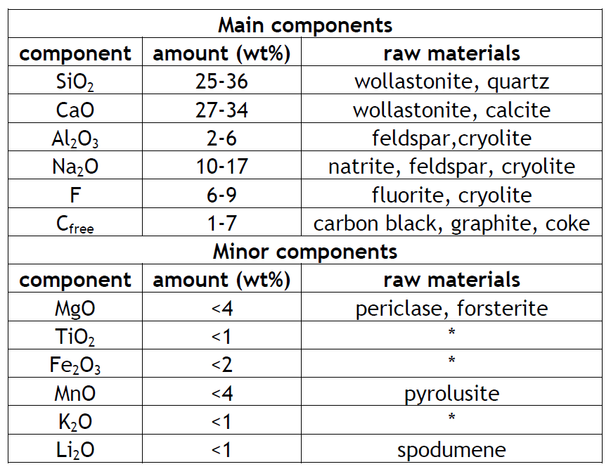
*: by raw materials or steel-slag interaction
As described above, mould powder consists of different components, which will affect the slag properties such as viscosity, crystallisation tendency and break and solidification temperatures [6]. Table 2 demonstrates the effect of different chemical compositions on these relevant physical properties.

Table 2 The effect of different chemical components on some properties of continuous casting mould powder [44]
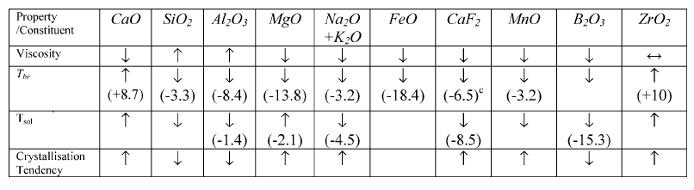where:
T_{br} (Break Temperature) = 1393K - %MO
T_{sol} (Solidification Temperature) = 1515K – x (MO)
(x: mole fraction, MO: oxide, ↑: increase, ↓: decrease and (^{c}) refer to %F)

The break temperature is the temperature below where viscosity of the mould powder shows a significant increase and the slag behaves as a non-Newtonian material. Break temperature is important for industry since it helps to control the heat transfer and lubrication inside the mould, and eventually prevent formation of sticker breakouts and longitudinal cracking during the process of continuous casting [45, 46, 9]. It has been reported that cooling rate and fluorine losses can affect the break temperature during the measurements. The values of break temperatures can be calculated to ± 20K from chemical composition of the mould powder by using the following equations [47].

$$T_{br}\left(K\right)=1393-8.4\%{Al}_{2}O_{3}-3.3\%{SiO}_{2}+8.65\%CaO-13.86\%MgO-18.4\%{Fe}_{2}O_{3}-3.2\%MnO-9.2\%{TiO}_{2}-2.2\%K_{2}O-3.2\%{Na}_{2}O-6.47\%F$$
Molten slags consist of three ionic groups as follows:
- Cations: Ca²⁺, Mg²⁺, Fe²⁺
- Anions: F²⁻, O²⁻
- Anion complexes: PO₄³⁻, SiO₄⁴⁻

SiO₄⁴⁻ is one of the main constituents of slags and this anion complex is in tetrahedral form in the slag. Each silicon atom in the centre is surrounded by four oxygen atoms and the SiO₄⁴⁻ anion complexes are connected to each other by oxygen ions which are referred to as bridging oxygen. Some cations such as Mg²⁺, K⁺ and Ca²⁺ have a propensity to break down these bonds. These cations form O²⁻ and O⁻ (non-bridging oxygen) and cause de-polymerisation of the slag. Figure 6 illustrates the structure of a SiO₄⁴⁻ tetrahedron and a silicate network [8, 6, 4, 48, 49].
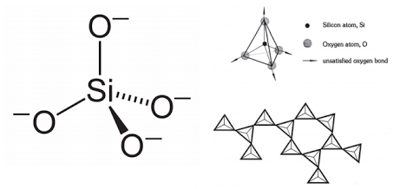
Figure 6 Structure of the SiO44- and silicate network [6]

Generally, mould slags involve a combination of acidic oxides such as P₂O₅ SiO₂ (network formers), and basic oxides, such as MgO and CaO (network modifiers) [4]. Acidic oxides are prone to capture O²⁻ anions to be able to form complex SiO₄⁴⁻ and PO₄³⁻ networks while the addition of basic oxides break up the silicate network and consequently form simpler networks. Figure 7 illustrates the effect of CaO and MgO on the network [49, 50, 51, 4, 52] .

Arrangements are required to be made in order for a silica network to change the physical properties of mould powder such as viscosity and melting temperatures. At high temperatures, the silicate network is disrupted by adding network modifiers such as Na₂O and MgO which increase mobility in slag and eventually decrease the viscosity and melting temperature of the slag. In very basic slags, the silica network is broken down to metal cations such as Ca²⁺, SiO⁴⁻ and O²⁻ anions [53, 4, 49, 54].

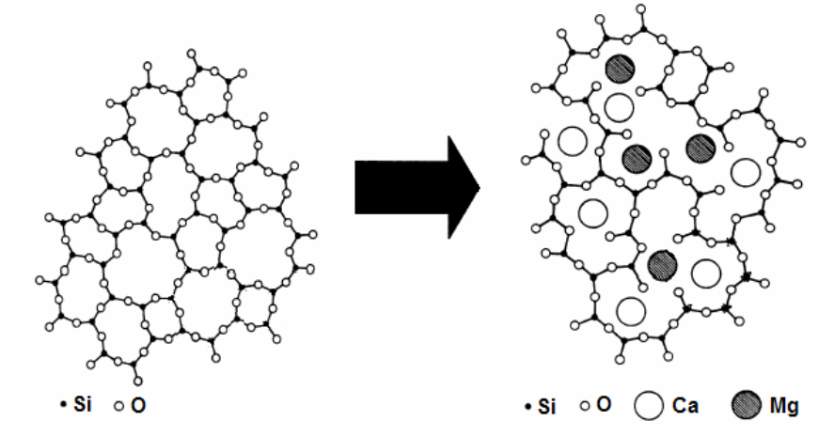
Figure 7 Effect of CaO and MgO on the silicate network [4]

The cations of Ba, Li, Sr and K are other network modifiers and are also commonly found in mould powders. However, boron is considered as a network former in slag and B₂O₃ additions usually result in a significant decrease in viscosity and melting temperature [53, 6]. Al₂O₃ has an atmospheric effect on mould slags. By addition of Al₂O₃ to acidic slag, Al₂O₃ works as a basic oxide to break the Si-O-Si bond and then enhance the amount of non-bridging oxygen in the slag. However, Al₂O₃ works as an acidic oxide when it added to basic slag by absorbing O²⁻ and reduces the amount of non-bridging oxygen in the slag [55] [56]. The melts with high silica concentration are usually attributed as acidic whilst high CaO melts are referred to as basic.
During the continuous casting process, the equilibrium position can be managed by controlling the mould slag basicity. The free oxygen anion (O²⁻) content of the mould slag determines slag basicity. Turkdogan [57] describes slag basicity as follows for the mould powders containing high P₂O₅ and MgO:

$$Basicity\left(B\right)=\frac{\%CaO+1.4×\%MgO}{\%SiO_{2}+0.84 ×\%P_{2}O_{5}} \left(1.1\right)$$

If the slag contains MgO <8% and P₂O₅ <5%, the basicity may be defined as follows:

$$Basicity\left(B\right)=1.17\frac{\%CaO}{\%SiO_{2}} \left(1.2\right)$$

In case of a low P₂O₅ content, the slag basicity can be represented via the following ratio:

$$Basicity\left(B\right)=\frac{\%CaO}{\%SiO_{2}} \left(1.3\right)$$

Mould powder basicity generally varies between 0.8 and 1.25 based on the process conditions. If the value of slag basicity is lower than one, it is rated as an acidic slag, while if the basicity value is higher than one, it is classified as a basic slag. Generally speaking, higher slag solidification temperatures are related to basic slags while lower solidification temperatures are related to acidic slags [4].
As some oxides such as Al₂O₃ and Fe₂O₃ may act both network former and network breaker, a major problem may raise while calculating basicity of mould powder. The ratio of Non-bridging O/Tetragonal O (NBO/T) is a measure of the polymerisation of slag and it can be calculated by dividing mole fraction of network breaker oxides to the mole fraction of network former oxides (see Equation 1.4). Therefore NBO/T ration is also kind of basicity index which enables finding out how oxides are acting in slag [53, 58].

$NBO/T=2(\sum{X_{MO}+\sum{X_{M_{2}O}-{Al}_{2}O_{3})/\left(X_{{SiO}_{2}}+2X_{{Al}_{2}O_{3}}\right) (1.4)}}$
Where X is the mole fraction and
$$X_{MO}= X_{MgO}+X_{CaO }+X_{BaO}+X_{FeO}+X_{MnO}..$$
$$X_{M_{2}O}=X_{{Li}_{2}O}+X_{{Na}_{2}O}+X_{K_{2}O }$$
It has also been suggested that visualising polymerisation is easier than de-polymerisation so Q which is a measure of de-polymerisation of the slag and can be calculated from NBO/T by using following equation:
$$Q=4-\left(\frac{NBO}{T}\right) 1.5$$

Q values for typical mould powders are ranged from Q =ca. 2 (for high speed casting with ƞ₁₃₀₀º_{C} = 0.6 dPas) to Q= ca. 3 (for high viscosity billet slags ƞ₁₃₀₀ º_{C} ≥15 dPas ) and X_{CaF2}, X_{TiO2} or X_{ZrO2} should be ignored while calculating Q values [53].

2.2.3.1 Selection of Mould Powders

Mould powders are manufactured using mixtures of several mineralogical components and raw materials. The functions of mould powders are given in section 2.2.2 and to provide lubrication and to controlling the heat transfer in horizontal direction between steel shell and water-cooled copper mould can be classified as main functions of mould powders. It has been noted that there is not a universal formula which can work out or perform equally well in all steel manufacturing plats regardless of casting condition and steel grades. Therefore, it is important to know the composition, properties and operational performance relationship of a mould powder in order to choose suitable material for a specific casting conditions and which in turn will help steel producers in creating the recipes of mould powders according to their caster running parameters [6, 59].

The mould powder must provide good lubrication and sufficient heat transfer between steel shell and mould. The key properties for good lubrication are viscosity and break temperature of mould powders while the crystallinity and break temperature are the other key properties for controlling heat transfer. However, thermal conductivity of mould powder, crystalline phases and optical properties of mould powders are also important properties but not as important as break temperatures and crystallisation fraction. In terms of slag entrapment, key factors are steel/slag interfacial tension and viscosity. The main factor effecting interfacial tension is S content of the steel but reducing B₂O₃, CaF₂ and Na₂O content of mould powders may help to increase steel/slag interfacial tension [42, 53].

Kromhout [6] suggests that melting of mould powder at meniscus and crystallisation of slag are the key processes during continuous casting and both melting and crystallisation of mould slag are related to mould powder composition.

Figure 8 presents a very useful guide for selection of mould powders to cast different steel grades. As can be seen in Error! Reference source not found., the upper dashed line should be used to select mould powders for crack sensitive steels and the lower dashed line for sticker sensitive grades and values between these two dashed lines should be used for other all other grades such as low (LC), medium (MC), intermediate (IC) and high (HC) carbon steel grades [60, 46].

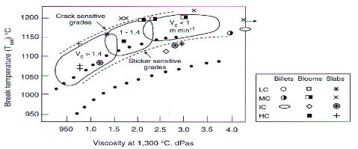
Figure 8 Break temperature as a function of mould powder viscosity [191]
0.5

2.2.3.2 Types of Mould Powders

Various types of mould powders with different compositions and properties are available in order to meet the needs of the steel industry. Mould powders are provided by manufacturers in different forms such as powders, granulated or extruded form. Each form of mould powder has its own advantages or disadvantages in terms of health, cost, viscosity, thermal properties, and melting rate etc [61, 53].The advantages and disadvantages of powders in the forms of powder, granules and extruded form are summarised in Table 3.

Table 3 The advantages and disadvantages of powders and granules [53]

Most of the mould powders in use in the steel industry are referred to as conventional mould powders which usually contain CaF₂ to form cuspidine phase in the slag film and are used for casting billets, blooms and slabs. A typical chemical composition of a conventional mould powder can be seen in Table 4. On the other hand, some specialist mould powders have been developed for specific conditions or special steel grades. These powders include F-free and C-free mould powders, non-Newtonian mould powders and powders for high-Al steel casting [40, 53].

Table 4 An overview of conventional mould powder chemical compositions(Mass percent) [62]

CaO | SiO₂ | Al₂O₃ | Na₂O | K₂O | MgO | MnO | Fe₂O₃ | F | C
22-45 | 17-56 | 0-13 | 0-25 | 0-2 | 0-10 | 0-5 | 0-6 | 2-15 | 2-20

2.2.3.2.1 Starter Powders

Starting mould powders have a low melting point and are used at the beginning of the casting process as the name suggests. These mould powders are designed to melt quickly once they get in contact with incoming molten steel from the tundish. Starting mould powders are expected to provide a large molten slag pool in order to:

- protect liquid steel from oxidation
- promote molten slag infiltration between strand and mould to be able to provide adequate lubrication.
The starting mould powders have the following properties:
- Chemically they contain high levels of low-melting point agents such as fluorides, Na₂O and borates.
- The carbon content in these mould powders is lower than 1% to provide a high melting rate and prevent carburisation of the steel shell.
- They may contain exothermic agents to provide additional heat.
- Starting powders have a tendency to create a slag rim as low-melting point agents may act as a glue and comprise some solid materials into the rim; so they should not be used more than necessary [4, 53].

2.2.3.2.2 Exothermic Mould Powders

These mould powders contain some exothermic agents such as Ca/Si or Fe/Si which generate heat once they react with O₂ (see following equations) [63].

$$Si+O_{2\left(g\right)}=SiO_{2} ∆H_{{25}^{o}C}=-911kJmol^{-1}$$
$$Ca+0.5O_{2\left(g\right)}=CaO ∆H_{{25}^{o}C}=-635kJmol^{-1}$$

The heat from these reactions increases the local temperature in the powder bed and that decreases the thermal gradient $\left(∆T= T_{pool}- T_{local}\right)$, and eventually reduces the total heat transfer in the mould [53].
Exothermic mould powders are used to

- Increase the depth of the slag pool to reduce the powder consumption, decrease carbon pick up by the steel shell or improve absorption of inclusions
- Decrease the length of the solidified meniscus by decreasing vertical heat transfer inside the mould which allow gas bubbles and inclusions to move towards the slag pool.

It should also be noted that the free-C is another exothermic agent and conversion of free-C to CO_{2(g)} reveals approximately 3 times more heat than conversion to CO_{(g)} (see following equations) [53].

$$C+{0.5O}_{2}=CO_{\left(g\right)} ∆H_{298}=-110kJmol^{-1}$$
$$C+O_{2}=CO_{2\left(g\right)} ∆H_{298}=-393kJmol^{-1}$$

2.2.3.2.3 Fluoride-free Mould Powders

Mould powders consist of a mix of artificial oxides and fluorides. Generally the content of fluoride in conventional mould powders is around 7% (it may reach up to 15% for casting of some special steels) which is usually added in the form of calcium fluoride (CaF₂) [53, 62].

Fluorine has an important role in continuous casting mould powders as it controls the physicochemical properties at high temperatures [64]. However, it is unwanted fluxing agent in mould powder due to the gasses formed as a result of reactions between the mould powders and molten steel. Oxy-fluoride systems are not stable as they can react together to form fluoride gases (see reactions below). As shown below, fluoride gases react with any moisture and form HF gases. HF gases cause corrosion on continuous casting equipment, acidification of cooling water and create a health hazard for the people who work in the plant. Therefore environmental concerns for fluorine emission creates a new research area of interest to design mould powders with zero or reduced amount of fluorine [53, 65, 66].
$${Na}_{2}O+{CaF}_{2}=CaO+2NaF_{\left(g\right)}$$
$${SiO}_{2}+{2CaF}_{2}=2CaO+2SiF_{4\left(g\right)}$$
$${Al_{2}O}_{3}+{3CaF}_{2}=3CaO+2AlF_{3\left(g\right)}$$
$$H_{2}O+{CaF}_{2}=CaO+2HF_{\left(g\right)}$$

The current research is focussed on the following :
- To keep the level of powder consumption stable
- To keep the level of horizontal heat transfer stable
- To replace cuspidine (3CaO.2SiO₂.CaF₂) with a suitable crystalline phase to be able to provide the required level of horizontal heat flux from molten steel to the water cooled copper mould [53, 62, 67].

Researchers have focused on two different approaches in the development of fluoride-free mould powders:

- To replace CaF₂ with other fluxing agents such as B₂O₃, Li₂O and Na₂O and then modify the chemical composition to provide similar properties to the original powder in terms of viscosity, break temperature and heat transfer [53, 68, 69].

- To replace cuspidine in the slag film with another suitable crystalline phase in order to reflect IR radiation and create an interfacial thermal resistance [53, 66, 70, 71].

2.2.3.2.4 Non-Newtonian Mould Powders

The viscosity of most molten mould slags are categorised to be Newtonian since their viscosity is not affected by applied stress or force. On the other hand, the viscosity of non-Newtonian slags decreases with increasing shear rate. Non- Newtonian mould powders have been manufactured to decrease mould powder entrapment which occurs near the centre of the mould as surface velocity is high at this area. Figure 9 shows how viscosity of the molten slag changes as a function of shear rate inside the water-cooled copper mould.

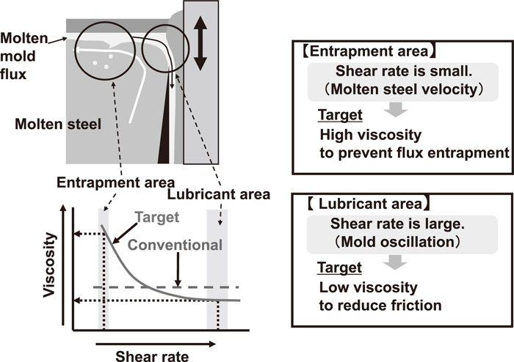
Figure 9 Schematic drawing showing the viscosity of non-Newtonian mould powder as a function of shear rate [72]

Watanabe et al. [72] studied development of new mould powders for continuous casting based on non-Newtonian fluid properties by adding Si₃N₄ to a conventional mould powder which has a CaO/SiO₂ ratio of 0.9. It was found that newly developed mould slag has a lower contact angle than conventional slags on a plate. It was also recorded that heat transfer was higher for newly developed non-Newtonian mould slags than for the conventional mould slags.

2.2.3.2.5 Mould Powders for Casting of High-Al Steels

High Al steels have superior properties in strength, formability and ductility since Al in steel enriches austenite stability. However, large amounts of dissolved Al in liquid steel tends to react with less stable oxides such as silica and titania in the slag to form alumina in conventional mould powders during the process of continuous casting. This leads to the picking up of alumina in the slag [73, 51]. Kenneth et al. [74] pointed out that an increase of 0.1 %wt. Al in steel leads to roughly a 1.5 %wt. alumina increase in mould slag composition.

It has been reported that alumina particles in slag tend to agglomerate and thus have a remarkable effect on viscosity, T_{liq} and T_{sol} which result in a decrease in mould powder consumption. It has also been reported that alumina enhances the crystallinity of the mould powder which reduces the lubrication [75, 76, 77].
On the other hand, the melting temperature of steel decreases with increasing Al content. Low melting temperature of steel leads to low vertical heat flow and shallows the slag pools. Therefore, it may be required to provide the slag in liquid form during the casting of high Al-steels since molten steel cannot provide enough heat to melt the mould powder [51].

2.2.3.2.5.1 Strategies for Minimising Alumina Pick-up

Several strategies have been developed to minimise Al₂O₃ pick up during casting of high Al-steels. These are [53, 51, 27, 11]:
- To adjust powder composition which may keep the slag in the low melting point region even with a high amount of Al₂O₃ pick-up.
- To add FeO and MnO to the powder in order to decrease the Si pick-up by steel through the reaction $2Al+3SiO_{2\left(slag\right)}=3Si+Al_{2}O_{3(slag)}$which may not occur in preference to $2Al+3MO_{\left(slag\right)}=3M+Al_{2}O_{3(slag)}$ where M=Fe or Mn)
- To increase the volume of the molten slag pool by adding exothermic agents to mould powders in order to decrease the Al₂O₃ concentration in slag.
- To decrease the Al₂O₃ formation by reducing SiO₂ content in the mould powder.
- To minimise Al₂O₃ formation by using mould powder which consists of lime-alumina and reducible fluxes such as B₂O₃, Na₂O and CaF₂.

It may be possible to use some of these strategies simultaneously but most of them are unincorporated from other approaches [53].

2.2.3.2.5.2 Approaches to Produce New Powder for High Al-Steels

In most of the cases, the conventional lime-silica based mould powders are not feasible for the casting of high- Al steels because the reactions between reducible oxides and aluminium changes the physicochemical properties of mould powders which would in turn cause insufficient lubrication and a non-uniform heat transfer [78, 14, 15]. In order to solve the aforementioned problem, initially, conventional lime-silica based mould powders with low basicity and low viscosity were proposed and a series of experimental studies and industrial plant trials have been conducted. However, it has been concluded that the steel-slag reaction is in the nature of lime-silica based mould powders and it is almost impossible to avoid. A range of fluidisers like B₂O₃ and Li₂O can be added in order to optimise mould powder properties and inhibit the reaction between liquid steel and slag but the change in mould slag composition owing to the steel-slag reaction can result in strong crystallisation tendencies and non-uniform heat flux. This makes the optimisation of lime-silica based mould powders through the addition of fluidisers difficult [73]. Therefore, the concept of non-reactive lime-alumina based mould powders was proposed by Street et al. [79]and research was focussed on these necessities.

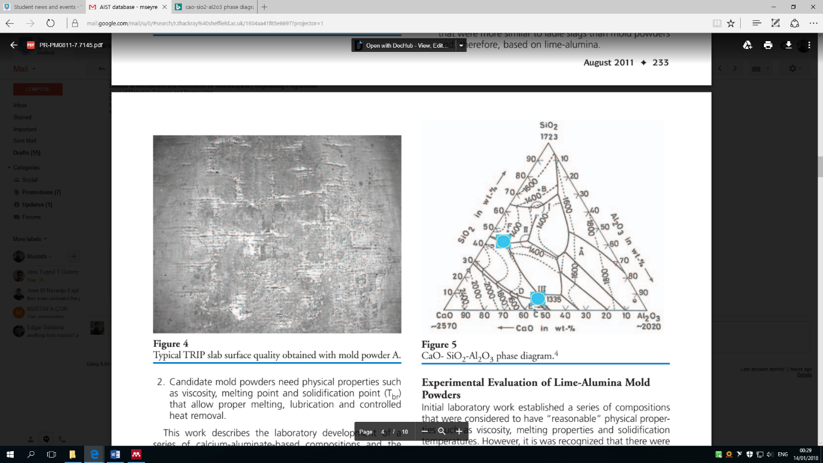

Figure 10 CaO-Al₂O₃-SiO₂ ternary phase diagram [74]

References | Composition of mould powders
References | Ca0/Al₂0₃ | SiO₂ | CaO | F | Al₂O₃ | Li₂O | Na₂O | B₂O₃ | ZrO₂
Shi et al. [80] 2014 | 3.2 -12.8 | 2.2-35.4% | 19.3- 42.6% | 8.1-15.1% | 1.5-26.2% | 3.0-6.2% | 1.0-12.3% | 5.4-16.0% | 0-3.5%
Xiao et al. [81] 2016 | 1-3 | 9.0% | 23.0-39.5% | 9.0% | 16.5-33.0% | 6.0% | 10.0% | 0-10.0% | ---
Gao et al. [82] 2015 | 1.4-1.6 | 12.8-14.2% | 38.2-42.8% | 9.50% | 26.00% | 6.50% | 0.0-6.0% | --- | ----
Fu et al. [13] 2014 | 0.1-2.8 | --- | 3.0-35.0 % | 14.4% (CaF₂) | 12,6-44.6% | 4.0% | 13.0% | 6.0% | ---
Zhang et al. [83] 2019 | 1.8-10.1 | 20.9-27.3% | 29.5-30-5% | 17.3-18.7%  (CaF₂) | 3.03-16.16% | --- | 3.79-16.2% | --- | ---
Jiang et al. [84] 2014 | 0.8-1.2 | ---- | 41.0-45.82% | --- | 38.2-43.5% | 3.0% | --- | 10.0% | 0-5.0%
Wang et al. [85] 2011 | 0.9 | 6.0-10.0% | 27.0-29.0% | 6.8% | 28.0-30.0% | 2.0-5.0% | 6.0-12.0% | 0-6.0% | -----
Lu et al. [86]2015 | 2.8-3.3 | 9.27% | 36.3-42.3% | 5.17-9.17% | 11.7-12.7% | 5.05% | 9.27% | 16.5% | ----
Zhao et al. [29] 2014 | 0.8 | 20.3% | 21.4-22.8% | 11.7% | 27.5-29.2% | 2.28% | 12.24% | 0-3% | -----
Shi et al. [87] 2014 | 1.2-12.9 | 2.2-36.4% | 19.3-42.6% | 8.1-15.1% | 3.8-26.2% | 2.1-6,4% | 1.0-12.3% | 5.4-16.0% | 0-3.5%
Lu et al. [15] 2014 | 1 | 11.26% | 30.7-33.03% | 10.35% | 29.8-32.07% | 2.48-7.08% | 8.51-13.11% | ----- | ----
Yan et al. [88] 2015 | 0.6-3.2 | 5.0% | 20.6-41.9% | 20.0% (CaF₂) | 13.1-34.4% | --- | 10.0% | 10.0% | ----
Yan et al. [89] 2016 | 1.1 | 5.0% | 28.8-39.3% | 0-20.0% (CaF₂) | 26.2-35.7% | --- | 10.0% | 10.0% | ---
Table 5 Chemical compositions of lime-alumina based mould powders which have been designed by different researchers (in weight percentage

In recent years, researchers have designed different lime-alumina based mould powders for casting high-Al containing steels and the chemical compositions of those designed mould powders have been summarised in Table 5. The CaO/Al₂O₃ ratio has been classified as one of the most significant factors affecting the properties of lime-alumina based mould powders. Blazek et al. [74] revised the CaO-Al₂O₃-SiO₂ phase diagram and has pointed out that the lowest melting temperature is with aCaO/Al₂O₃ ratio of 1 at ~10 %wt. SiO₂. The painted areas in
Figure 10 illustrate that the lowest melting temperatures for CaO-Al₂O₃ and CaO- SiO_{2.} compositions are comparable and indicate that the same amount of fluidisers would be favourable.

Lime-alumina based mould powders with varying CaO/Al₂O₃ ratio and different amounts of fluidiser have been studied and the results show that the lime-alumina based mould powder has great potential to improve the continuous casting process of high-Al steel by reducing the steel-slag interaction, controlling horizontal heat transfer and improving surface quality. However, lime-alumina based mould powders tend to crystallise easily which deteriorates lubrication during the casting process. Therefore, the crystallisation behaviour and the degree of steel-slag interaction should be considered simultaneously for the development of these lime-alumina based mould powders.

2.2.4 Infiltration of Mould Slag, Lubrication, Powder Consumption and Melting Rate

Infiltration of mould slag between the copper mould and strand shell may be explained as drawing through of the molten slag by oscillation of the mould on account of the fact that the slag wets the steel strand. Generally, mould slag infiltration increases by the oscillation of the copper mould as it has been reported by most workers that negative strip has a positive impact during the oscillation of mould. This has been confirmed at the laboratory scale, as well. Additionally, the entity of the mould slag rim (see Figure 4) also increases the infiltration of mould slag [6].

2.2.4.1 Lubrication and Mould Powder Consumption

During the process of continuous casting, mould slag infiltration is measured by mould powder consumption, since consumption may be evaluated as a convenient measure of molten slag flow ratio between the mould and strand shell. Mould powder consumption has also been considered a practical and simple method by which to the stability of the copper mould and solidification process can be evaluated [90].
As known, the molten mould slag lubricates the strand and provides liquid lubrication through the steel strand. However, some problems, (such as longitudinal cracking) may arise if the molten slag completely crystallises in the bottom half of the copper mould and liquid lubrication is depleted. The liquid friction (F₁) has been given by Equation 1.3.

$$F_{1 }= η\frac{\left(V_{c}-V_{m}\right)}{d_{1}} \left(1.3\right)$$

where V_{c} is the casting speed and V_{m} is the velocity of the mould. As can be seen, friction increases as the viscosity (η) increases and the thickness of the liquid slag film (d₁) decreases [44].

Generally, mould powder consumption can be expressed in kg/tonne (kilograms per tonne of steel cast) or kg/m² (kilograms per unit surface area). It is possible to convert powder consumption measurement in kg. tonne⁻¹ to kg.m⁻². Wolf [91] was one of the first researchers to propose the relationship between Q_{s} and Q_{t} and this is given by Equation 1.4.

$$Q_{s}= \frac{f.7.6.Q_{t}}{R} \left(1.4\right)$$
where:
Q_{s} = in kilograms of powder per tonne of steel
Q_{t} = in kilograms of powder per metre² of mould
f = fraction of powder forming slag
R= surface area/ volume ratio and expressed as R= 2 (w+t) / w.t where w is the width and t is the thickness of mould in metres. Figure 9 shows how mould dimensions affect powder consumption.

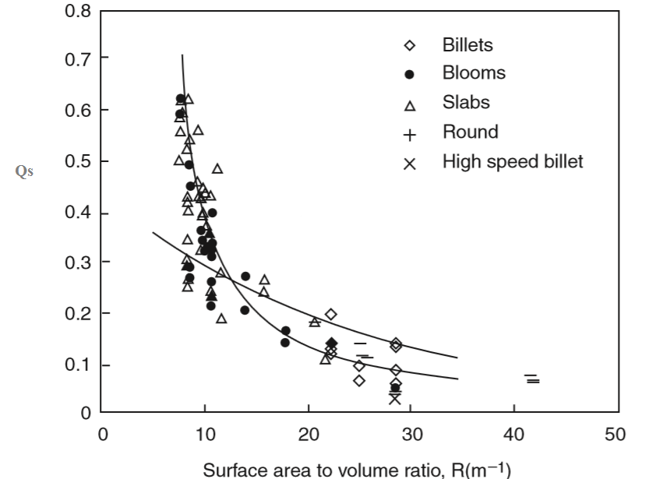
Figure 11 Qs (Powder consumption in kg powder per tonne of steel) as a function of R (surface area/ volume) [12]

As shown in Figure 11 mould powder consumption is also a function of mould shape and varies for billets, blooms and slabs. Figure 11 explains that powder consumption for slab casting sharply increases when the slab size increases [42]. It has been stated in the European Steel Research report that mould powder consumption for high speed billet and thin slab casting (high R value) is approximately 0.1 kg/m² while it is 0.5 to 0.6 kg/m² for conventional thickness slab casters [90].
The powder consumption is also related to the casting speed (V_{c}) and viscosity of the powder at 1300ºC. Wolf [91] proposed that the frictional forces are at minimum and mould heat transfer is optimal when

$$ηV_{c}^{2}=5±2 \left(1.5\right)$$

where η = slag viscosity (dPas) at 1300ºC
V_{c} = casting speed (mmin⁻¹)

Figure 12 shows how mould fraction and horizontal heat transfer change as a function of the parameter $ηV_{c}^{2}$.
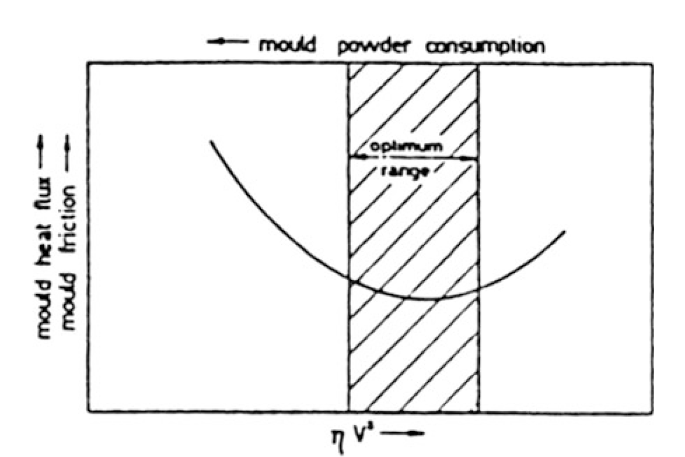
Figure 12 Schematic illustration showing horizontal heat flux and mould fraction as function of parameter ${ηV}_{c}^{2}ηV_{c}^{2}$

Ogibayashi et al. [92] suggested a new equation for optimal casting:

$$ηV_{c}=2.5 ±1 \left(1.6\right)$$

Wolf converted his own equation (Equation 1.4) and the equation of Ogiyabashi (Equation 8) into the following equations:
$Qs=0.7/(η^{0.5}. Vc ) (1.7$)

$Qs=0.6/(ηVc ) (1.8$)
In addition, Jenkinson proposed a relationship for optimum powder consumption (Q_{s}):

$$Q_{s}=\left[\frac{ρ_{slag}}{6000V_{c}^{0.5}}\right]\left[1+\left(\frac{ρ_{slag}g}{{9.10}^{5}ηV_{c}^{2}}\right)\right] \left(1.9\right)$$

where ρ = density of liquid slag and g = gravitational acceleration = 9.81 m/s² [60].

Jenkins remarked that powder consumption increases as the thickness of mould/strand gap increases. Besides a thicker shell shrinks more thus producing a larger gap [42].

Most recently, Tsutsumi et al. [93] have pointed out an alternative equation which considers more factors:

$Q_{s}= \frac{kβ}{T_{sol}η^{0.5}} \frac{S}{V_{c}} \cos^{-1}\left[\frac{1000V_{c}}{2ᴨfs}\right] \left(1.10\right)$

here k and β are constants,

s = Stroke length, f = frequency (Hz),
V_{c} = Casting Speed (m min⁻¹), η = Slag viscosity (dPas)
T_{sol} = Solidification Temperature (K)

It has been stated by Mills et al. [44] that the Tsutsumi equation provides the best estimation of Q_{s} after the converted Wolf equation.

Several relationships for optimal powder consumption have been proposed by different researchers and the influence of different casting parameters on powder consumption has been reviewed by the European Commission Technical Steel Research Group [90]. A decrease in powder consumption has been reported in the following situations:

- Casting speed increases (see Figure 13)
- Slag viscosity increases
- Oscillation frequency increases
- Positive strip time decreases
- Negative strip percentage decreases
- Mould taper increases
- Solidification temperature decreases
- Stroke length decreases
- Superheat decreases

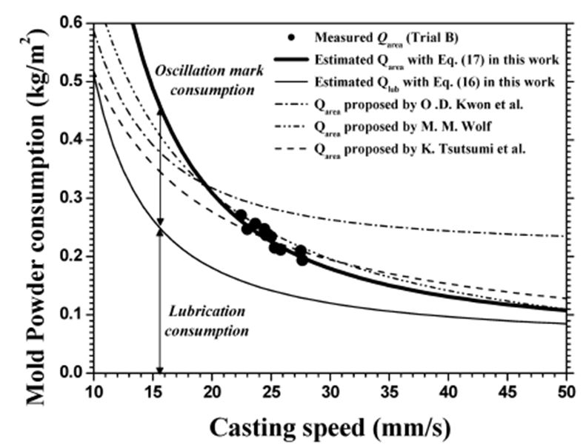
Figure 13 Effect of casting speed on powder consumption [1]

In addition, high or low powder consumption can cause some operational problems. For instance, if the consumption is too low, this can cause sticker breakouts, longitudinal cracking, off-corner cracking and transverse corner cracking. If the powder consumption is too high, it can also lead to some surface defects such as deep oscillation marks.

2.2.4.2 Melting Rate

The melting rate is controlled to an extent by the carbon content of the powder. However, particle size and the type of carbon also affect the melting rate of the powder. Melting rate is expressed by MR and can be calculated via the following equation [94].

$$MR=\left(w+t\right)Q_{s}V_{c} \left(1.11\right)$$

It is important to know the melting rate of the powder so as to increase the surface quality of the product and minimize operational problems, such as breakouts. Besides, it is possible to control the depth of powder pool by the melting rate. If the melting rate is too low, it will cause a lack of molten powder and the infiltration of the powder between the strand and the mould will be irregular. If the melting rate is too high, a layer of the non-reacted powder on the surface of the mould cannot be maintained.

It has been reported on the European Commission Technical Steel Research [90] report that the melting rate decreases if:
- The free carbon content of the powder increases
- The particle size of the free carbon decreases
- The bulk density of the powder increases
- The carbonate content (Li,Na,Co etc) decreases
- The vertical heat flux decreases (depends on casting speed, superheat, turbulence etc.)

2.2.5 Thermo-physical Properties of Mould Powder

2.2.5.1 Crystallisation

Formation of glass and crystallisation are two different competitive processes. The crystallisation arises from a combination of crystal nucleation and crystal growth processes [95]. Supercooling a liquid is a method of vitrification and preventing crystallisation. Thus, if a liquid cools down at a high enough cooling rate, limited crystallisation can occur or can be arrested to temperatures which correspond to high viscosities in the ɳ ≥ 10¹³ -10¹² Pa.s ͠ ɳ (T_{g}) range. (T_{g} is the glass transition temperature). Below the glass transition temperature, atomic rearrangement of the system is not probable and the structure is freezed-in due to the high viscosity. During the process of freezing-in its structure, the liquid transformation into a glass is usually defined as the glass transition [95, 96].

The most remarkable characteristic of the glass transition is the sudden change in the liquid properties, such as heat capacity and thermal expansion coefficient. The reason for this change in liquid properties is that it cooled down to the range of temperature where its viscosity reaches 10¹² Pa.s [97].

Cramb and Scheller [98, 99] observed the effects of the cooling rate on mould powder crystallisation. The crystallisation starts at lower temperatures with an increase in cooling rates. At high cooling rates, solidification takes place as partly crystalline or completely glassy.

Figure 14 illustrates the change in volume of liquid in the transition area during cooling. If the cooling rate is high enough to prevent crystal nucleation and growth, it is possible to produce a supercooled liquid (path a). If the liquid cools down gradually which is path b on Figure 14 , the liquid could crystallise at the melting temperature T_{m}. As the temperature decreases, it requires time to constitute the equilibrium presence of the liquid increases, and thus structural changes cannot keep track with the cooling rate. At this stage, the glass transition temperature reaches below the point where atomic rearrangement is not possible, and glass is formed. Consequently, it is possible to form glass from the liquid state if path a is followed. However, if the glasses are heated to a temperature between the glass transition temperature (T_{g}) and the melting point (T_{m}), they are prone to crystallise in order to reach thermodynamic equilibrium [97, 100].

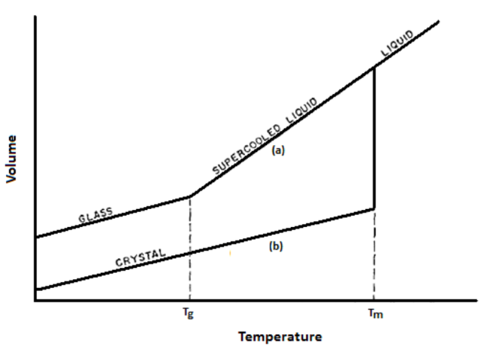
Figure 14 Schematic illustration of (a) Glass transition and (b) Crystallisation from liquid [100]

2.2.5.1.1 Mould Powder Solidification

Inside the continuous casting mould, the slag undergoes various cooling rates. The slag film consists of a liquid part at the steel side and a solid part at the copper mould side. Lubrication between the mould and steel strand is provided by this liquid part. The liquid part of the slag needs to move together with strand through the mould to be able to provide perfect lubrication. The solidification temperature of the mould powder is the most important factor to the determine the length of this liquid part of the slag film. The solid part of the slag film moves very slowly as the solid part provides thermal insulation which controls the horizontal heat flux [6, 101].

At a high cooling rate, glassy or amorphous solidification occurs at the copper mould surface. As a matter of principle, the cooling rate needs to be high enough so as to prohibit nuclei growth for glass formation. Devitrification of the crystallisation amorphous film takes place with the progress of time. As a result, crystals in the glass matrix shows up in the solid part of the slag film [102, 6, 4].

Molten slag solidifies to form crystals and a variety of solids crystallise from the mould powder elements. Each crystal type has a different solidification temperature. Crystals usually crystallise with other various crystals (more particularly if the crystals have close crystallisation temperatures). Table 6 summarises the expected crystalline phases formed in the solid slag [4, 103, 52].

Table 6 Expected crystal types that form from mould powder elements [4].
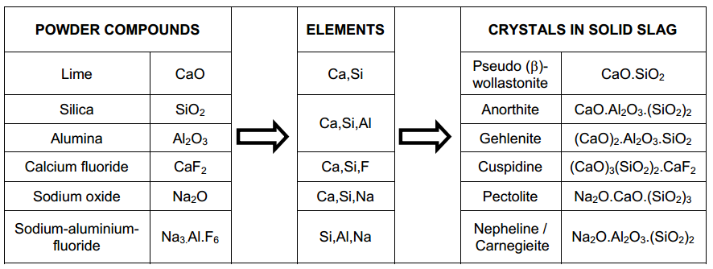

2.2.5.1.2 % Crystallinity

The % crystallinity (crystalline fraction) of mould powders can be calculated using the following equation which has been derived from the work published by Li et al. [104]:

$\%Crystallinity=141.1\left(\frac{NBO}{T}\right)-284.0 \left(1.12\right)$

The NBO/T ratio refers to the number of non-bridging oxygen ions per tetrahedrally coordinated atoms. It has been adopted to reflect the degree of depolymerisation of the slag. The NBO/T ratio is calculated as follows:

$$\frac{NBO}{T}=\frac{2X_{CaO}+2X_{BaO}+2X_{CaF2}+2X_{Na2O}-2X_{Al2O3}+6X_{Fe2O3}+\left(2X_{MgO}+2X_{MnO}\right)}{X_{SiO2}+2X_{Al2O3}+X_{TiO2}+2X_{B2O3}+\left(X_{MgO}+X_{MnO}\right)}$$
(1.13)

where x is mole fraction of the component in the mould powder. If MgO is higher than 7% and/ or MnO is higher than 4%, the bracket must be considered into the denominator. Otherwise the bracket must be included in the numerator [104, 105].

2.2.5.1.3 Crystallisation of Lime-Alumina Based Mould Powder

In the design and optimisation of lime-alumina based mould powders, special attention should be given to the crystallisation characteristics of the mould powder because it is generally accepted that the lubrication and horizontal heat transfer between the steel shell and the water cooled copper mould are significantly related to the crystallisation properties of mould powder. Much research has been done to reveal the crystallisation properties of conventional (lime-silica based) mould powders. However, limited research has been carried out related to the crystallisation behaviour of lime-alumina based mould powders so far.

As mould powder with high Al content crystallises easily, an appropriate amount of fluidiser should be added to adjust the lubrication and crystallisation properties of the mould powder. Li₂O and Na₂O are alkali oxides and can be used as fluxing agents in conventional mould powders, therefore they could play an important role in lime-alumina based mould powders too. Lu et al. [15] studied the crystallisation behaviour of lime-alumina based mould powders by using DHTT (Double hot thermocouple technology) and SHTT (Single hot thermocouple technology) and results indicate that Li₂O and Na₂O could inhibit the crystallisation of lime-alumina based mould powders by decreasing the initial crystallisation temperature and critical cooling rate. Wang et al. [85] also obtained similar results.

It has been stated that B₂O₃ is a powerful glass former and thus can restrain crystallisation of mould powders [106, 78, 107]. However, it is not commonly used in traditional mould powders apart from fluorine-free mould powders. Yan et al. [89] systematically investigated the effect of the replacement of CaF₂ with B₂O₃ on lime-alumina based mould powder properties and pointed out that B₂O₃ in addition can restrain the crystallinity and can have similar effects to CaF₂ additions on crystallisation of lime-alumina based powders.

TiO₂ is another uncommon component for traditional mould powders but it has the potential to decrease the steel-slag interaction during the high-Al steel casting as the stability of TiO₂ is higher than SiO₂. Li et al. [108]studied the effect of TiO₂ additions on crystallisation behaviour of lime-alumina based mould powders by using DTA (Differential thermal analysis) and the results indicated that the overall crystallisation of mould powders increased with the addition of TiO₂ ranging from 0 to 10 %wt.

The CaO/Al₂O₃ ratio has a significant effect on lime-alumina based mould powder properties. Therefore, the determination of the optimal CaO/Al₂O₃ ratio has a vital role in the design of lime-alumina based mould powder. Jiang et al. [14] revealed that the addition of alumina tends to enhance the crystallinity and critical cooling rate as the crystallisation temperature increases with an increase of CaO/Al₂O₃ ratio ranging from 0.8 to 1.2 in lime-alumina based mould powders. Some completed studies relating to the effect of different components on crystallisation of lime-alumina based powders is compiled in Table 7.

Table 7 Effect of addition of different components on the crystallisation of lime-alumina based mould powders
Addition | Influence on  Crystallisation | Comment | Reference
CaO/Al₂O₃ | Depends | Weaken (C/A ratio from 0.6 to 1.6)  Enhance (C/A ratio from 1.6 to 3.2) | Yan et al. [16]
Li₂O | Decrease | 2.48-7.08 %wt. Li₂O | Lu et al. [109]
B₂O₃ | Decrease | 4.7 - 10.4 %wt. B₂O₃ | Yang et al. [110]
BaO | Decrease | 0-10 %wt. BaO | Xiao et al. [78]
TiO₂ | increase | 0-10 %wt. TiO₂ | Li et al. [111]
ZrO₂ | Increase | 0-5 %wt. ZrO₂ | Jiang et al. [14]
Na₂O | Decrease | 6-12 %wt. Na₂O | Wang et al. [85]
F | Decrease | 5.17-9.17 %wt. F | Lu et al. [86]
MnO | Decrease | 0-3 %wt. MnO | Zhao et al. [10]

2.2.5.2 Viscosity

The viscosity (η) of the mould powder is probably the most important of the powder properties because;

- it affects the lubrication of the steel shell and in the turn of the consumption of powder
- slag entrapment can be minimized through the use of high viscosity powders
- SEN (Submerged entry nozzle) erosion rate is changed according to fluidity
- The pressure exerted by the molten slag can be seen in the mould/ steel shell channel, which affects the depth of the oscillation mark and can be minimised through the selection of powder viscosity [7].

Among the different properties of mould powder, viscosity plays a crucial role in the continuous casting process because it is primarily responsible for the lubrication behaviour of the mould powder. The viscosity of the slag is dependent on the structure of the melt. The viscosity of mould powders decreases with increasing concentration of network breakers such as CaO, MnO and FeO and decreasing concentration of network formers such as SiO₂ and Al₂O₃. Addition of some fluxes such as Na₂O, CaF₂ and B₂O₃ also decreases the viscosity of mould powders [112, 53].

The viscosity within the correct range can provide good lubrication between the slag and water-cooled mould and control the heat flux variation inside the mould which are all desirable to improve slab surface quality.

A wide range of techniques exists to determine, estimate or model the factors that can affect the viscosity of mould powders. The most widely used technique for measuring viscosity of mould powder is the rotating bob method. The rotating bob viscometer incorporates rotating a bob in the melt at a constant speed and measuring the required torque. This measurement is used the determine the viscosity temperature relationship. However, in order to estimate the viscosity of the mould powder, several experimental, thermodynamic and numerical models have been created. These models relate the viscosity to either or both of the temperature and chemical composition of the powder [58] [113].

Several techniques have been developed to determine, estimate or model the viscosity of mould powders at high temperatures. The methods used for measuring the viscosities of mould powders are given in Table 8. The most widely used technique for measuring viscosity of mould powder is the rotating bob method. The rotating bob viscometer incorporates rotating a bob in the melt at a constant speed and measuring the required torque. This measurement is used the determine the viscosity temperature relationship. However, in order to estimate the viscosity of the mould powder, several experimental, thermodynamic and numerical models have been created. These models relate the viscosity to either or both of the temperature and chemical composition of the powder [58] [113].

Table 8 Techniques used for measuring the viscosities of mould powders at high temperatures [114]

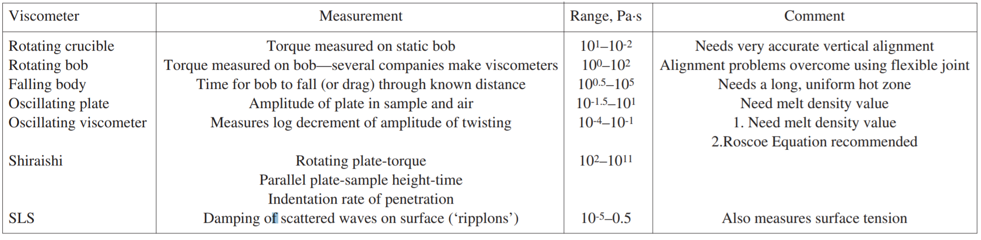

2.2.5.2.1 Estimation of Viscosity

A wide range of models have been developed for predicting the viscosity of mould powders from their chemical compositions. The models used for calculating the viscosities of mould powders are summarised in Table 9. The Riboud model is one of the oldest and simplest models available to calculate the viscosity of the mould slag and it is applicable to a wide range of different mould slags. The Riboud model divides the chemical composition of the mould powder into five different categories and sums of their mole fractions [115] [116].

- $X_{\text{SiO2}}=X_{SiO2}+X_{P2O5}+X_{TiO2}+X_{ZrO2} \left(1.14\right)$
- $X_{\text{CaO}}=X_{CaO}+X_{MgO}+X_{FeO}+X_{Fe2O3}+X_{MnO}+X_{CrO}+X_{ZnO}+X_{Cr2O3} \left(1.15\right)$
- $X_{\text{Al2O3}}=X_{Al2O3}+X_{B2O3} \left(1.16\right)$
- $X_{CaF2}$
- $X_{\text{Na2O}}=X_{Na2O}+X_{K2O}+X_{Li2O} \left(1.17\right)$

The temperature relation is given using Weymann equation:

$$In η\left(Pas\right)=InA.T+B.T \left(1.18\right)$$

where T is in Kelvin

$$A=exp⁡(-19.81+1.73.X_"CaO2+5.82.X_"CaF2"+7.02.X_"Na2O"-35.76X_"Al2O3" ) (1.19)$$

$$B=31140-23896X_{\text{CaO}}-46356X_{\text{CaF2}}-39159X_{\text{Na2O}}+68833X_{\text{Al2O3}} \left(1.20\right)$$

Table 9 Details of the models used to predict the viscosities of mould powders [114]

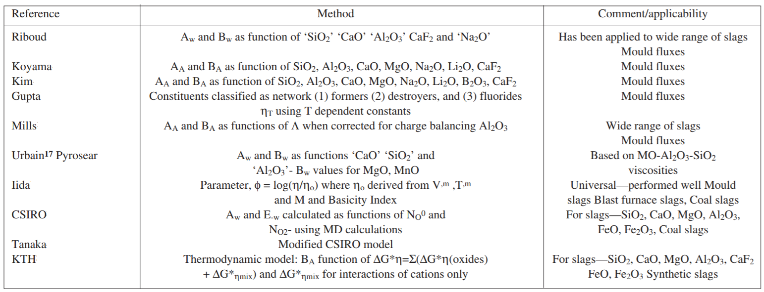

The Urbain model is another of the well-known slag viscosity models. This model is based upon the CaO-SiO₂-Al₂O₃ system and this model classifies the various powder components into the following categories:

$$Glass Formers$$
$$X_{G}=X_{SiO2}+X_{P2O5} \left(1.21\right)$$

$$Modifiers$$
$$X_{M}=X_{CaO}+X_{MgO}+X_{MnO}+X_{FeO}+X_{CrO}+X_{NiO}+X_{Na2O}+X_{K2O}+X_{Li2O} + {2X}_{TiO2} +{2X}_{ZrO2}+{3X}_{CaF2} \left(1.22\right)$$

$$Amphoterics$$
$$X_{A}= X_{Al2O3}+X_{Fe2O3}+X_{B2O3}+X_{Cr2O3} \left(1.23\right)$$

X_{G}, X_{M} and X_{A} need to be normalized by dividing them by (1+0.5X_{FeO1.5}+X_{TiO2} +X_{ZrO2} +X_{CaF2}) to obtain X*_{G} , X*_{M} and X*_{A}. Because the Urbain model works predominantly on the basis of M_{x}O this creates extra ions.

This model is related to the Weymann equation and A and B has been expressed by Urbain using the following equations:

$$η\left(dPas\right)=A.T.\exp\left(\frac{B}{T}\right) \left(1.24\right)$$

$$-InA=0.29.B+11.57 \left(1.25\right)$$

To calculate the B values, the following equations must be used where I values can be 0, 1, 2 or 3 and a, b and c are given constants [58] [116] [115].

$${ α}^{*}=\frac{X_{M}}{X_{M}X_{A}} \left(1.26\right)$$

$$B_{i}=α_{i}+b_{i}.α+c_{i}α^{2} \left(1.27\right)$$
$$B=B_{0}+B_{1}X_{SiO2}+B_{2}X_{SiO2}^{2}+B_{3}X_{SiO2 }^{3} \left(1.28\right)$$

$$B_{global}=\frac{X_{MnO}B_{MnO}+B_{CaO}X_{CaO}+B_{MgO}X_{MgO}}{X_{MnO}+X_{CaO}+X_{MgO}} \left(1.29\right)$$

The Riboud and Urbain models are based on the Weymann-Frankel equation and these models aim at a mould powder with less than 15% Al₂O₃ content. Therefore, there is a limitation in estimation of the viscosity of a mould powder with high Al₂O₃ content. Yan et al. [89] studied predictions of lime-alumina based mould powders and reported that the estimated viscosities with the Riboud and Urbain models present large deviations from experimental results. A rotational cylinder viscometer is utilised for measurement and the comparison of measured and calculated viscosities of mould powders with high Al₂O₃ can be seen in Figure 15. However, Zhang et al. [56] revealed that the agreements between calculated viscosities from the Riboud model and measured viscosities are feasible at low Al₂O₃/SiO₂ ratios but there is large deviation when the Al₂O₃ content exceeds 25% wt.

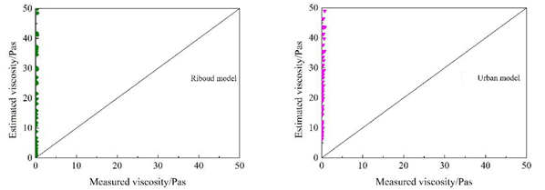

Figure 15 Comparison between experimental viscosities and those estimated by Urbain and Riboud models by Yan et. al. [89].

The viscosity of B₂O₃ containing mould powders have previously been evaluated by using the Riboud and Urbain models therefore, these two models are suitable for estimating the viscosity of B₂O₃ containing lime-alumina based mould powders. In these models, B₂O₃ is classified as a basic oxide in the Riboud model while it was considered as an amphoteric oxide in the Urbain model. Huang et al. [9] evaluated the effect of B₂O₃ on viscosity of slags and suggested that there is a large discrepancy between the calculated viscosity from the Riboud and Urbain models and measured values.

2.2.5.2.2 Viscosity of Mould Powder for Casting of Aluminium Containing Steels

It is known that any high dissolved Al in steel is apt to react with SiO₂ and other less stable oxides in conventional mould powders. As a result of this reaction, Si passes to the liquid steel and Al₂O₃ passes into the molten slag. The change in mould powder composition usually leads to variation in slag viscosity during the casting process and this variation in viscosity deteriorates the casting process and decreases the slab surface quality. As one of the most significant properties of metallurgical slags, viscosity is closely related to the composition of the mould powder and the temperature. So, the investigation into the effect of compositional change on mould powder properties is beneficial for the design of less reactive mould powder.

Scholars have researched the effect of CaO/SiO₂ ratio and Al₂O₃/SiO₂ ratio on properties of lime-silica based mould powders to inhibit the sudden change in viscosity. However, it has been pointed out that it is not easy to stabilise the viscosity of lime-silica based mould powders due to the reaction between the molten steel and slag [117]. It has been suggested that the determination of optimal CaO/Al₂O₃ ratio plays an important role in the design of mould powder for high-Al steel casting [73, 89]. Yan et al. [88] systematically studied the effect of CaO/Al₂O₃ ratio on the viscosity of lime-alumina based mould powders by utilising the rotational cylinder method and suggesting that as the CaO/Al₂O₃ ratio ranged from 0.6 to 3.2, the viscosity first decreases and then increases below 1270ºC. On the other hand, Blazek et al. [74] revealed that the viscosity of the mould powder decreased with the increase of CaO/Al₂O₃ ratio.

Kim and Sohn [118] analysed the influence of B₂O₃ and CaO/Al₂O₃ ratio on the viscosity of lime-alumina based mould powders with 12 %wt. Na₂O at varying temperatures and they found that an increase in the CaO/Al₂O₃ ratio and higher B₂O₃ concentrations decreased the viscosity.

Moreover, Li et al. [111] investigated the effect of TiO₂ addition on the viscosity of lime-alumina based mould powders by using the rotating spindle method and they concluded that the viscosity of the mould powder can decrease with increasing TiO₂ addition.

2.2.5.3 Heat Transfer

The amount of heat flux from the molten steel during the solidification is relatively dependent on the thermo-physical properties of the mould powders. During the process of continuous casting, different operational problems and some surface defects can occur because of the insufficient heat flux in the mould. For instance, longitudinal cracking can occur in the case of insufficient horizontal heat transfer between the strand and mould while vertical heat transfer affects the depth of the molten pool, lubrication, the depth of oscillation marks and pinhole formation. Therefore, it is important to understand the heat transfer phenomenon between the strand and the water cooled mould for the elimination of above mentioned casting problems. [42, 110].

2.2.5.3.1 Horizontal Heat Transfer

The horizontal heat transfer is a complex process, since there are two different competing mechanisms known as lattice conductivity (k_{c}) and radiation conductivity (k_{R}) [42]. Radiation conductivity involves the absorption, and re-emission of radiated energy as well as possible dominant heat transmission in glassy materials at elevated temperatures. It has been calculated by Mills et al. that k_{R}=10-30% k_{C} for the industrial slab casting process. The radiation conductivity (k_{R}) is expressed via the following equation:

$$k_{R}=\frac{16σn^{2}T^{3}}{3α} \left(1.30\right)$$

where α= absorption coefficient, σ= Stefan Boltzmann constant
n= refractive index (approx. 1.60) T= Thermodynamic temperature (K)
Figure 16 illustrates the resistance to heat transfer between the copper mould and steel shell (R*_{total}) with a series of resistances and Equation 13 is used to calculate R*_{total}.

$$R_{total}^{*}=R_{\frac{Cu}{Sl}}^{*}+{\left(\frac{d}{k}\right)}_{l}+{\left(\frac{d}{k}\right)}_{gl}+{\left(\frac{d}{k}\right)}_{cry} \left(1.31\right)$$

where R*_{Cu/Sl} = interfacial resistance
l =liquid layer, gl=glass layer and cry =crystalline layer
d =thickness

The interfacial resistance increases with:
- An increase in the thickness of the solid slag (d_{solid} =d_{gl}+d_{cry})
- crystallinity increase [7]

A decrease in the slag film thickness leads to an increase in horizontal heat transfer. A thicker slag film can also provide a perfect barrier for cooling and is more convenient for gas entrapment [4].

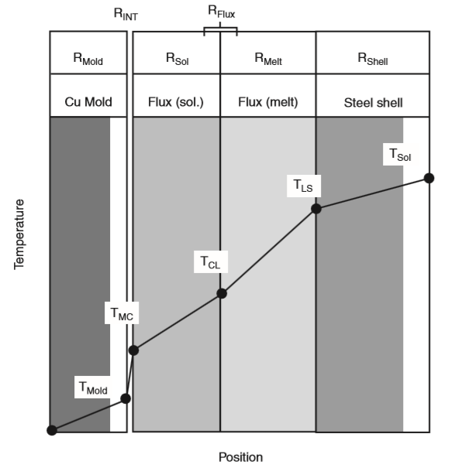
Figure 16 Schematic drawing of overall thermal resistance between steel shell and copper mould wall [12].

Some casting parameters can also affect the horizontal heat transfer. For instance, a casting speed increase and superheat increases heat transfer. In addition the steel grade and a large mould level fluctuation can also cause variability in heat transfer. Furthermore the liquid metal flow from the SEN (Submerged entry nozzle) impinges onto the steel shell and leads to variability in the thickness of the steel shell, which can result in longitudinal cracking [42].

2.2.5.3.2 Vertical Heat Transfer

Most of the casting parameters that have been mentioned above also affect the vertical heat transfer. As can be seen in Figure 17, a standing wave always forms on the steel surface and its size increases with an increase in the turbulence of metal flow. SEN height, port design and too much argon flow can also cause turbulence. Hence the mould powder may flow down and this gives rise to bad thermal insulation at the top of the wave, solidification of the meniscus and the formation of slivers. It has been reported that this problem can be solved by using exfoliating mould powders with reduced flowability.

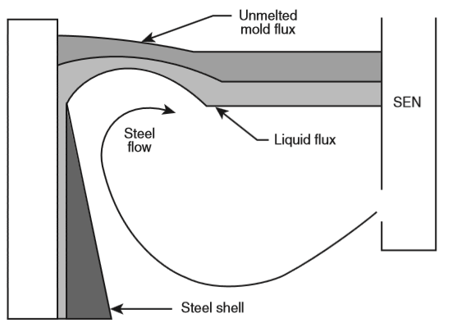

Figure 17 Schematic representation of the standing wave formation [12].

An increase in the depth of the mould powder layer can decrease the vertical heat transfer. In addition, powdered mould fluxes have approximately 20% better insulating properties than the granulated mould powders and can reduce vertical heat transfer too [42].

2.2.5.3.3 Heat Transfer Behaviour of Lime-Alumina Based Mould Powders

It is known that crystallisation behaviour of the slag has a dominant effect on heat transfer [119, 53] . The mould powders with a high crystallisation tendency are efficient in inhibiting heat withdrawn from the liquid steel owing to their high thermal resistance. High crystallinity in the slag decreases the transmissivity of the slag and increases air gaps between the mould wall and slag due to shrinkage which reduces the heat transfer.

There is limited research reporting on the effect of high alumina content on the heat transfer behaviour of mould powders. Wang et al. [85] observed the effect of Na₂O on crystallisation and heat transfer behaviour of lime-alumina based mould powders and the results indicate that the maximum and average heat flux increased with Na₂O addition. Zhao et al. [10] studied the effect of MnO on thermo-physical properties of mould powders used for high Al steel casting by using an infrared emitter technique (IET) and suggested that MnO additions could increase the steady state heat flux. Moreover, MnO addition to lime-alumina based mould powders can decrease the thickness of the crystalline layer and that will result in a higher total heat flux.

2.2.6 Mould Powder Related Product Defects and Operational Problems

2.2.6.1 Longitudinal Cracking

One of the main problems arising during the continuous casting of steel is longitudinal cracking, which is generally seen in carbon steel grades (where the carbon content varies between 0.008 and 0.14%) [4]. Longitudinal cracking may be classified into two categories:

- gross cracks (the length of strand is up to 400 mm long)
- subsurface cracks, shallow cracks that can be seen when casting peritectic steel grades [42]

It is possible to avoid longitudinal cracking through using the following procedures:
- increasing the mould powder pool thickness
- Allowing the casting parameter (ηV_{c}) to be between 3 and 7 in order to have optimal horizontal heat transfer and reduce the frictional forces between the steel shell and mould.

The best way to reduce longitudinal cracking is to decrease the thickness of the solidifying shell by reducing the magnitude of heat transfer in the mould [8].

2.2.6.2 Longitudinal Corner Cracking

The reasons for longitudinal corner cracking are identical to those of longitudinal cracking.. The solutions to this problem are identical to those for longitudinal cracking. An example of one of these solutions is the use of mould powders with high solidification temperatures [42].

An alternative solution has been proposed by Tai et al. [120] where they proposed that reducing superheat and metal flow into the corner can make cooling slower in the corners, which can be made possible by improving the SEN design.

2.2.6.3 Star Cracking

Star cracking is known to originate in the lower half of the mould. This problem is associated with infiltration of copper between the grain boundaries of the steel shell surface. During the casting process, the steel shell is in contact with the copper mould. Hence, some local melting of copper occurs. This copper pickup on the strand shell works as a barrier to the formation of solid intergranular bonds and star cracks form as the steel solidifies.

The following points contribute to the ways in which star cracking can be avoided:
- providing better lubrication between the copper mould and the steel shell
- coating the mould wall with high melting point metals (i.e. Ni, Mo and Cr) [4]

2.2.6.4 Sticker Breakouts

There are several causes of sticking problems but the main reason is lack of lubrication [7]. Sticker breakouts occur if the solidified steel shell is broken. Consequently, the liquid metal cannot be covered by the solidified steel shell. Figure 18 illustrates a normal steel shell formation and one broken by sticking. The figure also includes temperature –time graphics which present the behaviour of thermocouples for both normal shell formation and a distorted shell by sticking [1].

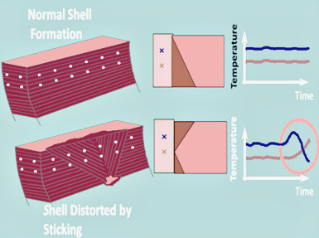

Figure 18 A normal steel shell formation and a distorted steel shell by sticking [1]

Faster casting speeds can also cause sticker breakouts. A change in casting speed induces a change in both horizontal and vertical heat transfer, and it leads to a change in the properties of the molten slag pool. As a result of this change, sticker breakouts occur when the steel shell is too thin [42].

Sticking breakouts can occur as a result of the following:
- decreasing slag viscosity related to an increase in Al₂O₃ content
- significant change of the liquid steel level
- changing in oscillation curves
- poor lubrication due to insufficient mould powder supply
- freezing of the meniscus because of poor thermal insulation [1].

2.2.6.5 Slag and Gas Entrapment

The principal cause of slag and gas entrapment is associated with metal flow turbulence in the mould [7]. As a consequence, some casting parameters such as metal flow speed, SEN immersion and argon flow rate are major reasons for these kinds of defects. Despite all this, it is possible to reduce these kinds of defects by manipulating the properties of the mould powders. Figure 19 shows an example of slag entrapment. Gas entrapment also has the same underlying mechanism.

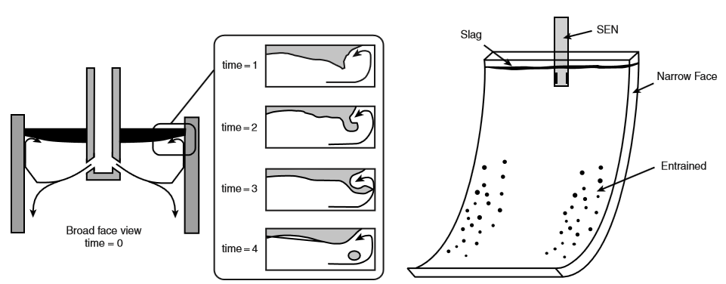
Figure 19 Schematic drawing of slag entrapment mechanism at high casting speed [121]

The best and most obvious way to prevent slag and gas entrapment is to decrease the metal flow turbulence. This can be possible by manipulating the submerged entry nozzle depth and port design, decreasing speed by using electromagnetic braking, decreasing argon flow or meniscus free casting [7]. It has been stated by Feldbauer et al. [122]that the best way to avoid slag and gas entrapment is to increase the interfacial tension between the metal and powder.

2.2.6.6 Oscillation Marks and Transverse Cracking

Oscillation marks can be described as horizontal indentations occurring at certain intervals on the surface of steel. These kinds of defects occur due to compression and tension during the casting process. It is possible to restore surface quality by grinding but the process of grinding consumes much time and can lead to a great deal of scrap especially when oscillation marks are deeply formed. The formation of oscillation marks cannot be completely prevented, but the depth of oscillation marks can be minimized to enhance product surface quality [4]. Figure 20 shows oscillation marks formed on the surface of a thin-slab steel casting.

Transverse cracking is associated with the formation of deep oscillation marks. Oscillation characteristics are the main factor affecting the depth of oscillation marks. Pressure in the slag film is also another important factor as it directly affects slag viscosity. The control of viscosity can decrease both the pressure and therefore the depth of oscillation marks. The following procedures can also decrease the depth of oscillation marks:

- Reducing the length of the meniscus by decreasing the vertical heat transfer
- Increasing the strength of the steel shell by increasing horizontal heat transfer [7].

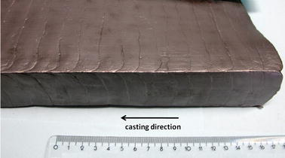

Figure 20 Oscillation marks on the steel surface [123]

EXPERIMENTAL APPARATUS AND METHODOLOGY

3.1 Materials

In this study, three different series of mould powders were designed and produced from pure chemical reagents CaO, Al₂O₃, SiO₂, TiO₂, B₂O_{3,} CaF₂ and ZrO₂ (the purity of all chemicals was >99%) along with Na₂CO₃ and Li₂CO₃ as the source of Na₂O and Li₂O. The chemical composition (wt. %) of the designed powders are given in Table 13,Table 17 and Table 22. The series of mould powders in Section 6 are called M series and B₂O₃ content in this series varies from 0 to 15 weight percent. The mould powders in Section 4 are designated C series, and the CaO/Al₂O₃ ratio varies from 1 to 3 in this series. The mould powders in Section 5 are designated T series and the powders in this series contain zero to fifteen weight percent TiO₂.
The chemical compositions of the lime-alumina based mould powders are listed in Table 13, Table 17 and Table 22 and these are the targeted chemical compositions prior to melting. As it is discussed in the results section, these compositions may be different after melting due to evaporation losses.
These mould powders have been designed after reviewing published worked for lime-alumina based mould powders. Some of this previous work has been listed in Table 5. After reviewing previous work, compositions which have not yet been investigated and new compositions were created in order to analyse the effect of different components on the properties of lime-alumina based mould powders. The weight percentage of each component for these designed mould powders were selected systematically and each series aimed to investigate the effect of different components and different weight percentages on the properties of powders. Namely:

- C-series Effect of CaO/Al₂O₃ ratio on physical properties of CaO-Al₂O₃ based mould powders
- T-series Effect of TiO₂ ratio on physical properties of CaO-Al₂O₃ based mould powders
- M-series Effect of B₂O₃ and CaO/Al₂O₃ ratio on physical properties of CaO-Al₂O₃ based mould powders

3.2 Methods for Measuring Crystallinity

Several methods have been used previously to measure the crystallinity of mould powders such as thermal expansion measurement, heat capacity measurement, X-Ray Diffraction measurements and metallographic determination [124]. In this study, crystallinity variations with each powder sample have been analysed using metallographic determination and X-Ray Diffraction measurements. The crystallinity of each powder sample is also estimated by a % crystallinity model.

3.2.1 Sample Preparation

Due to the possibility of having carbon in the raw powders, all mould powders were decarburised at 650ºC for 16 hours in air. The samples were prepared by melting 30g of raw powders in a platinum crucible. The mould powders were melted at 1500ºC in an induction furnace for 20 minutes to eliminate bubbles and homogenise their chemical composition. After that, the molten powder was poured into a stainless-steel crucible, which was in an ice-water bath. The obtained glassy disks were dried and cut in half, with one half used for metallographic determination and the other half for X-Ray Diffraction.

Figure 21 Experimental flow chart for crystallinity measurements

3.2.1.1 Chemical Composition Variation in Slag Samples

Through sample preparation stage, there may be some variation on slag chemistry due to volatilisation losses. The reactions between slag and steel also cause chemistry variation during the casting and it has been discussed in steel-slag interaction part in this thesis.
There is only one study which focused on the slag chemistry changes after premeeting. Yan et al. [76] investigated the effect of slag compositions and additives on the properties of mould powders for high -Al steel casting. They designed the mould powders which are listed in Table 10. Selected four designed mould powders were pre-melted in graphite crucibles at 1350 ºC for 1 hour and then quenched into water. The bulk slag samples dried and then crushed into powder size for chemical composition analyses by X-ray Fluorescence. The chemical compositions of selected pre-melted mould powders are given in Table 11. As it can be seen the variation in each chemical composition are within 2 wt.%. Authors are also noted that variation in slag chemistry is relatively small and it is reasonable to assume that this variation in slag composition will introduce negligible effect on experimental results. It is thought that the chemical composition variation between designed mould powder and pre-melted mould powder are also within 2 wt.% in this study.

Table 10 Chemical compositions of the designed mould powders (in mass percent) [76]
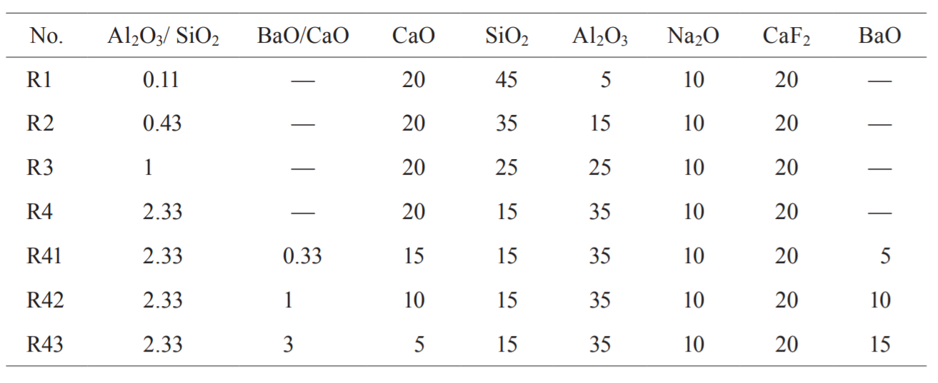

Table 11 Chemical composition of the selected pre-melted mould powders (in mass percent) [76]
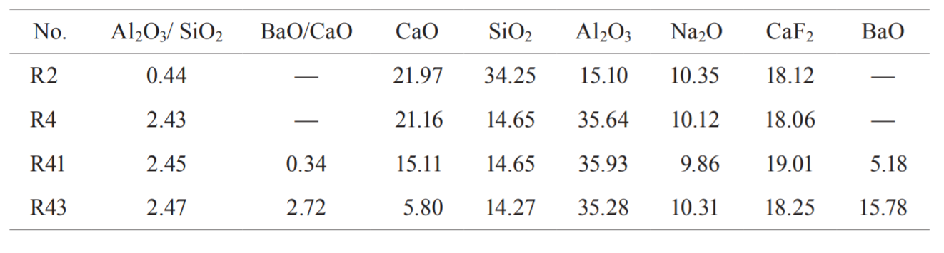

3.2.2 Metallographic Determination

In this method, the obtained glassy discs, after melting, were sectioned using a diamond blade on a SECOTOM-50 and mounted by a cold mounting technique in 40mm diameter cups. Then, the samples were ground and polished using 1µm solution before etching. Etching was done with HF acid at the concentration of 2.5% for 2 seconds. The samples were then observed with an optical microscope and the % crystallinity of samples was calculated by revealing the crystalline and glassy parts in the samples. Olympus Stream image analysis software was used to be able to determine the amount of glassy and crystalline fractions of the samples.

The main advantage of this method is that it allows us to measure the quenched layers in opposition to some other % crystallinity measurement methods. The problem with this method was the uncertainty caused by the occurrence of a transition zone (glass + crystalline) in some samples.

3.2.3 X-Ray Diffraction Measurements

The principle of the X-Ray Diffraction technique is based on Bragg’s law [125].
$$2d sinθ=n λ 2.1$$

where d is the distance between the atomic layers, λ is the wavelength of the X-Ray beam, ϴ is the scattering angle and n is a positive integer (n = 1, 2, 3 …).

Figure 22 illustrates the principle of X-Ray Diffraction. X-Ray Diffraction is a common analytical technique primarily used to identify phases in a crystalline material. During the analysis, the X-Rays are directed onto the sample with a specific wavelength, such as Cu, Fe, Mo. X-Rays reflected from the crystals at different angles, and the diffracted beams between 0 and 90⁰ are recorded.
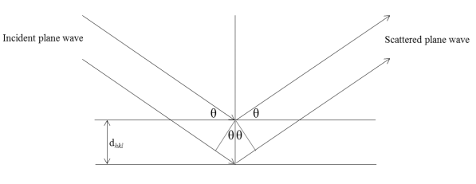
Figure 22 Schematic illustration of X-ray Diffraction beam [126]

In this study, the solidified samples after melting were crushed and ground with a mortar and pestle and then sieved using a 300-mesh screen to be able to use on the X-Ray Diffractometer. A Bruker D2 Phaser was employed for XRD analysis and results were analysed using the Diffrac.Suite software package. The X-ray diffraction data was collected in a range of 2ϴ =10 to 80 deg with rate of 10 deg/ min using CuK_{α} radiation (1.54184 A).

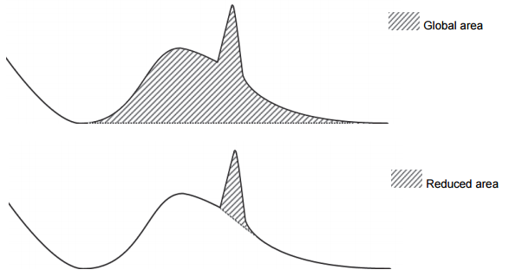

Figure 23 Global and Reduced area [127]

The % of crystallinity in the mould powder samples was calculated from its XRD scan. XRD patterns of a glassy phase do not give peaks but give a ‘bump’. The percentage of amorphous phase can be calculated with the help of the area under this bump and the area under the peaks [128]. The formula used to calculate the % of amorphous phase and % of crystallinity is as follows [127]:
$$\% Amorphous=\frac{Global area-Reduced area}{Global area}x100$$

$$\% Crystallinity=100-\% Amorphous$$

3.2.4 % Crystallinity

Li et al. [129] tried several parameters to determine the % crystallinity and suggested that the number of non-bridging oxygen per tetrahedrally-coordinated atom (NBO/T ratio) is the best option to determine the crystallinity fraction of mould powders from the composition after comparing the experimental results with the results obtained by the %crystallinity model.

Autor heated 20gr decarburised mould powder up to 1300 ºC and held there for 20 min. It is then poured on stainless steel plate. The solidified sample sectioned and the thickness of crystallised layer was measured to determine the % crystallinity. Related to this test, it should be noted that solidified slag sample may not be homogeneous. However, local inhomogeneities in solidified slag sample may also cause variation in %crystallinity as this test carried out with very small samples. As result of all these points, author suggests that there will be uncertainties associated with the measured % crystallinity along with some systematic errors arising from the measurement method.

The other reason for the uncertainties associated with the measured data could be the size of the area viewed. As the technique uses a small area of the sample to measure the crystallinity, local inhomogeneities could cause variation in crystallisation of sample. Therefore, the viewed area of the sample may not represent the whole sample.

Li et al. [129] is also plotted the % crystallinity of mould powders as a function of NBO/T ratio and Figure 24 shows that the critical point is NBO/T=2 as below this critical point, the slag samples have very low crystallinity while above this critical point, the % crystallinity is increasing with increasing NBO/T.

The percentage of crystallinity in the sample powders was calculated using the following equation:
$$\%Crystallinity=141.1\left(\frac{NBO}{T}\right)-284.0$$

The NBO/T ratio refers to the number of non-bridging oxygen per tetrahedrally-coordinated atom. It has been adopted to reflect the degree of depolymerisation of the slag. The NBO/T ratio is calculated as follows:

$$\frac{NBO}{T}=\frac{2X_{CaO}+2X_{BaO}+2X_{CaF2}+2X_{Na2O}-2X_{Al2O3}+6X_{Fe2O3}+\left(2X_{MgO}+2X_{MnO}\right)}{X_{SiO2}+2X_{Al2O3}+X_{TiO2}+2X_{B2O3}+\left(X_{MgO}+X_{MnO}\right)}$$

where x is mole fraction of the component in the mould powder. If MgO is higher than 7% and/ or MnO is higher than 4%, the bracket must be considered into the denominator. Otherwise the bracket must be included in the numerator [58, 53].

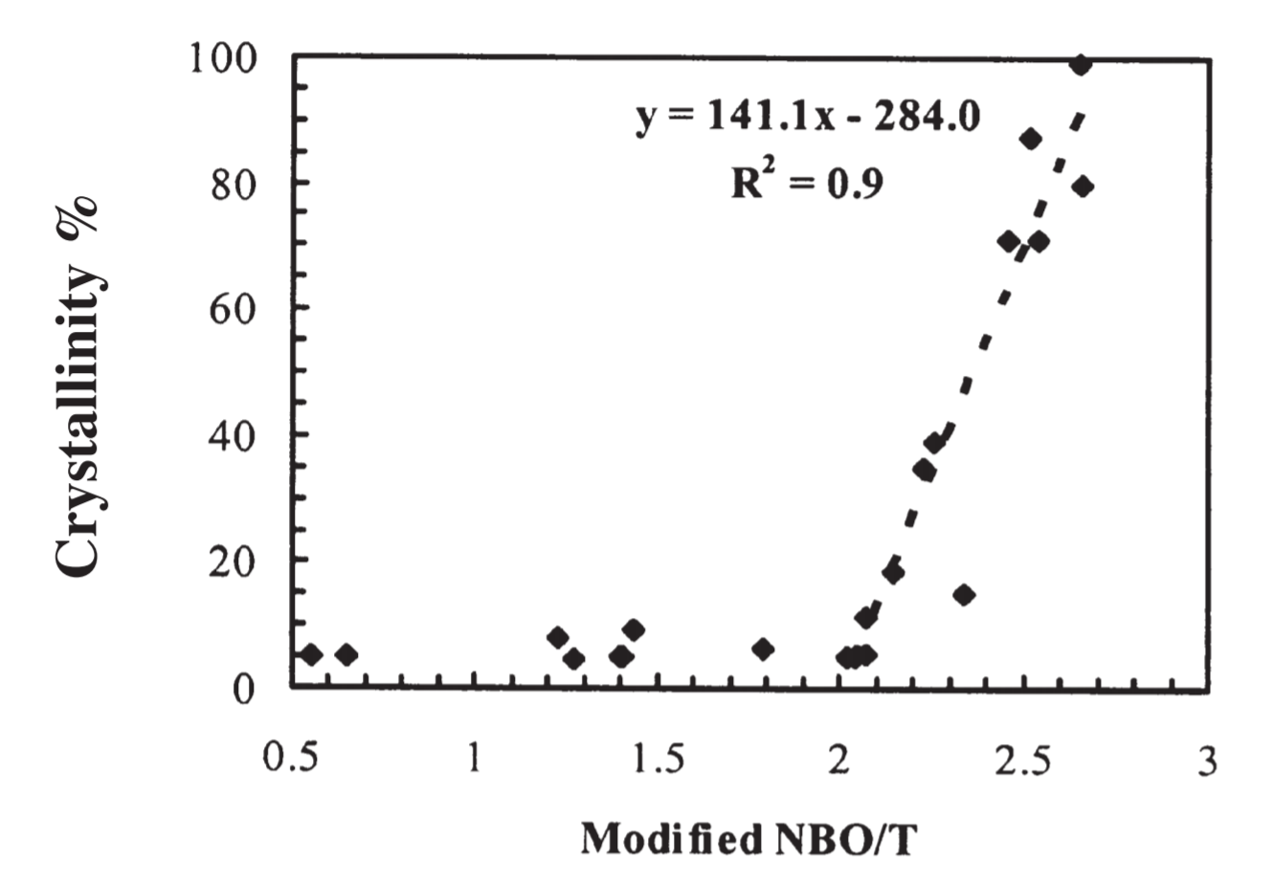
Figure 24 The %Crystallinity as a function of modified NBO/T ratio [53]

3.3 Methods for Examination of Melting and Crystallisation behaviour

3.3.1 Hot Stage Microscopy

A Misura 3.32 Heating Microscope at the Materials Processing Institute (MPI) was employed to determine the melting temperature of the mould powder. Figure 25 shows the Misura heating microscope used in this study. The shape of the sample is quite important and needs to be made to the correct dimensions.

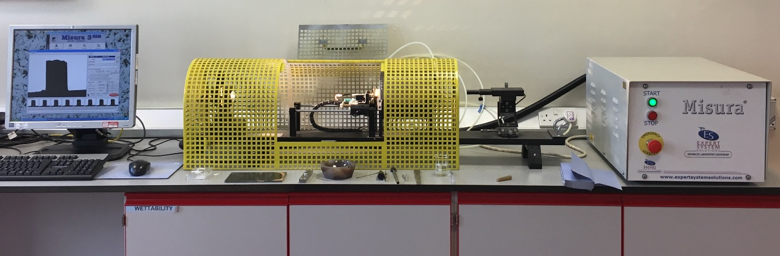
Figure 25 Misura 3.32 HSM heating Microscope in MPI

The raw powders were dampened with distilled water to be able to shape a sample which was cohesive enough for compactness. The powders were shaped into a 3mm high and 2mm diameter cylindrical mould with the help of a pressing tool and was placed on a small alumina plate. Then, this alumina plate was moved into the tube furnace with help of two rods. Figure 26 illustrates the schematic of the heating microscope.

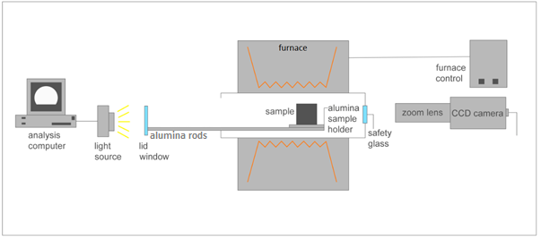
Figure 26 Schematic of Misura Heating Microscope

First, the sample was heated at a rate of 50ºC/min to 900ºC and then heated at a rate of 6ºC/min until it was completely melted in the air. The thermal cycle of this experiment is shown in Figure 27. The rate of heating and the changes in the sample shape was automatically recorded by an image analyser software during the heating. The melting temperature of each powder sample was detected by the software once the height of sample was reduced to 15% of its original height.
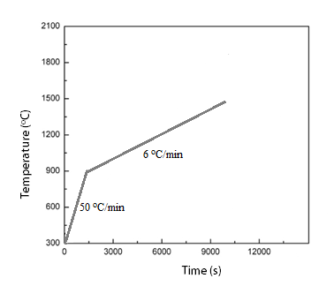
Figure 27 Thermal profile of heating microscope test

3.3.2 Simultaneous Thermal Analysis (STA)

Simultaneous Thermal analysis (STA) refers to the simultaneous application of two or more types of thermal analyses. Using this instrument, it is possible to get both Thermogravimetry (TGA) and Differential Scanning Calorimetry (DSC) measurements for a single sample at the same time. This means different kind of sensors are connected to the one sample [130, 131]. Figure 28 shows an idealised trace from a Simultaneous Thermal Analyser which combines TGA and DSC.
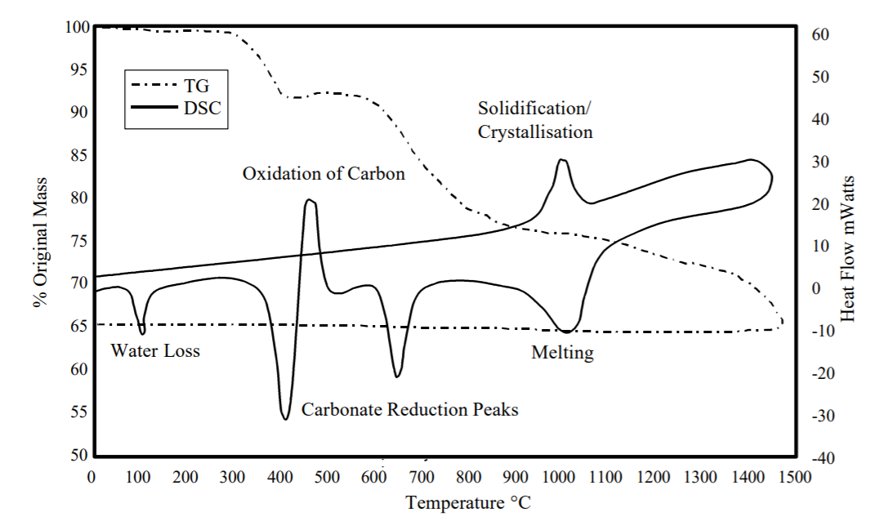
Figure 28 Idealised Simultaneous Thermal Analysis test results [132]

In this study, a TA Instruments Q600 SDT was employed to examine the crystallisation behaviour and determine the melting and glass transition temperatures of the mould powders. Samples of 30 mg were placed in a platinum crucible and heated from room temperature to 1500ºC at a heating rate of 10ºC/min in an argon atmosphere. Samples were held for 60 seconds at 1500ºC to homogenise the slag chemical composition and eliminate the bubbles. Subsequently, the molten slags were cooled to room temperature at different cooling rates of 5ºC/min, 10ºC/min, 15ºC/min and 20ºC/min. CCT (Continuous Cooling Transformation) diagrams were constructed by recording the relationship between time and temperature. Thermal profiles of the CCT experiments can be seen in Figure 29.

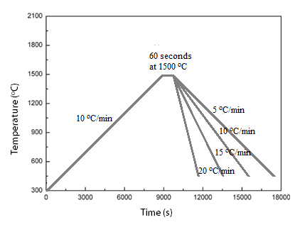
Figure 29 Thermal profile of CCT experiments

3.4 Methods for Measuring Viscosity

To be able to select the most convenient mould powder for continuous casting, the knowledge of various physiochemical properties of the mould powder such as viscosity and break temperatures is required. There has been extensive research to determine, estimate or model the factors that can affect the viscosity of mould powders. To estimate the viscosity of mould powder, several experimental, thermodynamic and numerical models have been created. These models relate the viscosity to either or both the temperature and the chemical composition of the powder [58] [113]. In this study, the rotating viscometer method and the Inclined Plane Test (IPT), which are detailed below, were applied to measure the viscosity of the mould powders. The Riboud and Urbain models were also applied to the designed mould powders in an attempt to estimate the viscosity.

3.4.1 Inclined Plane Test (IPT)

The inclined plane test is a simple method which is used to measure the viscosity of mould powders at 1300ºC. A V-shaped stainless-steel plate is arranged at 14º inclination with the help of a supporting block. The experimental set-up can be seen in Figure 30. The inclined plane test of the mould powders was carried out by the author at the Materials Processing Institute.

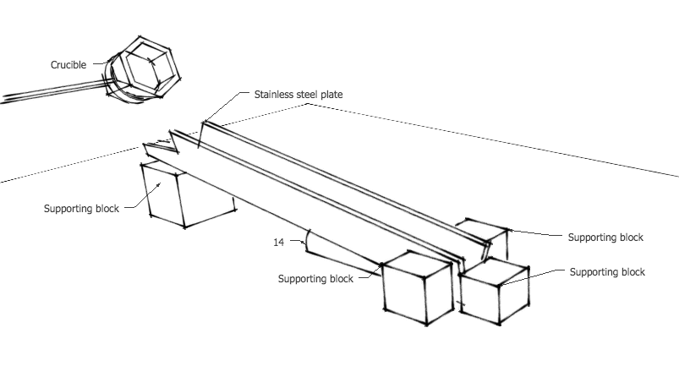
Figure 30 The experimental set-up of the Inclined Plane Test

The mould powders were decarburised at 700ºC for 12 hours. 15 g of decarburised mould powder was placed in a graphite crucible and held in a muffle furnace at 1300ºC. After 10 minutes, the crucible was removed from the furnace and the molten slag was directly poured over the top of the inclined plane. The molten slag flows down the inclined plane until it loses its fluidity. It forms as a ribbon on the inclined plane and the viscosity of mould powder at 1300ºC was calculated from the length of the slag ribbon.
The relationship between powder viscosity and ribbon length is as follows:
$η=C_{1}\exp\left(\frac{C_{2}}{L_{R}}\right) 2.2$

where η is viscosity of mould powder in dPa.s, L_{R} is the length of the ribbon and C₁ and C₂ are constants, which are determined as 0.2656 and 470 respectively [133].

3.5.2 Rotational Viscometry

High temperature viscosity measurements for C1, C3 and C3 mould powders were carried out by the author in the mould powder lab at the Materials Processing Institute. A Bahr VIS 403 HF rotational viscometer was utilised to determine the viscosity of selected mould powders. Figure 31 shows the instrument used for these experimental measurements.

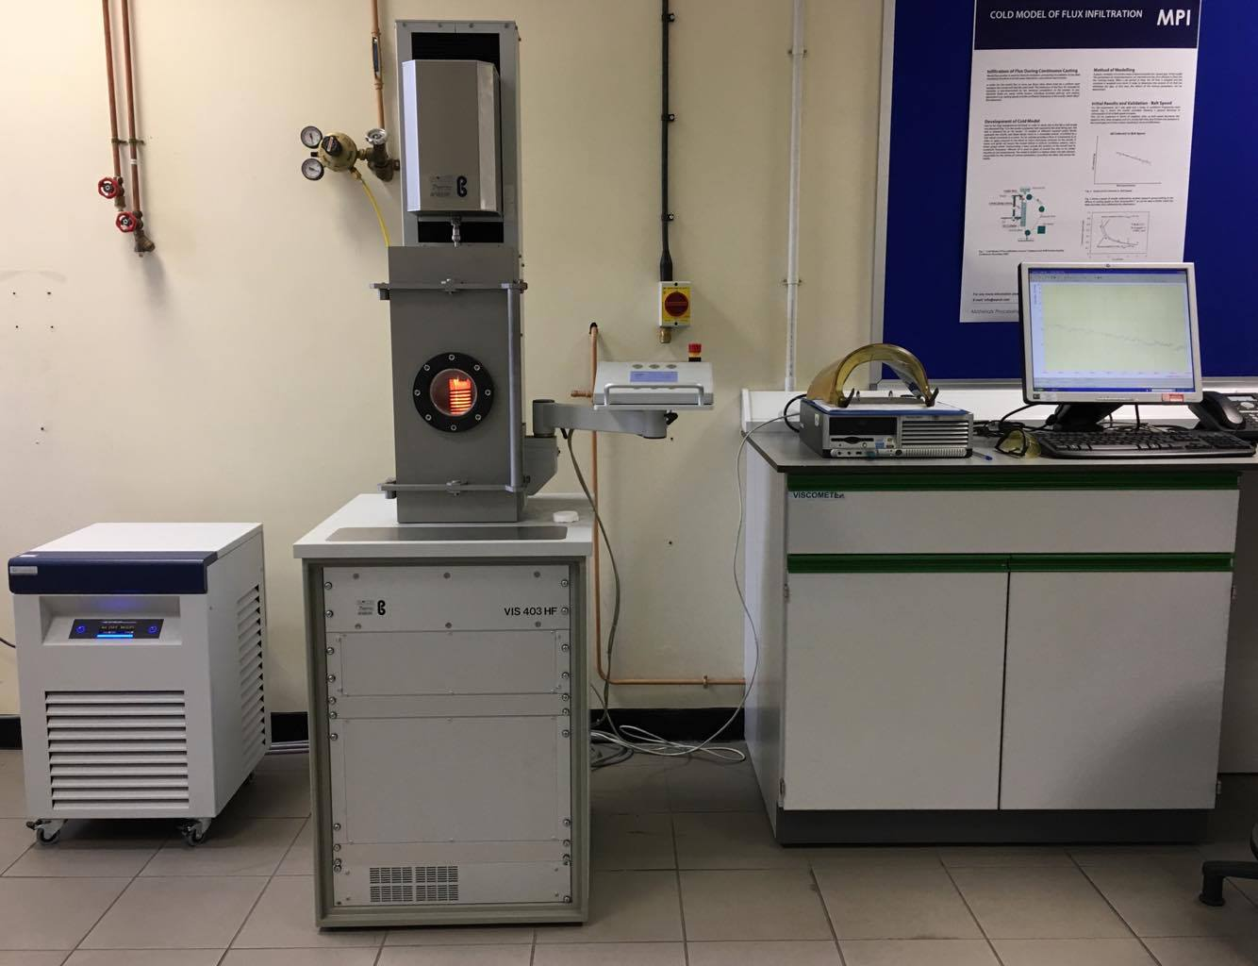
Figure 31 Bahr VIS 403 HF rotational viscometer

This machine measures the dynamic viscosity of materials with Newtonian behaviour such as slags. The viscosity of a sample is measured by measuring the torque of a rotating bob which is submerged in a liquid sample under a controlled temperature. The general principle for this instrument is to heat up the sample until the selected temperature is reached (usually above the melting temperature of the sample) and immerse the rotating bob in the liquid. The temperature of the sample is lowered systematically, and the torque is recorded synchronically. Once it reaches the predetermined maximum torque, the test stops automatically, and the rotating bob is removed from the crucible. The experimental set-up of the rotating bob viscometer is shown in Figure 32.
For this test, the mould powders were decarburised at 650ºC for 12 hours. The decarburised powders were melted at 1300ºC for 10 minutes and then molten slag was quenched onto a steel plate. The samples were broken into small pieces and 24g of the sample was placed into the viscometer in a Pt-Rd crucible. The crucible was heated up to 1400ºC and the rotating bob immersed into the molten slag. The temperature was lowered at 10ºC/min and data was collected simultaneously by the software until it reached the maximum torque of 49 mNm.

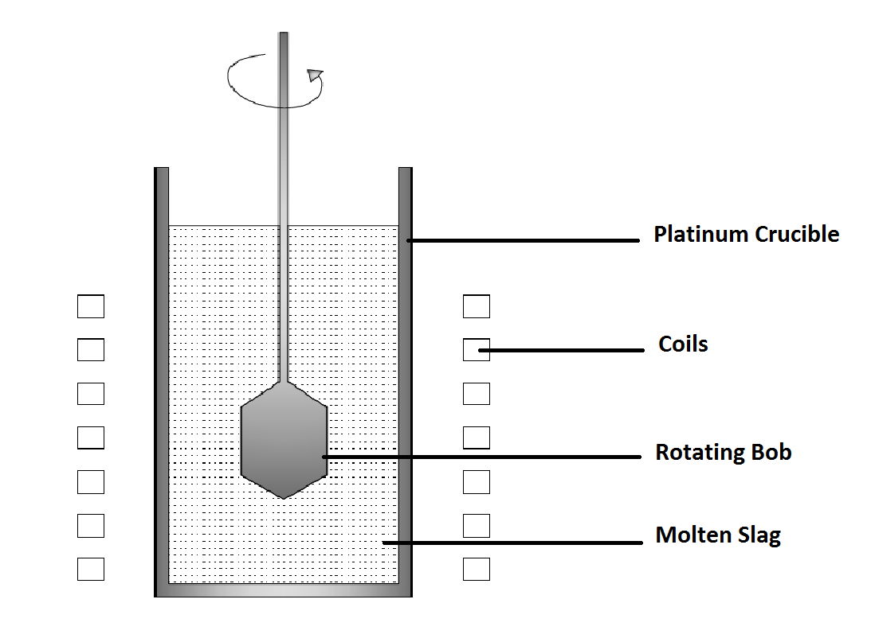
Figure 32 Schematic diagram of experimental set-up for the rotational viscometer test

3.5.3 FactSage

FactSage is well-known software in the field of thermochemistry, and was introduced in 2001 as the fusion of FACT-Win and ChemSage packages [134, 135]. This software package consists of a series of databases, calculation, manipulation modules and information that allow us to simulate thermochemistry of metallurgical processing, manipulate compounds, plot binary and ternary phase diagrams and access solution databases [136].

The developed model for viscosity calculations is distinct from other viscosity prediction models as it is directly related to the structure of the melt and the structure is calculated by using Modified Quasichemical Model [137].

The FactSage software package was used to calculate the viscosity of the designed mould powders at 1100ºC, 1200ºC, 1300ºC and 1400ºC from the chemical composition of the mould powders. During the last decade, the accuracy of software has been extensively improved for slag systems due to the data provided from academia and industrial collaborators. Thus, the database gives accurate estimations of the viscosity of mould powders [136].

The use of viscosity models has been checked against experimental results available for two different databases called Melts and Glasses [136, 138, 137]:

- Database for melts: Al₂O₃–B₂O₃–CaO–FeO–Fe₂O₃–K₂O–MgO–MnO–Na₂O–NiO–PbO–SiO₂–TiO₂–Ti₂O₃–ZnO–F

- Database for glasses: Al₂O₃–B₂O₃–CaO–K₂O–MgO–Na₂O–PbO–SiO₂

For these calculations, the database for melts was selected because this is valid for supercooled and liquid slags. This database generally corresponds to temperatures above 900ºC. Data entry for lithium oxide on FactSage is not available. Therefore, the lithium oxide content of the mould powder was added to sodium oxide for the viscosity calculations.

3.5.4 Riboud Model

The model is one of the oldest and simplest to calculate viscosity of mould slag and it is applicable to a wide range of different mould slags. The Riboud model divides the chemical composition of mould powder into five different categories and sums of their mole fractions [115] [116]. The major problem with this model is that it fails to differentiate between various cations. For example, MgO on a mole fraction basis is treated as if it was CaO [115].
- $X_{\text{SiO2}}=X_{SiO2}+X_{P2O5}+X_{TiO2}+X_{ZrO2}$
- $X_{\text{CaO}}=X_{CaO}+X_{MgO}+X_{FeO}+X_{Fe2O3}+X_{MnO}+X_{CrO}+X_{ZnO}+X_{Cr2O3}$
- $X_{\text{Al2O3}}=X_{Al2O3}+X_{B2O3}$
- $X_{CaF2}$
- $X_{\text{Na2O}}=X_{Na2O}+X_{K2O}+X_{Li2O}$

The temperature relation is given using the Weymann equation:
$In η\left(Pas\right)=InA.T+B.T$ where T is in Kelvin
$$A=exp⁡(-19.81+1.73.X_"CaO2+5.82.X_"CaF2"+7.02.X_"Na2O"-35.76X_"Al2O3")$$
$$B=31140-23896X_{\text{CaO}}-46356X_{\text{CaF2}}-39159X_{\text{Na2O}}+68833X_{\text{Al2O3}}$$

3.5.5 Urbain Model

The Urbain model is one of the well-known slag viscosity models. This model is based upon CaO-SiO₂-Al₂O₃ system and this model classified the various powder components into the following categories:
$$Glass Former X_{G}=X_{SiO2}+X_{P2O5}$$
$$Modifiers X_{M}=X_{CaO}+X_{MgO}+X_{MnO}+X_{FeO}+X_{CrO}+X_{NiO}+X_{Na2O}+X_{K2O}+X_{Li2O} + {2X}_{TiO2}+{2X}_{ZrO2}+{3X}_{CaF2}$$
$$Amphoterics X_{A}= X_{Al2O3}+X_{Fe2O3}+X_{B2O3}+X_{Cr2O3}$$

X_{G}, X_{M} and X_{A} need to be normalized by dividing them (1+0.5X_{FeO1.5}+X_{TiO2} +X_{ZrO2} +X_{CaF2}) to obtain X*_{G} , X*_{M} and X*_{A}. Because Urbain models work is predominantly based on M_{x}O, this creates extra ions.

This model related to the Weymann equation, and A and B, has been expressed by Urbain using the following equation:
$$η\left(dPas\right)=A.T.\exp\left(\frac{B}{T}\right)$$
$$-InA=0.29.B+11.57$$

To calculate the value of B, the following equations must be used where the values can be 0, 1, 2 or 3 and a, b and c are given constant [58] [116] [115].

$$α^{*}=\frac{X_{M}}{X_{M}X_{A}}$$
$$B_{i}=α_{i}+b_{i}.α+c_{i}α^{2}$$
$$B=B_{0}+B_{1}X_{SiO2}+B_{2}X_{SiO2}^{2}+B_{3}X_{SiO2}^{3}$$
$$B_{global}=\frac{X_{MnO}B_{MnO}+B_{CaO}X_{CaO}+B_{MgO}X_{MgO}}{X_{MnO}+X_{CaO}+X_{MgO}}$$

The main advantage of the Urbain model is that it takes account different chemical compositions and individual components while keeping the strengths of the model’s assumptions [139]. Kekkonen et al. [115] reported that parameters used in Urbain models are agreed with more than 3000 experimental results covering unary, six binary and ternary systems and liquids in the whole of the quaternary systems.

3.5 Examination of Steel-Slag Interaction

This part of study was aimed at investigating the mass transfer between the steel and slag. Steel-slag interaction test were carried out in the Quarrell laboratory in the Department of Materials Science and Engineering. shows the chemical composition of the high-aluminium TRIP steel which was used in this test.

Table 12 shows the chemical composition of the high-aluminium TRIP steel which was used in this test.

Table 12 Chemical composition of high-Al TRIP steel obtained from X-ray fluorescence

Composition ( wt-%) | Fe | Mn | Al | Si | Gd
Steel | 96.672 | 1.345 | 0.954 | 0.667 | 0.287

For this study, an alumina crucible (99.8% purity) with 20 mm height and 19mm diameter was employed. First, the TRIP steel was cut into small pieces and approximately 3g of steel was added into the alumina crucible and then the rest of the crucible was filled with mould powder (~ 5gr); this alumina crucible was then placed into the furnace. The crucible was kept in the furnace at 1500ºC for 20 minutes and then it was taken out from the furnace and cooled. A schematic diagram of the steel-slag test is shown in Figure 33. Crucibles were then cut into halves by a diamond blade on the SECOTOM-50 and mounted by the cold mounting technique into 40mm cups. Then they were ground and polished down to1µm before the X-ray Fluorescence tests were carried out. This test was applied for each mould powder composition.
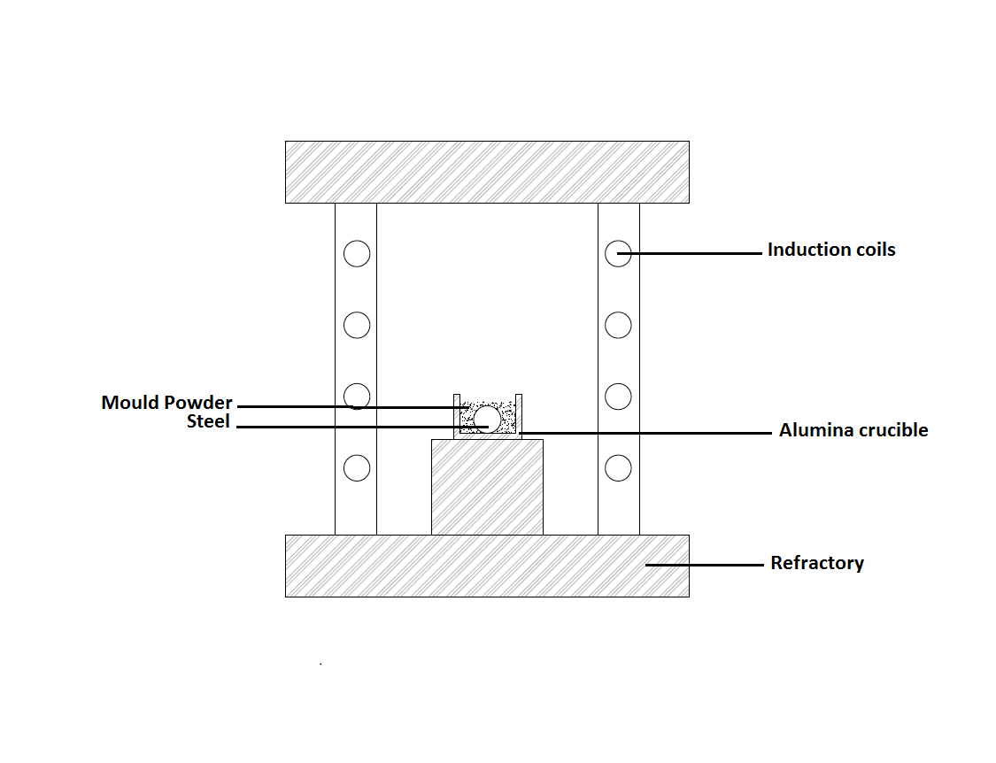
Figure 33 Schematic of steel-slag interaction test setup

3.5.1 X-ray Fluorescence Test

A Panalytical Zetium X-ray Fluorescence analyser in the XRD small research facility at the University of Sheffield was employed for chemical analysis of materials. This instrument has a 4kW rhodium X-Ray tube and automated sample chamber for sample input-output. The platform sensitivity is enhanced for high count rate by integration of EDXRF (Energy Dispersive XRF) and WDXRF (Wavelength XRF).

As X-ray Fluorescence relies on high quality calibration, the ED gain control and Drift Omnian standards have been run before the tests for checking and updating calibration tables. During the calibration’s tests, the data is compared against the factory test of the same standards and used to scale our X-Ray Fluoresce spectra accordingly. As X-ray tube of XRF is ageing, its intensities decrease, and the quantifications also decreases. Therefore this can make obtained data obsolete and meaningless. Running the ED gain correction and Drift Omnian standards deals with this and makes sure obtained data is accurate and precise [140].

This instrument is also capable of small spot analysis. This feature enables the user to choose multiple user-selected spots on the sample through a camera and obtain the spots chemical analysis. Figure 34 illustrates a picture of the steel-slag interaction test sample at the stage of deﬁning the pattern of small spots.

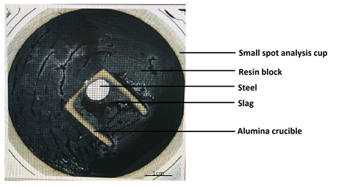
Figure 34 Steel-slag interaction test sample on CAM position for small spot analysis

3.5.2 Inductively Coupled Plasma Mass Spectrometer (ICP-MS)

The inductively coupled plasma technique is called “wet sampling method” as samples are dissolved in liquid for analysis [141]. This instrument uses an inductively coupled plasma to produce ions which are detected and analysed with a mass spectrometer. This instrument also has the capability to identify a range of metals at the concentrations below one part in 10¹² [142, 143, 144].A schematic of the inductively coupled plasma mass spectrometry is presented in Figure 35.

Crompton [145] pointed out that inductively coupled plasma mass spectrometry has important advantages over optical procedures in terms of limits of detection. This method also has better detection limits than conventional fluorometric techniques.

The inductively coupled plasma tests of our steel samples have been carried out by AMG Superalloys UK Limited. The steel samples were removed from the alumina crucible after the steel-slag interaction tests and analysed in an ICP instrument after dissolving them in HF acid. Through these tests, not only the Al, Si and Mn content of steel samples but also the boron content have been obtained and this was the main advantage of this technique over X-ray Fluorescence (XRF) in this study.

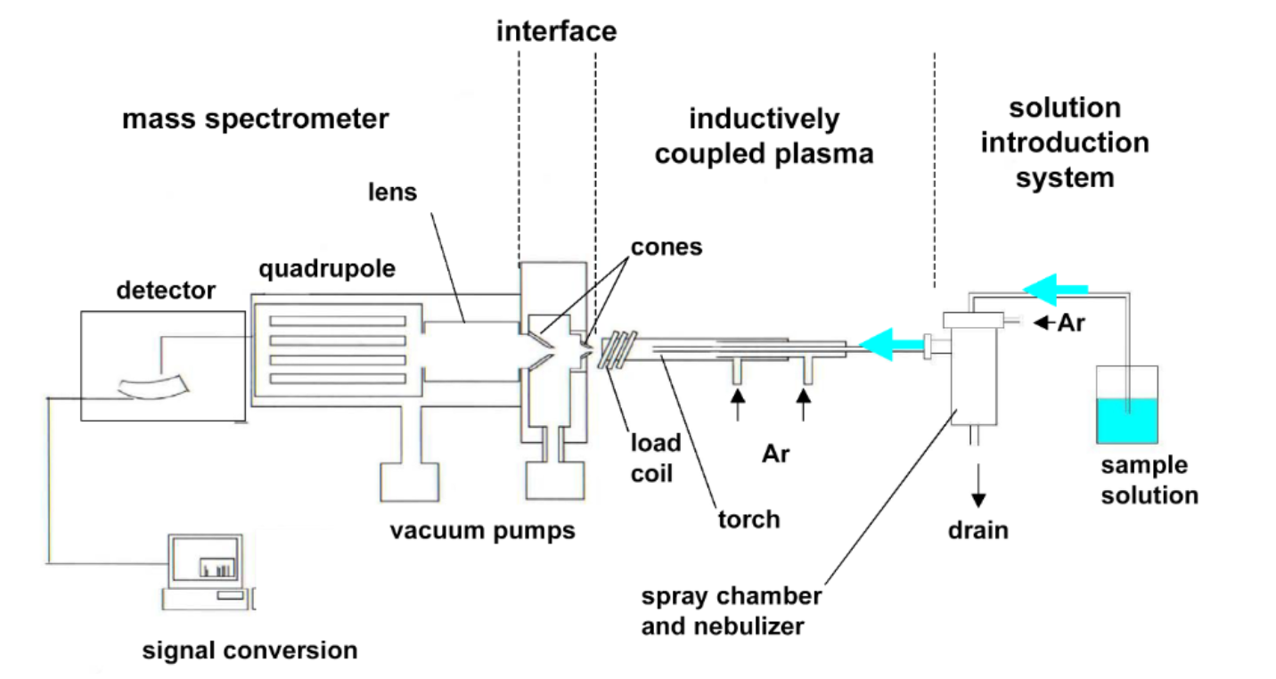
Figure 35 A schematic illustration of an Inductively Coupled Plasma Mass Spectrometer (ICP-MS) [142]

EFFECT OF CAO/AL₂O₃ RATIO ON PHYSICAL PROPERTIES OF CAO-AL₂O₃ BASED MOULD POWDERS

4.1. Materials

Five different types of mould powder were produced in order to analyse the effect of CaO/Al₂O₃ ratio (C/A ratio) on thermo-physical properties of lime-alumina based mould powder. Their chemical compositions were chosen considering variation in CaO/Al₂O₃ ratio and are given in Table 13. These lime-alumina based mould powders included five compositions were the CaO/Al₂O₃ ratio ranges from 1 to 3. Constant amounts of 5 %wt. Li₂O,10 %wt. Na₂O and 15 %wt. B₂O₃ were used in all samples.

Table 13 Chemical composition of C-series mould powders (in weight percent)

Powder | CaO/Al₂O₃ | SiO₂ | CaO | Al₂O₃ | Li₂O | Na₂O | B₂O₃
C1 | 1 | 10 | 30 | 30 | 5 | 10 | 15
C2 | 1.5 | 10 | 36 | 24 | 5 | 10 | 15
C3 | 2 | 10 | 40 | 20 | 5 | 10 | 15
C4 | 2.5 | 10 | 43 | 17 | 5 | 10 | 15
C5 | 3 | 10 | 45 | 15 | 5 | 10 | 15

Table 14 Chemical composition of C-series mould powder in molar%
Powder | SiO₂ | CaO | Al₂O₃ | Li₂O | Na₂O | B₂O₃
C1 | 10.81 | 34.74 | 19.11 | 10.87 | 10.48 | 13.99
C2 | 10.48 | 40.43 | 14.82 | 10.54 | 10.16 | 13.57
C3 | 10.27 | 44.03 | 12.11 | 10.33 | 9.96 | 13.3
C4 | 10.12 | 46.64 | 10.14 | 10.19 | 9.81 | 13.1
C5 | 10.02 | 48.33 | 8.86 | 10.08 | 9.72 | 12.99

4.2. Result and Discussion

4.2.1. Effect of CaO/Al₂O₃ ratio on the % crystallinity of mould powder

The crystallinity of C-series mould powders was investigated by X-Ray Diffraction and metallographic determination techniques. The results obtained with these tests are given below. XRD pattern of the C-series lime-alumina based mould powders presented in
Figure 38. Figure 36 shows the crystallinity of C-series mould powders obtained by X-Ray Diffraction with varying CaO/ Al₂O₃ ratio. The crystallinity for all C-series mould powder samples increased with an increase in the CaO / Al₂O₃ ratio. It also shows that the powders with a lower C/A ratio have lower crystallinity. According to X-ray Diffraction results, the powder with C/A ratio of 3 has relatively high crystallinity in comparison with the other four mould powders.
In order to verify crystallinity of C-series mould powder, another crystallinity determination test has been carried out. 20gr of each sample melted at 1500 ºC and molten powder is poured into a stainless-steel crucible, which is in an ice-water bath and then each solidified samples cuts through. Cross-sectional pictures of samples analysed with image analyses software. Figure 37 illustrates the microscopic and binary images of each C-series mould powders. Metallographic crystallinity determination of samples has been completed with area measurement via Image J software. The crystallinity of C-series mould powders obtained by metallographic determination have been given in Figure 36.

`
Figure 36 The % crystallinity in C-series mould powder as a function of C/A ratio
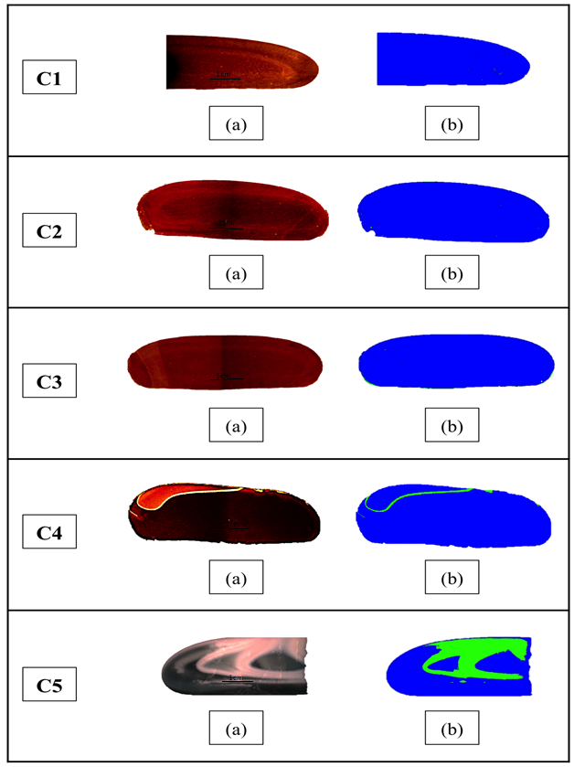

Figure 37 (a) Cross sectional images of C-series mould powders (b) Threshold analysis of C-series mould powder (crystal parts in green and glassy parts in blue).

The amount of crystalline phase obtained by X-Ray Diffraction for the mould powder samples are compared with the values obtained using the % crystallinity model and metallographic measurements in Figure 36. As it can be seen from this figure, the measured and estimated crystallinity for C-series mould powders present the same trend. However, the crystallinity obtained by metallographic measurement for C5 (C/A=3) is higher than the crystallinity measured by the X-Ray Diffraction even though the crystallinity results obtained by both techniques for the rest of the 4 samples are in good agreement. As NBO/T ratio of C1, C2, C3 and C4 (see Table 15) are below 2, they have been accepted completely glassy through the % Crystallinity model. The main reason for this difference between X-Ray Diffraction measurement and metallographic measurement could be the appearance of transition zones (glass + crystalline) in C5 mould powder. As the crystallinity is relatively high for C5 (C/A=3), transition zones appear on the cross-section image of the sample and that is the main source of uncertainty because the image analysis software could not separate phases perfectly during the thresholding.

The other reason for the uncertainties associated with the metallographic determination technique could be the size of the area viewed. As the technique uses a small area of the sample to measure the crystallinity, local inhomogeneities could cause variation in crystallisation of sample. Therefore, the viewed area of the sample may not represent the whole sample.

At that stage of the study, C-series mould powders have been used to investigate the effect of C/A ratio on the % crystallinity of lime-alumina based mould powder. As illustrated in Figure 36, crystallisation of the designed mould powders increases with the increase of C/A ratio ranged from 1 to 3. Al₂O₃ content of mould powder ranged from 15 %wt. to 30 %wt. in C-series mould powder. Al₂O₃ works as an acidic oxide with increase in Al₂O₃ which turns molten slag into an alumina-silicate structure, which is a more complicated structure and inhibits crystallisation. Crystallinity of the mould powder with C/A ratio of 1, 1.5, 2 and 2.5 are relatively low. This low crystallinity in these samples may be associated with the B₂O₃, Li₂O and Na₂O content of C-series mould powder. C-series mould powder contains constant 15 % wt. of B₂O₃ and boron trioxide is generally accepted as a very strong glass former which weakens crystallinity tendency of the mould powder [78] [146] [73].
The C-series mould powders also contain a constant amount of Li₂O and Na₂O. The current observation indicates that the appropriate amount of Li₂O and Na₂O addition restrains the crystallinity of lime-alumina based mould powders [82] [85] [80]. Lu et al. [109] have systematically investigated the effect of Li₂O and Na₂O addition on the crystallinity of lime-alumina based mould powder. The results indicate that the increase of Li₂O and Na₂O restrain the crystallisation of lime-alumina based mould powder by increasing the incubation time for crystalline growth and decreasing initial crystallisation temperature.

The increase in C/A ratio ranged from 1 to 2.5 and resulted in a small increase in the crystallinity of samples. The interesting phenomenon is that an increase of C/A ratio to 3 caused a big increase in crystallinity. This massive increase in crystallinity may be explained by the CaO addition since it increased the basicity of mould powder which is represented by %CaO/%SiO₂. It has been indicated that basicity has been used to measure the degree of depolymerisation of the melt and an increase in basicity could promote the crystallisation of mould powder.

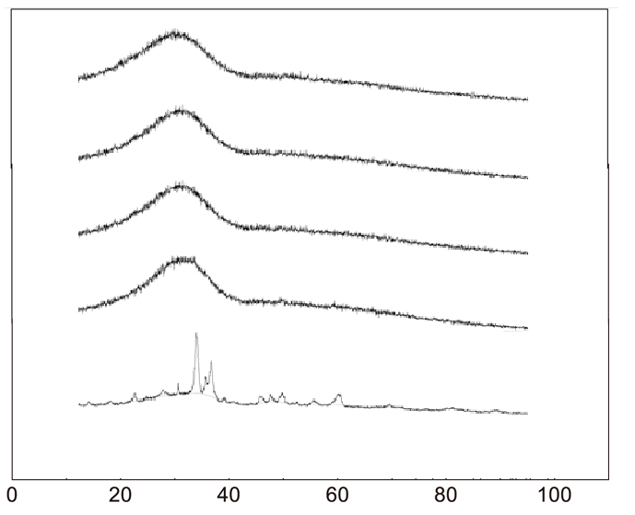
C/A-1
C/A- 2
2ϴ (degree)
C/A- 3
C/A-2.5
C/A- 1.5
Intensity

Figure 38 The XRD patterns of C-series mould powders with different C/A ratio

Li, Thackray and Mills [129] suggest that the number of non-bridging oxygen per tetrahedrally coordinated atom as represented by the NBO/T ratio is associated with the crystallinity of the mould powder and calculated as given on page 56. They noted also that the critical point arises at the NBO/T ratio of 2. Above this critical point, the crystallinity of the mould powder increases linearly with increasing NBO/T ratio, while below the critical point mould powders have very low crystallinity. As can be seen in Table 15, C5 (C/A=3) is only powder which exceed that critical point.

Table 15 NBO/T ratio of C-series mould powders

Powder No: | C1 | C2 | C3 | C4 | C5
NBO/T  ratio | 0.9 | 1.3 | 1.7 | 1.9 | 2.2

In this study, XRD patterns of C-series mould powders have been used to calculate %crystallinity of powders by using the area under the peaks or bumps. Figure 36 shows the crystallinity of C-series mould powders obtained by X-Ray Diffraction with varying CaO/ Al₂O₃ ratio. As it can be seen in Figure 38, apart from the powder with C/A of 3, other powders present bumps on their XRD scans as those are almost completely glassy. Through XRD phase analyses and Rietveld refinement, crystalline phases of slag samples and phase percentages could be determined. But those are not attempted in this study as only one sample present crystal peaks among the C-series mould powders and this will not allow us to do comparative analyses. But expected phases on C5 slag has been discussed below by means of previous studies.
Fluoride is usually added to conventional mould powders in the form of CaF₂ to control crystallisation by forming primary crystalline phase cuspidine (3CaO.2SiO₂.CaF₂) and to improve lubrication between steel shell and mould by decreasing the solidus temperatures. However, fluorides is unwanted from environmental point of view as it causes corrosion of refractories, increase landfill wastes and the emission of toxic gasses [147, 148, 107, 110]. Lime- alumina based mould powders are also designed with addition of 10-20% CaF₂ but removing fluoride from mould powders has attract more attention over past decade as it would eliminate the problem mentioned above [107]. C- series mould powders also designed as fluoride- free mould powders and B₂O₃, Li₂O and Na₂O are added as alternative substitutes for CaF₂.
It has been reported that cuspidine (3CaO.2SiO₂.CaF₂) or CaF₂ precipitates first in fluoride containing lime-alumina based mould powders [11, 149, 150, 76]. As C-series mould powders doesn’t contain fluoride, it is not possible to see fluoride containing phases in slag samples.

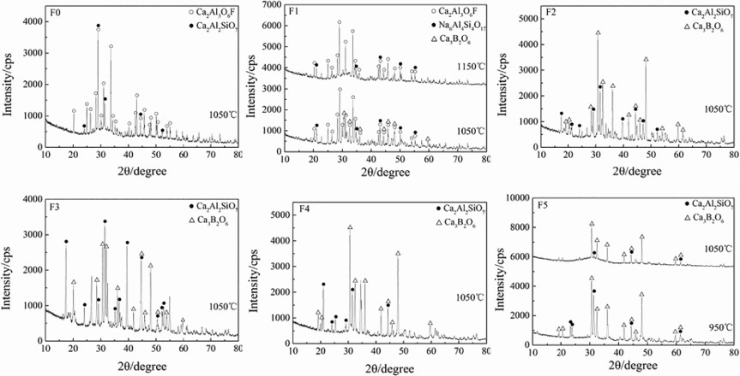

Figure 39 X-ray diffraction pattern of lime-alumina based mould powders at different CaF₂ and B₂O₃ content: F0 (CaF₂= 20 wt pct, B₂O₃= 10 wt pct), F1 (CaF₂= 13 wt pct, B₂O₃= 10 wt pct), F2 (CaF₂= 6 wt pct, B₂O₃= 10 wt pct), F3 (CaF₂= 0 wt pct, B₂O₃= 10 wt pct), F4 (CaF₂= 0 wt pct, B₂O₃= 15 wt pct), F5 (CaF₂= 0 wt pct, B₂O₃= 20 wt pct)

Yan et al. [107] studied the replacement of CaF₂ with B₂O₃ in lime-alumina based mould powders and suggests that addition of CaF₂ or B₂O₃ to lime alumina based mould powder decreases initial crystallisation temperature at same cooling rate, extend incubation time for crystallisation and consequently restrain crystallisation. B₂O₃ presents stronger ability to restrain crystallisation of lime-alumina based mould powder in comparison with CaF₂.

Yan et al. [107] also did crystalline phase analyses by utilising X-ray Diffractometer and crystalline phases of lime- alumina based mould powders with increasing B₂O₃ are shown in Figure 39. Authors revealed that primary crystalline phase is Ca₂Al₂SiO₇ in CaF₂ -free mould powders and addition of B₂O₃ in the absence of CaF₂ prevents crystallisation of Ca₂Al₂SiO₇ and promotes crystallisation of Ca₃B₂O₆ at lower temperatures. Xiao et al. [78] also obtained similar results while working on the effect of B₂O₃ and BaO on the crystallisation behaviour of fluoride free lime-alumina based mould powder. Authors worked with 4 different mould powders and all powders contained constant amount of 10 %wt. Na₂O and 6 %wt. Li₂O. It has been reported that the first phases appear in all samples is LiAlO₂ at both low and high temperature zones. The crystal phase of CaB₂O₃ is also formed in the sample which contain 10 %wt. B₂O₃. Gao et al. [82] investigated the effect of Na₂O addition on crystallisation behaviour of CaO-SiO₂-Al₂O₃ based mould powders, and revealed that according to peak intensity of crystals on XRD results, the intensity of LiAlO₂ increased and the intensity of Ca₂Al₂SiO₇ decreased with addition of Na₂O (0 to 4 % wt.).
As it contains 5 %wt. Li₂O,10 %wt. Na₂O, 15 %wt. B₂O₃ and nearly similar amount of CaO and Al₂O₃ with above reported study, the crystalline phases of LiAlO₂ and Ca₃B₂O₆ may also appear in C5 samples. Pisch et al. [151] studied phase equilibria and thermodynamics in the CaO-Al₂O₃-B₂O₃ ternary system and calculated liquidus surface of this ternary system using the FTO_{XID}5.3 database in FactSage software. The calculated liquidus surface of Ca₃B₂O₆ can be seen in Figure 40.
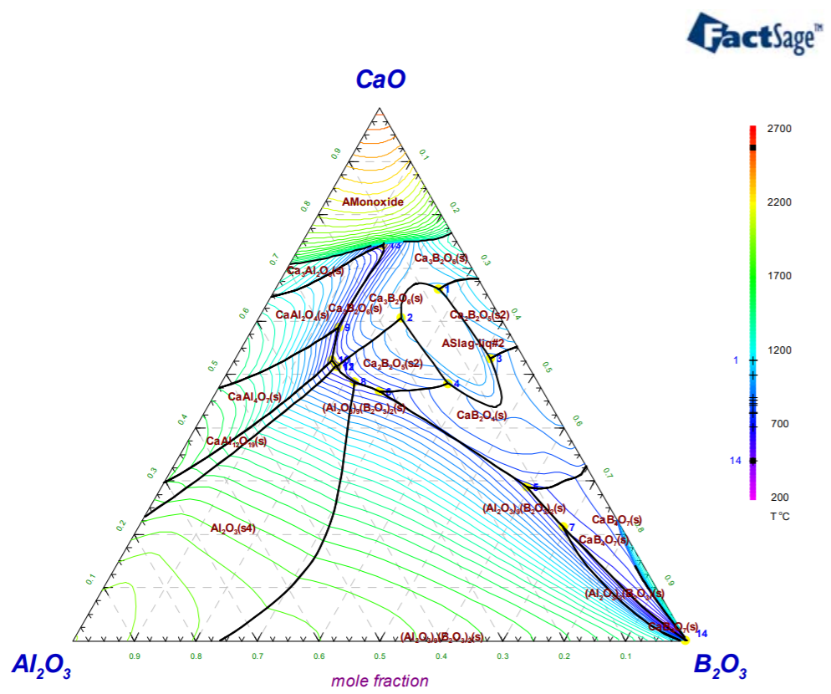

Figure 40 The CaO-Al₂O₃-B₂O₃ ternary system [151]

4.2.2. Effects of CaO/Al₂O₃ ratio on the Crystallization Behaviour of the Mould Flux

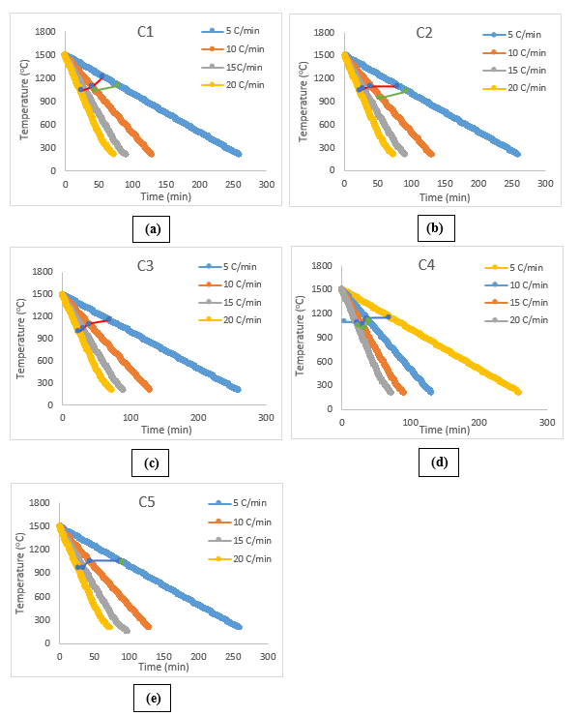
Figure 41 CCT diagrams of mould powders with different C/A ratio:
(a) C/A= 1 (b) C/A= 1.5 (c) C/A= 2 (d) C/A= 2.5 (e) C/A= 3

The crystallisation behaviour of the C-series lime-alumina based mould powders were investigated by employing STA (Simultaneous Thermal Analyser) at various cooling rates. The crystallisation temperatures of slags combined with recorded time-temperature data was used to construct CCT diagrams of mould powders for the cooling rates of 5.10, 15 and 20 ºC/min, as shown in Figure 41.However, Figure 43 shows heat flow- temperature curves of C-series mould powder at the cooling rate of 5.10, 15 and 20 ºC/min.
The results demonstrate that the crystallisation temperature of crystalline phases in C-series mould slags decreased with increasing cooling rate in STA measurements. A likely explanation is that an increase in continuous cooling rate will increase the viscosity of mould powder by increasing the degree of undercooling. Due to the increase in diffusion resistance, it requires greater driving force for the nucleation and growth of crystals in slag. Therefore, the crystallisation temperature decreases to supply the requirements for a larger driving force.

It can be observed from Figure 43 that there are two exothermic peaks in C1 and C2 STA curves at 5 and 10 ºC/min cooling rates, which prove the presence of two successive crystallisation events. Only C3 mould powder presented a single crystallisation event at all cooling rates. On the other hand, mould powder C1 does not present crystallisation event at the cooling rate of 15 ºC/min, and C1 (lowest C/A ratio) presents the highest crystallisation temperature at 1216 ºC at the cooling rate of 5 ºC/min among all mould powders.

Figure 42 represented the relationship between C/A ratio and the initial crystallisation temperatures of C-series mould powders at a cooling rate of 15 ºC/min. The results indicate that the initial crystallisation temperature of lime-alumina based mould powders decreases from 1190 ºC to 979 ºC with the increase of C/A ratio from 1 to 3. Thus, this indicated that an increase in C/A ratio inhibits the tendency for crystallisation. When the C/A ratio was higher than 1.5, the decreasing effect became weaker.

The results obtained in this part of the study is in agreement with the results of Jiang et al. [84]. They systematically studied the effect of C/A ratio on the crystallisation of lime-alumina based slag system by employing single and double hot thermocouple technology and suggested that initial crystallisation temperature decreased with increasing C/A ratio.

It could be found that % crystallinity results in Sectıon 4.2.1 do not the present same trend with results obtained from continuous cooling during STA measurements. The differences between these two trends could be the following reasons:

- Cooling rates in STA measurements is lower than those in % crystallinity measurements.
- A larger amount of mould powder for % crystallinity could increase natural convection which is beneficial to the crystallisation.

Figure 42 Effect of ratio on initial crystallisation temperature at cooling rate of 15 ºC/min

Various parameters have been reported regarding the thermal stability in glasses [152]. Turnbull [153] revealed a parameter based on the nucleation theory and use T_{g}/T_{m} ratio as a criterion for glass formation (K_{T}) where T_{g} is glass transition temperature and T_{m} is melting temperature.
$$K_{T}=T_{rg}=T_{g}/T_{m}$$
Turnbull [153] has also used the term of reduced glass transition temperature (T_{rg}) as the avoidance of a single nucleation event and indicated that it is equal to K_{T}. Zanotto and Coutinho [154] proposed that a high value of T_{rg} would result in high viscosity and eventually lead to a low critical cooling rate. They also suggest that having T_{rg} lower than 0.58-0.60 range display homogeneous nucleation while having it over or in the range of 0.58-0.60 display heterogeneous crystallisation. According to K_{T} values listed in Table 16, C-series mould powder display heterogeneous crystallisation as K_{T} values of C-series mould powders are over the range of 0.58-0.60. Sharda et al. [155] is also pointed out that T_{rg} indicates ease of glass formation. In this sense, The value of T_{rg} for C1, C2, C3 and C4 remains nearly constant which indicates good glass forming ability of these samples.

The glass transition temperature (T_{g}) is the temperature where a glass is transformed into a supercooled liquid and this transformation causes some distinct changes on properties such as step increase in thermal expansion coefficient [156] [53]. Mills et al. [157] use the following equation to calculate glass transition temperature:

$$Tg(K)=906-330.5XSiO2+190XCaO+440XAl2O3-449XN2O+K2O-11XMgO+154XCaF2-309XMnO- 1391XFeO$$

Inoue et al [158, 159] revealed another parameter for glass forming ability which is temperature difference between T_{x} and T_{g}. They also mentioned that higher value in this difference (T_{x} - T_{g}) means more delay in the nucleation process. T_{x} is initial crystallisation temperature here.
Hruby [160] has also proposed a glass forming ability parameter as K_{H} which is also used as a measure of glass forming tendency. The formula for Hruby parameter is given below and K_{H} values for C-series mould powder are listed in Table 16.

$$K_{H}=(T_{x}-T_{g})/(T_{m}-T_{x})$$
According to calculated values for K_{H}, C5 has highest glass forming tendency among the C-series mould powders. This is not consistent with data obtained by % crystallinity method as C5 has the highest crystallisation tendency among the C-series mould powders. In terms of C1, C2, C3 and C4, K_{H} values increases with the decrease of C/A ratio ranged from 1 to 2.5. That’s mean glass forming tendency decreases with an increase in C/A ratio. Al₂O₃ content of mould powder ranged from 15 %wt. to 30 %wt. in C-series mould powder. Al₂O₃ works as an acidic oxide with increase in Al₂O₃ which turns molten slag into an alumina-silicate structure, which is a more complicated structure and promotes glass formation.

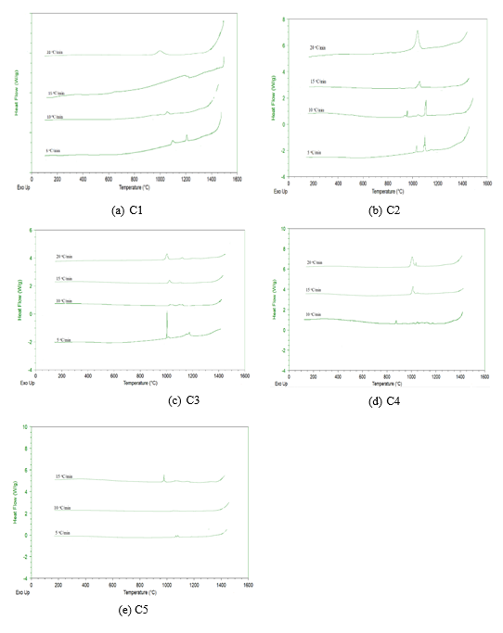

Figure 43 Heat flow-temperature curves for the C-series lime-alumina based mould powder at the cooling rate of 5,10, 15 and 20 ºC/min

Table 16 Temperature in ºC of T_{g}, T_{m} and T_{x} and values of K_{T} and K_{H} determine by using above slandered equations

Samples | T_{g} (ºC) | T_{m}(ºC) | T_{x}(ºC) | K_{T} | K_{H} | T_{x}-T_{g}
C1 | 700.2 | 942 | 1190 | 0.74 | -1.98 | 498.8
C2 | 694.6 | 970 | 1068 | 0.72 | -3.81 | 373.4
C3 | 691.1 | 965 | 1034 | 0.72 | -4.97 | 342.9
C4 | 688.6 | 965 | 1016 | 0.71 | -6.42 | 327.4
C5 | 686.9 | 1118 | 979 | 0.61 | 2.10 | 292.1

4.2.3. Effect of CaO/Al₂O₃ ratio on the melting behaviour of mould powder

The Hot Stage Microscopy was employed to study the effect of C/A on melting behaviour of lime-alumina based mould powder. The heating cycle of the experiment is given in Figure 27. A recording camera and automatic image analysis was used to observe melting behaviour of C-series mould powder during this test. The camera was used to take a picture of the sample every 2 ºC and pictures for sintering, softening and melting temperatures of the C1 powder are illustrated in Figure 44.

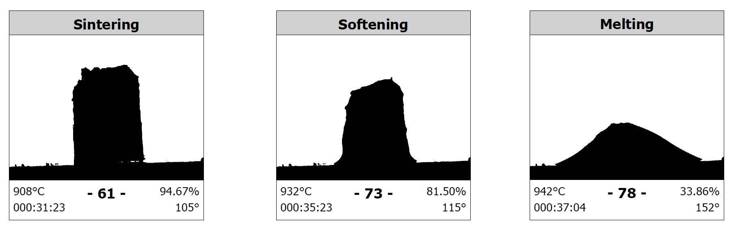
Figure 44 Sample pictures taken by the Hot Stage Microscopy camera for sintering, softening and melting temperatures of C1 powder

As can be observed in Figure 45 that when the value of C/A ratio increased from 1 to 2.5, the recorded melting temperature of samples slightly increased in the initial stage and then stabilised at about 960 ºC and then there was a dramatic increase in the melting temperature while C/A ratio increased from 2.5 to 3.

It should be noted that the results obtained in this part of the study are not in agreement with the general consideration that an increase of Al₂O₃ content results in an increase of melting temperature. Blazek et al. [74] systematically investigated the effect of C/A ratio on lime-alumina based mould powders for casting high-aluminium TRIP steels and suggested that melting temperature decreased when the C/A ratio ranged from 0.6 to 3.6. Similarly, Yu et al. [161] investigated the effect of Al₂O₃/ SiO₂ on the melting temperature of mould powder and suggested that melting points of all the series mould powders increase with Al₂O₃ addition.

Only one study which was published in 2017 by Qi, Liu and Jiang [162] is available and that indirectly agrees with this study. Authors investigated that melting temperatures of powders nearly stabilised at around 1140 ºC while C/A ratio ranged from 1 to 1.82. A probable explanation was raised from the authors’ work that with increasing C/A ratio, mould powder components such as Al₂O₃, CaO and SiO₂ can form as compounds of lower melting temperature, which may decline the melting temperature of the melt. The opposite way around, LiO₂ and Al₂O₃ tends to react to be able to form phases with high melting temperature with an increase in C/A ratio. These two opposite effects present nearly same influence and hence the melting temperature of mould powders present a stabilised trend while C/A ratio increasing from 1 to 2.5.

The dramatic increase in the melting temperature while C/A ratio increases from 2.5 to 3 is also consistent with only one study. Mustafa et al. [163] investigated the effect of B₂O₃ and C/A ratio on physical properties of mould powder and results suggest that melting temperature increased with the increase of C/A ratio ranged from 3.3 to 5.5 in lime-alumina based mould powder. However, LiO₂, Na₂O and B₂O₃ have effects on the melting temperatures of mould powders [163, 164, 165, 166] but C-series mould powders contain a constant amount of them.

Figure 45 Effect of C/A ratio on the melting temperature of C-series mould powder

4.2.4. Effect of CaO/Al₂O₃ ratio on the viscosity of mould powder

In this part of the study, three different techniques have been used to obtain viscosity of C-series mould powders at different temperatures.
First of all, IPT (Inclined Plane test) has been utilised to measure the viscosity of mould powders. During the test, the relationship between ribbon length of the powders and viscosity has been determined with the help of ‘V’ shaped stainless-steel plate. Figure 46 illustrates the change in mould powders’ viscosity as function of C/A ratio at 1300 ºC.
As it can be clearly seen in Figure 46 that the viscosity of mould powders decreases dramatically while C/A ratio changed from 1 to 1.5. The viscosity of C-series mould powder shows that with the increase in C/A ratio ranged from 1.5 to 2.5, viscosity slightly decreases, then when the C/A ratio over 2.5, viscosity nearly levels off.

Figure 46 Effect of C/A ratio on viscosity which measured by the IPT method.

Secondly the viscosity of C-series mould powders has been calculated by FactSage software package. The effect of temperature on viscosity of C-series mould powder at different C/A ratio are plotted in Figure 47, where viscosity decreases with increasing temperature at all C/A ratios as expected. Viscosity of all mould powders rapidly decreases while temperature increases from 1300 ºC to 1400 ºC and viscosity gradually decreases while temperature ranged from 1400 ºC to 1500 ºC. However, at the temperatures of 1300 ºC, 1400 ºC and 1500 ºC, viscosity of C-series mould powder decreases with an increase in C/A ratio.

Figure 47 Viscosity of C-series mould powders estimated by FactSage software as a function of temperature

Figure 48 Viscosity-temperature curves of C1, C2 and C3 samples obtained by rotating bob viscometer

Thirdly the rotating bob viscometer has employed to verify the reproducibility of viscosity measurement obtained by IPT and FactSage. Figure 48 shows the viscosity-temperature curves of the C1, C2 and C3 mould powders. It can be observed that the increasing temperature results in a decrease in each powder viscosity. Viscosity decreases with an increase in C/A ratio while temperature ranged from 1090 ºC to 1300 ºC. However, at temperatures below 1088 ºC, the viscosity of C5 dramatically increases while the viscosity of C1 and C3 gradually decreases.

Figure 49 Comparison of measured and estimated viscosity of C-series mould powders at 1300 ºC.

Figure 49 illustrates the comparison of experimental data obtained by IPT and rotating bob viscometer with the viscosities estimated by FactSage. As it can be noted from Figure 49, viscosity of mould powder obtained by these methods presents the same trend and both measured and estimated viscosities decrease with an increase in C/A ratio. Viscosity measurements methods used in this study were credible when the experimental uncertainties associated with viscosity determination tests were considered. However, a good correlation between the measured and the calculated viscosities was observed.

It is known that Al₂O₃ is an amphoteric oxide and has a remarkable effect on the viscosity of mould powder. It behaves as a basic oxide (network modifier) or an acidic oxide (network former) and depends on the basicity of the slag. The nature of alumina in the melt has been detailed in the literature diffusively. In the lime-alumina melts, Al-O complexes present 4-, 5- and 6-fold coordination and forms as AlO₄, AlO₅ and AlO₆ units [167, 168, 169].

At higher temperatures, more alumina is involved in the formation of aluminate structure with a decrease in C/A ratio. This increases the degree of polymerization and causes an increase in the viscosity of melt. On the other hand, with an increase in C/A ratio, more O²⁻ ions are free to depolymerise aluminate network and hence reduces the viscosity of the melt [89, 77, 88, 118]. Kim et al. [118] studied the role of B₂O₃ on the viscosity and structure in lime-alumina based mould powders and illustrate the depolymerizations of the slag structure with free O²⁻ ions in alumina-boron slag system through the Figure 50. This work adopted from Wright’s [170] work on Borate structures: crystalline and vitreous.

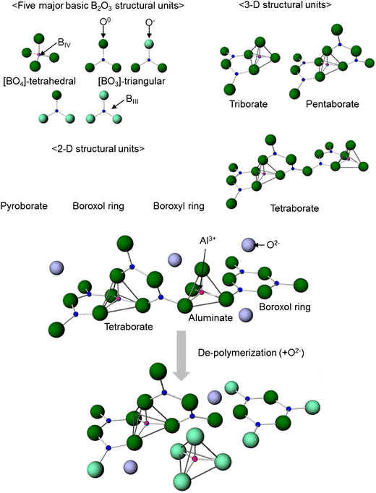
Figure 50 Schematic of the various borate structural units and the depolymerizations of the slag system
At lower temperatures, particles with higher melting temperatures start precipitation in the melt and solid particles begin controlling the viscosity therefore the viscosity of mould powder increases.

For the powders used in this part of the study, the mole fraction of basic oxides (Cao and Na₂O) are much more than the mole fraction of Al₂O₃. Therefore, alumina behaves as an acidic oxide to be able to promote [AlO₄]⁵⁻ ions when adequate charge balance is available by favour of basic oxides. Any excess Ca²⁺ cations in the CaO-Al₂O₃ melt depolymerise AlO₄ structural units and decrease the viscosity. Therefore, in C-series mould powder, viscosity decreases with an increase in C/A ratio.

As can be seen in Figure 46, the viscosity sharply decreases and then gradually becomes stable with an increase in C/A ratio. This is due to the fact that a further increase in C/A ratio supplied an excess of free O²⁻ ions and thus viscosity ultimately becomes stable.

The results obtained from this part of the study are consistent with the reported results. Yan et al. [88] systematically studied the effect of C/A ratio on the viscosity behaviour of lime-alumina based mould powders by utilising the rotational cylinder method and concluded that at temperatures above 1270 ºC, the viscosity first dramatically decreased and then gradually became stable. They also confirmed this behaviour of mould powders with the aid of Fourier transform infrared (FTIR) spectra. Kim and Sohn [118] also revealed that the viscosity is lowered with an increase in C/A ratio ranged from 0.8 to 1.2.
The C-series mould powders which contain 5% Li₂O and 15% B₂O₃. Li⁺ is very active when it has very low electrostatic potential to merge with O²⁻. Therefore it offers free O²⁻ ion in the melt and presents basic behaviour in the mould powder which destroys structure in the melt and decreases viscosity [161]. B₂O₃ is an acidic oxide and considered as a network former in melts. Therefore, addition of B₂O₃ increases acidity of mould fluxes and lowers the viscosity [161, 77, 171].

The viscosities of C-series lime-alumina based mould powders have also been calculated by using Riboud and Urbain models. Figure 51 presents the comparison of measured viscosities and data calculated by Urbain and Riboud models. Even though both models present a similar trend (viscosity of mould powder decreases with an increase in C/A ratio) with viscosities measured by the inclined plane test, the calculated viscosities using the Riboud model are significantly higher in contrast with measured results. However, the Urbain viscosity prediction model presents a relatively better estimation. The reason for this large discrepancy in Riboud model can be explained due to B₂O₃ being classified as a basic oxide in the Riboud model while it was treated as an amphoteric oxide in Urbain model.
Figure 51 Comparison between the measured (Inclined Plane Test) and calculated viscosities (Riboud and Urbain models) of mould powder listed in Table 13

4.2.5. Effect of CaO/Al₂O₃ ratio on the Steel-Slag Interaction

In order to investigate the mass exchange at the steel/slag interface, lab scale experiments were carried out for each C-series mould powder at the temperature of 1500 ºC. Chemical composition analysis of steel samples were completed using X-Ray Fluorescence. Figure 52 shows the amount of [Al] changes in steel as a function of C/A ratio of mould powders. As it can be observed in Figure 52, the [Al] content in steel decreases with an increase in C/A ratio. However, the change in total manganese content of steel at each C/A ratio can be seen in Figure 53.
It is know that the most significant chemical reaction which takes place at the molten steel/slag interface is the reduction of SiO₂ by the dissolved Al in steel [172]. The C-series lime alumina-based mould powders contain a constant amount of 10 %wt. SiO₂ and the SiO₂ in mould powder is reduced by Al in steel through the following reaction:
$$4\left[Al\right]+3\left(SiO_{2}\right)=3\left[Si\right]+2\left({Al}_{2}O_{3}\right)$$

According to Figure 52 , the reactivity between molten slag and steel increases with an increase in C/A ratio in mould powders. This phenomenon can be related to Al₂O₃ content in C-series mould powders. The higher amount of Al₂O₃ in mould powder may suppress the reaction of SiO₂ reduction as the Al₂O₃ content of C-series mould powder increases with a decrease in C/A ratio. Therefore, the decrease in the total amount of [Al] in steel increases with an increase in C/A ratio for C-series mould powder.

Figure 52 Total aluminium content of steel change depending on C/A ratio on the 20 min of elapsed interaction time

On the other hand, there is one study which disagrees with the above conclusion. Kim et al. [173] evaluates the compositional change between molten high-Al steel and lime-silica based mould powder and suggests that initial Al₂O₃ content in mould powder does not have an effect on SiO₂ reduction.

As the steel sample contains a high amount of [Mn], the following reaction may occur between SiO₂ in slag and Mn in steel.

$$2\left[Mn\right]+\left(SiO_{2}\right)=\left[Si\right]+2\left(MnO\right)$$

It is interesting to note that, no [Mn] was detected by XRF in the steel which was in contact with the powder with a C/A ratio of 1. However, as shown in Figure 53 the effect of C/A ratio on the total content of manganese change in steel is not clear. The reason for this uncertainty could be due to the following reaction where the high [Al] content in steel reduced the oxidised MnO content again.

$$2\left[Al\right]+3\left(MnO\right)=3\left[Mn\right]+\left({Al}_{2}O_{3}\right)$$

Figure 53 Total manganese content of steel change depending on C/A ratio on the 20 min of elapsed interaction time

In summary, it is clear that both total [Al] and [Mn] contents in steel have relatively decreased after steel/slag interaction. This means that the C/A ratio does not affect the degree of steel/slag interaction and SiO₂ content in C-series mould powder is not low enough to prevent reaction between molten steel and slag. On the other hand, C-series mould powders contain B₂O₃ and as an acidic oxide, B₂O₃ has similar effects on molten slags to that of SiO₂ and may react with high dissolved [Al] in steel through the following reaction:

$$B_{2}O_{3}+\left[Al\right]={Al}_{2}O_{2}+2B$$

where the reduced B may go into the steel. (C-series’ mould powders contain 15% B₂O₃) As XRF does not detect boron, further investigation was carried out by Inductively Coupled Plasma (ICP) mass spectrometry to see the effect of B₂O₃ content on steel/slag interaction.

Both ICP and X-Ray Fluorescence test results confirm that the original steel sample does not have boron present. Figure 54 shows the amount of [B] changes in steel as a function of the C/A ratio of mould powders. As it can be observed in Figure 54 steel picked up small amount of B.

It is pointed out by Kim et al. [173] that Na₂O content in mould powder may be reduced by [Al] in steel in the case of insufficient SiO₂ in the mould powder as:

$$2\left[Al\right]+3\left({NaO}_{2}\right)=6Na+\left({Al}_{2}O_{3}\right)$$

Figure 54 Total Boron content of steel change depending on C/A ratio on the 20 min of elapsed interaction time

EFFECT OF TIO₂ AND ZRO₂ ON PHYSICAL PROPERTIES OF CAO-AL2O3 BASED MOULD POWDERS

5.1. Materials

Five different types of mould powder were produced in order to analyse the effects of TiO₂ and ZrO₂ addition on thermo-physical properties of lime-alumina based mould powder. Their chemical compositions were chosen by considering variations in TiO₂ and ZrO₂ contents and are gathered in Table 17 . These lime-alumina based mould powders included five compositions where the TiO₂ content varied from 0 to 15 wt.%. However, T5 mould powder designed to investigate the effect of 5 wt.% ZrO₂ addition on thermo-physical properties of mould powders. Constant amounts of 5 %wt. Li₂O, 10 %wt. Na₂O and 5 %wt. B₂O₃ were used in all samples. Unlike the C-series and M-series mould powders, T-series mould powder contains constant amounts of 10 wt. % CaF₂.

Table 17 Chemical composition of T-series mould powders (in weight percent)

Powder | CaO/  Al₂O₃ | SiO₂ | CaO | CaF₂ | Al₂O₃ | Li₂O | Na₂O | B₂O₃ | TiO₂ | ZrO₂
T1 | 1.2 | 10 | 33 | 10 | 27 | 5 | 10 | 5 | 0 | -
T2 | 1.2 | 10 | 30 | 10 | 25 | 5 | 10 | 5 | 5 | -
T3 | 1.2 | 10 | 27 | 10 | 23 | 5 | 10 | 5 | 10 | -
T4 | 1.2 | 10 | 24 | 10 | 21 | 5 | 10 | 5 | 15 | -
T5 | 1.2 | 10 | 30 | 10 | 25 | 5 | 10 | 5 | - | 5

Table 18 Chemical composition of T-series mould powder in molar %

Powder | SiO₂ | CaO | CaF₂ | Al₂O₃ | Li₂O | Na₂O | B₂O₃ | TiO₂ | ZrO₂
T1 | 10.75 | 38 | 8.27 | 17.1 | 10.81 | 10.42 | 4.64 | 0 | 0
T2 | 10.88 | 34.97 | 8.37 | 16.03 | 10.94 | 10.55 | 4.69 | 3.56 | 0
T3 | 11.02 | 31.86 | 8.48 | 14.93 | 11.07 | 10.68 | 4.75 | 7.2 | 0
T4 | 11.15 | 28.68 | 8.58 | 13.8 | 11.21 | 10.81 | 4.81 | 10.94 | 0
T5 | 10.98 | 35.29 | 8.45 | 16.18 | 11.04 | 10.64 | 4.74 | 0 | 2.68

5.2. Result and Discussion

5.2.1. Effect of TiO₂ and ZrO₂ on the crystallinity of mould powder

In order to investigate the effect of TiO₂ and ZrO₂ on crystallinity of lime-alumina based mould powder, X-Ray Diffraction and metallographic determination techniques were performed. The % crystallinity values of T-series mould powders obtained by X-Ray Diffraction and metallographic determination with varying TiO₂ and ZrO₂ contents are listed in Table 19. XRD pattern of the T-series lime-alumina based mould powders presented in Figure 57 The XRD patterns of T-series mould powders with different C/A ratio. The crystallinity for all C-series mould powder samples grew with an increase in the TiO₂. This also shows that the powders with 0 wt.% TiO₂ have the lowest crystallinity while the powder with TiO₂ content of 15 % has the highest crystallinity among T-series mould powder.

Moreover, the cross-section images of slag disks were taken and Figure 56 illustrates the microscopic and binary images of each T-series mould powders. The values of the percentage of crystalline phase appear in slag disks which have been illustrated in Figure 55. It can be observed that T3 and T4 mould powder produce crystalline layer whilst T1 and T2 are almost completely glassy. 41% of T3 (10 %wt. TiO₂) slag disk crystallised whereas T4 (15 %wt. TiO₂) produced 45% crystallinity. As it can be seen in Figure 56, crystalline layers on the T3 and T4 slag samples occurred on the top of the disks and glassy layer at the bottom. This is owing to the thermal gradient that arises from top to bottom of the slag disks. The bottom of the sample was in contact with platinum crucible which was in ice-water and the top of the slag disks was in contact with air.
The current finding indicates that the crystallinity was enhanced with increase of TiO₂ content in T-series mould powder. This is consistent with the trend observed in both conventional (lime-silica based) and lime-alumina based mould powders that the increase of TiO₂ content would tend to promote crystallinity [174, 129, 108]. This can be explained by the structure of slag melts. The increase of crystallinity with increasing TiO₂ content might be as a result from the decease of the degree of polymerization. It has been reported by Li et al. [111] that the degree of polymerization for aluminate network decreased with the increase of TiO₂ content. The mass transfer of slag components from liquid to interface was precipitated with depolymerisation of AlO₄ network. Therefore, the growth of crystal from the liquid was promoted and crystallinity of slag increased.

Figure 55 The averages of measured % crystallinity in T-series mould powder as a function of TiO₂ addition with standard deviation bars

Table 19 The Metallographic and XRD % crystallinity values in T-series mould powder

T-series Samples | TiO₂ Content | ZrO₂ Content | Metallographic % crystallinity measurements | XRD %crystallinity measurements
T1 | 0 | 0 | 1.3 | 3.6
T2 | 5 | 0 | 0.6 | 4.9
T3 | 10 | 0 | 41.7 | 30
T4 | 15 | 0 | 45.7 | 55.5
T5 | 0 | 5 | 0.2 | 3.8

The interesting phenomenon is that an increase of TiO₂ content from 5 to 10 wt.% caused a significant increase in crystallinity, while the effect of 5 wt% TiO₂ addition is unclear. This significant increase has been confirmed by both metallographic measurement and X-Ray Diffraction results. Li et al. [129] studied effect of TiO₂ on crystallinity of slags and reported that the additions of 3 wt. % TiO₂ resulted in no change in crystallinity, and 6 wt. % TiO₂ additions caused only a slight increase in crystallinity. In addition, Shu et al. [174] studied the effects of B₂O₃ and TiO₂ on crystallization behaviour of mould powder in Al₂O₃-CaO-MgO-Na₂O-SiO₂ system while TiO₂ content vary from 3 to 10 wt.% and concluded that effect of TiO₂ on the crystallisation of mould powder is not clear. According to some other literature
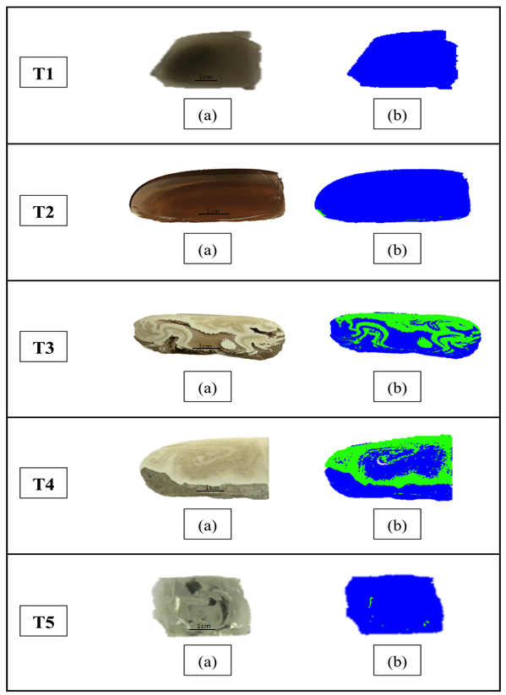

Figure 56 (a) Cross sectional images of T-series mould powders (b) Threshold analysis of C-series mould powder (crystal parts in green and glassy parts in blue).

data on TiO₂ containing mould powder, the crystallinity inhibited with the addition of TiO₂ [175, 176].
The obtained results from this part of the study are consistent with the viscosity results. Both the viscosity and crystallinity of T-series mould powder increased with addition of TiO₂ as high viscosity promotes crystallisation of mould powder due to the higher barrier for diffusion.

The effect of 5 wt. % ZrO₂ addition on crystallinity of lime-alumina based mould powders have also been investigated. The obtained results suggest that the ZrO₂ addition of 5 wt. % in lime-alumina based mould powder with C/A ratio of 1.2 does not have a significant effect on crystallinity of mould powder. This result is consistent with the other reported findings for lime-silica based mould powder [129, 147]. In terms of ZrO₂ addition on mould powders, it has been accepted that zirconia particles act as heterogeneous nucleation sites since it has limited solubility in molten slag [177]. Therefore, the ZrO₂ addition increases the grow rate of particles, but does not cause a significant change in crystallinity as crystallisation takes place by homogeneous nucleation and diffusion controlled growth [129].

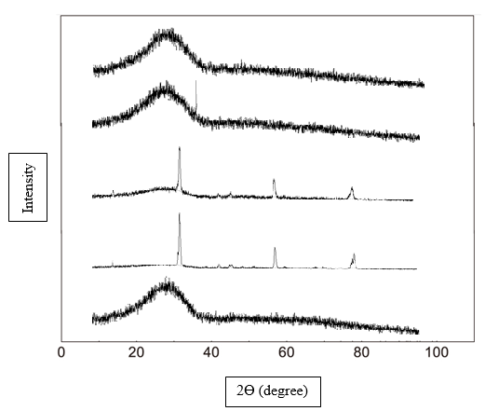
TiO₂ – 0 %
TiO₂ – 5 %

TiO₂ – 10 %

TiO₂ – 15 %

ZrO₂ – 5 %

Figure 57 The XRD patterns of T-series mould powders with different C/A ratio

The amount of crystalline phase in T-series lime-alumina based mould powder has also been estimated by using the % crystallinity model. As NBO/T ratio of all T-series mould powders (see Table 20) are below 2, they have been accepted as completely glassy through % Crystallinity model. Therefore, the estimated crystallinity for T3 and T4 are not consistent with measured crystallinity data. The formula used to calculate the NBO/T ratio was proposed by Li et al. [129] for lime-silica based mould powder and it has been indicated that the parameters may differ in this equation. As T-series lime-alumina based mould powder has quite high basicity (%CaO/%SiO₂ ratio), network formers or amphoteric oxides may behave as a network breaker or vice versa in molten slag with a high basicity. Therefore, % crystallinity model may require a modification for lime-alumina based mould powder.

Table 20 NBO/T ratio of T-series mould powders
Powder No: | T1 | T2 | T3 | T4 | T5
NBO/T | 1.85 | 1.74 | 1.63 | 1.53 | 1.86

5.2.2. Effect of TiO₂ and ZrO₂ on the melting temperature of mould powder

The present work probes into the melting temperatures of TiO₂ and ZrO₂ containing lime-alumina based mould powder. The melting temperatures of T-series mould powders have been presented in Figure 58 to evaluate the effect of TiO₂ and ZrO₂ addition. It could be observed that the melting temperature slightly increased at an initial stage and then decreased dramatically while TiO₂ content ranged from 0 to 15 % wt. This is not completely consistent with fulfilled researches.

Limited studies are available which demonstrate the effect of TiO₂ addition on melting temperature of metallurgical mould powders. Hao et al. [178] revealed that the melting temperature of mould powder for casting of titanium stabilised stainless steel grew with the increase of titania content that ranged from 0 to 12 % wt., while its solidification temperature and viscosity decreased. Wen et al. [66] and Shu et al. [174] also obtained similar results. Zhang et al. [179] investigated the melting temperature decreased from 1066 ºC to 1047 ºC with TiO₂ content increased from 1 to 2 %wt. and the melting temperature increased to 1077ºC as the TiO₂ content reach 5 %wt.

In terms of effect of TiO₂ on other critical temperatures, Wang et al. [180] systematically studied the effect of TiO₂ addition on critical temperature of B₂O₃ and TiO₂ containing fluoride free mould powders by using DTA (Differential thermal analyser) measurements and suggested that when TiO₂ content ranged from 0 to 10 %wt. liquidus temperature decreased, as the TiO₂ content exceed 10 %wt., liquidus temperature presented increasing trend.

In this study, the influence of TiO₂ on the melting temperature of lime-alumina based mould powder seems somewhat complex. The melting temperature rose with increasing TiO₂ up to 5 %wt., and subsequently it decreases with increasing TiO₂ content. This could be as TiO₂ is an amphoteric oxide which has both acidity and alkalescency [181, 66]. If the TiO₂ content is lower than 5 %wt, Ti ions in the melt behaved as a network former and raise the melting temperature, when the content higher than 5 %wt., it behaved as a network breaker and subsequently lowered the melting temperature.

As it can be also seen in Figure 58, the melting temperature of the mould powder decreased to 1382 ºC with ZrO₂ addition. This result is not in line with work done by Zhou et al. [182]. They also investigated the effect of ZrO₂ on physical properties of fluorine-free mould powders for casting medium carbon steels and suggest that when the ZrO₂ addition increased from 0 to 4.5 % wt., both initial and complete melting temperature of mould powders increased. The explanation raised from authors’ work is that as ZrO₂ has high melting temperature (2710 ºC), it may lead to an increase in melting temperature of mould powder.

Figure 58 Effect of TiO₂ and ZrO₂ addition on the melting temperature of T-series mould powder

5.2.3. Effect of TiO2 and ZrO2 on the viscosity of mould powder

The viscosity of T-series mould powder was measured by using Inclined Plane Test method and was also calculated by Fact Sage software. Figure 60 shows the measured values of the viscosity of CaO–Al₂O₃ based mould powders with various TiO₂ contents. At 1300 ºC, the viscosity first gradually decreases while TiO₂ content varies from 0 to 5 wt-% and then it rapidly increases with addition of TiO₂.

It is also possible to see the effects of ZrO₂ on viscosity of CaO–Al₂O₃ based mould powders in Figure 60. This shows that the viscosity slightly decreased with 5 wt-% ZrO₂ addition at 1300 ºC.
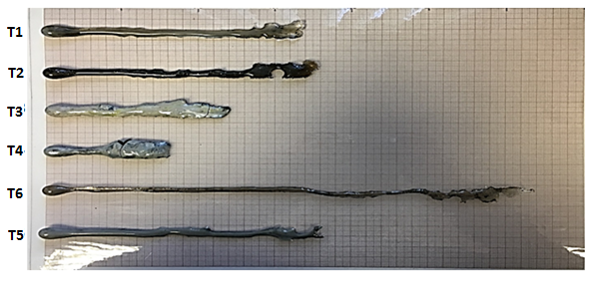
Figure 59 The ribbons of T-series mould powder from the inclined plane test

Figure 61 illustrates the calculated viscosities of the mould powders based on CaO–Al₂O₃ system with TiO₂ and ZrO₂ additions at various temperatures, where the TiO₂ content varied from 0 to 15 wt-% while the ZrO₂ increased from 0 to 5 wt-%. As it expected, a clear trend, the viscosity decreases with an increasing temperature. From Figure 61, it can be clearly seen that the viscosity of T-series mould powder decreases with the increase in TiO₂ content. T4 contains 15 %wt. TiO₂ and has the lowest viscosity among T-series mould powders at high temperatures. The viscosity also decreases with addition of ZrO₂ while temperature varied between 1300 ºC to 1500 ºC. Addition of 5 wt-% ZrO₂ decreases viscosity of CaO–Al₂O₃ based mould powder more than the addition of 5 wt-% TiO₂ while temperature above 1300 ºC.

Figure 60 Measured viscosities of CaO–Al₂O₃ based mould powder as a function of TiO₂ and ZrO₂ content at1300 ºC

Figure 62 illustrates the comparison of experimental data obtained by IPT (Inclined Plane Test) with the viscosities estimated by FactSage. As can be seen in Figure 62, the calculated viscosities using FactSage present large deviations from the measured results. The measured viscosity of T-series mould powder first gradually decreases and then increases dramatically while calculated viscosity decreases with addition of TiO₂. In addition, the viscosity decreases in both estimated and experimental methods while the ZrO₂ increases to 5 %wt.

The effect of TiO₂ addition on the viscosity and other properties of metallurgical slags was also studied by other researchers [156, 183, 184, 185, 19] and the results collected by IPT in this study are not fully consistent with the results reported in previous studies. Zheng et al. [18] investigated the viscosity and structural properties of CaO-SiO₂-TiO₂ slag and concluded that the addition of TiO₂ could weaken the strength of the slag structure, resulting in a reduction in viscosity. Liao et al. [20] showed that as the TiO₂ content of CaO-SiO₂-7wt%MgO-TiO₂-12wt%Al₂O₃ slag was increased from 15 to 30 %wt. and the CaO/SiO₂ ratio increased from 0.5 to 0.9, the viscosity of slag decreased. Shankar et al. [186] investigated the viscosity of CaO-SiO₂-MgO-Al₂O₃ and CaO-SiO₂-MgO-Al₂O₃-TiO₂ slag system. They found that the viscosity decreased with a small amount of TiO₂ addition while basicity varied from 0.48 to 0.8. A similar observation was found in the present case for CaO-Al₂O₃ based mould powders. Li et al. [111] investigated CaO-TiO₂-10.4wt%CaF₂-Al₂O₃ slag, and reported that the viscosity of investigated mould powder decreased gradually as the TiO₂ content was increased from 0-%wt. to 10 %wt. and the CaO/Al₂O₃ ratio was constant in the amount of 1.

Figure 61 Viscosity of T-series mould powders calculated by FactSage software as a function of temperature

On the other hand, some other researchers suggest that [187, 188, 156] TiO₂ works as a weak acidic oxide in a basic slag system, resulting in an increase in the network structure of the slag by polymerizing the slag melts, thus and so increases the viscosity of melt. Handfield and Charette [189] revealed that small amount of TiO₂ addition decreased the viscosity while large TiO₂ addition increased the slag viscosity. Ohno and Ross [188] also suggest that viscosity of slags can increase with addition of TiO₂ under reducing conditions.

TiO₂ is an amphoteric oxide and the behavior as an acidic oxide or basic oxide, depends on basicity of the melt [190]. TiO₂ can behave as a network former like other acidic oxides which increases the network structure and hence increasing the degree of polymerization. It is also accepted as a network modifier like other basic oxides which promote depolymerization by reducing the network structure of the slag [183]. In the current study, measured viscosity first decreased with 5 wt-% TiO₂ addition while it increased rapidly with further addition of TiO₂. This could be explained by the fact that tested mould powders act as a network modifier behavior till some point between 5 and 10 %wt. TiO₂ and then they start acting as a network former. As the viscosity of slag decreased with 5 % wt. TiO₂ addition, it suggests that TiO₂ behaved as a basic oxide in the tested mould powder. Basic oxides provide free O²⁻ ion and metal cations in the melt as they react with bridging oxygen to break apart large networks, resulting in a decrease in viscosity [191]. It would be very useful to confirm slag behaviour by using Raman Spectroscopy or FTIR (Fourier Transform Infrared) Spectroscopy for further investigation.

Figure 62 Comparison of measured and estimated viscosity of T-series mould powders at 1300 ºC and those obtained by IPT and FactSage

Zhou et al. [192] investigate the effect of ZrO₂ on physical properties of Fluorine-free mould powders and suggest that both the viscosity and break temperature increases with an increase in ZrO₂ from 0 to 4.5 %wt. The powders tested by authors in this study are lime-silica based powder and they have constant basicity of 1.15 while C/A ratio was nearly 10 for each powder. Researchers also pointed out that ZrO₂ is high valence amphoteric oxide, which behaved like a network former in the melt and increased the degree of polymerization of the melt. The phenomena obtained with ZrO₂ addition in this study could be explained if ZrO₂ acted like a network modifier and decreased the network structure of melt by increasing depolymerization which resulting in a decrease in viscosity.

Figure 63 shows the comparison of measured viscosities and data calculated by the Urbain and Riboud models. In terms of the effect of TiO₂ addition on viscosity, the calculated viscosities by the Riboud model estimate a consistent trend with measured viscosities. On the other hand, the effect of TiO₂ addition on viscosity stays unclear according to the data obtained by Urbain model. Riboud model presents a consistent trend with measured values for the effect of ZrO₂ addition.

Figure 63 Comparison between the measured (Inclined Plane Test) and calculated viscosities (Riboud and Urbain models) of mould powder listed in Table 17

5.2.4 Effect of TiO₂ Addition on the Steel-Slag Interaction

In order to investigate the mass exchange at the steel/slag interface, lab scale experiments were carried out for each T-series mould powder at a temperature of 1500ºC. An inductively coupled plasma mass spectrometry technique has been employed to complete the chemical composition analysis of the steel samples.

Figure 64 shows the amount of [Al], [B] and [Mn] changes in steel as a function of TiO₂ addition to mould powders. It is also possible to see the changes in steel composition with TiO₂ and ZrO₂ addition to mould powder in Table 21 . As it can be observed in Table 21, the [Al] and [Mn] content in steel significantly decreased in all the samples with no regard to TiO₂ and ZrO₂ content in the mould powder while a relatively small amount of boron has been picked up by the steels after the steel-slag interaction tests. On the other hand, it is worth noting that wt.%5 ZrO₂ addition has a better effect than any other amount of TiO₂ addition to powders in terms of preventing the steel-slag reaction as among the all T-series samples, T5 has highest [Al] and [Mn] content.

Table 21 TiO₂ and ZrO₂ content of T-series mould powders and change in steel composition after steel-slag interaction test

 | TiO₂ wt.% in powder | ZrO₂ wt.% in powder | B wt.% in steel | Al wt.% in steel | Mn wt.% in steel
T1 | --- | --- | 0.011 | 0.019 | 0.014
T2 | 5 | --- | 0.013 | 0.035 | 0.145
T3 | 10 | --- | 0.011 | 0.021 | 0.139
T4 | 15 | --- | 0.005 | 0.014 | 0.156
T5 | --- | 5 | 0.033 | 0.245 | 0.159
T6 | --- | --- | 0.027 | 0.03 | 0.153

T-series lime-alumina based mould powders contain a constant amount of 10%wt. SiO₂ and Na₂O and 5%wt. B₂O₃.Through the following reactions, SiO_{2,} B₂O₃ and Na₂O in the slag is reduced by aluminium and manganese in molten steel.
$$4\left[Al\right]+3\left(SiO_{2}\right)=3\left[Si\right]+2\left({Al}_{2}O_{3}\right)$$

$$2\left[Al\right]+3\left({NaO}_{2}\right)=6[Na]+\left({Al}_{2}O_{3}\right)$$

$$2\left[Mn\right]+\left(SiO_{2}\right)=\left[Si\right]+2\left(MnO\right)$$

$${(B}_{2}O_{3})+\left[Al\right]=({Al}_{2}O_{2)}+2[B]$$

Figure 64 Total Al, B and Mn content of steel change depending on TiO2 addition on the 20 min of elapsed interaction time

In summary, it is clear that the total [Al] and [Mn] contents in steel has significantly decreased. This mean that the addition of TiO₂ to mould powder is not helpful for better steel-slag interaction and the amount of oxides such as SiO_{2,} B₂O₃ and Na₂O are not low enough in the mould powders to suppress the reaction between steel and slag. On the other hand, the addition of ZrO₂ to the mould powder in higher amounts may be worth studying as the powder with 5%wt. ZrO₂ presented better performance than any of the other powders in the designed T-series.

EFFECT OF B₂O₃ AND CAO/AL₂O₃ RATIO ON PHYSICAL PROPERTIES OF CAO-AL₂O₃ BASED MOULD POWDERS

6.1. Materials

Six different types of mould powder were produced in order to analyse the effect of CaO/Al₂O₃ ratio (C/A ratio) and B₂O₃ addition, on crystallisation behaviour, viscosity and melting trajectory. Their chemical compositions are given in Table 22. These lime-alumina based mould powders can be classified in three groups. The first three powders have a C/A ratio of 3.3 and the others have a C/A ratio of 5.5 with zero to fifteen B₂O₃ content. T1 and T6 mould powders with the C/A ratio of 1.2 are also used in this part of the study to investigate the effect of 10 % wt. B₂O₃ addition on thermo-physical properties of lime-alumina based mould powders. All powders contain constant amounts of Li₂O and Na₂O to provide a multicomponent effect.

Table 22 Chemical composition of M-series, T1 and T6 mould powders (in weight percent)

Powder | CaO/  Al₂O₃ | SiO₂ | CaO | CaF₂ | Al₂O₃ | Li₂O | Na₂O | B₂O₃
M1 | 3.3 | 4 | 66 | - | 20 | 5 | 5 | 0
M2 | 3.3 | 0 | 65 | - | 20 | 5 | 5 | 5
M3 | 3.3 | 10 | 50 | - | 15 | 5 | 5 | 15
M4 | 5.5 | 5 | 71 | - | 13 | 5 | 5 | 0
M5 | 5.5 | 7 | 66 | - | 12 | 5 | 5 | 5
M6 | 5.5 | 4 | 60 | - | 11 | 5 | 5 | 15
T1 | 1.2 | 10 | 33 | 10 | 27 | 5 | 10 | 5
T6 | 1.2 | 10 | 30 | 10 | 25 | 5 | 10 | 10

Table 23 Chemical composition of M-series, T1 and T6 mould powder in molar%

Powder | SiO₂ | CaO | CaF₂ | Al₂O₃ | Li₂O | Na₂O | B₂O₃
M1 | 3.95 | 69.74 | 0 | 11.62 | 9.91 | 4.78 | 0
M2 | 0 | 69.2 | 0 | 11.7 | 9.99 | 4.82 | 4.29
M3 | 9.98 | 53.43 | 0 | 8.82 | 10.03 | 4.83 | 12.91
M4 | 5.73 | 72.7 | 0 | 7.32 | 9.61 | 4.63 | 0
M5 | 6.73 | 67.99 | 0 | 6.8 | 9.67 | 4.66 | 4.15
M6 | 3.9 | 62.65 | 0 | 6.32 | 9.8 | 4.72 | 12.61
T1 | 10.75 | 38 | 8.27 | 17.1 | 10.81 | 10.42 | 4.64
T6 | 10.76 | 34.58 | 8.28 | 15.85 | 10.82 | 10.43 | 9.28

6.2. Result and Discussion

6.2.1. Effect of B₂O₃ and CaO/Al₂O₃ ratio on the crystallinity of mould powder

The crystallinity of M-series, T1 and T6 mould powder was measured by using X-Ray Diffraction and metallographic determination techniques and was also calculated by the % Crystallinity model. Figure 67 shows the X-Ray diffraction patterns of the mould powders and Figure 66 illustrates the microscopic and binary cross-section image of slag disks. The metallographic determination test could not be applied for M1, M2, M4 and M5 samples due to their high viscosity at the testing temperature. Figure 65 presents the percentage change of the crystalline phases of M-series mould powders obtained by X-Ray Diffraction which shows an increase in B₂O₃ content and C/A ratio.

Figure 65 % Crystallinity obtained by X-Ray Diffraction in test samples with varying B₂O₃ content

It can be observed in Figure 65 that the crystallinity for all samples decreases with an increase in B₂O₃ for all C/A ratios of 1.2, 3.3 and 5.5. For the first 5% wt. of B₂O₃ content, the crystallinity decreases slightly, but when the B₂O₃ content increases between 5% to 15 % wt. (for both C/A ratio of 3.3 and 5.5), the crystallinity decreases dramatically. The mould powder with 15 % wt. B₂O₃ and C/A ratio of 3.3 exhibited the weakest crystallisation tendency among other mould powders. A slight decrease had been observed in crystallinity when the B₂O₃ content increased from 5 %wt. to 10 %wt. at the C/A ratio of 1.2.
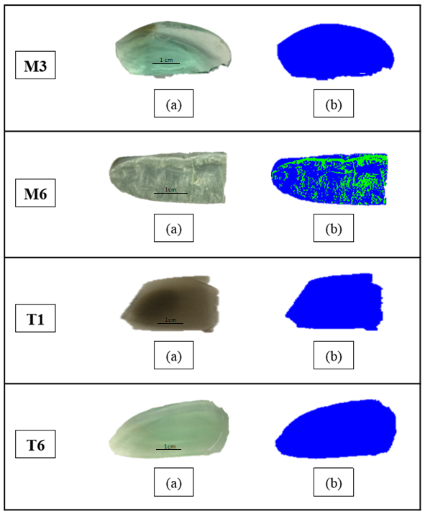

Figure 66 (a) Cross sectional images of M-series mould powders (b) Threshold analysis of M-series, T1 and T6 mould powder (crystal parts in green and glassy parts in blue).

In addition, the crystallinity of mould powders with 5 % wt. B₂O₃ content increases with an increase in C/A ratio. The same trend is also observed for the lime-alumina based powder with 15 %wt. B₂O₃ content. The percentage values for the crystalline phase obtained by X-Ray Diffraction for the mould powder samples and the values obtained with metallographic measurements are listed in Table 24.

As can be observed from Table 24, the crystallinity values obtained by both X-Ray Diffraction and metallographic determination for M-series, T1 and T6 lime-alumina based mould powders are in good agreement.

The current finding indicates that crystallinity was inhibited with an increase of B₂O₃ content in M-series, T1 and T6 mould powder. This is consistent with the reported results in both conventional (lime-silica based) and lime-alumina based mould powders that the increase of B₂O₃ content would tend to restrain the crystallinity [146, 89, 110, 11].

Lu et al. [146] investigated the effect of B₂O₃ and basicity on the crystallisation and heat transfer of mould powder using an emitter technique and double hot thermocouple technology, and revealed that the crystallisation of mould powder would be inhibited by addition of B₂O₃ content (6 to 10 % wt.).Yang et al. [110] systematically studied the effect of B₂O₃ thermo-physical properties of mould powders, and suggested that when the B₂O₃ content varied between 4.7 to 10.4 mass pct, the addition of B₂O₃ lowered the crystallinity of mould powder by decreasing melting temperature.

The reason for the above phenomena is that B₂O₃ generally acts as a network former in order to form a complex borate network structure. In boron-containing mould powders, complex boron network structures are based on [BO₃]³⁻ or [BO₄]⁵⁻ units. The addition of B₂O₃ will increase the [BO₃]³⁻ triangular unit or [BO₄]⁵⁻ tetrahedral unit and thus the complexity of the network structure, which strengthens the glass-forming ability and subsequently weakens the crystallisation tendency [107, 146, 110].

It has been confirmed by both X-Ray Diffraction and metallographic determination techniques that powder with a higher C/A ratio has higher crystallinity, while the B₂O₃ content fixed at 15 %wt. These results are in agreement with the reported results for C-series mould powder. In C-series mould powder, the crystallinity of lime-alumina based mould powder, increases while the C/A ratio ranged from 1 to 3. The interesting phenomena is that powder (M1) with lower C/A ratio (C/A=3.3) has higher crystallinity than powder with C/A ratio of 5.5 (M4) at zero B₂O₃ content. However, the crystallinity of M2 (C/A= 3.3) and M5 (C/A= 5.5) mould powders with 5 % wt. B₂O₃ content has nearly same amount of crystallinity percentage. The reason for the above interesting phenomena can be explained due to the reason that Al₂O₃ is an amphoteric oxide and can behave as a network former or network breaker depending on the basicity of molten slag. However, B₂O₃ always acts as a network former in the melt. Therefore, Al₂O₃ may act as a network former with the addition of B₂O₃. As the powders with C/A ratio of 3.3 contain more Al₂O₃ than the powders with 5.5, the crystallinity of mould powders with C/A ratio of 3.3 will further decrease with addition of B₂O₃.

Table 24 The Metallographic and XRD % crystallinity values in M-series, T1 and T6 mould powders

Samples | C/A  ratio | B₂O₃ Content | Metallographic % crystallinity measurements | XRD %crystallinity measurements
M1 | 3.3 | 0 | --- | 84.8
M2 | 3.3 | 5 | --- | 70
M3 | 3.3 | 15 | 0.4 | 0.7
M4 | 5.5 | 0 | --- | 74.4
M5 | 5.5 | 5 | --- | 69
M6 | 5.5 | 15 | 34.1 | 22
T1 | 1.2 | 5 | 1.3 | 3.6
T6 | 1.2 | 10 | 0.2 | 3

At fixed 5 %wt. B₂O_{3,} the crystallinity of the powder with C/A ratio of 1.2 is significantly lower than the crystallinity of powders with a C/A ratio of 3.3 and 5.5. It should be pointed out that T1 (5 %wt. B₂O₃) and T6 (10 %wt. B₂O₃) lime-alumina based mould powders contain 10 % wt. CaF₂ which has a similar effect as B₂O₃ on crystallisation of mould powders.
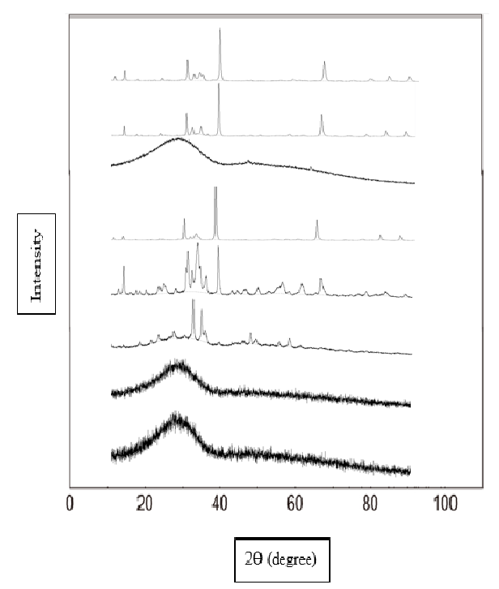
B₂O₃ – 0 %, C/A=3.3
B₂O₃ – 5 %, C/A=3.3

B₂O₃– 15 %, C/A=5.5

B₂O₃– 0 %, C/A=5.5

B₂O₃ – 5 %, C/A=5.5

B₂O₃– 15 %, C/A=5.5

B₂O₃– 5 %, C/A=1.2

B₂O₃–10 %, C/A=1.2

Figure 67 The XRD patterns of M-series mould powders with different C/A ratio and B₂O₃ content

Yan et al. [107] studied the evaluation of B₂O₃ as a replacement for CaF₂ in lime-alumina based powders and suggested that the addition of B₂O₃ to lime-alumina based mould powders, presents a similar effect to that of CaF₂ addition and inhibits crystallisation. It has also been indicated that B₂O₃ presents a stronger tendency to restrain crystallinity of lime-alumina based mould powders. A paper presented in Molten16 by Yan et al. [89] indicates that the addition of B₂O₃ suppresses the crystallinity and same amount of B₂O₃ has a nearly twofold effect on crystallinity compared to that of CaF₂. However, while T1 and T6 mould powders contain 10 % wt. Na₂O, M-series mould powders contain only 5 % wt. Lu et al. [15] studied the effect of Na₂O and Li₂O on crystallisation of lime-alumina based mould powders and revealed that Na₂O restrain the crystallisation of mould powder by lowering the initial crystallisation temperature.
Table 25 NBO/T ratio of M-series, T1 and T6 mould powders

Powder No: | M1 | M2 | M3 | M4 | M5 | M6 | T1 | T6
NBO/T | 3.38 | 2.96 | 1.55 | 4.66 | 3.43 | 2.36 | 1.85 | 1.58

The amount of crystalline phase in M-series, T1 and T6 lime-alumina based mould powders has also been estimated by using the % crystallinity model. As NBO/T ratio (see Table 25) of all M-series mould powders (apart from M6) are above the limit, they have been accepted as completely crystallised while T1 and T6 mould powders are accepted completely glassy as their NBO/T ratio below 2. The % crystallinity of M6 has been calculated as 50 % through % Crystallinity model.
Figure 68 illustrates the comparison of experimental data obtained by X-Ray Diffraction with the crystallinity estimated by the % Crystallinity model. As it can be seen in Figure 68 the agreements between calculated crystallinity and measured values are considerably in good agreement.

Figure 68 Comparison of measured (X-Ray Diffraction measurement) and estimated (% Crystallinity model) crystallinity of M-series, T1 and T6 mould powders

6.2.2. Effect of B₂O₃ and CaO/Al₂O₃ ratio on the melting temperature of mould powder

The melting temperatures were determined for each of the M-series, T1 and T6 mould powders through HSM (Hot stage Microscopy). Figure 69 presents the melting temperature of mould powders with different values of C/A ratio and B₂O₃ content.

The effect of the addition of B₂O₃ on the melting temperature of lime-alumina based mould powder is shown in Figure 69, where it can be seen that the melting temperature decreases with increasing B₂O₃ content when ranging from 0 to 15 %wt. at CaO/Al₂O₃ of 1.2 and 5.5. There is a small increase in melting temperature with an increase of B₂O₃ content from 0 to 5 %wt. and there is a significant decrease with an increase of B₂O₃ content from 5 to 15 %wt. for powders with a CaO/Al₂O₃ ratio of 3.3. The CaO-Al₂O₃ based mould powder with higher B₂O₃ content and a C/A ratio of 3.3 has the lowest melting temperature amongst all the investigated mould powders. This phenomenon is consistent with other reported data [193, 194, 195, 196, 197]
A likely explanation is that as an acidic oxide with a low melting temperature, B₂O₃ tends to combine with basic oxides and lower the melting temperature of the slag melt by forming eutectics such as CaO.B₂O₃.

Figure 69 Effect of B₂O₃ and C/A ratio on the melting temperature of M-series, T1 and T6 mould powders

As it can be seen in Figure 69, powders with a 5.5 C/A ratio have higher melting temperatures compared to powders with a 3.3 C/A ratio. This is not consistent with the reported results. Blazek et al. [198] suggested that melting temperature decreases with the increase of C/A ratio when ranging from 0.6 to 3.6 in lime-alumina based mould powders. There is only one study which is partly consistent with these investigated results. Li et al. [199] investigated to show a relatively small increase in melting temperature while the value of C/A ratio increased from 1 to 1.2.

6.2.3. Effect of B₂O₃ and CaO/Al₂O₃ ratio on the viscosity of mould powder

The effect of B₂O₃ and C/A ratio on viscosity behaviour of the designed mould powders which are listed on Table 26 was investigated using an Inclined Plane Test (IPT) and FactSage software. The results of the viscosity measurements obtained by using both techniques for designed lime-alumina based mould powders are shown in Table 26. Since the viscosities of M1, M2, M4 and M5 are too high at 1300 ºC, the Inclined Plane Test (IPT) couldn’t be applied to those samples.

Table 26 The measured and estimated viscosity values at 1300 ºC

Sample No | M1 |  | M2 | M3 | M4 | M5 | M6 | T1 | T6
C/A ratio |  | 3.3 | 3.3 | 3.3 | 5.5 | 5.5 | 5.5 | 1.2 | 1.2
wt-% B₂O₃ |  | 0 | 5 | 15 | 0 | 5 | 15 | 5 | 10
viscosity (IPT) (d Pas) |  | - | - | 0.70 | - | - | 0.72 | 3.18 | 1.06
viscosity (FactSage) (d Pas) |  | 5.85 | 3.69 | 3.20 | 5.08 | 3.86 | 2.10 | 1.90 | 1.79

It can be seen from Table 26 that the viscosity decreases from 3.18 poise to 1.06 poise with an increase in B₂O₃ at a fixed C/A ratio of 1.2. The calculated viscosities with FactSage for these two mould powders also present the same trend within the experimental results, but the values are considerably different. The reason for this difference could be due to the limited thermodynamic data references for the lime-alumina based slag system in the FactSage software package.

Figure 71 illustrates the changes in viscosity of the investigated mould powders with the addition of B₂O₃ at 1300 ºC using the FactSage software where the B₂O₃ content was 0, 5,10 and 15 % wt. at each C/A ratio of 1.2, 3.3 and 5.5. As it can be seen, the viscosity of the mould powders decreases with the addition of B₂O₃ at all three different C/A ratios. However, it is also particularly noteworthy that the measured viscosity decreases with the addition of B₂O₃ regardless of C/A ratio at 1300 ºC. This is consistent with the reported results [200, 118, 201, 202]. Huang et al. [200] investigated the effect of the addition of B₂O₃ on the viscosity of mould slag containing low silica content, where mould powder contains 0,3.6 and 9 % wt. B₂O₃ respectively. They pointed out that viscosity decreased with increasing B₂O₃ content. The findings of this study suggest that adding B₂O₃ significantly decreases the melting temperature of the slag and, so increasing the superheat degree of melt. Under greater degrees of superheat, the mobility of the particles in the melt rises and hence the viscosity decreases. The paper also contains the systematic analysis of the structure of the slags by Fourier transform infrared (FTIR) spectroscopy. Authors point out that boron is usually 3- or 4- coordinated with oxygen and the addition of CaO or Na₂O may cause configuration changes in the melt [9, 51]. This interaction described as follows:

$$2BO_{3}+CaO=2BO_{4}^{∓Ca^{2+}}$$

$$2BO_{3}+Na_{2}O=2BO_{4}^{∓2Na^{+}}$$

$$2BO_{3}+CaO=2BO_{3}^{∓Ca^{2+}}$$

$$2BO_{3}+Na_{2}O=2BO_{3}^{∓2Na^{+}}$$

As the used mould powder in the authors’ research [118] contains more than 50% network modifiers, the BO₃ is dominant in these melts and also according to the FTIR spectroscopy results (see Figure 70), 3-coordinated boron is higher than 4- coordinated boron in slag samples. With the addition of B₂O₃, charge compensating cations breaks the B-O bonds and BO₃⁻ units form in the melt with additional non-bridging oxygen. Therefore, the structure becomes simpler and thus viscosity decreases. This behaviour also suggested by Kim and Sohn [118].
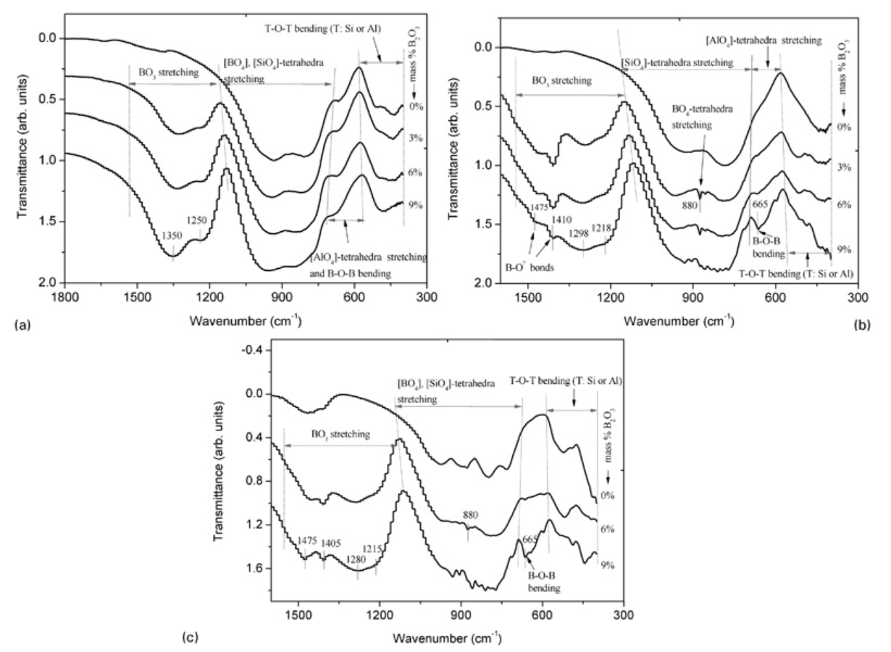

Figure 70 FTIR spectra of CaO–SiO2–12Na2O–30Al2O3–B2O3 system as a function of B₂O₃ [203]

The measured viscosity of mould powders a with constant amount of 15 % wt. B₂O₃ show that it is nearly stable while the C/A ratio increase from 3.3 to 5.5. The FactSage viscosity calculation for M3 and M6 present a decreasing trend which is not similar to the experimental results as the absolute values are higher than experimental results. Recently, some researchers suggested [118, 88, 202] that the addition of B₂O₃ has a relatively small effect on the slag viscosity when the mould powder has a high C/A ratio. Kim and Sohn [118] investigated that increasing the C/A ratio for mould powders containing 18 % wt. B₂O₃ beyond a C/A ratio of 1 has small effect on viscosity. A probable explanation was raised from authors’ work which explained that the existing B₂O₃ and Na₂O modified the slag structure and cause the disappearance of large complex structures in the melt. Therefore, increasing the C/A ratio will supply free oxygen ions to the melt and so the viscosity stabilises.

Figure 71 Effect of B₂O₃ addition on the estimated viscosity of mould powders with different C/A ratio at 1300 ºC

5 % wt. Li₂O and B₂O₃ at various percentages were added to M-series mould powder. Yu et al. [202] investigated the viscosity of mould fluxes for casting of high-Al TRIP steels and suggests that adding Li₂O and B₂O₃ to mould powder could have a synergistic effect to stabilise the acidity and also stabilise the amphoteric characteristic of Al₂O₃ and therefore viscosity could be levelled out. This is also consistent with the research done by Omoto et al. [204].

The effect of temperature on the viscosity of the lime-alumina based mould powder at different C/A ratios and B₂O₃ content are plotted in Figure 72, where the viscosity decreases with increasing temperature. However, the calculated viscosity decreases with increasing B₂O₃ content at C/A ratios of 1.2, 3.3 and 5.5 at different temperatures.

Figure 73 illustrates the comparison of experimental data obtained by IPT (Inclined Plane Test) with the viscosities estimated by FactSage. As it can be seen in Figure 73 the agreements between calculated viscosities by FactSage and measured values are not quite reasonable even though the calculated viscosities present the same trend with measured viscosities with an increase in B₂O₃ content.

Figure 72 Viscosity-temperature curves of P-series, T1 and T6 mould powders calculated by FactSage software

The viscosities of M-series, T1 and T6 lime-alumina based mould powders have been calculated by using Riboud and Urbain models. Figure 74 presents the comparison of measured viscosities and data calculated by Urbain and Riboud models. The agreement between estimated viscosities by Urbain model and experimental results are quite good at the C/A ratio of 1.2. At the fixed C/A ratio of 3.3 and 5.5, there is a large deviation between the experimental data and calculated viscosities by both Urbain and Riboud models. According to viscosities estimated by FactSage, the viscosity of M-series mould powder decreases with addition of B₂O₃. The estimated viscosities by both Urbain and Riboud models presents an opposite trend with the viscosities estimated by the FactSage software in terms of the effect of B₂O₃ addition.

Figure 73 Comparison of measured and estimated viscosity of P-series,T1 and T6 mould powders at 1300 ºC and those obtained by IPT and FactSage

Figure 74 Comparison between the measured (Inclined Plane Test) and calculated viscosities (Riboud and Urbain models) of mould powder listed in Table 22

6.2.4 Effect of B₂O₃ and CaO/Al₂O₃ ratio on the steel-slag interaction

In this part of the study laboratory crucible experiments were carried out at the temperature of 1500 ºC in order to investigate the interfacial mass exchange between molten steel and slag. The chemical composition of the steel samples was obtained by inductively couples plasma mass spectrometry.

Table 27 presents the amount of [Al], [B] and [Mn] changes in the steel samples after the steel-slag interaction tests. As it can be observed in Table 27, the [Al] and [Mn] content in steel significantly decreased in all samples regardless of C/A ratio and B₂O₃ content in mould powder while a relatively small amount of boron has been picked up by the steels.

Figure 75 and Figure 76 show the total [Al] and [Mn] (respectively) content in steel change depending on the B₂O₃ content and C/A ratio of mould powders. As it can be seen in these figures, steel samples melted with mould powders with a C/A ratio of 3.3 have the highest [Al] and [Mn] content. That means that the mould powders with a C/A ratio of 3.3 are less reactive than the other designed powders. This phenomenon can be related to the SiO₂ and B₂O₃ content of powders. During the casting of high-Al steels, the main reactions occurring at the steel-slag interface are the reduction of less stable oxides such as SiO₂ and B₂O₃ with high dissolved Al in molten steel. As M1 mould powder contains a low amount of SiO₂ (4 %wt.), the reactivity between SiO₂ and aluminium is smaller. Ting et al. [205] studied reaction performances and applications of mould fluxes for high-Al steels and pointed out that SiO₂ is easily reduced by aluminium, B₂O₃ and Na₂O may react with high dissolved Al under some conditions and CaO, CaF₂ and LiO₂ do not participate in reduction reactions with Al in molten steel.

Table 27 C/A ratio and B₂O₃ content of M and T-series mould powders and change in steel composition after the steel-slag interaction test

 | C/A ratio | B₂O₃ wt.% in powder | B wt.% in steel | Al wt.% in steel | Mn wt.% in steel
M1 | 3.3 | 0 | 0.033 | 0.627 | 1.283
M2 | 3.3 | 5 | 0.017 | 0.436 | 0.923
M3 | 3.3 | 15 | 0.005 | 0.211 | 0.641
M4 | 5.5 | 0 | 0.008 | 0.005 | 0.142
M5 | 5.5 | 5 | 0.029 | 0.008 | 0.155
M6 | 5.5 | 15 | 0.052 | 0.013 | 0.156
T1 | 1.2 | 5 | 0.011 | 0.019 | 0.014
T6 | 1.2 | 10 | 0.027 | 0.03 | 0.153

The powders used in this part of the study were designed with 3 different C/A ratios (1.2, 3.3 and 5.5). According to the steel-slag test results, powders with a C/A ratio of 3.3 are less reactive than powders with 1.2 and 5.5 C/A ratios. These results are not consistent to some extent with the results obtained by Xiao et al. [81]. They investigated a series of lime-alumina based mould powders with the C/A ratio ranging from 1 to 3 and concluded that steel-slag reactions increase with an increase in C/A ratio. On the other hand, Cho et al. [12] also researched the effect of C/A ratio on the degree of slag-steel reaction and pointed out that steel-slag interaction became severe for the powder with a C/A ratio of 3.3.

Figure 75 Total change in the Al content of steel depending on B₂O₃ addition on the 20 min of elapsed interaction time

In terms of the effect of B₂O₃ addition to the degree of steel-slag reaction, as can be seen in Figure 75 and Figure 76, the Al and Mn content in the steel samples decreases with increasing B₂O₃ content in the mould powders. Lime-alumina based mould powders with less B₂O₃ content are less reactive than the others. On the other hand, a very small amount (up to 0.01%) of boron is added to steel as an alloying element due to its effect on hardenability enhancement [206]. M-series mould powders contain B₂O₃ and as an acidic oxide, B₂O₃ in the slags may react with high dissolved [Al] in steel through the following reaction:
$$B_{2}O_{3}+\left[Al\right]={Al}_{2}O_{2}+2B$$

where the reduced B may go into the steel. As it can be seen in Table 27, steel samples picked up boron after the steel-slag tests. Even though only a small amount of boron is picked up by the steel samples, this may cause a major change in the steel properties.
In summary, among all of the T, M and C-series mould powders, the M series mould powders with C/A ratio of 3.3 have presented the best performance in terms of steel-slag reactions. In this study, performance and properties of lime-alumina based mould powders with C/A ratios of 3.3 and 0, 5 and 15 % wt. B₂O₃ content have been investigated. As mould powders with 3.3 C/A ratio performed better than other powders, it may worth investigating further the properties of mould powders with C/A ratio of 3.3 and B₂O₃ content ranging between 5 and 15 % wt.

Figure 76 Change in the Mn content of steel depending on B₂O₃ addition on the 20 min of elapsed interaction time

7.CONCLUSION

In this study, the crystallinity, viscosity and melting temperature of lime-alumina-based mould powder changes with the addition of B₂O_{3,} TiO₂ and ZrO₂ and the effects of increasing the CaO/Al₂O₃ ratio have been observed through STA (Simultaneous Thermal Analysis), HSM (Hot Stage Microscopy), XRD (X-ray Diffraction), IPT (Inclined Plate Test) and Rotational viscometer, which may provide guidelines for the design of lime-alumina based mould powder for casting high-Al steels. The crystallisation behaviour of designed mould powders was evaluated by generating CCT (continuous cooling transformation) diagrams. The changes in slag chemistry over time have also been analysed using XRF (X-ray fluorescence). Additionally, the FactSage software and empirical models used to calculate viscosity of mould powders. The specific findings for each chapter are summarised as follows:

- Effect of C/A ratio on physical properties of lime-alumina based mould powders

- According to the X-ray Diffraction results, the powder with C/A ratio of 3 has relatively high crystallinity in comparison with the other C-series mould powders, which was also confirmed by metallographic determination measurements. In addition, CCT test results indicate that an increase in C/A ratio decreases the initial crystallisation temperature of lime alumina-based mould powder at the cooling rate of 15 ºC/min. This demonstrates that the percentage of crystallinity of C-series mould powders obtained by X-Ray Diffraction are not in accordance with the CCT test results.

- The result of HSM tests indicated that the melting temperature of lime-alumina based mould powder increased when the C/A ratio ranged from 1 to 3. This behaviour is in agreement with M-series mould powder where the C/A ratio increased from 3.3 to 5.5. However, these results are not consistent with the literature data for conventional mould powder.
- Viscosity measurements with the IPT technique show that the viscosity sharply decreases and then gradually stabilises with an increase in C/A ratio. The rotating bob viscometer analysis of C1, C3 and C5 mould powder were discussed and the results were in line with above findings, which lends to the credibility of this study. However, good correlation between the measured and the calculated viscosities was observed for C-series mould powder.

- The results of steel/slag interaction tests show that the degree of steel/slag interaction decrease with an increase in Al₂O₃ content.

- From this part of the study, lime-alumina based mould powders with a C/A ratio in the range 1.5-2 has a low degree of steel/slag interaction, melting temperature and viscosity. Therefore, these conditions will significantly improve the lubrication of the lime-alumina based mould powder and consequently enhance the heat transfer by reducing crystallisation tendency which is beneficial for the casting of high-Al steels.

- Effect of TiO₂ and ZrO₂ on physical properties of lime-alumina based mould powders

- The crystallinity was enhanced with an increase of TiO₂ content in T-series mould powders. The increase of crystallinity with increasing TiO₂ content might be as a result of the decease of the degree of polymerization. The ZrO₂ addition of 5 wt. % in lime-alumina based mould powder with C/A ratio of 1.2 does not have a significant effect on the crystallinity of mould powder. However, there is relatively good agreement between the percentage of crystallinity obtained by X-Ray Diffraction and the percentage of crystallinity determined by metallographic technique while there is a large deviation between the measured data and calculated crystallinity.

- The melting temperature slightly increased first and then decrease dramatically while the TiO₂ content ranged from 0 to 15 % wt. This is not consistent with the trend observed in both conventional and lime-alumina based mould powders in that the increase of TiO₂ content would raise the melting temperature of mould powder.

- The measured viscosities of T-series mould powder first slightly decreased and then increased dramatically while the calculated viscosity by FactSage decreases with addition of TiO₂. In addition, the viscosity decreases in both estimated and experimental methods while the ZrO₂ increases to 5 %wt. Moreover, the calculated viscosities using the Urbain model show large deviations from the measured data while Riboud model shows a relatively reasonable prediction.

- Effect of B₂O₃ on physical properties of lime-alumina based mould powders

- The addition of B₂O₃ suppresses the crystallinity of lime-alumina based mould powder with various C/A ratios by lowering the crystallisation and melting temperature.

- The increase of B₂O₃ significantly improves the lubrication of the lime-alumina-based mould powders by reducing the crystallinity of the mould powder.

- Casting of high-Al steels requires a mould powder with low melting temperature and crystallinity. Therefore, the mould powder with a C/A ratio of 3.3 and higher content of B₂O₃ has a better capability to improve mould performance during casting of high-Al steels among the M-series lime-alumina based mould powder.

- In terms of steel-slag reactions, the M series mould powders with C/A ratio of 3.3 have presented the best performance among all of the T, M and C-series mould powders.

8.FURTHER WORK

Based on current work and obtained results, the following specific subjects can be suggested:

- Much future work is needed to develop this new slag system for casting of high-Al steels by way of optimising mould powder chemical composition with the addition of favourable components, reducing steel/slag interaction and controlling crystallinity.

- For the further understanding of the viscosity behaviour of studied mould powder, the relationship between viscosity and slag structure needs to be identified using Raman spectrometry or FTIR (Fourier transform infrared).

- As the effective control of heat transfer is one of the most important challenges for the development of mould powder and as it is directly related to crystallisation behaviour of mould powder, it is highly needed to investigate the heat transfer behaviour of designed mould powder.

- The findings from this study suggest that the currently available mathematical viscosity model should be modified to be able to the use for the viscosity calculation of lime-alumina based mould powders.

REFERENCES

[1] | E. Brandaleze, G. Di Gresia, L. Santini, A. Martin and E. Benavidez, “Mould Fluxes in the Steel Continuous Casting Process,” in Science and Technology of Casting Processes, InTech, 2012, pp. 205-233.
[2] | M. M. Wolf, “Making, Shaping and Treating of Steel: Casting Volume,” Pittsburgh, AISE, 2003, pp. 1-38.
[3] | “MetSoc,” [Online]. Available: http://www.metsoc.org/virtualtour/processes/steel/Casters.asp. [Accessed 28 11 2014].
[4] | J. A. Bothma, Heat transfer Through Mould Flux With Titanium Oxide Additions, South Africa: University of Pretoria, 2006.
[5] | A. Arefpour, A. Monshi, T. Khayamian and A. Saidi, “Investigation of Viscosity's Effects on Continuous Casting of Steel Mould Powders Containing B2O3, Li2O, TiO2, Fe2O3, ZnO, and Na2O,” Scientific Research, vol. 4, no. 08, pp. 435-444, 2012.
[6] | J. A. Kromhout, “Mould powders for high speed continuous casting of steel,” Gildeprint Drukkerijen, 2011.
[7] | K. C. Mills, A. B. Fox, R. P. Thackray and Z. Li, “The performance and properties of mould fluxes,” in VII International Conference on Molten Slags Fluxes and Salts, 2004.
[8] | Z. Elahipanah, “Thermo-Physical Properties of Mould Flux Slags for Continuous Casting of Steel,” Royal Institute of Technology, 2012.
[9] | X. H. Huang, L. Liao, K. Zheng, H.H. Hu, F. M. Wang, Z. T. Zhang, “Effect of B2O3 addition on viscosity of mould powder slag containing low silica content,” Ironmaking and Steelmaking, vol. 41, no. 1, pp. 67-74, 2014.
[10] | H. Zhao, W. Wang, L. Zhou, B. Lu and Y.B. Kang, “Effects of MnO on crystallisation, Melting, and Heat Transfer of CaO-Al2O3 based Mold Flux Used for High Al-TRIP Steel Casting,” Metallurgical and Materials Transactions B, vol. 45, no. 4, 2014.
[11] | C. B. Shi, M. D. Seo, J. W. Cho and S. H. Kim, “Crystallization characteistics of Cao-Al2O3 based Mould Flux and Their Effects on In-Mold Performance During High-Aluminium TRIP Steels Continuous Casting,” Metallurgical and Materials Transactions B, vol. 45, no. 3, 2014.
[12] | J. W. Cho, K. Blazek, M. Frazee, H. Yin, J. H. Park and S.W. Moon, “Assessment of CaO-Al2O3 Based Mold Flux System for High Aluminium TRIP Casting,” ISIJ, vol. 53, no. 1, pp. 62-70, 2013.
[13] | X. J. Fu, G. H. Wen, P. Tang, Q. Liu and Z. Y. Zhou, “Effects of Cao/Al2O3 ratio on crstallisation behaviour of Cao-Al2O3 based mould fluxes for high Al TRIP steel,” Ironmaking and Steelmaking, vol. 41, no. 5, 2014.
[14] | B. Jiang, W. Wang, I. Sohn, J. Wei, L. Zhou and B. Lu, “A Kinetic Study of the Effect of ZrO2 and CaO/Al2O3 Ratios on the Crystallisation Behaviour of a Cao-Al2O3-based Slag System,” Metallurgical and Materials Transactions B, vol. 45, no. 3, 2014.
[15] | B. Lu, K. Chen, W. Wang and B. Jiang, “Effects of Li2O and Na2O on crystallisation behaviour of lime-alumina based mold flux for Casting High-Al Steels,” ASM International, vol. 45B, 2014.
[16] | W. Yan, W. Chen, Y. Yang, C. Lippold & A. McLean, “Effect of CaO/Al2O3 ratio on viscosity and crystallisation behaviour of mould flux for high Alnon-magnetic steel,” Ironmaking & Steelmaking, vol. 42, no. 9, pp. 698-704, 2015.
[17] | J. Li, Q. Shu, X. Hou and K. Chou , “Effect of TiO2 Addition on Crystallization Characteristics of CaO- Al2O3-based Mould Fluxes for High Al Steel,” ISIJ International, vol. 55, no. 4, pp. 830-836, 2015.
[18] | K. Zheng, Z. Zhang , L. Liu and X. Wang, “Investigation of the Viscosity and Structural Properties of CaO-SiO2-TiO2 Slags,” Metallurgical and Materials Transaction B , vol. 45B, pp. 1389-1397, 2014.
[19] | J. B. Kim and I. Sohn, “Influence of TiO2/SiO2 and MnO on the viscosity and structure in the TiO2–MnO–SiO2 welding flux system,” Journal of Non-Crystalline Solids, vol. 379, pp. 235-243, 2013.
[20] | J. L. Liao, J. Li, X. D. Wang, Z. T. Zhang, “Influence of TiO2 and basicity on viscosity of Ti bearing slag,” Ironmaking & Steelmaking, vol. 39, no. 2, pp. 133-139, 2012.
[21] | S. .Chatterjee, Transformation in TRIP-assisted Steels: Microstructure and Properties, University of Cambridge, 2006.
[22] | Y. Hongliang, TRIP Steel, Pohang University of Science and Technology, 2010.
[23] | S. Turteltaub and A. S. J. Suiker, “Transformation-induced plasticity in ferrous alloys,” Journal of the Mechanics and Physics of Solids, vol. 53, no. 8, pp. 1747-1788, 2005.
[24] | M. Y. Demeri, “Advanced High-Strength Steels- Science, Technology and Applications,” ASM International, 2013.
[25] | A. I. Taub and A. A. Luo, “Advanced lightweight materials and manufacturing processes for automotive appllications,” MRS Bulletin, vol. 40, no. 12, pp. 1045-1055, 2015.
[26] | J. Gao, G. Wen, Q. Sun, P. Tang and Q. Liu, “The Influence of Na2O on the solidification and Crystallization Behavior of CaO-SiO2-Al2O3-Based Mold Flux,” Metallurgical and Materials Transaction B, vol. 46, no. 4, pp. 1850-1859, 2015.
[27] | B. Lu, K. Chen, W. Wang and B. Jiang, “Effects of Li2O and Na2O on the Crystallization Behavior of Lime-Alumina-Based Mold Flux for Casting High-Al Steels,” Metallurgical and Materials Transactions B-Process Metallurgy and Materials Processing Science, vol. 45, no. 4, pp. 1496-1509, 2014.
[28] | C. X. Ji, C. Yang, Z. Zeng, Z. H. Tian, C. L. Zhao and G. S. Zhu, “Continuous Casting of High-Al Steel in Shougang Jingtang Steel Works,” Journal of Iron and Steel Research, International, vol. 22, pp. 53-56, 2015.
[29] | H. Zhao, W. Wang, L. Zhou, B. Lu and Y. B. Kang, “Effects of MnO on Crystallisation, Melting and Heat Transfer of Cao-Al2O3 Based Mould Flux Used for High Al-TRIP Steel Casting,” Metallurgical and Materials Transactions B, vol. 45B, pp. 1510-1519, 2014.
[30] | H. C. Wang, Y. C. Dong, W. M. Zhang, S. J. Wang and Y. Zhou, “Physical and chemical performance of high Al steels,” Journal CSUT, vol. 12, no. 4, pp. 385-388, 2005.
[31] | H. Kim, D. W. Suh, W. and N. J. Kim, “Fe-Al-Mn-C lightweight structural alloys: a review on the microstructures and mechanical properties,” Science and Technology of Advanced Materials, vol. 14, no. 1, pp. 1-11, 2013.
[32] | Steeltank, “Effect of Chemical Elements in Steel,” American Welding Society, 2019.
[33] | “Total Materia,” Multi Phase Twinning-Induced Plasticity (TWIP) Steel, August 2007. [Online]. [Accessed July 2017].
[34] | O.Grässel, LKrüger, GFrommeyer, L.WMeyer, “High strength Fe–Mn–(Al, Si) TRIP/TWIP steels development — properties — application,” International Journal of Plasticity, vol. 16, no. 10-11, pp. 1391-1409, 2000.
[35] | W. Yan, Y.D. Yang, W.Q. Chen, M.Barati, A.McLean, “Design of mould fluxes for continuous casting of special steels,” The Canadian Journal of Metallurgy and Materials Science, vol. 54, no. 4, pp. 467-476, 2016.
[36] | H. Assia and B. Adel, “Mould powders in continuous casting,” IJRR, vol. 2, no. 1, pp. 1-4, 2012.
[37] | A.Cruz, F. Chavez, A. Romero, E. Palacios and V. Arredondo, “Mineralogical phases formed by flux glases in continuous casting mould,” Journal of Materials Processing Technology, vol. 182, no. 1-3, pp. 358-362, 2007.
[38] | R. Saraswat, A. B. Fox, K. C. Mills, P. D. Lee and B. Deo, “The factors affecting powder consumption of mould fluxes,” Scandinavian journal of metallurgy, vol. 33, no. 2, pp. 85-91, 2004.
[39] | E. F. Wei, Y. D. Yang, C. L. Feng and I. D. Sommerville A. McLean, “Effect of Carbon Properties on Melting Behavior of Mold Fluxes for Continuous Casting of Steel,” Journal of Iron and Steel Research, vol. 13, no. 2, pp. 22-26, 2006.
[40] | K. C. Mills, “A short history of mould powders,” Ironmaking & Steelmaking, vol. 44, no. 5, pp. 326-332, 2017.
[41] | D. Sighinolfi and M. Paganelli, “Study of the behaviour of mould powders for continuous casting by using the heating microscope,” in Innovation in Refractories and Traditional Ceramics, 2011.
[42] | K. C. Mills, “Mold Powders for Continuous Casting,” Pittsbrugh, The AISE Steel Foundation, 2003.
[43] | J. A. Kromhout, “Mould Powder Development for Continuous Casting of Steel,” Transaction of the Indian Institute of Metals, vol. 66, no. 5-6, pp. 587-596, 2013.
[44] | K. C. Mills and A. B. Fox, “The Role of Mould Fluxes in Continuous Casting- So Simple Yet So Complex,” ISIJ International, vol. 43, no. 10, pp. 1479-1486, 2003.
[45] | Kenneth C. Mills and Alistair B. Fox, “The Role of Mould Fluxes in Continuous Casting- So simple Yet So Complex,” ISIJ Internaional , vol. 43, pp. 1479-1486, 2003.
[46] | S. Sridhar, K. C. Mills, O. D. C. Afrange, H. P. Lo¨ rz, and R. Carli, “Break temperatures of mould fluxes and their relevance to continuous casting,” Ironmaking and Steelmaking, vol. 27, no. 3, pp. 238-242, 2000.
[47] | K.C. Mills, L.Yuan, R.T.Jones, “Estimating the physical properties of slag,” The journal of Southern African Institute of Mining and Metallurgy, vol. 111, 2011.
[48] | K. C. Mills, “The Influence of Structure on the Physico-chemical Properties of Slags,” ISIJ International, vol. 33, no. 1, pp. 148-155, 1993.
[49] | K. C. Mills, “Structure and Properties Used in the Continuous Casting of Steel: Part 1 Conventional Mould Powders,” ISIJ International, vol. 56, pp. 1-13, 2016.
[50] | G. Brooks, “Slag Chemistry for Steelsmakers,” Swinburne University of Technology, 2015.
[51] | K. C. Mills, “Structure and Properties of Slags Used in the Continuous Casting of Steel: Part 2 Specialist Mould Powders,” ISIJ International, vol. 56, no. 1, pp. 14-23, 2016.
[52] | K. N. Anisimov, A. M. Longinov, A. M. Toptygin, M. P. Gusevc, and S. V. Zarubin, “Investigation of the Mold Powder Film Structure and Its Influence on the Developed Surface in Continuous Casting,” Steel in Translation, vol. 46, no. 7, pp. 489-495, 2016.
[53] | K. C. Mills and C. A. Dacker, The Casting Powders Book, Springer, 2017.
[54] | SESHADRI SEETHARAMAN, ALEXANDER McLEAN, RODERICK GUTHRIE and SEETHARAMAN SRIDHAR, TREATISE ON PROCESS METALLURGY Process: Fundamentals, Oxford: Elsevier, 2014.
[55] | L. Zhou, W. Wang and K. Zhou, “Effect of Al2O3 on the Crystallization of Mold Flux for Casting High Al Steel,” Metallurgical and Materials Transaction E, vol. 2, no. 2, pp. 99-108, 2015.
[56] | Z. Zhang, G. Wen, P. Tang and S. Sridhar, “The Influence of Al2O3/SiO2 Ratio on the Viscosity of Mold Fluxes,” ISIJ international, vol. 48, no. 6, pp. 739-746, 2008.
[57] | E. T. Turkdogan, Fundamentals of Steelmaking, Cambridge: The University Press, 1999.
[58] | K. C. Mills, L. Yuan and R.T. Jones, “Estimating the physical properties of slag,” The journal of Southern African Institute of Mining and Metallurgy, vol. 111, 2011.
[59] | B. Mazumder, “A Process for Developing Continuous Casting Mould-Powder for Steel Industries,” Journal of Scientific & Industrial Research , vol. 58, pp. 773-780, 1999.
[60] | S. Sridhar, K.C.Mills, and T.Mallaband, “powder consumption and melting rates of continuous casting fluxes,” Ironmaking and Steelmaking, vol. 29, no. 3, 2002.
[61] | S. K. Sarna, “Ispatguru,” 16 June 2013. [Online]. Available: https://www.ispatguru.com/continuous-casting-mould-powders/#. [Accessed 5 March 2019].
[62] | Wanlin Wang, Dexiang Cai, Lei Zhang, “A Review of Fluorine-free Mold Flux Development,” ISIJ International, vol. 58, no. 11, pp. 1957-1964, 2018.
[63] | K. I. N. M. F. Hattori, “Exothermic mold powder for continuous casting”. Patent EP0513357A1, 22 10 1997.
[64] | E. Benavidez, L. Santini, M. Valentini, E. Brandaleze, “Influence of different oxides on the viscosity of fluorine-free mold fluxes,” in 11th International Congress on Metallurgy & Materials, Argentina, 2012.
[65] | A. R. Arefpoura, A. Monshi, A. Saidi, “Effects of Replacing Fluorine with Sodium and Titanium Oxides on Mold Powders Lubrication in Continuous Casting of Steel,” Journal of Advanced Materials and Processing, vol. 3, no. 1, pp. 59-66, 2015.
[66] | G. Wen, S. Sridhar, P. Tang, X. Qi and Y. Liu, “Development of Fluoride-free Mold Powders for Peritectic Steel Slab Casting,” ISIJ International, vol. 47, no. 8, pp. 1117-1125, 2007.
[67] | Jeferson Leandro Klug, René Hagemann , Nestor Cezar Heck, Antônio Cezar Faria Vilela, Piotr Roman Scheller, “FLUORINE-FREE MOULD SLAGS FOR SLAB CASTING: UTILISATION OF THE HOT THERMOCOUPLE TECHNIQUE TO BUILD TTT DIAGRAMS,” in Tecnol. Metal. Mater. Miner, São Paulo, 2012.
[68] | AB Fox, KC Mills, D Lever, C Bezerra, C Valadares, I Unamono, J Laraudogoitia, J Gisby, “DEVELOPMENT OF FLUORIDE-FREE FLUXES FOR BILLET CASTING,” ISIJ Intl, vol. 45, p. 1051, 2005.
[69] | MC Bezerra, CA Valadares, IP Rocha, JP Bulota, MC Carboni, IL Scripnic, CR Santos, K Mills, D Lever, “Impact of Fluorine Free Mould Flux use on Continuous Casting Process,” in Proc. 37th Steelmaking Seminar, Porto Allegre/Brazil, 2005.
[70] | LY Chen, GH Wen, CL Yang, F Mei, CY Shi, P Tang, “Development of low-fluoride and titanium-bearing mould fluxes for medium carbon peritectic steel slab casting,” Ironmaking and Steelmaking, vol. 42, no. 2, pp. 105-111 , 2015.
[71] | H Nakada, K Nagata, “Crystallization of CaO–SiO2–TiO2 Slag as a Candidate for Fluorine Free Mold Flux,” ISIJ Intl, vol. 46, no. 3, pp. 441-449, 2006.
[72] | Keiji Watanabe, Koichi Tsutsumi, Makoto Suzuki, Hiroki Fujita, Satoshi Hatori, Takayuki Suzuki, Tomoaki Omoto, “Development of New Mold Flux for Continuous Casting Based on Non-Newtonian Fluid Properties,” ISIJ International, vol. 54, no. 4, pp. 865-871, 2014.
[73] | W. Wang, B. Lu, D. Xiao, “A Review of Mold Flux Development for the Casting of High-Al Steels,” ASM International, October 2015.
[74] | K. Blazek, H. Yin, G. Skoczylas, M. McClymonds and M. Frazee, “Development and Evaluation of Lime-Alumina Based Mold Powders for Casting High Aluminum TRIP Steel Grades,” AIST Trans, vol. 8, pp. 232-249, 2011.
[75] | Gert Adrian Bezuidenhout, “THE EFFECT OF ALUMINA PICK-UP ON MOULD FLUX BEHAVIOUR IN CONTINUOUS CASTING,” University of Pretoria -Thesis, Pretoria, 1999.
[76] | Wei YAN, Weiqing CHEN, Yindong YANG, Carsten LIPPOLD and Alex MCLEAN, “Effect of Slag Compositions and Additive on Heat Transfer and Crystallization of Mold Fluxes for High-Al Non-magnetic Steel,” ISIJ International, vol. 55, no. 5, p. 1000–1009, 2015.
[77] | K. C. Mills, “Structure and Properties of Slags Used in the Continuous Casting of Steel: Part 2 Specialist Mould Powders,” ISIJ International, vol. 56, no. 1, pp. 14-23, 2016.
[78] | D. Xiao, W. Wang, B. Lu, “Effects of B2O3 and BaO on the Crystallization Behavior of Cao-Al2O3 Based Mold FLux for Casting High-Al Steels,” Metallurgical and Materials Transaction B, vol. 46B, pp. 873-881, 2015.
[79] | S. Street, K. James, N. Minor, A. Roelant and J. Tremp, “Production of high-aluminum steel slabs,” Iron Steel Technology, vol. 5, no. 7, p. 38–49, 2008.
[80] | C. Shi, M. Seo, J. Cho and S. Kim, “Crystallization characteistics of Cao-Al2O3 based Mould Flux and Their Effects on In-Mold Performance During High-Aluminium TRIP Steels Continuous Casting,” ASM International, vol. 45B, pp. 1081-1097, June 2014.
[81] | Dan Xiao, Wanlin Wang, Boxun Lu, Xinwang Zhang, “Advanced Mold Flux Development for the Casting of High-Al Steels,” in 10 th International Conference on Molten Slags, Fluxes and Salts, Seattle, 2016.
[82] | G. W. a. Q. S. J. Gao, “The Influence of Na2O on the Solidification and Crystallization Behavior of CaO-SiO2-Al2O3 Based Mould Flux,” ASM International 2015, vol. 46B, 2015.
[83] | Kaitian Zhang Jianhua Liu and Heng Cui, “Investigation on the Slag-Steel Reaction of Mold Fluxes Used for Casting Al-TRIP Steel,” Metals, vol. 9, no. 4, p. 398, 2019.
[84] | B. Jiang, W. Wang, I. Sohn, J. Wei, L. Zhou and B. Lu, “A Kinetic Study of the Effect of ZrO2 and CaO/Al2O3 Ratios on the Crystallisation Behaviour of a Cao-Al2O3-based Slag System,” Metallurgical and Materials Transactions B, vol. 45, no. 3, February 2014.
[85] | H. Wang, P.Tang, G.H. Wen, “Effect of Na2O on crystallization beaviour and heat transfer of high Al steel mould fluxes,” ironmaking and steelmaking, vol. 38, no. 5, 2011.
[86] | B. Lu and W. Wang, “Effects of Fluorine and BaO on the Crystallization Behavior of Lime–Alumina-Based Mold Flux for Casting High-Al Steels,” Metallurgical and Materials Transaction B, vol. 46, no. 2, pp. 852-862, 2015.
[87] | CHENG-BIN SHI , MYUNG-DUK SEO , JUNG-WOOK CHO , SEON-HYO KIM, “DEVELOPMENT OF CaO-Al2O3-BASED MOLD FLUX FOR CONTINUOUS CASTING OF HIGH-ALUMINUM STEELS,” in 8TH EUROPEAN CONTINUOUS CASTING CONFERENCE, Graz, 2014.
[88] | W. Yan, W. Chen, Y. Yang, C. Lippold & A. McLean, “Effect of CaO/Al2O3 ratio on viscosity and crystallisation behaviour of mould flux for high Alnon-magnetic steel,” Ironmaking & Steelmaking, Vols. 42:9,, pp. 698-704,, 2015.
[89] | W. Yan, A. McLean, Y. Yang, W. Chen and M. Barati, “Evaluation of Mold Flux for Continuous Casting of High-Aluminum Steel,” in Proceedings of The 10th International Conference on Molten Slags, Fluxes and Salts (MOLTEN16), Seattle, 2016.
[90] | A. S. Normanton, V. Ludlow, B. Harris, M. Hecth, C.A. Dacker, “Mould powder consumption, melting and lubrication and their effects on mould heat transfer and subsequent surface quality of continuously cast slab,” European Communities, Luxembourg, 2005.
[91] | M. M. Wolf, “Mould powder consumption- a useful criterion?,” in Proc. METEC Congress 94. 2nd European Continuous Casting Conference, Dusseldorf, June 1994.
[92] | S. Ogibayashi, K. Yamaguchi, K. Mukai, T. Takahashi, Y. Mimura, K. Koyama, Y. Nagano and T. Nakano, “Nippon Steel Technical Report,” 34, 1987.
[93] | K. Tsutsumi, H. Murakami, S. Nshioka, M. Tada and M. Nakada, “Tetsu-to-Hagane,” vol. 84, p. 617, 1998.
[94] | A. Azhari, F. Golestani-Fard, KC. Mills, F. Pourdavoud, M. Rasti and J. Izadi, “An Investigation on Mold Powders Properties Consumed in Iran,” International Journal of ISSI, vol. 4, no. 1,2, pp. 50-54, 2007.
[95] | J. E. Shelby, Introduction to Glass Science and Technology, Cambridge: The Royal Society of Chemistry, 2005.
[96] | V. M. Fokin, E. D. Zanotto, N. S. Yuritsyn, J. W. Schmelzer, “Homogeneous crystal nucleation in silicate glasses: A 40 years perspective,” Journal of Non-Crystalline Solids, vol. 352, no. 26-27, pp. 2681-2714, 2006.
[97] | E. D, Zanotto, “Crystallization of Liquids and Glasses,” Brazilian Journa! of Physics, vol. 22, no. 2, pp. 77-84, 1992.
[98] | A.W. Cramb, “From liquid to solid: Key issues in the future of steel casting,” Iron and Steel Technology, vol. 4, no. 7, pp. 59-75, 2007.
[99] | S. Lachmann and P. R. Scheller, “Crystallisation beheviour of synthetic mould slags,” in Proc. 6th European Conference on Countinuous Casting, Riccione, Italy, 2008.
[100] | J. L. Klug, “Crystallisation control for fluorine-free slags using the Single Hot Thermocouple Technique,” Thesis, Universidade Federal do Rio Grande do Sul, 2012.
[101] | G. Brooks, B. Tarrant and X. Tsekouras, “Solidification of Mould Fluxes,” in Electric Furnace Conference Proceedings, 2001.
[102] | J. W. Cho and J. Shibata, “Effect of solidification of mold fluxes on the heat transfer in casting mold,” Journal of Non-Crystalline Solids, vol. 282, no. 1, pp. 110-117, 2001.
[103] | A.Cruz, F. Chávez, A. Romero, E. Palacios and V. Arredondo, “Mineralogical phases formed by flux glasses in continuous casting mould,” Journal of Materials Processing Technology, vol. 182, no. 1-3, pp. 358-362, 2007.
[104] | Z. Li, R. Thackray and K.C.Mills, “A Test to determine crystallinity of mould fluxes,” in 7 International Conference on Molten Slags, Fluxes and Salts, 2004.
[105] | T. Schulz, B. Lychatz, N. Haustein and D. Janke, “Structurally Based Assessment of the Influence of Fluorides on the Characteristics of Continuous Casting Powder Slags,” Metallurgical and Materials Transactions B, vol. 44, no. 2, pp. 317-327, 2013.
[106] | D. TATAR, “STRUCTURAL AND THERMAL PROPERTIES OF SOME TELLURITE GLASSES,” ISTANBUL TECHNICAL UNIVERSITY- PhD Thesis, Istanbul, 2011.
[107] | W. Yan, W. Chen, Y. Yang, C. Lippold & A. McLean, “Evaluation of B2O3 as replacement for CaF2 in CaO–Al2O3 based mould flux,” Ironmaking & Steelmaking , vol. 43, no. 4, pp. 316-323, 2016.
[108] | J. Li, Q. Shu, X. Hou and K. Chou , “Effect of TiO2 Addition on Crystallization Characteristics of CaO- Al2O3-based Mould Fluxes for High Al Steel Casting,” ISIJ International, vol. 55, no. 4, pp. 830-836, 2015.
[109] | B. Lu, K. Chen, W. Wang and B. Jiang, “Effects of Li2O and Na2O on the Crystallization Behaviour of Lime-Alumina -Based Mold Flux for Casting High-Al Steels,” ASM International, vol. 45B, pp. 1496-1509, August 2014.
[110] | J. Yang, J. Zhang, Y. Sasaki, O. Ostrovski, C. Zhang, D. Cai and Y. Kashiwaya, “Effect of B2O3 on Crystallization Behavior, Structure, and Heat Transfer of CaO-SiO2-B2O3-Na2O-TiO2- Al2O3-MgO-Li2O Mold Fluxes,” Metallurgical and Materials Transactions B, vol. 48, no. 4, pp. 2077-2091, 2017.
[111] | J. L. Li, Q. F. Shu, K. C. Chou, “Effect of TiO2 addition on viscosity and structure of CaO–Al2O3 based mould fluxes for high Al steel casting,” The Canadian Journal of Metallurgy and Materials Science, pp. 85-91, 2015.
[112] | K. C. Mills and S. Seetharaman, Review of Viscosities of Slags, Glasses and Fluxes.
[113] | Z. Elahipanah, “Thermo-Physical Properties of Mould Flux slag for Continuous Casting of Steel,” Royal Instute of Technology, 2012.
[114] | SEETHARAMAN, S., MUKAI, K., and DU SICHEN, “Viscosities of slags—an overview,” in VII International Conference on Molten Slags Fluxes and Salts, Cape Town, 2004.
[115] | M. Kekkonen, H.Oghbasilasie, S.Louhenkilpi, “Viscosity models for molten slag,” Aslto University, 2012.
[116] | K. C. Mills, “The Estimation of Slag Properties,” Southern African Pyrometallurgy, 2011.
[117] | J. W. Cho, K. Blazek, M. Frazee, H. Yin, J. H. Park and S. W. Moon, “Development of CaO-Al2O3 Based Mold Flux System for High Aluminum TRIP Casting,” in Molten2012, 2012.
[118] | G. H. Kim and I. Sohn, “Role of B2O3 on the Viscosity and Structure in the CaO-Al2O3-Na2O-Based System,” Metallurgical And Materials Transactions B-Process Metallurgy And Materials, vol. 45, no. 1, pp. 86-95, 2014.
[119] | KWANG-JOO KIM & ALFONS MERSMANN, “HEAT TRANSFER EFFECT OF CRYSTAL GROWTH IN MELT CRYSTALLIZATION WITH DIRECT CONTACT COOLING,” Chemical Engineering Communications, vol. 172, no. 1, pp. 125-149, 1999.
[120] | H. Tai et al., “3rd. European Continuous Casting Conf.,” Madrid, 1998, pp. 447-454.
[121] | K. C. Mills, P. Ramirez-Lopez, P. D. Lee, B. Santillana, B. G. Thomas and R. Morales, “Looking into continuous casting mould,” Ironmaking & Steelmaking, vol. 41, no. 4, pp. 242-249, 2014.
[122] | S. Feldbauer, I Jimbo, A. Sharan, K. Shimizu, W. King, J. Stepanek, J Harman and W Cramb, “Physical properties of mold slags that are relevant to clean steel manufacture,” in Steelmaking Conference Proceedings, Warrendale, 1995.
[123] | P. E. Ramirez-Lopez, K. C. Mills, P.D. Lee and B. Santillana, “A Unified Mechanism for the Formation of Oscillation Marks,” Metallurgical and Materials Transactions B, vol. 43, no. 1, p. 109–122, 2012.
[124] | L. Courtrney, S. Nuortie-perkkio, C.A.G. Valandares, M.J. Richardson and K. C. Mill, “Crystallisation of slag films formed in continuous casting,” Ironmaking and Steelmaking, vol. 28, no. 5, pp. 412-417, 2001.
[125] | W. L. Bragg, “The diffraction of short electromagnetic waves by a crystal,” Proceedings of the Cambridge Philosophical Society, pp. 43-57, 1912.
[126] | M. Mohammed Sabri, Nano-precipitation and Transformations in Borosilicate Glasses by Electron Irradiation, The University of Sheffield: PhD Thesis, 2016.
[127] | “DIFFRAC.EVA User Manual,” Bruker AXS GmbH, Karlsruhe, Germany, 2013.
[128] | K. C. Mills, L. Courtney, A. B. Fox and B. Harris, “The use of thermal analysis in the determination of the crystalline fraction of slag films,” Thermochimica acta, vol. 391, pp. 175-184, 2002.
[129] | Z. Li, R. Thackray and K.C. Mills, “A test to determine crystallinity of mould fluxes,” in VII International Conference on Molten Slags Fluxes and Salts, The South African Institute of Mining and Metallurgy, 2004.
[130] | J. V. Humbeeck, “SIMULTANEOUS THERMAL ANALYSIS,” in Handbook of Thermal Analysis and Calorimetry. Vol. 1: Principles and Practice, Elsevier, 1998, pp. 497-508.
[131] | S. Warrington, “SIMULTANEOUS THERMAL ANALYSIS TECHNIQUES,” in Principles of Thermal Analysis and Calorimetry, Surry,UK, Royal Society of Chemistry, 2002.
[132] | S McKay, N S Hunter, A S Normanton, V Ludlow, P N Hewitt, B Harris, “CONTINUOUS CASTING MOULD POWDER EVALUATION,” in Corus UK.
[133] | A. Dey, S. Riaz, “Viscosity measurement of mould fluxes using inclined plane test and development of mathematical model,” Ironmaking & Steelmaking , vol. 39, no. 6, pp. 391-397, 2013.
[134] | C.W. Bale, E. Bélisle, P. Chartrand, S.A. Decterov , G. Eriksson, K. Hack, I.-H. Jung, Y.-B. Kang, J. Melançon, A.D. Pelton, C. Robelin and S. Petersen, FactSage Thermochemical Software and Databases – Recent Developments, Herzogenrath, GERMANY : Elsevier Science Ltd, 2008.
[135] | “General information The Integrated Thermodynamic Databank System,” [Online]. Available: http://www.factsage.com/fs_general.php. [Accessed 01 03 2019].
[136] | C. W. Bale. E. Bélisle, P. Chartrand, S. A. Decterov and G. Eriksson, “FactSage thermochemical software and databases, 2010–2016,” Calphad, vol. 54, no. 1, pp. 35-53, 2016.
[137] | “Factsage,” [Online]. Available: http://www.factsage.com/fs_viscosity.php. [Accessed 01 03 2019].
[138] | J.C.van Dyk, F.B.Waanders, A.Benson, M.L.Laumb, K.Hack, “Viscosity predictions of the slag composition of gasified coal, utilizing FactSage equilibrium modelling,” Fuel, vol. 88, no. 1, pp. 67-74, 2009.
[139] | S. SEETHARAMAN, K. MUKAI, and DU SICHEN, “Viscosities of slags—an overview,” in VII International Conference on Molten Slags Fluxes and Salts, Cape Town, 2004.
[140] | N. R.-. McLaren, “Standard Operating Procedures:PANalytical Zetium (XRF),” XRD Research Facility/ The University of Sheffield, Sheffieled, 29 November 2018.
[141] | Rajiv Kohli,K.L. Mittal, Developments in Surface Contamination and Cleaning: Detection, Characterization, and Analysis of Contaminants, William Andrew, 2012.
[142] | R. A. G. Jr., A COLLOIDAL NANOPARTICLE FORM OF INDIUM TIN OXIDE: SYSTEM DEVELOPMENT AND CHARACTERIZATION, PhD Thesis: Georgia Institute of Technology, May 2009 .
[143] | F. Esaka, “Inductively Coupled Plasma-Mass Spectrometry,” he international journal of the Japan Society for Analytical Chemistry, vol. 33, no. 10, pp. 1097-1098, 2017.
[144] | D. Beauchemin, “Inductively Coupled Plasma Mass Spectrometry,” Analytical Chemistry, vol. 74, no. 12, pp. , 2873-2894, 2002.
[145] | T.R.Crompton, “Chapter 1 - Metals in Natural Water Samples: Sampling Techniques,” in Determination of Metals in Natural Waters, Sediments and Soils, Leeds/UK, Elsevier, 2015, pp. 1-8.
[146] | B. Lu, W. Wang, J. Li, H. Zhao and D. Huang, “Effect of Basicity and B2O3 on the Crystallization and Heat Transfer Behaviours of Low Fluorine Mold Flux for Casting Medium Carbon Steels,” Metallurgical and Materials TransactionsB, vol. 44B, pp. 365-376, 2013.
[147] | Z. T. Zhang, G. H. Wen and Y.Y. Zhang, “Crystallization behavior of F-free mold fluxes,” International Journal of Minerals, Metallurgy and Materials, vol. 18, no. 2, pp. 150-158, 2011.
[148] | Zhang, Z., Li, J. & Liu, P., “Crystallization Behavior in Fluoride-Free Mold Fluxes Containing TiO2/ZrO2. J.,” Iron Steel Res. Int., vol. 18, pp. 31-37, 2011.
[149] | Ting Wu, Qian Wang, Shengping He, Jianfei Xu, Xiao Long and Yongjian Lu, “Study on Properties of Alumina-Based Mould Fluxes for High-Al Steel Slab Casting,” Steel Research International, vol. 83, pp. 1194-202, 2012.
[150] | Zuotai Zhang, G.H. Wen, J.L. Liao, Shreyas Sridhar, “Observations of Crystallization in Mold Slags with Varying Al2O3/SiO2 Ratio,” Steel Research International, vol. 81, pp. 516-28, 2010.
[151] | A. PISCH, F. FEREY, V. BRIAUD, “Phase Equilibria and Thermodynamics in the CaO-Al2O3-B2O3 Ternary System in Air,” Lafarge Centre de Recherche, Lyon, France .
[152] | D.B.Thombre, “Estimation of Glass-Forming Ability and Glass Stability of Lithium-Borosilicate Glasses,” International Journal of Innovative Research in Science, Engineering and Technology, vol. 2, no. 1, pp. 124-132, 2016.
[153] | D. Turnbull, “Under what conditions can a glass be formed?,” Contemporary Physics, vol. 10, no. 5, pp. 473-488, 1969.
[154] | E. D. Zanotto and F. A. B. Coutinho, “How Many Non-crystalline Solids Can Be Made From All the Elements of the Periodic Table?,” J.Non-Cryst. Solids, vol. 1, no. 3, pp. 285-288, 2004.
[155] | S Sharda, P Sharma and V Sharma, “A Study of Thermal Stability And Crystallization Kinetics of SbSeGe Glassy Alloys,” in ICMAEM-2017 , 2009.
[156] | H. Park, J.Y. Park, G. H. Kim and I. Sohn, “Effect of TiO2 on the Viscosity and Slag Structure in Blast Furnace Type Slags,” Steel research international, vol. 83, no. 2, pp. 150-156, 2012.
[157] | Kenneth C. Mills, Shyamprasad Karagadde, Peter David Lee, Lang Yuan, Fatemeh Shahbazian, “Calculation of Physical Properties for Use in Models of Continuous Casting Process-Part 1: Mould Slags,” ISIJ International, vol. 56, no. 2, pp. 264-273, 2016.
[158] | A. Inoue, B. Shen, and A. Takeuchi, “Fabrication, properties and applications of bulk glassy alloys in late transition metal- based systems,” Materials Science and Engineering A, vol. 441, pp. 18-25, 2006.
[159] | Akihisa Inoue,Tao Zhang,Tsuyoshi Masumoto, “Glass-forming ability of alloys,” Journal of Non-Crystalline Solids, Vols. 156-158, pp. 473-480, 1993.
[160] | A. HRUBY, “EVALUATION OF GLASS-FORMING TENDENCY BY MEANS OF DTA,” Czechoslovak Journal of Physics B, vol. 22, p. 1187–1193, 1972.
[161] | X. Yu, G. H. Wen, P. Tang & H. Wang, “Investigation on viscosity of mould fluxes during continuous casting of aluminium containing TRIP steel,” Ironmaking & Steelmaking , vol. 36, no. 6, pp. 623-630, 2013.
[162] | J. Qi, C. Liu and M. Jiang, “Properties investigation of CaO–Al2O3–SiO2–Li2O–B2O3–Ce2O3 mould flux with different w(CaO)/w(Al2O3) for heat-resistant steel continuous casting,” Canadian Metallurgical Quarterly , vol. 56, no. 2, p. 212–220, 2017.
[163] | M. Seyrek, R. Thackray and P. Nadig, “Effect of B2O3 and CaO / Al2O3 Ratio on Physical Properties of CaO-Al2O3 Based Mould Fluxes,” in IMMC 2016 Proceedings Book, Istanbul, 2016.
[164] | Han, J. , He, Feng , Mei, S.-X , Jin, M.-F and Xie, J.-L., “Effects of Na2O on the melt properties of borosilicate glass,” Journal of Wuhan University of Technology, vol. 37, pp. 12-18, 2015.
[165] | D. Aboutaleb, B. Safi, S. Laichaoui, and Z. Lemou, “Effect of Li2O and Na2O Addition on Structure and Properties of Glass System (B2O3-ZnO),” International Journal of Materials, Mechanics and Manufacturing, vol. 6, no. 6, 2018.
[166] | Lejun ZHOU, Wanlin WANG, Juan WEI and Boxun LU, “Effect of Na2O and B2O3 on Heat Transfer Behavior of Low Fluorine Mold Flux for Casting Medium Carbon Steels,” ISIJ International, vol. 4, pp. 665-672, 2013.
[167] | P. F. McMillan, W. T. Petuskey , B. Cote, D. Massiot, C. Landron and J. P. Coutures, “A structural investigation of CaO-A120 3 glasses via 27A1 MAS-NMR,” Journal of Non-Crystalline Solids, vol. 195, no. 3, pp. 261-271, 1996.
[168] | B. T. Poe, P. F. McMillan, B. Cote, D. Massiot and J. P. Coutures, “Structure and dynamics in calcium aluminate liquids: high-temperature 27Al NMR and Raman spectroscopy,” Journal of the American Ceramic Society, vol. 77, no. 7, pp. 1832-1838, 1994.
[169] | Z. Zhang, G Wen, P. Tang and S. Sridhar, “The Influence of Al2O3/SiO2 Ratio on the Viscosity of Mold Fluxes,” ISIJ International, vol. 48, no. 6, pp. 739-746, 2008.
[170] | A. C. Wright, “Borate structures: crystalline and vitreous,” Physics and Chemistry of Glasses - European Journal of Glass Science and Technology Part B,, vol. 51, no. 1, pp. 1-39, 2010.
[171] | A. B. Fox, K. C. Mills, D. Lever, C. Bezerra, C. Valadares, I. Unamuno, J. J. Laraudogoitia, J. Gisby, “Development of Fluoride-Free Fluxes for Billet Casting,” ISIJ International, vol. 45, no. 7, pp. 1051-1058, 2005.
[172] | J.Rudnitzki, R.Shepherd, E.Balichev, S.Karrasch, F.Krüger, “Investigation of Al2O3 pick-up in mould slag during continuous casting of Al containing steels,” in ECCC, European Continuous Casting Conference, Leoben, 2014.
[173] | M.S. KIM, S.W. LEE, J.W. CHO, M.S. PARK, H.G. LEE, Y.B. KANG, “A Reaction Between High Mn-High Al Steel and CaO-SiO2-Type Molten Mold Flux: Part I. Composition Evolution in Molten Mold Flu,” METALLURGICAL AND MATERIALS TRANSACTIONS B, vol. 44B, pp. 299-308, 2013.
[174] | Q. Shu, Z. Wang, J. L. Klug, K. Chou and P. R. Scheller, “Effects of B2O3 and TiO2 on Crystallization Behavior of Slags in Al2O3–CaO–MgO–Na2O–SiO2 System,” Steel Research International, vol. 84, no. 11, pp. 1138-1145, 2013.
[175] | D. L. Zheng, J. Li, C. B. Shi and J.T. Ju, “Effect of TiO2 on the crystallisation behaviour of CaF2–CaO–Al2O3–MgO slag for electroslag remelting of Ti-containing tool steel,” Ironmaking & Steelmaking, vol. 45, no. 2, pp. 135-144, 2016.
[176] | Z. Wang, Y. Sun, S. Sridrar, M. Zhang and Z. Zhang, “Investigation on Viscosity and Nonisothermal Crystallization Behavior of P-Bearing Steelmaking Slags with Varying TiO2Content,” Metallurgical and Materials Transactions B: Process Metallurgy and Materials Processing Science, vol. 48, no. 1, pp. 527-537, 2017.
[177] | A. B. Fox, M. E. Valdez, J. Gisby, P. D. Lee and S. Sridhar, “Dissolution of ZrO2, Al2O3, MgO and MgAl2O4 Particles in a B2O3 Containing Commercial Fluoride-free Mould Slag,” ISIJ International, vol. 44, no. 5, pp. 836-845, 2004.
[178] | Z. Q. Hao, W. Q. Chen, C. Lippold and H. X. Mao, “Effect of Titania Content on Physicochemical Properties of Mould Flux in Titanium Stabilized Stainless Steel,” The Chinese Journal of Process Engineering, vol. 9, no. 3, pp. 514-518, 2009.
[179] | C. J. Zhang, D. M. Tu and M. Hu, “Influence of Titanium Compounds on Melting and Crystalline Temperature of Mold Powder,” Advanced Materials Research, Vols. 284-286, pp. 1111-1114, 2011.
[180] | Z. Wang, Q. F. Shu and K. Chou, “Estimation of liquidus temperature for B2O3- and TiO2- containing fluoride free mould fluxes from activation energy for viscous flow and DTA measurements,” Canadian Metallurgical Quarterly, vol. 52, no. 4, pp. 405-412, 2013.
[181] | Z. Q. Hao, W.Q. Chen and C. Lippold, “Effect of Titania Absorption into a Mold Flux on the Heat Transfer Between the Mold and the Slab in the Continuous Casting of Titanium-Stabilized Stainless Steel,” Metallurgical and Materials Transactions B: Process Metallurgy and Materials Processing Science, vol. 41, no. 4, pp. 805-812, 2010.
[182] | L. Zhou, H. Li, W. Wang and I. Sohn, “Effect of ZrO2 on the Melting, Viscosity, and Crystallization Behaviors of Fluorine-Free Mold Flux for Casting Medium Carbon Steels,” steel research int, vol. 88, no. 9, 2017.
[183] | C. B. Shi, D. L. Zheng, S. H. Shin, J. Li and J. W. Cho, “Effect of TiO2 on the viscosity and structure of low-fluoride slag used for electroslag remelting of Ti-containing steels,” International Journal of Minerals, Metallurgy and Materials, vol. 24, no. 1, pp. 18-24, 2017.
[184] | C. Feng, M. S. Chu, J. Tang, J. Qin, F. Li and Z. G. Liu, “Effects of MgO and TiO2 on the viscous behaviors and phase compositions of titanium-bearing slag,” International Journal of Minerals, Metallurgy and Materials, vol. 23, no. 8, pp. 868-880, 2016.
[185] | K. X. Jiao, J. L. Zhang, Z. Y. Wang, C. L. Chen and Y. X. Liu, “Effect of TiO2 and FeO on the Viscosity and Structure of Blast Furnace Primary Slags,” steel research int., vol. 88, no. 5, pp. 1-9, 2017.
[186] | A. Shankar, M. Gorneruo, A.K. Lahiri and S. Seetharaman, “Experimental Investigation of the Viscosities in CaO-SiO2-MgO-Al2O3 and CaO-SiO2-MgO-Al2O3-TiO2 Slags,” Metallurgical and Materials Transaction B, vol. 38, no. 6, pp. 911-915, 2007.
[187] | G. Handfield, G. G. Charette, H. Y. Lee , “Titanium bearing ore and blast furnace slag viscosity,” JOURNAL OF METALS, vol. 24, no. 9, pp. 37-40, 1972.
[188] | A. Ohno and H. U. Ross, “Optimum Slag Composition for the Blast-Furnace Smelting of Titaniferous Ores,” Canadian Metallurgical Quarterly, vol. 2, no. 3, pp. 259-279, 1963.
[189] | G. Handfield, G.G. Charette, “Viscosity and structure of industrial high TiO2 slags,” Canadian Metallurgical Quarterly, vol. 10, no. 3, pp. 235-243, 1971.
[190] | Y. L. Zhen, G. H. Zhang, K. C. Chou, “Influence of Al2O3/TiO2 Ratio on Viscosities and Structure of CaO– MgO–Al2O3–SiO2–TiO2 Melts,” ISIJ International, vol. 54, no. 4, pp. 985-989, 2014.
[191] | G. H. Kim and I. Sohn, “Influence of Li2O on the Viscous Behavior of CaO–Al2O3–12 mass% Na2O–12 mass% CaF2 Based Slags,” ISIJ International, vol. 52, no. 1, pp. 68-73, 2012.
[192] | L. Zhou, H. Li, W. Wang and I. Sohn, “Effect of ZrO2 on the Melting, Viscosity, and Crystallization Behaviors of Fluorine-Free Mold Flux for Casting Medium Carbon Steels,” steel research int, vol. 88, no. 9, 2017.
[193] | H. M. Wang, G. R. Li , B. Li, X. J. Zhang and Y. Q. Yan, “Effect of B203 on Melting lkmperature of CaCbBased Ladle Refining Slag,” Journal of Iron and Steel Research, vol. 17, no. 10, pp. 18-22, 2010.
[194] | L. L. Yang, H. M. Wang, X. Zhu and G. R. Li, “Research on the Melting Temperature of CaO-SiO2-B2O3 Ternary Slag Systems,” Key Engineering Materials, vol. 575, pp. 370-373, 2014.
[195] | Q. Shu, Z. Wang, J. L. Klug, K. Chou and P. R. Scheller, “Effects of B2O3 and TiO2 on Crystallization Behavior of Slags in Al2O3–CaO–MgO–Na2O–SiO2 System,” steel research int., vol. 84, no. 11, pp. 1138-1145, 2013.
[196] | L. Zhou, W. Wang, B. Lu, G. Wen and J. Yang, “Effect of Basicity and B2O3 on Viscosity, Melting and Crystallization Behaviors of Low Fluorine Mold Fluxes for Casting Medium Carbon Steels,” Metals and Materials International, vol. 21, no. 1, pp. 126-133, 2015.
[197] | Y. Q. Lu, G. D. Zhang and M. F. Jiang, “Effects of B2O3 on Properties of Low Fluoride Content Mould Flux for Thin Slab Continuous Casting,” Advanced Materials Research, Vols. 233-235, pp. 805-808, 2011.
[198] | K. Blazek, H. Yin, G. Skoczylas, M. Mcclymonds and M. Frazee, “Development and Evaluation of Lime-Alumina Based Mold Powders for Casting High Aluminum TRIP Steel Grades,” AIST Trans, vol. 8, pp. 232-240, 2011.
[199] | J. Qi, C. Liu and M. Jiang, “Properties investigation of CaO–Al 2 O 3 –SiO 2 –Li 2 O–B 2 O 3 –Ce 2 O 3 mould flux with different w (CaO)/ w (Al 2 O 3 ) for heat,” Canadian Metallurgical Quarterly, vol. 56, no. 2, pp. 212-220, 2017.
[200] | X. H. Huang, J. L. Liao, K. Zheng, H. H. Hu, F. M. Wang & Z. T. Zhang, “Effect of B2O3 addition on viscosity of mould slag containing low silica content,” Ironmaking & Steelmaking , vol. 41, no. 1, pp. 67-74, 2014.
[201] | L. Bian and Y. Gao, “Influence of B2O3 and Basicity on Viscosity and Structure of Medium Titanium Bearing Blast Furnace Slag,” Journal of Chemistry, no. Article ID 6754593, 2016.
[202] | X. Yu, G. H. Wen, P. Tang & H. Wang, “Investigation on viscosity of mould fluxes during continuous casting of aluminium containing TRIP steel,” Ironmaking & Steelmaking, vol. 36, no. 8, pp. 623-630, 2009.
[203] | X.H. Huang, L.Liao, .Zeng,H.H.Hu,F.M.Wang, Z.T.Zhang, “Effect of B2O3 addition on viscosity of mould powder slag containing low silica content,” Ironmaking and Steelmaking, vol. 41, no. 1, 2014.
[204] | T. Omoto, T. Suzuki and H. Ogata, “Development of "SIPS series" Mold Powder for High Al Electromagnetic Steel,” Shinagawa Technical Report, 2007.
[205] | Ting W. Wu, Shengping He, Lilong Zhu, Qian Wang , “Study on Reaction Performances and Applications of Mold Flux for High-Aluminum Steel,” Materials Transactions, vol. 57, no. 1, pp. 58-63, 2016.
[206] | Saeed N. Ghali, Hoda S. El-Faramawy, Mamdouh M. Eissa , “Influence of Boron Additions on Mechanical Properties of Carbon Steel,” Journal of Minerals and Materials Characterization and Engineering, vol. 11, pp. 995-999 , 2012.
[207] | K. C. Mills and A. B. Fox, “The Role of Mould Fluxes in Continuous Casting- So simple Yet So Complex,” ISIJ Internaional, vol. 43, no. 10, pp. 1479-1486, 2003.
[208] | Kenneth C Mills, Alistair B Fox, and Maria Carolina Bezerra, “A Logical Approach to Mould Powder Selection,” in MMT2000, 2000.
[209] | E. T. Turkdogan, Fundamentals of steelmaking, London: The Institute of materials, 1996.
[210] | S. Louhenkilpi, “Continuous Casting of Steel,” in Treatise on Process Metallurgy, ELSEVIER, 2014, pp. 373-434.
[211] | B. G. Thomas, “Continuous Casting of Steel,” in Modeling for Casting and Solidification Processing, New York, 2001.
[212] | N. Walters, “World Steel Association,” 25 January 2019. [Online]. Available: https://www.worldsteel.org/media-centre/press-releases/2019/Global-crude-steel-output-increases-by-4.6--in-2018.html. [Accessed 08 March 2019].
[213] | K. Mills, “How Mold Fluxes Work,” in Treatise on Process Metallurgy, ELSEVIER, 2014, pp. 435-475.
[214] | K. Mills, “How Mold Fluxes Work,” in Treatise on Process Metallurgy, Elsevier, 2013, pp. 435-475.

APPENDICES
Publications
- Seyrek M., Thackray R. and Nadig P. ‘Effect of B₂O₃ and CaO/Al₂O₃ Ratio on Physical Properties of CaO-Al₂O₃ Based Mould Fluxes’ Proceedings Book of the 18th International Metallurgy & Materials Congress, pp. 905-908, 29 September - 01 October 2016, Istanbul, Turkey.

Colloquium and Conferences
- Seyrek M. and Thackray R. ‘The Performance and Properties of Lime-Alumina Based Mould Powders during Continuous Casting of High-Aluminium Steels’ The Nordic Summer Colloquium on Advanced Steel, NSCAS 2017, 28 August - 08 September 2017, Sweden
- Seyrek M. and Thackray R. ‘The Performance and Properties of Lime-Alumina Based Mould Powders during Continuous Casting of High-Aluminium Steels’ High Tech Steel Conference (HTSC) on Advanced Steel, September 2017, Falun, Sweden
- Seyrek M. and Thackray R. ‘The Effect of CaO/Al₂O₃ Ratio on Steel-Slag Interaction for High-Al Steel Casting’ 9th European Continuous Casting Conference, June 2017, Vienna, Austria
- Seyrek M., Thackray R. and Nadig P. ‘Effect of B₂O₃ and CaO/Al₂O₃ Ratio on Physical Properties of CaO-Al₂O₃ Based Mould Fluxes’ 18th International Metallurgy & Materials Congress, 29 September - 01 October 2016, Istanbul, Turkey
- Seyrek M., Thackray R. and Nadig P. “Effect of B₂O₃ and CaO/Al₂O₃ Ratio on Crystallinity of CaO-Al₂O₃ Based Mould Fluxes” 10th International Conference on Molten Slags, Fluxes and Salts, May 2016, Seattle, USA

