Identification of airborne bacteria from an indoor environment and initial characterisation of a multi-drug resistant Kytococcus sedentarius isolate

Meshari Ahmed Alhadlaq

A thesis submitted to the University of Sheffield for the degree of Doctor of Philosophy

Department of molecular biology and biotechnology,
The University of Sheffield
July 2019

Abstract

This study was conducted to identify the diversity of airborne bacteria in the Sheffield university lecture theatre (MBB-F2) through passive monitoring (PM) and active monitoring (AM). A total of 6 and 7 bacteria were isolated from settle plates as a PM and dehumidifier as AM respectively. Samples were taken over an hour a week on each Friday after 17.00 for eight weeks, and each sampler isolated different bacteria.
Bacteria isolated from dehumidifier were screened against a selection of antibiotics according to British Society for Antimicrobial Chemotherapy (BCAS). Disc diffusion and MIC methods indicated that Kytococcus sedentarius (designed MBB13) is resistant to gentamicin, ciprofloxacin and erythromycin; and the latter is normally a successful treatment for its infections. Kytococcus sedentarius is found on the skin, mucosae and oropharynx and also an opportunistic pathogen causing pitted keratolysis (PK), valve endocarditis and hemorrhagic pneumonia. Thus, features of this organism, together with the complete genome sequence, annotation and in vitro studies were used to describe this organism.
Data confirmed that K. sedentarius MBB13 is a strict aerobe; unable to cause PK due to its inability to degrade keratin; and under salt stress, it is able to produce glycine betaine as a main compatible solute and other solutes such as glutamate, proline, acetate, lactate and ectoine.
Kytococcus sedentarius MBB13 is an actinomyces and its genome revealed four WhiB proteins (1, 2, 3 and 7) that are restricted to actinomyces and four sigma factors (A, B, H and J). In Mycobacterium tuberculosis, WhiB proteins act as nitric oxide-responsive transcription regulators at least in part through interaction with the major sigma factor A ‘ σ^{A}’. The fundamental role of WhiB proteins in actinomyces’ developmental processes proposed that they could play a role in entry into and emergence from the non-replicative persistent state. The M. tuberculosis WhiB1 and WhiB2 are essential and encode DNA-binding proteins with a nitric oxide (NO) sensitive [4Fe-4S] cluster. NO is an important component of the host response to M. tuberculosis and a high dose of NO generated by macrophages can kill the bacilli but a low dose can promote transition to the dormant non-replicating state. Here, K. sedentarius MBB13 WhiB1 and WhiB2 are NO-sensitive; WhiB1 is O₂-insensitive but not WhiB2; and the cluster of WhiB1 is essential for the protein folding. A quantitative real time PCR analysis following exposure to a variety of growth and antibiotics indicates differential in upregulation of whiB genes. In vivo protein-protein interaction indicates that all four WhiB proteins of K. sedentarius MBB13 interact with the C-terminal domain of σ^{A} but not with the other sigma factors.
The sensitivity of WhiB1 and WhiB2 to NO, differentiation of whiB genes expression due to variety of growth and antibiotics, ability of WhiB proteins to interact with SigA and the structural characterization of folding WhiB1 suggest that those proteins may have a role in regulating the pathogenicity of K. sedentarius MBB13.

Acknowledgements

I would firstly like to thank Professor Jeffrey Green who started out as my supervisor but became my mentor throughout all this PhD for accepting me to work within his laboratory and his invaluable support in making this happen. His devotion and immeasurable support has been beyond any expectations I could have ever had, especially with his regular comments, feedback and criticism has had an exceptional impact on the area I am studying. Additionally to this, without his brilliant patience and and exceptional guidance I feel I would not have been able to achieve such a high standard in writing my thesis and studying at this level.
A special appreciation I would send to my previous supervisor Prof. Milton Wainwright for his support during my first year and for my advisors prof. Jim Gilmour and Prof. David Hornby for their help and scientific discussions. Also I would like to take this chance to say thanks for people in G10 (Dr. Amir Aldahi, Dr. Amal Sabour, Dr. Maha Alshikh, Dr. Tariq Omairi, Dr. Rana Alaeeq and Dr. Aref Alamri) and F10 (Dr. Joseph P Webb, Dr. Vijayendran Raghavendran, Dr. Michael L Cartron, Dr. Matthew D Rolfe, Dr. Amias CJ Alstrom-Moore, Dr. Ghazay Alotaibi and Peter J Bancroft) labs for their help and support during my PhD time. I would like to send a special appreciation to F09 lab group (Prof. Ling Chin Hwang, Adam Brooks, Satpal S Chodha and Alexandra V Parker) for their time in contributing to our lab meeting during our weekly presentation. Lastly, thanks to people in F01 lab for the useful discussion (specially Dr. Aidan J Taylor and Abdulmajeed Alqurashi).
Thank you from the bottom of my heart to my mother, father and grandmother Norah, Ahmed and Shikha (RIP) for taking care of me even when I was far away during my 10 years studies in the United Kingdom. A big thank for my uncle Abdul-Aziz who I consider as a second father, and for my sisters and brothers (Dhuha, Dr. Saja, Melaf, Linda, Ibrahim, Mohammed and Mohannad) for believing in me and you have always been in my heart.
In conclusion I would like to say thanks for my sponsor (Saudi Food and Drug Authority) for this opportunity to study abroad a MSc and PhD, and for the University of Sheffield for letting me having this chance.

List of Abbreviations
Amp^{R} – Ampicillin resistance
ARGs – Antibiotic resistance genes
bp – base pairs
cAMP – cyclic adenosine monophosphate
CD spectroscopy – Circular dichroism spectroscopy
DNIC – Dinitrosyl-iron-cysteine complex
DTT – Dithiothreitol
Fe-S – Iron-sulphur cluster
HGT – Horizontal gene transfer
Hygro-B^{R} – Hygromycin B resistance
IPTG – Isopropyl-β-D-thiogalactopyranoside
Kan^{R} – Kanamycin resistance
kDa – Kilo Dalton
MBB – Microbiology and molecular biotechnology
NO – Nitric oxide
OD – Optical density
PAGE – polyacrylamide gel electrophoresis
PCR – Polymerace chain reaction
PK – Pitted keratolysis
qRT-PCR – Quantitative polymerace chain reaction
RNAP – RNA polymerace
rpm – Revolutions per minute
SDS – Sodium dodecyl sulphate
Str^{R} – Streptomycin resistance
TEMED – N, N, N’ ,N’- Tetramethylethylenediamine
Tris – Tris (hydroxymethyl) methylamine
UV – Ultra violet visible spectroscopy
VBNC – Viable but nonculturable
Wbl – WhiB like

Table of contents

Abstract 2
Acknowledgements 4
List of Abbreviations 5
Table of contents 7
List of figures 10
List of tables 12
Chapter one 13
1 Introduction 13
1.1 Pollution of air 13
1.2 Lethal diseases can be transmitted by air 13
1.3 Airborne transmission 13
1.4 Factors that affect the spread of airborne pathogens in indoor environment 14
1.5 Culturable airborne bacteria 14
1.6 Assessment of airborne taxa in different places 15
1.7 Antibiotic resistance of airborne bacteria 16
1.8 Sampling of the culturable airborne communities 16
1.9 Aim of the study 18
1.10 Motivation behind this study 19
Chapter Two 20
2 Materials and methods 20
2.1 Bacterial strains and plasmids 20
2.2 Primers used in this study 28
2.3 Culture media and growth condition 30
2.4 Preparation and transformation of competent cells 38
2.5 Isolation of bacteria using passive (settle plates) or active (dehumidifier) sampling techniques 40
2.6 Nucleic acid methods 41
2.7 RNA stabilisation, extraction and expression 47
2.8 Protein methods 49
2.9 Iron-sulfur cluster analysis methods 54
2.10 In vivo protein-protein interaction 56
Chapter Three 58
3 Isolation and characterisation of bacteria from an indoor environment 58
3.1 Introduction 58
3.2 Isolation of airborne bacteria from MBB-F02 58
3.3 Identification of the bacterial isolates by 16S ribosomal RNA sequencing 62
3.4 Discussion 71
Chapter Four 73
4 Analysis of the K. sedentarius MBB13 genome 73
4.1 Introduction 73
4.2 Genome assembly 74
4.3 Comparing the genome of K. sedentarius MBB13 to that of strain DSM 20547 76
4.4 Kytococcus sedentarius MBB13: relationship with oxygen 79
4.5 Kytococcus sedentarius MBB13: Salt tolerance 89
4.6 Kytococcus sedentarius MBB13: keratinase production 95
4.7 Kytococcus sedentarius MBB13: monensin A and B production 96
4.8 Kytococcus sedentarius MBB13: wbl genes and sigma factors 97
4.9 Kytococcus sedentarius MBB13: Antibiotic resistance 101
4.10 Discussion 104
Chapter Five 106
5 Isolation and biochemical characterization of K. sedentarius MBB13 WhiB1 and WhiB2 proteins 106
5.1 Introduction 106
5.2 Overproduction of K. sedentarius MBB13 WhiB1 and WhiB2 in M. smegmatis MC² 155 109
5.3 Biochemical and biophysical characterisation of recombinant WhiB1 114
5.4 Biochemical and biophysical characterisation of recombinant WhiB2 122
5.5 Discussion 129
Chapter Six 131
6 Characterization of K. sedentarius MBB13 WhiB proteins and determination of their relationship with sigma factors 131
6.1 Introduction 131
6.2 Characterization of Wbl:Sigma factors (σ) complexes 132
6.2 Differential expression of whiB genes in response to growth phase and antibacterial agents 139
6.3 Discussion 147
Chapter Seven 151
7 General Discussion 151
7.1 Effects of sampling methodology 151
7.2 Kytococcus sedentarius 152
7.3 Wbl proteins 153
8 References 157
9 Appendix 176
Appendix 9.1 Partial sequences of the 16S rRNA of isolated strains 176
Appendix 9.2 Comparative interpretation of disc diffusion test of K. sedentarius 189
Appendix 9.3 Relative MIC response levels of K. sedentarius MBB13 against the tested antibiotics 190
Appendix 9.4 Processing genome files after sequencing 195
Appendix 9.5 Effect of bipyridyl, erythromycin and NaCl on Wbl:σ BATCH system 197
Appendix 9.6 Growth curve of K. sedentarius 198
Appendix 9.7 NCBI numbers of M. tuberculosis H37Rv, S. coelicolor A3, C. glutamicum MB001, M. smegmatis MC² 155 and Mycobacteriophage TM4 199
Appendix 9.8 Purification of WhiB1 in the presence of DTT 200
Appendix 9.9 Purification of WhiB2 in the presence of DTT 201
Appendix 9.10 Draft of the CD analysis of secondary structure of Holo- and Apo-WhiB1 202
Appendix 9.11 Gene sequences after cloning 203

List of figures

Fig. 2.1: Quick-Load Purple DNA ladders 43
Fig. 2.2: PiNK Plus prestained Protein Ladder 51
Fig. 3.1: A selection of the bacterial colonies detected by growth on (a) settle plates and (b) plating the water collected by the dehumidifier. 60
Fig. 3.2: Streak plates of isolates grown on Nutrient agar. 61
Fig. 3.3. PCR amplification of 16S rRNA genes of the isolated bacteria. 62
Fig. 4.1: A schematic of the genome sequence assembly of Kytococcus sedentarius MBB13. 75
Fig. 4.2: Comparison depicting linear diagram of K. sedentarius MBB13 and DSM 20547, generated by the Galaxy assembly website (https://hactar.shef.ac.uk/galaxy). 76
Fig. 4.3: Circular genome visualisation of K. sedentarius MBB13 and DSM 20547. 77
Fig. 4.4: Kytococcus sedentarius MBB13 may require oxygen for growth. 79
Fig. 4.5: The expected bacterial growth in thioglycollate broth for; (a) strict aerobe, (b) facultative anaerobe and (c) strict anaerobe. 80
Fig. 4.6: Growth Characteristics of K. sedentarius MBB13 (a) and (b) E. coli in tholgycollate broth. 81
Fig. 4.7: Schematic representations of (a) The pentose phosphate pathway, (b) Krebs cycle, (c) alternative aerobic respiratory chains, (d) responses to detoxify reactive oxygen species. 88
Fig. 4.8: Growth of Kytococcus sedentarius MBB13 in nutrient broth supplemented with different concentrations of NaCl at pH 7.5 ±0.2 after 24 h incubation at 37°C on an orbital shaker (150 rpm). 89
Fig. 4.9: Systems involved in osmotic adaptation by K. sedentarius MBB13. 92
Fig. 4.10: 1H NMR spectra of cell extracts derived from K. sedentarius MBB13 at 0, 0.5, 1.0, 1.5, 2.0, 2.5 and 3.0 NaCl (M) in nutrient broth (NB) medium (containing 0.1 M NaCl). 94
Fig. 4.11: Keratin azure test plates following 9 days incubation. The blue dye released surrounded the bacterial growth for positive reactions. 95
Fig. 4.12: Alignment of Wbl and major sigma factor A proteins between K. sedentarius MBB13 (KS) and M. tuberculosis H37Rv (Mtb) amino acid sequences. 100
Fig. 5.1: Sequence alignments of K. sedentarius MBB13 (KS) (a) WhiB1 and (b) WhiB2 to their homologs from Mycobacterium tuberculosis H37Rv (Mtb), Mycobacteriophage TM4 (MP), Streptomyces coelicolor A3(2) (SC), Corynebacterium glutamicum MB001 (CG) and Mycobacterium smegmatis MC² 155 (MS). 108
Fig. 5.2: Schematic diagram illustrating the construction of pMyNT-based expression plasmids for K. sedentarius MBB13 whiB1 and whiB2. 110
Fig. 5.3: Overproduction of K. sedentarius MBB13 WhiB1 and WhiB2 proteins from M. smegmatis MC² 155. 111
Fig. 5.4: Isolation of K. sedentarius MBB13 WhiB1 from M. smegmatis MC² 155. 112
Fig. 5.5: Isolation of K. sedentarius MBB13 WhiB2 from M. smegmatis MC² 155. 113
Fig. 5.6: UV-visible spectroscopic analysis of different fractions of WhiB1 eluted from HiTrap chelating chromatography. 114
Fig. 5.7: Oxygen insensitivity of [4Fe-4S] WhiB1. 115
Fig. 5.8: UV-visible spectra of holo-WhiB1 before and after exposure to Spermine NONOate. 116
Fig. 5.9: Diagram showing dinitrosyl-iron-cysteine (DNIC) complexes. 117
Fig. 5.10: CD analysis of secondary structure of holo- and apo-WhiB1. 118
Fig. 5.11: Time-course of WhiB1 [4Fe-4S] loss during denaturation with 1.5 M guanidinium thiocyanate monitored by UV-spectroscopy. 120
Fig. 5.11: 1D 1H-NMR of WhiB1. 121
Fig. 5.12: UV-visible spectrum of WhiB2 eluted from HiTrap chelating chromatography. 122
Fig. 5.13: UV-visible spectra during reconstitution of the iron-sulfur cluster of WhiB2. 124
Fig. 5.14: UV-visible spectra of cluster loss from reconstited-WhiB2. 125
Fig. 5.15: UV-visible spectra of WhiB2 before and after treatment with Spermine NONOate. 126
Fig. 5.16: LC-MS analysis of WhiB2 and WhiB1. 128
Fig. 5.17: Effect of NO on [4Fe-4S] Wbl protein to form tetranuclear iron octanitrosyl. 130
Fig. 6.1: Diagram of the two hybrid BACTH system. 133
Fig. 6.2: In-vivo interaction of WhiB proteins and sigma factors (σ) using the BATCH system. 134
Fig. 6.3: Bacterial two-hybrid system analysis of interaction between WhiB 1, 2, 3 and 7 and σ^{A}-CTD, σ^{B}, σ^{H} and σ^{J} of K. sedentarius MBB13. 135
Fig. 6.4: BACTH analysis of the effects of stress factors on interaction of K. sedentarius MBB13 Wbl proteins and σ^{A}-CTD. 137
Fig. 6.5: Ratio of ß-galactosidase activities of Wbl: σ^{A}-CTD of K. sedentarius MBB13 to the GCN4 leucine zipper (Zip-Zip) ‘the positive control’ under stress conditions as indicated by the BACTH system. 138
Fig. 6.6. Validation of specificity the Real-time PCR primers analysed by 10% gel electrophoresis. Primer pairs were used with K. sedentarius MBB13 genomic DNA as template. 140
Fig. 6.7: Genomic DNA in extracted total RNA. PCR products were separated on agarose gel (2%) and visualized using GelRed DNA stain (Section 2.5.5). 140
Fig. 6.8: Graph of efficiency validation of amplification for primers used in qRT-PCR. 141
Fig. 6.9: qRT-PCR analysis of relative expression levels of whiB1, 2, 3 and 7 during different phases of growth. 142
Fig. 6.10: qRT-PCR analysis of relative expression levels of whiB1, 2, 3 and 7 under various antibiotic stress. 144
Fig. 6.11: Protein-protein interaction between WhiB1, 2, 3 and 7 and σ^{A} (CTD), σ^{B}, σ^{H} and σ^{J} against WhiA of K. sedentarius MBB13 using BACTH system. 146
Fig. 6.12: Ribbon diagram of K. sedentarius MBB13 SigA (σ^{A}) three dimensional structure. 149

List of tables

Table 2.1: Bacterial strains available at the beginning of this study 20
Table 2.2: Bacterial strains isolated during this study 22
Table 2.3: Bacterial strains constructed in this study 23
Table 2.4: List of primers 28
Table 2.5: Antibiotic discs used in this study 35
Table 2.6: Antibiotic stocks used in this study 35
Table 3.1: Summary of 16S rRNA gene sequence analyses of oligotrophic bacteria cultured from (a) the settle plates, and (b) the dehumidifier. 64
Table 3.2: Antibiotic resistance pattern of the dehumidifier isolates. 68
Table 3.3: Measurement of MICs for a range of antibiotics against K. sedentarius MBB13. 70
Table 4.1: Overall sequence composition of both sequence of K. sedentarius MBB13 and DSM 20547. 78
Table 4.2: Metabolic reactions requiring molecular oxygen that are predicted to occur in K. sedentarius MBB13. 82
Table 4.3: Cluster genes involve in the production of monesin A and B in S. cinnamonensis ST021. 96
Table 4.4: Best match of Wbl protein and Sigma factors families of K. sedentarius MBB13 to those in Mycobacterium tuberculosis. 99
Table 6.1: Validation of amplification efficiency for the primers used in qRT-PCR. 140
Table 6.2: Gradient and intercept values of the used primers in qRT-PCR. 141

Chapter one

1 Introduction

1.1 Pollution of air
Air pollution is a process that introduces contamination to the atmosphere, in both indoor and outdoor environments, which can be harmful to human health. Air pollution claims more than two million lives per year worldwide (Kim et al., 2015). Bacteria are important components of polluted air and can be sources of airborne diseases (Abiola et al., 2018). A comprehensive assay undertaken in China throughout 2015, suggested that, although, the abundance of airborne bacteria varies and changes depending on location, for example urban areas, agricultural fields, forests, and mountains, there can be between 10⁴ to 10⁸ cells per m³ (Zhen et al., 2017).

1.2 Lethal diseases can be transmitted by air
Various effects injurious to human health, including lethal diseases, were reported to be transmitted via polluted air and tend to be linked with exposure to airborne microorganisms (e.g. viruses, bacteria and fungi) such as, respiratory inflammation, acute toxic effects, allergies and cancers (Kim et al., 2018). For many years, health centres were major areas for spreading antibiotic resistance through airborne pathogens (Byarugaba, 2004). However, recently many studies suggested that, indoor environments can contain antibiotic resistant bacteria (Roberts et al., 2011).

1.3 Airborne transmission
Airborne bacteria transmit through human respiratory fluid emitted via coughing, sneezing and talking. In industrialized countries, people spend ~85% of their time indoors which allow airborne bacteria to transmit between individuals (Hospodsky et al., 2012). Microbial communities can easily shift between environments. Therefore, occupational and residential environments have been under attention to study the link between those environments with airborne communities (Kelley and Gilbert, 2013).

1.4 Factors that affect the spread of airborne pathogens in indoor environment
People activities within the indoor environment are thought to be the main source for the spread and diversity of airborne microbial contamination through the following factors, coughing, walking, talking, sneezing and washing (Hayleeyesus and Manaye, 2014). Besides, the indoor environment also influences the microorganism’s growth and multiplication through several factors, including air exchange rate, air movement, temperature, humidity, building structures and location, design and ventilation systems (Meadow et al., 2014). A number of epidemiological studies were reviewed by the World Health Organisation (WHO) and suggested that indoor dampness-related factors are linked to several respiratory health issues that affect humans, such as asthma, upper respiratory tract symptoms, respiratory infections, coughs, wheeziness and dyspnoea (Heseltine and Rosen, 2009).

1.5 Culturable airborne bacteria
Airborne bacteria are classified into two groups; culturable and viable but nonculturable (VBNC) (Tong, 1999). It has been claimed that only 0.1% of the total microbial population of environment can be successfully cultured, which is due to the bacterial growth requirements (Hill et al., 2000). Several methods have been reported to isolate airborne population such as, passive and active monitoring for culturable bacteria (Napoli et al., 2012). Many effective markers have indicated that, VBNC cells are alive though confirmation of protection of genomic DNA, uptake of labeled amino acids and cellular membrane integrity (Ramamurthy et al., 2014). Therefore, several methods were proposed to detect VBNC communities through their metabolic activities, which can detect the accumulation of rhodomine (a chemical compound existing within the living cells) (Darzynkiewicz et al., 1982; Ramamurthy et al., 2014), or Quantitative PCR (qPCR) by the detection of global expression genes (Ramamurthy et al., 2014). In this current study, culturable airborne bacteria are targeted for indoor environment assessment (student lecture theatre).

1.6 Assessment of airborne taxa in different places
Exposure to airborne bacteria is a key element in the spread of infectious diseases (Hospodsky et al., 2012). In the last decade, indoor airborne bacteria have been studied widely employing different sampling techniques (Gόrny and Dutkiewicz, 2002). Although, humans are the main source of microbial diversity, ventilation also affects the microbial diversity of indoor rooms (Kelley and Gilbert, 2013). For instance, watery environments such as, hospital therapy pools and showerheads are rich in Mycobacteria, as well as many Proteobacteria and rarer groups (Kelley and Gilbert, 2013), while shower curtains and drinking water contain different Sphingomonas and Methylobacterium species (Vaz-Moreira et al., 2011; Kelley and Gilbert, 2013). A comprehensive study applied in two Neonatal Intensive Care Units suggested that those units are particularly susceptible to opportunistic pathogens and found the following species, Neisseria, Pseudomonas, Enterobacter, Streptococcus and Staphylococcus (Hewitt et al., 2013). Another study investigated the diversity of bacteria on surfaces in offices in three metropolitan cites (New York, San Francisco and Tucson, USA) and claimed that offices inhabited by males were more contaminated than those inhabited by females, and those offices were rich in genera found on human skin such as Streptococcus, Corynebacterium, Flavimonas, Lactobacillus and Burkholderiales, oral bacteria such as, Prevotella, Pseudomonas, Neisseria, Actinomyces and TM7 bacteria, human digestive tract bacteria such as, Bacteroidetes, Lactobacillus, Enterobacteriaceae and several pathogens such as Neisseria, Shigella, Streptococcus and Staphylococcus, and soil genera such as, Bacillus and rhizosphere as, Bradyrhizobium (Hewitt et al., 2012). Kelley and Gilbert (2013) reported a number of common bacteria collected from various hospital air samples as follows, Staphylococcus epidermidis, S. haemolyticus, Kytococcus sedentarius, Ralstonia pickettii, Enterobacter spp., Kocuria rhizophila, Methylobacterium extorquens, Micrococcus luteus, Microcystis aeruginosa, Prochlorococcus marinus and Methylocella silvestris.

1.7 Antibiotic resistance of airborne bacteria
Although, exposure to the contaminated air of work environments can lead to various infections and allergic reactions, those environments may also accelerate the spread of antibiotic resistance genes (ARGs). Detection of resistance to antibiotics in non-pathogen bacteria could give novel genetic determinants of resistance (Brągoszewska and Biedroń, 2018). Genes encoding resistance to drugs can be acquired by pathogenic bacteria from other bacteria that a live within the surrounding environment and that can be through genetic recombination mechanisms (Messi et al., 2015).
For example, hospital air contains multi-drug resistant bacteria (MDR) such as, vancomycin-resistant enterococci (VRE) and Staphylococcus aureus (MRSA) and Enterobacteriaceae, which become a problem in hospitals. Surprisingly these MDR bacteria could also be isolated from indoor and outdoor environments (Messi et al., 2015). Therefore, it was beneficial to detect antibiotic resistance genes (ARGs) directly instead of isolating the bacteria that contaminated the air and test their antibiotic resistance. Identification of ARGs can be achieved using specific PCR primers (Messi et al., 2015). For example, to screen airborne bacteria resistance to macrolide, lincosamide and streptogramin, those genes that are essential to be detected are erm(A), erm(B), erm(C), erm(F) and mef(A), and for tetracycline, tet(M), tet(O), tet(S), tet(K) and tet(L) (Sapkota et al., 2006; Messi et al., 2015).

1.8 Sampling of the culturable airborne communities

1.8.1 Passive monitoring
Passive monitoring uses settle plates or ‘petri dishes’ containing culture media that is exposed for a period time and then incubated (Napoli et al., 2012). This approach is only capable of monitoring biological particles that sediment out of the air and settle over the exposure period and, as a result, this method does not detect smaller particles or droplets remaining suspended in the air (Eaton et al., 2018). Passive monitoring is also unable to sample specific volumes of air, so the results, at best, can only be considered semi-quantitative (Harner et al., 2006). Settle plates may become overgrown in heavily contaminated conditions (Wang et al., 2008). However, settle plates are easy to use and inexpensive and require no specialised equipment (Harner et al., 2006).

1.8.2 Active monitoring
Active monitoring requires the use of a microbiological air sampler to physically draw a pre-determined volume of air through, or over, a particle collection device (Napoli et al., 2012). Two main types are in general use:

1.8.2.1 Impingers
Impingers use a liquid medium to collect particles from air drawn by a suction pump through a thin or narrow inlet tube into a small flask containing the collection medium; the air goes toward the collection medium surface, the flow rate being determined by the diameter of the inlet tube. Once the air contacts the surface of the liquid, it changes direction abruptly and any suspended particles impinge into the collection liquid. When the sampling is completed, the collection liquid can be cultured to determine the number of viable microbes in the sample. Since the sample volume can be calculated using the flow rate and sampling period of time, the result is considered quantitative (Willeke et al., 1998; Lin et al., 2000; Pan et al., 2019).

1.8.2.2 Impactors
Impactor samplers use a solid or adhesive medium, for example, agar gel, rather than a liquid to collect particles (Sialve et al., 2015). Air is drawn into a sampling head by a pump or fan and accelerated, generally through a perforated plate (sieve samplers), or through a narrow slit (slit samplers) (Montagna et al., 2017). This produces a laminar air flow onto the collection surface, usually a normal agar plate filled with a suitable medium. Air speed is measured by the diameter of the holes in sieve samplers and the width of the slit in slit samplers. When the air hits the collection surface it changes its direction and then any suspended particles are thrown out by inertia, impacting onto the collection surface. When the desired volume of air has passed through the sampling head, the agar plate is removed and directly incubated without more treatment. Following incubation, the number of viable colonies gives a direct quantitative estimate of the colony forming units in the volume of air sampled. Impaction samplers are convenient and can handle the higher rates of flow and large sample volumes necessary to monitor the quality of air in controlled environments where microbial numbers are likely to be low; microbial cells may however, be damaged induced by the sampling process and become less viable (Li, 1999; Sialve et al., 2015).
The most well-known impact sampler is the Andersen sampler, a multi-stage ‘cascade’ sieve sampler that uses perforated plates with progressively smaller holes at each stage, to allow particles to be separated based on size. Another is the Casella slit sampler, in which the slit is located above a turntable on which is placed an agar plate. Then, air is drawn through the slit and the agar plate rotates, then particles are deposited evenly over its surface (Crook, 1996).

1.9 Aim of the study
As explained previously in this introduction, indoor environment contain countless bacteria that can influence health negatively. Isolating airborne bacteria can produce different bacterial species. The aim of this study is: isolating bacteria from the air of student class using two methods, passive (settle plates) and active monitoring (dehumidifier). Identification of those species was determined by amplifying genes coding small subunit ribosomal RNA (16S rRNA) amplicon (Kelley and Gilbert, 2013). The abundance of bacteria isolated from active monitoring bias this study to focus on those isolated from dehumidifier.
A multi-resistance bacterium Kytococcus sedentarius (strain designated MBB13) was nominated for further investigation. Genome of K. sedentarius MBB13 was sequenced and compared to the reference genome DSM 20547. Some of the main features of the K. sedentarius isolate were identified genetically and tested in vivo as follows: oxygen relationship, salt tolerance and protein-protein interaction of WhiB-like with the major sigma A (σ ^{A}). Finally, the transcriptional factors WhiB1 and WhiB2 were isolated and characterised.

1.10 Motivation behind this study
This study reviewed microbial diversity in a student classroom located between laboratories dealing with genetically modified organisms (GMO) using passive and active monitoring culture-independent isolation methods. Why is this classroom even worth exploring?
In general, built environment is primarily a habitat for a large percentage of human beings whose health may depend on the diversity of those indoor tolerant microbes. Those built environments contain chemical compounds and physical conditions unlike the natural world where microbes evolved (Kelley and Gilbert, 2013). Built environments may have unexpected consequences for the selection of microbes which find this built environment suitable to live in and more information may help to design healthier buildings. Therefore, this study may give a deeper understanding of indoor microbial diversity that may help to inform public health policy especially for immune-compromised individuals.
Using the next generation sequencing technology offers exciting opportunities to discover important information about the selected bacterium (K. sedentarius MBB13) such as, it is favoured habitant, metabolism and stress responses.
To date, this is the first work that covered the microbial diversity of the University of Sheffield F2 class room and showed a molecular background about K. sedentarius in relation to WhiB-like proteins.

Chapter Two

2 Materials and methods

2.1 Bacterial strains and plasmids
The bacterial strains and plasmids used in this study are listed in Tables 2.1-2.3.
Table 2.1: Bacterial strains available at the beginning of this study
Storage no | Description  (Strain/plasmid/resistance) | Source
JRG3196 | Escherichia coli DH5α/pDB55 | Invitrogen
JRG6787 | E. coli DH5α/pMyNT, (overexpression plasmid), Hygromycin B resistant (Hygro-B^{R}) | Addgene
Gly6289  JRG6952 | E. coli DH5α / pKT25,  A two hybrid BATCH system vector, which encodes the T25 fragment of Bordetella pertussis adenylate cyclase upstream of the multiple cloning site (MCS), Kanamycin resistant (Kn^{R}) | Lab collection
Gly6290  JRG6953 | E. coli DH5α / pKT25-zip,  A two hybrid BATCH system control vector in which the leucine zipper of GCN4 is fused in frame to T25 (Kn^{R}) | Lab collection
Gly6291  JRG6954 | E. coli DH5α / pUT18,  A two hybrid BATCH system vector, which encodes the T18 fragment of Bordetella pertussis adenylate cyclase downstream of the MCS, Ampicillin resistant (Amp^{R}) | Lab collection
Gly6292  JRG6955 | E. coli DH5α / pUT18-zip,  A two hybrid BATCH system control vector, in which the leucine zipper of GCN4 is fused in frame to T18 (Amp^{R}) | Lab collection
Gly6293  JRG6956 | E. coli BTH101,  Host strain for the two hybrid BATCH system: F-, cya-99, araD139, gal15, galK16, rpsL1, hsdR2, mcrA1 and mcrB1, Streptomycin resistant (Str^{R}) | Lab collection
JRG6161 | Mycobacterium smegmatis MC²155 | Lab collection
JRG6068 | Pseudomonas putida KT2440 | Lab collection

Table 2.2: Bacterial strains isolated during this study
Storage no | Description  (Strain/plasmid/resistance) | Source
MBB1 | Staphylococcus hominis | In this study
MBB2 | Staphylococcus saprophyticus | In this study
MBB3 | Staphylococcus haemolyticus | In this study
MBB4 | Staphylococcus succinus | In this study
MBB5 | Pantoea ananatis | In this study
MBB6 | Micrococcus yunnanensis | In this study
MBB7 | Kocuria rhizophila | In this study
MBB8 | Pseudomonas fluorescens | In this study
MBB9 | Sphingomonas ginsenosidimutans | In this study
MBB10 | Sphingomonas yunnanensis | In this study
MBB11 | Novosphingobium barchaimii | In this study
MBB12 | Staphylococcus pasteuri | In this study
MBB13 | Kytococcus sedentarius | In this study

Table 2.3: Bacterial strains constructed in this study
Storage no | Description  (Strain/Vector/resistance) | Source
Gly6286  JRG6949 | E. coli (DH5α) / pMyNT-whiB1 (Hygro-B^{R}) | This study
Gly6287  JRG6950 | E. coli (DH5α) / pMyNT-whiB2 (Hygro-B^{R}) | This study
Gly6288  JRG6951 | E. coli (DH5α) / pMyNT-whiB7 (Hygro-B^{R}) | This study
Gly6308  JRG6971 | M. smegmatis / pMyNT-whiB1 (Hygro-B^{R}) | This study
Gly6309  JRG6972 | M. smegmatis / pMyNT-whiB2 (Hygro-B^{R}) | This study
Gly6910  JRG6973 | M. smegmatis / pMyNT-whiB7 (Hygro-B^{R}) | This study
Gly6271  pGS2598 | E. coli (DH5α) / pKT25-whiB1 (Kan^{R}) | This study
Gly6272  pGS2599 | E. coli (DH5α) / pKT25-whiB2 (Kan^{R}) | This study
Gly6294  JRG6957 | E. coli (DH5α) / pKT25-whiB3 (Kan^{R}) | This study
Gly6273  pGS2600 | E. coli (DH5α) / pKT25-whiB7 (Kan^{R}) | This study
Gly6312  JRG6975 | E. coli (DH5α) / pKT25-whiA (Kan^{R}) | This study
Gly6295  JRG6958 | E. coli (DH5α) / pUT18-sigmaA C-terminal domain (CTD) (Amp^{R}) | This study
Gly6296  JRG6959 | E. coli (DH5α) / pUT18-sigmaB (Amp^{R}) | This study
Gly6267  pGS2601 | E. coli (BTH101) / pUT18-sigmaH (Amp^{R} and Str^{R}) | This study
Gly6328  JRG6991 | E. coli / pUT18-sigmaJ (Amp^{R}) | This study
Gly6313  JRG6976 | E. coli / pUT18-whiA (Amp^{R}) | This study
Gly6297  JRG6960 | E. coli (BTH101) /  pKT25-whiB1 and pUT18-sigmaA CTD (Amp^{R}, Str^{R} and Kan^{R}) | This study
Gly6298  JRG6961 | E. coli (BTH101) /  pKT25-whiB1 and pUT18-sigmaB (Amp^{R}, Str^{R} and Kan^{R}) | This study
Gly6235 | E. coli (BTH101) /  pKT25-whiB1 and pUT18-sigmaH (Amp^{R}, Str^{R} and Kan^{R}) | This study
Gly6329  JRG6992 | E. coli (BTH101) /  pKT25-whiB1 and pUT18-sigmaJ (Amp^{R}, Str^{R} and Kan^{R}) | This study
Gly6314  JRG6977 | E. coli (BTH101) /  pKT25-whiB1 and pUT18-whiA, Amp^{R}, Str^{R} and Kan^{R} | This study
Gly6299  JRG6962 | E. coli (BTH101) /  pKT25-whiB2 and pUT18-sigmaA CTD (Amp^{R}, Str^{R} and Kan^{R}) | This study
Gly6300  JRG6963 | E. coli (BTH101) /  pKT25-whiB2 and pUT18-sigmaB (Amp^{R}, Str^{R} and Kan^{R}) | This study
Gly6236 | E. coli (BTH101) /  pKT25-whiB2 and pUT18-sigmaH (Amp^{R}, Str^{R} and Kan^{R}) | This study
Gly6330  JRG6993 | E. coli (BTH101) /  pKT25-whiB2 and pUT18-sigmaJ (Amp^{R}, Str^{R} and Kan^{R}) | This study
Gly6315  JRG6978 | E. coli (BTH101) /  pKT25-whiB2 and pUT18-whiA, Amp^{R}, Str^{R} and Kan^{R} | This study
Gly6301  JRG6964 | E. coli (BTH101) /  pKT25-whiB3 and pUT18-sigmaA CTD (Amp^{R}, Str^{R} and Kan^{R}) | This study
Gly6302  JRG6965 | E. coli (BTH101) /  pKT25-whiB3 and pUT18-sigmaB (Amp^{R}, Str^{R} and Kan^{R}) | This study
Gly6303  JRG6966 | E. coli (BTH101) /  pKT25-whiB3 and pUT18-sigmaH (Amp^{R}, Str^{R} and Kan^{R}) | This study
Gly6331  JRG6994 | E. coli (BTH101) /  pKT25-whiB3 and pUT18-sigmaJ (Amp^{R}, Str^{R} and Kan^{R}) | This study
Gly6316  JRG6979 | E. coli (BTH101) /  pKT25-whiB3 and pUT18-whiA (Amp^{R}, Str^{R} and Kan^{R}) | This study
Gly6304  JRG6967 | E. coli (BTH101) /  pKT25-whiB7 and pUT18-sigmaA CTD (Amp^{R}, Str^{R} and Kan^{R}) | This study
Gly6305  JRG6968 | E. coli (BTH101) /  pKT25-whiB7 and pUT18-sigmaB (Amp^{R}, Str^{R} and Kan^{R}) | This study
Gly6237 | E. coli (BTH101) /  pKT25-whiB7 and pUT18-sigmaH (Amp^{R}, Str^{R} and Kan^{R}) | This study
Gly6332  JRG6995 | E. coli (BTH101) /  pKT25-whiB7 and pUT18-sigmaJ (Amp^{R}, Str^{R} and Kan^{R}) | This study
Gly6317  JRG6980 | E. coli (BTH101) /  pKT25-whiB7 and pUT18-whiA (Amp^{R}, Str^{R} and Kan^{R}) | This study
Gly6318  JRG9681 | E. coli (BTH101) /  pKT25-whiA and pUT18-sigmaA CTD (Amp^{R}, Str^{R} and Kan^{R}) | This study
Gly6319  JRG6982 | E. coli (BTH101) /  pKT25-whiA and pUT18-sigmaB (Amp^{R}, Str^{R} and Kan^{R}) | This study
Gly6320  JRG6983 | E. coli (BTH101) /  pKT25-whiA and pUT18-sigmaH (Amp^{R}, Str^{R} and Kan^{R}) | This study
Gly6333  JRG6996 | E. coli (BTH101) /  pKT25-whiA and pUT18-sigmaJ (Amp^{R}, Str^{R} and Kan^{R}) | This study
Gly6306  JRG6969 | E. coli (BTH101) /  pKT25-zip and pUT18-zip (Amp^{R}, Str^{R} and Kan^{R}) | This study
Gly6307  JRG6970 | E. coli (BTH101) /  pKT25 and pUT18 (Amp^{R}, Str^{R} and Kan^{R}) | This study

2.2 Primers used in this study
The oligonucleotide primers used in this study are listed in Table 2.4.
Table 2.4: List of primers
Target or purpose | Primer | Sequence (from 5’ to 3’) | Reference
Universal primers for the bacterial 16S rRNA gene | 27-F | AGAGTTTGATCMTGGCTCAG | (Budi et al., 1999)
 | 1492-R | CGGTTACCTTGTTACGACTT
Amplification of WhiB1 coding region | whiB1-F | ATATATCCATGGACTGGCGAAGCAAAGCGG | This study
 | whiB1-R | ATATATAAGCTTTCAGCTGGCGCGGCGGGC
Amplification of WhiB2 coding region | whiB2-F | ATATATCCATGGACGAACTTCAGATCGTCG | This study
 | whiB2-R | ATATATAAGCTTTCAGGCGGTGAAGACCGC
Amplification of WhiB7 region | whiB7-F | ATATATCCATGGTGGCCCTGGCAGATCACC | This study
 | whiB7-R | ATATATAAGCTTTCAGGCCGCGATGGGGTG
qRT-PCR-WhiB1 | whiB1RNA-F | GTCTCGACGAGGACCCGGAA | This study
 | whiB1RNA-R | GGTCTCGATCGCCCACTGC
qRT-PCR-WhiB2 | whiB2RNA-F | TCAGATCGTCGGACATCCCG | This study
 | whiB2RNA-R | TAGTCGAGGCACTCGGAACG
qRT-PCR-WhiB3 | whiB3RNA-F | GACCCCGAGGAGTTCTTCCAC | This study
 | whiB3RNA-R | TCGCGGCACTCGAGGATGAC
qRT-PCR-WhiB7 | whiB7RNA-F | CTCATCGACCAAGCCCGTGT | This study
 | whiB7RNA-R | ACTTGGCGTACTCGACACCC
qRT-PCR-gyrA_1 | gyrA_1RNA-F | CCGCTCGTACAACAAGTGCG | This study
 | gyrA_1RNA-R | TCGATCAACGGGTAGCGCAT
Construction of pKT25-whiB1 | whiB1hs-F | ATATATTCTAGAGATGGACTGGCGAAGCAAAGCGG | This study
 | whiB1hs-R | ATATATGGTACCTCAGCTGGCGCGGCGGGCGC
Construction of pKT25-whiB2 | whiB2hs-F | ATATATTCTAGAGATGCACGAACTTCAGATCGTCG | This study
 | whiB2hsR | ATATATGGTACCTCAGGCGGTGAAGACCGCGCGCC
Construction of pKT25-whiB3 | whiB3hs-F | ATATATTCTAGAGATGGACAGCACGGCTCGCCAA | This study
 | whiB3hs-R | ATATATGGTACCTCATGCACCACGAAGCCCGCG
Construction of pKT25-whiB7 | whiB7hs-F | ATATATTCTAGAGATGTTGGCCCTGGCAGATCACC | This study
 | whiB7hs-R | ATATATGGTACCTCAGGCCGCGATGGGGTGCTTGC
Construction of pKT25-whiA | whiA25hs-F | ATATATTCTAGAGATGACCGCATCCCTCAAGGAC | This study
 | whiA25hs-R | ATATATGGTACCGCTCAGTCCTGCGGGGTGTCGGT
Construction of pUT18-sigmaA CTD | SigmaAhs-F | ATATATAAGCTTGATGGACGCTGTCTCCTTCACC | This study
 | SigmaAhs-R | ATATATGGTACCCGGTCTAAATAGTCGCGAAGAAC
Construction of pUT18-sigmaB | SigmaBhs-F | ATATATAAGCTTGATGATTCACGACGATTTTCCG | This study
 | SigmaBhs-R | ATATATGGTACCCGGGCATTCGATAAACCTCCCGG
Construction of pUT18-sigmaH | SigmaHhs-F | ATATATAAGCTTGATGACACCCACCACCAGCGAGA | This study
 | SigmaHhs-R | ATATATGGTACCCGCGAGGAGACCTCCTTACCTTG
Construction of pUT18-whiA | whiA18hs-F | ATATATAAGCTTGATGACCGCATCCCTCAAGGAC | This study
 | whiA18hs-R | ATATATGGTACCGCGTCCTGCGGGGTGTCGGTGGC
*Restriction enzyme sites are underlined; CCATGG, NcoI; AAGCTT, HindIII; TCTAGA, XbaI; GGATCC, BamHI.

2.3 Culture media and growth condition

2.3.1 Rich media

2.3.1.1 Nutrient medium
Staphylococcus hominis, Micrococcus yunnanensis, Staphylococcus saprophyticus, Staphylococcus haemolyticus, Pantoea ananatis, Staphylococcus succinus, Kocuria rhizophila, Pseudomonas fluorescens, Sphingomonas ginsenosidimutans, Sphingomonas yunnanensis, Staphylococcus pasteuri, Novosphingobium barchaimii and Kytococcus sedentarius were cultured in sterilised nutrient broth or on nutrient agar.
 | Nutrient broth | Nutrient agar
Distilled water | 1 L | 1 L
Beef extract | 1 g | 1 g
Yeast extract | 2 g | 2 g
Peptone | 5 g | 5 g
Sodium chloride (NaCl) | 5 g | 5 g
Bacteriological agar | - | 15 g

2.3.1.2 Iso-sensitest medium (ISO)
All bacteria were cultured using sterilised ISO media for antibiotic susceptibility testing based on the British Society for Antimicrobial Chemotherapy (BSAC) 2013 procedure.
 | ISO broth | ISO agar
Distilled water | 1 L | 1 L
Hydrolysed casein | 11 g | 11 g
Peptones | 3 g | 3 g
Glucose | 2 g | 2 g
Sodium chloride (NaCl) | 3 g | 3g
Soluble starch | 1 g | 1 g
Disodium hydrogen phosphate | 2 g | 2 g
Sodium acetate | 1 g | 1 g
Magnesium glycerophosphate | 0.2 g | 0.2 g
Calcium gluconate | 0.1 g | 0.1 g
Cobaltous sulphate | 0.001 g | 0.001 g
Cupric sulphate | 0.001 g | 0.001 g
Zinc sulphate | 0.001 g | 0.001 g
Ferrous sulphate | 0.001 g | 0.001 g
Manganous chloride | 0.002 g | 0.002 g
Menadione | 0.001 g | 0.001 g
Cyanocobalamin | 0.001 g | 0.001 g
L-Cysteine hydrochloride | 0.02 g | 0.02 g
L-Tryptophan | 0.02 g | 0.02 g
Pyridoxine | 0.003 g | 0.003 g
Pantothenate | 0.003 g | 0.003 g
Nicotinamide | 0.003 g | 0.003 g
Biotin | 0.0003 g | 0.0003 g
Thiamine | 0.00004 g | 0.00004 g
Adenine | 0.01 g | 0.01 g
Guanine | 0.01 g | 0.01 g
Xanthine | 0.01 g | 0.01 g
Uracil | 0.01 g | 0.01 g
Bacteriological agar | - | 15 g

2.3.1.3 Luria-Bertani (LB) medium
Escherichia coli was normally cultured in sterilised LB or on LB agar (Fisher 40377-41041).
 | LB broth | LB agar
Distilled water | 1 L | 1 L
Tryptone | 10 g | 10 g
Yeast extract | 5 g | 5 g
Sodium chloride (NaCl) | 10 g | 10 g
Bacteriological agar | - | 15 g

2.3.1.4 Middlebrook 7H9 (broth) and 7H10 (agar)
Mycobacterium smegmatis was routinely grown in sterilised 7H9 or on 7H10. For 7H9, ADS solution (see below) was added after sterilization by filtration. For gene expression purposes, 7H9 was prepared without ADS.
 | 7H9 | 7H10
Distilled water | 1 L | 1 L
Ammonium sulfate | 0.5 g | 0.5 g
Disodium phosphate | 2.5 g | 1.5 g
Monopotassium phosphate | 1 g | 1.5 g
Sodium citrate | 0.1 g | 0.4 g
Magnesium sulfate | 0.05 g | 0.025 g
Calcium chloride | 0.0005 g | 0.0005 g
Zinc sulphate | 0.001 g | 0.001 g
Copper sulfate | 0.001 g | 0.001 g
Ferric ammonium citrate | 0.04 g | 0.04 g
L-Glutamic acid | 0.05 g | 0.05 g
Pyridoxine hydrochloride | 0.001 g | 0.001 g
Biotin | 0.0005 g | 0.0005 g
Malachite green | - | 0.00025 g
Bacteriological agar | - | 15 g

To prepare Middlebrook 7H9 medium with ADS.

Middlebrook 7H9 medium powder | 4.7 g
ADS:  2% glucose  0.2% BSA  0.8% NaCl  50% Glycerol | 0.1 L
Water | 0.9 L

2.3.2 Growth media for antibiotic susceptibility testing

2.3.2.1 Iso/disc antibiotics
As described in Section 2.3.1.2, ISO agar medium was prepared and left to cool to about 45°C. Bacterial suspensions were mixed with the autoclaved ISO agar to match the turbidity of 0.5 McFarland standard (0.111 OD₆₀₀) (Beściak and Surmacz-Górska, 2011), then the mixture was poured into petri dishes, (30 ml/plate) and left to cool in a microbiological safety cabinet for 20 min. Antibiotic discs were then placed at the centre of the plates. The plates were incubated at 37°C for 18 h. Measurement of antibiotic inhibition zones and interpretation of the data was carried out according to the BSAC (2013).

2.3.2.2 Iso/minimum inhibitory concentration (MIC)
As described in Section 2.3.1.2, the ISO broth medium was prepared and left to cool to about 45°C, then 100 µl of ISO broth was added to each well of a 96 well plate using a multi-channel pipette. Then 100 µl of bacterial suspension (0.5 McFarland standard; 0.111 OD₆₀₀) (Beściak and Surmacz-Górska, 2011), containing 2048 mg/ml of the tested antibiotic was mixed with the first well to obtain 1024 mg/ml/bacterial suspension, then 100 µl of the first well was transferred to the second well to obtain 512 mg/ml, then this serial dilution was repeated in each well until the final concentration of 1 mg/ml. Data interpretation was done according to the BSAC guideline (2013).

2.3.3 Growth media for the bacterial BACTH two-hybrid system

2.3.3.1 MacConkey/maltose medium
Preparation of MacConkey/maltose agar plates was carried out by adding 40 g of MacConkey agar (Sigma BCBS2083V) to 1 L of distilled water. The medium was autoclaved and left on bench to cool to approximately 50°C, then maltose (1% final concentration), IPTG (0.5 mM) and appropriate antibiotics were added. For maltose 20% stock solutions, were prepared and filtered for sterilization. For additional testing, 0.05 mM 2,2’-Bipyridyl (dissolved in 20% ethanol), 64 µg Erythromycin or 5% NaCl were added. For antibiotics and the iron chelator, sterilization was done by filtration (0.20 µm non-pyrogenic sterile-R Minisart Syringe Filter).

2.3.3.2 LB/X-gal medium
As described in Section 2.3.1.3, LB agar was prepared and left to cool to about 45°C, 0.5 mM IPTG, 40 µg/ml X-gal and appropriate antibiotics were added before pouring the plates. For X-gal, a stock solution (20 mg/ml) was prepared in dimethyl formamide.

2.3.4 Bacterial growth supplements

2.3.4.1 Antibiotic susceptibility test
Antibiotic discs were purchased from Oxoid and class/loadings are listed in Table 2.5. For MIC measurements, antibiotic stock solutions were purchased from various companies (Table 2.6).

Table 2.5: Antibiotic discs used in this study
Name |  | Amount | Class
Erythromycin (E) |  | 5 µg | Macrolide
Doripenem (DOR) | 10 µg |  | β-Lactam  β-Lactam  β-Lactam  β-Lactam  β-Lactam
Imipenem (IPM) | 10 µg
Meropenem (MEM) | 10 µg
Piperacillin (PRL) | 75µg
Piperacillin-tazobactam (TZP) | 85 µg
Tetracycline (TE) | 10 µg |  | Tetracycline
Amikacin (AK) | 30 µg |  | Aminoglycoside  Aminoglycoside
Gentamicin (CN) | 10 µg
Vancomycin (VA) | 30 µg |  | Glycopeptide
Ciprofloxacin (CIP) | 1 µg |  | Quinolone
Polymyxin B (PB) | 300 units |  | Colistin
Rifampin (RD) | 5 µg |  | Antimycobacterial
Chloramphenicol (C) | 10 µg |  | Chloramphenicol

Table 2.6: Antibiotic stocks used in this study
Antibiotics | Lot/patch number | Company
Erythromycin | WXBC1653V | Sigma
Doripenem | 25MG/32128 | Sigma
Imipenem | 200MG/PHR1796 | Sigma
Meropenem | 300MG/1392454 | Sigma
Piperacillin | 350MG /1541500 | Sigma
Piperacillin-tazobactam | 116M4759V | Sigma
Tetracycline | 046M4809V | Sigma
Amikacin | A0368000 | Sigma
Gentamicin | 80K1461 | Sigma
Vancomycin | 10ML/SBR00001 | Sigma
Ciprofloxacin | 116M4062V | Sigma
Polymyxin B | 1MU/P4932 | Sigma
Rifampin | 500MG/PHR1806 | Sigma
Chloramphenicol | SLBR8869 | Sigma
Ampicillin sodium salt | G25794 | Sigma
Streptomycin sulfate | S6501-25G/064k0564 | Sigma
Kanamycin sulfate | 11815024 | Thermofisher
Hygromycin B | Z29C032 | Alfa aesar

2.3.4.2 Keratin degradation test
LB agar was prepared as described in Section 2.3.1.3 and then supplemented with 4 mg/ml of pieces of keratin azure ~1.5 mm length (Sigma). The LB-keratin azure agar was autoclaved and plates were poured in the Biological safety cabinet. Then a sterile disc (Sigma) was dipped into overnight cultures using sterile forceps and placed in the middle of the plate. The plates were incubated for 6 days at 37°C in darkness. This method has been adapted from (Scott and Untereiner, 2004).

2.3.4.3 Sample preparation for Nuclear Magnetic Resonance (NMR)
Overnight cultures (50 ml in 250 ml conical flasks) of K. sedentatius MBB13 were grown in Nutrient broth containing different NaCl concentrations at 37°C for 16 h with shaking (250 rpm). Bacteria were collected by centrifugation for 10 min at 3000 g. Supernatant was discarded and the pellets were resuspended in 1 ml dH₂O. Then the sample tubes were placed in ice and the bacteria were lysed by sonication (3 x 20 s with 15 s cooling between each sonication step). Samples then were transferred to Eppendorf tubes and centrifuged at 13000 g for 7 min. The supernatants were transferred to pre-weighed Eppendorf and frozen overnight at -80°C. The tubes were recapped with lids that had been pierced with a needle and transfer to a freeze-dryer for 72 h. After that, the lids with the holes were removed from the Eppendorf tubes and the tubes were sealed. The tubes were then re-weighed and stored at room temperature until sent to the NMR suite for analysis. The samples were dissolved in 530 μl D₂O and 5 μl trimethylsilyl propionate (100 mM). NMR spectra were collected using a Bruker 600 mHz.

2.3.4.4 Anaerobic growth
To grow bacteria on plates, 30 µl of overnight bacterial cultures were streaked on LB agar plates, which were then placed into an anaerobic jar (Oxoid) containing an Oxoid Anaerobic Gas Generating Kit (the kit was opened and 10 ml of water was immediately added), anaerobic catalyst (Oxoid) and anaerobic indicator (opened and placed into the jar immediately before sealing). The jar was sealed and placed at 37°C overnight. For anaerobic broth cultures, 25 ml universal tubes with silicone septa screw caps were autoclaved and then sterilised LB (10 ml) was placed in the tubes and the caps were screwed tightly. The medium and headspace were made anaerobic by bubbling with oxygen-free nitrogen for 8 min. A metal reusable hypodermic needle (autoclaved) was used to introduce the nitrogen gas and a microlance needle (0, 8 x 40 mm) (BD) was used to allow the gas to exit. Then 50 µl (0.01 OD₆₀₀) from an overnight bacterial culture was injected into the anaerobic medium and the cultures were incubated at 37°C overnight.

2.3.4.5 Medium supplements
Agar and broth media were supplemented with appropriate antibiotics at the following final concentrations: Ampicillin 100 µg/ml, Streptomycin 50 µg/ml, Kanamycin 35 µg/ml and Hygromycin B 100 µg/ml. For protein expression, IPTG (1.0 mM) or acetamide (0.2%) were added to the medium of E. coli or M. smegmatis cultures, respectively, to induce recombinant protein expression.

2.3.6 Bacterial growth conditions
Bacteria were grown from a single colony or a glycerol stock. Incubation time was 18 h for all bacteria, except M. smegmatis which was 72 h. For protein expression, M. smegmatis was cultured on 7H10 or in 7H9 media at 37°C. 7H9 cultures were agitated at 250 rpm. When the OD₆₀₀ reached 0.5-0.9, the cultures were induced with 0.2% acetamide and incubated for a further 12 h.

2.3.7 Bacterial growth measurement
Escherichia coli and M. smegmatis growth was estimated in broth media by reading the OD at 600 (OD₆₀₀). For M. smegmatis, the culture was supplemented with 2.0 ml/l glycerol and 0.5 ml/L Tween 80 to prevent the cells clumping.

2.3.8 Bacterial strain storage
For long term storage, bacterial cell pellets from a 5 ml culture were suspended in 1 ml LB broth (or 7H9 for M. smegmatis) and 1 ml of 80% (^{v}/_{v}) glycerol with the appropriate antibiotics. Then 1 ml of the mixture was transferred into a 1.5 ml Eppendorf tube and stored at -70°C.

2.4 Preparation and transformation of competent cells

2.4.1 Chemical competent cells

2.4.1.1 Preparation
A single colony of E. coli DH5α was placed in into 5 ml of LB medium and grown at 37°C overnight with shaking. One ml of this bacterial suspension was transferred into 100 ml of pre-warmed LB medium in 250 ml flask, and incubated at 37°C with shaking (250 rpm) until OD₆₀₀ ~0.5 (2 h estimated time). The culture was transferred into two Falcon tubes and both tubes were centrifuged at 4°C / 6000 x g for 20 min. Then the supernatants were discarded and the cells carefully suspended in 50 ml of chilled RF1 (see below) and kept on ice for 15 min. The cells were centrifuged at 4°C / 6000 x g for 20 min. Then the supernatants were discarded and the cells carefully suspended in 8 ml of chilled RF2 (see below) and kept on ice for 20 min. Then each 400 µl of RF2/bacterial suspension was transferred into an Eppendorf tube and stored at - 80°C.

RF1 (pH 5.8) |  | RF2 (pH 6.8)
Potassium chloride (KCl) | 100 mM | MOPS | 10 mM
Manganese (II) chloride tetrahydrate (MnCl₂.4H₂O) | 5 mM | KCl | 10 mM
Potassium acetate (CH₃CO₂K) | 30 mM | CaCl₂.2H₂O | 75 mM
Calcium chloride dihydrate (CaCl₂.2H₂O) | 10 mM | Glycerol 15% | 15%
Glycerol | 15%

2.4.1.2 Transformation
Frozen competent cells (Section 2.4.1.1) were thawed on ice for 30 min. Then an aliquot (100 µl) of competent cells was mixed with (0.1 ng-1 µg) pre-chilled plasmid or ligation mix. The mixture was left on ice for 2 min. The mixture was exposed to 42.2°C (heat shock) for 1.5 min. Again the mixture was left on ice for 2 min, then 800 µl of LB medium was added to the mixture and incubated at 37°C for 1 h. Then the mixture was centrifuged at 6000 x g for 1 min. The supernatant was discarded and the pellets were resuspended and spread on LB agar containing the appropriate antibiotic(s) before incubation at 37°C for 18 h.

2.4.2 Electrocompetent cells

2.4.2.1 Preparation
Primary overnight cultures (5 ml) of either E. coli or M. smegmatis were grown in defined media (described in Section 2.3.1.3 or 2.3.1.4 respectively). A 250 ml flask containing LB or 7H9 was inoculated with 300 µl of the overnight culture of E. coli or M. smegmatis. For E. coli, the new culture was incubated at 37°C with shaking at 250 rpm until the OD₆₀₀ reached ~0.6 (estimated time ~2 h). For M. smegmatis, the incubation time was 18 h until the OD₆₀₀ reached ~0.9. The cultures were immediately placed on ice for 30 min for E. coli or ~2 h for M. smegmatis. The cultures were poured into 50 ml Falcon tubes and centrifuged at 3500 x g for 10 min at 4°C. The supernatant was discarded and pellets were suspended with 10% (^{v}/_{v}) cold glycerol and centrifuged at 3500 x g for 10 min at 4°C. This was repeated twice more. The cell pellets were suspended in 1000 µl 10% (^{v}/_{v}) cold glycerol then, aliquots (100 µl) of the cell suspension were transferred to pre-cooled Eppendorf tubes in dry ice and stored at - 80°C.

2.4.2.2 Transformation
Frozen competent cells (Section 2.4.2.1) were thawed on ice for 30 min. Then the competent cells were mixed with plasmid (~0.5 µg). The mixtures were transferred to cooled electroporation cuvettes and electroporated at 1.8 kV for either E. coli or M. smegmatis by the Hybaid Cell Shock unit. Then, 800 µl of LB or 7H9 was added to the mixtures which were transferred into Eppendorf tubes and incubated for 1 h (E. coli) or 4 h (M. smegmatis) at 37°C. Mixtures were centrifuged at 12000 x g for 1 min and the supernatants discarded. The pellets were resuspended and spread on LB (E. coli) or 7H10 (M. smegmatis) plates with appropriate antibiotics and incubated at 37°C for 18 h (for E. coli) or 27 h (for M. smegmatis).

2.5 Isolation of bacteria using passive (settle plates) or active (dehumidifier) sampling techniques
Bacteria present in an occupied lecture theatre (MBB-F02) at the University of Sheffield were sampled from the third week of October until the first week of December 2015 (8 weeks), and isolation of collected bacteria was conducted each Friday. The study used two methods; dehumidifier sampling (active monitoring) and settle plates using open petri dishes containing nutrient agar (NA) medium (passive monitoring). Samples were taken each Friday after the students had left the room (normally after 5 pm when the room was unoccupied). For the dehumidifier (Meaco 12L Platinum) samples, the water tank had been washed three times and disinfected by ethanol three times and left to dry in a microbiology cabinet before fitting into the machine. The dehumidifier was located close to the exit door next to the first row of student benches. The dehumidifier was switched on for one hour to collect room air moisture (normally the dehumidifier collected 50 ml of water-vapour per hour). For the settle plates, four petri dishes were placed on tables adjacent to the location of the dehumidifier (~1-2 m away). The plates were left open while the dehumidifier was switched on to suction mode. After that, the plates were closed and the dehumidifier was switched off. Then the plates and the dehumidifier tank were taken to the laboratory. Water-vapour from the dehumidifier was transferred to a 50 ml Falcon tube and centrifuged. The supernatant was discarded and the ~50 μl of liquid that remained was streaked on a NA plate. The plates containing dehumidifier water-vapour residue and those which were left open (settle plates) were incubated at 37°C for 18 h. The following day, colonies were sub-cultured on fresh NA plates and were incubated at 37°C for 18 h. One colony of each sub-cultured bacterium was inoculated into 5 ml NB medium in a 50 ml Falcon tube and incubated at 37°C for 18 h. These bacterial cultures were used for genomic DNA extraction (Section 2.6.2).

2.6 Nucleic acid methods

2.6.1 DNA storage
Genomic and plasmid DNA were stored at -20°C.

2.6.2 Bacterial genomic extraction
Genomic DNA extraction was carried out using either Sigma GenElute or Qiagen QIAamp DNA mini kits according to the manufacturer’s instructions. An additional step, to improve cell lysis of K. sedentarius MBB13 was treatment of the cell suspensions with 300 µg/ml Lysozyme, 200 µg/ml Achromopeptidase, 200 µg/ml, Lysostaphin, 100 µg/ml Mutanolysin and 40 µl Proteinase K (20 mg/mL) for 30 min at 37°C (Sims et al., 2009). For whole genome sequencing, DNA was eluted in EB buffer with no EDTA (30–100 µl) yielding and a minimum concentration of 10 ng/µl.

2.6.2.1 Bioinformatics analysis by ACT
Genomic DNA was sent to MicrobesNG for Next-Generation Sequencing (NGS). Four trimmed files (fastq.gz) were received from MicrobesNG. Those files were used to generate three files that can be read by ACT software (Sanger) namely,
(1) Galaxy-[Concatenated_reference_Genbank_file]
(2) Galaxy-[ACT_comparison_file].tabular
(3) Galaxy-[Concatenated_contigs_Genbank_file]
These files were created through https://hactar.shef.ac.uk/galaxy. The process to create these files was carried out with help from Dr. Roy Chaudhuri from the Bioinformatics Services, Department of Molecular Biology and Biotechnology at the University of Sheffield and can be found in Appendix 9.4.a. The ACT software was used to open the K. sedentarius MBB13 and reference genomes together (Appendix 9.4.b).

2.6.3 Plasmid extraction
Plasmid DNA extraction was carried out using Qiagen QIAprep® Spin Miniprep Kit following the instructions provided by the manufacturer.

2.6.4 DNA concentration measurement
DNA concentration was measured using the NanoPhotometer P-300 Spectrophotometer after programing the machine by selecting double-strand DNA. The machine was blanked using EB buffer.

2.6.5 Agarose gel electrophoresis
DNA fragment size and concentration of genomic DNA, PCR amplification products and plasmids were estimated by agarose gel electrophoresis. Agarose (1 g) in 1x TAE buffer (100 ml) was heated until boiling in a microwave oven (~50 s). GelRed Nucleic Acid 10,000x (Biotium 18G0327) or Ethidium bromide solution (1% solution) was added to the melted agarose (1 µl/10 ml). Then the agarose was poured into the gel tray containing the appropriate comb and left on bench to cool for ~20 min. The gel was placed in the gel tank and covered with 1x TAE buffer. DNA samples were mixed with loading dye (6x) (Biolab B7024S) and before loading into the wells. HyperLadder (Bioline) 1 kb or 100 kb was used to estimate the DNA sizes. Gels were electrophoresed at 80 V, and 400 mA for 45 min (small gel) or 70 min (large gel). DNA was viewed using a Photodocumentation System (Syngene). Estimation of DNA molecular weight by comparison with standard DNA ladders (Fig 2.1).

 | 10x TAE buffer
Tris | 48.4 g
EDTA (0.5M, pH 8.0) | 20 ml
Glacial acetic acid | 11.42 ml
dH₂O | 1 L

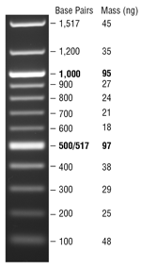 | 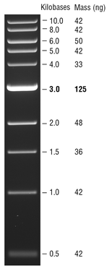
Fig. 2.1: Quick-Load Purple DNA ladders (New England BioLabs; image reproduced from www.neb.com)

2.6.6 DNA Gel extraction
Gels were placed on a 2UV transilluminator (UVP) to view the DNA fragments, and DNA fragments were cut out using a scalpel. DNA was extracted from the excised agarose using QIAquick Gel Extraction kit (Qiagen) following the manufacturer’s instructions.

2.6.7 Primer design
Oligonucleotide primers were designed for amplification of DNA fragments. Primers were designed to be 50-60% G-C rich, 20-30 bases in length and 55-70°C melting temperature (T_{m}). For cloning purposes, restriction endonuclease sites were incorporated into the primer design. T_{m} was estimated using ApE plasmid editor software (an open source software programme created by M. Wayne-Davis, http://biologylabs.utah.edu/jorgensen/wayned/ape/). The following website was use to check the presence of restriction sites within the gene of interest (NEBcutter V2.0): http://nc2.neb.com/NEBcutter2/index.php. For protein overexpression, primers were designed to allow insertion of the open reading frames between the Ncol and HindIII sites of pMyNT. For the bacterial two hybrid system, primers were designed to insert genes between XbaI and KpnI sites of pKT25, and between HindIII and KpnI for pUT18. Due to amplification difficulties, whiB3, σ^{A} C-terminal domain (CTD) and σ^{B} were synthesised, and σ^{J} was synthesised and ligated into pUT18 by Eurofins. The codon usage of the synthesised gene sequences were optimized to E. coli K-12 using this webpage: http://gcua.schoedl.de/sequential_v2.html. All primers were purchased from Eurofins. Gene sequences after cloning are available in Appendix 9.11.

2.6.8 DNA amplification
An AmpliTaq Gold fast or 2x MyTaq PCR master mix (MM) were used for DNA amplification. The standard reaction used was as follows:
 | 11.5 µl total volume
Forward primer (10 pmol/µl) | 0.5 µl
Reverse primer (10 pmol/µl) | 0.5 µl
Template DNA (50-100 ng/µl) | 1.25 µl
MM (AmpliTaq Gold/ 2x MyTaq Mix) | 3 µl
dH₂O | 6.25 µl

For Polymerase Chain Reactions (PCR), 30 cycles were performed as follows:
 | Time
Initial denaturation | 98°C – 30 s
Denaturation | 95°C – 1 min
Annealing | 5°C below the T_{m} of each primer pair
Extension | 72°C – 1 min/1 kbp
Final extension | 72°C – 5 min
Hold | 4°C

2.6.9 DNA digestion by restriction endonuclease
Restriction enzymes were purchased from New England Biolabs and the reactions were made in separate tubes as follows:

 | Insert | Vector
x10 Smart cut buffer | 2 µl | 2 µl
Restriction enzymes (20,000 U/ml) | 0.5 µl | 0.5 µl
DNA | 500 ng | -
Vector | - | 1000 ng
dH₂O | Up to 20 µl | Up to 20 µl

Mixtures were incubated at 37°C for 1 h. To stop restriction enzyme activity, DNA purification was carried out (alternatively, for HindIII and NcoI, mixtures were incubated at 80°C for 20 min).

2.6.10 DNA ligation
Quick ligation kits were purchased from New England Biolabs and the reactions were assembled as shown below. DNA-vector ratio was determined through the following webpage http://www.insilico.uni-duesseldorf.de/Lig_Input.html.
 | Volume
Quick ligase | 1 µl
Reaction buffer | 10 µl
DNA | 1:3 molar ratio vector to insert
Nuclease-free water | Up to 10 µl

Ligation mixtures were incubated at room temperature for 20 min. Ligation mixes were used to transform competent cells ether chemically or by electroporation as described in Sections 2.4.1.2 and 2.4.2.2.

2.6.11 DNA purification
DNA purification was carried out using QIAquick PCR kit (Qiagen) following the manufacturer’s instructions.

2.6.12 DNA sequence viewing and alignment
Plasmid DNA sequencing was carried out by either GATC Biotech Company or Core Genomic facility in Medical School at the University of Sheffield. All sequence files were viewed in either FinchTV or Snapgene programmes. The 16S rRNA gene sequence data were used to make a phylogenetic tree of the strains. Sequence data were analysed using NCBI website (https://www.ncbi.nlm.nih.gov/) to identify the closest match in the database (Appendix 9.1).

2.6.13 Site-directed mutagenesis
QuikChange II XL Site-Directed Mutagenesis Kit (Agilent Technologies 200521-5) was carried out for the site-directed mutagenesis according to the instructions of the manufacturer. Primers were designed via the following webpage: (https://www.agilent.com/store/primerDesignProgram.jsp).

2.7 RNA stabilisation, extraction and expression

2.7.1 RNA stabilisation
Mid-log phase cultures, were sampled (2-5 ml) and mixed with 2 volumes of RNA protect reagent (Qiagen). After mixing for 10 s, the samples were incubated at room temperature for 5 min. Mixtures were then centrifuged at 6000 x g for 10 min at 4°C. The supernatants were discarded and the cell pellets were immediately stored at -80°C.

2.7.2 RNA extraction
RNA was extracted using a RNeasy mini kit (Qiagen) according to the manufacturer’s procedure. To test for DNA contamination, DNA was amplified using the universal 16S ribosomal primers (27-F and 1492-R) and then the PCR sample was separated by gel electrophoresis and visualised.

2.7.3 DNA removal
For RNA samples that were positive in the 16S PCR test (Section 2.7.2), the contaminating DNA was removed using the Turbo DNA-free kit (Invitrogen) standard procedure.

2.7.4 RNA concentration measurement
RNA concentration was measured using the NanoPhotometer P-300 Spectrophotometer after programing the machine by selecting RNA. The instrument was blanked using RNase-free water.

2.7.5 Primer design for RNA specificity
Primers were designed using Primer-BLAST tool in NCBI webpage with the following criteria:

Criteria | Standard
T_{m} | 59-65 (62 optimal)
Produce size value | 200 as maximum
Product size | 70-200 bp
Primer length | 18-22 nucleotides (20 optimal)
GC rich | 20-60% (primer pair should have similar percentage)
Avoid nucleoids repeats | Examples, GTTTT or GCGCGCGC

2.7.6 Quantitative Real-Time PCR (qRT-PCR)
To detect the relative abundance of RNA, the samples were arrayed in an optical 96 well plate and amplification was detected using Brilliant III Ultra-Fast SYBR green qRT-PCR kit (Agilent Technologies) as follows:
 | Amount
2x Brilliant III SYBR green | 10 µl
10 mM F primer | 2 µl
10 mM R primer | 2 µl
100 mM DTT | 0.2 µl
RT/RNase Block | 1 µl
RNA | 2 µl
2 µM Reference dye (100 mM stock) | 0.3 µl
RNAase-free | 2.5 µl

Analysis was conducted on the total RNA from three biological and technical replicates. Cycling conditions were as follows:
50°C, 10 min | 1 cycle
95°C, 3 min | 1 cycles
95°C, 15 s | 40 cycles
60°C, 20 s

95°C, 1 min | 1 cycle
55°C, 30 s
95°C, 30 s

2.7.7 Analysis of quantitative real-time PCR
The expression of the genes of interest was normalized against the control gene using the ∆C_{T} method to determine the relative gene expression level between the two conditions (Manganelli et al., 1999).

2.8 Protein methods

2.8.1 Protein concentration measurement
Two methods to measure protein concentration were used, Bradford assay and Beer-Lambert law. To use the Bradford assay (Bradford, 1976), the absorbance was measured at 595 nm using Biochrom WPA Lightwave II spectrophotometer after reaction of sample with the Bradford reagent (Bio-Rad) according to the manufacturer’s procedure. For Beer-Lambert law, the theoretical extinction coefficient was first obtained from the ExPASy webpage: https://web.expasy.org/protparam/, then the absorbance was measured at 280 nm using a NanoPhotometer P-300 Spectrophotometer. The protein concentration was calculated as follows:
Bradford:
OD₉₅₉= Protein (µl) + reagent (10% Bradford reagent + 90% H₂0)
$\frac{OD595*15}{Protein volume (µl) }*$10⁶ = # mg/ml → $\frac{\# mg/ml }{Protein mass (kDa) }*$1000 = # µM

Beer–Lambert law:
$\frac{A420 nm}{Extinction coefficient factor}$*10⁶ = # µM

2.8.2 Denaturing gel electrophoresis (SDS-PAGE)
SDS-PAGE (Laemmli, 1970) was carried out in a glass plate sandwich (Bio-Rad). The two gels, resolving and stacking were prepared as follows:
 | 15% Resolving gel (ml) | 5% Stacking gel (ml)
dH₂O | 2.7 | 6.95
3 M Tris-HCl (pH 8.3) | 0.95 | -
0.5 M Tris-HCl (pH 6.3) | - | 1.25
30% Acrylamide | 3.8 | 1.7
10% TEMED | 0.02 | 0.02
10% SDS | 0.075 | 0.1
10% APS | 0.1 | 0.1

Firstly, the resolving gel was poured to occupy 2¾ of the space, with the rest left for the stacking gel. Then isopropanol was layered over the resolving gel to ensure a level surface until the gel was polymerized. Isopropanol was removed and the gel surface was washed with water. Then the stacking gel was loaded to fill the rest of the space. The comb was inserted and the gel left on the bench until it was polymerized. The gel was transferred into the gel tank containing 1x SDS running buffer and then the comb was removed from the gel. Loading dye was mixed with the protein samples at a ratio of (1:5) and the mixtures were heated to 95°C for 5 min. Samples were loaded into the wells alongside an appropriate standard protein ladder (Fig. 2.2). Polypeptides were separated by electrophoresis for 80 min at 180 V. The glass plates were removed and the gel was stained with Coomassie Blue solution for 60 min. The staining solution was removed and the gel was destained overnight. The 1x SDS running buffer, 5x loading dye, Coomassie Blue stain and destain solutions were prepared as follows:

1x SDS running buffer |  | 5x loading dye
SDS | 1 g | SDS | 5%
Tris | 3 g | Tris-HCl pH 6.8 | 0.225 M
Glycine | 14.4 g | Glycerol | 50%
dH₂O up to | Up to 1 L | Bromophenol blue | 0.05%
 |  | 2-Mercaptoethanol | 0.25 M

 | Commassie Blue stain | Destain
Methanol | 400 ml | 400 ml
Acetic acid | 100 ml | 100 ml
Commassie Brilliant Blue | 1.15 g/L | -
dH₂O up to | 1 L | 1 L

Estimation of protein molecular weight was achieved by the running of pre-stained markers (CSL-BBL) (Fig 2.2).

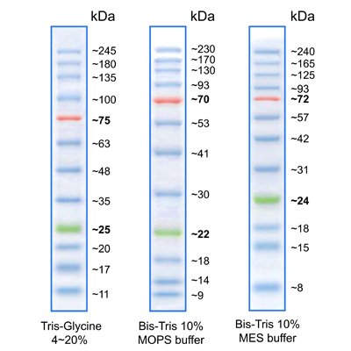
Fig. 2.2: PiNK Plus prestained Protein Ladder (Cleaver Scientific; www.clentlifescience.co.uk)

2.8.3 Protein overproduction of WhiB1 and WhiB2 in Mycobacterium smegmatis
The coding regions of whiB1 and whiB2 were amplified from K. sedentarius MBB13 genomic DNA using the forward and reverse primers for whiB1 and whiB2 (Table 2.4). The products were digested and ligated (Section 2.6.9 and 2.6.10) into pMyNT (Hygro-B^{R}) between the Ncol and HindIII sites. The integrity of both plasmids was checked by DNA sequencing (Section 2.6.12). Plasmids containing whiB1 (strain JRG6949) and whiB2 (strain JRG6947) were purified (Section 2.6.11) and used to transform (Section 2.4.2.2) M. smegmatis MC²155 (JRG6161) (Table 2.1). Protein overproduction was carried out in 2 L flasks containing 7H9 medium with Hygromycin-B (100 µg/ml). Cultures were grown at 37°C until OD₆₀₀ ~0.9 (~18 h) (Section 2.3.6) then the cultures were induced with 0.2% acetamide and incubated at 37°C for ~12 h, with shaking (250 rpm). Cells were collected by centrifugation at 17,500 x g for 30 min and stored at -20°C until cell lysate preparation.

2.8.4 Production of cell-free extracts
Frozen cells of the M. smegmatis containing the recombinant WhiB1 and WhiB2 proteins were suspended in either 20 mM NaH₂PO₄, pH 7.4 or 50 mM Tris, pH 8.0, containing 500 mM NaCl, and disrupted by sonication. Cells were sonicated (9 x 25 s pulses) on ice by Soniprep 150 Plus set to the maximum amplitude. The sonicated samples were centrifuged (using Avanti J-251) at 45,500 x g for 20 min to separate the cell debris from lysate. The supernatant was used for purification.

2.8.5 Protein purification by affinity chromatography
WhiB1 and WhiB2 (which both had N-terminal His₆-tags) were purified using 5 ml HiTrapTM chelating columns, on the AKTA Pure machine. Approximately, 10 ml of cell lysate was injected into the loading loop and the machine was set according to the manufacturer’s procedure. The purification buffers were prepared as follows:

 | Binding buffer A (pH 8.0) | Elution buffer B (pH 8.0)
Tris | 50 mM | 50 mM
NaCl | 0.5 M | 0.5 M
Imidazole | - | 0.5 M
dH₂O | Up to 1 L | Up to 1 L

The eluted fractions were collected and their protein concentrations were measured. Then the fractions were analysed by SDS-PAGE to determine their purity. The protein containing fractions were stored at -20°C.

2.8.6 Scanning UV visible spectroscopy
To obtain the absorption spectra of proteins, the pure fractions were transfer into cuvettes. Scanning was between 200-800 nm. The machine was baselined using a buffer blank. For measurement under anaerobic conditions, the protein solutions were transferred to Hellma® quartz cuvettes (10 mm) which had a screw cap lids to maintain anaerobic conditions.

2.8.7 Circular dichroism (CD) spectroscopy
Buffer exchange (20 mM NaH₂PO₄, 0.1 M NaCl, pH 7.4) was achieved by concentration and dilution (Vivaspin) or by membrane dialysis (Spectra/Por), size 3,000 Da molecular weight cut-off (MWCO). The protein (~75 µM WhiB1 or ~35 µM WhiB2) was transferred to a CD cuvette and spectra were collected using a Jasco J810 instrument.

2.8.8 Liquid chromatography mass spectrometry (LC-MS)
LC-MS was carried out by Mr. Simon Thorpe (Spectrometry Centre at the University of Sheffield) using Agilent 6530 Q-ToF (MS instrument) and Agilent 1260 infinity (LC instrument). In brief, the protein sample was diluted to 3 µM final concentration in an aqueous solution containing, 1% formic acid and 0.1% acetonitrile, and then loaded Phenomenex Aeris Widepore 3.6u XB–C18 column (50 mm x 2.1 mm). Bound protein was eluted by applying a linear gradient from 0.1% formic acid, 5% to 95% acetonitrile, at 0.4 ml/min (flow rate) for 10 min. The protein eluate was continuously introduced by the positive mode electrospray ionization (ESI) of the mass spectrometer.

2.9 Iron-sulfur cluster analysis methods

2.9.1 Removal of the iron-sulfur cluster from holo-WhiB1
Protein concentration was determined by Bradford assay and Beer–Lambert law (Section 2.8.1). Three measurements with different volumes of holo-protein were made and the average was taken. Then the protein was treated with 10 mM EDTA in presence of 1 mM TCEP-HCI and kept at room temperature overnight. Removal of the iron-sulfur cluster was detected by UV-visible spectroscopy.

2.9.2 Reconstitution of the WhiB2 iron-sulfur cluster
WhiB2 was purified (Section 2.8.5) and UV-visible spectra were taken to estimate the concentration of iron-sulfur clusters. For apo-WhiB2, the protein was reduced by adding 1 mM DTT before reconstitution. All reconstitution steps were carried out inside the anaerobic cabinet. Buffers and other solutions were left for at least 18 h inside the cabinet to ensure that they were anaerobic. Iron-sulfur cluster reconstitution was achieved using the NifS-based system (Kudhair et al., 2017) as follows:
 | Volume
Purified-Apo-WhiB2 | 1x
Ammonium ferrous sulphate | 10x protein concentration
L-cysteine | 20x protein concentration
DTT | 10 mM
NifS (Section 2.9.2.1) | 10 µg for each 200 µM of WhiB2

The reaction was left inside the anaerobic cabinet overnight. Next day, the reconstituted WhiB2 was dialyzed against anaerobic buffer: 25 mM NaH₂PO₄, 0.25 M NaCl, pH 7.4 overnight inside the cabinet to remove non-integrated reaction components (Section 2.9.3). The dialyzed reconstituted WhiB2 was transferred into Hellma® quartz cuvette (10 mm) and the screw cap lid was sealed to keep the protein anaerobic. The [4Fe-4S] cluster content was measured by UV-visible spectroscopy.

2.9.2.1 Expression and purification of desulfurase enzyme (NifS)
NifS is a cysteine desulfurase and can be isolated from Azotobacter vinelandii. NifS is used to provide sulphide from L-cysteine in order to reconstitute WhiB2. Dr. Dennis R. Dean (University of Virginia) provided the plasmid pDB55 which encodes NifS, the purification was done by Dr. Bassam Khudair. In brief, the overexpression of NifS was carried out as described by (Zheng et al., 1993), with few modifications as follows: protein induction was achieved by 1 mM IPTG instead of 1% lactose, incubation time 8 h instead of 2 h and cultures were incubated at 25°C.

2.9.3 Oxygen (O₂) sensitivity of the WhiB1 and WhiB2 iron-sulfur clusters
To examine the O₂ sensitivity of the purified and reconstituted WhiB1 and WhiB2 proteins, the UV-visible spectra of the proteins were recorded (Section 2.8.6). O₂-saturated buffer: 50 mM Tris, 0.5 M NaCl, pH 7.4, 5% glycerol was added to the anaerobic protein solutions such that the final concentration of O₂ was ~110 µM. UV-visible spectra were recorded at regular intervals. Alternatively, O₂ was introduced by bubbling directly into the unsealed cuvette using a Hamilton gastight syringe (100 µl).

2.9.4 Nitric oxide sensitivity of WhiB1 and WhiB2 iron-sulfur clusters
Spermine NONOate (Cayman) was used to investigate the sensitivity of the WhiB1 and WhiB2 iron-sulfur clusters to NO. Spermine NONOate releases NO with half-life of 39 min. Spermine NONOate was prepared by dissolving the powder in water to the final concentration of 19.06 mM. Spermine NONOate solution (30 µl) was injected using a Hamilton syringe into 1 ml of anaerobic protein (~35 µM) in a sealed Hellma® quartz cuvette (10 mm).

2.9.5 In vitro denaturation of Holo-WhiB1
To denature the holo-WhiB1 protein, guanidinum thiocyanate (BDH Chemicals, K21375064-551) was used. Guanidinum thiocyanate was prepared by dissolving the powder in water. Guanidinum thiocyanate working solution was mixed with the protein (~100 µM) to the final concentration of 1.5 M. Then the treated protein was left in the UV-visible spectrum to take several reading points to confirm the loss of the cluster.

2.10 In vivo protein-protein interaction

2.10.1 The bacterial Adenylate Cyclase-based Two-Hybrid (BACTH)
The interaction between WhiB proteins and RNA polymerase sigma factors was investigated using the BACTH system. First, the genes encoding the WhiB proteins and the sigma factors were amplified via PCR, the primers are listed in Table 2.4. PCR products were digested (Section 2.6.9) and ligated (Section 2.6.10) into, pKT25 between the XbaI and KpnI for whiB genes, and pUT18 between HindIII and KpnI for the sigma factors. As a result, each WhiB protein was cloned as an in-frame fusion at the C-terminal end of T25 in pKT25 and each sigma factor was sub-cloned as an in-frame fusion at the N-terminal end of T18 in pKT18. Plasmids were propagated in E. coli DH5α. Then plasmids were purified using a Qiagen miniprep kit (Section 2.6.11). The plasmids that encode the T25-WhiB and Sigma-T18 protein fusions were used to co-transform (Section 2.4.2.2) electrocompetent E. coli BTH101 (JRG6956) (Table 2.1). Transformed cells were plated on LB agar medium with appropriate antibiotics (Section 2.3.3.1) and incubated at 37°C for 24 to 36 h. After a successful electroporation, one colony was picked and inoculated into 5 ml LB broth containing appropriate antibiotics and incubated at 37°C for 19h. Samples (10 µl) of the cultures were dropped onto indicator media plates (MacConkey/maltose and LB/X-gal) with the appropriate antibiotics and IPTG for induction and incubated at 30°C for 36 to 40 h. It was found to be important to inoculate the indicator plate from an overnight culture that was inoculated from a plate. For iron-starvation, salt-stress and antibiotic-stress, 0.05 mM 2,2’-Bipyridyl (dissolved in 20% ethanol) and 64 µg/ml Erythromycin, were added to the indicator media respectively.

2.10.2 β-Galactosidase assay
β-Galactosidase assays weres used to measure the protein-protein interaction quantitatively. The transformed cell cultures were incubated overnight for an OD₆₀₀ 0.6 to 1.0. Cultures were left on ice before 1 ml was incubated in a water bath set at 28°C for 10 min. In a new Eppendorf tube the following components were assembled:
 | Volume
Transformed cell culture | 0.1 ml
Z-buffer | 0.7 ml
β-Mercaptoethanol | 1.89 µl
0.1% SDS | 10 µl
Chloroform | 20 µl

The preparation of Z-buffer was as follows:
 | Volume
Na₂HPO₄.7H₂O (0.06 M) | 16 g
NaH₂PO₄.H₂O (0.04 M) | 5.5 g
KCl (0.01 M) | 0.75 g
MgSO₄.7H₂O (0.001 M) | 0.246 g
dH₂O | 1 L
pH | 7.0

The mixture was vortexed for 10 s then and incubated at 28°C for 5 min. 200 µl of ONPG (prepared by adding 4 mg/ml in Z-buffer) was added and the reaction course was monitored with a stopped watch. Once the colour of the reaction became yellow, the reaction was stopped by adding 500 µl of 1 M Na₂CO₃. The reaction was centrifuged for 3 min then the absorbance of the supernatant was measured at 420 nm. β-Galactosidase activity was calculated as follows:
$$\frac{A420 nm}{time\left(min\right)*culture volume\left(ml\right)*OD600}*1000$$

Chapter Three

3 Isolation and characterisation of bacteria from an indoor environment

3.1 Introduction
Closed workplaces are important environments to measure the level of pollution that individuals are exposed to, since 90% of people’s time is spent indoors (Lee and Chang, 2000). Indoor environments contain a wide variety of bacteria which can affect air quality through air conditioning systems or humidifiers (Flannigan, 1992). Estimates of diversity of indoor microbes vary depending on the method of isolation. Therefore, many studies employed two methods of isolation i.e. passive and active monitoring, to assess the bacteria suspended in indoor air and then determined any correlations between the two methods (Napoli et al., 2012). As described in Chapter 1, passive monitoring uses settle plates (Petri dishes) containing solid culture media that are exposed for a fixed period of time. Active monitoring samples airborne particles by using a suction pump to draw air into a container and then analysing the microbes collected using either liquid or solid media (Gregory, 1973; Sehulster et al., 2003). Here, settle plates and a dehumidifier were employed to assess the bacteria suspended in a student lecture theatre. Dehumidifiers have been widely used to reduce air moisture and bacteria and dust are captured in the collection tank (Longo and Gasparella, 2005). Hence, the water within the collection tank contains bacteria that were present in the air within the dehumidifier’s control zone. The aim of the work reported in this chapter was to assess the bacterial diversity in the air of a lecture theatre using two different methods of isolation, active and passive monitoring, and to estimate the potential health hazards by determining the antibiotic resistance levels of the isolated bacteria.

3.2 Isolation of airborne bacteria from MBB-F02
Lecture theatre F02 in the Department of Molecular Biology and Biotechnology (MBB) at the University of Sheffield (MBB-F02) was chosen to examine airborne bacteria in an indoor environment after occupation by students, staff and visitors for two months during the autumn semester of 2015. MBB-F02 was chosen because it is one of the biggest and busiest rooms in MBB. Based on the university records, at least 152 lectures and 9 seminars were delivered in F02, equivalent to ~194 h of occupation over the 2 months of the experiment. Besides, MBB-F02 has a special location being ~3-10 metres from 5 microbiology laboratories. Based on the University Biosafety committee records, those laboratories are classified as class 2 Genetically Modified Organisms (GMO) laboratories, which could potentially enhance the risk of spreading antibiotic resistant bacteria. It has been suggested that visiting health centres such as hospitals can lead to visitor infection and can be potentially risky for older people, children and most notably, immunocompromised patients (Park et al., 2013). In this study, two types of aerosol sampling were conducted, one using a dehumidifier (active monitoring) and the other settle plates (open petri dishes; passive monitoring) to estimate the prevalence and identity of airborne bacteria (Section 2.4). Settle plates were left open on the benches and the dehumidifier was switched on for 1 h after the occupants had left the room. The settle-plate sampler collected 15 colonies, whereas ~250 colonies were collected from the dehumidifier over the two months of the experiment. The colonies were of varied appearance in size and colour indicating that several different bacterial species had been cultured (Fig. 3.1). This result suggests that active monitoring has the potential to detect a greater variety of species probably by virtue of sampling larger volumes of air. The data matched those of Sayer et al., (1972) who claimed that, the gravity settling culture (GSC) technique can give false negative results and therefore it is not reliable for quantitative evaluation of airborne bacteria, whereas the Andersen sampler (active monitoring) detected numerous bacteria. Also Sayer et al. (1972) demonstrated that collecting bacteria by plate using gravity failed to detect several bacteria, such as Staphylococcus aureus, which were detected by Andersen sampling. In addition, it is possible that the dehumidifier captures more bacteria due to its capacity to sample air/organisms present at higher attitude (~2-3 m).

a | 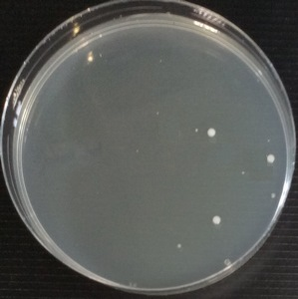 | 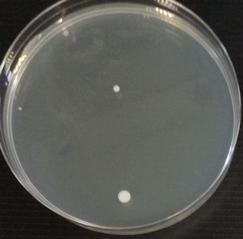
b | 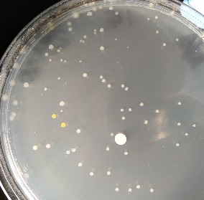 | 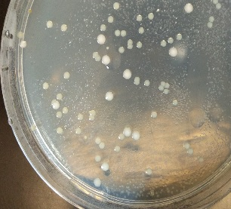
Fig. 3.1: A selection of the bacterial colonies detected by growth on (a) settle plates and (b) plating the water collected by the dehumidifier. The bacterial colonies were grown by incubation on Nutrient agar medium for 24 h at 37°C under aerobic conditions. Settle plates were opened for 1 h on a student table and the dehumidifier was run for 1 h.

To investigate further the bacteria detected by passive and active monitoring, the colonies were sub-cultured. Six and seven strains were successfully sub-cultured from settle plates and dehumidifier, respectively (Fig. 3.2).

a | 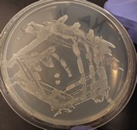 MBB1 | 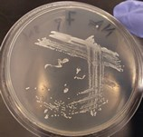  MBB2 | 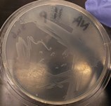 MBB3 | 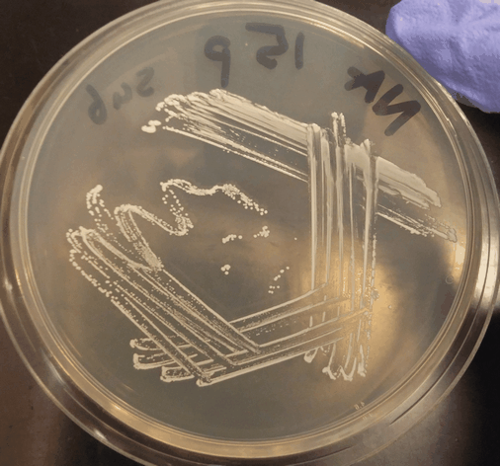 MBB4
 | 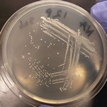 MBB5 | 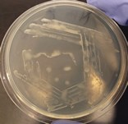 MBB6
b | 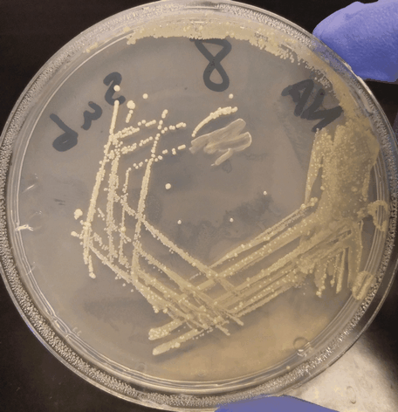 MBB7 | 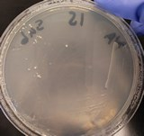 MBB8 | 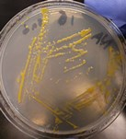 MBB9 | 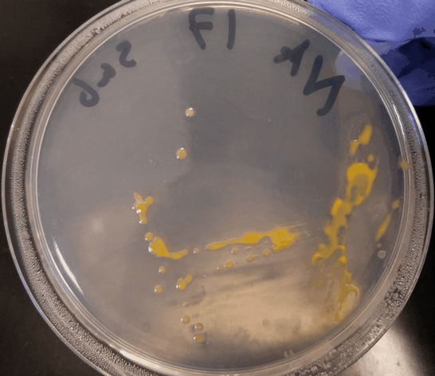 MBB10
 | 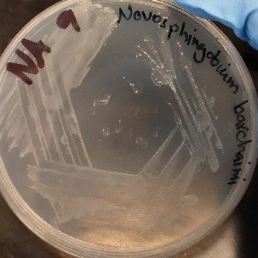  MBB11 | MBB12 | 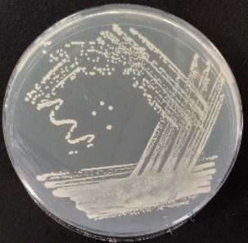  MBB13
Fig. 3.2: Streak plates of isolates grown on Nutrient agar. (a) Colonies picked from settle plates (b) Colonies picked from plates spread with resuspended particulates present in the dehumidifier water collection tank (Fig. 3.1). Plates were incubated at 37 °C overnight.

3.3 Identification of the bacterial isolates by 16S ribosomal RNA sequencing
The visual appearance (colour/size of bacterial colonies) of the settle plate and dehumidifier isolates were different (Figs. 3.1. and 3.2). The DNA sequences of 16S rRNA genes can be used to suggest the identities of bacterial isolates (Clarridge, 2004). Therefore genomic DNA was extracted (Section 2.6.2) from liquid cultures of the 13 isolates shown in Fig. 3.2, and the conserved region of their 16S rRNA genes was amplified by PCR using universal bacteria primers (27-F and 1492-R) (Table 2.4) (Budi et al., 1999) (Fig. 3.3). The DNA sequences (Section 2.6.12) of the PCR products were analysed using the BLAST programme available through the National Center for Biotechnology Information (NCBI) to identify the closest matches in the database (Table 3.1; Appendix 9.1).

L 1 2 3 4 5 6 | L 7 8 9 10 11 12 13
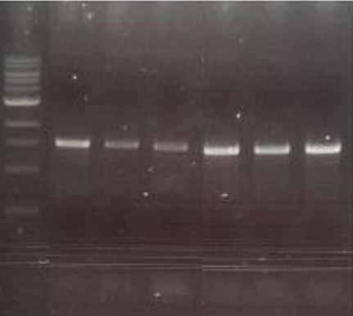 | 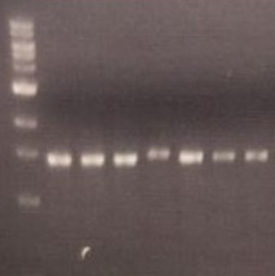
Fig. 3.3. PCR amplification of 16S rRNA genes of the isolated bacteria. Lanes L are Standard 1 kb Hyperladder; lanes 1 to 6 are the unknown microorganisms samples isolated from the settle plates (MBB1-6); lanes 7 to 13 are the unknown microorganism samples isolated from the dehumidifier trap (MBB7-13).

The six species isolated by passive monitoring belonged to three families Staphylococcaceae (Staphylococcus hominis, S. saprophyticus, S. haemolyticus and S. succinus), Micrococcaceae (Micrococcus yunnanensis) and Enterobacteriaceae (Pantoea ananatis). All isolates have been reported to be common inhabitants of human environments (Novakova et al., 2010; Evans et al., 2019). The seven species isolated from the dehumidifier trap (active monitoring) belonged to different families, namely, Micrococcaceae (Kocuria rhizophila), Sphingomonadaceae (Sphingomonas ginsenosidimutans, S. yunnanensis and Novosphingobium barchaimii), Dermacoccaceae (Kytococcus sedentarius), Pseudomonadaceae (Pseudomonas fluorescens) and Staphylococcaceae (S. pasteuri). Hence it appeared that the organisms isolated from the settle plates and the dehumidifier differed and those from the latter were more diverse.

Table 3.1: Summary of 16S rRNA gene sequence analyses of oligotrophic bacteria cultured from (a) the settle plates, and (b) the dehumidifier.
Identifier | Closest match | Taxa | Gram stain  (+/-) | Sequence  Identity Percentage | NBCI Sequences ID | Reference
(a)  MBB1 | Staphylococcus hominis | Staphylococcaceae  Staphylococcaceae  Staphylococcaceae  Staphylococcaceae | + | 100% | LN899796.1 | (Decraene et al., 2008)
MBB2 | Staphylococcus saprophyticus |  | + | 100% | KT720173.1 | (Decraene et al., 2008)
MBB3 | Staphylococcus haemolyticus |  | + | 99% | KT720154.1 | (Decraene et al., 2008)
MBB4 | Staphylococcus succinus |  | + | 100% | KJ888125.1 | (Gandolfi et al., 2011)
MBB5 | Pantoea ananatis | Enterobacteriaceae | - | 99% | AP012032.1 | (Luhung et al., 2018)
MBB6 | Micrococcus yunnanensis | Micrococcaceae | + | 96% | KT719656.1 | (Fang et al., 2014)
(b)
MBB7 | Kocuria rhizophila | Actinobacteria | + | 99% | KC429605.1 | (Takarada et al., 2008; Savini et al., 2010)
MBB8 | Pseudomonas fluorescens | Pseudomonadaceae | - | 100% | KT223384.1 | (Trivedi et al., 2015)
MBB9 | Sphingomonas ginsenosidimutans | Sphingomonadaceae | - | 100% | HF930756.1 | (Narciso-da-Rocha et al., 2014)
MBB10 | Sphingomonas yunnanensis | Sphingomonadaceae | - | 100% | JF459957.1 | (Zhang et al., 2005)
MBB11 | Novosphingobium barchaimii | Sphingomonadaceae | - | 99% | LN613112.1 | (Niharika et al., 2013)
MBB12 | Staphylococcus pasteuri | Staphylococcaceae | + | 99% | KR856343.1 | (Savini et al., 2009)
MBB13 | Kytococcus sedentarius | Actinobacteria | + | 98% | KC583230.1 | (Sims et al., 2009)

The most abundant bacterial taxa observed from passive monitoring matched those of a previous publication focused on the indoor microbiome (Table 3.1.a, Appendix. 9.1) (Decraene et al., 2008; Gandolfi et al., 2011; Fang et al., 2014; Abiola et al., 2018; Luhung et al., 2018). The Staphylococcaceae are likely to be associated with human skin (Luongo et al., 2017). Bacteria isolated by active monitoring (Table 3.1.b, Appendix. 9.1) were more likely to be water habitants such as, Sphingomonadaceae (Glaeser and Kämpfer, 2014) and Actinobacteria (Ghai et al., 2014). Therefore, this study confirms the need to have an awareness of the biases that can be introduced by the method of collection and isolation in understanding bacterial communities found in indoor air.

3.2.4 Screening of dehumidifier isolates for antibiotic resistance by disc diffusion tests
Determination of bacterial susceptibility to antibiotics is crucial to manage bacterial infections (Bonev et al., 2008). Therefore, it is important to screen bacteria against antibiotics and determine their effect on bacteria in the environment (Alexy et al., 2004). Disc diffusion assays can be used to determine sensitivity by comparison to standards set by the British Society for Antimicrobial Chemotherapy guideline (BSAC). The isolates were tested against the antibiotics that were suggested by BSAC based on bacterial taxa (BSAC, 2013) (Section 2.3.2.1) (Table 3.2). Because the BSAC does not have standard breakpoints for Sphingomonadaceae, Kocuria spp. and Kytococcus spp., the non-fermentative criteria were used for Sphingomonadaceae and Staphylococci spp. criteria were used for Kocuria spp. and Kytococcus spp (Sader and Jones, 2005; Mnif et al., 2006; Savini et al., 2010).
The results of the disc diffusion tests on the dehumidifier isolates are shown in Table 3.2. Bacteria were screened against seven classes of antibiotics: (1) Macrolides: erythromycin; (2) β-Lactams: doripenem, imipenem, meropenem, piperacillin and piperacillin-tazobactam; (3) Tetracyclines: tetracycline; (4) Aminoglycosides: amikacin, gentamicin; (5) Glycopeptides: vancomycin; (6) Quinolones: ciprofloxacin; and (7) Colistins; polymyxin B. All the bacteria for which sensitivity criteria were available were susceptible to doripenem, imipenem and piperacillin-tazobactam, for K. sedentarius sensitivity to these antibiotics has not been defined (Table 3.2). Sphingomonas ginsenosidimutans and Sphingomonas yunnanesis showed an intermediate response to amikacin and resistance to gentamicin, P. fluorescens was resistant to meropenem and K. rhizophlia was resistant to ciprofloxacin. Only K. sedentarius was resistant to two antibiotics, ciprofloxacin and erythromycin.
In the Sphingomonadaceae, the resistance of S. ginsenosidimutans to gentamicin (aminoglycoside) was reported previously (Narciso-da-Rocha et al., 2014). For N. barchaimii, sensitivity to all tested antibiotics including ciprofloxacin has also been reported by (Niharika et al., 2013). However, to date, Sphingomonas yunnanesis antibiotic resistance has not been tested. Nevertheless, Vaz-Moreira et al. (2011) reported that no resistance was observed in the genera of Sphingomonas and Novosphingobium. In addition, it is generally accepted that Sphingomonadaceae are non-pathogenic, however, bacteria belonging to this family are abundant in hospital water systems, and some are phototrophic and chlorine-resistant (Kim et al., 2007; Vaz-Moreira et al., 2011). Besides that, members of Sphingomonas harbour plasmids carrying resistance genes that offering the potential for spreading resistance traits to pathogens through horizontal gene transfer (HGT) (Narciso-da-Rocha et al., 2014). For example, the plasmid pNL1 that derived from S. aromaticivorans F199, can be transferred to a wide range of Sphingomonas strains. Plasmid pNL1 contains the replicase genes repAaAb that able to degrade xenobiotic compounds which suggests that the members of Sphingomonas genus are able to adapt quickly and efficiently to degrade new compounds in the environment (Basta et al., 2005).
The P. fluorescens isolate was sensitive to all the antibiotics tested here with the exception of the β-lactam meropenem (Table 3.2). To date, no antibiotic screening tests have been reported for P. fluorescens. This lack of information may be due to its low pathogenicity (Leeman et al., 1995).
A single resistance against ciprofloxacin was noticed for Kocuria rhizophila. However, Savini et al (2010) reported that K. rhizophila was susceptible ciprofloxacin. K. rhizophila has been widely used in industry as a quality control indicator in antibiotic sensitivity testing (Savini et al., 2010).
Despite, S. pasteuri being reported to exhibit resistance to macrolides, tetracyclines, chloramphenicol, streptomycin, fosfomycin and methicillin (Savini et al., 2009), no resistance was observed in this study (Table 3.2). Staphylococcus pasteuri causes nosocomial infections and is a blood derivatives contaminant, which suggests a role in causing human disease (Savini et al., 2009).
Examination of the antibiotic sensitivity of K. sedentarius MBB13 showed resistance to two antibiotics ciprofloxacin (Quinolones) and erythromycin (Macrolides). The resistance of K. sedentarius to antibiotics has been reported previously (Marples and Richardson, 1980; Chaudhary and Finkle, 2010; Savini et al., 2011). Kytococcus sedentarius is an opportunistic human pathogen implicated in several diseases such as Pitted keratolysis (PK) and bacteraemia (Sims et al., 2009). Unexpectedly, erythromycin has been widely used to treat PK infection (Pranteda et al., 2014).
In summary, seven bacteria have been isolated from air passed through a dehumidifier in MBB-F02 and tested against at least seven antibiotics. Four bacteria showed a single resistance namely S. ginsenosidimutans, S. yunnanesis, K. rhizophila and P. fluorescens, two bacteria were susceptible to all the tested antibiotics, namely N. barchaimii and S. pasteuri, and only one bacterium showed resistance to two antibiotics, K. sedentarius. Increasing recognition of resistance to antibiotics of K. sedentarius and because erythromycin is used to treat K. sedentarius infections, the minimum inhibitory concentration (MIC) profile of K. sedentarius was investigated using (BSAC, 2013) guideline for the assays.

Table 3.2: Antibiotic resistance pattern of the dehumidifier isolates.
Organism (strain ID)/ antibacterial agent | Interpretation of zone diameters (mm) |  |  |  | Organism (strain ID)/ antibacterial agent |  |  | Interpretation of zone diameters
 | mm categorization |  |  |  |  |  |  | mm categorization
S.ginsenosidimutans / (HF930756.1) (a) |  |  |  |  | P. fluorescens /  (KT223384.1) (b)
Amikacin  Ciprofloxacin  Doripenem  Gentamicin  Meropenem  Imipenem  Piperacillin  Piperacillin-tazobactam | 18.7±2.3  48.7±2.3  48.7±2.3  15.3±1.2  32.7±1.2  53.3±3.5  54.7±4.2  50.7±1.2 | I  S  S  R  S  S  S  S |  |  | Amikacin  Ciprofloxacin  Doripenem  Gentamicin  Meropenem  Imipenem  Piperacillin  Piperacillin-tazobactam | 36±0  42±2  26.7±1.2  34.7±1.2  6±0  25.3±2.3  30±0  34.7±1.2 |  |  | S  S  S  S  R  S  S  S
S.yunnanesis / (JF459957.1) (a) |  |  |  |  | K.rhizophlia /  (KC429605.1) (c)
Amikacin  Ciprofloxacin  Doripenem  Gentamicin  Meropenem  Imipenem  Piperacillin  Piperacillin-tazobactam | 16±4  36±1.2  50±0  16±4  31.3±4.6  55.3±1.2  58±3.5  58±2 | I  S  S  R  S  S  S  S |  |  | Amikacin  Ciprofloxacin  Doripenem  Gentamicin  Imipenem  Piperacillin-tazobactam  Polyxaycin-B |  | 31.3±4.2  13.7±1.5  40+0  30±0  40+0  33.3±5.8  21.3±2.3 |  | S  R  S  S  S  S  ND
N. barchaimii / (LN613112.1) (a) |  |  |  |  | S.pasteuri /  (KR856343.1) (c)
Amikacin  Ciprofloxacin  Doripenem  Gentamicin  Meropenem  Imipenem  Piperacillin  Piperacillin-tazobactam | 28±0  28±1.2  42.7±2.3  31.3±0  30±0  50±0  26.7±1.2  30±0 |  | S  S  S  S  S  S  S  S |  | Amikacin  Ciprofloxacin  Gentamicin  Chloramphenicol  Erythromycin  Tetracycline  Vanciomycin |  |  | 29.3±1.2  24.3±1.2  31.3±1.2  25.3±1.2  30±0  32.7±1.2  20±0 | S  S  S  S  S  S  S
K.sedentarius /  (KC583230.1) (c)  Amikacin  Ciprofloxacin  Doripenem  Gentamicin  Imipenem  Piperacillin-tazobactam  Vancomycin  Rifampin  Erythromycin  Tetracycline  Chloramphenicol | 29.3±1.7  9±0  24.3±1.5  31.7±2.1  29±1.7  10.3±1.5  32.3±3.8  39.7±5.5  9.3±0.6  27±3  20.7±1.2 |  |  | S  R  ND  S  ND  ND  ND  S  R  S  S
(a) Breakpoint of non-fermentative criteria was applied for this organism. (b) Breakpoint criteria of Pseudomonas spp. (c) Interpretive criteria for staphylococci was applied for this organism. * Symbols in categorization indicate sensitivity testing level as S, Susceptibility; R, resistance; I, moderate sensitivity; ND, not determined.

3.2.5 Determination of minimum inhibitory concentrations (MIC) of antibiotics against Kytococcus sedentarius MBB13
Kytococcus sedentarius MBB13 was the only bacterium exhibiting resistance to two antibiotics namely, ciprofloxacin and erythromycin, as judged by the disc diffusion method (Table 3.2; Appendix 9.2).
Increased resistance to antibiotics by K. sedentarius has been previously reported (Old and McNeill, 1979; Levenga et al., 2004; Savini et al., 2011; Folayan et al., 2018). Besides, K. sedentarius is an opportunistic pathogen causing, pitted keratolysis, hemorrhagic pneumonia and valve endocarditis (Sims et al., 2009).
To determine and confirm the antibiotic resistance profile of K. sedentarius MBB13, the MIC method was carried out using the 96-well microtiter plate assay (Section 2.3.2.2). In these tests, K. sedentarius MBB13 showed resistance to ciprofloxacin, erythromycin and also gentamicin (Table 3.3; Appendix. 9.3). Singh and Naik (2005) suggested that gentamicin sulphate cream is an effective treatment for Pitted keratolysis caused by K. sedentarius. These resistance patterns suggest that K. sedentarius MBB13 is a multi-resistant strain.

Table 3.3: Measurement of MICs for a range of antibiotics against K. sedentarius MBB13.
Antibacterial agent | MIC and interpretation |  | Reference range
 | (mg/L) / 24 h | Categorization | R> | I | S≤
Amikacin | 4 | S | 16 | 16 | 8
Ciprofloxacin | 32 | R | 1 | - | 1
Doripenem | 0.25 | ND | - | - | -
Gentamicin | 8 | R | 1 | - | 1
Imipenem | 16 | ND | - | - | -
Piperacillin sodium salt | 256 | ND | - | - | -
Vancomycin | 0.25 | S | 4 | - | 4
Rifampin | 0.004 | S | 0.5 | 0.12-0.5 | 0.06
Erythromycin | 128 | R | 2 | 2 | 1
Tetracycline | 2 | I | 2 | 2 | 1
Chloramphenicol | 8 | S | 8 | - | 8
Interpretive criteria for staphylococci was applied for Kytococcus sedentarius MBB13. * Symbols in categorization indicate sensitivity testing level as S, Susceptibility; R, resistance; I, moderate sensitivity; ND, not determined by BSAC. British Society for Antimicrobial Chemotherapy (BSAC) was used as reference guidance.

3.4 Discussion
Indoor environments contain opportunistic pathogens which due to either their pathogenicity or antibiotic resistance are a potential hazard to human health and particularly to the immunocompromised (Abiola et al., 2018). Different groups of bacteria were isolated from a student lecture theatre using different methods namely, passive monitoring and passage of air through a dehumidifier. As suggested in the literature, the range of microbes detected in indoor environments varies depending on the method of isolation (Napoli et al., 2012). This suggested that to evaluate the presence of organisms, different methods of isolation maybe required. The methods used here only detect culturable organisms; the viable-but-nonculturable (VBNC) organisms remain undetected. Therefore, to detect the VBNC, several methods have been suggested such as, microfluidics which detect their metabolic activity and toxic proteins (Jiang et al., 2014), or metagenomics that collects genes sequenced from the environment (Ghai et al., 2014), or by quantitative PCR to detect their DNA (Rowan et al., 2015).
The detection and isolation of a wider range of organisms from the dehumidifier water-vapour suggested that screening these organisms against a selection of common antibiotics is essential. This step is to assess the level of tolerance to communal antibiotics since pathogenic multi-resistant organisms have become a serious global public health problem (Zhu et al., 2011). The seven isolated species were screened against at least seven antibiotics selected according to BCAS (2013) (Table 2.1). Two of the isolates S. ginsenosidimutans and S. yunnanensis belonged to Sphingomonadaceae showed a single resistance to amikacin and moderate resistance to gentamicin. A number of Sphingomonadaceae members including, S. ginsenosidimutans were isolated from hospital tap-water and had susceptibility for all antibiotics used including amikacin and gentamicin (Narciso-da-Rocha et al., 2014). This result may increase the risks associated with this family since antibiotic resistance was detected here. Kytococcus sedentarius MBB13 showed resistance to ciprofloxacin and erythromycin. However, it has been reported that most K.sedentarius are susceptible to erythromycin and ciprofloxacin (Old and McNeill, 1979; Ertam et al., 2005; Chaudhary and Finkle, 2010). This result may give an indication that K. sedentarius MBB13 is a resistant strain. Erythromycin has been widely used to treat K. sedentarius infections (pitted keratolysis, peritonitis and bacteraemia) (Kuskonmaz et al., 2006; Chaudhary and Finkle, 2010; Pranteda et al., 2014). Therefore K. sedentarius MBB13 was selected for further analysis. To confirm the resistance phenomenon of K. sedentarius MBB13, MIC assays were employed. Beside the resistance to erythromycin and ciprofloxacin, K. sedentarius MBB13 was also resistant to gentamicin in those tests. However, Old and McNeill (1979) reported that K. sedentarius was susceptible to gentamicin. Guidelines for therapy of Kytococcus spp. illnesses are lacking, due to the absence of interpretive guidelines for evaluating growth inhibition in the presence of antibiotics. Thus, Staphylococci spp. breakpoints have been used in the literature to understand behaviour under drug exposure (Mnif et al., 2006; Chan et al., 2012). However, this may cause diagnostic confusion in treating this genus by antibiotics.
To conclude, employing two methods (settle plates and dehumidifier) of isolating airborne bacteria produced two different groups of bacteria. Antibiotic sensitivity screening showed that one of the bacteria captured by the dehumidifier, K. sedentarius MBB13, was resistant to erythromycin, gentamicin and ciprofloxacin. Despite that fact that K. sedentarius is an opportunistic pathogen and potentially multidrug-resistant bacterium, little is known about the molecular aspects involved in the mechanisms of either in resistance to drugs or being a strictly aerobic, marine habitant (Sims et al., 2009). Therefore, the K. sedentarius MBB13 genome was examined in the next stage of this project.

Chapter Four

4 Analysis of the K. sedentarius MBB13 genome

4.1 Introduction
Several studies including the results presented in (Chapter 3) have reported that K. sedentarius exhibits resistance to some antibiotics (Old and McNeill, 1979; Marples and Richardson, 1980; Levenga et al., 2004; Savini et al., 2011; Folayan et al., 2018). Kytococcus sedentarius has been isolated from several environments, including marine (Sims et al., 2009), human blood and lung tissues (Marples and Richardson, 1980; Levenga et al., 2004), indoor air (Folayan et al., 2018) and Silicone Gastrostomy Devices (Dautle et al., 2003), as well as human skin (Folayan et al., 2018). Some strains of K. sedentarius are reported to produce the antibiotics, monensin A and B (e.g. strain TR-2) (Pospisil et al., 1998).
Kytococcus sedentarius is a strictly aerobic, coccoid, gram positive actinobacterium considered to be part of commensal microflora (Sims et al., 2009). However, K. sedentarius may also become pathogenic under certain conditions. For example, due to production of extracellular enzymes (serine proteases P1 and P2) that degrade human callus, K. sedentarius is implicated in pitted keratolysis (Longshaw et al., 2002). It is associated with fatal haemorrhagic pneumonia for acute myeloid leukaemia patients (Levenga et al., 2004), cerebral cyst infection and ventriculoatrial shunt infection for those with congenital hydrocephalus (Greene et al., 1980). Moreover, a closely related strain, Kytococcus schroeteri is associated with postoperative spondylodiscitis and pneumonia, and in many cases was resistant to antibiotics (Shah et al., 2019). Eleven human infections have been recorded due to members of Kytococcus (Folayan et al., 2018). For example, a 55 year old neutropenic man diagnosed with myeloid leukaemia suffered from fatal haemorrhagic pneumonia associated with K. sedentarius (Levenga et al., 2004). In another case a 7 year old boy with congenital hydrocephalus contracted a cerebral cyst and ventriculoatrial shunt infections associated with K. sedentarius (Greene et al., 1980).
The aim was to sequence the K. sedentarius strain: MBB13, compare it to the DSM 20547 strain and determine the genomic features underpinning some of the typical K. sedentarius characteristics (respiration, antibiotic production, keratin degradation and salt tolerance). The genome of the reference strain K. sedentarius (DSM 20547 = 541^{T} = ATCC 14392 = JCM 11482 = CCM 314) has been sequenced (Sims et al., 2009).

4.2 Genome assembly
Comparative genomics is an important process in understanding the content of bacterial genomes and to analyse phenotypic differences between strains and species, and then correlate these to differences in genome sequences (Carver et al., 2005). Therefore, the Artemis Comparison Tool (ACT) (Section 2.6.2.1) was used to explore the K. sedentarius MBB13 genome sequence by pair-wise comparison (Edwards and Holt, 2013).
It is over 20 years since the sequencing of the first bacterial genome (Land et al., 2015). DNA sequencing is classified to four generations. In brief, the first generation (Sanger sequencing or chain termination method) was developed by Frederick Sanger (1977) and determines the nucleotide sequence using DNA polymerase and labelled dideoxy nucleotides. This method can be used for sequencing short DNA fragments (Parida and Mohapatra, 2016). The second generation (next generation sequencing ‘NGS’ or massive parallel sequencing) fragments the genome into small pieces and then assembles the entire genome matching up overlapping sequences (Pérez‐Enciso and Ferretti, 2010). The third generation (long-read or single molecule sequencing) is used to sequence a single molecule, therefore breaking long strands of DNA into small segments and assembly of the DNA fragments is unnecessary (Land et al., 2015; Bleidorn, 2016). The fourth generation is another single-molecule technique but nanopore-based sequencing where ultra-long, label-free, high throughput reads are possible with low amount of material (Yanxiao Feng et al., 2015).
The genome of K. sedentarius MBB13 has been sequenced using NGS (illumina method) by MicrobesNG, University of Birmingham (microbesng.uk). The genome was generated as contig files (four compressed files), which required assembly to overlap the sequence reads into one file containing the whole genome sequence (Fig. 4.1). The process takes place through the Galaxy website (https://hactar.shef.ac.uk/galaxy/). Contig files of K. sedentarius strain MBB13 were assembled using strain DSM 20547 (reference sequence) for annotation. Galaxy generates three different FASTA files which are then used by the ACT software for genome visualisation.

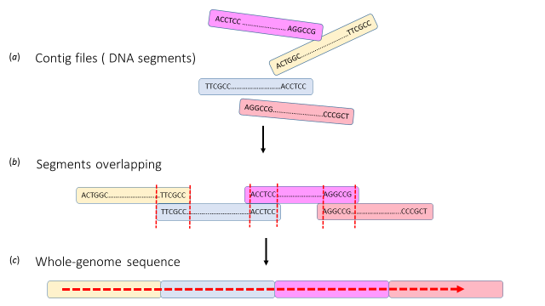
Fig. 4.1: A schematic of the genome sequence assembly of Kytococcus sedentarius MBB13. (a) The four contigs files are ready for assembly. (b) The contigs files are overlapped using the Galaxy website. (c) The whole-genome is generated as one readable file.

4.3 Comparing the genome of K. sedentarius MBB13 to that of strain DSM 20547
Pairwise reciprocal best-hit FASTA analysis was used to compare K. sedentarius strain MBB13 and the reference genome strain DSM 20547 (available from www.ncbi.nlm.nih.gov). The result summarised the relationship based on shared amino acid identity and revealed a common core set of genes (Fig. 4.2). The genome sequence of K. sedentarius MBB13 is 2695.4 kb in length with 97% identical to the reference genome (DSM 20547). In prokaryotes, the percentage of GC-content is 25-75%, and actinobacteria are considered as high GC (Chen and Zhang, 2003; Ventura et al., 2007). Kytococcus sedentarius MBB13 had 71.55% of GC similar to DSM 20547 (71.63%) (Fig. 4.2 and Table 4.1). The origin of replication was located upstream of dnaA, and at this point the GC skew value shifts (Fig 4.3).

K. sedentarius DSM 20547 (2,785,024 bp)
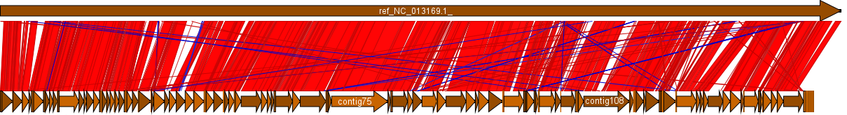 | Identical (97%)
K. sedentarius MBB13 (2,695,411 bp)
Fig. 4.2: Comparison depicting linear diagram of K. sedentarius MBB13 and DSM 20547, generated by the Galaxy assembly website (https://hactar.shef.ac.uk/galaxy). Arrows indicate the position of contigs, red blocks indicate conserved regions and blue blocks indicate conserved regions in reverse orientation. Identity percentage measurement was generated from blast.ncbi.nlm.nih.gov.

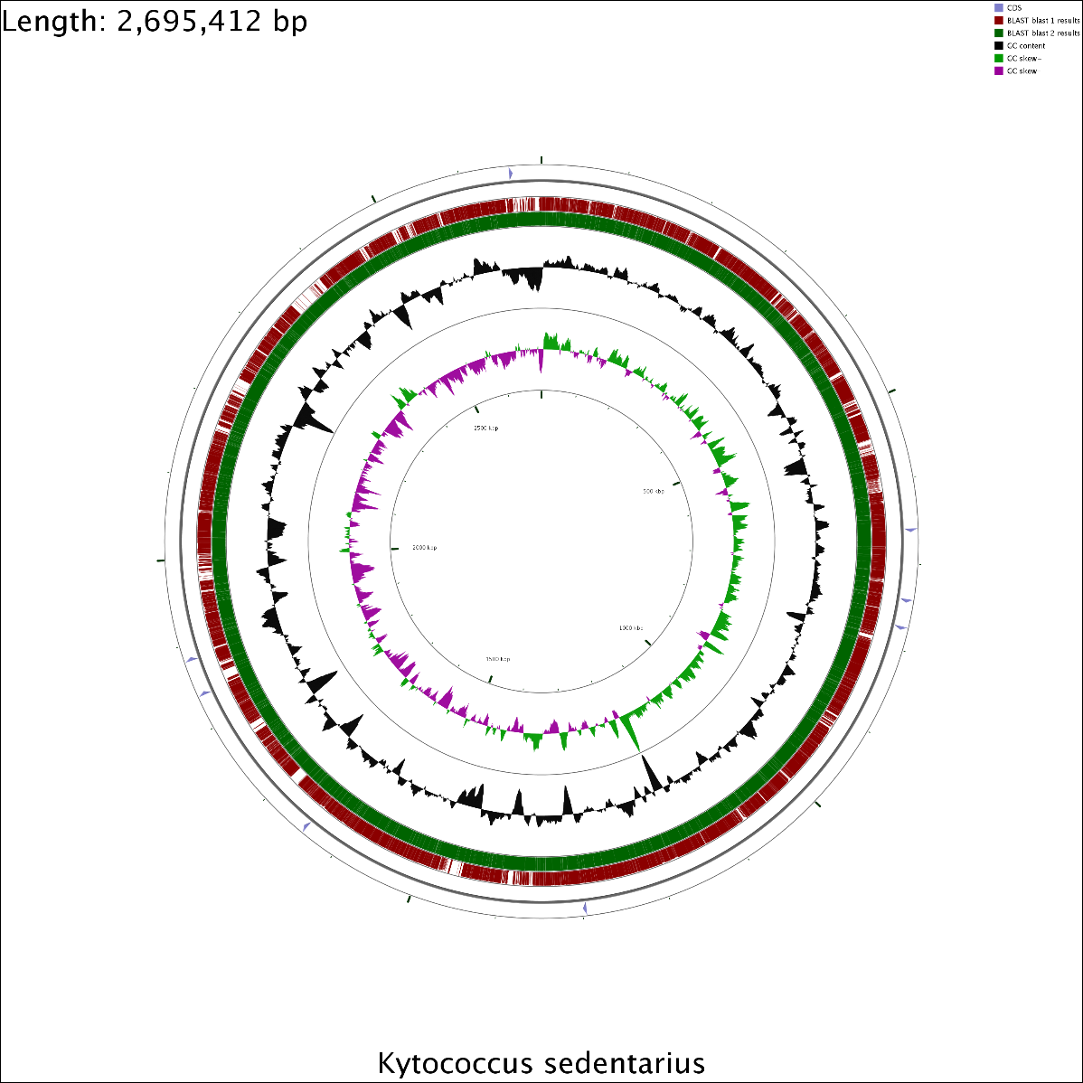
Fig. 4.3: Circular genome visualisation of K. sedentarius MBB13 and DSM 20547. The burgundy circle indicates the reference genome, and the green circle indicates the MBB13 genome. The %GC content is shown in an adjacent feature track (black circle). The GC skew is shown the last circle from inside (green and violet). This CGView map is generated via the online website of http://stothard.afns.ualberta.ca/cgview_server/.

Table 4.1: Overall sequence composition of both sequence of K. sedentarius MBB13 and DSM 20547.
 | MBB13 | DSM 20547
Number of bases | 2,695,411 | 2,785,024
GC percentage | 71.55 | 71.63
Total genes | 2499 | 2554
Assigned genes | 1789 (74.63%) | 1963 (76.85%)
Hypothetical proteins | 710 (36.08%) | 591 (23.14%)

The genome sequence of K. sedentarius MBB13 contains 2499 predicted genes. Putative functions were assigned to 74.63% of genes, while the remaining 36.08% were annotated as hypothetical proteins (Table 4.1).

4.4 Kytococcus sedentarius MBB13: relationship with oxygen
Kytococcus sedentarius is described as an obligate aerobe with strictly respiratory metabolism, with some strains being capable of reducing nitrate to nitrite (Stackebrandt, et al., 1995). Accordingly, K. sedentarius MBB13 did not grow on Luria-Bertani agar plates incubated under anaerobic conditions (Fig. 4.a). To test growth in liquid culture, a 5 ml aerobic culture of K. sedentarius MBB13 was grown in Luria-Bertani broth at 37°C overnight and was used to inoculate anaerobic Luria-Bertani broth to a final OD₆₀₀ of 0.1. After overnight incubation at 37°C to exhaust any remaining oxygen, 100 µl of this culture was transferred to either aerobic or anaerobic Luria-Bertani broth and these cultures were incubated under the corresponding conditions at 37°C overnight, at which point OD₆₀₀ measurements were made (Fig. 4.b). The OD₆₀₀ values for the aerobic cultures were four-fold greater than the anaerobic cultures, suggesting that some anaerobic growth (final OD₆₀₀ 0.5 compared to the initial OD₆₀₀ of 0.01) had occurred.

(a)  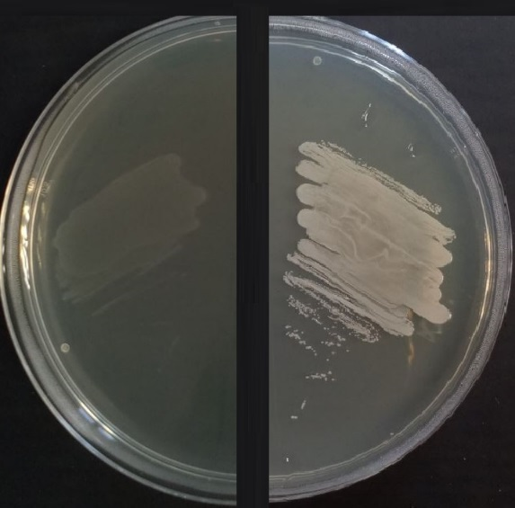 | (b)
Fig. 4.4: Kytococcus sedentarius MBB13 may require oxygen for growth. Cultures were incubated at 37°C for 18 h. (a) Luria-Bertani agar: left, anaerobic, right: aerobic. (b) Final optical densities (OD₆₀₀) achieved under anaerobic and aerobic conditions. Data shown are the mean values, error bars indicate standard errors (n=3).

To further test any requirement for oxygen to support the growth of K. sedentarius MBB13, the thioglycollate broth technique was applied. Sodium thioglycollate is a reducing agent that removes molecular oxygen from the environment and maintains a low oxygen tension (Patricia, 2014). When sodium thioglycollate is present in a column of growth medium in a tube, facultative anaerobes will grow throughout the medium; strict aerobes only grow at the surface of the medium in contact with air; and strict anaerobes only grow towards the bottom of the medium (Fig 4.5). Kytococcus sedentarius MBB13 grew only at the top of the thioglycollate broth (Fig. 4.6). The facultative anaerobe E. coli exhibited growth throughout the medium. This result indicates that K. sedentarius MBB13 grows only aerobically.
(a) (b) (c) | Fig. 4.5: The expected bacterial growth in thioglycollate broth for; (a) strict aerobe, (b) facultative anaerobe and (c) strict anaerobe.
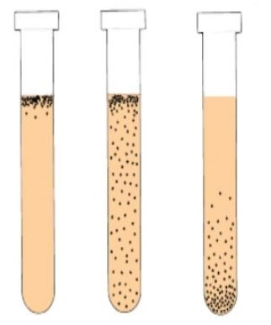

(a) (b) | Fig. 4.6: Growth Characteristics of K. sedentarius MBB13 (a) and (b) E. coli in thioglycollate broth. The bacterial growth was incubated at 37 °C for 48 h. Experiment was confirmed by three repeats.
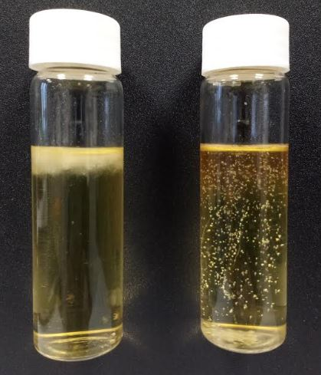

Interrogation of the K. sedentarius MBB13 genome using Biocyc (Karp et al., 2017) predicted that the bacterium had the capacity to carry out 41 reactions that require molecular oxygen, including aerobic respiration, heme biosyntheisis and synthesis of unsaturated fatty acids (Table 4.2). This list suggested that further investigation of the potential metabolic modes (e.g. aerobic respiration, anaerobic respiration, fermentation) available to K. sedentarius MBB13 might reveal its dependence on oxygen for growth.

Table 4.2: Metabolic reactions requiring molecular oxygen that are predicted to occur in K. sedentarius MBB13.
Reactions that consume oxygen | Pathways
2 an ubiquinol_{[membrane]} + oxygen_{[in]} + 5 H⁺_{[in]} → 2 a ubiquinone_{[membrane]} + 2 H₂O_{[in]} + 5 H⁺_{[out]} | proline or succinate to cytochrome oxidase electron transfer
ferroheme o + a reduced unknown electron carrier + oxygen → ferroheme i + an oxidized unknown electron carrier + H₂O | heme a biosynthesis
ferroheme i + a reduced unknown electron carrier + oxygen → hydroxyferroheme i + an oxidized unknown electron carrier + H₂O | heme a biosynthesis
coproporphyrinogen III + oxygen + 2 H⁺ → protoporphyrinogen IX + 2 CO₂ + 2 H₂O | heme b biosynthesis I (aerobic)
protoporphyrinogen IX + 3 oxygen → protoporphyrin IX + 3 hydrogen peroxide | heme b biosynthesis I (aerobic)
L-arginine + oxygen → 4-guanidinobutyramide + CO₂ + H₂O | L-arginine degradation X (arginine monooxygenase pathway)
L-phenylalanine + (6R)-L-erythro-5,6,7,8-tetrahydrobiopterin + oxygen → L-tyrosine + (6R)-4a-hydroxy-tetrahydrobiopterin | L-phenylalanine degradation I (aerobic)
L-tryptophan + oxygen → N-formylkynurenine | L-tryptophan degradation I (via anthranilate)
L-aspartate + oxygen → 2-iminosuccinate + hydrogen peroxide + H⁺ | NAD biosynthesis I (from aspartate)
n-octane + 2 a reduced rubredoxin + oxygen + 2 H⁺ → 1-octanol + 2 an oxidized rubredoxin + H₂O | octane oxidation
2 an ubiquinol_{[membrane]} + oxygen_{[in]} + 4 H⁺_{[in]} → 2 a ubiquinone_{[membrane]} + 4 H⁺_{[out]} + 2 H₂O_{[in]} | succinate to cytochrome bd oxidase electron transfer
4-imidazolone-5-propanoate + a reduced unknown electron carrier + oxygen + H₂O → 4-oxoglutaramate + ammonium + formate + an oxidized unknown electron carrier
ectoine + 2-oxoglutarate + oxygen → 5-hydroxyectoine + succinate + CO₂
a long-chain aldehyde + FMNH₂ + oxygen → a long-chain fatty acid + hν + FMN + H₂O + 2 H⁺
a (5Z)-alkan-5-enoyl-CoA + oxygen → a (2E,5Z)-alka-2,5-dienoyl-CoA + hydrogen peroxide
octanoyl-CoA + oxygen → trans-oct-2-enoyl-CoA + hydrogen peroxide
a 2,3,4-saturated fatty acyl CoA + oxygen → a trans-2-enoyl-CoA + hydrogen peroxide
a decanoyl-[Acp] + oxygen → a (2E)-dec-2-enoyl-[Acp] + hydrogen peroxide
6-cis-tridecenoyl-CoA + oxygen → 2-trans,6-cis-tridecadienoyl-CoA + hydrogen peroxide
3-oxo-2-(cis-2'-pentenyl)-cyclopentane-1-butanoyl-CoA + oxygen → 3-oxo-2-(cis-2'-pentenyl)-cyclopentane-1-(E-buta-2-enoyl)-CoA + hydrogen peroxide
4-cis-undecenoyl-CoA + oxygen → 2-trans, 4-cis-undecadienoyl-CoA + hydrogen peroxide
6-trans-tridecenoyl-CoA + oxygen → 2-trans-6-trans-tridecadienoyl-CoA + hydrogen peroxide
propanoyl-CoA + oxygen → acryloyl-CoA + hydrogen peroxide
4-trans-undecenoyl-CoA + oxygen → 2-trans, 4-trans-undecadienoyl-CoA + hydrogen peroxide
3-oxo-2-(cis-2'-pentenyl)-cyclopentane-1-octanoyl-CoA + oxygen → 3-oxo-2-(cis-2'-pentenyl)-cyclopentane-1-(E-octa-2-enoyl)-CoA + hydrogen peroxide
3-oxo-2-(cis-2'-pentenyl)-cyclopentane-1-hexanoyl-CoA + oxygen → 3-oxo-2-(cis-2'-pentenyl)-cyclopentane-1-(E-hexa-2-enoyl)-CoA + hydrogen peroxide
5-cis, 7-trans-tetradecadienoyl-CoA + oxygen → 2-trans, 5-cis, 7-trans-tetradecatrienoyl-CoA + hydrogen peroxide

(5Z)-tetradecenoyl-CoA + oxygen → (2E,5Z)-tetradecenoyl-CoA + hydrogen peroxide
4-hydroxybutanoyl-CoA + oxygen → 4-hydroxycrotonyl-CoA + hydrogen peroxide
(6Z,9Z,12Z,15Z,18Z,21Z)-tetracosahexaenoyl-CoA + oxygen → (2E,6Z,9Z,12Z,15Z,18Z,21Z)-tetracosaheptaenoyl-CoA + hydrogen peroxide
stearoyl-CoA + 2 a ferrocytochrome b₅ + oxygen + 2 H⁺ → oleoyl-CoA + 2 a ferricytochrome b₅ + 2 H₂O
palmitoyl-CoA + 2 a ferrocytochrome b₅ + oxygen + 2 H⁺ → palmitoleoyl-CoA + 2 a ferricytochrome b₅ + 2 H₂O
RH + a reduced [NADPH-hemoprotein reductase] + oxygen → ROH + an oxidized [NADPH-hemoprotein reductase] + H₂O
pyridoxine 5'-phosphate + oxygen → hydrogen peroxide + pyridoxal 5'-phosphate
pyridoxamine 5'-phosphate + oxygen + H₂O → ammonium + hydrogen peroxide + pyridoxal 5'-phosphate
phenylacetyl-CoA + NADPH + oxygen + H⁺ → 2-(1,2-epoxy-1,2-dihydrophenyl)acetyl-CoA + NADP⁺ + H₂O
4-hydroxyphenylpyruvate + oxygen → CO₂ + homogentisate
2-oxo-3-phenylpropanoate + oxygen → (2-hydroxyphenyl)acetate + CO₂
homogentisate + oxygen → 4-maleyl-acetoacetate + H⁺
4 a reduced c-type cytochrome_{[out]} + oxygen_{[in]} + 8 H⁺_{[in]} → 4 an oxidized c-type cytochrome_{[out]} + 4 H⁺_{[out]} + 2 H₂O_{[in]}
4 a reduced c-type cytochrome_{[out]} + oxygen_{[in]} + 8 H⁺_{[in]} → 4 an oxidized c-type cytochrome_{[out]} + 4 H⁺_{[out]} + 2 H₂O_{[in]}
(6Z,9Z,12Z,15Z,18Z)-tetracosapentaenoyl-CoA + oxygen = (2E,6Z,9Z,12Z,15Z,18Z)-tetracosahexaenoyl-CoA + hydrogen peroxide
Further analysis suggested that K. sedentarius MBB13 central carbon metabolism was based on glucose entering the pentose phosphate pathway to produce glyceraldehyde-3-phosphate; the glycolytic pathway was incomplete due to the absence of a gene coding for phosphofructokinase (Fig. 4.7.a). The overall pentose phosphate pathway reaction is shown in Eqn. 4.1.

3 glucose + 3 ATP + 6 NADP⁺ + 3 H₂O → 2 glucose-6-phosphate + glyceraldehyde-3-phosphate + 3 CO₂ + 6NADPH + 6 H⁺ [Eqn. 4.1]

Enzymes (glyceraldehyde-3-phosphate dehydrogenase, phosphoglycerate kinase, phosphoglycerate mutase, enolase and pyruvate kinase) for metabolism of glyceraldehyde-3-phosphate to pyruvate are predicted to be present.

glyceraldehyde-3-phosphate + phosphate + NAD⁺ + 2 ADP → pyruvate + NADH + H⁺ + 2ATP + H₂O [Eqn. 4.2]

In many bacteria pyruvate stands at the crossroads of aerobic and anaerobic metabolism (Yasid et al., 2016). Lacking pyruvate formate-lyase and pyruvate oxidase, it appears that K. sedentarius MBB13 was restricted to use of the pyruvate dehydrogenase complex to further metabolise pyruvate [Eqn. 4.3].

pyruvate + NAD⁺ + CoASH → acetyl-CoA + NADH + H⁺ + CO₂ [Eqn. 4.3]

Kytococcus sedentarius MBB13 appears to have a complete Krebs cycle for oxidation of acetyl-CoA [Eqn. 4.4] and provision of biosynthetic intermediates. The presence of genes coding for phosphotransacetylase and acetate kinase suggests that acetyl-CoA can be converted to acetate with concomitant substrate level phosphorylation [Eqn. 4.5] (Fig. 4.5.b). The presence of two putative acetyl-CoA synthetase genes (acsA_1 and acsA_2), suggest the capability to re-assimilate any excreted acetate [Eqn. 4.6].

acetyl-CoA + 3 NAD⁺ + FAD + phosphate + ADP → 2 CO₂ + CoASH + 3 NADH + 3 H⁺ + FADH₂ + ATP [Eqn. 4.4]

acetyl-CoA + phosphate + ADP → acetate + CoASH + ATP [Eqn. 4.5]

acetate + ATP + CoA → acetyl-CoA + AMP + PP_{i} [Eqn. 4.6]

The reducing equivalents (NAD(P)H and FADH₂) generated by the pentose phosphate pathway and Krebs cycle can be used to support biosynthesis of macromolecules or to feed an aerobic electron transport chain (Fig. 4.7.c). The K. sedentarius MBB13 strain possesses a non-proton translocating NADH dehydrogenase, enzymes for the biosynthesis of fully unsaturated menaquinones (MK8-12) and two alternative oxidases, cytochrome bc1-aa3 oxidase and cytochrome bd oxidase; the latter being associated with aerobic respiration at low oxygen tensions (Wu et al., 1996).
The Krebs cycle enzyme, succinate dehydrogenase donates electrons at the level of FADH₂ to the menaquinone pool and a proline dehydrogenase (PutB/ProC) could also serve as a primary dehydrogenase in the presence of proline. Enzymes associated with anaerobic fermentative metabolism, such as pyruvate formate-lyase, hydrogenase, were not detected in the genome K. sedentarius MBB13. Some strains of K. sedentarius are able to reduce nitrate to nitrite (Sims et al., 2009), a reaction which could allow nitrate to serve as an alternative terminal electron acceptor, however, the MBB13 strain did not possess genes resembling known nitrate reductases, suggesting that anaerobic respiratory growth was not possible.
Aerobic respiration is relatively energetically efficient but inevitably generates reactive oxygen species (ROS), such as superoxide, hydrogen peroxide and hydroxyl radicals, that can damage many cell components (Imlay, 2008).
The K. sedentarius MBB13 genome contains genes coding for sensor-regulator proteins SoxR (superoxide-responsive) and OxyR (hydrogen peroxide-responsive). The oxyR gene is located immediately downstream of the ahpCF genes, which code for an alkylhydroperoxide reductase, an enzyme involved in resistance to peroxide stress (Bsat et al., 1996). By analogy with other bacteria it is likely that OxyR will activate expression of ahpCF in response to peroxide stress. OxyR is also likely to activate expression of catalases (katA and katE) and predicted glutathione peroxidases (gpx1_1 and gpx1_2), since these enzymes are likely to be important in adapting to peroxide stress. SoxR is probably an activator of sodN, coding for a Ni-superoxide dismutase. These components of the K. sedentarius genome provide protection against endogenous reactive oxygen species damage associated with aerobic respiratory growth (Fig. 4.7d).
The main fatty acids of the K. sedentarius type strain 541 are reported to be methyl-branched iso-C_{17:1}, anteiso-C_{17:0}, saturated C_{15:0} and C_{17:0} (Sims et al., 2009). It is possible, but unlikely, that one or more of the potential oxygen-requiring lipid reactions listed in Table 4.2 are essential. However, synthesis of deoxynucleotides is essential for DNA replication. Ribonucleotide reductases (RNR) are used to catalyse the conversion of NDPs to dNDPs (Minnihan et al., 2013). One class of RNR has a tyrosyl radical at its active site and generation of this radical requires molecular oxygen (Minnihan et al., 2013). Another class of RNR use a vitamin B12, oxygen-independent mechanism to synthesise dNDPs (Lee et al., 2012). Bacteria that lack an oxygen-independent RNR cannot grow in the absence of oxygen (Foskolou and Hammond, 2017). However, this cannot account for the inability of K. sedentarius MBB13 to grow anaerobically because it possesses both RNR systems (Class I, O₂-dependent enzyme coded by nrdAB and Class II, O₂-independent enzyme encoded by nrdJ).
From this analysis of the K. sedentarius MBB13 genome sequence it was concluded that the requirement of oxygen is most likely due to the absence of fermentation and anaerobic respiratory pathways, resulting in dependence on the presence of oxygen as a terminal electron acceptor.

Fig. 4.7: Schematic representations of (a) The pentose phosphate pathway, (b) Krebs cycle, (c) alternative aerobic respiratory chains, (d) responses to detoxify reactive oxygen species. The schemes are based on analysis of genes present in the K. sedentarius MBB13 genome.

4.5 Kytococcus sedentarius MBB13: Salt tolerance
Kytococcus sedentarius was first isolated in 1944 from a slide immersed in sea water near San Diego, USA. Since then it is has been frequently isolated from human skin and, in the context of the current study, was also identified in a culture-independent investigation of the microbial content of commercial airline cabin air (Sims et al., 2009; Osman et al., 2008). Its presence in the marine environment and on human skin indicates that K. sedentarius is salt tolerant; the type strain 541^{T} can grow in media containing up to 10% (~1.7 M) NaCl (Sims et al., 2009). The optical densities of K. sedentarius MBB13 cultures grown for 24 h in nutrient broth supplemented with additional NaCl (nutrient broth contains 0.1 M NaCl) showed that growth negatively correlated with the increase in salinity (Fig. 4.8). Significant growth was observed when the total NaCl concentration was 0.6 M, a concentration similar to that of sea water. However, the best growth of K. sedentarius MBB13 was found at low salinity indicating that the strain is halotolerant (Ara et al., 2013).

Fig. 4.8: Growth of Kytococcus sedentarius MBB13 in nutrient broth supplemented with different concentrations of NaCl at pH 7.5 ±0.2 after 24 h incubation at 37°C on an orbital shaker (150 rpm). OD was measured at 600 nm against a medium blank. Data points are the means of three replicates plus or minus standard deviation.

Bacteria maintain an appropriate osmotic gradient across the cytoplasmic membrane by changing the osmotic potential of the cytosol to control water influx and efflux through aquaporins. Under conditions of high salinity, accumulation of osmoprotective compatible solutes, such as glycine betaine, proline, proline betaine, trehalose, glutamate, ectoine, carnitine, taurine and dimethylsulfonio-propionate, draws water into the cell to prevent desiccation (Wood, 2015). These compounds are excreted through mechanosensitive channels when the external osmolarity decreases (Wood, 2015). The response to high osmolarity often begins with uptake of potassium ions (K⁺), followed by replacement of K⁺ ions by one or more compatible solutes (McLaggan et al., 1994). Analysis of the K. sedentarius MBB13 genome indicated the presence of several genes potentially involved in the response to osmotic stress (Fig. 4.9).
In B. subtilis, K⁺ ion uptake to lessen water loss during initial exposure to high salinity is mediated by two related potassium importers KtrAB and KtrCD, consisting of a homodimeric transmembrane protein (KtrB) and an associated octameric cytosolic ring protein (KtrA) (Holtmann et al., 2003). Although K. sedentarius MBB13 possesses a ktrA gene, a ktrB candidate was not detected, suggesting that the KtrA protein has a different partner and probably does not function in gating K⁺ import in this bacterium (Hoffmann and Bremer, 2016).
The E. coli KdpFABC complex (K⁺-dependent ATPase) is another K⁺ transporter, encoded by the kdpFABC operon and is an alternative route to scavenge K⁺. KdpD is a membrane bound sensor kinase and KdpE is a cytosolic response regulator and comprise a typical prokaryotic two component signal transduction system. Upon stimulus, KdpD undergoes autophosphorylation and the phosphoryl group is transferred to the regulator KdpE. KdpE binds with high affinity at the kdpFABC promoter when in its phosphorylated and dimerized form, and triggers kdpFABC transcription (Schniederberend et al., 2010). In K. sedentarius MBB13, KdpFABC complex and its regulators are not detected (Fig. 4.9).

Ectoine is another major compatible solute in many halophiles such as, Chromohalobacter salexigens, Methylomicrobium alcaliphilum and Bacillus pasteurii. Ectoine can be taken up from the environment when available. Ectoine uptake is mediated by the Ect ABC transporter, which is encoded by the ectA, ectB, and ectC genes. In M. alcaliphilum, a MarR-like transcriptional regulator (EctR1) represses the expression of the ectABC-ask operon by binding at the putative -10 sequence (Mustakhimov et al., 2010). The K. sedentarius MBB13 genome possesses a MarR-like regulator and ectABC operon but does not contain the gene ask (Fig. 4.9).
Compatible solutes can be obtained from the environment or synthesised in the bacterial cytosol. Glycine betaine and choline uptake is mediated by the ABC-type transporter OpuC, which is encoded by the opuBA-opuCD-opuCB-opuCC-lcdH operon in the K. sedentarius MBB13 genome. In addition, opuD and betL, coding for Betaine/Carnitine/Choline Transporter (BCCT) family transporters, and proP, coding for a broad specificity Major Facilitator Superfamily (MFS) proline transporter, complete the catalogue of compatible solute uptake systems (Fig. 4.9). In Listeria monocytogenes, betL was rapidly expressed in response to an osmotic up-shift (Sleator et al., 2003) and ProP acts as an osmosensor and osmoregulator, permitting it to respond rapidly to changes in osmolarity (Culham et al., 2003).
Choline is a precursor of glycine betaine, conversion being catalysed by two enzymes (choline dehydrogenase, EC 1.1.91.1 and an aldehyde dehydrogenase, EC 1.2.1.8). In E. coli, these enzymes are encoded by the betAB operon (Wood, 2006). Although a betB gene was identified in the K. sedentarius MBB13 genome, betA was not. Gram-positive bacteria use an alcohol dehydrogenase (GbsB, EC 1.1.1.1) (Dandekar et al., 1999; Wood et al., 2001), and plants use a choline monoxygenase (EC 1.4.14.7) to effect the conversion of choline to betaine aldehyde (Hibino et al., 2002), but no similar genes were detected in the K. sedentarius MBB13 genome.
The K. sedentarius MBB13 putB-proC operon codes for enzymes allowing catabolism of proline to glutamate (see above). Kytococcus sedentarius MBB13 also possesses the otsAB genes, coding for trehalose biosynthesis enzymes (Fig. 4.9). Following osmotic down-shifts the accumulated compatible solutes need to be released to minimise water influx and K. sedentarius MBB13 has two mechanosensitive channels (mscL and ykuT/mscS) to fulfil this function.

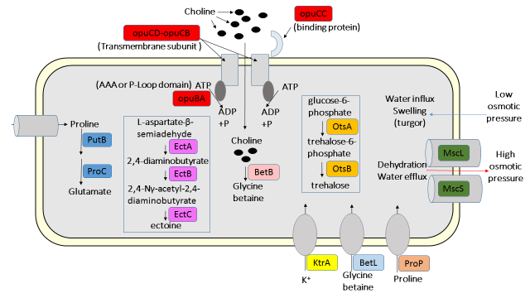
Fig. 4.9: Systems involved in osmotic adaptation by K. sedentarius MBB13. Analysis of the genome sequence identified transporters, channels and biosynthetic pathways that could contribute to tolerating high salinity. Membrane proteins involved in release or uptake of and cytoplasmic enzymes catalyzing the compatible solutes, glycine betaine, ectoine, glutamate and trehalose are shown. The catabolism (PutB-PutC) of L-proline is shown. MscS and MscL are mechanosensitive channels which are a transient gating systems to release compatible solutes in response to an osmotic down-shock, preventing cell lysis; they release non-specific organic compounds and water-attracting ions to reduce the cytoplasm osmotic potential and curb water influx. Glycine betaine synthesis from the precursor choline taken up by the osmotically inducible OpuC transporter [opuCA-opuCB-opuCC-opuCD] in response to high salinity and the BetB for glycine betaine synthesis. And EctABC for ectoine biosynthesis are shown. The operon otsAB allows synthesis of trehalose. These systems were identified based on their homologs in Bacillus spp. (Kuhlmann and Bremer, 2002; Schroeter et al., 2013).

To determine which of these potential osmoprotective systems were deployed by K. sedentarius MBB13 when cultures were grown in the presence of different NaCl concentrations, proton NMR analysis of cell extracts was carried out (Section 2.3.4.3) (Fig. 4.10). The ¹H NMR spectra showed that glycine betaine increased significantly as the NaCl concentration increased (Kim et al., 2017). Proline appeared to increase once the concentration of NaCl was raised above 1.0 M (Kim et al., 2017). A species with chemical shift of ~4.1 ppm indicated that ectoine appeared only when the NaCl concentration was greater than 2.0 M. Ecotine peaks were also present at 2.2. ppm and between 1.0-1.5 (Nagata et al., 1996; Khmelenina et al., 1999; Ongagna-Yhombi and Boyd, 2013). Acetate at ~2.0 ppm (Krucker et al., 2004) and lactate at ~1.3 ppm (Wang et al., 2017) appeared from 0.5 M NaCl. Chemical shifts at ~3.7 ppm are likely be glutamate and appeared between 1.0-1.5 M NaCl (Kim et al., 2017).
The analysis of the K. sedentarius MBB13 genome and the experiments presented here suggest that glycine betaine is the major compatible solute, but proline, glutamate, and ectoine also contribute to salt tolerance.

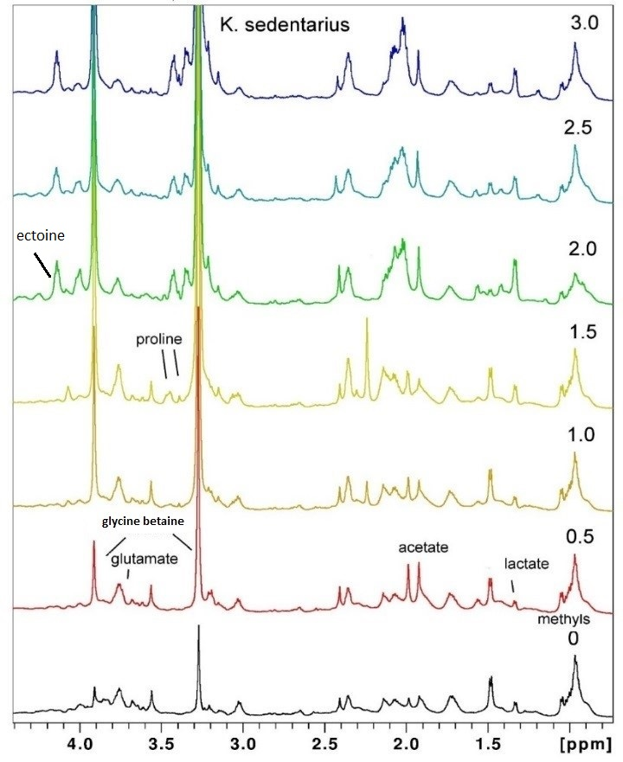
Fig. 4.10: 1H NMR spectra of cell extracts derived from K. sedentarius MBB13 at 0, 0.5, 1.0, 1.5, 2.0, 2.5 and 3.0 NaCl (M) in nutrient broth (NB) medium (containing 0.1 M NaCl). The spectra shown are equivalent to ~10 OD₆₀₀ units of bacteria without additional NaCl; ~8 OD₆₀₀ units of bacteria for cultures supplemented with 0.5, 1.0 or 1.5 M NaCl; ~6 OD₆₀₀ units of bacteria for cultures supplemented with 2.0 M NaCl; and 0.2 OD₆₀₀ units of bacteria for cultures supplemented with 3.0 M NaCl. The ¹H spectra identified glycine betaine as the most abundant compatible solute, and acetate, lactate, glutamate, ectoine and proline also accumulated. Solutes indicated by dashes.

4.6 Kytococcus sedentarius MBB13: keratinase production
Kytococcus sedentarius has been reported to cause pitted keratolysis (Nordstrom et al., 1987; Ertam et al., 2005; Singh and Naik, 2005). Some strains produce proteases P1 and P2 that are able to degrade keratin (Longshaw et al., 2002). The ability of K. sedentarius MBB13 to degrade keratin azure and release blue dye in the medium was tested (Section 2.3.4.2) (Fig 4.11). It appeared that K. sedentarius MBB13 was unable to degrade keratin. Keratinases in bacteria have been studied intensively and showed that, the active site was located in N-terminal of keratinases genes (Gupta and Ramnani, 2006; Brandelli et al., 2010), but no similar active sites were detected in the K. sedentarius MBB13 genome.
(a)  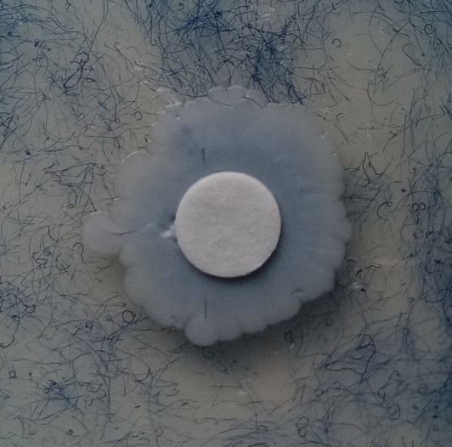 | (b)  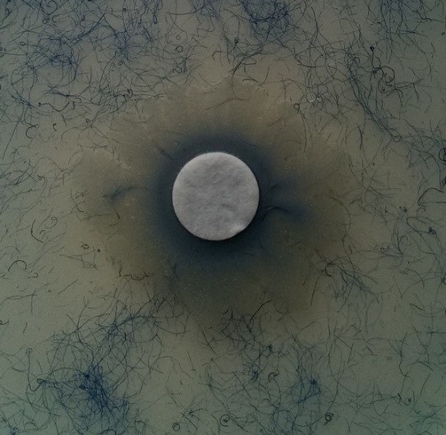
(C)
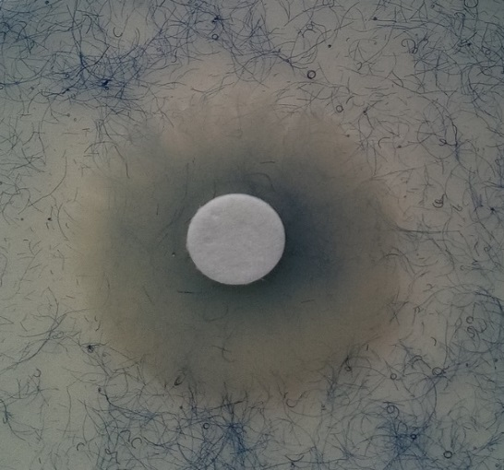
Fig. 4.11: Keratin azure test plates following 9 days incubation. The blue dye released surrounded the bacterial growth for positive reactions. (a) Kytococcus sedentarius MBB13, (b) Pseudomonas putida KT2440 (positive control) (c) Escherichia coli DH5α (negative control). Discs were dipped into overnight culture of the tested strains and placed by sterile forceps in the middle of the LB-keratin azure agar.

4.7 Kytococcus sedentarius MBB13: monensin A and B production
Complex reduced polyketides are natural products that are produced by modular enzyme biosynthesis systems termed polyketide synthases (PKSs). At least 20 antibiotics are derived from PKSs such as, monensin, erythromycin and lovastatin (Yuzawa et al., 2018).
Monensin (A and B) are polyether ionophore antibiotics and produced by Streptomyces cinnamonensis ST021, and mainly used to treat coccidiosis in poultry (Tang et al., 2017). They are also of interest because they promote cell apoptosis and inhibit proliferation of human cancer, including myeloma, neoplasia, glioma, lymphoma and breast cancer (Tang et al., 2017). Over 20 genes are required for monensin biosynthesis, and the mon cluster has been characterised from S. cinnamonensis. The monensin biosynthesis genes were classified into 4 groups, type I polyketide synthases (PKSs), type II thioesterases, post-PKS tailoring enzymes and putative pathway specific regulators (Table 4.3). The presence of activators such as MonH, MonRI and MonRII are essential for high production of monesin (Tang et al., 2017).
Table 4.3: Cluster genes involve in the production of monesin A and B in S. cinnamonensis ST021.
Gene type | Gene name
type I polyketide synthases (PKSs) | MonAI to MonAVIII
type II thioesterases | MonCII, MonAIX, and MonAX
post-PKS tailoring enzymes | MonBI, MonBII, MonCI, MonCII, and MonD
putative pathway specific regulators | MonH, MonRI, and MonRII
* Data adapted from (Tang et al., 2017)
It has been reported that K. sedentarius TR-2 is a producer of monensin A and B. Matrix-assisted laser desorption/ionization (MALDI) mass spectroscopy detected the presence of a mixture of monensin A and B , however no further genetic details were shown (Pospisil et al., 1998). Investigation of the genomes of K. sedentarius strains MBB13 and DSM 20547 (Section 2.5.2.1), showed that, the mon cluster genes were not present. Therefore, both the K. sedentarius MBB13 and DSM 20547 are not monensin producers.

4.8 Kytococcus sedentarius MBB13: wbl genes and sigma factors
Actinobacteria are the largest taxonomic unit among the 18 major lineages within the Bacteria domain (Ventura et al., 2007). One characteristic of the Actinobacteria is the possession of Wbl (WhiB-like) proteins (Bush, 2018). The first Wbl to be identified was WhiB from Streptomyces coelicolor, which was shown to co-control the cessation of aerial hyphal growth (Bush, 2018). It is now known that S. coelicolor has 14 Wbl proteins and M. tuberculosis has 7, with most Actinobacteria possessing more than one Wbl protein. Wbl proteins are small (~80–140 residues) and possess a [4Fe–4S] cluster coordinated by four invariant cysteine residues, along with a conserved five-residue G[V/I]WGG motif, predicted to mediate protein-protein interactions (Bush, 2018). The iron-sulfur clusters are thought to act as redox sensors in controlling diverse biological processes, such as morphogenesis, metabolism, virulence and antibiotic resistance (Miller and Auerbuch, 2015).
The Wbl proteins of M. tuberculosis have been extensively studied. WhiB1 is an essential nitric oxide-responsive transcription regulator (Smith et al., 2010; Kudhair et al., 2017). WhiB2 is also essential and depletion of WhiB2 leads to filamentous growth and aberrant septation and thus likely has a role in coordinating cell division (Gomez and Bishai, 2000). WhiB3 has an oxygen- and nitric oxide-sensitive [4Fe-4S] cluster and its expression is up-regulated at low pH and inside macrophages (Geiman et al., 2006; Rhodes et al., 2007; Singh et al., 2007). It is thought that WhiB3 is involved in mediating redox homeostasis when M. tuberculosis is in a host phagosome and thus is implicated in virulence and persistence (Singh et al., 2009). Like WhiB3, the iron-sulfur cluster of WhiB4 is sensitive to oxygen and nitric oxide. WhiB4 likely regulates the response to oxidative stress because deletion of whiB4 resulted in over-induction of anti-oxidant activities and enhanced resistance to oxidative stress (Chawla et al., 2012). The M. tuberculosis whiB5 mutant was attenuated in a mouse model of infection, was unable to resume growth following a chronic infection and was more sensitive to nitric oxide than the parental strain (Casonato et al., 2012). WhiB6, is implicated in pathogenesis through its regulation of the virulence critical Type VII secretion system ESX-1 and aspects of aerobic and anaerobic metabolism (Chen et al., 2016). WhiB7 controls multi-drug resistance by regulating the expression of several antibiotic resistance genes (Burian et al., 2013). Thus, WhiB7 is required for diversity of antibiotics resistance with different targets and structures such as lincosamides, pleuromutilins, phenicols, macrolides, tetracyclines and some aminoglycosides. It has been suggested that the antibiotic resistance genes, tap, erm and eis are also a part of the WhiB7 regulon. WhiB7 is thought to bind DNA through an AT-hook motif in the C-terminal region (Bush, 2018).
The overall picture that emerges from the study of M. tuberculosis Wbl proteins is that they primarily function as transcription regulators. With the exception of WhiB7, which possesses an AT-hook motif (see above), the other Wbl proteins lack a recognisable DNA-binding motif and interaction with DNA is likely to be mediated by their positively charged C-terminal regions (Smith et al. 2012). This raises questions about how Wbl proteins could target specific promoters to regulate gene expression. At least part of the answer is thought to be that Wbl proteins interact with other proteins, including RNA polymerase sigma factors. Thus, WhiB1, WhiB3 and WhiB7 interact directly with σ^{A} and WhiB2 and WhiB6 interacted with σ^{A} in a bacterial two-hybrid assay (Feng et al., 2016). Thus, it was of interest to catalogue the sigma factors of K. sedentarius MBB13. Analysis of the K. sedentarius MBB13 genome revealed the presence four sigma factors (σ^{A}, σ^{B}, σ^{R} and σ^{J}) (Table 4.4; Fig 4.12.b). In M. tuberculosis, the housekeeping sigma factor, σ^{A}, binds to core RNA polymerase during exponential growth phase and is the major sigma factor present in the cell. Under stress conditions alternative sigma factors replace σ^{A} to permit expression of different suites of genes allowing the bacterium to adapt to the new environmental conditions. Thus, σ^{B} is involved in adaptation to nutrient starvation and stationary phase (Sachdeva et al., 2010); σ^{H} (σ^{R}) plays a role in the response to oxidative stress and heat shock (Raman et al., 2001); and σ^{J} is implicated in survival in host macrophages (Sachdeva et al., 2010).

Table 4.4: Best match of Wbl protein and Sigma factors families of K. sedentarius MBB13 to those in Mycobacterium tuberculosis.
Superfamily | Gene | Proposed function | Identity (%)
Wbl | whiB1 | • Involved in growth, dormancy and reactivation | 73
 | whiB2 | • Involved in cell division | 87
 | whiB3 | • Involved in redox balance and virulence | 61
 | whiB7 | • Involved in redox balance, antibiotic resistance and virulence | 61
Sigma factors | SigmaA  (HrdB) | • RNA polymerase sigma-70 factor | 89
 | SigmaB | • Sigma-B/F/G subfamily | 35
 | SigmaR(or H) | • ECF RNA polymerase sigma factor | 69
 | SigmaJ | • RNA polymerase sigma-70 family | 39
*Proposed functions are adapted from blast.org. *If no gene name next to the bacterium, blast did not detect any.

(a) Fe-s cluster domain(N-terminal) DNA binding (C-terminal)

KS whiB1 ------------------MDWRSKAACLDEDPELFFPIGNT-GPA-IEQIEKAKKVCARCEVTETCLQWAIETGQDAGVWGGLSEDERRALKRRNA--RARRAS---
KS whiB2 ----VHELQIVGHPEQAVPSWQERALCAQTDPEAFFPEKGG-S------TREAKRVCTGCDVRSECLDYALENDERFGIWGGLSERERRKLKRRAV--FTA------
KS whiB3 ----MDSTARQPGPVADLWDWQFEGLCRTTDPEEFFHPEGERGSARRLRDERAKRVCQRCPVILECREHALAAKEPYGVWGGLSEDEREQELARRS---RRGLRGA-
KS whiB7 ----MLALADHQTLIDQARVAGRPLPCLENDPDTWFADTPT-G------VEYAKSLCHACPVRTLCLEGALERREPWGVWGGELIEAGRVLPRKRPRGRPRKHPIAA

Mtb whiB1 ------------------MDWRHKAVCRDEDPELFFPVGNS-GPA-LAQIADAKLVCNRCPVTTECLSWALNTGQDSGVWGGMSEDERRALKRRNA--RTKARTGV-
Mtb whiB2 LVPEAPAPFEEPLPPEATDQWQDRALCAQTDPEAFFPEKGG-S------TREAKKICMGCEVRHECLEYALAHDERFGIWGGLSERERRRLKRGII-----------
Mtb whiB3 ----MPQPEQLPGPNADIWNWQLQGLCRGMDSSMFFHPDGERGRARTQREQRAKEMCRRCPVIEACRSHALEVGEPYGVWGGLSESERDLLLKGTM-GRTRGIRRTA
Mtb whiB7 -------VSVLTVPRQTPRQRLPVLPCHVGDPDLWFADTPA-G------LEVAKTLCVSCPIRRQCLAAALQRAEPWGVWGGEIFDQGSIVSHKRPRGRPRKDAVA-
* * . :* . ** :* * : * *: : *:***
Variable region functional region
(b) ND1

Mtb SigA ------------------------------------------------------------------------------------------------------
KS SigA VTPPTSEKSAETPTVSEPVTAVLGKQLLDKPGLIEFVERAVDNGKVATDKVQQAIEGASLTPTQAQRLLKNLRSQGVEVHFDQETAARLAQEQRGVKPRASR

ND1

Mtb SigA VAAT-----KASTATDEPVKRTATKSPAASASGAK-TGAKRTAAKSASGSPP-AKR—-ATKPAARSVKPASAPQDTTTSTIPKRKTRAAAKSAAAKAPSARG
KS SigA SRTTRSTTAKTATAKSTTAKSTATKSTTAKSTAAKSTTAKSTAAKSTAAKSTTAKSTTAKSTAAKSTTAASGTSAKGT-ASTTRKATTAAKGTAAKSTTAKG
:* *::**.. .* ***** :*.::.** * ** *****::.. ** *.. **:*.. **. . . * : .**: :***.:***: :*:*
ND1

Mtb SigA HATKPRAPKDAQHEAATDPEDALDSVEELDAEPDLDVEPGEDLDLDAADLNLDDLEDDVAPDADDDLDSGDDEDHEDLEAEAAVAPGQTADDDEEIAEPTEK
KS SigA RTAAKGTTKSAAE---TNARNA------AADAPELDEIAAEDEAEERAA-----------------LA-GK—-D------TVELVAGETSQAAPQKAESTEE
::: : *.* . *: .:* *:** .** : * * *. * . :. *:*:: : ** **:
ND1

Mtb SigA DKASGDFVWDEDESEALRQARKDAELTASADSVRAYLKQIGKVALLNAEEEVELAKRIEAGLYATQLMTELSERGEKLPAAQRRDMMWICRDGDRAKNHLLE
KS SigA ESESRGFVLRADDEDDA-PAQQVVTAGATADAVKDYLKQIGKVALLNAEQEVDLAKRIEAGLFAEQRL----NSGDKIDAKLKRELWWVASDGKNAKNHLLE
:. * .** *:.: *:: . *:**:*: **************:**:*********:* * : : *:*: * :*:: *:. **..*******
ND1 ND2

Mtb SigA ANLRLVVSLAKRYTGRGMAFLDLIQEGNLGLIRAVEKFDYTKGYKFSTYATWWIRQAITRAMADQARTIRIPVHMVEVINKLGRIQRELLQDLGREPTPEEL
KS SigA ANLRLVVSLAKRYTGRGMLFLDLIQEGNLGLIRAVEKFDYTKGYKFSTYATWWIRQAITRAMADQARTIRIPVHMVEVINKLARVQRQMLQDLGREPTPEEL
****************** ***************************************************************.*:**::*************
ND2 LD CD

Mtb SigA AKEMDITPEKVLEIQQYAREPISLDQTIGDEGDSQLGDFIEDSEAVVAVDAVSFTLLQDQLQSVLDTLSEREAGVVRLRFGLTDGQPRTLDEIGQVYGVTRE
KS SigA AKELDMTPEKVVEVQKYGREPISLHTPLGEDGDSEFGDLIEDSEAVVPSDAVSFTLLQEQLHSVLDTLSEREAGVVSMRFGLADGQPKTLDEIGRVYGVTRE
***:*:*****:*:*:*.******. :*::***::**:******** *********:**:************** :****:****:******:*******
CD

Mtb SigA RIRQIESKTMSKLRHPSRSQVLRDYLD
KS SigA RIRQIESKTMSKLRHPSRSQVLRDYLD
***************************

Fig. 4.12: Alignment of Wbl and major sigma factor A proteins between K. sedentarius MBB13 (KS) and M. tuberculosis H37Rv (Mtb) amino acid sequences. (a) The conserved cysteines residues and unique G(I/V)WGG domain (tryptophan containing) of Wbl proteins are highlighted in green and yellow respectively, and AT-hook of Wbl7 is in blue. (b) The Sigma factor N-terminal 1 and 2, linker and C-terminal domains are indicated as ND1, ND2, LD and SD respectively. M. tuberculosis H37Rv was obtained from ncbi.nlm.nih.gov (RefSeq NC_000962.3).

4.9 Kytococcus sedentarius MBB13: Antibiotic resistance

4.9.1 Ciprofloxacin resistance
Antibiotic sensitivity screening indicated that K. sedentarius MBB13 was resistant to ciprofloxacin, a quinolone family antibiotic that targets DNA gyrase. Several mechanisms for ciprofloxacin resistance have been reported, including expression of multi-drug efflux pumps, mutations in drug uptake systems and missense mutations in GyrA, GyrB, ParC and ParE (Hooper, 1999). The K. sedentarius MBB13 DNA gyrase is encoded by the gyrB_1-gyrA_1 operon (Hooper, 1999). In several bacteria, ciprofloxacin resistance is linked to GyrA mutations of Ser (S112 in K. sedentarius MBB13 GyrA) and/or Asp (D116 in K. sedentarius MBB13) in the highly conserved quinolone resistance motif HPHGDSAVYD motif (Hooper, 1999). Replacement of Ser by Leu or Ile results in resistance (Hooper, 1999), but this motif is conserved in the K. sedentarius MBB13 GyrA. Mutations within amino acid motifs associated with ciprofloxacin resistance have also been recognized in GyrB. For example, D495R or D495H mutations result in ciprofloxacin resistance in M. tuberculosis (Hooper, 1999). However, the GyrB motifs that are altered in ciprofloxacin resistant strains are intact in K. sedentarius GyrB. Therefore, it was concluded that the observed ciprofloxacin resistance is not due to a resistant mutant DNA gyrase.
DNA gyrase can be regarded as a secondary quinolone target and resistance is often associated with mutations in parC and/or parE, which code for Topoisomerase IV, which is homologous to DNA gyrase and is required for decatenating newly replicated chromosomes. The parC and parE genes were annotated as gyrA_2 and gyrB_2 in the K. sedentarius MBB13 genome are located on opposite strands of the chromosome and are separated by three genes (atoE, yokF and yhdG_2). ParC-mediated quinolone resistance is associated with mutations analogous to those described above for GyrA. Kytococcus sedentarius MBB13 ParC has a Thr residue in place of the highly conserved Ser residue of the HPHGDSAVYD motif (see above), whether this could contribute to ciprofloxacin tolerance is as yet unknown, because a systematic analysis has not been reported. ParE mutations associated with quinolone resistance are associated with mutations at the positions equivalent to 492 and 530 in K. sedentarius MBB13 GyrB_2 (ParE), involving replacement of an Asp residue by Asn and an Asn residue by Asp (Hooper, 1999). However, at both these positions in K. sedentarius MBB13 ParE the ‘sensitive’ amino acids are present. Thus, it was concluded that ciprofloxacin resistance was not associated with mutations in ParC-ParE.
Quinolone resistance in M. smegmatis has been linked to over-expression of the major facilitator superfamily (MFS) efflux pump LfrA (Liu et al., 1996), but a similar protein was not encoded by the K. sedentarius MBB13 genome. The MFS efflux pumps NorA, Bmr and Blt contribute to quinolone resistance in the Gram-positive bacteria, Staphylococcus aureus and Bacillus subtilis (Hooper, 1999). The K. sedentarius MBB13 genome encodes a protein (annotated as Bmr3) with 31% identity, 53% similarity over 490 amino acids to the B. subtilis Bmr3 protein and 37% identity, 55% similarity over 458 amino acids to the S. cyanogenus LanJ protein, which effluxes the antibiotic landomycin, preventing killing of the producer strain. Thus, it is possible that Bmr3 contributes to ciprofloxacin resistance by pumping the drug out of the cytoplasm. This could be tested in the future by constructing a K. sedentarius MBB13 deletion mutant and retesting sensitivity.
In conclusion, analysis of the genome sequence suggests that the observed ciprofloxacin resistance is probably mediated through the action of efflux pumps, possibly involving over-expression of bmr3.

4.9.2 Erythromycin resistance
Resistance to erythromycin is conferred by methylation of a specific adenine base in the 23S rRNA by enzymes encoded by erm genes, or by plasmid borne efflux pumps (msr genes), or by mutations in ribosomal proteins L4 (RplD) or L22 (RplV). The genetic information available for K. sedentarius MBB13 only includes the chromosome, so no information on any potential plasmid borne genes is available. RplV linked erythromycin resistance is associated with a 9 base pair deletion that removes a 3 amino acid sequence - M82, K83 and R84 (E. coli numbering; (Chittum and Champney, 1994); these amino acids are present in K. sedentarius MBB13 RplV. RplD-mediated resistance again arises from several mutations, e.g. K63E, G69A, T70P and R168S (E. coli numbering), but none of these mutations are present in the K. sedentarius MBB13 RplD. Erythromycin resistance in many bacteria can also be conferred by base substitutions in the 23S rRNA (G2057A, A2058G, A2059C/G; E. coli rrlA numbering); however none of these mutations are present in the K. sedentarius MBB13 genome (Vester and Douthwaite, 2001). Furthermore, the K. sedentarius MBB13 genome contains no close matches to the S. aureus emrC gene, which encodes a methyltransferase that methylates A2058 of the 23S rRNA resulting in resistance to macrolide antibiotics (Vester and Douthwaite, 2001). The best match was rsmA (ksgA) at 20% identical, 43% similar over 244 amino acids. KsgA di-methylates 16S rRNA during maturation of the small RNA subunit and thus is unlikely to methylate 23S rRNA to provide resistance to erythromycin. Thus, this analysis of the K. sedentarius MBB13 genome sequence has not identified the mechanism underpinning the observed erythromycin resistance, but has ruled out some possibilities and suggests that perhaps over-expression of efflux pumps is likely to be involved.

4.10 Discussion
Although K. sedentarius is an opportunistic pathogen, very little is currently known about the molecular basis of factors contributing to its properties. In this chapter, the genetic knowledge of the isolate K. sedentarius MBB13 was extended by performing comparative analysis of the genome. First of all, the genome revealed a high similarity percentage to the reference with 97% with some gaps in the image of the genome alignment (Fig 4.2), the gaps reflect genes missing or acquired which could occur through exposure to environmental factor changes as a HGT process (Soucy et al., 2015).
In vivo tests and genome investigation of K. sedentarius MBB13 have also been studied in this chapter. The results of this study indicate that fermentation and anaerobic respiratory pathways are absent which suggests the reason it is a strict aerobe even with the presence of RNR. Besides that, proposing the cytochrome c pathway that consist of a cytochrome bc1-aa3 oxidase and cytochrome bd oxidase, based on genomics indicate its dependence on oxygen. Despite the fact that some strains of K. sedentarius reduce nitrate to nitrite (Sims et al., 2009) but K. sedentarius MBB13 may not reduce nitrate due to absence of nitrate reductases resembling genes.
NMR results indicate that glycine betaine is the main compatible solute compound, other solutes were also observed such as ectoine, proline, glutamate, acetate and lactate (Fig 4.7). Up to date, this is the first demonstration of genes involved in compatible solutes that compared the genome data of K. sedentarius.
It has been claimed that K. sedentarius strain M17C that was isolated from an infected human foot is able to degrade keratin due to the presence of keratinase enzymes (Longshaw et al., 2002). However, K. sedentarius strain MBB13 genome does not possess the genes involved in keratin degradation and did not degrade keratin azure (Fig 4.9). This finding suggests that not all K. sedentarius strains are keratin degraders including MBB13. Additionally, genome of strain M17C was unavailable online.
Kytococcus sedentarius is considered as a new producer of monensin antibiotic A and B. In S. cinnamonensis, the mon cluster was identified and gene inactivation suggested that two genes are important for the monesin production (monH and monRI). In K. sedentarius both strains MBB13 and DSM 20547 but not TR-2, the cluster was not identified. Up to date, TR-2 genome is still unavailable to investigate the production of monesin either by the bioinformatics tools or in vivo experiments.
To conclude this chapter, K. sedentarius MBB13 is strictly aerobic most likely due to due to the absence of fermentation and anaerobic respiratory pathways. The strain of K. sedentarius MBB13 is unable to degrade keratin. Kytococcus sedentarius MBB13 grows well under conditions with up to 0.6 M NaCl, most likely due to the presence of the following compatible solutes, glycine betaine, proline, glutamate and ectoine. Genome of K. sedentarius MBB13 does not have MonH, MonRI and MonRII, therefore is most likely unable to produce monesin. Kytococcus sedentarius MBB13 possesses four Wbl proteins with high similarity to those in M. tuberculosis. Wbl proteins are transcription factors some of which bind to the major sigma factor (σ^{A}) (Lipeng Feng et al., 2016). Therefore, the characterization of the K. sedentarius MBB13 Wbl proteins was undertaken as described in the next chapter.

Chapter Five

5 Isolation and biochemical characterization of K. sedentarius MBB13 WhiB1 and WhiB2 proteins

5.1 Introduction
The White-B-like (Wbl) family of proteins was discovered in Streptomyces coelicolor (Hopwood et al., 1970), and were genetically examined by Chater (1972) because mutants exhibited impaired production of aerial spores leading to white instead of grey colonies. Wbl proteins are found only within the actinomycetes and likely act as transcription regulators (Bush, 2018; Section 4.8). Wbl proteins have been isolated from a number of actinomycetes (Bush, 2018), and the Wbl proteins from Mycobacterium tuberculosis were isolated as [4Fe-4S]-, [2Fe-2S]- and apo- forms. After protein reconstitution, only the [4Fe-4S]- forms were found (Alam et al., 2009; Burian et al., 2013; Kudhair et al., 2017). Kytococcus sedentarius MBB13 has four genes coding for Wbl proteins (whiB1, whiB2, whB3 and whiB7) (Section 4.8). The biochemical and biophysical properties of Wbl proteins have been studied after isolation of recombinant proteins expressed in Escherichia coli. More recently M. tuberculosis WhiB1 was overproduced in Mycobacterium smegmatis under the control of the inducible acetamidase promoter (Daugelat et al., 2003). This approach facilitated the isolation of a stable holo-WhiB1 protein, allowing the first structure of a Wbl family member to be solved (Kudhair et al., 2017). In this chapter overproduction of K. sedentarius MBB13 WhiB1 and WhiB2 proteins in M. smegmatis MC²155 is reported along with some of the properties of the purified proteins.
The whiB1 gene of M. tuberculosis is essential and is thought to act as a specific NO-sensing DNA-binding protein, the effect of NO on M. tuberculosis is concentration dependent; high levels can kill but low levels promote entry into the latent state (Kudhair et al., 2017). Therefore reprogramming gene expression by WhiB1 could contribute to developmental adaptations when host generated NO is encountered (Smith et al., 2010). In Corynebacterium glutamicum, deletion of whcE (homolog of whiB1) increases sensitivity to oxidative stress and heat (Bush, 2018). In Streptomyces, wblE (homolog of whiB1) is essential but more investigation is still required (Bush, 2018).
The whiB2 of M. tuberculosis is also essential for growth (Gomez and Bishai, 2000). The Mycobacteriophage TM4 has a gene, whiBTM4, coding for a paralog of WhiB2 that when expressed in M. smegmatis results in the same phenotype as a whiB2 conditional mutant (Rybnicker et al., 2010). The Streptomyces WhiB2 (whiB) controls aerial growth and sporulation through a mechanism involving an unrelated DNA-binding protein WhiA (Bush, 2018). Also it has been reported that WhiB2 responds to several stresses that affect the cell envelope, such as antibiotics and SDS, suggesting that WhiB2 could be important in the early stages of infection (Konar et al., 2012).
The K. sedentarius MBB13 WhiB1 and 2 proteins retain the N-terminal cysteine cluster and the G(I/V)WGG domain in the C-terminal (Fig 5.1). The K. sedentarius WhiB1 protein is 73% identical to M. tuberculosis WhiB1, 65% identical to S. coelicolor WblE, 83% identical to C. glutamicum WhcE and 74% identical to M. smegmatis WhiB1. The K. sedentarius WhiB2 protein is 76% identical to M. tuberculosis WhiB2, 85% identical to S. coelicolor WhiB, 85% identical to C. glutamicum WhcD, 77% identical to M. smegmatis WhiB2 and 53% identical to Mycobacteriophage TM4 WhiBTM4. But both WhiB1 and WhiB2 of K. sedentarius MBB13 have not been previously characterized.
The aim of this work was to better understand K. sedentarius MBB13 WhiB1 and WhiB2 by determining the properties of the proteins and establish whether they operate as O₂- and/or NO-sensors.

(a)
SC WblE MDNWREHAACRTEDPDLFFPIGTTGPAALQTEQAKAVCRTCPVQEQCLRWALDTGQTLGV 60
KS WhiB1 -MDWRSKAACLDEDPELFFPIGNTGPAIEQIEKAKKVCARCEVTETCLQWAIETGQDAGV 59
CG WhcE -MDWRHEAICREEDPELFFPVGNSGPALAQIASAKMVCNRCPVTSQCLAWALETGQDAGV 59
Mtb WhiB1 -MDWRHKAVCRDEDPELFFPVGNSGPALAQIADAKLVCNRCPVTTECLSWALNTGQDSGV 59
MS WhiB1 -MDWRHKAVCRDEDPELFFPVGNSGPALAQIADAKLVCNRCPVTTECLSWALESGQDAGV 59
:** .* * ***:****:*.:*** * .** ** * * ** **:::** **

SC WblE WGGTSELERRALKRREAARRRSG---- 83
KS WhiB1 WGGLSEDERRALKRRNARARRAS---- 82
CG WhcE WGGMSEDERRALKRRKNRGRGRARIAV 86
Mtb WhiB1 WGGMSEDERRALKRRNARTKARTGV-- 84
MS WhiB1 WGGMSEDERRALKRRNARTKARTGV-- 84
*** ** ********: :

(b)
MP WhiBTM4 -------------------------------------------------------MHMHM 5
KS WhiB2 ---------------------------------------------VHELQIVGHPEQAVP 15
SC WhiB -------------------------------------------MTELVQQLLVDDADEEL 17
CG WhcD MEDSA--------------GDVSA--KLKAGQT------RTAL----EMTLDDLFGAVEQ 34
Mtb WhiB2 -----------------------------------------MVPEAPAPFEEPLPPEATD 19
MS WhiB2 MSYESGDFDRVVRFDNRLLGSVSHAPHIDTGSTPTGAAGRPQLSLVPDSF-DVAPEAEED 59

MP WhiBTM4 GGDPSAICAQTDPELWFPDKGQSTRDAKRMCMRCPLLDECRALALRDPHLVGVWGGLSAQ 65
KS WhiB2 SWQERALCAQTDPEAFFPEKGGSTREAKRVCTGCDVRSECLDYALENDERFGIWGGLSER 75
SC WhiB GWQERALCAQTDPESFFPEKGGSTREAKKVCLACEVRSECLEYALANDERFGIWGGLSER 77
CG WhcD EWQEQALCAQTDPEAFFPEKGGSTREAKRICQGCPVRDECLEFALEHDERFGIWGGLSER 94
Mtb WhiB2 QWQDRALCAQTDPEAFFPEKGGSTREAKKICMGCEVRHECLEYALAHDERFGIWGGLSER 79
MS WhiB2 QWQERALCAQTDPEAFFPEKGGSTREAKRICQGCEVRDACLEYALAHDERFGIWGGLSER 119
: *:******* :**:** ***:**::* * : * ** . . .*:***** :

MP WhiBTM4 ERRRIRKGASA-- 76
KS WhiB2 ERRKLKRRAVFTA 88
SC WhiB ERRRLKKAAV--- 87
CG WhcD ERRRLKREIS--- 104
Mtb WhiB2 ERRRLKRGII--- 89
MS WhiB2 ERRRLKRGII--- 129
***::::

Fig. 5.1: Sequence alignments of K. sedentarius MBB13 (KS) (a) WhiB1 and (b) WhiB2 to their homologs from Mycobacterium tuberculosis H37Rv (Mtb), Mycobacteriophage TM4 (MP), Streptomyces coelicolor A3(2) (SC), Corynebacterium glutamicum MB001 (CG) and Mycobacterium smegmatis MC² 155 (MS). Protein sequences were obtained from ncbi.nlm.nih.gov/protein/, ID numbers and percentage identity of genes can be found in Appendix 9.7. Identical residues are marked (*), strongly similar residues are marked (:) and weak similar residues are marked (.). Alignments were thought MultAlin tools (Corpet, 1988).

5.2 Overproduction of K. sedentarius MBB13 WhiB1 and WhiB2 in M. smegmatis MC² 155
Mycobacterium smegmatis and K. sedentarius are both actinobacteria (Sims et al., 2009; Bush, 2018). Kudhair et al. (2017) showed that, WhiB1 isolated after expression in M. smegmatis is more O₂ stable than recombinant WhiB1 purified from E. coli. Therefore, M. smegmatis MC² 155 was used for overexpression of the K. sedentarius MBB13 whiB1 and whiB2.
Overproduction of WhiB1 and WhiB2 was carried out after transforming M. smegmatis MC² 155 (Section 2.4.2.2) (Table 2.2). The encoded proteins have a N-terminal His₆-tag followed by a tobacco etch virus (TEV) protease tag and are expressed under the control of the acetamidase promoter (Fig 5.2). Cultures of transformed M. smegmatis MC² 155 cells were grown to OD₆₀₀ ~1.0 then induced with 0.2% acetamide. Incubation was continued 12 h for protein overproduction (Section 2.8.3). The cell-free extracts contained high levels of WhiB1 and WhiB2 in the soluble fractions (Fig 5.3). Purification of WhiB1 and WhiB2 was carried out by affinity chromatography (Section 2.8.5). Cell lysates of M. smegmatis were prepared by suspending the cell pellets in binding buffer (20 mM NaH₂PO₄, pH 7.4 or 500 mM NaCl, 50 mM Tris, pH 8.0), and then sonicating and clarifying the extracts by centrifugation (Section 2.8.4). Elution of both Wbl proteins from HiTrap chelating columns was achieved by application of linear imidazole gradient. WhiB1 containing fractions were dark brown, unlike WhiB2 which were colourless. The purity of both proteins were confirmed by SDS-PAGE (Fig 5.4) for WhiB1 and (Fig 5.5) for WhiB2.

(a)
or
whiB1 gene
249 bp
whiB2 gene
267 bp
NcoI-HF
HindIII-HF
HindIII-HF
NcoI-HF
HindIII
whiB2 gene
267 bp

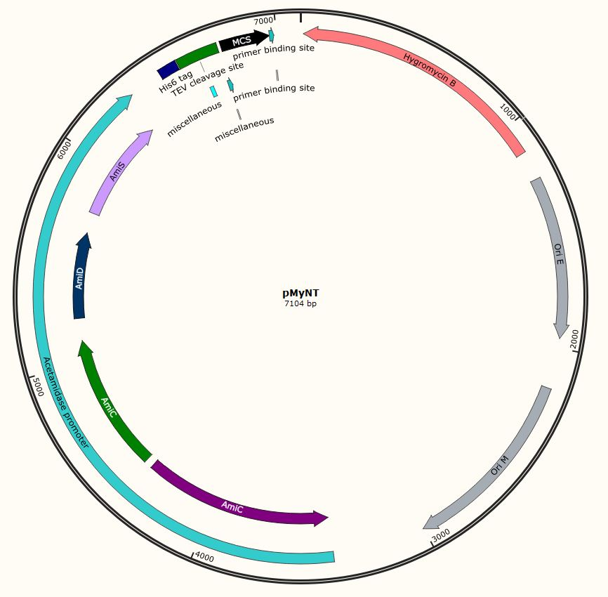
(b)
MKHHHHHHPSAGENLYFQGA-WhiB1 or WhiB2
His₆-tag TEV cleavage site
Fig. 5.2: Schematic diagram illustrating the construction of pMyNT-based expression plasmids for K. sedentarius MBB13 whiB1 and whiB2. (a) The whiB1 and 2 of K. sedentarius MBB13 were amplified by PCR after editing the primers by adding restriction enzymes (NcoI and HindIII) as indicated. (b) The plasmids encode either His₆-TEVCS-WhiB1 or His₆-TEVCS-WhiB2.

 | L 1 2 3 4 |  | L 5 6 7 8 9 10
~72 kDa  ~24 kDa  ~8 kDa | 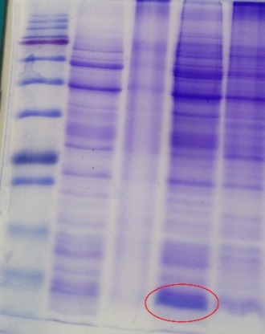 | 72 kDa  ~24 kDa  ~8 kDa | 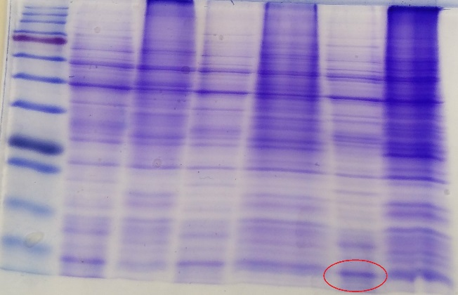
Fig. 5.3: Overproduction of K. sedentarius MBB13 WhiB1 and WhiB2 proteins from M. smegmatis MC² 155. The images show Coomassie blue-stained SDS-PAGE gels. Lanes L, protein ladder (sizes in kDa are indicated); lanes 1 and 2, extracts from uninduced cultures expressing WhiB1, soluble and insoluble fractions, respectively; lanes 3 and 4, extracts from induced cultures expressing WhiB1, soluble and insoluble fractions, respectively; lanes 5 and 6, irrelevant proteins; lanes 7 and 8, extracts from uninduced cultures expressing WhiB2, soluble and insoluble fractions, respectively; lanes 9 and 10, extracts from induced cultures expressing WhiB1, soluble and insoluble fractions, respectively. The locations of the overproduced soluble proteins are indicated by the red ellipses.

(a)

(b) | 1 2 3 4 5 6 7 8
72~ kDa  24~ kDa  8~ kDa | 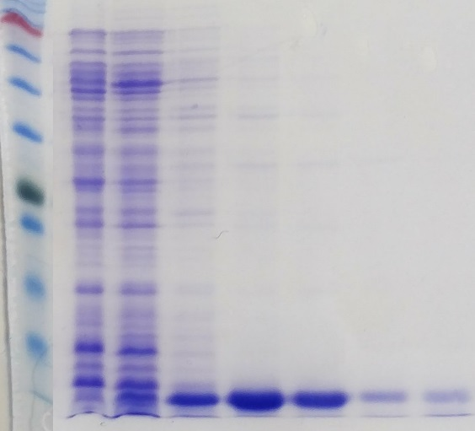
Fig. 5.4: Isolation of K. sedentarius MBB13 WhiB1 from M. smegmatis MC² 155. (a) HiTrap chelating column of elution profile of cell lysate containing WhiB1, the blue trace shows the protein absorbance and the red trace shows the concentration of imidazole from 0-0.5 M. (b) Coomassie stained SDS-PAGE gel of the elution profile fractions. Lane 1, protein ladder (sizes are indicated); lanes 2-3, non-specific bound proteins usually containing high histidine contents; lanes 4-8, fractions containing recombinant WhiB1.

(a)
(b) | 1 2 3 4 5 6 7 8 9 10 11 12 13 14 15
72~ kDa  24~ kDa  8~ kDa | 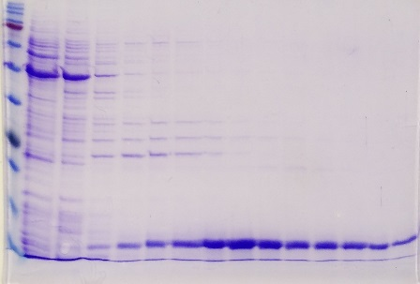
Fig. 5.5: Isolation of K. sedentarius MBB13 WhiB2 from M. smegmatis MC² 155. (a) HiTrap chelating column of elution profile of cell lysate containing WhiB2, the blue trace shows the protein absorbance and the red trace shows the concentration of imidazole from 0-0.5 M. (b) Coomassie blue-stained SDS-PAGE gel of the elution profile fractions. Lane 1, protein ladder (sizes indicated); lanes 2-7, non-specific bound proteins; lanes 8-15, fractions containing recombinant WhiB2.

5.3 Biochemical and biophysical characterisation of recombinant WhiB1

5.3.1 UV-visible spectroscopy
The WhiB1 protein fractions that eluted from the HiTrap chelating column were brown and colourless (Fig 5.4.b). The strong absorbance at 420 nm in the UV-visible spectrum of protein fraction (lane 6 in Fig 5.4.b) indicated the presence of a [4Fe-4S] cluster in the purified WhiB1 protein (Fig 5.6, purple line). In contrast, the spectrum of protein fraction (lane 7 in Fig 5.4.b) lacked absorbance at 420 nm, suggesting that the WhiB1 in this fraction was in the apo-form (Fig 5.6, green line). A [2Fe-2S] cluster is normally associated with peaks at 350 nm and 550-650 nm (Rybniker et al., 2010), which are absent in WhiB1. Kudhair et al. (2017) reported that overproduction of WhiB1 in M. smegmatis yields only the [4Fe-4S] form, unlike overproduction in E. coli which resulted in three forms [4Fe-4S]-, [2Fe-2S]- and apo- during aerobic purification (Smith et al., 2012).

Fig. 5.6: UV-visible spectroscopic analysis of different fractions of WhiB1 eluted from HiTrap chelating chromatography. Purple trace shows the spectrum of fraction 6 (60 µM WhiB1; Fig 5.4.b). The absorbance at 420 nm indicates the presence of a [4Fe-4S] cluster. The green trace shows the spectrum of fraction 7 (37 µM WhiB1; Fig 5.4.b). The absence of detectible features in the visible region of the spectrum suggests that this fraction contained apo-WhiB1.

5.3.2 Stability of [4Fe-4S] WhiB1 cluster in the presence of oxygen
The UV-visible spectrum of the isolated WhiB1 showed only one peak at 420 nm (Fig 5.6). This peak normally indicates the presence of [4Fe-4S] cluster. Iron-sulfur clusters are often sensitive to oxidation in air (Smith et al., 2012). To test the stability of the WhiB1 [4Fe-4S] in the presence of air, O₂-saturated buffer was added to anaerobic sample of holo-protein such that the final concentration of O₂ was 110 µM (Section 2.9.3). The UV-visible spectra were recorded before and after O₂ exposure (Fig 5.7). After 12 h of incubation under these conditions, no changes in 420 nm region of the spectrum were seen, suggesting that WhiB1 has an O₂-stable [4Fe-4S] cluster, consistent with data reported by Kudhair et al. (2017).

Fig. 5.7: Oxygen insensitivity of [4Fe-4S] WhiB1. The spectrum of blue and red traces were recorded at 0 and 12 h respectively after exposure to air-saturated buffer (50 mM Tris, 0.5 M NaCl, pH 7.4, 5% glycerol) with a final concentration of 110 µM of O₂. Reaction was incubated at 25°C. The final concentration of the protein after exposure to air-saturated buffer was ~19 µM.

5.3.3 WhiB1 reacts with Spermine NONOate, a source of nitric oxide (NO)
NO functions as a cytotoxin that is generated in macrophages during the first immune response against microbe invasion. Due to its chemistry, it readily undergoes redox and ligand binding reactions (Crack and Le Brun, 2019). Several transcription factors that contain Iron-sulfur clusters are known to respond to NO as well as O₂ (Smith et al., 2010; Kudhair et al., 2017). Reactions were carried out using the NO donor (Spermine NONOate) as described in Section 2.9.4. WhiB1 (58 µM) was exposed to 571.8 µM of Spermine NONOate for 6 h under anaerobic conditions. The UV-visible spectrum showed a feature centred at 420 nm (the [4Fe-4S] absorbance) before treatment. After addition of the spermine NONOate, an increase in absorbance at 350-360 nm and decrease at 420 nm were recorded with isosbestic point at 400 nm (Fig 5.8). This result suggested that a dimeric dinitrosyl-iron-cysteine complex had been formed (Fig 5.9) (Kudhair et al., 2017; Crack and Le Brun, 2019).

Fig. 5.8: UV-visible spectra of holo-WhiB1 before and after exposure to Spermine NONOate. Spectra of WhiB1 (58 µM cluster) before (blue trace) and after (red trace) 6 h incubation in the presence of 571.8 µM Spermine NONOate.

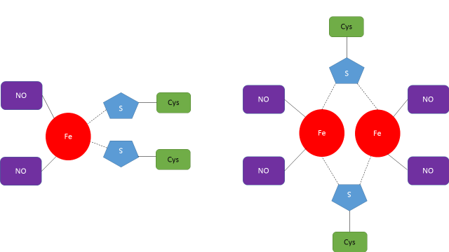
Monomeric dinitrosyl-iron-cysteine complex | Dimeric dinitrosyl-iron-cysteine complex
Fig. 5.9: Diagram showing dinitrosyl-iron-cysteine (DNIC) complexes.

5.3.4 Circular dichroism (CD) spectroscopy of WhiB1
As previously described, WhiB1 can be isolated in [4Fe-4S]- or apo- forms, therefore CD spectra were obtained to better understand the effect of the cluster on WhiB1 secondary structure. The samples were dialysed in 20 mM NaH₂PO₄, 0.1 M NaCl, pH 7.4 in order to decrease the salt in the buffer (high concentrations of salt can disturb the spectroscopy reading Appendix 9.10). The desalting was carried out using the vivaspin 5000 MWCO column. Both protein states (holo- and apo-) were analysed to compare their secondary structures (Fig 5.10). The difference was detected clearly using far UV-CD through a negative molar ellipticity between ~204-220 nm of apo- and holo- which indicate presence mostly random coil and α-helix respectively (Nelson and Cox, 2013). These results indicate that the WhiB1 protein structure depends on the presence of the [4Fe-4S].

Fig. 5.10: CD analysis of secondary structure of holo- and apo-WhiB1. The spectra of both samples (proteins concentration ~35 µM) were recorded in 20 mM NaH₂PO₄, 0.1 M NaCl, pH 7.4 at room temperature. Holo-protein (blue trace) shows a typical α-helix spectrum, while red trace shows a much stronger feature at 204 nm, suggesting the presence of increased content of random coil.

5.3.5 The iron-sulfur cluster is essential for folding of WhiB1
As judged by the CD analysis, the presence of the cluster in WhiB1 changed structure of the protein significantly (Fig 6.10). Apo- and holo-WhiB1 were also analysed using 1D proton NMR spectroscopy. To prepare apo-WhiB1, holo- protein (~20 µM) was treated with 1.5 M guanidinium thiocyanate and incubated at room temperature for 12 h (Section 2.9.5). Then holo-WhiB1 was refolded (Fig 5.11). Unlike M. tuberculosis WhiB4 that showed resistance to guanidine hydrochloride (Alam et al., 2007). For the 1D ¹H proton NMR spectra preparation, both samples were dialysed against 25 mM NaH₂PO₄, 0.25 M NaCl, pH 7.0 and the spectra were obtained by Dr. Andrea Hounslow (NMR facility, the University of Sheffield).
1D ¹H proton NMR is a method to qualitatively measure whether a protein is folded or not. If the protein is folded, the signals are narrow, sharp, well dispersed and cover a large range of chemical shifts, however, poor signals, with broader peaks indicate the protein is unfolded. This is due to the different protein proton environment, in a unfolded protein the protons occupy many different environments leading to broad signals, however, when the protein folds, the protons are more constrained and the chemical shifts reflect the environments occupied by the protons, leading to sharper, well-defined signals (Kwan et al., 2011).
As expected, the holo-WhiB1 showed sharp peaks covering a broad range of chemical shifts (Fig 5.12.a) especially in the area between 7-10 ppm. Apo-WhiB1 (Fig5.12.b) showed poor signals, with broader peaks in the same region, 7-10 ppm. This result indicated that, the Iron-sulfur cluster is important for protein folding. Cysteine (Cys) residues are important for iron-sulfur cluster acquisition (Smith et al., 2012), thus, NMR was used to detect the Cys residues. Same sample of holo-WhiB1 used in Fig 6.11.a, was recorded in the presence of 100% D₂O at 800 MHz (Fig 5.11.c). Area between 10-17 ppm was maximised and showed peaks likely to be Cys residues associated with the iron-sulfur cluster (Kudhair et al., 2017).

Fig. 5.11: Time-course of WhiB1 [4Fe-4S] loss during denaturation with 1.5 M guanidinium thiocyanate monitored by UV-spectroscopy. Holo-WhiB1 (~20 µM) was treated with 1.5 M guanidinium thiocyanate and incubated at room temperature for 12 h. Spectra were obtained at the indicated times.

(a) | 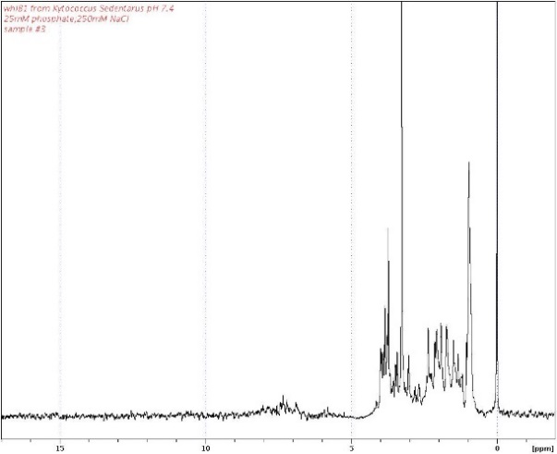 | Fig. 5.11: 1D 1H-NMR of WhiB1. Spectra were obtained using proteins prepared in 25 mM NaH₂PO₄ (pH 7.0) containing 0.25 M NaCl. (a) apo- and (b) holo-WhiB1 (c) Holo-WhiB1 spectrum in 100% D₂O 25 mM NaH₂PO₄, 0.25 M NaCl and (pH 7.0). The chemical shifts of the potential iron-sulfur ligands (cysteine residues) are arrowed.
(b) | 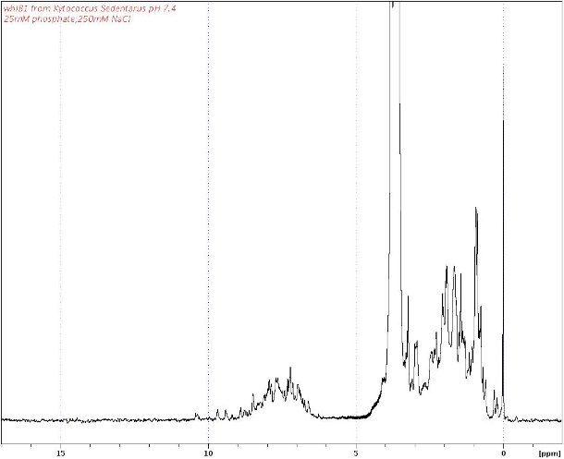
(c) | 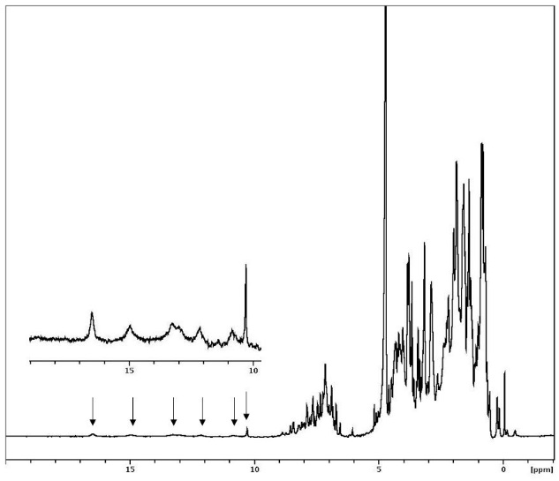

5.4 Biochemical and biophysical characterisation of recombinant WhiB2

5.4.1 UV-visible spectrum of WhiB2
Fractions eluted from the HiTrap chelating column when extracts containing recombinant WhiB1 were coloured (see above). In contrast, fractions containing WhiB2 were colourless, indicating that purified WhiB2 lacked an iron-sulfur cluster (apo-WhiB2) (Fig 5.4.b). This was confirmed by UV-visible spectroscopy, which showed the absence of features ([4Fe-4S], 420 nm; [2Fe-2S], 405, 500, 550 and 600 nm) (Khoroshilova et al., 1997). This suggests that the WhiB2 iron-sulfur cluster is O₂-sensitive.

Fig. 5.12: UV-visible spectrum of WhiB2 eluted from HiTrap chelating chromatography. The trace shows a peak at 280 nm arising from the aromatic amino acids present in WhiB2 (34 µM). Features associated with [4Fe–4S] cluster (420 nm) or [2Fe–2S] cluster (405, 500, 550 and 600 nm).

5.4.2 Holo-WhiB2 can be reconstituted in vitro
The ability of WhiB2 to acquire an iron-sulfur cluster was tested by carrying out an in vitro reconstitution reaction under anaerobic conditions (Section 2.9.2). UV-visible spectra were recorded at several points during the reaction (Fig 5.13.a). During anaerobic reconstitution, a brown colour developed over time and an increase in a broad absorbance at ~420 nm, typical for [4Fe-4S] containing proteins was observed. The spectrum showed other features between ~500-700 nm which probably indicate the formation of [2Fe-2S]. It was been suggested previously that fully reconstituted by Wbl proteins contain [4Fe-4S] clusters but [2Fe-2S] forms can be observed (Alam et al., 2009). To confirm the formation of [2Fe-2S] clusters during the reconstitution of WhiB2, absorption changes at 420 and 600 nm were plotted against time. As shown in (Fig 5.13.b and c), the cumulative increase in absorbance at 420 ([4Fe-4S]) and 600 nm ([2Fe-2S]) increased with similar kinetics. Therefore, it might be suggested that the [2Fe-2S] form of WhiB2 is an intermediate in the assembly of the [4Fe-4S] cluster and the reconstitution reactions were incomplete.

(a)
(b)
(c)
Fig. 5.13: UV-visible spectra during reconstitution of the iron-sulfur cluster of WhiB2. (a) Spectra of WhiB2 iron-sulfur cluster formation over 15 h. Reaction was carried out anaerobically inside the anaerobic cabinet using closed screw capped quartz cuvette containing WhiB2, 34 µM; FeNH₄(SO₄)₂, 0.4 mM; NifS, 2 µg; DTT, 10 mM and L-cysteine, 0.2 mM. (b and c) The absorbance change at 420 and 600 nm, respectively, over time during the reconstitution reaction. * Readings were normalised.

5.4.3 The WhiB2 iron-sulfur cluster is O2-sensitive
The UV-visible spectrum of the reconstituted WhiB2 showed peaks at 420 and ~600 nm indicating the presence of [4Fe-4S]- and [2Fe-2S]-forms (Khoroshilova et al., 1997). To test the stability of these iron-sulfur clusters when exposed to air, the screw cap of the cuvette containing anaerobic reconstituted (protein concentration ~25 µM) was opened. UV-visible spectra were recorded at several time points (Fig 5.14). The cluster associated peaks decreased by 50% in the first 10 h. The protein then precipitated after losing the cluster suggesting that some intermolecular disulphide bonds formed between the apo-WhiB2 molecules (Rybniker et al., 2010). Although, the S. coelicolor WhiD (homolog of M. tuberculosis WhiB3) [4Fe-4S] cluster reacts with O₂ to generate a [2Fe-2S] form (Jakimowicz et al., 2005), as observed for M. tuberculosis WhiB1 (Smith et al., 2010) there was no evidence for a [2Fe-2S] intermediate in the O₂-mediated disassembly of K. sedentarius WhiB2.

Fig. 5.14: UV-visible spectra of cluster loss from reconstited-WhiB2. Protein concentration after reconstitution ~25 µM. Screw capped quartz cuvette containing WhiB2 was left open to expose the protein to air. UV-visible spectra of the reconstituted [4Fe-4S]-WhiB2 showing cluster breakdown after exposure to air. Arrow indicates the direction of change.

5.4.4 WhiB2 reacts with Spermine NONOate
As mentioned before, the iron-sulfur clusters of Wbl proteins react with NO (Smith et al., 2010; Kudhair et al., 2017). In vitro reconstitution was carried out for apo-WhiB2 (~25 µM) (Section 2.9.4), using closed screw-capped quartz cuvette inside the anaerobic cabinet. Spermine NONOate (571.8 µM) was injected into the protein solution using a Hamilton syringe with microlance needle (0.8 x 40 mm) and the treated protein was left for 2 h anaerobically. Before addition of Spermine NONOate, the UV-visible spectrum showed a feature centred at 420 nm (the [4Fe-4S] absorbance) and features at longer wavelengths suggesting the presence of a [2Fe-2S] form. After addition of the Spermine NONOate, an increase in absorbance at ~360 nm and decrease at 420 nm were recorded with isosbestic point at 400 nm (Fig 5.15). As observed in WhiB1, the result suggested the formation of dimeric dinitrosyl-iron-cysteine complex had occurred (Fig 5.9) (Kudhair et al., 2017; Crack and Le Brun, 2019).

Fig. 5.15: UV-visible spectra of WhiB2 before and after treatment with Spermine NONOate. WhiB2 (~25 µM cluster) before (blue trace) and after (red trace) 2 h incubation in the presence of 571.8 µM Spermine NONOate. The arrows indicate the direction of the absorbance changes. The treated trace was normalised to the untreated readings.

5.4.5 Liquid chromatography mass spectrometry (LC-MS) study of WhiB2
Mass spectrometry has been used to show that several iron-sulfur proteins are capable of retaining cluster sulfide when their iron-sulfur clusters are disassembled in the presence of oxygen (Ibrahim et al., 2015). LC-MS was used to investigate whether WhiB1 and WhiB2 also exhibited this behaviour. The LC-MS spectra were collected by Mr. Simon Thorpe, (Spectrometry centre, the University of Sheffield) and the samples were prepared as described in Section 2.8.8. The major peak in WhiB2 spectrum was a species with a molecular mass of 12344 Da, ~4 Da less than the predicted molecular weight (12347.79 Da), equivalent to apo-WhiB2 with two intra-molecular disulphide bonds. A second peak at 12375 Da was 31 Da greater than the mass of apo-WhiB2 indicating the retention of one cluster sulfide (S = 32 Da) (Fig 5.16.a). A third species 17 Da larger than oxidsed apo-WhiB2 remains unassigned. For WhiB1, the major species had a molecular weight of 11526 Da, equivalent to reduced apo-WhiB1 (11525.96 Da) (Fig 5.16.b). Two minor species 16 and 54 Da larger than apo-WhiB1 were not equivalent to retention of either cluster sulfide or iron atoms.

(a)
(b)

Fig. 5.16: LC-MS analysis of WhiB2 and WhiB1. Protein samples (55 and 70 µM cluster) for WhiB2 and WhiB1 respectively, in 50 mM Tris, 0.5 M NaCl, 8.0 pH were applied the presence of 0.1 % formic acid to LC instrument for 10 min before mass analysis. (a) The peak at 12344 Da shows the oxidised monomeric apo-WhiB2, and the peak marked S° represents the addition of one sulfur atom retained by apo-WhiB2. (b) The peak at 11526 Da represents the monomer of apo-WhiB1 in its reduced form.

5.5 Discussion
In this chapter, in vitro biochemical and biophysical characteristics of K. sedentarius WhiB1 and WhiB2 iron-sulfur cluster have been studied. Isolation and purification of K. sedentarius WhiB1 and WhiB2 were achieved for the first time. Overexpression of both proteins was done using M. smegmatis.
Overproduction of WhiB1 protein in M. smegmatis produced two different form of the protein, one with a [4Fe-4S]- and the other being an apo-form as judged by UV-visible spectra (Fig 5.6). Overproduction of WhiB1 in E. coli which adopted three forms [4Fe-4S]-, [2Fe-2S]- and apo- (Smith et al., 2010).
Overproduction of WhiB2 on the other hand was different as the protein was isolated only as the apo- form (Fig 5.12). These data are consistent with a previous study of M. tuberculosis WhiB2, which has an O₂–sensitive iron-sulfur cluster (Konar et al., 2012). In vitro reconstitution of the WhiB2 iron-cluster under anaerobic conditions indicated that [4Fe-4S] and [2Fe-2S] clusters were formed (Fig 5.14). Generally, the seven Wbl proteins of M. tuberculosis were found to contain traces of a [2Fe-2S] cluster after aerobic isolation but when reconstituted anaerobically, only the [4Fe-4S] cluster forms were found (Alam et al., 2009). For M. tuberculosis reconstituted-WhiB1 it was reported that, occurrence of [2Fe-2S] form was due to the incomplete acquisition of iron and the [2Fe-2S] form was not observed by UV-visible spectroscopy when [4Fe-4S] WhiB1 was exposed to O₂ (Smith et al., 2010). Similarly, S. coelicolor the [4Fe-4S] cluster of WhiD (homolog of WhiB3) that is degraded after exposure to O₂ without passing through a [2Fe-2S] reaction intermediate (Crack et al., 2009).
Kytococcus sedentarius WhiB1 has a [4Fe-4S] cluster that is stable even after prolonged incubation in air. Analysis of both proteins WhiB1 and WhiB2 by LC-MS (Fig 5.16) indicate that, WhiB1 did not retain sulfur adducts upon the degradation of cluster. Unlike, WhiB2 which retained up to an extra of one sulfur adducts attached to the apo- form upon the dissociation of the cluster. Those data suggest that WhiB1 under aerobic conditions with absence of stabilizing tag or a partner protein loses its [4Fe-4S] forming an intermediate cluster form which is different from WhiB2, which then suggest a different roles in each K. sedentarius WhiB protein.
Proton 1D NMR spectrum of WhiB1 showed that the [4Fe-4S] cluster is essential for the protein’s structure (Fig 5.11). Also, the CD spectra of holo-WhiB1 demonstrates that the cluster changed the property of the protein in comparison to the apo- form (Fig 5.10). Similar observations suggested that, holo-WhiD of S. Streptomyces is similar to holo-WhiB1 (Crack et al., 2009). And the structure of the reduced and oxidized of apo- form of M. tuberculosis WhiB1, WhiB2, WhiB3, WhiB4 and WhiB7 showed a large proportion of disordered structure (Alam et al., 2007; Alam et al., 2009).
A number of iron-sulfur cluster proteins were reported to be NO-responsive resulting in changes to the structure of the protein that promote DNA-binding (Smith et al., 2010; Kudhair et al., 2017). In many [4Fe-4S] cluster proteins the reaction with NO is very rapid and changes the structure of the protein to the octa-nitrosylated cluster (Fig 5.17) (Crack et al., 2012). This study confirm that WhiB1 and WhiB2 react with Spermine NONOate as an NO donor and therefore behave similarly to those to other Wbl proteins (Fig 5.8 and 5.15) (Konar et al., 2012; Kudhair et al., 2017).

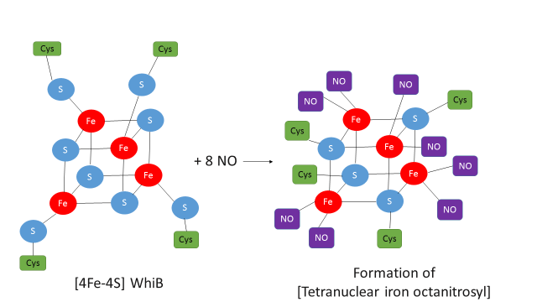
Fig. 5.17: Effect of NO on [4Fe-4S] Wbl protein to form tetranuclear iron octanitrosyl. It is most likely this formation is two RRE species. Diagram was adapted with modification from (Singh et al., 2007; Crack et al., 2012).

Chapter Six

6 Characterization of K. sedentarius MBB13 WhiB proteins and determination of their relationship with sigma factors

6.1 Introduction
In M. tuberculosis, there are 13 Sigma (σ) factors designed as SigA (σ^{A}) to SigM (σ^{M}) (Manganelli et al., 2004). σ^{A} is a member of sig⁷⁰ (σ⁷⁰) that essential in both M. smegmatis and M. tuberculosis (Gomez et al., 1998; Manganelli et al., 2004). Other sigma factors are non-essential and produced only in response to stress conditions (Wösten, 1998). σ⁷⁰ family shares four regions (1 to 4) and each region is divided, and the 4.2, 2.3, 2.4 and 2.5 regions are required to recognize the elements (-35, -10 and extended -10) of the targeted promotes (Wösten, 1998). In Mycobacteria, Wbl proteins were reported to interact with σ^{A}, such as WhiB3:σ^{A} in M. tuberculosis and M. bovis. Moreover, M. tuberculosis WhiB7 binds specifically with region 4 (the C-terminal domain ‘CTD’) via R515 (Burian et al., 2013). In M. bovis, a mutation on R515 of σ^{A}-CTD (region 4) cause attenuation on WhiB3:σ^{A} (Steyn et al., 2002). More specifically, all Wbl proteins from M. tuberculosis except WhiB5 interact with σ^{A}-CTD, WhiB3, 4, 6 and 7 interact via the residue R515 but not WhiB1 and 2 which indicate a different binding site is involved (Feng et al., 2016). It has been also reported that other Sigma factors interact with Wbl proteins. For example, M. tuberculosis WhiB2: σ^{B} (Zheng et al., 2012) and S. coelicolor WblC (homolog of M. tuberculosis WhiB7: σ^{R} (homolog of K. sedentarius MBB13 σ^{H}) (Yoo et al., 2016). The genome of K. sedentarius MBB13 has only four sigma factor encoding genes (A, B, H and J) and four Wbl genes (1, 2, 3 and 7) and therefore provides an opportunity to carry out a comprehensive analysis of the interactions between Wbl proteins and sigma factors in this bacterium.

6.2 Characterization of Wbl:Sigma factors (σ) complexes

6.2.1 Wbl proteins interact with region 4.0 of SigA (σ^{A})
Interaction between Wbl proteins and sigma factors (σ) A, B, H and J of K. sedentarius MBB13 was carried out using the Bacterial Adenylate Cyclase Two-Hybrid System (BATCH). BACTH was used as an E. coli-based in vivo assay for screening protein-protein interaction based on the reconstitution of complementary fragments (T25 and T18) of adenylate cyclase (CyaA) catalytic domains from Bordetella pertussis (Figure 5.17) (Karimova et al., 1998). Interaction between the two fragments causes cyclic AMP (cAMP) synthesis which then binds to the catabolite activator protein (CAP also known as cAMP receptor protein ‘CRP’) resulting in DNA-binding at CAP dependent promoters. This change in gene expression can be detected (maltose and lactose utilization) using indicator media (Fig 6.1).

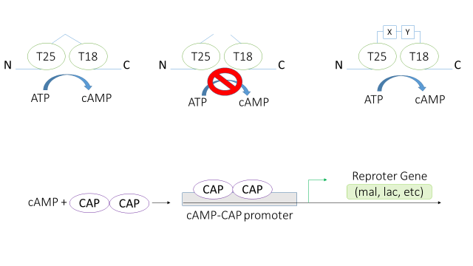
Fig. 6.1: Diagram of the two hybrid BACTH system. When the catalytic domain fragments (T25 and T18) of Bordetella pertussis adenylate cyclase are expressed as a full length protein (1-399 amino acid fused together) in Escherichia coli, it generates cAMP, but if the two fragments are expressed separately, no cAMP is produced. When interaction occurs between two genetically fused interacting proteins (X and Y), the adenylate cyclase catalytic domain fragments come close enough to restore cAMP synthesis. Cyclic AMP binds CAP (CRP) to permit binding at specific promoters in E. coli ∆cya such as the lac operon, which leads to a transcription of the reporter gene (lacZ). Diagram was adapted from (Karimova et al., 1998).

A comprehensive interaction analysis for K. sedentarius MBB13 WhiB proteins and sigma factors was carried out by transforming E. coli BTH101 (∆cya) with plasmids encoding either T25-WhiB1, 2, 3 or 7, and one of T18-sigma A, B, H or J (Fig 6.2.a) (Section 2.6.7). Transformed cells were grown on indicator media, MacConkey/maltose (Section 2.3.3.1) and Luria-Bertani broth containing X-gal (Section 2.3.3.2) and IPTG for induction. The positive control was pKT25-zip and pUT18-zip strain. The negative control contained the empty vectors encoding the T25 and T18 fragments. Interaction plates were incubated for ~30 h at 30°C. The positive and negative colonies on MacConkey medium were red and white, and blue and white for Luria-Bertani broth-X-gal medium, respectively. The results suggested that all Wbl proteins interacted with σ^{A}–CTD, but not with with σ^{B}, σ^{H} and σ^{J}. (Fig. 6.2.b.c).

(a)
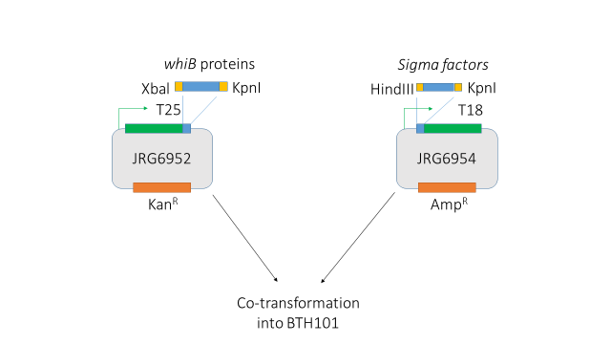
(b) | σ^{A}–CTD σ^{B} σ^{H} σ^{J} | (c) | σ^{A}–CTD σ^{B} σ^{H} σ^{J}
WhiB1  WhiB2  WhiB3  WhiB7 | 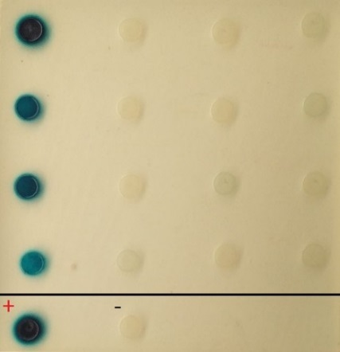 | WhiB1  WhiB2  WhiB3  WhiB7 | 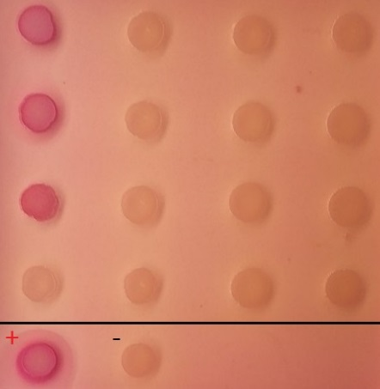
Fig. 6.2: In-vivo interaction of WhiB proteins and sigma factors (σ) using the BATCH system. (a) A diagram showing the construction of plasmids that encode T25-Wbl proteins by ligating whiB genes into pKT25 between Xbal and KpnI sites; and plasmids encoding T18-sigma by ligating sigma factor genes into pUT18 plasmid between HindIII and KpnI sites. Both plasmids were used to co-transform E. coli BTH101 (∆cya). Interactions were detected on (b) Luria-Bertani broth medium in the presence of X-gal, (c) MacConkey medium in the presence of maltose. Both plates were supplemented with ampicillin, kanamycin and IPTG. Controls were pKT25-zip and pUT18-zip plasmids as a positive control (+) and empty pKT25 and pUT18 plasmids as a negative control (-) (bottom row).

Quantitative measurement of the interactions was obtained by estimating β-galactosidase activates. The results indicated that WhiB1 and WhiB2 interact with σ^{A}–CTD significantly (Fig 6.3). The WhiB1:σ^{A}–CTD was ~40-fold greater than the negative control followed by WhiB2:σ^{A}–CTD at ~10-fold, and both WhiB3:σ^{A}–CTD and WhiB7:σ^{A}–CTD did not show a significant increase.

Fig. 6.3: Bacterial two-hybrid system analysis of interaction between WhiB 1, 2, 3 and 7 and σ^{A}-CTD, σ^{B}, σ^{H} and σ^{J} of K. sedentarius MBB13. Wbl and sigma proteins were fused to T25 and T18 domains respectively of B. pertussis adenylate cyclase in E. coli BTH101. Interaction between fusion partners enhanced the β-galactosidase production. Data points are the means of four replicates plus or minus standard deviation, significance (t-test) is indicated.

6.1.2 Effects of iron-starvation-, Erythromycin- and NaCl-stresses on interactions between Wbl proteins and σ^{A}-CTD
The effects of iron-starvation, salt-stress and Erythromycin on the ability of Wbl proteins and σ^{A}-CTD to form complexes was tested using BACTH (Section 2.10.1 and 2.10.2). As judged by visual appearance on Luria-Bertani broth-X-gal, erythromycin and NaCl decreased the interactions WhiB2, 3 and 7 but not WhiB1 proteins with σ^{A}–CTD (Fig 6.4.a). However, β-galactosidase activity measurements showed that WhiB1:σ^{A}–CTD interaction decreased ~40% in the presence of bipyridyl, ~60 % for 5% erythromycin and ~90% for NaCl, in comparison to the normal conditions (Fig 6.4.b.c.d.e). Moreover, reducing the availability of iron impaired WhiB2: σ^{A} interactions more than WhiB3:σ^{A} in comparison to the negative control. These results indicate that, Wbl iron-sulfur clusters react differently to iron-starvation, suggesting that accessibility to the clusters differs between K. sedentarius MBB13 Wbl proteins, which is consistent with results reported by Alam et al. (2009). It has been stated that the response of a host against bacterial infections is to restrict the availability of iron (Sritharan, 2016). This result indicates that iron-starvation might disassemble the WhiB:σ^{A} interactions. The effects of erythromycin and salt stress on the formation of WhiB:σ^{A} complexes were tested aerobically. Significant reductions in β-galactosidase activity was observed in response both stresses, compared to the positive control (Fig 6.4). However, the output from the leucine zipper control was also affected by the different growth conditions.

(a) | Nor | Bip | Ery |  | NaCl | (b)
 | σ^{A}
WhiB1

WhiB2

WhiB3

WhiB7
Controls
(c) |  |  | (d) |  |  |  | (e)
Fig. 6.4: BACTH analysis of the effects of stress factors on interaction of K. sedentarius MBB13 Wbl proteins and σ^{A}-CTD. (a) Luria-Bertani agar medium in the presence of X-gal and supplemented with ampicillin, kanamycin, IPTG and the different stresses as follows, Nor; normal condition, Bip; 0.05 mM 2,2’ bBipyrdyl, Ery; 64 µg/ml erythromycin and Salt: 5% NaCl, and grown at 30°C for 40 h. Controls showed same result and the tested conditions. (b, c, d and e) β-Galactosidase activities between the fused partners in the presence of different stress as indicated and the tested cultures were grown at LB liquid media at 37°C for 18 h. Control cultures were empty vector (negative control) and the GCN4 leucine zipper (Zip-Zip) (positive control). Both plates and liquid cultures were supplemented with ampicillin, kanamycin and streptomycin. The charts show the mean and standard deviation for four independent cultures; significance (t-test) are indicated.

Therefore, the data were reanalysed by normalising all the data to the activities of the positive control under the different growth conditions (Fig 6.5). This suggested that the WhiB1:σ^{A} interaction was significantly lower under iron-starvation and salt-stress conditions; that WhiB2:σ^{A} interaction was lower under all the stress conditions tested; but WhiB3:σ^{A} and WhiB7:σ^{A} interactions were unaffected.

Fig. 6.5: Ratio of ß-galactosidase activities of Wbl: σ^{A}-CTD of K. sedentarius MBB13 to the GCN4 leucine zipper (Zip-Zip) ‘the positive control’ under stress conditions as indicated by the BACTH system. Liquid cultures were grown at 37°C for 18 h, in LB with appropriate antibiotics and IPTG. The chart shows the mean and standard deviation for four independent cultures; significance (t-test) are indicated.

6.2 Differential expression of whiB genes in response to growth phase and antibacterial agents
As mentioned previously, Wbl proteins are transcription factors that are exclusively found within the actinobacteria. Geiman et al. (2006) reported that, M. tuberculosis wbl genes (strain CDC1551) are differentially expressed during the different phases of growth and in the presence of different antibiotics. Therefore, expression of K. sedentarius MBB13 wbl genes was determined using a quantitative real-time PCR assay (qRT-PCR).

6.2.1 Primer design and validation
The primers for the tageted genes were designed to produce amplicons of ~100 bp using the criteira in Section 2.7.5, and their amplification efficiencies were tested with genomic DNA as a template (Fig 6.6). This showed the amplification of DNA fragments of the predicted sizes. Total RNA was extacted from triplicate cultures of K. sedentarius MBB13 at different phases of the growth cycle in the presence of different antibiotics. RNA prepartions were processed using the DNA-free kit to remove any contaminating genomic DNA (Section 2.7.3), and the absence of contamining DNA was confirmed by the inability to amplify 16S rRNA gene using universal bacterial primers (Section 2.6.8; Table 2.3; Fig 6.7 ). Contamination by DNA would result in errors in any quantitative real-time PCR experiment (Laurell et al., 2012). Then gyrA (reference gene), whiB1 and whiB2 primers were used with different dilutions of genomic DNA to ensure that the amplification efficiencies were similar (Table 6.1, 6.2 and Fig 6.8).

Base Pairs  1,000  500/517  200  100 |  | 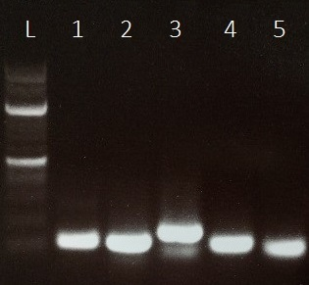 |  | Fig. 6.6. Validation of specificity the Real-time PCR primers analysed by 10% gel electrophoresis. Primer pairs were used with K. sedentarius MBB13 genomic DNA as template. Lane 1; 100 bp ladder, Lane 2; gyrA, Lane 3-6; whiB1, 2, 3 and 7 respectively.
 | (a) |  |  |  | (b)
Kilobases  3.0  1.5 | 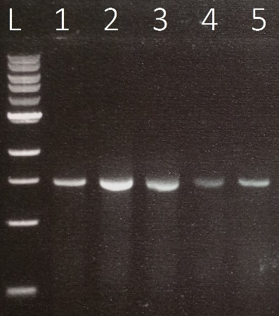 |  | Kilobases  3.0  1.5 |  | 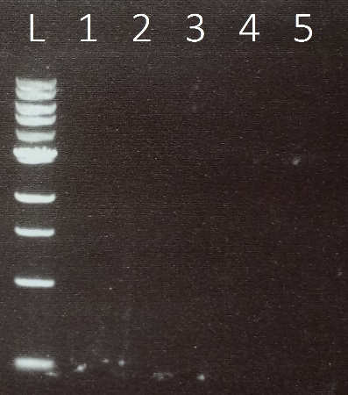
Fig. 6.7: Genomic DNA in extracted total RNA. PCR products were separated on agarose gel (2%) and visualized using GelRed DNA stain (Section 2.5.5). Amplification of genomic DNA from total RNA extracted from the targeted genes (a) before and (b) after treating with DNA-free kit (Section 2.6.3). Lane L, 1 kb DNA marker; lane 1, gyrA; lane 2, whiB1; lane 3, whiB2; lane 4, whiB3 and lane 5, whiB7.

Table 6.1: Validation of amplification efficiency for the primers used in qRT-PCR. A preliminary experiment was initiated to validate the prime pairs. The purified genomic DNA of K. sedentarius MBB13 was serially diluted and used as the template in duplicate qRT-PCR reaction.
Genomic DNA (ng) | Log₁₀ genomic DNA | gyrA average C_{T} value | whiB1 average C_{T} value | whiB2 average C_{T} value
100 | 1.273001272 | 19.52167 | 21.655 | 22.19833
50 | 0.670941281 | 20.27667 | 22.26833 | 23.165
25 | 0.068881289 | 21.01 | 22.8 | 23.61667
12.5 | -0.533178702 | 22.13833 | 23.58333 | 24.09167

Table 6.2: Gradient and intercept values of the used primers in qRT-PCR.
Gene name | Gradient | Intercept
gyrA | -1.4201 | 21.633
whiB1 | -1.4201 | 21.633
whiB2 | -1.1261 | 24.297

Fig. 6.8: Graph of efficiency validation of amplification for primers used in qRT-PCR. Average C_{T} value plotted against log₁₀ genomic DNA concentration for calculation of the intercept and gradient of lines. Lines points represent whiB1, whiB2 and gyrA as indicated.

6.2.2 Kytococcus sedentarius MBB13 wbl gene expression during the bacterial growth cycle
Kytococcus sedentarius MBB13 cultures were grown in Luria-Bertani broth medium at 37°C with shaking at 250 rpm. Samples (5 ml) were taken from triplicate cultures at early exponential phase (EEP; OD₆₀₀ of 0.75), and then at late exponential phase (LEP; OD₆₀₀ of 0.9) and finally in staionary phase (SP; OD₆₀₀ of 2.25) (see growth cruve of K. sedentarius MBB13 in Appendix 9.6). Total RNA was prepared (Section 2.7).
qRT-PCR analysis suggested that whiB1, whiB3 and whiB7 expression in K. sedentarius MBB13 in Luria-Bertani broth was higher in LEP in compared to SP. For whiB2 no significant change was obseved (Fig 6.9). Thefore, the the expression of K. sedentarius MBB13 wbl genes after exposure to antibiotics was assessed for LEP cultures.

Fig. 6.9: qRT-PCR analysis of relative expression levels of whiB1, 2, 3 and 7 during different phases of growth. Total RNA was isolated from K. sedentarius MBB13 cultures grown to early exponential phase (OD₆₀₀ 0.75), late exponential (OD₆₀₀ 0.9) and stationary (OD₆₀₀ 2.25). Relative expression level was calculated using the gyrA transcript for normalization. Averages of four repeats was taken to represent the error bars; significance (t-test) are indicated.

6.2.3 Kytococcus sedentarius MBB13 wbl gene expression in response to antibiotics
Kytococcus sedentarius MBB13 cultures were grown in Luria-Bertani broth medium at 37°C with shaking at 250 rpm until the OD₆₀₀ reached 0.9 (LEP), then triplicate cultures were treated with 2,048 µg/ml of either erythromycin, ciprofloxacin, gentamicin or tetracycline. After this, the cultures were incubated under the same conditions for 30 min. Then ~5 ml of the cultures before and after treating with antibiotics were taken for the total RNA purification (Section 2.7).
qRT-PCR analysis revealed a significant increase in whiB7 (4-fold) in response to ciprofloxacin, whiB3 (1.5-fold) and (1-fold) whiB7 in response to gentamicin and whiB1 (1-fold) in response to tetracycline. No signifcant increase after exposure to erythromycin was obsereved (Fig 6.10).
It is possible to conclude that, proteins synthesis inhibitor agents, gentamicin induces whiB3 and whiB7 and tetracycline induces whiB1 but not erythromycin (Neu, 1992), and the inhibiting cell division agent (ciprofloxacin) induces whiB7 (Loveless et al., 2010; de Lima Procópio et al., 2012).

Fig. 6.10: qRT-PCR analysis of relative expression levels of whiB1, 2, 3 and 7 under various antibiotic stress. Total RNA was isolated from K. sedentarius MBB13 grown until late exponential phase. Relative expression level was calculated using the gyrA transcript for normalization. Averages of four repeats were taken; significance (t-test) are indicated.

6.2.4 Kytococcus sedentarius MBB13: does WhiA have a role in cell division through WhiB2
As shown previously, σ^{A}-CTD interacts with Wbl proteins of K. sedentarius MBB13. Other species of actinomyces, e.g. Streptomyces venezuelae, a homolog of K. sedentarius MBB13 WhiB2 works with an unrelated transcription regulator, WhiA, to control a joint regulon. Mutation of whiA causes a failure to halt aerial growth (Bush et al., 2013). Kytococcus sedentarius MBB13 has a whiA gene. Thus, to investigate the possible interaction between Wbl, sigma factors and WhiA in K. sedentarius MBB13, the BACTH system was used. WhiA was fused inframe into pUT18 and pKT25 respectively to investigate its interactions with Wbl proteins and sigma factors. The results indicate that there was no significant interaction on the indicator plates or ß-galactosidase activities (Fig 6.11).

 |  | (a) | (b)
WhiB1, 2 ,3 and 7  σ^{A}, σ^{B}, σ^{H} and σ^{J} |  | 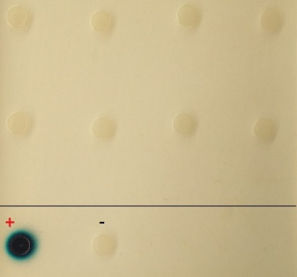 | 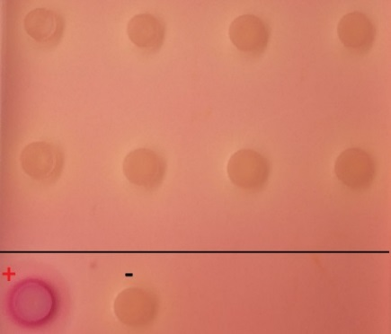
(c)
Fig. 6.11: Protein-protein interaction between WhiB1, 2, 3 and 7 and σ^{A} (CTD), σ^{B}, σ^{H} and σ^{J} against WhiA of K. sedentarius MBB13 using BACTH system. WhiA was fused in frame into both pUT18 and pKT25 in order to interact with WhiB-pKT25 and σ-pUT18 respectively. Detection of interaction was by (a) Luria-Bertani broth medium plate in the presence of X-gal and IPTG as an inducer grown at 30°C for 40 h. (b) β-Galactosidase activities between the fused partners, cultures were grown at 37°C for 18 h. Negative control was the empty vector, and the GCN4 leucine zipper (Zip-Zip) was the positive control. Both plates and liquid cultures were supplemented with ampicillin, kanamycin and streptomycin. The chart shows the mean and standard deviation for four independent cultures; significance (t-test) are indicated.

6.3 Discussion
In vivo protein-protein interaction of K. sedentarius MBB13 Wbl:σ were studied. σ^{A}-CTD interacts with all WhiB proteins of K. sedentarius MBB13. The interaction between Wbl proteins and σ^{A}-CTD could reprogram transcription through altering binding at promoter DNA and/or the function of the sigma factor (Dove et al., 2003); (Paget, 2015). σ^{A} share four main domains (Fig 4.12.b and 6.12) and in M. tuberculosis, the C-terminal domain is proposed to interact with WhiB proteins through binding the -35 elements of their promoters (Feng et al., 2016).
The importance of Wbl:σ interactions is illustrated by the attenuation of M. bovis by the R515H σ^{A}-CTD mutation or deletion of whiB3, which suggests stimulation of unknown virulence genes require the WhiB3:σ^{A}-CTD interaction (Steyn et al., 2002). In M. tuberculosis WhiB7, AT-hook domain binds σ^{A}-CTD and abolishes WhiB7:σ^{A}-CTD interaction when R515H mutation occurs in σ^{A}-CTD and WhiB7 multi-drug sensitivity effect due to R515H mutation, that is similar to the AT-hook deletion effect. Those findings indicate that WhiB7 acts to stabilise the σ^{A}-DNA binding and provides an addition selectivity for specific promoters in specific conditions (Burian et al., 2013). Therefore, it is likely that K. sedentarius MBB13 WhiB1, WhiB2, WhiB3 and WhiB7 act similarly to M. tuberculosis WhiB7 via its binding with σ^{A} and DNA interaction. σ^{A} of M. tuberculosis and M. smegmatis is a major vegetative sigma factor that essential for driving the housekeeping genes expressions (Manganelli et al., 2004). It is noteworthy that, infection by M. tuberculosis results in overexpression of σ^{A} in either human macrophages or mice lungs, and also modulates essential genes for virulence which leads to enhance intracellular growth (Wu et al., 2004). Therefore it is unlikely that Wbl proteins act as anti-σ^{A} factors to abolish σ^{A}-RNAP interaction due to essentiality of σ^{A}, instead this binding is possibly essential for specific genes regulation by stabilizing interactions of σ^{A} with DNA, which provide additional promoter selectivity, especially since M. tuberculosis WhiB1 C-terminal domain is rich in positive amino acids, which are important for DNA-binding (Smith et al., 2012). During macrophage infection σ^{A} is either be upregulated and interact with WhiB1 to induce other sigma factors that involve adaptation or virulence, besides that, some free σ^{A} at basal level is free for regulating housekeeping genes. Furthermore, it has been reported that whiB1 is possibly directly controlled by σ^{F} in M. smegmatis (Hümpel et al., 2010). Production of NO in activated macrophages is the first antibacterial defence against M. tuberculosis that needs to adapt through switching on or off a number of transcription pathway genes (Yang et al., 2009). Also sigma factors are sensory proteins that respond to external stimuli (Wösten, 1998). The K. sedentarius Wbl:σ interactions were then subjected to bipyridyl as an iron chelator, erythromycin and NaCl. It is obvious that bipyridyl effected on WhiB:σ^{A}-CTD but not on the control, unlike erythromycin and NaCl which have an effect on both WhiB:σ^{A}-CTD and the positive controls (Fig 6.12). It can be concluded that bipyridyl and erythromycin decreased impaired the activity of β-galactosidase of all interactions and it is possible to concluded that WhiB2:σ^{A}-CTD impaired more that WhiB3:σ^{A}-CTD in comparison to the same interaction under normal condition which indicated that each interaction may react differently under different stresses.

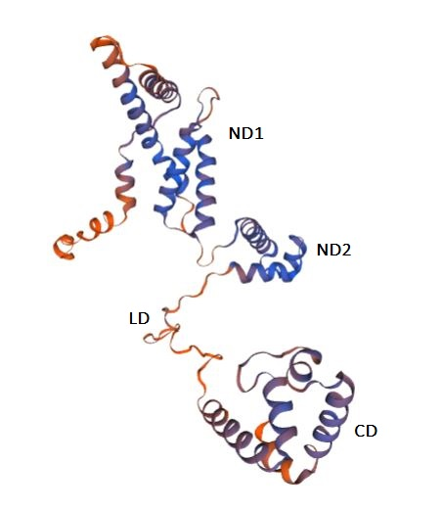
Fig. 6.12: Ribbon diagram of K. sedentarius MBB13 SigA (σ^{A}) three dimensional structure. The domains are indicated as follows: ND1, N-terminal 1; ND2, N-terminal 2; LD, linker domain; CD, C-terminal domain. The structure was obtained from the following webpage (swissmodel.expasy.org).

Expression of wbl genes under various conditions has been reported previously (Geiman et al., 2006). By using qRT-PCR, it is possible to claim that all whiB1, whiB2 and whiB7 were upregulated significantly during the late exponential phase. These patterns could be relevant to the in vivo chronic infection and similar to those found in M. tuberculosis whiB4, 5 and 7 which were upregulated during the late exponential phase (Geiman et al., 2006). Further assessment for adaptation for antibiotics response due to an evidence suggested that, M. tuberculosis whiB7 governs a resistance mechanism for various antibiotics (Morris et al., 2005). The gene whiB7 is upregulated significantly by Ciprofloxacin which is the only antibiotic that inhibits cell division, moreover, protein synthesis inhibitor antibiotics gentamicin induces whiB3 and whiB7, and tetracycline induces whiB1. Up to date, there is no evidence that explain the expression of whiB1 and whiB3 are stimulated by antibiotics.
In Streptomyces, the initiation of sporulation and the cessation of aerial growth is cocontrol by WhiB (homolog of K. sedentarius WhiB2) and WhiA (non-Wbl protein). By using BACTH system, the interaction between Wbl and σ proteins against WhiA were investigated, however, no evidence for binding were detected.
Results presented in this chapter show that the four Wbl proteins of K. sedentarius interact directly with the major sigma factor A (σ^{A}) through the C-terminal domain but not with σ^{B}, σ^{H} and σ^{J}. No evidence for an interaction between WhiB proteins or sigma factors with WhiA. The genes whiB1, whiB2 and whiB7 were upregulated significantly during the late exponential phase, and whiB7 was induced by ciprofloxacin, whiB3 and whiB7 are induced by gentamicin, and whiB1 was induced by tetracycline.

Chapter Seven

7 General Discussion

7.1 Effects of sampling methodology
The work presented here suggests that airborne bacteria contaminate the air within a lecture theatre. While this does not represent a problem to healthy individuals, airborne bacteria can be harmful for immunocompromised individuals (Folayan et al., 2018). Results in Chapter 3 indicated that isolating airborne bacteria by more than one method increases the chances to estimate the variety of airborne bacterial species accurately around individuals in indoor environments. This was assessed by visual appearance of colonies on Luria-Bertani plates, it is clear that dehumidifier collected a higher number of bacteria (Fig 3.1). It is likely that using an active sampling method such as a dehumidifier that depends on air suction may help to collect more airborne bacteria that are not detected using the passive monitoring such as settle plates, which only rely on gravity to draw airborne bacteria to the medium (Sayer et al., 1972) rather than using a specific fitted device to drag air (Zhang, 2006). The results matched those of Sayer et al. (1972) who claimed that applying different methods to isolate airborne microbes can simply produce different group of species. Elsewhere it has also been reported that active monitoring can collect more airborne bacteria especially for those considered inhalable viable particles (Napoli et al., 2012). However the design of each building could have the ability to control which species of airborne bacteria can or cannot grow within those built environments (BI) due to the materials used (Kelley and Gilbert, 2013). To conclude, the assessment of the diversity of airborne bacteria in each BI depends on method of isolation, materials used to build BI and the season of isolation (Sayer et al., 1972; Kelley and Gilbert, 2013). Therefore is possible to suggest that each BI may need its own investigation to identify the airborne microbes that may able to survive, especially in environments that are near to potentially hazardous laboratories which could enhance unusual organisms to transit from those laboratories to other non-clinical area such as waiting area room in hospitals which can pass individuals with various occupational hazards (Verde et al., 2015).

7.2 Kytococcus sedentarius
It is obvious that bacteria isolated from dehumidifier were abundant (Fig. 3.1) and belonged to different families (Table 3.1) which encouraged this study to focus on these bacteria. Many reports employed the study of the bacterial resistance against antibiotics as an initial test to determine the infection control strategy for each isolated strain, and this step is due to excessive use of antibiotics that have led to the development of bacterial isolates that are multidrug resistant (Adzitey, 2015). The initial screening of bacteria isolated by dehumidifier against a selection of antibiotics that were suggested by BCAS (2013) indicated that K. sedentarius MBB13 is resistant to erythromycin, gentamicin and ciprofloxacin (Table 3.2). The work described here and elsewhere resulted in isolation of multi drug resistant K. sedentarius (Greene et al., 1980; Marples and Richardson, 1980; Nordstrom et al., 1987; Levenga et al., 2004; Chaudhary and Finkle, 2010; Folayan et al., 2018). However, up to date, resistance to erythromycin has not been reported; furthermore, erythromycin has been used as a first-line treatment against K. sedentarius infections (Singh and Naik, 2005; Pranteda et al., 2014).
Due to the above facts, it was important to investigate K. sedentarius MBB13 at the molecular level, although, the genome of K. sedentarius was sequenced previously (Sims et al., 2009). Therefore, the whole genome of K. sedentarius MBB13 was sequenced in Chapter four. Kytococcus sedentarius is known to cause pitted keratosis (PK), likely through the ability of the cocci to produce two proteases, P1 and P2 that are active against keratin extracted from human callus (Longshaw et al., 2002). Brandelli et al. (2010) reported a comprehensive investigation of keratinase producers and suggested several conserved regions that are normally located in the N-terminal regions of some keratinases and similar proteases. The latter mentioned conserved regions however were not present in the K. sedentarius MBB13 genome which led to an investigation this bacterium in vivo. After growing K. sedentarius MBB13 on azure-based culture media assay, the cocci of MBB13 was unable to degrade the keratin dissolved within the Luria-Bertani plates, which indicates that probably not all K. sedentarius strains including MBB13 (Fig 4.11) are able to degrade callus that led to the infection of PK.
Another fact about K. sedentarius is that it was first isolated from a marine environment and uses the skin, mucosae and oropharynx of human beings as a habitat (Sims et al., 2009), which indicates that K. sedentarius is salt tolerant. The genome of K. sedentarius MBB13 reveals a combination of several strategies used by other organisms to adapt and grow in saline environments (Fig 4.9), and in this study, adaptation to different concentrations of NaCl was confirmed after an NMR examination of the cocci showing glycine betaine as the main compatible solute alongside ectoine, proline, acetate, lactate and glutamate (Fig 4.10), which indicate that the mentioned solutes could be beneficial for adaptation to salty environments.
In this study and elsewhere K. sedentarius is classified as a strict aerobe (Fig 4.6) (Sims et al., 2009), thus, for better understanding, the analysis of the MBB13 strain reveals various factors for its dependence on oxygen for survival. For example, the strain MBB13 can make 41 reactions that require molecular oxygen (Table 4.2), RNR systems and absence of fermentation and anaerobic respiratory pathways. Also the existence of cytochrome c pathway that contains (cytochrome bc1-aa3 oxidase and cytochrome bd oxidase) suggested its oxygen dependence.
The genome of K. sedentarius MBB13 also possesses the major sigma factor (σ^{A}) that has a high similarity with σ^{A} of M. tuberculosis (Fig 4.12). In bacteria, to initiate a transcription from promoters requires core RNA polymerase (RNAP) to acquire a dissociable specificity subunit, the sigma factor (Paget, 2015). Feng et al. (2016) reported that the M. tuberculosis σ^{A} interacts though its C-terminal domain (CTD) with the seven Wbl transcription factors. Kytococcus sedentarius MBB13 possesses four Wbl proteins, and in M. tuberculosis and other actinomyces members, Wbl proteins play essential roles (Bush, 2018).

7.3 Wbl proteins
The work presented in Chapter five partially characterized two of the four Wbl proteins of K. sedentarius MBB13. WhiB1 and WhiB2 of K. sedentarius MBB13 are iron-sulfur cluster proteins and NO-reactive; WhiB1 is O₂-insensitive but not WhiB2; the cluster of WhiB1 is essential for protein folding. Mycobacterium tuberculosis WhiB1 is essential (Smith et al., 2010). The purified recombinant WhiB1 of K. sedentarius MBB13 was found to carry a [4Fe-4S] cluster (Fig 5.6). Iron-sulfur clusters are proposed to be one of the oldest and most versatile cofactors for several protein classes and are implicated in many functions (Alam et al., 2009). This work and others propose a question about the nature of WhiB1. It was been proposed that WhiB1 play a role in switching between dormant and replicative states in M. tuberculosis (Smith et al., 2010). Here all four Wbl proteins interacted with σ^{A} and all the wbl genes, except whiB2, are upregulated in late exponential growth phase and with different antibiotics. Also the interaction of WhiB1 with σ^{A} could lead to an answer as to why WhiB1 is essential. σ^{A} is required for housekeeping gene transcription (Wu et al., 2004), therefore it is unlikely that WhiB1 acts as anti-sigma factor. Beside that several bacteria including actinomyces members showed a presence of anti-sigma factors (Beaucher et al., 2002; Lee et al., 2004). It is possible to hypothesise that switching WhiB1 release and binding to RNA polymerase depends on a WhiB1-partner which can have a specific role during the growth development in K. sedentarius MBB13. Another possibity is that essential genes can be regulated in response to specific stimuli for example, Spermine NONOate (NO donor). Here and others reported that WhiB1 did not respond to O₂ but reacted to NO and most likely formed an octa-nitrosylated form (Kudhair et al., 2017). This reaction switches the form of WhiB1 from non-DNA binding to DNA-binding (Smith et al., 2010). Kudhair et al. (2017) reported NO triggers WhiB1 to release from the complex of WhiB1:σ^{A}. Thus it is possible to conclude that switching between binding with DNA and σ^{A} in response to NO plays a regulatory role in K. sedentarius MBB13.
Although, the sensitivity of WhiB1 to NO and O₂ are studied here and by others; other external signals could play a role in reacting or regulating with WhiB1 cluster in response to infections. In M. tuberculosis, cyclic AMP is a signal that important to regulate WhiB1, which is present in macrophages during the infection at high levels (Bai et al., 2009). The cAMP receptor protein (CRP) regulates whiB1 and binds the upstream of whiB1 directly (Agarwal et al., 2006). At high levels of cAMP, whiB1 is downregulated by two binding sites that are occupied by CRP, but at low levels of cAMP, only one site is occupied by CRP which results in upregulation of whiB1 (Stapleton et al., 2010). Thus it is possible to conclude that, presence of low NO and high level of cAMP could enter M. tuberculosis into dormancy state in which the nitrosylated-WhiB1 down regulates the whiB1 gene (Kudhair et al., 2017). The downregulation may change the transcription state of other regulators which important for dormancy such as Dos regulon (Kudhair et al., 2017). Kytococcus sedentarius was isolated from 400 atmospheric pressure ‘atm’ at deep seawater in active state, but at 600 atm, it was in the no multiplication state (but was not killed) (Oppenheimer and ZoBell, 1952). Entering K. sedentarius into no multiplication state may raise a question, was it in dormancy state and was whiB1 playing any role in that no multiplication state.
Mycobacterium smegmatis WhmD and Streptomyces coelicolor WhiB (homolog of M. tuberculosis WhiB2) are essential genes involved in cell division (Raghunand and Bishai, 2006; Bush et al., 2016). Streptomyces coelicolor WhiB and WhiA proteins function cooperatively to control the expression of set of genes that targeted by WhiBA, and a mutant of WhiB (within the cysteine residues) prevents DNA binding by both WhiA and WhiB (Bush et al., 2016). WhiA does not belong to the family of WhiB proteins and is present in Gram-positive bacteria, including non-actinomycetes (Bush et al., 2016). In K. sedentarius MBB13, no interaction occurred between WhiB2 and WhiA, which indicating the WhiBA may not function as same as in S. coelicolor.
The biochemical evidence in this work showed that WhiB2 of K. sedentarius MBB13 is sensitive to O₂ which agreed with Rybniker et al. (2010), and is also sensitive to Spermine NONOate (NO donor) in agreement with the general features of Wbl proteins (Bush et al., 2016); however, up to date, WhiB2 has not been examined in the presence of NO yet. NO reacts with iron–sulfur cluster proteins and the consequent toxic effects are used by the immune system of the host in the response to pathogenic bacteria (Smith et al., 2010). This reaction of WhiB2 to Spermine NONOate could lead to change in the transcription state that may be important for the function of WhiB2, however, for better understanding, it is necessary to determine the function of WhiB2 in K. sedentarius.
In conclusion, the isolation of bacteria from the lecture theatre MBB-F02 revealed an antibiotic resistant bacterium K. sedentarius MBB13. The genome sequence and in vivo examination showed that, K. sedentarius MBB13 is strictly aerobic, unable to degrade keratin and salt tolerant. The nature of WhiB1 and WhiB2, their response to NO and the ability of WhiB1, 2, 3 and 7 to bind σ^{A} could provide new information about the significance of these regulators. Thus WhiB1 and WhiB2 are important NO sensor proteins that may play roles in K. sedentarius during adaptation to harsh environments or cell division respectively. Therefore, WhiB1 and WhiB2 are potential factors that can be targeted for more research which could lead to new treatment against this organism.

8 References

Abiola, I., Abass, A., Duodu, S. and Mosi, L. (2018) Characterization of culturable airborne bacteria and antibiotic susceptibility profiles of indoor and immediate-outdoor environments of a research institute. AAS Open Research, 2, 1-17.

Adzitey, F. (2015) Antibiotic classes and antibiotic susceptibility of bacterial isolates from selected poultry, UDSspace, 5, 2322-4568.

Agarwal, N., Raghunand, T.R. and Bishai, W.R. (2006) Regulation of the expression of whiB1 in Mycobacterium tuberculosis: role of cAMP receptor protein. Microbiology, 152, 2749-2756.

Alam, M.S., Garg, S.K. and Agrawal, P. (2007) Molecular function of WhiB4/Rv3681c of Mycobacterium tuberculosis H37Rv: a [4Fe− 4S] cluster co‐ordinating protein disulphide reductase. Molecular Microbiology, 63, 1414-1431.

Alam, M.S., Garg, S.K. and Agrawal, P. (2009) Studies on structural and functional divergence among seven WhiB proteins of Mycobacterium tuberculosis H37Rv. The FEBS Journal, 276, 76-93.

Alexy, R., Kümpel, T. and Kümmerer, K. (2004) Assessment of degradation of 18 antibiotics in the closed bottle test. Chemosphere, 57, 505-512.

Ara, I., Daram, D., Baljinova, T., Yamamura, H., Hozzein, W., Bakir, M. and Suto, M. (2013) Isolation, classification, phylogenetic analysis and scanning electron microscopy of halophilic, halotolerant and alkaliphilic Actinomycetes isolated from hypersaline soil. African Journal of Microbiology Research. 7, 298-308.

Bai, G., Schaak, D.D. and McDonough, K.A. (2009) cAMP levels within Mycobacterium tuberculosis and Mycobacterium bovis BCG increase upon infection of macrophages. FEMS Immunology and Medical Microbiology. 55, 68-73.

Basta, T., Buerger, S. and Stolz, A. (2005) Structural and replicative diversity of large plasmids from sphingomonads that degrade polycyclic aromatic compounds and xenobiotics. Microbiology, 151, 2025-2037.

Beaucher, J., Rodrigue, S., Jacques, P.É., Smith, I., Brzezinski, R. and Gaudreau, L. (2002) Novel Mycobacterium tuberculosis anti‐σ factor antagonists control σF activity by distinct mechanisms. Molecular Microbiology, 45, 1527-1540.

Beściak, G. and Surmacz-Górska, J. (2011) Biofilm as a basic life form of bacteria. In Proceedings of a Polish-Swedish-Ukranian Seminar, Krakow Poland, 7, 17-19.

Bleidorn, C. (2016) Third generation sequencing: technology and its potential impact on evolutionary biodiversity research. Systematics and Biodiversity, 14, 1-8.

Bonev, B., Hooper, J. and Parisot, J. (2008) Principles of assessing bacterial susceptibility to antibiotics using the agar diffusion method. Journal of Antimicrobial Chemotherapy, 61, 1295-1301.

Bradford, M.M. (1976) A rapid and sensitive method for the quantitation of microgram quantities of protein utilizing the principle of protein-dye binding. Analytical Biochemistry. 72, 248-254.

Brandelli, A., Daroit, D.J. and Riffel, A. (2010) Biochemical features of microbial keratinases and their production and applications. Applied Microbiology and Biotechnology, 85, 1735-1750.

Brągoszewska, E. and Biedroń, I. (2018) Indoor Air Quality and Potential Health Risk Impacts of Exposure to Antibiotic Resistant Bacteria in an Office Rooms in Southern Poland. International Journal of Environmental Research and Public Health, 15, 2604.

Bsat, N., Chen, L. and Helmann, J.D. (1996) Mutation of the Bacillus subtilis alkyl hydroperoxide reductase (ahpCF) operon reveals compensatory interactions among hydrogen peroxide stress genes. Journal of Bacteriology, 178, 6579-6586.

Budi, S.W., van Tuinen, D., Martinotti, G. and Gianinazzi, S. (1999) Isolation from the Sorghum bicolormycorrhizosphere of a bacterium compatible with Arbuscular mycorrhiza development and antagonistic towards soilborne fungal pathogens. Applied and Environmental Microbiology, 65, 5148-5150.

Burian, J. and Thompson, C.J. (2018) Regulatory genes coordinating antibiotic‐induced changes in promoter activity and early transcriptional termination of the mycobacterial intrinsic resistance gene whiB7. Molecular Microbiology, 107, 402-415.

Burian, J., Yim, G., Hsing, M., Axerio-Cilies, P., Cherkasov, A., Spiegelman, G.B. and Thompson, C.J. (2013) The mycobacterial antibiotic resistance determinant WhiB7 acts as a transcriptional activator by binding the primary sigma factor SigA (RpoV). Nucleic Acids Research, 41, 10062-10076.

Bush, M.J. (2018) The actinobacterial WhiB‐like (Wbl) family of transcription factors. Molecular Microbiology, 110, 663-676.

Bush, M.J., Bibb, M.J., Chandra, G., Findlay, K.C. and Buttner, M.J. (2013) Genes required for aerial growth, cell division, and chromosome segregation are targets of WhiA before sporulation in Streptomyces venezuelae. The American Society for Microbiology, 4, e00684-13.

Bush, M.J., Chandra, G., Bibb, M.J., Findlay, K.C. and Buttner, M.J. (2016) Genome-wide chromatin immunoprecipitation sequencing analysis shows that WhiB is a transcription factor that cocontrols its regulon with WhiA to initiate developmental cell division in Streptomyces. The American Society for Microbiology, 7, e00523-16.

Byarugaba, D. (2004) Antimicrobial resistance in developing countries and responsible risk factors. International Journal of Antimicrobial Agents, 24, 105-110.

Carver, T.J., Rutherford, K.M., Berriman, M., Rajandream, M.-A., Barrell, B.G. and Parkhill, J. (2005) ACT: the Artemis comparison tool. Bioinformatics, 21, 3422-3423.

Chan, J., Wong, S., Leung, S., Fan, R., Ngan, A., To, K., Lau, S., Yuen, K.-Y. and Woo, P. (2012) First report of chronic implant-related septic arthritis and osteomyelitis due to Kytococcus schroeteri and a review of human K. schroeteri infections. A Journal of Infectious Diseases, 40, 567-573.

Chater, K. (1972) A morphological and genetic mapping study of white colony mutants of Streptomyces coelicolor. Microbiology, 72, 9-28.

Chaudhary, D. and Finkle, S. (2010) Peritoneal dialysis-associated peritonitis due to Kytococcus sedentarius. Peritoneal Dialysis International. 30, 252-253.

Chen, L.-L. and Zhang, C.-T. (2003) Seven GC-rich microbial genomes adopt similar codon usage patterns regardless of their phylogenetic lineages. Biochemical and Biophysical Research Communications, 306, 310-317.

Chittum, H.S. and Champney, W.S. (1994) Ribosomal protein gene sequence changes in erythromycin-resistant mutants of Escherichia coli. Journal of Bacteriology, 176, 6192-6198.

Clarridge, J.E. (2004) Impact of 16S rRNA gene sequence analysis for identification of bacteria on clinical microbiology and infectious diseases. Clinical Microbiology Reviews, 17, 840-862.

Corpet, F. (1988) Multiple sequence alignment with hierarchical clustering. Nucleic Acids Research, 16, 10881-10890.

Crack, J.C., Den Hengst, C.D., Jakimowicz, P., Subramanian, S., Johnson, M.K., Buttner, M.J., Thomson, A.J. and Le Brun, N.E. (2009) Characterization of [4Fe-4S]-containing and cluster-free forms of Streptomyces WhiD. American Chemical Society, 48, 12252-12264.

Crack, J.C., Green, J., Thomson, A.J. and Le Brun, N.E. (2012) Iron–sulfur cluster sensor-regulators. Current Opinion in Chemical Biology, 16, 35-44.

Crack, J.C. and Le Brun, N.E. (2019) Mass Spectrometric Identification of [4Fe–4S](NO) Intermediates of Nitric Oxide Sensing by Regulatory Iron–Sulfur Cluster Proteins. Chemistry–A European Journal, 25, 3675-3684.

Crack, J.C., Stapleton, M.R., Green, J., Thomson, A.J. and Le Brun, N.E. (2013) Mechanism of [4Fe-4S](Cys) 4 cluster nitrosylation is conserved among NO-responsive regulators. Journal of Biological Chemistry, 288, 11492-11502.

Crook, B. (1996) Review: Methods of monitoring for process micro-organisms instalación biotechnology. American Occupational Hygiene. 40, 245-260.

Culham, D.E., Henderson, J., Crane, R.A. and Wood, J.M. (2003) Osmosensor ProP of Escherichia coli responds to the concentration, chemistry, and molecular size of osmolytes in the proteoliposome lumen. American Chemical Society, 42, 410-420.

Dandekar, T., Schuster, S., Berend, S., Huynen, M. and Peer, B. (1999) Pathway alignment: application to the comparative analysis of glycolytic enzymes. Biochemical Journal, 343, 115-124.

Daugelat, S., Kowall, J., Mattow, J., Bumann, D., Winter, R., Hurwitz, R. and Kaufmann, S.H. (2003) The RD1 proteins of Mycobacterium tuberculosis: expression in Mycobacterium smegmatis and biochemical characterization. Microbes and Infection, 5, 1082-1095.

Dautle, M.P., Wilkinson, T.R. and Gauderer, M.W. (2003) Isolation and identification of biofilm microorganisms from silicone gastrostomy devices. Journal of Pediatric Surgery, 38, 216-220.

de Lima Procópio, R.E., da Silva, I.R., Martins, M.K., de Azevedo, J.L. and de Araújo, J.M. (2012) Antibiotics produced by Streptomyces. The Brazilian Journal of Infectious Diseases, 16, 466-471.

Decraene, V., Ready, D., Pratten, J. and Wilson, M. (2008) Air-borne microbial contamination of surfaces in a UK dental clinic. The Journal of General and Applied Microbiology, 54, 195-203.

den Hengst, C.D. and Buttner, M.J. (2008) Redox control in Actinobacteria. Biochim Biophys Acta, 1780, 1201-1216.

Dove, S.L., Darst, S.A. and Hochschild, A. (2003) Region 4 of σ as a target for transcription regulation. Molecular Microbiology, 48, 863-874.

Eaton, S., Zúñiga, C., Czyzewski, J., Ellis, C., Genney, D.R., Haydon, D., Mirzai, N. and Yahr, R. (2018) A method for the direct detection of airborne dispersal in lichens. Molecular Ecology Resources, 18, 240-250.

Edwards, D.J. and Holt, K.E. (2013) Beginner’s guide to comparative bacterial genome analysis using next-generation sequence data. Microbial Informatics and Experimentation, 3, p2.

Ertam, İ., Aytimur, D. and YÜKSEL, S.E. (2005) Isolation of Kytococcus sedentarius from a case of pitted keratolysis. Ege Tip Dergisi, 44, 117-8.

Evans, S.E., Dueker, M.E., Logan, J.R. and Weathers, K.C. (2019) The biology of fog: results from coastal Maine and Namib Desert reveal common drivers of fog microbial composition. Science of the Total Environment, 647, 1547-1556.

Fang, Z., Gong, C., Ouyang, Z., Liu, P., Sun, L. and Wang, X. (2014) Characteristic and concentration distribution of culturable airborne bacteria in residential environments in Beijing, China. Aerosol Air Qual Res, 14, 943-53.

Feng, L., Chen, Z., Wang, Z., Hu, Y. and Chen, S. (2016) Genome-wide characterization of monomeric transcriptional regulators in Mycobacterium tuberculosis. Microbiology, 162, 889-897.

Feng, Y., Zhang, Y., Ying, C., Wang, D. and Du, C. (2015) Nanopore-based fourth-generation DNA sequencing technology. Genomics, Proteomics and Bioinformatics, 13, 4-16.

Flannigan, B. (1992) Indoor microbiological pollutants—sources, species, characterisation and evaluation. Chemical, Microbiological, Health and Comfort Aspects of Indoor Air Quality—State of the Art in SBS Springer, 4, p73-98.

Folayan, A., Mohandas, K., Ambu, S., Kumarasamy, V., Lee, N. and Mak, J. (2018) Kytococcus sedentarius and Micrococcus luteus: highly prevalent in indoor air and potentially deadly to the immunocompromised–should standards be set?. Tropical Biomedicine, 35, 149-160.

Foskolou, I.P. and Hammond, E.M. (2017) RRM2B: An oxygen-requiring protein with a role in hypoxia. Molecular and Cellular Oncology, 4, e1335272.

Gandolfi, I., Franzetti, A., Bertolini, V., Gaspari, E. and Bestetti, G. (2011) Antibiotic resistance in bacteria associated with coarse atmospheric particulate matter in an urban area. Journal of Applied Microbiology, 110, 1612-1620.

Geiman, D.E., Raghunand, T.R., Agarwal, N. and Bishai, W.R. (2006) Differential gene expression in response to exposure to antimycobacterial agents and other stress conditions among seven Mycobacterium tuberculosis whiB-like genes. Antimicrobial Agents and Chemotherapy, 50, 2836-2841.

Ghai, R., Mizuno, C.M., Picazo, A., Camacho, A. and Rodriguez‐Valera, F. (2014) Key roles for freshwater Actinobacteria revealed by deep metagenomic sequencing. Molecular Ecology, 23, 6073-6090.

Glaeser, S.P. and Kämpfer, P. (2014) The Family Sphingomonadaceae in: Rosenberg E., DeLong E.F., Lory S., Stackebrandt E., Thompson F. The Prokaryotes 4th edition. Springer.

Gomez, M., Doukhan, L., Nair, G. and Smith, I. (1998) sigA is an essential gene in Mycobacterium smegmatis. Molecular Microbiology, 29, 617-628.

Greene, G.R., Mc Ninch, C. and Foltz, E.L. (1980) Cerebral cyst infection with Micrococcus sedentarius: Case report. Journal of Neurosurgery, 52, 126-128.

Gregory, P.H. (1973) The microbiology of the atmosphere 2nd edition. Hill.

Gupta, R. and Ramnani, P. (2006) Microbial keratinases and their prospective applications: an overview. Applied Microbiology and Biotechnology, 70, 21-33.

Gόrny, R.L. and Dutkiewicz, J. (2002) Bacterial and fungal aerosols in indoor environment in Central and Eastern European countries. Ann Agric Environ Med, 9, 17-23.

Harner, T., Bartkow, M., Holoubek, I., Klanova, J., Wania, F., Gioia, R., Moeckel, C., Sweetman, A.J. and Jones, K.C. (2006) Passive air sampling for persistent organic pollutants: Introductory remarks to the special issue. Environmental Pollution, 144, 361-364.

Hayleeyesus, S.F. and Manaye, A.M. (2014) Microbiological quality of indoor air in university libraries. Asian Pacific Journal of Tropical Biomedicine, 4, S312-S317.

Heseltine, E. and Rosen, J. (2009) WHO guidelines for indoor air quality: dampness and mould 1st edition. WHO Regional Office Europe, 2009.

Hewitt, K.M., Gerba, C.P., Maxwell, S.L. and Kelley, S.T. (2012) Office space bacterial abundance and diversity in three metropolitan areas. PloS One, 7, e37849.

Hewitt, K.M., Mannino, F.L., Gonzalez, A., Chase, J.H., Caporaso, J.G., Knight, R. and Kelley, S.T. (2013) Bacterial diversity in two neonatal intensive care units (NICUs). PloS One, 8, e54703.

Hibino, T., Waditee, R., Araki, E., Ishikawa, H., Aoki, K., Tanaka, Y. and Takabe, T. (2002) Functional characterization of choline monooxygenase, an enzyme for betaine synthesis in plants. Journal of Biological Chemistry, 277, 41352-41360.

Hill, G., Mitkowski, N., Aldrich-Wolfe, L., Emele, L., Jurkonie, D., Ficke, A., Maldonado-Ramirez, S., Lynch, S. and Nelson, E. (2000) Methods for assessing the composition and diversity of soil microbial communities. Applied Soil Ecology, 15, 25-36.

Hoffmann, T. and Bremer, E. (2016) Management of osmotic stress by Bacillus subtilis: genetics and physiology. Stress and Environmental Regulation of Gene Expression and Adaptation in Bacteria, 1, 657-676.

Holtmann, G., Bakker, E.P., Uozumi, N. and Bremer, E. (2003) KtrAB and KtrCD: two K+ uptake systems in Bacillus subtilis and their role in adaptation to hypertonicity. Journal of Bacteriology, 185, 1289-1298.

Hooper, D.C. (1999) Mechanisms of fluoroquinolone resistance. Drug Resistance Updates, 2, 38-55.

Hopwood, D.A., Wildermuth, H. and Palmer, H.M. (1970) Mutants of Streptomyces coelicolor defective in sporulation. Microbiology, 61, 397-408.

Hospodsky, D., Qian, J., Nazaroff, W.W., Yamamoto, N., Bibby, K., Rismani-Yazdi, H. and Peccia, J. (2012) Human occupancy as a source of indoor airborne bacteria. PloS One, 7, e34867.

Hümpel, A., Gebhard, S., Cook, G.M. and Berney, M. (2010) The SigF regulon in Mycobacterium smegmatis reveals roles in adaptation to stationary phase, heat, and oxidative stress. Journal of Bacteriology, 192, 2491-2502.

Ibrahim, S.A., Crack, J.C., Rolfe, M.D., Borrero-de Acuña, J.M., Thomson, A.J., Le Brun, N.E., Schobert, M., Stapleton, M.R. and Green, J. (2015) Three Pseudomonas putida FNR family proteins with different sensitivities to O₂. Journal of Biological Chemistry, 290, 16812-16823.

Imlay, J.A. (2008) Cellular defenses against superoxide and hydrogen peroxide. Annu. Rev. Biochem., 77, 755-776.

Jakimowicz, P., Cheesman, M.R., Bishai, W.R., Chater, K.F., Thomson, A.J. and Buttner, M.J. (2005) Evidence that the Streptomyces developmental protein WhiD, a member of the WhiB family, binds a [4Fe-4S] cluster. Journal of Biological Chemistry, 280, 8309-8315.

Jiang, X., Jing, W., Zheng, L., Liu, S., Wu, W. and Sui, G. (2014) A continuous-flow high-throughput microfluidic device for airborne bacteria PCR detection. Lab on a Chip, 14, 671-676.

Karimova, G., Pidoux, J., Ullmann, A. and Ladant, D. (1998) A bacterial two-hybrid system based on a reconstituted signal transduction pathway. Proceedings of the National Academy of Sciences, 95, 5752-5756.

Kelley, S.T. and Gilbert, J.A. (2013) Studying the microbiology of the indoor environment. Genome Biology, 14, 202.

Khmelenina, V.N., Kalyuzhnaya, M.G., Sakharovsky, V.G., Suzina, N.E., Trotsenko, Y.A. and Gottschalk, G. (1999) Osmoadaptation in halophilic and alkaliphilic methanotrophs. Archives of microbiology, 172, 321-329.

Khoroshilova, N., Popescu, C., Münck, E., Beinert, H. and Kiley, P.J. (1997) Iron-sulfur cluster disassembly in the FNR protein of Escherichia coli by O₂:[4Fe-4S] to [2Fe-2S] conversion with loss of biological activity. Proceedings of the National Academy of Sciences, 94, 6087-6092.

Kim, K.-H., Kabir, E. and Jahan, S.A. (2018) Airborne bioaerosols and their impact on human health. Journal of Environmental Sciences, 67, 23-35.

Kim, K.-H., Kabir, E. and Kabir, S. (2015) A review on the human health impact of airborne particulate matter. Environment International, 74, 136-143.

Kim, K.H., Jia, B. and Jeon, C.O. (2017) Identification of Trans-4-Hydroxy-L-Proline as a compatible solute and its biosynthesis and molecular characterization in Halobacillus halophilus. Frontiers in Microbiology, 8, 2054.

Kim, M.K., Schubert, K., Im, W.-T., Kim, K.-H., Lee, S.-T. and Overmann, J. (2007) Sphingomonas kaistensis sp. nov., a novel alphaproteobacterium containing pufLM genes. International Journal of Systematic and Evolutionary Microbiology, 57, 1527-1534.

Konar, M., Alam, M.S., Arora, C. and Agrawal, P. (2012) WhiB2/Rv3260c, a cell division‐associated protein of Mycobacterium tuberculosis H37Rv, has properties of a chaperone. The FEBS Journal, 279, 2781-2792.

Krucker, M., Lienau, A., Putzbach, K., Grynbaum, M.D., Schuler, P. and Albert, K. (2004) Hyphenation of capillary HPLC to microcoil 1H NMR spectroscopy for the determination of tocopherol homologues. Analytical Chemistry, 76, 2623-2628.

Kudhair, B.K., Hounslow, A.M., Rolfe, M.D., Crack, J.C., Hunt, D.M., Buxton, R.S., Smith, L.J., Brun, N.E., Williamson, M.P. and Green, J. (2017) Structure of a Wbl protein and implications for NO sensing by M. tuberculosis. Nature Communications, 8, 2280.

Kuhlmann, A.U. and Bremer, E. (2002) Osmotically regulated synthesis of the compatible solute ectoine in Bacillus pasteurii and related Bacillus spp. Appl. Environ. Microbiol., 68, 772-783.

Kuskonmaz, B., Kara, A., Özen, M., Bülent Cengiz, A., Özen, M., Seçmeer, G. and Gürgey, A. (2006) Micrococcus sedentarius bacteraemia presenting with haemophagocytic syndrome in previously healthy boy. Scandinavian Journal of Infectious Diseases, 38, 146-148.

Kwan, A.H., Mobli, M., Gooley, P.R., King, G.F. and Mackay, J.P. (2011) Macromolecular NMR spectroscopy for the non‐spectroscopist. The FEBS Journal, 278, 687-703.

Laalami, S., Zig, L. and Putzer, H. (2014) Initiation of mRNA decay in bacteria. Cellular and Molecular Life Sciences, 71, 1799-1828.

Laemmli, U.K. (1970) Cleavage of structural proteins during the assembly of the head of bacteriophage T4. Nature, 227, 680.

Land, M., Hauser, L., Jun, S.-R., Nookaew, I., Leuze, M.R., Ahn, T.-H., Karpinets, T., Lund, O., Kora, G. and Wassenaar, T. (2015) Insights from 20 years of bacterial genome sequencing. Functional and Integrative Genomics, 15, 141-161.

Laurell, H., Iacovoni, J.S., Abot, A., Svec, D., Maoret, J.-J., Arnal, J.-F. and Kubista, M. (2012) Correction of RT–qPCR data for genomic DNA-derived signals with ValidPrime. Nucleic Acids Research, 40, e51-e51.

Lee, E.-J., Cho, Y.-H., Kim, H.-S., Ahn, B.-E. and Roe, J.-H. (2004) Regulation of σB by an anti-and an anti-anti-sigma factor in Streptomyces coelicolor in response to osmotic stress. Journal of Bacteriology, 186, 8490-8498.

Lee, K.-M., Go, J., Yoon, M.Y., Park, Y., Kim, S.C., Yong, D.E. and Yoon, S.S. (2012) Vitamin B12-mediated restoration of defective anaerobic growth leads to reduced biofilm formation in Pseudomonas aeruginosa. Infection and Immunity, 80, 1639-1649.

Lee, S. and Chang, M. (2000) Indoor and outdoor air quality investigation at schools in Hong Kong. Chemosphere, 41, 109-113.

Leeman, M., Van Pelt, J., Den Ouden, F., Heinsbroek, M., Bakker, P. and Schippers, B. (1995) Induction of systemic resistance against Fusarium wilt of radish by lipopolysaccharides of Pseudomonas fluorescens. Phytopathology, 85, 1021-1027.

Levenga, H., Donnelly, P., Blijlevens, N., Verweij, P., Shirango, H. and de Pauw, B. (2004) Fatal hemorrhagic pneumonia caused by infection due to Kytococcus sedentarius—a pathogen or passenger?. Annals of Hematology, 83, 447-449.

Li, C.-S. (1999) Sampling performance of impactors for bacterial bioaerosols. Aerosol Science and Technology, 30, 280-287.

Lin, X., Reponen, T., Willeke, K., Wang, Z., Grinshpun, S.A. and Trunov, M. (2000) Survival of airborne microorganisms during swirling aerosol collection. Aerosol Science and Technology, 32, 184-196.

Liu, J., Takiff, H.E. and Nikaido, H. (1996) Active efflux of fluoroquinolones in Mycobacterium smegmatis mediated by LfrA, a multidrug efflux pump. Journal of Bacteriology, 178, 3791-3795.

Longo, G.A. and Gasparella, A. (2005) Experimental and theoretical analysis of heat and mass transfer in a packed column dehumidifier/regenerator with liquid desiccant. International Journal of Heat and Mass Transfer, 48, 5240-5254.

Longshaw, C., Wright, J., Farrell, A. and Holland, K. (2002) Kytococcus sedentarius, the organism associated with pitted keratolysis, produces two keratin‐degrading enzymes. Journal of Applied Microbiology, 93, 810-816.

Loveless, B.M., Yermakova, A., Christensen, D.R., Kondig, J.P., Heine III, H.S., Wasieloski, L.P. and Kulesh, D.A. (2010) Identification of ciprofloxacin resistance by SimpleProbe™, high resolution melt and pyrosequencing™ nucleic acid analysis in biothreat agents: Bacillus anthracis, Yersinia pestis and Francisella tularensis. Molecular and Cellular Probes, 24, 154-160.

Luhung, I., Junqueira, A.C.M., Uchida, A., Purbojati, R.W., Houghton, J.N., Chénard, C., Wong, A., Clare, M.E., Kushwaha, K.K. and Panicker, D. (2018) Genome Sequence of Pantoea ananatis SGAir0210, Isolated from Outdoor Air in Singapore. Genome Announc., 6, e00643-18.

Luongo, J.C., Barberán, A., Hacker‐Cary, R., Morgan, E.E., Miller, S.L. and Fierer, N. (2017) Microbial analyses of airborne dust collected from dormitory rooms predict the sex of occupants. Indoor Air, 27, 338-344.

Manganelli, R., Dubnau, E., Tyagi, S., Kramer, F.R. and Smith, I. (1999) Differential expression of 10 sigma factor genes in Mycobacterium tuberculosis. Molecular Microbiology, 31, 715-724.

Manganelli, R., Proveddi, R., Rodrigue, S., Beaucher, J., Gaudreau, L. and Smith, I. (2004) σ factors and global gene regulation in Mycobacterium tuberculosis. Journal of Bacteriology, 186, 895-902.

Marples, R. and Richardson, J.F. (1980) Micrococcus in the blood. Journal of Medical Microbiology, 13, 355-362.

McLaggan, D., Naprstek, J., Buurman, E.T. and Epstein, W. (1994) Interdependence of K+ and glutamate accumulation during osmotic adaptation of Escherichia coli. Journal of Biological Chemistry, 269, 1911-1917.

Meadow, J.F., Altrichter, A.E., Kembel, S.W., Kline, J., Mhuireach, G., Moriyama, M., Northcutt, D., O'Connor, T.K., Womack, A.M. and Brown, G. (2014) Indoor airborne bacterial communities are influenced by ventilation, occupancy, and outdoor air source. Indoor Air, 24, 41-48.

Messi, P., Sabia, C., Anacarso, I., Condò, C., Iseppi, R., Stefani, S., de Niederhausern, S. and Bondi, M. (2015) Prevalence of multi-drug-resistant (MDR) bacteria in air samples from indoor and outdoor environments. Aerobiologia, 31, 381-387.

Miller, H.K. and Auerbuch, V. (2015) Bacterial iron–sulfur cluster sensors in mammalian pathogens. Metallomics, 7, 943-956.

Minnihan, E.C., Nocera, D.G. and Stubbe, J. (2013) Reversible, long-range radical transfer in E. coli class Ia ribonucleotide reductase. Accounts of Chemical Research, 46, 2524-2535.

Mnif, B., Boujelbène, I., Mahjoubi, F., Gdoura, R., Trabelsi, I., Moalla, S., Frikha, I., Kammoun, S. and Hammami, A. (2006) Endocarditis due to Kytococcus schroeteri: case report and review of the literature. Journal of Clinical Microbiology, 44, 1187-1189.

Montagna, M.T., De Giglio, O., Cristina, M.L., Albertini, R., Pasquarella, C., Group, G.-S.W., Group, A.W. and Group, S.W. (2017) Legionella indoor air contamination in: healthcare environments 1st edition. Indoor Air Quality in Healthcare Facilities Springer.

Morris, R.P., Nguyen, L., Gatfield, J., Visconti, K., Nguyen, K., Schnappinger, D., Ehrt, S., Liu, Y., Heifets, L. and Pieters, J. (2005) Ancestral antibiotic resistance in Mycobacterium tuberculosis. Proceedings of the National Academy of Sciences, 102, 12200-12205.

Mustakhimov, I.I., Reshetnikov, A.S., Glukhov, A.S., Khmelenina, V.N., Kalyuzhnaya, M.G. and Trotsenko, Y.A. (2010) Identification and characterization of EctR1, a new transcriptional regulator of the ectoine biosynthesis genes in the halotolerant methanotroph Methylomicrobium alcaliphilum 20Z. Journal of Bacteriology, 192, 410-417.

Nagata, S., Adachi, K. and Sano, H. (1996) NMR analyses of compatible solutes in a halotolerant Brevibacterium sp. Microbiology, 142, 3355-3362.

Napoli, C., Marcotrigiano, V. and Montagna, M.T. (2012) Air sampling procedures to evaluate microbial contamination: a comparison between active and passive methods in operating theatres. BMC Public Health, 12, 594.

Narciso-da-Rocha, C., Vaz-Moreira, I. and Manaia, C.M. (2014) Genotypic diversity and antibiotic resistance in Sphingomonadaceae isolated from hospital tap water. Science of the Total Environment, 466, 127-135.

Nelson, D. and Cox, M. (2013) Lehninger principles of biochemistry 4th edition. W. H. Freeman.

Neu, H.C. (1992) The crisis in antibiotic resistance. Science, 257, 1064-1073.

Niharika, N., Moskalikova, H., Kaur, J., Sedlackova, M., Hampl, A., Damborsky, J., Prokop, Z. and Lal, R. (2013) Novosphingobium barchaimii sp. nov., isolated from hexachlorocyclohexane-contaminated soil. International Journal of Systematic and Evolutionary Microbiology, 63, 667-672.

Nordstrom, K.M., McGinley, K.J., Cappiello, L., Zechman, J.M. and Leyden, J.J. (1987) Pitted keratolysis: the role of Micrococcus sedentarius. Archives of Dermatology, 123, 1320-1325.

Novakova, D., Pantůček, R., Hubálek, Z., Falsen, E., Busse, H.-J., Schumann, P. and Sedláček, I. (2010) Staphylococcus microti sp. nov., isolated from the common vole (Microtus arvalis). International Journal of Systematic and Evolutionary Microbiology, 60, 566-573.

Old, D. and McNeill, G. (1979) Endocarditis due to Micrococcus sedentarius incertae sedis. Journal of Clinical Pathology, 32, 951.

Ongagna-Yhombi, S.Y. and Boyd, E.F. (2013) Biosynthesis of the osmoprotectant ectoine, but not glycine betaine, is critical for survival of osmotically stressed Vibrio parahaemolyticus cells. Appl. Environ. Microbiol., 79, 5038-5049.

Oppenheimer, C.H. and ZoBell, C.E. (1952) The growth and viability of sixty-three species of marine bacteria as influenced by hydrostatic pressure. J Mar Res, 11, 10-18.

Paget, M. (2015) Bacterial sigma factors and anti-sigma factors: structure, function and distribution. Biomolecules, 5, 1245-1265.

Pan, M., Lednicky, J.A. and Wu, C.Y. (2019) Collection, Particle Sizing and Detection of Airborne Viruses. Journal of Applied Microbiology.

Parida, S.K. and Mohapatra, T. (2016) Whole genome sequencing. Principles and Practices of Plant Genomics, 3 , 156-210.

Park, D.-U., Yeom, J.-K., Lee, W.J. and Lee, K.-M. (2013) Assessment of the levels of airborne bacteria, Gram-negative bacteria, and fungi in hospital lobbies. International Journal of Environmental Research and Public Health, 10, 541-555.

Patricia, M.T. (2014) Bailey and Scott’s Diagnostic Microbiology 13th edition. Elsevier Science.

Pospisil, S., Benada, O., Kofronova, O., Petricek, M., Janda, L. and Havlicek, V. (1998) Kytococcus sedentarius (formerly Micrococcus sedentarius) and Dermacoccus nishinomiyaensis (formerly Micrococcus nishinomiyaensis) produce monensins, typical Streptomyces cinnamonensis metabolites. Canadian Journal of Microbiology, 44, 1007-1011.

Pranteda, G., Carlesimo, M., Pranteda, G., Abruzzese, C., Grimaldi, M., De Micco, S., Muscianese, M. and Bottoni, U. (2014) Pitted keratolysis, erythromycin, and hyperhidrosis. Dermatologic Therapy, 27, 101-104.

Py, B. and Barras, F. (2010) Building Fe–S proteins: bacterial strategies. Nature Reviews Microbiology, 8, 436.

Pérez‐Enciso, M. and Ferretti, L. (2010) Massive parallel sequencing in animal genetics: wherefroms and wheretos. Animal Genetics, 41, 561-569.

Raghunand, T.R. and Bishai, W.R. (2006) Mycobacterium smegmatis whmD and its homologue Mycobacterium tuberculosis whiB2 are functionally equivalent. Microbiology, 152, 2735-2747.

Ramamurthy, T., Ghosh, A., Pazhani, G.P. and Shinoda, S. (2014) Current perspectives on viable but non-culturable (VBNC) pathogenic bacteria. Frontiers in Public Health, 2, 103.

Roberts, M., Soge, O., No, D., Helgeson, S. and Meschke, J. (2011) Characterization of Methicillin‐resistant Staphylococcus aureus isolated from public surfaces on a University Campus, Student Homes and Local Community. Journal of Applied Microbiology, 110, 1531-1537.

Rowan, N.J., Valdramidis, V.P. and Gómez-López, V.M. (2015) A review of quantitative methods to describe efficacy of pulsed light generated inactivation data that embraces the occurrence of viable but non culturable state microorganisms. Trends in Food Science and Technology, 44, 79-92.

Rybniker, J., Nowag, A., Van Gumpel, E., Nissen, N., Robinson, N., Plum, G. and Hartmann, P. (2010) Insights into the function of the WhiB‐like protein of mycobacteriophage TM4–a transcriptional inhibitor of WhiB2. Molecular Microbiology, 77, 642-657.

Sader, H.S. and Jones, R.N. (2005) Antimicrobial susceptibility of uncommonly isolated non-enteric Gram-negative bacilli. International Journal of Antimicrobial Agents, 25, 95-109.

Sapkota, A., Ojo, K., Roberts, M. and Schwab, K. (2006) Antibiotic resistance genes in multidrug‐resistant Enterococcus spp. and Streptococcus spp. recovered from the indoor air of a large‐scale swine‐feeding operation. Letters in Applied Microbiology, 43, 534-540.

Savini, V., Catavitello, C., Bianco, A., Balbinot, A. and D'antonio, D. (2009) Epidemiology, pathogenicity and emerging resistances in Staphylococcus pasteuri: from mammals and lampreys, to man. Recent Patents on Anti-Infective Drug Discovery, 4, 123-129.

Savini, V., Catavitello, C., Masciarelli, G., Astolfi, D., Balbinot, A., Bianco, A., Febbo, F., D'Amario, C. and D'Antonio, D. (2010) Drug sensitivity and clinical impact of members of the genus Kocuria. Journal of Medical Microbiology, 59, 1395-1402.

Savini, V., Catavitello, C., Masciarelli, G., Astolfi, D., Balbinot, A., Bianco, A., Febbo, F., D'amario, C. and D'antonio, D. (2011) Review of airway illnesses by Kytococcus and Rothia and a look at inhalatory vancomycin as a treatment support. Recent Patents on Anti-Infective Drug Discovery, 6, 64-71.

Sayer, W.J., MacKnight, N.M. and Wilson, H.W. (1972) Hospital airborne bacteria as estimated by the Andersen sampler versus the gravity settling culture plate. American Journal of Clinical Pathology, 58, 558-566.

Schniederberend, M., Zimmann, P., Bogdanov, M., Dowhan, W. and Altendorf, K. (2010) Influence of K+-dependent membrane lipid composition on the expression of the kdpFABC operon in Escherichia coli. Biochim Biophys Acta, 1798, 32-39.

Schroeter, R., Hoffmann, T., Voigt, B., Meyer, H., Bleisteiner, M., Muntel, J., Jürgen, B., Albrecht, D., Becher, D. and Lalk, M. (2013) Stress responses of the industrial workhorse Bacillus licheniformis to osmotic challenges. PloS One, 8, e80956.

Scott, J. and Untereiner, W. (2004) Determination of keratin degradation by fungi using keratin azure. Medical Mycology, 42, 239-246.

Sehulster, L., Chinn, R.Y., Arduino, M., Carpenter, J., Donlan, R., Ashford, D., Besser, R., Fields, B., McNeil, M. and Whitney, C. (2003) Guidelines for environmental infection control in health-care facilities. Morbidity and Mortality Weekly Report Recommendations and Reports, 52, 1-42.

Shah, A.S., Vijayvargiya, P., Jung, S. and Wilson, J.W. (2019) Postoperative Hardware-Related Infection from Kytococcus schroeteri: Its Association with Prosthetic Material and Hematological Malignancies—A Report of a Case and Review of Existing Literature. Case Reports in Infectious Diseases, 2019, 4.

Sialve, B., Gales, A., Hamelin, J., Wery, N. and Steyer, J.-P. (2015) Bioaerosol emissions from open microalgal processes and their potential environmental impacts: what can be learned from natural and anthropogenic aquatic environments?. Current Opinion in Biotechnology, 33, 279-286.

Sims, D., Brettin, T., Detter, J.C., Han, C., Lapidus, A., Copeland, A., Del Rio, T.G., Nolan, M., Chen, F. and Lucas, S. (2009) Complete genome sequence of Kytococcus sedentarius type strain (541T). Standards in Genomic Sciences, 1, 12.

Singh, A., Guidry, L., Narasimhulu, K., Mai, D., Trombley, J., Redding, K.E., Giles, G.I., Lancaster, J.R. and Steyn, A.J. (2007) Mycobacterium tuberculosis WhiB3 responds to O₂ and nitric oxide via its [4Fe-4S] cluster and is essential for nutrient starvation survival. Proceedings of the National Academy of Sciences, 104, 11562-11567.

Singh, G. and Naik, C.L. (2005) Pitted keratolysis. Indian Journal of Dermatology, Venereology, and Leprology, 71, 213.

Sleator, R.D., Wood, J.M. and Hill, C. (2003) Transcriptional regulation and posttranslational activity of the betaine transporter BetL in Listeria monocytogenes are controlled by environmental salinity. Journal of Bacteriology, 185, 7140-7144.

Smith, L.J., Stapleton, M.R., Buxton, R.S. and Green, J. (2012) Structure-function relationships of the Mycobacterium tuberculosis transcription factor WhiB1. PLoS One, 7, e40407.

Smith, L.J., Stapleton, M.R., Fullstone, G.J., Crack, J.C., Thomson, A.J., Le Brun, N.E., Hunt, D.M., Harvey, E., Adinolfi, S. and Buxton, R.S. (2010) Mycobacterium tuberculosis WhiB1 is an essential DNA-binding protein with a nitric oxide-sensitive iron–sulfur cluster. Biochemical Journal, 432, 417-427.

Soucy, S.M., Huang, J. and Gogarten, J.P. (2015) Horizontal gene transfer: building the web of life. Nature Reviews Genetics, 16, 472.

Sritharan, M. (2016) Iron homeostasis in Mycobacterium tuberculosis: mechanistic insights into siderophore-mediated iron uptake. Journal of Bacteriology, 198, 2399-2409.

Stapleton, M., Haq, I., Hunt, D.M., Arnvig, K.B., Artymiuk, P.J., Buxton, R.S. and Green, J. (2010) Mycobacterium tuberculosis cAMP receptor protein (Rv3676) differs from the Escherichia coli paradigm in its cAMP binding and DNA binding properties and transcription activation properties. Journal of Biological Chemistry, 285, 7016-7027.

Steyn, A.J., Collins, D.M., Hondalus, M.K., Jacobs, W.R., Kawakami, R.P. and Bloom, B.R. (2002) Mycobacterium tuberculosis WhiB3 interacts with RpoV to affect host survival but is dispensable for in vivo growth. Proceedings of the National Academy of Sciences, 99, 3147-3152.

Takarada, H., Sekine, M., Kosugi, H., Matsuo, Y., Fujisawa, T., Omata, S., Kishi, E., Shimizu, A., Tsukatani, N. and Tanikawa, S. (2008) Complete genome sequence of the soil Actinomycete Kocuria rhizophila. Journal of Bacteriology, 190, 4139-4146.

Tang, Z.-K., Li, X.-M., Pang, A.-P., Lin, C.-Y., Zhang, Y., Zhang, J., Qiao, J. and Zhao, G.-R. (2017) Characterization of three pathway-specific regulators for high production of monensin in Streptomyces cinnamonensis. Applied Microbiology and Biotechnology, 101, 6083-6097.

Tong, Y. (1999) Diurnal distribution of total and culturable atmospheric bacteria at a rural site. Aerosol Science and Technology, 30, 246-254.

Trivedi, M.K., Patil, S., Shettigar, H., Gangwar, M. and Jana, S. (2015) Antimicrobial sensitivity pattern of Pseudomonas fluorescens after biofield treatment. Journal of Infectious Diseases and Therapy, 3, 222.

Vaz-Moreira, I., Nunes, O.C. and Manaia, C.M. (2011) Diversity and antibiotic resistance patterns of Sphingomonadaceae isolates from drinking water. Applied and Environmental Microbiology, 77, 5697-5706.

Ventura, M., Canchaya, C., Tauch, A., Chandra, G., Fitzgerald, G.F., Chater, K.F. and van Sinderen, D. (2007) Genomics of Actinobacteria: tracing the evolutionary history of an ancient phylum. Microbiol. Mol. Biol. Rev., 71, 495-548.

Verde, S.C., Almeida, S.M., Matos, J., Guerreiro, D., Meneses, M., Faria, T., Botelho, D., Santos, M. and Viegas, C. (2015) Microbiological assessment of indoor air quality at different hospital sites. Research in Microbiology, 166, 557-563.

Vester, B. and Douthwaite, S. (2001) Macrolide resistance conferred by base substitutions in 23S Rrna. Antimicrobial Agents and Chemotherapy, 45, 1-12.
Wang, A.M., Leung, G.K., Kiang, K.M., Chan, D., Cao, P. and Wu, E.X. (2017) Separation and quantification of lactate and lipid at 1.3 ppm by diffusion‐weighted magnetic resonance spectroscopy. Magnetic Resonance in Medicine, 77, 480-489.

Wang, J., Tilmann, F., White, R., Soosalu, H. and Bordoni, P. (2008) Application of multichannel Wiener filters to the suppression of ambient seismic noise in passive seismic arrays. The Leading Edge, 27, 232-238.

Willeke, K., Lin, X. and Grinshpun, S.A. (1998) Improved aerosol collection by combined impaction and centrifugal motion. Aerosol Science and Technology, 28, 439-456.

Wood, J.M. (2006) Osmosensing by bacteria. Sci. STKE, 2006, 43.

Wood, J.M. (2015) Bacterial responses to osmotic challenges. The Journal of General Physiology, 145, 381-388.

Wood, J.M., Bremer, E., Csonka, L.N., Kraemer, R., Poolman, B., van der Heide, T. and Smith, L.T. (2001) Osmosensing and osmoregulatory compatible solute accumulation by bacteria. Comparative Biochemistry and Physiology Part A: Molecular and Integrative Physiology, 130, 437-460.

Wu, G., Delgado, M.-J., Vargas, C., Davies, A.E., Poole, R.K. and Downie, J.A. (1996) The cytochrome bc1 complex but not CycM is necessary for symbiotic nitrogen fixation by Rhizobium leguminosarum. Microbiology, 142, 3381-3388.

Wu, S., Howard, S.T., Lakey, D.L., Kipnis, A., Samten, B., Safi, H., Gruppo, V., Wizel, B., Shams, H. and Basaraba, R.J. (2004) The principal sigma factor sigA mediates enhanced growth of Mycobacterium tuberculosis in vivo. Molecular Microbiology, 51, 1551-1562.

Wösten, M. (1998) Eubacterial sigma-factors. FEMS Microbiology Reviews, 22, 127-150.

Yang, C.-S., Yuk, J.-M. and Jo, E.-K. (2009) The role of nitric oxide in mycobacterial infections. Immune Network, 9, 46-52.

Yasid, N.A., Rolfe, M.D., Green, J. and Williamson, M.P. (2016) Homeostasis of metabolites in Escherichia coli on transition from anaerobic to aerobic conditions and the transient secretion of pyruvate. Royal Society Open Science, 3, 160187.

Yoo, J.-S., Oh, G.-S., Ryoo, S. and Roe, J.-H. (2016) Induction of a stable sigma factor SigR by translation-inhibiting antibiotics confers resistance to antibiotics. Scientific Reports, 6, 28628.

Yukl, E.T., Elbaz, M.A., Nakano, M.M. and Moënne-Loccoz, P. (2008) Transcription factor NsrR from Bacillus subtilis senses nitric oxide with a 4Fe− 4S cluster. Biochemistry, 47, 13084-13092.

Yuzawa, S., Backman, T.W., Keasling, J.D. and Katz, L. (2018) Synthetic biology of polyketide synthases. Journal of Industrial Microbiology and Biotechnology, 45, 621-633.

Zhang, L. (2006) Energy performance of independent air dehumidification systems with energy recovery measures. Energy, 31, 1228-1242.

Zhang, Y.-Q., Chen, Y.-G., Li, W.-J., Tian, X.-P., Xu, L.-H. and Jiang, C.-L. (2005) Sphingomonas yunnanensis sp. nov., a novel Gram-negative bacterium from a contaminated plate. International Journal of Systematic and Evolutionary Microbiology, 55, 2361-2364.

Zhen, Q., Deng, Y., Wang, Y., Wang, X., Zhang, H., Sun, X. and Ouyang, Z. (2017) Meteorological factors had more impact on airborne bacterial communities than air pollutants. Science of the Total Environment, 601, 703-712.

Zheng, F., Long, Q. and Xie, J. (2012) The function and regulatory network of WhiB and WhiB-like protein from comparative genomics and systems biology perspectives. Cell Biochemistry and Biophysics, 63, 103-108.

Zheng, L., White, R.H., Cash, V.L., Jack, R.F. and Dean, D.R. (1993) Cysteine desulfurase activity indicates a role for NIFS in metallocluster biosynthesis. Proceedings of the National Academy of Sciences, 90, 2754-2758.

Zhu, C., Yang, Q., Liu, L. and Wang, S. (2011) Rapid, Simple, and High‐Throughput Antimicrobial Susceptibility Testing and Antibiotics Screening. Angewandte Chemie International Edition, 50, 9607-9610.

9 Appendix
Appendix 9.1 Partial sequences of the 16S rRNA of isolated strains 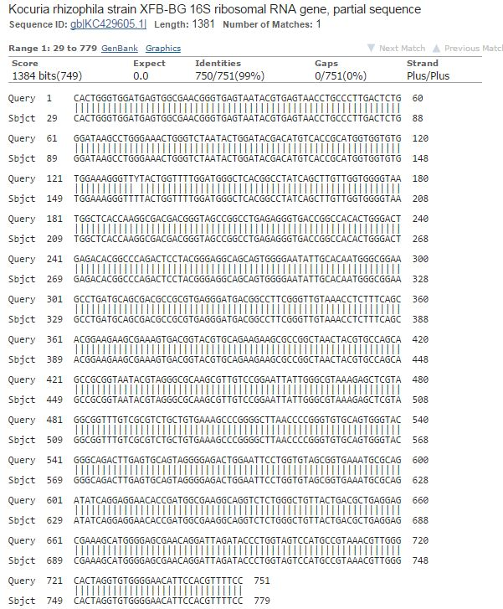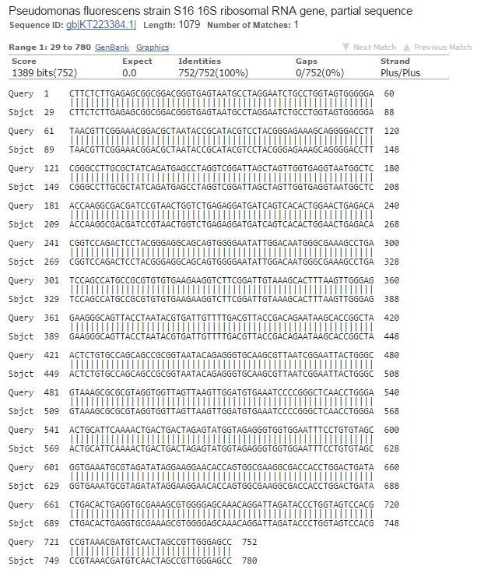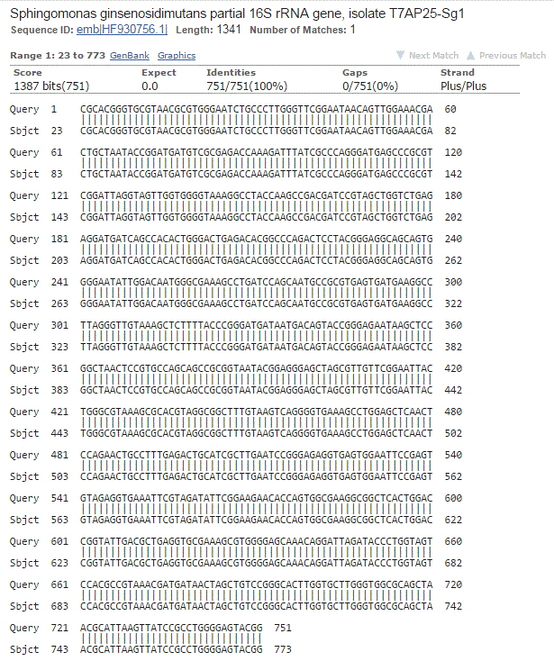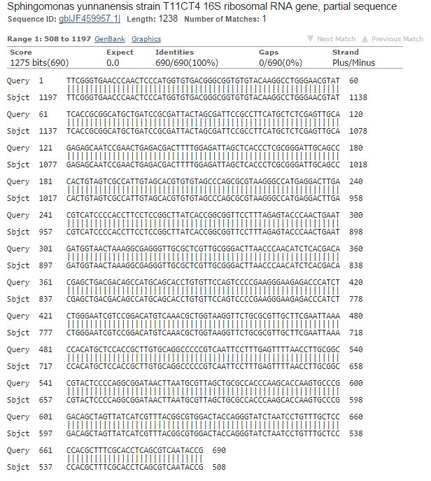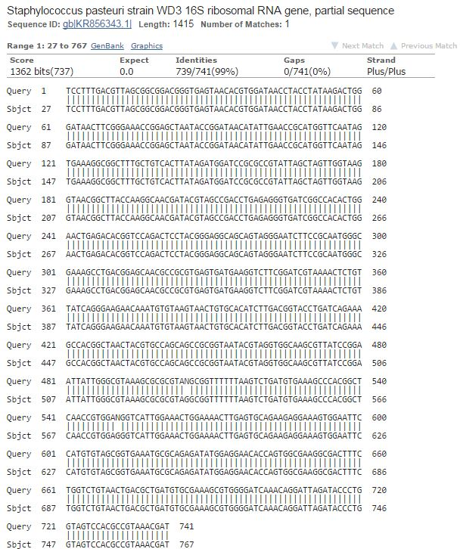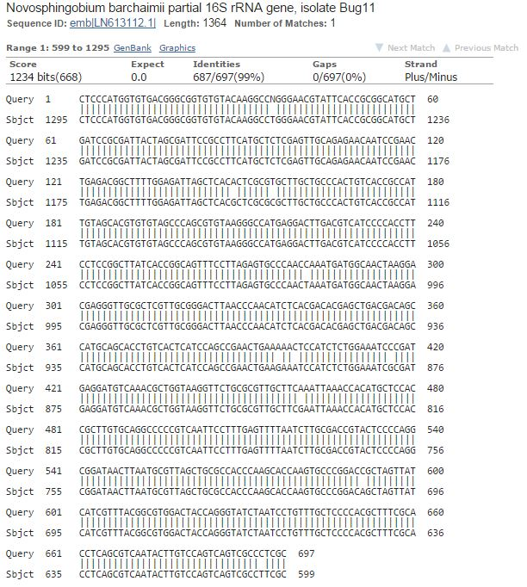
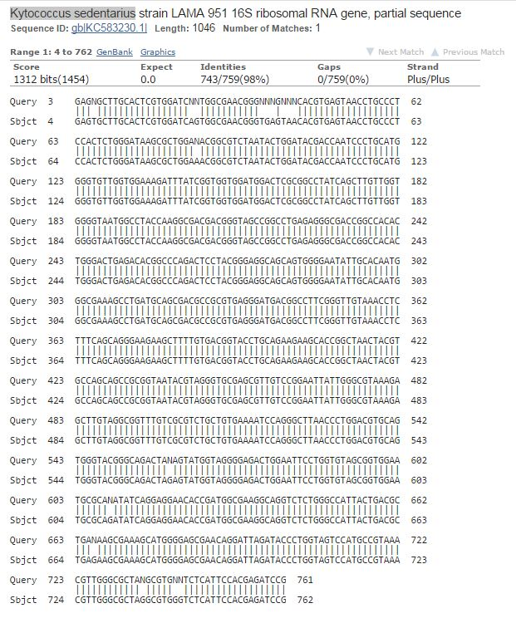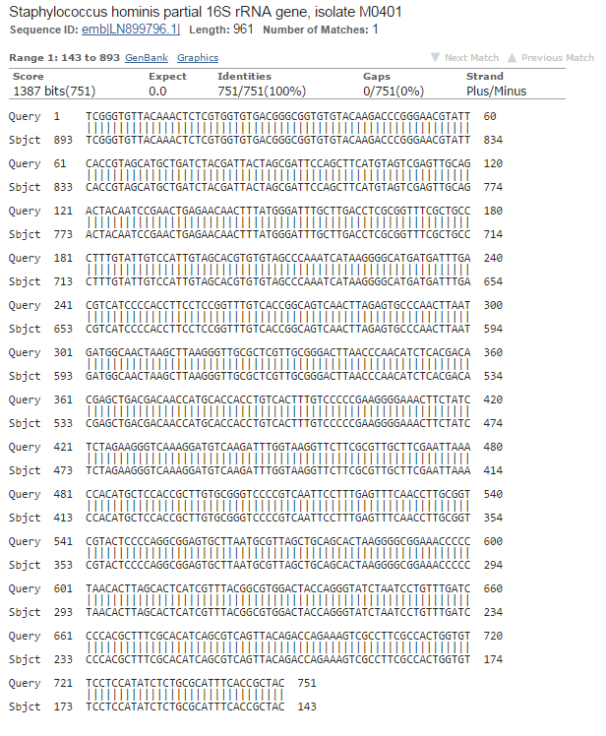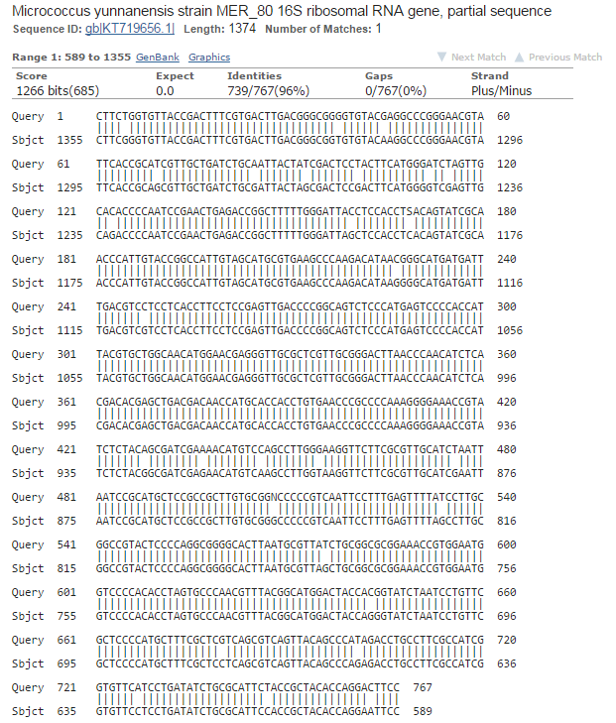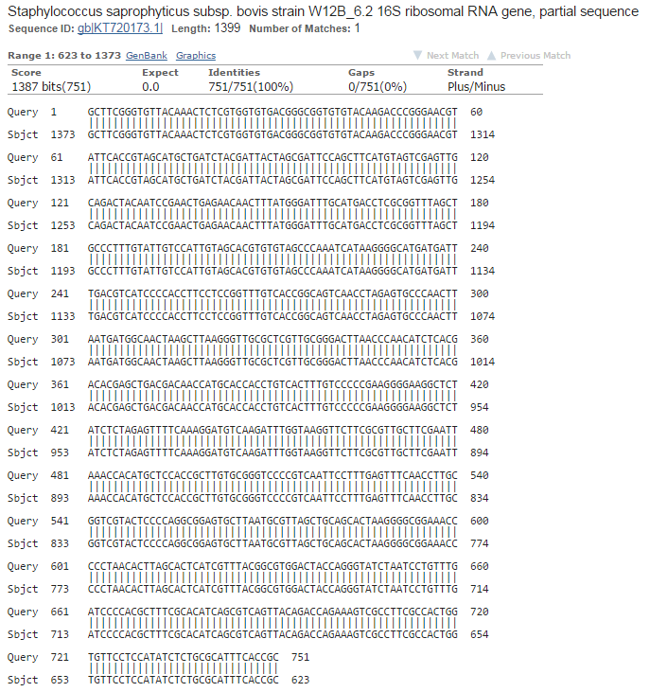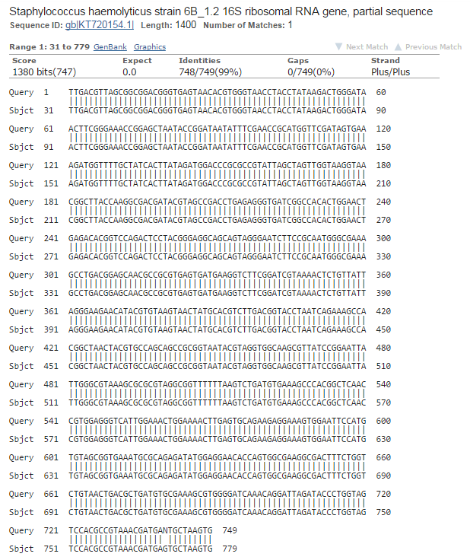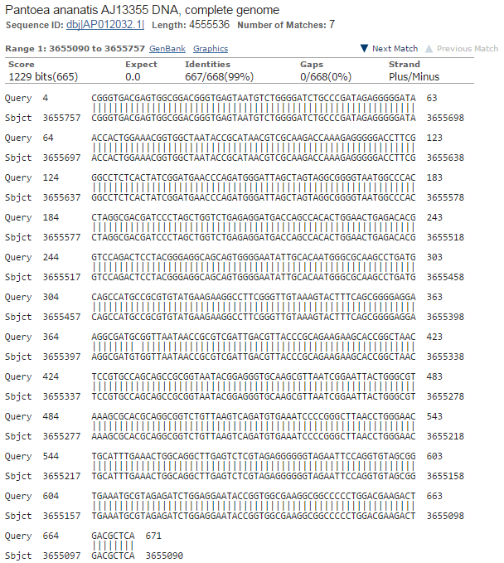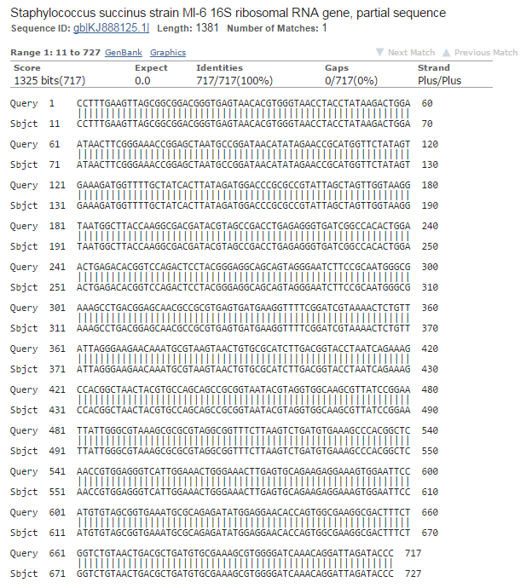

Appendix 9.2 Comparative interpretation of disc diffusion test of K. sedentarius
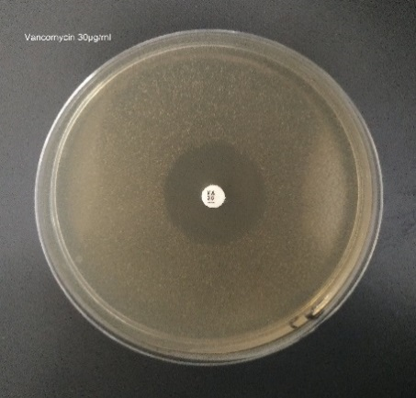 | 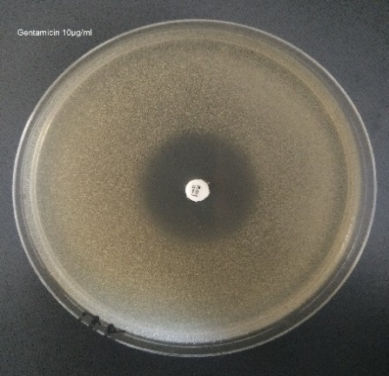 | 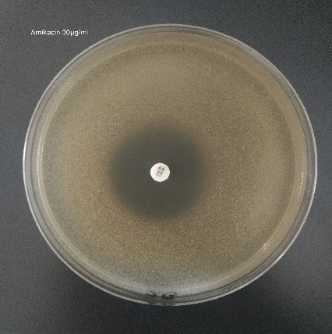
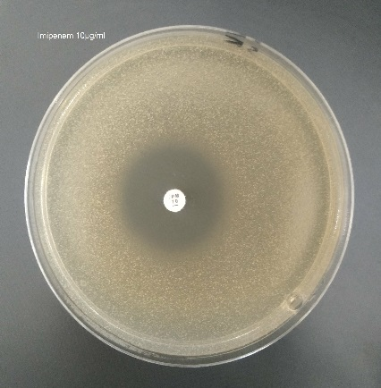 | 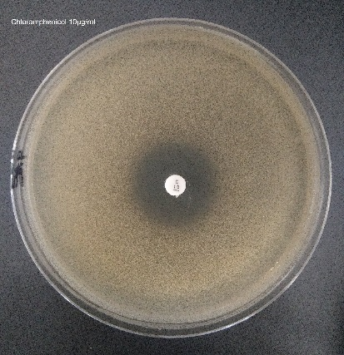 | 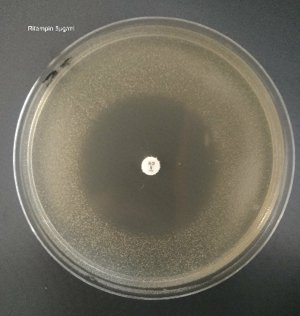
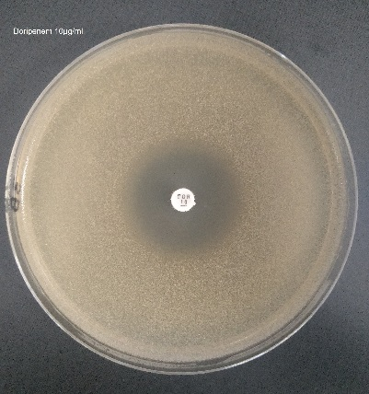 | 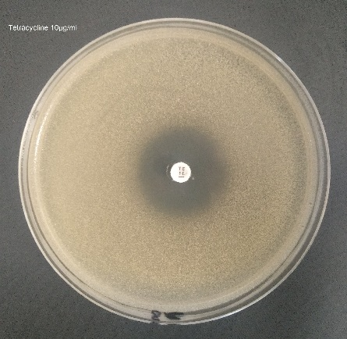 | 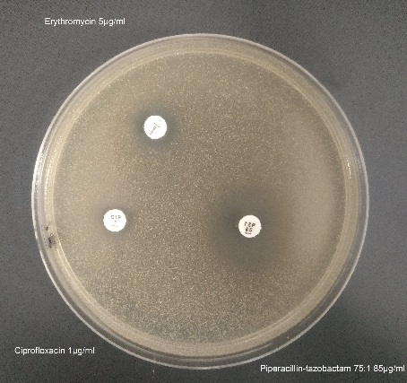
Fig shows the susceptibility pattern of Kytococcus sedentarius MBB13 to the follow antibiotics; Doripenem(DOR10), Imipenem (IMP10), Piperacillin-tazobactam(TZP85) Amikacin(AK30), Gentamicin(CN10), Ciprofloxasin(CIP1), Rifampin(RD5), Erythromycin(E5), Vancomycin(VA30), Tetracycline(TE10) and Chloramphenicol(C10). Three control strains are used to test the antibiotics performance, Staphylococcus aureus NCTC 12981, Escherichia coli NCTC 10418 and Pseudomonas aeruginosa NCTC 10662 (not shown).

Appendix 9.3 Relative MIC response levels of K. sedentarius MBB13 against the tested antibiotics

Appendix 9.4 Processing genome files after sequencing
(a)
Processing genome files from MicrobesNG Company
Open the following website and register an account (it might work without registration, haven't tried
it).
http://hactar.shef.ac.uk/galaxy
Click on "Get Data" at the left of the page, and select "Upload File", then "Choose local file", and
upload the reference genome and the Birmingham assembly file. Accepted formats are Fasta,
Genbank and EMBL.
Next click on "Genome assembly" (again on the left) and select "Actcompare".
Select the appropriate datasets as the reference and assembled contigs. Switch on the repeat filter.
Press "Execute".
This should produce a PNG image of the comparison, an ACT-compatible comparison file which you
can download, a log file and Genbank files representing the reference and contig genomes, each
with all replicons/contigs concatenated into a single pseudo-chromosome.
Save concatenated contig file and ACT comparison file.
Open concatenated contig file in Notepad and remove header/spaces/numbers (use replace tool).
Add a FASTA header e.g. >Identifier
Save as txt file
Back to Galaxy
On left Genome Annotation
Proka program run on concatenated contig txt file
Save genbank file
In ACT use reference genbank file
ACT comparision file
Proka genbank file

(b)
The following tracks is to how to extract data from ACT software:
Find gene sequence or amino acid or to search by piece of amino acid:
Goto → Choose the genome → Navigator → find the gene → right click → view → choose amino acid or bases
Codon usage:
File → Choose the genome → Write → Codon Usage of all Selected Features
All genes:
View → Choose the genome → SDS Genes and Products

Appendix 9.5 Effect of bipyridyl, erythromycin and NaCl on Wbl:σ BATCH system
(a) | σ ^{A} σ^{B} σ^{H} σ^{J} | (b)
WhiB1  WhiB2  WhiB3  WhiB7  controls | 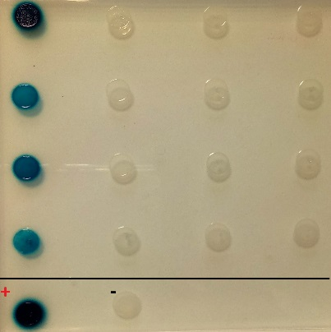
(c) |  | (d)
WhiB1  WhiB2  WhiB3  WhiB7  controls | 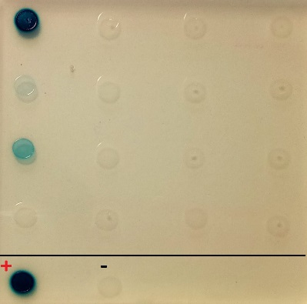
(e) |  | (f)
WhiB1  WhiB2  WhiB3  WhiB7  controls | 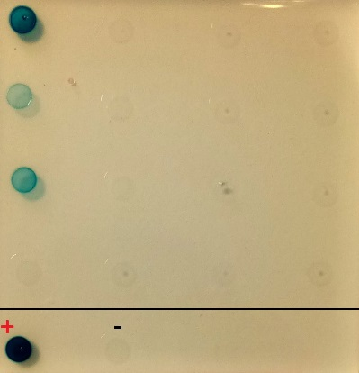
Fig shows the analysis by BACTH and β-galactosidase assays after disruption by stress factors between K. sedentarius MBB13 Wbls and Sigma factors (σ) fused into the domains, pKT25 and pUT18 of Bordetella pertussis respectively in E. coli BTH101. The interactions detection were by (a, c and e) LB medium in the presence of X-gal and IPTG as an inducer with different stress, 0.05 mM 2,2’ Bipyrdyl, 64 µg/ml Erythromycin and Salt: 5 % NaCl respectively. (b, d and f ) Enhancing of the β-galactosidase activities between the fused partners interactions with different stress as indicated. Control cultures were uncut from the same domains for negative control, and fused with GCN4 leucine zipper (Zip-Zip) for positive control. Both plates and liquid cultures were supplemented with ampicillin, kanamycin and streptomycin. Dara points means of four replicates plus or minus standard deviation, signifies (t-test) is indicated.

Appendix 9.6 Growth curve of K. sedentarius
Fig shows the growth curve of K. sedentarius MBB13 in LB medium incubated at 37 °C over 30 h. Red arrows indicate the phase of growth that used to extract the RNA from cells as follows, ~ 0.7 = early exponential, ~ 1.8 = late exponential and ~ 2.3 = stationary.

Appendix 9.7 NCBI numbers of M. tuberculosis H37Rv, S. coelicolor A3, C. glutamicum MB001, M. smegmatis MC² 155 and Mycobacteriophage TM4
Gene name in K. sedentarius MBB13 | Mycobacterium tuberculosis H37Rv (taxid:83332) | Streptomyces coelicolor A3(2) (taxid:100226) | Corynebacterium glutamicum MB001 (taxid:1310161) | Mycobacterium smegmatis MC² 155 | Mycobacteriophage TM4  (taxid:88870)
 | Percentage / NCBI ID
KS-WhiB1 | 73.42%/  NP_217735.1 | 65%/  NP_631361.1 | 83%/  AGT04761.1 | 74.68/  YP_886285.1 | No similarity
KS-WhiB2 | 76.32%/  NP_217777.1 | 85.51%/  NP_627256.1 | 85.96%/  AGT04734.1 | 77.63 %/  YP_886201.1 | 53.12%  NP_569784.1

Appendix 9.8 Purification of WhiB1 in the presence of DTT

(a)
(b) | 1 2 3 4 5 6 7 8 9 10 11 12 13 14 15
72~ kDa  24~ kDa  8~ kDa | 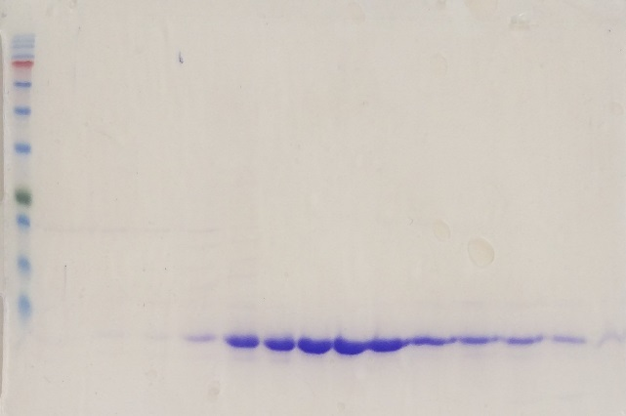
Fig shows isolation of K. sedentarius MBB13 WhiB1 from M. smegmatis MC² 155 using the buffer indicated. (a) HiTrap chelating column of elution profile of cell lysate containing WhiB1, the blue trace shows the protein absorbance as indicated of the injected cell lysate, and the red trace shows the concentration of the imidazole gradient from 0-0.5 M. Eluted WhiB1 appears in the form as indicated. (b) Coomassie stained SDS-PAGE gel of the elution profile fractions. Lane 1, protein ladder (size indicated); lanes 2-5, invisible of non-specific bound proteins usually contain high histidine contents; lanes 6-15, fraction of [4Fe-4S]-, [2Fe-2S]- and Apo- WhiB1.

Appendix 9.9 Purification of WhiB2 in the presence of DTT

(a)
(b) | 1 2 3 4 5 6 7 8 9 10 11
72~ kDa  24~ kDa  9~ kDa | 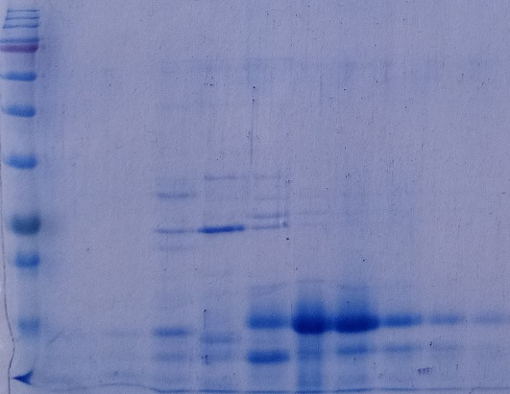
Fig shows isolation of K. sedentarius MBB13 WhiB2 from M. smegmatis MC² 155 using the buffer indicated. (a) HiTrap chelating column of elution profile of cell lysate containing WhiB2, the blue trace shows the protein absorbance as indicated of the injected cell lysate, and the red trace shows the concentration of the imidazole gradient from 0-0.5 M. Eluted Apo-WhiB2 appears in the form as indicated. (b) Coomassie stained SDS-PAGE gel of the elution profile fractions. Lane 1, protein ladder (size indicated); lanes 2-6, visible and invisible of non-specific bound proteins usually contain high histidine contents; lanes 7-15, fractions of Apo- WhiB2.

Appendix 9.10 Draft of the CD analysis of secondary structure of Holo- and Apo-WhiB1

Fig show a CD analysis of secondary structure of Holo- and Apo-WhiB1. The spectra of both samples (~35 µM cluster) were recorded in 20 mM NaH₂PO₄, 0.5 M NaCl, pH 7.4 at room temperature. The concentration affects negatively on figure reading in comparison to figure 6.10.

Appendix 9.11 Gene sequences after cloning
For the two hybrid system:
whiB (wbl) are fused in 25 fragment between XbaI (TCTAGA) and KpnI (GGTACC).
Sigma factor (σ) are fused in 18 fragment between HindIII (AAGCTT) and KpnI (GGTACC).
whiA was fused in both fragments (25 and 18).
Stop codon of gene fused in fragment T18 were removed.
whiB3, σ^{A}, σ^{B}, σ^{J} and whiA are optimised and synthesised.
For the overexpression:
whiB (wbl) 1,2 and 7 are fused between NcoI (CCATGG) and HindIII (AAGCTT).
Base pairs in red are added to be in frame, in green are modified and in blue are the restriction enzymes.

(a) Plasmid sequence of the two hybrid system

WhiB1 ------------------------------------------------------------
WhiB1_pKT25 TGACCAGCGGCGATTCGGTGACCGATTACCTGGCGCGCACGCGGCGGGCTGCAGGGTCGA

WhiB1 --------ATGGACTGGCGAAGCAAAGCGGCCTGTCTCGACGAGGACCCGGAACTGTTCT
WhiB1_pKT25 CTCTAGAGATGGACTGGCGAAGCAAAGCGGCCTGTCTCGACGAGGACCCGGAACTGTTCT
****************************************************

WhiB1 TCCCCATCGGGAACACGGGCCCGGCCATCGAGCAGATCGAGAAGGCCAAGAAGGTCTGCG
WhiB1_pKT25 TCCCCATCGGGAACACGGGCCCGGCCATCGAGCAGATCGAGAAGGCCAAGAAGGTCTGCG
************************************************************

WhiB1 CGCGGTGCGAGGTCACAGAGACCTGCCTGCAGTGGGCGATCGAGACCGGCCAGGACGCCG
WhiB1_pKT25 CGCGGTGCGAGGTCACAGAGACCTGCCTGCAGTGGGCGATCGAGACCGGCCAGGACGCCG
************************************************************

WhiB1 GCGTGTGGGGCGGTCTCTCCGAGGACGAGCGCCGCGCCCTGAAGCGACGCAACGCGCGCG
WhiB1_pKT25 GCGTGTGGGGCGGTCTCTCCGAGGACGAGCGCCGCGCCCTGAAGCGACGCAACGCGCGCG
************************************************************

WhiB1 CCCGCCGCGCCAGCTGA-------------------------------------------
WhiB1_pKT25 CCCGCCGCGCCAGCTGAGGTACCTAAGTAAGTAAGAATTCACTGGCCGTCGTTTTACAAC
*****************

WhiB2 ----------GTGCACGAACTTCAGATCGTCGGACATCCCGAGCAGGCCGTTCCCAGTTG
WhiB2_pKT25 GACTCTAGAGATGCACGAACTTCAGATCGTCGGACATCCCGAGCAGGCCGTTCCCAGTTG
*************************************************

WhiB2 GCAGGAGCGCGCCCTGTGCGCCCAGACCGACCCCGAGGCCTTCTTCCCCGAGAAGGGTGG
WhiB2_pKT25 GCAGGAGCGCGCCCTGTGCGCCCAGACCGACCCCGAGGCCTTCTTCCCCGAGAAGGGTGG
************************************************************

WhiB2 CTCCACGCGCGAGGCCAAGCGCGTCTGCACCGGCTGCGACGTGCGTTCCGAGTGCCTCGA
WhiB2_pKT25 CTCCACGCGCGAGGCCAAGCGCGTCTGCACCGGCTGCGACGTGCGTTCCGAGTGCCTCGA
************************************************************

WhiB2 CTACGCCCTCGAGAACGATGAGCGCTTCGGCATCTGGGGTGGCCTGTCCGAGCGGGAGCG
WhiB2_pKT25 CTACGCCCTCGAGAACGATGAGCGCTTCGGCATCTGGGGTGGCCTGTCCGAGCGGGAGCG
************************************************************

WhiB2 CCGCAAGCTCAAGCGGCGCGCGGTCTTCACCGCCTGA-----------------------
WhiB2_pKT25 CCGCAAGCTCAAGCGGCGCGCGGTCTTCACCGCCTGAGGTACCTAAGTAAGTAAGAATTC
*************************************

WhiB3 ------------------------------------------------------------
WhiB3_pKT25 CAGCGGCGATTCGGTGACCGATTACCTGGCGCGCACGCGGCGGGCTGCAGGGTCGACTCT

WhiB3 ----ATGGACAGCACGGCTCGCCAACCGGGCCCGGTTGCCGACTTGTGGGACTGGCAATT
WhiB3_pKT25 AGAGATGGACAGCACGGCTCGCCAACCGGGCCCGGTTGCCGACTTGTGGGACTGGCAATT
********************************************************

WhiB3 TGAGGGATTGTGCCGTACCACAGACCCGGAAGAGTTCTTCCATCCGGAAGGTGAACGTGG
WhiB3_pKT25 TGAGGGATTGTGCCGTACCACAGACCCGGAAGAGTTCTTCCATCCGGAAGGTGAACGTGG
************************************************************

WhiB3 CTCTGCCCGTCGTCTGCGCGACGAGCGTGCTAAACGTGTCTGCCAACGCTGTCCTGTGAT
WhiB3_pKT25 CTCTGCCCGTCGTCTGCGCGACGAGCGTGCTAAACGTGTCTGCCAACGCTGTCCTGTGAT
************************************************************

WhiB3 TCTTGAGTGCCGTGAACACGCATTAGCAGCGAAGGAACCTTATGGAGTCTGGGGGGGCTT
WhiB3_pKT25 TCTTGAGTGCCGTGAACACGCATTAGCAGCGAAGGAACCTTATGGAGTCTGGGGGGGCTT
************************************************************

WhiB3 GAGCGAAGACGAACGTGAACAAGAACTGGCACGTCGTTCGCGTCGCGGGCTTCGTGGTGC
WhiB3_pKT25 GAGCGAAGACGAACGTGAACAAGAACTGGCACGTCGTTCGCGTCGCGGGCTTCGTGGTGC
************************************************************

WhiB3 ATGA--------------------------------------------------------
WhiB3_pKT25 ATGAGGTACCTAAGTAAGTAAGAATTCACTGGCCGTCGTTTTACAACGTCGTGACTGGGA
****

WhiB7 ------------------------------------------------------------
WhiB7_pKT25 CCAGCGGCGATTCGGTGACCGATTACCTGGCGCGCACGCGGCGGGCTGCAGGGTCGACTC

WhiB7 -----ATGTTGGCCCTGGCAGATCACCAGACACTCATCGACCAAGCCCGTGTGGCCGGGC
WhiB7_pKT25 TAGAGATGTTGGCCCTGGCAGATCACCAGACACTCATCGACCAAGCCCGTGTGGCCGGGC
*******************************************************

WhiB7 GCCCCCTGCCCTGCCTCGAGAACGACCCCGACACCTGGTTCGCCGACACCCCCACGGGTG
WhiB7_pKT25 GCCCCCTGCCCTGCCTCGAGAACGACCCCGACACCTGGTTCGCCGACACCCCCACGGGTG
************************************************************

WhiB7 TCGAGTACGCCAAGTCCCTGTGCCACGCCTGCCCCGTGCGCACCCTCTGCCTCGAGGGTG
WhiB7_pKT25 TCGAGTACGCCAAGTCCCTGTGCCACGCCTGCCCCGTGCGCACCCTCTGCCTCGAGGGTG
************************************************************

WhiB7 CCTTGGAACGCCGCGAGCCCTGGGGTGTGTGGGGCGGCGAGCTCATCGAGGCCGGCCGGG
WhiB7_pKT25 CCTTGGAACGCCGCGAGCCCTGGGGTGTGTGGGGCGGCGAGCTCATCGAGGCCGGCCGGG
************************************************************

WhiB7 TGCTGCCGCGAAAGCGTCCGCGAGGACGTCCGCGCAAGCACCCCATCGCGGCCTGA----
WhiB7_pKT25 TGCTGCCGCGAAAGCGTCCGCGAGGACGTCCGCGCAAGCACCCCATCGCGGCCTGAGGTA
********************************************************

WhiB7 ------------------------------------------------------------
WhiB7_pKT25 CCTAAGTAAGTAAGAATTCACTGGCCGTCGTTTTACAACGTCGTGACTGGGAAAACCCTG

whiA --------ATGACTGCCAGTCTGAAGGACGAGTTAAGCCGCGTTGTTGTGCCTACCGCAG
whiA_pKT25 CTCTAGAGATGACTGCCAGTCTGAAGGACGAGTTAAGCCGCGTTGTTGTGCCTACCGCAG
****************************************************

whiA AAGCTCGCAAAGCTGAAGTGAGTAGTTTGTTACGCTTCGCAGGTGCCCTTCATCTTGTCG
whiA_pKT25 AAGCTCGCAAAGCTGAAGTGAGTAGTTTGTTACGCTTCGCAGGTGCCCTTCATCTTGTCG
************************************************************

whiA GAGGCCGTGTAGTGATTGAAGCTGAAGTCGACACGGCAAGCGCAGCTCGTCGCACCCGCG
whiA_pKT25 GAGGCCGTGTAGTGATTGAAGCTGAAGTCGACACGGCAAGCGCAGCTCGTCGCACCCGCG
************************************************************

whiA CCGCGATTTCGGAATTGTACGGTCACGATTCAGAATTGTTAGTGTTATCAGCCGGCGGTC
whiA_pKT25 CCGCGATTTCGGAATTGTACGGTCACGATTCAGAATTGTTAGTGTTATCAGCCGGCGGTC
************************************************************

whiA TTCGCCGCACAACACGCTACGTAGTGCGTGTCGTTGAGGGAGGTCAAAGTTTAGCCCGTC
whiA_pKT25 TTCGCCGCACAACACGCTACGTAGTGCGTGTCGTTGAGGGAGGTCAAAGTTTAGCCCGTC
************************************************************

whiA AAACCGGGCTGCTGGACGCTCAGGGGCGCCCTGTTCGCGGGTTACCCGCACGCGTTGTTC
whiA_pKT25 AAACCGGGCTGCTGGACGCTCAGGGGCGCCCTGTTCGCGGGTTACCCGCACGCGTTGTTC
************************************************************

whiA GTGGACCGGTTGCCGCGGCGGAAGCTGCCTGGCGTGGCGCATTCTTGGCACGCGGGTCGC
whiA_pKT25 GTGGACCGGTTGCCGCGGCGGAAGCTGCCTGGCGTGGCGCATTCTTGGCACGCGGGTCGC
************************************************************

whiA TGACTGAGCCCGGCCGCTCCAGCTCGTTGGAGGTGACCTGCCCAGGTCCCGAAGCTGCTT
whiA_pKT25 TGACTGAGCCCGGCCGCTCCAGCTCGTTGGAGGTGACCTGCCCAGGTCCCGAAGCTGCTT
************************************************************

whiA TGGCTCTGGTTGGTGCCGCCCGTCGCTTGGATATTGCAGCGAAATCACGTGAAGTTCGTG
whiA_pKT25 TGGCTCTGGTTGGTGCCGCCCGTCGCTTGGATATTGCAGCGAAATCACGTGAAGTTCGTG
************************************************************

whiA GCGTGGACCGCGTCGTCGTACGTGACGGTGACGGCATTTCCGCATTATTAACTCGTATGG
whiA_pKT25 GCGTGGACCGCGTCGTCGTACGTGACGGTGACGGCATTTCCGCATTATTAACTCGTATGG
************************************************************

whiA GCGCGCACGACGCGGTCTTAGCGTGGGAAGAGCGTCGCATGCGTCGTGAAGTCCGTGGAA
whiA_pKT25 GCGCGCACGACGCGGTCTTAGCGTGGGAAGAGCGTCGCATGCGTCGTGAAGTCCGTGGAA
************************************************************

whiA CTGCCAATCGCCTTGCGAATTTCGATGACGCGAACTTGCGTCGTTCCGCGCGCGCCGCGG
whiA_pKT25 CTGCCAATCGCCTTGCGAATTTCGATGACGCGAACTTGCGTCGTTCCGCGCGCGCCGCGG
************************************************************

whiA TGGCTGCGAGTGCACGCGTGGCCCGCGCGATGGAGTTGCTTGGCGACGAAGTACCCGAAC
whiA_pKT25 TGGCTGCGAGTGCACGCGTGGCCCGCGCGATGGAGTTGCTTGGCGACGAAGTACCCGAAC
************************************************************

whiA ACCTTCGTGTAGCGGGTACATTACGCATGGAACACAAACAAGCCTCTCTGGAAGAATTGG
whiA_pKT25 ACCTTCGTGTAGCGGGTACATTACGCATGGAACACAAACAAGCCTCTCTGGAAGAATTGG
************************************************************

whiA GGCAGTTGGCGACTCCTCCTTTGACGAAGGACGCCGTCGCGGGTCGCATTCGCCGTCTGC
whiA_pKT25 GGCAGTTGGCGACTCCTCCTTTGACGAAGGACGCCGTCGCGGGTCGCATTCGCCGTCTGC
************************************************************

whiA TGGCAATGGCGGACCGCCGCGCTGCCGAATTGGGGGTTGATGATACCCGCGTCACCATCA
whiA_pKT25 TGGCAATGGCGGACCGCCGCGCTGCCGAATTGGGGGTTGATGATACCCGCGTCACCATCA
************************************************************

whiA GCGAAGCTGAGGTGGACGCCCTGTTAAGCGACGAAGCTGCGGGTGATGTTGCCCAGGCGA
whiA_pKT25 GCGAAGCTGAGGTGGACGCCCTGTTAAGCGACGAAGCTGCGGGTGATGTTGCCCAGGCGA
************************************************************

whiA CCGACACCCCGCAAGACTGA----------------------------------------
whiA_pKT25 CCGACACCCCGCAAGACTGAGCGGTACCTAAGTAAGTAAGAATTCACTGGCCGTCGTTTT
********************

σ^{A}_CTD -------------------------------ATGGACGCTGTCTCCTTCACCCTTTTGCA
σ^{A}_CTD_pUT18 AACAGCTATGACCATGATTACGCCAAGCTTGATGGACGCTGTCTCCTTCACCCTTTTGCA
*****************************

σ^{A}_CTD GGAACAGCTTCATTCCGTGCTTGACACACTTAGCGAGCGTGAGGCGGGAGTAGTCTCAAT
σ^{A}_CTD_pUT18 GGAACAGCTTCATTCCGTGCTTGACACACTTAGCGAGCGTGAGGCGGGAGTAGTCTCAAT
************************************************************

σ^{A}_CTD GCGCTTTGGGTTAGCCGACGGCCAGCCGAAAACTCTGGATGAAATTGGGCGTGTCTATGG
σ^{A}_CTD_pUT18 GCGCTTTGGGTTAGCCGACGGCCAGCCGAAAACTCTGGATGAAATTGGGCGTGTCTATGG
************************************************************

σ^{A}_CTD CGTCACGCGCGAACGTATTCGTCAGATTGAATCCAAGACGATGTCTAAATTACGCCATCC
σ^{A}_CTD_pUT18 CGTCACGCGCGAACGTATTCGTCAGATTGAATCCAAGACGATGTCTAAATTACGCCATCC
************************************************************

σ^{A}_CTD TTCCCGTTCTCAAGTTCTTCGCGACTATTTAGACTGA-----------------------
σ^{A}_CTD_pUT18 TTCCCGTTCTCAAGTTCTTCGCGACTATTTAGACCGGGTACCGAGCTCGAATTCAGCCGC
********************************** *

σ^{B} ------------------------------ATGATTCACGACGATTTTCCGGCCCGTACA
σ^{B}_pUT18 ACAGCTATGACCATGATTACGCCAAGCTTGATGATTCACGACGATTTTCCGGCCCGTACA
******************************

σ^{B} CATGGTGCATCTCATGCTGTACCGGACCAGGCTCTGGTCCGTCGCCGCTTAACGGCTGCC
σ^{B}_pUT18 CATGGTGCATCTCATGCTGTACCGGACCAGGCTCTGGTCCGTCGCCGCTTAACGGCTGCC
************************************************************

σ^{B} CACGCCTTGCCCGAACAACACCGCCAACAAGAACTTATTGATGTGATCGCAGATCATATC
σ^{B}_pUT18 CACGCCTTGCCCGAACAACACCGCCAACAAGAACTTATTGATGTGATCGCAGATCATATC
************************************************************

σ^{B} CCTTTCGCGCGCCGTCTTGGTCGTCGTTTCGCTCCCACTCCGTCCCTTGTAGACGATTGC
σ^{B}_pUT18 CCTTTCGCGCGCCGTCTTGGTCGTCGTTTCGCTCCCACTCCGTCCCTTGTAGACGATTGC
************************************************************

σ^{B} GAACAAGTTGCCTGTATGGCTCTGGTCTTAGCTGTTCAACGCTGGGATCCTGCGTTTGAC
σ^{B}_pUT18 GAACAAGTTGCCTGTATGGCTCTGGTCTTAGCTGTTCAACGCTGGGATCCTGCGTTTGAC
************************************************************

σ^{B} GCCAATTTGAGCAGTTACGCGCAGCCTACCATTCTTGGGGAATTGCGTCGCTTCTTACGT
σ^{B}_pUT18 GCCAATTTGAGCAGTTACGCGCAGCCTACCATTCTTGGGGAATTGCGTCGCTTCTTACGT
************************************************************

σ^{B} GACTCGACGTGGTGGGTCCGTCCTCCCCGTCGTATCCAGGAGTTGGCCGCGTTAGTACGC
σ^{B}_pUT18 GACTCGACGTGGTGGGTCCGTCCTCCCCGTCGTATCCAGGAGTTGGCCGCGTTAGTACGC
************************************************************

σ^{B} TCTACTGAGGAAGAACTTCGTCACAGTACTGGCCGTGAGCCCACTGCGCAGGAAGTCGCT
σ^{B}_pUT18 TCTACTGAGGAAGAACTTCGTCACAGTACTGGCCGTGAGCCCACTGCGCAGGAAGTCGCT
************************************************************

σ^{B} CGTGCTGTTGGGGCATCACCCGATGAGGTGTCGGAGGCTCGCGTCGCCGCCGCTGGGCGT
σ^{B}_pUT18 CGTGCTGTTGGGGCATCACCCGATGAGGTGTCGGAGGCTCGCGTCGCCGCCGCTGGGCGT
************************************************************

σ^{B} TACGTGGCTTCAGTTGACGAGGAAGACCCTGAAACAGGGCGTCTTGTACATCTGGTACAC
σ^{B}_pUT18 TACGTGGCTTCAGTTGACGAGGAAGACCCTGAAACAGGGCGTCTTGTACATCTGGTACAC
************************************************************

σ^{B} AGCCCTGCCGTCGATGAATGGGTATCGTTACACCCACATATCCAGGCCCTTGACCCTCGT
σ^{B}_pUT18 AGCCCTGCCGTCGATGAATGGGTATCGTTACACCCACATATCCAGGCCCTTGACCCTCGT
************************************************************

σ^{B} GACCGTTGCGTGCTGTTACGCCGCTATCTTGAAGATGAAACCCAAGCCTCCATTGCGCGT
σ^{B}_pUT18 GACCGTTGCGTGCTGTTACGCCGCTATCTTGAAGATGAAACCCAAGCCTCCATTGCGCGT
************************************************************

σ^{B} GCGCTTGGCATCAGTCAGGCACAAGTCTCACGCCGCTTGAAACGCGCACTGGATACGCTT
σ^{B}_pUT18 GCGCTTGGCATCAGTCAGGCACAAGTCTCACGCCGCTTGAAACGCGCACTGGATACGCTT
************************************************************

σ^{B} CGCGAGCAAGTTCCGGGAGGTTTATCGAATGCCTGA------------------------
σ^{B}_pUT18 CGCGAGCAAGTTCCGGGAGGTTTATCGAATGCCCGGGGTACCGAGCTCGAATTCAGCCGC
********************************* *.

σ^{H} -------------------------------------ATGACACCCACCACCAGCGAGAA
σ^{H}_pUT18 ACAGGAAACAGCTATGACCATGATTACGCCAAGCTTGATGACACCCACCACCAGCGAGAA
***********************

σ^{H} GCCCCGCTCGGAGGTGAACAGCGACCCGGCAGAGGTCGACGTGGCCACCGAGACGCCCCA
σ^{H}_pUT18 GCCCCGCTCGGAGGTGAACAGCGACCCGGCAGAGGTCGACGTGGCCACCGAGACGCCCCA
************************************************************

σ^{H} GGAGCGCGCTGCGCGCTTCGAGCGCGAGGCGCTGCCCCATCTGGACCAGCTGTACAGCGC
σ^{H}_pUT18 GGAGCGCGCTGCGCGCTTCGAGCGCGAGGCGCTGCCCCATCTGGACCAGCTGTACAGCGC
************************************************************

σ^{H} GGCCCTGCGCACGACGCGTAACCCGACCGACGCCGAGGACCTGGTGCAGGAGACCTACGC
σ^{H}_pUT18 GGCCCTGCGCACGACGCGTAACCCGACCGACGCCGAGGACCTGGTGCAGGAGACCTACGC
************************************************************

σ^{H} CAAGGCGTACGCGGCGTTCCACCAGTACAAGCCGGGCACCAACCTCAAGGCGTGGATGTA
σ^{H}_pUT18 CAAGGCGTACGCGGCGTTCCACCAGTACAAGCCGGGCACCAACCTCAAGGCGTGGATGTA
************************************************************

σ^{H} CCGCATTCTCACCAACACGTACATCAACACCTACCGTAAGAAGCAGCGCCAGCCGCTGCA
σ^{H}_pUT18 CCGCATTCTCACCAACACGTACATCAACACCTACCGTAAGAAGCAGCGCCAGCCGCTGCA
************************************************************

σ^{H} GTCCGACGCCGCCGAGGTGGAGGACTACCAGTTGGCCGCAGCGGAGTCGCACACCGCCAA
σ^{H}_pUT18 GTCCGACGCCGCCGAGGTGGAGGACTACCAGTTGGCCGCAGCGGAGTCGCACACCGCCAA
************************************************************

σ^{H} GGGGCTGCGCTCCGCCGAGACCGAGGCGCTGGACCACATCGCCGACTCCCAAGTGACCGA
σ^{H}_pUT18 GGGGCTGCGCTCCGCCGAGACCGAGGCGCTGGACCACATCGCCGACTCCCAAGTGACCGA
************************************************************

σ^{H} CGCCCTGGCCCAGCTGAGTGAGGAGTTCCGCCTGGCGGTGTACCTGGCCGACGTGGAGGG
σ^{H}_pUT18 CGCCCTGGCCCAGCTGAGTGAGGAGTTCCGCCTGGCGGTGTACCTGGCCGACGTGGAGGG
************************************************************

σ^{H} CTTCGCCTACAAGGAGATCGCGGAGATCATGGACACGCCGATCGGCACCGTGATGTCTCG
σ^{H}_pUT18 CTTCGCCTACAAGGAGATCGCGGAGATCATGGACACGCCGATCGGCACCGTGATGTCTCG
************************************************************

σ^{H} CCTGCACCGGGGAAGAAAGCAGCTGCGGGAGCTGTTGGCCGAGTACGGAGCCGAACGCGG
σ^{H}_pUT18 CCTGCACCGGGGAAGAAAGCAGCTGCGGGAGCTGTTGGCCGAGTACGGAGCCGAACGCGG
************************************************************

σ^{H} CTTCGGCCGGCAGTCCCAAGGTAAGGAGGTCTCCTCGTGA--------------------
σ^{H}_pUT18 CTTCGGCCGGCAGTCCCAAGGTAAGGAGGTCTCCTCGCGGGTACCGAGCTCGAATTCAGC
************************************* *.

σ^{J} ---------------------------------------------------------ATG
σ^{J}_pUT18 AGATTGTACTGAGAGAAAGGCAATTGGGTACCGAGCTCGCGGCCGCAAGCAAGCTTGATG
***

σ^{J} GAAATGTCTCGTGTGGACCTGGAGCGTTTTGAGGTCGCCCGTGGACGTTTGGGTGCCGTC
σ^{J}_pUT18 GAAATGTCTCGTGTGGACCTGGAGCGTTTTGAGGTCGCCCGTGGACGTTTGGGTGCCGTC
************************************************************

σ^{J} GCTTATCGTCTGCTTGGGTCAGCTAGCGAAGCTGAAGATGTGGTACAAGAGTCCTTTGTC
σ^{J}_pUT18 GCTTATCGTCTGCTTGGGTCAGCTAGCGAAGCTGAAGATGTGGTACAAGAGTCCTTTGTC
************************************************************

σ^{J} CGTTGGCAGGCAGCCGACCGCGGTCGCATCGAAGTGCCCGTGGCGTGGTTGACTAAGGTT
σ^{J}_pUT18 CGTTGGCAGGCAGCCGACCGCGGTCGCATCGAAGTGCCCGTGGCGTGGTTGACTAAGGTT
************************************************************

σ^{J} GTTACCAATTTATGTTTAAACCAGCTTACCAGCGCACGTTCTCGTCGTGAAGAATACGTG
σ^{J}_pUT18 GTTACCAATTTATGTTTAAACCAGCTTACCAGCGCACGTTCTCGTCGTGAAGAATACGTG
************************************************************

σ^{J} GGTCAATGGCTGCCCGAGCCTCTGCTTGATGGGGATCCTATGTTAGGGCCTGCAGAAACC
σ^{J}_pUT18 GGTCAATGGCTGCCCGAGCCTCTGCTTGATGGGGATCCTATGTTAGGGCCTGCAGAAACC
************************************************************

σ^{J} TTGGAACAACGCGGGAGTGTTAGCTTAGCAATGTTGATGATCCTGGAAACTCTTAGTCCC
σ^{J}_pUT18 TTGGAACAACGCGGGAGTGTTAGCTTAGCAATGTTGATGATCCTGGAAACTCTTAGTCCC
************************************************************

σ^{J} ACCGAACGCGCAGTGTACGTGCTTCGCGAGGCGTTCGCTGTCCCTCATGGTGAAATTGCG
σ^{J}_pUT18 ACCGAACGCGCAGTGTACGTGCTTCGCGAGGCGTTCGCTGTCCCTCATGGTGAAATTGCG
************************************************************

σ^{J} GAAATTTTGGAAACTACGCCCGCTGCGACACAGCAAGCGTTATCCCGCGCTAAAAGCCGT
σ^{J}_pUT18 GAAATTTTGGAAACTACGCCCGCTGCGACACAGCAAGCGTTATCCCGCGCTAAAAGCCGT
************************************************************

σ^{J} ATCGCATCTTTGTCGCATCGTCACCGCACAGAAGCGGACCCTGTCGCTGCACGTGCTATC
σ^{J}_pUT18 ATCGCATCTTTGTCGCATCGTCACCGCACAGAAGCGGACCCTGTCGCTGCACGTGCTATC
************************************************************

σ^{J} GTAGAAGAGTTTTTGGCAGCCGCAACTAGCGGTCGCGTTGAAAATTTGGTCCGTCTGTTG
σ^{J}_pUT18 GTAGAAGAGTTTTTGGCAGCCGCAACTAGCGGTCGCGTTGAAAATTTGGTCCGTCTGTTG
************************************************************

σ^{J} ACTGATGACGCGTTCGGCATTGGGGACGGCGGAGGGGCGGTTCCCGCCCGTCCTAAACCA
σ^{J}_pUT18 ACTGATGACGCGTTCGGCATTGGGGACGGCGGAGGGGCGGTTCCCGCCCGTCCTAAACCA
************************************************************

σ^{J} GTCCTGGGGGCTCAGTCCGTCGCCAAGATGTTACGTGGATTAGCGGTTCCTTCAGCCGCC
σ^{J}_pUT18 GTCCTGGGGGCTCAGTCCGTCGCCAAGATGTTACGTGGATTAGCGGTTCCTTCAGCCGCC
************************************************************

σ^{J} AAGCGTGAGTTAGCAGGAGGCAGCTTAGATTGTCATTTCGCACTGGTCAATACATCCCCG
σ^{J}_pUT18 AAGCGTGAGTTAGCAGGAGGCAGCTTAGATTGTCATTTCGCACTGGTCAATACATCCCCG
************************************************************

σ^{J} GCCTTGGTGGCAGTAGTAGCGGGGCGCGTTGTAGGTGTAATCGTGCTTGATATTGCCGAC
σ^{J}_pUT18 GCCTTGGTGGCAGTAGTAGCGGGGCGCGTTGTAGGTGTAATCGTGCTTGATATTGCCGAC
************************************************************

σ^{J} GGACGTATCTCGGTGGTGCGTATTCAGGCCAATCCTCACAAACTTGACCGTGCGACTCGT
σ^{J}_pUT18 GGACGTATCTCGGTGGTGCGTATTCAGGCCAATCCTCCCAAACTTGACCGTGCGACTCGT
************************************************************

σ^{J} CGCTGGGCTGCTTCACCTCACGGTCGCCCGTTGCTGAGTGGGTGGTGA------------
σ^{J}_pUT18 CGCTGGGCTGCTTCACCTCACGGTCGCCCGTTGCTGAGTGGGTGGCGGGTACCACCTGCT
********************************************* *.

whiA ------------------------------ATGACTGCCAGTCTGAAGGACGAGTTAAGC
whiA_pUT18 ACAGCTATGACCATGATTACGCCAAGCTTGATGACTGCCAGTCTGAAGGACGAGTTAAGC
******************************

whiA CGCGTTGTTGTGCCTACCGCAGAAGCTCGCAAAGCTGAAGTGAGTAGTTTGTTACGCTTC
whiA_pUT18 CGCGTTGTTGTGCCTACCGCAGAAGCTCGCAAAGCTGAAGTGAGTAGTTTGTTACGCTTC
************************************************************

whiA GCAGGTGCCCTTCATCTTGTCGGAGGCCGTGTAGTGATTGAAGCTGAAGTCGACACGGCA
whiA_pUT18 GCAGGTGCCCTTCATCTTGTCGGAGGCCGTGTAGTGATTGAAGCTGAAGTCGACACGGCA
************************************************************

whiA AGCGCAGCTCGTCGCACCCGCGCCGCGATTTCGGAATTGTACGGTCACGATTCAGAATTG
whiA_pUT18 AGCGCAGCTCGTCGCACCCGCGCCGCGATTTCGGAATTGTACGGTCACGATTCAGAATTG
************************************************************

whiA TTAGTGTTATCAGCCGGCGGTCTTCGCCGCACAACACGCTACGTAGTGCGTGTCGTTGAG
whiA_pUT18 TTAGTGTTATCAGCCGGCGGTCTTCGCCGCACAACACGCTACGTAGTGCGTGTCGTTGAG
************************************************************

whiA GGAGGTCAAAGTTTAGCCCGTCAAACCGGGCTGCTGGACGCTCAGGGGCGCCCTGTTCGC
whiA_pUT18 GGAGGTCAAAGTTTAGCCCGTCAAACCGGGCTGCTGGACGCTCAGGGGCGCCCTGTTCGC
************************************************************

whiA GGGTTACCCGCACGCGTTGTTCGTGGACCGGTTGCCGCGGCGGAAGCTGCCTGGCGTGGC
whiA_pUT18 GGGTTACCCGCACGCGTTGTTCGTGGACCGGTTGCCGCGGCGGAAGCTGCCTGGCGTGGC
************************************************************

whiA GCATTCTTGGCACGCGGGTCGCTGACTGAGCCCGGCCGCTCCAGCTCGTTGGAGGTGACC
whiA_pUT18 GCATTCTTGGCACGCGGGTCGCTGACTGAGCCCGGCCGCTCCAGCTCGTTGGAGGTGACC
************************************************************

whiA TGCCCAGGTCCCGAAGCTGCTTTGGCTCTGGTTGGTGCCGCCCGTCGCTTGGATATTGCA
whiA_pUT18 TGCCCAGGTCCCGAAGCTGCTTTGGCTCTGGTTGGTGCCGCCCGTCGCTTGGATATTGCA
************************************************************

whiA GCGAAATCACGTGAAGTTCGTGGCGTGGACCGCGTCGTCGTACGTGACGGTGACGGCATT
whiA_pUT18 GCGAAATCACGTGAAGTTCGTGGCGTGGACCGCGTCGTCGTACGTGACGGTGACGGCATT
************************************************************

whiA TCCGCATTATTAACTCGTATGGGCGCGCACGACGCGGTCTTAGCGTGGGAAGAGCGTCGC
whiA_pUT18 TCCGCATTATTAACTCGTATGGGCGCGCACGACGCGGTCTTAGCGTGGGAAGAGCGTCGC
************************************************************

whiA ATGCGTCGTGAAGTCCGTGGAACTGCCAATCGCCTTGCGAATTTCGATGACGCGAACTTG
whiA_pUT18 ATGCGTCGTGAAGTCCGTGGAACTGCCAATCGCCTTGCGAATTTCGATGACGCGAACTTG
************************************************************

whiA CGTCGTTCCGCGCGCGCCGCGGTGGCTGCGAGTGCACGCGTGGCCCGCGCGATGGAGTTG
whiA_pUT18 CGTCGTTCCGCGCGCGCCGCGGTGGCTGCGAGTGCACGCGTGGCCCGCGCGATGGAGTTG
************************************************************

whiA CTTGGCGACGAAGTACCCGAACACCTTCGTGTAGCGGGTACATTACGCATGGAACACAAA
whiA_pUT18 CTTGGCGACGAAGTACCCGAACACCTTCGTGTAGCGGGTACATTACGCATGGAACACAAA
************************************************************

whiA CAAGCCTCTCTGGAAGAATTGGGGCAGTTGGCGACTCCTCCTTTGACGAAGGACGCCGTC
whiA_pUT18 CAAGCCTCTCTGGAAGAATTGGGGCAGTTGGCGACTCCTCCTTTGACGAAGGACGCCGTC
************************************************************

whiA GCGGGTCGCATTCGCCGTCTGCTGGCAATGGCGGACCGCCGCGCTGCCGAATTGGGGGTT
whiA_pUT18 GCGGGTCGCATTCGCCGTCTGCTGGCAATGGCGGACCGCCGCGCTGCCGAATTGGGGGTT
************************************************************

whiA GATGATACCCGCGTCACCATCAGCGAAGCTGAGGTGGACGCCCTGTTAAGCGACGAAGCT
whiA_pUT18 GATGATACCCGCGTCACCATCAGCGAAGCTGAGGTGGACGCCCTGTTAAGCGACGAAGCT
************************************************************

whiA GCGGGTGATGTTGCCCAGGCGACCGACACCCCGCAAGACTGA------------------
whiA_pUT18 GCGGGTGATGTTGCCCAGGCGACCGACACCCCGCAAGACGCGGTACCGAGCTCGAATTCA
*************************************** .

(b) Plasmid sequence of the overexpression system

whiB1 -------ATGGACTGGCGAAGCAAAGCGGCCTGTCTCGACGAGGACCCGGAACTGTTCTT
whiB1_pMyNT GGGCGCCATGGACTGGCGAAGCAAAGCGGCCTGTCTCGACGAGGACCCGGAACTGTTCTT
*****************************************************

whiB1 CCCCATCGGGAACACGGGCCCGGCCATCGAGCAGATCGAGAAGGCCAAGAAGGTCTGCGC
whiB1_pMyNT CCCCATCGGGAACACGGGCCCGGCCATCGAGCAGATCGAGAAGGCCAAGAAGGTCTGCGC
************************************************************

whiB1 GCGGTGCGAGGTCACAGAGACCTGCCTGCAGTGGGCGATCGAGACCGGCCAGGACGCCGG
whiB1_pMyNT GCGGTGCGAGGTCACAGAGACCTGCCTGCAGTGGGCGATCGAGACCGGCCAGGACGCCGG
************************************************************

whiB1 CGTGTGGGGCGGTCTCTCCGAGGACGAGCGCCGCGCCCTGAAGCGACGCAACGCGCGCGC
whiB1_pMyNT CGTGTGGGGCGGTCTCTCCGAGGACGAGCGCCGCGCCCTGAAGCGACGCAACGCGCGCGC
************************************************************

whiB1 CCGCCGCGCCAGCTGA--------------------------------------------
whiB1_pMyNT CCGCCGCGCCAGCTGAAAGCTTATCGATGTCGACGTAGTTAACTAGCGTACGATCGACTG
****************

whiB2 -------GTGCACGAACTTCAGATCGTCGGACATCCCGAGCAGGCCGTTCCCAGTTGGCA
whiB2_pMyNT GGGCGCCATGGACGAACTTCAGATCGTCGGACATCCCGAGCAGGCCGTTCCCAGTTGGCA
** *************************************************

WhiB2 GGAGCGCGCCCTGTGCGCCCAGACCGACCCCGAGGCCTTCTTCCCCGAGAAGGGTGGCTC
whiB2_pMyNT GGAGCGCGCCCTGTGCGCCCAGACCGACCCCGAGGCCTTCTTCCCCGAGAAGGGTGGCTC
************************************************************

whiB2 CACGCGCGAGGCCAAGCGCGTCTGCACCGGCTGCGACGTGCGTTCCGAGTGCCTCGACTA
whiB2_pMyNT CACGCGCGAGGCCAAGCGCGTCTGCACCGGCTGCGACGTGCGTTCCGAGTGCCTCGACTA
************************************************************

whiB2 CGCCCTCGAGAACGATGAGCGCTTCGGCATCTGGGGTGGCCTGTCCGAGCGGGAGCGCCG
whiB2_pMyNT CGCCCTCGAGAACGATGAGCGCTTCGGCATCTGGGGTGGCCTGTCCGAGCGGGAGCGCCG
************************************************************

whiB2 CAAGCTCAAGCGGCGCGCGGTCTTCACCGCCTGA--------------------------
whiB2_pMyNT CAAGCTCAAGCGGCGCGCGGTCTTCACCGCCTGAAAGCTTATCGATGTCGACGTAGTTAA
**********************************

whiB7 --------ATGTTGGCCCTGGCAGATCACCAGACACTCATCGACCAAGCCCGTGTGGCCG
whiB7_pMyNT AGGGCGCCATGGTGGCCCTGGCAGATCACCAGACACTCATCGACCAAGCCCGTGTGGCCG
*** ************************************************

whiB7 GGCGCCCCCTGCCCTGCCTCGAGAACGACCCCGACACCTGGTTCGCCGACACCCCCACGG
whiB7_pMyNT GGCGCCCCCTGCCCTGCCTCGAGAACGACCCCGACACCTGGTTCGCCGACACCCCCACGG
************************************************************

whiB7 GTGTCGAGTACGCCAAGTCCCTGTGCCACGCCTGCCCCGTGCGCACCCTCTGCCTCGAGG
whiB7_pMyNT GTGTCGAGTACGCCAAGTCCCTGTGCCACGCCTGCCCCGTGCGCACCCTCTGCCTCGAGG
************************************************************

whiB7 GTGCCTTGGAACGCCGCGAGCCCTGGGGTGTGTGGGGCGGCGAGCTCATCGAGGCCGGCC
whiB7_pMyNT GTGCCTTGGAACGCCGCGAGCCCTGGGGTGTGTGGGGCGGCGAGCTCATCGAGGCCGGCC
************************************************************

whiB7 GGGTGCTGCCGCGAAAGCGTCCGCGAGGACGTCCGCGCAAGCACCCCATCGCGGCCTGA-
whiB7_pMyNT GGGTGCTGCCGCGAAAGCGTCCGCGAGGACGTCCGCGCAAGCACCCCATCGCGGCCTGAA
***********************************************************

whiB7 ------------------------------------------------------------
whiB7_pMyNT AGCTTATCGATGTCGACGTAGTTAACTAGCGTACGATCGACTGCCAGGCATCAAATAAAA

