Pseudaminic acid as a target for antimicrobial therapy



Joseph Ferner

A thesis submitted in partial fulfilment of the requirements for the degree of Doctor of Philosophy

The University of Sheffield Faculty of Medicine, Dentistry and Health Department of Infection, Immunity & Cardiovascular Disease

April 2019

Acknowledgements
Firstly, I would like to thank Jon Shaw and Simon Jones for their continued supervision and support throughout. As well as Jon and Simon, thanks are due to the respective Shaw and Jones groups over the years, notably (but not limited to) Ernesto, my main man Al, my main woman Jenna, Matt, Bryony, Dan C, Dan J, Fede and Haneesh. I am also hugely appreciative of all the support from the collaborators at the university of York, Dr Martin Fascione, Dr Harriet Chidwick, and especially Emily Flack.
In addition to my colleagues, I owe big thanks to my unwavering chemistry family: Alec, Rosie and Oli, you guys were there at the start all those years ago, big love. Thanks also to newer additions, Shannon, James, Alex, Jenny, Dave (AKA Lunch Bunch). In these stressful, anxiety-inducing times, the mutual moral support of those who know is invaluable.
Finally, I am eternally grateful for the love, support and tolerance that I am unfathomably fortunate to receive from my “flatmate” Shan, my wonderful parents, and my brother Daniel.

Declaration
I declare that all the work contained herein is my own work, unless otherwise referenced.

Contents

Acknowledgements 3
Declaration 4
List of abbreviations 8
Abstract 10
1. Introduction 11
1.1. Antimicrobial resistance 11
1.2. Bacterial structure and therapeutics 11
1.2.1. Bacteria: structure and nomenclature 11
1.2.2. Bacterial cell wall: penicillins, cephalosporins and carbapenems 13
1.2.3. The liposaccharide component: polymyxins 16
1.3. Flagellum structure 17
1.4. Flagella glycosylation 19
1.4.1. Flagella glycosylation in Campylobacter jejuni 21
1.4.2. Flagella glycosylation in Helicobacter pylori 22
1.4.3. Flagella glycosylation in Aeromonas caviae 22
1.4.4. Glycosylation as a therapeutic target 23
1.5. Sialic acid and derivatives 24
1.5.1. Sialic acid 24
1.5.2. Pseudaminic acid: associated pathogens 25
1.5.3. Pseudaminic acid biosynthesis 27
1.6. Sialic acid synthase and analogous enzyme inhibitors 28
1.7. Proposed pseudaminic acid synthase inhibitors 31
1.7.1. Methylene and fluoromethylene phosphonate inhibitors 32
1.7.2. General considerations of bioavailability and membrane permeability 34
1.8. Project aims 38
2. Methods and materials 41
2.1. Bacterial strains, plasmids, antibiotics and media 41
2.1.1. Luria Bertani broth (LB broth) and enriched LB broth 41
2.1.2. Luria Bertani agar 41
2.1.3. Horse blood added Columbia Blood Agar (CBA) 41
2.1.4. Swarming and swimming agar 42
2.1.5. Bacterial strains 42
2.1.6. Bacterial growth 43
2.1.7. Bacterial plasmids 43
2.1.8. Antibiotics and additives 44
2.2. Method for the preparation of competent cells 44
2.3. Bacterial transformation 45
2.4. Protein overexpression 46
2.4.1. Expression from pET plasmids 46
2.4.2. Expression from pMAL plasmid 47
2.4.3. Sodium dodecyl sulphate polyacrylamide gel electrophoresis (SDS-PAGE) 48
2.4.4. Protein buffer exchange and further purification 49
2.4.5. Thrombin cleavage of HisTags 49
2.5. Enzyme reactions 50
2.5.1. ¹H NMR spectroscopy-monitored reactions 50
2.5.2. LCMS-monitored enzyme reactions 50
2.6. Protein crystallography 51
2.7. Preparation of bacterial strain for transmission electron microscopy (TEM) 51
2.8. Chemical syntheses 52
3. Expression and characterisation of the A. caviae Pse enzymes 53
3.1. Introduction 53
3.2. Results and discussion 60
3.2.1. Enzyme expression 60
3.2.2. Enzyme activity: NMR experiment 68
3.2.3. Enzyme activity: LCMS experiment 69
3.2.4. PseI crystal structure 76
3.2.5. Enzyme inhibition assay 79
3.3. Summary and conclusions 82
4. Evaluating strategies towards the synthesis of potential PseI inhibitors 84
4.1. Introduction 84
4.2. Towards the synthesis of Tanner’s inhibitor 85
4.2.1. Model compounds 87
4.3. Orthoester synthesis for an aldol approach 98
4.3.1. The aldol approach 99
4.3.2. Phosphonate addition as a route towards the proposed inhibitor 23 103
4.4. Summary and conclusions 108
5. Microbial motility assays and LCMS inhibition assays 110
5.1. Introduction 110
5.1.1. Bacterial motility: swarming and swimming and assays 110
5.1.2. Caffeine as a quorum sensing inhibitor 111
5.1.3. “Aryl pyrrole” as potential enzyme-targeting control 115
5.2. Results and Discussion 116
5.2.1. Motility assays using caffeine 116
5.2.2. Synthesis of aryl pyrrole 98 119
5.2.3. Aryl pyrrole 98 effect on motility 119
5.2.4. Aryl pyrrole 98 in LCMS assay 121
5.2.5. Aryl pyrrole 98 analogues 123
5.2.6. Aryl pyrrole analogues in LCMS assays 127
5.3. Summary and conclusions 134
6. Conclusions and future work 136
6.1. Future work 143
7. Experimental 146
8. References 178
9. Appendix 191

List of abbreviations
AMR | antimicrobial resistance
Ac | acetyl/Aeromonas caviae
(deoxy) AltdiNAc | 2,4-diacetamido- 2,4,6-trideoxy-L-altrose
Amp | ampicillin
BuLi | butyl lithium
CBA | Columbia blood agar
CD | circular dichroism
Cj | Campylobacter jejuni
Cm | chloramphenicol
CMP | cytidine monophosphate
CTP | cytidine triphosphate
d | doublet
DCM | dichloromethane
dd | doublet of doublets
ddd | double doublet of doublets
DIAD | diisopropyl azodicarboxylate
DMAP | dimethylamino pyridine
DMF | dimethyl formamide
DMS | dimethyl sulfide
DMSO | dimethyl sulfoxide
dr | diastereomeric ratio
EDCI | 1-ethyl-3-(3-dimethylaminopropyl)carbodiimide
Et | ethyl
EtOAc | ethyl acetate
EtOH | ethanol
GF | gel filtration
GlcNAc | N-acetylglucosamine
h | hours
HisTag | Histidine tag
HisTrap | Histidine trap (column)
HPLC | high-performance liquid chromatography
IC50 | half maximal inhibitory concentration
iPr | isopropyl
iPrOH | isopropanol
IPTG | isopropyl β-D-1-thiogalactopyranoside
kDa | kilodaltons (kg mol-1)
KDN | 2-keto-3-deoxy-D-glycero-D-galacto-nonulosonic acid
KDO | 2-keto-3-deoxy-d-manno-octulosonic
KDO8P | 3-deoxy-D-manno-2-octulosonate-8-phosphate
KDO8PS | 3-deoxy-D-manno-2-octulosonate-8-phosphate synthase
K_{i} | inhibitor constant
Km | kanamycin
LB | Luria-Bertani
LCMS | liquid chromatography mass spectrometry
LD50 | half median lethal dose
L-Glu | L-glutamic acid (L-glutamate)
M | molar
m | multiplet
Maf | motility-associated factor (protein)
ManNAc | N-acetylmannosamine
MBP | maltose-binding protein
Me | methyl
MeCN | acetonitrile
MeOH | methanol
MESG | 2-amino-6-mercapto-7-methylpurine ribonucleoside
MIC | minimum inhibitory concentration
mM | millimolar
MoA | mechanism of action
MS | mass spectrometry
MW | microwave
NADPH | nicotinamide adenine dinucleotide phosphate
nBu | normal butyl
nBuLi | normal butyl lithium
n-hexane | normal hexane
NMR | nuclear magnetic resonance
OD600 | optical density (at 600 nm)
PDC | pyridinium dichromate
PEP | phosphoenol pyruvate
P_{i} | monophosphate
PLP | pyridoxal phosphate
PMA | phosphomolybdic acid
PP_{i} | pyrophosphate
pTsOH | para-toluenesulfonic acid
RSM | returned starting material
rt | room temperature
s | singlet
SAR | structure-activity relationship
SDS-PAGE | sodiumdodecylsulfate polyacrylamide
t | triplet
TBS | tertiarybutyldimethylsilyl
TBSOTf | tertiarybutyldimethylsilyl triflate
tBu | tertiarybutyl
tBuOH | tertiarybutanol
Tdd | triple doublet of doublets
TEMPO | 2,2,6,6-tetramethylpiperidine 1-oxyl radical
THF | tetrahydrofuran
TLC | thin layer chromatography
UDP | uridine diphosphate
UPLC | ultra-pure liquid chromatography
UV | ultraviolet
VT | variable temperature
WHO | world health organisation

Abstract
Antimicrobial resistance represents an ever-increasing threat to world health. A drive for novel, narrower-range antimicrobials is necessary and new bacterial structural targets are being considered. Bacterial flagella are extracellular protein structures commonly found in liquid-borne bacteria. They are used for motility, aid colonisation, and play an essential role in bacterial pathogenesis. It has been found that some bacteria glycosylate their flagella as an important mechanism in flagella assembly. Pseudaminic acid (Pse) is a sialic-acid family nonulosonic sugar, unique to microbes, which decorates the flagella of pathogenic bacteria such as Campylobacter jejuni, Helicobacter pylori and Aeromonas caviae (the focus of this work). The 6-step bacterial biosynthetic pathway for Pse has previously been elucidated with the pseudaminic acid synthase enzyme (PseI) playing a key role. It is hypothesised that inhibiting PseI will disrupt bacterial flagella glycosylation and affect bacterial motility and colonisation without affecting the host and therefore provide a potential new method of antimicrobial therapy.
In this project, two potential PseI inhibitors have been designed based on the literature precedent for the inhibition of analogous ulosonic acid synthase enzymes. After the assessment of parallel chemical models, an efficient method of accessing one of the proposed inhibitors was determined and demonstrated on a model phenylpropanal-derived compound. Furthermore, the synthetic route uses a key step aldol reaction, the product of which is a common intermediate that can be used to furnish both inhibitors via a proposed divergent synthesis. Expression and purification of the enzymes used in the A. caviae pseudaminic acid biosynthesis was carried out in order to test inhibition. LCMS reactions confirmed the activity of the expressed enzymes and provided a simple inhibition assay. This was used to test a set of compounds derived from a different potential PseI inhibitor from the literature. Work is ongoing towards the first acquisition of a crystal structure of the PseI enzyme to better characterise its active site.

Introduction

Antimicrobial resistance
Since Fleming discovered penicillin in the early twentieth century, antibiotics have facilitated invaluable advances in medicine and are now ubiquitous in modern practice. However, their increasing overuse coupled with the lack of novel treatments throughout the twenty first century has accelerated the inevitable evolution of resistant strains of bacteria, causing antimicrobial resistance (AMR) to be a pertinent threat to modern medicine. Fleming himself famously wrote of antibacterial resistance: “…the thoughtless person playing with penicillin is morally responsible for the death of the man who finally succumbs to infection with the penicillin-resistant organism…” (Fleming, 1945).
A 2014 British government review predicted, based on current resistance levels, that by 2050, an additional 10 million people worldwide would die each year as a result of AMR. At this point, AMR is expected to overtake cancer as a leading cause of death worldwide (O’Neill, 2014). It is also estimated that the global cost of AMR will be as much as $100 trillion by this time. Whilst this assumes that nothing will be done to combat the rate of increased resistance in the meantime, these figures still represent a colossal challenge to world health and highlight a necessity to develop better working practices and novel therapies. The chief medical officer Prof. Sally Davies argued in 2013 that AMR is as important a threat to the world as climate change (Davies, 2013).

Bacterial structure and therapeutics
In order to properly understand the mechanisms of bacterial resistance, one must first consider bacterial structure and the existing therapeutics that target them.

Bacteria: structure and nomenclature
Bacterial nomenclature divides the organisms into two main categories based on cell wall structural differences and the intrinsic reactivity of these with a specific chemical dye. Gram-positive bacteria, which give purple colouration in the Gram dye test, have a cytoplasmic membrane, surrounded by a cell wall composed of an outer coating of a teichoic acid and peptidoglycan and a single cell membrane (Figure 1). In contrast, Gram-negative bacteria give a red colour and have an additional outer cell membrane made up of lipopolysaccharides, phospholipids and proteins, in addition to a smaller peptidoglycan layer and inner membrane. This makes them harder targets for antimicrobial therapy (Patrick, 2001).
Figure 1 The basic structures of Gram-positive and Gram-negative bacteria.
The bacterial cell lacks the specific nucleus or organelles, such as mitochondria, that eukaryotic animal cell has, whilst the animal cell does not contain a cell wall (Patrick, 2001). It is in fact believed that the mitochondria and other components of the eukaryotic cell evolved from what were originally bacteria via symbiosis (Margulis, 1970).
In further contrast with eukaryotic cells, many bacterial cells have external protein structures, notably the flagella. Some bacterial species do not contain the flagella proteins (e.g. the solid-surface-motile, Gram-negative Myxococcus xanthus) which are predominantly used for fluid bacterial motility (Mauriello et al., 2010). For the purposes of this project, only bacterial flagellates were considered. Bacteria are subdivided into further categories based on their geometries, for example cocci cells are spherical and bacilli cells are cylindrical (Patrick, 2001). Biochemically and genetically bacteria can be further subdivided into Phyla, family, genus and species.

Bacterial cell wall: penicillins, cephalosporins and carbapenems
The bacterial cell wall is a common target for antimicrobial therapy. Penicillin-derived antibiotics (1, Figure 2) contain a beta-lactam motif and act by inhibiting the transpeptidase enzyme, which is responsible for synthesising the cross-linked peptidoglycan component of the bacterial cell wall. Peptidoglycan is a polymer whose backbone is made up of alternating N-acetylglucosamine and N-acetylmuramic acid sugars, with the latter being bound to peptide chains. The peptide chains form crosslinks with those on parallel sugar backbones. When cross-linking is inhibited, the cell wall loses its mesh-like structural integrity (Park and Strominger, 1957; Yocum, Rasmussen and Strominger, 1980; Ghooi and Thatte, 1995; Patrick, 2001). Penicillins are mainly active against Gram-positive bacteria. Gram-negative bacteria contain an additional outer membrane which has a limited number of protein channels that antibiotics must negotiate. However, Amoxicillin is active against both Gram-positive and Gram-negative bacteria (Park and Strominger, 1957).
Cephalosporins (2, Figure 2) are similar to penicillins in structure and activity and contain an analogous β-lactam structure but with a six-membered sulfur-containing ring. They also interfere with bacterial cell wall synthesis (Boyd, 1985). They are frequently used because of their reduced risks of toxicity and the fact that they are broad-spectrum, meaning they are active against multiple species of bacteria. However, their broad-spectrum activity can be a danger as the bacterial microorganisms that are not affected by cephalosporin activity can be overlooked. These unaffected microorganisms can be pathogenic, e.g. coagulase-negative Staphylococci, or have pathogenic potential, e.g. Enterococcus, and blanket cephalosporin treatment can result in their overgrowth. This can result in further cephalosporin resistance (Moellering, 1992; Dancer, 2001).
Figure 2 The general structures of penicillin 1 and cephalosporin 2.
Penicillins and cephalosporins are both targeted by the bacterial enzymes that promote β-lactam ring-opening hydrolysis which destroys antimicrobial activity. There are three reported enzymes which cause β-lactam hydrolysis; β-lactamases, used by all Gram-negative and some Gram-positive bacteria, acylases, and esterases (Dever and Dermody, 1991). The fifth-generation cephalosporin drug ceftaroline fosamil 3 (Figure 3) is designed to maintain activity against usually resistant microorganisms. It contains an oxime group designed to give the drug β-lactamase resistance (Laudano, 2011; Vazquez et al., 2015).
Figure 3 The structure of cephalosporin derivative ceftaroline fosamil 3.
Carbapenems 4 are the most recent class of β-lactam antibiotics and are reserved as an antibiotic of last resort against multidrug resistant bacteria (Hawkey and Livermore, 2012). They have a similar mechanism of action to the aforementioned β-lactam antibiotics but are additionally active against β-lactamases making them an invaluable therapy (Hashizume et al., 1984). They differ in structure to cephalosporins and penicillins with the absence of the endocyclic sulfur at the C-1 position (Figure 4).
Figure 4 The general structure of a carbapenem 4, a carbon atom is present instead of sulfur in the C-1 position. R¹ normally contains a secondary alcohol group important for activity.
The original carbapenem, thienamycin 5, was discovered in Streptomyces cattleya and was one of the first isolated β-lactamase-resistant antibiotics of this kind (Kahan et al., 1979) (Figure 5). Thienamycin paved the way for the discovery of subsequent generations of carbapenems (Miyadera et al., 1983; Branch et al., 1998). The antibiotic contains a hydroxyethyl sidechain which is characteristic of carbapenems. This hydroxy group is not only different from the amide group seen in cephalosporins and penicillins but is also linked to the β-lactamase inhibition exhibited by carbapenems (Moellering, Eliopoulos and Sentochnik, 1989; Nukaga et al., 2008). The C-1 carbon atom is also linked to the increased stability of carbapenems against β-lactamases (Moellering, Eliopoulos and Sentochnik, 1989).
Figure 5 The structure of thienamycin 5, the first discovered carbapenem.
Thienamycin itself 5 proved to be unstable (Kahan et al., 1979) and was never brought into clinical use but later generation carbapenems include the first clinically available carbapenem, imipenem, as well as the highly-used broader-spectrum meropenem and the recent orally-available tebipenem (Hawkey and Livermore, 2012; Hazra, Xu and Blanchard, 2014). These antibiotics are generally used in conjunction with others to treat complex multidrug resistant bacterial infections (Hawkey and Livermore, 2012). However, carbapenem resistance is increasingly emerging through a number of mechanisms as an important threat to this last resort class of antibiotics (Meletis, 2016).

The liposaccharide component: polymyxins
Gram-negative bacteria contain the additional outer membrane which they use as a permeability barrier, making them a harder target for cell-wall-targeted antimicrobial therapy (Patrick, 2001). The relatively recently revived polymyxin class of cyclic, polypeptidic antibiotics is considered by many to be another last line of defence against multidrug-resistant, Gram-negative bacteria (Yu et al., 2015). This revival came out of necessity after it was originally side-lined due to showing nephrotoxicity when administered parenterally (Falagas, Kasiakou and Saravolatz, 2005). These antibiotics are thought to act by targeting the liposaccharide component of the outer membrane in Gram-negative bacteria, with their binding inducing lysis (Velkov et al., 2010). The renewed interest in polymyxins over the last 20 years is due to their activity against Gram-negative multidrug-resistant bacteria but even this last line is under threat due to the recently reported plasmid-mediated resistance of the MCR-1 gene which is transmissible between bacteria (Liu et al., 2015).
Many well-established antibiotics focus on the generic bacterial cell wall and membranes and some target intracellular structures such as the chromosome (e.g. rifamycins and quinolones) and the ribosomes (aminoglycosides e.g. streptomycin and kanamycin) (Misumi and Tanaka, 1980; Campbell et al., 2001; Patrick, 2001). It is of paramount importance that the next generation of antibiotics target specific bacterial pathogenicity to try and prolong the period of activity before the evolution of resistance. In understanding the different determinants of this pathogenicity, new structural targets can be identified for narrower-spectrum antimicrobial therapies.

Flagellum structure
Bacterial flagella structures are more common in bacteria found in liquid media as they are used to propel the bacteria through the solution. These can be monotrichous or multitrichous, meaning they have one or many flagella at one end of the cell. There are, however, some solid-motile bacteria which use peritrichous flagella (flagella protruding from all over the cell) to swarm (Logan, 2006; Chevance and Hughes, 2008). In the case of Aeromonas caviae (the main focus for this work), there is a single polar flagellum in liquid media (Figure 6), but the bacteria can also spontaneously produce lateral flagella for swarming on solid media (Kirov et al., 2002). The use of flagella for motility is essential for bacterial colonisation and hence pathogenesis (Ud-Din, Liu and Roujeinikova, 2015).
flagellum
Figure 6 An electron micrograph of Aeromonas caviae sch3N showing its polar flagellum. The TEM image was captured with the help of Shannon North (Department of Chemistry, University of Sheffield).
In monotrichous and multitrichous liquid-borne bacteria, the long, extracellular section of the flagellum is known as the filament and is turned in a helical motion by an intracellular motor to generate motility (Creuzenet et al., 2000) (Figure 7). Contrary to eukaryotes, the energy to power this motor does not come from ATP but from proton-motive or sodium-motive force generated by an ion gradient across the bacterial membrane (Larsen et al., 1974; Manson et al., 1977).
In most cases, the bacterial flagella filament is composed of between one and five main flagellin protein subunits (Creuzenet et al., 2000; Schirm et al., 2003). In aeromonads, the two flagellin subunits which comprise their flagella filament are encoded by flaA and flaB. Interestingly, the knockout of either of these flagellin genes does not stop motility. The Aeromonas compensates for the missing subunit by creating its flagella filaments out of the remaining flagellin (FlaA or FlaB) and motility is only reduced by approximately 50% (Rabaan et al., 2001). This case is contrary that of other bacterial flagellates such as of H. pylori, in which FlaA and FlaB correspond respectively to major and minor parts of the flagella filament and the former is required for flagella function (Kostrzynska et al., 1991).
Each filament subunit is made up of thousands of flagellin monomers that polymerise into a helical duct. The flagellin monomers are made up of three domains that, when folded, are located throughout the filament cross-section: D0, D1, and D2/3 (Figure 7). D0 contains both the protein N and C termini as the protein is folded back on itself. D0 forms the inner core of the filament. D1 also makes up the filament core and the chaperone-binding domain is contained on the C-terminal end of D1. This chaperone-binding domain is essential for the stability and binding of flagellin to its chaperone protein during polymerisation and assembly (Auvray et al., 2001; Parker et al., 2014). Finally, D2/3 is the central section of the unfolded protein and sits on the outer layer of the filament when folded. It is this D2/3 region that is the site of glycosylation in many bacteria.
Figure 7 A representation of the flagella structure with a cross-section of the filament showing the three flagellin protein domains and an illustration of the folding of a flagellin monomer.
The motor is at the base of the section of the flagellum which is buried in the bacterial membrane, known as the basal body (Schirm et al., 2003). The basal body is made up of the flagella rod which is sheathed by two rings at the inner and outer membranes. The flagellar proteins are grown outwards through the centre of this rod to produce the hook and filament (Logan, 2006). The hook is a universal joint linking the basal body to the filament, allowing rotation of the filament propeller (Samatey et al., 2004).

Flagella glycosylation
Flagella have been the focus of attention in recent years due to the discovery of bacterial flagella glycosylation (the acceptance of a glycan onto a protein) in a number of species as an important mechanism for flagella assembly (Szymanski et al., 1999; Logan, 2006). Two forms of bacterial glycosylation can occur; O-linked glycosylation occurs within the cytoplasm (Figure 2) and N-linked glycosylation occurs in the periplasm in Gram-negative bacteria (Creuzenet et al., 2000; Schirm et al., 2003; Weerapana, 2006). O-Linked glycosylation takes place through serine and threonine amino acid residues in the flagellin protein and similarly, N-linked glycosylation occurs through asparagine residues (Szymanski et al., 2003). The exact biological role of glycosylation is unclear but its necessity for flagellar assembly and virulence has been established (Logan, 2006). This post-translational modification often involves nonulosonic acid glycans (9-carbon sugars), mostly in Gram-negative bacteria and in some Gram-positive Clostridia (Carter et al., 2009). The nonulosonic acid sugars are transferred to the flagellin D2/3 by flagellin-specific glycosyltransferases known as Mafs. These Maf (motility associated factor) proteins are relatively newly characterised and are putatively responsible for the direct O-linked modification of the flagellin proteins with nonulosonic acids (Karlyshev et al., 2002; Parker et al., 2012). After glycosylation of the protein in the D2/3 region, the flagellin is bound to the chaperone protein and secreted through the rod, where it can fold and aggregate with other flagellin monomers to form the growing filament (Logan, 2006) (Figure 8).
Figure 8 A diagram of a Gram-negative bacterial flagellum showing O-linked glycosylation. The flagellin proteins are glycosylated in the cell cytoplasm and transported through the central rod individually to form the growing flagellar filament

Flagella glycosylation in Campylobacter jejuni
Campylobacter jejuni, a monotrichous, Gram-negative bacterium, commonly found in food, is one of the main causes of gastro-intestinal infection (Fernando et al., 2007). It is considered that the Campylobacter jejuni flagella play a key role in the pathogenicity of the bacterium and likewise the corkscrew-like motility that comes from these helical shaped bacteria (Grant et al., 1993). It has been found that Campylobacter jejuni glycosylates its flagella proteins by the O-linked mechanism. Interfering with this glycosylation process reduces the capacity for bacterial invasion and colonisation (Szymanski et al., 2003). C. jejuni modifies its flagella with nonulosonic acids derived from sialic acid including pseudaminic acid 6 and legionaminic acid 7 (Thibault et al., 2001; Logan et al., 2002, 2009) (Figure 9). The genes involved in these post-translational modifications are found in defined locations known as glycosylation islands. Due to C. jejuni employing a variety of glycans, up to 50 genes are present in its glycosylation islands, including the genes that are responsible for the nonulosonic acid biosyntheses and up to seven maf variants for glycan transfer (Karlyshev et al., 2002; Parker et al., 2014).
Figure 9 The structures of nonulosonic acid sugars pseudaminic acid 6 and legionaminic acid 7.
It has been demonstrated that a mutation of pseB (one of the genes in the pseudaminic acid biosynthetic pathway) results in a complete lack of C. jejuni motility. In these mutants, it was observed via electron microscopy that the flagella filament did not form and that only the hook was present. Complementation of pseB to repair functionality restored the fully working flagella and motility (Goon et al., 2003). Pseudaminic acid is therefore an essential glycan for C. jejuni motility and hence, virulence.

Flagella glycosylation in Helicobacter pylori
Another gastric bacterial species, the multitrichous Helicobacter pylori, which is one of the major causes of gastric and duodenal ulcers and is associated with gastric cancers, undergoes O-linked glycosylation of its flagella. Unlike C. jejuni, the sole bacterial glycan employed by H. pylori is pseudaminic acid 6 (Schirm et al., 2003; Mégraud, 2005). Despite the presence of only pseudaminic acid as a glycan, two maf genes are associated with H. pylori although their specific roles are unclear. The specific locations of Helicobacter pylori glycosylation were elucidated by Schrim et al. (2003) using mass spectrometry with both the flagellin proteins, FlaA and FlaB, undergoing O-linked glycosylation with pseudaminic acid. There are seven sites of FlaA glycosylation, five on serine residues and two on threonine. The results for FlaB were not as conclusive because, as previously discussed, the protein is present in significantly lower quantities than FlaA. Nonetheless, it was found that FlaB was glycosylated at a further 10 sites. All of the sites appeared to be contained to the D2/D3 region at the surface of the flagellar filament proteins (Schirm et al., 2003). As with C. jejuni, mutational studies have shown that pseudaminic acid glycosylation is equally essential in H. pylori for flagella assembly, motility and virulence (Schirm et al., 2003).

Flagella glycosylation in Aeromonas caviae
Aeromonas caviae modifies its polar flagellum with pseudaminic acid 6 via O-linked glycosylation. As with H. pylori, this is the only flagella glycan employed by the bacteria. The A. caviae flagellin subunits FlaA and FlaB are glycosylated with pseudaminic acid at six to eight sites in the central D2/3 region. A. caviae has the least genetically complex glycosylation system with a single maf gene and a smaller set of pseudaminic acid biosynthesis genes (Tabei et al., 2009). Like with H. pylori and C. jejuni, mutation studies have demonstrated that pseudaminic acid is crucial for the assembly of functional flagella in A. caviae (Tabei et al., 2009). The consequence of a lack of functional flagella on bacterial pathogenicity was further examined in a mouse model. The mutant A. caviae (with an inactive pseudaminic acid synthase gene) required a far greater LD₅₀ (median lethal dose) than the wild-type (A. caviae sch3N), confirming that pseudaminic acid glycosylation is important for virulence as well as motility (Tabei et al., 2009).

Glycosylation as a therapeutic target
It has been shown that flagellar glycosylation is an essential mechanism in the bacterial production of the flagella (Josenhans and Suerbaum, 2002; Goon et al., 2003; Schirm et al., 2003; Tabei et al., 2009). It therefore stands to reason that inhibiting glycan formation could interfere with the flagellar assembly and hence the pathogenesis of the bacterium in question and in doing so could have therapeutic value. In many cases such as those above, motility is required for pathogenicity and glycosylated flagella are required for motility. Furthermore, the glycan pseudaminic acid, although belonging to the sialic acid family of sugars, is unique to microorganisms so its inhibition would theoretically not affect host cells, making it an ideal target glycan for antimicrobial therapy (Robert Ménard et al., 2014). Pseudaminic acid has been highlighted as a potential therapeutic target in a number of bacteria and the genes associated with its biosynthesis have been identified and are homologous throughout these bacteria (Schirm et al., 2003; Schoenhofen et al., 2006; Canals et al., 2007; Almagro-Moreno and Boyd, 2010). This gene set is simplest in the case of A. caviae and has been extensively characterised in previous work in the group, making it an ideal model for this work (Rabaan et al., 2001; Tabei et al., 2009). Ménard and co-workers (2014) screened a library of compounds for inhibition of the enzymes in the H. pylori biosynthesis and found three potential lead compounds, but they have yet to develop them further. Furthermore, no work has been done to design a targeted inhibitor of the pseudaminic acid biosynthesis in any of the aforementioned bacteria. Precedent does however exist for the design and assessment of inhibitors of analogous ulosonic acid synthase enzymes to those present in the bacterial pseudaminic acid biosynthetic pathway (Grison et al., 2005; Liu et al., 2009). The most notable example is the successful competitive inhibition of the sialic acid synthase enzyme NeuB by Tanner and co-workers (2009).

Sialic acid and derivatives

Sialic acid
Neuraminic acid, also known as sialic acid 8, is a nonulosonic acid monosaccharide (Figure 10) that was first discovered in the 1950s. It was found after hydrolysis of salivary mucins and hence the name, from the Greek sialon meaning saliva, sialic acid. Sialic acid and its nonulosonic acid derivatives (sialic acids) have been found to have a wide range of biological functions in animal cells, including roles in neuronal development and immune system regulation (Varki et al., 2009).
Figure 10 The structure of sialic acid
As well as sialic acids having roles in human physiology, they are also employed in avian and mammalian hosts and many bacteria, viruses and parasitic protozoa also use sialic acids to aid pathogenesis (Ress and Linhardt, 2004). Pathogenic microbes which use sialic acids include Legionella pneumophilia, the cause of Legionnaire’s disease, which has been found to have the sialic acid, legionaminic acid 7 present in its flagella (Schoenhofen et al., 2009). The corkscrew-shaped bacteria of the genus Leptospira are the cause of leptospirosis, an illness commonly contracted from mammals such as rodents. Leptospira species have been found to synthesise sialic acids, including sialic acid 8 itself, although the pathogenic significance of this has yet to be established (Ricaldi et al., 2012). Deaminated neuraminic acid, 2-keto-3-deoxy-D-glycero-D-galacto-nononic acid (KDN), is a type of sialic acid found in capsules of some pathogenic bacteria such as Klebsiella ozaenae, which is associated with various human infections including urinary tract infections and pneumonia (Goldstein et al., 1978; Inoue and Kitajima, 2006). The target glycan pseudaminic acid is also a member of the sialic acid family.

Pseudaminic acid: associated pathogens
Pseudaminic acid 6 (Figure 11) is structurally related to sialic acid 8 but as previously mentioned is only present in microbes and not host organisms unlike its more common sialic acid counterpart.
Figure 11 The structure of pseudaminic acid 6 compared with that of sialic acid 8.
Pseudaminic acid decorates the flagella of a number of bacteria and is present in the lipopolysaccharide in Pseudomonas aeruginosa, from which it takes its name. It was first discovered in Pseudomonas in 1984 and has since been identified as a flagella glycan in the aforementioned gastric bacteria Helicobacter pylori, Campylobacter jejuni and Aeromonas caviae amongst others (Xu et al., 2009; Zunk et al., 2014). More recently, pseudaminic acid derivatives have been shown to be present in other bacteria such as the periodontal pathogen Tannerella forsythia (Bloch et al., 2018) and the nosocomial infection Acinetobacter baumannii (Kasimova et al., 2017). It has been considered that due to the structural similarities between pseudaminic acid and sialic acid, the immune response to such pathogens is reduced due to the common presence of sialic acid in host cells (Zunk et al., 2014). This factor must also be noted when considering inhibition of pseudaminic acid synthase as a therapeutic option whereby any potential inhibitor has to have complete selectivity for the virulence-associated sialic acid derivative.
The Helicobacter pylori Gram-negative bacterium is considered the most common cause of cancers related to infection. It is thought to considerably increase the risk of gastric cancer, the fourth most common cancer worldwide (Wroblewski, Peek and Wilson, 2010). An estimated 50% of the world’s population carry the Helicobacter pylori infection although in most cases it is asymptomatic. Approximately 10% of those infected go on to develop peptic ulcer disease and up to 3% contract gastric cancer (Wroblewski, Peek and Wilson, 2010). Current treatment for Helicobacter pylori infection includes proton pump inhibitors and multiple antibiotic courses, however increasing cases of resistance is driving the need for new therapies (Crowe, 2015). The use of pseudaminic acid in Helicobacter pylori to glycosylate multiple flagellin sites has already been discussed. Campylobacter jejuni also uses the pseudaminic acid glycan and is responsible for most cases of food-contracted gastroenteritis in humans (Fernando et al., 2007). Research into Campylobacter is limited by the lack of animal models which present the same symptomatic response as humans (Young, Davis and Dirita, 2007). Both H. pylori and Campylobacter, along with Acinetobacter are listed as high priority on the World Health Organisation’s priority pathogens list for research and development of new antibiotics (Tacconelli et al., 2017).
Equally, Aeromonas caviae decorates its single polar flagellum with pseudaminic acid. A. caviae causes gastroenteritis, wound infections and bacteraemia (Parker and Shaw, 2011). The enteric pathogen was isolated from a majority of infants presenting with prolonged cases of diarrhoea in early clinical studies (Namdari and Bottone, 1990). It has since been linked to many cases of diarrhoea and gastroenteritis in paediatric patients across the world and has shown resistance to a variety of antibiotics (Guerra et al., 2007; Qamar et al., 2016). Aeromonas bacteria are also becoming an increasing concern in aquaculture. In all the cases of these bacteria, the bacterial enzymatic biosynthesis of pseudaminic acid for subsequent glycosylation is an essential virulent factor (Zunk and Kiefel, 2014) and forms the foundation for this project.

Pseudaminic acid biosynthesis
The bacterial biosynthetic pathway for pseudaminic acid has been investigated in recent years with that of Helicobacter pylori being elucidated as a six-step enzyme-mediated pathway (Schoenhofen et al., 2006). The biosynthesis starts with UDP-N-acetylglucosamine 9 (UDP-GlcNAc) which is transformed into pseudaminic acid 6 by six characterised pseudaminic acid synthase enzymes (PseB,C,H,G,I,F) (Scheme 1).
Scheme 1 The six enzyme biosynthesis of pseudaminic acid from UDP-GlcNAc, scheme adapted from Schoenhofen et al. (2006)
PseB is responsible for the dehydration and rearrangement of UDP-GlcNAc 9 into the ketone 10 followed by the PseC-mediated aminotransfer in the presence of glutamic acid (L-Glu) to produce the amine 11. N-Acetylation and UDP-cleavage are then catalysed by enzymes PseH and PseG respectively. In A. caviae, the acetylation and cleavage roles of PseH and PseG have been found to be performed by a single enzyme, PseH/G. Condensation then occurs with phosphoenolpyruvate (PEP), facilitated by pseudaminic synthase PseI to give pseudaminic acid 6. This process has been shown to work in vitro and can be monitored by nuclear magnetic resonance (¹H NMR) spectroscopy as the anomeric protons give a different signal at each step (Schoenhofen et al., 2006). This is a useful assay for studying any potential pseudaminic acid synthase inhibitors in addition to providing clues on each step for the design of inhibitors. The penultimate step uses the pseudaminic acid synthase PseI enzyme, coupled with phosphoenolpyruvate (PEP) to generate pseudaminic acid which is then activated by cytidine monophosphate (CMP) in the final step. This PseI-catalysed step is of interest for inhibition and is easily monitored for potential high-throughput assay development as phosphate, PO₄³⁻ (P_{i}), is released in the condensation reaction (Schoenhofen et al., 2006). Furthermore, literature precedent exists for the inhibition of similar PEP-condensing enzymes and the chemical intermediates in this step are well characterised (Chou et al., 2005; Liu et al., 2009).

Sialic acid synthase and analogous enzyme inhibitors
The bacterial enzymatic biosynthesis of sialic acid also proceeds from UDP-GlcNAc 9 which is first hydrolysed and epimerised to give N-acetylmannosamine (ManNAc) 15. This is then transformed into sialic acid 8 by condensation with PEP, catalysed by the enzyme sialic acid synthase (NeuB) (Gunawan et al., 2005; Liu et al., 2009). It is this second step (Scheme 2) that has been examined by Tanner et al. (2009) for the design of a sialic acid synthase inhibitor. This NeuB-facilitated step is analogous to the PseI-catalysed step in the pseudaminic acid biosynthesis discussed previously. The aldose form of ManNAc 15 reacts with PEP via a metal ion chelate to produce the oxocarbenium intermediate 16. A hydroxy group is then delivered from the metal ion to the electrophilic oxocarbenium carbon centre to give the tetrahedral intermediate 17. The tetrahedral intermediate breaks down via the re-generation of the carbonyl group (from the newly-delivered hydroxy group) and subsequent elimination of phosphate bound to the metal ion. This generates open-chain sialic acid 8.
Scheme 2 The PEP-condensation step of the biosynthetic pathway of sialic acid 8, via two intermediate species (16 and 17), adapted from Tanner et al. (2009).
The hydroxy group which adds to the oxocarbenium intermediate 16 has been shown to come from the same metal ion which coordinates to the aldehyde form of ManNAc 15 to increase the carbonyl electrophilicity in the aldol step (Liu et al., 2009). The reactivity of the oxocarbenium intermediate 16 forms the basis of Tanner’s NeuB inhibitor 18 (Figure 12).
Figure 12 The structure of Tanner’s sialic acid synthase inhibitor 18 based on the oxocarbenium intermediate.
In Tanner’s NeuB inhibitor 18, the oxocarbenium ion has been replaced with a tetrahedral centre, thus removing its reactivity and preventing any further nucleophilic attack. Both (2R) and (2S) stereochemistries were examined, with the former 18 selectively binding, suggesting that the hydroxy group attacks selectively on one face in the enzyme mechanism.
This NeuB inhibitor 18 showed competitive inhibition in a kinetic phosphate-release assay with a k_{i} of 3.1 μM. The success of this NeuB inhibitor raises the possibility of a structurally related equivalent, based on the analogous oxocarbenium intermediate in the pseudaminic acid biosynthesis that would selectively bind to PseI. Tanner’s work does in fact conclude by suggesting that inhibitors of this nature could be applicable to other NeuB-like enzymes and highlights that NeuB shares a 35% identity with PseI from C. jejuni. The work also alluded to a potential inhibitor based on the reactivity of the tetrahedral intermediate which should equally be considered in the pseudaminic acid model (Liu et al., 2009).
The tetrahedral intermediary step involves the key loss of the phosphate group to generate the new carbonyl group of the open-chain sialic (or pseudaminic) acid. Therefore, the design of an inhibitor, removing the powerful leaving group potential of the phosphate should be considered. The simplest way in which to do this is by replacing the phosphate group with a phosphonate group.
Validation for inhibitors of this nature also already exists in the literature with the synthesis of phosphonate-based inhibitors of one of the octulosonic acid KDO synthase enzymes, KDO8PS (Grison et al., 2005). As with the nonulosonic NeuB analogues, the KDO8PS enzyme catalyses the condensation of PEP with an aldose 19 (Scheme 3).
Scheme 3 The KDO8PS-mediated PEP condensation to form open-chain octulosonic acid, KDO-8-P (3-deoxy-D-manno-2-octulosonate-8-phosphate) 20.
Successful inhibition of bacterial KDO8PS was reported by Grison et al. with tetrahedral intermediate-mimics 21 (Figure 13) in plate-based disc diffusion tests. However, their results were qualitative and kinetic studies were not reported.
Figure 13 A phosphonate-based KDO8PS inhibitor reported by Grison et al. (2005).

Proposed pseudaminic acid synthase inhibitors
A tetrahedral intermediate-derived phosphonate inhibitor 23 and an oxocarbenium ion-derived phosphate inhibitor 22 therefore provide a foundation for pseudaminic acid synthase inhibition in this work (Figure 14).
Figure 14 Proposed inhibitors of PseI: a tetrahedral phosphate inhibitor based on Tanner's NeuB inhibitor 22, and a tetrahedral phosphonate inhibitor designed to mimic the tetrahedral intermediate while removing its reactivity 23. X can be CH₂, CF₂, or CFH.
As discussed, a phosphonate group is the simplest way of mimicking the tetrahedral intermediate while removing the leaving group ability of the phosphate. However, it should be considered that an isoelectronic inhibitor design may be preferable. It is not yet known to what extent the electronics of the phosphate group in the tetrahedral intermediate play a role in binding. For this reason, a fluoromethylene phosphonate group should also be considered (where X is CF₂ or CFH) as this is an established bioisostere for phosphate groups where the oxygen lone pair is important to activity (Loranger et al., 2013).

Methylene and fluoromethylene phosphonate inhibitors
Phosphate groups play a huge role in biology and the search for suitable bioisosteres has been of interest to medicinal chemists for many decades. In the context of this work, Grison et al. (2005) demonstrated that a simple phosphonate replacement acted as a suitable inhibitor of the phosphate binding enzyme KDO8PS, but specific enzyme-targeting assays were not carried out. Although the phosphonate group is the simplest hydrolysis-stable replacement for a biologically active phosphate, its difference in electronic properties may have an effect on permeability and binding.
The use of phosphonates and other phosphate isosteres has been comprehensively reviewed by Elliott et al. (2012). One of the main problems with using a methylene group to replace the oxygen in a phosphate is the effect on pK_{a}. Due to the decrease in electronegativity that arises from the lack of phosphate oxygen, the phosphonate group is less acidic than the original phosphate. When comparing the relative pK_{a}s of phosphonic and phosphoric acids, the difference in the pK_{a} for the first deprotonation, although notable, is such that both will still be deprotonated at physiological pH. There is however a significant difference that comes from the second deprotonation (the pK_{a} of methyl phosphonate is 7.49; the pK_{a} of methyl phosphate is 6.31). At physiological pH, the phosphate will be doubly deprotonated whereas the isosteric phosphonate will only be singly ionised (Elliott et al., 2012). This difference in acidity means that using a phosphonate as a phosphate bioisostere is in effect replacing a dianionic species with a monoanionic one.
It is important therefore to consider the employment of more isoelectronic bioisosteres for the phosphate group. The replacement of the phosphate oxygen with other electronegative atoms such as nitrogen and sulfur helps conserve some of the phosphate group electronic properties with a better match in relative pK_{a} values. However, the hydrolytic stability is again decreased compared with that of a methylene group (Blackburn and Kent, 1981). The use of halomethylene analogues was developed by Blackburn and co-workers (1981) in an attempt to retain the hydrolytic stability of the methylene group without compromising the electronic nature of the phosphate group. They found that the pK_{a} of the first deprotonation of benzylphosphonic acid was 7.6, significantly higher than the 6.25 value for benzylyphosphoric acid. The incorporation of a single fluorine in the form of a monofluoromethylene group saw the pK_{a} reduce to 6.5, much closer to the original phosphate value (Figure 15).
Figure 15 Benzyl phosphonic acid and its methylene and fluoromethylene analogues with the pKa values for the first deprotonation displayed beneath.
A CF₂ group can equally be used to mimic both electronic and steric properties of the oxygen atom. These CF₂ and CFH analogues are hence attractive molecules for enzyme inhibition via substitution of biologically active phosphates for the equivalent fluoromethylene phosphonate, as they eliminate the potential for hydrolysis by removing the leaving group capacity of the phosphate whilst retaining some of the electronegativity and hence acidity (Blackburn and Kent, 1981; Kitazume and Yamazaki, 1999; Reddy, 2015).
More recently, Jakeman et al. (2013) investigated the inhibition of enzymatic cell wall biosynthesis in the Gram-positive penicillin-resistant bacterium, Streptococcus pneumoniae using CFH and CF₂ phosphate-analogue inhibitors. The biosynthesis of the peptidoglycan linking unit, 6-deoxy-L-mannose was investigated and a 1-phosphate sugar 24 was identified as an important intermediate and useful basis for inhibitor design (Figure 16) (Loranger et al., 2013).
Figure 16 The 6-deoxy-L-mannose 1C-phophonate 24 and analogues as inhibitors 25-27 adapted from Jakeman et al. (2013).
In enzyme inhibition studies, it was found that the presence of one fluorine atom 26 increased inhibition with respect to the non-fluorinated phosphonate compound 25. However, the molecule containing the CF₂ group 27 showed decreased inhibition potential compared with the other two (25 and 26) (Loranger et al., 2013). This suggests that this phosphate-oxygen-replacing group is involved in enzyme binding and that its size and electronic structure affect inhibition. Therefore, in the case of pseudaminic acid inhibition, the CF₂, CFH and non-fluorinated compounds should be considered. A CFH fluoromethylene group raises an additional stereochemical question. Other work within the group is investigating the stereoselective synthesis of similar fluoromethylene phosphonates.

General considerations of bioavailability and membrane permeability
Having considered the design of potential inhibitors in the context of developing suitable bioisosteres, it follows that some thought should be given to the general bioavailability, membrane permeability and drug-like properties of antimicrobial inhibitors.
It is difficult to consider the design of any potential therapeutic compound without referencing Lipinski’s rules. In 1997, Lipinski et al. outlined a set of guidelines on what makes a good orally-available drug-like compound. The factors included: having a partition coefficient (logP – a measure of lipophilicity) of ≥5, having no more than 5 hydrogen-bond donors and 10 hydrogen-bond acceptors, and having a molecular mass of less than 500 g mol⁻¹. However, antibiotics have a tendency to function outside of these guidelines. They often have a mass greater than 500 g mol⁻¹ and are frequently more hydrophilic and more highly charged than traditional “drug-like” molecules (Lipinski et al., 1997; Frantz, 2004). Reasons for these exceptions include the difference in cell permeability between bacterial cells and other cells. As previously discussed, the Gram-negative bacterial cell contains an outer membrane which acts as a general permeation barrier. Another consequence of this outer membrane is an increased hydrophilicity on the surface of the bacterial cell compared with normal biological membranes. It is for this reason that the permeability potential of antibiotics often requires less lipophilicity than other drugs and hence why Lipinski’s rule of logP ≥5 does not necessarily apply to the discovery of new antimicrobials (Nikaido and Vaara, 1985). In Gram-positive bacteria, there may also be structural characteristics that mean that effective antibiotics would not necessarily abide by Lipinski’s rule on lipophilicity. Although more common in Gram-negative species, some Gram-positive bacteria (including species of Streptococcus and Staphylococcus) have polysaccharide capsules which impart an increased hydrophilicity on the cell. Negatively charged teichoic acids are also a notable hydrophilic feature in the cell walls of Gram-positive bacteria, again requiring less lipophilic character in any potential permeating drug whose point of action is in the cell (e.g. ribosome-targeting macrolides such as azithromycin) (Swoboda et al., 2009). The fact that most established antibiotics deviate – at least in part – from Lipinski’s rules caused Coates and Hu to question if the rules are even useful for the discovery of antibiotics in their review of approaches towards antibiotic development (Coates and Hu, 2007).
More recently, Scott and Waring (2018) outlined some lead optimisation guidelines based on current drug development metrics. They recommend that lowering compound lipophilicity should be a consideration when addressing poor ADMET (absorption, distribution, metabolism, excretion and toxicity) parameters as it can increase solubility and metabolic stability (factors which are often inversely proportional to lipophilicity). This guideline also correlates well with the need for Gram-negative-targeting antimicrobials to be less lipophilic in order to have a better chance of permeation. The work also suggests that the incorporation of heterocycles in potential lead compounds is preferable to having additional polar hydrogen bond-donating or accepting groups and allows for a decrease in lipophilicity without having too much of an effect on permeability (Scott and Waring, 2018). The use of an aromatic heterocycle as a potential inhibitor is examined in Chapter 5 of this work.
In general, Gram-negative antibiotics must negotiate their way into the cell through membrane protein channels known as porins (Figure 17). P. aeruginosa displays resistance to a number of established antibiotics via the use of “slow-moving” porin channels which allows the bacterium to extrude the drug by efflux as it enters the cell at a reduced rate. Current antimicrobial research must consider the Gram-negative bacterial efflux systems when attempting to design drugs that will permeate the complex double membrane (Nikaido, 2003). For example, the CmeABC efflux pump in C. jejuni allows for multi-drug resistance to antibiotics including fluoroquinolones and macrolides (Lin, Michel and Zhang, 2002). In fact, many drugs that have shown promise in vitro have failed to reach the intended target when tested against the organism. The outer membrane lipopolysaccharides (LPS) in Gram-negative bacteria can also act as general ionic barrier to antibiotics. P. aeruginosa can alter its LPS to be more anionic allowing it to bind to certain cationic antimicrobials such as polymyxins and prevent their permeation (Corona and Martinez, 2013). Additionally, some Gram-negative bacteria are able to form outer membrane vesicles (OMVs) made up of portions of the outer membrane with proteins and periplasm enveloped inside. These vesicles can also trap cationic antibiotics and impart resistance by reducing free drug concentration (Corona and Martinez, 2013).
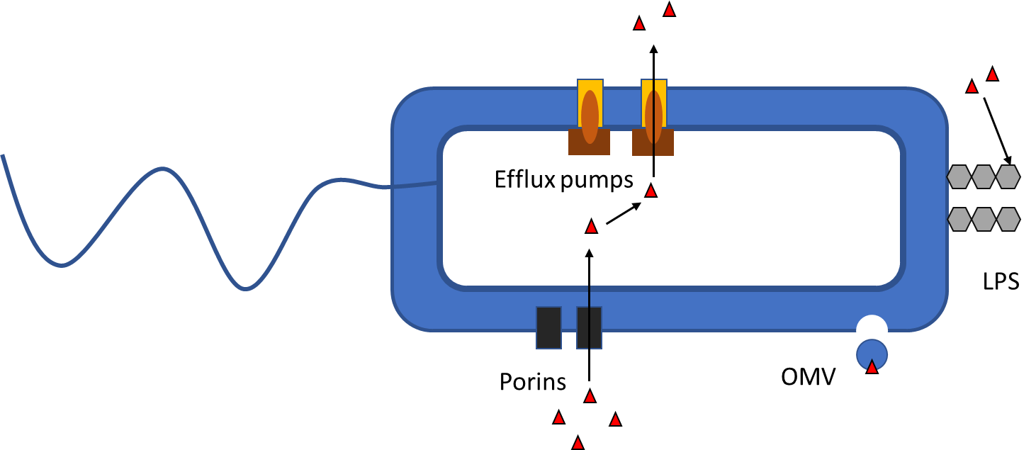
Figure 17 A schematic of a Gram-negative bacterium displaying some of the permeability barriers that potential antimicrobials must overcome (adapted from Corona and Martinez, 2013). Generic antibiotic molecules are represented by red triangles. Slow-moving porin channels can limit the number of drug molecules entering the cell and efflux pumps can expel hostile compounds. Negatively charged LPS and outer membrane vesicles (OMVs) can trap free drug molecules and limit their access to the cell.
Cama and co-workers (2019) have very recently reviewed the current methods and research avenues for better-characterising and even quantifying drug permeability in Gram-negative bacteria. Of the techniques covered in this review, notable methods of measuring antibiotic accumulation in the bacterial cell include the use of autofluorescence microscopy to monitor antibiotic levels in a single cell (Kaščáková et al., 2012), as well as the employment of mass spectrometry to track intracellular drug concentrations (Richter et al., 2017). The latter technique allowed researchers to find that flat compounds containing a primary amine were able to preferentially permeate E. coli. The use of these bacterial accumulation assays allows a better picture to be constructed on what factors are needed for good permeability and developments of this type could eventually lead to a set of rules specifically for antimicrobial drug discovery. This represents an area of research that is now vital to the efforts to tackle antimicrobial resistance on a global level.
In relation to the proposed inhibitors in work, the project will take the form of a proof of concept and major considerations of the drug-like properties of the compounds will be reserved for after inhibition can be established. However, it can be noted that the sugar-derived side chain in the proposed inhibitors imparts a level of hydrophilicity on the compounds. This can be, at such an early stage, considered an advantage as their lack of lipophilicity is in accordance with the desired properties of a potential antimicrobial drug. When coupled with the literature precedent for the activity of similar structures, as well as the potential for altering the lipophilicity when any binding characterisation is carried out in further work, the proposed inhibitors are attractive precursor candidates for future development.

Project aims
Given that the bacterial flagella are essential to motility, colonisation and pathogenicity, it follows that disabling them would be an interesting antimicrobial therapeutic option. Some bacteria, including the gastric bacteria H. pylori, C. jejuni, and A. caviae are known to glycosylate their flagella with pseudaminic acid as a vital part of flagella assembly (Josenhans and Suerbaum, 2002). The biosynthetic pathway of pseudaminic acid 6 has been elucidated (Schoenhofen et al., 2006) and target inhibitors can be identified based on the previous work carried out on the sialic acid model (Liu et al., 2009) (Figure 18).
The first goal for this project is to replicate the Tanner synthesis of the sialic acid synthase inhibitor 18. This is both a good model for the chemistry required to synthesise the PseI inhibitor 22 as well as providing an interesting test of the potential promiscuity of the PseI enzyme. It must also be determined whether the structures and relative enzymatic bindings are different enough to be sure that a pseudaminic acid synthase inhibitor would not also inhibit the synthesis of sialic acid and in doing so, harm the host.
Figure 18 The PseI inhibitor designs for this work, 22 and 23, based on the intrinsic reactivities of the oxocarbenium and tetrahedral intermediates, 28 and 29, in the PseI-catalysed conversion of deoxy AltdiNAc 13 into pseudaminic acid 6.
At the same time, the precedent set by the work of Schoenhofen et al. (2006) will be used to express and purify the pseudaminic acid biosynthetic enzymes to create a working assay with which to test the inhibitors. This project will focus on the enzymes produced by A. caviae. Whilst there is wealth of variation in the number of glycosylation genes in aeromonads, they all require the same base enzymes to generate pseudaminic acid. The A. caviae Sch3N model already developed within the group contains the simplest genomic island for glycosylation making it ideal to work with (Tabei et al., 2009; Parker et al., 2014). ¹H NMR analysis of this pathway will be examined to track individual steps in an in vitro synthesis. Eventually, kinetic studies of inhibition will be investigated by monitoring phosphate release.
Once the Tanner NeuB inhibitor 18 has been synthesised and tested for activity in the pseudaminic acid pathway, the following step is to investigate the chemical methods towards the synthesis of the tetrahedral-intermediate-based phosphonate inhibitor 23. Eventually, both this inhibitor 23 and the oxocarbenium-based phosphate inhibitor 22 will be investigated. The stereospecificity of a CFH tetrahedral analogue inhibitor should also be examined if enzyme inhibition testing points to it as a more active option. This project will aim to complement other work in the group investigating the efficient chemical synthesis of the pseudaminic acid open chain backbone, which can then be modified into the aforementioned inhibitors by the methods developed herein. Whilst the primary focus of this work is to examine if the proposed homogeny with Tanner’s inhibition model exists, some consideration should be given to the drug-like properties of the target inhibitors, notably their membrane permeability and, to some extent, their bioavailability.
Finally, any successful inhibition of PseI should be considered for application in other bacterial glycosylation mechanisms. This can be expanded to inhibit other cases of bacterial pathogenic employment of pseudaminic acid, for example in the capsules and lipopolysaccharides. Successful inhibitors can also be adapted to inhibit other PEP-condensing enzymes that produce bacterial ulosonic acids such as legionaminic acid synthase (LegI). Particular attention should be paid to pathogens which already display or are at risk of displaying AMR.

Methods and materials

Bacterial strains, plasmids, antibiotics and media
Unless otherwise stated, all media components used in this work were purchased from Oxoid or Fisher suppliers. Prior to use, all media were autoclaved for 20 minutes at 15 psi and 121 °C, followed by the addition of appropriate antibiotics or other supplements when necessary.

Luria Bertani broth (LB broth) and enriched LB broth
Luria-Bertani (LB) broth | 1% (w/v) tryptone  0.5% (w/v) yeast extract  1% (w/v) NaCl  distilled H₂O
Enriched Luria-Bertani (LB) broth | 1% (w/v) tryptone  0.5% (w/v) yeast extract  0.5% (w/v) NaCl  0.2% (w/v) glucose  distilled H₂O

Luria Bertani agar

LB agar | 1% (w/v) tryptone  0.5% (w/v) yeast extract  1% (w/v) NaCl  1.5% (w/v) agar  Distilled H₂O

Horse blood added Columbia Blood Agar (CBA)
CBA was made by the department of IICD in the University of Sheffield Medical school.

Swarming and swimming agar
Bacterial swarming agar | 1% (w/v) glucose  0.5% (w/v) Bacto agar  0.5% (w/v) peptone  0.2% (w/v) yeast extract
Bacterial swimming agar | 1% (w/v) tryptone  0.5% (w/v) NaCl  0.25% (w/v) agar

Bacterial strains
Table 1 Bacterial strains used in this work
Strain | Description
Aeromonas caviae Sch3N | Wild type for motility/MIC studies, spontaneous Nalidixic acid resistance (Gryllos et al., 2001),
Escherichia coli DH5α | Competent strain for plasmid transformation (Invitrogen),  F– endA1 glnV44 thi-1 recA1 relA1 gyrA96 deoR nupG purB20 φ80dlacZΔM15 Δ(lacZYA-argF)U169, hsdR17(r_{K}–m_{K}⁺), λ–
Escherichia coli BL21(DE3) | T7 expression strain for gene expression (Novagen), F– ompT gal dcm lon hsdS_{B}(r_{B}–m_{B}–) [malB⁺]_{K-12}(λ^{S})
Escherichia coli ER2523 | NEB express strain for MBP-fused gene expression (NEB), fhuA2 [lon] ompT gal sulA11 R(mcr73::miniTn10--Tet^{S})2 [dcm] R(zgb-210::Tn10--Tet^{S}) endA1 Δ(mcrC-mrr)114::IS10
Pseudomonas aeruginosa PAO1 | Wild type for motility studies (Stover et al., 2000)

Bacterial growth
E. coli strains were grown at 37 °C on LB agar or in LB broth cultures (with shaking at 200 rpm) with the relevant antibiotic added when necessary. A. caviae and P. aeruginosa strains were grown on CBA or LB agar at 37 °C with relevant antibiotics when necessary.

Bacterial plasmids
Table 2 Bacterial plasmids used in this work
Plasmid | Description
pET28a | T7 promoter, N-terminal HisTag, Kanamycin resistance (Novagen)
pET-PseB | A. caviae gene PseB ligated to pET28a plasmid, kanamycin resistance (Shengtao Rui and Dr Jonathan Shaw)
pET-PseC | A. caviae gene PseC ligated to pET28a plasmid, kanamycin resistance (Shengtao Rui and Dr Jonathan Shaw)
pET-PseI | A. caviae gene PseI ligated to pET28a plasmid, kanamycin resistance (Shengtao Rui and Dr Jonathan Shaw)
pET-PseF | A. caviae gene PseF ligated to pET28a plasmid, kanamycin resistance (Shengtao Rui and Dr Jonathan Shaw)
pMAL-c5x | MBP fusion promoter, ampicillin resistance (NEB)
pMAL-PseH/G | A. caviae gene PseH/G ligated to pMAL-c5x plasmid, ampicillin resistance (Shengtao Rui and Dr Jonathan Shaw)
pET-PseB_{Cj} | C. jejuni gene PseB ligated to pET28b plasmid, kanamycin resistance (Dr M. Fascione, University of York)
pET-PseI_{Cj} | C. jejuni gene PseI ligated to pET28b plasmid, kanamycin resistance (Dr M. Fascione, University of York)

All plasmids used in this study (except for pET-PseI_{Cj} and pET-PseB_{Cj}) were taken from storage at -80 °C, then after transformation into E. coli BL-21, stored at -80 °C in protect tubes. Those containing the C. jejuni gene of interest were obtained from the Fascione group at the University of York and transported on ice back to the University of Sheffield.

Antibiotics and additives
Antibiotic/additive | Final working concentration
Kanamycin (Km) | 25 µg/mL
Ampicillin (Amp) | 50 µg/mL
Chloramphenicol (Cm) | 50 µg/mL
Nalidixic acid (Nal) | 50 µg/mL
IPTG | 1 mM

Method for the preparation of competent cells
Previously prepared chemically competent E. coli BL-21 was obtained from cold storage (-80 °C) for this work. The general method used within the group is as follows:
A 10 mL overnight culture of the relevant E. coli strain was incubated at 37 °C with shaking at 200 rpm. A suspension of the overnight pre-culture (1 mL) was diluted by 1:100 in sterile broth (100 mL). This was incubated with shaking at 37 °C until an OD_{600nm} of approximately 0.3 was achieved. This culture was then divided into 50 mL plastic centrifuge tubes and cooled on ice for 15 minutes before centrifugation at 1600 xg for 20 minutes at 4 °C. After discarding the supernatant, the cell pellet was re-suspended at 1/3 of the original volume in RF1 solution (33 mL). This was cooled on ice for 15 minutes before further centrifugation at 1600 xg for 20 minutes (again at 4 °C). Finally, the resulting pellet was re-suspended in 8 mL RF2 solution and cooled on ice for 15 minutes before being split into 200 µL aliquots in cold sterile Eppendorf tubes. These aliquots were stored at -80 °C where they were recovered for this work.
RF1 solution | 100 mM KCl  50 mM MnCl  30 mM KOAc  10 mM CaCl₂
RF2 solution | 10 mM MOPS  10 mM KCl  75 mM CaCl₂

Bacterial transformation
Bacterial transformations were not necessary in most cases as previously-transformed, competent E. coli were obtained from cold storage. In the cases where transformation was necessary, it was carried out following the method detailed below:
A sterile Eppendorf tube containing 200 µL of competent E. coli BL-21 and 1-2 µL of relevant plasmid was cooled on ice for 1 h. The sample was then heat shocked in a water bath at 42 °C for 90 seconds before returning to ice for 1-2 minutes. LB broth (800 µL) was added and the tube was incubated at 37 °C with shaking at 200 rpm for 1 h (in a New Brunswick Scientific C25KC Incubator Shaker). 100 µL of the sample was spread onto agar containing the required antibiotic and the remaining sample was centrifuged at 12000 xg for 1 minute (using an Eppendorf benchtop centrifuge 5418). The supernatant was discarded, and the pellet was re-suspended in its own volume. This was spread on a separate agar plate containing the required antibiotic to give a second culture sample at higher concentration.

Protein overexpression
All plasmids containing the A. caviae protein gene of interest used for expression in this work were previously cloned by other members of the group. C. jejuni protein plasmids were obtained from collaborators at the university of York.

Expression from pET plasmids
The proteins PseB, PseC, PseI and PseF were expressed from the relevant pET28a plasmid in Escherichia coli BL21(DE3). Bacterial pre-cultures were carried out in 5-10 mL LB broth with kanamycin. These were shaken at 37 °C and 200 rpm overnight. The overnight cultures were diluted into large-scale cultures (500-2000 mL LB broth containing kanamycin) at a concentration of 1-5 mL per 500 mL. These were shaken at 37 °C and 200 rpm until an OD_{600nm} in the region of 0.3-0.6 was observed, at which point Isopropyl β-D-1-thiogalactopyranoside (IPTG) was added to a concentration of 1 mM to induce protein expression. The cultures were allowed to grow for a further 4-16 h, before being decanted into 250 mL centrifuge tubes and centrifuged for 15 minutes at 4 °C and 6000 xg (using a Beckman Coulter Avanti J-26 XP centrifuge and a JA.25.50 rotor). The pellets were separated from the supernatants, re-suspended in 25 mL binding buffer and sonicated using a Jencons LTD Vibra CellTM sonicator (8 x 30 second intervals with 1-minute cooling on ice in between each) before further centrifugation for 15 minutes at 4 °C and 30000 xg (using a JLA.16.250 rotor). The supernatants were filter sterilized through a Millipore filter and then passed through a 1 mL HisTrap column (GE Healthcare) using a 1 mL syringe. The proteins were eluted from the column with an imidazole buffer of increasing gradient (5 mL at each gradient using a 1 mL syringe).
Binding buffer (for HisTrap) | 25 mM Tris-HCl  10 mM imidazole  400 mM NaCl  distilled H₂O  pH 7.4
Imidazole elution buffers | 50-500 mM imidazole  5 M NaCl  1 M Tris-HCl  distilled H₂O

Expression from pMAL plasmid
The PseH/G protein was expressed from the relevant pMAL-c5x plasmid in E. coli ER2523 (NEB express). Expression was carried out in enriched LB broth following the same procedure as with the pET series up until the cell harvesting. After centrifugation, the cells were re-suspended in 25 mL MBP-column buffer and sonicated (10 x 15 second intervals with 1-minute cooling on ice in between each) before further centrifugation for 15 minutes at 4 °C and 30000 xg. The supernatant was filter sterilized and loaded onto a 1 mL MBPTrap column (GE healthcare) using a 1 mL syringe. The MBP-tagged protein was eluted from the column in column buffer containing 10 mM maltose (5 mL using a 1 mL syringe).
Maltose column buffer (for MBPTrap) | 20 mM Tris-HCl  200 mM NaCl  1 mM EDTA  pH 7.4
Maltose elution buffer | Column buffer (as above)  10 mM maltose

Sodium dodecyl sulphate polyacrylamide gel electrophoresis (SDS-PAGE)
Protein samples (10 µL) were boiled in laemmli buffer (10 µL) for 10 minutes and analysed on a 12% polyacrylamide SDS-PAGE gel made up of resolving and stacking gels. Electrophoresis was carried out for 30 minutes at 100 V and then for a further 1 h at 150 V in a Bio Rad Mini-PROTEAN Tetra System in 10 x SDS running buffer (using a Bio Rad Power Pac 300). Gels were stained with Coomassie Blue (30 minutes) and washed with de-stain solution (2-18 h) or using Instant Blue stain (Expedeon).
SDS-PAGE resolving gel 12% (10 mL, for two Bio Rad Mini-gels) | 4 mL 30% acrylamide  3.3 mL distilled H₂O  2.5 mL Tris-Cl pH 8.8  200 μL 10% (w/v) ammonium persulfate (APS)  100 μL 10% (w/v) sodium dodecyl sulphate SDS  7 μL tetramethylethylenediamine (TEMED)
SDS-PAGE stacking gel 12% (5 mL, for two Bio Rad Mini-gels) | 0.65 mL 30% acrylamide  3 mL distilled H₂O  1.25 mL stacking buffer  50 μL APS  5 μL TEMED
10 x SDS running buffer | 250 Mm Tris-base  1.92 M glycine  1% (w/v) SDS
SDS-PAGE Coomassie Blue stain solution | 50% methanol  2.5 g Coomassie blue  10% acetic acid  40% distilled H₂O
SDS-PAGE de-stain solution | 40% methanol  10% acetic acid  50% distilled H₂O
Laemmli buffer | 62.5 mM Tris (pH 6.8)  2% (w/v) SDS  5% (w/v) β-mercaptoethanol  10% (w/v) glycerol  0.02% (w/v) Bromophenol Blue

Protein buffer exchange and further purification
Proteins were concentrated to 1 mL using a Pierce Protein Concentrator (Pes, 3 K MWCO, 2-6 mL, Thermo Scientific) following the supplier protocol. They were then refined and buffer exchanged via gel filtration, eluting with 50 mM phosphate buffer or 20 mM Tris-Cl buffer (pH 7.4). A 5 mL gel filtration de-salting column (GE Healthcare) was used with a UV detector on an AKTA purifier at a flow rate of 1 mL/minute and the protein was collected manually.
Phosphate buffer (1 L, 100 mM stock) | 95 mL 0.2 M NaH₂PO₄.H₂O (27.6 g in 1 L dH₂O)  405 mL 0.2 M Na₂HPO₄.7H₂O (53.6 g in 1 L dH₂O)  500 mL dH₂O
Tris-Cl buffer (1 L, 1 M stock) | 157.6 g Tris Base in 1 L dH₂O  pH 7.4

Thrombin cleavage of HisTags
For the cleavage of HisTags, the proteins were first transferred into 20 mM Tris-Cl buffer (pH 7.4) using a 5 mL de-salting column on the AKTA purifier following the method detailed previously (2.4.4.). Samples were then incubated with thrombin (GE Healthcare) in Thrombin Cleavage Buffer (Novagen) at a concentration of 3-5 units/mg of protein at 4 °C overnight. Protein concentration was determined either by using a Pierce BCA Protein Assay Kit (following the supplier protocol) or using a Thermo Scientific NanoDrop A280 assay. The cleavage mixtures were swiftly passed through 1 mL HisTrap column using a 1 mL syringe and the flow-through was immediately separated from excess thrombin via gel filtration (with a 5 mL de-salting column) on the AKTA purifier with the required buffer (method as before). The HisTrap was washed with 300 mM imidazole elution buffer and any un-cleaved protein was recycled. Cleavage was monitored via SDS-PAGE and cleavage yields were determined by final mass of cleaved protein obtained.

Enzyme reactions

¹H NMR spectroscopy-monitored reactions
Enzyme reactions were carried out on a Bruker AV500 spectrometer. The enzymes were added to a solution of 8 mM UDP-GlcNAc in a phosphate buffer (10% D₂O, pH 7.3). First experiments involved the addition of PseB enzyme in a concentration of ~85 μg/mL, with and without NADP⁺ cofactor (1 mM) to assess its necessity for the enzyme activity. The attempted NMR reaction with both PseB and PseC was carried out at higher dilution with enzyme concentrations of 20 μg/mL in the presence of substrates pyridoxal phosphate (PLP) and amino donor L-glutamate (L-Glu), both at 1 mM. Experiments were conducted over 4 h with the acquisition of a spectrum approximately every 10 minutes.

LCMS-monitored enzyme reactions
Enzymes and substrates were combined in 50 mM phosphate buffer and incubated at 37 °C (Table 3). The reactions were followed by LCMS using a Waters Acquity UPLC machine fitted with a C18 column. Sugar peaks were followed on the chromatogram.
Table 3 Concentrations of the enzymes and substrates used in the LCMS reactions
Enzyme/substrate | Final concentration
PseB | - mg/mL
PseC | 0.2 mg/mL
PseH/G | 0.1 mg/mL
PseI | 0.1 mg/mL
PseF | 0.1 mg/mL
UDP-GlcNAc | 1 mM
L-glutamate | 10 mM
Pyridoxal phosphate | 2 mM
Phosphoenol pyruvate | 1.5 mM
Acetylthiocholine iodide | 60 mM

For inhibitor analysis, enzymes PseB, PseC, PseH/G and substrates UDP-GlcNAc, L-glutamate, PLP and acetylthiocholine iodide were combined in 50 mM phosphate buffer and incubated overnight at 37 °C. Complete turnover was confirmed at this stage by LCMS. PEP was added to the reaction as well the potential inhibitors (discussed later). The reactions were restarted with the addition of PseI and inhibitor efficacy was monitored by the relative intensity of the pseudaminic acid peak on the LCMS chromatogram.

Protein crystallography
For crystallography of PseI, the protein was expressed, purified, cleaved from its HisTag, and concentrated to 20 mg/mL following the above procedures. The concentrated, cleaved protein was split into 20-40 µL aliquots and flash-frozen in liquid nitrogen before packaging in dry ice and posting to Prof. Richard Lewis at the University of Newcastle for crystallography screening.

Preparation of bacterial strain for transmission electron microscopy (TEM)
Aeromonas caviae Sch3N was grown statically in 10 mL LB broth until an OD₆₀₀ of ≥1 was reached. Copper/palladium TEM grids (Agar Scientific, UK) were surface-coated in-house with a thin film of amorphous carbon. The grids were subjected to a glow discharge for 30 seconds to create a hydrophilic surface. The A. caviae dispersion (10 μL) was adsorbed onto a treated grid for 60 seconds and then blotted with filter paper to remove excess liquid. The grids were washed twice in 10 mM phosphate-buffered saline (PBS tablets from Sigma). Uranyl formate (10 μL, 0.75% w/v aqueous solution) was placed onto each loaded grid for 15 seconds and then blotted to remove excess liquid. The grids were dried using a vacuum hose. Imaging was performed using a Philips CM100 instrument operating at 100 kV and equipped with a Gatan 1k CCD camera.

Chemical syntheses
The chemical syntheses reported herein were carried out as described in the experimental section (chapter 6) at the end of this thesis.

Expression and characterisation of the A. caviae Pse enzymes

Introduction
As previously discussed (1.5.3.), the pseudaminic acid biosynthesis in A. caviae proceeds via five enzymes, of which PseI is the target for inhibition in this work. PseI catalyses the aldol condensation of deoxy AltdiNAc 13 with phosphoenol pyruvate (PEP), a by-product of which is inorganic monophosphate (P_{i}) (Scheme 4).
Scheme 4 The pseudaminic acid biosynthesis in A. caviae
Schoenhofen and co-workers (2006) characterised the full biosynthetic pathway in H. pylori. They demonstrated the first in vitro enzymatic synthesis of pseudaminic acid by combining all six of the H. pylori Pse synthase enzymes. Moreover, the work set a precedent for activity assays by monitoring product turnover by ¹H NMR spectroscopy. The ability to monitor product turnover in this one-pot reaction circumvented the necessity of having to isolate the deoxy AltdiNAc substrate 13 in order to screen for PseI inhibition. They suggested that inhibition assays could be carried out through combining the commercially available starting material UDP-GlcNAc 9 with the enzymes and relevant co-factors and any potential inhibitors, before monitoring and quantifying phosphate (P_{i}) production after incubation.
The production of P_{i} is useful for enzyme assays and can be followed via UV absorbance. A spectrophotometric assay measuring P_{i} production was reported by Webb (1992) and forms the basis of the assay used by Tanner and co-workers to measure their sialic acid synthase inhibitor (Liu et al., 2009). In this assay, 2-amino-6-mercapto-7-methylpurine ribonucleoside (MESG) 30, an analogue of guanosine, gives an increase in UV absorbance at 360 nm when phosphorolysed with P_{i} in the presence of the purine nucleoside phosphorylase enzyme (Scheme 5).
Scheme 5 The phosphorylation of MESG 30 as a potential means of following P_{i} production. There is an increase in absorbance as a function of pH (Webb, 1992).
This reaction follows Michaelis-Menten kinetics and provides a quantification for the production of phosphate and therefore also provides a quantification for the inhibition of a phosphate-producing enzyme such as PseI. This work will examine alternative means of testing inhibition, but future work will ultimately aim to couple these with this spectrophotometric approach.
As previously discussed, the rationale for the inhibitor design in this work comes from the work carried out by Tanner et al. in inhibiting the N. meningitidis NeuB enzyme. Although it is reasonable to expect that the inhibitors proposed in this work will have a similar activity and binding affinity with PseI to Tanner’s with NeuB, the phylogeny of the two enzymes should be considered and their structures compared.
Extensive phylogenetic analysis of the nonulosonic acid biosynthetic pathway has been carried out by Lewis et al. (2009). The work revealed an extensive history of sialic acid biosynthesis across bacteria, archaea and eukarya, suggesting many complex evolutionary pathways. In bacteria, the legionaminic acid and sialic acid biosynthetic pathways are closely related such that one is proposed to have derived from the other. Pseudaminic acid biosynthesis also shares a similar genomic identity. A common feature of all the nonulosonic acid synthesis pathways, besides starting with UDP-GlcNAc, is the presence of PEP-condensing enzyme such as PseI. It is suggested that the bacterial synthesis and extracellular display of these sialic acid-derived sugars might be a type of mimicry designed to aid colonisation of host environments. The close evolutionary link between the enzymes associated with pseudaminic acid and sialic acid biosynthesis serves to strengthen the proposal for a PseI inhibition model based on that of NeuB.
Sequence comparison for a selection of NeuB-related enzymes from different bacteria was carried out in order to assess general similarities as well as allowing for direct comparison of active site residues (Figure 19). The active site residues that were determined to play a role in N. meningitidis NeuB binding of ManNAc substrate and inhibitor are highlighted, these were identified from the work by Tanner et al. (2009) and can be seen in the active site crystal structure (Figure 20). Of the highlighted residues associated with active site binding in NeuB, 79% are the same in PseI (from all species). This includes the residues that bind to the phosphate group in phosphoenol pyruvate (Lys53, Lys129, Ser132, Ser154 and Ser213) and those bound to the active site Mn²⁺ metal ion (His215 and His236), which would be predicted to be constant in all cases. Others that are in common are associated with binding to the backbone hydroxyl groups that share the same orientation in pseudaminic acid, legionaminic acid and sialic acid (e.g. Asp247).
NeuB _{N. meningitides} 1 --MQNNNEFKIGNRSVGYNHEPLIICEIGINHEGSLKTAFEMVDAAYNAGAEVVKHQTHI
NeuB _{C. jejuni} 1 ------MQIKIDK-LTISQKNPLIIPEIGINHNGSLEIAKLMVDAAKRAGAKIIKHQTHI
LegI _{C. jejuni} 1 ------------------MKKTLIIAEAGVNHNGDLNLAKKLIEIAADSGADFVKFQSFK
PseI _{A.caviae} 1 MDKIIKPFITINGRKIGPDYPPYIIAELSANHNGDINRAFAIMEEAKKAGADAIKLQTYT
PseI _{H. pylori} 1 -----------------MLQPPKIVAELSANHNQDLNLAKESLHAIKESGADFVKLQTYT
PSeI _{C. jejuni} 1 ----------MQIGNFNTDKKVFIIAELSANHAGSLEMALKSIKAAKKAGADAIKIQTYT
NeuB _{N. meningitides} 59 VEDEMSDEAKQ---VIPGN--ADVSIYEIMERCALNEEDEIKLKEYVESKGMIFISTLFS
NeuB _{C. jejuni} 54 VEDEMSQEAKN---VIPGN--ANISIYEIMEQCALNYKDELALKEYVEKQGLVYLSTPFS
LegI _{C. jejuni} 43 AKNCISTKAKKAPYQLKTTANDESQ-LQMVQKLELDLKAHKELILHAKKCNIAFLSTPFD
PseI _{A.caviae} 61 A-DTITFECDSEEFQIHGGLWDGKNLYQLYKEAQMPWEWHQPLFEKAKELGITIFSSPFD
PseI _{H. pylori} 44 P-SCMTLNSKEDPFIIQGTLWDKENLYELYQKASTPLEWHAELFELARKLDLGIFSSPFS
PSeI _{C. jejuni} 51 P-DSLTLNSDKEDFIIKGGLWDKRKLYELYESAKTPYEWHSQIFETAQNEGILCFSSPFA
NeuB _{N. meningitides} 114 RAAALRLQRMDIPAYKIGSGECNNYPLIKLVASFGKPIILSTGMNSIESIKKSVEIIREA
NeuB _{C. jejuni} 109 RAAANRLEDMGVSAYKIGSGECNNYPLIKHIAQFKKPMIISTGMNSIESIKPTVKILRDY
LegI _{C. jejuni} 102 LESVDLLNELGLKIFKIPSGEITNLPYLKKIAKLNKKIILSTGMANLGEIEEALNVLCKN
PseI _{A.caviae} 120 FTAVDLLEDLDAPAYKIASFELIDLPLIKRVAQTGKPMIMSTGMANAEEIAEAIATAQSN
PseI _{H. pylori} 103 SQALELLESLNCPMYKIASFEIVDLDLIEKAARTQKPIILSSGIATHTELQDAISLCRRV
PSeI _{C. jejuni} 110 KEDVEFLKRFDPIAYKIASFEANDENFVRLIAKEKKPTIVSTGIATEEELFKICEIFKEE
NeuB _{N. meningitides} 174 ---GVPYALLHCTNIYPTPYEDVRLGGMNDLSEAFPDAIIGLSDHTLDNYACLGAVALGG
NeuB _{C. jejuni} 169 ---EIPFVLLHTTNLYPTPSHLVRLQAMLELYKEF-NCLYGLSDHTTNNLACIGAIALGA
LegI _{C. jejuni} 162 GAKRQNITLLHCTTEYPAPFNEVNLKAMQSLKDAF-KLDVGYSDHTRGIHISLAAVALGA
PseI _{A.caviae} 180 --GCQELVVLHCVSGYPAPADQYNLRTIADMAERF-GVLSGLSDHTIDNATAVAAVALGA
PseI _{H. pylori} 163 --NNFDITLLKCVSAYPSKIEDANLLSMVKLGEIF-GVKFGLSDHTIGSLCPILATTLGA
PSeI _{C. jejuni} 170 --KNPDLVFLKCTSTYPTAIEDMNLKGIVSLKEKF-NVEVGLSDHSFGFLAPVMAVALGA
NeuB _{N. meningitides} 231 SILERHFTDRMDRPGPDIVCSMNPDTFKELKQGAHALKLARGGKKDTIIAGEKPTKDFAF
NeuB _{C. jejuni} 225 SVLERHFTDTMDRKGPDIVCSMDESTLKDLINQTQEMVLLRGDNNKNPLKEEQVTIDFAF
LegI _{C. jejuni} 221 CVIEKHFTLDKNMSGPDHKASLEPQELKMLCTQIRQIQKAMGDGIKKASKSEQKNINIVR
PseI _{A.caviae} 237 CLIEKHVTMDRNGGGADDSFSLEPHELAALCKDAKTAWSALGSVNYTRTEA-EKGNVKFR
PseI _{H. pylori} 220 SMIEKHFILNKSLQTPDSAFSMDFNGFKSMVEAIKQSVLALGEEEPRINPKTLEKRRFFA
PSeI _{C. jejuni} 227 RVIEKHFMLDKSIESEDSKFSLDFDEFKAMVDAVRQAESALGDGKLDLDEKVL-KNRVFA
NeuB _{N. meningitides} 291 ASVVADKDIKKGELLSGDNLWVKRPGNGDFSVNEYETLFGKVAACNIRKGAQIKKTDIE-
NeuB _{C. jejuni} 285 ASVVSIKDIKKGEILSMDNIWVKRPSKGGISAKDFEAILGKRAKKDIKNNIQLTWDDFE-
LegI _{C. jejuni} 281 KSLVAKKDIKKGEIFSEGNLTTKRPANG-ISAMRYEEFLGKIATKNYKEDELIRE-----
PseI _{A.caviae} 296 RSLYVIRDIKAGDVLSNDNVRSIRPGFG-LAPKYLEQVLGKTAIVDIKRGTPLSFEFI--
PseI _{H. pylori} 280 RSLFVIKDIQKGEALTENNIKALRPNLG-LHPKFYKEILGQKASKFLKANTPLSADDIER
PSeI _{C. jejuni} 286 RSLYASKDIKKGEMFSEENVKSVRPSFG-LHPKFYQELLGKKASKDIKFGDALKQGDFQ-
NeuB _{N. meningitidis} --
NeuB _{C. jejuni} --
LegI _{C. jejuni} --
PseI _{A.caviae} --
PseI _{H. pylori} 339 SL
PSeI _{C. jejuni} --

Figure 19 Sequence alignment for NeuB from N. meningitidis, NeuB from C. jejuni, LegI from C. jejuni, PseI from A. caviae, PseI from H. pylori and PseI from C. jejuni. Active site residues identified in binding to Tanner’s inhibitor and substrate are highlighted. Those in common with PseI are highlighted in yellow, those that differ are highlighted in green. Highlighted in red are residues in common between all 3 PseI enzymes that are not shared with the NeuB (and LegI) enzymes, these indicate structural differences most likely associated with the difference in substrate shape of AltdiNAc compared with ManNAc. Figure generated using clustalw.
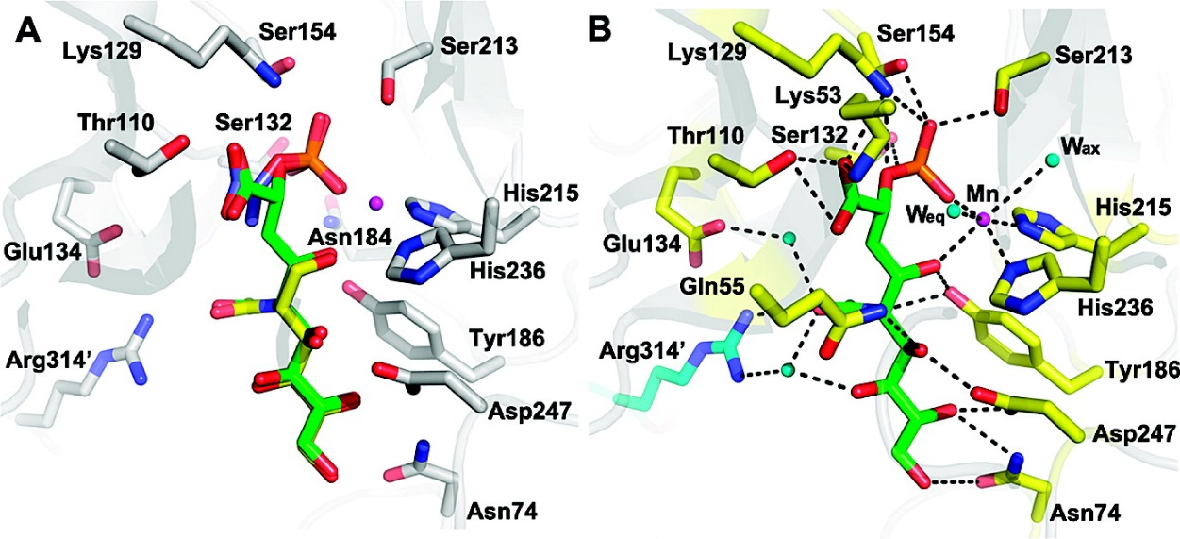

Figure 20 Figure from the previous work on NeuB inhibition (Liu et al., 2009). A The active site residues lined up with Tanner's NeuB inhibitor (yellow carbons) overlaid on top of the enzyme substrate (green carbons) showing the binding and shape similarities of the inhibitor and substrate. B the residues in binding (represented by dashed lines) with the ManNAc and PEP substrates as well as the Mn metal atom (purple) and surrounding water molecules (turquoise).
Key active site residue differences can be equated with structural differences in the substrate side chains. For example, the terminal hydroxyl group present in the NeuB substrate and Tanner’s inhibitor hydrogen-bonds with the Asn74 residue. This residue is not present in the PseI and LegI enzymes as their substrates have a terminal methyl group. Interestingly, this residue differs in the different PseI enzymes (between Thr and Gly), this may be due to evolution to bind different substrates. The residues highlighted in red indicate conserved residues in the PseI enzymes that are not shared by the NeuB (and LegI) enzymes. These are likely due to slight active site conformational changes to account for the structural differences in the sugar substrates.
Comparison of the secondary structure was also examined between the PseI and NeuB enzyme. Sequence alignment of the two enzymes including secondary structural features from the solved NeuB crystal structure was performed (Figure 21). Comparisons of this type were previously carried out in work by Gunawan et al. (2005) and they discussed the Pro313 residue (conserved between the two enzymes) as playing a structural role in the active site for correct substrate positioning. This Pro313 residue is adjacent to the Arg314 residue which (as seen in Figure 20) binds to the N-acetyl group in the NeuB substrate. It has been indicated that the presence of this N-acetyl side chain is key for good binding to the NeuB enzyme and that longer acyl side chains were detrimental to binding. It is thought that the Pro313 residue helps create a tight binding conformation around the substrate and that longer N-acyl side chains would require significant conformational changes. It appears that not only are important binding residues conserved between the NeuB and PseI enzymes, but important structural residues are also conserved.
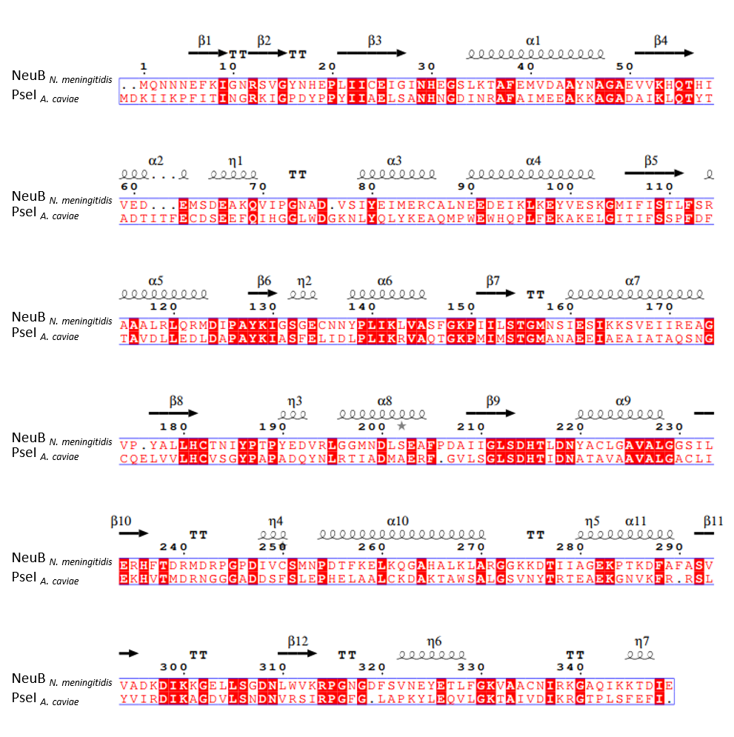
Figure 21 Structure alignment between NeuB (N. meningitidis) and PseI (A. caviae) with NeuB secondary structural features above. α-Helices (α) and 3₁₀-helices (η) are represented with a looped line, strict β-turns with TT and β-sheets with an arrow. Figure generated using MultAlin and Espript http://espript.ibcp.fr.
In addition to sequence alignments, the predicted crystal structure of PseI (generated using Phyre2) was compared with that of NeuB. The two structures overlaid perfectly and the predicted active site pocket for PseI corresponded with the bound substrate in the NeuB active site (Figure 22).
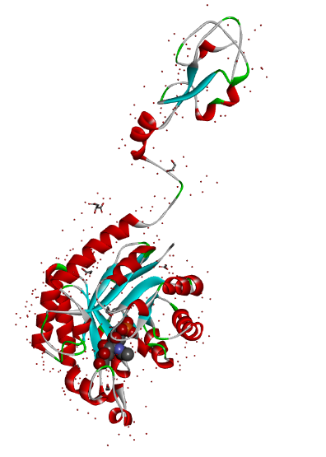
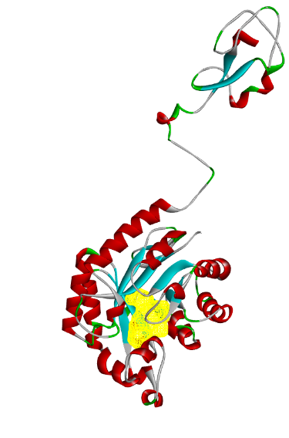
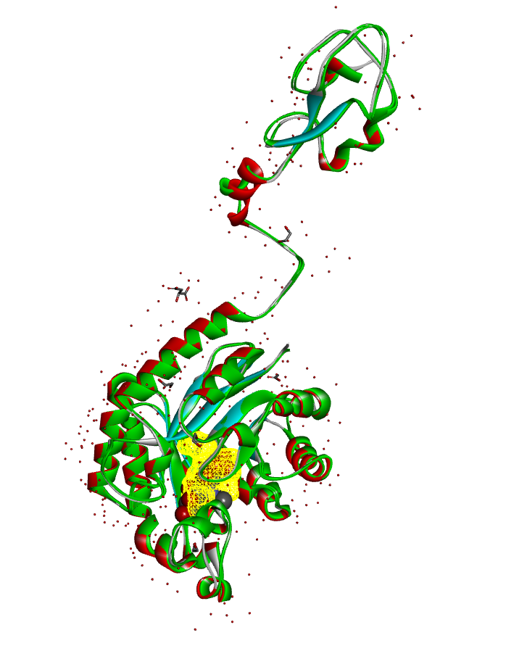
PseI overlay NeuB
Figure 22 Phyre2 predicted structure of PseI with predicted yellow binding pocket (left), NeuB structure (right) and overlay of Tanner's NeuB (standard colours) and PseI A. caviae (green) (centre). Tanner's inhibitor is bound in the NeuB structure which corresponds to the yellow binding pocket of the PseI structure.
Whilst this again supports the argument for the homology between the enzymes and therefore the homology in their inhibition, it should not be treated as significant evidence as it is likely that the predicted PseI structure was based upon the existing NeuB crystal data. This project has set in motion the acquisition of a true crystal structure for the A. caviae PseI enzyme, the details of which are discussed in this chapter, which could be used for future docking studies with the proposed inhibitors.
It is fair to conclude from the sequence comparison of NeuB and PseI that the precedent in NeuB inhibition set by Tanner et al. should be reproducible PseI. The overall structures (NeuB from N. meningitidis and PseI from A. caviae) may only share a 23% sequence similarity but the active sites appear to be largely homogenous and therefore an inhibitor tailored to PseI should display a similar activity to that of Tanner’s NeuB inhibitor.
It should be noted that C. jejuni contains all three of the NeuB, LegI and PseI enzymes which helps highlight that, despite the close similarities in active site residues, the individual enzymes are unlikely to be promiscuous between the different nonulosonic acid sugars and that the inhibitor structural differences should be adequate to ensure targeted binding. This is further evidenced in work by Tabei et al. (2009), in which an A. caviae pseI-negative mutant was successfully complemented by PseI from C. jejuni but not by NeuB or LegI.

Results and discussion
With the target enzyme identified as PseI, in order to test any potential small-molecule inhibitors, an active pathway of enzymes is required. In addition to needing active PseI, the preceding enzymes would be necessary to produce in situ the deoxy AltdiNAc substrate 13 required for the assay as this is not readily available.

Enzyme expression
All enzymes were expressed in E. coli BL-21 or NEB strain ER2523. Where relevant, the bacterial transformations were carried with the pET28a plasmid containing the relevant gene (coded in previous work within the group and stored at -80 °C). Initial solubility issues with the PseH/G enzyme resulted in the use of the pMAL-c5X (NEB) plasmid to produce the enzyme fused with maltose-binding protein (MBP). This significantly increased the protein mass relative to the others (Table 4). Contrary to this, PseF has a comparatively lower mass.
Table 4 A table of the comparative sizes of the proteins expressed in this work (including their tags).
Protein (tag included) | Mass (kDa)
PseB (HisTag) | 40
PseC (HisTag) | 45
PseH/G (MBPTag) | 99
PseI (HisTag) | 41
PseF (HisTag) | 28

The four enzymes (PseB, PseC, PseI, PseF) containing histidine tags (HisTags) were expressed from the appropriate pET vector. These were purified via nickel column chromatography (HisTrap) and eluted with a gradient of column buffer containing imidazole. The PseH/G enzyme was purified with the aid of a sepharose column (MBPTrap) and eluted with a gradient of maltose-containing buffer. Purification gels for each of the 5 enzymes are shown (Figure 23-Figure 27). Buffer exchange of all five enzymes was carried out via gel filtration (GF) chromatography using a 5 mL de-salting column at a flow rate of 1 mL/min.
1 2 3 4 5 6 7 8 9 10 11
KDa
190-
135-

100-
75-

58-

46-

32-

25-
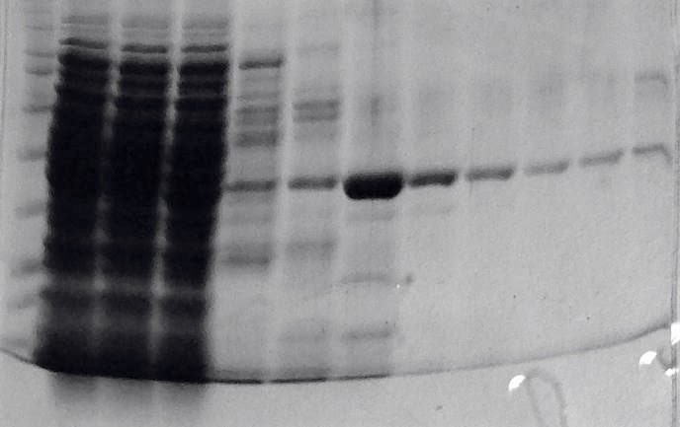
Figure 23 Purification gel for PseB. The protein was harvested and filter-sterilised before being loaded onto a HisTrap column and eluted with a gradient of imidazole. Lane 1 pellet, lane 2 filtered supernatant, lane 3 HisTrap flow through, lane 4 50 mM imidazole, lane 5 100 mM imidazole, lane 6 150 mM imidazole, lane 7 200 mM imidazole, lane 8 250 mM imidazole, lane 9 300 mM imidazole, lane 10 400 mM imidazole, lane 11 500 mM imidazole.
KDa
190-
135-
100-
75-
58-

46-

32-

25-
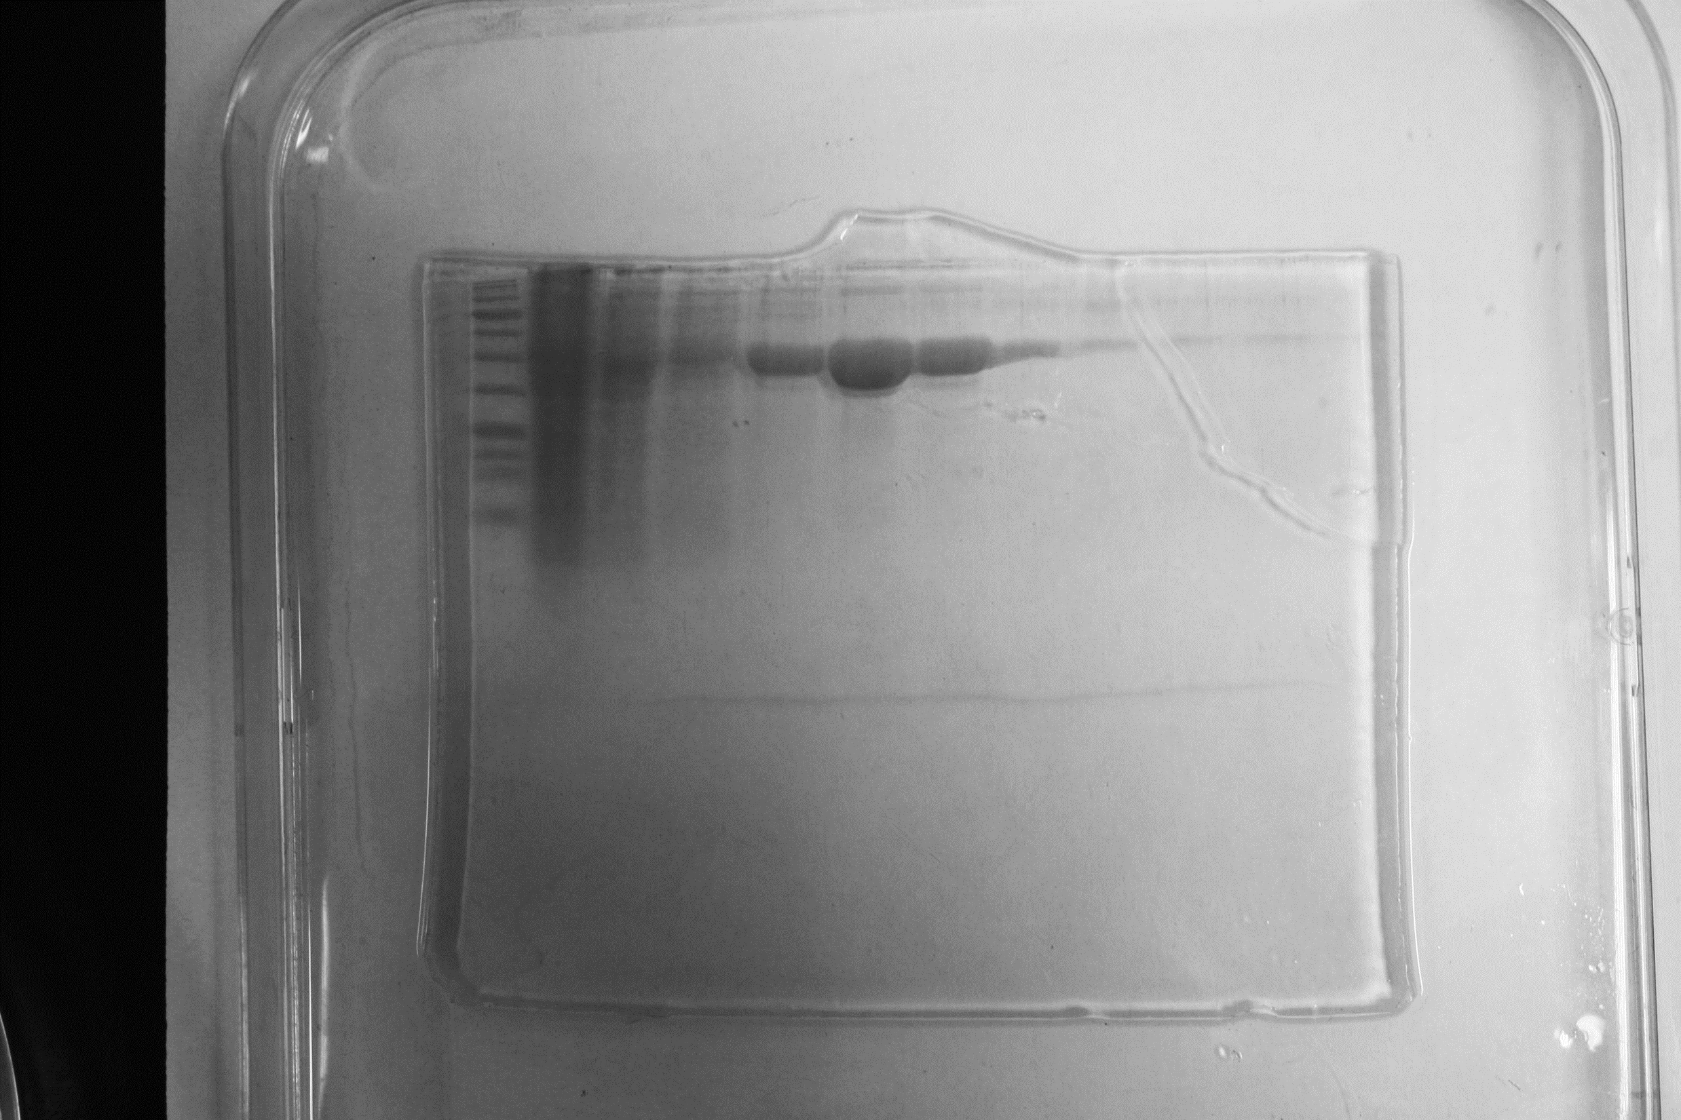
1 2 3 4 5 6 7 8 9 10 11
Figure 24 Purification gel for PseC. The protein was harvested and filter-sterilised before being loaded onto a HisTrap column and eluted with a gradient of imidazole. Lane 1 pellet, lane 2 filtered supernatant, lane 3 HisTrap flow through, lane 4 50 mM imidazole, lane 5 100 mM imidazole, lane 6 150 mM imidazole, lane 7 200 mM imidazole, lane 8 250 mM imidazole, lane 9 300 mM imidazole, lane 10 400 mM imidazole, lane 11 500 mM imidazole.

KDa
190-
135-
100-
75-
58-

46-

32-

25-
1 2 3 4 5 6 7 8 9 10 11
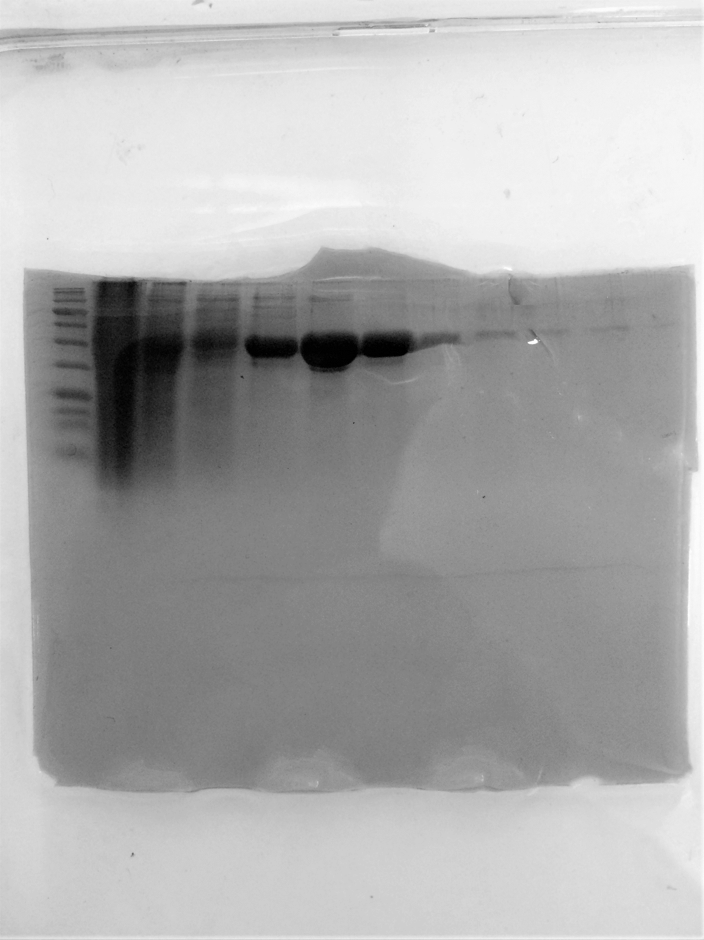
Figure 25 Purification gel for PseI. The protein was harvested and filter-sterilised before being loaded onto a HisTrap column and eluted with a gradient of imidazole. Lane 1 pellet, lane 2 filtered supernatant, lane 3 HisTrap flow through, lane 4 50 mM imidazole, lane 5 100 mM imidazole, lane 6 150 mM imidazole, lane 7 200 mM imidazole, lane 8 250 mM imidazole, lane 9 300 mM imidazole, lane 10 400 mM imidazole, lane 11 500 mM imidazole.

KDa
190-
135-
100-

75-

58-

46-

32-

25-
1 2 3 4 5 6 7 8 9 10 11
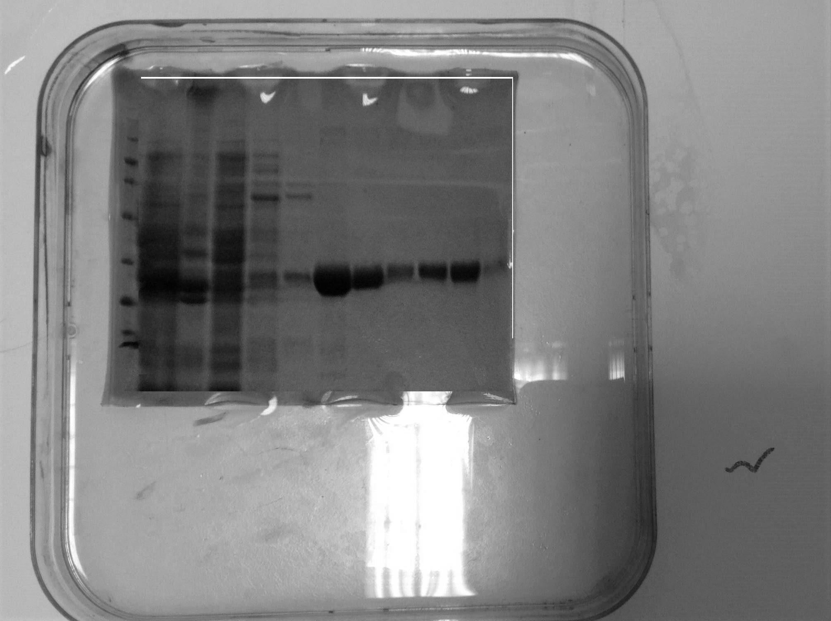
Figure 26 Purification gel for PseF. The protein was harvested and filter-sterilised before being passed loaded onto a HisTrap column and eluted with a gradient of imidazole. Lane 1 pellet, lane 2 filtered supernatant, lane 3 HisTrap flow through, lane 4 50 mM imidazole, lane 5 100 mM imidazole, lane 6 150 mM imidazole, lane 7 200 mM imidazole, lane 8 250 mM imidazole, lane 9 300 mM imidazole, lane 10 400 mM imidazole, lane 11 500 mM imidazole.

PseH/G was purified via the use of an MBPTrap column (as described in Chapter 2).
KDa

190-
135-

100-

75-

58-

46-

32-

25-
1 2 3 4 5
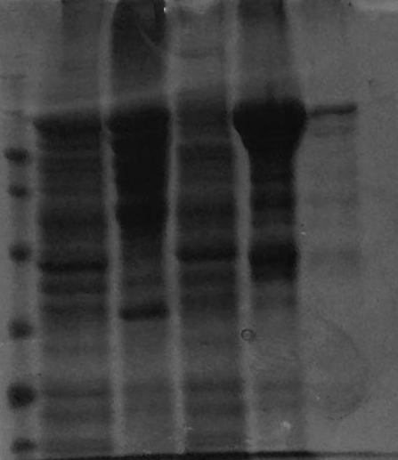
Figure 27 Purification gel for PseH/G. The protein was harvested and filter-sterilised before being loaded onto a MBPTrap column and eluted with 10 mM maltose-containing column buffer. Lane 1 pellet, lane 2 filtered supernatant, lane 3 MBPTrap flow through, lane 4 column buffer wash, lane 5 elution with 10 mM maltose.

Expression of the PseB enzyme presented difficulties from the beginning as the strain did not fit the same growth time profile as for the expression of the other proteins. To optimise the timing for IPTG induction of the pET-PseB strain, growth curves were recorded for varying concentrations of overnight preculture in 500 mL LB broth (Figure 28). It was found that at a concentration of 1% overnight culture the pre-exponential growth time points corresponded best with those of the other enzymes grown via standard protocol (0.2% overnight culture). The pET plasmid used contains resistance to the antibiotic kanamycin and addition of this into the media was kept constant at a final concentration of 10 μg/mL.
b
a
d
c
Figure 28 Growth curves for transformed E. coli BL-21 and ER2523 for the expression of a PseB, b PseC, c PseH/G, d PseI. LB broth was incubated with the relevant bacteria and antibiotics. These were incubated at 37 °C with shaking. IPTG was added when an OD₆₀₀ of approximately 0.5 was reached (2-4 h) and time points were taken until an OD₆₀₀ of ≥1.5 was observed (approximately 7 h).
Despite this optimisation of growth time, the expression of PseB was still low-yielding. It was considered that, when induced with IPTG, the bacteria were producing the PseB protein too quickly, resulting in a lack of protein solubility. This was backed up by the presence of a large amount of insoluble protein left in the cell pellet after sonication. In order to address this, the bacteria were grown at 30 °C instead of 37 °C to slow growth and protein production. This significantly improved the yield of protein produced.
With the optimised PseB expression conditions, it was possible to express and purify all of the enzymes in the A. caviae pseudaminic acid biosynthetic pathway, including PseF which was not actually required for potential inhibition assays (Figure 29).
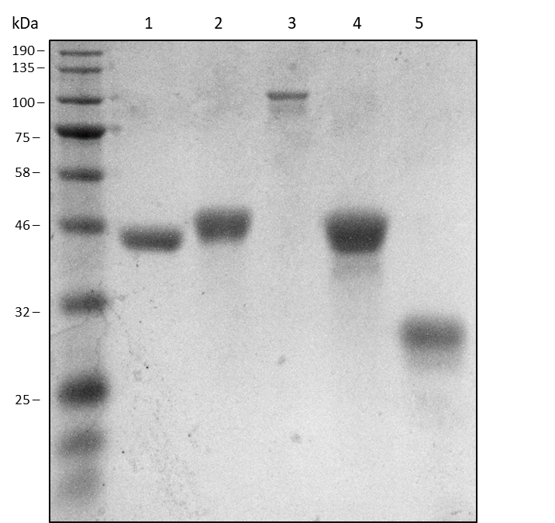
Figure 29 12% SDS-PAGE gel of all five expressed proteins: PseB (lane 1), PseC (lane 2), PseH/G (lane 3), PseI (lane 4), and PseF (lane 5). All proteins were expressed and purified before being buffer exchanged into 50 mM phosphate buffer. They were concentrated to 0.5 mg/mL and treated with Laemmli buffer before gel loading. The gel was stained with InstantBlue.
Initial enzyme activity trials were explored. Replication of the precedent (Schoenhofen et al., 2006) to monitor activity via ¹H NMR spectroscopy was trialled in the first instance.

Enzyme activity: NMR experiment
With the five enzymes in hand, ¹H NMR spectroscopy was initially employed using only UDP-GlcNAc 9 and the purified PseB enzyme in an attempt to monitor the substrate conversion into the ketone 10 (Scheme 6).
Scheme 6 The PseB-mediated transformation of UDP-GlcNAc 9 into the ketone 10.
The UDP- GlcNAc was dissolved in 10% D₂O phosphate buffer in the NMR tube before addition of the enzyme at a final concentration of 85 μg/mL. A spectrum was taken every 10 minutes for 4 hours and revealed no reaction had occurred. The protein was re-expressed and the NMR reaction repeated, this time with the addition of NADPH (1 mM) as a cofactor to determine whether it was needed for activity. Previous crystallography studies of the PseB enzyme in H. pylori found that the NADPH cofactor bound tightly to the active site. Therefore the addition of it was not necessary for turnover as it was already present (Ishiyama et al., 2006; Schoenhofen et al., 2006). In this case (with the addition of NADPH), again no change was observed in the spectral data over 4 hours.
It was previously found (Morrison, Schoenhofen and Tanner, 2008a) that a hydrate by-product 33 (Scheme 7) can be formed by re-hydration of the PseB-catalysed dehydrated ketone product 10. The ketone can also undergo epimerisation at the C-5 centre 34 to no longer be turned over by PseC. It was therefore demonstrated that PseB and PseC turnover is easier to monitor when carried out with both enzymes in a one-pot fashion. Furthermore, a 10-fold excess of PseC is optimal to force turnover to the PseC-catalysed amino product 11.
Scheme 7 The potential by-products that can form after the initial dehydration of UDP-GlcNAc 9 adapted from Morrison et al. (Morrison, Schoenhofen and Tanner, 2008b). Hydration can occur to form the diol 33 and epimerisation of the C-5 methyl group is also possible to form the unreactive epimer 34.
With this in mind, the NMR reaction was repeated with PseB and said 10-fold excess of PseC, but without success. At this point it was concluded that further investigation into PseB was needed to confirm its activity.

Enzyme activity: LCMS experiment
After the unsuccessful ¹H NMR assay, LCMS was employed to investigate activity. This was achieved as part of a collaboration with the Fascione group at the University of York who have assembled a working LCMS assay with their C. jejuni series of Pse enzymes. It was subsequently concluded that all enzymes in the A. caviae biosynthetic pathway from this work, except for the PseB, were active (Figures 30-32).
UDP-GlcNAc 9
a
b
Figure 30 MS data courtesy of the Fascione group in York: No turnover of UDP-GlcNAc 9 was observed after incubation with PseB_{Ac} (from this work) and PseC_{Cj} (from collaborators) after 4 h a and after 16 h b.
The PseB enzyme from this work (PseB_{Ac}) was shown to be inactive with no UDP-GlcNAc turnover observed when used with the collaborating group’s active PseC enzyme (PseC_{Cj}) (10-fold excess) (Figure 30, b). The PseB_{Ac} was then substituted with the active analogue (PseB_{Cj}) provided by the collaborators and tested in sequence with each of the other enzymes in the biosynthetic pathway that were expressed in this work (Ac). This showed that all other enzymes were displaying activity (with varying conversion), bringing the UDP-GlcNAc 9 through to the CMP-pseudaminic acid final product 14 (Figures 31-32).
UDP-4-amino-4,6-dideoxy-β-L-AltNAc 11
UDP-GlcNAc 9
c
d
Figure 31 MS data courtesy of the Fascione group in York: PseB_{Cj} (from collaborators) and PseC_{Ac} (from this work) catalysed successful yet incomplete turnover of UDP-GlcNAc 9 into UDP-amino-4,6-dideoxy-β-L-AltNAc 11, c. The subsequent addition of PseH/G (from this work) showed disappearance of the AltNAc product 11, d.
After the addition of PseH/G_{Ac} to the PseC_{Ac} product mixture, the disappearance of the 589 g mol⁻¹ PseC product peak was observed, suggesting it was being turned over by the PseH/G enzyme. However, the PseH/G product peak for the 2,4-diacetamido-2,4,6-trideoxy-β-L-altropyranose (deoxy AltdiNAc) 13 (246 g mol⁻¹) was not observed (Figure 31, d). This could be due to the PseH/G_{Ac} enzyme from this work being bifunctional and performing the tasks (N-acetylation and UDP-cleavage respectively) of both the PseH_{Cj} and PseG_{Cj} enzymes from the C. jejuni series and hence a wider range of side-products could be observed with varying degrees of conversion. The addition of the subsequent PseI enzyme to this showed clear turnover to pseudaminic acid 6 (Figure 32, e). Notably, this also confirmed that the uncleaved MBP bound to the PseH/G_{Ac} did not affect its activity. Finally, the PseF_{Ac}-mediated conversion of pseudaminic acid into the CMP-modified sugar 14 was also observed (Figure 32, f).

Pseudaminic acid 6
CMP-Pseudaminic acid 14
e
f
Figure 32 MS data courtesy of the Fascione group in York: PseI_{Ac} (from this work) further turned over the product to Pseudaminic acid 6, e and finally PseF_{Ac} (from this work) converted Pseudaminic acid into CMP-Pseudaminic acid 14, f
It should be noted that there were some issues with the stability of the components in the one-pot assay. The PseC, PseI and PseF enzyme expressions were all high-yielding and the enzymes themselves could be reliably stored at -80 °C for at least 3 months (an example duration between consecutive assays carried out at the University of York) whilst still retaining their activity. However, it was found that, when stored in the same way, PseH/G was no longer active. In addition to a lack of long-term stability, PseH/G expression was also low yielding. Both factors could be a result of the fact that the enzyme is bound to MBP due to original solubility issues. These problems were simply overcome by freshly expressing (on a reasonable scale for the yield of enzyme) the PseH/G before subsequent assays. The PseB enzyme also presented with issues of stability and expression yield which were considered to be a side effect of its lack of activity (discussed in detail below).
After its confirmation, the cause of the inactivity of PseB was investigated. It has been previously elucidated by crystallography that the PseB enzyme adopts a predominantly α-helical secondary structure (Ishiyama et al., 2006). Circular dichroism was employed to assess the structure of the inactive PseB and showed a characteristic α-helix curve (Figure 33).
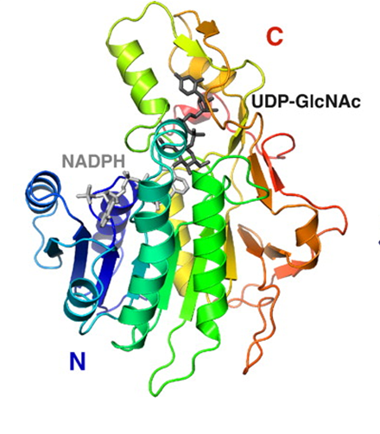
Figure 33 CD spectrum showing characteristic α-helix minima for PseB (from this work) and the crystal structure of H. pylori PseB from work by Ishiyama et al. (2006) displaying the protein folding with the locations of its C and N termini as well as the tightly-bound NADPH cofactor and the UDP-GlcNAc biding site. No control was employed in the CD but a negative control of denatured protein could have been used.
This provided evidence against misfolding as an explanation for lack of activity. Previous structural characterisation of PseB also shows that it adopts a hexameric (six aggregating units) quaternary structure for activity (Ishiyama et al., 2006) (Figure 34). It was considered that the HisTag in this work may be interfering with the ability of the enzyme to aggregate with other units.
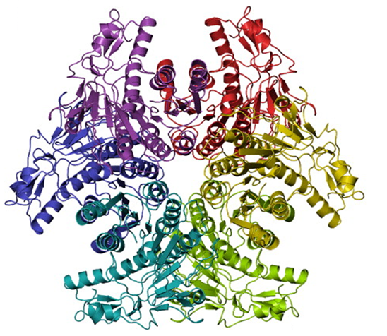
Figure 34 Ribbon representation of the PseB hexamer aggregate produced by Ishiyama et al. (2006) following gel filtration, dynamic light scattering and electron microscopy studies. Each protein unit is shown as a different colour.
The N-terminal tag including the HisTag employed is approximately 20 amino acid residues in length. However, previous literature examples have shown activity with the tag still on (Schoenhofen et al., 2006) and the N-terminus is not buried in the hexamer, but relatively peripheral. Nevertheless, HisTag-cleavage was investigated with thrombin, as the HisTag used incorporates a thrombin cleavage site.
The thrombin cleavage of PseB was achieved via incubation at 25 °C for 16 h. The extent of thrombin cleavage was confirmed by elution of the PseB protein through a “reverse-nickel” column whereby the cleaved protein washed straight through a HisTrap column and was present in the flow through lane of the SDS-PAGE (Figure 35). It should be noted that the mass difference between cleaved and uncleaved protein was not always evident by SDS-PAGE. This mass difference is easier to observe when the gel is allowed to run for longer than optimum time periods and can be seen later in this work. Some uncleaved protein was found to be present (lane 3) in a wash with 300 mM imidazole eluent and was recycled.
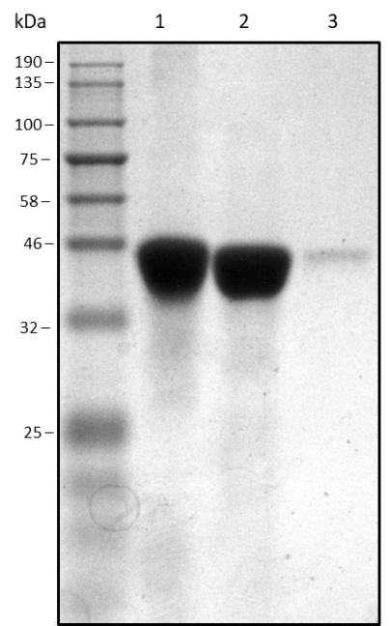
Figure 35 12% SDS-PAGE gel for the cleavage of PseB: reference uncleaved PseB (lane 1), cleaved PseB from the HisTrap flow-through (lane 2), uncleaved PseB from the 300 mM imidazole elution (lane 3). A sample of uncleaved protein was reserved as a reference and the rest was cleaved following the conditions reported. After cleavage, the protein was passed through the HisTrap column with the flow-through containing cleaved protein and the 300 mM elution containing any uncleaved protein for recycling.
Uncleaved and cleaved protein were separated via elution through a HisTrap column and uncleaved protein was recycled for further cleavage. It was found that, when left in the presence of thrombin for extended periods (72 h or more), PseB is completely broken down by the enzyme. Thus, the cleaved protein from the flow-through was immediately separated from thrombin via gel filtration with a de-salting column. Eventually enough cleaved PseB was isolated for further activity testing.
The activity of the cleaved PseB was tested following the same LCMS methods as previous activity assays. Cleaved PseB_{Ac} from this work was incubated with UDP-GlcNAc 9 and the relevant cofactors and either PseC_{Ac} from this work or PseC_{Cj} from the collaborators. PseB_{Cj} and PseC_{Ac} were also combined as a positive control. It was found that the cleaved PseB_{Ac} was still inactive and after 24 h incubation, no turnover from UDP-GlcNAc 9 (606 g mol⁻¹) was observed (Figure 36, a). PseC_{Ac} was confirmed to still be active and when incubated with PseB_{Cj}, turnover to the AltNAc product 11 (589 g mol⁻¹) was seen (Figure 36, b).
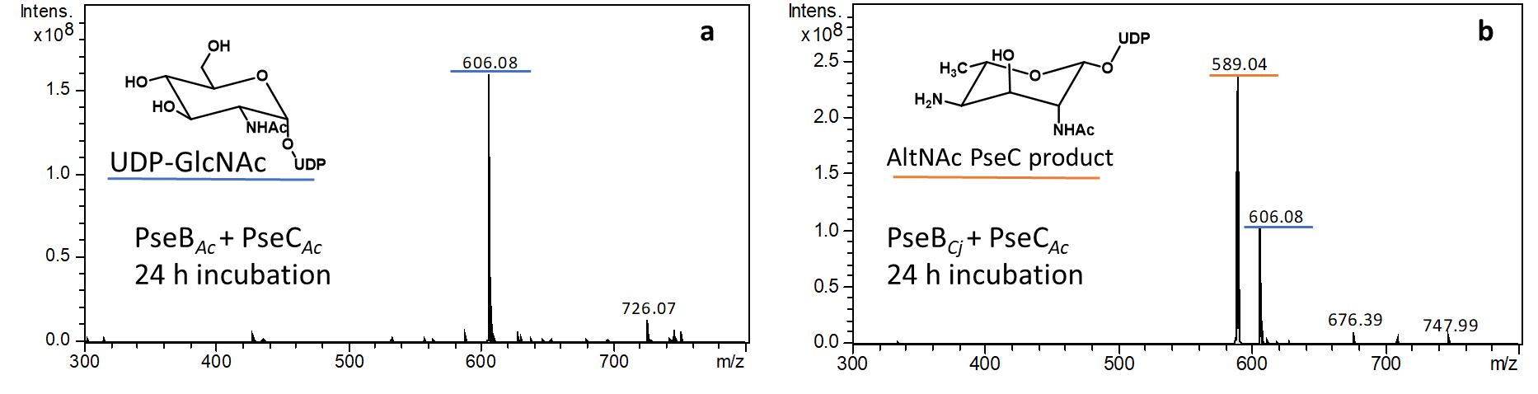
Figure 36 LCMS spectra showing the inactivity of newly cleaved PseB_{Ac}. a After 24 h incubation with PseC and UDP-GlcNAc 9, no turnover was seen. b A positive control containing PseB_{Cj} from the collaborators showed turnover to the PseC product 11.
Following the persistent lack of PseB_{Ac} activity, the plasmid for the University of York collaborator’s PseB_{Cj} was kindly donated. The plasmid was transformed into chemically competent E. coli BL-21 and the protein expressed. A combination of proteins from C. jejuni and A. caviae were used for all subsequent assays. Interestingly, the C. jejuni PseF enzyme produced by the collaborators was equally inactive, therefore a full active pathway was only possible for both parties through the collaboration.

PseI crystal structure
With the activity of PseI (the enzyme of interest for inhibition) confirmed by LCMS (Figure 32, e), a crystal structure was sought to better characterise the target active site. Without previous existing crystal data for PseI, the closest homologue is the NeuB sialic acid synthase enzyme (Gunawan et al., 2005). It was considered that this could be used for molecular replacement if the successful growth of PseI crystals was achieved. To avoid the growth of salt crystals due to the phosphate buffer that the PseI enzyme was originally purified into, a buffer exchange was carried out into the more crystallography-suitable tris-HCl buffer (pH 7.5). The enzyme was pre-screened at the Department of Molecular Biology and Biotechnology at the University of Sheffield. The broad screening kits employed included the common, commercially available JCSG, PACT, ammonium sulfate, and PROPLEX assays. After 1, 4 and 8 weeks, no notable crystals had formed, and it was again considered that the HisTag might be interfering. It was thought that the length of the HisTag (approximately 20 residues) would hinder the enzymes ability to pack into crystalline form.
Thrombin was employed to cleave the HisTag, following the same method as with PseB. As a large quantity of cleaved protein was required for crystallography, the optimisation of cleavage conditions was investigated with varying units of thrombin (2-6 u per mg of protein) being assessed at various time intervals (4-18 h) at 25 °C. Over-cleavage of the protein was again prevented by the immediate post-cleavage removal of thrombin via gel filtration. All of the above conditions resulted in poor yields due to the degradation of protein (Figure 37).
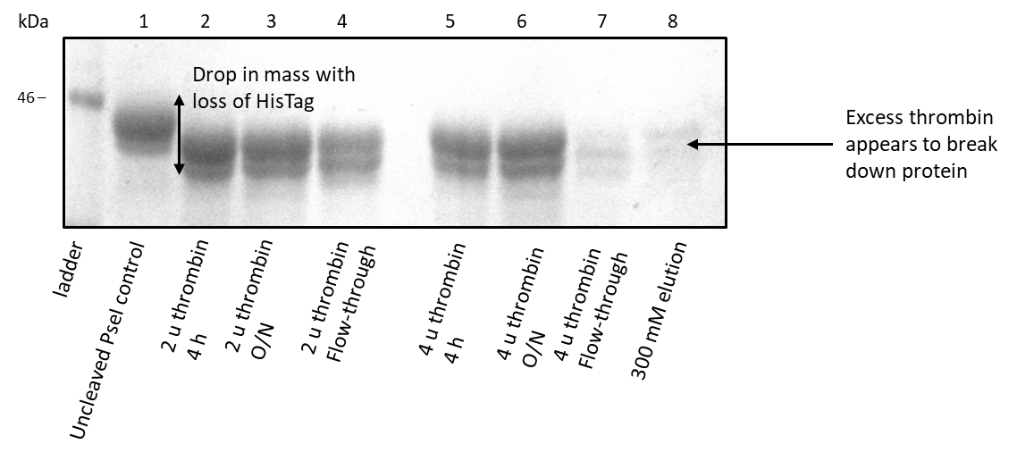
Figure 37 SDS-PAGE gel of the cleaved protein, lanes 2-7. Degradation is apparent in the 4 u overnight sample, lanes 7-8.
Milder means of cleavage were also investigated with incubation overnight at 5 °C resulting in incomplete cleavage (40% based on the relative masses of cleaved and uncleaved protein), but importantly, no protein degradation. Finally, high-yielding, stable cleavage was achieved via the continual recycling of uncleaved protein under mild cleavage conditions (3 u/mg, 5 °C, 16 h) (Figure 38).
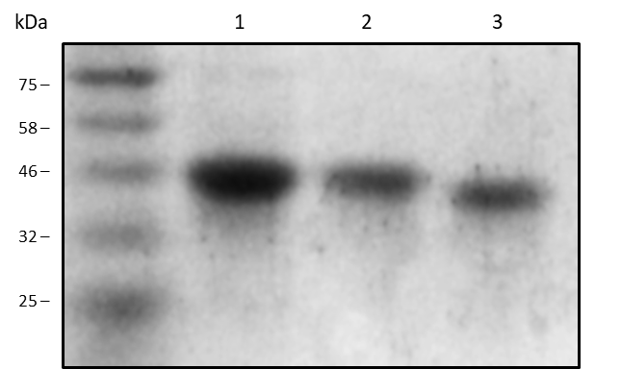
Figure 38 SDS-PAGE gel of the milder conditions of thrombin PseI HisTag-cleavage: Reference uncleaved protein (lane 1), uncleaved protein from a 300 mM HisTrap elution (lane 2), cleaved protein from the HisTrap flow-through (lane 3). The combined amount of cleaved and uncleaved protein was equal to the original amount, suggesting no degradation under these conditions.
The protein was subsequently concentrated to 10-20 mg/mL and sent to the University of Newcastle for crystallography trials (thanks to a collaboration with Prof. Rick Lewis). In addition to protein on its own, crystal trays were also set up in the presence of PEP as a substrate to see if it would help crystal formation. Manganese was also incorporated following the precedent set by Gunawan et al. (2005) in obtaining the crystal structure of NeuB. N-Acetylmannosamine (ManNAc) 15 was also used as a substrate with the NeuB crystallography trials in the literature. As the deoxy AltdiNAc substrate 13 from this work was not obtainable, ManNAc was employed alongside the PEP and Mn²⁺ for these trials. Further to this, the aryl pyrrole compound that is discussed in detail in chapter 5 of this work was also later supplied to the collaborators at the University of Newcastle for crystallography trials.
At the time of writing, this crystallography work is still ongoing but preliminary crystals were obtained with an initial sample of PseI, the concentration of which was too low (10 mg/mL) for proper diffraction (Figure 39). However, some diffraction was observed, and subsequent protein samples were sent at the higher concentration of 20 mg/mL.
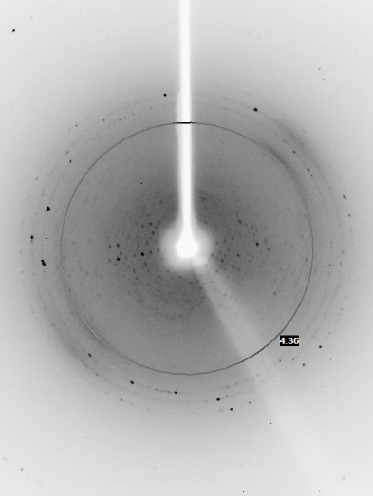
200 µm
Figure 39 Preliminary crystals found at a protein concentration of 10 mg/mL and subsequent diffraction pattern. Images courtesy of Dr Vincent Rao at the University of Newcastle.

Enzyme inhibition assay
Two potential assays for following the kinetic inhibition of PseI were identified, the first being the production of inorganic phosphate (P_{i}) in the PseI-catalysed step (Scheme 8). As discussed previously, Tanner et al. reported using this as a means of monitoring their sialic acid synthase inhibitors. It was also considered that the production of diphosphate (PP_{i}) in the following PseF-catalysed step could be monitored via luminescence in a coupled assay.
Scheme 8 The PseI and PseF enzymatic steps generating phosphate and diphosphate respectively.
However, for preliminary inhibitor compounds, a quicker and easier means of assessing inhibition activity was also sought. The simple qualification of inhibitors can be made by inspection of the relative intensities of product peaks by LCMS (Scheme 9). Whilst this method does not provide a numerical value for inhibition, it can illustrate a trend in activity. With this, the active enzymes from this study were combined with some preliminary inhibitors from other work within the group.
Scheme 9 The simplified inhibition assay reaction. UDP-GlcNAc 9 and the relevant enzymes and cofactors are incubated overnight to produce deoxy AltdiNAc 13. Inhibitors are added and the reactions started with the addtion of PseI. Pseudaminic acid 6 turnover is monitored on the LCMS chromatogram.
The three compounds chosen were synthesised by another member of the group. They all contained structural motifs of the tetrahedral intermediate-based phosphonate inhibitor 23 proposed in this work, all with greatly simplified side chains (Figure 40). The reason for testing these compounds was that they contain relevant chemistry of the designed inhibitor and would provide some structure-activity information on the specificity of the side chain in binding.
Figure 40 The proposed inhibitor 23 and the compounds made in the group that were employed for initial activity screening.
The screening of the compounds was carried out at three concentrations: 0.1 mM, 1 mM (equal to the concentration of the substrate [assuming 100% conversion from 1 mM UDP-GlcNAc]), and 5 mM. Each concentration was screened against both the PseI_{Ac} and the PseI_{Cj} enzymes. UDP-GlcNAc 9 and all relevant cofactors were incubated overnight with the enzymes preceding PseI (PseB, PseC, PseH, PseG). A small aliquot of this overnight reaction was taken to confirm conversion to the deoxy AltdiNAc substrate 13. The rest was divided into reaction aliquots and added to the compounds (35-37) at the aforementioned concentrations. PEP was added to the reactions, as well as to controls containing only enzymes and substrate. Each concentration was tested in triplicate. The reactions were initiated with the addition of PseI (Cj or Ac) and incubated again at 37 °C. The resulting LCMS chromatograms were analysed for each concentration of each compound. It was found that at all concentrations, the pseudaminic acid peak intensity remained equal to that of the controls (Figure 41).
Control (no compound)
5 mM phosphonate 35
5 mM fluorophosphonate 36
5 mM isopropyl compound 37
Figure 41 Selected chromatogram data for the testing of the phosphonate compounds synthesised within the group 35, 36, 37 against PseI_{Ac}. The maximum concentration (5 mM) of compound in each case has no effect on the intensity of the pseudaminic acid peak compared with the control (black).
It was concluded that the compounds were not active against either PseI enzyme. This was thought to be due to the lack of side-chain complexity and specificity in all three cases, but the data still provided valuable information as to the promiscuity (or lack thereof) of the enzyme in question.

Summary and conclusions
The expression and purification of each of the enzymes in the A. caviae biosynthetic pathway was carried out. After initial failure to monitor activity via NMR, LCMS was employed thanks to a collaboration with the University of York. This allowed the discovery that the PseB enzyme (the first in the pathway) was not active when expressed from the A. caviae pseB. Some probing into the inactivity of PseB_{Ac} was carried out and CD indicated that the protein was soluble with the presence of some α-helical secondary structure, though whether this corresponded to its native state is inconclusive. Cleavage of the PseB HisTag did not restore activity which suggests that the tag may not interfere with the native protein structure and led to the conclusion that the tag, although potentially still part of the problem, is not the sole cause of inactivity. Further analytical work is needed to identify the cause of its inactivity. More insight into the quaternary structure of PseB in solution could be gained from techniques such as SEC-MALS (size exclusion chromatography - multi-angle laser light scattering) which allows molar mass determination for large molecules and could indicate the degree of aggregation. Other techniques should also be considered for the probing of substrate binding in the inactive PseB, such as ITC and tryptophan fluorescence quenching. ITC (isothermal titration calorimetry) is a technique often employed to measure the interaction of small molecules with proteins. By measuring the change in heat arising from the reaction of the protein with a titrated ligand (such as UDP-GlcNAc), a binding affinity can be determined. In future, ITC could even be employed throughout the assay alongside the measure of substrate turnover and could help with the development of potential PseI inhibitors. Tryptophan fluorescence quenching allows for the characterisation of binding through the change in fluorescence of tryptophan residues at 295 nm. However, this technique is not always suitable for substrates that absorb near the same excitation or emission wavelengths of protein tryptophan which could be the case in this work due to the absorbance of the UDP group in UDP-GlcNAc.
Despite not determining why PseB was inactive, a fully functional biosynthetic pathway was assembled with the use of PseB from C. jejuni, thanks to the collaboration. For this reason, further investigation into the activity of PseB_{Ac}, including the above techniques, was not carried out. Using the mix of enzymes (from A. caviae and C. jejuni) and the UDP-GlcNAc starting material, along with relevant substrates and cofactors, product turnover was monitored via LCMS all the way through to CMP-pseudaminic acid. As a result, a method of testing potential inhibitors against the PseI enzyme has been determined. Monitoring the pseudaminic acid product peak on the LC chromatogram allows qualification of inhibitory activity. The highly simplified set of phosphonates (35-37) made by another member of the group were screened and showed no activity by LCMS. It is therefore important to develop the chemical methods required to synthesise inhibitors from the correct substrate. In order to develop these synthetic methods in the absence of the difficult-to-obtain deoxy AltdiNAc substrate 13, various chemical models must be assessed.

Evaluating strategies towards the synthesis of potential PseI inhibitors

Introduction
As previously discussed, the inhibitor designs result from the precedent set by Tanner et al. (2009) for sialic acid synthase inhibition. The inhibitors designed for this work are based on two reactive intermediates which are proposed to occur during the PseI-catalysed conversion of deoxy AltdiNAc 13 into pseudaminic acid 6 (Scheme 10). This reaction occurs analogously to that of the sialic acid synthase step targeted by Tanner et al. and sees the condensation of phosphoenol pyruvate (PEP) with the open-chain aldehyde form of the deoxy AltdiNAc PseI substrate 13. The aldol-like reaction is mediated via coordination to a metal ion present within the PseI active site.
Scheme 10 The PseI-catalysed formation of pseudaminic acid 6 (analogous to that of sialic acid and NeuB) that informs the proposed inhibitor designs.
The first oxocarbenium intermediate informed the design of the previously discussed phosphate inhibitor 22 and the second tetrahedral intermediate informed that of the phosphoate inhibitor 23 (Figure 42). The chemical rationale for these designs has already been examined in this work and somewhat verified in analogous mechanisms in the literature (Grison et al., 2005; Liu et al., 2009).
Figure 42 Structures of the proposed phosphate 22 and phosphonate 23 inhibitors. In the phosphonate inhibitor 23, X can be CF₂, CFH, or most simply CH₂.
The key intermediate aldehyde with the relevant deoxy AltdiNAc sidechain 13 is difficult to obtain. Previously reported total syntheses of the compound are expensive, time-consuming and low-yielding (13-14 steps, 1-14%) (Lee et al., 2011; Liu et al., 2017). Biochemical methods can be employed to obtain it chemo-enzymatically, but this method is again expensive, low-yielding and the product is extremely difficult to purify. While a more efficient total synthesis is being developed within the group, this work will aim to evaluate the key chemical steps that will eventually be transferable to this aldehyde.

Towards the synthesis of Tanner’s inhibitor
The route used for the synthesis of Tanner’s inhibitor 18 (Scheme 11) was initially followed as reported in the literature (Bednarski and Weitz, 1989; Liu et al., 2009) using commercially available ManNAc 15 which was first converted to the oxime with methoxyamine hydrochloride and then poly-acetylated with acetic anhydride.
Scheme 11 Synthesis of sialic acid synthase inhibitor 14, from Tanner et al. (2009).
The first two steps were initially attempted in a one-pot synthesis, but the recovered product yields proved poor (10%). NMR tube reactions were carried out in order to follow the conversion of each step by ¹H NMR spectroscopy. It was found that the oxime formation underwent successful conversion within four hours. The number of equivalents of acetic anhydride was then varied from a stoichiometric amount to a large excess (eight equivalents per hydroxy group), in order to optimise the acetylation step. This large excess of acetic anhydride proved to be detrimental to the protection, with compound degradation observed. Therefore, two equivalents per hydoxy group were employed as the ideal amount, contrary to the previously reported four equivalents (Bednarski and Weitz, 1989).
It was concluded that the poor yields of oxime formation were as a result of the work-up conditions and not related to the reaction itself. A study was carried out to assess alternatives to the copper sulfate aqueous wash that was reported in the literature (Bednarski and Weitz, 1989). Washing the crude reaction mixture with water, saturated ammonium chloride, and saturated ammonium acetate each resulted in incomplete removal of residual pyridine and similarly poor mass returns. However, HCl (1 M) was found to fully remove pyridine without affecting the product and was employed for subsequent washes. With optimised work-up conditions in hand, recrystallisation was carried out from ethyl acetate and hexane (1:2) to give pure oxime 38 in consistent yields in excess of 75%.
The acetylated oxime 38 was then subjected to ozonolysis conditions following the literature precedent (Bednarski and Weitz, 1989) to form the aldehyde 39. Whilst there was evidence of successful conversion, with the aldehyde α-hydrogen signal present in the ¹H NMR spectrum, the ozonolysis presented problems. Despite the solution turning blue after 15 minutes (usually an indication of an excess of ozone and therefore complete reaction), NMR monitoring revealed that greater conversion was achieved with longer reaction times. However, this conversion peaked at 80% (measured from the ratio of appropriate signals in the ¹H NMR spectrum) after 45 minutes and it was concluded that this time was optimal.
The aldehyde 39 was taken forward without further purification to attempt the indium-mediated allylation reaction to furnish the ester 40. The mass return for this reaction was low (35%) and the crude ¹H NMR spectrum contained many impurities. Attempted purification via flash column chromatography did not yield the desired product. The reaction was postponed until consistent, repeatable ozonolysis results could be produced and more research had been carried out into indium-mediated allylation reactions.

Model compounds
Given the aforementioned issues with the indium-mediated reaction and the expense of the ManNAc substrate 15, reactions on model compounds were investigated (Figure 43).

Figure 43 Model compounds for optimising the ozonolysis and indium reactions.
Further research into indium-mediated allylation provided examples with milder and simpler conditions than those previously employed. An example reaction was followed as reported (Araki, Hirokazu and Butsugan, 1988) with the coupling of octanal 45 and dimethylallyl bromide 46 (Scheme 12).
Scheme 12 Literature example of indium-mediated synthesis of 3,3-dimethyl-1-undecen-4-ol 40 from octanal 38.
This reaction proceeded in moderate yield in accordance with the literature (Araki, Hirokazu and Butsugan, 1988) and was subsequently repeated with the simple model compound, 3-phenylpropanal 44 in place of octanal 45 (Scheme 13).
Scheme 13 Synthesis of 3,3-dimethyl-6-phenyl-1-hexen-4-ol 48 using allyl bromide 46 and literature conditions.
The reaction proceeded in good yield with no further purification required. These conditions were then employed for reaction of 3-phenylpropanal 44 and the relevant bromide, 2-bromomethylacrylate 49. It was considered that with this acrylate 49, the product could undergo lactonisation to form the γ-lactone 51 (Scheme 14). Lactonisation has been previously reported with the products of indium-mediated allylation with methyl 2-bromethylacrylate 49 under acidic conditions (Li and Chan, 1991).
Scheme 14 The indium-mediated allylation of 3-phenylpropanal 44 and subsequent acid-catalysed cyclisation of the ester product 50 to give the lactone 51.
The resultant crude mixture of products was found to consist of returned aldehyde 44 and bromide 49, as well as desired ester product 50, small quantities of the lactone 51 in a respective ratio of 5:19:62:14.
Upon purification via column chromatography on silica gel, the lactone was obtained as a major product despite being the minor product in the crude material. The desired ester was not isolated. It was thought that the acidity of the stationary phase silica could be facilitating the conversion of the product ester 50 into the lactone 51. In order to confirm this, the crude sample (with known ratio of ester to lactone) was stirred in the same eluent as used on the column with a small amount of silica for 30 minutes, then filtered and concentrated. The ratio changed from 75:25 ester:lactone to 60:40, suggesting that the silica does indeed catalyse the lactonisation.
Following a thorough review of indium-mediated allylations of this type in the literature, a number of solvents and conditions were examined (Table 5). These were predominantly low yielding with all giving a crude mixture of ester and lactone. Again, none of the desired ester was isolated after purification.
Table 5 Varying conditions for the indium-mediated allylation of 3-phenylpropanal and the resulting ratios of ester to lactone *calculated using peak integrals in the ¹H NMR spectra of the crude reaction mixture and the isolated yield of lactone.
Solvent | Conditions | Crude ratio* ester:lactone | Lactone yield
DMF | In, rt, 1.5 h | 3:1 | 30%
MeCN/HCl (20/1) | In, 45 °C, 6.5 h | 3:1 | 45%
H₂O | In, rt, 16 h | RSM | 0%
EtOH/H₂O (1/5) | In, rt, 16 h | RSM | 0%
THF/NH₄Cl (2/1) | In, rt, 16 h | 2:1 | 15%
MeOH/NH₄Cl | In, rt, 16 h | 2:1 | 30%

It was considered that spontaneous lactonisation could be avoided by incorporating the acid in place of the methyl ester. Bromomethyl acrylic acid 52 was therefore examined with the phenylpropanal model with some success (Scheme 15).
Scheme 15 Indium-mediated addition of bromomethylacrylic acid and phenylpropanal.
At the same time, the stoichiometry of the reaction with the bromomethacrylate 49 was also examined following work by Butsugan et al. (1988) that suggested an optimal ratio of 2:3:2 indium:allyl bromide:carbonyl compound. This stoichiometry arose from the proposed allylic indium sesquihalide as the active species in the reaction (Scheme 16).
Scheme 16 Generic scheme for the formation of the active indium species
These studies found that two of the three alkyl groups (R) react with the carbonyl compound, hence the 2:3:2 ratio. The employment of this stoichiometry in the above examples saw no significant change in yield. As a result, the previously examined small excesses of indium and allyl bromide (2.1 and 1.2 equivalents respectively) were settled on with a view to economising on expensive starting materials.
The original conditions reported by Tanner et al. (MeCN/HCl) were taken forward with the intention of further optimising the conditions for the formation of ester on a more complex model compound. It was also considered that even if lactone formation was unavoidable, the lactone itself could still be brought forward. Alternatively, the bromomethacrylic acid could be used in place of the ester, although additional protection steps would be required. Following these conclusions, a more representative model compound was employed.
The phenylalanine-derived aldehyde 43 was prepared as a model for the indium-mediated allylation reaction. A stereospecific α-N-acetyl group was employed to mimic the reactivity of the ManNAc-derived aldehyde 39. The rest of the molecule was designed for ease and scalability of synthesis, with a phenyl group included as an easy marker for monitoring conversion (Scheme 17).
Scheme 17 The model compound 43 and phenylalanine 55 from which it is synthesised via the alcohol 54.
The N-acetylated amino aldehyde 43 was synthesised from phenylalanine 55 (Scheme 18) following various literature precedents (Adams, Bawa and Jones, 2006; De Marco et al., 2009; Zupancic, Mohar and Stephan, 2010; Norsikian et al., 2015). Phenylalanine 55 was first converted to the methyl ester hydrochloride 56 with thionyl chloride in methanol in near-quantitative yields. Treatment with acetic anhydride in pyridine gave the N-acetylated product 57 in good yield. Lithium borohydride (LiBH₄) was employed for the reduction of the methyl ester to the corresponding alcohol. Optimisation led to four equivalents of LiBH₄ being an optimum amount.
Scheme 18 Synthesis of the model compound 28 from phenylalanine 31
Oxidation conditions for the transformation of the alcohol 54 into the aldehyde 43 were investigated. Both TEMPO and PDC oxidations yielded only returned starting material (RSM). Swern oxidation conditions provided the desired aldehyde 43 in acceptable yields.
The phenylalanine-derived aldehyde 43 was used without further purification in the indium-mediated allylation following the conditions employed by Tanner et al. As with the ManNAc-derived aldehyde 39, the reaction again proved challenging and neither the desired product 58, nor lactone, was isolated (Scheme 19).
Scheme 19 The attempted indium-mediated allylation of the phenylalanine-derived aldehyde 43 did not furnish the desired addition product 58.
Despite the lack of success with the phenylalanine-derived aldehyde 43, the inexpensive epimer of ManNAc, N-acetyl-D-glucosamine (GlcNAc) 59 was also investigated. GlcNAc was converted to the acetylated oxime ozonolysis precursor 42 using the same methods as with ManNAc (Scheme 20).
Scheme 20 Conversion of GlcNAc 59 into the oxime 42
The oxime 42 could no longer be recrystallized using the same conditions as with ManNAc but the crude material was of a high enough purity to be carried forward to ozonolysis without further purification.
The dimethyl sulfide (DMS) ozonolysis work-up, which furnishes the aldehyde directly, was not ideal for long-term storage with the aldehyde 60 degrading quickly. Therefore, a reductive sodium borohydride (NaBH₄) work-up was investigated in order to retain the product as the more stable alcohol 61 until oxidation immediately before use in the indium-mediated reaction (Scheme 21).
Scheme 21 A reductive (NaBH₄) ozonolysis work-up could allow for longer term storage of material as the alcohol 61, compared with directly accessing the unstable aldehyde 60 via DMS work-up.
It was considered that the successful Swern oxidation employed to furnish the phenylalanine-derived aldehyde 43 could be applied to this GlcNAc-derived alcohol 61. The reductive ozonolysis was therefore attempted on the GlcNAc-derived oxime 42 (Scheme 22).
Scheme 22 Attempted ozonolysis with reductive work-up to furnish the alcohol 61.
It was found however that the crude mixture was less pure than that of the DMS work-up and purification attempts saw product degradation. Following this, it was concluded that the compounds would be stored as the oxime and ozonolysis would be performed with the DMS oxidative work up, immediately prior to attempting the indium-mediated reaction.
With the ozonolysis consistently generating the GlcNAc-derived aldehyde 60, this was applied to the indium-mediated allylation reaction. Following the results from the phenylpropanal model, the bromomethacrylic acid substrate 52 was examined. In addition to this, the isopropyl ester 62 was also synthesised from the acid via a Mitsonobu esterification with a view to making spontaneous lactonisation less favourable (Scheme 23).
Scheme 23 The synthesis of bromomethylacrylic acid isopropyl ester from the acid.
However, both of these methacrylate variants, 52 and 62, were attempted in the indium-mediated addition reaction with the GlcNAc-derived aldehyde 60 to no avail (Scheme 24).
Scheme 24 The attempted indium-mediated addition of bromomethylacrylic acid 52 and bromomethylacrylic acid isopropyl ester 62 to the GlcNAc-derived aldehyde 60.
In further attempts to circumvent the lactonisation, a one-pot acetylation of the newly generated hydroxyl group was employed (Scheme 25).
Scheme 25 The synthesis of GlcNAc-derived aldehyde 60 and the indium-mediated reaction with the aldehyde 60 and bromomethyl acrylate 49, followed by in situ acetylation of the newly formed hydroxy group to give the poly-acetylated methyl ester 63.
Trace amounts of desired ester product 63 were yielded from this reaction in varying degrees of purity by ¹H NMR spectroscopy. As previously discussed, it was considered that the lactone itself could be brought forward through the ozonolysis step before saponification at a later stage but it was not actually isolated from the reaction with the sugar and the ester was only recovered in trace amounts.
Concurrently, other means of generating the carbon-carbon bond formed in the indium-mediated reaction were sought. The replacement of indium with a similarly functioning metal was first investigated with the employment of zinc (Scheme 26).
Scheme 26 Zinc-mediated allylation of 3-phenylpropanal 44.
Despite the zinc-mediated allylation giving some product with dimethylallyl bromide 46 and phenylpropanal 44, the reaction with the sugar-derived aldehyde 60 did not proceed. It was considered that this could be due inconsistencies in the zinc activation process (with iodine) but after repeated attempts saw the same result, the reaction was abandoned.
Samarium diiodide was also briefly examined following the precedent set by work by Proctor et al. (Findley et al., 2008) (Scheme 27).
Scheme 27 Precedent for SmI₂-mediated coupling (above) set by Proctor et al. (2008) and below, the proposed use thereof in this project.
Samarium diiodide was synthesised following the literature (Procter, Flowers and Skrydstrup, 2009) as a dark blue solution and used immediately. A simplified methacrylate substrate 67 (lacking the OTBS group) was employed initially to test the SmI₂ coupling with both phenyl propanal 44 and the GlcNAc derived aldehyde 60 (Scheme 28). These SmI₂-mediated additions did not yield any product, with only returned starting material observed.
Scheme 28 The SmI₂-mediated reaction between methyl methacrylate 67 and 3-phenyl propanal 44 and the GlcNAc-derived aldehyde 60.
With the indium-mediated allylation reaction proving difficult, expensive, and very low-yielding, and with the zinc and samarium variations proving equally unfruitful, an alternative route was sought.

Orthoester synthesis for an aldol approach
In 2017, Norimura et al. reported the use of aldol chemistry to form the key bond between sugar-derived aldehydes and a protected ketone orthoester 69. Amongst the variety of sugars investigated, poly-benzylated GlcNAc and ManNAc derivatives were used in good yields and stereoselectivities (Scheme 29). The orthoester 69 is a protected pyruvic acid analogue. This aldol reaction is therefore equivalent to the key chemical steps catalysed by the enzyme in question and, with the literature precedent, makes an attractive and lower-cost alternative to indium chemistry. In addition, the aldol reaction would circumvent an additional oxidation step in the previously-examined indium-catalysed synthesis (the ozonolysis of the new alkene 40 is no longer required).
Scheme 29 Reaction between the poly-benzylated ManNAc-derived aldehyde 39 to give the aldol product 70 (Norimura et al., 2017) compared with the product 40 of the equivalent indium-mediated reaction (Liu et al., 2009) below.
The orthoester was synthesised in accordance with the literature (Norimura et al., 2017) (Scheme 30).
Scheme 30 Synthesis of the orthoester 69.
Racemic lactic acid 71 was first acetylated using acetyl chloride. There were some initial problems with purification due to formation of a by-product from the THF solvent, but vacuum distillation gave the desired product in good yields and high purity. This acetylated acid 72 was then subjected to Steglich esterification conditions using EDCI and the oxetane alcohol 73. The following ester 74 was subjected to boron trifluoride diethyl etherate which catalysed orthoester formation in high yields. The acetate 75 was then hydrolysed using sodium hydride in methanol to give the alcohol 76. Early attempts to purify the alcohol product on silica resulted in product decomposition. As a result, the crude alcohol was oxidised using Parikh-Doering conditions to give the final ketone orthoester 69. The main triethyl ammonium impurity from this step was easily removed by trituration to give the product in moderate yields.

The aldol approach
As with the indium coupling reaction, the aldehyde substrate required for the aldol reaction towards the proposed inhibitors 22 and 23 is that derived from the deoxy AltdiNAc sugar 13. As previously discussed, this substrate is not easily obtained, so a model compound was assessed in order to probe the chemistry. Initial attempts of the aldol reaction were carried out using the simplified substrate of 3-phenylpropanal 44 (Scheme 31).
Scheme 31 The aldol trial reaction with the ketone orthoester 69 and phenylpropanal 44.
The reaction was first carried out in accordance with the literature conditions, but only very low conversions were observed. The reaction time was increased from 1 h to 3 h which saw an increase in conversion from 25% to 65%. Zinc chloride was employed in an attempt to further increase conversion through chelation but orthoester degradation was observed in the crude ¹H NMR spectrum.
The newly formed alcohol 77 was protected as the tertiarybutyldimethylsilyl (TBS) ether 78 using TBSOTf in accordance with the literature conditions (Norimura et al., 2017) (Scheme 32). Extended reaction times for this protection saw product degradation. As a result, poor initial conversion was improved through increasing the equivalents of TBSOTf to a larger excess (2-4 equivalents).
Scheme 32 The TBS protection of the newly formed aldol alcohol 77.
The GlcNAc and mannose-derived aldehydes 80 and 83 were synthesised via either hydrolysis or ozonolysis of the poly-benzylated oxime. Ozonolysis of the GlcNAc oxime 79 was carried out using the same method as previously-reported with the poly-acetylated derivative 42 (Scheme 33). Hydrolysis of the mannose oxime 82 was followed from the literature (Norimura et al., 2017). The oximes were formed as previously and the benzylations were carried out in accordance with the literature.
Scheme 33 The synthesis of GlcNAc and mannose-derived aldehydes 78, 77 towards the aldol reaction, methods were followed or adapted from the literature (Norimura et al., 2017).
The sugar-derived aldehydes were then investigated in the aldol reaction. Good conversions were observed through the disappearance of the aldehyde signal on the crude ¹H NMR spectrum. However, in both cases, purification of the crude mixture by column chromatography proved difficult with the unreacted orthoester ketone eluting concurrently with the mannose-derived aldol product 85. Ultimately, both aldol products (84 and 85) were isolated as a mixture of diastereoisomers but in varying degrees of purity (Scheme 34).
Scheme 34 The attempted aldol reactions between the orthoester 69 and the sugar-derived aldehydes 80 and 83. dr was calculated based on the relative integrals of the 6 H orthoester singlets at approximately 4 ppm on the crude ¹H NMR.
The attempted TBS protection of the mannose-derived aldol product 85 was subsequently carried out under the previous conditions used on the phenylpropanal substrate 77 (Scheme 35). Unfortunately, product degradation was observed.
Scheme 35 The attempted TBS protection of the mannose-derived aldol product 85. Product degradation was observed and none of the desired product was isolated.
It was considered that the added complexity of the sugar side-chain made the compound more sensitive to the conditions used. In the future, shorter reaction times should be examined as even in the case of the simpler phenylpropanal compound, a lack of product stability was observed when the protection was carried out over an extended period of time. The literature conditions for the same transformation involved fewer equivalents of TBSOTf and shorter reaction times. However, TLC monitoring of the reaction showed a persistent lack of completion, hence the addition of more TBSOTf and a longer reaction time being used. It was later considered that the appearance of starting material in the TLC could have been due to the presence of a decomposition product of similar Rf. The acid sensitivity of the orthoester moiety is described in the literature (Norimura et al., 2017) and has been observed in this work and it should be considered in future that when using a greater excess of TBSOTf, more lutidine base should also be used to scavenge any triflic acid present.
Nevertheless, the precedent set by the literature in demonstrating high selectivity and yields in the aldol reaction with α-acetamido sugars bodes well for the future development of the inhibitors described in this work. The TBS protection of the mannose-derived aldol product has equally been described in the literature, proceeding in high yields (Norimura et al., 2017). However, due to the pressures of time and the desire to examine the potential for accessing the protected phosphonate inhibitor via a phosphonate addition reaction, the model sugar-derived compounds were not investigated further in favour of examining the subsequent chemistry on the simple model phenylpropanal derived compound 78.

Phosphonate addition as a route towards the proposed inhibitor 23
With the phenylpropanal model aldol product 78 in hand, the route towards the phosphonate-based inhibitor 23 was examined. This route was chosen over the phosphate-based inhibitor 22 because it required fewer steps and it deviated more from the chemistry established in the literature (Scheme 36).
Scheme 36 The potential divergence in inhibitor synthesis. A three-step approach analogous to the Tanner inhibitor to make the phosphate inhibitor 22 and a one-step approach to the phosphonate inhibitor 23 design from this work.
The diethylmethyl phosphonate addition proved challenging at first. The crude mixture was difficult to analyse and attempts at purification did not yield the desired product. The crude ³¹P NMR spectrum did however suggest a number of products had been formed. It was considered that the α-deprotonation of the ketone, either by excess BuLi or the organolithium formed in the phosphonate deprotonation, could be competing with the desired nucleophilic addition reaction. The extent of phosphonate deprotonation was therefore investigated. As with previous attempts, diethylmethyl phosphonate was added to nBuLi at -78 °C and stirred for 15 minutes. An aliquot of this was then removed and quenched with deuterium chloride (DCl). After work-up, ¹H NMR analysis of this product saw an integration value of 2 for the diethylmethyl phosphonate methyl signal, suggesting that deprotonation was occurring as intended.
A simpler ketone was sought to assess the reaction and acetophenone 86 was employed as a model. It was confirmed that the competing α-deprotonation was resulting in the formation of the cross-product 88 (Scheme 37). This was isolated in a relatively low yield however, suggesting that the intended product could also be forming.
Scheme 37 The reaction of acetophenone 86 with diethylmethyl phosphonate with formation of a cross-product 88 due to the enolisation of the acetophenone.
With this, the stoichiometry of the reaction was varied to assess the effect on formation of the by-product 88 and potential product 87 (Table 6). It was found that an excess of ketone 86 was detrimental, causing a greater proportion of cross-product 88 to be formed. The equivalents of phosphonate and base were kept equal.
Table 6 A table to show the result of changing the equivalents of ketone 86 with respect to phosphonate and BuLi.
Entry | Equivalents of ketone 86 | Equivalents of phosphonate | Equivalents of BuLi | Conversion* | Yield of cross product 88
1 | 1.5 | 1.0 | 1.0 | 65% | 30%
2 | 1.0 | 1.5 | 1.5 | 90% | 10%
*Conversion is calculated based on the relevant starting material peak integrals in the crude ¹H NMR spectrum. Yield of cross-product 88 is given as an isolated yield.
With the excess of phosphonate and base giving the highest proportion of potential product (entry 2) but no product isolation, it was considered that the product itself might not be fully stable on silica gel during purification. With this, the reaction was repeated and purified quickly via column chromatography in order to minimise the contact with silica. The desired product 87 was isolated in a 90% yield.
The optimised reaction and purification conditions were then employed on the model aldol product 78 to give the desired addition product 89 as a pure 60:40 mixture of diastereoisomers in a 55% yield (Scheme 38).
Scheme 38 The successful phosphonate addition to the phenylpropanal aldol product 78.
Upon successful isolation of the phosphonate addition product, a number of additives were employed to assess their effect on the diastereoselectivity of the reaction (Table 7).
Table 7 A table showing the effect on conversion and dr of various additives in the phosphonate addition reaction
Additive | Conversion* | Diastereomeric ratio**
None | 95% | 51:49
ZnBr₂ | 27% | 48:52
B(OMe)₃ | 74% | 49:51
MgCl₂ | 100% | 49:51
*Conversion calculated from the relative integrals for the starting material and products orthoester 6 H singlet at approximately 4 ppm. **Diastereomeric ratio determined from the relative integrals of the products orthoester 6 H singlet at approximately 4 ppm in conjunction with the relative heights of the ³¹P NMR product peaks.
Although the dr varies slightly across the four reactions, all results are close enough to 50:50 to conclude that the incorporation of the additives did not have an effect on the dr of the reaction. It could be noted that the zinc bromide significantly reduced the conversion of the reaction, but this is more likely an anomalous result caused by the presence HBr in the reagent. This could cause incomplete formation of the relevant addition product that is used to track conversion.
In work by Grison et al. (2005), they also saw the aforementioned competing enolization when carrying out phosphonate additions to α-ketoesters. Their substrates contained sugar-derived backbones which are more complex than the phenyl-propyl sidechain in this work and more akin to those proposed in future work. However, their observed diastereomeric ratios peaked at 61:39, suggesting that the sidechain itself does little to influence the diastereoselectivity of the phosphonate addition (Scheme 39).
Scheme 39 An example reaction from the literature (Grison et al., 2005), the dr for this reaction is 51:49 based on the peak heights in the crude ³¹P NMR spectrum.
Interestingly, the synthesis carried out by Grison et al. was towards inhibitors of the KDO8PS enzyme, an analogous enzyme to PseI used in bacterial biosynthesis of KDO. They designed their tetrahedral phosphonate inhibitors based on open chain intermediates that are closely related to those that informed the inhibitor designs in this work. Importantly for this work, they found that their inhibitors displayed some antibacterial activity against the Gram-negative bacteria possessing the KDO8PS enzyme (notably, P. aeruginosa and E. coli) (Figure 44). This activity resulted even when the inhibitors were used as a near-50:50 mix of diastereoisomers. Furthermore, the inhibitors were tested with the phosphonate still protected in its diethyl ester form.
Figure 44 One of the active inhibitors 21 from work by Grison et al. (left) compared with the proposed PseI inhibitor 23 from this work (right). The phosphonic acid in the proposed inhibitor 23 may still show activity as the phosphonic ester.
This precedent bodes well for the future work on pseudaminic acid synthase inhibitors. It suggests that when the relevant sugar sidechains are incorporated into the aldol and phosphonate reactions examined in this work, the lack of diastereoselectivity of this final phosphonate addition step may not have an effect on inhibitory activity. In addition to this, it may also be applicable that the deprotection of the phosphonate would not be necessary for inhibition which would be advantageous on two fronts. Firstly, it reduces the subsequent number of deprotection steps required to access the inhibitor and thus increases potential yield, and secondly, it opens up the possibility of varying the alkyl groups on the phosphonate which would allow a certain degree of tailoring of the hydrophobicity of the inhibitor. This could in turn help with membrane-permeability issues that may arise in the future. It could also be another explanation for the lack of activity of the simple phosphonate compounds (35, 36, 37) discussed at the end of chapter 3, as they were tested as unprotected phosphonic acids.

Summary and conclusions
In summary, the route towards the proposed inhibitors in this work has been evaluated on a series of model compounds of varying complexity. It has been found that the indium-mediated chain extension is an expensive and low-yielding bottle neck in the original synthetic strategy. Initial attempts to follow the chemistry outlined by Tanner et al. (2009) were abandoned in favour of the more diverse and better yielding aldol reaction reported by Norimura et al. (2017). The orthoester ketone aldol substrate 69 was made according to the literature in an overall yield of 22% over 5 steps and acts as a masked pyruvate group. Aldehydes derived from model sugars mannose and GlcNAc (80 and 83) were synthesised and the aldol reaction was carried out on them with varying yields and product purity. The mannose-derived aldol product 85 was then taken through an attempted TBS protection step which saw product degradation. Following this, the sugar-derived aldol products were taken no further as a result of the pressures of time. Instead, the phenylpropanal-derived aldol product 78 was brought forward due the relative ease of its synthesis and purification. A phosphonate addition reaction was investigated with this substrate and proved a one-step means of furnishing a simplified model of the protected phosphonate inhibitor 23. This chemistry is in theory applicable to the protected product of the aldol reaction between deoxy altdiNAc 13 and the orthoester ketone 69. The potential for the 3-step synthesis of the phosphate inhibitor 22 was also proposed from this aldol product. The aldol reaction therefore provides a key intermediate which can be altered into either inhibitor via a divergent synthesis. This aldol reaction has been shown to work in the literature (and to some extent in this work) on more complex sugar-derived aldehydes that are akin to the desired deoxy AltdiNAc substrate.

Microbial motility assays and LCMS inhibition assays

Introduction
As previously discussed (1.3.), the flagellum provides bacteria with motor-driven motility. Whilst the specific mechanics of this motility have already been examined in this work, the classifications of surface translocation should be introduced. The two types of movement demonstrated by species with one or more flagella are classified as “swarming” and “swimming”.

Bacterial motility: swarming and swimming and assays
Bacterial swarming was first comprehensively reviewed by Henrichsen (1972) in Proteus mirabilis, Clostridium tetani, and Bacillus alvei. He concluded that swarming bacteria require many (peritrichous) flagella which allow them to move over solid and partially solid surfaces. It was suggested as early as 1939 (Clark) that bacterial flagella are essential for swarming. Attempts to stain the flagella in a non-motile strain of B. alvei failed and it was concluded that no flagella were present as they were not required in the absence of motility. Interestingly, flagella are also implicated in the swarming species’ ability to sense a surface. This “mechanosensing” is observed in swarming bacteria and those which form biofilms such as Pseudomonas aeruginosa (Belas, 2014).
Swarming species are equally able to swim in liquid media. Swimming can be carried out by bacteria with varying numbers of flagella including monotrichous species. Most liquid-borne bacteria possess some quantity of flagella with which to swim (Henrichsen, 1972). Swimming bacteria can change course by switching the direction of rotation of their flagella, a phenomenon known as tumbling.
Swarming and swimming motility has long been observed in the afore-mentioned P. aeruginosa. More recently, it was found that some strains of the usually monotrichous species such as A. caviae can demonstrate an ability to spontaneously produce the lateral flagella required for swarming when grown on agar (Merino, Shaw and Tomás, 2006). The swimming and swarming assays carried out as part of this project were on these two species, the former for its well-documented use in assays of this nature and the latter as a result of it performing the relevant biosynthesis of pseudaminic acid as a flagella glycan.
The most common means of monitoring swimming and swarming in the laboratory is through inoculation in the centre of a tailored motility agar (0.25% and 0.6% w/v agar for swimming and swarming respectively). P. aeruginosa is known for its characteristic green swarming patterns and the subtler “halos” in swimming agar are also easily examinable (Figure 45). The swimming halos appear as the bacteria swim out through the agar media from the central inoculation point whereas the swarming pattern sees them move over the surface of the firmer swarming agar. Nutrient-rich agar is required for most swarming assays although the exact components can differ between bacterial species.
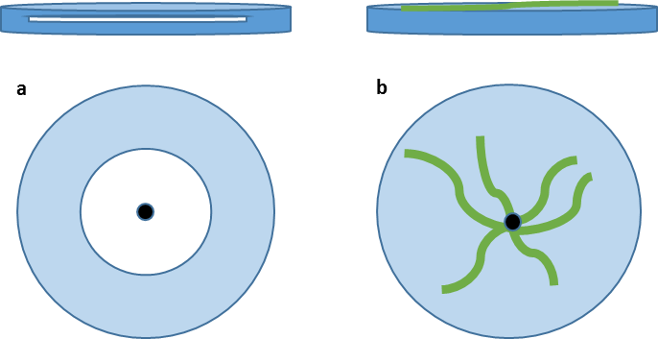
Figure 45 A representation of the cross section and above view of plates showing a white swimming halo a and green swarming pattern b.

Caffeine as a quorum sensing inhibitor
Many natural products have been shown to inhibit bacterial motility through various mechanisms. These have been comprehensively reviewed by Silva and co-workers (2016) and from this a shortlist of readily-available potential motility inhibitors was generated (Figure 46) in the interest of finding a suitable assay and potential positive control.
Figure 46 A shortlist of natural products showing inhibitory activity against bacterial motility in a range of bacteria, MICs are shown in blue (Silva et al., 2016).
Caffeine 92 was one of the most easily sourced natural products and showed significant swarming motility inhibition in P. aeruginosa (Norizan, Yin and Chan, 2013). This was thought to be as a result of its quorum sensing inhibition.
Quorum sensing is a means of intercellular bacterial communication via the secretion of signalling molecules and allows bacteria to coordinate many functions including motility (Miller and Bassler, 2001). In many Gram-negative bacteria, quorum sensing is mediated by the production of acyl-homoserine lactones (acyl-HSLs) (Figure 47). These acyl-HSLs are produced by members of the LuxI protein family and are detected by LuxR-type receptors. The receptor binding of HSLs alters bacterial genes that are responsible for various biological processes and allows quorum sensing to regulate bacterial function. Acyl-HSLs are autoinducers meaning that the binding of HSLs regulates the increased synthesis of further HSLs in a feed-forward regulatory loop (Fuqua, Parsek and Greenberg, 2001; Whitehead et al., 2001; Papenfort and Bassler, 2016). The extracellular concentration of these signalling molecules is directly related to the cell density of the bacteria producing them and the bacterial sensing of HSLs allows for population regulation at critical concentration (Whitehead et al., 2001; Papenfort and Bassler, 2016).
Pseudomonas aeruginosa has been the subject of a significant amount of research into quorum sensing and it uses the extracellular signalling mechanisms to regulate multiple virulent factors. There are two HSL signalling molecules associated with P. aeruginosa, N-butanoyl-homoserine lactone and N-3-oxododecanoyl-homoserine lactone, produced by LuxI analogues RhlI and LasI respectively (Oinuma and Greenberg, 2011). These acyl-HSLs bind to RhlR and LasR receptors which are homologues of LuxR.

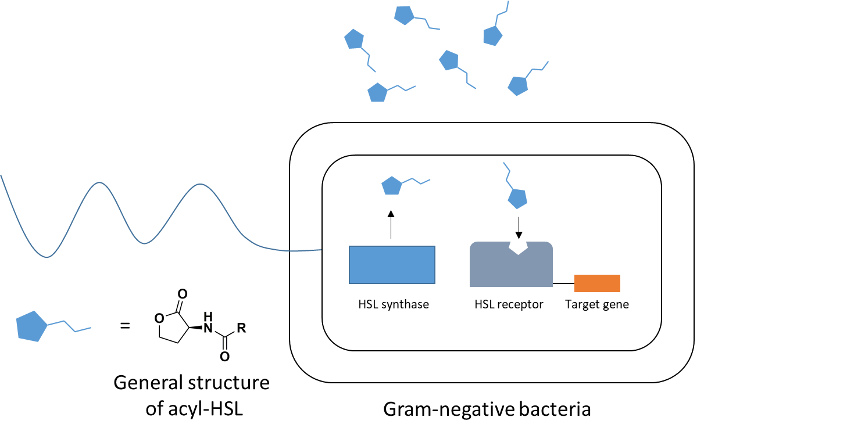
Figure 47 Simplified schematic of quorum sensing in Gram-negative bacteria (adapted from Ivanova, Fernandes and Tzanov, 2013). The HSL autoinducers are synthesised intracellularly by HSL synthase enzymes (usually of the LuxI family) and are able to freely diffuse through the bacterial membrane. As cell density increases, so does the extracellular concentration of HSL autoinducers and once a threshold is reached, these are detected by intracellular receptors (of the LuxR family). The binding of HSL autoinducers induces a genetic response in the bacteria which can be related to many functions including the production of more HSLs (autoinduction), as well as regulating swarming motility in P. aeruginosa.
In the work by Norizan and co-workers (2013), caffeine restricts P. aeruginosa swarming motility at a concentration of 0.3 mg/mL. It should be noted that in P. aeruginosa, there are multiple factors that influence swarming motility. In addition to the swarming motility of P. aeruginosa being flagella-dependent, it has also shown to be dependent on pili; unlike other swarming bacteria such as A. caviae, in which swarming motility is entirely flagella-dependent. This flagella and pili-dependent swarming motility in P. aeruginosa is controlled by quorum sensing. It has been found that the binding of signalling HSLs to RhlR activates the expression of rhlAB which encodes for the production and secretion of various rhamnolipid biosurfactants. The secretion of these biosurfactants aids P. aeruginosa surface swarming by decreasing surface tension (Thilo Köhler et al., 2000; Whitehead et al., 2001). Interestingly, P. aeruginosa swimming motility has also been linked to quorum sensing. Li and co-workers (2015) found that a novel regulator gene, PA5022, was required for swimming motility. An immotile PA5022 knockout mutant showed reduced expression of both rhlI and lasI suggesting the link between swimming motility and the genes associated with quorum sensing.
Despite the complex combination of factors affecting motility, the work by Norizan and co-workers (Norizan, Yin and Chan, 2013) made caffeine an attractive, easily-sourced compound for the construction of motility assays in this work. Furthermore, if these swarming inhibition data could be replicated in a species containing PseI, then caffeine could also be employed as a facile positive control in any future motility assays testing the designed inhibitors.

“Aryl pyrrole” as potential enzyme-targeting control
In previous literature (Robert Ménard et al., 2014), all enzymes from the H. pylori pseudaminic acid biosynthetic pathway were screened against a library of potential small-molecule inhibitors. Whilst the research focused on inhibition of the PseB enzyme, they did find a small molecule that inhibited the PseI enzyme targeted in this work (Figure 48).
Figure 48 Aryl pyrrole compound 98 shows was screened for inhibition of the PseI target enzyme.
The phenyl pyrrole derivative 98 showed significant activity against both the PseB and PseI enzymes. It was considered that this could act as a more significant positive control in inhibition assays in this work. In addition, the testing of this pyrrole in a plate-based motility assay has not previously been carried out.

Results and Discussion
The aim of this project is to design and synthesise inhibitors of the PseI enzyme. Whilst the demonstration of any viable inhibition activity against the enzyme in question is vital, it follows that they must also be able to reach the target enzyme in the cell. It is therefore necessary to look at activity of any inhibitors against the bacterium as a whole in addition to the enzyme assay.

Motility assays using caffeine
The precedent for arrested swarming motility in P. aeruginosa due to caffeine 92 acting as a quorum sensing inhibitor (Norizan, Yin and Chan, 2013) was first replicated to gain familiarity with the required assays as well as offering the possibility of an easily-sourced positive control. Caffeine 92 was tested at concentrations ranging from 0.2-1 mg/mL. For the swarming assays (Figure 49) the caffeine was incorporated into the molten agar media at the desired concentration whereas with the swimming assays (Figure 50), it was pipetted onto a filter disc at the edge of the inoculated plates. In both cases, plates were inoculated with P. aeruginosa in the centre using a sterile toothpick. It is clear from inspection that motility is reduced with increasing caffeine concentration.
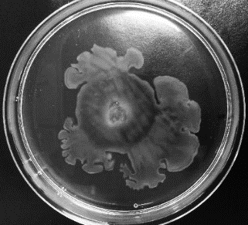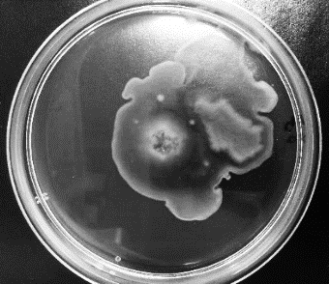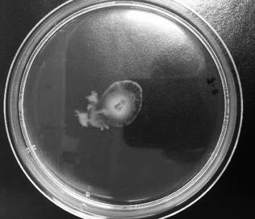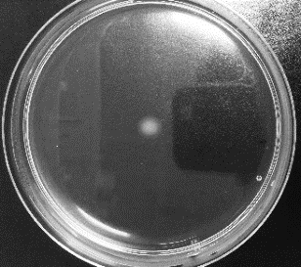
a b c d
Figure 49 P. aeruginosa swarming assay after incubation for 18 h at rt and 4 h at 37 °C with increasing caffeine 92 concentration: a no caffeine, b 0.2 mg/mL, c 0.5 mg/mL, d 1 mg/mL caffeine. Caffeine was incorporated into the molten agar at varying final concentration before pouring. After the caffeine-containing agar was set, the plates were inoculated in the centre with P. aeruginosa. The assays were performed in triplicate and showed that increasing caffeine concentration decreased bacterial swarming in all cases.
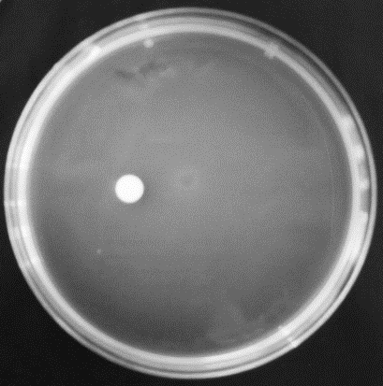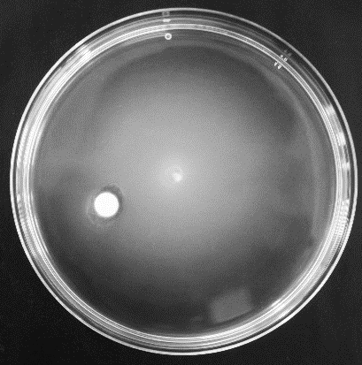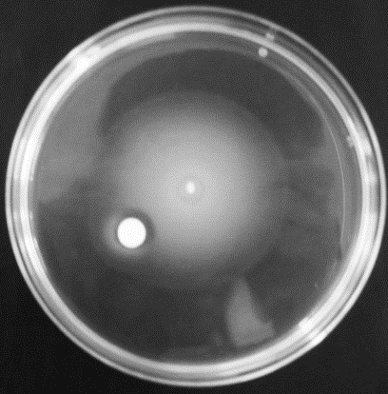
e f g
Figure 50 P. aeruginosa swimming assay after incubation for 24 h at rt with increasing caffeine 92 concentration: e no caffeine, f 0.5 mg/mL, g 1 mg/mL. Plates were inoculated in the centre with P. aeruginosa and a filter disc was placed on the agar and treated with an aqueous caffeine solution at varying concentrations. The assays were carried out in triplicate and motility was found to slow with increasing caffeine concentration.
Disc diffusion swimming assays were carried out in the hope of gaining a different visualisation of the effect on motility. The swimming assays could alternatively be carried out in the same way as the swarming assay, with compound incorporated into the agar, but it was thought that the filter disc would give a better indication of whether the caffeine was affecting motility as opposed to being a general growth inhibitor. Ideally, a clear inhibitory area would be visible around the filter disc. However, whilst there was evidence of the presence of caffeine slowing the swimming, there did not appear to be obvious inhibitory zones around the filter disc. This is perhaps due to the caffeine solution leaching into the media and causing a general effect on the bacterial swimming progress. In the swimming assays, all halos did eventually reach the edge of the plate. It appeared that caffeine was acting as a retardant rather than completely inhibiting motility. It is important to note that, unlike the swarming assays, these caffeine swimming assays were not previously reported in the literature. It was considered that the qualitative results could be quantified, for example by the measurement of halo radius with respect to time but since caffeine was merely employed as a model, this was not pursued further at this point.
The next logical step was to see if caffeine showed activity in the organism of choice, A. caviae. Swimming assays were first carried out as swarming assays in A. caviae require more sensitive conditions due to their additional need to grow peritrichous flagella in situ. The swimming assays revealed no significant effect of the caffeine on motility over 24 h (Figure 51).
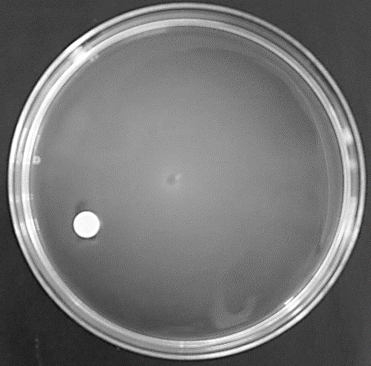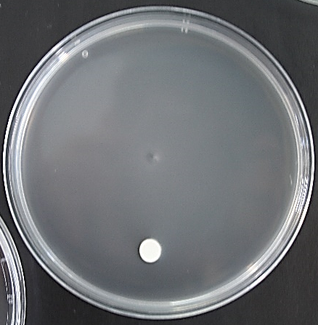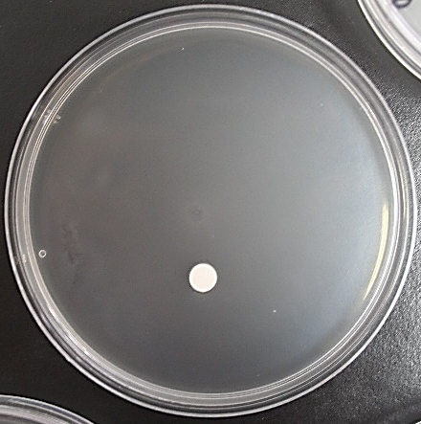
h i j
Figure 51 Swimming assays in A. caviae after incubation for 24 h at rt with varying caffeine 92 concentrations: h no caffeine, i 0.5 mg/mL caffeine, and j 1 mg/mL caffeine.
This inactivity is perhaps due to a difference in the quorum sensing mechanisms between the two bacterial genera. It has been mentioned previously that P. aeruginosa swarming requires the quorum sensing-regulated production of biosurfactant rhamnolipids (Pesci et al., 1997; T Köhler et al., 2000). Although the relationship is less well understood, swimming motility in P. aeruginosa has also been linked to quorum sensing via the PA5022 gene (Li et al., 2015). From the above assay, it may be at best speculated that quorum sensing may not regulate swimming motility in A. caviae. However, quorum sensing in A. caviae is generally less well studied and whilst the presence of LuxI-type proteins related to quorum sensing in various aeromonads has been determined, there is little evidence of how this might regulate motility (Talagrand-Reboul, Jumas-Bilak and Lamy, 2017). The result of caffeine on swarming was not tested in A. caviae although it may have shown an inhibitory trend, if A. caviae swarming (unlike swimming) is controlled by quorum sensing in the same way as P. aeruginosa. However, with this initial lack of transferability and without a clear mechanism of action, further testing of caffeine was side-lined in favour of a compound that would be more relevant to motility-inhibition in the species of interest.

Synthesis of aryl pyrrole 98
The aryl pyrrole 98 was synthesised via a microwave-assisted Paal-Knorr pyrrole synthesis following the procedure detailed in the literature (Noberini et al., 2011) (Scheme 40).
Scheme 40 Paal-Knorr synthesis of aryl pyrrole compound 98.
Whilst the synthesis was facile and quick, the product had to be at a high purity for use in the assays. The purification proved challenging as a gradual decrease in product solubility was observed. Flash column chromatography on silica gel saw immediate pyrrole degradation and was subsequently abandoned. Recrystallisation was also attempted and whilst crystals were obtained, they were no purer by ¹H NMR spectroscopy. Acid/base extraction improved the purity to approximately 90% (measured by relative integrals in the ¹H NMR spectrum). It was then considered that the pyrrole 98 would be assayed as an aqueous solution and any insoluble organic impurities could be filtered off. Aqueous sodium hydroxide (1 M) was used to fully solubilise the product and a ¹H NMR spectrum in NaOD/D₂O confirmed its purity.

Aryl pyrrole 98 effect on motility
As the aryl pyrrole compound 98 was found to inhibit the enzyme of interest (in H. pylori), it was incorporated in plate-based assays with A. caviae. The basic solution of compound was tested in swimming assays with A. caviae. As with previous swimming assays, the compound 98 in solution at varying concentrations (0.1-1 mg/mL) was introduced onto the plate via a filter disc with bacterial inoculation in the centre of the plate. Control assays were set up with plates containing only a dry filter disc, a filter disc treated with 1 M NaOH containing no compound, and a filter disc treated with H₂O. In all cases, the bacterial swimming halos expanded to the edge of the plates within a 16 h timeframe (Figure 52).
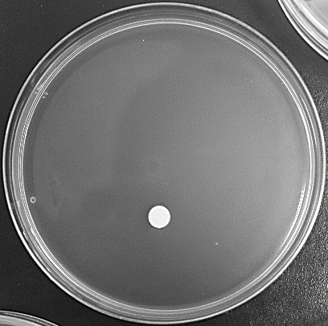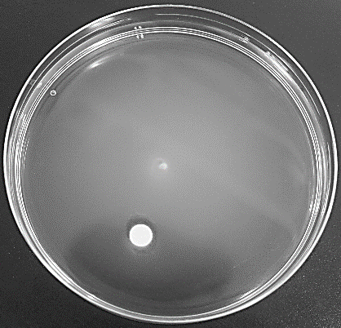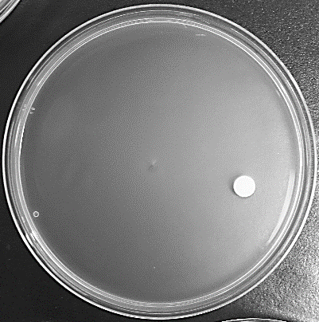
a b c
Figure 52 Swimming assay after 16 h incubation at rt with A. caviae and a filter disc treated with H₂O a, 1 M NaOH b, and the aryl pyrrole 98 at 1 mg/mL c. All assays were repeated as three independent triplicates. In all cases the bacteria have moved to the edge of the plate.
It was confirmed that the aryl pyrrole compound 98 was simply unable to reach its target in the plate assay. Cellular assays in the literature (R. Ménard et al., 2014) also saw a lack of activity and suggested a lack of permeability as the cause, given its activity against the enzyme in vitro. Interestingly, the bacteria were completely unaffected by the significant basicity of 1 M NaOH which was a concern prior to the assay. It was decided that it was important to first demonstrate activity against the enzyme before incorporating inhibitors into motility assays. After confirming enzyme inhibition, the motility assays can then inform on the membrane-permeability of any future potential inhibitors and their structures can be altered accordingly. Given the apparent lack of permeability of the aryl pyrrole compound 98 above, and in the literature, no further plate-based assays were carried out in this work but, as discussed, should be used in the future with potential inhibitors.

Aryl pyrrole 98 in LCMS assay
The previously-discussed LCMS assay was employed to test the activity of the aryl pyrrole against the enzyme. As with the previous compounds, the aryl pyrrole 98 was tested at three concentrations (0.1-5 mM) and all other conditions were kept constant. It should be noted that these concentrations are far greater than those reported in the literature (R. Ménard et al., 2014). Ménard et al. found that this aryl pyrrole compound inhibited the H. pylori PseB enzyme with an IC₅₀ (half-maximal inhibitory concentration) of 21.4 μM. Whilst it is important for potency that inhibitory concentrations are low, the LCMS assay in this work is employed to observe inhibitory trends rather than discern an exact IC value.
Again, the reactions were pre-incubated with the enzymes leading up to PseI until the complete turnover to the deoxy AltdiNAc 13 was observed (overnight). These were then added to the relevant inhibitor and PEP mixtures. The reactions were initiated with the addition of PseI and incubated for a minimum of 4 h before testing. On the chromatograms, decreasing intensity of the pseudaminic acid peaks (333 g mol⁻¹) was observed with increasing concentration of inhibitor (Figure 53). Furthermore, complete inhibition was seen at the 5 mM concentration in the case of the C. jejuni PseI_{Cj}.
Aryl pyrrole 0.1 mM (PseI_{Cj})
Aryl pyrrole 1.0 mM (PseI_{Cj})
Aryl pyrrole 5.0 mM (PseI_{Cj})
Control – no inhibitor
a
Aryl pyrrole 0.1 mM (PseI_{Ac})
Aryl pyrrole 1.0 mM (PseI_{Ac})
Aryl pyrrole 5.0 mM (PseI_{Ac})
Control – no inhibitor
b
Figure 53 LCMS chromatograms showing the effect of the aryl pyrrole inhibitor 98 on pseudaminic acid 6 production by a PseI_{Cj} and b PseI_{Ac}. In both cases dose-dependent inhibition can be observed. Increasing inhibitor concentration results in decreasing intensity of the pseudaminic acid signal (333 g mol⁻¹).
The compound 98 was also tested for activity against the PseB enzyme (from C. jejuni) as it was progressed as a PseB lead compound in the literature (R. Ménard et al., 2014). This was achieved by incubating the compound with all the enzymes (PseB-PseI) at the start of the reaction. Again, the height of the pseudaminic acid peak was monitored and the same results were seen (Figure 54, c). In these cases of inhibition (1-5 mM inhibitor), none of the intermediary sugar products were seen throughout the run, leading to the conclusion that the compound was inhibiting PseB in this case. Further to this, the remaining presence of UDP-GlcNAc 9 was observed with 1 mM and 5 mM inhibitor 98, showing that the first enzyme was affected (Figure 54, d). Unfortunately, the UDP-GlcNAc 9 does not resolve as a single peak on the chromatogram but a general trend can still be observed.
Aryl pyrrole 0.1 mM (PseB_{Cj})
Aryl pyrrole 1.0 mM (PseB_{Cj})
Aryl pyrrole 5.0 mM (PseB_{Cj})
Control – no inhibitor
a
b
Figure 54 An LCMS chromatogram showing the effect of the aryl pyrrole inhibitor 98 on eventual pseudaminic acid 6 production by inhibition of PseB_{Cj} a, and a chromatogram showing the remaining UDP-GlcNAc 9 (606 g mol⁻¹) after incubation for the same sample b. It should be noted that UDP-GlcNAc 9 has an affinity for the column, hence the lack of a defined peak.

Aryl pyrrole 98 analogues
With the positive result of the aryl pyrrole inhibitor 98 against PseI (albeit at high concentrations), a small number of analogues (Figure 55) was designed to probe the structure-activity relationship (SAR). Ménard and co-workers varied the groups around the benzene ring to a degree and found little or detrimental change in activity. In order to avoid covering the same ground as the literature, it was decided that this work would focus on the specificity of carboxyl group; namely its location on the ring and whether the ortho hydroxyl group was necessary. It was also considered that a change in the pyrrole functionality could affect activity.
Figure 55 Preliminary aryl pyrrole compound set designed to probe the importance of the carboxylic acid group
The relevant aniline derivatives were purchased and the microwave reactions with the diketone 99 were carried out as with the original compound 98. It was found that the synthesis of the ortho-acid compounds (104 and 105) was more complex. It was thought that the potential steric barrier to rotation of having the acid group located next to the pyrrole methyl group caused the reactions to be slow and low-yielding as well as complicating the resulting spectra. The mono-ortho-acid 104 appeared to be a mixture of compounds by ¹H NMR spectroscopy yet LCMS and TLC contradicted this. A variable temperature (VT) ¹H NMR was carried out in order to rule out a potential rotational isomer effect but only saw the eventual degradation of the compound. This apparent decomposition has previously been demonstrated for the compound in question 104 by Hartmann and co-workers (2013). They eventually concluded that the compounds underwent spontaneous polymerisation which was accelerated at higher temperatures. The polymerisation was characterised by the gradual broadening of peaks and the disappearance of the pyrrole C-H peak by ¹H NMR spectroscopy. The same was seen in the VT NMR spectrum from this work (Figure 56). It was considered that the presence of an intramolecular acid group was further promoting this polymerisation and could be a reason for the increased difficulty of formation of the diacid compounds in this work (105 and 106). In order to address the problem, the sodium salts were generated. The advantage to this was two-fold: it circumvented the need for NaOH as a solvent and allowed full aqueous solubility as well as increasing the overall stability of the compounds. Furthermore, purification by DOWEX ion-exchange chromatography was now a possibility.
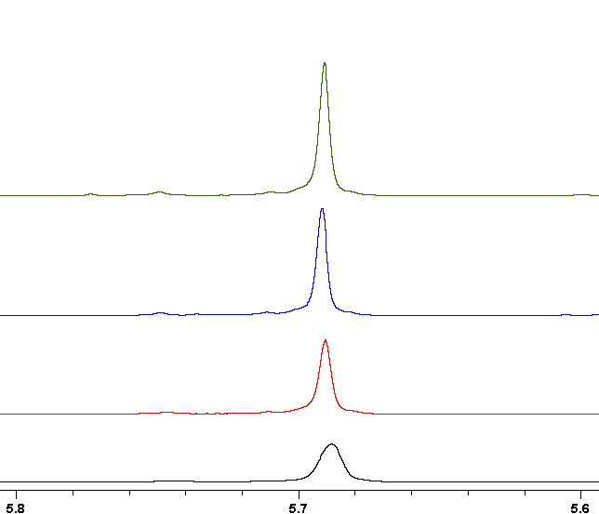
ppm
Figure 56 Expansion of the pyrrole C-H signal in the VT 1H NMR of the ortho-acid compound 104 at 25 °C (green), 50 °C (blue), 80 °C (red), and 100 °C (black) showing the peak broadening and decreasing with increasing temperature.
Eventually, due to lack of clear characterisation and very low mass returns, the ortho-acid compounds (104 and 105) were excluded from the set entirely. Likewise, the final diacid compound 106 was not successfully isolated and subsequently omitted. The remaining three compounds were considered to represent a good preliminary means of testing the SAR of the acid group as well as the hydroxyl group.
With this, two more compounds were added to the updated compound set (Figure 57) and all were converted to the salt using one equivalent of NaH.
Figure 57 The secondary aryl pyrrole series designed to test the SAR of the carboxylic acid placement and the pyrrole ring importance.
The pyrrolidine compound 112 was considered as a probe of the necessity of the pyrrole group and provided a more stable alternative as polymerisation was no longer possible. It was synthesised via the methyl esterification of the original aniline 100 followed by reaction with the dibromide 114. The resulting pyrrolidine 115 was then hydrolysed to give the acid which was converted to the salt 112 (Scheme 41).
Scheme 41 The synthesis of aryl pyrrolidine 110.
The methyl ester of the original pyrrole 110 was also created using the aniline methyl ester 113. This was considered as a test of the hydrophilic importance of the acid group. It was evidently no longer possible to convert it to the sodium salt and it was dissolved in DMSO to be diluted to 10% with water. Unfortunately, it had to excluded from screening due to precipitation from the 10% DMSO solution.

Aryl pyrrole analogues in LCMS assays
With the final five-compound collection in hand, the enzyme assays were carried out at the University of York as previously. It should be noted that in the interim the University of York upgraded their LCMS facilities from HPLCMS to UPLCMS (details in 2.5.2.), hence the following chromatograms having smoother peaks and marginally different retention times to those previously shown. Each compound was tested at 0.1, 1.0 and 5.0 mM concentrations and each concentration was tested in duplicate. These were all tested on the PseI_{Ac} from this work as well as PseI_{Cj} from York.

It was found that the original aryl pyrrole still showed dose-dependent inhibition as the sodium salt 107 (Figure 58).
PseI_{A. caviae}

a
0.1 mM inhibitor
1.0 mM inhibitor
5.0 mM inhibitor
Control (no inhibitor)

PseI_{C. jejuni}

b
0.1 mM inhibitor
1.0 mM inhibitor
5.0 mM inhibitor
Control (no inhibitor)

Figure 58 LCMS chromatograms showing the effect on the intensity of the pseudaminic acid peak with increasing concentrations of aryl pyrrole inhibitor 107 in a PseI_{Ac} from this work and b PseI_{Cj} from York. Each concentration was tested in triplicate with a negative control containing no inhibitor also in triplicate. In both cases, increasing inhibitor concentration results in decreasing intensity of the pseudaminic acid peak.
Interestingly, the removal of the hydroxy group ortho to the acid appeared to reduce the inhibition of PseI_{Ac} but not PseI_{Cj} (Figure 59). This could suggest something about the difference in structure of the two homologous enzymes that makes the hydrogen bond-donor hydroxyl group essential for PseI_{Ac}. Without knowing the mechanism of action (MoA) of these compounds and the differences in enzyme structure, it is difficult to speculate further.
PseI_{A. caviae}

0.1 mM inhibitor
1.0 mM inhibitor
5.0 mM inhibitor
Control (no inhibitor)

a
PseI_{C. jejuni}

b
0.1 mM inhibitor
1.0 mM inhibitor
5.0 mM inhibitor
Control (no inhibitor)

Figure 59 LCMS chromatograms showing the effect on the intensity of the pseudaminic acid peak with increasing concentrations of aryl pyrrole inhibitor 108 in a PseI_{Ac} from this work and b PseI_{Cj} from York. Each concentration was tested in triplicate with a negative control containing no inhibitor also in triplicate. In the case of PseI_{Ac} a, some dose-dependent inhibition is observed but the decrease in peak intensity is small. In the case of PseI_{Cj} b, complete inhibition appears to occur at higher concentration.
Further to this, the shifting of the acid group from para to the meta position (still in the absence of the hydroxy group) 109 showed a decrease in inhibition (Figure 60). In this case, although some dose-responsive inhibition does seem to be present, it could be within the margins of error for this assay.
PseI_{A. caviae}

a
0.1 mM inhibitor
1.0 mM inhibitor
5.0 mM inhibitor
Control (no inhibitor)

PseI_{C. jejuni}

b
0.1 mM inhibitor
1.0 mM inhibitor
5.0 mM inhibitor
Control (no inhibitor)

Figure 60 LCMS chromatograms showing the effect on the intensity of the pseudaminic acid peak with increasing concentrations of aryl pyrrole inhibitor 109 in a PseI_{Ac} from this work and b PseI_{Cj} from York. Each concentration was tested in triplicate with a negative control containing no inhibitor also in triplicate. In both cases it appears that the compound has no effect on the production of pseudaminic acid with all concentrations giving peaks of similar intensity.
Replacement of the hydroxy group in the original aryl pyrrole to a methoxy group 111 again led to reduced inhibition in both enzymes (Figure 61). Considering that the complete removal of the hydroxy group still showed inhibition in the PseI_{Cj}, this is interesting and suggests that the methoxy group has a negative steric effect.
PseI_{A. caviae}

a
0.1 mM inhibitor
1.0 mM inhibitor
5.0 mM inhibitor
Control (no inhibitor)

PseI_{C. jejuni}

b
0.1 mM inhibitor
1.0 mM inhibitor
5.0 mM inhibitor
Control (no inhibitor)

Figure 61 LCMS chromatograms showing the effect on the intensity of the pseudaminic acid peak with increasing concentrations of aryl pyrrole inhibitor 111 in a PseI_{Ac} from this work and b PseI_{Cj} from York. Each concentration was tested in triplicate with a negative control containing no inhibitor also in triplicate. In both cases some concentration-dependent reduction in pseudaminic acid production is observed (more notably in PseI_{Ac}) but overall inhibition is not significant.

Finally, the pyrrolidine compound 112 also saw a decrease in activity (Figure 62). Despite the evidence of some dose-dependent inhibition, it could be concluded that the pyrrole group (or perhaps the methyl groups) plays a role in activity.
0.1 mM inhibitor
1.0 mM inhibitor
5.0 mM inhibitor
Control (no inhibitor)

PseI_{A. caviae}

a
0.1 mM inhibitor
1.0 mM inhibitor
5.0 mM inhibitor
Control (no inhibitor)

PseI_{C. jejuni}

b
Figure 62 LCMS chromatograms showing the effect on the intensity of the pseudaminic acid peak with increasing concentrations of aryl pyrrolidine inhibitor 112 in a PseI_{Ac} from this work and b PseI_{Cj} from York. Each concentration was tested in triplicate with a negative control containing no inhibitor also in triplicate. As before, some correlation between increasing inhibitor concentration and decreasing pseudaminic acid peak intensity is evident in both cases but inhibition is not significant.
In theory, it is possible to predict IC₅₀ values from does-responsive inhibition. Plotting inhibitor concentration (or the log of inhibitor concentration) against percentage inhibition allows for this calculation. Examples were generated for the inhibition of A. caviae PseI by the original compound 107 (Figure 63). However, the data set is too small for an effective estimate and a larger range of concentrations would need to be tested in a better-suited kinetic assay such as the aforementioned spectrophotometric assay. In addition, the LCMS assays were performed in triplicate, but no independent repeats were carried out due to the collaborative nature of the work. As a result, the data is not considered quantifiable at this stage.
Figure 63 An example graph of the log of concentration of inhibitor 107 against intensity of the pseudaminic acid chromatogram signal to illustrate the potential for estimating IC₅₀ (calculated using GraphPad Prism8). IC₅₀ = 0.53 mM. The data are normalised based on the intensity of the control (no inhibitor) pseudaminic acid peak (considered to be 100% intensity). However, the LCMS data are not considered quantitative and there are too few data points, this should be seen as an example only.
The use of high concentrations of inhibitor in order to visualise a trend on the chromatogram also leads to a predicted IC₅₀ value in the high micromolar/low millimolar region (530 µM in this case), where the literature quotes values that are in the micromolar range (21.4 µM for 107) (Robert Ménard et al., 2014).

Summary and conclusions
In order to probe the available methods of testing potential inhibitors, motility assays were examined, as well as the synthesis of an existing literature compound 107 with activity against the enzyme in question. From this compound, a small subset of related compounds was synthesised in order to determine the potential of LCMS for examining SAR. Chromatograms were generated for varying concentrations of each compound, showing – in some cases – a dose-responsive inhibition. These results were, at best, semi-quantitative and should be considered as more of a qualitative evaluation of SAR. In effect, they can only inform on whether a compound derivative, is as active as, or less active than its parent compound. However, an example IC₅₀ curve was generated for the literature compound 107 and a an IC₅₀ value was derived as 530 μM. Generally, a good IC₅₀ value would be at least an order of magnitude lower than this, although sub-micromolar is preferential. In fact, the effective IC₅₀ of an antibiotic can depend on multiple factors including whether the inhibition is reversible or irreversible and the drug-free growth rate of the bacterial species. Greulich et al. (2015) examined ribosome-targeting antibiotics (including kanamycin – IC₅₀ 0.54 μM) in E. coli, and found that for those exhibiting irreversible binding, a higher bacterial growth rate led to decreased antibiotic susceptibility. It is thought that this negative trend between the efficacy of irreversibly binding inhibitors and bacterial growth rate is yet another factor contributing to (or in fact a symptom of) increased development of antimicrobial resistance (Greulich et al., 2015). Considerations of the IC₅₀ of a potential antimicrobial should also include the toxicology of the dosage for the host. The aforementioned assays using caffeine saw an effective concentration of 0.1 mg/mL, which is approximately equivalent to the concentration in a cup of tea. In fact, the lethal caffeine dose for humans is in the order of 10 g (Murray and Traylor, 2019).
The data reported in this chapter pointed to the original literature candidate compound 107 (Figure 58) being the best PseI inhibitor but have revealed some interesting discrepancies between the enzyme from A. caviae and that of C. jejuni. The fact the compound was active against PseB_{Hp} and PseI_{Hp} in the literature makes it unlikely that it is a specific site-binder. Without any further elucidation of its MoA, it is hard to make any further conclusions about the SAR data reported herein. It has also been shown that the inhibitor 107 does not display activity in plate-based motility assays suggesting an inability to access the target enzyme through the bacterial cell; a result which was mirrored in cellular assays in the literature (Robert Ménard et al., 2014).
Overall, an initial means of testing inhibition has been found and allowed for some SAR probing in a literature inhibitor. Whilst this method doesn’t allow for the quantification of inhibition, it is a good starting point for analysing inhibitory trends. Furthermore, when used in conjunction with motility assays, any future inhibitors can swiftly be tested against the enzyme as well as against the organism as a whole. In future work, if successful inhibitors were to be synthesised with the relevant side-chains, they could be tested in this manner before a more accurate kinetic method akin to that used by Tanner et al. (Liu et al., 2009).

Conclusions and future work

A. caviae and a number of other pathogenic bacteria decorate their flagella with pseudaminic acid. The biosynthesis of pseudaminic acid, although varying slightly in different bacteria, proceeds via the same base enzymes. The PseI enzyme converts the deoxy AltdiNAc sugar 13 substrate into pseudaminic acid 6 via condensation with PEP. This work set out to target the PseI enzyme for inhibition. Following the design of analogous enzyme inhibitors in the literature, two PseI inhibitors were proposed: a tetrahedral phosphate inhibitor 22, designed to mimic the oxocarbenium ion intermediate while removing its activity; and a tetrahedral phosphonate inhibitor 23, based on the tetrahedral intermediate. Rationale for the designed inhibitors has been developed through the precedent set by existing analogous models, namely the inhibition of NeuB. The sequence alignment and secondary structure comparison between NeuB and PseI supported the notion that a similar inhibitor design to that of the NeuB inhibitor would be active against the homologous PseI enzyme. Despite the similarity of the two enzymes, there is evidence for a lack of promiscuity and it is therefore reasonable to expect that a targeted PseI inhibitor would not also bind to NeuB.
The relevant sidechain required for both proposed inhibitors is derived from the deoxy AltdiNAc sugar 13, the product of PseH/G. However, this sugar is difficult to obtain in useful quantities and high purity, both chemically and chemoenzymatically. Other work within the group was assessing a more efficient total synthesis of pseudaminic acid, via the deoxy AltdiNAc substrate, than those already reported in the literature (Zunk et al., 2014; Liu et al., 2017). Unfortunately, that work, never produced the deoxy AltdiNAc needed for this project. Therefore, the chemistry detailed in this work has endeavoured to develop and investigate the chemical methods that would be used to alter this sugar aldose into the PseI inhibitors in order to inform future inhibitor synthesis when the relevant substrate is obtained. A number of model compounds have been employed to research the key reactions required for inhibitor synthesis. While existing methods (Liu et al., 2009) of chain extension using indium Barbier-type chemistry were challenging, expensive and low-yielding, the aldol chemistry developed by Norimura et al. (2017) proved a simpler and more efficient approach. This key aldol reaction was shown to work on phenylpropanal 44 as a simple model before attempts on more complex substrates. To some extent, the aldol reaction was successful with model Mannose and GlcNAc sugar-derived aldehydes in this work and the literature shows the versatility of the reaction with such compounds. The most relevant of the sugar models examined in the literature (and attempted in this work) are those which saw the aldol reaction succeed with α-acetamido aldehydes derived from ManNAc and GlcNAc. These sugar aldehydes are most closely related to the deoxy AltdiNAc substrate. However, due to the pressures of time and the constraints of this project, the sugar-derived aldol products were not pursued further in this work than what is already reported in the literature.
With this in mind, it has been shown the resulting aldol product can be TBS protected and subjected to a one-step phosphonate addition at the ketone to immediately furnish the protected phosphonate-based inhibitor 23. This was examined on the simplified model compound 78 derived from 3-phenylpropanal 44 and the reaction proceeded in reasonable yields (55%). It has been proposed that the aldol product could equally be converted (via three steps) into the protected phosphate-based intermediate 22. The aldol reaction is therefore an ideal reaction as it provides a common intermediate which can give both inhibitors in a divergent synthesis (outlined further in future work).
In addition to developing the methods towards the inhibitor syntheses, this project set out to develop an enzyme inhibition assay. Literature precedent for the assembly of a fully working enzyme assay exists for the H. pylori set of Pse enzymes with product turnover observed in a one-pot reaction. Not only does this method allow for the characterisation of the pathway as a whole, it negates the need for the deoxy AltidiNAc sugar as a substrate for PseI inhibition studies as it can be generated in situ from commercially-available UDP-GlcNAc. In this work, the full set of biosynthetic enzymes from A. caviae were expressed, purified and tested for activity. The use of ¹H NMR to monitor product turnover in the literature was not successfully replicated and instead the enzyme-mediated synthesis was followed by LCMS thanks to collaboration with the University of York. Unfortunately, the first enzyme in the pathway, PseB, was shown to be inactive. After some probing into the secondary structure of PseB, the cause of its inactivity was not determined. It was found to have an apparent α-helical structure by CD (although a suitable control was not used) and it was no more active after the cleavage of its HisTag. Further analysis should be carried out to try and solve this issue; the multimeric structure could be examined by techniques such as SEC-MALS and techniques to look at substrate binding should also be considered. However, further determination of the inactivity was not investigated in this work in favour of moving forward with a working assay and a fully active pathway that was possible to construct through the mutually beneficial collaboration with the University of York. Interestingly, the pathway was active using a mixture of enzymes from both A. caviae and C. jejuni. This further confirms the homogeneity between the enzymes in this series from different species. Sequence alignment of the PseI from A. caviae, C. jejuni and H. pylori demonstrated that they shared common structural residues that were not present in the NeuB enzyme.
The five-step turnover of UDP-GlcNAc into pseudaminic acid was monitored by LCMS. In addition to this, LCMS was employed as a means of testing inhibitors. The pseudaminic acid product peak on the chromatogram allowed for a simple means of tracking inhibition. Three simple tetrahedral phosphonates (35, 36, 37) synthesised by another member of the group were initially tested and showed no activity (no effect on pseudaminic acid production). This confirmed that sidechain specificity is important as the enzyme was not promiscuous enough to bind to these compounds.
In order to test the potential of the LCMS inhibition assay, a series of aryl pyrrole-derived PseI inhibitors were synthesised following a library compound 98 from the literature (R. Ménard et al., 2014). The compound set was screened by LCMS and dose-dependent inhibition was observed on the LCMS chromatogram. These results were qualitative and despite generating an example of determining IC₅₀ values through the plotting of % activity versus Log [inhibitor], no further attempts were made to quantify them as the data set was too small for each compound. Although the activity of the aryl pyrrole compound against multiple enzymes in the pathway led to the conclusion that it was probably not involved in site-binding, it did allow for the LCMS assay to be developed as an interesting way of swiftly screening for inhibition. The testing of a variety of structural derivatives also gave some structure activity insight about the compound set. It was found that both the pyrrole and the para-carboxyl groups were necessary for activity. Furthermore, the assays highlighted a potential structural difference between the A. caviae PseI and the C. jejuni PseI as the former required the additional neighbouring hydroxy group for activity where the latter did not. The fact that the collaboration allowed for these compounds to be screened against the PseI enzymes from both A. caviae and C. jejuni is relevant to the application of future inhibitors as potential therapeutics for both bacterial genera.
Plate-based motility assays were also investigated as a means of screening inhibitors against the organism. The testing of potential positive controls led to quorum sensing-inhibitor caffeine 92 showing activity in P. aeruginosa swarming and swimming assays. However, its activity was not replicated in A. caviae swimming assays. Swarming assays in A. caviae were not carried out but it is thought that they would see the same results, because swarming (like swimming) is regulated by flagella in A. caviae. The aryl pyrrole-derived PseI inhibitor 98 was equally inactive in A. caviae motility assays, raising the important question of membrane-permeability for future inhibitors. The library compound 98 was also shown not to reach the target when tested against the organism as whole in the literature (R. Ménard et al., 2014). As previously discussed, permeability into Gram-negative bacteria is not trivial and the pyrrole compound 98 contains a negatively charged carboxylate group, which could have resulted in poor permeability. Interestingly, another lead compound from the same work by Ménard and co-workers showed activity in bacterial cellular assays despite also containing the same aryl pyrrole core structure and a carboxylate anion. It is suggested that the presence of additional lipophilic aromatic groups in this compound helped balance the overall lipophilicity of the molecule and allow for permeability. Ultimately, it is difficult to predict an ideal level of lipophilicity for drugs targeting Gram-negatvie bacteria and the potential for structural editing to incorporate either hydrophobic or hydrophilic groups should be considered when examining binding. It would be interesting to examine the cellular activity of some of the other aryl pyrrole variants from this work that still displayed activity; however, there was not the time. The incorporation of more heteroatoms into either of the rings in the aryl pyrrole structure could also be considered to increase potential permeability according to the aforementioned work by Scott and Waring (2018). In fact, the other lead compound from the work by Ménard and co-workers (2014) contained an additional furan ring.
Attempts are also underway to obtain the first crystal structure of PseI which would help inform on inhibitor design and active site characterisation. A solved PseI crystal would allow for direct comparison with the solved NeuB structure to further cement the rationale for the proposed inhibitors in this work. In addition, it would allow for soaking and docking studies to be carried out with any potential inhibitors to assess their binding. Equally, in silico quantitative SAR modelling alongside docking studies with a solved crystal structure can allow for the amelioration of activity and binding of potential enzyme inhibitors to increase the chances of therapeutic success (as demonstrated in work by Veselinovic et al. (2018) in targeting the FtsZ enzyme which has implications in bacterial cell division). With full characterisation of inhibitor binding, it would be possible to identify non-vital sites on the molecule that, if necessary, could be modified to try and tailor permeability. As discussed previously, the work by Grison et al. (2005) saw the ethyl phosphonate inhibitor display improved activity over the unprotected phosphonic acid. This is therefore an obvious site for structure variation in the proposed inhibitors whereby the ethyl phosphonate groups could be left protected for an increased lipophilicity, or the protecting groups varied. In addition to considering methods of increasing inhibitor permeability, the employment of a potentiator - whose purpose it is to increase membrane permeability - could also be considered. Muheim and co-workers (2017) described the high throughput screening of compounds to increase the outer membrane permeability of E. coli to vancomycin (and other high-molecular-weight antibiotics). The work identified a lead compound which, at sub-inhibitory concentrations, partially inhibited the chaperone protein LolA. LolA is responsible for the transport of three proteins to the outer membrane that are required for its structural integrity. Thus, the partial inhibition of LolA results in increased outer membrane permeability. In addition to the improved permeation of large-scaffold antibiotics, the lead compound also showed increased permeability of the small molecule probe, 1-N-phenylnaphthylamine. Potentiators of this type may play an important role in the efforts against AMR.
In general, the bioavailability of existing commercial antibiotics varies. The antibiotic Gentamicin, which is used as the drug of choice against a number of Gram-negative blood infections including P. aeruginosa, is administered parenterally. The previously-discussed carbapenem, Meropenem, is used intravenously against infections including that of N. meningitidis. In contrast, most penicillins are orally available. It is preferable to have a drug that can be administered orally as it does not require hospital admission or supervision. In terms of the bioavailability of the proposed inhibitors, their hydrophilic nature is encouraging. If in the future they are considered for development as drug candidates, it should be noted that many existing antimicrobials are administered intravenously and intramuscularly to circumvent a lack of bioavailability, so it is not necessarily a defining factor of their drug potential.
Additional, and later-stage considerations must also be made for the toxicology of any potential antibiotics. Toxicity of antibiotics tends to come into effect when patients are on high or sustained doses. However, reports of various adverse effects of many commercial antibiotics exist (Yılmaz and Özcengiz, 2017). Even in penicillin, there are cases of neurotoxicity (Fossieck and Parker, 1974). Although very much a future concept in relation to this work, the testing of toxicity as part of the development of new antibiotics can be carried out at a preliminary laboratory stage with the employment of mammalian cell assays. One such assay for the assessment of potential antibiotic toxicology is described by Sarver et al. (2012) and uses positive and negative antibiotic toxicity controls, erythromycin and ampicillin respectively. Other considerations for the development of novel therapeutics include half-life – a measure of how long the drug remains in the blood stream. In antibiotic sulfonamides alone, half-life can vary from 10-150 hours. In fact, the pharmacokinetic properties (the entry, action and exit of a drug in the body) of antibiotics from the last 30 years have been thoroughly reviewed by Baietto et al. and reveal a huge and often patient-dependent variation across the different classes of antibiotics in all of the aforementioned properties (Baietto et al., 2014).
In summary, all these drug-like properties - from permeability and bioavailability to toxicology and pharmacokinetics – are factors that must be considered upon the development of any potential new antimicrobials, but there is a certain amount of acceptable deviation from an ideal property as is seen in many established antibiotics. In order to reach this stage of consideration however, more work is needed to prove the concept of inhibition outlined in this work. Only after the synthesis and confirmed activity of the proposed inhibitors, can one consider their development as novel therapeutics. Nonetheless, it is useful to keep all of these factors in mind, even at such an early stage of inhibitor design.
Overall, this project has aimed to combine both chemical and microbiological methods in order to probe the avenues of targeting pseudaminic acid for antimicrobial therapy. The foundation has been set for the synthesis of pseudaminic acid synthase inhibitors (22 and 23) from the deoxy AltdiNAc sugar 13 and their subsequent testing against the enzyme. After enzyme-activity is confirmed and the original concept is proved, then the drug-like properties of the inhibitors should be examined in greater detail. It is hoped that the methods developed in this work will eventually contribute to combatting the problem of AMR.

Future work
The methods developed in this work can be applied to the synthesis of both proposed inhibitors via the deoxy AltdiNAc substrate 13 (Scheme 42).
Scheme 42 The synthesis of PseI inhibitors 22 and 23 from deoxy AltdiNAc 13 following the methods developed in this work. A key step aldol reaction would furnish the chain-extended orthoester product 117 which can be converted via 3-5 steps into either inhibitor.
Once synthesised, these inhibitors should be preliminarily screened against the biosynthetic pathway in the LCMS assay set up in this work. They should also be investigated in plate-based motility assays and membrane-permeability should be considered. If required, it may be possible to consider the incorporation of more hydrophobic protecting groups on the phosphorus, although this may have a detrimental effect on activity. In the case of the phosphonate inhibitor 23, the incorporation of a mono or difluoromethylene phosphonate group should be investigated with a view to better conserving the electronic properties of the original phosphate group. The synthetic strategy would remain the same for the difluoro compound which can be synthesised from commercially available difluoromethyl diethylphosphonate. A monofluoro group would have to be investigated from a stereochemical perspective. The monofluoro phosphonate reagent could be made from the reaction of deprotonated diethylmethyl phosphonate with an electrophilic fluorine source. Successful inhibitor candidates can then be quantified in the aforementioned spectrophotometric phosphate release assay. These candidates should then be considered in relation to their drug-like properties and their bioavailability and permeability should be investigated and tuned for further development.
If a crystal structure of PseI were obtained, this could be used to do soaking studies with potential inhibitors to assess their binding. Equally, it would be interesting to obtain the crystal structure as a solved PseI crystal structure does not already exist and direct comparisons could then be made with the existing sialic acid synthase NeuB structure. The cause for the lack of activity in the A. caviae PseB enzyme could be pursued further with the aforementioned structural and substrate binding analysis. Employment of alternative expression strains could also be considered.
Finally, any future PseI inhibitors should be examined for their therapeutic potential against other bacteria that decorate their flagella with pseudaminic acid, as well as those that require pseudaminic acid for other structures. The chemical methods could also be adapted to synthesise inhibitors of other PEP-condensing nonulosonic acid synthase enzymes such as LegI which in fact shares an even greater similarity with NeuB. In general, novel antimicrobial therapies should be investigated as a matter of extreme importance to tackle the ever worsening issue of AMR.

Experimental
Unless otherwise stated, non-aqueous reactions were performed in anhydrous solvents obtained from the University of Sheffield Grubbs solvent service and all glassware was flame-dried. All other solvents and reagents used were purchased from commercial suppliers. 2-Phenylpropanal was distilled before use. DMSO was distilled before use as a reagent. All other chemicals were used in reaction as received from the supplier. All melting points were taken in triplicate using a Gallenkamp melting point apparatus with a manual thermometer. ¹H, ¹³C and ³¹P NMR experiments were run on either a Bruker Avance 400 or Bruker Avance III HD 400 spectrometer at 298 K. Chemical shifts (δ) are reported in parts per million (ppm) relative to the deuterated lock solvent as an internal standard, where s = singlet, d = doublet, t = triplet, q = quartet, m = multiplet, dd = doublet of doublets, ddd = double doublet of doublets, td = triplet of doublets, and tdd = triple doublet of doublets. All coupling constants (J) are reported in hertz, Hz and calculated with the aid of Bruker TopSpin NMR software. IR spectroscopy was carried out on a PerkinElmer FT-IR Spectrum 100 spectrometer, using either thin film KCl discs or a Universal diamond ATR. Mass spectrometry was carried out on an Agilent Technologies 7200 spectrometer, using either electron impact (EI) or electrospray ionisation (ESI). TLC was carried out on Merck silica gel 60 F254 aluminium-backed plates. TLC plates were visualised using ultraviolet light followed by staining with potassium permanganate or phosphomolybdic acid (PMA) TLC dips. PMA was purchased as a solution in ethanol and diluted for use as a stain. Column chromatography was carried out using silica gel obtained from VWR Chemicals, particle size 40-63 μm. Reactions using microwave conditions were carried out in a CEM Corporation Discover S-class microwave synthesiser, at pressure ≤ 20 bar and power ≤ 200 W.

2-Acetamido-2-deoxy-3,4,5,6-tetra-O-acetyl-D-mannose (E)-methyloxime 38 (major and minor)
Methoxyamine hydrochloride (0.45 g, 5.42 mmol) was added to a solution of N-acetyl-D-mannosamine (1.00 g, 4.52 mmol) in anhydrous pyridine (16 mL) and stirred at room temperature for 4 h. Acetic anhydride (3.4 mL, 36.2 mmol) and DMAP (20 mg, 0.16 mmol) were added and the reaction was stirred at room temperature for a further 18 h. The solution was concentrated under reduced pressure, diluted in EtOAc (30 mL) and washed with aqueous 1 M HCl (4 x 30 mL) and brine (2 x 20 mL). The organic layer was dried (Na₂SO₄), filtered and concentrated under reduced pressure. The resulting white solid was recrystallised from EtOAc:hexane (1:2) to give the oxime 38 as white crystals (1.51 g, 80%) in a mixture of two geometric isomers in ratio 91:9; mp 98-99 °C (from EtOAc/hexane) [lit. (Bednarski and Weitz, 1989) 99-100 °C (from EtOAc/hexane)]; [α]_{D}²² +3.4 (c 1.0 in CH₂Cl₂); major isomer: δ_{H}(400 MHz; CDCl₃) 2.00 (3 H, s, CH₃), 2.06 (3 H, s, CH₃), 2.07 (3 H, s, CH₃), 2.08 (3 H, s, CH₃), 2.14 (3 H, s, CH₃), 3.80 (3 H, s, CH₃), 4.05 (1 H, dd, J 12.5, 5.6, CHH) , 4.25 (1 H, dd, J 12.5, 2.8, CHH), 4.78-4.90 (1 H, m, CHNHAc), 5.06-5.18 (1 H, m, CHOAc), 5.40 (1 H, dd, J 8.0, 3.1, CHOAc), 5.44 (1 H, dd, J 6.6, 3.1, CHOAc), 6.10 (1 H, d, J 8.6, NHAc), 7.33 (1 H, d, J 5.5, CH=N); δ_{C} (100 MHz; CDCl₃) 170.6 (C=O), 170.2 (C=O), 170.0 (C=O), 169.9 (C=O), 169.8 (C=O), 145.4 (C=N), 70.3 (CHOAc), 68.6 (CHOAc), 68.1 (CHOAc), 62.0 (OCH₃), 61.9 (CH₂), 49.1 (CHN), 23.2 (CH₃), 20.8 (CH₃), 20.8 (CH₃), 20.7 (CH₃), 20.7 (CH₃), Selected data for minor isomer: δ_{H}(400 MHz; CDCl₃) 1.84 (3 H, s, CH₃), 1.97 (3 H, s, CH₃), 2.01 (3 H, s, CH₃), 2.15 (3 H, s, CH₃), 2.18 (3 H, s, CH₃), 3.95 (3 H, s, CH₃), 4.50 (1 H, dd, J 12.5, 5.6, CHH), 4.92-4.97 (1 H, m, CHNHAc), 4.99-5.05 (1 H, m, CHOAc), 5.60 (1 H, dd, J 7.8, 2.7, CHOAc), 6.61 (1 H, d, J 7.6, NHAc), 6.72 (1 H, d, J 6.6 CH=N); δ_{C} (100 MHz; CDCl₃) 170.0 (C=O), 169.7 (C=O), 145.5 (C=N), 69.4 (CHOAc), 68.4 (CHOAc), 62.4 (OCH₃) 45.1 (CHN); ν_{max} (ATR)/cm⁻¹ 3267, 1742, 1651, 1547. An [α]_{D} value was not previously reported in the literature. All other data are in accordance with the literature (Bednarski and Weitz, 1989).
3,3-Dimethyl-1-undecen-4-ol 47
Indium powder (202 mg, 1.76 mmol) was suspended in dimethyl formamide (DMF) (2 mL) at room temperature. A mixture of octanal (0.19 mL, 1.17 mmol) and dimethylallyl bromide (0.20 mL, 1.76 mmol) in DMF (1 mL) was added dropwise and the reaction stirred at room temperature for 1.5 h. Aqueous HCl (1 M, 10 mL) was added and the product was extracted with diethyl ether (3 x 10 mL). The combined organic layers were washed with brine (2 x 10 mL) and dried (MgSO₄), filtered and concentrated under reduced pressure to give a crude yellow oil. This was purified via flash column chromatography on silica gel eluting with 1% ethyl acetate in 40/60 petroleum ether to afford 3,3-dimethyl-1-undecen-4-ol 47 as a clear oil (128 mg, 52%); δ_{H} (400 MHz; CDCl₃) 0.89 (3 H, t, J 6.4, CH₃), 1.00 (6 H, s, 2 x CH₃), 1.20-1.40 (10 H, m, 5 x CH₂), 1.45-1.65 (3 H, m, CH₂ and OH), 3.25 (1 H, d, J 9.8, CHOH), 5.06 (1 H, dd, J 17.4, 1.3, CH=CHH), 5.09 (1 H, dd, J 10.9, 1.3, CH=CHH), 5.83 (1 H, dd, J 17.4, 10.9, CH=CH₂); δ_{C} (100 MHz; CDCl₃) 145.6 (CH=CH₂), 113.2 (CH=CH₂), 78.3 (CHOH), 41.7 [C(CH₃)₂], 31.9 (CH₂), 31.4 (CH₂), 29.7 (CH₂), 29.4 (CH₂), 27.1 (CH₂), 23.1 (CH₃), 22.7 (CH₂), 22.0 (CH₃), 14.1 (CH₃). No ¹³C NMR data were reported in the literature. ¹H NMR data are in accordance with the literature (Araki et al., 1987).
3,3-Dimethyl-6-phenyl-1-hexen-4-ol 48
Indium powder (320 mg, 2.79 mmol) was suspended in dimethyl formamide (DMF) (4 mL) at room temperature. A mixture of 3-phenylpropanal (0.25 mL, 1.86 mmol) and dimethylallyl bromide (032 mL, 2.79 mmol) in DMF (1 mL) was added dropwise and the reaction stirred at room temperature for 1.5 h. Aqueous HCl (1 M, 10 mL) was added and the product was extracted with diethyl ether (3 x 10 mL). The combined organic layers were washed with brine (2 x 10 mL) and dried (MgSO₄), filtered and concentrated under reduced pressure to give the alcohol 48 as a crude clear oil that did not require further purification (454 mg, 80%); δ_{H} (400 MHz; CDCl₃) 1.08 (6 H, s, 2 x CH₃), 1.60-1.72 (1 H, m, CH₂), 1.86-1.98 (1 H, m, CH₂), 2.22-2.60 (1 H, s broad, OH), 2.65-2.75 (1 H, m, CH₂), 2.90-3.10 (1 H, m, CH₂), 3.37 (1 H, dd, J 10.6, 1.8, CHOH), 5.13 (1 H, dd, J 17.5, 1.3, CH=CH₂), 5.16 (1 H, dd, J 10.9, 1.3, CH=CH₂), 5.88 (1 H, dd, J 17.5, 10.9, CH=CH₂), 7.23-733 (3 H, m, ArH), 7.33-7.42 (2 H, m, ArH); δ_{C} (100 MHz; CDCl₃) 163.2 (CH=CH₂), 145.4 (ArCH), 142.5 (ArC), 128.6 (ArCH), 128.5 (ArCH), 128.4 (ArCH), 125.9 (ArCH), 113.5 (CH=CH₂), 77.7 (CHOH), 41.8 [C(CH₃)₂], 33.5 (CH₂), 33.4 (CH₂), 23.0 (CH₃), 22.05 (CH₃). All data are in accordance with the literature (Kobayashi and Nishio, 2002).
Dihydro-​3-​methylene-​5-​(2-​phenylethyl)​-2(3H)​-​furanone 51
Indium (322 mg, 2.8 mmol) and NH₄Cl (150 mg, 2.8 mmol) were suspended in a solution of methyl 2-(bromomethyl)acrylate (0.2 mL, 1.68 mmol) in methanol (3 mL) under a nitrogen atmosphere. The reaction was heated to 50 °C for 15 minutes. 3-Phenylpropanal (0.18 mL, 1.4 mmol) was added dropwise and the reaction stirred at 50 °C for a further 1.5 h. After filtration through Celite, the mixture was concentrated under reduced pressure. The residue was redissolved in dilute HCl (0.1 M, 10 mL) and brine (5 mL) and extracted with EtOAc (3 x 10 mL). The combined organic layers were washed with brine (2 x 10 mL), dried (Na₂SO₄), filtered, and concentrated under reduced pressure to afford a crude mixture of lactone, unreacted 2-(bromomethyl)acrylate and methyl ester in a 13:25:62 ratio (250 mg). The crude product (207 mg, 0.88 mmol) was then dissolved in dry DCM (3 mL) and p-toluenesulfonic acid monohydrate salt (168 mg, 0.88 mmol) was added under a nitrogen atmosphere and stirred at room temperature for 18 h. The reaction mixture was washed with brine (2 x 5 mL) and the brine was reextracted with DCM (3 x 10 mL). The combined organic layers were dried (MgSO₄), filtered, and concentrated under reduced pressure to give the crude lactone (150 mg). This was purified via flash silica gel column chromatography to yield lactone 51 as a clear oil (86 mg, 30%); δ_{H} (400 MHz; CDCl₃) 1.96 (1 H, dddd, J 14.0, 9.1, 7.2, 5.0, C₈HH), 2.01-2.13 (1 H, m, C₈HH), 2.61 (1 H, ddt, J 17.1, 6.0, 2.5, C₁₀HH), 2.78 (1 H, ddd, J 14.0, 8.6, 7.2, C₇HH), 2.86 (1 H, ddd, J 14.0, 9.1, 5.3, C₇HH), 3.07 (1 H, ddt, J 17.1, 7.7, 2.5, C₁₀HH), 4.53 (1 H, tdd, J 7.7, 6.0, 5.0, C₉H), 5.66 (1 H, t, J 2.5, C₁₂HH), 6.27 (1 H, t, J 2.5, C₁₂HH), 7.19-7.27 (3 H, m, ArCH), 7.27-7.37 (2 H, m, ArCH); δ_{C} (100 MHz; CDCl₃) 170.4 (C=O), 144.9 (C=CH₂), 134.5 (ArC), 128.6 (2 x ArCH), 128.5 (2 x ArCH), 126.1 (ArCH), 122.3 (C=CH₂), 76.5 (CH), 38.1 (CH₂), 33.5 (CH₂), 31.3 (CH₂). The ¹H NMR and ¹³C NMR data are in accordance with the literature (Le Lamer et al., 2006; Elford et al., 2009).
2-methylene-4-hydroxy-6-phenylhexanoic acid 53
Indium (430 mg, 3.74 mmol) was suspended in DMF (2 mL) under a nitrogen atmosphere. 2-(Bromomethyl)acrylic acid (370 mg, 2.24 mmol) in DMF (1 mL) was added and the mixture stirred at room temperature for 5 minutes. 3-Phenyl propanal (0.25 mL, 1.87 mmol) was added dropwise and the reaction was stirred at room temperature for a further 2 h. Saturated NH₄Cl (2 mL) was added and stirred for 5 minutes before the filtration through Celite. The mixture was diluted with H₂O (10 mL) and extracted with Et₂O (4 x 5 mL). The combined organic layers were washed with saturated brine solution (2 x 10 mL), dried (Na₂SO₄), filtered, and concentrated under reduced pressure to give a waxy white solid. Recrystallisation from dichloromethane yielded the acid 53 as white crystals (186 mg, 45%); mp 108-110 °C; δ_{H} (400 MHz; d₆-DMSO) 1.47-1.59 (1 H, m, CHH), 1.59-1.70 (1 H, m, CHH), 2.30 (1 H, dd, J 13.6, 7.4, CHH), 2.37 (1 H, dd, J 13.6, 5.0, CHH), 2.56 (1 H, ddd, J 13.7, 10.1, 6.3, CHH), 2.72 (1 H, ddd, J 13.7, 10.0, 5.1, CHH), 3.36 (1 H, broad s, OH), 3.60 (1 H, tdd, J 7.4, 5.0, 4.3, CHOH), 5.60 (1 H, d, J 1.1, C=HH), 6.06 (1 H, d, J 1.1, C=CHH ), 7.12-7.22 (3 H, m, ArCH), 7.22-7.30 (2 H, m, ArCH); δ_{C} (100 MHz; d₆-DMSO) 168.9 (C=O), 142.9 (C=CH₂), 138.9 (C=CH₂), 128.8 (2 x ArCH), 128.7 (2 x ArCH), 126.8 (ArC), 126.0 (ArCH), 68.5 (CHOH), 39.5 (CH₂), 39.4 (CH₂), 31.9 (CH₂); ν_{max} (ATR)/cm⁻¹ 3389, 2932, 2590, 1699, 1437, 1329, 1251, 1228, 1077; m/z (TOF ES⁺) 243.1003 (50%, M+Na⁺, C₁₃H₁₆O₃Na requires 243.0992), 221 (20, M+H⁺), 203 (100), 185 (40), 117 (5), 157 (60).
D-Phenylalanine methyl ester hydrochloride 56
D-Phenylalanine (3.00 g, 18.16 mmol) was suspended in MeOH (30 mL) and cooled to 0 °C. Thionyl chloride (1.45 mL, 19.98 mmol) was added dropwise over 10 minutes and the reaction mixture was stirred at 0 °C for 30 minutes. The solution was warmed to room temperature, stirred for 2.5 h and then heated at reflux for a further 30 minutes. The solution was cooled and concentrated under reduced pressure to give a waxy white solid which was washed with Et₂O (30 mL) and dried under high vacuum to give methyl ester 56 as a white powder (3.88 g, 99%) that did not require further purification; mp 150-154 °C, lit. (Adams, Bawa and Jones, 2006) 150-154 °C; [α]_{D}²² -4.0 (c 1.0 in H₂O), lit. (Adams, Bawa and Jones, 2006) [α]_{D}²² -3.0 (c 1.0 in H₂O); δ_{H} (400 MHz; D₂O) 3.15 (1 H, dd, J 14.5, 7.5, CHH), 3.25 (1 H, dd, J 14.5, 5.9, CHH), 3.75 (3 H, s, CO₂CH₃), 4.35 (1 H, dd, J 7.5, 5.9, CH), 7.20-7.25 (2 H, m, 2 x ArCH), 7.27-7.40 (3 H, m, 3 x ArCH). All data are in accordance with the literature (Adams, Bawa and Jones, 2006).
(S)-N-Acetylphenylalanine methyl ester 57
(S)-Phenylalanine methyl ester hydrochloride 56 (2.00 g, 9.27 mmol) was dissolved in anhydrous pyridine (30 mL) and acetic anhydride (1.75 mL, 18.6 mmol) was added. The solution was stirred overnight at room temperature and then concentrated under reduced pressure. EtOAc (45 mL) was added and the mixture washed with aqueous 1 M HCl (4 x 20 mL) and saturated bicarbonate solution (2 x 30 mL). The organic extract was dried (Na₂SO₄), filtered and concentrated under reduced pressure to give the N-acetylated amino ester 57 as a white solid (1.65 g, 81%), no further purification was required; mp 85-89 °C, lit. (De Marco et al., 2009) 85-88 °C; [α]_{D}²² -10.2 (c 1.0 in MeOH), lit. (Zupancic, Mohar and Stephan, 2010) [α]_{D}²² -15.7 (c 1.0 in MeOH); δ_{H} (400 MHz; CDCl₃) 2.00 (3 H, s, NHCOCH₃), 3.10 (1 H, dd, J 13.9, 5.7, CHH), 3.18 (1 H, dd, J 13.9, 5.7, CHH), 3.75 (3 H, s, CO₂CH₃), 4.90 (1 H, dt, J 7.8, 5.7, CH), 5.96 (1 H, d, J 6.6, NHAc), 7.09-7.13 (2 H, m, ArCH), 7.24-7.34 (3 H, m, ArCH); δ_{C} (100 MHz; CDCl₃) 172.1 (C=O), 169.7 (C=O), 135.8 (ArC), 129.3 (2 x ArCH), 128.6 (2 x ArCH), 127.2 (ArCH), 53.1 (CH), 52.3 (CO₂CH₃), 37.9 (CH₂), 23.1 (CH₃). All data are in accordance with the literature (De Marco et al., 2009; Zupancic, Mohar and Stephan, 2010).
(S)-N-Acetylphenylalaninol 54
(S)-N-Acetylphenylalanine methyl ester (1.50 g, 6.78 mmol) was dissolved in methanol (90 mL) and cooled to -78 °C under an argon atmosphere. Lithium borohydride (591 mg, 27.13 mmol) was added portionwise and the reaction was allowed to warm to room temperature and stirred for 16 h. The methanol was concentrated in vacuo and EtOAc (50 mL) and NH₄Cl (50 mL) added. The product was extracted with EtOAc (4 x 30 mL) and the combined organic layers washed with water (2 x 30 mL), dried (Na₂SO₄), filtered and concentrated under reduced pressure to give the alcohol 54 as a white solid (843 mg, 65%) that did not require further purification; mp 90-93 °C, lit. (Pan and Liu, 2014) 92-94 °C; [α]_{D}²⁰ -15.5 (c 1.20, CHCl₃), lit. (Pan and Liu, 2014) [α]_{D}²⁰ -20.8 (c 1.20, CHCl₃); δ_{H} (400 MHz; CDCl₃) 2.00 (3 H, s, CH₃), 2.88 (2 H, d, J 7.8, CH₂OH), 3.16-3.36 (1 H, s broad, OH), 3.58 (1 H, dd, J 11.0, 5.1, CHH), 3.68 (1 H, dd, J 11.0, 3.7, CHH), 4.12-4.22 (1 H, m, CH), 6.02 (1 H, d, J 7.3, NH), 7.18-7.36 (5 H, m, ArCH); δ_{C} (100 MHz; CDCl₃) 170.9 (C=O), 137.6 (ArC), 129.2 (2 x ArC), 128.7 (2 x ArC), 126.7 (ArC), 64.0 (CH₂), 52.9 (CH), 37.0 (CH₂), 23.4 (CH₃). All data are in accordance with the literature (Pan and Liu, 2014; Chen et al., 2015; Norsikian et al., 2015).
(S)-N-Acetyl-phenylalaninal 43
Oxalyl chloride (0.14 mL, 1.56 mmol) was stirred in DCM (20 mL) at -78 °C under an atmosphere of N₂. DMSO (0.19 mL, 2.73 mmol) was added dropwise, followed by (S)-N-acetyl-phenylalaninol (250 mg, 1.33 mmol) dissolved in DCM (10 mL). The reaction was stirred for 10 minutes before the addition of triethylamine (0.77 mL, 5.46 mmol). The reaction was then stirred for 30 minutes before being allowed to warm to room temperature and stirred for a further 2.5 h. Water (10 mL) was added and the layers separated. The aqueous layer was extracted with Et₂O (3 x 30 mL) and the combined organic extracts washed with NaHCO₃ (30 mL), brine (30 mL) and H₂O (30 mL), dried (Na₂SO₄), filtered, and concentrated under reduced pressure to give the aldehyde 43 (173 mg) as a crude yellow oil which was used without further purification; selected NMR data: δ_{H} (400 MHz; CDCl₃) 1.99 (3 H, s, CH₃), 3.12 (1 H, dd, J 15.1, 6.6, CHH), 3.16 (1 H, dd, J 15.1, 6.6, CHH), 4.62-4.69 (1 H, m, CH), 6.45 (1 H, d, J 5.5, NH), 7.10-7.35 (5 H, m, ArH), 9.61 (1 H, s, CHO). ¹H NMR data are in accordance with the literature (Norsikian et al., 2015).
2-Acetamido-2-deoxy-3,4,5,6-tetra-O-acetyl-D-glucose (E)-methyloxime 42 (major and minor)
Methoxyamine hydrochloride (0.45 g, 5.42 mmol) was added to a solution of N-acetyl-D-glucosamine (1.00 g, 4.52 mmol) in anhydrous pyridine (16 mL) and stirred at room temperature for 4 h. Acetic anhydride (3.4 mL, 36.2 mmol) and DMAP (20 mg, 0.16 mmol) were added and the reaction was stirred at room temperature for a further 18 h. The solution was concentrated under reduced pressure, diluted in EtOAc (30 mL) and washed with aqueous 1 M HCl (4 x 30 mL) and brine (2 x 20 mL). The organic layer was dried (Na₂SO₄), filtered and concentrated under reduced pressure to give the oxime 42 as a clear sticky oil (1.61 g, 85%) in a mixture of two geometric isomers in a ratio of 87:13, [α]_{D}²² +9.5 (c 1.0 in CH₂Cl₂); major isomer: δ_{H}(400 MHz; CDCl₃) 1.96-2.20 (15 H, m, 5 x CH₃), 3.85 (3 H, s, CH₃), 4.05 (1 H, dd, J 12.5, 5.1, CHH) , 4.25 (1 H, dd, J 12.5, 2.9, CHH), 4.93 (1 H, ddd, J 8.4, 6.8, 3.8, CHNHAc), 5.12-5.18 (1 H, m, CHOAc), 5.40 (1 H, dd, J 8.4, 2.9, CHOAc), 5.43 (1 H, dd, J 6.8, 2.9, CHOAc), 6.10 (1 H, d, J 8.4, NHAc), 7.40 (1 H, d, J 3.8, CH=N); δ_{C} (100 MHz; CDCl₃) 170.5 (C=O), 170.1 (C=O), 170.0 (C=O), 169.9 (C=O), 169.8 (C=O), 145.1 (C=N), 69.5 (CHOAc), 68.3 (CHOAc), 67.9 (CHOAc), 61.9 (OCH₃), 61.7 (CH₂), 48.7 (CHN), 23.2 (CH₃), 20.8 (CH₃), 20.7 (CH₃), 20.7 (CH₃), 20.6 (CH₃); Selected data for minor isomer: δ_{H}(400 MHz; CDCl₃) 2.45 (3 H, s, CH₃), 3.95 (3 H, s, CH₃), 4.28 (1 H, dd, J 12.5, 2.9, CHH), 5.19-5.23 (1 H, m, CHNAc), 5.23-5.30 (1 H, m, CHOAc), 5.54 (1 H, dd, J 6.8, 4.3, CHOAc), 6.26 (1 H, d, J 9.3, NHAc), 6.59 (1 H, d, J 5.9, CH=N); δ_{C} (100 MHz; CDCl₃) 146.0 (C=N), 69.5 (CHOAc), 69.0 (CHOAc), 68.9 (CHOAc), 62.5 (OCH₃), 61.6 (CH₂), 46.7 (CHN), 24.7 (CH₃), 23.1 (CH₃), 20.9 (CH₃), 20.5 (CH₃). An [α]_{D} value was not reported in the literature. All other data are in accordance with the literature (Bednarski and Weitz, 1989).
Synthesis of 2-Acetamido-2-deoxy-3,4,5,6-tetra-O-acetly-aldehydo-D-glucose 60
The GlcNAc-derived oxime 42 (250 mg, 0.60 mmol) was dissolved in DCM (50 mL) at -78 °C. Ozone was bubbled through the solution for 45 minutes. Dimethyl sulfide (0.48 mL, 6.60 mmol) was added and the reaction was allowed to warm to room temperature and stirred for a further 30 minutes. The solution was concentrated under reduced pressure to afford aldehyde 60 (250 mg) as a yellow oil which was used without further purification; selected NMR data: δ_{H}(400 MHz; CDCl₃) 2.05 (3 H, s, CH₃), 2.07 (3 H, s, CH₃), 2.08 (3 H, s, CH₃), 2.11 (3 H, s, CH₃), 2.15 (3 H, s, CH₃), 4.11 (1 H, dd, J 12.5, 4.9, CHOAc), 4.23 (1 H, dd, J 12.5, 3.1, CHOAc), 4.84-4.92 (1 H, m, CHNHAc), 5.17 (1 H, ddd, J 8.2, 6.0, 3.1, CHOAc), 5.39 (1 H, dd, J 8.2, 3.0, CHH), 5.7 (1 H, dd, J 6.0, 3.0, CHH), 6.25 (1 H, d, J 7.0, NHAc), 9.68 (1 H, s, CHO). ¹H NMR data are in accordance with the literature (Bednarski and Weitz, 1989).
Bromomethyl acrylic acid isopropyl ester 62
Bromomethyl acrylic acid (150 mg, 0.91 mmol) and DIAD (0.13 mL, 0.91 mmol) were stirred in diethyl ether (2 mL) at 0 °C under nitrogen. A solution of isopropanol (0.1 mL, 1.36 mmol) and triphenylphosphine (239 mg, 0.91 mmol) in diethyl ether (3 mL) was added dropwise. The reaction was stirred at 0 °C for 1 h then warmed to rt and stirred overnight. The mixture was filtered and washed with diethyl ether (10 mL). The filtrate was concentrated in vacuo to give the crude isopropyl ester as a yellow oil. This was purified by flash column chromatography on silica gel (97:3 40/60 petroleum ether:ethyl acetate) to give the isopropyl ester 62 as a clear oil (20 mg, 11%); δ_{H} (400 MHz; CDCl₃) 1.35 (6 H, d, J 6.3, 2 x CH₃), 4.20 (2 H, s, CH₂), 5.12 [1 H, quintet, J 6.3, CH(CH₃)₂], 5.91 (1 H, s, C=CHH), 6.35 (1 H, s, C=CHH); δ_{C} (100 MHz; CDCl₃) 164.4 (C=O), 137.9 (C=CH₂), 128.7 (C=CH₂), 69.0 [C(CH₃)₂], 29.6 (CH₂), 21.8 (2 x CH₃); m/z (EI⁺) 205.9930 (1%, M⁺, C₇H₁₁BrO₂ requires 205.9937), 167 (50), 166 (55), 165 (52), 164 (58), 149 (98), 147 (100). MS and ¹³C NMR data were not previously reported. All other data are in accordance with those reported in the literature (Sandanayaka et al., 2016).
Methyl 5-acetamido-3,5-dideoxy-2-methylidine-4,6,7,8,9-penta-O-acetyl-D-glycero-gluco-2-nonulosonate 63
Methyl 2-(bromomethyl)acrylate (89 mg, 0.50 mmol) was added to a solution of the GlcNAc-derived aldehyde 60 (346 mg, 0.89 mmol) in MeCN/HCl (20/1, 6 mL). A suspension of indium (166 mg, 1.45 mmol) in MeCN/HCl (20/1, 0.5 mL) was added to the mixture and it was stirred at 45 C under N₂ for 3.5 h. More of the acrylate (89 mg, 0.50 mmol) and indium (56 mg, 0.49 mmol) were added and the reaction was stirred for a further 3 h at 45 °C. After cooling to rt, the reaction mixture was filtered through Celite and washed with MeCN/HCl (20/1, 10 mL). The filtrate was concentrated under reduced pressure and the resulting residue was re-dissolved in pyridine (4 mL). Ac₂O (0.35 mL, 3.74 mmol) and DMAP (1 mg, 0.008 mmol) were added and the reaction was stirred at rt under N₂ overnight. The mixture was concentrated under reduced pressure and the resulting residue was re-dissolved in EtOAc (10 mL) and HCl (10 mL). The layers were separated and the aqueous layer was extracted with EtOAc (3 x 15 mL). The combined organic layers were washed with brine (2 x 30 mL), dried (Na₂SO₄), filtered and concentrated under reduced pressure to give the crude poly-acetylated methyl ester (250 mg). This was purified via flash silica gel column chromatography (80:20 EtOAc:40/60 petroleum ether) to give the product 63 in trace quantities; δ_{H} (400 MHz; CDCl₃) 2.02-2.05 (6 H, m, 2 x CH₃), 2.07-2.12 (12 H, m, 4 x CH₃), 2.51 (1 H, dd, J 13.7, 7.7, C₃HH), 2.56 (1 H, dd, J 13.7, 5.6, C₃HH), 3.80 (3 H, s, CH₃), 4.12 (1 H, dd, J 12.5, 5.3, C₉HH), 4.24 (1 H, dd, J 12.5, 2.8, C₉HH), 4.32 (1 H, ddd, J 10.2, 9.0, 2.2, C₅H), 5.04 (1 H, dd, J 9.0, 2.8, C₆H), 5.13 (1 H, ddd, J 7.7, 5.6, 2.2, C₄H), 5.39 (1 H, ddd, J 8.0,5.3, 2.8, C₈H), 5.51 (1 H, dd, J 8.0, 2.8, C₇H), 5.65 (1 H, d, J 10.2, NH), 5.66 (1 H, d, J 1.0, C=CHH), 6.25 (1 H, d, J 1.0, C=CHH); δ_{C} (100 MHz; CDCl₃) 171.2 (C=O), 170.7 (C=O), 170.0 (2 x C=O), 169.9 (C=O), 169.7 (C=O), 166.6 (C=O), 135.3 (C=CH₂), 128.8 (C=CH₂), 70.3 (CH), 69.7 (CH), 69.6 (CH), 68.5 (CH), 68.1 (CH), 61.8 (CH₂), 52.1 (CH₃), 50.8 (CH₃), 34.7 (CH₂), 23.1 (CH₃), 20.7 (2 x CH₃), 20.6 (CH₃), 20.6 (CH₃); ν_{max} (ATR)/cm⁻¹ 3358, 2956, 1741, 1668, 1370, 1209; m/z (ESI) 554 (40%, M+Na⁺), 532.2022 (100, M+H⁺, C₂₃H₃₃NO₁₃ requires 532.2025).
3,3-Dimethyl-6-phenyl-1-hexen-4-ol 48
Zinc (203 mg, 3.11 mmol) was suspended in DMF (5 mL) and I₂ (16.0 mg, 0.06 mmol) was added. Dimethylallyl bromide was added to the mixture and it was stirred for 5 minutes before the addition of 3-phenylpropanal (0.25 mL, 1.86 mmol). The reaction was stirred for 1 h at rt before quenching with saturated NH₄Cl solution (5 mL) and stirring for a further 20 minutes. The mixture was filtered through Celite, washed with DMF (10 mL) and extracted with Et₂O (3 x 10 mL). The combined organic layers were washed with brine (2 x 20 mL), dried (Na₂SO₄), filtered and concentrated under reduced pressure to give the alcohol 48 as a clear oil (58 mg, 15%) that was not subjected to further purification; δ_{H} (400 MHz; CDCl₃) 1.08 (6 H, s, 2 x CH₃), 1.60-1.72 (1 H, m, CH₂), 1.86-1.98 (1 H, m, CH₂), 2.22-2.60 (1 H, s broad, OH), 2.65-2.75 (1 H, m, CH₂), 2.90-3.10 (1 H, m, CH₂), 3.37 (1 H, dd, J 10.6, 1.8, CHOH), 5.13 (1 H, dd, J 17.5, 1.3, CH=CH₂), 5.16 (1 H, dd, J 10.9, 1.3, CH=CH₂), 5.88 (1 H, dd, J 17.5, 10.9, CH=CH₂), 7.23-733 (3 H, m, ArH), 7.33-7.42 (2 H, m, ArH); δ_{C} (100 MHz; CDCl₃) 163.2 (CH=CH₂), 145.4 (ArCH), 142.5 (ArC), 128.6 (ArCH), 128.5 (ArCH), 128.4 (ArCH), 125.9 (ArCH), 113.5 (CH=CH₂), 77.7 (CHOH), 41.8 [C(CH₃)₂], 33.5 (CH₂), 33.4 (CH₂), 23.0 (CH₃), 22.05 (CH₃). All data are in accordance with the literature (Kobayashi and Nishio, 2002).
Synthesis of 2-Acetoxypropanoic acid 72
Acetyl chloride (31.6 mL, 222 mmol) was added dropwise to a solution of racemic lactic acid (5.0 g, 55.5 mmol) in THF (500 mL) at 0 °C under N₂. The reaction was then stirred at room temperature overnight before being concentrated under reduced pressure. Vacuum distillation of the crude material yielded the acetate 72 as a clear oil (5.5 g, 75 %). Bp 140 °C (10 mmHg), lit. (Hughes, Price and Simpkins, 1999) 112 °C (2 mmHg); δ_{H} (400 MHz; CDCl₃) 1.55 (3 H, d, J 7.1, CH₃), 2.16 (3 H, s, CH₃), 5.12 (1 H, q, J 7.1, CHOAc), 10.90 (1 H, broad s, OH); δ_{C} (100 MHz; CDCl₃) 176.7 (C=O), 170.1 (C=O), 68.2 (CH), 20.2 (CH₃), 16.9 (CH₃); ν_{max} /cm⁻¹ 3498, 2996, 2946, 1733, 1459, 1376, 1242. All data are in accordance with the literature (Hughes, Price and Simpkins, 1999; Norimura et al., 2017).
(3-Methyloxetan-3-yl)methyl 2-acetoxypropanoate 74
2-Acetoxy propanoic acid (3.41 g, 25.8 mmol) in DCM (16 mL) was added dropwise to a solution of 3-methyl-3-oxetanemethanol (3.17 g, 31.0 mmol), EDCI (5.44 g, 28.5 mmol), and DMAP (315 mg, 2.58 mmol) in DCM (52 mL) at 0 °C under N₂. After complete addition, the reaction was allowed to warm to room temperature and stirred for 4 h before being quenched with saturated aqueous NH₄Cl (30 mL). The resulting aqueous layer was extracted with DCM (3 x 30 mL). The combined organic phases were washed with H₂O (2 x 30 mL) and brine (2 x 30 mL), dried (Na₂SO₄), filtered, and concentrated under reduced pressure to give the crude ester. This was purified via flash column chromatography on silica gel, eluting with 70:30 40/60 petroleum ether:EtOAc to give the ester 74 as a clear oil (4.18 g, 75%). δ_{H} (400 MHz; CDCl₃) 1.33 (3 H, s, CH₃), 1.52 (3 H, d, J 7.1, CH₃), 2.13 (3 H, s, CH₃), 4.20 (1 H, d, J 11.1, CHH), 4.25 (1 H, d, J 11.1, CHH), 4.38 (2 H, d, J 6.0, CH₂), 4.50 (1 H, d, J 12.1, CHH), 4.52 (1 H, d, J 12.1, CHH), 5.09 (1 H, q, J 7.1, CH); δ_{C} (100 MHz; CDCl₃) 170.9 (C=O), 170.5 (C=O), 79.3 (CH₂), 79.3 (CH₂), 69.1 (CH₂), 68.6 (CH), 39.1 (CMeR₃), 21.0 (CH₃), 20.6 (CH₃), 17.0 (CH₃); m/z (ESI⁺) 217.1068 (100%, M+H⁺, C₁₀H₁₇O₅ requires 217.1071). All data are in accordance with the literature (Norimura et al., 2017).
1-(4-Methyl-2,6,7-trioxabicyclo[2.2.2]octan-1-yl)ethan-1-ol 75
BF₃.OEt₂ (0.38 mL, 3.05 mmol) was added dropwise to a solution of the lactic acid-derived ester 74 (6.6 g, 30.5 mmol) in DCM (75 mL) at 0 °C under N₂. The reaction was allowed to warm to room temperature and stirred for 4 h before quenching with triethylamine (0.64 mL, 4.58 mmol) at 0 °C and stirring for a further 15 minutes. H₂O (100 mL) was added and the phases separated. The aqueous was extracted with chloroform (3 x 50 mL) and the combined organic phases were washed with H₂O (2 x 100 mL) and brine (2 x 100 mL), dried (Na₂SO₄), filtered and concentrated under reduced pressure to give the crude orthoester. This was purified via column chromatography (70:30 to 60:40 40/60 petroleum ether:ethyl acetate) to yield the orthoester 75 as a white solid (6.16 g, 93%). Mp 80-83 °C, lit. (Norimura et al., 2017) 79-81 °C; δ_{H} (400 MHz; CDCl₃) 0.81 (3 H, s, CH₃), 1.24 (3 H, d, J 6.6, CH₃), 2.09 (3 H, s, CH₃), 3.92 (6 H, s, 3 x CH₂), 4.99 (1 H, q, J 6.6, CHOAc); δ_{C} (100 MHz; CDCl₃) 170.1 (C=O), 107.6 [C(OR)₃], 72.7 (3 x CH₂), 69.9 (CHOAc), 30.6 (CR₃), 21.3 (COCH₃), 14.5 (CH₃), 14.3 (CH₃); m/z (ESI⁺) 239 (5%), 217.1071 (100, M+H⁺, C₁₀H₁₇O₅ requires 217.1074), 171 (5). All data are in accordance with the literature (Norimura et al., 2017).
1-(4-Methyl-2,6,7-trioxabicyclo[2.2.2]octan-1-yl)ethan-1-ol 76
NaH (110 mg 60% dispersion in mineral oil, 2.75 mmol) was washed with hexane (3 x 10 mL) under N₂. The acetate 75 (5.95 g, 27.5 mmol) in MeOH (100 mL) was added dropwise to the washed NaH at 0 °C over 2 h. The mixture was allowed to warm to room temperature and stirred overnight. The solvent was removed under reduced pressure and the resulting alcohol 76 as a waxy white solid (5 g, quant.) was taken on without further purification. Mp 62-64 °C, lit. (Norimura et al., 2017) 63-66 °C; δ_{H} (400 MHz; CDCl₃) 0.81 (3 H, s, CH₃), 1.19 (3 H, d, J 6.5, CH₃), 2.13 (1 H, br s, OH), 3.73 (1 H, q, J 6.5, CH), 3.93 (6 H, s, 3 x CH₂); δ_{C} (100 MHz; CDCl₃) 108.3 [C(OR)₃], 72.7 (3 x CH₂), 69.4 (CHOH), 30.6 (CR₃), 16.2 (CH₃), 14.3 (CH₃). All data are in accordance with the literature (Norimura et al., 2017).
1-(4-Methyl-2,6,7-trioxabicyclo[2.2.2]octan-1-yl)ethan-1-one 69
SO₃.Py (37.3 g, 234 mmol) was added portionwise to a stirred solution of the alcohol 76 (10.2 g, 58.5 mmol), triethylamine (98 mL, 702 mmol) and DMSO (16.6 mL, 234 mmol) in DCM (100 mL) at 0 °C. The mixture was stirred at room temperature for 3 h under N₂ before being quenched with H₂O (200 mL). The phases were separated and the aqueous layer was extracted with DCM (3 x 200 mL). The combined organic layers were washed with H₂O (2 x 200 mL) and brine (2 x 200 mL), dried (Na₂SO₄), filtered and concentrated under reduced pressure to give the crude orthoester (6.58 g) as a yellow solid. This was purified by trituration with 40/60 petroleum ether and subsequent recrystallization from n-hexane to give the pure ketone 69 as a white solid (5.13 g, 51%). Mp 100-105 °C, lit. (Norimura et al., 2017) 105-114 °C; δ_{H} (400 MHz; CDCl₃) 0.83 (3 H, s, CH₃), 2.23 (3 H, s, CH₃), 3.97 (6 H, s, 3 x CH₂); δ_{C} (100 MHz; CDCl₃) 196.7 (C=O), 103.4 [C(OR)₃], 73.1 (3 x CH₂), 30.9 (CR₃), 24.6 (CH₃), 14.3 (CH₃); ν_{max} /cm⁻¹ 2892, 1737, 1479, 1062, 1025. All data are in accordance with the literature (Norimura et al., 2017).
3-Hydroxy-1-(4-methyl-2,6,7-trioxabicyclo[2.2.2]octan-1-yl)-5-phenylpentan-1-one 77
A solution of the ketone orthoester 69 (384 mg, 2.2 mmol) in THF (2 mL) was added dropwise to LiHMDS [2.4 mL (1 M in THF), 2.4 mmol] in THF (8 mL) at -78 °C under N₂. The reaction was stirred at -78 °C for 30 minutes before the dropwise addition of 3-phenyl propanal 44 (250 mg, 1.86 mmol) in THF (2 mL). After stirring at -78 °C for a further 3 h, the reaction was quenched with phosphate buffer (10 mL, 100 mM, pH 6.86) and allowed to warm to room temperature. The mixture was extracted with EtOAc (3 x 15 mL). The combined organic layers were washed with H₂O (2 x 30 mL) and brine (2 x 30 mL), dried (Na₂SO₄), filtered and concentrated under reduced pressure to give the crude aldol product. This was purified via flash column chromatography on silica gel (70:30 n-hexane:EtOAc) to give the pure hydroxy ketone 77 as pale yellow oil (381 mg, 67%); δ_{H} (400 MHz; CDCl₃) 0.89 (3 H, s, CH₃), 1.69-1.80 [1 H, m, (Ph)CHH], 1.80-1.92 [1 H, m, (Ph)CHH], 2.66-2.77 (1 H, m, CHH), 2.77-2.89 (3 H, m, CHH, CH₂), 4.02 [6 H, s, C(OCH₂)₃], 4.07-4.16 (1 H, m, CHOH), 7.16-7.25 (3 H, m, 3 x ArCH), 7.25-7.35 (2 H, m, 2 x ArCH); δ_{C} (100 MHz; CDCl₃) 198.9 (C=O), 141.9 (ArC), 128.5 (2 x ArCH), 128.4 (2 x ArCH), 125.8 (ArCH), 101.0 [C(O)C(OCH₂)₃], 73.1 (3 x CH₂), 66.6 (CHOH), 44.1 (CH₂), 38.1 (CH₂), 31.7 (CH₂), 30.9 [C(CH₂)₃], 14.2 (CH₃); ν_{max} (film)/cm⁻¹ 3506, 3026, 2934, 2883, 1745, 1495, 992; m/z (ESI) 345 (10%), 329 (100, M+Na⁺), 307.1543 (35, M+H⁺, C₁₇H₂₃O₅ requires 307.1540), 289 (43), 205 (45), 159 (5), 187 (10), 117 (10), 103 (90).
3-([Tert-butyldimethylsilyl]oxy)-1-(4-methyl-2,6,7-trioxabicyclo[2.2.2]octan-1-yl)-5-phenylpentan-1-one 78
The hydroxyketone 77 (200 mg, 0.65 mmol) and 2,6-lutidine (0.11 mL, 0.98 mmol) were stirred in DCM (6.5 mL) at 0 °C under N₂. TBSOTf (0.36 mL, 1.56 mmol) was added dropwise. The reaction was stirred at 0 °C for 1 h before warming to rt and stirring for a further 2.5 h. Saturated aqueous NH₄Cl (5 mL) was added and the aqueous layer was extracted with DCM (3 x 10 mL). The combined organic layers were washed with water (2 x 10 mL) and brine (2 x 10 mL), dried (Na₂SO₄), filtered and concentrated under reduced pressure. The crude product was purified by flash column chromatography on silicagel (70:30 40/60 petroleum ether:EtOAc) to give the TBS-protected alcohol 78 as a clear oil (150 mg, 55%); δ_{H} (400 MHz; CDCl₃) 0.07 (3H, s, SiCH₃), 0.09 (3 H, s, SiCH₃), 0.88 (3 H, s, CH₃), 0.91 [9 H, s, C(CH₃)₃], 1.69-1.90 (2 H, m, CH₂), 2.59-2.77 (2 H, m, CH₂CH₂), 2.85 [1 H, dd, J 17.4, 6.8, CHH(CO)], 2.93 [1 H, dd, J 17.4, 5.8, CHH(CO)], 4.01 (6 H, s, 6 x CH₂), 4.28-4.37 (1 H, m, CHOTBS), 7.14-7.22 (3 H, m, 3 x ArCH), 7.24-7.33 (2 H, m, 2 x ArCH); δ_{C} (100 MHz; CDCl₃) 196.5 (C=O), 142.4 (ArC), 128.4 (2 x ArCH), 128.3 (2 x ArCH), 125.6 (ArCH), 104.5 [C(OCH₂)₃], 73.1 (3 x CH₂), 67.4 (CHOTBS), 44.7 (CH₂), 39.3 (CH₂), 31.2 (CH₂), 30.1 [C(CH₂)₃], 25.9 (3 x CH₃), 14.2 (CH₃), 4.7 (SiCH₃), 4.6 (SiCH₃); ν_{max} (film)/cm⁻¹ 2924, 1674, 1598, 1444, 1172, 1029; m/z (TOF ES⁺) 443.2225 (100%, M+Na⁺, C₂₃H₃₆O₅Si requires 443.2230), 421 (30, M+H⁺), 249 (60).

N-[(2S,3R,4S,5R,Z)-3,4,5,6-Tetrakis(benzyloxy)-1-(methoxyimino)hexan-2-yl]acetamide 79
N-Acetyl-D-glucosamine (1.00 g, 4.52 mmol) was stirred with O-methylhydroxylamine hydrochloride (453 mg, 5.42 mmol) in anhydrous pyridine (6.5 mL) at 70 °C under a nitrogen atmosphere. After 12 h, the mixture was concentrated under reduced pressure. The resultant residue was redissolved in DMF (25 mL) and cooled to 0 °C before the successive addition of BnBr (7.01 mL, 59.2 mmol), BaO (6.52 g, 42.5 mmol) and Ba(OH)₂.8H₂O (4.57 g, 14.5 mmol) and stirred for 6 h under nitrogen. The reaction mixture was allowed to warm to room temperature and stirred for a further 18 h before filtration through Celite and washing with DCM (2 x 10 mL). The filtrate was concentrated in vacuo, redissolved in EtOAc (100 mL) and washed with H₂O (2 x 100 mL) and brine (2 x 100 mL). The organic layer was dried (Na₂SO₄), filtered and the solvent removed under reduced pressure to the give crude benzylated oxime as an orange oil. This was purified by flash silica gel column chromatography (40/60 petroleum ether:EtOAc, 70:30) to give the product 79 as a pale yellow oil (1.54 g, 56%). [α]_{D}²⁴ -10.0 (c 0.5 in CHCl₃), lit. (Norimura et al., 2017) [α]_{D}²⁴ -10.5 (c 0.5 in CHCl₃); δ_{H} (400 MHz; CDCl₃) 1.95 (1 H, s, CH₃), 3.66-3.71 (1 H, m, CHOBn), 3.80 (3 H, s, CH₃), 3.8-3.83 (1 H, m, CHOBn), 3.84-3.91 (2 H, m, CH₂OBn), 4.10 (1 H, dd, J 5.6, 2.4, CHOBn), 4.48 (1 H, d, J 11.8, BnCHH), 4.53 (1 H, d, J 11.8, BnCHH), 4.58 (1 H, d, J 11.3, BnCHH), 4.60 (1 H, d, J 11.1, BnCHH), 4.63 (1 H, d, J 11.9, BnCHH), 4.66 (1 H, d, J 11.1, BnCHH), 4.86 (1 H, d, J 11.9, BnCHH), 4.75 (1 H, d, J 11.3, BnHH), 4.91-4.98 (1 H, m, CHNHAc), 6.18 (1 H, d, J 8.4, NH), 7.24-7.36 (21 H, m, 20 x ArCH, CHNOMe); δ_{C} (100 MHz; CDCl₃) 169.8 (C=O), 147.9 (C=N), 138.5 (ArC), 138.4 (ArC), 138.1 (ArC), 138.0 (ArC), 128.4 (2 x ArCH), 128.3 (2 x ArCH), 128.3 (2 x ArCH), 128.3 (2 x ArCH), 128.2 (2 x ArCH), 127.9 (2 x ArCH), 127.8 (2 x ArCH), 127.7 (2 x ArCH), 127.6 (2 x ArCH), 127.5 (ArCH), 127.5 (ArC), 79.7 (CH), 78.7 (CH), 78.6 (CH), 74.5 (CH₂Ph), 74.1 (CH₂Ph), 73.4 (CH₂Ph), 72.1 (CH₂Ph), 68.9 (CH₂), 61.6 (CH), 49.9 (CH₃), 23.2 (CH₃); ν_{max}/cm⁻¹ 3296, 3063, 3031, 2937, 2871, 1954, 1659, 1497, 1454, 1092, 1029. All data are in accordance with the literature (Norimura et al., 2017).
N-((2R,3R,4S,5R)-3,4,5,6-Tetrakis(benzyloxy)-1-oxohexan-2-yl)acetamide 80
The poly-benzylated GlcNAc-derived oxime 79 (200 mg, 0.33 mmol) was dissolved in DCM (50 mL) at -78 °C. Ozone was bubbled through the solution for 45 minutes. Dimethyl sulfide (0.26 mL, 3.61 mmol) was added and the reaction was allowed to warm to room temperature and stirred overnight. The solution was concentrated under reduced pressure to afford aldehyde 80 (150 mg) as a pale yellow oil which was used without further purification; selected NMR data: δ_{H}(400 MHz; CDCl₃) 2.01 (3 H, s, CH₃), 3.58 (1 H, dd, J 10.2, 2.3, CHOBn), 3.61-3.66 (1 H, m, CHOBn), 3.70 (1 H, dd, J 10.2, 3.9, CHOBn), 4.12 (1 H, dd, J 7.5, 2.7 CHHOBn), 4.16 (1 H, dd, J 7.1, 2.7 CHHOBn), 4.36-4.44 (4 H, m, 4 x BnCHH), 4.52-4.59 (4 H, m, 4 x BnCHH), 4.88-5.02 (1 H, m, CHNHAc), 7.10-7.45 (20 H, m, 20 x ArCH), 9.60 (1 H, s, CHO).
(2R,3R,4R,5R)-2,3,4,5,6-Pentakis(benzyloxy)hexanal O-methyl oxime 82
Mannose (4 g, 22.2 mmol) and MeONH₃Cl (2.22 g, 26.6 mmol) were dissolved in pyridine (32 mL) and stirred a 70 °C overnight under N₂. The reaction mixture was concentrated under reduced pressure and the resulting residue was re-dissolved in DMF (222 mL). NaH [7.1 g (60% dispersion in mineral oil), 178 mmol] was added portionwise at 0 °C. The mixture was stirred at 0 °C under N₂ for 1 h before the dropwise addition of BnBr (18.4 mL, 155 mmol), followed by Bu₄NI (820 mg, 2.22 mmol). The reaction was allowed to warm to rt and stirred overnight under N₂. The solvent was removed under reduced pressure and the resulting residue was re-dissolved EtOAc (100 mL) and washed with H₂O (2 x 100 mL) and brine (2 x 100 mL). The EtOAc layer was dried (Na₂SO₄), filtered and concentrated under reduced pressure to give oxime as a brown solid. This was purified via dry column chromatography on silica gel (90:10 40/60 petroleum ether:EtOAc) to yield the benzylated oxime 82 as a pale yellow oil (7.9 g, 55%); [α]_{D}²⁴ -5.0 (c 1.0, CHCl₃), lit. (Norimura et al., 2017) [α]_{D}²⁴ -4.25 (c 1.0, CHCl₃); δ_{H} (400 MHz; CDCl₃) 3.69 (1 H, dd, J 10.4, 4.4, CHH), 3.84 (1 H, s, CH₃), 3.85-3.92 (2 H, m, CHH, CHOBn), 3.97 (1 H, dd, J 6.3, 3.8, CHOBn), 4.08 (1 H, dd, J 5.6, 3.8, CHOBn), 4.26 (1 H, dd, J 8.2, 5.6, CHOBn), 4.32 (1 H, d, J 11.8, BnCHH), 4.46 (1 H, d, J 11.8, BnCHH), 4.49 (1 H, d, J 11.2, BnCHH), 4.53 (1 H, d, J 12.1, BnCHH), 4.57 (1 H, d, J 11.2, BnCHH), 4.60 (1 H, d, J 11.2, BnCHH), 4.61 (1 H, d, J 12.1, BnCHH), 4.67 (1 H, d, J 11.2, BnCHH), 4.70 (1 H, d, J 11.6, BnCHH), 4.73 (1 H, d, J 11.6, BnCHH), 7.22-7.37 (25 H, m, 25 x ArCH), 7.47 (1 H, d, J 8.2, CHNOMe); δ_{C} (100 MHz; CDCl₃) 148.5 (C=N), 138.6 (ArC), 138.6 (ArC), 138.3 (ArC), 138.1 (ArC), 137.9 (ArC), 128.3 (4 x ArCH), 128.3 (2 x ArCH), 128.2 (4 x ArCH), 127.9 (2 x ArCH), 127.7 (4 x ArCH), 127.7 (2 x ArCH), 127.7 (2 x ArCH), 127.6 (ArCH), 127.6 (ArCH), 127.5 (ArCH), 127.4 (ArCH), 127.4 (ArCH), 80.2 (CHOBn), 78.7 (CHOBn), 78.3 (CHOBn), 77.2 (CHOBn), 74.4 (CH₂), 74.2 (CH₂), 73.3 (CH₂), 71.8 (CH₂), 70.5 (CH₂), 69.0 (CH₂), 61.7 (CH₃). All data are in accordance with the literature (Norimura et al., 2017).
(2S,3S,4R,5R)-2,3,4,5,6-Pentakis(benzyloxy)hexanal 83
p-Toluenesulfonic acid (144 mg, 0.758 mmol) was added portionwise to the mannose-derived oxime 82 (500 mg, 0.758 mmol) in THF/HCHO (2.5/1). The reaction was stirred overnight at rt before quenching with saturated NaHCO₃ solution (10 mL). The product was extracted with EtOAc (3 x 10 mL) and the combined organic layers were washed with H₂O (2 x 20 mL) and brine (2 x 20 mL). The mixture was then dried (Na₂SO₄), filtered and concentrated under reduced pressure to give the crude aldehyde 83 (360 mg) as a yellow oil which was used without further purification; selected NMR data: δ_{H} (400 MHz; CDCl₃) 3.67-3.76 (1 H, m, CHH), 3.85-3.93 (2 H, m, CHH, CHOBn), 3.97 (1 H, dd, J 6.4, 3.8, CHOBn), 3.99-4.04 (1 H, m, CHOBn), 4.15 (1 H, dd, J 4.2, 4.0, CHOBn), 4.33 (1 H, d, J 11.7, BnCHH), 4.46 (1 H, d, J 11.7, BnCHH), 4.50 (1 H, d, J 12.0, BnCHH), 4.51 (1 H, d, J 12.0, BnCHH), 4.55 (1 H, d, J 12.0, BnCHH), 4.57 (1 H, d, J 11.1, BnCHH), 4.59 (1 H, d, J 11.1, BnCHH), 4.64 (1 H, d, J 12.0, BnCHH), 4.67 (1 H, d, J 11.7, BnCHH), 4.68 (1 H, d, J 11.7, BnCHH), 7.22-7.38 (25 H, m, 25 x ArCH), 9.72 (1 H, d, J 1.7, CHO). ¹H NMR data are in accordance with the literature (Norimura et al., 2017).
(3R,4R,5R,6R,7R)-4,5,6,7,8-Pentakis(benzyloxy)-3-hydroxy-1-(4-methyl-2,6,7-triox abicyclo[2.2.2]octan-1-yl)octan-1-one 85
The orthoester ketone 69 (151 mg, 0.88 mmol) in THF (3.5 mL) was added dropwise to a solution of LiHMDS [1.1 mL (1 M THF solution), 1.1 mmol] in THF (1 mL) at -78 °C under N₂. After stirring for 30 minutes, the mannose-derived aldehyde 83 (460 mg, 0.73 mmol) in THF (1 mL) was added dropwise and the reaction was stirred for a further 3 h. The reaction was quenched with phosphate buffer (7.5 mL, 100 mM, pH 6.86) and allowed to warm to room temperature. The mixture was extracted with EtOAc (3 x 10 mL) and the combined organic layers were washed with H₂O (2 x 30 mL) and brine (2 x 30 mL) before drying (Na₂SO₄), filtering and concentrating under reduced pressure. The crude residue was purified by flash silica gel column chromatography (70:30 40/60 petroleum ether:EtOAc) to give the hydroxy ketone 85 (100 mg, 16%) as a mixture of diastereoisomers (85:15); selected NMR data for major isomer: δ_{H} (400 MHz; CDCl₃) 0.86 (3 H, s, CH₃), 2.93 (1 H, d, J 4.1, OH), 2.96 (1 H, dd, J 18.4, 9.1, CHOBn), 3.17 (1 H, dd, J 18.4, 2.3, CHOBn), 3.70-3.76 (2 H, m, 2 x CHHOBn), 3.84-3.88 (1 H, m, CHOBn), 3.90 (1 H, dd, J 8.9, 4.5, CHOBn), 3.98 (6 H, s, 3 x CH₂), 3.99-4.01 (1 H, m, CHH), 4.10 (1 H, dd, J 5.2, 4.4, CHH), 4.44-4.56 (5 H, m, 4 x BnCHH, CHOH), 4.58 (1 H, d, J 12.3, BnCHH), 4.61 (1 H, d, J 12.3, BnCHH), 4.64 (1 H, d, J 11.0, BnCHH), 4.67 (1 H, d, J 11.7, BnCHH), 4.69-4.75 (2 H, m, 2 x BnCHH), 7.20-7.40 (25 H, m, 25 x ArCH). ¹H NMR data are in accordance with the literature (Norimura et al., 2017).
(3R,4R,5R,6R,7R)-4,5,6,7,8-Pentakis(benzyloxy)-3-([Tert-butyldimethylsilyl]oxy)-1-(4-methyl-2,6,7-triox abicyclo[2.2.2]octan-1-yl)octan-1-one 85’
The hydroxyketone 85 (100 mg, 0.13 mmol) and 2,6-lutidine (33 mg, 0.19 mmol) were stirred in DCM (3 mL) at 0 °C under N₂. TBSOTf (0.17 mL, 0.3 mmol) was added dropwise. The reaction was stirred at 0 °C for 1 h before warming to rt and stirring for a further 5 h. Saturated aqueous NH₄Cl (5 mL) was added and the aqueous layer was extracted with DCM (3 x 10 mL). The combined organic layers were washed with water (2 x 10 mL) and brine (2 x 10 mL), dried (Na₂SO₄), filtered and concentrated under reduced pressure. The resulting product was shown to be that of the degredation of 85 by ¹H NMR. The reaction was abandoned.
Dimethyl 2-hydroxy-2-phenylpropyl phosphonate 87
Diethyl methylphosphonate (0.7 mL, 5.0 mmol) in THF (12 mL) was added dropwise to a solution of 2.5 M nBuLi (2.0 mL, 5.0 mmol) in THF (12 mL) at -78 °C under N₂. The reaction was stirred at -78 °C for 15 minutes before the dropwise addition of acetophenone (0.3 mL, 2.5 mmol) in THF (16 mL). The reaction was stirred at -78 °C for 1.5 h before being allowed to warm to rt. NH₄Cl (10 mL) was added and the reaction was stirred for a further 10 minutes. The reaction mixture was extracted with DCM (3 x 20 mL). The combined organic layers were dried (Na₂SO₄), filtered and concentrated under reduced pressure to give the crude alcohol (1.4 g). This was purified via flash silica gel column chromatography (60:40 n-hexane:EtOAc) to give the pure alcohol 87 as a clear oil (645 mg, 95%); δ_{H} (400 MHz; CDCl₃) 0.99 (3 H, td, J 7.1, 1.8, CH₃), 1.30 (3 H, td, J 7.1, 1.8, CH₃), 1.61 (3 H, s, CH₃), 2.33 (1 H, td, J 17.5, 1.6, CHHP), 2.46 (1 H, td, J 17.5, 1.6, CHHP), 3.31-3.44 (1 H, m, CHHO), 3.62-3.74 (1 H, m, CHHO), 3.96-4.12 (2 H, m, 2 x CHHO), 5.02 (1 H, s, OH), 7.18-7.26 (1 H, m, ArCH), 7.28-7.36 (2 H, m, 2 x ArCH), 7.44-7.52 (2 H, m, 2 x ArCH); δ_{C} (100 MHz; CDCl₃) 147.2 (d, J 7.1, ArC), 128.1 (ArCH), 126.7 (ArCH), 124.8 (2 x ArCH), 72.0 (d, J 4.7, COH), 61.7 (d, J 6.5, CH₂), 61.4 (d, J 6.5, CH₂), 39.7 (d, J 135.6, CH₂), 32.4 (d, J 14.3, CH₃), 16.3 (d, J 6.1, CH₃) 16.1 (d, J 6.1, CH₃); δ_{P} (162 MHz; CDCl₃) 28.85; ν_{max} (ATR)/cm⁻¹ 3400, 2981, 1220, 1053, 1027, 966. ³¹P NMR data were not reported in the literature. All other data are in accordance with the literature (Taniguchi et al., 2011).
1,3-Diphenyl-3-hydroxy-1-butanone 88
Isolated as a by-product of the reaction to form dimethyl 2-hydroxy-2-phenylpropyl phosphonate. Mp 52-54 °C lit (Hasegawa et al., 1991) 52-54 °C; δ_{H} (400 MHz; CDCl₃) 1.65 (3 H, s, CH₃), 3.37 (1 H, d, J 17.4, CHH), 3.81 (1 H, d, J 17.4, CHH), 4.89 (1 H, s, OH), 7.19-7.27 (1 H, m, ArCH), 7.34 (2 H, t, J 7.7, 2 x ArCH), 7.44-7.54 (4 H, m, 4 x ArCH), 7.60 (1 H, t, J 7.4, ArCH), 7.92 (2 H, d, J 8.5, 2 x ArCH); δ_{C} (100 MHz; CDCl₃) 201.3 (C=O), 147.7 (ArC), 137.0 (ArC), 133.7 (ArCH), 128.7 (2 x ArCH), 128.3 (2 x ArCH), 128.1 (2 x ArCH), 126.7 (ArCH), 124.4 (2 x ArCH), 73.6 (COH), 48.8 (CH₂), 31.0 (CH₃); ν_{max} (ATR)/cm⁻¹ 3485, 3060, 1667, 1597, 1448. All data are in accordance with the literature (Hasegawa et al., 1991).
4-Ethoxy-10,10,11,11-tetramethyl-6-{4-methyl-2,6,7-trioxabicyclo[2.2.2]octan-1-yl}-4-methylidene-8-(2-phenylethyl)-3,9-dioxa-4-phospha-10-siladodecan-6-ol 89 (major and minor)
Diethyl methylphosphonate (0.055 mL, 0.38 mmol) in THF (1 mL) was added dropwise to a solution of nBuLi (2 M in hexanes, 0.19 mL, 0.38 mmol) in THF (1 mL) at -78 °C under N₂. The reaction was stirred for 15 minutes before the dropwise addition of a solution of the ketone orthoester 78 (80 mg, 0.19 mmol) in THF (2 mL). The reaction was stirred at -78 °C for 2 h before the addition of NH₄Cl (3 mL). The reaction was allowed to slowly warm to rt before being extracted with DCM (3 x 5 mL). The combined organic layers were dried (Na₂SO₄), filtered and concentrated under reduced pressure to give the crude phosphonate (200 mg). This was purified via flash silica gel column chromatography (50:50 nhexane:EtOAc) to give the pure phosphonate 89 as a clear oil and a mixture of diastereoisomers (60:40) (60 mg, 55%); selected data for major isomer: δ_{H} (400 MHz; CDCl₃) 0.06-0.08 (6 H, m, 2 x CH₃), 0.80-0.83 (3 H, m, CH₃), 0.88-0.91 (9 H, 3 x CH₃), 1.25-1.30 (3 H, m, CH₃), 1.31-1.33 (3 H, m, CH₃), 2.31-2.40 (1 H, m, CHHP), 2.40-2.52 (1 H, m, CHHP), 2.66-2.77 (2 H, m, 2 x CHHO), 3.88 (6 H, s, 3 x CH₂), 4.35-4.42 (1 H, m, CHH), 4.94 (1 H, s, OH), 7.14-7.24 (5 H, m, 5 x ArCH); δ_{C} (100 MHz; CDCl₃) 142.4 (ArC), 128.4 (2 x ArCH), 128.2 (2 x ArCH), 125.6 (ArCH), 109.7 (C[OR]₃), 72.5 (3 x CH₂), 70.3 (CH), 61.8 (d, J 6.3, CH₂), 60.8 (d, J 6.3, CH₂), 41.1 (CH₂), 40.5 (CH₂), 40.3 (CH₂), 32.7 (d, J 141.5, CH₂), 30.5 (CCH₃), 26.0 (3 x CH₃), 16.5 (CH₃), 16.5 (CH₃), 14.4 (CH₃), selected data for minor isomer: δ_{H} (400 MHz; CDCl₃) 0.09-0.13 (6 H, m, 2 x CH₃), 0.83-0.85 (3 H, m, CH₃), 0.91-0.95 (9 H, 3 x CH₃), 1.34-1.37 (3 H, m, CH₃), 2.54-2.65 (2 H, m, 2 x CHHO), 3.94 (6 H, s, 3 x CH₂), 4.29-4.35 (1 H, CHH), 4.45 (1 H, s, OH), 7.24-7.32 (5 H, m, 5 x ArCH); δ_{C} (100 MHz; CDCl₃) 142.9 (ArC), 128.5 (2 x ArCH), 128.2 (2 x ArCH₂), 125.5 (ArCH), 109.6 (C[OR]₃), 75.0 (COH), 72.6 (3 x CH₂), 70.2 (CH), 61.5 (d, J 6.4, CH₂), 61.3 (d, J 6.4, CH₂), 41.0 (CH₂), 40.3 (CH₂), 40.2 (CH₂), 32.6 (d, J 138.4, CH₂), 30.6 (CCH₃), 26.0 (3 x CH₃), 16.4 (CH₃), 16.3 (CH₃); δ_{P} (400 MHz; CDCl₃) 29.47 (major), 28.48 (minor); ν_{max} (ATR)/cm⁻¹ 3415, 2928, 1472, 1250, 1047; m/z (TOF ESI) 595 (100%, M+Na⁺), 573.3032 (20, M+H⁺, C₂₈H₅₁O₈PSi requires 573.3007), 443 (10%).
Synthesis of aryl pyrrole inhibitors
General method A. The relevant aniline (1 mmol) and 2,5-hexanedione (0.14 mL, 1.2 mmol) were dissolved in glacial acetic acid (3 mL). The mixture was irradiated in a microwave for 10 minutes at 150 °C. Ice-cold water (15 mL) was added to the hot reaction mixture and the resulting precipitate was filtered under reduced pressure and washed with ice-cold water (3 x 5 mL). The precipitate was dried under vacuum to give the pyrrole. In cases where no or little precipitate formed, the aqueous mixture was extracted with DCM (3 x 10 mL). The combined DCM extracts were dried (Na₂SO₄), filtered and concentrated under reduced pressure to give the pyrrole. Once in hand, the acids were converted to their corresponding sodium salt via general method B.
4-(2,5 Dimethyl-pyrrol-1-yl)-2-hydroxybenzoic acid 98
Obtained via general method A in a 65% yield as a dark red solid (280 mg); mp 118-120 °C; δ_{H} (400 MHz; CDCl₃) 2.12 (6 H, s, 2 x CH₃), 5.95 (2 H, s, ArCH), 6.82 (1 H, dd, J 8.4, 1.9, ArCH), 6.92 (1 H, d, J 1.9, ArCH), 8.05 (1 H, d, J 8.4, ArCH); δ_{C} (100 MHz; CDCl₃) 173.7 (C=O), 162.6 (ArC), 146.2 (ArC), 131.5 (ArCH), 128.6 (ArC), 119.4 (ArCH), 117.1 (ArCH), 111.0 (2 x ArCCH₃), 106.7 (2 x ArCH), 13.1 (2 x CH₃); ν_{max} (film)/cm⁻¹ 3059, 2977, 2920, 1667, 1614, 1504, 1397. Melting point was not recorded in the literature. All other data are in accordance with the literature (Noberini et al., 2011).
4-(2,5-Dimethyl-1H-pyrrol-1-yl)benzoic acid 102
Obtained via general method A in a 47% yield as a light grey solid (110 mg); mp 165-168 °C, lit.(Veisi et al., 2013) 174-175 °C; δ_{H} (400 MHz; d₆-DMSO) 2.00 (6 H, s, 2 x CH₃), 5.84 (2 H, s, 2 x ArCH), 7.40 (2 H, d, J 7.6, ArCH), 8.06 (2 H, d, J 7.6, ArCH), 13.15 (1 H, broad s, COOH); δ_{C} (100 MHz; d₆-DMSO) 167.2 (C=O), 142.0 (ArC), 132.4 (2 x ArCH), 132.3 (ArC), 128.2 (2 x ArCH), 128.0 (2 x ArC), 106.8 (2 x ArCH), 13.5 (2 x CH₃); ν_{max} (film)/cm⁻¹ 3417, 3054, 2306, 1698, 1608, 1422, 1323, 1266. All data except the melting point are in accordance with the literature (Veisis et al., 2013).
3-(2,5-Dimethyl-1H-pyrrol-1-yl)benzoic acid 103
Obtained via general method A in a 31% yield as a grey solid (73 mg); mp 138-141 °C, lit.(Zhu et al., 2013) 148-150 °C; δ_{H} (400 MHz; d₆-DMSO) 1.99 (6 H, s, 2 x CH₃), 5.83 (2 H, s, 2 x ArCH), 7.45-7.59 (1 H, m, ArCH), 7.61-7.74 (2 H, m, ArCH), 7.96-8.00 (1 H, m, ArCH), 13.27 (1 H, broad s, COOH); δ_{C} (100 MHz; d₆-DMSO) 167.1 (C=O), 140.0 (ArC), 132.9 (ArCH), 132.6 (ArC), 130.4 (ArCH), 129.0 (2 x ArCH) 128.0 (2 x ArC), 106.7 (2 x ArCH), 13.4 (2 x CH₃); ν_{max} (film)/cm⁻¹ 3945, 3691, 3054, 2987, 2686, 2306, 1699, 1422, 1265. All data are in accordance with the literature (Zhu et al., 2013).
(2,5-Dimethyl-1H-pyrrol-1-yl)-2-methoxybenzoic acid 101
Obtained via general method A in a 20% yield as a red solid (45 mg); mp 135-138 °C; δ_{H} (400 MHz; d₆-DMSO) 2.02 (6 H, s, 2 x CH₃), 3.84 (3 H, s, CH₃), 5.83 (2 H, s, 2 x ArCH), 6.89 (1 H, dd, J 8.1, 1.8, ArCH), 7.00 (1 H, d, J 1.8, ArCH), 7.74 (1 H, d, J 8.1, ArCH), 12.80 (1 H, broad s, COOH); δ_{C} (100 MHz; d₆-DMSO) 167.4 (C=O), 159.0 (ArC), 142.9 (ArC), 131.8 (ArCH), 128.0 (2 x ArC), 120.9 (ArC), 120.0 (ArCH), 112.7 (ArCH), 106.8 (2 x ArCH), 56.6 (CH₃), 13.5 (2 x CH₃); ν_{max} (film)/cm⁻¹ 3055, 2987, 1740, 1611, 1422, 1266; m/z (TOF ES⁺) 268 (60%, M+Na⁺), 257 (10), 245.1130 (100, M+H⁺, C₁₄H₁₅NO₃ requires 246.1125), 228 (20), 204 (15), 184 (50), 176 (20), 163 (15).
4-(2,5-Dimethyl-1H-pyrrol-1-yl)-2-hydroxybenzoic acid methyl ester 110
Obtained via general method A in a 20% yield as a grey solid (45 mg); mp 59-61°C, lit.(Liu et al., 2008) 58-61 °C; δ_{H} (400 MHz; d₆-DMSO) 2.00 (6 H, s, 2 x CH₃), 3.91 (3 H, s, CH₃), 5.82 (2 H, s, 2 x ArCH), 6.84 (1 H, dd, J 8.4, 2.0, ArCH), 6.89 (1 H, d, J 2.0, ArCH), 7.87 (1 H, d, J 8.4, ArCH), 10.68 (1 H, s, OH); δ_{C} (100 MHz; d₆-DMSO) 169.1 (C=O), 160.7 (ArC), 144.8 (ArC), 138.1 (ArC), 131.5 (ArCH), 127.9 (2 x ArC), 119.6 (ArCH), 116.9 (ArCH), 107.3 (2 x ArCH), 53.3 (CH₃), 13.5 (2 x CH₃); ν_{max} (film)/cm⁻¹ 3432, 2956, 1678, 1505, 1338, 1281, 1193. IR and ¹³C NMR data were not reported in the literature. All other data are in accordance with the literature (Liu et al., 2008).
General method B. Sodium hydride (1 equivalent) was washed with n-hexane (3 x 2 mL). The relevant aryl pyrrole (1 equivalent) was dissolved in THF (10 mM) and added dropwise to the washed sodium hydride. The reaction was stirred at rt under N₂ for 3 h before being concentrated under reduced pressure. The resulting solid corresponded to the pure sodium salt. In cases where further purification was necessary, the salts were dissolved in water and passed through a DOWEX column before removal of the solvent via lyophilisation. All the sodium salts were confirmed by ¹H NMR in D₂O before biological testing.
Synthesis of aryl pyrrolidine 112
Methyl 4-amino-2-hydroxy-benzoate 113
4-Amino-2-hydroxybenzoic acid (5 g, 33 mmol) was dissolved in methanol (130 mL) at 0 °C under N₂ and concentrated H₂SO₄ (7 mL) was added dropwise. The reaction was heated to reflux overnight. The mixture was neutralised by portionwise addition of NaHCO₃ (caution) until pH 8 was achieved. The suspension was concentrated under reduced pressure and the following residue re-dissolved in EtOAc (20 mL) and H₂O (20 mL). The layers were separated and the aqueous layer extracted with EtOAc (3 x 20 mL). The combined organic layers were dried (MgSO₄), filtered and concentrated to give the crude amino ester (3.7 g). This was purified by recrystallization from H₂O to give the pure methyl ester 113 as yellow crystals (1.1 g, 21%); mp 121-124 °C, lit. (Durcik et al., 2018) 120-121 °C; δ_{H} (400 MHz; d₆-DMSO) 3.79 (3 H, s, CH₃), 6.00 (1 H, d, J 2.1, ArCH), 610-6.16 (3 H, m, ArCH, NH₂), 7.45 (1 H, d, J 8.7, ArCH), 10.77 (1 H, s, OH); δ_{C} (100 MHz; d₆-DMSO) 170.4 (C=O), 163.3 (ArC), 156.5 (ArC), 131.5 (ArCH), 107.1 (ArCH), 100.0 (ArC), 99.0 (ArCH), 52.0 (CH₃); ν_{max} (film)/cm⁻¹ 3475, 3380, 3250, 2953, 1643, 1624, 1576, 1516, 1437. All data in accordance with the literature (Durcik et al., 2018).
2-Hydroxy-4-(1pyrrolidinyl)-benzoic acid methyl ester 115
Aniline 113 (164 mg, 1.0 mmol) and K₂CO₃ (152 mg, 1.1 mmol) were dissolved in DMF (5 mL) and degassed with N₂ for 15 minutes. 1,4-Dibromobutane (0.14 mL, 1.1 mmol) was added dropwise. The mixture was heated to 80 °C and stirred overnight. After allowing to cool, the DMF was concentrated under reduced pressure and the resulting residue was diluted with EtOAc and H₂O (10 mL ea.). The aqueous layer was extracted with EtOAc (3 x 10 mL) and the combined organics were washed with brine (10 mL). After drying (Na₂SO₄) and filtering, the solvent was removed under reduced pressure to give the crude pyrrolidine (198 mg). This was purified by flash silica gel column chromatography (80:20 hexane:EtOAc) to give the pure pyrrolidine methyl ester 115 (40 mg, 18%); mp 108-110 °C; δ_{H} (400 MHz; CDCl₃) 1.89-2.16 (4 H, m, 2 x CH₂), 3.21-3.43 (4 H, m, 2 x CH₂), 3.89 (3 H, s, CH₃), 6.04 (1 H, d, J 1.8, ArCH), 6.11 (1 H, dd, J 8.9, 1.8, ArCH), 7.66 (1 H, d, J 8.9, ArCH), 11.01 (1 H, broad s, OH); δ_{C} (100 MHz; d₆-DMSO) 170.6 (C=O), 163.2 (ArC), 153.0 (ArC), 131.1 (ArCH), 104.4 (ArCH), 100.2 (ArC), 97.6 (ArCH), 51.6 (CH₃), 47.6 (2 x CH₂), 25.4 (2 x CH₂); ν_{max} (film)/cm⁻¹ 3124, 2952, 1659, 1626, 1568, 1519, 1439, 1344, 1286, 1191, 1101; m/z (TOF ES⁺) 244 (10%, M+Na⁺), 233 (1), 222.1122 (100, M+H⁺, C₁₂H₁₆NO₃ requires 222.1125), 190 (5), 172 (2), 151 (1), 112 (1).
2-Hydroxy-4-(1pyrrolidinyl)-benzoic acid 112
The pyrrolidine methyl ester 115 (15 mg, 0.07 mmol) was dissolved in methanol (2 mL) and H₂O (1 mL). NaOH (30 mg, 0.75 mmol) was added and the reaction was heated to 90 °C overnight. HCl (1 M) was added dropwise and the resulting white precipitate was extracted with DCM (3 x 5 mL). The combined organic washes were dried (Na₂SO₄), filtered and concentrated under reduced pressure to give the pure acid 112 as a white solid (14 mg, 100%); mp 160-162 °C; δ_{H} (400 MHz; d₆-DMSO) 1.80-2.10 (4 H, m, 2 x CH₂), 3.20-3.32 (4 H, m, 2 x CH₂), 5.90-5.94 (1 H, m, ArCH), 6.09-6.16 (1 H, m, ArCH), 7.54 (1 H, d, J 8.8, ArCH), 11.49 (1 H, broad s, OH), 12.91 (1 H, broad s, OH); δ_{C} (100 MHz; d₆-DMSO) 172.8 (C=O), 163.6 (ArC), 153.2 (ArC), 131.9 (ArCH), 105.0 (ArCH), 100.3 (ArC), 97.5 (ArCH), 47.7 (2 x CH₂), 25.8 (2 x CH₂); ν_{max} (film)/cm⁻¹ 2964, 2919, 2865, 2556, 1614, 1522, 1401; m/z (TOF ES⁺) 230 (5%, M+Na⁺), 208.0973 (100, M+H⁺, C₁₁H₁₄NO₃ requires 208.0968), 190 (5).
This compound was converted to the sodium salt using general method B.

References

Adams, H., Bawa, R. A. and Jones, S. (2006) ‘N-Alkyl oxazolidines as stereocontrol elements in asymmetric Diels–Alder cycloadditions of 9-substituted anthracene derivatives’, Organic & Biomolecular Chemistry. The Royal Society of Chemistry, 4(22), pp. 4206–4213. doi: 10.1039/B610055D.
Almagro-Moreno, S. and Boyd, E. F. (2010) ‘Bacterial catabolism of nonulosonic (sialic) acid and fitness in the gut.’, Gut microbes. Taylor & Francis, 1(1), pp. 45–50. doi: 10.4161/gmic.1.1.10386.
Araki, S., Hatano, M., Ito, H. and Butsugan, Y. (1987) ‘Samarium(II)-mediated reaction of allylic phosphate esters with carbonyl compounds: A new method for “Umpolung” of allylic phosphates’, Journal of Organometallic Chemistry. Elsevier, 333(3), pp. 329–335. doi: 10.1016/S0022-328X(00)99810-3.
Araki, S., Hirokazu, I. and Butsugan, Y. (1988) ‘Indium in Organic Synthesis: Indium-mediated allylation of carbonyl compounds’, The Chemistry, (3), pp. 1831–1833.
Auvray, F., Thomas, J., Fraser, G. M. and Hughes, C. (2001) ‘Flagellin polymerisation control by a cytosolic export chaperone1 1Edited by I. B. Holland’, Journal of Molecular Biology, 308(2), pp. 221–229. doi: 10.1006/jmbi.2001.4597.
Baietto, L., Corcione, S., Pacini, G., Perri, G. Di, D’Avolio, A. and De Rosa, F. G. (2014) ‘A 30-years review on pharmacokinetics of antibiotics: is the right time for pharmacogenetics?’, Current drug metabolism. Bentham Science Publishers, 15(6), pp. 581–98. doi: 10.2174/1389200215666140605130935.
Bednarski, M. D. and Weitz, D. J. (1989) ‘Synthesis of Acyclic Sugar Aldehydes by Ozonolysis of Oximes’, Journal of Organic Chemistry, 26(7), pp. 4957–4959.
Belas, R. (2014) ‘Biofilms, flagella, and mechanosensing of surfaces by bacteria’, Trends in Microbiology, 22(9), pp. 517–527. doi: 10.1016/j.tim.2014.05.002.
Blackburn, G. M. and Kent, D. E. (1981) ‘A Novel Synthesis of a-and y-Fluoroalkylphosphonates’, J. Chem. Soc., Chem. Commun., pp. 511–513.
Bloch, S., Zwicker, S., Bostanci, N., Sjöling, Å., Boström, E. A., Belibasakis, G. N. and Schäffer, C. (2018) ‘Immune response profiling of primary monocytes and oral keratinocytes to different Tannerella forsythia strains and their cell surface mutants’, Molecular Oral Microbiology, 33(2), pp. 155–167. doi: 10.1111/omi.12208.
Boyd, D. B. (1985) ‘Elucidating the leaving group effect in the beta-lactam ring opening mechanism of cephalosporins’, Journal of Organic Chemistry, 50(6), pp. 886–888. doi: 10.1021/jo00206a034.
Branch, C. L., Burton, G., Clarke, G. J., Coulton, S., Douglas, J. D., Eglington, A. J., Guest, A. W., Hinks, J. D., Hird, N. W., Holland, R. K., Hunt, E., Knott, S. J., Moss, S. F., Naylor, A., Pearson, M. J. and Takle, A. K. (1998) ‘Novel C-2 substituted carbapenem derivatives. Part IV. Synthesis and biological activity of five membered heteroaromatic derivatives.’, The Journal of antibiotics, 51(2), pp. 210–20.
Cama, J., Henney, A. M. and Winterhalter, M. (2019) ‘Breaching the Barrier: Quantifying Antibiotic Permeability across Gram-negative Bacterial Membranes’, Journal of Molecular Biology. Elsevier Ltd, (xxxx). doi: 10.1016/j.jmb.2019.03.031.
Campbell, E. A., Korzheva, N., Mustaev, A., Murakami, K., Nair, S., Goldfarb, A. and Darst, S. A. (2001) ‘Structural mechanism for rifampicin inhibition of bacterial rna polymerase.’, Cell. Elsevier, 104(6), pp. 901–12. doi: 10.1016/S0092-8674(01)00286-0.
Canals, R., Vilches, S., Wilhelms, M., Shaw, J. G., Merino, S. and Tomas, J. M. (2007) ‘Non-structural flagella genes affecting both polar and lateral flagella-mediated motility in Aeromonas hydrophila’, Microbiology. Microbiology Society, 153(4), pp. 1165–1175. doi: 10.1099/mic.0.2006/000687-0.
Carter, A. T., Paul, C. J., Mason, D. R., Twine, S. M., Alston, M. J., Logan, S. M., Austin, J. W. and Peck, M. W. (2009) ‘Independent evolution of neurotoxin and flagellar genetic loci in proteolytic Clostridium botulinum.’, BMC genomics. BioMed Central, 10, p. 115. doi: 10.1186/1471-2164-10-115.
Chen, H., Hu, Z., Zhang, J., Liang, G. and Xu, B. (2015) ‘A modified fluoro-Pummerer reaction with DAST and NIS for synthesis of β-amino-α-fluoro-sulfides from corresponding β-amino-sulfides’, Tetrahedron, 71(14), pp. 2089–2094. doi: 10.1016/j.tet.2015.02.049.
Chevance, F. F. V and Hughes, K. T. (2008) ‘Coordinating assembly of a bacterial macromolecular machine.’, Nature reviews. Microbiology. Nature Publishing Group, 6(6), pp. 455–65. doi: 10.1038/nrmicro1887.
Chou, W. K., Dick, S., Wakarchuk, W. W. and Tanner, M. E. (2005) ‘Identification and characterization of NeuB3 from Campylobacter jejuni as a pseudaminic acid synthase.’, The Journal of biological chemistry. American Society for Biochemistry and Molecular Biology, 280(43), pp. 35922–8. doi: 10.1074/jbc.M507483200.
Coates, A. R. M. and Hu, Y. (2007) ‘Novel approaches to developing new antibiotics for bacterial infections.’, British journal of pharmacology. Wiley-Blackwell, 152(8), pp. 1147–54. doi: 10.1038/sj.bjp.0707432.
Corona, F. and Martinez, J. (2013) ‘Phenotypic Resistance to Antibiotics’, Antibiotics. Multidisciplinary Digital Publishing Institute, 2(2), pp. 237–255. doi: 10.3390/antibiotics2020237.
Creuzenet, C., Schur, M. J., Li, J., Wakarchuk, W. W. and Lam, J. S. (2000) ‘FlaA1, a new bifunctional UDP-GlcNAc C6 Dehydratase/ C4 reductase from Helicobacter pylori.’, Journal of Biological Chemistry, 275(45), pp. 34873–80. doi: 10.1074/jbc.M006369200.
Crowe, S. E. (2015) Patietnt information: Helicobacter pylori infection and treatment (beyond the basics), UpToDate. Edited by M. Feldman, S. Grover, and T. W. Post. UpToDate, Waltham, MA.
Dancer, S. J. (2001) ‘The problem with cephalosporins.’, The Journal of Antimicrobial Chemotherapy, 48(4), pp. 463–478. doi: 10.1093/jac/48.4.463.
Davies, S. C. (2013) ‘Infections and the Rise of Antimicrobial Resistance’, Annual Report of the Chief Medical Officer - Volume Two (2011), Chapter 5., p. 73. doi: 10.1016/S0140-6736(13)60604-2.
Dever, L. A. and Dermody, T. S. (1991) ‘Mechanisms of Bacterial Resistance to Antibiotics’, Archives of Internal Medicine, 151(5), pp. 886–895. doi: 10.1001/archinte.1991.00400050040010.
Durcik, M., Tammela, P., Barančoková, M., Tomašič, T., Ilaš, J., Kikelj, D. and Zidar, N. (2018) ‘Synthesis and Evaluation of N -Phenylpyrrolamides as DNA Gyrase B Inhibitors’, ChemMedChem. John Wiley & Sons, Ltd, 13(2), pp. 186–198. doi: 10.1002/cmdc.201700549.
Elford, T. G., Ulaczyk-Lesanko, A., De Pascale, G., Wright, G. D. and Hall, D. G. (2009) ‘Diversity-Oriented Synthesis and Preliminary Biological Screening of Highly Substituted Five-Membered Lactones and Lactams Originating From an Allyboration of Aldehydes and Imines’, Journal of Combinatorial Chemistry. American Chemical Society, 11(1), pp. 155–168. doi: 10.1021/cc8001487.
Elliott, T. S., Slowey, A., Ye, Y. and Conway, S. J. (2012) ‘The use of phosphate bioisosteres in medicinal chemistry and chemical biology’, MedChemComm. The Royal Society of Chemistry, 3(7), p. 735. doi: 10.1039/c2md20079a.
Falagas, M. E., Kasiakou, S. K. and Saravolatz, L. D. (2005) ‘Colistin: The Revival of Polymyxins for the Management of Multidrug-Resistant Gram-Negative Bacterial Infections’, Clinical Infectious Diseases, 40(9), pp. 1333–1341. doi: 10.1086/429323.
Fernando, U., Biswas, D., Allan, B., Willson, P. and Potter, A. a (2007) ‘Influence of Campylobacter jejuni fliA, rpoN and flgK genes on colonization of the chicken gut.’, International Journal of Food Microbiology, 118(2), pp. 194–200. doi: 10.1016/j.ijfoodmicro.2007.07.038.
Findley, T. J. K., Sucunza, D., Miller, L. C., Davies, D. T. and Procter, D. J. (2008) ‘A Flexible, Stereoselective Approach to the Decorated cis -Hydrindane Skeleton: Synthesis of the Proposed Structure of Faurinone’, Chemistry - A European Journal. WILEY‐VCH Verlag, 14(23), pp. 6862–6865. doi: 10.1002/chem.200800930.
Fleming, A. (1945) ‘Penicillin’s finder assays its future’, New York Times, 26 June, p. 21.
Fossieck, B. and Parker, R. H. (1974) ‘Neurotoxicity During Intravenous Infusion of Penicillin. A Review’, The Journal of Clinical Pharmacology. John Wiley & Sons, Ltd, 14(10), pp. 504–512. doi: 10.1002/j.1552-4604.1974.tb01364.x.
Frantz, S. (2004) ‘Better antibiotics through chemistry’, Nature Reviews Drug Discovery, 3(11), pp. 900–900. doi: 10.1038/nrd1574.
Fuqua, C., Parsek, M. R. and Greenberg, E. P. (2001) ‘Regulation of Gene Expression by Cell-to-cell Communication: Acyl-homoserine Lactone Quorum Sensing’, Annual Review of Genetics, (35), pp. 4539–4568. doi: 10.1146/annurev.nutr.21.1.141.
Ghooi, R. B. and Thatte, S. M. (1995) ‘Inhibition of cell wall synthesis--is this the mechanism of action of penicillins?’, Medical hypotheses, 44(2), pp. 127–31.
Goldstein, E. J. C., Lewis, R. P., Martin, W. J. and Edelstein, P. H. (1978) ‘Infections caused by Klebsiella ozaenae: a changing disease spectrum’, Journal of Clinical Microbiology, 8(4), pp. 413–418.
Goon, S., Kelly, J. F., Logan, S. M., Ewing, C. P. and Guerry, P. (2003) ‘Pseudaminic acid, the major modification on Campylobacter flagellin, is synthesized via the Cj1293 gene’, Molecular Microbiology. John Wiley & Sons, Ltd (10.1111), 50(2), pp. 659–671. doi: 10.1046/j.1365-2958.2003.03725.x.
Grant, C. C., Konkel, M. E., Cieplak, W. and Tompkins, L. S. (1993) ‘Role of flagella in adherence, internalization, and translocation of Campylobacter jejuni in nonpolarized and polarized epithelial cell cultures.’, Infection and immunity, 61(5), pp. 1764–71.
Greulich, P., Scott, M., Evans, M. R. and Allen, R. J. (2015) ‘Growth-dependent bacterial susceptibility to ribosome-targeting antibiotics.’, Molecular systems biology. European Molecular Biology Organization, 11(3), p. 796. doi: 10.15252/MSB.20145949.
Grison, C., Petek, S., Finance, C. and Coutrot, P. (2005) ‘Synthesis and antibacterial activity of mechanism-based inhibitors of KDO8P synthase and DAH7P synthase’, Carbohydrate Research. Elsevier, 340(4), pp. 529–537. doi: 10.1016/J.CARRES.2004.11.019.
Gryllos, I., Shaw, J. G., Gavín, R., Merino, S. and Tomás, J. M. (2001) ‘Role of flm locus in mesophilic Aeromonas species adherence.’, Infection and immunity. American Society for Microbiology (ASM), 69(1), pp. 65–74. doi: 10.1128/IAI.69.1.65-74.2001.
Guerra, I. M. F., Fadanelli, R., Figueiró, M., Schreiner, F., Delamare, A. P. L., Wollheim, C., Costa, S. O. P. and Echeverrigaray, S. (2007) ‘Aeromonas associated diarrhoeal disease in south Brazil: prevalence, virulence factors and antimicrobial resistance’, Brazilian Journal of Microbiology. SBM, 38(4), pp. 638–643. doi: 10.1590/S1517-83822007000400011.
Gunawan, J., Simard, D., Gilbert, M., Lovering, A. L., Wakarchuk, W. W., Tanner, M. E. and Strynadka, N. C. J. (2005) ‘Structural and mechanistic analysis of sialic acid synthase NeuB from Neisseria meningitidis in complex with Mn2+, phosphoenolpyruvate, and N-acetylmannosaminitol’, Journal of Biological Chemistry, 280(5), pp. 3555–3563. doi: 10.1074/jbc.M411942200.
Hasegawa, E., Ishiyama, K., Horaguchi, T. and Shimizu, T. (1991) ‘Exploratory study on photoinduced single electron transfer reactions of .alpha.,.beta.-epoxy ketones with amines’, The Journal of Organic Chemistry. American Chemical Society, 56(4), pp. 1631–1635. doi: 10.1021/jo00004a052.
Hashizume, T., Ishino, F., Nakagawa, J., Tamaki, S. and Matsuhashi, M. (1984) ‘Studies on the mechanism of action of imipenem (N-formimidoylthienamycin) in vitro: binding to the penicillin-binding proteins (PBPs) in Escherichia coli and Pseudomonas aeruginosa, and inhibition of enzyme activities due to the PBPs in E. coli.’, The Journal of antibiotics, 37(4), pp. 394–400.
Hawkey, P. M. and Livermore, D. M. (2012) ‘Carbapenem antibiotics for serious infections.’, BMJ (Clinical research ed.). British Medical Journal Publishing Group, 344, p. e3236. doi: 10.1136/bmj.e3236.
Hazra, S., Xu, H. and Blanchard, J. S. (2014) ‘Tebipenem, a New Carbapenem Antibiotic, Is a Slow Substrate That Inhibits the β-Lactamase from Mycobacterium tuberculosis’, Biochemistry. American Chemical Society, 53(22), pp. 3671–3678. doi: 10.1021/bi500339j.
Henrichsen, J. (1972) ‘Bacterial surface translocation: a survey and a classification.’, Bacteriological reviews. American Society for Microbiology (ASM), 36(4), pp. 478–503.
Hughes, A. D., Price, D. A. and Simpkins, N. S. (1999) ‘Atropisomeric amides: stereoselective enolate chemistry and enantioselective synthesis via a new SmI2-mediated reduction’, Journal of the Chemical Society. The Royal Society of Chemistry, 0(10), pp. 1295–1304. doi: 10.1039/a901154d.
Inoue, S. and Kitajima, K. (2006) ‘KDN (Deaminated neuraminic acid): Dreamful past and exciting future of the newest member of the sialic acid family’, Glycoconjugate Journal, 23(7–8), pp. 277–290. doi: 10.1007/s10719-006-6484-y.
Ishiyama, N., Creuzenet, C., Miller, W. L., Demendi, M., Anderson, E. M., Harauz, G., Lam, J. S. and Berghuis, A. M. (2006) ‘Structural Studies of FlaA1 from Helicobacter pylori Reveal the Mechanism for Inverting 4,6-Dehydratase Activity’, Journal of Biological Chemistry, 281(34), pp. 24489–24495. doi: 10.1074/jbc.M602393200.
Ivanova, K., Fernandes, M. and Tzanov, T. (2013) ‘Current advances on bacterial pathogenesis inhibition and treatment strategies’, in, pp. 322–336. doi: 10.13140/RG.2.1.3988.7840.
Josenhans, C. and Suerbaum, S. (2002) ‘The neuA / flmD gene cluster of Helicobacter pylori is involved in Fagellar biosynthesis and Flagellin glycosylation’, FEMS Microbiology Letters, 210, pp. 165–172.
Kahan, J. S., Kahan, F. M., Goegelman, R., Currie, S. A., Jackson, M., Stapley, E. O., Miller, T. W., Miller, A. K., Hendlin, D., Mochales, S., Hernandez, S., Woodruff, H. B. and Birnbaum, J. (1979) ‘Thienamycin, a new beta-lactam antibiotic. I. Discovery, taxonomy, isolation and physical properties.’, The Journal of antibiotics, 32(1), pp. 1–12.
Karlyshev, A. V., Linton, D., Gregson, N. A. and Wren, B. W. (2002) ‘A novel paralogous gene family involved in phase-variable flagella-mediated motility in Campylobacter jejuni’, Microbiology, 148(2), pp. 473–480. doi: 10.1099/00221287-148-2-473.
Kaščáková, S., Maigre, L., Chevalier, J., Réfrégiers, M. and Pagès, J.-M. (2012) ‘Antibiotic Transport in Resistant Bacteria: Synchrotron UV Fluorescence Microscopy to Determine Antibiotic Accumulation with Single Cell Resolution’, PLoS ONE. Edited by M. A. Webber. Public Library of Science, 7(6), p. e38624. doi: 10.1371/journal.pone.0038624.
Kasimova, A. A., Shneider, M. M., Arbatsky, N. P., Popova, A. V., Shashkov, A. S., Miroshnikov, K. A., Balaji, V., Biswas, I. and Knirel, Y. A. (2017) ‘Structure and gene cluster of the K93 capsular polysaccharide of Acinetobacter baumannii B11911 containing 5-N-Acetyl-7-N-[(R)-3-hydroxybutanoyl]pseudaminic acid’, Biochemistry (Moscow), 82(4), pp. 483–489. doi: 10.1134/S0006297917040101.
Kirov, S. M., Tassell, B. C., Semmler, A. B. T., O’Donovan, L. A., Rabaan, A. A. and Shaw, J. G. (2002) ‘Lateral flagella and swarming motility in Aeromonas species.’, Journal of Bacteriology. American Society for Microbiology (ASM), 184(2), pp. 547–55. doi: 10.1128/JB.184.2.547-555.2002.
Kitazume, T. and Yamazaki, T. (1999) Experimental Methods in Organic Fluorine Chemistry. CRC Press.
Kobayashi, S. and Nishio, K. (2002) ‘Facile and Highly Stereoselective Synthesis of Homoallylic Alcohols Using Organosilicon Intermediates’. American Chemical Society.
Köhler, T., Curty, L. K., Barja, F., van Delden, C. and Pechère, J. C. (2000) ‘Swarming of Pseudomonas aeruginosa is dependent on cell-to-cell signaling and requires flagella and pili.’, Journal of bacteriology. American Society for Microbiology Journals, 182(21), pp. 5990–6. doi: 10.1128/JB.182.21.5990-5996.2000.
Köhler, T., Kocjancic Curty, L., Barja, F., van Delden, C. and Pechère, J.-C. (2000) ‘Swarming of Pseudomonas aeruginosa is dependent on cell-to-cell signaling and requires flagella and pili’, Journal of Bacteriology, 182(21), pp. 5990–5996. doi: 10.1128/JB.182.21.5990-5996.2000.
Kostrzynska, M., Betts, J. D., Austin, J. W. and Trust, T. J. (1991) ‘Identification, characterization, and spatial localization of two flagellin species in Helicobacter pylori flagella.’, Journal of bacteriology. American Society for Microbiology Journals, 173(3), pp. 937–46. doi: 10.1128/JB.173.3.937-946.1991.
Le Lamer, A.-C., Gouault, N., David, M., Boustie, J. and Uriac, P. (2006) ‘Method for the parallel synthesis of alpha-methylene-gamma-lactones from a fluorous acrylate.’, Journal of Combinatorial Chemistry. American Chemical Society, 8(5), pp. 643–645. doi: 10.1021/cc060046+.
Larsen, S. H., Adler, J., Gargus, J. J. and Hogg, R. W. (1974) ‘Chemomechanical coupling without ATP: the source of energy for motility and chemotaxis in bacteria.’, Proceedings of the National Academy of Sciences of the United States of America. National Academy of Sciences, 71(4), pp. 1239–43. doi: 10.1073/PNAS.71.4.1239.
Laudano, J. B. (2011) ‘Ceftaroline fosamil: a new broad-spectrum cephalosporin’, Journal of Antimicrobial Chemotherapy, 66(Supplement 3), pp. iii11-iii18. doi: 10.1093/jac/dkr095.
Lee, Y. J., Kubota, A., Ishiwata, A. and Ito, Y. (2011) ‘Synthesis of pseudaminic acid, a unique nonulopyranoside derived from pathogenic bacteria through 6-deoxy-AltdiNAc’, Tetrahedron Letters. Pergamon, 52(3), pp. 418–421. doi: 10.1016/J.TETLET.2010.11.078.
Lewis, A. L., Desa, N., Hansen, E. E., Knirel, Y. A., Gordon, J. I., Gagneux, P., Nizet, V. and Varki, A. (2009) ‘Innovations in host and microbial sialic acid biosynthesis revealed by phylogenomic prediction of nonulosonic acid structure’, Proceedings of the National Academy of Sciences, 106(32), pp. 13552–13557. doi: 10.1073/pnas.0902431106.
Li, C. J. and Chan, T. H. (1991) ‘Organometallic reactions in aqueous media with indium’, Tetrahedron Letters, 32(48), pp. 7017–7020. doi: 10.1016/0040-4039(91)85028-4.
Li, Y., Bai, F., Xia, H., Zhuang, L., Xu, H., Jin, Y., Zhang, X., Bai, Y. and Qiao, M. (2015) ‘A novel regulator PA5022 (aefA) is involved in swimming motility, biofilm formation and elastase activity of Pseudomonas aeruginosa’, Microbiological Research, 176, pp. 14–20. doi: 10.1016/j.micres.2015.04.001.
Lin, J., Michel, L. O. and Zhang, Q. (2002) ‘CmeABC functions as a multidrug efflux system in Campylobacter jejuni.’, Antimicrobial agents and chemotherapy. American Society for Microbiology Journals, 46(7), pp. 2124–31. doi: 10.1128/aac.46.7.2124-2131.2002.
Lipinski, C. A., Lombardo, F., Dominy, B. W. and Feeney, P. J. (1997) ‘Experimental and computational approaches to estimate solubility and permeability in drug discovery and development settings’, Advanced Drug Delivery Reviews. Elsevier, 46(1–3), pp. 3–26. doi: 10.1016/S0169-409X(00)00129-0.
Liu, F., Lee, H. J., Strynadka, N. C. J. and Tanner, M. E. (2009) ‘Inhibition of Neisseria meningitidis sialic acid synthase by a tetrahedral intermediate analogue’, Biochemistry, 48(39), pp. 9194–9201. doi: 10.1021/bi9012758.
Liu, H., Zhang, Y., Wei, R., Andolina, G. and Li, X. (2017) ‘Total Synthesis of Pseudomonas aeruginosa 1244 Pilin Glycan via de Novo Synthesis of Pseudaminic Acid’, Journal of the American Chemical Society. American Chemical Society, 139(38), pp. 13420–13428. doi: 10.1021/jacs.7b06055.
Liu, K., Lu, H., Hou, L., Qi, Z., Teixeira, C., Barbault, F., Fan, B.-T., Liu, S., Jiang, S. and Xie, L. (2008) ‘Design, Synthesis, and Biological Evaluation of N -Carboxyphenylpyrrole Derivatives as Potent HIV Fusion Inhibitors Targeting gp41’, Journal of Medicinal Chemistry. American Chemical Society, 51(24), pp. 7843–7854. doi: 10.1021/jm800869t.
Liu, Y.-Y., Wang, Y., Walsh, T. R., Yi, L.-X., Zhang, R., Spencer, J., Doi, Y., Tian, G., Dong, B., Huang, X., Yu, L.-F., Gu, D., Ren, H., Chen, X., Lv, L., He, D., Zhou, H., Liang, Z., Liu, J.-H. and Shen, J. (2015) ‘Emergence of plasmid-mediated colistin resistance mechanism MCR-1 in animals and human beings in China: a microbiological and molecular biological study’, The Lancet. Infectious Diseases. Elsevier Ltd, 3099(15), pp. 1–8. doi: 10.1016/S1473-3099(15)00424-7.
Logan, S. M. (2006) ‘Flagellar glycosylation - a new component of the motility repertoire?’, Microbiology, 152(5), pp. 1249–1262. doi: 10.1099/mic.0.28735-0.
Logan, S. M., Hui, J. P. M., Vinogradov, E., Aubry, A. J., Melanson, J. E., Kelly, J. F., Nothaft, H. and Soo, E. C. (2009) ‘Identification of novel carbohydrate modifications on Campylobacter jejuni 11168 flagellin using metabolomics-based approaches’, FEBS Journal, 276(4), pp. 1014–1023. doi: 10.1111/j.1742-4658.2008.06840.x.
Logan, S. M., Kelly, J. F., Thibault, P., Ewing, C. P. and Guerry, P. (2002) ‘Structural heterogeneity of carbohydrate modifications affects serospecificity of Campylobacter flagellins.’, Molecular microbiology, 46(2), pp. 587–97.
Loranger, M. W., Forget, S. M., McCormick, N. E., Syvitski, R. T. and Jakeman, D. L. (2013) ‘Synthesis and evaluation of l-rhamnose 1C-phosphonates as nucleotidylyltransferase inhibitors.’, Journal of Organic Chemistry. American Chemical Society, 78(19), pp. 9822–33. doi: 10.1021/jo401542s.
Manson, M. D., Tedesco, P., Berg, H. C., Harold, F. M. and Van der Drift, C. (1977) ‘A protonmotive force drives bacterial flagella.’, Proceedings of the National Academy of Sciences of the United States of America. National Academy of Sciences, 74(7), pp. 3060–4.
De Marco, R., Di Gioia, M. L., Leggio, A., Liguori, A. and Viscomi, M. C. (2009) ‘Deprotection of N -Nosyl-α-amino Acids by Using Solid-Supported Mercaptoacetic Acid’, European Journal of Organic Chemistry, 2009(22), pp. 3795–3800. doi: 10.1002/ejoc.200900271.
Margulis, L. (1970) Origin of eukaryotic cells. New Haven, CT: Yale University Press.
Mauriello, E. M. F., Mignot, T., Yang, Z. and Zusman, D. R. (2010) ‘Gliding Motility Revisited: How Do the Myxobacteria Move without Flagella?’, Microbiology and Molecular Biology Reviews, 74(2), pp. 229–249. doi: 10.1128/MMBR.00043-09.
Mégraud, F. (2005) ‘A humble bacterium sweeps this year’s Nobel Prize.’, Cell, 123(6), pp. 975–6. doi: 10.1016/j.cell.2005.11.032.
Meletis, G. (2016) ‘Carbapenem resistance: overview of the problem and future perspectives.’, Therapeutic advances in infectious disease. SAGE Publications, 3(1), pp. 15–21. doi: 10.1177/2049936115621709.
Ménard, R., Schoenhofen, I. C., Tao, L., Aubry, A., Bouchard, P., Reid, C. W., Lachance, P., Twine, S. M., Fulton, K. M., Cui, Q., Hogues, H., Purisima, E. O., Sulea, T. and Logan, S. M. (2014) ‘Small-molecule inhibitors of the pseudaminic acid biosynthetic pathway: targeting motility as a key bacterial virulence factor.’, Antimicrobial agents and chemotherapy, 58(12), pp. 7430–40. doi: 10.1128/AAC.03858-14.
Ménard, R., Schoenhofen, I. C., Tao, L., Aubry, A., Bouchard, P., Reid, C. W., Lachance, P., Twine, S. M., Fulton, K. M., Cui, Q., Hogues, H., Purisima, E. O., Sulea, T. and Logan, S. M. (2014) ‘Small-Molecule Inhibitors of the Pseudaminic Acid Biosynthetic Pathway: Targeting Motility as a Key Bacterial Virulence Factor’, Antimicrobial agents and chemotherapy, 58(12), pp. 7430–7440. doi: 10.1128/AAC.03858-14.
Merino, S., Shaw, J. G. and Tomás, J. M. (2006) ‘Bacterial lateral flagella: an inducible flagella system’, FEMS Microbiology Letters, 263(2), pp. 127–135. doi: 10.1111/j.1574-6968.2006.00403.x.
Miller, M. B. and Bassler, B. L. (2001) ‘Quorum Sensing in Bacteria’, Annual Review of Microbiology, 55(1), pp. 165–199. doi: 10.1146/annurev.micro.55.1.165.
Misumi, M. and Tanaka, N. (1980) ‘Mechanism of inhibition of translocation by kanamycin and viomycin: A comparative study with fusidic acid’, Biochemical and Biophysical Research Communications. Academic Press, 92(2), pp. 647–654. doi: 10.1016/0006-291X(80)90382-4.
Miyadera, T., Sugimura, Y., Hashimoto, T., Tanaka, T., Iino, K., Shibata, T. and Sugawara, S. (1983) ‘Synthesis and in vitro activity of a new carbapenem, RS-533.’, The Journal of antibiotics, 36(8), pp. 1034–9.
Moellering, R. C. (1992) ‘Emergence of Enterococcus as a significant pathogen.’, Clinical Infectious Diseases, 14(6), pp. 1173–1176.
Moellering, R. C., Eliopoulos, G. M. and Sentochnik, D. E. (1989) ‘The carbapenems: new broad spectrum beta-lactam antibiotics.’, The Journal of antimicrobial chemotherapy, 24 Suppl A, pp. 1–7.
Morrison, J. P., Schoenhofen, I. C. and Tanner, M. E. (2008a) ‘Mechanistic studies on PseB of pseudaminic acid biosynthesis: A UDP-N-acetylglucosamine 5-inverting 4,6-dehydratase’, Bioorganic Chemistry, 36(6), pp. 312–320. doi: 10.1016/j.bioorg.2008.08.004.
Morrison, J. P., Schoenhofen, I. C. and Tanner, M. E. (2008b) ‘Mechanistic studies on PseB of pseudaminic acid biosynthesis: A UDP-N-acetylglucosamine 5-inverting 4,6-dehydratase’, Bioorganic Chemistry. Elsevier Inc., 36(6), pp. 312–320. doi: 10.1016/j.bioorg.2008.08.004.
Muheim, C., Götzke, H., Eriksson, A. U., Lindberg, S., Lauritsen, I., Nørholm, M. H. H. and Daley, D. O. (2017) ‘Increasing the permeability of Escherichia coli using MAC13243’, Scientific Reports. Nature Publishing Group, 7(1), p. 17629. doi: 10.1038/s41598-017-17772-6.
Murray, A. and Traylor, J. (2019) Caffeine Toxicity, StatPearls. StatPearls Publishing.
Namdari, H. and Bottone, E. J. (1990) ‘Microbiologic and clinical evidence supporting the role of Aeromonas caviae as a pediatric enteric pathogen.’, Journal of clinical microbiology, 28(5), pp. 837–40.
Nikaido, H. (2003) ‘Molecular basis of bacterial outer membrane permeability revisited.’, Microbiology and molecular biology reviews : MMBR. American Society for Microbiology, 67(4), pp. 593–656. doi: 10.1128/mmbr.67.4.593-656.2003.
Nikaido, H. and Vaara, M. (1985) ‘Molecular basis of bacterial outer membrane permeability.’, Microbiological reviews. American Society for Microbiology Journals, 49(1), pp. 1–32.
Noberini, R., De, S. K., Zhang, Z., Wu, B., Raveendra-Panickar, D., Chen, V., Vazquez, J., Qin, H., Song, J., Cosford, N. D. P., Pellecchia, M. and Pasquale, E. B. (2011) ‘A Disalicylic Acid-Furanyl Derivative Inhibits Ephrin Binding to a Subset of Eph Receptors’, Chemical Biology & Drug Design. John Wiley & Sons, Ltd (10.1111), 78(4), pp. 667–678. doi: 10.1111/j.1747-0285.2011.01199.x.
Norimura, Y., Yamamoto, D., Makino, K., Itzstein, M. von, Popa, M., Ma, J., Liu, X.-W., Coyle, A. R., Janda, K. D. and Wong, C.-H. (2017) ‘Synthesis of sialic acid derivatives based on chiral substrate-controlled stereoselective aldol reactions using pyruvic acid oxabicyclo[2.2.2]octyl orthoester’, Organic & Biomolecular Chemistry. The Royal Society of Chemistry, 15(3), pp. 640–648. doi: 10.1039/C6OB02412B.
Norizan, S. N. M., Yin, W.-F. and Chan, K.-G. (2013) ‘Caffeine as a potential quorum sensing inhibitor.’, Sensors. Multidisciplinary Digital Publishing Institute (MDPI), 13(4), pp. 5117–29. doi: 10.3390/s130405117.
Norsikian, S., Beretta, M., Cannillo, A., Martin, A., Retailleau, P. and Beau, J.-M. (2015) ‘Synthesis of enantioenriched 1,2-trans-diamines using the borono-Mannich reaction with N-protected α-amino aldehydes’, Chemical communications. Royal Society of Chemistry, 51(49), pp. 9991–9994. doi: 10.1039/C5CC01716E.
Nukaga, M., Bethel, C. R., Thomson, J. M., Hujer, A. M., Distler, A., Anderson, V. E., Knox, J. R. and Bonomo, R. A. (2008) ‘Inhibition of Class A β-Lactamases by Carbapenems: Crystallographic Observation of Two Conformations of Meropenem in SHV-1’, Journal of the American Chemical Society. American Chemical Society, 130(38), pp. 12656–12662. doi: 10.1021/ja7111146.
O’Neill, J. (2014) ‘Antimicrobial Resistance : Tackling a crisis for the health and wealth of nations’, Review on Antimicrobial Resistance, (December), pp. 1–16.
Oinuma, K. I. and Greenberg, E. P. (2011) ‘Acyl-homoserine lactone binding to and stability of the orphan pseudomonas aeruginosa quorum-sensing signal receptor qscr’, Journal of Bacteriology, 193(2), pp. 421–428. doi: 10.1128/JB.01041-10.
Pan, X. and Liu, Z. (2014) ‘The preparation of novel chiral auxiliaries SAMIQ/RAMIQ and their application in the asymmetric Michael addition’, Tetrahedron. Pergamon, 70(31), pp. 4602–4610. doi: 10.1016/J.TET.2014.05.049.
Papenfort, K. and Bassler, B. L. (2016) ‘Quorum sensing signal-response systems in Gram-negative bacteria’, Nature Reviews Microbiology. Nature Publishing Group, 14(9), pp. 576–588. doi: 10.1038/nrmicro.2016.89.
Park, J. T. and Strominger, J. L. (1957) ‘Mode of Action of Penicillin: Biochemical Basis for the Mechanism of Action of Penicillin and for Its Selective Toxicity’, Science, 125(3238), pp. 99–101. doi: 10.1126/science.125.3238.99.
Parker, J. L., Day-Williams, M. J., Tomas, J. M., Stafford, G. P. and Shaw, J. G. (2012) ‘Identification of a putative glycosyltransferase responsible for the transfer of pseudaminic acid onto the polar flagellin of Aeromonas caviae Sch3N’, MicrobiologyOpen, 1(2), pp. 149–160. doi: 10.1002/mbo3.19.
Parker, J. L., Lowry, R. C., Couto, N. A. S., Wright, P. C., Stafford, G. P. and Shaw, J. G. (2014) ‘Maf-dependent bacterial flagellin glycosylation occurs before chaperone binding and flagellar T3SS export’, Molecular Microbiology, 92(2), pp. 258–272. doi: 10.1111/mmi.12549.
Parker, J. L. and Shaw, J. G. (2011) ‘Aeromonas spp. clinical microbiology and disease’, Journal of Infection. W.B. Saunders, 62(2), pp. 109–118. doi: 10.1016/J.JINF.2010.12.003.
Patrick, G. L. (2001) An Introduction to Medicinal Chemistry. 2nd edn. Oxford University Press.
Pesci, E. C., Pearson, J. P., Seed, P. C. and Iglewski, B. H. (1997) ‘Regulation of las and rhl quorum sensing in Pseudomonas aeruginosa.’, Journal of bacteriology. American Society for Microbiology Journals, 179(10), pp. 3127–32. doi: 10.1128/JB.179.10.3127-3132.1997.
Procter, D. J., Flowers, R. A. and Skrydstrup, T. (2009) ‘Organic Synthesis using Samarium Diiodide: A Practical Guide’. Royal Society of Chemistry.
Qamar, F. N., Nisar, M. I., Quadri, F., Shakoor, S., Sow, S. O., Nasrin, D., Blackwelder, W. C., Wu, Y., Farag, T., Panchalingham, S., Sur, D., Qureshi, S., Faruque, A. S. G., Saha, D., Alonso, P. L., Breiman, R. F., Bassat, Q., Tamboura, B., Ramamurthy, T., Kanungo, S., Ahmed, S., Hossain, A., Das, S. K., Antonio, M., Hossain, M. J., Mandomando, I., Tennant, S. M., Kotloff, K. L., Levine, M. M. and Zaidi, A. K. M. (2016) ‘Aeromonas-Associated Diarrhea in Children Under 5 Years: The GEMS Experience.’, The American journal of tropical medicine and hygiene. The American Society of Tropical Medicine and Hygiene, 95(4), pp. 774–780. doi: 10.4269/ajtmh.16-0321.
Rabaan, A. A., Gryllos, I., Tomas, J. M. and Shaw, J. G. (2001) ‘Motility and the Polar Flagellum Are Required for Aeromonas caviae Adherence to HEp-2 Cells’, Infection and Immunity, 69(7), pp. 4257–4267. doi: 10.1128/IAI.69.7.4257-4267.2001.
Reddy, V. P. (2015) Organofluorine Compounds in Biology and Medicine. 2nd edn. Newnes.
Ress, D. K. and Linhardt, R. J. (2004) ‘Sialic Acid Donors: Chemical Synthesis and Glycosylation’, Current Organic Synthesis, 1(1), pp. 31–46. doi: 10.2174/1570179043485448.
Ricaldi, J. N., Matthias, M. A., Vinetz, J. M. and Lewis, A. L. (2012) ‘Expression of sialic acids and other nonulosonic acids in Leptospira’.
Richter, M. F., Drown, B. S., Riley, A. P., Garcia, A., Shirai, T., Svec, R. L. and Hergenrother, P. J. (2017) ‘Predictive compound accumulation rules yield a broad-spectrum antibiotic’, Nature. Nature Publishing Group, 545(7654), pp. 299–304. doi: 10.1038/nature22308.
Samatey, F. a, Matsunami, H., Imada, K., Nagashima, S., Shaikh, T. R., Thomas, D. R., Chen, J. Z., Derosier, D. J., Kitao, A. and Namba, K. (2004) ‘Structure of the bacterial flagellar hook and implication for the molecular universal joint mechanism.’, Nature, 431(7012), pp. 1062–1068. doi: 10.1038/nature02997.
Sandanayaka, V. P., Shechter, S., Daelemans, D. and Leen, V. (2016) ‘Exo Olefin-Containing Nuclear Transport Modulators and Uses Thereof’. United States Patent Application Publication .
Sarver, J. G., Trendel, J. A., Bearss, N. R., Wang, L., Luniwal, A., Erhardt, P. W. and Viola, R. E. (2012) ‘Early Stage Efficacy and Toxicology Screening for Antibiotics and Enzyme Inhibitors’, Journal of Biomolecular Screening. SAGE PublicationsSage CA: Los Angeles, CA, 17(5), pp. 673–682. doi: 10.1177/1087057112438769.
Schirm, M., Soo, E. C., Aubry, a. J., Austin, J., Thibault, P. and Logan, S. M. (2003) ‘Structural, genetic and functional characterization of the flagellin glycosylation process in Helicobacter pylori’, Molecular Microbiology, 48, pp. 1579–1592. doi: 10.1046/j.1365-2958.2003.03527.x.
Schoenhofen, I. C., McNally, D. J., Brisson, J. R. and Logan, S. M. (2006) ‘Elucidation of the CMP-pseudaminic acid pathway in Helicobacter pylori: Synthesis from UDP-N-acetylglucosamine by a single enzymatic reaction’, Glycobiology, 16(9), pp. 8–14. doi: 10.1093/glycob/cwl010.
Schoenhofen, I. C., Vinogradov, E., Whitfield, D. M., Brisson, J. R. and Logan, S. M. (2009) ‘The CMP-legionaminic acid pathway in Campylobacter: Biosynthesis involving novel GDP-linked precursors’, Glycobiology, 19(7), pp. 715–725. doi: 10.1093/glycob/cwp039.
Scott, J. S. and Waring, M. J. (2018) ‘Practical application of ligand efficiency metrics in lead optimisation’, Bioorganic and Medicinal Chemistry. Elsevier Ltd, 26(11), pp. 3006–3015. doi: 10.1016/j.bmc.2018.04.004.
Silva, L. N., Zimmer, K. R., Macedo, A. J. and Trentin, D. S. (2016) ‘Plant Natural Products Targeting Bacterial Virulence Factors’, Chemical Reviews. American Chemical Society, 116(16), pp. 9162–9236. doi: 10.1021/acs.chemrev.6b00184.
Stover, C. K., Pham, X. Q., Erwin, A. L., Mizoguchi, S. D., Warrener, P., Hickey, M. J., Brinkman, F. S. L., Hufnagle, W. O., Kowalik, D. J., Lagrou, M., Garber, R. L., Goltry, L., Tolentino, E., Westbrock-Wadman, S., Yuan, Y., Brody, L. L., Coulter, S. N., Folger, K. R., Kas, A., Larbig, K., Lim, R., Smith, K., Spencer, D., Wong, G. K.-S., Wu, Z., Paulsen, I. T., Reizer, J., Saier, M. H., Hancock, R. E. W., Lory, S. and Olson, M. V. (2000) ‘Complete genome sequence of Pseudomonas aeruginosa PAO1, an opportunistic pathogen’, Nature. Nature Publishing Group, 406(6799), pp. 959–964. doi: 10.1038/35023079.
Swoboda, J. G., Campbell, J., Meredith, T. C. and Walker, S. (2009) ‘Wall Teichoic Acid Function, Biosynthesis, and Inhibition’, ChemBioChem. John Wiley & Sons, Ltd, 11(1), pp. 35–45. doi: 10.1002/cbic.200900557.
Szymanski, C. M., Logan, S. M., Linton, D. and Wren, B. W. (2003) ‘Campylobacter – a tale of two protein glycosylation systems’, Trends in Microbiology, 11(5), pp. 233–238. doi: 10.1016/S0966-842X(03)00079-9.
Szymanski, C. M., Yao, R., Ewing, C. P., Trust, T. J. and Guerry, P. (1999) ‘Evidence for a system of general protein glycosylation in Campylobacter jejuni.’, Molecular microbiology, 32(5), pp. 1022–1030. doi: 10.1046/j.1365-2958.1999.01415.x.
Tabei, S. M. B., Hitchen, P. G., Day-Williams, M. J., Merino, S., Vart, R., Pang, P. C., Horsburgh, G. J., Viches, S., Wilhelms, M., Tomás, J. M., Dell, A. and Shaw, J. G. (2009) ‘An Aeromonas caviae Genomic island ism required for both O-antigen lipopolysaccharide biosynthesis and flagellinlycosylation’, Journal of Bacteriology, 191(8), pp. 2851–2863. doi: 10.1128/JB.01406-08.
Tacconelli, E., Carrara, E., Savoldi, A., Kattula, D. and Burkert, F. (2017) GLOBAL PRIORITY LIST OF ANTIBIOTIC-RESISTANT BACTERIA TO GUIDE RESEARCH, DISCOVERY, AND DEVELOPMENT OF NEW ANTIBIOTICS.
Talagrand-Reboul, E., Jumas-Bilak, E. and Lamy, B. (2017) ‘The social life of Aeromonas through biofilm and quorum sensing systems’, Frontiers in Microbiology. Frontiers Media S.A. doi: 10.3389/fmicb.2017.00037.
Taniguchi, T., Idota, A., Yokoyama, S. and Ishibashi, H. (2011) ‘Synthesis of β-hydroxyphosphonates by iron-catalyzed oxidative addition of phosphonyl radicals to alkenes’, Tetrahedron Letters. Pergamon, 52(37), pp. 4768–4770. doi: 10.1016/J.TETLET.2011.07.026.
Thibault, P., Logan, S. M., Kelly, J. F., Brisson, J.-R., Ewing, C. P., Trust, T. J. and Guerry, P. (2001) ‘Identification of the Carbohydrate Moieties and Glycosylation Motifs in Campylobacter jejuni Flagellin’, Journal of Biological Chemistry, 276(37), pp. 34862–34870. doi: 10.1074/jbc.M104529200.
Ud-Din, A. I., Liu, Y. C. and Roujeinikova, A. (2015) ‘Crystal structure of Helicobacter pylori pseudaminic acid biosynthesis N-acetyltransferase PseH: implications for substrate specificity and catalysis.’, PLoS one, 10(3), p. e0115634. doi: 10.1371/journal.pone.0115634.
Varki, A., Schauer, R., Cummings, R. and Esko, J. (2009) Essentials of Glycobiology. 2nd edn. Cold Spring Harbor Laboratory Press.
Vazquez, J. A., Maggiore, C. R., Cole, P., Smith, A., Jandourek, A. and Friedland, H. D. (2015) ‘Ceftaroline Fosamil for the Treatment of Staphylococcus aureus Bacteremia Secondary to Acute Bacterial Skin and Skin Structure Infections or Community-Acquired Bacterial Pneumonia.’, Infectious diseases in clinical practice, 23(1), pp. 39–43. doi: 10.1097/IPC.0000000000000191.
Veisi, H., Azadbakht, R., Ezadifar, M. and Hemmati, S. (2013) ‘An Efficient and Green Procedure for Synthesis of Pyrrole Derivatives by Paal-Knorr Condensation Using Sodium Dodecyl Sulfate in Aqueous Micellar’, Journal of Heterocyclic Chemistry. Wiley-Blackwell, 50(S1), pp. E241–E246. doi: 10.1002/jhet.1069.
Velkov, T., Thompson, P. E., Nation, R. L. and Li, J. (2010) ‘Structure-activity relationships of polymyxins antibiotics’, Journal of Medicinal Chemistry, 53(5), pp. 1898–1916. doi: 10.1021/jm900999h.Structure.
Veselinović, A. M., Toropov, A., Toropova, A., Stanković-Đorđević, D. and Veselinović, J. B. (2018) ‘Design and development of novel antibiotics based on FtsZ inhibition – in silico studies’, New Journal of Chemistry. The Royal Society of Chemistry, 42(13), pp. 10976–10982. doi: 10.1039/C8NJ01034J.
Webb, M. R. (1992) ‘A continuous spectrophotometric assay for inorganic phosphate and for measuring phosphate release kinetics in biological systems.’, Proceedings of the National Academy of Sciences of the United States of America. National Academy of Sciences, 89(11), pp. 4884–7.
Weerapana, E. (2006) ‘Asparagine-linked protein glycosylation: from eukaryotic to prokaryotic systems’, Glycobiology, 16(6), p. 91R–101R. doi: 10.1093/glycob/cwj099.
Whitehead, N. A., Barnard, A. M. L., Slater, H., Simpson, N. J. L. and Salmond, G. P. C. (2001) ‘Quorum-sensing in Gram-negative bacteria’, 25.
Wroblewski, L. E., Peek, R. M. and Wilson, K. T. (2010) ‘Helicobacter pylori and Gastric Cancer: Factors That Modulate Disease Risk’, Clinical Microbiology Reviews, 23(4), pp. 713–739. doi: 10.1128/CMR.00011-10.
Xu, G., Ryan, C., Kiefel, M. J., Wilson, J. C. and Taylor, G. L. (2009) ‘Structural Studies on the Pseudomonas aeruginosa Sialidase-Like Enzyme PA2794 Suggest Substrate and Mechanistic Variations’, Journal of Molecular Biology, 386(3), pp. 828–840. doi: 10.1016/j.jmb.2008.12.084.
Yılmaz, Ç. and Özcengiz, G. (2017) ‘Antibiotics: Pharmacokinetics, toxicity, resistance and multidrug efflux pumps’, Biochemical Pharmacology. Elsevier, 133, pp. 43–62. doi: 10.1016/J.BCP.2016.10.005.
Yocum, R. R., Rasmussen, J. R. and Strominger, J. L. (1980) ‘The mechanism of action of penicillin. Penicillin acylates the active site of Bacillus stearothermophilus D-alanine carboxypeptidase’, Journal of Biological Chemistry, 255(9), pp. 3977–3986.
Young, K. T., Davis, L. M. and Dirita, V. J. (2007) ‘Campylobacter jejuni: molecular biology and pathogenesis.’, Nature reviews. Microbiology, 5(9), pp. 665–679. doi: 10.1038/nrmicro1718.
Yu, Z., Qin, W., Lin, J., Fang, S. and Qiu, J. (2015) ‘Antibacterial Mechanisms of Polymyxin and Bacterial Resistance’, BioMed Research International, 2015, pp. 1–11. doi: 10.1155/2015/679109.
Zhu, W., Groh, M., Haupenthal, J. and Hartmann, R. W. (2013) ‘A Detective Story in Drug Discovery: Elucidation of a Screening Artifact Reveals Polymeric Carboxylic Acids as Potent Inhibitors of RNA Polymerase’, Chemistry - A European Journal. Wiley-Blackwell, 19(26), pp. 8397–8400. doi: 10.1002/chem.201301289.
Zunk, M. and Kiefel, M. J. (2014) ‘The occurrence and biological significance of the α-keto-sugars pseudaminic acid and legionaminic acid within pathogenic bacteria’, RSC Advances, 4(7), p. 3413. doi: 10.1039/c3ra44924f.
Zunk, M., Williams, J., Carter, J. and Kiefel, M. J. (2014) ‘A new approach towards the synthesis of pseudaminic acid analogues.’, Organic & Biomolecular Chemistry, 12(18), pp. 2918–25. doi: 10.1039/c3ob42491j.
Zupancic, B., Mohar, B. and Stephan, M. (2010) ‘Impact on hydrogenation catalytic cycle of the R groups’ cyclic feature in “R-SMS-Phos”.’, Organic Letters. American Chemical Society, 12(13), pp. 3022–5. doi: 10.1021/ol101029s.

Appendix
  - Appendix 2 Predicted crystal structure comparison
  - PseI from A.caviae Phyre2 model. Predicted binding pocket in yellow.
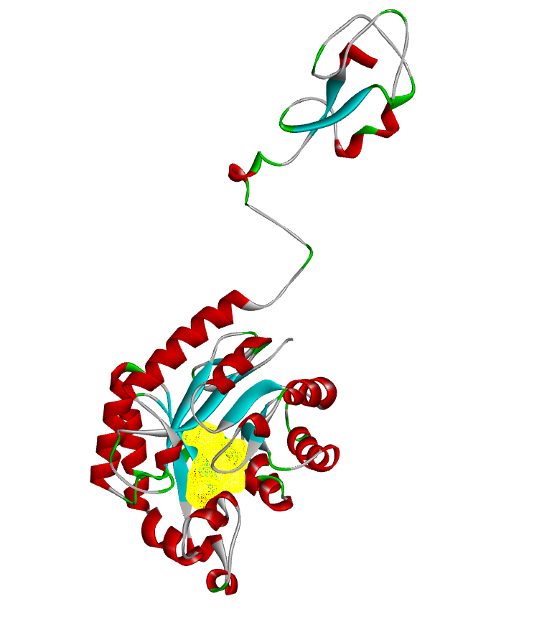

NeuB from Tanner et al. (Liu et al., 2009) with Tanner’s inhibitor bound in same binding pocket
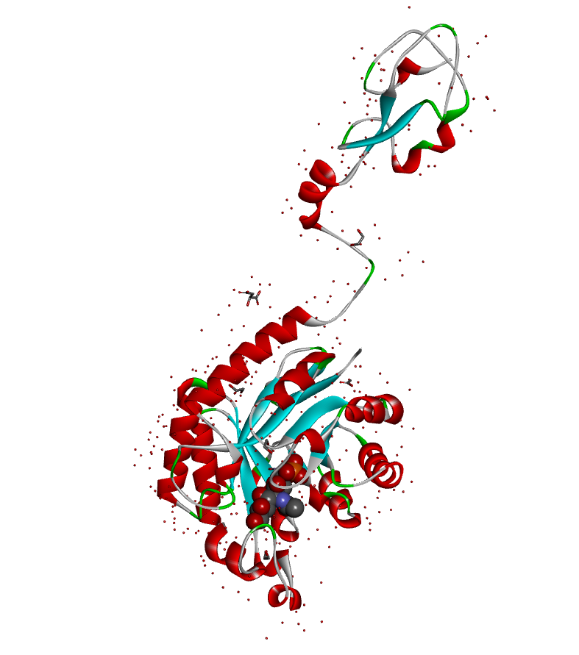

NeuB (standard colours) and PseI (green) overlaid. Tanner inhibitor bound in same yellow highlighted pocket. Phosphonate inhibitor 22 from this work displayed alongside.
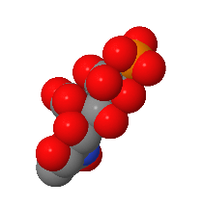

Phosphonate inhibitor 22 from this work and Tanner’s bound inhibitor in the NeuB active site (Liu et al., 2009).

