

Mycobacterium tuberculosis aconitase-IRE interactions: integrating iron, oxidative and nitrosative stress responses to regulate cell wall biosynthesis

By:
Peter J Bancroft

A thesis submitted in partial fulfilment of the requirements for the degree of
Doctor of Philosophy

The University of Sheffield
Faculty of Science
Department of Molecular Biology and Biotechnology

September 2019

Abstract

With over one million deaths per year caused by tuberculosis and the rise in drug-resistant infections, the need to improve our understanding of Mycobacterium tuberculosis biology has never been greater, particularly the bacterium’s cell wall processes and responses to the stresses encountered during infection.
Aconitase is a bi-functional protein that has been characterised in both eukaryotes and prokaryotes. Under iron-replete conditions, aconitase possesses a [4Fe-4S] cluster that enables it to act as a Krebs cycle enzyme, catalysing the interconversion of citrate and isocitrate via the intermediate cis-aconitate. Conditions such as oxidative stress, nitrosative stress and iron starvation can result in the disassembly of the iron-sulfur cluster. Apo-aconitase instead functions as an RNA-binding protein, specifically able to bind iron-responsive elements (IREs) in certain mRNA molecules. This RNA-binding activity serves as a mechanism of post-transcriptional regulation of gene expression under stressful conditions such as oxidative damage and iron starvation. An IRE-like sequence was identified in the cwlM gene of M. tuberculosis, a gene encoding an essential protein involved in peptidoglycan biosynthesis.
This project confirms that the aconitase of M. tuberculosis (AcnA) is a bi-functional protein with mutually exclusive enzyme and RNA-binding activities. Dismantling of the iron-sulfur cluster and AcnA-RNA binding occur under stressful conditions, and apo-AcnA is able to bind the IRE in cwlM mRNA. The effect of this binding was studied using a mutant strain of M. smegmatis defective for IRE structure, and revealed that the IRE is important for growth and recovery of stressed mycobacteria, with the mutant strain unable to recover from a combination of oxidative and nitrosative stress. Induction of cwlM expression under stress conditions was also shown to be detrimental to growth and survival of bacteria. Mycobacteria with wild type cwlM_{Mtb} exhibited a decrease in the abundance of CwlM in response to oxidative stress and iron deprivation, while the mutant with a disrupted IRE showed no decrease in CwlM abundance. Transcription of cwlM was shown to be up-regulated under nitrosative stress, as was CwlM at the protein level.
These findings indicate that regulation of cwlM mRNA translation by AcnA has the effect of reducing CwlM expression and improving the recovery of mycobacteria under stress, and that disruption of the IRE in the cwlM mRNA results in dysregulation of CwlM levels with deleterious effects for survival.

Abbreviations
Acn | Aconitase
ADC | Albumin-dextrose-catalase supplement
BIP | Bipyridyl
BSA | Bovine serum albumin
c-Acn | Cytoplasmic aconitase
CFU | Colony forming units
DRaCALA | Differential radial capillary action ligand assay
EDTA | Ethylenediaminetetraacetic acid
EMSA | Electrophoretic mobility shift assay
GPL | Glycopeptidolipid
HRP | Horseradish peroxidase
IRE | Iron-responsive element
IRP | Iron regulatory protein
IVT | In vitro transcription
LAM | Lipoarabinomannan
LM | Lipomannan
m-Acn | Mitochondrial aconitase
MPN | Most probable number
Ms cwlM-CM | Mycobacterium smegmatis (conditional mutant cwlM)
Mtb | Mycobacterium tuberculosis
NBT | Nitro blue tetrazolium
NO | Nitric oxide
OD | Optical density
PAGE | Polyacrylamide gel electrophoresis
PASTA | Penicillin-binding protein and serine/threonine kinase associated (domain)
PBS | Phosphate-buffered saline
PCR | Polymerase chain reaction
PDIM | Phthiocerol dimycocerosate
PIM | Phosphatidylinositol mannoside
Pri | Pristinamycin
ROS | Reactive oxygen species
RT-qPCR | Reverse transcription quantitative polymerase chain reaction
SDS | Sodium dodecyl sulfate
TAE | Tris-acetate-EDTA
TBE | Tris-borate-EDTA
TBS | Tris-buffered saline
TE | Tris-EDTA
TSG | Tris-salt-glycerol
TMB | 3,3’,5,5’-tetramethylbenzidine
WT | Wild type

Contents
Chapter 1: Introduction | 6
1.1 Mycobacterium tuberculosis | 6
1.2 Mycobacterial cell wall | 13
1.3 Aconitase and iron-responsive elements | 18
1.4 CwlM | 22
1.5 Project aims | 24
Chapter 2: Materials and Methods | 26
2.1 Bacteria and growth media | 26
2.2 Buffers | 31
2.3 DNA and RNA methods | 32
2.4 Protein methods | 44
2.5 Miscellaneous methods | 51
Chapter 3: Aconitase as an Enzyme | 53
3.1 Production of aconitase | 53
3.2 Aconitase absorption spectra | 55
3.3 Optimum conditions for AcnA activity | 57
3.4 Kinetics | 58
3.5 Sensitivity to stress reagents | 59
3.6 Discussion | 60
Chapter 4: Aconitase as an IRE-Binding Protein | 63
4.1 Generation of IRE RNA | 63
4.2 Aconitase-IRE binding assays | 64
4.3 Discussion | 68
Chapter 5: Consequences of cwlM IRE Mutation for Growth | 72
5.1 Single stress conditions | 73
5.2 Combination stress conditions | 75
5.3 Effect of pristinamycin on stressed cultures | 77
5.4 Testing for viable non-culturable bacteria | 79
5.5 Stressing turbid cultures | 80
5.6 Growth of CwlM amidase activity mutants | 83
5.7 Discussion | 85
Chapter 6: CwlM Expression Studies | 92
6.1 Transcription of cwlM | 92
6.2 CwlM protein abundance – 2 hour time course | 94
6.3 CwlM protein abundance – 6 hour time course | 97
6.4 CwlM cell wall hydrolysis activity | 100
6.5 Discussion | 102
Chapter 7: Conclusions | 108
Appendices | 112
Appendix 1 | 112
Appendix 2 | 113
Appendix 3 | 119
Appendix 4 | 125
References | 127
Acknowledgements | 146
Chapter 1: Introduction
1.1 Mycobacterium tuberculosis
Mycobacterium tuberculosis is the causative agent of the disease tuberculosis, which is responsible for over 1.6 million deaths annually, of which 1.3 million are caused by the single infection of M. tuberculosis, and 300,000 deaths resulting from HIV co-infection. These figures identify M. tuberculosis as the world’s greatest cause of mortality from a single infection. Furthermore, an estimated 1.7 billion people worldwide are predicted to be latently infected, i.e. infected with persistent mycobacteria without showing symptoms. Among latently infected individuals, 5-10% are anticipated to develop tuberculosis symptoms within their lifetime (World Health Organisation, 2018). Treatment of tuberculosis is costly and requires a course of multiple drugs to be taken across a period of many months or years, however resistance to the first line drugs rifampicin and isoniazid, as well as other anti-mycobacterial compounds, is emerging (Centers for Disease Control and Prevention, 2006). Closely related to M. tuberculosis is M. bovis, the causative agent of bovine tuberculosis. Though primarily a chronic disease of cattle, bovine tuberculosis can cause human infections and also has economic consequences for pastoral farming (Quigley et al., 1997; More et al., 2007).
Transmission of M. tuberculosis is via airborne droplets. When inhaled into the lungs, the bacteria are engulfed by alveolar macrophages, however M. tuberculosis is able to block the maturation of the phagosome and so inhibit effective killing by phagocytosis (Guirado and Schlesinger, 2013; Zimmerli et al., 1996). The bacteria are able to escape the phagosome and grow inside the host macrophage, killing it. A healthy immune system responds by recruiting many immune cells, chiefly macrophages and lymphocytes, to the site of infection. Activated macrophages become more efficient at killing mycobacteria, but M. tuberculosis is well-adapted to survive the immune response. The infection and immune response lead to the formation of a lesion called a granuloma (Figure 1.1.1), a battleground between mycobacteria and phagocytes enclosed by a wall of fibrous material and lymphocytes. The caseum, the core of the granuloma, consists of macrophages, bacteria and cell debris (Russell et al., 2009). The granuloma can effectively contain the infection, but the ability of M. tuberculosis to survive the immune effectors prevents clearance. This creates a stalemate between the host and the bacteria, which are not killed but are also unable to cause further damage (Stewart et al., 2003; Guirado and Schlesinger, 2013). This containment of the infection results in a latent infection in which the bacteria could persist for many years in the granuloma without causing the human host to experience any symptoms.
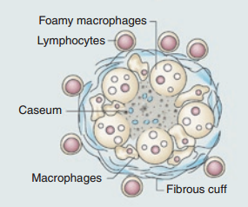
Figure 1.1.1: Structure of the tuberculosis granuloma. The caseum is a mix of bacteria, cell debris and immune system effectors, creating very harsh environment. Macrophages attempting to clear M. tuberculosis can become foamy as a result of lipid export dysregulation caused by the bacteria. The encapsulating fibrous cuff helps to limit the spread of bacteria and also restricts oxygen flow into the granuloma. Adapted from Russell et al., 2009.

When stressed, mycobacteria can transition to a persistent, non-culturable state called dormancy. Dormant mycobacteria do not grow and exhibit cell wall changes and limited metabolism. In vitro studies have shown that dormancy can be induced when mycobacteria are stressed with hypoxia, iron deprivation and exposure to reactive oxygen and nitrogen species, all of which are present in the phagosome or granuloma (Voskuil et al., 2003; Wayne and Sohaskey, 2001). While in the dormant state, M. tuberculosis becomes highly resistant to killing by the immune system and anti-mycobacterial drugs (Betts et al., 2002). Because mycobacteria are obligate aerobes and can transition to dormancy following hypoxia, dormancy is thought to be an adaptation to help M. tuberculosis survive in low-oxygen environments like the granuloma. Cultures of M. tuberculosis subjected to anaerobiosis exhibit heightened activity of isocitrate lyase and glycine dehydrogenase, promoting the glyoxylate pathway and oxidation of NADH (Wayne and Lin, 1982). An array of 48 genes has been identified in M. tuberculosis that are induced during dormancy in the presence of nitric oxide and repressed in the presence of oxygen (Voskuil et al., 2003), implying competitive regulation of these genes which would favour dormancy in the hostile granuloma environment. Dormancy has also been observed in M. tuberculosis cultures grown in vitro with a prolonged stationary phase (Shleeva et al., 2002) or insufficient iron (Kurthtoki et al., 2017).
Persistent non-growing mycobacteria characteristically do not grow on solid media but can be grown in broth culture (Shleeva et al., 2002). This awakening from dormancy is termed resuscitation and is described as the restoration of typical growth and metabolism. The role of cell wall remodelling is unclear, but it is likely to modulate permeability and occurs in both the transition to and the resuscitation from dormancy. A resuscitation-promoting factor (Rpf) was first isolated from Micrococcus luteus and characterised as a secretory protein growth factor with peptidoglycan hydrolase activity able to increase the number of viable cells recoverable from dormant non-replicating cultures. This Rpf was effective on dormant mycobacteria as well as Mi. luteus cells (Mukamolova et al., 1998). Five genes have been identified in M. tuberculosis and M. bovis with products that resemble the Rpf of Mi. luteus, and subsequently were termed RpfA-E and shown to behave in the same way, including cross-reactivity with Mi. luteus (Mukamolova et al., 2002). Structurally Rpfs resemble lysozymes (Cohen-Gonsaud et al., 2005), so along with the secretory nature of these Rpfs it has been suggested that they affect cell wall configuration by exogenous hydrolysis of peptidoglycan. The Rpfs are not essential for in vitro cultivation of mycobacteria, but are required for the virulence of M. tuberculosis (Kana et al., 2007).
The phagosome is a harsh environment for bacteria. The metabolism critical for the survival of M. tuberculosis within the phagosome has been studied via transcriptional analysis, showing induction of genes relevant to dormancy, fatty acid oxidation, mycolic acid modification and iron scavenging, with the addition of a switch to anaerobic respiration in the presence of oxidative, nitrosative and hypoxic stressors produced by macrophages (Schnappinger et al., 2003). This is suggestive of M. tuberculosis utilising fatty acids as a carbon source, complementing the knowledge that triglyceride stores are essential for resuscitation of M. bovis from dormancy (Low et al., 2009). The two isoforms of isocitrate lyase, the enzymes which initiate the glyoxylate cycle, have also been shown to be necessary for in vivo virulence of M. tuberculosis and thus suggest an additional role of fatty acids as the source of acetate for carbohydrate synthesis in the carbohydrate-poor phagosome (Muñoz-Elías and McKinney, 2005). Cholesterol metabolism has also been implicated in M. tuberculosis in vivo survival, as seen by the attenuation of strains deficient in the Mce4 cholesterol importer (Chang et al., 2009) and the secreted cholesterol oxidase ChoD (Cowley and Av-Gay, 2001; Brzostek et al., 2007).
Various genes in M. tuberculosis have their expression modulated by the presence of stresses. The effects of reactive oxygen species (ROS) and nitric oxide (NO) on mycobacteria have been reported with some overlap, but are both radical compounds that can react detrimentally with proteins, lipids, nucleic acids and various other factors. Respiration is known to be impaired in M. tuberculosis stressed with NO as a result of dysregulation of electron transport chain proteins (Voskuil et al., 2003). The alternative sigma factor SigH is known to be induced in M. tuberculosis stressed with either ROS or NO (Raman et al., 2001; Voskuil et al., 2011), and SigH up-regulates expression of the thioredoxin operon (trxB2-trxC) and the cysteine biosynthesis operon rv1334-36 (Raman et al., 2001; Sharp et al., 2016). The sigma factors SigE and SigB were also found to be up-regulated by SigH, enabling further modulation of gene expression (illustrated in Figure 1.1.2). Bacteria with sigH mutations are also more sensitive to ROS (Raman et al., 2001). The multifunctional KatG protein of M. tuberculosis, which functions as a catalase-peroxidase-peroxynitritase, is also up-regulated by ROS and NO. Either stress can strongly repress expression of ribosome-associated proteins and the resuscitation-promoting factor RpfA (Voskuil et al., 2011). Generally genes induced in the presence of either ROS or NO are induced more strongly by ROS than NO. The two stresses have been reported to affect expression of some genes exclusively, however. The suf operon, the DosR dormancy regulon and SigE are induced by NO (Cortes et al., 2017; Voskuil et al., 2003; Kumar et al., 2007; Voskuil et al., 2011), but induction by ROS of these genes has not been reported.
Mycobacteria can defend against ROS and NO attack from macrophages via various means. Thioredoxins and mycothiol repair redox damage caused by ROS and NO, and the KatG and Sod proteins detoxify ROS (Dussurget et al., 2001). The proteasome also aids recovery from stress by turning over damaged proteins (Darwin et al., 2003). The WhiB transcription factor proteins are known to bind DNA and modulate gene expression to adapt to stress (Smith et al., 2010). Under prolonged or severe stress conditions, the Cmr protein dissociates from the dosR promoter, de-repressing the dormancy regulon to promote survival over growth (Smith et al., 2017). The IscS protein has been shown to be important for survival through ROS stress by providing sulfur for iron-sulfur cluster cofactors that are disassembled by oxidative stressors (Rybniker et al., 2014).
Catalases and dismutases like KatG and Sod proteins can scavenge ROS, however little is known about how mycobacteria sense exogenous ROS. Many other species of bacteria respond to ROS via the OxyR regulon, however oxyR is a known pseudogene in M. tuberculosis (Deretic et al., 1997).
Other stresses encountered by M. tuberculosis during infection include the hypoxia within the granuloma and the acid stress inflicted by phagocytosis. Mycobacteria are strictly aerobic, so the low oxygen environment of the granuloma is inhibitory to their growth. Dormancy can be induced under these conditions by activation of DosR, which is the regulator of the dormancy regulon genes (Voskuil et al., 2003; Kumar et al., 2007). Dormancy will aid the survival of mycobacteria in response to various stresses, but a different response has been reported for acid-stressed M. tuberculosis. Acid stress was shown not to impair growth, but instead to require M. tuberculosis to use an alternative peptidoglycan hydrolase, RipA, to divide cells (Botella et al., 2017).
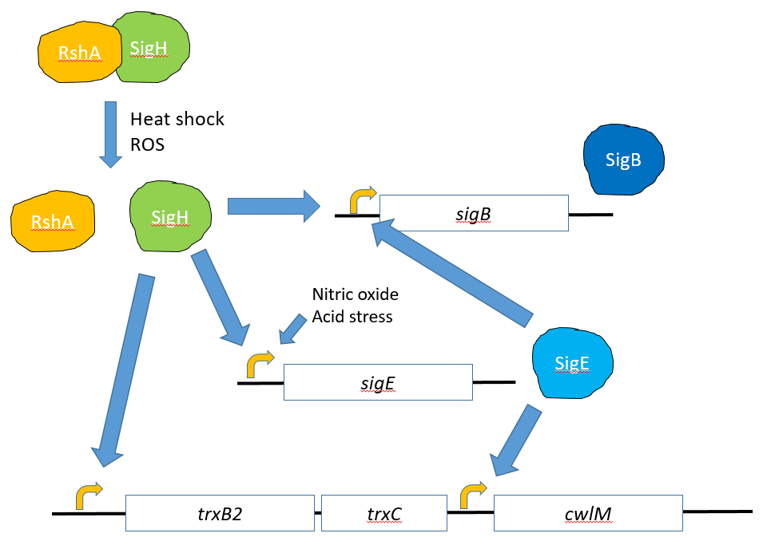
Figure 1.1.2: Simplified model of SigH induction pathways. SigH dissociates from the anti-sigma factor RshA when challenged with heat shock or oxidative stress (Song et al., 2003), allowing SigH to promote transcription of the sigB, sigE and trxB2-trxC genes (Raman et al., 2001; Sharp et al., 2016). SigE has also been reported to be induced by NO and acid stress, however the precise mechanism of induction is unclear (Cortes et al., 2017; Bansal et al., 2017). SigE may promote transcription of cwlM based on a consensus sequence upstream of cwlM transcription start site (Manganelli et al., 2004; Cortes et al., 2013). SigH and SigE jointly regulate sigB expression (Raman et al., 2001), and SigB has been reported to up-regulate a diverse set of genes (Lee et al., 2007).

Iron is essential for M. tuberculosis to cause infection in vivo, and thus M. tuberculosis produces siderophores (exochelins and mycobactins) to secure iron from the surrounding environment. Exochelin siderophores are small, soluble and have a high affinity for ferric iron. Mycobactins are more hydrophobic and often found within mycobacterial membranes or the cell wall, and are suspected to receive iron from exochelins for intracellular delivery (Macham et al., 1975). Siderophores are produced most abundantly when available iron is scarce, and inhibited (by IdeR at the transcriptional level in the case of mycobactins) when iron is replete (Gobin et al., 1995; Li et al., 2013; Rodriguez et al., 2002). The iron-dependent transcriptional regulator IdeR represses numerous genes when under iron-replete conditions, including genes encoding mycobactin synthesis proteins MbtA and MbtB, and the bacterioferritins BfrA and BfrB. The IdeR regulon has also been shown to include genes encoding products not directly related to iron acquisition and homeostasis, such as the peptidoglycan synthesis protein MurB, the fatty acid carrier protein AcpP, the histidine biosynthesis protein HisE and the phenylalanine biosynthesis protein PheA (Gold et al., 2001).
1.2 Mycobacterial cell wall
The cell wall of M. tuberculosis (illustrated in Figure 1.2.2) is lipid-rich and an integral factor in survival and virulence by providing an effective permeability barrier and modulating the host immune response. The peptidoglycan layer serves as an anchor for galactan chains. The galactans are bonded to branched arabinans and together form the arabinogalactan layer of the cell wall. The non-reducing termini of the arabinan branches are esterified with mycolic acids, and these mycolic acids form the inner leaflet of the outer membrane lipid bilayer. The outer leaflet is composed of a diverse set of lipids including trehalose mycolates, di- and pentaacyltrehaloses, glycopeptidolipids (GPL), sulfolipids, phthiocerol dimycocerosate (PDIM) and mannosylated phospholipids. Phospholipids with mannose linkages can also be found in the outer leaflet of the cytoplasmic membrane (Ortalo-Magné et al., 1996). These include phosphatidylinositol mannoside (PIM), lipomannan (LM) and lipoarabinomannan (LAM). The glycan chains of LM and LAM in the cytoplasmic membrane can extend up to the outer membrane (Pitarque et al., 2008), while those in the outer leaflet of the outer membrane extend into the capsular layer. Mannosylated surface LAMs are utilised by M. tuberculosis to interfere with T lymphocyte signalling (Mahon et al., 2012; Richmond et al. 2012). The capsule is a complex, fluid mixture of proteins, glycans, triglycerides and other lipids (Daffé and Etienne, 1999).
Peptidoglycan is composed of alternating N-acetylmuramic acid (NAM) and N-acetylglucosamine (NAG) residues covalently linked in long chains, with peptide cross-links between NAM residues of different chains. The peptidoglycan synthesis pathway is largely conserved across eubacteria (reviewed in Lovering et al., 2012). Bacteria use UDP-NAG as the initial compound that is fed into the peptidoglycan biosynthesis pathway (illustrated in Figure 1.2.1). The proteins MurA and MurB catalyse the conversion of UDP-NAG to UDP-NAM (Skarzynski et al., 1996; Benson et al., 1997), which is then linked to a short series of amino acids by MurC-F (Bouhss et al., 1997; Eveland et al., 1997). The membrane protein MraY (also known as MurX) removes UDP and couples the NAM-peptide to bactoprenol, a membrane-bound lipid, forming a molecule referred to as lipid I (Al-Dabbagh et al., 2008). The MurG transferase bonds NAG to the NAM unit of lipid I using UDP-NAG from the cellular pool, forming lipid II (Bouhss et al., 2004). Lipid II is membrane-bound with its NAG-NAM-peptide on the cytoplasmic side, but a flippase named MurJ (formerly MviN) is believed to be responsible for transporting lipid II to the exterior (Ruiz, 2008). Outside the cell, glycosyltransferase and transpeptidase proteins facilitate NAG-NAM polymerisation, bactoprenol removal and the cross-linking of peptide side chains to yield complete peptidoglycan (reviewed in Lovering et al., 2012). The proteins MurA-G, MurJ and MraY have all been identified in M. tuberculosis (Belanger and Inamine, 2000), as well as the glutamate racemase MurI, which generates D-glutamate for the cross-linking peptides (Gu et al., 2003).
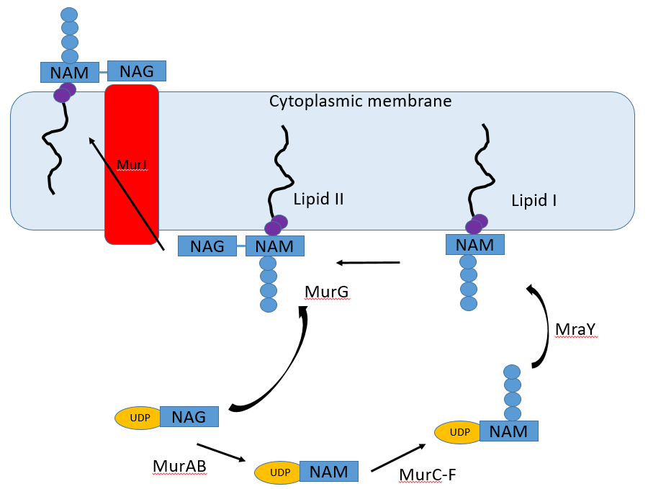
Figure 1.2.1: Synthesis of peptidoglycan precursors. MurA and MurB drive the conversion of UDP-NAG to UDP-NAM (Skarzynski et al., 1996; Benson et al., 1997), which receives a peptide side chain from the MurC-F proteins (Bouhss et al., 1997; Eveland et al., 1997). MraY links NAM to bactoprenol on the inner leaflet of the cytoplasmic membrane (lipid I) and removes UDP (Al-Dabbagh et al., 2008). Addition of NAG to lipid I forms lipid II, which is exported by the flippase MurJ (Ruiz, 2008). On the exterior of the membrane, bactoprenol is severed and repeating chains of NAM-NAG is assembled with peptide cross-links (Lovering et al., 2012).

The synthesis of arabinogalactan begins with polyprenol phosphate (Pol-P) and UDP-NAG, which are linked together by the NAG transferase Rfe to form Pol-P-P-NAG. Rhamnose is joined to the NAG by the rhamnosyltransferase WbbL (Mikušova et al., 1996; Mills et al., 2004). Galactose is added and extended from the rhamnose sugar by GlfT proteins to form the galactan (Kremer et al., 2001). Arabinose is added to the galactan by AftA and extended by EmbA and EmbB to complete the branched arabinans (Xin et al., 1997; Telenti et al., 1997) in a process that is regulated by EmbR, a transcriptional regulator that improves embA and embB transcription upon phosphorylation by the serine/threonine kinase PknB (Belanger et al., 1996; Molle et al., 2003; Sharma et al., 2006). The CpsA1 and CpsA2 proteins link a peptidoglycan N-acetylmuramic acid residue via phosphodiester bond to the N-acetylglucosamine-rhamnose terminus of galactan (Grzegorzewicz et al., 2016), attaching the arabinogalactan polymer to the cell wall peptidoglycan layer. The esterification of the arabinan termini with mycolic acids is catalysed by the secreted FbpA-C mycolyl transferase proteins, collectively known as the antigen 85 complex, which transfer mycolic acids from trehalose mycolates (Belisle et al., 1997).
This complex cell wall structure is responsible for much of the intrinsic antimicrobial resistance of mycobacteria. As the structure on which the mycolate arabinogalactan complex is built, the peptidoglycan component of the cell wall is crucial for M. tuberculosis to succeed as a pathogen.

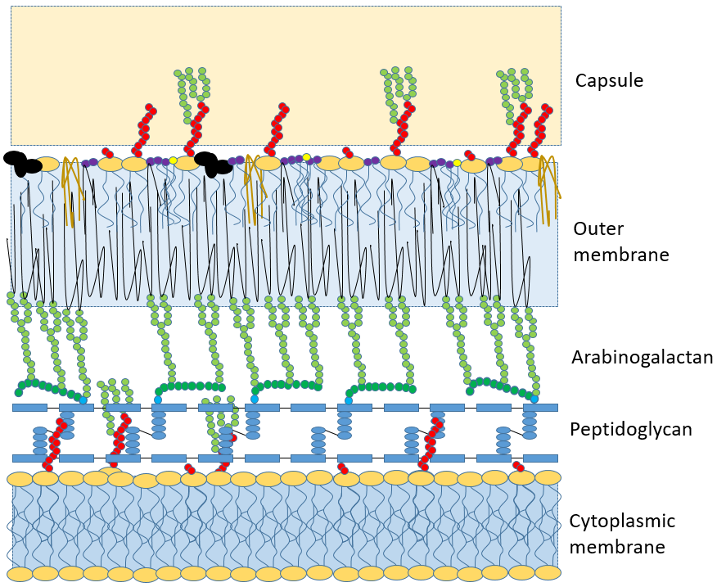
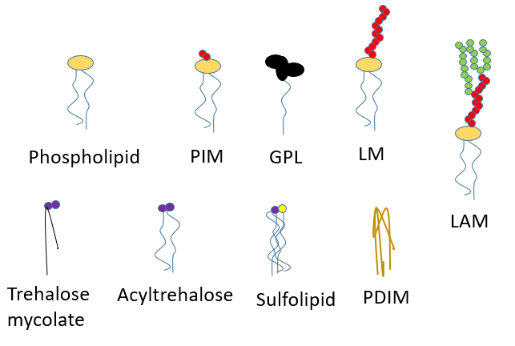
Figure 1.2.2: Diagram of the M. tuberculosis cell wall structure. Wall layers and constituent lipids are labelled. The cytoplasmic membrane includes phospholipids and the mannosylated phospholipids PIM, LM and LAM (Pitarque et al., 2008). The peptidoglycan layer is composed of cross-linked NAM-NAG chains (see Figure 1.2.1) and supports arabinogalactans. Glycans linked to cytoplasmic membrane phospholipids can extend up into the arabinogalactan layer (Pitarque et al., 2008). The termini of the arabinogalactans are esterified to mycolic acids, which form an outer membrane bilayer with various lipids including phospholipids, PIM, LM, LAM, PDIM, GPL, sulfolipid, trehalose mycolate and acyltrehaloses (Ortalo-Magné et al., 1996). The capsule layer is a fluid mix of lipids, glycans and glycolipids (Daffé and Etienne, 1999).

1.3 Aconitase and iron-responsive elements
The aconitase enzyme functions as a part of the tricarboxylic acid (TCA) and glyoxylate cycles, catalysing the interconversion of citrate and isocitrate via cis-aconitate. This enzyme has chiefly been studied in eukaryotic systems. The eukaryotic enzyme’s active site and iron-sulfur cluster (Figure 1.3A) are within a deep cleft between the domains of the protein, and active aconitase requires a [4Fe-4S] cluster (Robbins and Stout, 1989a). The protein has four main domains (Figure 1.3B), but the three cysteine residues crucial for coordinating the iron-sulfur cluster are all within the third domain from the N-terminus of the protein (Robbins and Stout, 1989b). These cysteine residues each form a ligand with one of the four iron ions in the cluster. The fourth iron (designated Fe_{a}) is believed to form a ligand with a solvent molecule, such as water, or with a substrate molecule (Figure 1.3A; Robbins and Stout, 1989a; Kennedy et al., 1987; Beinert et al., 1996). All four domains of the aconitase protein appear to contribute to the active site of the enzyme (Robbins and Stout, 1989b). The mechanism of aconitase enzymatic activity entails binding of the substrate citrate or isocitrate and a water molecule to the Fe_{a} with ligands stabilised by histidine and aspartate residues. Aconitase catalyses the dehydration and rehydration of its substrate in a processes that requires the intermediate cis-aconitate to be bound to Fe_{a} in two successive orientations, termed the citrate mode and the isocitrate mode, which differ by a 180° rotation around the carbon-carbon double bond of cis-aconitate. It has been suggested that this rotation is instead a displacement of one cis-aconitate molecule with another in the opposite orientation rather than a simple flip of the bound cis-aconitate (Emptage et al., 1983; Lauble et al., 1994; Beinert et al., 1996).
In eukaryotes, aconitase is produced in two variants: a mitochondrial form (m-Acn) and a cytoplasmic form (c-Acn). Both exhibit enzymatic activity, however c-Acn has been widely studied as an iron regulatory protein (IRP; Walden et al., 2006; Artymiuk and Green, 2006; Mansilla et al., 2018). IRPs bind to iron-responsive elements (IREs; Figure 1.3C; Figure 1.3D) in the untranslated regions of mRNA molecules. IREs are helical stem-loops with a consensus sequence (usually CAGUGU or CAGUGC) at the loop end and a mid-stem bulge with unpaired nucleotides. Binding of IRPs to IREs in the 3’ untranslated region stabilises the mRNA and promotes translation, whereas binding in the 5’ untranslated region inhibits translation of the mRNA (Casey et al., 1988; reviewed in Theil, 1993; reviewed in Goss and Theil, 2011). The mammalian c-Acn is termed IRP1 as there is an additional sub-class of IRP, IRP2, which does not have aconitase functionality and its RNA-binding activity is heavily repressed in the presence of plentiful iron (Guo et al., 1994).
Aconitases can transition from enzymatic to RNA-binding functionality when the [4Fe-4S] cluster is lost. Fe_{a} is the most sensitive part of the cluster and is easily removed by certain factors. Oxidation, which occurs in the presence of radical oxygen species, results in the loss of Fe_{a} from the cluster, forming a [3Fe-4S] cluster which inactivates the aconitase enzyme (Cairo et al., 2002). Superoxide (O₂⁻) is effective at dismantling iron-sulfur clusters by altering the redox state of iron atoms and causing them to dissociate from the cluster (Cairo et al., 2002; Green and Paget, 2004, reviewed in Tong and Rouault, 2007). Prolonged iron deprivation or exposure to oxidative factors results in total loss of the iron-sulfur cluster, leaving the apo-protein (Kennedy et al., 1983). Nitric oxide and peroxynitrite are also potent attackers of iron-sulfur clusters, forming dinitrosyl-iron complexes (Bouton and Drapier, 2003; Soum and Drapier, 2003). Complete loss of the iron-sulfur cluster causes a conformational change in aconitase that enables the protein to bind RNA.
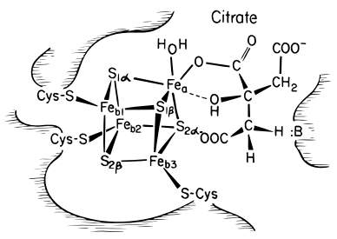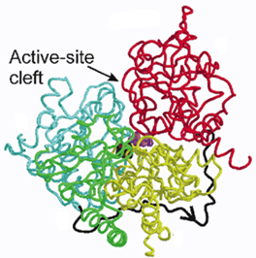
A
B

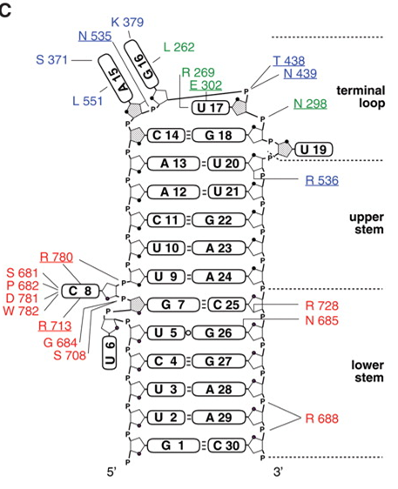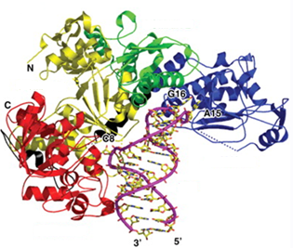
C
D

Figure 1.3: Aconitase and IRE structures. (A) Model of interaction between aconitase-bound iron-sulfur cluster and substrate molecule. Adapted from Beinert et al., 1996. (B) Structure of m-Acn with bound iron-sulfur cluster and substrate. Adapted from Williams et al., 2002. Domains 1-4 (yellow, green, cyan, red, respectively), linker peptide (black, with arrow), iron-sulfur cluster (black, central), substrate molecule (purple). (C) Model of IRE from frog ferritin gene transcript labelled with aconitase residues predicted to bind. Adapted from Walden et al., 2006. (D) Model of apo-aconitase interaction with IRE. Adapted from Walden et al., 2012. Domains 1-4 (yellow, green, blue, red, respectively), linker peptide (black), IRE (purple).

Bacterial aconitases are best characterised in Escherichia coli, which expresses two distinct aconitases: AcnA and AcnB. As with eukaryotic aconitases, both aconitases of E. coli are composed of four core domains: AcnA has a linker peptide between the third and fourth domains, whereas AcnB has no linker peptide and expresses the equivalent of AcnA’s fourth domain at the N-terminal region of the AcnB protein along with a HEAT-like domain (Bradbury et al., 1996; Williams et al., 2002). The AcnA of E. coli has 53% sequence identity with eukaryotic c-Acn (reviewed in Gruer et al., 1997). Transcription studies demonstrated that AcnA expression increases in response to redox stress and iron deficiency, whereas AcnB is considered the major enzyme of the tricarboxylic acid (TCA) cycle during exponential growth phase (Cunningham et al., 1997; Jordan et al., 1999; Prodromou et al., 1992), i.e. AcnB is the ‘usual’ aconitase and AcnA is available as a backup aconitase. AcnA and AcnB were both found to post-transcriptionally regulate their own expression (when in the apo-form) by binding to IRE-like sequences in the mRNA transcripts to stabilise the mRNA and thus promote translation of aconitase proteins (Tang and Guest, 1999). In other species of bacteria, aconitase-mediated post-transcriptional regulation of gene expression has been linked to virulence attributes such as motility in Salmonella enterica serovar Typhimurium and Helicobacter pylori (Tang et al., 2004; Austin et al., 2015). Aconitases in Bacillus subtilis and Streptomyces viridochromogenes have been linked to persistence through sporulation (Alén and Sonenshein, 1999; Serio et al., 2006; Michta et al., 2014). An aconitase protein has been shown to regulate production of pathogenicity factors in the brassica pathogen Xanthomonas campestris (Wilson et al., 1998). Cytotoxic interactions of nitric oxide with bacterial iron-sulfur proteins including E. coli’s AcnB have also been established (Duan et al., 2009).
Previous work has shown that M. tuberculosis aconitase (an AcnA type protein) binds to IRE-like sequences in the mRNA of the thioredoxin gene trxC and the iron-dependent transcription repressor gene ideR (Banerjee et al., 2007). Unlike E. coli, M. tuberculosis possesses only one aconitase gene (rv1475c). When starved of iron, M. tuberculosis aconitase switches to the RNA-binding conformation and suppresses ideR, thus preventing IdeR-mediated repression of mycobactin synthesis genes and promoting iron acquisition (Banerjee et al., 2007; Rodriguez et al., 2002).
1.4 CwlM
The CwlM protein of M. tuberculosis it is a cytoplasmic protein that has been reported to serve multiple possible roles. It can be recovered from cytoplasmic fractions of growth phase culture lysate, and is described as an N-acetylmuramoyl-L-alanine amidase, a hydrolytic enzyme that degrades peptidoglycan (Deng et al., 2005). It is a cytoplasmic protein, leading to the hypothesis that its enzymatic function targets peptidoglycan precursors prior to their export to the cell surface.
In recent years, CwlM has been reported to instead function primarily as an enhancer to MurA, an enzyme involved in the early stages of peptidoglycan biosynthesis (see Figure 1.2.1). Boutte and colleagues reported that, when phosphorylated, CwlM binds to and improves the activity of MurA. Phosphorylation of CwlM was found to be dependent on nutrient availability. Furthermore, the peptidoglycan hydrolase activity of CwlM was found to be dispensable for in vitro growth of M. tuberculosis (Boutte et al., 2016). The possibility that CwlM’s primary role is not that of a peptidoglycan hydrolase is corroborated by the presence of Rv3717, another N-acetylmuramoyl-L-alanine amidase expressed by M. tuberculosis which has been suggested to serve a similar role in targeting peptidoglycan fragments for hydrolysis (Prigozhin et al., 2013). More recent studies have shown CwlM to be a substrate of protein kinase B (PknB) in M. tuberculosis and that phosphorylated CwlM can bind the cytoplasmic phosphopeptide-binding protein FhaA. In the same study, non-phosphorylated CwlM was shown to interact with the lipid II flippase MurJ (see Figure 1.2.1), suggesting a possible role for CwlM in regulating the transport of cell wall precursors by MurJ (Turapov et al., 2018). An autolytic role has also been proposed for CwlM in biofilm processes, where CwlM was found to be up-regulated during M. smegmatis biofilm formation (Wang et al., 2019).
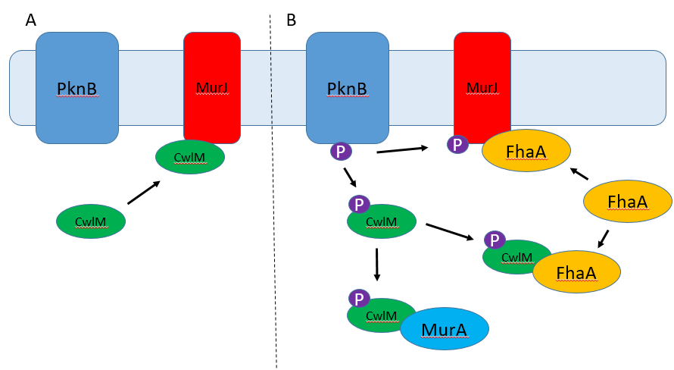
Figure 1.4: Interactions of CwlM depending on PknB activity. Adapted from Turapov et al., 2018. (A) PknB is inactive and CwlM is not phosphorylated. CwlM binds the intracellular domain of MurJ and may influence lipid II flippase activity (Turapov et al., 2018). (B) PknB is active and CwlM is phosphorylated. CwlM can bind and enhance the activity of MurA (Boutte et al., 2016), or CwlM can bind FhaA. MurJ is also phosphorylated by PknB and can then be bound by FhaA (Turapov et al., 2018).

The cwlM gene (rv3915) is immediately downstream of the thioredoxin reductase (trxB2, rv3913) and thioredoxin (trxC, rv3914) genes (Figure 1.1.2). The trx operon is known to include the trxB2 and trxC genes, but is also predicted to include cwlM (OperonDB, 2010), although this has not been experimentally demonstrated. The trx operon is expressed from a SigH promoter, however cwlM can be transcribed independently, as a SigE promoter and putative ribosome binding site have been identified approximately 50 and 10 nucleotides, respectively, upstream of the start of the cwlM coding region (Manganelli et al., 1999; Manganelli et al., 2001; Manganelli et al., 2002; Manganelli et al., 2004; Cortes et al., 2013).
1.5 Project aims
Tuberculosis poses a global threat, particularly with latent infections and the rise in antibiotic resistance. A significant factor in the success of M. tuberculosis as a pathogen is its cell envelope, which provides an excellent permeability barrier and houses factors to enable modulation of the immune response and resistance to antimicrobial effectors (Mahon et al., 2012; Richmond et al., 2012). Cell wall processes are also implicated in dormancy and resuscitation (Wayne and Sohaskey, 2001; Cohen-Gonsaud et al., 2005), the transitions responsible for survival of mycobacteria under severe stress. Whether as a peptidoglycan hydrolase or a binding partner for MurA or MurJ, CwlM is implicated in cell wall processes and is an essential protein for growth of M. tuberculosis, making it a prospective target for research into novel anti-mycobacterial therapies.
An IRE-like sequence was previously described as a 3’ IRE in the untranslated region of the trxC (rv3914) mRNA (Banerjee et al., 2007) in M. tuberculosis. However, this IRE is also situated within the coding region of the cwlM (rv3915) mRNA close to the 5’ end, leading to the hypothesis that translation of cwlM mRNA could be inhibited by aconitase-IRE binding. The M. tuberculosis aconitase (AcnA) was previously shown to be a bifunctional protein with the ability to bind the IRE in its apo-form (Banerjee et al., 2007), but consequences for CwlM have not been studied before. This project presents the hypothesis that AcnA can be induced to bind the cwlM IRE under stressful conditions that cause the dismantling of AcnA’s iron-sulfur cluster, and that this binding has an inhibitory effect on translation, down-regulating CwlM expression to halt growth and thereby demonstrate a link between central metabolism and cell wall biosynthesis in M. tuberculosis.
This project reports the characterisation of M. tuberculosis AcnA has both an enzyme and RNA-binding protein, and the consequences of the cwlM IRE for growth and expression of CwlM under stress using M. smegmatis as a model system with recombinant cwlM_{Mtb}. There is 82% identity between the amino acid sequences of the aconitases of M. tuberculosis and M. smegmatis, and 78% identity between the cwlM genes of both strains, with 70% of the cwlM_{Mtb} IRE-like sequence conserved in M. smegmatis. As a model for studying M. tuberculosis biology, M. smegmatis has limits due to be a non-pathogenic and saprophytic species that lives in soil, aquatic environments and smegma (Parashar et al., 2009; Alvarez and Teval, 1885), whereas M. tuberculosis is an obligate human pathogen. As such, M. smegmatis is not considered an ideal model when studying the virulence of M. tuberculosis (Barry, 2001; Reyrat and Khan, 2001), but has been used many times when studying the core biology of mycobacteria (Tyagi and Sharma, 2002). It is noted that M. smegmatis has much in common with the transcriptional machinery of M. tuberculosis (including sigma factors B, E and H; Bashyam et al., 1996), as well as a dormancy program (Dick et al., 1998). The two species also have equally unknown ROS-sensing mechanisms, with no functional oxyR gene identified in either species.
The faster and safer cultivation of M. smegmatis, and its useful similarity to M. tuberculosis, make M. smegmatis a useful system to study the mycobacterial aconitase-IRE interactions.

Chapter 2: Materials and Methods
2.1 Bacteria and growth media
2.1.1 Strains
From laboratory stocks at University of Sheffield:
Escherichia coli BL21 (λDE3)
Escherichia coli DH5α
Mycobacterium smegmatis MC² 155
From laboratory stocks at University of Leicester:
Micrococcus luteus
Mycobacterium smegmatis conditional mutant cwlM (Ms cwlM-CM)
From Agilent:
XL1-Blue Supercompetent cells

From this work:
Escherichia coli BL21 (λDE3) pET28a.acn_{Mtb} (pGS2541)
Escherichia coli DH5α pGEM-3Zf.IRE(WT)
Escherichia coli DH5α pGEM-3Zf.IRE(IRE1)
Escherichia coli DH5α pGEM-3Zf.IRE(IRE2)
Escherichia coli DH5α pMV306.cwlM_{Mtb}.WT
Escherichia coli DH5α pMV306.cwlM_{Mtb}.IRE1
Escherichia coli DH5α pMV306.cwlM_{Mtb}.IRE2
Ms cwlM-CM pMV306
Ms cwlM-CM pMV306.cwlM_{Mtb}.WT
Ms cwlM-CM pMV306.cwlM_{Mtb}.IRE1
Ms cwlM-CM pMV306.cwlM_{Mtb}.IRE2
Ms cwlM-CM pMV306.cwlM_{Mtb}.D339A
Ms cwlM-CM pMV306.cwlM_{Mtb}.E217A
2.1.2 Growth media
Broth and plate media constituents and pH are given in Table 2.1.2. For liquid media, relevant antibiotics were added immediately before inoculation. For solid media, relevant antibiotics were added immediately before pouring medium into plates.
Strains of E. coli were generally cultured on LB media, with the exception of E. coli BL21 (λDE3) pET28a.acn_{Mtb} (pGS2541), which was cultured on LB, terrific or autoinduction media for production of AcnA. All strains of M. smegmatis were cultured on 7H9 broth and 7H10 agar. Nutrient broth and nutrient agar were used for growth of Microccocus luteus only.

LB broth | Terrific broth | 7H9 broth
10 g/l tryptone | 12 g/l tryptone | 4.7 g/l Middlebrook 7H9 base
5 g/l yeast extract | 24 g/l yeast extract | 0.4% (v/v) glycerol
5 g/l NaCl | 17 mM KH₂PO₄ | 10% (v/v) Middlebrook ADC
 | 72 mM K₂HPO₄ | 0.05% (v/v) Tween 80
Nutrient broth | Autoinduction broth | NZY⁺ broth
10 g/l peptone | 20 g/l tryptone | 10 g/l casein hydrolysate
3 g/l yeast extract | 5 g/l yeast extract | 5 g/l yeast extract
5 g/l NaCl | 5 g/l NaCl | 5 g/l NaCl
 | 6 g/l Na₂HPO₄ | pH 7.5
 | 3 g/l KH₂PO₄
 | 6 g/l glycerol
 | 1 g/l glucose
 | 2 g/l lactose
 | pH 7.2
LB agar | 7H10 agar | Nutrient agar
10 g/l tryptone | 19.5 g/l Middlebrook 7H10 base | 10 g/l peptone
5 g/l yeast extract | 0.5% (v/v) glycerol | 3 g/l yeast extract
5 g/l NaCl | 10% (v/v) Middlebrook ADC | 5 g/l NaCl
15 g/l agar |  | 15 g/l agar
Table 2.1.2: Composition of liquid and solid growth media. All media were sterilised by autoclaving at 121°C for 30 minutes. Where necessary, pH was adjusted prior to autoclaving. Where included, sterile Middlebrook ADC, glucose and lactose were added post-autoclaving to media at approximately 45°C. For 7H10 agar, Middlebrook ADC was added immediately before pouring medium into plates. For 7H9 broth, Tween 80 was added immediately before inoculation.

2.1.3 Culture conditions
All E. coli and M. smegmatis strains were grown at 37°C with shaking at 220 rpm in conical flasks (unless otherwise indicated). Micrococcus luteus was grown at 30°C with agitation at 150 rpm.
Where stress was applied to inoculated Ms cwlM-CM cultures, stressors were added at concentrations of 75 μM, 200 μM and 100 μM for plumbagin, spermine NONOate and BIP, respectively. Where stress was applied to turbid cultures, broths were grown on a 96-well microplate in a Tecan plate reader at 37°C with shaking.
For the strain E. coli BL21 (λDE3) pGS2541, IPTG was included in broth culture (unless grown in autoinduction broth) to induce protein overexpression from the plasmid.
Details of antibiotics used in cultures are listed in Table 2.1.3.
Antibiotic | Concentration | Subjects
Ampicillin | 50 μg/ml | All strains carrying plasmid pGEM-3Zf
Hygromycin | 50 μg/ml | All Ms cwlM-CM strains
Kanamycin | 50 μg/ml | All strains carrying plasmids pGS2541 or pMV306
Pristinamycin | 2 μg/ml | Ms cwlM-CM (no plasmid) and Ms cwlM-CM pMV306
Table 2.1.3: Names and concentrations of antibiotics used when culturing strains listed in Section 2.1.1.

2.1.4 Measurement of microbial growth
2.1.4.1 Optical density
Growth of broth cultures was measured by reading optical density (OD) at a wavelength of 600 nm using a Varian Cary 50 Bio UV-visible spectrophotometer or Tecan plate reader.
2.1.4.2 Most probable number
Growth of broth cultures was estimated using the most probable number (MPN) method. Samples of broths were diluted 1:10 in fresh broth in each of four tubes, and a series of ten-fold dilutions was set up to a maximum dilution of 1:100,000,000. Tubes were incubated at 37°C for five days to observe development of turbidity. Values for MPN/ml were calculated using an MPN calculator program according to Jarvis et al., 2010.
2.1.4.3 Colony forming units
Growth on agar was measured by counting colony forming units (CFU). Samples of broths were diluted 1:10 using sterile broth in a series of ten-fold dilutions to a maximum dilution of 1:1,000,000. Volumes of 10 μl were immediately taken from each dilution in the series and spread on 7H10 agar. Agar plates were incubated at 37°C until colonies formed. Colonies were recorded and values for CFU/ml were calculated.
2.1.5 MIC testing
Broth cultures of bacteria were grown to OD₆₀₀ 0.8 and then inoculated 1:1000 into fresh broths containing known concentrations of subject reagents. Concentrations were tested using two-fold increases from 1 μM to 256 μM. Where a concentration of reagent prevented growth of bacteria, the minimum inhibitory concentration (MIC) of the reagent was more closely identified by testing concentrations at 25 μM intervals below the initially identified preventative concentration.
To test the MIC for hypoxanthine in the presence of xanthine oxidase, broths included concentrations from 1 mM to 10 mM hypoxanthine (increasing in intervals of 1 mM) and 0.1 U/ml xanthine oxidase, where 1 U was defined as the amount of xanthine oxidase that converts 1 μmol xanthine to uric acid per minute at pH 8.0 and 37°C.

2.2 Buffers
All buffers referenced in this project are listed alphabetically in Table 2.2.
Acn-IRE binding buffer (5 X) | Aconitase assay buffer (10 X) | Annealing buffer
50 mM Tris-HCl | 200 mM Tris-HCl | 10 mM Tris
250 mM NaCl | 1 M NaCl | 50 mM NaCl
5 mM MgCl₂ | 100 mM MgCl₂ | 1 mM EDTA
2.5 mM EDTA | pH 6.0-10.0 | pH 7.6
2.5 mM dithiothreitol
20% (v/v) glycerol
pH 7.5
DRaCALA buffer (10 X) | EMSA loading buffer (6 X) | Ligation buffer (10 X)
100 mM Tris-HCl | 10 mM Tris-HCl | 300 mM Tris-HCl
1 M NaCl | 30% (v/v) glycerol | 100 mM MgCl₂
100 mM MgCl₂ | 0.25% (w/v) bromophenol blue | 100 mM dithiothreitol
pH 8.0 | 0.25% (w/v) xylene cyanol | 10 mM ATP
 | pH 8.0 | pH 7.8
Lysis buffer | NBT assay buffer (5 X) | Ni²⁺ affinity binding buffer
50 mM Tris-HCl | 200 mM K₂HPO₄ | 50 mM NaH₂PO₄
200 mM NaCl | 50 mM KH₂PO₄ | 300 mM NaCl
1 mM PMSF | pH 8.0 | 20 mM imidazole
pH 7.5 |  | pH 8.0
Ni²⁺ affinity elution buffer | PBS buffer | Reconstitution buffer (2 X)
50 mM NaH₂PO₄ | 8 g/l NaCl | 50 mM Tris-HCl
300 mM NaCl | 1.44 g/l Na₂HPO₄ | 200 mM NaCl
270 mM imidazole | 0.24 g/l KH₂PO₄ | 1 mM Fe(NH₄)₂(SO₄)₂
pH 8.0 | 0.2 g/l KCl | 5 mM dithiothreitol
 | pH 7.4 | pH 8.0
Renaturing buffer | RNA loading buffer (2 X) | SDS-PAGE loading buffer (3 X)
20 mM KH₂PO₄ | 1 mM EDTA | 390 mM Tris
2% (v/v) Triton X-100 | 50% (v/v) glycerol | 60 mg/ml SDS
pH 6.8 | 0.4% (w/v) bromophenol blue | 30% (v/v) glycerol)
 | pH 8.0 | 15% (v/v) β-mercaptoethanol
 |  | 0.2% (w/v) bromophenol blue
 |  | pH 6.8
SDS-PAGE running buffer | TAE buffer | TBE buffer (10 X)
25 mM Tris | 40 mM Tris | 1 M Tris
190 mM glycine | 20 mM acetic acid | 1M boric acid
0.1% (w/v) SDS | 1 mM EDTA | 20 mM EDTA
 | pH 8.2 | pH 8.0
TBS buffer | TE buffer | Thrombin assay buffer
20 mM Tris | 10 mM Tris-HCl | 20 mM Tris-HCl
150 mM NaCl | 1 mM EDTA | 150 mM NaCl
pH 7.5 | pH 8.0 | 1.5 mM CaCl₂
 |  | 3% (v/v) glycerol
 |  | pH 8.4
TSG buffer | Western transfer buffer | Table 2.2: Compositions of buffers used in this project. Note buffers that are commercial products or components of a kit are not included.
20 mM Tris-HCl | 25 mM Tris
100 mM NaCl | 190 mM glycine
3% (v/v) glycerol | 20% (v/v) methanol
pH 8.0 | pH 8.0
2.3 DNA and RNA methods
2.3.1 Measurement of nucleic acid concentration
Concentration of DNA and RNA in solution was measured by absorbance using a Thermo Scientific Nanodrop Lite spectrophotometer. For radiolabelled RNA samples, concentration was estimated by liquid scintillation using a TRI-CARB 1600TR analyser.
2.3.2 Concentrating nucleic acids
Concentration of DNA in aqueous solution was increased where necessary using a centrifugal evaporator under vacuum.
For RNA, concentration was increased by ethanol precipitation. Samples of RNA were precipitated by addition of ethanol and mixed by vortex. Samples were then centrifuged at 16,000 x g for 10 minutes. Supernatant was discarded and the pellet was dissolved in a desired volume of nuclease-free water or buffer.
2.3.3 Transformation of competent cells
2.3.3.1 Preparation of electrocompetent E. coli cells
Cultures of E. coli DH5α and E. coli BL21 (λDE3) were grown to OD₆₀₀ 0.4 in 50 ml LB broth. Broths were transferred to 50 ml Falcon tubes and placed in an ice water bath for 15 minutes. Broths were then centrifuged at 4,000 x g for 5 minutes at 4°C in a pre-cooled centrifuge. Supernatant was discarded and the pellet was re-suspended in 5 ml ice-cold Milli-Q water. Centrifugation and re-suspension were repeated twice more, with the final re-suspension in 250 μl ice-cold Milli-Q water containing 10% (v/v) glycerol. The suspension was aliquoted into volumes of 50 μl in pre-cooled tubes and frozen at -80°C until used.

2.3.3.2 Preparation of electrocompetent M. smegmatis cells
Cultures of M. smegmatis conditional mutant were grown to OD₆₀₀ 1.0 in 100 ml 7H9 broth containing 50 μg/ml hygromycin and 2 μg/ml pristinamycin. Broths were distributed into 50 ml Falcon tubes and incubated on ice for 30 minutes. Broths were then centrifuged at 4,000 x g for 15 minutes at 4°C in a pre-cooled centrifuge. Supernatant was discarded and the pellets were re-suspended in 35 ml ice-cold 10% (v/v) glycerol. Centrifugation and re-suspension were repeated twice more, with the final re-suspension in 3 ml ice-cold 10% (v/v) glycerol. The suspension was aliquoted into volumes of 400 μl in pre-cooled electroporation cuvettes and used immediately.
2.3.3.3 Electroporation
Aliquots of electrocompetent E. coli cells were thawed on ice, mixed with 500 ng plasmid DNA and transferred to Flowgen 1 mm electroporation cuvettes. Cuvettes were pulsed at 1800 V using a Hybaid Cell Shock electroporator. Cells were diluted with 1 ml LB broth, transferred to 1.5 ml Eppendorf tubes and incubated at 37°C for 1 hour. Volumes of 50 μl were spread on LB agar containing the relevant antibiotics and incubated overnight at 37°C to allow growth of transformant colonies.
For electroporation of Ms cwlM-CM, aliquots of 400 μl cells were pulsed with 50-100 ng plasmid DNA at 2500 V. Pulsed cells were diluted with 3 ml 7H9 broth and incubated at 37°C for 3 hours before being plated on 7H10 agar containing the necessary antibiotics with and without pristinamycin. Plates were incubated 37°C for 3 days to allow growth of bacteria.

2.3.3.4 Heat pulse transformation
Competent cell aliquots of 50 μl were mixed with DNA in round-bottom 14 ml Falcon tubes and incubated on ice for 30 minutes. Tubes were warmed to 42°C for 45 seconds then returned to ice for 2 minutes. Cells were diluted with 0.5 ml NZY⁺ broth pre-warmed to 42°C and then incubated at 37°C were shaking at 250 rpm for 1 hour before spreading on LB agar containing the necessary antibiotics.

2.3.4 Site-directed mutagenesis
Site-directed mutagenesis (SDM) was carried out using the QuikChange II Site-Directed Mutagenesis Kit. Oligonucleotides with the IRE1 mutant IRE sequence were used to prepare the following sample reaction: 125 ng of each oligonucleotide, 50 ng template DNA (pMV306.cwlM_{Mtb}.WT), 1 μl dNTP mix, 5 μl 10 X SDM reaction buffer, distilled water to a final volume of 50 μl. The reaction was started with the addition of 1 μl PfuUltra HF DNA polymerase and thermal cycling as follows: 30 seconds at 95°C; 18 cycles of 30 seconds at 95°C, 60 seconds at 55°C and 5 minutes at 68°C. After cycling, reactions were incubated on ice for 2 minutes.
Samples were mixed with 1 μl (10 U) DpnI restriction enzyme and incubated at 37°C for 1 hour to degrade template DNA. The treated DNA was used to transform XL1-Blue supercompetent cells via heat pulse. The transformants were plated on LB agar containing 50 μg/ml kanamycin and grown at 37°C overnight. Colonies were selected from plates, inoculated into LB broth and grown overnight at 37°C. Plasmid was purified from turbid broths and DNA was sequenced to confirm success of the mutation to produce the plasmid pMV306.cwlM_{Mtb.}IRE1, which was then used to transform M. smegmatis condition mutant.
Further mutation of pMV306.cwlM_{Mtb.}IRE1 was performed as before using oligonucleotides with the IRE2 mutant IRE sequence. The mutation produced the plasmid pMV306.cwlM_{Mtb.}IRE2 and was again confirmed by DNA sequencing.

2.3.5 Plasmid purification
Plasmids were extracted and purified from E. coli strains grown in broth using the Qiagen QiaSpin plasmid miniprep kit.
To purify plasmids from M. smegmatis strains, bacteria were grown to OD₆₀₀ 0.4 in 10 ml 7H9 broth and centrifuged at 4,000 x g for 15 minutes. The supernatant was discarded and the cells were re-suspended in 0.5 ml TE buffer (see Section 2.2). An aliquot of 100 μl zirconia beads (0.1 mm diameter) in a 2 ml screw-cap tube was mixed with 100 μl TE buffer. The cell suspension was added to the beads and homogenised using the MP Biomedicals FastPrep-24 5G homogeniser by pulsing 3 times at 6.0 m/s for 45 seconds with a rest of 2 minutes on ice between pulses. The lysate was transferred to an ice-cold 1.5 ml Eppendorf tube and centrifuged at 14,000 x g for 15 minutes at 4°C in a pre-cooled centrifuge. Supernatant was used to transform E. coli DH5α cells via electroporation. Transformants were inoculated into LB broth and grown overnight at 37°C. Plasmid was then purified from E. coli using the Qiagen QiaSpin plasmid miniprep kit.
2.3.6 Restriction digestion
Restriction endonuclease digestion reactions were carried out in 20 μl volumes using New England Biolabs High-Fidelity restriction endonucleases and associated CutSmart buffer. Reactions were composed of 1 μg subject DNA, 2 μl 10 X CutSmart buffer and 1 μl 100,000 U/ml high-fidelity endonuclease (where 1 U is defined as the amount of protein needed to digest 1 μg DNA in 1 hour at 37°C) for each enzyme used in the reaction, nuclease-free water to a final 20 μl reaction volume. Reactions were incubated at 37°C for 1 hour, then heated at 65°C for 15 minutes to inactivate the enzyme.
2.3.7 Agarose gel electrophoresis
Agarose was added to TAE buffer (see Section 2.2) to a final concentration of 0.8% (w/v) for DNA samples, or 1.0% (w/v) for RNA samples. The mixture was heated to melt the agarose and then allowed to cool to approximately 42°C. GelRed was added to the agarose solution to give a final 1 X concentration and the gel was poured and cast with a well comb. The gel was allowed to set for 40-60 minutes, then the comb was removed and the gel was placed in an electrophoresis tank and submerged in TAE buffer.
Samples of DNA were mixed with New England Biolabs 6 X purple gel loading dye and then pipetted into the wells. Bioline Hyperladder 1kb Plus was included as standard DNA size markers. The tank was closed and electrophoresis was performed at 100 V for approximately 1 hour.
Samples of RNA were mixed with 2 X RNA loading buffer (see Section 2.2) and were run at 100 V for approximately 1 hour before being removed from the tank and visualised.

2.3.8 DNA oligonucleotides
All DNA oligonucleotides used in this project are listed in Table 2.3.8 with their function.
Name | Sequence | Use
PB00 | AAGCTGTGACTAGCAAATCTGTGAACTC | DNA sequencing for pGS2541
LS62 | CTCGAGTCAGCCTGACTTCAGTATG | DNA sequencing for pGS2541
LS63 | GTCCTGCACCAACACCTCCAACCCC | DNA sequencing for pGS2541
LS64 | CAATCGTGGTCTTCACCCACGGC | DNA sequencing for pGS2541
LS65 | CCCGCGAAATTAATACGACTCAC | DNA sequencing for pGS2541
LS66 | CGGGCTTTGTTAGCAGCCGGATC | DNA sequencing for pGS2541
M13F | GTTTTCCCAGTCACGAC | DNA sequencing for pGEM-3Zf plasmids
M13R | CAGGAAACAGCTATGAC | DNA sequencing for pGEM-3Zf plasmids
PMV306F | TGGTATCTTTATAGTCCTGTC | DNA sequencing for pMV306 plasmids
PMV306R2 | TAGTTAACTACGTCGACATCGA | DNA sequencing for pMV306 plasmids
PB01 | CTGCGCTGTGGGGACCGGAGTGCGGCCGTCACCG | SDM
PB02 | CGGTGACGGCCGCACTCCGGTCCCCACAGCGCAG | SDM
PB03 | GGGGACCGGAGTGCAGCAGTGACCGAGATCCGGG | SDM
PB04 | CCCGGATCTCGGTCACTGCTGCACTCCGGTCCCC | SDM
PB05 | AATTCGCTGTGGCGACCGCAGTGCGGCCGTCACCGAGG | Annealing and ligation into pGEM-3Zf
PB06 | AATTCCTCGGTGACGGCCGCACTGCGGTCGCCACAGCG | Annealing and ligation into pGEM-3Zf
PB07 | AATTCGCTGTGGGGACCGGAGTGCGGCCGTCACCGAGG | Annealing and ligation into pGEM-3Zf
PB08 | AATTCCTCGGTGACGGCCGCACTCCGGTCCCCACAGCG | Annealing and ligation into pGEM-3Zf
PB09 | AATTCGCTGTGGGGACCGGAGTGCAGCAGTGACCGAGG | Annealing and ligation into pGEM-3Zf
PB10 | AATTCCTCGGTCACTGCTGCACTCCGGTCCCCACAGCG | Annealing and ligation into pGEM-3Zf
QRRSF | AACTGACGCTGAGGAGCGAAAG | RT-qPCR amplification of rrsA RNA
QRRSR | TCCCAAGGAAGGAAACCCACAC | RT-qPCR amplification of rrsA RNA
QCWLF | TTTCACTTCGGCAACTCGCACG | RT-qPCR amplification of cwlM RNA
QCWLR | TTCGACCATGCACACGGCAATC | RT-qPCR amplification of cwlM RNA
Table 2.3.8: DNA oligonucleotide sequences and uses. All sequences are given in the 5’ to 3’ orientation.

2.3.9 DNA sequencing
Plasmid DNA was sequenced using the GATC Biotech LightRun sequencing service.
2.3.10 Annealing oligonucleotides
Each of a complementary pair of DNA oligonucleotides was dissolved in annealing buffer (see Section 2.2) and then combined to give a final volume of 5 μl buffer containing 500 ng of each oligonucleotide in a microcentrifuge tube. Mixtures were heated at 95°C for 5 minutes, then allowed to cool to room temperature.
2.3.11 Ligation of annealed oligonucleotides
Duplex oligonucleotides were ligated into the plasmid pGEM-3Zf, which had been previously treated with EcoRI restriction endonuclease. The ligation reaction mixture was as follows: 250 ng EcoRI-treated plasmid, 750 ng oligonucleotide duplex, 10 μl 10 X ligation buffer (see Section 2.2), 50 U T4 DNA ligase (where 1 U converts 1 nmol phosphorus-32 to Norit-absorbable material in 20 minutes at 37°C), nuclease-free water to a final volume of 100 μl. The reaction was mixed by vortex and briefly centrifuged. Reactions were incubated at room temperature for 2 hours.

2.3.12 Colony PCR
Whole colonies were picked from agar plates and suspended in 20 μl water. The polymerase chain reaction (PCR) was set up as follows: 2 μl colony suspension, 0.4 μl forward primer, 0.4 μl reverse primer, 5 μl LongAmp Hot Start Taq (X2) master mix, water to a final volume of 10 μl. Samples were cycled 30 times in a Techne Prime thermal cycler as follows: 15 seconds at 95°C, 15 seconds at 55°C, 20 seconds at 72°C. Reaction products were visualised following agarose gel electrophoresis. Amplification was confirmed by the presence of bright single bands of the expected size.
2.3.13 In vitro transcription
In vitro transcription (IVT) was performed using the T7 RNA polymerase site from the vector pGEM-3Zf with ligated IRE sequence inserts. The plasmid was vector was purified and linearised using BamHI restriction endonuclease. The IVT reaction was performed using the MAXIscript SP6/T7 kit. The reaction mixture for producing radio-labelled RNA was as follows: 1 μg linear plasmid, 2 μl 10 X transcription buffer, 1 μl 10 mM ATP, 1 μl 10 mM GTP, 1 μl 10 mM UTP, 5 μl 800 Ci/mmol 10 mCi/ml [α-³²P] CTP, 1 μl RNase inhibitor, 2 μl T7 RNA polymerase, nuclease-free water to a final volume of 20 μl. Unlabelled RNA was prepared using 1 μl 10 mM CTP. The reaction mixture was mixed by vortex and briefly centrifuged, then incubated at room temperature for 20 minutes. Reactions were then mixed with 1 μl TURBO DNase and incubated at 37°C for 15 minutes to degrade plasmid DNA.
The RNA product was purified by mixing the samples with 1 μl 0.5 M EDTA (pH 8.0), 82.5 μl 3M ammonium acetate and 273 μl ethanol. Mixtures were incubated at room temperature for 5 minutes, then centrifuged at 16,000 x g for 10 minutes and supernatant discarded. The pellet was mixed with 100 μl 70% (v/v) ethanol, centrifuged again as before, and supernatant discarded. The pellet was dissolved in 100 μl nuclease-free water.
2.3.14 Differential radial capillary action ligand assay (DRaCALA)
The binding reaction was set up as follows: 10 ng radiolabelled RNA, 0-20 μg apo-aconitase, 1 μl 10 X DRaCALA buffer (see Section 2.2), nuclease-free water to a final volume of 10 μl. The mixture was incubated at room temperature for 5 minutes, then spotted onto nitrocellulose in 2.5 μl droplets. Nitrocellulose was allowed to dry for 20 minutes, then was enclosed in plastic wrap, exposed to a Fujifilm bio-imaging plate and visualised via phosphorimaging using a Typhoon FLA 7000 laser scanner.
2.3.15 Electrophoretic mobility shift assay (EMSA)
Polyacrylamide gels for EMSA were prepared in volumes of 10 ml: 0.5 ml 10 X TBE buffer (see Section 2.2), 1.25 ml 40% (w/v) acrylamide/bis-acylamide (37.5:1) solution, 8.14 ml distilled water, 0.1 ml 10% (w/v) ammonium persulfate, 10 μl TEMED. Gels were cast with dimensions of 8.6 cm width and 6.8 cm height.
Samples of RNA prepared by IVT were heated at 95°C for 1 minute and allowed to cool down to room temperature. Binding reactions were prepared in volumes of 20 μl and consisted of 4 μl 5 X Acn-IRE binding buffer (see Section 2.2), RNA and aconitase in varying concentrations, and nuclease-free water to a final volume of 20 μl. Reactions were incubated at room temperature for 1 hour. Before electrophoresis, 4 μl 6 X EMSA loading buffer (see Section 2.2) was added to each reaction. Samples were loaded onto the gel and run at a constant 100 V in 0.5 X TBE buffer for approximately 40 minutes. Gels were enclosed in plastic wrap, dried under vacuum, exposed to a Fujifilm bio-imaging plate and visualised via phosphorimaging using a Typhoon FLA 7000 laser scanner.
2.3.16 RNA structure prediction
Secondary structure of RNA molecules was predicted using the ViennaRNA Web Services online RNAfold program (Gruber et al., 2008).
2.3.17 Extraction of whole RNA
Ms cwlM-CM strains were grown in 7H9 broth to OD₆₀₀ 0.6 and harvested by centrifugation at 10,000 x g for 20 minutes at 4°C. Cell pellets were weighed and re-suspended in 1 ml RNAzol per 100 mg of pellet. The suspension was added to an aliquot of zirconia beads and homogenised using the MP Biomedicals FastPrep-24 5G homogeniser by pulsing 3 times at 6.0 m/s for 45 seconds with a rest of 2 minutes on ice between pulses. Samples were centrifuged at 14,000 x g for 10 minutes to pellet the beads and cell debris, then transferred to a new microfuge tube, centrifuged again and the supernatant transferred to another clean tube.
The RNA extract was purified by mixing the samples with 1 μl 0.5 M EDTA (pH 8.0), 82.5 μl 3M ammonium acetate and 273 μl ethanol. Mixtures were incubated at room temperature for 5 minutes, then centrifuged at 16,000 x g for 10 minutes and supernatant discarded. The pellet was mixed with 100 μl 70% (v/v) ethanol, centrifuged again as before, and supernatant discarded. The pellet was dissolved in 100 μl nuclease-free water.

2.3.18 RT-qPCR
RNA was purified from Ms cwlM-CM strains by growing bacteria to OD₆₀₀ 0.6 in 7H9 broth. Cultures were stressed by adding plumbagin, spermine NONOate or BIP and incubating cultures for 1 hour at 37°C before harvesting and lysing cells to extract RNA as described in Section 2.3.17.
All RT-qPCR reactions were performed using the Bioline SensiFAST SYBR Lo-ROX One-Step kit and measured using a Stratagene Mx3005P qPCR machine. Reactions were cycled as follows: 10 minutes at 45°C; 2 minutes at 95°C; 40 cycles of 5 seconds at 95°C, 25 seconds at 55°C and 20 seconds at 72°C; 1 minute at 95°C; 30 seconds at 55°C; 30 seconds at 95°C. Three biological replicates were used, each with three technical replicates, and C_{T} values were recorded for amplification of cwlM and rrsA. Fold change in cwlM was calculated using the ΔΔC_{T} method, with cwlM levels normalised against rrsA.

2.4 Protein methods
2.4.1 Measurement of protein concentration
Protein concentration was measured via Bio-Rad protein assay. A standard curve of protein concentration was constructed using BSA samples of known concentration. Protein samples of unknown concentration were interpolated from the standard curve.
2.4.2 SDS-PAGE
Resolving gels for SDS-polyacrylamide gel electrophoresis (SDS-PAGE) were made in volumes of 10 ml with the following composition: 2.5 ml 1.5 M Tris (pH 8.8), 0.1 ml 10% (w/v) sodium dodecyl sulfate (SDS), 40% (w/v) acrylamide/bisacrylamide 37.5:1 mix to a given final concentration, 0.1 ml 10% (w/v) ammonium persulfate (APS), 8 μl TEMED, distilled water to a final volume of 10 ml.
Stacking gels were made in volumes of 4 ml with the following composition: 0.5 ml 1 M Tris (pH 6.8), 40 μl 10% (w/v) SDS, 0.5 ml 40% (w/v) acrylamide/bisacrylamide 37.5:1 mix, 40 μl 10% (w/v) APS, 4 μl TEMED, distilled water to a final volume of 4 ml.
Gels were placed in a Bio-Rad Mini-Protean electrophoresis tank and submerged in SDS-PAGE running buffer (see Section 2.2). Samples containing protein were mixed with 3 X SDS-PAGE loading buffer (see Section 2.2). Samples and protein size markers were loaded onto the gel and run at 50 V for 5 minutes then increased to 250 V for a further 30-45 minutes.
Gels that were not used for Western blotting were stained with Coomassie R-250 using the following staining solution: 50% (v/v) methanol, 10% (v/v) acetic acid, 0.1% (w/v) Coomassie R-250. Gels were allowed to stain overnight, then gels were de-stained with the following solution: 25% (v/v) methanol, 7% (v/v) acetic acid.
2.4.3 Preparation of aconitase
2.4.3.1 Inspection of aconitase production
Strain E. coli BL21 (λDE3) pGS2541 was grown to approximately OD₆₀₀ 1.0 in 1 litre broth, using IPTG as the inducer (in lactose-free media). Cells were harvested by centrifugation at 4,000 x g for 30 minutes at 4°C, then re-suspended in lysis buffer (see Section 2.2) containing Complete Mini EDTA-Free protease inhibitors (Roche) in a 1:3 ratio of pellet weight to buffer volume. Suspensions were sonicated with 10 pulses at an amplitude of 15 μm, each pulse lasting 10 seconds with a 20 second rest on ice between pulses. Lysed bacteria were centrifuged at 16,000 x g for 30 minutes at 4°C to pellet insoluble material.
Total protein content of lysates was measured as described in Section 2.4.1 and lysates were examined by Coomassie-stained SDS-PAGE as described in Section 2.4.2.
2.4.3.2 Protein purification
Strain E. coli BL21 (λDE3) pGS2541 was grown to OD₆₀₀ 1.5 in terrific broth and cells were harvested by centrifugation at 4,000 x g for 30 minutes at 4°C. The cell pellet was re-suspended in lysis buffer containing Complete Mini EDTA-Free protease inhibitors (Roche) in a 1:3 ratio of cell weight to buffer volume. Suspensions were sonicated with 10 pulses at an amplitude of 15 μm, each pulse lasting 10 seconds with a 20 second rest on ice between pulses. Lysed bacteria were centrifuged at 16,000 x g for 30 minutes at 4°C to pellet insoluble material.
The His-tagged aconitase protein was purified by nickel affinity chromatography using a GE Healthcare HiTrap Chelating HP column. Columns were primed with nickel by loading three column volumes of 100 mM NiSO₄. Columns were washed with one column volume of Ni²⁺ affinity binding buffer (see Section 2.2) and then the clarified bacterial lysate was loaded onto the column. After the protein was loaded, columns were washed with three column volumes of binding buffer and then protein was eluted in three column volumes of Ni²⁺ affinity elution buffer (see Section 2.2). Fractions were collected in volumes of 1 ml and samples of each elution fraction were run on SDS-PAGE to evaluate purity of the aconitase. Aconitase-rich fractions were pooled and dialysed with TSG buffer (see Section 2.2) for 16 hours under anaerobic conditions using cellulose dialysis tubing with 14,000 kDa molecular weight cut-off.
2.4.3.3 Reconstitution of aconitase
Purified and dialysed aconitase was reconstituted by combining equal volumes of the aconitase preparation and 2 X reconstitution buffer (see Section 2.2) and incubating for 20 minutes at 25°C under anaerobic conditions. Samples were transferred to anaerobic microcentrifuge tubes and centrifuged at 10,000 x g for 10 minutes. Supernatant was dialysed into TSG buffer for 16 hours under anaerobic conditions using cellulose dialysis tubing with 14,000 Da molecular weight cut-off. Preparations of holo-AcnA were stored at 4°C under anaerobic conditions and were stable for 1-2 weeks without significant loss of iron-sulfur cluster (as determined by spectral analysis, see Section 2.4.4) at concentrations up to approximately 20 μM, however all preparations were used for experiments within one week of production.
2.4.3.4 Preparation of apo-aconitase
The iron chelator BIP was added to purified and dialysed aconitase preparations to a final concentration of 100 μM and incubated at room temperature for 1 hour. Samples were then dialysed into TSG buffer for 16 hours under anaerobic conditions using cellulose dialysis tubing with 14,000 Da molecular weight cut-off. Preparations of apo-AcnA were stored at 4°C at concentrations up to approximately 20 μM for 3-4 weeks without forming precipitate. All preparations were used for experiments within one week of production.
2.4.3.5 Application of stress to aconitase
Preparations of 10 μM holo-Acn in 2 ml TSG buffer were stressed with 100 μM BIP, 200 μM spermine NONOate or 6 mM hypoxanthine ( with 0.1 U/ml xanthine oxidse, where 1 U was defined as the amount of xanthine oxidase that converts 1 μmol xanthine to uric acid per minute at pH 8.0 and 37°C). After 1 hour of incubation at room temperature with stresses, samples were dialysed with 1 litre TSG buffer for 3 hours using cellulose dialysis tubing with a molecular weight cut-off of 14,000 Da to remove breakaway iron and remaining stressors. Samples were removed from dialysis tubing, stored at 4°C under anaerobic conditions and used for experiments within one day.
2.4.4 Spectral absorption analysis
Samples were added to 1 ml quartz cuvettes and absorbance was recorded in the range 200-800 nm wavelength using a Varian Cary 50 Bio UV-visible spectrophotometer at room temperature.
2.4.5 Aconitase activity assay
Aconitase activity was investigated using a coupled enzyme assay in 1 ml quartz cuvettes. A typical reaction mixture was as follows: 100 μl 10 X aconitase assay buffer (see Section 2.2), 10 mM NADP⁺, 3 U isocitrate dehydrogenase (where 1 U is defined as the amount of protein that will convert 1 μmol isocitrate to α-ketoglutarate per min minute at pH 8.0 and 37°C), 50 μg holo-aconitase, distilled water up to a final volume of 950 μl. The assay was initiated with addition of 50 μl 100 mM citrate. Absorbance at 340 nm was recorded for 15 minutes at 37°C using a Varian Cary 50 Bio UV-visible spectrophotometer. The maximum rate of reaction was calculated from the absorbance data and used to quantify enzyme activity.
Enzyme activity was evaluated across a range of substrate concentrations, temperature and pH conditions.
2.4.6 Thrombin reaction
Removal of the His-tag from aconitase was achieved using thrombin proteolysis. Reactions were composed of 1 mg/ml aconitase and 50 μg/ml thrombin in thrombin assay buffer (see Section 2.2). Reactions were incubated at 37°C for 1 hour. Successful cleavage of the His-tag was confirmed by mass spectrometry.
2.4.7 Zymography
Micrococcus luteus was grown to OD₆₀₀ 1.5 in 1 litre of broth. Cells were harvested by centrifugation at 7,000 x g for 25 minutes and the pellet was re-suspended in 5 ml PBS buffer (see Section 2.2). The suspension was centrifuged at 4,500 x g for 15 minutes at 4°C. The supernatant was removed and the pellet was lyophilised using a ScanVac CoolSafe freeze dryer.
Zymograms were performed using 8% SDS-PAGE gels in which the resolving gel contained 0.2% (w/v) freeze-dried Mi. luteus cells.
Samples were loaded onto the gel and run for 1 hour at 200 V. Gels were removed and incubated in renaturing buffer (see Section 2.2) with gentle agitation for 2 hours, with replacement of the renaturing buffer every half hour. Gels were then incubated in renaturing buffer overnight at 37°C, then stained with 0.1% (w/v) bromophenol blue in 0.05% (w/v) KOH solution for 15 minutes. Stain was washed off with water.
2.4.8 Western blot
CwlM content from Ms cwlM-CM strains was assessed by growing bacteria to OD₆₀₀ 0.6 in 100 ml 7H9 broth and then stressing cultures by adding plumbagin, spermine NONOate or BIP and incubating cultures for up to 6 hours at 37°C before harvesting cells by centrifugation at 10,000 x g for 20 minutes at 4°C. Harvested cells were suspended in 1 ml ice-cold lysis buffer. Suspensions were sonicated three times with a 5 second pulse at 15 μm amplitude followed by 3 minutes incubation on ice. The sonicator probe was cooled with dry ice prior to each pulse and cell suspensions remained on ice at all times. Lysates were centrifuged at 2500 x g for 15 minutes at 4°C in a pre-cooled microcentrifuge. Supernatant was transferred to an ice-cold 1.5 ml low protein binding microcentrifuge tube and centrifuged again for 5 minutes. Supernatant was transferred to an ice-cold ultracentrifuge tube and centrifuged at 27,000 x g for 1 hour at 4°C in a pre-cooled ultracentrifuge. Supernatant was aliquoted into low protein binding tubes and stored at -80°C.
Samples of culture lysate were thawed on ice, loaded onto an 8% SDS-polyacrylamide gel and electrophoresis was performed as described in Section 2.4.2 using HRP-conjugated protein standards. Gels were then incubated in western transfer buffer (see Section 2.2) for 15 minutes at room temperature with gentle agitation, then the transfer sandwich assembled. The gel and a nitrocellulose membrane was sandwiched between filter paper and fibre pads that were soaked with western transfer buffer, then inserted into the transfer cassette of Bio-Rad electrophoretic transfer tank. The tank was filled with western transfer buffer and placed in an ice bath. Proteins were transferred from the gel to the membrane under a voltage of 100 V for 1 hour.
After the transfer, the membrane was extracted and washed with TBS buffer (see Section 2.2) before being incubated in TBS buffer containing 5% (w/v) milk for 30 minutes at room temperature with gentle agitation. Membranes were then washed three times with TBS buffer containing 0.1% (v/v) Tween 20, and then incubated overnight at 4°C with gentle agitation in TBS buffer containing 0.5% (w/v) milk and anti-CwlM rabbit IgG (sourced from G Mukamolova, University of Leicester) at 1:40,000 dilution. After overnight incubation, membranes were washed three times with TBS buffer containing 0.1% (v/v) Tween 20, and then incubated for 30 minutes with gentle agitation in TBS buffer containing 5% (w/v) milk. Membranes were then washed three times with TBS buffer containing 0.1% (v/v) Tween 20, and then incubated for 3 hours with gentle agitation at room temperature in TBS buffer containing 0.5% (w/v) milk and HRP-conjugated anti-rabbit goat IgG (ThermoFisher) at 1:10,000 dilution. After secondary antibody incubation, membranes were washed three times with TBS buffer containing 0.1% (v/v) Tween 20. Antibody binding was visualised using Pierce Ultra 1-Step TMB-Blotting Solution.
Densitometry analysis of blots was performed using ImageJ software (National Institutes of Health).

2.5 Miscellaneous methods
2.5.1 Iron assay
Iron content was assayed based on the method of Woodland and Dalton, 1984. Sample volumes of 400 μl were mixed with 66 μl 12% (w/v) trichloroacetic acid in a 1.5 ml microcentrifuge tube. Samples were boiled for 5 minutes at 100°C and then centrifuged at 10,000 x g for 3 minutes. Supernatant was transferred to a new tube and mixed with 30 μl 1% (w/v) bathophenanthroline disulfonic acid, 400 μl 3 M sodium acetate and 90 μl 20% (w/v) L-ascorbic acid. Distilled water was added to samples to raise the volume to 1 ml. Samples were transferred to 1 ml cuvettes and absorbance at 535 nm was recorded using a Varian Cary 50 Bio UV-visible spectrophotometer.
Samples of Fe(NH₄)₂(SO₄)₂ of known concentration were used to construct a standard curve of iron concentration. Samples of unknown iron content were interpolated from the standard curve.
2.5.2 NBT assay
Nitroblue tetrazolium (NBT) assays were used to confirm generation of ROS. Assay reactions were prepared in 1 ml cuvettes as follows: 200 μl 5 X NBT assay buffer (see Section 2.2), 0.6 mM NBT, ROS-generating reagents, distilled water to a final volume of 1 ml. Absorbance at 570 nm was recorded for 10 minutes. Generation of ROS was confirmed by a steady increase in absorbance.
For testing ROS generation by xanthine oxidase, assays used 6 mM hypoxanthine and 0.1 U/ml xanthine oxidase (where 1 U converts 1 μmol xanthine to uric acid per minute at pH 8 and 37°C). For ROS generation by plumbagin, assays used 75 μM plumbagin and 500 μl Ms cwlM-CM culture lysate.
2.5.3 Curve fitting
Standard and Michaelis-Menten curves were fitted to data using the graphical software GraphPad Prism 7.02.

Chapter 3: Aconitase as an Enzyme

The hypothesis that M. tuberculosis AcnA is a bi-functional protein (transitioning from an essential enzyme to a post-transcriptional regulator of peptidoglycan biosynthesis under stress conditions) was tested by generating recombinant AcnA and studying both the enzyme activity and iron content of the protein following stress. Production and purification of AcnA from a strain of E. coli BL21 (λDE3) carrying the AcnA expression plasmid pGS2541 was optimised (see Section 2.4.3), and the enzyme activity of AcnA was characterised (Section 2.4.5) with regard to the optimum temperature and pH, Michaelis-Menten kinetics, iron-sulfur cluster stability and any consequences of the N-terminal His-tag.
3.1 Production of aconitase
The protein content of E. coli strain BL21 (λDE3) pGS2541 culture lysates was examined as described in Section 2.4.3.1. Briefly, bacteria were grown to OD₆₀₀ 1.0 and cells were harvested, lysed, sonicated and clarified before measuring total protein concentration and estimating AcnA production by SDS-PAGE analysis. To optimise the production process, varying temperatures, IPTG concentrations and growth media were tested to compare relative abundance of AcnA protein. Bacteria were grown in LB broth, terrific broth or auto-induction broth at 25°C, 30°C or 37°C with 60 μg/ml, 120 μg/ml or 240 μg/ml IPTG as the inducer. Introduction of the IPTG into the medium upon inoculation (T0) was compared with adding the inducer only after the bacteria had reached OD₆₀₀ 0.6. The results are displayed in Figure 3.1. Purification by nickel affinity chromatography is displayed in Panel I.
The highest concentration of total protein was recovered from bacteria grown in terrific broth containing 120 μg/ml IPTG at 37°C. For both LB and terrific broths, the electrophoresis gels showed more intense bands for AcnA protein in lysates from bacteria grown at 37°C with 120 μg/ml or 240 μg/ml IPTG. Bacteria grown in the auto-induction broth gave poor yields of protein and there was no obvious AcnA band on the SDS-polyacrylamide gels.

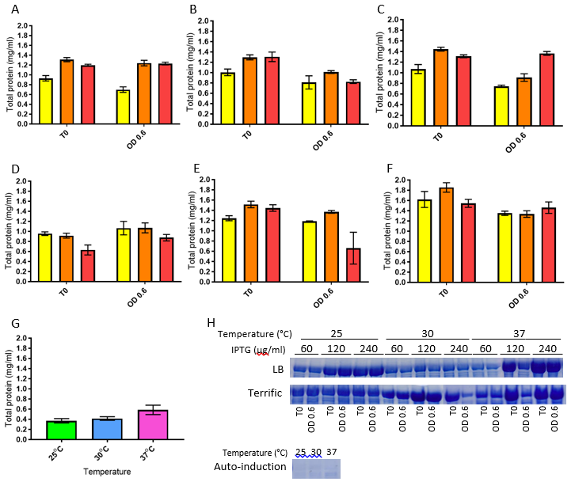
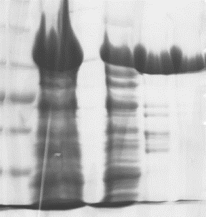  100  70  55  35  1 2 3 4 5  I | Figure 3.1: Total protein recovered from BL21 (λDE3) pGS2541 cultures. (A) Cultures grown in LB broth at 25°C. (B) Cultures grown in LB broth at 30°C. (C) Cultures grown in LB broth at 37°C. (D) Cultures grown in terrific broth at 25°C. (E) Cultures grown in terrific broth at 30°C. (F) Cultures grown in terrific broth at 37°C. Cultures were grown with 60 μg/ml (yellow), 120 μg/ml (orange) or 240 μg/ml IPTG (red). (G) Cultures grown in auto-induction broth at 25°C (green), 30°C (blue) and 37°C (pink). (H) Coomassie-stained SDS-polyacrylamide electrophoresis gels displaying the ~100 kDa AcnA band for each condition. (I) Coomassie-stained SDS-polyacrylamide electrophoresis gel displaying stages of AcnA purification. 1: protein size markers (size in kDa alongside), 2: crude lysate, 3: clarified lysate, 4: wash fraction, 5: final elution fraction. Charts A-F display mean total protein and standard deviation from three biological replicates. Gels shown in panel H are representative of three biological replicates.

3.2 Aconitase absorption spectra
Purified preparations of AcnA (typically 12-18 μM) were analysed for iron content and it was found that iron was almost completely removed from aconitase during the purification process, with less than 0.1 μM iron detected in all purified aconitase samples.
Holo-aconitase was produced by reconstituting the purified protein with iron in the presence of dithiothreitol as described in Section 2.4.3.3. Excess iron and dithiothreitol were removed from samples by dialysing in TSG buffer. Protein and iron contents of samples were recorded, and holo-AcnA samples were typically found to contain 5.7 μM iron (+/- 0.6 μM) per 1 μM AcnA (based on seven independent reconstitutions).
Iron-depleted apo-AcnA was prepared by incubating purified aconitase samples with 100 μM bipyridyl for 1 hour, and then dialysing with TSG buffer. Iron concentration of samples was measured after dialysis to confirm the loss of iron (< 0.1 μM iron detected in all dialysed samples containing 12-18 μM AcnA).
Reconstituted holo-AcnA and unreconstituted apo-AcnA were analysed using UV-visible spectroscopy (Figure 3.2). At 410 nm, the spectra showed greater absorbance of holo-AcnA (0.482 ± 0.016) compared to apo-AcnA (0.309 ± 0.009). Each AcnA molecule folds around one [4Fe-4S] cluster, so a difference of 10 μM [4Fe-4S] (same as the sample protein content) between holo- and apo-AcnA was expected. Using the 15,000 M⁻¹ cm⁻¹ canonical molar extinction coefficient for a [4Fe-4S] cluster, these data equate to an actual difference of approximately 11.5 μM [4Fe-4S], a larger difference by 1.5 μM than expected.
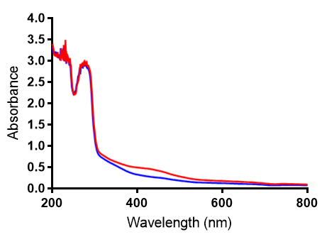
Figure 3.2: Absorption spectra of holo-AcnA (red) and apo-AcnA (blue). Samples were preparations of 1.0 mg AcnA (approximately 10 μM) in TSG buffer. Data are representative of two AcnA preparations.

3.3 Optimum conditions for AcnA activity
Optimum temperature and pH conditions for holo-aconitase were investigated. A coupled enzyme assay was used to measure the rate of citrate conversion to isocitrate by aconitase as the rate-limiting step, with excess isocitrate dehydrogenase and NADP⁺ included to convert isocitrate to α-ketoglutarate and NADPH, which could be recorded spectrophotometrically at 340 nm. Many aconitases are active across a broad range of temperatures and pH, with typical optima of 30-40°C and pH 6-8 (Beinert et al., 1996; Jordan et al., 1999; Baumgart and Bott, 2011; Mansilla et al., 2018). As shown in Figure 3.3, the M. tuberculosis holo-AcnA preparation falls within these boundaries, exhibiting optimum activity at 35-40°C and approximately pH 8.0.
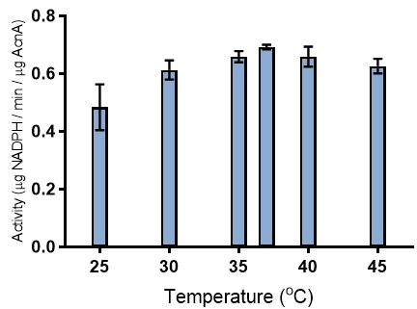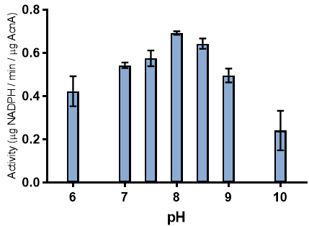
B
A
Figure 3.3: Aconitase activity measured via coupled assay (Section 2.4.5) with isocitrate dehydrogenase over a range of temperatures (A) and pH (B). Bars represent mean and standard deviation determined from three enzyme preparations.

3.4 Kinetics
Using the temperature and pH optima described above, aconitase activity was tested using a range of substrate concentrations and a Michaelis-Menten curve was fitted to the data (Figure 3.4). This yielded a V_{max} of 1.15 μg NADPH per minute per μg AcnA, and a K_{M} value of 3.3 mM. Reconstitution of the iron-sulfur cluster was required for activity and treatment of the protein with thrombin to remove the His-tag did not affect enzyme activity.
B
A
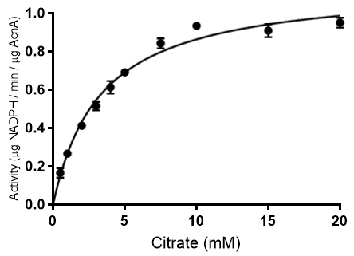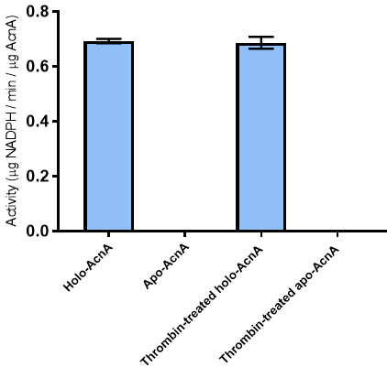
Figure 3.4: (A) Aconitase activity kinetics measured with Michaelis-Menten fit. Curve was fitted using GraphPad Prism version 7.02. (B) Aconitase activity of thrombin-treated and untreated AcnA preparations. All assays were performed as described in Section 2.4.5. Figures display mean and standard deviation of three enzyme preparations.

3.5 Sensitivity to stress reagents
The response of holo-AcnA to ROS, NO and BIP stresses was studied by incubating a preparation of active enzyme with stress-inducing reagents in vitro for 1 hour. After stress, enzyme preparations were dialysed with TSG buffer to remove any iron atoms that had broken away from the iron-sulfur cluster. Enzyme activity and iron content were measured before stress and after dialysis. Generation of ROS used a combination of hypoxanthine and xanthine oxidase. Spermine NONOate was used to generate NO. Figure 3.5 shows the post-dialysis enzyme activity and the iron content of samples as a percentage of the original content. In all cases of stress, enzyme activity was abolished after one hour, however iron loss was much more varied. The least effect on iron content was caused by NO, with a loss of approximately 35% of the original iron. The complete loss of activity from the NO-stressed AcnA implies that fairly little iron needs to be lost from the enzyme to render it inactive. This is supported by existing literature describing the role of Fe_{a} in the aconitase reaction mechanism (Robbins and Stout, 1989a; Beinert et al., 1996; Cairo et al., 2002).

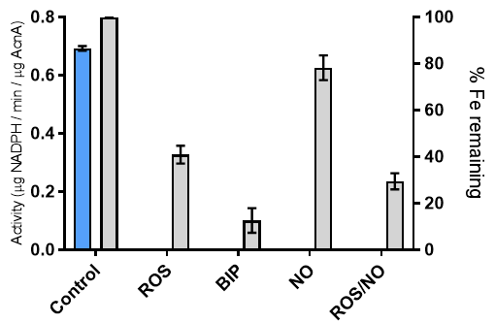
Figure 3.5: Aconitase activity (blue) and iron content (grey) after 1 hour of stress followed by dialysis. ROS stress was induced using 6 mM hypoxanthine and 0.1 U/ml xanthine oxidase. NO stress was induced using 200 μM spermine NONOate. BIP was used at a concentration of 100 μM. Mean and standard deviation derived from three enzyme preparations are plotted for both scales. Note that aconitase activity was only observed in the untreated (control) preparations.

3.6 Discussion
The AcnA of M. tuberculosis was previously studied by Banerjee and colleagues, who measured aconitase activity by recording the formation of cis-aconitate from isocitrate. The optimum pH recorded for AcnA in this assay was 8.0 with the enzyme remaining functional at pH 6.0 and pH 10.0 (Banerjee et al., 2007). The same pH optimum was found for the coupled enzyme assay presented here, and furthermore enzyme activity was observed across the same pH range. This backs up the pH optimum described by Banerjee and colleagues, and also demonstrates that the same pH is optimal for the processing of citrate to isocitrate. Temperature optimum for M. tuberculosis AcnA has not been previously described in published literature, and has been found by this study to be in the range of 35-40°C. This shows AcnA to be at its peak enzyme activity in the same temperature range as the human lung environment where M. tuberculosis infection occurs.
The K_{M} for enzyme activity described by Banerjee and colleagues (0.56 mM) is a much lower value than the K_{M} described here (3.3 mM) due to the different assay techniques employed. This project studied the conversion of citrate to isocitrate by AcnA rather than the conversion of isocitrate to cis-aconitate. Since a two-step reaction was studied in this project, the K_{M} recorded for the coupled enzyme assay is predictably greater than that recorded for the one-step cis-aconitate assay. A repeat of the assay used by Banerjee and colleagues would be needed for a direct comparison of K_{M} values, however this study does present the first recorded K_{M} and V_{max} values for the full citrate-to-isocitrate processing of M. tuberculosis AcnA.
The results displayed in Figure 3.5 demonstrated that aconitase activity could be extinguished with the loss of as little as 20-25% of the incorporated iron, as in the case of NO-stressed AcnA. Previous work with eukaryotic aconitases has shown that the loss of only one iron atom – specifically the Fe_{a} atom, which is exposed from the [4Fe-4S] to bind to substrate molecules – is sufficient to inactivate the enzyme (Beinert et al., 1996). The loss of a single iron atom from the iron-sulfur cluster of AcnA equates to a 25% decrease in total incorporated iron, leading to the conclusion that the results presented here demonstrate that the loss of a single iron atom from the iron-sulfur cluster of AcnA can inactivate the enzyme, holding true to what is known of eukaryotic aconitases.
Oxidative stress, nitric oxide and iron deprivation are all exerted by macrophages on M. tuberculosis during infection. All of these stresses are able to inactivate AcnA (as shown in Figure 3.5), which is the only known M. tuberculosis aconitase enzyme. Total inactivation of aconitase would be expected to halt aerobic metabolism and prevent growth, implying that M. tuberculosis must have a means of countering or surviving macrophage-applied stress to enable core metabolism. Thioredoxins are ubiquitous proteins that are able to combat the effects of oxidative stress, and the expression of the thioredoxin in M. tuberculosis was implied to be up-regulated by the binding of apo-AcnA to the 3’ IRE of the trxC transcript (Banerjee et al., 2007). This suggests a response mechanism to oxidative stress, whereby oxidative damage to the AcnA iron-sulfur cluster induces RNA-binding activity, resulting in the up-regulation of thioredoxin expression. Mycothiol is also produced by M. tuberculosis as a redox regulator, with hypersensitivity to ROS and NO resulting from mutation of genes involved in the mycothiol synthesis pathway (Buchmeier et al., 2003). The iron uptake regulator FurA has been shown to de-repress expression from the katG gene in response to ROS, enabling expression of the catalase/peroxidase KatG protein under oxidative stress (Pym et al., 2001). In addition to AcnA, the WhiB-like iron-sulfur proteins in M. tuberculosis have been shown to respond to oxidative damage. The WhiB proteins of M. tuberculosis have been reported to behave both as transcription factors and as disulphide reductases that are sensitive to oxidative and nitrosative stresses (reviewed in Hengst and Buttner, 2008). Damage to iron-sulfur clusters as a means of sensing oxidative stress is not unique to AcnA in M. tuberculosis, but the research outlined here presents another means by which the bacteria can sense and adapt to stressful conditions.

Chapter 4: Aconitase as an IRE-Binding Protein

The findings of Chapter 3 describe the typical aconitase activity of the [4Fe-4S] form of M. tuberculosis AcnA, as well as the sensitivity to host-related stresses of this iron-sulfur cluster and the consequences of stress with respect to enzyme activity. This chapter presents studies into the RNA-binding activity of AcnA with the predicted IRE of the cwlM transcript.
4.1 Generation of IRE RNA
The secondary structures of previously studied IREs typically feature the sequence CAGUG at the apex of the stem loop, and an unpaired C within the stem. The RNAfold program (Gruber et al., 2008) indicated that these two traits are present in the predicted folding of the cwlM IRE (Figure 4.1).
To determine whether AcnA binding to the cwlM IRE was specific a mutant IRE with a disrupted secondary structure was designed. Base substitutions were made in the wild type (WT) IRE sequence such that the secondary structure was altered but the corresponding amino acid sequence was unchanged. This was to avoid mutations in the essential CwlM protein. In Figure 4.1, the mutant IRE1 differs from the WT by two substitutions that result in a predicted folding pattern that has a GAGUG sequence on the end of the loop and no unpaired C base, but still retains stem loop structure. Mutant IRE2 has the same two substitutions as IRE1 with three additional substitutions (five in total) that has a predicted fold structure with many unpaired bases and no apical CAGUG or GAGUG, i.e. without the typical traits of an IRE-like stem loop.

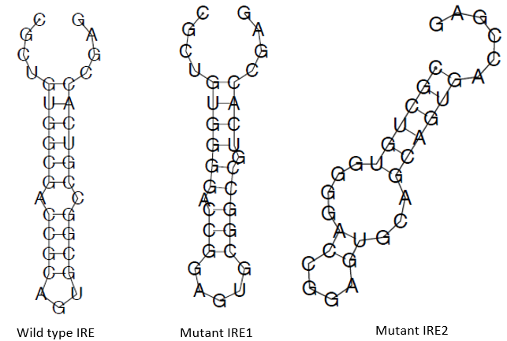
Figure 4.1: WT and mutant IRE folding as predicted by RNAfold (Gruber et al., 2008).

4.2 Aconitase-IRE binding assays
4.2.1 Apo-AcnA binding assays
The WT and mutant IRE RNAs were constructed by ligating paired DNA oligonucleotides into pGEM-3Zf vectors downstream of a T7 RNA polymerase promoter. The RNA was synthesised via IVT (producing 33 nt RNA molecules with the sequences displayed in Figure 4.1), incubated with apo-AcnA and the binding activity was first studied by DRaCALA using radiolabelled RNA (Figure 4.2.1A). The DRaCALA results were unusual, producing dense signals across a broader area than is typical for bound probes and without a ring-shaped signal for diffused, unbound probes. The DRaCALA suggested a lower degree of diffusion for WT IRE-AcnA complexes due to the higher-density signal, implying apo-AcnA has a greater affinity for WT IRE RNA compared with the mutant IRE1 and IRE2 RNAs.
The binding profiles of apo-AcnA with each IRE sequence were further studied by EMSA. Using a fixed quantity of labelled WT IRE RNA and an ascending concentration of apo-AcnA, a binding titration profile was constructed that showed a pair of shifted bands in samples containing 1-10 μg apo-AcnA, but only a single band for higher concentrations of aconitase (Figure 4.2.1B). An identical binding profile was obtained when aconitase was treated with thrombin to remove the His-tag. Both bands were confirmed to be a result of AcnA-RNA binding by supershifting the bands. Supershifts were achieved by including 8 μg anti-AcnA IgG (Prodromou et al., 1991) in the binding reaction mixture. AcnA has been reported by Banerjee and colleagues to be able to aggregate as trimers as a result of ionic interactions (Banerjee et al., 2007). It may be the case that the ratio of trimeric to monomeric AcnA increases with AcnA concentration, causing the gradual transition from two shifted bands to one.
Competition binding assays were used to compare the abilities of unlabelled WT, IRE1 and IRE2 RNAs to compete with radiolabelled WT IRE for aconitase in reactions that contained 20 μg apo-AcnA (approximately 10 μM). Unlabelled whole yeast RNA was used as a non-specific competitor. Competing RNAs were included at 1:1, 1:2, 1:5 and 1:10 ratios of labelled WT to unlabelled competitor RNA. Competitive binding is indicated on EMSAs by a decrease in the intensity of the shifted band. Yeast RNA did not show any indication of competitive binding. Unlabelled WT and IRE1 RNA caused a decrease in band intensity as the relative proportion of the total sample RNA increased. The IRE2 RNA did not exhibit this competitive binding. As such, a titration profile of apo-AcnA with radiolabelled IRE2 RNA revealed that a pair of shifted bands was present even with 20 μg apo-AcnA, suggesting a lower binding affinity.
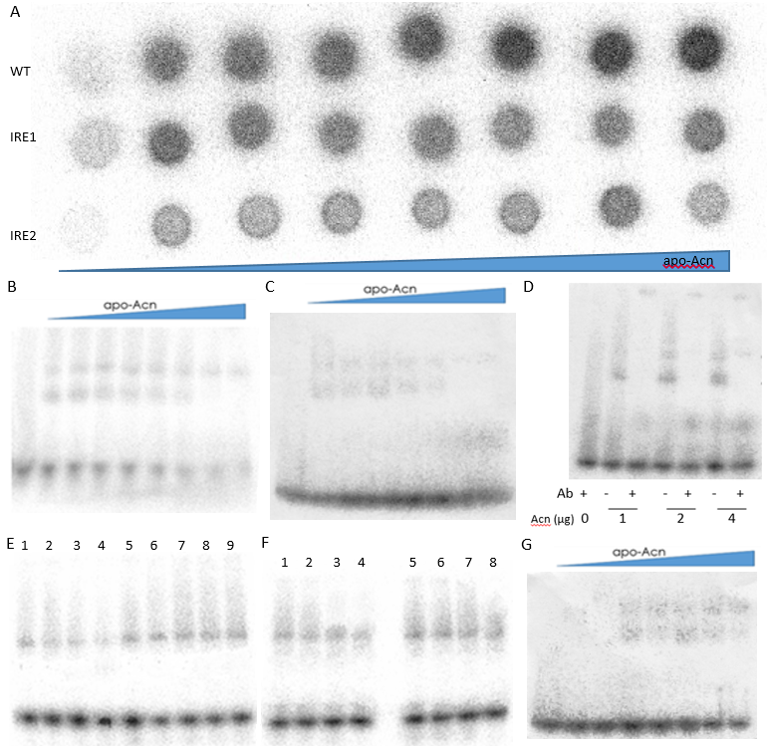
Figure 4.2.1: Binding assays with apo-AcnA. (A) DRaCALA with binding assays for 10 ng IRE RNA and (from left to right) 1, 2, 4, 6, 8, 10, 15 and 20 μg apo-AcnA. (B) Titration profile EMSA for 10 ng WT IRE RNA with 0 – 20 μg apo-AcnA. (C) Titration profile EMSA for 10 ng WT IRE RNA with 0 – 20 μg thrombin-treated apo-AcnA. (D) Supershift EMSA for 10 ng WT IRE RNA, apo-AcnA and anti-AcnA antibody. (E) Competitive binding assay EMSA with 20 μg apo-AcnA, unlabelled RNA and 10 ng labelled WT IRE RNA. Lanes 1 – 4: labelled WT IRE vs unlabelled WT IRE in ratios 1:1, 1:2, 1:5, 1:10. Lane 5: labelled WT IRE with no competitor. Lanes 6 – 9: labelled WT IRE vs unlabelled whole yeast RNA in ratios 1:1, 1:2, 1:5, 1:10. (F) Competitive binding assay EMSA with 20 μg apo-AcnA, unlabelled RNA and 10 ng labelled WT IRE RNA. Lanes 1 – 4: Lanes 1 – 4: labelled WT IRE vs unlabelled IRE1 RNA in ratios 1:1, 1:2, 1:5, 1:10. Lanes 5 – 8: labelled WT IRE vs unlabelled IRE2 RNA in ratios 1:1, 1:2, 1:5, 1:10. (G) Titration profile EMSA for 10 ng IRE2 RNA with 0 – 20 μg apo-AcnA. Green arrows indicate free IRE; red arrows indicate AcnA-bound IRE; the blue arrow indicates supershifted AcnA-IRE.

4.2.2 Holo-AcnA binding assays
The ability of holo-Acn to bind RNA was also studied (Figure 4.2.2). Samples of holo-AcnA that were unstressed or stressed with ROS, NO and BIP (as previously described) were incubated with labelled WT IRE RNA and studied by EMSA. This showed that unstressed (i.e. iron-replete) aconitase could not bind RNA, and that holo-AcnA with any of the stresses could acquire RNA-binding functionality. Interestingly, the NO-stressed holo-AcnA displayed two shifted bands, an observation also made with low concentrations of apo-AcnA, whereas all other stressed holo-AcnA samples produced only one shifted band. This could be an indicator that NO-stressed AcnA is not induced to bind RNA to the same extent as AcnA stressed with ROS and BIP. Binding profiles were obtained for the holo-AcnA samples treated with ROS, NO and a combination of ROS and NO. In ROS and ROS/NO stressed samples, the second of the two shifted bands was diminished earlier than in the standard purified apo-AcnA profiles. The NO-treated AcnA produced no shifted bands at aconitase concentrations below 4 μg and a pair of shifted bands even at 20 μg. This further implies NO does not induce RNA-binding functionality in holo-AcnA as effectively as ROS.
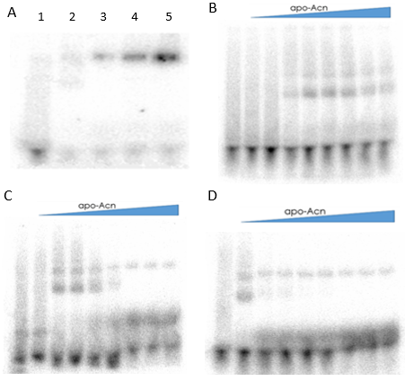
holo-Acn
holo-Acn
holo-Acn
Figure 4.2.2: Binding assays with stressed holo-AcnA. (A) Binding assay with 10 ng WT IRE RNA and 20 μg unstressed or stressed holo-AcnA. Lane 1: unstressed holo-AcnA. Lanes 2 – 5: holo-AcnA stressed with NO, ROS, BIP, and both NO and ROS, respectively. ROS, NO and iron deprivation stresses were inflicted on AcnA preparations using 6 mM hypoxanthine, 200 μM spermine NONOate and 100 μM BIP, respectively, for 1 hour and dialysed as described in Section 2.4.3.5. (B) Titration profile EMSA for 10 ng WT IRE RNA with 0 – 20 μg NO-stressed holo-AcnA. (C) Titration profile EMSA for 10 ng WT IRE RNA with 0 – 20 μg ROS-stressed holo-AcnA. (D) Titration profile EMSA for 10 ng WT IRE RNA with 0 – 20 μg NO/ROS-stressed holo-AcnA. Green arrows indicate free IRE; red arrows indicate AcnA-bound IRE.

4.3 Discussion
The typical features of an IRE are the unpaired C residue in the stem and the CAGUG sequence on the looping end. Studies on the rabbit (Oryctolagus cuniculus) aconitase iron-responsive protein 1 (IRP1, ACO1) and the IRE found in the human L-ferritin mRNA revealed three amino acid residues involved in the IRE interaction. The CAGUG sequence was found to associate with K379 and S371 of IRP1, and the unpaired C associated with S681 (Selezneva et al., 2013). An alignment of the amino acid sequences of rabbit IRP1 and M. tuberculosis AcnA revealed 49.6% sequence identity, but highlighted the residues R377, S367 and S723 in AcnA (conserved in E. coli AcnA protein) in conserved regions as potentially analogous residues involved in protein-IRE interaction (Table 4.3).
M. tuberculosis H37Rv AcnA | 363 DVVPSIAGPKRPQDRIAL | 719 TDHISPAGAIKPGTPAAR
E. coli K12 AcnA | 369 DVEASLAGPKRPQDRVAL | 674 TDHISPAGSIKPDSPAGR
O. cuniculus Q01059 ACO1 | 367 TVVPCCSGPKRPQDKVAV | 677 TDHISPAGNIARNSPAAR
Table 4.3: Extracts of aconitase protein sequence alignments (Clustal Omega). Potential IRE-interacting residues are underlined.

Although the IRE sequence is found at the 5’ end of the cwlM gene, it was previously assigned by Banerjee et al. (2007) as a 3’ loop in the untranslated region of the mRNA of the thioredoxin gene trxC. In this role, aconitase-IRE binding in response to oxidative stress would be expected to stabilise the mRNA and thus encourage translation of the trxC mRNA (Banerjee et al., 2007). Improved expression of thioredoxin could theoretically promote repair of oxidative damage and support the activity of ribonucleotide reductases, improving the ability of M. tuberculosis to grow in stressful conditions. Recent work has shown that thioredoxin reductases from C. glutamicum and M. tuberculosis (trxB2, first gene in the trxB2-trxC operon) are responsible for transferring electrons to the glutaredoxin-like protein NrdH in both species (Van Laer et al., 2013).
Banerjee and colleagues specifically searched the M. tuberculosis genome for IRE-like sequences in untranslated regions (Banerjee et al., 2007), so the IRE-like sequence at the 5’ end of cwlM, which is in the 3’ untranslated region of the trxC transcript, was labelled as being in the trxC mRNA. The situation of the IRE may enable it to influence translation of both trxC and cwlM in M. tuberculosis, however the expression of these proteins was not studied.
The studies outlined in this chapter have confirmed that M. tuberculosis AcnA can only bind RNA in the apo-form, and that apo-AcnA can bind the WT cwlM IRE and mutant IRE1, though there is less binding of apo-AcnA to the mutant IRE2. Furthermore it was demonstrated that holo-AcnA subjected to stress can acquire RNA-binding activity. The mutant IRE2 structure given here was predicted to result in poorer binding of apo-AcnA if incorporated into the cwlM gene of stressed mycobacteria.
Banerjee and colleagues previously described the interaction of this IRE with AcnA as part of the trxC mRNA. The WT IRE probes used for EMSAs in this study differ from those used by Banerjee only by having four additional nucleotides at each end of the molecule (not affecting the predicted folding of the RNA). Where Banerjee’s EMSA showed a single band for AcnA-bound IRE with numerous smaller-size bands not attributed to bound IRE (Banerjee et al., 2007), this study presents a clear shift from a single free RNA band to a single band of AcnA-bound IRE (or two bands at lower AcnA concentrations). This confirms Banerjee’s finding that the IRE can be bound by AcnA, but also demonstrates that AcnA can be induced to bind the IRE as a direct result of exposure to [4Fe-4S]-disassembling stresses.
The paired shifted bands observed when lower amounts of AcnA were incubated with IRE RNA may be the result of AcnA forming trimers. A mixture of monomeric and trimeric AcnA could produce two distinct shifted bands. As AcnA concentration increases, so too could the proportion of trimers, hence only one shifted band is observed in EMSAs with higher AcnA contents. The trimeric form of M. tuberculosis AcnA was reported by Banerjee and colleagues and state to be the result of ionic interactions between protein molecules and not to impact the enzyme activity of AcnA. However, Banerjee only conducted EMSAs with a single concentration of AcnA and did not observe paired shifted bands (Banerjee et al., 2007). This could be explained by an abundance of trimers in Banerjee’s binding reaction. This project is the first demonstration of paired band shifts as a result of M. tuberculosis AcnA IRE binding.
This study has found RNA-binding activity to be inducible in holo-AcnA when stressed with ROS, NO or iron deprivation. As discussed in Chapter 3, a 25% decrease in the iron content of holo-AcnA could theoretically extinguish enzyme activity, as was observed in Section 3.5 where NO could abolish aconitase activity without costing the AcnA preparation more than 20-25% of its iron content. The RNA-binding function of aconitases is regarded as being the result of a conformational change in the protein following loss of the iron-sulfur cluster (Beinert et al., 1996), however the data presented in this chapter suggest that RNA-binding activity is possible in AcnA stressed with NO, which, as stated, could leave 75% of the protein’s iron intact. This implies the possibility of RNA-binding in AcnA with incomplete iron-sulfur clusters rather than totally absent clusters.

Chapter 5: Consequences of cwlM IRE Mutation for Growth

Knowing that the iron-sulfur cluster of AcnA can be dismantled by stress and that apo-AcnA can bind to the IRE of the cwlM gene transcript, experiments were conducted to study the effect of the IRE1 and IRE2 mutations on growth and survival of mycobacteria in culture with oxidative, nitrosative and iron-chelating stress factors. The binding of apo-AcnA to the cwlM IRE would be expected to result in down-regulation of translation. This suggests that, under stress conditions, AcnA is not metabolically active (apo-AcnA) and so halts central carbon metabolism and growth, such that peptidoglycan biosynthesis becomes unnecessary and therefore inhibition of cwlM translation by apo-AcnA would usefully impede the synthesis of peptidoglycan. Disruption of the cwlM IRE was hypothesised to result in negation of the regulatory effects of AcnA-IRE binding, and so uncouple central metabolism from cell wall biosynthesis.
This hypothesis was tested using a strain of M. smegmatis with a conditional cwlM mutation (Ms cwlM-CM) that was provided by Dr G Mukamolova (Turapov et al., 2018) and prepared using the method described by Forti et al. (2009). This mutant’s chromosomal cwlM promoter was replaced with the ptr promoter that is bound by a repressor protein to block transcription. The promoter is de-repressed in the presence of pristinamycin, i.e. Ms cwlM-CM requires a pristinamycin-containing medium to grow. This conditional mutant strain also carries a hygromycin resistance marker.
To study the cwlM gene of M. tuberculosis, Ms cwlM-CM was transformed with a pMV306 plasmid vector carrying cwlM_{Mtb} and the 200 bp upstream region (pMV306.cwlM_{Mtb}.WT). Using SDM, the IRE1 and IRE2 mutations (illustrated in Figure 4.1) were introduced into the plasmid-borne cwlM gene to produce the plasmids pMV306.cwlM_{Mtb}.IRE1 and pMV306.cwlM_{Mtb}.IRE2, and these plasmids were then used to transform and complement Ms cwlM-CM. These strains, now with WT, IRE1 and IRE2 variant cwlM genes, were cultured in media and exposed to stresses that were previously shown to cause in vitro disassembly of the AcnA iron-sulfur cluster (Chapter 3) and induce AcnA-RNA binding (Chapter 4). The data presented here show a growth defect in Ms cwlM-CM pMV306.cwlM_{Mtb}.IRE2 (disrupted IRE) when exposed to a combination of stresses.
5.1 Single stress conditions
The Ms cwlM-Cm pMV306.cwlM_{Mtb} strains were grown in broth containing plumbagin, spermine NONOate or BIP to inflict ROS (Raman et al., 2001; Casonato et al., 2014), NO and iron deprivation stresses, respectively (see Appendix 1 for MIC values). Starter cultures were grown to OD₆₀₀ 0.8 and inoculated 1:1000 in 7H9 broth. Broths were incubated at 37°C for 96 hours, with colony forming units counted every 24 hours (Figure 5.1).
All three strains grew similarly when unstressed (Figure 5.1A) or stressed with NO (Figure 5.1D), and all exhibited slowed growth or decline during the first 24 hours of culture with oxidative stress or iron deprivation. When cultured with ROS stress (Figure 5.1B), only Ms cwlM-CM pMV306.cwlM_{Mtb}.IRE1 displayed significantly poorer growth than the WT strain throughout the experiment. The Ms cwlM-CM pMV306.cwlM_{Mtb}.IRE2 strain exhibited poorer growth at the 24 and 48 hour time points when cultures were stressed with BIP (Figure 5.1C), but recovered to WT levels at later time points. It is interesting to note that the NO-stressed cultures (Figure 5.1D) appear to show better growth for the IRE1 and IRE2 mutant strains, though this difference is not statistically significant by the Student’s t-test.

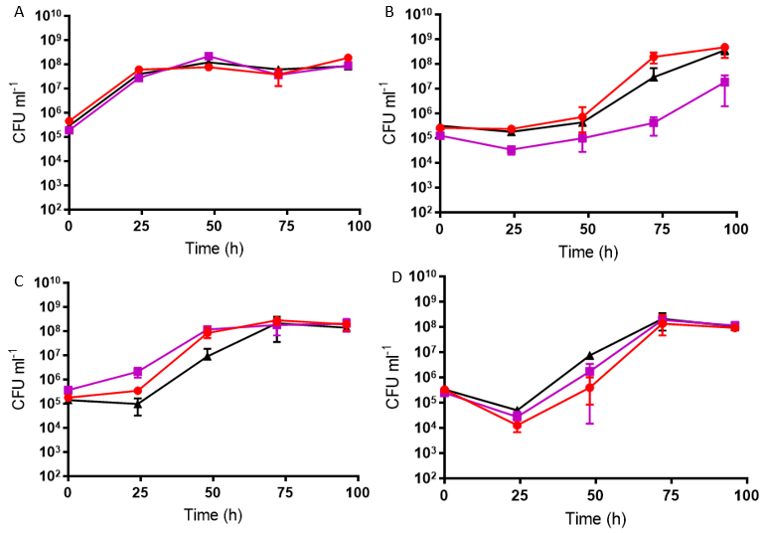
*
*
*
*
*
Figure 5.1: Growth of Ms cwlM-CM pMV306.cwlM_{Mtb} strains in (A) unstressed, (B) ROS stressed, (C) BIP stressed and (D) NO stressed broths. Ms cwlM-CM pMV306.cwlM_{Mtb}.WT (red), Ms cwlM-CM pMV306.cwlM_{Mtb}.IRE1 (purple), Ms cwlM-CM pMV306.cwlM_{Mtb}.IRE2 (black). Asterisks indicate significantly poorer recovery of bacteria compared with the WT strain as analysed by Student’s t-test (single asterisk p < 0.05, double asterisk p < 0.01). Charts display mean CFU/ml and standard deviation of three biological replicates. The first measure was taken immediately after addition of stressors. Stressors were included at concentrations of 75 μM plumbagin, 200 μM spermine NONOate and 100 μM BIP to inflict respective ROS, NO and iron deprivation stresses.

5.2 Combination stress conditions
The differences in growth phenotype observed in Figure 5.1 were generally small or not consistent across the full timescale of the experiment. Furthermore, single stressors are not necessarily representative of the stress inflicted on M. tuberculosis by macrophages. To further study the effect of stress on the Ms cwlM-Cm pMV306.cwlM_{Mtb} strains, bacteria were inoculated as described in Section 5.1 into broths containing multiple stresses and grown as before (Figure 5.2).
With the exception of the 72 hour time point when grown with both ROS and BIP stresses (Figure 5.2B), the Ms cwlM-CM pMV306.cwlM_{Mtb}.IRE1 strain behaved similarly to the WT strain across all stress combinations, however the Ms cwlM-CM pMV306.cwlM_{Mtb}.IRE2 strain was greatly impaired in all cases, with no colonies recovered from 24 hours onward when stressed with ROS and NO (Figure 5.2A), ROS and BIP (Figure 5.2B) or a combination of all three stresses (Figure 5.1D). The IRE2 strain was recovered at every time point when stressed with NO and BIP (Figure 5.2C), but this recovery of colonies was significantly poorer than WT at 48, 72 and 96 hours post-inoculation. Since the IRE2 strain only differs from the wild type in its IRE sequence, it is likely that the IRE has a role in the response of mycobacteria to these stresses.
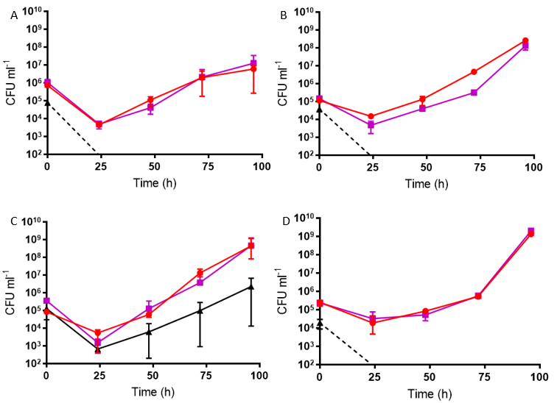
*
**
**
*
Figure 5.2: Growth of Ms cwlM-CM pMV306.cwlM_{Mtb} strains in (A) ROS/NO, (B) ROS/BIP, (C) BIP/NO and (D) ROS/NO/BIP stressed broths. Ms cwlM-CM pMV306.cwlM_{Mtb}.WT (red), Ms cwlM-CM pMV306.cwlM_{Mtb}.IRE1 (purple), Ms cwlM-CM pMV306.cwlM_{Mtb}.IRE2 (black). Dashed lines indicate total depletion of recoverable colonies. Asterisks indicate significantly poorer recovery of bacteria compared with the WT strain as analysed by Student’s t-test (single asterisk p < 0.05, double asterisk p < 0.01). Charts display mean CFU/ml and standard deviation of three biological replicates. The first measure was taken immediately after addition of stressors. Stressors were included at concentrations of 75 μM plumbagin, 200 μM spermine NONOate and 100 μM BIP to inflict respective ROS, NO and iron deprivation stresses.

5.3 Effect of pristinamycin on stressed cultures
To check if under-expression of functional CwlM protein was linked to the failure of Ms cwlM-CM pMV306.cwlM_{Mtb}.IRE2 to grow under multiple stress conditions, the WT and IRE2 strains were inoculated into broths containing the stress reagent combinations outlined in Section 5.2, with the inclusion of pristinamycin to enable expression of the chromosomal cwlM gene (Figure 5.3).
In the absence of stressors, the inclusion of pristinmaycin did not result in any significant difference in growth between the two strains (Figure 5.3A). The Ms cwlM-CM pMV306.cwlM_{Mtb}.WT strain exhibited poorer recovery under all stress combinations with pristinamycin (Figure 5.3B-E) compared with the absence of pristinamycin (Figure 5.2). Only when the stress combination was ROS and BIP (Figure 5.3C) could the WT strain be recovered at every time point. When stressed with ROS and NO (Figure 5.3B), the WT strain could be recovered after 24 hours, but not 48 hours. Recovery was worse still when stressed with NO and BIP or all three stresses (Figure 5.3D, E) where bacteria could not be recovered after 24 hours. These deleterious effects imply that the presence of pristinamycin sensitises Ms cwlM-CM pMV306.cwlM_{Mtb}.WT to the combined stresses. The CwlM production induced by pristinamycin would further imply that this increased sensitivity to stress is the result of heightened CwlM levels.
The inclusion of pristinamycin did not have the effect of improving recovery of Ms cwlM-CM pMV306.cwlM_{Mtb}.IRE2 from stressed cultures (Figure 5.3B-E). In fact, the presence of pristinamycin worsened the recovery of this strain when stressed with NO and BIP (Figure 5.3D). As with the WT strain, pristinamycin appears to be detrimental to the growth of bacteria, strengthening the conclusion that CwlM may be harmful to mycobacteria under stress.
B
A
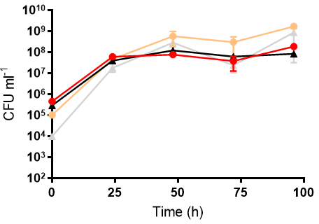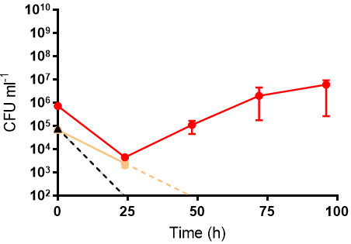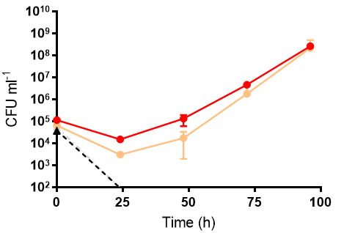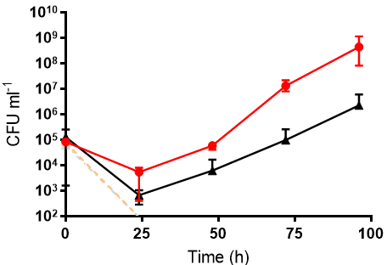
C
D
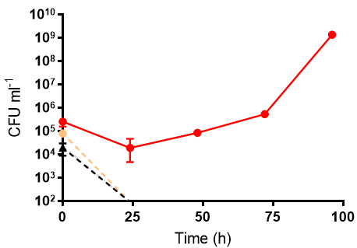
E
Figure 5.3: Growth of Ms cwlM-CM pMV306.cwlM_{Mtb}.WT and Ms cwlM-CM pMV306.cwlM_{Mtb}.IRE2 strains in broths containing pristinamycin and (A) no stress, (B) ROS/NO stress, (C) ROS/BIP stress, (D) BIP/NO stress and (E) ROS/NO/BIP stress. Ms cwlM-CM pMV306.cwlM_{Mtb}.WT (Pri- red, Pri+ orange), Ms cwlM-CM pMV306.cwlM_{Mtb}.IRE2 (Pri- black, Pri+ grey). Dashed lines indicate total depletion of recoverable colonies. Charts display mean CFU/ml and standard deviation of three biological replicates. The first measure was taken immediately after addition of stressors. Stressors were included at concentrations of 75 μM plumbagin, 200 μM spermine NONOate and 100 μM BIP to inflict respective ROS, NO and iron deprivation stresses. Pristinamycin was included at 2 μg/ml.

5.4 Testing for viable non-culturable bacteria
Mycobacteria are known to be able to enter a non-culturable dormant state when stressed (Voskuil et al., 2003). In this state, the bacteria do not grow on agar but can be resuscitated in broth (Shleeva et al., 2002). A most probable number (MPN) assay was used to assess numbers of Ms cwlM-CM pMV306.cwlM_{Mtb}.WT and IRE2 mutant bacteria in broth with ROS/NO combined stress. Culture samples were serially diluted in multiple tubes of stress-free broth every two days for two weeks and the MPN/ml was calculated (Figure 5.4). The data displayed in Figure 5.4 show that viable Ms cwlM-CM pMV306.cwlM_{Mtb}.IRE2 bacteria were still present in the combination-stressed culture even after two weeks, though their numbers were in decline. This decline appears to dissipate toward the end of the two weeks, by which time the MPN/ml had decreased approximately 100-fold. The Ms cwlM-CM pMV306.cwlM_{Mtb}.WT strain did not show this impairment, its growth exceeding 10⁹ MPN/ml on day 10 of the experiment.
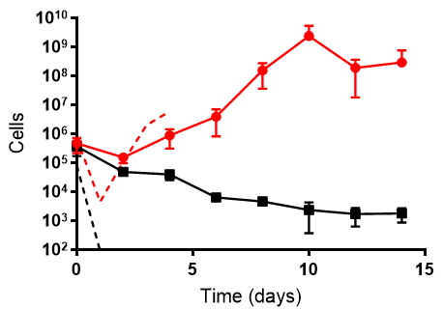
Figure 5.4: Recovery of Ms cwlM-CM pMV306.cwlM_{Mtb}.WT (red) and Ms cwlM-CM pMV306.cwlM_{Mtb}.IRE2 (black) strains in broth containing combined ROS/NO stresses. Solid lines represent cell count as MPN ml⁻¹ calculated by the method of Jarvis et al. (2010); dashed lines represent cell count as CFU ml⁻¹ (data from Figure 5.2A). Charts display mean and standard deviation of three biological replicates. The first measure was taken immediately after addition of stressors. Stressors were included at concentrations of 75 μM plumbagin and 200 μM spermine NONOate to inflict respective ROS and NO stresses.

5.5 Stressing turbid cultures
Each of the Ms cwlM-CM pMV306.cwlM_{Mtb} strains was also examined for their response to stress being applied during growth phase rather than them encountering stress immediately upon inoculation into the medium. Therefore, cultures were grown to OD₆₀₀ 0.6 prior to adding stress reagents, then OD₆₀₀ was measured every 30 minutes and colony forming units every 2 hours for 12 hours (Figure 5.5). Both means of measuring showed the same trends in each experiment. For ROS, BIP and ROS/NO stresses, the IRE2 strain’s growth was hindered more than the WT and IRE1 strains (Figure 5.5B, C, E). Stressing with NO did not distinguish the IRE2 strain from the other two (Figure 5.5D), nor could this strain be distinguished in the absence of any stress (Figure 5.5A). The IRE1 strain was consistent with WT in all experiments.
Unlike the single stress growth experiments described in Section 5.1, Ms cwlM-CM pMV306.cwlM_{Mtb}.IRE2 exhibited a clear decrease in OD₆₀₀ and CFU/ml when stressed with either ROS or BIP. The lack of an inhibitory effect from NO is consistent with Figure 5.1.
These results lend more credence to a possible role of the cwlM IRE in the mycobacterial response to oxidative stress and iron deprivation.

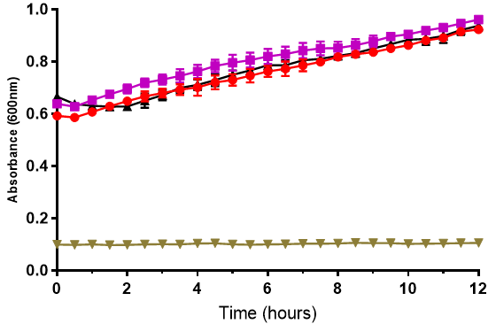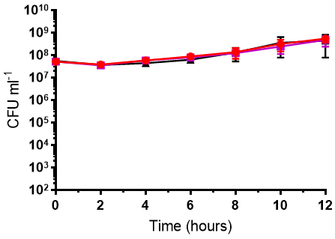
A
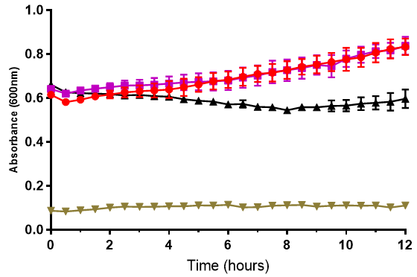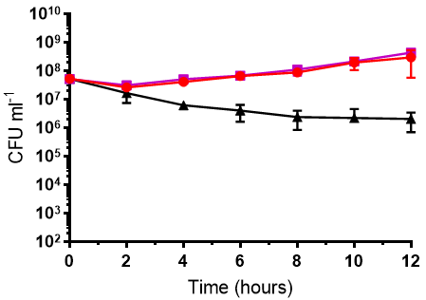
B
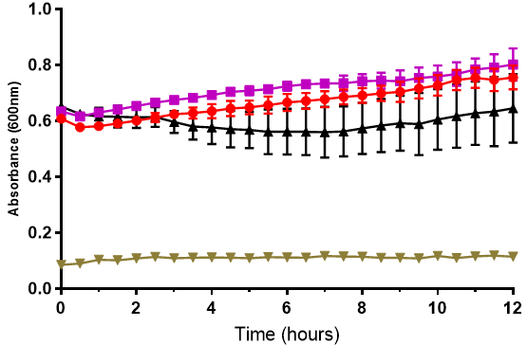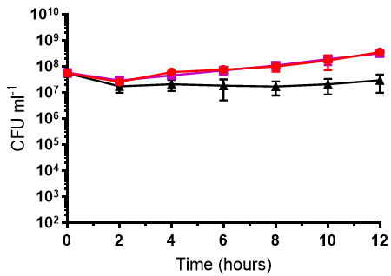
C
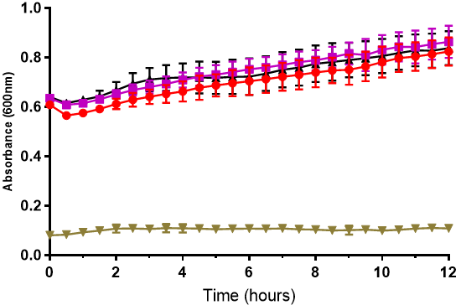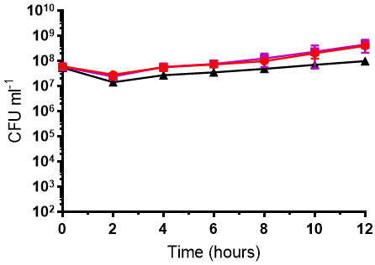
D
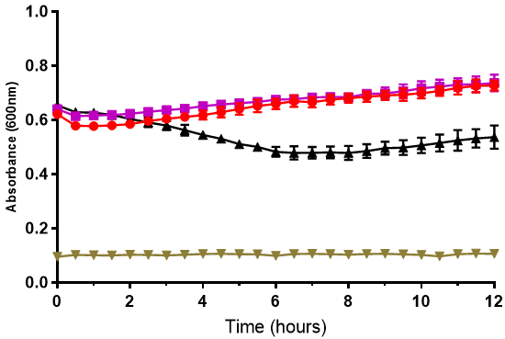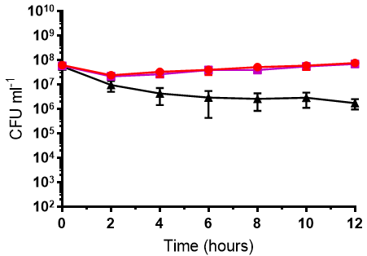
E
Figure 5.5: Measurement by optical density at 600 nm and CFU/ml of growing Ms cwlM-CM pMV306.cwlM_{Mtb} strains in broth containing (A) no stress, (B) ROS stress, (C) BIP stress, (D) NO stress and (E) ROS/NO combined stresses. Ms cwlM-CM pMV306.cwlM_{Mtb}.WT (red), Ms cwlM-CM pMV306.cwlM_{Mtb}.IRE1 (purple), Ms cwlM-CM pMV306.cwlM_{Mtb}.IRE2 (black), negative control (brown). All charts display mean and standard deviation of three biological replicates. Stressors were included at concentrations of 75 μM plumbagin, 200 μM spermine NONOate and 100 μM BIP to inflict respective ROS, NO and iron deprivation stresses.

5.6 Growth of CwlM amidase activity mutants
Two more cwlM gene variant strains were provided by Dr G Mukamolova (University of Leicester): Ms cwlM-CM pMV306.cwlM_{Mtb}.E217A and Ms cwlM-CM pMV306.cwlM_{Mtb}.D339A. There should be no deviation from wild type AcnA-IRE interactions in these strains, however they have amino acid substitutions that render the CwlM protein enzymatically inactive (amidase negative). These strains were grown in stress-free, single stress or ROS/NO combined stress conditions (Figure 5.6) as described in Sections 5.1 and 5.2. These experiments expand on previous research that found the amidase activity of CwlM is not required for growth in vitro (Boutte et al., 2016) by characterising the essentiality of this activity under stress conditions.
The amidase activity of CwlM does appear to be expendable for growth in vitro without stress (Figure 5.6A) or with any single stress (Figure 5.6B, C, D), however the E217A and D339A mutant strains both exhibited slowed growth compared to WT in the first 24 hours of unstressed growth (Figure 5.6A), suggesting that, though not essential, CwlM amidase activity does have a role in the growth of mycobacteria. More abundantly clear is the significantly poorer recovery of colonies from either of the mutant strains compared with WT when cultured under stress. Despite neither mutant having enzyme activity (G Mukamolova, unpublished work), only the E217A mutant was unable to grow in the ROS/NO combined stress experiment, though the D339A mutant was still weaker than the WT strain (Figure 5.6E).

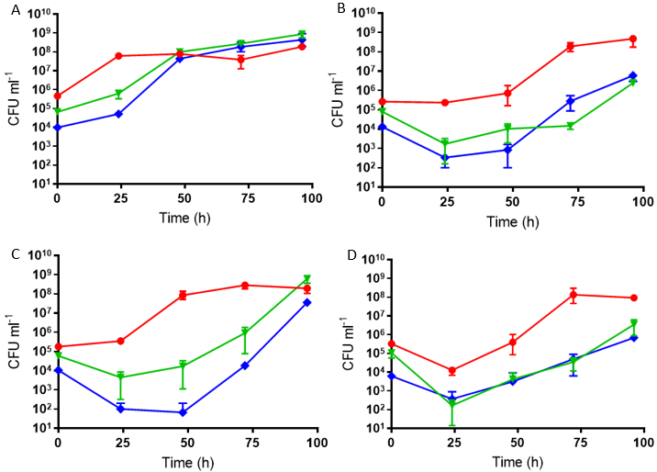
*
*
**
**
**
**
**
**
**
**
**
**
*
*
*
*
**
**
**
**
**
**
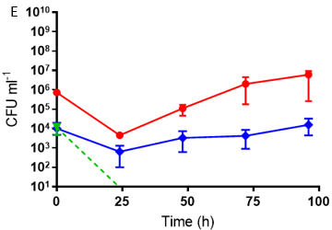
**
**
**
*
Figure 5.6: Growth of Ms cwlM-CM pMV306.cwlM_{Mtb}.WT and equivalent CwlM amidase negative mutant strains in broth containing (A) no stress, (B) ROS stress, (C) BIP stress, (D) NO stress and (E) ROS/NO combined stresses. Ms cwlM-CM pMV306.cwlM_{Mtb}.WT (red), Ms cwlM-CM pMV306.cwlM_{Mtb}.E217A (green), Ms cwlM-CM pMV306.cwlM_{Mtb}.D339A (blue). Dashed lines indicate total depletion of recoverable colonies. Asterisks indicate significantly poorer recovery of bacteria compared with the WT strain as analysed by Student’s t-test (single asterisk p < 0.05, double asterisk p < 0.01). Charts display mean CFU/ml and standard deviation of three biological replicates. The first measure was taken immediately after addition of stressors. Stressors were included at concentrations of 75 μM plumbagin, 200 μM spermine NONOate and 100 μM BIP to inflict respective ROS, NO and iron deprivation stresses.

5.7 Discussion
The induction of the thioredoxin and cysteine synthesis proteins by SigH under oxidative and nitrosative stress conditions provides a counter to the redox damage inflicted by these stresses. Iron-sulfur clusters are at risk from ROS and NO, affecting more proteins than just AcnA. The seven WhiB regulatory proteins in M. tuberculosis all harbour iron-sulfur clusters, with multiple of them specifically reported as being sensitive to NO (Singh et al., 2007; Smith et al., 2010). With essential regulatory processes and aerobic respiration in M. tuberculosis requiring iron-sulfur proteins, an effective response to iron-sulfur cluster attack is indicated.
The ability of the Ms cwlM-CM pMV306.cwlM_{Mtb}.WT strain to grow during the ROS/NO dual stress, when the IRE2 variant cannot (Figure 5.2), implies the mechanisms of response to ROS and NO stresses are sufficient in the WT. The inability of the IRE2 strain to grow suggests that the disruption of the IRE in cwlM renders the cellular response insufficient for growth. At the concentrations of plumbagin and spermine NONOate used in this study, the loss of AcnA-mediated regulation at the cwlM gene is able to overcome the other growth-enabling stress responses in the IRE2 strain and so prevent growth, as observed in Figure 5.2. The failure of Ms cwlM-CM pMV306.cwlM_{Mtb}.IRE2 to grow was also observed in the ROS/BIP and ROS/NO/BIP combined stress experiments, but not the NO/BIP experiment, though the IRE2 strain’s growth was hindered. The presence of ROS is common to all combined stress growth experiments where the IRE2 strain was unable to grow, but given that the IRE2 mutant strain was impaired in the NO/BIP experiment as well, it may simply be the case that ROS is a more potent stressor than NO or BIP, and that the addition of NO or BIP to ROS-stressed M. smegmatis crosses the threshold to inhibit growth. The relative potency of ROS and BIP as compared with NO is apparent from Chapter 3, where NO was shown to have a markedly smaller effect on AcnA iron-sulfur clusters than ROS or BIP (Section 3.5). However, Figure 3.5 also implied a lesser degree of iron-sulfur cluster damage from ROS/NO combined stress than from BIP alone, yet cultures stressed only with BIP did not impair growth of Ms cwlM-CM pMV306.cwlM_{Mtb}.IRE2 significantly more or less than Ms cwlM-CM pMV306.cwlM_{Mtb}.WT. It is unlikely that AcnA iron-sulfur cluster damage (and subsequent IRE binding) is the only factor involved in whether the bacteria are stressed enough to cease growth.
It should be that the potency of NO in these growth experiments is subject to consideration of the half life of the spermine NONOate donor, a compound which degrades to produce two molecules of NO per molecule of donor. With a half life of 40-60 minutes, spermine NONOate effectiveness as a donor of NO diminishes with time, making the earlier part of the growth experiments the times at which NO concentration in culture broth is highest. It is likely that the growth trends observed for NO-stressed cultures pertain to a heavy initial stress and subsequent recovery.
It may be the case that the 24-hour time intervals between measuring growth were too lengthy to see any significant difference in growth between strains in the single stress experiments. Use of single stresses on pre-grown cultures did yield a difference between the WT and mutant IRE2 strains (Figure 5.5). Here, the bacteria were in growth phase prior to addition of stress and were sampled for growth during only 12 hours in total. Single stresses may not have been sufficient to reveal a significant difference in the relatively small cell number present at the beginning of the growth experiments described in Section 5.1, or perhaps this difference was not observed due to the 24 hours between sampling. However, the difference in growth between the two strains shown in Figure 5.5 demonstrates that growth phase Ms cwlM-CM pMV306.cwlM_{Mtb}.IRE2 bacteria are more sensitive to stress applied by ROS and BIP individually. CwlM is a protein found in greatest abundance during growth phase and is essential for growth (Deng et al., 2005; Turapov et al., 2018), so the effect of AcnA-mediated regulation of CwlM expression ought to be most apparent in Figure 5.5. The stresses applied to mycobacteria would be expected to dismantle the iron-sulfur cluster of AcnA and induce IRE-binding in the WT strain, potentially resulting in reduced translation and so lowering CwlM levels. Lowering CwlM expression would be expected to hinder growth of the WT, but in fact the WT strain is able to grow despite the stress. Conversely, the mutant IRE2 strain, which has lost its IRE structure, would be expected not to exhibit hindered growth as CwlM levels should not be lowered by AcnA-IRE binding. However, the ROS, BIP and combination stresses all slowed the growth of the IRE2 strain. This implies that, rather than simply enabling growth, CwlM expression makes bacteria more sensitive to these stresses. This idea is supported by the data displayed in Figure 5.3, which show even Ms cwlM-CM pMV306.cwlM_{Mtb}.WT to exhibit a growth defect when stress is combined with pristinamycin-induced expression of CwlM from the chromosome. It appears that the bacteria are only able to endure stress without entering a non-culturable state if the AcnA-mediated repression of CwlM expression takes place.
When inoculated into cultures under stress from NO (Figure 5.1D), Ms cwlM-CM pMV306.cwlM_{Mtb}.WT and both IRE mutant strains exhibited a decline in CFU/ml after 24 hours, however there was no decline observed for any of these strains when they were stressed with NO in growth phase (Figure 5.5D). Although both ROS and NO have both been observed to damage iron-sulfur clusters, the growth defect in response to ROS of the Ms cwlM-CM pMV306.cwlM_{Mtb}.IRE2 strain (Figure 5.5B) and this strain’s lack of hindrance in response to NO suggest that the two stresses are not both inducing the AcnA-IRE interaction to the same extent. This follows from the findings of Chapters 3 and 4, which demonstrated a lesser extent of AcnA iron-sulfur cluster degradation in response to NO compared with ROS (Figure 3.5), and a lesser extent of AcnA-IRE binding for NO-stressed AcnA compared with ROS-stressed AcnA (Figure 4.2.2A). Based on the data, it appears mycobacterial aconitases are not very sensitive to NO and this is reflected in the relative ineffectiveness of NO stress during growth phase (Figure 5.5D) compared with NO stress at the time of inoculation (Figure 5.1D). Given the proposed pro-growth effects of CwlM binding to MurA or MurJ, it could be possible for heightened expression of CwlM to counter any growth-slowing effects of NO. This elevated expression could be a result of transcription from the potential SigE-dependent promoter 50 bp upstream of cwlM_{Mtb} (Manganelli et al., 2004; Cortes et al., 2013) if the promoter is compatible with the M. smegmatis SigE orthologue.
Pristinamycin-induced CwlM expression was found to be harmful in all combination-stress experiments, and prevented growth of Ms cwlM-CM pMV306.cwlM_{Mtb}.WT under all stress combinations other than ROS/BIP, the only combination without NO. If both pristinamycin and NO have the effect of increasing CwlM levels, and that this increase is harmful under oxidative stress and iron starvation, then the weakening of Ms cwlM-CM pMV306.cwlM_{Mtb}.WT in the presence of pristinamycin, NO and additional stress can be explained, although there is no obvious mechanism for CwlM to be harmful under stress conditions only. This idea also assumes increased expression of CwlM in the presence NO, though it has not been shown.
Iron starvation of M. tuberculosis has previously been shown to result in non-replicating persistence in vitro (Kurthtoki et al., 2017). The concentration of BIP used in this work was determined by MIC testing M. smegmatis cultures, which only revealed whether the bacteria could grow. Since non-replicating persistence is not apparent in the data presented here, it is likely that the BIP concentration was insufficient to cause this effect. When determining the MIC, M. smegmatis strains were able to grow in the presence of 100 μM BIP but not 125 μM. It is possible that sub-culturing the non-growing MIC broths in BIP-free medium would have resulted in growth, and that it could be determined that bacteria were still viable such as was shown for ROS/NO-stressed Ms cwlM-CM pMV306.cwlM_{Mtb}.IRE2 in Section 5.4. This line of thinking could also be applied to the other MIC tests on plumbagin and spermine NONOate, where higher concentrations might have induced the dormancy regulon and prevented growth.
The strains Ms cwlM-CM pMV306.cwlM_{Mtb}.E217A and D339A are not mutants for IRE structure, but instead for CwlM hydrolytic activity. The amino acid substitutions E217A and D339A in the CwlM protein remove its amidase catalytic activity, an activity which was shown to be expendable for growth in vitro by Boutte et al. (2016). However, Figure 5.6 demonstrates that both of these mutations result in slowed growth even in unstressed conditions and the represents the first recorded instance of CwlM amidase mutation resulting in a growth defect. This study confirms the finding by Boutte and colleague that CwlM amidase activity is not essential for growth in vitro, however this study demonstrates that its loss is not inconsequential especially under stressful conditions. Unlike with the IRE mutant strains, a distinction between the WT and E217A/D339A strains could be made when cultures were challenged with single stresses. Both of the amidase negative mutant strains were able to recover and grow, but there was a significantly greater drop in CFU after the first 24 hours compared with the WT strain. This suggests the catalytic function of CwlM does have a role in the response to stress. The E217A mutant strain was shown to be unrecoverable within 24 hours of inoculation, perhaps indicating that residue 217 is of greater import in this response than residue 339.
It is unclear where the catalytic activity of CwlM fits in with its role as an enhancer of MurA or a binding partner for MurJ, nor is it known what effect phosphorylation has on this activity. In association with MurA, CwlM would be removed from its substrate. This could suggest that the phosphorylation which enables CwlM to associate with MurA serves as a switch to promote peptidoglycan synthesis and avoid degradation of precursors. When associated with MurJ, however, CwlM may be in proximity of peptidoglycan precursors that are awaiting transport to the exterior side of the cytoplasmic membrane. Degradation of these precursors would slow the generation of new peptidoglycan and therefore growth. This would, however, be contrary to suggestions that CwlM binding to MurJ improves the export of peptidoglycan precursors.
The peptidoglycan hydrolase activity of CwlM implies a role in halting cell wall construction, i.e. inhibiting growth. The association of CwlM with MurA to promote peptidoglycan synthesis requires phosphorylation, and CwlM is a known substrate of the kinase PknB (Turapov et al., 2018). Little is known about the regulation of PknB’s activity, though it is believed to be active under aerobic conditions (Ortega et al., 2014), meaning that PknB is generally active and able to phosphorylate CwlM, so the enzymatic activity of CwlM is unlikely to be its primary function. Since the disruption of this enzyme activity was detrimental to stressed mycobacteria (Figure 5.6), this activity is likely important when bacteria are stressed. If this enzyme activity is interpreted as inhibitory to peptidoglycan biosynthesis, then it appears that constructing peptidoglycan under stress is harmful to the survival of mycobacteria.
This idea that peptidoglycan synthesis is harmful under stress conditions, together with the possibility of heightened CwlM levels in response to NO, provide a partial explanation for some of the growth phenotypes recorded in this chapter. The combined stresses that include NO, such as the ROS/NO combination, could be theorised to involve heightened CwlM expression and, therefore, greater peptidoglycan synthesis or perhaps greater peptidoglycan degradation by the amidase activity of CwlM. With the effect of ROS on the AcnA iron-sulfur cluster, apo-AcnA would be able to regulate cwlM translation and inhibit this harmful peptidoglycan synthesis effect. However, the Ms cwlM-CM pMV306.cwlM_{Mtb}.IRE2 strain is unable to regulate via AcnA-IRE binding, and so the harmful peptidoglycan synthesis ensues and the bacteria sustain enough damage to trigger the non-culturable state. This model could be expanded upon with more knowledge of PknB regulation under stress and a more defined reason as to why cell wall biosynthesis under oxidative stress should be harmful.
These results assume that the native aconitase of M. smegmatis binds the recombinant IRE. The aconitases of M. tuberculosis and M. smegmatis share 82% identity, but the aconitase of M. smegmatis has not been well characterised, nor have the sensing and response mechanisms of M. smegmatis to oxidative stress and iron availability, imposing some limitations on the conclusions that can be drawn from these experiments.
The findings in this and previous chapters indicate that the interaction between AcnA and the cwlM IRE are important for growth under stressful conditions. To look into why this is the case, the extents of transcription and translation of cwlM were investigated.

Chapter 6: CwlM Expression Studies

Having observed weaker growth from Ms cwlM-CM pMV306.cwlM_{Mtb}.IRE2 compared with WT under stress conditions, the expression of CwlM was studied at the transcriptional and protein levels. By studying mRNA and protein abundance, post-transcriptional regulation of CwlM may be identifiable, thus solidifying the mechanism of regulation under stress.
6.1 Transcription of cwlM
The relative abundance of cwlM mRNA in stressed and unstressed cultures of the Ms cwlM-CM strains was studied by RT-qPCR. Bacteria were grown to OD₆₀₀ 0.6 and stressed for 1 hour before cells were harvested by centrifugation and lysed with zirconia beads. Total RNA was purified using RNAzol and used as the template for RT-qPCR analysis. Levels of cwlM mRNA were normalised against the 16S ribosomal subunit RNA (rrsA) and expressed as a fold change relative to the cwlM mRNA levels of each strain’s unstressed, pristinamycin-free cultures (Figure 6.1). Unstressed cultures including pristinamycin were included as positive controls for up-regulation by utilising the sequence similarity in the cwlM genes of M. tuberculosis and M. smegmatis.
Where differences compared with unstressed pristinamycin-free cultures were observed, both Ms cwlM-CM pMV306.cwlM_{Mtb}.WT and Ms cwlM-CM pMV306.cwlM_{Mtb}.IRE2 responded similarly. Pristinamycin caused a fold increase of approximately 4.8 in cwlM expression for the WT strain and 4.9 for the IRE2 strain compared with the unstressed pristinamycin-free cultures. Cultures stressed with ROS or BIP showed no change in cwlM mRNA levels relative to unstressed cultures, however NO did induce an increase in cwlM mRNA abundance of approximately 3.3-fold in the WT strain and 3.1-fold in the IRE2 strain. The combination of ROS and NO also caused fold increases of 2.7 and 3.0 in the WT and IRE2 strains, respectively. These effects suggest that NO can promote the transcription of cwlM in a way that neither ROS nor BIP can alone.
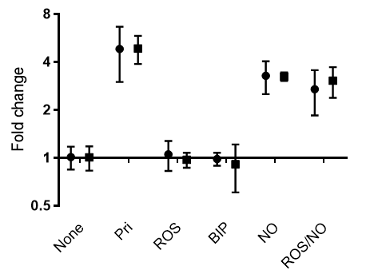
Figure 6.1: Fold change in cwlM mRNA in Ms cwlM-CM IRE variant strain cultures WT and IRE2 determined by normalising against rrsA using the ΔΔC_{T} method. Ms cwlM-CM pMV306.cwlM_{Mtb}.WT (circles), Ms cwlM-CM pMV306.cwlM_{Mtb}.IRE2 (squares). Data are means and standard deviation derived from three technical replicates of three biological replicates. Stressors were included in cultures at concentrations of 75 μM plumbagin, 200 μM spermine NONOate and 100 μM BIP to inflict respective ROS, NO and iron deprivation stresses. Pristinamycin was included at 2 μg/ml.

6.2 CwlM protein abundance – 2 hour time course
Relative CwlM levels in stressed and unstressed Ms cwlM-CM pMV306.cwlM_{Mtb}.WT and Ms cwlM-CM pMV306.cwlM_{Mtb}.IRE2 cultures were studied by western blotting. Cultures were grown to OD₆₀₀ 0.6 and stress reagents were added to the medium. Cells were harvested at 30, 60 and 120 minutes after addition of the stresses. Harvested cells were lysed by ice-cold sonication and clarified by centrifugation. Lysates were tested for total protein content and volumes of lysate containing 20 μg protein were separated by electrophoresis through an 8% SDS-polyacrylamide gel and subsequently transferred to a nitrocellulose membrane. Membranes were incubated with anti-CwlM rabbit IgG and then HRP-conjugated anti-rabbit goat IgG. Blots were visualised by addition of chromogenic HRP substrate. The CwlM protein band was identified using lysates from pristinamycin-replete and pristinamycin-depleted Ms cwlM-CM (plasmid-free) cultures (Figure 6.2.1). Unstressed cultures of Ms cwlM-CM pMV306.cwlM_{Mtb}.WT and Ms cwlM-CM pMV306.cwlM_{Mtb}.IRE2 including pristinamycin were included as positive controls for up-regulation of CwlM protein.
A clear difference was observed between the WT and IRE2 strains in Figure 6.2.2A. The WT strain showed less CwlM protein in culture lysate when stressed with ROS or BIP compared with unstressed cultures at each time point, though the difference was most obvious after 2 hours. This was not the case for the IRE2 strain’s culture lysates with the same stresses, where ROS and BIP stressed culture lysates appeared to yield levels of CwlM similar to the unstressed culture lysate. There was no clear reduction in CwlM protein levels when cultures were stressed with NO, with these cultures appearing to be more similar to the lysates of the unstressed pristinamycin-induced cultures than the pristinamycin-free unstressed cultures. The densitometry chart in Figure 6.2.2B also shows the much lower band intensities for the WT strain lysates at 2 hours under ROS and BIP stresses, and 1.5-2 fold increases in band intensity for both Pri and NO-treated culture lysates.
The ROS/NO combination stress highlighted a strong phenotype for Ms cwlM-CM pMV306.cwlM_{Mtb}.IRE2 in the growth experiments (see Section 5.3), however this was not reflected in the western blots (Figure 6.2.2A), as there was no obvious difference in CwlM levels between unstressed and ROS/NO stressed culture lysates across the 2 hour period that was studied. This was similarly the case in the densitometry analysis of the 2 hour cultures (Figure 6.2.2B), which found 0.9 fold and 1.1 fold changes in band intensity for the WT and IRE2 strains, respectively. The relatively unchanged abundance of CwlM in ROS/NO-stressed cultures may be the result of conflicting down-regulation, as a result of ROS-induced Acn-IRE binding, and up-regulation by NO-induced transcription of cwlM. This apparent increase in CwlM abundance following exposure to NO is reinforced by the increase in cwlM mRNA recorded in Figure 6.1, showing a correlation between mRNA and protein abundance in respose to NO.
1 2 3 4
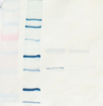  CwlM  70  55  40 | Figure 6.2.1: Western blot of Ms cwlM-CM lysates from cultures grown with pristinamycin. Lane 1: protein standard markers, sizes in kDa given alongside. Lane 2: HRP-conjugated protein standards. Lane 3: culture lysate from Ms cwlM-CM grown with 2 μg/ml pristinamycin. Lane 4: culture lysates from Ms cwlM-CM grown with 2 μg/ml pristinamycin, then pristinamycin depleted by harvesting cells by centrifugation and re-suspending in pristinamycin-free broth. The red box marks the cropped area in later blots. The blue arrow indicates the location of the 43.9 kDa CwlM protein band. Note: a faint additional band approximately level with the 55 kDa standard marker is the result of known cross-reactivity of the anti-CwlM IgG with membrane fraction constituents, the presence of which indicates imperfect removal of membrane fraction during preparation of lysate.
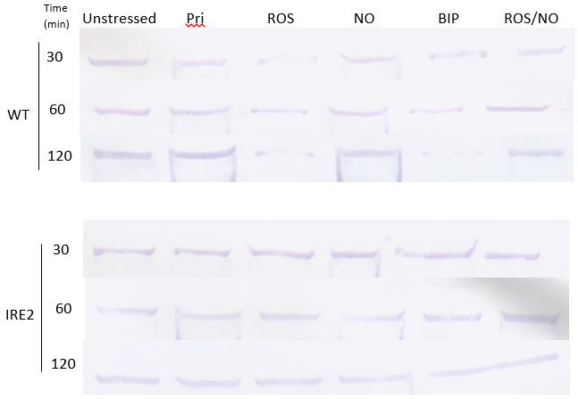
A
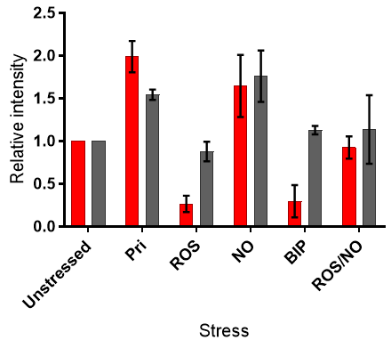
B
Figure 6.2.2: Western blot of culture lysates from Ms cwlM-CM IRE variant strains WT and IRE2. Unstressed cultures contained no stress reagents. Pri cultures contained pristinamycin and no stress reagents. Stressed cultures contained either ROS, NO, BIP or ROS and NO together. Full blots and loading controls can be found in Appendix 2. (B) Densitometry analysis of 2 hour Western blots; Ms cwlM-CM pMV306.cwlM_{Mtb}.WT (red), Ms cwlM-CM pMV306.cwlM_{Mtb}.IRE2 (grey). Data displayed are means and range of two biological replicates. Stressors were included in cultures at concentrations of 75 μM plumbagin, 200 μM spermine NONOate and 100 μM BIP to inflict respective ROS, NO and iron deprivation stresses. Pristinamycin was included at 2 μg/ml.

6.3 CwlM protein abundance – 6 hour time course
The severe growth defect of Ms cwlM-CM pMV306.cwlM_{Mtb}.IRE2 exposed to ROS and NO stresses simultaneously (Figure 5.2) did not appear to have a basis in changes to CwlM levels after 2 hours of stress (Figure 6.2.2). The experiments outlined in Section 6.2 were repeated for unstressed and ROS/NO stressed cultures, this time harvesting cells at 2, 4 or 6 hours after introducing the stress into the culture to observe whether there were any differences in CwlM abundance between the WT and IRE2 strains stressed with ROS and NO. Lysates were blotted using the same anti-CwlM rabbit IgG as was mentioned in Section 6.2 (Figure 6.3.1A) or a rabbit IgG provided by Dr G Mukamolova (University of Leicester) which had been raised against either phosphorylated (Figure 6.3.1B) or non-phosphorylated CwlM (Figure 6.3.1C).
As shown in Figure 6.3.1A and E, the stressed WT strain lysate displayed CwlM levels that were lower than those of the unstressed culture lysate after 6 hours, suggesting a decline in CwlM induced by the stress. For the IRE2 strain, there was clearly a greater abundance of CwlM in the stressed culture lysate than the unstressed culture lysate after 6 hours. This denotes a difference in the response to stress of the two strains with respect to CwlM expression. Together with the results from the growth experiments, this suggests heightened expression of CwlM is detrimental to growth of bacteria under stress conditions.
The bands in the western blots that used the antibody raised against phosphorylated CwlM appeared to be consistent, showing no clear increase or decrease in phosphorylated CwlM levels in the stressed cultures compared with the unstressed (Figure 6.3.1B, E, F). The accompanying densitometry analysis of those blots did not reveal any significant difference in protein abundance from the unstressed culture lysate when stressed with ROS and NO, so it appears that abundance of phosphorylated CwlM is not affected under these stress conditions.
Where the antibody raised against non-phosphorylated CwlM was used, the data at the 6 hour time point indicated an increase in non-phosphorylated CwlM in the IRE2 stressed culture lysates that was not observed in the WT strain (Figure 6.3.1C, E, F), measured as a 2.3-fold increase by band intensity. These results suggest that non-phosphorylated CwlM levels increase while phosphorylated CwlM levels remain constant in the absence of Acn-IRE binding, i.e. the binding of apo-AcnA to the cwlM IRE prevents this increase in the expression of the protein.
Preliminary western blots of lysates from single-stressed cultures using the phospho-specific antibodies are displayed in Figure 6.3.2. Cultures were stressed for one hour prior ro harvesting and lysis of cells.
Both of the phospho-specific antibodies revealed a visibly lower level of phosphorylated and non-phosphorylated CwlM in Ms cwlM-CM pMV306.cwlM_{Mtb}.WT when cultures were stressed with either ROS or BIP, but there was no such decrease in protein abundance in the IRE2 strain lysates. The apparent increase in CwlM abundance in response to pristinamycin and NO was common to both strains with either antibody. These results suggest that individual stresses have similar immediate effects on the abundances of both the phosphorylated and non-phosphorylated forms of CwlM.

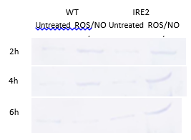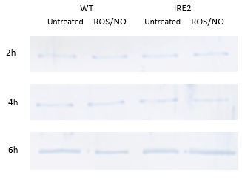
B
A
C
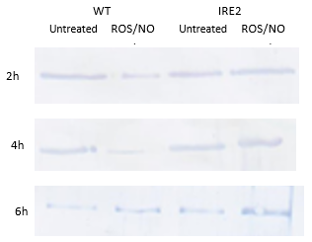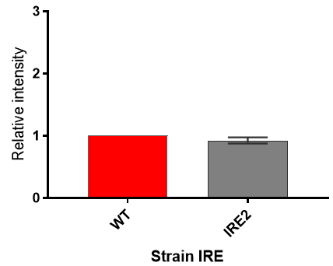
D

F
E
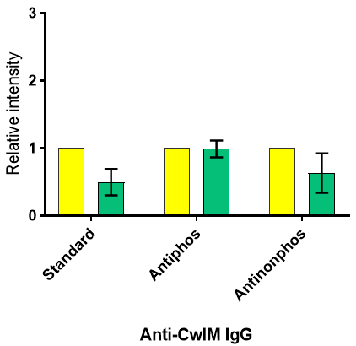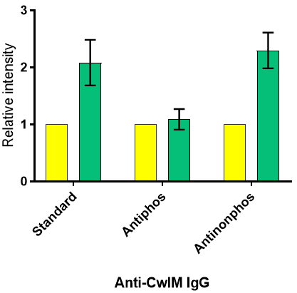
Figure 6.3.1: Western blot of untreated (unstressed) and ROS/NO stressed culture lysates from Ms cwlM-CM IRE variant strains WT and IRE2 with accompanying graphs of relative band intensity at the 6 hour time point. (A) Western blot using anti-CwlM IgG. (B) Western blot using anti-phosphorylated CwlM IgG. (C) Western blot using anti-non-phosphorylated CwlM IgG. (D) Band intensity of IRE2 strain lysate (grey) relative to WT strain (red). (E) Band intensity of ROS/NO-stressed WT strain culture lysates (green) blotted with each of the different anti-CwlM IgG relative to unstressed culture lysates (yellow). (F) Band intensity of ROS/NO-stressed IRE2 strain culture lysates (green) blotted with each of the different anti-CwlM IgG relative to unstressed culture lysates (yellow). Full blots and loading controls can be found in Appendix 3. Each blot is representative of two biological replicates. Charts display mean and range of band intensities. Stressors were included in cultures at concentrations of 75 μM plumbagin and 200 μM spermine NONOate to inflict respective ROS and NO stresses.
A
Unstressed Pri ROS NO BIP ROS/NO
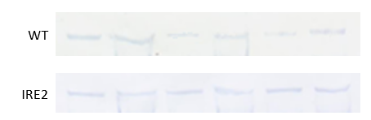

Unstressed Pri ROS NO BIP ROS/NO
B

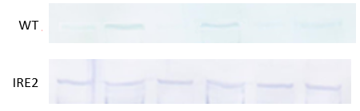

Figure 6.3.2: Western blot of untreated (unstressed) and stressed culture lysates from Ms cwlM-CM IRE variant strains WT and IRE2. Cells were harvested and lysed one hour post-stress. (A) Blotted using anti-phosphorylated CwlM IgG. (B) Blotted using anti-non-phosphorylated CwlM IgG. Full blots can be found in Appendix 4. Blots represent single preliminary experiments. Stressors were included in cultures at concentrations of 75 μM plumbagin, 200 μM spermine NONOate and 100 μM BIP to inflict respective ROS, NO and iron deprivation stresses. Pristinamycin was included at 2 μg/ml.

6.4 CwlM cell wall hydrolysis activity
Lysates from each stressed culture described in Section 6.2 were separated on an 8% SDS-polyacrylamide gel containing whole free-dried Mi. luteus cells and incubated in a renaturing buffer to allow CwlM to re-fold. The peptidoglycan hydrolysis activity should then be observed in the form of clearance zones in the Micrococcus-containing gel.
However, while the lysozyme positive control did produce a band of clearance on the gel, no other samples from either strain showed detectable lysis of Mi. luteus cells (Figure 6.4).

A
C U Pri ROS NO BIP ROS/NO


B
C U Pri ROS NO BIP ROS/NO



Figure 6.4: Zymograms of unstressed and stressed culture lysates for (A) Ms cwlM-CM pMV306.cwlM_{Mtb}.WT and (B) Ms cwlM-CM pMV306.cwlM_{Mtb}.IRE2. In both panels, C indicates the lysozyme control and U indicates the unstressed culture. Each panel is representative of two biological replicates. Stressors were included in cultures at concentrations of 75 μM plumbagin, 200 μM spermine NONOate and 100 μM BIP to inflict respective ROS, NO and iron deprivation stresses. Pristinamycin was included at 2 μg/ml.

6.5 Discussion
When stressed with ROS or BIP the Ms cwlM-CM pMV306.cwlM_{Mtb}.WT and Ms cwlM-CM pMV306.cwlM_{Mtb}.IRE2 exhibited the same response at the RNA level. Neither stress induced a change in the abundance of cwlM transcript (Figure 6.1), suggesting there is no transcriptional response from cwlM to these stresses. At the protein level, ROS and BIP stresses resulted in a decrease in CwlM protein abundance in the WT strain but not the IRE2 strain (Figure 6.2.2) despite the lack of any change at the mRNA level in either strain. This supports the hypothesis that the IRE in the cwlM gene has a role in repression of the translation of the cwlM transcript, and also coincides with the binding of IRE by AcnA stressed with ROS or BIP displayed in Figure 4.2.2. In response to iron-sulfur cluster damage by ROS or BIP, AcnA acquires RNA-binding activity and binds the IRE in the cwlM transcript, thus translation of CwlM is inhibited and protein levels decrease.
In M. tuberculosis, oxidative stress activates SigH by causing the anti-sigma factor RshA to dissociate (Song et al., 2003), though the binding of RshA to SigH is can be weakened in the absence of oxidative stress as a result of the phosphorylation of RshA by PknB. This weakening of the anti-sigma binding enables limited up-regulation of the SigH regulon without stress (Park et al., 2008). Given that SigH has been reported to up-regulate expression of SigE (Raman et al., 2001) and that cwlM_{Mtb} transcription may be influenced by a SigE-dependent promoter (Manganelli et al., 2004; Cortes et al., 2013), an increase in transcription of cwlM would be expected in response to any stress that can activate SigH. However, the abundance of cwlM mRNA in Ms cwlM-CM pMV306.cwlM_{Mtb}.WT and Ms cwlM-CM pMV306.cwlM_{Mtb}.IRE2 did not change in response to ROS, suggesting that this mechanism of induction is not present in Ms cwlM-CM. There are five RpoE-like gene products encoded in the M. smegmatis genome that are comparable to the SigH of M. tuberculosis (Waagmeester et al., 2005), but their expression and regulatory roles have not been described. Similarly, a SigE-like protein has been reported for M. smegmatis but not fully characterised (Waagmeester et al., 2005). The lack of induction of cwlM in the Ms cwlM-CM pMV306.cwlM_{Mtb} strains in response to ROS could be the result of a difference in the regulation of sigma factors between M. tuberculosis and M. smegmatis, or perhaps simply explained by the absence of a genuine SigE-dependent promoter upstream of cwlM_{Mtb}. Abundance of cwlM mRNA increased in response to NO and ROS/NO, which could be explained by the presence of a functional SigE-dependent promoter in connection with SigE induction by NO (Voskuil et al., 2011; Cortes et al., 2017).
The increase in cwlM mRNA that was observed in both strains when stressed with NO (Figure 6.1) was followed by the observation of an increase in CwlM at the protein level (Figure 6.2.2). It is clear that NO is able to induce cwlM transcription without also inducing enough RNA-binding activity in AcnA to counteract the increased transcription/translation.
The ROS/NO double stress culture lysates produced more complicated results. An increase in cwlM mRNA consistent with the results of NO stress (Figure 6.1), however there was not the same induction of CwlM at the protein level, where neither strain showed a mean band intensity that greatly deviated from that of the unstressed culture lysates after 2 hours of incubation with stress (Figure 6.2.2). The results from Chapter 5 suggested this combination of stresses could distinguish the two strains, having caused Ms cwlM-CM pMV306.cwlM_{Mtb}.IRE2 to cease growth and enter the non-culturable state (Figure 5.2, Figure 5.4), and it was further implied that elevated CwlM levels were relevant to this observation (Figure 5.3). Elongation of the stress incubation period to 6 hours revealed a significant difference in CwlM protein levels between unstressed and stressed culture lysates from both the WT and IRE2 strains (Figure 6.3.1A, D), showing a decrease in CwlM band intensity for Ms cwlM-CM pMV306.cwlM_{Mtb}.WT and an increase for Ms cwlM-CM pMV306.cwlM_{Mtb}.IRE2. This demonstrated that the IRE structure was able to influence expression of CwlM under ROS/NO stress, lowering it in the WT strain but not the IRE2 strain. As discussed in Chapter 4, the WT IRE binds apo-AcnA much more efficiently than the IRE2 mutant RNA (Figure 4.2.1) and that ROS can efficiently induce RNA-binding activity in AcnA (Figure 4.2.2). Together with the results presented in this chapter, the data suggest that ROS/NO combined stress has the effect of increasing cwlM transcription while also inducing apo-AcnA to bind to the IRE in the transcript and inhibit translation in the WT strain, but not having the same inhibitory effect in the IRE2 strain where AcnA-IRE binding is weaker. This has the effect of elevating CwlM levels in Ms cwlM-CM pMV306.cwlM_{Mtb}.IRE2. This provides an explanation for the growth defect of the IRE2 strain under ROS/NO stress, as heightened levels of CwlM were shown to be detrimental to growth of mycobacteria when induced by pristinamycin (Figure 5.3).
The findings outlined above point to abundant CwlM having a harmful impact on mycobacteria under oxidative stress, though why CwlM should have this effect is not clear. The function of CwlM is dependent on its phosphorylation state, interacting with MurA or FhaA when phosphorylated (Boutte et al., 2016; Turapov et al., 2018) and with MurJ when not (Turapov et al., 2018), and its hydrolytic enzyme activity is of unknown function in the wider picture of CwlM activity.
Using antibodies raised against phosphorylated and non-phosphorylated CwlM highlighted a difference in the abundance of each form of CwlM. Applying ROS and NO stresses together caused the level of non-phosphorylated CwlM to increase in Ms cwlM-CM pMV306.cwlM_{Mtb}.IRE2 but not the WT strain (Figure 6.3.1C, E, F), while the relative abundance of phosphorylated CwlM in stressed cultures of both strains were not significantly different from their unstressed counterparts (Figure 6.3.1B, E, F). The heightened expression of CwlM under ROS/NO stress could cause more non-phosphorylated CwlM to be present if the kinase activity of PknB is reduced under stress or unable to keep up with the higher levels of CwlM being translated, though there is no data to support either explanation. However, it is clear that both phosphorylation states of CwlM are present whether the bacteria are stressed or not (Figure 6.3.1B, C), and it appears that the CwlM pool does not become more phosphorylated under stress (Figure 6.3.1B, E, F). Since the response of the IRE2 strain to ROS/NO stress was to produce more non-phosphorylated CwlM, it is the non-phosphorylated form of CwlM that is linked to the harmful effects of heightened CwlM expression under stress conditions.
The non-phosphorylated form of CwlM is known to bind MurJ (Turapov et al., 2018), though the effect of this interaction is uncertain. It has been suggested to improve translocation of the peptidoglycan precursor lipid II by MurJ (Turapov et al., 2018). If this is the case, then the increased levels of non-phosphorylated CwlM observed in the ROS/NO stressed Ms cwlM-CM pMV306.cwlM_{Mtb}.IRE2 culture could have the effect of accelerating export of lipid II.
Recent work by Kaur and colleagues provides insight into the interactions of lipid II and PknB in M. tuberculosis. By binding the extracellular PASTA domain of PknB, lipid II assists in the localisation of PknB to the poles and septa of growing mycobacteria. This interaction is also believed to be part of a strict mechanism to control the kinase activity of PknB, as hyperphosphorylation of the PknB intracellular kinase domain was observed when the PASTA domain was mutated to prevent binding to lipid II. This hyperphosphorylation was accompanied by indiscriminate phosphorylation of other intracellular proteins, including proteins not believed to be substrates of PknB, leading to cell death (Kaur et al., 2019). If Ms cwlM-CM pMV306.cwlM_{Mtb}.IRE2 stressed with both ROS and NO does export lipid II excessively, the consequence could be overly stringent regulation of PknB activity, inhibiting the phosphorylation of other intracellular proteins and cause dysregulation of cytoplasmic processes. Placing a level of control on PknB activity could also explain the abundance of both phosphorylated and non-phosphorylated CwlM in mycobacteria, with both forms of CwlM seeming to aid in peptidoglycan synthesis. Another reported substrate of PknB is MurJ, which is associated with CwlM to supposedly improve lipid II export when not phosphorylated, and which is associated with FhaA binding and reduced peptidoglycan synthesis when phosphorylated (Gee et al., 2012; Turapov et al., 2018), suggesting its flippase activity is hindered as a result of phosphorylation. Therefore, a mixed population of phosphorylated and non-phosphorylated MurJ (as a result of lipid II-mediated control of PknB activity) enables a level of control of lipid II translocation to the exterior of the cytoplasmic membrane, thus moderating the extent of PknB binding to lipid II. This model for regulation of PknB kinase activity entails potential limitation of lipid II export by MurJ, and so could place limits on the maximum rate of cell wall construction (something which could be investigated by recording the rate of vancomycin incorporation into the cell wall). Increased expression of PknB would also be expected to cause a greater extent of phosphorylation, which is observed in mycobacteria resuscitating from hypoxia-induced dormancy (Ortega et al., 2014). PknB abundance during and following stress could also be investigated by western blot under a similar protocol to that used for CwlM in this chapter.
There may be another layer of control to CwlM activity besides the limited phosphorylation by PknB. When phosphorylated, CwlM can be bound by FhaA, another protein in addition to PknB that is localised at the poles and septa of growing mycobacteria (Mir et al., 2011; Turapov et al., 2018). While the effect of this interaction is unknown, the high-affinity interaction of FhaA with other phosphorylated proteins including MurJ and PknB (Turapov et al., 2018; Roumestand et al., 2011) has been established, suggesting FhaA may be a regulator of the functions of numerous phosphopeptides, not exclusively CwlM.
The enzymatic activity of CwlM is controversial, with reports of both activity and inactivity (Deng et al., 2005; Boutte et al., 2016; Turapov et al. 2018; Wang et al., 2018). In this study, no peptidoglycan hydrolase activity was observed from the Ms cwlM-CM pMV306.cwlM_{Mtb} culture lysates (Figure 6.4). This is at odds with the findings of Figure 5.6, in which mutant M. smegmatis strains lacking CwlM catalytic activity exhibited hindered growth in culture with individual stresses, a phenotype not observed in Ms cwlM-CM pMV306.cwlM_{Mtb}.WT and Ms cwlM-CM pMV306.cwlM_{Mtb}.IRE2, which, according to Figure 6.4, do not have any hydrolytically-active CwlM either. This raises the possibility that there were flaws in the zymogram procedure, or perhaps that the Ms cwlM-CM pMV306.cwlM_{Mtb}.E217A and Ms cwlM-CM pMV306.cwlM_{Mtb}.D339A strains show poorer growth under stress conditions than the WT strain for reasons other than loss of enzyme activity. Substrate specificity may also be a factor in the zymograms’ negative results, as the external surface of cell wall may not be the ideal substrate for a cytoplasmic amidase. An experiment utilising lipid II or NAM-NAG dimers as the substrate may have yielded positive results.
The role, if any, for peptidoglycan hydrolysis in the function of CwlM is unclear. As a cytoplasmic protein, CwlM potentially has access to peptidoglycan precursors prior to their export, so this possible enzyme activity may contribute to slowing the biosynthesis of peptidoglycan, though the mechanisms of control around the enzyme activity are unknown.
Chapter 7: Conclusions

The M. tuberculosis aconitase has been characterised as both an enzyme and an RNA-binding protein, and the role of this binding with respect to the essential peptidoglycan biosynthesis regulator, CwlM, has been studied.
During tuberculosis infection, M. tuberculosis is subjected to oxidative and nitrosative stress from macrophages, as well as iron deprivation. This study has shown the M. tuberculosis AcnA to be sensitive to ROS and NO, resulting in damage to its iron-sulfur cluster and inactivation of the enzyme. Stress-damaged AcnA is able to bind the IRE toward the 5’ end of the cwlM transcript, improving the ability of mycobacteria to survive and recover under stressful conditions by inhibiting translation of the cwlM mRNA.
By studying ROS and NO stresses separately, this project has found ROS to be a more potent activator of AcnA RNA-binding activity and subsequent down-regulation of CwlM, while NO was shown to increase CwlM expression by up-regulating transcription. When the two stresses were applied together, cwlM was found to be up-regulated at the transcriptional level, but the presence of an intact IRE ultimately led to the lowering of CwlM protein abundance. Without the IRE, mycobacteria were found to be more sensitive to ROS, but not NO, and up-regulated CwlM at the protein level when stressed with ROS and NO together, an observation linked with the failure of the mutant to grow in culture. The CwlM protein itself was implicated as detrimental to growth and survival when its expression under stressful conditions was elevated. Due to the limitations impoed by the half life of spermine NONOate, the results from NO-stressed cultures in Chapter 5 may be better informed if experiments were repeated either with a different NO donor or with addition of NO to culture broths during the 96-hour period of the experiment.
The phenotype described for mycobacteria with a mutated cwlM IRE could be further validated by studying mutations in the AcnA protein. For example, a strain expressing a mutant AcnA with unaltered enzyme activity but no RNA-binding activity would also be expected to result in dysregulated cwlM translation, and, based on the findings of this project, hindered growth under stressful conditions but not in the absence of stress.
A role for AcnA-IRE interactions in the response of mycobacteria to stress has been established, however the role of CwlM, and why it causes harm when abundant under stress, remains elusive. An answer to this may be found following further study into the interactions of CwlM with MurJ and the regulation of PknB activity. The proposed model for AcnA responding to stress and regulating cwlM expression is given in Figure 7.
This study has found that reducing CwlM expression during stress improves the ability of mycobacteria to continue growing, even though it is implied that cell wall biosynthesis has been slowed. This finding could be clarified by studying the growth, CwlM expression, cell wall characteristics (e.g. rate of synthesis, permeability) and CwlM protein interactions of mycobacteria in detail from the moment stress is applied to the point at which bacteria begin to recover. This could be used to generate a timescale for CwlM repression for wild type mycobacteria and reveal the binding partners of CwlM under stress when the cwlM IRE is mutated, helping to build a picture that explains why CwlM is harmful to stressed mycobacteria.

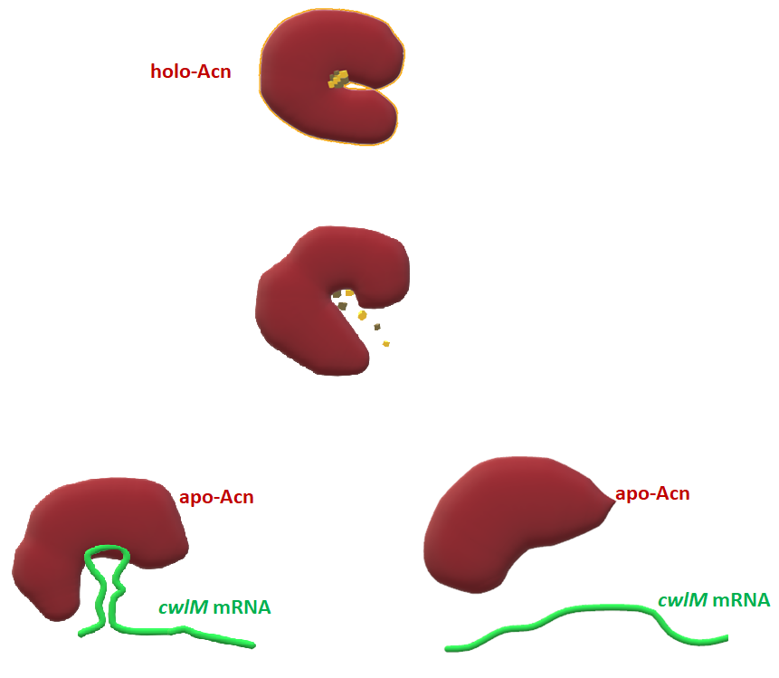
Mutant IRE2
WT IRE
Stress

Repression of CwlM translation
Uncontrolled CwlM translation

Excess CwlM and hindered growth

Figure 7: Model of CwlM regulation by M. tuberculosis Acn (AcnA). The iron-sulfur cluster of holo-Acn is dismantled by stress, e.g. ROS and iron depletion, causing transition to the apo-form. Apo-Acn is able to bind to the IRE in the cwlM transcript and inhibit translation, thus lowering CwlM levels in the cytoplasm and impairing peptidoglycan biosynthesis. This sequence of events is important for enabling mycobacteria to overcome the stress and grow. When the IRE is mutated (IRE2), Acn-IRE binding is disrupted and apo-Acn does not inhibit translation, leaving CwlM abundance unchanged and unregulated, and mycobacteria become non-culturable.

Further study into the known interactions of CwlM with other proteins is indicated as a means of explaining the role of CwlM and the need to lower its expression in response to stress. This could build upon the work of Boutte et al. (2016) and Turapov et al. (2018) to take a closer look at the interactions of CwlM with MurA, MurJ, FhaA and PknB under specific stress conditions in the IRE mutant strains described here. This projects suggests that CwlM binding with MurA or MurJ to improve their activities may correlate with impaired growth and recovery of stressed mycobacteria, particularly mycobacteria under oxidative stress. Co-immunoprecipitation of CwlM with MurA and MurJ from the cytoplasmic and membrane fractions of stressed wild type and IRE mutant culture lysates could be used to measure the interactions of CwlM alongside measurement of microbial growth (e.g. colony forming units or absorbance) and peptidoglycan biosynthesis (e.g. by incorporation of BODIPY FL vancomycin). It may also be useful to test the amidase activity of CwlM in vitro against specific potential substrates from cytoplasm (such as NAM-peptides and lipid II) to confirm that CwlM possesses this amidase activity and to define its intracellular substrates.
As with any findings relevant to M. tuberculosis using M. smegmatis as a model system, there are limitations to this project’s conclusions. While there is evidence of conservation of transcriptional and regulatory machinery between the two species (Bashyam et al., 1996; Tyagi and Sharma, 2002), this project has not explored the IRE-binding capabilities of M. smegmatis aconitase, a process that is assumed to be occurring in the growth experiments of Chapter 5. Further study into the native aconitase’s interactions with the cwlM_{Mtb} IRE could be performed, however this current of this project could be taken as sufficient to inform similar (and perhaps more relevant) experiments in M. tuberculosis.
Appendices
Appendix 1: Table of MIC values for M. smegmatis cultures
Note hypoxanthine was used together with 0.1 U/ml xanthine oxidase, where 1 U is define as the amount of xanthine oxidase that converts 1 μmol xanthine to uric acid per minute at pH 8 and 37°C.
 | MIC
Strain | Spermine NONoate | Spermine | BIP | Plumbagin | Hypoxanthine
M. smegmatis MC² 155 | 200-225 μM | > 10 mM | 100-125 μM | 75-100 μM | 6-7 mM
Ms cwlM-CM | 200-225 μM | > 10 mM | 100-125 μM | 75-100 μM | 6-7 mM
Ms cwlM-CM  pMV306 | 200-225 μM | > 10 mM | 100-125 μM | 75-100 μM | 6-7 mM
Ms cwlM-CM pMV306.cwlM_{Mtb}.WT | 200-225 μM | > 10 mM | 100-125 μM | 75-100 μM | 6-7 mM
Ms cwlM-CM pMV306.cwlM_{Mtb}.IRE1 | 200-225 μM | > 10 mM | 100-125 μM | 75-100 μM | 6-7 mM
Ms cwlM-CM pMV306.cwlM_{Mtb}.IRE2 | 200-225 μM | > 10 mM | 100-125 μM | 75-100 μM | 6-7 mM
Ms cwlM-CM pMV306.cwlM_{Mtb}.E217A | 200-225 μM | > 10 mM | 100-125 μM | 75-100 μM | 6-7 mM
Ms cwlM-CM pMV306.cwlM_{Mtb}.D339A | 200-225 μM | > 10 mM | 100-125 μM | 75-100 μM | 6-7 mM

Appendix 2: Western blots for stressed culture lysates using Anti-CwlM, 30-120 minutes
Key:
1: Unstressed
2: Pristinamycin
3: ROS
4: NO
5: BIP
6: ROS/NO
Ms cwlM-CM pMV306.cwlM_{Mtb}.WT stressed/unstressed culture lysates: Replicate 1, 30 minutes
1 2 3 4 5 6 1 2 3 4 5 6
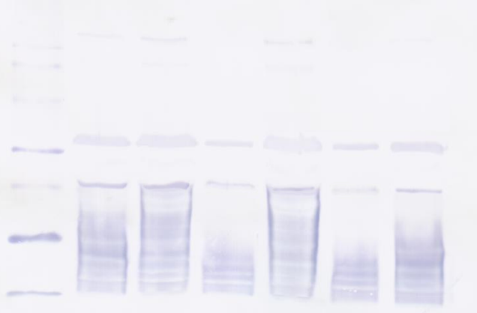
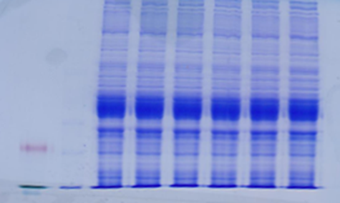
50
40
30

Ms cwlM-CM pMV306.cwlM_{Mtb}.WT stressed/unstressed culture lysates: Replicate 1, 60 minutes
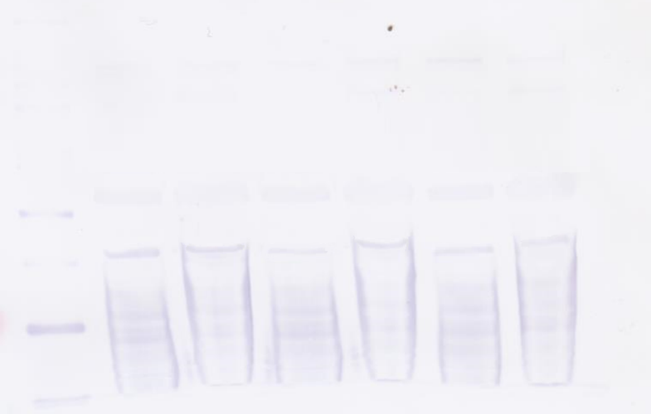
1 2 3 4 5 6 1 2 3 4 5 6
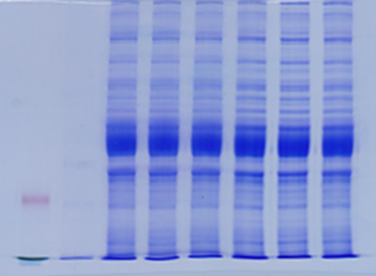
50
40
30

Ms cwlM-CM pMV306.cwlM_{Mtb}.WT stressed/unstressed culture lysates: Replicate 1, 120 minutes
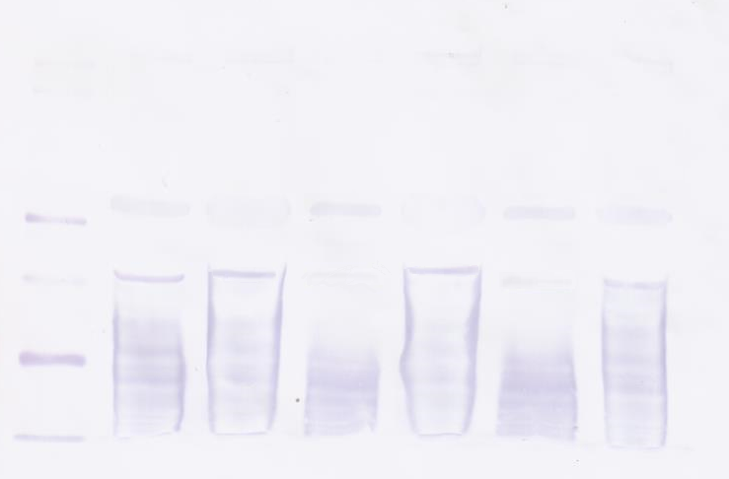
1 2 3 4 5 6 1 2 3 4 5 6
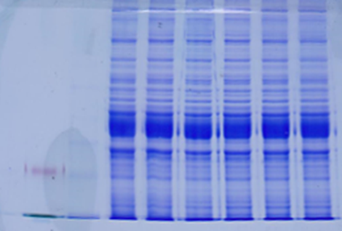
50
40
30

Ms cwlM-CM pMV306.cwlM_{Mtb} (IRE2) stressed/unstressed culture lysates: Replicate 1, 30 minutes
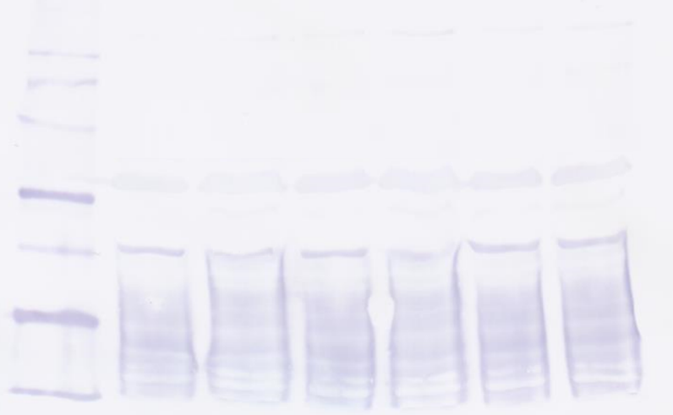
1 2 3 4 5 6 1 2 3 4 5 6
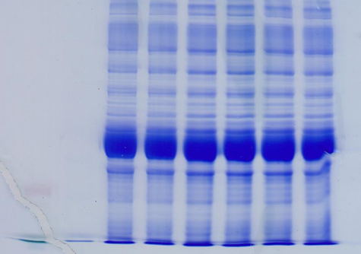
50
40
30

Ms cwlM-CM pMV306.cwlM_{Mtb} (IRE2) stressed/unstressed culture lysates: Replicate 1, 60 minutes
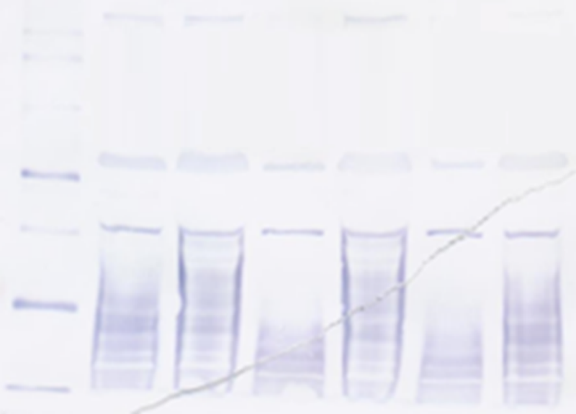
1 2 3 4 5 6 1 2 3 4 5 6
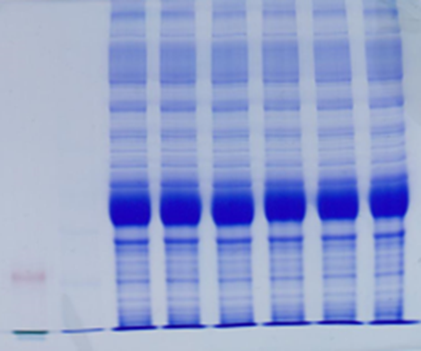
50
40
30

Ms cwlM-CM pMV306.cwlM_{Mtb} (IRE2) stressed/unstressed culture lysates: Replicate 1, 120 minutes
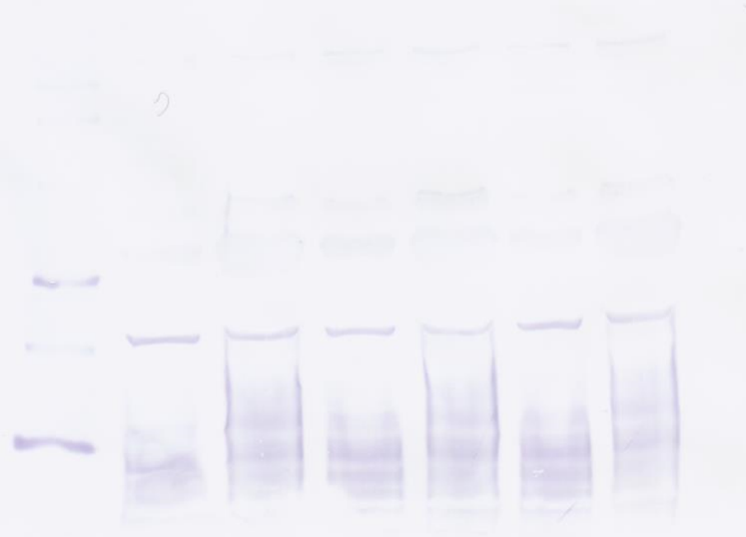
1 2 3 4 5 6 1 2 3 4 5 6
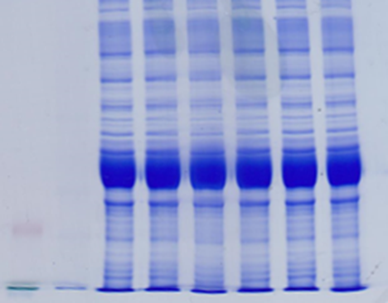
50
40
30

Ms cwlM-CM pMV306.cwlM_{Mtb}.WT stressed/unstressed culture lysates: Replicate 2, 30 minutes
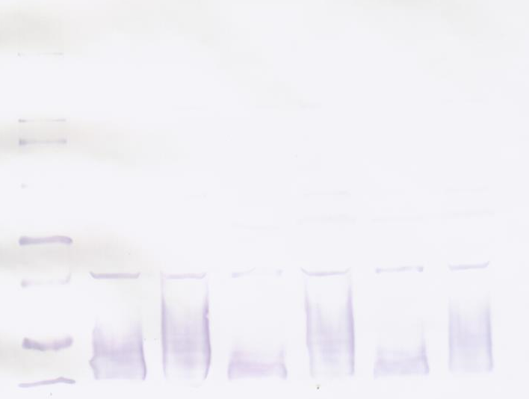
1 2 3 4 5 6 1 2 3 4 5 6
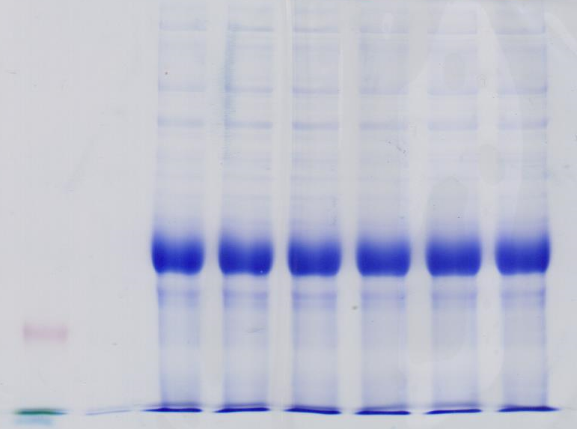
50
40
30
Ms cwlM-CM pMV306.cwlM_{Mtb}.WT stressed/unstressed culture lysates: Replicate 2, 60 minutes
1 2 3 4 5 6 1 2 3 4 5 6
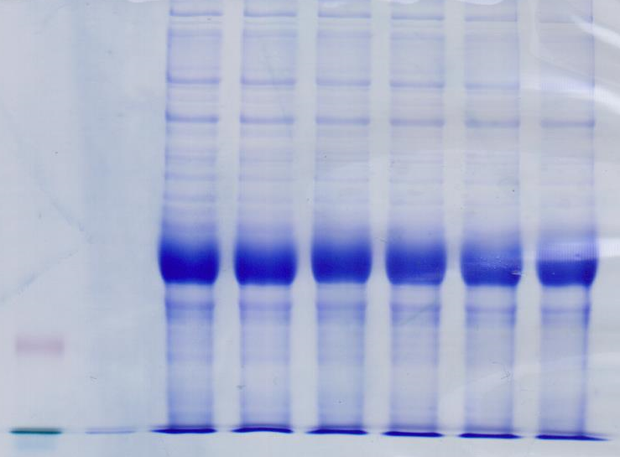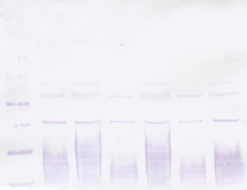
50
40
30

Ms cwlM-CM pMV306.cwlM_{Mtb}.WT stressed/unstressed culture lysates: Replicate 2, 120 minutes
1 2 3 4 5 6 1 2 3 4 5 6
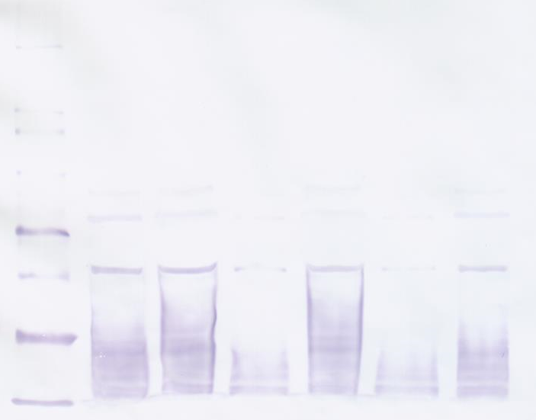
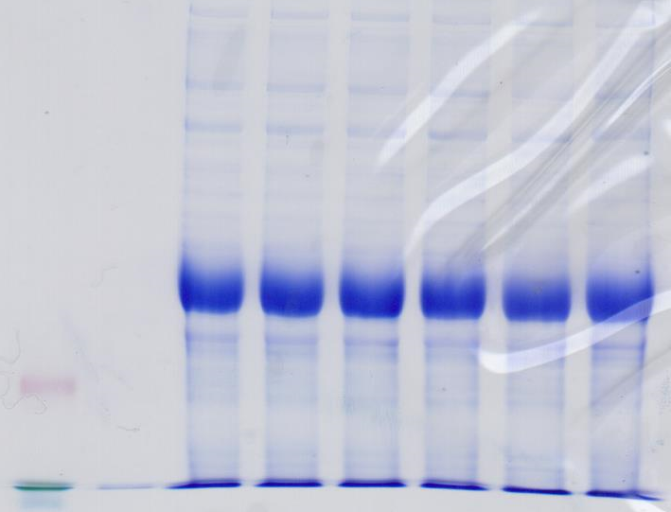
50
40
30

Ms cwlM-CM pMV306.cwlM_{Mtb} (IRE2) stressed/unstressed culture lysates: Replicate 2, 30 minutes
1 2 3 4 5 6 1 2 3 4 5 6
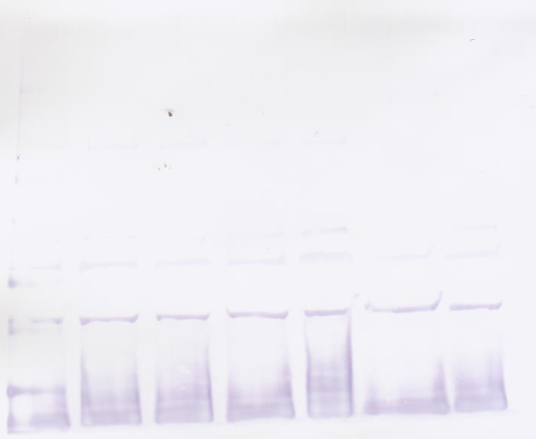
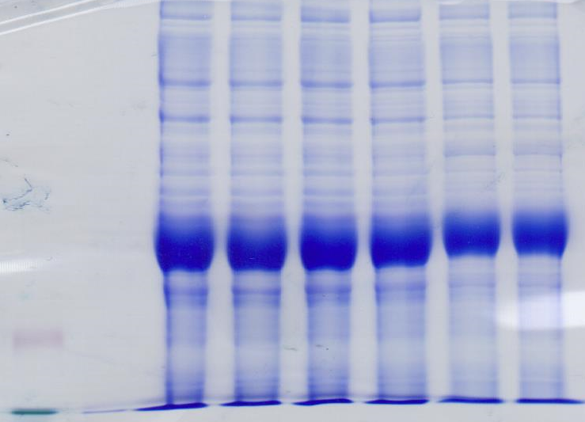
50
40
30

Ms cwlM-CM pMV306.cwlM_{Mtb} (IRE2) stressed/unstressed culture lysates: Replicate 2, 60 minutes
1 2 3 4 5 6 1 2 3 4 5 6
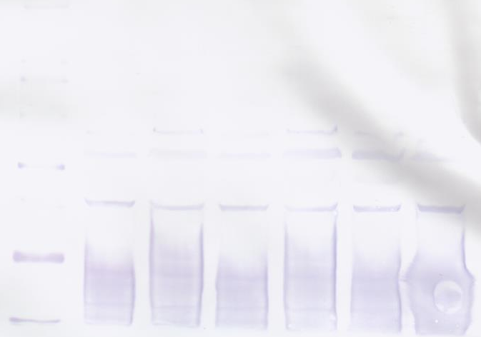
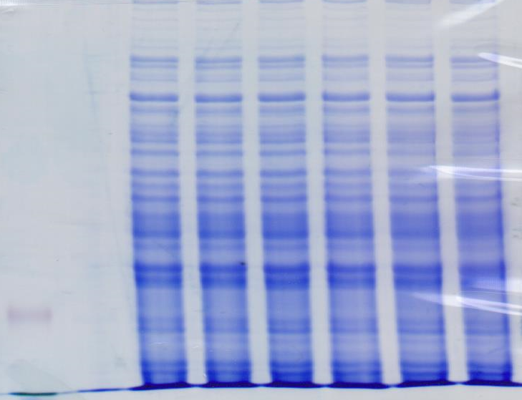
50
40
30
Ms cwlM-CM pMV306.cwlM_{Mtb} (IRE2) stressed/unstressed culture lysates: Replicate 2, 120 minutes
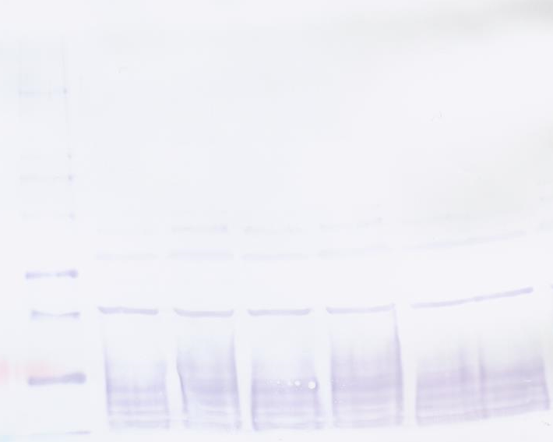
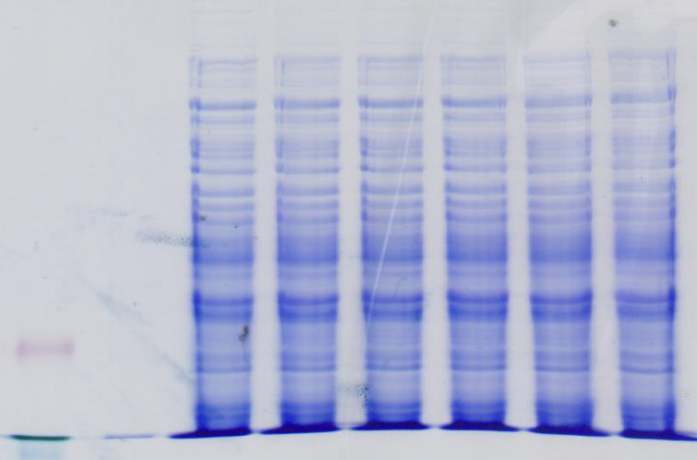
1 2 3 4 5 6 1 2 3 4 5 6
50
40
30

Appendix 3: Western blots for ROS/NO dual-stressed culture lysates using Anti-CwlM, anti-phospho-CwlM and anti-nonphospho-CwlM, 2-6 hours
Key:
1: Replicate 1, Ms cwlM-CM pMV306.cwlM_{Mtb}.WT, unstressed, 2 hours
2: Replicate 1, Ms cwlM-CM pMV306.cwlM_{Mtb}.WT, ROS/NO, 2 hours
3: Replicate 1, Ms cwlM-CM pMV306.cwlM_{Mtb}.IRE2, unstressed, 2 hours
4: Replicate 1, Ms cwlM-CM pMV306.cwlM_{Mtb}.IRE2, ROS/NO, 2 hours
5: Replicate 1, Ms cwlM-CM pMV306.cwlM_{Mtb}.WT, unstressed, 4 hours
6: Replicate 1, Ms cwlM-CM pMV306.cwlM_{Mtb}.WT, ROS/NO, 4 hours
7: Replicate 1, Ms cwlM-CM pMV306.cwlM_{Mtb}.IRE2, unstressed, 4 hours
8: Replicate 1, Ms cwlM-CM pMV306.cwlM_{Mtb}.IRE2, ROS/NO, 4 hours
9: Replicate 2, Ms cwlM-CM pMV306.cwlM_{Mtb}.WT, unstressed, 2 hours
10: Replicate 2, Ms cwlM-CM pMV306.cwlM_{Mtb}.WT, ROS/NO, 2 hours
11: Replicate 2, Ms cwlM-CM pMV306.cwlM_{Mtb}.IRE2, unstressed, 2 hours
12: Replicate 2, Ms cwlM-CM pMV306.cwlM_{Mtb}.IRE2, ROS/NO, 2 hours
13: Replicate 2, Ms cwlM-CM pMV306.cwlM_{Mtb}.WT, unstressed, 4 hours
14: Replicate 2, Ms cwlM-CM pMV306.cwlM_{Mtb}.WT, ROS/NO, 4 hours
15: Replicate 2, Ms cwlM-CM pMV306.cwlM_{Mtb}.IRE2, unstressed, 4 hours
16: Replicate 2, Ms cwlM-CM pMV306.cwlM_{Mtb}.IRE2, ROS/NO, 4 hours
17: Replicate 1, Ms cwlM-CM pMV306.cwlM_{Mtb}.WT, unstressed, 6 hours
18: Replicate 1, Ms cwlM-CM pMV306.cwlM_{Mtb}.WT, ROS/NO, 6 hours
19: Replicate 1, Ms cwlM-CM pMV306.cwlM_{Mtb}.IRE2, unstressed, 6 hours
20: Replicate 1, Ms cwlM-CM pMV306.cwlM_{Mtb}.IRE2, ROS/NO, 6 hours
21: Replicate 2, Ms cwlM-CM pMV306.cwlM_{Mtb}.WT, unstressed, 6 hours
22: Replicate 2, Ms cwlM-CM pMV306.cwlM_{Mtb}.WT, ROS/NO, 6 hours
23: Replicate 2, Ms cwlM-CM pMV306.cwlM_{Mtb}.IRE2, unstressed, 6 hours
24: Replicate 2, Ms cwlM-CM pMV306.cwlM_{Mtb}.IRE2, ROS/NO, 6 hours

Anti-CwlM blots
1 2 3 4 5 6 7 8
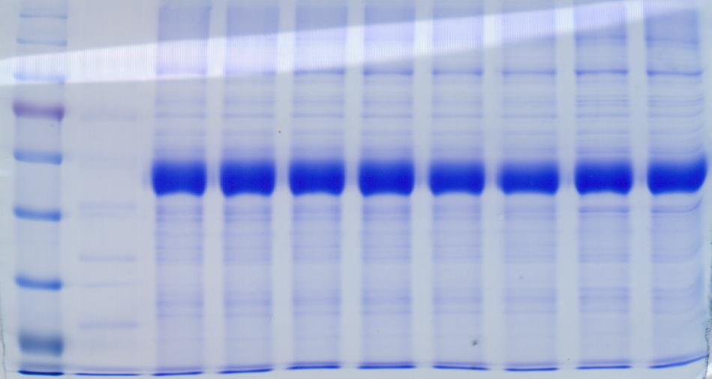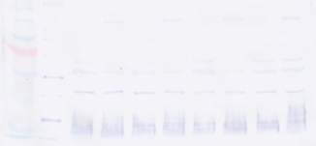
70
55
40
70
55
40
9 10 11 12 13 14 15 16
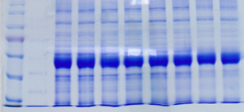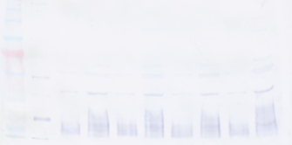
70
55
40
70
55
40
17 18 19 20 21 22 23 24
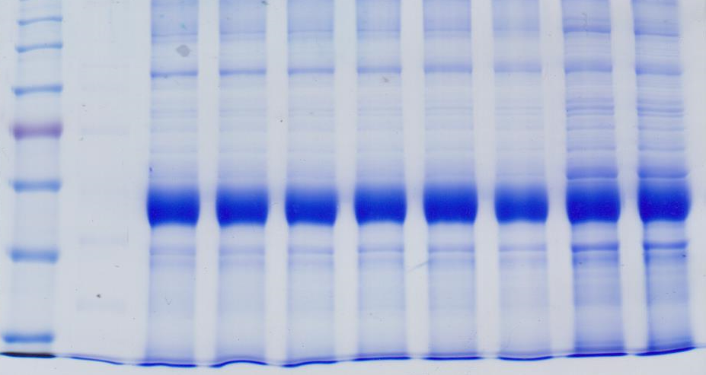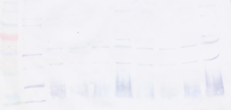
70
55
40
70
55
40
Anti-phosphoCwlM blots
1 2 3 4 5 6 7 8
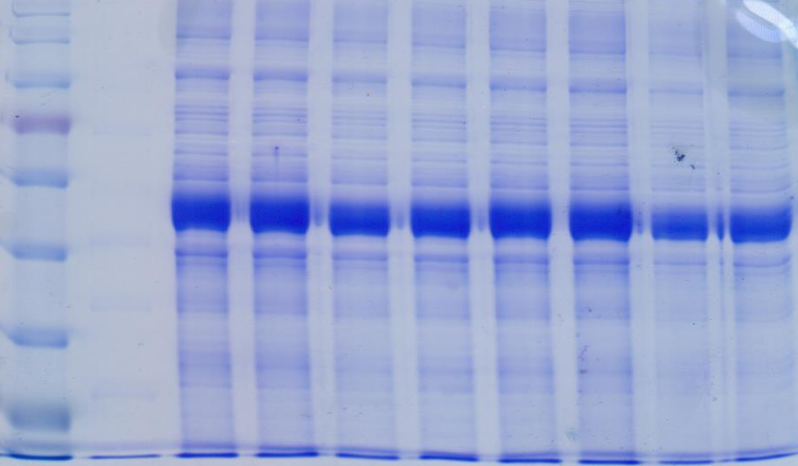
70
55
40
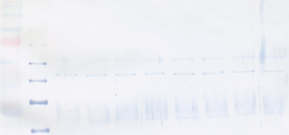
70
55
40
9 10 11 12 13 14 15 16
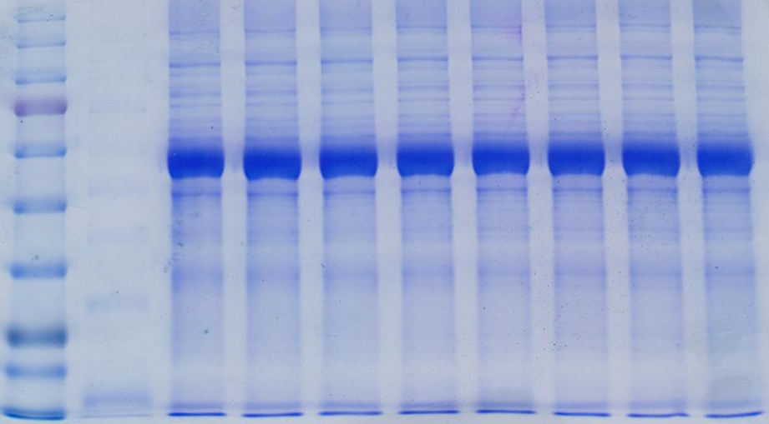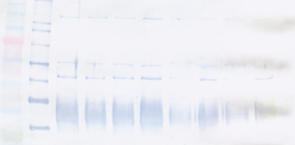
70
55
40
70
55
40
17 18 19 20 21 22 23 24
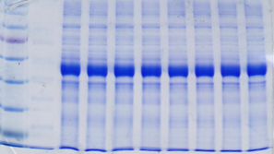
70
55
40
70
55
40
Band discolouration

Anti-nonphosCwlM
1 2 3 4 5 6 7 8
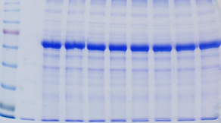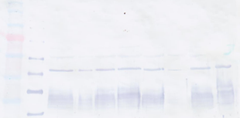
70
55
40
70
55
40
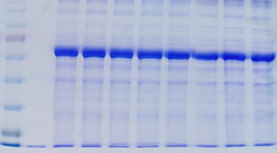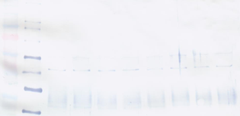
70
55
40
70
55
40
9 10 11 12 13 14 15 16

17 18 19 20 21 22 23 24
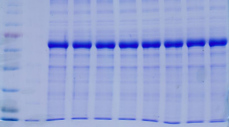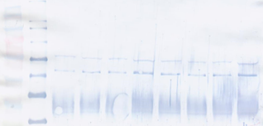
70
55
40
70
55
40

Appendix 4: Western blots for lysates of cultures stressed for one hour and blotted using phosphor-specific antibodies.
Ms cwlM-CM pMV306.cwlM_{Mtb}.WT, anti-phosphorylated CwlM
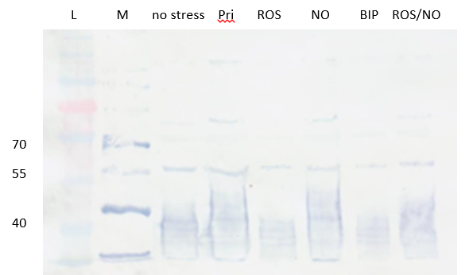

Ms cwlM-CM pMV306.cwlM_{Mtb}.WT, anti-non-phosphorylated CwlM
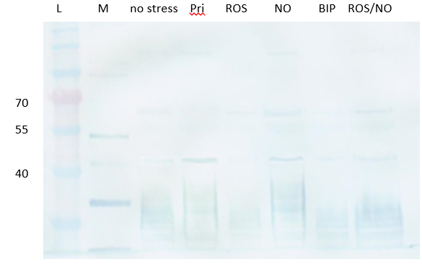

Ms cwlM-CM pMV306.cwlM_{Mtb}.IRE2, anti-phosphorylated CwlM
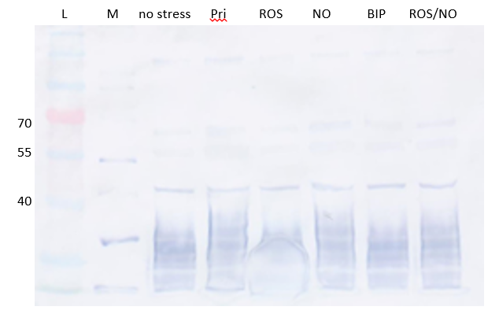
Ms cwlM-CM pMV306.cwlM_{Mtb}.IRE2, anti-non-phosphorylated CwlM
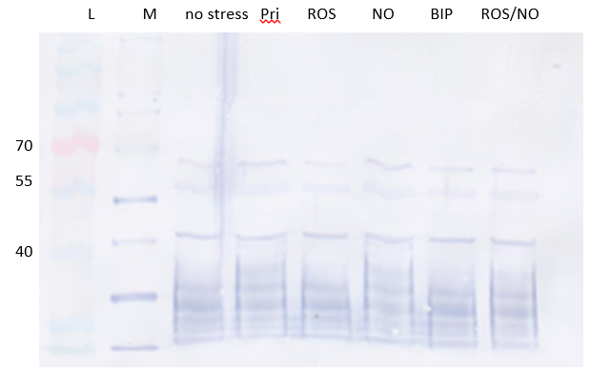

References
Abramovitch, R. B.; Rohde, K. H.; Hsu, F. F.; Russell, D. G. (2011) aprABC: a Mycobacterium tuberculosis complex-specific locus that modulates pH-driven adaptation to the macrophage phagosome, Mol. Microbiol. 80, 678–94
Al-Dabbagh, B.; Henry, X.; El Ghachi, M.; Auger, G.; Blanot, D.; Parquet, C.; Mengin-Lecreulx, D.; Bouhss, A. (2008) Active site mapping of MraY, a member of the polyprenyl-phosphate N-acetylhexosamine 1-phosphate transferase superfamily, catalyzing the first membrane step of peptidoglycan biosynthesis, Biochemistry 47, 8919–28
Alén, C.; Sonenshein, A. L. (1999) Bacillus subtilis aconitase is an RNA-binding protein, Proc. Natl. Acad. Sci. U S A 96, 10412-10417
Alvarez, E.; Tavel, E. (1885) Recherches sur le bacilli de Lustgarten, Archives de Physiologie Normal et Pathologique 6, 303-321
Artymiuk, P. J.; Green, J. (2006) The double life of aconitase, Structure 14, 2-4
Austin, C. M.; Wang, G.; Maier, R. J. (2015) Aconitase functions as a pleiotropic posttranscriptional regulator in Helicobacter pylori, J. Bacteriol. 197, 3076-3086
Baker, J. J.; Johnson, B. K.; Abramovitch, R. B. (2014) Slow growth of Mycobacterium tuberculosis at acidic pH is regulated by phoPR and host-associated carbon source,. Mol. Microbiol. 94, 56–69
Banerjee, S.; Nandyala, A. K.; Raviprasad, P.; Ahmed, N.; Hasnain, S. E. (2007) Iron-dependent RNA- binding activity of Mycobacterium tuberculosis aconitase, J. Bacteriol. 189, 4046-4052
Bansal, R.; Kumar, V. A.; Sevalkar, R. R.; Singh, P. R.; Sarkar, D. (2017) Mycobacterium tuberculosis virulence‐regulator PhoP interacts with alternative sigma factor SigE during acid‐stress response, Mol. Microbiol. 104, 400-411
Barry, C. E. (2001) Mycobacterium smegmatis: an absurd model for tuberculosis?, Trends Microbiol. 9, 473-474
Bashyam, M. D.; Kaushal, D.; Dasgupta, S. K.; Tyagi, A. K. (1996) A study of the mycobacterial transcription apparatus: Identification of novel features in promoter elements, J. Bacteriol. 178, 4847-4853
Baumgart, M.; Bott, M. (2011) Biochemical characterisation of aconitase from Corynebacterium glutamicum, J. Biotechnol. 154, 163-170
Beinert, H.; Kennedy, M. C.; Stout, C. D. (1996) Aconitase as iron-sulfur protein, enzyme and iron-regulatory protein, Chem. Rev. 96, 2335-2373
Belanger, A. E.; Besra, G. S.; Ford, M. E.; Mikušová, K.; Belisle, J. T.; Brennan, P. J.; Inamine, J. M.; (1996) The embAB genes of Mycobacterium avium encode an arabinosyl transferase involved in cell wall arabinan biosynthesis that is the target for the antimycobacterial drug ethambutol, Proc. Natl. Acad. Sci. U S A 93, 11919–11924
Belanger, A. E.; Inamine, J. M. (2000) Genetics of cell wall biosynthesis, Molecular Genetics of Mycobacteria, ASM Press, Washington, DC, 191-202
Belisle, J. T.; Vissa, V. D.; Sievert, T.; Takayama, K.; Brennan, P. J.; Besra, G. S. (1997) Role of the major antigen of Mycobacterium tuberculosis in cell wall biogenesis, Science 276, 1420–1422
Benson, T. E.; Walsh, C. T.; Hogle, J. M. (1997) X-ray crystal structures of the S229A mutant and wild-type MurB in the presence of the substrate enolpyruvyl-UDP-N-acetylglucosamine at 1.8 Ȧ resolution, Biochemistry 36, 806–11
Betts, J. C.; Lukey, P. T.; Robb, L. C.; McAdam, R. A.; Duncan, K. (2002) Evaluation of a nutrient starvation model of Mycobacterium tuberculosis persistence by gene and protein expression profiling, Molec. Microbiol. 43, 717-731
Botella, H.; Vaubourgeix, J.; Lee, M. H.; Song, N.; Xu, W.; Makinoshima, H.; Glickman, M. S.; Ehrt, S. (2017) Mycobacterium tuberculosis protease MarP activates a peptidoglycan hydrolase during acid stress, EMBO J. 36, 536-548
Bouhss, A.; Mengin-Lecreulx, D.; Blanot, D.; van Heijenoort, J.; Parquet, C. (1997) Invariant amino acids in the Mur peptide synthetases of bacterial peptidoglycan synthesis and their modification by site-directed mutagenesis in the UDP-MurNAc:L-alanine ligase from Escherichia coli, Biochemistry 36, 11556–63
Bouhss, A.; Crouvoisier, M.; Blanot, D.; Mengin-Lecreulx, D. (2004) Purification and characterization of the bacterial MraY translocase catalyzing the first membrane step of peptidoglycan biosynthesis, J. Biol. Chem. 279, 29974–80
Bouton, C.; Drapier, J. (2003) Iron regulatory proteins as NO signal transducers, Sci. Signal. 2003, pp. pe17
Boutte, C. C.; Baer, C. E.; Papavinasasundaram, K.; Liu, W.; Chase, M. R.; Meniche, X.; Fortune, S. M.; Sassetti, C. M.; Ioerger, T. R.; Rubin, E.J. (2016) A cytoplasmic peptidoglycan amidase homologue controls mycobacterial cell wall synthesis, Elife 5, pii: e14590
Bradbury, A. J.; Gruer, M. J.; Rudd, K. E.; Guest, J. R. (1996) The seocnd aconitase (AcnB) of Escherichia coli, Microbiology 142 (2): 389-400
Brzostek, A.; Dziadek, B.; Rumijowska-Galowicz, A.; Pawelczyk, J.; Dziadek, J. (2007) Cholesterol oxidase is required for virulence of Mycobacterium tuberculosis, FEMS Microbiol. Lett. 275, 106-112
Buchmeier, N. A.; Newton, G. L.; Koledin, T.; Fahey, R. C. (2003) Association of mycothiol with protection of Mycobacterium tuberculosis from toxic oxidants and antibiotics, Mol. Microbiol. 47, 1723-1732
Cairo, G.; Recalcati, S.; Pietrangelo, A.; Minotti, G. (2002) The iron regulatory proteins: targets and modulators of free radical reactions and oxidative damage, Free Radic. Biol. Med. 32, 1237-1243
Casey, J. L.; Hentze, M. W.; Koeller, D. M.; Caughman, S. W.; Rouault, T. A.; Klausner, R. D.; Harford, J. B. (1988) Iron-responsive elements: regulatory RNA sequences that control mRNA levels and translation, Science 240, 924-928
Casonato, S.; Provvedi, R.; Dainese, E.; Palù, G.; Manganelli, R. (2014) Mycobacterium tuberculosis requires the ECF sigma factor SigE to arrest phagosome maturation, PLoS One 9, p.e108893
Centers for Disease Control and Prevention (2006) Emergence of Mycobacterium tuberculosis with extensive resistance to second-line drugs - worldwide, 2000-2004; Morb. Mortal. Wkly Rep. 55, 302-305
Cohen-Gonsaud, M.; Barthe, P.; Bagneris, C.; Henderson, B.; Ward, J.; Roumestand, C.; Keep, N. H. (2005) The structure of a resuscitation-promoting factor domain from Mycobacterium tuberculosis shows homology to lysozymes, Nat. Struct. Molec. Biol. 12, 270-273
Cortes, T.; Schubert, O. T.; Rose, G.; Arnvig, K. B.; Comas, I.; Aebersold, R.; Young, D. B. (2013) Genome-wide mapping of transcriptional start sites defines an extensive leaderless transcriptome in Mycobacterium tuberculosis, Cell Rep. 5, 1121-1131
Cortes, T.; Schubert, O. T.; Banaei-Esfahani, A.; Collins, B. C.; Aebersold, R.; Young, D. B. (2017) Delayed effects of transcriptional responses in Mycobacterium tuberculosis exposed to nitric oxide suggest other mechanisms involved in survival, Sci. Rep. 7, 8208
Cowley, F. C.; Av-Gay, Y. (2001) Monitoring promoter activity and protein localization in Mycobacterium spp. Using green fluorescent protein, Gene 264, 225-231
Cunningham, L.; Gruer, M. J.; Guest, J. R. (1997) Transcriptional regulation of the aconitase genes (acnA and acnB) of Escherichia coli, Microbiology 143, 3795-3805
Daffé, M.; Etienne, G. (1999) The capsule of Mycobacterium tuberculosis and its implications for pathogenicity, Tuber. Lung Dis. 79, 153-169
Darwin, K. H.; Ehrt, S.; Gutierrez-Ramos, J.; Weich, N.; Nathan, C. F. (2003) The proteasome of Mycobacterium tuberculosis is required for resistance to nitric oxide, Science 302, 1963-1966
Deng, L. L.; Humphries, D. E.; Arbeit, R. D.; Carlton, L. E.; Smole, S. C.; Carroll, J. D. (2005) Identification of a novel peptidoglycan hydrolase CwlM in Mycobacterium tuberculosis, Biochim. Biophys. Acta Proteins Proteom. 1747, 57-66
Deretic, V.; Song, J.; Pagán-Ramos, E. (1997) Loss of oxyR in Mycobacterium tuberculosis, Trend Microbiol. 5, 367-372
Dick, T.; Lee, B. H.; Murugasu-Oei, B. (1998) Oxygen depletion induced dormancy in Mycobacterium smegmatis, FEMS Microbiol. Lett. 163, 159-164
Duan, X.; Yang, J.; Ren, B.; Tan, G.; Ding, H. (2009) Reactivity of nitric oxide with the [4Fe-4S] cluster of dihydroxyacid dehydratase from Escherichia coli, Biochem. J. 417, 783-789
Dussurget, O.; Stewart, G.; Neyrolles, O.; Pescher, P.; Young, D.; Marchal, G. (2001) Role of Mycobacterium tuberculosis copper-zinc superoxide dismutase, Infect. Immun. 69, 529-533
Emptage, M. H.; Kent, T. A.; Kennedy, M. C.; Beinert, H.; Münck, E. (1983) Mössbauer and EPR studies of activated aconitase: development of a localized valence state at a subsite of the [4Fe-4S] cluster on binding of citrate, Proc. Natl. Acad. Sci. U S A 80, 4674-4678
Eveland, S. S.; Pompliano, D. L.; Anderson, M. S. (1997) Conditionally lethal Escherichia coli murein mutants contain point defects that map to regions conserved among murein and folyl poly-gamma-glutamate ligases: identification of a ligase superfamily, Biochemistry 36, 6223–29
Forti, F.; Crosta, A.; Ghisotti, D. (2009) Pristinamycin-inducible gene regulation in mycobacteria, J. Biotechnol. 140, 270-277
Gee, C. L.; Papavinasasundaram, K. G.; Blair, S. R.; Baer, C. E.; Falick, A. M.; King, D. S.; Griffin, J. E.; Venghatakrishnan, H.; Zukauskas, A.; Wei, J. R.; Dhiman, R. K.; Crick, D. C.; Rubin, E. J.; Sassetti, C. M.; Alber, T. (2012) A phosphorylated pseudokinase complex controls cell wall synthesis in mycobacteria, Sci. Signal. 5, pp. ra7
Gobin, J.; Moore, C. H.; Reeve, J. R.; Wong, D. K.; Gibson, B. W.; Horwitz, M. A. (1995) Iron acquisition by Mycobacterium tuberculosis: isolation and characterization of a family of iron-binding exochelins, Proc. Natl. Acad. Sci. U S A 92, 5189-5193
Gold, B.; Rodriguez, G. M.; Marras, S. A. E.; Pentecost, M.; Smith, I. (2001) The Mycobacterium tuberculosis IdeR is a dual functional regulator that controls transcription of genes involved in iron acquisition, iron storage and survival in macrophages, Mol. Microbiol. 42, 851-865
Goss, D. J.; Theil, E. C. (2011) Iron responsive mRNAs: a family of Fe²⁺ sensitive riboregulators, Acc. Chem. Res. 44, 1320-1328
Green, J.; Paget, M. S. (2004) Bacterial redox sensors, Nat. Rev. Microbiol. 2, 954-966
Gruber, A. R.; Lorenz, R.; Bernhart, S. H.; Neuböck, R.; Hofacker, I. L. (2008) The Vienna RNA websuite, Nucl. Acids Res. 36, W70-4
Gruer, M. J.; Artymiuk, P. J.; Guest, J. R. (1997) The aconitase family: three structural variations on a common theme, Trends Biochem. Sci. 22, 3-6
Grzegorzewicz, A.E.; de Sousa-d’Auria, C.; McNeil, M. R.; Huc-Claustre, E.; Jones, V.; Petit, C.; Angala, S. K.; Zemanová, J.; Wang, Q.; Belardinelli, J. M.; Gao, Q.; Ishizaki, Y.; Mikušová, K.; Brennan, P. J.; Ronning, D. R.; Chami, M.; Houssin, C.; Jackson, M. (2016) Assembling of the Mycobacterium tuberculosis cell wall core, J. Biol. Chem. 291, 18867-18879
Gu, S.; Chen, J.; Dobos, K. M.; Bradbury, E. M.; Belisle, J. T.; Chen, X. (2003) Comprehensive proteomic profiling of the membrane constituents of a Mycobacterium tuberculosis strain, Mol. Cell. Proteomics 2, 1284-96
Guirado, E.; Schlesinger, L. S. (2013) Modeling the Mycobacterium tuberculosis granuloma - the critical battlefield in host immunity and disease, Front. Immunol. 4, 98
Guo, B.; Yu, Y.; Leibold, E. A. (1994) Iron regulates cytoplasmic levels of a novel iron-responsive element-binding protein without aconitase activity, J. Biol. Chem. 269, 24252-24260
Hengst, C.D.; Buttner, M. J. (2008) Redox control in actinobacteria, Biochim. Biophys. Acta 1780, 1201-1216
Jarvis, B.; Wilrich, C.; Wilrich, P. T. (2010) Reconsideration of the derivation of Most Probable Numbers, their standard deviations, confidence bounds and rarity values, J. Appl. Microbiol. 109, 1660-1667
Jordan, P. A.; Tang, Y.; Bradbury, A. J.; Thomson, A. J.; Guest, J. R. (1999) Biochemical and spectroscopic characterization of Escherichia coli aconitases (AcnA and AcnB), Biochem. J. 344, 739-746
Kana, B. D.; Gordhan, B. G.; Downing, K. J.; Sung, N.; Vostroktunova, G.; Machowski, E. E.; Tsenova, L.; Young, M.; Kaprelyants, A.; Kaplan, G.; Mizrahi, V. (2007) The resuscitation-promoting factors of Mycobacterium tuberculosis are required for virulence and resuscitation from dormancy but are collectively dispensible for growth in vitro, Molec. Microbiol. 67, 672-684
Kaur, P.; Rausch, M.; Malakar, B.; Watson, U.; Damle, N. P.; Chawla, Y.; Srinivasan, S.; Sharma, K.; Schneider, T.; Jhingan, G. D.; Saini, D.; Mohanty, D.; Grein, F.; Nandicoori, V. K. (2019) Lipid II interaction with specific residues of Mycobacterium tuberculosis PknB extracytoplasmic domain governs its optimal activation, Nat. Commun. 10, 1231
Kennedy, M. C.; Emptage, M. H.; Dreyer, J.; Beinert, H. (1983) The role of iron in the activation-inactivation of aconitase, J. Biol. Chem. 256, 11096-11106
Kennedy, M. C.; Werst, M.; Telser, J.; Emptage, M. H.; Beinert, H.; Hoffman, B. M. (1987) Mode of substrate carboxyl binding to the [4Fe-4S]+ cluster of reduced aconitase as studied by 17O and 13C electron-nuclear double resonance spectroscopy, Proc. Natl. Acad. Sci. U S A 84, 8854-8858
Kremer, L.; Dover, L. G.; Morehouse, C.; Hitchin, P.; Everett, M.; Morris, H. R.; Dell, A.; Brennan, P. J.; McNeil, M. R.; Flaherty, C. (2001) Galactan biosynthesis in Mycobacterium tuberculosis: identification of a bifunctional UDP-galactofuranosyltransferase, J. Biol. Chem. 276, 26430–26440
Kumar, A.; Toledo, J. C.; Patel, R. P.; Lancaster, J. R.; Steyn, A. J. (2007) Mycobacterium tuberculosis DosS is a redox sensor and DosT is a hypoxia sensor, Proc. Natl. Acad. Sci. U S A 104, 11568-11573
Kurthkoti, K.; Amin, H.; Marakalala, M. J.; Ghanny, S.; Subbian, S.; Sakatos, A.; Livny, J.; Fortune, S. M.; Berney, M.; Rodriguez, G. M. (2017) The capacity of Mycobacterium tuberculosis to survive iron starvation might enable it to persist in iron-deprived microenvironments of human granulomas, MBio 8, pp.e01092-17
Lauble, H.; Kennedy, M. C.; Beinert, H.; Stout, C. D. (1994) Crystal structures of aconitase with trans-aconitate and nitrocitrate bound, J. Mol. Biol. 237, 437-451
Lee, J. H.; Karakousis, P. C.; Bishai, W. R. (2007) Roles of SigB and SigF in the Mycobacterium tuberculosis sigma factor network, J. Bacteriol. 190, 699-707
Li, W.; He, J.; Xie, L.; Chen, T.; Xie, J. (2013) Comparative genomic insights into the biosynthesis and regulation of mycobacterial siderophores, Cell. Physiol. Biochem. 31, 1-13
Lovering, A. L.; Safadi, S. S.; Strynadka, N. C. J. (2012) Structural perspective of peptidoglycan biosynthesis and assembly, Annu. Rev. Biochem. 81, 451-478
Low, K. L.; Rao, P. S. S.; Shui, G.; Bendt, A. K.; Pethe, K.; Dick, T.; Wenk, M. R. (2009) Triacylglycerol utilization is required for regrowth of in vitro hypoxic nonreplicating Mycobacterium bovis bacillus Calmette-Guerin, J. Bacteriol. 191, 5037-5043
Macham, L. P.; Ratledge, C.; Nocton, J. C. (1975) Extracellular iron acquisition by mycobacteria: role of the exochelins and evidence against the role of mycobactins, Infect. Immun. 12, 1242-1251
Mahon, R. N.; Sande, O. J.; Rojas, R. E.; Levine, A. D.; Harding, C. V. ; Boom, W. H. (2012) Mycobacterium tuberculosis ManLAM inhibits T-cell-receptor signaling by interference with ZAP-70, Lck and LAT phosphorylation, Cell. Immunol. 275, 98-105
Manganelli, R.; Dubnau, E.; Tyagi, S.; Kramer, F. R.; Smith, I. (1999) Differential expression of 10 sigma factor genes in Mycobacterium tuberculosis, Mol. Microbiol. 31, 715-724
Manganelli, R.; Voskuil, M. I.; Schoolnik, G. K.; Smith, I. (2001) The Mycobacterium tuberculosis ECF sigma factor σ^{E}: role in global gene expression and survival in macrophages, Mol. Microbiol. 41, 423-437
Manganelli, R.; Voskuil, M. I.; Schoolnik, G. K.; Dubnau, E.; Gomez, M.; Smith, I. (2002) Role of the extracytoplasmic-function σ factor σ^{H} in Mycobacterium tuberculosis global gene expression, Mol. Microbiol. 45, 365-374
Manganelli, R.; Provvedi, R.; Rodrigue, S.; Beaucher. J.; Gaudreau, L.; Smith, I. (2004) Sigma factors and global gene regulation in Mycobacterium tuberculosis, J. Bacteriol. 186, 895-902
Mansilla, S.; Tόrtora, V.; Chiribao, M. L.; Zeida, A.; Robello, C.; Castro, L. (2018) Biochemical and structural characterization of human aconitase, a key mitochondrial oxidant target, Free Radic. Biol. Med. 128, S88-S89
Michta, E.; Ding, W.; Zhu, S.; Blin, K.; Ruan, H.; Wang, R. (2014) Proteomic approach to reveal the regulatory function of aconitase AcnA in oxidative stress response in the antibiotic producer Streptomyces viridochromogenes Tu494, PLOS One 9, e87905
Mikušová, K.; Mikus, M.; Besra G. S.; Hancock, I.; Brennan, P. J. (1996) Biosynthesis of the linkage region of the mycobacterial cell wall, J. Biol. Chem. 271, 7820–7828
Mills, J. A.; Motichka, K.; Jucker, M.; Wu, H. P.; Uhlik, B. C.; Stern, R. J.; Scherman, M. S.; Vissa, V. D.; Pan, F.; Kundu, M. (2004) Inactivation of the mycobacterial rhamnosyltransferase, which is needed for the formation of the arabinogalactan-peptidoglycan linker, leads to irreversible loss of viability, J. Biol. Chem. 279, 43540–43546
Mir, M.; Asong, J.; Li, X.; Cardot, J.; Boons, G. J.; Husson, R. N. (2011) The extracytoplasmic domain of the Mycobacterium tuberculosis Ser/Thr kinase PknB binds specific muropeptides and is required for PknB localization, PLoS Pathog. 7, e1002182
Molle, V.; Kremer, L.; Girard-Blanc, C.; Besra, G. S.; Cozzone, A. J.; Prost, J. F. (2003) An FHA phosphoprotein recognition domain mediates protein EmbR phosphorylation by PknH, a Ser/Thr protein kinase from Mycobacterium tuberculosis, Biochemistry 42, 15300-9
More, S. J.; Clegg, T. A.; McGrath, G. E.; Collins, J. D.; Comer, L. A. L; Gormley, E. (2007) Does reactive badger culling lead to an increase in tuberculosis in cattle? Vet. Rec. 161, 208-209
Mukamolova, G. V.; Kaprelyants, A. S.; Young, D. I.; Young, M.; Kell, D. B. (1998) A bacterial cytokine, Proc. Natl. Acad. Sci. U S A 95, 8916-8921
Mukamolova, G. V.; Turapov, O. A.; Young, D. I.; Kaprelyants, A. S.; Kell, D. B.; Young, M. (2002) A family of autocrine growth factors in Mycobacterium tuberculosis, Molec. Microbiol. 46, 623-635
Muñoz-Elías, E. J.; McKinney, J. D. (2005) Mycobacterium tuberculosis isocitrate lyases 1 and 2 are jointly required for in vivo growth and virulence, Nat. Med. 11, 638-644
Newton, G. L.; Arnold, K.; Price, M. S.; Sherrill, C.; del Cardayré, S. B.; Aharonowitz, Y.; Cohen, G.; Davies, J.; Fahey, R. C.; Davis, C. (1996) Distribution of thiols in microorganisms: mycothiol is a major thiol in most actinomycetes, J. Bacteriol. 178, 1990-1995
OperonDB (2010) Gene pairs for Mycobacterium tuberculosis H37Rv, Center for Bioinformatics and Computational Biology, viewed 14/04/2019, available at <operondb.cbcb.umd.edu/cgi-bin/operondb/pairs.cgi?genome_id=613>
Ortalo-Magné, A.; Lemassu, A.; Lanéelle, M. A.; Bardou, F.; Silve, G.; Gounon, P.; Marchal, G.; Daffé, M. (1996) Identification of the surface-exposed lipids on the cell envelopes of Mycobacterium tuberculosis and other mycobacterial species, J. Bacteriol. 178, 456-461
Ortega, C.; Liao, R.; Anderson, L. N.; Rustad, T.; Ollodart, A. R.; Wright, A. T.; Sherman, D. R.; Grundner, C. (2014) Mycobacterium tuberculosis Ser/Thr protein kinase B mediates an oxygen-dependent replication switch, PLoS Biol. 12, e1001746
Parashar, D.; Das, R.; Chauhan, D. S.; Sharma, V. D.; Lavania, M.; Yadav, V. S.; Chauhan, S. V.; Katoch, V. M. (2009) Identification of environmental mycobacteria isolated from Agra, north India by conventional and molecular approaches, Indian J. Med. Res. 129, 424-431

Park, S. T.; Kang, C. M.; Husson, R. N. (2008) Regulation of the SigH stress response regulon by an essential protein kinase in Mycobacterium tuberculosis, Proc. Nat. Acad. Sci. U S A 105, 13105
Pitarque, S.; Lourroy-Maumus, G.; Payré, B.; Jackson, M.; Puzo, G.; Nigou, J. (2008) The immunomodulatory lipoglycans, lipoarabinomannan and lipomannan, are exposed at the mycobacterial cell surface, Tuberculosis (Edinb.) 88, 560-565
Prigozhin, D. M.; Mavrici, D.; Huizar, J. P.; Vansell, H. J.; Alber, T. (2013) Structural and biochemical analyses of Mycobacterium tuberculosis N-acetylmuramyl-l-alanine amidase Rv3717 point to a role in peptidoglycan fragment recycling, J. Biol. Chem. 288, 31549-31555
Prodromou, C.; Haynes, M. J.; Guest, J. R. (1991) The aconitase of Escherichia coli: purification of the enzyme and molecular cloning and map location of the gene (acn), J. Gen. Microbiol. 137, 2505-2515
Prodromou, C.; Artymiuk, P. J.; Guest, J. R. (1992) The aconitase of Escherichia coli, FEBS J. 204, 599-609
Quigley, E. C.; Costello, E.; Flynn, O.; Gogarty, A.; McGuirk, J.; Murphy, A.; Egan J. (1997) Isolation of mycobacteria from lymph node lesions in deer, Vet. Rec. 141, 516-518
Raman, S.; Song, T.; Puyang, X.; Bardarov, S.; Jacobs, W. R.; Husson, R. N. (2001) The alternative sigma factor SigH regulates major components of oxidative and heat stress responses in Mycobacterium tuberculosis, J. Bacteriol. 183, 6119-6125
Reyrat, J.; Khan, D. (2001) Mycobacterium smegmatis: an absurd model for tuberculosis?, Trends Microbiol. 9, 473-474

Richmond, J.; Lee, J.; Green, D.; Kornfeld, H.; Cruikshank, W. (2012) Mannose-capped lipoarabinomannan from Mycobacterium tuberculosis preferentially inhibits sphingosine-1-phosphate-induced migration of Th1 cells, J. Immunol. 189, 5886-5895
Robbins, A. H.; Stout, C. D. (1989b) The structure of aconitase, Proteins 5, 289-312
Robbins, A. H.; Stout, C. D. (1989a) Structure of activated aconitase: formation of the [4Fe-4S] cluster in the crystal, Proc. Natl. Acad. Sci. U S A 86, 3639-3643
Rodriguez, G. M.; Voskuil, M. I.; Gold, B.; Schoolnik, G. K.; Smith, I. (2002) ideR, an essential gene in Mycobacterium tuberculosis: role of IdeR in iron-dependent gene expression, iron metabolism, and oxidative stress response, Infect. Immun. 70, 3371-3381
Roumestand, C.; Leiba, J.; Galophe, N.; Margeat, E.; Padilla, A.; Bessin, Y.; Barthe, P.; Molle, V.; Cohen-Gonsaud, M. (2011) Structural insight into the Mycobacterium tuberculosis Rv0020c protein and its interaction with the PknB kinase, Structure 19, 1525-1534
Ruiz, N. (2008) Bioinformatics identification of MurJ (MviN) as the peptidoglycan lipid II flippase in Escherichia coli, Proc. Natl. Acad. Sci. U S A 105, 15553–57
Russell, D. .; Cardona, P.; Kim, M.; Allain, S.; Altare, F. (2009) Foamy macrophages and the progression of the human tuberculosis granuloma, Nature Immunol. 10, 943-948
Rybniker, J.; Pojer, F.; Marienhagen, J.; Kolly, G. S.; Chen, J. M.; van Gumpel, E.; Hartmann, P.; Cole, S. T. (2014) The cysteine desulfurase IscS of Mycobacterium tuberculosis is involved in iron-sulfur cluster biogenesis and oxidative stress defence, Biochem. J. 459, 467-478
Schnappinger, D.; Ehrt, S.; Voskuil, M. I.; Liu, Y.; Mangan, J. A.; Monahan, I. M.; Dolganov, G.; Efron, B.; Butcher, P. D.; Nathan, C.; Schoolnik, G. K. (2003) Transcriptional adaptation of Mycobacterium tuberculosis within macrophages: insights into the phagosomal environment, J. Exp. Med. 198, 693-704
Selezneva, A. I.; Walden, W. E.; Volz, K. W. (2013) Nucleotide-Specific Recognition of Iron-Responsive Elements by Iron Regulatory Protein 1, J. Mol. Biol. 425, 3301-3310
Serio, A. W.; Pechter, K. B.; Sonenshein, A. L. (2006) Bacillus subtilis aconitase is required for efficient late-sporulation gene expression, J. Bacteriol. 188, 6396-6405
Sharma, K.; Gupta, M.; Krupa, A.; Srinivasan, N.; Singh, Y. (2006) EmbR, a regulatory protein with ATPase activity, is a substrate of multiple serine/threonine kinases and phosphatase in Mycobacterium tuberculosis, FEBS J. 273, 2711–21
Sharp, J. D.; Singh, A. K.; Park, S. T.; Lyubetskaya, A.; Peterson, M. W.; Gomes, A. L. C.; Potluri, L. P.; Raman, S.; Galagan, J. E.; Husson, R. N. (2016) Comprehensive definition of the SigH regulon of Mycobacterium tuberculosis reveals transcriptional control of diverse stress responses, PLoS One 11, p.e0152145
Shleeva, M. O.; Bagramyan, K.; Telkov, M. V.; Mukamolova, G. V.; Young, M.; Kell, D. B.; Kaprelyants, A. S. (2002) Formation and resuscitation of 'non-culturable' cells of Rhodococcus rhodochrous and Mycobacterium tuberculosis in prolonged stationary phase, Microbiology 148, 1581-1591
Singh, A.; Guidry, L.; Narasimhulu, K. V.; Mai, D.; Trombley, J.; Redding, K. E.; Giles, G. I.; Lancaster, J. R.; Steyn, A. J. (2007) Mycobacterium tuberculosis WhiB3 responds to O2 and nitric oxide via its [4Fe-4S] cluster and is essential for nutrient starvation survival, Proc. Natl. Acad. Sci. U S A 104, 11562-11567
Skarzynski, T.; Mistry, A.; Wonacott, A.; Hutchinson, S. E.; Kelly, V. A.; Duncan, K. (1996) Structure of UDP-N-acetylglucosamine enolpyruvyl transferase, an enzyme essential for the synthesis of bacterial peptidoglycan, complexed with substrate UDP-N-acetylglucosamine and the drug fosfomycin. Structure 4, 1465–74
Smith, L. J.; Stapleton, M. R.; Fullstone, G. J.; Crack, J. C.; Thomson, A. J.; Le Brun, N. E.; Hunt, D. M.; Harvey, E.; Adinolfi, S.; Buxton, R. S.; Green, J. (2010) Mycobacterium tuberculosis WhiB1 is an essential DNA-binding protein with a nitric oxide sensitive iron-sulphur cluster, Biochem. J. 432, 417-427
Smith, L. J.; Bochkareva, A.; Rolfe, M. D.; Hunt, D. M.; Kahramanoglou, C.; Braun, Y.; Rodgers, A.; Blockley, A.; Coade, S.; Lougheed, K. E. A.; Hafneh, N. A.; Glenn, S. M.; Crack, J. C.; Le Brun, N. E.; Saldanha, J. W.; Makarov, V.; Nobeli, I.; Arnvig, K.; Mukamolova, G. V.; Buxton, R. S.; Green, J. (2017) Cmr is a redox-responsive regulator of DosR that contributes to M. tuberculosis virulence, Nucleic Acids Res. 45, 6600-6612
Song, T.; Dove, S. L.; Lee, K. H.; Husson, R. N. (2003) RshA, an anti-sigma factor that regulates the activity of the mycobacterial stress response sigma factor SigH, Mol. Microbiol. 50, 949–959
Soum, E.; Drapier, J. C. (2003) Nitric oxide and peroxynitrite promote complete disruption of the [4Fe-4S] cluster of recombinant human iron regulatory protein 1, J. Biol. Inorg. Chem. 8, 226-232
Stewart, G. R.; Robertson, B. D.; Young, D. B. (2003) Tuberculosis: a problem with persistence, Nat. Rev. Microbiol. 1, 97-105
Tang, Y.; Guest, J. R. (1999) Direct evidence for mRNA binding and post-transcriptional regulation by Escherichia coli aconitases, Microbiology 145, 3069-3079
Tang, Y.; Guest, J. R.; Artymiuk, P. J.; Read, R. C.; Green, J. (2004) Post-transcriptional regulation of bacterial motility by aconitase proteins, Mol. Microbiol. 51, 1817-1826
Telenti, A.; Philipp, W. J.; Sreevatsan, S.; Bernasconi, C.; Stockbauer, K. E.; Wieles, B.; Musser, J. M.; Jacobs, W. R. (1997) The emb operon, a gene cluster of Mycobacterium tuberculosis involved in resistance to ethambutol, Nat. Med. 3, 567
Theil, E. C. (1993) The IRE (iron regulatory element) family: structures which regulate mRNA translation or stability, Biofactors 4, 87-93
Tong, W. H.; Rouault, T. A. (2007) Metabolic regulation of citrate and iron by aconitases: role of iron-sulfur cluster biogenesis, BioMetals 20, 549-564
Turapov, O.; Forti, F.; Kadhim; B., Ghisotti, D.; Sassine, J.; Straatman-Iwanowska, A.; Bottrill, A. R.; Moynihan, P. J.; Wallis, R.; Barthe, P.; Cohen-Gonsaud, M.; Ajuh, P.; Vollmer, W.; Mukamolova, G. V. (2018) Two faces of CwlM, an essential PknB substrate, in Mycobacterium tuberculosis, Cell Rep. 25, 57-67
Tyagi, J. S.; Sharma, D. (2002) Mycobacterium smegmatis and tuberculosis, Trends Microbiol. 10, 68-69
Van Laer, K.; Dziewulska, A. M.; Fislage, M.; Wahni, K.; Hbeddou, A.; Collet, J. F.; Versées, W.; Mateos, L. M.; Dufe, V. T.; Messens, J. (2015) NrdH-redoxin of Mycobacterium tuberculosis and Corynebacterium glutamicum dimerizes at high protein concentration and exclusively receives electrons from thioredoxin reductase, J. Biol. Chem. 288, 7942-7955
Voskuil, M. I.; Schnappinger, D.; Visconti, K. C.; Harrell, M. I.; Dolganov, G. M.; Sherman, D. R.; Schoolnik, G. K. (2003) Inhibition of respiration by nitric oxide induces a Mycobacterium tuberculosis dormancy program, J. Exp. Med. 198, 705-713
Voskuil, M. I.; Bartek, I. L.; Visconti, K.; Schoolnik, G. K. (2011) The response of Mycobacterium tuberculosis to reactive oxygen and nitrogen species, Front Microbiol. 2, 105
Waagmeester, A.; Thompson, J.; Reyrat, J. M. (2005) Identifying sigma factors in Mycobacterium smegmatis by comparative genomic analysis, Trends Microbiol. 13, 505-509
Walden, W. E.; Selezneva, A. I.; Dupuy, J.; Volbeda, A.; Fontecilla-Camps, J. C.; Theil, E. C.; Volz, K. (2006) Structure of dual function iron regulatory protein 1 complexed with ferritin IRE-RNA, Science 314, 1903-1908
Walden, W. E.; Selezneva, A.; Volz, K. (2012) Accommodating variety in iron-responsive elements: Crystal structure of transferrin receptor 1 B IRE bound to iron regulatory protein 1, FEBS Lett. 586, 32-35
Wang, C.; Zhang, Q.; Tang, X.; An, Y.; Li, S.; Xu, H.; Li, Y.; Wang, X.; Luan, W.; Wang, Y.; Liu, M.; Yu, L. (2019) Effects of CwlM on autolysis and biofilm formation in Mycobacterium tuberculosis and Mycobacterium smegmatis, Int. J. Med. Microbiol. 309, 73-83
Wayne, L. G.; Lin, K. Y. (1982) Glyoxylate metabolism and adaptation of Mycobacterium tuberculosis to survival under anaerobic conditions, Infect. Immun. 37, 1042-1049
Wayne, L. G.; Sohaskey, C. D. (2001) Nonreplicating persistence of Mycobacterium tuberculosis, Ann. Rev. Microbiol. 55, 139–163
Williams, T. H.; Stillman, T. J.; Barynin, V. V.; Sedelnikova, S. E.; Tang, Y.; Green, J.; Guest, J. R.; Artymiuk, P. J. (2002) E. coli aconitase B structure reveals a HEAT-like domain with implications for protein-protein recognition, Nat. Struct. Biol. 9, 447-452
Wilson, T. J.; Bertrand, N.; Tang, J. L.; Feng, J. X.; Pan, M. Q.; Barber, C. E.; Dow, J. M.; Daniels M. J. (1998) The rpfA gene of Xanthomonas campestris pathovar campestris, which is involved in the regulation of pathogenicity factor production, encodes an aconitase, Mol. Microbiol. 28, 961-970
Woodland, M. P.; Dalton, H. (1984) Purification and characterization of Component A of the methane monooxygenase from Methylococcus capsulatus (Bath), J. Biol. Chem. 259, 53-59
World Health Organization (2018) Global tuberculosis report, available at <https://www.who.int/tb/publications/global_report/en/>
Xin, Y.; Lee, R. E.; Scherman, M. S.; Khoo, K. H.; Besra, G. S.; Brennan, P. J.; McNeil, M. (1997) Characterization of the in vitro synthesized arabinan of mycobacterial cell walls, Biochim. Biophys. Acta 1335, 231-234
Zimmerli, S.; Edwards, S.; Ernst, J. D. (1996) Selective receptor blockade during phagocytosis does not alter the survival and growth of Mycobacterium tuberculosis in human macrophages, Am. J. Respir. Cell Mol. Biol. 15, 760-770

Acknowledgements
University of Sheffield
Professor Jeff Green – for his supervision, support and advice thoughout the project
Dr Rebecca Corrigan – for providing resources and guidance for radiochemical work
Dr Rebecca Barnes – for her guidance and insights into the PhD and professional development process
Ruth Roberts – for providing support and training for radiochemical work, strain preservation and laboratory safety and maintenance
Dr Matt Rolfe – for his help and guidance during the early stages of the project
Dr Joe Webb – for his useful advice throughout the project
Dr Vijay Raghavendran – for his useful input on scientific literature
Dr Amias Alstrom-Moore – for his support in the later stages of the project
Dr Michael Cartron – for providing support with laboratory equipment and gas cylinder safety training
Dr Laura Smith – for providing some of the preliminary resources of this project
Dr Bassam Kudhair – for his insights into iron-sulfur proteins and guidance on various methods of study
Dr Laura Dixon – for her support, useful demonstrations of IVT and EMSA and insights into current literature
Dr Meshari Alhadlaq – for his support and guidance with qPCR

University of Leicester
Professor Galina Mukamolova – for her collaborating work with M. tuberculosis, guidance on methods of studying mycobacteria, and for providing laboratory space for my working visits
Dr Obolbek Turapov – for his practical demonstrations and guidance on methods of studying mycobacteria

University College London
Dr Kristine Arnvig – for her useful comments on my findings and the direction of future work

