The Role Of Basement Membrane Remodelling And Laminin-111 In The Adult Skeletal Muscle Myogenesis

Daniele Ranaldi
A thesis submitted in partial fulfilment of the requirements for the degree of Doctor of Philosophy
The University of Sheffield
Department of Biomedical Science
September 2019

Abstract
Satellite cells are skeletal muscle-specific stem cells that are responsible for the homeostasis and repair of the skeletal muscle tissue. Usually quiescent, satellite cells can be activated, enter the cell cycle, and differentiate to regenerate damaged muscle fibres. Satellite cells are positioned in a specific anatomical compartment between the basement membrane surrounding the myofibre and the myofibre sarcolemma. This location, known as the “niche” plays a central role in the regulation of stem cell activity. However, the relationship between the basal lamina and satellite cells has not been extensively examined. I hypothesized that the basal lamina, and in particular Laminins, has a key role in the control of satellite cells and adult myogenesis. Here, I report that the basement membrane undergoes a remodelling process to incorporate Laminin-111 upon activation of satellite cells. I showed that remodelling of the satellite cell basal lamina is mediated by Matrix Metalloproteinase 2 and 9, whose expression is up-regulated in activated satellite cells. Furthermore, I have examined the requirement for Laminin-111 in satellite cell-mediated muscle repair using pharmacological and genetics approaches. The outcome of my investigations reveals that Laminin-111 plays an essential role at different stages of adult myogenesis. Laminin-111 stimulates the activation of satellite cells and promotes their proliferation. Furthermore, Laminin-111 is required for self-renewal and long-term capacity to regenerate muscles following injury. These effects are dependent on the expression and function of Integrin α6, a receptor with high affinity for Laminin-111 normally down-regulated in adult muscle cells.
These data provide novel insight into the mechanisms that control satellite cell activity, in particular their self-renewal, and offer a possible explanation for the known therapeutic effect of Laminin-111 treatments in animal models of congenital muscular dystrophies.

Acknowledgements
Four years have passed working on this project, and what I did would have been undeniably impossible without the help and the support of many people who actively contributed to realise my aspiration. The list would be long; anyway there are some key people that deserve my special gratitude.
I would like to express all my gratefulness to my supervisor Dr. Anne-Gaelle Borycki, as this experience would not have been possible without her support, her patience, and indeed her guidance throughout this time. I have learnt a lot from this experience and she gave me some of the most important lessons.
Of course I would like to thank Dr. Steve Winder and Dr. Andrew Peden for their valuable advice and their moral and scientific support.
Every lab companion that day after day become a new friend, sharing experience I’ll recall for long time. In particular Dr. Sara Cruz Migoni for her friendship, and the ability to help people to feel like home. Kamallia, one of the most amazing team member I have ever had. Thank you so much, to you and everyone on the Bateson Centre.
I feel blessed for the amazing people that stayed on my side despite the physical distance dividing us. Stefano, Fabrizio, Edoardo, Dario as well as Federica. They gave me help every single day of this adventure. Without them and their friendship everything would have been harder, and I just hope to be present for them as much as they have been present for me. Furthermore, Luis, thank you for every single training session at 6 a.m., and for your true friendship.
Grazie Ylenia, in questi anni sei stata il sole caldo che mancava nel cielo tutti i giorni. Hai saputo rendere magico e dare musica a ogni momento che ho passato con te.
Infine, grazie ai miei genitori, Silvio e Maria. Mi avete appoggiato, sostenuto, e spinto. Ho imparato molte cose in questi anni, e molte riguardano quanto è stato grande quello che avete fatto per me da sempre. Vorrei potervi rendere orgogliosi sempre, e da uomo spero un giorno di poter essere come te, papà.
Summary
Abstract 4
1 Introduction 11
1.1 Muscle fibre anatomy 11
1.1.1 M yogenesis 13
1.2 Satellite cells 16
1.2.1 Development of satellite cells 16
1.2.2 Satellite cells: overview 18
1.2.3 Other muscle progenitor involved in regeneration 20
1.3 Muscular dystrophies 23
1.3.1 Duchenne and Becker muscular dystrophies. 24
1.3.2 Congenital muscular dystrophies. 24
1.4 Skeletal muscle progression to repair 26
1.4.1 Muscle regeneration overview: causes of damages and effect on skeletal muscle tissues 26
28
1.4.2 Inflammation: effects of macrophages on muscle regeneration 29
1.4.3 The myogenic program 30
1.4.3.3 Quiescence maintenance 32
1.5 Adult stem cell niche 40
1.5.1 Role and definition of the stem cell niche 40
1.5.2 The skeletal muscle stem cell niche 41
1.6 ECM 42
1.6.1 ECM overview 42
1.6.2 ECM architecture and composition 43
1.6.3 Type IV Collagen anchors the basement membrane to the interstitial Matrix. 45
1.6.4 Nidogen (Entactin) acts as a linker in basement membranes. 45
1.6.5 Perlecan is a linker molecule in basement membranes 46
1.6.6 Laminins 46
2 Materials and methods 54
2.1 Mouse models 54
3 Matrix Metalloproteinases mediate the remodelling and the incorporation of Laminin-111 at the satellite cell basement membrane 64
3.1 Introduction 64
3.1.1 Hypothesis and aim 66
3.3 Results 66
3.3.1 Ex-vivo characterization of MMP9 activity during myogenesis 66
3.3.2 Inhibiting MMP9 impairs Laminin-111 deposition into the basement membrane. 72
3.3.3 MMP inhibition impairs satellite cell-mediated myogenesis 76
3.4 Discussion 80
3.4.1 Matrix Metalloproteinases are produced by activated satellite cells. 80
3.4.2 Matrix Metalloproteinase inhibition impairs basement membrane remodelling and myogenesis 81
4 Role of Laminin α1 and Integrin α6: the effects on satellite cells myogenesis 84
4.1 Introduction 84
4.1.1 Hypothesis and aim 86
4.2 Results 86
4.2.1 Laminin-111 accelerates the activation of satellite cells ex vivo. 87
4.2.2 Exogenous Laminin-111 promotes proliferation of satellite cells ex vivo. 89
4.2.3 Laminin-111 increases the amount of proliferating myoblasts 91
4.2.4 Laminin-111 influences the orientation and symmetry of the first division of satellite cells 94
4.3 Discussion 96
4.3.1 Laminin-111 accelerates the activation of satellite cells. 96
4.3.2 Laminin-111 increases proliferation of satellite cells during early stages of myogenesis. 97
4.3.1 Laminin-111 Laminins the direction and the symmetry of satellite cell division 97
5. Laminin-111 loss affects myogenesis in ex-vivo model. 100
5.1 Introduction 100
5.2 Results 102
5.2.1 Loss of Laminin Laminin-111 does not affects the activation of satellite cells ex-vivo. 102
5.2.2 Loss of Laminin-111 affects proliferation of satellite cells ex vivo. 103
5.3 Results 109
6 Effects of Laminin- 111 loss in vivo 111
6.1 Introduction 111
The previous chapter evidence some peculiar effects of the modulation of Laminin-111 in ex- vivo experiments. The aim of this part is to understand how the effects of laminin-111 are affecting a more complex system as a whole organism. 113
6.2 Results 113
6.2.1 Laminin-111 mildly influences the activation of satellite cells in vivo models of regeneration. 113
6.2.2 The Laminin-111 promotes exclusively proliferation of satellite cells in in vivo models of regeneration. 117
6.2.3 Loss of Laminin α1 mildly affects the maturation of muscle fibres in vivo 121
6.2.4 The loss of Laminin-111 impairs self- renewal of satellite cells in vivo 130
6.2.5 Laminin-111 ablation reduces the pool of satellite cells after multiples rounds of injury 135
6.3 Conclusion 138
6.3.1 Laminin-111 loss affects the regeneration of muscle fibres in vivo 138
6.3.2 Loss of Laminin- α 1 leads to a failure in satellite cell self-renewal. 142
7 Discussion 145
7.1 Loss of ECM remodelling leads to an impairment of myogenesis. 146
7.2 Laminin-111 is required for myogenic progenitor cell proliferation and self-renewal 148
7.3 Laminin-111 could control the adult myogenesis through Wnt/Notch pathway. 150
7.4 Laminin-111 plays a physiological role in adult myogenesis. 151
7.5 Limitations 154
7.6 Conclusions and future directions 155
8 Bibliography 157

1 Introduction

1.1 Muscle fibre anatomy
The adult skeletal muscle tissue is one of the principal components of the human body, representing the 40% of the whole body mass. The principal property of muscle tissue is the ability to contract. The main function of skeletal muscle tissue therefore is the movement of body segments. Nonetheless, skeletal muscle is also responsible of other actions as breathing and shallowing. Due to the exceptional metabolic activity, the muscle mass can influence and regulate the glucose homeostasis, and the carbohydrate metabolism (Richter et al. 1982).
The muscle ability to contract is correlated to the organization of its structure. The muscle fibre, or myofibre, is the main single unit composing the muscle tissue. The myofibre is a syncytium, obtained by the fusion of several muscle precursors in a single cylindrical shaped structure. It is possible to have a clue of the fusion process, observing the presence of several nuclei distributed along the whole length of the myofibre. Each myofibre contains several myofibrils: tubular, protein structures formed principally by actin and myosin. The number of myofibrils present in the myofibres will influence the dimension and the final strength of the muscle. The very core of the muscle tissue, where the chemical energy is converted in movement, is the sarcomere. This structure is finely organized, as well as the superior structures of muscle tissues. In the sarcomere antiparallel filament of actin and myosin are intercalated. These parallel proteins, overlapping, generate a band on the myofibril that is visible with visible light. The globular domains of myosin are covered by troponine, preventing the interaction between myosin and actin. The muscle contraction is triggered by the release of calcium from the endoplasmatic reticulum surrounding the sarcomere. Calcium binds to tropomyosin, reducing the affinity of troponin for myosin. In these conditions, myosin is able to interact with actin and generates force, pulling to the centre of the sarcomere the z bands (Huxley 1974). The single muscle fibre is surrounded by a layer extracellular matrix (ECM), or basal lamina. Outside the ECM is present an ulterior layer connective tissue, the endomysium. The endomysium encases and organizes capillaries and nerves, as well as lymphatic cells. Groups of myofibres are organized in bundles and covered by a further level of connective tissue called perimysium (Lieber 2002). Another stratum of connective tissue, the perimysium (Davies & Nowak 2006), surrounds these bundles of myofibres. All these layers of connective tissues are in continuity and connected by collagen, leading blood vessels and nerves through the skeletal muscle tissue (fig. 1.1).
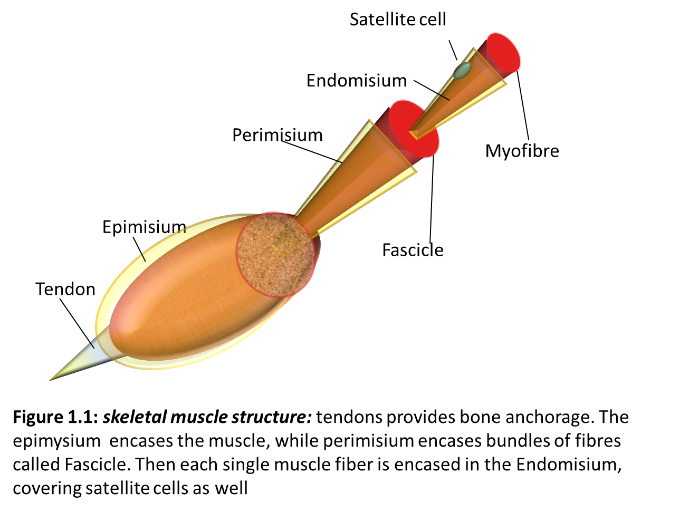
Endomysium
Perimysium
Epimysium
Figure 1.1: skeletal muscle structure: tendons provides bone anchorage. The epimysium encases the muscle, while perimysium encases bundles of fibres called fascicle. Then each single muscle fiber is encased in the endomysium covering satellite cells as well. (adapted from Pearson education 2009)

It is possible to distinguish different types of muscle fibres. The main categorization divides muscle fibres in Type I and Type II, or respectively, slow and fast. Muscle fibres Type I are functionally characterised by the resistance to repeated and prolonged contraction (Schiaffino & Reggiani 1994). This property derives from the use of aerobic metabolism, which needs abundant haemoglobin, and mitochondria, and a high supply of blood through capillaries. Muscle fibres type II, instead, are characterised by a shorter resistance to prolonged contraction, but are able to contract faster than type I. Muscle fibres type II can be further divided in type IIa and IIb, depending on the succinate dehydrogenase (SDH) activity, high in type IIa, and low in type IIb (Schiaffino & Reggiani 2011). Furthermore it has been observed a third type of fibres named IIX. The myosin in these fibres donate contraction properties intermediate between type IIa and b (Schiaffino & Reggiani 1994) .

1.1.1 Myogenesis

The genesis of skeletal muscles is a highly regulated process that takes place before birth, and continues in the post-natal period. During the development, the skeletal muscles are formed from the segmented paraxial mesoderm (Tajbakhsh et al. 1997). The muscles of the head are exceptions as they are formed from other structures. From embryological studies was possible to determine the early stages of myogenesis. Around 7.5 dpc the paraxial mesoderm adjacent to the notochord starts a process of segmentation that leads to the formation of clusters of epithelial cells: the somites (Noden 1988; Scaal & Christ 2004). This segmentation follows a model extremely scheduled in terms of time and space. The formation of the somites proceeds in direction rostro-caudal. This segmentation is directed by the regulatory factors secreted by the anatomical regions in proximity of the paraxial mesoderm. In particular, the neural tube express Shh and Wnt1, the notochord contributes secreting Shh, and the surface ectoderm releases Wnt7a and Wnt6 (Sambasivan et al. 2009; Messina et al. 2009; Buckingham 2001; Bajard et al. 2006). The cues from the regions around the paraxial mesoderm will contribute to the spatial determination of the different structures that will generate from the somites. The ventral compartment of the somites will develop the sclerotome, which in turn will develop the skeletal apparatus. The dorsal part of the somite will form the dermomyotome, which will originate different tissues as blood vessels, brown fat, dermal progenitors and of course myogenic progenitors (Scaal & Christ 2004; Buckingham 2001). The medial somatic area, the myotome is the region providing the progenitors for the formation of the muscle masses. The first stage of the muscle genesis consists in a first wave of migrating cells that will provide the formation of a sheet of non-proliferating muscles progenitor that will form a scaffold for the second wave of proliferating cells. The second wave consists in proliferating progenitors that will successively invade the scaffold. The second stage of foetal myogenesis begins with an epithelial to mesenchymal transition (EMT). In this transition the epithelial-like cells in the dermomyotome downregulate the expression of adhesion proteins gaining the ability to migrate from the lips of the dermomyotome. The cells produced in the dermomyotome and forming the myotome are characterised by the expression of Pax3 and Pax7 genes (Relaix et al. 2005). Muscle progenitors are also identified by the expression of other factors for the regulation of myogenesis(Relaix et al. 2005; Kassar-Duchossoy et al. 2005). These myogenic regulatory factors (MRF) are characterized by the presence of a helix-loop-helix for the heterodimerization with “E proteins”. These proteins are able to recognise genome regions, defined as “E Boxes” (Wei & Paterson 2001). These sequences are characteristics of muscle-related gene promoters. The MRF are four transcription factors: Myf5, MyoD, Myogenin and MRF4. Myf5 is the first factor to be transcribed. Myf5 transcription is upregulated in the progenitors of the myotome, and is followed by the expression of MyoD gene. It has been shown through several knock out experiments that Myf5 and MyoD might have a redundant activity in muscle formation. The exclusive knock out of one of the two genes resulted in the formation of the muscle mass and the expression of Myogenin and MRF4. The knock-out of Myf5 resulted in a compensation of MyoD (Braun et al. 1992), while the knock-out of MyoD resulted in a delay in the usual formation of the muscle mass (Rudnicki et al. 1992). On the opposite, the double knock-out Myf5:MyoD resulted in the absence of Myogenin expression and the failure in the formation of muscle masses (Rudnicki et al. 1993). The last two MRF to be transcribed, Myogenin and MRF4, act downstream Myf5 and MyoD and are involved in the later stages of differentiation, regulating the fusion of myogenic progenitors, and the maturation of myofibres (Rawls et al. 1995).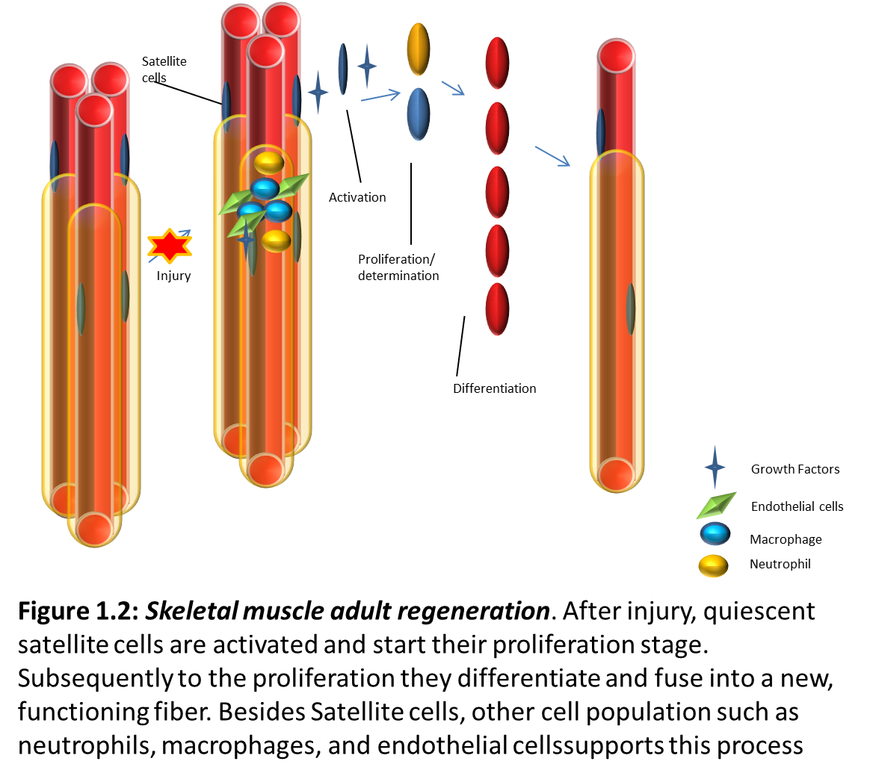
Figure 1.2: Skeletal muscle adult regeneration. After injury, quiescent satellite cells are activated and start their proliferation stage.
Subsequently to the proliferation they differentiate and fuse into a new, functioning fiber. Besides satellite cells, other cell population such as neutrophils, macrophages, and endothelial cells support this process. Adapted from Olguin et al. 2007.

1.2 Satellite cells
The organization of the adult skeletal muscle provides for two main feature of the tissue: the first one is the functional ability to contract and provide mechanical tension; the second one is the dynamic adaptation to external stimuli and insults through regeneration of contractile units. The spatial organization of myofibres, and supporting structures described before, is completed by the presence of stem cells able to generate new muscle fibres through a process that, to a different extent, recapitulates the embryonic myogenesis. These cells can support the homeostasis of the tissue renewing old myofibres, or regenerate damaged muscle fibres in case of injury. In the adult skeletal muscle tissue, satellite cells are the tissue specific stem cells, and the main effectors of myofibres regeneration. Alongside satellite cells, other cell types have been identified able to support adult myogenesis.

1.2.1 Development of satellite cells

The genesis of satellite cells is a process strictly connected with the embryonic muscle formation.
While craniofacial muscles derive from the cranial paraxial mesoderm (CPM) and the lateral splanchnic mesoderm (SpM), the rest of the body muscles are derived from segmented paraxial mesoderm. Based on lineage studies, head muscles showed a myogenic process that diverges from the one of trunk muscles in terms of transcription factors and timing. This difference is mirrored in the related pool of satellite cells. In this thesis only the trunk muscles will be analysed (Harel et al. 2009)
At E10.5 it is possible to identify in the myotome a small group of Pax3+ cells. The observation of the different myotomes, from the rostral to the caudal ones, allows understanding the different stages evolution of this population of Pax3+ cells. In the caudal regions only few Pax3+ cells are visible, localized in the central part of the myotome. In the rostral ones, instead, Pax3+ cells invaded the whole myotome. This observation suggests a link with the ongoing EMT in the dermomyotome, and furthermore that the origin of this Pax3+ cell population is localised in the central part of the myotome (Relaix et al. 2005). In this broader population of Pax3+ cells It has been observed a smaller cell population of Pax7+ cells (Relaix et al. 2004; Relaix et al. 2005). Further investigation revealed that Pax3+/pax7+ cells are negative for Myf5 expression, distinguishing them from the Pax3+ cells in the dermomyotome lip (Relaix et al. 2005). Pax3+/Pax7+ population is an actively proliferating population, as shown by the expression of mitotic marker. This population retains the condition of progenitor, never engaging the myogenic process. In later stages of myogenesis Pax3+/Pax7+ cells are swathed by the basement membrane covering the muscle fibres (Relaix et al. 2005). (fig. 1.3)
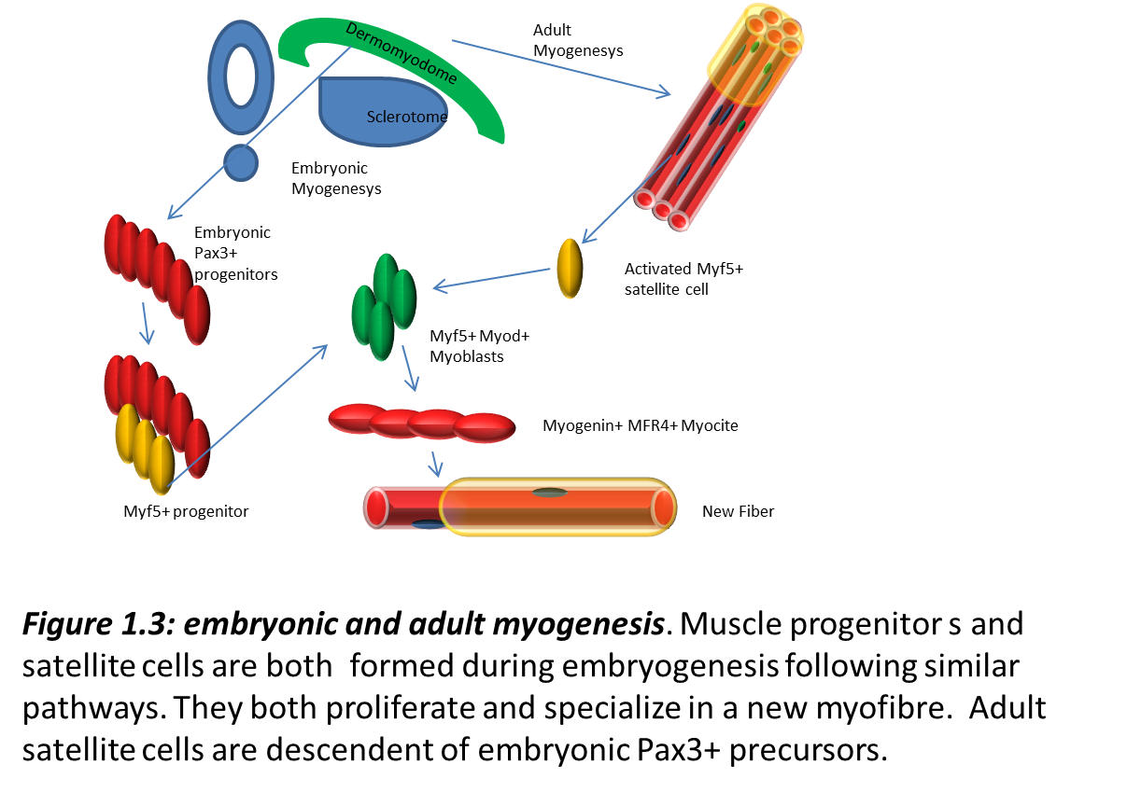
Figure 1.3: embryonic and adult myogenesis. Muscle progenitors and satellite cells are both formed during embryogenesis following similar pathways. They both proliferate and specialize in a new myofibre. Adult satellite cells are descendent of embryonic Pax3+ precursors. Adapted from Parker et al. 2003

1.2.2 Satellite cells: overview

Satellite cells were first observed by Alexander Mauro in 1961. Mauro named these cells “satellite” due to their anatomical position. Satellite cells reside between the muscle single fibre, and the basement membrane covering the muscle single fibre itself. Considering the close proximity with muscle fibres Mauro hypothesised that satellite cells could have been involved with muscle tissue regeneration. (Mauro 1961). This hypothesis was verified some years later, demonstrating the competence of satellite cells to differentiate in myoblast and their ability to contribute to repair and regeneration of myofibres (Moss & Leblond 1971; Moss & Leblond 1970; Reznik 1969). Successive studies focused on the interaction of satellite cells with their microenvironment and the role of external cues in the proliferation and differentiation of these cells, demonstrating that the stimulus for cell proliferation was triggered by signals from the environment external to the cell niche (Bischoff 1986). Moreover, it was observed that isolated cells in culture show a higher proliferation rate compared with those cultured with isolated single fibres. This observation confirmed that the environment around satellite cells could influence their behaviour (Bischoff 1990). These ideas will lead to the concept of “niche” as the environment that guarantees the optimal condition for stem cell quiescence, activation and proliferation of satellite cells.
Parallel to morphological and functional studies, Satellite cells have been characterised also from a molecular point of view. The identification of markers in satellite cells is fundamental for a deeper comprehension of the nature of satellite cells, and for a more practical reason: the opportunity to identify satellite cells through imaging and flow cytometry.
Satellite cells can be identified through some markers as m-cadherin, myf5, c-met, CD34 and Caveolin (Cornelison et al. 2001; Beauchamp et al. 2000; Cornelison & Wold 1997; Irintchev & Wernig 1994; Allen et al. 1995). The most important markers for satellite cells are two genes of the Paired box family: Pax3 and Pax7 (Treisman et al. 1991; Mansouri et al. 1999). Quiescent satellite cells express high levels of Pax7, while Pax3 can be used to identify precursors of satellite cells during early stage of differentiation (Goulding et al. 1991; Mansouri et al. 1996; Lacosta et al. 2005). The interest in these two homologous genes goes further the simple identification of satellite cells, concerns a deeper knowledge of the mechanisms of muscle generation. The characterization of mutant mice for Pax3 and Pax7 led to the conclusion that despite the homology and a partial redundancy of these two genes, the two members of the paired box family regulate different mechanism during development and muscle generation. Mice bearing the spontaneous Pax3 mutation named “splotch” show numerous neural crest anomalies, particularly in the caudal region (Moase & Trasler 1989). Moreover this mutation causes the death of mice before birth. On the opposite Pax7 null mice have rostral defect in the neural crest, and usually die 3 weeks after birth (Oustanina et al. 2004; Mansouri et al. 1996).
The loss of Pax3 or Pax7 leads to different defects in muscle development. Pax3 is expressed in the presomitic mesoderm, and in the dermomyotome, where it is localized within two structures called the epaxial and hypaxial lips (Goulding et al. 1994; Goulding et al. 1991). In Pax3 -/- mutant mice the migration of myoblasts is impaired, leading to an unsuccessful formation of limb muscle. This defect is caused by the missing interaction between Pax3 and c-met, the promoter of myoblast migration (Bladt et al. 1995; Epstein et al. 1996). Over expression of Pax7 does not rescue the phenotype of Pax3-/- mice. This leads to the conclusion that Pax3 has a leading role in muscle formation (Mansouri et al. 1996), as confirmed from the phenotype of Pax7-/- mice. Pax3-/- mutant mice die during gestation (caused principally by defects in the normal neural crest formation) (Epstein et al. 1993). As very few Pax7-/- mutant mice are able to survive for about three weeks after birth, Pax7-/- mutation allows the observation of the muscle behaviour in absence of Pax7 (Oustanina et al. 2004). The analysis of Pax7-/- mice muscles, anyway, has detected the absence of satellite cells (Oustanina et al. 2004). Taken together these observations suggest the importance of Pax7 in the renewal and proliferation of satellite cells.
Pax3 and Pax7 are also involved in the control of differentiation mechanisms, interacting with MRFs. In particular Pax3 prevents precursors from entering myogenic lineage, repressing the expression of Myf5 and Myogenin (Tajbakhsh et al. 1997; Bajard et al. 2006). Pax7 instead prevents the expression of MyoD and Myogenin. These mechanisms could be involved in the control of myogenic program, avoiding a premature loss of stemness characteristics (Oustanina et al. 2004; Seale et al. 2000a).

1.2.3 Other muscle progenitor involved in regeneration
In later years many studies have focused on the identification of the muscle regeneration ability of cell population different from satellite cells.
Adult bone marrow has a heterogeneous population of stem cells. The bone marrow stem cells are of course, able to produce all the component of the hematic tissue, but it has been shown that a population of stem cells (CD32,33,34-,c-kit-) from bone marrow are also able to produce the three embryonic germ layers (Jiang et al. 2002). This population of multipotent adult progenitor cells (MAPCs) from the bone marrow is able to differentiate to myoblasts, and form myotubes in vitro. These observations revealed the myogenic potential of bone marrow derived stem cells. (Muguruma et al. 2003; Wakitani et al. 1995). These conclusions are confirmed observing the behaviour of mesenchymal stem cells (MSC) isolated from bone marrow. The administration of whole bone marrow extract in injured muscles pointed out the assimilation of mesenchymal cells from bone marrow in the new regenerated muscle fibres (Ferrari et al. 1998). The use of bone marrow derived stem cells as potential therapy for muscle diseases is still in debate due to contrasting experimental outcomes. Besides the ability to cross the cell walls of blood vessels, and therefore be administrated systemically (Ferrari et al. 1998), bone marrow stem cells showed also poor ability to colonise the satellite cells niche (Gussoni et al. 1999). BMSCs are able to retain “stemness” properties during the infusion in the blood vessels, but also poor fusion ability, giving rise to smaller myotubes (Ferrari et al. 1998).
The mesoangioblasts are vessel associated stem cells (Messina et al. 2009). These stem cells originate in the dorsal aorta (Minasi et al. 2002) and can be isolated through their markers CD34, c-Kit, Flk1. The origin of this tissue is the same as the skeletal muscle tissue. Both dorsal aorta and skeletal muscle are derived from the mesoderm (De Angelis et al. 1999; Bladt et al. 1995). Mesoangioblasts isolated from the dorsal aorta show multipotent properties, being able to give rise to multiple structures once engrafted in chick embryos. It has been observed that mesoangioblasts can give rise also to muscle tissue, both smooth and skeletal. (Minasi et al. 2002; De Angelis et al. 1999). The ability of mesoangioblasts to differentiate in muscle precursors is dependent on the ability to express Pax3 (Dellavalle et al. 2007). The use of Cre-Lox system has been used to investigate the involvement of mesoangioblasts in skeletal muscle formation (Motoike et al. 2003), leading to the conclusion that mesoangioblasts are marginally involved in the adult growth. Due to their ability to interact with blood vessels cell walls and the preservation of stemness during administration, mesoangioblasts have been the principal target for cell therapy in muscle dystrophy treatment. These therapies are based on the systemic infusion of treated mesoangioblasts (Morosetti et al. 2007; Morosetti et al. 2006; Sampaolesi et al. 2006).
Pericytes are cells present in small vessels associated to basal membrane, usually associated with vessel endothelial cells. They are believed to regulate the vessel gauge through smooth muscle actin action (Kutcher & Herman 2009). Pericytes originate from the sclerotome, and this characteristic distinguishes pericytes from mesoangioblasts (Pouget et al. 2008). Pericytes are multipotent stem cells able to give rise, in culture, to a broad variety of differentiated stem cells (Alliot-Licht et al. 2005; Farrington-Rock et al. 2004). Few studies focused on the ability of pericytes to differentiate in skeletal muscle precursor. Pericytes can be distinguished from mesoangioblasts and satellite cells through the peculiar expression of tissue non-specific alkaline phosphatase (ALP) (Dellavalle et al. 2007). Another important difference between pericytes and satellite cells is the expression of Pax7, Myf5 and MyoD. Pericytes precursors don’t express satellite cells marker Pax7, nor the MRF Myf5 and MyoD (Dellavalle et al. 2007). The expression of the two MRF is barely upregulated only after the induction of the differentiation. This observation induced to believe that, in pericytes derived muscle precursors, the transcription of myogenin is regulated by non-canonical mechanisms (Dellavalle et al. 2007). Comparing pericytes harvested from human DMD patients with pericytes from healthy donors, it is possible to observe little or no difference from a genetic point of view. Moreover DMD pericytes are able to give rise to myotubes at a similar pace (Dellavalle et al. 2007). The intra-arterial infusion of pericytes in immunosuppressed MDX mice showed their ability to be included inside regenerating myofibres, to renovate dystrophin expression, and to migrate under the basal lamina, in the satellite cells niche (Dellavalle et al. 2007). Moreover pericytes from MDX mice can be engrafted after being manipulated in vitro to express correct form of mutated proteins (Dellavalle et al. 2007).

1.3 Muscular dystrophies

The adult skeletal muscle tissue can be also affected by a number of pathologies pushing the regenerative machinery to the limit of its function (Emery 2002). Skeletal muscle dystrophies are a large group of inherited genetic disorders. These pathologies cause a degenerative muscle weakness and muscle wasting, and cause death in the first 20 years of age. Muscular dystrophies were described for the first time in 1852 by Edward Meryon (Meryon 1852). As described in his studies the onset of muscle dystrophies is in the first years of life, and causes death in the adolescence. These muscle degenerative pathologies may lead, with time, to a failure of regeneration. The reason might lie in the depletion of the satellite cell pool present in the tissue, or the disruption of the architecture (Smith et al. 2016; Jejurikar & Kuzon 2003).
Over 30 types of Muscular dystrophies are currently known. This broad set of disease is grouped in six main classes depending on the muscle group mostly affected. The Emery-Dreifuss, involves the proximal muscles of the upper limb and the distal portion of the lower limb. The Limb-girdle group affects the proximal portion of limbs in particular shoulders and hip articulation. The Facioscapulohumeral group concerns the muscle group of the upper limb, affecting shoulder and proximal portion of the arms. Furthermore causes problem the face muscles. The Distal group affects the distal part of the limbs, as the name itself suggests, and the Oculopharyngeal strikes mainly the oculomotor muscles and the pharyngeal muscle. The sixt group is represented by the Duchenne and Becker dystrophies (Emery 2002).

1.3.1 Duchenne and Becker muscular dystrophies.

Duchenne and Becker muscular dystrophies (DMD and BMD, respectively) have an incidence of 1 in 3500 male births per year. These X-linked disorders are caused by a mutation in the Dystrophin gene (Bulman et al. 1991). The Dystrophin protein is involved in the connection between the cytoskeleton and the sarcolemma, assisting the muscle fibre during the contraction (Bulman et al. 1991). The loss of this important stabiliser leads to an increased fragility of the fibres. DMD and BMD are differentiated by the severity of the Dystrophin mutation (Anthony et al. 2011). In Duchenne muscular dystrophy Dystrophin is completely absent. In Becker muscular dystrophy the mutation in the Dystrophin gene allows the expression of a partially functioning protein, causing a milder phenotype. The first symptoms begin around 3 years of age, and if not treated the death occurs usually in the first 20 years of age of the patient. These dystrophies affect mainly skeletal muscles, and the diaphragm, but defects involve also the cardiac system and (Bulman et al. 1991).
A mouse model of DMD (mdx mouse line) with a point mutation in the Dystrophin gene has been identified, although in contrast to human DMD, mdx mice undergo cycles of muscle disruption and repair between the second and the tenth week of age. After the tenth week, muscles are stabilised and further episodes of muscle degeneration do not occur until the mice reach old age (Cullen & Jaros 1988).

1.3.2 Congenital muscular dystrophies.

The term CMD defines a broad group of autosomal recessively inherited disorders (Saito et al. 2008). The term congenital relates to the early onset of the symptoms starting from the first months after birth. Amongst this group some forms of congenital muscle dystrophy can cause mental retardation (Durbeej 2015).
The most common type of Congenital muscular dystrophy is Congenital muscular dystrophy type 1A (MDC1A) with an incidence of 0.7/100000 (calculated on samples in Italy) represents about the 50% of all congenital muscular dystrophies in Europe.
The cause of MDC1A is the mutation of the LAMA2 gene. This alteration leads to a defective production of the laminin-α2 protein, and subsequently the loss of the matrix proteins laminin-211 and laminin-221. Laminin-211 provides for the anchorage of myofibres to the basement membrane, relieving the mechanical stress originated from the fibre contraction. In MDC1A muscle fibres are more prone to apoptosis, due to sarcolemmal fragility (Rooney et al. 2012).
CMD1A is caused by homozygous mutation of the LAMA2 gene leading to a lack of Laminin α2 in the basement membrane. In some cases, a partial expression of Laminin-211 has been observed (Sparks et al. 1993). The lack of Laminin α2 subunit in the adult muscle basement membrane causes the disruption of the extracellular matrix and leads to an increased muscle weakness and fibre necrosis (Emery 2002; Durbeej 2015). Magnetic resonance tests revealed that congenital muscular dystrophy type 1A is characterised by an altered conformation of white-matter in the brain. Even though this defect does not cause mental disability. Most patients are able to stand with some support, but almost none learn to walk. In this type of dystrophy the cardiac function is normal, but patient tends to develop impairment in the muscle movement related to consumption of food and respiration (Sparks et al. 1993; Durbeej 2015).
Currently five different mouse models exist. The dy^{3K}/dy^{3K} mouse model has been generated through targeted mutation of Laminin α2 and mice die around 3 weeks of age with a severe dystrophic phenotype (Guo et al. 2003). The dy^{3K}/dy^{3K} mice are completely unable to produce Laminin α2. These mice show a strongly reduced body mass similar to human patients (Miyagoe et al. 1997). Laminin α1 overexpression in dy^{3K}/dy^{3K} mice ameliorates the phenotype of these mice (Van Ry et al. 2014). In particular, the transgenic expression of Lama1 lead to a longer lifespan and an amelioration of the morphology of muscle tissue. These effects might be linked to a possible promotion of myogenesis and proliferation of myogenic precursors induced by Laminin α1 (Riederer et al. 2015; Rooney et al. 2012).

1.4 Skeletal muscle progression to repair

1.4.1 Muscle regeneration overview: causes of damages and effect on skeletal muscle tissues

Skeletal muscle plasticity and its ability to recover after damage have been studied for a long time. First studies on the properties of myogenic precursor cells to align and fuse in a new fibre started at the beginning of the 19th century. Further studies were performed on adult muscles of frogs and rabbits describing the degeneration of muscle fibres and the growth of the new forming muscle fibres (Carlson 1973).
A further step in the study of skeletal muscle regeneration was the generation of models for muscle injuries and repair. These investigations, besides setting the methods for an induced degeneration of skeletal muscles, reported two different ways of myofibre regeneration, one defined as continuous, and a second defined as discontinuous. The former sees the new myofibres regenerated from a surviving damaged fibre, the latter recapitulates the embryonic myogenesis and forms the new myofibres starting from the single muscle progenitors (Scharner & Zammit 2011). Other studies supported the hypothesis of a muscle regeneration starting from previous formed myonuclei. These studies also described the in vitro regeneration of small samples of adult muscles from humans and rats (Pogogeff & Murray 1946). The regeneration of skeletal muscles was also documented in dystrophic rats (Pappenheimer 1939). In the beginning of the ‘60s investigations with tritiated thymidine labelling found that the radioactive marker was present only in mononucleated cells, as myoblasts, endothelial cells, fibroblasts and leucocytes. On the opposite, the myonuclei present in the muscle fibres were completely negative. This investigation disproved idea that myonuclei might generate a cell population responsible for the muscle regeneration (Walker 1962). In the same period, Mauro observed and described a population of cells positioned around the single muscle fibres. Due to their peculiar peripheral position these cells were named “satellite” (Mauro 1961). Tritium labelling during muscle regeneration demonstrated the ability of these cells to proliferate (Reznik 1969). Further investigations on ex vivo cultures of myofibres showed the ability of satellite cells to form colonies and fuse with myotubes (Bischoff 1975). All these outcomes led to the conclusions that satellite cells were the main myogenic precursors in the skeletal muscle. This was further confirmed through the observation that the ablation of Pax7+ cells leads to a failure in the adult skeletal muscle regeneration (Lepper et al. 2011).
Healthy adult skeletal muscle shows a reduced turnover of myonuclei. However, skeletal muscle tissue has an extraordinary growth and repair ability during the normal development as well as in response to intense exercise, injuries or pathologies such as muscular dystrophies (Carlson & Gutmann 1975; Carlson 1973). Skeletal muscle can be restored after damage in 14 days in the mouse, and the regeneration is effective even after repeated injuries (Luz et al. 2002; Rosenblatt 1992).
The process that leads from the damage to the regeneration of the tissue can be divided in different steps, and it is possible to follow the muscle regeneration observing some muscle sections at determined time point after the muscle injury, staining the sections with haematoxylin and eosin, to observe the muscle architecture, and a combination of MRFs and basement membranes markers to study the myogenic progression of myogenic precursors.
A staining with Haematoxylin and Eosin of a non-injured muscle reveals an even and continuous distribution of muscle fibres across the muscle. If the muscle is injured for example injecting cardiotoxin (CTX) in the tissue, the muscle fibres are rapidly destroyed, and the satellite cells are spared to regenerate the muscle tissue (Sherwood et al. 2004).
The mechanical or chemical trauma causes the disruption of the muscle fibres integrity, this leads to fibre necrosis, a degradation of the fibres mediated by proteases and the release of creatine and myoglobin (Sorichter et al. 1998). Immune cells are reversed from the blood flow to the interested area, promoting the degradation of necrotic cells, and promoting the activation of satellite cells (Serrano et al. 2008). (fig. 1.4)

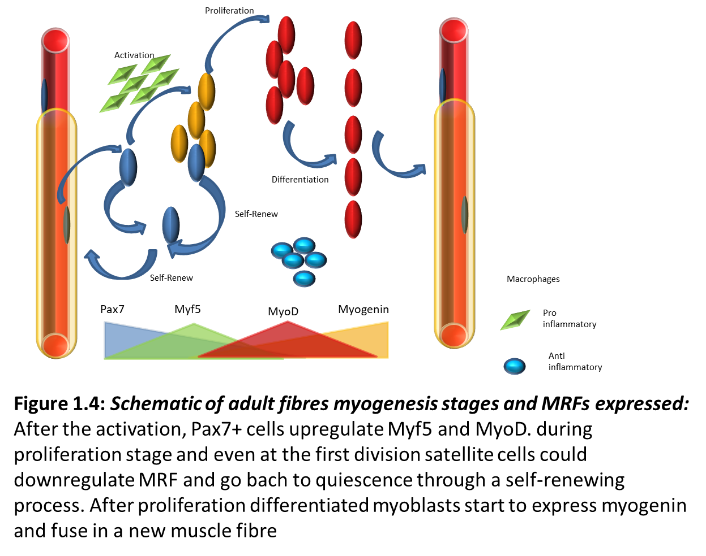
Figure 1.4: Schematic of adult fibres myogenesis stages and MRFs expressed. After activation, Pax7+ cells upregulate Myf5 and MyoD. During proliferation stage and even at the first division satellite cells could downregulate MRF and go back to quiescence through a self-renewing process. After proliferation, differentiated myoblasts start to express Myogenin and fusein anew muscle fibre. Adapted from Olguin et al. 2007

1.4.2 Inflammation: effects of macrophages on muscle regeneration
During muscle inflammation immune cells release histamine, TNF-α and interleukin 6 (IL-6). These factors are known to trigger satellite cell activation (Serrano et al. 2008; Belizário et al. 2016). The chemokines secreted during inflammation promote the infiltration of monocytes and their differentiation in macrophages (Arnold et al. 2007). This stage could be observed 2 days after an injury induced by CTX. The muscle tissue is characterised by the presence of inflammatory cells, fibroblasts and activated satellite cells.
The study of macrophages involved in the regeneration of the muscle tissue revealed the presence of two different populations of macrophages: the M1 with pro inflammatory properties, and the M2 with an anti-inflammatory activity (Saclier, Yacoub-Youssef, et al. 2013; Nguyen & Tidball 2003). The first wave of macrophages (M1) will remove the rests of necrotic fibres, and secrete IL-1b, TNF-β, and IL-6. These cytokines will trigger the activation of the quiescent satellite cells and promote their return to cell cycle, preventing their differentiation (Saclier, Yacoub-Youssef, et al. 2013). The wave of M1 macrophages peaks at 3 days after injury, and is over usually after 7 days (St Pierre & Tidball 1994). The second wave of macrophages is composed of M2 macrophages, and peaks at 5 days after injury and is over 10 days later. M2 macrophages release IL-4 and IGF-1, factors that promote the proliferation and differentiation of satellite cells (Saclier et al. 2013).
Besides the macrophages and the satellite cells, the correct regeneration of the muscle tissue requires the proper restoration of the extracellular matrix and all the supporting structures present in the adult skeletal muscle. Fibroblasts are originated from mesenchymal stem cells, and are involved in the synthesis of different extracellular component as collagen, fibronectin, elastin proteoglycans and laminins (Murphy et al. 2011). Furthermore, fibroblasts provide other important elements for the extracellular matrix remodelling after injury: metalloproteinases (MMPs) (Lindner et al. 2012). Fibroblasts are activated since the early stages of muscle repair and provide the ECM component supporting the formation and maturation of new myofibres (Chen & Li. 2009). The secretion of MMPs allows the remodelling of the ECM promoting satellite cells migration (Chen & Li. 2009).
When observing the regeneration of the muscle tissue it is important to consider the morphologic features too. 4 days after injury, the infiltrated immune cells are still present. Anyway the staining with a basement membrane such as Pan Laminin or laminin α2 shows the formation of newly formed small myofibres. These fibres are characterised by the central position of the nucleus.
7 days after the CTX injury the freshly formed fibres are bigger and rounder, and the overall shape looks even and rounded. At 14 days after injury the muscle regeneration is complete. The inflammatory cells have almost completely disappeared, and the full restoration of the tissue will be complete by the 21st day after the injury, with no inflammatory tissue and a centronucleated fibre as big as the non-injured ones.
The last population of cells involved in the restoration of the tissue are the endothelial cells. These cells promote the formation of the new vessels in the regenerated zone. Furthermore the secretion of VEGF appears to stimulate the proliferation of muscle precursors (Christov et al. 2007).

1.4.3 The myogenic program

1.4.3.1 Myogenesis: an overview.

There is a parallelism between embryonic and adult myogenesis, and to some extent this is true if one considers the stages of myogenesis and the signalling involved. The three important phases of myogenesis are proliferation, differentiation of myogenic progenitor cells and maturation. In adult myogenesis, satellite cells undergo a further process, the activation. Myogenesis is driven by transcription factors usually referred as MRFs (muscle regulatory factors) expressed sequentially during myogenesis (Le Grand & Rudnicki 2007). This sequential activation of MRFs in adult satellite cells mimics the progression of events that lead to the formation of muscles in the embryo (Cooper et al. 1999; Cornelison et al. 2000; Cornelison & Wold 1997; Zammit et al. 2002). During their quiescent state, a small subpopulation of adult satellite cells express Pax3, as well as Pax7 (Zammit et al. 2006). After their activation, satellite cells engage in the myogenic program in a way that is similar to embryonic myogenic cells. The first MRF expressed by satellite cells upon activation is Myf5, a basic helix-loop-helix transcription factor (Cooper et al. 1999; Zammit et al. 2002; Cornelison & Wold 1997). Subsequently, within 12 hours of activation, satellite cells upregulate the second next myogenic factor MyoD. The last two MRFs expressed are Myogenin and MRF4 (Cornelison & Wold 1997; Ferrari et al. 1998; Grounds et al. 1992; Megeney et al. 1996; Yablonka-Reuveni & Rivera 1994). The analogy with embryonic embryogenesis is concluded with the fusion of myoblasts expressing Myogenin to form new fibres, or with damaged fibres.

1.4.3.2 Satellite cell quiescence
Quiescent satellite cells have a small cytoplasmic content and are identifiable by a number of molecular markers. Pax7 is the most important marker. This transcription factor provides for the lineage determination and survival of satellite cells (Seale et al. 2000b; Zammit et al. 2006). Alongside Pax7, another member of the Pax family, Pax3, can be used to identify satellite cells from specific muscles as the diaphragm (Zammit et al. 2006).
Pax7 is present in satellite cells during the early stages of myogenesis and it is downregulated in differentiated myocytes. Quiescent satellite cells can also be identified by several other markers, such as M-cadherin, Caveolin-1, and CD34

The characterization of Pax7^{-/-} mice revealed the important role of this transcription factor in adult skeletal muscle stem cells. Pax7 mutant mice have a reduced size, a rapid loss of satellite cells, and poor regenerative capacity (Kuang et al. 2006; Lepper et al. 2011). Furthermore, studies of loss and gain of function defined Pax7 as the master regulator of several myogenic genes, most of them related to the proliferation of myogenic precursors and the inhibition of myoblasts differentiation (McKinnell et al. 2008). In these experiments, the silencing of Pax7 expression through the use of siRNA led to the loss of Myf5 expression and the inhibition of myoblasts proliferation (McKinnell et al. 2008). On the other hand, gain of function experiments in in vivo cultures of satellite cells demonstrated that the constitutive expression of Pax7 promotes the proliferation of satellite cells, inhibiting the progress to differentiation (Otto et al. 2009). The further characterization of these cells revealed that Pax7 led to the downregulation of MyoD. The inhibition of MyoD activity affected the expression of Myogenin too, leading to a stop in the normal myogenic differentiation (Olguin & Olwin 2004). Further loss of function experiments demonstrated that Pax7 expression is required throughout the muscle regeneration and that a sustained tamoxifen-induced Pax7 inhibition leads to impaired muscles regeneration. This investigation demonstrates how Pax7 can regulate the myogenesis on several levels of control (Günther et al. 2013)

1.4.3.3 Quiescence maintenance

The quiescence of satellite cells is fundamental for the health of muscle tissue, as their uncontrolled activation could lead to a rapid depletion of the stem cell pool (Boonen et al. 2009). Therefore the G₀ state is maintained through different control mechanisms (Rumman et al. 2015). Notch signalling is involved in the maintenance of quiescence in adult satellite cells, and this hypothesis is supported by the study of Notch null mice. Loss of Notch signalling causes an early activation of satellite cells (Brack et al. 2008), without affecting the differentiation of myogenic progenitor cells (Fukada 2011).
Satellite cell activation can be triggered by several growth factors such as fibroblast growth factor (FGF), insulin growth factor (IGF) and platelet derived growth factor (PDGF) (DeLapeyrière et al. 1993; Floss et al. 1997). To prevent the erroneous activation by these external stimuli, quiescent satellite cells are actively expressing Sprouty, an inhibitor of the MAPK. The inhibition of the tyrosine kinase receptors prevents the activation caused by growth factors (Fukada et al. 2007).
Quiescence can also be maintained through the inhibition of the cell cycle. Myostatin induces the expression of p21, a kinase inhibitor that keeps satellite cells in G₀ state (George et al. 2013). In vivo and in vitro analyses observed that the loss of Myostatin in vivo causes an increase of satellite cells activation, confirming the role of Myostatin in cell quiescence (Boonen et al. 2009).
Furthermore, beside the quiescent and active state (see next paragraph), it has been observed and described a state defined as G_{alert} (Dumont et al. 2015; Rodgerset al 2014, Fu et al. 2015). This state is triggered systemically in satellite cells after a localised injury. The transition to this state is mediated by c-met, HGF, and as recently discovered, mTORC1. Cells in G_{alert} phase are set for immediate activation in case of necessity (Rodgers et al. 2014b).

1.4.3.4 Satellite cell activation.
The complex net of signals activating quiescent satellite cells drives the shift from G₀ to G₁ phase. Once satellite cells enter the cell cycle, they will begin a phase characterised by a high proliferation rate. This stage known as “transit amplifying stage” has been observed also in other stem cells such as skin stem cells (Sancho et al. 2004). During this stage, the signalling pathways will drive the transcription machinery to drive satellite cells to the determination of their fate: differentiation and fusion in muscle fibres or return to quiescence (Buckingham 2007; Olguin & Olwin 2004).
Different kinds of cues provide the stimulus for the activation of satellite cells. The environment and the external stimuli have a major role in the exit from the G₀ state (Dhawan & Rando; 2005). The first factor promoting the activation of satellite cells is the mechanical stretch of the muscle fibres. Mechanical stress activates the release of nitric oxide (NO) by the nitric oxide syntetase (NOS). One of the main effects of NO release is the activation of MMPs and a partial degradation of the ECM (Tatsumi et al. 2002). Following this event, several growth factors that were trapped in the basement membrane are released and contact their receptors at the surface of satellite cells (Yamada et al. 2008; Tatsumi et al. 2002).
FGF-2 and HGF are two of the main growth factors released upon the degradation of the ECM, both of them are involved in the activation and proliferation of satellite cells through the activation of the MAP kinase pathway (Yablonka-Reuveni et al. 1999; Cornelison & Wold 1997). HGF binds to its receptor c-Met at the surface of satellite cells. The effects on activation of satellite cells are visible through loss of function experiments. The use of HGF specific antibodies inhibits the contact between c-met receptors and HGF preventing satellite cells activation. The exogenous administration of HGF in freshly injured TA muscles promoted the activation of satellite cells and reduced their proliferation (Cornelison & Wold, 1997; Tatsumi et al. 1998). FGF-2 is known to interact with Syndecan-3 and 4, present on the satellite cells surface (Punch et al. 2009). The release of FGF-2 in injured muscles promotes the activation of satellite cells as can be observed by the increased contribution of myogenic precursors during tissue regeneration. (Cornelison et al. 2001; Cornelison et al. 2004). On the other hand, it has been observed that Syndecan4-null satellite cells show a delayed activation and a reduced proliferation (Dhawan & Rando 2005).
The intrinsic signals such as microRNAs play also an important role in the maintenance of quiescence. miRNA-31, for example, binds Myf5 mRNAs present in quiescent cells and prevents the translation into protein (Crist et al. 2012). From this stage of activation muscle progenitors can start their proliferation stage.

1.4.3.5 Proliferation of satellite cells.
Activated satellite cells maintain the expression of Pax7 and Caveolin-1 and upregulate the first two MRFs: Myf5 and MyoD (Cooper et al. 1999). The expression of MyoD is lower in freshly activated satellite cells and is gradually increased in proliferating myogenic precursors. MyoD promotes the re-entry of satellite cells in the cell cycle and is particularly present in G₁ cells. The expression of MyoD regulates Cdc6, a gene responsible for the accessibility of DNA for replication, promoting the proliferation of satellite cells (Zhang et al. 2010). The loss of MyoD in vivo leads to a reduced proliferation and a subsequent inefficient tissue regeneration after cardiotoxin injection (Megeney et al. 1996). MyoD is also the counterweight of Pax7 in the balance between return to quiescence and progression to differentiation, as the downregulation of one of the two genes in this proliferative stage leads to self-renewal or terminal differentiation (Olguin & Olwin 2004). The role of Myf5 and MyoD in embryonic myogenesis is somehow redundant with both Myf5-/- and MyoD -/- mice able to produce muscles, but showing impairment to hypaxial and epaxial muscles respectively (Rudnicki et al. 1993). This is not true in the adult myogenesis. The loss of Myf5 or MyoD in mdx mice leads to a failure in muscle regeneration due to impaired proliferation or loss of differentiation, respectively (Olguin & Olwin 2004; Ustanina et al. 2007).
Upon injury or a traumatic event several growth factors are released in the injured area and elicit the activation and proliferation of satellite cells (Brizzi et al. 2012b). IGF is needed during the activation of satellite cells, as its expression promotes the expression of Myf5. Furthermore IGF is able to promote the cell cycle activating cyclin D2. In C2C12 cells, Cyclin D2 elicits the proliferation of cells through PI3K/AKT and MEK/ERK pathways (Fu et al. 2015; Cornelison et al. 2000; Lovett et al. 2006). IGF promotes also the survival of satellite cells. The effects of IGF on proliferation and survival of myogenic precursors was studied in mdx mice (Barton et al. 2002). A transgenic breed of mdx mice overexpressing IGF showed an increased activation of the AKT pathway and a hypertrophy in dystrophic muscles (Barton et al. 2002). FGF is another growth factor known to promote satellite cells proliferation stimulating the MKK-ERK signalling pathway. FGF stimulation promotes the cycling of cells, assisting the transit ion fron the G₁ to S phase (Jones et al. 2001). Furthermore, the adult proliferation stage is controlled by other regulatory pathways found in the embryonic stage as well: Notch, Wnt and Sonic Hedgehog (SHH) (Dumont et al. 2015 b).
SHH pathway has been observed to activate in vitro PI3K/AKT pathway promoting the proliferation of myoblasts (Elia et al. 2007).
Wnt canonical signalling is activated upon Wnt ligand to its receptor Frizzled and LRP co-receptor. The ligand-receptor contact inactivates GSK-3β. This process causes the stabilization of β-catenin, usually ubiquitinated. β-catenin is then able to translocate to the nucleus, promoting the proliferation of satellite cells (Subramaniam et al. 2014; Macdonald et al. 2009).
Notch signalling during adult myogenesis has a double effect, caused by the existence of two waves of notch expression. Notch maintains the quiescence of satellite cells until its inactivation upon satellite cells activation. During the proliferation of satellite cells, notch signalling is upregulated in order to promote differentiation and prevent early differentiation (Andrew S. Brack et al. 2008). During this stage of myogenesis satellite cells can still “decide” to terminally differentiate or return to quiescence and self-renew.

1.4.3.6 Satellite cell self-renewal.

It has been observed that in healthy muscles the amount of satellite cells is kept constant even after several cycles of damage and regeneration (Sottocornola & Lo Celso 2012). This feature allows the muscle tissue to cope efficiently with future needs. The replenishment of the satellite cell pool, known as self-renewal, can be observed ex vivo when activated satellite cells either embrace myogenic differentiation or return to a quiescent state, a characteristic that has also been observed in vivo (Collins & Partridge 2005). The Pax 7 -/- mice showed a precocious loss of myogenic precursors could be explained by the loss of self-renewing satellite cells (von Maltzahn et al. 2013).
This process is tightly linked to cell division, with progenitor cells undergoing either symmetric cell division to produce two stem cells or asymmetric cell division to produce two distinct cell types. In the latter case, the downregulation of MyoD leads to the return to quiescence, while the downregulation of Pax7 promotes the differentiation of satellite cells (Olguin & Olwin 2004). Symmetric and asymmetric cell divisions can occur along different division plans: the planar one, with a division occurring parallel to the muscle fibre, and an apical-basal, with a division occurring usually perpendicularly to the muscle fibre. In this last case one daughter cell is retained by the basal lamina, while the other cell remains closer to the muscle fibre (Morrison & Spradling 2008; N. A. Dumont et al. 2015). Wnt7a signalling stimulates the expansion of satellite cells through planar cell division, and do so through the planar cell polarity pathway (PCP) (Le Grand, Andrew E Jones, et al. 2009). One of the main effector of the PCP pathway is Vangl2 (von Maltzahn et al. 2012). This protein localizes to the two opposed poles of the stem cells promoting a mitotic division parallel to the myofibre (Dumont et al. 2015). This mechanism is influenced by the composition of the stem cell niche, and in particular by the increased expression of Fibronectin. The interaction between Fibronectin and Syndecan-4 triggers the non-canonical Wnt signalling (von Maltzahn et al. 2012).
Asymmetric divisions are strongly influenced by the signals from the satellite cells niche. Cues for apico-basal cell division reside in the asymmetric distribution of adhesion cues on the ECM side and the myofibre side of single satellite cells (Kuang et al. 2007). Asymmetric distribution of adhesion proteins causes one daughter cell to be retained by the basement membrane while the other one has no contact with the ECM, retaining the contact with the muscle fibre. This mechanism of division gives rise to an apical-basal division where the apical cell maintains mostly cadherin, while the basal one retains Integrins and other receptors interacting with the basement membrane ( Dumont et al. 2015). This polarised environment determines the orientation of the mitotic spindles and also the uneven distribution of MRFs between the two daughter cells. In satellite cells usually apical cells are Pax7+/Myf5+, while basal daughter cells are Pax7+/Myf5- (Kuang et al. 2007; Kuang, Gillespie, et al. 2008). Notch pathway seems to be involved in the determination of cell division. Delta-1 ligand is usually expressed in the proliferating Pax7+/Myf5+ cells, while Numb was expressed in Pax7+/Myf5- satellite cells. This asymmetric distribution might suggest the need to inhibit notch for self-renewal of satellite cells (Kuang et al. 2007). another important regulator of asymmetric division is the Par complex (Troy et al. 2012; Dumont et al. 2015). The three members of the Par complex Par3, Par6 and the atypical protein kinase C (PKC) are inherited only by the differentiating daughter cells, causing the asymmetric segregation of several factors, including p38a/βMAPK complex that drives the upregulation of MyoD (Keren et al. 2006). Furthermore p38a can control Pax7 via PRC2 (polycomb repressor complex) causing differentiation of the satellite cells. This mechanism therefore causes the upregulation of MyoD in one daughter cell, and maintains Pax7 in the other, establishing distinct cell fates (Troy et al. 2012). It has been observed that Par complex activity might directly interfere with the PCP program (Seifert & Mlodzik 2007).

1.4.3.7 Satellite cells differentiation
The expression of Myf5 and MyoD is linked to the activation of the myogenic program and the expansion of the myogenic progenitor cells. MRF4 and Myogenin are the two MRFs involved in the terminal differentiation of myoblasts (Bismuth & Relaix 2010). MyoD triggers a self-reinforcing transcription pathway promoting the expression of all the MRFs (Weintraub et al. 1991). The study of MRF expression during muscle regeneration revealed that MyoD and Myogenin are upregulated in the first six hours after the injury and the peak of their expression is around 48 hours (Grounds et al. 1992). Myogenin expression can induce differentiation through the transcription of microRNA. In particular microRNA-206 and microRNA-1 can inhibit the expression of Pax7. These two microRNAs are usually not detected in proliferating cells (Fu et al. 2015; Chen et al. 2010).
The final stage of skeletal muscle differentiation is characterised by a new balance between Wnt and Notch signalling (Brack et al. 2008). Myogenin positive cells block BMP signalling causing the exit from the cell cycle and post mitotic differentiation. Muscle progenitors terminal differentiation is concomitant with the upregulation of canonical Wnt signalling pathway (Starkey et al. 2011). In vivo experiment demonstrated that the inhibition of Wnt prevents muscle differentiation (Brack et al. 2008). In this stage of myogenesis Notch is progressively downregulated while Wnt signalling starts to be predominant. The upregulation of Wnt pathway correlates with the downregulation of Notch signalling. The withdrawal from cell cycle myoblasts and the expression of TGF-β2 promotes the fusion in new fibres (von Maltzahn et al. 2012).

1.5 Adult stem cell niche

1.5.1 Role and definition of the stem cell niche

Adult tissues undergo a continuous process of repair throughout life. The homeostasis of adult issues is possible through the presence of tissue-specific stem cells. These pluripotent cells reside in an environment suitable for their proper functioning and activity. This microenvironment is identified as niche. Schofield first reported the idea of a stem cell niche in 1978 referring to the environment of hematopoietic stem cell (Schofield 1978). Following the first studies on the hematopoietic stem cell niche, other niches were identified, such as the niche of ovary stem cells from the Drosophila melanogaster (Yamashita et al. 2005), of intestinal crypt stem cells (De Mey & Freund 2013), or of the hair follicles (Fujiwara et al. 2011; Matsumura et al. 2016).
The niche is defined as the “specific location in a tissue where stem cells can reside for an indefinite period of time, produce progeny and self-renew” (Spradling et al. 2001; Schofield 1978). Usually niches are composed of several elements as extracellular matrix and vascular cells providing protection and nutrients to stem cells, soluble factors and cell adhesion proteins stimulating and directing stem cells activity. Furthermore the niche keeps under control the quiescence of stem cells preventing futile proliferation that could lead to a stem cell loss and the accumulation of gene mutation, potentially leading to the generation of cancer cells.

1.5.2 The skeletal muscle stem cell niche

Since their first discovery in 1961, a striking characteristic of satellite cells has been their position. They are positioned at the periphery of muscle fibres encased by the basal lamina covering the muscle fibre (Mauro 1961). The muscle fibre interacts with satellite cells through chemical and mechanical signals, using these cues to regulate satellite cell function (Cheung & Rando 2013; Kuang et al. 2008; Tatsumi et al. 1998). The extracellular matrix covering the muscle fibre is also important. The basal lamina provides anchoring and mechanical support, two fundamental requirements for the survival of the satellite cells (Fuchs et al. 2004).
Another important cellular component of the adult skeletal muscle stem cell niche is the microvasculature system providing nourishment and extrinsic signals. Over 80% of satellite cells are localised proximal to capillaries and endothelial cells (Christov et al. 2007). In combination with the vasculature, interstitial cells provide other cues about the environment and can stimulate satellite cell activity (Christov et al. 2007). Macrophages and fibroblasts are also known to interact functionally with satellite cells (Saclier, Yacoub-Youssef, et al. 2013). Thus, the satellite cell niche is a complex cellular compartment and dynamic environment, which controls satellite cell quiescence, activation, proliferation, differentiation, and self-renewal.
Its importance is also illustrated in experiments on aged mice. In old mice (19-25 months of age) satellite cells show a reduced ability to expand and to replenish the stem cell pool (Day et al. 2010). To investigate further this aspect, satellite cells from old mice were engrafted into young mice, and the use of gene reporters allowed tracking their fate. The outcome of this experiment demonstrated that old satellite cells in a young environment are able to proliferate and self-renew in a way comparable to young satellite cells (Carlson and Conboy, 2007). These results demonstrate that the impaired ability to regenerate depends on the alteration of the healthy condition of the niche, and not on the satellite cells themselves (Shefer et al. 2006; Cousin et al. 2013), even though another interpretation is that the regeneration potential of satellite cells depends also on the environment milieu.

1.6 ECM

1.6.1 ECM overview

The ECM is a heterogeneous three dimensional structure formed by the association of proteins, glycoproteins and proteoglycans that gives specific biochemical and physical features to the ECM (Hynes 2009; Gattazzo et al. 2014; Ahmed & Ffrench-Constant 2016; Kruegel & Miosge 2010). The different kind of ECM present in the organism are characterised by the proportions and the structural position of the different components, and these differences are mirrored by the specific functions that the cellular part needs in that specific tissue (Kruegel & Miosge 2010; Wong & Rustgi 2013; Choi et al. 2015). The ECM provides cells with a physical and biomechanical scaffold, and also with biochemical signalling and anchorage (Jansen et al. 2017; Cipitria & Salmeron-Sanchez 2017; Chiarugi 2008). The ECM was originally considered as a static and inactive structure, with limited role aside that of a scaffold. In the last 20 years, evidence has emerged showing that the ECM controls the behaviour of cells and in particular stem cells, regulating the building, the degradation and the remodelling of its structure, promoting tissues development, and restoration (Chiarugi 2008; Sanes 2003a; Marthiens et al. 2010; Ahmed & Ffrench-Constant 2016). In some tissues, such as the adult skeletal muscle, the stiffness of the extracellular matrix surrounding muscle fibres was shown to influence the activity of muscle stem cells (Ahmed & Ffrench-Constant 2016; Conboy & Rando 2005; Lacraz et al. 2015). Moreover ECM behave as “motherboard” for cell guidance, exposing signalling molecules for the cells receptors and managing the release or segregation of other signalling components (Brack & Rando 2007). The ECM-cell system is a biunivocal organisation where both elements can influence each other. Cells can influence the composition of the ECM promoting a remodelling of their surrounding environment (Kristel J.M. Boonen & Post 2008; Köninger et al. 2004; Nakajima et al. 1990). Therefore, misplacement or a lack of one or more ECM components could affect the properties of the whole structure leading to an impairment of the function of the whole organ. The role of the adult skeletal muscle basement membrane has been investigated in the fusion and maturation of myotubes during muscle regeneration (Hauschka & Konigsberg 1966). The components and the structure of the ECM have also been extensively studied at the neuromuscular junction (NMJ) and in the basal lamina surrounding muscle fibres (Li & Thompson 2011). In the next paragraphs are illustrated the main features of the ECMs.

1.6.2 ECM architecture and composition

The ECM has two different components: the pericellular and the interstitial matrix (Lund & Cornelison 2013; GUILAK et al. 2006; Egeblad et al. 2010). The interstitial matrix determines the mechanical support of the extracellular matrix, as it is composed predominantly of connective tissue (Egeblad et al. 2010; Feller et al. 2017). The main components of this matrix are collagens, Glycosamminoglycans, and proteoglycans (Järveläinen et al. 2009). The components of this meshwork, and in particular the glycosaminoglycans, confer to the interstitial matrix its gel properties (Frantz et al. 2010). The most abundant component in the interstitial ECM is collagen type I (Egeblad et al. 2010). It provides mechanical strength to the ECM trough the formation of a fibril network within the matrix structure, but also offers substrates for cell adhesion, can regulate migration, and in minor part chemotaxis (Rozario & DeSimone 2010). The second main component of the interstitial matrix is fibronectin. It mediates biochemical interaction with cells, regulating cell adhesion and cell migration (Mao & Schwarzbauer 2005; Sawicka et al. 2015).
The pericellular matrix is in close contact with cells, and is also known as basement membrane, the main focus of my thesis. The basement membrane in the adult skeletal muscle surrounds completely the muscle fibre and encases satellite cells too (Mauro 1961; Gulati et al. 1983a; Järveläinen et al. 2009). In the adult skeletal muscle the interaction of the basement membrane with the muscle fibre grants the mechanical resilience of the fibre itself (Kjær, 2004).
The basement membrane has a self-assembling property, led by its main components: Collagen IV and Laminins (Sasaki et al. 2004; Yurchenco & Patton 2009). The structure is then stabilised by Perlecans and Nidogens (Yurchenco et al. 2004). When studied through the use of a transmission electron microscope, the pericellular matrix can be further distinguished in other two sub-structures: an electron-dense sheet, and an electron-lucent part. The electron-dense structure is mainly composed by Collagen IV, while the second one is formed mostly by laminins, heparin sulphate proteoglycans, nidogen, and perlecans. The former is defined as “lamina densa”, the latter is called “lamina lucida”, and is the one closer to the cellular part of the tissue (Hohenester & Yurchenco 2013). (fig. 1.5 adapted from Mysculardistrophy.UK)
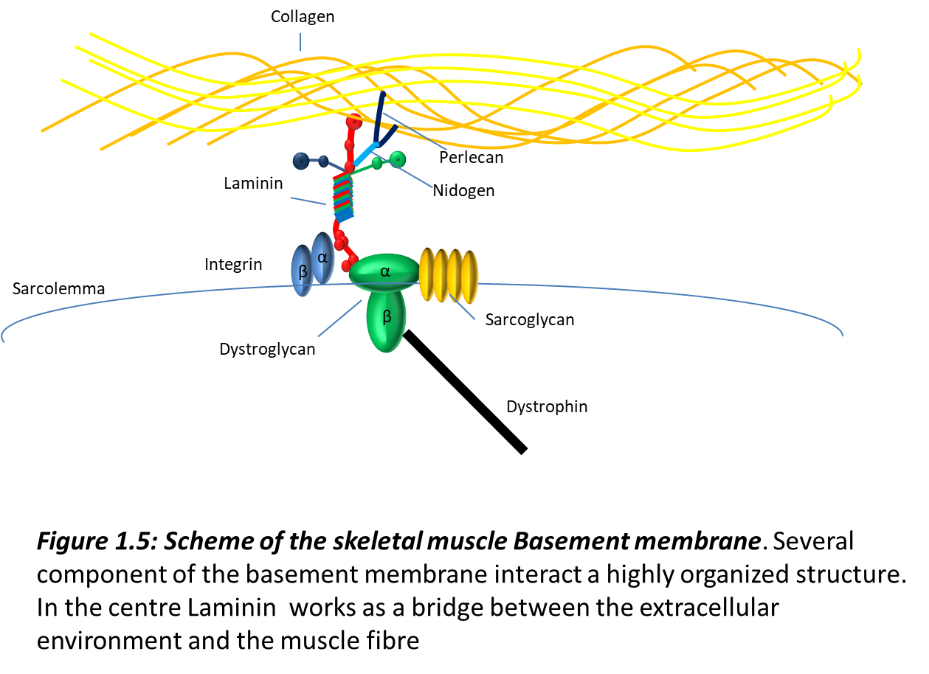
Figure 1.5: Scheme of skeletal muscle basement membrane. The several component of the basement membrane interact to form in a highly organized structure. Laminin works as a bridge between the extracellular environment and the muscle fibre. Adapted from Musculardystrophy.uk

1.6.3 Type IV Collagen anchors the basement membrane to the interstitial Matrix.
One of the main component of BM is collagen IV. It secures the interstitial matrix to the basement membrane and provides the stabilization of the whole basement membrane (Kruegel & Miosge 2010). Collagen IV is a heterotrimer, and currently six different variety have been identified: α1, α2, α3, α4, α5, and α6 (Hudson et al. 1993). Collagen IV is composed usually by two α1, and one α2 subunit. The three subunits assemble forming a triple helix. The N and C end of the chains are formed by non-collagenous domains, usually addressed as NC1. These domains allow the formation of self-assembled networks of Collagen IV (Weber et al. 1984; Pöschl et al. 2004).
It has been observed that the kind of collagen IV present in adult muscles depends on the predominant kind of fibre (slow or fast twitch) (Onofre-Oliveira et al. 2012). Studies on collagen IV demonstrated that basement membrane assembly does not requires collagen IV, but the loss of its expression leads to death during later embryonic development. Furthermore knock out of α1 and α2 leads to embryonic death at E10.5 due to basement membrane instability and non-functioning Reichert’s membrane (Pöschl et al. 2004).

1.6.4 Nidogen (Entactin) acts as a linker in basement membranes.
Nidogen is another important component of the basement membrane (Kruegel & Miosge 2010). Nidogen contains three globular domains, two on the N terminal and one on the C-terminal. These globular regions are linked through a EGF repeat structure (Timpl 1989). Nidogen has the important role to connect collagen IV and laminins in the basement membrane, granting a more firm structure able to resist mechanical stress (Chung & Durkin 1990). The two globular domain on the N-terminal ( G1 and G2) interact with collagen IV, while the single globular domain on the C-terminal (G3) interacts with the Laminin γ subunit (Charonis et al. 2005; Chung & Durkin 1990). Nidogen can also interact with other components of the basement membrane such as perlecan and fibulin (Hohenester & Engel 2002; Sasaki et al. 2004).

1.6.5 Perlecan is a linker molecule in basement membranes

Perlecan is a heavy weight heparan sulphate proteoglycan with 5 functional domains. It is known that Perlecan interacts with nidogen through domain IV and with laminins through domain V. Perlecan can be involved in the regulation of cell behaviour, and has affinity for factors such as Shh and FGF (Melrose et al. 2008; Kruegel & Miosge 2010).

1.6.6 Laminins

1.6.6.1 Laminins: an overview
Laminin is a high molecular weight protein (850 kDa) formed by three subunits α, β, γ (Sasaki et al. 2004). Laminin was isolated at the beginning of 1980 from an Engelbreth-Holm-Swarm sarcoma, a tumour rich in basement membrane deposition (Timpl et al. 1979). Further biochemical studies revealed that Laminin was formed by three different disulphide linked polypeptides (Colognato & Yurchenco 2000). These three subunits, originally named A, B1, and B2, were later renamed α, β and γ chain, respectively. Electron microscopy analysis of purified proteins revealed that the three subunit assemble to form a cross shaped quaternary structure with a long arm of 77 nm, and three short arms one of 48 nm and the other two about 34 nm (Colognato & Yurchenco 2000; Sasaki et al. 2004; Hohenester & Yurchenco 2013).
To date, 11 Laminin genes have been identified in the human genome on chromosomes 1,3,6,7,9,18 and 20. They code for 5α, 3β and 3γ chains (Timpl et al. 2000). A new nomenclature was also adopted naming each Laminin according to their chain composition. For example Laminin-111 is composed of Laminin α1, β1 and γ1 (Malinda & Kleinman 1996; Burgeson et al. 1994).

1.6.6.2 Laminins: from structure to protein-protein interactions

With some differences, all Laminin proteins display a cross-shaped structure (Timpl et al. 2000; Durbeej 2010). The shorter arms of the cross are formed by each of the N-terminal region of the α, β, and γ chains. The longer arm of the cross is a coiled coil structure formed by the C-terminal regions of the α, β, and γ chains. This coiled coil structure is possible as the length of the chains composing the long arm is conserved through the different chains (between 561- and 591 kDa) (Schéele et al. 2007; Durbeej 2010; Domogatskaya et al. 2012). These portions are rich in non-polar amino acids that will fold in an α helix coiled coil organization (Timpl et al. 2000; Tzu & Marinkovich 2008). The β chains have a 31 residues structure that protrudes out of the coiled coil arrangement forming a β knob (Hamill et al. 2009). Being formed by each of the three subunit forming laminin, the coiled coil structure is the region of the protein that confers the specific properties to each Laminin in terms of interaction with receptors (Timpl et al. 2000; Schéele et al. 2007; Domogatskaya et al. 2012). This region is also responsible for the assembly of the Laminin quaternary structure. The first stage of this process involves the assembly of the β and γ chains, subsequently the α chain is added, forming a triple chain structure that will fold into the final α-helix structure (Ekblom et al. 2003; Sasaki et al. 2004). Di-sulphide bridges stabilize the whole structure. At the end of this structure are present 5 Laminin globular domains (LG) (Ekblom et al. 2003). These domains named LG1 to LG5. These 5 LG domains are formed by a 900 residue sequence at the C-terminal of the α chain and are “divided” in two groups: LG1, 2, 3 in one and LG4, 5 is the second (Timpl et al. 2000; Sasaki et al. 2004; Li et al. 2003). The short arm of Laminins is formed by the residues at the N-terminal of the α, β, and γ chains (Malinda & Kleinman 1996) and comprises three domains: the N-terminal domain (LN), the Laminin IV (L4), and the Laminin-type Epidermal Growth Factor-like (LE) (Colognato & Yurchenco 2000; Hamill et al. 2009).
Laminins have a key role anchoring the ECM to the cell surface through binding to cell surface receptors. The Laminin C-term LG domains interacts with receptors, transmitting biochemical and mechanical cues from the extracellular matrix to the cells, while the Laminin N-term domains mediate interactions with other Laminins and components of the ECM to form the meshwork that keeps the ECM together (Timpl et al. 2000; Yurchenco et al. 2004; Sasaki et al. 2004).
LG domains interact with multiple receptors. LG4 and LG5 domains contain sites with a strong affinity for Galactosulphatides, Syndecan, and α-Dystroglycan (Domogatskaya et al. 2012). The study of the group formed by LG1, 2, and 3 demonstrated the high affinity of these domains for Integrins. Different laminin α subunit have different affinities for a small pool of Integrins identified as Integrin α3β1, α6β1, α7β1 and α6β4 (Nishiuchi et al. 2006). It has been observed that Integrin α7β1 has a strong affinity for LG domains of laminin subunit α2 and α5, whereas Integrin α6β1 has a broad affinity with all α chains, and a particular affinity for laminin α1 (Plantman et al. 2008; Nishiuchi et al. 2006). Besides the laminin α chains, integrin binding can be also influenced by β and γ chains, probably regulating the spatial conformation of globular domains involved in the interaction with their receptors (Domogatskaya et al. 2012).
The short branches on the laminin N-terminus contribute to the construction and the arrangement of basement membranes (Yurchenco et al. 2004; Hohenester & Yurchenco 2013). Laminins 111, 211 and 511 interact through the LN domain at the very end of the short arm (Domogatskaya et al. 2012; Hohenester & Yurchenco 2013). The polymeric mesh formed by Laminin is linked to the collagen IV network through the interaction with the heparan sulphate proteoglycans perlecan and nidogen (Sanes et al. 1990; Yurchenco et al. 2004). This interaction is critical to the stability of the basement membrane. Nidogen has been characterized after isolation from EHS sarcoma and has been observed the formation of stable interaction with Laminin-111 (Domogatskaya et al. 2012; Yurchenco et al. 2004; Cheng et al. 1997; Ho et al. 2008). Nidogens shows also a good affinity for two isoforms of laminin γ1 and γ3 (Ho et al. 2008 and and Fig 1.6).
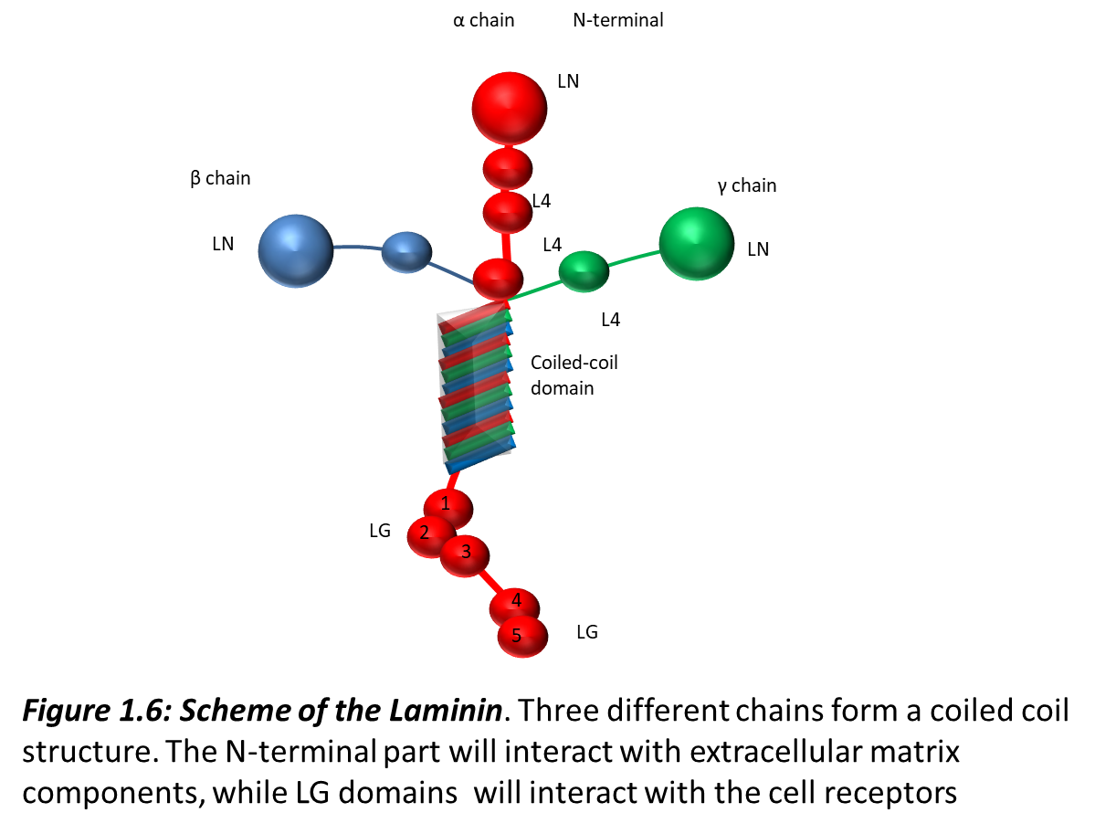
Figure 1.6: Scheme of the Laminin. Three different chains form a coiled coil structure. then-terminal part will interact with extracellular matrix component, while LG domains will interact with the cell receptors. Adapted from Sigma-Aldrich website

1.6.6.3 Laminin distribution
Due to their importance laminins are broadly distributed in adult and embryonic tissues. Laminin α subunits display a differential distribution depending on the kind of tissue. Laminins α1, α3, α5 are usually associated with basement membranes of epithelial tissues, whereas Laminins α2 and α4 are present mostly in mesenchymal and endothelial-derived tissues (Tunggal et al. 2000; Domogatskaya et al. 2012).
Laminins in basement membranes play a fundamental role since the first stages of embryonic development. Laminin-111 and Laminin-511 are present in two essential basement membranes, the extraembryonic membrane known as Reichert’s membrane and the embryonic basement membrane. This membrane grants the correct implantation of the embryo and the connections with the maternal organism (Yurchenco et al. 2004). Laminin-111 can be detected since the morula stage, and can be observed with Laminin-511 during the formation of Reichert’s membrane (Li et al. 2003; Miner & Yurchenco 2004) and the RNA of Lama1 and Lama5, the genes coding for their α subunit is detectable since the 2-4 cell stage (Miner et al. 1997). Due to the broad presence of chains β1 and γ1, mutations in Lamb1 and Lamc1 lead to embryonic lethality. Mutations on LAMA1 genes are lethal as well, leading to embryonic death of Lama1 null mice at E7, due to an impairment in the formation of Reichert’s membrane (Miner & Yurchenco 2004). On the opposite, mice with a Lama 5 gene deletion are able to compensate through Lama 1 over-expression and form a proper basement membrane (Miner et al. 1997; Miner et al. 2004). Lama5 deletion leads to impairments in vascularization and other morphological defects such as digit formation and the correct differentiation of intestinal smooth muscles (Miner et al. 1998; Ritié et al. 2012; Díaz-Mendoza et al. 2013).

1.6.6.4 Expression of Laminins during skeletal muscle development
In skeletal muscles Laminin distribution varies with developmental stage, and in the adult muscle with the area, synaptic or extra synaptic, considered. In the early stages of mouse development, at E9.5, Laminin α1 and Laminin α5 are both deposited in the nascent myotomal basement membrane that separates muscle progenitor cells as they populate the myotome from sclerotomal cells that populate the ventral somite. At E11.5, Laminin α2 becomes detected in the myotomal basement membrane and around nascent muscle fibres and progressively replaces Laminin-111 and Laminin-511 (Patton et al. 1997). Initially, Laminin-511 is present in the basement membrane of skeletal muscle with Laminin-211, while Laminin-111 is progressively limited to the extremities of the myotubes (Patton et al. 1997; Kruegel & Miosge 2010). Before the beginning of the secondary myogenesis, at E14.5, there is a strong upregulation of Lama4 and Lama2, the two genes coding for Laminin α4 and α2 respectively. At stage E15.5 these two laminin Isoforms are the predominant ones in myofibres (Patton et al. 1997). In the peri-natal stage there is a further maturation of the muscle fibres leading Laminin-211 to be the predominant Laminin isoform present in the extra-synaptic basement membrane (Patton et al. 1997; Hohenester & Yurchenco 2013). Other Laminin isoforms can be found at the synaptic basement membrane such as Laminin-221, Laminin-521 and Laminin-421 (Rogers & Nishimune 2017; Pook et al. 2015).
The myotomal basement membrane is not only a scaffold structure separating the myotome and the sclerotome, it functions also as a regulator of myogenic specification and differentiation. The myotomal basement membrane regulates embryonic myogenesis through Laminin-induced Integrin signalling (Anderson et al. 2009; Bajanca et al. 2006; Seo et al. 2006). The inhibition of Laminin-Integrin α6β1 interaction in embryos impairs the migration of myogenic progenitor cells from the dermomyotome and causes their premature differentiation within the dermomyotome (Bajanca et al. 2006). In Shh-deficient embryos, which fail to form a myotomal membrane, myotomal cells maintain the expression of Pax3 gene, fail to exit from the cell cycle and postpone myogenic differentiation (Anderson et al. 2009). Importantly, exogenous addition of Laminin-111 is sufficient to restore patterning and differentiation of myotomal cells in Shh^{-/-};Gli3^{-/-} mutant embryos, which display a milder phenotype than Shh^{-/-} embryos (Anderson et al. 2009). Thus, Laminin-Integrin interaction, in particular with Laminin-111, plays a key role in patterning and controlling muscle progenitor cell fate.

1.6.6.5 Laminin turnover and ECM remodelling: the role of matrix metalloproteinases
The dynamic changes in the composition of the ECM are supported by Matrix Metalloproteinases (MMPs) (Vu & Werb 2000). The original idea of MMPs as mediator of ECM degradation was the observation of the high amount of MMPs in cancer during the formation of metastasis. During this process the ECM is degraded in order to desegregate the physical barrier and allow tumorigenic cells to migrate (Coussens et al. 2002). Nonetheless the activity of MMPs is not limited to the tumour environment, and is broadly involved in the physiological cell activity (Page-McCaw, Ewald, et al. 2007).
Matrix metalloproteases are a large protease family of about 24 proteins with endopeptidase activity, which targets most of ECM components, but also signalling molecules such as growth factors (Morrison et al. 2009). MMPs structure and activity is dependent on the presence of Ca²⁺ and Zn²⁺ (Bode et al. 1993). MMPs are grouped in sub-families, including Matrilysins, Gelatinases, Collagenases, and Stromelysins (Hojilla et al. 2003; Egeblad & Werb 2002). Besides their grouping on the basis of their “main” substrate, MMPs can be classified as secreted or membrane-bound proteins (Kleifeld et al. 2010). The activation of MMPs occurs through the removal of the N-terminal domain by auto-proteolysis or cross-activation by other MMPs, or through the activity of a serine protease (Egeblad & Werb 2002; Hojilla et al. 2003). Furthermore MMP activity can be inhibited through a range of inhibitors. This includes non-specific MMP inhibitors, such as α2-macroglobulin, which triggers the endocytosis of MMPs promoting their binding to scavengers receptors (Sottrup-Jensen & Birkedal-Hansen 1989). A second class of MMP-specific inhibitors, known as Tissue Inhibitors of Metalloproteinases (TIMPs), has key function in the balance of MMP activity (Hoegy et al. 2001; Iyer et al. 2012). Loss in the equilibrium between MMPs and inhibitors can lead to pathologies like cancer, cardiovascular diseases and arthritis (Martignetti et al. 2001; Page-McCaw, Ewald, et al. 2007).

2 Materials and methods

2.1 Mouse models
2.1.1 C57BL/6 mice

6 to 8 week-old adult mice were maintained in accordance with the UK Home Office regulation and the UK Animal Act of 1986 (ASPA) under a UK Home Office licence. All mouse lines were kept on a C57BL/6 background, referred also as wild-type (WT) mice. Animal care and husbandry were carried out at Biological Services at The University of Sheffield.
2.1.2 Tg(Sox2Cre) mice

In Lama^{flox/flox} mice, the first exon of Laminin α1 gene and the transcription starting site were flanked by loxP-FRT PGK neomycin selection cassette in the first intron and, in the 50 region by loxP site. The deletion of the first exon causes loss of Lama1. (Alpy et al. 2005). Sox2 promoter was controlling the expression of Cre recombinase (Edwards et al. 2010). Lama1^{flox/flox};Sox2Cre mice were generated crossing Lama1^{flox/flox} mice with Lama1^{flox/+};Sox2Cre/+ mice. Linked to the described angiogenesis-promoting function of Ln-1, Lama1^{Δ/Δ} show impaired retinal vascularization,and a reduced weight at birth (Dixelius et al., 2004).

2.1.3 Pax7CreERT2-Lama1flox/flox mice

A second mouse line has been generated, carrying the inducible Cre recombinase under the control of Pax7 promoter. In this mouse line the deletion of the first exon of Lama1 gene is restricted to satellite cells, and can be triggered upon Tamoxifer administration protocol (Lepper et al. 2011).
Lama1^{flox/flox};Pax7Cre^{ERT2/+} mice, referred here as Lama1/Pax7Cre, were generated by crossing Lama1^{flox/+};Pax7CreERT2/+ mice with Lama1^{flox/flox} mice.
2.1.4 Pax7GFP mice
A Tg:Pax7-GFP mouse line was used. The nGFP reporter in this mouse line the nGFP reporter was introduced in Pax7 gene fist exon. The Tg:Pax7-GFP mouse is the one described in (Sambasivan et al., 2009).

2.1.5 Induction of recombination
In these mouse strains, Tamoxifen (TM, Sigma-Aldrich) (10mg/ml diluted in corn oil; Sigma-Aldrich) was administered by intraperitoneal (IP) injections at a dose of 3mg/40g of body weight daily for 4 days before injury. Subsequently, mice were fed with TM chow (approximately 40 mg/kg/day; Harlan Laboratories) until sacrifice.

2.1.6 Genotyping

The genotyping was performed on tissue samples harvested from the ears of mice. The ear clips were digested in 10mM NaOH, heat treated at 95° C for 30 minutes, and treated with 1M Tris buffer (pH 8.0). DNA was precipited with amonium acetate and ethanol.

Table 1 List of primers for PCR

 | Forward | Reverse
Laminin a1 floxed | 5’-GGCTGCACTAGGTAGAGTTTGAACGTACAG-3’ | 5’-GATGCTGCCCTGGTTGGTCTTGAATTTATG-3’
Laminin a1 floxed | 5’-CCTCGGGGATTGCTTTACAACTAACAATGT- 3’ | 5’-CTCGAGGTCGACGGTATCGATAAGCTTCGA-3’
Laminin a1 delta | 5’-GAACAGCAAGTGTTTTAAGCCCCTAAACCC-3’ | 5’-GGCTGCACTAGGTAGAGTTTGAACGTACAG-3’

 | Forward | Reverse
Tg(Sox2-cre) | 5’-GCATTACCGGTCGATGCAACGAGTGATGAG-3’ | 5’-GAGTGAACGAACCTGGTCGAAATCAGTGCG-3’
Pax7^{CrE} | 5’-ACTAGGCTCCACTCTGTCCTTC-3’ | 5’-GCAGATGTAGGGACATTCCAGTG3’
Tg:Pax7-GFP | 5’-CCACACCTCCCCCTGAACCTGAAACATAAA-3’ | 5’-GAATTCCCCGGGGAGTCGCATCCTGCGG-3’

2.2 Single myofibres culture system
2.2.1 Harvesting EDL and TA muscles
Tibialis anterior (TA) and Extensor Digitorum Longus (EDL) muscles were used as muscle samples.
Tibialis Anterior muscles were used for cryosectioning and EDL muscles were used for the isolation of single fibres. C57BL/6 EDL muscles for single fibres cultures were harvested at 6 to 8 weeks of age, whereas Lama^{flox}/Sox2Cre and Lamaflox/Pax7Cre/Pax7GFP muscles were harvested at 8 weeks of age, as at this age the latest postnatal muscle formation is complete. Mice were killed by cervical dislocation under Schedule 1 protocol, and leg fur sprinkled with 70% Industrial Methylated Spirit IMS to clean the skin and facilitate the subsequent hair removal. Hair was shaved with a scalpel, exposing the skin. To expose the muscles beneath, the skin was cut and removed. The same procedure is performed on the paw skin, to uncover the distal TA and EDL tendons. The mouse is then pinned on styrofoam board under a dissection stereomicroscope. In order to avoid mechanical stress to the muscles during the removal, the fascia layer covering the muscle mass is loosen and removed with the help of forceps. The distal EDL and TA tendons are cut and pulled out at the level of the ankle. While the four distal tendons of EDL are kept in position with a forceps, the TA tendon is gently pulled, lifting the TA muscle and exposing the EDL beneath. The proximal tendon of TA is cut close to the patella, and the TA muscle is fully removed and set aside for further procedure. The longer and thinner distal EDL tendons are pulled, and after the proximal EDL tendon recision, the EDL muscle is removed and placed in freshly made collagenase.

2.2.2 Isolation of single muscle fibres from EDL
The EDL muscle isolated as described above is digested to isolate single muscle fibres with two sequential steps: an enzymatic digestion and a mechanical isolation of fibres.
The enzymatic digestion is carried out at 37°C in a solution of 0.2% Collagenase type I (Sigma-Aldrich) in Dulbecco Modified Eagle Medium (DMEM)+Glutamax with 1% Penicillin-streptomycin-fungicide (PSF; Sigma-Aldrich). Freshly isolated EDL muscles are placed in the digestion solution and incubated for 60-90 minutes at 37°C and 5% CO₂. The mechanical isolation of fibres is performed using a glass Pasteur pipette, cut with a diamond cutter, in order to obtain a bore large enough to allow the EDL muscle to pass through. The glass pipette is hovered over a Bunsen beak to blunt the sharp edges. The pipette is coated with a 5% Bovine serum albumin (BSA) in PBS to prevent fibres from sticking to the glass wall. Mechanical digestion is performed in 60mm Petri dishes coated with 5% BSA, containing isolation media pre-warmed at 37°C. The EDL muscle is flushed through a large pipette to mechanically help the release of single fibres. Single muscle fibres are then transferred to a second dish for washing. The washing step is repeated three times to ensure that all non-muscle cells and connective tissue are discarded. From each EDL it is possible to isolate an average of 200 fibres. Isolated single fibres are immediately fixed in 4% Paraformaldehyde for 5 minutes at room temperature and are considered as time point 0 hour.

2.2.3 Single muscle fibre culture
Freshly isolated muscle fibres are then cultured in 5% BSA-coated Petri dishes containing DMEM supplemented with 10% horse serum , 0.5% chick embryo extract (Seralab) and 1% Penicillin-Streptomycin-Fungizone PSF at 37°C in 5% CO₂ for 24, 48 and 72 hours (Zammit et al. 2004). At the end of the culture period, fibres are collected in an Eppendorf tube, fixed in 4% PFA for 5 minutes, washed twice with PBS, and processed for analysis or stored at 4°C for no more than two weeks. For each experimental condition it was analysed a minimum of 30 fibres.

2.2.3.1 Treatment with exogenous Laminin-111 and CD49f antibody and MMPs inhibitors in myofibre cultures

Myofibres were incubated with 30μg/ml of Laminin-111 (EMD Millipore CC095), or 30μg/ml of Integrin α6 blocking antibody (CD49f) (clone GoH3 MCA699) for the indicated times. The inhibition of MMPs was performed through the administration of ARP-100 and Marimastat. For each experimental condition it was analysed a minimum of 30 fibres.

2.3 Immuno-histochemistry on single EDL myofibres
Fixed single myofibres were permeabilised in 0.5% Triton-X100 for 8 minutes, washed three times and blocked for 20 minutes in 500μl of 20% horse serum in PBS. Fibres were then incubated with the appropriate primary antibody diluted in PBS overnight at 4°C. Excess of antibody was washed in 0.025% Tween 20 in PBS. Fibres were then incubated with the secondary antibody for 1 hour at room temperature. Stained single muscle fibres were subsequently washed three times with triton in Phosphate-buffered saline PBST, placed on a microscope slide, and mounted with Dapi Vectashield (Vector Laboratories) for counting and imaging.
2.5 Muscle transverse sections
2.5.1 Freezing and cryosectioning muscles
TA muscles were harvested as described previously and fixed for 1h at 4°C in 2% PFA with 0.25% Triton 100-X in PBS. After at least 3 washes in PBS at 4°C, muscles were incubated in 20% sucrose in PBS overnight at 4°C. For embedding, muscles were dipped in OCT compound (VWR Chemicals) and immediately plunged in Isopentane cooled in liquid nitrogen until completely frozen. Frozen TA muscles were stored at -80°C.
TA muscles were then prepared for sectioning on a Bright cryostat. TA were mounted in OCT on a metal chunk cooled at -40°C, and transverse sections (8-10 μm thickness) were collected on Superfrost slides (Thermo Scientifc) and air dried at room temperature for 2 hours. In order to screen the condition of the muscle on each slide were 12 sections 200µm apart. Slides were then stored at -20°C

2.4.2 Hematoxilin and eosin (H&E) staining
Muscle sections were air dried room temperature for 30 minutes and re-hydrated for 1 hour in PBS. Muscle sections were then stained for 5 to 10 minutes in 1% eosin in methanol, rinsed in tap water, incubated for 5 minutes in haematoxylin and rinsed in tap water. Slides were incubated for 5 minutes in an ethanol series (70 to 100%). Slides are then cleared in xylene for 20 minutes and mounted with DPX mountant.

2.5.3 Immunoﬂuorescence of muscle sections
Muscle sections were air dried at room temperature for 30 minutes and hydrated for 5 minutes in PBS. Slides were then permeabilized and blocked for one hour in 5% BSA, 1% foetal bovine serum (FBS), 1% heat-inactivated goat serum and 0.5% Triton 100-X in PBS. Muscle sections were incubated with primary antibodies diluted in PHT (PBS with 1% heat-inactivated goat serum and 0.5% Triton 100-X) in a humidified chamber overnight at 4°C. Sections were then washed with PHT three times for five minutes and incubated with secondary antibodies diluted in PHT for 45 minutes at room temperature. Following three washes in PHT slides were mounted in Vectashield with DAPI.
Table 2 List of primary and secondary antibodies used

Name | Host | Reference | Supplier | Dilution
Pax7 | Mouse monoclonal | Pax7 | DSHB | 1:20
Myf5 | Rabbit polyclonal | sc-302 | Santa Cruz | 1:1000
MyoD | Rabbit polyclonal | sc-304 | Santa Cruz | 1:2000
Caveolin1 | Rabbit polyclonal | sc-894 | Santa Cruz | 1:400
Myogenin | Rabbit monoclonal | F5D | Santa Cruz | 1:50
Myogenin | Mouse monoclonal | F5D | DSHB | 1:50
MMP9 | Goat | sc-6841 | Santa Cruz | 1:300
GFP | Chicken | ab13970 | Abcam | 1:600
Ki67 | Rabbit polyclonal | Ki67 | Leica | 1:300
Laminin α1 | Rat monoclonal | Mab2000 | Gift Durbreej laboratories | 1:1
Laminin α2 | Rat monoclonal | mAb(4H8-2) | Enzo | 1:300
Par3 | Rabbit polyclonal | Par3 | Fisher-scientific | 1:1000
Collagen I | Rabbit polyclonal | AB765 | Millipore | 1:300
Pan laminin | Rabbit monoclonal | L9393 | Sigma-Aldrich | 1:100
Alexa 594 anti-mouse | Goat | A11005 | Life Technologies | 1:500
Alexa 594 anti-rabbit | Goat | A11037 | Life Technologies | 1:500
Alexa 488 anti-rabbit | Goat | A11034 | Life Technologies | 1:500
Alexa 488 anti-chicken | Goat | A11039 | Life Technologies | 1:500
Alexa 488 anti-rat | Donkey | A21208 | Life Technologies | 1:500
Alexa 633 anti-rabbit | Goat | A21070 | Life Technologies | 1:500

2.4.4 Imaging
Slides stained for haematoxylin and eosin were observed and photographed with a Leica DMR upright microscope. Slides treated for immunofluorescence were observed on a Olympus BX51 microscope with X-cite 120 illumination system (EXFO, Quebec, Canada) and photographed on a Zeiss Apotome with ZEN pro imaging system. Images were processed and analysed (cross-sectional area (CSA) and cell counting) with ImageJ and Photoshop software.
2.4.1 ImageJ picture processing
Pictures of muscle sections stained for Laminin were split into the different colour component, converted to a black and white 8 bit image, and the outlines of muscle fibres were contoured one by one using the pencil tool. The inner area of fibres was then converted to black. The scale was set as 0,3095 µm/pixel as a standard for every image analysed. (This value is the exact conversion for 20x pictures). The program was then instructed to evaluate the black particles bigger than 150 µm, as smaller particles cannot be considered as muscle fibres.
Pictures of muscle sections stained for collagen were split in the different colour component, converted to a black and white 8 bit image, and the positive signal was converted to black pixels, while the background was converted to white. The scale was set 1 pixel/pixel as a standard for every image analysed. The sum of all black particles was then compared with the full dimension of the pixel expressed in squared pixels.

2.4 Model of muscle injury in vivo
2.4.1 Cardiotoxin-mediated muscle injury
Mice were anaesthetised and maintained in anaesthesia condition with Isoﬂurane (IsoFlo, Abbott) as suggested by home office guidelines. The left TA muscle was injured, injecting with insulin syringe, 50µl of Cardiotoxin (CTX) (10µM in PBS) from Naja mossambica (Latoxan). CTX injured and contralateral muscles were harvested at the designated time points after injury. Multiple round of injury protocol was performed injuring the left TA muscle as described before and repeating the procedure every 21 days for three times. 14 days after the last injury TA muscles were harvested as described before.

2.4.2 Feret measurement of fibre diameter
The Feret diameter is an evaluation parameter used to measure object with irregular shape. In this case my analysis of fibres cross-section was based on the minimal feret diameter, the smallest of all the possible diameters describing an individual fibre. This kind of measure allows eliminating wrong measurement or artefact due to an imperfect sectioning of the muscle sample. For each mouse a minimum of 12 sections were analysed from injured TA, and at least 4 fields per section.
2.4.3 Statistical analysis
The statistical analysis of data was performed using Prism software. The raw data of the experiments were saved on excel files. Unless specified differently, the average of 3 biological replicate experiments (n=3). Each single biological replicate was performed on control and tested populations (for the analysis on mutant mice for each “n” I have analysed one mutant, one heterozygous, and one control mouse, for treated fibres Laminin-111 or CD49f antibody and control fibres). For each fiber experiment I have analysed 4 time point (0,24, 48, 72h), and for each time point I have counted the cell population from at least 15 fibres. Standard deviation were calculated on excel and the outcomes were analysed on Prism software with a non-parametric one-way Anova test. The averages and STDEV of these 15 fibres were considered as n=1. This procedure has been repeated on other mice with the same characteristics in order to reach an n=3. The average and the STDEV of these 3 replicated experiments have been calculated using prism software dividing the values for genotype, time point, and cell populations. The population have been compared using a one-way Anova test.
For histological analysis, for each condition were analysed at least 12 sections. To obtain a complete observation of the muscle, sections were 200µm apart, and at least 2 to 3 field of view were analysed for each section.
For single fibres a minimum of 15 fibres were analysed for each condition for every mouse. These numbers ensured significative numbers for a statistical analysis even for an n=3.
Collagen evaluation was performed calculating Collagen positive pixel using ImageJ software and then confronting this value with the total amount of pixel present in the pictures analysed.
The distribution of fibres diameter was divided in ranges of dimensions and the statistical analysis between control ad subjects of investigations was performed comparing the distribution of frequency of fibres in each range of diameter.

3 Matrix Metalloproteinases mediate the remodelling and the incorporation of Laminin-111 at the satellite cell basement membrane

3.1 Introduction

In previous work from our lab the presence of Laminin-111 in the basement membrane overlying activated satellite cells has been observed. The presence of an embryonic isoform of Laminin in an adult tissue is a novel observation. In a different investigation, we also observed the presence of Matrix Metalloproteinases (MMPs) in activated satellite cells. Matrix Metalloproteinases and Laminins are both implicated in extracellular matrix turnover, as the former can degrade the latter, which is a main component of the extracellular matrix. The extracellular matrix plays an important role in the control of stem cell activity. Extracellular matrix is responsible for the control of cell quiescence, cell proliferation and cell migration (Morrison & Spradling 2008; Rozario & DeSimone 2010), which are fundamental processes in the life of stem cells. This suggests that the stem cell niche, an environment that supports stem cell activity (Morrison & Spradling 2008; Ahmed & Ffrench-Constant 2016), is likely to comprise the extracellular matrix.
Satellite cells are the stem cells specific for the adult skeletal muscle tissue. The peculiar position of these cells, sandwiched between the muscle fibres and the basement membrane surrounding the single fibre, suggests the importance of the extracellular matrix for the efficient activity of these cells. Nonetheless, the influence of the basement membrane on the satellite cells activity is still poorly understood.
It has been showed that during demanding muscle activity, such as vigorous physical movement, the transcription and the expression levels of Matrix Metalloproteinases increase (Barnes et al. 2009; Kherif et al. 1999). In particular, three members of the Matrix Metalloproteinase family have been reported as linked to adult skeletal muscle tissue during regeneration and repair: MMP-2, MMP-9 and MMP-14 (Barnes et al. 2009). The upregulation of these proteins is associated with degenerative pathologies such as muscular dystrophies, nerve injury and hearth failure (Madden et al. 2011; Kherif et al. 1999). Southern blot analysis and zymography on whole muscle extract showed that MMP-2 has a constitutive expression, whereas MMP-9 is expressed and transcribed only upon stimulation of muscle regeneration. MMP-9 is induced 24 hours post injury (CTX injection), and upregulated for the first 3 days after injury. MMP9 is subsequently downregulated from 4 to 7 days after damage. This evidence is based on studies of whole muscles and muscle sections, and is not focused on satellite cells. Therefore, other cell populations expressing MMP9, in particular macrophages, are likely to constitute the core of the observations previously reported (Kherif et al. 1999).
In 1983 Gulati hypothesised that the expression of MMPs could be related to ECM remodelling (Gulati et al. 1983b). Despite the numerous studies investigating MMPs, MMP-2 and 9 in particular, the source of these proteases is still uncertain. Many studies demonstrate a direct relation with macrophages, and bone marrow related cells, such as lymphocytes and neutrophils (Iyer et al. 2012; Nissinen & Kähäri 2014; Wang et al. 2009). However, it remains unknown whether satellite cells are able to provide endogenous MMPs and whether MMPs are involved in the remodelling of the basement membrane overlying activated satellite cells.

3.1.1 Hypothesis and aim

In previous work from our lab (Shantisree Rayagiri Ph.D. thesis) we observed the presence of Laminin-111 at the basement membrane overlying activated satellite cells. My hypothesis is that the incorporation of Laminin-111 in the basement membrane of activated satellite cells results from a remodelling process mediated by MMP2 and MMP9, two gelatinases expressed in the muscle tissue.
The aim of this chapter was to study the role of the remodelling of the muscle basement membrane in relation with myogenesis, and understand how the Matrix Metalloproteinase activity is linked to Laminin-111. I focused on the function of MMP-9 as it is shown to be upregulated during muscle regeneration, in a transient way (Shiba et al. 2015). To address this hypothesis, I used the single muscle fibre culture system. This approach allows us to observe satellite cells in their niche, in the absence of other cell populations like macrophages. I used this approach, combined with the use of inhibitors of MMPs, to understand how MMPs control satellite cell activity, and the role of MMPs in the remodelling of the basement membrane during myogenesis.

3.3 Results

3.3.1 Ex-vivo characterization of MMP9 activity during myogenesis
Single fibre culture is an ex vivo tool useful to gain insight in the molecular mechanisms controlling adult myogenesis. Single fibres isolated from the extensor digitorum longus (EDL) of 8-10 week-old C57BL/6 mice were cultured for 72 hours and harvested at 0, 24, 48 and 72 hours (Fig. 3.1). Fibres were then analysed by immunofluorescence using antibodies directed against MMP9 and Pax7 or MyoD, in order to follow the different cell populations during adult myogenesis (Fig. 3.1; a, b, c, d).
At 0 hours, in freshly isolated fibres (Fig. 3.1; a), it is possible to count 5 to 6 satellite cells per fibre. Satellite cells are usually not activated and positive only for Pax7, which is a transcription factor expressed exclusively by satellite cells (Seale et al. 2000a). Pax7 is used to identify satellite cells at early stages of myogenesis, but it is downregulated from 48 hours onwards in cells that are in later phases of differentiation. Usually very few cells (<10%) are positive for early myogenesis markers such as Myf5 at 0 hours. In the first 24 hours of culture, quiescent satellite cells become activated and enter the cell cycle, and upregulate the expression of the myogenic transcription factor Myf5. Activated satellite cells show modification in their shape, becoming rounder and bigger than the narrower quiescent ones. At this stage it is still possible to count 5 to 6 satellite cells per fibre, as the first cell division has not occurred yet. At this time point 90% of satellite cells are co-expressing Pax7 and Myf5. Only 10% of satellite cells are negative for Myf5 (Fig. 3.1; b).
Between 24 and 48 hours in culture, satellite cells will finish a single long cell cycle, concluded with their first division, usually around 42 hours in culture, and will start shorter cell cycles of division (Siegel et al. 2009). 48 hours represents the proliferation step. Therefore, at this stage an increase in the number of satellite cells per fibre occurs, as we can count an average of 25 cells per fibre. Usually about 85% of satellite cells are expressing both Pax7 and MyoD (Zammit et al. 2002). The remaining cells are positive for MyoD only, or Pax7 only (respectively 9% and 6% of the whole population. Fig. 3.1 ). The population of satellite cells not expressing MyoD comprises two sub-populations: one population shows a delay in myogenesis, the second one is likely to have downregulated MyoD. This latter population represents the self-renewing population of satellite cells (Fig. 3.1; c, e, f).
The pool of satellite cells that has not reverted to quiescence will engage into differentiation. After 72 hours in culture, satellite cells have divided multiple times, and clusters of cells are visible on the fibres (Fig. 3.1 d). Differentiating satellite cells express Myogenin, and downregulate Pax7 (Zammit et al. 2004). At this time point the identification of satellite cells relies on Caveolin, another satellite cell marker. This adhesion molecule is usually present on the surface of quiescent satellite cells (Gnocchi et al. 2009). Caveolin was selected as Satellite cell marker to allow Myogenin staining, as Myogenin and Pax7 are prepared in the same host. While Myogenin marks nuclei, Caveolin marks the cell surface. At 72 hours in culture, the majority of satellite cells (51%) are double positive for Myogenin and Caveolin (Myogenin+/Caveolin+),while the 40% of the cell population is expressing only Caveolin (Myogenin-/Caveolin+). Within this population is present a pool of satellite cells with a delayed expression of the differentiation marker, and a pool of satellite cells that returned to quiescence. Finally, a small number of satellite cells (8%) express only Myogenin. This population is composed of differentiated satellite cells (Fig. 3.1; d, e, f).
In my investigation on the relation between myogenesis and MMP9, I have performed a double immunofluorescence staining for Pax7 and MMP9 to identify satellite cells at all time point, and a double immunofluorescence staining for MyoD and MMP9 to observe how differentiating and proliferating satellite cells relate with Matrix metalloproteinases (Fig. 3.2). In these two double staining, as described before, at time point 0 satellite cells are not yet activated. Satellite cells are positive for Pax7 only, but not for MyoD. At this time point satellite cells are also negative for MMP9 (Fig. 3.2; a, e).
After 24h in culture activated satellite cells begin expressing MMP9. The signal from MMP9 is a dot shaped staining surrounding the nucleus of activated satellite cells. Pax7/MMP9 double immunofluorescence allows the identification of a population of satellite cells (about 20%) that are not expressing MMP9 yet (Fig. 3.2; b, f, i, j). This result matches with the amount of MMP9 negative cells in the MMP9/MyoD staining, as it is possible to observe again that about 20% of MyoD positive cells that are not expressing MMP9.
At 48 hours, 100% of satellite cells are positive for MMP9 (Fig. 3.2; c, g, i, j). The signal surrounds the nuclei of proliferating satellite cells, shaping the outline of the basement membrane overlying the cells.
At 72 hours, MMP9 seems to be present outside the nuclei of 100% of satellite cells, in a shape that conveys the impression of continuity between one cell and the other suggesting the outline of the basement membrane (Fig. 3.2; d, h, i, j).
Taken together, these observations indicate that activation of satellite cells is associated with MMP9 upregulation. MMP9 is not detected in quiescent satellite cells; however, subsequently to the satellite cell activation and the expression of MyoD, 80% of the satellite cells express MMP9.

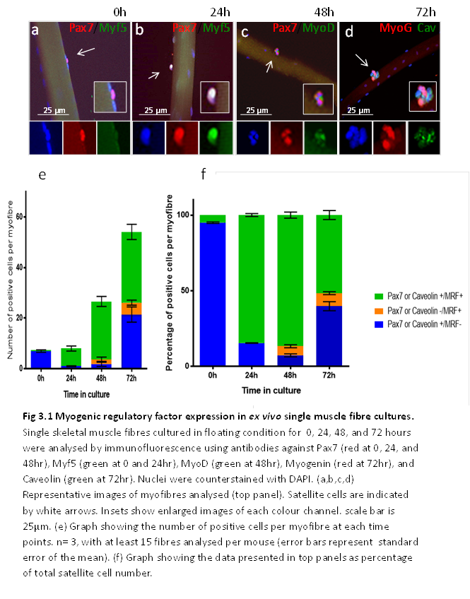
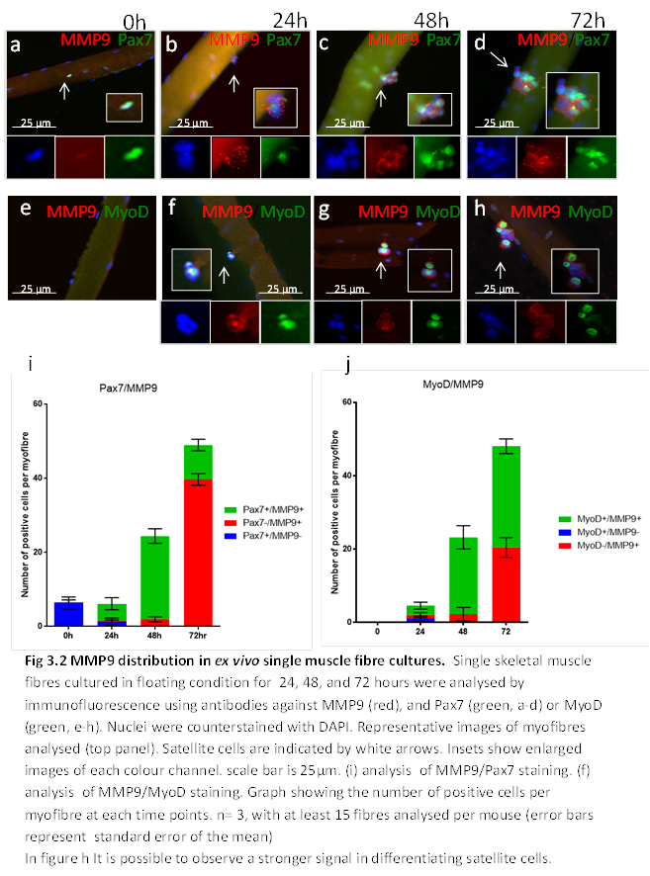

3.3.2 Inhibiting MMP9 impairs Laminin-111 deposition into the basement membrane.
With this first experiment I have described how MMP9 has a transient expression during myogenesis, showing to be strongly expressed upon satellite cell activation. Thus, MMP9 and Laminin α1 are expressed in activated satellite cells with a similar time pattern: both proteins are expressed within 24 hours of myofibre culture following the activation of satellite cells. Therefore, I asked whether the inhibition of MMP9 could inhibit the remodelling of the basement membrane and the deposition of Laminin-111.
Two different inhibitors were used to investigate a potential role of MMPs of the gelatinase family in the incorporation of Laminin-111 into the basement membrane: ARP-100, and Marimastat. Arp-100 below the concentration of 50nM has an inhibitory activity specific for MMP2 (Rossello et al. 2004) . Marimastat, on the opposite, is a broad-spectrum inhibitor, blocking the activity of MMP2 and MMP9 but also MMP1, 7, and 14 (Rasmussen & McCann 1997).
Satellite cells were cultured for 0, 24, 48 and 72 hours (Fig. 3.3) and examined by immunofluorescence for Laminin α1 and an MRF marker, depending on the time point.
Satellite cells fixed at 0 hour showed no Myf5 and no Laminin α1 expression, as previous experiments showed (Fig. 3.3; a). Most satellite cells in single fibres cultured for 24 hours are activated and express Laminin α1 in control conditions (Fig. 3.3; b). In contrast, satellite cells cultured in the presence of inhibitors (both ARP-100 and Marimastat) show little or no Laminin α1 immuno-detection (Fig. 3.3; c, d). By 48 hours, satellite cells are proliferating and display Laminin α1 deposition into the basement membrane surrounding satellite cells in DMSO control (Fig. 3.3 b-d). In contrast, the inhibition of MMP2 using ARP-100 leads to a moderate reduction of Laminin α1 deposition, while the inhibition of MMP2 and MMP9 with Marimastat causes a strong loss of signal for Laminin α1 (Fig. 3.3; f, g; white arrows). Similar observations are made during the differentiation of satellite cells (72 hours). In fibres cultured with Marimastat, Laminin α1 deposition into the basement membrane overlying satellite cells is strongly inhibited compared to fibres cultured in the presence of ARP-100 (Fig. 3.3; i, j). These observations confirm that MMP expression correlates with the incorporation of Laminin α1 into the basement membrane, and show that the combined action of the gelatinases MMP2 and 9 catalyzes a local remodelling of the basement membrane following satellite cell activation, allowing for the deposition of Laminin-111.
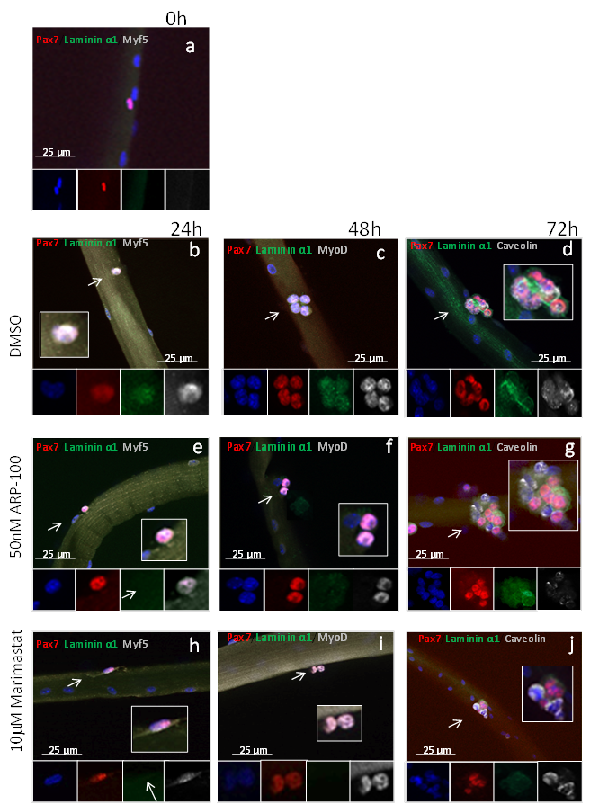
Fig 3.3. Effects of MMPs inhibition on satellite cells in ex vivo single fibre cultures. Single skeletal muscle fibres cultured in floating conditions for 0, 24, 48, and 72 hours and incubated with DMSO as control or ARP-100 50 nM, or Marimastat 10 μM were analysed by immunofluorescence using antibodies against Pax7 (red), Laminin α1 (green) and MRF according to the time point (grey). Nuclei were counterstained with DAPI.
Representative images of myofibres analysed (top panel). Satellite cells are indicated by white arrows. Insets show enlarged images of each colour channel. scale bar is 25μm Satellite cells harvested at 0h (a) show no activation and no expression of Laminin α1.
After 24 hours in culture, satellite cells are activated, as demonstrated by the expression of Myf5 (b,c, d). Activated satellite cells incubated with ARP-100 (c) or Marimastat (d) show an impairement in Laminin α1 incorporation into the basement membrane, compared with control fibres (b).
After 48 hours in culture, (e,f, g), satellite cells are proliferating, and if incubated with DMSO are able to incorporate correctly Laminin α1(e). Incubation with ARP-100 (f) leads to a moderate decrease in the detection of Laminin α1 (white arrow); treatment with Marimastaat (g) leads to a strong decrease of the incorporation of Laminin α1 (white arrow) in the basement membrane.
At 72 hours (h, i, j), satellite cells are differentiating and incorporated Laminin α1 in the basement membrane in the presence of DMSO (h). Incubation with ARP-100 (i) leads to a moderate decrease in the signal from Laminin α1 (white arrow); treatment with Marimastaat (j) leads to a strong decrease of the incorporation of Laminin α1 (white arrow) in the basement membrane.
(n=3, at least 15 fibres analysed for each condition, non-parametric one-way Anova test on average of each replicate.)

3.3.3 MMP inhibition impairs satellite cell-mediated myogenesis

To further investigate the effect of basement membrane remodelling on satellite cells, I analysed the myogenic program of satellite cells from single fibres cultured for 24, 48 and 72 hours in the presence of DMSO (control), ARP-100 50 nM or Marimastat 10μM (Fig. 3.4). Satellite cells on fibres cultured with DMSO for 24 hours show a normal activation, as about 100% satellite cells are positive for Pax7 and Myf5 (Fig. 3.3b). Fibres cultured in the presence of Marimastaat show a significant reduction in the number of activated satellite cells (Fig. 3.4; h, k) (5.6 ± 0.02 cells Pax7+/Myf5+ in DMSO, 3.5 ± 0.4 in Marimastaat; p=0.0089). The activation of satellite cells in fibres incubated with ARP-100 is statistically comparable to control fibres (Fig. 3.4; e, k). After 48 hours in culture, a reduction in the total number of satellite cells is observed in fibres cultured in the presence of inhibitors (Fig. 3.4). Although the population of Pax7+/MyoD- and Pax7-/MyoD+ is comparable between treated and control fibres, I observed a reduction in the population of proliferating satellite cells. Treatment with ARP-100 resulted in a mild, but significant reduction in Pax7+/MyoD+ cells (25.5 ± 0.4 cells Pax7+/MyoD+ in DMSO, 20.3 ± 1.1 in ARP-100; p=0.0115). Marimastaat treatment caused a strong reduction in the number of proliferating satellite cells (25.5 ± 0.4 cells Pax7+/MyoD+ in DMSO, 13.1 ± 0.5 in Marimastaat; p < 0.0001) (Fig. 3.4; c, f, i, k). By 72 hours in culture, fibres cultured in DMSO had large clusters of proliferating cells, whereas fibres cultured in ARP-100 or Marimastaat had smaller clusters (Fig. 3.4). Compared with control fibres, ARP-100-treated fibres showed a moderate reduction in the pool of Caveolin only positive cells (28.6 ± 0.7 cells Myogenin-/Caveolin+ in DMSO, 21.5 ± 1.1 in ARP-100; p=0.005) and in the number of Caveolin+/Myogenin+ differentiating cells (36.1 ± 2.4 cells Myogenin+/Caveolin+ in DMSO, 26.4 ± 0.4 in ARP-100; p=0.0182). In the presence of Marimastaat, the decrease in the number of Caveolin positive cells (28.6 ± 0.7 cells Myogenin-/Caveolin+in DMSO, 9.1 ± 0.6 in ARP-100; p=0.0006) and in the number of Caveolin+/Myogenin+ cells (36.1 ± 2.4 cells Myogenin+/Caveolin+ in DMSO, 13.5 ± 1.6 in ARP-100; p=0.0016) was considerable (Fig. 3.4; d, g, j, k).
Taken together, these data demonstrate that inhibition of MMPs, which prevents basement membrane remodelling and deposition of Laminin-111, impairs myogenesis. This observation suggests that MMPs play a fundamental role in the correct progression of satellite cells through myogenesis.

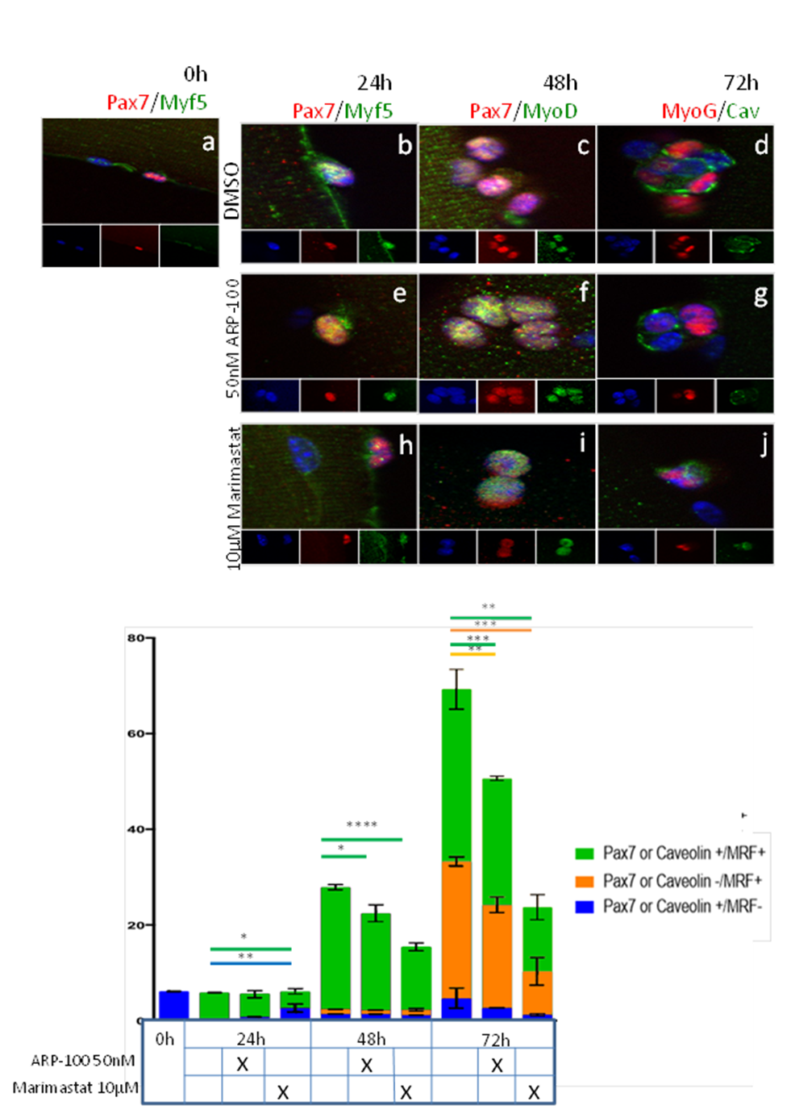
Number of positive cells per myofiber
Fig 3.4 Effects of MMPs inhibition on satellite cell-mediated myogenesis in ex vivo single muscle fibre cultures. Single skeletal muscle fibres cultured in floating condition for 24, 48, and 72 hours were incubated with DMSO as control (a-d) or ARP-100 (e-g), or Marimastaat (h-j) x axis represents the number of positive cells for each population. Fibers were analysed by immunofluorescence using antibodies against Pax7 (red at 0, 24, and 48hr), Myf5 (green at 0 and 24hr), MyoD (green at 48hr), Myogenin (red at 72hr), and Caveolin (green at 72hr). Nuclei were counterstained with DAPI.
k. Graph showing the number of positive cells per myofibre at each time points. n= 3, with at least 15 fibres analysed per mouse (error bars represent standard error of the mean; * represents p-value<0,05; ** p-value<0,01; *** p-value<0,001; **** p-value<0,0001, non-parametric one-way Anova test on average of each replicate.).

3.4 Discussion

3.4.1 Matrix Metalloproteinases are produced by activated satellite cells.
Cells are constantly exposed to multiple stimuli dependent on the external environment. In particular, the ECM undergoes continuous remodelling to adapt to changes in the external micro-environment. Currently, the consequences of ECM remodelling on cell activity and function are poorly understood (Solomonov et al. 2016). Matrix metalloproteinases (MMP) are a family of related proteins, whose function is to cleave proteotically components of the extracellular matrix, growth factors, and MMP or MMP inhibitor proteins (Rohani & Parks 2015; Gaffney et al. 2015). Two members of this family were previously identified in the muscle tissue, MMP2 and MMP9 (Madden et al. 2011; Barnes et al. 2009). The upregulation of these two metalloproteinases was observed in different conditions: after muscle exercise and physical activity, and also in muscle pathologies as in Duchenne muscular dystrophy (Yeghiazaryan et al. 2012a; Barnes et al. 2009; Kumar et al. 2010). In particular, MMP9 expression has been studied in relation with muscle activity and injury. Quantitative RT-PCR of whole muscle from freeze-injured and non-injured C57BL/6 TA muscles showed MMP9 upregulation in injured muscles (Barnes et al. 2009; Kherif et al. 1999; Yeghiazaryan et al. 2012a). Most studies on MMPs use zymography, western blotting and RT-PCR analyses of whole muscle lyzates, which do not allow the identification of the cell types producing MMPs (Barnes et al. 2009; Yeghiazaryan et al. 2012b; Kherif et al. 1999; Zanotti et al. 2007; Ogura et al. 2014). To overcome this issue, I have used a single myofiber culture system that allows to test specifically for the production of MMPs by satellite cells.
My findings show that MMP9 is not constitutively expressed, as quiescent satellite cells are negative for MMP9. MMP9 expression rises gradually after 24 hours in culture, concomitantly with the activation of satellite cells. These observations are consistent with a previous report observed by Kherif in 1999 (Kherif et al. 1999). In this study, the authors analysed whole muscle extracts by zymography, western blot, and southern blot analysis following cardiotoxin-mediated injury. They found a transient upregulation of MMP9 in the first 3 days after the injury, and suggested that satellite cells were the producing cells (Kherif et al. 1999). Such transient upregulation is also observed in other physiological conditions such as training (Yeghiazaryan et al. 2012b). Zymography and immunofluorescence on whole muscle transverse sections of treadmill-trained rat showed the expression of MMP9 in the cytoplasm of activated satellite cells . In this chapter, I confirmed and extend previously published findings by showing that MMP9 is up-regulated following satellite cell activation and remains preferentially associated with proliferating and differentiating muscle progenitor cells (MyoD+ cells). This suggests that MMP9 may play important function related to the expansion and differentiation phases of satellite cell-derived muscle progenitor cells.

3.4.2 Matrix Metalloproteinase inhibition impairs basement membrane remodelling and myogenesis

MMPs are known to have a central role in remodelling tissues such as bones, connective tissue and blood vessels (Page-McCaw, Ewald, et al. 2007). The expression of MMPs, in particular MMP2 and MMP9, during muscle tissue regeneration has been proposed to catalyze an essential remodelling of the cellular environment of the muscle fibre and satellite cells (Hindi et al. 2013a; Shiba et al. 2015; Lewis et al. 2000; Sanes 2003b). So far, remodelling of basement membrane in adult skeletal muscles is primarily associated with the degradation of necrotic muscle fibres and the migration of satellite cells and macrophages, another cell population expressing MMP9 (Shiba et al. 2015; Lewis et al. 2000; Sanes 2003b; Tsuruda et al. 2004; Mu et al. 2010). At later stages of myogenesis, MMP activity is also associated with myoblasts fusion to form myofibres (Krause et al. 2013; Ogura et al. 2014; Chen & Li 2009; Hindi et al. 2013b). However, previous studies cannot distinguish whether MMP activity is required in satellite cells or in other cell types, as whole muscle analyses include multiple sources of MMPs, including macrophages (Greenlee et al. 2007; Yeghiazaryan et al. 2012b; Alameddine & Morgan 2016). In this chapter, I demonstrate that MMP activity derived from satellite cells plays a role in remodelling the satellite cell basement membrane and in satellite cell-mediated myogenesis. My findings show clearly that different levels of MMP inhibition lead to a proportional impairment of the incorporation of new ECM components, in this case Laminin-111, in the basement membrane. These data shed light on two main features of MMPs: the likely cooperation between different members of the MMP family in the local degradation and remodelling of the muscle basement membrane, and the specific role of MMPs in the turn-over in Laminin isoforms in the basement membrane overlying satellite cells. To strengthen these conclusions, nonetheless, it would be necessary to perform further staining aimed to check and control the integrity of the basement membrane and the efficient migration of satellite cells, as the data observed might be due to an increased cell death
This functional redundancy amongst MMPs has been described before in flies and through the study of conditional knock-out mice (Page-McCaw, Ewald, et al. 2007). However, functional redundancy reported in the absence of a gene function does not imply that similar dual activity exists in normal conditions. A recent article (Solomonov et al. 2016) suggests instead that even if MMPs share substrates, their activity may produce different proteolytic products, which in turn may generate different stimuli in cells.
MMP inhibition produced a visible impairment of myogenesis in satellite cells. Depending on the level of inhibition, satellite cells showed a delay in activation, and a deficiency in proliferation.
The role of MMPs in myogenesis and muscle-related pathologies has been extensively studied (Ogura et al. 2014; Hindi et al. 2013b; Dahiya et al. 2011; Obradovi et al. 2016; Alameddine & Morgan 2016; Delwel et al. 1994; Li et al. 2009). Many of these studies have focused on the effects of MMP inhibition in Duchenne muscular dystrophy models (mdx mice). As reported by Shiba et al., the mdx mouse model represents a complex situation in which muscle degeneration is associated with a chronic inflammation, making the interpretation of blocking MMP activity difficult (Shiba et al. 2015). Consistent with this prediction, conflicting findings have been reported on the effect of inhibiting MMPs in vivo. In some studies, the inhibition of MMPs, including MMP9, led to an improved proliferation of transplanted myoblasts in mdx mice (Hindi et al. 2013b). Indeed, mdx/MMP9^{-/-} mice display a general amelioration of the pathogenesis with a reduction in serum levels of Creatine kinase, and an increase in muscle fibre regeneration and muscle force (Li et al. 2009). In contrast, other studies suggest a requirement for MMP9 in muscle regeneration and myogenesis. For instance, transgenic mice overexpressing MMP9 display muscle hypertrophy and increased levels of MyoD expressing cells (Dahiya et al. 2011). Furthermore, studies in C2C12 cells showed that the inhibition of MMP9 led to a reduced formation of myotubes, and after laceration injury the stimulation of MMP9 expression through the injection of Elastin improved the regeneration of the tissue and the involvement of Pax7 positive cells in the process (Mu et al. 2010).

4 Role of Laminin α1 and Integrin α6: the effects on satellite cells myogenesis

4.1 Introduction
In the previous chapter I have demonstrated that satellite cells remodel their basal lamina after their activation, by producing the remodelling enzymes MMP2 and MMP9, and promoting the deposition of Laminin-111 in the satellite cell basal lamina. These observations support the previous knowledge that stem cells establish a strong relationship with their environment. Our findings suggest an apparent need to redefine the surrounding niche to support new requirements of satellite cells engaged in adult myogenesis. This chapter will focus on the direct effects of Laminin-111 during the different stages of the adult myogenesis. In healthy adult skeletal muscles, satellite cells are rarely dividing, remaining quiescent in a cell cycle phase known as G0 (Rodgers et al. 2014a). The quiescent condition allows the cells to promptly leave the G₀ state and enter the cell cycle in response to injury. This would not be possible for fully differentiated cells as G₀ state is permanent. Nonetheless, the G₀ condition can be artificially bypassed through the induction of pluripotency in vitro (iPS) (Cheung & Rando 2013.; Subramaniam et al. 2014). It has been observed that satellite cells can enter a further state known as G_{alert} (Fu et al. 2015). This state is characterized by a situation that is intermediate between G₀ and G₁. It is believed that this state, regulated by mTORC1, is an answer to systemic stress, priming satellite cells to re-enter the cell cycle. These cells are not fully activated but show characteristics that are typical of G₁ satellite cells, such as dimension and metabolic activity. Nonetheless, these cells are not really in an active state, as demonstrated by engraftment experiments, where they demonstrate a metabolic activity comparable to G₀ satellite cells, despite being primed for MRFs transcription and immediate activation. (Dumont, Wang, and Rudnicki, 2014.; Fu, Wang, and Hu 2015; Rodgers et al. 2014)
The findings that blocking MMP activity, which leads to the inhibition of Laminin-111 incorporation in the basement membrane, impaired myogenesis suggests that remodelling the niche may have an essential function in the activation of satellite cells and myogenesis. This is consistent with the previous knowledge that the basement membrane has an important role as part of the niche and in the micro-environment surrounding stem cells in general (Ahmed & Ffrench-Constant 2016; Rumman et al. 2015). For instance, in epidermal stem cells the Laminin composition of the basement membrane, in particular the proportion of Laminin-332 and Laminin-511 is fundamental to preserve tissue homeostasis, and alteration in this ratio leads to aberrant stem cell activation (Morgner et al. 2015). With this in mind, the change in Laminin composition and the incorporation of Laminin-111 in the satellite cell basal lamina could lead to the formation of a new environment able to support satellite cell activity. Consistent with this idea, it is known that Laminin-111 ameliorates some dystrophic phenotypes, presumably by stabilising fibre sarcolemma (Riederer et al. 2015; Gawlik et al. 2004; Rooney et al. 2009; Rooney et al. 2012). However, additional effect on satellite cell activity cannot be excluded, and the effects of this laminin isoform on adult myogenesis remain poorly understood. The differentiation of satellite cells when investigated ex vivo using the single fibre culture can be visualised by the presence of Pax7⁻/Myogenin⁺ cells. Pax7 at this stage is downregulated in differentiating, but not self-renewing cells, allowing the identification of cells choosing different fates following asymmetric cell division ( Zammit et al. 2004; Gnocchi et al. 2009).
Another important feature, worth observing is the possible perturbation of the direction of cell division, as the asymmetric division is influenced by the niche. The mitotic spindle orientation is determined by cues from the basal lamina and the myofibre. During asymmetric division adhesion proteins causes the basal daughter cell to be retained by the basement membrane while the apical one retains the contact with the muscle fibre. This mechanism of division causes an uneven distribution of fate factors between the two daughter cells. In satellite cells usually apical cells are Pax7+/Myf5+, while basal daughter cells are Pax7+/Myf5-. This process is also extremely important for of the self-renewal mechanism (Knoblich 2001). The interaction of just one daughter cell with the basement membrane causes a polarization of the daughter cells doublets, leading to an asymmetric distribution of signalling molecules (Brizzi et al. 2012a).
The importance of contact with the basement membrane was observed also in a dynamic tissue as intestinal epithelium. Recent studies focused on the organization of the crypt of Lieberkühn, and how stem cells are able to give rise to new differentiating cells and maintaining their stemness ( De Mey & Freund 2013). In the crypt of Lieberkühn has been observed a mechanism of self-renewal based purely on the contact with the basement membrane. Crypt Base Columnar cells (CBC) are undifferentiated epithelial cells present in the intestinal crypt. These cells continuously divide giving rise to two similar daughter cells. After the division the two cells will compete for the contact with the basement membrane, causing the winning one to maintain the stem condition, and the other one to drift away to differentiation(Snippert et al. 2010; Lopez-Garcia et al. 2010).

4.1.1 Hypothesis and aim
The previous chapter suggested that an impaired remodelling of the basement membrane and an inefficient incorporation of Laminin might affect normal myogenesis. In this chapter I will perform gain of function and loss of function experiments on single fibre culture administrating Laminin-111 and CD49f antibody to observe directly the effects of Laminin-111 on satellite cells activity.

4.2 Results

4.2.1 Laminin-111 accelerates the activation of satellite cells ex vivo.
In order to test the role of Laminin-111 in satellite cells, I first used a single fibre culture system to examine the effect of adding exogenous Laminin-111 to satellite cells. Single muscle fibres isolated from C57BL6 mice were cultured for 72 hours in the presence of 30μl/ml of Laminin-111 or DMSO (control), and harvested at 0, 24, 48, and 72 hours for analysis ( Fig 4.1). Muscle fibres were first analysed by immunofluorescence using antibodies against Pax7 and Myf5 (at 0 and 24 hours) in order to evaluate how satellite cells are exiting quiescence and becoming activated upon culture.
Fibres observed at 0 hour (freshly isolated) had an average of about 5 satellite cells per fibre. These satellite cells were not activated as shown by the absence of Pax7⁺/Myf5⁺ cells. Fibres cultured for 24 hours were stained for both Pax7 and Myf5 consistent with their activation (fig 4.1). At this early stage, the number of satellite cells per fibre was slightly increased in fibres cultured in the presence of Laminin-111 compared to control fibres (7 Pax7⁺/Myf5⁺ cells per fibre in Laminin-111 treated fibres compared to 5 Pax7⁺/Myf5⁺ cells in control fibres; >25 fibres analysed for each condition; n=3, P value=0.0254, non-parametric one-way Anova test onaverage of each replicate; fig 4.1, b,g.). This suggests that satellite cells exit quiescence and enter the cell cycle sooner in the presence of Laminin-111. This is reinforced by the observation of treated satellite cells at this time point. When compared with control, fibres treated with Laminin-111 are characterized by the presence of satellite cell doublets, which are usually not expected until around 42 hours in control fibres.
Next, I asked whether loss-of-function approaches would impair satellite cell activation, and used two different approaches examining first cultured fibres from Laminin α1-deficient mice and then fibres in which signalling through the Laminin-111 receptor, Integrin α6, is blocked. It is known that Laminin α1 binds preferentially integrin α6, while Laminin α2 has a higher affinity for integrin α7. This subunit is part of Integrin α7β1, the constitutive receptor present in muscles during the adult stage (Brancaccio et al. 1998). Previous findings from Dr. Shanti Rayagiri observed the expression of integrin α6β1 during the adult myogenesis in ex vivo culture. In freshly isolated myofibres quiescent satellite cells were not expressing integrin α6β1. Anyway, during the first 24 hours in culture, concomitantly with satellite cells activation integrin α6β1 was upregulated and detectable until 72 hours, although at lower levels. Integrin α6β1 was also detected in vivo after cardiotoxin induced injury. To understand if the effects of Laminin-111 on satellite cells are mediated via Integrin α6 I have used the single fibre culture tool. In the normal culture media (see materials and methods) I have added 30µl/ml of CD49f antibody. Single muscle fibres C57 Bl6 mice have been cultured for 72 hours and harvested at 24, 48 and 72 hours(fig 4.1 c,f). Single muscle fibres have been stained for MRF in order to evaluate how satellite cells are progressing through myogenesis. Fibres cultured for 24h were stained for Pax7 and Myf5 to observe the activation of satellite cells. CD49f antibody treated fibres harboured about 5 satellite cells per fibre and most of these were positive for Myf5 (fig 4.1 g These results revealed that satellite cells number is reduced in fibres treated with CD49f antibody compared to control fibres, suggesting that blocking signalling via Integrin α6 for 24 hours is sufficient to impair proliferation of satellite cells. Taken together, these observations show that Laminin-α1 is not directly involved in the activation of satellite cells. However, the administration of exogenous Laminin-111 to single fibre cultures caused the formation of doublets earlier than what observed in control fibres, suggesting that this Laminin isoform could accelerate the activation of satellite cells.

4.2.2 Exogenous Laminin-111 promotes proliferation of satellite cells ex vivo.

To assess whether Laminin-111 plays a role in the proliferation of satellite cell-derived myogenic progenitor cells, I analysed single muscle fibres cultured for 48 hours in the presence of 30μg/ml of Laminin-111 or DMSO (control). Muscle fibres were first analysed by immunofluorescence using antibodies against Pax7 and MyoD in order to evaluate how satellite cells are engaged with cell expansion.
The treatment of satellite cells with Laminin-111 had caused a slight increase in the total number of satellite cells and in the number of activated satellite cells, suggesting an early entry into the cell cycle. Consistent with my observations at 24 hours, I observed an increase in the total number of satellite cells per fibre in samples incubated for 48 hours with Laminin-111 compared to control fibres (fig 4.1 e,g). In particular, in Laminin-111 treated fibres there was a higher number of proliferating cells, marked as positive for both Pax7 and MyoD (20 Pax7+/MyoD+ cells in control, 32 in Laminin-111 treated, P value < 0.0001, non-parametric one-way Anova test onaverage of each replicate; n=3). This observation, consistent with the presence of early doublets at 24 hours, suggests a possible increase in the rate of proliferating cells.
On the opposite side, the administration of CD49f antibody for 48 hours caused a reduction in the total number of satellite cells in fibres treated with CD49f antibody compared to control (20 cells in total per fibre in control, 7 in anti-CD49f treated fibres P value < 0.0001, non-parametric one-way Anova test on average of each replicate n=3). When comparing anti-CD49f-treated and control population of differentiating (MyoD+/Pax7-) and self-renewing (MyoD-/Pax7+) cells, it was possible to observe differences in terms of absolute number, anyway the two-way anova analysis revealed no statistical difference between the population (p value > 0.05, n=3 two-way anova test on the average of each n).
(fig 4.1 f,g). Taken together these data suggest a direct influence of Laminin-111 in the proliferation of satellite cells, and the importance of Integrin α6 role in the signalling transmission.

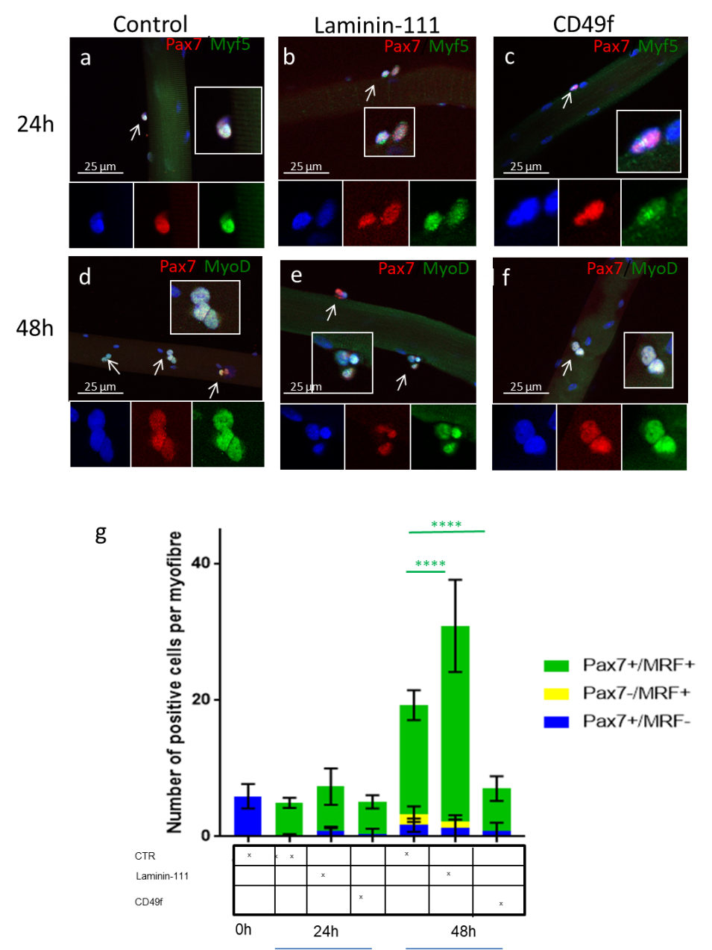
Fig 4.1 Laminin-111 signalling through Integrin α6 enhances the proliferation of satellite cells in early stages. Single skeletal muscle fibres cultured in floating condition for 0, 24, 48, hours and treated with Laminin-111 and CD49f were analysed by immunofluorescence using antibodies against Pax7 (red at 0, 24, and 48hr), Myf5 (green at 0 and 24hr), and MyoD (green at 48hr).Nuclei were counterstained with DAPI. (a-f) Representative images of myofibres analysed. Satellite cells are indicated by white arrows. Insets show enlarged images of each colour channel. scale bar is 25μm. (d-e-f) It is possible to observe that laminin-111 treated fibres show groups of 3-4 cells compared to CD49f treated fibres where are present only doublets. (g) Graph showing the number of positive cells per myofibre at each time points. n= 3, with at least 15 fibres analysed per mouse (error bars represents standard error of the mean. The colour of the stars matches the cell population colour. **** indicates a p-value<0,0001, non-parametric one-way Anova test on average of each replicate.).

4.2.3 Laminin-111 increases the amount of differentiating myoblasts

In the previous paragraphs I have analysed the first two steps of the myogenesis, i.e. the activation and the proliferation of satellite cells, observing their behaviour after 24 and 48 hours of culture. To understand if Laminin-111 effect extends to differentiating satellite cells, I have studied the satellite cells after 72 hours in culture; observing if the proliferation rate is affected, and if there is a change in the differentiating satellite cells population.
Single fibres from 8 week-old C57/Bl6 mice EDL were cultured for 72 hours, in the presence of exogenous Laminin-111 (Fig 4.2 b,d). After 72 hours in culture, I observed that satellite cells treated with Laminin-111 showed a further increase in total cell number reaching about two folds the amount of satellite cells present in control fibres (Fig. 4.2 a,d). This increase in cell number was consistent with that observed earlier at 48 hours (Fig. 4.1). (Total Caveolin + only cells: 17 in control, 43 in Laminin-111 treated; p<0,0001, total number of cells 49 in DMSO control, 87 in Laminin-111 treated p<0,0001, non-parametric one-way Anova test on average of each replicate , n=3 Fig 4.2.1 d). The loss of function experiment, interrupting the signalling pathway between Laminin-111 and its receptor Integrin α6β1, caused the opposite effect of that observed in fibres treated with Laminin-111 (Fig. 4.2 c). In anti-CD49f treated fibres the total cell number decreases significantly as well as the proliferating subpopulation (total Caveolin + only cells: 17 in DMSO control, 5 in anti-CD49f treated; p<0,0001, total number of cells 49 in DMSO control, 16 in anti-CD49f treated p<0,0001, non-parametric one-way Anova test on average of each replicate, n=3, Fig. 4.2 d). When comparing Laminin-111 treated and anti-CD49f treated fibres it is also possible to appreciate an effect on differentiating satellite cells marked with myogenin. Laminin-111 treated fibres shows a moderately increased amount of differentiating cells, while anti-CD49f have a strongly reduced number of Myogenin+ cells ( total Myogenin+ only cells: 3 in DMSO control, in Laminin-111 treated 6; 1 in anti-CD49f treated; p<0,0001, non-parametric one-way Anova test on average of each replicate; n=3, Fig. 4.2 c, d). Thus, the addition of exogenous Laminin-111 and blocking signalling through Integrin α6β1 have effects that are consistent with Laminin-111 playing a role in the control of satellite cell proliferation and self-renewal.
In this case the loss of Laminin-111 could cause increased apoptosis, or could impair satellite cell migration, leading to an increase of apoptotic cells, and a reduction of the number myogenic progenitor cells contributing to new myofibres, explaining the reduced size of regenerated fibres in Lama1-deficient mice.
A role for Laminin-111 in cell migration is a possibility as Laminin-111-treated fibres displayed scattered satellite cells, as if their migration were enhanced. The same behaviour is not visible in control fibres. It has been reported that Laminin-111 increases cell migration in tumour metastasis and in healthy epithelial tissues (Pawara et al. 2007). Other studies reported that Integrin α6 confers migration properties to cells (Pawara et al. 2007; King et al. 2008). These evidence led to the conclusion that the remodelling of the basement membrane may have an important role in the migration of myogenic progenitor cells and their contribution to the new myofibres.

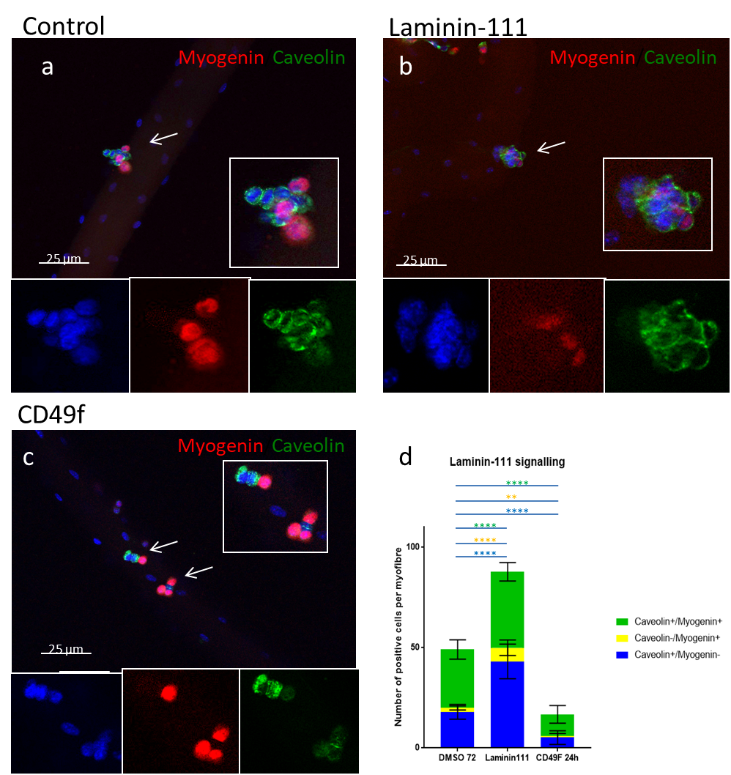
Fig 4.2 Effects of Laminin-111 at 72h of treatment. Single skeletal muscle fibres cultured in floating condition for 72 hours treated with Laminin-111 or CD49f (DMSO as control). White arrow indicate clusters of satellite cells a-c single fibres stained for Caveolin (green ) and Myogenin (red). Nuclei are stained with DAPI. d Representative data from at n=3, with at least 11 fibres considered for each mouse (values expressed as mean and error bar representing standard error of the mean The colour of the stars matches the cell population colour. ** indicates a p-value<0,01; **** indicates a p-value<0,0001, non-parametric one-way Anova test on average of each replicate.).

4.2.4 Laminin-111 influences the orientation and symmetry of the first division of satellite cells
To understand how Laminin-111 influences self-renewal during the myogenesis, I have studied the orientation and symmetry of satellite cell doublets using the ex vivo myofibre culture method. I have studied doublets arising after the first division after 46 hours in culture. Single fibres from Tg (Pax7GFP) mice were cultured for 46 hours in the presence of Laminin-111 or PBS, and analysed by immunofluorescence for MyoD and Pax7 distribution to observe a possible asymmetry in the distribution of MyoD (Fig. 4.3).
Laminin-111 treated satellite cells showed a majority of doublets with a planar and symmetrical division (about 80-90% of considered doublets) originating two identic daughter cells (Pax7+/MyoD+). A minor population of doublets (10% of considered doublets) revealed to be asymmetric, showing a compartmentalization in the distribution of the MRF, showing one of the two daughter cells negative for MyoD expression. This behaviour depends on the need to expand the amount of myogenic progenitors through planar, symmetric divisions, and keep few cells unengaged with myogenesis, through apical-basal division (fig 4.3 a, c).
When compared to control fibres, Laminin-111 treated fibres showed an increase in the number of apical-basal doublets, in favour of planar ones (Fig 4.3 b). Moreover, when considering the symmetry of satellite cells doublets it is possible to observe an increase in the amount of symmetrical division in Laminin-111 treated fibres, generating two daughter cells expressing both MyoD and Pax7. The outcome of this analysis shows that Laminin-111 increases the percentage of planar and symmetric division reducing in turn the amount of planar asymmetric and apical-basal and asymmetric divisions (Fig 4.3 c). These observations could point to the property of Laminin-111 to promote proliferation of cells increasing the planar and symmetric divisions. Moreover, the observation of the influence of Laminin-111 signalling on self-renewing of satellite cells cultured for 72 hours might suggest that Laminin-111 promotes the self-renewal mechanism through the known pathway of the planar and symmetrical of satellite cells, allowing a later stochastic decision for self-renewing cells.
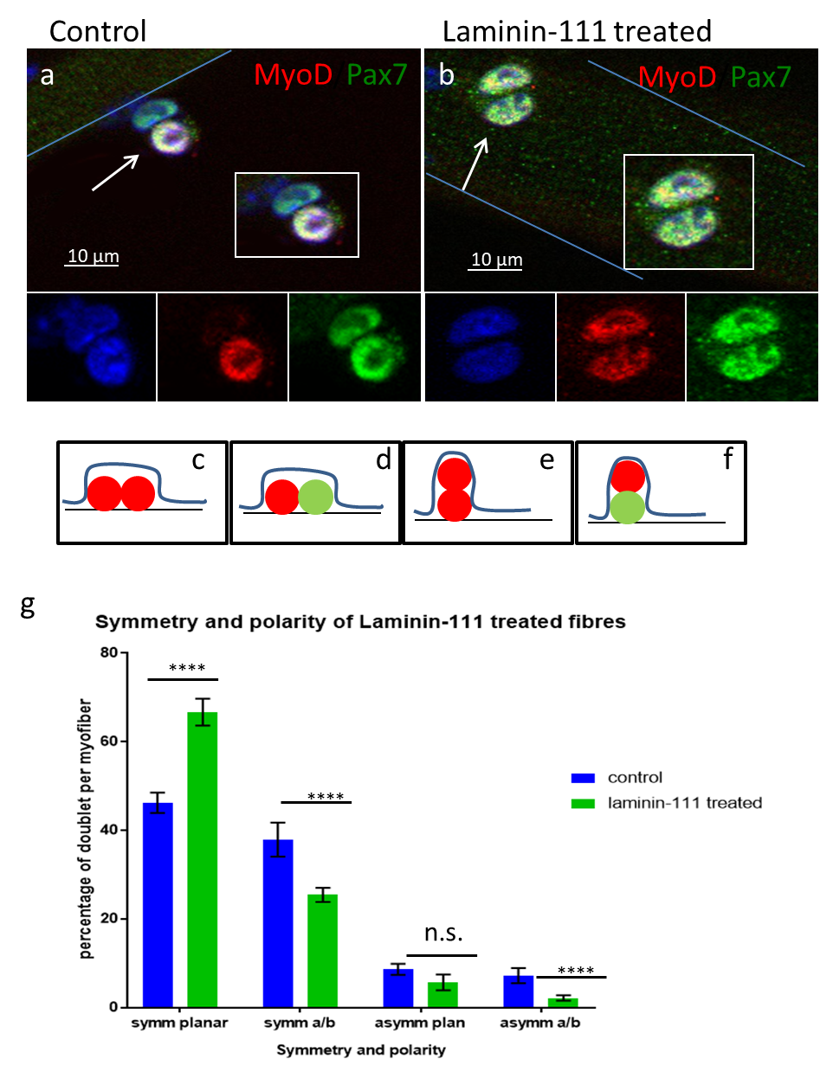
Fig 4.3 Effects of Laminin-111 treatment on satellite cells doublets ex vivo. Single skeletal muscle fibres cultured in floating condition for 46 hours were analysed by immunofluorescence using antibodies against Pax7 (green) and MyoD (red). Nuclei were counterstained with DAPI. (a,b) Representative images of control and treated fibres. Satellite cells are indicated by white arrows. Insets show enlarged images of each colour channel. scale bar is 10μm.(c-f) schematic representation of divisions; from left to right planar-symmetric, planar asymmetric, apical basal-symmetric and apical basal-asymmetric. (g) Graph showing the percentage of each kind of doublet per myofiber. n= 3, with at least 15 fibres analysed per mouse (error bars represent standard error of the mean. **** indicates a p-value<0,0001, non-parametric one-way Anova test on average of each replicate.).

4.3 Discussion

4.3.1 Laminin-111 accelerates the activation of satellite cells.
MMP inhibition blocked basement membrane remodelling in single fibre cultures, and caused a delayed activation of satellite cells at 24 hours and a reduced rate of cell proliferation at 48 hours. Thus, we hypothesised that Laminin-111 may have a role in the activation and proliferation of satellite cells. Gain-of-function and loss-of-function experiments were carried out to address this possibility. In single fibres treated with CD49f antibody to inhibit laminin signalling through Integrin α6, satellite cells activation was overall not affected, suggesting that Laminin-111 may not be required for the activation of satellite cells. If this is the case, we would have to assume that the delay I have observed in satellite cell activation in cultures treated with MMP inhibitors is due to another function of MMPs. MMPs trigger release of HGF in response to muscle fibre stretching and the release of NO (Yamada et al. 2006). As mechanical stretch activates satellite cells under the action of HGF (Tatsumi et al. 2002), Yamada observed that the administration of MMPs inhibitor TIMP1 in cultures led to a strong reduction of HGF without alterating NO levels (Yamada et al. 2006). The mechanism linking nitric oxide production and upregulation of MMP2 and 9 has been described in different works (Kherif et al. 1999; Fukada et al. 2004; Kleiner et al. 1993; Chakraborti et al. 2002). In particular, Yamada investigated further this aspect connecting this effect with MMP2 degradation of basement membrane and the release of growth factors entrapped in the basement membrane such as FGF (Yamada et al. 2006; Yamada et al. 2008). In my experiments the administration of Laminin-111 should have not increased the degradation of ECM by MMPs. Therefore FGF and Laminin-111 could interact on two parallel pathways promoting the activation of satellite cells.

4.3.2 Laminin-111 increases proliferation of satellite cells during early stages of myogenesis.
The administration of exogenous Laminin-111 to single fibre cultures caused an increase in satellite cell number. This observation coincided with the presence of cell doublets in treated fibres at 24 hours, usually not visible until between 24 and 48 hours in control fibre cultures. This observation suggests that Laminin-111 can promote satellite cell proliferation ex-vivo. Conversely, the inhibition of Integrin α6 signalling impaired satellite cell proliferation ex vivo, indicating that Laminin-111 may be necessary and sufficient for the expansion of muscle progenitor cells, after their activation.

4.3.3 Laminin-111 influences the direction and the symmetry of satellite cell division

Satellite cells self-renew through two main mechanisms, the one based on the asymmetric division of transcription factors, and the second one based on a stochastic downregulation of MRFs and return to quiescence. The symmetric/asymmetric division system relies on a compartmentalization of fate determinants and Laminins expansion of stem cell pool through symmetric generation of two daughter cells, or the return to quiescence through the rise of one differentiating cell and one self-renewing daughter. The treatment of single fibres from C57/Bl6 mice with Laminin-111 showed the ability of the embryonic isoform to influence the quality of the first division of activated satellite cells. The treatment with Laminin-111 corresponds to an increase of planar symmetrical divisions, usually related with the expansion of the stem cell pool. This outcome could be explained with an increased adherence of daughter cells to the Laminin-111 enriched satellite cells. Moreover, the increase of the planar, symmetrical divisions could be translated to the observed faster proliferation at all time points in C57/Bl6 fibres treated for 72 hours, as the planar symmetrical divisions are the basis of stem cell expansion. The increase of the planar, symmetric division could be addressed to a possible role of Laminin-111 to retain satellite cells on the basement membrane. However, this outcome could be also dependent on the possible increased incorporation of this isoform in the basement membrane due to an administration of exogenous Laminin-111 that could reach a higher concentration than a physiological condition. This aspect needs to be confirmed evaluating the incorporation and distribution of laminin-111 in treated cells. The direction and symmetry of satellite cells division is a fundamental feature finely regulated by several mechanisms. In a recent paper it has been observed that activated satellite cells upregulate the expression of dystrophin that in turns interacts with the Par complex, regulating the polarization of the satellite cells. Comparing laminin and MDX mice and tracing satellite cells lineage with YFP reporters, they observe how Dystrophin can determine the orientation of the satellite cells doublets and the distribution of the Par complex (Dumont et al. 2015). Par complex has been observed to be involved, with Laminin, in the mechanisms determining the asymmetry of cell division and to contribute, therefore, to the determination of self-renew (Neumüller & Knoblich 2009; Troy et al. 2012) . Through an in situ proximity ligation assay it has been observed that Dystrophin and MARK2 expression were found to be polarized in a subset of activated satellite cells, with a corresponding polarized distribution of PARD3 at the opposite pole. In mdx satellite cells, dystrophin deficiency resulted in reduced expression of MARK2 and loss of PARD3 polarization. In accordance with the abnormal expression of polarity proteins, a significant reduction in asymmetric satellite stem cell divisions was observed in cultured myofibres isolated from mdx mice. Moreover, abrogation of asymmetric stem cell division resulted in the gradual loss of myogenic progenitors and impaired muscle regeneration. The final outcomes of this investigation match with my observation on Laminin-111 treated cells. It is possible that Laminin-111 could influence the polarization and orientation of Par complex in order to promote a fast expansion of satellite cells, however, this possibility needs to be further investigated.
Furthermore, my findings match with what was observed during investigation involving Integrinα6, Laminin-111 main cell receptor. In several tissues integrins have been recognised as necessary for the stem cell maintenance (Ellis & Tanentzapf 2010). For example in the mammary stem cell niche, the ablation of the β1 subunit of integrin leads to an increased amount of symmetric cell divisions causing the depletion of the stem cell pool (Taddei et al. 2008; Gallo-Payet et al. 2017).

5. Laminin-111 loss affects myogenesis in ex-vivo model.
5.1 Introduction
The basement membrane is a key component of the satellite cell niche as it can trap through binding a number of signalling molecules and growth factors that regulate satellite cell activity (Boonen & Post 2008; Tierney & Sacco 2016; Lund & Cornelison 2013; Mehuron et al. 2014). The induction of MMP expression upon satellite cell activation provides a mechanism for the release of trapped ligand from the basement membrane (Yamada et al. 2006; Yamada et al. 2008; Boonen & Post 2008). For instance, Yamada and colleagues suggested that MMPs, and MMP2 in particular, promote the activation of rat satellite cells upon stretch by release of growth factors such as HGF, usually entrapped in the basement membrane. This mechanism is triggered by the release of nitric oxide upon muscle stretch. (Yamada et al. 2006, 2008). Besides the release of trapped growth factors, the remodelling of ECM could reshape the distribution and pool of ligands for cell receptors, regulating indirectly the behaviour of cells. This has been observed in many developmental tissues such as intestinal crypt, where a shift has been observed between fibronectin and collagen. The remodelling and the substitution of fibronectin might be directly involved with the early differentiation of crypt cells. The importance of ECM components can be observed in the formation of small intestinal mucosa. The loss of Laminin-511 and the compensation by deposition of Laminin-111 and Laminin-411 causes the misplaced formation of colon like mucosa, characterised by a higher cell proliferation rate. From these descriptions it appears clear that the niche is a delicate environment and the balance of all the different character is fundamental for the proper functioning of the system.
In the previous chapters I have studied the effects of Laminin-111 through gain of function and loss of function experiments on single fibres culture from C57/bl6 mice.
The results of these experiments suggested that
Laminin-111 might increase satellite cell proliferation, as the inhibition of Integrin α6 signalling seems to reduce satellite cells number. These results may suggest that Laminin-111 may be necessary and sufficient for the expansion of muscle progenitor cells, after their activation.
The outcomes of these experiments are valid in order to understand the effects of the direct interaction of Laminin-111 and integrin on the satellite cells. Nonetheless these effects are an artificial forcing of a physiological process.
For example, satellite cells self-renew direction and symmetry of division might be influenced by the binding with Laminin-111 present in the basement membrane. The outcome observed with treatment of fibres from C57/Bl6 mice with Laminin-111 might be influenced and over-performed due to a non-physiological presence of Laminin-111 in the satellite cells niche.
In order to understand if the previous hypothesis is valid in a more physiological environment and verify the outcomes I have observed the effects of single fibres cultured for 0, 24, 48 and 72 hours harvesting the single fibres from Lama1^{flox/flox}/Sox2Cre and Lama1^{flox/flox}/Pax7^{CreERT2} mouse lines (see materials and methods chapter).

Disclaimer:
The fibres from Sox2Cre mice resulted to be particularly fragile, and the mice showed a reduced growth rate. During my permanence in the lab it was possible for me to perform a full experiment with these mice fibres only once. Nonetheless, the trend I have observed has been confirmed by experiments performed by other member of my lab who kindly provided me with the results. In this thesis I will present the outcomes and images of my experiment for the sake of completeness. For this, and only this experiment, the standard deviation was calculated on the basis of the total of number of fibres analysed (n=1, 15-20 fibres analysed for each condition). The whole results have been published on Nature Communications shortly after the first submission of this thesis (n=3, two-way anova test based on the average of each replicate) (Rayagiri et al. 2018).

5.2 Results
5.2.1 Loss of Laminin Laminin-111 does not affects the activation of satellite cells ex-vivo.
To observe the effect of a loss of Laminin-111 signalling in a more physiological way, I have cultured single fibres from two mutant mice lines not expressing Laminin α1. Lama1^{flox/flox}/Sox2Cre and Lama1^{flox/flox}/Pax7^{CreERT2}. The difference between these two mice lines relies in the timing and the specificity of recombination. In Sox2Cre line the loss of Laminin α1 is extended to all tissues, since the early stages of embryonic formation. The Pax7^{CreERT2} offers some restrictions to the recombination. The loss of Laminin α1 is restricted to Pax7 expressing cells, and the recombination can be induced in adult stage through tamoxifen administration. To investigate the role of Laminin-111 in satellite cells, I used a single fibre culture on fibres isolated from transgenic mice. Single muscle fibres isolated from Lama1^{flox/flox}/Sox2Cre and Lama1^{flox/flox}/Pax7^{CreERT2} mice were cultured for 72 hours and harvested at 0, 24, 48, and 72 hours for analysis (fig 5.1; 5.2). Lama1^{Δ/Δ}/Sox2Cre and Lama1^{Δ/Δ}/Pax7^{CreERT2} fibres were cultured in parallel with littermates control mice Lama1^{Δ/+} or Lama1^{+/+} of the relative Cre line. Muscle fibres were first analysed by immunofluorescence using antibodies against Pax7 and Myf5 (at 0 and 24 hours) in order to evaluate how satellite cells are exiting quiescence and becoming activated upon culture.

Single fibres from knock-out Lama1^{Δ/Δ}/Sox2Cre (Fig 5.1) mice showed a mild reduction in the number of satellite cells when compared with the ones isolated from their littermates both control mice (Lama1^{+/+}) and heterozygous (Lama1^{Δ/+}). In these animals the number of satellite cells present on each fibre was slightly lower than what is usually observed in C57 Bl6 mice. The control type mice showed usually 5 satellite cells per fibre. Knock-out mice instead showed an average of 2.5 satellite cells on freshly isolated fibres (fig 5.1 j). A Pax7/Myf5 staining on fibres cultured for 24 hours showed a successful activation of satellite cells in all conditions. (100% of cells activated for control and mutant mice (fig 5.1 j).
In Lama^{flox/flox}/Pax7CreERT2 mouse line, the lama1 deletion is controlled through the injection of Tamoxifen. Fresh single fibres from this mouse line had more satellite cells compared with WT C57 mice, about 7 satellite cells per fibre (fig 5.2). Anyway, Lama1^{Δ/Δ} mice showed no difference in the number of satellite cells when compared with control mice of the same strain. Moreover, the staining for Pax7/Myf5 showed the ability of knock-out mice to activate satellite cells properly after 24 hours (fig 5.2 b,e,h,j).
Taken together, these observations show that loss of Laminin-α1 does not prevent the activation of satellite cells.

5.2.2 Loss of Laminin-111 affects proliferation of satellite cells ex vivo.
The reduced population of proliferative satellite cells was also observed in muscle fibre cultures from Lama^{Δ/Δ}/Sox2Cre mutant mice lines. An average of 5 satellite cells proliferating per fibre was observed in Lama^{Δ/Δ}/Sox2Cre fibres compared to 15 in control fibres (counting of MyoD+/Pax7+ cells per fibre: 15,2±3,63 in control, 5,3±4,02 in Lama^{Δ/Δ};Sox2Cre p value= 0,034, n=1; fig 5.1 c,f,i,j). A similar observation was made in Lama^{Δ/Δ}/Pax7CreERT2 fibres, in which an average of 18 satellite proliferating cells per fibre was recorded compared to 23 cells in control fibres (counting of MyoD+/Pax7+ cells per fibre: 22,71±0,75 in control, 18,62±0,21 in Lama^{Δ/Δ}; p value= 0,025, non-parametric one-way Anova test on average of each replicate, n=3; fig 5.2 c,f,i,j). In both mice lines heterozygous mice show behaviour intermediate between conditional knock-out mice and control mice. Nonetheless, Lama^{Δ/+};Sox2Cre mice show a behaviour comparable to mutant mice, while Lama^{Δ/+}/ Pax7^{CreERT2} is closer to Lama^{+/+}/ Pax7^{CreERT2} mice.
Taken together these data suggest a direct influence of Laminin-111 in the proliferation of satellite cells.

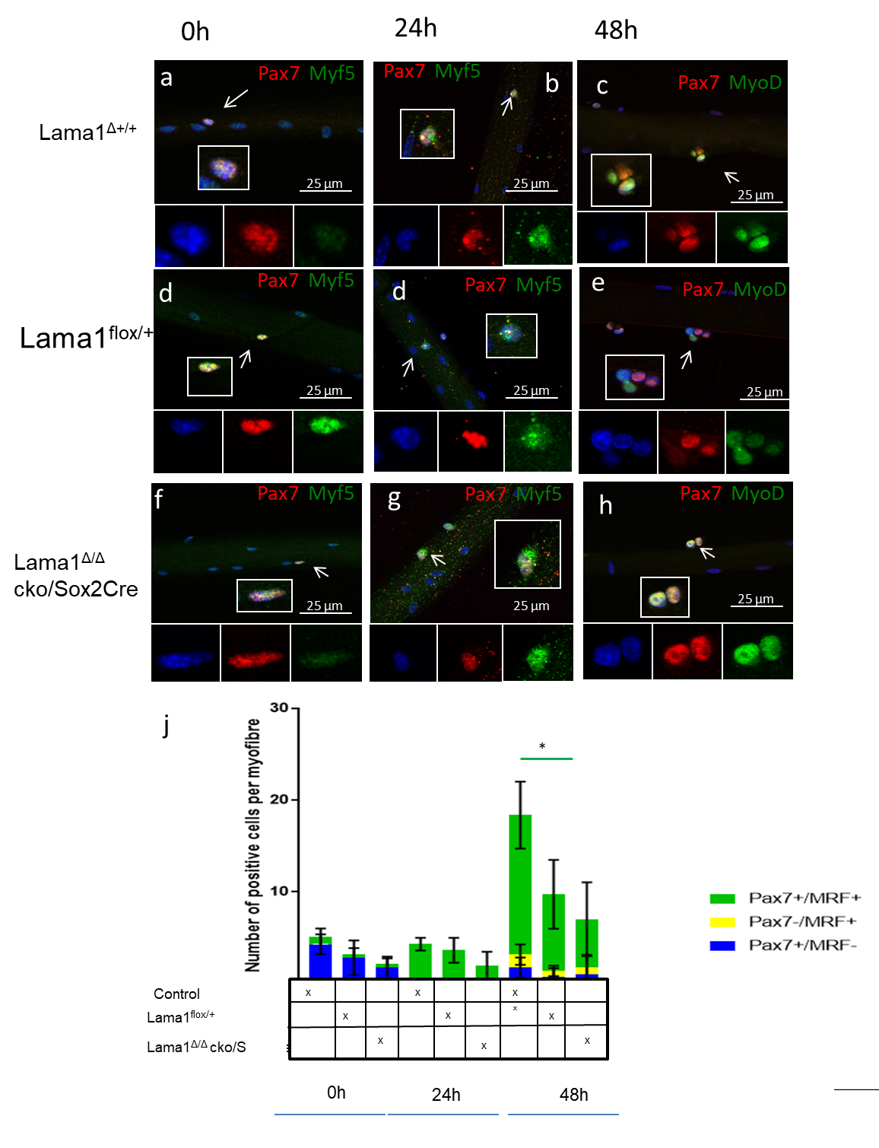
Fig 5.1 Loss of laminin α1 impairs adult myogenesis ex vivo single muscle fibre cultures from Lama^{flox}/Sox2Cre mouse line. Single skeletal muscle fibres cultured in floating condition for 0, 24, 48, hours were analysed by immunofluorescence using antibodies against Pax7 (red at 0, 24, and 48hr), Myf5 (green at 0 and 24hr), and MyoD (green at 48hr).Nuclei were counterstained with DAPI. (a-i) Representative images of myofibres analysed. Satellite cells are indicated by white arrows. Insets show enlarged images of each colour channel. scale bar is 25μm. (j) Graph showing the number of positive cells per myofibre at each time points. n= 1, with at least 15 fibres analysed per mouse (error bars represent standard error of the mean The colour of the stars matches the cell population colour. * indicates a p-value<0,05, non-parametric one-way Anova test on average of each replicate.).

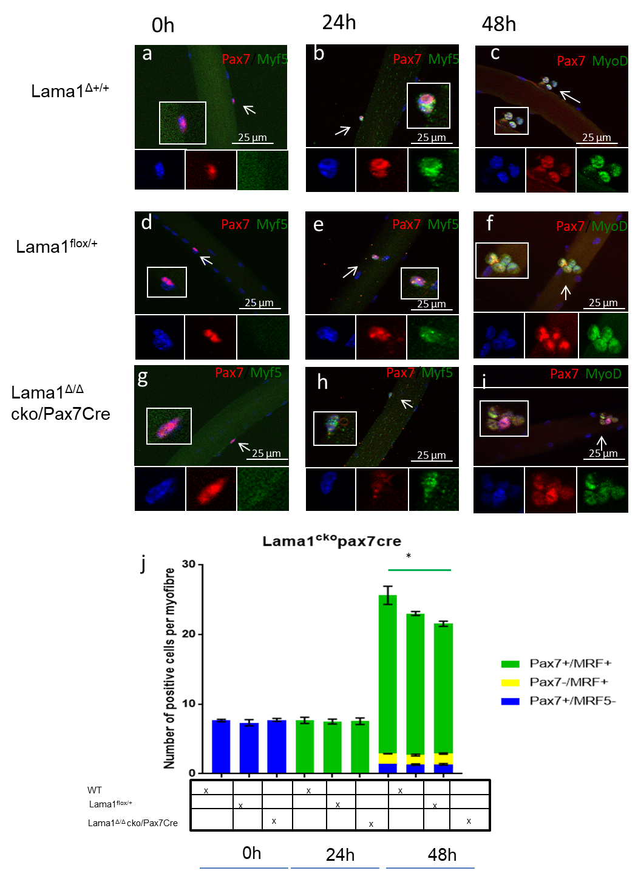
Fig 5.2 Myogenic regulatory factor expression in ex vivo single muscle fibre cultures from Lama^{flox}/Pax7^{CreERT2} mouse line. Single skeletal muscle fibres cultured in floating condition for 0, 24, 48, hours were analysed by immunofluorescence using antibodies against Pax7 (red at 0, 24, and 48hr), Myf5 (green at 0 and 24hr), and MyoD (green at 48hr).Nuclei were counterstained with DAPI. (a-i) Representative images of myofibres analysed. Satellite cells are indicated by white arrows. Insets show enlarged images of each colour channel. scale bar is 25μm. (j) Graph showing the number of positive cells per myofibre at each time points. n= 3, with at least 15 fibres analysed per mouse (error bars represent standard error of the mean. The colour of the stars matches the cell population colour. * indicates a p-value<0,05, non-parametric one-way Anova test on average of each replicate.).
).

To observe the effects of Laminin-111 loss, EDL muscle fibres from Lama1^{flox/flox}/Sox2Cre mice lines were cultured and analysed at 72 hours using antibodies against Caveolin and Myogenin (Fig 5.3). The inactivation of Lama1 led to a general reduction of the total number of satellite cells, suggesting an impaired proliferation, and to a diminished pool of self-renewing cells (total Caveolin+ only cells: 18 in WT, 12 in Lama1^{Δ/Δ}/Sox2Cre mouse; p<0,0058 , total number of cells 55 in WT control, 29 Lama1^{Δ/Δ}/Sox2Cre mouse, p<0,0001, n=1 Fig 5.3 a,c,e,g).
Interestingly, Lama1^{flox/flox}/Pax7 ^{CreERt2} muscle fibre cultures did not display a similar decrease in total cell number and in Caveolin⁺/Myogenin⁻ cells. The Lama1^{Δ/Δ}/Pax7^{CreERt2} mice show a slightly reduced amount of satellite cells when compared with control fibres but not statistically significant (Fig. 5.3 b,d,f,h).

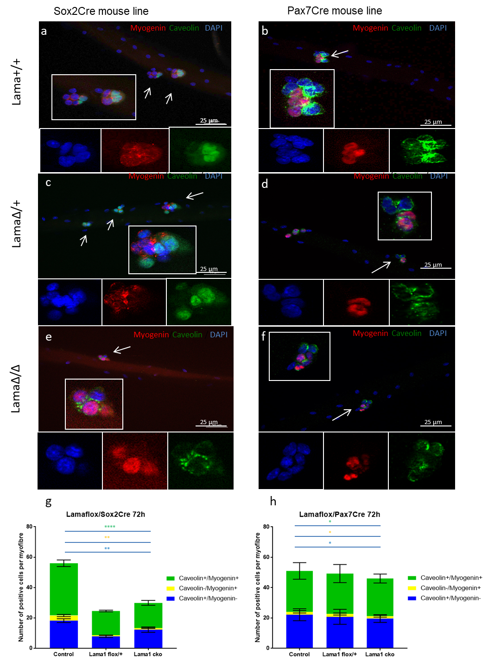
Fig 5.3 Loss of Laminin-111 in KO mice leads to a mild loss leads to a loss of proliferating SC at 72 hours of culture. Single skeletal muscle fibres cultured in floating condition for 72 hours harvested from Lama1^{flox/flox}/Sox2Cre and Lama1^{flox/flox}/Pax7Cre mice. a-f single fibres stained for Caveolin (green ) and Myogenin (red). Nuclei are stained with DAPI. Images are representative of Wt (a,b), heterozygous mice (c,d) and ko mice (e,f). g,h Representative data from at least three cultures from Lama1^{flox/flox}/Sox2Cre and Lama1^{flox/flox}/Pax7Cre mice, n=3 with at least 11 fibres considered for each mouse (values expressed as mean and error bar representing standard error of the mean (error bars represent standard error of the mean. The colour of the stars matches the cell population colour. **** indicates a p-value<0,0001, ** indicates a p-value<0,01, * indicates a p-value<0,05, non-parametric one-way Anova test on average of each replicate.). Nuclei are stained with DAPI.

5.3 Discussion
The ex-vivo experiment on mutant mice confirmed most of the observation from ex vivo experiments from C57 mice.
The hypothesis that Laminin-111 might have a role in the activation and proliferation of satellite cells was reflected in the ex vivo experiment on c57 mice muscle fibres. In single fibres from Laminin α1-deficient mice, satellite cells activation was overall not affected, confirming the idea that Laminin-111 might not be the main effector of the activation of satellite cells. These observation might point once more to the importance of mechanical stress and release of other signalling molecules, such as Nitric Oxide (Yamada et al. 2006). As mechanical stretch activates satellite cells under the action of HGF (Tatsumi et al. 2002), Yamada observed that the administration of the MMPs inhibitor TIMP1 in cultures led to a strong reduction of HGF without altering NO levels (Yamada et al. 2006). The pathway connecting the nitric oxide production to the upregulation of MMP2 and 9 has been observed and described. (Kherif et al. 1999; Fukada et al. 2004; Kleiner et al. 1993; Chakraborti et al. 2002) Yamada investigated further this aspect suggesting that MMP2 degradation of basement membrane could lead to the release of growth factors entrapped in the basement membrane such as FGF (Yamada et al. 2006; Yamada et al. 2008). Anyway, the administration of Laminin-111 should have not changed the activity of ECM degradation by MMPs. Therefore FGF and Laminin-111 could interact on two parallel pathways promoting the activation of satellite cells.

Nonetheless, the study of the two mutant mice lines pointed to another effect of Laminin-111. Freshly isolated single fibres form Lama1^{flox/flox} /Pax7cre mice show about the same number of satellite cells than C57 mice, while Sox2^{cre} have about half of the satellite cells observed on the wild types and littermates. This initial consideration suggests a possible role for the incorporation of Laminin-111 in the basement membrane: the remodelling of satellite cells basement membrane and the incorporation of Laminin-111 is necessary to maintain the satellite cells pool and preserves the regeneration properties of the adult muscle tissue. Further proof of this behaviour will be found in the next chapter. This observation might help to explain the behaviour of heterozygous Lama1^{flox/flox}/Sox2^{Cre} mice. In these mice satellite cells development and quality might be influenced by the reduced amount of Laminin α1 produced starting since the early stages of development. This consideration could suggest either a dose dependent role of Laminin-111. Furthermore this behaviour could be dependent. This hypothesis might be further investigated observing the behaviour of heterozygous Lama1^{flox}/Pax7cre mice after several months after Cre recombinase activation, as it may show a behaviour similar to the one observed in Lama1^{flox}/Sox2cre

6 Effects of Laminin- 111 loss in vivo
6.1 Introduction
In the previous chapters I have focused my attention on the effects of Laminin-111 in ex vivo experiments. A single fibre culture experiment provides for an accurate understanding of the myogenesis in a very controlled environment, observing directly the satellite cells behaviour. Nonetheless, the adult myogenesis is a complex mechanism involving different group of cells, and is just one gear of a bigger and more complex mechanism. Therefore, to have a deeper understanding of the effects of laminin on the adult myogenesis, in this chapter I will focus on in vivo experiments.
Starting from the earliest stages of muscle regeneration, the interaction with other cell group it is important for the proper muscle regeneration.
In the early stages of regeneration an important process that contributes to the regeneration of the muscular tissue: inflammation (Merly et al. 1999; Lapointe et al. 2002). Several studies have reported the important role of inflammation in muscle regeneration, and the role of macrophages in satellite cells activation and proliferation (Merly et al. 1999; Lapointe et al. 2002; Tidball & Villalta 2010; Nguyen & Tidball 2003; Saclier, Yacoub-Youssef, et al. 2013). Immediately after the disruption of fibres, there is an inflammatory response, initiated with the appearance of neutrophils, followed by two waves of macrophages M₁ and M_{2.} The first wave of M₁ macrophages has a pro- inflammatory effect, releases Tumor Necrosis Factor (TNF) and Interleukine-1 (IL-1), and carries out the elimination of debris (Nguyen & Tidball 2003). The second wave of M₂ macrophages shows an anti-inflammatory activity (Tidball & Villalta 2010). It is possible that the incorporation of Laminin-111 in satellite cells basement membrane may promote the interaction of Macrophages with muscle progenitors at the injury site. The direct interaction of ECM component with cellular parts could have an important role in the muscle regeneration as well.
The study of in vivo models could help to understand better how the effect of Laminin-111 on satellite proliferation and differentiation cells could influence the formation of regenerated muscle fibres.
This chapter focus on determining how the niche remodelling and the incorporation of Laminin-111 in the basement membrane of satellite cells can influence their differentiation. Satellite cell-derived progenitor cell differentiation is finely regulated by several cues. It has been recognised the importance of the interaction of different tissues and cell population in the niche. The investigation of myogenesis of satellite cells from Syndecan3 -/- mice led to the complete failure in the differentiation of myogenic precursors, as well as a poor proliferation of satellite cells (Cornelison et al. 2001). These effects in vivo, caused failure to regenerate functioning fibres and the consequent deposition of Collagen I to form scar tissue. The laminin receptor Integrin has also been involved in the differentiation of satellite cells. It has been observed that the subunit β1 could influence the differentiation of C2C12 cells. The involvement of integrin β1 as laminin main receptor in the differentiation of satellite cells points to a possible involvement of Laminins in the determination of the satellite cells fate(Von der Mark et al. 1991; Patton et al. 1997). Nonetheless, the role of the interaction between Laminin and integrins in the latest stages of regeneration is still poorly understood ( Boonen & Post 2008).
In the previous chapters I have observed an impaired proliferation of myogenic precursors. The experimental procedures in vivo will help to observe how these two observations will affect the general architecture of a regenerated muscle and how a muscle tissue can cope with multiple rounds of injury. The asymmetric division is influenced by the niche. The mitotic spindle orientation is determined by cues from the basal lamina and the myofibre. During asymmetric division adhesion proteins cause the basal daughter cell to be retained by the basement membrane while the apical one retains the contact with the muscle fibre. This mechanism of division causes an uneven distribution of fate factors between the two daughter cells. In satellite cells usually apical cells are Pax7+/Myf5+, while basal daughter cells are Pax7+/Myf5-. A mechanism based on Laminin retaining only one of the two daughter cells leads to one of the main features of the self-renewal process: the asymmetric division (Knoblich 2001) . The interaction of just one daughter cell with the basement membrane causes a polarization of the daughter cells doublets, leading to an asymmetric distribution of signalling molecules (Brizzi et al. 2012a).
6.1.1 Aims
In the previous chapters I focused on the effects of the modulation of Laminin-111 in ex- vivo experiments. The aim of this part is to understand how the effects of laminin-111 are affecting a more complex system as a whole organism.

6.2 Results

6.2.1 Laminin-111 mildly influences the activation of satellite cells in in vivo models of regeneration.

The singe fibres analysis revealed Laminin-111 as a possible accelerator of Satellite cells activation. In order to confirm this role of Laminin-111 in vivo I have studied the early response to cardiotoxin injection in transgenic mouse lines.
For this investigation tibialis anterior muscles from Lama1^{Δ/Δ}/Sox2Cre mice and Lama1^{+/+}/Sox2Cre control mice were injured with cardiotoxin (CTX), as described in materials and method (chapter 2). The same protocol was performed in Lama1^{Δ/Δ}/Pax7^{CreERT2} mice and Lama1^{Δ/+}/Pax7^{CreERT2}, while Lama1^{+/+}/Pax7^{CreERT2} mice were used as control.
In this section I will focus primarily on the 2 days post-injury (DPI) as this time point allows observing the early response to CTX injection, analysing the activation and engagement of satellite cells in the myogenic program.
To investigate the role of Laminin-111 loss on the activation of satellite cells, I have performed a staining for MyoD on transverse sections from muscles harvested at 2 days post injury (Fig 6.1, 6.2). In Lama1^{Δ/Δ}/Sox2cre the absolute number of MyoD+ cells is lower than the one counted in their Lama1^{+/+} littermates, even though a statistical analysis revealed no significant difference (n=3, p value = 0,09, non-parametric one-way Anova test on average of each replicate). (fig 6.1 a-c). In Lama1/Pax7^{CreERT2} mouse line, instead, there is no difference in terms of absolute number or statistical difference the total number of MyoD+ counted in Lama1^{Δ/Δ}/Pax7^{CreERT2} , Lama1^{Δ/+}/Pax7^{CreERT2}, and controls Lama1^{+/+}/Pax7^{CreERT2} (110 MyoD+ cell per field; n=3; p value=0,11, non-parametric one-way Anova test on average of each replicate; fig 6.2 c-f). Taken together these data can give interesting insight into the mechanism that links Laminin-111 to satellite cells activation. Lama1^{Δ/Δ}/Sox2Cre mice show a reduced ability to activate satellite cells compared to Lama1^{Δ/Δ}/Pax7^{CreERT2} mouse line. This effect could be dependent on the missing involvement of other Laminin-111 expressing cells such as macrophages in Lama1^{Δ/Δ}/Sox2Cre. In Lama1^{Δ/Δ}/Pax7^{CreERT2} the involvement of macrophages could be still present. Another possible option is that in Lama1^{Δ/Δ}/Sox2Cre the early deletion of Laminin α1 could have caused a diminishment of the satellite cells pool. Lama1^{Δ/Δ}/Pax7^{CreERT2} mice are spared by this defect, as recombination is induced only after cardiotoxin injection.
At 2 dpi, Lama^{Δ/Δ}/Pax7Cre mice show a similar population of proliferating non-myogenic progenitors (p values: 0.2<x<0.034, non-parametric one-way Anova test on average of each replicate; n=3, at least 10 fields considered for each experiment, non-parametric one-way Anova test on average of each replicate; n=3; fig 6.2 e,f,g,h).

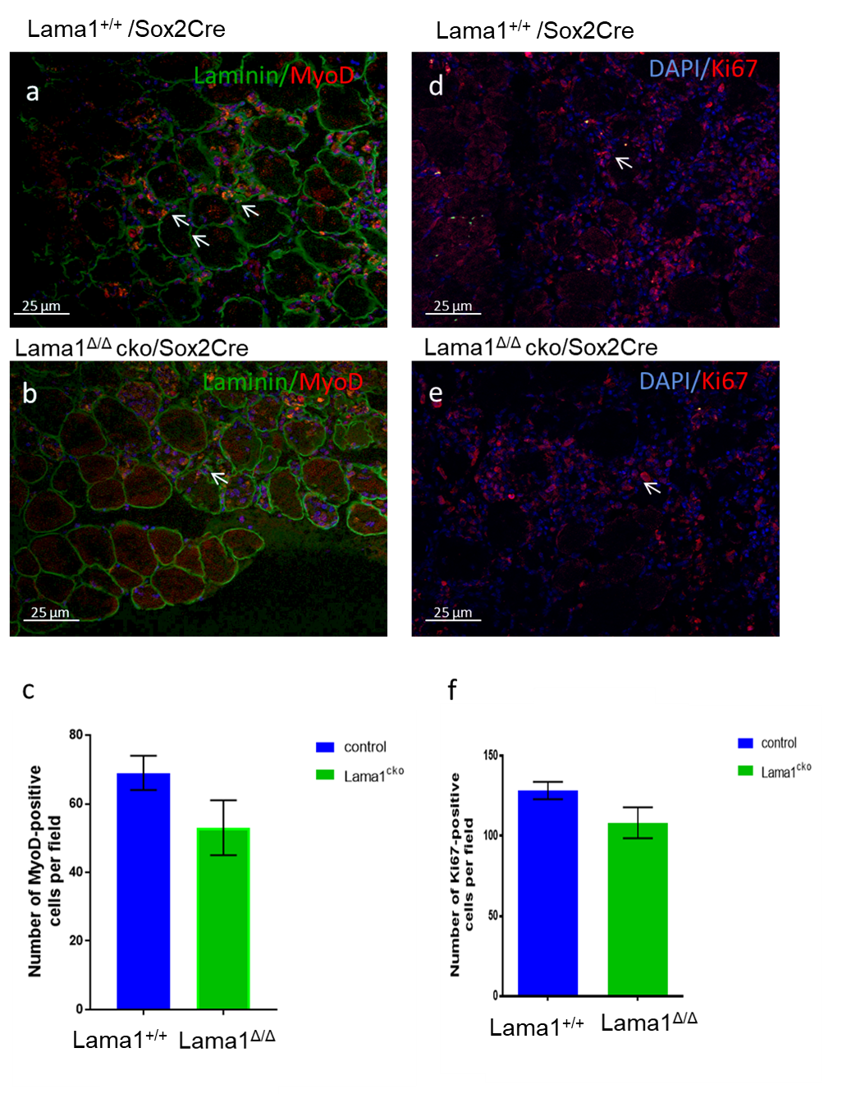
Fig 6.1 Lama^{flox}/Sox2Cre mouse line satellite cells show a reduced proliferation at 2DPI. Sections from Lama^{flox}/Sox2Cre mice were analysed by immunofluorescence using antibodies against MyoD Laminin or Ki67. Nuclei were counterstained with DAPI. (a,b,d,e) Representative images of myofibres analysed. (c,f) Graph showing the number of positive cells per section at each time points. n= 3, 12 sections analysed for each condition, at least 3 fields of view considered for each section (error bars represent standard error of the mean, non-parametric one-way Anova test on average of each replicate.).

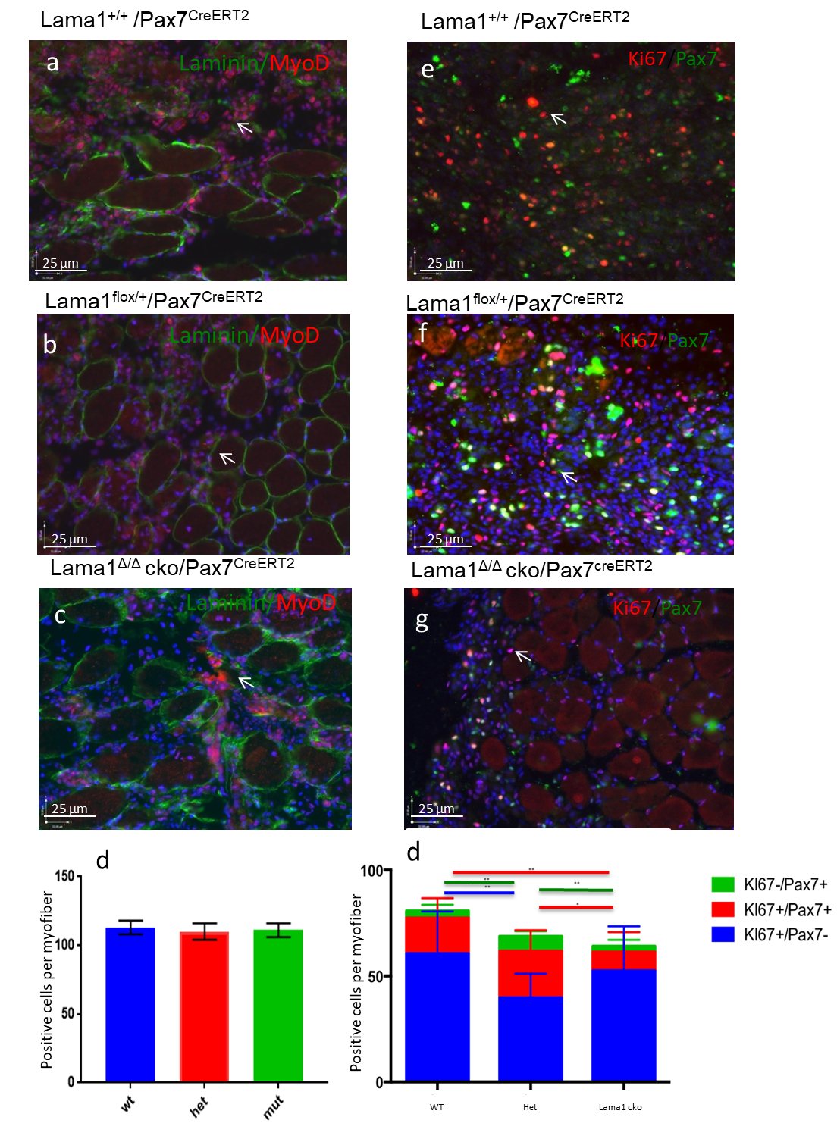
Fig 6.2 Analysis of muscle sections from Lama^{flox}/Pax7Cre mouse line 2DPI.
Sections from Lama^{flox}/Sox2Cre mice were analysed by immunofluorescence
using antibodies against MyoD and Laminin or Ki67 and Pax7. Nuclei were
counterstained with DAPI. (a,b,c,e,f,g) Representative images of myofibres
analysed. (d,h) Graph showing the number of positive cells per section at each
time points. n= 3, 12 sections analysed for each condition, at least 3 fields of view considered for each section (error bars represent standard error of the mean, non-parametric one-way Anova test on average of each replicate.).
Number of positive cells per field
Number of MyoD-positive cells per field
h

6.2.2 The Laminin-111 promotes exclusively proliferation of satellite cells in in vivo models of regeneration.
Previous ex vivo investigations on single fibres revealed Laminin-111 mediated increase of satellite cells proliferation. In order to investigate the effect of Laminin-111 on satellite cells proliferation in vivo I have studied the response to injury in transgenic mice lines focusing on the 4 days post injury stage, as it is the suitable one to study the satellite cells proliferation. For this investigation, tibialis anterior muscles from Lama1^{Δ/Δ}/Sox2Cre mice and Lama1^{+/+}/Sox2Cre control mice were injured by cardiotoxin (CTX) injection, and the muscle harvested 4 days after the injury.
The same protocol was performed in Lama1^{Δ/Δ}/Pax7^{CreERT2} mice and Lama1^{Δ/+}/Pax7^{CreERT2} , Lama1^{+/+}/Pax7^{CreERT2} mice as control.
Sections from Lama1 ^{flox /flox}/ Sox2Cre mouse line were stained with Myod and pictures of the injured area were counted (at least 3 picture for each section. sections were 200µm apart. This analysis revealed no statistical differences between the different genotypes (n=3,p value >0,05, non-parametric one-way Anova test on average of each replicate 6.3 a,b,c). The proliferation of satellite cells has been investigated using Ki67 as proliferation marker. The staining for Ki67 on Lama^{Δ/Δ}/Sox2Cre mice showed a moderate reduction of a proliferating population of cells compared with WT littermates (p value=0.0087, non-parametric one-way Anova test on average of each replicate; n=3, at least 10 fields considered for each muscle Fig 6.3 d,e,f).
As in this particular stage of regeneration injured muscle tissue is populated, besides the myogenic progenitors, by other cell population expressing Laminin-111, such as macrophages. The Lama^{flox/flox}/Pax7^{CreERT2} mouse line was suitable to observe the effect of Laminin-111 loss on satellite cells without affecting Laminin α1 expression in macrophages. The same injury protocol was performed on Lama^{Δ/Δ}/ Pax7^{CreERT2} mice and controls: Lama^{Δ/+}/ Pax7^{CreERT2}, and Lama^{+/+}/ Pax7^{CreERT2}.
The counting of MyoD+ cells at 4 days post injury showed a difference between Lama^{Δ/Δ}/Pax7Cre and their control littermates. Mutant mouse section had about 85 activated muscle progenitors compared with the 100 cells in controls (p value=0,0038, non-parametric one-way Anova test on average of each replicate; n=3, at least 10 fields considered for each experiment; fig 6.4 a,b,c). In Pax7Cre mouse line, was crossed with the Tg: pax7nGfp mouse line so that Pax7+ cells were expressing also expressing nGFP. Pax7 positive cells were labelled using a GFP staining. It was possible to distinguish the population of proliferating satellite cells. In this mouse line at 4 DPI all mice showed the same amount of proliferating non-myogenic cells (Ki67+/Pax7-).
The number of non-proliferating cells is statistically comparable between control littermates and Lama^{Δ/Δ}/Pax7Cre mice. However, these mutant mice show a mild reduction of Ki67+/Pax7+ proliferating satellite cells. (P value= 0,0046, non-parametric one-way Anova test on average of each replicate). Nonetheless, Lama^{Δ/Δ}/Pax7Cre mice reveal a lower number of differentiating cells, compared with controls (MyoD+ cells per field respectively 77,9 and 98,8; p value=0,019, non-parametric one-way Anova test on average of each replicate ; n=3; fig 6.3 e,f,g,h).
These analyses point out that, the amount of cells involved in the myogenic process is mildly affected by Laminin α1 deletion at 4 dpi, while earlier stages of regeneration are not perturbed.

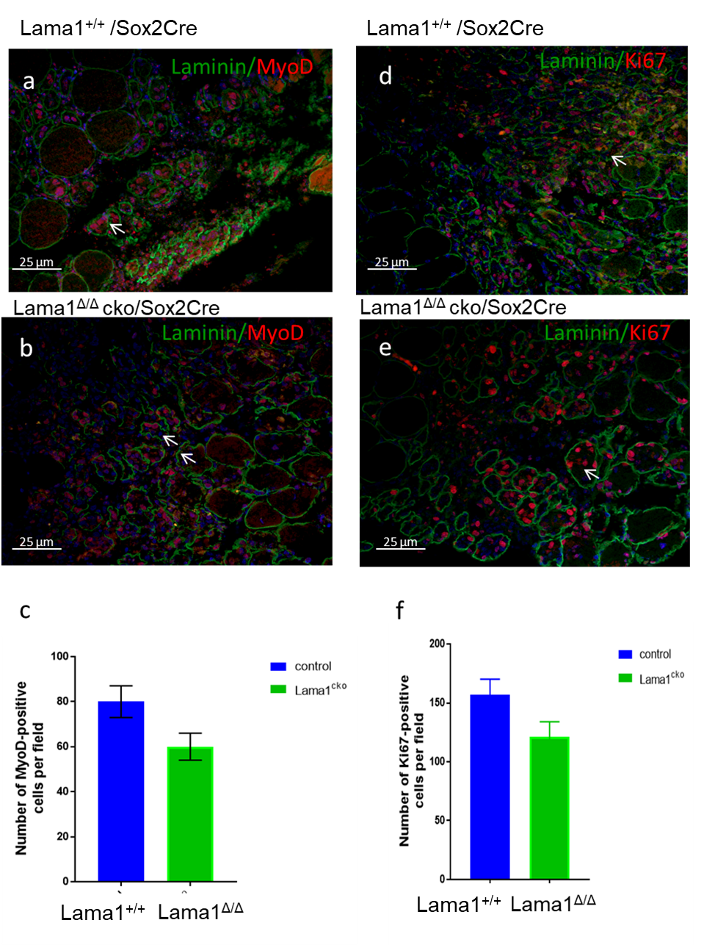
Fig 6.3 Lama^{flox}/Sox2^{Cre} mouse line satellite cells show a reduced proliferation at 4DPI. Sections from Lamaflox/Sox2Cre mice were analysed by immunofluorescence using antibodies against Laminin and MyoD or Ki67. Nuclei were counterstained with DAPI. (a,b,c,e,f,g) Representative images of myofibres analysed. (d,h) Graph showing the number of positive cells per section at each time points. n= 3, 12 sections analysed for each condition, at least 3 fields of view considered for each section (error bars represent standard error of the mean, non-parametric one-way Anova test on average of each replicate.).

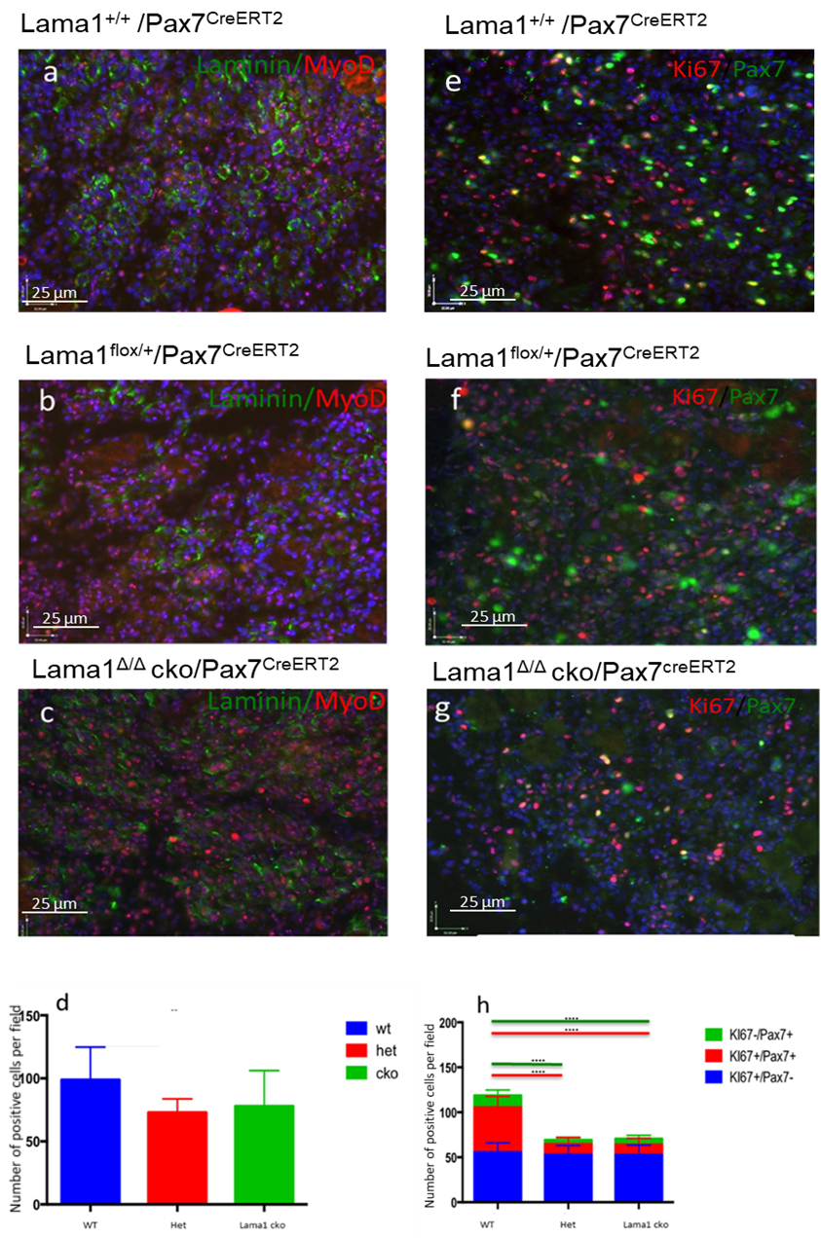
Fig 6.4 Analysis of muscle sections from Lama^{flox}/Pax7^{Cre} mouse line 4DPI. Sections from Lama^{flox}/Sox2^{Cre} mice were analysed by immunofluorescence using antibodies against MyoD and Laminin or Ki67 and antibody against GFP(Pax7). Nuclei were counterstained with DAPI. (a,b,c,e,f,g) Representative images of myofibres analysed. (d,h) Graph showing the number of positive cells per section at each time points. n= 3, 12 sections analysed for each condition, at least 3 fields of view considered for each section (error bars represents standard error of the mean, non-parametric one-way Anova test on average of each replicate.).

6.2.3 Loss of Laminin α1 mildly affects the maturation of muscle fibres in vivo
To observe the ability of mutant mice to regenerate healthy myofibres, a single cardiotoxin (CTX) injury was carried out as described in materials and methods and injured TA muscles were analysed at 7 days post injury (7dpi) by histology using haematoxylin and eosin staining to evaluate the general architecture of the tissues (Fig 6.5). Control muscles displayed efficient regeneration, as evidenced by the presence of newly regenerated fibres, identified by their centrally located nuclei. In contrast, Lama1^{Δ/Δ}/Sox2Cre muscles showed a higher level of inflammation, architecture closer to that of a 4dpi muscle and smaller newly-formed fibres than those observed in control littermates (Fig. 6.5 a,c). A similar effect was observed in Lama1^{flox/flox} /Pax7cre mice (Fig. 6.5 b,d), indicating that this defect is mostly dependent on the endogenous production of Laminin-111 from satellite cells. These observations suggest that muscle regeneration is slightly impaired in the absence of Lama1.a
To further assess muscle regeneration in these samples, I performed an immunofluorescence labelling for Pan-Laminin to highlight the basement membrane surrounding myofibres and for MyoD to mark centro-nucleated myonuclei of regenerated fibres, as well as mononucleated muscle progenitor cells (Fig. 6.6) The pan Laminin staining confirmed that control 7dpi muscles had round regularly-shaped fibres, Lama1^{Δ/Δ} of both mice lines muscles showed irregular fibres (Fig.. 6.6 c-d). To evaluate the size of myofibres I determined the minimal Feret diameter. The minimal feret diameter was calculated for at least 12 fields of view for each sample and the outcomes plotted as normal distribution of frequency. Finally, the distribution of minimal Ferret’s diameter was plotted for each genotype (Fig. 6.6 ). The comparison of Lama1^{flox/flox}/Sox2Cre mouse mutant and control fibre diameter distribution showed a significant shift of mutant muscle values toward smaller dimensions compared to control muscles (p<0.0001, non-parametric one-way Anova test on average of each replicate; n=3; Fig. 6.6 e). The same analysis was performed in Lama1^{flox/flox} /Pax7cre and revealed a similar shift toward smaller diameters (p<0.000, non-parametric one-way Anova test on average of each replicate 1; n=3, Fig. 6.6e-f).
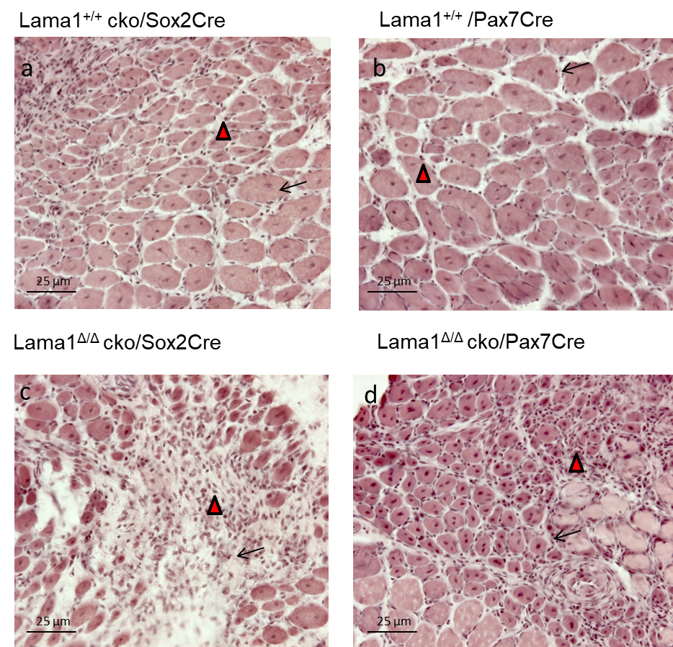
Fig 6.5 Haematoxylin and eosin staining of mice at 7DPI stage of regeneration (20x magnification). Tibialis anterior muscles were harvested from Lama1^{flox/flox}/Sox2Cre and Lama1^{flox/flox}/Pax7Cre mice and stained for haematoxylin and eosin. Black arrows indicate freshly regenerated fibres. Red arrow head indicates the infiltration of inflammatory tissue. a-b sections from Wt mice. c-d sections from conditional ko mice

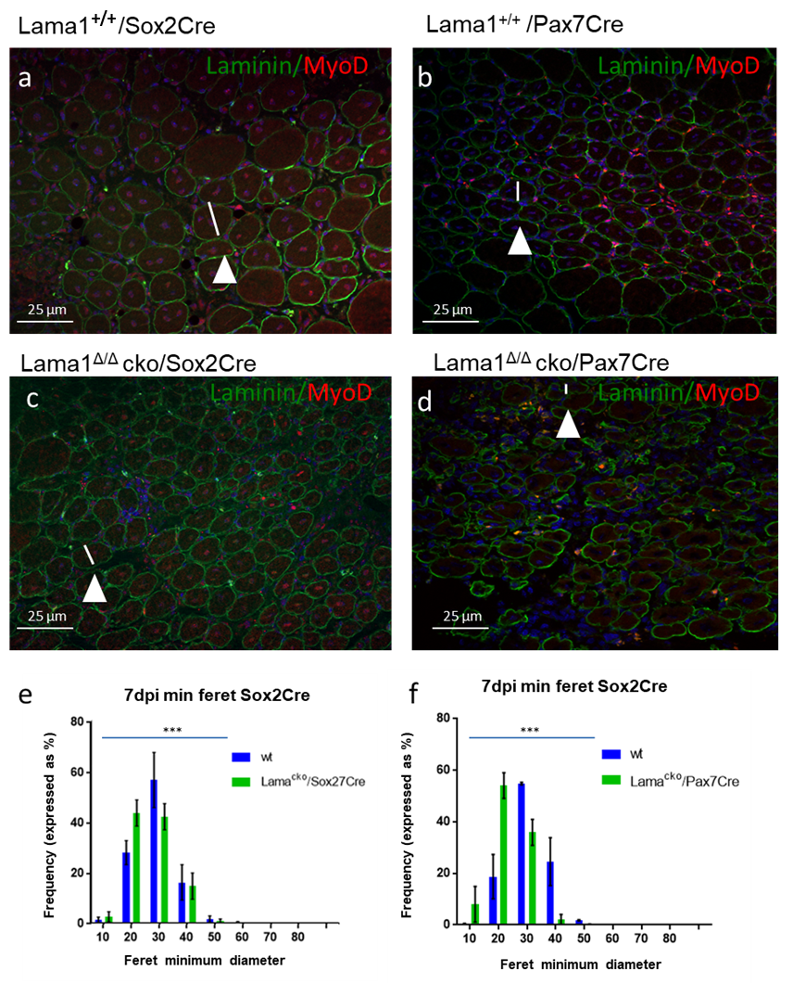
Fig 6.6 Dimension of new regenerated fibres at 7DPI stage of regeneration (20x magnification). Tibialis anterior muscles were harvested from Lama1^{flox/flox}/Sox2Cre and Lama1^{flox/flox}/Pax7Cre mice and stained for laminin (green) and MyoD (red). The arrows point to a white bar representative of an example of the minimum feret diameter. a-b sections from Wt mice. c-d sections from conditional ko mice. e-f Charts displaying the distribution of frequency for each range of dimension. Values are expressed as percentage and error bar representing standard error of the mean. The star value is referred to the analysis of the whole distributions. N=3, 12 sections analysed for each condition, at least 3 fields of view considered for each section non-parametric one-way Anova test on average of each replicate
To assess whether the smaller diameter of Laminin α1-deficient mice was caused by a defect in muscle progenitor proliferation, I performed an immunostaining for Ki67 (Fig. 6.7). The counting of Ki67+ satellite cells showed that the control littermates have a slightly higher amount of proliferating cells compared to the Lama^{Δ/Δ} mice. Nevertheless, the statistical analysis shows no significant difference between the two littermates (Fig. 6.7 e-f). This analysis assessed the proliferation of all cells present in the muscle sections not distinguishing the Myogenic and the non-myogenic. This could point out that in this stage of regeneration Laminin-111 has no more involvement with the proliferation itself, but might be related with other stages of myogenesis.
To further examine how regeneration proceeds in the absence of Laminin α1, I examined injured TA 14 days after CTX injection. Haematoxylin and eosin staining of control and Lama1^{flox/flox};Sox2^{Cre/+} TA muscles showed the restoration of a normal architecture and the presence of centronucleated myofibres of similar dimensions to non-injured fibres in control mice. Although regeneration in Lama1^{flox/flox} ;Sox2^{Cre/+} mice was somewhat imperfect, Lama1-deficient muscles appeared to complete regeneration. Similar histological observations were made in 14dpi TA muscles from Lama1^{flox/flox} ; Pax7^{CreERT2/+} mice (Fig. 6.8).
Pan-Laminin and MyoD immunofluorescence analysis was carried out to mark the basement membrane surrounding the myofibres and to label the centro-nucleated myonuclei of regenerated fibres and evaluate the number of myogenic progenitor cells returning to a sublaminal position (Fig. 6.9). The pan Laminin staining confirmed my histological observations, showing regeneration albeit with irregularly-shaped fibres in Lama1-deficient mice compared to control mice (Fig. 6.9 a-b-c-d). The counting on MyoD positive cells revealed a slightly reduced amount of myogenic cells in the Lama1^{Δ/Δ} mice, suggesting a reduced contribution of myogenic precursors to regeneration (n=3; p<0,0001, non-parametric one-way Anova test on average of each replicate). The minimal feret diameter was calculated for at least 12 fields of view for each sample and the outcomes plotted as normal
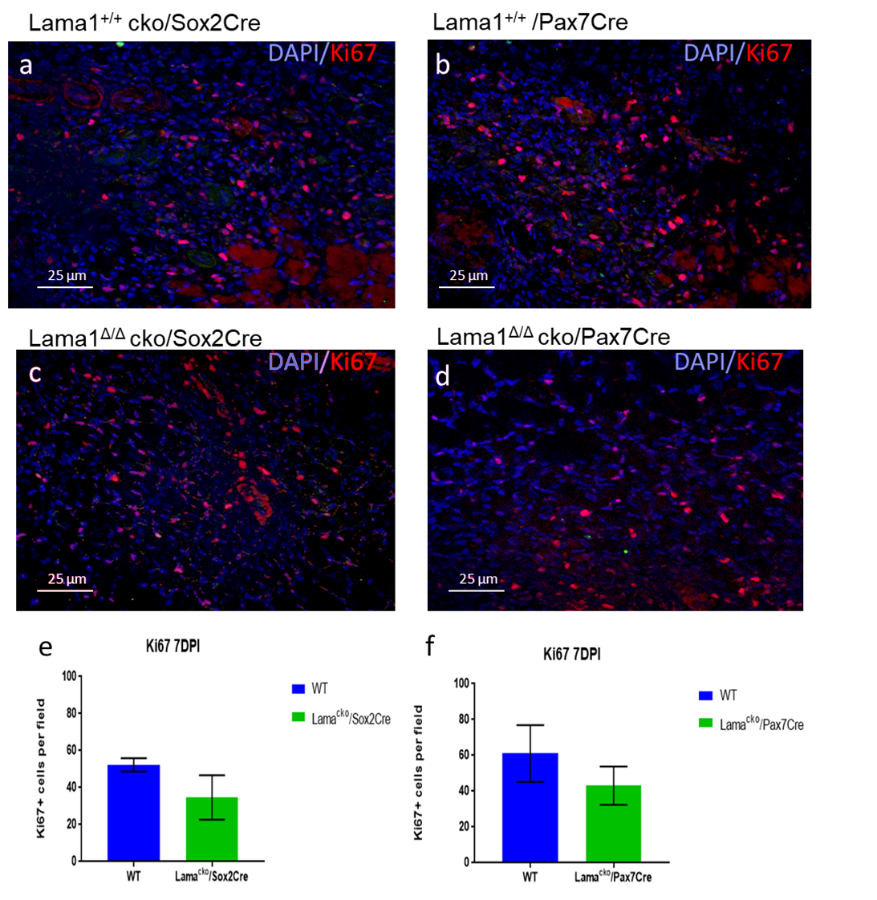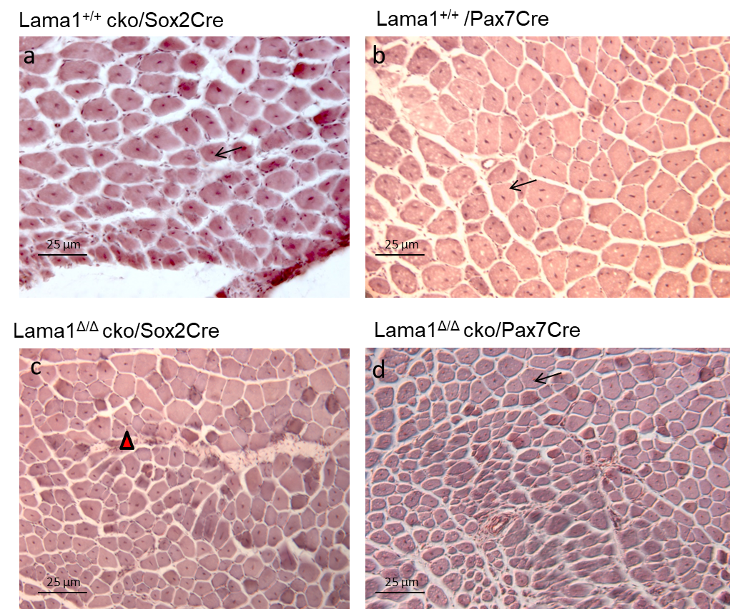
Fig 6.7 proliferation of cells at 7DPI stage of regeneration (20x magnification). Tibialis anterior muscles were harvested from Lama1^{flox/flox}/Sox2Cre and Lama1^{flox/flox}/Pax7Cre mice and stained for Ki67(red). a-b sections from Wt mice. c-d sections from conditional ko mice. e-f Charts displaying the amount of proliferating cells. Values are expressed as mean and error bar representing standard error of the mean. N=3, 12 sections analysed for each condition, at least 3 fields of view considered for each section non-parametric one-way Anova test on average of each replicate
Fig 6.8 Haematoxylin and eosin staining of mice at 14DPI stage of regeneration (20x magnification). Tibialis anterior muscles were harvested from Lama1^{flox/flox}/Sox2Cre and Lama1^{flox/flox}/Pax7Cre mice and stained for haematoxylin and eosin staining. Black arrow indicate freshly regenerated fibres. Red arrow head indicates the infiltration of inflammatory tissue. a-b sections from Wt mice. c-d sections from conditional ko mice
distribution of frequency. Finally, the distribution of minimal Ferret’s diameter was plotted for each genotype (Fig. 6.9 e,f). The comparison of Lama1^{flox/flox}/Sox2Cre mouse mutant and control fibre diameter distribution showed a significant shift of mutant muscle values toward smaller dimensions compared to control muscles (In the controls the peak value is 30µm while in Lama1^{Δ/Δ} mice have a peak value of 20µm; p<0.0001, non-parametric one-way Anova test on average of each replicate; n=3). The same analysis was performed in 7DPI Lama1^{flox/flox} /Pax7cre and revealed a similar shift toward smaller diameters (p<0.0001, non-parametric one-way Anova test on average of each replicate; n=3) (Fig. 6.7 e-f). (Fig. 6.9 e-f). Consistent with my observations, the comparison of the distribution of the minimal Ferret’s diameter between mutant and control muscles highlights the presence of fibres of smaller dimensions in mutant muscles (p<0,0001, non-parametric one-way Anova test on average of each replicate; n=3).
When a damaged tissue is not able to repair, the physiological answer to that issue is the deposition of connective tissue to fill the gaps. The evaluation of Collagen I present at the end of the tissue regeneration is an important aspect, as the presence of non-contractile tissue leads to a loss of function of the whole skeletal muscle tissue. To analyse the presence of scar tissue, I performed an immunodetection of Collagen I (Fig. 6.10). The staining revealed a very mild deposition of collagen in all animals (Fig. 6.10 a-d). Despite appearing slightly stronger in some areas of the samples, the statistical analysis of the percentage of Collagen I in each field shows a very mild difference between control and Lama1^{Δ/Δ} mice (Lama1^{flox/flox}/Sox2Cre p=0,5; Lama1^{flox/flox}/Pax7cre p=0,8) (Fig.. 6.10 e-f)
Taken together, the reduced diameter of regenerated satellite cells in the two conditional ko mice lines suggest a slower regeneration of the injured tissues. These outcomes might be dependent on an ineffective differentiation of myoblasts, or even with a reduced contribution of myoblast fusing in a new myofibre.

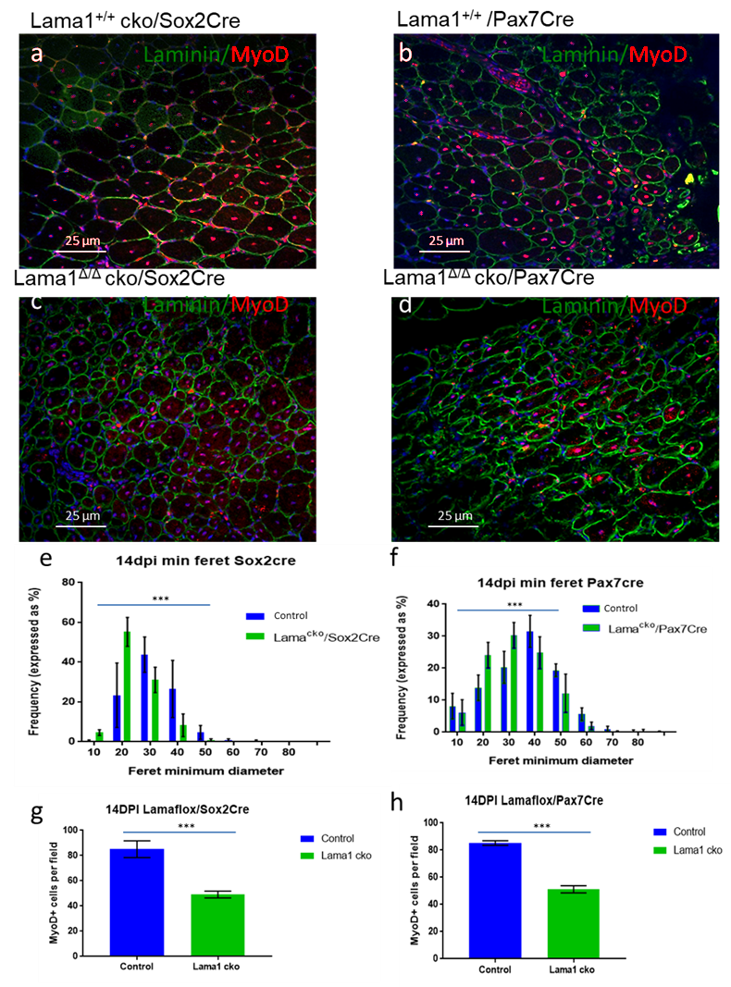
Fig 6.9 Dimension of new regenerated fibres at 14DPI stage of regeneration (20x magnification). Tibialis anterior muscles were harvested from Lama1^{flox/flox}/Sox2Cre and Lama1^{flox/flox}/Pax7Cre mice and stained for laminin (green) and MyoD (red). a-b sections from Wt mice. c-d sections from conditional ko mice. e-f Charts displaying the distribution of frequency for each range of dimension. Values are expressed as percentage and error bar representing standard error of the mean. N=3, non-parametric one-way Anova test on average of each replicate
g-h representative data of sublaminal MyoD+ cells. Values are expressed as mean and error bar representing standard error of the mean. N=3, 12 sections analysed for each condition, at least 3 fields of view considered for each section non-parametric one-way Anova test on average of each replicate
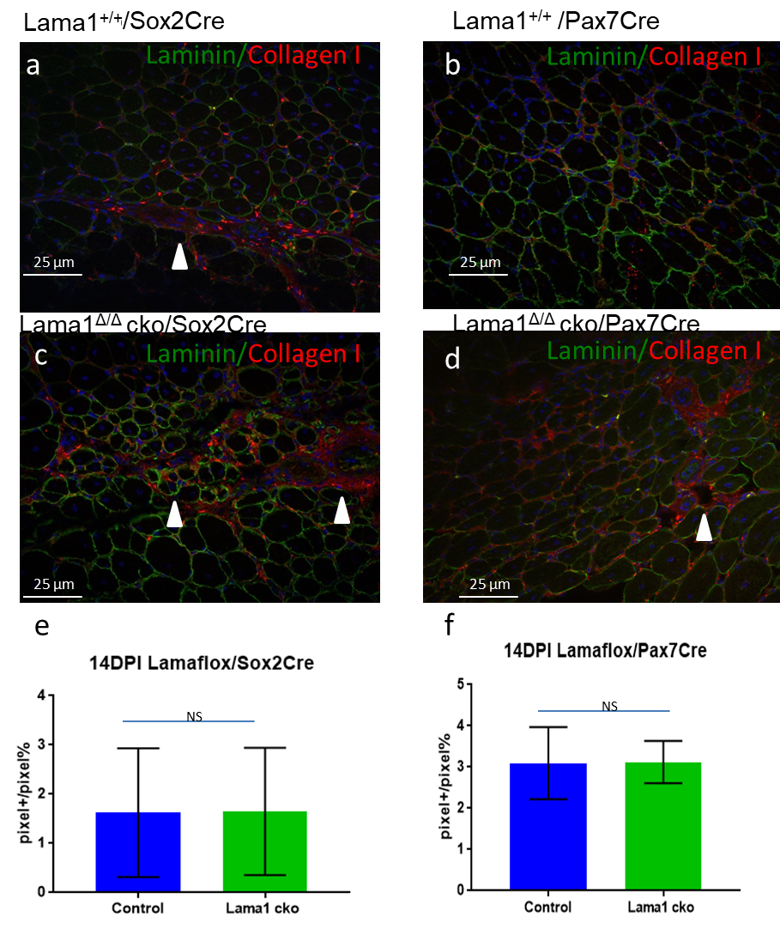
Fig 6.10 Collagen I deposition at 14DPI stage of regeneration (20x magnification). Tibialis anterior muscles were harvested from Lama1^{flox/flox}/Sox2Cre and Lama1^{flox/flox}/Pax7Cre mice and stained for laminin (green) and Collagen I(red). White arrowheads indicate examples of Collagen I deposition in injured areas of tissue. a-b sections from Wt mice. c-d sections from conditional ko mice. e-f Charts displaying the pecrntage of Collagen present in each field analysed. Values are expressed as percentage and error bar representing standard error of the mean. N=3, 12 sections analysed for each condition, at least 3 fields of view considered for each section non-parametric one-way Anova test on average of each replicate

6.2.4 The loss of Laminin-111 impairs self- renewal of satellite cells in vivo

To understand if Laminin-111 could promote the self-renewal of satellite cells in vivo, I have tested the ability of Lama1^{Δ/Δ} muscle to regenerate after repeated rounds of injury. For this investigation tibialis anterior muscles from Lama1^{Δ/Δ}/Sox2Cre mice and Lama1^{+/+}/Sox2Cre Laminin mice were injured with cardiotoxin (CTX), as described before. The same protocol was performed in Lama1^{Δ/Δ}/Pax7^{CreERT2} mice and, Lama1^{+/+}/Pax7^{CreERT2} mice. 21 days were allowed to regenerate completely the injury, and a second injection of tamoxifen was performed. The injury and regeneration cycles were repeated 3 times. 14 days after the third injury the muscles were harvested for analysis. I performed a haematoxylin and eosin staining to evaluate the general architecture of the tissues (Fig 6.11).
Control muscles revealed an overall regenerated tissue. Regenerated centro nucleated muscle fibres showed different sizes, in some cases big and round, comparable with non-injured fibres in the same muscles; in other cases smaller than the non-injured ones. Muscle fibres were in direct contact one with the others with only small gaps in some spots. It is not present infiltration of inflammatory tissue between fibres (Fig. 6.11 a, c). The mutant mice, instead showed an irregular tissue, with regenerated fibres separated one from the other and some inflammatory tissue present in between fibres. The injured areas are clearly visible due to the dimension and disruption of continuity of muscle fibres (Fig. 6.11 b,d,e).
To evaluate the dimension of regenerated muscle fibres I have performed a staining for Laminin α2 to evidence the outline of muscle fibres, and MyoD to identify the centro-nucleated fibres (Fig. 6.12 a,b,d,e,f). The regenerated fibres minimal feret diameters were measured and the distribution between controls and mutants was observed (Fig. 6.12 c,g). This analysis confirmed what was visible in the haematoxylin and eosin staining. Fibres from control mice have even and well defined borders, and in general were more regular than their mutant littermates. The comparison of the minimum feret diameters showed a significant shift of mutant fibres toward smaller diameters, as if these fibres were not able to fully maturate.
In Lama^{flox}/Sox2Cre mice it was possible to observe that the distribution of Laminin littermates peaks between 40 and 50 µm of minimum feret; Lama^{Δ/Δ}/Sox2Cre mice instead muscle fibres peaked at values between 10 and 30 µm of minimum feret. The overall distribution compared per diameter rank showed a high statistical significance, scoring a p value < 0,0001 (Fig. 6.12 c). The same analysis in Lama^{flox}/Pax7Cre mice confirmed the differences between laminin and mutant littermates, scoring a p value< 0,0001 (Fig. 6.12 g).
To analyse the presence of fibrosis in triple injured muscles, I performed immunofluorescence analysis using antibodies against Collagen 1 (Fig. 6.13). It revealed that the gaps visible in the haematoxylin and eosin staining were filled with Collagen. Moreover, regenerated fibres were encased in a thicker layer of collagen 1 than their control littermates (Fig 6.13 a,b,d,e,f). In Control animals, Lama^{flox/+} Lama^{flox/+} mice with no Sox2Cre, an average of 10% Collagen I per field was observed. This percentage rises to 32% in Lama^{Δ/Δ}/Sox2Cre mice (laminin 10.22 ± 3.171; Lama^{Δ/Δ}/Sox2Cre 32.48 ± 3.57; P value = 0.0299; Fig. 6.13 c). The evaluation of a satellite cell-specific knockout (Lama^{flox/flox}/Pax7^{CreERT2}) mice showed also the presence of fibrosis in the absence of Laminin α1 (laminin 9.71 ± 3.138; Lama^{Δ/Δ}/Pax7Cre 29.82 ± 4.059; P value 0.0035, non-parametric one-way Anova test on average of each replicate; n=3, Fig. 6.13 g).
Thus, the reduced diameter of regenerated fibres and the abundant deposition of Collagen 1 in the two conditional knock out mice lines suggest an ineffective regeneration of the injured tissues. This outcome could be dependent on the depletion of the satellite cell pool due to poor self-renewal.

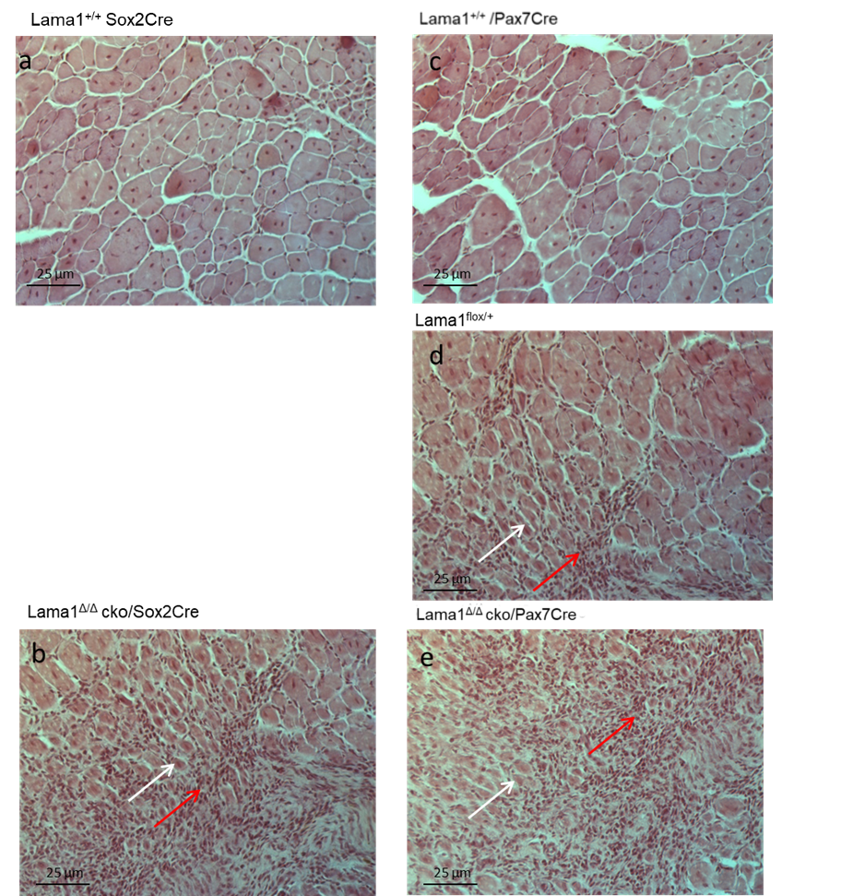
Fig 6.11 Haematoxylin and eosin staining of repeated injuries in conditional ko mouse lines. Tibialis anterior muscles were harvested 14 days after the third cycle of injury and regeneration, and stained with haematoxylin and eosin. Red arrows indicates inflammatory infiltration ( b,d,e) present in Lama ko and heterozygous mice. white arrows indicate the small fibres regenerated by Lama ko and heterozygous mice
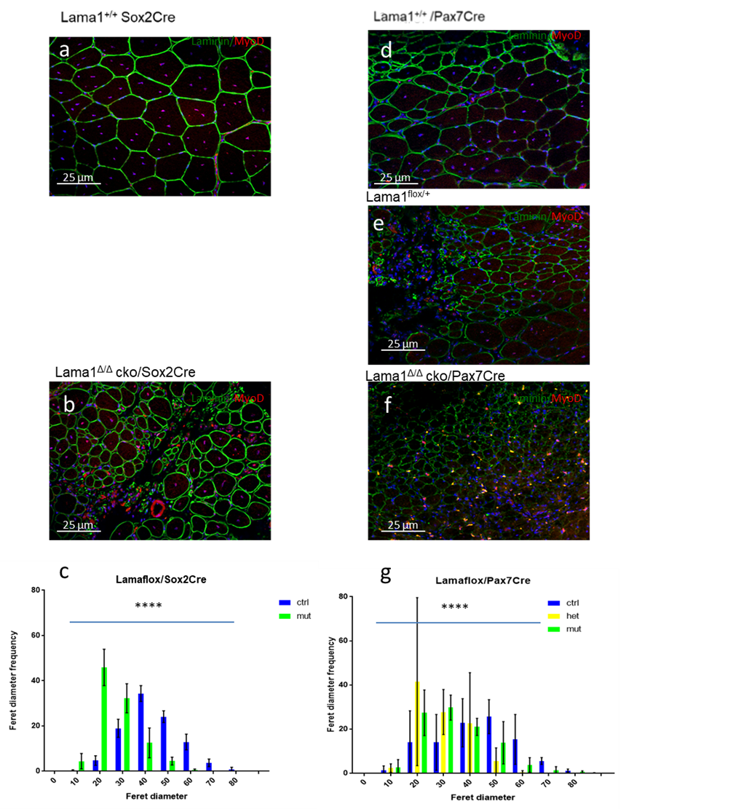
Fig 6.12 Minimum feret analysis of regenerated fibres. Tibialis anterior muscles were harvested 14 days after the third cycle of injury and regeneration, and stained with Pan-Lamininn (green) and MyoD (red). (a,b, d-f) representative images of TA sections from the two mouse lines. (c,g) chart showing the distribution of the different diameters expressed as percentage. N=3, 12 sections analysed for each condition, at least 3 fields of view considered for each section (error bars represent standard error of the mean. ****represents p-value < 0,0001 of the two distribution)

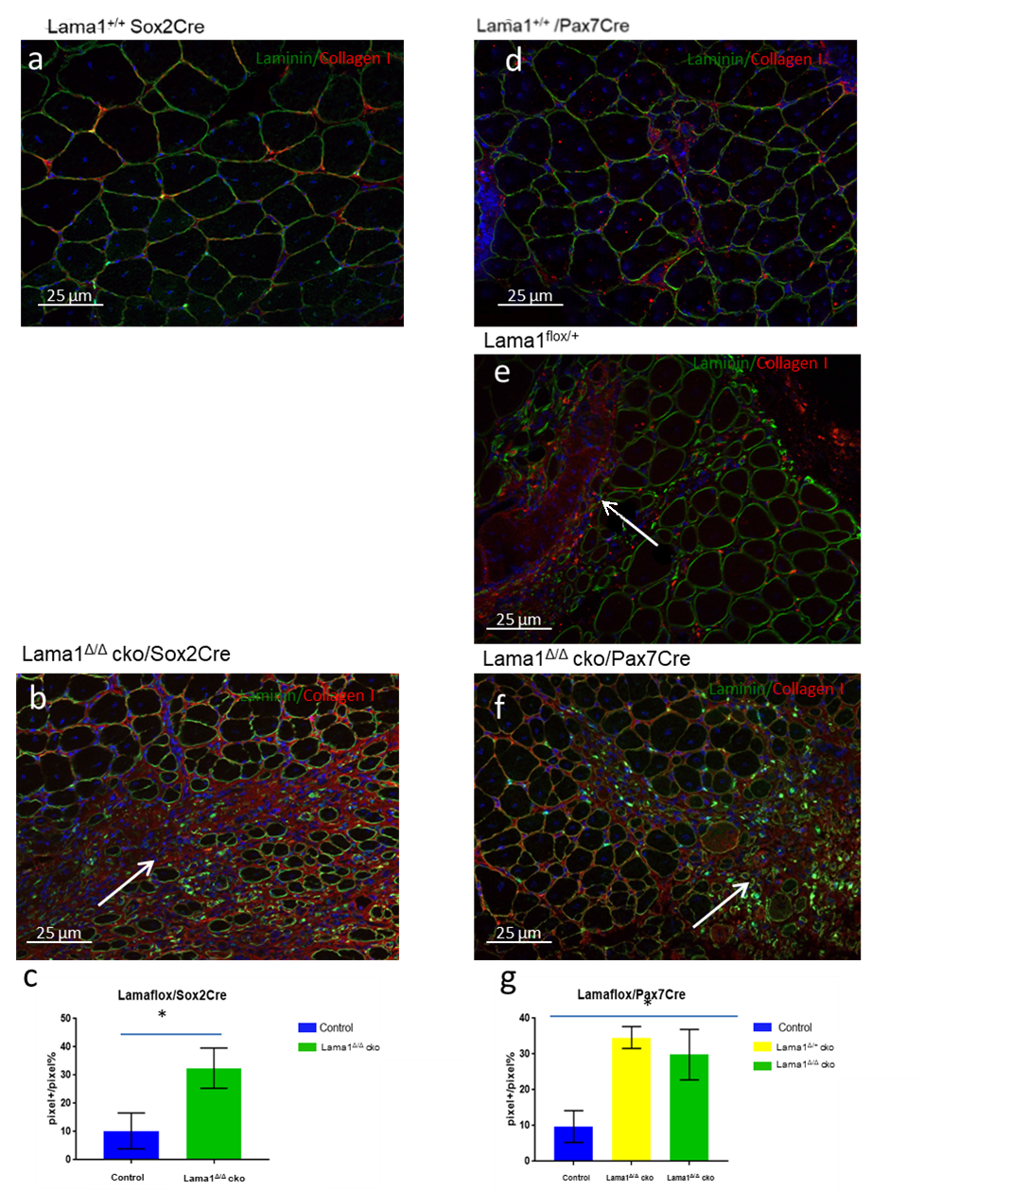
Fig 6.13 Collagen evaluation analysis in repeated injury condition . Tibialis anterior muscles were harvested 14 days after the third cycle of injury and regeneration, and stained with Pan-Lamininn (green) and Collagen1 (red). (a,b, d-f) representative images of TA sections from the two mouse lines. White arrows point to wide collagen enriched areas. (c,g) chart showing the amount of collagen expressed as percentage of positive pixels per view field. N=3, 12 sections analysed for each condition, at least 3 fields of view considered for each section (error bars represent standard error of the mean. * represents a p-value < 0,05)

6.2.5 Laminin-111 ablation reduces the pool of satellite cells after multiples rounds of injury

In order to understand to what degree Laminin-α1 is required for satellite cell self-renewal, I counted the number of MyoD+ cells that returned to a sub laminar position (Fig. 6.15). This counting could help to determine if after several injuries the number myogenic precursor cells returning to quiescence and re-integrating their niche diminished progressively, as this could be a clue of an impaired self-renewal.
The use of MyoD as marker helps to identify myogenic precursors that were active, as using exclusively Pax7 could evidence a pool of satellite cells that remained quiescent. This approach would not give a definitive proof of the self-renewal property of these tissue, nonetheless would give a substantial cue about the homing to sub laminal position of myogenic precursors.
This experiment was performed in mice that went through 1, 2 and 3 rounds of cardiotoxin injury and regeneration, harvesting the muscles 14 days after the second injury (Fig. 6.15 b-g). Sections from these muscles were stained with Pan-Laminin to evidence the basement membrane and MyoD to label the myogenic cells. For this counting only MyoD+ cells that were in close contact with the basement membrane, positioned on the side of the regenerated myofibre were considered (Fig. 6.15 a). This analysis at 14 dpi after just one round of injury revealed that in both mice lines the sublaminal myogenic cells are statistically comparable (Fig. 6.15 b, c). Nonetheless it is possible to observe a trend in the charts with a lower number of MyoD+ cells in sublaminal position in Laminin-111 null mice. The counting of sublaminal cells after 2 rounds of injury revealed that mutant mice in both mouse lines had a reduced number of satellite cells under the basal lamina compared to their Laminin littermates. In Lama^{flox}/Sox2Cre mouse line Control mice showed about 10 sublaminal satellite cells per field, while Lama^{Δ/Δ}/Sox2Cre littermates show only 5 (p value < 0,0001, non-parametric one-way Anova test on average of each replicate; n=3; Fig. 6.15 d). In Lama^{flox}/Pax7Cre mouse line the difference is confirmed, with about 11 sublaminal satellite cells per field in control mice and 6 in Lama^{Δ/Δ}/Pax7Cre mice (p value < 0,0001, non-parametric one-way Anova test on average of each replicate; n=3. Fig 6.15 e). This difference was further confirmed with the analysis of muscles harvested from both mice lines after 3 rounds of injuries (p value < 0,0001, non-parametric one-way Anova test on average of each replicate; n=3. Fig 6.15 f,g). The relation between number of injury cycles and the reduced number of sublaminal satellite cells in conditional knock out mice can be related with a progressive reduction of satellite cells able to self-renew. Cycle after cycle a small quantity of satellite cells is lost, compromising the regenerative ability of the muscle tissue. These data confirm that Laminin-111 could actually affect the ability of self-renewal of stem cells
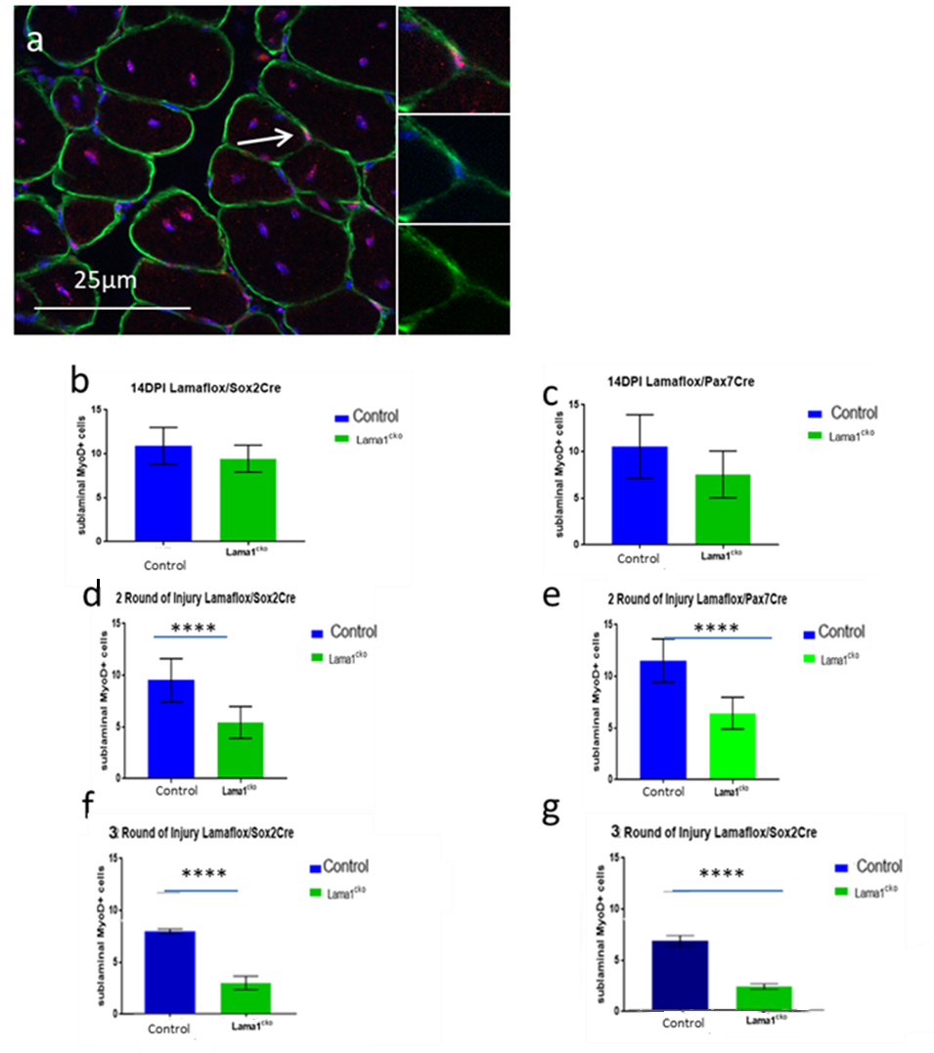
Fig 6.14 Evaluation of sublaminal myogenic cells. Tibialis anterior muscles were harvested 14 days after the second cycle of injury and regeneration, and stained with Pan-Lamininn (green) and MyoD(red). (a) representative image of TA section showing a sublaminal myogenic cell. The cells were considered of interest if positive for MyoD, and positioned on the inner side of the basement membrane. Chart showing the amount of sublaminal myogenic cells espressed as mean of positive cells per view field (14DPI:b,c; 2 rounds of injury: d,e; 3 rounds of injury: f,g). n=3, 12 sections analysed for each condition, at least 3 fields of view considered for each section (error bars represent standard error of the mean. **** represents a p-value<0,0001)

6.3 Conclusion

6.3.1 Laminin-111 loss affects the regeneration of muscle fibres in vivo
As observed in the ex vivo experiments, the mild effect of Laminin-111 on the activation of satellite cells is observable also in vivo. The staining of sections of muscles in early stages of regeneration pointed to a mild difference in the activated (MyoD+) cells. This difference is visible in Lama1^{Δ/Δ} /Sox2Cre mice as well as in Lama1^{Δ/Δ}/Pax7Cre mutant even though in the latter line the deletion of Laminin α1 was induced only one week before the injury excluding previous defect during myogenesis due to lack of Laminin-111.
A further similarity between ex vivo and in vivo experiments is related to the outcomes of the observations about cell proliferation. The observation on single fibres experiments suggested that Laminin-111 could promote the proliferation of satellite cells. The same effect is visible in vivo comparing the population of activated muscle progenitors at 2 and 4 days after injury. The increase of MyoD+ cells during the first 4 days of regeneration is not visible in Lama^{Δ/Δ} mice. This observation is compatible with impairment (or a delay) in the proper proliferation of muscle precursor. It has been observed that the binding of Laminin with Integrin α6 could promote the proliferation of satellite cells. This mechanism can be elicited by the activation of the Delta-like 4 (Dll4)/Notch pathway (Estrach et al. 2011).
Anyway in some cases it has been observed how the administration of Laminin-111 could promote the proliferation of satellite cells. For example, the effects of Laminin-111 treatment on Myoblasts proliferation has been observed both in vivo and in vitro. Goudenge observed that myoblasts cultured in 2% serum and Laminin-111 show a higher proliferation than their controls. Moreover he confirmed that the higher number of Myogenic precursor was not depending on a lower fusion rate, as treated myoblasts were able to differentiate exactly as control cells (Goudenege et al. 2010). Similar effects were observed in vivo. It has been observed that Laminin-111 could be a good treatment for Merosin deficient mice. Analysis of embryonic Myosin heavy chain (eMyHC) showed that merosin deficient mice injected with Laminin-111 showed a higher amount of proliferating satellite cells 4 days after CTX injection, 31% more than controls.(Van Ry et al. 2014). These studies suggest the property of Laminin-111 to promote proliferation of satellite cells, even though, it would be necessary to perform further staining combining Ki67 marker with a direct satellite cell marker, and in general try to discriminate clearly which is the population mostly affected by laminin-111.
It has been observed previously that Macrophages are involved in the proliferation of satellite cells (Saclier et al. 2013; Chazaud et al. 2003; Cantini et al. 1994; Merly et al. 1999). It is not possible to state that Laminin-111 does not change the expansion of macrophages, as a clear double staining with macrophages marker was not performed in this work. Anyway, I have observed in Lama^{flox}/Pax7Cre mice the combined staining for Ki67 and Pax7 at 4 Days showed that there is a proliferating population of non-myogenic cells that is clearly non influenced by the lack of Laminin-111. It is possible that this population represents the macrophages involved in the early stages of tissue repair
Another work by Segawa observed in C3H/HeN mice that normal regeneration after CTX injection was impaired upon injection of an inhibitor of macrophage migration of the muscle tissue was observed activation of satellite cells and proliferation of muscle progenitors (Segawa et al. 2008). From what was observed in Lama^{flox}/Pax7Cre mice, the contribution of proliferating non-myogenic cells (potentially macrophages) is not impaired. Therefore the delay in myogenic cells proliferation is depending only on the missed incorporation of Laminin-111.

The effects of an impaired proliferation can be observed from a macroscopic point of view looking at the fibre regeneration at 7 and 14 days post injury. The impairement of normal myogenesis could be observed looking at the dimension of maturing muscle fibres and the deposition of collagen. Including the generation of smaller fibres and the presence of collagen I deposition at 7dpi and 14dpi. The same difference is not as clear in Lama^{Δ/Δ}/pax7^{creERT2} mice, as conditional KO mice show just a slighter reduction in fibres diameter and the difference in the deposition of collagen is not as striking as what was observed in Lama^{flox}/Sox2^{cre}. The difference between the two mouse lines could be explained thinking about the different features in Laminin α1 deletion. Lama^{flox}/Sox2 cre mice are born with the LAMA1 gene ko. On the opposite, in Lama^{flox}/Pax7 cre mice the deletion was induced right before the injury. This difference causes the Lama^{flox}/Sox2cre mice to accumulate some defect in satellite cells proliferation during their 8 weeks of life. The Lama^{Δ/Δ} /Pax7cre mice, instead, were healthy and able to express Laminin-111 until the week before the cardiotoxin injection.
This initial consideration suggests a possible role for the incorporation of Laminin-111 in the basement membrane: the remodelling of satellite cells basement membrane and the incorporation of Laminin-111 is necessary to maintain the satellite cells pool and preserves the regeneration properties of the adult muscle tissue. The observation of the centro-nucleated fibres and the architecture of the regenerated muscle tissue
The reduced size of newly-regenerated fibres at 7 and 14 dpi could be due to one of the following possibilities: a) an initial reduced number of muscle progenitor cells caused by a proliferation defect at an earlier time point, b) an initial reduced number of muscle progenitor cells caused by an impaired migration, c) a defect in muscle progenitor cell ability to fuse between each other and with existing muscle fibres.
Following proliferation, myogenic progenitor cells either return to quiescence and replenish the stem cell pool or migrate to the site of injury and fuse to form a new fibre. It was observed that cells that are not involved in the formation of a new fibre undergo apoptosis (Schwartz et al. 2009). In the same work it was observed that the amount of cells is anyway sufficient to form fibres of the normal size and dimension. Anyway, in this case the loss of Laminin-111 could cause an increased apoptosis, or could impair satellite cell migration, leading to an increase of apoptotic cells, and a reduction of the number myogenic progenitor cells contributing to new myofibres, explaining the reduced size of regenerated fibres in Lama1-deficient mice.
Another possible explanation for the reduced size of regenerated fibres could be related to a defect in the normal ability of myogenic progenitor to fuse in a single myofibre. This aspect was studied, in particular in relation with the interaction of myoblasts with extracellular components and immune system cells.
The expression of Integrin α6 on the surface of activated satellite cells, as observed in previous works from Dr. Shantisree Rayagiri, could suggest an interaction between macrophages and satellite cells during the myogenesis pathway. It has been observed that the anti-inflammatory wave of macrophages could influence the differentiation and the fusion of myoblasts during the later stages of myogenesis. Chazaud in 2009 observed that the depletion of the anti-inflammatory macrophage wave caused a strong reduction in the diameters of regenerated muscles following CTX injury. A possible explanation for this effect was observed by Villalte in the same year. In this study it was observed that the second wave of macrophages stimulates the differentiation and the fusion of myoblasts. The loss of Laminin-111 expression in my mouse strains could impair this interaction.
A very similar defect in the dimension of myofibres was observed in a study by Vadivelu on the role of TIS7 protein. TIS7 -/- mice were characterised, and it was observed in vivo that older mice showed smaller muscle fibres, when compared with their control littermates. An in vitro characterization of myogenic progenitors from these mice revealed that the size deficit could be addressed to a reduced differentiation and fusion rate of Tis7 -/- myoblasts. The administration in vitro of purified Laminin restored the defect, increasing the myoblasts ability to differentiate and fuse in a new myotube. This observation may suggest the Idea that myoblasts interaction with laminin could promote the correct maturation of myofibres, and that the reduced size of muscle fibres in Lama^{Δ/Δ} mice could depend on an impaired mechanism of differentiation and fusion.
These possibilities are not mutually exclusive, and the regeneration disorder could be caused by a concurrence of all these cases.
Furthermore, the defect in engagement with differentiation and fusion could be related with other properties of Laminin-111 and its receptor.
As observed by Timpl in 1994 Laminins have the properties to bind with growth factors blocking their proliferation effect, stimulating therefore the differentiation of myoblasts. In particular Timpl claimed that Laminin has an affinity for HSPG. This growth factor promotes the proliferation of satellite cells. Laminin could bind this and other growth factor and entrap them in the ECM during the last stages of regeneration, or prevent the triggering of signalling pathways such as Shh. Furthermore the interaction of Laminin-111 with Integrin on the surface of satellite cells could work as anchoring and scaffold for new born fibres. It has been observed that β1 subunit of integrin could activate the Focal Adhesion Kinase (FAK) promoting the fusion of myoblasts positioned in the same cluster.

6.3.2 Loss of Laminin- α 1 leads to a failure in satellite cell self-renewal.
In previous loss of function experiments I have observed a reduced number of self-renewing satellite cells in ex vivo conditions (Caveolin+ only cells), and a reduced number of sublaminal MyoD+ cells in vivo, suggesting an impaired self-renewal of satellite cells. To confirm these outcomes I have observed the quality of regeneration in skeletal muscle tissue after three rounds of injury and regeneration. In both mice Lama1 conditional knock out mouse lines, the lack of Laminin-111 led to a failure in the efficient regeneration of muscle tissue. This outcome was obtained observing the smaller regenerated fibres, and the presence of extended areas of scar tissue. Furthermore, when MyoD+ cells under the basal lamina of new fibres were counted, it was possible to observe that mutant mice of both strains showed a strong reduction in sublaminal myogenic precursors (that can be identified as satellite cells).
This lack of homing myogenic precursors is visible as well after 2 rounds of injury. In conditions of repeated cycles of injury and regeneration, it is possible that the damaged muscle might recruit myogenic precursors from neighbouring healthy muscle (Conboy et al. 2005). Taken together these observations suggest that the loss of Laminin-111 causes the inability to restore the original pool of myogenic precursors after each cycle of damage and regeneration.
Many studies observed that the ECM has a strong role in the regeneration of the skeletal muscle and that undergoes a broad remodelling (Calve et al. 2010). The importance of the niche and the ECM in the determination of satellite cells self-renewal has also been observed studying the components of the basement membrane. The glycoprotein Fibronectin is able to stimulate Wnt7a signalling through its receptor complex Syndecan-4/Fzd7. This pathway stimulates symmetric divisions, promoting the expansion of the satellite cells pool (Bentzinger et al. 2013). It has been observed that another important element for satellite cells behaviour is the stiffness of the basement membrane. It has been observed that Collagen VI is involved in the regulation of satellite cells self renewal. Col6a1-null mice demonstrated a delay in the in muscle regeneration and a reduction of the pool of satellite cells. it has also been observed that after multiple round of muscle injury the mutant mice are not able to perform a successful regeneration (Urciuolo et al. 2013). It is believed that the mechanical properties of the basement membrane could influence satellite cells self-renewal program, as it has been observed studying satellite cells behaviour on hydrogels mimicking basement membrane stiffness (Gilbert et al. 2010).
The importance of niche and ECM components has been studied in aged muscles. It has been observed that in old mice (19-25 months of age) satellite cells show a reduced ability to expand and to replenish the stem cell pool (Day et al. 2010). Nonetheless, it has been observed that the impaired ability to regenerate depends on the alteration of the healthy condition of the niche, and not on the satellite cells. As proof of this it has been observed that old satellite cells grafted in young mice regain their ability to regenerate damaged muscles, and also that they recover their ability to self-renew (Shefer et al. 2006).
Similar studies in mdx mouse addressed the importance of the components of the basement membrane, suggesting that the mdx phenotype could be dependent on the abnormal composition of the basement membrane surrounding the muscle fibre and leading to an impairment of the cell polarity, leading to an imbalance toward differentiation to the detriment of self-renewal (Chang et al. 2016).

7 Discussion
The micro-environment surrounding stem cells plays an important role in stem cell activity. Specifically, the remodelling of ECM components provides a biochemical stimulus for their activation, proliferation and differentiation. Previous work from our lab reported on the remodelling of the ECM at the satellite cell niche upon their activation, resulting in the incorporation of an embryonic isoform of Laminin, Laminin α1, into the adult muscle stem cell basement membrane. My thesis project aimed at deciphering whether the deposition of Laminin-111 in the satellite cell niche was an essential process during adult myogenesis. To address this question, I used in vivo and ex vivo loss-of-function and gain-of-function approaches. The ex vivo muscle fibre culture system allowed me to observe satellite cell’s behaviour within their natural environment (the myofibre and the basal lamina) and through the use of two Lama1 conditional knock-out mouse lines, I could assess the effects of the loss of Laminin α1 in adult muscle regeneration.
I demonstrated that MMP9 and MMP2 play a fundamental role in the remodelling of the basement membrane at the satellite cell niche, and showed that they are produced by satellite cells themselves upon activation. Furthermore, I uncovered that the loss of Laminin α1 might affect adult myogenesis, particularly when muscles were subjected to repeated cycles of injury. This phenotype might be caused by a reduction of muscle progenitor cell proliferation and by an impairment of satellite cell self-renewal. The treatment of single fibres with Laminin-111 indicates that exogenous Laminin-111 promotes satellite cell self-renewal by altering the plan of cell division. This investigation besides suggesting a further description of the myogenic machinery regulation extends the knowledge on the role of the environment in the regulation of stem cell activity.
My observations might help expand current knowledge of remodelling and could help to explain the effect of Laminin-111 as muscular dystrophy treatment.

7.1 Loss of ECM remodelling leads to an impairment of myogenesis.
The remodelling of the ECM promotes the turnover of ECM components in order to build the most favourable environment for cell activity. Different studies proposed that basement membrane remodelling is a mechanism to assist stem cell activity and indicated that MMPs are effectors of a controlled alteration of the existing ECM, creating the right conditions for cell activity, such as migration (Page-McCaw et al. 2007; Reagan & Rosen 2016; Hojilla et al. 2003; Wong & Rustgi 2013). These activities have been reported in several works, spanning from the hair follicle niche, where residing stem cells promote the incorporation of Nephronectin in their basement membrane to promote the anchorage of the erector pili muscle to the bulge, to cancer stem cells, inducing the incorporation of Periostin in the basement membrane to enable their implantation in tumour sites (Malanchi et al. 2011; Fujiwara et al. 2011).
Furthermore, these effects can be obtained through the cleavage of ECM components producing fragments with new biological activity modulating the activity of cells through the control of release of new signalling molecules (Solomonov et al. 2016; Hindi et al. 2013a; Yamada et al. 2008).
The role of the different members of Matrix metalloprotease family has been investigated through the use of mutant mouse lines. However, a weak phenotype was observed due to functional redundancy amongst MMPs (Page-McCaw, Andrew J Ewald, et al. 2007). Despite several studies (including this one) reporting that MMP2 and MMP9 are upregulated during the early stages of muscle regeneration (Lewis et al. 2000; Hong Li et al. 2009; Yeghiazaryan et al. 2012a; Kherif et al. 1999; Zimowska et al. 2008), the analysis of MMP2 and MMP9-deficient mice only revealed defects related to vascular formation, bone remodelling and lung formation (Page-McCaw, Ewald, et al. 2007). Furthermore, the effect of MMPs and MMP9 on adult muscles has been observed in engraftment experiments in mdx mice. It has been observed that the expression of MMP9 promoted the successful engraftment of satellite cells in mdx muscles (Ogura et al. 2014; Morgan et al. 2010). This behaviour although still obscure, confirms my observations, as the proper expression of MMPs promotes the correct myogenesis. Nonetheless the in vivo results from Morgan might be dependent on an easier invasion of satellite cells or a promotion of the macrophages interaction with satellite cells.
My work observed directly the remodelling of satellite cells basement membrane through the activity of MMPs, and suggested how the inhibition of MMPs activity might impair the progressive incorporation of Laminin-111 in the basement membrane. Interestingly, MMP9 and MMP2 appear to be cooperating during the basement membrane remodelling, as the inhibition of both MMPs produced a severe loss of Laminin-111 in the satellite cell ECM, compared to the inhibition of MMP2 only. Furthermore, I have reported that blocking remodelling had a profound impact on myogenesis comparable to that observed in single muscle fibre cultures from Lama1^{cko} mice or in fibre cultures treated with CD49f antibody.
These findings might suggest that MMP 2 and 9 are key players in the remodelling of the adult muscle basement membrane, a role consistent with previous studies reporting the upregulation of these two metalloproteases upon strenuous physical activity or mechanical damage. In particular has been observed the activation of MMP2 (constitutively expressed) and the upregulation of MMP9 transcription (Zimowska et al. 2008).
In addition, my work pointed out that MMPs can be provided endogenously by satellite cells. Previous study investigating myogenesis in whole muscles, reported that the main source of MMPs were macrophages (Vaisar et al. 2009; Hindi et al. 2013b), although another study observed the presence of MMP9 mRNA through in situ staining of satellite cells, suggesting that they might produce part of the MMP9 needed for ECM remodelling (Kherif et al. 1999).
My observations shed light on the remodelling of the Basement membrane clarifying the origin of MMPs in the niche and the synergistic activity of MMP9 and 2 during adult myogenesis. My observation also explained how satellite cells are able to provide their own MMPs, and that the portion of MMP provided by macrophages is not strictly necessary.

7.2 Laminin-111 is required for myogenic progenitor cell proliferation and self-renewal

The characterization of the two conditional mutant mouse lines (Sox2Cre and Pax7CreERT2-driven loss of Lama1) suggested that the loss of Laminin α1 (and thus Laminin-111) reduces the proliferation of myogenic precursors in the early stages of regeneration (2 and 4 dpi). This finding was supported by the reduced proliferation rate observed in single fibre cultures in the absence of Laminin α1. Especially in the first 48 hours of culture myogenic precursors seems to be less prone to expansion. A similar effect has been observed in mice lacking MyoD, raising the possibility that Laminin α1 stimulates satellite cell proliferation through its control of MyoD expression ( Yablonka-Reuveni et al. 1999).
Indeed, MyoD -/- satellite cells in single fibre cultures showed an increased proliferation, due to a delay in the expression of Myogenin, and a longer period in a proliferative state. The delayed expression of Myogenin has been observed also in vivo, were it correlates with a slower regeneration and an increase of self-renewing cells ( Yablonka-Reuveni et al. 1999; Wei & Paterson 2001). These outcomes are comparable with the role of Laminin-111 and its signalling through Integrin α6; therefore maybe the two observation could be somehow related and linked by a molecular pathway. It has been observed that the preferred receptor for Laminin-111, Integrin α6, is able to induce the expression of Dll4, an activator of Notch pathway during vascular and endothelial formation. A study from Hirsinger showed that Notch pathway can modulate selectively the expression of MyoD (Hirsinger et al. 2001). A retrovirus was used to induce the over-expression of Delta1 in the chick embryos. The upregulation of Notch activator lead to a downregulation of MyoD expression, leaving unaffected the expression of Myf5 and MyoD (Hirsinger et al. 2001; Delfini et al. 2000). The effect of Notch Pathway on MyoD expression was observed in other investigations. In particular, Kuroda observed the possible pathway that connects Notch expression to MyoD downregulation. C2C12 cells were co cultured with X63 myeloma cell line expressing a full-length mouse Delta1 epitope (D10 cells). The overexpression of Delta1 caused a visible delay in the C2C12 formation of myoubes. The analysis of MyoD RNA in C2C12 cells revealed a reduction of differentiating myoblast and an increased amount of proliferating cells, positive for Ki67 staining (Kuroda et al. 1999). A delay in differentiation and a marked expansion state has been observed also in freshly isolated satellite cells. Satellite cells isolated from 12 weeks old mice were cultured on different Laminin substrates to characterize their behaviour. It has been observed that the culture on Laminin-521 and 511 promoted both the proliferation and the differentiation of satellite cells. The same study claims that the culture of satellite cells on Laminin-111 enhance the proliferation of satellite cells; exerting, however no effect on the differentiation to myoblasts. The integrin expression analysis revealed that beside the known affinity of Integrin α6 for Laminin-111, satellite cells cultured on this substrate expressed high concentration of integrinβ2 (Penton et al. 2016). Interestingly this integrin subunit has been observed to promote the muscle hypertrophy in mice muscle by mediating the interaction with anti-inflammatory macrophages (Marino et al. 2008). Taken together these observations might suggest that the remodelling of basement membrane and the incorporation of Laminin-111 promotes through different means the proliferation stage of myogenesis.
The loss of Laminin-111 in vivo led to a poor myogenesis, proliferation, and an impaired self-renewal of satellite cells, and the effects of MyoD on proliferation and self-renewal seems to be a suitable target for Laminin-111/integrin α6 signalling. Therefore, one may hypothesize that the interaction between Laminin-111 and Integrin α6 might modulate myogenesis progression through the regulation of the Notch pathway. As a future direction it would be interesting focusing on the effect of the Laminin-111/Integrin α6 on the expression of MRF from a molecular point of view. This investigation could explain the mechanism linking the embryonic isoform of laminin to its effects on the adult myogenesis.

7.3 Laminin-111 could control the adult myogenesis through Wnt/Notch pathway.

As adult myogenesis recapitulates embryonic myogenesis, in the same way the remodelling of the basement membrane upon injury could recreate the embryonic environment of the early stages of muscle formation (Chargè & Rudnicki 2004; Wang & Conboy 2010).The outcomes of my experiments pointed out that the treatment of skeletal muscle fibres with Laminin-111 increased the number of planar, symmetric cell divisions. This is usually related to the cell expansion. The observed increase of the planar, symmetrical divisions might be achieved through Integrin α6, Laminin-111 main receptors. As a matter of fact, Integrin α6 has been observed promoting cell proliferation in models of colon rectal cancer, and in the same study this property was connected with the promotion of β-catenin/Wnt pathway (Goel et al. 2014; Groulx et al. 2014). Dr Shanti Rayagiri observed the expression of Integrin α6 on activated satellite cells (Shanti Rayagiri PhD thesis) and the switch of the integrin pool on satellite cells reflects the turnover ECM components and the incorporation of Laminin-111 in the basement membrane. Therefore seems evident that the observed effects of Laminin-111 are exerted through Integrin α6. Starting from these bases, it is important to consider the different pathways elicited by Integrin α6 and identify the ones related to the modulation of cell division and the determination of the fate of multipotent stem cells. Two possible candidate are Notch and Wnt pathway (Le Grand et al. 2009; von Maltzahn et al. 2012; De Mey & Freund 2013; Schuster-Gossler et al. 2007; Artavanis-Tsakonas et al. 1999)
The presence of Integrin α6 leads to the triggering of Wnt7a pathway promoting the expansion of the satellite cell pool as observed in a recent work from le grand (Le Grand et al. 2009). Anyway, another pathway triggered by Integrin α6 is the Notch pathway (Estrach et al. 2011). The crosstalk between Wnt and Notch is well studied, and has been observed during different process of cell proliferation and differentiation (Collu et al. 2014). The Notch/Wnt pathway has been also observed in the adult myogenesis, were the switch between the two directs the progression through myogenesis determining the timing for expansion and differentiation of satellite cells (Rios et al. 2011; Brack et al. 2008).
Notch and Wnt pathway can work together to coordinate big group of progenitor cells as has been observed in the intestinal crypt ( De Mey & Freund 2013; Panousopoulou & Green 2014). The crosstalk between these two signalling pathways is evident also during early embryonic myogenesis (Collu et al. 2014; Brack et al. 2008; Rios et al. 2011; Hayward and Kalmar 2008), reinforcing the Idea that ECM remodelling of activated satellite cells recreates the embryonic microenvironment. A future line of investigation could focus on the role of these two pathways during the different stages of adult myogenesis.

7.4 Laminin-111 plays a physiological role in adult myogenesis.
The adult ECM offers primarily support to the muscle fibres during contraction (Aumailley & Timpl 1986). Laminin-211 is the docking station for the DGC and supports the integrity of the fibre anchoring indirectly the Dystrophin to the extracellular matrix (Gumerson & Michele 2011). The interaction between the ECM and the muscle fibre is supported by the interaction between Laminin-211 and its main receptor, Integrin α7β1 (Guo et al. 2006; Sanes et al. 1990). Loss of Integrin α7 causes a phenotype similar to the CMD, with increased fibre fragility and muscle wasting. Double mouse mutant Itga7^{-/-};Dystrophin^{-/-} are characterised by an extremely strong dystrophic phenotype and a post-natal death at 4 weeks (Guo et al. 2006). There is no change in
Laminin α2 expression in these mutant mice, suggesting that Laminin α2 expression is independent from the expression of its receptors (Guo et al. 2006; Guo et al. 2003). It is possible to conclude that beside its importance in maintaining a functional and healthy adult skeletal muscle tissue, Laminin-211 is not involved in its repair. On the opposite, this role was associated to Laminin-111. Several studies focused on the ability of exogenous administration of Laminin-111 to restore regenerative potential in different dystrophic mouse lines (Rooney et al. 2009; Van Ry et al. 2014; Rooney et al. 2012).
The loss of Integrin α7 causes congenital muscular dystrophy characterised by a delay in muscle development and a reduced mobility (Guo et al. 2006; Burkin & Kaufman 1999). The characterization of a mouse model lacking Integrin α7 revealed general muscle weakness, and a tendency of muscle fragility, most probably due to the loss of connection between muscle fibres and Laminin-211 present at the adult basement membrane (Guo et al. 2006). The isolation of satellite cells from WT and mutant mice revealed that the loss of Integrin α7 causes a reduced activation of satellite cells and a delay in their proliferation (Guo et al. 2003). The study of their muscle regeneration pointed to a delayed restoration of the tissue and the formation of hypotonic muscle fibres (Guo et al. 2006). The administration of Laminin-111 before cardiotoxin injection promoted the correct regeneration of the muscle fibres, ameliorating the proliferation of myogenic progenitors and the size of newly formed fibres (Rooney et al. 2009).
Similar observations were obtained in the mouse model of MDC1A, the Merosin-deficient mouse. Laminin α2-deficient mice have a phenotype similar to the one observed in congenital muscular dystrophy caused by Integrin α7 mutation (Van Ry et al. 2014; Rooney et al. 2012). Once again, the administration of Laminin-111 led to an improvement of the skeletal muscle tissue regeneration in terms of the architecture of the regenerated tissue, and fibre diameter. The effect of Laminin-111 administration was tested in Duchenne muscular dystrophy models as well (mdx mice), however with conflicting results depending on the method used (Gawlik et al. 2011; Goudenege et al. 2010). Intra-muscular and systemic administration of exogenous Laminin-111 in mdx mice caused an amelioration of the mdx phenotype (Rooney et al. 2012). In contrast, the generation of mdxLM1 mice, which over-express Laminin α1 under the control of an ubiquitous promoter, did not ameliorate the mdx phenotype (Gawlik et al. 2011). Although both studies showed an increased expression of Integrin α7 upon up-regulation of Laminin-111, this latter report stated that the DGC was not restored (Gawlik et al. 2011). This last study seems to jeopardize the claim that Laminin-111 may be used as a therapeutic treatment of muscle disorders and dystrophies. However, this discrepancy may be the result of distinct methods used to raise the levels of Laminin-111 in muscles.
Most of these studies consider that Laminin-111 is an isoform present in embryonic, but not adult muscles.
My findings provide a new perspective on these previous studies by suggesting that Laminin-111 is expressed physiologically in regenerating adult muscles. The expression of the embryonic Laminin isoform, Laminin α1, in the basement membrane overlying activated satellite cells suggest that a possible effect of exogenous Laminin-111 is the stimulation of the satellite cell niche and an improved regeneration.

7.5 Limitations

Of course this study has several limitations. Most of them are dependent on methods and markers used that could lead to a misinterpretation of results.
The administration of Laminin-111 and CD49f antibody could have interacted differently from what happens in physiological condition. This could be related to the different concentration of ligand interacting with the receptor. Furthermore, CD49f antibody might prevent other ligand to interact correctly with the receptor due to steric effect, for example. These details could lead to an inaccurate interpretation of the effects of Laminin-111in the myogenesis of satellite cells.
A similar problem could be observable in Lama1 conditional KO mice. The Tamoxifen injection protocol, used to activate the Cre recombinase and remove the first exon of LAMA1 gene, might have been less effective than the expected. This should have been verified through a quantification of Laminin-111 presence in the analysed samples. Furthermore for the same experiment line, injury protocol might have been less efficient than expected, this might have caused a lighter damage than the one planned, not provoking a uniform damage throughout the muscles, and creating differences between the littermates. This could explain the reason why regenerated fibres might look bigger than what might usually appear.

The observed effects of Laminin111 administration might also be explained in an alternative way. Laminin111 might promote cell survival in early stages of myogenesis. This hypothesis should be tested with further experiments and studies.

Due to the role of MMPs in the degradation and remodelling of basement membrane, their inhibition might have spoiled the initial condition needed for the proper myogenesis. Furthermore the effect on incorporation of Laminin111 in the basement membrane upon MMPs inhibition might be dependent on the loss of synthesis of Laminin111, rather than the incorporation.
The evaluation of regenerating fibres after cardiotoxin injection is based on the direct comparison of injured TA muscles from the two conditional KO lines. For a future consolidation of the current works it would be fundamental to compare non injured muscles as well. This control could help to evidence potential basal difference between the basal dimensions of muscle fibres.

Furthermore, I have observed that in some cases heterozygous mice show a phenotype that could be comparable or even worse than homozygous ko mice.
This observation resembles the ones observed in dominant negative mutations or the over-dominance theory (Dietrich 1994).
This observation should be confirmed with a consistent study of heterozygous mice, dividing them for sex (as mosaicism might play an important role in this phenomenon).
7.6 Conclusions and future directions
Laminin-111 treatment has previously been used as a therapy in muscle related diseases, in particular in CMD1A, and caused an amelioration of the dystrophic phenotype. Nonetheless, the mechanisms underlying this amelioration are still poorly understood. My project demonstrated that Laminin-111 promotes proliferation of myogenic progenitor cells in adult myogenesis and improves their self-renewal. These two processes are essential for the regenerative capacity of the adult muscle tissue, as they control the generation of myogenic progenitor cells contributing to the formation of new muscle fibres and ensure the long-term maintaining of a pool of residing satellite cells regeneration after regeneration. These findings suggest that Laminin-111 re-expression in the damaged adult muscle plays an important role to recreate an embryonic microenvironment favourable to satellite cell activity.
Future research will investigate the molecular pathways elicited by Laminin-111. The potential role of Laminin-111 as therapy for muscular dystrophy translates to the need to deepen the molecular regulation of myogenesis and find new nodes of the pathways that can be controlled through a pharmacological way.

8 Bibliography
Ahmed, M. & Ffrench-Constant, C., 2016. Extracellular Matrix Regulation of Stem Cell Behavior. Current stem cell reports, 2, pp.197–206.
Alameddine, H.S. & Morgan, J.E., 2016. Matrix Metalloproteinases and Tissue Inhibitor of Metalloproteinases in Inflammation and Fibrosis of Skeletal Muscles. Journal of neuromuscular diseases, 3(4), pp.455–473.
Allen, R.E. et al., 1995. Hepatocyte growth factor activates quiescent skeletal muscle satellite cells in vitro. Journal of Cellular Physiology, 165(2), pp.307–312.
Alliot-Licht, B. et al., 2005. Dexamethasone stimulates differentiation of odontoblast-like cells in human dental pulp cultures. Cell and tissue research, 321(3), pp.391–400.
Alpy, F. et al., 2005. Generation of a conditionally null allele of the laminin alpha1 gene. Genesis (New York, N.Y. : 2000), 43(2), pp.59–70.
Anderson, C., Thorsteinsdóttir, S. & Borycki, A.-G., 2009. Sonic hedgehog-dependent synthesis of laminin alpha1 controls basement membrane assembly in the myotome. Development (Cambridge, England), 136(20), pp.3495–504.
De Angelis, L. et al., 1999. Skeletal myogenic progenitors originating from embryonic dorsal aorta coexpress endothelial and myogenic markers and contribute to postnatal muscle growth and regeneration. The Journal of cell biology, 147, pp.869–878.
Anthony, K. et al., 2011. Dystrophin quantification and clinical correlations in Becker muscular dystrophy: implications for clinical trials. Brain : a journal of neurology, 134(Pt 12), pp.3547–59.
Arnold, L. et al., 2007. Inflammatory monocytes recruited after skeletal muscle injury switch into antiinflammatory macrophages to support myogenesis. The Journal of experimental medicine, 204(5), pp.1057–69.
Artavanis-Tsakonas, S., Rand, M.D. & Lake, R.J., 1999. Notch signaling: cell fate control and signal integration in development. Science (New York, N.Y.), 284(5415), pp.770–6.
Aumailley, M. & Timpl, R., 1986. Attachment of cells to basement membrane collagen type IV. The Journal of cell biology, 103(4), pp.1569–75.
Bajanca, F. et al., 2006. Integrin alpha6beta1-laminin interactions regulate early myotome formation in the mouse embryo. Development (Cambridge, England), 133(9), pp.1635–44.
Bajard, L. et al., 2006. A novel genetic hierarchy functions during hypaxial myogenesis: Pax3 directly activates Myf5 in muscle progenitor cells in the limb. Genes & Development, 20(17), pp.2450–2464.
Barnes, B.R. et al., 2009. Alterations in mRNA and protein levels of metalloproteinases-2, -9, and -14 and tissue inhibitor of metalloproteinase-2 responses to traumatic skeletal muscle injury. American Journal of Physiology - Cell Physiology, 297(6).
Barton, E.R. et al., 2002. Muscle-specific expression of insulin-like growth factor I counters muscle decline in mdx mice. The Journal of cell biology, 157(1), pp.137–48.
Beauchamp, J.R. et al., 2000. Expression of Cd34 and Myf5 Defines the Majority of Quiescent Adult Skeletal Muscle Satellite Cells. The Journal of Cell Biology, 151(6), pp.1221–1234.
Belizário, J.E. et al., 2016. Skeletal muscle wasting and renewal: a pivotal role of myokine IL-6. SpringerPlus.
Bentzinger, C.F. et al., 2013. Fibronectin Regulates Wnt7a Signaling and Satellite Cell Expansion. Cell Stem Cell, 12(1), pp.75–87.
Bischoff, R., 1986. A satellite cell mitogen from crushed adult muscle. Developmental biology, 115(1), pp.140–7.
Bischoff, R., 1990. Cell cycle commitment of rat muscle satellite cells. The Journal of cell biology, 111(1), pp.201–7.
Bischoff, R., 1975. Regeneration of single skeletal muscle fibers in vitro. The Anatomical Record, 182(2), pp.215–235.
Bismuth, K. & Relaix, F., 2010. Genetic regulation of skeletal muscle development. Experimental cell research, 316(18), pp.3081–3086.
Bladt, F. et al., 1995. Essential role for the c-met receptor in the migration of myogenic precursor cells into the limb bud. Nature, 376(6543), pp.768–771.
Bode, W., Gomis-Rüth, F.X. & Stöckler, W., 1993. Astacins, serralysins, snake venom and matrix metalloproteinases exhibit identical zinc-binding environments (HEXXHXXGXXH and Met-turn) and topologies and should be grouped into a common family, the “metzincins”. FEBS letters, 331(1–2), pp.134–40.
Boonen, K.J.M. et al., 2009. Essential environmental cues from the satellite cell niche: optimizing proliferation and differentiation. AJP: Cell Physiology, 296(6), pp.C1338–C1345.
Boonen, K.J.M. & Post, M.J., 2008. The Muscle Stem Cell Niche: Regulation of Satellite Cells During Regeneration. Tissue Engineering Part B: Reviews, 14(4), pp.419–431.
Borycki, A.G. et al., 1999. Sonic hedgehog controls epaxial muscle determination through Myf5 activation. Development (Cambridge, England), 126(18), pp.4053–63.
Brack, A.S. et al., 2008. A Temporal Switch from Notch to Wnt Signaling in Muscle Stem Cells Is Necessary for Normal Adult Myogenesis. Cell Stem Cell, 2(1), pp.50–59.
Brack, A.S. & Rando, T. a., 2007. Intrinsic Changes and Extrinsic Influences of Myogenic Stem Cell Function During Aging. Stem Cell Reviews, 3(3), pp.226–237.
Brancaccio, M. et al., 1998. Differential Onset of Expression of α7 and β1D Integrins During Mouse Heart and Skeletal Muscle Development. Cell Adhesion and Communication, 5(3), pp.193–205.
Braun, T. et al., 1992. Targeted inactivation of the muscle regulatory gene Myf-5 results in abnormal rib development and perinatal death. Cell, 71(3), pp.369–82.
Brizzi, M.F., Tarone, G. & Defilippi, P., 2012a. Extracellular matrix, integrins, and growth factors as tailors of the stem cell niche. Current Opinion in Cell Biology, 24(5), pp.645–651.
Buckingham, M., 2001. Skeletal muscle formation in vertebrates. Current opinion in genetics & development, 11(4), pp.440–8.
Buckingham, M., 2007. Skeletal muscle progenitor cells and the role of Pax genes. Comptes rendus biologies, 330(6–7), pp.530–3.
Bulman, D.E. et al., 1991. Point mutation in the human dystrophin gene: identification through western blot analysis. Genomics, 10(2), pp.457–60.
Burgeson, R.E. et al., 1994. A new nomenclature for the laminins. Matrix Biology, 14(3), pp.209–211.
Burkin, D.J. & Kaufman, S.J., 1999. The alpha7beta1 integrin in muscle development and disease. Cell and tissue research, 296(1), pp.183–90.
Calve, S., Odelberg, S.J. & Simon, H.-G., 2010. A transitional extracellular matrix instructs cell behavior during muscle regeneration. Developmental Biology, 344(1), pp.259–271.
Cantini, M. et al., 1994. Macrophages Regulate Proliferation and Differentiation of Satellite Cells. Biochemical and Biophysical Research Communications, 202(3), pp.1688–1696.
Carlson, B.M., 1973. The regeneration of skeletal muscle a review. American Journal of Anatomy, 137(2), pp.119–149.
Carlson, B.M. & Gutmann, E., 1975. Regneration in free grafts of normal and denervated muscles in the rat: morphology and histochemistry. The Anatomical record, 183(1), pp.47–62.
Chakraborti, T. et al., 2002. Role of Ca2+-dependent metalloprotease-2 in stimulating Ca2+ ATPase activity under peroxynitrite treatment in bovine pulmonary artery smooth muscle membrane. IUBMB life, 53(3), pp.167–73.
Chang, N.C., Chevalier, F.P. & Rudnicki, M.A., 2016. Satellite Cells in Muscular Dystrophy ? Lost in Polarity. Trends in Molecular Medicine, 22(6), pp.479–496.
Chargé, S.B.P. & Rudnicki, M.A., 2004. Cellular and Molecular Regulation of Muscle Regeneration. Physiological Reviews, 84(1).
Charonis, A. et al., 2005. Basement membrane peptides: functional considerations and biomedical applications in autoimmunity. Current medicinal chemistry, 12(13), pp.1495–502.
Chazaud, B. et al., 2003. Satellite cells attract monocytes and use macrophages as a support to escape apoptosis and enhance muscle growth. The Journal of cell biology, 163(5), pp.1133–1143.
Chen, J.-F. et al., 2010. microRNA-1 and microRNA-206 regulate skeletal muscle satellite cell proliferation and differentiation by repressing Pax7. The Journal of cell biology, 190(5), pp.867–79.
Chen, X. & Li, Y., Role of matrix metalloproteinases in skeletal muscle: migration, differentiation, regeneration and fibrosis. Cell adhesion & migration, 3(4), pp.337–41.
Cheng, Y.S. et al., 1997. Self-assembly of laminin isoforms. The Journal of biological chemistry, 272(50), pp.31525–32.
Cheung, T.H. & Rando, T.A., 2013. Molecular regulation of stem cell quiescence. Nature reviews. Molecular cell biology, 14(6), pp.329–40.
Chiarugi, P., 2008. From anchorage dependent proliferation to survival: Lessons from redox signalling. IUBMB Life, 60(5), pp.301–307.
Choi, H.-R. et al., 2015. Niche interactions in epidermal stem cells. World journal of stem cells, 7(2), pp.495–501.
Christov, C. et al., 2007. Muscle satellite cells and endothelial cells: close neighbors and privileged partners. Molecular biology of the cell, 18(4), pp.1397–409.
Chung, A.E. & Durkin, M.E., 1990. Entactin: Structure and Function. American Journal of Respiratory Cell and Molecular Biology, 3(4), pp.275–282.
Cipitria, A. & Salmeron-Sanchez, M., 2017. Mechanotransduction and Growth Factor Signalling to Engineer Cellular Microenvironments. Advanced Healthcare Materials, 6(15), p.1700052.
Collins, C.A. & Partridge, T.A., 2005. Self-Renewal of the Adult Skeletal Muscle Satellite Cell. Cell Cycle, 4(10), pp.1338–1341.
Collu, G.M., Hidalgo-Sastre, A. & Brennan, K., 2014. Wnt-Notch signalling crosstalk in development and disease. Cellular and molecular life sciences : CMLS, 71(18), pp.3553–67.
Colognato, H. & Yurchenco, P.D., 2000. Form and function: the laminin family of heterotrimers. Developmental dynamics : an official publication of the American Association of Anatomists, 218(2), pp.213–234.
Conboy, I.M. et al., 2005. Rejuvenation of aged progenitor cells by exposure to a young systemic environment. Nature, 433(7027), pp.760–764.
Conboy, I.M. & Rando, T.A., 2005. Aging, Stem Cells and Tissue Regeneration: Lessons from Muscle. Cell Cycle, 4(3), pp.407–410.
Cooper, R.N. et al., 1999. In vivo satellite cell activation via Myf5 and MyoD in regenerating mouse skeletal muscle. Journal of cell science, 112 ( Pt 1, pp.2895–2901.
Cornelison, D.D. et al., 2000. MyoD(-/-) satellite cells in single-fiber culture are differentiation defective and MRF4 deficient. Developmental biology, 224(2), pp.122–137.
Cornelison, D.D. & Wold, B.J., 1997. Single-cell analysis of regulatory gene expression in quiescent and activated mouse skeletal muscle satellite cells. Developmental biology, 191(2), pp.270–83.
Cornelison, D.D.W. et al., 2004. Essential and separable roles for Syndecan-3 and Syndecan-4 in skeletal muscle development and regeneration. Genes & development, 18(18), pp.2231–6.
Cornelison, D.D.W. et al., 2001. Syndecan-3 and Syndecan-4 Specifically Mark Skeletal Muscle Satellite Cells and Are Implicated in Satellite Cell Maintenance and Muscle Regeneration. Developmental Biology, 239(1), pp.79–94.
Cousin, W. et al., 2013. Regenerative Capacity of Old Muscle Stem Cells Declines without Significant Accumulation of DNA Damage M. Wu, ed. PLoS ONE, 8(5), p.e63528.
Coussens, L.M., Fingleton, B. & Matrisian, L.M., 2002. Matrix metalloproteinase inhibitors and cancer: trials and tribulations. Science (New York, N.Y.), 295(5564), pp.2387–92.
Crist, C.G., Montarras, D. & Buckingham, M., 2012. Muscle satellite cells are primed for myogenesis but maintain quiescence with sequestration of Myf5 mRNA targeted by microRNA-31 in mRNP granules. Cell stem cell, 11(1), pp.118–26.
Cullen, M.J. & Jaros, E., 1988. Ultrastructure of the skeletal muscle in the X chromosome-linked dystrophic (mdx) mouse. Comparison with Duchenne muscular dystrophy. Acta neuropathologica, 77(1), pp.69–81.
Dahiya, S. et al., 2011. Elevated levels of active matrix metalloproteinase-9 cause hypertrophy in skeletal muscle of normal and dystrophin-deficient mdx mice. Human molecular genetics, 20(22), pp.4345–59.
Davies, K.E. & Nowak, K.J., 2006. Molecular mechanisms of muscular dystrophies: old and new players. Nature reviews. Molecular cell biology, 7(10), pp.762–73.
Day, K. et al., 2010. The depletion of skeletal muscle satellite cells with age is concomitant with reduced capacity of single progenitors to produce reserve progeny. Developmental Biology, 340, pp.330–343.
DeLapeyrière, O. et al., 1993. Expression of the Fgf6 gene is restricted to developing skeletal muscle in the mouse embryo. Development (Cambridge, England), 118(2), pp.601–11.
Delfini, M.C. et al., 2000. Delta 1-activated notch inhibits muscle differentiation without affecting Myf5 and Pax3 expression in chick limb myogenesis. Development (Cambridge, England), 127(23), pp.5213–24.
Dellavalle, A. et al., 2007. Pericytes of human skeletal muscle are myogenic precursors distinct from satellite cells. Nature Cell Biology, 9(3), pp.255–267.
Delwel, G.O. et al., 1994. Distinct and overlapping ligand specificities of the alpha 3A beta 1 and alpha 6A beta 1 integrins: recognition of laminin isoforms. Molecular biology of the cell, 5(2), pp.203–15.
Dhawan, J. & Rando, T.A., 2005. Stem cells in postnatal myogenesis: molecular mechanisms of satellite cell quiescence, activation and replenishment. Trends in Cell Biology, 15(12), pp.666–673.
Díaz-Mendoza, M.J. et al., 2013. Interdigital cell death in the embryonic limb is associated with depletion of Reelin in the extracellular matrix. Cell Death and Disease, 4(9), p.e800.
Dietrich, M.R., 1994. The origins of the neutral theory of molecular evolution. Journal of the History of Biology, 27(1), pp.21–59.
Domogatskaya, A., Rodin, S. & Tryggvason, K., 2012. Functional Diversity of Laminins. Annual Review of Cell and Developmental Biology, 28(1), pp.523–553.
a. Dumont, N.A. et al., 2015. Dystrophin expression in muscle stem cells regulates their polarity and asymmetric division HHS Public Access. Nat Med, 21(12), pp.1455–1463.
b. Dumont, N.A., Wang, Y.X. & Rudnicki, M.A., 2015. Intrinsic and extrinsic mechanisms regulating satellite cell function. Development, 142(9), pp.1572–1581.
Durbeej, M., 2015. Laminin-α2 Chain-Deficient Congenital Muscular Dystrophy. In Current topics in membranes. pp. 31–60.
Durbeej, M., 2010. Laminins. Cell and Tissue Research, 339(1), pp.259–268.
Edwards, M.M. et al., 2010. Mutations in Lama1 disrupt retinal vascular development and inner limiting membrane formation. The Journal of biological chemistry, 285(10), pp.7697–711.
Egeblad, M., Rasch, M.G. & Weaver, V.M., 2010. Dynamic interplay between the collagen scaffold and tumor evolution. Current opinion in cell biology, 22(5), pp.697–706.
Egeblad, M. & Werb, Z., 2002. New functions for the matrix metalloproteinases in cancer progression. Nature reviews. Cancer, 2(3), pp.161–74.
Ekblom, P., Lonai, P. & Talts, J.F., 2003. Expression and biological role of laminin-1. Matrix biology : journal of the International Society for Matrix Biology, 22(1), pp.35–47.
Elia, D. et al., 2007. Sonic hedgehog promotes proliferation and differentiation of adult muscle cells: Involvement of MAPK/ERK and PI3K/Akt pathways. Biochimica et biophysica acta, 1773(9), pp.1438–46.
Ellis, S.J. & Tanentzapf, G., 2010. Integrin-mediated adhesion and stem-cell-niche interactions. Cell and Tissue Research, 339(1), pp.121–130.
Emery, A.E.H., 2002. The muscular dystrophies. Lancet, 359(9307), pp.687–95.
Epstein, D.J. et al., 1993. A mutation within intron 3 of the Pax-3 gene produces aberrantly spliced mRNA transcripts in the splotch (Sp) mouse mutant. Proceedings of the National Academy of Sciences of the United States of America, 90(2), pp.532–6.
Epstein, J.A. et al., 1996. Pax3 modulates expression of the c-Met receptor during limb muscle development. Proceedings of the National Academy of Sciences of the United States of America, 93(9), pp.4213–8.
Estrach, S. et al., 2011. Laminin-binding integrins induce Dll4 expression and Notch signaling in endothelial cells. Circulation research, 109(2), pp.172–82.
Farrington-Rock, C. et al., 2004. Chondrogenic and adipogenic potential of microvascular pericytes. Circulation, 110(15), pp.2226–32.
Feller, L., Khammissa, R.A.G. & Lemmer, J., 2017. Biomechanical cell regulatory networks as complex adaptive systems in relation to cancer. Cancer Cell International, 17(1), p.16.
Ferrari, G. et al., 1998. Muscle regeneration by bone marrow-derived myogenic progenitors. Science (New York, N.Y.), 279(5356), pp.1528–30.
Floss, T., Arnold, H.H. & Braun, T., 1997. A role for FGF-6 in skeletal muscle regeneration. Genes & development, 11(16), pp.2040–51.
Frantz, C., Stewart, K.M. & Weaver, V.M., 2010. The extracellular matrix at a glance. Journal of Cell Science, 123(24), pp.4195–4200.
Fu, X., Wang, H. & Hu, P., 2015. Stem cell activation in skeletal muscle regeneration. Cellular and molecular life sciences : CMLS, 72(9), pp.1663–77.
Fuchs, E., Tumbar, T. & Guasch, G., 2004. Socializing with the neighbors: stem cells and their niche. Cell, 116(6), pp.769–78.
Fujiwara, H. et al., 2011. The basement membrane of hair follicle stem cells is a muscle cell niche. Cell, 144(4), pp.577–89.
Fukada, S. et al., 2007. Molecular Signature of Quiescent Satellite Cells in Adult Skeletal Muscle. Stem Cells, 25(10), pp.2448–2459.
Fukada, S. et al., 2004. Purification and cell-surface marker characterization of quiescent satellite cells from murine skeletal muscle by a novel monoclonal antibody. Experimental Cell Research, 296(2), pp.245–255.
Fukada, S.-I., 2011. Molecular regulation of muscle stem cells by “quiescence genes”. Yakugaku zasshi : Journal of the Pharmaceutical Society of Japan, 131(9), pp.1329–32.
Gaffney, J. et al., 2015. Multilevel regulation of matrix metalloproteinases in tissue homeostasis indicates their molecular specificity in vivo. Matrix biology : journal of the International Society for Matrix Biology, 44–46, pp.191–9.
Gallo-Payet, N. et al., 2017. Molecular Mechanisms of Stem/ Progenitor Cell Maintenance in the Adrenal Cortex. Front. Endocrinol, 8(8), pp.523389–52.
Gattazzo, F., Urciuolo, A. & Bonaldo, P., 2014. Extracellular matrix: a dynamic microenvironment for stem cell niche. Biochimica et biophysica acta, 1840(8), pp.2506–19.
Gawlik, K. et al., 2004. Laminin alpha1 chain reduces muscular dystrophy in laminin alpha2 chain deficient mice. Human molecular genetics, 13(16), pp.1775–84.
Gawlik, K.I., Oliveira, B.M. & Durbeej, M., 2011. Transgenic Expression of Laminin ␣1 Chain Does Not Prevent Muscle Disease in the mdx Mouse Model for Duchenne Muscular Dystrophy. AJPA, 178, pp.1728–1737.
George, R.M. et al., 2013. Numb-deficient satellite cells have regeneration and proliferation defects. Proceedings of the National Academy of Sciences of the United States of America, 110(46), pp.18549–54.
Gilbert, P.M. et al., 2010. Substrate elasticity regulates skeletal muscle stem cell self-renewal in culture. Science (New York, N.Y.), 329(5995), pp.1078–81.
Gnocchi, V.F. et al., 2009. Further Characterisation of the Molecular Signature of Quiescent and Activated Mouse Muscle Satellite Cells G. Parise, ed. PLoS ONE, 4(4), p.e5205.
Goel, H.L. et al., 2014. Regulated splicing of the α6 integrin cytoplasmic domain determines the fate of breast cancer stem cells. Cell reports, 7(3), pp.747–61.
Goudenege, S. et al., 2010. Laminin-111: a potential therapeutic agent for Duchenne muscular dystrophy. Molecular therapy : the journal of the American Society of Gene Therapy, 18(12), pp.2155–63.
Goulding, M., Lumsden, A. & Paquette, A.J., 1994. Regulation of Pax-3 expression in the dermomyotome and its role in muscle development. Development (Cambridge, England), 120(4), pp.957–71.
Goulding, M.D. et al., 1991. Pax-3, a novel murine DNA binding protein expressed during early neurogenesis. The EMBO journal, 10(5), pp.1135–47.
Le Grand, F., Jones, A.E., et al., 2009. Wnt7a Activates the Planar Cell Polarity Pathway to Drive the Symmetric Expansion of Satellite Stem Cells. Cell Stem Cell, 4(6), pp.535–547.
Le Grand, F. & Rudnicki, M., 2007. Satellite and stem cells in muscle growth and repair. Development, 134(22).
Greenlee, K.J., Werb, Z. & Kheradmand, F., 2007. Matrix metalloproteinases in lung: multiple, multifarious, and multifaceted. Physiological reviews, 87(1), pp.69–98.
Groulx, J.-F. et al., 2014. Integrin α6A splice variant regulates proliferation and the Wnt/β-catenin pathway in human colorectal cancer cells. Carcinogenesis, 35(6), pp.1217–1227.
Grounds, M.D. et al., 1992. Identification of skeletal muscle precursor cells in vivo by use of MyoD1 and myogenin probes. Cell and tissue research, 267(1), pp.99–104.
Guilak, F. et al., 2006. The Pericellular Matrix as a Transducer of Biomechanical and Biochemical Signals in Articular Cartilage. Annals of the New York Academy of Sciences, 1068(1), pp.498–512.
Gulati, A.K., Reddi, A.H. & Zalewski, A.A., 1983. Changes in the basement membrane zone components during skeletal muscle fiber degeneration and regeneration. The Journal of Cell Biology, 97(4).
Gumerson, J.D. & Michele, D.E., 2011. The Dystrophin-Glycoprotein Complex in the Prevention of Muscle Damage. Journal of Biomedicine and Biotechnology, 2011, pp.1–13.
Günther, S. et al., 2013. Myf5-Positive Satellite Cells Contribute to Pax7-Dependent Long-Term Maintenance of Adult Muscle Stem Cells. Cell Stem Cell, 13(5), pp.590–601.
Guo, C. et al., 2006. Absence of 7 integrin in dystrophin-deficient mice causes a myopathy similar to Duchenne muscular dystrophy. Human Molecular Genetics, 15(6), pp.989–998.
Guo, L.T. et al., 2003. Laminin α2 deficiency and muscular dystrophy; genotype-phenotype correlation in mutant mice. Neuromuscular Disorders, 13(3), pp.207–215.
Gussoni, E. et al., 1999. Dystrophin expression in the mdx mouse restored by stem cell transplantation. Nature, 401(6751), pp.390–394.
Hamill, K.J. et al., 2009. Laminin deposition in the extracellular matrix: a complex picture emerges. Journal of cell science, 122(Pt 24), pp.4409–4417.
Harel, I. et al., 2009. Distinct origins and genetic programs of head muscle satellite cells. Developmental cell, 16(6), pp.822–32.
Hauschka, S.D. & Konigsberg, I.R., 1966. The influence of collagen on the development of muscle clones. Proceedings of the National Academy of Sciences of the United States of America, 55(1), pp.119–26.
Hayward P, Kalmar T, A.A., 2008. Wnt/Notch signalling and information processing during development. Development, 135, pp.411–424.
Hindi, S.M. et al., 2013. Matrix Metalloproteinase-9 Inhibition Improves Proliferation and Engraftment of Myogenic Cells in Dystrophic Muscle of mdx Mice A. Asakura, ed. PLoS ONE, 8(8), p.e72121.
Hirsinger, E. et al., 2001. Notch signalling acts in postmitotic avian myogenic cells to control MyoD activation. Development (Cambridge, England), 128(1), pp.107–16.
Ho, M.S.P. et al., 2008. Nidogens-Extracellular matrix linker molecules. Microscopy research and technique, 71(5), pp.387–95.
Hoegy, S.E. et al., 2001. Tissue inhibitor of metalloproteinases-2 (TIMP-2) suppresses TKR-growth factor signaling independent of metalloproteinase inhibition. The Journal of biological chemistry, 276(5), pp.3203–14.
Hohenester, E. & Engel, J., 2002. Domain structure and organisation in extracellular matrix proteins. Matrix biology : journal of the International Society for Matrix Biology, 21(2), pp.115–28.
Hohenester, E. & Yurchenco, P.D., 2013. Laminins in basement membrane assembly. Cell adhesion & migration, 7(1), pp.56–63.
Hojilla, C. V, Mohammed, F.F. & Khokha, R., 2003. Matrix metalloproteinases and their tissue inhibitors direct cell fate during cancer development. British journal of cancer, 89(10), pp.1817–21.
Hudson, B.G., Reeders, S.T. & Tryggvason, K., 1993. Type IV collagen: structure, gene organization, and role in human diseases. Molecular basis of Goodpasture and Alport syndromes and diffuse leiomyomatosis. The Journal of biological chemistry, 268(35), pp.26033–6.
Huxley, A.F., 1974. Muscular contraction. The Journal of physiology, 243(1), pp.1–43.
Hynes, R.O., 2009. The Extracellular Matrix: Not Just Pretty Fibrils. Science, 326(5957), pp.1216–1219.
Irintchev, A. & Wernig, A., 1994. Denervation and reinnervation of muscle: physiological effects. European archives of oto-rhino-laryngology : official journal of the European Federation of Oto-Rhino-Laryngological Societies (EUFOS) : affiliated with the German Society for Oto-Rhino-Laryngology - Head and Neck Surgery, pp.S28-30.
Iyer, R.P. et al., 2012. The history of matrix metalloproteinases: milestones, myths, and misperceptions. American journal of physiology. Heart and circulatory physiology, 303(8), pp.H919-30.
Jansen, K.A., Atherton, P. & Ballestrem, C., 2017. Mechanotransduction at the cell-matrix interface. Seminars in Cell & Developmental Biology.
Järveläinen, H. et al., 2009. .Extracellular matrix molecules: potential targets in pharmacotherapy. Pharmacological reviews, 61(2), pp.198–223.
Jejurikar, S.S. & Kuzon, W.M., 2003. Satellite cell depletion in degenerative skeletal muscle. Apoptosis, 8, pp.573–578.
Jiang, Y. et al., 2002. Multipotent progenitor cells can be isolated from postnatal murine bone marrow, muscle, and brain. Experimental hematology, 30(8), pp.896–904.
Jones, N.C. et al., 2001. ERK1/2 is required for myoblast proliferation but is dispensable for muscle gene expression and cell fusion. Journal of Cellular Physiology, 186(1), pp.104–115.
Kassar-Duchossoy, L. et al., 2005. Pax3/Pax7 mark a novel population of primitive myogenic cells during development. Genes & development, 19(12), pp.1426–1431.
Keren, A., Tamir, Y. & Bengal, E., 2006. The p38 MAPK signaling pathway: a major regulator of skeletal muscle development. Molecular and cellular endocrinology, 252(1–2), pp.224–30.
Kherif, S. et al., 1999. Expression of matrix metalloproteinases 2 and 9 in regenerating skeletal muscle: a study in experimentally injured and mdx muscles. Developmental biology, 205(1), pp.158–170.
King, T.E. et al., 2008. The role of alpha 6 integrin in prostate cancer migration and bone pain in a novel xenograft model. PloS one, 3(10), p.e3535.
Kjær, M., 2004. Role of Extracellular Matrix in Adaptation of Tendon and Skeletal Muscle to Mechanical Loading. Physiological Reviews, 84(2).
Kleifeld, O. et al., 2010. Isotopic labeling of terminal amines in complex samples identifies protein N-termini and protease cleavage products. Nature biotechnology, 28(3), pp.281–8.
Kleiner, D.E. et al., 1993. Stability analysis of latent and active 72-kDa type IV collagenase: the role of tissue inhibitor of metalloproteinases-2 (TIMP-2). Biochemistry, 32(6), pp.1583–92.
Knoblich, J.A., 2001. Asymmetric cell division during animal development. Nature Reviews Molecular Cell Biology, 2(1), pp.11–20.
Köninger, J. et al., 2004. Pancreatic tumor cells influence the composition of the extracellular matrix. Biochemical and Biophysical Research Communications, 322(3), pp.943–949.
Krause, M.P. et al., 2013. Impaired Macrophage and Satellite Cell Infiltration Occurs in a Muscle-Specific Fashion Following Injury in Diabetic Skeletal Muscle A. Asakura, ed. PLoS ONE, 8(8), p.e70971.
Kruegel, J. & Miosge, N., 2010. Basement membrane components are key players in specialized extracellular matrices. Cellular and molecular life sciences : CMLS, 67(17), pp.2879–95.
Kuang, S. et al., 2007. Asymmetric self-renewal and commitment of satellite stem cells in muscle. Cell, 129(5), pp.999–1010.
Kuang, S. et al., 2006. Distinct roles for Pax7 and Pax3 in adult regenerative myogenesis. The Journal of cell biology, 172(1), pp.103–13.
Kuang, S., Gillespie, M.A. & Rudnicki, M.A., 2008. Niche regulation of muscle satellite cell self-renewal and differentiation. Cell stem cell, 2(1), pp.22–31.
Kumar, A., Bhatnagar, S. & Kumar, A., 2010. Matrix metalloproteinase inhibitor batimastat alleviates pathology and improves skeletal muscle function in dystrophin-deficient mdx mice. The American journal of pathology, 177(1), pp.248–60.
Kuroda, K. et al., 1999. Delta-induced Notch signaling mediated by RBP-J inhibits MyoD expression and myogenesis. The Journal of biological chemistry, 274(11), pp.7238–44.
Kutcher, M.E. & Herman, I.M., 2009. The pericyte: cellular regulator of microvascular blood flow. Microvascular research, 77(3), pp.235–46.
Lacosta, A.M. et al., 2005. Novel expression patterns of Pax3/Pax7 in early trunk neural crest and its melanocyte and non-melanocyte lineages in amniote embryos. Pigment Cell Research, 18(4), pp.243–251.
Lacraz, G. et al., 2015. Increased Stiffness in Aged Skeletal Muscle Impairs Muscle Progenitor Cell Proliferative Activity A. Kumar, ed. PLOS ONE, 10(8), p.e0136217.
Lapointe, B.M., Frémont, P. & Côté, C.H., 2002. Adaptation to lengthening contractions is independent of voluntary muscle recruitment but relies on inflammation. American Journal of Physiology - Regulatory, Integrative and Comparative Physiology, 282(1), pp.R323–R329.
Lepper, C., Partridge, T.A. & Fan, C.-M., 2011. An absolute requirement for Pax7-positive satellite cells in acute injury-induced skeletal muscle regeneration. Development, 138(17).
Lewis, M.P. et al., 2000. Gelatinase-B (Matrix Metalloproteinase-9; MMP-9) secretion is involved in the migratory phase of human and murine muscle cell cultures. Journal of Muscle Research and Cell Motility, 21(3), pp.223–233.
Li, H. et al., 2009. Matrix metalloproteinase-9 inhibition ameliorates pathogenesis and improves skeletal muscle regeneration in muscular dystrophy. Human Molecular Genetics, 18(14), pp.2584–2598.
Li, S. et al., 2003. The Role of Laminin in Embryonic Cell Polarization and Tissue Organization. Developmental Cell, 4(5), pp.613–624.
Li, Y. & Thompson, W.J., 2011. Nerve Terminal Growth Remodels Neuromuscular Synapses in Mice following Regeneration of the Postsynaptic Muscle Fiber. Journal of Neuroscience, 31(37), pp.13191–13203.
Lieber, R., 2002. Skeletal muscle structure, function, and plasticity.
Lindner, D. et al., 2012. Differential Expression of Matrix Metalloproteases in Human Fibroblasts with Different Origins. Biochemistry Research International, 2012, pp.1–10.
Lopez-Garcia, C. et al., 2010. Intestinal Stem Cell Replacement Follows a Pattern of Neutral Drift. Science, 330(6005), pp.822–825.
Lovett, F.A. et al., 2006. Convergence of Igf2 expression and adhesion signalling via RhoA and p38 MAPK enhances myogenic differentiation. Journal of cell science, 119(Pt 23), pp.4828–40.
Lund, D.K. & Cornelison, D.D.W., 2013. Enter the matrix: shape, signal and superhighway. The FEBS journal, 280(17), pp.4089–99.
Luz, M.A.M., Marques, M.J. & Santo Neto, H., 2002. Impaired regeneration of dystrophin-deficient muscle fibers is caused by exhaustion of myogenic cells. Brazilian journal of medical and biological research = Revista brasileira de pesquisas medicas e biologicas, 35(6), pp.691–5.
Macdonald, B.T., Tamai, K. & He, X., Wnt/β-catenin signaling: components, mechanisms, and diseases.
Madden, M.C. et al., 2011. Plasma matrix metalloproteinase-9 response to eccentric exercise of the elbow flexors. European journal of applied physiology, 111(8), pp.1795–805.
Malanchi, I. et al., 2011. Interactions between cancer stem cells and their niche govern metastatic colonization. Nature, 481(7379), pp.85–89.
Malinda, K.M. & Kleinman, H.K., 1996. The laminins. The International Journal of Biochemistry & Cell Biology, 28(9), pp.957–959.
von Maltzahn, J. et al., 2013. Pax7 is critical for the normal function of satellite cells in adult skeletal muscle. Proceedings of the National Academy of Sciences, 110(41), pp.16474–16479.
von Maltzahn, J. et al., 2012. Wnt signaling in myogenesis. Trends in cell biology, 22(11), pp.602–9.
Mansouri, A., Goudreau, G. & Gruss, P., 1999. Pax genes and their role in organogenesis. Cancer research, 59(7 Suppl), p.1707s–1709s; discussion 1709s–1710s.
Mansouri, A., Hallonet, M. & Gruss, P., 1996. Pax genes and their roles in cell differentiation and development. Current opinion in cell biology, 8(6), pp.851–7.
Mao, Y. & Schwarzbauer, J.E., 2005. Fibronectin fibrillogenesis, a cell-mediated matrix assembly process. Matrix Biology, 24(6), pp.389–399.
Marino, J.S. et al., 2008. Beta2-integrins contribute to skeletal muscle hypertrophy in mice. American journal of physiology. Cell physiology, 295(4), pp.C1026-36.
von der Mark, H. et al., 1991. Skeletal myoblasts utilize a novel beta 1-series integrin and not alpha 6 beta 1 for binding to the E8 and T8 fragments of laminin. The Journal of biological chemistry, 266(35), pp.23593–601.
Marthiens, V. et al., 2010. Adhesion molecules in the stem cell niche--more than just staying in shape? Journal of cell science, 123(Pt 10), pp.1613–1622.
Martignetti, J.A. et al., 2001. Mutation of the matrix metalloproteinase 2 gene (MMP2) causes a multicentric osteolysis and arthritis syndrome. Nature Genetics, 28(3), pp.261–265.
Matsumura, H. et al., 2016. Hair follicle aging is driven by transepidermal elimination of stem cells via COL17A1 proteolysis. Science (New York, N.Y.), 351(6273), p.aad4395.
Mauro, a, 1961. Satellite cell of skeletal muscle fibers. The Journal of biophysical and biochemical cytology, 9, pp.493–5.
McKinnell, I.W. et al., 2008. Pax7 activates myogenic genes by recruitment of a histone methyltransferase complex. Nature Cell Biology, 10(1), pp.77–84.
Megeney, L.A. et al., 1996. MyoD is required for myogenic stem cell function in adult skeletal muscle. Genes & development, 10(10), pp.1173–83.
Mehuron, T. et al., 2014. Dysregulation of matricellular proteins is an early signature of pathology in laminin-deficient muscular dystrophy. Skeletal Muscle, 4(1), p.14.
Melrose, J. et al., 2008. Perlecan, the “jack of all trades” proteoglycan of cartilaginous weight-bearing connective tissues. BioEssays, 30(5), pp.457–469.
Merly, F. et al., 1999. Macrophages enhance muscle satellite cell proliferation and delay their differentiation. Muscle & nerve, 22(6), pp.724–32.
Messina, G. et al., 2009. Skeletal Muscle Differentiation of Embryonic Mesoangioblasts Requires Pax3 Activity. Stem Cells, 27(1), pp.157–164.
De Mey, J.R. & Freund, J.-N., 2013. Understanding epithelial homeostasis in the intestine: An old battlefield of ideas, recent breakthroughs and remaining controversies. Tissue barriers, 1(2), p.e24965.
Minasi, M.G. et al., 2002. The meso-angioblast: a multipotent, self-renewing cell that originates from the dorsal aorta and differentiates into most mesodermal tissues. Development (Cambridge, England), 129(11), pp.2773–83.
Miner, J.H. et al., 2004. Compositional and structural requirements for laminin and basement membranes during mouse embryo implantation and gastrulation. Development (Cambridge, England), 131(10), pp.2247–2256.
Miner, J.H. et al., 1997. The Laminin α Chains: Expression, Developmental Transitions, and Chromosomal Locations of α1-5, Identification of Heterotrimeric Laminins 8–11, and Cloning of a Novel α3 Isoform Journal ofCell Biology. , 137(3), pp.685–701.
Miner, J.H., Cunningham, J. & Sanes, J.R., 1998. Roles for laminin in embryogenesis: exencephaly, syndactyly, and placentopathy in mice lacking the laminin alpha5 chain. The Journal of cell biology, 143(6), pp.1713–23.
Miner, J.H. & Yurchenco, P.D., 2004. Laminin Functions In Tissue Morphogenesis. Annual Review of Cell and Developmental Biology, 20(1), pp.255–284.
Miyagoe, Y. et al., 1997. Laminin alpha2 chain-null mutant mice by targeted disruption of the Lama2 gene: a new model of merosin (laminin 2)-deficient congenital muscular dystrophy. FEBS letters, 415(1), pp.33–39.
Moase, C.E. & Trasler, D.G., 1989. Spinal ganglia reduction in the splotch-delayed mouse neural tube defect mutant. Teratology, 40(1), pp.67–75.
Morgan, J. et al., 2010. MMP-9 overexpression improves myogenic cell migration and engraftment. Muscle & Nerve, 42(4), pp.584–595.
Morgan E. Carlson and Irina M. Conboy, 2007 Loss of stem cell regenerative capacity within aged niches. Aging Cell Jun; 6(3): 371–382.
Morgner, J. et al., 2015. Integrin-linked kinase regulates the niche of quiescent epidermal stem cells. Nature communications, 6, p.8198.
Morosetti, R. et al., 2007. Isolation and characterization of mesoangioblasts from facioscapulohumeral muscular dystrophy muscle biopsies. Stem cells (Dayton, Ohio), 25(12), pp.3173–82.
Morosetti, R. et al., 2006. MyoD expression restores defective myogenic differentiation of human mesoangioblasts from inclusion-body myositis muscle. Proceedings of the National Academy of Sciences of the United States of America, 103(45), pp.16995–7000.
Morrison, C.J. et al., 2009. Matrix metalloproteinase proteomics: substrates, targets, and therapy. Current opinion in cell biology, 21(5), pp.645–53.
Morrison, S.J. & Spradling, A.C., 2008. Stem Cells and Niches: Mechanisms That Promote Stem Cell Maintenance throughout Life. Cell, 132(4), pp.598–611.
Moss, F.P. & Leblond, C.P., 1970. Nature of dividing nuclei in skeletal muscle of growing rats. The Journal of cell biology, 44(2), pp.459–62.
Moss, F.P. & Leblond, C.P., 1971. Satellite cells as the source of nuclei in muscles of growing rats. The Anatomical Record, 170(4), pp.421–435.
Motoike, T. et al., 2003. Evidence for novel fate of Flk1+ progenitor: Contribution to muscle lineage. genesis, 35(3), pp.153–159.
Mu, X. et al., 2010. Relaxin Regulates MMP Expression and Promotes Satellite Cell Mobilization During Muscle Healing in Both Young and Aged Mice. The American Journal of Pathology, 177(5), pp.2399–2410.
Muguruma, Y. et al., 2003. In vivo and in vitro differentiation of myocytes from human bone marrow-derived multipotent progenitor cells. Experimental hematology, 31(12), pp.1323–30.
Murphy, M.M. et al., 2011. Satellite cells, connective tissue fibroblasts and their interactions are crucial for muscle regeneration. Development (Cambridge, England), 138(17), pp.3625–37.
Nakajima, M. et al., 1990. Influence of Organ Environment on Extracellular Matrix Degradative Activity and Metastasis of Human Colon Carcinoma Cells. JNCI Journal of the National Cancer Institute, 82(24), pp.1890–1898.
Neumüller, R.A. & Knoblich, J.A., 2009. Dividing cellular asymmetry: asymmetric cell division and its implications for stem cells and cancer. Genes & development, 23(23), pp.2675–99.
Nguyen, H.X. & Tidball, J.G., 2003. Interactions between neutrophils and macrophages promote macrophage killing of rat muscle cells in vitro. The Journal of Physiology, 547(1), pp.125–132.
Nishiuchi, R. et al., 2006. Ligand-binding specificities of laminin-binding integrins: a comprehensive survey of laminin-integrin interactions using recombinant alpha3beta1, alpha6beta1, alpha7beta1 and alpha6beta4 integrins. Matrix biology : journal of the International Society for Matrix Biology, 25(3), pp.189–97.
Nissinen, L. & Kähäri, V.-M., 2014. Matrix metalloproteinases in inflammation. Biochimica et biophysica acta.
Noden, D.M., 1988. Interactions and fates of avian craniofacial mesenchyme. Development (Cambridge, England), 103 Suppl, pp.121–40.
Obradovi, H. et al., 2016. Doxycycline Inhibits IL-17-Stimulated MMP-9 Expression by Downregulating ERK1/2 Activation: Implications in Myogenic Differentiation. Mediators of Inflammation, 2016, p.2939658.
Ogura, Y. et al., 2014. Therapeutic potential of matrix metalloproteinases in Duchenne muscular dystrophy. Frontiers in Cell and Developmental Biology, 2, p.11.
Olguin, H.C. et al., 2007. Reciprocal inhibition between Pax7 and muscle regulatory factors modulates myogenic cell fate determination. The Journal of cell biology, 177, pp.769–779.
Olguin, H.C. & Olwin, B.B., 2004. Pax-7 up-regulation inhibits myogenesis and cell cycle progression in satellite cells: a potential mechanism for self-renewal. Developmental biology, 275(2), pp.375–388.
Onofre-Oliveira, P.C.G. et al., 2012. Differential expression of genes involved in the degeneration and regeneration pathways in mouse models for muscular dystrophies. Neuromolecular medicine, 14(1), pp.74–83.
Otto, A, Collins-Hooper, H. & Patel, K., 2009. The origin, molecular regulation and therapeutic potential of myogenic stem cell populations. Journal of anatomy, 215(5), pp.477–497.
Oustanina, S., Hause, G. & Braun, T., 2004. Pax7 directs postnatal renewal and propagation of myogenic satellite cells but not their specification. The EMBO journal, 23(16), pp.3430–9.
Page-McCaw, A., Ewald, A.J. & Werb, Z., 2007. Matrix metalloproteinases and the regulation of tissue remodelling. Nature Reviews Molecular Cell Biology, 8(3), pp.221–233.
Panousopoulou, E. & Green, J.B.A., 2014. Spindle orientation processes in epithelial growth and organisation. Seminars in Cell and Developmental Biology, 34, pp.124–132.
Pappenheimer, A.M., 1939. The pathology of nutritional muscular dystrophy in young rats. The American journal of pathology, 15(2), p.179–184.3.
Parker, M.H., Seale, P. & Rudnicki, M.A., 2003. Looking back to the embryo: defining transcriptional networks in adult myogenesis. Nature Reviews Genetics, 4(7), pp.497–507.
Patton, B.L. et al., 1997. Distribution and function of laminins in the neuromuscular system of developing, adult, and mutant mice. The Journal of cell biology, 139(6), pp.1507–21.
Pawara, S.C. et al., Integrin α6 cleavage: A novel modification to modulate cell migration.
Penton, C.M. et al., 2016. Laminin 521 maintains differentiation potential of mouse and human satellite cell-derived myoblasts during long-term culture expansion. Skeletal Muscle, 6(1), p.44.
Plantman, S. et al., 2008. Integrin-laminin interactions controlling neurite outgrowth from adult DRG neurons in vitro. Molecular and cellular neurosciences, 39(1), pp.50–62.
Pogogeff, I.A. & Murray, M.R., 1946. Form and behavior of adult mammalian skeletal muscle in vitro. The Anatomical record, 95, pp.321–35.
Pook, M. et al., 2015. Changes in Laminin Expression Pattern during Early Differentiation of Human Embryonic Stem Cells E. T. Zambidis, ed. PLOS ONE, 10(9), p.e0138346.
Pöschl, E. et al., 2004. Collagen IV is essential for basement membrane stability but dispensable for initiation of its assembly during early development. Development, 131(7).
Pouget, C., Pottin, K. & Jaffredo, T., 2008. Sclerotomal origin of vascular smooth muscle cells and pericytes in the embryo. Developmental Biology, 315(2), pp.437–447.
Punch, V.G., Jones, A.E. & Rudnicki, M.A., 2009. Transcriptional networks that regulate muscle stem cell function DEFINING MUSCLE STEM CELLS.
Rasmussen, H.S. & McCann, P.P., 1997. Matrix metalloproteinase inhibition as a novel anticancer strategy: a review with special focus on batimastat and marimastat. Pharmacology & therapeutics, 75(1), pp.69–75.
Rawls, A. et al., 1995. Myogenin’s Functions Do Not Overlap with Those of MyoD or Myf-5 during Mouse Embryogenesis. Developmental Biology, 172(1), pp.37–50.
Rayagiri, S.S. et al., 2018. Basal lamina remodeling at the skeletal muscle stem cell niche mediates stem cell self-renewal. Nature communications, 9(1), p.1075.
Reagan, M.R. & Rosen, C.J., 2016. Navigating the bone marrow niche: translational insights and cancer-driven dysfunction. Nature reviews. Rheumatology, 12(3), pp.154–68.
Relaix, F. et al., 2005. A Pax3/Pax7-dependent population of skeletal muscle progenitor cells. Nature, 435(7044), pp.948–953.
Relaix, F. et al., 2004. Divergent functions of murine Pax3 and Pax7 in limb muscle development. Genes & Development, 18(9), pp.1088–1105.
Reznik, M., 1969. Thymidine-3H uptake by satellite cells of regenerating skeletal muscle. The Journal of cell biology, 40(2), pp.568–71.
Richter, E.A. et al., 1982. Muscle glucose metabolism following exercise in the rat: increased sensitivity to insulin. The Journal of clinical investigation, 69(4), pp.785–93.
Riederer, I. et al., 2015. Laminin therapy for the promotion of muscle regeneration. FEBS Letters, 589(22), pp.3449–3453.
Rios, A.C. et al., 2011. Neural crest regulates myogenesis through the transient activation of NOTCH. Nature, 473(7348), pp.532–5.
Ritié, L. et al., 2012. Abnormal Wnt and PI3Kinase Signaling in the Malformed Intestine of lama5 Deficient Mice C. Gottardi, ed. PLoS ONE, 7(5), p.e37710.
Rodgers, J.T. et al., 2014a. mTORC1 controls the adaptive transition of quiescent stem cells from G0 to G(Alert). Nature, 510(7505), pp.393–6.
Rogers, R.S. & Nishimune, H., 2017. The role of laminins in the organization and function of neuromuscular junctions. Matrix Biology, 57–58, pp.86–105.
Rohani, M.G. & Parks, W.C., 2015. Matrix remodeling by MMPs during wound repair. Matrix Biology, 44–46, pp.113–121.
Rooney, J.E. et al., 2012. Laminin-111 protein therapy reduces muscle pathology and improves viability of a mouse model of merosin-deficient congenital muscular dystrophy. The American journal of pathology, 180(4), pp.1593–602.
Rooney, J.E. et al., 2009. Laminin-111 Restores Regenerative Capacity in a Mouse Model for α7 Integrin Congenital Myopathy. The American Journal of Pathology, 174(1), pp.256–264.
Rosenblatt, J.D., 1992. A time course study of the isometric contractile properties of rat extensor digitorum longus muscle injected with bupivacaine. Comparative biochemistry and physiology. Comparative physiology, 101(2), pp.361–7.
Rossello, A. et al., 2004. New N-arylsulfonyl-N-alkoxyaminoacetohydroxamic acids as selective inhibitors of gelatinase A (MMP-2). Bioorganic & medicinal chemistry, 12(9), pp.2441–50.
Rozario, T. & DeSimone, D.W., 2010. The extracellular matrix in development and morphogenesis: a dynamic view. Developmental biology, 341(1), pp.126–140.
Rudnicki, M.A. et al., 1992. Inactivation of MyoD in mice leads to up-regulation of the myogenic HLH gene Myf-5 and results in apparently normal muscle development. Cell, 71(3), pp.383–90.
Rudnicki, M. A. et al., 1993. MyoD or Myf-5 is required for the formation of skeletal muscle. Cell, 75(7), pp.1351–1359.
Rumman, M., Dhawan, J. & Kassem, M., 2015. Concise Review: Quiescence in Adult Stem Cells: Biological Significance and Relevance to Tissue Regeneration. STEM CELLS, 33(10), pp.2903–2912.
Van Ry, P.M. et al., 2014. Laminin-111 improves muscle repair in a mouse model of merosin-deficient congenital muscular dystrophy. Human molecular genetics, 23(2), pp.383–96.
Saclier, M., Yacoub-Youssef, H., et al., 2013. Differentially Activated Macrophages Orchestrate Myogenic Precursor Cell Fate During Human Skeletal Muscle Regeneration. STEM CELLS, 31(2), pp.384–396.
Saclier, M., Cuvellier, S., et al., 2013. Monocyte/macrophage interactions with myogenic precursor cells during skeletal muscle regeneration. FEBS Journal, 280(17), pp.4118–4130.
Saito, F. et al., 2008. Congenital muscular dystrophy and alpha-dystroglycanopathy. Rinsho shinkeigaku = Clinical neurology, 48(8), pp.543–9.
Sambasivan, R. et al., 2009. Distinct regulatory cascades govern extraocular and pharyngeal arch muscle progenitor cell fates. Developmental cell, 16(6), pp.810–21.
Sampaolesi, M. et al., 2006. Mesoangioblast stem cells ameliorate muscle function in dystrophic dogs. Nature, 444(7119), pp.574–579.
Sancho, E., Batlle, E. & Clevers, H., 2004. Signaling Pathways In Intestinal Development And Cancer. Annual Review of Cell and Developmental Biology, 20(1), pp.695–723.
Sanes, J.R. et al., 1990. Molecular heterogeneity of basal laminae: isoforms of laminin and collagen IV at the neuromuscular junction and elsewhere. The Journal of cell biology, 111(4), pp.1685–99.
Sanes, J.R., 2003b. The basement membrane/basal lamina of skeletal muscle. The Journal of biological chemistry, 278(15), pp.12601–12604.
Sasaki, T., Fässler, R. & Hohenester, E., 2004. Laminin: the crux of basement membrane assembly. The Journal of cell biology, 164(7), pp.959–963.
Sawicka, K.M. et al., 2015. Fibronectin Interaction and Enhancement of Growth Factors: Importance for Wound Healing. Advances in Wound Care, 4(8), pp.469–478.
Scaal, M. & Christ, B., 2004. Formation and differentiation of the avian dermomyotome. Anatomy and Embryology, 208(6), pp.411–24.
Scharner, J. & Zammit, P.S., 2011. The muscle satellite cell at 50: the formative years. Skeletal Muscle, 1(1), p.28.
Schéele, S. et al., 2007. Laminin isoforms in development and disease. Journal of molecular medicine (Berlin, Germany), 85(8), pp.825–36.
Schiaffino, S. & Reggiani, C., 2011. Fiber Types in Mammalian Skeletal Muscles. Physiological Reviews, 91(4), pp.1447–1531.
Schiaffino, S. & Reggiani, C., 1994. Myosin isoforms in mammalian skeletal muscle. Journal of applied physiology (Bethesda, Md. : 1985), 77(2), pp.493–501.
Schofield, R., 1978. The relationship between the spleen colony-forming cell and the haemopoietic stem cell. Blood cells, 4(1–2), pp.7–25.
Schuster-Gossler, K., Cordes, R. & Gossler, A., 2007. Premature myogenic differentiation and depletion of progenitor cells cause severe muscle hypotrophy in Delta1 mutants. Proceedings of the National Academy of Sciences of the United States of America, 104(2), pp.537–42.
Schwartz, L.M. et al., 2009. Cell Death in Myoblasts and Muscles. In Methods in molecular biology (Clifton, N.J.). pp. 313–332.
Seale, P. et al., 2000a. Pax7 is required for the specification of myogenic satellite cells. Cell, 102, pp.777–786.
Segawa, M. et al., 2008. Suppression of macrophage functions impairs skeletal muscle regeneration with severe fibrosis.
Seifert, J.R.K. & Mlodzik, M., 2007. Frizzled/PCP signalling: a conserved mechanism regulating cell polarity and directed motility. Nature reviews. Genetics, 8(2), pp.126–38.
Seo, K.W. et al., 2006. Targeted disruption of the DM domain containing transcription factor Dmrt2 reveals an essential role in somite patterning. Developmental biology, 290(1), pp.200–10.
Serrano, A.L. et al., 2008. Interleukin-6 Is an Essential Regulator of Satellite Cell-Mediated Skeletal Muscle Hypertrophy. Cell Metabolism, 7(1), pp.33–44.
Shefer, G. et al., 2006. Satellite-cell pool size does matter: Defining the myogenic potency of aging skeletal muscle. Developmental Biology, 294(1), pp.50–66.
Sherwood, R.I. et al., 2004. Isolation of adult mouse myogenic progenitors: functional heterogeneity of cells within and engrafting skeletal muscle. Cell, 119(4), pp.543–54.
Shiba, N. et al., 2015. Differential roles of MMP-9 in early and late stages of dystrophic muscles in a mouse model of Duchenne muscular dystrophy. Biochimica et Biophysica Acta (BBA) - Molecular Basis of Disease, 1852(10), pp.2170–2182.
Siegel, A.L. et al., 2009. 3D timelapse analysis of muscle satellite cell motility. Stem cells, 27(10), pp.2527–2538.
Smith, L.R. et al., 2016. Increased collagen cross-linking is a signature of dystrophin-deficient muscle. Muscle & Nerve, 54(1), pp.71–78.
Snippert, H.J. et al., 2010. Intestinal Crypt Homeostasis Results from Neutral Competition between Symmetrically Dividing Lgr5 Stem Cells. Cell, 143(1), pp.134–144.
Solomonov, I. et al., 2016. Distinct biological events generated by ECM proteolysis by two homologous collagenases. Proceedings of the National Academy of Sciences of the United States of America, 113(39), pp.10884–9.
Sorichter, S. et al., 1998. Early assessment of exercise induced skeletal muscle injury using plasma fatty acid binding protein. British journal of sports medicine, 32(2), pp.121–4.
Sottocornola, R. & Lo Celso, C., 2012. Dormancy in the stem cell niche. Stem Cell Res Ther, 3(2), p.10.
Sottrup-Jensen, L. & Birkedal-Hansen, H., 1989. Human fibroblast collagenase-alpha-macroglobulin interactions. Localization of cleavage sites in the bait regions of five mammalian alpha-macroglobulins. The Journal of biological chemistry, 264(1), pp.393–401.
Sparks, S.E. et al., 1993. Congenital Muscular Dystrophy Overview,
Spradling, a, Drummond-Barbosa, D. & Kai, T., 2001. Stem cells find their niche. Nature, 414(6859), pp.98–104.
St Pierre, B.A. & Tidball, J.G., 1994. Differential response of macrophage subpopulations to soleus muscle reloading after rat hindlimb suspension. Journal of applied physiology (Bethesda, Md. : 1985), 77(1), pp.290–7.
Starkey, J.D. et al., 2011. Skeletal muscle satellite cells are committed to myogenesis and do not spontaneously adopt nonmyogenic fates. The journal of histochemistry and cytochemistry : official journal of the Histochemistry Society, 59(1), pp.33–46.
Subramaniam, S. et al., 2014. Distinct transcriptional networks in quiescent myoblasts: a role for Wnt signaling in reversible vs. irreversible arrest. PloS one, 8(6), p.e65097.
Taddei, I. et al., 2008. Beta1 integrin deletion from the basal compartment of the mammary epithelium affects stem cells. Nature cell biology, 10(6), pp.716–22.
Tajbakhsh, S. et al., 1997. Redefining the Genetic Hierarchies Controlling Skeletal Myogenesis: Pax-3 and Myf-5 Act Upstream of MyoD. Cell, 89(1), pp.127–138.
Tatsumi, R. et al., 1998. HGF/SF is present in normal adult skeletal muscle and is capable of activating satellite cells. Developmental biology, 194(1), pp.114–28.
Tatsumi, R. et al., 2002. Release of Hepatocyte Growth Factor from Mechanically Stretched Skeletal Muscle Satellite Cells and Role of pH and Nitric Oxide. Molecular Biology of the Cell, 13(8), pp.2909–2918.
Thomas Mehuron, Ajay Kumar, Lina Duarte, Jenny Yamauchi, A.A. and M.G., Dysregulation of matricellular proteins is an early signature of pathology in laminin-deficient muscular dystrophy.
Tidball, J.G. & Villalta, S.A., 2010. Regulatory interactions between muscle and the immune system during muscle regeneration. AJP: Regulatory, Integrative and Comparative Physiology, 298(5), pp.R1173–R1187.
Tierney, M.T. & Sacco, A., 2016. Satellite Cell Heterogeneity in Skeletal Muscle Homeostasis. Trends in Cell Biology, 26, pp.434–444.
Timpl, R. et al., 1979. Laminin--a glycoprotein from basement membranes. The Journal of biological chemistry, 254(19), pp.9933–7.
Timpl, R., 1989. Structure and biological activity of basement membrane proteins. , 5502.
Timpl, R. et al., 2000. Structure and function of laminin LG modules. Matrix Biology, 19(4), pp.309–317.
Treisman, J., Harris, E. & Desplan, C., 1991. The paired box encodes a second DNA-binding domain in the paired homeo domain protein. Genes & development, 5(4), pp.594–604.
Troy, A. et al., 2012. Coordination of satellite cell activation and self-renewal by Par-complex-dependent asymmetric activation of p38α/β MAPK. Cell stem cell, 11(4), pp.541–53.
Tsuruda, T., Costello-Boerrigter, L.C. & Burnett, Jr., J.C., 2004. Matrix Metalloproteinases: Pathways of Induction by Bioactive Molecules. Heart Failure Reviews, 9(1), pp.53–61.
Tunggal, P. et al., 2000. Laminins: Structure and genetic regulation. Microscopy Research and Technique, 51(3), pp.214–227.
Tzu, J. & Marinkovich, M.P., 2008. Bridging structure with function: structural, regulatory, and developmental role of laminins. The international journal of biochemistry & cell biology, 40(2), pp.199–214.
Urciuolo, A. et al., 2013. Collagen VI regulates satellite cell self-renewal and muscle regeneration. Nature communications, 4, p.1964.
Ustanina, S. et al., 2007. The myogenic factor Myf5 supports efficient skeletal muscle regeneration by enabling transient myoblast amplification. Stem cells (Dayton, Ohio), 25(8), pp.2006–16.
Vaisar, T. et al., 2009. MMP-9 sheds the beta2 integrin subunit (CD18) from macrophages. Molecular & cellular proteomics : MCP, 8(5), pp.1044–60.
Vu, T.H. & Werb, Z., 2000. Matrix metalloproteinases: effectors of development and normal physiology. Genes & development, 14(17), pp.2123–33.
Wakitani, S., Saito, T. & Caplan, A.I., 1995. Myogenic cells derived from rat bone marrow mesenchymal stem cells exposed to 5-azacytidine. Muscle & nerve, 18(12), pp.1417–26.
Walker, B.E., 1962. A radioautographic study of muscle regeneration in dystrophic mice. The American journal of pathology, 41, pp.41–53.
Wang, G. et al., 2009. Bone marrow-derived cells are the major source of MMP-9 contributing to blood–brain barrier dysfunction and infarct formation after ischemic stroke in mice. Brain Research, 1294, pp.183–192.
Wang, J. & Conboy, I., 2010. Embryonic vs. Adult Myogenesis: Challenging the “Regeneration Recapitulates Development” Paradigm. Journal of Molecular Cell Biology, 2(1), pp.1–4.
Weber, S. et al., 1984. Subunit structure and assembly of the globular domain of basement-membrane collagen type IV. European journal of biochemistry, 139(2), pp.401–10.
Wei, Q. & Paterson, B.M., 2001. Regulation of MyoD function in the dividing myoblast. FEBS letters, 490(3), pp.171–8.
Weintraub, H. et al., 1991. The myoD gene family: nodal point during specification of the muscle cell lineage. Science (New York, N.Y.), 251, pp.761–766.
Wong, G.S. & Rustgi, A.K., 2013. Matricellular proteins: priming the tumour microenvironment for cancer development and metastasis. British journal of cancer, 108(4), pp.755–61.
Yablonka-Reuveni, Z. et al., 1999. The Transition from Proliferation to Differentiation Is Delayed in Satellite Cells from Mice Lacking MyoD. Developmental Biology, 210(2), pp.440–455.
Yablonka-Reuveni, Z. & Rivera, A.J., 1994. Temporal expression of regulatory and structural muscle proteins during myogenesis of satellite cells on isolated adult rat fibers. Developmental biology, 164(2), pp.588–603.
Yablonka-Reuveni, Z., Seger, R. & Rivera, A.J., 1999. Fibroblast growth factor promotes recruitment of skeletal muscle satellite cells in young and old rats. The journal of histochemistry and cytochemistry : official journal of the Histochemistry Society, 47(1), pp.23–42.
Yamada, M. et al., 2008. Matrix metalloproteinase-2 mediates stretch-induced activation of skeletal muscle satellite cells in a nitric oxide-dependent manner. The International Journal of Biochemistry & Cell Biology The International Journal of Biochemistry & Cell Biology The International Journal of Biochemistry & Cell Biology, 40(40), pp.2183–2191.
Yamada, M. et al., 2006. Matrix metalloproteinases are involved in mechanical stretch–induced activation of skeletal muscle satellite cells. Muscle & Nerve, 34(3), pp.313–319.
Yamashita, Y.M., Fuller, M.T. & Jones, D.L., 2005. Signaling in stem cell niches: lessons from the Drosophila germline. Journal of Cell Science, 118(4), pp.665–672.
Yeghiazaryan, M. et al., 2012a. Fine-structural distribution of MMP-2 and MMP-9 activities in the rat skeletal muscle upon training: a study by high-resolution in situ zymography. Histochemistry and Cell Biology, 138(1), pp.75–87.
Yurchenco, P.D., Amenta, P.S. & Patton, B.L., 2004. Basement membrane assembly, stability and activities observed through a developmental lens. Matrix biology : journal of the International Society for Matrix Biology, 22(7), pp.521–38.
Yurchenco, P.D. & Patton, B.L., 2009. Developmental and pathogenic mechanisms of basement membrane assembly. Current pharmaceutical design, 15(12), pp.1277–94.
Zammit, P.S. et al., 2002. Kinetics of myoblast proliferation show that resident satellite cells are competent to fully regenerate skeletal muscle fibers. Experimental cell research, 281(1), pp.39–49.
Zammit, P.S. et al., 2004. Muscle satellite cells adopt divergent fates. The Journal of Cell Biology, 166(3), pp.347–357.
Zammit, P.S. et al., 2004. Muscle satellite cells adopt divergent fates: a mechanism for self-renewal? The Journal of Cell Biology, 166(3), pp.347–357.
Zammit, P.S. et al., 2006. Pax7 and myogenic progression in skeletal muscle satellite cells. Journal of Cell Science, 119(9).
Zanotti, S. et al., 2007. Altered extracellular matrix transcript expression and protein modulation in primary Duchenne muscular dystrophy myotubes. Matrix Biology, 26(8), pp.615–624.
Zhang, K., Sha, J. & Harter, M.L., 2010. Activation of Cdc6 by MyoD is associated with the expansion of quiescent myogenic satellite cells. The Journal of cell biology, 188(1), pp.39–48.
Zimowska, M. et al., 2008. Distinct patterns of MMP-9 and MMP-2 activity in slow and fast twitch skeletal muscle regeneration in vivo. The International journal of developmental biology, 52(2–3), pp.307–14.

