

UK music pirates in the 1990s:
transformative piracy in soul, jazz and funk scenes

Ian Townsend

A thesis submitted in partial fulfilment of the requirements for the degree of:
Doctor of Philosophy

The University of Sheffield
School of Management

27 February 2019

Acknowledgements
This study would not exist without the initial suggestion of my undertaking doctoral research by Dr Matthew Cheeseman. I am most grateful for the support and helpful guidance he has offered throughout the research process. Further encouragement in the formulation of this research came from Dr Daragh O’ Reilly and Dr David Patmore, and it has been to my advantage that all three subsequently agreed to be supervisors, and remained so throughout the five years it took to reach submission. I am very grateful to have received such sage guidance.

I am indebted to The University of Sheffield for generously granting funding for this research through the British Library Concordat scheme, and to Andy Linehan, curator of Popular Music at the British Library Sound Archive in London, for offering both support as a non-university supervisor, and expert guidance which helped shape the direction of this research. The Sheffield University Management School team have never been less than congenial and highly professional assisting in matters pertaining to procedure and paperwork.

I would like to thank all those who kindly agreed to act as interviewees as part of the research process. Regrettably the nature of this work means none can be named here but without exception they kindly provided information of the greatest value. The final document was proofread and formatted by Toni Prince, whose words of encouragement about the content were gratefully received, particularly in the final months. The camaraderie of several fellow students was invaluable in the first year, and I particularly appreciated the support they provided during the period of the confirmation review.

Lastly, I would like to say how grateful I am for the support, encouragement and patience displayed by all the members of my immediate family, my wife Nicole McCartney, and my daughter Lauren Jane Townsend. The result is dedicated with humility and thanks to them.

Abstract
This study presents detailed life stories of music pirates who practiced transformative music piracy in the 1990s. These pirates made unauthorised use of old soul, jazz and funk recordings to produce unlicensed compilations of music on vinyl records. Hundreds of such compilations were produced and this thesis asks who the pirates were, why they released them, and how they managed to get them manufactured. The transgressive production practices of four music pirates are focused on in particular, although further interviews with others were carried out. The thesis examines how they acquired rare and often obscure recordings to create their compilations. Relationships between them and personnel who worked in various sectors of the music industries are analysed. Connections between transformative pirates, the music industries and UK club cultures of hip hop, rare groove, acid jazz and deep funk situates this work within the intersections between various forms of authorised and unauthorised cultural production.

To understand precedents for transformative piracy in the 20th century, literature on the music industries, copyright, music compilation, music piracy and club cultures have been surveyed. The social, cultural and musical lives of four transformative pirates are revealed through oral history methods for the purpose of analysing and interpreting aesthetic differences between the unlicensed compilations of soul, jazz and funk recordings they produced. Offering thick description of their practices, these key informants talked about why they created them, who they worked with, how they made them, and what they think about the vinyl records they produced. This research reveals how social relationships between record collectors, record dealers, record shop owners and music distributors were central to this world of unauthorised production. Art world theory and sociology of music perspectives inform analysis and interpretation designed to formulate understanding of the cultural and social mechanisms that lay behind this particular type of transformative piracy. Contributions to knowledge are made to the academic fields of music piracy, club cultures and the sociology of music.

Contents

Acknowledgements 2
Abstract 3
1 INTRODUCTION 10
1.1 CONCEPTS AND THEMES RELATED TO THIS STUDY 10
1.1.1 Aesthetic record collectors and collectable records 10
1.1.2 Familiarity, knowledge and obscurity 13
1.1.3 The transformational use of recordings: ‘Run Shaker Life’ 14
1.1.4 Independent reissue labels 15
1.1.5 Summary 18
1.2 THE ROUTE TO UNLICENSED COMPILATIONS AND THEIR PRODUCERS 18
1.2.1 1970–1980: Generation X record collecting 18
1.2.2 1980–2000: Compilation tapes 19
1.2.3 1995–2010: Record collecting, the VG+ Plus music forum, and 'swap CDs' 20
1.2.4 2011: Spoke records, Forumusic and unlicensed compilations 23
1.2.5 2011: Unlicensed compilations on vinyl record 23
1.2.5 2011–2012: Initial investigations 24
1.2.6 August 2012: Producers of unlicensed compilations 26
1.2.7 Summary of chapter 27
2 LITERATURE REVIEW 29
2.1 OVERVIEW 29
2.2 COMPILATION, COPYRIGHT, LICENSING AND TYPES OF MUSIC PIRACY 30
2.2.1 Compilation 30
2.2.2 Copyright and music licensing 30
2.2.3 Types of music piracy 31
2.2.4 Summary 32
2.3 THE CONCEPTUAL SHAPE OF THIS THESIS 32
2.3.1 The problem of ‘tape worlds’ 33
2.3.2 The concept of 'music industries' 35
2.3.3 Sites between recording and consumption 36
2.3.4 Art Worlds 38
2.3.5 Summary 39
2.4 LICENSED COMPILATION AND THE MUSIC INDUSTRIES 40
2.4.1 Licensed compilations: The importance of 'back catalogue' 41
2.4.2 Compilation brands in the late 20th century 43
2.4.3 Compilations and club cultures 44
2.4.4 The success of commercial compilations in the late 20th century 45
2.4.5 UK music distribution and retail in the 1980s 48
2.4.6 Overproduction 49
2.4.7 Marginal spaces as locations for compilation resources 50
2.4.8 Reissue labels, sampling, and night clubs 52
2.4.9 Summary 54
2.5 UNLICENSED COMPILATIONS: BREAKBEAT LPS 55
2.5.1 Hip hop music and culture: 1974–1979 56
2.5.2 'Breaks' and 'beats' 57
2.5.3 The first wave of breakbeat LPs: early 1980s to 1986 59
2.5.4 The breakbeat canon 60
2.5.5 The second wave of breakbeat LPs: 1990s 61
2.5.6 Summary 61
2.6 MUSIC PIRACY AND THE MUSIC INDUSTRIES 62
2.6.1 Copyright owners and music piracy: ‘a repeated pattern’ 63
2.6.2 Music pirates: music industry personnel 65
2.6.3 Music pirates: record collectors and anti-piracy operations 66
2.6.4 Record collectors, obscure recordings and record companies 67
2.6.5 Transformative piracy vs. counterfeiting 68
2.6.6 Gaps in the academic record of music piracy 69
2.6.7 Summary 70
2.7 MUSIC PIRACY, MUSIC SCENES AND CLUB CULTURES 71
2.7.1 Music piracy in club cultures and music scenes 71
2.7.2 Bootlegging: transformative pirate practices 72
2.8 SUMMARY OF LITERATURE REVIEW 74
3 METHODOLOGY 76
3.1 INTRODUCTION 76
3.2 RESEARCH QUESTION, AIMS AND OBJECTIVES 76
3.3 QUALITATIVE RESEARCH 77
3.3.1 Overview 77
3.3.2 Qualitative research 77
3.3.2 Interpretivism, constructivism and reflexivity 78
3.4 RESEARCH DESIGN 79
3.4.1 Overview: a revelatory case study 79
3.4.2 The route to making contact with music pirates 80
3.4.3 Why oral history method was chosen 80
3.4.4 Oral history protocols 81
3.4.5 Oral history and reflexivity 81
3.4.6 Bias in research 82
3.4.7 Empowerment as a strategy within oral history 83
3.4.8 Music piracy: the implications of ‘difficult subject matter’ 84
3.4.6 Memory and meaning 85
3.5 REPRESENTATIVENESS, RELIABILTY, VALIDITY 86
3.5.1 Representativeness and reliability 86
3.5.2 Validity: internal, external and constructed 87
3.6 ETHICS 87
3.6.1 Addressing ethical principles of research 87
3.6.2 Ethics policy 88
3.6.2.1 Ethical approval and consent forms 88
3.6.2.2 Anonymity of participants 88
3.6.2.3 Informed consent 88
3.6.2.4 Respect of privacy in social and online spaces 89
3.6.2.5 Data storage 89
3.6.3 The British Library connection to this research 89
3.6.4 British Library 'Club Cultures' oral history project 90
3.6.5 British Library 'Club Cultures' oral history project: ethical considerations 90
3.6.6 Confidentiality 91
3.7 DATA COLLECTION 91
3.7.1 Overview 91
3.7.2 34 interviewees / 36 interviews 92
3.7.3 Three phases of interview data collection 92
3.7.3.1 Phase 1: 9 interviews 93
3.7.1.2 Phase 2: 6 interviewees (8 interviews) 93
3.7.1.3 Phase 3: 19 interviewees 94
3.7.4 Documents, observations and audio-visual material 95
3.8 DATA ANALYSIS 96
3.8.1 Analytical strategy 96
3.8.2 Coding data: 'oral coding' 98
3.8.3 Coding data: transcripts 98
3.8.4 Hybrid coding: line-by-line coding and the use of a prompt sheet 98
3.8.5 Use of a prompt sheet 99
3.9 LIMITATIONS OF RESEARCH 99
3.9.1 Volume of data 99
3.9.2 The exclusion of two music pirate oral histories 100
3.9.3 Structure of data analysis chapters 101
3.10 SUMMARY 102
4 UNLICENSED COMPILATIONS AND UK SOUL, JAZZ, AND FUNK CLUB CULTURES 103
4.1 OVERVIEW 103
4.2 PRODUCING A COMPILATION OF MUSIC ON VINYL RECORD 103
4.2.1 Recording 103
4.2.2 Mastering 104
4.2.3 Cutting 104
4.2.4 Pressing 104
4.2.5 Record sleeves and labels 104
4.2 'WHITE LABEL' UNLICENSED COMPILATIONS 105
4.4 LEE'S UNTITLED WHITE LABEL COMPILATION 107
4.5 FULL COLOUR SLEEVES: THE DEALER'S CHOICE SERIES 110
4.6 SIGNALLING ON COMPILATION SLEEVES 112
4.7 LIBRARY MUSIC LPS AND BLAXPLOITATION FILM SOUNDTRACKS 115
4.8 SOUL MUSIC IN THE UK 119
4.9 SOUL MUSIC-BASED CLUB CULTURES 122
4.9.1 Deep Soul 122
4.9.2 Northern soul 123
4.9.3 Jazz-Funk 124
4.9.4 Rare Groove 126
4.9.5 Acid Jazz 127
4.9.6 Deep Funk 127
4.10 SUMMARY 128
5 DON 130
5.1 DON'S YOUTH: TWO DIFFERENT WORLDS 131
5.2 DEALING: VINYL RECORDS AS RESOURCES 133
5.3 NEGOTIATING AN ABUNDANCE OF RECORDS: DON'S MAILING LIST 135
5.4 DON'S INTRODUCTION TO PIRACY: THE SOUND OF FUNK (1992) 138
5.5 THE PHAT SERIES (1993) 143
5.6 DON'S PRODUCTION PRACTICE 146
5.7 DON'S DISTRIBUTION 147
5.8 UK PRODUCTIONS 148
5.8.1 Alex: Folk Funk Experience (1995) 148
5.8.2 Kenneth and Stan: Dealer’s Choice series 150
5.8.3 Stan: Rhythm of the Ancients (2000) 150
5.8.4 Russell: Chill Town series 151
5.8.5 MCPS employee: Texas Twister 153
5.8.6 Don’s counterfeits: Sabu Martinez LP and the Pure series 154
5.9 DISTRIBUTION COMPANIES 156
5.9.1 Cross-trading 157
5.10 INTERNATIONAL CONNECTIONS 158
5.11 THE END OF TRANSFORMATIVE PIRACY FOR DON 161
5.12 SUMMARY 163
6 RAY 165
6.1 INTRODUCTION 165
6.2 RECORD COLLECTING AND HIP HOP 166
6.3 BUMP ‘N’ HUSTLE MUSIC (1991) AND RARE GROOVE 167
6.4 WHY RAY PRODUCED COMPILATIONS 170
6.5 FROM THE FUNK SIDE (1994) 171
6.6 COMPILATIONS AND TIME 174
6.7 RAY'S EXPERIENCE OF PRODUCTION 176
6.8 BREAKBEAT COMPILATIONS 180
6.9 PLANET OF THE BREAKS / DIMENSIONS IN SOUND 187
6.10 THE NOTHING BUT FUNK SERIES 192
6.11 CROSS-TRADING, DISTRIBUTION COMPANIES AND SALES SHEETS 192
6.12 SUMMARY 194
7 FRANK 196
7.1 INTRODUCTION 196
7.2 BEFORE THE MARKET STALL: 1974–1982 198
7.3 FRANK'S MARKET STALL: STOCK, SUPPLY AND DEMAND 1983–1985 199
7.4 NEW BUSINESS ARRANGEMENTS: 1985–1989 205
7.5 ROGER, PAUL AND UNLICENSED COMPILATIONS: 1988–1992 207
7.6 FRANK, A BOLAN BOOTLEG AND BOOTLEGGING 216
7.7 UNLICENSED COMPILATIONS ON CASSETTE TAPE AND CD-R: 1997–2000 218
7.8 'LAWLESS', THE BPI, AND THE END OF THE STALL 224
7.9 SUMMARY 227
8 VIC 229
8.1 INTRODUCTION 229
8.2 FROM PUNK TO NORTHERN SOUL: 1982–1990 229
8.3 FROM ACID JAZZ AND 'BAR CULTURE' TO TRANSFORMATIVE PIRACY: 1991–1995 235
8.4 VIC AND HARRY'S CO-PRODUCTIONS 241
8.5 PRODUCTION, PRESENTATION AND PORNO CHIC 248
8.6 SELLING UK RECORDS TO THE US 254
8.7 COUNTERFEITS 259
8.8 THE END OF AN ERA: PLAYSKOOL BREAKS (2003) 260
8.9 SUMMARY 261
9 Conclusion 263
9.1 AREAS FOR FURTHER RESEARCH 267
Bibliography 269
Discography (in order of mention) 290
Appendices 295
Appendix A: Original research question 295
Appendix B: Letter and Consent Form for Data Set 1, Non-Pirate Interviewees 296
Appendix C: Letter and Consent Form for Data Set 2, Pirate Interviewees 298
Appendix D: Introductory letter to potential participants 300
Appendix E: Additional information for participants 302
Appendix F: Data Sets 305
Appendix G: Pirate compilations cited by members of Very Good Plus music forum 308
Appendix H: Codes and thematic statements from listening to key informants 310
Appendix I: Kenneth’s text messages 311
Appendix J: Don, distribution and getting paid 314
Appendix J: Timeline of training courses / confirmation Review / seminars / conferences / field research 315

1 INTRODUCTION
The prestige that any given standard may command among its devotees takes on a rather provincial hue when examined in the light of the myriads of others that may be cherished with equal passion by their own adherents ... One cannot come away from a study of a century of musical tastes without being struck by the perennial revision of human judgements, and the conviction that, under different circumstances, our tastes would have taken other channels with which we today would have been equally contented.
(Mueller, 2015, 49)
In the 1990s hundreds of unlicensed compilations of music on vinyl record appeared in UK record shops and on market stalls. They mainly contained old soul, jazz and funk recordings but some included TV show themes, library production music or selections taken from blaxploitation or thriller film soundtracks. Most recordings had not been edited in any way. Very few tracks on the compilations had been popular chart hits, and many were obscure, taken from rare records either difficult to find or expensive and beyond the budget of most collectors. This research will present portraits of music pirates who produced these unlicensed compilations of soul, jazz, funk and other recordings on vinyl records in the 1990s.
This chapter is divided into two sections. The aim of the first section is to define key concepts and themes that recur throughout this study. The aim of the second section is to introduce readers to some background information about the provenance of this research. In combination these two sections create a foundation that signals the aims and objectives of this thesis.

1.1 CONCEPTS AND THEMES RELATED TO THIS STUDY

1.1.1 Aesthetic record collectors and collectable records
English comedienne, actress and singer, Marti Caine, became a household name in the UK in 1975 when she won a UK television talent contest show called New Faces. In 1996 she was posthumously awarded an honorary doctorate from Sheffield Hallam University for her lifelong service to entertainment and fund-raising activities for cancer charities. Paul Nicholas was a pop star, actor and performer in musical theatre who won a BAFTA television award for his performance as Vince Pinner in a UK television sitcom called Just Good Friends in the 1980s. Grumbleweeds were a 1960s British comedy band who toured cabaret clubs for over a decade before they were spotted at Batley Variety club by a BBC producer and given a BBC 4 radio series, before becoming regular performers on UK radio and television throughout the 1980s. Apart from reaching levels of celebrity as light entertainers in the 1970s and 1980s, they all at some point in their careers made a vinyl record now considered desirable by UK record collectors. Marti Caine's 1981 Point of View LP is sought after by fans of soul, funk and disco, Grumbleweeds 1970 LP In a Teknikolor Dreem contains a semblance of the psychedelic promise and flavour of its title and cover art, and Paul Nicholas' gospel-tinged, percussive-driven version of the Richie Havens song ‘Run Shaker Life’, has been considered collectable for at least twenty years, despite its lowly origin on the B-side of a 45 rpm single released in 1970.

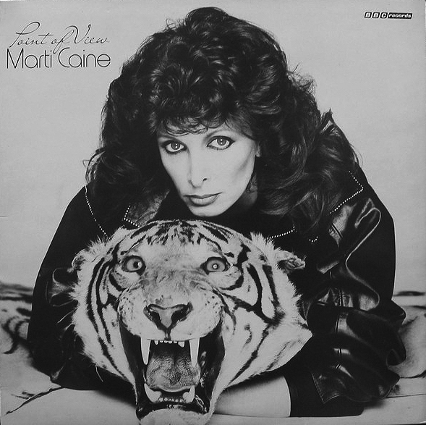
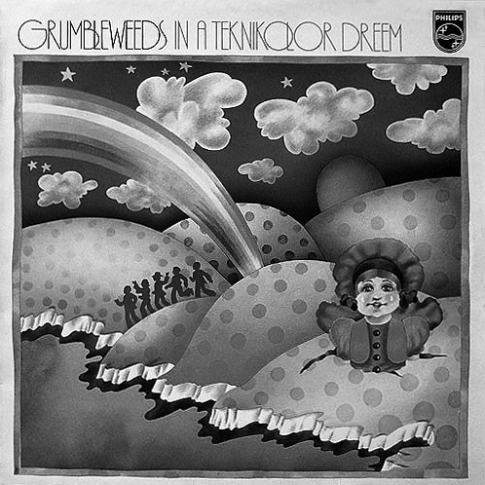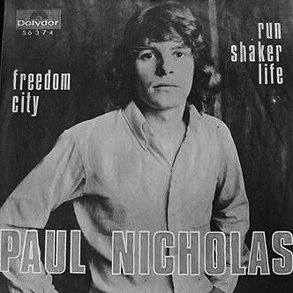
Figure 1 (top): Marti Caine, Point of View, BBC Records, 1981.
Figure 2 (bottom left): Grumbleweeds, In a Teknikolor Dreem, Philips 1970.
Figure 3 (bottom right): Paul Nicholas, ‘Run Shaker Life’, Polydor 1969.
As dusty-fingered prospectors, record collectors devote hours searching through boxes, crates and shelves to find old records containing something worth hearing. Whether found in charity shops, second-hand record stores, car boot sales or online, vinyl records are fashionable commodities that circulate in ‘regimes of value’ with desire and demand for them rising and falling over time as culture changes (Appadurai, 1986, 4). The cultural status of Marti, Paul and Grumbleweeds as light entertainers of yesteryear is not wholly irrelevant to record collectors today, and adds novelty value to finding records that were previously disregarded but have now become desirable. Exchanging knowledge with other collectors about when and where they were found, their physical condition and how much they cost, generates interest that feeds further exchanges about the aesthetic merit and present economic value of such records.
Once word has spread and records like the ones above have achieved a level of desirability, they will eventually be included in rare record price guides. But seeking records already categorised as valuable is only one aspect of collecting. Guided largely by personal taste, many collectors derive greater pleasure from finding records nobody else appears to know about. Unlike taxonomic record collectors who seek records by catalogue number to complete label series or discographies of favoured artists, aesthetic record collectors tend to be more wide-ranging in their taste. Not limited to labels, genres or artists, they are happier discovering 'one-trackers', best defined as long-playing records containing just one or two tracks that are worth hearing, or curiosities outside the world of recordings by artists promoted by record companies: promotional flexi-discs, privately-pressed LPs (also known as 'vanity pressings'), spoken word recordings, film soundtracks, library production music (also known as 'mood music') and sound effect and children's records.

1.1.2 Familiarity, knowledge and obscurity
Some collectors claim they have an instinct for discovering unusual records but the reality is more prosaic; countless hours spent looking for records familiarises avid record collectors to thousands of sleeves and labels. Experienced collectors flick quickly through records and pause only when their eyes register unfamiliar sleeves. The unfamiliar record will be inspected and after a few seconds is either laid to one side for more sustained attention later, or slipped back into the rack if something about its sleeve or track list suggests it is unlikely to yield anything of musical merit. Knowledge gained in regular haunts is invaluable, but has limited application abroad. In foreign lands the ratio of familiar to unfamiliar records is inverted, but local record collectors, sympathetic to visiting ones, will often offer rudimentary guides to records worth finding (Vályi, 2010, 14–15). If enough hours are invested, records common in foreign terrain become familiar. Obscure records can only be found after familiarity with ubiquitous ones has been achieved.
Obscurity is defined as 'unknown, inconspicuous or unimportant' (Cambridge Dictionary online, 2019). These are impermanent states as transitory as things 'known, conspicuous or important'. In the 1970s the celebrity status of Marti Caine, Grumbleweeds and Paul Nicholas would have rendered any vinyl record they made conspicuous. They would have been promoted, advertised, abundant and available for sale in hundreds of record shops. As the celebrity status of these artists waned their records would be relegated from walls to racks, bargain bins or skips, or from living room shelves to garages, jumble sales, second-hand record shops or car boot sales. Discovered decades later by a different generation of record collectors, Point of View, In a Teknikolor Dreem, and ‘Run Shaker Life’ would be inspected, put to one side, listened to later and reappraised. Subsequently their aesthetic merit would be re-evaluated, ultimately affecting their economic value in the market place. In 2017 one copy of Marti Caine's Point of View sold for £470, Grumbleweeds In a Teknikolor Dreem held a median value of around £30, and a UK copy of the Paul Nicholas version of ‘Run Shaker Life’ sold for £109.

1.1.3 The transformational use of recordings: ‘Run Shaker Life’
Just as temporality can affect the value of a recording, so too can transformational use, such as when an album track is used as one side of a 45 rpm single or as one song on a film soundtrack. Transformational use occurs when someone has decided to employ an original recording in a different way, at a different time, and for a different purpose. The act of music compilation is itself a form of transformational use because it creates a unique product; recordings have been removed from one context and placed in another. The unauthorised transformational use of recordings of soul, jazz, funk and various other recordings is central to this study and referred to throughout as transformative piracy.

As transformational use lies at the root of transformative piracy, a brief look at transformative use in the life cycle of the song ‘Run, Shaker, Life’ is instructive here. First released in 1967 as one track on an LP called Something Else Again by Richie Havens, ‘Run Shaker Life’ was originally a dance song called ‘Come Life, Shaker Life’ written by a prolific Shaker poet and songwriter called Issachar Bates around 1835. Havens developed an alternative version of the song with slightly different lyrics for live performance and transformed it again when he re-grouped his live band to record the song in a studio (American Music Preservation, 2019). By the time Paul Nicholas recorded a cover version of the Havens song in 1969, it had already been subject to a series of transformative uses. In 2006 the Paul Nicholas version of ‘Run Shaker Life’ was included on a licensed compilation album called Le Beat Bespoke 2 (2006).

1.1.4 Independent reissue labels
Inclusion on a compilation album can affect the monetary value of a (formerly) obscure record depending on the availability of the original version. As a direct result of being compiled, knowledge of a recording's desirability becomes widespread amongst collectors, dealers, and record shop owners, increasing the number of people who will immediately seek to buy a copy, make a mental note to look out for one, or add it to their 'wants' list or eBay searches. Drawing from Benjamin's concept related to the appeal of original works of art, Thornton (1995) noted original vinyl records had ‘aura’ for many record collectors (27), but temporality, technological change, compilation and various kinds of reissues all conspire to make the future desirability, economic value of original vinyl records impossible to predict.
The musical content on licensed compilations made by independent reissue record labels from the 1990s onwards is very similar to the musical content on unlicensed compilations. A visit to the Independent Label Market at Spitalfields, London in April 2016 offered a snapshot of reissue record labels as a sector of the music industries in the 21st century. Nine percent of record stalls belonged to owners of reissue labels, the oldest being Cherry Red Records (1978) and most recent being Africa Seven (2015), Athens of the North (2014), and Be With Records (2014). Salient to the decade when unlicensed compilations proliferated, the largest number of independent reissue labels represented at the event were established between 1992 and 2002. All were founded by entrepreneurial record collectors who believed music of value could be found amidst the overproduction of vinyl records by music industries in the 20th century.

Figure 4: Advertisement for the Independent Label Market, Spitalfields, London, April 2016.

Joe Davis at Far Out Recordings (1994) reissued music from new and established Brazilian artists. At Soul Jazz Records (1992), Stuart Baker reissued sought after jazz albums and compiled jazz dance tracks popular in London clubs, New Orleans funk, Latin jazz, Latin rock and Latin soul. On Jazzman Records (1998), Gerald 'Jazzman' Short released hard-to-find tracks desirable to collectors as 45 rpm singles and developed specialist sub-labels from which to reissue records from a myriad of discursive genres including popcorn, Northern Soul, tittyshakers, jukebox R&B, modern soul and jazz funk. Miles Cleret at Soundway Records (2002) initially re-issued and compiled old music from Africa, Latin America, the Caribbean and Asia, and later developed his catalogue to include old psychedelic rock, disco, boogie and funk. Mr Bongo (1995) and BBE (1996) reissued soul, jazz, funk and R&B records, Pressure Sounds (1995) specialised in the reissue of rare reggae, and the first release from Trunk Records (1996) was the first ever commercial compilation of tracks from the back catalogue of a library music production house.
Guided by personal taste, an awareness of contemporary club scenes that celebrated older music, and the range of genres and subcultures that preceded them, reissue label owners repackaged obscurer music they knew certain groups of record collectors and club goers would want to hear and own on vinyl record. Unlike reissue labels established in the 1970s such as Charley (1974), Bear Family (1975), Ace (1978) and Rhino (1978), many reissue labels launched in the 1990s eschewed rock n' roll and pop music of the 1950s and 1960s in favour of soul, jazz and funk music from the 1960s, 1970s and 1980s. As reissue labels developed and expanded their catalogues, each reflected the taste, preferences and personalities of their owners. Although the output, image and brand identity of labels differed, the familiar subcultural trope of 'underground versus mainstream' was foundational to all of them. This is exemplified by the succinct wording on the business card collected from the Discrepant (2011) record stall at the Independent Label Market in in April 2016 .


Figure 5: Discrepant records business card.

1.1.5 Summary
The purpose of this introduction was to introduce vinyl records as valuable artefacts and define music compilation as a transformational use of recordings, and transformative music piracy as an unauthorised use of recordings. The transitory nature of culture was examined through a discussion of experiential knowledge acquired by record collectors: the focus here was on how temporality, taste and personal judgement affected the value of vinyl records.
Parallels were drawn between licensed and unlicensed compilations in this section because this study materialised directly from an active interest in both. The next section provides some background information about how activities related to these interests led to the discovery of unlicensed compilations of soul, jazz and funk compilations in the 1990s and connections to individuals who produced them.

1.2 THE ROUTE TO UNLICENSED COMPILATIONS AND THEIR PRODUCERS
The subject of this research project emerged from a sequence of personal choices and events that pre-dated my attendance on the University of Sheffield Management School postgraduate PhD research course from October 31 2013. The aim of this section is to signal how record collecting, making compilations of music, membership of a record collectors' music forum, co-owning an independent record label called Spoke, and writing articles about unlicensed compilations for a website called Forumusic, led to this research project. This section provides background information about my proximity to themes, concepts and ideas central to this study as a preface to discussion of my reflexive approach to the design of this research project in the methodology section that follows the literature review.

1.2.1 1970–1980: Generation X record collecting
I was born in 1962 at the upper end of ‘generation X’, a term discredited as a theoretical concept but considered acceptable for the demographic born between 1960–1980 (Henseler, 2013, 1). Although concepts of generation, decade or era represent arbitrary temporal categories they are ‘not an accident of chronology but a coming together of disparate influences’ and whether political or social, these influences shape events, activities and memories that formulate the zeitgeist (Street, 2016, 23). My childhood experience of popular music was primarily through radio and TV shows that played chart music, and I collected pop, disco, punk, rock and progressive rock records. In my teenage years I owned a record player and cassette tape recorder, and recorded popular music chart shows from the radio. I believe my social and cognitive development, affected by rapid developments in media, communication and information technologies (Collins and Young, 2014, 11), was entirely consistent with that of many of my generation X peers in the global north.

1.2.2 1980–2000: Compilation tapes
I stopped buying records at the age of 18 when my older brother became a pop music journalist and began to return home from work with piles of brand new albums and singles. His record shelves resembled those found in a well-stocked record shop and with access to these and his record player and a tape deck, the range of music and genres on my compilation tapes broadened over time, as did the sound quality of the recordings. I was aware of the ‘home taking is killing music’ anti-piracy campaign in the UK but was unmoved by it because many of my peers also made cassette tape compilations and none of them were ever arrested. Buying vinyl records fell by the wayside around 1980, and after the purchase of a CD player in the late 1980s I invested in numerous Northern Soul and easy listening CD compilations. These compilations were a gateway to music played in subcultural scenes I had never experienced in person. At a later date I wrote website articles about easy listening compilations released on CD by major record labels between 1994 and 1998 (Townsend, 2013a), and the 1990s UK easy listening scene that engendered them (Townsend, 2013b).
In summary, as a teenage record collector between 1970 and 2000 I enjoyed making mixed genre compilations from vinyl records I didn't own, but purchased licensed compilations when the music industries began to create retrospective compilations to exploit their back catalogues. From an aesthetic point of view I preferred listening to selected tracks compiled onto cassette tape over listening to whole albums by just one artist. From an economic perspective I never minded buying a musical product if it had sufficient appeal. Licensed, unlicensed, personally curated, made by a friend, purchased or borrowed, my enjoyment of music compilations on cassette tapes was never affected by thought of them as products of home piracy

1.2.3 1995–2010: Record collecting, the VG+ Plus music forum, and 'swap CDs'
I returned to record collecting around 1995. As CDs became more popular, old vinyl records became plentiful and inexpensive to buy from charity shops and car boot sales. Seeking information about a musician online I discovered a website and music forum called Vinyl Vulture, which is now called Very Good Plus (VG+). It is a virtual hub for record collectors to discuss records, record collecting and music scenes. The forum also facilitated the arrangement of social events and through these I met many generation X collectors from all over the UK, some of whom ran independent reissue record labels. Of particular appeal to me, a democratic spirit of sharing obscure music infused a regular annual event known as the 'VG+ CD Swap'.

If 50 members participated in a CD swap event, each had to create a unique compilation of music and reproduce it on 50 recordable CDs (CD-Rs). Sent to a central point, on a given date, the 5,000 CD-Rs received were arranged into sets and posted out so that each participant received copies of every other participant's CD. At its peak in 2009 a full set of VG+ swap CD-Rs consisted of 69 unique compilations (Townsend, 2009). A website article entitled 'What are swap CDs?' explains this culture of swapping CD-Rs in more detail (Townsend, 2014a). The range of music found on what came to be known as 'swap CDs' was incredibly diverse, and peer pressure dictated a significant percentage contained obscure recordings. When I discovered a US-based forum for record collectors called Waxidermy also arranged CD-R swaps I participated in those as well. In 2010 a full set of Waxidermy swap CD-Rs contained 76 unique compilations (Townsend, 2010). My commitment to this culture extended to cataloguing sleeve art for all the VG+ and Waxidermy CD swaps from 2005 to 2014 (Townsend, 2014b) and as I listened carefully to each new batch of swap CDs, I would store favourite tracks in a folder on my computer's hard drive and produce 'Best of ...' compilations.
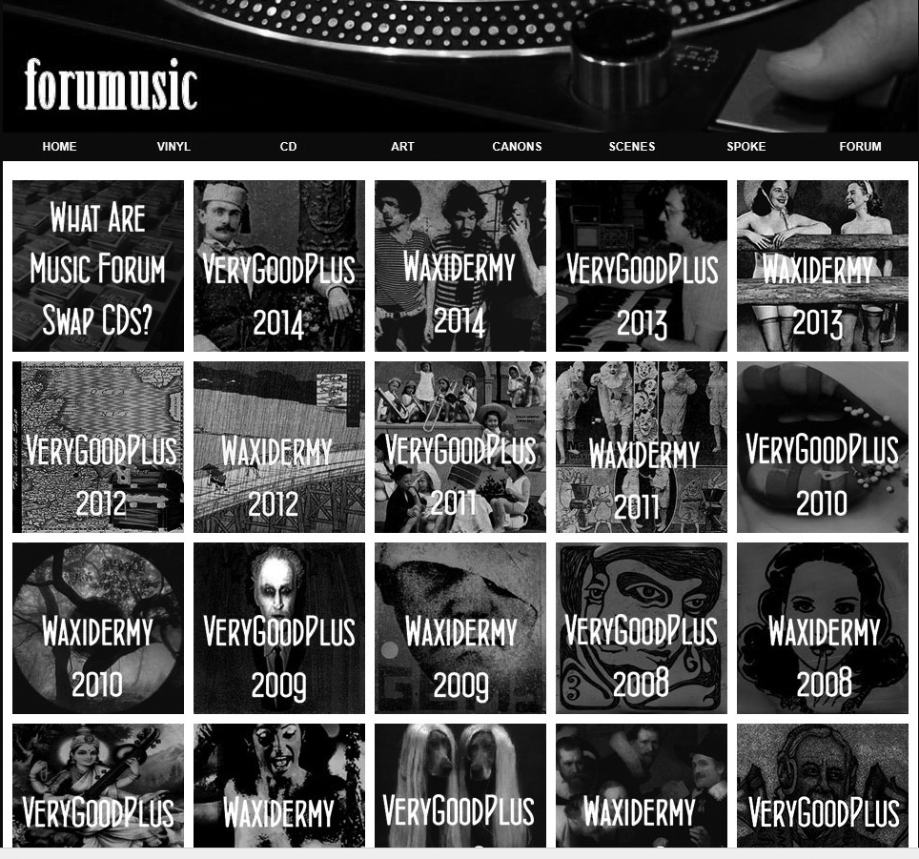
Figure 6: Forumusic website page: links to pages of VG+ and Waxidermy swap sleeve art.
Members the VG+ forum also created themed compilations as group projects. For these, participants forwarded MP3s of one favourite track to an appointed person via email. After tracks had been compiled, a sleeve would be designed, and each participant would receive a copy of the compilation on CD-R. Shortly after joining the VG+ forum I was involved in the production of two compilations: It’s Fun to Listen and Learn! A Vinyl Vulture Childrens Compilation (2006) contained selections of music intended for children, and Flute and Harpsichord (2007) evolved into a three CD-R set of tracks that featured those instruments.

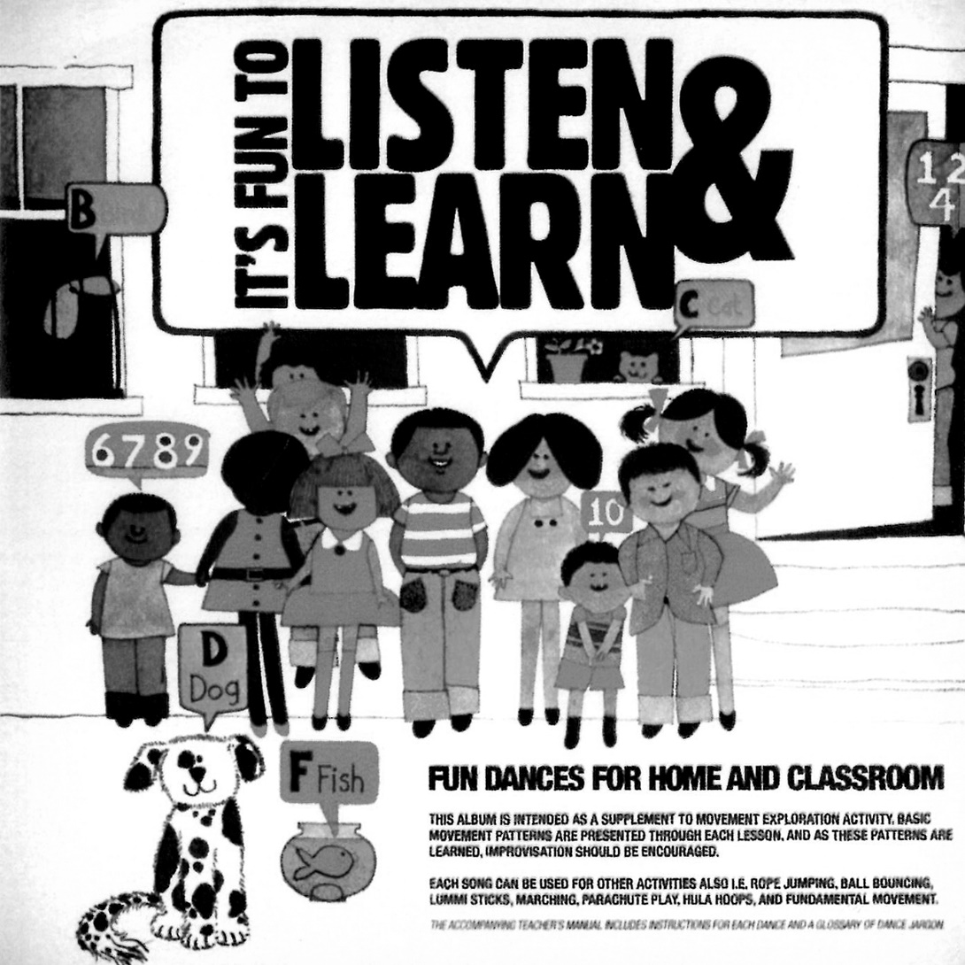

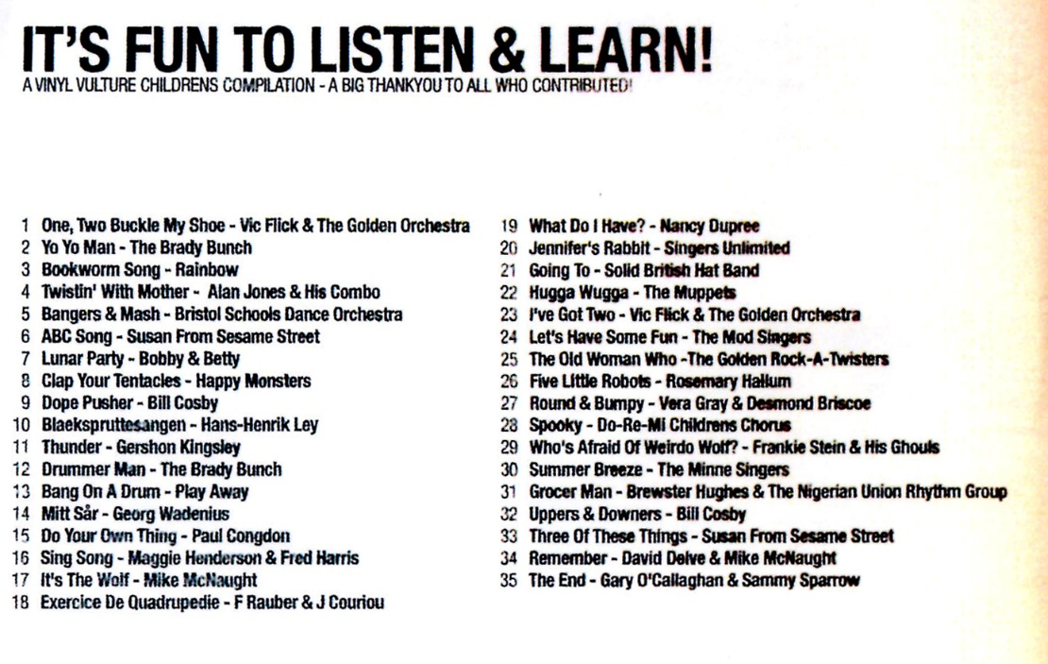
Figure 7: Vinyl Vulture—It’s Fun to Listen and Learn CD-R front and back.

I have shared this personal information to show that activities related to music compilation extended well beyond my teenage years. The discovery in my mid-40s of an online community of generation X record collectors who liked to make music compilations was a revelation. Populated by like-minded souls, the VG+ forum and CD swap events introduced me to a range of music I would never have otherwise heard. It deepened my appreciation of compilations as unique listening experiences; compilations expressively reflect the musical taste and personality of those who produce them.

1.2.4 2011: Spoke records, Forumusic and unlicensed compilations
Access to so much interesting music was compounded by frustration that much of it was either hard to find on vinyl record or prohibitively expensive. This inspired myself and two fellow VG+ members to plan a reissue record label called Spoke records. After the untimely death of the highly respected record collector, and original third partner Neil 'Towny' Suddes, Col Wolfe and I launched Spoke records in February 2011.

Our aim to reissue obscure recordings we liked ‘regardless of genre’ was very deliberate, and in hindsight reflected the influence of many years spent producing and listening to compilations of music. Col Wolfe and I believed the 7’ vinyl records we released would appeal to similar-minded peers and consequently our first ‘double A-side’ release had an emotive, orchestral beat ballad called ‘Don't Mind If I Cry’ on one side, and a thumping, rockabilly-styles song called Crimpton Krompton Canary Bridge, on the other. The latter was first heard on a Waxidermy swap CD compiled by a record collector from Philadelphia called Mark Johnson. In this particular case Mark's sharing of a musical obscurity on a swap CD compiled in the US led to a UK release, and a copyright owner receiving royalty payments for a song 45 years after it had been recorded. The performer Shirley Bates eventually revealed the musicians in the studio were Elvis Presley's touring band who happened to be ‘passing through’ the city where she lived at the time she was recording it.

1.2.5 2011: Unlicensed compilations on vinyl record
I first heard about unlicensed compilations that contained obscure selections of soul, jazz and funk music when I interviewed record collectors I knew from the VG+ music forum in 2011 and 2012. I had found designing Spoke's monochrome website and researching and writing about artists to be an unexpectedly creative pleasure, but felt restricted by the necessity of keeping everything focussed on Spoke products. To counter this I designed a complementary, full colour website to compose and present articles I thought would be of interest to record collectors. For the website I called Forumusic (pronounced 'forum' / 'music') I planned a series of articles on record collectors and during interviews several mentioned compilation albums they liked and referred to as 'boots' or '90s boots'. They stated these albums had alerted them to recordings they liked but had had never heard before. By academic definition these records were not 'bootlegs' but unlicensed compilations: products of transformative piracy. Being compilations of obscure provenance and highly recommended by record collectors whose musical tastes I respected, my interest was piqued and I endeavoured to find out more about them.

1.2.5 2011–2012: Initial investigations
To research unlicensed compilations I conducted internet searches on titles of unlicensed compilations interviewees had given me and found that on Discogs (2019), the ‘Database and Marketplace for Worldwide Music on Vinyl, CD, Cassette‘, they were almost universally categorised as 'Not on label. Unofficial. Comp’. No other definition of them existed on-line and their provenance was unknown. As stated earlier, they were 33 rpm, long playing vinyl records that predominantly contained selected tracks from soul, jazz, funk and Latin albums of the 1960s and 1970s, but also included selections from library production music albums, blaxploitation soundtracks, children's LPs and various other sources. Many sleeves and labels were full colour and appeared to be professionally designed and this rendered them indistinguishable from legitimately produced vinyl records. Some had generic black or white sleeves with track lists printed on stickers that were attached to the sleeves. Further research on Discogs revealed many existed in series, ranging in number from 2 to 25, and where sleeve notes appeared credible, production dates ranged from the late 1980s to the early 2000s.
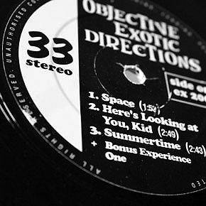
Figure 8: label design of unlicensed compilation Objective Erotic Directions.

To formulate a series of articles about '90s boots' for Forumusic I decided to harvest as much information as possible about them from VG+ members. In August 2011 I wrote a forum post entitled 'Rep your favourite 90s boot'. Having discovered them via interviews conducted with several VG+ members I believed other members would know more and have information to share. The post attracted 96 responses from 41 respondents based in the UK, Europe and Japan, and 70 different titles were recommended to me (See Appendix G). Like the VG+ forum members I had interviewed in person, other forum members were unanimously positive about them. No one passed judgement on their unauthorised status and the volume of responses suggested many perceived them as a unified body of work. It was clear that on one online music forum at least they were a recognised phenomenon.

The fact that 70 titles name-checked by forum members were all available on vinyl record suggested that whoever had produced them had made a serious commitment to making compilations of music beyond that of home tapers like myself; unlike cassette tape compilations, unlicensed compilations on vinyl record could not be manufactured at home. The high number of titles suggested that more than one producer was responsible for them. The range of responses the forum post received suggested unlicensed compilations had been widely distributed because record collectors based in the UK, Europe and Japan were all familiar with similar titles, and Discogs revealed sellers in all these locations had copies for sale. None of this information was conclusive of anything but it added to their mystique and encouraged me to make further enquiries about them at social events wherever record collectors were present.

I was keen to hear some of the recommended titles, but rather than purchase them online I travelled to London, curious to see if any were available for sale in second-hand record shops. This experience deepened my interest further. In one shop dozens were for sale filed under 'Soul/Funk Compilations', and in another several were found scattered throughout the racks of soul, funk, jazz and Latin records. The behaviour of one shop manager suggested they were an illicit, 'under the counter' phenomenon. On the VG+ music forum I reported how I had found two unlicensed compilations in the record racks of a London shop and then asked the shop manager if he had any more. He immediately apologised, saying it was not customary to sell illegal records. Once I had explained to him that I wasn't a Trading Standards officer he relaxed and pulled a pile of them out from behind the counter for me to look through. I selected two more but as I paid him £15 he said the money was for ‘the plastic bag, and you can put those records you found in there and get rid of them for us’. (Very Good Plus, August, 2011). This confirmed to me unlicensed compilations of soul, jazz and funk were acknowledged as a specific body of releases beyond the generation X record collectors who congregated on the VG+ forum.

1.2.6 August 2012: Producers of unlicensed compilations
At regular social events organised by various members of the VG+ forum several record collectors discreetly proffered the names of people they believed to be directly responsible for producing unlicensed compilations. It transpired three of them posted regularly on the VG+ music forum and I was able to contact them discreetly about unlicensed compilations they were alleged to have produced via the forum's private messaging facility in the first instance and then by email. Two agreed to be interviewed by telephone on a guarantee of anonymity but the third politely refused. Both who agreed consented to their telephone conversations being recorded, and at the end of those conversations stated they would talk about them at greater length in the future, should I wish to know more.

The first two Forumusic articles about '90s boots' appeared online before the interviews had been conducted. The first article was a crude introduction to the field and the second consisted of reviews of what I perceived to be the earliest unlicensed compilations. After his initial refusal to be interviewed the third person unexpectedly contacted me by text messages after reading the articles. He was keen to challenge incorrect assumptions I had made about unlicensed compilations being linked in some way to the easy listening scene of the early 1990s. His 925 word communication spread across numerous text messages contained information that informed the literature review of this study and it is discussed in chapter 4.

1.2.7 Summary of chapter
The first section of this chapter introduced ideas about how the passage of time, cultural shifts, fads and fashions, and reissue or compilation can affect the economic and aesthetic value of sound recordings. Licensed (or authorised) music compilation was defined as an authorised transformational use of existing recordings. This helped frame understanding of unlicensed (or unauthorised) music compilation as the unauthorised transformational use of recordings. The aim of this research is to document life stories of music pirates who made unauthorised transformational use of existing recordings to make unlicensed compilations of soul, jazz and funk music on vinyl records in the 1990s. The purpose of doing this is to gain an understanding of a particular manifestation of transformative piracy that flourished at the end of the 20th century. The research area is therefore unlicensed compilations and the producers of soul, jazz, and funk recordings on vinyl record in the UK in the 1990s.

The objectives of this study are as follows:
- To interpret the life stories of music pirates actively involved in producing products of transformative piracy in the 1990s, giving priority to their narratives.
- To document how and why they created, produced and distributed unlicensed compilations of soul, jazz and funk on vinyl records.
- To analyse relationships between music pirates and the social and cultural worlds they inhabited during the 1990s.
- To interpret, analyse and evaluate the transformative piracy of soul, jazz and funk recordings in the 1990s.
In the next chapter the literature on unlicensed and licensed music compilations, music piracy and the music industries is reviewed to ascertain if the domain and subjects of this study have ever been studied before. The purpose of this chapter is to find gaps in academic literature this study can address, and find theoretical and conceptual ideas to guide the direction of the research methodology.

2 LITERATURE REVIEW

2.1 OVERVIEW
This chapter argues that the subjects of this study were participants in a world of unauthorised music production that flourished in the last decade of the 20th century. A position adopted throughout is that to produce, distribute and sell their vinyl records, transformative pirates must have worked with others, and at some point engaged the services of sectors of the music industries. This chapter therefore focusses on oppositional themes. Literature has been consulted on authorised and unauthorised production, the music industries and music piracy, licensed and unlicensed compilations. The chapter also reverberates between large organisations of corporate collective activity (the music industries, the British Phonographic Institute [BPI], record companies), and smaller non-corporate groups of collective activity such as record collectors and DJs. This chapter will show literature on analogue music piracy is relatively undeveloped because analogue music pirates have rarely been spoken to. Given the opportunity to hear pirate voices, the theoretical direction of this study gravitates towards an amalgam of production of culture, and sociology of music perspectives to frame, present and analyse music pirates three-dimensionally as musical, cultural and social beings, rather than as individuals who transgressed copyright laws.

Literature on licensed and unlicensed compilations, music piracy, music industries, record collecting, hip hop and club cultures is reviewed. Definitions of compilation, copyright, music licensing and different types of music piracy lead to discussions of 'home taping' and the critical difference between literature on the 'music industry' and the 'music industries'. In tandem with thoughts about the domain and subjects of this study, these discussions inform the conceptual shape of this thesis. Problematizing a study of licensed compilation leads to an examination of UK music distribution and retail in the 1980s and 1990s. To look closely at records that resemble unlicensed compilations, academic literature on hip hop is surveyed to understand a phenomenon known as 'breakbeat LPs'. Knowledge gaps about breakbeat LPs identified in literature on hop-hop are matched by gaps in literature on music piracy. The chapter summary describes contributions to knowledge that data obtained in this research will aim to make to academic fields of music piracy, the music industries and the sociology of music.

2.2 COMPILATION, COPYRIGHT, LICENSING AND TYPES OF MUSIC PIRACY
The purpose of this section to ensure key concepts related to the domain of this research are understood by the reader before specific themes are surveyed.

2.2.1 Compilation
'Compilation’ describes a process and a product; lists, books, records, broadcasts or concert programmes are all created ‘by assembling previously separate items’ (English Oxford Living Dictionaries). The word compilation originated from 'compilare', which means ‘to plunder’ (ibid) and suggests for compilation to occur a compiler must have access to an existing reserve of items. A music compilation contains recordings taken from different sources (Passman, 2001, 127). If a compilation of music is reproduced for commercial purposes, recordings have to be licensed from copyright owners (Harrison, 2008, 60). Copyright ownership belongs to either the person who produced the original recording or a person or organisation that the copyright has been assigned to either permanently or temporarily (ibid, 60). To understand the difference between licensed and unlicensed compilation it is necessary to define copyright and music licensing.

2.2.2 Copyright and music licensing
In music, copyright is the general term for rights that are attached to the sale, rental, lease, performance or broadcasting of an original composition, or recording, or copies of them to the public (Harrison, 2008, 59). To do any of these things, permission must be sought from the copyright owner and this usually involves a licensing deal (ibid, 59). In a licensing deal the licensor is the person or company who owns rights and the licensee is ‘the person or company to whom the rights are licensed’ (ibid, 57). To make a music compilation for commercial purposes a compiler must act as a licensee and arrange separate licensing deals with every licensor who owns copyrights to recordings used; detailed terms in licensing contracts specify how recordings may be used, how long copyright lasts for, and territories of the world to which rights apply (ibid, 102).

Before a sound recording can be reproduced commercially a mechanical licence is also required. A significant source of income for songwriters, a mechanical licence triggers a royalty payment for every copy of a song reproduced on any format (ibid, 90). In the 1990s UK licensees would have purchased a mechanical license from the Mechanical Copyright Protection Society (MCPS) (ibid, 297–298). Known as a collection agency, MCPS collected mechanical fees from licensees and distributed them to copyright owners (ibid, 302–303). When tracks are included on compilations, copyright owners receive a percentage of royalties ‘pro-rata’, dependent on the running time of the track used relative to the total length of the compilation (McPherson, 1999, 68).

In theory, copyright laws control the way reproductions of sound recordings are distributed and sold (Wikström, 2009, 17). The International Federation of the Phonographic Industries (IFPI) defined music copyright as ‘the means by which a person or a business makes a living from creativity’ (Anderton, Dubber and James, 2010, 161). Sinnreich (2013, 22) described copyright as ‘a set of property laws establishing who has the right to communicate (or prevent the communication of) ideas, to whom, via what media, and under what circumstances’. Using copyright law, record companies developed restrictive practices and business models of artificial scarcity that enabled them to control markets and monopolize profits from recordings ‘by selling fewer works for more money’ (ibid, 3). Music piracy challenged copyright owners control of recordings and several different types of piratical product evolved. These are now described so that transformative piracy can be understood relative to counterfeiting, piracy and bootlegging.

2.2.3 Types of music piracy
A counterfeit is a copy of a recording and its packaging, and is therefore an attempt to convince consumers they have purchased an original product (Marshall, 2005, 110–111). Counterfeits are almost exact equivalents of original products and for this reason counterfeiting is sometimes referred to as ‘equivalency’ (Kernfeld, 2011, 4). A pirated musical product is different from a counterfeit because it produces the sounds of an original recording but not the original packaging or cover art, even though words are sometimes added to give consumers an impression the product is licensed (Marshall, 2005, 111). Illegitimately reproduced musical sounds on counterfeits or pirated products will not have not been re-contextualised or edited in any way. On a pirate or counterfeit album for example, there would be no rearrangement of the order in which tracks appear (Kernfeld, 2011, 4).

In contrast, bootlegging and transformative piracy create novel products. A bootleg is an unofficial recording of a live concert or a previously unissued studio recording released for public consumption without permission from the artist (Marshall, 2005, 111). Transformative piracy is best understood as an unauthorised kind of transformational use. Products of transformational use show ‘the unique touch of the person who chose the track sequence, picked a title, and designed a cover, without necessarily transforming the sounds contained on the CD, LP, or tape to a great extent’ (Cummings, 2013, 205–206). A unique compilation of existing recordings, none of which have been licensed, is therefore an example of a ‘nonequivalent, transformational, unauthorized song product’ (Kernfeld, 2011, 7). Throughout this study the practice of making an unlicensed compilation of music Is referred to as either an example of 'unauthorised transformational use' or 'transformative piracy'.

2.2.4 Summary
A compilation of music is licensed if a producer has secured permission to use all the recordings it contains, and has paid a mechanical license fee to reproduce and sell copies of it. If either or both are missing, the compilation is unlicensed and should not be sold commercially. The presence of existing recordings of soul, jazz, funk and other music on unlicensed compilations suggested literature on the recording industries was less relevant to this research than literature on how vinyl records were manufactured, distributed and sold. The next section describes how literature on 'music industries' as opposed to 'music industry' guided the conceptual shape of this thesis and was discovered during research into a UK anti-piracy campaign against ‘home taping’ (Sinnreich, 2013, 34; Johns, 2009, 432). The campaign is described for the purpose of understanding contested views about home taping, relevant to discussions that follow later in the chapter.

2.3 THE CONCEPTUAL SHAPE OF THIS THESIS
The first concept adopted to sharpen the focus of this research was the preferred use of 'music industries' over 'music industry' in discussions of popular music (Williamson and Cloonan, 2007; Sterne, 2014). This section explains why the concept of 'music industries' was adopted after literature on the subject of home taping had been consulted, and how this led to the idea of analysing the subjects of this study through the lens of Becker's (2006) ‘art world’ theory.

2.3.1 The problem of ‘tape worlds’
Copying recordings in the home, including the transformational use of them to create compilations, was commonly known as ‘home copying’ or ‘home taping’ (Johns, 2009, 432). Home taping was problematic for record companies because they perceived it challenged their control over copyrighted musical products (ibid, 460–462). In the 1950s reel-to-reel tape recorders did not sell well but introduced the practice of recording sounds in the home (Bijsterveld and Jacobs, 2009, 40–41). Initially promoted by developers for recording and sharing ‘precious moments of family life’ (ibid, 29), by the late 1950s ‘recorded music increasingly topped the list of things to do at home with a tape recorder’ (ibid, 30). Compact cassette recorders popularised home taping from the late 1960s onwards and as the domesticity of home taping spread beyond America and Europe it ‘eclipsed commercial piracy [to create] the first truly global piracy’ (Johns, 2009, 461). The growth in popularity of sound recordings made at home implied ‘a radical decentralization of cultural production’ (ibid, 432).

The affordability and portability of cassette tape recorders spurred independent production and distribution as artists unconnected to record companies developed international networks via post, sharing their work on ‘inexpensive, portable, and malleable’ cassette tapes (James, 1992, vii). Johns (2009) referred to communities that copied and compiled recordings onto cassette tape as ‘tape worlds’ (460):

For as teenagers swapped mix-tape compilations in London and poets competed with each other in Africa, in Northern California cassettes were being pressed into service to build a similar kind of community of recording, sharing and copying. (462)

Copying sounds from radio broadcasts, vinyl records or television programmes was dubbed piratical whether or not the recordings were used for commercial purposes, and ‘by the late 1970s the music industry was describing [home taping] as the greatest threat it had ever faced—an existential threat that might destroy music itself’ (Ibid, 433). Home taping was an unrestricted practice and record companies believed sound recordings duplicated in the home represented products that had not been paid for. During a court case in 2007, Jennifer Pariser, the head of litigation for Sony BMG, stated copying a purchased song was ‘a nice way of saying ‘steals just one copy’‘ (Bangeman, 2007).

In the 1980s, the British Phonographic Institute (BPI) ran an advertising campaign with a slogan that declared ‘home taping is killing music, and it's illegal’ (Bottomley, 2015, 124), even though the BPI publicly acknowledged the UK had ‘the lowest 'piracy rate' in the world’ (Hennessy, 1982, 9). The BPI acted because in a European Community-funded report the Associate Director General and Chief Legal Advisor to the International Federation of Phonograms Industry (IFPI) concluded cassette tape piracy was responsible for a 26% slump in record sales between 1978 and 1980 (Davies, 1986). Challenging the veracity of this conclusion Cummings (2013) suggested organisations working on behalf of the music industries overlooked many other factors that may have contributed to the downturn in record sales at the end of the 1970s (180). Patry (2009) asserted unauthorised copying was always ‘a rhetorical bogey-man [employed to ensure] artificial scarcity over lawful copies’ (4). Kernfeld (2011) was adamant ‘claims of causality that linked sales figures to piracy’ invariably arose whenever the music business failed to expand (147). Other academics questioned the validity of 'music industry' statistics that ‘lumped’ formats together (Kirster and Malm, 1984, 22) or failed to account for total sales in all markets (Sinnreich, 2013, 42). Gronow (1983) concluded statistics posted by the music industries should, in general, be taken ‘with a grain of salt’ (60). The BPI believed home taping was responsible for poor record sales (Cummings, 2013, 202) but several academics suggested their campaign was duplicitous.

Johns (2009) asserted the wording of the BPI campaign wrongly inferred home taping was illegal ( 432–435) and Bottomley (2015) stated ‘major labels condemned the practice as piracy—even though private, non-commercial copying was mostly legal’ (123). Williamson and Cloonan (2007) noted the BPI was funded by some, but not all record labels, and despite being ‘a sector of a sector of the music industries’ (306), sought to portray itself as ‘representative of a greater section of the music industries’ than it was in reality (307). The BPI attempted to present itself as representative of a singular 'music industry' and persuade the UK public home taping was illegal, but their anti-music piracy campaign served only the ‘vested interests’ of certain sectors of the recording industry (305–306).

2.3.2 The concept of 'music industries'
Frith (2000) considered it was misleading ‘to regard the music industry as a single industry’ (390), and literature critical of the BPI campaign highlighted reasons why thinking about 'music industries' was preferable to 'music industry'. Williamson and Cloonan (2007) noted the notion of 'music industry' employed by academics, record companies, the media and political bodies ‘suggested simplicity where there [was] complexity and homogeneity where there [was] heterogeneity’ (305). Moreover they believed the term 'music industry' had become synonymous with the term 'recording industry' and cited literature that conflated the two:

[F]ollowing the early pioneers, an array of articles and books followed which equated the recording industry with the music industry ... In 1986 Dave Laing analysed the music industry and the cultural imperialism thesis in terms of the recording industry. Eleven years later, McCourt and Rothenbuler (1997) wrote about the effect of SoundScan software on 'the popular music industry', but again conflated this with the recording industry. Lopes' (1992) analysis of 'the popular music industry' is restricted to analysis of the Billboard charts, a method repeated by Burnett (1993) in his analysis of 'the popular music industry in transition'. While more acerbic than most in his analysis of the exploits of major companies, Dave Harker (1997) still conflates 'music industry' rhetoric with that of major recording companies (ibid, 134).

Sinnreich (2013, 9) used the term 'music industry' but clarified that for him it implied a ‘broad constellation of individuals and institutions that collectively exploit musical expression for profit’. Fairchild (2016, 2) believed too many studies were overly focussed on record producers or record companies. Bottomley (2015, 124) insisted 'recording industry' was inadequate for describing ‘a complex array of interrelated industries and groups of producers who operate according to diverse interests and ideologies’. Adding support to this view of the music industries as a collection of very distinct sectors, a successful sound engineer's memoir documented how interference from record label executives had a deleterious effect on artists recording in various studios (Brown, 2010) and an earlier study revealed recording a hit record for a major record company involved discrete practices conducted in many different locations (Stokes, 1977). The next section explains how thinking about 'music industries’ rather than 'music industry' helped to develop the conceptual shape of this study.

From observation of the products they made, the subjects of this research appeared to occupy a space where practices from several different worlds intersected and overlapped. The inclusion of obscure and rare recordings suggested connections to record collectors (Milano, 2003; Cooper And Smay, 2005; Williamson, 2008) while their compilation of music from different genres appeared to echo practices of home taping (Johns, 2009, 460). The presence of so many Afro-American soul, jazz and funk recordings on the unlicensed compilations suggested suggested those who produced them may have connections to the rare groove club culture of the 1980s (Brewster and Broughton, 2006, 416). Additionally their chosen format—vinyl records—indicated connections either directly or indirectly with pressing plants. The availability of unlicensed compilations throughout the UK also indicated those who produced them were connected to national networks of record distribution.

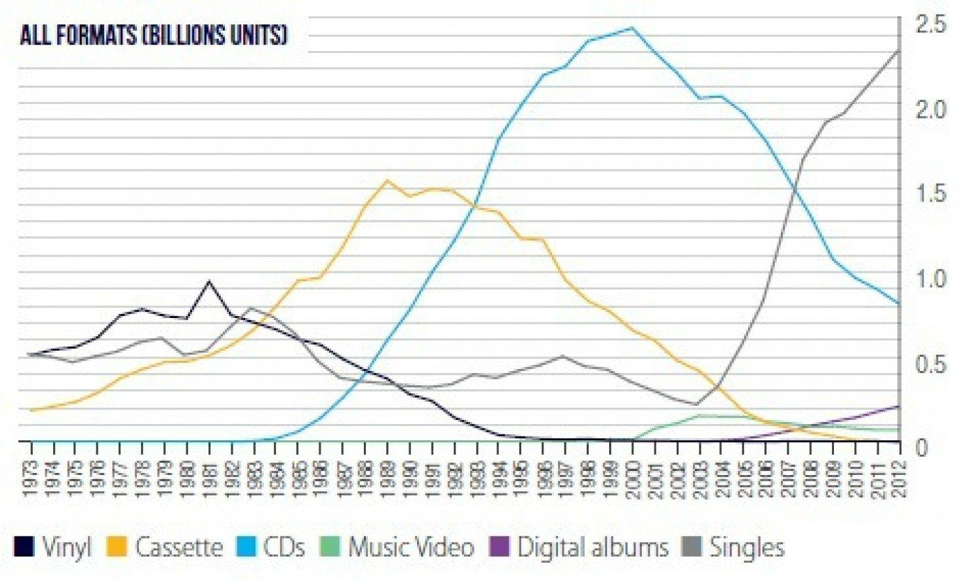
Figure 9: International Federation Phonographic Industry, 2013.

2.3.3 Sites between recording and consumption
Thinking about how the subjects of this study may or may not have engaged with sectors of the music industries drew focus of towards studies on the manufacture, distribution and retail of vinyl records and it was here significant gaps in the academic record became apparent. In the 1990s the manufacture, production and distribution of vinyl records was in decline (see Figure 9) but these sectors of the music industries have received less scholarly attention than record collectors, record stores or dance floors (Palm, 2017, 1). Fairchild (2016, 2) maintained music industry studies rarely linked ‘material facts of mechanisms of consumption to the material facts of music’ or acknowledged activities of significance between the moment a musical product was completed and the moment it was consumed. Jones (2002, 215) asserted the ‘intermediate step between the technological production and the popular consumption [of music] continues to be ignored’, and Kjus (2016, 2117) concurred, stating ‘processes of music creation and appreciation [had possibly] been considered more valuable and worthy than those of distribution’. The status of manufacturing, distribution and retail appears lowly in comparison to sectors related to the production of recordings or their consumption.

In Leyshon's (2001) diagram to show how ‘the functions, temporalities and geographies’ of four distinctive ‘musical networks’ overlapped (see Wikström, 2009, 49), the number of sectors described in the ‘creativity network’ clearly outweigh the combined number of sectors in ‘reproduction’ and ‘distribution’ networks:

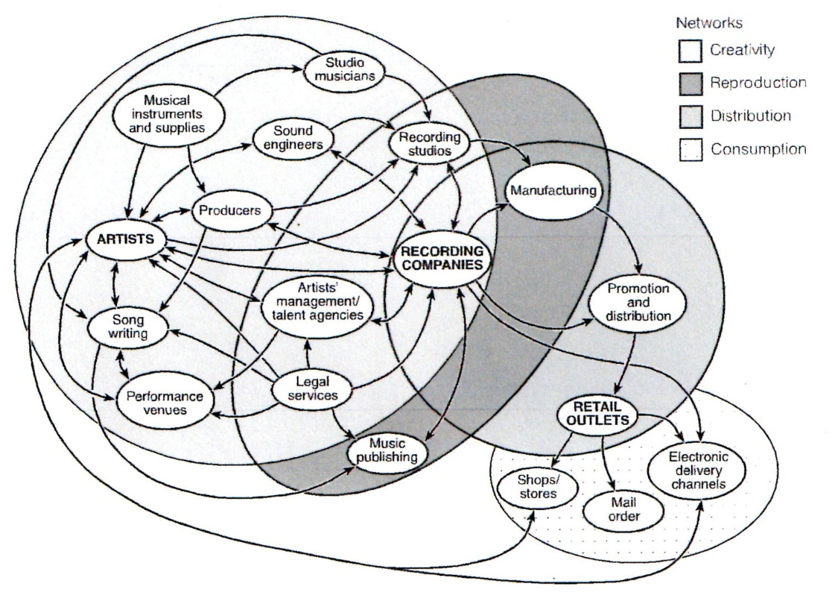

Figure 10: musical networks, Leyshon (2001, 61).

Coverage of manufacturing and distribution has been severely restricted in some academic research because overviews of popular music have often been compartmentalised into categories of recording, publishing and live performance. Hull, Hutchison and Strasser (2011) presented these categories as recordings, songwriting and live appearances, while Taylor (2016, 21) adopted a Marxist, material culture perspective and defined them as 'different regimes of commodification ... as published score ... as live sound ... as recorded sound'. In a light-hearted careers guide entitled How to Make It in the Music Business, Pattenden (2001, 37) suggested that despite distribution being ‘vital’ to the music business, it lacked the glamour or excitement of other areas.

2.3.4 Art Worlds
Becker's (2006, 1) ‘art worlds’ theory was selected as a theoretical tool for analysing the subjects of this study. Becker suggested ‘artistic work, like all human activity, involves the joint activity of a number, often a large number of people’. As ‘stuff made out of atoms’ (Negroponte, 1995), vinyl records made by the subjects of this study had to be manufactured, stored and transported from where they were produced, to where they were sold. Becker (2006, 375) suggested his art words theory accounted for people ‘in the middle of doing something that requires them to pay attention to each other (and being conscious] of what they do in the light of what others do’. As producers of cultural products, the subjects of this study could also be analysed using ‘field of cultural production’ theory (Bourdieu, 1998) but the simultaneous use of this and ‘art worlds’ theory in some studies has been criticised (Becker, 2006, 372–386).

In response to studies that employed both, Becker (ibid, 385) believed they were methodologically incompatible because they asked ‘different kinds of questions and look[ed] for different kinds of answers and [were] not reducible one to the other’. He maintained people do not automatically respond ‘to mysterious external forces [but develop] lines of activity gradually, seeing how others respond to what they do and adjusting what they do next in a way that meshes with what others have done and will probably do next’ (375). Becker outlined Bourdieu's theory of ‘field’ as ‘metaphorical ... a defined and confined space ... in which there is a limited amount of room’, and likened it to ‘a field of forces in physics’ as opposed to a ‘lot of people doing something together’ (373): the ‘principal entities’ in Bourdieu's theory were ‘forces, spaces, relations, and actors (characterized by their relative power) who [developed] strategies using the variable amounts of power they [had] available.’ (374).

Key to the choice of ‘art worlds’ theory over ‘field’ as a tool for analysis in this study was Becker's own comparison between the two. He suggested his ‘world … [was] not a closed unit’, whereas Bourdieu's field was ‘limited by rules and practices that [kept] outsiders out and [made] it impossible to be part of some collective activity unless [they were] chosen by people who [were] already a part of it’ (376). The suggestion of complicity here between 'insiders' and 'outsiders' prompted thoughts about how this study may involve consideration of how authorised and unauthorised worlds of production merged. In conversation with Becker, Alain Pessin observed Becker's approach proceeded from observation, was suspicious of over-arching theory and was focused on ‘micro-relations’ compared to Bourdieu's use of a ‘wide angle lens’ (Becker, 2006, 384). He suggested Becker's art worlds theory was ‘[a] sociology of situations [that involved] process ... career ... openness [and] choice’, whereas Bourdieu's theory of ‘fields’ was a ‘sociology of structures ... [concerned with] ‘habitus ... disposition ... closure [and] determination’ (ibid, 386). Pessin concluded Becker's theory was a ‘sociologioco-ethnographic approach that [tried] to make explicit the circumstances in which social situations [created] links between actors ...’ and Becker concurred, stating his theory was ‘open to multiple possibilities, discovered in the course of immersion in social life’ (386).

2.3.5 Summary
Definitions of compilation, copyright and licensing led to a discussion about contested views of home taping and the concept of 'music industries'. The content and materiality of unlicensed compilations suggested those who produced them did not require the services of the music business or the recording industries. But as people who manufactured vinyl records they would, at the very least, require the services of pressing plants, and perhaps also distribution and retail sectors often obscured in 'music industry' studies that privileged ‘the worldview of larger operators [and eliminated] smaller operators from debates’ (Williamson and Cloonan, 2007, 315). Research focussed on how unlicensed compilation producers negotiated the pressing, distribution and retail of vinyl records could generate new knowledge about how legitimate and illegitimate production practices co-existed in these sectors.

Information provided by the transformative pirates who organised the manufacture of vinyl records may offer fresh insights into manufacturing and distribution sectors often framed as ‘vital’ (Anderton, Dubber, James, 2013, 98) but crucially under-researched (Kjus, 2016, 2117). Williamson and Cloonan (2007, 315) asserted 'music industry' studies provided no platform for accounts of inequalities or disagreements between different pressing plants and different distributors, but data provided by this research could reveal much about how personnel in these sectors interacted with individuals who hired their services. Becker's (2006, 300–310) art worlds theory takes into consideration how conflict shaped collective activity: in the 1990s vinyl record manufacturers, distributors and retailers competed hard as demand for music on vinyl records inexorably declined compared to the demand for music on compact disc (see Figure 9). While a primary focus of this study will be to analyse the domain and subjects as a hidden, but productive world of collective activity, narratives on how they negotiated with other worlds to get their vinyl records manufactured, distributed and sold at a time when vinyl record production was in decline may yield interesting data.

Observing the principle ‘you can discover things about one case by looking at another case that seems similar but isn't quite the same’ (Becker, 2006, xi), licensed compilations and unlicensed compilations called 'breakbeat LPs' are surveyed in the next two sections for purposes of comparison. Focussed on the nature, content and purpose of compilations, literature surveyed highlights reasons why both licensed and unlicensed types increasingly included obscure recordings in the last quarter of the 20th century. The purpose of positioning these sections back-to-back is to draw attention to similarities and differences between licensed and unlicensed compilations. The purpose of this is to further develop ideas about connections between authorised and unauthorised worlds of production.

2.4 LICENSED COMPILATION AND THE MUSIC INDUSTRIES
Only one study on the subject of licensed music compilations in the 1990s was found (Wikström and Burnett, 2009). After this has been surveyed, attention turns to looking at compilations anatomically, focussing on different aspects of how they were produced, distributed and consumed in the 1990s. This approach pursues the idea the creation of successful products requires resources to be mobilised (Becker, 2006, 68–76), and the support of various personnel to ensure they are appreciated, distributed, and sold (ibid, 77–95). Different types of licensed compilation are described and their economic importance to the music industries is outlined. Surveying how compilations were branded leads to evidence record companies employed individuals from outside the recording industries to create compilations. A study that suggested obscure recordings became increasingly prevalent on compilations in the last quarter of the 20th century is problematized, and this leads to an examination of UK music distribution and retail in the 1980s, including spaces where resources for compilations of old and obscure recordings could potentially be found.

2.4.1 Licensed compilations: The importance of 'back catalogue'
The first albums by popular artists such as Elvis Presley, Johnny Ray, Guy Mitchell and Frankie Laine in the 1950s were all compilations of ‘previous hits’ (Osborne, 2014, 105). ‘Greatest Hits’ or ‘Best Of ...’ albums generated lucrative income streams for record companies, as did compilations organised thematically by genre, activity, mood, time period or record label (Wikström and Burnett, 2009, 509). The UK's best-selling album ever was Queen's Greatest Hits (Osborne, 2014, 115). In the 1960s The Sound of Music original soundtrack ‘topped the British album charts for more weeks than the Beatles (Dave Harker cited in Frith, 1996, 15–16) and in 1998 music compiled from the film Titanic sold 25 million copies (Marshall, 2005, 119). Released in 1983, Michael Jackson's Thriller was the best-selling album of all time and became a compilation of hit singles by default, as one-by-one songs taken from it featured high in popular music charts (Garofalo, 1999, 343; Osborne, 2014, 114–115). These compilations were successful because recordings compiled, or media brands they were connected with, were popular with the general public.

'Back catalogue' is a general term for older recordings copyright-owned by record companies. Garofalo (1999) described back catalogue as ‘ a valuable commodity’ (344). Compilations created from popular back catalogue recordings lacked the ‘risk associated with the development of new musical content’ (Wikström and Burnett, 2009, 508) and were economic to produce: no new recording costs were incurred and if B-sides or previously unreleased recordings were included they could be promoted as novel releases (ibid, 508–509). They represented a further manifestation of artificial scarcity; they ensured the sale of ‘as many copies of a few records to as many people as possible [to maximise] the capacity of a label's factories and sales force’ (Cummings, 2013, 4).

Recordings licensed to third parties were considered a ‘secondary exploitation’ of back catalogue (Negus, 1992, 68). In the 1980s back catalogue was exploited relentlessly to make boxed-set, CD-only overviews of popular artists' careers. This strategy encouraged consumers ‘to replace their LP record collection with new and shiny discs’ (Wikström and Burnett, 2009, 508). In the world of night club cultures these ‘vast back catalogues of music ... available again on the newly-launched compact disc format [encouraged individuals to] try on different styles, eras, musical genres [and persuaded many] to spend as much time rifling through the record racks as the dressing-up box’ (Garratt, 1998, 72). Garofalo (1999) claimed that ‘[b]y the early nineties, [back] catalogue sales were estimated as high as 40 percent of all album sales’ (344).

Compilations helped counter economic uncertainties that arose from the inability of record companies' to predict ‘fads and fashions’ (Hirsch, 1972). Revenue from their sales could be used to offset costs related to the production of new acts or the management of existing ones (Negus, 1999, 31–33). While research suggested sales of commercial compilation albums increased markedly between 1988 and 1995 (Wikström and Burnett, 2009, 512), a manager of several successful chart acts opined how music streaming in the first decade of the 21st century had decimated the status sales of ‘Greatest Hits’ style compilations. He summarised how this loss of revenue affected record companies investment strategies:

Two marketing guys, who I respect enormously, sat me down and said, 'Jazz, we know your act has sold millions of records, but we're not going to put out a Greatest Hits. They just don't work any more.' Blimey, I thought. The death of Greatest Hits. They were the lifeblood of the music industry. Greatest Hits used to pay the Christmas bonuses, pay the rent, raise cash to launch a couple of new acts. 'A few years ago' one of them said, 'we'd spend money on marketing and we'd know, almost exactly, where the album would chart the following week. You paid the money and the record sold. But Jazz, the thing is ... we don't know any more' (Summers, 2013, 268).

The next two sections will show that from the 1980s onwards compilations became a way for media producers from outside the music industries to communicate brand values. They will also show that concurrent to this development, record companies created their own brands to monetise recordings from back catalogue that had not previously been considered valuable, and to do this they gleaned knowledge from DJs whose livelihoods depended on knowing which obscure records were popular with club-goers. It will be argued musical eclecticism in some UK night clubs during the 1980s and 1990s was the catalyst for novel relationships between record companies and night club DJs.

2.4.2 Compilation brands in the late 20th century
In the late 20th century consumer-oriented companies such as fashion design houses, radio stations, night club chains and music magazines produced successful music compilation brands because they discovered it was profitable to connect their core business products to music with values consistent with those of their consumer bases (Wikström and Burnett, 2009, 517). One such example was the denim jeans manufacturer Levi Strauss and Co: classic sixties soul and R&B songs were licensed for use in their television and cinema commercials and on compilations that bore the brand name. Film, television and video game companies also linked successful brands they owned to compilations of music: the film Garden State the television series OC and the video game Metal Gear Solid (ibid, 516–518).

Record companies also created brands of their own, and these included compilations aimed at contemporary night club audiences (517). Defined as ‘club cultures’, these predominately youth-based cultures socialised in dance clubs ‘on the basis of their shared taste in music, their consumption of common media and, most importantly, their preference for people with similar tastes to themselves’ (Thornton, 1995, 3). In the last quarter of the 20th century the number of UK night clubs that played records eclipsed the number of 'live' music venues (Thornton, 1995, 44–48). Malbon (1999, 6–10) calculated that by the late 1990s between 400 to 500 clubs were open every night of the week in Greater London alone, and DJs were ‘far more likely to offer an eclectic blend of music within a single club night than just one choice’ (6–10). Seeds of musical eclecticism in UK night clubs were sown over a decade earlier in ‘one nighter’ clubs whereby promoters commandeered venues ‘to run a singular event on a weekly, monthly or one-off basis’ (Benson, 1997, 12).

By the mid-1980s ... there were illegal parties in empty office buildings, in warehouses, factories, gyms, and hotels. There were one-off events in theatres, cinemas, mansions, and swimming pools ... Popular nights would move from venue to venue; popular DJs would often change nights, taking their crowd with them... Flyers for clubs in London [in 1986] promised house as part of a musical menu that might also include go-go, hip hop, jazz, funk, and whatever else was flavour of the month.
(Garratt, 1998, 79–80)

2.4.3 Compilations and club cultures
After analysing differences between clubs that featured 'live' bands and clubs that played music from vinyl records, Thornton (1995, 85) concluded ‘records found artistic credibility by exploiting properties specific to them rather than qualities that imitated performance [and] under certain circumstances, rare and exclusive recordings acquired an aura’. In night clubs selected recordings were the focus of attention rather than artists. Audiences attending 'live' performances expected to hear an artist's repertoire of songs; night club audiences expected to hear DJs play a selection of recordings by various artists. The following paragraphs describe how record companies established connections with DJs to capitalise upon their knowledge of records played in UK night clubs.

London-based record collector and DJ Dean Rudland created compilations for labels such as Acid Jazz, BGP, EMI and Ace records throughout the 1990s and into the 2000s. In an interview with the Cultures of Soul website (2011), Rudland stated his aim for compilations such as Blue Break Beats (1992) and Super Funk (2000) was ‘to get together as many rare tracks as possible and then make them sound good together’. He recalled a compilation of jazz tracks from the Blue Note record label called Blue Break Beats (1992) that ‘sold over 100, 000 copies in the UK’ initiated a career making compilations of music ‘from the super commercial to the comically obscure’. Rudland thought the 1990s were ‘a golden age for [making] compilations’, and the only decade in history when anyone could have made a career out of such a practice (Cultures of Soul, 2011).

Rudland's transition from collecting records to curating compilations was not unique. In 1985 the record collector, pirate radio presenter, and night club DJ Gilles Peterson compiled jazz, jazz-funk and ‘musica per Brasilia’ recordings for a compilation called Jazz Juice (1985). In 1987 Dave Hucker, who played Latin American and Caribbean records at his regular night club in a Colombian restaurant in London between 1982 and 1986 compiled We Got Latin Soul! (1987) for the Charly record label. In 1988 Dez Parkes compiled a selection of old soul and funk recordings for Rare: A Rare Collection of Grooves (1988) for Polydor records. Each of these represented the first volume in a series. To give this some context: just a few years after major record companies attempted to criminalise individuals for home taping they employed DJs who regularly made transformational use of recordings in night clubs to make compilations for them.

Stebbins (2004, 200–201) noted that when pursued keenly enough, some hobbies develop into careers. Personnel in record companies recognised DJs who played esoteric compilations of music in night clubs on a regular basis possessed knowledge of long-forgotten back catalogue recordings popular with contemporary night club audiences. Copyright ownership was worthless if music owned was never heard, played or used. Bodó (2014, 256) cited ‘well-known arguments’ that attested to ‘obscurity being a bigger threat than piracy’ to the success of any product. Thus from the mid-1980s onwards record companies bundled selections of music that were popular in night clubs onto compilations. To do this successfully they capitalised on record collectors and DJs knowledge of obscure back catalogue material to transform night time club-goers into daytime consumers. This study will examine the possibility the increased presence of DJ-curated music compilations incentivised the production of unlicensed compilations of soul, jazz and funk.

Wikström and Burnett (2009) conducted research on the popularity of music compilations between 1976 and 2005 and their findings provide clues as to why record collectors secured work as compilers. Problematizing their research opens up a space to examine unique features of music distribution and retail in the UK in the late 20th century. Becker (2006) asserted networks of distribution were vital to the success of any product (93–95), as were personnel who were supportive of products being distributed (77–92).

2.4.4 The success of commercial compilations in the late 20th century
Wikström and Burnett (2009, 515) concluded changes in consumer behaviour influenced compilation consumption. In the 1990s older consumers bought ‘recorded music at the same rate as, or even at a greater rate than, the teenage audience’ and tended to purchase ‘easily recognizable compilation brands’. Older consumers were also more loyal to physical formats; collections of vinyl records, cassette tapes or CDs were not as relevant to the identity formation of young people as they had been in previous decades (515–516). According to their study, the population size of countries affected levels of licensed compilation activity. The relevance of this to this study is discussed below.

Wikström and Burnett (2009, 512) analysed sales of commercial albums between 1976 and 2005 in Sweden, the UK, and the US, and concluded ‘the commercial success of so-called compilation albums [had] increased significantly over the last two decades’ in North America and in Europe'.


Figure 11: Average commercial success of compilation albums. Wikström and Burnett, 2009, 512.

Significant differences can be seen on the graph, between the commercial success of compilation albums in large and small countries in 1990 (Figure 11). In the large US market 15% of best-selling albums were compilations, but in the UK and Sweden the figures were 27% and 38% respectively (ibid, 513). One explanation offered was the size of market; a negative correlation can be observed between market size and compilation album success (Figure 12). Sales were highest in the USA where the percentage of successful compilations compared to other commercial releases was the smallest. Sales were lowest in Sweden, but the percentage of compilations sold there was the highest.

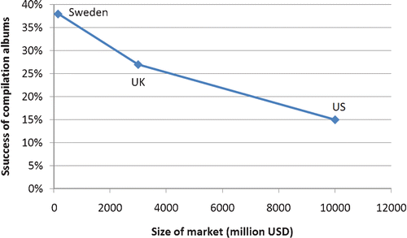
Figure 12: Success of compilation albums compared to size of market, Wikström and Burnett, 2009, 514.

Wikström and Burnett (2009, 512–514) believed production costs were similar in every country but population size affected how record companies recouped costs. In larger countries with high populations, record companies could afford to release solo work by esoteric artists because the potential audience size was substantial, but in smaller countries with lower populations the possibility of recouping investment from such releases was limited. In smaller countries it was more cost effective for record companies to aggregate recordings by different artists onto compilations. Wikström and Burnett (2009, 514) concluded ‘[t]he smaller the market, the greater the need to create aggregated music projects, such as compilation albums’.

One problem with Wikström and Burnett's study was that for each country they aggregated sales of all the different types of compilation they had previously described, compared and contrasted. This meant their research did not differentiate between what types of compilation were sold to whom, how many of each type were sold, or how they had been distributed. With this information missing it is impossible to assess what types of compilation sold the most. It could not be ascertained, for example, how popular ‘Greatest Hits’ style compilations were compared to esoteric compilations made by artists celebrated in niche music scenes. This criticism supports the view of academics who believed 'music industry' studies fail to take account of the role or impact of work done by different sectors of the music industries. Details about how and where products are distributed is important to know because product availability affects product consumption.

John Culshaw, the head of the classical division of Decca Records, was convinced Britten's War Requiem would sell well, given its performance to celebrate the rebuilding of Coventry Cathedral was to receive extensive media coverage. The first pressing sold out within a week and several months elapsed before more copies arrived, ‘by which time the sales impetus had been lost’ (Frith, 1996, 22). In this case the initial production run was too low. This affected its availability which in turn affected how many were sold. One focus of this research is thus to interrogate producers about how and where their unlicensed compilations were distributed, who they perceived their target consumers to be, and how they distributed their products to ensure they reached those consumers.

This focus is important because Hesmondhalgh (1998, 257) clarified there was no singular UK distribution industry in the 1980s because an independent network had ‘emerged ... in parallel with, and in opposition to, the distribution facilities of major record companies’. The significance of this is that different networks of distribution distributed different products in different ways. It will be shown in the next section that while some distributors imported obscure older US recordings into the UK and sold them from specialist independent sites, others exclusively distributed contemporary popular UK recordings to high street record shops.

2.4.5 UK music distribution and retail in the 1980s
Hesmondhalgh's (1998) study, in addition to testimonies from distribution and retail employees, an American music business lawyer, and writers on club cultures (Cotgrave, 2009; Cosgrove, 2016), show how an abundance of UK and US records ended up being sold for discount prices through a network of UK specialist independent record shops. Of greatest relevance to the domain of this study, details reveal reasons why so many old US soul, jazz and funk records reached UK record shops in the early 1980s. This meant that UK-based record collectors who heard, liked and wished to own original old Afro-American soul, jazz and funk recordings did not have to travel internationally to buy them. These types of recordings featured predominantly on the unlicensed compilations created by the subjects of this study.

Between 1978 and 1982 major record labels distributed vinyl records exclusively to high street chains. This change resulted in the number of specialist independent record shops in Britain rising from 1,750 to 2,370 (Hesmondhalgh, 1998, 258, citing figures from the BPI yearbook 1982). These specialist independent shops were served by ‘a new sector of independent wholesalers and distributors’ known as ‘one stops’. These operated by ‘buying records from the majors at a bulk discount’. Independent specialist retailers were attracted to using one-stops because they supplied records ‘without the small order surcharge imposed by the majors’. When seven one-stops formed an association called The Cartel, each retained autonomous control over musical products they received and distributed and this meant specialist shops they served had access to a diversity of products from all over the UK (ibid, 259). Retailers hand-picked records they wanted to stock from delivery vans run by specialist companies (Jones, 2010, 44–46). Much of the stock was the result of overproduction by record companies; unsold records were ‘deleted ... when it was no longer worthwhile keeping [them] in their warehouses’ (ibid, 43).

2.4.6 Overproduction
Overproduction was a strategy whereby companies released many different records each year in the knowledge ‘one in eight or less’ would recoup their production costs (Negus, 1999, 32). Negus (1992, 152) had concluded in a study of pop culture and conflict in the music industries that ‘the recording industry constantly produce[d] more failures than successes’. Described as 'throwing mud against the wall' (ibid, 34) overproduction presumed the failure of many releases would be offset by the success of just one or two. Production expenses incurred by records that failed would eventually be ‘written off’ to prevent further potential losses (Anderson, Dubber and James, 2013, 40). Overproduction contributed to inestimable numbers of unsold recordings made by ‘the unknowns and the no knowns who ‘tear the tickets at the Hall of Fame’ (Plasketes, 2009, 11, citing song lyrics by MacDonald, 1989).

Record companies deleted records from their inventories because recording contracts stated royalties did not have to be paid to artists for unsold records (Avalon, 2009, 78). Deleted records imported from abroad were sometimes referred to as ‘cutouts’. Cutouts had the corners of their sleeves clipped so they could not be sold as brand new products (Cotgrave, 2009, 32), and specialist distributors purchased them at drastically reduced prices (Jones, 2010, 43–53). In the US an estimated 200 million cutouts a year were sold on during the 1980s (Avalon, 2009, 78). When ABC Records were sold to MCA in 1983, 9 million unsold records were found in a warehouse and sold off to a distribution company for 35 cents each. No artists received any money and MCA made an estimated ‘$3 million in cash and barter’ (ibid, 56). In his book on ‘the UK jazz dance scene’, Cotgrave (2009, 39) observed that when thousands of US cutouts appeared in UK shops in the early 1980s they were greeted enthusiastically by club goers and DJs:

These were deleted US Jazz, Soul or Funk albums that were discontinued, withdrawn, no longer available etc and had a little 'clip' taken off of the sleeve. Shops like A1 in Glasgow; the countrywide 'Our Price' chain; Bluebird Records (the cut-out kings); Robinsons and Yanks in Manchester and many other import shops, were absolutely flooded with thousands upon thousands of these incredible known and predominantly unknown albums—some on tiny independent labels. They were cheap too: half or a third of the price of a regular album. So many tracks were being uncovered for the dancefloor—literally by the hundreds. It was a breathtaking time.

Respected DJ and radio broadcaster Trevor Nelson's first employment in the music business helped to shape his future career. In 1985 he worked on ‘the import vans’ that supplied imported records to specialist independent shops in London and this meant he ‘had a copy of everything’ to play on his pirate radio show in the evenings (Facey, 2013, 5). But distribution networks linked to high street chains and specialist shops were not the only UK sites where obsolete US records could be found. In the 1970s and 1980s the Northern Soul scene celebrated 45 rpm records that had failed to reach popular music charts, made by obscure singers and bands ‘who copied the Detroit sound of sixties Motown pop’ (Brewster and Broughton, 2006, 88). Predominantly played and danced to in ‘decaying ballrooms, working men's clubs and rooms above clubs’ (Cosgrave, 2016, 26), original copies of obscure singles on ‘black American labels from the sixties ... came to define the [Northern Soul] scene’ (ibid, 40). Decades of vinyl record overproduction meant vinyl records were sufficiently abundant for independent record dealers in the UK like John Anderson to establish themselves as record importers, distributors and retailers. Capitalising on the popularity of the Northern Soul scene, Anderson imported thousands of deleted and unsold US soul singles into the UK (ibid, 127).

2.4.7 Marginal spaces as locations for compilation resources
Resources are required for ‘art works of any kind’ (Becker, 2006, 69) and resources required for music compilations are recordings. Having established record companies employed DJs to create compilations of non-contemporary music in the 1980s, attention is now paid to where they may have found common and obscure old recordings as potential source material for compilations. By this time recordings of music on various media formats had been available to the public for nearly 100 years (Read and Welch, 1976). Although many were never successful in the first instance and others quickly became obsolete, no media formats ever completely disappeared (Sinnreich, 2013, 41). In the 1990s old vinyl records that had accumulated in specific spaces were approached by record collectors not as failed products, but as potential resources that could be mobilised in different ways for different purposes (Becker, 2006, 68–76). In an essay entitled 'Exhausted Commodities', Straw (2000, np) observed how vinyl records had accumulated over time in flea markets, car boot sales, charity shops and ‘commercial enterprises which resemble[d] charity shops’. He described how collectors who frequented these spaces repurposed the vinyl records they found there.

Straw's ideas are examined here because they reflect ideas expressed in literature on music piracy about how musical products travelled over time and across space to places where they were appropriated for uses unforeseen at their point of production (Johns, 2009). Old records were repurposed in authorised and unauthorised ways, and this moves the focus of discussion towards ideas about consumers who ‘do not consume things without changing them’ (Cova, Kozinets and Shankar, 2007, 4) and ‘regimes of value’—the idea that the value of an object increases or decreases according to how near or far it is in time and space:

... as commodities travel greater distances (institutional, spatial, temporal), knowledge about them tends to become partial, contradictory and differentiated. But such differentiation may itself (through the mechanisms of tournaments of value, authentication, or frustrated desire) lead to the intensification of demand.
(Appadurai, 1986, 56)

In the same decade that several large retail chains competed to ‘build the world's biggest record store’ (Straw, 2000, np), the UK public witnessed a country-wide proliferation of car boot sales:

Car-boot sales, it is generally agreed, first appeared in Britain in the late 1970s and early 1980s. Situated primarily, although not exclusively, in fields, car parks, and/or open spaces... these events involve the exchange of, for the most part, used household and personal goods....However, it is only during the 1990s, as these events have expanded dramatically in terms of number and size, that they have attracted widespread political attention, and that they have become mass-participation events.
(Gregson et al, 1997, 87)

In the 1990s so many charity shops opened in the UK that ‘a shortage of second-hand items forced them to import saleable items from other European countries’ (McCann, 1997, cited in Straw, 2000, np). Straw (2000, np) described spaces where vinyl records and other objects subject to cycles of fashion accumulated as ‘museums of failure’, and suggested piles of degraded cultural commodities appeared monumental, historically solid and ‘museum-like’. Curatorial practice was inferred rather than stated here, but Straw's description suggested piles of unwanted vinyl records were compilations aggregated into specific spaces by criteria of being worthless to their original owners. Key to his analysis from a material culture perspective, vinyl records no longer valued were not destroyed but transferred to sites where others could find them and value them differently.

‘Scavenger-like’ record collectors defined as ‘disc jockeys, lounge music revivalists [and] curator-compilers’ frequented these spaces. Curatorship was invoked again, focused on individuals who sought records that had acquired a degree of ‘hip credibility’ in certain circles; ‘Italian jazz-funk, Asian girl-group garage psychedelia, or funky crime-movie soundtracks from India’.The musical content on vinyl records they selected revealed local musicians all over the world had in previous decades assimilated genres of music that had attained global popularity:

… the bossa nova records made in the mid-1960s by Australian high school bands, the Mexican recordings covering the theme songs of American television programs, or the albums by Czech female singers of the 1960s featuring translated versions of songs by Petula Clark and Nancy Sinatra’.
(Straw, 2000, np)

2.4.8 Reissue labels, sampling, and night clubs
Straw asserted records found were used by owners of reissue record labels, night club DJs, and musicians. Thus the consumption of recordings from marginal retail spaces nourished various forms of productivity and creativity. In a solitary study of reissue labels in the 21st century, Maalsen (2016, 517) observed some independent record label owners reissued music by ‘underground acts at greater peril of being forgotten’, and maintained this re-evaluation of old recordings not commercially successful when first released contested the discourse of music heritage’.

Straw (2000, np) was convinced inventive music-making was a peripheral activity because most artists remained committed to ‘endlessly revaloriz[ing] an Anglo-American canon’, but developments in music technology had enabled new kinds of creativity. At the moment in time when ‘over 50–year’s worth of analogue production on vinyl records was rendered obsolete by the aggressive promotion of CDs, increasingly affordable digital samplers enabled musicians to repurpose sounds from records they could buy cheaply from car boot sales or charity shops’. In the 1990s the sounds on many new recordings reflected musical genres that had been sampled or pastiched:

Many of the best records of 1998 featured bizarre cross-fertilisations of styles. The petite Japanese women of Buffalo Daughter sang bossa novas; the dinky German band Stereo Total sang in French, Italian and Japanese (and covered KC and the Sunshine Band); the L.A.-based ensemble Ozomatli mixed hip hop with mambo and Tex-Mex party music.
(Sullivan, 1999, D1; cited in Straw, 2000, np).

In the UK In the mid-1980s, some music of previously low cultural profile suddenly became central to DJ play lists. Shepherd (2003, 327) believed DJs who played selections of music from pornographic films, TV shows and film soundtracks shared an ‘anti-rock stance’ with audiences who found retrospective sounds attractive. In the 1990s a ‘transgressive anti-conventionalism’ developed amongst other groups drawn to culturally marginal music genres such as ‘garage psychedelia, surf music and [what came to be known as] Space Age Bachelor Pad Music or loungecore’ (Straw, 2000, np). In the 1990s UK night clubs diversified as unconventional selections of music were included in increasingly eclectic play lists. One contemporary observer offered a revealing snapshot of how different musical genres and subcultural groups converged in a 1994 London night club called Smashing:

'Queen Bitch'; the Beastie Boys' rap cacophony; the Barbarella theme song; the Happy Mondays' narcoleptic white funk; or the Smiths' 'Panic', dissolving into throbbing acid house. What kind of music do they play? The only kind. Indy rock? James Last? Grunge? Sammy Davis Jnr? Sixties soundtracks? Si, si, senor. Glam? Punk? New Wave? Disco? Pinky and Perky? Tick them all off, and anything else that comes to mind. Meet your fab hosts, Matthew, Martin, Michael and Adrian, whose various musical and aesthetic preferences clash and mutate in this kaleidoscopic jolly-u Oh, what a life of human waste: Mods, rockers, skins, trannies, beatniks, disco queens, hippies, dippy chicks, old school trendies, all the nightlife gangs are welcome. (Sharkey, 1994).

2.4.9 Summary
Compilations of music generated significant revenue for record companies and in the last quarter of the 20th century compilations increasingly included obscure recordings. For consumers in smaller markets such as the UK there were more compilations to choose from: record collectors whose observations inspired this research were UK—based and spoke highly of unlicensed compilations that introduced them to esoteric recordings by artists they had never heard of before. It could be hypothesised the high volume of licensed compilations available in the UK nurtured an interest in unlicensed ones and also in obscure music, but academics have noted a tendency for music consumers in the West to keep ‘a certain distance from the mainstream’ since the 1950s (Danielson, 2006, 27). Evidence showed record companies and night club DJs connected as non-contemporary records became popular in UK club cultures: record companies effectively monetised DJs' knowledge of back catalogue material that was previously considered worthless. Licensed products created by this union echoed the content on products made by the subjects of this study; unlicensed compilations also contained recordings of soul, jazz and funk and other music popular in club cultures.

Given similarities between licensed and unlicensed compilations, one focus of this research is to find out whether legitimate and illegitimate worlds of music production ever intersected. Phrased another way, one line of enquiry must be to find out if the subjects of this study were connected with personnel from the music industries before, during or after they made unlicensed compilations. Additionally, comparisons between release dates of similar licensed and unlicensed compilations could offer insights into whether illegitimate compilations of soul, jazz and funk pre-empted legitimate ones, or vice versa. Subjects could also reveal whether unlicensed compilations pre-empted independent reissue labels that produced similar products.

Literature showed different distribution networks were available to producers who had novel music products to sell, so another focus must be to find out how subjects distributed and sold their products. Connections between specialist importers, distributors, independent shops and UK club cultures suggest information about where recordings used for unlicensed compilations were sourced, and where unlicensed compilations were sold, could reveal much about the social and cultural worlds the subjects inhabited. Additionally their information could lead to intact being established with individuals who acquired unlicensed compilations for their shops or market stalls. These could provide further 'insider' perspectives on how authorised and unauthorised modes of distribution and retail co-existed.

It’s worth noting that the subject of the next section—unlicensed compilations on vinyl records known as ‘breakbeat LPs’, and also referred to as ‘breakbeat compilations’, or ‘breaks records’ (Schloss, 2004)—are absent from several overviews of music piracy in the 20th century. This raises questions about why some genres of music appear to be foregrounded in academic literature on piracy over others. The section that follows defines breakbeat LPs, situates them in a timeline of hip hop music production, and exposes a gap in knowledge about hip hop in the 1990s that data from this study may be able to address.

2.5 UNLICENSED COMPILATIONS: BREAKBEAT LPS
In a study of record collectors and DJs in Europe (Vályi, 2010), and an overview of sample-based hip hop music production (Schloss, 2004), breakbeat LPs were described as production tools used by DJs and producers to make hip hop music. The phenomenon of breakbeat LPs is examined here because like the unlicensed compilations on vinyl record produced by the subjects of this study they contain old soul, jazz and funk recordings. It will be shown below that breakbeat LPs appeared in record shops in the 1980s in two distinct waves. The second wave is relevant to this study because it occurred from around 1987 to 1995, a period that has since been referred to as hip hop's ‘golden age’ (Schloss, 2004; Williams, 2014, 28) or ‘Golden Era‘ (Frane, 2017, 291). The second wave of breakbeat LPs appeared around the same time unlicensed compilations of soul, jazz and funk flourished in the UK. One focus of this research will therefore be to find out if the subjects of this study identified their products as breakbeat LPs.

As literature below shows, no research has yet been conducted on the provenance of the second wave of breakbeat LPs, and although they are present in academic literature on hip hop, they are absent from literature on music piracy. This raises questions about why some piratical products have been surveyed in depth in academic literature on music piracy while others have not. If the UK-based subjects of this study identify themselves as breakbeat LP producers, a gap in academic literature on music piracy will be addressed and a useful contribution will have been made to academic literature on hip hop music production.

Hip hop music between 1974 and 1979 is now surveyed to emphasise how transformational use was central to its development and transformative piracy was central to its dissemination. After concepts of ‘breaks’ and ‘beats’ have been defined, both waves of breakbeat LP production are described to clarify where gaps in academic knowledge about transformative piracy exist.

2.5.1 Hip hop music and culture: 1974–1979
The worldwide popularity of hip hop as both a music and unified scene has been described as a ‘lingua franca’ (Morgan and Bennett, 2011, 179) and ‘central to youth culture’ (Richardson and Pough, 2016, 129) but at its source, hip hop music developed from a unique transformational use of old records. Between 1974 and 1979 a combination of aesthetic practices coalesced into what eventually became known as the ‘four elements’ of hip hop: DJ-ing, graffiti, breakdancing, and rapping (Williams, 2014b, 23–25). DJs employed two turntables to collage 'the best fragments of records’ into a novel style of music (McLeod, 1999, 135). Prior to 1979 many did not believe 'live' performances of hip hop DJs and rappers could be transformed into saleable music products (Brewster and Broughton, 2009, 9). The sound of hip hop was first disseminated widely via cassette tape recordings of DJ performances at ‘hip hop jams’ in parks between 1974 and 1979 (Perkins, 1996, 7): bootlegs of 'live' hip hop music on cassette tape disseminated the sound of this new musical form to wider audiences but did not share information about how the music was made or what vinyl records DJs used to make it.

Cassette tape recordings were copied, compiled, distributed, traded and sold throughout New York City ‘by word of mouth’ (Perkins, 1996, 10) and passed ‘hand-to-hand in the Black and Latino neighbourhoods of Brooklyn, the Lower East Side, Queens and Long Island's Black Belt’ (Chang, 2007, 128). They were played by New York taxi drivers, sent to relatives and friends beyond New York, and taken overseas by servicemen (Brewster and Broughton, 2006, 260). Unique practices of the hip hop scene were ‘taught and performed in the context of face-to-face interactions between human beings’ (Schloss, 2009, 4) but it was pirated recordings on cassette tape that spread the sound of hip hop beyond the location of its original performance.

2.5.2 'Breaks' and 'beats'
The term 'breakbeat' refers to ‘breaks’ and ‘beats’ used to make hip hop music. ‘Breaks’ are short segments in songs ‘where all instruments except the rhythm section fall silent and the groove is distilled to its most fundamental element’ (Schloss 2009, ). Breakbeat LPs were vinyl records that compiled complete recordings that contained breaks and beats could be used by individuals who aspired to be hip hop DJs or hip hop producers.

DJs located breaks ‘by inspecting thousands of records looking for a wide band that was blacker than the rest of the vinyl’, and it was these visual clues that signified which parts of a record were most likely to contain ‘a bare extended funky drum break’ (Allen, 1999, 3). DJs would play breaks from vinyl records on separate turntables to seamlessly 'mix' and recombine short segments ‘of existing songs and instrumental passages into a new musical piece’ or syncopated, continuous rhythm (Bennett, 2000, 134). Dancers who moved in time to the re-contextualised breaks came to be known as ‘breakdancers’ (Brewster and Broughton, 2006, 238).

DJs who played breaks were not ‘bound by the more general constraints of genre or style’ (Schloss, 2004, 32), and sought satisfaction from ‘getting audiences to dance to breaks that were taken from genres they professed to hate’. Grandmaster Flash noted breakdancers were incredulous when they discovered they had danced to breaks in tracks by the The Beatles or The Monkees (Toop 1984, 66). DJ Shadow praised how DJ Africa Bambaataa exhorted New York gangs to rally around music rather than territories, and demonstrated his commitment to crossing musical boundaries by playing breaks from records by James Brown, The Rolling Stones and Kraftwerk. (Vályi, 2010, 102). Vályi noted participants in this confined scene ‘assembled a collectively appreciated repertoire of songs, a canon of breaks that was crystallised and made apparent primarily in live DJ sets’ (Vályi, 2010, 108–109)

Exclusive knowledge of certain breaks was integral to the identity and reputation of well-known DJs, and the reason why breakbeat LPs divided opinion within the hip hop community. Names of artists and tracks were ‘strictly guarded by the inner circle of DJs who discovered and popularized them’ because from a ‘businesswise’ perspective it kept them ahead of others (Fricke and Ahearn, 2002, 108). In spite of this secrecy, DJ performances inspired young people and a small ‘local scene of aspiring DJs [and] savvy self-made record merchants’ (Leland and Steinski 1998; Smith 2006) to discover the names of tracks that contained breaks:

There was a time when searching for beats and digging in the crates was a part of the culture of the whole projects. It was just something we all did ... When we were going to jams we just stood there just trying to know, [to] see if we [could] name every beat that Bambaataa or whoever was DJ-ing put on ... And if we heard a new beat we set out for a journey as children thirteen or fourteen years old to go and find that beat.
(Jesse West in Beatdawg magazine 2007, cited in Vályi, 2010, 109)

In Making beats: The Art of Sample-based Hip hop, Schloss (2004) emphasised beats were created from breaks by using a sampler or sampling software; the term ‘making beats’ described the creation of ‘musical collages composed of brief segments of recorded sound’ (2). Brewster and Broughton (2006) asserted sampling technology ‘could do faster, more accurately, and more easily what a DJ had long been able to do’ (267). Schloss (2009) concurred and noted that at the outset, hip hop producers favoured turning funk and soul breaks into beats ‘which—even in their original context—were clearly defined’ (36–37). Sampling technology meant DJs who had formerly stood behind two turntables to manipulate a repertoire of vinyl records for dancers at live events could create music introspectively, seated in a studio with no audience present.

As sampling technology evolved and sampling times grew longer, ‘the spectrum of music that could be pressed into service for hip hop [broadened as DJs exploited] an infinite number of samples from vinyl, advertising jingles, television sitcom themes, and movie soundtracks’ (Perkins, 1996, 8). Schloss (2004, 37) summarised the impact this had on record collectors and how record collecting changed as record producers realised the importance of finding unique sounds on old vinyl records that had not been sampled by anyone else:

Record collecting [was now] approached as if potential breaks [had] been unlooped and hidden randomly throughout the world's music… As digital sampling became the method of choice for hip hop deejays (who, now… began to call themselves producers, their pre-existing hunger for rare records became of paramount importance.

2.5.3 The first wave of breakbeat LPs: early 1980s to 1986
As stated above, many hip hop DJs safeguarded the identity of tracks they used and pirated cassette tapes disseminated only the sound of hip hop music. But in the mid-1980s ‘a Bronx-based deejay named Lenny Roberts began to press compilations of rare recordings, each containing a sought-after rhythm break, under the name Ultimate Breaks and Beats’ (Schloss, 2004, 37). The Ultimate Breaks and Beats series [UBB] exposed the titles of many sampled recordings to a wider audience. Purchased from ‘hip hop oriented specialist stores’ (Leland and Steinski, 1988), these records signalled ‘the arrival of affordable audio-sampling technology and sample-based hip hop practices’ (Vályi, 2010, 111).

Lenny [Roberts] started the Ultimate Breaks and Beats series on the Street Beat label in the Bronx, New York City, to supply record diggers with compilations of rare records, as well as to introduce songs to hip hop heads who were unaware of the incredible music the past had to offer.
(Liner notes for Ultimate Breaks and Beats, The Complete Edition, cited in Vályi, 2010, 92).

A ‘record collector and closet DJ’, Roberts was initiated into the culture of hip hop in 1976 via his son's enthusiasm for the genre, and as he taped live hip hop performances he got to know the respected DJs and records they played (Leland and Steinski, 1988, 96). When UBB LPs first appeared in specialist record stores shops they were purchased and used extensively as the source for hundreds of new hip hop records worldwide. Cited in Schloss (2004, 123), DJ Kool Akiem stated ‘[e]verybody sampled offa them Ultimate Breakbeats back in the eighties. I can't think of no artist that didnt’. But breakbeat LPs were deplored by some hip hop scene participants because they broke the secrecy that surrounded the repertoires of the earliest DJs and were seen as a shortcut that reduced the need for DJs and producers and deejays to search for original breaks. Schloss (2004, 121) noted that breakbeat LPs were ‘[u]sually unlicensed, often unlabelled, [and] almost always on vinyl’, and the twenty-five volume UBB series ‘spawned hundreds of imitators’ (ibid, 38). The UBB series represented a 'first wave' of breakbeat LPs and their provenance was known.

2.5.4 The breakbeat canon
The UBB series and a few others, anthologised recordings with breaks on that were played by pioneering hip hop DJs between 1974 and 1979. They allowed younger hip hop producers with samplers to inexpensively collect breaks played by original DJs and make novel hip hop tracks. From the second half of the 1980s and well into the mid-1990s, these producers almost exclusively sampled music from the funk era. Vincent (1996) stated that ‘without exception, every original funk artist’ referred to in his study of the development of funk music ‘was reincarnated in some modern rap song’ (9). Danielsen (2006, 4) agreed:

In the 1990s ... funk was rediscovered, due to rap and hip hop and a general revival of groove-based funk. The grooves of the golden age of funk in the 1970s became the prime source of samples for hip hop, while some new dance music, such as acid jazz and trip-hop, recirculated the old grooves in new wrappings ... The old grooves themselves were also revived for older and newer fans.

Criteria for inclusion on what has been called the ‘breakbeat canon’ was unusual: it included no hip hop songs, only the most popular songs sampled by hip hop producers (Frane, 2017). Inclusion rested on the number of artists that utilised the same segments of the same song to make new hip hop recordings. Many of the recordings Vincent (1996) and Danielsen (2006) referred to in their studies of funk music were integral to the breakbeat canon, and were also the same as many of the recordings included on the UBB series (Schloss, 2004, 37–38). James Brown's Funky Drummer was ‘sampled and recontextualized so extensively as to achieve near ubiquity in a range of popular music genres’ (Oliver, 2015, 180, cited in Frane, 2017, 291). The breakbeat canon was central to hip hop's transformation into a a global, multi-million dollar business in the 1990s, when ‘everything from soft-drink commercials to ‘white’ pop music [had] appropriated hip hop music's musical and visual style’ (McLeod, 1999, 136). Vályi's (2010, 151–227) research detailed how DJs from the US (New York City, San Francisco Bay Area, Philadelphia), the UK (London, Manchester, Essex) and Hungary (Budapest, Pécs) gained knowledge of the breakbeat canon from copies of breakbeat LPs they bought in their own countries and used for purposes of DJ-ing or producing hip hop tracks.

2.5.5 The second wave of breakbeat LPs: 1990s
Vályi (2010, 123) stated ‘the second wave of breakbeat compilations’ that followed the UBB series represented ‘the crystallisation of a new canon’. Schloss (2004, 121) noted ‘hundreds of such anthologies’ followed the UBB series. Cited in Vályi (2010, 123) hip hop producer and MC, Diamond D dubbed them ‘the second level of breaks’. The provenance of the second wave of breakbeat LPs is not so well defined. The second wave of breakbeat LPs appeared during a ‘period of profound transformation in the early to mid-1990s [when] a range of new players—self-made journalists, mixtape DJs, bootleggers, legitimate record companies, record shops—entered and extended the collective field’ seeking records with breaks on that could be played or sampled (ibid, 120). Vályi made no further suggestions as to who the producers of second wave breakbeat LPs were, where they were based, or how they produced and distributed them, but later contended whoever had made them ‘had a knowledge of breaks that matched, even surpassed that of celebrated hip hop producers’ (ibid, 122).

2.5.6 Summary
The second wave of breakbeat LPs extended the breakbeat canon because it provided producers with recordings that had not previously been sampled. One imperative of this research must therefore be to interrogate the possibility unlicensed compilations of soul, jazz and funk produced in the UK in the 1990s, were 'second wave' breakbeat LPs that appeared in mid-1980s. If they were a novel contribution will have been made to literature on hip hop, because information about their compilation could be used to analyse how the transformative piracy of breakbeat LPs in the US was interpreted by transformative pirates in the UK

If, however, the unlicensed compilations the subjects of this study produced were not breakbeat LPs, it raises questions about what else inspired them. Only the subjects of this study can state what product they believed they had produced, and what audiences or worlds they had intended them for. This study will therefore either extend present knowledge about breakbeat LPs in hip hop culture, or introduce an entirely new phenomenon into the timeline of music piracy. Irrespective of what the contribution will be, analysis of the domain and subjects through the lens of art world theory will ensure focus is primarily maintained on social and cultural aspects of production, rather than primarily on analysis of how the production of unlicensed compilations affected copyright owners or the music industries.

Having surveyed literature on one specific example of transformative piracy, literature on music piracy in general is now examined for purposes of situating the subjects of this study conceptually and temporally into the history of music piracy in the 20th century. Literature on music piracy is evaluated in two distinct sections. The reason for this is because after 'music industries' and 'art worlds' had been adopted to guide the conceptual shape of this study, it was apparent music piracy was a subject that had been approached from entirely different perspectives by writers from very different worlds. The next section evaluates literature on music piracy in relation to copyright owners and the music industries [2.6 ], before the penultimate section of the chapter evaluates literature on music piracy in relation to music scenes and club cultures [2.7].

2.6 MUSIC PIRACY AND THE MUSIC INDUSTRIES
The literature is concentrated on the effect music piracy had on the music industries. The purpose of this section is to emphasise how opinions about different type of music piracy have been formulated from observation of pirate products and the effect they had on the music industries, rather than from perspectives of how and why products of piracy were designed, planned, resourced, financed and manufactured. This section will show analogue music piracy has rarely been analysed as a social and cultural practice.

A pattern constructed to explain the symbiotic relationship between music piracy and copyright owners is problematized, and this leads to a discussion of transition periods between obsolete and newly introduced music formats. A hypothesis on music piracy creates a space for surveying music pirates employed in the music industries, and different sectors of the music industries as potential sites for piratical activities. Literature on music pirates who were record collectors highlights how throughout history, copyright owners have chosen to overlook low levels of piratical production. Examples of transformational use and transformative piracy in genres of jazz, folk and rock are described for purposes of underscoring historic links between record collectors, obscure recordings and record companies. Subjective opinions about transformative piracy and counterfeiting are critiqued, and attention is drawn to literature that suggests piracy can be analysed outside of legalistic or moralistic frameworks. Collectively these lead to conclusions about how this study can make an important contribution to literature on music pirates, and music piracy as was practised in the late 20th century.

2.6.1 Copyright owners and music piracy: ‘a repeated pattern’
Kernfeld (2011, 2) asserted contests between ‘monopolist’ copyright owners and music pirates followed ‘a repeated pattern’ of control, disobedience and prohibition, followed by either assimilation or obsolescence. He maintained copyright owners attempted to control recordings they owned, but music pirates disobediently reproduced and distributed them in unforeseen ways. When copyright owners sought to prohibit piracy and failed, they either assimilated what pirates had produced to ‘put them out of business’, or ‘a new, different, and alternative song product’ appeared, made old formats obsolete, and ended the contest for both parties (3–4). There are two problems with this pattern.

Firstly, the pattern of obedience and disobedience situates music piracy in relation to copyright owners the effect they had on each other, and secondly it assumes format obsolescence was inevitable. But some major record companies adopted strategies to accelerate format obsolescence. Narratives ‘of perfect fidelity and sonic quality in order to migrate consumers to new platforms’ are well-documented (Sinnreich, 2013, 54), and in a personal memoir Australian comedian and writer Barry Humphries (2017, 125–134) described how he was employed in the 1960s to shatter thousands of unsold 78 rpm shellac discs with a hammer when the EMI record company was actively promoting sales of 33 rpm vinyl records as a higher fidelity product to replace them. Although Kernfeld (2011, 4) was adamant original disputes between copyright owners and music pirates evaporated when new formats rendered older ones obsolete, Cummings (2013) insisted no new song product or mode of distribution music ever immediately superseded an older one. He observed ‘[c]haos prevailed [in the 1960s when music retailers had to] stock the same musical selections on monaural and stereo discs, reels of tape, several types of cartridge, and cassettes’ (Business Week, cited in Cummings, 2013, 85). As consumers prevaricated over whether or not to upgrade music collections, no single music format was assured of sales high enough for production to be sustainable, and as a result, music pirates were able to exploit production ‘supply gaps’. The suggestion that piratical activity increased during periods of format transition provides an additional focus for this research: the subjects of this study produced their compilations when vinyl records, CDs and cassette tapes co-existed, but CDs and cassette tapes were the most popular formats (see Figure 9). This raises questions about the chosen format of unlicensed compilation producers.
It's possible some recordings compiled on unlicensed compilations in the 1990s had never previously been released on CD, but given the commercial success of compilations on CD, the rising interest in musical obscurities, and the popularity of CD boxed set anthologies (Wikström and Burnett, 2009), unlicensed compilations on CD would have appealed to more consumers. Literature suggests the subject’s choice of vinyl record may have been informed by culture rather than economics. Overwhelming evidence suggests that in the last two decades of the 20th century playing vinyl records remained central to many club cultures (Thornton, 1995; Brewster and Broughton, 2006). As stated previously, a DJs knowledge of obscure, novel, rare records that were popular with audiences was considered a mark of subcultural capital, a form of status acquired by individuals ‘whose knowledge of style and music differentiated them from other members of their group’ (Thornton, 1995, 12). Maintenance of subcultural capital was not easy for DJs because popular recordings were only celebrated in club cultures for short periods of time. Browne (Milestone, 1998; cited in Browne, 2005, 130) cited how Dr Katie Milestone explained to him the difference between the concept of 'newies' and 'oldies' in the fast turnover of records on the Northern Soul scene:

A newie is a rare record that has only just been uncovered so it's new [to the Northern Soul scene]. An oldie is a record that has become established as a Northern Soul anthem. Therefore, if you're a real connoisseur, you'd probably be bored of an oldie, you'd have heard it so many times it would be like any old chart record.

This research will focus on factors that guided the selection of recordings for unlicensed compilations and in this respect it could make a useful contribution to literature on club cultures. Only the subjects of this study can reveal why so many recordings they compiled were obscure, where they found them, what market those recordings were intended for, and whether recordings compiled were already popular and sought-after by audiences, or were recent discoveries intended to introduce novel sounds to existing club cultures. Answers to these questions could provide insights into whether it was social, cultural or economic mechanisms that animated the movement of recordings from one regime of value to another. No assumptions should be made about why unlicensed compilations appeared on vinyl record rather than CD. Narratives from transformative pirates could provide fresh perspectives on how some recordings became popular in club cultures in the first instance.

2.6.2 Music pirates: music industry personnel
Johns (2009, 13) hypothesised piratical activity invariably occurred a distance in space and time from legitimate sites of production, but this obliquely raises a problem related to the identity of some music pirates. He suggested piracy developed in spaces that were, by implication, disorderly and unregulated, but literature reviewed in this section and the one that follows reveals some music pirates were identified as personnel working in the music industries:

Piracy is a matter of the history of reception as well as production ... It is a matter of the geography of [piratical] practices too. Piracy has always been a matter of place—of territory and geopolitics—as well as time ... Extrapolation from [examples] gives us the nearest thing we have to a hypothesis about the development of piracy itself. It sees piracy as essentially a phenomenon of geopolitical thresholds. Piracy's location, on this view, always lies beyond the sway of the civilising process.

Related to this, Cummings (2013, 35) believed boundaries between authorised and unauthorised reproduction were occasionally ‘fuzzy’, and suggested ‘industry wheeler-dealers, record collectors, radio stations, musicians unions, bootleggers, even the Mafia’ all staked different claims on how music should be reproduced, disseminated, distributed or exchanged. Examples listed below show that as long as the concept of 'music industries' is adopted, Johns idea that piracy developed in unregulated spaces is coherent, because literature reveals that in some sectors of the music industries, employees operated as pirates.

In the 1890s Russell Hunting recorded a spoken word comedy routine for Leeds and Caitlin distributors but was only aware his performances were being pirated after he saw a studio assistant carrying duplicates of original disc cylinders. When he realised the company had duplicated more cylinders than he had recorded, he ‘charged them with unfair dealing and threatened to expose them if they did not make good all past duplications’ (Gaisberg, 1947, 26).

In the 1930s Eli Oberstein failed to attract new artists to his RCA Victor record label and to generate new song products he simply reproduced recordings made by other companies and occasionally changed the names of performers (Cummings, 2013, 35). In the 1950s record companies offered transcription services and frequently pressed discs from tape recordings supplied by customers (ibid, 71). In 1951 this meant that ‘RCA got in trouble for printing bootleg copies of its own jazz records’ (ibid, 76). In the 1980s a major record label was caught and fined for pressing thousands of off the books recordings by one of its most successful artists (Patry, 2009).

These examples taken from different decades have been selected to show piratical practice was occasionally triggered by competition between different record companies (Cummings, 2013, 35), or enabled by insufficiently monitored administrative systems that linked different music industry sectors (Cummings, 2013, 76). These examples suggest attention to the legal rights of copyright owners was not sufficiently rigorous in some sectors to prevent unauthorised production from occurring. Additionally, maverick management personnel made decisions that deliberately flouted copyright law (Cummings, 2013, 35), and some employees in the music industries were unaware tasks they were ordinarily required to perform were piratical (Gaisberg, 1947, 26).

Collectively these examples suggest attention be paid to the proximity of unlicensed compilation producers to sectors of the music industries. A similar level of attention must also be paid to individuals they claimed to have worked alongside or individuals they mention. In short, it is clear from literature that it is not beyond reason to suspect personnel who worked within, or for the music industries, were complicit in piratical activity.

2.6.3 Music pirates: record collectors and anti-piracy operations
There are numerous examples of record collectors who were music pirates. Links between record collecting, music piracy and popular music first materialised in the 1920s when collecting records was viewed as a form of cultural preservation; record companies believed there was little ‘to be gained by keeping obscure records in print’ and record collectors pirated older records rarely heard on the radio (Cummings, 2013, 38).

A wave of new entrepreneurs [catered] to collectors by reissuing the scarce recordings of early jazz ... A former baker in the Bronx … turn[ed] out copies of jazz classics through a variety of labels … in order to confuse any labels or lawyers who came sniffing down his trail. So many labels had popped up to meet the demand for old records that some were copying the products of other pirates.
(ibid, 50)

Major record companies were sometimes aware of small scale piracy but took no action. In the 1950s a record company executive stated his company would not reissue the ‘mouldy stuff’ released by pirates because ‘it never sold anyway’ (ibid, 50). Pirates sensed ‘big record company brass’ were not concerned about piracy as long as sales amounted to 1,000 pressings or less (ibid, 51). Jazz critic Wilder Hobson (1951, 41; cited in Cummings, 2013, 38) observed that in the first half of the 20th century music pirates were ‘frequently engaged in offering time-tested, out-of-print works of art which the big recording interests have not felt it worthwhile to issue’.

These examples suggest record companies were not interested in pressing vinyl records that were of interest to fewer consumers, and record companies ignored music piracy conducted on a smaller scale. Chapter 4 will provide evidence of hundreds of different unlicensed compilations of soul, jazz and funk existed, but only those who produced them would know how many were copies of each title were pressed and sold. Subjects of this study will be asked if anti-piracy initiatives ever affected their production. Knowledge obtained from them about the scale of their production may contextualise the extent to which anti-piracy initiatives did or did not impinge on their practices.

2.6.4 Record collectors, obscure recordings and record companies
Two examples of transformational use, one authorised and one unauthorised, provide examples of how collectors knowledge of arcane recordings were capitalised upon by record companies. In the 1930s the management of Decca records believed old Louis Armstrong recordings, originally released on the 78 rpm format, were of little value and granted an independent label permission to compile and sell them on the latest format of ten-inch LPs. When it was discovered the new compilation had sold well, Decca copied the label's release track-for-track, repackaged and promoted it, and it remained a lucrative seller in their back catalogue for over 50 years (Kernfeld, 2011, 134). Sinnreich (2013, 84) provided an extraordinary example of a product of transformative piracy that was celebrated by the music industries. In the 1950s ethnomusicologist Harry Smith's compilation called an Anthology of American Folk Music compiled dozens of songs from different genres without permission from copyright owners. It influenced a generation of 1960s folk musicians and for this reason Smith was ‘celebrated throughout his life, and was even awarded a Chairman's Merit Award’ at the 1991 Grammys, shortly before his death (ibid, 85).

These examples tell us connections between record collectors and record companies are not unprecedented: record companies have capitalised on record collectors' knowledge of obscure recordings in the past. Links between record collectors, obscure records and record companies were also established in the first decade of the 21st century via the growth in popularity of internet blogs. Music blogger Eric Lumbleau (2011, np) argued uploading sound files of out-of-print LPs to the internet challenged the value of music ‘foisted’ on music fans by music journalists. He claimed obscure albums posted on his blog increased their public profile sufficiently for them to be viably reissued. To Lumbleau, his Mutant Sounds blog was ‘a Smithsonian Institute of the musical sub-underground ... a decoder ring for historically situating networks of marginalia that have previously sidestepped analysis ... a raspberry-blowing rebuke to the fates that have marginalised some of the most crucial musical information in history’.

2.6.5 Transformative piracy vs. counterfeiting
Despite a lack of data on the provenance of pirate products and modes of pirate production, scholarly opinions on transformative piracy as a form of unauthorised transformational use have been consistently positive. Sinnreich (2013) viewed the transformative use of recordings in whole or part for compilation, mixing or ‘mash-ups’ as exercises in creativity. Kernfield (2011, 125–6) emphasised transformative piracy involved the creation of novel products, while counterfeiting simply reproduced equivalents to products already available:

[A] substantial portion of record piracy ... involves equivalency, the merely venal copying of someone else's song products. Time and again, examples of this practice lack any component of transformational use: a new musical convenience, a new musical portability, a way to personalise or customize songs and song products, the distribution of otherwise unavailable repertories, and so forth.

Cummings (2013, 206) believed distinctions between transformative piracy and equivalency were highly subjective but labelled the latter ‘exploitative copying’, thereby undermining his own argument that music piracy in general was ‘too protean, too varied, and too multifaceted to easily define some uses as good (sampling in hip hop) or bad (commercial piracy) ...’. These subjective opinions were challenged when arguments began to emerge for music piracy to be researched outside of legalistic frameworks. Tushnet (2004, 566) deliberately called counterfeiting ‘non-transformative copying’, a productive form of ‘free speech’ for social purposes. Tehranian (2011) referred to counterfeiting in positive terms as an essential part of identity formation. Meese (2014, 22) concluded both views represented ‘a worthy attempt to understand non-transformative copying and commercial piracy as a potentially progressive social practice’, rather than one understood only in relation to ‘the broader legal framework of copyright law’.

Digital music piracy is not the subject of this study, but debates surrounding it have generated analyses and conclusions sympathetic to viewing musical piracy as both a creative and productive phenomenon. Sinnreich (2013, 200) concluded his study of music piracy with a polemic argument against the reduction of ‘all cultural activity to a stark permission / piracy binary’ and called for restrictions on terms of copyright, an abandonment of all anti-piracy agendas, and intelligent decision making that balanced the rights of copyright owners with the rights of individuals who chose to use existing musical texts creatively. A roundtable debate generated the following positive statement about music piracy:

The term [piracy] crystallises and embodies the contradictions and possibilities over contemporary struggles over production, consumption and circulation. Its rich life in history, literature and now digital circles has prevented negative associations from fully colonizing it ... Piracy ... has been heralded by actors actively taking the label to breathe new life into asserting a more long standing position about the right to access and share cultural and academic goods.
(Schwarz, et. al, 2015, 87)

2.6.6 Gaps in the academic record of music piracy
Evidence suggests vinyl record piracy was not a priority to anti-piracy organisations in the 1990s. In an oral history interview recorded for the British Library Sound Archive, Derek Varnals (1998), the technical director of the BPI, was adamant there was a hiatus in vinyl record piracy between 1989 and 1992. He asserted that during this period record labels represented by the BPI were more concerned about the potential threat to revenue from pirated CDs. By the end of the 1980s the BPI believed vinyl record bootlegs were in decline so they targeted their anti-piracy operations towards combatting CD piracy instead (Heylin, 2003, 161–175).

Literature on the history of music piracy supports Varnal's assessment, and exposes a gap in the academic record where the transformative piracy of soul, jazz and funk compilations should be. Cummings (2013, 161–174) survey of music piracy extended to rock bootlegs in the 1970s and 1980s, and hip hop mixtapes and pirated CDs in the 1990s. Kernfeld (2011, 178–82) shifted abruptly from rock bootlegs in the early 1980s to the CD piracy of rock and pop in the 1990s. Unlicensed compilations of soul, jazz and funk released on vinyl records in the 1990s are absent from the academic record except for the breakbeat LPs documented in literature on the hip hop scene. This omission suggests much literature on music piracy has followed the lead of popular music writing in general. Concern has been expressed about a bias towards rock music in popular music academic writing for over a quarter of a century (Brennon, 2017, 17–18), and it remains a problem. In a 2013 guide to the study of popular music for students, two out of five sub-headings in a section entitled ‘A brief history of the recorded music industry’ were ‘The rise of rock 'n' roll’ and ‘The emergence of rock and the dominance of the album’ (Anderton, Dubber and James, 2013, 26–30).

2.6.7 Summary
Several points raised in this section can be used to help shape the focus of this research. Record collectors negotiated sectors of the music industries to get piratical music products made, as did music industry personnel. This necessitates the need for being aware of the proximity of unlicensed compilation producers to the music industries and where possible, directing the research focus towards obtaining further information how deep any connections to the music industries run. The subject’s production of unlicensed compilations on vinyl record when sales of cassette tapes and CDs were significantly higher indicates it will be important to interrogate subjects as to why they produced their unlicensed compilations on that particular format. This line of enquiry highlights the importance of paying attention to conventions adopted by transformative pirates in the 1990s. Phrased another way, no piratical practices evident from either finished product or mode of production should be assumed as normative. Questions that begin with ‘why’ must take equal precedence to questions that begin with ‘how’ and ‘where’. In other words, compilation, format, content, titles, sleeve text and packaging must be approached as concepts to be explained. In the event any of these are explained as choices, reasons for why they were chosen must be pursued.

2.7 MUSIC PIRACY, MUSIC SCENES AND CLUB CULTURES
Literature on music piracy in club cultures and music scenes in the 20th century differs significantly from literature surveyed in the previous section: the effect pirate products had on copyright owners and the music industries is not foregrounded. This section provides evidence of this, shows music piracy was prevalent in club cultures and music scenes, and provides further information about pirate practices and pirate identities. The purpose of this section is to show music piracy in club cultures and music scenes was small in scale and recordings that were pirated were obscure.

2.7.1 Music piracy in club cultures and music scenes
Jamieson (1999, 1–11) argued different values were attached to counterfeit and pirated ‘rare and collectable’ 45 rpm seven inch single releases in Northern Soul, rockabilly, jump blues, and doo wop scenes. Drawing from Appadurai's (1986) notion that objects circulate in 'regimes of value', Jamieson (1999, 10) noted his own knowledge of ‘record bootlegging’ was gleaned from 25 years of ‘tracking down rare records’ in total including five years as a ‘Teddy Boy’ and seven years ‘as a manufacturer and retailer of repros’.

A life-long collector of rock 'n' roll records, Dowling (2008), wrote evasively but with candour about his involvement in the creation of pirated rock 'n' roll recordings. Proud to have illegally produced copies of ‘one of the greatest-sounding, hard-to-find, two-sided rockabilly slabs ever’, he was surprised when the US artist who made the record thanked him for his piracy at an event, grateful that it's unauthorised distribution had resuscitated his career as a recording artist. He also recalled how US artist Marvin Rainwater held up a pirated copy of one of his records while performing on stage in England and stated ‘[w]ithout this record, I guess I wouldn't be over here with you guys’ (304–305).

By the early 1970s, the popularity of a particular musical style ‘developed by the Motown record label and later by smaller labels [that attempted] to capture the Motown style, was waning in the US but becoming very popular in night clubs in Britain (Jamieson, 1999, 2). Cosgrave (2016) and Nowell (2015) were both devotees of the club culture that came to be known as Northern Soul and attended Northern Soul events regularly. Bootleggers were a ‘problem’ for Northern Soul DJs, who would keep labels of rare 45 rpm US records covered up for weeks to stop ‘enterprising record vultures’ in the UK from finding out what they were and bootlegging them to produce hundreds of cheap copies for soul fans (Nowell, 2015, 101). Cosgrave (2016, 40) was equally dismissive of unauthorised releases, describing unlicensed reproductions of rare 45 rpm singles as ‘vilified bootleg copies’.

It is evident from these brief summaries that music pirates in club cultures were relatively small scale operators, musical content pirated was obscure rather than popular, and the records produced were sold primarily to scenic participants. This contradicts assessments made in literature focussed on music piracy and the music industries. Cummings (2013, 7) noted music piracy ‘mutated from the practice of a select few with esoteric tastes into a potentially mass market’ and Kernfeld (2011, 12) stated ‘disobediently distributed’ recordings were almost always popular ones. Heylin (2003, 9) maintained organisations working on behalf of the music industries constructed an image of ‘big-time’ rock bootleggers as ‘a technological scapegoat to explain [their] diminishing profits’. He asserted rock bootlegging was small scale ‘disorganised crime’ that survived ‘on margins and sales that corporate economics could never withstand’.

2.7.2 Bootlegging: transformative pirate practices
Heylin (2003) presented rock bootlegging as a ‘remarkably resilient’ industry (3), denied it existed ‘in direct competition to the product peddled by legitimate record companies’ (6), and asserted bootleggers were fans of artists who purchased ‘the entire official corpus ('rarities' included) [and all] requisite fanzines’ before they ventured ‘into the murky waters of bootlegging’ (7). Bootleggers believed they had liberated previously unheard recordings, ‘bringing them to all the people, not just the chosen few’ (37). Journalists suggested the quality of music on bootlegs inspired record companies to ‘look to their vaults’ (Entertainment World, cited in Heylin, 2003, 36). Bootleggers knew for certain they inspired others, because desirable bootlegs were duplicated and sold by other bootleggers.

Heylin's (2003) study provided useful insights into piratical practices and of significance to this research, he provided detailed background information about who bootleggers were when they were not actively making transformational use of official recordings and unauthorised 'live' recordings of rock music. Some worked as distributors (34), and this explained the ease with which they established distribution networks (50). Other bootleggers worked as rock journalists (44) and this facilitated links to underground music scenes and niche media (35); West coast radio station DJs, ‘unconcerned with legal niceties’, played bootlegs, fuelling demand for them and inspiring the rock press to write about them (36). Bootleggers got to know each other, and each other's work, at sites where records were manufactured and distributed:

Many local pressing plants were unconcerned about the legality of what they were doing ... This [one] plant was owned by this old guy who was an alcoholic and just wanted cash and didn't care. They made a lot of money from us and a lot of people came there. The word got out. We'd all run into each other at the plant ... People'd [even] pick up the wrong box and get someone else's records.
(ibid, 49–50)

Much of Heylin's original research was conducted on rock bootlegging in the US in the 1970s, but in the 1980s a significant number of bootleg titles were being pressed in Europe, Japan and America (214). Cosgrave (2016, 183) observed that pirates in the UK in the 1960s had experienced little difficulty getting records pressed: ‘EMI led a national campaign to control independent pressing plants who, feeling starved of commissions from the majors, often took on illegal and unlicensed work’. Similar circumstances prevailed elsewhere; Kernfeld (2011, 13) ventured that if a pressing plant was ‘operating under capacity’, illicit orders helped ‘pay the bills’. The distribution of pirated records to club audiences was not difficult; Cummings (Black Music, June 1974, 8–14) observed poorly produced pressings of rare ‘obscure sounds’ were sold cheaply to club-goers from car boots as they left Northern Soul nights. This example highlights that distribution to club audiences, of both pirated records, and knowledge of records that could eventually be pirated, was made easier by the defined musical, social and geographic nature of night clubs.

2.8 SUMMARY OF LITERATURE REVIEW
Academics have repeatedly discussed music piracy in relation to copyright ownership and by doing so have chosen to contextualise it in a legalistic framework. With equal frequency, they have formulated opinions about types of music piracy, based purely on subjective assessments of pirated products. Academics concluded products of transformative piracy were creative, and products of counterfeiting were ‘venal’, without reference to their provenance or production. These were subjective opinions. The incentive, motivation or aspiration that lies behind the production of any media product cannot be ascertained from mere observation of the finished article. Given access to individuals who were music pirates and who are happy to talk about what they did, the focus of this research will be on who they were before they became music pirates, what their personal entry points to piracy were, and why they chose to make unlicensed compilations of soul, jazz and funk recordings on vinyl records rather than some other type of pirate product. In other words, the focus will be on what musical, social, and cultural factors preceded their piracy, inaugurated it, and sustained it.

Sociology of music and production of culture perspectives guided this research project before it even commenced. Interviews conducted with record collectors prior to this research that led, in the first instance, to unlicensed compilations, were inadvertently conducted from sociological perspectives: all interviewees chosen were record collectors who ‘[did] things with music’ (DeNora, 2015, 345). They organised record-based social events, started music forums, frequented music forums to connect with other musicians, or made personal compilations. Similarly, the subjects of this study were interviewed because they did things with music. They arranged for vinyl records to be produced containing music they did not have permission to use. Becker noted his mentor Everett Hughes asserted ‘Everything that happens in society is somebody's work’ (Plummer, 2002, 23), and DeNora (2015, 344) asserted music is never ‘simply ‘shaped’ by ‘social forces’, but should be viewed ‘as a social process’.

The study of music piracy in the 20th century remains an uneven field of research because ‘music industry’ perspectives have been too influential on how it has been considered, conceptualised and understood. And a gulf exists, identified in this chapter, between studies of music piracy in relation to copyright and the music industries, and music piracy in club cultures. This research may go some way towards bridging these separate streams because the subjects of this study appear to have favoured soul, jazz and funk recordings celebrated in club cultures, but chose to place it on a format more closely associated with rock music. Academics have rarely spoken to music pirates so their perspectives on music piracy; conventions of productive worlds they inhabited, how they envisioned, financed and resourced their creations, and reasons why they produced certain types of product but not others, have rarely been heard. Similarly, few pirates have been interrogated about how or why they became pirates in the first instance, or what percentage of their waking lives their piratical activities consumed. This study will therefore make a novel contribution to literature on music piracy, because it will obtain and interpret data about social and cultural practices and conventions in one particular world of piracy: the transformative piracy of soul, jazz, funk and other music that flourished in the UK in the 1990s.

As stated clearly in the section on breakbeat LPs, this study could also make a valuable contribution to literature on hip ho The production of unlicensed compilations of soul, jazz and funk in the UK in the 1990s coincided with a time when some record collectors inaugurated independent reissue record labels. One aim of this study must therefore be to find out if the appearance of unlicensed compilations pre-empted, coincided with, or followed the evolution of independent reissue labels that produced authorised equivalents of similar products. But the appearance of unlicensed compilations of soul, jazz and funk recordings also coincided with both the appearance of 'second wave' breakbeat LPs in the US, and eclectic selections of soul, jazz and funk featured on playlists in niche UK night clubs. At stake in this study is the solution to a boundary problem; research must be focussed on finding out which of these worlds, if any, the subjects and domain of this study were connected to.

If unlicensed compilations made by subjects were integral to niche UK club cultures related to soul, jazz and funk recordings, a contribution will be made to literature on club cultures. Data could provide novel information about social or cultural mechanisms that animated the movement of obscure, newly discovered old recordings from one regime of value to another, or about how subcultural capital in niche club cultures originated when new recordings were introduced or evolved as those recordings were disseminated more widely. If the subjects of this study classify vinyl records they made as breakbeat LPs, a rich contribution will be made to literature on the global flow of hip hop culture in the 1990s.

3 METHODOLOGY

3.1 INTRODUCTION
This chapter explains how the research question was developed in response to findings from a literature review and opportunities that arose during the research process. The research question and aims are stated, followed by a discussion of interpretivist philosophy, research design, ethics, data collection, methods, and data analysis. The chapter concludes with a discussion of the limitations of this research project followed by an overview of chapters to follow.

Latour says that though the methods section may not look it, it is the most polemic of all the sections of a scientific article, the one that fights with other authors and articles and fends off their attacks ... Methods ... carry a heavy moral charge. Using them correctly, according to the standards accepted by honourable practitioners in the field, signal's the researcher's honesty and respect for those colleagues and their opinions... Not using them correctly signals arrogance, incompetence, dishonesty or immorality.
(Becker, 2007, 81–82)

3.2 RESEARCH QUESTION, AIMS AND OBJECTIVES
There have been no studies on how products of transformative piracy were produced and pirate narratives are largely absent from literature on music piracy. The research question therefore asks:

Unlicensed compilations of soul, jazz, and funk recordings on vinyl record in the UK in the 1990s: who was responsible for producing them, why did they do it, how did they do it, and what do they think about it now?

The aim of this research is to document life stories of music pirates who made unauthorised transformational use of existing recordings to make unlicensed compilations of soul, jazz and funk music on vinyl records in the 1990s. The purpose of doing this is to gain an understanding of a particular manifestation of transformative piracy that flourished at the end of the 20th century. A strategy based on case studies, using qualitative methods, has been employed to achieve the following research objectives:

- To interpret the life stories of four music pirates actively involved in producing products of transformative piracy in the 1990s, giving priority to their narratives.
- To document how and why they created, produced and distributed unlicensed compilations of soul, jazz and funk on vinyl records.
- To analyse relationships between music pirates, and the social and cultural worlds they inhabited during the 1990s.
- To interpret, analyse and evaluate the transformative piracy of soul, jazz and funk recordings in the 1990s.

3.3 QUALITATIVE RESEARCH

3.3.1 Overview
This study employs qualitative research methods and draws from traditions of interpretivism and constructivism. Qualitative research is defined and the necessity for reflexivity in interpretivist and constructivist research is discussed. This is followed by a substantive explanation of why oral history methods were chosen as the primary qualitative method for data collection in this research project.

3.3.2 Qualitative research
Qualitative research generates detailed data about the dimensions of social worlds, addressing subject matter very different from the ‘atoms, molecules, gases, chemicals, metals and so on’ studied by researchers in the fields of natural science (Bryman, 2012, 399). Natural scientists’ credibility rests with the development of theories reliable enough to be applicable as analytic tools when addressing wider scientific questions. In social science, generalisation is always probabilistic and better defined as making inferences from a balance of probabilities. Social scientists are more tolerant of anomalies and idiosyncrasies than generalizations, and this in part explains the appeal of strangers, outsiders and marginal people as choice research subjects (Plummer, 2007, 134).

In natural science, objects studied are external to the researcher but in social science such detachment is not possible. Comprehension of knowledge in social science may be subject to different interpretation throughout the research process (Corbetta, 2002, 28). As a result of this, qualitative research procedures differ from methods employed by natural science researchers (Benton and Craib, 2011, 91). Mason (2012) observed qualitative research was ‘not a unified set of techniques or philosophies’ and asserted this was one of its great strengths (2–3). Qualitative research has links to interpretivist sociological traditions, most notably schools such as phenomenology (Schutz, 1976), ethnomethodology (Garfinkel, 1967) and symbolic interactionism (Blumer, 1969), but has also been adopted in traditions such as anthropology, linguistics, psychology, psychoanalysis, media studies and feminism (Mason, 2012, 2). Creswell (1998, 4) noted qualitative researchers could choose from ‘a baffling number of choices of traditions’.

3.3.2 Interpretivism, constructivism and reflexivity
Qualitative research is most commonly associated with interpretivism (Mason, 2012, 2).
Interpretivism is ‘an epistemological position that requires the social scientist to grasp the subjective meaning of social action’ (Bryman, 2012, 712). Constructivism is an ‘ontological position ... that asserts that social phenomena and their meanings are continually being accomplished by social actors’ (ibid, 710). Social research is ‘not an experimental science in search of law, but an interpretive one in search of meaning’ (Corbetta, 2003, 24). Interpretivist researchers acknowledge that people construct knowledge of the world through meanings they attribute to material things, people, institutions or situations (Bryman. 2012, 28). As a result of this ‘constructed realities vary in form and content among individuals, groups, and cultures’ (Corbetta, 2003, 14). Interpretivism and constructivism are related approaches to qualitative research, characteristic of a world view that sensitises researchers ‘towards a goal of understanding the complex world of lived experience from the point of view of those who live it’ (Schwandt, 1994, 118). Just as social groups continually change through social interaction, constructivist perspectives are themselves subject to constant revision (Bryman, 2012, 33).

A key tenet of interpretivist philosophy is that the researcher and research subject are inseparable. A researcher interprets realities constructed by human research subjects and this removes the possibility of any detachment between the two (Corbetta, 2003, 28). Research subjects construct and interpret their own realities and a researcher interprets those realities ‘rather than one [reality] that can be regarded as definitive’ (Bryman 2012, 33). Reflexivity is therefore central to interpretivism because throughout the research process the ‘language, interpretation and selectivity’ of a researcher shapes perception of the world being investigated (Alvesson and Sköldberg, 2000, 2). A researcher's choice of topic, research methods and research design all reflect personal values. Adherence to ethical principles of research requires the route taken to connect with research subjects, and choices made throughout the research process, must be reflected upon, and this requires a strong commitment to reflexivity:

A strong reflexivity ... recognises that the ethnographer and his or her language are inevitably a part of the phenomenon being investigated ... Linked to this reflexivity is a sense of the responsibility for the consequences of a particular way of representing the words and practices of other people ... a responsibility to recognise complexity and difference, rather than hide them beneath a veil of homogeneity and generalization.
(Spencer, 2001, 450, cited in Mason, 2002, 194)

3.4 RESEARCH DESIGN

3.4.1 Overview: a revelatory case study
The aim of this section is to clarify how this research project was designed, explain choices of strategy and method, and outline my connection to the domain and subjects of this thesis. The purpose of this is to reflect upon how and why, as a record collector and co-owner of a reissue record label, I chose to research transformative music piracy and establish communication with individuals who produced unauthorised song products. A case study strategy employing oral history and other methods was chosen for this research project for the following reasons. Literature revealed academics had rarely spoken to music pirates and the transformative piracy of soul, jazz and funk in the UK in the 1990s had never been studied at all. The domain and subjects of this study therefore align to descriptions of a ‘revelatory case’ (Bryman, 2012, 70). A revelatory case exists ‘when an investigator has an opportunity to observe and analyse a phenomenon previously inaccessible to scientific investigation’ (Yinn, 2009, 48). Unlicensed compilations of soul, jazz and funk have never been inaccessible and are still available from online retailers or independent record shops today. My access to individuals who produced some of them was obtained through the VG+ music forum.

3.4.2 The route to making contact with music pirates
As signalled in the introduction, I had locational, generational, cultural and aesthetic affinities to record collectors whose positive affirmations for unlicensed compilations triggered this research project. As a British, male, generation X record collector based in the UK I socialised with fellow record collectors from a similar demographic in the ‘rich, in-group social environment’ of an online forum (Baym, 2010, 9). Regular activities on the VG+ music forum included creating and swapping compilations of music on CD-R that made unauthorised transformational use of existing recordings.

Social capital is generally understood as a ‘stock of social relationships [making it] easier to do things that otherwise you could not’ (Gauntlett, 2011, 129–130). My active involvement in activities such as the annual VG+ CD swap events generated sufficient ‘bridging’ and ‘bonding’ social capital (Putnam, 1995) to establish close connections with VG+ forum members who included record dealers, musicians, record shop owners, music distributors, record label owners, DJs and event promoters. After I had expressed interest in unlicensed compilations at VG+ forum social events, my attention was drawn to the names of forum members I had known online for almost a decade who were alleged to have produced some. The ease with which I was able to connect to unlicensed compilation producers can therefore be traced back to shared affinities, mutual acquaintances, and social capital accrued through active involvement in the social life of an online community.

What holds a collective intelligence together is not the possession of knowledge, which is relatively static, but the social process of acquiring knowledge, which is dynamic and participatory, continually testing and reaffirming the group's social ties.
(Jenkins, 2008, 54)

3.4.3 Why oral history method was chosen
Thompson (2000, 1) noted that where ‘no history is at hand, it will be created’. Oral history method has often been employed for purposes of ‘historical construction’ (Grele, 1996, 63), or ‘recovery history’ (Abrams, 2016, 5) to ‘record the words of people whose voices may well have been lost before, but who now can gain a permanent record’ (Plummer, 2001, 29). Oral history interviews have secured evidence unobtainable ‘from conventional historical sources, usually written ones’ (Abrams, 2016, 5), to make visible groups that have been excluded from historical narratives (ibid, 153). The literature review showed academics rarely provided evidence of why, where or how different types of pirate product were produced: the concept of 'music piracy' has problematized the study of 'music piracies'. This study will access the voices of music pirates talking about one specific type of transformative piracy that occurred in a particular place and at a particular time. The ‘reconstructive agenda’ of oral history (Abrams, 2016, 5) makes it an ideal tool for investigating what unlicensed compilations of soul, jazz and funk on vinyl record were, and how and why they were made in the 1990s. I believe that by employing oral history method to secure narratives from music pirates who produced pirate products, the history of just one, temporally and spatially bounded manifestation of transformative music piracy can be reconstructed.

3.4.4 Oral history protocols
An oral history interview is a formal event arranged to take place at a specific time and place agreed by the researcher and subject (Ritchie, 2015, 48). Before the event itself has been conducted, consent forms must be signed, a space must be organised and recording equipment prepared (ibid, 48). The level of preparation, arrangement, agreement and organisation embedded in these protocols signal a relationship exists between a researcher and subject even before an interview has commenced. Moreover the recorded interview itself ‘depends largely on what the interviewer puts into it in terms of questions, dialogue, and personal relationship’ (Portelli, 2016, 55). The protocols and process of oral history method invariably reflect the personality, personal values, beliefs, feelings and biases of the researcher (Bryman, 2012, 39).

3.4.5 Oral history and reflexivity
Bryman (2012) noted affinities developed between researchers and their subjects before and during long dialogues, could make it difficult for researchers to ‘disentangle their stance as social scientists from their subjects' perspective’ (Bryman, 2012, 39). Spencer (2001) suggested there could be ‘liberation’ in this closeness, providing researchers took responsibility for the inevitable ‘limitations and partiality’ inherent in their personal perspectives (450). Abrams (2016, 56–57) concurred, stating that in the 1990s, oral historians began to recognise subjectivity as a positive element:

As oral historians sought to gain insight into other people's personal experiences they encouraged self-reflection on the researcher's own identity. The recognition that subjective identities were not only present in the research setting but that they also influenced the outcomes also had a liberating effect on the ways in which historians began to interpret memory stories.

The literature review revealed academics have called for music piracy to be analysed outside of legalistic or moralistic frameworks. I believe examining the domain and subjects of this study outside of these frameworks will be a fruitful way of gaining insights into what music pirates themselves considered ethical or unethical about their practices. Phased another way, I believe that by approaching this one type of transformative piracy as an aesthetic, creative and productive phenomenon, and focussing on personal, social and cultural factors that engendered and sustained it, the ethical principles of unlicensed compilation producers will be revealed through details of their actions. As a person who organised the distribution of VG+ swap CDs on several occasions, I cannot claim impartiality towards individuals who distributed different unauthorised compilations of music. I view music compilation as a pleasurable activity and music compilations as unique listening experiences. On reflection, these are the reasons I gravitated so enthusiastically towards unlicensed compilations of soul, jazz and funk when I first discovered them.

3.4.6 Bias in research
Accusations of bias are not uncommon in social science, but bias defined as foregrounding one perspective over another, derived from the conscious or unconscious inclination of a researcher to interpret data ‘in line with his or her commitments’ is defensible in social research (Hammersley and Gomm, 1997, 1.1). Howard Becker’s widely cited article ‘Whose side are we on?’ (1967) argued ‘sociologists are inevitably partisan, and that they should be explicitly so’ (Hammersley, 2001, 91). Becker (1967) stated ‘the question is not whether we should take sides, since we inevitably will, but whose side we are on’ (239). Hammersley (2001, 92) believed the implication of Becker's statement to be that ‘we should side with those in a subordinate position ... people in different social locations necessarily have different perspectives, and the researcher must simply adopt one or other of these’.

Bias is embedded within this revelatory case study because data provided by music pirates about the production of unlicensed compilations could not have been obtained from any other source. Bias can be seen here ‘as a positive feature, in the sense that it is illuminating: it reveals important aspects of [a phenomenon] … hidden from other perspectives’ (Hammersley and Gomm, 1997, 1.4). Secondly, my positive bias for collecting records, making music compilations, writing about both, and socialising with other collectors and compilers online and in real life, situated me in a unique position to identify and connect with subjects after my interest in products they created had been stimulated. Gitlin et al, (1989) suggested research should be biased in favour of one group over another (245, cited in Hammersley and Gomm, 1997, 1.5). A positive bias towards unauthorised compilations, based on my interest in their content, led me to the subjects of the research.

Thirdly, by adopting the position of investigating how transformative pirate products were produced and prioritising the narratives of those who hold that information, I have authorised and empowered their perspectives over that of organisations affected by their unauthorised products: I have sided with those in a subordinate position. ‘Empowerment’ in oral history (Ritchie, 128) is usually interpreted as ‘undertaking interviews for the sole purpose of recovering voices and placing them in the historical record’ (Abrams, 2016, 15). An analysis of a study of sex workers in the UK discussed issues related to empowerment: the researcher endeavoured to ‘share authority’ for managing data with research subjects (Rickard, 2003). I have not shared authority for data collected with my subjects, but Rickard’s analysis draws attention to the impact oral history methods can have on research subjects who exist in realms perceived to be beyond the realms of 'normal' society.

3.4.7 Empowerment as a strategy within oral history
Rickard (2003) questioned whether scholarship and theoretical development was compromised when an oral historian adopted a ‘parallel advocacy role’ (47). In Rickard's case, this role included a commitment to ‘share authority’ with sex workers in the ‘setting up, funding, organising, and publishing of a UK sex work project’ in the 1990s (47). The ‘important yet contested role’ of oral history in collaborative oral history projects first emerged in 1971 (48) when it was reported that at the first feminist academic conference on prostitution, sex workers in attendance vociferously dismissed feminist academics as ‘interfering straight women’ (56):

[The sex workers] ... came on like gangbusters. They had a great deal to say about the presumption of straight women who fancied they could debate, decide or even discuss what was their situation and not ours.
(Millet, 1973; cited by Rickard, 2003, 48).

Reflecting on her work in the ‘relatively narrow arena of the 'sex-positive' feminist working in a sex work context to the broader world of oral historians with an interest in shared authority’ (48), and the consequences of attempting to ‘share authority in managing the data’ with her interviewees, Rickard conceded that for a variety of reasons only a third of interviewees chose to accept copies of interview tapes and most were reluctant to read or change transcripts (49). Although this strategy failed, Rickard remained adamant oral histories worked ‘to destabilize current ways of knowing and challenge inaccurate stereotypes’ (56).

Similar to data collection for this research on transformative piracy, Rickard's process of getting interviewees ‘relied heavily on word-of-mouth and rather nicely embraced spontaneity and chance encounters’ (52), and similar to narratives found in chapters that follow, most of Rickard's interviewees experienced ‘interviews as empowering’ (53). Analysis of data in this research project commenced from music pirates' oral histories to empower their voices and perspectives. This strategy was deliberately adopted to present an account of pirate productivity from a perspective different from those of researchers who wrote about music piracy without consulting individuals who produced pirate products.

3.4.8 Music piracy: the implications of ‘difficult subject matter’
Rickard noted her research project commenced and continued without approval from any official ethics committee and was adamant it may not have been allowed under new research governance measures introduced in the UK in 2001. Music piracy is a legally and morally contentious subject and it took some considerable time for this research project to be approved by the The University of Sheffield (TUOS) ethics review committee. But however stringently an ethics committee imposes rules to safeguard researchers, subjects and how research is conducted, it has no jurisdiction over how a study of a transgressive, contentious, or morally charged subject material will be received once it has been published, or the effect it may have on the public. A study entitled ‘”Difficult” exhibitions and intimate encounters' (Bonnell and Simon, 2007, 66) suggested museum exhibitions of ‘difficult subject matter’ offered the public the ‘potential for insight that may support new ways of relating with and within the world around them’.

Bonnell and Simon (2007, 65) discussed how museums in the late 20th century, as ‘institutions of social memory’, began to represent cultural heritage differently by organising exhibitions of ‘difficult subject matter’. Through comparative analysis of The Museum of World Culture's No Name Fever: AIDS in the Age of Globalization (ibid, 70–73), and Kulturen's Surviving: Voices from Ravensbrück (ibid, 72–74), they concluded exhibitions of personal histories such as these ‘expanded on traces of the past’, offering visitors the possibility of ‘a transformative moment of learning’ to radically question how adequately they had understood and conceptualised the past:

Exhibitions that grapple with ‘the dark side’ of human existence must function as more than ‘post-it’ notes ... [much can be] learned not only about ‘difficult’ histories but from them ... public history must be capable of animating a critical historical consciousness ... [one] that constantly probes the adequacy of the ethical character and social arrangements of daily life’ (ibid, 81).

How this study of difficult subject matter will be received by the public cannot be predicted, but I contend that by commencing from a perspective that views one type of music piracy as a productive and creative practice, fresh insights may be gained into social and cultural mechanisms that shifted certain individuals from a passive engagement with sound recordings to a more active one. Finding out how and why music pirates mobilised certain types of recording as resources for compilation in a specific period of time should also add to understanding of how unauthorised production co-existed alongside authorised production in the late 20th century, despite the best efforts of anti-piracy organisations to curtail it. This study may alter how transformative piracy is viewed by investigating social and cultural factors that underpinned piratical practices to probe the adequacy of present definitions of it.

3.4.6 Memory and meaning
Oral histories have been criticised as unreliable historical sources. Critics have argued that in oral history interviews, memory and recall can be affected by illness, old age, nostalgia or personal bias, or influenced by ‘collective and retrospective versions of the past’ (Thomson and Perks, 2016, 3). Others argue this ‘so-called unreliability of memory’ is a strength (ibid, 4). Portelli (2016, 53) insisted orality, narrative form, and the subjectivity of memory gifted oral history ‘a different credibility’. Thomson and Perks (2016, 4) asserted memory works as ‘both the subject and source of oral history’, but meanings generated from memories during interviews have implications for both researchers and historians:

‘But what is really important is that memory is not a passive depository of facts but an active process of creation of meanings. Thus, the specific utility of oral history sources for the historian lies, not so much in their ability to preserve the past, as in the very changes wrought by memory. These changes reveal the narrators' effort to make sense of the past and to give a form to their lives, and set the interview and the narrator in their historical context’ (Portelli, 2016, 54).

This study is centred on how music pirates practiced transformative piracy but their memories of this period of their lives, and what those memories mean to them, will be shaped by the context of the oral history interview itself. Although their memories and the meaning of those memories will be true to them, just how much or how little they reveal to me will be influenced by how our relationship develops during the interview process.

3.5 REPRESENTATIVENESS, RELIABILTY, VALIDITY

3.5.1 Representativeness and reliability
Criteria for assessing representativeness, reliability and validity have been formulated to establish trustworthiness in methods and outcomes. While interpretivist philosophy maintains truth is subjective and reality is constructed by interactions that occur between informants and researchers, bias embedded in the memories of an informant remains when a researcher selectively retrieves, analyses and interprets them, and this presents problems for evaluation (Plummer, 2007, 153). Qualitative researchers seek ‘information rich [samples] much less concerned with representativeness’ (ibid, 131) to generate ‘insights, understandings, appreciation [and] intimate familiarity [with] the eccentric world of the atypical... rather than facts, explanations or generalisations’ (ibid, 153). To fully understand a unique aspect of existence, a few key informants central to the world investigated, and with intimate knowledge of its character, constitute ‘a far better 'representative' sample than a thousand individuals who may be involved in the action that is being formed but who are not knowledgeable about that formation’ (Blumer, [1939], 1979, xxxiii, in Plummer, 2007, 164).

3.5.2 Validity: internal, external and constructed
Creswell (1998) problematized the validation of standards in social science research by asking ‘how do we know that the qualitative study is believable, accurate, and ‘right’?’ (193). Yin (2014, 44–48) listed construct validity, external validity and internal validity as three tests commonly used to address concepts of ‘trustworthiness, credibility, confirmability and data dependability’ that underpin validity in empirical social research. Additionally he suggested that research from multiple sources established data collection was not determined from subjective or pre-conceived notions (46–47).

In this study, convergent lines of inquiry broadened data collection from a focus on pirate products to their producers. Following this, data collection widened to subjects identified by interviewees, conforming to Yin's second tactic for constructing validity: establishing ‘a chain of evidence’ (ibid, 47). Becker (2007, 142) stated procedures to prove how and why event x leads to event y were a form of internal validity: ‘an additive model of how things happen’. Interpretivists employ a variety analytical methods to find ‘conjectures’ or ‘variables’ as opposed to singular proofs (ibid, 143). The extent to which external validity can be tested in a case study of an identified group is hindered by their lack of representativeness to wider populations. For case studies, subjects are selected, not randomly sampled, for their inside knowledge of the world that is of interest to the researcher.

3.6 ETHICS

3.6.1 Addressing ethical principles of research
For an academic study to be acceptable to the academic community, research must be ethical. Ethical principles dictate data can only be obtained by informed consent, obtaining data by deception is unacceptable, and the privacy and safety of research participants is paramount (Diener and Crandall, 1978; summarised in Bryman 2012, 133). This section lists and describes measures taken to ensure ethical principles were adhered to during this research project.

3.6.2 Ethics policy
The University of Sheffield (TUOS) ‘Ethics Policy Governing Research Involving Human Participants’ stresses that care and attention be paid to participants rights, including consent to participate in research and rights to confidentiality, security and safety. Researchers' obligations include ensuring research is conducted with honesty, integrity, minimal risk to participants and themselves and with cultural sensitivity. TUOS guidance on ethics was followed throughout the research process.

3.6.2.1 Ethical approval and consent forms
This study investigated individuals whose activities were transgressive of copyright and licensing laws over twenty years ago. As stipulated in Section 3 of TUOS 'Ethics Review Procedure' (10–19), approval to conduct research was applied for. This was granted when agreement on the final wording of the consent forms for participants was achieved, in consultation with the TUOS Ethics Approval committee. The result of consultation was two consent forms: one for participants specifically contacted to gain information about music piracy; and one for participants contacted to gain information about music cultures, scenes and music industry practices in the 1990s. These consent forms were titled 'DS1: Non-Pirate Interviewees' and 'DS2: Pirate interviewees' (see Appendix B and C).

3.6.2.2 Anonymity of participants
On the consent forms, anonymity was compulsory for DS2: Pirate interviewees and optional for DS1: Non-Pirate Interviewees. After listening to all interviews a decision was taken to anonymise the names of all interviewees and all individuals they referenced. As some Non-Pirate / DS2 interviewees made references to acts that transgressed copyright laws, this decision was taken to protect the identity of all interviews in adherence to guidelines stating the researcher’s ‘imperative duty of care to participants’ (ibid, 30).

3.6.2.3 Informed consent
Before signing informed consent forms for interviews, all participants received information outlining the nature of the study (see Appendix D and E).

3.6.2.4 Respect of privacy in social and online spaces
Interviews were conducted in private in locations chosen by, or agreed to, by participants. Three music pirates were content to be interviewed in their own homes. Information about some participants was obtained from social media sites, blogs or websites prior to interview, but only where access to the information was accessible to the public.

3.6.2.5 Data storage
Conforming to ethical principles outlined by TUOS EthIcs review committee, throughout the duration of the research project, WAV sound files of all recorded interviews and interview transcripts were stored on one home computer, under coded titles, to protect the identity of all interviewees. Recordings and transcripts of twelve interviews conducted during research will however be stored in the British Library Sound Archive in London, as part of an oral history project, after this study is completed. The reason for this is now explained, followed by reasons why the storage of the twelve interviews in the British Library sound archive will not compromise ethical principles adhered to throughout this research.

3.6.3 The British Library connection to this research
Andy Linehan, the curator of popular music at the British Library, was instrumental to oral history methods being adopted as the primary source of data collection for this research. Andy agreed to act as a non-university supervisor for this research on behalf of the British Library, in conjunction with the Management School of the University of Sheffield. His approval of the domain as a suitable subject for a PhD helped secure British Library Concordat research funding. This Collaborative Doctoral Partnerships Scheme sponsored collaboration between Higher Education Institution (HEI) departments and non-HEI organisations and businesses.

Andy drew attention to oral histories stored in the British Library Sound Archive recorded by respected academic Dave Laing, whose calm interview technique was educative. Laing prompted interviewees to expand upon points of interest as opportunities arose, but otherwise allowed them space to stop, pause, think and speak again, and as a result, narratives sounded like monologues. Several of his interviewees spoke about the effect of music piracy on the music industries and their involvement in anti-piracy initiatives. Their narratives on how music piracy affected the music industries aligned with those of many academics who wrote about music piracy, but personal details they revealed about anti-piracy initiatives, unavailable from existing literature, introduced the idea that oral history methods would be of use for obtaining ‘insider’ information about music piracy as it was practised from music pirates.

3.6.4 British Library 'Club Cultures' oral history project
After discussion with Andy Linehan it was decided that an invitation to record an oral history life story at the British Library for a project entitled ‘UK club cultures of the 1980s and 1990s’ could attract individuals involved in club cultures of the 1990s to speak about how those scenes developed. Literature on licensed compilation had drawn attention to links between record companies and DJs from UK club cultures of the 1980s and 1990s, and literature on UK club cultures highlighted esoteric selections of music were increasingly popular in clubs that also played soul, jazz and funk. Sampling for interview subjects was strategic and purposive to investigating club cultures mentioned in pirate narratives. From an ethical perspective, this idea offered an element of prestige to attract key individuals from soul, jazz, funk, Latin and other niche club cultures as potential interviewees. These interviews represent a unique collaboration between this doctoral research project and the British Library sound archive. Interviews were recorded in the sound-proofed Fred Gaisberg recording studio at the British Library.

3.6.5 British Library 'Club Cultures' oral history project: ethical considerations
Twelve DS1 / Non-Pirate interviews were recorded for the provisionally titled ‘British Library Club Cultures Project’. Interviewees were aware sound files and transcripts of their interviews would be used for this research and also that they would be accessible in perpetuity at the British Library sound archive. In accordance with best practice in oral history method (Richie, 2012), separate British Library consent and permission forms for this project were signed by interviewees after they had fully approved all sound files, synopses and transcripts (Ritchie, 2012). In addition to generating data essential for this research, interviews conducted for the British Library Club Cultures oral history project will be available for future researchers seeking to understand the complexity of relationships between vinyl record collectors, DJs, club promoters and the music industries in the late 20th century.

3.6.6 Confidentiality
On completion of the study, sound files, notes and transcripts of the 'DS2: Pirate Interviewees' will be destroyed, as will 'DS1: Non-Pirate interviews' not conducted specifically for the British Library oral history project. There are several reasons why the twelve 'DS1: Non-Pirate interviewees' conducted for British Library oral history project will not be destroyed when this study is completed.

Firstly, the interviews provide no information directly or indirectly related to music piracy within those club cultures, the subjects of this research, or anyone else referenced by the subjects of this research. Secondly the twelve interviewees have signed British Library consent forms to allow the sound recordings and transcripts of their interviews to be stored in the British Library sound archive and be accessible to academic researchers. Thirdly, the sound recordings and transcripts of their interviews will not be forwarded to the British Library sound archive until after interviewees have approved both. In other words, on completion of this study they will be offered the opportunity to listen to their oral history interviews, read transcripts of them, and have the final say about whether or not they are placed in the British Library sound archive.

3.7 DATA COLLECTION

3.7.1 Overview
Data collection for this research project began in October 2013 and was completed in July 2016. The primary method used was oral history interview but in the course of research observations were made at sites where records were sold, documents were collected, and audio visual materials were accessed. Interviews, observation, documents and audio visual material are data sets that conform to Creswell's (1998) schemata for data collection (120). This section has been structured using these data sets as headings. Mason (2012, 120) stated access, sampling and selection are vital strategic elements to data collection in qualitative research so reference to these strategies are incorporated in descriptions of each data set.

3.7.2 34 interviewees / 36 interviews
34 individuals were interviewed. 36 interviews were recorded with a digital audio recorder. 29 were transcribed by the researcher between April 2015 and July 2016 and a transcription service was used for the final 7. These transcriptions were checked for accuracy by listening to the original sound files and amended where necessary. Categorising all 34 interviewees was problematic. Every interviewee identified as a record collector, many also identified as DJs, and some had at various stages been record shop employees, promoters, distributors or recording artists.

2 of the 34 interviewees had been interviewed prior to the commencement of this research project: both were music pirates and both agreed on consent forms they were content for their first interviews to be used in this research. In their second interviews they expanded upon much of what they had spoken about in their first, much shorter, telephone interviews. The first interviews will be referred to in data analysis chapters because differences and similarities between stories that are repeated reveals much about the way individuals construct personal narratives (Ritchie, 2012, 126).

3.7.3 Three phases of interview data collection
Opportunistic research, whereby a researcher’s own experience in a particular field creates pathways to key informants that would be inaccessible to others (Plummer, 2002, 33), changed the focus of this research project. After eight music pirates were interviewed, a decision was taken to make transformative piracy the focus of this research. The original intention had been to make a comparative study of authorised and unauthorised production (see Appendix A).

This shift in the focus of research is best illustrated by the chronology of interviews. The three phases described below illustrate research was ‘ongoing ... grounded in the practice, process and context of the research itself’ (Mason, 2012, 24). Research was an active process, shaped by strategic thinking in response to unexpected opportunities as they arose. The research focus changed when snowball sampling, whereby access to new subjects is obtained through introductions, contacts or information supplied by interviewees (Berg, 2006, 7817–7821), led from one music pirate to another and other interviewees involved in piratical distribution. This unforeseen circumstance funnelled research more purposively towards addressing knowledge gaps in literature on music piracy. The three phases are now described and in the tables below, music pirates and British Library (BL) interviews are in bold type for purposes of clarity.

3.7.3.1 Phase 1: 9 interviews
The first nine interviewees (1–9) reflect the original research plan (see Appendix A); three reissue record label owners, three DJ / promoters involved in 1990s club cultures, two record collectors and one person employed by a record company to make compilations. The DJs and club promoters were the first three interviews for the British Library Club Cultures project. Access to these interviewees was open and unproblematic: selected by convenience sampling, the participants were already known to the researcher (Bryman, 2012, 201–202). They were also sampled purposively. Purposive sampling is a non-probability procedure ‘in which the judgement of the researcher is used to select the cases that make up the sample’ (Lewis, Saunders and Thornhill, 2007, 608). These interviewees generated data on record collecting, club cultures, and licensed compilations.

Date | Name | Venue | Purpose
April 2015 | 1 JT | Café | Music industry / Reissue label owner (1990s)
April 2015 | 2 AV | Café | Music industry / Reissue label owner (2000s)
May2015 | 3 EG | Café | Music industry / Reissue label owner (2000s)
June 2015 | 4 HE | Home | Record collector: soul, funk, jazz, Latin specialist
July 2015 | 5 GA | BL | DJ / easy listening scene / Latin
July 2015 | 6 GB | BL | DJ / funk / compiler / artist /distribution / retail
July 2015 | 7 RH | BL | DJ / mobile party DJ / promoter / radio piracy
Aug 2015 | 8 SJ | Cafe | Record collector: all genres / Radio DJ
Sep 2015 | 9 LJ | Home | Record collector: all genres /author

Figure 13: phase 1 interviews.

3.7.1.2 Phase 2: 6 interviewees (8 interviews)
Six interviewees (numbered 10 to 15), but eight interviews. The two music pirates interviewed by telephone prior to research in 2011 (10 QI and 11 DN) were re-interviewed at their homes in 2015. Through the method of snowball sampling, two interviews were then conducted with record shop employees involved in the retail of unlicensed compilations.

Connection to a third pirate (14XI—‘Stan’) was serendipitous. He was being interviewed to talk about his life as a pirate radio DJ. He revealed he had made numerous unlicensed compilations during the interview protocol of signing consent form. During a private discussion about this project at a record collectors social evening a fourth pirate (15 TL—‘Lee’) was discovered. The testimony of ‘Stan’ has been excluded from this study (see 3.9.2). The testimony of Lee is discussed at length in Chapter 4. Transformative music piracy became the domain of this research project at the end of this phase because ‘Don’ and ‘Vic’ offered connections to people they worked with and other pirates who could be interviewed.

Apr 2011 | 10 QI | Phone | ‘Don’ / numerous unlicensed compilations
Oct 2015 | 10 QI | Home | ‘Don’ / numerous unlicensed compilations
Apr 2011 | 11 DN | Phone | ‘Vic’/ pirate / numerous unlicensed compilations
Oct 2015 | 11 DN | Home | ‘Vic’ / pirate / numerous unlicensed compilations
Oct 2015 | 12 MB | Café | Music industry: record shop employee (1990s) / producer
Nov 2015 | 13 BD | Café | Music industry: record shop employee (1990s) / DJ
Nov 2015 | 14 XI | Home | ‘Stan’ / pirate / numerous unlicensed compilations
Dec 2015 | 15 TL | Café | ‘Frank’ / pirate / one unlicensed compilation

Figure 14: phase 2 interviews.

3.7.1.3 Phase 3: 19 interviewees
Narratives from the music pirates interviewed during the second phase highlighted a network of unauthorised production. Purposive sampling was employed to address the shift in the research focus (Bryman, 2012, 416). Interviewees in this third phase were either named by pirates or considered to be of use for providing information about club cultures or themes pirates had referenced.

Access to pirates five and six (22 BX—‘Ray’ / 23 NE—‘Eric’) was unproblematic because contact details were received from other pirates. Pirate seven (33 BL—‘Frank’) was named by other pirates but no contact information was available. Contacted on Facebook, he agreed to be interviewed about unlicensed compilations he bought, traded and sold on a market stall, and about one unlicensed compilation he had produced. An eighth music pirate (34 FS—‘Jon’) introduced himself to me at a record fair after overhearing a conversation about this study. His testimony has been excluded from this study (see 3.9.2). Five interviewees from sectors of the music industry were purposively sampled for triangulating data in pirate narratives.

Jan 2016 | 16 RS | BL | Music industry: mobile party DJ / promoter / radio piracy
Jan 2016 | 17 DH | BL | DJ / ‘world’ music /radio piracy
Jan 2016 | 18 MG | BL | DJ / easy listening scene / compiler/ music media
Feb 2016 | 19 AG | Phone | Music industry: compiler
Feb 2016 | 20 BH | Café | DJ / Hip Hop producer / compiler
Feb 2016 | 21 AC | Home | Music industry: Independent distribution (90s)
Feb 2016 | 22 BX | Café | ‘Ray’ / pirate / numerous unlicensed compilations
Mar 2016 | 23 NE | Phone | ‘Eric’ / pirate / numerous unlicensed compilations
Mar 2016 | 24 SB | Home | DJ / Northern Soul DJ in the 70s
Mar 2016 | 25 MC | Phone | DJ / Northern Soul promoter in the 80s / 90s
Mar 2016 | 26 TP | BL | Music industry: DJ / compiler / major label PR
Apr 2016 | 27 WM | BL | DJ / soul, funk, r n’b, / TV / retail (chain stores)
Apr 2016 | 28 AS | BL | DJ / soul, funk, r n’b, / ‘breaks’ / recording artist
May 2016 | 29 MR | Home | Music industry: independent retailer (1990s)
June 2016 | 30 MH | BL | DJ / glam performer / recording artist
June 2016 | 31 NP | BL | DJ / pop and gay / major label PR / back catalogue
June 2016 | 32 FF | BL | DJ / soul, funk, jazz / author / compiler / music media
June 2016 | 33 BL | Home | ‘Frank’ / pirate / one unlicensed compilation
June 2016 | 34 FS | Home | ‘Jon’ / pirate / numerous unlicensed compilations

Figure 15: phase 3 interviews.

3.7.4 Documents, observations and audio-visual material
Documents accessed at the British Library included magazines, BPI reports and oral history transcripts. Niche media such as fanzines and other low circulation publications related to soul, jazz and funk scenes were obtained from on-line sellers, friends, or second-hand record shops. Several documents were also given to me by various interviewees.

Photographs were taken during observations. These were of locations related to the buying, selling and trading of records. Some interviewees granted permission for photographs to be taken of photographs, club flyers, unlicensed compilations, magazines and fanzines during interviews. Items photographed were either already present at interview locations or brought to interview locations by the interviewees.

I collected unlicensed compilations from August 2011 onwards. 150 were collected in total. It is impossible at this time to state definitively how many unlicensed compilations of soul, jazz and funk recordings exist because throughout research new titles were continually discovered. A best guess, based on titles seen online and in record shops, is that 150 albums represent a third of those actually produced. This figure is discussed in greater detail in chapter 4.

Observations were made of how old records were bought, traded and sold in shops and record fairs of the UK, and at Europe's largest record fair in Utrecht, Holland. These events offered opportunities to collect ephemera related to records. Field memos were written during or immediately after visits.

A number of documentaries on record collecting, record collectors and independent record labels were viewed online. Several provided information relevant to themes raised in this study. These will be specifically referenced in the data analysis chapters at all points where they have been used.

3.8 DATA ANALYSIS

3.8.1 Analytical strategy
Yin (2014, 132–135) believed that for high quality analysis, attention must be paid ‘to all the evidence collected’, and where a diverse set of evidence was present, a unique analytic strategy should be developed. In response to findings from literature on music piracy and the process of data collection, music pirates became the research subjects, so a unique analytical strategy was formulated in order to use all evidence collected to address the new research question and objectives. The strategy formulated allows the case to ‘reveal its own story’ (Stake, 1994, 237).

Oral histories of the eight music pirates were coded first to prioritise themes in their narratives. Information on these themes was then sought from oral histories of all other interviewees. Interviewees from the first phase of interviews were not music pirates, but as record collectors, reissue record label owners, DJs, club promoters and a record company compiler, their narratives included information relevant to themes raised by transformative pirates: compilation, sourcing records, mobilising vinyl records for productive purposes and so forth. These narratives on productive activities related to old vinyl records in the 1990s assisted focus on what Becker (2000, 226) called ‘the temporal dimension in which, as everyone recognises, phenomena occur’.

Chronological analysis structures the chapters on music pirates presented as individual case studies in chapters 5 to 8. Polkinghorne (1995, 5) stated ‘narrative descriptions exhibit human activity as purposeful engagement in the world’, drawing together ‘diverse events, happenings, and actions of human lives into thematically unified goal-directed processes’. Applying a strategy he called ‘narrative configuration’, data relevant to the research aims is organised to create discourse in which events are configured into a temporally organised whole. This approach creates ‘a thematic thread to lay out happenings as parts of an unfolding movement that culminates in an outcome ... The thematic thread is called the plot, and the plot's integrating operation is called emplotment’.

Analysis of emergent themes occurs throughout this emplotment to assist the creation of ‘an interesting and readable report ... [that provides] ... sufficient description to allow the reader to understand the analysis, and sufficient analysis to allow the reader to understand the description’ (Paton, 343). Analysis proceeds from ‘art world’ theory (Becker, 2006) but as explained at the end of the literature review, use of oral history methods combined with the research focus on how and why unlicensed compilations were produced in the 1990s also allows for analysis from ‘production of culture’ perspectives. ‘Art world’ and ‘production of culture’ theories are compatible within an academic field that has been called ‘the sociology of music’ (Santoro, 2015, 127).

3.8.2 Coding data: 'oral coding'
Assigning codes to ‘summative, salient, essence-capturing’ portions of data was chosen as the most effective method for analysing transcripts accumulated during data collection (Saldana 2016, 4). As interviewees who provided 'insider' accounts of transformative piracy as it was practiced, the sound files of eight music pirates were listened to first. Bernauer's (2015) concept of ‘oral coding ... to document emergent codes, themes and concepts’ (cited in Saldana, 2016, 74) was adopted. This involved listening repeatedly to sound files to hear how the pirates spoke, emphasised certain points but not others, and imparted anecdotes, examples or metaphors to justify opinions or points of view. This provided insights annotation of typed transcripts alone could not have achieved.

3.8.3 Coding data: transcripts
Saldana (2016, 73) defined 33 qualitative research coding methods, described contexts in which to use them, and provided examples of how different methods affect analytic outcomes. 'In-Vivo', 'Process', and/or 'Values Coding' were singled out as ‘ideal for interview transcripts [for] attuning yourself to participant perspectives and actions’, but first attempts at coding transcripts manually using these felt unnatural and left large amounts of text not coded. Viewed retrospectively, this was a consequence of having already attained a preliminary grasp of the wider picture by identifying themes from repeated listening. Saldana (2016, 69) was adamant ‘no-one, including myself, can claim final authority on the ‘best’ way to code qualitative data’. Patton's (2015, 522) asserted that ‘because each qualitative study is unique, the analytical approach used will be unique’. Acting on this, a hybrid coding approach using a prompt sheet was developed to code data in a way that generated analytical thinking.

3.8.4 Hybrid coding: line-by-line coding and the use of a prompt sheet
Line-by-line coding stimulated a much greater volume of themes. Saldana (2016, 54) noted if too many themes were generated it could be ‘a less than desirable outcome’. Bazeley and Jackson (2013, 2) supported the views of academics who believed researchers ‘should routinely assess’ whether methods adopted were fit for purpose. Lindlof and Taylor (2011, 242, cited in Saldana, 2016, 212) stated competent analysis is a ‘blend of strategic mindfulness and unexpected discovery’. In response to this problem of generating too many themes, I constructed a prompt sheet to ensure coding did not diverge from the research objectives to interpret life stories of four UK music pirates giving priority to their voices: document how and why they created, produced and distributed pirate products, analyse their relationships with others and the cultural worlds they inhabited, and to evaluate their world of unauthorised production.

3.8.5 Use of a prompt sheet
The prompt sheet contained eight themes identified from pirate narratives and effectively 'policed' the coding and analysis of all other transcripts. The focus of research had already shifted towards investigating what transformative pirates had done and why they did it: the prompt sheet kept thoughts contingent to the research parameters. All remaining transcripts were coded line-by-line. The prompt sheet providing a guide for identifying eight recurring themes that were relevant to transformative pirates more quickly: record collectors, record dealers, club cultures / subcultures, distribution / distributors, knowledge, abundance, obscurity, genres (see Appendix E).

3.9 LIMITATIONS OF RESEARCH

3.9.1 Volume of data
Everything collected for a research project should be considered useful (Becker, 2014, 3), but to achieve a readable report some material must be left ‘on the cutting room floor’ (Becker, 2007, 31). I will outline below how a decision taken to focus on the life stories of four music pirates in separate data chapters does not represent a limitation in this study. Travers (2001, 11) believed working with large data sets encouraged ‘a positivist mentality’ towards analysis and led to ‘decontextualized extracts from interviews’ rather than in-depth analysis of how subjects understood themselves and their activities.

Knowing everything means knowing nothing. Knowledge results from weeding out extraneous detail and exposing basic structures, the part we're interested in. Not everything is interesting or useful to us (Becker, 2007, 93).

3.9.2 The exclusion of two music pirate oral histories
The onus on this revelatory case study is to document, interpret and analyse a world of transformative piracy that has not been studied before. As an investigation of a novel phenomenon, this study must set parameters and establish boundaries where none presently exist. The body of evidence presented and analysed must create a foundation robust enough to support or stimulate any future studies of transformative piracy, and it is for this reason that oral history testimonies of two transformative music pirates interviewed for this study were excluded. As the diagram below shows, unlicensed compilations made by Stan and Jon were produced in the 21st century.

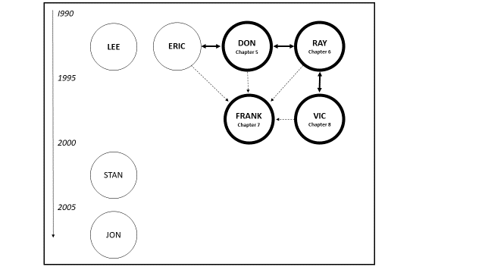
Figure 16: the eight music pirates. The circles represent music pirates interviewed. The bold circles represent music pirates focussed on in chapters 5–8. Bold arrows show music pirates who worked together. The dotted lines show Frank distributed the work of 4 pirates.

Stan and Jon produced unlicensed compilations in the 21st century. Stan was scheduled to be interviewed about his life as a pirate radio DJ in the 1990s but spoke about his production of unlicensed compilations when he discovered the nature of this study during the oral history protocol of signing consent forms. Interviewed at home, he pulled dozens of different unlicensed compilations he had produced in the early 2000s from his record shelves, talked about them, and allowed me to photograph them.

Jon revealed his identity as a transformative pirate to me at a record fair after overhearing me talking about this research project with a reissue record label owner. He revealed the logo on his t-shirt advertised the Light Sounds Dark record label. This label began producing unlicensed compilations of obscure music in 2009 taken from among other sources, rare, privately released, limited-edition cassette tapes made in the 1980s. My initial thought was that the transformative pirate practices of Stan and Jon could be compared to those of the other pirates interviewed, but the content of their unlicensed compilations drew from different musical cultures of the 21st century. A surfeit of data, and the limitation of word count in PhD study, a focus on the world of transformative piracy of soul, jazz and funk recordings in the 1990s has been maintained to generate a clear and cohesive study of just one world, rather than a confusing comparative study of three.

3.9.3 Structure of data analysis chapters
Chapter 4 acts as a bridge between the literature review and chapters that document the life stories of four music pirates who were connected in various ways. This chapter introduces and analyses some unlicensed compilations to provide readers with a secure understanding of some of the products made by the subjects of this study and others. Through analysis of content, music genres valorised by music pirates and references to music scenes referenced on the products themselves will described. This is important because it will allow the term ‘soul, jazz, and funk’ to be unpacked and understood. A brief overview of the unique collective reception of these genres in the UK from 1960 onwards will familiarise readers with scenes such as 'rare groove', 'deep funk' and 'acid jazz' that music pirates will refer to. Some of these scenes have not yet been surveyed by academics, despite their influence on mainstream popular music more generally. Lee’s oral history testimony is analysed in chapter 4, because he produced one unique unlicensed compilation in the early 1990s, but didn't know of Don, Ray, Frank, Vic and Marc or of the unlicensed compilations they produced.

Chapters 5 to 8 deliver detailed portraits of four music pirates in separate chapters: Don, Ray, Frank and Vic. These four were selected from the eight interviewed because they were connected. The purpose of these chapters is provide the fullest possible portrait of one network of music pirates and show how their transformative piracy of soul, jazz and funk evolved through social, cultural and geographic connections. Figure 16 shows that Don, Ray, Frank, Vic and Marc, were all connected to each other in various ways by either the production of unlicensed compilations or their distribution by other music pirates. It will be seen that by focussing on the oral histories of Don, Ray, Frank and Vic separately in chapters 5 to 8, the practices of numerous other music pirates who could not be accessed for this study are discussed. Marc had a unique working relationship with Don, so his oral history testimony is included in Don's chapter.

3.10 SUMMARY
This chapter has described the interpretive philosophy that underpins the construction of this revelatory case study of transformative music pirates. Decisions that guided the trajectory of this research project from choice of topic to the design of research have been reflected upon and discussed. The research design itself has been tailored to make best use of all available data collected both before and after the focus of research changed. In the chapters that follow analysis of data will be interwoven throughout pirate narratives so the story of how they practiced transformative piracy in the 1990s runs parallel to an interpretation of their world drawn from theoretical perspectives in literature on ‘art worlds’ (Becker, 2006), the ‘production of culture’ (eg Peterson, 1976; Lena, 2012) and the ‘sociology of music’ (eg DeNora, 2000).

4 UNLICENSED COMPILATIONS AND UK SOUL, JAZZ, AND FUNK CLUB CULTURES

4.1 OVERVIEW
This chapter serves as a preface and a bridge to four chapters that describe, analyse and interpret the lives of four transformative pirates: 'Don', 'Ray', 'Frank', and 'Vic'. The purpose of this chapter is to introduce and describe unlicensed compilations, and provide readers with background information about club cultures and music the four pirates will make references to. The first aim of this chapter is provide readers with an idea of how unlicensed compilations evolved over a decade In terms of their content and appearance. This is achieved through surveying images and text on their sleeves, labels and paper inserts, and hearing the voices of two transformative pirates speaking about unlicensed compilations they produced.

The second aim of this chapter is to provide readers with a chronological map of how soul, jazz and funk scenes evolved in the UK The chapter ends with descriptions of club cultures of 1980s and 1990s that Don, Ray, Frank and Vic make references to in their chapters. These club cultures are rare groove (1985–1990), acid jazz (1990–1995) and deep funk (1994–2000). This chapter begins with a brief description of how vinyl records are produced, because the subjects of this study discuss how they produced their compilations by using words like ‘mastered’, ‘cut’, ‘equalised’, and ‘pressed’.

4.2 PRODUCING A COMPILATION OF MUSIC ON VINYL RECORD

4.2.1 Recording
Most producers of unlicensed compilations recorded the sound of the 45 rpm singles or 33 rpm album tracks included on their compilations onto Digital Audio Tape (DAT) or CD-R (recordable CD) from vinyl records, using the best hi-fidelity separates (turntable, amplifier, speakers) available. Some spoke of being ‘meticulous’ about equalising their recordings. Equalisation is the process of adjusting the balance between sound frequencies (ie bass, mid-range, treble). By using an equaliser the range of each frequency can be weakened or boosted (Strong, 2005, 25).

4.2.2 Mastering
Mastering creates an audio master—the recording that will be taken to a pressing plant facility to enable engineers to cut a template (see below). Some pirates interviewed got their track selections recorded and mastered by professionals in recording studios or by keen semi-professionals with the correct equipment at home. For a compilation, mastering engineers put recordings into the correct order and ensure there are gaps between them if they are required. They then ensure the sounds of the recordings are fine-tuned using equalisers, limiters, compressors and other devices to ‘ensure sonic consistency across the entire album’ (Anderton, Dubber, and James, 2013). The end result of mastering is an audio master of the entire compilation on a CD-R or DAT.

4.2.3 Cutting
At the cutting stage, sounds from the audio master are transferred to a lacquer master disc through a ‘series of carefully calibrated mechanical and chemical procedures’. The disc is ‘engraved by a special lathe equipped with a cutting stylus’. Robert Henke, a master cutter at Dubplates and Mastering Studio in Berlin observed if cutting was done five times, it would give five different results: ‘there is no single way to do it’ (Bartmanski and Woodward, 2015, 79).

4.2.4 Pressing
When engineers at the pressing plant receive the lacquer master disc they make a ‘stamper’. Three discs are produced by a process of electroplating: ‘the “father” (the negative copy), the “mother” (the negative copy, playable and thus testable template) and the “son” or stamper that is mounted on actual pressing machines as the printing negative’. On average a stamper can be used to press 2,000 copies before it needs to be replaced. For larger pressing runs, more 'sons' are needed, and extra production costs are incurred (ibid, 2015, 79).

4.2.5 Record sleeves and labels
Vic, the subject of chapter 8, explained record labels are added to records, and records are packaged into sleeves, at the pressing plant where the records are manufactured. For this reason he viewed pressing plants, as ‘manufacturers’ or ‘brokers’: companies paid to organise the production of a vinyl record from cutting to finished product:

Half the time [unlicensed compilations] were pressed at [name of pressing plant]. They’re not manufacturers ... they’re just brokers. You go to them they get you your artwork done, they get your sleeves done, they get the records done. Some ask for paperwork, some don’t. Vinyl pressing did get cheaper... [in the 1990s] because like everything else it got more competitive but it’s an expensive process mate. You’ll always have to pay for it ... I think the only reason [the cost] went down was the whole competition thing.

Relevant to the present context, the most significant point to be taken from this brief overview is that vinyl record production involves collective activity: the production of vinyl records involves the engineering skills of many different professionals, communication between various pools of personnel, and the mobilisation of many different material resources.

4.2 'WHITE LABEL' UNLICENSED COMPILATIONS
Hundreds of different unlicensed compilations were packaged in plain white sleeves with a hole for the label to be seen. Subjects universally referred to these as 'white label' releases even though some were plain black. Within the realm of white label releases were considerable variations. On some, titles and track listings were written directly on the sleeve and label in marker pen or biro. Many had stickers attached to them annotated with the same information but with the addition of an image or design bearing the name of the imaginary record label. Some had nothing written on the sleeves or labels but came with crudely photocopied inserts. It is beyond the scope of this research to place an exact figure on how many different white label titles were released but 'hundreds' may be a conservative estimate. According to the website Discogs (2019), a record label called From The Basement (2019) released 30 ‘unofficial’ titles, including at least 8 volumes called Sack of Soul, 4 volumes of Jackin the Beats, and titles that included recordings tsampled by hip hop artists: Sack of Jigga, Sack of Nas, Sack of Ghostface and A B.I.G. Sack.
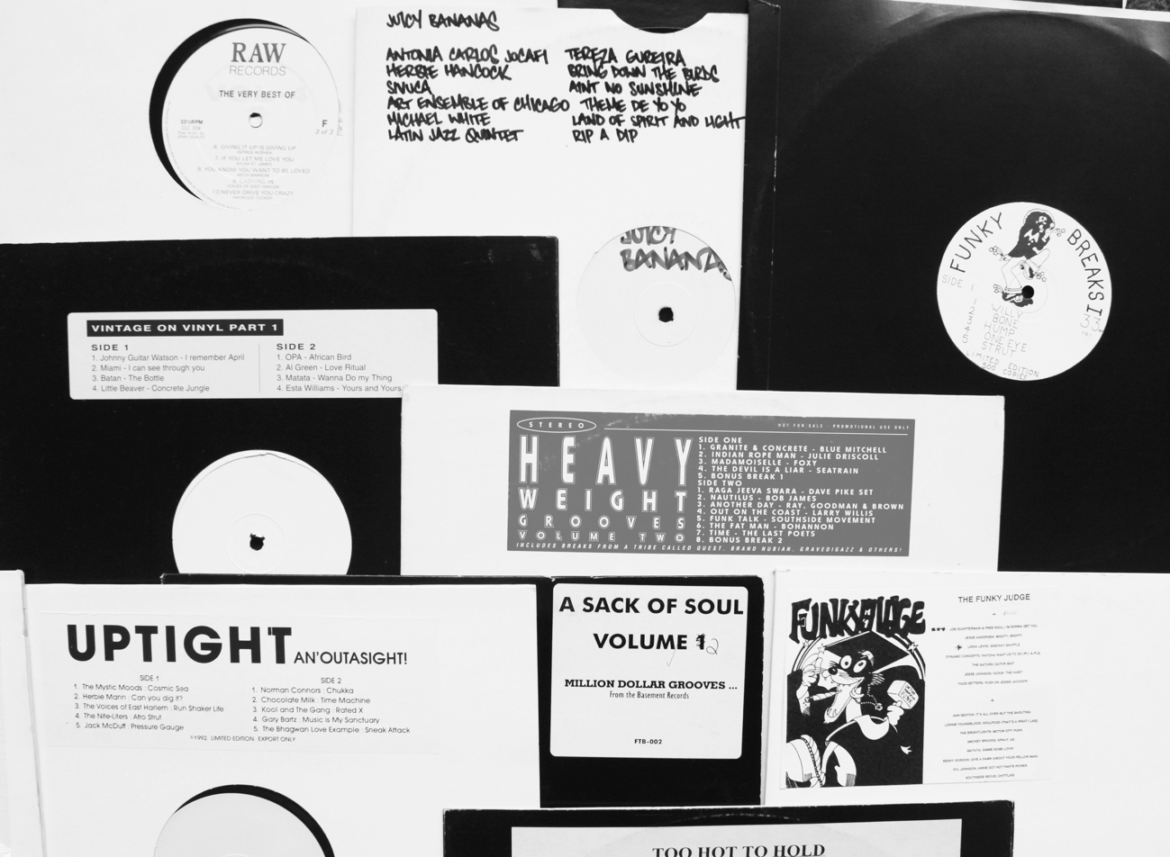
Figure 17: a variety of ‘white label’ releases.

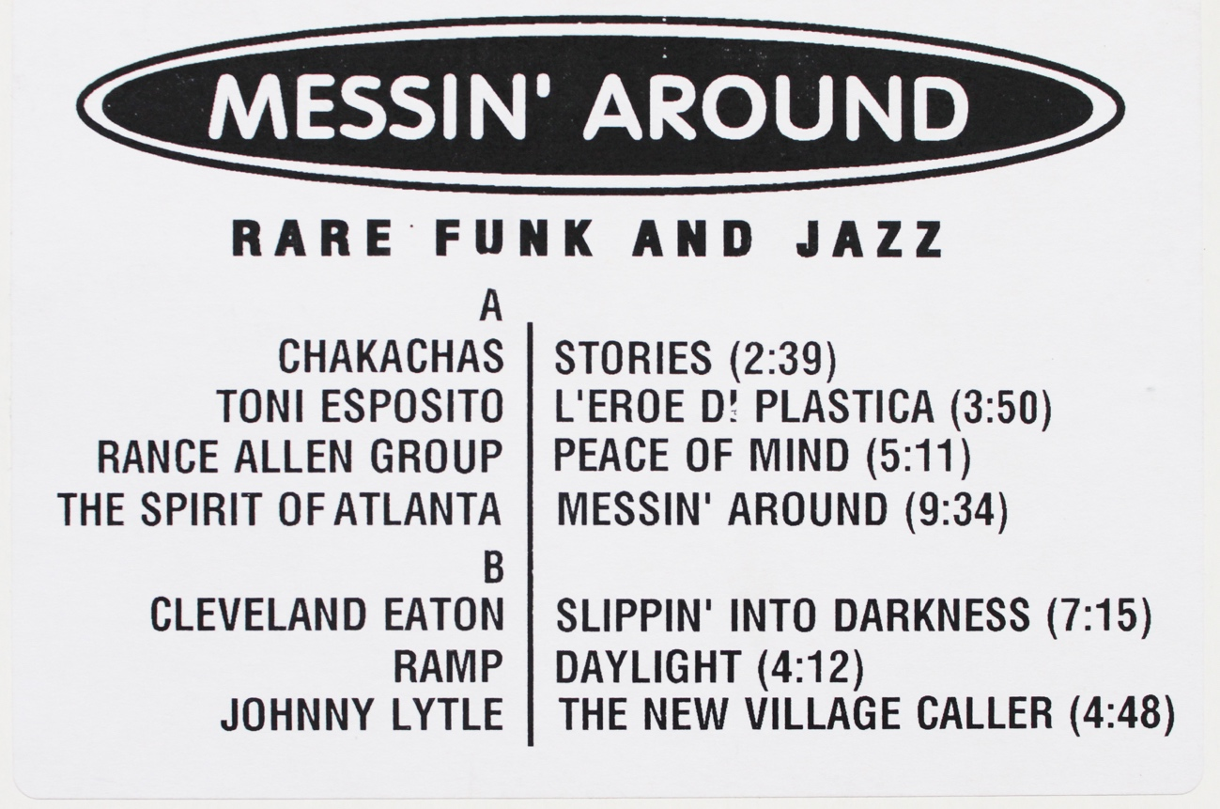
Figure 18: detail of sleeve sticker: Messin’ Around (1990?).

Between 1987 and 1992 a label called Raw Records (2019) released a total of 22 white label compilations listed as ‘unofficial’ on Discogs including 8 volumes called Blast From The Past. Vintage on Vinyl (2019) released 8 compilations with stickers on the sleeve but blank labels. Numerous other titles appear to be what Vic referred to as ‘one-offs’. The general consensus amongst subjects interviewed for this study was that white label releases were ‘early’. Documented in chapters that follow, Vic spoke about ‘all those white label ones that came through from the early days’, and Don suggested white labels were ‘dead’ by the mid-1990s. A record shop owner called Joe who was interviewed for this study spoke about his customers losing interest in white label compilations as more began to be released with more professional looking sleeves. The suggestion from these accounts is that numerous white label compilations preceded compilations presented in two-colour or full colour sleeves.

4.4 LEE'S UNTITLED WHITE LABEL COMPILATION
One white label compilation, completely unmarked, but with a crudely photocopied A4 sheet of paper containing a track list inserted inside its sleeve, was produced by a man called Lee. It was an interesting ‘one-off’ because he was involved with its compilation but never sold any copies of it. Lee regularly posted on an Internet music forum called Soul Strut (2019), and I met him in person for the first time at a Soul Strut music forum event in London in 2014. When I met him I was carrying a compilation album of soul, jazz and funk recordings I had just purchased called Déjà Vu (1992). Released on the Luv N' Haight (2019) record label in 1992, I had no idea he had written the sleeve notes for it. When conversation turned to my area of research he spoke about an unlicensed compilation he had produced and agreed to be interviewed about it. Six months later, looking at a copy of the white label unlicensed compilation he had co-produced with a man from San Francisco in 1991, he explained his involvement with it, and what the purpose had been for both himself and his friend in the US:

...[T]his compilation ... what I wanted to do was press this up so that I could sell some of the more expensive pieces [ie records] on here, but from his side ... he wanted to get these tracks on vinyl record because he couldn’t get them in the US.

Lee was a successful banker in the UK and in the late 1980s he had a passion for going to clubs where he could hear soul and jazz music being played. Asked to describe a typical weekend in the late 1980s he said that he would maybe go on a Friday night ‘to something like a Cock Happy event which would be Gilles Peterson and Chris Bangs deejaying up somewhere in the West End or Mayfair’. Saturday would be spent ‘chilling out around the West End, doing the trawl of record shops, Reckless Records and those kinds of places’. On Sunday he would go to a club called Dingwall's to listen to DJs playing jazz records ‘in the morning and throughout the afternoon’, and after eating and drinking he would head towards record shops again:

Come about three or four o clock we’d take all the sounds that we’d heard, just upstairs to where Soul Jazz was on Camden Market, the original one, just a little shack, no more than ten by fifteen, and say to Alex or Stuart back there ‘What was that record I heard back there? It goes like this … dun,dun, dun … ’, and they’d say ‘that was Liquid Love by Freddie Hubbard, here it is, it’s a fiver’. They were just great times.

Lee regularly travelled to the US to ‘rinse their shops of all the good records [because they] didn’t have a clue about records that were worth a decent amount of money in the UK’ He became friendly with a shop owner in San Francisco who also ran a record label. They spoke on the telephone three or four times a week because the owner always ‘wanted to know what the hot records’ were in London. Lee sent him ‘things like Balanca Pema by Roland Mesquita, Jungle Fantasy by Sam Most [or] The Hipster by Harold McNair’ on cassette tape. He believed these records were known to ‘a fair few people’ in London, but thought few people in the US would have heard them. In return Lee received cassette tapes from his friend. They traded compilations on cassette tape until his friend suggested they make a compilation on vinyl record:

He said to me, ‘Well you want all these tracks of mine and I want all the tracks that you’ve got over there so why don’t we just do this. I’ll press up a hundred copies on a white label and I’ll have fifty and you have fifty’ ... All I did was I sent my records over there, he took them off, plonked them on vinyl, sent them back to me and ‘Voila!’ One month later these records arrive. This was a different way of doing a cassette swa Something you could actually play in a club or you could DJ out with ... or you could use it as a bit of collateral in a trade or to sweeten up a deal somewhere. That's how it came about.

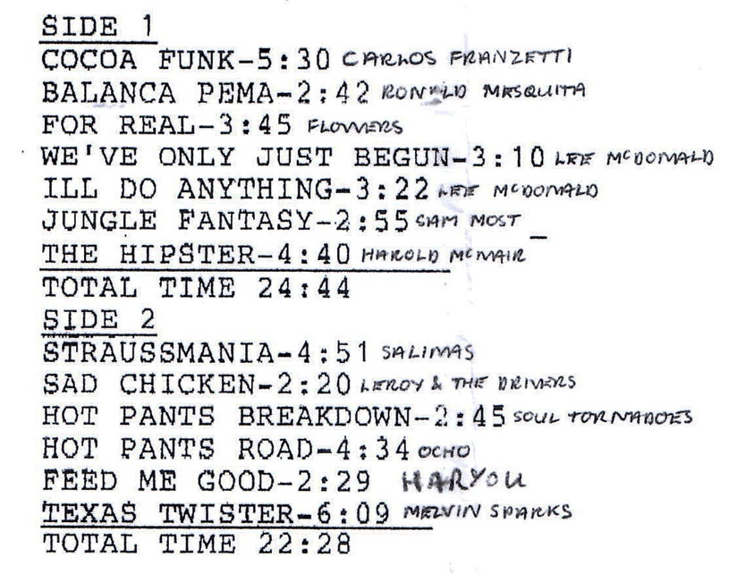
Figure 19: detail of the insert of Lee’s untitled, unlicensed compilation.

Lee believed US pressing plants connected to his friend's record label mastered and manufactured the record but he never knew exactly how many copies were pressed. He was unconcerned about it's illegality because he had not financed it. His role in the project had been to simply select potential recordings that could be included on the compilation and post them to the US Lee suspected that like himself, his friend ‘would use [the records] in his shop to sweeten up a trade ... or give them over to regular customers so they had some really good new sounds to hear’. Lee claimed he never sold any of his copies because he didn't need the money, but gave them to friends his friends in ‘a “This is what we did, haha isn’t it great?” kind of way’. Lee thought some of his friend's track selections were ‘old news’, but believed no-one in the U.S would have known or been able to obtain original copies of recordings he contributed to it. Overall Lee felt the project was ‘mutually advantageous’:

... [S]uddenly I had this physical product I could use for whatever purpose I wanted. I mean, I could have run off bunch of 500 and got rid of them no problem but I didn’t. We kept it to a 100 and kept 50 each but that wasn’t for any altruistic purposes for the artist or whatever, we just didn’t want to be part of that whole quasi-criminal enterprise. It didn’t hit the shelves.

The first two paragraphs of the sleeve notes Lee wrote for Déjà Vu in 1992 reflected his own record collecting lifestyle at that time, and serve as a useful preface to information that will be shared below and in chapters that follow about connections between record collectors, record collecting, and club cultures in 1990s:

It's official: jazz, funk, and soul have gone global. From Tokyo and Kyoto in Japan, all through Europe, to the United States, west coast, east coast, and all points in between, the clued-up clubs and discerning dancefloors are throbbing to the predominantly black American sounds of the seventies.

The result of this upsurge is that legions of intrepid collectors have scoured the States in search of those hidden hordes of vital vinyl, leaving no meat on the bones of any record store, warehouse, or private collection in their path. It is still possible to find almost any record you desire, but you'll need the right connection, in the right place, at the right time.
(Sleeve notes on the rear sleeve of Déjà Vu, 1992)

4.5 FULL COLOUR SLEEVES: THE DEALER'S CHOICE SERIES
The volume of unlicensed compilations packaged in plain white or black sleeves with stickers, and with simple black and white label designs, began to be overtaken from around 1992 by two-colour and full-colour sleeves, replete with graphic design art and photographic images. Evidence from transformative pirates suggests the surge in compilation sleeves that were graphically designed reflected the rise of affordable desk top publishing software. Ray, who is the subject of chapter 6, stated he designed the covers for his compilations From the Funk Side, and the second volume of Nuggets of Funk, by manipulating photos on Photoshop or Quark or something’:

Same with the Planet of the Breaks covers... but I knew my limitations, so I pulled out and would get other people to do things after a while. But I done those. I just had a computer and it would take weeks to get it right, you know, to learn different techniques and stuff.

Talking about a compilation called Texas Twister, Don, who is the subject of chapter 5 asserted that by the mid-1990s, any compilation sleeves could be designed by any art student with access to a computer. Ray's explanation provides evidence that the digital revolution of the early 1990s, that shifted musical production from professional studios to bedrooms (Taylor, 2015) also enabled anyone keen enough to try their hand at graphic design to achieve a reasonable standard of professionalism through the use of newly affordable desk top publishing computer software.

A number of serial releases provide evidence of this transition from plain black and white sleeves to colourful and more professionally presented ones. The first volumes of Chill Pill, Nuggets of Funk, and Dealer's Choice were all white label compilations but subsequent volumes made use of colourful graphic designs. Kenneth produced a white label compilation called The Mookmasters... up the street... round the corner... down the block, before he teamed up with a record shop owner in Scotland to produce the Dealer's Choice series. Kenneth was one of the first transformative pirates I contacted but he politely refused to be interviewed for this study [see Section 1.2.6]. He did however forward me a sequence of text messages after I posted the first two Forumusic website articles called 'The 90s Boot Boom' and '90s Boot Roots: 1990–1993' online. In his text messages he drew attention to conceptual mistakes I had made about the world of unlicensed compilations. For me this minor event underscored how misconceptions about music piracy can be made if conclusions are drawn solely from observations of product. Kenneth's full sequence of text messages are available to read in Appendix I, but the following excerpts provide information about the design and presentation of the Dealer's Choice series and a subsequent unlicensed compilation Kenneth planned called Beat Actione. The excerpts illustrate some unlicensed compilation producers invested a great deal of time and effort into the quality of their products:

First Dealer’s Choice was a simple sticker affair cos we had barely enough money to get the record press. We did it for fun and we were fans of other boots of hip hop breaks that were happening. Sometimes it was like a race to be the first to find out what the break to what was, we'd hear someone else found the break for something, forcing us to rethink our track list and vice versa ... I digress ... So, for the second Dealer’s Choice we were able to afford a proper cover, albeit only a two colour one. But we strived to provide the best product we could: cover design, mastering, track choice. We hated those boots that just put the same stuff out or copied other boots, we took a little pride and tried to get creative whenever we could. Beat Actione was also the result of the stagnant, over saturated boots scene. I made that with two other people and the boot had a different, much more creative vision. We tried to find a laminate that could rival those MFP chazzer covers but no one uses the same chemicals anymore, we tried! We had plans for a follow up, to have been called Beat Gone. It was going to have gatefold art ...

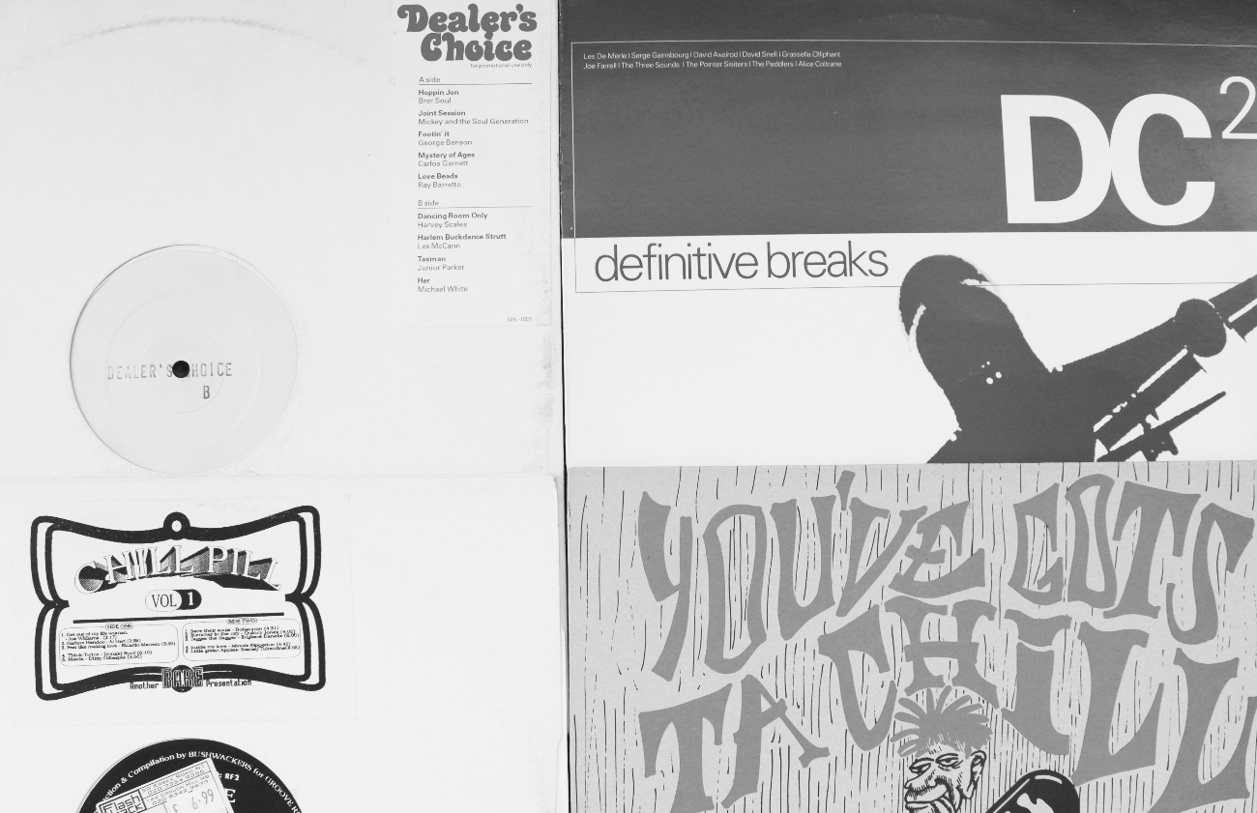
Figure 20 (left): first volumes of Chill Pill and Dealer’s Choice.
Figure 21 (right): second volumes: You’ve Gots Ta Chill and DC2.

The significance of unlicensed compilations that were planned as branded series cannot be overlooked. It may be recalled from the literature review that record companies from the mid-1980s developed the idea of branded series of music played in club cultures, compiled by respected DJs. Producers of unlicensed compilations appear to have been influenced by this. Producing a series of compilations was a wise move from an economic perspective: literature on collecting reveals collectors naturally gravitate towards ‘acquiring and possessing things [that are] perceived as part of a set’ (Belk, 1995, 67).

4.6 SIGNALLING ON COMPILATION SLEEVES
The transition to full-colour sleeves made unlicensed compilations look like legitimately released LPs, and facilitated the inclusion of more information about their content. On some sleeves, details about specific tracks were discussed while others included prose that drew attention to music scenes, club cultures, ideas about the connoisseurship of collecting rare and obscure records, and the economic worth of the recordings on the release. Unable to advertise elsewhere, sleeves were one site where producers could promote their own product.

Some sleeve note prose employed the use of ‘bandwagon effects’ as discussed in signalling theory (Spence, 1973, 1976, 2002). Signalling theory proposes that when a product is made, the branding of it serves as a marketing signal: ‘a piece of information about a product or service that helps customers to make inference about the quality and the value of the product’ (Herbig and Milesics, 1994). Sleeve notes on some compilations signalled the content was not only unique and sought-after, but knowledge about the rare and obscure recordings was gleaned from existing communities where selective connoisseurship was the norm and the original vinyl records were in short supply. Sleeve notes imparted the recordings on compilations were already 'in demand', and being consumed by discerning groups of record collectors:

The global spice trade is presently such that demand for certain spicy bits of rare vinyl outstrips supply. And so presented here for the first time on compilation are some downright essential additions to any record connoisseurs spice rack.
(Jazz, Soul, Funk 'N' Grooves Vol 1, Spicy Records)

... once again we've scoured the five corners of the Earth to come up with the goods that discerning collectors and DJs around the globe are screaming for—just check the line-u …
(Jazz, Soul, Funk 'N' Grooves Vol 2, Spicy Records)

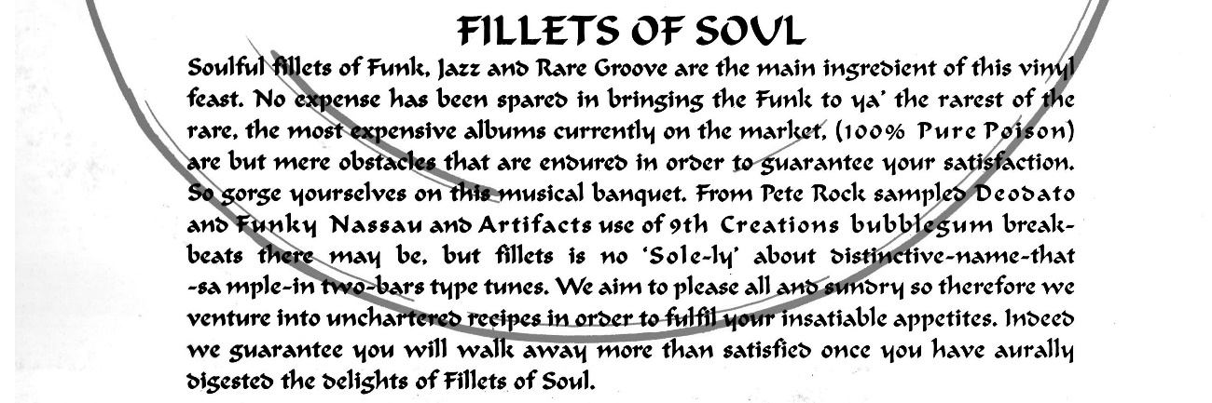
Figure 22: sleeve notes for Fillets of Soul (1994).

Unable to advertise their products legitimately, and simultaneously aware their products were illegal unlicensed compilation producers found ways to embed signals in their products to attract potential consumers and obfuscate BPI anti-piracy operatives. Beginning with the latter, Don explained how producers adopted practices to obscure the provenance of their compilations and camouflage them in record racks. He described how a prolific producer called Alex created different label names for releases to convey the impression his compilations were by a variety of different producers:

Alex used to change the name of his labels. First it was RMM, then it was Scope because he got stuff out of charity shops. His label would change on different releases, it wasn’t one established thing.

Another way UK compilers attempted to conceal the provenance of completing was by making them look like imports. Looking at a compilation called La Guepe, Don confirmed there were a lot of compilations ‘with cod French on the back’ to make it appear they had been produced somewhere else.

Quel que de Chose Jazz actually came from London. There was a lot of that went on and [there were] fake [names] even on the Sound Of Funk. I rang Bryan up and said, ‘Who the fuck is Fat Albert?’ and he said, ‘Oh, he’s a cartoon character. I just thought I’d put his name in for a laugh’... I think on Beat Actione there were fake European sleeve notes, disguising them as French because there was a [real] French series … Soul Patrol.

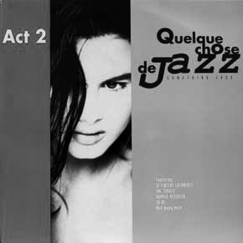
Figure 23: front sleeve design of Quleque chose de Jazz Volumer 2.

During earlier research I discovered two compilations called All Souls Ave Volume 2 and Volume 7 and it quickly became apparent no further volumes existed. Don confirmed this was another form of obfuscation, designed to confuse anti-piracy operatives. A high number on a volume made it look as it if was part of a large and well-established series:

Yes that’s it. That became a bit of an in-joke with people. People would just put out Volume 2 and there wouldn’t be a Volume 1. I think even Acme went from Volume 3 to Volume 7. Putting out a Volume 2 was to put off people like MCPS.

4.7 LIBRARY MUSIC LPS AND BLAXPLOITATION FILM SOUNDTRACKS
Some producers signalled the attractiveness of their products to potential consumers by mimicking sleeve designs of LPs they believed their customers would be looking for. Several tracks on an album by the Lafayette Afro Rock Band called Malik (1972) contained samples that had been used by well-known hip hop producers. The producers of Celestial Soul understood this and mimicked its sleeve design.

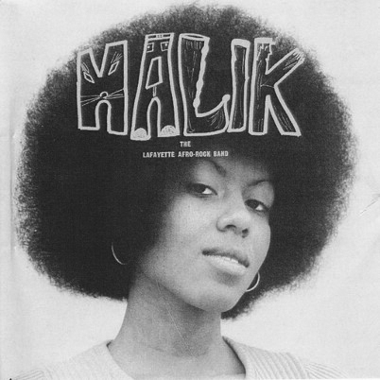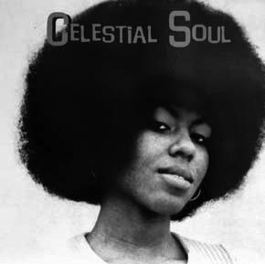
Figure 24 (left): The Lafayette Afro Rock Band Malik (1972).
Figure 25 (right): Celestial Soul (1991).

An unlicensed compilation producer called Henry, who will be discussed at length in Chapter 6, ensured the sleeve of Nuggets of Funk 4—Diggin' Deeper mimicked the sleeve of Bob Dorough’s Multiplication Rock (1973), which contained ‘Three is the Magic Number’, a track popular with hip hop producers.

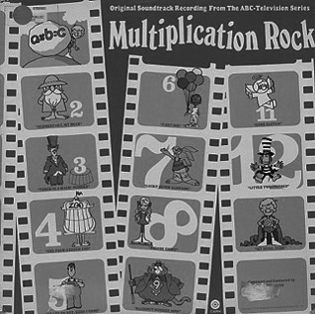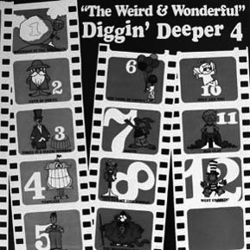
Figure 26 (left): Bob Dorough’s Multiplication Rock (1972).
Figure 27 (left): Nuggets of Funk 4—Diggin' Deeper (1991).

In the mid-1990s, record collectors began to actively search for library music LPs, so several producers designed unlicensed compilation sleeves to look like them. Library music LPs were produced by European music companies such as Music de Wolfe, Bruton, Chappell Music and KPM. These companies, and hundreds more, commissioned amateur, semi-professional and professional musicians to create original compositions to be licensed for use as mood, incidental, or theme music for film, television, radio and theatrical productions and advertising. Library music LPs were never commercially available because they were pressed in limited quantities and sent directly to production houses and radio stations for use when necessary (Trunk, 2016, 3). In the late 1980s and early 1990s however, record collectors began to find library records that had been ‘discarded, skipped or just given away’ by library companies because they had transferred the music in their back catalogues to CD, attracted by the fact CDs had cleaner sound, longer playing times, and were less cumbersome to store (Trunk, 2016, 3). Attracted by the fact that some recordings on library music LPs were instrumental and mimicked funk sounds of the 1970s, collectors began to seek out library music created by certain composers.

The producers of an unlicensed compilation called The Big Beat understood all of this, so borrowed a striking graphic from a Music de Wolfe library music LP:

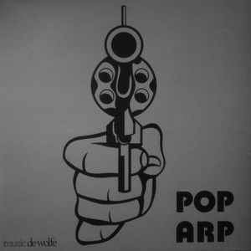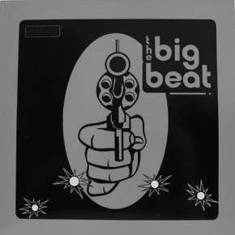
Figure 28 (left): Pop Arp (Music de Wolfe, 1974).
Figure 29 (right): The Big Beat (1994).

Another inspiration to record collectors in the late 1980s early 1990s was music from blaxploitation films. The rare groove scene in the UK that peaked between 1985 and 1990 popularised a taste for 1970s boogie and funk rhythms, 1970s fashions and music from 1970s blaxploitation film soundtracks.

An elision of the words ‘black’ and ‘exploitation’ (Demers, 2003, 42), blaxploitation films were ‘made between 1970 and 1975 by both black and white film directors alike, to exploit the black film audience’ (Lawrence, 2012, 19). Set in urban spaces of the USA, blaxploitation films depicted strong, black male and female characters; heroic police detectives, and vigilantes or pimps who possessed ‘the ability to survive in and navigate the establishment while maintaining their blackness...[using] any means necessary to overcome the oppressive establishment’ (ibid, 18–19). Lawrence (2012, 20) described blaxploitation soundtrack music as ‘contemporary rhythm-and-blues’. Demers (2003, 45–6) called it ‘the ghetto sound’, and asserted it was a unique development within black popular music. Providing a strong indication that unlicensed compilation producers were connected to popular UK club cultures, numerous blaxploitation film soundtracks appeared on unlicensed compilations and some signalled blaxploitation theme content on their sleeves.

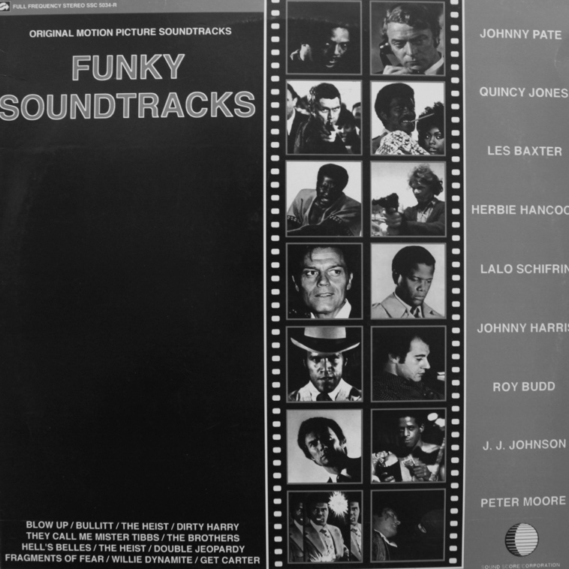
Figure 30: Funky Soundtracks (1991).

The paragraphs and images above have provided a brief introduction to the content of unlicensed compilations, and an overview of how the appearance of them evolved between the late 1980s and the 1990s. By the mid-1990s many were indistinguishable from professionally packaged albums produced by the music industries. A further parallel to legitimate productions: numerous compilations began to be presented as separate volumes that were part of a series. This is not to say white label releases were not produced later in the decade, but as evidence in chapters that follow will show, they became fewer in number as the production of novel titles pressured producers to make products more desirable to consumers. Brief descriptions of Lee and Kenneth's productions have introduced the fact that different personal, social and cultural circumstances lay behind the production of at least two unlicensed compilations. Explanation of images on some compilation sleeves has established funk-oriented music on library music LPs and blaxploitation film soundtracks were compiled alongside old, obscure and rare soul, funk and jazz recordings by artists who worked within the established boundaries of those genres. The explanations also revealed decisions about some sleeve designs were neither arbitrary nor aesthetic. Intelligent 'signalling' decisions were made to counteract the fact that the illegitimate status of unlicensed products limited possibilities for promoting them in traditional ways.

The words soul, jazz, funk, Latin, jazz-funk appear in variety of combinations in the titles, sub-titles and text of numerous unlicensed compilations. The words breaks, beats and breakbeats are also prevalent, as are sporadic references to club cultures. Looking back to how people perceived soul music at its origin, and forward to words found on sleeves of unlicensed compilations, the following section describes reasons why genres of soul, funk and jazz became linked discursively linked in the 1990s. The purpose of this section is to provide readers with information about club cultures Don, Ray, Frank and Vic talk about in their respective chapters: Northern Soul, rare groove, acid jazz and deep funk. It will be described below how from the outset, definitions of soul music were formulated discursively by references to other genres. This is crucial for understanding why one type of music described as 'soul' doesn't sound like another, and why, for example, some types of soul music can be danced to frenetically (Northern Soul), while other types of soul music can make people emotional (deep soul).

4.8 SOUL MUSIC IN THE UK
Discursive definitions of soul music highlight how music fans listened subjectively to US recordings imported into the UK. Richardson (2015) ventured that soul music was first heard in the UK around 1960 when US 45 rpm singles with a ‘symphonic soul’ sound were first licensed for UK release. Bill Millar, who wrote a biography of The Drifters, ascribed soul's emergence to when strings were added to R&B-style arrangements (Richardson, 2015, 17). Cummings (1975, 5–11) noted many soul performers originally sang in church choirs, attributed the development of soul to the influence of gospel music on jazz pianists like Horace Silver and Bobby Timmons, and credited Ray Charles for adding gospel styling to R&B songs. Frith (1975, 38) stated ‘soul music emerged in the early sixties (whether in jazz or pop) out of the combination of two traditions of black music that had previously been kept separate–the secular and the profane, blues and gospel’. To Hoare (1975, 123), soul music resulted from fusions developed from ‘different streams of the great black music tradition'.

These definitions illustrate listeners interpreted and described different sounds as 'soul music' by discursively linking them to other genres: blues, R&B, gospel and jazz. This provides a basis for understanding why some music has been described as soul jazz, funky soul, soulful blues, and so forth. Lena (2012, 29) suggested attempts to imitate existing genres, or experiment with them, led to new forms of soul music. Soul music developed in different directions because compositions, arrangements, and performances people described as soulful carried influences from other genres. No soul recordings were ever alike because they were art works: materials surrounding their production were never exactly the same (Becker, 2006, 301). Variations of soul music developed because musicians either attempted to imitate the sounds they heard and liked, or resisted and pointedly attempted to create something slightly different (Lena, 2012, 29–30).

Richardson (2015, 17) described how convoluted licensing arrangements and deals between UK and US record labels meant UK releases of American soul in the early 1960s were largely ‘accidental and incidental’. As a result of this, information about soul music and performers was scarce. Dedicated fans of the records contacted artists, producers and owners of record labels directly, collected and collated biographical information, compiled discographies, inaugurated appreciation societies and published knowledge they had acquired about rare soul records and soul musicians in regular newsletters and fanzines: they ‘grouped together by intricate networks of communications’ and shared enthusiasm about music amongst themselves (Thornton, 1995, 137). Descriptions in chapters that follow will show that in the world of the transformative piracy of the 1990s, networks of individuals coalesced around genres of music, and established conventional practices to create products that revealed what their musical preferences were to others.

A brief survey of how the word 'soul' was contextualised in songs, fanzines, and magazines is instructive here. Richardson (2015, 7) concluded the word ‘soul’ itself originated in religious experience, but first arrived as a musical term in reference to jazz, rather than R&B. The word 'soul' had appeared in R&B songs during the 1950s, but it was only after Berry Gordy Jr. launched his Soul label in 1964 that new and existing fanzines dedicated to the music adopted it (ibid, 31). SOUL, 'the magazine for the R&B collector', was launched in 1965 and re-named Soul Music Monthly two years later (ibid. 67–69). The Motown record label fanzine called Hitsville metamorphosed into Rhythm and Soul USA in 1966 (ibid, 35), and Home of the Blues was re-titled Blues & Soul in 1967 (ibid, 28).

Mobilised into cooperative networks, soul fans engaged established organisational systems and promoted whatever type of soul music they preferred in night clubs, or ran specialist independent record shops, or helped to arrange UK tours for soul performers in concert venues (ibid, 38–63). Many soul fanzine editors became associated with shops that imported and sold American R&B records, and several later became journalists for soul magazines. By the mid-1960s Irma Thomas, Nina Simone, Barbara Lynn, Otis Redding, James Brown, The Shirelles, Dionne Warwick, Maxine Brown, Chuck Jackson, Dee Dee Warwick and Don Covay all had UK fan clubs, as did almost every artist on the Scepter / Wand record labels (ibid, 30). Connections between fanzines that promoted soul records and shops that sold them, led to the establishment of UK record labels dedicated to licensing and releasing the latest US soul records on a more regular basis.

Without distribution a resource ‘cannot be well thought of or have historical importance’ (Becker, 2006, 95). By the mid-1960s soul records were no longer a scarce resource and were distributed nationwide, because individuals had advocated for wider recognition of soul music in various ways. Initially limited to radio play on the American Forces Network, soul music began to reach more homes in the UK when American R&B and soul music began to be broadcast from the pirate radio stations London (1964) and Caroline (1964) based on ships anchored off the UK coast (Nowell, 2015). Additionally, fans experienced 'live' performances by American soul artists in a variety of settings: The Isley Brothers, Dionne Warwick, the Ronettes and the Crystals featured in package shows; Billy Stewart, the Orlons, Rufus Thomas, Joe Tex and Solomon Burke featured sporadically at smaller night clubs and other venues, and the Motown and Stax record labels staged large scale theatrical shows in 1965 and 1967 respectively (Richardson, 2015, 43–53). Collectively these activities attracted the attention of nationally distributed music magazines:

. ... Record Mirror found an audience with the growing minority of teenagers who were discovering the untold treasures and pleasures of Black American soul music which had emerged from the sophistication of R&B... Record Mirror became essential for soul fans in the early 1960s, as awareness of our music began to grow
(ibid, 15)

Discursive descriptions of the varied mixture of musical genres on unlicensed compilations suggested no two were the same. Thinking about how variant styles of soul music were received and mediated by enthusiastic individuals, this study will describe ways in which circumstances of production and distribution affected the both the production of unlicensed compilations and how they were received. Notable in paragraphs above is that individuals coalesced into groups to champion variant styles of soul music. In descriptions of soul-based music scenes in the UK from the late 1960s to 1995, attention will be drawn to individuals within scenes respected for their knowledge of, and enthusiasm for, specific genres of music in club cultures. The purpose of this is to narrow focus towards how, in the highly populated club cultures of Northern Soul and jazz-funk, and the smaller club cultures of acid jazz and deep funk, knowledgeable individuals were central to the formation of scenes through their advocacy for certain genres of music. This provides a foundation for chapters that follow on transformative pirates who drew on their knowledge of overlooked, obscure and rare records to mobilise them as resources for unlicensed compilations, and through their sociality, accumulated pools of personnel who helped them re-mediate old recordings of soul, jazz, funk to new audiences

4.9 SOUL MUSIC-BASED CLUB CULTURES

4.9.1 Deep Soul
In 1968 Dave Godin liked slow, lyrically emotive soul music that was melodically inspired by gospel. He licensed such tracks from American record labels, released them on his independent record label called Deep Soul, and sold two tracks at a time paired back-to-back on 45 rpm singles from his Soul City record shop to people who preferred to listen to soul in private rather than dance to it in public. (Richardson, 2015, 90–93). In 1970 a box of records in Godin's London record shop was labelled ‘Northern Soul’ after he observed that football fans travelling south from Manchester, Liverpool and Leeds made frequent requests for any R&B records that had a driving ‘four to the floor’ rhythm similar to that found on popular Motown chart hits (Cosgrave, 2016, 30). Invited to the north of England in 1970 he discovered a scene where hundreds of young people bought, collected and traded rare R&B records and danced frenetically to them in unique ways (ibid, 31).

4.9.2 Northern soul
Once communications were established between soul fans, record companies, events organisers, night clubs, and nationally distributed magazines, new organisational structures developed such as ‘all-nighters’ where fans danced to soul records throughout the night. These generated further cooperative networks between geographically dispersed fans, event organisers, venue owners, local businesses and the media. Intermittent at first, all-nighters eventually became weekly focal points for soul fans from dozens of smaller clubs to meet, talk about records and dance on a regular basis (Cosgrave, 2016, 37–38). Within a year of its opening in 1963 the Twisted Wheel coffee-bar dance club in Manchester, with no alcohol licence, a capacity of 300 and basic decor, had a membership of 14,000 (Haslam, 2015, 137–138). Cosgrove (2016, 28) adjudged the intensity of its atmosphere, rarity of soul music played and the extravagance of its dancers made it ‘the template by which all subsequent Northern Soul clubs were judged’. Resident DJ Roger Eagle, an avid record collector passionate about turning people on to music they'd never heard before, played ‘blues, R&B, blue beat and soul records’ (Haslam, 2015, 137–138). Despite the name 'Northern Soul' was a culture, not a genre in music.

Between 1965 and 1970 the Northern Soul scene emerged and developed largely unmediated by outside influences from a network of soul music clubs based primarily in regional northern towns of the UK (Cosgrave, 2016, 31; Hollows and Milestone, 1998, 83). Record collectors and dancers were central to it (Jones, 2016, 73), as were amphetamines, the ‘forbidden fruits of the local chemist shop’, that helped participants stay awake all night to either endlessly talk about Afro-American soul records or energetically dance to them (Cosgrave, 1982, 39). But in the 1970s the Northern Soul scene splintered into factions. Some fans believed records with fast insistent rhythms, popularised by DJs when the scene first emerged, represented Northern Soul at its purest but as the number of old records like this that could be found dwindled, some Northern Soul DJs introduced music that was melodically and rhythmically different. Record collector and DJ Ian Levine, who discovered and played many records now considered as classics of the original scene, attracted supporters and detractors in equal measure as he insisted on challenging the stagnation of play lists by introducing recordings released in the 1970s (Cosgrave, 2016, 129–134). Disagreements over definitions of soul music now extended to Northern Soul records. Passionate about aesthetics, some soul fans attended venues where DJs played original sounds, while others embraced DJs attempting to move the scene forward (ibid, 132).

In the 1970s enthusiasm expressed by UK fans for whatever tempo, timbre or rhythm of soul music they preferred created a north / south divide. In 1972 Blues & Soul magazine editor John Abbey remarked upon a ‘friendly rivalry’ between northern and southern UK soul scenes and observed ‘a great deal of difference between the soul records bought in Blackpool than, say, London’ (Abbey, 1972, 3). Fanaticism followed conflict, but the resultant division of a genre into sub genres was not a phenomenon unique to soul music. In his study of ‘a jazz art world’ Lopes (2002, 1) documented how in the 1950s fans of vernacular styles opposed modernist professional musicians who experimented with jazz to generate ‘a long list of stylistic nomenclatures: cool jazz, hard bop, soul jazz, west coast jazz, east coast jazz, mainstream jazz, free jazz, third stream jazz, black music, fusion jazz, bossa nova and others’. Becker (2006, 10) stated ‘[n]ew worlds come into existence, old ones disappear. No art world can protect itself fully or for long against all the impulses for change, whether they arise from external forces or internal tensions’.

4.9.3 Jazz-Funk
In the early 1970s a vibrant London soul scene provided ‘great musical expression for those second-generation Commonwealth immigrants who saw no problem in taking America as their musical touchstone’ (Bradley, 2013, 255). Inspired by the soul and funk sounds of James Brown, Curtis Mayfield and the Jackson 5, some young black Britons formed their own bands. Discursively signalling a link between genres, David Joseph from funk band Hi Tension described the Jackson 5's music as a ‘watershed between old-school soul and new wave funk’ (ibid, 263). Bradley insisted the 1970s soul scene centred on ‘American import records, available from a few ultra-specialist outlets that carried US imports within days of their American release dates’ (ibid, 258). In these spaces younger soul fans made connections to original scene participants such as John Abbey, who ran Contempo Records in Hanway Street and was the owner of Blues & Soul magazine (ibid, 258).

Individuals knowledgeable about the history of soul music also emerged from within the black community itself. Dez Parkes was a respected dancer amidst a crowd of no more than two or three hundred people who attended small soul clubs before becoming ‘one of the original [jazz-funk] scene's most influential deejays’ (Bradley, 2013, 260). An avid record collector, credited by his peers as an authority on Afro-American music, Parkes introduced many of them to records they had never heard before, and sleeve notes provided pointers to other obscurities:

... we used to go round his house to sift out all these rare musics, Michel Colombier ... people that nobody would know of. We'd be looking at the musicians on there and we'd start tracking them to other albums ... studying all the different connections—who's the engineer on that record? Oh, George Massenburg who put out his own gear and he engineered for Earth, Wind and Fire and also Ramsey Lewis ... that was our study ...
(Camelle Hinds of funk band Central Line, cited in Bradley, 2013, 268).

A taste for contemporary Afro-American music among young black Britons arose partly from an over-familiarity with 1960s soul music, as well as reggae and ska from the West Indies and the Caribbean: these genres had soundtracked their childhoods. As teenagers in the early 1970s they embraced contemporary soul, jazz, funk and jazz-funk imports because they felt uplifted by both the sounds and the positive messages conveyed by the lyrics. Older brothers who preferred downbeat reggae rhythms and dismissed the contemporary soul scene as ‘Europeanised or upwardly mobile’, were roundly ignored (ibid, 262). Inspired by US artists they made a point of seeing any funk or jazz- funk acts that toured the UK: ‘Bros Johnson ... War ... Crown Heights Affair ... the Blackbyrds ... Stevie Wonder ...’ (ibid, 267–268).

Scenes that eventually became discursively known as jazz-funk, Brit-funk and rare groove developed as much from local teenage alliances in the early 1970s soul scene as friendships forged later on in spaces crucial for hearing music that could not be heard elsewhere. Conversations in record shops yielded vital word-of-mouth information about music worth hearing, clubs worth visiting, pirate radio stations worth tuning in to, and even the best times for visiting record shops to catch the latest American imports (ibid, 258). Cotgrave (2009, 21) observed that by 1974/75, the jazz-funk scene in which young people danced to US records that fused jazz, rock and funk, was rapidly gaining momentum, and after the advent of jazz-funk ‘all-dayers’ in 1977, went ‘absolutely enormous all over the country’ courtesy of its presence being mediated by specialist radio shows, import record shops, magazines and newspapers.

4.9.4 Rare Groove
Described as ‘a breath of fresh air’ by Cotgrave (2009, 52), the rare groove scene ‘revolved around the revival and discovery of lesser-known, bass heavy Funk 45s and album tracks from the late '60s to the late 70s’. Dez Parkes was an original DJ on the scene that came to be called rare groove. When he spoke about a licensed series of compilations he made for RCA in 1987 called ‘Rare’, he stated records played on the rare groove scene ‘could be something that was 15 years old or a record of any genre that came out two weeks ago on a limited press’.

An energetic and entrepreneurial figure, Norman Jay collected records, ran a sound system, pirated records and gave the rare groove scene its name when he began his 'Original Rare Groove Show' on pirate radio station KISS FM in 1985 (Garratt, 1998, 81). Between 1983 and 1984 he ran a Monday night club in Southall, Middlesex called The Bridge where many of his regular crowd of around 700 adopted 1970s fashions and danced to old funk and soul records, in parallel to similar scenes happening elsewhere at the same time (Godfrey, 1990, 176). By 1986 he had expanded the reach of his Shake 'n' Fingerpop sound system by establishing partnerships with other sound systems, had pirated rare records that proved popular with his radio and club night audiences, and had funded artists associated to James Brown such as Bobby Byrd and Vicki Anderson to fly over from the US and make live appearances in the UK (Garratt, 1998, 81). Record companies quickly capitalised on all of this unofficial promotion by jumping on it as ‘a trendy way to market their back catalogue material, getting hits out of reissued songs by Vikki Anderson, Bobby Byrd, and the Jackson Sisters’ (Brewster and Broughton, 2006, 417–418).

Interviewed in 2017, Dez Parkes challenged how the term ‘rare groove’ had been interpreted over the years as he reflected on an influential series of four albums he compiled for RCA in 1987 called ‘Rare’. He acknowledged successful sales were ‘boosted by the popularity of Norman Jay's [Original Rare Groove] pirate radio show ... [which aired] some good old tunes [featured at] functions like ‘Shake’ and ‘Finger Pop’, but insisted that at the scene's peak, music played ‘could be something that was 15 years old or a record of any genre that came out two weeks ago on a limited press’ (Facey, 2017, 9). When actively involved in the scene he knew music played was not necessarily either old or confined to genres of funk and soul, but rather ‘not so accessible [and] limited in quantity’. It irritated him that too many people bought ‘into the hype and [were] charged fraudulent amounts of money for music that wasn't that great’. He felt some music that record shops and record labels tagged 'rare groove' were not good: ‘We as DJs have always played old music across the years… so if you put a name to something it doesn't change the essence of what it is (Facey, 2017, 10).

4.9.5 Acid Jazz
Like Northern Soul and rare groove, acid jazz was a scene rather than a genre, and though it embraced numerous genres it developed out of the 1980s jazz dance scene. The name began as a quip exchanged between DJs Chris Bangs and Gilles Peterson, who were playing jazz records when a screen behind them flashed the word 'Acid'. Cotgrove (2009, 58–60) explained it then developed into an ‘in-joke’ between an influential circle of DJs and resulted in jazz dance nights being rebranded as Acid Jazz nights, and the development of a record label called Acid Jazz. A logo, some badges, events and promotion led to many asking ‘What is Acid Jazz?’. Musically, acid jazz nights mixed driving mod, jazz and Hammond organ sounds. Visually, advocates of the scene crossed 1950s beatnik and 1960s mod fashions, and added a dash of psychedelia for good measure.

4.9.6 Deep Funk
As the rare groove scene declined towards the end of the 1980s, it was followed a few years later by a scene focused exclusively on genuine funk rarities. This came to be known as the deep funk scene, after a popular club of the same name (Stirland, 1999, 6). Don stated that, as a direct result of the scene, ‘rare funk 45s like “Sad Chicken” ... became in demand [and were] fetching big money’. Gary Dennis, an influential record dealer, DJ and owner of a record shop called Crazy Beat in Essex, explained how as the rare groove scene faded, an appetite developed amongst dancers and collectors for harder-to-find funk 45s like “Iron Leg” by Mickey and the Soul Generation (Facey, 2011, 11). Ian Wright was one of the DJs who spearheaded the deep funk scene:

I went to one of [Gary Dennis'] dos, I think in '89 or something like that, and started hearing things like ‘Hot Pants Breakdown’ and ‘Bold Soul Sister’ and ‘Iron Leg’ by Mickey and The Soul Generation, along with the Jazz Funk classics–thinking ‘this is a bit tasty’. Then it went from there ... Then Black Grape [dealer and mailing list] came along, I bought ‘Sad Chicken’ from him … cheap, and he likes to remind me about that!
(Mahood and Bones, 1999, 67)

The term ‘Deep funk’ quickly became generic shorthand for ‘rare 45s’ with a funk beat (Allen, 2004, 13), but as one of the founders of the original Deep Funk club night explained in an interview for this study, the original meaning was entirely different:

[Deep Funk club] ... the basement was '60s, harder Hammond grooves, no modern, no '70s, no P-funk or anything like tha t... Upstairs we were going to have P-funk … modern soul, possibly a little bit of funkyish hip hop, but only just the tiniest smattering. So the whole idea was to encompass funk as a music, so ... ‘Deep Funk’. If somebody says, ‘a great Deep Funk tune’, they really shouldn’t be pigeon-holing it like that because there is no, one, good ‘Deep Funk’ tune. There is no genre, because it’s all encompassing. It’s a good sixties funk tune, or it’s a good P-funk tune, or it could be a good 45 that was played at the Deep Funk club, but you shouldn’t be calling it a ‘Deep Funk 45’.

Like the Northern Soul scene, the deep funk scene was based around recordings with a specific beat, but also appealed to record collectors.

4.10 SUMMARY
From the above it can be concluded circumstances of production spawned variant types of soul music and generated different responses from different audiences. Felleszs (2011, 7) stated the evolution of musical genres was ‘often accompanied by the formation of new social collectivities’: different sounds attracted different communities, and those communities became advocates for whatever sounds they had become attached to. Becker (2006, 69–70) observed ‘the development and success of any novel art work or musical genre depends on co-operative links between the individuals who champion them and develop distribution systems to make them available to new audiences. In the 1960s, as distribution networks made US recordings available in the UK, variant styles of soul music were received by audiences, and co-operative links developed between different groups of people who were passionate about whatever music they perceived to be soulful.

This study will argue musical taste, and advocacy for certain genres of music over others, led to variant types of unlicensed compilations. Analysis and interpretation of the lives of unlicensed compilations producers will show their taste in music, personal and social circumstances, and circumstances surrounding their productions, influenced the products they created. Titles, sub-titles, and text on compilation sleeves have already shown that no two unlicensed compilations were alike. This research will show how through their compilations, transformative pirates mediated the soul, jazz, funk, library music LPs, and blaxploitation soundtracks that surrounded them in the 1990s in different ways and for different purposes.

5 DON
The subject of this chapter is a record collector, record dealer and transformative pirate called Don who stated he was involved ‘in one way or another’ with ‘most’ unlicensed compilations in the 1990s. To assess his claim this chapter describes how through social interactions and agency as an independent record dealer Don co-produced six unlicensed compilations, financed the production of others, and eventually assumed a key role as a major distributor of them throughout the UK and internationally. This portrait is presented here as the first of four detailed portraits of transformative music pirates because Don's piratical practices intersected with those of many others.

Don's story introduces both the scale of transformative piracy in the 1990s and how conventions of it evolved. Through collecting and dealing Don developed an aesthetic view of about what kinds of recordings should be compiled but these were challenged when he encountered other producers. This reveals the extent to which piratical products, like any artefacts, could 'prescribe' certain behaviours (Latour, 1991), or 'configure' users in particular ways (Woolgar, 1997), but not ‘compel users to behave in preferred or prescripted ways’ (DeNora, 2000, 35). This chapter alone will show the transformative piracy of unlicensed compilations may be viewed as an 'art world' of collective activity that involved the mobilisation of resources and personnel, systems of distribution, the establishment of conventions, and disputed aesthetics between individuals (Becker, 2006). A brief analysis of content from Don's first email communication provides a brief introduction to his frank disposition and ethics as a useful preface to his narratives.

Don claimed that along with several other people he had ‘approached major labels attempting to license tracks’ in the early 1990s, but had been ‘put off by the ludicrous amounts of money per track required’. He believed record labels deliberately obstructed such requests because ‘it wasn't worth their while to do the paperwork for one track on a twelve track compilation that would sell only a few thousand [copies]’. From this first communication it was apparent Don wanted it known his original intention had been to make compilations of music legitimately, and that his practice of transformative piracy was in response to the intransigence of copyright owners who would refuse to license recordings if potential economic returns were low.

Framing himself as influential within one network of piracy Don stated ‘a lot of people’ approached him about making unlicensed compilations and added that at one stage ‘people [were] bootlegging bootlegs’. If true this meant piratical practices from the late 1940s were duplicated in the 1990s. Cummings (2013, 50) noted during a ‘surge of bootlegging’ after World War II ‘so many labels had popped up to meet the demand for old records that some were copying the products of other pirates’. The possibility Don could name unlicensed compilations that had been copied offered promise of empirical evidence that was lacking in Cummings observation. It also suggested he would know the provenance of both the pirated unlicensed compilations and the original unlicensed compilations that were their source. During his interview Don revealed that it was he who had 'bootlegged' other people's 'bootlegs' and provided full details of how and why he did it. He signed off his email stating he had ‘kept single copies of most [unlicensed compilation] titles’, had ‘track listings for lots of others’, and would be ‘glad to help’.

5.1 DON'S YOUTH: TWO DIFFERENT WORLDS
When he became a teenager in the late 1960s Don experienced different genres of music in different locations. He danced to soul, ska and reggae 45 rpm singles at a ‘glorified youth club’ near the council housing estate where he lived, and he listened to blues and rock albums in a club called the ‘Progressive Music Society’ run by sixth formers at the grammar school he attended. Two factors placed him in these locations and influenced the peer groups with whom he socialised. Firstly, UK grammar schools selected children according to their academic attainment and admitted ‘only a fifth of eleven-year olds’(Adonis, 2002, 13). This meant Don had different friendship groups at school and at home. Secondly, Don was 6' 3’ tall at the age of fourteen. This enabled him to join the sixth form grammar school football team two years early. Some of his team mates who played in bands encouraged him to listen to blues and rock albums and this inspired him to take guitar lessons.

His physical size also enabled him to spend Friday nights at a local youth club where he socialised with much older ‘mod’ teenagers and danced to popular chart 45 rpm singles by Prince Buster, the Skatalites, and various artists from the Stax, Motown, and Atlantic record labels. Influenced by his older peers, Don listened to Spencer Davis, The Yardbirds and the Animals at a time when ‘everyone else was listening to the Beatles’. He never thought about the music he liked as a ‘black sound’ but when he began to buy records he realised any music based on a ‘blues scale’ appealed to him. Adamant that high street record shops near his home stocked ‘absolutely fuck all... other than chart stuff’, he recalled buying Son House, Robert Johnson and Charlie Parker records from second-hand record shops , listening to Eric Clapton and Peter Green, and he read as much as he could about artists who influenced them. His older friends listened to Led Zeppelin albums at the grammar school's music club but Don ‘freaked everybody out’ when he played a Roland Kirk album.

The sociologist G.H. Mead, whose primary focus was on social processes, believed social order resulted from the ability of people to think and act reflexively in relation to the expectations of others, and this ultimately led them ‘to act in regular, normal and predictable ways, at least for most of the time’ (Martin, 1995, 168). When Don responded to music in different ways in different locations he followed conventions of genres ‘known to all or almost all well-socialized members of [societies] in which [they exist]’ (Becker, 2006, 42). DeNora (2000, 33) argued the semiotic force of music—’its affect on hearing’—was the ‘product of 'human-music interaction'‘. The way music affected Don in his youth was contingent on where and how he appropriated it, and he reflexively articulated this in the way he ‘connect[ed] music with other things’ (DeNora, 2000, 33). Thus he listened to 'progressive' rock, blues or jazz albums at school, and danced to soul, ska and reggae 45 rpm singles at youth club.

Describing himself as ‘a major anorak from about the age of twelve or thirteen’, Don asserted he was always a ‘kind of a student’, and described Melody Maker as ‘the cool paper ... years before NME [New Musical Express] became the hipster’s bible’. He assiduously read record labels and sleeve notes; names such as McKinley Morganfield or Skip James on album sleeves drew him towards blues artists and by degrees he ‘got into gospel, not just black stuff ... but hillbilly, roots stuff’. Thornton (1995, 116–2) believed academics overlooked the influence of mass and micro media on identity and social formation. In his teenage years Don had yet to be influenced by 'niche' music fanzines or dealer's annotated lists of records, but confident in what musical knowledge he possessed he regularly won prizes from radio phone-in competitions. A first indicator of his future career buying and selling records, he realised early on that his musical knowledge could be exploited for material gain.

Conquergood (2004, 369) asserted knowledge exists in different domains. One domain he called ‘the map’ was ‘official, objective, and abstract’. Another domain he called ‘the story’ was ‘practical, embodied, and popular’. De Certeau (1984, 129) stated ‘what the map cuts up, the story cuts across’. Don developed his personal 'map' of music from reading; his 'storied' knowledge of music came from listening and dancing. In his teenage years his taste in music was also shaped by polarities of genre and format: soul and reggae 45 rpm records from the popular music charts at youth club, and ‘progressive’ 33 rpm albums in the sixth form common room at school. His knowledge of different music evolved from embodied participation and cognitive connection: ‘knowing how’ and ‘knowing who’' (Conquergood, 2004, 369).

When Don reflected on the role of music in his life at university in the mid-1970s he began to speak less about how it affected his social life and more about where, how, and from whom he obtained records. Don's path from being a record collector (1970s), to record dealer (1980s), to compiler, producer, distributor and co-ordinator of unlicensed compilations (1990s) can be analysed theoretically through G.H. Mead's work on how individuals generate meaning through triadic relationships between themselves, objects, and affordances indicated or designated by objects (Martin, 1995, 52). Don's triadic relationship with the sociality that music on records afforded him at grammar school and youth club changed when, through his own agency, he began to view vinyl records as resources. He realised records with affordances of rarity or obscurity could be translated into profit.

The next section analyses Don's transformation from record collector to record dealer. It shows how he began to view records as artefacts that could be bought, sold, traded and redistributed. For him, old soul records in particular became ‘a resource in and through which agency and identity’ were produced (DeNora, 2000, 5).

5.2 DEALING: VINYL RECORDS AS RESOURCES
Becker (2006, 70) stated cooperating ‘with people who furnish resources, both material and human, are a characteristic of any art world’. When Don spoke about London in the mid-1970s he linked names or descriptions of people to names or descriptions of places where he found records. Accurately remembering the names of record dealers, where they were located, and genres they stocked was important to him because he was trying to recall how he ‘started dealing’. Don now referred to records as ‘stuff’ he could ‘buy and sell’. To be a successful dealer he had to discipline his aesthetic judgement and establish specific criteria for evaluation that would be understood by his potential customer base (Kjørup, 1976, 48). The way he thought and talked about records–premises he would use to classify artefacts as good, bad or indifferent—would ultimately both produce and affect his reputation as a dealer (Becker, 2006, 131).

Becker (2006, 137) observed aestheticians that shape art worlds adopt an ‘exclusionary approach... making hard decisions about resources in a clear-cut and defensible, rather than fuzzy and arguable, way’. Don repeated that in his adult years he bought records ‘seriously’. His unconscious use of the adjective made it clear that when he began dealing records in the late 1970s he separated ‘the deserving from the undeserving’ and did so ‘definitively’ (Becker, 2006, 137). He expressed a preference for US releases over UK one's and an antipathy towards popular chart music. He ‘seriously’ bought American imports and added he ‘only’ bought UK releases of ‘Stax, Atlantic and Motown stuff’ as a teenager because it ‘had kind of charted’. He found ‘proper American 45s, as opposed to British ones’ but added if ‘something was on Stateside or HMV’ he would still buy it. These were British record labels that licensed US soul music for UK release (Richardson, 2016, 16) and therefore another stated preference for US recordings. Don expressed regret that a dealer he once knew who used to sell ‘only black music’, was now ‘doing just kind of pop and rock stuff’.

When Don found duplicate records he concentrated on how, as resources for dealing, they could be mobilised as ‘abstractly exchangeable’ consumer goods (Adorno, 2002, 128). His approach was prosaic: ‘you get a double of something and you think, ‘Oh I can get a fiver for this’, and then you start’. London record shops had original copies of US recordings Don knew from Flyright record label compilations: ‘British guys doing reissues of Delta Blues stuff mainly’. Original US records Don wanted to collect were expensive so to raise money he sold ‘odd records ... more interesting than chart stuff’ that he had purchased ‘for pennies’ from second-hand shops and junk shops many years earlier.

Belk (1995, 140) noted that ‘besides its emphasis on possessive having, collecting also involves an emphasis on acquisitive doing’. Don's collecting at this stage can be distinguished from terminal materialism ‘in which possessions are sought for the sake of having them’, and interpreted as instrumental materialism ‘in which possessions are sought as a means of doing something else’ (ibid, 140). With his acquired knowledge of what records dealers sold and what records they wanted, Don made a point of travelling to locations where he could secure the best return for records he had available for trade or sale:

There weren’t many [second-hand] vinyl shops in [the mid-to late 1970s] and it was a case of going around London to find stuff... There’d be oldie shops and rock n' roll shops like Moon Dogs. There was one just off the Holloway Road, a couple of teddy boys/rockers ... You could go in there and find some great rare soul records that were selling for, like, ten bob each. I’d go in there with a pile of rock 'n' roll stuff that I’d bought in junk shops or whatever, and they’d give you fifty [pounds] credit and you’d spend that fifty quid either on records for yourself or records that you could sell to soul people.

Don understood the value of old records differed according to where and when they were purchased and who they were purchased by. In this respect he understood how records circulated in ‘regimes of value’ (Appadurai, 1986), ‘valued by different social groups, in different ways, in different times and places’ (Taylor, 2016, 11). His grasp of this concept was underscored in a separate narrative about a ‘funk collector’ who discovered thousands of US 45 rpm singles in an abandoned London record shop. The funk collector knew little about the high prices some Northern Soul 45s commanded in the north of England, and Don knew a dealer based there who had regularly sold Don US funk 45s cheaply because he was unaware of how popular they were in the south of England. Don played middle man and made a lucrative profit as he ‘traded [funk and Northern Soul records] up and down’ between the two men, securing for himself within every deal numerous soul US 45s he liked from the hoard the funk collector had found.

5.3 NEGOTIATING AN ABUNDANCE OF RECORDS: DON'S MAILING LIST
In the late 1970s Don found a different way of selling records via his reading of soul magazines:

[Buying, selling and trading records] just gradually grew and I thought ‘Oh well, I’ve got two hundred singles here, I’ll put an advert in Black Echoes, Blues & Soul’... you would get thirty, forty, fifty replies so you’d send them a list out and then twenty people would buy and then the next month you’d do the same.

Also known by record collectors as 'record lists', 'dealer lists' and 'paper lists', mailing lists were a tool for dealers to sell records not commonly stocked in standard record shops: imported records, limited edition 12’ singles, second-hand records, deletions and so forth. Records were listed by genre or record label and lists were often annotated with descriptions of how records sounded. Before Don started his own mailing list, he received many from established dealers, and stated his preference was for buying ‘multiples’: one record to keep, and many to sell. Developing his practice of trading up and trading down, he bought ‘a lot’ of ‘funk and soul ballad stuff’ cheaply by mail order from a well-known American dealer who knew more about doo wop and rock n' roll records that were collectable in the US but little about the collectability of certain soul records in the UK:

He was always worried you were screwing him, which of course, I was. (Laughs) I’d go ‘I’ll take 20 copies at six dollars each'. The best deal I got ... was a record by Geater [also 'Jeter'] Davis on Sun Belt called ‘Wherever You Are’ which was rumoured not to exist and I saw it on his list ... he had found it but didn’t know. I think he had a box of about forty and I said ‘I’ll take the lot and give you ten dollars each’… I was selling them in those days for a hundred quid each.

Bringing together discursive narrative and the subject of collecting, Bal (1994, 114) concluded processes that bring ‘amelioration to the collector... can bring deterioration to the object-being as it forfeits its function and, by extension, to the subject who held, used, or owned it before’. Don's negotiation with the US dealer displayed two hallmarks of collector motivation: competition and domination (ibid, 103). An element of hostility was present. Don's dealing was ‘an attack on someone else's property by means of money; negotiation over prices; elimination of a rival; accomplishment of the task of developing 'taste' [and] expertise competing with that of others...’ (114). With a plot ‘that evolve[d] so easily around struggle’, Don framed the US dealer as ‘'other': the one who los[t] the object, literally by having to sell or otherwise yield it...’ (ibid, 114).

Don discussed how several UK dealers regularly shipped tens of thousands of 45 rpm singles from American warehouses to the UK He asserted that few UK importers knew about the ‘deep soul’ or ‘great funk’ records he valued, and they ‘shoved aside’ any records that didn't have ‘that [Northern Soul] beat’. Don knew the ‘Northern Soul sound’ but it was not his favourite music. Based in the south of the UK he was adamant that ‘you had to be up North with the DJs and know what was being played, and what was dead, and what was being 'covered up' and all that kind of stuff’. Many 45 rpm records Don acquired from UK importers gifted Don deep soul and funk recordings on one record:

A lot of that [deep and southern soul stuff] you’d flip it over and find a funk tune on the B-side ... Very small labels in Georgia or Alabama or somewhere ... [artists would] do an Otis Redding type thing on the A-side and a James Brown thing on the B-side. It was having that knowledge.

Less time-consuming than dealing ‘on foot’, Don's mailing lists included his telephone number and personal conversations went beyond record sales. He purchased new stock, learned about other dealers and their practices, records that were ‘sought-after’ in club cultures, and where markets for different genres of music were located. He used his knowledge of deep soul to his own advantage as he dealt with Surinamese immigrants in Holland and ‘two massive collectors’ in Japan. The Surinamese population in Holland ‘had a huge thirst for really slow, doomy, [deep soul] Southern ballads... and the Japs [did] too’. Don would airmail his latest mailing lists to regular customers and ten days later money orders would arrive.

For dealers who imported records from America, and Don who cherry-picked from their imports, there were advantages and disadvantages to owning an abundance of records. 45s imported from America cost Don ‘a few cents’ each and he bought ‘a huge amount of blues and gospel stuff’ from UK importers ‘for pennies’. Although this occasionally left him with unsold stock he could equally find himself with multiple copies of records worth a lot more than their purchase price. He said that when ‘the deep funk crowd moved into heavy 50s RnB sounds’ in the 1990s, he already possessed copies of many records they wanted. Don regretted that some records he once owned would have been worth more if had held on to them for longer. Fine art dealers often faced a similar dilemma: ‘Dealers ... find it advantageous to hold on to the work of artists just becoming known. It will be worth more as the painter's reputation grows’ (Becker, 2006, 114).

In essence record dealing was record re-distribution: Don's success depended on the availability of records, knowing where to find them, and knowing who wanted them. Drawing from Lyon (1974), Becker (2006, 70) outlined how distribution in art worlds depended on ‘resource pools’ and ‘personnel pools’. Distributors could only operate according to the ‘kinds of materials and personnel’ available to them (ibid, 69) and ‘in response to a real or imagined demand’ for those resources (ibid, 70). US warehouses that stocked hundreds of thousands of unsold US records were resource pools for UK dealers. They imported records from them in response to the demand for US soul records in the UK's Northern Soul scene. But UK dealers also imported many ‘non-Northern Soul’ records. It was from these UK resource pools that Don selectively acquired deep soul and funk records for UK record collectors and DJs unconnected to the Northern Soul scene.

Don's transition from collecting records to dealing ‘doubles’, to seeking ‘multiples’ involved accessing resource pools where obscure records were available in greater abundance. The next section will show that when an opportunity to assist in the creation of an unlicensed compilation of obscure funk recordings materialised, Don drew upon his experience as a dealer to monetise his knowledge of markets for rare and obscure records in a new way.

5.4 DON'S INTRODUCTION TO PIRACY: THE SOUND OF FUNK (1992)
Don's introduction to unlicensed compilation arose from his reputation as a record dealer based in the south of England, his connection to a Northern Soul record dealer called Bryan, and his respect for the musical knowledge of a young collector of funk records called Ray. Collectively they produced an unlicensed compilation of obscure and rare funk recordings called The Sound of Funk. Don stated it ‘was the real start... the first compilation I actually did’ and the story of the project's success draws attention to his energy, the effectiveness of his agency and his understanding of regimes of value. The story behind The Sound of Funk also reveals how different musical cultures were affected in different ways by the same records. Moving towards sociological perspectives that challenged Bourdieu's ‘rusty frameworks of habitus, field and capital’ (Prior, 2015, 353), the story shows how musical taste can be seen as an active process ‘rather than a socially determined stock of capital... a practice of attachment in which [record collectors] exchange properties with [records] and in which what counts is what happens in the encounter, rather than what is determined by external social forces’ (ibid, 353).

Don knew Bryan from dealing records and producing compilations of Northern Soul music. He would give Bryan ‘Northern stuff... because that’s what he specialised in’, and in return would receive deep soul and funk records. Don had earned ‘a reputation for dealing in funk [45s in the late 1980s] because there weren’t many people doing it’. Bryan and Don were friends and when Bryan spoke of cash flow problems inhibiting a plan to import a large shipment of records, Don lent him ‘a couple of grand’. His faith in Bryan—’a really straight guy’—was rewarded ‘with a really good deal of a couple of thousand records, some crap but some fantastic stuff, [including] a lot of the funk stuff that was really big ... things like Smokey Brooks’ “Spin It Jig”’. Although he still owned twenty copies of this, he believed he had sold ‘about a hundred of them’ over the years.

Based in the north of the UK, Bryan began to receive numerous telephone calls in the early 1990s from record collectors in London asking for funk 45s. After twenty callers had requested copies of Mickey and The Soul Generation’s ‘Iron Leg’, he spoke to Don about the possibility of creating a funk compilation. Don was already selling hundreds of old US funk records to participants and DJs in London's thriving rare groove scene. He had acquired the records many years earlier from a distribution company in Manchester that catered for ‘the Northern Soul crowd’. The company's mailing lists always ‘had Maceo and the Macks ... James Brown [45s]... and all that stuff on People [record label] ... for like 10p and 20p’. These records were inexpensive because ‘on-the-one’ funk rhythms did not appeal to Northern Soul fans. Don was selling these ‘and similar early funky stuff like The Meters’ to Barry in the basement of a London market because in the early 1990s he was still ‘playing [his guitar] in bands’ and was ‘a bit skint’.

Despite his range of contacts, Don initially failed to link the growing demand for funk 45s with a resurgent interest in hip hop music in the UK. Unaware the ‘Golden Age of Hip hop’ had dawned for a younger generation, Barry the market stall owner repeatedly asked Don for old US funk 45s because customers were asking for ‘records with drum breaks on them’. Don remarked that someone had dubbed him ‘The Godfather of Hip hop in London’ because he was selling ‘fucking hundreds of all these records’ to Barry and hip hop fans were buying them as fast as he could supply them:

I must have sold a couple of hundred copies [of James Brown ‘Funky Drummer’] to shops around London but I didn’t know what they were buying it for. It wasn’t just the breaks, it was the samples as well. No-one else was getting this stuff and I was just pulling them out of my arse, you know? These were 10p, 20p records and I think I was getting £1.50 / £2.00 for them in London ... [Barry] was selling them for £4 or £5 and they were going like hot cakes.

When Bryan approached Don about producing a compilation of rare funk 45s, Don immediately contacted a mailing list customer called Ray who was ten years younger than him. Don had high regard for Ray's knowledge. He respected him as a ‘complete fucking anorak’ who was ‘more up on the funk’ than he was. He admired his ‘stamina and enthusiasm’ as he methodically searched through Don's stock for desirable funk and soul records. Together Don and Ray selected and compiled most of the tracks for The Sound of Funk but Don did not expand much on how it was produced. He talked instead about how he promoted it, and favourable terms he negotiated for being in charge of its distribution in preference to being paid a fee for compiling it.

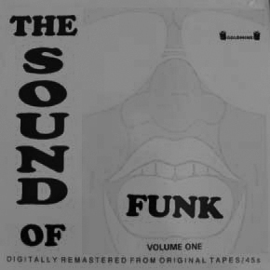
Figure 31: The Sound of Funk (1992).

Don negotiated ‘exclusive distribution’ on 1,000 copies, ‘promoted it hard’, and ensured it would be available at sites where its greatest potential audience was located. He felt he got ‘a real buzz on it’ by promoting it to his network of contacts in specialist independent record shops and getting it reviewed in Blues & Soul magazine, soul fanzines, and a ‘very cool, glossy [London] mag’ called Touch. The 1,000 copies cost him four pounds each. He sold 200 copies for a ‘tenner’ each by mail order alone. He then made ‘one pound fifty’ profit on remaining copies by selling them wholesale to a distribution company.

Don estimated The Sound of Funk sold ‘close to 25,000’ copies. He believed Bryan's earlier Northern Soul compilations sold between 1000 and 1500. Its instant success surprised them all, but poor communication with Bryan soured Don's ‘exclusive’ distribution deal. Don informed regular customers it was a limited edition, but when the first run sold out Bryan immediately pressed more copies and sold them to independent record shops. Don's customers were unhappy when they saw copies available for sale in Soho record shops. Bryan's business partner blamed the 'massive demand' for it, apologised to Don, and attempted to placate him with 200 copies free of charge.

Don's input to the The Sound of Funk was largely an extension of his dealing practice: he capitalised on what he knew and also what he didn't know. The latter was evident when he eschewed working as a duo with Bryan and invited Ray to join the project: he acknowledged Ray knew more about rare funk 45s than he did. Don stated The Sound of Funk ‘kicked off the whole distribution thing that I started to do’. Naturally gregarious, the experience expanded Don's network of contacts in the music industries to include pressing plant and distribution personnel, and also music journalists. Pressed further about his media connections he laughed when he recalled how a journalist for a Sunday newspaper had ‘ripped off’ himself and many others. She had angled for and secured free ‘preview’ copies of numerous unlicensed compilations but never actually reviewed any of them because she was not a music journalist. Don qualified that he never sent preview copies of The Sound of Funk or other unlicensed compilations to pirate radio stations because he knew pirate radio DJs were regular customers at shops he supplied them to.

When Don described The Sound of Funk as ‘semi-legit’ during his four and a half hour oral history interview is definition matched one he had provided in a brief telephone conversation that had been recorded four years earlier. Both explanations lacked the thoughtful pauses that marked most of Don's reminisces: his explanation of ‘semi-legit’ was a clearly a well-rehearsed narrative he had shared many times before. He understood that to license recordings correctly two types of licenses were required. ‘Semi-legit’ was in reference to the fact only one had been obtained. In other words mechanical licences had been secured but permission from copyright owners to use the sound recordings had not. Pressed to justify the legitimacy of this Don acknowledged it would be no defence in court if copyright owners sued for copyright infringement but was adamant the provenance of many US recordings were so obscure that original copyright owners could never be found:

[The Sound of Funk and] the early [Northern Soul] compilations Bryan did … were 'semi-legit' depending on which side of the fence you were on. It was basically an insurance policy because you could say, ‘Well, look, I’ve got the MCPS, I’ve got the mechanicals for it, but I just couldn’t track these people down’. There was a certain amount of truth to that because ... something on a really small label which probably existed for nine months in Knob Lick, Arkansas and disappeared ... sometimes they didn’t have writing credits on them ... [there were] no ASCAP, or BMI, or any details on [them]so the MCPS route … gave you more leeway to get it pressed because if you had a license people wouldn’t worry about it.

The thrust of Don's argument here—his ethical defence—aligns to theories about pirate practice being located temporally and geographically distant from sites of legitimate production. Based in the UK in the 1990s, his invocation of a ‘small’ label in ‘Knob Lick, Arkansas’ that ‘disappeared’ many years ago, conforms to Johns' (2009, 13) view of piracy always being located ‘beyond the sway of the civilising process’ and piratical practice being a matter of the ‘history of reception as well as production’. Don felt the legitimacy of The Sound of Funk went unchallenged because most recordings on it were ‘stupidly rare... nobody [knew] them, and all the labels [were] defunct’.

Due to a ‘bit of a falling out’ with Bryan's partner, Don was not involved with volume two of The Sound of Funk but stated ‘by general consensus’ it sold less well than the first because ‘there weren’t killer tracks [on it] just average kind of stuff’. Becker (2006, 138) observed products made by artists for art worlds were ‘justified by a coherent and defensible aesthetic... recognised by appropriate people as having aesthetic value’. Don's aesthetic view was that recordings selected for unlicensed compilations should always be rare or obscure. From his perspective this aesthetic was defensible in the case of The Sound of Funk because an unidentified community (‘general consensus’) had not heard the tracks before. For record companies that made legitimate compilations the opposite applied: it was imperative most recordings on compilations were already proven sellers or artists were well known.

Don's final co-productions with Ray after The Sound of Funk begins to provide an answer to the question of whether unlicensed compilations of soul, jazz and funk produced in the UK represented, or were part of, the 'second wave' of breakbeat compilations as discussed in hip hop literature by Vályi (2010) and Schloss (2004).

5.5 THE PHAT SERIES (1993)
After The Sound of Funk, Don believed that he and Ray co-produced an ‘early white label’ compilation called Bump ‘N’ Hustle Music but said little more about it. Bump ‘N’ Hustle Music is discussed in the next chapter on Ray, who spoke about it in more detail. According to Don, Bump ‘N’ Hustle Music was followed by three releases: Phat Funky Soul, Phat Jazz, and Phat Funk. 'Phat' is an adjective commonly used in hip hop culture to denote something 'great' or 'excellent'. Thus despite Don's initial lack of awareness about local variants of hip hop culture in the UK, either Ray or himself decided to ensure US hip hop slang, written in very large typeface, preceded the words 'jazz', 'funk' and 'funky soul' in the respective titles. The aim was to extend their appeal beyond collectors who valorised rare recordings, and reach fans of hip hop who want a variety of album tracks as potential sample material. Even though the sleeve notes made no mention of samples, beats or breaks, the Phat series could be viewed as 'second wave' breakbeat compilations by default. Displaying Don's aesthetic preferences, the sleeve notes to Phat Jazz abound with references to the rarity and obscurity of recordings:

'Garvey's Strut' will kill ya! Taken from a supremely rare South African album ... Earl Lett's funky little sax-led offering was originally only available on a rare 7” issue on his own Beantown label... 'Funky Mars' is 7 inches of cosmic funky jazz from the obscure Strawberry label. Well there's rare and there's R-A-R-E ... Horselmat (literally ‘food for your ears’) were an eight piece Swedish band who sadly only made one album which never saw commercial release. Only 100 copies of this privately pressed album are in circulation and not surprisingly it has reached Holy Grail status amongst collectors.
(Phat Jazz sleeve notes)
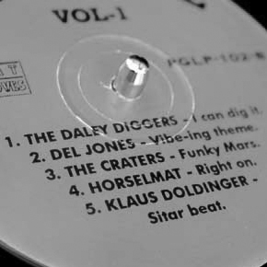
Figure 32: record label, Phat Jazz (1993).

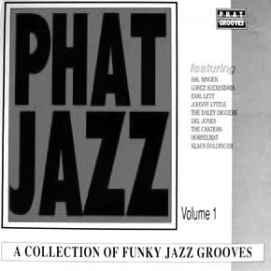
Figure 33: front sleeve, Phat Jazz (1993).

Don emphasised that for him, producing unlicensed compilations was ‘very much about putting out £200 singles and tracks from £500 LPs’ because he came ‘more from the rare soul 45 side of it, and rare albums, and rare deals’. The Horselmat recording came from an LP as rare as the sleeve notes stated, but Don sourced a copy through dealing , purchased it, recorded the track he wanted and then sold it ‘at a slight loss’. Sales of Phat Jazz more than re-numerated him for this shortfall. But desirable recordings used on unlicensed compilations did not have to be purchased outright:

That Lemuria track [on Phat Funky Soul] was going for stupid money. There were always big tracks on ours. The Brazilian version of ‘Hot Pants Road’ on Phat Funk … was going for about £400 at the time … Some dealers and collectors ... you’d pay them £50 to borrow a record to get it mastered and recorded on to DAT [digital audio tape] or CDr, and then give it back, and then they flogged it.

This reciprocal arrangement benefitted both parties beyond the cash transaction. The inclusion of a track from a rare album would help sales of unlicensed compilations, but the lender would retain ownership of it. The track that had been ‘comped’ would then be heard by many people who would not otherwise have done so, and demand for copies of the original album could potentially increase. Becker (2006, 95) pointed out artefacts not distributed cannot be known ‘and thus cannot be well thought of or have historical importance’. Of benefit to Don, unlicensed compilations that conformed to his aesthetic operated as a shop window for products in the possession of rare record dealers.

One imperative of this study is to show transformative piracy in the 1990s had all the features of an 'art world' (Becker, 2006). Another is to present detailed sociological portraits of four transformative pirates drawing from production of culture / sociology of music perspectives (Shepherd and Devine, 2015). In the present context it is important to show how the identities of each of the four subjects was different—shaped by circumstances of their musical and social lives—and how their individual identities influenced the presentation and content of unlicensed compilations they produced. Key to understanding both Don's identity and his world of transformative piracy, sections that follow reveal he was less a co-producer and more a distributor of unlicensed compilations produced by others. Descriptions of his production and distribution practices help to explain why he described himself as being ‘involved ‘in one way or another’ with ‘most’ unlicensed compilations. It will also be shown how his aesthetic views changed when he attempted to co-ordinate compilations produced by transformative pirates who worked in record shops and other sectors of the music industries.

5.6 DON'S PRODUCTION PRACTICE
Becker (2006, 134) noted that for aestheticians, ‘[w]ork becomes good, therefore valuable, through the achievement of consensus about the basis on which it is to be judged and through the application of the agreed-on aesthetic principles to particular cases’. Dismissive of ‘[unlicensed compilations that were] so shite ... you could almost hear the needle being dropped on the record’, Don Insisted unlicensed compilations should sound ‘good’, and he ‘remastered [recordings] properly’ using ‘Cedar noise reduction’ equipment. His assertion the technique was costly ‘even for the white label stuff’ emphasised he prioritised sound quality irrespective of what was, or was not spent on packaging. He felt it was akin to restoration to spend hours ‘taking all the pops and crackles’ out of ‘very rare’ records, especially if they were in poor condition.

Manufactured in the UK at legitimate pressing plants, Don recalled that pressing one thousand copies of each unlicensed compilation ‘was pretty standard’ in the mid-1990s. He favoured plants where ‘no questions would be asked’ and references made to people he ‘knew’, and ‘mates’, clarified pressing was done covertly. Don's own compilations were undeniably the ‘result of what a lot of people [had] done jointly’ (Becker, 1989, 282). In an echo of the term ‘semi-legit’ he stated manufacturing unlicensed compilations was sometimes affected by ‘degrees of legitimacy’. Asked to expand on this he described how pressing was occasionally done hurriedly; the following quote suggested not all pressing plant staff were involved:

... if you knew people, and you were quite confident, and you knew the tracks were OK, you could press a thousand and then pay in cash … but there were some things you’d have terrible trouble with because they would get mates to press them up on the night shift, and they’d be pulling them off too quickly from the cooling stage. You’d get a batch that were completely warped to fuck because they were done on a night shift by a mate … some records just ended up as Frisbees.

The Sound of Funk, Bump ‘N’ Hustle Music and the three volumes of the Phat series were co-produced with Ray. As the next chapter will show, after Don and Ray's partnership ended Ray went on to make many more, both on his own and in partnership with others. Don did however move on to 'produce' further compilations in other ways; he offered advice on how to make them, provided finance for a select few to make their own, and counterfeited unlicensed compilations made by associates. These activities were all offshoots of his distribution practices.

The next section looks at how Don's personal view of what recordings unlicensed compilations should contain altered as through his distribution of them, he helped to disseminate the idea of transformative piracy. His belief unlicensed compilations should only contain rare and obscure recordings changed when he realised he was unfamiliar with recordings that consumers outside his world of dealing really wanted.

5.7 DON'S DISTRIBUTION
Becker (2006, 300) observed ‘[w]orlds change continuously–sometimes gradually. A minor detail but a significant moment—by the mid-1990s Don had distributed so many different unlicensed compilations that he included a dedicated list of them on his regular mailing lists. He discursively titled them ‘boots’ following its popular usage among the record collectors who bought them. This marked their mediation as conventional artefacts sufficiently recognisable by content and presentation to be categorised. Transformative pirates interviewed for this study consistently used the term, as did the record collectors who inaugurated this research. Comparison can made here to the 1960s UK fanzine editors discussed in chapter 4, who mediated US records made by Afro-American artists and described them in various ways before eventually categorising them as 'soul'.

His extensive knowledge of the content on compilations he distributed provided Don with an overview of how various musical styles and genres moved ‘in and out of vogue’ in the 1990s, from ‘drum breaks to sampled beats ... library music ... soundtracks ... [and] all that blaxploitation stuff’. Through his regular distribution of ‘three or four titles at a time’ on a sale-or-return basis to record shops in and around London his personal connections to producers multiplied to such an extent that he began to know about forthcoming compilations before they were pressed. This was because as Don sold unlicensed compilations he advertised the concept of them, people would ask him how they were produced. He recalled ‘meeting people in shops, collectors getting in touch, friends of collectors, friends of dealers—just that sort of network’.

I went around all the [independent] shops ... I knew the people who worked there. A thing that happened quite often was I would be in a shop giving them ten, fifteen, twenty copies of three different titles then somebody would go ‘Oh I’m thinking of doing a compilation, can you help me out with it?' A lot of that stuff did happen in shops. Or people would ring me up and say ‘So and so has given me your number. I know you did this album and can you help me?’

5.8 UK PRODUCTIONS
Just as Don's one-to-one communication with customers via his mailing lists had afforded him more than just sales, his sociality in UK record shops as he sold compilations yielded opportunities for him to be entrepreneurial in new ways. Don encouraged people to create compilations and provided a select few with money ‘up front’ to do it. The examples that follow also show that knowledge flowed both ways. As he introduced conventions of transformative piracy to record shop owners, employees and their customers, they shared up-to-date information with him about popular records, musical fads and fashions, the latest clubs, and in one instance, the movement of BPI anti-piracy operatives.

5.8.1 Alex: Folk Funk Experience (1995)
Good friends with Don for many years, Alex worked in a popular independent London record shop in the 1990s. Ideally placed to know from week to week, the records DJs in jazz dance, acid jazz and rare groove clubs were looking for, Alex was a prolific compiler. Don described him as a ‘poacher turned gamekeeper’, because after he had produced numerous unlicensed compilations he went on to work for a legitimate reissue record label. It was for this reason he politely declined to be interviewed for this study. Don trusted Alex's musical knowledge, taste and judgement to such an extent that whenever Alex made a new compilation, Don would finance it:

And then he’d do another one ... and I’d go, ‘Yeah, alright, do a thousand. Here’s two grand, I’ll give you another two grand in a month’, and all he had to do was take a DAT to somewhere like [named pressing plant] ... and get it pressed up.

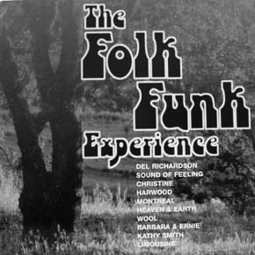
Figure 34: Folk Funk Experience (1995).

Being an avid and respected record collector, and with so many niche club cultures running simultaneously in London, the content on Alex's compilations varied widely. Folk Funk Experience contained recordings record companies had classified as folk music but he and fellow collectors heard as folk music with funk rhythms. Two compilations of Latin jazz, jazz-funk, afro-funk and fusion recordings called Quelque Chose De Jazz were carefully disguised, replete with broken English sleeve notes, as French productions. Alex also attempted to camouflage his prodigious output by presenting compilations on different labels. He knew that looking for records in charity shops was popular, so a few years after the UK charity the Spastics Society was re-named Scope in 1994, he released a compilation called Kaleidoscopic Vibrations (1997) on a label named Scope. It contained a selection of 'funky' easy-listening recordings knowledgeable record collectors could easily have found in charity shops in the early 1990s. Don asserted these were just a few of the compilations Alex compiled and produced. Track lists on other compilations he produced suggest he was positioned much closer to various UK dance club cultures than he was to the hip hop culture of breakbeat LPs, but like Don and Ray's Phat series, many of them could be considered breakbeat LPs by default.

5.8.2 Kenneth and Stan: Dealer’s Choice series
In 1997 the owner of a London record shop telephoned Don to say a BPI employee had been ‘sniffing around asking questions’ about Dealer’s Choice 2, an unlicensed compilation that was a breakbeat LP by design: all the full recordings on it had already been sampled and it also contained short 'snips'—sections of other recordings with useful breaks. This was another record Don had financed and distributed on the basis of his respect for the compiler's knowledge. According to Don, ‘from day one ... if you wanted to know anything about any sample, Kenneth was your man’. Dealer’s Choice 2 included a Serge Gainsbourg track called ‘Melody’ that had already been sampled by The Beatnuts, and was described on the sleeve as ‘the track people die for ... super cool snares and bass’. A DJ and musician called David Holmes sampled ‘Melody’ in 1997 for a track called ‘Don't Die Just Yet’ and credited Dealer’s Choice Volume 2 as the sample source. Copyright owners notified the BPI to investigate and Don was livid:

David Holmes ... said ‘Thanks to Dealer’s Choice 2 for the Serge Gainsbourg track’, or something like that ... We were like, ‘You’ve just name-checked a bootleg you fucking idiot, you’re going to get us all in trouble’. I remember a few shops were clearing them off the shelves. The BPI [said] ‘Serge Gainsbourg? An album called Dealers Choice? What?’ So we sort of laid low for a while after that.

5.8.3 Stan: Rhythm of the Ancients (2000)
Don's version of this incident was confirmed to me by Kenneth in a sequence of text messages but nothing came of their investigation. This scare occurred just after Dealer’s Choice 4 had been released. Volume 5 was scrapped and Don lost the money he had already paid out for it ‘up front’. Interviewed for this study, Kenneth's co-producer Stan recompensed Don by compiling and pressing an unlicensed compilation called Rhythm of the Ancients. This release was therefore an unlicensed compilation produced by one transformative pirate to settle a debt with another. Stan was based in the far north of the UK and never met Don in person. Limitations of space prevent Stan's full story from being shared here but significant to evidence already presented, he was a record shop owner, ran a successful night club but then moved unsuccessfully into record distribution. His awareness of transformative piracy had arisen from unlicensed compilations he received from a major record distribution company based in a coastal town in the south of England that was not mentioned by any other interviewees. Further evidence of other networks of transformative piracy is provided later in this chapter.

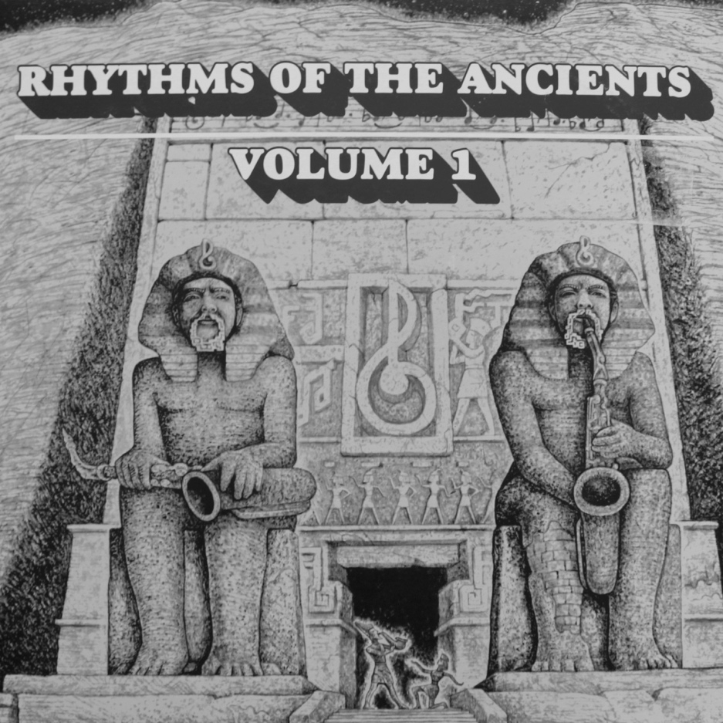
Figure 35: Rhythm of the Ancients (2000).

5.8.4 Russell: Chill Town series
Becker (2006, 213) notes

[P]eople ... who distribute art works make editorial choices when they refuse to distribute some works, require changes in others before distribution, or (most subtly) create a network of facilities and a body of practice which lead artists in the world whose works they distribute to make works which fit easily into that scheme’

Don's own words confirm he naturally assumed roles as an aesthetician and editor:

I’d always get the track listing first because it got a bit crazy ... It got to the stage where people would just be putting out some records they had in their collection which were just fucking shit really. People would ring me up and I’d go ‘Don’t bother mate, honestly, it’s not going to sell’.

In 1993 an independent record shop owner in the Midlands called Russell shared a track list for a compilation he was planning called Chill Town 1, and asked Don if he would distribute it for him when it was pressed. Don was convinced it would not sell because it contained ‘all common album tracks [and] ten to fifteen [pound] singles’. Russell insisted it would sell because he knew what recordings his customers were asking for. It transpired Russell was right and Don was wrong: a new ‘audience suggest[ed] new possibilities ... [and] the first people involved experiment[ed] with it’ (Becker, 2006, 314). Don contextualised the success of Chill Town 1 and releases that followed it in the following way:

... [T]he funk thing had spread ... the beats were going ... everyone was picking up on samples and stuff. I did most of [Russell's compilations] ... the Chill Town series, the Kit-Kat ones, the Coca-Cola one. They went huge because ... people were coming into his shop asking for samples. They were actually good sellers. I would say they sold two to three thousand. So then the cat was out of the bag, and everybody was asking dealers for samples, and everybody knew the tracks that everybody was after, and then everybody went in that kind of [direction].

Depending ‘on the people and resources they attract ... innovations, with their associated possibilities, often spread quickly’ (Becker, 2006, 314). As records that ‘let the cat out of the bag’, Don believed Russell's compilations educated audiences and dealers because they allowed many to know recordings other people were looking for. Unlicensed compilations functioned here as ‘frozen remains of collective action, brought to life whenever someone use[d] them’ (Becker, 2007, 15). Chill Town 1 was so popular it evolved into a series, suggesting that in some instances unlicensed compilations became collectable in their own right, captivating ‘the acquisitive urge that is supposed to be basic and unavoidable’ amongst collectors (Belk, 1995, 88).

Don admitted his preference for obscurities and rarities blind-sided him to what many consumers wanted. Moulin (1967, 118, in Becker, 2006, 110) observed ‘[t]he innovative dealer bets on an unknown work: his objective is to give it a public existence and impose it on the market’. Because Don's regular mailing list customers sought obscurities his judgment was skewed by his dealing. He initially failed to understand many would never pay hundreds of pounds for one record. Russell's customers wanted recordings popular in night clubs or useful for sampling so for them, paying ten pounds for a brand new record that included between eight and ten recordings valued between ten to fifteen pounds each represented excellent value for money. Different consumers developed their musical tastes socially in groups that coalesced around records that offered different affordances.

5.8.5 MCPS employee: Texas Twister
Don understood why hip hop fans wanted funk or soul records but made few references to club cultures in general. Texas Twister as a ‘one-off’ produced by an MCPS employee who Don described as a ‘classic “I can pull a compilation out from my record collection” guy’. Don knew all the recordings except one by Dino Lorenzo, but agreed to distribute it because it contained Melvin Sparks ‘Smilin’ Billy’ which was popular in rare groove clubs at the time. The producer intended Texas Twister to be packaged in a plain white sleeve because he believed it was customary practice, but Don insisted white labels were ‘dead’, a sleeve was required, and that ‘anyone with a Mac could do it’. Don's singling out of ‘Smilin' Billy’ as ‘a big one back in the day’, offered further confirmation compilation content was influenced by recordings that were popular in night clubs.

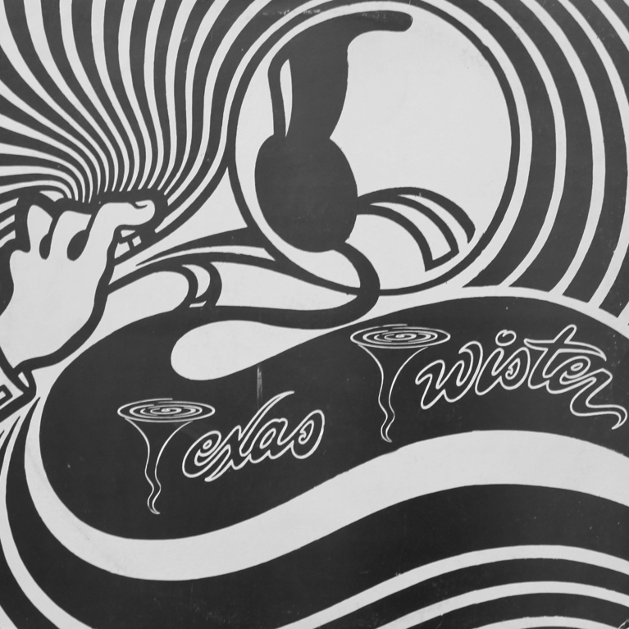
Figure 36: Texas Twister (1994).

The inclusion of contemporary club 'hits' may make unlicensed compilations a more accurate record of club sounds in the 1990s than most licensed compilations. In comparison, the content of official music industry compilations was often restricted by what could be licensed legally, what was available and affordable, and the imposition of commercial checks and balances. A music industries employee interviewed for this study was left frustrated when just one track he favoured, ideal for the reggae compilation he was responsible for compiling, was adjudged ‘too obscure’ by his record company management team. The Dino Lorenzo track on Texas Twister was both approved by Don and recalled by him more than twenty years later, precisely because he ‘didn't know it’.

Don acknowledged the audience for ‘comps ... gradually widened out’ from collectors who sought rare recordings or aspirant hip hop producers who wanted music to sample, to people who just wanted to own, on vinyl record, ‘nice little jazz funk’ tunes or ‘good tracks’ they heard in night clubs. Becker (2007, 19) spoke of how ‘in some worlds the representation soon leaves the ‘inside’ world of the makers, experts, and adepts and enters lay worlds, in which what users make of the object may vary considerably from what the makers intended’.

5.8.6 Don’s counterfeits: Sabu Martinez LP and the Pure series
Around 1997 a London record shop owner asked Don if he would counterfeit an original soundtrack album called Three Days of the Condor because ‘he was getting asked for that one a lot’. Don knew the owner would pay him for 200 copies immediately if he counterfeited it but thought the request ‘was a bit cheeky’, adding that it came around the same time as ‘the soundtrack thing was kicking off ... [but] things were getting warmed up’. His latter reference was to his close encounter with the BPI anti-piracy unit. Don declined to counterfeit the soundtrack but several years earlier—around 1991—he had counterfeited several unlicensed records that had been produced by a music pirate based in France.

Pure Volume 1 was an unlicensed compilation of rare funk 45s that had preceded The Sound of Funk by about three years. Don purchased multiple copies of it directly from its compiler at a UK record fair. He described him as ‘a nice guy and a big funk collector’ who lived in Paris courtesy of a wealthy father who lived in ‘this fuck off brownstone [apartment] in New York’. Involved in the ‘big funk scene in Paris’ the compiler eventually produced five volumes of Pure. Volumes 1 to 3 were followed by two versions of volume 4, one of which ‘had extra tracks’. The same compiler also pirated a Sabu Martinez album. According to Don, original copies of this particular album were selling ‘for about £500’ in the early 1990s.

Based in Paris, the compiler distributed the Pure compilations and the pirated Martinez album throughout France, Germany, Spain and Italy. When he asked Don to be his UK distributor Don agreed, but things quickly became problematic. After ‘hundreds’ of the Sabu Martinez album ‘flew out’ in the UK, Don had UK distribution companies ‘screaming’ at him for more copies but the compiler ‘was travelling’ and couldn't help. Don was adamant the compiler's private wealth affected his work ethic: comfortably off financially, additional profits were irrelevant to him. Aware of the demand from UK distributors, Don pressed more copies of the Martinez album himself.

Applying what he described as ‘a bit of the old Celtic charm’, Don related ‘some bullshit story about our masters getting burned down in a fire’ to a receptionist at a pressing planet, handed over ‘a really clean digital audio tape [DAT] of it’, and said he had lost the original artwork. He paid cash for 1,000 copies because a senior employee at a UK distribution company had already agreed to buy over half of the pressing run. The operation was successful so Don also counterfeited the first version of Pure volume 4 because a track on it by Cyril Neville called ‘Gossip’ had suddenly become popular with funk DJs based in the UK. After this sold ‘quite quickly’ Don also counterfeited 500 extra copies of Pure Volume 3 too, ‘because it was a hell of an album ... and it still sells’.

Don's decision not to counterfeit Three Days of the Condor was understandable: he was unwilling to risk drawing attention to his piratical activity so shortly after a close encounter with BPI anti-piracy unit. Analysis of his decision to counterfeit compilations produced by a fellow collector, dealer, and pirate is more problematic. ‘The work people do varies with the nature of their participation in an art world’ (Becker, 2006, 226). Don linked the compiler's monied background to his work ethic and concluded he had no financial need to capitalise on the success of his compilations. To Don this represented a defence of his action, but even without this, it must be considered the lure of the potential profit from distributors ‘screaming’ for an unlicensed product he knew he could duplicate must have been impossible for him to resist.

Further problematizing assessment of Don's ethics, in 2014 the owner of a well-known on-line record retail business offered him cash in advance to make pirate copies of several desirable and hard-to-find 45 rpm singles but he refused. As an aesthetician and editor Don had attempted to influence what unlicensed compilations should or should not be produced, but as a pirate he was able to be decisive about what kinds of products he would counterfeit. From these decisions his ethical view of counterfeiting can be seen as consistent. In the 1990s he counterfeited unlicensed products but in the 1990s and 2010s refused to counterfeit products that were licensed. It cannot be discounted that decisions he made were contingent on assessments of personal risk to himself and his operations at any given time.

5.9 DISTRIBUTION COMPANIES
For greater profits Don preferred to sell unlicensed compilations directly to record shops but also used several legitimate UK distribution companies. He called them ‘exporters’ because ‘three quarters of a pressing run of a thousand’ compilations sold to them would be exported to distribution companies based in the US, Japan, and Germany. He described delivering compilation titles to a circuit of companies in North London; ‘600 to Park Royal ... 300 to Perivale ... then 100 to someone else’. On one occasion he returned home to find a distributor had left a message asking for 500 more. Don maintained if a compilation was good enough, and ‘properly promoted to get a bit of a buzz going’, he could sell a pressing run in one afternoon ‘just driving around the North Circular doing all four [distribution companies]’. Don dealt with four separate companies because they received compilations first and paid for them later. This meant ‘getting paid was a perennial problem’. Companies settled their bills on a ‘thirty days time / end of the month’ basis, so Don would deliver records to them ‘by the last Friday of the month’ so he didn’t have to wait two months to be paid:

It was always 'so and so at the office has got your cheque' so by having four different distributors one of them would probably pay you on time if you were lucky ... A lot of the stuff I would just literally make a pound a record. [An unlicensed compilation producer] would give me a thousand compilations and [i would say] ‘I’ll give you four grand in a month’s time [but] while I waited [for distributors to pay for them] I'd give them something upfront. I’d sell [their compilations] for £5, £5.50 or whatever to the distributors…

One sales strategy Don employed with UK distribution companies involved playing one company off against another. He was able to do this because many UK distribution companies exported whatever stock they could secure to the same distribution companies abroad. As novel vinyl records, unlicensed compilations were unobtainable from conventional suppliers so were easy to sell and distributors competed for exclusive access to them. Competition between two UK distribution companies Don used developed into a personal feud. One employee at a company called Traxtion became ‘a bad odour’ because he worked for them but then ‘fucked off ... taking all their contacts and shops’ with him to start his own company called JayPlay. Don exploited this animosity between Traxtion owner Maurizio, and Jay of Jayplay:

Traxtion were probably the biggest and the best distributor but I used other people when they pissed me off. [Maurizio would say] ‘Oi! Why are you taking stuff to Jay?’ I said ‘Well mate, you haven’t fucking paid me for last month ... the thing about Jay is that he pays me on the fucking nail’ [Maurizio replied] ‘Oh I’ll pay you on the … ‘ So you’d kind of use that.

5.9.1 Cross-trading
True to form, when Don ‘dropped records off’ to distribution companies he socialised with employees. If he heard about or saw a novel unlicensed compilation in their holding bays he would make a point of finding out who had produced it. Occasionally he would ‘bump into’ other producers delivering products to distributors and ‘cross-trade’. Cross-trading was a process whereby producers or dealers would exchange multiple copies of unlicensed compilations to obtain different titles to sell to retailers in their own areas.

Sometimes you’d see people on a Friday at a distributor and they’d be like, 'Did you do that? What else have you got? Do you want to do some trades because I’ve got a hundred of this... There were a lot of dealers trading. If you’d got a hundred copies left you’d swap around. Once a comp had its initial burst, [it went] out in dribs and drabs, so you’re better off carrying ten of ten different titles, instead of a hundred of one title. There was a lot of that going on, a lot of cross-trading. I got that from Ray, who got it from Gerald, who got it from Pete … you get the picture?

Cross-trading meant unsold compilations did not languish in storage, remained in circulation, and were distributed more widely. I witnessed cross-trading between reissue record label owners at Utrecht Record Fair in 2015 and at Spitalfields’ Independent Record Label market in 2016. A reissue record label owner interviewed for this study said one benefit of attending record fairs was that cross-trading provided ‘fresh stock’ to sell to regular customers at home. The ‘initial burst’ of sales for unlicensed compilations that Don spoke about mirrored the way licensed recordings sold. The novelty of a recording and good promotion of it would trigger high sales and possibly a position in popular music charts. Movement down the music charts signalled sales of a recording had dwindled. Wikström (2013, 55) calculated ‘the life of a hit record last[ed] only 60–120 days’. Sales of new unlicensed compilations appeared to follow a similar trajectory.

The reality of Don's involvement with ‘most’ unlicensed compilations was his distribution, as opposed to his production of them. But as his narratives reveal, he was not the only distributor. Becker (2006, 95) stated ‘art worlds often have more than one distribution system operating at the same time’. Don's story of producers he would ‘bump into’ at distribution companies confirmed other networks of unlicensed compilation producers were also active throughout the 1990s. This was further confirmed when Don talked about unlicensed compilations I had taken along to his interview.

5.10 INTERNATIONAL CONNECTIONS
A standard technique employed by oral historians during interviews involves the use of ‘documents of life’: during interviews artefacts related to the subject's life are presented to stimulate memories (Plummer, 2001, 17). When Don was shown a random selection of 35 unlicensed compilations, he recognised 27, and knew who had produced 18 of them. Thus despite his gregarious disposition, dealing, regular distribution, cross-trading, and social connections with employees at various distribution companies and pressing plants, there were 8 compilations he had never seen before.

As detailed above, compilations Don recognised stimulated memories of transformative pirates he knew in the UK; owners, staff and customers of record shops and personnel involved in various sectors of the music industries. His reminisces about distribution provided novel information about his own practices, his own network of transformative piracy, and evidence other networks also existed in the UK Additionally his narratives revealed more about his aesthetics and ethics. Below it will be briefly be shown that other compilations Don recognised prompted narratives about his connections to producers as far afield as America, Eastern Europe and Australia.

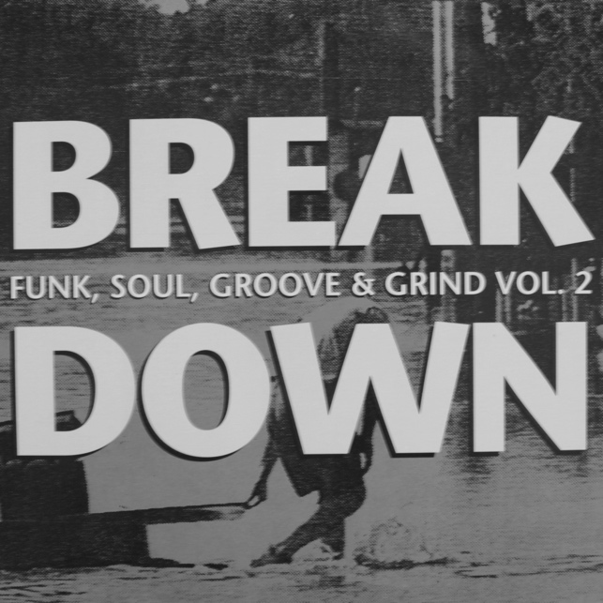
Figure 37: The Breakdown Vol. 2.

A friend of Don's who worked for MCA in America and also owned a distribution company produced two unlicensed breakbeat LPs called The Breakdown Parts 1 and 2. In a reciprocal arrangement, Don distributed these in the UK and his friend distributed unlicensed compilations for Don in the US Don also co-ordinated the content of a breakbeat LP series called Vinyl Dogs produced on America's east coast. Concerned the Vinyl Dogs compilers ‘were not up to speed’, he insisted they sent him track lists before they produced new volumes to avoid duplicating tracks that had already been ‘comped’ in the UK:

[The Vinyl Dogs producers] would say, 'would you be interested in a compilation?’ I’d say, ‘Yes, but I need to see the track listing’, and then sometimes I’d say, ‘Well you’ve got to take this off because it’s already on three albums over here’, but they were mainly [break] beat compilations so they got in quite early on those. I can’t remember the plant [they used] but I got one of their compliment slips and they were using a big, serious record plant. Their compilations were quite good quality.

Eastern European recordings were included on Jazz Kajmak, a compilation of jazz tracks Don financed and distributed in collaboration with its compiler, an architect from Belgrade:

[He was a] big, big jazz collector … There’s one great beat on here somewhere. Kajmak is pronounced Ky-Mack, and it’s like a Slovakian cream dish, so this translates to Jazz Cream. He used to buy records from me and he obviously saw the boots. I knew him quite well. He was working in London. I went round to his flat and he played some stuff. This RTB [track] ... this is radio, something, Belgrade … basically this was all stuff from his own collection, really obscure, and I said, ‘Well, you can put this out because no-one’s going to give a flying fuck about this’. It was a bit slow. We pressed a thousand and I’ve got about twenty left.

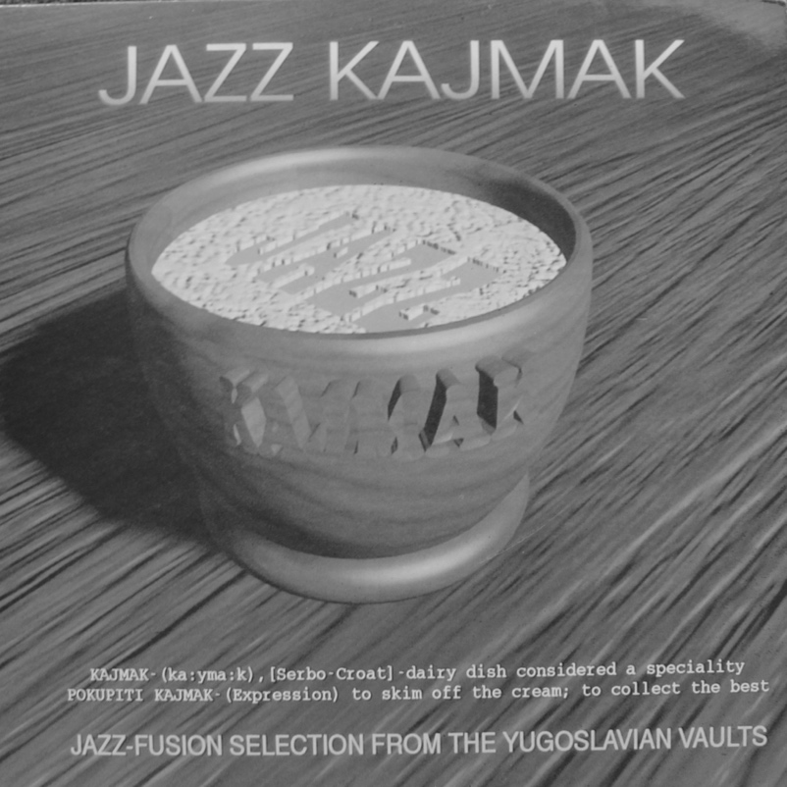
Figure 38: Jazz Kajmak (1995).

Don had earlier suggested it was futile to try and license recordings produced by small, independent record labels in ‘Knob Lick, Arkansas’. As in that statement, his ‘flying fuck’ here was delivered in a deliberately off-hand manner. Simultaneously aggressive and nonchalant, Don felt no fear of being apprehended for pirating recordings produced many years earlier, a long way away from the UK This reverberates once again with Johns (2009, 27) assertion that piracy happens a distance away in time and space from original production sites.
Featuring recordings from several Australian bands, Don confirmed an Australian DJ produced three volumes of Batteria for the Beat Heads in Australia, in addition to two self-explanatory volumes titled Groovy Soundtracks. Inspired by ‘a buying trip’ to the UK where he spent ‘quite a few grand’ on funk singles, Don showed the DJ several funk compilations and Australian production / UK distribution deal was arranged.

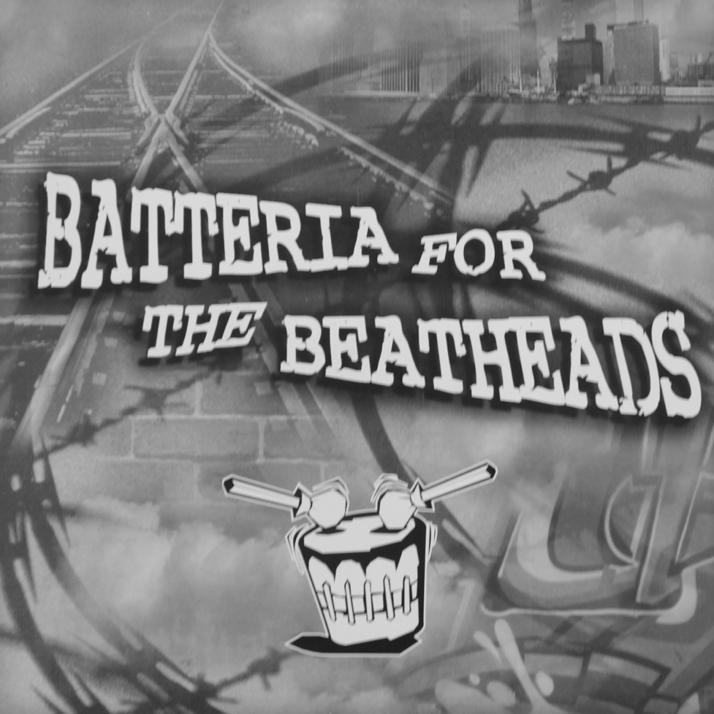
Figure 39: Batteria for the Beat Heads (1998).

5.11 THE END OF TRANSFORMATIVE PIRACY FOR DON
Compilations Don did not recognise led him to ruminate on why, for him at least, transformative piracy as a practice and source of income eventually lost its appeal.
Just as growth in art worlds level off and eventually decline (Becker, 2006, 347–350), Don perceived transformative piracy reached a peak and then faded. Some significance can be drawn from the fact he ruminated on this as he forensically scrutinised the sleeves and track lists of compilations he had never seen before: these were artefacts that were not a part of his world. Rare Funk Vol. 6: Mod Funk Edition elicited a response of ‘dreadful shit’. He didn't know the producers, shook his head, indicated many of the tracks had been ‘comped’ before, and suspected it was a ‘boot of boots’. Similar judgment was passed on a luxuriantly packaged compilation called The Mighty Mellow. Don looked at these branded compilations in glossy sleeves that ran to many volumes and stated they were ‘one of the reasons he ‘got away from it’:

... the whole thing felt ‘of its time’ you know? It started to get a bit shitty, and flooded with crap really because most of those early bootlegs were just fucking great records, apart from anything else. I mean, not everything was my cup of tea, especially the psychedelic kinda stuff, but you hear it was good stuff even if it wasn’t to your taste. People had the arse out of it. It just started to feel a bit wrong. There were tons of ‘breaks and beats’ ones coming out. Initially I knew everyone who was doing it, and then everyone started doing them, and I think the music got diluted, the quality dropped, and then it started to get to the point when I’d ring [named distributor] or [named distributor] up and it went from being ‘Fuck! Great! What’s on it?’ to like ‘Oh. You’ve got another comp OK’. The enthusiasm went out of it... it had been done to death because every fucker was doing it. Everybody thought they could make records out of their own record collection.

Diminished income was a significant factor in Don's growing disillusionment with unlicensed compilations. He ‘got fed up driving round town’ because sale-or-return arrangements were ‘a bit of a grind’ and on occasions became ‘a fucking nightmare’. Cash transactions conducted ‘off the books’ meant that when ‘a shop or distributor went bust owing you money, then you had to just take it on the chin... it became harder and harder work, with less returns’:

I think the heyday has gone. It’s more for the hardcore now. It’s not sexy anymore. I think that was the problem. Keeping it fresh. At its peak there was that kind of one-upmanship of being a step ahead. I think there was an element of manufacturing the market as well.

The following quote was Don's response when he was asked to summarise how piracy felt at the end of his interview:

I suppose it felt good to be considered a kind of authority in an area of music that you really liked. It was money basically. It was also good fun. It was also quite nice to plan an album, and then put it out and see it in the shops, and then see it sell out … It was quite edgy too, you know, hiring a van, driving to the pressing plant and picking up your stuff. You’re looking over your shoulder wondering if someone’s going to give you a tug when you’ve got a thousand bootlegs with you or whatever.

Of interest here is that ‘money’, which is not a feeling but is for many a measure of success, was preceded by a first thought that echoed what 200 collectors of various artefacts, interviewed by Belk (1995, 87), considered to ‘be the most general benefit’ of a collecting habit: ‘a feeling of mastery, competence, or success’. As his primary thought this underscores that transformative piracy for Don, through his insistence on compiling recordings that were rare or obscure, was first and foremost a public display of his ability to ‘be discriminating [which] is incontestably the most essential skill of connoisseurship’ (Price, 1989, 13).

5.12 SUMMARY
This chapter has focussed on Don's agency and motivation as a record collector and record dealer, and his sociality as a co-producer, co-ordinator and distributor of unlicensed compilations of soul, jazz, funk and other recordings. '[T]he all-important networks of influence’ essential for any study that claims to analyse artistic production from a sociological perspective (Martin, 1995, 115) have been emphasised throughout. From his childhood and teenage experiences Don understood different genres of music had different affordances for different audiences, and when he began collecting vinyl records he realised they afforded him material value as resources. Don combined this knowledge with his communication skills to shape a unique career for himself as a record dealer.

Dealers and collectors ‘develop a consensus about the worth of work and how it can be appreciated’ (Becker, 2006, 115). Don specialised in soul records that were rare or obscure. These affordances were ‘determined by social valuation and not by any intrinsic properties of the objects themselves’ (Belk, 1995, 38). When Don discovered resource pools of US records in the UK he plundered them and used his mailing list as a tool for locating potential customers for his more esoteric selections. He became involved in producing and distributing unlicensed because he realised they represented a novel way to monetise both his knowledge of rare and obscure recordings and his awareness of where markets for them existed in the UK

Don's claim that he was involved with ‘most’ unlicensed compilations has some validity. He nationally and internationally distributed many other transformative pirates' compilations from his UK base, funding some of these productions and co-ordinating the content of others. Ample evidence has been presented to show he was a pivotal figure situated centrally within one extended network of unlicensed compilation production. Addressing one imperative of this research, some of the compilations Don co-compiled with Ray could be described as breakbeat LPs by default, while many he funded and distributed were breakbeat LPs by design. Evidence from his narratives have revealed many 'second wave' breakbeat LPs were produced in the UK and some were produced in the US, Eastern Europe and Australia.

Don's world of transformative piracy portrayed all the features of an art world: unlicensed compilations were undeniably the product of collective activities. Conventional ways of operating were established, resources and personnel were mobilised, and the content of compilations were influenced by both the aesthetic judgements of producers and the critical reception of audiences. On occasions conflicts of opinion over the musical content of compilations engendered change, but if content changes translated to successful sales they became conventions. By degrees, different aesthetics influenced the content of unlicensed compilations.

Transformative pirates Ray, Frank and Vic are presented over the next three chapters. Their stories interweave, they were connected in various ways with Don, but each engaged with music and sectors of the music industries in different ways. To build on what has been presented so far a portrait of Ray is presented next. He co-authored The Sound of Funk with Don and Bryan, before going on to make many more compilations alone and with others.

6 RAY

6.1 INTRODUCTION
Almost a decade younger than Don, Ray produced numerous unlicensed compilations on his own and with others. This chapter provides further evidence of how the idea of transformative piracy spread amongst record collectors meeting at sites of vinyl record retail and distribution. Throughout this chapter Ray's working methods will be compared to Don's to highlight the importance of parsing differences between what is meant by production and co-production. An argument developed in this chapter is that from a sociological perspective it is more relevant to speak of 'worlds' of transformative piracy. Ray's world of transformative piracy was not the same as Don's, and he continued to produce unlicensed compilations long after Don limited his own activities to distribution.

Drawing from Durkheim, Martin (1995, 5) insisted ‘individual personalities are not the irreducible elements of social life but are formed in an already existing social environment’. Ray's relentless compilation of records was ‘ostensibly a self-expressive act’ (Belk, 1995, 89), closely connected his social life, musical taste and the fact that from childhood to adulthood he listened almost exclusively to repertoires of music selected and presented on the radio and in night clubs by DJs. Invoking the first principle of social constructionism—that ‘groups of people are real if they think they are’ and realise what they are doing socially (Jenkins, 2014, 13)—Ray's narratives reveal how a younger cohort of record collectors adopted the notion of unlicensed compilations and filled them with content related to their experiences of 1990s club cultures. This chapter will show how social and cultural differences between Ray, Don, and other co-producers Ray worked with, affected both their motivation and the musical content on unlicensed compilations they produced.

The chapter continues to examine what individuals who produced unlicensed compilations perceived affordances of vinyl records to be, and how these perceptions were linked to their social identities. The section that follows begins with an overview of how Ray's taste in music was shaped by his personal circumstances, location, lifestyle preferences and agency, and reveals how he and Don became friends through his regular subscription to Don's mailing list.

6.2 RECORD COLLECTING AND HIP HOP
In his teens Ray attended a suburban boy’s grammar school, listened avidly to DJ Tim Westwood's pirate radio hip hop shows on LWR (1984–1987), and spent money he earned from newspaper delivery on electro and hip hop records. He recalled no one liked the hip hop records he played at a party in 1986, but a year later ‘everyone was into hip hop ... because De La Soul and Beastie Boys had come out’. He considered himself lucky that his childhood home had good reception for pirate radio shows broadcast from London. His taste in music was further developed by his active involvement in London's rare groove scene from 1985 onwards. Where Don's interest in collecting vinyl records had been fuelled by listening to 'progressive' LPs at school or listening to popular chart singles in a youth club, Ray's was inspired by listening to pirate radio shows and dancing in night clubs. This difference is not insignificant. In one sense Ray listened almost exclusively to music compilations rather than albums: pirate radio and night club DJs exclusively played selected repertoires of music.

By the mid-1980s Ray was familiar with London's independent record shops and received mailing lists from various record dealers. Like others who enjoyed hip hop music he was intrigued by the sound of 'breaks' and sought to know the original funk and soul records they were sampled from. ‘Blown away’ when he first heard James Brown, Ray used dealer's lists to learn about other funk artists and by default, about collectable records from many other genres. Records he wanted to own were prohibitively expensive in London shops such as Reckless Records but he addressed this problem by using the dealer's lists he received, his local knowledge, and agency:

I’d get a lot of the dealer’s record lists for the knowledge because I [wanted] to get those £30 records for £3 ... What I’d do is, I’d get a list and I’d highlight the ones that sounded interesting. I would think ... What? £35 ... for Suite London? You’re having a laugh aren’t you? They’ve got that down at Bakerman’s'.

‘Bakerman's’ was his name for a suburban high street shop near his home that sold second-hand records, pornographic magazines, and general groceries. Advertisements on the sleeves of UK 78s reveal that in the first half of the 20th century shops often sold records alongside other goods, and record collectors interviewed for this study recalled purchasing records from electrical shops and newsagents in the 1970s and 1980s. Ray recalled finding two copies of The Peddlers Suite London album in Bakerman's for £3 each when copies of it were priced at £35 on a dealer's list. Reminiscent of words spoken by Don he recalled thinking ‘hang on a second ... I can buy doubles and I can start selling’. When the owner of Bakerman's allowed Ray access to records stored in the back room of his shop he was ‘there all day’. This confirmed Don's assessment of him as a methodical collector; Ray did not leave the shop until he had looked at every record.

Ray regularly purchased 45 rpm singles from Don's mailing lists and they became firm friends. Don allowed Ray to look through his stock at home, and after Ray helped Don out at a record fair, Don paid him in records. Ray recalled ‘some amazing records ... the old Baden-Powell album ... Prophet Soul ‘Do You Hear Me?’ on Saxton, Sticks of Dynamite ‘It’s Football Baby’ … things like that, pure funk things’. Ray also purchased records from other mailing lists, including one he regularly received from Bryan. He felt Bryan ‘gave away great funk singles for £2.50 [because he] was into Northern Soul and all that nonsense music’. He purchased funk records from Bryan's mailing lists long before Don asked him to join The Sound of Funk project and forward ideas for recordings that could be included in it.

In the next section Ray's account of the first unlicensed compilation he ever produced with Don called Bump ‘N’ Hustle Music (1991), problematizes the story Don presented. At odds with Don's account, Ray was adamant they co-produced Bump ‘N’ Hustle Music together before Don invited him to work on The Sound of Funk in 1993. This section draws attention to how individuals ‘remember what they think is important’ to reconstruct their identities through narratives (Ritchie, 2015, 16). It must be noted that for this study they were both were recalling events that occurred a quarter of a century ago and it is common that over time and with age, subjects confuse chronological sequences of events.

6.3 BUMP ‘N’ HUSTLE MUSIC (1991) AND RARE GROOVE
When Ray revealed he had compiled, distributed and sold an unlicensed compilation called Bump ‘N’ Hustle Music with Don prior to The Sound of Funk he positioned himself as Don’s equal. Jenkins (2014, 6) stated identification ‘is something that someone does’, and that while ‘[i]ndividually, 'the past' is a memory; collectively it is history ... both are human constructs and both are massively implicated in identification’ (50). When Don recalled events he hierarchically positioned himself as a co-ordinator: Bryan asked him for help, and Don immediately enlisted Ray. By inviting Ray to join The Sound of Funk project Don released himself from being second in a partnership of two, to being central in a partnership of three.

In the present context however, interest extends beyond questions of hierarchy to analysis of how Ray and Don recalled the different positions they adopted in the practice of transformative piracy. It’s useful here to think about transformative piracy as a set of conventions: the collection of recordings, their compilation, and technical conventions related to getting recordings mastered and pressing, sleeve and label designs and so forth. Becker (2006, 42) observed ‘[d]ifferent groups of participants know different parts of the total body of conventions used by an art world, ordinarily what they need to know to facilitate the portion of collective action in which they take part’. Analysis in the last chapter revealed Don eventually settled on the convention of distribution. This chapter will show that after he finished working with Don, Ray continued to be an active compiler. Significant to his identity, Ray's focus on the convention of compilation was firmly established when he first worked with Don: he was solely responsible for the content of Bump ‘N’ Hustle Music.

Ray described Bump ‘N’ Hustle Music as ‘a white label thing with a sticker’. In this respect it resembled thousands of the kind of white label, record company promotional releases of the type Thornton (1995) described as accessories essential for developing the ‘subcultural capital’ of any self-respecting night club DJ. Ray agreed Bump ‘N’ Hustle Music's packaging helped to make it inconspicuous, but stated the only reason its presentation was so basic was because it was produced on a limited budget. He believed it would sell well on the strength of its content alone. Bump ‘N’ Hustle Music contained ‘just current rare groove tunes’.

Throughout the late 1980s Ray had frequented Norman Jay's rare groove club nights called Shake 'n’ Fingerpop. He described this time as ‘listening to records, going to all of Norman Jay's [club nights], and then selling records to him the next day’. In her summary of the rare groove scene Garratt (1998, 81) suggested Jay himself was a music pirate and the popularity of some the ‘rare records’ he had ‘bootlegged’, such as Maceo and the Macks ‘Cross The Tracks’ and the Jackson Sisters ‘I Believe in Miracles’, had inspired record companies to the officially re-release them. In terms of chronology, evidence suggests Ray's version of events was correct: Bump N' Hustle Music (1991) preceded The Sound of Funk (1993).

Norman Jay hosted his first Shake 'n' Fingerpop club night in 1985, broadcast his first edition of The Original Rare Groove Show on Kiss 94fm the same year, but by 1990 the popularity of the rare groove scene had declined. Ray's suggestion Bump ‘N’ Hustle Music contained ‘just’ current rare groove tunes implied it was, in effect, a compilation of recordings presently popular in night clubs, albeit for a niche audience familiar with recordings discursively categorised as 'rare groove'. This is significant to analysis for two reasons. Firstly it suggests Don's involvement with its content was minimal. Either Don's discriminatory aesthetic for content to be rare was not fully formed at this time or Ray over-ruled him. Secondly, Bump ‘N’ Hustle Music provides evidence the content on at least one unlicensed compilation was directly influenced by club culture.

Both The Sound of Funk and Bump ‘N’ Hustle Music suggest Ray's contribution to the content of compilations was more significant than Don's. Ray confirmed that The Sound of Funk was Bryan's idea and Don introduced him to the project, but the knowledge of rare funk records Ray was enlisted to provide came from recordings he had purchased from them both. Phrased another way, although Don and Bryan had originally owned the records, it was Ray who knew what they sounded like and from his active participation in club cultures, it was Ray who understood what they afforded to night club audiences. In this respect Ray's triadic relationship with vinyl records was different to Don's. He collected vinyl records for their combined affordances of obscurity, listening pleasure and what they contributed to club culture.

The point being pursed here is that collecting records is not the same as listening to them, or listening to them in different environments. Collecting has been defined as ‘the process of actively, selectively, and passionately acquiring and possessing things removed from ordinary use and perceived as part of a set of non-identical objects or experiences’ (Belk, 1995, 67). But collecting records, and listening to records that have been collected, are mutually exclusive activities (see for example Eisenberg, 1987, 4–5). For Ray, collecting records, listening to them, and dancing to them was instrumental to his interest in making compilations. Ray's agency for compilation lay in his belief that much great music was undervalued because record companies denied people the chance of hearing it, and he revealed an almost messianic side to his character when he passionately explained why he made them. It followed an indignant narrative about a reissue record label owner Ray knew called Ronnie who he knew had also produced numerous unlicensed compilations.

6.4 WHY RAY PRODUCED COMPILATIONS
Ray's payment for his contribution to The Sound of Funk was ten free copies of it. Discomfited his input to an album that sold close to 25,000 copies was so poorly rewarded, he opined that his embodied knowledge of rare funk records had ‘made [Bryan] a lot of money’ and that Bryan had used the success of The Sound of Funk as a platform to launch a ‘series of albums that he didn’t license’. Unlike Don, Ray did not believe a mechanical copyright form gave unlicensed compilations any kind of legitimacy. Irritated the notion of 'semi-legit' was in reality subterfuge to release recordings that had not been fully licensed, he recalled that like Bryan, Ronnie had also used what he called the ‘[mechanical] copyright licence trick’ to reissue recordings and launch a record label in the late 1990s that was not fully legitimate:

Ronnie for example, doesn’t license his albums, his 7s ... none of it’s licensed. It’s just a little, tricky MCPS license where you declare that if the owners come to you, you’ve reserved a certain amount of money in an account for when they come because you’ve tried to contact them. But you haven’t, right? And no one ever comes back, so you’ve made all the money.

Ray was talking here about a contractual arrangement known as 'escrow', whereby a producer holds on to funds on behalf of a copyright owner who has yet to be located, but as he talked it became apparent he was less perturbed by Ronnie's 'semi-legit' reissues of soul, jazz and funk recordings than he was by Ronnie's hypocritical views on piracy. Ray maintained that in interviews Ronnie was derisive about music piracy, even though he had produced three unlicensed compilations of library music around the time he had launched his legitimate reissue record label. Ray knew Ronnie had produced a series of unlicensed compilations called the Dimensions in Sound series, and believed he used the profits from them to run his record label. Admitting with his hands held up, that his own compilations were wholly unlicensed, he moved on to speak about what motivated him to make them:

For me it was more of a ‘Do you know this tune? Do you know this tune? This is amazing’. It was more of an informative thing, the way a DJ would play, you know? ‘Do you know this? Dance to this, this is amazing’ ... How come people talk about this record and not this one? It’s just as good. Not being a DJ, or not really wanting to DJ, this was an outlet for that. It’s an extension from DJ-ing really, doing a compilation album. So that’s how it started. It just carried on that way.

Here Ray made no reference to what rarity afforded but maintained obscurity was important. In other words, to him compilations were an opportunity to create repertoires of ‘amazing’ recordings to introduce audiences to novel songs. Ray's compilations were an extension of his lifetime engagement with music: listening to repertoires of music selected by DJs and played on pirate radio stations or in night clubs. His use of ‘informative’ also emphasised he felt compilations should be educative. This was exactly the reason why record collectors interviewed prior to this research said they liked unlicensed compilations. Obscure track selections they had never heard before had piqued their interest in new artists and genres.

6.5 FROM THE FUNK SIDE (1994)
Ray's last co-production with Don showed how well he understood an audience for obscure recordings existed: 5,000 copies of From the Funk Side were pressed and he asserted it ‘sold well’. The compilation was inspired by Ray's love of James Brown and his dissatisfaction with official record company retrospectives of Brown's work. In October 1987 Soul Underground magazine alerted people to ‘Expect two new James Brown LPs from Polydor in the near future, containing some previously unreleased material’ (Lubich, 2010, 12). Ray stated that as ‘a real James Brown fan’ he knew of James Brown productions ‘never on compilations’, that ‘no one knew about’, and which were ‘hard to find’.

Keen to create a compilation of Brown's more obscure releases, Ray had asked a friend called Barrie K. Sharpe to approach Polygram records on his behalf. A respected fashion designer, DJ and recording artist, Sharpe (2013, 107) had regularly played 1970s recordings by Brown, Fred Wesley, and other funk artists in London night clubs throughout the 1980s. Acknowledging Sharpe's promotion of their music had helped rejuvenate their careers, the recording artists Bobby Byrd and Vicky Anderson invited him ‘along with Norman Jay, Jazzie B and Aitch B’ to be a tour DJ for them in Japan. When Sharpe asked Byrd why he had been invited, Byrd stated ‘I know it was you that brought us all back from the dead’. Ray believed Sharpe's high media profile and friendship with artists close to James Brown could give Sharpe some leverage to look through Polygram's back catalogue:

I was like, 'Barrie? Why don’t I approach Polygram / Polydor on your behalf? Why don’t you do a compilation album called Barrie K. Sharpe’s James Brown Grooves, or whatever ... there’s bound to be hours and hours of unreleased James Brown stuff. You can do a compilation album.

Ray abjectly concluded ‘some undeserving knob that’s probably only heard Sex Machine ... [not] a real [James Brown] fan’ would eventually get access to Polydor's ‘vaults’ because the practice of making official compilations was not about what you knew, but who you knew, or ‘being in the right place at the right time’. Ray felt the music business was full of ‘undeserving characters’ who got an ‘undeserved reputation’ and knew ‘nothing’. Although it was not licensed Ray was proud of From the Funk Side. He interpreted it as a homage to James Brown, produced by a ‘real’ James Brown fan.

Of interest in the present context is that From the Funk Side included recordings copied from CD. This was something new. Becker (2006, 301) noted art worlds were subject to continuous or sometimes revolutionary change. He stated ‘practices and products change because no one can do anything exactly the same way twice’. In the 1980s Ray had acquired most of Brown's back catalogue on vinyl records from ‘old soul guys [who had] loads of records they didn't care about’. On From the Funk Side he compiled some ‘old James Brown productions which, at the time, no one had picked up on’, but he also included recordings ‘which needed to be on vinyl … [like] ‘Tighten Up’ by Maceo, which is a live recording … [but] only came on a CD’. Convention on unlicensed compilations up to this point had been to source recordings from vinyl records. Like the rock bootleggers profiled by Heylin (2003, 7), whose ‘accumulated knowledge’ of artists they bootlegged involved purchasing their ‘entire official corpus (“rarities” included)’, Ray owned every official James Brown release including box-set retrospectives of his work on CD that contained previously unreleased material. Ray welcomed these novel recordings, but questioned the choice of format from the perspective of a convention he understood: dancing to vinyl records played by DJs in night clubs:

How are you going to play [a CD] in a nightclub?’ OK, fair enough. We didn’t know that in ten years’ time it was just going to be CDs, and vinyl was going to be phased out, but we wanted everything on vinyl, not CD, so that was the way to do it … I wanted that track on a record so I put it on there.

Changes occur within art worlds because producers make aesthetic and editorial decisions which affect the nature of products. In other words, conventions are constantly challenged (Becker, 2006, 192–225). Ray's editorial decision to ‘put it on there’—to transform a licensed recording on CD into an unlicensed recording on vinyl record that could be played by a DJ in a night club, transformed the recording's affordance and challenged a convention of transformative piracy:

Being creative as well as reflective, innovative as well as repetitive and routine, editorial moments embody an interesting and difficult dilemma for artists. To produce unique works of art that will be interesting to audiences, artists must unlearn a little of the conventionally right way of doing things they have learned. Totally conventional pieces bore everyone and bring the artist few rewards. So artists, to be successful in producing art, must violate standards more or less deeply internalised.
(Becker, 2006, 204)

Ray's adaptation of one piratical convention was made possible because the affordance of longer playing time on CD had in itself introduced a new convention within the music industries: the phenomena of 'previously unreleased material'. At some point in the distant past a record company employee had concluded no market existed for a live recording of Maceo Parker performing ‘Tighten Up’, but as Becker (2006, 143) asserted ‘the judgements of connoisseurs give authority, but successive generations of specialists do not illuminate the same sectors of the past’. Thus Maceo Parker's live recording of ‘Tighten Up’ was effectively reappraised twice in the 1990s: a record company employee deemed it suitable as 'previously unreleased material' for a CD, but on hearing it, Ray felt it should be available on a vinyl record. Becker (2006, 218) stated art works only die ‘when no one ever again experiences them directly ... [or] because no one cares enough to save them’.

Evidence from Ray's narratives suggested producing a compilation of obscurities was time-consuming. An argument pursued in the next section is that making compilations of popular recordings for commercial release required less time and effort. The section includes description of how Ray looked for obscure records and time he invested when faced with an abundance of them. The section will also examine how record collecting practices cemented social bonds between individuals from very different economic backgrounds.

6.6 COMPILATIONS AND TIME
Creating a compilation of music is an activity that requires recordings be selected and arranged into some sort of order. Cognition, creativity and purpose are inherent in these processes: even a compilation of randomly selected and randomly arranged recordings requires all three. Selection precedes arrangement, but selection cannot happen unless an existing pool of recordings has been located. The previous chapter revealed that as Don developed an appetite for rare and obscure recordings he progressed from seeking US records in UK record shops to seeking them where he knew they would be more abundant. As obscure recordings can only be understood relative to familiar ones, finding desirable obscurities amidst thousands of imported US records required a great deal of time.

Someone compiling popular recordings can draw from aural, tactile, numerical or textual evidence to establish how popular they were, but paradoxically, sifting through such data makes locating popular recordings less time-consuming. This is because in the first instance, popular recordings will be easier to find: they are more likely to be available on different formats. Additionally popular music charts, press releases, reviews, ephemera, and much else related to a recording's cultural biography provide a variety of means by which to gauge a recording's popularity. By making available some ‘kinds of materials and personnel and not others’, the music industries enabled the production of ‘works that rely on on easily gotten resources more likely than those for which the resources are more difficult to get’ (Becker, 2006, 69–70). This is one reason why record companies were able to populate the retail market with so many popular music compilations throughout the 1980s and 1990s. In contrast to this, someone who compiles obscure recordings has little information to draw upon.

Once a compiler has found an obscure recording, the onus falls on aesthetic judgment to assess its musical merit. One imperative of releasing a compilation of obscurities legitimately or illegitimately is to sell it, but with little or no information about how critics or audiences have responded to those obscurities in the past, a compiler must think hard about what the potential audience for such a compilation is, and whether that audience will receive it positively:

Someone must respond to the work once it is done, have an emotional or intellectual reaction to it, 'see something in it’, and appreciate it... we are interested in the event which consists of a work being made and appreciated; for that to happen, the activity and response of appreciation must occur’.
(Becker, 2006, 4)

A compiler of obscurities therefore assumes a position of tastemaker: a person ‘that establishes or strongly influences what is considered to be stylish, acceptable, or worthwhile in a given sphere of interest’ (Random House Unabridged Dictionary, 1997). From this perspective Ray's record collecting can be seen as instrumental materialism: he constructed a personal pool of obscure recordings for the purpose of making compilations of music that many people had never heard before. In terms of the time he spent searching for obscurities, descriptions of how Ray looked for records revealed that for him, time was merely collateral. Whatever quantity of records he encountered dictated the amount of time he allocated to looking through them.

Whenever Ray found records time was irrelevant, and proximity to Don meant proximity to records in abundance. Don stated that Ray drove him ‘crazy’ because he had a habit of going through record boxes twice. Ray recalled that one of his ‘best digging trips ever’ was to a farm in Romford owned by former world champion snooker player Steve Davis. Don regularly sold rare soul records to Davis, and knew he had ‘just got a shitload of records in’. In one of Davis' ‘two big barns’, Don and Ray found a 6ft high, bubble-wrapped pallet. Ray described the scene:

[W]hen we slit [the pallet] open with a knife it was all 45s. It was amazing. The records in there were just … you know … Raw Soul Express ‘The Way We Live’, multiple copies. That’s a £400 record now. We’d get them for a fiver. [Steve] was a soul man. Some of the records I got there, back then, are still unknown now. Some amazing funk records. Steve Davis came along and was talking to us, and I was like, ‘Is this for real?’

Relevant to analysis of this and the example that follows, Belk (1995, 93) maintained one of the ‘diverse motivations and pleasures’ of collecting was that it helped established a ‘community of friends’, amongst whom was widespread belief that collecting was ‘a great leveller, and that blue-collar workers, white-collar workers, professionals, and aristocrats all share a common status’. Ray believed Davis welcomed them both because ‘unlike other dealers’, Don had ‘helped him out a lot’ over many years. Don had regularly found Davis rare soul records he wanted and had sold them to him at reasonable prices. Ray revealed how he too looked after the interests of fellow record collectors in another story that highlighted how time was of secondary importance wherever there were records in abundance. When Don asked Ray to look after his house for a week, Ray used it as an opportunity to help out Don and one of Don's friends. The story is very straightforward.

Don gave Ray £200 credit as payment for house-sitting while he was on holiday, and free rein to look through the 17,000 records he had stored in his loft. Ray knew a friend of Don's called Joe visited Don regularly to buy new stock for his record shop, and also knew that many of Joe's customers were interested in funk records. Over a week Ray invested every moment he could familiarising himself with Don's records and repaid Don in kind by setting aside records that he could sell to Joe when he returned from holiday:

All I had to do was walk the dog in the morning, get my portable, go up in the loft, play through funk and soul records … I got some amazing records and obviously, records are personal to me ... It was a time, you know? It was one of the best times... Joe would come up once a month to go through records. I’d be there pulling out records for him, because maybe my knowledge was a bit more on the funk, so I’d be helping Don out. Yeah, ‘play him this, play him this’, getting a pile together for Joe [who would spend] three hundred, four hundred quid on records.

Although Don and Ray both spoke about getting compilations recorded, mastered and pressed there were three significant differences between their accounts. The next section describes these differences and at how one in particular—Ray's use of a legitimate recording studio, mastering facility and pressing plant—opened the way for him to continue making compilations on his own and with others after he stopped working with Don. The section also provides an opening for looking more closely at Ray's aesthetic view of musical genres and 1990s club cultures beyond the rare groove scene that had informed the content of Bump ‘N’ Hustle Music in 1991.

6.7 RAY'S EXPERIENCE OF PRODUCTION
Ray suggested that when he worked with Don he shouldered more responsibility for these processes because he ‘was quite talkative’ and ‘could bullshit off the cuff a little bit’. Secondly, he acknowledged a co-producer of later compilations taught him the value of being ‘meticulous’ about recording and equalising sounds before taking a digital audio tape [DAT] to a pressing plant. Thirdly, in contrast to Don's stories about records being pressed, covertly and overnight by ‘mates’, Ray contacted pressing plants as if he were a regular customer, following standard procedures to get his compilations mastered and pressed professionally during the day. Encouraged to talk about how this felt, he stated:

I wasn’t really that phased by any questions because, you know, it’s taking a risk, getting something pressed. ‘Do you own the rights to this? Have you licensed this?’—‘Yes. Yes’. Maybe Don couldn’t do that, or didn’t feel he could do that, or he didn’t have the bottle … so I done that, and that carried on.

This statement underscores how as co-producers, Ray and Don assumed different responsibilities, and a line can be drawn between these responsibilities and routes they pursued when their partnership ended. Whereas Don's lifelong experience of buying, selling and trading—constant conversation, movement, negotiation, and hustling—ultimately led to his pre-occupation with distribution, Ray ‘carried on’ producing compilations because as described above, he was more involved in manufacturing them legitimately from the outset. Paradoxically, the subterfuge he assumed as a legitimate record producer dispensed with any need for him to engage in subterfuge at the point of manufacture. Poker-faced, Ray could walk in and out of the front entrance of mastering and pressing facilities during the day in a business-like fashion, and consolidate his social connections with specialist employees over successive visits.

Before he took compilations to be mastered, cut, and pressed Ray copied tracks from vinyl records and CD onto DAT, and equalised sounds in a studio ‘that had the right equipment for cleaning up stuff’. He then placed an order with the pressing plant, paid a deposit, and on arrival at the pressing plant would say ‘I’m a recording artist and these are my raps’. No-one asked to see contracts, licenses or any other paperwork and different departments appeared disconnected from one another:

[T]he old lady previewing [the test pressings] ... there’s no communication between her and the person you placed the order with, so you’re taking a risk but ... you know, you’ve paid a deposit up front. You could have lost that deposit I suppose, if they found out. They’re probably a lot more strict now. I wouldn’t know.

Getting a compilation cut to a master disc and pressed was the pivotal point between legitimate and illegitimate production. It was the moment a compilation of music on tape was transformed through specialised processes into a piratical product—a vinyl record of music produced without permission from copyright owners. Although Ray spoke about ‘risk’ and ‘having the bottle’ (possessing courage], he did not overly dramatise his narrative. He described his negotiation of these processes somewhat prosaically, making them sound routine and slightly dull. In total contrast he became animated when he spoke of people he met at mastering facilities and pressing who had links, however obliquely, to musicians, scenes or recordings he knew a lot about.

One compilation was mastered by cutting engineer George Peckham, well-known in the music industries as the man who inscribed the words, ‘A Porky Prime Cut’ into the runout grooves on many records. Ray sat with him while he cut a master disc, captivated by George's ‘stories about hearing Jimi Hendrix for the first time in London’. He also got to know engineers at Abbey Road who had seen ‘The Beatles coming and going... [and] had cut all the Studio 2 stuff’. But these were of less interest to him than engineers who had been ‘tape operators on the Mandingo sessions’. This reference underscored his interest in club cultures and prompted a narrative that offered insights into his experience of their range and variety in the 1990s.

In the mid-1970s UK band leader Geoff Love adopted the moniker 'Mandingo' and arranged three albums of original funk compositions for his orchestra. Influenced by US blaxploitation soundtracks, the albums were recorded at Abbey Road's famous Studio 2 and released on EMI's Studio2Stereo label. Interviewed for this study, a DJ called Martin Green stated he played a Mandingo track called ‘Black Rite’ at a club called Smashing in 1994 and it caught the attention of an EMI employee called Tristram Penna. Also interviewed for this study, Penna stated he petitioned EMI to make a compilation and together with Green and Patrick Whittaker, was given access to EMI's back catalogue and compiled an album of 'funky' easy listening tracks called The Sound Gallery which went on to sell close to 100,000 copies.

Relevant to this study's focus on compilation and Ray's proximity to club cultures The Sound Gallery compilation was born from a chance encounter between a DJ and a music industries employee in a night club. Composed entirely of recordings on albums that had sold poorly in the first instance, and had never been released as singles or been 'hit' records, sales of The Sound Gallery prompted the production of a second volume. The point of stating this is EMI successfully made profits from obscure recordings by inadvertently adopting the business model transformative pirates of soul, jazz and funk recordings had been developing for several years. The Sound Gallery included the track ‘Black Rite’ alongside other easy listening tracks taken from Studio2Stereo albums and a selection of KPM library production music recordings also owned by EMI. Ray knew all about the Mandingo series and The Sound Gallery album but was derisive of the 1990s easy listening scene itself:

I remember that! I remember going to a club in Chinatown with my mates, because we were quite experimental. We went to this place and it was all easy listening … I remember we walked in there and they played, ‘They Call Me Mr Tibbs’ … and then they played … some shit … and I was like, ‘I can’t believe people actually listen and dance to this!’ [We ended up taking] the piss ... They’d always play ‘Car Wash’ and Chic and they’d all be dressed up in their 70s clothes, whereas you could go a few streets down and there’d be an underground club playing really hard funk or rare groove tunes.

Here Ray expressed his aesthetic preference for music played in some club cultures but not others as definitively as Don had expressed his preference for original US Afro-American blues, soul and funk recordings. Ray's preference was similar to Don's in terms of musical genres. He did not like the popular chart hits that easy listening DJs sometimes played, but recognised they popularised 'funky' library production music produced primarily by European composers (Hollander, 2018). As stated above, they sometimes played blaxploitation themes but also rejuvenated interest in 'lounge' music performed by white American and European crooners such as Andy Williams, Françoise Hardy, Tom Jones and Julie London, as well as orchestral cover versions of popular hits arranged by white American and European band leaders such as Percy Faith, James Last, Tony Hatch, Nelson Riddle, Bert Kaempfert and Henry Mancini (Jones, 1997). Separated by ten years within the demographic of generation X, both Ray and Don preferred original soul and funk recordings made by Afro-American artists. Don's preference had evolved from buying and selling rare soul, funk and jazz records, Ray's preference had evolved from experiencing soul and funk records in night clubs. Both their musical tastes and their favoured conventions of transformative piracy were socially constructed, Ray was repeatedly exposed to compilations of music on pirate radio, in night clubs, and on hip hop records.

The next section examines Ray's production of breakbeat LPs alone and with a fellow hip hop fan called Henry. The rise and fall of Ray and Henry's working relationship is described, and this raises the topic of how aesthetic and sometimes personal conflicts between transformative pirates affected the production of unlicensed compilations. The section shows that even when transformative pirates intended to produce breakbeat LPs, they had different aesthetic opinions about what recordings they should contain content and what they should be. The section is prefaced by looking at differences between how breakbeat LPs were conceived and perceived, drawing on theoretical ideas about 'schools of activity' versus 'schools of thought' (Gilmore, 1988).

6.8 BREAKBEAT COMPILATIONS
One objective of this study is to discover if unlicensed compilations produced in the UK were the ‘second wave’ of breakbeat LPs that followed on from the UBB series and earlier compilations that aggregated recordings that included breaks and beats. Evidence suggests compilations made by Ray and Don that have been discussed up to this point were not intended as breakbeat compilations, but could be been discursively labelled as breakbeat LPs by default. In this respect, their compilations could be described as liminal. Old 1970s records played at night in funk and rare groove UK club cultures primarily influenced their content. It was entirely coincidental that similar records were sought in record shops during the day by hip hop fans and aspirant hip hop producers.

From a theoretical point of view interest here lies in how breakbeat LPs have been labelled in academic literature. Gilmore (1988, 206) made a distinction between what he called 'schools of activity' and 'schools of thought'. He described the former as groups who produced music ('schools of activity') and described the latter as the critics, theorists, or historians who discursively categorised music that was produced ('schools of thought'). In the present context Don and Ray can be considered 'schools of activity', and hip hop academics who spoke of breakbeat compilations can be considered 'schools of thought':

[Schools of thought] are assigned by critics, theorists and historians, based on the supposed similarity of their works. [Schools of activity] ... are real social groups, in the sense that they are constituted by the actual participants in an art world as they develop and sustain the “common practices” which make possible an effective division of labour among “interdependent specialists”‘.
(Martin, 1995, 188)

The point discussed here aligns closely to imperatives of 'labelling theory' found in literature on deviance: that equal attention be paid to groups that are the labelled and groups who apply labels (Downes and Rock, 2007, 160). On surface appearance Don and Ray's co-produced compilations could be labelled by hip hop academics as breakbeat LPs. In reality, their content was influenced by cultural, social and personal factors largely unrelated to hip hop culture. The Sound of Funk aggregated funk recordings desired by record collectors, Bump ‘N’ Hustle Music developed from Ray's connection to the rare groove scene, and From the Funk Side was Ray's homage to his favourite funk artist James Brown. Co-produced by Don and Ray, the inclusion of the word ‘phat’ in three different titles was included as a lure to attract hip hop fans looking for samples. As stated in the previous chapter, Don and Ray's co-productions Phat Jazz, Phat Funk and Phat Funky Soul were not originally intended as breakbeat LPs. Moreover, because Ray was a UK fan of hip hop music, he was less invested in US hip hop culture.

Bennett (2000, 133–165) conducted research in two European cities to study how hip hop fans interpreted ‘global’ cultures in ‘local’ ways. He suggested discussions on ‘the merits of hip hop as an authentic form of cultural expression correspond[ed] closely with the differing local contexts in which hip hop [was] played out’ (ibid, 134). Based in the UK, Ray was a fan of hip hop music but was ambivalent about some aspects of hip hop culture. He dismissed the word 'digging' even though it was regularly used in hip hop communities as shorthand for the practice of seeking vinyl records that contained breaks (Schloss, 2004, 91–94). He used the term twice in narratives but rejected it as ‘an Americanism’, and questioned the extended version of it: ‘Digging in the crates?... It's not always crates is it’? His opinions on the UBB breakbeat LP series however, did align with those of some US hip hop producers who saw ‘such compilations as a violation of producers' ethics’ (Schloss, 2004, 38). Ray stated:

I remember hating UBB when they came out in '84 / '85, because we wanted original breaks, or we didn’t want people to know what they were, because they were OUR records. It’s like, there were people getting into it that shouldn’t have been into it, and we were quite protective… This was a good five years before I started doing what I was doing, the compilation albums.

Ray produced numerous breakbeat LPs himself in the mid-1990s on his own and in partnership with Henry, a DJ and hip hop producer he met at an event that was called the Black Music Record Fair in London. Ray occasionally sold records there with Don. In his interview, Don recalled one particular incident that had stuck in his mind:

I used to do the Black Music Record Fairs and it was at the Baden Powell Hall in Kensington. Everybody had a six foot table and there was this guy who had two boxes of records which was about a tenth of what Ray and I had on our stall. They weren’t even particularly rare records. He bought a couple of records and gave me his card which said ‘DM Records’ and underneath was his name, followed by the words ‘Managing Director.’ Ray and I were like ‘Oh no. You utter cunt.’ It was a bit like Del Boy giving you his card at a car boot sale.

At one Black Music Fair, Ray noticed an ‘amazing UK rapper’ called Caveman MCM listening to an ‘amazing tune’ by Alvin Cash called ‘Stone Thing’. Ray didn't own a copy, and after the rapper purchased it he spoke to Henry, who had sold Caveman MCM the record. Ray suggested Henry had a reputation for being ‘a bit rude and abrupt’ but they connected through their mutual appreciation of hip hop and together co-produced two breakbeat LPs called Nuggets! of Funk and Nuggets of Funk...! Henry later produced three further volumes alone while Ray independently produced five volumes of breakbeat LPs he called his Planet of the Breaks series: Escape from the Planet of the Breaks (1998), Return to the Planet of the Breaks (1999), Planet of the Breaks (1999), Battle for the Planet of the Breaks (1999) and Planet of the Big Funk Break (2001).

Bonded via their discussion of ‘Stone Thing’, Ray and Henry quickly realised they had much in common. They regularly traded records and Henry was impressed when Ray delivered him multiple copies of Melvin Bliss ‘Synthetic Substitution’, unaware of where he had sourced them from. Ray described how he used Bryan's mailing list:

I’d bring [Henry] like, five copies [of Melvin Bliss ‘Synthetic Substitution’] at a time and he’d be giving me amazing funk albums I wanted like S.O.U.L, for these records that I was literally getting for £2.50 a pop off Bryan. Bryan had multiple copies of Hook n’ Sling and Eddie Bo’s and everything ... Henry got wind I was doing a compilation and he wanted to be a part of it, and that’s how we came about.

Henry's meticulous approach to the first two Nuggets of Funk volumes required considerable investment of time and money. Ray recalled they worked at a home studio in Tottenham owned by a sound engineer from ‘one of them old jazz funk bands of the late 70s / early 80s’. Henry's insisted on ‘getting it sounding right’, and this meant production sessions often ran from 8pm in the evening until 5am in the morning. Ray estimated getting their compilations mastered and equalised, and getting someone to ‘take all the pops and scratches out’, cost ‘three to three hundred and fifty [pounds]’. Ray estimated that in addition to payment for the master disc, getting records pressed, and getting sleeves printed, the production of one unlicensed compilation cost around fifteen hundred pounds. Don mentioned in his interview that one safeguard against unnecessary financial loss was to pay for 1,000 sleeves but only 300 records. If the first 300 records pressed sold well and further demand was apparent, 300 more would be pressed, and so on. Ray stated they never re-pressed Bump ‘N’ Hustle Music because they had produced it too quickly and the sound quality wasn’t as good as they wanted it to be:

To be honest there were so many people doing compilation albums, it was easy just do a white label, stickered compilation LP with a few lame, half-arsed tracks on there, but we wanted them to be better than that.

Ray and Henry's friendship developed through mutual respect for each other’s knowledge of records, but they clashed over what Ray described as Henry's ‘paranoia’, and disagreements about what tracks they should compile. As the narrative that follows reveals, these disagreements partly arose because they were also prolific solo artists: they worked together as co-producers while they each made unlicensed compilations on their own. Two important points can be gleaned from the narrative that follows: Ray's criteria for choosing recordings differed from Henry's, and together they developed a habit of labelling recordings they used with false names. As Ray explained, the latter practice provided proof some tracks they compiled re-surfaced on unlicensed compilations produced by others later on:

The Nuggets of Funk series [I produced with Henry, contained] tracks that had already been sampled, whereas the stuff that I was putting on [Planet of The Breaks] hadn’t been sampled, but were [sampled by hip hop producers] later on. I can only presume they were sampled off my compilations to be honest because there were a few occasions when I covered up tracks and names. It came about that. ‘Yeah, this is such-and-such, by such-and-such’ and it was my bullshit name. I remember some stuff being re-bootlegged by Dusty Fingers using my bullshit names … We only did two Nuggets of Funk together... the white label one and the one with the fruit machine [on the cover]. We fell out after that … He wanted a copy of Allen Toussaint’s ‘Get Out Of My Life Woman’, and of course I got him a couple of copies. He wanted to use it on a compilation, even though I was going to use it on one of mine … something like that anyway.

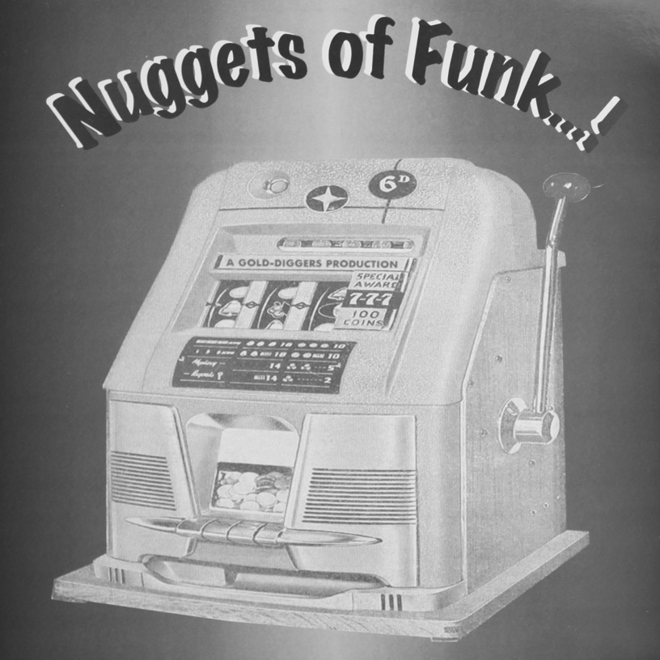
Figure 40: Nuggets of Funk…! (1994).

In simple terms, Henry compiled recordings that had already been sampled. As a record dealer, he knew what recordings his customers wanted. Just as numerous requests for Micky and the Soul Generation ‘Iron Leg’ inspired Northern Soul dealer Bryan to create a compilation of rare funk recordings for record collectors and club-goers, demand for recordings already sampled by hip hop producers inspired Henry to create breakbeat LPs that included them. Ray suggested Henry's criteria for making compilations was shaped by demand when he explained why Henry included a recording called E.V.A. by the French electronic music pioneer Jean Jacques Perrey on Nuggets of Funk...! E.V.A. was one track on a 1970 album called Mood Indigo. Ray said Henry ‘ figured [he could] only get two copies [of Mood Indigo], but if [he had the E.V.A. track] on a compilation album, [he] could sell five hundred copies’. In other words, Henry could not meet demand for copies of Mood Indigo but knew the inclusion of E.V.A. on a compilation would be a major selling point. Ray didn’t know the Mood Indigo album at the time but when Henry described it to him he knew he had seen a copy in a local shop.

I literally went into a charity shop near where I lived and it was there for a quid. I said ‘I’ve got one’ and he said ‘You’re joking!’... I brought it round to him maybe the next day and I think it was too crackly to use. I think he rated me because I could find records … but he had the knowledge because he was down with the producers, so knew what the breaks were.

Asked how Henry ‘was down with the producers’, Ray explained Henry knew many successful US hip hop producers personally. Henry was one of a number of UK record collectors who regularly travelled to the US in the 1990s to sell UK records to hip hop producers. Unavailable in the US, but easy to find and purchase inexpensively from UK charity shops in the 1990s, the UK records Henry sold to U.S hip hop producers contained drum breaks or otherwise interesting funk sounds of use for purposes of sampling. Just as Don had traded funk and soul records between the north and south of the UK, buying inexpensively in one location and selling them for more in another, Henry and other transformative pirates inexpensively purchased records from charity shops in the UK and either sold them to US hip hop producers or traded them for US records they wanted. These selling trips to the US are discussed in more detail and analysed in chapter 8.

Henry's 'insider' knowledge of samples, gleaned from US producers themselves, earned him a place in academic literature because he annotated his last two Nuggets compilations with details about songs that sampled recordings he included on them. On the sleeve of Nuggets 3: Diggin' Deeper... for example, he annotated Whatnauts’ ‘Why Can't People Be Colors Too’ with the words: ‘Check the drums at around 3.55 as sampled by A Tribe Called Quest / Pete Rock / Large Professor / The Beatminerz etc’. Schloss (2004, 126) noted information given out on breakbeat LP sleeves, ‘not only about the original song, but also about hip hop songs that have sampled it’, caused legal problems for producers, and represented two kinds of ethical violation:

The first is that it gives away privileged information that should rightfully be acquired through diligent digging, or at least through word of mouth. The second is that it puts the cited hip hop producer at legal risk: many of the samples have not been legally cleared, particularly if they were, fir example, only one or two notes from a saxophone solo. Although such a sample would probably not require the producer to pay publishing rights to the original composer, it would still technically require a payment to the record company for the use of the master recording. This is what DJ Premier refers to as ‘snitching’.

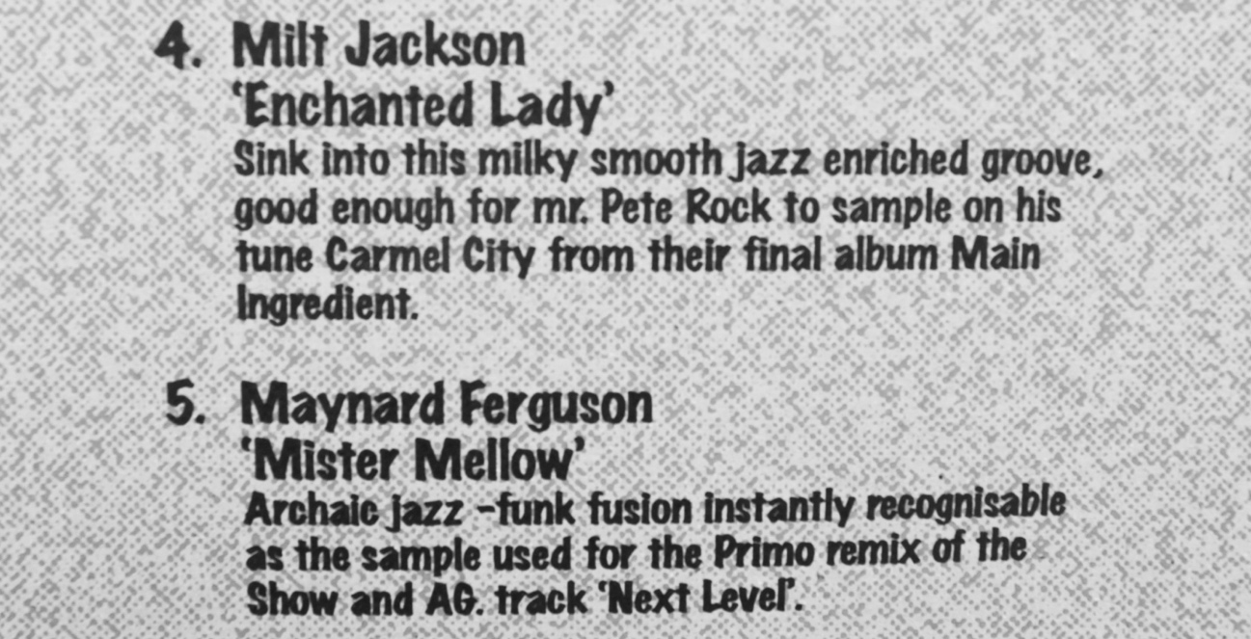
Figure 41: example of ‘snitching’ on rear sleeve of Chill Pill Vol 2—You’ve Gots Ta Chill.

Ray did not dwell on details about his parting with Henry but it illustrates the world of transformative piracy was not a relentless sequence of opportune, productively fruitful partnerships that ended amicably. It's hypothetical, but Don and Henry could have been very successful working together, given the former's capacity for promotion and distribution and the latter's meticulous production skills. But Don and Henry never managed to bond beyond trading aggressive profanities because Don hated running stalls at record fairs and on one occasion Henry severely tried his patience. Don admitted he ‘found it much easier to put a list out, sit down with a cup of coffee and wait for the phone calls to come in [as opposed to] being out there and unloading the van and dealing with fucking dickheads all day, because it’s really hard work’. Running a stall one day, Don had some records on display that he was selling for a friend at a fixed price. Henry had bought records from Don before, but on this particular day he failed to grasp Don was not in a position to offer cut-price deals on records that did not belong to him. This led to friction:

[Henry] said, ‘Would you take 20 for these two?’ And normally at a record fair you’d go, ‘Yeah alright mate’, but I said, ‘I’m sorry mate, I can’t, they’re not mine, I’m selling them for a mate’. He said ‘Well I’ve got £20’, and I said ‘That’s the price he wants and I’m only making a pound a record and I’d be fucking losing money if I gave them to you £20’. So he said something like, ‘Fuck you then’ and I said ‘Fuck off you fat cunt and don’t ever come back or I’ll fucking punch you’. I just didn’t have the patience.

6.9 PLANET OF THE BREAKS / DIMENSIONS IN SOUND
As stated above, one reason why Ray and Henry clashed was because simultaneous to their co-productions, Ray produced his own Planet of the Breaks series. Asked how he had planned this branded series of compilations, Ray said that he hadn't:

I just started thinking, ‘ I can do another one … I can call it this ...’ you know? When I did the first one, I didn’t think, ‘Oh, I’m going to do five’, I just thought, ‘I can do another one’ and it just went on to five records. Same with Dimensions in Sound. I didn’t realise, you know, that we’d do three.

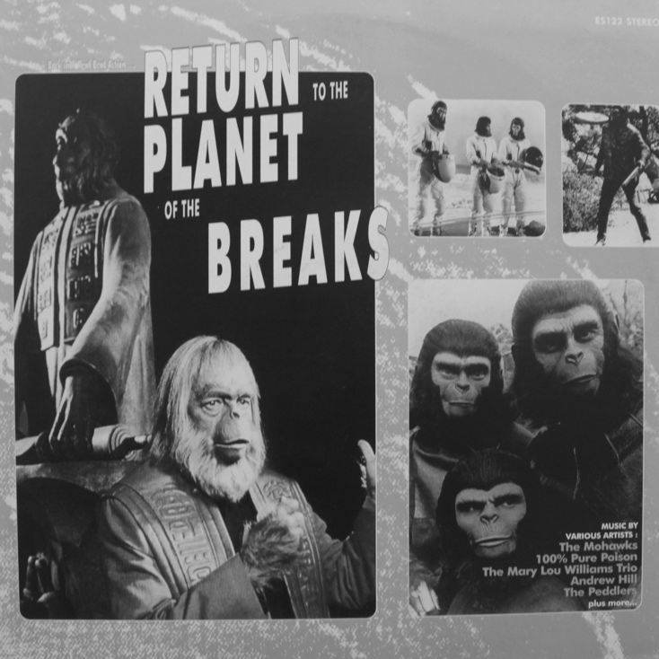
Figure 42: Return to the Planet of the Breaks (1999).

Similar in title to the Valley of the Beats series of breakbeat LPs made by Vic, who is the subject of chapter 8, I asked Ray if the two series were related in anyway, given that both appeared to pastiche the titles of the Planet of the Apes series of films made in the 1970s. He knew Vic, knew they ‘had very similar tastes’, suspected there were some track duplications between the two series, but couldn't say for certain who came up with the idea first. He was however, proud to point out that his series was a solo effort. Although the following statement comparing the two series appears innocuous, it revealed an interesting aspect of Ray's character, not as a person, but as a key informant for this study holding on to information he clearly did not want to share:

He probably got ideas about different tracks off this person or that person, whereas my stuff, it was a totally one person band. It was all me: my knowledge, my records, my ideas.

Oral historians have noted that when research is concerned with historic acts of transgression, key informants often respond only to questions asked of them. Phrased another way, key informants will rarely voluntarily offer up information about other transgressive acts they have been involved in if they believe the researcher knows nothing about those acts in advance. First of all, it was apparent Ray had no intention of naming ‘this person, or that person’, but was unaware I already knew he was referring to a respected record collector, DJ and producer. The reason for this was I had already interviewed Vic. When I proffered the DJ and record producers name as 'Harry', Ray affirmed I was correct, but closed the discussion down swiftly:

OK. I wasn’t going to say that. That makes sense. I knew that. I knew that they were, you know, doing stuff, but it was never talked about.

Harry's partnership with Vic is discussed in greater detail in chapter 8 but it is sufficient to state here that Ray's response to Harry's name reflected Harry's reputation as someone who would occasionally obtain records or solve problems by way of his physical presence.

One further point of interest relative to the relationship between myself as the researcher, and Ray as the subject, arose during the interview after the interview was over. When asked about further compilations he produced in the late 1990s known as the Nothing but Funk series, he visibly and audibly faltered before he answered. This was because he had not expected me to ask him about it. At our informal and very short introductory meeting I had not mentioned these compilations because at that time I did not know he had produced them. I was only party to knowing he had produced them because I had interviewed Vic a few weeks earlier. Six months after he was interviewed, Ray revealed to me via a private message on social media that he had also produced two unlicensed compilations of 'left-field' disco called Disco Unusual Volume 1 and 2. A personal communication from him was triggered by a public post on social media drawing attention to the Disco Unusual cover art having been cut and pasted from a magazine advertisement. Ray confirmed this information was correct and identified the exact source of the image, but did so privately. Disco Unusual Volume 2 was released in 2006.

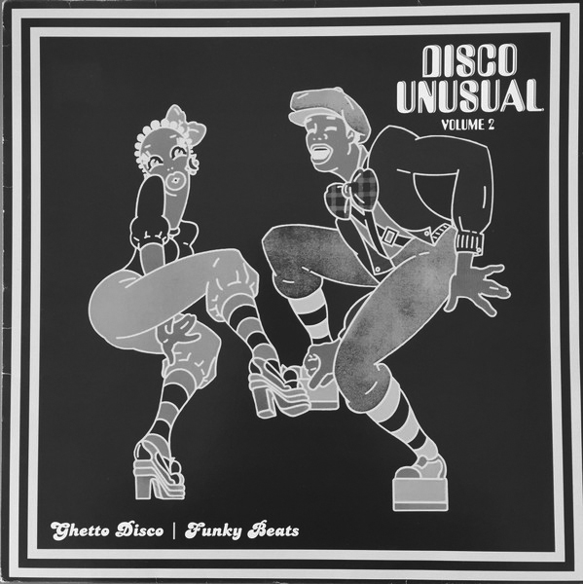
Figure 43: Disco Unusual (2006).

The gradual appearance of numerous unlicensed compilations in record shops and on market stalls in the early 1990s attracted other individuals to its possibilities. Don provided evidence record dealers and record shop employees were highly active transformative pirates because they had the access to potential content for compilations, safe storage locations from which to distribute them, and a regular pool of customers. But Ray was surprised when Ronnie, who was a record dealer and had recently started a reissue label, suggested they work together to make a series of unlicensed compilations of library music. Ray had helped Ronnie out over the years, and Ray had sourced mint copies of the first single Ronnie released on his reissue label:

Basically it was Ronnie who had [the] idea. He said, ‘Do you wanna do some compilation albums?’ I’m like, ‘Yeah, but you’re a … you know … you sell ...’. At the time he was just starting with his 7” label doing legitimate stuff, but obviously he was doing ‘on the side’ stuff with me. I remember he brought round a big pile of amazing library records like only he could do. We went through it, and we joint compiled what went on the first one, second one and third one. The third one we also pressed on CD. I’ve still got some, but the records flew out. They were great comps, you know.

Described in chapter 4, the library records Ray referred to here were European library production music albums. Being a record dealer, Ronnie had early notice of this new area of interest for record collectors. Ray explained he had never really been a fan of library music. From his perspective as a fan of hip hop fan he felt they rarely had more than ‘two second breaks’ and whole tracks were not necessarily worth hearing. He stated that when he worked with Ronnie on the Dimensions in Sound series he ‘tried to select tracks where the whole track was good, so if you didn’t want to sample it you could DJ the whole track’. His narrative took an unexpected turn when he revealed Ronnie had 'legitimately' reissued recordings Ray had already compiled:

I put [a well-known library track] on a comp, then Ronnie heard it, and released it as a 7” a few years later. If you look at Planet of the Breaks, there’s a few that have been on there that Ronnie has done as 7” [singles], but that’s another story.

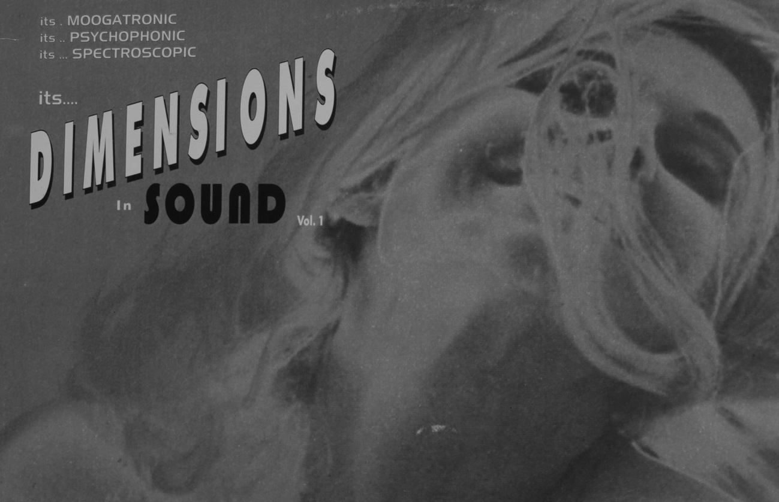
Figure 44: front sleeve detail of Dimensions in Sound (1998).

Ray's interview was conducted in one of his favourite cafes in an area that was beginning to be gentrified, and his understanding the process was deeply personal. He explained the rising cost of housing in the area had already excluded the sons and daughters of many local people he knew from ever being able to buy a home near to the area where they grew up. Through this lens Ray unexpectedly delivered very strong views about some of Ronnie's behaviour and in a passionate conclusion framed Ronnie's label it as a different form of gentrification: the gentrification of music piracy.

The thing is, Ronnie was sneaky because if he was planning on releasing something [legitimately for his reissue label] and got wind someone else was going to do it, he’d ring them up and start screwing, and threatening to grass them up … I was like ‘Ronnie, that’s really hypocritical. You don’t license everything’, and that’s one aspect I can’t respect … invariably you’d end up having to give him a hundred records free or something of your press because he’d started crying like a baby. I know some guys had to put a sticker over an entire run of their albums because they had to change a track, and they had already printed up the sleeves … That really is arsey, because you created the demand, and now some middle-class twat, Ronnie, has come along, riding your coat-tails, doing it so-called legally, but he’s not, and the demand had nothing to do with him. See, it’s a respect thing, and that’s the problem. That’s what the middle classes do. They grab on to something, take it over, make out they’ve been doing it forever, and then exclude you.

6.10 THE NOTHING BUT FUNK SERIES
Ray did not expect to be asked about the Nothing but Funk series he produced but Vic, who is the subject of chapter 8, shared Ray's name when I purchased a copy of one of the series from him after he was interviewed. Vic knew the Nothing but Funk included tracks exclusively reissued on CD that Ray had seen fit to translate into his favoured format. As stated above, the first time he did the was on his co-production with Don called From the Funk Side. The idea of using CDs for source material had clearly taken root, he knew there was ‘still a lot of [good] James Brown stuff out there’ and was convinced more ‘people were opening up’ to funk sounds because many ‘more legitimate funk compilations [were] coming out’:

There was a BGP King label compilation but they still didn’t put the right stuff on, in my mind. I had every single James Brown record and production and I thought ‘Let me just do a few’. There were... things that only came out on CD that needed to be on vinyl again… that needed to come out. I tried to research… I tried to put the information of the artists who were in the recording sessions so it was a little bit more interesting, a little bit more trainspottery, but the music would be good as well, you know?

6.11 CROSS-TRADING, DISTRIBUTION COMPANIES AND SALES SHEETS
Like Don, Ray cross-traded unlicensed compilations, but provided insights into how he used the practice to obtain desirable records from the US. Once he had built a variety of different titles, through cross-trading with Vic and other UK producers he would make up a package and send it to his contacts there:

I’d be swapping 3,000 records at a time with those guys that would get the Scorpio records. I’d send them 3,000 records and they’d send me 3,000 different records. So maybe you press up a thousand records to sell but you press up 2,000 because you’d know you could trade five or six hundred with America and you’d be getting amazing records.

Asked to explain what ‘the Scorpio records’ he described Scorpio as ‘a totally naughty Mafia company’, and explained his chief interest in trading with them lay in the fact they had ‘pirated all the James Brown albums, all the Roy Ayers, all The Meters … everything’. He owned original copies of all these albums but understood how desirable they all were from a musical perspective to younger UK DJs, hip hip producers and rare groove club-goers who wouldn't care if the records were original or otherwise. He recalled how these records generated ‘£500 cash every time’ he visited friends who owned record shops.

Don, Ray and Vic continually cross-traded because sales of new titles declined very quickly once the novelty of them had worn off and newer ones superseded them. In other words, to a certain degree having a variety of stock alleviated sales shortfalls when sales of a new release began to dwindle. This did not mean however, that they never had what retailers call 'deadstock'. Talking about the problem of deadstock storage Ray recalled when he had the simple idea of producing a sales sheet for all of his old stock and it generated an unexpected windfall that almost made him crash his bike. He explained that sales sheets, like a sales catalogue, were essentially lists of any products a producer had for sale. Ray had sold a lot of his own titles through Traxtion, but with deadstock remaining, he decided to send a sales sheet to a distributor called Velocity:

I had about three or four titles of compilation albums, maybe sold about five hundred copies, split with Don somewhere, and then I had maybe a couple of my own and there was a distribution company called Velocity. I thought. ‘OK, I’ll give them a few sales sheets of the albums I’ve got’, like four or five albums, you know? These had been out for years, sitting in the garage, pretty dead because they only had a certain shelf life … Not having much hope, this girl from Velocity rang me up when I was out on a cycle ride. She said, ‘I have got an order for you, it’s pretty big. It’s for 950 records’. I thought, ‘Hang on … that’s about four or five grand’. I was like ‘Are you serious?’ I was living at home, I didn’t really have that many expenses or outgoings and I was like, ‘I couldn’t spend that money!’ This was new orders, from a new distribution company, for old records. This company sold stuff to Japan, and maybe Traxtion didn’t do that ...

6.12 SUMMARY
Martin (1995, 217) maintained that to address the sociology of music, attention should be paid to ‘the relationship of groups' socio-economic locations and their music... the emergence of a hierarchy of musical styles... [and] viewing the production of music in industrialised societies as a business rather than an art’. Like the preceding chapter, this one has concentrated on ‘how the social gets into the music’ (Shepherd, 1991, 77), but while Ray's social life in night clubs influenced what recordings he put on his compilations, it was also apparent he responded to market demands. Adamant Northern Soul was ‘nonsense music’, and unimpressed by easy listening clubs, Ray was in some respects fortunate that in hierarchical terms, his favourite music was funk and his favourite artist was James Brown. Both were hugely popular in the UK night clubs he attended, and both featured predominantly on his compilations: Ray's personal taste and social life were embedded in his productions. Record shop staff had challenged Don's ideas about compilation content; Ray was closer to his potential customer base by way of his age, location and cultural influences.

Like Don, Ray recalled moments when he realised the economic value of vinyl records. As record collectors they both spoke about ‘doubles’—one to keep, one to sell—and then about ‘multiples’. Anecdotal evidence of the latter in particular were recounted with relish, such as when Don secured multiples of the Jeter Davis record inexpensively from an American dealer and Ray found duplicate copies of rare funk records at Steve Davis' house. These 'us and them' narratives underpinned how they identified themselves and what that knew in relation to others and what those others did and did not know—'”who's who” (and hence “what's what”)’ (Jenkins, 2014, 6). These examples exemplify how they exploited 'insider' knowledge of the demand for obscure records in different markets. Both Don and Ray discussed transformative piracy in business terms because the production of unlicensed compilations involved financial investment. Don spoke of ‘manufacturing the market’, Ray spoke of ‘sales sheets’, and both extended their trading skills beyond local and national boundaries. But perhaps more than Don, in many situations Ray reflexively engaged with others to pursue projects.

Ray worked with Don and Bryan on The Sound of Funk, helped Ronnie produce the Dimensions in Sound series, and enlisted Henry to inaugurate the Nuggets of Funk series. His narratives also revealed internal conversation: that which ‘makes (most of us) 'active agents', people who can exercise governance in our own lives, as opposed to 'passive agents' to whom things simply happen’ (Archer, 2007, 6). Ray ruminated on the implications of Ronnie investing funds raised from transformative piracy to finance his reissue label, and beyond his completed projects with Don, Ronnie, and Henry, he reflexively mused about projects that could have been. He never approached Polygram on Barrie K. Sharpe's behalf but the fact remains it was something he thought about doing:

We form projects to advance or protect what we care about most [and if] we are to survive and thrive, we have to be practitioners, and the definition of a successful practice is the realisation of a particular project in the relevant part of the environment ... Our performative competence relies upon acquiring skilful practices in relation to material artefacts; and our self-worth hinges upon developing rewarding practices in society.
(ibid, 7–9)

Convinced ‘musical genres entangle[d] themselves in evolving social formations’, Born (2015, 364) believed sociological analysis should focus on ‘musical formations (on the one hand) and social identity formations (on the other)’. Frank only ever produced one unlicensed compilation but as the next chapter will reveal, he probably saw and handled more of them than any other transformative pirate in this study. Frank ran a record stall in a busy market from 1983 to 2006. His story reveals how licensed and unlicensed recordings he bought and sold created entanglements between himself and various social formations that coalesced around his market stall.

7 FRANK

7.1 INTRODUCTION
Frank bought and sold new and second-hand vinyl records, cassette tapes and CDs from his city centre market stall between 1983 and 2006. In 1988 he produced just one unlicensed compilation on vinyl record of his own but by the 1990s his stall was a hub for selling hundreds of different titles. Frank therefore witnessed how some particularly active transformative pirates operated, but based in a busy marginal retail site he worked alongside people who bootlegged and counterfeited recordings on an array of formats. This chapter will also describe how he tried and failed to organise the production of a one bootleg vinyl record, generated a steady income by self-producing and selling unlicensed compilations on cassette tape and CD-R, and eventually had all his market stall stock seized by the police after he received a visit from members of the BPI anti-piracy unit. Frank observed many different worlds of music piracy from his market stall, and market stalls that sold musical products have rarely been researched in studies of popular music.

Like record shops or music distribution warehouses, market stalls are social spaces where musical products reside after they have been produced but before they have been consumed (Fairchild, 2016, 2). This chapter continues to analyse how the transformative piracy of the unlicensed compilation of music on vinyl record was influenced by record collectors socialising at sites where musical products were abundant, but context is provided by description and analysis of how other types of music piracy flourished in the same spaces. The story behind Frank's production of one unlicensed compilation on vinyl record in late 1988 reveals several transformative pirates were already operative when Don and Ray produced Bump 'N' Hustle Music in 1989. Moreover Frank's assiduous production of unlicensed compilations on cassette tape and CD-R in the late 1990s provides an example of how music pirates developed technological competencies to create novel pirate products on different formats in response to changing consumer demand.

Williams (1983, 43) asserted that to analyse art works, it is important to understand ‘general social conditions’ at the time of their production. One secondary source provides a snapshot of life in one busy UK city centre market in the mid-1990s. The UK-based Guardian newspaper published an article about life in Camden Market in the 1990s and invited readers to share memories to provide material for a follow-up article. One reader wrote the following:

I worked up at the stables market in the mid nineties, some memories: always cold, dragging a ton of tweed jackets up the cobbles in the rain on a clothes rail with one wheel missing; everyone was called Steve, Dave or Pete (Beardy Pete, Welsh Pete, etc); My pal shouting at John-Paul Gaultier ‘Discount, qu'est que c'est fucking discount?’; mulled wine for breakfast; the guy next door smoking crack behind his stall; Cissy Strut by the Meters being played all day long by the bootleg tape sellers; the Israeli bloke two stalls up telling us about juggling live grenades during national service; the stench of non-specific 'ethnic food'; the endless wall of people filing past; a job lot of 1970s Adidas tracksuits from a warehouse in Beirut; sitting on the radiator in a pub in Primrose Hill after work until I could feel my legs again …
('Henrydog', responding to Perry, 2015)

Unprompted, Frank arrived for his interview with a plastic bag containing unlicensed compilations on vinyl record, cassette tape and CD-R. His enthusiasm for the subject of this study was palpable and he spoke with candour about why he began his market stall. Frank's market stall was located in the same city centre market as Barry's. It may be recalled here that it was Barry who bought funk singles from Don for two pounds and sold them to his customers for five. Ray provided a useful description of where Frank and Barry's stalls were located in the market, underscored the importance of Frank's market stall to the distribution of his unlicensed compilations, and suggested Frank and an assistant called Paul also produced them:

Frank had the corner stand in the market opposite Barry's [which was] downstairs in a tight little alleyway. Frank was someone you could take a box of compilations to—25 Bump 'N’ Hustle Music, £5 each–and you could go back next Saturday and he’d have another 25. His stall was like the hub. They’d be doing their own [unlicensed compilations] too. Frank and Paul done a few James Brown ones. One of them I really liked. It was called The First Family of Funk. It had a really nice cover and a really nice label design. When [Don and I] did From the Funk Side, [we] carefully didn’t duplicate [any tracks they had already used].

Ray's information about Frank was not entirely accurate. In his interview Frank made it clear he only ever produced one unlicensed compilation while Paul produced many. Paul is a significant figure in this chapter, but before discussing how Paul and others who worked for Frank were involved in music piracy, it is important to understand who Frank was and how he came to be the manager of a city centre market stall.

7.2 BEFORE THE MARKET STALL: 1974–1982
In complete contrast to Don and Ray, Frank stated the ‘whole other world of black music, of soul music and funk’ was largely unknown to him until he was in his mid-twenties. He was born in the late 1950s and described himself as ‘white middle class’, a ‘child of the early 1970s’, and explicitly linked his education at a fee-paying public school to his taste for ‘Led Zeppelin, yes... prog rock... [and] heavy metal’. He added his exposure to ‘black music’ in his teens was limited to ‘bits like Stevie Wonder’ heard on the radio.

When Frank left school in 1974 he worked as an assistant engineer in a recording studio. His father was an influential figure in the music industries. Aged 19 in 1976, he became an A&R man for a major record label ‘with a very staid image’. He knew this was ‘an incredible job’ and that his father's influence helped him to secure it. On his first day at work he described how he sat ‘like a proper A&R guy’ in a wood-panelled office with a piano and thought ‘What the fuck am I going to do?’ Given ‘entrepreneurial discretion’ to produce hit records and assessed only by their ‘recent track record’, A&R staff in record companies rarely held on to their jobs for very long (Peterson and Berger, 1971, 101). In 1976 Frank heard an exciting band and urged his record label to sign them. His ‘overweight, cigar-puffing boss’ switched off a demo tape of their songs after the second track, banged his hands on the desk and told Frank ‘What this company needs is a new Max Bygraves’.

To the company's loss, the new wave band called XTC that Frank had urged the company to sign were contracted to another record label and shortly afterwards Frank left the company ‘by mutual agreement’. He managed a pop band for a year without success but was sacked when they changed record label. Determined to remain in the music business he packed classical records for a mail order company and then became the assistant manager of a record shop that sold rock records. When the shop closed in 1982 he worked in the warehouse of a record wholesaler but was laid off after a few months along with a colleague called Mark. Frank was despondent but Mark suggested they should work for themselves:

Mark said to me, ‘Look. Don’t worry about it. You’ve got some records, I’ve got some records, let’s go to the market and sell records’ ... I said to him, ‘Mark. I will NEVER sell records on a market stall’. 25 years later, I finally stopped selling records. [Laughs] And that was the start of it. So about May 1983, we both went down in my car and got a stall down the back of the market. It was funny. I was thinking, ‘What can I sell?’

7.3 FRANK'S MARKET STALL: STOCK, SUPPLY AND DEMAND 1983–1985
Frank and Mark bought and sold a mixture of products that were both licensed and unlicensed: brand new and second-hand vinyl records, cassette tapes and CDs. Frank insisted selling records ‘was never a problem’, but ‘getting them’ was vital. He asserted obtaining stock was ‘everything’. He joked his real achievement was not selling valuable records, but ‘selling the crap’, and spoke of supply as ‘the lifeblood’ of his stall. Of particular interest is how Frank and Mark acquired new records. It will be shown later in this chapter their ability to sell popular new chart records at low prices created friction with other another record stall holder called Dylan. Relevant to information that follows, Dylan was a full-time music journalist.

In reference to digitised music Taylor (2016, 69) stated ‘one of the most remarked-upon features of today's capitalism is the seemingly limitless supply of commodities, including cultural commodities such as music’. Often overlooked in the digital era is that for some individuals in the early 1990s, both old and new recordings on a variety of analogue formats were sufficiently abundant for consumers to have difficulty navigating ‘through them to find what they might want’ (ibid, 70). The plenitude Taylor described as new was present well before recorded music was digitised: vinyl record plenitude was the reason Northern Soul and jazz-funk scenes flourished in the 1970s. As previous chapters have shown, Don, Ray and others found a plentiful supply of old records in various locations in the 1990s.

Frank did not find brand new records in equivalent quantities, but managed to secure some inexpensively, and on a regular basis, by way of knowledge best described as knowing 'who-was-who' and 'what-was-what'. Frank had worked briefly for a classical music wholesaler and stated this had provided ‘a whole lot of classical box sets and stuff’ to sell, but didn't expand on how he acquired them. He also revealed his business partner Mark was a former employee of HMV records. A manager Mark was still in contact with ‘found a way’ of selling them ‘current chart material at £2 each’. Other new, contemporary records were also obtained from ‘chart return shops’. Frank explained these were shops with ‘machines designed to log what records sold’. A company called the British Market Research Bureau would tally sales figures on a weekly basis to construct popular music charts for media publications and popular music chart shows. From his time in the music business Frank knew major record companies sent chart return shops free promotional items including such products as ‘limited edition, double pack 7s, shaped discs [and] picture discs’ to promote their artists. Frank observed ‘it was knowing where to buy this stuff’. Through music business connections he kept abreast of where chart return shops were located and through regular visits established contacts and purchased 'free' promotional material to sell to customers from his market stall.

To place Frank's procurement of new records in some context, it is worth noting other ways promotional material from record companies reached points of sale in the late 20th century, and how some new products were simply discarded for others to appropriate. My brother worked as a music journalist for a pop magazine throughout the 1980s and would regularly return home from work with dozens of records marked ‘for promotional use only’. Once reviewed, many were sold to second-hand record shops for cash or traded for credit notes. Interviewed for the British Library Club Cultures project, a night club DJ called Wendy May offered a perspective from the other side of the record shop counter. On-and-off throughout the 1970s and 1980s she managed various Virgin record stores. One of her tasks was to purchase records from customers:

People would bring in their collections and I would give them money or credit or whatever. I didn’t really [know what they were worth]. You knew how much [a record] would go for new … there was no guide or anything. Nothing was computerised ... It was shambolic but real, you know, and fun. And then as soon as it became all corporate, much later, when I worked for them much, much later at the Virgin Megastore, it just lost all its charm.

This evidence shows how new records given away by record companies for promotional purposes reached record shops and the unregulated stock purchase practices of at least one high street chain record shop. A former record shop employee interviewed anonymously for this study to provide information about how unlicensed compilations were purchased from transformative pirates explained how and why sales ‘reps’ from major record labels gave new products to record shops free of charge:

I did witness ... Universal, Sony, Warners, when they had reps ... if they wanted to push a new release, they would give [copies] very, very cheaply to us ... We’d get extra copies free and things like that. [When they got] a band [to perform] 'in-store', we would get, 30 or 40 free copies of their release, completely off the books ... We’d get a mysterious box of 40 ... It was an incentive to get a band in that we wouldn’t normally have.

Also interviewed for the British Library Club Cultures project, Greg Belson worked for a music promotions company in the mid-1990s before he became a recording artist and DJ. Greg described another reason why record companies would ask music distributors to provide free records to record shops:

We were working on a title by Clean Up Records, ‘Six Underground’ by Sneaker Pimps, and they really, really wanted to break that record. Clean Up Records was a subsidiary of One Little Indian, which was Bjork’s record label and to make sure this record sold, [and] got prime-time visualisation in the record store, we offered a ‘Buy One, Get Five Free’ ... so you buy one at £2.49, you get five copies free. Essentially ... you keep the price down, and you keep the visualisation prime. Put the record on in the record store … ’Oh this is great. How much is this? ‘It’s 49p.’ It's not £2.99, or £3.99 so 'boom’, that record went in [to the popular music charts] top three I think?

A music distribution company employee interviewed for this study spoke about how major record companies rarely arranged to collect unsold new records. He stated that so many of them accumulated in his company's warehouse alongside CDs and cassette tapes, that large industrial skips were in permanent use for their disposal. He knew people who worked for other music distribution companies and they confirmed this arrangement was common practice. No employee was ever discouraged from taking home discarded records, CDs or cassette tapes because this meant there were less to dispose of.

Collectively the examples above underscore how routine record company practices allowed new records to enter legitimate retail sites 'off the books'. The way Frank procured new records was not unique, but what he described as the ‘brilliant’ success of his first weekend as a market stall holder had nothing to do with new records. A friend owed Mark some money. He was a reputable record dealer so to repay his debt he gave Mark and Frank hundreds of second-hand records to sell. Frank and Mark had no idea what they were because they did not recognise the names of many artists and titles. They failed to comprehend why they sold so quickly, because they had no idea ‘60s psych demos’ were desirable in 1983, or that there were experienced record collectors amongst the customers who visited their stall on their opening day:

I can always remember our first day... we were selling 60s psych demos for either 60p or 80p. We wondered why we had such a good first day! [The dealer who gave them to us] had been collecting for years. So our first weekend was brilliant. I mean, it would be because we knew fuck all! (Laughs) We didn’t know anything … You know, I’d worked in a shop, I’d worked in wholesale, I was passionate about music. I knew fuck all about retail … and even less about the second-hand market. Neither of us knew anything but we learned very, very quickly.

Frank belatedly realised the importance of knowing his stock so began to read Record Collector magazine and record guides he found in a local rock and roll shop.The latter were particularly useful because according to Frank, in the mid-1980s rock and roll records were ‘everywhere’. But it was experiential knowledge acquired from buying and selling records on a daily basis that shaped what became his business mantra of ‘buy it all’.

[W]hen you’re on a market stall it doesn’t really matter. You’re prepared to turn a blind eye when somebody, probably sweating, probably with carrier bags … you’re not really interested in their ID. You just want to see, ‘What’ve you got?’ and ‘Can we buy it?’.

According to Frank, knowledge of the value of second-hand records was essential but pointless if you didn't have sufficient quantities of records in the first instance. When the van from the SP&S deletions company arrived at their stall one week with one hundred copies of a Marc and the Mambas album that was ‘already rare’ they bought them all at 60 pence each. But specialist deletions companies, record dealers, the HMV manager Mark knew, and chart return shops were not the only suppliers of records to the stall. Some of the people ‘probably sweating, probably with carrier bags’ became regular suppliers and Frank recalled many saleable second-hand records were delivered to his market stall in the city from the suburbs outside of it. They came courtesy of an entrepreneurial young record collector named Phil who like Don and Ray, understood how records were valued differently by different people in different locations.

Phil... [was] very, very important with regards to the supply of records to my stall. From the late 80s, Phil had a full-time job. He would get up … at 4 o clock on a Saturday and a Sunday, and get round I don’t know how many [car] boot fairs, and would buy stuff, and then come every Sunday and sell them to me wholesale. Anything and everything. Phil had this extraordinary knowledge base right across the board. He’s an expert on reggae, ska and roots but he knows everything about heavy metal, about Northern ...

As a ‘social spectacle [that] was genuinely new’, car boot sales ‘mushroomed in scale and visibility’ across the UK on Saturday and Sunday mornings in the 1980s (Gregson and Crewe, 1994, 261). In these ‘marginal spaces of consumption’ (Gregson and Crewe, 1997, 39) the ‘unpredictability, informality, disarray and cheapness’ of goods was attractive to buyers (42), and value was ‘not an inherent characteristic of commodities [found there, but something] open to constant relational, social and active negotiation, determined through the interplay of desire, demand, knowledge and supply’ (50). For young entrepreneurs like Phil, car boot sales offered a way to learn and understand ‘precise ways in which desire, demand and knowledge interweave to determine the precise value of commodities’ (50).

Phil was an example of what one record label owner interviewed for this study called a ‘bag boy’. It was a phenomenon he observed in London record shops from the late 1980s to the mid-1990s. They regularly travelled into the city on buses from car boot sales in the suburbs carrying bags full of desirable easy listening, jazz, funk and soul records. He stated records like Something by Shirley Bassey would be purchased from car boot sales in the suburbs for 50p and then sold ‘for a fiver’ to the owners of independent record shops in London who would then ‘sell them for like ... for like, twenty [pounds] or something’. I believed this would be a one-off anecdote but Lee, who in chapter 4 had spoken about the unlicensed compilation he had produced with a shop owner from San Francisco, remarked in a post on the Soul Strut music forum about someone he knew who worked in a very similar way:

You'd pre-arrange to meet him on a street corner in Soho or Mile End. He'd be 30 minutes late, minimum. A quick glance around to see who was watching … then the bag opens. Maybe 5, 10, maybe even 20 pieces packed in there. Huddle into a corner away from curious passers-by. It's early evening, rush hour, low sun streaming through the thoroughfares. A flick through, you'd pause and look at a cover, maybe take it out, flip over to see the reverse. 'Tough' would be the one-word commentary from our hero, 'Killer’. 'How much?', 'Ton.' A bead of sweat would slowly trickle down your brow. How I miss those days ... it was 15 years ago and more, but where are you now that the finances are in better shape? Make yourselves known! I'll be your one-man cash dispenser like in days of yore.

Frank spoke at length about the importance of securing a good pitch for his stall. Prime locations were near main thoroughfares that ran through the market itself, or close to the busy high streets that surrounded it. In the space of a year Frank and Mark's stall moved several times, but eventually ended up directly opposite the record stall of a hard-drinking music journalist called Dylan. Frank knew ‘he took umbrage at the fact that we turned up’. Dylan's stall was large, L-shaped and positioned at the nexus of two streets. Frank and Mark were serious competition, and Dylan watched resentfully as a stream of customers bought brand new chart albums from Frank and Mark at £3.99 each. Frank laughed when he recalled Dylan would get drunk, throw 7” singles at his head, and shout ‘You fucking public school cunt’. Dylan had run his stall for many years but one day told Frank and Mark that he'd had enough and offered them him his pitch, free of charge. Frank remarked it was strange because to secure ‘a prime spot like that, even in 1984, would cost money’.

Of equal importance to having a prime spot was the possession of a good sound system. Frank could not ‘emphasise enough the marketing value of having a good sound system and being able to DJ and having the record there to sell’. To underline his point he described the effect of playing a pirated 12” single of Ananda Shankar’s ‘Dancing Drums’, with ‘Streets of Calcutta’ to a music celebrity who frequented his stall. Frank had bought a box of them from a man who ‘just turned up’ at his stall at a time when they were not available anywhere else:

We used to get quite a few artists come round the stall. Norman Cook [aka Fatboy Slim) ... bought a lot of hip hop from us. Rob from Stereo MCs would come every week ... They bought the boots too. Bobby Gillespie from Primal Scream used to come down … I remember saying to him, ‘You've gotta hear this Bobby’, and I put on ‘Dancing Drums’. It starts with those synths, and I remember that when the band came in he practically jumped out of his skin. I could tell it was one of those, ‘this is one of the most amazing things I've ever heard’ moments. He bought copies for himself, and all his band.

7.4 NEW BUSINESS ARRANGEMENTS: 1985–1989
Frank and Mark's stall was doing so well that by 1985 they decided to try and increase their turnover by selling records on week days from a rented basement shop in the city. After the weekend market crates of records would be transported to the basement for storage and sale from Monday to Friday and then on Friday they would do the reverse: ‘up the stairs into the van and ready to go’. Up to this point Frank had been unsuccessful in all his music industries' employment and consideration of this draws attention to how the compartmentalisation of the music industries into sectors worked for some individuals but not others. Both Frank and his father were more successful knowing how sectors of the music industries operated but working outside of them. A brief review of Frank's career up to this point, and comparison of it to the careers of his father, Don and Ray, serves to highlight how, in combination, recorded music engenders sociality and aggregates ‘listeners into virtual collectivities and publics based on musical and other identifications’ (Born, 2015, 360).

In short order, Frank moved from music production (recording studio and record company), to distribution (mail order company and warehouseman), to retail (assistant manager of a record shop). He failed to make an impact in the ‘turbulent’ sector of production, passed quickly through the ‘bureaucracy’ of distribution and promotion (Peterson and Berger, 1971, 98–101), and when he worked in sales he had the misfortune of being made redundant. Like his father, Frank found success when he used his knowledge of how different sectors of the music industries operated, but worked independently outside them. A highly influential figure in how music was mediated to the public, Frank's father knew and worked with many lesser and well-known artists, organised music events, and was instrumental in the introduction and promotion of popular music charts to the UK public. He could not however, be described accurately in singular terms as either a producer, distributor, promoter or retailer: his work combined elements of all of them. The remainder of this chapter will show that once Frank discovered music that excited him, he followed in his father's footsteps.

In some respects Frank's identity at this time was close to that of both Don and Ray when they began dealing. Purchased in bulk, vinyl records were resources that afforded him an income. He knew where to source them from, they were brought to him, he knew what customers wanted, and he formulated clear value judgements. He stated selling ‘valuable’ records was good, but selling ‘crap’ ones was better. Like Don and Ray he drew on tools he had at his disposal: they had mailing lists, and he had his stall and sound system. But unlike Don and Ray his narratives lacked passion about a specific genre or genres. Early in the interview he linked his taste for rock, ‘prog', and heavy metal music to his teenage environment but offered no sense of having travelled on a journey of musical discovery.

Frank's talk of music and records lacked the ‘work-like, competitive ... aggressive ...’ characteristics often displayed by male collectors (Belk, 1995, 97). Baudrillard (1994, 9) stated ‘the collector partakes of the sublime not by virtue of the types of things he collects ... but by virtue of his fanaticism’. Don and Ray talked enthusiastically about artists, recordings and record labels, and anecdotes linked to them were infused with a degree with passion. Frank's narratives lacked emotional edge until he spoke about his inadvertent discovery of funk music. It came via one unlicensed compilation and two market stall assistants. But Roger and Paul were far more immersed in the soul, jazz and funk music of contemporary 1990s club cultures than Frank first realised.

In the following section material entanglements between Frank and individuals who worked on his stall are analysed, drawing from perspectives in literature on archaeology about ‘relationships between humans and things’ (Hodder, 2012). This is not at-a-distance from sociological ideas inherent in theories on art worlds, the production of culture, and the sociology of music. Entanglement theory examines how dependency develops between human beings and objects, shifting debate away from Gibson's (1986) notion of what objects 'afford'—their ‘potentialities for a particular set of actions’ (Hodder, 2012, 49)—towards how humans depend on things, things depend on other things, and things depend on humans: ‘[t]he social world of humans, and the material world of things are entangled together by dependences and dependencies that create potentials, further investments and entrapments’ (Gibson 1986, 89).

7.5 ROGER, PAUL AND UNLICENSED COMPILATIONS: 1988–1992
This section describes how Frank depended on what Roger and Paul knew about soul, funk and jazz records, and how they depended on him to distribute the unlicensed compilations they produced. It also describes Frank's discovery, use and distribution of unlicensed compilations, the effect they had on his customers, and the effect they had on him when he finally realised Roger and Paul had produced them. Throughout this section it will be shown how the production of unlicensed compilations, and the objects themselves generated dependences and dependencies between Frank and the staff who worked on his still.

A street cleaner called Roger who ‘who really knew about funk’ would occasionally visit the basement shop ran by Frank and Mark. Frank explained that although it transpired Roger was ‘duplicitous, dishonest and lots of other stuff’, he was impressed by Roger’s knowledge of soul, jazz and funk when he first met him. For reasons irrelevant to the present context, Frank and Mark parted company amicably at the beginning of 1987 and by mutual agreement Frank kept the stall and Mark kept the shop.When the shop closed a few months later, Mark informed Frank that his new assistant Roger was looking for a job. Frank noted the demand for soul, jazz, funk and Latin records had increased in the mid-1980s, and felt he lacked knowledge in these areas. He employed Roger and for the next few years depended on his expertise to guide his acquisition of soul, jazz and funk records. Roger's opinion was valued by customers, but from the very beginning he was also a problem.

When Roger arrived on the stall he sold Frank a large number of records, including ‘a whole bunch of singles’. Roger shared a house with a well-known local musician known as Blend. Frank knew Blend well because he periodically helped Frank out on his stall. One afternoon Blend was surprised to discover some of his own records were for sale on the stall. Frank explained what had happened:

This is a true story … [Blend] handed me this record. It was a 7” and it was Genesis ‘I Know What I Like In Your Wardrobe’, in a Stephan Grapelli bag. Blend went, ‘That’s a coincidence. I’ve got a Genesis single in a Stephan Grapelli bag’. I thought, ‘Uh oh’. He said, ‘Hang on...’. When he looked at the singles, all of his singles were in there … At that point I should have got rid of Roger … because if you can do that to somebody you live with, God knows what he was doing on the stall.

Frank did not sack Roger, but towards the end of 1991 Roger left of his own accord and started his own record stall at the other end of the market. When Frank got the chance to see it he was ‘not happy at all': numerous records from his own stall were on sale there. Roger must have known things that belonged to Blend and Frank were not his, but ‘human dependence on things leads to entanglement between humans and things ...’ (Hodder, 2012, 10). It's worth pausing to recall many of the new vinyl records that arrived on Frank's market stall were only there because at one stage in their life story they were an 'off the books' means by which record companies got the work of their artists into popular charts. Giving away new records free to shops was not an act that afforded chart success; chart success was dependent upon it. The success of Roger's stall was as dependent on a supply of records as much as Frank's. It could be argued the success or failure of both stalls depended on some stock being acquired 'off the books'.

Frank presented an unlicensed compilation called The JBs and Some and stated it had arrived on his market stall in late 1988, just before Roger began working for him. It was a compilation of James Brown productions delivered by a ‘guy [who] turned up with 25 of them in a brown box’. When he played a copy on the stall's sound system he was incredulous at how people responded to it and as a result, he bought them all:

I put it on, and it was like moths to a flame. It was like, ‘What’s this? I’ll have it’, just from all over. Thing is, having that spot, and also having like a decent sound system ... I wouldn’t let anybody else play music around me, because like … it was a real selling tool being able to play this stuff loud … because there were always lots of people walking past. You hear something good, I mean ... just play it! I can always remember ...

They cost Frank ‘four or five [pounds]’ each and he sold them for a ‘tenner’. ‘Buy for five ... sell for ten’ was his ‘rule of thumb’ and he asserted anything under a ‘100% mark-up’ was ‘not worth doing’. Frank would ‘sell out of [The JBs and Some] every week’ so insisted the seller brought him more copies. This information offered support to Ray's testimony that Frank bought multiple copies of Bump 'N' Hustle from him on a weekly basis. At this point in time unlicensed compilations were a dependable source of regular income for both Frank and people who produced them. If unlicensed compilations had not sold so well, Ray would not have continued to produce them and Don would not have been able to distribute them.

Frank put his glasses on, perused the sleeve of The JBs and Some, indicated the track called ‘Same Beat’, and said ‘like … wow’. When Frank first received it he had no idea that Paul had made it, because Paul was not the person who brought it to the stall. The JBs and Some made a big impact on Frank. It signalled a change in the kind of music he focused on selling. What impressed him most was that ‘people wouldn't ask for it’ because they didn't know about it, but when he played it, they would buy it. The record introduced Frank to funk, made him want to know more about the genre but admitted he ‘just didn’t know where to look’. It was shortly after this that Roger came to work for him, and then in 1990, Paul joined the stall:

By 1990, me, Roger and Paul ... the whole thrust of the stall had changed from … rock, second-hand stuff and sixties stuff … We had become more niche, more specialist, mainly through these two guys. So by 1990 the stall was becoming more jazz, funk, hip hop oriented by having these two guys here. I remember that for me I learned a lot very quickly.

Roger and Paul worked together with Frank on his stall for nearly two years until, as described above, Roger left Frank's stall, taking some of Frank’s stock with him. Frank learned a lot about soul, jazz, funk, Latin and hip hop from them both, but was unaware that they had produced several of the unlicensed compilations that had sold so well.

To order his thoughts and stimulate his memory of how events unfolded, at this point in the interview Frank took a number of vinyl records from his bag and carefully laid them out on the table. All of the records were unlicensed compilations: Latino Funk Chicano Jazz, More Funky People and Kool and The Gang Give It Up, Out–Vol.1, and Funky Soundtracks (Volumes 1 to 3). Frank then explained why Roger and Paul introduced these compilations to his stall covertly, without admitting to him that they had produced them. It transpired the reason was financial self-interest, but it is worth hearing how Frank framed what was in effect, their dual duplicity.

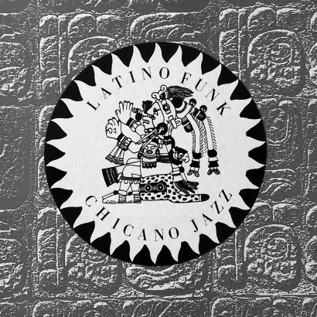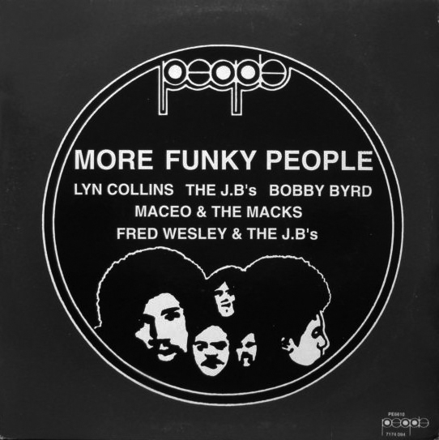
Figure 45 (left): Latino Funk Chicano Jazz (1990).
Figure 46 (right): More Funky People (1990).

I’d love to tell you that I was directly involved with what Paul and Roger were producing, but actually they did it behind my back. About 1991/1992 … Roger came to me with a box of these, saying, ‘I bought these wholesale’. We had an arrangement whereby I paid them whatever it was per day, but they could put their own stuff on the stall and we’d split it, essentially. And then … there were some things we bought as a threesome, that were split three ways, OK? With ones that they’d done themselves there was a different cut. So to get a bit more money [it was in Roger's interest] to tell me he'd bought them wholesale, rather than that he’d produced them, because obviously if he’d produced them he was going to get less.

Observable in Frank's narrative above is a subtle shift from references to ‘Paul and Roger’, to just Roger. Paul was just as duplicitous as Roger over the provenance of unlicensed compilations, but did not steal his stock or give Frank any other cause for concern. Frank recalled that when he sold a compilation to a customer one day he said to him, ‘The guys that did this really knew what they were doing’. At that moment it dawned on him the ‘guys’ were Roger and Paul:

Roger [had already gone] so I confronted Paul and said, ‘Is this you?’ He said, ‘Look ... Roger made me, you know, because of the split?’ So he came clean, and he said, ‘That's mine, that’s mine, and that’s mine’ [Frank pointed to Latino Funk Chicano Jazz, More Funky People, and Kool and The Gang–Give It Up]. So these were all ones that they were bringing in ‘wholesale’ which they’d actually made themselves. It IS funny. It’s funny now (Laughs again).

Frank had not looked at the compilations for twenty years, but when he inspected the sleeve of Out Vol. 1 he laughed out loud when he noticed Roger had written ‘To Frank—Thanks for Everything’ on it.

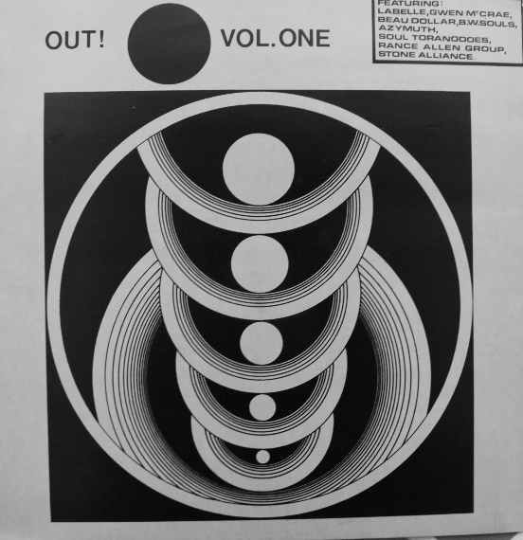
Figure 47: Out! Vol 1 (1989).

Frank arranged the volumes until he was happy with what he believed was an accurate chronology. He eventually settled on the following dates: 1988: JBs and Some and Jump Jazz! Vol.1; 1989: Out Vol. 1, Latino Funk Chicano Jazz, More Funky People; 1990: Kool and The Gan—Give It Up. Frank then indicated four volumes called Funky Soundtracks produced by Roger and Paul around 1990 when Paul first joined the stall. Frank explained that when a box of unlicensed compilations called The Chase Scene arrived on the stall in 1990 it caused Roger and Paul some consternation, ‘because they hadn't brought out their Funky Soundtracks one yet’. Like Funky Soundtracks, The Chase Scene series compiled themes and incidental music from soundtracks to spy films, thrillers, and blaxploitation movies. Frank suggested ‘it was like zeitgeist, it was in the air’. There were however very few duplications between the 'funky' soundtrack recordings they compiled and recordIngs included on The Chase Scene series, which eventually ran to a total of three volumes.

After Paul admitted he had produced the unlicensed compilations that had sold so well, and had apologised for lying about obtaining them from a wholesalers, he explained everything that had gone on to Frank. He admitted he had co-produced The JBs and Some and it was his co-producer who had regularly delivered copies to Frank. Paul and his co-producer parted company after Paul discovered he had been ‘ripped off’ in some undisclosed way. Frank laughed at the irony of it but was surprised when Paul informed him his former market stall partner Mark had been involved in the production of unlicensed compilations from the outset. Paul claimed Latino Funk Chicano Jazz, More Funky People, and Kool and The Gang–Give It Up were all manufactured at a Swedish pressing plant by someone Mark knew. Frank was not entirely convinced this was true and believed it was more likely Paul and Mark had arranged for them to be manufactured at the pressing plant where Paul had briefly worked. After Paul worked on Frank's stall, he as employed moved in strategic marketing divisions for several major record labels. Strategic marketing divisions were largely responsible for finding different ways to exploit back catalogue. Paul moved from company to company, and was responsible for overseeing the reissue of numerous soul, jazz and funk recordings. Like Alex in Don's chapter, Paul could best be described as a 'poacher turned gamekeeper'.

When numerous pirated copies of a sought-after album by Marva Whitney were delivered to his stall, Frank enlisted the help of Roger and Paul to produce a makeshift cover that would help to sell it. The records had plain white labels and plain white sleeves and the track list was printed on photocopied A4 sheets. Frank described it as a ‘really rare ... amazing album’ that was ‘selling for a lot of money even then’. He knew it would be popular, bought all the copies and set to work. Frank had an original copy of the album but instead of copying the sleeve from it he designed a new one that included images of her 7” singles on the cover.

Asked why he had gone to the effort of making a sleeve for a pirated album, Frank produced a photograph of the display wall behind his stall in the 1990s: almost every record displayed was an unlicensed compilation. He gave four reasons why he was not afraid to have them on show. First of all he believed their novel sleeves protected them: making a new sleeve for the Marva Whitney album made it look like a new, legitimate release and therefore safe for display. Secondly, he sensed major record companies had a negative attitude towards ‘black music’ generally and this attitude filtered down to the BPI anti-piracy unit they funded. Pressed to explain this point Frank said he was convinced the general attitude of major record labels was ‘it's black music; we don't give a shit’.

Thirdly, he remarked upon the poor status of vinyl records in the 1990s. While cherished vinyl records, he understood from selling them that ‘record companies were obsessed with promoting CDs’. He later explained that as the 1990s progressed more customers sought CDs than vinyl records, and this was one reason he began to make compilations on CD-R at the end of the decade. Finally he pointed out that pirated records, cassette tapes and CDs were not the only illegitimate products that copyright owners had to worry about in the 1990s:

You've also got to remember there was a whole big market of bootlegged video tapes as well. Massive. Tons of it. Live bands on videotapes. Some compiled. Nearly all of that stuff is on YouTube now. For a short period of time, I had a space next to my stall where I just gutted some nice shelves and I had like 50 or 60 live gig video tapes. There was a whole market in bootleg videos at very much the same time as the live cassette tapes. They didn't like that. That was risky … It's interesting what seemed to be OK and what didn't.

Narratives from Don and Ray provided thick description of vinyl record plenitude in the 1990s. Frank's narratives provided evidence the plenitude of recorded music available was not restricted to vinyl records. From one geographic point on the map—qa marginal retail site in a busy city centre—Frank had panoramic view of licensed and unlicensed recorded music on a range of formats. Viewed from Don and Ray's perspectives, the scale of unlicensed compilation production was hard to quantify. Metaphorically speaking Frank revealed the transformative piracy of soul, jazz and funk recordings was just one small piece of a much larger jigsaw of piratical practice. Notwithstanding rock bootlegs on vinyl record, music was also pirated, produced, distributed and sold on cassette tapes, CDs and video tapes, and Frank was surrounded by them.

In summarising this period of his life Frank stated ‘the whole flavour of the stall, from ’87 to the 1990s had completely changed’. He also believed unlicensed compilations were prized by his customers because it gave them access to an array of obscure music that was either unattainable or unaffordable:

We'd now become specialists in funk and hip hop, jazz. Around '91, '92 Roger got himself a stall and there was just me and Paul. I suppose, early to mid-90s, there was a proliferation of more and more vinyl bootlegs; funk, kind of breaks, Nuggets of Funk… I’ve got them all. We had a reputation. We were the funk stall. We were somewhere where you’d get breaks, you know? We're talking 1988 here... How much would it cost you to get all those individual tracks? First of all, if you could find them, which would be impossible, I mean we're talking hundreds [of pounds].

Asked whether he felt any of the unlicensed compilations sold from his stall were ever used to make hit records, he was adamant a song called ‘The Band Played the Boogie’ by Us 3 was produced as a direct result of the band’s producer buying unlicensed compilations from his stall.

Geoff Wilkinson … used to come down in the early 1990s, and any new decent bootleg compilation, he would buy it … He got himself a deal with Blue Note records, so the first thing he did was he sampled ‘Sookie Sookie’ by Grant Green … [That was] on Jump Jazz! which he bought ... I don't know if he actually sampled from it because signed to Blue Note, he had access to all the originals, but I'm certain he heard it on Jump Jazz! first. So he's somebody who actually got a hit out of listening to bootlegs.

Inspired by The JBs and Some, Frank made Jump Jazz! Vol. 1. The art work for the sleeve was done by a friend called Nigel who attended Chelsea Art College and occasionally worked on the stall. The ‘Bloody Good Piss-take’ logo on the crudely photocopied sleeve was Frank's idea. It was a pastiche of the BGP label and a sardonic reference to the fact that established record labels often sub-headed their names with ‘hip sayings’. He found a record plant, couldn't remember how many he pressed, but followed the template of The JBs and Some by including one ‘killer’ track that always drew customers to the stall: ‘Sookie Sookie’ by Grant Green.

That one track… there was always one, just like ‘Same Beat’ on The JBs and Some. You'd put it on the sound system and you’d be guaranteed people would come from far and wide, saying, ‘What’s that? I want it’. I didn’t know what Gilles Peterson looked like but he was at the stall one day and Paul pointed him out. He looked at Jump Jazz! Vol. 1 and said, 'That’s good for jazz’.

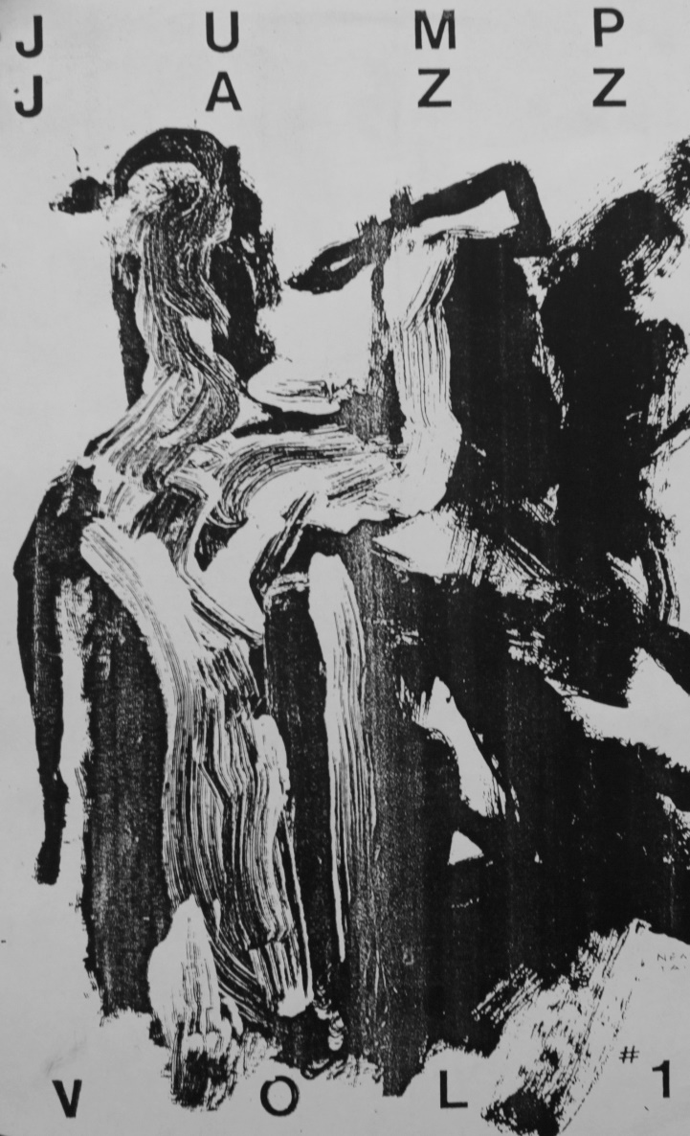
Figure 48: detail from front sleeve of Jump Jazz! Vol 1 (1988).

Volume 2 of Jump Jazz! never materialised. When Frank laughed at the sleeve, he was not laughing at the flourish of Nigel's rapidly executed pen and ink illustration of a jazz musician, but at the typography surrounding it, and its crude, monotone, photocopied look. When Don was asked about the sleeve designs of unlicensed compilations, his piquant response was that everyone knew someone who went to art school. Ray admitted he passed graphic design work over to others when he felt he had reached the limits of his artistic competency, and this was also the case for Jump Jazz! Vol.1. As explained in chapter 4, unlicensed compilations frequently lacked dates but a dedication to Frank's new born daughter on the sleeve—’For the foxiest jazz kitten’... provided confirmation it was produced at the end of 1988.

7.6 FRANK, A BOLAN BOOTLEG AND BOOTLEGGING
Having established contact with personnel at a pressing plant Frank's next project was in conjunction with a friend ‘who was the spitting image of Marc Bolan’ who wanted to make a bootleg LP of unreleased Bolan recordings. Evidence from media sources confirm the bootlegging of all kinds of products was widespread in the early 1990s. In October 1990, the UK music magazine Sounds presented the first of a four-part series entitled ‘Bootlegs: a special investigation’. In a cultural review of the year 1990, the editorial team of The Face magazine described bootlegging as ‘the year's growth industry’ and underscored it was a practice not restricted to music:

Adidas' stripes and logo were freely used on tracksuits, sweatshirts and jackets until the multinational threatened to take legal action and merchandise was pushed under the counter. T-shirts also proved a lucrative market, as people set up business one day and sold screen-printed rip-offs the next. Meanwhile, a new kind of bootleg record emerged. For a fiver upwards, unauthorised mixes and dance tracks were made accessible to DJs, collectors and even record companies—DNA's remix of Suzanne Vega's ‘Tom's Diner’ was a bootleg before it was picked up for official release and became a chart hit. ('Review of the year: 1990' The Face Magazine, January 1991, 23).

In 1992 Frank made his own media contribution to the subject of bootleg albums through his connection to a rock journalist who regularly sold him promotional records. He pulled a music magazine called Rage dated October 1992 from his carrier bag and indicated a double-page spread on bootlegging. Frank assisted the journalist who wrote the article, and ensured his Jump Jazz! Vol.1 was included on a list that included Prince and Madonna albums. After it was published a DJ for London's Capital Radio invited the journalist to talk about bootlegs on a radio show. Frank surmised the DJ had read the article and thought ‘Great! Bootlegs! This will be a great half hour of radio’. The journalist knew that Frank knew more about bootlegs than he did and invited him along to tape an interview but Frank politely refused because he suspected conversation would turn to how he knew so much about them. Frank knew many bootleggers but didn't sell rock bootlegs from his own stall during his first decade on the market.

When Frank went to the pressing plant to produce the Bolan bootleg album the Bolan lookalike had always wanted to make it quickly became evident some of the purportedly 'unreleased' recordings had been recorded from the radio. A sound engineer at the plant noticed this but appeared unperturbed. Unfortunately for Frank, the pressing plant manager telephoned him the day before he was going to collect the records and said, ‘I've had someone in, and he's questioning whether you've got the licensing to do this’. Embarrassed and unsure of what would happen next, Frank admitted it was a bootleg, and never collected the pressings. The manager's response to his admission surprised him. Frank explained:

[The pressing plant manager said,] ‘Why didn't you tell me, and then there would have been no problems. I could have done it without anyone else seeing it’. Because I didn't tell him, it meant that whoever paid them a visit saw it listed on their orders. Naively, I thought the guy knew it was a bootleg. With Jump Jazz! ... no one was going to question those tracks. Who would know about those tracks back then? But Bolan is Bolan, so it was much easier. The Bolan guy never spoke to me again. It cost X amount of money to press up, and the world got deprived of this amazing Bolan bootleg.

Evident once again in this scenario, Frank was too trusting of people and had a tendency to accept things at face value too quickly. The ‘Bolan bootleg’ story does not make sense. The pressing plant received ‘X amount of money’ in advance to manufacture a record that included tracks one of their own engineers knew had been recorded from the radio. This raises the question of whether the Bolan bootleg was ever pressed at all. Knowing they had been asked to press a bootleg, and having received money in advance, the plant manager could simply have lied to Frank about ‘someone’ asking questions. Frank did not return so had no way of knowing whether the bootlegs had been pressed.

If what the manager said was true, and the plant had pressed the bootlegs, it raises questions about what happened to them, and why the mysterious ‘someone’ who had the authority to look at pressing plant order books failed to ask for Frank's contact details. Whatever actually happened someone at the pressing plant now possessed a selection of unreleased recordings produced by a significant figure from the history of popular music in the 20th century that had been collected over many years by an avid fan. In the right hands, some or all of those recordings would have considerable market value. In the light of data provided by Don and Ray about how pressing plants and distribution companies operated, the likelihood here is that Frank and his unfortunate friend were victims of a scam. Familiar with the sound of the recordings he had hoped to hear on a vinyl record, only the Bolan fan himself would know if the recordings he once possessed ever surfaced on vinyl record, CD or on-line.

Frank believed that due to novelty, bootlegs had no effect whatsoever on the revenue of record companies. In broad agreement with Heylin (2003) Frank asserted bootleggers he knew had ‘everything by that artist [they liked] already and ... just wanted to expand their collection’. He spoke of a friend with a market stall whose display racks of dozens of Bob Dylan bootlegs were only ‘the tip of the iceberg’: customers who expressed interest in them would be taken to his car parked nearby and shown ‘hundreds’ more. In support of his dismissal of claims that bootlegging was linked to organised crime, he cited the ‘incredibly limited’ quantities of bootleg CDs and vinyl records produced. He doubted ‘any [bootleg] CDs ever exceeded a thousand’ because they were ‘made by fans for fans, and only fans [were] ever going to buy them’. He did not believe bootlegging was as lucrative as the music industries projected it to be and was angry his Bob Dylan bootleg selling friend was ‘actually filmed... being busted’:

They did this programme ... they make out as if it's Mafia-related or whatever? What fucking nonsense. There might have been the odd character who ... fancied himself as some sort of gangster, but mainly these are passionate music people … It's hard to believe any of them were businessmen who were just in it for the money. It's much more for the music, and the rest of it, and having a laugh with it.

7.7 UNLICENSED COMPILATIONS ON CASSETTE TAPE AND CD-R: 1997–2000
Surrounded in the city centre market place by so many different pirated and bootlegged products, it came as no surprise when Frank pulled cassette tape and CD-R compilations from his plastic bag. As documents personal to him, he had carried each of them along to the interview to annotate his life story. Frank's production of unlicensed compilations of funk recordings on cassette tape and CD-R occurred after Paul had left his stall in 1996. Frank admitted that having Paul and his knowledge of ‘black music’ on the market stall had initially compensated for ‘insecurities’ he felt about his lack of knowledge about ‘this stuff’:

Being a white, middle class guy who's into prog rock, who's heard all this quite late on in his life as well. [The reason] I’d kept Roger on the stall was … about my own insecurities. We'd established this new, kind of, niche market and I was worried that if I sacked him … I didn’t know enough … I kept him on because I felt he was important in terms of this new market. So by ’96, Paul had left and I felt confident enough to be able to buy black music because I’d learnt, I’d finally learnt, in my own way, enough to do be able to do my own tapes.

Inspiration to make and sell cassette tape compilations came from a rearrangement of his stall for practical purposes, and from his observation of another market trader. Playing records on his stall began to be a problem because when his back was turned to play records customers handed to him, they stole stock. Compilation tapes were a solution to this problem, but inspiration to sell them came from a colourful character with a unique sales technique called Tambourine Tony. Frank witnessed him in action every day on his way to work at the market ‘around the mid-1990s’. Tambourine Tony played cassette tape compilations on his sound system, danced and banged a tambourine in time with the music, and sold copies of the compilations whenever anyone stopped to ask him what they were:

He had two outlets at the market, one, literally tiny space, just outside the tube. .. and another further up the road. I got to know Tony quite well. His area ... was very, very narrow ... because all he needed was enough space to have a box of tapes, a good sound system, and a tambourine. I could see that people would buy off him and he used to make a lot of money and so I thought ‘OK, this is an easy source of income’.

Frank did not realise until later that Tambourine Tony had produced some of the unlicensed compilations Frank sold from his stall between 1990 and 1992. All Souls Avenue Volume 2 and Volume 7, and Original! Blue Funk had been co-produced with ‘an absolutely lovely guy’ called DJ Spool, and it was DJ Spool who had sold them to Frank.

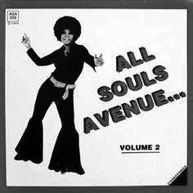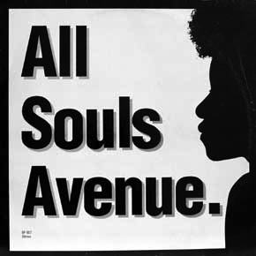
Figure 49: Tambourine Tony’s unlicensed compilations.

Frank and Tony were not the only people on the market who sold unlicensed compilations of soul, jazz and funk recordings on cassette tape. Gerald 'Jazzman' Short admitted he was so ‘thirsty for knowledge’ about music he heard on the radio that he would ‘go to clubs and buy tapes from people in the market ... to hear tunes that I'd never heard before’. Frustrated that some music compiled was too ‘obvious’, and passionate that old funk and jazz recordings were strong music’ that deserved to be heard beyond people on ‘the scene’, he began to make his own cassette tape compilations and took them to Camden Market in London:

I thought I'd make my own tapes and sell them myself. I turned up one day with a tape player, box of tapes and some upturned bread baskets and sold 6 tapes. I carried on with this, got myself a permanent pitch selling tapes at the weekend and worked during the week.
(Allen, 2004, 24).

Short become a record dealer, developed his market pitch into a record stall, and in 1998 launched his Jazzman record label to legitimately reissue soul, jazz and funk recordings. A DJ interviewed for this study who ran popular 'world music' club nights in the late 1980s observed pirate radio DJs would sell cassette tape compilations of their shows from market stalls. A radio pirate radio pirate he knew ‘had a total sound system ... would be playing songs, would have young kids toasting’ over the cassette tapes he played and people would stop, listen and buy them. He admitted he would compile and produce cassette tape compilations of his DJ sets to sell to club-goers:

People would come up to you and say ‘Do you have tapes?’, or ‘Do you sell tapes of the music that you are playing?’ You would say ‘Yes, here you are, £5 please’. That was always a nice little earner. One or two a night. A bit of money. I did a bootleg [cassette tape] of Fred Wesley and Maceo Parker when [they] were the biggest thing, and sold that through places like [named independent record shops].

Around 1997, after Frank had observed how easily Tambourine Tony had sold his cassette tapes compilations, he produced a series of his own called Melting Pot. Each volume was themed and he stated he was proud to have pulled together a ‘breakbeats one’. To save time he invested in a multiple CD-R burner and enlisted the help of his children to duplicate and package them.

It was convenient to have really good music playing constantly but what was great was always being able to sell it. Really. Everything must be for sale. So customers would hear what I was playing [on cassette tape] and I could say, ‘it's this’, give them the tape and say, ‘it's a fiver’.

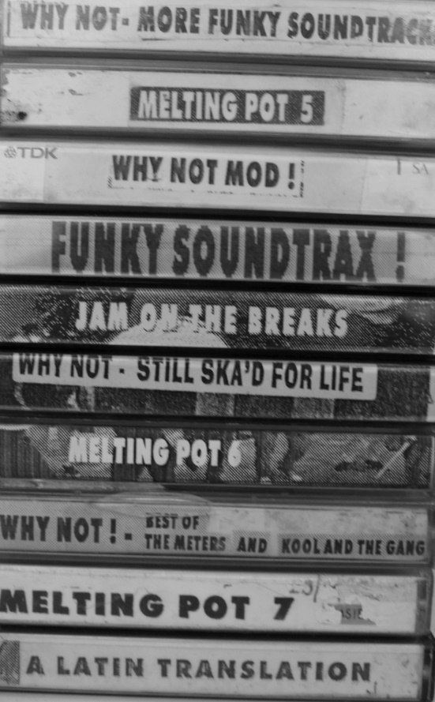
Figure 50: a selection of Frank’s Melting Pot cassette tape compilations.

Others items Frank retrieved from his plastic bag were CD-R compilations. He asserted he ‘knew nothing about computers’ but was inspired to learn about them when he found out that rock bootleggers he knew well were making counterfeit CD-R copies of rock bootlegs and counterfeit CD-R copies of legitimate CDs. Around 1997 he began to buy the CD-Rs of rock bootlegs from them wholesale to sell from his stall but would not countenance buying counterfeit CD-R copies of legitimate Beatles, Rolling Stones and U2 albums. He was emphatic that he ‘drew a line’. Proud of the fact that he didn't ‘do counterfeiting’, Frank maintained that ‘after years of running around, going to boot fairs [and] courting journalists’, life became a lot easier because he could just go to a market stall nearby and buy ‘a whole bunch of bootlegs’ at five pounds each. He described them as ‘guaranteed sellers’; people would pay twelve pounds for them. Unfortunately for Frank, in the year 2000, BPI anti-piracy officers, supported by the police, seized all the stock from his main rock bootleg suppliers. Frank's stall was not raided on this occasion. In the same year he became his own source of supply: he taught himself how to copy CDs and how to make, duplicate and burn his own CD-Rs.

Frank produced a series of unlicensed CD-R compilations, sold them to his customers for ten pounds each and referred to this particular period of piratical productivity as his ‘own little cottage industry’. Using a word borrowed from the music industries he stated he built up ‘a catalogue’ of around 15 Funk Bomb CD-Rs. In an act reminiscent of Don's counterfeiting of unlicensed compilations produced by other transformative pirates, Frank began counterfeiting pirate products. He duplicated rock bootleg CDs and CD-Rs he had acquired from his rock bootlegging friends before the BPI closed down their operation. Frank stated a downturn in the market for vinyl records was the main reason he began to make funk compilations on CD-R. He believed the main reason unlicensed compilations that ‘had always sold [well] on vinyl’ began to sit for longer in the racks was because ‘[record] companies were desperately trying to fade vinyl out and make people buy CDs’

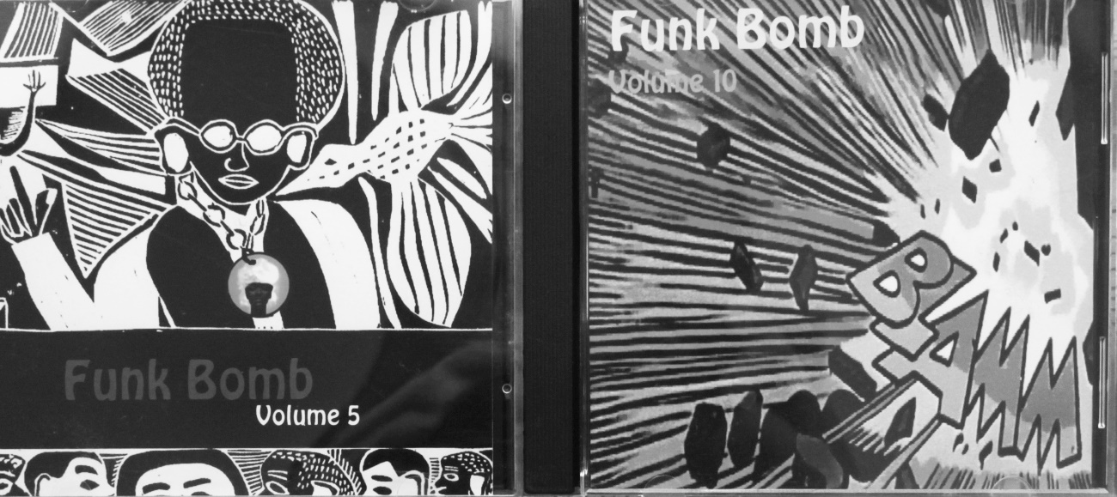
Figure 51: Frank’s Funk Bomb CD-Rs: Volume 5 and Volume 10.

In the late 1990s Tambourine Tony also stopped producing cassette tape compilations but produced compilations on CD rather than CD-R. He produced a series called Funk Around The World that was particularly popular. Frank held a copy of one of Tambourine Tony's CDs up to the light next to one of his own Funk Bomb CD-Rs and explained differences between the two. Frank knew Tony had his CDs manufactured ‘properly’ but never found out where because they fell out when Frank attempted to show Tony how easily he could copy CDs on his computer:

Around 2000, I showed Tony how easy it was to copy CDs at home. I would copy a U2 or Radiohead bootleg, but would never copy a funk bootleg: that just wasn't on. I wanted to show Tony how easy it was to copy stuff, but he immediately got it into his head that I had my own operation, where I was copying his CDs and selling them, and we fell out as a result. But quite a while later, I bumped into him and said, ‘You know, I never bootlegged any of your funky soundtracks CDs’. There were quite a few of those funky soundtrack CDs around. I just wanted to show him how it could be done, but then I lost touch with him.

Disappointed Tony had misinterpreted his offer of help, Frank stated how much he respected him as a record collector, even though it frustrated him that Tony changed the names of some of the more interesting tracks on his compilations.

The last time I saw Tony he was still selling records. The thing he liked better than anything else was going to Europe. He loved to go to record fairs and uncover stuff. It's very hard to be absolutely sure who discovered what but Tony was definitely one of those people who would make these journeys ... who would uncover lost tracks hidden on a B-side, or find a 7” that nobody had heard of ... but the bastard would change the name [of tracks when he compiled them]. That's why I'm still trying to find out what the Raj Gupta Sindra Sitar track is [on All Souls Avenue].

7.8 'LAWLESS', THE BPI, AND THE END OF THE STALL
Major record distribution companies had been vital to Don and Ray's distribution of unlicensed compilations. Although Frank had received stock for his market stall from specialist UK distribution companies like SP&S he did not have any dealings with any others until he began duplicating CD-Rs. Around 2000, and through contacts in the music industries, Frank began to sell his CD-R compilations to a major UK distributor called Lawless. The company had not been mentioned by Don or Ray, and neither were they mentioned by Vic, who is the subject of the next chapter.

Lawless exported CDs, CD-Rs, and vinyl records to shops and distributors in Japan who would feedback information to Lawless about specific kinds of musical product they would be happy to buy. In response to these requests a manager at Lawless asked Frank to think about interesting compilations or sought-after records he could supply to them on CD-R, and send any ideas to them on a sales sheet. Frank dis this, his sales sheets were sent to Japan, and if Lawless received ‘orders of over one hundred or something’, he would produce the required amount and sell them to Lawless for a wholesale price. Learning what shops and distributors in Japan wanted, Frank realised there was still a thriving market for unlicensed funk compilations and rock bootlegs on CD-R in Japan in the year 2000. Frank was specifically asked for both, but the plastic bag he had brought along to the interview also yielded an album called Soul Makossa by Afrique, on vinyl record:

I came up with this one … It's got one really good track called ‘House of the Rising Funk’. Ray did the label and the sleeve for me. It's not a compilation, it's a counterfeit. Back in those days it was a £30/£40 quid album. I gave the guy lots of choice, and the only one he came back [for] with orders from Japan was that one. Same sleeve, but you can feel it's not from 1973. I also did a CD-R of Radiohead Unplugged, a classic bootleg title, gave that to my friend at Lawless and they came back and I think it was at least 100 of that on CD-R...so I had to manufacture those at home for export. [Laughs].

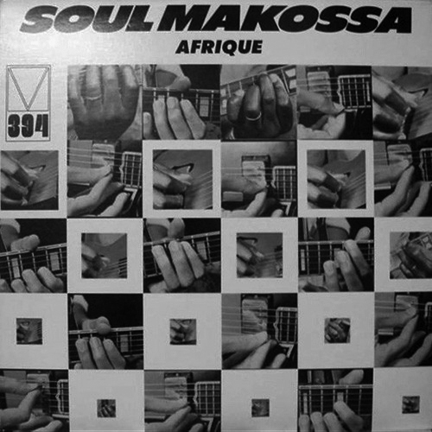
Figure 52: Soul Makossa by Afrique.

Despite Frank's earlier declaration that he would not ‘do counterfeiting’ he had eventually yielded to temptation. In the first instance he had maintained he would ‘copy a U2 or Radiohead bootleg, but would never copy a funk bootleg’ but here, a few years on, he was making counterfeits of legitimately released albums.

Frank's life as a market stall trader ended in 2006 when ongoing health issues made demands on his personal income and, by his own admission, he stopped ploughing ‘money straight back into stock’. He began to owe people money, partly because he had expanded his business from one to two stalls just before he received a visit from BPI anti-piracy officers and the police. When the ‘first bust’ came he was at a football match. One of his stall assistants telephoned him to say a policeman had ‘taken away all the CDs’. Frank immediately suspected it was an undercover policeman who was well-known to all the market traders:

The BPI had this policeman … I think it was Sergeant Slaughter. He was well-known around the market ... Word on the street was ... when he retired, [he] had been promised a job at the BPI, so it became his raison d'etre, his thing, sniffing out the bootleg stalls and doing them.

The BPI took all of Frank's stock, and it was his responsibility to retrieve from them ‘everything that was legal’. He was surprised that he was not charged or given any sort of warning. He received most of his stock back, including bootlegs on vinyl record. He didn't know whether or not the police knew they were bootlegs, but suspected they were not concerned with them. Frank was unconcerned about the stock they kept, as he still had his burner and his master copies. His market stall did not close because of the BPI bust, he closed it down himself in 2006 to focus on dealing with unresolved health issues. Adamant the BPI knew all the market stalls that sold pirated products, counterfeits and bootlegs, Frank believed they were always focussed on CDs rather than vinyl records.

In my opinion the BPI were well aware of all the stalls that were doing bootlegs, and I think there was an unwritten understanding: ‘Don't take the piss’. They knew that you were selling them, but it wasn't wise to be advertising that you were doing them, you know? Like, have them out, but don't hang them up … I'm just talking about CDs. The secret was to make sure that most of the stuff you had on display was legal, and if it wasn't, make sure it looked legal so a policeman wouldn't know.

Frank was already struggling at this point because he had expanded his business to two stalls and had bought numerous bootlegs ‘because it was the quickest and easiest way’ to fill them up. The problem for Frank was that none of the stock Sergeant Slaughter had seized from his stall had been paid for. Frank had purchased 100s of bootlegged CD-Rs from a regular supplier ‘on tick’, and the BPI raid came just a week after he had opened his second stall. In debt to the supplier, and with personal problems mounting up, Frank realised he had ceased to prioritise what he knew was vital to his business:

A good day is, when everything you've made, you plough straight back into stock. You need enough to live, to pay your rent, but the thing is, I was very much aware that I was saying no to stuff, when deep down I knew I should be buying it … because the money I was making was going elsewhere. In many ways, that was why I remained stuck on that stall, while my contemporaries were moving up and on into shops, doing stuff legitimately. It's why the market had to stop for me. I had to change my life around.

Reflecting on the worlds of piracy he encountered and experienced, Frank concluded he respected producers of unlicensed compilations as ‘knowledgeable music lovers’. Knowing so many pirates who were employed in record retail and distribution he reasoned their passion, in combination with their knowledge of what music their customers wanted to hear meant they were ideally situated to understand a market they both manufactured and sustained. When asked to conclude his interview by speaking about what he thought about piracy now, twenty five years on, Frank unconsciously interpreted it through the lens of his personal experience of selling records from a marginal retail site. Piracy to Frank was simply a form of supply that fulfilled demand:

The people selling records know what sells, and know what makes something sell. So when you've got retailers making their own records, they know what to put on there. These aren't people who are making them for a quick buck. [They] have spent years trawling through crates of records ... As I said, record companies, like, ignored it. At the coal face, front line people who are selling direct to the public know what people want to buy. And that's pure experience. Paul got that job at [major record label] because he had that. He's one of the few people who has been on both sides … The compilations that he's done for [named major label] are brilliant too, but he's obviously slightly more limited. The great thing about doing your own compilation is you don't need to speak to anybody.

7.9 SUMMARY
Frank made a transition from a series of unsuccessful posts in various sectors of the music industries, to being a successful independent retailer and re-distributor of records, cassette tapes, and CDs. Although he appeared at times to be hapless, and overly trusting of untrustworthy people around him, he nevertheless displayed a keen intelligence for pushing past personal differences to do what was right for the success of his business. In contrast to Don and Ray, Frank displayed few signs of the kinds of competencies and mastery that define collectors, and rarely mentioned contemporary club cultures, record labels or record collecting. What Frank did was respect the aptitude and knowledge of others, and he kept close those he knew could keep his business healthy. Frank was intelligent, rather than knowledgeable. People he worked alongside, employed, and knew—Mark, Roger, Paul and Tambourine Tony, all kept their illicit activities a secret from him but depended both on him and the success of his stall for the distribution of the piratical products they made.

Frank's story is not so much about what vinyl records afforded him or them, but about how they generated entanglements. Martin (1995, 75) argued a strong relationship existed ‘between the nature of music and the society in which it is created’. In Frank's story unlicensed compilations of soul, jazz and funk on vinyl record, in addition to counterfeits, bootlegs, and other products of unlicensed transformational use on cassette tape, CD and CD-R, all generated dependency and dependencies. Frank wholly depended on Roger and Paul's knowledge of older soul, funk and jazz recordings at a time when these genres were in their ascendancy in UK club cultures and across Europe and the Far East. Frank knew his ‘white, middle-class’ teenage years in a fee-paying public school, and his brief period of time in the music business, taught him very little about recordings that by his own admission, changed the complexion of his business between 1983 and 1995. Frank's story revealed much more about illegitimate activities in various sectors of the music industries too.

An unexpected novelty in this chapter was how easy it was for Frank and Mark to obtain brand new popular chart records from high street record shops to sell from their market stall. Although specific details of this transfer of new products between one legitimate and one marginal retail site were sparse, the mechanism for it was undoubtedly social, as was Frank's procurement of record company promotional items that were intended to be given away free. Evidence from other interviewees suggested record companies either used brand new records as a form of currency or discarded them as if they were loose change. The pressing plant manager's response to the Marc Bolan bootleg suggested that either pressing bootlegs, or stealing bootlegs from those who came to have them pressed, was a standard industry practice. Through the use of Frank's sales sheets, Frank's contact at the distribution company called Lawless ensured distribution companies and shops in Japan received the exact type and number of whatever bootlegs, counterfeits, or unlicensed compilations they wanted.

In the next chapter the focus of this study returns to Northern Soul, introduces 'bar culture' and acid jazz scenes, through documenting the life story of a transformative pirate called Vic.

8 VIC

8.1 INTRODUCTION
In 1988 Vic was buying and selling 45 rpm records at Northern Soul events. He believed he was ‘the youngest lad’ there because everyone else ‘had sodded off to the rave scene’. Vic claimed that when he attended smaller Northern Soul ‘nighters’ there were only ever about ‘two to three hundred people in the room’, but many were ‘premier collectors in the world of rare soul’. He regretted not realising at the time how much ‘immense knowledge’ they all shared with him before he abruptly left Northern Soul music and the scene itself. He recalled that one day he just ‘packed [it] in’. He thought ‘Fuck that, I hate that shit, I’m into Acid Jazz now’.

This chapter profiles a restless and energetic record collector, record dealer and unlicensed compilation producer called Vic, whose taste in music moved from punk and ska to mod until he discovered Northern Soul in the 1980s when he was 15 years old. A decade later he embraced the acid jazz scene before he made the first of many unlicensed compilations of soul, jazz and funk recordings in 1995. It was called Fully Loaded. He made many more in subsequent years. Like Ray who was profiled in chapter 6, Vic was born close to 1970 and spent his formative teenage years in night clubs. But unlike Ray, Vic's stated passion was for the ‘four on the floor’ rhythms of Northern Soul records. Ray thought Northern Soul was ‘nonsense music’ and as a teenager Ray listened almost exclusively to hip hop before he gravitated towards 'on-the-one' funk rhythms of James Brown that hip hop producers sampled. Vic co-produced a series of unlicensed compilations called Planet of the Beats around the same Ray produced Planet of the Breaks. As contemporaries they simultaneously produced breakbeat LPs, but they arrived at producing them from very different directions. This chapter emphasises once again that individuals involved in the production of unlicensed compilations of soul, jazz and funk recordings in the 1990s came from different backgrounds. Vic's story provides further proof the world of transformative piracy can be analysed as an art world, and that unlicensed compilations were the product of collective and social activities.

8.2 FROM PUNK TO NORTHERN SOUL: 1982–1990
Before analysing Vic's musical journey from shoplifting punk records to producing unlicensed compilations of soul, jazz and funk recordings on vinyl record, it is worth hearing him he described by two people described who knew him. Ray could not remember exactly how they first met, but he initially wondered if Vic was ‘for real...’. Ray's initial thoughts were that Vic was ‘a bit sneaky or something’ but he came to the conclusion he was ‘a lovely guy’, who must have done well for himself because he drove ‘a really nice BMW series 6’ car. Bradley first met Vic in 1996 in the independent record shop where he worked. Vic had arrived to sell unlicensed compilations, Bradley was conscious of ‘some familiarity’ between Vic and the record shop manager, but Vic's presence and personality made a big impression on him. He concluded Vic was ‘really helpful' and that meeting him was ‘an education’. The shop stocked a lot of ‘jazz … prog … and … psych records’, and a ‘really animated’ Vic indicated certain records were worth a lot more than the shop was charging for them. Bradley described the records Vic was selling as ‘really interesting looking compilations of jazz and funk type stuff’:

We looked through [his bag] and he said, ‘I’ve got some more in the boot of my car’, and when we went out there was this amazing box of comps… There was the Diggin' Deeper series. It was before Beat Actione, which was one of my favourite comps of the time, and I think he might have had Dimensions in Sound there as well. He had quite a lot of white label ones as well … which were mainly funk and jazz breaks ... He had a few ‘Best ofs’ too ... and I think Rotary Connection was one.

The remainder of this section traces Vic's musical story from his teenage years to the end of his period as a Northern Soul boy. Vic was acquisitive from an early age. On the housing estate where he lived he observed how youths acquires artefacts to both signal and establish their identities. Shaping a role for himself amongst them as a resourceful intermediary who would supply any demand he saw, at the age of 15 he transferred these skills to the Northern Soul scene.

Vic was disarmingly candid about how he acquired records to satisfy his teenage taste in music. At twelve he bought punk records—’all the Crass’—but eventually accumulated ‘a best collection of everything’ after he taught himself how to be ‘a boss shoplifter’ who ‘never got caught’:

Like a little toe rag, [I was] just robbing Crass records, and Discharge and Anti-Pasti… That’s how I made me money. I used to do a milk round, and it was hard work. I was like the richest kid just from me milk round, but then I had to work from six to eight in the morning, so I’d go to this big local, cheesy 7–11 and I’d just rob loads of stationery and sell that in school and make about ten or fifteen quid. I think I got twenty quid from the milk round. I was killing it.

Vic's father ‘went to the Twisted Wheel and all those early soul clubs’, and also owned a ‘massive collection’ of records. Vic described the collection as ‘just wall to wall 7s’, but only ever saw it in a photograph. He never knew his father because he ‘walked out and left’ when Vic was young, so his early taste in music was shaped by contemporary sounds he heard played on the radio. Vic stated ‘after the punk thing’, he got ‘into the mod thing’, and then ‘just learned, you know?’ Sounding similar to Don, who traced the lineage of musical genres back to their roots, Vic recalled whenever he liked a style of music he would want to know where it came from:

Your first records are The Jam and Two-Tone, aren’t they? And then you’re like, ‘What the fuck? Where do they get it from? The Who and all that?’ … And then I just got into the black stuff … the soul and that, and then I heard about Northern Soul at the age of fifteen. I went to my first nighter and was just a soul boy and then, 91–ish, 92–ish, I got into Acid Jazz and shit.

Buying and selling records featured throughout Vic's recollections of his teenage years. It was also a unique feature of life inside Northern Soul clubs. An original Northern Soul fan observed: ‘It was clear from the start you had two sorts of people on the northern scene, record collectors and dancers’ (Jones, 2016, 73). Northern soul events often included a record bar: a dedicated space where record collecting club-goers would buy, sell or trade soul records (Cosgrave, 2016, 44). Prices fluctuated, depending on the rarity of records from one month to the next, but an odd disjuncture existed between Northern Soul fans and the records they danced to. Many worked in low-paid jobs but some of the vinyl records they danced to were rare and therefore expensive. 'Northern soul' was not a musical genre, it was a culture that developed socially from dancers demanding records that had a particular sound, and record collectors who could supply them. Possessing records no one else owned cemented DJs reputations.

‘Bootleggers’ provided cheap and often poorly pressed copies of popular rare records (Nowell, 2015, 101) and this production ensured Northern Soul fans who could not afford original copies of rare records could play songs they loved at home. But Vic was not involved in music piracy when he was a Northern Soul fan. He found the scene ‘exhilarating’, described larger events as ‘two thousand people all bouncing up and down’ to music that was ‘incredible’ and insisted he ignored ‘drugs like speed’ because he liked ‘the record thing best’. His propensity for buying and selling records inside venues came ‘towards the end’ of his time on the scene and as the narrative below reveals, it was a natural development of skills he acquired on the housing estate where he lived when he was a teenager. As Baudrillard (1994, 11–12) stated, the ‘exchange value [of collectable objects] is governed by cultural and social criteria’.

[I was] buying and selling when I was collecting the punk, then I started collecting the mod and the Two-Tone. On our estate it’d be like, ‘Who wants to swap? I got a Two-Tone collection here, and a mod parka, who wants to swap it?’ … for some hip hop record. Then you’d be a mod with your box of Two-Tone, and he’d be a breakdancer. Everyone was into shit, you know what I mean? There was always a new fad. You’re a scooter boy, you’re a skinhead, you’re a mod … You’re ... you know ... a hip hop kid, you’re new wave, you’re a punk. Always summat, but it was a nightmare because you couldn’t walk from one corner to the next cos you’d get fuckin’ slapped. You go to [town] you get battered by rastas, you could walk down the street in [another town] and punks would be kicking fuck out of ya. At sixteen I had like a scooter, a Vespa, and our estate is quite rough, but you know it was a community and there were no drugs then or nothing. It was before all that kicked off. Everyone used to go to this Scout Hut disco … My estate started fighting with the scooter boys didn’t they? So this big ruckus went off … So I used to have to drive on my estate and I’d see all of the lads [from the neighbouring estate] shouting, ’Hey there, knobhead’ at me … I'm thinking ‘Please don’t break down now!’ It was quite exciting really.

Vic's narrative of how teenagers on the estate where he lived swapped material artefacts linked to musical cultures draws attention to one way in which ‘musical genres entangle[d] themselves in evolving social formations’ (Born, 2015, 364). His narrative also showed how social relations between individuals and groups were affected by materiality. Options of owning one type of cultural artefact or another, and choices made from options that were offered, moved individuals away from a position of neutrality to being identifiably connected to a particular social group or 'tribe'. Clothes, records and even modes of transport selected by individuals were resources ‘in and through which social [regulation]—production, segregation, [and] imagination—[was] accomplished and sustained’ (DeNora, 2000, 34–35). Born (2015, 364) insisted that to fully grasp the way ‘wider social identity formations are refracted in music’, sociological analysis should focus on ‘musical formations (on the one hand) and social identity formations (on the other)’. Vic highlighted that cultural artefacts bought, sold and swapped indicated how teenagers acknowledged each new musical ‘fad’. His thick description illustrated how music ‘conjures up and animates imagined communities, aggregating its listeners into virtual collectivities and publics based on musical and other identifications’ (ibid, 360).

In an echo of Vic's portrayal of the relentless turnover of musical cultures in his teenage years, photographer Mark Charnock noted how many different UK youth cultures in the 1980s followed each other and occasionally intersected. He noted ‘the psychedelic revival’ followed ‘the mod revival’ ... the 'hard times' look championed by The Face magazine [crossed over with] the start of goth and also rockabilly / psychobilly’, but concluded many young people did not universally adopt the style of one subcultural group or another but picked at them ‘like magpies, using bits from one and pieces from the other’ (Manandhar, 2014, 81). Vic's teenage life was very much a magpie-like existence. From shoplifting, to swapping, to dealing records, to the way he moved from one musical genre to another, the following paragraphs show that even when Vic spent a decade absorbed in Northern Soul culture he remained abreast of developments and changes in musical worlds beyond it. His breadth of knowledge about different musical genres, combined with his lived experience of various musical subcultures, informed the content of unlicensed compilations he began to produce in 1995.

Vic attended Northern Soul nights throughout the 1980s but never worked as a DJ because he preferred ‘wheeling and dealing’ records. Throughout this time he was friendly with a well-known record dealer and fanzine writer. It was evident during his interview that he was still emotionally affected by the tragic circumstances surrounding his friend's death in the 1990s. Vic recalled the dealer was ‘fucking bonkers [but] had boss knowledge’. He would ‘hang out with him’ constantly, carry his records to events, and in 1992 Vic's friend purchased him a ‘one-way ticket for three months’ to go to America to look for records. Vic stayed in a big New York hostel, had a relationship with a female manager, and got drunk ‘most days’ with ‘a crazy alcoholic gay guy who just loved to get pissed but had no friends’. Vic claimed that for over a month he had ‘mad adventures’ with ‘ex-Vietnam people’ and ‘ran the place’ until he was finally ‘kicked out’. His Northern Soul friend continued to send him money every week so that he could ‘hit loads of [record] shops’.

Vic laughed as he recalled some ‘spectacularly’ unsuccessful days searching for desirable records. A phone call that offered ‘lots of soul 45s’ resulted in an all-day bus journey to the ‘middle of nowhere’, only for Vic to discover the promised 45s were ‘all fucking repros’. He did however, find ‘some amazing shops that killed it’. He described one called Strider that specialised in ‘big thousand dollar doo wop records’. When the owner allowed Vic to ‘go through his entire stock’, he made sure he looked at every single record. Of similar age and mind set to Ray, wherever Vic found records boxed, shelved or piled up, the priority was looking for records rather than worrying about time. In the 1960s, Record Corner in Balham was one of the first UK record shops to import thousands of US soul and country records. Vic stated that in the late 1980s, although it took him ‘a week’, he ‘cleaned it out’:

I was going at eight in the morning and staying until eight at night. Seven days just going through 45s. Come out with about that much stuff [opens arms]. I was just getting the good stuff dude. I got like twenty copies of Monkey Magic, you know, the BBC record? Got loads of good soul tunes. What’s that big soul tune on Blue Candle out of Miami? £50 record all day … I probably got about three hundred, four hundred records or something.

Vic's record collecting practice was consistent. Each day spent ‘digging’ for records at Strider's in the US started at nine in the morning and finished at seven in the evening. He said it took him ten days ‘because [Strider's] had that many 7s’. It was however, a successful visit:

I was buying primarily Northern soul and Rhythm and Blues. The guys running it were mainly doo wop guys. I got an Executive Four. One of them would probably cost you five grand now, but there’s only like a handful of known copies. I got one of them unplayed in there. It’s probably the best copy that exists. Thirty dollars. Typical northern. Just boss.

I was curious about Vic's ethics because earlier he described his teenage self as a ‘toe rag’, was nonchalant about his aptitude for shoplifting, and celebrated how it profited him financially. In America, he was thousands of miles way from his benefactor in the UK and no one was watching. I asked if he was entirely honest with his friend about every rare record he found. One or two undeclared finds could have funded a longer stay, better accommodation, or simply boosted his bank balance. I asked him if he was honest about everything he managed to find:

No. I couldn’t [do that]. I had to send it to me mate. He was sending me money to buy records and I was shaving a bit off for food and travel and stuff. He paid for my flight to get out there as well. I wasn’t going to rip the dude off. That’s why I’m still in business. No one has got anything bad to say about me. Always paid my bills and not ripped anyone off.

Vic never explained why he suddenly abandoned the Northern Soul scene, but did say he ‘fell out’ with his friend shortly after returning to the UK. He never lost contact with friends outside of the scene, and began to DJ alongside some of them around 1992. He described them as ‘just hardcore heads of this collector, that collector, that type of DJ’. Many had been breakdancers, some had ‘[collected] Electro since the day it started’ while others had recently ‘jumped on the Acid Jazz thing’. Vic's transition from Northern Soul to ‘Acid Jazz and all that shit’ was not as unexpected he first indicated. He admitted that on his Northern Soul buying trips to America he was ‘already into the Latin and stuff’.

8.3 FROM ACID JAZZ AND 'BAR CULTURE' TO TRANSFORMATIVE PIRACY: 1991–1995
In the early 1990s music played by night club DJs on pirate radio stations began to exert an influence on Vic's musical tastes. He confessed he would drive from the north of the UK to London so that he could listen to DJs like ‘Gilles Peterson and Patrick Forge’ playing jazz sounds so that he could keep abreast of whatever ‘the boss London radio pirate stations’ were playing. He attended acid jazz nights and recalled hearing records like ‘Celestial Blues’ by Gary Bartz and ‘You’ by Spanky Wilson. He decided the latter was ‘just a right good up-tempo funk record’ and went on to say he would he ‘go to all the weekenders and stuff where they’d have the Acid Jazz rooms or whatever ... Snowboy and all boys like that DJ-ing’.

Vic had piles of different music magazines in his house. When I drew attention to them he pulled out copies of old soul fanzines he particularly like and explained what he liked about them. He spoke authoritatively about a wide range of artists, bands, record labels and music scenes, and was particularly interested in how scenes ‘crossed over’ in various ways. Don and Ray read Black Echoes and Blues & Soul magazine and Frank read the NME and consulted record guides regularly after he had sold '60s psych demo 45s' far too cheaply on his first day of market stall trading. Vic described music publications he read and what he like about them.

I’ve alway read loads. Obviously I like trainspotty music stuff [and also] good fiction and sci-fi stuff. I used to get all the music magazines. On the Northern scene I used to get the underground fanzines … like Shades Of Soul … Blues & Soul … Black Echoes. Before that, I remember buying all those mod books that came out... and loads of punk stuff as well.

Vic discussed how from the late 1980s to the mid-1990s, the popular cultures of house, techno and rave ran parallel to smaller scenes that mixed soul, jazz, funk, Latin, mod, and psychedelic music. He thought the acid jazz scene had some influence on house music by way of what he discursively called ‘bar culture’. He defined this in the following way:

As the Acid Jazz became acceptable to chill out on, so all house music people got on that at the Café Del Mar n’ shit. I think on the tail end of that, bar culture became massive because you just used to be able to play in any bar as long as [the music] was soulful or funky. People liked it, had a little dance, and that was pretty much every bar throughout the country, wasn’t it? In every town there was always about five trendy bars playing that sort of thing. I got to know everybody who owned a club. Business isn’t it? You just get on it. [I was regularly booked to DJ because the city I was from] was pretty hot for nightclubbing. We had like two or three Acid Jazz clubs back in the day, and then clubs that put funky bands on, and then there’d be a DJ.

Vic's definition of 'bar culture' as a 1990s phenomenon sited in pubs and clubs correlates to research on how local authorities all over the UK engineered the development of a ‘night-time’ economy in city centres during the 1980s. Featherstone (2007, 11) suggested the problematic term ‘post-modern’ was best used for ‘directing our attention to changes taking place in contemporary culture’ across a wide range of practices. Concepts employed to discuss post-modernism in western societies included de-industrialization, post-industrialism, late capitalism, and post-Fordism, because cities in particular had ‘lost population, businesses and jobs, tax revenues and vibrant public services [and this resulted in] physical decay, and social decomposition ... dilapidated buildings, derelict land, homeless people, begging, rising crime, racial tensions, riots and much more besides’ (Mole, 1996, 16–17). Faced with a scarcity of profitable projects to offer return on excess capital (Harvey, 1986, 8), private developers turned to speculative construction to regenerate abandoned factories and urban spaces, supported by government initiatives such as ‘urban development corporations’ that by-passed local councils ‘to hoist the free market flag’ in inner cities (Robson, 1988; in Mole, 1996, 43). From the mid-1980s onwards night-time economies of multi-screen cinemas, multi-level night clubs and public houses transformed into cocktail bars, sprang up in every major city and town of the UK:

For many cities the post-industrial landscape [offered opportunities for re-invention] as places of consumption of popular cultural forms based in the night-time economy. A new economy of pleasure no linked no longer to repression but to proliferation and multiplication within a new wave of commodification—of pleasure and desire, evasion and of transgression. This [was a] liminal economy where boundaries between legal, illegal and informal [were] blurred.
(Lovatt, 1996, 141)

Featherstone (1991) suggested these restructured urban landscapes were occupied by a variety of social formations he dubbed ‘new cultural intermediaries’, and it is compelling to draw comparison between descriptions of them and the subjects is this study. Empirical research on cultural intermediaries—also described as ‘new intellectuals’ (Bourdieu, 1984), ‘gentrifiers’ (Zukin, 1987), ‘urban working class pop bohemians’ (Milestone, 1996), and ‘pop designers’ (Purvis, 1996)—highlighted how distinctions between their work patterns and social lives had for the most part eroded (O'Connor and Wynne, 1996). Like cultural intermediaries, unlicensed compilation producers could be described as individuals whose cultural and social lives merged in liminal spaces where vinyl records were stored prior to consumption: distribution warehouses, market stalls, record shops, car boot sales, and so forth.

All the subjects profiled in this study alternately engaged in legitimate and illegitimate business as they re-distributed old records and distributed new unlicensed compilations. Distinctions between their work patterns and social lives blurred. Ray and Vic danced in the same spaces where they sold records. Vic wryly suggested that being paid to play music in bars, so that people could have ‘a little dance’, was ‘business’. Ray concluded Ronnie's 'legitimate' reissue record label represented a form of gentrification: the gentrification of music piracy. Like cultural intermediaries, the subjects of this study ‘operated in distinctive and formative ways’ to produce cultural goods that reflected their ‘values, interests and identifications’ (Crewe, 2OO3, 21). The unlicensed compilations of Don, Ray, Frank, Vic and others, re-mediated obscure, rare or under-appreciated recordings to new audiences. Like artefacts produced by cultural intermediaries, unlicensed compilations were the result of ‘aptitudes and knowledge ... normally associated with ... spheres of consumption, leisure and the 'everyday'‘, rather than traditional work (Ibid, 2003, 23).

Although it was clear Vic continuously bought and sold records his dealing practices appeared to be less methodical than Don's and closer to Ray's. He made no references to bulk purchases or the organisation of a mailing list, but did obliquely refer to regular customers. Don mentioned paperwork, inventories of stock, specific customers, genres they asked for, and where they were located. Although Vic mentioned ‘business’ his record dealing appeared ad hoc and opportunistic rather than pre-meditated or strategic, conducted casually in night clubs or with record collecting friends at his home. Prior to the interview conducted in his home a friend had stopped by to ask if he had anything ‘new in’. Vic clearly kept an eye on current markets, understood how values changed, and like Don he also expressed regret for rare records he had sold too soon.

Even on my Northern trip I was already into the Latin and stuff so I was buying that then. I had all those big ones back in the day, the Bobby Valentin’s an’ all that. God, I sold that for £50. Bobby Valentin’s ‘Use It Before You Lose It’. £500 now, I think … Used to find them things, they used to be cheap, man!

It was evident from walls in his house lined from floor to ceiling with records that Vic was a collector and there were records personal to him that he would never sell. In the bathroom were piles of Northern Soul fanzines. But there were also boxes of records in his hallway, either just arrived or available for people to look through, select from, and purchase before leaving. It was in these boxes I had found one volume of Ray's Nothing but Funk series. Vic sold it to me and the information he provided about how and why it had been produced could never have been deduced from what was written on the sleeve or label.

Vic produced his first unlicensed compilation in 1995 and the inspiration to produce it came from two others he had heard: Teen Tonic produced by a friend called Harry, and the first volumes of the Nuggets series co-produced by Ronnie and Henry. Harry played a significant role in Vic's life as a transformative pirate. He was ‘a bit of a DJ around town’ and therefore someone Vic used to ‘hang out’ with. It was Harry who introduced Vic to Ray: Harry was friendly with Henry, Ray's co-producer on the first two volumes of Nuggets of Funk. It will be shown in sections that follow that Vic's attribution of the trait ‘relentless’ to Harry's record collecting practice, surfaced in other aspects of Harry's character.

Teen Tonic was Harry's ... All the moog stuff was going big. Harry's a top collector, no one can touch him. He’s up there with Ronnie and Henry … If you don’t sell him the record he’ll just break in your house and steal it off you, but he’ll have it … he’s just relentless. That was the first time anyone had heard Pierre Henry ‘Teen Tonic’. Previous to that, the Nuggets of Funk series had come out, so I was already inspired by them.

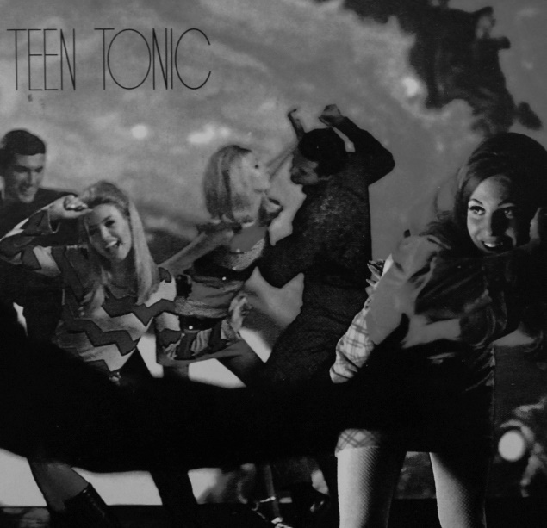
Figure 53: Teen Tonic (1995).

Harry acted as Vic's mentor for learning what Vic described as ‘the mechanics, basically, of making a record’. Notable in the narrative below is that he cited a distribution company Don had used. Similarities to Don's mode of operation also extended to Vic's personal distribution of his productions and the number of records pressed. Vic succinctly described the process Harry taught him:

Pay a man to manufacture them, get a sleeve designed, get them into distribution, get them sold, price structures … [After it was pressed] I was straight on to business, onto Traxtion. You just give them an invoice. And you do a little one sheet, don’t you. A little sales sheet. Send the thing beforehand, so they know what’s what. Back then, things were hot. All me mates were record guys. Bang. So I was selling them all to them as well… We pressed a thousand Fully Loaded but it's hard to find [now] because I never re-pressed it. It was my first record, dude. Then got straight on with Fully Loaded Two because I thought, ‘I’ve made some money’.

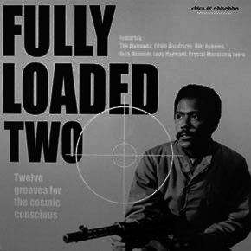
Figure 54: Fully Loaded Two (1996).

Some piratical practices of Vic and Don were identical, but they never met in person or communicated. This raised questions about how transformative pirates, hundreds of miles apart, adopted similar practices. The answer lay in mutual acquaintances. Harry was Vic's mentor, and Harry already knew Henry, who worked with Ray. Ray definitely knew Harry: Harry was the person Ray referred to as the ‘other people’ who produced the Valley of the Beats series with Vic. It was Ray who had closed down conversation about Harry after I revealed I knew who he was. Setting aside these social connections and the intimation Harry was a transformative pirate not to be discussed lightly, Vic's narratives revealed that some conventions of transformative piracy appeared to be universal. From this it can be concluded conventions of transformative piracy—modes of distribution, distributors used, sales sheets, numbers of records pressed—were communicated socially, because some were identical in geographic locations two hundred miles apart.

Asked about recordings he compiled on Fully Loaded, Vic described where he found them. He repetitively described many as ‘just found digging’ or ‘digging find’, but some responses yielded details about the types of places he looked for records and geographical information about where he had located them.

I used to get copies of Spanky Wilson’s ‘Sunshine of Your Love’ from a famous Northern Soul record dealer. He used to have a stall in Preston. Famous guy though. Used to do me sealed copies for ten to fifteen pound. I must have had about four or five from him. I found Little Alfred and the Linden Black Youth Choir ‘For the Money’ in a second-hand furniture shop in Southport. I found Jason Pew Mosso in a furniture shop too ... There are a lot of American records in the north of England because of the Northern Soul scene. I think I got Pucho and the Latin Soul Brothers in [independent record shop, London]. That’s quite an expensive Latin. I got James Young’s ‘Funky Booty’ in [independent record shop, Manchester].

Vic didn't make any reference at all to any of the high street record shop chains such as HMV, Virgin, Our Price (or to a lesser extent in the UK, Tower Records and Sam Goody's) that proliferated in major towns and cities in the 1990s. The content of Vic's narrative here is consistent with that of many male record collectors interviewed during and prior this study. When asked to recall stories about their most lucrative or interesting record 'finds' they described junk shops, market stalls, industrial refuse skips, second-hand shops, electrical shops, municipal recycling centres and charity shops. Nearly all of these spaces were described as distant rather than local, and stories frequently included details of how hard places were to find, or how dirty and difficult to navigate they were. In line with academic research on the construction of masculine gender identity, many of these stories reflected attempts to present record collecting as a form of 'subcultural capital' accumulation acquired through hard work (Belk, 1995, 99–101).

8.4 VIC AND HARRY'S CO-PRODUCTIONS
After his solo success with the Fully Loaded Volume 1 and 2, and Harry's success with Teen Tonic, Vic and Harry became co-producers. They regularly sought records together—’just digging to do comps, arguing …'—and produced the four volume Valley of the Beats series: Beyond the Valley of the Beats (1997), Beyond the Valley of the Superbeats (1998), Beyond the Valley of the Ultrabeats (1998) and Beyond the Valley of the Pornobeats (2000). Vic and Harry made it clear these were breakbeat LPs, and Vic described the target audience.

[We were doing it] at the right time because all the kids were starting to get interested in funk and soul because of the hip hop. They were chasing the samples. ‘Oooh, what’s Lord Finesse made that track out of? Oh it’s this jazz tune...’. Kids got into soul and funk that way ... We were always geared towards the hip hop thing because it was becoming so big and stuff it was just like the scene, wasn’t it? Samplers outsold guitars in that period. Decks were outselling guitars, cos all that DJ / producer thing was coming in: make your own dance music … they all wanted the loops. It was the hot market, it was in fashion. Simple as that. Lot of money in it. There was a lot of money about back then. People had money to spend on disposable shit like records.

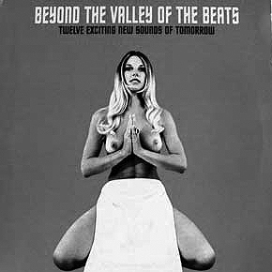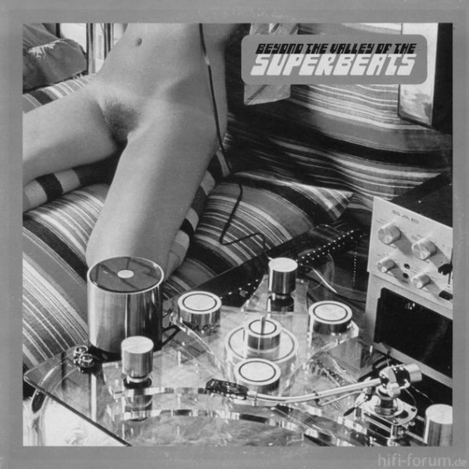
Figure 55 (left) Beyond the Valley of the Beats (1997).
Figure 56 (right) Beyond the Valley of the Superbeats (1998).

The Valley of the Beats series was very successful. Repeatedly re-pressed in response to demand, Vic and Harry sold around 20,000 copies of the four titles in total. As their productivity increased effective distribution became crucial. Don had worked with four major distribution companies. Vic named one Don had used [Traxtion] but mentioned many more that Don had not. He stated that when it came to finding companies to distribute their unlicensed compilations overseas, he and Harry were spoilt for choice. The narrative that follows offers more information about how open distribution companies were to accepting and distributing unlicensed compilations, how specific they were about titles they wanted, and how the mechanism of sales sheets informed how many they would want:

We used everyone, dude. Everyone. Some would say, ‘Don’t bring that’ if you’d already dropped it there … We used about half a dozen distributors who covered that stuff. Traxtion, GoCart ... Oh, mate, there must have been about twenty who came and went in that time you know … ‘Have you had this one before?’ You know. It’s all interbred, innit … it was credit but they always knew how many they wanted. Most of them had pre-orders anyway, because you sent them the one sales sheet a couple of weeks before you released the record. They’d buy them off me for a fiver and they’d pass them to the shops for £6.50. One phone call. Distribution was where it was at. They’d be shifting bloody weight and I’d be waiting for that fat cheque at the end of the month.

What this tells us is that buyers who purchased unlicensed compilations wholesale from distribution companies were complicit to how many unlicensed compilations were produced, and what types of unlicensed compilations followed. Vic's information supports how Ray and Frank described the purpose of sales sheets. Frank explained Lawless requested sales sheets and returned to him only when they had received a sufficient number of orders for the products he had included on it. Vic's observation the distribution companies he used would be ‘shifting bloody weight’ matches Don's observation distribution companies would buy three-quarters of a pressing run of a thousand unlicensed compilations. Another convention of transformative piracy is also apparent here: the use of numerous distributors. When Vic voiced a question he sometimes asked distribution companies—’Have you had this one before?’—this was a recollection that he sold so many compilations to so many distribution companies that he occasionally had difficulty keeping track of what he was doing. But Vic began to sound as business-like as Don when he talked about problems getting paid:

That’s the job isn’t it? Even the good people are hard to get money out of. Even I am. I’d have the printers phoning me and I’d be—’I’ll be back to you in a minute’—then I’m phoning my man who has just had a thousand records off me and he’d be, ‘Oh yeah. I sent the cheque’. No one has ever got the dosh [money] have they? I was good at it though. I always got the dosh in.

Vic’s practices began to resemble Don's in another way too. Flush with cash from his productions he began to drive to London ‘as often as three times a week’ via Leeds and Manchester, and so became a familiar face to personnel in various distribution companies and independent record shops in different cities. On some occasions, instead of collecting £500 cash from distributors in London for unlicensed compilations, he would take £500 of stock instead, and then ‘bounce back up’ to sell that stock to shops in Leeds and Manchester. Any stock unsold after that would go to ‘mates’:

And then, cos all me mates then were DJs, everyone bought records, so I’d be round to me mates with all the latest things, £100, £100 … I’d do a grand just from ten, twenty mates cos I’d have the boss stuff. People wanted records, they were hot ...

Adroit at simultaneously distributing, trading and selling, Vic exploited his knowledge of what different records were worth to different groups of people in different places. He talked fondly of ‘fifteen years on the road’ and how he would sometimes do a thousand miles a week travelling between Manchester, Leeds, Bradford, Sheffield, Nottingham, Liverpool and London. In London alone he would drop records off to five different record shops. At one, he claimed he would regularly ‘do a thousand quid over the counter’. Familiar with what record shops and distributors stocked, he stated he ‘made it his business’ to know who ‘the little one-off’ guys were—the producers who only made one or two unlicensed compilations—so that he could cross-trade with them to have exclusive stock others may not have had. He confirmed he regularly cross-traded with Ray too, because they had access to different record shops who would buy whatever unlicensed compilations they had.

It needs little revision here that like Don, Ray and Frank, Vic understood the concept of 'regimes of value' (Appadurai, 1986) through experience. Travelling regularly across the UK between sites where new records were abundant, he was familiar with where quantities of unsold new records accumulated, and learned ways of profitably transferring them from one space to another. Some of the distances Vic transferred records between were remarkably short. It may be recalled here that in Frank's story, a character named Phil transferred old records from car boot sales in the suburbs to Frank's market stall in the city. Vic profited handsomely when he transferred new hip hop records from one independent record shop to another, on the opposite side of a street:

[A record shop] at one time fancied itself as a hip hop distributor so they were buying big quantity on some boss stuff … It was the fucking quantity of it lying around, like ten copies of this, twenty copies of that, fifty copies of this. I was just going in there because they were just stuck with it. I said, ‘I’ll buy all this off you. A quid a pop’. I was literally going in there and buying 500 records then going across the road to [another record shop] and selling them for four quid …! I must have done about four or five grand like that over a month … But [that stock] was dead in the water as far as they were concerned.

Summarised for clarity, and to draw a comparison here with how unlicensed compilations sold, Vic understood that new imported hip hop records had a limited shelf life. The subject of hip hop records being ‘hot’, and therefore saleable, for only a short period of time was also raised during an interview conducted with Joe, the independent record shop owner who regularly visited Don to buy records. Don would sell Joe old soul and funk 45s and whatever current unlicensed compilations he had co-produced, financed, or otherwise possessed through cross-trading. Between them Don and Joe ensured at least one independent record shop in the west of the UK was well-stocked with a variety of the latest unlicensed compilations. Joe spoke about the problem of new stock in his shop when it was no longer saleable.

Vic's comment that he ‘always got the dosh in’ reminded him about ways in which Harry occasionally capitalised on his physical size to move their business along. Vic himself was not physically small but projected an image of being so whenever he described Harry. In a particularly forthright narrative he inadvertently invoked the image of himself as the talkative Lenny, and Harry as George, in the novel Of Mice and Men. Harry would occasionally use his physical presence to secure money that was owed to them:

Harry, he’s a massive fucking cunt. Always moody. I had someone owed us loads of money, it was nothing really, he was a mate of mine. He was only a couple of days late. Next thing I know he’s phoning me and he’s like, ‘Vic? I’ve got this animal next to me … I’ve got a cheque for you’. I was like, ‘Oh yeah. That’s my mate Harry, you better pay him’. He’s like, ‘Yeah, yeah, I will do’.

Vic and Harry also worked as a team to sequence their compilations. From an aesthetic perspective, the best unlicensed compilations benefited from tracks being ordered to provide a cohesive and satisfying listening sequence. Breakbeat LPs have been discussed as ‘production tools’, but only one record collector who spoke about unlicensed compilations prior to this study was a hip hop producer. It is often overlooked that many people purchased unlicensed compilations because they wanted to listen to them. Frith (1988, 3–20) wrote at length about the importance of value judgements in music. One value judgment I would proffer is that unlicensed compilations produced by Vic and Harry, as well as the Nuggets of Funk series produced by Ray and Henry, were well-sequenced. Vic described how they approached compilation:

We’d just lay them out in front of us and we’d play them on the deck. You’d just lay them out like that ... [indicates he would lay records out on the floor) … six a side and just play them. Always put your bomb tracks at the beginning, and I always like to put a mellow one at the end. And then fill it up. [Laughs] I think with the Valley of the Beats we always put a folk funk one at the end. That was our thing.

Vic's reference to adding a mellow ‘folk funk’ recording at the end of compilations illustrates how often musical genres were discursively-titled by record collectors. A reissue record label owner interviewed for this study believed the term was first used amongst record collectors in the mid-1980s, but research suggests transformative pirates were the first to use the term on record sleeves. Alex, who was discussed in 5.8.1, produced Folk Funk Experience (1995), seven years before two licensed releases on the Harmless record label produced compilations called As We Travel (2002) and Make Music (2002) and subtitled both of them with the phrase Folk Funk Flavours and Ambient Soul. Talking about tracks he compiled later Vic described Bonnie Dobson ‘Milk and Honey’ as ‘a folk funk thing’ and then shared his thoughts on the genre:

The thing with the folk funk thing is, them records are so hard to find and there’s only like a couple of score of them that are any good. It just doesn’t really exist does it? You can name all the best ones on your hands and I’ve been doing that for twenty years.

The ‘bomb’ first track on Vic and Harry's first volume of the Planet of the Beats series was Yves Hyatt’ ‘Path to Ascension’. They did not know this track before they planned to produce the compilation. Having decided to work together as a team Vic and Harry actively sought novel recordings for compilations. This move was a significant one, and a further example of the way entanglement theory, the way that

[H]umans and things, humans and humans, things and things depend on each other ... rely on each other, produce each other ... But that dependence is in continual tension with boundaries and constraints as things and humans reach various limits (of resources, of material and social possibility) that are overcome by, that demand, yet further dependence and investment. Entanglement can thus be defined as the dialectic of dependence and dependency.
(Hodder, 2012, 88–89)

To fill their first compilations, Vic and Harry drew on their personal knowledge of obscure recordings they included in their DJ sets. When they came together as a team with the express intention to make further compilations it generated a necessity to find novel content. They produced unlicensed compilations, but unlicensed compilations also produced them. Having been successful in their initial endeavours, the desire to make more unlicensed compilations affected their social actions.

Vic described how they discovered the Yves Hyatt track, and how Harry secured it from the person who introduced then to it. Illustrating once again his involvement in a variety of different club cultures, the person who played Path to Ascension to Vic and Harry was according to Vic, a ‘big mod DJ’ in London who played in all the mod clubs and ‘had boss records’:

Me and Harry went round because we were looking for tunes to do this comp. He’s playing us all these nuggets and we go, ‘We’ll have that’. He’s going, ‘It’s not for sale or nothing’. I think Harry purposefully got him drunk and stoned and then did an incredible deal with him and got the record. No one had that record. When we heard it we were like ‘What the fuck’s that?’ No one had that record apart from this kid.

The album that ‘Path to Ascension’ was taken from is now expensive to buy. Vic suggested its inclusion as the first track on Planet of the Beats was partly responsible. He felt ‘sooner or later someone would have discovered it’, but had no doubt it's inclusion on Planet of the Beats ‘put a lot of people onto it’. Vic's suggestion cannot be verified empirically. As he himself observed, it was available for anyone to discover. The presence of unlicensed compilations in record shops and on market stalls did however mediate obscure recordings more widely. It may be recalled here that Don verified some record dealers loaned rare records to transformative pirates to include on unlicensed compilations for a small fee, and suggested they felt this would increase the value of the original copies they still owned.

As in descriptions of his teenage life on his estate riding his scooter away from rival gangs, a faint suggestion of potential violence was never far from scenes Vic described. In his twenties his reputation as a record collector led him socialise with various characters who were evidently quite violent, but he had an ability to keep sufficiently distant from them to stay safe. The following excerpts from his interview offer a glimpse of the kind of company Vic attracted, how his sociality invariably involved music, and ways that he distanced himself from violent behaviour:

Have you ever heard of the Cresswells? The [city] shoot-out where the families got shot? All over the papers, big gangster war round here. Well, Patrick Cresswell's there … I was going, ‘Yeah. They owe me for about 500 records, this company, the invoice is two weeks late’. He says, ‘Vic! I’ll fucking sort it out. When his mother’s lying there with a knife in her leg he’ll soon pay ya!’ So I say [Vic lowered his voice at this point], ‘Yeah, it’s not quite that sort of business’. Patrick looked after our mate who was a pot dealer. My mate grew the skunk an’ that so I think Patrick was there all the time and I think he had some kind of involvement.

Funny. The Cresswell's were a bunch of scum, all shooting each other. All white lads … Big war, ten, fifteen years ago. It was all in the papers and stuff. I used to bring Patrick little CDs of hip hop. I loved me hardcore, you know? All the trendy arsonists and cool people. So I used to make them for him and he was like, ‘Do me some more CDs Vic, cos’ I’m having a party and it’s gonna be massive! Are you coming to DJ?’ I thought, ‘I’m not going to DJ at your gangster fights where everyone’s tooled up, and snorting coke all night … to play moody hip hop. No way’. I got out of it. Fuck that.

8.5 PRODUCTION, PRESENTATION AND PORNO CHIC
Like Ray and Henry, Vic and Harry paid close attention to sound quality and paid a well-known sound editor £250 to master each volume of the Planet of the Beats series. Mastering the compilations involved ensuring sound levels were even across all the recordings and pops and crackles were removed. The sound editor used a ‘Pro Tools rig’. Vic said it would cost £300 now ‘but back then it was big, crazy money’. In terms of design many of Vic and Harry's productions featured images of naked or semi-clad women. From the look of various models' make-up and hair styles the images appeared to have been sourced from adult magazines from the 1970s or 1980s. Post-modernist discourse, 'porno chic', sexually-themed night club names, and broad circulation 'lad mag' magazines in the 1990s provide some social context for Vic and Harry's sleeve designs.

Literature on post-modernism provided some clues as to why visual and textual references to pornographic culture began to be perceived as culturally acceptable in the 1990s. Hebdige (1988, 171) believed that in post-modernist times, ‘the past [was] played and replayed as an amusing range of styles, genres, signifying practices, to be combined and recombined at will’. In a study entitled Mediated Sex: Pornography and Postmodern Culture, McNair (1996) suggested the concept of postmodernism was useful for describing a climate in which images of sex and gender are being invested with new significance. He examined the influence artists such as Madonna, Jeff Koons and La Cicciolina—’Bad girls and gay boys’—had on what he described as the zeitgeist some referred to as 'porno chic'. Either reflective of porno chic, or contributing to its construction as a recognisable phenomena, many 1990s night clubs were hedonistically titled to colloquially, discursively or specifically refer to sexuality and pornography.

Listed in the London events magazine Time Out for the week commencing Wednesday 30th October 1991, it was reported that a club called Pure Sexy had DJs mixing ‘their favourite sexy dance tunes, orgasmic grooves and Porno-House’. At a venue named HQs there was Big Skank, at a night named Hard Club held at venue called Gossips, DJ Teresa Orlowski [a German pornographic film star] mixed ‘up the Eurobeat, futurist and alternative beats’. At The Gardening Club there was Tongue Kung Fu and at Joe's Brasserie there was Raw. Event promoters at The WAG club in Wardour Street named one club night Shag at the Wag. Scattered throughout the remaining five days of club listings were Kinky Disco, Close-Up, Come On Fridays, Moist, The Pleasuredome, Strapdown, Footshandy, Love Ranch, Juicy Fruit, Black and White's 7th Night of Passion, (The World Of) Fantasy, Hellfire Club, HOT, Spice, Trade, Rush and Big Free 'n' Sexy. In the same issue of Time Out the editors of the magazine re-branded the News In Brief section as Speakeasy and highlighted a trend in the titling of night clubs:

OVER-SEXED AND OVER HERE: Since we chronicled the 'Summer of Lust' story of sexy nightlife a few months ago, clubland hasn't been in a hurry to Mary Whitewash its act. Just lately we've had events like ‘Up and Cumming present Bonk’ and ‘Orgasm’. On Saturday the sex-cessful Rubber Club returns for another outrageous private party. Some promoters got in on the act recently with what must surely be the last word in sexual hard-sell, a rave called Genitalia. Apparently it was raided, though we're not sure whether it was the Pay Party brigade, the Obscene Publications squad or the Sun [newspaper] who got there first.

A unique feature of the UK media landscape in the 1990s was the phenomenon described in tabloid and broadsheet newspapers as 'the new lad' (Crewe, 2003, 1–11). This phenomenon was connected to the launch and successful sales of a new range of men's 'lifestyle' magazines which ‘redefined the UK magazine market’:

The sales of early titles such as Arena and Esquire were rapidly outstripped by such titles as Loaded and FHM, as images of the 'new man' were replaced by an emphasis on more 'laddish' forms of masculinity, associated with drinking, sport and sex.
(Jackson, Stevenson, Brooks, 2001, 1)

Crewe (2003, 9) conducted research on the ‘cultural resources and identities of certain key practitioners within the men's press... to fully understand the formation of individual titles and the sector as a whole’. In striking similarity to the subjects of this study he analysed 'lad mag' magazine editors through the theoretical lens of post-modernism as ‘cultural practitioners’ to conclude they were ‘instinctive... pivotal figures’ who articulated ‘spheres of production and consumption’ to make material ‘what were otherwise only notional market possibilities’ (ibid, 192). The line of comparison drawn here is that unlicensed compilation producers worked in similar spheres and made products from recordings that no record companies saw market possibilities for at that time.

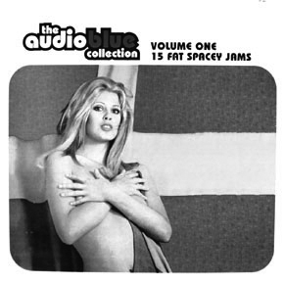
Figure 57: The Audio Blue Collection (1996).

Two features of an unlicensed compilation produced by Vic and Harry called The Audio Blue Collection signal that it was very much a production of the mid-1990s. Firstly, the title and sleeve design represent elements of the porno chic aesthetic: the words 'blue' and 'collection' in the title pastiche how companies like the Color Climax Corporation of Copenhagen branded and compiled retrospective adult films into series on video cassette in the 1990s, and images on the front and rear sleeve are 'stills' taken from 1970s and 1980s adult films. Secondly, Vic confirmed all the recordings compiled on it were taken from library production music LPs he borrowed from a friend. Significantly his description of where his friend found the recordings provides evidence to support Trunk's (2016) claim that in the 1990s, whole collections of library production music on vinyl record were discarded into refuse skips but retrieved by record collectors who were curious to know what kind of music was on them:

My mate In Liverpool’s [finest] second-hand shop, years ago … pulled out some of the best libraries I’ve seen out of a skip at BBC Merseyside. There was a Feelings [Stefano Torossi] in there. He’s like a bit of a hip hop producer and goes, ‘I just got all these mad records, they’ve got library written on the front of them’. I was like, ‘Oh fucking hell’. He showed me them and like 90% ... were like the best library … all the boss ones. I said, ‘I’ll buy ‘em off ya’ and he’s like, ‘No, I’m going to keep ‘em’. He’s not arsed about record collecting, he just wanted something to sample. I was so pissed off. I got the whole collection about ten years later … I did him a good deal. Had to have them though. They were destined for me. There were loads of big pieces.

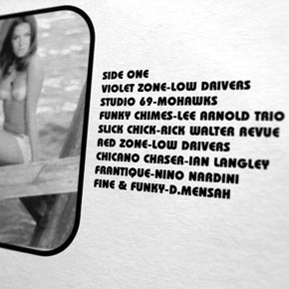
Figure 58: rear sleeve detail of The Audio Blue Collection (1996).

Vic explained how a fortuitous find in a bookshop while looking for records in the US resulted in the striking cover image for Beyond the Valley of the Ultrabeats.

The best thing about that record is when me and Harry were in Brooklyn and we went over to like this magazine shop.There were records in there. Harry was doing the LPs, I was doing the 45s … and then we found the Pam Grier Players spread she did for the black porno mag. She’s just there and you can see her tit, a bit of side muff, you can see her arse. Fucking hell. Pam Grier in the buff! So that’s … Harry's idea, wasn’t it. We’d just be out digging in that vintage magazine shop, just so that we could look at porn, and that’s where we found a good image. But that was just pure spawn [luck] because we saw some boss black mags, then we realised they were porn mags and it was all music-related … I think we got her tits on the other side of that record, or just a nipple.

Vic's delight at finding a photograph of movie star Pam Grier naked to use for the sleeve of Beyond the Valley of the Ultrabeats draws attention to interest amongst record collectors in the 1990s for blaxploitation film soundtracks of the 1970s. Pam Grier was the iconic star of many well-known blaxploitation films, including Coffy (1973) and Foxy Brown (1974). Funk-inspired tracks from various blaxploitation soundtracks such as Cleopatra Jones, Sweet Sweetback's Baadasssss Song, Shaft, Shaft in Africa, Willie Dynamite, Trouble Man and many more appeared on dozens of different unlicensed compilations. As discussed in the chapter that profiled Frank, two series of unlicensed compilations branded Funky Soundtracks and The Chase Scene were dedicated solely to theme and incidental music from blaxploitation films and crime thrillers. They also included funk music soundtracks from thrillers such as The French Connection, Dirty Harry and Bullitt. It may be recalled the Funky Soundtracks series was produced by Frank's assistants Roger and Paul, and it was the slightly earlier appearance of The Chase Scene series that caused them both much consternation.

On the sleeves of their productions Vic and Harry accurately credited recordings taken from ‘big funky’ orchestral albums, Bollywood soundtracks and progressive rock albums, but frequently ‘made-up’ names for recordings taken from library music production LPs. Fear Machines’ Strings of Fear for example, was invented for a recording copied from a French library music LP, as was Jacques Delon’s Hot Dogs. Vic stated they ‘liked to use rude words’: Baby Gravy materialised because ‘President Clinton had just said he’d left baby gravy on Monica Lewinsky’s top’. Vic and Harry concealed the identity of library recordings they selected so that they could accumulate multiple copies of the LPs they had been sourced from before other record collectors identified them. This was Vic's acknowledgment recordings chosen for compilation raised the value of original LPs they were on. Vic maintained he and ‘Harry were on [library records] pretty quick because of Henry’, who had co-produced the first two volumes of Nuggets of Funk with Ray. Vic had ‘seen them around’ but he only got his headphones on to ‘listen, listen, listen’ after Henry had introduced him to some particularly interesting and ‘funky’ tracks. Library music recordings Vic and Harry ‘comped’ on various Planet of the Beats volumes re-appeared a few years later on other unlicensed compilations with their ‘made-up’ names intact:

When [the] Dusty Fingers [series of breakbeat LPs] started coming out, they started copying tracks that we had made up names for … I think they did it with Ray as well. He told us he made up some names ... and then his titles appeared on their LPs.

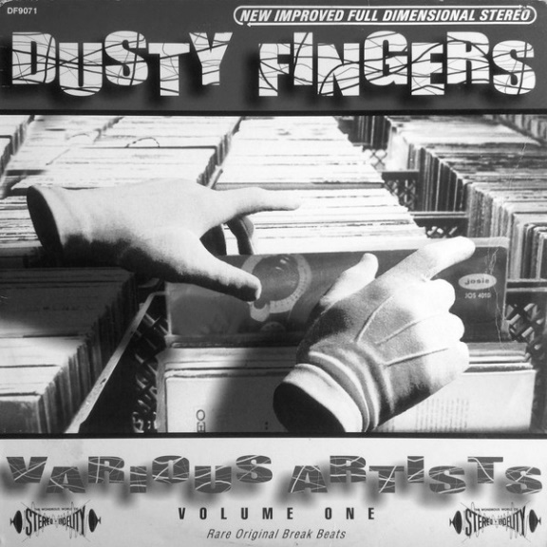
Figure 59: Dusty Fingers (1997).

8.6 SELLING UK RECORDS TO THE US
During a conversation about a particularly successful unlicensed compilation, Vic raised the subject of trips made to the US in the late 1990s in the company of Harry, Ray and Henry. He revealed that in the same way record collectors in the UK were attracted to vinyl records made by Afro-American artists in the 1960s, in the late 20th century record collectors in the US were attracted to vinyl records predominantly made by musicians in the UK and Europe. Relevant to the present context, unlicensed compilations afforded them all, for a short period of time, respect and attention from US record collectors, dealers, and hip hop producers. Ironically, this entanglement with US collectors arose directly from their aptitude for sourcing and compiling obscure recordings, but discussion arose from a conversation about a compilation Vic and Harry produced that aggregated well-known recordings that had never been compiled on one record before. The compilation was called Beastie Boy Breaks and for a period of three months one record shop alone sold around fifty copies of it every week. Vic recalled he and Harry ‘had good fun’ collating many of the recordings the popular group The Beastie Boys had sampled on their best-selling albums and they ended up pressing around five thousand copies, because it ‘just caught on, big time’. They sold copies to shops and distributors for £6 and £5 respectively.

I used to be rich dude, because I was trading so much with America as well bringing in the hip hop LPs and American reissues. No one could touch me ... always had boss stuff. I was making great mark-ups. Plus [record collectors in the US] all wanted our stuff and they were chasing us because of the Planet of the Beats series and stuff. We were getting crazy love from that.

Vic spoke more animatedly about visits to the US in the late 1990s than he had about his first trip there in 1992. One reason for this was that American flea markets sold thousands of soul, funk and jazz records desirable to UK collectors at ‘a dollar each’, because US citizens were upgrading their music collections from vinyl record to CD at the same rate as people in the UK.

All the diggers back in the day, in New York [went there]. Loads of people would set up stalls. Loads of records. Thousands of LPs, a dollar each. Got loads of stuff ... Bryan and that, they’d just take the whole fucking warehouse. Container shebang. They were all rigged up to do that … Probably cost him a grand and they’re getting what? 50,000 45s? Even if you sell them a quid a piece ... They were just buying the black music ones. Fucking on it.

When first Vic visited America alone in 1992, his flight out, flight home and budget for buying records had all been paid for by his friend from the Northern Soul scene. In the late-1990s, his numerous trips with friends were self-funded. Transformative piracy—’banging out records’—had made him wealthy. He maintained the unlicensed compilations he had produced with Harry were ‘hot as fuck’ in US record shops, as were original UK albums they transported there to sell. Collectively unlicensed compilations, and an assortment of UK records sourced from charity shops and car boot sales, ‘paid for the trips’:

I was getting invited to Lord Finesse’s house and everyone wanted to hang out with us and shit. Me and Harry we had boss records like, and everyone wanted loops didn’t they? Walking through ‘No Claims’ your fucking shoulder felt like it was about to fall off … We were minted because we were selling so many friggin’ records, and it was so cheap out there. We just partied, buying everything, especially Harry, he’s the king of spending money … There was good hip hop going on and that was all the fashion then, weren’t it?

Unlicensed compilations were popular because by the mid-1990s, original and pirated copies of Lenny Robert's UBB compilations were ubiquitous throughout the US and Europe (Valyi, 2010, ). Pirated copies of a similar series called Super Disco Brakes were also easy to find. A distributor interviewed for this study recalled volumes from both series were occasionally given away in some London record shops, pushed into plastic bags as free gifts for customers who had purchased other goods. By this time the breakbeats on these recordings had been sampled many times over by amateur and professional producers all over the world, so new material to sample was welcomed. Vic asserted the same state of affairs existed in the US: hip hop producers there wanted ‘fresh breaks’, but UK and European releases were hard to find. In the 1970s and 1980s UK dealers had continually shipped container loads of old US records to the UK, but no US dealers had shipped container loads of old UK records to the US.

Vic explained that Henry, Ronnie the reissue record label owner, and a few others were the first transformative pirates to travel to the US to sell UK produced unlicensed compilations and original UK records. Vic and Harry eventually ‘hooked up with Henry’ and went. In comparison to his earlier visit ‘all the trendy [record] shops’ had caught up with the demand for old US funk records’ but now wanted European library production music albums and UK easy listening LPs that had ‘funky’ orchestral tracks on them. Vic would swap, sell or trade ‘all the easy listeners, and all the sick Euro loops’ for ‘big funk LPs, and boss funk 45s, and breaks 45s’ that US collectors did not ‘gave a shit about’.

[We took over] Klaus Wunderlich [LPs], stuff like that. British record see? All the Jean Jacques Perrey ones, because every programme you turned on [had that] E.V.A. [track] on, but over there, you couldn’t get it. We’d have some like, cos it was European only really. They were just selling them to your Pete Rock’s and what-have-you … Hip hop [producers] had money for that sort of thing. Playschool Breaks, that Procol Harum Salty Dog LP with the shitty drum break, they always wanted that. That gospel one on Music For Pleasure with the drum break, they loved that. Oh Happy Day ... or something.

The records Vic cited were relatively easy to find in UK record shops, charity shops, or at car boot sales and could be purchased for as little as 50p or £1. Klaus Wunderlich's eerie-but-funky version of Gershwin's classic ‘Summertime’ was available in the UK on several budget-priced Wunderlich compilation albums. The BBC Records Playschool LP contained an open drum break on the track called ‘Bang on the Drum’ and although Jean-Jacque Perrey's E.V.A. was easier to find in Europe, Ray managed to find a copy in a local record shop on the same day Henry had asked him to look out for it. Vic mentioned several other albums he transported to the US.

The Hanged Man OST [original soundtrack] was a legendary one ... There would be a copy in New York and everyone would be talking—’A1 [record shop] or such-and-such has got The Hanged Man OST hanging on the wall’. They were $150 to $200 back then … And some of them Italian libraries … they were fucking rare, and … fucking brilliant. That’s why they are £400 now when they pop up on Ebay. Still collectable … I was finding them. What’s the biggest Conroy library? I had four copies of Stefano Torossi Feelings ...

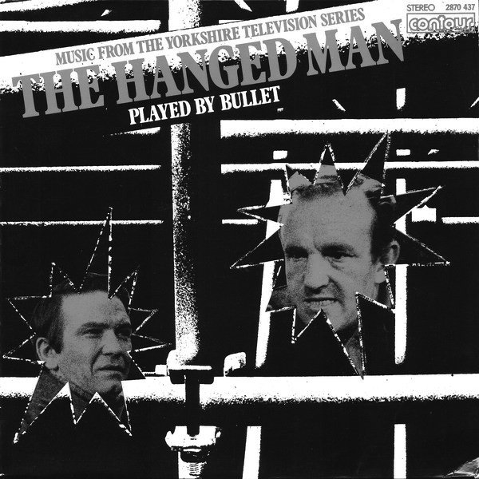
Figure 60: The Hanged Man OST.

Record shops traditionally positioned rare and expensive LPs on the wall. The Hanged Man was a budget label release of the soundtrack to an original Yorkshire Television series, and the recordings on it were entirely sourced from two 1976 library music albums composed by Alan Tew for Themes International Music called Drama Suite 1 and 2. Both albums are now collectable and expensive. The Hanged Man OST was a rare example of 'funky' library music being made available commercially: all the music in the series was taken from two library production music LPs that had never commercially available to the public. In the 1970s, UK film and television producers created bleak crime dramas, such as Get Carter and The Hanged Man, and selected tracks from these also found their way onto numerous unlicensed compilations.

It needs no revision that these exchanges of US records to the UK, and UK records to the US represent a further example of regimes of value, but this does not wholly explain the appeal of these records to the recipients. One theoretical explanation is disconnectedness theory. Harris (2013, 13) observed:

[We] tend to reserve a special type of appeal for music that is from locations far away or disconnected from us ... Our biases and understandings about the source of a cultural object often inform our evaluations’ ... one of the questions is whether that appeal is based on the inherent uniqueness or qualities of the music or whether our interpretation of the music alters its appeal, given that we know the music's source is foreign to us.

Disconnectedness theory also offers a way to understand the appeal of records made by mainstream light entertainers in the 1980s to record collectors in the 21st century. Harris suggested ‘disconnectedness plays a critical role when such sources are seen as socially distant or dissimilar, such as members of subcultures, those considered exotic or foreign, or artists who are economically and psychologically disadvantaged’ (ibid, 16). Evident here are ideas about the appeal of foreignness. In an examination of ethnocentrism, Geertz (2000, 70) noted that when the philosopher Levi-Strauss was invited to deliver a lecture to open The International Year to Combat Racism, he upset his UNESCO hosts by suggesting ethnocentrism was ‘not only not in itself a bad thing, but… if it doesn't get out of hand, rather a good one’:

If… human societies exhibit a certain optimal diversity beyond which they cannot go, but below which they can no longer descend without danger, we must recognise that, to a large extent, this diversity results from the desire of each culture to resist the cultures surrounding it, to distinguish itself from them–in short to be itself. Cultures are not unaware of one another, they even borrow from one another on occasion; but, in order not to perish, they must in other connections remain somewhat impermeable to one another.
(Levi-Strauss, 1985, cited in Geertz, 2000, 70)

Geertz (2000, 71) expanded on this by suggesting that, if diversity between cultures did not create a sense of enchantment, it could in the very least generate feelings of ‘indifference, and thus integrity’. Relating this to cultural production, he asserted that truly diverse creation relied on being deaf to, or even rejecting, other values, and extended this argument to suggest the greatest creativity of all resulted from a certain level of communication between cultures:

The great creative eras were those in which communication had become adequate for mutual stimulation by remote partners, yet was not so frequent or so rapid as to endanger the indispensable obstacles between individuals or groups or to reduce them to the point where overly facile exchanges might equalise and nullify their diversity.
(ibid, 71–72)

This perspective offers a way to explain the appeal of Afro-American musical genres to many UK club cultures. Reviewing a television programme about Northern Soul on his personal blog, a respected expert on Northern Soul called Tim Brown drew attention to the sense of disconnectedness that made it unique.

The Northern Soul scene ... was the first meaningful youth culture built around music from another time and place ... music that had largely failed in its country of origin, music that in its originations and its availability put it beyond the control of the UK record companies and British radio. That the kids couldn’t be told what to do and that the makers of the music had no conception that a latter-day demand existed is to my mind the essential facet of the Northern Soul enigma. In promoting music, often of real quality, that had been left, covered in the dust of the ghettos, there is a sense of some worth and pride.
(Brown, 2007, np)

8.7 COUNTERFEITS
Vic expressed no reservations about his transformative piracy, but prefaced a confession he had counterfeited records with the words ‘I shouldn't really confess to this, but …’. A record shop owner had asked Don to counterfeit an original soundtrack LP called Three Days of the Condor and he refused, but counterfeited unlicensed compilations. In response to a request from his contact at the distribution company Lawless, Frank pirated an album by Afrique called Soul Makossa, and packaged it in a sleeve designed by Ray. The same record shop owner who had asked Don to make counterfeit copies of Three Days of the Condor asked Vic if he would make counterfeit copies of the original soundtrack to the film Barbarella.

I did 2,000 on … the Barbarella soundtrack. I did a few naughty ones like that. Just through the same company. I did The Italian Job as well. With the Barbarella thing, the distributor came to me and said ‘Why don’t you do that?’… and they took 2,000 off me at pre-order. Then [name] from [named record shop] came to me and said, ‘Why don’t you do that with The Italian Job?’… He said people asked for it every day. He did that 7” Roy Castle boot, the voodoo thing ... and a few other high end things like that as well. I think he may have done The Wickerman 7”? ... He always did the high end booties.

All of subjects of this study produced counterfeits, but three of them spoke about it guardedly, as if they knew they had crossed a moral line and had let themselves down in some way. Their conception of counterfeiting as a piratical taboo is puzzling, but aligns with its vilified status in literature on piracy. Ray did not admit to it, but Frank was clear Ray had helped him to counterfeit the sleeve of Afrique Soul Makossa. The pre-order of 2,000 counterfeit copies of the Barbarella original soundtrack suggests distributors believed consumers had no reservations about buying them. Common sense suggests that given rarity creates demand in the first instance, few consumers buying a brand new copy of a twenty-five year old album would believe they were buying an original copy.

8.8 THE END OF AN ERA: PLAYSKOOL BREAKS (2003)
Vic described an unlicensed compilation he made alone in 2003 as an ‘end of an era record’. He named the compilation Playskool Breaks, said he ‘banged out a thousand over a couple of months’, but to him this represented a slow-down. He observed that ‘across the board, across the music industry, there was a recession that was just killing it’, but then made an interesting point about how the recession altered conventions of cross-trading.

I went through two of those times. Just boof! Half our records were going to Japan at one point, when we all first started. It was fat. Three, four grand cheques were coming in and it was all Japanese money. It just dropped off overnight. I went through a distributor in the UK … We could export things then; it was cheaper he pound wasn't as strong. [But] it got to a point where the pound got so strong that the Americans wouldn't pay us cash … couldn't afford 4 or 5 pound for a record, it was like, 9 dollars for that. That's when we all started trading. I used to do special export price anyway, like £4 as opposed to £5 for a British dealer. But … they couldn't pay that after a while. You don't want someone in America owing you money … So we'd just trade a thousand of my records for a thousand of theirs.

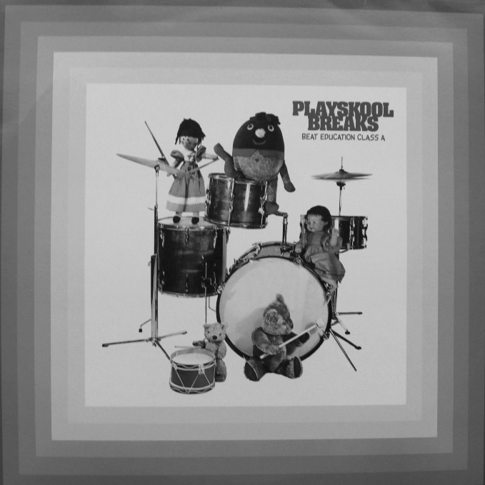
Figure 61: Playskool Breaks (2003).

8.9 SUMMARY
Vic's story revealed how a variety of different scenes intersected and overlapped in the 1990s. He provided evidence unlicensed compilations produced in the 1990s cannot be solely defined as either breakbeat LPs or responses to music played in club cultures: unlicensed compilations were made subjectively as personal responses to prevailing circumstances. Vic was adamant "no one was interested in breaks" when he made Fully Loaded in 1995: for himself and his contemporaries it was "all about the funk and the jazz". But he then qualified his Valley of the Beats series was produced in response to demand that emerged later:

The breaks thing kicked in a bit later with Nuggets and all that shit... putting library tracks on [along with things like] Three Is The Magic Number and all that. That was the biggest record. It was like the biggest tune. You couldn’t go anywhere without hearing it.

These comments draw attention once again to why one focus of this study was to ascertain whether unlicensed compilations were breakbeat LPs or produced in connection to club cultures. As someone who made breakbeat LPs himself, Vic understood they were only one part of the story. Vic's own assessment unlicensed compilations reflected interest in soul, jazz and funk recordings in 1995 and was followed "a bit later" by an interest in breaks and beats - is subjective. His viewpoint was constructed from the perspective of a transformative pirate whose first production - Fully Loaded - was produced at a time when his "business" was playing soul, jazz and funk recordings in pubs, clubs and bars to crowds who liked to have "a little dance". Adding a personal touch Vic named the record label for Fully Loaded 'Rahsaan', because at the moment in time he compiled it he loved the music of Rahsaan Roland Kirk.

Becker (2006) argued if academics wanted to accurately represent what happened in past societies it made "more sense to see... artefacts as the frozen remains of collective action" (p.15). Vic thought Fully Loaded was “not a bad comp... full of good quality soul and funk”. It included records from his personal record collection he had played at "loads of little jazz nights and Acid Jazz nights”. The content of Fully Loaded was therefore personal, but also informed by social, collective activity. In his classic study called The System of Collecting, Baudrillard (1994) argued "the miracle of collecting" lay in the fact "it is invariably oneself that one collects". Every transformative pirate in this study was a record collector and evidence in this study has suggested that in the content of their productions it was themselves they compiled.

9 Conclusion
Portraits of four music pirates were presented for the purpose of answering the research question:

Unlicensed compilations of soul, jazz, and funk recordings on vinyl record in the UK in the 1990s: who was responsible for producing them, why did they do it, how did they do it, and what do they think about it now?

From their narratives, practices of transformative piracy have been described and analysed primarily for the purpose of making a contribution to literature on music piracy. Research was focussed on how and why they produced, distributed and sold unlicensed compilations, and how their musical tastes, sociality, agency and motivation affected the content of the products they made. This approach enabled differences to be parsed between them as social individuals engaged in collective activities to produce artworks: unlicensed compilations of music on vinyl record.

Music pirates who practiced transformative piracy to produce unlicensed compilations of soul, jazz and funk recordings on vinyl record in the 1990s were predominantly UK-based record collectors who either worked in distribution and retail sectors of the music industries or operated independently outside of them record dealers. The transformative pirates interviewed for this study revealed the names of many others who ordinarily worked in record shops, distribution companies, pressing plants, and the music business. Whether they compiled recordings alone or with others, they coalesced into loose networks of collective activity to ensure compilations were manufactured, distributed and sold. This study has confirmed numerous unlicensed compilations on vinyl record, classified by hip hop scholars as ‘second wave’ breakbeat compilations, were compiled and produced in the UK, and sufficient evidence has been presented to claim the production of unlicensed compilations of soul, jazz, funk and other music on vinyl records in the 1990s represented an art world.

Becker (2006, 301) concluded the formation of successful art worlds—worlds that produced artefacts historically accepted by audiences as a form of art recognisable as a unified phenomenon—depended on innovators who won ‘organizational victories’: the success of innovators depended on their ability to construct ‘the apparatus of an art world’ by mobilising ‘enough personnel to cooperate in regular ways that sustained and furthered their idea.’ The innovatory aspect of transformative piracy was that it represented a coming together of conventions and practices from different worlds to create artefacts that were similar enough to be categorised by those who purchased them as a unified body of work. Moreover the production of unlicensed compilations was regular and sustained because conventions were established and practices were shared. Information about where to get records pressed, how many to press, how to get them distributed—‘knowing who's who and what's what’—were passed between transformative pirates and those interested in becoming transformative pirates. The transformative piracy of soul, jazz and funk recordings in the 1990s was a form of collective, social, non-institutionalised activity that produced ‘its own affective and aggregative identity affects, its own modes of imitation or contagion’ (Tarde, 1969; in Born, 2015, 362).

Unlicensed compilations were manufactured by pressing plant employees, handled by staff in distribution warehouses, and were seen being delivered to record shops or market stalls. As tangible, material artefacts produced by transformative pirates, the presence of unlicensed compilations in these spaces produced more transformative pirates: record collectors saw them as the product of record collections owned by other record collectors, and networks of record collectors coalesced to produce vinyl records sufficiently similar to be identified by their peers as a novel body of work. The production and reception of unlicensed compilations exemplified ‘music's capacity to animate imagined communities’ (Born, 2015, 362). As advocates for old, lesser known, and occasionally rare recordings of soul, jazz and funk music, transformative pirates and the compilations they produced aggregated ‘adherents into virtual collectivities and publics based on musical and other identifications.

As the 1990s progressed, unlicensed compilation content reflected contemporary trends in UK club cultures and record collecting. In the rare groove scene of the late 1980s, DJs played 1970s funk recordings and dancers adopted 1970s fashions; when funk-oriented recordings from 1970s thriller and blaxploitation film soundtracks began to be included on unlicensed compilations in the early 1990s, transformative pirates in the UK ensured funk-oriented themes and incidental music from 1970s television programmes and films produced in the UK were not excluded. In the early 1990s record collectors enthused about vinyl records from the 1960s, 1970s, and 1980s they had never seen before—library music LPs—and by the mid-1990s transformative pirates compiled 'funky' recordings selected from these records. Unrestricted by impositions copyright owners may have enforced on what recordings they could, or could not have used, transformative pirates produced unlicensed compilations that reflected aesthetic changes in record collecting and club cultures that prevailed at the time of their production. But the content on compilations did not convey entirely accurate snapshots of musical moments in time because as this study showed, content was influenced in major and minor ways by a variety of social, cultural, economic, and personal factors.

Content changed when demand from consumers began to influence what transformative pirates produced. All four subjects who were the focus of separate chapters started out as transformative pirates but ended up making counterfeits. A significant point to be made here is they produced unlicensed compilations because they wanted to, but produced counterfeits when requested to do so by people employed in distribution and retail sectors of the music industries. From this perspective it is understandable why some academics asserted transformative piracy was creative, but counterfeiting was not. When Don, Ray, Frank and Vic became counterfeiters they supplied a demand for existing products, but as transformative pirates they created a demand for products that had never existed before. Don was correct to suggest that he and others manufactured a market, and that market gifted Ronnie and Alex skills they were able to transfer to reissue labels, while Paul transferred his to the specialist marketing divisions of several major record companies.

Transformative piracy proliferated in the UK in the 1990s because it was a generative phenomenon: every new unlicensed compilation created demand for further iterations because resources mobilised to produce them—recordings on old vinyl records—were abundant. As more and more unlicensed compilations materialised, other record collectors emerged who felt they could produce better ones. Like the northern soul scene, knowing about records others knew little about was vital, and the northern soul scene was one reason why the production of unlicensed compilations in the UK continued throughout the 1990s. Unique musical, social, and cultural features of soul-based club cultures—and the northern soul scene in particular—engendered the importation of thousands of old US recordings of soul, jazz, funk and other musical genres into the UK in the 1970s and 1980s. As new generations of UK record collectors with different aesthetic values approached the abundance of imported US recordings they looked for different kinds of records. Funk and deep soul recordings cast aside by northern soul collectors in the 1970s began to be of interest to record collectors involved in the UK club cultures of hip hop, rare groove, and deep funk in the 1980s and 1990s. One key finding of this study is that the abundance of recordings imported to the UK that fuelled the northern soul scene, fuelled later scenes and the music piracy these scenes engendered.

The nature of compilations produced by the music pirates interviewed for this study was influenced by social and cultural circumstances specific to their environments.
Internal conversation informed decisions to produce piratical products and was followed by actions that propelled each of them towards unique projects. Don ‘got tired’ of asking the French compiler to re-press Pure Volume 1, so re-pressed it himself. Ray memorised prices of obscure records from mailing lists, purchased them cheaper elsewhere, and then transferred what he had learned about regimes of value to his collecting, dealing and piracy. Frank watched Tambourine Tony selling compilations on cassette tape, adopted the idea, and later produced compilations on CD-R for a distribution company to ship to Japan. Decisive questions about art works, and answers to those questions, can be found in areas of intersection between content, material processes of creation, general social conditions, and purpose (Williams, 1983, 43). Focussed on personal, social and cultural aspects of production, this study has answered questions about transformative piracy that could never have been ascertained from observation of unlicensed products alone.

It was shown in chapter 4, that the content of Lee's untitled compilation was generated by his regular communication with a US record shop owner. Lee wanted to hear US recordings that were unfamiliar to him, and the shop owner wanted to know what recordings were played in UK club cultures. Their exchange of recordings on cassette tape evolved into a compilation on vinyl record that contained selections of music valued by record collectors and club-goers in different countries. Observation of their finished product alone would revealed nothing of this. Similarly Rhythms of the Ancients was compiled by one transformative pirate to repay a debt to another; unlicensed compilations produced in France were counterfeited by a transformative pirate in the UK; a transformative pirate produced a series of unlicensed compilations of library music recordings, spoke out publicly against music piracy, and forced a fellow music pirate to repress an unlicensed compilation because it contained a recording he licensed for his reissue label. Conflict was as much a part of this world as collective activity.

The evolution of transformative piracy mirrored the way the music industries evolved in industrial societies. Don and Ray both produced unlicensed compilations in response to perceived market demand. In his initial attempts to exert aesthetic control over content, Don championed the inclusion of rare, obscure or previously ‘un-comped’ recordings, but ceased when he experienced lucrative economic return from unlicensed compilations created by record shop staff who knew what recordings their customers wanted. This transition mirrored that of established record companies and cultural service providers in the twentieth century that attempted to impose their authority over media content but eventually yielded to popular demand from markets. Frith (1987, 287) suggested record companies moved away from educating audiences to providing a service for them.

9.1 AREAS FOR FURTHER RESEARCH
This research project, and the literature review in particular, was hampered by numerous gaps in the academic record. Despite the popularity of the UK jazz-funk scene in the 1970s, there have been no academic studies of it. Cotgrove (2009, 21–24) offers a tantalising glimpse of this musical culture, and the ‘jazz-funk tribes’ that were an integral part of it (21–24), but while the dry bones of mod and punk subcultures have been forensically picked over, the jazz-funk scene patiently awaits a research student or seasoned academic to discover what riches it has to offer. Literature on UK club cultures in the 1980s and 1990s in general has remained stubbornly focussed on highly populated scenes at the expense of smaller ones. In the course of reviewing literature I could find no academic studies on rare groove, acid jazz, deep funk or easy listening scenes, and yet all these were well-documented in music and lifestyle magazines throughout the 1980s and 1990s. In academic literature on UK record shops, specialist black music shops are conspicuously absent. Advertisements in Black Echoes offer a glimpse of social groups that coalesced around recorded music, clubs and records shops that remain wholly unexplored in academic writing on popular music.

Data obtained in this study has drawn attention to formal and informal ways vinyl records were distributed, from ‘bag boys’ to record dealers with mailing lists, to major distribution companies. The latter provided insights into transgressive practices by personnel in major distribution companies and pressing plants, but academic studies on their legitimate operations would have provided a better foundation for both comparison, and understanding more about how they were organised, daily routines, systems, and so forth. Data on the independent, informal distribution practices of Don, Ray and Vic suggests a study purely focussed on record dealers who catered for aesthetic or taxonomic record collectors in various music scenes or club cultures could make a further contribution to literature on the consumption of popular music. Frank's story revealed record companies that over-produced brand new records and developed numerous marketing strategies to compel consumers to buy them had fewer strategies to deal with much greater abundance of records that never sold. Research focussed on how record companies used distribution companies, free records, and promotional items to promote their artists could make a further contribution to transgressive practices within sectors music industries. As a result of this study any future research on reissue record labels should pay close attention to how old recordings are licensed, and the musical, social and cultural backgrounds of reissue record label owners.

This study has made a contribution to literature on music piracy, and transformative piracy in particular. The voices of music pirates speaking about what they did, why they did it, and what they think about it now, have been foregrounded. As a result of listening carefully to what they had to say about how and why they became music pirates, the sociality of their practices has been revealed. The life stories of Don, Ray, Frank and Vic were selected from the eight transformative pirates interviewed only because they were connected to each other, but in hearing about those connections, they provided information about many other pirates, and it is evident they formed only one part of a much wider network.

Lee, whose one unlicensed compilation was discussed in chapter 4, did not know, or know of Don, Ray, Frank and Vic. It is evident from this and other data shared here, that there were other networks of transformative piracy. A study of those networks could reveal whether all pirates who made transformational use of recordings were social, or whether all transformative pirates moved on to become counterfeiters. Academics already speak about a sociology of music, but with further research space may open up to speak about a sociology of music piracy. I believe a sociology of music piracy would make a significant contribution to academic literature on popular music and the music industries.

Bibliography
Abrams, L. (2016) Oral history theory (2nd Ed.) Oxford: Routledge.
Adonis, A. (2012) Education, education, education; reforming England’s schools. London:
Biteback.
Adorno, T. W. ([1938] 1978) ‘On the fetish character of music and the regression of listening’, in Arato, A., Gebhardt, E. The essential Frankfurt school reader. London: Blackwell.
Aldave, C. (2003a) ‘Funk equation = Stubblefield + Starks, part I: Clyde Stubblefield, in Wax Poetics, Issue 4, 46–51.
Aldave, C. (2003b) ‘Funk equation = Stubblefield + Starks, part II: John “Jab’o” Sparks, in Wax Poetics, Issue 5, 40–46.
Alderman, J. (2001) Sonic boom: Napster, MP3 and the new pioneers of music. Massachusetts:
Perseus.
Allan, D. (2006) 'Effects of popular music in advertising on attention and memory', Journal of Advertising Research, December 2006, 434–444.
Allen, G. (2000) Intertextuality. New York, NY: Routledge.
Allen, J (2004) 'Academic archive volume VI, Part II: accessing the past in Eldred v. Ashcroft (01608) 239 F.3d 372 affirmed', Wax Poetics, issue 7, (winter), 12–15.
Anderson, C. (2009) The longer long tail method: How endless choice is creating unlimited demand. London: Random House Business Books.
Anderson, F.J. (2016) The blaxpolitation encyclopaedia. CreateSpace Independent Publishing Platform (Amazon).
Anderson, J.L. (2001) 'Piracy and World History: An Economic Perspective on Maritime Predation', in C.R Pennell (ed.), Bandits at Sea: A Pirates Reader, 82–106. New York: New York University Press.
Anderton, C., Dubber, A., James, M., (2013) Understanding the music industries. London: Sage.
Appadurau, A. (ed.) (1986) The social life of things. Cambridge: Cambridge University Press.
Archer, M. S. (2007) Making our way through the world: human reflexivity and social mobility.
Cambridge: Cambridge University Press.
Arvantikis J., Fredriksson, M. (eds.) (2014) Piracy: leakages from modernity. Sacramento: Litwin Books.
Athique, A. (2008) 'The global dynamics of Indian media piracy: export markets, playback media and the informal society', in Media, Culture and Society, vol.30, no.5, 699–727.
Atsushi, O. (2010) ‘‘Pirates or entrepreneurs?’ The migration and trade of sea people in Southwest Kalimantan, c. 1770–1820’, Indonesia, October, Vol. 90, 67–95.
Attali, J. (1985 [2014])Noise: the political economy of music. Minneapolis and London: University of Minnesota Press.
Aufderheide, P (2015), in Schwarz, J.A., Burkart, P., Aufderheide, P., Jaszi, P., Kelty, C., Coleman, G., 'Piracy and Social Change: Roundtable Discussion', Popular Communication, Vol.13, 87–97.
Avalon, M. (2009)Confessions of a record producer: how to survive the scams and shams of the music business (4th edition). New York: Backbeat Books.
Bakhtin, M. M. (1981) The dialogic imagination: Four essays (C. Emerson and M. Holquist, Trans.). Austin, TX: University of Texas Press.
Baldwin, P. (2014) The copyright wars: Three centuries of transatlantic battle. New Jersey:
Princeton University Press.
Barfe, L. (2004) Where have all the good times gone: the rise and fall of the record industry.
London: Atlantic.
Barthes, ([1967] 1993) Image music text. London: Foundation.
Bartmanski, D., Woodward, I. (2015) Vinyl. London: Bloomsbury.
Bazeley, P., Jackson, K. (2013) Qualitative data analysis with NVivo. London: Sage.
Becker, H. S. (1951) 'The professional dance musician and his audience', American Journal of Sociology 57, Vol.2, 136–144.
Becker, H. S. (1963) Outsiders. New York: Free Press.
Becker, H. S. (1982) Art worlds. Berkley and Los Angeles: University of California Press.
Becker, H.S. (2007) Telling about society. Chicago: University of Chicago.
Becker, H.S. (2014) What about Mozart? What about murder? Reasoning From cases. Chicago:
University of Chicago Press.
Belk, R.W. (1995) Collecting in a consumer society. Oxford: Routledge.
Benjamin, W. (2008) The work of art in the age of mechanical reproduction. London: Penguin.
Benkler, Y. (2007) The wealth of networks: how social production transforms markets and freedom. Connecticut: Yale University Press.
Bennett, A. (2013) Music, style and aging: growing old disgracefully. Philadelphia: Temple Press.
Benson, R. (ed.). (1997) Night fever: club writing in The Face: 1980–1997. London: Boxtree.
Benton, T., and Craib, I. (2011) Philosophy of social science: the philosophical foundations of social thought. New York: Palgrave MacMillan.
Bernauer, J.A. (2015) 'Opening the ears that science closed; transforming qualitative data using oral coding', The Qualitative report, Vol.20, no.4, 406–415.
Bhattacharjee, S., Gopal, R.D., Lawrence Sanders, G. (2003) 'Digital music and online sharing', Communications of the ACM, vol.46, no.7, 107–111.
Bitner, J. (ed.) (2009) Cassette from my ex: stories and soundtracks of lost loves. New York: St.
Martin's Griffin.
Blashill,P., Curtis, A.D (et al.) ‘The 500 greatest albums of all time’ Rolling Stone, Issue 937, November 12 2003, 83–178.
Blumer, H. (1939/ 1979) Critiques of research in the social sciences: an appraisal of Thomas and
Znaniecki's Polish peasant in Europe and America. New York: Social Science Research Council (2nd edn, with a new introduction, New Brunswick,NJ: Transaction Books).
Blumer, H. (1969) Symbolic interactionism: perspective and method. Englewood Cliffs, NJ:
Prentice Hall.
Bodó, B. (2014) 'Set the fox to watch the geese: voluntary IP regimes in piratical file-sharing communities' in Fredriksson, M., Arvantakis, J. (eds.) Piracy: Leakages from modernity.
Sacramento: Litwin Books, 19–36.
Bones, B.D (2000) 'Northern soul', Big Daddy, issue 3, 76–77.
Boorstin, E.S. (2004) Music in the age of file sharing. Princeton: Princeton University Press.
Born, G. (2015) 'Mediation theory', in Shepherd, J., Devine, K. (eds.) (2015). The Routledge reader on the sociology of music. New York: Routledge, 359–369.
Bottomley, A. (2015) "Home taping is killing music": the recording industries' 1980s anti-home taping campaigns and struggles over production, labor and creativity', Creative Industries Journal, Vol.8, No.2, 123–145.
Bounie, D., Bourreau, M., Waelbroeck, P. (2006) Piracy and the demand for films: Analysis of piracy behavior in French Universities', Review of Economic Research on Copyright Issues, vol.3, no.2, 15–17.
Bourdieu, P. (1993)The field of cultural production. Cambridge: Polity.
Brackenridge, C. (1998) Encyclopedia of cinematic trash: Vol.1: blaxploitation movies and soundtracks. Glasgow: Storm in a Trashcan Publications.
Brackett, D. (2000) Interpreting popular music. Berkeley, CA: University of California Press.
Brackett, D. (2002) 'Musical meaning: genres, categories and crossover’. In Hesmondhalgh, D., Negus, K., (eds.) Popular Music Studies. London: Arnold. 63–83).
Brackett, D. (2016) Categorizing Sound: Genre and Twentieth Century Music. Oakland:
University of California Press.
Bradley, L. (2013) Sounds like London: 100 years of black music in the capital. London:
Serpent's Tail.
Brennan, M. (2017) When genres collide. London and New York: Bloomsbury Publishing.
Brennan, T. (2008) Secular devotion: Afro-Latin music and imperial Jazz. London: Verso Books.
Brewster, B., and Broughton, F. (2006) Last night a DJ saved my life: the history of the disc jockey.
London: Headline.
Brown, P. (2010) Are we still rolling? Studios, drugs and rock 'n' roll - one man's journey recording classic albums. New York: Tape Op Books.
Brown, T. (2010) The Wigan Casino years. UK: Outta Sight Limited.
Browne, K.L.J. (2005) '"Soul or nothing": The formation of cultural identity on the British Northern Soul scene', PhD dissertation, University of California.
Bryman, A. (2012) Social research methods. (4th edn.) Oxford: Oxford University Press.
Bureau, S. (2014) ‘Piracy as an avant-gardist deviance: how do entrepreneurial pirates contribute to the wealth or misery of nations?’ Int. J. Entrepreneurship and Small Business, Vol.
22, No. 4, 426–438.
Burke, S. (2010) The death and return of the author: criticism and subjectivity in Barthes, Foucault, and Derrida (3 Ed.). Edinburgh University Press.
Burnett, R. (1992) ‘The implications of ownership changes on concentration and diversity in the phonogram industry’, Communication Research, Vol. 19, December 1992, 749 – 769.
Burnett, R. (1996) The Global Jukebox. London: Routledge.
Bynoe, Y. (2005) Money, power, respect: a critique of the business of rap music. In Kelley, N. (ed.) R and B: Rhythm and business: the political economy of black music. New York: Akashic Books.
Calamer, G., Gallo, P. (2009) Record store days. New York: Sterling.
Carson, K. (2016) Trying to Get Over: African American Directors after Blaxploitation, 1977 - 1986. Texas: University of Texas Press.
Chaboud, M-C. (2014) ‘Pirates never sail alone: exploring the mechanics of social entrepreneurship involved in software piracy’, Int. J. Entrepreneurship and Small Business, Vol.
22, No. 4, 519–536.
Chang, J. (2007) Can’t stop, won’t stop: a history of the hip hop generation. US: Ebury Press / Random House.
Chapple, S., Garofalo, R (1977) Rock ‘n' roll is here to pay: the history and politics of the music industry. Chicago: Nelson-Hall.
Cicourel, A.V. (1964) Method and measurement in sociology. New York: The Free Press.
Coleman, G. (2015) in Schwarz, J.A., Burkart, P., Aufderheide, P., Jaszi, P., Kelty, C., Coleman, G., 'Piracy and Social Change: Roundtable Discussion', Popular Communication, Vol.13, 87–
97.
Collins, S. and Young, S. (2014) Beyond 2.0: The future of music. Sheffield and Bristol: Equinox.
Collis, J., Elliott, T (1978) 'The man with the telephone ear: Harvey Goldsmith, rock promoter, extraordinary', Time Out magazine: No. 438, September 15–21, 1978, supplement, p.14.
Conquergood, D. (2007) 'Performance studies: interventions and radical research', in Bial, H.
(ed.),The performance studies reader:Oxford: Routledge, 369–380.
Coombe, R. J. (1998) The cultural life of intellectual properties: authorship, appropriation and the law. Durham and London: Duke University Press.
Corbetta, P. (2003) Social research: theory, methods and techniques. London: Sage.
Cosgrave, S. (2016) Young soul rebels: a personal history of Northern Soul. Edinburgh: Polygon.
Costello, M., Wallace, D.F. (1990) Signifyin' rappers: rap and race in the urban present. New York: Ecco.
Cotgrove, M. (2001) 'The king of the record dealers: an exclusive interview with John Anderson', Big Daddy, issue 7, 74–78.
Cotgrove, M. (2009) From jazz funk and fusion to acid jazz: the history of the UK jazz dance scene. London: Chaser.
Cova, B., Kozinets, R.V.,Shankar, A. (2007) Consumer tribes. Oxford: Routledge.
Creswell, J. (2009) Research design; qualitative and quantitative and mixed methods Approaches. London: Sage.
Creswell, J. W. (1998) Qualitative inquiry abs research design: choosing among five traditions. London: Sage.
Crewe, B. (2003) Representing men: cultural production and producers in the men's magazine market. Oxford and New York: Berg.
Crewe, L., Gregson, N. (1998) ‘Tales of the unexpected: exploring car boot sales as marginal spaces of contemporary consumption’, Transactions of the Institute of British Geographers, Vol. 23, No. 1, (1998), 39–53.
Crisp, V. (2014) 'To Name a Thief: Constructing the Deviant Pirate' in Fredriksson, M. and
Arvantakis, J. (eds.). Piracy: Leakages from modernity. Sacramento: Litwin Books, 19 - 36.
Cummings, A.S. (2013) Democracy of sound: music piracy and the remaking of American copyright in the twentieth century. Oxford: Oxford University Press.
Danet, B., Katriel, T. (1986) Books, butterflies and Botticellis; a life-span perspective on collecting’, paper presented at the Sixth International Conference on Culture and Communication, Philadelphia, Pennsylvania, October.
Danielsen, A. (2006) Presence and pleasure: the funk grooves of James Brown and Parliament.
Middletown, CT: Wesleyan University Press.
Davies, H. (1996) ‘A history of sampling’. Organised Sound, Vol. 1(1), 3–11.
Dawdy, S.L., Bonni, J (2012) 'Towards a General Theory of Piracy', Anthropological Quarterly, Vol. 85, No.3, 673–700.
De Castro, J.O., Balkin, D.B. and Shepherd, D.A. (2008) ‘Can entrepreneurial firms benefit from product piracy?, Journal of Business Venturing, Vol. 23, No. 1, 75–90.
de Jong, T., van Vliet, H. (2014) ‘The Surinam soul scene’, Available at: http://www.sirshambling.com/articles/surinam_soul/index.php (Accessed: 22 October 2017).
Deabill, S., Snowball, I (2013) From Ronnie's to Ravers: personal situations in London clubland.
Hertfordshire: Countdown Books.
Dearlove, R. (1992) ‘Collectors soul’, Voices from the Shadows, issue 19. 64–68.
Deleuze, G., Guattari, C. (1998) A thousand plateaus: capitalism and schizophrenia. London:
Athlone Press.
Demers, J. (2001) ‘Brothers gonna work it out?: echoes of blaxploitation sound in hip hop’, Music Research Forum, 16, 2–19.
Demers, J. (2003) ‘Sampling the 1970s in hip hop’, Popular Music, 22(3), 41–56.
Demers, J. (2006) Steal this music: How intellectual property law affects musical creativity.
Athens, GA: University of Georgia Press.
DeNora, T. (2000) Music in everyday life. Cambridge: Cambridge University Press.
DeNora, T. (2015) 'After Adorno', in Shepherd, J., Devine, K. (eds.) (2015). The Routledge reader on the sociology of music. New York: Routledge, 341–349.
Dent, A.S. (2012) ‘Introduction: understanding the war on piracy, or why we need more anthropology of pirates’, Anthropological Quarterly, Vol. 85, No. 3, 659–672.
Derrida, J. (1967) Of grammatology. Baltimore: John Hopkins University Press.
Dictionary.com (2017) ‘compilation’. Available at: http://www.dictionary.com/browse/compilation?s=t (Accessed: 21 October 2017).
Diener, E., Crandall, R. (1978) Ethics in social and behavioural research. Chicago: University of Chicago Press.
Doctorow, C. (2008) Content: Selected essays on technology, creativity, copyright and the future of music. San Francisco: Tachyon.
Dowling, J. (2008) Just for kicks: The story of my life. UK: J. Dowling Publishing.
Dowling, J. (2010) Just for kicks: The story of your life. UK: J. Dowling Publishing.
Downes, D., Rock, P. (2007) Understanding deviance. Oxford: Oxford University Press.
Dua, J. (2013) ‘A sea of trade and a sea of fish: piracy and protection in the Western Indian Ocean’, Journal of Eastern African Studies, Vol. 7, No. 2, 1–18.
Durand, R. and Vergne, J-P. (2013) The pirate organization: lessons from the fringes of capitalism, Harvard Business Press, Boston.
Eckhardt, J.T. and Shane, S.A. (2003) ‘Opportunities and entrepreneurship’, Journal of Management, Vol. 29, No. 3, 333–349.
Eisenhardt, K.M. (1989) 'Building theories from case study research', Academy of Management Review, Vol.14, 532–550.
Etzkorn, K .P. (1959) 'Musical and social patterns of songwriters: an exploratory sociological study', PhD diss., Princeton University.
Evans, M. (2015) Vinyl: The art of making records. London: Aurum Press Limited.
Facey, F.A (2006) 'Dear Readers', Soul Survivors, issue 1, (July / Aug), p.1.
Facey, F.A (2009) ‘Fitzroy chats to DJ Colin Curtis – Part 1, Soul Survivors, issue 15, (Dec 08/Jan 09), 16–22).
Facey, F.A (2011) 'Fitzroy chats to Gary Dennis', Soul Survivors, issue 28, (Feb/Mar), 10–12.
Facey, F.A (2017) 'Fitzroy speaks with Dez Parkes', Soul Survivors, issue 71, (Aug/Sept), 8–
14.
Facey, F.A (2103) 'Trevor Nelson talks to Fitzroy', Soul Survivors, issue 47, (Jun/Jul), 4–10).
Fairchild, C. (2016) Pop Idols and Pirates: Mechanisms of Consumption and the Global Circulation of Music. London and New York: Routledge.
Featherstone, M. (1991) Consumer culture and postmodernism. London: Sage.
Fellezs, K. (2011) Birds of fire: jazz, rock, funk and the creation of jazz fusion (refiguring American music). New York: Duke University Press.
Fernandes, S. (2011) Close to the edge: In search of the global hip hop Generation. Verso.
Fine, G.A. (2003) 'Crafting Authenticity: The Validation of Identity in Self-Taught Art', Theory and Society, Vol. 32, No. 2 (Apr., 2003), 153–180.
Finnegan, R. (2007) The hidden musicians: music-making in an English town. Middletown CT:
Wesleyan University Press.
Fletcher, T. (2013) Boy about town. London: Heinemann.
Forumusic (2012) 'Home page', Forumusic website, Available at: http://www.forumusic.co.uk/ (Accessed: 21 October 2017).
Frane, A.V. (2017) 'Swing rhythm in classic drum breaks from hip hop's breakbeat canon' Music Perception, Volume 34, Issue 3, 291–302.
Frank, B.B. (2016) Kiss My Baaadasssssss!!!: The Blaxploitation Shopping List. CreateSpace Independent Publishing Platform (Amazon).
Fricke, J., Ahearn, C. (2002) Yes Yes Y'all: The experience music project Oral History of Hip Hop's First Decade. Cambridge, MA: Da Capo Press.
Frith (1996) Performing rites. Cambridge MA: Harvard University Press.
Frith, S., Straw, W., Street, J. (2010)The Cambridge companion to pop and rock. Cambridge:
Cambridge University Press, 95–105.
Gaisberg, F. (1947) Music on record. New York: Hale
Garfinkel, H. (1967) Studies in ethnomethodology. Englewood Cliffs, NJ: Prentice Hall.
Garofalo, R. (1999) ‘From music publishing to MP3: music and industry in the twentieth century.. American Music, vol.17, no.3, (autumn 1999), 318 – 354.
Garratt, S. (1998) Adventures in wonderland. London: Headline.
Geertz, C. (1973) The interpretation of cultures. New York: Basic Books.
Geertz, C. (2000) Available light: anthropological reflections on philosophical topics. New Jersey: Princeton University Press.
Gelatt, R. (1977)The fabulous phonograph, 1877–1977. London: Cassell.
Gilroy, P. (1991) 'Sounds authentic: black music, ethnicity, and the challenge of the changing same'. Black Music Research Journal, Vol. 11, no.2: 111–136.
Gilroy, P. (1993) The black Atlantic. London: Verso.
Godbolt, J. (1990) The world of jazz in printed ephemera and collectibles. London: Studio Editions.
Goddard, G. (2011) Kiss FM: from radical radio to big business. London: Radio Books.
Godfrey, J. (1990) Adecade of i-Deas: the encyclopaedia of the ‘80s. London: Penguin.
Gonzalez, F.L. (1977) Disco-file: the discographical catalog of American Rock and Roll and Rhythm and Blues vocal harmony group. (2nd Ed.) Flushing: Library of Congress.
Grimmelmann, J. (2009) 'The ethical vision of copyright law', Fordham Law Review, vol. 77, no.
5. 2005–2037.
Gronow, P. (1983) 'The record industry: the growth of a mass medium', Popular Music, Vol. 3, January, 53–75.
Gronow, P., Saunio, I. (1999) An international history of the recording industry. London and New York: Cassell.
Hager, S. (1984) Hip hop: the illustrated history of break dancing, rap music, and grafitti. New York: St. Martin's Press.
Halberstam, M. (1988) ‘Terrorism on the high seas: the Achille Lauro, piracy and the IMO convention on maritime safety’, American Journal of International Law, Vol. 82, No. 2, p.269.
Hammersley, M. and Gomm, R. (2000) 'Introduction', in Gomm, R., Hattersley, M. and Foster, P. (eds), Case Study Method. London: Sage.
Hardy, P. (1980) 'Riding the gravy train', Time Out magazine (London), issue 549, October 2430, 12–15.
Haring, B. (1996) Off the charts: ruthless days and reckless nights within the music industry.
New York: Carol Publishing Group.
Harrison, A. (2008) Music: the business: the essential guide to the law and the deals. London:
Virgin Books.
Hatch, D., Millward, S. (1987) From blues to rock: an analytical history of pop music. Manchester: Manchester University Press.
Hatzopolous, P., Kambouri, N. (2014) 'Pirate economies and the production of smooth spaces', in Fredriksson, M., Arvantakis, J. (eds.) Piracy: Leakages from modernity. Sacramento:
Litwin Books, 19 - 36.
Hebdige, D. (1988) Hiding in the light. London and New York: Comedia.
Hebditch, S. (2015) London's pirate pioneers: the illegal broadcasters who changed British radio. London: TX Publications.
Henderson, A. (1988) On the air: pioneers of American broadcasting. Washington: Smithsonian Institute Press.
Herbig, P., Milewics, J. (1994) ‘Evaluating the brand extension decision using a model of reputation building’,Journal of Product and Brand Management Vol. 3, No.1, 39–47.
Hesmondhalgh, D. (1998) 'Post-Punk's attempt to democratise the music industry: the success and failure of Rough Trade', Popular Music, Vol.16, No. 3, 255–273.
Heylin, C. (2003) Bootleg!: the rise and fall of the secret recording industry. London: Omnibus.
Hirsch, P. M. (1972) 'Processing fads and fashions: an organisation-set analysis of cultural industry systems', American Journal of Sociology, vol.77, no.4, 639–659.
Hodder, I. (2012) Entangled: an archaeology of the relationships between humans and things.
Chichester: Wiley-Blackwell.
Holt, F. (2007) Genre in popular music. Chicago: University of Chicago Press.
Horner, J. (1991) 'Thecase of DAT technology: industry versus pecuniary function'. Journal of Economic Issues, 25 (2), 449–57.
Howard, J. (2008) Blaxploitation cinema: the essential guide. London: FAB Press.
Hull, G.P., Hutchison, T., Strasser, R. (2011) The music business and the recording industry (3rd ed.). New York: Routledge.
Humphries, B. (2017) More please: an autobiography. UK: Penguin.
James, R. (ed.) (1992) Cassette mythos. Brooklyn: Autonomedia.
Jamieson, M. (1999) 'The place of counterfeits in regimes of value', The Journal of the Royal Anthropological Institute, Vol.5, No.1 (Mar., 1999), 1–11.
Jenkins (2006) Convergence culture: where old and new media collide. New York: New York University Press.
Jenkins, S. (2007) Thatcher and sons: A revolution in three acts. London: Penguin.
Jie, Y. (2014) 'Cultural resistance or corporate assistance: disenchanting the anti-capitalist myth of digital piracy', in Fredriksson, M., ,Arvantakis, J. (eds.) Piracy: Leakages from modernity. Sacramento: Litwin Books, 195–213.
Johns, A. (2009) Piracy: the intellectual property wars from Gutenburg to Gates. Chicago:
University of Chicago Press.
Jones, G (2010) Last Shop Standing: Whatever happened to record shops? Kent: Proper Music Publishing.
Jones, G. (2016) They danced all night. CreateSpace Independent Publishing Platform.
Jones, S. (2002) ‘Music that moves: popular music, distribution and network technologies’, Cultural Studies, 16(2), 213–232.
Jonkmanns, B. (2015) Record Stores. Berlin: Seltmann + Söhne.
Karaganis, J. (ed.) (2011) Media Piracy in Emerging Economies. New York: Social Research Council.
Kelley, N. (2005) R and B: Rhythm and Business: The Political Economy of Black Music. New York:
Akashic Books.
Kernfeld, B. (2011) Pop song piracy: disobedient music production since 1929. Chicago: Chicago University Press.
King, R. (2015) Original Rockers. London: Faber and Faber Limited.
Kjus, Y. (2016) 'Reclaiming the music: The power of local and physical music distribution in the age of global online services', New Media and Society, Vol 18(9), 2116–2132.
Knab, C., Day, B. (2013) Music is your Business: The Musicians FourFront Marketing and Legal Guide. Seattle: FourFront Media and Music, 4th edn.
Knee, S. (2013) A scene in between: tripping through the fashions of UK indie music 1980–1988. London: Cicada Books.
Knopper, S. (2009) Appetite for self-destruction: The spectacular crash of the record industry in the digital age. London: Simon and Schuster.
Kopytoff, I. (1986) 'The cultural biography of things: commoditization as a process', in Appadurau, A. (ed.) (1986) The social life of things. Cambridge: Cambridge University Press.
Koven, M.J. (2010) Blaxploitation Films. Hertfordshire: Kamera.
Krims, A. (2000) Rap music and the poetics of identity. Cambridge: Cambridge University Press.
Kugelberg, J., Major, P., Daley, M.P. (eds.) (2012) Enjoy the Experience: Homemade Records 1958–1992. New York and Los Angeles: Sinecure Books.
Kusek, D. and Leonhard, G. (2005) The future of music: Manifesto for the digital music revolution. Boston: Berklee Press.
Latour, B. (2005) Reassembling the social: an introduction to actor network theory. Oxford:
Oxford University Press.
Lawrence, N (2012) Blaxploitation Films of the 1970s: (Studies in African American History and Culture). London: Routledge.
Lawrence, T. (2003) Love saves the day: a history of American dance music culture, 1970 - 1979. Durham and London: Duke University Press.
Leeson, P.T. (2009) The Invisible Hook: The Hidden Economies of Pirates. Princeton: Princeton University Press.
Leibenstein, H. (1950) Bandwagon, snob, and Veblen effects in theory of consumers' demand.
Quarterly Journal of Economics, 64 (2), 183–207).
Leland, J., Steinski. (1988) 'The Big Steal'. The Face magazine, March, Vol 1, issue 95, 96100.
Lena, J. C. (2012) Banding Together: How Communities Create Genres in Popular Music. New Jersey: Princeton.
Lessig, L. (2004) Free culture: The nature and future of creativity. London: Penguin.
Lewis, P., Saunders, M., Thornhill, A. (2007) Research methods for business students. Essex:
Pearson Education Limited.
Lewis, R. (1990) 'Record bootleggers tap into niche market', Los Angeles Times, 9 November, p.25.
Liang, L. (2005) 'Porous legalities and avenues of participation'. Sarai Reader, 5, 6–17. Retrieved
10 July 2013, from /// http://www.sarai.net/journal/05_pdf/01/02_lawrence.pdf
Liang, L. (2009) 'Piracy, creativity and infrastructure: Rethinking access to culture'. Working paper. Retrieved 15 September 2017, from http://ssrn.com/abstract=1436229
Lias, J. (2016) Spinning Around: The History of the Soul LP. East Sussex: Lias publishing.
Lindlof, T.R., Taylor,B.C. (2011) Qualitative communication research methods (3rd ed.).
Thousand Oaks, CA: Sage.
Lopes, P. (1992) "Innovation and diversity in the popular music industry, 1969 to 1990", American Sociological Review, February, 1992, Vol. 57, February, 56–71.
Lopes, P. (2002) The rise of a jazz art world. Cambridge: Cambridge University Press.
López Nadal, G. (2001) 'Corsairing as a commercial system: The edges of legitimate trade', in C.R Pennell (ed.), Bandits at sea: a pirates Reader, 125–136. New York: New York University Press.
Lovatt, A. (1996) 'The ecstasy of urban regeneration: regulation of the night-time economy in the transition to a post-Fordist city', in O'Connor, J., Wynne, D. (eds) From the margins to the centre: Cultural production and consumption in the post-industrial city. Hampshire: Arena,
91–117.
Lovell, N. (2013) The curve: turning followers into superfans. London: Penguin Books.
Lubich, D. (2012) Catch the beat: the best of Soul Underground 1987 - 91.
London: DJhistory.com.
Lury, C. (1993) Cultural rights: technology, legality and personality. London: Routledge.
Maalsen, S. (2016) ‘Reissuing popular music heritages: the materiality of the niche reissued record and challenging what matters’, Popular music and society, vol.39, no. 5, 516–531.
Machin, D. (2013) Analysing popular music: image, sound, text. London: Sage.
Maffesoli. M. (1996) Time of the tribes. London: Sage
Mahood, G., Bones, B.D. (1999) 'Keb Darge: legendary deep funk', Big Daddy, issue 1, summer, 6–10.
Mahood, G., Bones, B.D. (2000) 'Ian Wright: The praying mantis of funk 45s', Big Daddy, issue 3, 67–68.
Mahood, G., Bones, B.D. (2000) 'Jazzman records: A profile of a connoisseurs reissue label', Big Daddy, issue 3, p.72.
Malbon, B. (1999) Clubbing: dancing, ecstasy and vitality. London: Routledge.
Manandhar, N. (2014) What we wore: a people's history of British style. London: Prestel.
Mansbach, A., Rudder, D. (1997 [2005]) 'Artist&industry, or how not to get jerked'. Hip Hop Elementary Roundtable discussion, Elementary magazine, Spring 1997. In Kelley, N. (2005) R and B: rhythm and business: the political economy of black music. New York: Akashic Books.
Marshall, B. (2007) Berlin Bromley. London: SAF Publishing.
Marshall, L. (2003) 'For and against the record industry: an introduction to tape traders'.
Popular Music, Vol 22/1, 57–72.
Marshall, L. (2005) Bootlegging: romanticism and copyright in the music industry. London:
Sage.
Martin, P. J. (1995) Sounds and society: themes in the sociology of music. Manchester:
Manchester University Press.
Martinez, G. (1998) What it is... What it was!: The black film explosion of the '70s in words and pictures. New York: Hyperion.
Mason, J. (2002) Qualitative researching, (2nd Ed).London: Sage Publications.
Mazor, B. (2015) Ralph Peer and the making of popular roots music. Chicago: Chicago Review Press.
McLeod, K. (1999) ‘Authenticity within hip hop and other cultures threatened with assimilation’, essay,International Communication association.
McNair, B. (1996) Mediated sex: pornography and postmodern culture. London: Arnold.
McSmith, A. (2011) No such thing as society. London: Constable.
Medosch, A. (2003) ‘Piratology: the deep seas of open code and free culture’, in Medosch, A.
(Ed.): Dive. An introduction into the world of free software and copyleft culture, Fact, London.
Meese, J. (2014) 'The pirate imaginary and the potential of the authorial pirate'.
Menn, J. (2003) All the rave: The rise and fall of Shawn Fanning’s Napster. New York: Crown Business.
Merriam, A.P. (1964)The anthropology of music. Evanston: Northwestern University.
Merriden, T. (2001) Irresistable forces: The business legacy of Napster and the growth of the underground internet. Oxford: Wiley.
Middleton, J., Beebe, R. (2002) 'The racial politics of hybridity and 'neo-eclecticism' in contemporary popular music', Popular Music, vol.21, no.2, 159–72.
Middleton, R. (1990) Studying popular music. Milton Keynes, UK: Open University Press.
Milestone, K. (1996) 'Regional variations: northernness and new urban economies of hedonism', in O'Connor, J., Wynne, D. (eds) From the margins to the centre: Cultural production and consumption in the post-industrial city. Hampshire: Arena, 91–117.
Millard, A. (2005) America on record: a history of recorded sound. New York: Cambridge University Press.
Mitchell, T. (ed.) (2002) Global noise: rap and hip hop outside the USA. Hanover, NH: Weslyan University Press.
Mole, P. (1996) 'Fordism, Post-Fordism and the contemporary city', in O'Connor, J., Wynne, D. (eds.) From the margins to the centre: Cultural production and consumption in the postindustrial city. Hampshire: Arena, 15–48.
Moore, T. (2004) Mix tape: The art of cassette culture. New York: Universe.
Moore, T. (ed.) (2004) Mix tape: the art of cassette culture. New York: Universe.
Morgan, M. (2016) "The world is yours": the globalisation of hip hop language', Social Identities, vol.22, no.2, 133–139.
Morgan, M., and Bennett, D. (2011) Hip hop and the global imprint of a black cultural form.
Daedalus, Boston: Spring 140(2), 176–196.
Mueller, J.H. (2015) 'Musical taste and how it is formed', in Shepherd, J., Devine, K. (eds.) (2015). The Routledge reader on the sociology of music. New York: Routledge, 49–57.
Murphy, G. (2015). Cowboys and indies. London: Serpent's Tail.
Murphy, M.N. (2009) Small Boats, Weak States, Dirty Money: The Challenge of Piracy, Columbia University Press, New York.
Murphy, M.N. (2013) Contemporary Piracy and Maritime Terrorism: The Threat to International Security, Routledge, London.
Napier-Bell, S. (2014) Ta-ra-ra-boom-de-ay: the dodgy business of popular music. London:
Unbound.
Neale, S. (1980) Genre. London: British Film Institute.
Negus, K. (1992) Producing pop. New York: Edward Arnold.
Negus, K. (1999) Music genres and corporate cultures. Oxford: Routledge.
Nowell, D. (2015) The story of Northern Soul: a definitive history of the dance scene that refuses to die. London: Portico.
O'Connor, J., Wynne, D. (eds.). (1996)From the margins to the centre: Cultural production and consumption in the post-industrial city. Hampshire: Arena.
Oliver, R. (2015) ‘Breakbeat syncretism: The drum sample in African American popular music’.
In J. Metcalf and C. Spaulding (Eds.), African American culture and society after Rodney King (
177–192).
Osborne, R. (2014) Vinyl: A History of the Analogue Record. Surrey: Ashgate.
Palmås, K., Andersson Schwarz, J. and Larsson, S. (2014) ‘The liability of politicalness:
legitimacy and legality in piracy-proximate entrepreneurship’, Int. J. Entrepreneurship and Small Business, Vol. 22, No. 4, 408–425.
Pang, L. (2006) Cultural control and globalization in Asia: copyright, piracy and cinema.
London: Routledge.
Paris, C. (2011) A pretty smart way to catch a lobster (The Alice in Wonderland years). London:
Magic Alice.
Passman, D.S, (2001) All you need to know about the music business: revised and updated edition. London: Penguin.
Patry, W (2011) How to fix copyright. New York: Oxford University Press.
Pattenden, S (2001) How to Make It in the Music Business: A Virgin Careers Guide: Fully Revised and Updated. London: Virgin Publishing Ltd.
Patton, M.Q. (2015) Qualitative research and evaluation methods (4th ed.). Thousand Oaks, CA: Sage.
Peitz, M., Waelbrook, P. (2006) 'Why the music industry may gain from free downloading - The role of sampling', International Journal of Industrial Organisation, vol.24, no.5, 907–913.
Perkins, W.E. (1996) ed. Droppin' Science: Critical Essays on Rap Music and Hip Hop Culture.
Philadelphia: Temple University Press.
Perry, F. (2016) 'From Punk to Pop-Up: Share Your Memories of Camden Market', Guardian, 15 November, 2016.
Petchauer, E. (2015) ‘Starting with Style: toward a second wave of hip hop education research and practice’, Urban Education, Vol.50 (1) p.78–105.
Peterson, R. A., and D. Berger. (1975) ‘Cycles in symbol production: The case of popular music.’ American Sociological Review, 40: 158–173.
Peterson, R.A. (1997) Creating country music: fabricating authenticity. Chicago: University of Chicago Press.
Petrusich, A. (2014) Donot sell at any price: the wild, obsessive hunt for the world's rarest 78rpm Records. New York: Scribner.
Peukert, A. (2014) 'Why do "good people" disregard copyright on the internet?' Online.
Phillips, D.J. (2013) Shaping jazz: cities, labels, and the global emergence of an art form. New Jersey: Princeton.
Picard, R.G. (2002) The Economics and Financing of Media Companies. New York: Fordham UP.
Piller, C. (2006) 'How Piracy Opens Doors for Windows', Los Angeles Times, April 9 2005.
Pittz, T.G. and Adler, T.R. (2014) ‘Entrepreneurial piracy through strategic deception: the ‘make, buy, or steal’ decision’, Int. J. Entrepreneurship and Small Business, Vol. 22, No. 4, 466–481.
Plasketes, G. (2009) B-Sides, undercurrents, and overtones: peripheries to popular in music, 1960 to the present. Surrey: Ashgate.
Plummer, K. (2001) Documents of life 2: an invitation to critical humanism. London: Sage.
Podoshen, J. S (2008) 'Why take tunes?’ An exploratory multinational look at student downloading', Journal of Internet Commerce, 7:2, 180–202.
Polkinghorne, D.E. (1995) 'Narrative configuration in qualitative analysis', Hatch, J.A., Wisniewski, R. (eds.), Life history and narrative. London: Falmer Press, 5–23.
Portelli, A. (2016) 'What makes oral history different', in Perks, R., Thomson, A. (eds.) The oral history reader (3rd Ed.). London and New York: Routledge.
Potter, R.A. (1995) Spectacular vernaculars. New York: State University of New York Press.
Purvis, S. (1996) The interchangeable roles of the producer, consumer and cultural intermediary, The new 'pop' fashion designer, in O'Connor, J., Wynne, D. (eds.) From the margins to the centre: Cultural production and consumption in the post-industrial city.
Hampshire: Arena, 117–140.
Regev, M. (2002) 'The 'pop-rockization of popular music'. In Hesmondhalgh, D., Negus, K.
(1996) Popular Music Theory. Cambridge: Polity Press, 1996.
Richards, K., Fox, J. (2010) Life. London: Phoenix.
Richards, L., Morse, J.L (2013) Read me first for a user's guide to qualitative methods (3rd Ed.).
Thousand Oaks, CA: Sage.
Richardson, E. (2006) Hiphop literacies. New York: London.
Richardson, E., Pough, G. (2016) ‘Hiphop literacies and the globalization of black popular culture,’ Social Identities, vol. 22, No.2, 129–132.
Ridout, H.C. (1941) 'Behind the needle: looking over 40 years of the gramophone IX', Gramophone, 28/214 (March), 219–20.
Rimini, F., Marshall, J. (2014) 'Piracy is normal, piracy is boring: systemic disruption in everyday life' in Arvantikis J., Fredriksson, M. (eds.) (2014) Piracy: leakages from modernity. Sacramento:
Litwin Books.
Rimmer, M. (2007) Digital copyright and the consumer revolution: hands off my iPod.
Cheltenham: Edward Elgar.
Ritchie, D.A. (2015) Doing oral history (3rd Ed.). Oxford: Oxford University Press.
Roediger, D.R. (1991) The wages of whiteness: race and the making of the American working class. New York and London: Verso.
Rose, T. (1994) Black noise: Rap music and black culture in contemporary America. Hanover, NH: Wesleyan University Press.
Roth, S (2014) 'The eye patch of the beholder: introduction to entrepreneurship and piracy', Int. J. Entrepreneurship and Small Business, Vol. 22, No. 4, 2014.
Roth, S. (2014) ‘Booties, bounties, business models: a map to the next red oceans’, Int. J.
Entrepreneurship and Small Business, Vol. 22, No. 4, 439–448.
Roy, G., Dowd, T.J. (2010) ‘What is sociological about music?’ Annual Review of Sociology. Vol.
36, 183–203.
Ruggerio, V. (2000) Crime and markets: essays in anti-criminology. Oxford: Oxford University Press.
Rushton, N. (2009) Northern soul stories: angst and acetates: eye witness anecdotes from the ultimate dance music underground. UK: Soulvation.
Saldana, J. (2016) The coding manual for qualitative research. London: Sage.
Santoro, M. (2015) 'Production perspectives', in Shepherd, J., Devine, K. (eds.) (2015). The Routledge reader on the sociology of music. New York: Routledge, 127–141.
Scaringella, L. (2014) ‘Smart-stolen tacit knowledge: institutional arrangements for invited piracy’, Int. J. Entrepreneurship and Small Business, Vol. 22, No. 4, 495–518.
Schillings, S. (2014) 'Piratical community and the digital age: the structural racialization of piracy in European law and culture', in
Schloss, J. (2009)Foundation: b-boys, b-girls, and hip hop culture in New York. New York, NY:
Oxford University Press.
Schloss, J. G. (2004)Making beats: The art of sample-based hip hop. Middletown, CT: Wesleyan University Press.
Schulz, K-P. (2014) ‘Piracy in innovation processes: violation or collaboration?’ Int. J.
Entrepreneurship and Small Business, Vol. 22, No. 4, 482–494.
Schutz, A. (2015) 'Making music together: a study in social relationship', Shepherd, J., Devine, K. (eds.) (2015). The Routledge reader on the sociology of music. New York: Routledge, 57–
67.
Schwarz, J.A., Burkart, P., Aufderheide, P., Jaszi, P., Kelty, C., Coleman, G. (2015) 'Piracy and Social Change: Roundtable Discussion', Popular Communication, Vol.13, 87–97.
Segrave, K. (2002) Jukeboxes: An American Social History. Jefferson, NC: McFarland and Co, Inc.
Selsky, D. (1990) 'Compact discs now 26 percent of recorded music sales'. Library Journal, vol.15,no. 12, p.32.
Sharpe, B. (2013) This was not part of the Masterplan: the memoirs of a naughty boy. London:
Countdown.
Sheffield, R. (2007) Love is a mix tape: a memoir. New York: Piatkus.
Shen, X. (2005) 'A Dilemma for Developing Countries in Intellectual Property strategy? Lessons from a Case Study of Software Piracy and Microsoft in China', Science and Public Policy, no.32, p.187.
Shepherd, J., Devine, K. (eds.) (2015)The Routledge reader on the sociology of music. New York:
Routledge.
Shuker, R. (1994) Understanding Popular Music. New York: Routledge.
Simons, H. (2009) Case study research and practice. London: Sage.
Simper, P. (2017) Pop stars in my pantry. London: Unbound.
Sinha, R.K. and Mandel, N. (2008) ‘Preventing digital music piracy: the carrot or the stick?’, Journal of Marketing, Vol. 72, No. 1, 1–15.
Sinnreich, A. (2013) The piracy crusade: how the industry's war on sharing destroys markets and erodes civil liberties. Amherst and Boston: University of Massachusetts Press.
Slobin, M. (1993) Subcultural sounds: micromusics of the West. New England: Wesleyann University Press.
Smith, C.S. (2000) 'Fearing control by Microsoft, China backs the Linux system', The New York Times, July 7 2000.
Smith, D.C. (1980) ‘Paragons, pariahs, and pirates: a spectrum-based theory of enterprise’, Crime and Delinquency, Vol. 26, No. 3, 358–386.
Smith, G., Sullivan, C. (2012).We can be heroes: punks, poseurs, peacocks and people of a particular persuasion: London clubland 1976–1984’. London: Unbound.
Spence, M. (1973) ‘Job market signalling’, Quarterly Journal of Economics Vol. 87, no.3, pp, 355– 374.
Spence, M. (1976) ‘Informational aspects of market structure: an introduction’, Quarterly Journal of Economics, vol.90, no. 4, pp, 593–597.
Spence, M. (2002) ‘Signalling in retrospect and the informational structure of job markets’,American Economic Reviewvol. 92, no. 3, pp, 434–459.
Spoke Records (2011) 'Home page', Spoke Records website. Available at: http://spokerecords.co.uk/ (Accessed 21 October 2017).
Stake, R.E (2005) 'Qualitative case studies', in N.K. Denzin and Y.S. Lincoln (eds.), The Sage Handbook of Qualitative Research (3rd edn). Thousand Oaks, CA: Sage.
Stang, Rev.I. (1988) High weirdness by mail: A directory of the fringe, mad prophets, crackpots, kooks and true visionaries.New York: Simon and Schuster.
Stewart, G. (2013) Bang! A history of Britain in the 1980s. London: Atlantic Books.
Stirland, J. (1999) 'How good is good? An introduction to deep funk', Big Daddy, issue 1, summer, 4–5.
Strathern, M. (1988) The gender of the gift: problems with women and problems with society in Melanesia. Berkeley: University of California.
Stratton, J., Zuberi, N. (2014) Black popular music in Britain since 1945. Farnham: Ashgate.
Straw, W (2000) ‘Exhausted commodities: The material culture of music’, Canadian Journal of Communication, Vol, 25. No.1.
Stuttgen, T. (2014) In a quARe time and place: post-slavery temporalities, blaxploitation, and Sun Ra's Afrofuturism between intersectionality and heterogeneity. Berlin: Bbooks Verlag.
Sundaram, R. (2010)Pirate modernity: Delhi's media urbanism. New York: Routledge.
Symington, A. (2001) 'Bootleggin'’, Big Daddy, issue 6, p.88.
Taplin, J. (2017) Move fast and break things: how Facebook, Google and Amazon have cornered culture and what it means for all of us. London: Macmillan.
Taylor, T. D. (2012) The sounds of capitalism. Chicago: The University of Chicago Press.
Taylor, T.D. (2016) Music and capitalism: a history of the present. Chicago: University of Chicago Press.
Tehranian, J. (2011) 'Parchment, pixels and personhood: user rights and the IP (identity politics) of IP (intellectual property)', Colorado Law Review, vol. 82, no. 1, 1– 84.
Thomas, G. (2016) How to do your case study. Thousand Oaks, CA: Sage.
Thompson, M. (1979) Rubbish theory: The creation and destruction of value. London and New York: Oxford University Press.
Thompson, R.F. (1996) 'Hip Hop 101', in Perkins W.E. (ed.) Droppin' Science: Critical Essays on Rap Music and Hip Hop Culture. Philadelphia: Temple University Press.
Thornton, S. (1995) Club cultures: music, media and subcultural capital. Cambridge: Polity Press.
Tomkins, R. (2008) 'Back in the groove', Financial Times, 8 February.
Toop, D. (1984) Rap attack. New York, Serpent's Tail.
Townsend, I. (2012a) 'Forumusic presents the 90s boot boom', Forumusic website. Available at: http://www.forumusic.co.uk/l_b_b_intro.html (Accessed 25 October 2017).
Townsend, I. (2012a) Craig aka Mr Sayers. Available at http://www.forumusic.co.uk/craig_sayers.html (Accessed: 21st October 2017).
Townsend, I. (2012b) A dusty pile of 78s: Killing time silently with 100+ year-old recordings. Available at http://www.forumusic.co.uk/a_pile_of_78s.html (Accessed: 21st October 2017).
Travers, M. (2001) Qualitative research through case studies. London: Sage.
Trunk, J. (2005) The music library: graphic art and sound. London: Fuel.
Trunk, J. (2016) The music library: graphic art and sound (2nd ed.). London: Fuel.
Tully, T. (1986)‘Choosing the right sampler’, Electronic Musician, December, 27–34.
Turner, A.W (2010) Rejoice! Rejoice!: Britain in the 80s. London: Aurum.
Tushnet, R. (2004) 'Copy this essay: how fair use doctrine harms free speech and how copying serves it', Yale Law Journal, vol. 144, 534–590.
Vagg, J. (1995) 'Rough seas?' Contemporary piracy in South East Asia', British Journal of Criminology, vol.35, no.1, 63–68.
Vahabi, M. (2009) 'An introduction to destructive coordination', American Journal of Economics and Sociology, vol. 68, no.2, 353–386.
Vaidhyanathan, S. (2001) Copyrights and copywrongs: The rise of intellectual property and how it threatens creativity. New York and London: New York University Press.
Valentine, N. (2013) Clubs, drugs and canapés. London: Unbound.
Vályi, G. (2010) ‘Digging in the crates: practices of identity and belonging in a translocal record collecting Scene’, PhD thesis. Goldsmiths College, University of London.
Vincent, R. (1996) Funk: the music, the people, and the rhythm of the one. New York: St.
Martin's Griffin.
Vinen, R. (2009) Thatcher's Britain: The politics and social upheaval of the 1980's. London:
Simon and Shuster.
VJ, D., Wesker, L. (2012) The rise and rise of underground radio. London: Every Generation Media.
Vogel, H.L (2001) Entertainment industry economics (5th edn). Cambridge: UP.
Waksman, S. (2009) This Ain't the Summer of Love: Conflict and Crossover in Heavy Metal and Punk. Berkley and Los Angeles: University of California Press.
Waldfogel, J. (2010) 'Music file sharing and sales displacement in the ITunes era', Information Economics and Policy, vol.22, no.4, 306–314.
Walker, D., Rausch, A.J., Watson, C. (2009) Reflections on blaxploitation: actors and directors speak. Maryland: Scarecrow Press.
Wall, T. (2003)Studying Popular Music Culture. London: Arnold.
Wallis, R., Malm, K. (1984) Big sounds from small peoples: the music industry in small countries.
London: Constable.
Warren, R. (1998) 'The Future of Home Recording', Stereo Review, vol. 63, no. 1, 67–71.
Webb, J.W., Tihanyi, L., Ireland, R.D., Sirmon, D.G. (2009) 'You say illegal, I say legitimate entrepreneurship in the informal economy', Academy of Management Review, vol. 34, no. 3, 492 -510

Wenger, E. (1998) Communities of practice: learning, meaning and identity. Cambridge:
Cambridge University Press.

Wikström, P. (2013) The music industry. Cambridge: Polity Press.
Wikstrom, P., Burnett, R. (2009)'Samesongs, different wrapping: the rise of the compilation album', Popular Music and Society Vol. 32, No. 4, October 2009, 507–522.
Williams, C.W. (2004)Cash-in-hand work: the underground sector and the hidden economy of favours. New York: Palgrave Macmillan.
Williams, C.W. (2006) The hidden enterprise culture: entrepreneurship in the underground economy. Massachusetts: Edward Elgar.
Williams, J. A. (2009) Beats and flows: A response to Kyle Adams. Music Theory Online,
15(2). http://mto.societymusictheory.org/issues/mto.09.15.2/mto. 09.15.2.williams.html.
Williams, J. A. (2014) Theoretical approaches to quotation in hip hop recordings. Contemporary Music Review, 33, 188–209. DOI: 10.1080/07494467.2014.959276.
Williams, J.A. (2014b) Rhymin' and Stealin': Musical Borrowing in Hip hop. Ann Arbor:
University of Michigan Press.
Wilson, G. (2012) Cleveland Anderson in conversation 2004. Available at: http://www.electrofunkroots.co.uk/cleveland-anderson/ (Accessed: 21st October 2017).
Winstanley, R., Nowell, D. (1996) Soul survivors: The Wigan Casino story. London: Robson Books.
Witt, S. (2015) How music got free: The end of an industry, the turn of the century and the patient zero of piracy. New York: Viking.
Yar, M. (2005) 'The global "epidemic" of movie "piracy": crime-wave or social construction?',Media, Culture and Society, Vol. 27, No. 5, 677 - 696.
Yin, R. (2014) Case study research: design and methods. London: Sage.
Yordanov, O. (2011) New club kids: London party fashion in the noughties. Munich, London, New York: Prestel.

Discography (in order of mention)
Paul Nicholas (1970) ‘Freedom City / Run Shaker Life’ [vinyl]. UK: Polydor. Available at
Discogs: https://www.discogs.com/Paul-Nicholas-Freedom-City-Run-ShakerLife/release/7195068 (Accessed: 21 October 2017).
Marti Caine (1981) Point of View [vinyl]. UK: BBC. Available at: https://www.discogs.com/Marti-Caine-Point-Of-View-/release/4221747(Accessed:
21 October 2017).
The Grumbleweeds (1972) In A Teknikolor Dreem [vinyl]. UK: Phillips. Available at: https://www.discogs.com/The-Grumbleweeds-In-A-TeknikolorDreem/release/4621211 (Accessed: 21 October 2017).
Various Artists (1986–1989) Ultimate Breaks and Beats (Series of), [vinyl]. Brooklyn:
Street Beat Records. Available at Discogs: http://www.discogs.com/label/4242-StreetBeat-Records [accessed 21 October 2017].
Various Artists (1989?) The sound of funk: volume one [vinyl]. UK: Goldmine Soul
Supply. Available at: https://www.discogs.com/Various-The-Sound-Of-Funk-Volume1/master/52919 (Accessed: 21 October 2017).
Various Artists (1988?) Bump ‘N’ Hustle Music [vinyl]. UK: Not on label. Available at: https://www.discogs.com/Various-Bump-N-HustleMusic/release/2026832 (Accessed: 21 October 2017).
Various Artists (1995?) Phat funk volume one [vinyl]. UK: Phat Grooves. Available at: https://www.discogs.com/Various-Phat-Funk-Volume-
1/release/1573147 (Accessed: 21 October 2017).
Various Artists (1995?) Phat Jazz volume one [vinyl]. UK: Phat Grooves.
Available at: https://www.discogs.com/Various-Phat-Jazz-Volume-
1/release/1184964 (Accessed: 21 October 2017).
Various Artists (1995?) Phat funky soul volume one [vinyl]. UK: Phat Grooves. Available at: https://www.discogs.com/Various-Phat-Funky-Soul-Volume-
1/release/2323993 (Accessed: 21 October 2017).
Various Artists (199?) Groovy grooves [vinyl]. UK: Groove records inc. Available at: https://www.discogs.com/Various-Groovy-Grooves-Volume-
1/release/2695867 (Accessed: 21 October 2017).

Various Artists (1999) Escape from the Planet of The Breaks [vinyl]. Available at: https://www.discogs.com/label/51555-Escape-The-Break-Records (Accessed: 21 October 2017).
Various Artists (1998) Return to The Planet Of The Breaks [vinyl]. Available at: https://www.discogs.com/label/51555-Escape-The-Break-Records (Accessed: 21 October 2017).
Various Artists (1999) Planet of The Breaks [vinyl]. Available at:
https://www.discogs.com/label/51555-Escape-The-Break-Records (Accessed: 21
October 2017).
Various Artists (1999) Battle for the Planet of the Breaks [vinyl]. Available at: https://www.discogs.com/label/51555-Escape-The-Break-Records (Accessed: 21 October 2017).
Various Artists (2001) Planet of the Big Funk Breaks [vinyl]. Available at:
https://www.discogs.com/label/51555-Escape-The-Break-Records (Accessed: 21 October 2017).
Various Artists (1993) Funky & Some (Some of James Brown’s Funkiest People) [vinyl].
Available at: https://www.discogs.com/label/126696-Funky-People-Inc (Accessed: 21 October 2017).
Various Artists (199?) Nothing But Funk (12 JB Produced Funk Instrumentals 19671977) [vinyl]. Available at: https://www.discogs.com/label/126696-Funky-People-Inc (Accessed: 21 October 2017).
Various Artists (199?) Nothing But Funk Volume 2 (11 Selections Of Rare JB Funkiness
From 1967-1977) [vinyl]. Available at: https://www.discogs.com/label/126696-FunkyPeople-Inc (Accessed: 21 October 2017).
Various Artists (199?) Nothing But Funk Volume 3 (11 Selections Of James Brown
Rarities From 1963-1973) [vinyl]. Available at: https://www.discogs.com/label/126696Funky-People-Inc (Accessed: 21 October 2017).
Various Artists (199?) Nothing But Funk Volume 4 (11 James Brown Produced Rarities
From 1963-1975) [vinyl]. Available at: https://www.discogs.com/label/126696-FunkyPeople-Inc (Accessed: 21 October 2017).
Various Artists (2005) Nothing But Funk Volume 5 (10 JB Produced Funky Selections
1965-1976) [vinyl]. Available at: https://www.discogs.com/label/126696-Funky-
People-Inc (Accessed: 21 October 2017).
Various Artists (2007) Nothing But Soul [vinyl]. Available at:
https://www.discogs.com/label/126696-Funky-People-Inc (Accessed: 21 October 2017).

Ray and Ronnie
Various Artists (199?) Dimensions in Sound Vol. 1 [vinyl]. Available at:
https://www.discogs.com/label/509923-Dimensions-in-Sound (Accessed: 21 October 2017).
Various Artists (199?) Dimensions in Sound Vol. 2 [vinyl]. Available at:
https://www.discogs.com/label/509923-Dimensions-in-Sound (Accessed: 21 October 2017).
Various Artists (199?) Dimensions in Sound Vol. 3 [vinyl]. Available at:
https://www.discogs.com/label/509923-Dimensions-in-Sound (Accessed: 21 October 2017).

Frank
Various Artists (199] Jump Jazz! Volume 1 [vinyl]. UK:
Available at: https://www.discogs.com/Various-Jump-Jazz-Vol-1/release/3142258 (Accessed: 21 October 2017).

Vic
Various Artists (1997) Beyond the Planet of the Beats [vinyl]. UK: Grand Gruyere
Recordings. Available at: https://www.discogs.com/Various-Beyond-The-Valley-OfThe-Beats/release/1821006 (Accessed: 21 October 2017).
Various Artists (1998 ) Beyond the Planet of the Suoerbeats [vinyl]. UK: Grand Gruyere
Recordings. Available at: https://www.discogs.com/Various-Beyond-The-Valley-Of TheSuperbeats/release/910642 (Accessed: 21 October 2017).
Various Artists (1998 ) Beyond the Valley of the Ultrabeats [vinyl]. UK: Grand Gruyere
Recordings. Available at: https://www.discogs.com/Various-Beyond-The-Valley-OfThe-Ultrabeats/release/1200378 (Accessed: 21 October 2017).
Various Artists (1998 ) Beyond the Valley of the Pornobeats [vinyl]. UK: Grand Gruyere
Recordings. Available at: https://www.discogs.com/Various-Beyond-The-Valley-OfThe-Pornobeats/release/1186535 (Accessed: 21 October 2017).

The French compiler
Various Artists (1990) Pure [vinyl]. France: Pure Records. Available
at: https://www.discogs.com/Various-Pure/release/1369301 (Accessed: 21 October 2017).
Various Artists (1992?) Pure volume 3 [vinyl]. France: Pure Records
Available at: https://www.discogs.com/Various-Pure3/release/1065474?ev=rr (Accessed: 21 October 2017).
Various Artists (1993) Pure volume 4[vinyl]. France: Pure Records. Available at: https://www.discogs.com/Various-Pure-4/master/223690 (Accessed: 21 October 2017).
Sabu Martinez (993) Afro-temple [vinyl]. France: Pure Records. Available at: https://www.discogs.com/Sabu-Martinez-Afro-Temple/master/18139 (Accessed:
21 October 2017).

Alex
Various Artists (199?) Quelque chose de jazz [vinyl]. UK: Yellow productions.
Available at: https://www.discogs.com/Various-Quelque-Chose-De-
Jazz/release/1286892 (Accessed: 21 October 2017).
Various Artists (199?) Quelque chose de jazz: act 2 [vinyl]. UK: Yellow
productions. Available at: https://www.discogs.com/Various-Quelque-Chose-De-JazzAct-2/release/118049 (Accessed: 21 October 2017).

Kenneth
Various Artists (199?) Beat actione [vinyl]. UK: Action Records. Available at: https://www.discogs.com/Various-Beat-Actione/release/1189325 (Accessed: 21 October 2017).
Various Artists (199?) Dealer's Choice [vinyl]. Available
at: https://www.discogs.com/Various-Dealers-Choice/release/1946715 (Accessed: 21 October 2017).
Various Artists (199?) Dealer's Choice: Volume 2: DC2: Definitive
Breaks [vinyl]. Available at: https://www.discogs.com/Various-Dealers-Choice-Volume2/master/844321 (Accessed: 21 October 2017).
Various Artists (1996) Dealer's Choice: Volume 3: Breaks Collector [vinyl]. Available at: https://www.discogs.com/Various-Dealers-Choice-3/release/1396060 (Accessed: 21 October 2017).
Various Artists (1996) Dealer's Choice Number 4: Return of the Breakheads [vinyl].
Available at: https://www.discogs.com/Various-Dealerss-Choice-Number-4-Return-OfThe-Breakheads/release/4118641 (Accessed: 21 October 2017).

Tambourine Tony
Various Artists (199?) All Souls Ave ... : Volume 2 [vinyl]. Available at: https://www.discogs.com/Various-All-Souls-Avenue-Volume-2/release/4475433 (Accessed: 21 October 2017).
Various Artists (199?) All Souls Ave... Volume 7 [vinyl]. Available
at: https://www.discogs.com/Various-Original-Sounds-Presents-All-Souls-AvenueVolume-7/release/2068306 (Accessed: 21 October 2017).

Russell
Various Artists (199?] Chill Town presents (series) [vinyl]. UK: Chill Town. Available at: https://www.discogs.com/label/56923-Chill-Town (Accessed: 21 October 2017).

Paul
Various Artists (1994] More Funky People [vinyl]. UK:
https://www.discogs.com/Various-More-Funky-People/release/2074572 (Accessed: 21
October 2017).
Various Artists (1991) Out! Vol.1 [vinyl]. UK: Chill Town. Available
at: https://www.discogs.com/Various-Out-Vol-One/release/1505428 (Accessed: 21 October 2017).
Various Artists (1990] JBS and some [vinyl]. UK: Ripe
Available at: https://www.discogs.com/Various-JBs-Some/release/2087381 (Accessed: 21 October 2017).
Various Artists (199] Latino Funk Chicano Jazz [vinyl]. UK: Maya Records
Available at: https://www.discogs.com/Various-Latino-Funk-Chicano-Jazz/release/2507746 (Accessed: 21 October 2017).
Various Artists (1994–1997] Funky Soundtracks (series) [vinyl]. UK: Sound Score
Corporation. Available at: https://www.discogs.com/label/107959-Sound-Score-
Corporation (Accessed: 21 October 2017).

Appendices

Appendix A: Original research question
WWW and music 1990–2010: How web entrepreneur’s monetised freely shared knowledge of rare music

Overview
- How from 1900 to 2010 non-physical music formats and music sharing on the World Wide Web and through new social media has led to a re-evaluation of the popular music archive
- Collating evidence of how knowledge of rare music was disseminated prior to this time frame by influential DJs, dealer lists, club nights, fanzines and pirate releases.
- Investigating quantitatively and qualitatively how collective knowledge shared on blogs and forums has monetised ‘crate-digging’ culture and generated a wave of entrepreneurial record labels.
- Researching the speed at which these entrepreneurial labels react to the networked revaluation of musical canons via detailed examination of the channels through which new discoveries are filtered.
- Qualitatively examining via interviews with label runners, distributors, pirates and consumers the way in which new audiences have evolved for nonmainstream music which was previously considered unmarketable or nonprofitable by major record labels.
- Collating factual evidence of how over a period of ten years the unearthing of overlooked private press / vanity releases by entrepreneurial labels has engendered the pursuit of sourcing and releasing previously unreleased music by unknown artists from around the world.
- Examining how some of these newly discovered sounds have now crossed over into the commercial mainstream through their exposure on the internet and use in popular games and films.

Appendix B: Letter and Consent Form for Data Set 1, Non-Pirate Interviewees

Piracy or Entrepreneurship? Pirate compilations of music on vinyl record in the UK during
the 1990s
:

Name of R
esearcher:
Ian Townsend

Participant Identification Number:

DS1:

Please initial

box

I confirm that I have read and understand the information sheet explaining the

above

r
esearchproject,and I have had the opportunity to ask questions about the project.

I understand that my participation is voluntary and I am free to withdrawat any time

without reason and without there being any negativeconsequences.

Additionally
,

s
hould I not wish to answer any particularquestions, I am free to decline.

------------
-------------------------------------------------------------------------------------------------------
--
-------

Option for Anonymity

I understand that my responses will be kept strictly confidential
,
my name will not

be linked with the research material
s, and I will not be identified or identifiable in the

report or reports result
ing

from the research.

-------------------------------------------------------------------------------------------------------------------
--
-------

I wish to check how my
contribution has been written up to ensure I am not

identifiable in the finished PhD thesis.
(
This is called ‘Respondent Validation’
)

I agree to take part in the above research project.

I agree my interview may be recorded for the British Library Soun
d Archive

I have signed a Consent Form for the British Library Sound Archive

________________________ ________________ ____________________
Name of Participant Date Signature

_________________________ ________________ ____________________
Name of person taking consent Date Signature
To be signed and dated in presence of the participant

_________________________ ________________ ____________________
Lead Researcher Date Signature
To be signed and dated in presence of the participant

Copies:

Once this has been signed by all parties the participant should receive a copy of the signed and dated participant consent form, the letter/pre-written script/information sheet and any other written information provided to the participants. A copy of the signed and dated consent form should be placed in the project’s main record (eg a site file), which must be kept in a secure location.

Appendix C: Letter and Consent Form for Data Set 2, Pirate Interviewees

Piracy or Ent
repreneurship? Pirate compilations of music on vinyl record in the UK during
the 1990s

Name of Researcher:
Ian Townsend

Participant Identification Number:

DS2:

Please initial box

I confirm that I have read and understand the information sheet explaini
ng the

above

R
esearch

project,and I have had the opportunity to ask questions about the project.

I understand that my participation is voluntary and I am free to withdrawat any time

without reason and without there being any negativeconsequences.

Additi
onally
,

s
hould I not wish to answer any particularquestions, I am free to decline.

I consent to my interview being digitally recorded

I understand my responses will be kept strictly confidential
,
my name will not be

linked with the research materia
ls, and I will not be identified or identifiable in the

report or reports result
ing

from the research.

I wish to check how my contribution has been written up to ensure I am not

identifiable in the finished PhD thesis.
(
This is called ‘Respondent Valid
ation’)

I agree to take part in the above research project.

I understand all data will be destroyed on completion of the PhD.

________________________

________________ ____________________

Name of Participant

Date

Signature

_______________
__________

________________ ____________________

Name of person taking consent Date Signature
To be signed and dated in presence of the participant

_________________________ ________________ ____________________
Lead Researcher Date Signature
To be signed and dated in presence of the participant

Copies:

Once this has been signed by all parties the participant should receive a copy of the signed and dated participant consent form, the letter/pre-written script/information sheet and any other written information provided to the participants. A copy of the signed and dated consent form should be placed in the project’s main record (eg a site file), which must be kept in a secure location.

Appendix D: Introductory letter to potential participants
Dear Sir / Madam
I am presently working on a PhD about music piracy in the 1990s which is funded by the British Library Sound archive. My PhD is focused on pirate compilation LPs of music that were distributed and sold in record shops and on market stalls throughout the 1990s. My purpose is to document and analyse these pirate compilation LPs of funk, soul, jazz, Latin, library, rock and psych (aka ‘boots’ / ‘90s boots’ / ‘breaks LPs’) academically for the first time, examining possibilities the aesthetic, creative and entrepreneurial aspects of this ‘transformative piracy’ in the 1990s added value to the legitimate music industry both then and now.
My research process involves interviewing some people with knowledge to share about the activities of music pirates in the 1990s. It also involves interviewing many more people with zero knowledge of music pirates but who may offer insights into the breadth of the vinyl record-based music scenes and club cultures of the 1990s relative to the content on 1990s pirate LPs. Regarding these two points, please note your receipt of this communication in no way suggests or infers that you or anyone connected to you is or was involved in any kind of music piracy.
Concurrent and contextual to my research, curators in national institutions across the globe now recognise a wide range of unauthorised, pirated and copyright-infringing recordings from the 20th century are of great importance culturally, providing vital content for documentary radio shows and simultaneously providing material for ongoing debates about intellectual property and the nature and purpose of copyright.
I will complete at least 40 interviews for this interpretative, sociological study of music piracy, including leading academics, writers, producers, musicians, record label owners, former distributors and retailers, record dealers, record collectors and pirates. As my research project has already benefitted from listening to ‘Oral History’ life stories of music industry figures from the 1970s and 1980s stored in the British Library Sound archive, I may request that a few of my interviews are conducted as Oral Histories to preserve first-hand accounts of vinyl recordbased club cultures in the 1990s and 2000s for future scholars.
I would really appreciate your help in this PhD by conducting a telephone, Skype or face-toface interview with you at your convenience.
Kind Regards
Ian Townsend
Please note:
• Ethical consideration demands no pirates or any individuals involved in piracy to any degree can be named or identified by any contextual means in this PhD.
Please see the ‘Additional information for Participants’ attached for further information on safeguards for all participants in this research.

Appendix E: Additional information for participants
PhD Title: Piracy or Entrepreneurism?
Pirate Compilations of Music on Vinyl Records in the UK in the 1990s
Researcher: Ian Townsend
Additional Information for Participants
Research Funding:
This research is sponsored by the British Library Sound Archive to further academic knowledge on unauthorised recordings and is jointly funded by the AHRC / British Library Concordat studentship scheme.
The nature and the purpose of this research:
To create an interpretative study of music piracy in the 20th century, focusing on the transformative piracy of the 1990s that created a large body of mixed-genre compilation LPs. (Transformative piracy is the unauthorised reproduction of recorded music taken from different sources, compiled in a new context. It is not the same as counterfeiting or bootlegging).
Potential benefits of this research:
Regarding piracy: This study will make a significant contribution to debates on piracy and the often symbiotic relationship between a hidden economy and a legitimate one, seeking to challenge present narratives about transformative piracy.
Potential risks of this research:
No potential risks are envisioned to participants interviewed about vinyl record-based music scenes and club cultures of the 1990s.
Ifm however, in the course of an interview participants inadvertently share information they did not wish to share, or information they feel may compromise them I some way, they may highlight and the contribution will be struck off-record, erased from the interview and not used.

Safeguards from potential risks:
The ‘Consent Form’ signed prior to interview includes various options including that of complete anonymity at every stage. (Note: Anonymity is compulsory for any participants contributing information about piracy).
Audio data collection / transcription and storage
System and safeguards:
- Participants agreeing to be interviewed for the British Library ‘Oral History’ Life Stories project cannot request anonymity. (Being musicians, authors, journalists, media commentators or record label owners, these requested participants will historically have already made, or be in the process of making, a significant public contribution to popular music culture)
- Names and contact details of participants requesting anonymity will be kept in a password protected file separate from the recorded data. (Note: Anonymity is compulsory for participants supplying information about piracy)
- Sound files will be transferred and stored on my home computer only. (Sound files will then be erased from the digital recorder)
- Sound files on the home computer will not be moved, copied or transferred to any other device.
- Only transcriptions relating to piracy will be anonymised (unless anonymity has been requested)
- Only PhD supervisors and assessors will be allowed access to transcripts
- Once audio recording has been transferred, transcribed, verified by participants, all audio recordings will be erased.
- On completion and verification of the PhD research by assessors all stored data will be destroyed.

Research methods:
Semi-structured interviews with academics, songwriters, producers, record label owners, distributors, retailers, record dealers, record collectors, pirates, DJs and performers.
Data collection from various literature, discographies constructed from various sources.
Freedom to decline from contributing to this research:
Participants contacted are free to decline from taking any part in this research.
Participation in this research:
- Participation in this research requires your involvement in a privately recorded interview with the researcher for between one and two hours in a quiet place.
- Date, time and venue can be arranged well in advance to suit you.
- Some interviews will take place at the British Library Sound archive in London
If any aspect of this research concerns you please contact:
Daragh O’Reilly PhD FCIM
Senior Lecturer in Creative and Cultural Studies
Manager—Marketing and Cultural Industries Division
Room CO82, Sheffield University Management School
Conduit Road, Sheffield S10 1FL
United Kingdom Tel: +44 114 222 3442 e-mail: d.t.oreilly@sheffield.ac.uk

Appendix F: Data Sets
Phase 1: Interviews: Exploratory work: Record Collectors / Reissue Label Owners
Date | Name | Venue | Reason
April 2015 | 1 JT | Cafe | Music Industry / Reissue label owner (1990s)
April 2015 | 2 AV | Cafe | Music Industry / Reissue label owner (2000s)
May2015 | 3 EG | Cafe | Music Industry / Reissue label owner (2000s)
June 2015 | 4 HE | Home | Record collector: soul, funk, jazz, Latin specialist
July 2015 | 5 GA | British  Library | DJ / easy listening scene / Latin
July 2015 | 6 GB | British  Library | DJ / funk / compiler / artist /distribution / retail
July 2015 | 7 RH | British  Library | DJ / mobile party DJ / promoter / radio piracy
Aug 2015 | 8 SJ | Cafe | Record collector: all genres / Radio DJ
Sep 2015 | 9 LJ | Home | Record collector: all genres /author

Phase 2: Interviews: Key informants: ‘Pirate’ Interviews / Pirate compilation retailers
Apr 2011 | 10 PH | Phone | ‘Pirate’ / Author of numerous unlicensed compilations
Oct 2015 | 10 PH | Home | ‘Pirate’ / Author of numerous unlicensed compilations
Apr 2011 | 11 CM | Phone | ‘Pirate’ / Author of numerous unlicensed compilations
Oct 2015 | 11 CM | Home | ‘Pirate’ / Author of numerous unlicensed compilations
Oct 2015 | 12MB | Cafe | Music Industry: independent retailer (1990s) / DJ / producer
Nov 2015 | 13BD | Cafe | Music Industry: independent retailer (1990s) / DJ
Nov 2015 | 14 WH | Home | ‘Pirate’ / Author of numerous unlicensed compilations
Dec 2015 | 15 SK | Cafe | ‘Pirate’ / Author of one unlicensed compilation

Phase 3: Interviews: ‘Key informant-generated’ participants: DJs / Music Industry
Jan 2016 | 16RS | British  Library | Music Industry: mobile party DJ / promoter / radio piracy
Jan 2016 | 17DH | British  Library | DJ / ‘world’ music /radio piracy
Jan 2016 | 18MG | British  Library | DJ / easy listening scene / compiler/ music media

Feb 2016 | 19AG | Phone | Music Industry: compiler
Feb 2016 | 20 BH | Cafe | DJ / Hip Hop producer / compiler
Feb 2016 | 21 AC | Home | Music Industry: Independent distribution (90s)
Feb 2016 | 22 AW | Cafe | ‘Pirate’ / Author of numerous unlicensed compilations
Mar 2016 | 23 MD | Phone | ‘Pirate’ / Author of numerous unlicensed compilations
Mar 2016 | 24 SB | Home | DJ / Northern Soul DJ in the 70s
Mar 2016 | 25MC | Phone | DJ / Northern Soul promoter in the 80s / 90s
Mar 2016 | 26TP | British  Library | Music Industry: DJ / compiler / major label PR
Apr 2016 | 27WM | British  Library | DJ / soul, funk, r n’b, rockabilly / TV / retail (chain stores)
Apr 2016 | 28AS | British  Library | DJ / soul, funk, r n’b, / ‘breaks’ / recording artist
May 2016 | 29MR | Home | Music Industry: independent retailer (1990s)
June 2016 | 30MH | British  Library | DJ / glam and gay / performer / recording artist
June 2016 | 31NP | British  Library | DJ / pop and gay / major label PR / back catalogue
June 2016 | 32FF | British  Library | DJ / soul, funk, jazz / author / compiler / music media
June 2016 | 33AK | Home | ‘Pirate’ / Author of one unlicensed compilation
June 2016 | 34ER | Home | ‘Pirate’ / Author of numerous unlicensed compilations
Documents |  | Home
Data Description |  |  | Reason
LP records Pirate compilations |  |  | 150: various compilations / pirate products
Magazines Record Collector |  |  | 1979–present:overview of record collecting
Magazines Big Daddy |  |  | 2002–2004: specialist ‘breaks’(UK)
Magazines The Face |  |  | 90s-00s: club scenes / nightlife / DJs
Magazines The Circulation |  |  | ‘93—Japan only in-store: pirate auth. articles 6 issues
Magazines Wax Poetics |  |  | 2002–2006: specialist ‘breaks’ (US)
Magazines Rage magazine |  |  | 1991—1 issue / pirate auth. article
Magazine Soul Survivors |  |  | 2006 present: soul music scenes / interviews
Magazine Observer |  |  | 8-part history of modern music
Fanzine Soulin’ |  |  | July 2001: modern soul collectors
Flyers Various |  |  | independent record label promo material
Magazine Time Out |  |  | 80s–90s: surveyed at British Library (clubs info)
Magazine Music Week |  |  | Various: surveyed at British Library (compilations)
Magazine Makin’ Music  Observations |  |  | Various: music technology in the 1980s / 1990s
Data Description |  |  | Reason
Record fair Utrecht 2015 |  |  | Genres, collecting, filing, collectors, pirate product
Record fair Independent 2015 |  |  | Genres, collecting, filing, collectors, pirate product
Rec. Shops London  Photographs  Data Number Reason |  |  | Survey of present retail of 1990s pirate compilations
Photographs 42 Pirate records and CDs belonging to pirate ‘AK’
Photographs 27 Pirate records (counterfeits and comps) belonging to pirate ‘WH’
Photographs 530 Record fair: Utrecht: 2015: Stalls, collectors, filing, memorabilia
Photographs 65 Record fair: London: 2015: Stalls, collectors, filing, memorabilia

Appendix G: Pirate compilations cited by members of Very Good Plus music forum
94 replies from 41 record collectors posted 16-08-2011 and 28-11-2011. 70 titles suggested.

Dusty Fingers | Shaolin Soul 1 and 2 | Turds on a Bum Ride
Beyond the Valley of the  Beats | Folk Funk Experience | Incredible Sound Show  Stories
The Sound of Funk | Nuggets of Funk | Rubbles (series)
Beat Actione | Cool Classics | Instant Grooves
Showbiz and AG | Vinyl Dogs | Beyond Valley o/t Ultrabeats
Strange Beats: Vol. 1 | Darker than Blue | Super Breaks and Beats: Vol. 1
2069: A Spaced Oddity | Jazz a la Carte | Strata East (Soul Jazz)
Out: Volume 1 | Motherlode | The Sound Gallery (Deram
Juicy Bananas | Jazz Jump | Urban Classics
Diggin' Deeper 4 | The Melting Pot | Battle f/t Planet of the  Breaks
Return / Planet of the Breaks | Earth Quake Breaks | Mindbending Nuggets
Mood Mosaic: Hascisch  Party | Bump n' Hustle Music | Jazz Dance Classics
The Mighty Mellow | Here It Comes | Behind Kundstradgarden
KPM Soundclash | Uptight An'Outasight!  (series) | Inside Out
Abstractions | The Big Line-Up! | B-Boy Breaks: Original Tunes
The Big Beat | Pure Funk series | Sampled By The Beastie Boys
Mystic Moments | Vintage on Vinyl | All Back to Mine
Dealers Choice | Bent, Batty and 'Bnoxious | ‘The Hipster’: Jazee Joos
Exotic Objective Directions | Untitled | Phat Jazz
Funky Soundtracks 1&2 | Rare Brazil | Soundbox: 1 and 2
Swinging Mademoiselle 1&2 | Nuggets! Of Funk Vol.1 | Rare: RCA and Arista
Easin' In | Priceless
Sexopolis | Blue Funk
Chill Town series | Death Disco Breaks
At 11.10am on 16th August 2011 the researcher posted a thread entitled 'Rep Your Favourite '90s Boots Please….' on the Very Good Plus music forum. This forum was mainly populated by white, male generation X record collectors aged between 35 and 55.

Speaking to a number of forum posters it appears the rash of illegal boot Lps that appeared in the mid-90s played a major role in alerting them to a wider breadth of music and sounds… LDJB kindly gifted me Dimensions In Sound Vol 1 and 2 at Leeds Record Fair and the mix of genres fascinated me... Some suggested that back in the mid-90s day with acne, a poorly paid job and only a tenner to spend on blind punts vs. spending a tenner on an illegal comp with a mad range of interesting tunes (and leads) there was only ever going to be one winner... Sie V flashed me, amongst others, his Big Beat gun (with the Color Climax address on the back...) Flash me yours or just point at it please?’

Responses to the thread highlighted the problems of bounding the field. Some compilations mentioned were legally licensed and on major record labels. The thread did, however, draw attention to how well known pirate compilations were to a specific demographic of record collectors in the UK and Europe.

Appendix H: Codes and thematic statements from listening to key informants
Collectors | Frequent naming of other collectors, often ranked: 'he was a big collector' Affection for collectors in record shops, far outweighed affection for dealers and subcultures.
Dealers | Named, ranked and discriminated from collectors. Hierarchies of respect. Who knew what. Several anecdotes linked to ‘not so clever’ dealers. Odd breed or pecking order? Informants knew every dealer’s specialism
Subcultures | Used as verbal shorthand: Mods, Skins, Soulboys, Deep Soul collectors. Movement between them (selves and others), comes across strongly. No loyalty to any one subculture. All dismissed in different ways.
Distribution | Names of distributors, who they worked for. Looked down on possibly?  Certainly easy to manipulate…. easily fooled, woo-ed, persuaded.
Knowledge | Frequent references to who knew what about certain genres and who didn't. Geographic knowledge always linked to record shops.
Abundance | Pallets, boot full, containers of, warehouses, stacks of...  Also abundant volume of same records: 'fifty of this, forty of that', 'I found seven'
Obscurity | Location and music, often linked, as in: 'found this rarity in this junk shop street off the main thoroughfare. Obscure finds in obscure locations: the further or harder to get to the better.
Genres | Knowledge of, collection of, dealing of named genres. Used as shorthand. Northern Soul featured very frequently.

Appendix I: Kenneth’s text messages
Text messages from ‘Kenneth’, co-author of the Dealer’s Choice series, and Beat Actione. Kenneth was not interviewed for this study, but this sequence of text messages from him, in response to reading the first Forumusic articles, inspired further investigation into the topic.

Dealers Choice... All a bit hazy but they were put together with a friend and pulling favours from others for tracks, cover design etc. tracks were a mix of breaks sources and as things progressed, some tracks that we thought we worthy of sampling. But the series was 100% influenced by what was happening in hip hop, or more accurately what happened in hip hop–like a secondary industry within the hip hop ecosystem if you will. Vinyl Dogs and nuggets series definitely fell in this vein. For example, one nuggets release has the Johnny Pate version of Look of Love but that's got nothing to do with any easy listening scene, it's because Showbiz and AG used it for an unreleased remix and what's interesting is that it was often the person who supplied the producer with the break is behind the boot of breaks that followed it.

Ok to continue... I'm on the way to SC by the way so that's why I'm writing in bits in my mobile... First dealers choice was a simple sticker affair cos we had barely enough money to get the record press. We did it for fun and we were fans of other boots of hip hop breaks that were happening. Sometimes it was like a race to be the first to find out what the break to what was, we'd hear someone else found the break for something, forcing us to rethink our track list and vice versa. We had a lot of respect for nuggets as they not only made the best sounding by mastering on pro tools, and nuggets two had EVA on it and no one knew that gangstarr break at the time–that release sold loads and inspired a lot of new breaks series...

I digress... So, for the second dealers choice we were able to afford a proper cover, albeit only a two colour one. But we strived to provide the best product we could: cover design, mastering, track choice. We hated those boots that just put the same stuff out or copied other boots, we took a little pride and tried to get creative whenever we could. I can't really remember the years very well but I think they ran between 96 and 98, I'm probably wrong on that though... One thing that led to the end of those records was thru David Holmes sampling melody Nelson, which we used on DC2. Apparently dealers got a shout out from him on a release cover art–which led to the BPI looking around, after Philips lodged a complaint against the Holmes track as it had not cleared the gainsbourg sample. BPI never found us personally but they were able to track the releases to the pressing plant we used, and that complaint plus a few others caused the plant to crack down on all the after hours pressing jobs be done for boots. No one cared about shutting boots down, no one ever sold enough for it to be an issue, but bigger selling artists like Holmes and others did sell enough–and when the BPI receives a complaint, they're obliged to follow them up, thus the end of our contact at the pressing plant. But that was ok, we were bored of the samples boot scene by then. Beat Actione was also the result of the stagnant, over saturated boots scene. I made that with two other people and the boot had a different, much more creative vision.

Beat Actione was inspired by all the crazy wackjob releases from the 70s, all of which are in the DNA of this forum. Definitely not easy listening, we were very interested in the more edgy but still funny creations, very much in the same vein of what FK does today. Check out the back and you'll see us in wigs and glasses and if you take the first three letters of our puesdonames it will spell compilers. So we strived to get the spirit of crazy shit like Projecto A into all elements of the product, not just the choice of tracks. That's why we did Portuguese/Esperanto translations of pigeon English descriptions for each track, suggested dance for the album. We tried to find a laminate that could rival those MFP chazzer covers but no one uses the same chemicals anymore, we tried!

We had plans for a follow up, to have been called Beat Gone. It was going to have gatefold art, again inspired especially by Projecto A. Beat Gone was to be built around a poem not unlike The Rake's Progress, where the violent death of our hero confuses the next world, causing him to be sent to hell by mistake (side a). This half of the story is told through the track list, starting with Sound Of Feeling, thought to stuff like Pazuzu. Eventually our hero is heard and he's spat out into heaven (side 2). The heaven side starts out blissfully enough, with tracks like (forget name will follow up) and Merit Hemmingson, but then our hero sees beyond the manufactured bliss and gets disillusioned, taking us into Stark Reality and Terry Durham's Crystal Telephone. So it was supposed to be a fake reworking of a fake Greek classic tale retold in a 70s political climate of suspicion, general anti-Vietnam sentiment wrapped in Projecto A / massereri madness. Now that's what I call a concept boot and I wish we did it and I wish that launched a new phase ofcrazy concept boots!

Appendix J: Don, distribution and getting paid
I went around all the shops, I knew all the collector shops, Soul Jazz and the like, I knew the people who worked there. People knew I was dealing with it and I compiled it and put it in the shops. A thing that happened quite often was I would be in a shop giving them ten, fifteen, twenty copies of three different titles then somebody would go ‘Oh I’m thinking of doing a compilation, can you help me out with it? A lot of that stuff did happen actually in shops. Or people would ring me up and say ‘So and so has given me your number. I know you did this album and can you help me?’ because I knew the distributors and there were only two or three main ones in London who were actually doing export stuff and going round with the vans. Planet were one of them. Traxtion in Perivale? They were the main ones originally. Everyone’s got their stories about Traxtion. They were run by an Italian guy and it was a bit of a pain getting money. Then there was a guy called Jay who worked at Traxtion and left to start his own company which was called JayPlay in Archway. Planet used to do a lot of House and all that kind of whatever it was, I don’t know the difference between House, Garage and all that shit to be honest. They were doing all sort of 12’ stuff. They all used to cover the same sort of shops around London and some would have odd shops in wherever, you know, your typical sort of specialist shops. A lot of export too. Japan was the big market for it really. Distributionwise I used to go through a few, partly because … the other one was ..oh shit … they were part of Virgin. They were in Park Royal … again I could dig out the information … it will come to me. There were probably about four main ones … and …they’d have like Lexington and all the big Japanese people, they’d all have other niches as well. The other thing was getting paid was a perennial problem because it would always be thirty days / end of the month so you’d always try and get them delivered by the last Friday of the month so you didn’t have to wait two months. It was always so and so at the office has got your cheque, so by having four different distributors one of them would probably pay you on time if you were lucky because a lot of the stuff I would just literally make a pound a record. Somebody would give me a thousand records and I said, ‘Well, you know I’ll give you four grand in a month’s time while I get paid and then maybe give them something upfront. I’d just kind of sell them for £5, £5.50 or whatever to the wholesalers…

Appendix J: Timeline of training courses / confirmation Review / seminars / conferences / field research
2013
October–December
University of Sheffield DPP PGR Modules: all modules attended as required.

November 6th
Workshop: Criminal Entrepreneurism: Does it add value to the economy ?
Venue : Sheffield Hallam University

December 12th
Seminar: Retromania / Pop Piracy
Venue : Birmingham University
Presention: Paper: ‘Unlicensed compilations on vinyl record in the 1990s’

2014
June 24th–June 25th 2014
Conference : MEIEA 1st European Conference
Venue : Missenden Abbey, Buckinghamshire

November 21st 2014
Training: Introduction to Oral History
Venue: Weston Park Museum, Sheffield

November 2014
Confirmation Review: submitted and approved

2015
April 11th–12th 2015
Reseach: International Record Fair
Venue: Jaarbeurs Utrecht Netherlands

July 3rd 2015
Exhibition and talk : Shout Out ! UK Pirate Radio in the 80s
Venue : Institute of Contemporary Arts, The Mall, London

July 13th–17th 2015
International Conference: KISMIF: ‘Crossing borders of underground scenes’ international conference
Venue : University of Porto : Casa da Musica Porto, Portugal
Presention: Paper: ‘Transformative piracy in the 1990s’

September 9th–10th 2015
Conference : IASPM UK and Ireland: Popular Music Futures
Venue : School of Music, Corbett Road, Cardiff
Presention: Paper: ‘Entrepreneurial pirate curators of the 1990s’

2016
July 23rd 2016
Research: Independent Label Market
Venue : Spitalfields Market, London

