

STATIC AND DYNAMIC ANALYSIS
OF A SHAPE-MORPHING, THIN-SHELL CYLINDER UNDER
ACTUATIONS OF SHAPE-MEMORY ALLOY

A DISSERTATION
SUBMITTED TO THE DEPARTMENT OF MECHANICAL ENGINEERING
THE UNIVERSITY OF SHEFFIELD
FOR THE DEGREE OF
DOCTORE OF PHILOSOPHY
Zijiang Yang
Resubmission Date: September 2019

Abstract
Shape-morphing turbofan bypass nozzles, incorporating shape-memory alloy actuators, have been studied in terms of engine performance and fuel economy in recent years. This study uses such a nozzle to investigate the possibility of reducing vibrations by morphing the shape of the structure, thereby moving structural resonances away from tonal excitation frequencies. Accordingly, the principal objective was to develop a cylindrical morphing nozzle with reliable working performance and effective vibration-reducing capability. The morphing behaviour of the nozzle was simulated using finite element analysis and verified by physical experiments. The initial results revealed that the manufacturing precision of the cylinder and actuators dramatically affected the static deformation. A second morphing nozzle was built under more strictly controlled tolerances, with actuator dimensional accuracy being improved using a specially designed clamp. Improved correlation between simulation and experiment was achieved using this nozzle. The design process revealed the importance of actuator stiffness and development of fatigue within the actuator material. The investigations showed that several heating/cooling cycles tended to stabilise performance and therefore these were incorporated as a pre-test process.
The simulation work carried out on the second nozzle showed that the natural frequencies of the first six modes achieved shifts from 4.1% to 0.3% when the actuators were activated providing an adequate range to allow resonance-avoidance. As morphing altered mode shapes, the use of individual frequency response functions was considered an unreliable measure of overall vibration suppression. Instead, the measure used was the kinetic energy frequency response of the structure. Over the frequency range spanning the first six vibration modes of the structure, it was shown that kinetic energy levels of the cylinder could be reduced by more than 97% if the excitation frequency remains stationary at the at the frequency of an initial resonance. For scenarios where the excitation ramps up or down, the morphing cylinder was able to reduce time “on resonance” by activating or deactivating the actuators at appropriate times. This novel approach offers considerable benefits in the reduction of noise and vibration-induced fatigue.

Acknowledgements
First and foremost, I want to thank my supervisor, Jem A. Rongong. I appreciate all his contributions of time, ideas and funding that made my PhD experience productive and stimulating. The patience and enthusiasm he has for his research was contagious and motivational for me, even during the tough times I experienced in the course of my research. I am also thankful for the excellent example he provided as a successful engineering researcher.
I am also especially grateful for the help given by Ning Tang who contributed immensely to my personal and professional time at Sheffield. He has been a source of good advice and collaboration.
Regarding the experiment rigs, I thank Dave Webster, and Gareth Barker for fabricating the excellent quality parts. I also thank James Scoltock from the Department of Electronic and Electrical Engineering for the circuit welding.
I also gratefully acknowledge Stephen Wilder from Gimson Robotics who helped to build the actuators, Liu Wei from Yining Welding for achieving an almost impossible task on the cylinder and Wenya Zhang from Seabird Metallurgy for delivering the urgently-needed shape-memory alloy material in time.
Finally, I would like to thank my family for their love and encouragement, and for the presence of my wife, Wu, here in Sheffield. Thank you all!.
Zijiang Yang
University of Sheffield
September 2019

Contents

Abstract II
Acknowledgements IV
Contents VI
Nomenclature X
List of Tables XIII
List of Figures XIV
Chapter 1 Introduction 1
1.1 Motivation 1
1.2 Aim and Objectives 2
1.3 Main Contributions 4
1.4 Thesis Layout 5
Chapter 2 Background for the VAN 6
Chapter 3 Literature Review 14
3.1 Ni-Ti SMA 14
3.1.1 Shape-Memory Effect of Ni-Ti SMA 15
3.1.2 Thermal Hysteresis of Ni-Ti SMA 17
3.1.3 Super-elasticity of Ni-Ti SMA 18
3.1.4 Crystal Structure of Ni-Ti SMA 21
3.1.5 Yielding Behaviour of Ni-Ti SMA 23
3.1.6 Material Characterisation and Fabrication of Ni-Ti SMA 26
3.1.7 Influential Factors on Ni-Ti SMA Detwinning 28
3.1.8 Fatigue in Ni-Ti SMA 31
3.2 Thin-shell Cylinder Dynamics 35
3.2.1 Natural Frequency and Mode Shape of Thin-shell Cylinders 36
3.2.2 Twin Modes of Thin-shell Cylinders 38
3.3 SMA Damping and Modal Tuning 41
Chapter 4 Actuator and Cylinder Modal Analysis and Testing 44
4.1 Actuator Modal Analysis and Testing 44
4.1.1 Actuator FE Modelling 45
4.1.2 Actuator Impact Testing 48
4.1.3 Actuator Mode Shape Identification 53
4.1.4 Actuator Natural Frequencies and Damping 55
4.2 Cylindrical Nozzle Modal Analysis and Testing 61
4.2.1 Cylinder FE Modelling 61
4.2.2 Cylinder Impact Testing 64
4.2.3 Cylinder Mode Shape Identification 68
4.2.4 Cylinder Natural Frequencies 72
4.3 Conclusion 73
Chapter 5 VAN Modelling and Experimentation 76
5.1 VAN Modelling 76
5.1.1 Fundamental Principle of Finite-Element-Method for Statics 77
5.1.2 Actuator Material Modelling 81
5.1.3 VAN Deformation Analysis 85
5.1.4 VAN Parameter Study 89
5.2 VAN Modal Analysis 92
5.2.1 VAN Natural Frequencies 93
5.2.2 Attenuation Estimation Based on Shifted Natural Frequencies 96
5.2.3 VAN FRF Estimation 100
5.3 Static VAN Experiment 106
5.3.1 Actuator Prestretching 106
5.3.2 VAN Assembly 108
5.3.3 VAN Deformation Experiment 110
5.4 Conclusion 114
Chapter 6 New VAN Fabrication 116
6.1 New SMA Actuators 117
6.1.1 New Actuator Fabrication 117
6.1.2 New Actuator Material Testing 121
6.1.3 New Actuator Fatigue Testing 124
6.2 New Ti-Alloy Nozzle 128
6.2.1 New Nozzle Fabrication 129
6.2.2 Improvements in the New Cylinder 130
6.3 Conclusion 136
Chapter 7 New VAN Static and Dynamic Analysis 138
7.1 New Cylinder Impact Testing 138
7.2 New VAN Static Experiment 140
7.3 Methodologies for VAN Dynamic Testing 145
7.3.1 Exponential Window 145
7.3.2 Kinetic Energy FRF in FE Model 148
7.4 Dynamic Analysis for VAN 151
7.4.1 Kinetic Energy FRF of the FE VAN 151
7.4.2 Kinetic Energy FRF of the Experimental VAN 153
7.5 Resonance Avoidance by the VAN 157
7.6 Time on Resonance Reduction by the VAN 162
7.7 Conclusion 167
Conclusions and Future Work 171
8.1 Conclusions 171
8.1.1 Reliable and Repeatable Morphing Structure 171
8.1.2 Accurate FE Model 172
8.1.3 Evaluation of Shape Morphing for Resonance Avoidance 173
8.2 Novel Contributions 174
8.3 Future Work 175
References 179
Appendix A Logical Sequence of this Study 193
Appendix B Force-Deformation Diagram 195
Appendix C Damping Estimation Methods 197
C.1 Damping Estimation by Nyquist Plot 197
C.2 FRF Estimation by the Minimisation Method 200
Appendix D VAN Damping by the Strain-Energy Method 206
Appendix E Derivations of Methodologies: Exponential Window and Kinetic Energy FRF in FE Model 208
E.1 Windowed Damping Correction Method 208
E.2 Element Displacement FRF by Shape Functions of Brick Element 212

Nomenclature
A_{pqr} residual part of response time function
A_{s}, A_{f}, M_{s} M_{f} transformation temperatures
A_{pqr} residual part of response time function
A_{s}, A_{f}, M_{s} M_{f} transformation temperatures
α coefficient of thermal expansion
B a constant matrix decided by the inertia matrix
D a constitutive matrix relating the strain tensor and stress tensor matrices
d_{in} maximum inward displacement
ΔL_{B}/ΔL_{A} relative inward displacement of Station B and Station A
∆θ_{n} circumferential shift of mode shape with circumferential index of n
E Young’s modulus
ε_{detw} detwinned strain after unloading
ε_{induced} induced thermal strain
ε_{load} maximum loading strain
ε_{res} residual strain after heating
∈_{τ}(ω) error spectrum
f_{q}(t), F_{q}(ω) input time signal and Laplace transformation on q^{th} degree of freedom
ζ modal damping ratio
H_{ji} transfer function of the DOFs of i and j
H_{x}, H_{y} transfer function related to x axis and y axis
η loss factor
K a scalar that relates to the product of the square power of the frequency
k_{n} stiffness matrix
λ_{r} complex eigenvalue of mode r
[m] mass matrix
m, n longitudinal and circumferential indices
MIN a scalar or vector that is a local minimum to a function fun(MIN)
N averaged segments
N₂ shape function of node number 2
N_{i}(x,y) shape functions
r_{n} frequency/natural frequency ratio
rh, ih real and imaginary parts of the frequency points
[S] system matrix related to inertias and stiffnesses
S_{yx}(ω) cross-spectral density
S_{yy}(ω) autospectral density
t_{cut-off} cutoff time
τ sample size
τ_{w} time constant of exponential window
u̅(x,y),v̅(x,y) displacements at any point that has coordinates of (x,y) within a element
v, ρ and ue volume, density and displacement of a element
W_{i} strain energy stored by the i^{th} element
w(t) exponential window function
w(t_{cutoff}) cutoff value
ϕ_{n} modal vector
{Φ}_{r} mass normalised eigenvector of mode r
Φ_{yy}(τ) correlation of time domain
x discrete time data
X discrete spectral array
x_{p}(t), X_{p}(ω) response signal and Laplace transformation on the DOF of p
X(ω) calculated spectrum
{x(0)} initial condition of structure
{Y} response amplitude vector
ψ_{pr} modal vector for estimation p and mode r
ω_{n} natural frequency of the n^{th} mode
ω_{d} damped natural frequency
Π potential energy
Λ strain energy
W work done by external loads

List of Tables
4.1 | Material properties of martensitic SMA at room temperature | 45
4.2 | SMA plate natural frequencies, and contour plots of total deformation | 47
4.3 | Natural frequencies of SMA plate from impulse test and FE modelling | 58
4.4 | Damping ratios under different SMA phases | 60
4.5 | Martensitic damping ratios measured at two time points | 60
4.6 | Modal shapes of free supported cylinder vibration | 63
4.7 | Natural frequencies of FE and experimental models with free support | 73
5.1 | Deflection and area reduction under different scenarios | 88
6.1 | Damping ratios of the new SMA plates | 124
6.2 | Dimensions of the two cylinders | 134
7.1 | Shifted natural frequencies of the actual VAN | 158
7.2 | Changed damping ratios of the VAN | 159
7.3 | Reduced kinetic energy of the VAN at the first mode peaks. Reduction rate of cooled-heated is based on the cooled FRF magnitudes | 162
D.1 | Modal damping ratios of the free-support cylinder – actuator structure at the end of heating | 206
D.2 | Modal damping ratios of free-support cylinder – actuator structure at the end of cooling | 207

List of Figures
1.1 | Turbofan engine with bypass duct | 1
1.2 | VAN concept with actuators attached (blue areas) | 3
2.1 | Performance map of a civil jet fan | 8
2.2 | Variable geometry chevrons integrated with SMA actuators for flight test | 9
2.3 | VAN with 12 interlocking panels | 9
2.4 | VAN with disassembled members | 10
2.5 | Cylinder showing the features at one station | 11
2.6 | Dimensions of the SMA actuators | 11
2.7 | Configurations of one station and the inward displacement achieved | 12
2.8 | Contradicting forces from the SMA actuator and the self-stiffness of the cylinder | 13
3.1 | A Ni-Ti SMA plate undergoing a thermal-mechanical loading cycle | 16
3.2 | Typical characteristic temperatures of Ni-Ti SMA | 18
3.3 | Ni-Ti SMA austenite shows superelasticity when external stress is applied and then removed | 19
3.4 | Transformation temperatures affected by external stress | 20
3.5 | Lattice structures of martensite and austenite in Ni-Ti | 21
3.6 | Variations in crystalline structure during thermomechanical transformations | 22
3.7 | Stress-strain curve for the detwinning process in typical Ni-Ti SMA | 24
3.8 | Strain-stress curves for the detwinning process (grey) and superelastic effect | 25
3.9 | Dislocation slippage in the lattice structure during martensitic detwinning | 30
3.10 | Recorded permanent strains at different annealing temperatures and stress levels, generated by the detwinning process | 31
3.11 | Stresses required to achieve constant strain, as a function of N (the number of cycles) | 33
3.12 | Total strain per cycle under controlled stress, as a function of N, the cycling number | 33
3.13 | Accumulating residual strain and dissipated energy from a superelastic wire | 34
3.14 | Stress-strain fatigue curves of annealed Ni-Ti SMA (1) and stress-relieved Ni-Ti SMA (2) | 35
3.15 | Illustration of pure radial, radial and radial-shearing modes | 37
3.16 | Mode shape rotates with excitation | 38
3.17 | Drive mode and response mode | 39
3.18 | Split modes for n = 2, where ∆θ_{n} is the rotation of the antinode after point mass is added | 40
3.19 | Split modes for n = 2, where ∆θ_{n} is the rotation of the antinode after stiffness is added | 41
4.1 | Diagram of impact test for actuator | 49
4.2 | Time signal of the force channel (a) and acceleration channel (b) | 50
4.3 | Estimated receptance (a) and phase (b) graphs for SMA plate impulse test | 50
4.4 | Coherence and FRF of SMA plate impulse test | 52
4.5 | Measured locations on SMA plate | 54
4.6 | MAC chart for SMA plate | 55
4.7 | Nyquist plot and FRF of mobility from measured frequency points | 57
4.8 | Nyquist plot and FRF of mobility from FE model | 57
4.9 | Vibration amplitudes and modal damping (first mode) | 59
4.10 | Natural frequencies of the 20th mode under varying meshing densities | 62
4.11 | Meshed cylindrical nozzle | 62
4.12 | Cylindrical nozzle and suspension for impulse test | 64
4.13 | FRF of cylinder impulse test | 65
4.14 | Phase and FRF plots over a spectral range, measured at a certain DOF | 66
4.15 | Phase and FRF plots over a spectral range, measured at a different DOF | 66
4.16 | Unexpected peak between the 19th and 20th modes of the cylinder | 68
4.17 | Distribution of measured response matrix, as shown by star marks | 69
4.18 | Vector matrix of the first (24.62 Hz) (a) and third (41.76 Hz) (b) modes | 70
4.19 | Vector matrix of the 19th (366.8 Hz) (a) and 20th (369.1 Hz) (b) modes. Data from experimental results. | 71
4.20 | Vector matrices of the 17th mode from three models – FE cylinder without spacers (a), FE cylinder with spacers (b) and experimental cylinder with spacers (c) | 71
4.21 | Natural frequency split of twin modes | 73
5.1 | Finite element mesh with 2-dimensional elements | 78
5.2 | Triangular element with three nodes (black) and an arbitrary point (red) on the face element | 78
5.3 | Young’s modulus vs. temperature for SMA | 82
5.4 | Thermal coefficient vs. temperature for one heat/cool cycle | 84
5.5 | Multilinear plasticity at various temperatures during cooling | 85
5.6 | Bonded (red) and frictionless (blue) contacts | 85
5.7 | Load steps for static analysis
5.8 | Total deformation at the end of heating and cooling based on a 2% prestretch on SMA actuators | 87
5.9 | Stress levels on an actuator at the end of heating | 88
5.10 | Bypass nozzle area reduction vs. inward displacement d_{in} | 89
5.11 | Configurations of actuators (red lines) | 90
5.12 | Bypass nozzle area reduction under different actuator configurations | 90
5.13 | Bypass nozzle area reduction under various actuator widths, where the original width is 60 mm | 91
5.14 | Bypass nozzle area reduction under various actuator functional lengths | 92
5.15 | Mode shapes of undeformed (left) and deformed (right) cylinders | 93
5.16 | SMA-installation-induced natural frequency shifts | 93
5.17 | Solid curves are d_{in} vs. temperature | 94
5.18 | Strokes (four heating) of deformation-induced natural frequency shifting | 95
5.19 | Strokes (two heating) of deformation-induced natural frequency shifting | 96
5.20 | Initial and shifted FRF. Shifted frequency Δω (a) | 97
5.21 | Induced quality-factor reduction by shifted natural frequency | 99
5.22 | Changes in natural frequencies (four heatings) | 100
5.23 | Changes in natural frequencies (two heatings) | 100
5.24 | Modal damping ratios of the VAN at end of heating (125°C) and cooling (22°C) | 102
5.25 | FRFs of the VAN under conditions of end of heating (125°C) and cooling (22°C) | 106
5.26 | Tensile test setup | 107
5.27 | Stress-position curves of the tensile testing of four SMA plates | 108
5.28 | Film heater applied with black adhesive | 109
5.29 | SMA plate attached to two film heaters | 109
5.30 | VAN rig assembly | 110
5.31 | Locations of the four plates (in green) | 111
5.32 | Inward displacements d_{in} vs. temperature | 111
5.33 | Cylinder with undeformed shape (a), symmetrically-deformed shape (b) and oval shape (c) | 112
5.34 | (a) Heating-end temperatures of B actuators were reduced gradually. (b) The inward displacement on the B stations was gradually reduced | 113
5.35 | (a) Desynchronised thermal conditions simulate heating speed changes in set B actuators. (b) Relative inward displacements affected by the desynchronisations | 113
6.1 | Thickness at each location on Plate 1 | 117
6.2 | Averaged thickness on each plate | 118
6.3 | Temperature distribution during erosion-wire cutting | 119
6.4 | Fixture with bolts constraining material surface | 119
6.5 | Hatched area still exhibiting thermal fluctuation | 119
6.6 | Round nuggets added to increase constrained areas during erosion-wire cutting through the bridge-shaped nuggets (lower left) | 120
6.7 | SMA plates cut using new fixture | 120
6.8 | Two types of SMA plates were made | 121
6.9 | Stress-strain curves (first cycle) | 122
6.10 | Maximum tensile strains vs. detwinned strains | 122
6.11 | Stress (Pa) distributions in two thin film structures under tensile loads | 123
6.12 | Specimens under different loads on their first cycles behaved differently | 125
6.13 | Specimens under strain-controlled tensile loads of maximum elongations of 6 mm (a), 5.2 mm (b), 4.0 mm (c) and 3.2 mm (d) | 126
6.14 | Forces required to achieve controlled strains during the first 10 cycles. Zoomed-in image on the right | 127
6.15 | Residual strains by cycle number | 127
6.16 | Effect of thermo-cyclic-load-induced fatigue on change in stiffness | 128
6.17 | Illustration of laser beam welding | 130
6.18 | Welding line of TIG-welded cylinder (left) and laser-welded cylinder (right) | 131
6.19 | Front view with locations of welding spots (left) and top view with laser welding beam (right) | 131
6.20 | (a) Circle with a circularity tolerance of 0.08. (b) Cylinder with a cylindricity tolerance of 0.12 | 132
6.21 | Radius measured from the inner circle of the previous (a) and new (b) cylinders | 133
6.22 | Locations of the bonding screws | 135
6.23 | After heating the actuator, the locations of the fastening holes separated, resulting in large shear loads on the screws | 135
6.24 | Bridge-shaped clamper | 136
7.1 | FRF measured by laser sensors | 139
7.2 | Natural frequency splitting of the twin modes in the previous and new cylinders | 140
7.3 | Attachment of actuator | 142
7.4 | Inward displacement vs. measured temperature | 143
7.5 | Inward displacement vs. working cycle | 144
7.6 | Maximum d_{in} achieved on each actuator vs. the predictions | 145
7.7 | (a) Unwindowed and (b) windowed signal of an impact excitation response | 146
7.8 | Damping correction on windowed transfer function and verification of the correction function | 148
7.9 | Elemental volumes grouped and numbered | 150
7.10 | Radial force and radial displacement | 152
7.11 | Kinetic energy spectrum of the FE VAN | 153
7.12 | Cylinder surfaces was divided into equal rectangles | 154
7.13 | VAN impact test setup. | 155
7.14 | Kinetic energy spectra of the experimental VAN | 156
7.15 | Comparison of the kinetic energy FRFs of the experimental and FE models | 157
7.16 | First mode peaks (left). Percentage achievable vibration reduction (right) | 160
7.17 | Sixth mode peaks (left). Percentage achievable vibration reduction (right) | 161
7.18 | Kinetic energy FRF peaks of the first mode. Reduction magnitudes shown as dashed lines | 162
7.19 | Illustration of how the VAN reduces time on resonance when the engine starts up | 163
7.20 | Illustration of the rig setup for sweep-sine testing | 164
7.21 | Sweep-sine testing on the VAN at the end of heating and cooling | 165
7.22 | Three FRFs for when the VAN is at heating end (red), in the middle of cooling down (yellow) and fully cooled off (blue) | 166
8.1 | Squeezed thermal insulation foam can hold film heaters in place – no adhesive or grease needed | 177
A.1 | Logical sequence of work carried out, as reported in Chapters 4 through 7 | 194
B.1 | Force-deformation graphs of the VAN | 196
C.1 | A Nyquist fitting for frequency points around a peak. System assumed to be lightly damped | 199
C.2 | A Nyquist fitting with half power points. System assumed to be lightly damped | 200
C.3 | Nyquist circle of receptance fitted by the minimisation method. | 202
C.4 | FRF peak fitted by the minimisation method. | 203
C.5 | Correcting the multiple-DOFs FRF, which was approximated by a single-DOF transfer function | 205
E.1 | 20-node quadratic element. Node 2 has to pass through the grey planes | 213
E.2 | 20-node quadratic element. Node 9 has to pass through the grey planes | 215

Chapter 1
Introduction

Motivation
In recent years, there has been increased interest in the use of shape morphing to manipulate the airflow around aircraft components to achieve improvements in performance and/or efficiency. One such component that has received attention is the bypass nozzle in turbofan engines (Figure 1.1).
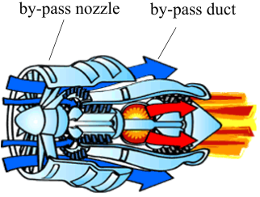
Figure 1.1 Turbofan engine with bypass duct [1].
Altering the nozzle shape affects its area and therefore shape morphing can be used to adjust important factors such as noise, efficiency and stall margin [2]. A secondary feature of shape morphing in aerodynamics that is not widely considered is the resultant change in structural properties. In particular, the effects on vibration behaviour are rarely considered. For thin-walled structures, such as jet engine nozzles, relatively small changes in shape can cause significant modifications of the natural frequencies and vibration mode shapes. This sensitivity offers the intriguing possibility of deliberately morphing thin-walled structures in order to alter their natural frequencies, and thereby the vibration response. In the context of an aircraft component, this behaviour could be used to reduce unwanted noise and high cycle fatigue considerations by avoiding or minimising time spent on resonance.
In the design of aircraft components, efforts are usually made to avoid resonant vibration arising from engine excitation under steady-state cruise conditions. However, it is often not possible to eliminate resonant vibration completely during takeoff, climb and landing because the engine changes speed causing the excitation to sweep gradually through a broad range of frequencies. The ability to manipulate natural frequencies via shape morphing would enable structural control strategies that either avoid, or rapidly pass through, resonance zones, thereby dramatically reducing the time spent around resonance.

Aim and Objectives
The aim of this research was to evaluate, theoretically and experimentally, the feasibility of developing a shape-morphing structure that could provide changes in vibration characteristics conveniently and to a level where resonance-avoidance might be performed successfully.
In order to achieve this, the following three principal objectives were envisaged.
- Rebuild a realistic, repeatable, reliable and high machining precision morphing structure on which to investigate resonance-avoidance ideas.
- Build and validate a numerical model of the structure that can represent accurately both the static shape morphing behavior and the dynamic response.
- Conduct numerical studies and vibration experiments to investigate the effects of shape morphing on the vibration response and from this, identify the potential for vibration control using shape morphing.
The structure chosen for this work was a variable-area nozzle (VAN) concept that was originally developed in 2008 as part of the EU-funded project ADVACT, which was aimed at investigating the possibility of using shape-memory alloys (SMAs) to make a morphing fan bypass nozzle for noise control purposes [2]. The model of the nozzle considered in this project is illustrated in Figure 1.2.
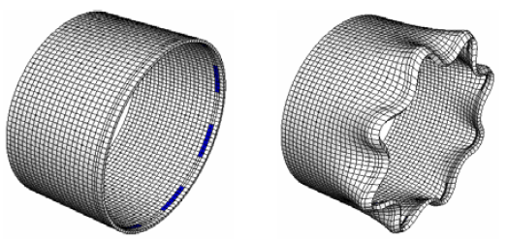
Figure 1.2 VAN concept with actuators attached (blue areas) [2].
The focus of the original research was to develop advanced actuation concepts for future aero-engine control systems [2]. Relevant outputs of the project included: a physical prototype of a morphing VAN assembly actuated using SMA plate; a simplified numerical approach for predicting static deformations and material data for the actuators used. This VAN assembly was judged to be suitable for resonance-avoidance studies because, like many aerospace structures, it is a thin-walled, lightly damped shell with several different families of vibration modes and has the added advantage of ready-made morphing capability.

Main Contributions
To the author’s knowledge, this is the first study to use shape morphing of practical shell-type structures to avoid resonant vibration. Some distinctive aspects, highlighting the inherent novelty of the work, are described below.
- The majority of publications on SMA actuated structures focus on the characterization and use of SMA wire [3-6]. This research involves SMA thin-plate actuators which are much less well understood but are attractive as they offer the potential of greater actuation force and simple construction. However, because they are uncommon, even construction methods for the thin plate actuators had to be developed as new work in this thesis. This includes finding the best way to manufacture thin plate SMA, with the restricted tolerance and monitoring early cycle fatigue of thin plate SMA. Here, a special clamp was designed for the cutting to enable high precision to be maintained for the SMA actuator dimensions. In addition, this work included a study on tensile stiffness and fatigue inside SMA with rarely studied thin plate structure, in order to predict and stabilise the performance of the VAN.
- The overall kinetic energy frequency response function (FRF) of a vibrating structure was adopted to avoid the localization problem of response sensors when dealing with cylindrical structures with mode shapes that may change with static deflection. In addition, an original methodology for extracting the overall kinetic energy FRF from a finite element (FE) model was demonstrated.
- Previous research into structural modification for vibration control has achieved the necessary alterations to the system matrices through methods that are relatively easy to model but hard to realize practically: such as the addition of mass at targeted locations or cumbersome joint-devices that affect boundary conditions [7-10]. Instead in this work, compact SMA actuators that are permanently built into the structure allow electrically actuated deformation which in turn enables controlled and repeatable modification of the system matrices

Thesis Layout
First of all, background information that relates to the design of VANs and the results from the ADVACT report are outlined in Chapter 2. Supplementary knowledge, such as the principle behind the VAN achieving fuel efficiency, follows the background information. Chapter 3 provides further context, through a more general review of SMA actuators and the vibration of thin-shell structures.
Chapter 4 describes the vibration testing and numerical model development of a bare SMA actuator and bare nozzle, separately. Chapter 5 describes the numerical modelling of the assembled VAN, and the experimental validation produced by the ADVACT project. The work presented in these the two chapters revealed a number of problems with the original structure, including, critically, a lack of machining precision in the SMA actuators, such that, even when static, the experimental results did not match the simulation. In addition, the vibration studies revealed that the fabrication induced imperfections that strongly affected the natural frequencies and mode shapes of the nozzle.
Chapters 6 and 7 detail the work carried out once the structure had been remanufactured, in an attempt to minimise the fabrication limitations previously experienced. The first of these chapters describes the reproduction and loading-cycle testing of SMA actuators. This is followed by the reproduction of the cylinder nozzle under strictly-controlled machining tolerances. The subsequent chapter describes the vibration reduction analysis, using the kinetic energy spectrum of the nozzle.
Chapter 8 then provides some conclusions and outlines recommendations for further work.
A flow chart, providing the logical sequence of the work, is shown in Figure A.1.

Chapter 2
Background for the VAN
The VAN developed as part of the ADVACT project was used as the test structure for the research described in this thesis. This chapter briefly explains the original motivation for developing the VAN and summarises the main features of the structure inherited from that project.
Experimental and analytical work had predicted and verified the beneficial impacts that in-flight adjustment of fan nozzle area can have on the operation of commercial turbofan engines. These include improvements in operational stability, fuel economy and noise reduction [11,12]. The key aerodynamic parameters that vary with flight conditions and govern performance are illustrated in Figure 2.1 which shows an example of a performance map where the fan pressure ratio (lower part) and isentropic efficiency (upper part) are plotted against a normalised mass flow rate [13]. In operation, the aim is usually to optimise efficiency whilst avoiding surge - a major instability in the flow through the fan that can result in loss of thrust and catastrophic damage.
With reference to Figure 2.1, it can be seen that when fan rotational speed is constant, the operating point on the fan working line changes with the Mach number of the aircraft, or the inlet air stream speed, which is positive to the inlet mass flow rate [14]. During takeoff, an aircraft’s speed is increased gradually, so the operating point shifts away from the surge line towards the right, and the pressure ratio across the inlet and exhaust of the nozzle is reduced. Note that the compressor surge, or compressor stall, is a local disruption of the airflow in the compressor that propagates instability around the flow path, potentially eventually destroying the engine [15]. Control systems are widely adapted to make sure engines work under surge lines; the distances to the surge line is the surge margin [14].
The upper part of Figure 2.1 indicates that an increasing mass flow rate improves fan efficiency at constant rotational speeds until an optimum point is reached. This is probably caused by the reduced pressure ratio increasing the conversion ratio between the potential and kinetic energy of the exhaust gas at the propulsion stage [16]. The maximum fan efficiency shown in Figure 2.1 is reached at a normalised rotor speed of 90%; the maximum efficiency working line is shown by the dotted line. Note that the maximum efficiency working points of an actual engine can shift slightly towards the right of the fan efficiency points on a compressor map, due to the optimum efficiency being the product of fan and propulsive efficiencies [17].
When an actuated VAN was installed and tested in a previous study, it was possible to adjust the fan pressure ratio by activating the actuators at a constant fan rotational speed [17]. Taking a takeoff scenario as an example, the cross-sectional area of the VAN is opened up to reduce the fan pressure ratio, which shifts towards the right and the maximum efficiency point. When the aircraft reaches a certain flight speed, the cross-sectional area of the VAN is closed off to shift the fan pressure ratio towards left for the maximum efficiency point.
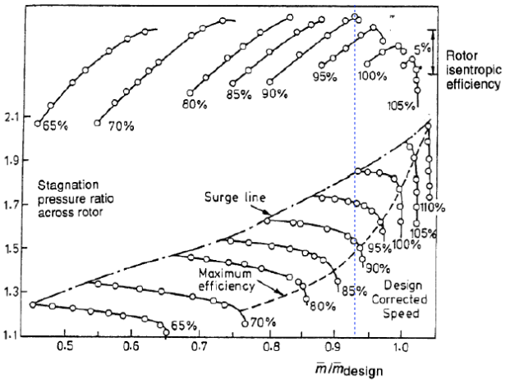
Figure 2.1 Performance map of a civil jet fan with normalised fan rotational speed from 65% to 110% [13]. The pressure ratio (lower part) and rotor efficiency (upper part) are plotted against normalised mass flow rate. The dashed line shows where the engine achieves maximum fuel efficiency.
In addition, an experimental study by Woodward et al. [11] found that, during takeoff, an 10.9% increase in nozzle area can reduce the effective perceived noise level of a flyover at an altitude of 450 m by at least 2 dB. Another programme, carried out by Crichton et al. [17,18], produced specific results that suggested increasing the nozzle area to a fan pressure ratio of 1.1 during takeoff, decreasing the nozzle area to a fan pressure ratio of 1.5 during the final climb.
The design and testing of VANs has evolved over the last few years. In 2005 and 2006, Boeing carried out full-scale static and flight tests of VANs with variable chevrons on a 777-300ER [19,20]. As shown in Figure 2.2, each chevron was integrated with three SMA actuators, which had a simple proportional integral derivative controller to vary the pressure ratio of the engine [19,20]. On the other hand, Mabe [16] developed a prototype VAN without slats, but with the nozzle body comprising 12 interlocking panels that could be opened and closed by 12 bending SMA actuators (Fig. 2.3).
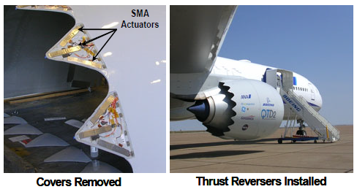
Figure 2.2 Variable geometry chevrons integrated with SMA actuators for flight test [16].
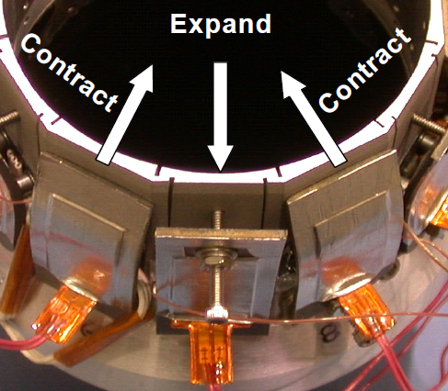
Figure 2.3 VAN with 12 interlocking panels [16].
The VAN inherited from the ADVACT project consisted of a titanium alloy cylinder, to represent the nozzle, and four SMA actuators. As shown in Figure 2.4, each actuator was firmly clamped onto three spacers, which were welded to the surface of the cylinder. Unlike the configuration originally envisaged in Figure 1.2, the actuator plates were attached to the outer surface of the nozzle.
The nozzle part of the VAN was a thin-shell cylinder made from Grade 5 Ti alloy, also known as Ti-6Al-4V, in which the abbreviation denotes the chemical composition of the alloy. Ti alloys are relatively flexible and can endure significant strain before yielding, which makes them an ideal material for VANs [21]. The dimensions of the cylinder were as follows: 500 mm inner diameter, 300 mm depth and 2.4 mm wall thickness. At each actuator station, the three spacers were equally spaced from each other with the dimensions shown in Figure 2.5.
The actuators were cut from a sheet of SMA by electro-discharge machining (EDM). The dimensions of the plates are shown in Figure 2.6. The active part of each plate was 149 mm in length and 1.1 mm in thickness. At each end, there was a thicker tab to improve contact during tensile loading. The actuators were pre-stretched before attaching them to the cylinder - the pre-stretching was sufficient to allow the end tabs on the actuator to be located beyond the outer spacers on the cylinder.
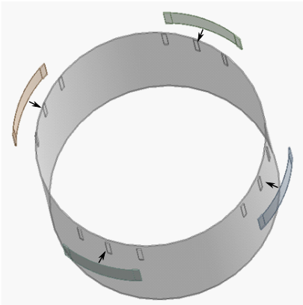
Figure 2.4 VAN with disassembled members.
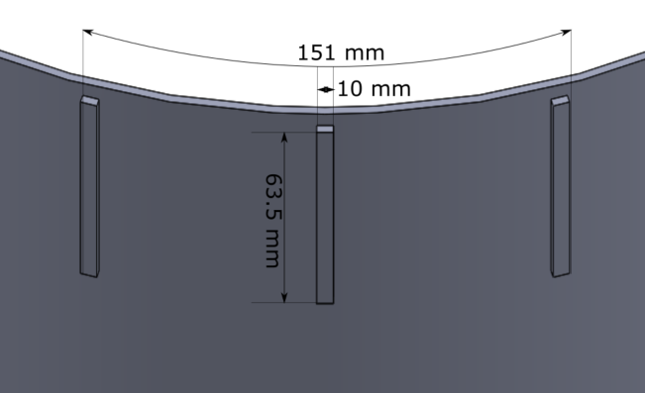
Figure 2.5 Cylinder showing the features at one station.
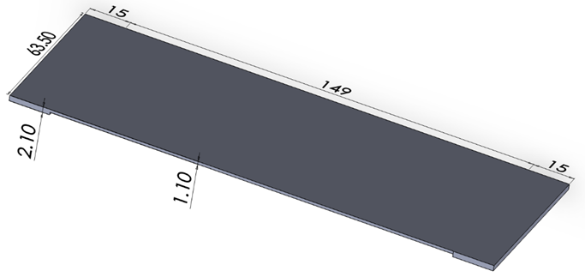
Figure 2.6 Dimensions of the SMA actuators.
Tapped holes were drilled through the actuators tabs and the cylinder for fastening bolts (Figure 2.7). The actuators contract when subjected to increased temperature, pulling the outer spacers towards each other. The middle spacers receive a radial force, and the combination of these loads drive this part of the cylinder inward. This inward movement (d_{in}) is a frequently used indicator of how much the cylinder has deformed.
Upon cooling, the SMA actuators reduce in stiffness. The stiffness of the cylinder exceeds the stiffness of the actuators and hence the middle spacer is pushed outwards. During this process, the actuators are restretched, and the cylinder recovers its original shape. The deformation cycle is repeatable if the thermal inputs are adequately controlled.
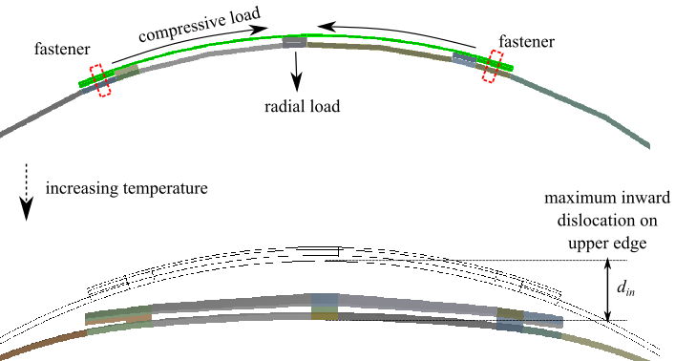
Figure 2.7 Configurations of one station and the inward displacement achieved.
The working cycle can be explained by a force-deformation graph. In Figure 2.8, the black curve represents the resisting stiffness of the cylinder, with the resisting force being zero when no deformation is occurring at point 1, and the resisting force increasing as deformation proceeds. The blue curve in Figure 2.8 represents the first prestretching of the SMA actuator, with a residual strain occurring after unloading. The black and blue curves meet at point 1, so the actuator is just long enough to be clamped onto the spacers.
Upon heating, the SMA actuators transform from the martensitic to the austenitic phase, and start to deform the cylinder. When reaching the maximum temperature, the actuators and cylinder reach a balance, where the red curve intersects with the black curve at point 2. At the end of the cooling, the actuators are restretched by the cylinder, as indicated at point 3. Note that the actuators cannot fully recover because the cylinder cannot provide sufficient force to push the actuators back to point 3. An opposing actuator configuration would fully recover the cylinder shape, but it was not considered due to its increased complexity. The complete force-deformation graphs are shown in Figure B.1.
The final version of the demonstrator developed in the ADVACT project achieved an inward displacement of around 15 mm on the middle spacer, which resulted in a 5% cross-sectional area on the bypass duct (Figure 1.1) [1]. The simulated model only achieved 10 mm inward displacement, suggesting some modelling inaccuracy in the original work.
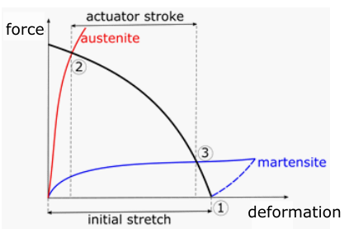
Figure 2.8 Contradicting forces from the SMA actuator and the self-stiffness of the cylinder.

Chapter 3
Literature Review

Ni-Ti SMA
‘SMA’ is a generic term for metal compounds that can ‘remember’ their original shapes when deformed, and that can return to those shapes when the thermal environment changes. A SMA component can undergo large, reversible deformations, and generate high recovery forces when the recovery action is impeded. This material is a solid-state alternative for conventional actuators, and is widely applied in the biomedical, aircraft, spacecraft and telecommunications industries [22].
There has been an enormous number of studies on the various properties of SMA. If their titles were all written down, that list would be longer than this entire thesis. In this part of the literature review, several aspects of Ni-Ti SMA that are relevant to this work are discussed, including their phase transformations, material properties and engineering characteristics.

Shape-Memory Effect of Ni-Ti SMA
SMAs can be created from a growing list of binary or ternary alloys. Two of the main types of SMAs are Cu-Al and Ni-Ti based. Cu-Al-based SMAs usually come with additional Zn or Ni, resulting in a family of SMAs with high transformation temperatures, above 100°C [23]. This type of SMA is prone to having unstable transformation temperatures and low recovery strains; in other words, low working cycles [24]. Since Cu-Al SMAs are relatively inexpensive and take less effort to prepare, they can be used in single-cycle applications, such as fire alarm components [25].
Ni-Ti, also called Nitinol or Ni-Ti SMA, is a metal alloy made of Ni and Ti, in which the atomic fraction of the two elements is approximately equal. This is the most commercially successful SMA on the market due to its unique combination of properties, such as its transformation temperature being above that of room temperature and it having a high recovery strain [26]. The shape-memory property of Ni-Ti alloy was first discovered at the Naval Ordnance Laboratory, in 1959, during a study attempting to find a new material with a high corrosion resistance and high strength for missile nose cones [27].
Two novel and outstanding properties exhibited by Ni-Ti SMAs are its shape-memory effect (SME) and superelasticity [28]. The latter is a more complex derivative of a SME under specific circumstances.
The SME of SMAs is identified through thermomechanical cycling, where two metallographic phases are involved. At relatively lower temperatures, the compound is fully a martensitic phase. With increasing temperature, austenitic phase then emerges and, ultimately, takes up the entire alloy. These two phases, which are respectively called the daughter and parent phase, can be present at the same time during the intermediate stage of phase transformation [29]. The SME can also be activated with thermomechanical loading, as illustrated in Figure 3.1, where a Ni-Ti SMA plate is shown undergoing a thermomechanical loading cycle.
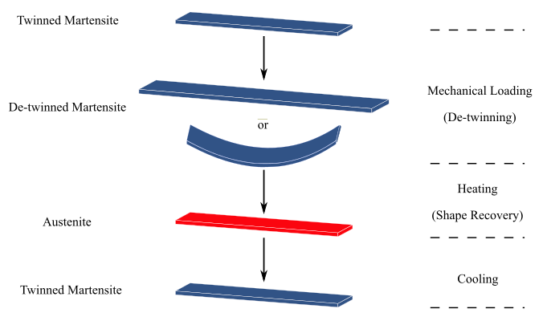
Figure 3.1 A Ni-Ti SMA plate undergoing a thermal-mechanical loading cycle.
Figure 3.1 shows that, below a critical temperature, martensitic Ni-Ti SMA plates can undergo linear or bending loads, with the plates retaining the deformed shapes when the loads are removed [26]. This process detwins the atomic orientations between the lattice layers in the originally twinned martensite and can result in strains of up to 8%. Following a rise in temperature, the martensite transforms to austenite. This austenitic transformation results in strain recovery which is complete if no retraining load is present. Upon cooling, the twinned martensite is restored, and is ready for the next working cycle. This process is called martensitic transformation.
By comparison with carbon steel, which requires much higher austenitic transformation temperatures (around 700–800°C), Ni-Ti usually has critical temperatures of 0–115°C [30]. The martensitic transformation of carbon steel forms a very hard and brittle crystalline structure via rapid cooling, such as quenching [31]. For Ni-Ti SMA, the martensitic alloy exhibits high ductility by showing a ‘yield plateau’ caused by the reversible de-twinning process before real plastic strain emerges [32]. Although some Fe-based alloys do indicate SMEs, and are applied in the engineering field, carbon steel generally does not show as remarkable an SME as SMAs do [33,34].

Thermal Hysteresis of Ni-Ti SMA
During the working cycles of Ni-Ti SMAs, there are four critical temperatures that derive from the phase transformations. Starting from full martensite, austenite starts to emerge as the alloy is heated to starting temperature A_{s} and the parent phase is fully delivered at finishing temperature A_{f}. When subjected to a cooling environment, the martensite phase starts emerging at starting temperature M_{s} and the daughter phase is fully restored at finishing temperature M_{f} [35]. It is notable that these phase transformations are instantaneous processes [36].
Moreover, the austenite-martensite transformations exhibit thermal hysteresis, which is illustrated in Figure 3.2. For a typical Ni-Ti SMA, the austenite starting temperature of A_{s} is higher than the martensite finishing temperature of M_{f} [37]. The width of the hysteresis loop, typically valued from 20°C to 50°C, can be reduced or amplified by adjustments in the atomic ratio among the two elements and specific thermal treatments [38,39].
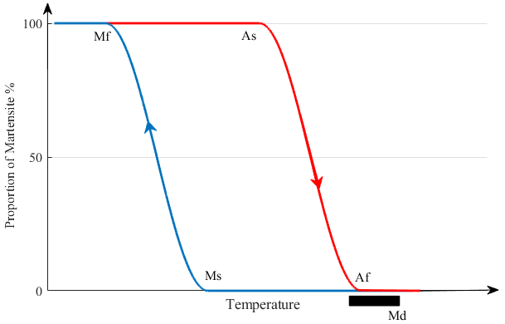
Figure 3.2 Typical characteristic temperatures of Ni-Ti SMA.

Super-elasticity of Ni-Ti SMA
The martensitic phase of Ni-Ti SMA can undergo large inelastic strains associated with de-twinnig. When external stress is applied to Ni-Ti SMA at, or above, A_{f}, the strain-induced crystal structure change will transform the austenite into twinned martensite [40]. At the same time, this martensite portion of the alloy is detwinned by the applied stress. Thus, the overall elongation of the loaded Ni-Ti SMA plate will consist not only of the elastic strain in the austenitic phase, but also the de-twinning strain in the martensitic phase (Fig. 3.3).
The strain induced in superelastic loading can reach up to 10%. It is fully recoverable upon the removal of the external stress [41]. For this reason, some Ni-Ti SMAs, with A_{f} values down to 0°C, can be made into superelastic components that are still functional at very low room temperatures [42].
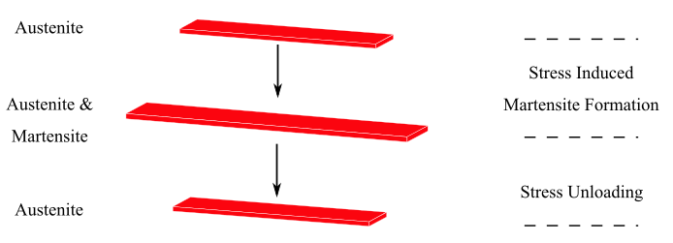
Figure 3.3 Ni-Ti SMA austenite shows superelasticity when external stress is applied and then removed.
The black bar in Figure 3.2 denotes a typical temperature range in which the alloy will show optimal superelasticity [43]. If a thermal resource starts heating a Ni-Ti SMA plate through A_{s} to A_{f}, the superelasticity of the plate will not be measurable until the vast majority of the alloy has transformed into austenite and the superelasticity reaches an optimum close to temperature A_{f} [43]. The length of the black bar in Figure 3.2 is finite, which means that M_{d} is the highest temperature at which a ‘stress plateau’ is still applicable [43].
An equivalent model to explain superelasticity involves external stress increasing characteristic temperatures, as illustrated in Figure 3.4. Characteristic temperatures increase along with increasing stress [44]. The dashed arrow on Figure 3.4 indicates the route via which austenitic alloys travel through the boundary of the two phases. In cases where an austenitic transformation of Ni-Ti SMA is accompanied by external force, superelastic transformation can also take place. To achieve a fully accomplished austenitic alloy, the final body temperature of the alloy must be higher than A_{f}.
It has been found that only Nitinol and some Cu-based alloys exhibit superelasticity [45]. Moreover, when Gadaj et al. [46] studied the surface temperatures of a stress-loaded Ni-Ti SMA under three temperature ranges (below A_{f}, A_{f} < T < M_{d} and above M_{d}), a heterogeneous surface temperature distribution was observed in the middle one, while the other two showed uniformly distributed temperatures (see Figure 3.2 for M_{d}). This shows that the development of martensitic transformation is non-homogeneous in the optimal superelasticity temperature range.

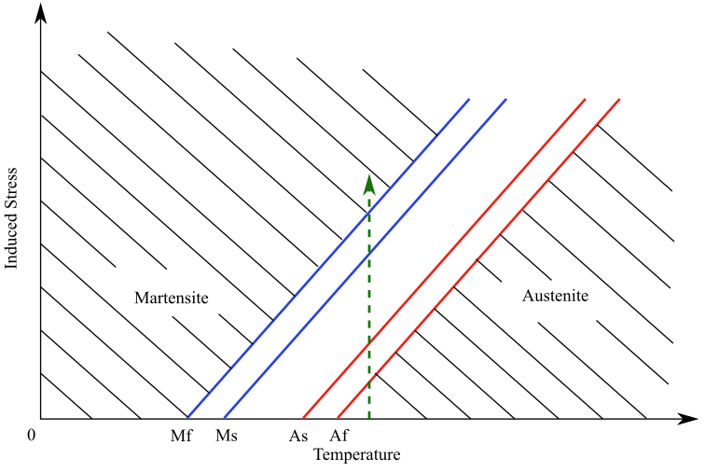
Figure 3.4 Transformation temperatures affected by external stress.

Crystal Structure of Ni-Ti SMA
Its heat-sensitive crystalline structure gives Ni-Ti SMA unique thermoelastic properties. In the austenitic phase, Ni-Ti SMAs are formed of simple cubic, body-centred lattices (Fig. 3.5) [47]. Upon cooling, martensitic transformation turns the compound into a structure with twinned lattice planes, with each cell having a monoclinic lattice structure [48]. This transformation changes the crystalline structure of the alloy, but retains the composition, so the process is a diffusionless type of transformation [49]. This implies that the set of atoms moves collectively when changing their orientation with respect to the original lattice, resulting in shearing strains between the lattice planes. This is accommodated by the substructure, such as twinning in martensite [50].
To compare this with the annealing process used for stainless steel, which also involves austenitic and martensitic phases, Fe atoms are rearranged to form face-centred cubic lattices representing the austenitic transformation [51]. During the rapid cooling process to form martensite, the carbon atoms have no time to diffuse out of the crystal structure, and so the lattice structure can vary depending on the constituent elements [52].
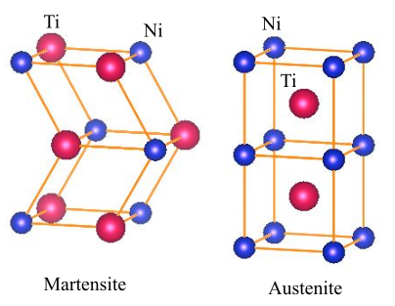
Figure 3.5 Lattice structures of martensite and austenite in Ni-Ti drawn using VESTA software which enables electronic and structural analysis [53].
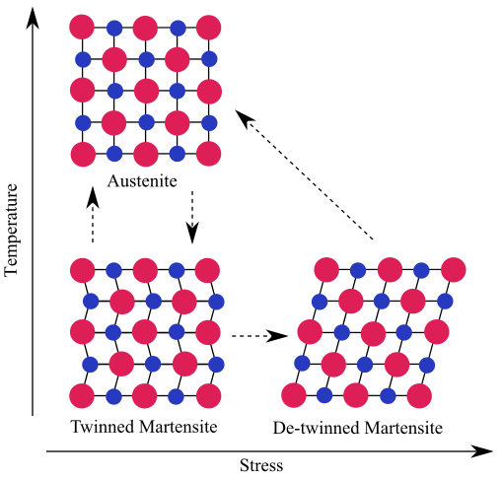
Figure 3.6 Variations in crystalline structure during thermomechanical transformations.
Figure 3.6 shows how the Ni-Ti SMA lattice structure changes under thermomechanical cycling. The atomic arrays in the twinned martensite have paired lattice planes that can be rearranged, by external stress, into a single crystalline direction, without causing slippage. This detwinning process does not break the atomic bonds, so the accompanying strain is not permanent [54]. Upon heating, the Ni-Ti SMA generates a high recovery stress when it is prevented from eliminating the detwinning strain [55]. Austenitic and twinned-martensitic phases can be generated in both directions using the superelasticity of Ni-Ti SMA.
Note that Ni-Ti SMA is an intermetallic alloy, formed by reactive sintering at temperatures higher than 500°C [56]. Unlike solid-solution alloys, in which the atoms are randomly positioned in the lattice, the Ni and Ti atoms are specifically located in the lattice, as shown in Figure 3.6 [57].

Yielding Behaviour of Ni-Ti SMA
When a twinned martensite plate is under tensile stress, it initially will exhibit elastic extension, followed by a ‘stress plateau’ at the detwinning stage (Fig. 3.7). For typical Ni-Ti SMA, the yielding stress can be as low as around 120 MPa, compared with stainless steel, which yields around 290 MPa [58]. During the detwinning stage, the reorientation of lattice twins proceeds unevenly throughout the Ni-Ti material [59]. This eventually leads to macroscopic deformation of up to 6% strain under constant load [33]. To the end of the stress plateau, the stress-strain curve tends to follow the traditional yielding pattern of typical materials. Ni-Ti SMAs are mostly polycrystalline, so the onset of further detwinning indicates the start of detwinning in martensite twins that are less favourable to the loading direction [33]. As the stress increases to stage 4 (Fig. 3.7), a large proportion of permanent dislocations start being generated, and the martensite twins, which are even lesser favourable to the loading direction, are detwinned [60]. Upon unloading, only the elastic portion of the overall strain can be restored, and the outstanding strain (ε_{dtw}) indicates the maximum recoverable strain, when heated.
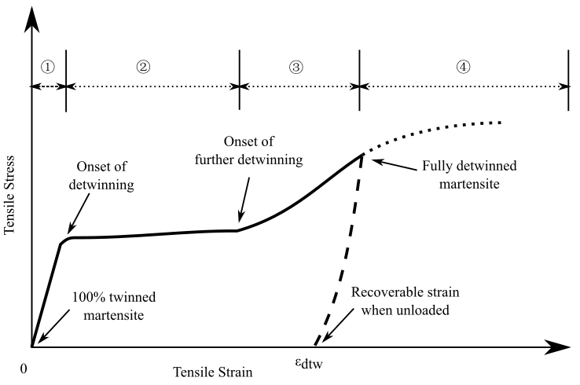
Figure 3.7 Stress-strain curve for the detwinning process in typical Ni-Ti SMA.
Sequential heating can convert the Ni-Ti SMA sample into austenite, which is represented by the A–B segment in Figure 3.8. Superelastic behaviour can be demonstrated by gradually applying a tensile load; an initial elastic stage of the austenite phase is denoted by the B–C segment. The yielding stress for the upcoming ‘stress plateau’ is positively related to temperature, and is also generally higher than the yield stress of the detwinning process when in the martensitic phase [61].
The C–D segment starts with gradually emerging microscopic martensite, accompanied by some plastic deformation, which is hard to observe compared to the upcoming macroscopic detwinning [61]. The following ‘stress-plateau’ (C–D segment) and further detwinning (D–E segment) stages are similar to the martensitic ones in Figure 3.7. At the end of the further detwinning stage, a short period of elastic deformation can occur [61]. The E–F segment represents the elastic unloading, which is followed by the gradual restoration of austenite [61]. After the elastic unloading of the austenite phase (G–H segment), the accumulated plastic deformation from the cycle is responsible for 0.05–0.3% of irrecoverable strain, where the strain magnitude is affected by temperature and maximum loading stress [61].
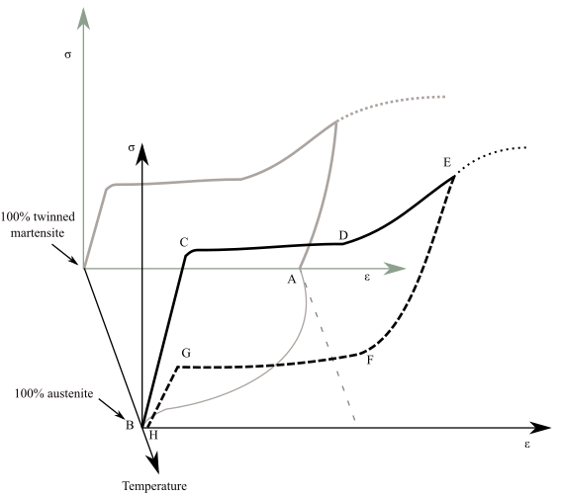
Figure 3.8 Strain-stress curves for the detwinning process (grey) and superelastic effect in typical Ni-Ti SMA.

Material Characterisation and Fabrication of Ni-Ti SMA
Conventional Ni-Ti SMAs have atomic ratios where the Ni is restricted to 49–51% (around 55% by weight); these are called 50-Nitinol. When the atomic ratio is above this narrow range, the compound will not form the cubic austenite lattice structure during fabrication, but instead will decompose into a mixture of Ti-Ni and Ti-Ni₃ [62]. A type of 55-Nitinol with 55% (atomic weight) Ni has also been proved to exhibit superelasticity. However, this new Nitinol has not been commercially applied yet due to there being many difficulties associated with its fabrication [63]. Another example of a Ni-Ti alloy – 66-Nitinol – which does not possess the SME or superelasticity, but was discovered before 50-Nitinol, is now being developed into premature-wear bearings and gear tooth surfaces to exploit its combined properties of high corrosion resistance and appropriate hardness [64]. To clarify, unless otherwise stated, the terms ‘Nitinol’ and ‘Ni-Ti SMA’, in this work, usually refer to 50-Nitinol with an equiatomic composition.
For Ni-Ti SMAs with equiatomic compositions, subtle adjustments in the ratios of the two elements can have a dramatic effect on their material properties, especially their characteristic temperatures [65]. For instance, by increasing the atomic ratio of Ni from 50% to 51% can lower the A_{f} by up to 100°C [66]. Apart from atomic ratio, machining and annealing processes can also finely adjust the transformation temperatures of the alloy materials [67].
Commercially available Nitinols are commercially classified into two groups for two distinct applications – superelastic Nitinols (A_{f} < 22°C) and shape-memory Nitinols (22°C < A_{f} <115°C) [67]. Superelastic Nitinols are generally in the austenitic phase at room temperature, so those alloys can undergo large, recoverable strains under daily circumstances. This type of Nitinol can remain superelastic starting from their A_{f} up to temperatures around 50°C above the A_{f} [67]. Shape-memory Nitinols generally exist as martensite at room temperature, and thus they are ideal components for outputting large recovery forces when thermal loads are applied.
The fabrication of Nitinol products starts with melting Nitinol ingots using a combination of vacuum induction melting and vacuum arc remelting [68]. The raw materials do not have SME or superelastic properties, requiring hot working, such as forging, swaging and hot rolling at 600–800°C, to recrystallise the microstructure and make it useful [66]. The sensitivity of the compositional ratio in Nitinols makes its manufacturing process exceedingly difficult. Due to the high reactivity of Ti, the Ti atoms can easily combine with O or N. Recent studies have shown that melting the materials with smaller, non-metallic, inclusions produced a much improved fatigue life compared with melts with larger inclusions [69]. Also, Dawood et al. [70] found that, during annealing, the cooling rate has a significant effect on the SME properties of Nitinols.
This stage outputs intermediate forms of Nitinol, such as bars and plates, based on the specified metallurgical requirements of the second stage [71]. Differential scanning calorimetry (DSC), a method that measures the energy given off or absorbed by a sample of alloy, is often used to test the baseline properties in bars and plates prior to further works [71].
In the second stage, cold working is applied to produce appropriate strengths and shapes, such as wire drawing and sheet rolling. Usually, the cold working is partially completed, followed by full annealing, and this cycle is repeated many times. This is to avoid fracturing during work hardening because Nitinol hardens very quickly [72]. After this stage, the fabricated Nitinol wires, sheets or foil are ready for customised machining, such as laser cutting and EDM.
Finally, the machined Nitinol workpiece will achieve the desired geometry. A thermomechanical treatment can be applied, as required, to reset the alloy body into customisable shapes in the parent phase [67]. The Nitinol workpiece will be held in the desired shape by tolled fixture, and then heated in a furnace to a carefully chosen temperature – usually one lower than the recrystallisation temperature – of around 450–550°C for a few minutes, before being quenched in cold water [66].

Influential Factors on Ni-Ti SMA Detwinning
The useful features of Ni-Ti SMA are related to the detwinning process, in which macroscopically recoverable strain can be generated. There are several factors that affect yield behaviour – the quality of the detwinning or the recovery rate. The influences of these factors can be addressed by the stress-strain curve, shape recovery rate or functional life of a Ni-Ti SMA component.
Firstly, if two identical Ni-Ti SMA specimens are fabricated, but then go through different loading histories, their yield behaviours and transformation temperatures will no longer be unique in the hysteresis loop range (M_{f} < T < A_{f}) [73].
During the manufacturing stage, the annealing temperature has a major effect on the yield stress of Ni-Ti SMA [33,73]. Liu and McCormick [73] showed that yield stress will reach the minimum when the annealing temperature approaches the recrystallisation temperature. When a specimen has undergone strain-controlled loading cycles, the higher the annealing temperature, the smaller the recorded stress, when T < A_{s}, but the opposite applies when T > A_{s} [33].
Apart from the manufacturing factors, stress mode and loading direction play an important role in detwinning. Compressive loading can induce a high density of dislocations and a low amount of detwinned lattices in the martensite alloy [74]. Liu et al. [75] applied dynamic tensile loads with strain rates as high as 300 s⁻¹ to Ni-Ti martensite to replace the quasi-static load, and found that the yield stress increased slightly, but the plateau strain and strain recovery rate were not influenced.
Liu et al. [76] found the microstructure of Ni-Ti SMA, especially the texture orientation, to be critical to the quality of the detwinning. As Ni-Ti SMA plates or wires are usually rolled or drawn from raw material, textures are commonly existant. Study has shown that applying tension force in the rolling direction of Ni-Ti plate provides a long plateau strain and high recovery rate, while applying loads in the transverse direction results in strain hardening and a low recovery rate [33].
A low recovery rate usually implies a considerable portion of the detwinning strain is permanent strain from dislocation slippage during the phase transformations. This deteriorates the functional stability of Ni-Ti SMA [17]. Figure 3.9 illustrates dislocation slippage in the lattice structure of martensite. The development of dislocation slippage is a gradual process, which equates to the degradation of the working abilities in Ni-Ti SMAs [77].
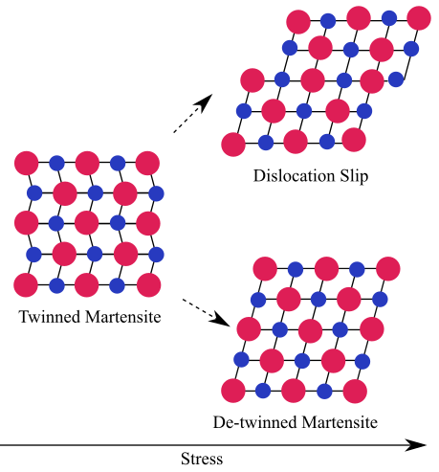
Figure 3.9 Dislocation slippage in the lattice structure during martensitic detwinning.
Liu and McConnick [73] studied the influences of loading magnitude and annealing temperature on permanent strain during martensitic detwinning. Ni-Ti SMA components made from differently annealed motherboards were stretched under three controlled stress levels, and the unrecoverable strains were recorded [73]. The results showed that higher loading stress could introduce more permanent strain, and that the alloy that was previously heat-treated at 770K exhibited almost no dislocation slippage (Fig. 3.10).
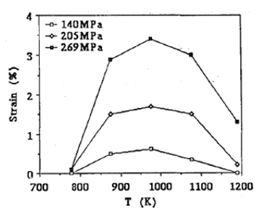
Figure 3.10 Recorded permanent strains at different annealing temperatures and stress levels, generated by the detwinning process [73].

Fatigue in Ni-Ti SMA
As in stainless steel, Ni-Ti SMA exhibits fatigue-related mechanical failure. At a certain defect level, irreversible slippage is the result of dislocations within the crystallographic structures. A stable structure is formed to accommodate further slippage and an increased dislocation density [78]. Gradually, the slip strain localises in small regions that form persistent slip bands or bundles until a crack is ultimately initiated [78]. The accumulation of dislocations in Ni-Ti SMA comes from both thermal and mechanical cycling, which result in changes in the transformation temperatures and stress-strain relationships [79].
Thermal-cycling-induced thermal fatigue refers to applications where external force or strain is absent, but internal stress exists. DSC results from a type of high Ni Ni-Ti SMA that, when annealed at 900°C for 30 min, shows a M_{f} decreased of more than 24°C after 100 cyclic rotations of temperature from -150°C to 120°C [80]. The increasing dislocation bands act at the lattice shear interfaces, impeding the motion of the martensitic planes, therefore increasing the required driving force for transformation initiation, and consequently lowering the M_{f} [80].
Mechanical-cycling-induced fatigue is related to the cyclic loading force or cyclic temperature applied to a constrained body. In previous studies, researchers have evaluated the fatigue behaviour of Ni-Ti SMA using basic approaches, such as stress-life or strain-life under controlled loading stress or controlled loading strain [79]. Melton and Mercier [81] investigated the mechanical failure of a group of annealed, binary Ni-Ti SMAs at room temperature, where some of the alloys were martensitic and others were austenitic. The investigation addressed the following points:
- Superelastic Nitinols are longer-lived and have better fatigue limits than SME Nitinols when subjected to stress-controlled loading cycles. Both types of Nitinols may have a 10⁷-cycle fatigue limit when subjected to stresses that are controlled at approximately 80% of the stress plateau.
- Repeated stress-controlled cycling brings elongation at zero loading force, and this ‘plastic’ strain can accumulate.
- SME Nitinols have a superior fatigue life over superelastic Nitinols when subjected to strain-controlled cycling. Also, SME Nitinols have smaller surface areas from the stress-strain hysteresis loops, which reduce the mechanical energy required per cycle.
- Repeated strain-controlled cycling leads to modulus hardening. This may be due to increased dislocation density caused by the increasing number of cycles.
The accumulating effect of stiffness on the alloy is significant. Melton and Mercier [81] revealed that, when a SME Nitinol with M_{s} > 30°C was subjected to strain-controlled cyclic loading, the stress required to achieve the same strain increased along with the cycle number, as shown in Figure 3.11. This figure also indicates that the required stresses increased dramatically at the first five cycles, and continued to increase with decaying speeds. When applied with controlled stress, the total strain for each cycle decreased almost linearly, until failure, as Figure 3.12 shows. This again confirms the modulus hardening discussed above. It also shows a linearly regressed stiffness after the initial 10 cycles [5].
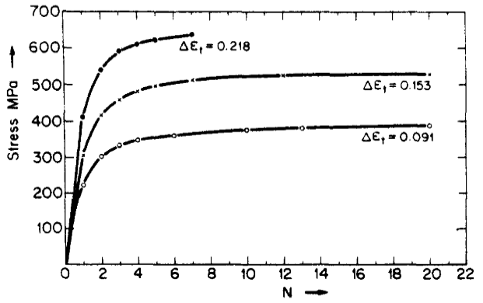
Figure 3.11 Stresses required to achieve constant strain, as a function of N (the number of cycles) [5].
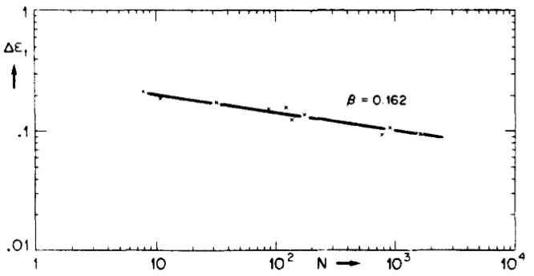
Figure 3.12 Total strain per cycle under controlled stress, as a function of N, the cycling number [5].
The damping behaviour and residual strain, or SMA creep, generated through the working cycles was observed by Soul et al. [6]. As shown in Figure 3.13, a ‘training’ sequence of 100 cycles was performed on a superelastic wire sample, with the residual strain and dissipated energy being recorded. The results indicated that the material characterisation of Nitinol wire tended to stabilise after 20 cycles. The dislocation-induced strain and damping capability of the Nitinol wire then both reached an even stronger condition after 100 cycles.
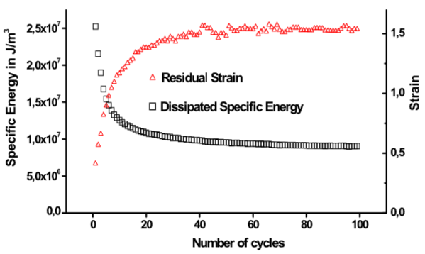
Figure 3.13 Accumulating residual strain and dissipated energy from a superelastic wire under training cycles using a 0.01-Hz sinusoidal waveform with a displacement control of 8% strain [6].
From the manufacturing aspect, Pelton and Mitchell [82] carried out strain-controlled cyclic tests on two Ni50.8Ti49.2 specimens that were either annealed at 900°C for 30 min or stress relieved at 500°C for 10 min. The stress-strain curves (Fig. 3.14) indicate that both specimens were tested under controlled a mean strain amplitude of 1.5% and a cyclic strain amplitude of 0.25% for up to 100 cycles at room temperature, where both specimens were austenitic [82]. Figure 3.14 also reveals a major material softening during the ‘stress plateau’ stage of the annealed specimen. Modulus hardening on the annealed specimen was still observable, even at 100 cycle loads, while the other specimen tended to stabilise after the third cycle. The cyclic parts on both curves translated towards the right, with the annealed specimen translated slightly more. This hints at the accumulation of permanent strains by the samples continuing with cycle loading.
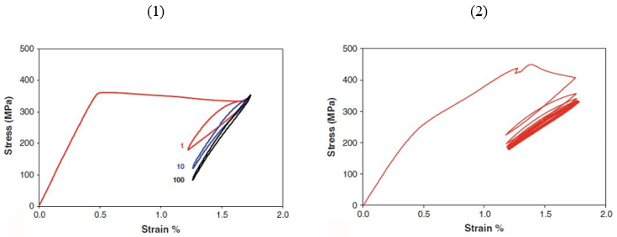
Figure 3.14 Stress-strain fatigue curves of annealed Ni-Ti SMA (1) and stress-relieved Ni-Ti SMA (2) under 1.5% mean strain and 0.25% cyclic strain amplitudes [82].

Thin-shell Cylinder Dynamics
According to Chen and Lui [83], shell plate and circular shell structures can be classified into varied types. A thin-shell structure is distinctive from other plate or similar structures by its relatively small thickness compared to its other dimensions [84]. They are typically curved, lightweight and used for a wide variety of applications including the construction of rooves of large buildings, boat hulls and aircraft nozzles [85].
The dynamic response of walled cylinders has been studied for decades. Love’s [85] simplification resulted in a general dynamic theory for the vibration of continuous structures that have thickness. The simplification introduced the logical extension of the beam and plate equations into shell structure assumptions for both transverse and extensional motion [86]. More recent investigators have mainly concentrated on developing simplified methods, with approximations of the numbers of parameters and their internal influence [87,88]. For example, Weingarten [89] developed a frequency equation based on known characteristic functions of beams with free-free or fixed-free boundaries, and achieved agreement with Rayleigh’s inextensional theory [90]. Additionally, for the conical shell, which has a geometry close to that of the turbine nozzle, Grigoluk [91] employed quite similar energy approaches for conical shells of limited conicity. Recent papers usually concentrate on specified geometry and material composition in characterised environments; that is, Zhang and Guo [92] studied the dynamic behaviour of thin-walled shells in both static and spinning situations.

Natural Frequency and Mode Shape of Thin-shell Cylinders
Thin-walled cylinders exhibit six main types of mode shape, while thick-walled cylinders are even more complex [93]. In this work, only the pure radial modes and radial-with-radial-shearing modes were studied. The other types of mode shapes, such as the extension mode, usually occur at much higher frequencies. The excitation occurring in a commercial gas turbine nozzle shows the main spectral range to be below 200 Hz [94].
Two types of vibration modes are shown in Figure 3.15. The Type A mode shape primarily exhibits radial motion, with the cross-sections along the axial direction remaining constant and undistorted. The Type B mode shape combines the radial motions with gradually varying phases in the axial direction. Index n is the circumferential node number, or nodal diameter, while index m is the longitudinal node number. The pure radial motion modes always have m = 0, but the Type B modes are satisfied with m > 0.
.
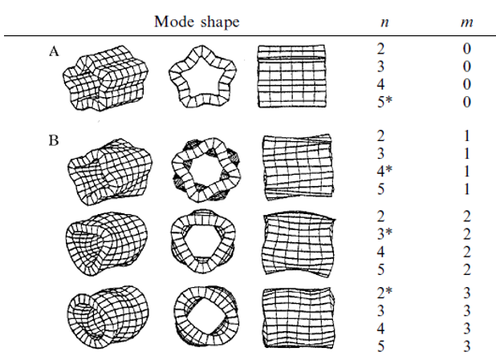
Figure 3.15 Illustration of pure radial, radial and radial-shearing modes [93].
The natural frequencies of a cylinder with an infinite axial length are dependent upon only the radial dimensions of the shell [93]. On the other hand, the natural frequencies of a finite cylinder are dependent upon both the axial length and the radial dimensions [93]. The eigenvalues of a cylinder shell with different boundary conditions can be calculated by many methods. The Timoshenko [95] ring equation firstly examined the natural frequencies of free-free cylindrical shells where m = 0. His equation showed the natural frequencies of these modes to be independent of the length of the cylinder [95]. The equations for modes with m > 0 were then developed by Sewall [96], in which the radial, circumferential and longitudinal motions of the shell are each approximated by the products of trigonometric functions in the circumferential direction and elementary beam functions in the longitudinal direction. Platus [97] also developed a frequency equation for cylinders with fixed-free boundary conditions by using Rayleigh-type vibration analyses. Ultimately, Watkin and Clary [98] validated the above frequency equations, finding the predictions to be in good agreement with the experimental results.

Twin Modes of Thin-shell Cylinders
Axisymmetric structures exhibit certain unique vibration behaviours. Take, for example, a vibrational beam, in which, whether or not the exciter changes location, the mode shape is invariant [99]. For a perfect cylinder, however, the mode shapes will orient themselves such that an antinode, or maximum motion point, will always align with the exciter location (Fig. 3.16) [99]. This can be explained by the vibration movement having no preferred direction, since it is an axisymmetric geometry [100].
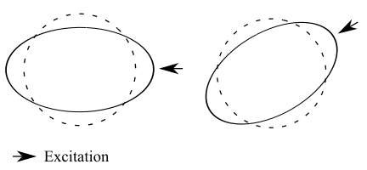
Figure 3.16 Mode shape rotates with excitation.
In addition, for a perfectly axisymmetric cylinder that is perfectly round, with no accessories attached, each dominant mode is accompanied by a recessive mode that is too insignificant to observe [101]. In this work, the dominant and recessive modes are viewed as a pair of twin modes, or as drive and response modes. They have identical natural frequencies and mode shapes, but they are circumferentially split from each other by π/2n, where n is the circumferential index (Fig. 3.17) [101]. The reason for the existence of twin modes is that vibration energy can be transmitted in both directions in the cylinder body.
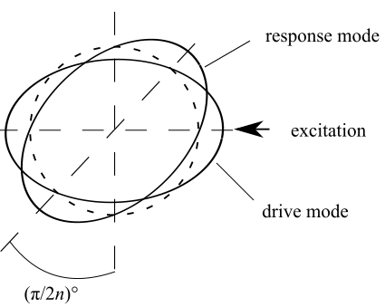
Figure 3.17 Drive mode and response mode, split from each other by 45° when n = 2.
For a perfect cylinder, the response mode vibration is unobservable because the eigenvectors always have zero elements in the degree of freedom (DOF) where the input forces are excited. Thus, the transfer functions for the response modes will always be zero. However, in real structures, the response modes are often observable, and the twin modes will have different natural frequencies. This is because, when imperfection or asymmetry exists in axisymmetric rings, the modes have preferential directions [100].
Soedel [100] studied the analytical solutions of a cylinder with an attached single point mass, added stiffness or ovalness. To simplify, while the mathematical interpretations are not shown here, the general conclusions are discussed. For cases of point mass and added stiffness, the mode shape expressions are unchanged, but the line-up of the twin modes are changed by the antinode now being located at the location where the added features are attached (Fig. 3.18) [100]. For natural frequencies, the added mass decreases one of the modes, while the other mode remains unchanged, but the added stiffness increases one of the modes, while the other mode remains unchanged [100]. It is possible to see one mode increasing and the other decreasing by a combination of the two effects. For an oval shell, the twin mode shapes also line up with a certain imperfection factor, but their natural frequencies split towards different directions from the original one [100].
Note that, for a rolled cylinder, the welding bead can represent the added mass. The hardened oxidation layer near the seam can represent added stiffness and the roundness of the cylinder can represent the ovalness. Fabrication processes contribute enormous and complex asymmetries that are impossible to predict using analytical solutions. The only way to produce a perfect cylinder is by casting, which is cost inefficient.
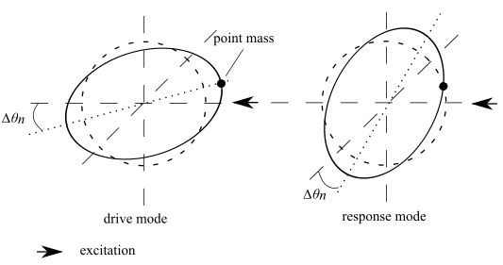
Figure 3.18 Split modes for n = 2, where ∆θ_{n} is the rotation of the antinode after point mass is added.
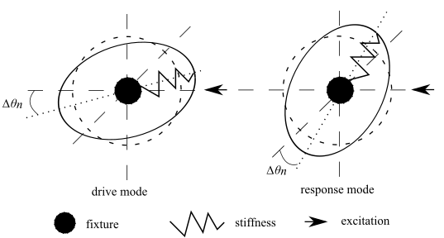
Figure 3.19 Split modes for n = 2, where ∆θ_{n} is the rotation of the antinode after stiffness is added.

SMA Damping and Modal Tuning
The basic principle of the VAN concept in this work is a self-actuating and self-adaptive structure reacting to its environment for the purpose of vibration reduction by adjusting natural frequencies. Although the sensing and executing procedures were hand-operated in this work, further development of this prototype foresees a self-tuning system integrated with a temperature-conditioning module and a feedback control.
SMAs are widely studied for their unique properties, such as their large recovery strain and high loss factor due to superelasticity. An example of this is the passive vibration control of a vibrating plate supported by SMA wires or a SMA-wired, embedded resin sleeve [3]. The SMA wires reduce vibration of the plate through two mechanisms – resisting deflections of the plate, acting like an elastic foundation vibration absorber, and dissipating energy by the hysteresis loop through the superelasticity of the SMA wires [3,4]. Another passive vibration damping study examined vibration reduction on the stay cable of a bridge structure; the performance of the SMA damper was found to be related not only to the location the damper was installed in, but also the parameters of the damper, such as stiffness and energy-dissipation capability [101].
In semi-active vibration reduction, SMAs are applied as device actuators or tuned dampers. Heinonen et al. [102] developed a semi-active vibration isolator for civil structures undergoing various loading conditions. The embedded SMA actuators were able to change the kinematic boundary condition of the isolator, with the change in stiffness of the device being adapted according to the environmental conditions [102]. Hong et al. [103] experimentally validated a SMA-actuated damped structure comprising a steel ring and two metal rubber dampers. The result showed the high stability and effectiveness of the SMA as an execution unit in thin-shell structures [103]. SMA wires were applied as dampers in the semi-active vibration-control device of a single-degree-of-freedom dynamic system by Amarante dos Santos et al. [104]. In this case, the SMA wires were controlled within a narrow superelastic window for optimum energy dissipating efficiency by a self-adaptive, preloaded stress on the SMA wires, according to the vibration level of the main structure [104].
In terms of natural frequency tuning, Cakar [7] demonstrated an analytical method using concentrated mass with modified distributions. The method yielded a set of nonlinear equations, according to the number of frequencies that needed to be shifted, and the necessary masses were estimated by solving these equations [7]. Yee and Tsuei [8] discussed the extent of the application of this method for damped structures, with modified mass and stiffness matrices. Mostaghel et al. [9] derived an analytical method to shift the vibration modes of plate structures by a desired amount by controlling the initial performance of the plates through ratios of the plate thicknesses. Lopez-Alba et al. [10] studied mode shifting in a plate under thermal conditions in which the modes were shifted under asymmetric heating due to thermally-induced buckling.
Above all, SMA-assisted vibration reduction has been widely studied. The main roles of SMAs in these studies have focused around passive energy dissipation elements and triggering units. On the other hand, precise control of SMA dampers requires complicated control systems and heavy rig setups [104]. The tuning of natural frequencies could be achieved through parameter modifications or self-reflections due to environmental changes. However, these tuning systems require complicated setups for the needed changes to be applied, for which the costs and space to build such devices are prohibitive. The VAN vibration reduction device utilises the high damping ability and long actuation range of SMA, together with the ductility of a Ti alloy, to shift vibration modes via a compact setup.

Chapter 4
Actuator and Cylinder Modal Analysis and Testing
In this chapter, the actuators and cylinder tested individually for their natural frequencies and mode shapes are reported on. Additional purposes of the tests included investigating the phase-dependent damping of the actuators and mode shapes pairing between FE and experimental models.

Actuator Modal Analysis and Testing
The actuators were previously made, as part of the ADVACT project, from a piece of 50-50 Ni-Ti bar, which had a rolled thickness of only 3 mm. This implied an enhanced stiffness of the SMA plates due to a high level of work hardening. In Chapter 6, it is explained that new SMA actuators were crafted from a Ni-Ti bar with a thickness of 10 mm, in which the stiffness of the actuators was proved to be much smaller.
The material properties of the martensitic SMA, since it was martensite at room temperature, are listed in Table 4.1. The Young’s modulus, at room temperature, was adapted by FE modal testing. The SMA body was slightly bent at room temperature, since the geometry was cylindrical rather than flat. The geometry of SMA plates is relatively simple, so an automatic mesh was generated under proper element sizes.
Table 4.1 Material properties of martensitic SMA at room temperature [2].
Property | Unit | Value
Density | kg m⁻³ | 6450
Young’s modulus (room temperature) | Pa | 6.81e¹⁰
Poisson’s ratio |  | 0.33

Actuator FE Modelling
Analytically, natural frequencies and mode shapes are generated by matrix iteration procedures, accompanied by the orthogonality of the eigenvectors. Given a multi-DOF system, the equation for the motion of free vibration without damping can be written as the matrix form:
 | $$\left[S\right]\left\{Y\right\}=K\{Y\}$$ | (4.1)[105]
, where [S] is the system matrix related to inertias and stiffnesses, {Y} is the response amplitude vector for the DOF, and K is a scalar that relates to the product of the square power of the frequency and the normalised division between inertia and stiffness, which can be written as ω²m/k. Note that the m/k here is not related to the modal mass and stiffness matrices, but is only a constant related to the equation of motion in the system. When Eq. (4.1) is solved, the scalar K and frequency ω are known, thus the solved ω equals a natural frequency ω_{n}.
Eq. (4.1) is solved by firstly assuming a mode shape {Y}', multiplying {Y}' by [S], and normalising the result by making one of the elements in {Y}'' unity:
 | $$\left[S\right]\left\{Y\right\}'=K'\{Y\}''$$ | (4.2)
This procedure is repeated until {Y}' = {Y}''. Since the convergence is always the highest for K, the highest natural frequency is found, and the stabilised {Y} is the corresponding eigenvector, or mode shape, of the mode. Similarly, the lowest mode can be found by premultiplying Eq. (4.1) by K⁻¹[S]⁻¹
 | $${\left[S\right]}^{-1}\left\{Y\right\}=K^{-1}\{Y\}$$ | (4.3)
The convergence yields the highest value of K⁻¹ because of the lowest value of ω. Practically, a system could have an enormous number of DOFs. Starting from the lowest mode could save calculation time, if only the lowest modes are required.
The second mode can be calculated based on the orthogonality relation between the two eigenvectors of a system with n DOFs:
 | $$\sum_{i=1}^{n}{m_{i}}Y_{i}\left(r\right)Y_{i}\left(s\right)=0$$ | (4.4)
, where m_{i} is the i^{th} inertia, Y_{i}(r) and Y_{i}(s) are the i^{th} amplitudes corresponding to the two neighbouring resonances, the r^{th} and s^{th} modes. By substituting the first mode shape {Y(r)} into Eq. (4.4), the s^{th} mode shape is therefore:
 | $$\left\{Y(s)\right\}=B\{Y(s)\}$$ | (4.5)
, where B is a constant matrix decided by the inertia matrix. By substituting Eq. (4.5) into the left side of Eq. (4.3), it gives:
 | $${\left[S\right]}^{-1}B\left\{Y(s)\right\}=K^{-1}\{Y(s)\}$$ | (4.6)
By repeating the iteration procedure demonstrated above, the eigenvector for the s^{th} mode and the corresponding natural frequency can be generated.
In the FE environment, the free-support modal analysis was set to ‘undamped’. Apart from the six rigid modes, the first six modes are listed in Table 4.2. The six rigid modes are the translational and torsional modes around the three axes. The first mode is a bending mode, with two nodal points in the transversal direction, while the second mode is torsion. Following this, there are bending and torsion modes at higher degrees.
Table 4.2 SMA plate natural frequencies, and contour plots of total deformation.
Frequency (Hz) | Mode shape
79.73 | 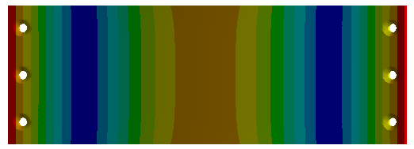
148.18 | 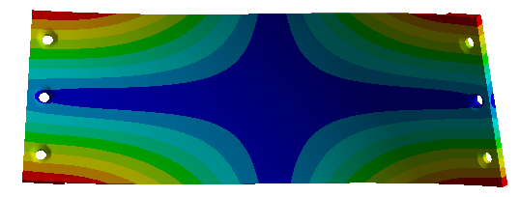
243.01 | 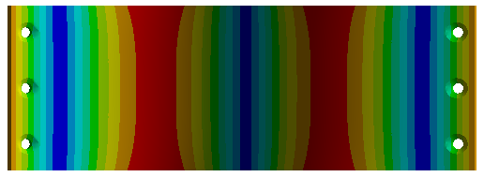
341.17 | 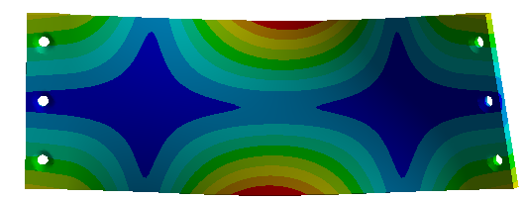
502.24 | 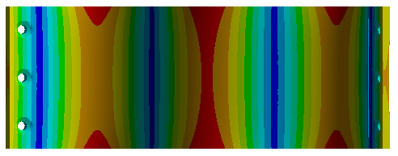
651.86 | 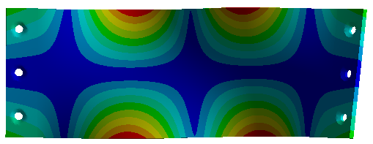

Actuator Impact Testing
The plate was suspended by lightweight nylon line and excited using an instrumented hammer (Figure 4.1). The test used a Dytran impulse hammer and a lightweight accelerometer (Dytran 3225F1), which weighed less than 1.8 g, compared to the plate that weighed around 120 g. Time signals were acquired through a Picoscope, and were analysed in MATLAB. Other data acquisition devices, such as SigLab, were not considered because the limited channels were not capable for future testing of the cylinder. A hard-plastic hammer-head was chosen because it could input enough energy (up to 800 Hz), while the impulse width was not too short to cause multiple impacts. It was assumed that each impact would hit exactly the same point on the plate. The impact and acquisition points were at the bottom left and right of the plate, respectively, where the maximum vibrations were observed in the FE results.
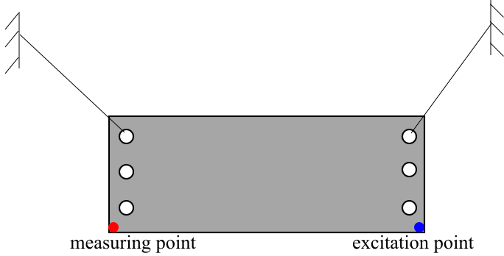
Figure 4.1 Diagram of impact test for actuator.
The following content demonstrates the principle of signal processing for this test. Using MATLAB’s discrete Fourier transform command, discrete spectral array X_{n} is calculated by:
 | $$X_{n}=\sum_{r=0}^{N-1}{x_{r}e^{-i\frac{2πnr}{N}}}$$ | (4.7)
, where x_{n} refers to discrete time data. The half-sine impulse signal lasted about 400×10⁻⁶ s (Fig. 4.2.a), from which the sampling interval was chosen to be 10⁻⁵ s, resulting in a Nyquist frequency of 50×10³ Hz. This is a significantly higher value than the perspective broader of the frequency range of the impulse spectrum. Thus, there was no aliasing in the spectrum. The decay time of the acceleration signal was less than 1 s, thus the length of the sample was set at 2¹⁷. The time length of the sample was thus approximately 1.31 s,, resulting in the frequency increment being approximately 0.76 Hz.
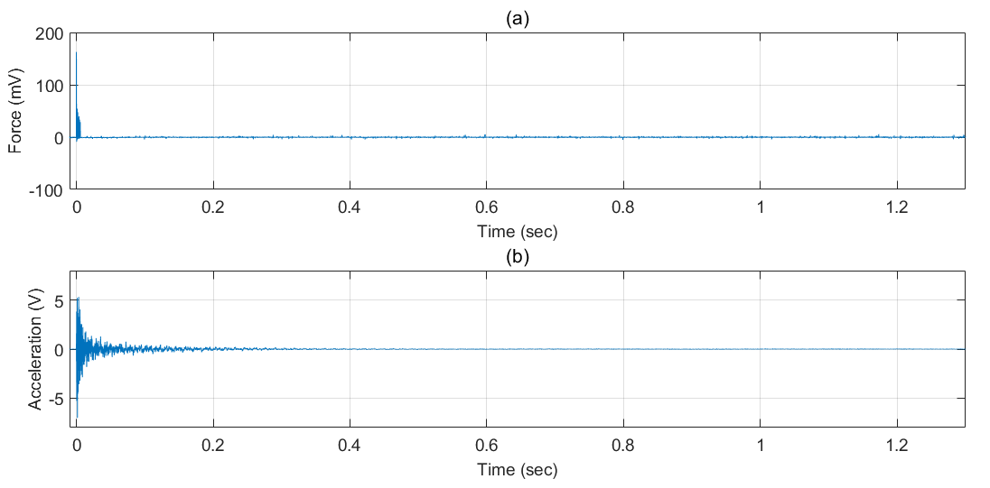
Figure 4.2 Time signal of the force channel (a) and acceleration channel (b).
A set of 10 samples were averaged into an estimated FRF to remove the signal noise, and the coherence function was calculated. Also, the sensitivities of the sensors were considered, so a receptance graph and the phase were plotted (Fig. 4.3).
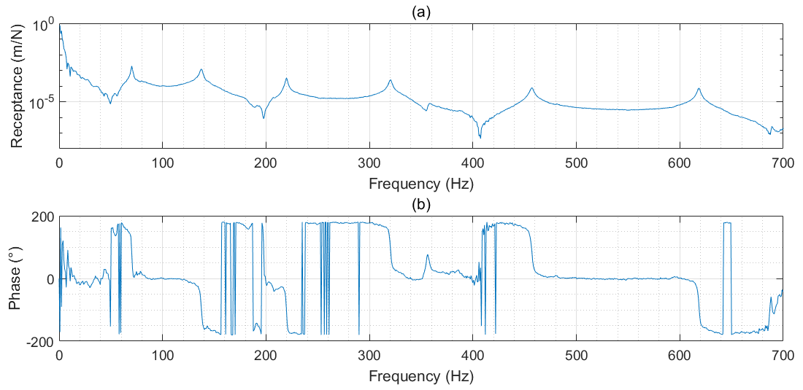
Figure 4.3 Estimated receptance (a) and phase (b) graphs for SMA plate impulse test.
The noise level inside the spectrum was evaluated by sample averaging. Assuming no aliasing:
 | $${F[x}_{τ}(t)]=X(ω)+∈_{τ}(ω)$$ | (4.8)
, where X(ω) is the true spectrum and ∈_{τ}(ω) is an error term associated with the finite sample size τ. This means the error can be removed by averaging; that is, by taking N segments of time data x_{i}(t), then:
 | $$X\left(ω\right)≈E\left[X_{i}\left(ω\right)\right]+E\left[∈_{τ}^{i}\left(ω\right)\right]=E\left[X_{i}\left(ω\right)\right]=\frac{1}{N}\sum_{i=1}^{N}{X_{i}(ω)}$$ | (4.9)
The coherence function can provide a quick, visual inspection of the quality of an FRF and is an indicator of noise and nonlinearity in a system with a measured input x(ω) and output y(ω) signal. The coherence is usually expressed as:
 | $$r^{2}(ω)=\frac{{\left|S_{yx}(ω)\right|}^{2}}{S_{yy}(ω)S_{xx}(ω)}$$ | (4.10)
, where S_{yx}(ω) is the cross-spectral density and S_{yy}(ω) is the autospectral density. These power spectral densities are denoted as:
 | $$S_{yy}(ω)={F[Φ}_{yy}(τ)]=E[Y\left(ω\right){Y\left(ω\right)}^{*}]$$ | (4.11)
and:
 | $$S_{yx}(ω)={F[Φ}_{yx}(τ)]=E[Y\left(ω\right){X\left(ω\right)}^{*}]$$ | (4.12)
, where Φ_{yy}(τ) is:
 | $$Φ_{yy}(τ)=E[x\left(t+τ\right)x\left(t\right)]$$ | (4.13)
Eq. (4.13) is a correlation function that measures how much a signal looks like itself when shifted by time τ. As for the random signal, Φ_{yy}(τ) equals zero in all time domains, except where τ = 0. As shown in Figure 4.4, the coherence approaches unity close to the resonance frequencies. The increase in coherence at certain intervals indicates a high contribution of noise where the frequency responses were relatively low.
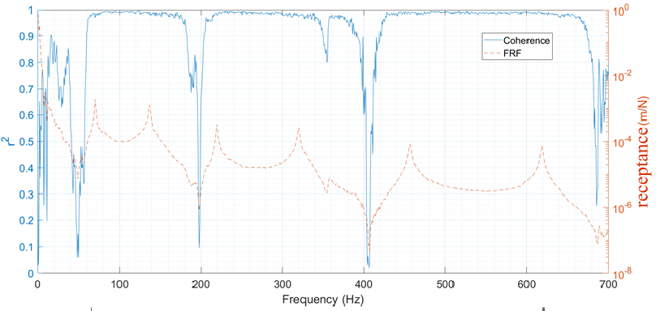
Figure 4.4 Coherence and FRF of SMA plate impulse test.

Actuator Mode Shape Identification
The modal shapes can be represented by frequency response function matrices with complex vectors. By simply moving the accelerometer to different locations on the plate, the rows of complex vectors can be read from the frequency response function, and then assembled on a matrix. This assumes that the accelerometer and the adhesive content have negligible weights; the FE result showed negligible changes in the natural frequencies caused by the added weight, which was usually between 0.05 Hz and 0.2 Hz.
To evaluate the quality or coherence of experimental modal vectors, statistical methods have been developed since the 1970s, after ordinary coherence calculation was associated with FRF computation [106,107]. The calculation was traditionally applied by evaluating the orthogonality of two experimental modal vectors, together with a mass matrix derived from an analytical or FE model [108]. However, when the results did not satisfy the orthogonality relation, it was difficult to be confident that the modal data was the reason, or part of the reason, since the mass matrix might have been invalid [109,110].
The modal assurance criterion (MAC) is a scalar constant used to evaluate consistency between vector matrices and between estimates of one modal vector. It provides a method for normalising the magnitudes and phase differences of the estimates, and then for calculating the superimposed errors for each element of each vector [111]. For a pair of modal vectors coming from different estimation sources – in this case, FE and experiment – the MAC is defined as:
 | $${MAC}_{pqr}=\frac{{\left|{\left\{ψ_{pr}\right\}}^{T}\left\{{ψ_{qr}}^{*}\right\}\right|}^{2}}{{\left\{ψ_{pr}\right\}}^{T}\left\{{ψ_{pr}}^{*}\right\}{\left\{ψ_{qr}\right\}}^{T}\left\{{ψ_{qr}}^{*}\right\}}$$ | (4.14)
, where {ψ_{pr}}^{T} is the transpose of the modal vector for estimation p, mode r, and {ψ_{qr}}* is the complex conjugate of the modal vector for estimate q, mode r. Note that the modal vector is normalised within each estimate, taking into account the magnitude and phase.
By observing the mode shapes in Table 4.2, it was possible to focus on one-quarter of the plate to get a better resolution. As shown in Figure 4.5, the impact tests were carried out at 30 locations as a representation of the overall plate. Note that the plate was bent, thus the accelerometer was measuring the total accelerations of the x-y planes.
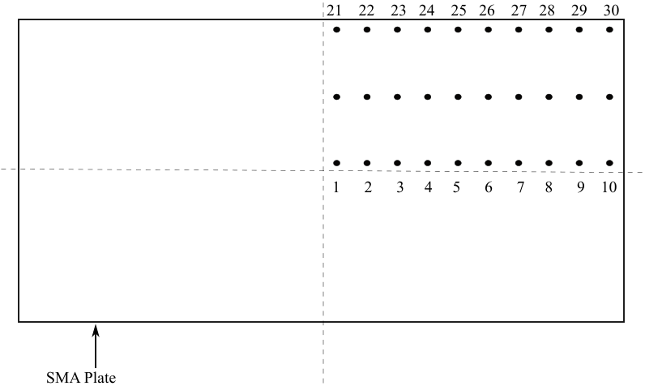
Figure 4.5 Measured locations on SMA plate.
The plate was assumed to be linear within the excitation level, and efforts were made to hit the same point. As well as the data above, a set of 10 FRF data were averaged to reduce the noise.
The MAC result of the SMA plate is shown in Figure 4.6. Strong consistencies in the modal vectors on the diagonal axis indicate that the modal shapes from the FE model adequately represented the real plate, at least for the first six modes. Apart from the diagonal axis, few blocks show considerable correlations, which might be because only one-quarter of the plate was considered.
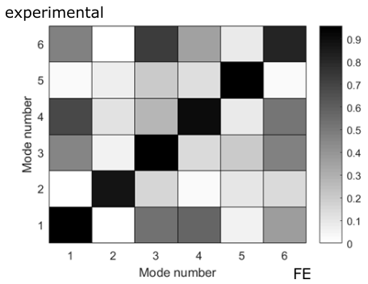
Figure 4.6 MAC chart for SMA plate.

Actuator Natural Frequencies and Damping
In this section, the exact natural frequencies and modal damping ratios of the actuators are calculated by a combination of the Nyquist plot method and a minimisation method. The methodologies of these methods are demonstrated in Appendix C.
For the martensitic actuator, the first mobility FRF peak was circle fitted by the above methods, and the result is shown in Figure 4.7. From this result, the circle was tilted heavily towards the negative imaginary axis, from which the maximum mobility did not emerged before, but rather after, the undamped natural frequency ω_{n}. This could be due to the stacking effects of the mobility from the rigid mode or the second mode. The magnitude and phase plots show adequate correlations between the measured points and the estimated FRF.
The condition near this first mode was evaluated using the FE model for comparison. Mode shapes were solved based on a normalised mass matrix, from which the first modal stiffness was the square power of the first natural frequency. Damping of the FE model was set to be the same as for the physical model. The circle fitted result is shown in Figure 4.8. From this result, the Nyquist plot shows the circle was symmetrically divided by the real axis. This is because the FRF ignored the effects from the other modes, and the damping was subtle. Note that the magnitude of the peak was slightly larger than the actual system. A physical accelerometer measured the vibration perpendicular to the tiny area around the node, and the FE mobility calculated the FRFs on the x and y axes of the space and then synthesised them. The plate was bent, so the curved angle for that tiny area decided the weighted values of the synthetisation. The FE mobility assumed this angle to be 45°, which might be different from that of the actual plate.
From comparing the fittings from the physical and FE models, the environmental effects from the testing rig and neighbouring modes increased the fitting error of both the Nyquist plot and the FRF estimation.
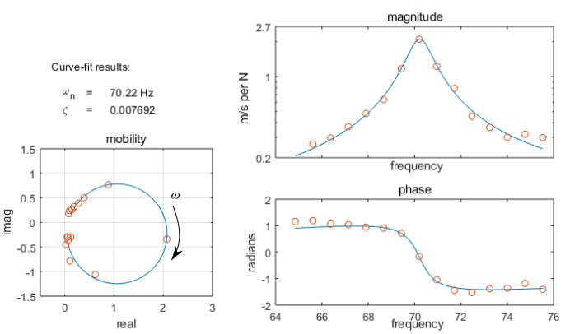
Figure 4.7 Nyquist plot and FRF of mobility from measured frequency points.
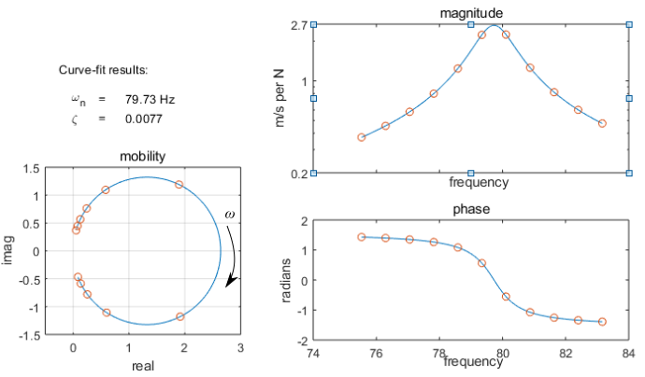
Figure 4.8 Nyquist plot and FRF of mobility from FE model.

The natural frequencies of the SMA plate were generated by the above methodology, and the results are shown in Table 4.3. The bending modes, Modes 1, 3 and 5, show relatively larger errors than the torsion modes. This may be because the self-bending of the plate was not accurately reflected in the FE model, and the bending modes might have been more sensitive to this misrepresentation.
Table 4.3 Natural frequencies of SMA plate from impulse test and FE modelling. The difference is the increased natural frequency relative to the experimentally-measured natural frequency.
 | Natural frequency (Hz)
Results | Mode 1 | Mode 2 | Mode 3 | Mode 4 | Mode 5 | Mode 6
Experiment | 70.22 | 137.40 | 219.80 | 320.30 | 457.00 | 618.40
FE model | 79.73 | 148.16 | 242.90 | 340.86 | 501.25 | 649.68
Difference | 13.5% | 7.7% | 10.5% | 6.4% | 9.7% | 5.1%
The high damping capabilities of SMAs like Nitinol are well known in industry, with efforts having been made to explore the usability of SMAs as passive dampers [112]. There are many factors that can be ascribed to the high-energy dissipating property of SMAs. One obvious factor is the hysteresis loading/unloading curve from when the SMA plate exhibits cyclic loads. By inspecting a loading/unloading stress-strain curve of martensite, the hysteresis loop indicates an energy dissipation of SMA detwinning. Pan and Cho [113] showed that strain amplitude significantly changes the dissipated energy of the hysteresis loop, but that the increased total potential energy made the loss factor almost invariable. However, amplitude-variable impact testing showed the opposite. Figure 4.9 shows there was no obvious correlation between vibration amplitude and damping ratio. This may be because there were not enough samples for impact testing, or the range of vibration amplitude was not wide enough to reveal the larger picture of the correlation.
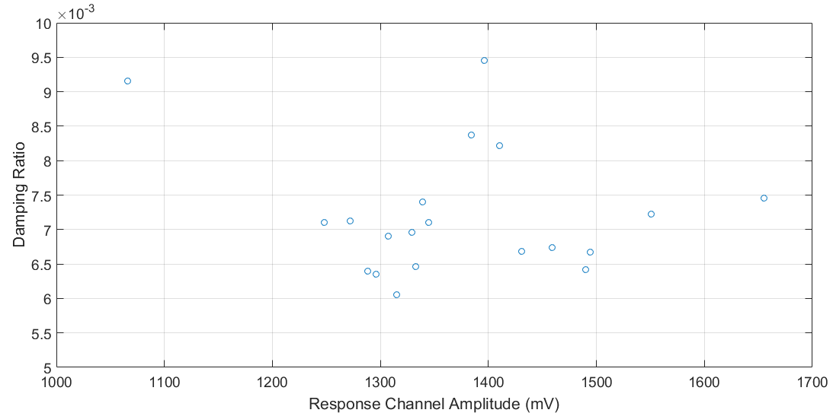
Figure 4.9 Vibration amplitudes and modal damping (first mode).
SMA damping was studied for different phases. SMA plates were heated to 125ºC, until they fully transformed to austenite, in which lower damping was expected. For the impulse test, a high-temperature resistant accelerometer (Dytran 3035C) and a charge amplifier connected to signal conditioner were used. Ceramic adhesive replaced beeswax, which would have melted around 75ºC.
The results are shown in Table 4.4, in which it can be seen that the austenitic SMA exhibited a lower damping ratio. This may be because of a lower internal friction between the crystal planes and a flatter hysteresis loop in the austenitic phase. Other factors may include added damping at high temperature by the ceramic bonding and air circulation inside the environmental chamber gently blowing the plate.
Note that the plate exhibited extensive self-bending after heating, which might have resulted from the residual stress from the cutting. The geometry of the plates was changed dramatically, thus a comparison between the natural frequencies before and after heating was dismissed. Even though the natural frequencies rose dramatically after heating, the FE model shows the first six modes still indicated similar modal shapes.
Finally, the damping ratios of the martensitic SMA were measured twice, at two different times, 12 noon and 9 am. Table 4.5 shows that ambient conditions can affect the damping of SMA plates. Generally, these results indicate that the SMA exhibited less damping at noon, when the temperature was higher and humidity lower. This may be because the martensitic SMA damped more energy when the temperature and surrounding air were damping less energy at noon. Nevertheless, the damping calculation method could induce error by inappropriate curve fitting.
Table 4.4 Damping ratios under different SMA phases.
 | Damping ratio ζ
Phase | Mode 1 | Mode 2 | Mode 3 | Mode 4 | Mode 5 | Mode 6
Martensite | 0.0050 | 0.0111 | 0.0042 | 0.0049 | 0.0034 | 0.0030
Austenite | 0.0031 | 0.0098 | 0.0019 | 0.0033 | 0.0017 | 0.0018
Table 4.5 Martensitic damping ratios measured at two time points.
 | Damping ratio ζ
Time of day | Mode 1 | Mode 2 | Mode 3 | Mode 4 | Mode 5 | Mode 6
12 pm | 0.0077 | 0.0079 | 0.0036 | 0.0036 | 0.0031 | 0.0018
9 am | 0.0083 | 0.0085 | 0.0047 | 0.0048 | 0.0040 | 0.0024

Cylindrical Nozzle Modal Analysis and Testing
The cylinder was rolled from a Ti-alloy sheet and then welded at the seam. There was a distinct welding line and the surrounding area was oxidised during the welding, as Ti is very active at its melting temperature. The asymmetry of the cylinder was affected during manufacturing so splitting of the twin modes was expected.

Cylinder FE Modelling
Solid elements were adopted for the cylinder body. A mesh was generated using an automatic algorithm that favoured hexahedral elements. The body was divided into upper and lower segments, which were meshed by two sweeping methods. These sweeping methods were defined by their respective starting and ending faces. The sweeping went through the segments axially, using defined sweeping densities. The circumferential divisions were controlled by multiple-line densities. The combined meshing constraints ensured a balanced mesh with adequate mapping densities. While a high mesh density ensures accuracy, the solving can be computationally expensive. A trade-off study was conducted at the natural frequency of the 20th mode.
Figure 4.10 shows that the natural frequency of the 20th mode converged at 369 Hz, and the consumed time surged dramatically at around 29,000 elements. Thus, the ideal selection for the division quantity fell into 25,596 elements, from which the meshed cylinder shown in Figure 4.11 is derived.
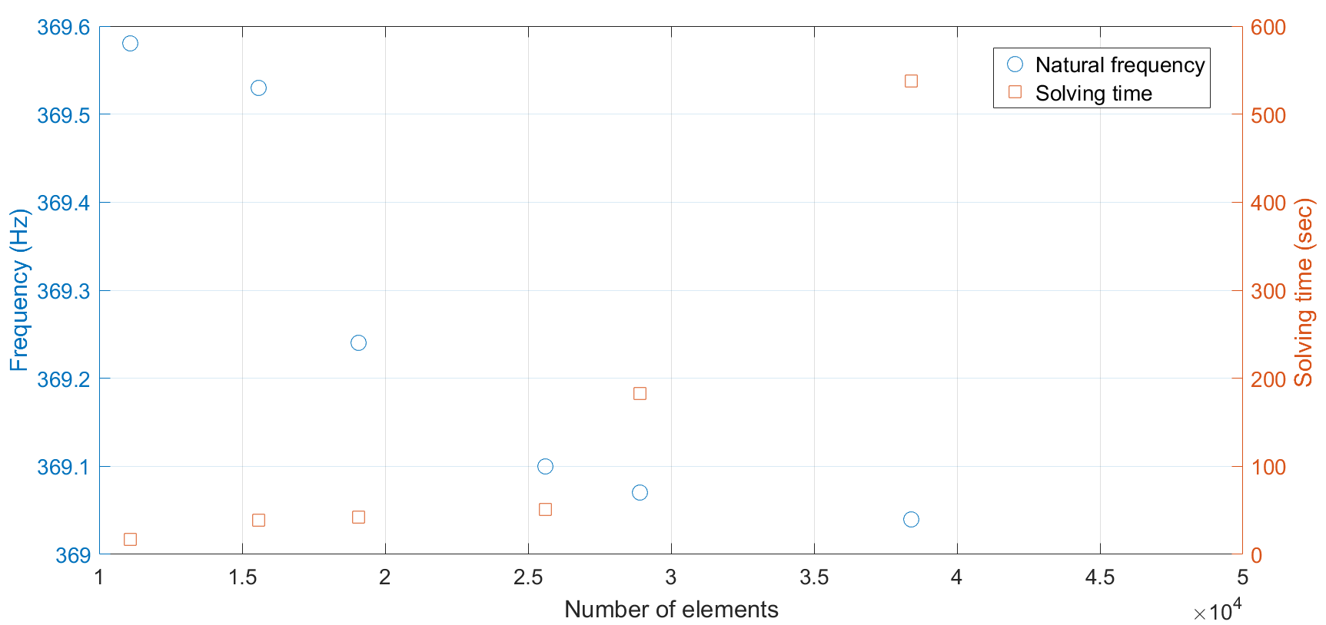
Figure 4.10 Natural frequencies of the 20th mode under varying meshing densities.
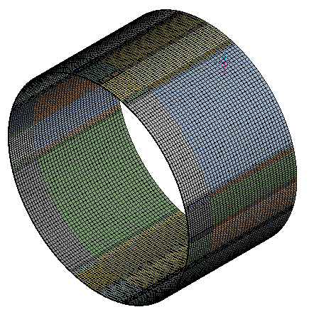
Figure 4.11 Meshed cylindrical nozzle.
A modal analysis was carried out under free boundary conditions. Table 4.6 shows several resonant modes with their mode shapes. The first mode is an in-plane bending mode, while the second mode is a response mode of the first mode, with m = 0 and n = 2. The third mode is an out-of-plane bending mode, while the fourth mode is a response mode of the third mode, with m = 1 and n = 2. The 19th mode is an out-of-plane bending mode, while the 20th mode is a response mode of the 19th mode, with m = 1 and n = 6.
Since the FE model did not consider the defects of the actual cylinder, the geometry was completely symmetric about the central axis. Thus, little differences in the natural frequencies between the twin modes were observed. For example, the first mode’s natural frequency was 24.97 Hz, while the second mode’s was 25.04 Hz. The twin mode splitting would be much more significant in experimental results.

Table 4.6 Modal shapes of free supported cylinder vibration.
1st mode 24.97 Hz  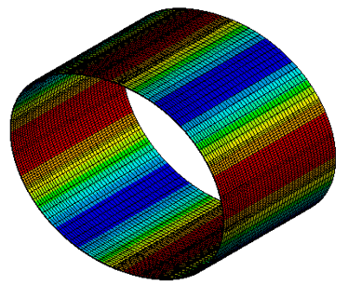 | 3rd mode 40.95 Hz  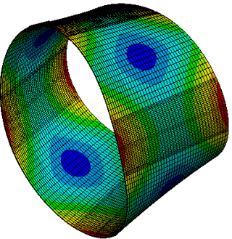
17th mode 321.63 Hz  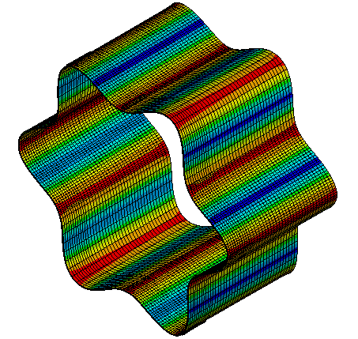 | 19th mode 366.80 Hz  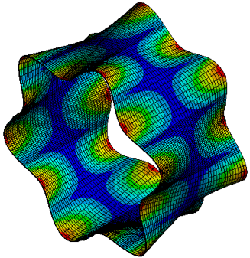

Cylinder Impact Testing
The cylinder was suspended by soft strings to simulate free boundary conditions (Fig. 4.12). A lightweight accelerometer was applied to the cylinder surface for response acquisition. An impulse hammer with a force transducer was applied for input. It was assumed that each hammer blow hit the same point. Both the input and response points were located on the same DOF, on the edge of the cylinder, for maximum response signals.
It took a long time for the cylinder to decay to a free oscillation, with the sampling time being as long as 50 s just in occupying the decay period. The time span was carefully chosen because, if it was too short, there might be a leakage of the response signal. On the other hand, if the time span was too long, the end of the time signal would consist of pure noise, which would introduce more noise into the spectrum. A total of 30 time signals were averaged into an estimated FRF in order to increase the coherence value. The receptance FRF of the suspended cylinder is shown in Figure 4.13.
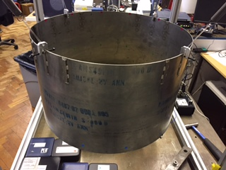
Figure 4.12 Cylindrical nozzle and suspension for impulse test.
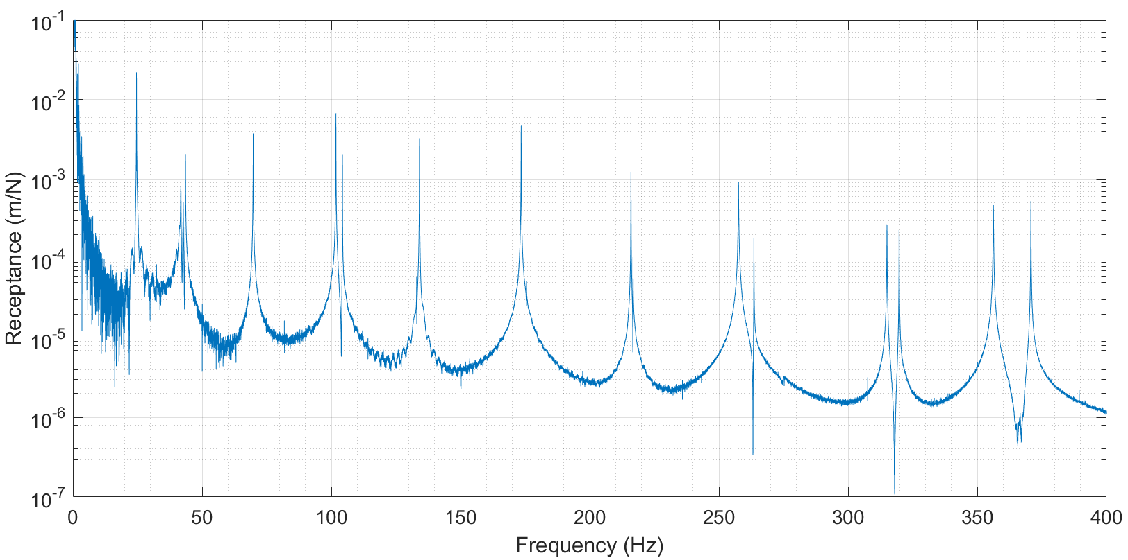
Figure 4.13 FRF of cylinder impulse test.
As shown in Figure 4.13, up to 20 resonances were contained in the frequency range from 10 to 400 Hz. It is obvious that the twin modes started to emerge at the second peak. The frequency splitting between the last twin modes could be as large as 14 Hz. Some twin modes were hardly distinguished in the FRF, which may be because the response modes were too subtle, and were hidden behind the strongly excited drive modes. This can be solved by circumferentially shifting the accelerometer to a point that falls onto the antinodes of the response modes.
Note that the twin modes of this cylindrical structure were located within a close distance from the FRF. Thus, an interesting phenomenon was observed by looking at the magnitudes of the FRF. The intermediate area of the spectrum between a pair of twin modes was either a pit or a smooth curve (Figs 4.14, 4.15). This was achieved by placing the accelerometer onto different locations of the cylinder, and the reason is interpreted in the following paragraphs.
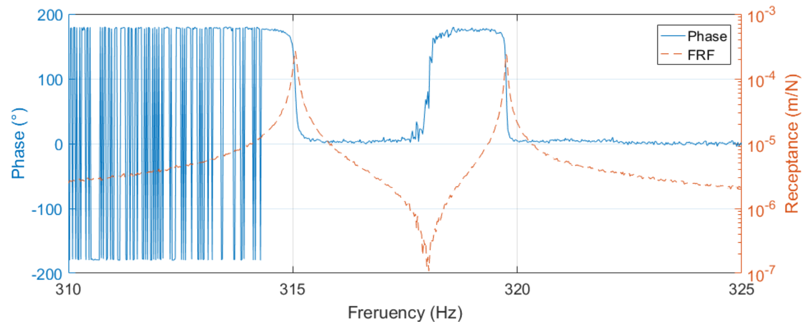
Figure 4.14 Phase and FRF plots over a spectral range, measured at a certain DOF.
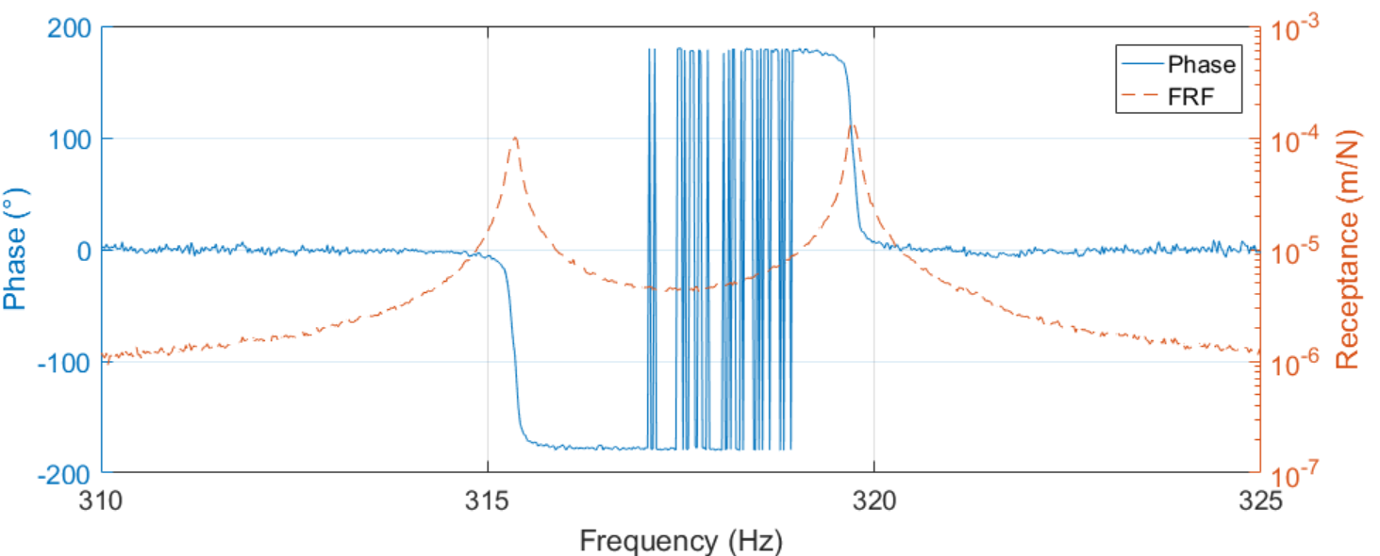
Figure 4.15 Phase and FRF plots over a spectral range, measured at a different DOF.
Figure 4.14 shows the combined action of anti-resonance by the pair of twin modes. Analytically, this could be explained by the transfer function in Eq. (4.15). The FRF between 315 Hz and 320 Hz is approximated by:
 | $$H≈\frac{φ_{17}^{i}φ_{17}^{j}}{{ω_{17}}^{2}\left[1-{\left(\frac{ω}{w_{17}}\right)}^{2}+2j\frac{ω}{w_{17}}ζ_{17}\right]}+\frac{φ_{18}^{i}φ_{18}^{j}}{{ω_{18}}^{2}[1-{\left(\frac{ω}{w_{18}}\right)}^{2}+2j\frac{ω}{w_{18}}ζ_{18}]}$$ | (4.15)
, where φ_{n} is the vector matrix and ω_{n} is the natural frequency. The mode shapes were mass normalised, thus the model stiffnesses was replaced by the square power of the natural frequencies.
Because the phases of the FRF at the two peaks were both around 90° (Fig. 4.14), the two values $φ_{17}^{i}φ_{17}^{j}$ and $φ_{18}^{i}φ_{18}^{j}$ had the same polarity. When ω fell between ω₁₇ and ω₁₈, the real parts of the complex H, $1-{\left(\frac{ω}{w_{17}}\right)}^{2}$ and $1-{\left(\frac{ω}{w_{18}}\right)}^{2}$, had opposite polarities. This resulted in the cancelation of the real part of complex H. Moreover, since ω was far from ω₁₇ or ω₁₈, the real part of H dominated the absolute magnitude over the imaginary part of H. Overall, the magnitude of the FRF in the middle bandwidth was decreased and a pit was formed.
On other hand, Figure 4.15 does not shown a pit between the twin modes. This is because the phases of the FRF are at two peaks around 90° and -90°, which is the opposite to the previous scenario. Thus, the magnitude of the FRF was stacked by the two peaks, resulting in a smooth curve, without a pit in the middle bandwidth.
The above interpretation might be able to explain a third resonance peak between a pair of twin modes (Fig. 4.16). The phases of the two peaks have opposite polarities, and so the amplitude in the middle of the FRF was stacked by the two peaks.
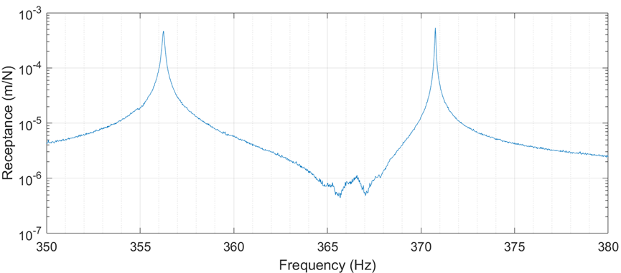
Figure 4.16 Unexpected peak between the 19th and 20th modes of the cylinder.

Cylinder Mode Shape Identification
A practical method was applied to correlate the mode shapes from the FE model to the actual cylinder. The accelerometer was shifted around the cylinder surface while the impact point stayed still, with the FRF being generated at each shift. As shown in Figure 4.17, 30 points were equally distributed around one-quarter of the upper end. Also, to identify the out-of-plane bending modes, nine points were also considered. To save acquisition time during the impact testing, three lightweight accelerometers were applied at the same time.
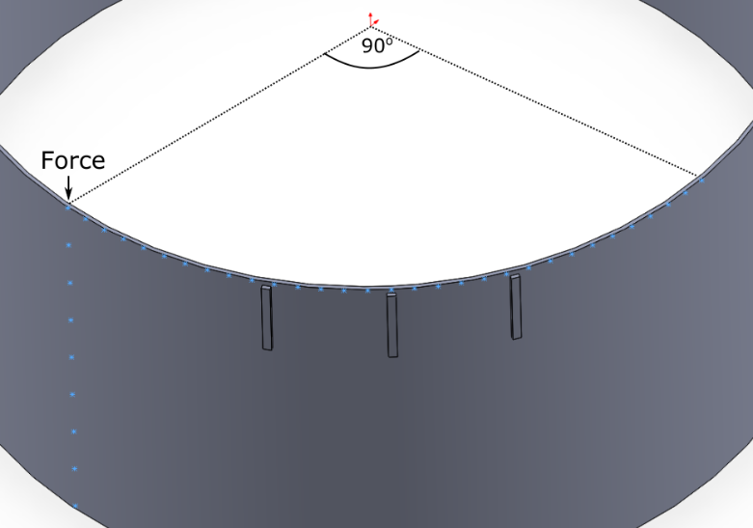
Figure 4.17 Distribution of measured response matrix, as shown by star marks.
The FRF peaks were generated for all modes, and the mode shapes were combined using the considered points for each mode. Contour plots were adapted for visual cognition, in which the magnitudes within each mode were normalised. Mode shapes for the first and third modes are plotted in Figure 4.18.
From Figure 4.18.a, the maximum response magnitude can be seen to be slightly shifted from the 0° point, which implies that the cylinder is asymmetric. The amplitudes start from the maximum to the minimum for an arc length of 45°, which verifies that n = 2. By comparing the magnitudes in the y-direction, the third mode is confirmed to be an out-of-plane bending mode.
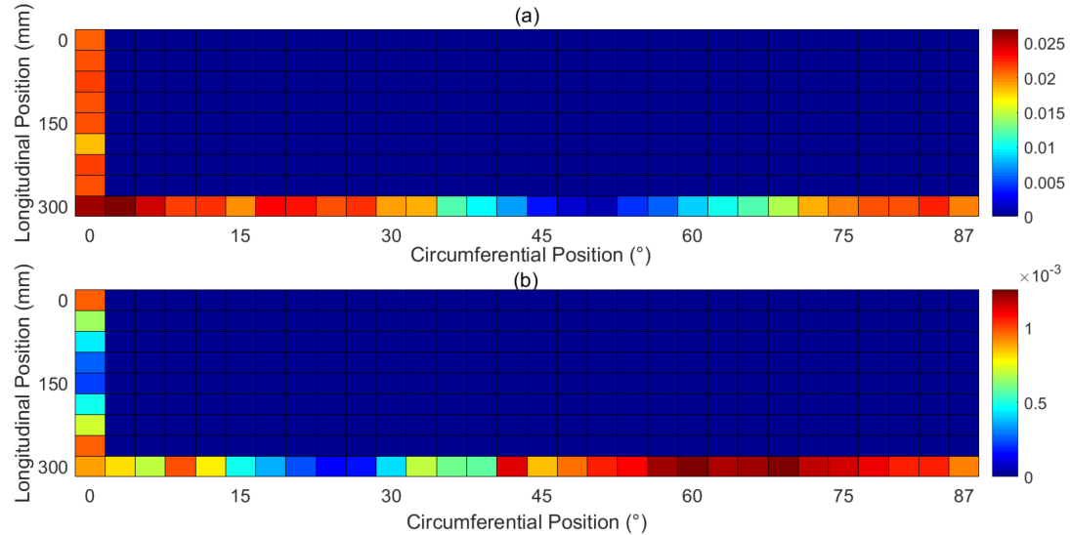
Figure 4.18 Vector matrix of the first (24.62 Hz) (a) and third (41.76 Hz) (b) modes. Plot vertically inversed, with the bottom of the plot representing the upper edge of the cylinder. Data from experimental results.
In Figure 4.19, a pair of in-plane bending twin modes, with six circumferential nodes, is shown. The maximum point on the first mode is exactly the minimum point of the second mode, so that the two modes were confirmed to be a pair of twin modes.
The FE model was also considered in Figure 4.20, in which the effect of the spacers is first addressed. The result (Fig. 4.20.a, b) shows the existence of the spacers rotating the mode shape circumferentially by around 3°. This implies that the mode shape is sensitive to the added masses, considering how small the spacers were. Figure 4.20.c indicates the effects of the manufacturing defects of the actual cylinder stacked with the effects of the spacers, which further rotate the mode shape by around 3°. This implies the importance of experimental testing, as defects on the actual structure can affect the mode shape in an unpredictable manner.
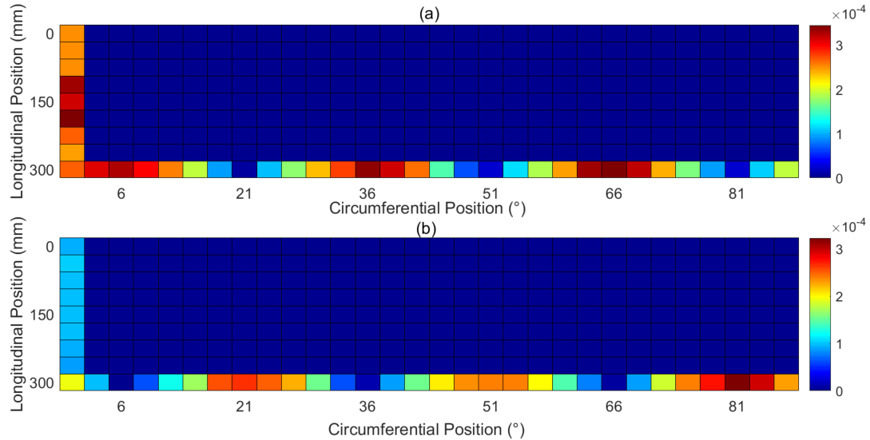
Figure 4.19 Vector matrix of the 19th (366.8 Hz) (a) and 20th (369.1 Hz) (b) modes. Data from experimental results.
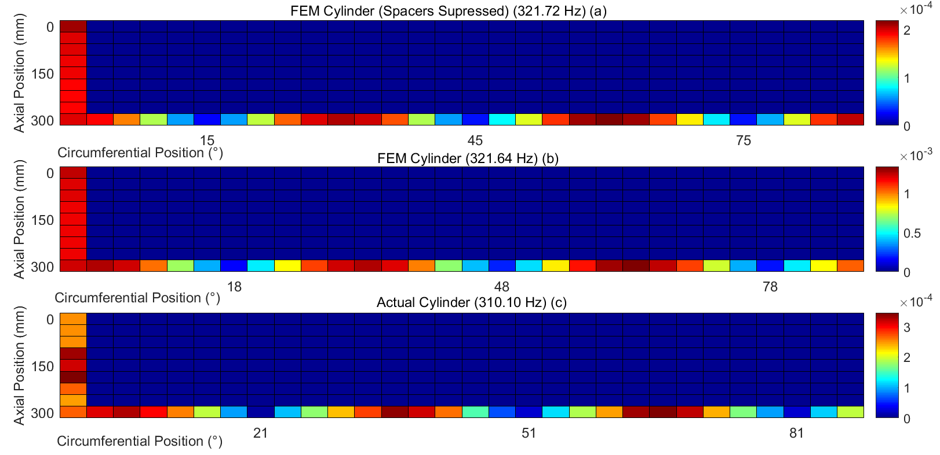
Figure 4.20 Vector matrices of the 17th mode from three models – FE cylinder without spacers (a), FE cylinder with spacers (b) and experimental cylinder with spacers (c).

Cylinder Natural Frequencies
The accuracy of the FE model can be reflected in the natural frequencies compared to the experimental results. The natural frequencies of the 20 modes in both the FE and experimental models are listed in Table 4.7. For simplification, the twin modes were halved in such a way that only the ones with relatively lower frequencies are listed.
In general, the actual cylinder has lower natural frequencies than the FE model, except for the two-way out-of-plane bending mode. The out-of-plane modes indicate a larger error between the two models, with 10.6 Hz on the last out-of-plane bending mode and 6.53 Hz on the last in-plane bending mode.
Lastly, the twin-mode splitting was studied by calculating the percentages of the change based on the actual model. Figure 4.21 shows that the FE model generally split much less than the actual cylinder. This makes sense because the actual cylinder exhibited manufacturing defects, which were not considered in the FE model. Moreover, the out-of-plane bending modes split larger than the in-plane bending modes in both models. This indicates that torsional vibration is more sensitive to the asymmetries of the cylinder. It is notable that the natural frequencies of the twin modes with odd circumferential nodes were identical for the FE model. The Ti-alloy cylinder exhibited quite low damping, with the loss factor being measured as 0.00014 < η < 0.00043.
Table 4.7 Natural frequencies of FE and experimental models with free support. Difference is related to the experimental results.
ω_{n} (Hz) | FE | Experiment | Difference | FE | Experiment | Difference
n node number | In-plane bending |  |  | Out-of-plane bending
2 | 24.971 | 24.62 | 1.4% | 40.947 | 41.76 | 1.9%
3 | 70.731 | 69.68 | 1.5% | 102.47 | 101.8 | 0.66%
4 | 135.61 | 133 | 2.0% | 175.14 | 173.5 | 0.95%
5 | 219.29 | 216 | 1.5% | 263.26 | 257.6 | 2.2%
6 | 321.63 | 315.1 | 2.1% | 366.8 | 356.2 | 3.0%
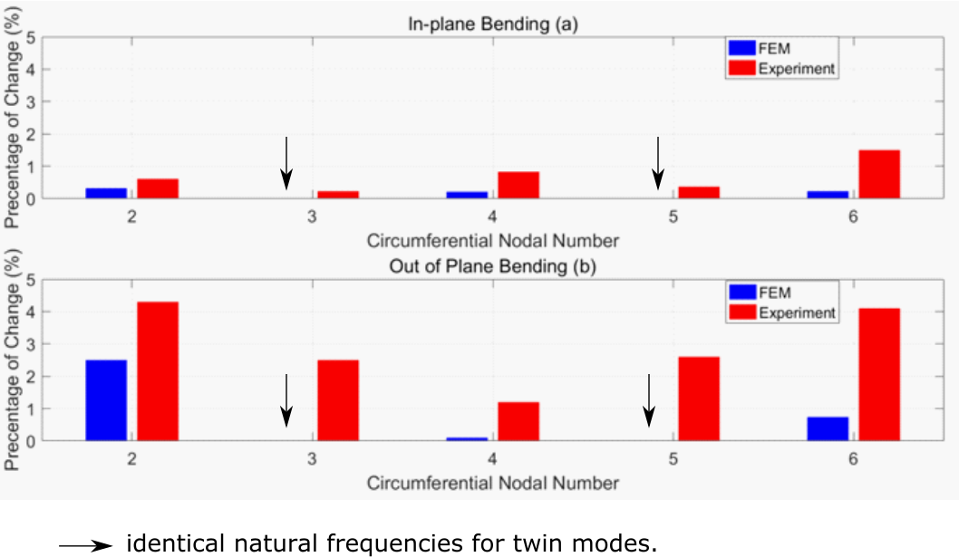Figure 4.21 Natural frequency split of twin modes.

Conclusion
In this chapter, the dynamic properties of the two components of the VAN were discussed. A SMA actuator FE model was built, and a modal analysis was applied for natural frequencies and mode shapes. Impact tests were carried out on the physical actuator that generated the FRF. A MAC method was adapted to calculate the correlation factor between the FE and experimental mode shapes. The MAC result showed strong similarities in the vibration patterns between the two models, by which the experimental mode shapes were verified.
The half-power method, adapting the Nyquist plot to calculate modal damping, was demonstrated. Moreover, a practical procedure, adapting the minimisation method to curve fit the Nyquist plot and FRF peak, was demonstrated. Then, the exact natural frequencies and damping ratios could be calculated, following the curve fitting procedure.
The natural frequencies of the FE model showed consistency with the experimental model. The natural frequency differences between the two models were found to be more significant in the bending than the torsion modes. The damping ratios are reduced in the austenitic phase, as opposed to the martensitic phase. In addition, environmental conditions, such as temperature, can affect the damping of SMA. Lastly, there was no correlation between vibration amplitude and damping, which was unexpected, considering previous research findings.
The cylinder FE model was meshed into a managed quantity of elements to produce solving time efficiency. The modal analysis showed there was a subtle twin-mode splitting in the FE model. The FRF from the impulse test showed significant twin-mode splitting, especially in the higher-order modes. The mode shapes of the actual cylinder were measured by shifting the accelerometers around the cylinder surface. The contour plots from the experimental results correlate the mode shapes with the FE results. Moreover, the asymmetry of the cylinder, including the spacers and manufacturing defects, can influence the rotational translation of the mode shapes. The differences in the natural frequencies between the two models were below 5%, which verified the FE model. Lastly, the twin-mode splitting was much more significant in the actual cylinder than in the FE model, which may be because of the unaddressed manufacturing defects in the FE model.

Chapter 5
VAN Modelling and Experimentation
In the previous chapter, FE models of the bare actuator and cylinder were verified by mode shape correlation studies. In this chapter, the VAN FE model is assembled, with a material model buildup and dynamic analysis of the morphing structure. Following that, an experimental testing of the assembled VAN was applied to verify the FE model. The results show that the experimental VAN performance was strongly affected by the manufacturing quality of the SMA actuators.

VAN Modelling
The VAN assembly was modelled in a FE environment. Material models were built to simulate the SME and detwinning properties of SMA. After boundary conditioning, a static analysis was carried out to model a SMA working cycle, with heating of the SMA followed by cooling. An optimising study was adapted based on the parameters, including the dimensions, of the actuators.

Fundamental Principle of Finite-Element-Method for Statics
Finite-Element-Method (FEM) is a numerical solution method used to solve engineering problems, including solid mechanics, thermal radiation and fluid dynamics. For solid mechanics, FEM analyses the distribution of displacement and stress on a continuous body under known loads and boundary conditions by solving an assembled partial differential equation, considering the Cauchy stress tensor within each element [114].
Assuming a 2-dimensional body meshed by third-order elements (Figure 5.1), the shape function within a triangular element (Figure 5.2), which describes the physical behaviour of the element, can be defined by an interpolation function, and this gives:
 | $$\overline{u}\left(x,y\right)=N_{1}\left(x,y\right)u_{1}+N_{2}\left(x,y\right)u_{2}+N_{3}(x, y)u_{3}$$ | (5.1)
 | $$\overline{ ν}\left(x,y\right)=N_{1}\left(x,y\right)ν_{1}+N_{2}\left(x,y\right)ν_{2}+N_{3}(x, y)ν_{3}$$ | (5.2)
, where u̅(x,y) and v̅(x,y) are displacements at any point that has coordinates of (x,y) within the element, N_{i}(x,y) are the shape functions, and u_{i} and v_{i} are the nodal displacements for node i. Eqs (5.1) and (5.2) are involved with the development of equations within the element. They will later derive the displacement components throughout the body structure in the postprocessing stage.
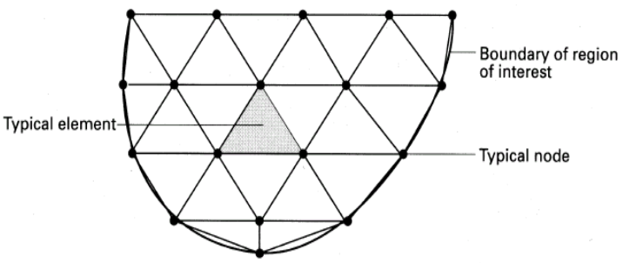
Figure 5.1 Finite element mesh with 2-dimensional elements [115].
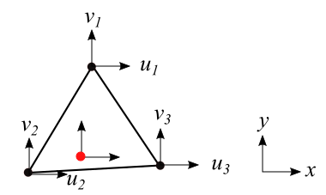
Figure 5.2 Triangular element with three nodes (black) and an arbitrary point (red) on the face element.
The equations for the element can be then developed by the minimum total potential energy principle, by which a loaded elastic structure attains the equilibrium position when the potential energy Π is at a minimum:
 | $$Π=Λ-W$$ | (5.3)
, where Λ is the strain energy of the structure and W is the work done by the external loads [116].
By utilising the shape functions, the strain distribution within the element can be related to the nodal displacements. For plane strain conditions and isotropic elasticity, the strain energy can be written as:
 | $$Λ=\frac{1}{2}{u_{e}}^{T}\int_{0}^{V_{e}}{B^{T}DBdV_{e}u_{e}}=\frac{1}{2}{u_{e}}^{T}K_{e}u_{e}$$ | (5.4)[116]
, where u_{e} is the nodal displacement vector, B is a matrix reassembled by differentiating the shape function matrix, and D is a constitutive matrix relating the strain tensor and stress tensor matrices. These are written as:
 | $${u_{e}}^{T}=(u_{1} ν_{1} u_{2} ν_{2} u_{3} ν_{3})$$ | (5.5)
 | $$B=\left[\begin{matrix}\frac{∂N_{1}}{∂x} & 0 & \frac{∂N_{2}}{∂x} & 0 & \frac{∂N_{3}}{∂x} & 0 \\ 0 & \frac{∂N_{1}}{∂y} & 0 & \frac{∂N_{2}}{∂y} & 0 & \frac{∂N_{3}}{∂y} \\ \frac{∂N_{1}}{∂y} & \frac{∂N_{1}}{∂x} & \frac{∂N_{2}}{∂y} & \frac{∂N_{2}}{∂x} & \frac{∂N_{3}}{∂y} & \frac{∂N_{3}}{∂x}\end{matrix}\right]$$ | (5.6)
and
 | $$D=\frac{E}{(1+ν)(1-2ν)}\left[\begin{matrix}1-ν & ν & 0 \\ v & 1-v & 0 \\ 0 & 0 & \frac{1-2ν}{2}\end{matrix}\right]$$ | (5.7)[116]
, where E is Young’s modulus and ν here is Poisson’s ratio. In addition, the V_{e} in Eq. (5.4) is the volume of the element and K_{e} is the element stiffness matrix, which can be calculated by the integral.
Assuming only nodal loads were applied, the work done by the loads can be written as:
 | $$W={u_{e}}^{T}f_{e}$$ | (5.8)
, where f_{e} is the nodal forces vector.
Following that, the potential energy of the whole structure can be written as:
 | $$Π=\sum_{e=1}^{total of e}{\left(\frac{1}{2}{u_{e}}^{T}K_{e}u_{e}-{u_{e}}^{T}f_{e}\right)}=\frac{1}{2}U^{T}KU-U^{T}F$$ | (5.9)[116]
, where U is the nodal displacement of all the DOFs in the structure, K is the global stiffness matrix and F is the nodal forces of all the DOFs in the structure. An equivalent state has to be reached to satisfy the minimising of the potential energy, thus U has to satisfy the following equation at every DOF for a structure with n DOFs:
 | $$\frac{∂Π}{∂u_{1}}=\frac{∂Π}{∂u_{2}}=…=\frac{∂Π}{∂u_{n}}=\frac{∂Π}{∂U}=0$$ | (5.10)
By substituting Eq. (5.9) into Eq. (5.10), the problem can finally be derived into solving the following equation:
 | $$KU=F$$ | (5.11)[116]
, where the global matrix K is assembled by filling in an empty global stiffness matrix. Where elements shared the same node or same side, the corresponding stiffnesses were summed. Moreover, as the global stiffness matrix is a singular matrix, Eq. (5.11) cannot be solved because the determinant of K is zero. Thus, boundary conditions must be applied, and the constrained DOFs are removed from the equation.
After solving for the nodal displacements vector U, the deformation of any point in the structure can be derived from the shape functions. Moreover, the stress and strain matrices can be computed within each element by:
 | $$ε(x,y)=Bu_{e}$$ | (5.12)[116]
and:
 | $$σ(x,y)=Dε(x,y)$$ | (5.13)[116]
, where ε(x,y) and σ(x,y) are the stress and strain distributions within an element

Actuator Material Modelling
DSC is a thermoanalytical test in which the amount of heat required to increase the temperature of a material is measured against temperature [117]. Following DSC testing, the ADVACT report gave the following principal SMA temperatures: A_{s} = 89ºC, A_{f} = 114ºC, M_{f} = 82ºC, M_{f} = 58ºC [2].
The Young’s modulus of SMAs is known to change with temperature. It is commonly assumed that the Young’s modulus in the austenite phase is significantly higher than in the martensite phase. The measurement of Young’s modulus was carried out for the ADVACT report using a three-point bend configuration by a Metravib VA2000 viscoanalyser.
The measured Young’s modulus is shown in Figure 5.3. The stiffness of the material varies continuously with temperature, and the lowest points are at around A_{s} when heating and M_{f} when cooling. The material was assumed to be isotropic in terms of elastic modulus.
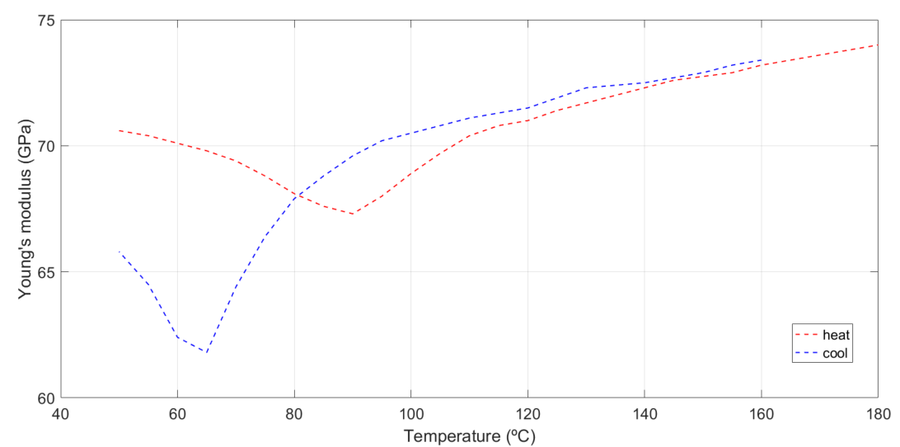
Figure 5.3 Young’s modulus vs. temperature for SMA [2].
The SME enables an actuator to contract a certain amount of strain upon heating by 2% based on a prestretch of 2% strain, according to the ADVACT report. In the FE model, the actuators were drawn to the lengths that had elongated by 2%. The phase-transformation-induced contraction was modelled using a pseudo-thermal expansion coefficient. The induced contracting strain is written as:
 | $$ε_{induced}=α(T-T_{0})$$ | (5.14)
, where α is the coefficient of thermal expansion with a reference temperature of 0°C. Coefficient α was calculated according to the testing data from the ADVACT report, which is shown in Figure 5.4 [2].
The pseudo-thermal expansion was only applied in the circumferential direction, and the material was assumed to be orthotropic. Poisson’s ratio was set to be as low as 0.01 to ensure that deformation only occurred in the circumferential direction. In addition, the thermal expansion coefficient had to be defined in a cylindrical coordinate system because the contracting direction was only circumferential. In ANSYS, the thermal expansion directions of elements follow the elemental coordinates system. Thus, a command to switch the elemental coordinates system from Cartesian to cylindrical was added into the presolution setting.
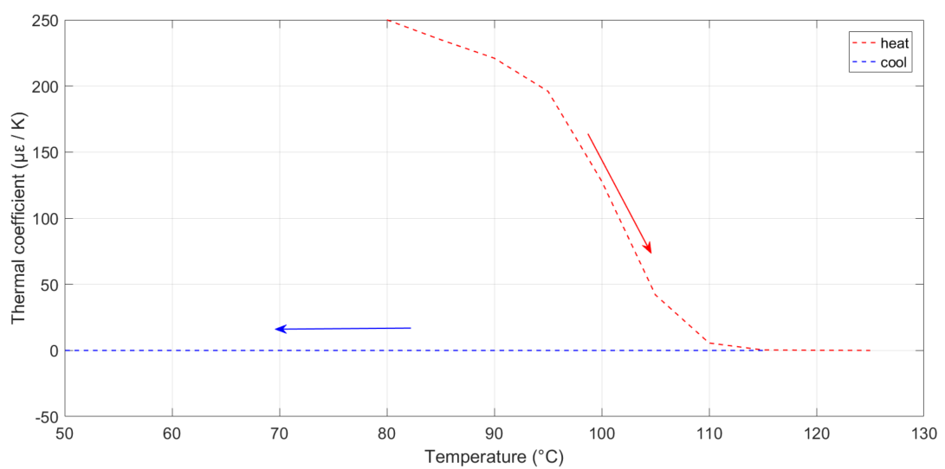
Figure 5.4 Thermal coefficient vs. temperature for one heat/cool cycle, measured by Birmingham University [2].
During cooling, the self-stiffness of the host structure restretches the actuator. This detwinning process was simulated by an elastic-plastic material model. A defined plasticity is added to the SMA material and is only initiated once the cooling stage starts. The corresponding testing data was measured by a researcher at Birmingham University, UK [2], from which it was found that the distinct point where the ‘plasticity’ commenced was difficult to define. Instead, different levels of detwinning occurred, depending on the applied stress and temperature. The results are shown in the stress-strain curves in Figure 5.5, which synthesises the ‘plasticity’ of the cooling stages at different temperatures [2].
It is important to note that the procedure for SMAs outlined here does not directly take into account the effect of superelasticity, which could occur during the final part of the heating stage. If, based on experimental results, the superelasticity of the SMA did emerge, the VAN would be less deformed at the end of heating, or would require higher heating temperatures to achieve the potential deformation.
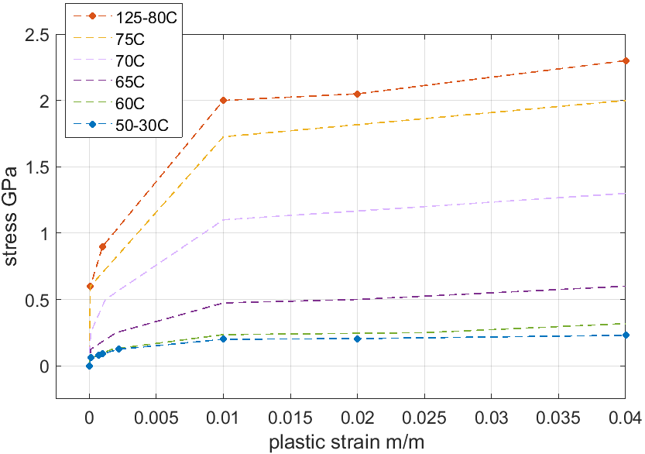
Figure 5.5 Multilinear plasticity at various temperatures during cooling [2].

VAN Deformation Analysis
One cylinder and four actuators were assembled to create the VAN in a FE environment. Several contacting pairs were defined between the cylinder and the actuators. For each station, the actuator was constrained with the cylinder by two slim faces where bonded contacts were defined. Moreover, three wider faces were defined as frictionless to enable a small amount of sliding between the three spacers and the actuator when it contracted or expanded (Fig. 5.6).
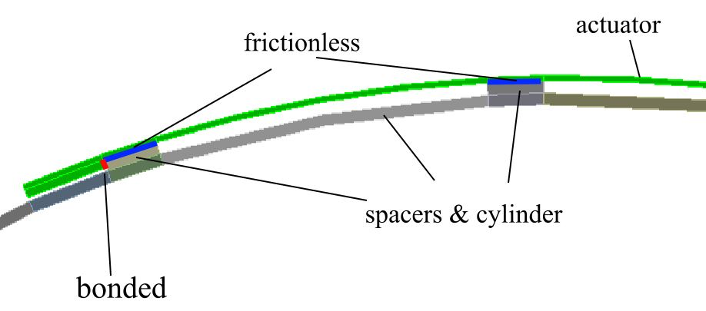
Figure 5.6 Bonded (red) and frictionless (blue) contacts.
The static analysis in the FE environment modelled a single heating/cooling cycle. The heating stage started at 80°C, where the austenite transformation began. The heating ended at 125°C, when the actuators were fully converted to austenite. The cooling stage started at 100°C, reaching 30°C at the end. The analysis encompassed the cooling stage temperatures from 126–196°C (Fig. 5.7). This was because the time steps could only go in one direction.
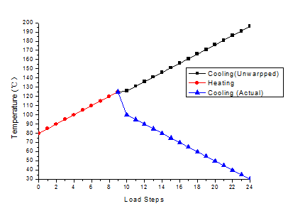
Figure 5.7 Load steps for static analysis.
The static deformation achieved at the end of the heating and cooling is shown in Figure 5.8. The inward displacement at the active edge d_{in} reached a maximum of 16.32 mm, leaving a residual of 6.61 mm when cooling ended. This residual deformation was expected, and is mentioned in Figure 2.8.
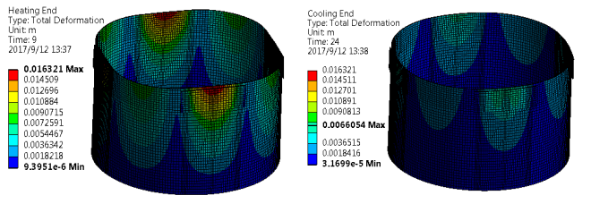
Figure 5.8 Total deformation at the end of heating and cooling based on a 2% prestretch on SMA actuators.
The stress distribution on the VAN were investigated to determine any potential yield. Firstly, the cylinder did not reach the yield stress of Grade 5 Ti-alloy. Secondly, the actuator’s stress level at the end of heating is shown in Figure 5.9, where the critical area is around the corner of the plate. The majority of the plate exhibited stresses below 800 MPa, which is the threshold austenite plasticity. The corner areas might have experience yield, but no major effects were predicted across the entire plate. By increasing the thickness of the SMA plates, this excessive stress around the corners would be relieved. However, new actuators would have to have been crafted, and so this was not considered.
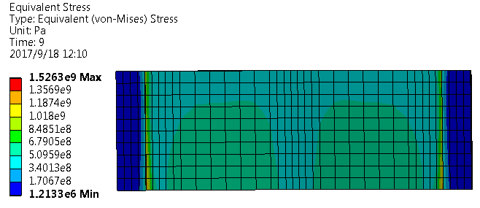
Figure 5.9 Stress levels on an actuator at the end of heating.
Cross-sectional area changes in the deflected cylinder were calculated via an integral of the nodal coordinates. In addition, a 3% prestretch was tested for extra VAN functionality. The results showed that, with a 2% actuator prestretch, the achieved inward displacement and area reduction were significantly greater than the findings in the ADVACT report, which were 10.8 mm and 1.8%, respectively [2]. For the 3% prestretched model, d_{in} almost doubled, and the reduced area almost tripled (Table 5.1). However, higher stress levels were observed on the cylinder and SMA plates, from which yield on both parts was predicted. Thus, the 3% prestretched model was not considered in the experimental testing.
Table 5.1 Deflection and area reduction under different scenarios.
Number of actuators attached and heated | Initial strain (%) | Maximum d_{in} (mm) | Maximum area reduction (%)
4 | 2 | 16.3 | 3.87
4 | 3 | 31.6 | 10.72

VAN Parameter Study
The parameters, including the actuators and spacer dimensions, were not studied for ADVACT report. This section examines the effects of changing the original parameters on the static results. The aim was to look for the potential improvements that changing any of the parameters could bring.
Firstly, the VAN was constrained by the bottom faces, rather than being free of support. As shown in Figure 5.10, the 2% prestretched model generated two static results under different boundary conditions. The clamping did resist the deformation of the cylinder, with around a 1.5% decreased area reduction.
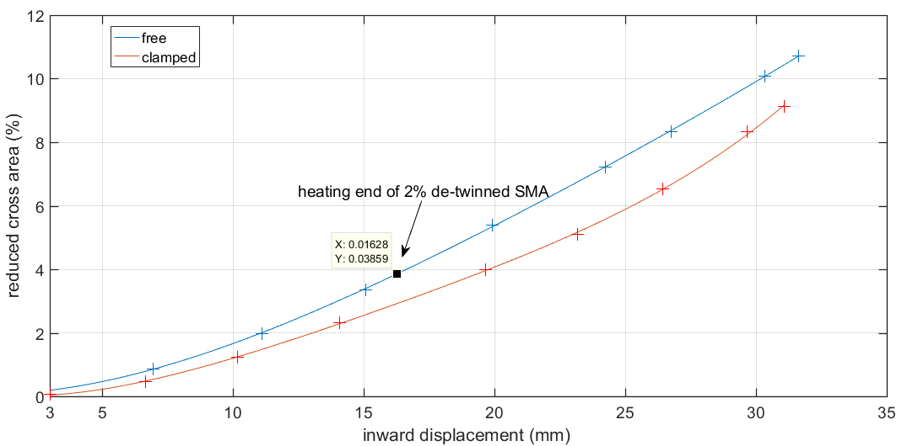
Figure 5.10 Bypass nozzle area reduction vs. inward displacement d_{in}.
The quantity and locations of the actuators divided into three types of configurations (Fig. 5.11). The area reduction achieved shows that the opposite-twin configuration produced least area change, while the original configuration produced the most area change (Fig. 5.12). Moreover, the results suggest a decaying return from adding actuators.
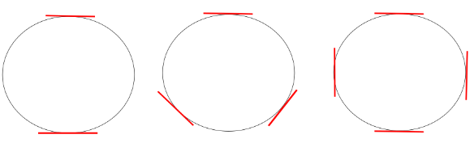
Figure 5.11 Configurations of actuators (red lines).
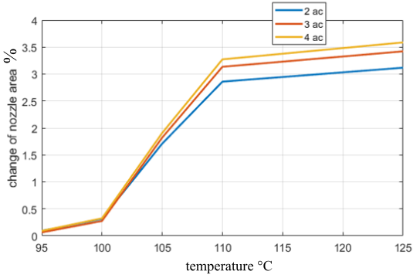
Figure 5.12 Bypass nozzle area reduction under different actuator configurations.
The dimensions of the actuators were then studied by modifying the geometries of the FE model and static analysis. Firstly, reducing the actuator widths dramatically reduced the static deformation (Fig. 5.13). On the other hand, increasing the width to 80 mm did not produce any improvements (Fig. 5.13). This indicates that there is no return from increasing the width of the actuators.
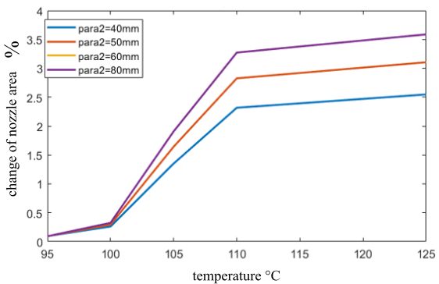
Figure 5.13 Bypass nozzle area reduction under various actuator widths, where the original width is 60 mm. Results for widths 60 mm and 80 mm are identical.
Referring to Figure 2.6, the functional lengths of the actuators – currently 151 mm after prestretching – were modified in the FE model. As shown in Figure 5.14, increasing and decreasing this parameter produced a slight increase in area reduction capability.
Additional parameter studies showed some effects from actuator thickness to spacer dimensions. Increased actuator thickness produced greater area reduction, but the drawback was that there was also greater residual deformation at the end of cooling, and hence little gain in the overall stroke.
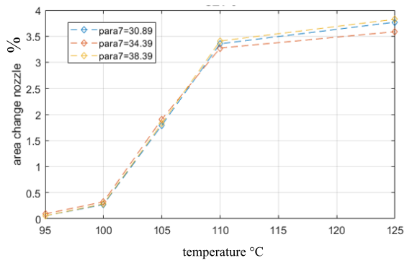
Figure 5.14 Bypass nozzle area reduction under various actuator functional lengths. Here, arc radius represents functional length: original length = 151 mm (34.39° in red curve); elongated length = 160 mm (38.39° in yellow curve); reduced length = 140 mm (30.89° in blue curve).

VAN Modal Analysis
Static deformation affects the natural frequencies of VANs. This section addresses the shifting natural frequencies at different static loading levels. This is followed by the prediction of FRFs according to the FE and modal damping results.
First, the mode shapes at each temperature of heating and cooling were checked. Although there were minor alterations, it was found that mode shape retained the same patterns, and emerged in the same order, from the first to the 20th mode. The observable changes in the modal shapes were generally of two types – circumferential rotations and longitudinal variations. Figure 5.15 shows the antinodes in the left mode shape rotated, and in the longitudinal direction, the node shifts toward the upper edge of the cylinder.
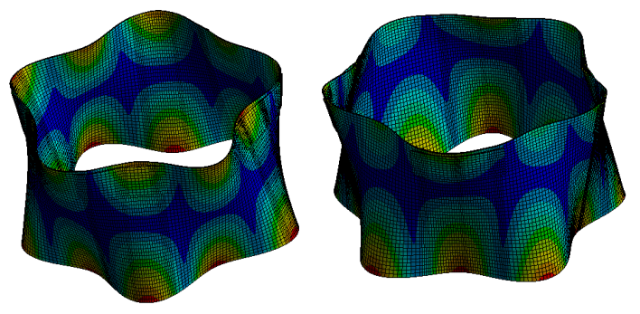
Figure 5.15 Mode shapes of undeformed (left) and deformed (right) cylinders.

VAN Natural Frequencies
The effects on natural frequencies of installing actuators were studied. It is obvious that the difference between the two models generally increases with the order of the circumferential node (Fig. 5.16). Moreover, the fifth-order modes were distinctly unchanged, which might be because the mode shapes of these modes bypassed the influence of the square-shaped deformation in some way. Additionally, most of the twinned modes shifted to opposite directions.
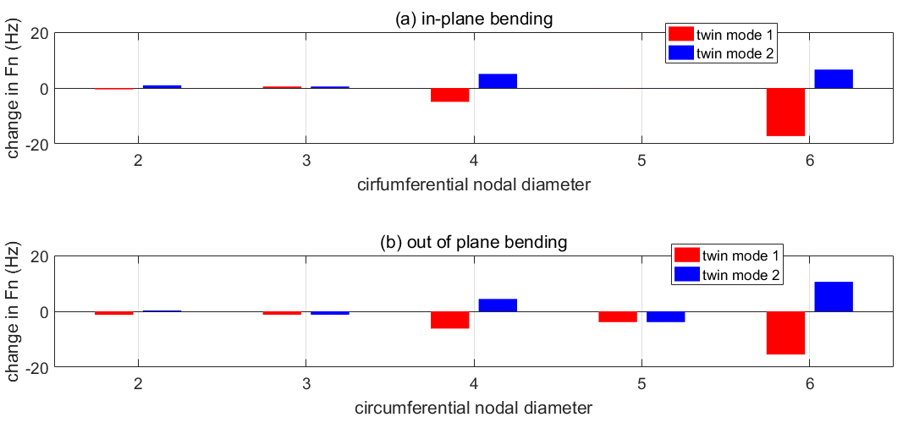
Figure 5.16 SMA-installation-induced natural frequency shifts.
The natural frequencies varied with static deformation level, and the relationship is shown in Figure 5.17. The solid curves show static deformation against temperature. The dashed and dotted curves show the twin-mode natural frequencies against temperature. The modes behaved differently during the heating stages. For the twin modes with two circumferential nodes, their natural frequencies ascended or descended without going back. The natural frequencies of the twin modes with three circumferential nodes remained identical.
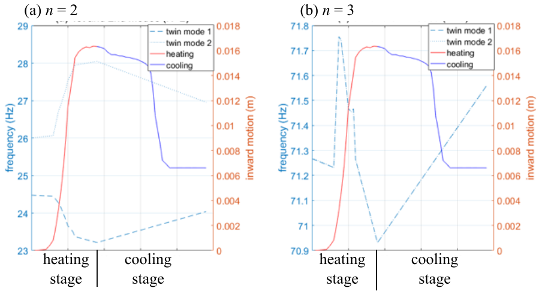
Figure 5.17 Solid curves are d_{in} vs. temperature. Dashed and dotted curves are the shifted natural frequencies of the twin modes. When n = 3, the twin modes maintain their natural frequencies, even when the temperature changes (b).
The ranges of values for natural frequencies that can be achieved by activating the VAN are shown in Figure 5.18. The range is the achievable distance between the highest and lowest natural frequencies for each resonant mode, during both the heating and cooling stages. The y-axis stands for circumferential index n and longitudinal index m, with the twin modes plotted in the same colour. Some modes have relatively small shifting ranges, of less than 0.4 Hz.
An extreme condition to be considered from Figure 5.18 is that a pair of twin modes whose ranged are adjacent to each other end to end, which is the case when n = 2, m = 1. If an applied harmonic excitation occurs at a frequency between the two ranges, the actuators will be activated to shift the resonance from the excitation frequency. This reduces the vibration of one twin mode to the minimum, but also could lead the structure to a peak vibration in the other twin mode. In this situation, a good solution would be to control the actuators in a way that the deformation stops in the intermediate range of the stroke.
The actuation ranges where only two SMA plates were activated are shown in Figure 5.19. The actuating strokes were generally shortened, thus the four-deflection configuration is a better configuration.
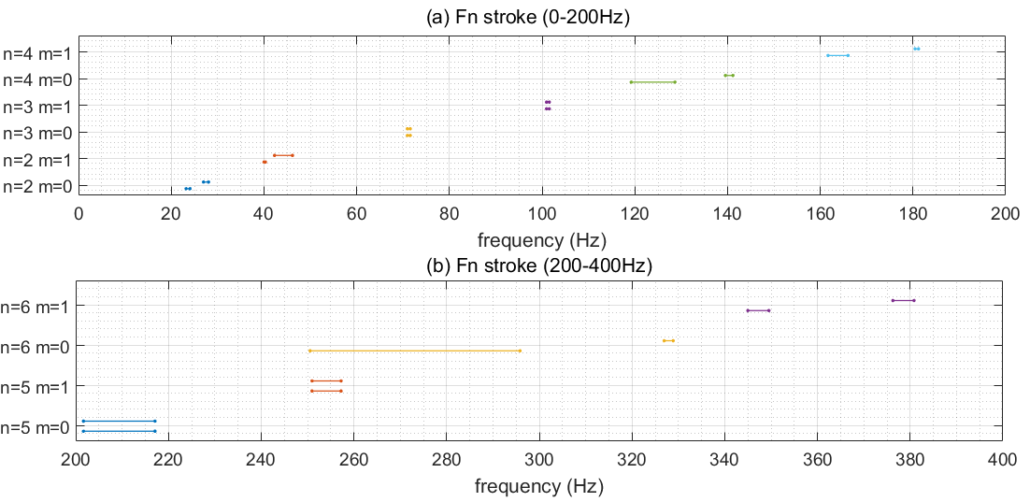
Figure 5.18 Strokes (four heating) of deformation-induced natural frequency shifting.
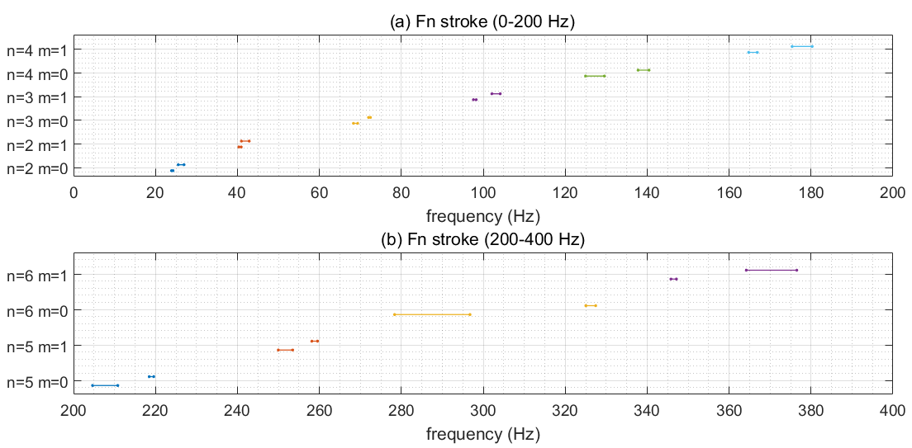
Figure 5.19 Strokes (two heating) of deformation-induced natural frequency shifting.

Attenuation Estimation Based on Shifted Natural Frequencies
In this section, an approximated relation between shifted natural frequency and reduced vibration amplitude is developed. The section assumes the structure only experiences single harmonic excitation. From Figure 5.20, it is assumed that the structure undergoes harmonic excitation at frequency ω. By applying static deformation to change the system matrix, the FRF shifted by an amount of Δω. If the two curves were identical in shape, then the reduction of receptance could be written as:
 | $$㆐H’(ω)㆐=㆐H(ω-Δω)㆐.$$ | (5.15)
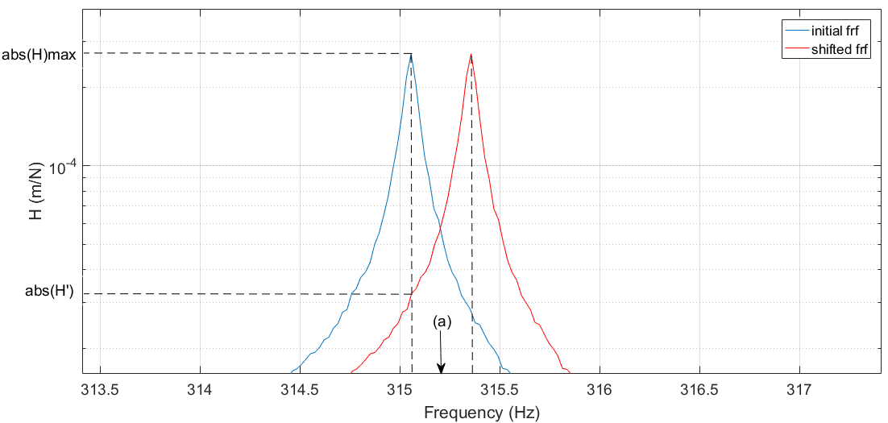
Figure 5.20 Initial and shifted FRF. Shifted frequency Δω (a).
Recalling the modal analysis for a multiple-DOF system, for a viscously damped structure with nodal force and measured nodes at DOF j and DOF i, the response function is written as:
 | $$H_{ij}(ω)=\sum_{n=1}^{N}{\frac{Φ_{n}^{i}Φ_{n}^{j}}{k_{n}(1-{r_{n}}^{2}+2jr_{n}ζ_{n})}}$$ | (5.16)
, where r_{n} = ω/ω_{n}. For a spectral range close to the resonance peak of the m^{th} mode:
 | $$H_{ij}(ω)≈\frac{Φ_{m}^{i}Φ_{m}^{j}}{k_{m}(1-{r_{m}}^{2}+2jr_{m}ζ_{m})}$$ | (5.17)
As the structural deformation changes the stiffness matrix [k], the modal damping vector{ζ} and the modal shape vector [Φ], it is certain that the ㆐H’㆐will be different from the initial response function ㆐H㆐. Given this, the discussion in this section is based on the hypothesis that the static deformation is minor, and thus the modal matrices of the VAN can be viewed as unchanged.
Recalling the definition of the quality factor for a spectrum that is close to the m^{th} mode peak:
 | $$\left|Q_{ij}(ω)\right|≈\frac{1}{\sqrt{{(1-{r_{m}}^{2})}^{2}+{(2ζ_{m}r_{m})}^{2}}}$$ | (5.18)
, where the maximum response is $1/2ζ_{m}$.
The reduction-in-quality factor is given by:
 | $$R=\frac{{\left|Q\right|}_{max}-\left|Q\right|}{{\left|Q\right|}_{max}}≈1-\frac{2ζ_{m}}{\sqrt{{(1-{r_{m}}^{2})}^{2}+{(2ζ_{m}r_{m})}^{2}}}$$ | (5.19)
, where the shifted natural frequency is:
 | $$Δω=\left(r_{m}-1\right)ω_{m}$$ | (5.20)
From the previous sections, the measured damping of a cylindrical nozzle is given by 0.00014 < η < 0.00043. The SMA actuators have a relatively larger dissipation capability. Thus, it is reasonable to assume the structural loss factor to be 0.00035, which results in a modal damping ratio of 0.000175 when in a spectral range near a resonant peak.
Substituting the damping ratio into Eq. (5.19) gives a function for the relationship between the percentage of change in the natural frequency and the percentage of reduction in the quality factor. This function is shown in Figure 5.21, where the tip of the data marks a prediction that the VAN can reduce the quality factor by 98% if this natural frequency increases or decreases by just 0.88%. Note that this prediction of the relationship becomes inaccurate when the frequency is at some distance from the peak resonance.
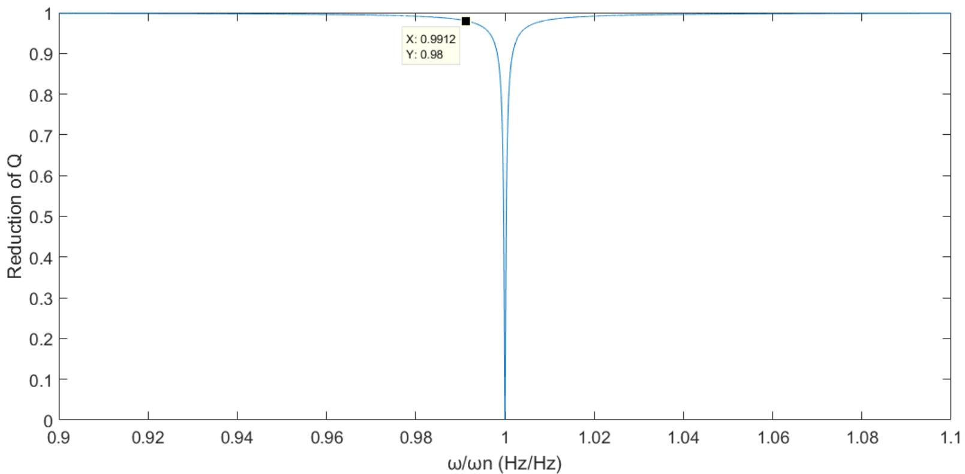
Figure 5.21 Induced quality-factor reduction by shifted natural frequency.
The quality-factor reduction levels of the 20 modes are shown in Figure 5.22, in which the dash line indicates a criterion of Δω = 0.0088ω_{n}. The results show that a few of the modes lie below the threshold. This can be solved by activating only two of the actuators; the improvement can clearly be seen. For example, the fourth red bar in Figure 5.22 (right) transforms to the fourth red bar in Figure 5.23 (right). In the meantime, certain other modes may experience retraction from this change, thus a flexible jump between the configurations is ideal.
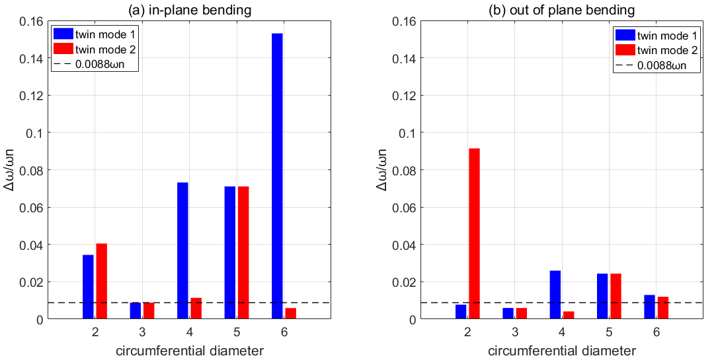
Figure 5.22 Changes in natural frequencies (four heatings) and the criterion (dashed lines) for a 98% quality-factor reduction.
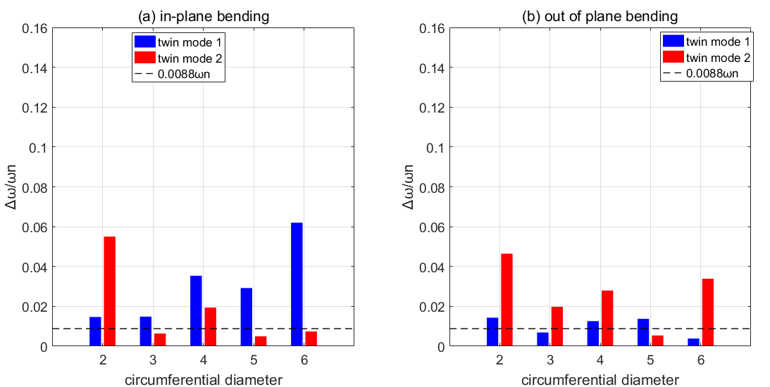
Figure 5.23 Changes in natural frequencies (two heatings) and the criterion (dashed lines) for a 98% quality-factor reduction.

VAN FRF Estimation
A more accurate way to estimate vibration reduction in VANs could be via FRF comparison. For the FE model, FRF could be generated by harmonic analysis, in which the entire body is considered in the calculation. A time-efficient way was to only calculate the FRFs for critical locations or nodes. The modal stiffnesses and masses could be extracted from the modal analysis result, while the modal damping or modal loss factor could be calculated for a composite structure of Ti-alloy and SMA.
To predict the loss factor of a composite system, Bateman [118] adapted the Ungar–Kerwin equation to determine the damping layer thicknesses for maximum damping. Mallick [119] compared the Ungar–Kerwin method to others, such as the complex modulus approach of Suarez et al. [120].
The methods above are based on the strain-energy method first applied by Ungar and Kerwin [121]. The formulation for an arbitrary system with linear viscoelastic elements is given by:
$$η=D/U=\frac{\sum_{i=1}^{n}{η_{i}W_{i}}}{\sum_{i=1}^{n}{W_{i}}}$$ | (5.21)
, where W_{i} is the strain energy stored by the i^{th} element and η_{i} is the loss factor of the i^{th} element in the composition. In this case, the two elemental fractions – Ti-alloy and SMA – can be drawn separately from the FE results. Thus, the equation can be written as:
$$η=\frac{\sum{η_{t}W_{t}}+\sum{η_{s}W_{s}}}{\sum{W_{t}}+\sum{W_{s}}}$$ | (5.22)
, where W_{t} and W_{s} are the strain energies of the Ti-alloy and SMA elements.
The strain-energy vectors for each mode were exported from the FE software. Because no correlation was found between vibration amplitude and the damping of the SMA (Fig. 4.13), the damping of the VAN was set to be independent from the vibration amplitude.
The results of the damping ratios are shown in Figure 5.24 with references to the Ti-alloy damping. Note that the transferral of the loss factors and damping ratios was based on the assumption that the frequency points were close to the resonant peaks. The figure illustrates the performance of the SMA material as a damper component. There is a sign of the dependence of velocity on the damping as the curves decrease by the order of the modes. Moreover, the cooling stage shows slightly higher damping ratios, which verifies that martensite overtakes austenite in terms of damping capability (Table 4.4). More detailed results of the damping ratios are listed in Appendix D.
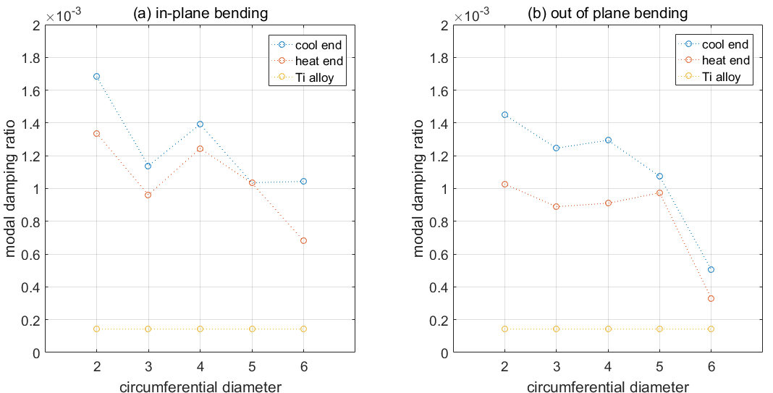
Figure 5.24 Modal damping ratios of the VAN at end of heating (125°C) and cooling (22°C).
By adapting the modal superposition method, the FRF at an antinode of the FE model was generated:
 | $$H_{ij}(ω)=\sum_{n=1}^{N}{\frac{Φ_{n}^{i}Φ_{n}^{j}}{k_{n}(1-{r_{n}}^{2}+2jr_{n}ζ_{n})}}$$ | (5.23)
, where ϕ_{n} is the modal vector, k_{n} is the stiffness matrix, r_{n} is the frequency/natural frequency ratio and ζ_{n} is the modal damping ratio. The modal vectors are extracted from the modal shapes. Note that ANSYS normalises mode shapes to a unity mass matrix by default. Given that, the stiffness matrix was calculated from the natural frequencies.
Note that Eq. (5.23) interprets a structure by its viscous damping model, while the strain method provides a result from interpreting a hysteresis damping model. As the hysteresis damping model refers to material models in which the dissipated energy does not depend on frequency, an equivalent viscous damping coefficient can be derived for a hysteresis damping model. Considering a single-DOF viscous damping system, the dissipated energy of a cyclic loop under forced vibration can be written as:
 | $$ΔW=πcωX_{sdof}$$ | (5.24) [122]
, where c is the viscous damping coefficient, ω is the excitation frequency and X_{sdof} is the displacement amplitude of the forced vibration. The same equation, but for a single-DOF hysteresis damping system, can be written as:
 | $$ΔW=πh_{sdof}X_{sdof}$$ | (5.25) [122]
, where h_{sdof} is a parameter related to the dissipation efficiency of the system. The equivalent c_{eq} for this hysteresis damping system can be written as:
 | $$c_{eq}=\frac{h_{sdof}}{ω}$$ | (5.26)
Then the restoring force for the hysteresis damping system is written as:
 | $$F_{sdof}=\frac{h_{sdof}}{ω}\dot{x}+kx$$ | (5.27)
Now, the relation between h_{sdof} and loss factor η is derived by the following equations. The maximum strain energy per cycle can be written as:

 | $$U_{sdof}=πkX_{sdof}$$ | (5.28) [105]
The loss factor is then defined by the ratio between the dissipated energy per cycle and the maximum strain energy per cycle:
 | $$η=\frac{ΔW}{U_{sdof}}=\frac{h_{sdof}}{k}$$ | (5.29)
By substituting Eq. (5.29) into Eq. (5.26), the equivalent viscous damping coefficient, according to the loss factor, is given:
 | $$c_{eq}=\frac{ηk}{ω}$$ | (5.30)
Finally, the equivalent modal damping ratio can be written as
 | $$ζ_{eq}=\frac{c_{eq}}{c_{c}}=\frac{η}{2}\frac{ω_{n}}{ω}$$ | (5.31)
When ω = ω_{n}, the modal damping ratio is:
 | $$ζ=η/2$$ | (5.32)
Note that Eq. (5.32) is only valid when the excitation frequency is exactly equal to one of the natural frequencies. Apart from these frequency points, the equivalent modal damping ratios are ever-changing throughout the spectral range. Thus, a more accurate version from the hysteresis damping model can be stated as:
 | $$H_{ij}(ω)=\sum_{n=1}^{N}{\frac{Φ_{n}^{i}Φ_{n}^{j}}{k_{n}(1-{r_{n}}^{2}+jη_{n})}}$$ | (5.33)
However, when the excitation frequency moves away from the natural frequencies, the real part of the FRF function becomes overwhelmingly dominant. Given this, the error from adapting Eq. (5.32) into a hysteresis-damping modelled structure is subtle. However, the FRF estimation carried out for the VAN in this chapter still used an adapted hysteresis version of the equation.
Nodal force and nodal displacement vectors at identical DOFs at identical nodes were considered. The results under conditions of end of heating (125°C) and cooling (22°C) are shown in Figure 5.25. The amount of shifted natural frequencies generally increase by the order of modes. The cooling-end FRF has lower peaks, which verifies the higher damping capability of martensite. The two peaks in the range of 50–100 Hz overlap significantly, indicating the difficulty of shifting resonances away at these modes. Note that one mode (red curve around 300 Hz) disappeared, which may have been caused by the DOF being monitored not being near the antinode of the mode shape.
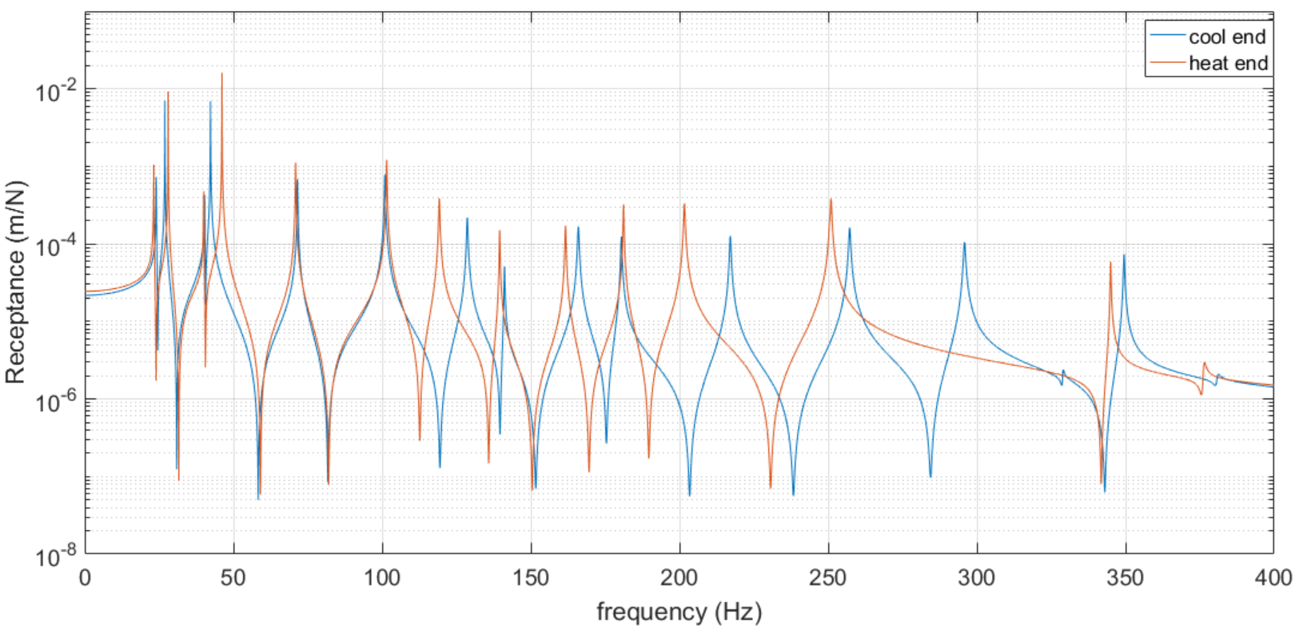
Figure 5.25 FRFs of the VAN under conditions of end of heating (125°C) and cooling (22°C).

Static VAN Experiment
The VAN assembly and heating is described in this section. The FE and experimental results are compared, and the significant differences discussed. Many manufacturing and material defects were revealed during the experiment.

Actuator Prestretching
The actuator thicknesses were measured, and slight differences were found between the four of these. Thus, the forces used to stretch them to the same strain were different. Strain-controlled stretching was practically difficult because the plates became slightly bent when even the preloading forces were applied. Trial stretching showed that the stiffnesses of the plates were greater than indicated by the data provided in the ADVACT report. This could be due to the fatigue developed in previous working cycles. The working records were not provided in the ADVACT report, which made it difficult to estimate the forces needed for each plate.
Despite this, force-controlled stretching was adapted under carefully operated stretching forces. The stretching work was applied on an electric static test machine (Tinius Olsen H25KS), which can provide forces up to 25 kN. Specially designed grips were crafted to fit on the plate ends (Fig. 5.26).
The stress-position results are shown in Figure 5.27, where the unloading strains for each plate are approximately 2%. Variations can be seen at the start of the stretching, indicating the plates were bent at different levels.
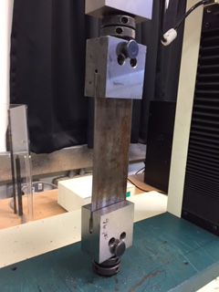
Figure 5.26 Tensile test setup.
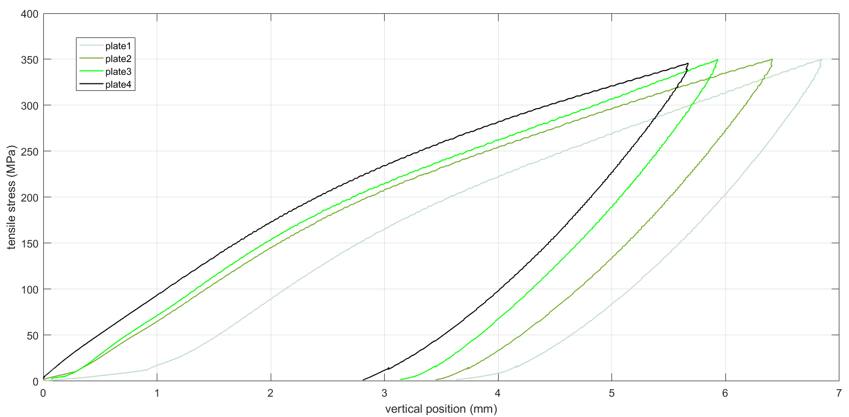
Figure 5.27 Stress-position curves of the tensile testing of four SMA plates.

VAN Assembly
Prior to attaching the actuators, they were bonded using thermal heaters (thin-film heaters rated up to 200°C). The heater circuit was etched onto Kapton film, resulting in a package around 0.25 mm thick that can deliver 1.4 W/cm² of thermal output. The heaters were driven by a 28V power supply outputting direct current.
Each actuator was bonded using two film heaters and two types of epoxy. As shown in Figure 5.28, the white silicone grease OmegaTherm-201 is a very highly thermally-conductive filled paste. This thick, smooth paste wets most surfaces, and will not harden on long exposure to elevated temperatures. It is rated for continuous use between -40°C and 200°C. Excess amounts of the grease were applied to make sure the heater was in full contact with the surface of the actuator so as to eliminate any air pockets trapped underneath. This made sure all the actuators received heat equally, and prevented overheating of the heaters themselves if air pockets did exist.
The edges of the film heaters were applied to the actuator using black epoxy (OmegaBond-200). This adhesive has a curing temperature and hardens on heating. The black adhesive provided bonding strength, while the white grease provided the thermal agent between the heaters and the plates. The black epoxy was applied perpendicularly to the direction of the loads in order to reduce suppression of the thermal contraction of the plates. Both adhesives have high electrical resistance that prevents short-circuiting. Figure 5.29 shows the locations of the film heaters on the inner surface of the actuator.
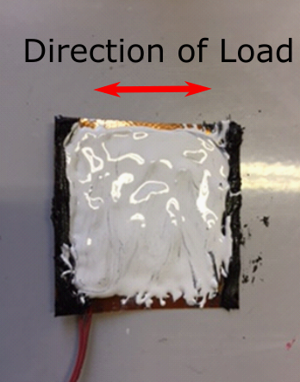
Figure 5.28 Film heater applied with black adhesive.
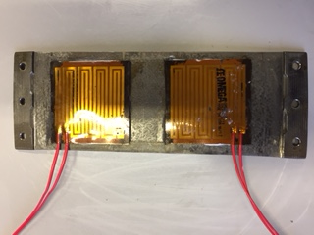
Figure 5.29 SMA plate attached to two film heaters.
The actuators were bonded to the nozzle using countersunk screws. Inward displacement of the edges was measured by dial indicators using a measuring range of 2.5 in (Fig. 5.30). The temperature of the SMA plates was monitored using an infrared thermometer.
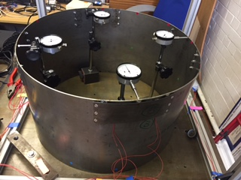
Figure 5.30 VAN rig assembly.

VAN Deformation Experiment
The four plates were numbered based on their locations, and the displacement/temperature curves are shown in Figures 5.31 and 5.32. The results show that the deformations at Stations 1 and 3 are significantly smaller than the others. The VAN deformed into an oval shape rather than the expected square shape. This indicates that, under the same prestretched strain, actuators might output different levels of force. Actuator thickness was modified in the FE model, in terms of physical values, and the simulation showed a similar shape. In comparing the experimental and FE static results from Figure 5.17, the common point is that both cooled models exhibit residual deflection. However, the actual VAN did not achieve the symmetric deformation the FE VAN did.
Slight asymmetric deformation was expected from the static testing, but the extent of the asymmetry was unexpected. As reported in Chapter 6, new actuators were crafted with strictly monitored tolerances. The reason for these new actuators was that the oval-shaped deformation could affect the bonding between the actuators and the cylinder. As the actuation forces are high, an alteration in the loading direction could transfer excessive load to the bolts leading to sudden failure. To avoid this safety hazard, the dynamic experiment on the physical VAN was postponed, and is reported on in Chapter 7, with newly-crafted and adapted actuators.
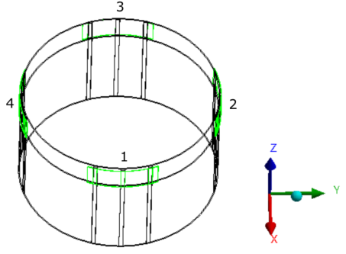
Figure 5.31 Locations of the four plates (in green).
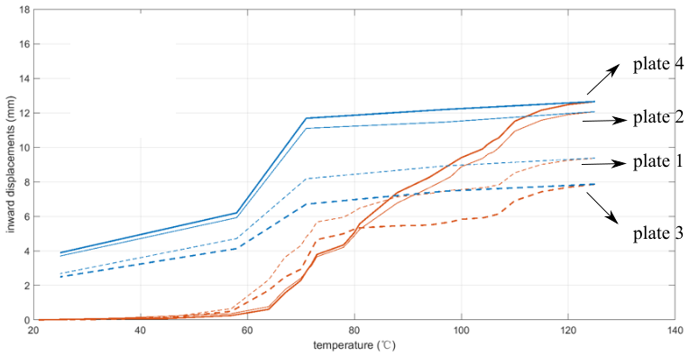
Figure 5.32 Inward displacements d_{in} vs. temperature. Red curves – heating stages. Blue curves – cooling stages.
Assuming the actuators maintained the same thickness, asymmetric deformation was still achievable by unbalancing the temperatures of the four actuators. Taking the example of the oval-shaped deformation, assuming two current-limiting switches were connected to the B actuators, two types of control were then achievable – the terminal temperatures at the end of heating and the speed of heating (Fig. 5.33).
By gradually decreasing the heating-end temperature of the B actuators, the VAN can achieve different levels of deformation. Figure 5.34a shows the B actuators having their terminal temperatures decreased, with the fifth model being completely unheated. The unbalanced inward displacements are shown in Figure 5.34b. From point one to point five, the deflection imbalances gradually intensify, with the B side finally being pushed outwards by the dominating A-side deflections. When the A and B temperatures were close to each other, the VAN shape was more sensitive to the decrease in the B temperatures (from point one to point four in Figure 5.34b).
The temperature-changing speed on the two sets of actuators might have affected the end-of-heating deformation. In the FE model, the speed of the heating was simply modelled by postponing or anticipating a few solving steps on the B actuators (Fig. 5.35a). However, the desynchronisations had little effect on the shape of the end-of-heating VAN (Fig. 5.35b).
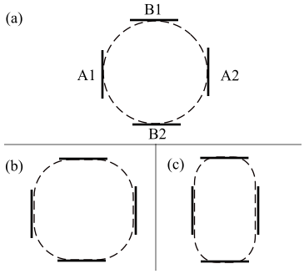
Figure 5.33 Cylinder with undeformed shape (a), symmetrically-deformed shape (b) and oval shape (c).
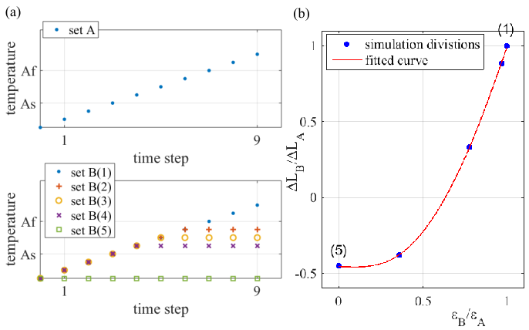
Figure 5.34 (a) Heating-end temperatures of B actuators were reduced gradually. (b) The inward displacement on the B stations was gradually reduced. ΔL_{B}/ ΔL_{A} is the relative inward displacement. ε_{B}/ε_{A} is the relative strain applied by thermal contracting.
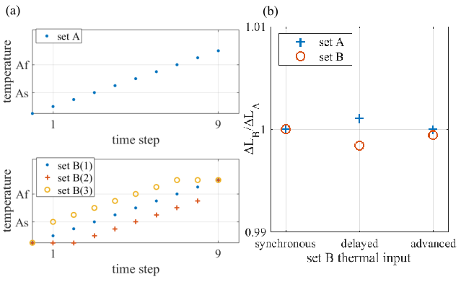
Figure 5.35 (a) Desynchronised thermal conditions simulate heating speed changes in set B actuators. (b) Relative inward displacements affected by the desynchronisations. Note that the range of the y-axis is short, indicating subtle changes in ΔL_{B}/ΔL_{A}.

Conclusion
In this chapter, the simulation procedures and experimental verification of the morphing ability of the VAN in a FE environment were demonstrated. The fundamental principle of FEM statics was first introduced. This was followed by a report on the material modelling of the SMA, in which the two main features of SMA – SME and detwinning – were simulated using a thermal expansion coefficient and multiple linear plasticity, respectively.
The VAN was deformed under loaded temperature conditions, in which a maximum deflection of 16.3 mm was achieved at heating end. At the end of cooling, a residual deflection of 6.6 mm was observed, and a deflection stroke of 9.7 mm was achieved. The bypass nozzle area was reduced by up to 3.87%. Following the static analysis, the parameters of the actuators and spacers were studied to determine their maximum deflection performance. The results showed that the four-actuator configuration, with its original dimensions, could achieve a slightly higher performance through a modification of the parameters. However, the manufacturing of the VAN was expensive, and so the parameters were kept unchanged.
Modal analysis of the VAN showed that the mode shapes were almost unchanged throughout the heating/cooling cycle. The VAN’s natural frequencies, however, varied along with the level of static deformation. The changing of the natural frequencies could increase or decrease during a heating or cooling stage. For some modes, the twin modes had identical natural frequencies throughout the heating/cooling cycle. On changing the VAN’s natural frequencies, the actuator strokes were significantly larger for some modes, subtler for others.
An approximated method for evaluating reduced vibration by shifting the FRF peaks was introduced. The results showed that, by shifting only 0.88% of a natural frequency, a reduction of 98% in displacement magnitude was achievable. In addition, by switching between two- and four-heating configurations, each mode could shift enough frequency to achieve a 98% vibration reduction. A strain energy method was adapted to calculate the modal damping of the VAN. Then, the FRF of the VAN was estimated based on modal analysis data from the FE model. Comparison of the multiple FRFs provided a more reliable method for estimating the reduced vibration.
The VAN rig was set up to verify the FE results. The prestretching test indicated manufacturing errors in the thicknesses of the four actuators. Special adhesives were adapted for the thermal agent and for constraining the actuators. The heating/cooling experiment showed that the deformed VAN exhibited a significant imbalance in the contracting forces at the four stations. The actuators were prestretched by controlled strain. Thus, the thicker actuators output larger contracting forces. The sensitivity of the VAN deflection reacting to different levels of unbalanced thicknesses in the four actuators were studied in a FE environment. The results showed that the deflection was much more sensitive when the four actuators had close thicknesses. Moreover, the speed of heating had little effect on the deflection asymmetry of the VAN.
Note that the original aim of the ADVACT report was to reduce the cross-sectional area of the bypass nozzle for better flight performance and fuel efficiency. However, the main objective of this study was to optimise the VAN shape morphing in order to avoid resonance. Thus, the original focus of the ADVACT report was not considered to be the main interest in this work. Further work could focus on balancing the two objectives as a dual optimisation study.

Chapter 6
New VAN Fabrication
The experimental results laid out in Chapter 5 showed that machining precision strongly affects deformation. Crafting processes for new actuators and cylinders with controlled tolerances are discussed in this chapter. The crafting of a new VAN also considered other factors, such as precision in the length of the actuators and the location of the spacers when crafting a new cylinder. This was because the stroke of the actuators was as small as 2%, with even the smallest mismatch between plate length and spacer distance resulting in a failed assembly. Note that the spacers had to align with the cylinder axis when being welded onto the cylinder.
The new cylinder was crafted by laser welding so that a seamless and clean condition could be presumed. The aim was to obtain a consistent radius of curvature for the cylinder and to eliminate the welding line. For the new actuators, the machining tolerances were restricted to ±0.01 mm for plate thickness.
The new production process encountered difficulties due to limited funding and time. External suppliers were involved in the crafting process, and much effort was spent in delivering the desired precision. The new cylinder and actuators were tested, and the FE model was updated accordingly because of minor changes in a few dimensions.

New SMA Actuators
In this section, the process of crafting four SMA plates, with strict precision, is discussed. The development of a cutting fixture is outlined, and the reason for adapting a new type of SMA material is explained. This is followed by the stiffness and early cycle fatigue testing of the new actuators.

New Actuator Fabrication
The SMA actuators from the ADVACT project were carefully measured throughout the whole face (Fig. 6.1). The measurements showed that the surface was uneven, and the averaged thickness of the lower plate was far from the expected value of 1.1 mm. This is because the wire cutting process generated excessive thermal stress on the thin plate structure. The absence of an adequate fixture caused the thin plate to deform during the cutting. Figure 6.2 shows the averaged thickness of each plate. The second plate was 20.2% thicker than the first plate, indicating that 20.2% of extra force caused the asymmetric deformation.
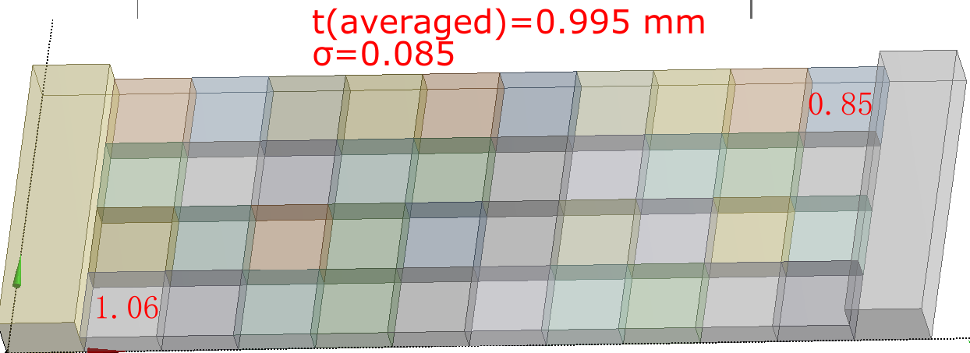
Figure 6.1 Thickness at each location on Plate 1. The standard variation is 0.085.
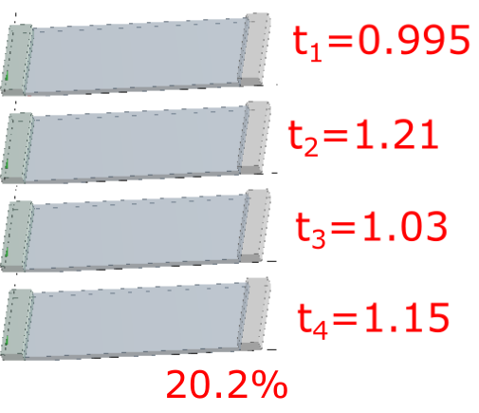
Figure 6.2 Averaged thickness on each plate. Plate 2 is 20.2% thicker than Plate 1.
The cutting was carried out by a third-party manufacturer who specialised in military and aerospace EDM. The workpiece was a leftover SMA bar from the ADVACT project. Thus, the newly crafted actuators would have the same work hardening as the previous actuators.
EMD is a cutting process that adapts the thermal heat emitted during electrical discharging between electrodes to melt a workpiece. Figure 6.3 shows that the temperature near the erosion wire is the highest, while the left side gradually cools and the right remains cold. Given this, the workpiece would experience excessive thermal stress due to its thinness, and so a workpiece fixture was required to protect the plate from thermal strain.
The fixture aimed to constrain the entire surface of the SMA plate. A holder was crafted, using multiple constraining bolts, for the EDM process (Fig. 6.4). However, it was found that the thermal stresses were so large that the area away from the bolts still exhibited distortion (Fig. 6.5). The constraining method was then improved by adding nuggets under the bolts (Fig. 6.6). Two bridge-shaped spacers were adapted to create a gap to let the wiring line through. The bridge spacers were repositioned so the wiring line could cut through the entire face of the workpiece.
Ultimately, the new plates were crafted and measured. The results show that the cutting tolerance was achieved, and the dimension accuracy was greatly improved (Fig. 6.7). The error for the average thickness was as little as 3.6%, compared with the previous actuators where this was 20.2%. In addition, the consistency of the thickness across each plate surface was dramatically improved.
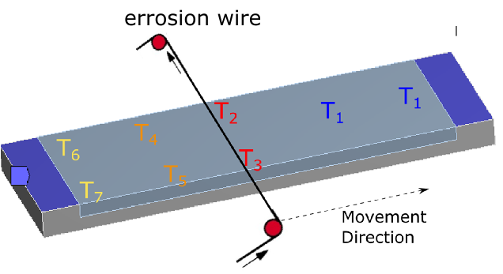
Figure 6.3 Temperature distribution during erosion-wire cutting.
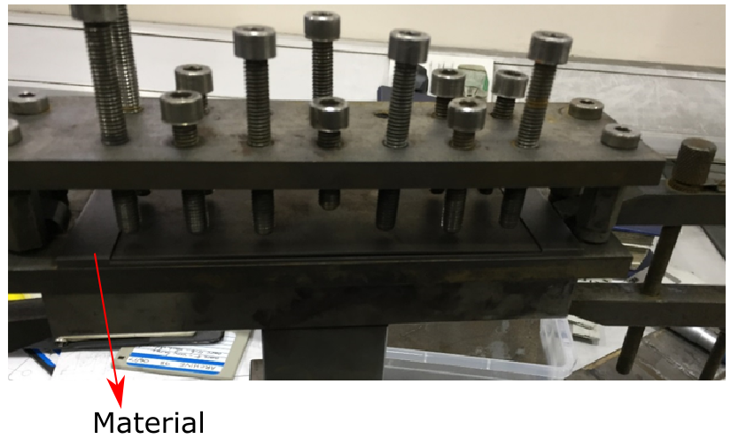
Figure 6.4 Fixture with bolts constraining material surface.
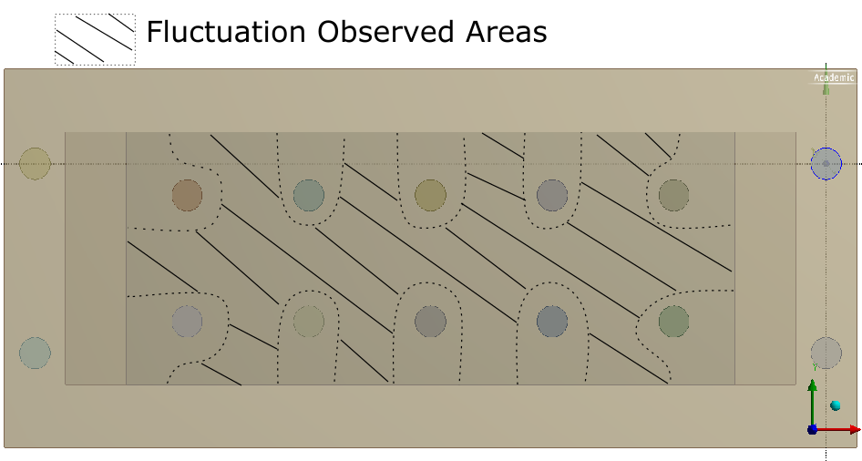
Figure 6.5 Hatched area still exhibiting thermal fluctuation.
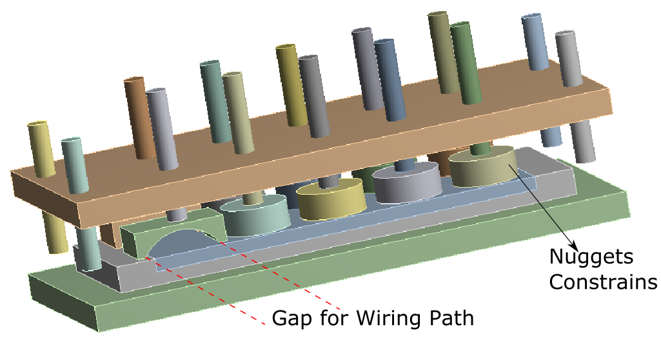
Figure 6.6 Round nuggets added to increase constrained areas during erosion-wire cutting through the bridge-shaped nuggets (lower left).
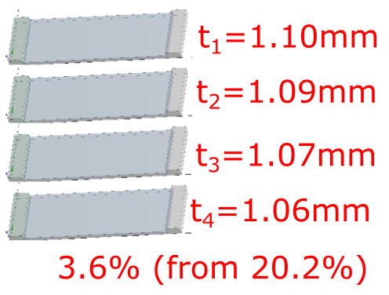
Figure 6.7 SMA plates cut using new fixture.
Even though the dimensions of the actuators met the requirement of the VAN, the material was still in question. Tensile testing of the new actuators found that the permanent dislocation after only one working cycle was as large as 1%, while the prestretching was only 2%. With such a large degree of fatigue, the VAN strokes would be significantly weakened. The SMA material might have experienced excessive work hardening, with the yield point of the material being very low. Moreover, it was assumed that the metallurgical industry had improved the machining of SMA materials over the years, and so a new SMA material, with similar transformation temperatures, was ordered from another third-party manufacturer. It was expected that the new SMA material would exhibit less cyclic fatigue.
When crafting the new actuators for the second time, using new SMA material, the actuator dimensions were slightly modified from the old drawing. In addition, several slim testing specimens were crafted for material testing (Fig. 6.8).
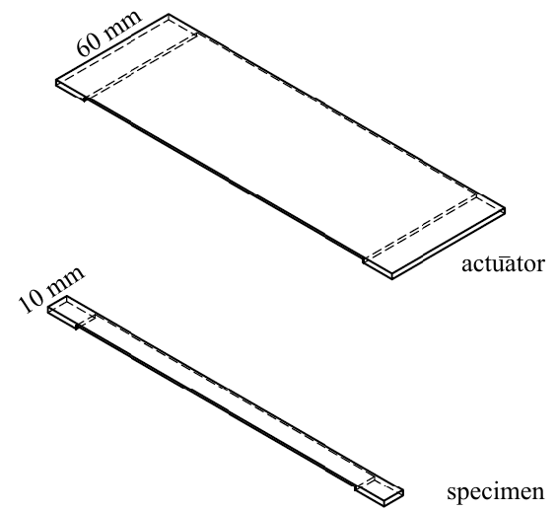
Figure 6.8 Two types of SMA plates were made.

New Actuator Material Testing
The new SMA specimens were tested under the martensitic phase to address stiffness, fatigue and any changes from increased loading cycles. The stretched specimens were normalised after each stretching by preheating them in a chamber with a temperature above A_{f}. The tensile tests described in this chapter were configured to be strain controlled.
Figure 6.9 shows a specimen (blue curve) surpassing the stress-plateau field. A further detwinning stage followed, and the ultimate strain reached 0.09. Looking at Specimen 2, there are three strains that are frequently cited in the following content – at the loading end (ε_{load}), when the actuators were fully released (ε_{detw}) and residual after heating (ε_{res}). The relationship between ε_{load} and ε_{detw} was found to be linear. This helps in estimating the required ε_{load} for an objective ε_{detw} (Fig. 6.10).
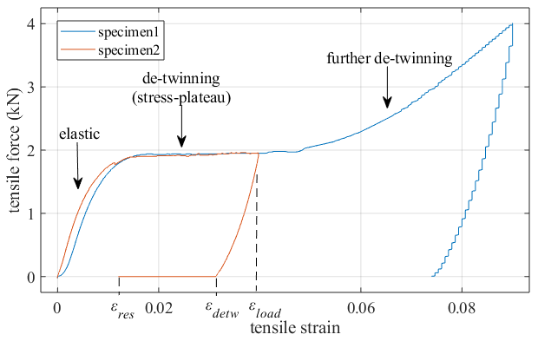
Figure 6.9 Stress-strain curves (first cycle).
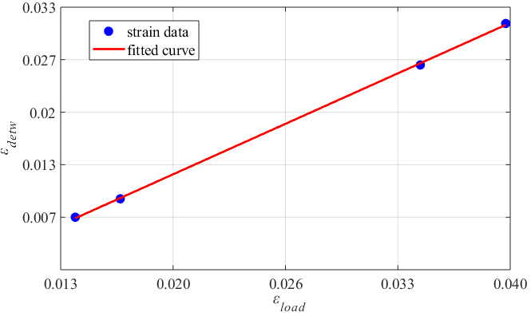
Figure 6.10 Maximum tensile strains vs. detwinned strains.
When stretching the actuators, which were six times wider than the specimens, the forces required were more than six times those needed for the specimens. A possible reason could be that the stress distributions on the stretched specimen and actuator surfaces were different (Fig. 6.11). This resulted in a significantly unbalanced detwinning rate in the wider plate, because of which the dislocation densities and stiffnesses in the wider plate were changed.
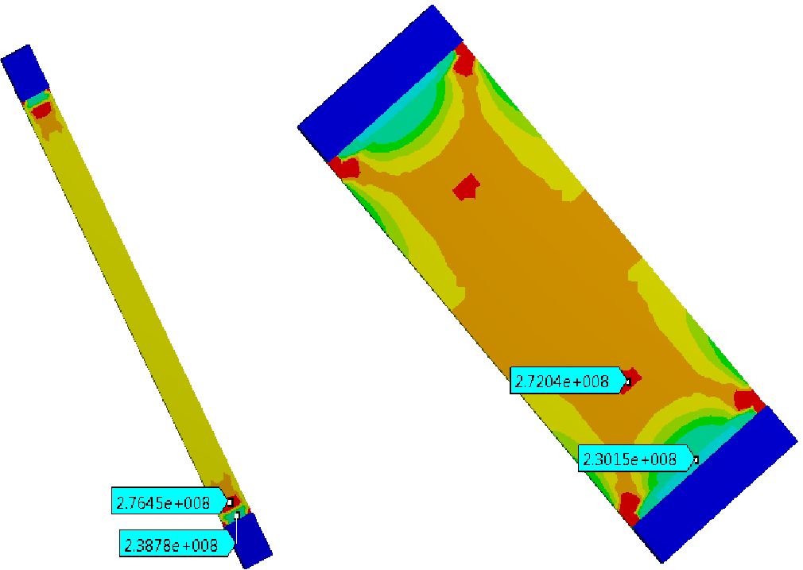
Figure 6.11 Stress (Pa) distributions in two thin plate structures under tensile loads. The material model was structural steel.
The damping ratio of the new SMA was calculated by impact testing, and the results are shown in Table 6.1. As predicted, the austenite SMA was less damped than the martensite. Compared to Table 4.6 the new SMA material had a similar damping capability to the previous SMA. This may indicate that the reduced work-hardening level did not increase the damping of the SMA material.
Table 6.1 Damping ratios of the new SMA plates.
Phase | Damping ratio ζ
Phase | Mode 1 | Mode 2 | Mode 3 | Mode 4 | Mode 5 | Mode 6
Martensite | 0.010 | 0.012 | 0.0029 | 0.0041 | 0.0027 | 0.0030
Austenite | 0.0071 | 0.0085 | 0.0013 | 0.0029 | 0.0019 | 0.0015

New Actuator Fatigue Testing
The Ni-Ti actuators were expected to exhibit considerably early cyclic dislocations. It is known that this fatigue behaviour tends to stabilise after certain number of working cycles, according to Chapter 3. Moreover, by limiting the loading stresses, it might be able to control the scale of accumulated dislocations.
Figure 6.12a shows a specimen that was first stretched to the stress-plateau stage, and then acquired a dislocation strain of 1.5 mm after heating. The second stretch on this specimen showed a shortened elastic stage and the inconspicuousness of the stress-plateau stage. This indicated an incomplete recrystallisation of the martensite planes or unsorted plane orientations. Figure 6.12b shows another specimen being first stretched, using a controlled force within the elastic range, with the detwinned strain being fully recovered after heating. The second stretch on this specimen shows almost unchanged stiffness and an observable stress-plateau stage. Overall, the data indicates that it is possible to eliminate dislocation strain by limiting the tensile stress to a certain range; for example, the maximum elastic stress.
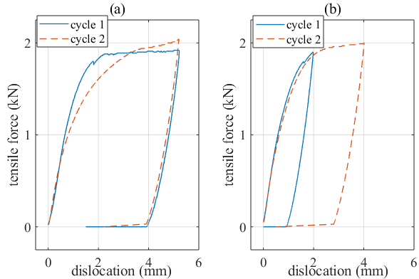
Figure 6.12 Specimens under different loads on their first cycles behaved differently.
Four specimens were stretched under controlled ε_{load} for up to 10 cycles, with different loading rates of 0.021 < ε_{load} < 0.04. In all, the larger the ε_{load}, the faster the material hardened (Fig. 6.13). For the specimen with ε_{load} = 0.04, the required force to reach the same strain almost doubled after 10 cycles, while for the specimen with ε_{load} = 0.21, the increase in this force was only around 5%. In addition, the stiffnesses of all the specimens changed mostly after the first cycle.
The yield point became indistinct after the first cycles, and this process was faster in those samples with larger loading strains. It is notable that ε_{detw} decreased after each cycle. This indicates that, as the fatigue accumulate, the portion of elastic strain increases.
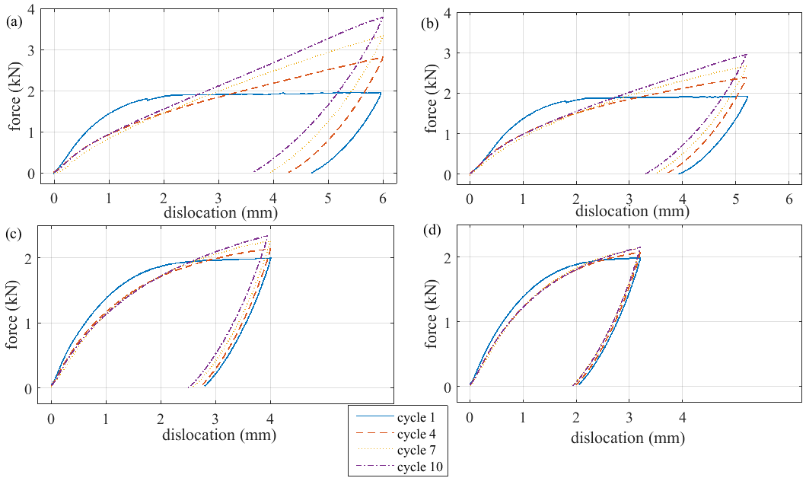
Figure 6.13 Specimens under strain-controlled tensile loads of maximum elongations of 6 mm (a), 5.2 mm (b), 4.0 mm (c) and 3.2 mm (d).
The forces required to stretch the specimens to the same strain level against the working cycle are shown in Figure 6.14. The densities of the permanent dislocations accumulated faster in the heavily loaded specimens. This can be verified by the larger slope on the curve of ε_{load} = 0.04 in Figure 6.14. The zoomed-in image on the right shows that the stiffness of the least-stretched specimen tended to stabilise after seven cycling loads.
Dislocation strains accumulate after each stretching/heating cycle. Figure 6.15 shows that the accumulating speed of residual strains tends to slow down following each cycle. For the least-stretched specimen, the result may suggest that the accumulated residual strain could be eliminated after more than 10 working cycles.
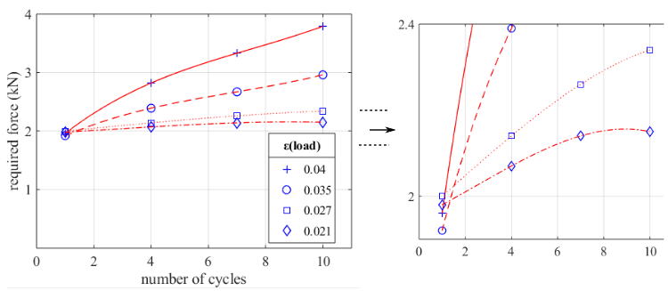
Figure 6.14 Forces required to achieve controlled strains during the first 10 cycles. Zoomed-in image on the right.
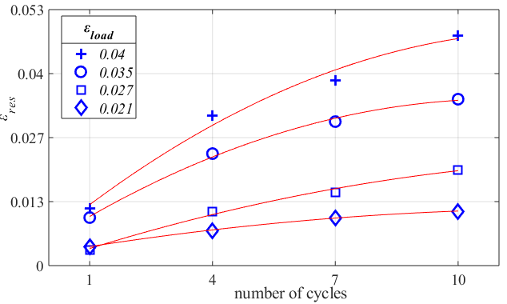
Figure 6.15 Residual strains by cycle number.
The results above suggest that it is reasonable to reduce the prestretching strain discussed in Chapter 5 from 0.02 to 0.013. The benefits include a greater stability in the stiffness of the actuators and a reduced accumulating dislocation strain. The value 0.013 is from a configuration modification of the actuators in Chapter 7. Also, the results suggest a training process for the actuators for SMA stabilisation prior to any main testing.
In the SMA literature review, the thermofatigue and phase transformations of Ni-Ti, without the induction of external stress, were discussed. To verify this, a specimen was heated above A_{f} and then cooled below M_{f}, without any prestretching, for three cycles. The result shows that the stiffness of the specimen slightly increased, compared to an untreated specimen (Fig. 6.16). This proves that the SMA material does exhibit thermofatigue in the absence of mechanical loading.
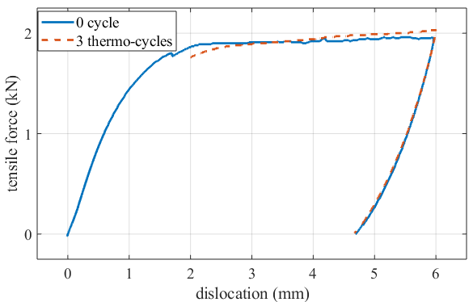
Figure 6.16. Effect of thermo-cyclic-load-induced fatigue on change in stiffness.

New Ti-Alloy Nozzle
The previous nozzle was welded using tungsten inert gas (TIG) for the ADVACT project. The raised welding bead at the seam line added asymmetry to the cylinder. Moreover, the heat-affected zone (HAZ) near the seam line slightly distorted the cylinder during welding. Lastly, gas protection was insufficient during the welding, with the blackened HAZ becoming oxidised and hardened.
The next section discusses the manufacturing of a new Ti-alloy nozzle, which has same dimensions as the previous one. The aim was to increase the precision of the crafting process and to decrease the asymmetry of the nozzle.

New Nozzle Fabrication
A thin shell cylinder can be made by three steps, rolling of material sheet, welding at the seam line and roundness correction at a furnace. The precision of a cylindrical structure can be evaluated by several indicators such as welding bead size, oxides layer, cylindrical roundness.
Firstly, a rectangular sheet of titanium alloy was sawed out. The sheet went through a roller mill and the two edges formed a longitudinal gap. The gap was very narrow so no filling material needed for the gap during welding. The length of the sheet was precisely calculated to avoid either a large gap or failing to close the gap by redundant material at the seam line. Since titanium ally has a much higher yielding point than steel, the precise rolling was very difficult to achieve.
The welding of cylinder was carried out by a supplier who was specialized at laser beam welding. This expensive technique provides a concentrated, discrete heat pulse, allowing for narrow and deep welds. The benefits of laser beam welding include ultimate precision, low heat application and no need of feed material [123].
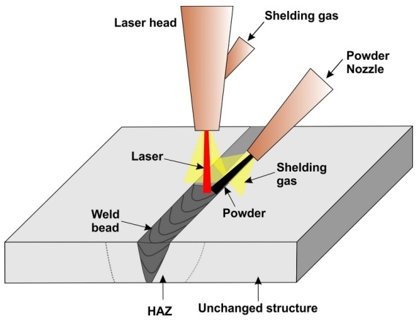
Figure 6.17 Illustration of laser beam welding [124].

Improvements in the New Cylinder
The welding lines on the two cylinders are shown in Figure 6.18. The previous welding bead was blackened, and scratches could clearly be seen on it. This indicates inadequate gas protection during welding, resulting in oxygenation and hardening. Moreover, the geometry around the welding line of the previous cylinder was distorted by thermal stress during the welding. In contrast, the new cylinder had a flat and smooth welding bead due to the absence of filling material. The oxygenation and welding-affected distortion of the new cylinder was subtle.
The bonding method of the spacers was changed, and the result is shown in Figure 6.19. The spacers of the previous cylinder were spot-welded, and the strength of the welding was a concern. Most of the area of the spacer face was not bonded with the cylinder surface, resulting in stress concentrations near the welding spots. For the new cylinder, the laser beam was adapted to penetrate to a controlled depth, and the material on the spacer and cylinder were melted, resulting in a firm bond.
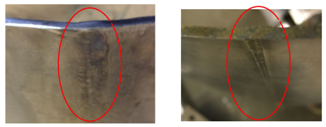
Figure 6.18. Welding line of TIG-welded cylinder (left) and laser-welded cylinder (right).
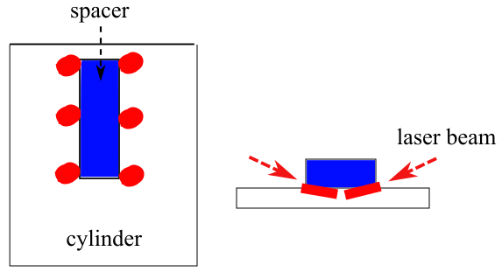
Figure 6.19 Front view with locations of welding spots (left) and top view with laser welding beam (right).
The following is a discussion of the measuring of the cylinder precision. The circularity, or roundness, of a shape is defined by how closely the shape approaches a mathematically perfect circle [125]. In two concentric circles sandwiching a circular feature, the ring area between the maximum inscribed circle and the minimum circumscribed circle is called the minimum tolerance zone (Fig. 6.20a). The roundness is defined as the difference between the two radii [126]. Cylindricity, by the way, is a 3-dimensional tolerance that not only controls the circularity of each cross-sectional profile of the cylinder, but also the surface straightness of the overall length of the cylinder [127]. Like circularity, the entire surface of a cylindrical body should fall into the minimum tolerance zone defined by two concentric cylinders (Fig. 6.20b). It is a certainty that, if a cylinder is sliced into segments, the circularity of each segment is always equal to, or smaller than, the cylindricity of the cylinder.
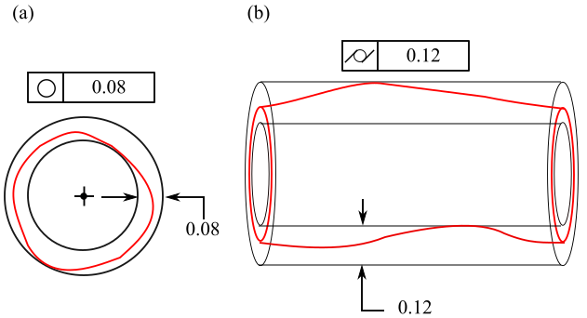
Figure 6.20 (a) Circle with a circularity tolerance of 0.08. (b) Cylinder with a cylindricity tolerance of 0.12. The term ‘tolerance’ is used in machining engineering for quality control.
The cylindricity of a shaft can be measured by placing it on a V-shaped base or rotating spindle, which provide circular datums as references. By rotating the body of the shaft, surface variations in the circumferential direction can be measured by a fixed-dial gauge. This gives the circularity of the measured segment of the shaft, by subtracting the minimum and maximum readings [126].
The techniques described above are commonly used for measuring components that have relatively high machining precisions, such as gear shafts or casted rings. For the cylinder, however, the structural distortion was so great that it was even visible to the naked eye. This caused difficulty in locating the central axis of the cylinder. Moreover, when considering any axial distortion inside the cylinder, the central axis cannot be a straight line. To simplify, no axial distortion in the cylinder was assumed, resulting in the cylindricity of the cylinder being equal to the circularities of any segment of the cyclinder.
The inner circle of one end segment was traced onto a drawing pad. Then, the profile was carefully cut out and suspended by thin wool floss from one point. The extended cord of the floss was drawn, and this procedure was repeated from a different hanging point. The barycentre was determined at the intersection point of the two cords. The procedure was repeated from a third hanging point, and the extension cord intersected with the two others at the barycentre. This verified that the centre was correctly located.
Based on the barycentre, the measured radii along the circle are shown in Figure 6.21. The previous cylinder had a circularity of 17 mm, while the laser-welded cylinder had a circularity of 21 mm. Note that the maximum radius of the previous cylinder was located at the seam line. This indicates thermal distortion during TIG welding. The new cylinder had less radius distortion at the seam line. However, a critical rolling defect resulted in a minimum radius of 238.5 mm, which significantly affected the overall cylindricity. Table 6.2 shows the measured dimensions of the two cylinders.
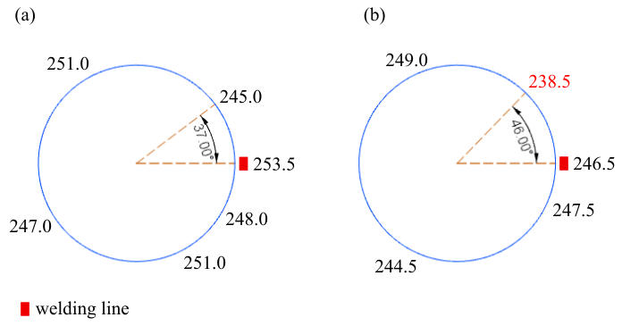
Figure 6.21 Radius measured from the inner circle of the previous (a) and new (b) cylinders.
Table 6.2 Dimensions of the two cylinders.
Parameter | Previous cylinder | New cylinder
Density (g/cm³) | 4.50 | 4.44
Modulus (GPa) | 115 | 113.8
Wall depth (mm) | 300 | 300
Wall thickness (mm) | 2.3 | 2.3
Outer diameter (mm) | 501.0 | 497.2
Cylindricity (mm) | 17.0 | 21
The actuator fastening method was improved on the new VAN. There was a concern that the screws that bonded the actuators might experience high stresses. The FE simulation showed that, during heating, the nodal displacements from three tapped holes were not synchronous on the two bodies. Figure 6.22 shows the coordinates of the two sets of tapped holes that split away from each other by around 2 mm. This indicates that the fastening screw experienced large shear stresses, which raises a safety issue if the screws were to fracture and pop out.
To enhance the safety of the connections, the screws were replaced by bridge-shaped clamps. These clamps press the free ends of the actuators onto the cylinder (Fig. 6.23). High-temperature-resisitant lubricant was applied at the pressed surfaces to enable sliding when heating (Fig. 6.24).
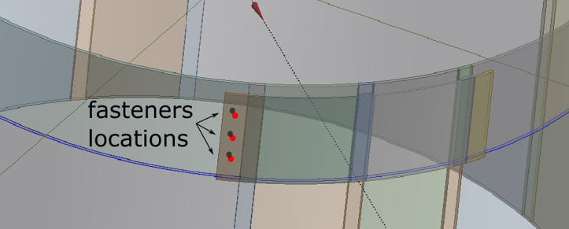
Figure 6.22 Locations of the bonding screws.
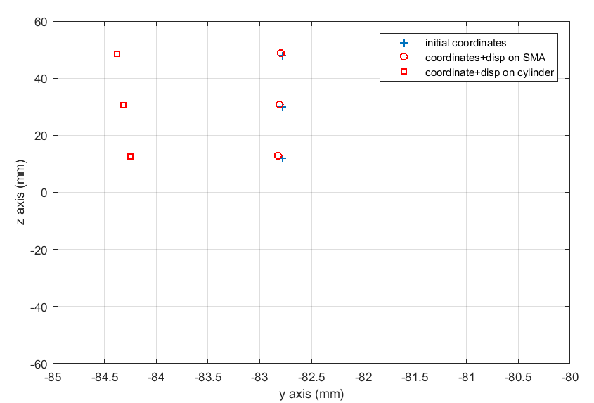
Figure 6.23 After heating the actuator, the locations of the fastening holes separated, resulting in large shear loads on the screws.
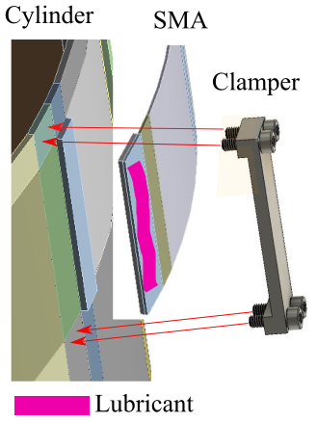
Figure 6.24 Bridge-shaped clamper.

Conclusion
The motivation for crafting new SMA actuators was discussed at the beginning of this chapter. A tolerance-controlled EDM process was adapted for the crafting of the SMA actuators. The new actuators were examined in terms of their material stiffness and de-twinning properties. Their early cycle fatigue was studied, and the result showed an increased stiffness and residual strain from loaded cycles. The amounts of these increases were positively related to loading strain. The stiffness of the SMA tended to stabilise after 10 cycles under 2% stretching strain, but dislocation strain in the SMA still accumulated after 10 cycles under the same stretching strain. This suggested that the prestretching strain could be controlled within 2%.
The new Ti-alloy nozzle was crafted to reduce the manufacturing defects of the previous one. The process of recrafting included sheet rolling and laser welding. Along the seam line, the raised welding bead and oxidised area were significantly improved by the laser-welding technique. The radius error along the seam line was dramatically reduced, but the overall cylindricity was increased due to a rolling defect. In addition, the spacers were laser welded onto the cylinder to give a strengthened bond, and the fastening method for the actuators and cylinder was improved.
The first contribution, in Section 1.3, was the technique to machine thin plate SMA material with high precision. SMA wires are widely adapted in experiments on SMA-related studies. The SMA plates were less adapted by previous researchers, so little was understood about the manufacturing difficulties of machining SMA. The thin plate actuators used in this work required large-profile SMA face cutting, with high precision. Special clamps and constraining nuggets were designed to prevent thermal-stress-induced distortion during the cutting.
Other contributions described in the chapter include the pioneering implementation of seaming a thin-shell cylinder by laser welding and the improvement to the safety of the VAN by adapting the laser welding and bridge-shaped clamps to bond the components. Laser welding has proven to be a more appropriate technique for dynamic experimental models because of the small HAZ and low weight added by the welding bead.
On other hand, the developed clamp for SMA cutting was heavy, and the EDM process was cost inefficient. The geometry of the actuators can be optimised in a way that cutting can become less complex. For cylinder crafting, the laser welding has a limited penetration depth, which restricts the range of application if a thicker cylinder is required. The bonding between the actuators and the cylinder by the bridge-shaped clamps added considerable weight, which might affect the dynamic response of the VAN. A more compact clamp could be considered in future work.

Chapter 7
New VAN Static and Dynamic Analysis
The fabrication of the new actuators and nozzle was discussed in the last chapter. Here, static deformation testing is demonstrated for the new VAN. This is followed by the results of impact testing on the morphing VAN and a discussion of these. The objectives were to estimate the capability of reducing vibration by shifting the FRF in two scenarios – harmonic excitation using stationary and time-varying frequencies. The FE model was adjusted to the changed dimensions of the new actuators and cylinder (Table 6.2).

New Cylinder Impact Testing
Impact testing of the new cylinder involved adapting the free suspension outlined in Chapter 4. For excitation, a shaker was initially considered, but trial runs showed that the lightly damped cylinder was affected by the damping introduced by the shaker coil and the vibrating chassis. Given this, an instrumented hammer was used as the excitation source. The response of the cylinder was recorded by laser sensors that measured the displacement signal. A special carrier was constructed to accommodate two lasers simultaneously. This carrier was designed to allow radial and axial positioning of the lasers with an accuracy of at least 20 micrometers. The stage was made from two stepper motors and a control circuit operated by codes. Subsequently, measurement of vibration using the laser sensors was abandoned when the assembled VAN was tested in Section 7.4 because the VAN exhibited significant damping from the SMA actuators such that the FRF peaks were submerged in the noise signal, particularly at higher frequencies. However, the bare cylinder FRF in this section was still measured by the laser sensor.
Figure 7.1 shows the FRF of the cylinder, measured at the same DOF of the excitation point. The noise level in the result is significantly large, compared with the FRF measured by accelerometer (Figure 4.13). Since the new cylinder had an almost identical geometry to the previous one, a mode-shape identification of the new cylinder was not considered necessary.
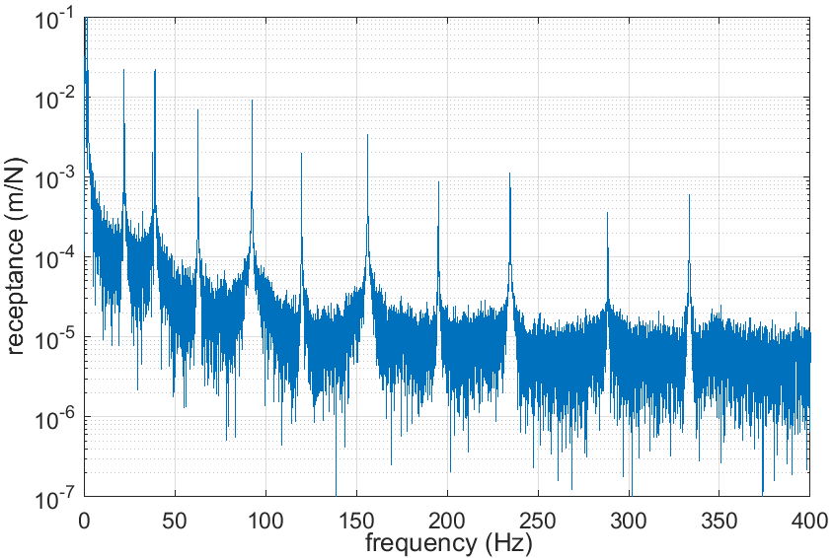
Figure 7.1 FRF measured by laser sensors.
The purpose of recrafting the cylinder was to reduce the manufacturing defects so that the cylinder would have a strong correlation with the FE model. Modal analysis on the highly symmetric FE cylinder showed that the natural frequency splitting of the twin modes was subtle. Given this, the new cylinder was expected to show less natural frequency splitting than the previous cylinder. The two cylinders are compared in Figure 7.2, which shows that only the first and second out-of-plane bending modes decreased the splitting on the new cylinder. The reason might be because, even through the welding bead on the new cylinder was eliminated, the critical rolling defect (Figure 6.21) still caused the twin modes to split.
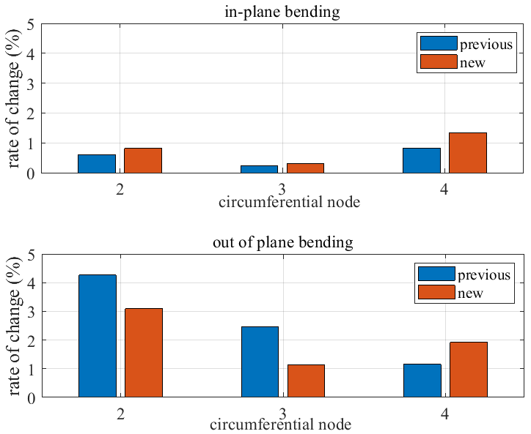
Figure 7.2 Natural frequency splitting of the twin modes in the previous and new cylinders.

New VAN Static Experiment
The static deformation testing outlined in Chapter 5 was repeated on the new VAN. According to Figures 6.14 and 6.15, the prestretched strain of the actuators was set to be as small as possible to reduce cyclic fatigue. Thus, the prestretch was set to 1.37% strain. Moreover, only two actuators were used, and these actuators were located opposite to each other. This was because one of the spacers was poorly positioned during the welding, resulting in one actuator not being attached to its station. The FE simulation showed that two-actuator deformation could achieve more natural frequency shifting than three actuators. Thus, the static and dynamic testing reported in this chapter was adapted to the two-actuator configuration.
Several modifications were applied to the instruments to increase the accuracy of the measurements. Firstly, laser displacement sensors replaced dial gauges for measuring the static deformation of the cylinder. This is because it took several seconds to read all the dial gauges, while the VAN might have been carrying on deforming. Instead, the lasers provided voltage data that could be linked to a data acquisition system. Moreover, thermocouples were used, rather than an infrared thermometer, to measure the temperature of the actuators. An adequate bonding method for binding thermocouple beads onto the surface of the actuator was lacking. Epoxy adhesive was not strong enough to hold the thermocouple beads, and soldering the beads would have activated the SMA phase transformation. Thus, the thermocouples were attached to the film heaters (Figure 7.3). Because of this, the measured temperature might have been slightly higher than the actual temperature of the actuator because of the delay in heat transmission. The thermocouple beads were covered in Al foil, and so the beads were encased in a confined space. The foil was covered with Kapton tape, which can retain its stickiness up to 200°C.
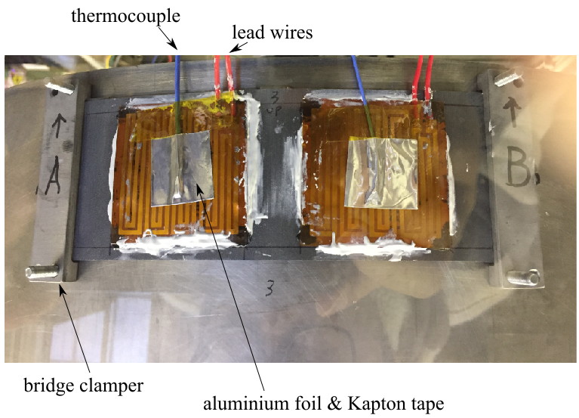
Figure 7.3 Attachment of actuator.
Before carrying out the dynamic testing, the VAN was heated and cooled for nine cycles in order to stabilise the properties of the SMA actuators. Inward displacements d_{in} vs. temperature are shown in Figure 7.4. Overall, the maximum d_{in} at the end of heating decreased gradually with the working cycles. The d_{in} at the end of cooling became negative, indicating some rigid body movement by the cylinder. The VAN did not reach the maximum deformation at A_{f}, implying the existence of superelasticity. The superelasticity is defined by the A_{s} and A_{f} being higher than the normal level when the SMA exhibits high stress. The SMA actuators were able to further deform the cylinder until the temperature reached 140°C.
The maximum d_{in} was less than 6 mm, and was lower than expected. This was because the stiffness of the new actuators was much lower than the previous actuators. Given this, the stiffness of the SMA in the FE model was updated to be the same as that of the new actuators.
The time spent on heating or cooling was decided by the input voltage and ambient temperature. Without a temperature conditioner, the input voltage was set to be at a constant value of 17 V when heating. The actuators were able to reach and maintain the maximum temperature, as shown in Figure 7.4, while the input voltage was still 17 V. The time spent on heating was around 4 min, but in industrial applications, a temperature conditioner would be adapted to boost the speed. The input voltage was removed when cooling, resulting in a cooling time of around 12 min for the actuators to reach ambient temperature. Note that the aircraft bypass nozzle would be exposed to high-speed cold air when flying, so the cooling speed would be much faster.
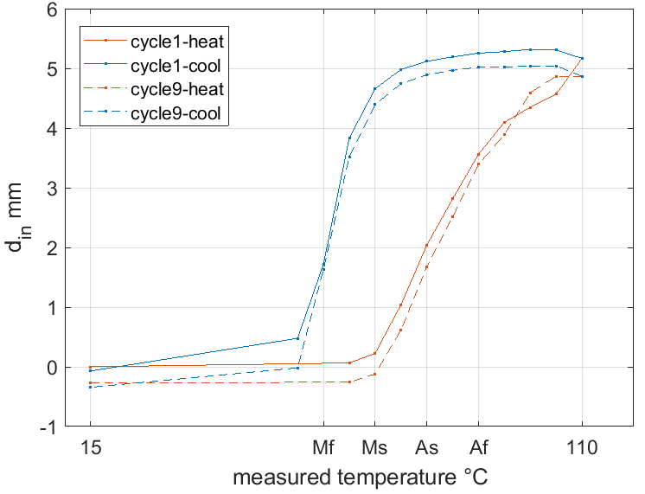
Figure 7.4 Inward displacement vs. measured temperature. The transformation temperatures were provided by the SMA supplier.
Figure 7.5 shows the maximum d_{in} vs. the loading cycles at the two stations. It shows that the deformation of the VAN tended to stabilise around the ninth cycle. Moreover, the deformation was slightly asymmetric, with one of the stations deflected more than the other, by around 0.5 mm. The reason could be the thermal conduction rate preloading differences on the two actuators.
Ultimately, the new material stiffness was updated in the FE environment. The static analysis showed that the achieved d_{in} was 9.6 mm. This is reasonable because the FE model did not consider the superelasticity of the SMA, the software assuming that the actuators had fully transformed into austenite.
To correlate the deformations between the FE and actual models, the actuator stiffness was manipulated in the FE model to achieve the same deformation as in the experimental model. In the upcoming dynamic analysis, where the two model FRFs were to be compared, a strong static deformation correlation between the two models was required.
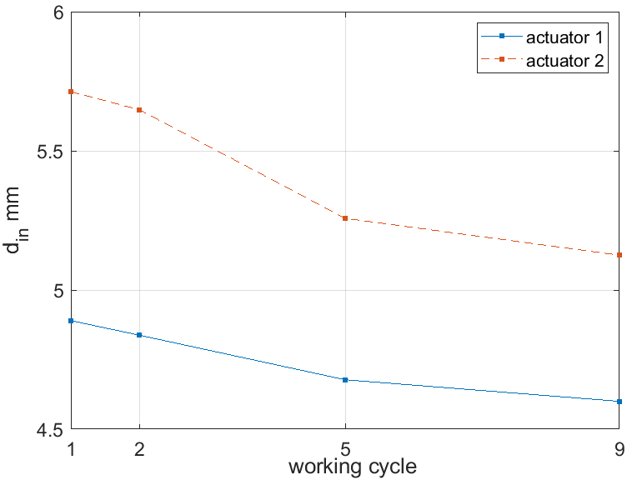
Figure 7.5 Inward displacement vs. working cycle.
The evidence for a better validation of the new VAN is shown in Figure 7.6, where the maximum d_{in} is plotted for each actuator. Even though the experimental displacements are all below the predictions, the new VAN has a more balanced deflection. The reason for the new VAN’s underperformance could be the preloading of the joints, which is a problem inherent in the design.
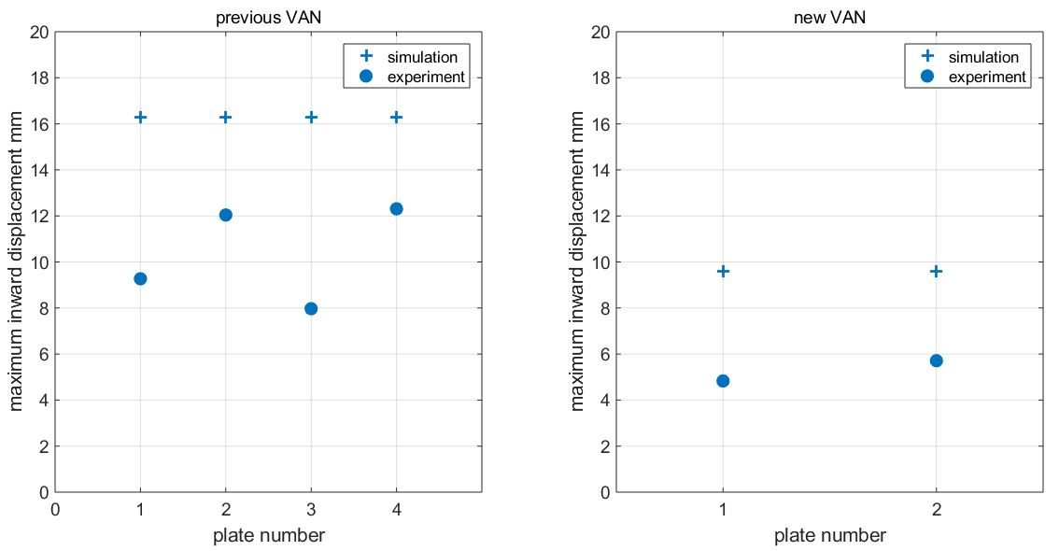
Figure 7.6 Maximum d_{in} achieved on each actuator vs. the predictions.

Methodologies for VAN Dynamic Testing
This section introduces two methodologies, exponential window (Section 7.3.1) and kinetic energy FRF (Section 7.3.2), that were adapted in the dynamic testing of assembled VAN in Section 7.4.

Exponential Window
For time efficiency, an exponential window was added to the time signal to shorten the lengths of the gathered data. The free oscillation of the cylinder varied from 40 to 60 s, depending on the impact force. By reducing the acquisition time to less than 20 s, scanning of the entire cylinder could be completed within the working hours of a day.
The advantages of the exponential window include the amplification being unity at the beginning of the time, and then reaching almost zero at the cutoff time for less leakage (Figure 7.7). The exponential window was developed to work with transient analyses, such as impact and random excitation tests, to stop leakage from lightly damped systems and to attenuate noise for heavily damped systems [128]. The exponential window function is defined by the time constant τ_{w}:
 | $$w\left(t\right)=e^{\frac{-t}{τ_{w}}}$$ | (7.1)
, where the time constant is calculated by selecting a cutoff time, t_{cutoff}, and the cutoff value w(t_{cutoff}):
 | $$τ_{w}=\frac{-t_{cutoff}}{ln\left[w(t_{cutoff})\right]}$$ | (7.2)

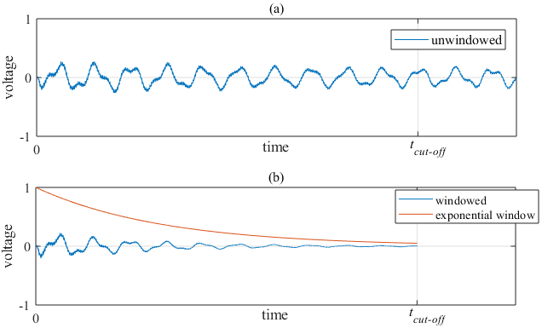
Figure 7.7 (a) Unwindowed and (b) windowed signal of an impact excitation response.
The artificially added damping can be corrected, and the error associated with this correction has been examined in previous works [129,130]. Fladung [130] also found that this error related to a pretrigger delay and an unwindowed force signal. The correction methods for the windowed damping are based on the shift property of Laplace transform theory.
The relationship between true and windowed modal damping ratios $ζ_{r}$ and ${\hat{ζ}}_{r}$ is shown in Equation 7.3, where r is mode number and $ω_{d}^{r}$ is damped natural frequency of mode r. The derivations of the correction function are comprehensively demonstrated in Appendix E.1.
 | $$ζ_{r}≈\frac{{\hat{ζ}}_{r}}{\sqrt{1-{{\hat{ζ}}_{r}}^{2}}}-\frac{1}{τ_{w}ω_{d}^{r}}$$ | (7.3)
The correction function in Eq. (7.3) was then verified by a test example. The impact test time signals were windowed with a cutoff time t_{cutoff} of 11.93 s and a cutoff value w(t_{cut-off}) of 5%. This resulted in a time parameter τ_{w} of 3.98 s. The windowed damping ratios were then estimated using the windowed time signals, and the corrected damping ratios were calculated using Eq. (7.3). To verify this, the true damping ratios, using the unwindowed time signal, were also plotted.
In Figure 7.8, the damping ratios are plotted against their representative natural frequencies. The correction function can be seen to have corrected the damping ratios accurately. The mismatch on the first mode might be due to the added damping being so large that it also significantly amplified the curve fitting error. It is clear that the added damping increased dramatically at low frequencies, tending to stablise at high frequencies.
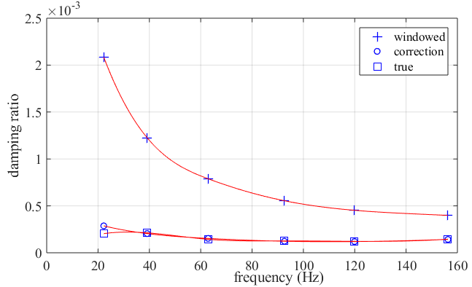
Figure 7.8 Damping correction on windowed transfer function and verification of the correction function.

Kinetic Energy FRF in FE Model
When estimating the reduced vibration from static deformation, the overall cylinder kinetic energy FRF was considered rather than the conventional FRF, which focuses on a single DOF. The reasons are listed below, from looking at Figure 5.15:
- The mode shapes could rotate away from the initial location after heating. If an antinode point was chosen as the response DOF under cold conditions, then this location would not be an antinode after heating.
- For the out-of-plane bending modes, the longitudinal node would shift towards the SMA side.
The correlation of the FRFs between the heated and cooled models would be weakened if any of the above scenarios occurred. Thus, a more sensible method was to adapt the dynamic response of the entire cylinder. To implement this kinetic energy method, the accelerometers had to scan the entire body of the cylinder, and the exponential window mentioned in the last section was essential in reducing the acquisition time.
ANSYS only provides a single-strain energy vector for the elements and for each resonance. This was far from enough to generate a power spectrum in a continued range. However, by adapting the nodal FRFs within one element, this elemental FRF could be generated. Then, the overall elements sum up the kinetic energy FRF of the cylinder.
Consider the kinetic energy of a structure with multiple elements:
$$Ek=\sum{\frac{1}{2}(vρ){\dot{u}}^{2}}$$ | (7.4)
, where v and ρ are the volume and density of the elements, respectively, u is the displacement and Ek is the kinetic energy of the structure. In the mesh, the contact and target elements are ignored, and the other elements are all brick elements with mid-line nodes. Note that the spacers and SMA bodies are not considered in the energy summation, as the object of interest is the cylindrical nozzle.
As the mesh size and mesh densities are not constant around the structure, the cylinder was divided into different zones. The element size within each zone was constant. In all, there were eight different sizes among all the solid elements (Fig. 7.9). Note that Figure 7.9 only shows one-quarter of the cylinder. Given that, the zones shown in Figure 7.9 include the other three-quarters of the cylinder.
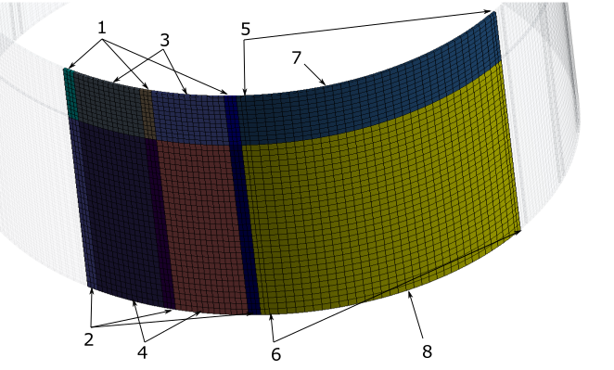
Figure 7.9 Elemental volumes grouped and numbered.
There were eight zones and, given that, the kinetic energy of the cylinder can be written as:
$$Ek=\sum_{m=1}^{8}{{Ek}_{m}}$$ | (7.5)
Assuming a zone m, then there are n elements. Thus, the overall kinetic energy in this zone is:
$$Ek_{m}=-\frac{1}{2}ρω^{2}v_{m}\sum_{n}{{u_{n}}^{2}}$$ | (7.6)
, where ω is the frequency in radius. The density was provided in Table 6.2. The volumes of each zone were extracted from the FE model.
The velocity of an element body was represented by the velocity at the centroid point of that element. The brick elements within the cylinder all had eight corner nodes and 12 mid-side nodes. Thus, the displacement at centroid point of a 20 nodes brick element can be calculated by:
$$ue=-\frac{1}{4}\sum_{i=1}^{8}{u_{i}+\frac{1}{4}}\sum_{j=9}^{20}{u_{j}}$$ | (7.7)
where ue is the displacement at centroid point of the element, u_{i} and u_{j} are the displacements at corner and mid-side nodes of the element. The detailed derivation is shown in Appendix E.2.

Dynamic Analysis for VAN
This section introduces the testing, analysing and discussions of VAN overall kinetic energy FRFs in both FE model and experimental model.

Kinetic Energy FRF of the FE VAN
The loss factors of the FE model were calculated by Eq. (5.22), and the FRFs of the nodes were generated by Eq. (5.33). Note that the force input was a radial vector, and the response from a node was also a radial movement (Fig. 7.10). Thus, the radial response transfer function can be calculated as:
$$H_{u_{x}}=H_{F_{x}u_{x}}+H_{F_{y}u_{x}}$$ | (7.8)
and
$$H_{u_{y}}=H_{F_{x}u_{y}}+H_{F_{y}u_{y}}$$ | (7.9)
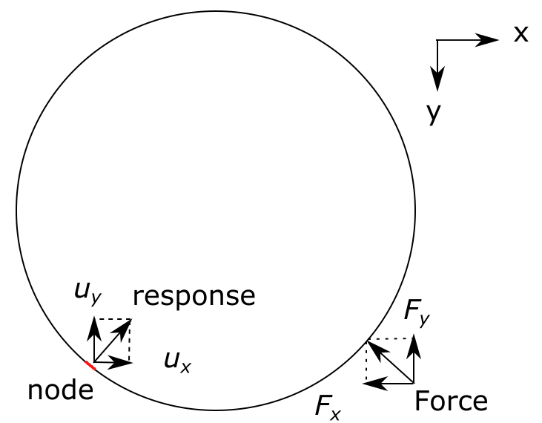
Figure 7.10 Radial force and radial displacement.
The scripting and solving work is as complex as that for around 500,000 DOFs multiplied with around 8000 frequency divisions to be calculated. The coding process met with difficulties, with the whole-matrix dimensions exceeding the memory limit in MATLAB. In many situations, the FRFs have to be operated in separated bandwidths to reduce the matrix sizes. The frequency density was reduced to save computing time, so certain resonance spikes might not have displayed their exact magnitudes.
The FE result of the kinetic energy FRF is shown in Figure 7.11. The first six pairs of the twin modes can clearly be seen, indicating the splitting of their natural frequencies is significantly large. The response modes, or the peaks with lower magnitudes, exhibit significant natural frequency shifting. However, the drive modes, or the peaks with higher magnitudes, do not show obvious shifting of the natural frequencies. This suggests that the static deformation did not significantly affect the system matrices of the FE model. For the magnitudes of the FRF peaks, there was no significant change. This may imply that the damping of the VAN, at least for the modes shown below, was not greatly affected by the phase transformation of the SMA actuators.
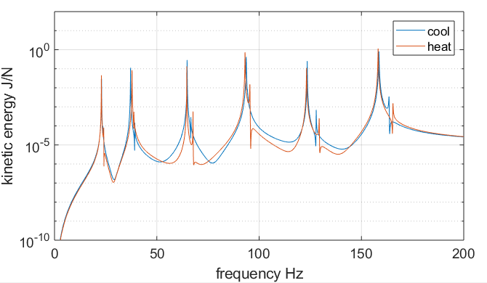
Figure 7.11 Kinetic energy spectrum of the FE VAN.

Kinetic Energy FRF of the Experimental VAN
The inner cylinder surface was divided into equal parts, so the overall kinetic energy of the VAN could be approximated as a summation of the squared velocity at the centres of the rectangular shell elements (Fig. 7.12). Because the elements had identical volumes and densities, the overall kinetic energy of the VAN could easily be calculated. The cylinder surface was meshed into 24 circumferential divisions and 16 longitudinal divisions.
Kinetic energy FRFs were generated experimentally by shifting accelerometers around the inner surface of the cylinder. This was based on two assumptions – that the shell elements were thin enough for the velocities of the inner and outer surfaces to be identical, and that the meshing density was fine enough to represent the overall cylinder.
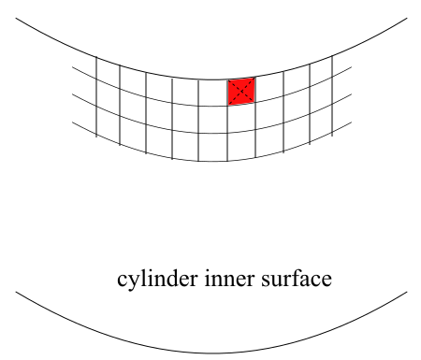
Figure 7.12 Cylinder surfaces was divided into equal rectangles.
The cylinder was inverted, and suspended on the far side of the actuators. This was because the suspension strings provided radial forces that could have affected the radial deflections on the near-actuator side. In addition, all the impact testing for the heating or cooling models needed to be finished within one working day. If the impact testing for the heating model was to be split over two days, then the FRF peaks would have double tips. This is because the heater would have to be turned off overnight. When the VAN was heated on the next day, the exact microstructure within the actuators would be different.
The VAN impact test rig is illustrated in Figure 7.13, with the rotary stage and motor control unit not being involved in these tests. The VAN was isolated using acrylic sheets for safety reasons. A direct current power supply provided the thermal input for the film heater.
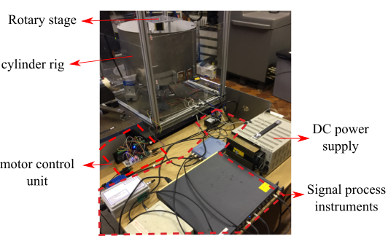
Figure 7.13 VAN impact test setup. Because the infrared cameras were replaced by accelerometers, the motor control unit and rotary stage were not involved in the actual testing.
The experimental results of the kinetic energy FRFs are shown in Figure 7.14. Compared to FE result from Figure 7.11, the actual cylinder shifted more natural frequencies than the FE model. This may be because the manufacturing defects of the cylinder were not represented in the FE model. The twin-mode splitting can clearly be seen, but, in laser sensor measured result from Figure 7.1, the splitting is hardly visible. This indicates that the overall kinetic energy FRF is better than the single-DOF FRF in its capability to show every mode of the cylindrical structure. The damping of the first six pairs of twin modes was not strongly affected by the phase transformation of the actuators for which the peak magnitudes did not change dramatically.
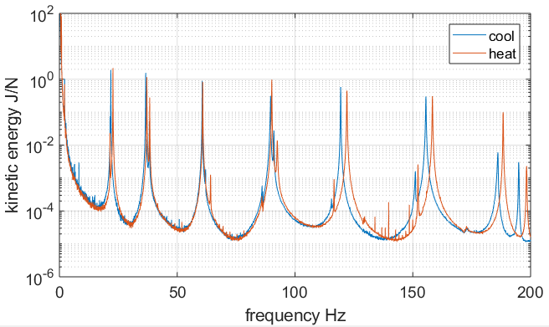
Figure 7.14 Kinetic energy spectra of the experimental VAN.
Figure 7.15 compares the kinetic energy FRFs of the FE model and the experimental results. Firstly, the FE model’s natural frequencies are larger than those of the experimental mode, indicating that the FE model did not include the manufacturing defects of the actual cylinder. Moreover, the twin modes are different in the two models. By looking at the peaks between 100 Hz and 175 Hz, the less excited modes can be seen to emerge earlier than the more excited modes in the experimental model, but the FE model shows opposite case. This may also be caused by the manufacturing defects of the cylinder, including the welding line. The peak amplitudes of the FE model are significantly smaller than those of the experimental model in the low-frequency range. This may be because the FE model excluded the rigid body modes that brought down the magnitudes of the FRF in the low-frequency range. Lastly, the two FRFs have different magnitudes at 0 Hz. The experimental model is infinite because the kinetic energy FRF was calculated from the acceleration FRF by dividing the radian frequency. The velocity magnitude at 0 Hz becomes infinite if the acceleration magnitude at 0 Hz is not zero. Because of the existence of noise content, the acceleration magnitude at 0 Hz will always be higher than zero. On the opposite side, the FE model excludes the rigid body modes, which results in a zero magnitude at 0 Hz.
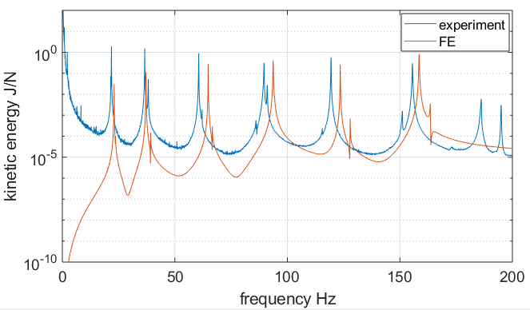
Figure 7.15 Comparison of the kinetic energy FRFs of the experimental and FE models.

Resonance Avoidance by the VAN
The experimental VAN’s capability of avoiding resonance is studied in this section. Section 5.2.2 suggested a 0.88% natural frequency shift would result in a 98% reduction in the quality factor. The shifted natural frequencies and modal damping ratios of the experimental VAN are listed in Tables 7.1 and 7.2, respectively. Note that the less excited response modes are not listed in the tables.
The results show that the amount of shifting of the natural frequencies of the VAN gradually decreased from mode 1 to mode 3, then increased after mode 3. Apart from modes 3 and 4, all the other modes passed the 0.88% shift magnitude. This indicates that the deflection of the VAN was not large enough to achieve a major difference in the third and fourth modes. It might also suggest that the two-actuator configuration had little effect on the natural frequencies of the third and fourth modes. A four-actuator-configurated VAN could be considered in the future to explore the effects on these modes.
The modal damping ratios suggest a significant increase in the damping capability of the VAN from attaching the SMA actuators. There is no obvious difference in the damping ratios between the in-plane and out-of-plane bending modes. Moreover, the VAN shows similar damping ratios at the end of heating and cooling. Compared to Figure 5.24, where the modal damping ratios were estimated using the strain-energy method, the modal damping ratios of the undeformed VAN in Table 7.2 are not always higher than those of the deformed VAN. This might be because, when the VAN was heated and deformed, the bonding adhesives induced damping and joint frictions induced damping were increased.
Table 7.1 Shifted natural frequencies of the actual VAN.
Mode number | 1 | 2 | 3 | 4 | 5 | 6
Undeformed VAN (Hz) | 21.8 | 36.62 | 60.58 | 89.63 | 119.4 | 155.6
Deformed VAN (Hz) | 22.69 | 37.12 | 60.77 | 90.14 | 122 | 158.4
Shifting rate based on undeformed VAN (%) | 4.1 | 1.4 | 0.3 | 0.6 | 2.2 | 1.8
Table 7.2 Changed damping ratios of the VAN.
Mode number | 1 | 2 | 3 | 4 | 5 | 6
Bare cylinder (10⁻⁴) | 2.0 | 2.1 | 1.4 | 1.3 | 1.2 | 1.5
Undeformed VAN (10⁻⁴) | 8.5 | 7.2 | 4.3 | 7.4 | 3.4 | 5.7
Deformed VAN (10⁻⁴) | 8.4 | 7.7 | 2.3 | 5.8 | 5.1 | 4.8
The reduced vibration estimation method developed in Section 5.2.2 was based on the shifted natural frequency, which depends on an assumption that the FRF peak remains the same after shifting. In practice, this is usually not the case. Thus, a more accurate method is to compare the FRFs before and after shifting. Figure 7.16 (left) shows the two FRF peaks of the first mode at the end of cooling and heating. The bandwidth can be divided into two regions. When the excitation frequency sits in the left region, the heated VAN will always exhibit less vibration than the cooled VAN, thus the actuators should be heated to shift the FRF towards the right. When the excitation frequency sits in the right region, the cooled VAN will always exhibit less vibration than the heated VAN, thus the actuators should be turned off, to shift the FRF towards the left. Given that, the VAN can choose to activate or turn off the actuators, depending on the excitation frequency.
The percentages of the reductions in overall kinetic energy by these operations is shown in Figure 7.16 (right). The reduction percentages were calculated by the following equations:
$${Reduction}_{cool to heat}=100\%\frac{\left|{FRF}_{cool}\right|-\left|{FRF}_{heat}\right|}{\left|{FRF}_{cool}\right|}$$ | (7.10)
$${Reduction}_{heat to cool}=100\%\frac{\left|{FRF}_{heat}\right|-\left|{FRF}_{cool}\right|}{\left|{FRF}_{heat}\right|}$$ | (7.11)
In Figure 7.16, when the excitation frequency sits on the dashed line, the reduction is zero, with the VAN system having no achievable reduction. The reduction can achieve almost 100% when the excitation frequency sits on either of the natural frequencies. Also, the achievable reduction is above 50% at the shown bandwidth, indicating that vibration within this bandwidth can be avoided. Note that Figure 7.16 (right) also shows an unavoidable frequency point at around 21.5 Hz.
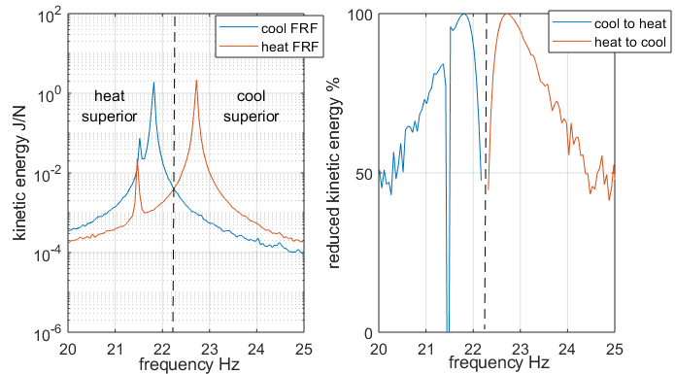
Figure 7.16 First mode peaks (left). Percentage achievable vibration reduction (right).
For some resonant modes, the conditions around the peaks can be more complex. Figure 7.17 (left) shows the sixth mode peaks having four regions. This is because there is a response mode (red curve) emerging between the twin modes (blue curve), which forms a slim superior cooling region. The achievable vibration reduction is shown in Figure 7.17 (right), where the majority of the bandwidth can reduce more than 50% of the kinetic energy, apart from the intersectional frequency points (dashed line in Fig. 7.17, left). After inspecting the reduced kinetic energy of the first six modes, it can be conluded that each resonant peak can be avoided or reduced by the cooling/heating or heating/cooling operations.
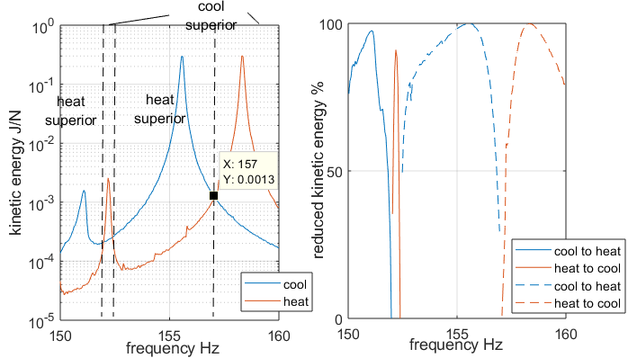
Figure 7.17 Sixth mode peaks (left). Percentage achievable vibration reduction (right).
Lastly, to verify the conclusions reached above, each FRF peak in a cooling or heating state was examined in terms of the percentage reduction, as illustrated in Figure 7.18. To simplify this, the less excited modes were not considered. The results show that each FRF peak, either for the cooling- or heating-end model, can be reduced by more than 97% (Table 7.3). Considering the small amounts of shifted natural frequencies for the third and fourth modes (Table 7.1), the achievable reductions are still significant. This suggests that the operational margins required for avoiding VAN resonances are very small. Considering the difficulties involved in introducing large deformations in aircraft engine nozzles or other industrial applications, the SMA-actuated resonance-avoidance technique is promising.
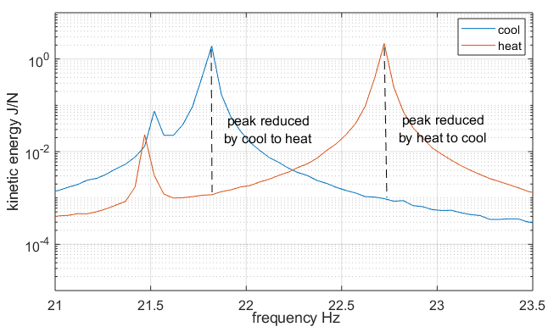
Figure 7.18 Kinetic energy FRF peaks of the first mode. Reduction magnitudes shown as dashed lines.
Table 7.3 Reduced kinetic energy of the VAN at the first mode peaks. Reduction rate of cooled-heated is based on the cooled FRF magnitudes.
 | Mode number
Peak reduction (%) | 1 | 2 | 3 | 4 | 5 | 6
Cooled to heated | 99.94 | 99.64 | 97.80 | 97.02 | 99.94 | 99.90
Heated to cooled | 99.96 | 99.52 | 98.10 | 99.36 | 99.95 | 99.87

Time on Resonance Reduction by the VAN
In the previous section, the VAN demonstrated a resonance-avoidance ability with stationary excitation frequencies. However, aircraft engine nozzles are usually optimised to eliminate resonances at cruising speeds. More often than not, aircraft nozzles can exhibit resonances during takeoff and landing. The VAN-configured engine nozzle can reduce resonance time and thus increase structure lifetime.
As shown in Figure 7.19, a nozzle subjected to a gradually increasing rotor speed V_{rot} will have the high vibration associated resonance for a time that is proportional to the width of the spike Δω. To reduce the time on resonance, the actuators could be preheated, after which the FRF will shift towards the red curve. When the engine rotor speed approaches the resonance margin, the nozzle can be cooled off to enable the spike to shift in the opposite direction of the rotor speed. This will form a sharpened response spike and a shortened resonance time. Similarly for speed reduction, the actuators can be precooled and then heated until the rotor speed passes through the resonance region.
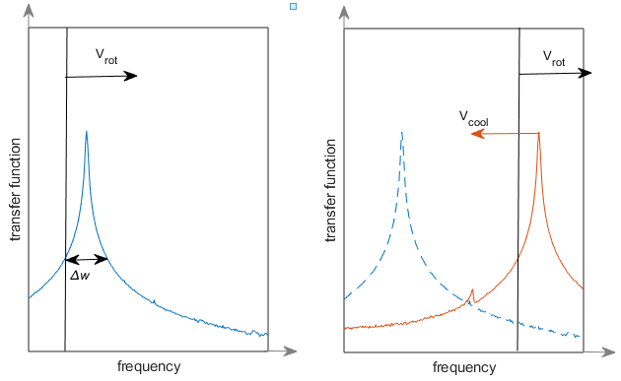
Figure7.19 Illustration of how the VAN reduces time on resonance when the engine starts up.
The engine start-up case for the VAN was examined experimentally using the physical VAN assembly subjected to excitation of increasing frequency. The nozzle was connected to a dynamic shaker to provide a frequency-changing sinusoidal force. A sweep-sine signal was generated across a narrow bandwidth, where only the fourth out-of-plane bending mode was involved. Here, the frequency response was obtained using the signal from a force transducer from the excitation point and a response signal from the movement of the nozzle (Figure 7.20). A SigLab module generated an output signal to the shaker through an amplifier, while the input channels of the module were connected to the force transducer and response sensors.
As the SigLab module had limited input channels, only one accelerometer was connected, being installed at an antinode of the fourth resonant mode shape. The testing did not adapt the method used in earlier sections of this chapter to collect the overall kinetic energy of the nozzle. This was because the repetitive thermal cycles would have slightly changed the natural frequencies of the VAN after each cycle due to material fatigue in the SMA, which would ultimately form a FRF spike with multiple tips. Both the excitation and response points were located along one edge of the cylinder.
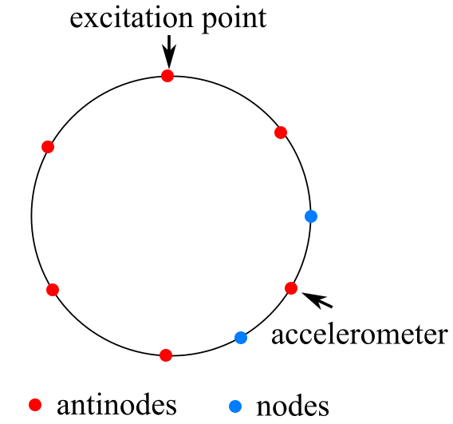
Figure 7.20 Illustration of the rig setup for sweep-sine testing.
A out-of-plane resonance mode was selected to generate a single FRF peak. The frequency division and number of averagings inside SigLab were carefully managed to avoid errors. A trial test showed that the magnitudes of the FRF peak changed by approximately 2 dB, indicating that the model shape rotated after heating (Figure 7.21). Moreover, the phases close to 90 Hz did not decrease to zero because of the close modes. The twin modes were too close, such that the phases around 90 Hz could not decrease to zero.
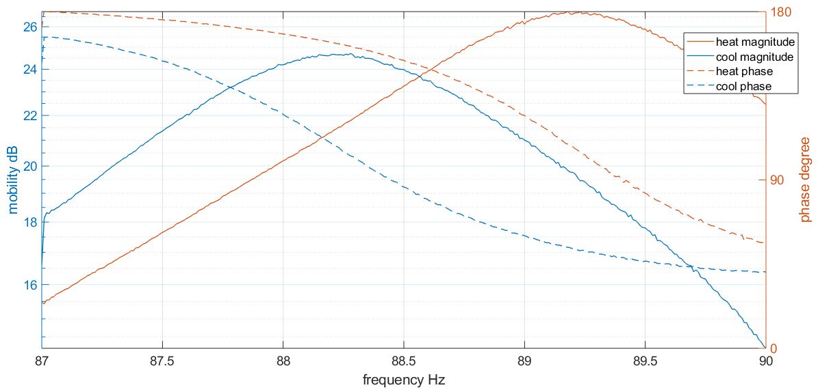
Figure 7.21 Sweep-sine testing on the VAN at the end of heating and cooling.
The formal testing of the VAN was divided into three steps. The VAN was heated to the austenitic phase, and a sweep-sine FRF was generated while the temperature was maintained. A second FRF was generated by initially starting the sweep-sine excitation, then turning off the heat at an appropriate time. The sweep-sine process ended at the exact time when the SMA was fully restored to martensite. Finally, a third FRF was generated when the actuators had completely cooled down. An appropriate sweeping speed was designed based on the cooling speed of the SMA.
The results are shown in Figure 7.22, in which the snap point was set to 87.5 Hz when the heater power was turned off. This timing made most of the martensitic transformation happen between 88 Hz and 89.75 Hz (yellow curve).
The shape of the cooling FRF (yellow curve) is asymmetric, with the right side descending dramatically. This is because the left-shifting tendency of the FRF boosted the decreasing of the FRF when the excitation frequency was in the right half of the peak. It was assumed that the resonant zone was a bandwidth with a magnitude drop of 6 dB. The bandwidth Δω for the passive VAN (i.e. where shape was not morphed, as shown in blue curve in Figure 7.22) was 2.24 Hz, and 1.72 Hz for the cooling down VAN (yellow curve in Figure 7.22). This produced a 23% reduction in time in resonance. The reduction could be further increased by speeding up the actuator cooling. In application models, such as aircraft engines, the bypass nozzle would be exposed to cold air, and so a faster cooling down speed and a larger resonance time reduction could be achieved.
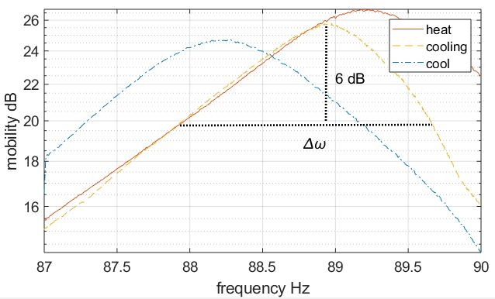
Figure 7.22 Three FRFs for when the VAN is at heating end (red), in the middle of cooling down (yellow) and fully cooled off (blue). The reduced resonant time is represented by the width of Δω.

Conclusion
This chapter discussed the static deformation of a newly fabricated VAN and a dynamic analysis of the morphing nozzle. The objectives were to estimate the resonance-avoiding capability of the morphing VAN.
Firstly, vibration tests using impact excitation and laser sensor showed that some resonance splitting, arising from non-identical twin modes, occurs on the new cylinder.
The static deformation test was modified to include thermocouples, so a temperature hysteresis loop could be plotted. The static test results showed that the temperature-deflection behaviour of the VAN tended to stabilise after nine cycles.
An exponential window was employed to increase the acquisition efficiency. The principle and verification of the exponential window was demonstrated. The results showed that the windowed damping ratios could be corrected at frequencies higher than 20 Hz with little error.
Following the preparation sections described above, the main content of this chapter started with the necessity of determining the kinetic energy FRF for the overall cylinder structure. Then, the calculation method for the kinetic energy FRF in a FE environment was interpreted. The method adapted the shape function of 20-node brick elements. However, the result of the kinetic energy FRF showed little natural frequency shifting for the first six modes. The results also indicated little change in the modal damping by the phase transformation of the actuators.
The experimental kinetic energy FRFs were generated by shifting the accelerometers around the cylinder surface, and then summing up all the divisions. The results showed significant changes in natural frequency shifting. Moreover, all the less excited twin-mode peaks were visible, which indicated the advantage of the overall kinetic energy FRF compared to the single-DOF FRF.
The ability of the VAN to avoid resonance was then studied. First, the natural frequencies shifted by the heating actuators were listed. The results showed that the first mode achieved the most change (4.1%) and the third mode achieved the least change (0.3%). They also indicated that the third and fourth modes may have encountered insufficient amounts of resonance avoidance.
The capability of the VAN to avoid resonance was then considered within the individual modes. Generally, the conditions around the FRF peaks of each mode can be divided into two or more regions. These regions show reduced vibration under either heating- or cooling-end status. Most parts around the FRF peaks showed significant reductions in kinetic energy, from 50% to almost 100%. The areas near the intersections of two peaks showed much less vibration reduction. However, the vibration magnitudes around the intersection areas were small. The reduced magnitudes at the FRF peak frequencies indicated that all six modes could achieve at least a 97% reduction in kinetic energy. This suggests that each resonance could be confidently avoided, even if the third mode only shifted 0.3% of the natural frequency.
Lastly, the controlled SMA actuators can reduce the time on resonance of an aircraft engine nozzle when changing speed. A shaker with a sweep-sine output force modelled the harmonic excitation of the engine nozzle during start-up. The SMA actuators transformed phases at a designated time to form a sharpened FRF peak. The results showed that the time on resonance can be reduced by 23%, and can be further reduced once an adequate cooling system is added.
The second contribution in Section 1.3 was the adaptation of the kinetic energy FRF in estimating resonance avoidance. The kinetic energy FRF measures the vibration energy of the overall cylinder reacting to a unit excitation force. The objective is to avoid the localisation problem of the accelerometer when the mode shape of the structure rotates or distorts after external loading changes the system matrices. Moreover, the twin-mode pairs are a unique issue in ring or cylindrical structures that have closed and symmetrical geometries. The less excited twin modes are easily hidden if a single-DOF FRF is adapted (Figure 4.13). From Figure 7.16, the result showed that the FRF peaks retained their magnitude levels after heating, indicating that the kinetic energy FRF successfully bypassed the localisation problem. In addition, Figure 7.16 shows every twin mode, even the less excited ones, and indicates that the kinetic energy FRF is effective in showing all resonances for ring or cylindrical structures. For the FE model, the shape function of a brick element was derived in order to develop a function for calculating the kinetic energy of a cylinder according to the nodal FRFs of the structure. One of the drawbacks of the kinetic energy FRF are the costs of acquisition and coding time. Repeated impact testing assumed that the response of the VAN to different levels of impact force would be linear, which is doubtful, as apparent from a review of the literature.
The last contribution to Section 1.3 was adapting the SMA actuators for natural frequency tuning. Previous work have studied various methods for tuning the modal conditions of vibrating structures. However, the components added to implement the required actuation were cumbersome [7-10]. The SMA-actuated VAN design has the advantages of having compact configurations and being self-recoverable. The static deflections achieved by the SMA actuators in this work were adapted for the resonance avoidance.
The modal experiments showed that even a 0.3% shift in the natural frequency could reduce FRF peak vibration by up to 97% of the kinetic energy. The results achieved imply a promising capability for resonance avoidance by SMA actuators because the required operational margins on the spectrum are very narrow. Moreover, the SMA material has some damping capability, which assists vibration reduction in the overall structure. One disadvantage of the SMA-actuated structure is the high precision required in manufacturing both the actuators and the main structure. In addition, the early-cycle fatigue of SMA actuators may bring down the natural frequency shift strokes. Thus, the stresses loaded on the actuators have to be limited within an adequate range to reduce the fatigue accumulation inside the actuators.

Conclusions and Future Work

Conclusions
The main objectives of this work were to develop a reliable and repeatable morphing structure, to obtain an accurate finite element model of this structure, and to use these to investigate the effectiveness of shape morphing for vibration reduction. Each of the objectives was achieved successfully. Details relating to this are summarised in this section along with some of the novel contributions of the work.

Reliable and Repeatable Morphing Structure
Initially, a variable area nozzle (VAN) was used that had been created as part of a different research project. That project used thermally-controlled SMA actuators to change the shape of a cylindrical aeroengine bypass nozzle in order to improve operating envelope and to reduce jet noise. It was convenient to use this nozzle as it provided significant and controllable shape change. This phase of the work also identified the importance of twin modes in cyclic-symmetric structures. More extensive studies, especially the dynamic analysis, were not however carried out using the initial structure. This was because the manufacturing precision, particularly on the actuators, was poor. This resulted in uneven deformation on heating and a potential threat to the integrity of the entire structure. Additionally, inconsistencies in the shape of the titanium cylinder affected the frequency separation in the twin modes. Overall, it was considered the repeatability and predictability were inadequate.
To address the problems raised, an entirely new VAN was constructed giving much more careful attention to the manufacturing tolerances. When the new SMA actuators were cut from the forged bar using EDM, a novel clamp was developed that would resist residual stress deformation. Measured results showed that the designed clamp successfully controlled the thicknesses of the actuators to within an error of 3.6%, down from the previous error of 20%. The nozzle itself was rolled from titanium alloy sheet. Laser welding was used to attach spacers on the cylinder and to join the seam. This dramatically reduced the welding bead on, although some inaccuracy from the rolling process remained. Controlled testing of the actuator material also showed that large pre-strains gave rise to fatigue concerns and that this should be limited within 1.3%. Pre-cycling the actuators up to 9 times was shown to stabilise behaviour. The disadvantage to using such a low actuator pre-strain was that it reduced the level of shape morphing achieved.

Accurate FE Model
FE models of the actuator and cylinder were built and validated individually, and then as a combined system. Meshing density was set as a compromise between accuracy and computation expense. Models were built for both the initial cylinder and the new one. The shape memory effect was simulated using a thermal strain followed by plastic deformation. Material data to feed into this model was obtained by testing smaller specimens of the material.
The dynamic analysis results indicated the accuracy of the FE model. In the initial structure, the natural frequencies were predicted to within 3% but actuator stiffness was underestimated by about 20%. This was thought to be caused by a combination of manufacturing inaccuracy and material property drift (though work hardening and dislocation) in the actuators. Mode shapes, however, were modelled correctly.

Evaluation of Shape Morphing for Resonance Avoidance
As the first study of this kind, was of predicting, measuring and evaluating success using the VAN structure, were developed as the research progressed.
Modal analysis was carried out on the pre-stressed VAN to study the changes in the natural frequencies, along with the static deformation level. The results showed that some natural frequencies changed their shift directions several times during shape morphing. For the twin-mode pairs, some natural frequencies shifted in opposite directions while others remained unchanged throughout the static deformation cycle. This highlighted the importance of understanding the ability of the actuators to adjust particular modes. An attenuation study, considering single-frequency excitation, showed that the vibration level of a resonant peak could be reduced by up to 98% if the natural frequency could be shifted by just 0.88%. For the structure considered, this meant that almost all resonances could be effectively avoided.
The presence of twin-modes and some change in mode shapes during morphing meant that individual FRFs by themselves would not give an accurate measure of overall vibration reduction. Instead, an approach was developed to obtain the kinetic energy of the whole structure, as a function of frequency, when subjected to vibration. This was done experimentally and numerically. In this way, the effect on overall vibration levels could be monitored through one image rather than many FRFs. Results evaluated using the kinetic energy approach confirmed the initial evaluation discussed above. For each of the first six modes, resonant vibration could be reduced by at least 97% for single frequency excitation.
In practice, an important use for this method was thought to be where total vibration is gradually increasing or reducing in frequency – for example, changes in engine speed. Several different scenarios that were considered, highlighted the importance of understanding the best direction to move a resonance. Depending on the resonance frequency and the closeness of the excitation frequency, it might be more advantageous to move rapidly up or down through the excitation frequency. For one scenario, with excitation frequency gradually increasing, the ability to decrease time ‘on resonance’ was demonstrated. The achieved value of 23% was significant – but could be increased dramatically by forced cooling of the actuator – something that would happen naturally on an aeroengine VAN in service.

Novel Contributions
The main novel contributions of this work are identified in Section 1.3. They have been discussed in conclusion sections from Chapter 6 and 7. To summarise, they are listed below:
- Producing thin plate actuators with stepped edges from SMA using EDM, which had a consistent thickness in the main body of 1 mm required the development of a new holding clamp. Moreover, the early cyclic fatigue of thin plate SMA actuator was studied by monitoring the changes in stiffness and accumulated dislocation along with the working cycles. The developed clamper for EDM can be applied in other projects where SMA plate actuators are used and where the machining precision of the actuators are vital.
- The overall kinetic energy frequency response function (FRF) of a vibrating structure was adopted to avoid the localization problem of response sensors when dealing with cylindrical structures with mode shapes that may change with static deflection. In addition, a methodology for the overall kinetic energy FRF in FE environment was developed and verified. The kinetic energy method developed for assessing the overall effectiveness of vibration control is unusual. It does not appear to have been used before to evaluate vibrations in morphing structures. This method can be applied in other dynamic analysis where the main structures have ring or cylindrical geometries and also exhibit static deformation.
- This research has delivered a compact, repeatable, self-actuated morphing structure that enables adjustment of its resonant vibrations. The change in natural frequencies can be controlled for resonances avoidance. The results show the required shifts of natural frequencies to achieve up to 97% in overall kinetic energy FRF magnitude reductions were as little as 0.3%. This demonstrates that SMA plates embedded into smart structures (including plates, rings and nozzles) can be configured to avoid resonances at a wide frequency bandwidth.

Future Work
As this research is the initial study into SMA actuated shape morphing for vibration control, several follow-on activities are immediately of interest.
Firstly, a theoretical model could be constructed for a deformed thin-shell structure. This could start with a simple, thin-plate structure and then be applied to the deformation of a cylindrical nozzle. The static model should be carefully studied to ximprove the bonding strategy of the actuators because the current screw-bolt bonding will develop some shear moment around the bonding area.
The damping behaviour of SMA material may be strongly related to the amplitude of dynamic strain that the specimen undergoes. Under these conditions, behavoiur under flexural loading will be different from the tensile response. An amplitude controlled, harmonic analysis should be carried out to measure the material properties, including stiffness and damping, of SMA plates under different temperatures.
For the specific VAN structure in question, some improvements could be made. These include:
- Small piezoelectric (PZT) patches could replace the accelerometer to measure strain levels on the structure as this would reduce added weight. The same PZTs could be used to apply impulse excitation for modal tests to reduce the error developed from manually-impacted locations.
- The static deformation described in Chapter 7 only achieved around 5 mm of inward displacement. More static deformation could be achieved by increasing the SMA plate thickness, or by ordering a more work-hardened SMA sheet from the supplier. Figure 5.13 shows that the natural frequencies could be shifted in either direction during the heating stage if the terminal static deformation was large enough.
- In the testing reported in Chapter 7, only two actuators were attached. The misaligned spacers on the other stations could be removed and replaced correctly. The four-station configuration enabled both oval- and square-shaped deformation, via which the diversity of the changing dynamics of the VAN could be increased.
- The actuators generated thermal contraction up to 120°C. This clearly indicates the existence of superelasticity during heating. The original ADVACT study tested the stiffness of austenite, but the superelasticity test was not applied. In this work, the testing was scheduled, until it was found that the tensile machine with the heating chamber was unavailable and a crucial component was waiting to be installed. By testing the superelasticity and the related fatigue behaviour, a more adequate FE model could be produced.
The film heater was bonded by epoxy grease, and this was not a strong connection because the film heater could be moved during installation and transportation. A more reliable bonding technique is shown in Figure 8.1, where a film heater can be held in place by the elasticity of insulation foam. A thermocouple bead could be placed between the film heater and the SMA so that the actual temperature of the SMA could be measured.
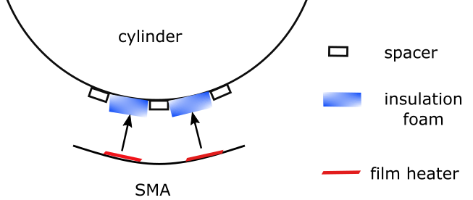
Figure 8.1 Squeezed thermal insulation foam can hold film heaters in place – no adhesive or grease needed.
In terms of controlling the thermal input power to reduce vibration, a feedback from the cylinder static deformation would have to be built. The existence of temperature hysteresis means that the SMA temperature cannot be used as an indicator of static deformation. A possible solution would be to attach a piece of strain gauge to a cylinder in a location where the most static strain occurs. A low-pass filter would enable the strain gauge to only output the static signal. By doing this, it would be possible to achieve real-time control of the vibration reduction by using the static signal and excitation frequency.
Finally, testing of the rapid passing-through resonance region that is discussed in Section 7.6 could be performed by measuring the time duration of the resonance noise with a decibel meter. However, an adequate cooling unit would have to be developed in order to achieve significant passing-through time reduction.

References
- Shaw J. R. Ultra-Efficient Engine Technology. [Online]. Available at https://www.grc.nasa.gov/WWW/k-12/UEET/StudentSite/engines.html (2014).
- Rongong J. et al. ADVACT_WP7_D7.4: Variable area nozzle. Project Note. University of Sheffield, Sheffield, UK (2008).
- Birman V., Rusnak I. Vibrations of plates with superelastic shape-memory alloy wires. Journal of Engineering Mathematics, 78, 223–237 (2013).
- Birman V. Shape-memory elastic foundation and supports for passive vibration control of composite plates. International Journal of Solids and Structures, 45, 320–335 (2007).
- Miyazaki S., Imai T., Igo Y., Otsuka K. Effect of cyclic deformation on the pseudoelasticity characteristics of Ti-Ni alloys. Metallurgical Transactions A, 17A, 115 (1986).
- Soul H., Isalgue A., Yawny A., Torra V., Lovey F. C. Pseudoelastic fatigue of NiTi wires: Frequency and size effects on damping capacity. Smart Materials and Structures, 19(8), (2010).
- Cakar O. A method for shifting natural frequencies of a dynamic system to desired values with concentrated mass modifications. Journal of Vibroengineering, 20(1), 1-12 (2018).
- Yee E.-K.-L., Tsuei Y.-G. Method for shifting natural frequencies of damped mechanical systems. American Institute of Aeronautics and Astronautics Journal, 29(11), 1973–1977 (1991).
- Mostaghel N., Fu K.-C., Yu Q. Shifting natural frequencies of plates through preforming. Earthquake Engineering Structural Dynamics, 24(3), 411–418 (1995).
- Lopez-Alba E., Sebastian C.-M., Silva A.-C.-S., Patterson E.-A. 2019, Experimental study of mode shifting in an asymmetrically heated rectangular plate. Journal of Sound and Vibration, 439, 241–250 (2019).
- Woodward R. P., Hughes C. E., Podboy G. G. Fan Noise Reduction with Increased Bypass Nozzle Area. AIAA Journal of Aircraft, 43(6), 1719–1725 (2006).
- Crichton D., Xu L., Hall C. A. Preliminary Fan Design for a Silent Aircraft. J. Turbomach., 129(1), 184–191 (2007).
- Cumpsty N. A. Jet Propulsion. Cambridge, UK: Cambridge University Press (2003).
- Saravanamuttoo H. I. H. Gas turbine theory. London, UK: Prentice Hall (2008).
- Aviation Safety Network Datebase [Online]. Available at http://aviation-safety.net/database/record.php?id=19971206-0 (1997).
- Mabe J. Variable Area Jet Nozzle for Noise Reduction Using Shape-Memory Alloy Actuators. The Journal of the Acoustical Society of America, 123, 63871 (2008).
- Crichton D., Xu L., Hall C. A. Preliminary Fan Design for a Silent Aircraft. J. Turbomach., 129(1), 184–191 (2007).
- Crichton D., de la Rosa Blanca E., Law T., Hileman J. Design and Operation for Ultra Low Noise Take-Off. 45th AIAA Aerospace Sciences Meeting and Exhibit, Reno, Nevada, AIAA-2007-456 (2007).
- Calkins F., Butler G., Mabe J. Variable Geometry Chevrons for Jet Noise Reduction. 12th AIAA/CEAS Aeroacoustics Conference, Cambridge, Massachusetts, AIAA-2006-2546 (2006).
- Cabell R., Schiller N., Mabe J. H., Ruggeri R. T., Butler G. W. Feedback Control of a Morphing Chevron for Takeoff and Cruise Noise Reduction. Active 04, Williamsburg, Virginia, pp. 1-11 (2004).
- Material datasheet for Grade 6 Titanium Alloy. [Online]. Available at http://www.matweb.com/search/DataSheet.aspx?MatGUID=b350a789eda946c6b86a3e4d3c577b39 (2015).
- Melton K. N., Harrison J. D. Proceedings of the 1st International Conference on Shape-Memory and Superelastic Technologies, Pacific Grove, California, p. 187 (1994).
- Agnihotri R., Bhardwaj S. Synthesis and Characterization of Cuznal-Based Shape-Memory Alloys and to Optimize Behavior on Different Properties by Varying Weight Percentage. International Journal of Materials Science and Engineering, 4(4), 229-234 (2016).
- Hane K. F., Shield T. W. Microstructure in a Copper-Aluminium-Nickel Shape-Memory Alloy. Proceedings, Mathematical, Physical and Engineering Sciences, 455(1991), pp. 3901–3915 (1999).
- Dericioglu A., Ögel B., Bor S. Production of Cu-Zn-Al Shape-Memory Alloys by Powder Metallurgy from Elemental Powders. Materials Development and Processing, 8, 340–344 (2006).
- Duerig T. W., Melton K. N., Stockel D., Wayman C. M. Engineering Aspects of Shape-Memory Alloys. Oxford: Butterworth-Heinemann, pp. 3–20 (2013).
- Kauffman G. B., Mayo I. The Story of Nitinol: The Serendipitous Discovery of the Memory Metal and Its Applications. The Chemical Educator, 2(2), 1–21 (1997).
- Naresh C. et al. Shape-Memory Alloys: A State of the Art Review. IOP Conference Series, Materials Science and Engineering, 149, 1-13 (2016).
- Nitinol Specification Guidelines. [Online]. Available at http://jmmedical.com/resources/120/Nitinol-Specification-Guidelines.html (2015).
- Khan A. Q. The Effect of Morphology on the Strength of Copper-based Martensites. Leuven, Belgium, p. 300 (1972).
- Miyazaki S., Kohiyama Y., Otsuka K., Duerig R. W. Effects of Several Factors on the Ductility of the Ti-Ni Alloy. Materials Science Forum, 56–58, 765–770 (1990).
- Liu Y. On the Detwinning Mechanism in Shape-Memory Alloys. IUTAM Symposium on Mechanics of Martensitic Phase Transformation in Solids: Proceedings of the IUTAM Symposium, Hong Kong, China, 11–15 June 2001, pp. 37–44 (2002).
- Cladera A., Weber B., Leinenbach C., Czaderski C., Shahverdi M., Motavalli M. Iron-based Shape-Memory Alloys for Civil Engineering Structures: An Overview. Construction and Building Materials, 63, 281–293 (2014).
- Worden K. et al. Smart Technologies. London, UK: World Scientific Publishing (UK) Ltd. (2013).
- Kumar S. S., Jilani S. A. K. Generation of Mechanical Energy using a Nitinol Wire. International Journal of Engineering Trends and Technology, 29(1), 23-28 (2015).
- Funakubo H. Shape-Memory Alloys. New York, USA: Gordon and Breach Science Publishers (1987).
- Chluba C., Ge W., Miranda R., Strobel J., Kienle L., Quandt E., Wuttig M. Ultralow-fatigue Shape-Memory Alloy Films. Science, 348(6238), 1004–1007 (2015).
- Spini T. S. Transition Temperature Range of Thermally Activated Nickel-Titanium Archwires. Journal of Applied Oral Science, 22(2), 109–117 (2014).
- Friedrich K., Breuer U. Multifunctionality of Polymer Composites. Norwich, NewYork: William Andrew, pp. 945–964 (2015).
- Strandel B., Ohashi S., Ohtsuka H., Miyazaki S., Ishihara T. Effect of Mechanical Cycling on the Pseudoelasticity Characteristics of Ti–Ni and Ti–Ni–Cu Alloys. Mater Science and Engineering. A, A203, 187–196 (1995).
- Schneevoigt R., Haase A., Eckardt V. L., Harzer W., Bourauel C. Laboratory Analysis of Superelastic NiTi Compression Springs. Medical Engineering & Physics, 21(2), 119–125 (1999).
- Yahia L. H., Ryhänen J. Bioperformance of Shape-Memory Alloys Berlin, Heidelberg: Springer, pp. 3–23 (2000).
- Nemat-Nasser S., Guo W. G. Superelastic and Cyclic Response of NiTi SMA at Various Strain Rates and Temperatures. Mechanics of Materials, 38(5–6), 463–474 (2006).
- Zeng X., Du Z., Schuh C., Gan C. Enhanced Shape Memory and Superelasticity in Small-Volume Ceramics: A Perspective on the Controlling Factors. MRS Communications, 7(4), 747–754 (2017).
- Clive, B. Innovation: Shape-Memory and Superelastic Alloys. [Online]. .Available at https://www.copper.org/publications/newsletters/innovations/1999/07/shape.html (1999).
- Gadaj S. P., Nowacki W. K., Pieczyska E.A. Temperature Evolution in Deformed Shape-Memory Alloy. Infrared Physics & Technology, 43, 151–155 (2002).
- Turteltaub S., Suiker A. S. J. A Multiscale Thermomechanical Model for Cubic to Tetragonal Martensitic Phase Transformations. International Journal of Solids and Structures, 43(14–15), 4509–4545 (2006).
- Michal G.M., Sinclair R. The Structure of TiNi Martensite. Acta Crystallographica Section B, 37, 1803–1807 (1981).
- Yoo Y., Kim Y., Shin D., Lee J. Development of martensite transformation kinetics of NiTi shape-memory alloys under compression. International Journal of Solids and Structures, 64–65, 51–61 (2015).
- Nespolo, M. Crystal Twinning. [Online]. Available at http://www.crystallography.fr/mathcryst/twins.htm (2009).
- Cladera A., Weber B., Leinenbach C., Czaderski C., Shahverdi M., Motavalli M. Iron-based shape-memory alloys for civil engineering structures: An overview. Construction and Building Materials, 63, 281–293 (2014).
- Oleg D., Sherby J. W., Lesuer D., Syn C. K. Revisiting the Structure of Martensite in Iron-Carbon Steels. Materials Transactions, 49(9), 2016–2027 (2008).
- Momma K., Izumi F. VESTA 3 for three-dimensional visualization of crystal, volumetric and morphology data. Journal of Applied Crystallography, 44, 1272–1276 (2011).
- NANOLAB of University of Modena and Reggio Emilia. NiTi Memory Alloys, Background Reading. Technical report (2013).
- Klaput K. Studies of selected mechanical properties of nitinol – Shape-memory alloy. Archives of Foundry Engineering, 10(3), 155–158 (2010).
- Pavel N. Formation of Ni–Ti intermetallics during reactive sintering at 500–650°C. Materials Chemistry and Physics, 155, 113–121 (2015).
- Ermete A. Alloy vs. intermetallic compounds: Effect of the ordering on the electrocatalytic activity for oxygen reduction and the stability of low-temperature fuel cell catalysts. Applied Catalysis B: Environmental, 217, 201–213 (2017).
- Aesar A. Nickel-Titanium Shape-Memory Alloys. [Online]. Available at https://www.azom.com/article.aspx?ArticleID=1365 (2002).
- Liu Y. N., Liu Y., Humbeeck V. J. Lüders-like deformation associated with martensite reorientation in NiTi. Scripta Mater., 38, 1047–1055 (1998).
- Liu Y., Xie Z. L., Humbeeck V. J., Delaey L., Liu Y. N. On the deformation of the twinned domain in NiTi shape-memory alloys. Philosophical Magazine, 80, 1935–1953 (2000).
- Maho H., Nagtoshi O. A new constitutive equation for superelastic deformation and prediction of martensite volume fraction in titanium-nickel-copper shape-memory alloy. Material Transactions, 43(5), 822–827 (2002).
- Otsuka S. K., Wayman C. M. Shape-Memory Materials. Cambridge, UK: Cambridge University Press (1999).
- Clingman D. J., Clalkins F. T., Smith J.P. Thermomechanical properties of
60-Nitinol. SPIE Smart Structures and Materials, 5053, 219-229 (2003).
- Abbott Ball Company Inc. Nitinol 60: The Magical Material DeMystified. [Online]. Available at https://www.abbottball.com/nitinol/ (2014).
- Adharapurapu R. R. Phase transformations in nickel-rich nickel-titanium alloys: Influence of strain rate, temperature, thermomechanical treatment and nickel composition on the shape-memory and superelastic characteristics. PhD thesis, UC San Diego. Available at https://escholarship.org/uc/item/7dt6n9p8 (2007).
- Russell S. M. Nitinol Melting and Fabrication. Proceedings of the International Conference on Shape-Memory and Superelastic Technologies, Pacific Grove, California, USA (2000).
- Nitinol Specification Guidelines. [Online]. Available at http://jmmedical.com/resources/120/Nitinol-Specification-Guidelines.html
- Pelton A. R., Russell S. M., DiCello J. The physical metallurgy of nitinol for medical applications. Journal of the Minerals, Metals & Materials Society 55(5), 1–33 (2003).
- Robertson S. W., Launey M., Shelley O., Ong O., Vien L., Senthilnathan K., Saffari P., Schlegel S., Pelton A. R. A statistical approach to understand the role of inclusions on the fatigue resistance of superelastic Nitinol wire and tubing. Journal of the Mechanical Behavior of Biomedical Materials, 51, 119–131 (2015).
- Dawood N. W. Effect of Cooling Rate on the Phase Transformation Behavior and Hardness of NiTi Shape-Memory Alloys. Journal of Babylon University Engineering Sciences, 23(2), 1-9, (2015).
- Wayman C. M. Standard Test Method for Transformation Temperature of Nickel-Titanium Alloys by Thermal Analysis. West Conshohocken, Pennsylvania: ASTM International (2010).
- Kapoor D. Nitinol for Medical Applications: A Brief Introduction to the Properties and Processing of Nickel Titanium Shape-Memory Alloys and their Use in Stents. Johnson Matthey Technol., 61(1), 66 (2017).
- Liu Y. N., McConnick P. G. Influence of heat treatment on the mechanical behaviour of a NiTi alloy. The Iron and Steel Institute of Japan International, 29(5), 417–422 (1989).
- Wasilewski R. J. The effects of applied stress on the martensitic transfonnation in TiNi. Metallurgical and Materials Transactions, 2, 2973–2981 (1971).
- Liu Y., Li Y. L., Ramesh K. T. Rate dependence of defonnation mechanisms in shape-memory alloy. Philosophical Magazine A, 82(12), 2461–2473 (2002).
- Liu Y., Xie Z. L., Van Humbeeck J., Delaney L. Effect of texture orientation on the martensite defonnation of NiTi shape-memory alloy sheet. Acta Materialia, 47, 645–660 (1999).
- Sangid M. D. The Physics of Fatigue Crack Initiation. International Journal of Fatigue, 57, 58–72 (2012).
- Pelton A. R. Nitinol Fatigue: A Review of Microstructures and Mechanisms. Journal of Materials Engineering and Performance, 20(4–5), 613–617 (2011).
- Pelton, A.R., Huang, G.H., Moine, P., Sinclair, R. Transformation Induced Dislocations in Ti-Ni. Unpublished report (2010).
- Goldstein H. Classical mechanics. New York, New York: Addison-Wesley Ltd. (1950).
- Melton K. N., Mercier O. Fatigue of NiTi thermoelastic martensites. Acta Metallurgica, 27, 173 (1927).
- Pelton, A.R., Mitchell M.R. Microstructural Effects of Mechanically Cycled Nitinol. Unpublished report (2006).
- Chen W.-F., Lui E. M. Handbook of Structural Engineering (Second Edition). Boca Raton, Florida: CRC Press (2005).
- Calladine C. R. Theory of Shell Structures. Cambridge: Cambridge University Press (2010).
- Love A. E. H. The small free vibrations and deformations of thin elastic shells. Philosophical Transactions of the Royal Society of London. A, 179, 491-546 (1888).
- Soedel W. Vibrations of Shells and Plates (Second Edition, Revised and Expanded). New York, New York: Marcel Dekker Inc. (1993).
- Kevin F. Influence of boundary conditions on the modal characteristics of thin cylindrical shells. American Institute of Aeronautics and Astronautics Journal, 2(12), 2150–2157 (1964).
- Arnold R. N., Warbbon G. B. The flexural vibrations of thin cylinders. Proceedings of the Institution of Mechanical Engineers (London), 167(1), 62–74 (1953).
- Weingarten V. I. Free vibration of thin cylindrical shells. American Institute of Aeronautics and Astronautics Journal, 2(4), 717–722 (1964).
- Rayleigh J. W. S. On the infinitesimal bending of surfaces of revolution. Proceedings of the London Mathematical Society, s1-13(1), 4-16 (1882).
- Grigoluk E. I. Small oscillations of thin resilient conical shells. NASA Technical Note, F-25 (1960).
- Zhang D. Z., Guo X. H. Design of vibrating experiments with thin cylindrical shells. Experimental Technology and Management, 24(10), 250–253 (2007).
- Wang H., Williams K. Vibration modes of thick cylinders of finite length. Journal of Sound and Vibration, 191(5), 955–971 (1996).
- Fabry S., Ceskovic M. Aircraft Gas Turbine Engine Vibration Diagnostic, Magazine of Aviation Development, 5(4), 24–28 (2017).
- Timoshenko S. Vibration Problems in Engineering (Second Edition). New York: D. Van Nostrand Co. Inc. (1937).
- Sewall J. L. et al. An experimental and analytical vibration study of a ring-stiffened cylindrical shell structure with various support conditions. NASA Technical Note, D-S2398 (1964).
- Platus D. of The National Aeronautics and Space Administration. Study on Bell-Mode Vibrations of Conical Nozzles. Technical Report (1962).
- Watkin J. D., Clary R. R. Vibration characteristics of some thin-walled cylindrical and conical frustum shells. NASA Report (1965).
- Soedel W. Vibration of Shells and Plates (Third Edition). New York: Marcel Dekker, Inc. (2004).
- Soedel W. Simple Mathematical Models of Mode Splitting of Hermetic Compressor Shells that Deviate from Axisymmetry. International Compressor Engineering Conference, Purdue University, Indiana, United States. pp. 259-262 (1980).
- Li H., Liu M., Ou J. Vibration mitigation of a stay cable with one shape-memory alloy damper. Structural Control and Health Monitoring, 11, 21–36 (2004).
- Heinonen J., Vessonen I., Klinge P., Lindroos T. Semi-active vibration control based on shape-memory alloy actuators: Analysis and experimental testing. Rakenteiden Mekaniikka, 40(1), pp. 23–38 (2007).
- Hong J., Yan W., Ma Y., Zhang D., Yang X. Experimental investigation on the vibration tuning of a shell with a shape-memory alloy ring. Smart Materials and Structures, 24, 1-13 (2015).
- Amarante dos Santos F.-P., Cismasiu C., Teixeira J.-P. Semi-active vibration control device based on superelastic NiTi wires. Structural Control and Health Monitoring, 20, 890–902 (2013).
- Staszewski W.-J. Structural Vibration: Analysis and Practice. Lecture notes, University of Sheffield (2013).
- Allemang R. J. Investigation of some multiple input/output frequency response function experimental modal analysis techniques. Unpublished PhD thesis, University of Cincinnati, Cincinnati, pp. 141–214 (1980).
- Allemang R. J., Brown D. L. A correlation coefficient for modal vector analysis. International Modal Analysis Conference, University of Cincinnati, Cincinnati, Qhio, pp. 110–116 (1982).
- Targoff W. P. Orthogonality check and correction of measured modes. American Institute of Aeronautics and Astronautics Journal, 14(2), 164–167 (1976).
- O’Callahan J., Avitabile P., Riemer R. System Equivalent Reduction Expansion Process (SEREP). Proceedings, International Modal Analysis Conference, Riviera Hotel, Las Vegas, Nevada, United States, pp. 29–37 (1989).
- Kammer D. C. Sensor Placement for On-Orbit Modal Identification and Correlation of Large Space Structures. American Control Conference, Sheraton Harbor Island Hotel, San Diego, California, United States, pp. 2984 –2990 (1990).
- Allemang R. J. The modal assurance criterion: Twenty years of use and abuse. Sound and Vibration, 37(8), 14–23 (2003).
- Humbeeck J. V., Kustov S. Active and passive damping of noise and vibrations through shape-memory alloys: Applications and mechanisms. Smart Material and Structure, 14, 171–185 (2005).
- Pan Q., Cho C. Damping property of shape-memory alloys. Metal, 5, 13–15 (2008).
- Irgens F. Continuum Mechanics. Heidelberg, Germany: Springer-Verlag (2008).
- Fagan M.-J. Finite Element Analysis: Theory and Practice. London, UK: Longman (1996).
- Taylor Z. Finite Element Techniques. Lecture notes, University of Sheffield (2013).
- Wunderlich B. Thermal Analysis. New York, New York: Academic Press, pp. 137–140 (1990).
- Bateman M. J. Constrained viscoelastic layer damping of thick aluminium plates: Design analysis and testing. Unpublished PhD thesis, Naval Postgraduate School, Monterey, California (1990).
- Mallick P. K. Composite Engineering Handbook. New York, New York: Marcel Dekker Inc. (1997).
- Suarez S. A., Gibson R. F., Deobald L. R. Random and impulse techniques for measurement of damping in composite materials. Experimental Techniques, 8(10), 19–24 (1984).
- Ungar E.E., Kerwin E. M. Loss factors of viscoelastic systems in terms of energy concepts. Journal of the Acoustical Society of America, 34(7), 954–957 (1962).
- Rongong J. Dynamics of Structures and Machines. Lecture notes, University of Sheffield (2013).
- SPI Lasers UK Ltd, The top 5 benefits of laser welding. [Online]. Available at
https://www.spilasers.com/application-welding/the-top-5-benefits-of-laser-welding/ (2019).
- Mechstuff4u.com, Laser beam welding. [Online]. Available at
https://www.mechstuff4u.com/2017/05/laser-beam-welding.html (2015).
- Taylor Hobson Precision. A guide to the Measurement of Roundness, Commercial Booklet (2019).
- Geiss T. and Derr M., Dimensioning and Tolerance Training. [Online]. Available at https://www.gdandtbasics.com/ (2019).
- Liptak B. G. Instrument Engineers’ Handbook: Process Control and Optimization. Boca Raton, Florida: CRC Press, p. 2464 (2005).
- Taber R. C., Vold H., Brown ,D. L., Rocklin G. T. Exponential window for burst random excitation. Proceedings of the 3rd IMAC, Orlando, FL, pp. 989–995 (1985).
- Clark R. L., Wicks A. L., Becker W. J. Effects of an exponential window on the damping coefficient. Proceedings of the 7th IMAC, Las Vegas, NV, pp. 83–86 (1989).
- Fladung W., Rost R. Application and Correction of the Exponential Window for Frequency Response Functions. Mechanical Systems and Signal Processing, 11(1), 23–36 (1997).
- Rongong J. 2000, Experiment and Modelling. Lecture notes, MatLab function: mobfit.m, University of Sheffield (2013).
- The Mathworks Ltd, [Online]. Available at
https://uk.mathworks.com/help/optim/ug/unconstrained-nonlinear-optimization-algorithms.html (2019).

Appendix A
Logical Sequence of this Study
The flowchart below provides a logical sequence for the work carried out in this study. It begins with the ADVACT report and ends with a practical study to reduce the resonant time of a starting engine. The rectangular boxes with rounded corners highlight the initial conditions or pursued objectives of the work.
Figure A.1 Logical sequence of work carried out, as reported in Chapters 4 through 7.

Appendix B
Force-Deformation Diagram
The process that occurs when the VAN is heated or cooled can be divided into eight stages.
- Pre-stretching of the actuator.
- Stiffness of the cylinder (dashed line): the actuator is clamped onto the cylinder, with no stress generated, and thus the two curves meet at the origin of the plane. The curves are shifted to the left so that the starting point falls on the origin.
- The stiffness of the actuator (blue line) surges, but little contraction is observed due to the temperature still being below A_{s}.
- The actuator starts to contract, resulting in a residual deformation, ε_{res}, but the deformation is not finished.
- The maximum deformation, ε_{resmax}, is reached when the temperature passes A_{f}. The achievable deformation at the end of detwinning, ε_{dtw}, refers to the scenario where the cylinder self-stiffness is suddenly removed.
- Due to the hysteresis of the SMA, the actuator still retains most of the stiffness, even when the temperature passes A_{s} in the cooling stage.
- The actuator becomes martensite-dominant when the temperature passes M_{s}.
- The minimum deformation, ε_{resmin}, is reached when the temperature passes M_{f}.
- The actuator stroke can then be defined by the distance between ε_{resmin} and ε_{resmax}.
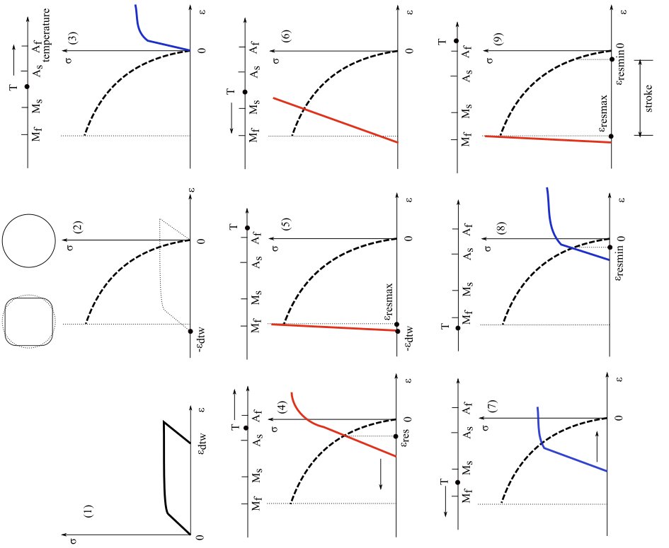
Figure B.1 Force-deformation graphs of the VAN.

Appendix C
Damping Estimation Methods

Damping Estimation by Nyquist Plot
The Nyquist plot is often adapted for studying conditions around resonance. The complex vector of the receptance or mobility of one mode is plotted on a complex plane. The fitting of the scalars in that vector forms a near-circular path when frequency passes through the resonance peak [122]. For a single DOF system, the circular fitting of the receptance starts from 0° to -180°.
If the receptance is multiplied by modal stiffness k, then the maximum of the magnitude of the circular fitting is called quality factor Q [122]. Assuming a single DOF system under forced vibration, the receptance of the FRF is related to the vibration displacement:
 | $$Receptance=\frac{X}{F}=\frac{1}{k[1-{\left(\frac{ω}{w_{n}}\right)}^{2}+2j\frac{ω}{w_{n}}ζ]}$$ | (C.1)
, where X is the magnitude of harmonic vibration displacement, F is the magnitude of harmonic force, w is the excitation frequency, w_{n} is the natural frequency, k is the modal stiffness and ζ is the modal damping ratio. For a lightly damped system, the quality factor can be written as:
 | $$Q={\left|\frac{Xk}{F}\right|}_{Max}=\frac{1}{2ζ\sqrt{1-ζ^{2}}}≈\frac{1}{2ζ}$$ | (C.2)
Thus, for a lightly damped system, the damping ratio can be calculated from the diameter of the circular fitting (Figure C.1). Note that, for any damped system, the Nyquist circle is slightly tilted away from the imaginary axis. This is because the maximum receptance is achieved at the damped natural frequency ω_{d}, rather than at the undamped natural frequency ω_{n}, the relationship between the two terms being written as:
 | $$ω_{d}=ω_{n}\sqrt{1-ζ^{2}}$$ | (C.3)
For the mobility FRF, where velocity is concerned, FRF is written as:
 | $$Mobility=\frac{\dot{X}}{F}=\frac{j2πω}{k[1-{\left(\frac{ω}{w_{n}}\right)}^{2}+2j\frac{ω}{w_{n}}ζ]}$$ | (C.4)
The Nyquist plot for the mobility FRF is rotated by 90° anticlockwise from the receptance circle. The radius of the mobility circle is enlarged by 2πω_{n}. Moreover, the circular shape of mobility is slightly deformed from the receptance because the numerator in the mobility equation changes along with frequency point ω.
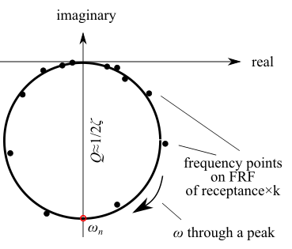
Figure C.1 A Nyquist fitting for frequency points around a peak. System assumed to be lightly damped.
For systems with unknown modal stiffness, the damping ratio can be derived from the frequencies of two points at each side of the circular fitting. Assuming the natural frequency of a single-DOF, lightly-damped system is known, the two points, with frequencies ω₁ and ω₂, will have radial degrees that relate to the centre of the circle θ₁, θ₂. The damping ratio can be written as:
 | $$ζ=\frac{ω_{1}-ω_{2}}{ω_{n}\left[\tan{\frac{θ_{1}}{2}}+\tan{\frac{θ_{2}}{2}}\right]}$$ | (C.5)[105]
When θ₁=θ₂=90°, the two points are called half power points because the energy of these locations on the FRF are half that at resonance [105]. At these locations, the frequencies ω₁ and ω₂ are called half power frequencies, ω_{hp1} and ω_{hp2} (Figure C.2). Based on that, Eq. (C.5) can be written as:
 | $$ζ=\frac{ω_{hp1}-ω_{hp2}}{{2ω}_{n}}$$ | (C.6)
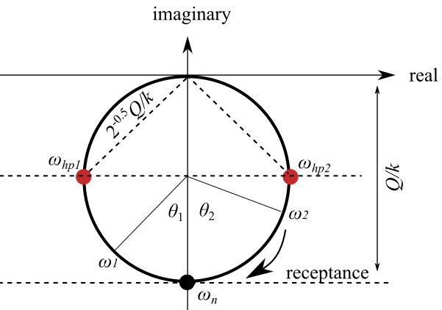
Figure C.2 A Nyquist fitting with half power points. System assumed to be lightly damped.

FRF Estimation by the Minimisation Method
In the previous section, the damping estimation with known natural frequency and intense frequency points around a FRF peak was discussed. However, for measurements with large frequency divisions, the points nearest to the peak could be at some distance from the peak. Moreover, the circle was slightly tilted away from the imaginary axis, and so the centre of the circle, strictly speaking, is not on the imaginary axis. This increases the difficulty of Nyquist fitting in practice.
Rongong [131] adapted an iteration method that optimises the minimum distances from the fittings to the frequency points. This method can generate Nyquist plots and FRF plots for a set of frequency points with large frequency divisions. Given that, it was applied to the estimations of natural frequencies, damping ratios and peak magnitudes of the FRF peaks from the previous section and in the following content of this work.
The procedure for Nyquist and FRF plot fittings was divided into four steps. Firstly, a set of frequency points that centred on a FRF peak was selected, and their complex values and corresponding frequencies were plotted on a complex coordinate system. Secondly, a MATLAB built-in iteration solver produced an optimising circular fitting for the frequency points. Thirdly, the quality factor was the product of the radius of the circle and the modal stiffness (Eq. (C.2)). By assuming an initial damping ratio, an initial modal stiffness could be derived. The measured frequency point that had the highest magnitude was chosen as an initial natural frequency. Lastly, the above modal coefficients formed an assumed FRF, and the distances from it to the measured frequency points were minimised until the closest fitting was achieved. In the following, the implementation of this procedure in the MATLAB environment is discussed.
Unconstrained minimisation involves finding the a scalar or vector MIN that is a local minimum to a function fun(MIN). The unconstrained term means there are no restrictions to the range of MIN [132]. In the MATLAB environment, the syntax is written as:
 | $$MIN=fminsearch(fun,{MIN}_{0})$$ | (C.7)
, which starts the iteration at initial point MIN₀ and returns an optimisation point of MIN, from which the minimum value of the function is found. This iteration method was used to find the Nyquist fitting, natural frequency, modal damping ratio and FRF fitting.
Firstly, a set of frequency points were plotted in a complex coordinate system as dots (Fig. C.3). A maximum point was marked, and the initial circle was assumed to be centred on the halfway location of this complex value. The initial vector MIN₀ comprised an assumed radius of the circle, and real and imaginary parts of the circle’s centre. Secondly, the minimising function calculated the averaged error between the circle’s radius and the distances from the circle’s centre to the frequency points, which can be written as:
 | $$fitcirclefun=mean\left[\left|{MIN(1)}^{2}-{\left(MIN\left(2\right)-rh\right)}^{2}-{\left(MIN\left(3\right)-ih\right)}^{2}\right|\right]$$ | (C.8)
, where rh and ih are two vectors that contain the real and imaginary parts of the frequency points. The optimised circle was then found when the fitcirclefun function was the minimum, and the function returned a vector B that comprised the centre and radius of the fitting circle. The circle tilted to the right because the complex value of receptance fell into the fourth quadrant when at the damped natural frequency.
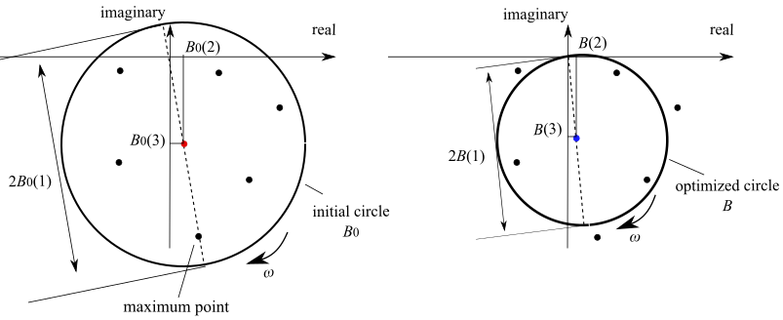
Figure C.3 Nyquist circle of receptance fitted by the minimisation method. Dots are measured frequency points around an FRF peak.
Thirdly, the initial damping ratio was given a reasonable value, and then the modal stiffness could be calculated by:
 | $$k=\frac{1}{{\left|Receptance\right|}_{Max}}\frac{1}{2ζ}=\frac{1}{4ζB(1)}$$ | (C.9)
The initial natural frequency was set to be the frequency of the maximum point. An initial assumption of receptance FRF can then be generated by Eq. (C.1).
Following this, a second minimisation programme was formed. The parameters vector MIN’ comprised the natural frequency and the modal damping, which had the initial values stated above. The objective of the minimising function was to go through iterations to optimise the mean distances between the assumed FRF and the measured frequency points (Fig. C.4). The magnitude of the FRF was calculated by substituting the corresponding frequency into the receptance assumed above. The minimisation programme returned a vector comprising the optimised natural frequency and the damping ratio.
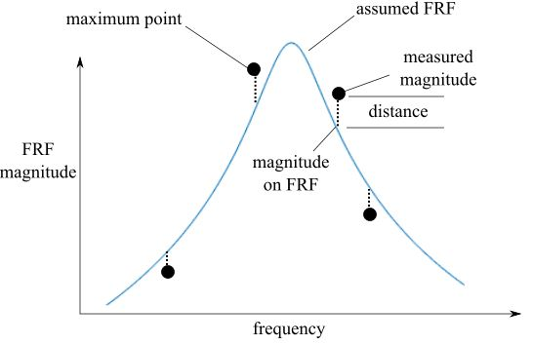
Figure C.4 FRF peak fitted by the minimisation method. Dots are measured frequency points around a FRF peak.
However, there was another problem that the FRF approximation above did not address. When calculating the modal stiffness and receptance FRF, the system was assumed to be a single DOF. However, the measured system was obviously a multiple DOF structure, whose receptance around the nth mode had to be slightly modified from Eq. (C.1) to the following:
 | $${{Receptance}_{n}}^{ij}≈\frac{±φ_{n}^{i}φ_{n}^{j}}{k_{n}[1-{\left(\frac{ω}{w_{n}}\right)}^{2}+2j\frac{ω}{w_{n}}ζ]}$$ | (C.10)
, where i and j are the DOFs that the received force and vibration were measured on, and φ_{n} is the mode shape of the n^{th} mode. Compared to the single DOF version, this receptance fitting circle radius was multiplied by $φ_{n}^{i}φ_{n}^{j}$, and also rotated by 180° or 0°, depending on the vibration directions of the two DOFs i and j. In practice, the radius of the assumed FRF would not be affected because the modal stiffness was modified to:
 | $$k_{n}=\frac{φ_{n}^{i}φ_{n}^{j}}{{\left|{{Receptance}_{n}}^{ij}\right|}_{Max}}\frac{1}{2ζ}$$ | (C.11)
By substituting k_{n} into Eq. (C.10), the same result as the single-DOF approximation is achieved, except that the phase of the FRF might need to be rotated by 180°. The criteria for the rotation were decided by the location of the circular fitting centre, which was decided at the first minimisation function. If the circle centre falls into the second quadrant, for the receptance FRF, the phase of the assumed FRF in Figure C.3 has to be rotated by 180°. Otherwise, if the circle centre falls into the fourth quadrant, no rotation is needed.
The rotating procedure was carried out by firstly shifting the single-DOF FRF approximation onto the origin of the coordinates. Then, the phases of the complex values in the approximated FRF were added by π. Finally, the FRF was shifted onto the location where the centre of the circular fitting was located. The shift was applied by taking the Boolean operations for the complex FRF and the complex location of the circular centre.
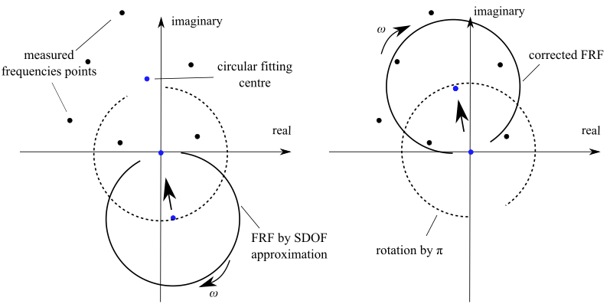
Figure C.5 Correcting the multiple-DOFs FRF, which was approximated by a single-DOF transfer function. The FRF shows the receptance of the system

Appendix D
VAN Damping by the Strain-Energy Method
Table D.1 and D.2 show modal damping ratios of all the twin modes generated by the strain-energy method in Section 5.2.3 at both heating and cooling ends.
Table D.1 Modal damping ratios of the free-support cylinder – actuator structure at the end of heating
 | Twin mode 1 | Twin mode 2 | Twin mode 1 | Twin mode 2
Circumferential Node Number | In-plane Bending |  | Out of Plane Bending
2 | 0.00134 | 0.00028 | 0.00103 | 0.00021
3 | 0.00096 | 0.00096 | 0.00089 | 0.00089
4 | 0.00124 | 0.00066 | 0.00091 | 0.00062
5 | 0.00103 | 0.00103 | 0.00097 | 0.00068
6 | 0.00068 | 0.00091 | 0.00033 | 0.00122

Table D.2 Modal damping ratios of free-support cylinder – actuator structure at the end of cooling.
 | Twin mode 1 | Twin mode 2 | Twin mode 1 | Twin mode 2
Circumferential Node Number | In-plane Bending |  | Out of Plane Bending
2 | 0.00168 | 0.00042 | 0.00145 | 0.00045
3 | 0.00114 | 0.00114 | 0.00125 | 0.00125
4 | 0.00139 | 0.00076 | 0.00129 | 0.00102
5 | 0.00104 | 0.00104 | 0.00107 | 0.00107
6 | 0.00104 | 0.00074 | 0.00051 | 0.00149

Appendix E
Derivations of Methodologies: Exponential Window and Kinetic Energy FRF in FE Model

Windowed Damping Correction Method
According to the shift property in Laplace transform theory, the exponential window shifts the complex variable of the windowed Laplace transform:
 | If $y\left(t\right)↔Y\left(s\right),$ then $e^{at}y(t)↔Y(s-a)$ | (E.1)
The windowed input signal at a DOF f_{q}(t) and output signal at another DOF x_{p}(t) are shifted in the s domain:
 | $$e^{\frac{-t}{τ_{w}}}f_{q}(t)↔F_{q}(s+\frac{1}{τ_{w}})$$ | and | $$e^{\frac{-t}{τ_{w}}}x_{p}(t)↔X_{p}(s+\frac{1}{τ_{w}})$$ | (E.2)
The inverse Lapace transformation of the transfer function H_{pq}(s+1/τ_{w}) is the impulse response function (IRF) of the system:
 | $$H_{pq}\left(s+\frac{1}{τ_{w}}\right)=\frac{X_{p}\left(s+\frac{1}{τ_{w}}\right)}{F_{q}\left(s+\frac{1}{τ_{w}}\right)}$$ | and | $$H_{pq}\left(s+\frac{1}{τ_{w}}\right)↔e^{\frac{-t}{τ_{w}}}h_{pq}(t)$$ | (E.3)
The IRF of the true system h_{pq}(t) will have the following relationship with the windowed one, which is denoted by (^):
 | $$e^{\frac{-t}{τ_{w}}}h_{pq}\left(t\right)={\hat{h}}_{pq}\left(t\right)$$ | (E.4)
Now, recalling the superposition method, the free response of a system with n DOFs, based on the given initial conditions, can be written as:
 | $$\left\{x\left(t\right)\right\}=\sum_{r=1}^{n}{\left({\left\{Φ\right\}}_{r}^{T}[m]\left\{x\left(0\right)\right\}cosω_{d}^{r}t+{\left\{Φ\right\}}_{r}^{T}[m]\left\{\dot{x}\left(0\right)\right\}sinω_{d}^{r}t\right)}·{\left\{Φ\right\}}_{r}·e^{-ζ_{r}ω_{n}^{r}t}$$ | (E.5)
, where [m] is the mass matrix, {Φ}_{r} is the mass normalised eigenvector of mode r, {x(0)} is the initial condition, ω_{n} is the undamped natural frequency by rad/s, ω_{d} is the damped natural frequency by rad/s and ζ is the modal damping ratio.
The duration of an impulse excitation is infinitesimally short and, as such, there is insufficient time for movement of an appreciable distance. Given that, the displacement’s initial condition is given by:
 | $$\left\{x(0)\right\}=\{0\}$$ | thus | $$\left\{x(t)\right\}=\sum_{r=1}^{n}{{\left\{Φ\right\}}_{r}^{T}[m]\left\{\dot{x}(0)\right\}sinω_{d}^{r}t}·{\left\{Φ\right\}}_{r}·e^{-ζ_{r}ω_{n}^{r}t}$$ | (E.6)
The IRF related to the DOFs pair of p and q can thus be written as:
 | $$x_{p}\left(t\right)={(\sum_{r=1}^{n}{{\left\{Φ\right\}}_{r}^{T}[m]{\left\{\dot{x}\left(0\right)\right\}}_{q}sinω_{d}^{r}t}·{\left\{Φ\right\}}_{r}·e^{-ζ_{r}ω_{n}^{r}t}) }_{p}$$ | (E.7)
It is obvious that the time-dependant part of Eq. (E.7) can be written as:
 | $$sinω_{d}^{r}t·e^{-ζ_{r}ω_{n}^{r}t}=i·e^{-(iω_{d}^{r}+ζ_{r}ω_{n}^{r})t}=i·e^{λ_{r}t}$$ | (E.8)
, where λ_{r} is the complex eigenvalue of mode r.
The rest of Eq. (E.7) are constant values decided by the initial conditions and the system matrix. Thus, Eq. (E.7) can be simplified as:
 | $$h_{pq}\left(t\right)=x_{p}\left(t\right)=\sum_{r=1}^{n}{i·e^{λ_{r}t}·A_{pqr}}$$ | (E.9)
, where A_{pqr} is the residue of the DOFs pair p and q for mode r. Substituting Eq. (E.9) into Eq. (E.4) gives:
 | $$e^{\frac{-t}{τ_{w}}}\sum_{r=1}^{n}{i·e^{λ_{r}t}·A_{pqr}}=\sum_{r=1}^{n}{i·e^{{\hat{λ}}_{r}t}·{\hat{A}}_{pqr}}$$ | (E.10)
Equating the like terms in Eq. (E.10) gives:
 | $$e^{\left(\frac{-1}{τ_{w}}+λ_{r}\right)t}=e^{{\hat{λ}}_{r}t}$$ | and | $$A_{pqr}={\hat{A}}_{pqr}$$ | (E.11)
Replacing λ_{r} with complex values gives:
 | $$\frac{-1}{τ_{w}}-iω_{d}^{r}-ζ_{r}ω_{n}^{r}=-i{\hat{ω}}_{d}^{r}-{\hat{ζ}}_{r}{\hat{ω}}_{n}^{r}$$ | (E.12)
Equating the real and complex parts in Eq. (E.12) gives the relationships of the damped natural frequencies:
 | $$ω_{d}^{r}={\hat{ω}}_{d}^{r}$$ | (E.13)
and the windowed damping ratio is given by:
 | $${\hat{ζ}}_{r}=\frac{\frac{1}{τ_{w}}+ζ_{r}ω_{n}^{r}}{{\hat{ω}}_{n}^{r}}$$ | (E.14)
From Eqs (E.11) and (E.13), it is obvious that the residual parts of the IRF and the damped natural frequencies are unchanged by the windowed transfer function. In addition, from Eq. (E.14), the amplification of the damping ratios was negatively related to the natural frequencies and the cutoff time.
Substituting:
 | $$ω_{d}^{r}=\sqrt{1-{ζ_{r}}^{2}}ω_{n}^{r}$$ | (E.15)
into Eq. (E.13) gives the corrected damping ratios of the lightly damped structure.
 | $$ζ_{r}=\frac{\left(\frac{{\hat{ζ}}_{r}}{\sqrt{1-{{\hat{ζ}}_{r}}^{2}}}-\frac{1}{τ_{w}ω_{d}^{r}}\right)}{\sqrt{1-{ζ_{r}}^{2}}}≈\frac{{\hat{ζ}}_{r}}{\sqrt{1-{{\hat{ζ}}_{r}}^{2}}}-\frac{1}{τ_{w}ω_{d}^{r}}$$ | (E.16)

Element Displacement FRF by Shape Functions of Brick Element
The displacement of the centroid point of a brick element can be described by the 20 nodes that comprise that element. The kinetic energy of that element is then represented by the centroid point.
Firstly, the displacements at the centre of an element need to be defined using nodal displacements from the shape functions. Figure E.1 is a 20-node brick element with mid-side nodes in a Cartesian coordinate system where the origin is at the centre of the element and the element has the dimensions 2a×2b×2c.
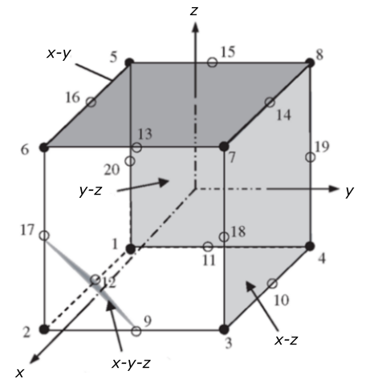
Figure E.1 20-node quadratic element. Node 2 has to pass through the grey planes.
The shape functions are constructed by simple inspection, making use of the shape function properties [140]. For example, for corner node 2 (Fig. E.1), where x₂ = a, y₂ = -b, z₃ = -c, the shape function N2 has to pass through the following four planes, as shown in Figure E.1 to ensure it vanishes at remote nodes:
- vanishes at nodes 1, 4, 5, 8, 11, 15, 19, 20 (y-z plane): a + x = 0
- vanishes at nodes 3, 4, 7, 8, 10, 14, 18, 19 (x-z plane): -b + y = 0
- vanishes at nodes 5, 6, 7, 8, 13, 14, 15, 16 (x-y plane): -c + z = 0
- vanishes at nodes 9, 12, 17 (x-y-z plane): x – αy – βz – γ = 0
, where α, β, γ can be calculated by the natural coordinates of the mid-side nodes 9, 12 and 17. So the last equation goes to: x – y·a/b – z·a/c – 2a = 0.
Thus, the shape function N₂ can be written as:
$$N_{2}=C∙(a+x)(b-y)(c-z)(x- \frac{a}{b}y-\frac{a}{c}z-2a)$$ | (E.17)
, where C is constant and can be determined by the fact that N₂ has to be unity at node 2, which gives:
$$C=\frac{1}{(a+a)(b+b)(c+c)(a+ \frac{a}{b}b+\frac{a}{c}c-2a)}=\frac{1}{8a^{2}bc}$$ | (E.18)
Finally, we have:
$$N_{2}=\frac{1}{8a^{2}bc}(a+x)(b-y)(c-z)(x- \frac{a}{b}y-\frac{a}{c}z-2a)$$ | (E.19)
The displacement on an element centroid can be obtained from:
$$ue=\sum_{j=1}^{20}{N_{j}u_{j}}$$ | (E.20)
The centre of an element is at (0, 0, 0), and when j = 2, it gives:
$$N_{2}u_{2}=-\frac{1}{4}u_{2}$$ | (E.21)
Similarly, all the shape functions for the corner nodes will give the same results.
As for the mid-side nodes – for example, node 9 (a, 0, -c) – N₉ has to pass through four planes, as shown in Figure E.2, which gives:
- vanishes at nodes 1, 4, 5, 8, 11, 15, 19, 20 (y-z plane): a + x = 0
- vanishes at nodes 3, 4, 7, 8, 10, 14, 18, 19 (x-z’ plane): -b + y = 0
- vanishes at nodes 5, 6, 7, 8, 13, 14, 15, 16 (x-y plane): -c + z = 0
- vanishes at nodes 1, 2, 5, 6, 12, 13, 16, 17 (x-z plane): b + y = 0.
N₅ can be immediately written as:
$$N_{9}=C∙(a+x)(b-y)(c-z)(b+y)$$ | (E.22)
, where c is a constant to be determined by the condition that it has to be unity at node 9, which gives:
$$C=\frac{1}{4ab^{2}c}$$ | (E.23)
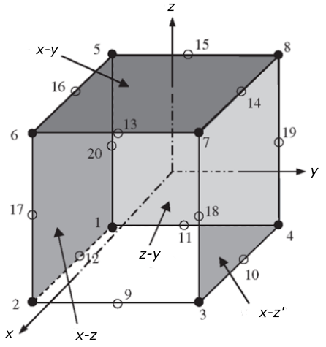
Figure E.2 20-node quadratic element. Node 9 has to pass through the grey planes.
Finally, we have:
$$N_{9}=\frac{1}{4ab^{2}c}(a+x)(b-y)(c-z)(b+y)$$ | (E.24)
The centre of the element is displaced when j=9:
$$N_{9}u_{9}=\frac{1}{4}u_{9}$$ | (E.25)
This applies to the other mid-side nodes. Ultimately, the centre of the element shows displacement:
$$ue=-\frac{1}{4}\sum_{i=1}^{8}{u_{i}+\frac{1}{4}}\sum_{j=9}^{20}{u_{j}}$$ | (7.7)

