Regulation of DHHC5 localisation by palmitoylation of Golga7b has effects on DHHC5 interactions, endocytosis and cell adhesion

A thesis presented to the Department of Biomedical Science in the Faculty of Science at the University of Sheffield

In partial fulfilment of the requirements
of a degree of
Doctor of Philosophy

By Keith Woodley
Registration number 150104841

September 2019

Acknowledgments

First and foremost my sincerest thanks go to my supervisor, Dr. Mark Collins. Without his support and patience, there is no way my Ph.D. study would have ended this way, and with the production of some research that I am truly proud of. At the outset of this work, I couldn’t have imagined a better supervisor.

Thanks must almost be extended to my advisors throughout my time here, Dr. Andrew Peden, Professor Matthew Holley, and Professor Liz Smythe. Their different views helped to shape the direction of this research and kept me on a path to completion. Their questions always gave me a unique perspective and kept me out of the bubble that I often found myself in during this research.

To my lab mates Hatoon and Maria: firstly, thank you for putting up with my untidy desk and my ever expanding rack of buffers I couldn’t throw away. But most importantly, thank you for making this lab an inviting place to work, and the fun we have had along the way. The conversations we’ve had about my research and yours have helped me more than you will have realised. Also, you made me much cake, and the importance of this is impossible to overlook.

Although this work has taken place within the University of Sheffield, there are a number of people outside of it that must be thanked for what they have done for me over the past almost 4 years. To the Sheffield Vipers, possibly the greatest group of people I have had the pleasure of knowing and playing sports alongside, thank you for tolerating this angry, moody Scot shouting at you all for doing things “wrong”. Rarely have I had more fun playing any sport. The friendships I’ve made with you all will last forever, and leaving you is among the hardest things to do at the end of this experience. I will always miss the showers.

To every medical student I have lived with, Amelia, Jess, Iona, Callum, Bethan, Elliot, and Alex: thank you for eating my Sunday roasts, playing video games with me and welcoming me into your friendship groups. Having you all in my life has made this process easier and better than you will ever know.

And finally, and most importantly, I thank my family, my mother Tanya, my father Brian, my brother Daniel and my step-father Colin. Your support has been endless. You don’t understand what I do but are still eager to hear about what I do and why I do it. You encouraged me to take this risk and follow my dream and it’s been the best decision I’ve ever made. I will never be able to repay you.

Abstract
Among post-translational modifications, palmitoylation, also known as S-acylation, is uniquely positioned as the only fully reversible lipid modification and aberrant palmitoylation has been linked to problems with a number of cellular processes. Despite this, little is known about the palmitoyl-acyltransferase enzymes which mediate the attachment of the lipid to proteins. Among these enzymes, DHHC5 is unique as it resident at the plasma membrane and has an extended C-terminal tail that can be modified by palmitoylation, among other PTMs. In this work, it has been shown that DHHC5 needs to palmitoylate a novel substrate and regulator, Golga7b, in order for it to be stabilised at the plasma membrane and that preventing palmitoylation of Golga7b causes DHHC5 to be mis-localised to regions within the cell. However, palmitoylation of Golga7b is not the only palmitoylation event that is important for DHHC5 localisation, as halting palmitoylation of the DHHC5 C-terminal tail prevents endocytosis of DHHC5 and traps the protein at the plasma membrane. By using affinity purification-mass spectrometry, a range of processes that DHHC5 could be involved with and that regulate DHHC5 were revealed. Among these, it was shown that DHHC5 is endocytosed by a mechanism that requires the AP2 complex and depleting this complex or blocking endocytosis another way, causes DHHC5 to be trapped at the plasma membrane. Also revealed by the AP-MS was the high enrichment of adhesion proteins and it was later proven that DHHC5 palmitoylates a pair of desmosomal proteins and has a wider role in cellular adhesion. Together the work presented here uncovers more about the regulation of the location of DHHC5 by a number of factors including palmitoylation of itself and an interacting protein and endocytosis of DHHC5 and goes on to show that DHHC5 has a central role in proper cell adhesion.

Contents
- Introduction ................................................................................................................ 14
  - S-acylation as a post-translational modification .................................................... 14
  - Methods to study palmitoylation .......................................................................... 18
  - Palmitoyl acyltransferase enzymes ........................................................................ 25
  - The determinants of PAT substrate specificity....................................................... 33
  - DHHC5 – A Plasma Membrane localised PAT ......................................................... 38
  - Palmitoylation and the regulation of cellular adhesion.......................................... 56
  - Rationale behind this work.................................................................................... 63
- Methods ...................................................................................................................... 67
  - Cell lines used ....................................................................................................... 67
  - SiRNA .................................................................................................................... 67
  - Constructs ............................................................................................................. 70
  - Cell culture ............................................................................................................ 70
    - Media Recipes................................................................................................ 71
    - Normal DMEM ............................................................................................... 71
    - Low Calcium DMEM ....................................................................................... 71
  - Transfection .......................................................................................................... 72
  - Drug treatments.................................................................................................... 73
  - Protein ABE ........................................................................................................... 74
    - Buffer recipes................................................................................................. 74
    - Lysis buffer..................................................................................................... 74
    - Resuspension buffer ...................................................................................... 74
    - IP buffer ......................................................................................................... 75
  - SDS-PAGE for MS .................................................................................................. 76
  - In-gel Digestion ..................................................................................................... 77
  - Tris-Glycine SDS-PAGE for immunoblotting........................................................ 78
  - Sample prep for immunoblotting ....................................................................... 79
  - Western Blotting ............................................................................................... 80
    - Antibodies...................................................................................................... 80
    - Immunoblotting ............................................................................................. 80
    - Analysis .......................................................................................................... 81
  - Paraformaldehyde preparation ......................................................................... 82
  - ................................................................................................................................. 82
  - Immunofluorescence ......................................................................................... 82
    - Antibodies...................................................................................................... 82
    - Immunocytochemistry ................................................................................... 83
  - Immunoprecipitation from HeLa cells for AP-MS/Blotting ................................. 84
    - Lysis Buffer .................................................................................................... 84
  - Immunoprecipitation from mouse forebrain for AP-MS/Blotting ....................... 85
    - Lysis Buffer .................................................................................................... 85
  - PEG switch ......................................................................................................... 86
    - Lysis Buffer .................................................................................................... 86
    - Resuspension buffer ...................................................................................... 86
  - Calcium Switch assay ......................................................................................... 88
  - Plasmid Preparation .......................................................................................... 88
    - LB Broth ......................................................................................................... 88
    - LB Agar........................................................................................................... 88
    - Bacterial Transformation ............................................................................... 89
    - Bacterial culture ............................................................................................. 89
  - ssABE ................................................................................................................. 90
    - Extraction buffer ............................................................................................ 90
    - 2LB buffer ...................................................................................................... 90
    - 1LB buffer ...................................................................................................... 91
  - Native PAGE ...................................................................................................... 93
    - Extraction Buffer ............................................................................................ 93
    - Sample Preparation ....................................................................................... 93
  - Confocal Microscopy ......................................................................................... 94
  - Confocal Image Analysis .................................................................................... 95
  - Mass Spectrometry............................................................................................ 95
  - MS data analysis ................................................................................................ 96
  - MS Data statistics .............................................................................................. 97
  - BCA Assay .......................................................................................................... 97
  - Cell Scatter Assay .............................................................................................. 98
  - Trans-epithelial Electrical Resistance ................................................................. 99
  - Cell Surface Biotinylation ................................................................................... 99
  - Biotin Endocytosis Assay .................................................................................. 100
- Golga7b controls the location of DHHC5.................................................................... 101
  - Golga7b is a palmitoylated protein and interacts with DHHC5 in a manner
independent of its palmitoylation ................................................................................. 102
  - Golga7b can reverse over-expression induced mis-localisation of DHHC5 ........... 108
  - Catalytic activity is not required for effects of Golga7b on DHHC5, but palmitoylation
of the C-terminal tail is .................................................................................................. 121
  - Discussion ........................................................................................................... 131
- The interactions of DHHC5 reveal roles in a number of processes and uncovers novel
potential regulators .......................................................................................................... 134
  - Cell type selection ............................................................................................... 135
  - DHHC5 interacts with a large number of proteins in HeLa cells ........................... 139
  - The interactions of DHHC5 change when present at the plasma membrane or within
the cell .......................................................................................................................... 144
  - DHHC5 interacts with a large number of adhesion proteins when present at the
plasma membrane ........................................................................................................ 150
  - DHHC5 interacts with a specific subset of proteins when present within the cell 155
  - Comparison of datasets ...................................................................................... 158
  - Discussion ........................................................................................................... 162
- DHHC5 substrates can be investigated by site-specific methods ................................ 164
  - DHHC5 knockdown is able to affect palmitoylation of known substrates ............ 166
  - Pilot ssABE .......................................................................................................... 168
  - Replicate ssABE ................................................................................................... 172
  - Discussion ........................................................................................................... 178
- The AP2 complex is essential for DHHC5 endocytosis ................................................ 181
  - Endocytosis inhibition by depleting cholesterol traps DHHC5 at the plasma membrane and can reverse the phenotype caused by Golga7b mutation ..................... 182
  - Dynamin inhibition restores DHHC5 to the plasma membrane during mutant
Golga7b expression ....................................................................................................... 186
  - The AP2 complex is required for DHHC5 endocytosis .......................................... 191
  - Preventing palmitoylation of DHHC5 abolishes its endocytosis ........................... 193
  - Discussion ........................................................................................................... 195
- DHHC5 is an essential part of the cellular adhesion machinery .................................. 202
  - Introduction ........................................................................................................ 202
  - DHHC5 is important for correct desmoglein-2 localisation .................................. 204
  - The DHHC5-Golga7b complex is required for efficient desmosome trafficking .... 210
  - DHHC5 plays a wider role in cell adhesion ........................................................... 218
  - Discussion ........................................................................................................... 223
- Discussion ................................................................................................................. 227
  - DHHC5 localisation is controlled by palmitoylation of its C-terminal tail and Golga7b
227
  - DHHC5 interacts with a wide range of proteins dependent on its localisation ..... 230
  - DHHC5 may palmitoylate a wide range of proteins ............................................. 232
  - DHHC5 in endocytosed by a system dependent on dynamin and the AP2 complex
235
  - DHHC5 palmitoylates desmosomal proteins and is important for proper cell adhesion
237
  - Mechanism of DHHC5 regulation by Golga7b palmitoylation .............................. 239
  - DHHC5 may be linked to a number of diseases ................................................... 249
  - The proteins that DHHC5 interacts with and palmitoylates are overlapping yet
distinct .......................................................................................................................... 254
  - Summary............................................................................................................. 258
- References ................................................................................................................ 260
- Appendices ................................................................................................................ 287
  - Appendix A1 – Cell type selection .................................................................... 287
  - Appendix table A2 – DHHC5 alone AP-MS........................................................ 407
  - Appendix table A3 – DHHC5 + WT Golga7b AP-MS .......................................... 413
  - Appendix table A4 – DHHC5 + mutant Golga7b AP-MS .................................... 421
  - Appendix table A5 – Significantly different proteins between DHHC5 + WT Golga7b
and DHHC5 + mutant Golga7b ....................................................................................... 423
  - Appendix Table A6 – Pilot ssABE ...................................................................... 428
  - Appendix table A7 – ssABE data from DHHC5 siRNA replicates ........................ 438
  - Appendix table A8 – Proteins shared between Pilot ssABE and DHHC5 + WT
Golga7b AP-MS ............................................................................................................. 444

1 Introduction

1.1 S-acylation as a post-translational modification

Post-translational modifications are used by cells and organisms in almost every cellular and metabolic process and can be used to alter the chemistry of certain amino acid residues within proteins. Among these, the addition of lipids to proteins occupies a unique niche within the cell as they make proteins far more hydrophobic and can act as anchors to attach soluble proteins to cellular membranes.

Fatty acid modification come in several types, including mysristoylation, prenylation and Sacylation (palmitoylation). These three types of modification vary in the types of lipids they attach as well as the amino acid that they are attached to and the types of bond used to attach them. As a result, each type occupies a specific niche in the cellular architecture and are often used an essential steps in protein processing to direct proteins to particular membranes within the cell in order to ensure correct protein localisation. This correct localisation can be important for correct protein signalling.

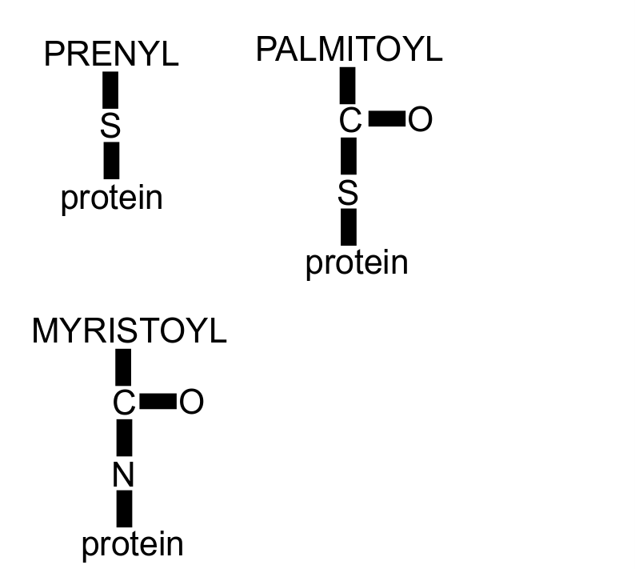
Figure 1.1: Schematic of the three bond types used in fatty acid modifications of proteins. The amide and thioether bonds used in myristoylation and prenylation are more stable than the thioester used in palmitoylation because the sulfur atom present in the bond is more electronegative than the nitrogen in the amide bond. This polarises the bond more, making it weaker and more prone to hydrophilic attack and thus breakage.

Myristoylation is possibly the best characterised and understood lipid modification that occurs in eukaryotes. Myristate is a 14 carbon long saturated lipid and it is attached to the Nterminus of proteins with an amide bond (Resh, 1999). It always occurs at an N-terminal glycine residue which is revealed by the cleavage of the initiator methionine, and there is also a preference for either a serine or a threonine several residues downstream of the glycine, although only the glycine is absolutely required. The amide linkage means that this modification is irreversible.

Protein S-acylation is the addition of a long-chain fatty acid to the side chain of a cysteine residue via a thioester bond, thus increasing the hydrophobicity of the protein. This is often referred to as protein palmitoylation, as the saturated fatty acid palmitic acid is the most common lipid added, although proteins can also be modified with stearic acid and oleic acid
(Schmidt et al., 1979). In this manuscript, the term palmitoylation is used to mean all types of S-acylation, although palmitic acid is not only attached to cysteine residues and can also be attached to proteins through N-palmitoylation (Pepinsky et al., 1998) and O-palmitoylation (Zou et al., 2011). As with the addition of other fatty acids to proteins, palmitoylation is primarily used for membrane anchoring (Hallak et al., 1994), although it does have a role in a number of processes, for example, transcriptional activation (Kostiuk et al., 2010). It has also been found to be important in modulating the activity of certain enzymes through the palmitoylation of active site cysteine residues (Berthiaume et al., 1994). Palmitoylation is fully reversible, like phosphorylation or acetylation, and only occurs post-translationally, unlike other fatty acid modifications to proteins, such as N-myristoylation, which generally occur cotranslationally and are usually irreversible (James & Olson, 1989). The reversible nature of the modification is important, as cycles of protein palmitoylation and depalmitoylation have roles in protein activation and inactivation in response to external stimuli or signaling pathways.

Palmitoylation is used by cells to alter protein localisation and regulate membrane trafficking, with the palmitoylation-mediated cycling of certain RAS GTP proteins between the plasma membrane, the Golgi and the other intracellular membranes in response to external triggers being the classic example (Rocks et al., 2005). All RAS isoforms are farnesylated on the Nterminus (Rubio et al., 1999), however, H-RAS and N-RAS are also palmitoylated (Rocks et al., 2005). In this system, depalmitoylation of the protein, possibly by the depalmitoylation enzyme APT1 (Dekker et al., 2010) in combination with other proteins (Ahearn et al., 2011), occurs at the plasma membrane, leading to the protein being distributed amongst other intracellular membranes, before being palmitoylated at the Golgi by the DHHC9-GCP16 palmitoyl acyltransferase complex (Swarthout et al., 2005) and then trafficked back to the plasma membrane. This palmitoylation controlled cycling of RAS is involved in regulating the activity and correct subcellular localisation of this important signalling protein.

Dysfunction of palmitoylation has been implicated in a range of diseases including various cancers (Yan et al., 2013; Yeste-Velasco et al., 2014) and diabetes (Berchtold et al., 2011), and is particularly implicated in neurological diseases such as Huntingdon’s (Huang et al., 2011), schizophrenia (Mukai et al., 2004) and Alzheimer’s (Meckler et al., 2010). As palmitic acid is a saturated fatty acid and often occurs in combination with other lipid modifications, it is also implicated in the partitioning of proteins into lipid raft subdomains (Webb et al., 2000) which can be used to encourage interaction with other proteins involved in a signalling pathway or protein activators, for example. Stearic acid is also saturated so will have a similar effect, but oleic acid is unsaturated so not all S-acylated proteins will necessarily preferentially partition into lipid raft domains.

Although palmitoylation was discovered over 35 years ago on viral proteins (Schmidt et al., 1979), it has only been within the past decade that the extent of protein palmitoylation has been uncovered with the introduction and development of proteomic approaches for the study the palmitoylated proteome. This has led to the realisation that palmitoylation is much more widespread than first thought, with at least 10% of human genes having a protein product that is palmitoylated (Sanders et al., 2015).

1.2 Methods to study palmitoylation

Palmitoylation has proven a difficult modification to study for a number of reasons. For a number of years, the difficulty in specifically purifying palmitoylated proteins was a major challenge. Unlike phosphorylated proteins, which can be purified in a number of ways (Dunn et al., 2010), or acetyl-lysine proteins, which can be isolated by specific antibodies (Swaney & Villen, 2016), palmitate is non-immunogenic, so no antibodies can be raised, and has no specific chemical properties that would enable easy enrichment. As a result, initial studies into palmitoylation relied on a candidate approach and leveraged radioactive fatty acids and site-directed mutagenesis to study potentially palmitoylated proteins.

Replacement of palmitate with a radioactive form of the fatty acid, most commonly [³H]palmitate, was the preferred method for investigating protein palmitoylation for over 25 years (Schmidt et al., 1979). The method involves the addition of the radioactive palmitate to cell cultures so it is used to palmitoylate proteins, isolation of the protein of interest and detection and visualisation of the incorporated radioactivity. This method has been used in many studies (Schmidt et al., 1979; Schmidt & Schlesinger, 1979; Topinka & Bredt, 1998; Gubitosi-Klug et al., 2005) but it does involve long exposure times to see a detectable signal due to the low levels of radioactivity given off by [³H]-palmitate. Labeling with radioactive palmitic acid relies on a candidate approach, so it is low throughput but is often used to confirm results from higher throughput studies as it is considered less prone to false positive results than other methods. Although the incorporation of radioactive palmitate is considered conclusive proof that the candidate protein is palmitoylated, if no radioactive palmitate is detected, it does not rule out that the protein is palmitoylated, as it may be modified in response to particular signals, or the protein was not palmitoylated within the labeling timeframe. As labelling is performed by introduction of the radioactive palmitate into the media, the method can be used to perform pulse-chase studies of palmitoylation dynamics, and has been used to investigate the turnover time of palmitoylated proteins (Magee et al., 1987). Radioactive labelling can only indicate if a protein is palmitoylated, and does not provide any information on the stoichiometry of the modification or on the possible site or sites of palmitoylation, which are among the reasons that other methods were developed for discovery.

The acyl-biotin exchange (ABE) method was developed to exploit the sensitivity of the thioester bond to cleavage by hydroxylamine at neutral pH (Drisdel & Green, 2004). Subsequent labeling and capture of previously modified cysteine residues using biotin allows purification of previously palmitoylated proteins using streptavidin resin. The first proteomic study of palmitoylation was performed using ABE (Roth et al., 2006b) which allowed largescale identification and analysis of this modification. ABE is a multi-step process that firstly involves irreversibly blocking free cysteines with an alkylating agent such as N-Ethylmaleimide (NEM). The palmitoyl moieties are then cleaved at the thioester bond by hydroxylamine leaving free thiols on cysteine residues which can then be linked to thiol-reactive groups (Drisdel & Green, 2004). The preferred group for addition is usually N-(6-(biotinamido)hexyl)3’-(2-pyridyldithio)-propionamide (biotin-HPDP), a reducing agent cleavable form of biotin
(Roth et al., 2006a). The biotin-HPDP tag is cleaved off with β-mercaptoethanol releasing the formerly palmitoylated proteins, which can be identified using mass spectrometry or by immunoblotting (Roth et al., 2006b). This method has been successfully employed in a number of proteomic studies of palmitoylation (Roth et al., 2006a; Kang et al., 2008; Yang et al., 2010; Dowal et al., 2011; Merrick et al., 2011; Ivaldi et al., 2012; Hemsley et al., 2013) due to the ability of the method to survey a large number of palmitoylated proteins in a single experiment. ABE can capture most of the palmitoylated proteins in a cell at any given time, which makes it an ideal technique for proteomic studies and can be performed on samples and tissues taken from animals or animal models of diseases.

The ABE method does have a number of drawbacks which need to be considered when using this technique for analysis. First of all, a number of enzymes use a thiol intermediate in their reaction mechanisms such as the Lat1 and Pdx1 proteins, which are subunits of the mitochondrial pyruvate dehydrogenase complex (Roth et al., 2006b). Ubiquitin ligases also make use of thioester bond as an intermediate in their enzymatic reactions (Deshaies & Joazeiro, 2009), so these proteins are also detected by this technique. It is not impossible that these proteins could be palmitoylated, but confirmation of this would need to be probed using another approach. ABE also requires complete reduction of disulphide bonds and alkylation of free cysteines to ensure that these thiol side groups are not labeled by biotinHPDP which would lead to a large number of false positive results. Conversely, incomplete labeling with biotin-HPDP would give false negative results as sensitivity would be reduced.
Control samples without hydroxylamine treatment must be prepared alongside the normal ABE samples in order for proteins that bind to the streptavidin resin non-specifically to be identified. Most studies use relative quantitation of the plus/minus hydroxylamine fractions to identify proteins that are quantitatively enriched upon hydroxylamine treatment (Wan et al., 2007; Jones et al., 2012). This introduces the chance that palmitoylated proteins are not identified due to non-specific elution of the non-palmitoylated version of the protein in the minus hydroxylamine control which would lead to no overall enrichment of the protein upon hydroxylamine treatment. There will also be some loss of palmitate from proteins in the minus hydroxylamine control through hydrolysis over time. These proteins will be subsequently labeled with biotin-HPDP, and will lead to a reduction in the plus/minus hydroxylamine ratio, affecting the quantification.

An Acyl resin-assisted capture (acylRAC) technique has been devised as an attempt to improve the standard ABE methodology and streamline the workflow (Forrester et al., 2011). AcylRAC is an altered version of the ABE protocol which captures the previously palmitoylated proteins on a thiol-reactive resin after cleavage of the thioester bond by hydroxylamine (Forrester et al., 2011). Proteins can then be eluted from the resin by reduction of the disulphide bond that has been formed between the resin and cysteine residues. This process is very similar to ABE and had been used effectively to enrich for S-nitrosylation, which is another cysteine linked post-translational modification, prior to its adaptation to study palmitoylation (Forrester et al., 2009). AcylRAC has been used successfully in multiple proteomic analyses of palmitoylation in a range of cell types (Forrester et al., 2011; Ren et al., 2013). Like the ABE protocols, this method can potentially survey the large portion palmitoylated proteome at once and can be performed using tissue as the labeling of the palmitoylated residues occurs after cell lysis but the method suffers from many of the same problems that can occur in ABE. Incomplete cleavage of palmitoyl modifications would give false negatives just as incomplete blockage of free cysteines will give false positives. It takes fewer steps to complete so the total sample loss over the course of the experiment is likely to be reduced compared to the standard ABE method.

The traditional ABE process requires a large number of protein precipitation steps as reagents used for alkylation, reduction, and biotin labeling need to be removed before proceeding to the next steps. This results in sample loss at each step if not all proteins are efficiently precipitated, which is crucial when the PTM being studied is often only a small portion of the total protein present in the cell at any one time. In some protein cases, it has been estimated that the stoichiometry of palmitoylation is as low as 0.5% of the total amount of a protein species within a cell (Wan et al., 2013). If a protein is present in low abundance, and stoichiometry of palmitoylation is also low, any sample loss could lead to the protein not being identified as palmitoylated.

Standard ABE methods lack the resolution to pinpoint the exact residues on which palmitoylation occurs (Roth et al., 2006a; Hemsley et al., 2013), but a trio of modified ABE methods developed recently have allowed identification of palmitoylation sites on a large scale (Yang et al., 2010; Forrester et al., 2011; Collins et al., 2017). The first method was developed by Yang et al and includes digestion of the proteins prior to purification with streptavidin (Yang et al., 2010). This method, named palmitoyl protein identification and site characterisation (PalmPISC), revealed a total of 127 potential sites of palmitoylation on 85 proteins, which was less than half the number of palmitoyl proteins detected using a traditional ABE approach in the same study. Several reasons were given for this including the fact that the peptide-based approach while resolving sites of palmitoylation, did lead to lower protein confidence due to only one or two peptides being detected rather than more complete coverage of the protein sequence.

The second method uses a version of the AcylRAC method (Forrester et al., 2011) with the digestion of the proteins taking place while they are bound to the thiol-reactive resin. Peptides can then be eluted just as in the normal AcylRAC method by reducing the disulphide bond between the cysteine and the resin. As the cysteine residues of the released peptides retain their free thiols after elution, groups can be attached to these either for more reliable site identification or quantification. This method identified 93 sites on 88 peptides using iTRAQ labels for more accuracy in the quantification.

The third method was devised very recently by Collins et al, site specific acyl-biotinyl exchange (ssABE). This method also digests proteins prior to the streptavidin purification step and introduces a number of other technical improvements over the standard ABE protocol. As mentioned earlier, the traditional ABE process has issues with potential sample loss. The ssABE protocol has all of the necessary reactions taking place in a single chamber of a molecular weight cut off membrane concentrator which not only reduces the time taken to perform this method but also reduces the potential sample loss greatly. This method resulted in the highest number of palmitoylation sites being discovered in a single study to date with 906 sites on over 600 proteins, with a high average fold change in plus versus minus hydroxylamine giving high confidence to most sites uncovered, compared to an average of around 200-500 proteins discovered in other ABE proteomic studies (Roth et al., 2006a; Kang et al., 2008; Dowal et al., 2011; Ivaldi et al., 2012; Jones et al., 2012; Hemsley et al., 2013; Wan et al., 2013; Sanders et al., 2015). The ssABE method also allowed a proteomic study of co-modification of proteins by palmitoylation and phosphorylation on the same sample. This development allows the interplay of other modifications with palmitoylation to be probed more closely as searches of the SwissPalm and UniProt databases have shown that not only is phosphorylation slightly upregulated in proteins that are palmitoylated (75% of palmitoylated proteins have a phosphorylation site compared to 64% of the total human proteome) but ubiquitination sites are found on a much higher proportion of palmitoylated proteins versus the rest of the proteome (61% of palmitoylated proteins versus 33% in the whole proteome) (Blanc et al., 2015). While this could be simply down to the fact that many palmitoylated proteins are degraded when not palmitoylated and as a result they are ubiquitinated as an identifier for protein degradation, it could be worth looking into whether these two modifications occur simultaneously on a protein to perform any other function, such as the combination of palmitoylation and phosphorylation on BK channels which causes the activation of the channel (Shipston, 2013).

Site specific data can help to uncover many of the current unknowns within the world of protein palmitoylation. Among these is the creation of sequence motifs for the residues that surround the palmitoylated cysteine. Opinion on whether protein palmitoylation does indeed have a consensus sequence or motif is split (Gubitosi-Klug et al., 2005; Salaun et al., 2010), although most data found to this point does appear to point to more general characteristics for surrounding amino acids rather than a consensus sequence. There have been reports of consensus sequence discoveries (Gubitosi-Klug et al., 2005), but the sequences do not fit across all palmitoylated proteins, or only fit a small number of closely related palmitoylated proteins or protein families.

The site level resolution provided by these methods also allows the mapping and quantification of specific target sites of palmitoylation through the use of drug or gene knockout studies. For example, ssABE was used in combination with a specific inhibitor of the APT1 de-palmitoylation enzyme and SILAC-based quantification to find the potential substrates of this enzyme (Collins et al., 2017). This can be easily extended in the future with specific gene knockdowns or knockout studies to look at the targets of specific palmitoyl acyltransferases. As there appears to be little in the way of a consensus sequence for global palmitoylation, it is possible that each enzyme, or group of closely related enzymes, has a consensus sequence or short motif which it recognises for palmitoylation. It would not have been possible to look into this with protein level techniques, but the specific site resolution of these methods means that this can be achieved.

1.3 Palmitoyl acyltransferase enzymes

Palmitoyl acyltransferase enzymes (PATs) are a large family of integral membrane proteins with 22 proteins containing the signature DHHC cysteine rich domain found in the human genome (Ohno et al., 2006), with later analysis revealing a 23rd member of the family (Korycka et al., 2012) (Figure 1.2). After the discovery of palmitoylation, it took more than 20 years to discover and describe the PAT responsible for the palmitoylation of RAS in Saccharomyces Cerevisiae, the erf2/erf4 complex (Lobo et al., 2002), as before this it was thought that palmitoylation could be a non-enzymatic process. It was definitively shown that palmitoylation was mainly an enzymatic process by knockout of most of the PATs present in S. Cerevisiae and subsequent loss of the majority of cellular palmitoylation (Roth et al., 2006a).

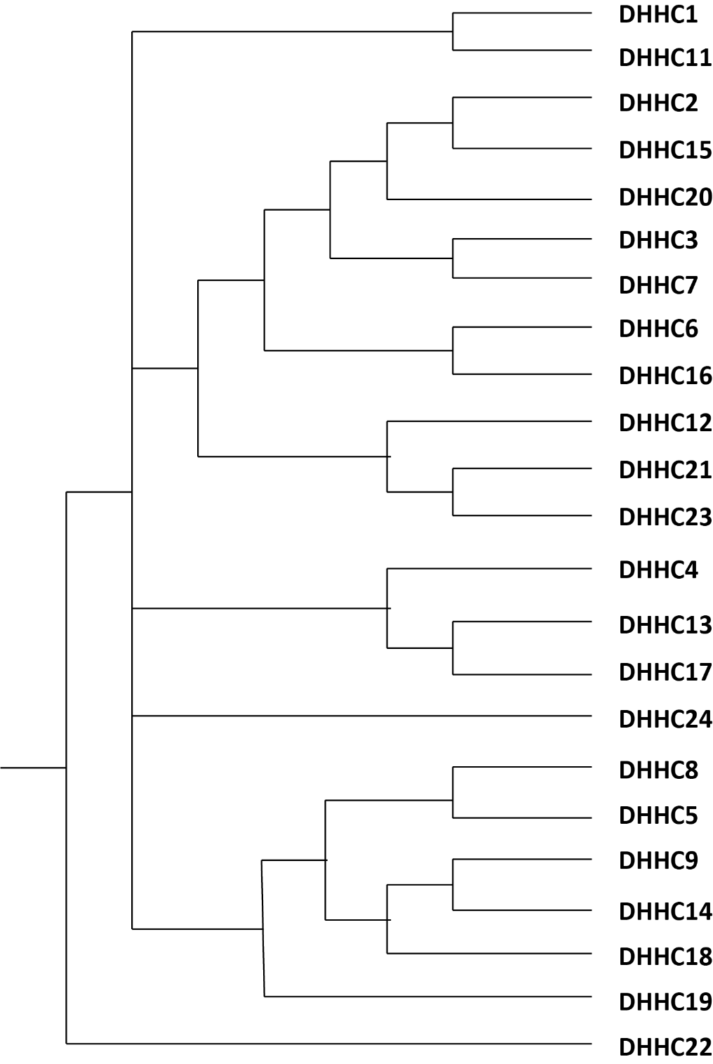
Figure 1.2: Phlyogentic tree of all 23 mammalian palmitoyl-acyl transferases, adapted from Korycka et al. 2012.
The mechanism of palmitoylation by PATs first involves the auto-palmitoylation of a cysteine residue in the conserved catalytic tetrad consisting of aspartic acid, a pair of histidines and a cysteine, which gives the enzymes their alternative names (DHHC). This acyl chain is then either transferred to a substrate or undergoes hydrolysis (Jennings & Linder, 2012). It has also been shown that the length of the acyl chain has a profound effect on the auto acylation rate of PATs (Jennings & Linder, 2012), which suggests that some lengths of acyl chain are incompatible with certain PATs.

The large family of PATs have a number of structural features that are common to all members. The conserved DHHC catalytic tetrad is common to PATs but it has been demonstrated that this sequence is not absolutely required for activity of certain yeast PATs (Gonzalez Montoro et al., 2015). Further from this, work has shown that mutations elsewhere in the conserved cysteine rich domain (CRD), which contains this characteristic DHHC motif, can have an effect on the overall activity of the PAT, suggesting other residues outside of the catalytic tetrad are important for proper activity (Gottlieb et al., 2015). This was backed up by the determination of the crystal structure of DHHC20 revealed that a number of residues within the CRD that are outside of the catalytic tetrad that are close to the catalytic cysteine in 3D space are essential for proper activity of the palmitoyl acyltransferase (Rana et al., 2018).

PATs also have a conserved motif in the C-terminal which analysis revealed is common to the majority of PATs in eukaryotes, named the Palmitoyltransferase Conserved C-terminal
(PaCCT) domain (Gonzalez Montoro et al., 2009). This short motif is found immediately on the C-terminal side of the final transmembrane domain and mutation of single residues in this domain prevented palmitoylation of certain substrates. The crystal structure revealed that the C-terminal region after the final transmembrane domain contacts the CRD, opening up the possibility that the mutation of these residues in the PaCCT has an effect on the inherent activity of the PAT or that these mutations are required for the interaction of the substrate and PAT and this is needed for palmitoylation of the substrate.

Sequencing of PAT cDNA sequence isolated from human pancreas revealed that the CRD contained a pair of motifs that closely resembled zinc binding sites which were closely related to zinc-finger domains (Putilina et al., 1999). It took a number of years before it was confirmed that these motifs did actually bind to zinc and this zinc binding was important for the activity of PATs (Gottlieb et al., 2015). If the zinc was depleted by chelation from purified PAT preparations, activity was lost. Again, structural data shed more light on the zinc binding motifs of PATs, with one of the histidine residues from the catalytic tetrad being involved in co-ordinating the zinc ion (Rana et al., 2018). This gives a reason for the loss of zinc reducing the catalytic activity of PATs, as it is likely important in modulating the specific structure of the catalytic domain of these proteins and disrupting the specific structure of this area would undoubtedly have an effect on the catalytic activity.

The crystal structure of the human DHHC20 also revealed a number of other interesting structural features including the “pocket” where the acyl chain is present before transfer to a substrate. The residues that line this pocket affect the acyl chain length preference of PATs, with bulkier amino acid side chains causing a preference for shorter acyl chains and smaller side chains resulting in a preference for longer acyl chains. This backs up earlier work which showed that different PATs preferred different chain lengths and that mutation of particular residues was able to alter this preference (Greaves et al., 2017). These different preferences for chain lengths could have some potential effects on the substrates of PATs, particularly on substrates that are shared between more than one PAT. For example, if a protein is palmitoylated by a pair of PATs, one of which prefers C20 saturated fatty acids, while the other prefers C14 fatty acids, this could have a noticeable effect on both the membrane affinity and the potential partitioning of the palmitoylated proteins into distinct lipid microdomains. Given that different lipid domains have different resident proteins and have other effects on proteins such as regulating their lateral diffusion throughout the membrane (Yamamoto et al., 2017), this could have a downstream effect on protein interactions and even their signalling and behaviour.

Each PAT has a distinct subcellular distribution, with the majority of PATs being resident at the Golgi (Ohno et al., 2006). Due to this over-representation of palmitoylating enzymes at the Golgi, as well as other reasons, it has been suggested that the Golgi is the major centre of protein palmitoylation within the cell (Salaun et al., 2010). However, it is important to point out that the endoplasmic reticulum and the plasma membrane have resident PATs. How the individual localisations of PATs is both established and maintained is largely unknown, as are the factors, signalling events and proteins that could affect this location. It has been found that signalling sequences in the C-terminal tail of DHHC4 and 6 are essential for correct localisation at the endoplasmic reticulum and that by introducing these short sequences into the tail of another PAT, DHHC3, it is sufficient to move DHHC3 from its usual location at the Golgi to the ER (Gorleku et al., 2011). It is important to point out that discovery of PAT location by using exogenous over-expressed proteins may cause some issue with artefacts, as some studies have found that over-expressing PATs does cause them to be localised away from their endogenous location (Hou et al., 2009).

Interestingly, it has been shown that PATs do not always work alone in order to palmitoylate their substrates and can form complexes with other proteins in order to palmitoylate their substrates. The yeast RAS PAT was shown to be a complex of the proteins Erf2 and Erf4 and both were required for RAS palmitoylation (Lobo et al., 2002). Later work was able to show that Erf4 stabilises the auto-palmitoylation of the catalytic cysteine of Erf2 during the palmitoylation reaction, which then allows the transfer of the acyl chain onto the RAS substrate (Mitchell et al., 2012). Building on this work in yeast, it was then found that the mammalian RAS PAT, DHHC9, requires the interacting protein GCP16, also known as Golga7, in order to function as a PAT for RAS (Swarthout et al., 2005). Although there has been no further work on the DHH9-GCP16 complex, to our knowledge, it is likely that GCP16 performs the same role as Erf4 in stabilising the acyl-PAT intermediate in the palmitoylation reaction.

PATs have been implicated in a range of diseases. There has been a significant amount of work done on DHHC17, which is also known as Huntingtin interacting protein 14 (HIP14). As the name suggests, this PAT interacts with the Huntingtin protein (HTT) which is the key player in the emergence and progression of Huntingdon disease (Singaraja et al., 2002). It was also found that the similar DHHC13, also known as HIP14-like (HIP14l), is also an interactor and that both of these proteins are responsible for the palmitoylation of WT HTT (Huang et al., 2011). It also emerged that the mutations in HTT that lead to Huntingdon disease lead to a reduction in the palmitoylation of both DHHC17 and of some of its known substrates which suggests that this interaction between HTT and DHHC17 has an effect on the activity of DHHC17. This is a point that should be investigated further, as it is known that certain PATs require an interacting protein to stabilise the acyl-PAT intermediate and to allow palmitoylation of their substrates, such as the yeast proteins Erf2 and Erf4 (Mitchell et al.,
2012) and the human DHHC9 and Golga7 (Swarthout et al., 2005). In the case of DHHC17 and HTT, the reduced palmitoylation of DHHC17 after HTT mutation could be indicative of a reduction in the stability of the acyl-DHHC17 intermediate that is formed prior to the transfer of the acyl chain to the substrate, giving HTT and DHHC17 a similar relationship to DHHC9 and
Golga7. While the study which discovered this was focussed on this as a mechanism in Huntingdon disease and so was interested in the Huntingdon’s causing mutation in HTT and its effects, removal, or depletion, of HTT from the system would need to be used to confirm that HTT is required by DHHC17 for it to palmitoylate its substrates.

When DHHC17 is knocked down in a mouse model, it causes a number of neurological deficits (Singaraja et al., 2011). These include reduced motor skills in adult mice, significant cell death in the striate nucleus, as well as reduced total volume of the striatum, and less excitatory synapses. These phenotypes at least partially mirror the progression of Huntingdon disease which may suggest that the effect that mutant HTT has on DHHC17 could partially be responsible for the progression of Huntingdon disease. When DHHC17 was deleted in adult mice, it led to sudden death occurring around 10 weeks after deletion (Sanders et al., 2016). Prior to death, the mice show paralysis and all of the phenotypes previously seen in the knockout mouse model including the striatal defects. However, this work showed that despite the loss of cells in the striatum, the overall weight of the mouse brains was increased due to an increase in numbers of glial cells which suggests a possible inhibitory role for DHHC17 in the generation of glia.

DHHC13 deficient mouse models also show a similar phenotype to the DHHC17 knockdown (Sutton et al., 2013), however, the authors note that the phenotype develops over a longer period and is more progressive and so more closely matches the phenotype that is seen with models of Huntingdon disease. These results suggest that dysfunction in both DHHC13 and
DHHC17 could contribute to the progression and phenotype of Huntingdon disease. It could be important to separate the individual roles of these proteins in Huntingdon’s in order to unpick the wider role that protein palmitoylation plays in the progression of the disease and it’s potential as a treatment to prevent this progression.

PATs have been shown to have a role in the generation of one of the major Alzheimer’s associated proteins amyloid-β. DHHC12 was shown to interact with the amyloid-β precursor protein (APP) and its expression severely inhibits the production of the toxic amyloid-β (Mizumaru et al., 2009). Cells that expressed DHHC12 kept the amyloid-β precursor trapped at the Golgi, and an enzymatically inactive form of DHHC12 did lead to an increase in cleavage of the pre-cursor, although this cleavage was not amyloidogenic.

Further work then went on to show that palmitoylation of the amyloid precursor leads to amyloidogenic cleavage of this protein to from the toxic product (Bhattacharyya et al., 2013). The authors were able to show that over-expression of DHHC7 and DHHC21 caused an increase in the palmitoylation of APP, suggesting that either or both of these PATs are responsible for palmitoylation of APP. This palmitoylated APP preferentially partitions into lipid rafts and becomes more abundant in mice as they age, while being more amenable to cleavage that gives rise to amyloid-β.

PATs have also been implicated in diseases outside of a neuronal setting, with DHHC14 having been identified in a tumour suppressor in testicular and prostate cancer (Yeste-Velasco et al., 2014). Over-expression of DHHC14 leads to increased apoptosis of cancer cells and reduces the growth of xenografts in mice. It was also found to have significantly reduced expression in a number of prostate cancer cell lines. No specific substrates have been assigned to DHHC14 that could go some way to explaining why it appears to have a close association with these cancers and finding these could be important in designing therapeutic strategies for tackling these cancers in a way that targets palmitoylation specifically.

1.4 The determinants of PAT substrate specificity

With all enzymes, the determinants of their substrates are important features to be studied. In PATs, a number of different features appear to be important for each DHHC protein to palmitoylate their substrates.
Figure 1.3: Basic schematic of PAT structure. On the left is the usual, basic PAT structure, with 4 transmembrane domains shows by rectangles. The DHHC catalytic tetrad is present on the cytoplasmic face between the second and third transmembrane helix. Most PATs have this basic structure with some minor alterations, such as DHHC5 with an extended Cterminal tail. On the right is a representation of a more unusual PAT, such as DHHC13 or 17. These have 6 transmembrane domains as well as an Ankyrin repeat domain on its N-terminus. Again, the DHHC domain is on the cytoplasmic face but in these cases it is between the 4th and 5th transmembrane domains.

For example, the palmitoylation of SNAP23 and SNAP25 can provide some very interesting and important insights into how the specificity of PATs is mediated and how this specificity can affect the palmitoylation of its substrates. In this case, one of the palmitoylating enzymes of SNAP25 is DHHC17 (Lemonidis et al., 2014). This interaction and subsequent palmitoylation of SNAP25 is mediated by the Ankyrin repeat domains that are present at the N-terminal of DHHC17. This work then went on to show that there is a very specific recognition motif on SNAP25, and cysteine string protein, which allows DHHC17 to interact with its substrates. This was somewhat of an important breakthrough in the field of palmitoylation and the enzymes that mediate this process as it was the first confidently assigned and determined recognition sequence that is required for interaction between a PAT and its substrates, but unfortunately this motif is only a determinant of substrate recognition and does not reveal where along the substrate the palmitoylation event takes place. A structural study was subsequently performed that looked at the molecular interactions that occur between the Ankyrin repeat domain and the portion of SNAP25 that mediates the interaction between them (Verardi et al., 2017). This work was able to find there are a number of residues in the Ankyrin repeat domain in DHHC17 that are required for interaction with the SNAP25 recognition peptide, demonstrating that mutations to both the substrate and PAT can affect the interaction and presumably the palmitoylation of the substrates. This work then took this further to show that the interaction between DHHC17 and its most well-known substrate, and most important substrate from a human health and disease standpoint, HTT is mediated by the same region of DHHC17 as interacts with SNAP25. Given the effects of palmitoylation on HTT and Huntingdon disease, it could be interesting to look at effects of mutations in DHHC17 and the effects of this on conditions that could potentially mirror or be close to Huntingdon disease presentation. Additionally, it would be intriguing to investigate whether HTT mutations that cause Huntingdon disease would affect the interaction, either by preventing it or destabilising
it.

There is one other PAT that has an Ankyrin repeat domain in DHHC13, and this protein does interact robustly with SNAP25, similar to what is seen with DHHC17 (Lemonidis et al., 2014).
This interaction takes place in the same Ankyrin repeat domain as DHHC17, showing that domains shared between PATs can interact with the same proteins. However, it is highly interesting that DHHC13 appears to be entirely unable to palmitoylate SNAP25 despite the strong interaction between the two proteins. This shows that simply an interaction between a PAT and a protein is not enough to show that the protein is a substrate of this PAT. Furthermore, it shows that for DHHC13 and DHHC17 substrate specificity is dependent on other regions of the protein, and not just the Ankyrin repeat domains. This could be differences within the cysteine rich domain that contains the active site or in one of the cytoplasmic loops between the transmembrane domains. More work on this particular example could give some very valuable insights into the substrate specificity of very similar PATs.

DHHC17 is not the only PAT that is capable of palmitoylating SNAP25 as both DHHC3 and DHHC7 are capable of palmitoylating SNAP25 (Lemonidis et al., 2014). Neither of these proteins contains an Ankyrin repeat domain, which is unlike DHHC13 and DHHC17, and interactions between these PATs and SNAP25 was essentially undetectable by coimmunoprecipitation followed by immunoblotting. This result brings up a number of interesting and important questions. The lack of strong, detectable interactions between DHHC3 and 7 and SNAP25 is likely caused by neither DHHC3 nor 7 having an Ankyrin repeat domain, and it could be that by changing the conditions used in the pulldowns that a stronger interaction would be seen between DHHC3/7 and SNAP25. It does confirm that the determination of substrate specificity of PATs towards SNAP25 is not dependent on a strong interaction mediated by Ankyrin repeat domains but instead is caused by some other feature that DHHC3, DHHC7, and DHHC13 all have in common. As mentioned above, this could be due to recognition features in other domains of the protein such as the catalytic domain or the cytoplasmic loops.

The protein SNAP25b is closely related to both SNAP23 and SNAP25 but does have a number of differences in the important cysteine rich domain where palmitoylation takes place. As a result, DHHC15 is only capable of palmitoylating SNAP25b (Greaves et al., 2010), which shows very minor changes in the region of where the substrate protein is palmitoylated can have effects on the PATs capable of palmitoylating them. To back this idea up, a single point mutation of SNAP23 in the cysteine rich domain and caused it to resemble SNAP25b more closely allowed DHHC17 to palmitoylate this mutated form of SNAP23. As this mutation was just the change of a single amino acid, it shows how exquisitely specific these enzymes can be, despite the general idea in the field that PATs have a large overlap and are not always the most specific enzymes. However, it was also shown in the same work that simply by exchanging the active site containing CRD from DHHC3, a PAT that is capable of palmitoylating SNAP23, into DHHC15 does not allow this mutant DHHC15 to be active towards SNAP23. This implicates one or more other regions outside of the catalytic domain in the recognition of SNAP23 and its palmitoylation, and these regions which may contain certain motifs are not present in DHHC15. In all, the extensive work on SNAP25 and SNAP23 palmitoylation and the PATs that mediate it show that the interactions between PATs and their substrates and the specificity of PATs to these proteins is complex, and involves more domains than simply the active site containing cysteine rich domain. Furthermore, a finding that is especially notable is that just because a PAT interacts with a protein it does not necessarily palmitoylate that protein, as is the case with DHHC13.

The specific sub-cellular localisations of individual PATs may also play a role in the substrate specificity of PATs by keeping certain PATs in particular locations where their substrates are present. Work on the very specific signals that can control the localisation of PATs has revealed a number of interesting features, particularly on the localisation signals that cause PATs to be localised to the endoplasmic reticulum (Gorleku et al., 2011). The determinant of endoplasmic reticulum localisation is a short, 5 residue peptide sequence in the C-terminal of the endoplasmic reticulum PATs DHHC4 and DHHC6 and although each of these proteins had slightly different peptide sequences, both contained multiple Lysine residues. It was also demonstrated that either of these peptide sequences are capable of shifting the Golgi localised PAT DHHC3 to the endoplasmic reticulum, and that removal of these peptide sequences from DHHC4 and DHHC6 caused them to be localised to the Golgi. This is an interesting result as it suggests that the Golgi may be the part of the cell where all PATs will congregate, which is unsurprising given that most PATs are present at this compartment, and that only the presence of a localisation sequence or another factor will cause the movement of a PAT to another area within the cell. This work went on to show that when DHHC3 was present at the plasma membrane it was still able to palmitoylate a pair of its substrates in cysteine string protein and SNAP25. This contradicts the idea that the spatial arrangement of PATs is important for substrate specificity, but further evidence confirmed that it still has some role in PAT-substrate relationships. Mutations in cysteine string protein cause it to be localised to the endoplasmic reticulum, and make it unable to be palmitoylated due to its PAT, DHHC3, being at the Golgi (Greaves & Chamberlain, 2006). However, if the ER localisation signal from either DHHC4 or DHHC6 is added to DHHC3, the mutant cysteine string protein is palmitoylated. This shows that spatial localisation of PATs and substrates within the cell can be an important regulator of PAT specificity and of the palmitoylation state of substrates.

1.5 DHHC5 – A Plasma Membrane localised PAT

As mentioned above, most PATs are present at the Golgi apparatus, however, DHHC5 is found at the plasma membrane (Ohno et al., 2006) making it somewhat unusual. Its mRNA also appears to be present in all tissues types of the body, meaning it appears to be ubiquitously expressed, whereas many other PATs have much more restricted expression patterns (Ohno et al., 2006). It is most closely related to the Golgi-localised PAT DHHC8 (Figure 1, (Ohno et al., 2006; Korycka et al., 2012)), with around 50% identity between the proteins in BLAST analysis. Pairwise sequence alignment of the human forms of both proteins using the EMBOSS Water software (Rice et al., 2000)(Figure 1.4) shows good alignment of the sequences through the domains that would contain the transmembrane helices and the cysteine rich domain and extends to the early portion of the C-terminal tail of both domains, which includes the conserved PaCCT domain (Gonzalez Montoro et al., 2009). The sequences do diverge more noticeably further along the C-terminal tail, from around residue 250. As most differences in these two related proteins occur in this area it is highly likely that the motifs or domains that determine the different localisation of these proteins occurs somewhere in this region, as DHHC5 is mainly localised at the plasma membrane and DHHC8 is localised to the Golgi (Ohno et al., 2006). It is interesting to note that the majority of the first 250 residues are extremely similar with excellent alignment as these PATs will presumable have distinct substrates. This suggests that the differences in substrate specificity may come from regions in the C-terminus where there is more differences between the sequences, or from between the third and fourth transmembrane domains where the sequence similarity is less good. Alternatively, other features could contribute to the substrate specificity of these PATs such as their distinct localisation within the cell.

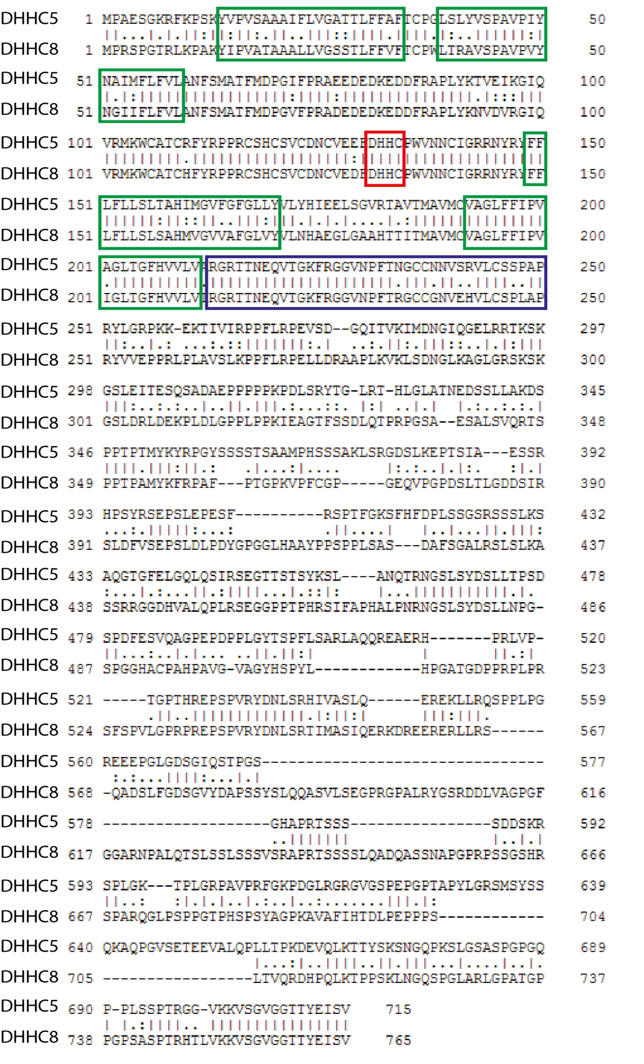
Figure 1.4: Pairwise sequence alignment of DHHC5 and DHHC8, performed using the EMBOSS Water program. Catalytic tetrad is shown in the red box, transmembrane domains are shown in green boxes and the PaCCT domain in the blue box.

While no structure of DHHC5 has been solved to date, it is possible to create a model of the protein based on the structure of DHHC20 (Rana et al., 2018) using the SWISS-MODEL program (Biasini et al., 2014) (Figure 1.5). As mentioned above, a number of structural features are common to all or most PATs, including DHHC5. DHHC5 contains many of the common structural motifs of PATs including the 4 transmembrane domains and the CRD which contains the active site. The model lacks the extended C-terminal tail of DHHC5 but does include the PaCCT domain which immediately follows the final transmembrane domain.
This domain contains a predicted amphipathic helix which contains 3 palmitoylation sites
(Collins et al., 2017) opening up the intriguing possibility that this possible helix can be “pinned” to the plasma membrane by palmitoylation. The extended C-terminal tail of DHHC5 is missing from this model and will likely be difficult to model as it is long and has very few areas of recognised secondary structure. However, this area would be intriguing to map, as it contains several known areas of interaction with other proteins and domains of interest. Among these is a known PDZ binding domain that is at the extreme C-terminus of the protein sequence and encompasses the final six residues of DHHC5 (Li et al., 2010). This region is important for DHHC5 from a scaffolding point of view as it mediated the interaction between DHHC5 and the post-synaptic density scaffolding protein PSD95. This interaction is of particular interest as PSD95 is not a DHHC5 substrate, but could be an essential way of controlling the localisation and proteins in proximity of DHHC5 when it is present at the plasma membrane.

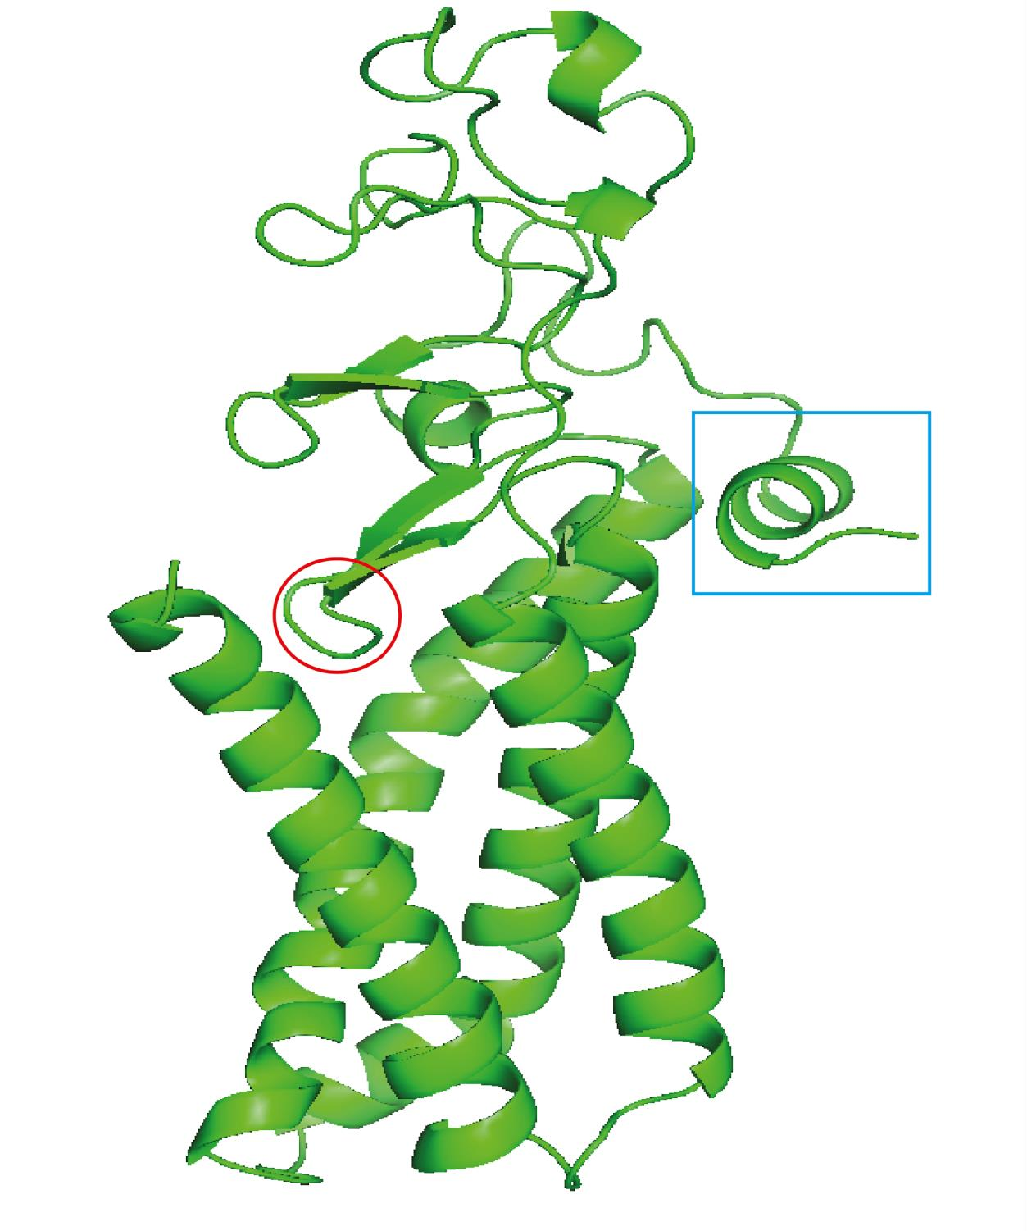

Figure 1.5: Homology based model of DHHC5 based on the crystal structure of DHHC20 and made using the SWISS-MODEL program (Biasini et al., 2012). The red circle shows the position of the active site. The cyan box is an amphipathic alpha helix in the C-terminal of DHHC5 where there are 3 palmitoylation sites. The 4 long alpha helices at the bottom are transmembrane with the fatty acid chain intermediate fitting between them before transfer onto the substrate.

As with most other PATs, there are very few confirmed substrates of DHHC5, which is likely down to a number of factors including substrate overlap and the techniques used to study the possible substrates. Known and confirmed substrates include the prominent lipid raft protein Flotillin 2 (Li et al., 2012), the synaptic scaffolding protein δ-catenin (Brigidi et al.,
2014) and the PDZ domain containing protein Grip1b (Thomas et al., 2012). The study on Grip1b shows the difficulty in finding substrates that are unique to a single PAT, as the authors found that both DHHC5 and the closely related DHHC8 are able to palmitoylate Grip1b despite their different subcellular localisations.

There has been a study using a DHHC5 gene trap mouse line, which expressed around 5% of the WT amount of DHHC5, which used a metabolic labeling method combined with SILAC to find 22 possible or probable DHHC5 substrates (Li et al., 2012). This study looked at DHHC5 substrates on a protein level, which makes it likely that proteins that are multiply palmitoylated by different PATs would be missed from this analysis. For example, if a protein is palmitoylated on one site by a certain PAT at the Golgi as it is trafficked to the plasma membrane, or as a way to cause it to locate to the plasma membrane, and it is then palmitoylated again on one or more other residues at the plasma membrane by DHHC5, it would likely still be pulled down by the ABE method. However, methods that give site level resolution, such as PEG switch for a candidate approach, or ssABE for a whole palmitoylated proteome view would likely give a fuller view of the substrates of DHHC5.

The generation of the DHHC5 gene trap mouse did reveal a number of interesting roles for DHHC5 in a neural context (Li et al., 2010). This mutation had a rate of embryonic lethality of around 50% and behavioural testing of these mice showed that they had defects in fear conditioning, suggesting problems in their learning and memory. This does implicate DHHC5, and by association DHHC5 palmitoylation, in various processes at the post-synaptic density involved with the formation and storage of memories. It was revealed in the same work that DHHC5 is present at the post-synaptic density and forms a complex with the important postsynaptic scaffolding protein PSD95 through an interaction between one of the PDZ domains of PSD95 and the PDZ binding domain which is present at the very C-terminus of DHHC5, as has been discussed above.

Work on DHHC5 in a neural setting has shown that DHHC5 is degraded when certain cues are introduced (Li et al., 2012). When neural stem cells were starved of growth factors, which is often used to cause these cells to differentiate, DHHC5 levels were reduced, however, it could be reversed over shorter time points and inhibiting the ubiquitin controlled degradation system was able to reduce the levels of DHHC5 degraded. This shows that DHHC5 may be especially important in some areas of either maintenance of neural stem cells in their stem cell state or in the development of these cells. More work would need to be done on neural stem cells to identify the specific targets of DHHC5 palmitoylation in this cell type, and it would be interesting to track the fate of these substrates after differentiation in both protein abundance and cellular localisation to see if the drop in DHHC5 influences these proteins in any way and potentially leads to any downstream effects or cascades.

Further work has been done on DHHC5 at the post-synaptic density has shown that it palmitoylates δ-catenin, an important scaffolding protein, in response to synaptic activity (Brigidi et al., 2014). At the post-synaptic density, palmitoylated δ-catenin then associates with adhesion molecules N-cadherin, which changes the size and structure of the postsynaptic density. On top of this, the palmitoylation event appears to increase the levels of AMPA receptor subunits at the post-synaptic density which may sensitise the neuron to these signals. Fear conditioning of mice showed that this increased the levels of δ-catenin palmitoylation, which links both δ-catenin to learning and memory and shows the mechanism by which loss of DHHC5 in the gene trap mice affects the learning and memory of these mice (Li et al., 2010). To back this up it was also shown that preventing palmitoylation of δ-catenin leads to a decrease in the learning and memory of mice, in a very similar way to what was seen with DHHC5 knockdown mice, adding further evidence to the link between DHHC5 and memory.

A later study on DHHC5 at the post-synaptic density shed further light on the mechanism of its palmitoylation of δ-catenin and the nature of its interaction with PSD95 (Brigidi et al., 2015). At basal conditions, DHHC5 is at the plasma membrane at the post-synaptic density, while δ-catenin is usually present in the dendritic spines of neurons (Matter et al., 2009), so in order for DHHC5 to palmitoylate δ-catenin, one or both protein must move to a shared location. This work was able to show that DHHC5 is held at the plasma membrane through an interaction with PSD95, which is mediated by the PDZ binding domain on DHHC5 as discussed previously, and phosphorylation by the Src family kinase Fyn, but after synaptic activity, DHHC5 is de-phosphorylated (Figure 1.6). The loss of phosphorylation causes DHHC5 to be endocytosed and trafficked to dendritic spines, where it then palmitoylates δ-catenin before both are moved back to the post-synaptic density allowing the recruitment and stabilisation of AMPA receptors. DHHC5 is endocytosed by the clathrin endocytosis system and requires the AP2 adaptor complex to bind DHHC5 at a canonical AP2 binding motif in the C-terminus of DHHC5 in order for DHHC5 to be endocytosed. One of the major aspects of the phosphorylation event is to phosphorylate a residue in this AP2 binding motif which likely physically blocks the interaction with the AP2 complex or alternatively prevented the recognition of the motif on DHHC5 by the AP2 complex. The interaction with PSD95 is unlikely to be dependent on the phosphorylation event given the site of phosphorylation is not in close proximity to the PDZ binding domain of DHHC5, and the interaction is likely broken by the endocytosis of DHHC5. However, it is entirely possible that the phosphorylation event help to stabilise the interaction between PSD95 and DHHC5 and does not solely function to prevent association with the AP2 complex and the clathrin endocytosis machinery. The discovery that DHHC5 is trafficked away from the plasma membrane to palmitoylate δcatenin opens up the possibility of DHHC5 having other substrates which are not present at the plasma membrane and are instead found in internal compartments. It also demonstrates how important post-translational modification of the DHHC5 C-terminal tail is to the regulation of DHHC5, and how these post-translational modifications could be important in regulating the localisation of DHHC5.

DHHC5  substrate | Notes
Flot2 | Thought to be unique to DHHC5, with multiple palmitoylation sites
Flot1 | As above
Grip1b | Shared with DHHC8
δ-catenin | Neural substrate, requires DHHC5 to be trafficked to dendritic spine from post-  synpatic density
Phospholemman | Important substrate of DHHC5 in heart, regulates association with other  proteins
Furin | Palmitoylation essential for anthrax toxin processing
PCSK7 | Palmitoylation essential for anthrax toxin processing
Sphingosine 1phosphate receptor 1 | Palmitoylation is required for proper Gprotein coupling and signalling  modulation
Table 1.1: Selected DHHC5 substrates and short notes on how palmitoylation by DHHC5 is important in their lifecycle, or how it affects these proteins.
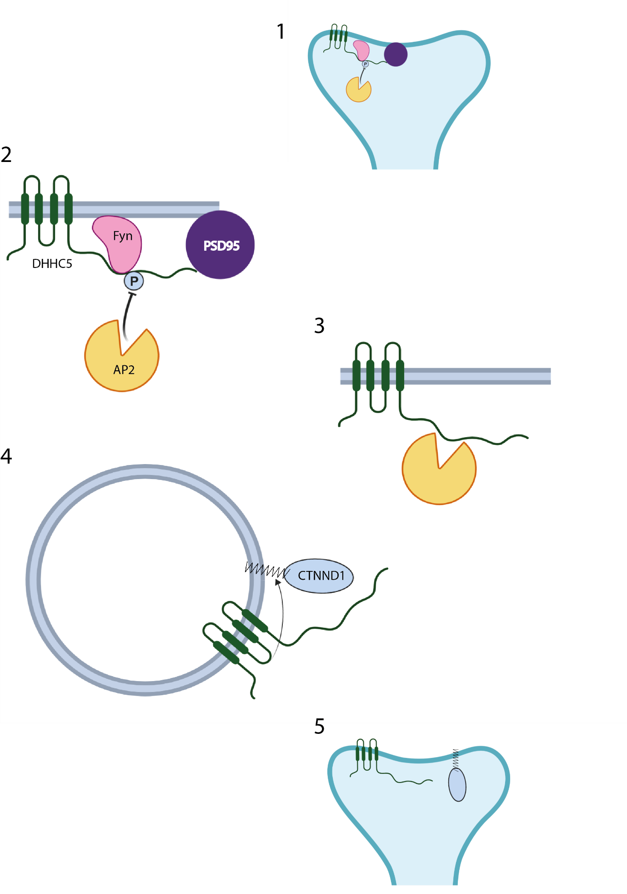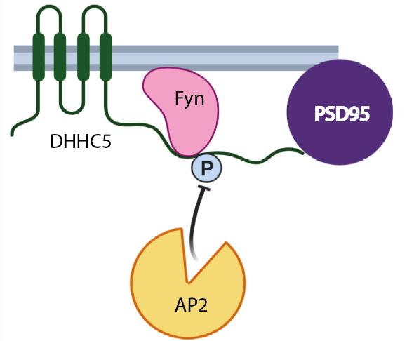
1

-
DHHC5 present stably at the post
-
synaptic density in complex with Fyn
kinase and PSD95.

2

-

Binding of AP2, and internalisation of
DHHC5 is prevented by phosphorylation
of DHHC5 by Fyn kinase

3

-

Upon neural activity, phosphorylation
of DHHC5

is lost, allowing internalisation
of DHHC5 by AP2 mediated clathrin
endocytoiss

4

–

After
internalisation,
to
moves
DHHC5
dendritic
spines
where it palmitoylates
δ
-
catenin.

5

–

DHHC5 and δ
-
catenin are then
trafficked together back to the post
-
synaptic

density, leading to structural
changes of the synapse.

Figure 1.6: Schematic of DHHC5 localisation and movement at the post-synaptic density in neurons. Adapted from Brigidi et al. 2015.
DHHC5 does share some substrates with other PATs, most notably with the closely related DHHC8, despite their different subcellular localisations (Ohno et al., 2006). Together, these enzymes both palmitoylate the important trafficking protein GRIP1b (Thomas et al., 2012), although the balance of palmitoylation between the enzymes is unknown apart from in neurons where it is known that DHHC5 is the major PAT. This work did throw up some interesting results, such as showing that DHHC5 is enriched in dendritic shafts, despite later work showing that DHHC5 was more usually found enriched at the post-synaptic density
(Brigidi et al., 2015), although it is known to traffic to dendritic shafts. How these two PATs “share” this substrate is an interesting question, with multiple conceivable answers, including that DHHC5 and DHHC8 each palmitoylate GRIP1b in different cell types or that GRIP1b is palmitoylated by DHHC8 at the Golgi while being trafficked to the plasma membrane and then palmitoylated by DHHC5 at the plasma membrane. Another apparent shared substrate between DHHC5 and DHHC8 is the adhesion protein Ankyrin-G (He et al., 2014). In MDCK cells, both DHHC5 and DHHC8 were found at the plasma membrane, where Ankyrin-G is also located. As DHHC8 was thought to be present in the Golgi, it opens up the possibility that PATs can be present in different cellular compartments in different cell types. Alternatively, as the initial work on PAT localisations was done using over-expressed proteins (Ohno et al., 2006), it could point to over-expression of PATs causing localisation defects, which has been suggested in the past (Hou et al., 2009). This naturally would cause a number of PATs to be assigned to locations that are not necessarily correct. Improvements to these assignments could be made by using antibodies specific to each individual PAT, however, this could require specific antibodies to each member of the protein, which could prove difficult with transmembrane proteins. It also emphasises the need to check the localisation of PATs before any work involving them, especially if they are being over-expressed as it is potentially important that the endogenous and over-expressed proteins share a location.

DHHC5 also shares a substrate with another Golgi localised PAT DHHC4 (Wang et al., 2019). DHHC5 and DHHC4 both palmitoylate the protein CD36, an important regulator of fatty acid uptake in cells (Pepino et al., 2014), and loss of this palmitoylation inhibits this process. Unlike the substrates that overlap between DHHC5 and DHHC8, PATs which appear to have some overlap in subcellular localisation, DHHC4 and DHHC5 have very distinct and different locations within the cell, with DHHC5 at the plasma membrane and DHHC4 only present at the Golgi (Wang et al., 2019). This points to a first palmitoylation event of CD36 at the Golgi by DHHC4 before further palmitoylation by DHHC5 at the plasma membrane. As mentioned previously, this scenario would be difficult to detect with more traditional approaches to investigating if a protein if palmitoylated, such as using heavy labelled radioactive palmitate or ABE, but could be detected by site level methods like PEG switch.

A genome-wide association study comparing patients who had schizophrenia with control patients showed DHHC5 as the 4th most significantly enriched protein in a large study (Zhao et al., 2018). This again supports the idea that DHHC5 is highly important in a neural setting and plays a role in a number of highly important processes that contribute to proper brain function. Interestingly, DHHC18 was ranked as the third most significant protein hit in this study which suggests that abhorrent palmitoylation could be closely linked to this condition. This is another disease linked to DHHC5, and palmitoylation or PATs in general, where the knowledge and ability to possibly translate this association into a usable therapy is impaired by the lack of knowledge of both the substrates of individual PATs and their regulation on both a cellular and molecular level. In this particular example, DHHC5 is significantly overexpressed in schizophrenia patients, along with DHHC18, but no work has been done to see what the molecular effects of this may be in a neuronal setting. It has also been shown by a separate study that some schizophrenia patients contain a nonsense mutation of DHHC5 which introduces a stop codon at the site of glutamic acid at position 648 in DHHC5 (Fromer et al., 2014). This mutation would truncate the C-terminal tail of DHHC5, and cause it ot be lacking its PDZ binding domain Often work with PATs, and DHHC5, has used a knockdown approach, it would be interesting to turn this around and use an over-expression model in neurons and investigate the effects this may have both at the post-synaptic density, where DHHC5 has a number of defined roles, and more widely in the cell. This could be used to show possible structural changes at the post-synaptic density, changes in the palmitoylated proteome of these cells or alterations that could affect DHHC5 itself such as mis-localisation or accelerated degradation.

While much of the work on DHHC5 has focussed on a neural setting, it has also been found to have a number of important roles in processes in a number of other cell types. The phenomenon of massive endocytosis (MEND), where up to 70% of the cell surface is internalised (Lariccia et al., 2011), in fibroblasts has been shown to be inhibited by knockdown of DHHC5, suggesting that it plays a key role in this phenomenon (Hilgemann et al., 2013). When this work was extended to investigate the phenomenon in heart muscle, which undergo MEND after re-oxygenation following oxygen deprivation such as would occur following a heart attack, it was again shown that reduced levels of DHHC5 could reduce the occurrence of MEND in this organ (Lin et al., 2013) and that removing DHHC5, and thus inhibiting MEND, reduces the effects of reoxygenation injury on the heart. Interestingly, when DHHC5 deficient cardiac cells undergo anoxia, it actually increases the plasma membrane localisation of the ion channel NCX1 and the protein phospholemman. This is an intriguing point as palmitoylation is often used to stabilise proteins at the plasma membrane. It could be that palmitoylation of these proteins is used as a way to trigger their endocytosis and that by removing the enzyme that palmitoylates them it leads to a stabilisation of NCX1 and phospholemman at the plasma membrane. Given that DHHC5 is required for MEND, and that MEND that occurs after oxygen reintroduction following periods of anoxia appears to be detrimental to the recovery of heart muscle cells, targeting DHHC5 specifically, or potentially palmitoylation more generally, could be a way to prevent or reduce the detrimental effects seen in cardiac muscle after heart attacks.

The triggering of MEND appears to be a multi-step process, which originates in the mitochondria before a cascade reaches DHHC5 at the plasma membrane whereby the palmitoylation of plasma membrane protein causes the process of MEND itself (Hilgemann et al., 2013). In cardiac fibroblasts, a series of steps occurs that begins with the opening of mitochondrial pores, causing a large release of coenzyme A, which rapidly binds fatty acid chains to form acyl-CoA. The increase in acyl-CoA leads to palmitoylation of a large number of membrane proteins, presumably by DHHC5. The blockage of any step of this process, such as depleting fatty acids which will prevent acyl-coA synthesis or preventing the opening of mitochondrial pores, inhibits the whole process which demonstrates that this is a specific cascade and that disruption at any point of it stops MEND. There was also some interesting insights into the mechanisms by which MEND is initiated. While it is known that it is triggered by the reintroduction of oxygen after periods of anoxia in cardiac muscle, the molecular mechanisms were unknown. It was shown that depolarisation of mitochondria, such as by the movement of calcium into mitochondria, leads to the pore opening and subsequently MEND.
It is also caused by transient exposure of cardiac cells to hydrogen peroxide which causes oxidative stress, but not by long term or constant exposure of cells to hydrogen peroxide, or if hydrogen peroxide is present. This matches what is known about MEND with respect to its triggering after re-oxygenation following anoxia, as it has been established that hydrogen peroxide can be released by cells after oxygen is reintroduced (Zulueta et al., 1995), this transient event would likely lead to the cascade that leads to MEND. As has been discussed above, blocking palmitoylation or targeting DHHC5 could prevent this process, but what was shown in this work was that if any of the steps that lead to this palmitoylation event are perturbed it could help to prevent reoxygenation injury in heart attacks.

The importance of DHHC5 in the heart was further revealed when it was shown to palmitoylate phospholemman, an important interacting and regulating protein of the resident sodium pump, NCX1, mentioned above (Howie et al., 2014). This palmitoylation event inhibits the sodium/calcium ATPase, but only when one of the two cytoplasmic cysteine residues of phospholemman is palmitoylated. This study also found that the interaction between phospholemman and DHHC5 is independent of the PDZ binding domain of DHHC5 and instead occurs in a region consisting of around 120 amino acids which are immediately on the C-terminal side of the 4th and final transmembrane domain, which shows that DHHC5 does not only interact with other proteins through its PDZ binding domain.

The role of DHHC5 in a range of important processes was when a siRNA screen on non-small cell lung cancers showed that knockdown of DHHC5 resulted in the reduced growth of certain tumours and tumour-derived cell types (Tian et al., 2015). The effect appeared to be restricted to lung cancer cell lines as bronchial cancer cells showed no change in growth and knockdown inhibited growth of mouse xenografts could only be rescued by a WT DHHC5 rescue and not a catalytically inactive form of the protein, pointing to DHHC5 having a substrate or substrates which is essential for the growth of these tumours. This substrate, or substrates, was not investigated and would likely need to be uncovered, along with other DHHC5 substrates, before a therapeutic treatment and strategy was developed to target this potential avenue for cancer treatment. Without this knowledge, possible off target effects would be hard to pin down, but could also show ways in which combination therapies involving targeting DHHC5 or its substrates could complement current lung cancer therapy. However, over the panel of lung cancer cell lines tested, not all showed a growth defect after depletion of DHHC5 by siRNA or shRNA. The reasons for this aren’t entirely clear but could be due to a number of things. It is likely that the growth defect results from dependence on DHHC5 palmitoylation of one or more proteins, however in some lines it could be that there is compensation by one or more PATs that removes the dependence on DHHC5. This could be revealed by looking at the levels of other PATs in each cell type. It may be prudent to initially look at abundance of related PATs like DHHC8 or plasma membrane localised PATs such as DHHC22, as these are probably the most likely PATs to compensate. It is also feasible that the cancer cells that are not susceptible to DHHC5 knockdown simply because they do not express the protein or proteins that are palmitoylated by DHHC5. To confirm this scenario, palmitoyl proteome profiling of each of the cell lines would likely be required and compared to find any differences. A third reason could be that upon knockdown of DHHC5 and loss of
palmitoylation of the substrates that are required for the growth of these cancers, the cancers that are resistant to DHHC5 knockdown go through another pathway to ensure growth continues. This could be revealed by looking at changes in gene expression, protein abundance or metabolite levels after DHHC5 knockdown as an increase in certain proteins or metabolites would indicate a different pathway used to ensure continued cancer growth.

A siRNA screen was also used to reveal the involvement of DHHC5 in the process of endosome to Golgi retrieval (Breusegem & Seaman, 2014). An unbiased screen was performed that demonstrated that depletion of DHHC5 slowed the movement of proteins from endosomes to the Golgi, but did not affect the initial endocytosis and internalisation of proteins. This work was able to show that DHHC5 knockdown prevented colocalisation of CD8 with Golgi body markers during a CD8 antibody uptake assay, showing that knockdown of DHHC5 does impact on the process of cargo moving from the endosome to the Golgi. This work also revealed that DHHC5 is not only present at the plasma membrane but also at Rab8 and 11 tubular recycling endosomes within the cell. This points to DHHC5 being cycled from the plasma membrane to internal compartments before movement back to the plasma membrane, much like what happens in neurons (Brigidi et al., 2015). This study and the study that showed that DHHC5 is endocytosed from post-synaptic density to dendritic spines together show that DHHC5 is not solely localised to the plasma membrane and that DHHC5 may be trafficked to different areas of the cell depending on the cell type or potentially even the type of signal the cell receives. Additionally, 4 clathrin-mediated endocytosis motifs (Yxxφ) were found in the C-terminal tail of DHHC5, pointing to this being the mechanism of DHHC5 endocytosis. The work in neurons backed this up, as it was shown that DHHC5 interacts with the AP2 complex and that the clathrin endocytosis system is the mechanism by which DHHC5 is removed from the plasma membrane allowing it to travel to dendritic spines. Further investigation on the mechanism of DHHC5 removal from the plasma membrane in other cell types would confirm that it is through the AP2 mediated clathrin endocytic system, along with how the triggering and particular timing of DHHC5 endocytosis is regulated.

1.6 Palmitoylation and the regulation of cellular adhesion

The adhesion of cells to one another and to the extracellular matrix is an essential process in all multicellular organisms and many of the proteins involved with these processes have been found to be palmitoylated, with very few PATs assigned to them.

Desmosomes are one of a number of essential cell:cell adhesion complexes found in the body and their dysfunction has been linked skin conditions (Rickman et al., 1999) and diseases of the heart, such as arrhythmogenic right ventricular cardiomyopathy (Lahtinen et al., 2011). They are multi-component protein complexes that span the plasma membrane and are linked to the intermediate filament portion of the cytoskeleton (Kottke et al., 2006). Neighbouring cells are linked by interactions between the extracellular portions of the transmembrane desmosomal cadherins, desmoglein, and desmocollin (Garrod & Chidgey, 2008). On the internal face of the plasma membrane, there a number of proteins which together form a structure known as the desmosomal plaque (Kowalczyk et al., 1994). These proteins function to link adjacent desmosomal cadherins and link the desmosome to the intermediate
filaments.

The timing of the formation of the desmosome and the molecular mechanisms that are involved in the initial formation of a functional desmosomal unit are somewhat murky. The minimal functional unit of an adherent desmosome appears to be a desmoglein, a desmocollin and a plakoglobin (Getsios et al., 2004), so both desmosomal cadherins and a single member of the internal plaque protein complex. Either cadherin expressed alone is insufficient to allow cell:cell adhesion. These 3 proteins, when expressed together in nonadherent cells, will allow them to become adhesive to one another. It is interesting that the two cadherins require a desmosomal plaque protein in plakoglobin, which points to successful clustering of these proteins being a requirement either their stabilisation at the plasma membrane or for the interaction between cells that allows the cadherins to form adhesions between one another.

Using the phenomenon in cultured cells that removal of calcium from the growth media will cause desmosomes to be internalised, and reintroduction will cause a restoration of the desmosomal components to the plasma membrane, the trafficking of the protein components of the desmosome were studied (Pasdar & Nelson, 1989). This showed that the components are trafficked independent of one another to the plasma membrane, with the transmembrane cadherins and the cytoplasmic components of the desmosomal plaque trafficked through different pathways, where they then presumably come together to form the full, functional desmosome. It also revealed some interesting insights into the fact that if cells are not in contact with one another, desmosomal components are much less stable and are rapidly degraded compared to when desmosomes are in contact with another desmosome in a neighbouring cell.

Insight has been gained through a range of techniques into the interactions of various members of the desmosome and how these interactions could influence the size, stability and adhesion properties of the complex. Plakophilin-3, the most widely expressed member of the
3 proteins in the plakophilin family in the epithelium (Bonne et al., 1999), has been shown to interact directly with both the desmosomal cadherins and proteins within the desmosomal plaque (Bonne et al., 2003). The direct interaction with both desmosomal cadherins suggests that it may have a hand in clustering the essential proteins that bind with corresponding proteins on the surface of other cells within the desmosome, aiding in the formation of a functional desmosomal unit. The work expanded on the role and the binding partners of PKP3 to show that it has multiple binding sites for desmoplakin. Interaction with multiple desmoplakin proteins would lead to a build up on these proteins on the interior face of the plasma membrane, expanding the desmosomal plaque, as has been hinted at in other works (Kowalczyk et al., 1999), and could even have roles in clustering groups of cadherins and plaque components to discreet areas of the plasma membrane.

Palmitoylation has been found on 6 different desmosomal proteins (Roberts et al., 2014) which represent that majority of the desmosomal complex (Figure 1.7). Among these, the palmitoylation of the proteins plakophilin-2 and -3, which are present on the cytosolic face of the membrane, are not integral membrane proteins and function to link the desmosomes to intermediate filaments (Mertens et al., 1996), was shown to be essential for the proper localisation of a number of other desmosomal proteins including the desmosomal cadherin desmoglein-2. However, this work did not look more deeply into the PAT or PATs which palmitoylate the individual members of the complex or if all members are palmitoylated by a single PAT. The profound effects of loss of palmitoylation of PKP2 and PKP3 on the other members of the complex does throw up some interesting questions. Given that these proteins are present on the cytoplasmic face of the plasma membrane and are not transmembrane proteins, it may be assumed that palmitoylation functions to localise plakophilin to the plasma membrane which allows interaction with the other members of the desmosomal complex.
However, this simple explanation does not explain why the loss of plakophilin palmitoylation would lead to the mislocalisation of the desmosomal cadherins. It could be that palmitoylation does allow the association of plakophilin with the plasma membrane and subsequent association with the desmosome complex, but that plakophilin is required to stabilise other members of the complex, likely through linking them to the intermediate filaments and to one another.

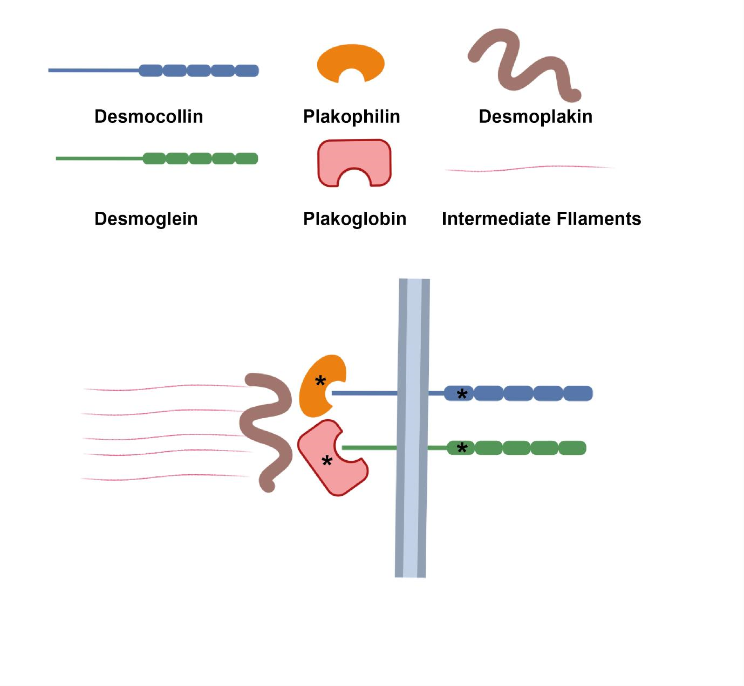
Figure
1.7
:
A basic schematic of one half of a functional

desmosome unit. All basic components are
present, with palmitoylated proteins designated by *. This shows that both transmembrane proteins
(
desmocollin and desmoglein) are palmitoylated along with the two proteins that are closest to the
plasma membrane (
plakophilin and plakoglobin).

When further work was carried out to characterise the effects of preventing the palmitoylation of desmoglein-2 (Roberts et al., 2016). This showed less profound effects than was seen when plakophilin-2 palmitoylation was blocked but did demonstrate that palmitoylation of desmoglein-2 caused a small portion of the proteins to be localised to lysosomes, so could palmitoylation could play a role in stabilising desmoglein-2. Furthermore, this work showed that when desmoglein-2 loses palmitoylation it’s trafficking to the plasma membrane is severely impaired, but was not prevented as under basal conditions the majority palmitoylation-deficient desmoglein-2 was found at the plasma membrane. This fact led to the hypothesis that DSG2 is palmitoylated by a PAT somewhere in the trafficking pathway, likely at the Golgi, although no additional data or evidence was produced to back this up. As mentioned above, non-adherent desmosomal components, including desmogleins, have a much shorter half-life and are degraded more quickly (Pasdar & Nelson, 1989). The portion of non-palmitoylated DSG2 seen overlapping with lysosomal markers could well be being degraded, which is backed up by the fact that the palmitoylation deficient mutant of DSG2 is degraded more rapidly than its WT counterpart. These 2 points of evidence together could indicate that loss of palmitoylation of DSG2 causes it to be less adherent, and in turn, overall desmosomal adherence to be impaired.

Outside of desmosomes, other adhesion proteins have been shown to be palmitoylated. In neurons, the adhesion protein neural cell adhesion molecule (NCAM) is palmitoylated by both DHHC3 and DHHC7 (Lievens et al., 2016) and that this palmitoylation is required for neurons to react to fibroblast growth factor 2 (FGF2) which causes neurite growth. The reaction to FGF2 and subsequent palmitoylation of NCAM by DHHC3 is controlled by a tyrosine phosphorylation event on DHHC3 by Src kinase. This phosphorylation functions to reduce the auto-palmitoylation of DHHC3 and subsequent palmitoylation of NCAM after FGF2 stimulation. This is an interesting finding as it implicates other post-translational modifications in the activity of PATs, as the auto-acylation rate is often used as an indicator of PAT activity and this is increased in DHHC3 when phosphorylation is prevented or reduced. The site of the phosphorylation is at the extreme N-terminus of DHHC3 on Tyrosine 18, at an area away from the active site which is located between the second and third transmembrane domain. It would be very interesting to see how the phosphorylation of DHHC3 at tyrosine 18 affects its structure, and in particular, how it could affect the active site of the enzyme from the modification of a region distal to the active site. Some idea of what could be occurring in this situation could come from the crystal structure of DHHC20 (Rana et al., 2018), it could be that phosphorylation of this region prevents the auto-acylation of DHHC3 through blocking the region by which the acyl chain enters the “binding pocket” that houses the acyl chain in the acyl-enzyme intermediate before transfer to the substrate.

The tight junction claudin protein has also been confirmed as palmitoylated (Van Itallie et al., 2005). Claudins are known to be one of the major determinants of the cell adhesion based trans-epithelial electrical resistance assay (McCarthy et al., 2000) with an increase in claudin expression leading to an increase in electrical resistance across a cell monolayer (Furuse et al., 2001). Palmitoylation of claudin appears to help target claudin to tight junctions at the plasma membrane, with palmitoylation deficient claudin being present in lower quantities at tight junctions and some protein being seen overlapping with lysosomal markers. Despite this, palmitoylation deficient claudin did not have a lower half life and was still able to form functional adhesions between cells, suggesting that the role of palmitoylation is to allow claudin to localise to tight junctions efficiently, but is not absolutely required for this to happen. Similar to what is seen with DSG2 (Roberts et al., 2016), the overlap with lysosomal markers is likely indicative of lower protein stability of the palmitoylation deficient form of claudin.

In the epithelial setting, palmitoylation of the tight junction localised junctional adhesion molecule C (JAM-C) has been linked to its function and global cell adhesion (Aramsangtienchai et al., 2017). JAM-C is a transmembrane protein that is palmitoylated by DHHC7 on a pair on cysteine residues close to the transmembrane domain and these palmitoylation events promote localisation of JAM-C to its native position at tight junctions. Knockdown of DHHC7 leads to a drop in palmitoylation of JAM-C and subsequently leads to a decrease in cell adhesion as was demonstrated by an increase in cellular migration. This links palmitoylation of adhesion proteins to epithelial to mesenchymal transition (EMT), a process closely associated with cancer malignancy (Larue & Bellacosa, 2005), and makes targeting palmitoylation a potential cancer therapy strategy.

The process of Snail protein induced EMT does appear to drive a range of changes in the palmitoylated proteome or possibly that a number of changes in the palmitoylated proteome drives this process (Hernandez et al., 2016). The Snail protein drives one form of EMT and is often found in malignant and fast spreading cancers (Ye et al., 2015). When Snail was introduced into a breast cancer cell line, changes in the palmitoylated proteome and protein abundance were investigated which led to the discovery that upon Snail transduction a number of proteins palmitoylation state was decoupled from their abundance. While only 2 of these proteins were adhesion proteins (RhoA protein and Plectin protein), it does suggest that widespread changes in cellular palmitoylation can occur as a result of EMT or to potentially drive the EMT phenotype.

1.7 Rationale behind this work

As has been established here, palmitoylation of certain proteins is known to have a role in a number of essential cellular processes and has been implicated in a wide range of diseases. However, there are very few examples of PATs which are assigned to these proteins. There are also a number of situations where PATs are known to be involved in certain processes, such as DHHC5 in MEND following anoxia in cardiac muscle cells or in the growth of certain lung cancers, but it is unknown how they are involved in these processes on a molecular level or which proteins they palmitoylate to affect this. Therefore, it is important to attempt to gain a deeper insight into the regulation and substrates of PATs and also to link this information with wider cellular processes in an integrated manner.

As the activity of both DHHC9, through its interactor Golga7 (Swarthout et al., 2005), and DHHC17, through its interactor HTT (Huang et al., 2011), are modulated by interacting proteins, it makes it possible that other PATs are regulated in this manner also, or that interacting proteins may regulate other things to do with PATs. DHHC5 has been shown to interact with a protein closely related to Golga7, known as Golga7b (Huttlin et al., 2015), which has been independently shown to be a likely palmitoylated protein also (Collins et al., 2017). As a result of these two facts, the interaction between Golga7b and DHHC5 will be probed, with a view to investigating how Golga7b influences DHHC5 and what its role in DHHC5 regulation may be. It could be that Golga7b and DHHC5 have a relationship similar to that of DHHC9 and Golga7, but it is entirely possible that Golga7b could be important for other DHHC5 processes, such as retrieval from the plasma membrane, recycling back to the plasma membrane or even establishment or stabilisation of DHHC5 at the plasma membrane. This last point has not been fully explained in DHHC5, apart from in neurons, where phosphorylation plays a role (Brigidi et al., 2015), and given the similarities in sequence with DHHC8 shown here and the difference in subcellular localisation, there must be one or more factors that play a role in DHHC5 plasma membrane localisation.

Among PATs, DHHC5 sits in a unique setting. It is localised mainly to the plasma membrane, which in itself is unusual for a PAT, but it is also present in other cellular compartments, such as dendritic spines in neurons (Brigidi et al., 2014) and also in endosomes on other cell types (Breusegem & Seaman, 2014). The mechanism of the movement of DHHC5 from the plasma membrane to the compartments within the cell has been shown to be mediated by the AP2 system at the post-synaptic density in neurons and is controlled by phosphorylation of DHHC5 by a plasma membrane localised kinase (Brigidi et al., 2015). If, and indeed how, this process both occurs and is regulated in other cell types is something that could give another dimension to DHHC5 and its landscape of substrates and processes it regulates. As a part of this work, this process will be investigated, with the hypothesis being that DHHC5 is internalised by the same AP2 mediated clathrin endocytosis system as it is seen in neurons.

In order to gain a more rounded view of how DHHC5 may be regulated and also the processes DHHC5 regulates, proteomic methods could be used to gain an unbiased overview. By using complementing strategies it is more likely that a fuller picture of DHHC5 substrates and processes it is involved with. In the past, using knockdown or depletion of PATs has not always given the full breadth of substrates of the particular PAT being studied, as has been seen in the past with DHHC5 (Li et al., 2012). This can be partly attributed to the techniques used, but by using more than one proteomic technique it is likely that more processes that DHHC5 may be involved in will be found with high confidence and a greater breadth of the roles of DHHC5 in the cell will be gained.

As has been mentioned here, palmitoylation appears to be disproportionately common in processes that regulate the adhesion of cells, with desmosomes being perhaps the most palmitoylated of all these complexes, with no less than 6 members of the protein complex being palmitoylated (Roberts et al., 2014). However, no PATs have been found that palmitoylate any of these proteins. DHHC5 is a viable candidate to palmitoylate any of the proteins in the complex, as it is present at the plasma membrane, where desmosomes are naturally present. Given the apparent importance for palmitoylation in desmosomal
localisation, and potentially in wider cell adhesion, it will be important to investigate this.

In summary, this work will aim to investigate the role of the interacting protein Golga7b with regards to DHHC5 activity and potentially localisation. It will look to find novel substrates of DHHC5 and processes regulated by this PAT through a pair of complementary proteomic methods. It will investigate whether DHHC5 is endocytosed in other cell types and through what pathway this occurs and finally, will investigate DHHC5 as a possible palmitoylating enzyme of desmosomes and if this is the case, whether DHHC5 has a role in cell adhesion.

2 Methods

2.1 Cell lines used

HeLa cells – human cervical cancer cell line
A431 cells – human epidermoid carcinoma cell line

2.2 SiRNA

All siRNA was purchased from Dharmacon (GE Life Sciences).
DHHC5 siRNA – SMARTpool: ON-TARGETplus ZDHHC5 siRNA (L-026577-01)
Sequences: GGAAAGCTGAAGACTGAAGAAAGAT, GCTGTATCTTGATCTGTCTGACTGT,
GAAGTACAGCTGAAGACCACCTACA, GCCAGTTGCAATCCATTCGTTCAGA
Golga7b siRNA - SMARTpool: ON-TARGETplus GOLGA7B siRNA (L-029668-02)
Sequences: GAGCGTGGGATGAGGGTTATTGAGA, GGCCAAGATCAAATATGGAGAAAGT, GACGTTTATTTAGCACTTCCTATGT, GGAGGTAGCTCTCTGGAGTCAAAG
AP2m siRNA – SMARTpool: ON-TARGETplus Human AP2M1 (1173) siRNA (L-008170-00-0005)
Sequences: GTGGATGCCTTTCGGGTCAATGTTA, GCCATGGTCTTCGAATTCCTCTATA,
GAGCTGCTGGATGAGATTCTAGACT, GGGCATCAAGAGTCAGCATCAGACA
Non-targeting siRNA – siGENOME Non-Targeting siRNA #1 (D-001210-01)

All siRNA arrived lyophilised and were resuspended in a sterile buffer containing 150mM NaCl and 10mM HEPES pH 7.4. Full resuspension was ensured by pipetting the solution several times and placing the mixture in a thermomixer at 37°C for 30 minutes with shaking at 700rpm. SiRNA was then stored at -20°C before use.

SiRNA was added to cells 18 hours after passaging in the following concentrations:
DHHC5 siRNA – 5nM
Golga7b siRNA – 20nM
AP2m siRNA – 15nM
Non-targeting control siRNA was used in the same concentrations as the targeted siRNAs.
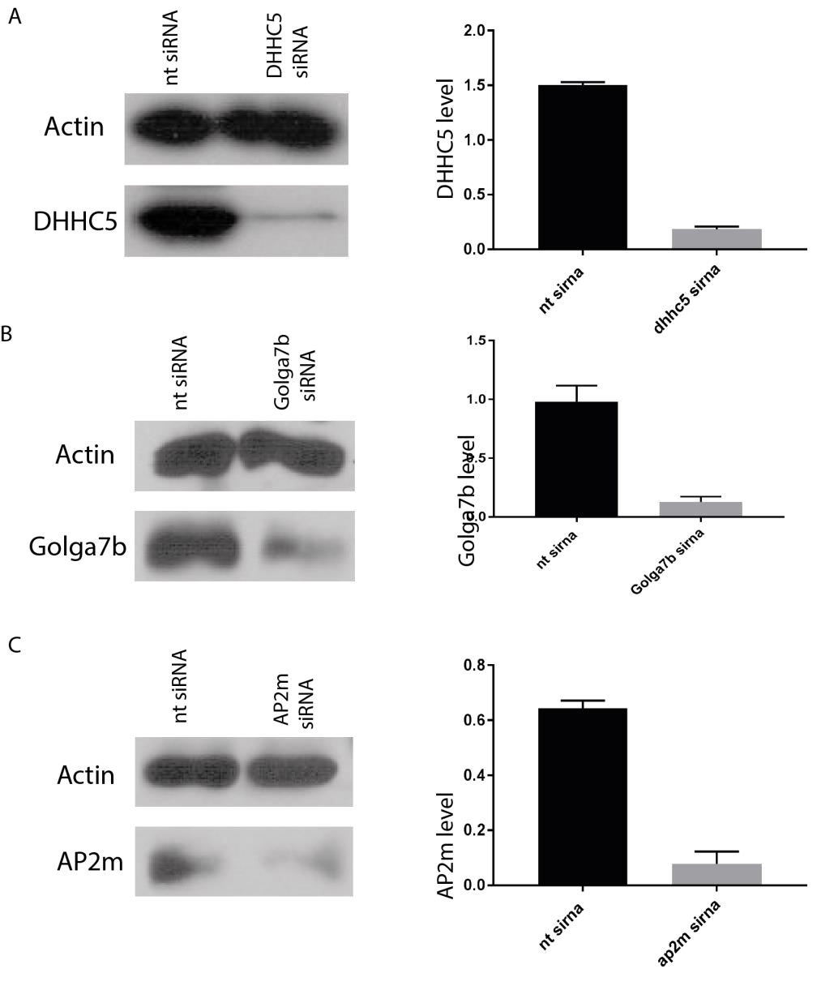
Figure 2.2: SiRNA knockdowns. A – DHHC5 siRNA treatment. Image is representative of 3 immunoblots, quantification is from all 3 blots, normalised to Actin. B – Golga7b siRNA treatment. Image is representative of 3 immunoblots, quantification is from all 3 blots, normalised to Actin. C – AP2m siRNA treatment. Image is representative of 3 immunoblots, quantification is from all 3 blots, normalised to Actin.

Mission siRNA transfection reagent (sigma, S1452) was used for transfection of DHHC5 siRNA at a ratio of 5:1 transfection reagent:siRNA (vol:vol). This was then incubated for 15 minutes at room temperature before adding to cells.

DharmaFECT siRNA transfection reagent 4 (dharmacon, GE life sciences, T-2004-01) was used for transfection of Golga7b siRNA at a ratio of 3:1 transfection reagent:siRNA (vol:vol). This was then incubated for 15 minutes at room temperature before adding to cells.

For all siRNA experiments, cells were returned to the incubator for up to 72 hours before either harvesting or fixation as described previously.

2.3 Constructs

N-terminally HA-tagged DHHC5 construct was a kind gift from Dr Andrew Peden. All other contructs were ordered from Genscript with either human DHHC5 (GeneID 25921) or human Golga7b (GeneID 401647) as templates. All ORF clones were under the CMV promoter in the pcDNA3.1+ vector which had either a FLAG or HA tag following the protein coding region before the stop codon. Cysteine residues mutated in the Golga7b constructs were at positions 33,
78, 81, 90 and 141. DHHC5 residues mutated were at position 134 for catalytic mutant and positions 236, 237 and 245 for C-terminal mutant.

2.4 Cell culture

2.4.1 Media Recipes

2.4.2 Normal DMEM

Dulbecco’s Modified Eagle Medium (DMEM) – Gibco – 11995-065 – 89%
Foetal Bovine Serum (FBS) – Gibco - - 10%
Penicillin/Streptomycin, 10000 units penicillin/10000µg streptomycin – Gibco – 15140122 – 1%

2.4.3 Low Calcium DMEM

Calcium-free DMEM - Gibco – 21068028
Foetal Bovine Serum (FBS) – Gibco - - 10%
Sodium Pyruvate – Gibco – 11360-039 – 1mM
L-glutamine – Gibco – 25030-024 – 4mM
Calcium Chloride – Sigma Alrdrich - C5670 - 5µM

All cells were grown in normal DMEM, except for during Calcium switch experiments. Cells were grown in 100mm cell culture dishes (cellstar, grenier bio-one – 664 160), 6 well plates
(cellstar, grenier bio-one – 657 160) or 12 well plates (cellstar, grenier bio-one – 665 160) depending on the experiment to be carried out and were kept in an incubator that was maintained at 37°C with 5% CO₂ atmosphere. Cell lines were split 1:10 every 3 or 4 days or when they reached ~80% confluence. Cells were detached from plates with 0.5% trypsinEDTA solution (Gibco - 11590626) after washing with sterile PBS (Alfa Aesar – J60801) and placed back in the incubator to facilitate detachment. After 5 minutes plates were removed and 1-2ml of media was added to inactivate trypsin and the solution was pipetted several times to detach all cells before cells were added to new plates filled with fresh media which was pre-warmed to 37°C in a water bath.

To harvest cell pellets, cells were washed with PBS then had trypsin added as above when ~80% confluent. After addition of media to inactivate trypsin and pipetting to fully detach all cells, cells were collected into a 15ml tube and spun at 500xg for 5 minutes. The liquid was removed and the cells resuspended in 1.5ml PBS before centrifugation at 500xg for 5 minutes. PBS was removed and cell pellets were either used immediately or stored at -80°C until further use.

2.5 Transfection

All transfection was carried out using polyethylinimine (PEI, 25kDa linear, Alfa Aesar, 43896) which was prepared at a 1mg/ml solution by dissolving 10mg of PEI in 8ml of water and subsequently adjusting the pH of the solution to 7 with hydrochloric acid (0.5M, Sigma, 131710). This was then topped up to 10ml with H₂O before filtering with a 0.2µm filter to ensure sterility and to remove any undissolved PEI. PEI was then stored at -80°C for long term storage or 4°C for short term storage.

Transfections were carried out using a ratio of 1:3 of DNA:PEI with the following DNA weights used for each type of culture plate: 100mm dish - 5µg DNA, 6 well plate - 2µg DNA, 12 well plate 1µg DNA. DNA and PEI was mixed and allowed to complex at room temperature for 30 minutes before adding the transfection mixture to cell culture plates. Cells were placed back into the incubator and allowed to grow for 24 hours before harvesting or fixing unless otherwise stated.

2.6 Drug treatments

Cells were treated with the following drugs at the stated concentrations for the stated lengths of time.

Mg-132 (Alfa Aesar, J63250) - 10µM, 18 hours
Methyl-β-cyclodextin – 5mM, multiple time points, 4 hours maximum
Dynasore (Generon, A1605) – 25µM, multiple time points, 4 hours maximum Palmostatin B (Calbiochem, 178501) – 100nM, 18 hours

2.7 Protein ABE

2.7.1 Buffer recipes

All buffers made up in distilled water unless otherwise stated

2.7.2 Lysis buffer

4% sodium dodecyl sulphate (SDS) – w/vol - fisher scientific – s/5200/53
1mM EDTA – Sigma Aldrich – E5134
25mM TCEP – Sigma Aldrich – 646547
50mM Tris pH7.4 – Sigma Aldrich – T6066

2.7.3 Resuspension buffer

2.5% SDS – w/vol 1mM EDTA
50mM Tris pH7.4

2.7.4 IP buffer

1% triton x-100 – vol/vol - Sigma Aldrich – T9284
0.1% SDS – w/vol
1mM EDTA
150mM NaCl - Applichem – A2942

Cell pellets were resuspended in lysis buffer and then homogenised using an electric homogeniser for 15 seconds. Lysates were heated at 70°C for 15 minutes before being centrifuged at 16,000xg for 10 minutes and the supernatants retained. After cooling, maleimide (Sigma Aldrich – 09830) was added to 100mM final concentration and incubated for 3 hours at 40°C with shaking at 500rpm in a thermomixer. Samples were then acetone precipitated by the addition of 4x volume of -20°C acetone (Fisher – A/2050/17) and resuspended twice in resuspension buffer with 5 washes with ice cold acetone after each precipitation to remove any excess maleimide. Lysates were split into + and – hydroxylamine (HA) treatment conditions. The +HA samples had 2M hydroxylamine/50mM Tris pH 7.4 added to a final hydroxylamine concentration of 1M, while the –HA samples had an equal volume of 50mM Tris pH 7.4 added. HA was made fresh immediately before use and prepared by dissolving hydroxylamine in distilled water, before the pH was adjusted up to 7.4 with 4M
NaOH (Sigma Aldrich – 35274). EZ link Biotin-HPDP (Thermo Fisher – 21341) dissolved in DMSO was mixed with N,N-dimethylformamide (Sigma Aldrich – D4551) and then added to samples at a final concentration of 0.5mM and samples were then incubated for 1 hour at 37°C with shaking at 500rpm in a thermomixer. Proteins were precipitated with acetone and then washed 4 times with ice cold acetone to remove any excess biotin. Protein was resuspended in IP buffer and incubated with 30µl of streptavidin-sepharose resin (Thermo Fisher – 43-4341), which was prewashed twice with IP buffer, for 1 hour at room temperature with end-over-end rotation. Resin was washed 4 times in the resuspension buffer before elution of bound proteins by the addition of 20mM TCEP for 20 minutes at 37°C with 600 rpm shaking in a thermomixer. Eluted proteins were collected by centrifugation at 800xg for 5 minutes and the supernatants were retained. Samples were stored at -20°C until further use.

2.8 SDS-PAGE for MS

4x NuPAGE buffer (Invitrogen, NP0007) was added to protein samples which were then heated at 70°C for 15 minutes. Samples were loaded onto a 4-12% Bis-Tris gel (Invitrogen – NP0335BOX) and the gel tank filled with 1x Bis-Tris gel running buffer. Gels were run at 120V until the protein dye front reached approximately halfway down the gel, and were then fixed for 30 minutes at room temperature with agitation using a solution containing 40% methanol (Fisher – M/4056/17)/2% acetic acid (Sigma Aldrich – A6283) (vol/vol). After fixing gels were stained using 20% Brilliant Blue G – Colloidal Coomassie (Sigma Aldrich – b2025)/20% methanol (vol/vol) overnight at room temperature with agitation. The gel was destained for 1 hour at room temperature with 20% methanol (vol/vol) and stored in water at 4°C before further processing.

2.9 In-gel Digestion

Gel lanes containing proteins were cut into ~1mm cubes using a sterile scalpel before destaining with 50mM ammonium bicarbonate (Sigma Aldrich – 09830)/50% acetonitrile (Sigma Aldrich - 34851) (vol/vol) at 25°C with shaking (600rpm) in a thermomixer for 30 minutes. The solution was then removed and replaced several times until the gel pieces were colourless. Destaining was then continued overnight in the acetonitrile/ammonium bicarbonate solution at 4°C. The next day the samples were returned to the thermomixer at 25°C with 600rpm shaking and the detaining solution was changed several more times until the gel pieces were completely clear.

Once destaining was complete, samples were incubated with 100% acetonitrile at room temperature for 15 minutes. Proteins in the gel were digested using a 1ng/µl solution of Pierce MS-grade trypsin (Thermo Scientific - 90057) diluted in 50mM ammonium bicarbonate for 1 hour at 37°C, at which point the liquid was topped up to cover the gel pieces with 50mM ammonium bicarbonate if required followed by overnight incubation at 25°C with shaking at 700rpm in a thermomixer.

After incubation, peptides were collected by removing the supernatant into a new tube and acetonitrile (sigma) was then added to the gel pieces for 20 minutes at 37°C with shaking at 500rpm. The supernatant was removed and added to the supernatant that was removed previously. 100µ 0.5% formic acid was added to the gel cubes and incubated for 20 minutes at 37°C with shaking at 500rpm, then 200µl acetonitrile was added and incubated for 20 minutes at 37°C with shaking at 500rpm. The supernatant was then removed and added to the sample recovered previously. The addition of formic acid and acetonitrile was then repeated and the supernatants recovered. Acetonitrile was then added to the gel pieces for 15 minutes at 37°C with shaking at 500rpm. The supernatant was recovered and pooled with previous supernatants recovered. Samples were then dried in a speedvac at 30°C until fully dried. Dried peptides were then stored at -20°C until further use.

Prior to LC-MS/MS analysis, peptides were resuspended in 0.5% formic acid before being sonicated in a sonic bath for 5 minutes to ensure full resuspension. Samples were then centrifuged at 14000xg for 5 minutes and the supernatants put into MS sample tubes before analysis.

2.10 Tris-Glycine SDS-PAGE for immunoblotting

10% tris-glycine resolving gels were made using the following recipe:
2ml of 40% acrylamide (Invitrogen – HC2040)
2ml resolving buffer (Invitrogen – HC2212)
3.9ml distilled H₂O
80µl 10% APS (Invitrogen – HC2005)
8µl TEMED (Invitrogen – HC2006)
The APS was made fresh dissolved in distilled water. After mixing by inverting the tube, the resolving gel was poured between two glass plates and 1-2ml of butanol was poured on top to act as an overlay. After 5-10 minutes to allow the gel to set, the overlay was poured off and a 4% stacking gel was made using the following recipe:
300µl of 40% acrylamide (Invitrogen – HC2040)
750µl of stacking buffer (Invitrogen – HC2112)
1.92ml of distilled H₂O
30µl 10% APS (Invitrogen – HC2005)
3µl TEMED (Invitrogen – HC2006)
After mixing by inverting the tube, the stacking gel was poured on top of the resolving gel and a comb to create the wells was placed in the top. After 5-10 minutes to allow the gel to set, combs were removed and samples and protein ladder (prestained protein marker, thermo) were loaded.

2.11 Sample prep for immunoblotting

Samples for blotting had 2x Tris-Glycine SDS sample buffer (Novex – LC2676) added to a final concentration of 1x and were then heated at 70°C for 15 minutes with shaking at 500rpm in a thermomixer. Samples were then loaded onto the gel using gel loading tips.

2.12 Western Blotting

2.12.1 Antibodies

ANTI-FLAG - M2 clone – Sigma Aldrich - F1804 – 1:1000
Flotillin-2 (C42A3) – Cell signalling technologies - 3436 – 1:1000
Anti-δ-catenin – BD transduction labs - 610133 – 1:1000
PSD95 - Cell signalling technologies - 2507 – 1:1000
C10orf132 (Golga7b) – Bioss antibodies - bs9774r – 1:1000
Anti-zDHHC5 – Atlas antibodies - HPA014670 – 1:1000
HA-tag – Neo Biotech NB-22-0108 – 1:1000
DSG2 (8E5) – Santa Cruz Biotechnology - sc-23911 – 1:500
Clathrin HC Antibody (B-5) – Santa Cruz Biotechnology - sc-271252 – 1:1000
Anti-Rabbit HRP – Thermo Fisher Scientific – 32260 – 1:2500
Anti-Mouse HRP – Cell Signaling – 7076 – 1:2500

2.12.2 Immunoblotting

Proteins were transferred to 0.2µm polyvinylidene difluoride (PVDF) membranes (Thermo
Fisher - 86520) in 1x NuPAGE transfer buffer (Novex – NP0006-1) for 90 minutes at 30V in a transfer sandwich consisting of the cathode, a sponge, filter paper, the PAGE gel, the PVDF membrane, filter paper, a sponge then the anode. Membranes were blocked for 1 hour at room temperature on a roller in pbs 0.1%-tween-20 (Fisher – BP337)(vol/vol, pbs-t) 5% skim milk powder (weight/vol, Sigma Aldrich - 70166), before overnight incubation with primary antibody diluted in 5ml of pbs-t 1% skim milk powder (weight/vol) at 4°C on a roller. Membranes were then washed 5 times with 10 ml pbs-t for 5 minutes each on a roller at room temperature, before incubation with secondary antibody diluted in pbs-t 1% milk for 1 hour at room temperature on a roller. Membranes were washed again 5 times with 10ml pbs-t for
5 minutes at room temperature on a roller before a final wash with 10ml pbs without tween20 at room temperature for 5 minutes on a roller. Clarity ECL solution (Bio-Rad – 170-5061) was added in a 1:1 ratio of peroxide solution:luminol/enhancer solution with a final volume of 10ml for 5 minutes at room temperature on a roller before another wash with 10ml pbs for 1 minute on a roller at room temperature. Blots were imaged by exposure on CL-X posure x-ray film (Thermo Fisher - 34091) prior to development to visualise protein bands.

2.12.3 Analysis

Developed X-ray film was scanned to create a digital image. These images were processed in ImageJ by first converting to an 8-bit image to make the image black and white. Lanes of interest were designated by selecting them with the rectangle tool, before using the “select lanes” tool. Intensity profiles of the lane was then plotted using the “plot lanes” tool and the peaks that corresponded to the proteins of interest were highlighted. Finally, the “label peaks” tool was used to give the area under each peak, both total and as a % of the total. All statistical analysis was performed in GraphPad Prism using a parametric ratio paired t-test that assumed a Gaussian distribution.

2.13 Paraformaldehyde preparation

40g of paraformaldehyde powder (Sigma Aldrich – 158127) was added to 800ml of PBS and heated to 60°C while stirring. 1M sodium hydroxide (Sigma Aldrich – 35274) was added dropwise until all of the powder was fully dissolved. The solution was cooled and filtered using a 0.2µm filter and the volume adjusted to 1l with PBS. The pH was then checked and, if needed, the pH was adjusted to pH 6.9 with 0.5M HCl (Sigma Aldrich – 13-1710). The solution was then stored at -20°C until further use.

2.14

2.15 Immunofluorescence

2.15.1 Antibodies

ANTI-FLAG - M2 clone – Sigma Aldrich - F1804 – 1:250
C10orf132 (Golga7b) – Bioss antibodies - bs9774r – 1:100
Anti-zDHHC5 (rabbit) – Atlas antibodies - HPA014670 – 1:200
HA-tag – Neo Biotech - NB-22-0108 – 1:250
Anti-zDHHC5 (chicken) – GeneTex – GTX85126 - 1:50
DSG2 (8E5) – Santa Cruz Biotechnology - sc-23911 – 1:100
AP2M1 – GeneTex – GTX85110 – 1:100
Anti-Chicken Secondary Antibody, Alexa Fluor 647 – Invitrogen – A21449 - 1:1000
Anti-Mouse Secondary Antibody, Alexa Fluor 488 – Invitrogen – A21202 - 1:2000
Anti-Rabbit Secondary Antibody, Alexa Fluor 594 – Invitrogen – A21207 - 1:2000

2.15.2 Immunocytochemistry

Cells were seeded onto glass coverslips (16mm diameter, thickness no. 1, VWR – 631-052) in a 12 well plate and were grown for 24 hours at 37°c/5% CO₂ as described previously. The media was changed and cells were transfected with a 3:1 ratio of PEI:cDNA for 24 hours as described previously. Media was removed, coverslips were washed briefly with 1-2 ml of PBS and cells were fixed with 4% 1ml PFA (described previously) for 10 minutes at room temperature. Cover slips were washed again with PBS before permeabilisation with 0.3% triton x-100-PBS (vol/vol) for 15 minutes at room temperature with gentle agitation. After washing with PBS, coverslips were blocked with 0.2% fish skin gelatin (Sigma Aldrich – G7765)/0.01% triton x-100 (vol/vol) in PBS (blocking solution) for an hour at room temperature with agitation. Primary antibody was incubated at the concentrations mentioned previously diluted in blocking solution for 1 hour at room temperature. Coverslips were washed three times for 5 minutes with 1ml of PBS with gentle agitation before incubation with secondary antibodies diluted in blocking solution for 2 hours at room temperature, protected from light by wrapping plates in tin foil with gentle agitation.
Coverslips were then washed with 1ml of PBS 3 times for 5 minutes with gentle agitation before mounting on glass slides with DAPI fluoromount-G mounting media (Southern Biotech – 0100-20) before being kept in dark at 4°C before confocal imaging.

2.16 Immunoprecipitation from HeLa cells for AP-MS/Blotting

2.16.1 Lysis Buffer

1% triton x-100 – vol/vol
50mM Tris pH7.2
150mM NaCl
1mM EDTA
Protease inhibitor cocktail – 1:200 vol/vol – Sigma Aldrich

5 100mm dishes of HeLa cells was harvested at ~80% confluency after 48 hour transfection, as described previously. Cell pellets were collected and immediately resuspended in lysis buffer. Samples were then rotated end-over-end at 4°c for 30 minutes before spinning at
16,000xg for 5 mins. The supernatants were retained. 100µl of anti-FLAG M2 resin (Sigma Aldrich – A2220) was washed in lysis buffer without protease inhibitors 3 times, added to the samples and then left overnight with end-over-end rotation at 4°c. Samples were then spun at 800xg for 2 minutes to collect the resin before being washed 5 times for 5 minutes each at room temperature with end-over-end rotation with lysis buffer without protease inhibitors. Immunoprecipitated proteins were eluted by 3 times resin bed volume of 2mg/ml triple FLAG peptide (Sigma Aldrich – F4799) dissolved in lysis buffer without protease inhibitors for 30 mins at room temperature with end over end rotation. The samples were then centrifuged at 800xg for 5 minutes and the supernatants retained. Eluted proteins were stored at -20°C until further use.

2.17 Immunoprecipitation from mouse forebrain for AP-MS/Blotting

2.17.1 Lysis Buffer

1% triton x-100 – vol/vol
1% sodium deoxycholate – w/vol - Sigma Aldrich - 30970
50mM Tris pH7.2
150mM NaCl
1mM EDTA
Protease inhibitor cocktail – 1:200 vol/vol

A whole mouse forebrain was added to 5ml of lysis buffer and homogenised 20 times using a dounce homogeniser. The crude lysate was then transferred to tubes and spun at 16,000xg for 5 minutes. The supernatant was retained and pre cleared with protein G sepharose slurry for 1hr at 4°c with end-over-end rotation. Samples were spun at 800xg for 5 minutes and the supernatant retained. Anti-DHHC5 primary antibody (Atlas antibodies - HPA014670) or normal rabbit IgG (Cell Signaling – 2729) were added to samples and rotated end-over-end for 1 hour at 4°c. Protein G sepharose slurry that was prewashed in lysis buffer without protease inhibitors was then added and left overnight at 4°c with end-over-end rotation. The resin was pelleted by centrifugation at 800xg for 2 minutes and then washed 5 times with lysis buffer without protease inhibitors. Proteins were eluted by heating at 50°c for 15 minutes with 4x NuPAGE buffer supplemented with TCEP at 20mM. Samples were then spun at 1000xg for 2 minutes, the supernatants retained and stored at -20°C until further use.

2.18 PEG switch

All buffers were made up in distilled water unless otherwise stated.

2.18.1 Lysis Buffer

2.5% SDS – w/vol
1mM EDTA
50mM Tris pH 7.2

2.18.2 Resuspension buffer

1% SDS – w/vol
1mM EDTA
50mM Tris pH 7.4

Cells were harvested as described previously and pellets were resuspended in lysis buffer.
Lysates were heated at 70°c for 20 minutes with shaking at 500rpm in a thermomixer and DNA was sheared by passing the lysates through a fine gauge needle. Lysates were centrifuged at 16,000xg for 5 minutes and the supernatants retained. Samples were cooled to room temperature and HEPES buffer (Sigma Aldrich – H3375) and maleimide (Sigma Aldrich
– 09830) were both added to 100mM final concentration. Samples were incubated at 40°c for 3 hours with shaking at 500rpm in a thermomixer to block all free cysteines. Protein was precipitated with 4x volume of -20°C acetone followed by incubation at -20°C for 1 hour. Protein was pelleted by spinning at 16000xg for 2 minutes and the pellet was washed 5 times with 80% acetone to remove any excess maleimide. Pellets were resuspended in resuspension buffer and split into +/- hydroxylamine (HA) samples. To the +HA sample, 2M HA pH 7.4/50mM tris pH 7.4 was added to a final concentration of 1M HA. To the –HA sample, the same volume of 50mM tris pH 7.4 was added. Samples were incubated at room temperature for 1 hour with end over end rotation. Acetone precipitation of protein was performed as described above. Pellets were resuspended in resuspension buffer, and 5kDa mPEG was added to a final concentration of 5mM. Samples were incubated at 25°c for 1 hour with
600rpm shaking in a thermomixer. Protein was acetone precipitated as described above.
Pellets were resuspended in lysis buffer and stored at -20°C before further use.

2.19 Calcium Switch assay

A431 cells were seeded on glass coverslips (16mm diameter, thickness no. 1, VWR – 631-052) in a 12 well plate with either normal DMEM or low Calcium DMEM and placed back into the incubator for 18 hours. Control or targeted siRNA was then added as described previously and cells were placed back into the incubator for 72 hours. CaCl₂ was then added to the low calcium media to a final concentration of 2mM for 30 minutes, 1 or 3 hours. Control cells were left in low calcium media. Cells were then fixed with 4% PFA and prepared as described previously in the immunocytochemistry section.

2.20 Plasmid Preparation

2.20.1 LB Broth

25g LB Broth, Miller – Fisher Scientific – BP1426
1l distilled H₂0

2.20.2 LB Agar

40g LB Agar, Miller – Fisher Scientific – BP1425
1l distilled H₂0

2.20.3 Bacterial Transformation

Plasmid constructs were amplified in the competent DH5α E. coli strain. A 50ml aliquot of bacteria was removed from the -80°C freezer and thawed on ice for 5 minutes. 100ng of plasmid DNA was then added to the bacteria and tubes were gently mixed before incubation on ice for 30 minutes. Following this bacteria were heat shocked for 20 seconds at 42°C in a thermomixer without shaking. Cells were then placed back onto ice for 2 minutes before addition of 950µl of LB broth. Tubes were incubated for 1 hour at 37°C in a thermomixer with gentle shaking at 300rpm. 100µl of this mixture was spread onto a LB agar plate supplemented with ampicillin using a sterile pipette tip. Plates were incubated at 37°C overnight and were then sealed with parafilm and kept at 4°C until further use.

2.20.4 Bacterial culture

250ml of autoclaved LB broth was added to a 1l conical flask and supplemented with ampicillin at a 1:1000 ratio. 3-4 individual cultures were then picked from the transformed bacterial plate with a sterile pipette tip and added to the LB broth. The culture was then incubated at 37°C with shaking at 100rpm for 18 hours or until an OD600 of between 2 and 3 was reached. Plasmids were then purified using the geneJET maxi-prep kit (Thermo Fisher Scientific – K0491) as per the manufacturer’s instructions.

2.21 ssABE

2.21.1 Extraction buffer

4% SDS – w/vol
100mM Tris pH 8.5
5mM EDTA
50mM TCEP
25mM iodoacetamide (IAA) – Sigma Aldrich – I6125
Protease inhibitor cocktail – 1:200 – vol/vol

2.21.2 2LB buffer

100mM Tris pH 7.4
300mM NaCl
10mM EDTA
0.2% SDS – w/vol
0.4% triton x-100 – vol/vol

2.21.3 1LB buffer

50mM Tris pH 7.4
150mM NaCl
5mM EDTA
0.1% SDS – w/vol
0.2% triton-100 – vol/vol

Cell pellets were resuspended in extraction buffer and homogenised 25 times using a dounce homogeniser. Crude cell lysates were transferred to tubes then heated at 70°c for 20 minutes and DNA was sheared by passing the extract through a fine gauge needle 15 times. Samples were cooled, centrifuged at 16000xg for 10 minutes and the supernatant retained. IAA was added to a final concentration of 50mM and urea (Sigma Aldrich – U0631) was added to a final concentration of 8M, before incubation in the dark with shaking at 500rpm at room temperature for 3 hours.

2mg of each sample was transferred to separate amicon 30kDa ultra-15 centrifugal MWCO spin columns (Millipore – R6HA61952) which were pre-washed with 8M urea/100mM tris pH8. Samples were washed 3 times with 8M urea/100mM tris pH8 and twice with 8M urea and 100mM tris pH 7.4 by centrifugation at 4000xg for 10 minutes each time. EZ link biotinHPDP, solubilised in DMSO and mixed with N,N-dimethyl formamide, was added to a final concentration of 1mM. Hydroxylamine pH7.4, prepared fresh as described previously, was added to the +HA sample to a final concentration of 0.7M. The same of volume of 100mM tris pH7.4 was added to the –HA sample. Samples were incubated for 1 hour at room temperature with gentle shaking at 200rpm.

Samples were then washed 4 times with 8M urea/100mM tris pH7.4, once with 8M urea/tris pH8 and once with 8M urea/100mM ammonium bicarbonate by centrifugation, before addition of 100mM ammonium bicarbonate to a 1M final concentration of urea. Promega sequencing grade modified trypsin (Promega – V51111) was added in a 1:50 ratio (trypsin:total protein, 40µg trypsin per sample) and left to digest at 37°C for 3 hours with shaking at 100rpm, before peptides were collected from the upper chamber. 2LB buffer was added, the samples were centrifuged at 4000xg for 10 minutes, the flow through collected and added to peptides taken from top of chamber and stored at -20°c. 1LB buffer was then added to the top chamber and left overnight at room temperature with gentle agitation. The flow-through was collected and pooled with frozen peptides before 150µl of streptavidin resin was washed in 1LB buffer, added to the peptide samples and incubated for 1 hour at room temperature on a roller. Beads were collected by centrifugation at 1200xg for 5 minutes and washed twice with 1LB for 5 minutes on a roller then 2M Urea/100mM ammonium bicarbonate. Beads were then transferred to a mini-column and washed twice with 2M urea/100mM tris pH7.4 using a syringe and then with distilled water using a syringe. 20mM
TCEP was added to the column and incubated for 10 minutes at 37°c to elute bound peptides, which were collected. This was then repeated with 10mM TCEP to ensure all peptides were eluted and the eluates pooled before being acidified by the addition of 10µl 10% formic acid.
Peptides were then dried in a speedvac at 30°C and stored at -20°C until further use.

2.22 Native PAGE

2.22.1 Extraction Buffer

1% digitonin – w/vol –
50mM NaCl
1mM EDTA
50mM tris pH 7.2
Protease inhibitor cocktail – 1:200, vol:vol

2.22.2 Sample Preparation

Cell pellets were harvested as described earlier and resuspended in extraction buffer before being homogenised 15 times using a dounce homogeniser. Samples were then left at 4°C for
30 minutes with end over end rotation. Lysates were then spun at 16000xg for 10 minutes at 4°C and the supernatants retained. 5% G-250 additive (Invitrogen – BN2004) was added to samples to a final percentage of one quarter of the detergent percentage (0.25%) followed by 4x native PAGE sample buffer (Invitrogen – BN20032) to a final concentration of 1x. Samples were loaded onto 3-12% Bis-Tris native PAGE gels (Invitrogen – BN2011). The anode chamber of the gel tank was filled with 20x Native PAGE running buffer (Invitrogen – BN2001) which was diluted to 1x with distilled water. The cathode chamber was filled with dark blue cathode buffer consisting of 1x native PAGE running buffer with 20x cathode buffer additive (Invitrogen - BN2002) diluted to 1x. The gel was run at 200 volts until the dye front reached approximately halfway down the gel at which point the dark blue cathode buffer was removed and replaced with light blue cathode buffer which consisted of cathode buffer additive diluted in native PAGE running buffer to a final concentration of 0.1x. The gel was then run at 250 volts until the dye front reached the end of the gel.

For immunoblotting, the transfer step followed exactly as described in the immunoblotting section above, however prior to blocking the membrane was stained with ponceau-S stain which was made up of 0.5% ponceau-S (w/vol, Fisher – BP103-10) and 1% acetic acid (vol/vol) in distilled water. PVDF membranes were then washed twice with 100% methanol for 15 minutes each time to remove the stain. The rest of the immunoblot was performed as described previously.

2.23 Confocal Microscopy

All confocal microscopy was performed on a Nikon A1 confocal microscope using the following laser wavelengths: 405nm (blue), 488nm (green), 561nm (red) and 640nm (far-red).
Images were acquired using a 60x objective lens and the NIS elements program (Nikon instruments) in an ND2 format. For all samples, no primary and no secondary controls were used to threshold the exposure at each individual laser wavelength.

2.24 Confocal Image Analysis

All images were analysed using the FIJI (Schindelin et al., 2012) and imageJ (Schneider et al., 2012) software packages. To assess plasma membrane or internal protein signal, the colour channels were split to isolate the channel of interest. The free draw tool was used to draw around a single cell and the mean intensity, raw integrated density and integrated density were measured. The shape was then moved just within the plasma membrane of the cell and the same measurements recorded. The ratio of the two means was then used to show level of protein signal at the plasma membrane (higher ratio indicates more signal at the plasma membrane).

Co-localisation analysis was performed using the JACoP plugin for imageJ (Bolte & Cordelieres, 2006). Threshold for both images was set automatically and Pearson’s coefficient was recorded, with Costes’ randomisation and automatic threshold.

2.25 Mass Spectrometry

All samples for Mass Spectrometry (MS) were resuspended in 0.5% formic acid before sonication for 5 minutes to ensure full resuspension of peptides. Samples were then centrifuged at 16000xg for 5 minutes to pellet any insoluble material and the supernatants transferred to MS sample vials. All samples were analysed on an LTQ Orbitrap Elite hybrid instrument (Thermo Fisher) connected to an Ultimate RSLCnano LC system (Dionex) with a nanospray electrospray ionisation source. 18µl of samples was loaded onto a trap column before transfer onto a 50cm C18 easyspray column. Peptides were eluted over a 130 minute gradient from buffer A (0.5% formic acid) to buffer B (0.5% formic acid in 75% acetonitrile). Peptides were chosen for CID MS2 by being amog the top 20 most intense signals at the MS1 stage.

2.26 MS data analysis

All raw mass spectrometry data was analysed with MaxQuant version 1.5.6 (Cox & Mann, 2008) with the following settings: digestion set to Trypsin/P, methionine oxidation and Nterminal protein acetylation as variable modifications, cysteine carbamidomethylation as a fixed modification, match between runs was enabled with a match time window of 0.7 minutes and a 20 minute alignment time window, label free quantification was enabled with a minimum ratio count of 2, minimum number of neighbours of 3 and an average number of neighbours of 6. PSM and protein match thresholds were set at 0.1ppm

For ssABE data, it was analysed in the same way as above, except palmitoylation (C) was added as a variable modification. As this is not a standard modification available in MaxQuant it was added in the configuration tab of MaxQuant with a cysteine specificity with the following composition C(-2) H(-3) N(-1) O(-1) for a total loss of 57.02 daltons, which corresponds to the loss of carbamidomethylation on cysteine.

2.27 MS Data statistics

For immunoprecipitation data, protein groups file generated by MaxQuant was loaded into the Perseus platform (Tyanova et al., 2016) with the LFQ intensity from each individual run as main columns. The matrix was filtered to remove all proteins that were potential contaminants, only identified by site and reverse sequences. The LFQ intensities were then transformed by log2(x) and individual LFQ columns were grouped by experiment (e.g. all control experiments grouped, all DHHC5 pulldowns grouped etc.). Rows without valid values in 3 out of 4 runs in at least one of the groups were removed and all remaining missing values were replaced from the normal distribution with each column imputed individually. Following this, a two-tailed Student’s T-test with S0 set to 3 and a permutation based FDR of 0.05 was performed and all non-significant proteins were removed and the matrix was exported in a .txt format for further analysis.

2.28 BCA Assay

To quantify protein in samples, BCA assays were performed using a micro BCA protein assay kit (Thermo Fisher – 23235). Protein standards were made by diluting 2mg/ml BSA in water to the following concentrations in µg/ml: 1, 3, 5, 7, 15 and 20 and blank that contained no proteins but did include lysis buffer. 5µl of the protein lysis buffer was also added to all standards. 5µl of the sample was diluted in water. BCA solution was made up in a 25:24:1 ratio of A:B:C and added in equal volumes to all standards and samples. Samples were then incubated for 1 hour at 60°C with shaking at 600rpm in a thermomixer before transferring to
1cm path length cuvettes and measuring the absorption with a spectrophotometer (BioRad SmartSpec plus) at 562nm. The spectrophotometer was blanked prior to taking any readings. The readings were then used to create a standard curve and the protein concentration of the experimental samples calculated.

2.29 Cell Scatter Assay

A431 cells at 80% confluency in 100mm dishes were treated with either DHHC5, Golga7b or non-targeting siRNA as detailed above. Cells were incubated for 24 hours at 37°C/5% CO₂ before being trypsinised to remove cells from plates. 5000 cells were then plated in a single well of a 6 well plate and incubated for 24 hours. The media was removed and replaced with DMEM without serum and siRNA. Cells were then imaged using a Nikon widefield system at 10x magnification and the positions that were imaged were recorded. Immediately after, human epidermal growth factor (EGF, Invitrogen – PHG0313) was added to a final concentration of 5ng/ml and the cells were returned to the incubator for 48 hours. After this the positions that were imaged at time zero were imaged again to record the degree of scattering. To quantify the degree of scattering, images were overlayed with a grid in ImageJ and the number of grid squares occupied before and after treatment with EGF was counted.

2.30 Trans-epithelial Electrical Resistance

100,000 A431 cells were seeded in a 0.4µm pore size transwell insert (Falcon – 353095) in a 24 well plate, plus one blank insert that had no cells but did have media. Cells were incubated for 16 hours before treatment with either DHHC5 or non-targeting siRNA as detailed previously and incubated for 24 hours. Resistance in each well was measured 3 times with an epithelial voltohmmeter (World Precision Instruments) and averaged, including the blank. The blank measurement was subtracted from all other measurements before statistical analysis with GraphPad Prism.

2.31 Cell Surface Biotinylation

The procedure was performed essentially as described previously (Brigidi et al., 2015). In brief, cells were was with PBS supplemented with 0.1mM Magnesium chloride and 1mM
Calcium chloride (PBS-CM), before treatment for 30 minutes at 4°C with PBS-CM with 1mg/ml
NHS-SS-Biotin (Thermo). Cells were then washed with PBS-CM, then twice with PBS-CM with
50mM glycine at 4°C. Cells were then lysed in a buffer containing 50mM Tris pH 7.2, 1mM EDTA, 1% IGEPAL CA-630 and protease inhibitors (1:200, Sigma). Lysates were then incubated with Streptavidin agarose resin (Sigma) over night at 4°C with agitation. Resin was then washed 5 times in lysis buffer supplemented with 150mM NaCl before lysis with PAGE buffer with 50mM TCEP at 70°C to elute captured proteins.

2.32 Biotin Endocytosis Assay

The method was performed as previously described (Cihil & Swiatecka-Urban, 2013) with some minor changes. In short, cells were washed with PBS-CM twice for 15 minutes at 4°C before addition of PBS-CM supplemented with 1mg/ml NHS-SS-Biotin for 30 minutes at 4°C. Cells were then moved back to 37°C while being washed 3 times with PBS-CM for 5 minutes each. Cells were then treated 4 times with glutathione buffer (75mM NaCl, 1mM MgCl2, 0.1mM CaCl2, 50mM GSH, 80mM NaOH and 10% FBS) at 4°C. Cells were then lysed (lysis buffer: 50mM Tris pH 7.2, 1mM EDTA, 1% IGEPAL CA-630 and protease inhibitors (1:200, Sigma)) and a pulldown, washing and elution of proteins with streptavidin agarose exactly as described for the cell surface biotinylation assay.

3 Golga7b controls the location of DHHC5

Controlling the subcellular location of proteins is important for cells in a number of pathways from signalling to control of the cell cycle, and palmitoylation has been found to have an influence on the location and trafficking of a number of proteins. The classic example of the location of a protein being controlled by palmitoylation is the GTPase Ras (Eisenberg et al., 2013) where palmitoylation is needed for it to be trafficked to the plasma membrane and is also needed for Ras to be activated (Song et al., 2013).

The location of other proteins in the palmitoylation cycle has also been found to be important for their activity, and their ability to affect their substrates. The movement of acyl-protein thioesterases, the proteins responsible for the depalmitoylation of many palmitoylated proteins, from the cytosol to membranes has been shown to be important for it to be able to depalmitoylate a number of substrates (Kong et al., 2013) and localisation of PATs to specific subcellular compartments has been shown to be an important factor in their substrate specificity (Gorleku et al., 2011). Further from this, the control of location and movement of
DHHC5 has also been shown to be important in neurons. In response to synaptic activity, DHHC5 moves from the plasma membrane at the post-synaptic density into the dendritic spine in order to palmitoylate one of its substrates, δ-catenin (Brigidi et al., 2015). Both DHHC5 and δ-catenin are then trafficked back to the plasma membrane. This system is thought to be controlled by a phosphorylation site on the C-terminal site of DHHC5, which is rapidly de-phosphorylated after induction of long-term depression. While the neuron is a highly specialised cell, it is intriguing that a similar movement or shuttling to and from the plasma membrane may take place with DHHC5 in other cell types within the body and in nonspecialised cell types. As the kinase which mediates the phosphorylation of DHHC5 which is important for the movement of DHHC5 in neurons is specific to post-synaptic densities, it is likely that either a different kinase is responsible for the phosphorylation of DHHC5 or other factors may be involved. Despite this example, the precise factors that control the establishment and maintenance of PATs is not well understood.

DHHC5 has been shown to have a probable interaction with the protein Golga7b (Huttlin et al., 2015), a protein of the Erf4 superfamily. This is potentially interesting as Erf4 is the interaction partner of the yeast PAT Erf2 that is required for the formation of a functional PAT and the palmitoylation of Ras (Lobo et al., 2002). In mammalian systems, this relationship is seen with the mammalian Ras PAT, DHHC9, and the protein Golga7 (Swarthout et al., 2005), which is very closely related to Golga7b (78% BLAST-P identity). This makes it possible that Golga7b fulfils a similar role with respect to DHHC5 as Golga7 does for DHHC9.

3.1 Golga7b is a palmitoylated protein and interacts with DHHC5 in a manner

independent of its palmitoylation

Previous AP-MS studies have suggested that DHHC5 interacts with the protein Golga7b (Huttlin et al., 2015) and studies on the palmitoylated proteome have found that Golga7b is predicted to be palmitoylated (Morrison et al., 2015). It was therefore important to firstly confirm that Golga7b is a palmitoylated protein and that it interacts with DHHC5. To address whether Golga7b is a palmitoylated protein we employed an acyl-biotin exchange (ABE) assay which involves specific cleavage of s-acylation sites by neutral hydroxylamine, attachment of biotin at these sites followed by purification of formerly palmitoylated proteins with streptavidin resin (Drisdel & Green, 2004). We performed this assay in a mouse forebrain extract, which showed a clear enrichment in the “+HA” condition, and no signal in the “-HA” control condition which lacks the hydroxylamine treatment, showing that in mouse forebrain
Golga7b is a palmitoylated protein (Figure 3.1A).
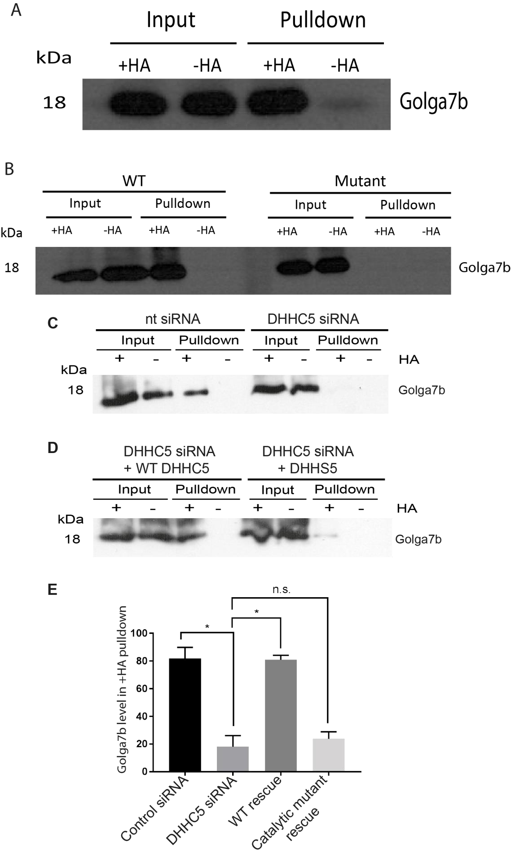

Figure 3.1: Golga7b is palmitoylated by DHHC5: A - ABE of Golga7b in whole mouse forebrain lysate. Presence of Golga7b signal in the +HA lane of the pulldown, but not in the –HA pulldown lane, shows that
Golga7b is palmitoylated in a neural environment, where DHHC5 is typically enriched. B - ABE assay of WT Golga7b and a mutant Golga7b that is unable to be palmitoylated (all cysteines in the sequence have been mutated to alanines) expressed in HeLa cells. Presence of Golga7b only in the pulldown lane of the +HA lane of the WT shows it is palmitoylated, while no presence in the corresponding lane of the mutant shows that this version of Golga7b cannot be palmitoylated. C - ABE assay of WT Golga7b expressed in HeLa cells treated with either non-targeting siRNA or DHHC5 siRNA. Loss of Golga7b signal in the +HA lane of the DHHC5 siRNA lane shows it is a DHHC5 substrate. D - ABE assay of WT Golga7b expressed in HeLa cells treated with DHHC5 siRNA and expressing siRNA resistant DHHC5 or catalytic mutant DHHS5 confirming Golga7b is a DHHC5 substrate. E – Quantification of blots from C and D, paired t-test, N=4. *=P<0.05, n.s.= not significant.
To follow this, we obtained a plasmid encoding mutant form of Golga7b where all cysteine residues in the protein sequence were mutated to alanines, which would prevent palmitoylation. When we expressed a WT construct in HeLa cells, it again showed that it was palmitoylated by the presence of the protein in the +HA lane and no signal in the –HA condition (Figure 3.1B). As expected, when the mutant construct was expressed in HeLa cells, no signal was seen in the +HA or –HA conditions despite its presence in the input for both of these, showing that removal of cysteine residues prevents Golga7b palmitoylation (Figure 1B).

To investigate whether DHHC5 is the PAT responsible for Golga7b palmitoylation, DHHC5 was depleted from HeLa cells using siRNA, the cells lysed and an ABE assay performed (Figure 1C).
A significant drop in palmitoylated Golga7b was seen (Figure 1B and E), demonstrating that Golga7b is a DHHC5 substrate. To fully confirm this, HeLa cells were depleted to DHHC5 with siRNA as before, but then either siRNA resistant WT DHHC5 or a catalytically inactive DHHS5 mutant were transfected into cells. When the WT was transfected in, palmitoylation of Golga7b was restored back to normal levels (Figure 1D and E), whereas the catalytic mutant was unable to do so (Figure 1D and E). This confirms that DHHC5 is the major PAT for Golga7b.
However, it is possible that it is not the only PAT capable of palmitoylating Golga7b as some residual palmitoylated Golga7b is present even when DHHC5 is depleted by siRNA, and other PATs could be responsible for this signal seen. Another possible explanation for this signal is that the siRNA does not remove all DHHC5 in the cells so there could be some low level palmitoylation by DHHC5 still present in cells.

To demonstrate Golga7b and DHHC5 are interaction partners, we performed immunoprecipitation experiments using a plasmid encoding a version of DHHC5 that was triple FLAG-tagged on its C-terminus (DHHC5-3xFLAG). DHHC5-3xFLAG was able to pulldown both the WT (Figure 3.2A) and mutant (Figure 3.2B) forms of Golga7b, showing that the palmitoylation of Golga7b is not essential for its interaction with DHHC5.
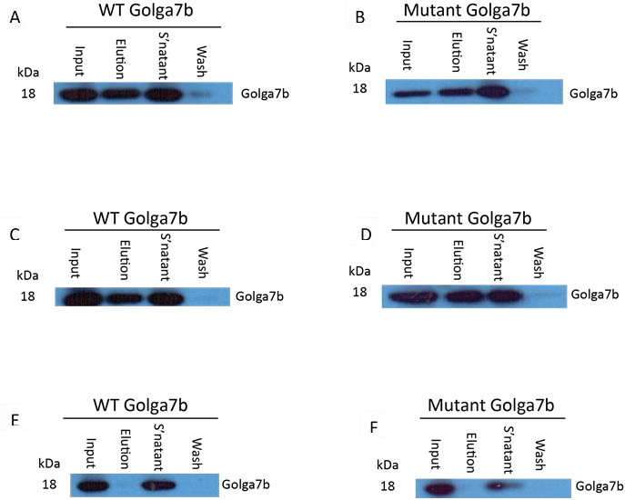

Figure 3.2: Palmitoylation of Golga7b is not required for interaction with DHHC5. A: Pulldown of HA-tagged WT golga7b construct by 3xFLAG-tagged DHHC5. There is a clear strong band in the “elution” lane, suggesting this interaction occurs. B: Pulldown of HA-tagged mutant golga7b construct, where all cysteines have been mutated to alanines, by 3xFLAG-tagged DHHC5. There is a clear strong band in the “elution” lane, suggesting that mutation of the cysteines in Golga7b does not affect DHHC5 binding. C: Pulldown of HA-tagged WT golga7b construct by FLAG-tagged catalytically inactive DHHS5. There is a clear strong band in the “elution” lane, suggesting this interaction occurs. This suggests that the catalytic activity of DHHC5 is not required for this interaction to take place. D: Pulldown of HA-tagged mutant golga7b construct, where all cysteines have been mutated to alanines, by FLAG-tagged DHHS5. There is a clear strong band in the “elution” lane showing that these proteins interact just as with the WT DHHC5 and mutant Golga7b. E: Pulldown of HA-tagged WT golga7b construct by FLAG-tagged DHHC5 that has the palmitoylation sites in the C-terminus mutated to alanines. There is no band in the elution, suggesting this interaction doesn’t occur and that the mutations in DHHC5 are affecting the ability of these two proteins to interact. F: Pulldown of HA-tagged mutant golga7b construct by FLAG-tagged DHHC5 that has the palmitoylation sites in the C-terminus mutated to alanines. There is no band in the elution, suggesting this interaction doesn’t occur, as is seen in E.

We extended the immunoprecipitations to investigate whether a pair of DHHC5 mutants could pull down Golga7b. We obtained a plasmid encoding a catalytically inactive form of DHHC5 where the cysteine in the catalytic tetrad was mutated to a serine (DHHS5), and we also obtained a mutant where the 3 sites of palmitoylation in the C-terminal tail of DHHC5 (Collins et al., 2017) were mutated to alanines (C-terminal mutant). DHHS5 was able to successfully pulldown both WT and mutant Golga7b showing that catalytic activity of DHHC5 is not required for its interaction with Golga7b (Figures 3.2C and D). However, the C-terminal mutant was unable to pull down either the WT or non-palmitoylatable mutant Golga7b (Figures 3.2E and F), which suggests that either palmitoylation of DHHC5 is important for the interaction with Golga7b to take place or that the mutations introduced into DHHC5 are affecting a structural component of DHHC5 that is essential for the interaction between Golga7b and DHHC5.

3.2 Golga7b can reverse over-expression induced mis-localisation of DHHC5

It has been noted in the past that over-expression of palmitoyl acyltransferases can cause a mislocalisation of these proteins (Hou et al., 2009). The reasons for this are not entirely clear, but there are a number of possibilities, including that the movement of PATs to, or the maintenance of PATs at, their final destination requires other factors or proteins that are not present in the cell in sufficient quantity when the PAT is over-expressed. As a result of this, we looked to investigate whether over-expression of DHHC5 would cause a localisation defect. We performed immunocytochemistry experiments on HeLa cells staining for either endogenous DHHC5 or over-expressed DHHC5 that was either tagged with hemagglutinin on the N-terminus or a triple FLAG-tag on the C-terminus. The signal from the endogenous protein was almost exclusively confined to the plasma membrane (Figure 3.3G–I and J), where DHHC5 has been reported before (Ohno et al., 2006; Li et al., 2010). When either the Nterminally or C-terminally tagged proteins were over-expressed in Hela cells it caused DHHC5 to not only be present at the plasma membrane but also in a number of compartments within the cell (Figures 3.3A-C and D–F, Figure 3.3J). This confirms that over-expression of DHHC5 does cause a mislocalisation of the protein compared to its endogenous location at the plasma membrane and it also suggests that altering the N- and C-terminus alone of DHHC5 does not affect the trafficking as there is no difference in location of the two tagged versions of DHHC5.
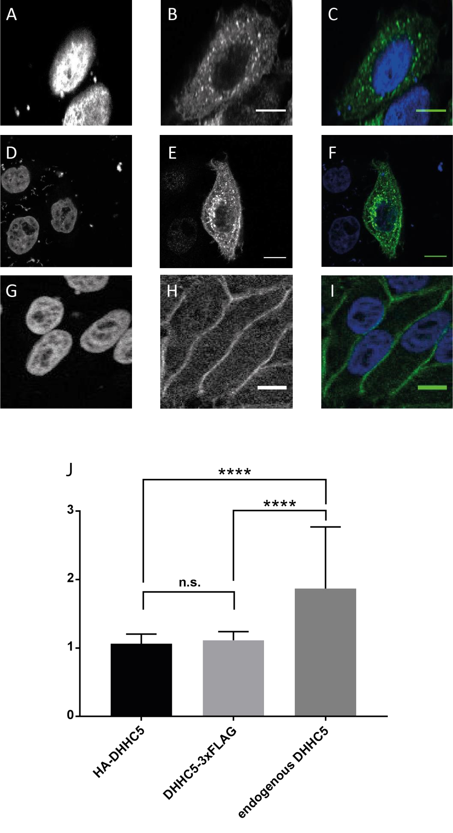
DAPI

D
HHC5

Merge

Level of
DHHC5

at Plasma Membrane

Figure 3.3: Overexpression of DHHC5 causes localisation defects. A – C: Confocal microscope images of overexpression of N-terminally HA tagged DHHC5 in HeLa cells. A: DAPI staining of cell nuclei. B: Anti-HA signal showing DHHC5. C: Merged image. These show that signal from the overexpressed DHHC5 is distributed throughout the cell. D – F: Confocal microscope images of overexpression of Cterminally 3xFLAG tagged DHHC5 in HeLa cells. D: DAPI staining of cell nuclei. E: Anti-FLAG signal showing DHHC5. F: Merged image. These show that signal from the overexpressed DHHC5 is distributed throughout the cell, with an almost identical distribution to the C-terminally tagged DHHC5 shown in A-C. G – I: Confocal microscope images of endogenous DHHC5 in HeLa cells. G: DAPI staining of cell nuclei. H: Staining of endogenous DHHC5. I: Merged image. These show that the majority of endogenous DHHC5 is present at the plasma membrane, where it is known to be resident, and contrasts the overexpressed proteins shown in A – C and D – F. J: Quantification of the membrane signal of HA-DHHC5 and DHHC5-3xFLAG overexpressions and endogenous DHHC5. HA-DHHC5, n=37. DHHC5-3xFLAG, n=29. Endogenous DHHC5, n=42. **** = p<0.0001, n.s. = not significant, two-tailed unpaired t-test with Welch’s correction. The membrane signal is calculated by the ratio of the means of the total cell fluorescence and the internal cell fluorescence. A higher ratio is indicative of a higher membrane signal. Graph is shown as mean + 1 s.e.m. All scale bars are 10µm.
We then investigated whether the sub-cellular location of DHHC5 could be influenced by coexpression with Golga7b. The related Golga7 is required for DHHC9 activity towards Ras (Swarthout et al., 2005) and a similar relationship was expected in this case, so little to no difference in DHHC5 localisation when co-expressed with Golga7b was the anticipated result.
However, when we co-expressed a C-terminally FLAG-tagged WT Golga7b plasmid with the N-terminally HA-tagged DHHC5 construct in HeLa cells and performed immunocytochemistry experiments followed by confocal imaging, it showed DHHC5 signal predominantly at the plasma membrane (Figure 3.4E – H and I), which was similar to endogenous DHHC5 (Figure
3.3G-I) and noticeably different to DHHC5 expressed alone (Figure 3.3A-C). This suggests that Golga7b is key in either establishing DHHC5 at the plasma membrane after its synthesis or that it is important in maintaining DHHC5 at the plasma membrane. Membrane association of DHHC5 was measured by a ratio of total cell fluorescence to internal cell fluorescence from confocal microscopy images from a slice through the approximatge centre of the cell.

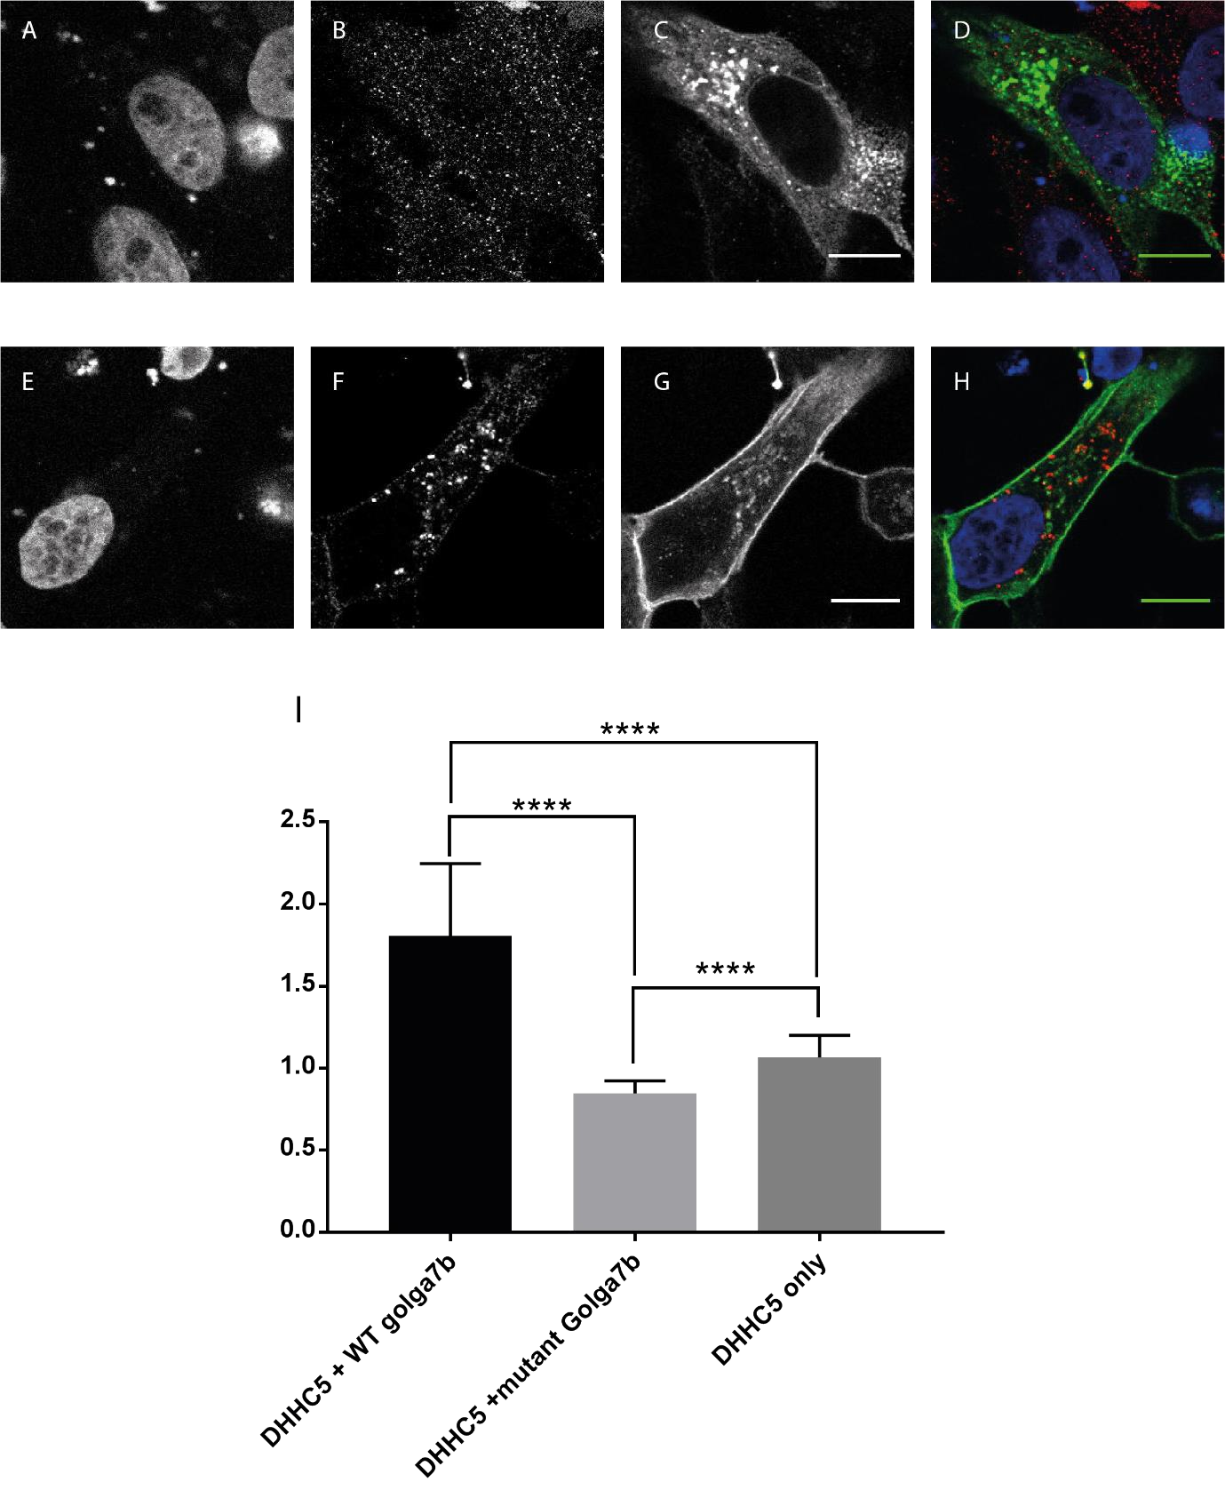
Level of
DHHC5

at Plasma Membrane

DAPI

Golga7b

D
HHC5

Merge

Figure 3.4: Co-expression of DHHC5 and Golga7b is able to reverse overexpression-induced DHHC5 mislocalisation. A – D: Confocal images of co-expression of N-terminally HA-tagged DHHC5 and Cterminally FLAG-tagged non-palmitoylatable Golga7b mutant in HeLa cells. A: DAPI staining of nuclei. B: Anti-FLAG staining of mutant Golga7b. C: Anti-HA staining of DHHC5. D: Merged image. This shows that DHHC5 is localised throughout the cell, with the majority being located within the cell, rather than at the membrane. E – H: Confocal images of co-expression of N-terminally HAtagged DHHC5 and C-terminally FLAG-tagged WT Golga7b mutant in HeLa cells. E: DAPI staining of nuclei. F: Anti-FLAG staining of WT Golga7b. G: Anti-HA staining of DHHC5. H: Merged image. This shows that DHHC5 is localised mainly at the plasma membrane with some signal within the cell. I: Quantificantion of plasma membrane signal of DHHC5 in the two conditions shown in A – D and E – H and also the HA-DHHC5 single over-expression shown in figure 3 A – C. This shows that the mutant Golga7b has less DHHC5 signal at the plasma membrane than the over expression. DHHC5 only, n=37. DHHC5 + mutant Golga7b, n=53. DHHC5 + WT Golga7b, n=49. **** = p<0.0001, two-tailed unpaired t-test with Welch’s correction. All scale bare are 10µm.

To build on this we wanted to find out if preventing palmitoylation of Golga7b would have any effect on localisation of DHHC5. To achieve this we co-expressed N-terminally HA-tagged
DHHC5 with the non-palmitoylatable mutant Golga7b which was C-terminally tagged with FLAG epitope in HeLa cells and subsequently performed immunocytochemistry and confocal microscopy. Under these conditions, DHHC5 was dramatically shifted away from the plasma membrane and was localised within the cell (Figure 3.4A – D and I). The mutant Golga7b caused more DHHC5 signal to be present within the cell than when DHHC5 was expressed alone, which points to a possible dominant negative effect of mutant Golga7b. If there was no dominant negative effect of the non-palmitoylatable mutant Golga7b, it would be expected that the endogenous Golga7b, which has not been knocked down in these experiments, would be able to cause DHHC5 signal to be in a similar location to when DHHC5 is expressed alone. Together with the results from the co-expression of the WT Golga7b and DHHC5, it shows that not only is Golga7b important for the correct localisation of DHHC5, but that palmitoylation of Golga7b appears to be essential for Golga7b to influence DHHC5 location in the correct manner.

This work was done in cells still expressing endogenous levels of DHHC5, so further experiments were carried out to investigate whether removal of endogenous DHHC5 by siRNA and then the addition of resistant plasmids containing DHHC5 co-transfected with either WT or mutant Golga7b. This showed no difference to when DHHC5 was not knocked down by siRNA, with WT Golga7b driving DHHC5 to the plasma membrane (Figure 3.5A) and mutant Golga7b leading to DHHC5 being present within the cell (Figure 3.5B). However, a caveat must be added to these experiments as it is impossible to know for certain if the cells that were expressing the tagged version of DHHC5 were fully depleted of endogenous DHHC5 as the antibody to detect DHHC5 cannot distinguish between the transfected and endogenous
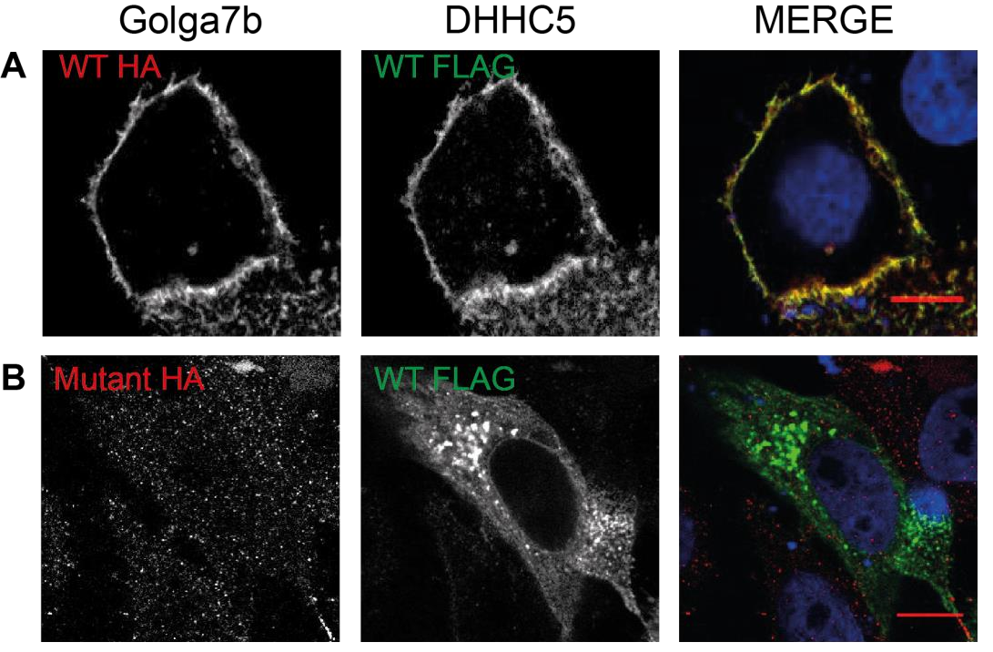
Figure 3.5: Depletion of endogenous DHHC5 doesn’t affect phenotypes seen with overexpression of DHHC5 when co-expressed with WT or mutant Golga7b.Left panel: HA tagged Golga7b, middle panel: FLAG tagged DHHC5, right panel: merged image including DAPI staining and left and middle panels A – Confocal images of HeLa cells treated with
DHHC5 siRNA then transfected with WT Golga7b and WT DHHC5. B - Confocal images of HeLa cells treated with DHHC5 siRNA then transfected with mutant Golga7b and WT DHHC5.
proteins. Given the lack of DHHC5 staining in other cells, it is likely, however, that the knockdown was efficient and similar in all cells.

As over-expression studies can cause a number of artefacts within cells and to further probe whether the mutant Golga7b can have a dominant negative effect on DHHC5 in the presence of endogenous Golga7b, we looked into the effects of WT and non-palmitoylatable mutant Golga7b on endogenous DHHC5 location within the cell. We over-expressed either WT or nonpalmitoylatable mutant Golga7b which were C-terminally FLAG-tagged in HeLa cells and again performed immunocytochemistry followed by confocal microscopy to investigate the location of DHHC5 within the cell. Expression of the WT Golga7b construct led to a small, but significant, increase in plasma membrane expression of endogenous DHHC5 (Figure 3.6E–H and I), suggesting that WT golga7b is able to drive DHHC5 to the plasma membrane, which matches the effect of WT golga7b on over-expressed DHHC5 (Figure 3.4E-H).

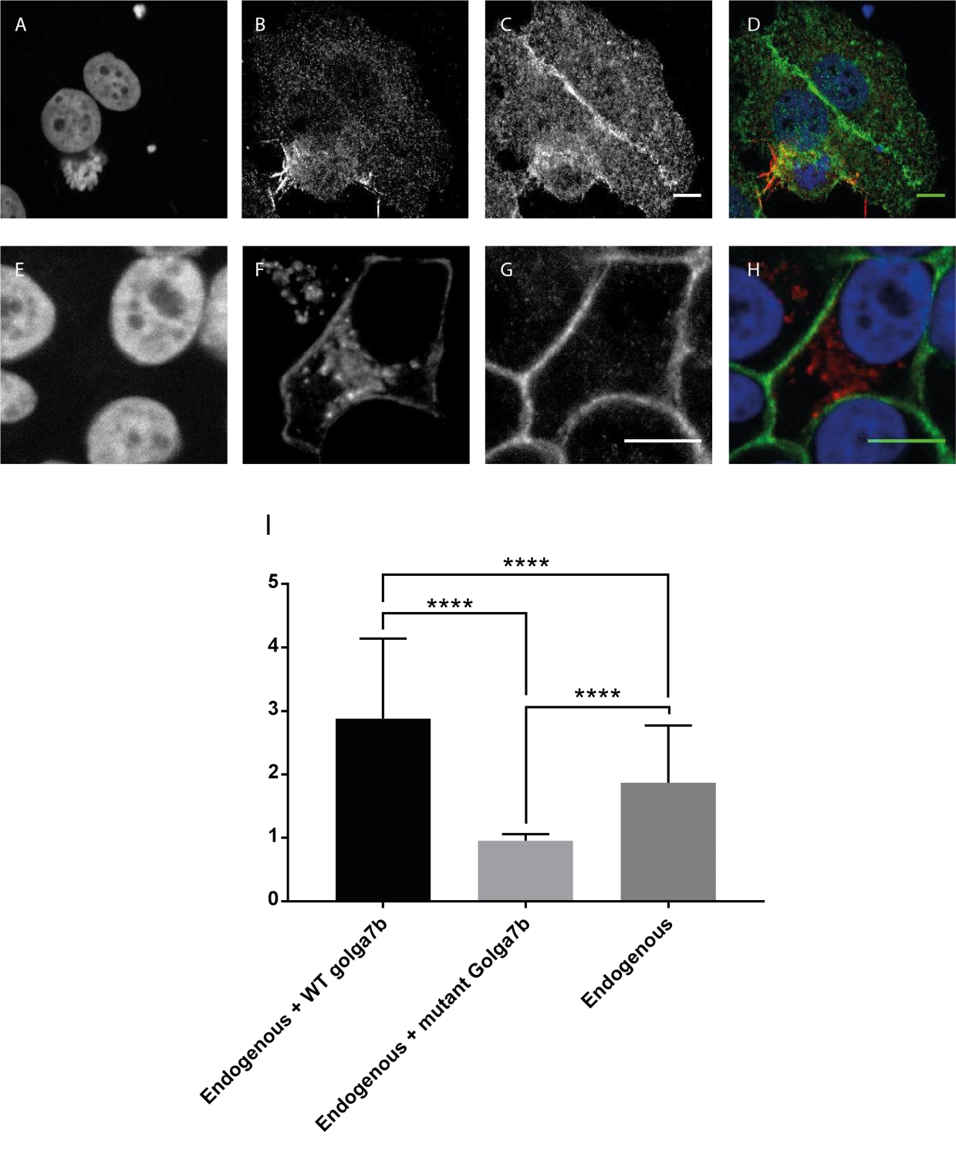
Level of
DHHC5

at Plasma Membrane

DAPI

Golga7b
DHHC5

Merge

***

In contrast to this, expression of the non-palmitoylatable mutant Golga7b in HeLa cells led to endogenous DHHC5 being localised away from the plasma membrane, with the majority of
Figure 3.6: Golga7b is able to alter the location of endogenous DHHC5. A – D: Confocal images of expression of C-terminally FLAG-tagged non-palmitoylatable mutant Golga7b in HeLa cells. A: DAPI staining of nuclei. B: Anti-FLAG staining of mutant Golga7b. C: Endogenous DHHC5. D: Merged image. This shows that when mutant Golga7b is over-expressed, DHHC5 signal is found throughout the cell. E – H: Confocal images of expression of C-terminally FLAG-tagged WT Golga7b in HeLa cells. E: DAPI staining of nuclei. F: Anti-FLAG staining of WT Golga7b. G: Endogenous DHHC5. H: Merged image. This shows that when WT Golga7b is expressed in HeLa cells DHHC5 signal is almost exclusively seen at the plasma membrane. I: Quantificantion of the membrane signal of DHHC5 in E – H (first bar of graph), A – D (second bar of graph) or figure 3 G – I (third lane of graph). Endogenous + WT golga7b, n = 37. Endogenous + mutant golga7b, n = 23. Endogenous, n = 42. **** = p<0.0001, ***=p<0.001, ANOVA. All scale bars 10µm.
DHHC5 signal being present within the cell (Figure 6A–D and I). This further supports the hypothesis that palmitoylation of Golga7b is important for the correct localisation of DHHC5 and its maintenance at the plasma membrane.

If Golga7b is necessary for DHHC5 to be present at the plasma membrane and if insufficient Golga7b when DHHC5 is overexpressed alone is the reason for the mislocalisation of DHHC5 in this condition then we hypothesised that reducing the level of Golga7b in HeLa cells would lead to DHHC5 being mislocalised. To achieve this, we knocked down Golga7b using siRNA in HeLa cells and performed immunocytochemistry and confocal microscopy staining for DHHC5. Upon knockdown of Golga7b, DHHC5 was again localised away from the plasma membrane in areas within the cell (Figure 3.6 E-H). This result supports our hypothesis that the presence of Golga7b is essential for the correct localisation of DHHC5 and that insufficient levels of Golga7b within the cell lead to a mislocalisation of DHHC5.

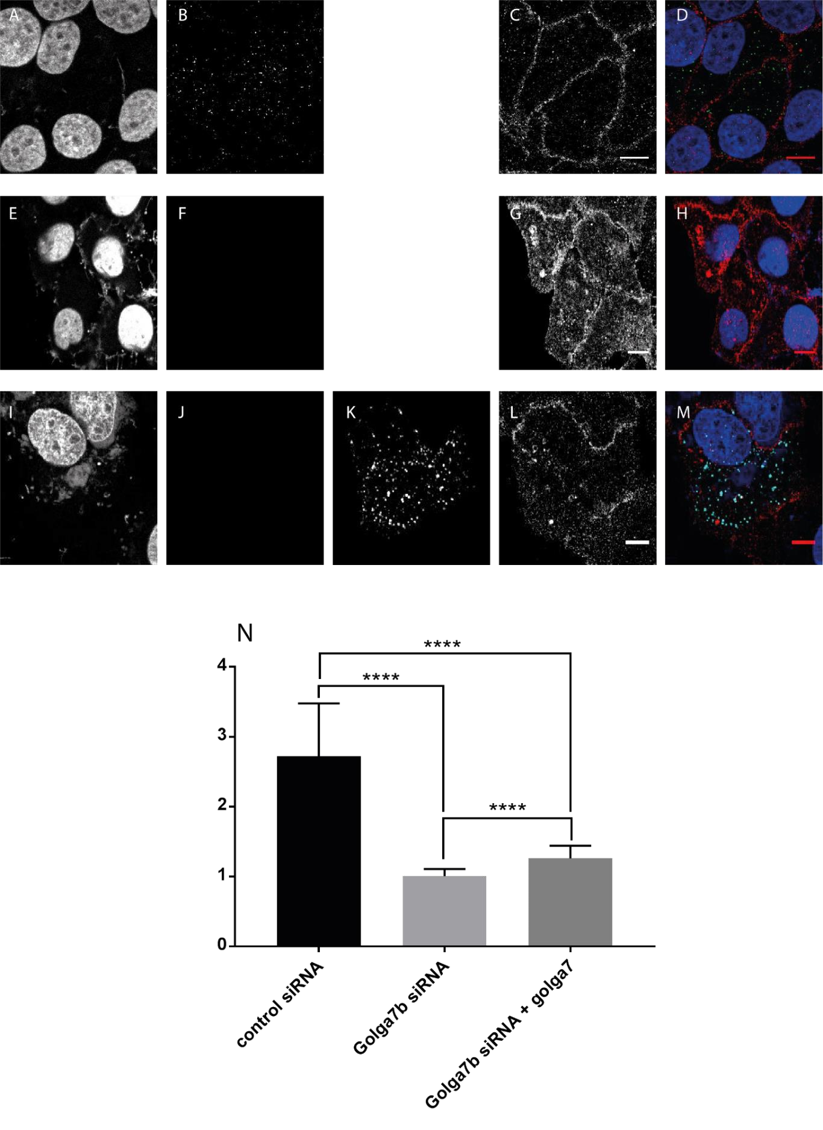
Level of
DHHC5

at Plasma Membrane

DAPI

Golga7b

D
HHC5

Merge

Golga7

*

Figure 3.7: Golga7b knockdown causes a mislocalisation of DHHC5 that is not rescued by overexpression of Golga7 in HeLa cells. A – D: Confocal images of endogenous DHHC5 and Golga7b in HeLa cells. A: DAPI staining of nuclei. B: Endogenous Golga7b. C: Endogenous DHHC5. D: Merged image. DHHC5 is in red, Golga7b in green and DAPI in blue. These images show that the majority of DHHC5 signal is found at the plasma membrane. E – H: Confocal images of HeLa cells treated with 20nM Golga7b siRNA. E: DAPI staining of nuclei. F: Endogenous Golga7b. G: DHHC5 signal. H: Merged image. DHHC5 is in red, Golga7b in green and DAPI in blue. This shows that knocking down Golga7b causes a significant portion of DHHC5 signal to be localised away from the plasma membrane. I – M: Confocal images of HeLa cells treated with 20nM Golga7b siRNA transfected with C-terminally FLAG-tagged Golga7. I: DAPI staining of nuclei. J: endogenous Golga7b. K: Anti-FLAG staining of Golga7. L: Endogenous DHHC5. M: Merged image. DHHC5 is in red, Golga7b in green, Golga7 in cyan and DAPI in blue. This shows that there is a significant portion of DHHC5 signal within the cell. N: Quantification of membrane signal of DHHC5 in each condition. Control siRNA, n = 23. Golga7b siRNA, n = 23. Golga7b siRNA + golga7, n = 27. **** = p<0.0001, *=p<0.05, ANOVA. All scale bars 10µm.

Given that Golga7b is closely related to the DHHC9 co-factor Golga7, also known as GCP16 (Swarthout et al., 2005), it was important to discover if Golga7 could have a similar reversal effect on the localisation of over-expressed DHHC5 as Golga7b. We co-expressed a Cterminally FLAG-tagged Golga7 with the N-terminally HA-tagged DHHC5 in HeLa cells and performed immunocytochemistry and confocal microscopy. Co-expressing Golga7 and DHHC5 caused a phenotype of DHHC5 plasma membrane signal (Figure 3.7A-D) that was between that of DHHC5 over-expressed alone (Figure 3.3A-C, Figure 3.7N) and DHHC5 coexpressed with WT Golga7b (Figure 3.4 E-H, 3.7N). This suggests that while Golga7 expression does cause more DHHC5 to be present at the plasma membrane than when DHHC5 is expressed alone, it does not influence plasma membrane expression of DHHC5 to the extent of Golga7b (Figure 8E). This suggests that while other proteins may allow a partial rescue of the over-expression induced mislocalisation of DHHC5, it appears that sufficient levels of Golga7b in the cell are needed for full rescue of this phenotype and plasma membrane localisation of DHHC5.

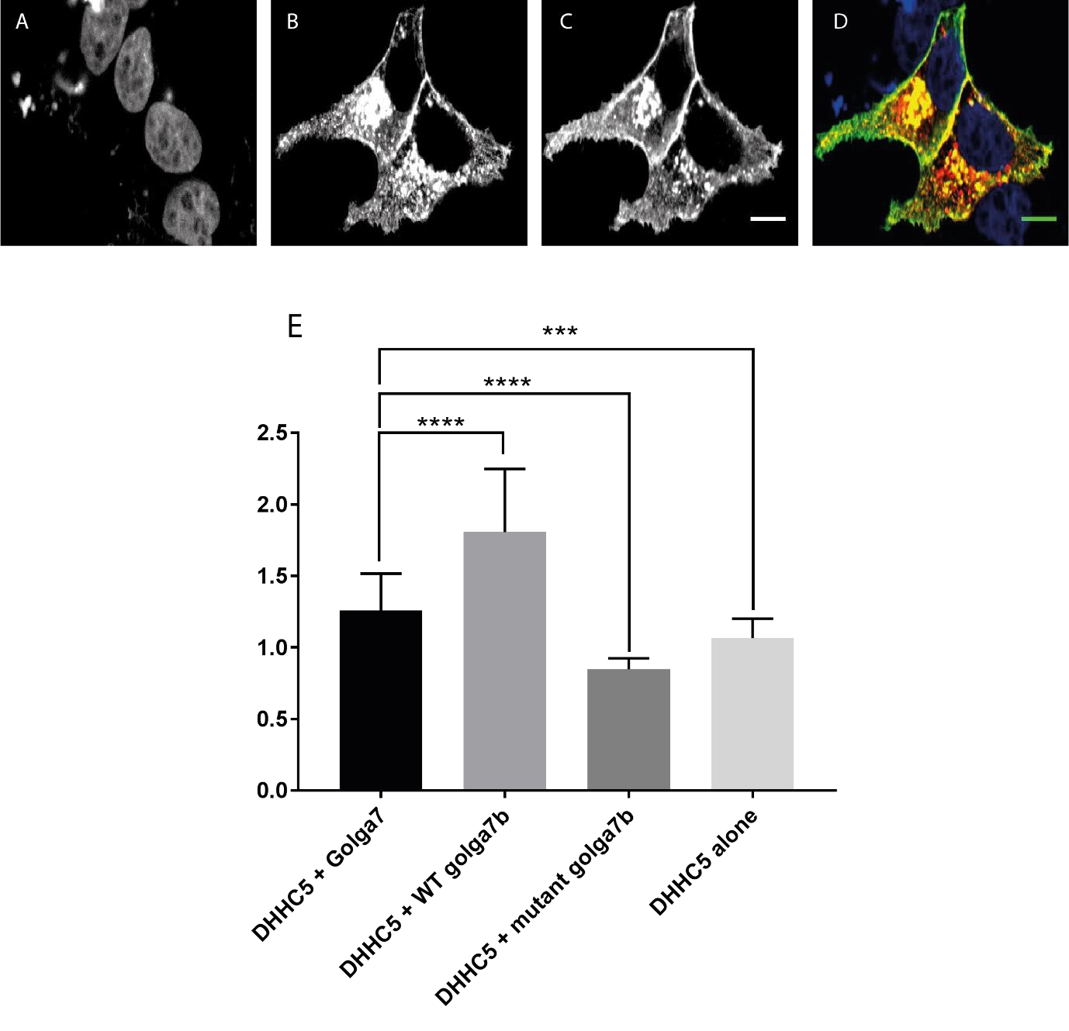
Level of
DHHC5

at Plasma Membrane

DAPI

Golga7
DHHC5

Merge

***

Figure 3.8: Golga7 is unable mimic the effects of Golga7b when DHHC5 is over-expressed. A – D: Confocal images of co-expression of HA-DHHC5 and C-terminally FLAG-tagged Golga7 in HeLa cells. A: DAPI staining of nuclei. B: Anti-FLAG staining Golga7. C: Anti-HA staining DHHC5. D: Merged image. This shows that while some DHHC5 signal is present at the plasma membrane, there is still a significant portion of DHHC5 fluorescence seen within the cell. E: Quantification of membrane signal of DHHC5 over-expression when expressed alone (HA-DHHC5, Figure 3A – C) or with Golga7, WT Golga7b (Figure 4E – H) or mutant Golga7b (Figure 4A – D). ***=p<0.001, ****=p<0.0001, ANOVA. DHHC5 + Golga7, n = 27. DHHC5 + WT Golga7b, n=49. DHHC5 + mutant Golga7b, n=53. DHHC5 only, n=37. All scale bars 10µm.

As has been mentioned previously, over-expression studies of PATs can cause artefacts, so in order to have a more specific assay of the effects of Golga7 on DHHC5 location we reduced the levels of Golga7b in HeLa cells with siRNA as performed previously, but we then overexpressed a C-terminally FLAG-tagged version of Golga7 and looked at DHHC5 location in the cell using immunocytochemistry and confocal microscopy. Expression of Golga7 in Golga7b siRNA HeLa cells made a small, but significant, increase in plasma membrane signal of DHHC5 compared to cells without Golga7 (Figures 3.7I-M, N), but the level of plasma membrane signal of DHHC5 was still far below that of cells that were treated with a non-targeting siRNA (Figures 3.7A-D, N). This supports the results found previously when Golga7 was able to partially restore the phenotype of DHHC5 location seen when DHHC5 was over-expressed, and also supports that Golga7b appears to have a unique role in maintenance and control of DHHC5 location within the cell.

3.3 Catalytic activity is not required for effects of Golga7b on DHHC5, but

palmitoylation of the C-terminal tail is

As was shown earlier, mutation of the catalytic cysteine of DHHC5 to a serine made no difference to its interaction with either WT Golga7b or the non-palmitoylatable mutant Golga7b (Figure 2C and D). However, when the palmitoylation sites in the C-terminal tail of
DHHC5 were mutated, DHHC5 was no longer able to interact with either WT or mutant Golga7b (Figure 2E and F). Given these results, we decided to investigate whether WT and mutant Golga7b could lead to the same phenotypes of DHHC5 location within the cell when co-expressed with either of these two DHHC5 mutants.

We began by co-expressing the catalytically inactive DHHS5 which was FLAG tagged on the Cterminus with either WT or non-palmitoylatable mutant Golga7b which were both HA-tagged on the C-terminus in HeLa cells and performing immunocytochemistry followed by confocal microscopy as before. It was hypothesised that the mutant Golga7b would have a similar effect on DHHS5 location as DHHC5, but it was unknown if the WT Golga7b would be able to cause DHHS5 to be located at the plasma membrane as it is possible that WT Golga7b required palmitoylation by DHHC5 in order for it to function in terms of its control DHHC5 location, and the DHHS5 mutant would be unable to palmitoylate Golga7b. When DHHS5 was overexpressed alone, the signal was seen throughout the cell (Figure 3.9A-C, L), similar to when DHHC5 was over-expressed (Figure 3.3B, C). Co-expression of DHHS5 and WT Golga7b did cause the DHHS5 signal to be localised significantly more at the plasma membrane (Figure
8D-G, L), which again mirrored what was seen with DHHC5 and WT Golga7b (Figure 4G, H). When DHHS5 was co-expressed with the non-palmitoylatable mutant Golga7b, it again followed the phenotype seen when the WT DHHC5 was co-expressed with mutant Golga7b (Figure 4C, D), with the DHHS5 signal being present mainly within the cell and away from the plasma membrane (Figure 3.9H-K, L).

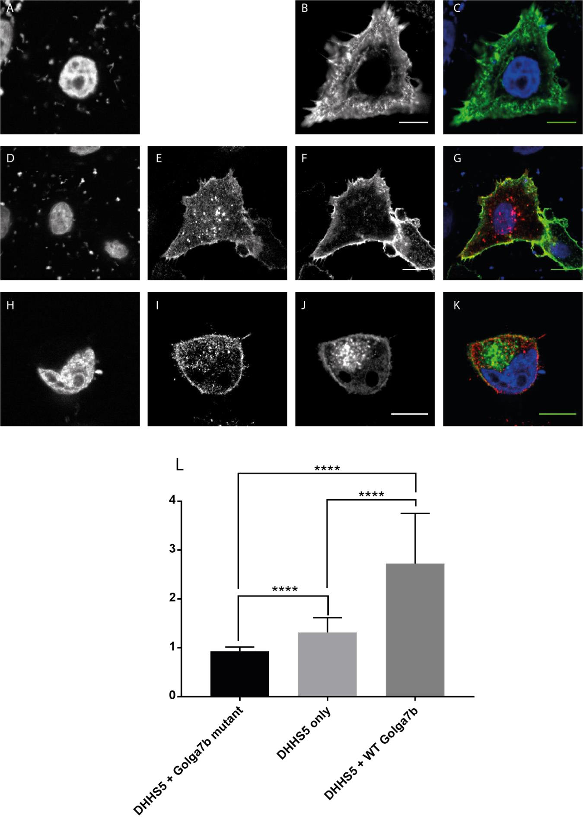
Level of
DHHC5

at Plasma Membrane

DAPI

Golga7b

DHHS5

Merge

**

Figure 3.9: Effects of over-expression and WT or mutant Golga7b are not affected by DHHC5 catalytic activity. A – C: Confocal images of over-expression of a C-terminally FLAG-tagged catalytically inactive version of DHHC5 (DHHS5) in HeLa cells. A: DAPI staining of nuclei. B: Anti-FLAG staining of DHHS5. C: Merged image. This shows that over-expressing a catalytically inactive form of DHHC5 shows a similar pattern to the WT form of DHHC5 with the signal seen throughout the cell. D – G: Co-expression of DHHS5 and a C-terminally HA-tagged WT Golga7b in HeLa cells. D: DAPI staining of nuclei. E: Anti-HA staining of WT Golga7b. F: Anti-FLAG staining of DHHS5. G: Merged image. This shows that WT golga7b expression shows the same effect on DHHS5 as it does on WT DHHC5 with the majority of DHHS5 signal being seen at the plasma membrane. H – K: Confocal images of DHHS5 co-expressed with a C-terminally HA-tagged mutant Golga7b in HeLa cells. H: DAPI staining of nuclei. I: Anti-HA staining of mutant Golga7b. J: Anti-FLAG staining of DHHS5. K: Merged image. This shows that mutant golga7b expression shows the same effect on DHHS5 as it does on WT DHHC5 with the majority of DHHS5 signal being seen within the cell rather than at the plasma membrane. M: Quantification of plasma membrane signal of DHHS5 when expressed alone or with WT or mutant Golga7b in HeLa cells. DHHS5 only, n=18. DHHS5 + mutant Golga7b, n=28. DHHS5 + WT Golga7b, n=40. **** = p<0.0001, **=p<0.01 ANOVA. All scale bars are 10µm.
We then investigated the effects of WT or mutant Golga7b on the DHHC5 mutant with the Cterminal palmitoylation sites mutated (C-terminal mutant). As the C-terminal DHHC5 mutant is unable to interact with either the WT or mutant Golga7b (Figure 3.2E, F), we thought it was unlikely that Golga7b would be able to influence the location of the C-terminal DHHC5 mutant. When the DHHC5 C-terminal mutant was over-expressed alone in HeLa cells, confocal microscopy showed that almost all of the signal was at the plasma membrane (Figure 3.10AC), which is in contrast to both WT DHHC5 (Figure 3.3B, C) and the DHHS5 catalytic mutant (Figure 3.9B, C) where the signals were present throughout the cell. When the C-terminal mutant was co-expressed with WT Golga7b, the DHHC5 C-terminal mutant signal was again seen at the plasma membrane, with no significant difference to when it was expressed alone (Figure 3.10D-G). Finally, when the C-terminal mutant was co-expressed with the nonpalmitoylatable mutant Golga7b, it again showed no difference in the location of DHHC5 signal with almost all of it being at the plasma membrane (Figure 3.10H-K). Given that the Cterminal mutant can’t interact with either version of Golga7b, the fact that Golga7b has no effect on its location is not surprising. However, it is interesting that the location of the Cterminal mutant is at the plasma membrane even when expressed alone, which is in contrast to the locations of both the WT DHHC5 and the catalytically inactive DHHS5 mutant when they are over-expressed. These results suggest that the DHHC5 C-terminal mutant is constitutively trafficked to the plasma membrane, which makes it possible that all versions of DHHC5 are constitutively trafficked to the plasma membrane where the lack of Golga7b leads to at least a portion DHHC5 being endocytosed. It also points to the fact that either the palmitoylation of the DHHC5 C-terminal tail or a secondary structure element that is disrupted by the mutation of the three cysteine residues is needed for the internalisation of DHHC5 and removing this effectively traps DHHC5 at the plasma membrane.

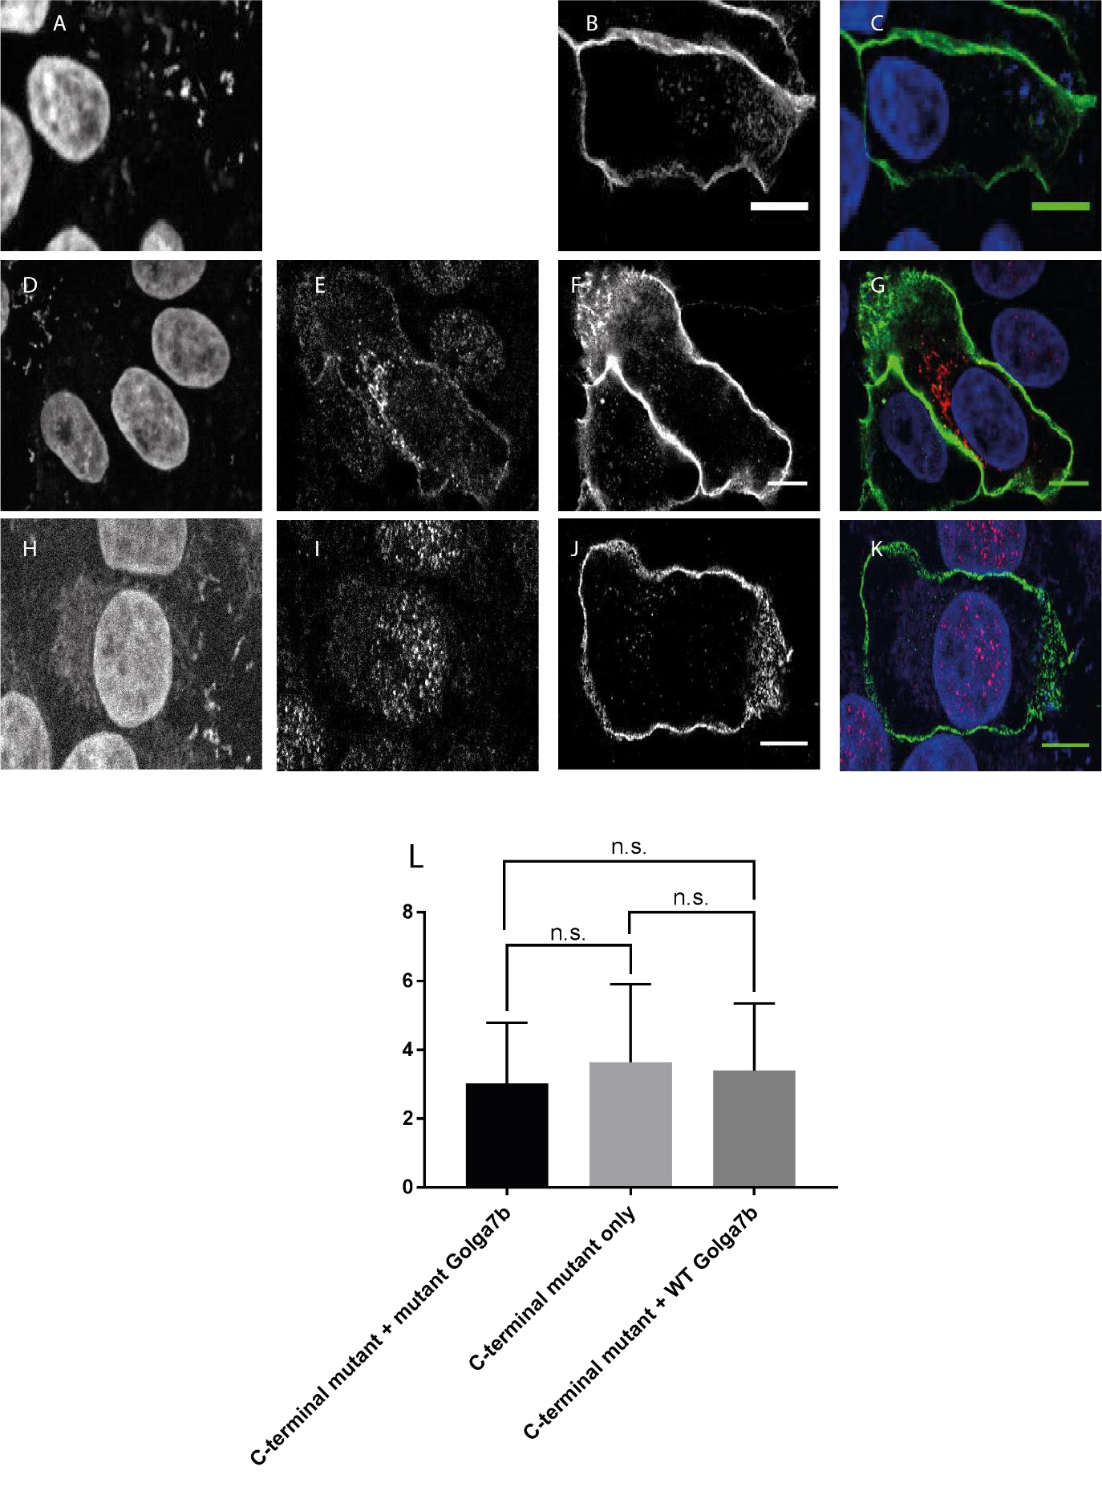
Level of
DHHC5

at Plasma Membrane

DAPI

Golga7b

C
-
term
mutant

Merge

Figure 3.10: Effects of Golga7b are nullified when the C-terminal palmitoylation sites of DHHC5 are mutated. A – C: Confocal images of over-expression of a C-terminally FLAG-tagged version of DHHC5 where the palmitoylation site in the C-terminal tail have been mutated (C-terminal mutant) in HeLa cells. A: DAPI staining of nuclei. B: Anti-FLAG staining of C-terminal mutant. C: Merged image. This shows that over-expressing the C-terminal mutant causes a different pattern of DHHC5 signal compared to WT DHHC5 and DHHS5 with the majority of the signal at the plasma membrane. D – G: Co-expression of C-terminal mutant and a C-terminally HA-tagged WT Golga7b in HeLa cells. D: DAPI staining of nuclei. E: Anti-HA staining of WT Golga7b. F: Anti-FLAG staining of C-terminal mutant. G: Merged image. This shows that WT golga7b expression does not change the signal pattern of the C-terminal mutant with almost all of the signal being found at the plasma membrane. H – K: Confocal images of the C-terminal mutant co-expressed with a C-terminally HA-tagged mutant Golga7b in HeLa cells. H: DAPI staining of nuclei. I: Anti-HA staining of mutant Golga7b. J: Anti-FLAG staining of C-terminal mutant. K: Merged image. This shows that mutant golga7b has no effect on the location of the C-terminal mutant with most of the signal being at the plasma membrane. M: Quantification of plasma membrane signal of C-terminal mutant when expressed alone or with WT or mutant Golga7b in HeLa cells. C-terminal mutant only, n=45. C-terminal mutant + mutant Golga7b, n=31. C-terminal mutant + WT Golga7b, n=42 n.s. = not significant, two-tailed unpaired ttest with Welch’s correction. All scale bars are 10µm.

As with the work done on WT DHHC5 and the effects of Golga7b on its localisation, these experiments on both the catalytic and C-terminal mutants were done with a background of endogenous DHHC5 still present in the HeLa cells. To address whether the removal of endogenous DHHC5 would alter how WT or mutant Golga7b would affect either of these
DHHC5 mutants. No change was seen in the C-terminal mutant, with essentially all of the DHHC5 signal being seen at the plasma membrane when co-expressed with both WT and mutant Golga7b. In contrast to this, the localisation of the catalytic mutant DHHS5 was dramatically changed when endogenous DHHC5 was depleted by siRNA, with a significant portion of the DHHS5 signal seen within the cell when co-expressed with WT or mutant Golga7b. While there was significantly more DHHS5 at the plasma membrane when coexpressed with WT Golga7b, this could be due to there being some endogenous DHHC5 still present within the cell or compensation by another PAT, as some palmitoylation of Golga7b when DHHC5 is depleted with siRNA and the catalytic mutant DHHS5 added (Figure 3.1b). This shows that palmitoylation of Golga7b by DHHC5 stabilises DHHC5 at the plasma membrane.
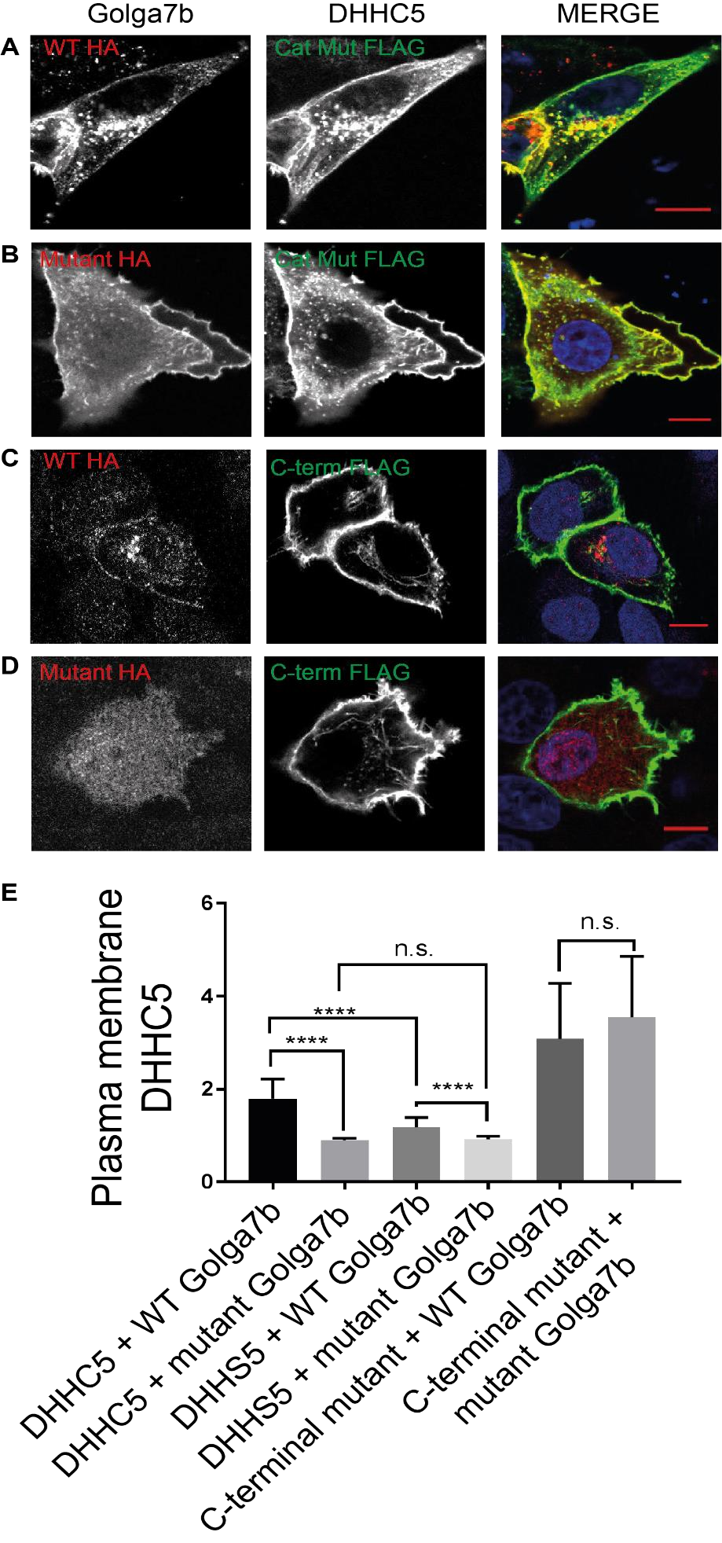
**

*

Figure 3.11: Palmitoylation of Golga7b by DHHC5 stabilises DHHC5 at the plasma membrane. Left panel: HA tagged Golga7b, middle panel: FLAG tagged DHHC5, right panel: merged image including DAPI staining and left and middle panels A – Confocal images of HeLa cells treated with DHHC5 siRNA then transfected with WT Golga7b and catalytic mutant DHHS5. B - Confocal images of HeLa cells treated with DHHC5 siRNA then transfected with mutant Golga7b and catalytic mutant DHHS5. C – Confocal images of HeLa cells treated with DHHC5 siRNA then transfected with WT Golga7b and C-terminal mutant DHHC5. D - Confocal images of HeLa cells treated with DHHC5 siRNA then transfected with mutant Golga7b and C-terminal mutant DHHC5. E – Quantification of plasma membrane signal of the data presented here and from figure 5. ****=p<0.0001, **=p<0.01, *=p<0.05 ANOVA DHHC5 + WT Golga7b, n = 49. DHHC5 + mutant Golga7b, n=53. DHHS5 + WT Golga7b, n=30. DHHS5 + mutant Golga7b, n=28. C-terminal mutant + WT Golga7b, n = 31. C-terminal mutant + mutant Golga7b, n=45. All scale bars 10µm.

The idea that palmitoylation of the DHHC5 C-terminal is important in regulating the localisation of this protein is further supported by treating HeLa cells expressing WT Golga7b with either the catalytically inactive DHHS5, the C-terminal mutant or endogenous DHHC5 with the depalmitoylation inhibitor palmostatin B. Palmostatin B treatment causes a significant portion both endogenous DHHC5 (Figure 3.12A) and the catalytic mutant (Figure 12B) to be moved away from the plasma membrane and into regions within the cell, despite the presence of over-expressed WT Golga7b in the cells. When HeLa cells co-expressing WT Golga7b and the C-terminal DHHC5 mutant were treated with palmostatin B, there was no change in the localisation of the C-terminal mutant (Figure 3.12C) which makes it likely that the effects of palmostatin B on DHHC5 localisation are caused by an increase in palmitoylation of the C-terminal tail of DHHC5. This is a single replicate experiment so would need to be repeated for this conclusion to be drawn with any confidence and the palmitoylation state of DHHC5 in all conditions would need to confirmed.

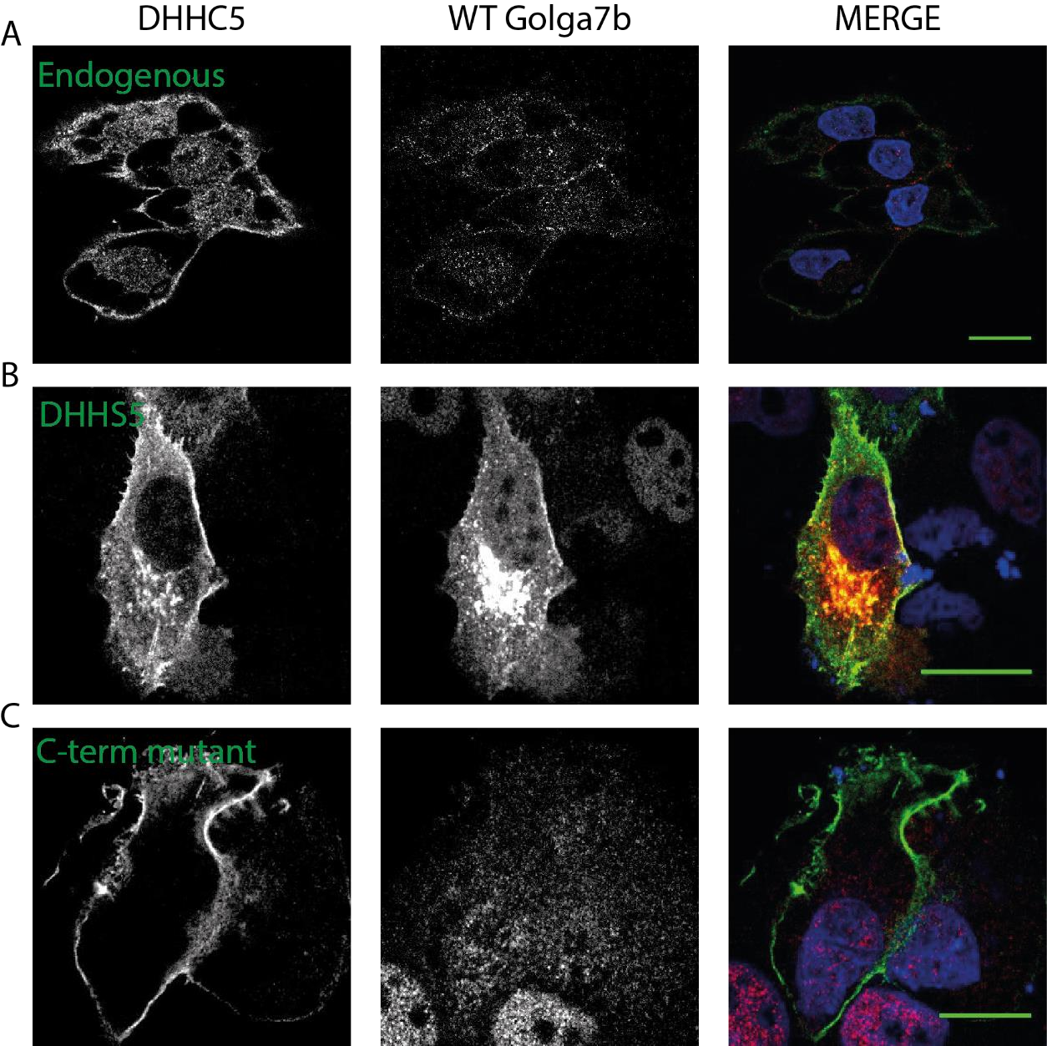
Figure 3.12: Increasing palmitoylation of DHHC5 induces its internalisation. Left panel:
DHHC5. Middle panel: Golga7b WT. Right panel: merged image including DAPI staining. A – Confocal images of HeLa cells stained for endogenous DHHC5 and ectopically expressed WT Golga7b. B - Confocal images of HeLa cells stained for co-expressed DHHS5 catalytic mutant and WT Golga7b. C - Confocal images of HeLa cells stained for co-expressed C-terminal mutant DHHC5 and WT Golga7b. All cells treated with palmostatin B at 100nM for 18 hours. Representative images.

3.4 Discussion

The initial hypothesis was that Golga7b was likely to be an essential co-factor of DHHC5 so that it could palmitoylate one or more of its substrates, much like the relationship between DHHC9 and Golga7 (Swarthout et al., 2005), but this work showed that Golga7b instead has a profound effect on the location of DHHC5 within the cell that appears to be linked to the palmitoylation of Golga7b. However, it is still possible that Golga7b fulfils a role similar to that of Golga7 in the activity and action of DHHC5 and this possibility would need to be
investigated further to definitively rule it out.

The movement of DHHC5 around the cell, from the plasma membrane to internal compartments, has been documented in neurons and shown to be essential for it to palmitoylate at least one of its substrates (Brigidi et al., 2015). This work suggests that maintenance of DHHC5 at the plasma membrane in non-specialised cells involves a different regulation event with Golga7b an essential factor, as opposed to the phosphorylation recorded in neurons (Brigidi et al., 2015). As has been demonstrated in the results above, Golga7 is unable to compensate for the loss of Golga7b despite the proteins being closely related (78% identity as measured by BLAST-P, blast.ncbi.nlm.nih.gov/Blast.cgi). While it has been shown in neurons that other proteins and post-translational modifications are needed to keep DHHC5 at the plasma membrane and prevent internalisation (Brigidi et al., 2015), these results suggest that DHHC5 localisation is controlled at least in part specifically by Golga7b rather than being a general effect of a group of related proteins, and more precisely by the ability of Golga7b to be palmitoylated. The human protein atlas (proteinatlas.org) shows that Golga7b is expressed in all tissue types which could mean that this mechanism of DHHC5 location control could take place in many different cell types throughout the body. This work does not rule out a phosphorylation event being involved in the maintenance of DHHC5 at the plasma membrane, but given that the complex present in neurons involves synaptic specific components, it is unlikely to involve exactly the same mechanism in other cell types.

The fact that over-expressing WT Golga7b, which is palmitoylated in both HeLa cells and mouse forebrain, is able to cause DHHC5 to be located at the plasma membrane, while removing the ability for Golga7b to be palmitoylated causes a dramatic shift in DHHC5 location to compartments within the cell suggests that the palmitoylation of Golga7b by DHHC5 could be vital in its regulation of DHHC5 location. However, it must be mentioned that it is possible that mutation of Golga7b could result in a change in the structure or interactions of Golga7b that result in the phenotype observed.

The loss of interaction between Golga7b and DHHC5 when the 3 palmitoylation sites in the Cterminal tail and the subsequent phenotype of this mutants location in HeLa cells both with and without Golga7b does suggest a number of possible roles for the palmitoylation of this region of DHHC5. Together the results suggest that this region is not required for correct trafficking of DHHC5 to the plasma membrane as this mutant is present at the plasma membrane which means that other factors or regions of the protein are required for this process.
The results that interaction with WT Golga7b appears to be necessary to maintain DHHC5 at the plasma membrane and that the C-terminal mutant, which does not interact with Golga7b, is always present at the plasma membrane appear to be in conflict with one another. However, the results presented here show that palmitoylation of DHHC5 is required for it to be internalised which makes it possible that palmitoylation of Golga7b functions to protect Cterminally palmitoylated DHHC5 from endocytosis and that the C-terminal mutant, while being unable to interact with Golga7b, is unable to be internalised because it is not palmitoylated on its C-terminal. This hypothesis suggest that palmitoylation of the C-terminal tail of DHHC5 is an endocytic trigger for the protein.

4 The interactions of DHHC5 reveal roles in a number of processes and uncovers novel potential regulators

DHHC5 has a PDZ binding domain which is known to have a role in its interaction with the synaptic protein PSD-95 (Li et al., 2010). While DHHC5 does not palmitoylate PSD-95 (Fukata et al., 2004), PSD-95 is important for maintaining DHHC5 at the post-synaptic density (Brigidi et al., 2015). What effect the removal of the PDZ binding domain of DHHC5 would have on the maintenance of DHHC5 at the post-synaptic density is unknown, although it would be expected to disrupt this interaction and lead to an internalisation of DHHC5.

It has been demonstrated in the past that DHHC5 can successfully and stably pulldown its substrate phospholemman (Howie et al., 2014). This work also defined the area of the Cterminal of DHHC5 that was essential for the interaction between it and phospholemman, and found that this area was immediately C-terminal to the fourth and final transmembrane domain in the long, unstructured C-terminal tail, independent of its PDZ binding domain. This stable interaction between DHHC5 and one of its substrates opens up interaction based strategies as a possible way to find potential DHHC5 substrates as well as regulators and other interactors. This area was also implicated in the interaction between DHHC5 and Golga7b as has been shown in a previous chapter when the region was mutated to prevent
palmitoylation of three cysteine residues in this area.
As detailed above, DHHC5 does not only interact with proteins with its PDZ binding domain, but at areas throughout its c-terminal tail. This is also true for the interaction between DHHC5 and the AP2 at the post synaptic density which mediates the internalisation of DHHC5 and subsequent palmitoylation of δ-catenin (Brigidi et al., 2015). This interaction is prevented by phosphorylation of DHHC5 by Fyn kinase on tyrosine 533, which also interacts with another different site in the C-terminal of DHHC5. Fyn kinase was shown to interact with an SH3 domain, so there are multiple recognisable protein interaction domains in the tail of DHHC5. This shows that DHHC5 interacts with both substrates and regulating proteins along the length of its C-terminal tail in diverse regions.

This work looks to discover the breadth of proteins that DHHC5 interacts with, and how its localisation, which has been shown here to be controlled by palmitoylation of the accessory protein Golga7b, can alter its interactions. These interactions could reveal novel processes DHHC5 is involved with, new regulating proteins and potential substrates.

4.1 Cell type selection

Before collecting replicate controlled repeats of DHHC5 pulldowns in a cell line, three different cell types were investigated with a pulldown of C-terminally triple FLAG tagged DHHC5 over-expressed in HEK293, HeLa and nsc34 cell lines. These cell lines were chosen for a number of reasons. HEK293 cells were selected due to their ease of transfection which usually occurs at relatively high efficiencies and the high production of transfected proteins in this cell type (Thomas & Smart, 2005). HeLa cells were chosen as much of the previous work on DHHC5 presented here had been performed in these cells, so any results could be linked to previous results. HeLa cells are also known to be easy to transfect and produce high levels of protein (Nikcevic et al., 2003). Nsc34 cells are a hybrid of neural blastoma and spinal cord cells fused to create a neural-like cell line (Cashman et al., 1992). As DHHC5 has a number of roles in the neural setting (Li et al., 2012; Thomas et al., 2012; Brigidi et al., 2014; Brigidi et al., 2015) it was reasoned that looking at the interactions of DHHC5 in nsc34 cells would give an insight into some of these important processes.

In all cases, DHHC5 was transfected into the cells which were subsequently cultured for 48 hours to allow for protein production, before cell harvesting, lysis and DHHC5 pulldown with anti-FLAG resin. Elutions proteins were separated by SDS-PAGE, before digestion, extraction and LC-MS/MS analysis.

The largest number of proteins was found in HEK293 cells (Figure 4.1a and Appendix A1), which may be because they are known to express ectopic proteins at a very high level (Thomas & Smart, 2005) and a higher level of DHHC5 would lead to more proteins pulled down. This is supported by the sums of the intensities of proteins found in each condition, as the HEK cell condition had approximately 3 times the total protein intensity of the HeLa cells condition and more than an order of magnitude more than nsc34 cells. Further weight is added to this idea by the fact that the intensity of DHHC5 seen in the HEK cell pulldown is higher than either of the other conditions, with HeLa cells second and nsc34 cells third, which would make it likely to pull down more proteins.
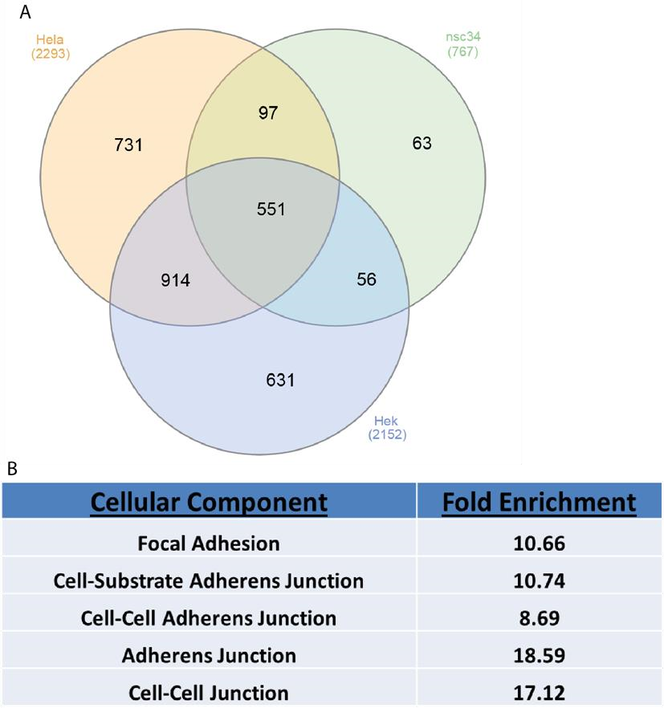
Figure 4.1: A - Venn diagram of the total number of proteins found in AP-MS from each cell type, HeLa, HEK, or nsc-34 cells, including proteins shared between each cell type. These experiments had no controls, so were used purely as pilot runs to choose cell type. B – Cell adhesion processes that are significantly enriched in the shared proteins, with the cellular component designation and the fold enrichment over the protein coding genome.
In both HEK and HeLa conditions, the bait protein DHHC5 was in the top 10 most abundant proteins detected, which is indicative of a successful pulldown, with the position of DHHC5 is the HeLa pulldown being slightly higher than in HEK (4th position compared to 8th position). In the nsc34 cell extract pulldowns, DHHC5 appears much lower down the list. This fact alone was sufficient to discount nsc34 cells from further use and AP-MS experiments. The fact that DHHC5 appears higher in the list also makes HeLa cells a preferred option and combined with the fact that the previous work on DHHC5 localisation and the influence on Golga7b on the location of DHHC5 had been done in HeLa cells made it the choice of cell type to use in further work.

As mentioned above, nsc34 cells were used as they are a neural-like cell line and it was thought that this could give an insight into neural processes that DHHC5 is involved with, as DHHC5 is known to have an important role in learning and memory (Li et al., 2010) and be key in controlling the architecture of the post-synaptic density (Brigidi et al., 2015). However, very few proteins are unique to this cell type alone (Figure 4.1a, 63 out of 767 total) which suggests that very little extra insight would be gained from using this cell type over HeLa or HEK.

Among the proteins common to all three cell lines, cell adhesion processes were highly enriched when GO enrichment was performed (Figure 4.1b). The fact these processes are enriched in proteins common to all three diverse cell types suggests that DHHC5 could have a role cell adhesion in a number of cell types. This is a potentially interesting avenue as many adhesion proteins are known to be palmitoylated (Van Itallie et al., 2005; Aramsangtienchai et al., 2017), but the PATs responsible are unknown in most cases.

4.2 DHHC5 interacts with a large number of proteins in HeLa cells

Much is unknown about the interactions of DHHC5 and in order to find possible new substrates, regulators and processes that it may be involved in affinity purification of a tagged version of DHHC5 followed by tandem mass spectrometry was performed. A DHHC5 construct that had been triple FLAG tagged on the C-terminus was over-expressed in HeLa cells and then immunoprecipitated using anti-FLAG resin before elution, separation by gel electrophoresis and high performance liquid chromatography coupled to tandem mass spectrometry. Elutions from control cells were compared to DHHC5 pulldowns and significantly enriched proteins were identified as potential interactors. Control cells were treated with the transfection agent polyethylinimine (PEI) but had no DHHC5 plasmid added. Apart from this, these cells were handled in exactly the same manner as all other experimental conditions. As a further filtering step, the results were run through the CRAPome database (Mellacheruvu et al., 2013) with 4 extra controls added, and only those with a SAINT score above 0.95 were taken forward as potential interactors. The added controls matched the experimental conditions used as closely as possible, with all 4 being anti-FLAG agarose bead control purifications from HeLa cells.

This analysis revealed 238 proteins as possible interactors of DHHC5 (Appendix A2). Among the proteins identified by MS/MS, DHHC5 had the highest number of spectral counts suggesting it was the most abundant protein pulled down in this assay. This is indicative of an efficient pulldown as the bait protein should be the most abundant. Scatter plots of the intensity of the DHHC5 pulldown compared to control pulldowns showed that for most proteins detected there was very little difference in the intensity detected for the majority of proteins with a few showing noticeable differences between the two purifications. The majority of noticeable differences between DHHC5 and control purifications were seen at low intensities in the control conditions suggesting that these proteins are specific to the DHHC5 pulldowns. Scatter plots comparing different repeats of DHHC5 pulldowns showed very good agreement between replicates, which shows our methodology is robust and repeatable
(Figure 4.2).

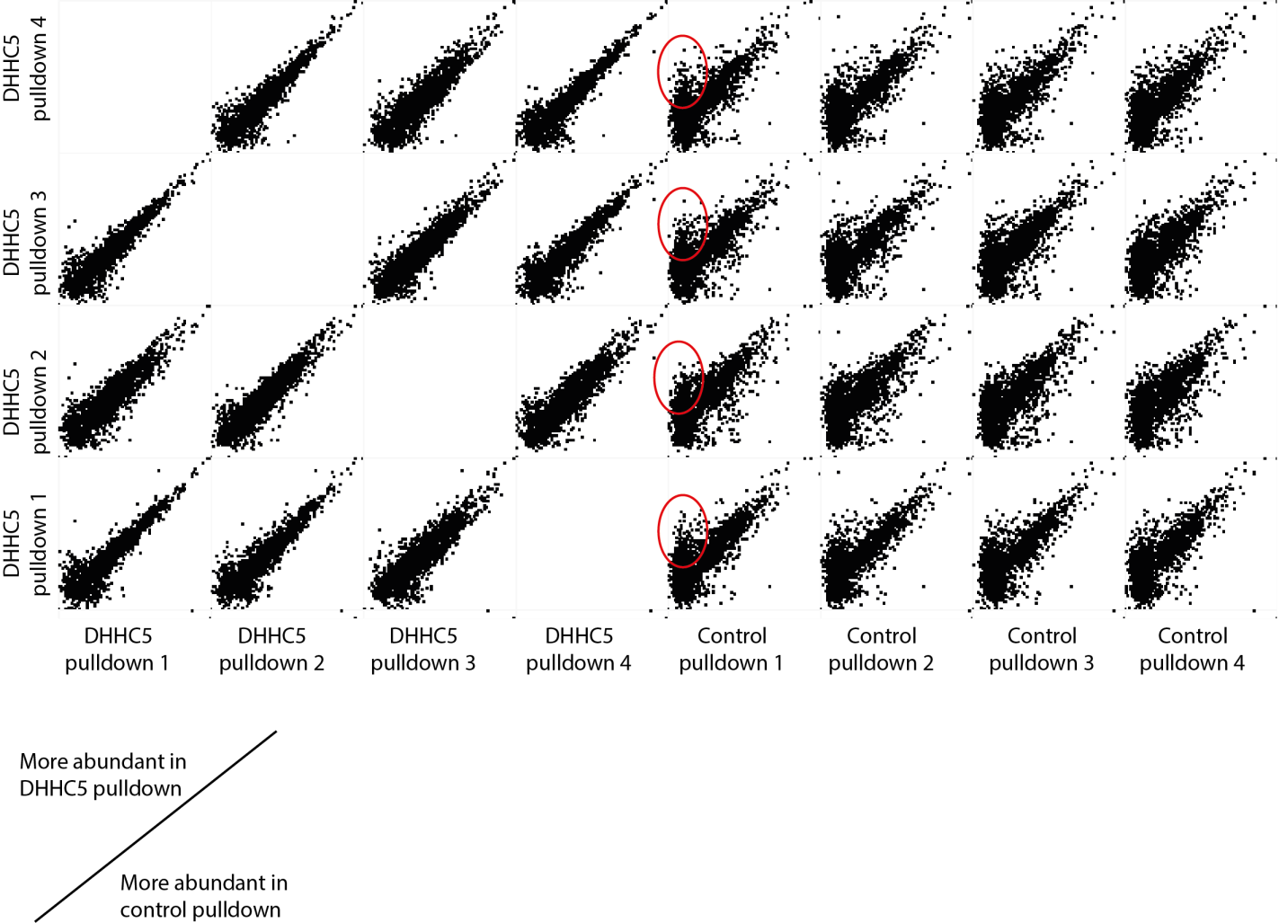

It has been demonstrated previously that when DHHC5 is over-expressed alone it is mislocalised to many regions of the cell away from the plasma membrane. The AP-MS/MS data showed 240 proteins significantly enriched over control enrichments after filtering using the CRAPome SAINT scoring system (Mellacheruvu et al., 2013). This list of proteins contained proteins from a wide range of subcellular locations, which is likely as a result of the localisation defects seen in DHHC5 when it is over-expressed.

While Golga7b was not seen in the dataset, despite having been shown to be an interactor in co-immunoprecipitation experiments presented previously in this manuscript, the related protein Golga7, also known as GCP16, was. Golga7 is the DHHC9 interactor that is essential for DHHC9 to act as a functional PAT for the RAS protein (Swarthout et al., 2005) It has been
Figure 4.2: Multi-scatter plots of AP-MS experiments from control, mock transfected pulldowns and C-terminally triple-FLAG tagged DHHC5. These demonstrate that the DHHC5 repeats were all very similar with very little difference between repeats. When compared to the control pulldowns there many proteins show no difference between pulldowns, but there are a number of proteins that are in high abundance in DHHC5 pulldowns and very low abundance in control pulldowns (indicated by the red circles). These proteins are likely the significantly different proteins and show they are almost exclusive to the DHHC5 pulldowns. demonstrated previously that Golga7 cannot fully rescue the DHHC5 mis-localisation phenotype, so this interaction may play a slightly different role.

It is notable that among the proteins which interact with DHHC5 on its own there are 8 proteasomal proteins. In reality, all proteins will interact with the proteasome as part of their natural life cycle, but this could point to over-expression of DHHC5 inducing an increase in degradation of DHHC5 which could be linked to the over-expression induced mis-localisation of DHHC5 as has been shown previously by in this work and for other PATs in previous work (Hou et al., 2009). However, it cannot be ruled out that one of these proteins are pulled down by DHHC5 as a de facto interactor and the rest of the proteasomal proteins are present in the dataset due to their presence in the proteasome complex rather than their interaction with DHHC5.

The adhesion receptor CD44 is also among the proteins predicted to be an interactor. CD44 is a known dually palmitoylated protein (Thankamony & Knudson, 2006) with no confirmed PAT that palmitoylates it. The palmitoylation of CD44 is important in the motility and invasion of breast cancer cells (Babina et al., 2014) which links palmitoylation to cancer cell adhesion. It was also found that DHHC5 interacts with the tight junction protein TJP1, and the focal adhesion associated protein Talin 1 (Burridge & Connell, 1983). The endogenous location of these three proteins at the plasma membrane makes it more likely that these are bona fide interactors of DHHC5 and could implicate palmitoylation of proteins by DHHC5 in cell adhesion.

Both Flotillin proteins were found as potential interactors in this analysis. Flotillin 2 is a known and well characterised DHHC5 substrate (Li et al., 2012), which implies this strategy can be used to identify substrates, although not every substrate has been shown to interact robustly with their respective PAT (Lemonidis et al., 2014). It is also important to note that not all of the proteins that are pulled down by DHHC5 will be or is likely to be a substrate as the list of potential interactors will include possible regulators and other associated proteins. Both of these proteins are generally present in lipid microdomains at the plasma membrane as they are often structural components of these areas of the cell (Salzer & Prohaska, 2001). This is important as it demonstrates that the workflow employed here is able to pulldown highly hydrophobic integral membrane proteins which can be challenging to identify by pulldown methods.

Also present, are a number of proteins involved in the AP2 mediated clathrin endocytosis pathway such as the AP2 sigma subunit and the clathrin heavy chain. These proteins have been identified as DHHC5 interactors in neurons (Brigidi et al., 2015) and are thought to be responsible for the retrieval and endocytosis of DHHC5 from the plasma membrane at the post-synaptic density. Their presence in this dataset further confirms the previous interaction and adds greater evidence that the strategy presented here is capable of pulling down known interactors. It should be noted that DHHC5 likely only interacts with a single member of the AP2 complex and that the clathrin heavy chain is pulled down by this interaction.

Also among the interactors are the ubiquitin E3 ligase HUWE1. While ubiquitination of DHHC5 has not been directly confirmed, it has been shown that the reduction in DHHC5 proteins level that is triggered by neural cell differentiation can be partially reversed by inhibiting ubiquitinmediated protein degradation (Li et al., 2012). These two results together imply that DHHC5 is likely to be ubiquitinated and this ubiquitination event is responsible for DHHC5 degradation, however this will need to be independently confirmed with other experiments to confirm that’s DHHC5 is indeed ubiquitinated, on which site and whether this possible event is involved in the degradation of DHHC5.

Among the potential interactors are 10 protein kinases, including the important signalling protein MAPK1. Uniprot has assigned 25 different phosphorylation sites on DHHC5, so a large number of interacting kinases is to be expected. However, how many of these sites are phosphorylated at any given time is unknown, as is which kinases mediate each phosphorylation site. Conversely there are 6 phosphatases in the dataset, one or more of which are presumably involved in the dephosphorylation of DHHC5 in response to various
signals.

When it comes to MAPK1, it has been found to be palmitoylated in adipocytes (Ren et al., 2013), but the PAT responsible for this is unknown. The interaction with DHHC5 makes it possible that DHHC5 is the PAT which mediates this palmitoylation event. The effects of palmitoylation on MAPK1 are unknown and would need to be studied to discover whether palmitoylation of MAPK1 by DHHC5 has any effects on MAPK1 signalling or on the cascade as a whole.

4.3 The interactions of DHHC5 change when present at the plasma membrane or

within the cell

As demonstrated previously in results chapter 1 of this manuscript, a change in the location of DHHC5 can be induced by expressing WT or non-palmitoylatable mutant Golga7b, with WT
Golga7b causing DHHC5 to be present almost exclusively at the plasma membrane and mutant Golga7b leading to DHHC5 being present within the cell. Because of this it was decided to investigate whether the interactions of DHHC5 with its substrates would be altered when it is present at the plasma membrane or internally within the cell. We performed anti-FLAG immunoprecipitation experiments with lysates from HeLa cells co-expressing a C-terminally triple-FLAG tagged DHHC5 construct with either WT Golga7b or the non-palmitoylatable mutant Golga7b. As a ‘proof of concept’ experiment we initially looked at whether DHHC5 would interact with the well characterised, plasma membrane localised DHHC5 substrate
Flotillin 2 (Flot2) (Li et al., 2012). This showed that when DHHC5 was co-expressed with WT Golga7b and is therefore present at the plasma membrane, DHHC5 can successfully pulldown Flot2 (Figure 4.3). However, when DHHC5 was co-expressed with mutant Golga7b, the level of Flot2 pulled down by DHHC5 is significantly reduced (Figure 4.3). This shows that DHHC5 is capable of pulling down its substrates and additionally that the location of DHHC5 is important in its interactions with its substrates.

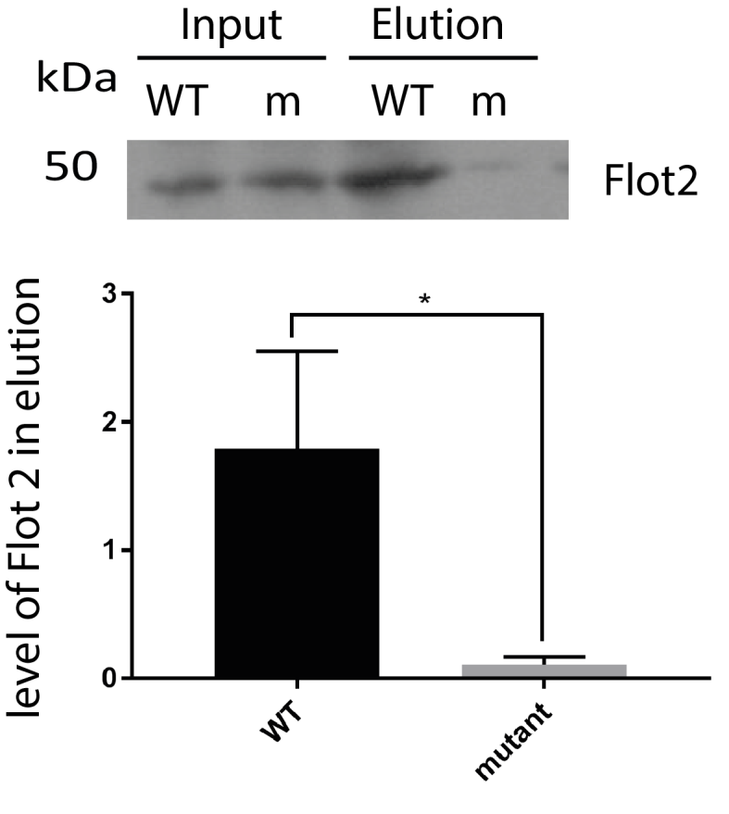
Figure 4.3: Western blots of Flotillin-2, and quantification of those blots, of co-immunoprecipitation experiments of DHHC5 when it was co-expressed with either WT or non-palmitoylatable mutant Golga7b. This change in localisation of DHHC5 leads to a significant reduction in Flot2 pulled down, consistent with the PM localisation of DHHC5 when co-expressed with WT Golga7b. N=3, *=P<0.05, paired t-test.
As a strategy to find potentially novel substrates and interactors of DHHC5, we employed an affinity purification followed by mass spectrometry (AP-MS) approach. Triple FLAG tagged DHHC5 was co-expressed with either WT or non-palmitoylatable mutant Golga7b in HeLa cells. DHHC5 was then pulled down with anti-FLAG resin and all associated proteins and DHHC5 were eluted and analysed by tandem mass spectrometry. 5 different conditions were compared; a control condition which was not transfected, DHHC5 expressed alone, DHHC5 co-expressed with mutant Golga7b, DHHC5 co-expressed with WT Golga7b and DHHC5 coexpressed with WT Golga7b and treated with the proteasome inhibitor mg132. The final condition was included as mutant Golga7b was undetectable by western blot unless cells were treated with mg132 so this condition was required to ensure the most accurate comparison between conditions.

This revealed 304 proteins that were significantly enriched in the “+ WT Golga7b + mg132” condition compared to control (Appendix A3) and 39 proteins that were significantly enriched in the “+ mutant Golga7b” condition compared to control (Appendix A4). This high number of interactions is not unusual for enzymes as they interact with both regulatory proteins and substrates which increases the number of potential interaction partners. There is a striking difference in the number of proteins that DHHC5 potentially interacts with when it is present at the plasma membrane compared to within the cell. This could be due to the majority of DHHC5 interacting proteins being exclusively present at the plasma membrane and few cytoplasmic or internal proteins are capable of interacting with the protein.

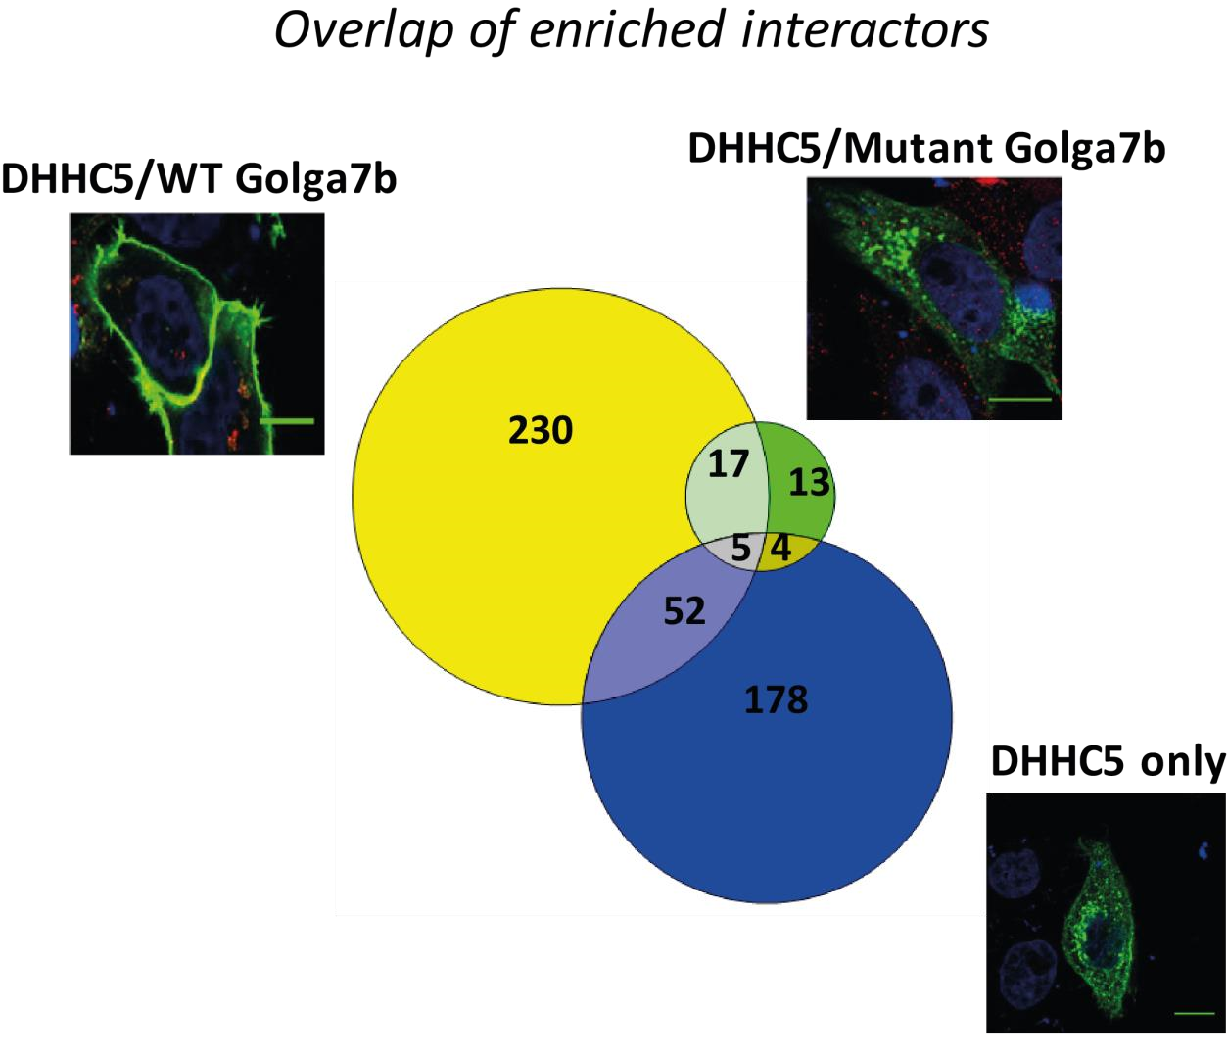
Figure 4.4: Venn diagram comparing the number of proteins and overlaps in the 3 major conditions: HeLa cells expressing DHHC5 co-expressed with WT Golga7b and treated with mg132, HeLa cells expressing DHHC5 co-expressed with mutant Golga7b and treated with mg132 and HeLa cells expressing DHHC5 alone.

It is also likely that this data does not represent the full picture of DHHC5 interactions with this approach as DHHC5 was tagged on the C-terminal end of the sequence and the last 4 digits of the amino acid sequence constitute a PDZ binding motif (Li et al., 2010). This makes it possible that the triple FLAG tag covers up the PDZ binding motif so no proteins which interact with DHHC5 through the PDZ binding motif will be pulled down. It is also important to point out that only a single protein was pulled down significantly differently when DHHC5 was expressed with WT Golga7b compared to when DHHC5 was expressed with WT Golga7b and treated with the proteasome inhibitor MG132. This is important as it shows that the addition of MG132 does not significantly alter almost all of the interactions made by DHHC5 so the differences between the different conditions here is likely to be caused by the differences in DHHC5 localisation rather than interactions being affected by the addition of MG132.

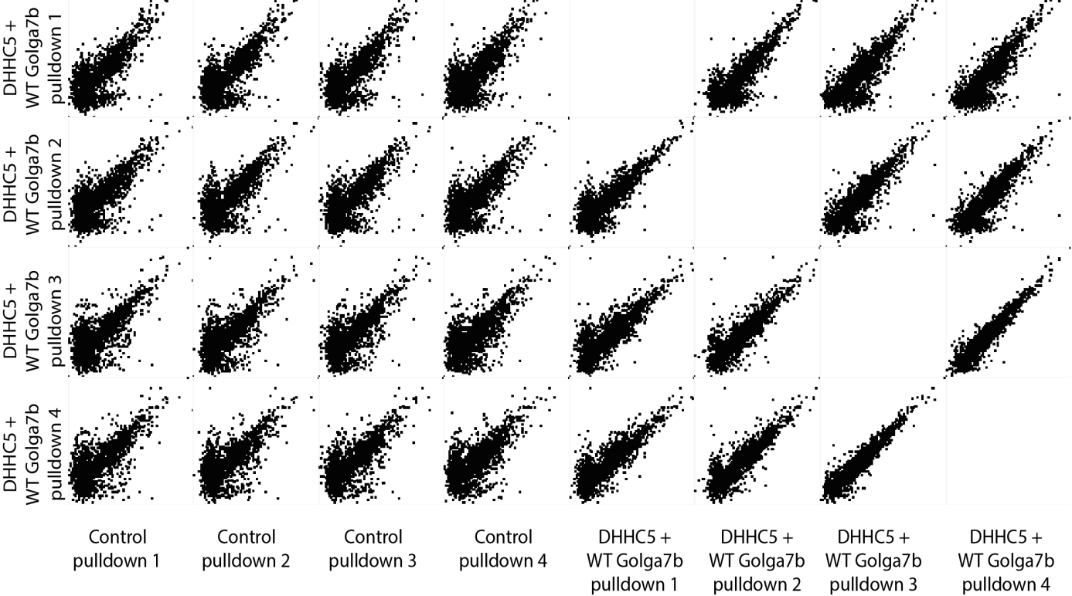

Figure 4.5: Multi-scatter plots of AP-MS experiments from control, mock transfected pulldowns and C-terminally triple-FLAG tagged DHHC5 co-transfected with WT Golga7b. These demonstrate that the DHHC5 repeats were all very similar with very little difference between repeats. When compared to the control pulldowns there many proteins show no difference between pulldowns, but there are a number of proteins that are in high abundance in DHHC5 pulldowns and very low abundance in control pulldowns. These proteins are likely the significantly different proteins and show they are almost exclusive to the DHHC5 pulldowns.

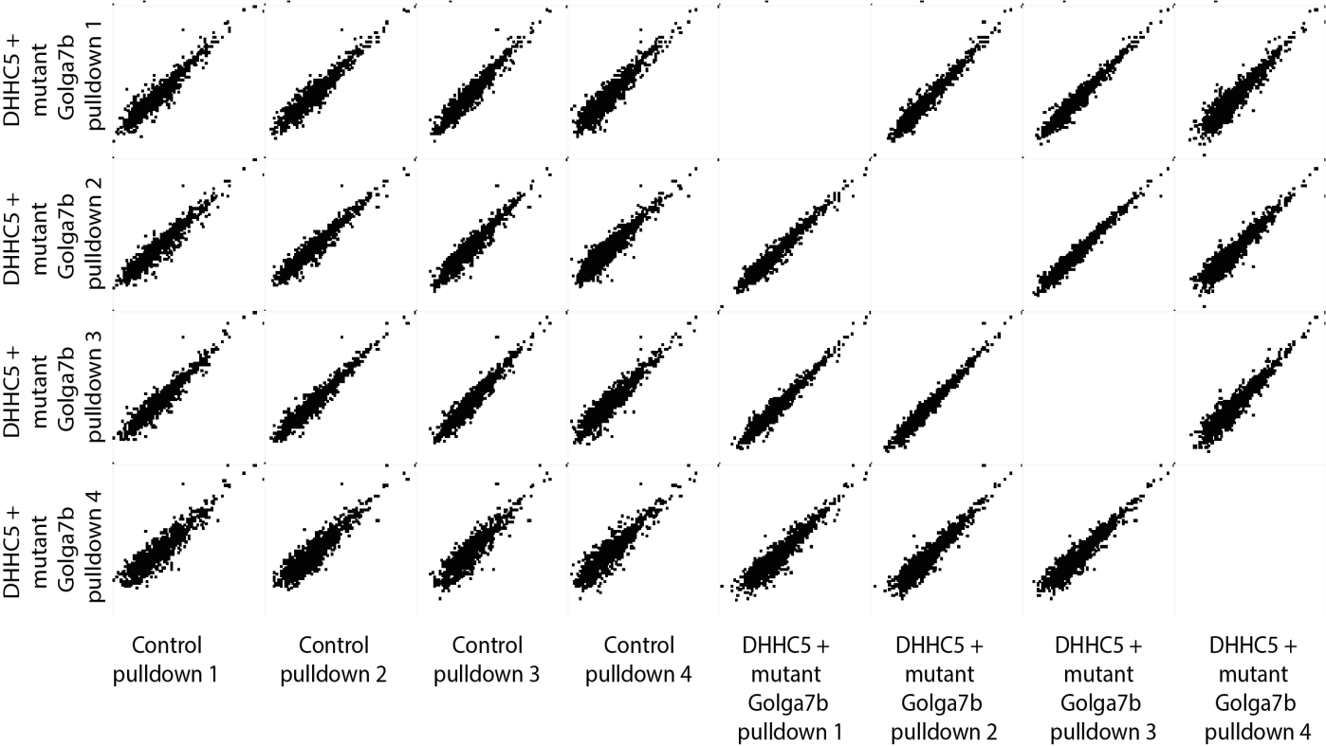
Figure 4.6: Multi-scatter plots of AP-MS experiments from control, mock transfected pulldowns and Cterminally triple-FLAG tagged DHHC5 co-transfected with mutant Golga7b. These demonstrate that the DHHC5 repeats were all very similar with very little difference between repeats. When compared to the control pulldowns there almost all proteins show no difference between the two conditions, which is reflected in the low number of significantly different protein between the two conditions.

4.4 DHHC5 interacts with a large number of adhesion proteins when present at

the plasma membrane

In the “+WT Golga7b + mg132” condition when DHHC5 is co-expressed with WT Golga7b, which is essentially the same in terms of DHHC5 location as endogenous DHHC5, it was found that the top 8 gene ontology: cell component terms when analysed with the WEBGestalt platform (Zhang et al., 2005) were involved in some form of adhesion, which suggests that DHHC5 could be involved in regulating cellular adhesion or possibly that DHHC5 is a member of the cellular adhesion machinery and is present and enriched at points of adhesion. The 9th most enriched GO: cellular component was “membrane region” which was expected given
DHHC5 is present almost exclusively at the plasma membrane when co-expressed with WT Golga7b. This is interesting as a number of adhesion proteins and processes have been shown previously to be palmitoylated, but very few palmitoylated adhesion proteins have known PATs that palmitoylate them (McCarthy et al., 2000; Furuse et al., 2001; Van Itallie et al., 2005; Roberts et al., 2014; Lievens et al., 2016; Roberts et al., 2016).

It has been shown in neurons that DHHC5 forms a complex with PSD-95 and Fyn kinase, which is a Src family kinase, at the post-synaptic density (Brigidi et al., 2015) and that phosphorylation of DHHC5 by Fyn inhibits the association of DHHC5 with the AP2 endocytosis machinery. This system has not been shown to occur in any other cell type, but psd-95 and
Fyn are not expressed ubiquitously and are highly enriched in synapses (Bayes et al., 2017). However, when DHHC5 is co-expressed with WT Golga7b and is therefore present at the plasma membrane it interacts with a pair of Src family kinases, YES and Lyn. These are closely related to Fyn kinase so it is possible that palmitoylation of DHHC5 is mediated by other Src family kinases in cell types or tissues where Fyn kinase is not expressed or is present at a very low level.

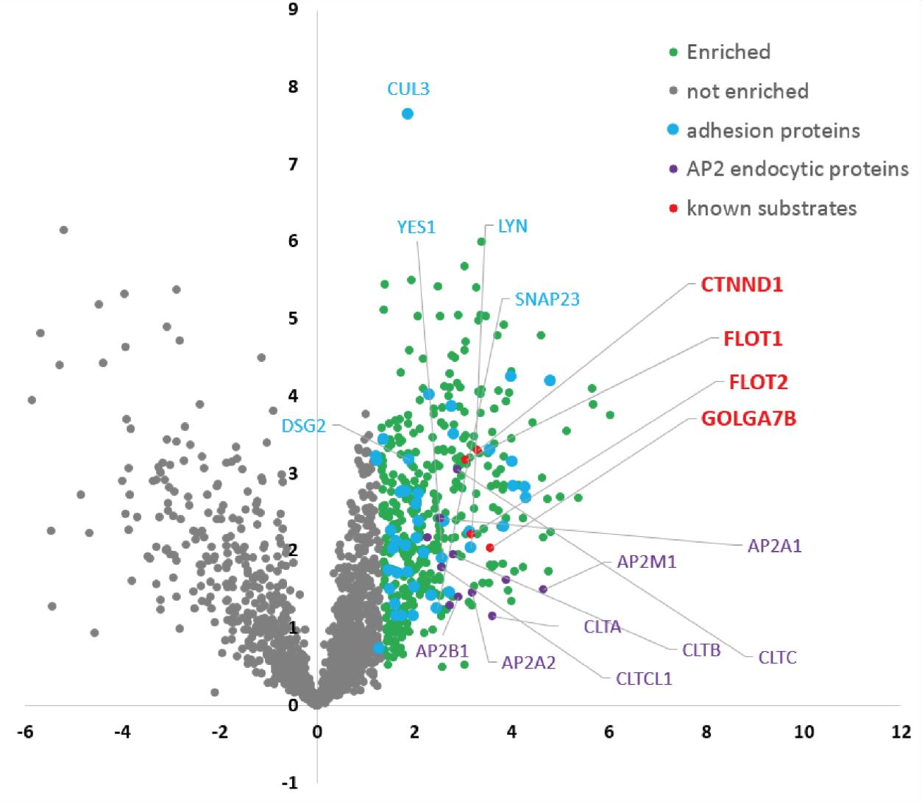
Figure 4.7: Volcano plot of significantly enriched proteins from pulldowns from lysates from HeLa cells co-expressing DHHC5 and WT Golga7b treated with mg132. All enriched proteins are shown in green, all unenriched proteins are in grey. All proteins that are involved in adhesion processes as designated by GO term are shown in blue. All proteins involved in AP2 mediated clathrin endocytosis are in violet. All known substrates are shown in red.
As mentioned above, the top 8 most significantly enriched GO terms were all linked to cell:cell or cell:matrix adhesion. As has been mentioned previously, the regulation of a number of cell adhesion systems is controlled by palmitoylation including desmosomes (Roberts et al., 2014; Roberts et al., 2016). The desmosomal protein DSG2 is found as an interactor of DHHC5, along with both flotillins which are known to be involved with desmosomal clustering (Vollner et al., 2016). The enzymes responsible for palmitoylation-based regulation of desmosomal proteins is unknown, this data makes it possible that DHHC5 is the enzyme responsible.

Outside of desmosomes, proteins from other cell adhesion systems are seen as interactors of DHHC5 at the plasma membrane. The focal adhesion protein talin-1 is among these. Talin-1 is not a known palmitoylated protein but other focal adhesion proteins are known to be palmitoylated which regulates their interactions with and localisation to focal adhesions, such as tetraspanins (Yang et al., 2004). Palmitoylation has not been shown to have as integral a role as in desmosomes, but if DHHC5 is palmitoylating Talin-1 and this is a source of regulation it could expand the role of palmitoylation in focal adhesion integrity.

Additionally, the tight junction protein TJP1, also known as ZO-1, was found as a DHHC5 interactor. Like Talin-1, ZO-1 is not a confirmed palmitoylated protein, but the regulation and localisation of other tight junction proteins is affected by palmitoylation. The claudin proteins need to be palmitoylated for localisation at the tight junction (Van Itallie et al., 2005) and the protein JAM-C is similar (Aramsangtienchai et al., 2017). It is possible that ZO-1 could also be regulated by palmitoylation and that DHHC5 is the palmitoylating enzyme. The presence of proteins from all of these different cell adhesion complexes could implicate DHHC5 in wider cell adhesion and a role in regulation of a number of different cell adhesion systems.

While the majority of proteins found in this dataset make logical sense as they are present either at the plasma membrane or the trafficking systems which involve the movement of proteins to the plasma membrane, there are a few proteins from other internal organelles including fumarate hyrdratase, the important Krebs cycle enzyme, which is resident in the mitchondrion. This could be due to a number of reasons. It is possible, if unlikely, that a small population of DHHC5 is resident at the mitochondrial membrane. However DHHC5 has never been seen at this location and no data that has been collected or presented here supports this. It is also possible that when DHHC5 is trafficked from the plasma membrane it is redistributed among the endomembrane system and that the mitochondrial membrane is among these areas which would facilitate this interaction. The most likely explanation is probably that these proteins are artefacts of the AP-MS process and not de facto DHHC5 interactors.

Similar to what was seen when DHHC5 was expressed alone, there was 3 members of the AP2 complex (2 AP2 alpha subunits and the AP2 mu subunit) and the clathrin light and heavy chains. It has been shown previously that DHHC5 interacts with the AP2 complex in neurons (Brigidi et al., 2015) but this has not been shown in any other cell type. This work further backs up that DHHC5 is endocytosed by the AP2 controlled clathrin system and points to DHHC5 trafficking from the plasma membrane being a process that occurs in other cell types and may indeed be a ubiquitous trait of the protein in all cell and tissue types. It also suggests that the interaction with WT Golga7b does not prevent interaction with the endocytic machinery, which could have been one mechanism by which palmitoylation of Golga7b keeps DHHC5 trapped at the plasma membrane. This hypothesis was unlikely due to the association between DHHC5 and AP2 having been shown previously to be inhibited by phosphorylation of the C-terminal tail of DHHC5 (Brigidi et al., 2015). This phosphorylation is likely to be unaffected by Golga7b as the area where it was shown that the region of DHHC5 where the Golga7b:DHHC5 interaction occurs is not close to the residue that is phosphorylated which is downstream of the interaction site. It has not been confirmed that this phosphorylation of DHHC5 occurs in cell types other than neurons, however as discussed above a pair of Src family kinases similar to Fyn kinase, which phosphorylates DHHC5 in neurons, are DHHC5 interactors, so phosphorylation of DHHC5 is entirely plausible. As stated above, association of the AP2 complex with DHHC5 requires it not to be phosphorylated on tyrosine 533 by the Src family kinase Fyn. The results have shown DHHC5 interacts with other Src family kinsases so it is possible that it could be phosphorylated by them, while interaction with the AP2 complex is also seen. If DHHC5 is phosphorylated on tyrosine 533 by one of these other Src family kinases, this could be indicative of two distinct populations of DHHC5, one of which is phosphorylated and is unable to interact with the AP2 complex and the other of which is not phosphorylated and interacts with the AP2 complex and can undergo endocytosis and recycling back to the plasma membrane.

4.5 DHHC5 interacts with a specific subset of proteins when present within the cell

As mentioned above, after analysis and filtering of results, 39 proteins were found as interactors with DHHC5 when it was co-expressed with the non-palmitoylatable Golga7b mutant and is therefore present within the cell. This is a much smaller number than when DHHC5 is co-expressed with WT Golga7b and a smaller number than would be expected from many enzymes. A likely reason for this is that DHHC5 is severely mis-localised when coexpressed with mutant Golga7b so the proteins that it normally interacts with are not present in the same cellular compartment. Another more remote possibility is that palmitoylation of Golga7b allows it to act as an intermediate protein that facilitates indirect interaction between DHHC5 and other proteins.

One of the more interesting proteins in the dataset is Golga7, which is closely related to Golga7b and is the co-factor for DHHC9 to palmitoylate Ras (Swarthout et al., 2005). However, it has been shown here that Golga7 cannot rescue DHHC5 mis-localisation which is caused by Golga7b knockdown, so this interaction may play another role in regulating DHHC5. The Golgin family of proteins are known as Golgi tethering proteins which are important in cargo sorting for export to the plasma membrane (Witkos & Lowe, 2015) which makes it possible that this interaction facilitates the retrieval of DHHC5 to the plasma membrane after endocytosis.

Golga7 is not the only protein involved in the protein export pathway as the synaptobrevin homolog YKT6 which is involved in trafficking from the endoplasmic reticulum to the Golgi (McNew et al., 1997) and retrieval of endosomes to the Golgi (Tai et al., 2004). These results together suggest that DHHC5 may be recycled through the endosomal system to the Golgi before export back to the plasma membrane after endocytosis and internalisation. YKT6 is a particularly interesting protein from a palmitoylation standpoint as previous research has found it to be palmitoylated at its N-terminus and that this palmitoylation is mediated by YKT6 itself (Veit, 2004). While this doesn’t make it impossible that it is a DHHC5 substrate, it makes it much more likely that it is involved in the regulation or transport of DHHC5.

The early endosomal protein Rab18 is also seen as a DHHC5 interactor when it is co-expressed with palmitoylation deficient mutant Golga7b. Rab18 is involved in early endosomal movement from the plasma membrane (Bem et al., 2011) and is found at early endosomes (Lutcke et al., 1994) which suggests that once DHHC5 is internalised from the plasma membrane it is moved through the early endosome system before trafficking to the Golgi and presumably back to the plasma membrane to repeat the process.

While it has been demonstrated here that the majority of DHHC5 is present within the cell when it is co-expressed with mutant Golga7b, there is still some signal at the plasma membrane. This is backed up by the interaction seen between DHHC5 and syntenin-1, a protein localised to cell adhesions at the plasma membrane (Zimmermann et al., 2001). As mentioned above, DHHC5 does interact with a large number of adhesion proteins when DHHC5 is co-expressed with WT Golga7b and thus present at the plasma membrane and this result further strengthens the concept that DHHC5 could be an important regulator of cell adhesion. However, it must be noted that sytenin-1 is not solely localised to the plasma membrane (Fernandez-Larrea et al., 1999) and is an important regulator of the pathway by which proteins are exported to the plasma membrane. This option is also viable as has there are a number of other proteins from this pathway found as interactors of DHHC5 when it is co-expressed with mutant Golga7b as has been discussed above.

4.6 Comparison of datasets

Further from this, we looked into proteins that were significantly differently enriched between the “+ WT Golga7b” and “+ mutant Golga7b” conditions. This revealed 163 proteins that were significantly enriched in the +WT condition compared to the +mutant condition and 10 proteins that were significantly enriched in the +mutant condition compared to the +WT condition (Appendix A5). Among the proteins significantly enriched in the +WT condition was Flot2 which had been validated as significantly differently pulled down previously (Figure 1). To further validate the approach and confirm the accuracy of the workflow, 2 more proteins found as significantly enriched in the +WT condition were chosen. The clathrin heavy chain (CLTC) was chosen as it was wanted to know if DHHC5 interacts with members of the clathrin endocytic system, and desmoglein-2 (dsg2) was chosen as it is a known palmitoylated protein (Roberts et al., 2014) but the PAT responsible for its palmitoylation is unknown meaning it is a potential DHHC5 substrate. In both cases, the western blot results supported the AP-MS, with both proteins being pulled down in greater quantities by DHHC5 when it was coexpressed with WT Golga7b when compared to the mutant Golga7b (Figure 4.8a and b), confirming the interaction between these proteins and DHHC5 taking place at the plasma membrane and further validating the results of the AP-MS.
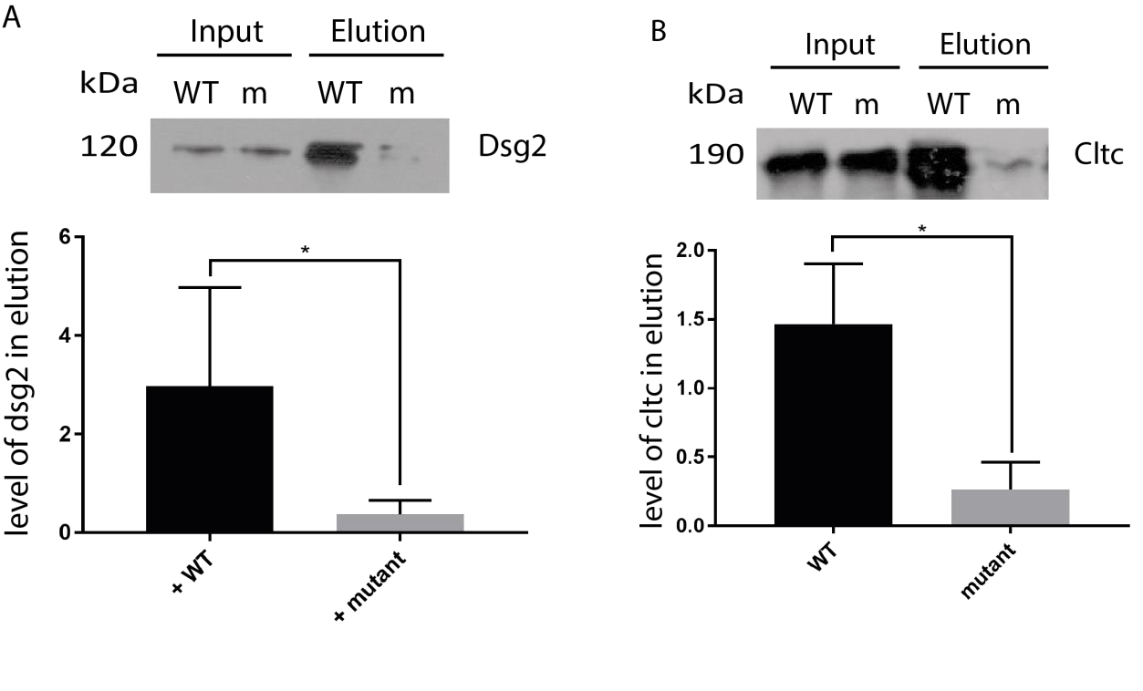
Figure 4.8: A - Western blots of Dsg2, and quantification of those blots, of co-immunoprecipitation experiments of DHHC5 when it was co-expressed with either WT or non-palmitoylatable mutant Golga7b. This change in localisation of DHHC5 leads to a significant reduction in Dsg2 pulled down, consistent with the PM localisation of DHHC5 when co-expressed with WT Golga7b. N=3, *=P<0.05, paired t-test. B - Western blots of Cltc, and quantification of those blots, of co-immunoprecipitation experiments of DHHC5 when it was co-expressed with either WT or non-palmitoylatable mutant Golga7b. This change in localisation of DHHC5 leads to a significant reduction in Cltc pulled down, consistent with the PM localisation of DHHC5 when co-expressed with WT Golga7b. N=3, *=P<0.05, paired t-test.

Among the proteins that was significantly enriched in when DHHC5 was co-expressed with mutant Golga7b compared to WT Golga7b was DHHC5 itself. This is a slightly confusing result, as the microscopy data presented previously did not suggest that there was significantly more DHHC5 present in cells when expressed with mutant Golga7b. One possible explanation is that the extraction and lysis conditions used were relatively mild as denaturation of the proteins and disruption of the protein:protein interactions needed to be avoided. As a result of this, it is likely that not all of the plasma membrane was effectively solubilised, such as lipid raft microdomains. If a population of DHHC5 is present in these parts of the plasma membrane that are not well solubilised by the lysis conditions used it would lead to a lower amount of DHHC5 detected. If this is the case, the DHHC5 population within the cell would be in membrane systems that are more effectively solubilised by the lysis conditions used so this would explain the difference in DHHC5 intensity detected.

When comparing the proteins pulled down when DHHC5 was alone, when it was expressed with WT Golga7b, and thus present at the plasma membrane, and when it was expressed with mutant Golga7b, and thus present within the cell, it was noticed that the number of adhesion proteins pulled down in each condition was very different. As expected, when DHHC5 is at the plasma membrane it pulls down the largest number of cell adhesion proteins with 41 and this number drops significantly when DHHC5 is expressed with mutant Golga7b and is within the cell with only 2 proteins being present in the pulldown. However, when DHHC5 is expressed alone there are also very few of these proteins present in the pulldown dataset, with only 4 cell adhesion proteins found. This could be caused by a number of things. It is possible that Golga7b is an adaptor protein and is required for DHHC5 to interact with a number of proteins including those involved with cell adhesion. It is also possible that palmitoylation of Golga7b causes DHHC5 to be present in a particular microdomain which facilitates the interaction between DHHC5 and proteins involved in cell adhesion.

There are some notable adhesion proteins which interact with DHHC5 significantly more when DHHC5 is co-expressed with WT Golga7b compared to when it is co-expressed with mutant Golga7b. Among these is the known palmitoylated desmosomal protein desmoglein 2 (DSG2) (Roberts et al., 2016). This palmitoylation is known to be involved in the correct trafficking of the protein, but no PAT has been found which is responsible for this palmitoylation. The interaction with DHHC5 and the fact this interaction takes place much more robustly when DHHC5 is at the plasma membrane makes DHHC5 a likely PAT for this protein and possible regulator of desmosome formation and trafficking.

Another known palmitoylated adhesion protein is the important cell fate determination protein Numb. The balance of palmitoylation and depalmitoylation of NUMB has been shown to be important for its asymmetrical distribution into daughter cells at mitosis, with the depalmitoylation enzyme APT1 being an important player in this process (Stypulkowski et al., 2018). While the depalmitoylation enzyme for Numb has been discovered, the PAT responsible for palmitoylating Numb initially is unknown and this interaction makes DHHC5 a possible candidate. Numb is also involved in adherens junctions (Kowalczyk & Nanes, 2012) which could mean that DHHC5 is not only involved in desmosomal regulation and could play a wider and more general role in adhesion of cells to one another and to the external environment.

There are a pair of E3 ubiquitin ligases (BRE1A and UBR4) which interact with DHHC5 significantly more when it is present at the plasma membrane, which are different from the E3 ubiquitin ligase which interacts with DHHC5 when it is expressed alone, HUWE1, which is also interacts with DHHC5 significantly more when it is present at the plasma membrane compared to when it is within the cell. This could mean that DHHC5 can be ubuiquitinated by a number of different ligases. The significantly lower level of these proteins seen when DHHC5 is co-expressed with mutant Golga7b could be down to UBR4 being present at the plasma membrane (Nakatani et al., 2005). BRE1A is primarily a nuclear protein (Liu et al., 2009) but has been seen in other locations in certain cell types (Ishino et al., 2014). If this is indicative of a higher level of DHHC5 ubiquitination at the plasma membrane it could also help to explain why there is a significantly lower level of DHHC5 seen when it is co-expressed with WT Golga7b compared to mutant Golga7b if this potential ubiquitination would lead to degradation of DHHC5. If a lower level of interacting ubiquitin ligases is indicative of a lower level of ubiquitination of DHHC5 and therefore degradation, it would also help to explain why there is a significantly higher level of DHHC5 seen when it is co-expressed with mutant Golga7b compared when it is expressed with WT Golga7b. While there is little supporting to data to back up this hypothesis, it is also intriguing that it is possible that less degradation of DHHC5 occurs when it is mis-localised away from its endogenous location. The reason that this may be the case are unclear, but it could be that the ubiquitination enzymes which modify DHHC5 and tag it for proteasomal degradation are localised at the plasma membrane so DHHC5 which is present within the cell is unable to be ubiquitinated and subsequently degraded.

4.7 Discussion

This work presented above shows that the location of DHHC5 has a profound effect on its interactions, both in the number of proteins that DHHC5 interacts with and the types of proteins that are interacting.

It was mentioned above that when DHHC5 is expressed alone, it pulls down 8 proteins which are components of the proteasome. When DHHC5 is co-expressed with WT Golga7b, it interacts with 4 proteasomal proteins, while none were pulled down when DHHC5 was expressed with mutant Golga7b. While a low level of interaction could be expected as essentially all proteins interact with the proteasome in their life cycle, the relative enrichment of proteasomal proteins that interact when DHHC5 is expressed on its own does suggest that there could be an increase in degradation of DHHC5 when it is over-expressed.

When DHHC5 is over-expressed alone in HeLa cells it has been shown previously in this manuscript that there is a significant mislocalisation of DHHC5 with it present not only at the plasma membrane but throughout the cell. We used this condition in the AP-MS pulldowns, and as a result it is unknown if many of the pulled down proteins which are resident in areas of the cell away from the plasma membrane are indeed de facto interactors or are artefacts from over-expression. While this is likely for some proteins found, such as the nuclear and nucleolar proteins found as interactors when DHHC5 was expressed alone, it is also possible that DHHC5 does interact with a number of them. As DHHC5 is trafficked away from the plasma by AP2 mediated clathrin endocytosis to membrane systems within the cell as has been demonstrated here and in neurons (Brigidi et al., 2015), the scope of its interactions goes beyond just proteins that are at the plasma membrane and includes proteins from all cellular compartments.

5 DHHC5 substrates can be investigated by site-specific methods

The targets of most PATs have remained elusive to date, with the total number of known palmitoylated proteins far outweighing the number of palmitoylated proteins that have known PATs which palmitoylate them (Blanc et al., 2015). Most knowledge of individual PAT substrates have come from candidate approaches (Swarthout et al., 2005), with some proteomic scale work (Li et al., 2012). Very few confirmed substrates have been found in proteomic studies, for a number of likely reasons. The study looking into the substrates of
DHHC5 (Li et al., 2012) used a DHHC5 gene-trap mouse line and found 20 proteins as likely DHHC5 substrates. The gene trap procedure did not completely remove all DHHC5 expression, with around 5% of DHHC5 mRNA still present within the cell, which could influence the results as there is likely still a number of proteins still being palmitoylated by the low level of DHHC5 within the cells. Furthermore, methods to study the palmitoylated proteome have lagged behind those used to investigate other post-translational modifications. Most methods involve pulling down palamitoylated proteins, such as the ABE method (Drisdel & Green, 2004), so if a protein is palmitoylated on multiple sites and just a single site is mediated by the PAT being knocked down the protein will still be pulled down in the ABE. While there is the idea that the majority of proteins can be palmitoylated by more than one PAT and there is significant overlap between PATs is likely true for a number of palmitoylated proteins, it has also been shown that certain PATs have specificity for certain substrates (Greaves et al., 2010; Fredericks et al., 2014) so it is likely that more palmitoylated proteins are palmitoylated by a single PAT. Further methods have been developed to allow proteomic scale investigation of palmitoylation at a site level, including the site-specific ABE method (Collins et al., 2017), which will allow an understanding of both palmitoylation and PAT substrates at a deeper level.

The known and confirmed substrates of DHHC5 are relatively limited and have been primarily investigated in specialised cell types. It has been shown that DHHC5 palmitoylates δ-catenin in dendritic spines (Brigidi et al., 2014) after movement from the post-synaptic density (Brigidi et al., 2015) in neurons. It has also been shown to palmitoylate the sodium channel phosphlemman in cardiac muscle (Howie et al., 2014), a modification which inhibits the action of the pump. It was found from the DHHC5 gene-trap mouse that DHHC5 palmitoylates the lipid micro-domain marker Flotillin-2 (Li et al., 2012), but it was also later revealed that it palmitoylates the closely related protein Flotillin-1 (Wan et al., 2013). As Flotillin-1, Flotillin-2 and phospholemman are all usually partitioned into lipid micro-domains at the plasma membrane it could suggest that DHHC5 preferentially targets proteins in these areas of the plasma membrane. However, this is far from a certainty, as it could be that palmitoylation of these proteins leads to their partitioning into these cholesterol rich domains as the addition of a saturated long chain fatty acid would encourage this event. DHHC5 is also known to share substrates with the closely related PAT DHHC8, even though they are both known to be present in different cellular compartments (Ohno et al., 2006). Palmitoylation of the protein Grip1b is important for moving the protein to recycling endosomes and is mediated by both DHHC5 and DHHC8 (Thomas et al., 2012). This causes faster recycling of the AMPA receptor back to the plasma membrane, a known interactor of GRIP1b, in neurons. The adhesion protein Ankyrin-G is another protein palmitoylated by both DHHC5 and DHHC8, although this was found in epithelium rather than neurons (He et al., 2014). These results show that DHHC5 and DHHC8 may share a number of substrates in diverse cell types throughout the body.

Previous work presented here shows that affinity purification followed by mass spectrometry is an appropriate strategy for pulling down substrates of DHHC5, however it cannot be confidently stated that any proteins found in this way are DHHC5 substrates as this list of proteins will include regulators and other interactors of DHHC5 as well as substrates. To gain a more specific insight into solely DHHC5 substrates and their sites of palmitoylation, the ssABE approach (Collins et al., 2017) was paired with a siRNA-mediated knockdown of DHHC5 in HeLa cells.

5.1 DHHC5 knockdown is able to affect palmitoylation of known substrates

It has been demonstrated in COS-1 cells that depletion of DHHC5 abolishes the palmitoylation of Flotillin-2 (Flot2, (Li et al., 2012). However, as this work was carried out in HeLa cells, it was important to confirm that depletion of DHHC5 would lead to a reduction in the palmitoylation of Flotillin-2. To achieve this, HeLa cells were treated with DHHC5 siRNA for 72 hours before harvesting and lysis. The lysate was then used to perform a PEG switch experiment which will show a shift in molecular weight on an immunoblot for each palmitoylated cysteine. In this case, a loss of the triply palmitoylated form of Flot2 is seen (Figure 1), which does contrast the apparent total loss of palmitoylation that has been seen previously in Cos-1 cells (Li et al., 2012). There could be a number of reasons for this. The technique used previously was the ABE technique, while this technique is slightly different and could lead to a slightly different result. However, the ABE method should still be able to pull down Flot2 if it has only lost 1 of the 3 palmitoylation sites, which makes this explanation much less likely. It is also possible that this palmitoylation event is controlled by different PATs in different cell types, or that depletion of DHHC5 leads to compensation by another PAT so only sites on Flot2 which are specifically targeted by DHHC5 would show a change. This hypothesis is bolstered by overexpressing DHHC5 in HeLa cells which increases the quantity of the triply palmitoylated form of Flot2 relative to the other palmitoylated forms of this protein. However, this result confirms that by using a technique that can identify and quantify specific sites of palmitoylation on proteins and combining it with siRNA mediated knockdown of DHHC5 it is possible to discover substrates of DHHC5.

To investigate this further, we used a haploid cell line that had been subjected CRISPR/CAS9 genome manipulation (Yin & Chen, 2017) to remove DHHC5. After a PEG switch and an immunoblot against Flot2, loss of Flot2 palmitoylation was not lost with singly, doubly and some triply palmitoylated Flot2 seen (Figure 5.1). There was a significant portion of Flot2 that was in the unmodified Apo form, which could be indicative of a reduction in overall palmitoylation of Flot2. When DHHC5 was reintroduced and over-expressed in these DHHC5 siRNA treated HeLa cells by transient transfection of an N-terminally HA-tagged version of DHHC5, a noticeable increase in the palmitoylated forms of Flot 2 was seen. Particularly striking is the fact that the doubly palmitoylated form appears to be the most abundant, whereas when DHHC5 is knocked down the singly palmitoylated form of the protein is the most abundant.

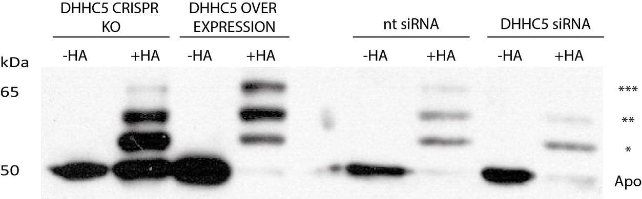

Figure 5.1: PEG switch of lysates from HAP1 CRISPR/CAS9 DHHC5 KO cells (DHHC5 CRISPR KO), HeLa cells treated with DHHC5 siRNA and over-expressing and siRNA resistant DHHC5 (DHHC5 OVER EXPRESSION), HeLa cells treated with non-targeting siRNA (nt siRNA) and HeLa cells treated with DHHC5 siRNA (DHHC5 siRNA). Immunoblot targeting Flotillin-2, Apo = unmodified protein, * = singly palmitoylated, ** = dually palmitoylated, *** = triply palmitoylated.

5.2 Pilot ssABE

To test the applicability of the ssABE protocol (Collins et al., 2017, Figure 5.2) to address the question of DHHC5 substrates on a proteomic level, a single replicate experiment was carried out. HeLa cells treated with either DHHC5 siRNA or non-targeting siRNA were cultured, harvested and lysed prior to undergoing the ssABE procedure.

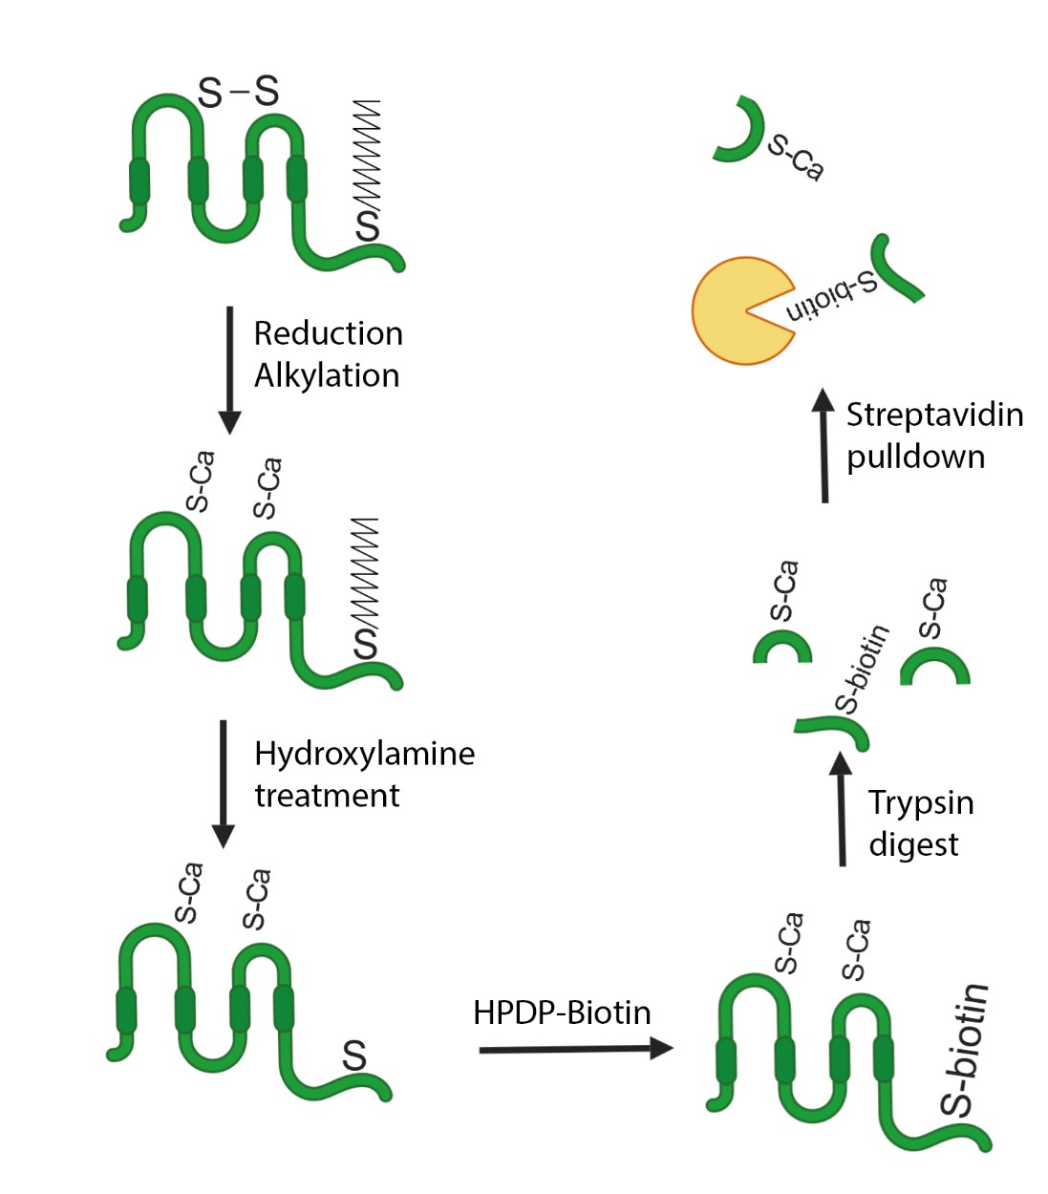
Figure 5.2: Overview of the ssABE procedure. Lysates from cells or tissues are reuced by addition of TCEP and free cysteines are alkylated by iodoacetamide. Samples are then treated with hydroxylamine to cleave palmitate before addition of HPDP-biotin to biotinylated the newly free cysteines that were formerly palmitoylated. Proteins are then digested by trypsin before pulldown of biotinylated peptides with streptavidin resin. Peptides are then eluted and analysed by LC-MS/MS. In tandem with this, a control is performed without the addition of hydroxylamine, but all other steps remain identical.

To filter the data, after MaxQuant (Cox & Mann, 2008) processing where palmitoylation sites were assigned by free cysteine residues, potential palmitoylation sites were assigned by +HA:HA ratio of 2 or greater and possible DHHC5 substrates were assigned by a ratio of nt siRNA intensity:DHHC5 siRNA intensity in the +HA condition of 3:1 or greater.

The quality of the pulldown of previously biotinylated peptides and subsequent washing and release can be investigated by looking at the number of peptides that do not contain a cysteine residue. In these experiments, out of 3026 peptides identified only 83 peptides did not contain a cysteine residue. This is indicative of an efficient capture of biotinylated peptides and a very low chance of a pulldown of non-cysteine containing peptides, showing the washing steps are effectively removing most other contaminating peptides.

After filtering, 221 sites on 207 proteins were found as possible DHHC5 substrates (Appendix A6), 99% of which have been found to be palmitoylated in previous palmitoylated proteome studies according to the SwissPalm database (Blanc et al., 2015)(Appendix figure s2), with only 2 proteins not found in this database. This gives confidence that the proteins being detected are indeed bona fide palmitoylated proteins, which makes it possible that they are DHHC5 substrates.

Among these are some proteins that bolster the claim that this approach could find new DHHC5 substrates. The known DHHC5 substrate δ-catenin is present, with the palmitoylation site being a known site of palmitoylation (Brigidi et al., 2014), as is the related protein αcatenin, although this is not a known substrate. However, neither Flotillin protein is present, despite being established as DHHC5 substrates, both here and elsewhere (Li et al., 2012), nor is Golga7b. It could be that these proteins would be detected and shown as DHHC5 substrates by multiple replicate analysis, rather than just a single replicate as was performed here. Another known substrate that is not seen is the sodium/calcium channel phospholemman (Howie et al., 2014), however this protein was not expected to be seen within this setting as it is mainly found within cardiac muscle and is not known to be expressed in HeLa cells (Uhlen et al., 2015).

Gene ontology analysis of the potential DHHC5 substrates by the PANTHER online program was carried to out to attempt to gain a deeper insight into the locations and pathways that could be regulated by DHHC5 palmitoylation (Thomas et al., 2003). Among the things that stand out from this data is the significant under representation of proteins that are integral components of the plasma membrane. This is a strange result as many integral membrane proteins are known to palmitoylated, significantly more than the human proteome overall (Collins et al., 2017) and the fact that DHHC5 is chiefly localised to the plasma membrane. The reasons for this are unclear, but could be down to a number of factors. It is possible that the majority of transmembrane proteins are palmitoylated either by another plasma membrane localised PAT, such as DHHC20 (Ohno et al., 2006), or are palmitoylated during their trafficking to the plasma membrane, wither at the endoplasmic reticulum or at the Golgi. It could also be that DHHC5 simply does not palmitoylate many integral membrane proteins in HeLa cells, although there are still 98 proteins designated as “integral membrane protein” in the dataset.

Another interesting insight gained from the GO analysis was the significant over representation of cell:cell and cell:matrix adhesion proteins, which is similar to what was seen from the DHHC5 pulldowns in the previous chapter. Among these proteins is the known palmitoylated protein plakophilin-3 (PKP3) (Roberts et al., 2014), a desmosomal protein (Bonne et al., 2003) and the palmitoylation of PKP3 at a particular site (Cys 569) is important for the correct localisation of another desmosomal protein DSG2 (Roberts et al., 2014). This site is the site found in this analysis to be potentially palmitoylated by DHHC5 and DSG2, another palmitoylated protein (Roberts et al., 2016), was shown in the previous chapter to interact with DHHC5 in a localisation dependent manner, with more DSG2 pulled down when DHHC5 is at the plasma membrane. The junctional Plakoglobin is also present, another known palmitoylated desmosomal protein (Roberts et al., 2014) as is another desmosomal protein plakoglobin. Plakoglobin has not been shown to be palmitoylated before, and was not pulled down in ABE experiments so was not thought to be a palmitoylated member of the complex (Roberts et al., 2014), but the presence in this experiment may warrant further future investigation of plakoglobin as a palmitoylated protein and DHHC5 substrate. This potentially positions DHHC5 as the major PAT for the desmosomal protein complex, which could potentially have impacts on the stability and localisation of desmosomal proteins and on cell adhesion more generally.

5.3 Replicate ssABE

Replicate datasets were generated exactly as the pilot data, scaled up to give 4 biological replicates of each condition (DHHC5 siRNA and non-targeting siRNA) using the ssABE method (Woodley & Collins, 2019). The data was filtered using the Perseus platform for statistical analysis (Tyanova et al., 2016) using the intensity of palmitoylation sites, designated by free, non-alkylated cysteines. A two-tailed t-test was used to find sites significantly enriched in the “+HA” condition of each pulldown condition.

When DHHC5 was knocked down with siRNA the majority of palmitoylation sites were enriched, even if not significantly, in the +HA condition as can be seen in the volcano plot (Figure 5.3). This indicates that the experiments were successful overall for this condition and higher overall intensity would be expected in the +HA pulldown as more peptides would be biotinylated. However, in lysates from cells treated with negative control non-targeting siRNA the differences between the +HA and –HA conditions were much less obvious, which led to no palmitoylation sites being significantly enriched in the +HA condition over the –HA condition (Figure 5.4). The reasons for this are unclear but as ssABE is a multi-step procedure issues with one or more steps could contribute to the results seen here. It is possible that problems with the wash steps would lead to an issue such as is seen here, as insufficient washing would lead to more contaminating peptides in the –HA pulldown, whereas washes that are too harsh would lead to loss of biotinylated peptides. The second possibility is more likely in this case as overall the +HA intensity of the non-targeting siRNA condition is much lower than in the DHHC5 siRNA treated condition. However, the overall higher intensity of sites in the –HA condition of the control compared to the DHHC5 siRNA condition does suggest that there was an overall higher capture of peptides in this condition, which could be down to more non-specific capture of non-biotinylated peptides by the streptavidin resin.

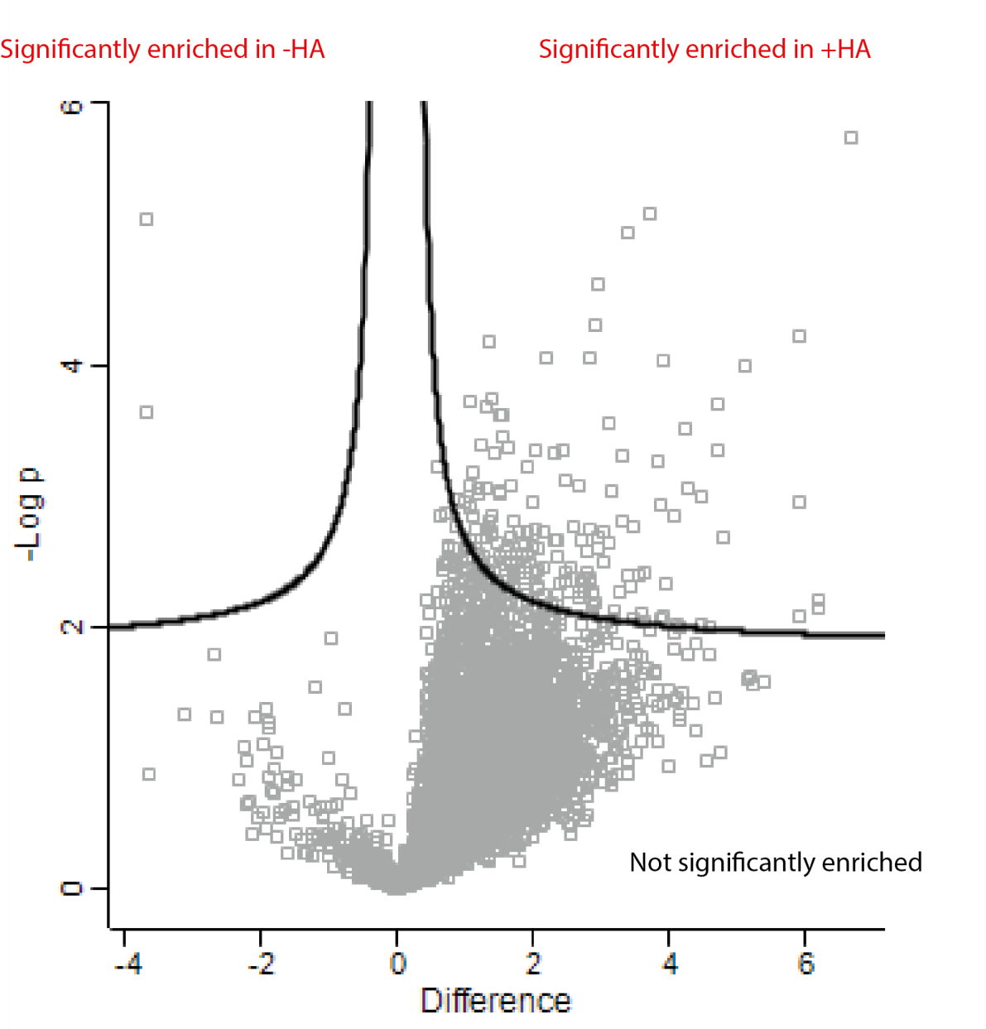
Figure 5.3: A number of proteins are palmitoylated in HeLa cells after DHHC5 depletion with siRNA. A volcano plot of palmitoylation sites from 4 replicates of HeLa cells treated with DHHC5 siRNA (10nM, for 72 hours) after ssABE procedure and MS/MS analysis. Sites that are significantly enriched in the +HA condition are in the upper right, above the line. Sites that are significantly enriched in the -HA condition are in the upper left, above the line. Sites that are not significantly enriched are below the lines.

It is also possible that there was a discrepancy in the total amount of protein in each condition with the DHHC5 siRNA lysates containing more protein than the non-targeting siRNA lysates.
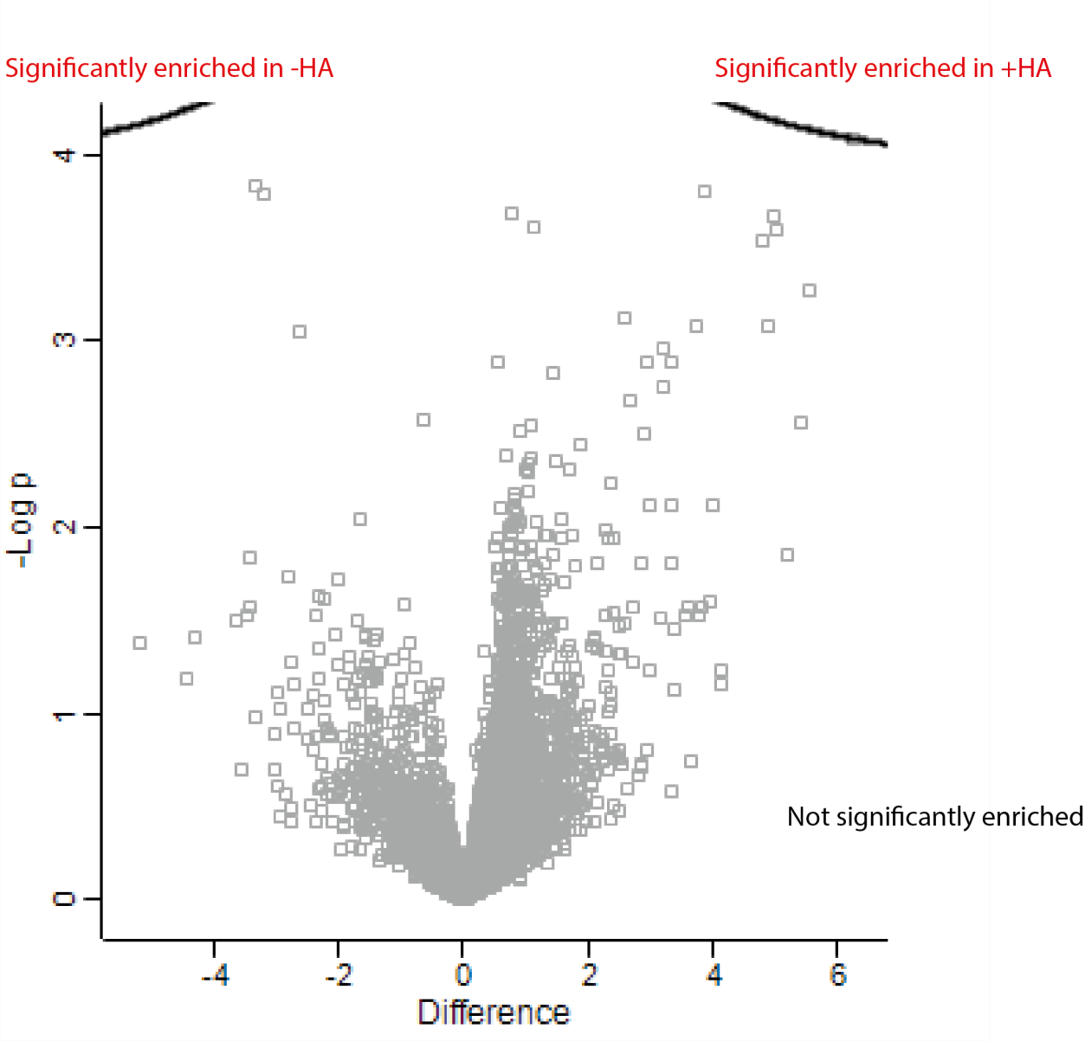
Figure 5.4: No proteins appeared to be palmitoylated in HeLa cells after treatment with negative control non-targeting siRNA. A volcano plot of palmitoylation sites from 4 replicates of HeLa cells treated with non-targeting siRNA (10nM, for 72 hours) after ssABE procedure and MS/MS analysis. Sites that are significantly enriched in the +HA condition are in the upper right, above the line. Sites that are significantly enriched in the -HA condition are in the upper left, above the line. Sites that are not significantly enriched are below the lines.
A protein quantification was carried out prior to the ssABE procedure to ensure even amounts of protein were used in each condition, but a problem at this stage would be reflected in lower or higher intensities later on. This is a less likely scenario as it does not account for the similarity in intensities in the +HA and –HA conditions of the pulldowns. Another option is that the step to block free cysteine residues with iodoacetamide did not effectively block all cysteine residues. This would lead to a high level of tagging of non-palmitoylated cysteines with biotin, increasing the overall intensity of the –HA condition. A similar issue could be seen if not all disulphide bonds were broken during reduction by TCEP, as if these bonds broke at any other point after this, these peptides would be pulled down in similar intensities in both +HA and –HA conditions.

Hydroxylamine treatment is known to degrade proteins, specifically breaking peptide bonds between asparagine and glycine at basic pH (Antorini et al., 1997), and could lead to an overall reduction in the intensity of the +HA samples. While the pH of hydroxylamine was ensured to be neutral prior to treatment and should have been kept neutral by the addition of buffer, if there was a drift to more basic pH over the time of hydroxylamine treatment it would lead to a specific degradation of proteins in the +HA sample. These peptides would then be lost through the subsequent washing stages. Given the lower intensity in the +HA condition of the lysates from cells treated with non-targeting siRNA compared to those treated with DHHC5 siRNA, this possibility must be considered. Another issue that could have occurred with hydroxylamine treatment is if it was not present in a sufficient concentration to effectively break the thioester bonds. This would not explain the higher than expected intensity of peptides in the -HA

In the palmitoylation sites found to be significantly enriched in +HA over –HA in the DHHC5 siRNA condition there are 226 sites on 215 proteins (Appendix A7), 210 of which are known palmitoylated proteins in the Swisspalm database (Blanc et al., 2015). Importantly, no known DHHC5 substrates are in this dataset, which shows that this approach could be used to find DHHC5 substrates on a large scale with appropriate controls without DHHC5 knockdown.

The PAT DHHC6 is present in this dataset. As a PAT, it is known to be palmitoylated on its active site cysteine as part of its enzyme mechanism (Rana et al., 2019), but also has a number of other interesting features. It associates with Selenoprotein K, which stabilises the acylDHHC6 intermediate (Fredericks et al., 2017), similar to what happens with the yeast DHHC9 homolog Erf2 with the protein Erf4 (Mitchell et al., 2012). Also, it is part of a known palmitoylation cascade, where palmitoylation of sites away from the active site of DHHC6 by the upstream PAT DHHC16 (Abrami et al., 2017) and these palmitoylation events control the activity of DHHC6. One of these sites is palmitoylated in this dataset, showing that this palmitoylation cascade takes place in this system.

When looking into the proteins in this list and performing Gene Ontology analysis on the PANTHER platform (Mi et al., 2013) revealed that there was a significant enrichment of proteins from several regions of the cell. Proteasome components were enriched 8 fold in the dataset compared to the human proteome as a whole, while nuclear pore proteins were enriched more than 7.5 times. There is also a significant enrichment of focal adhesion proteins, a complex that is known to contain several palmitoylated proteins (Yang et al., 2004; Ory et al., 2007; Termini et al., 2014). DHHC5 has been linked to adhesion processes by APMS shown in the previous chapter and the pilot data presented here, but the role of focal adhesions is solely to mediate the adhesion of cells to the extracellular matrix (Wehrle-Haller,
2012), whereas cell:cell adhesion processes were significantly enriched in the other assays.
This makes is likely that DHHC5 may mediate how cells adhere to one another but not to the ECM.

On the other side, integral membrane proteins are significantly under represented, which could be indicative of the removal of a plasma membrane localised PAT in DHHC5 which could be responsible for the palmitoylation of integral membrane proteins. However, the potential DHHC5 substrates in the pilot data also showed an under representation of integral membrane proteins, so this could be a result of the technique used or it could be that integral membrane proteins are not highly palmitoylated in HeLa cells.

5.4 Discussion

The data presented here demonstrates that depletion of DHHC5 by siRNA can affect the modification of specific palmitoylation sites or palmitoylated species of the known DHHC5 substrate Flotillin-2. However, this contradicts previous work that demonstrated that palmitoylation of Flot2 is completely lost after DHHC5 is depleted in neural stem cells (Li et al., 2012). The reasons for this are unclear, but could be linked to various factors. In this work, HeLa cells were used, knockdown was performed using siRNA and a PEG switch was used to assay Flot2 palmitoylation. In the previous work, neural stem cell gene traps of DHHC5 were used in conjunction with Cos-1 cell over expression of the protein and the ABE method was used to assay the palmitoylation of Flot2. The differences could be down to the method chosen, as ABE and PEG switch can give different results for proteins as ABE is based on a streptavidin pulldown after release and biotinylation of palmitoylated cysteines, whereas a PEG switch releases the palmitate from cysteines and replaces it with a 5 kDa mass tag. No pulldown is required for PEG switch but it does rely on a specific antibody to accurately show the different palmitoylation states. Another reason could be that DHHC5 is responsible for modifying a single palmitoylation site in HeLa cells out of the three palmitoylated cysteines (Neumann-Giesen et al., 2004), while it is responsible for palmitoylating more than that in neural and Cos-1 cells. The authors of the previous work note that DHHC5 does appear to mediate the palmitoylation of Flot2 on Cysteine 4 more strongly than the other two sites, which makes this a likely potential explanation. Of course, further work in HeLa cells on Flot2 palmitoylation by DHHC5 would be required to confirm that this is the case.

While no strong conclusions can be drawn from the pilot ssABE data on DHHC5 substrates, it could give insights into possible future avenues of research on DHHC5 substrates and processes it regulates. Cell adhesion processes are again significantly enriched, which does match closely what has been shown with AP-MS data in the previous chapter. As adhesion proteins feature both as interactors and potential substrates of DHHC5 it positions adhesion processes as an intriguing avenue for future research.

An interesting future avenue that could be explored from this work would be to investigate the effects of the knockdown of Golga7b on the palmitoylated proteome and in particular on DHHC5 substrates. This work would be aided a set of high confidence DHHC5 substrates, which is what the work presented here would have hoped to have achieved. However, the effects of the movement of DHHC5 caused by the depletion of Golga7b could still be investigated by ssABE. It could be that by forcing DHHC5 to internalise by knocking down Golga7b, or by some other way of removing it from the system, there are major changes to the palmitoylated proteome, including the palmitoylation of a range of proteins that are not usually DHHC5 substrates. This would indicate that controlling the localisation of DHHC5 through the palmitoylation of Golga7b is an important way of modulating DHHC5 substrates and controlling its specificity. Alternatively, it could be that DHHC5 palmitoylates only a very select group of proteins within the cell even when it is localised there for an extended period of time rather than transiently as is the case after endocytosis from the post-synaptic density in neurons (Brigidi et al., 2015), and the major change seen would be the probable reduction in palmitoylation of plasma membrane proteins that are DHHC5 substrates such as Flot2. In either event, an analysis of the palmitoylated proteome after Golga7b depletion and subsequent mis-localisation of DHHC5 would provide some interesting and useful insights into DHHC5 substrate specificity and to what extent the localisation of DHHC5 is required for controlling the palmitoylation of its substrates.

6 The AP2 complex is essential for DHHC5 endocytosis

One of the defining features of the family of palmitoyl acyltransferase enzymes is that each one has a distinct subcellular location (Ohno et al., 2006). It appears that DHHC5 may be unusual and unique among PATs as it has been found previously that DHHC5 is trafficked away from the post-synaptic density to the dendritic spine and that maintenance at the plasma membrane of the post-synaptic density is mediated by a specific phosphorylation event (Brigidi et al., 2015). This makes it possible that DHHC5 is held at the plasma membrane by one or more events or interactions and that it can be trafficked to and from the plasma membrane through an unknown mechanism. As DHHC5 is the only PAT that has been shown to actively traffic around the cell, it is important to understand the mechanism through which DHHC5 is moved away from the plasma membrane.

It has been demonstrated that the AP2 complex interacts with DHHC5 at the post-synaptic density in a phosphorylation dependent manner (Brigidi et al., 2015), which makes it very likely that DHHC5 is endocytosed through this pathway when it is internalised. However, it is largely unknown if this process is tied specifically to the cycling of DHHC5 at the post-synaptic density, or is a more general feature of DHHC5 in different cell types and it has not been confirmed that DHHC5 is specifically trafficked through this pathway.

6.1 Endocytosis inhibition by depleting cholesterol traps DHHC5 at the plasma

membrane and can reverse the phenotype caused by Golga7b mutation

As shown previously, expression of DHHC5 with non-palmitoylatable mutant Golga7b causes it to be mislocalised away from the plasma membrane to areas within the cell (), however the mechanism by which this is achieved is unknown. After finding a large number of proteins involved in endocytic pathways as possible interactors with DHHC5 when it is present at the plasma membrane using AP-MS, it was hypothesised that DHHC5 is actively endocytosed away from the plasma membrane and inhibiting endocytosis could cause DHHC5 to be trapped at the plasma membrane. It would also show whether the phenotype of DHHC5 location caused by non-palmitoylatable mutant Golga7b is a result of incorrect trafficking to the membrane after protein synthesis or if DHHC5 is able to reach the plasma membrane after synthesis and the phenotype is caused by a defect downstream of that.

Initially, the known endocytosis inhibitor (Vercauteren et al., 2010) and cholesterol depletion agent (Mahammad & Parmryd, 2015) methyl-β-cyclodextrin (mβc) was used. HeLa cells expressing the non-palmitoylatable mutant Golga7b and WT DHHC5 were treated with 5mM mβc for up to 4 hours or with sterile H₂O as a control. The plasma membrane signal of DHHC5 increased over time (Figure 6.1) with 1 hour of treatment leading to the first significant increase in plasma membrane signal (Figure 6.1c). The plasma membrane signal of DHHC5 peaked at 2 hours of treatment with methyl-β-cyclodextrin (Figure 6.1d), but returned to a level that was not significantly different to untreated cells after 4 hours (Figure 6.1e). This shows that either cholesterol or a form of endocytosis that is inhibited by methyl-βcyclodextrin is required for the internalisation of DHHC5 and that inhibiting this is capable of reversing the effects of loss of Golga7b palmitoylation.
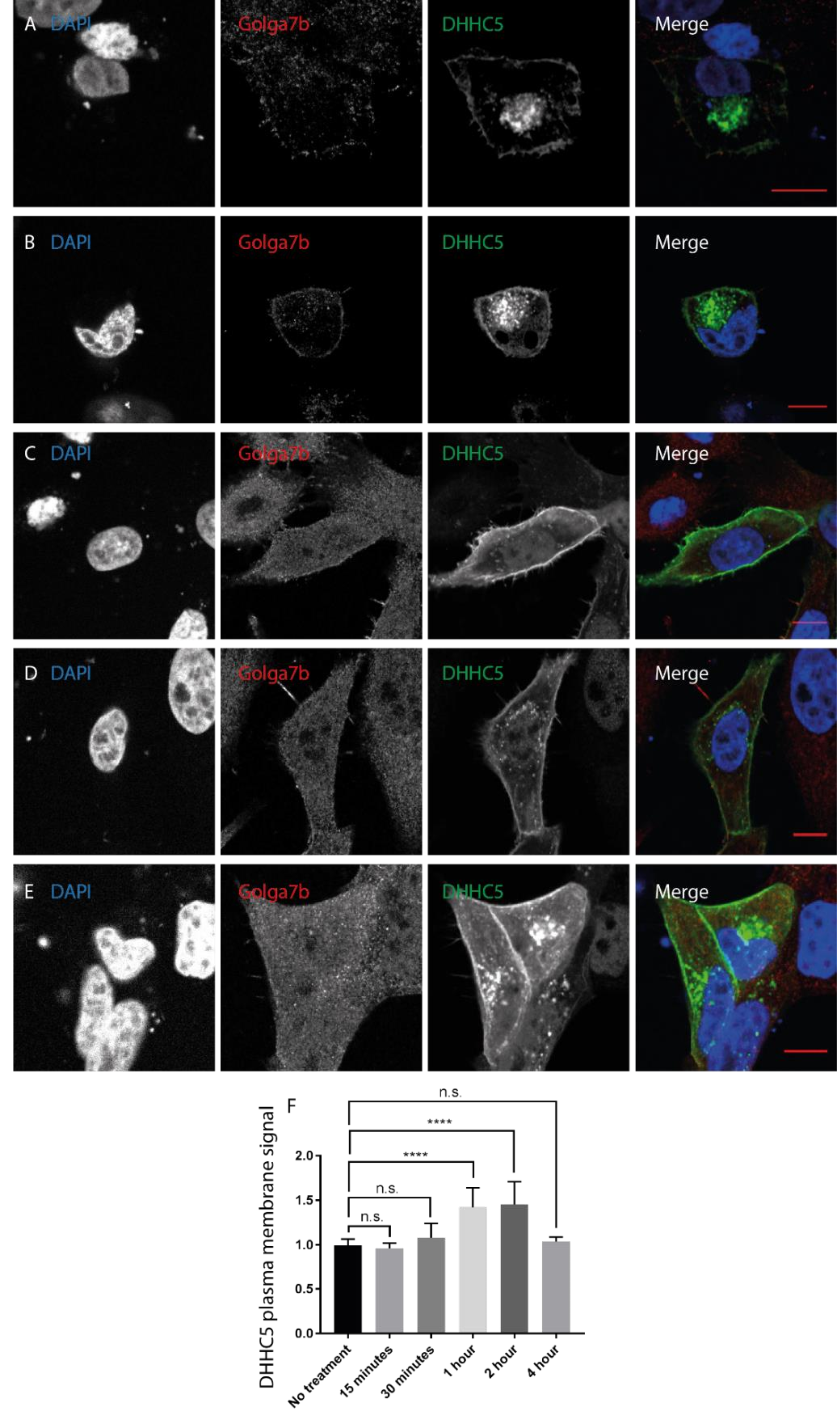
**

**

Figure 6.1: Methyl-β-cyclodextrin treatment (25mM) of HeLa cells co-expressing C-terminally HA tagged non-palmitoylatable mutant Golga7b and C-terminally triple FLAG tagged WT DHHC5over a 4 hour time course. Stained for DAPI (left panels), anti-HA (2nd panels from left), anti-FLAG (3rd panels from left) and a merged image (right panels). A – 15 minute time point. B – 30 minute time point. C – 1 hour time point. D – 2 hour time point. E – 4 hour time point. F – Quantification of the plasma membrane signal of DHHC5 at each individual time point.no treatment, n=10. 15 minutes, n=13. 30 minutes, n=17. 1 hour, n=21. 2 hour, n=24. 4 hour, n=6. n.s.=not significant, **=p<0.01, ANOVA.
Further work was done to find if inhibition of endocytosis using methyl-β-cyclodextrin affected the localisation of the mutant forms of DHHC5 when co-expressed with mutant Golga7b. All cells were treated for 2 hours, which was the time with the peak of WT DHHC5 plasma membrane signal when co-expressed with mutant Golga7b and treated with methylβ-cyclodextrin (Figure 6.1d). The catalytic DHHS5 mutant showed a significant increase in plasma membrane signal when treated with 25mM methyl-β-cyclodextrin (Figure 6.2a) when compared to untreated control cells which co-expressed DHHS5 and mutant Golga7b (Figure 6.2b), which mirrors the WT DHHC5 (Figure 1d), showing that DHHC5 does not need to be active for this inhibition of endocytosis to have an effect. However, there was no change in the plasma membrane signal of the DHHC5 mutant that has had its palmitoylation sites in its C-terminal tail mutated to prevent palmitoylation when co-expressed with mutant Golga7b and treated with methyl-β-cyclodextrin (Figure 6.2c) compared to untreated control cells (Figure 6.2d). This result is interesting as it shows that endocytosis of DHHC5 is likely to be dependent on the palmitoylation of a region in the C-terminal tail, and supports the data presented earlier which showed that inhibiting depalmitoylation with palmostatin B leads to
DHHC5 signal being seen within the cell.
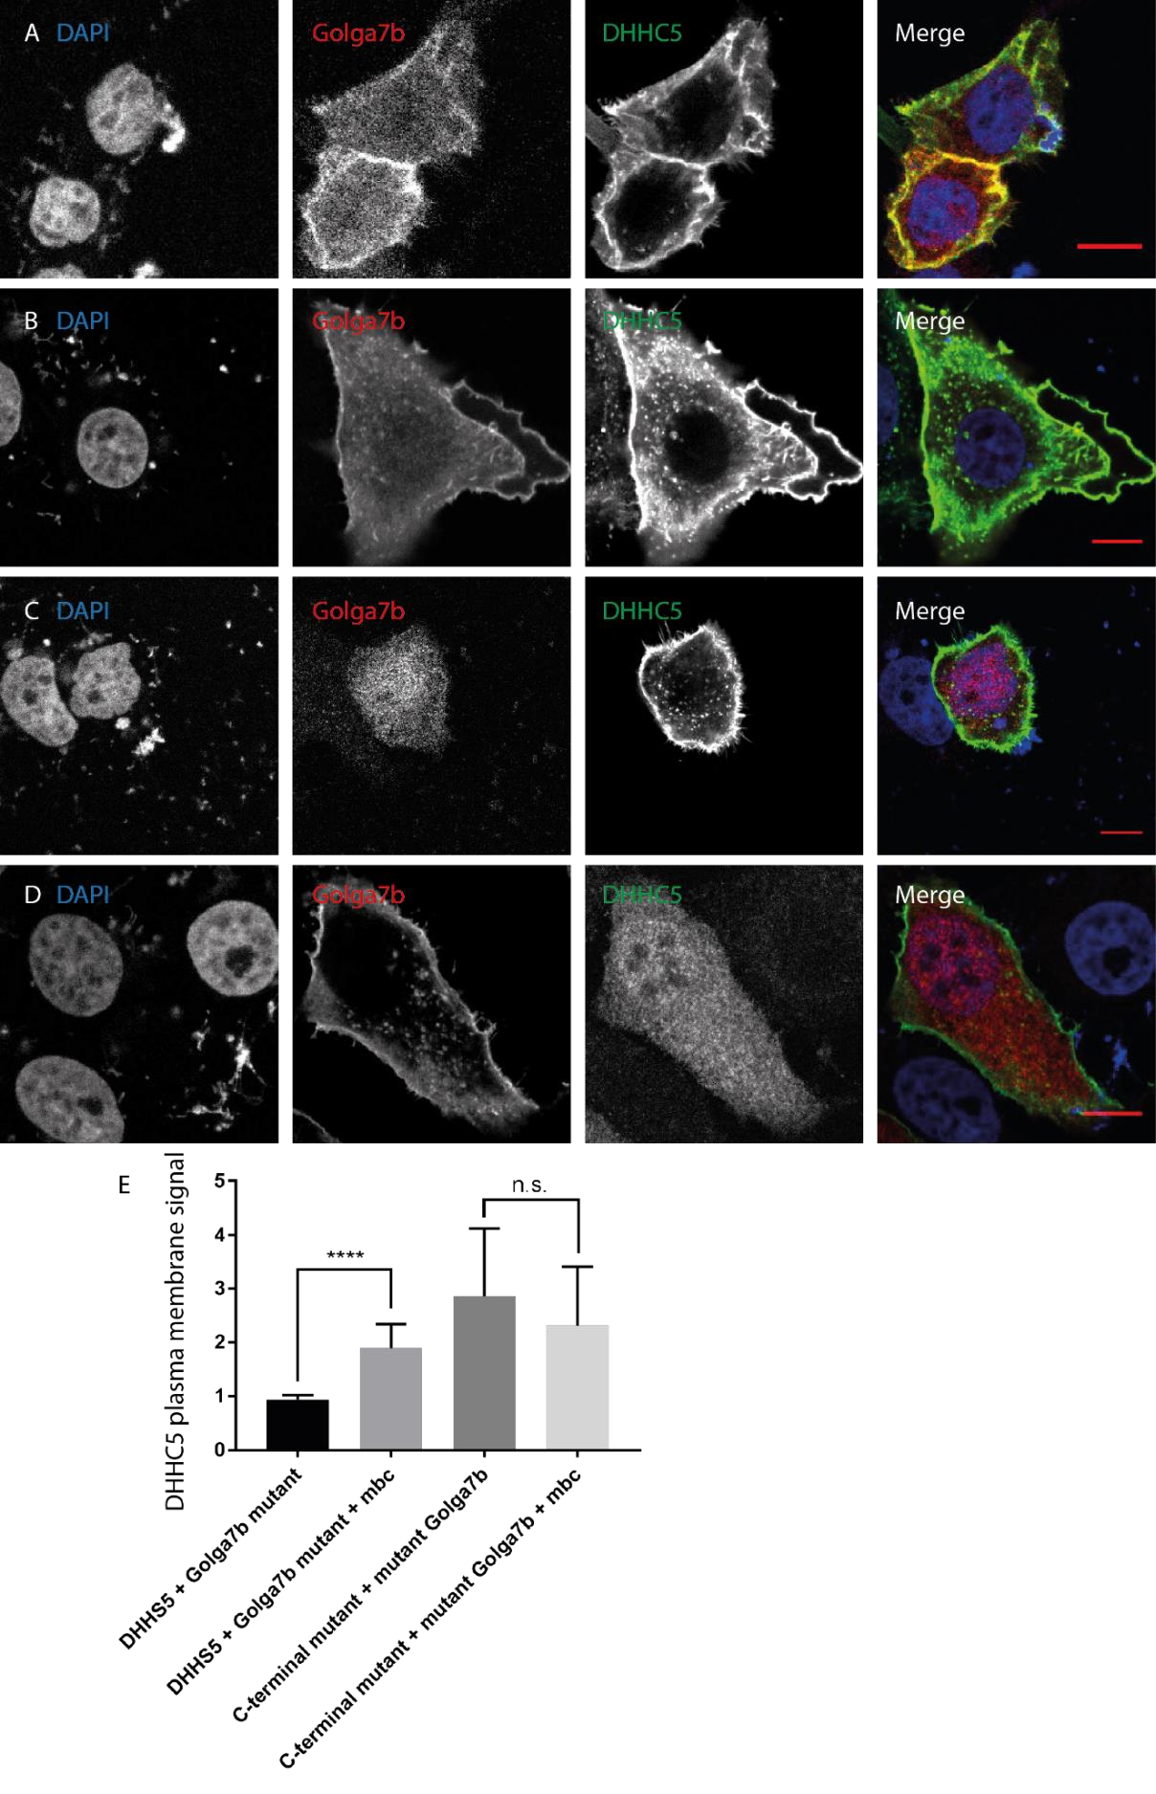

Figure 6.2: Methyl-β-cyclodextrin treatment (25mM) of HeLa cells co-expressing C-terminally HA tagged nonpalmitoylatable mutant Golga7b and C-terminally FLAG tagged WT DHHC5over a 4 hour time course. Stained for DAPI (left panels), anti-HA (2nd panels from left), anti-FLAG (3rd panels from left) and a merged image (right panels). A – 15 minute time point. B – 30 minute time point. C – 1 hour time point. D – 2 hour time point. E – 4 hour time point. F – Quantification of the plasma membrane signal of DHHC5 at each individual time point.no treatment, n=10. 15 minutes, n=13. 30 minutes, n=17. 1 hour, n=21. 2 hour, n=24. 4 hour, n=6. n.s.=not significant, ****=p<0.001 unpaired T test.

6.2 Dynamin inhibition restores DHHC5 to the plasma membrane during mutant

Golga7b expression

Next, the dynamin inhibitor dynasore (Macia et al., 2006) was used as a more specific and rapid inhibitor of endocytosis to gain more insight into whether the endocytosis of DHHC5 is dependent on cholesterol that was depleted by methyl-β-cyclodextrin or if it requires the protein dynamin, or if the DHHC5 phenotype caused by methyl-β-cyclodextrin is due to another off-target effect of this treatment. When HeLa cells co-expressing WT DHHC5 and mutant Golga7b were treated with 25µM dynasore or vehicle (DMSO) over a time course of 0 to 4 hours (Figures 6.3 and 6.4), DHHC5 signal was rapidly shifted to the plasma membrane with a significant increase in the ratio of plasma membrane signal to total cell signal of DHHC5 seen after 15 minutes (Figure 6.3c and h) and peaking 30 minutes after dynasore treatment (Figure 6.3d and h). There was a drop in the ratio of plasma membrane signal of DHHC5 seen at the longer time points of 1 hour and more (Figures 6.3 e-h), but this was still a significant increase on untreated cells and did not decrease further after 1 hour of treatment. Control cells treated with DMSO showed no significant changes over the entire 4 hour time course of treatment (Figure 6.4), confirming that all the changes seen with dynasore were entirely down to the action of the small molecule on the cells.

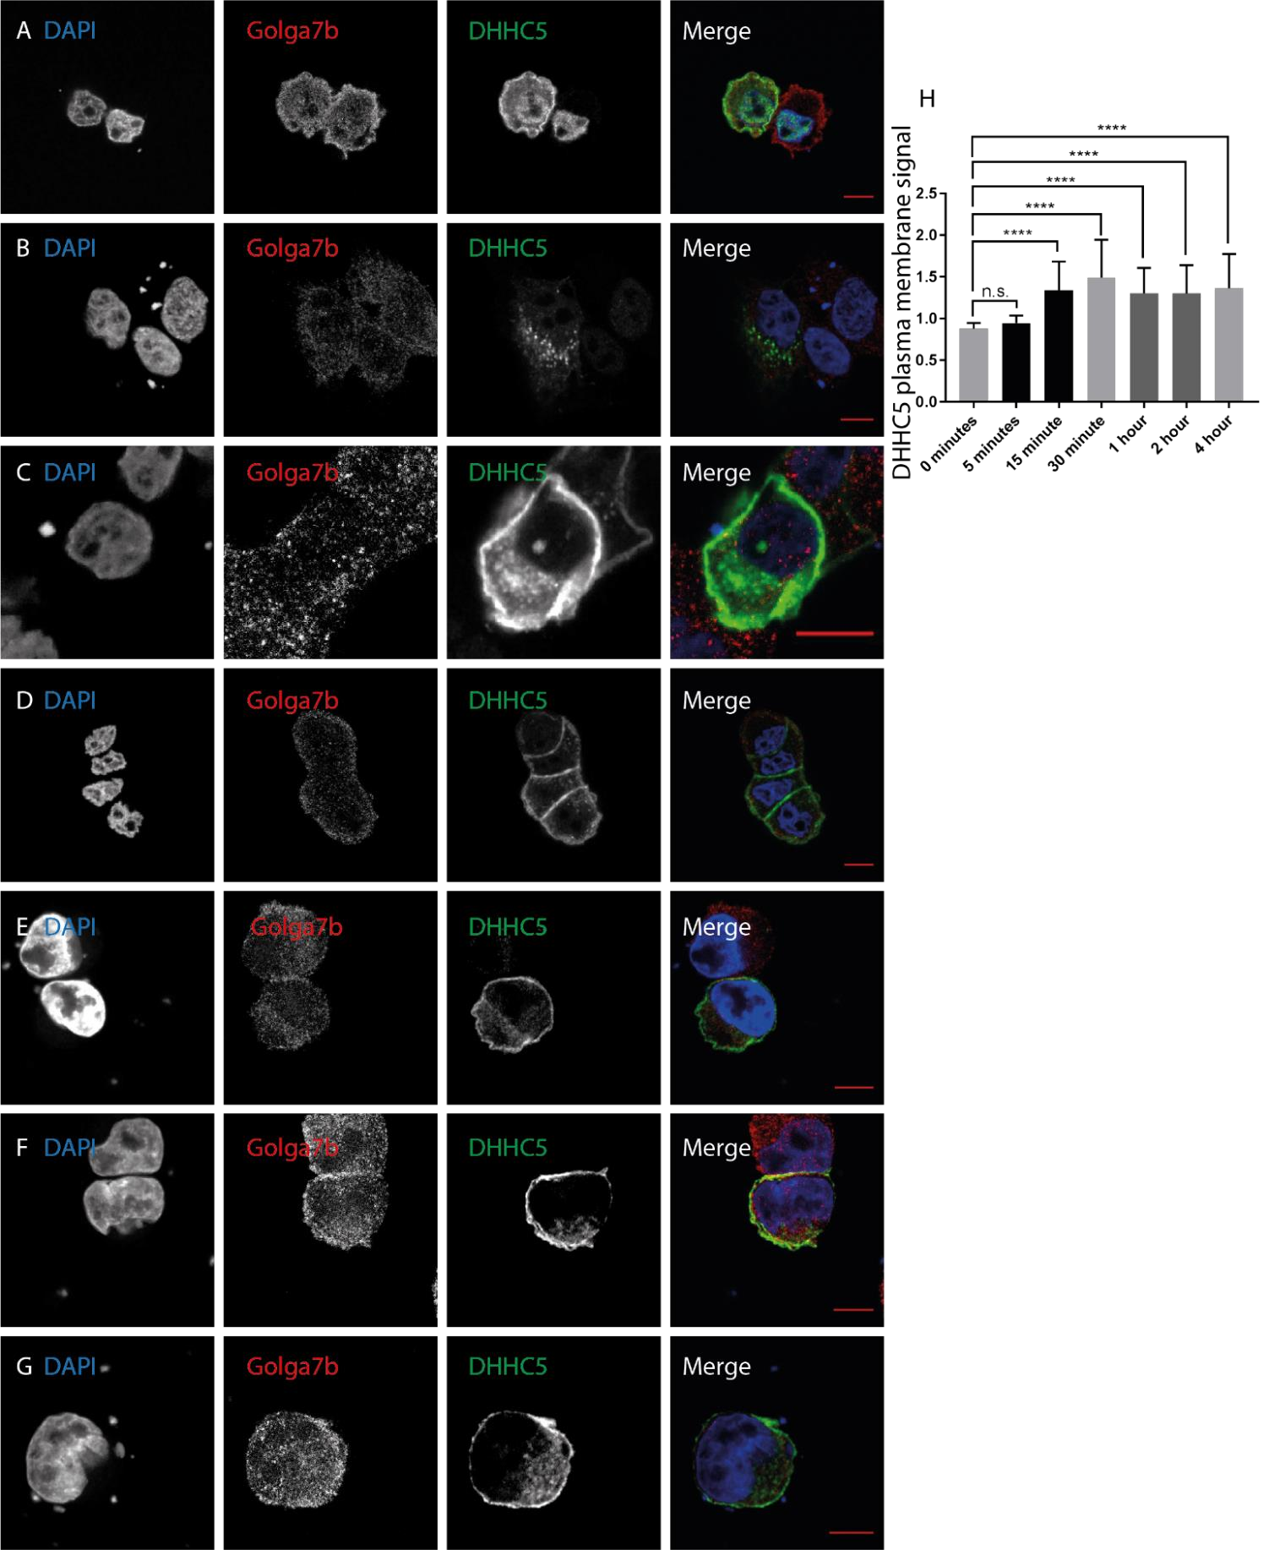

**

**

**

*

**

Figure 6.3: Dynamin inhibitor dynasore treatment (25µM) of HeLa cells co-expressing C-terminally HA tagged nonpalmitoylatable mutant Golga7b and C-terminally triple FLAG tagged WT DHHC5 over a 4 hour time course. Stained for DAPI (left panels), anti-HA (2nd panels from left), anti-FLAG (3rd panels from left) and a merged image (right panels). A – 0 minute time point. B – 5 minute time point. C – 15 minute time point. D – 30 minute time point. E – 1 hour time point. F – 2 hour time point. G – 4 hour time point. F – Quantification of the plasma membrane signal of DHHC5. 0 minutes, n=10. 5 minutes, n=37. 15 minutes, n=47. 30 minutes, n=37. 1 hour, n=25. 2 hour, n=28. 4 hour, n=21. ANOVA, n.s.=not significant, **=p<0.0¹⁸⁷1, *=p,0.05

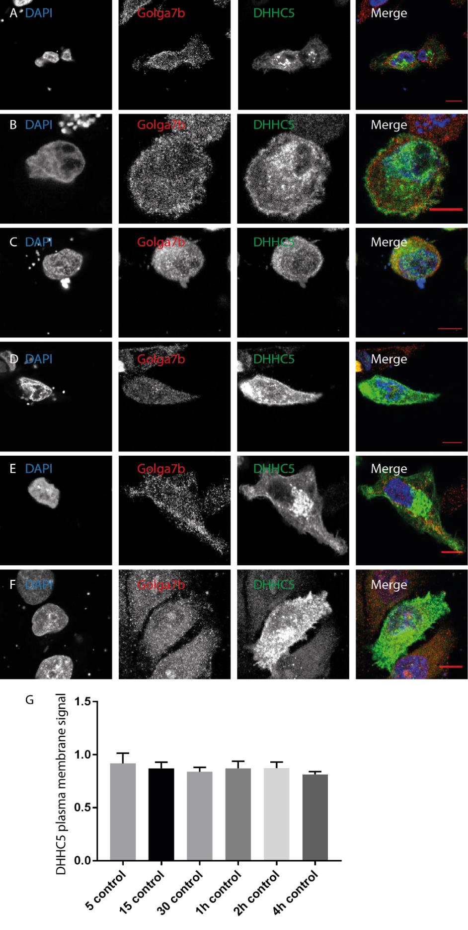

Figure
6.
4:
Control treatment (DMSO
)

for dynasore treatment of HeLa cells co
-
expressing C
-
terminally HA tagged
non
-
palmitoylatable mutant Golga7b and C
-
terminally triple FLAG tagged WT DHHC5over a 4 hour time course.
Stained for DAPI (left panels), anti
-
HA (2nd panels from left), anti
-
FLAG (
3
rd panels from left) and a merged image
(
right panels). A
–

0
minute time point. B
–

5
minute time point. C
–

15
minute time point. D
–

30
minute time
point. E
–

1
hour time point. F
–

2
hour time point. G
–

4
hour time point. F
–

Quantification of the pl
asma
membrane signal of DHHC5. 0 minutes, n=10. 5 minutes, n=37. 15 minutes, n=47. 30 minutes, n=37. 1 hour, n=25.
2
hour, n=28. 4 hour, n=21. Unpaired t
-
test, no significant changes

As was done previously for methyl-β-cyclodextrin, the effects of dynasore were investigated on HeLa cells which were co-expressing mutant Golga7b along with one of the two DHHC5 mutants, either the catalytically inactive DHHS5 mutant and the C-terminal mutant that was missing the 3 palmitoylation sites in its C-terminal tail. Cells were treated with 25µM dynasore for 30 minutes, which was the peak of WT DHHC5 plasma membrane signal when coexpressed with mutant Golga7b and treated with dynasore, or the vehicle DMSO. The dynasore treatment restored the catalytic mutant DHHS5 to the plasma membrane (Figure 6.5a), while DMSO treatment caused DHHS5 to remain in other compartments of the cell (Figure 6.5b). This closely mimics the phenotype of WT DHHC5, as was seen with the methylβ-cyclodextrin (Figure 6.2a) and again confirms that DHHC5 does not need to be catalytically active for an endocytic block to reverse the effects of mutant Golga7b. As the C-terminal mutant version of DHHC5 is always present at the plasma membrane and co-expression does not affect this localisation, it was thought that it would be unlikely that dynasore treatment would change this localisation significantly. This hypothesis turned out to be correct as no change was seen between dynasore treated cells (Figure 6.5c) and DMSO treated cells (Figure 6.5d). This further confirms that the DHHC5 C-terminal mutant is unable to be internalised despite the fact that it cannot interact with Golga7b.

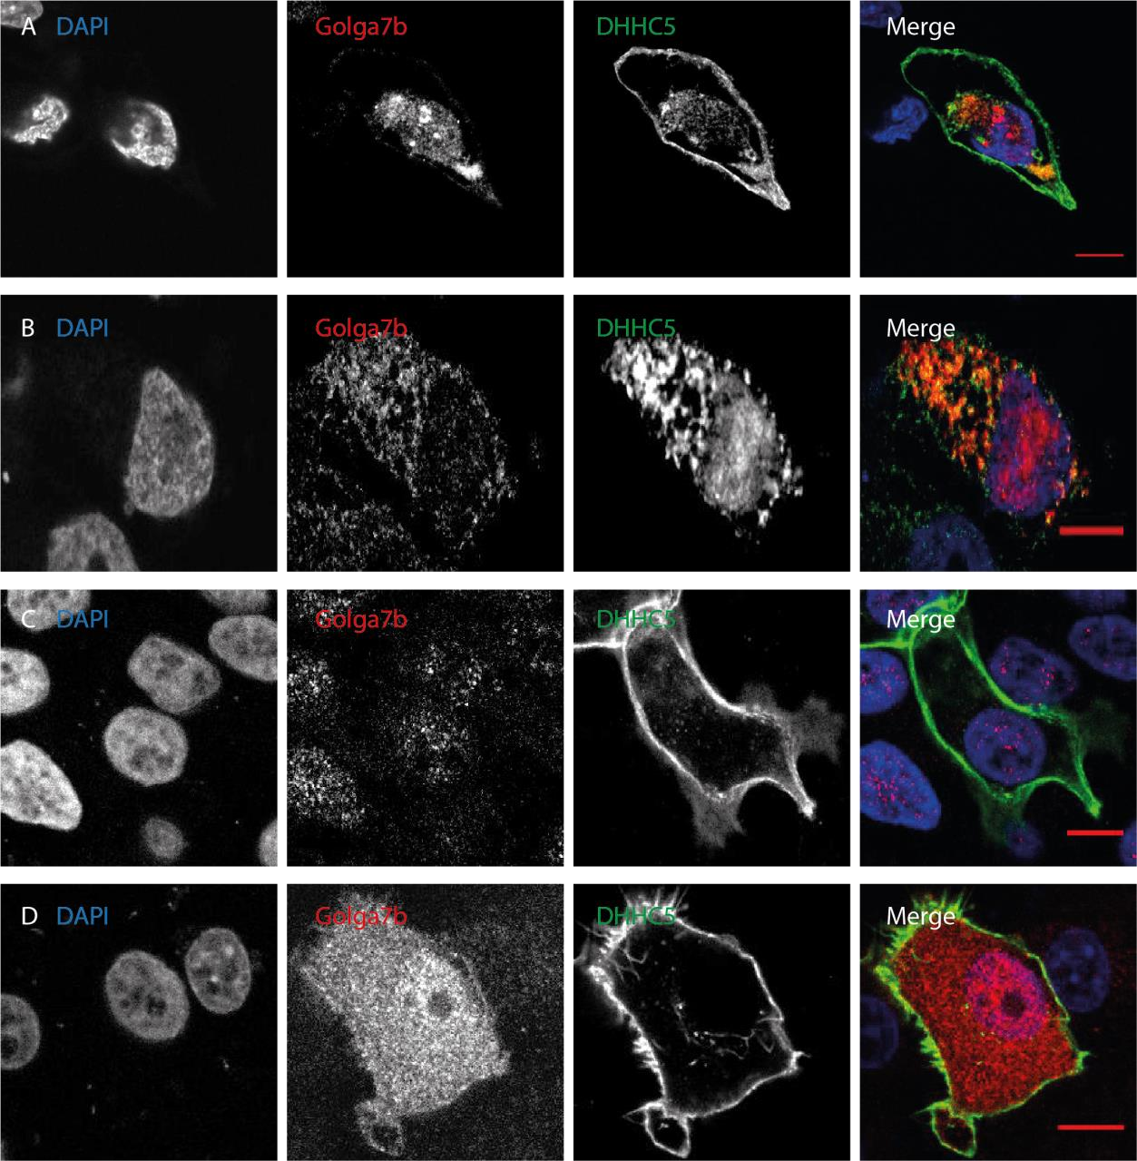
Figure 6.5: 30 minute dynamin inhibitor dynasore treatment (25µM) or DMSO treatment of HeLa cells coexpressing C-terminally HA tagged non-palmitoylatable mutant Golga7b and C-terminally FLAG tagged DHHS5 catalytic mutant or C-terminal DHHC5 mutant.. Stained for DAPI (left panels), anti-HA (2nd panels from left), antiFLAG (3rd panels from left) and a merged image (right panels). A – DHHS5 catalytic mutant dynasore treated. B DHHS5 catalytic mutant DMSO. C - DHHC5 C-terminal mutant dynasore treated. D - DHHC5 C-terminal mutant DMSO

This was then extended to see if dynasore would affect the location of the DHHC5 signal in cells co-expressing WT Golga7b. In HeLa cells co-expressing WT Golga7b and WT DHHC5 treated for 30 minutes with 25µM dynasore, as this was the peak of DHHC5 plasma membrane signal when DHHC5 was expressed with mutant Golga7b, there was significantly more DHHC5 fluorescence signal seen at the plasma membrane when imaged using confocal microscopy than when compared to control cells which were treated with DMSO. This suggests that co-expression of WT Golga7b with DHHC5 does not prevent endocytosis of DHHC5 and that endocytosis and recycling of DHHC5 is a normal part of its lifecycle.

6.3 The AP2 complex is required for DHHC5 endocytosis

While the above work shows that inhibiting endocytosis pharmacologically causes more
DHHC5 to be seen at the plasma membrane, it does not confirm that either clathrin or the
AP2 complex are involved as was hinted at by the interaction data shown earlier. Furthermore, previous work by other groups has shown that DHHC5 does interact with AP2µ (Brigidi et al., 2015) but did not show a functional role for AP2µ in DHHC5 endocytosis. To address this, HeLa cells were treated with non-targeting siRNA or siRNA targeted against the AP2µ subunit and then transfected with mutant Golga7b. In cells treated with non-targeting siRNA, endogenous DHHC5 was present throughout the cell (Figure 6.6a), presumable in numerous compartments of the endomembrane system. When AP2µ was knocked down with siRNA, endogenous DHHC5 was again found in its normal location at the plasma membrane
(Figure 6.6b), effectively reversing the phenotype that is caused by expression of mutant
Golga7b. This shows that DHHC5 is endocytosed away from the plasma membrane via the AP2 mediated clathrin endocytosis pathway and that the AP2µ subunit is essential in this process.
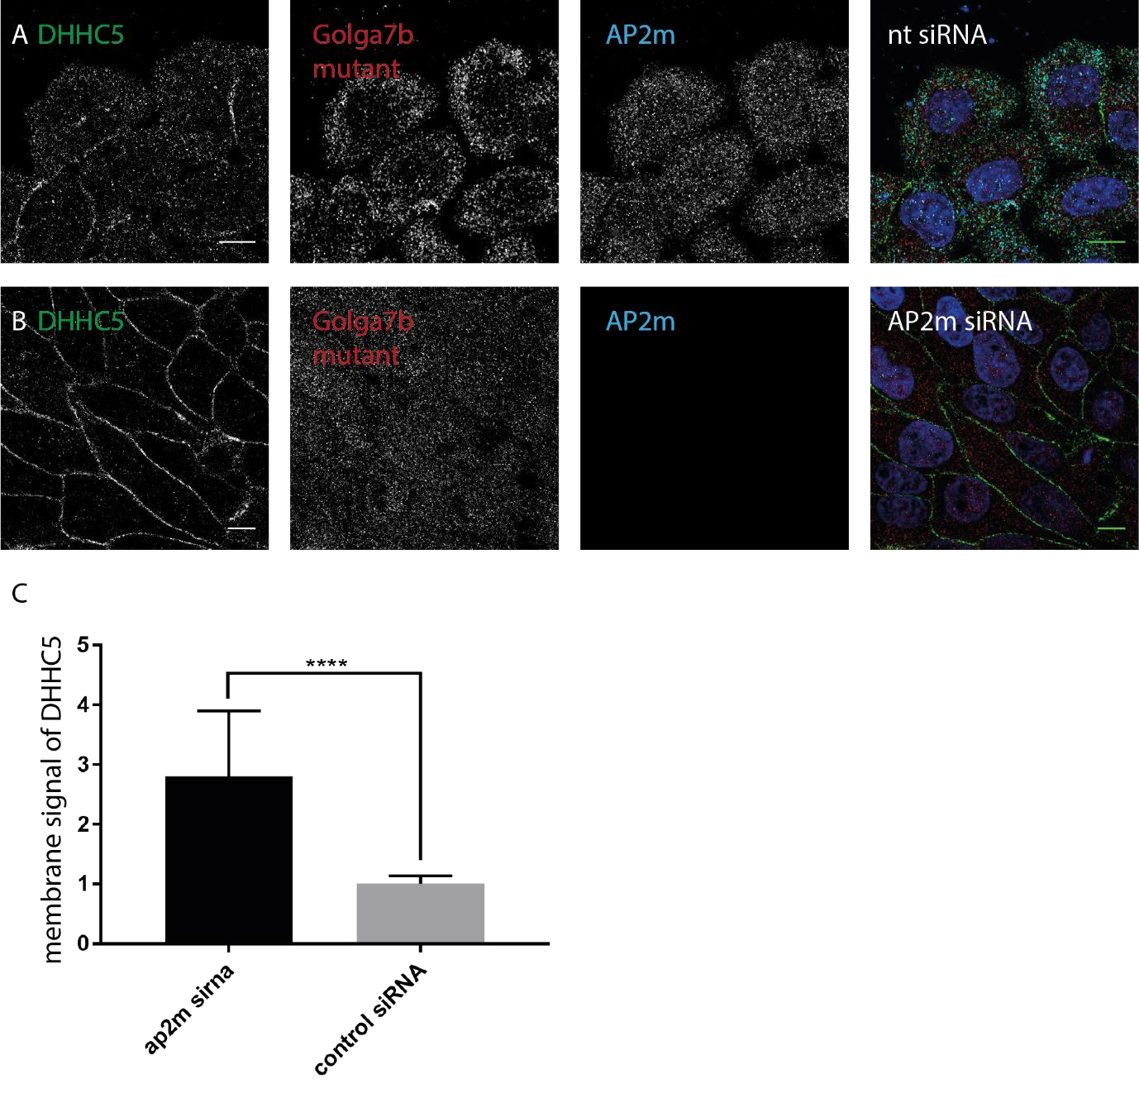
Figure
6.
6:
Knockdown of AP2µ subunit in HeLa cells expressing mutant Golga7b with siRNA (20nM).
Immunocytochemistry images, staining for DHHC5 (left panel), mutant Golga7b (second panel from left),
AP2µ subunit (3rd panel) and a merged image

(
right panel). A
–

non
-
targeting siRNA treatment of Hela
cells. B
–

AP2µ siRNA treatment of HeLa cells. C
–

Quantification of membrane signal of DHHC5 done by
taking the ratio of total cell fluorescence divided by the internal cell fluorescence. T
-
test, *
***=p<0.001
,
AP2m siRNA n=40, control siRNA n=28.

6.4 Preventing palmitoylation of DHHC5 abolishes its endocytosis

While these experiments demonstrate that DHHC5 is endocytosed through AP2 controlled endocytosis and that by blocking this process it is possible to reverse the mislocalisation of DHHC5, it doesn’t shed any more light on the balance of DHHC5 endocytosis and whether preventing the palmitoylation of DHHC5 or Golga7b changes the dynamics of DHHC5 endocytosis. To investigate this question, a biotin based endocytosis assay was carried out, where proteins on the cell surface are labelled with a cleavable biotin at low temperature to block endocytosis, before endocytosis is triggered by raising the temperature. The biotin still at the cell surface is cleaved before cell lysis and pulldown on streptavidin resin. Any proteins pulled down will have been endocytosed as the biotin on them will not have been cleaved. When this was done on endogenous DHHC5 in HeLa cells, a small amount of DHHC5 was pulled down by the streptavidin resin suggesting that there is some endocytosis of DHHC5 that happens as part of its life cycle (Figure 6.7a). In addition to this, over-expression of DHHC5 increased the rate of endocytosis, but not to the extent that expression of mutant Golga7b does. Conversely, WT Golga7b prevents endocytosis as does the C-terminal mutant of DHHC5 (Figure 6.7a). However, co-expression of DHHC5 with WT Golga7b does not completely abolish endocytosis of DHHC5 from the plasma membrane as a very faint signal is seen in the pulldown of this condition when the x-ray film is exposed to the immunoblot membrane for a much longer timeframe. There is no corresponding signal with the DHHC5 C-terminal mutant, showing again that this mutant of DHHC5 is stable at the plasma membrane and does not appear to endocytosed at all.

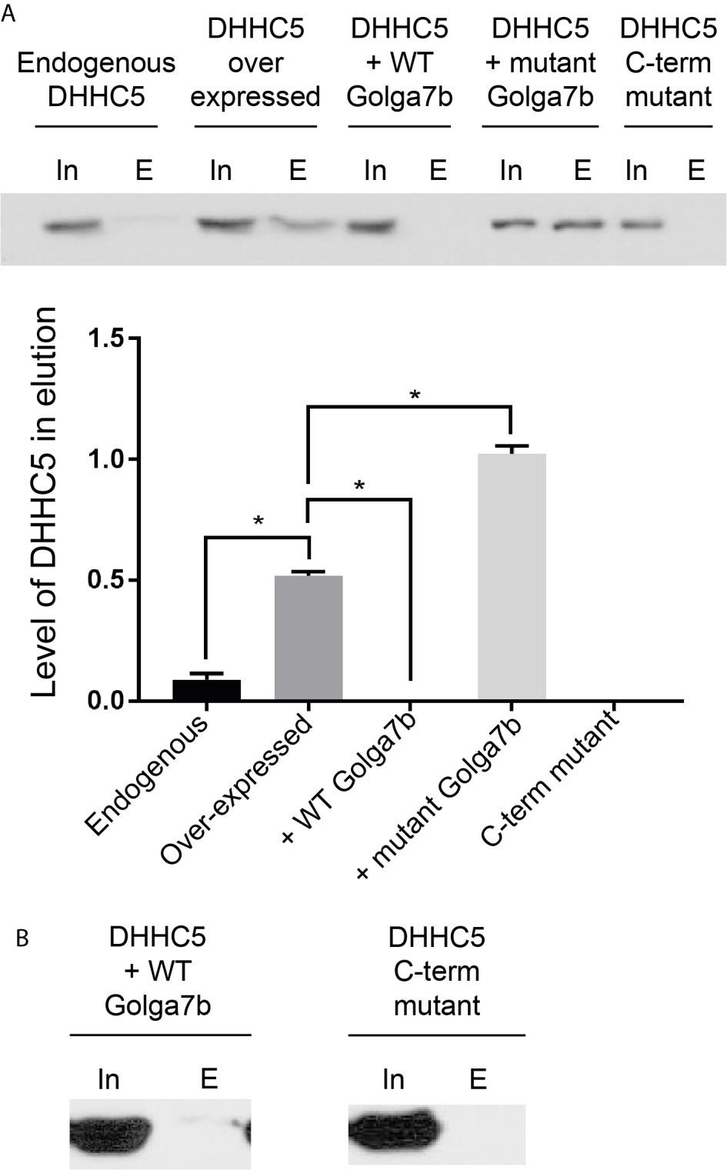
Figure 6.7: A - Biotin endocytosis assays from normal HeLa cells, HeLa cells over-expressing DHHC5, HeLa cells co-expressing DHHC5 and WT Golga7b, HeLa cells co-expressing DHHC5 and mutant Golga7b or HeLa cells expressing the DHHC5 C-terminal mutant. “In” is the input in each condition while “E” is elution following streptavidin pulldown of biotinylated proteins. Quantification of elution normalised to input, *=p<0.05, paired t-test, N=3. B – Long exposure of DHHC5 co-expressed with WT Golga7b and the DHHC5 C-terminal mutant expressed alone. A very faint signal is seen in the DHHC5 + WT Golga7b pulldown is seen with no corresponding band in the DHHC5 C-terminal mutant.

6.5 Discussion

The work described here demonstrates that DHHC5 is trafficked through the AP2 mediated clathrin endocytosis pathway, and that by blocking this pathway it is possible to “trap” DHHC5 at the plasma membrane. It is also possible to reverse the loss of DHHC5 at the plasma membrane that is caused by preventing palmitoylation of Golga7b by inhibiting AP2 mediated clathrin endocytosis. This validates previous work which suspected that DHHC5 is trafficked through this pathway as DHHC5 has a number of endocytic motifs in its C-terminus and interacts with AP2µ at the post-synaptic density in neurons (Brigidi et al., 2015). Furthermore, the work presented here also shows that endocytosis of DHHC5 has a dependence on dynamin, and potentially on cholesterol rich domains at the plasma membrane, as both the dynamin inhibitor dynasore and the cholesterol depletion agent methyl-β-cyclodextrin are able to inhibit the internalisation of DHHC5.

The dependence of DHHC5 endocytosis on cholesterol rich lipid domains at the plasma membrane cannot be completely assured from the experiments shown here, as only methylβ-cyclodextrin was used to deplete cholesterol, and no other experiments were performed to confirm this hypothesis. However, it is an intriguing possibility that should be investigated further in future work. Possible further evidence for this is from the behaviour, and apparent resistance to internalisation, of the DHHC5 C-terminal mutant. This mutant has been point mutated on its C-terminus at 3 palmitoylation sites to prevent palmitoylation of DHHC5 at these sites. Palmitoylation has been shown to regulate the association of integral membrane proteins with cholesterol rich microdomains at the plasma membrane (Levental et al., 2010), and loss of palmitoylation of DHHC5 such as is seen with the C-terminal mutant would presumably disrupt the association of DHHC5 with such domains. If endocytosis of DHHC5 specifically takes place at these areas of the plasma membrane, this could explain why the Cterminal mutant is not endocytosed. It would also explain why depletion of cholesterol by methyl-β-cyclodextrin would also be able to block DHHC5 endocytosis. This scenario is certainly not without several caveats though, and these would need to be considered if future work was to focus on this area. Endocytosis at these cholesterol rich domains is often takes place in a clathrin independent manner (Lamaze et al., 2001), and is instead dependent on Caveolin-1 and a member of the dynamin family, Dynamin 2 (Nabi & Le, 2003). This type of endocytosis would still be blocked by dynasore, so the restoration of DHHC5 to the plasma membrane after dynasore treatment would still be seen in this hypothetical scenario. The loss of AP2 could also lead to a similar effect, even if DHHC5 is endocytosed in a clathrin independent manner, as it has been shown to associate with Caveolin rich domains to mediate the uptake of Transferrin receptor (Puri, 2009). However, in the AP-MS results presented previously, the clathrin heavy chain was seen as an interactor of DHHC5, an interaction which is likely mediated by the AP2 complex. While this does not rule out clathrinindependent endosytosis as a potential pathway of DHHC5 removal from the plasma membrane, it makes clathrin-dependent endocytosis being another pathway through which DHHC5 is trafficked much more likely. The balance between these two possible pathways of internalisation could be investigated by depleting clathrin chains within the cell, by siRNA or other methods, and seeing if DHHC5 is again localised to the plasma membrane similar to what is seen with knockdown of AP2 here. This method would not guarantee a definitive result either however, as when clathrin-dependent pathways have been blocked in previous studies, proteins are often trafficked in clathrin-independent ways (Puri, 2009). The interaction with clathrin also does not rule out an important role for cholesterol rich domains at the plasma membrane in the internalisation of DHHC5 as there have been examples of clathrin-dependent pathways endocytosing proteins from the plasma membrane from these areas (Ares & Ortiz, 2012). As mentioned above, the involvement of detergent resistant membrane raft domains would go some way to explaining the behaviour of the DHHC5 Cterminal mutant, and could potentially be better observed in a system where the formation of these domains could be prevented or tightly controlled.

The drop in the ratio of plasma membrane signal to total cell signal seen at the longest recorded time point of methyl-β-cyclodextrin is most likely caused by effects of methyl-βcyclodextrin on various internal membranes. As methyl-β-cyclodextrin depletes cholesterol in all biological membranes, it has been shown to have an effect on Golgi apparatus morphology and slows the trafficking of proteins to the membrane (Hansen et al., 2000). This makes it possible that decrease of the proportion of DHHC5 signal seen at the plasma membrane is due to the increase of DHHC5 trapped in the secretion pathway rather than a depletion of DHHC5 at the plasma membrane. If the turnover rate of DHHC5 is unchanged by methyl-β-cyclodextrin, disruption of the secretion system would prevent newly synthesised DHHC5 from reaching the plasma membrane. If DHHC5 needs to be internalised to be degraded then dissolution of the Golgi would make no difference to the plasma membrane signal of DHHC5, but a drop in relative plasma membrane signal compared to signal in the whole cell would be seen, which is the method of quantification used in this work. This could also be the cause of the reduction of the proportion of DHHC5 C-terminal mutant signal seen at the plasma membrane after treatment with methyl-β-cyclodextrin. A similar phenotype was seen at the longer time points of dynasore treatment, although the reasons for this are slightly less clear. It is possible that after blocking endocytosis that is mediated by dynamin that DHHC5 is trafficked through an alternative endocytosis pathway, although this process would need to be much slower to explain why this takes an hour to show a difference in the ratio of DHHC5 signal. It is also possible that the decrease in ratio of total cell fluorescence to internal cell fluorescence is due to newly synthesised DHHC5 being within the cell having not reached the plasma membrane. Co-treatment with the protein synthesis inhibitor
cylohexamide (Baliga et al., 1969) would likely be able to prevent this if synthesis of DHHC5 is the reason for the drop of plasma membrane signal of DHHC5.

It is notable that inhibition of dynamin with dynasore produces a rapid increase in DHHC5 signal at the plasma membrane. The speed of this change shows that restoration of DHHC5 to the plasma membrane is almost certainly caused by recycling of DHHC5 back to the plasma membrane away from areas within the cell rather than synthesis of new DHHC5, as this would require a much longer time to occur. It also suggests that the mode of action of Golga7b is to stabilise DHHC5 at the plasma membrane as if palmitoylation of Golga7b was involved in the recycling of DHHC5 back to the plasma membrane inhibition of endocytosis would have no effect on DHHC5 location when DHHC5 is co-expressed with mutant Golga7b.

A particularly interesting result presented here is that dynamin inhibition significantly increases the DHHC5 signal at the plasma membrane when it is co-expressed with WT Golga7b compared to cells without dynamin inhibition. This suggests that WT Golga7b does not prevent DHHC5 endocytosis as its mode of action, but may instead be involved in stabilising DHHC5 at the plasma membrane, increasing the half-time of DHHC5 on the plasma membrane before endocytosis and recycling, which is supported by other results presented here, particularly the long exposure immunoblot of the biotin-based endocytosis assays. This scenario is entirely possible as not all of DHHC5 present in the cell interacts with Golga7b, as shown by a clear band in the supernatant of the co-immunoprecipitation experiments shown previously.

The results that interaction with WT Golga7b appears to be necessary to maintain DHHC5 at the plasma membrane and that the C-terminal mutant, which does not interact with Golga7b, is always present at the plasma membrane appear to be in conflict with one another. However, the results presented here show that palmitoylation of DHHC5 is required for it to be internalised which makes it possible that palmitoylation of Golga7b functions to protect Cterminally palmitoylated DHHC5 from endocytosis and that the C-terminal mutant, while being unable to interact with Golga7b, is unable to be internalised because it is not palmitoylated on its C-terminal. This hypothesis suggest that palmitoylation of the C-terminal tail of DHHC5 is an endocytic trigger for the protein which is supported by the palmostatin B results presented previously where treatment with palmostatin B leads to endogenous and catalytic mutant DHHC5 signal being seen within the cell. Palmostatin B treatment reduces de-palmitoylation and presumably leads to an increase in palmitoylation of DHHC5, which these results point to being an important regulator of DHHC5 endocytosis. This palmitoylation event could work in concert with the phosphorylation event shown to be important in regulating DHHC5 endocytosis in neurons or could be restricted to certain cell types (Brigidi et al., 2015). The potential importance of the palmitoylation of the C-terminal of DHHC5, how it could affect the partitioning of DHHC5 into particular cholesterol rich domains of the plasma membrane, and how this could influence its endocytosis has been discussed above, but where the Src family kinases that potentially phosphorylate DHHC5 in HeLa cells are located on the plasma membrane could also have an effect on the dynamics of its retrieval from the plasma membrane. For example, if these kinases are excluded from cholesterol rich lipid rafts, the movement of DHHC5 into these domains, potentially through the palmitoylation of the DHHC5 C-terminal, would likely lead to the loss of phosphorylation and subsequent endocytosis. The location of the putative phosphatases that mediate the removal of this phosphorylation event could also have a similar role to play.

It would be interesting to pin down the exact roles that DHHC5 plays, including its substrates, when it is present within the cell. As has been shown here through the biotin-based endocytosis assays, endogenous DHHC5 is cycled away from the plasma membrane at a fairly low level under normal conditions. The explanation of this could be as simple as it is endocytosed to allow degradation and DHHC5 has a relatively high turnover rate. However, it could be play a number of other roles. A shown in a previous chapter, and here, coexpression with the non-palmitoylatable mutant Golga7b or the depletion of Golga7b causes
DHHC5 to be internalised. This phenomenon could be a very important tool in discovering DHHC5 substrates within the cell. It is known that loss of DHHC5 within the cell causes problems with the endosome to Golgi retrieval of proteins (Breusegem & Seaman, 2014), and this could be down to several proteins within this pathway not being palmitoylated. As these proteins are within the cell, DHHC5 would also need to be within the cell, and endocytosis from the plasma membrane is one way of ensuring DHHC5 is within the cell. The other option here is that DHHC5 palmitoylates these proteins while it is being trafficked to the plasma membrane following synthesis, however, DHHC5 is presumably present in endosomes after retrieval from the plasma membrane so would then be in the correct place to palmitoylate proteins in this area of the cell. A study comparing the palmitoylated proteome when DHHC5 is present at the plasma membrane compared to when it is within the cell could be one way of getting towards an answer on this question. The AP-MS study presented here in a previous chapter does not show any obvious candidates for proteins in the endosome to Golgi retrieval system when DHHC5 is co-expressed with mutant Golga7b and is therefore within the cell, so it could be that the interactions DHHC5 has with its substrates within the cell are transient and weaker as DHHC5 is trafficked back to the plasma membrane.

In all, the results presented in this chapter demonstrate that DHHC5 is endocytosed through a pathway that requires both dynamin and the AP2 complex, and one that likely involves the clathrin system. It has also been shown that the mis-localising effects of non-palmitoylatable mutant Golga7b can be reversed by inhibiting endocytosis and that this form of Golga7b increases the rate of DHHC5 endocytosis while WT Golga7b decreases this rate, which is an important step in the formation of a model as to the mechanisms by which Golga7b influences DHHC5 localisation by modulating the stability of DHHC5 at the plasma membrane. This makes it far more likely that Golga7b palmitoylation functions to prevent DHC5 endocytosis rather than increasing the rate of trafficking back to the plasma membrane, which was another plausible way in which these phenotypes could be achieved.

7 DHHC5 is an essential part of the cellular adhesion machinery

7.1 Introduction

Cell adhesion is one of the most important cellular processes, and is needed for essential events such as development of multicellular organisms. Its dysregulation has profound consequences and is the driving cause of a number of skin diseases such as palmoplantar keratoderma and epidermolysis bullosa (Etzioni, 1996; Ishida-Yamamoto & Igawa, 2014; Broussard et al., 2015), while correct regulation of adhesion is essential for proper development (Kawauchi, 2012; Lagendijk et al., 2014).

Palmitoylation has been implicated in the regulation of cell junctions and adhesion in a number of different proteins. Palmitoylation of the tight junction claudin proteins is required for their efficient incorporation into junctions, as non-palmitoylatable mutants were also found in lysosomal compartments (Van Itallie et al., 2005). However, mutants lacking the palmitoylation site were still found at junctions and were not degraded at a faster rate suggesting palmitoylation is needed only for effective localisation of claudins.

Further from this, the tight junction protein junctional adhesion molecule C (JAM-C) has been found to be palmitoylated by the PAT DHHC7 (Aramsangtienchai et al., 2017). This palmitoylation event was demonstrated to promote JAM-C localisation to cell:cell junctions, and palmitoylation of JAM-C was shown to reduce cancer cell migration suggesting that palmitoylation of JAM-C promotes cell adhesion.

Along with regulating cell adhesion, palmitoylation also plays a part in cellular polarity which is closely linked to adhesion processes. The polarity and migration protein Scribble (SCRIB) has been found to be palmitoylated and this palmitoylation event is essential to localise SCRIB to areas of cell:cell adhesion (Chen et al., 2016). This palmitoylation is also required to establish and maintain proper cell polarity in epithelial cells, a process which SCRIB is central to. Further work characterised DHHC7 as the PAT responsible for the majority of SCRIB palmitoylation and the acyl-protein thioesterase APT2 as the enzyme responsible for depalmitoylation of SCRIB, as APT2 inhibition was able to restore SCRIB to its correct localisation when DHHC7 expression was reduced (Hernandez et al., 2017).

Among the cellular adhesion machinery, desmosomes have been implicated in a number of skin diseases (Nitoiu et al., 2014) and have been shown to be a key player in the development of arrhythmogenic right ventricular cardiomyopathy (Zhou et al., 2015). The progression of these diseases has been linked to the loss of adhesion between the affected cells. Palmitoylation of a high number of demosomal components has been reported including plakophilin-2 and -3, desmoglein-2 and -3, plakoglobin and desmocollin-2 (Roberts et al.,
2014). Preventing palmitoylation with the broad spectrum PAT inhibitor 2-bromopalmitate (2-BP) altered the localisation of these desmosomal proteins away from the plasma membrane which suggests that palmitoylation of these components is essential in localising them to the plasma membrane and directing them to sites of adhesion. It was then discovered that palmitoylation of plakophilin-3 (PKP3) appears to be essential for the assembly of desmosomes and that preventing palmitoylation of PKP3 by mutating the palmitoylated cysteine leads to a mislocalisation of a number of other endogenous desmosomal proteins, although the PAT or PATs responsible for the palmitoylation of PKP3 and the other desmosome proteins remains unknown.

The function of palmitoylation of the desmosomal cadherin desmoglein-2 (DSG2) has been investigated further and palmitoylation was found to play a similar role as has been found for other adhesion proteins (Roberts et al., 2016). Preventing palmitoylation of DSG2 leads to a shortened protein half-life and a colocalisation with lysosomal markers which shows that palmitoylation likely has a stabilising effect on the protein. Further from this, preventing palmitoylation of DSG2 caused a small proportion of the protein to be localised away from the plasma membrane and that mutation of the DSG2 palmitoylation site caused it to be incorporated more slowly at desmosomes showing that palmitoylation of DSG2 regulates the correct trafficking of DSG2.

7.2 DHHC5 is important for correct desmoglein-2 localisation

As described in a previous chapter, desmoglein-2 (DSG2) was found as a novel potential interactor in an AP-MS study and was later confirmed to interact with DHHC5 in a localisation dependent manner, with DHHC5 pulling down significantly more DSG2 when DHHC5 is at the plasma membrane. As mentioned above, DSG2 is a known palmitoylated protein (Roberts et al., 2014), so it was investigated whether DHHC5 is the PAT which is responsible for this palmitoylation. After knocking down DHHC5 in HeLa cells using siRNA, an ABE was performed comparing DHHC5 knockdown cells with cells treated with a negative control non-targeting siRNA (Figure 7.1a). This showed a strong band in the hydroxylamine treated pulldown lane of the samples treated with the negative control siRNA, but this band was almost completely lost in the DHHC5 siRNA treated condition. This shows that DHHC5 is responsible for the vast majority, if not all, of palmitoylation of DSG2.

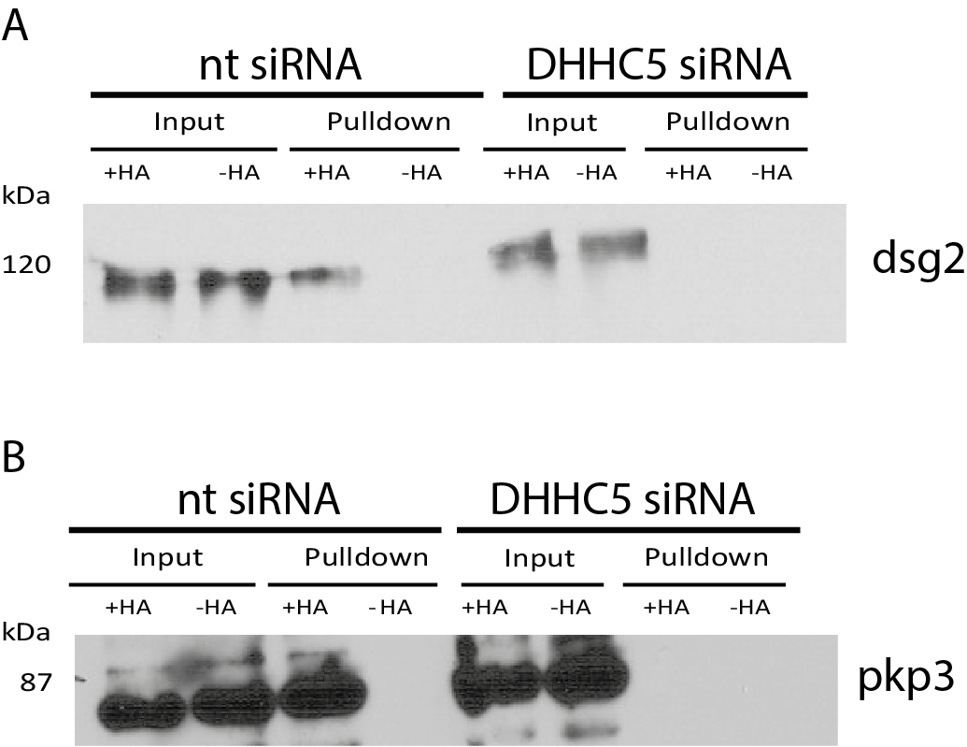
Figure 7.1: DHHC5 is a PAT for a pair of palmitoylated desmosomal proteins. A – Immunoblot of ABE assay from HeLa cells treated with either DHHC5 (DHHC5 siRNA) or non-targeting siRNA (nt siRNA). Loss of desmoglein 2 (DSG2) signal in the +HA pulldown lane of the DHHC5 siRNA treated lane shows DHHC5 is the major PAT responsible for DSG2 palmitoylation. B - Immunoblot of ABE assay from HeLa cells treated with either DHHC5 (DHHC5 siRNA) or non-targeting siRNA (nt siRNA). Loss of plakophilin 3 (PKP3) signal in the +HA pulldown lane of the DHHC5 siRNA treated lane shows DHHC5 is the major PAT responsible for PKP3 palmitoylation.
This result does contradict the previous work on palmitoylation of DSG2, which hypothesised that DSG2 was palmitoylated somewhere in its pathway of traffic to the plasma membrane, most likely at the Golgi where the majority of PATs are present (Roberts et al., 2016), while DHHC5 appears to be located mainly, although not exclusively, at the plasma membrane. To address this issue and to better understand where in the cell DSG2 is palmitoylated, an ABE was performed when A431 cells were kept in low calcium conditions. At very low calcium, desmosomal components are removed from the cell surface and are trafficked to areas within the cell (Tobey et al., 2004), so if DSG2 is palmitoylated in this state, then it is likely to be palmitoylated somewhere within the cell. The ABE showed a significant drop in palmitoylation of DSG2 at low calcium which shows that DSG2 is likely palmitoylated at the plasma membrane by DHHC5 (Figure 7.2).

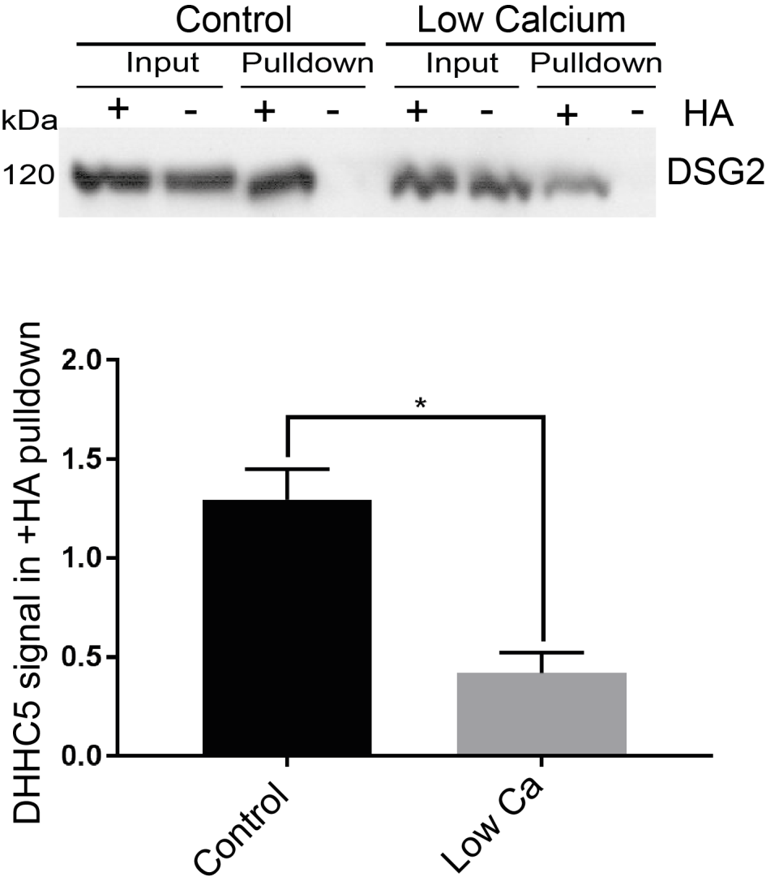
Figure 7.2: DSG2 is palmitoylated at the plasma membrane. Western blots of DSG2 after ABE assays of A431 cells cultured in normal media or at very low calcium (5µM). A significant drop in the +HA lane in the low Ca compared to normal media shows a significant drop in palmitoylation of DSG2 in this condition. Quantification normalised to input, *=p<0.05, paired t-test, N=4.

To build upon this, the A431 epithelial cancer cell line was treated with either DHHC5 siRNA or non-targeting siRNA and the localisation of DSG2 within cells was probed using immunofluorescence and confocal microscopy. In control non-targeting siRNA cells, DSG2 was present in distinct puncta at the plasma membrane which colocalised very well with endogenous DHHC5 staining at the plasma membrane (figure 7.3c and d), consistent with desmosomes containing DSG2 being present at the plasma membrane (Schlipp et al., 2014). However, when DHHC5 is knocked down with siRNA, DSG2 signal is seen throughout the cell, with noticeably more puncta than in cells treated with non-targeting siRNA (figures 7.3a and
b). This suggests that DHHC5 mediated palmitoylation of DSG2 is required for correct desmosomal clustering and localisation to the plasma membrane. It also partially matches previous work which demonstrated that palmitoylation deficient DSG2 had a population within the cell at the lysosome while WT palmitoylated DSG2 was almost exclusively at the plasma membrane (Roberts et al., 2016), as is seen here when cells are treated it the negative control non-targeting siRNA. However, the phenotype here when DHHC5 is knocked down appears to be much stronger than what is seen when desmoglein 2 palmitoylation is prevented by mutating the site of DSG2 palmitoylation.

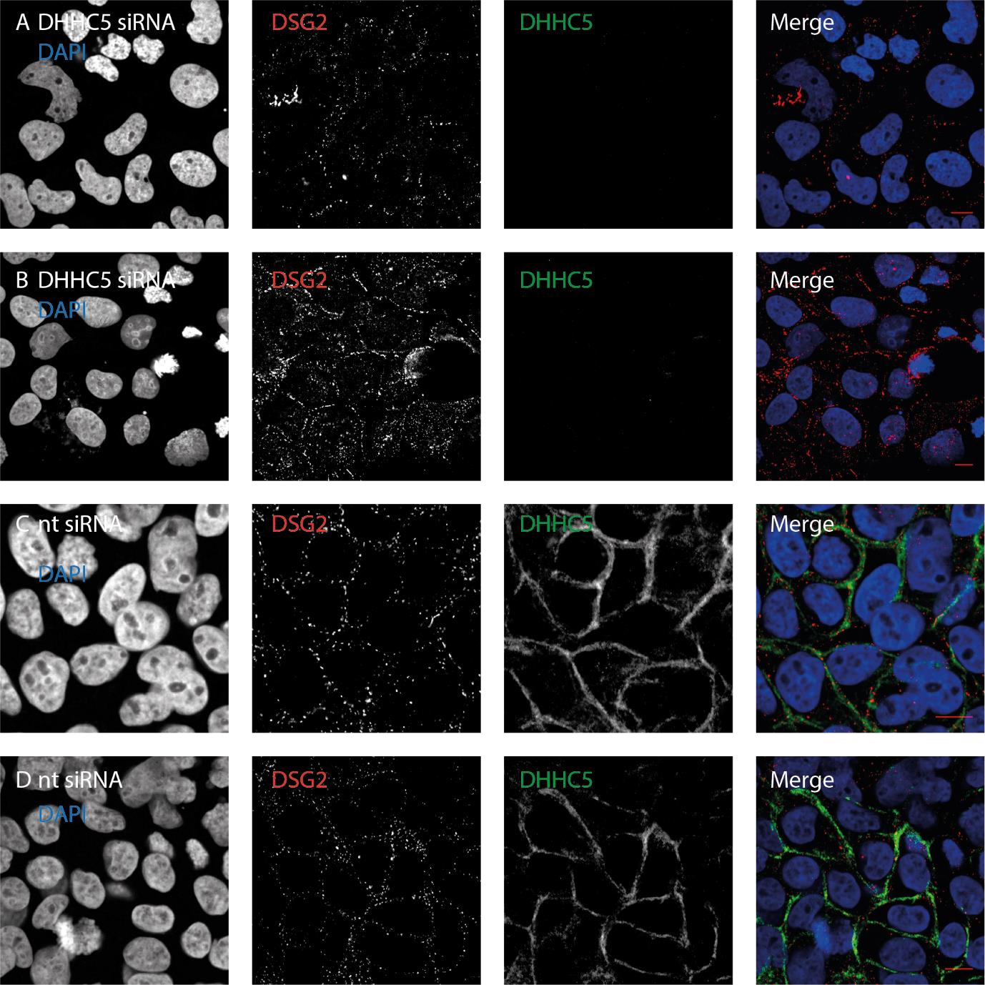
Figure 7.3: DHHC5 is essential for proper DSG2 localisation. A and B – Confocal microscope images of A431 cells which have been treated with DHHC5 siRNA, stained with anti-DSG2 (red) and antiDHHC5 (green). While a portion of DSG2 remains at cell junctions, a significant portion of it is present within the cell. C and D - Confocal microscope images of A431 cells which have been treated with nt siRNA, stained with anti-DSG2 (red) and anti-DHHC5 (green). Almost all of the DSg2 signal overlays with DHHC5 at the plasma membrane. All scale bars 10µm.

This phenotype of DSG2 localisation was much stronger than has been seen previously when palmitoylation of DSG2 was prevented by mutation of the palmitoylation sites (Roberts et al., 2016), but matched the DSG2 phenotype seen when palmitoylation of another desmosomsal protein, plakophilin 3 (PKP3), was blocked (Roberts et al., 2014). Therefore, it was hypothesised that DHHC5 was a possible candidate as the PAT which palmitoylates PKP3 and loss of PKP3 palmitoylation contributes to the mislocalisation of DSG2 along with loss of DSG2 palmitoylation. PKP3 was also seen as a potential DHHC5 substrate in the pilot ssABE data in a previous chapter of this manuscript, although was absent from the AP-MS screen. An ABE assay was performed on HeLa cell lysates which had been treated with either DHHC5 or nontargeting siRNA, showing almost a complete loss of PKP3 palmitoylation when DHHC5 was knocked down (Figure 1b), similar to what was observed with DSG2. This shows that DHHC5 is the major PAT responsible for the palmitoylation of PKP3 and confirms the hypothesis that loss of PKP3 palmitoylation leads to the mislocalisation of DSG2 seen when DHHC5 is knocked down.

7.3 The DHHC5-Golga7b complex is required for efficient desmosome trafficking

It has been previously demonstrated that loss of palmitoylation of DSG2 causes a delay in its trafficking to the plasma membrane (Roberts et al., 2016), so a calcium switch was performed to compare the trafficking of DSG2 in cells treated with DHHC5 siRNA or non-targetting siRNA. In culture, desmosomes require calcium to form functional connections and for their presence at the plasma membrane, so culturing cells in media that is free from calcium leads to internalisation of desmosomes which are then trafficked back to the plasma membrane when calcium is restored to normal levels in the media (Tobey et al., 2004). In A431 cells treated with non-targeting siRNA and subjected to a calcium switch (Figure 7.4), DSG2 signal was seen returning to the plasma membrane over a period of three hours after calcium was restored to the media. This movement happens rapidly, with significantly more DSG2 present at the plasma membrane after just 30 minutes (Figure 7.4b), and this increase continuing in a linear fashion for the full three hour time course (Figure 7.4e). This is generally the expected type if result from this kind of experiment (Scheffers et al., 2000).

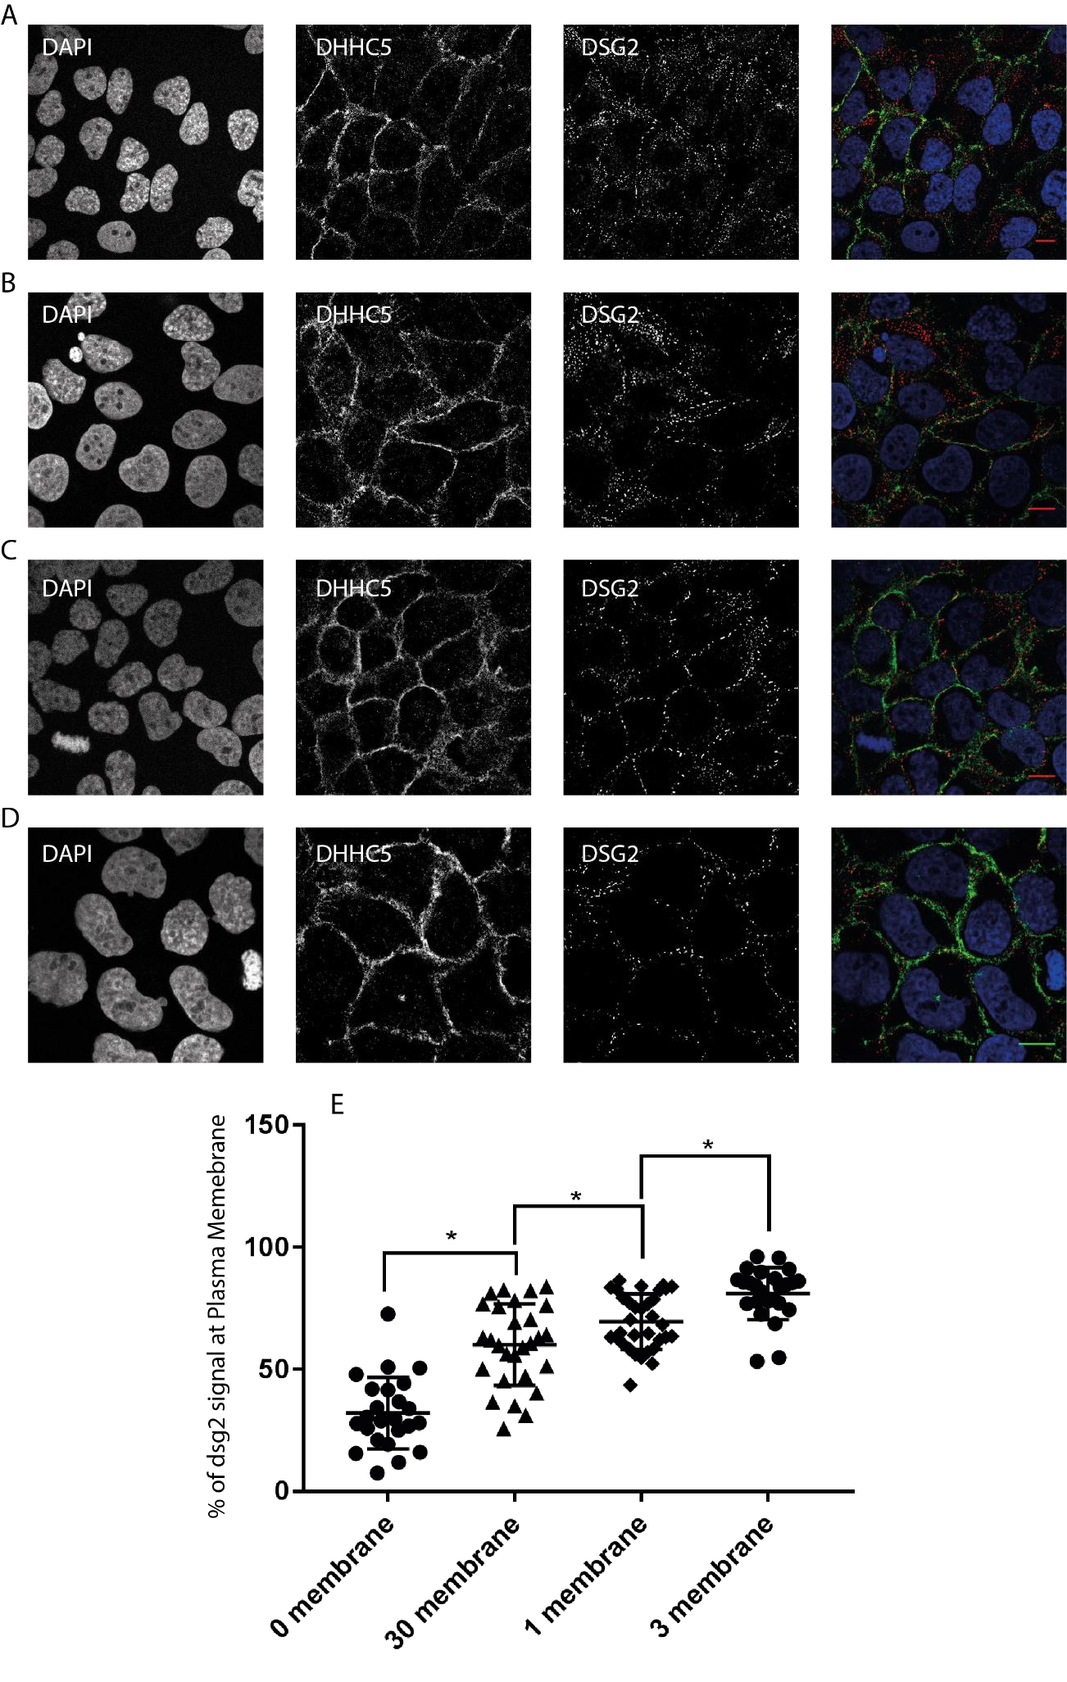

Figure 7.4: Calcium switch of A431 cells treated with non-targeting siRNA. Confocal images of cells stained for nuclei (DAPI, blue, left panel), DHHC5 (green, second panel), desmoglein 2 (DSG2, red, third panel) and merged image (Merge, right panel). All scale bars 10µm. A – time zero after calcium chloride addition. B – 30 minutes after calcium chloride addition. C – 1 hour after calcium chloride addition. D - 3 hours after calcium chloride addition. E - % of dsg2 signal seen at the plasma membrane at each time point, *=p<0.05, unpaired t test.

Alongside this, DHHC5 was knocked down in a431 cells and a calcium switch performed (Figure 7.5). When calcium was restored to the media there was no significant change in the percentage of DSG2 at the plasma membrane, and did not significantly change over the full 3 hour time course measured (Figure 5d), which noticeably contrasts the result when the A431 cells were treated with the negative control non-targeting siRNA, presented above (Figure 7.4), which showed a steady, significant increase over time. This points to DHHC5-mediated palmitoylation of DSG2 being essential for trafficking of DSG2 to the plasma membrane. This result helps to confirm the previous work that showed that preventing DSG2 palmitoylation has a significant effect on the trafficking of DSG2 back to the plasma membrane (Roberts et al., 2016). This also showed no significant restoration of DHHC5 to the plasma membrane after reintroduction of Calcium, up to an 18 hour time point. There was a slight increase between the 30 minute and 3 hour time points in the previous work, but this difference was not continued to the 18 hour time-point and was non-significant. Given that DHHC5 has been shown here to be the PAT for DSG2 (Figure 7.1a), and that the Calcium switch shown here matches previous work, it can be concluded that loss of palmitoylation of DSG2 which is caused by depletion of DHHC5 is the cause of the trafficking defect seen.

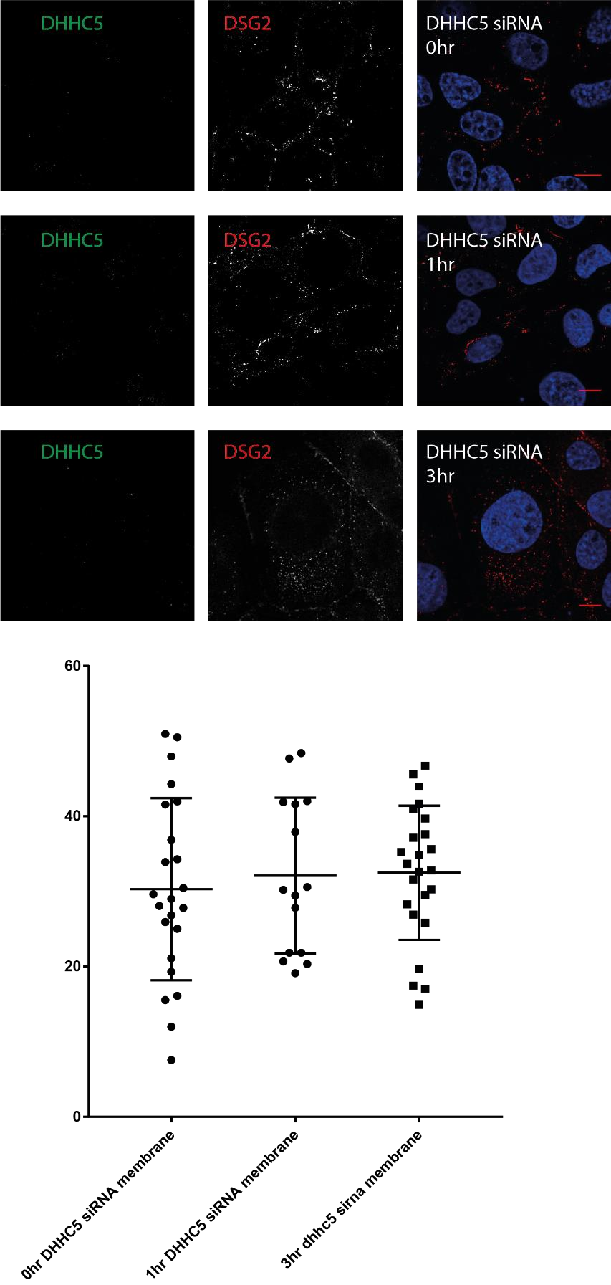
Figure
7.
5:
Calcium switch of A431 cells treated with DHHC5 siRNA. Confocal images
of cells stained for nuclei (DAPI, blue, left panel), DHHC5 (green, second panel),
desmoglein 2 (DSG2,
red, third panel) and merged image (Merge, right panel). All
scale bars 10µm. A
–

time zero after calcium chloride addition. B
–

1
hour after
calcium chloride addition. C
-

3
hours after calcium chloride addition. D
-

% of dsg2
signal seen at the plasma
membrane at each time point

As has been shown previously, Golga7b had a profound effect on the localisation of DHHC5 within the cell. Therefore, it is possible that loss of Golga7b could have an effect on the localisation and trafficking of DSG2 by causing a mis-localisation of DHHC5, which could affect the palmitoylation of DSG2. To probe this, a calcium switch was performed on A431 cells that had been treated with Golga7b siRNA (Figure 7.6c). This showed that knockdown of Golga7b does cause DSG2 trafficking to be inhibited, although not to the extent of DHHC5 siRNA treatment of cells (Figure 7.6d). This result links Golga7b to DHHC5 function and suggests that correct localisation of DHHC5 is essential for it to act on its substrates. It may also add further weight to DHHC5 palmitoylation of DSG2, and indeed all DSG2 palmitoylation, occurs at the plasma membrane, as depletion of Golga7b moves DHHC5 to internal areas of the cell, so it is no longer present at the plasma membrane, and the effects mimic, although not quite as acutely, what is seen with DHHC5 depletion by siRNA. However, it must also be noted that there is a chance that Golga7b palmitoylation is required for DHHC5 activity, not localisation, similar to what is seen with Golga7 and DHHC9 (Swarthout et al., 2005), and that this scenario cannot be ruled out from this work.

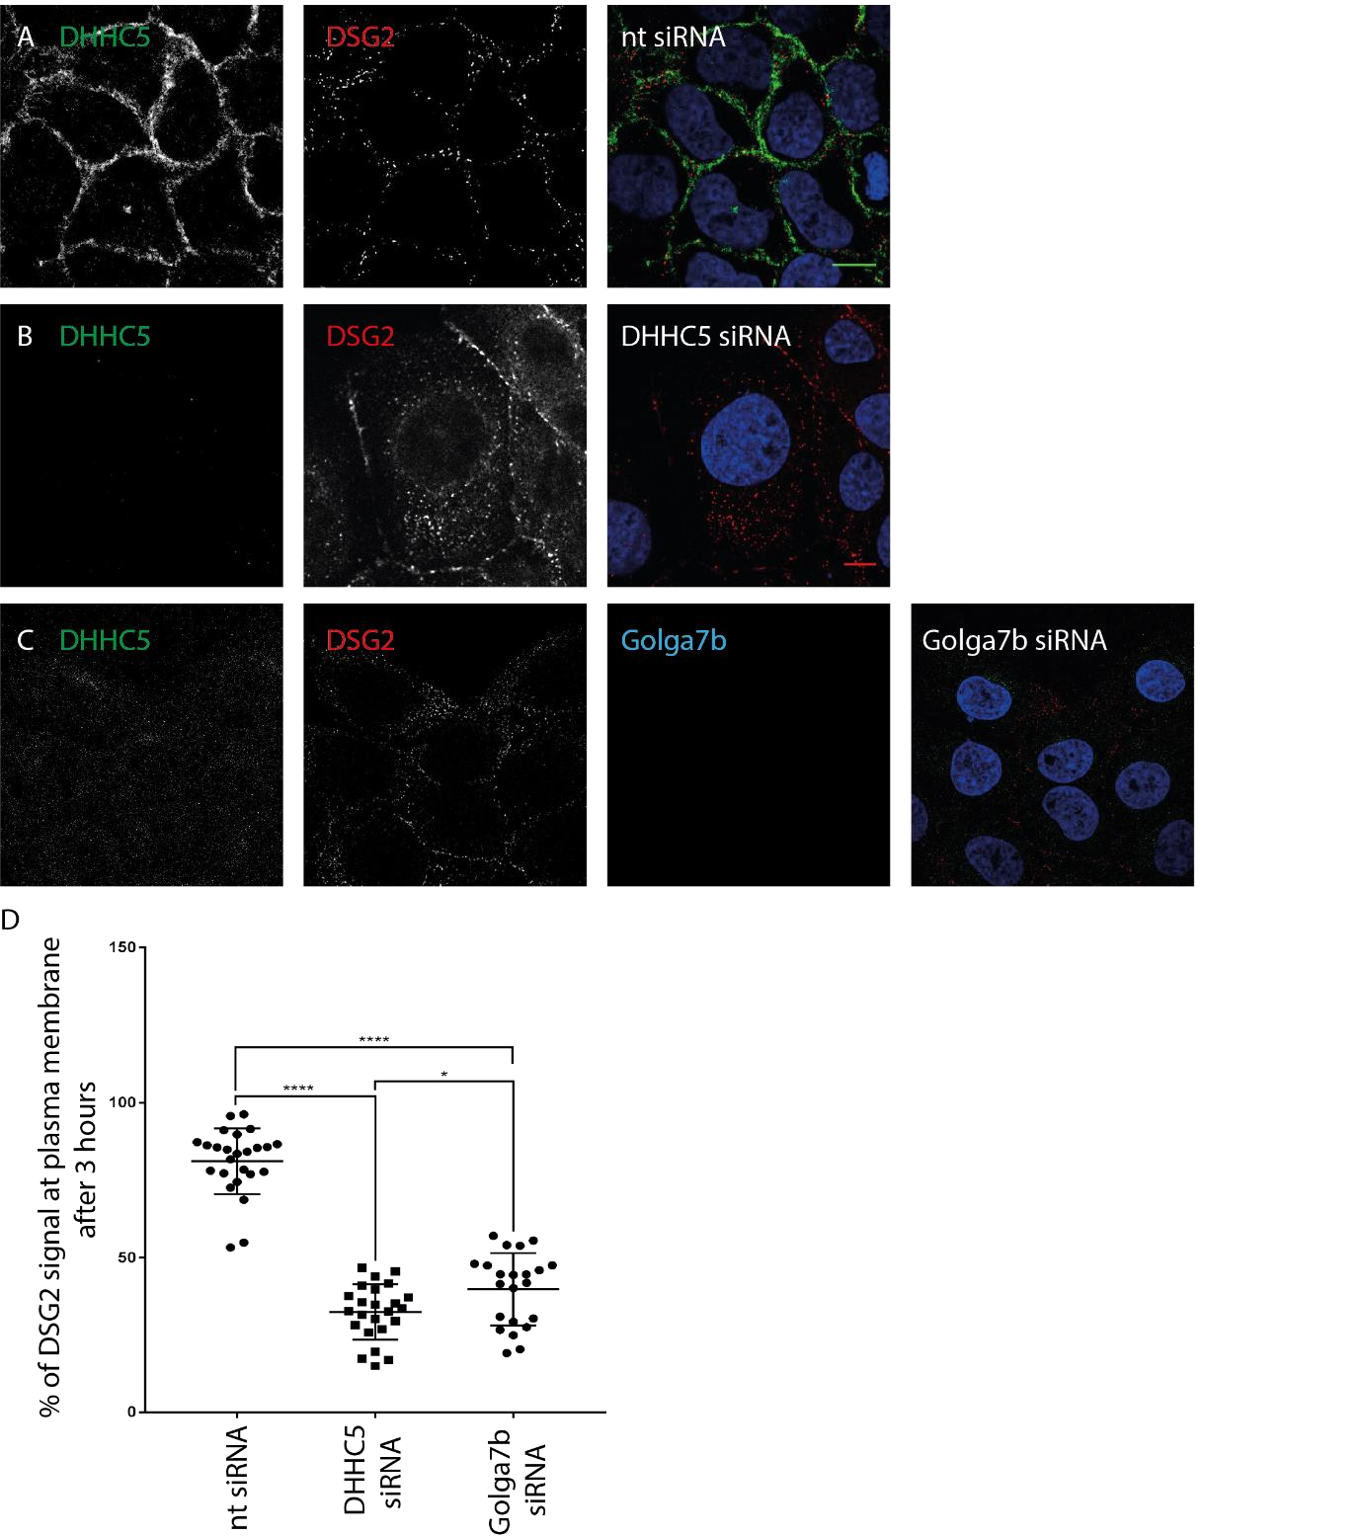
Figure
7.
6:
Knockdown of DHHC5 and Golga7b impairs trafficking of DSG2. A
–

Confocal images of
A431 cells treated with
non
-
targeting siRNA stained for DHHC5 (green, left panel), desmoglein 2 (red,
middle panel) and a merged image (right panel). B
-

Confocal images of A431 cells treated with DHHC5
siRNA stained for DHHC5 (green, left panel), desmoglein 2 (red, middle panel)

and a merged image
(
right panel). C
-

Confocal images of A431 cells treated with Golga7b siRNA stained for DHHC5 (green,
left panel), desmoglein 2 (red, second panel), Golga7b (cyan, third panel) and a merged image (right
panel). All scale bars 10µm. D
–

Graph of the percentage of DSG2 signal seen at the plasma membrane.
****=p<0.001, *=p<0.05
, t
-
test.

Given that confocal image quantification can be subject to some biases, the level of DSG2 at the plasma membrane 3 hours after the reintroduction of calcium in cells depleted of DHHC5 or Golga7b was investigated using a cell surface biotinylation assay. This process tags proteins at the cell surface with biotin before cell lysis and pulldown of biotinylated proteins with streptavidin. The results closely matched those gained from the confocal imaging quantification, with a significant reduction in the level of DGS2 at the surface when DHHC5 or Golga7b are knocked down, but also a significant reduction in DSG2 at the cell surface when
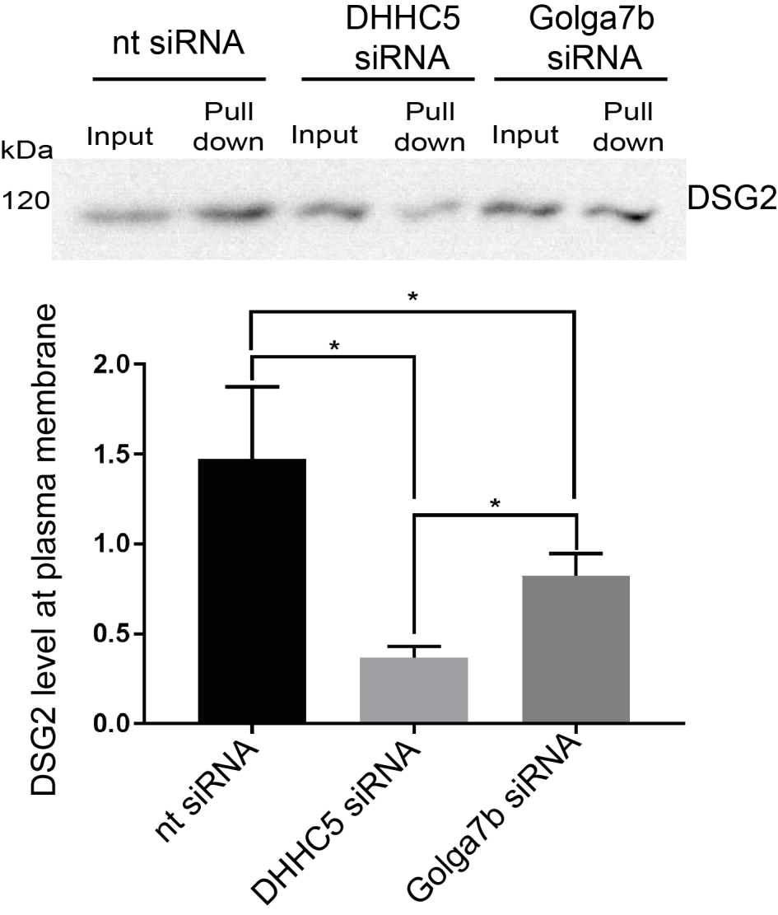
Figure
7.
7:
Loss of DHHC5 or Golga7b lowers the level of DSG2 at the plasma membrane. Western blot
of DSG2 from cell surface biotinylation from A431 c
ells 3 hours after reintroduction of calcium in a
calcium switch. Lowe signal in pulldown shows a lower level of the protein at the cell surface.
Quantification of 4 individual experiments, *=p<0.05, paired t
-
test, all lanes normalised to input signal.
DHHC5 is depleted compared to when Golga7b is depleted (Figure 7.7). The drop seen with Golga7b is not quite as severe as when the confocal images were quantified, and again detected significantly more DSG2 at the plasma membrane than when DHHC5 was depleted by siRNA. This suggests that either there is still some DHHC5 at the plasma membrane, which is a likely possibility given that DHHC5 signal is seen throughout the cell including at the plasma membrane when Golga7b is knocked down in confocal images, or that there is some DSG2 palmitoylation from DSG2 within the cell, which is also a possibility.

7.4 DHHC5 plays a wider role in cell adhesion

Due to the internalisation and loss of palmitoylation of desmosomal components caused by the knockdown of DHHC5, it was hypothesised that siRNA mediated knockdown of DHHC5 would lead to a reduction in cell adhesion. To test this, we exploited the fact that cells in culture like to cluster and form colonies. We treated A431 cells with either DHHC5 or nontargeting siRNA then plated cells on fresh plates before counting the number of cells per colony (Figure 7.8). This showed that while the total number of cells in each plate was notsignificantly different (Figure 7.8d), cells that had been treated with DHHC5 siRNA formed significantly smaller colonies suggesting a defect in cell:cell adhesion (Figure 7.8b and c). There was still a noticeable reduction in the total number of cells in the DHHC5 siRNA treated conditions, and although this was not significant, it may be indicative of a lower growth rate after DHHC5 siRNA treatment which would naturally lead to smaller colonies of cells as was seen here.

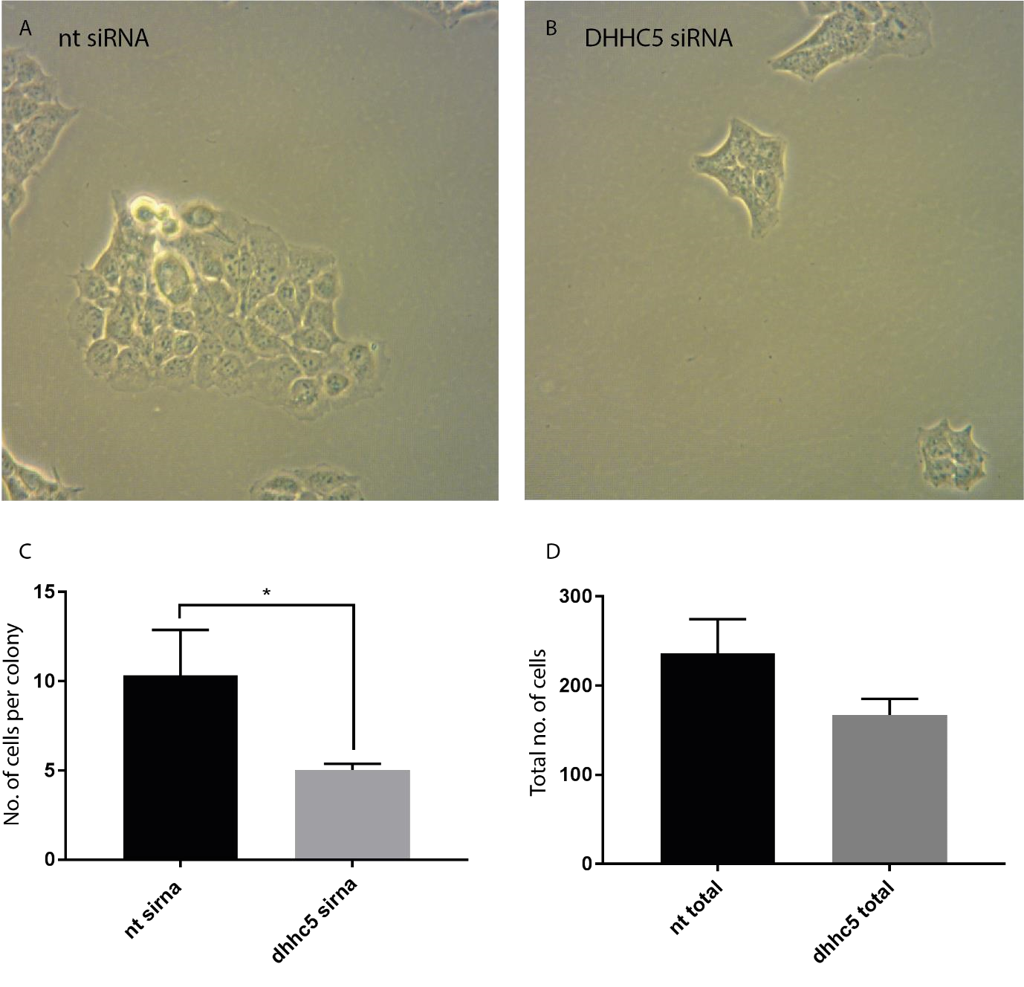
Figure 7.8: DHHC5 is required for cells to form colonies. A – 10x brightfield microscope images of A431 cells that were treated with non-targeting siRNA. B - 10x brightfield microscope images of A431 cells that were treated with DHHC5 siRNA. C – Graph of the average number of cells in each colony in A431 cells treated with either non-targeting siRNA (nt sirna) or DHHC5 siRNA (dhhc5 sirna). * = p<0.05, t-test, N=3. D – Total number of cells present in 10 fields of view captured of A431 cells treated with non-targeting siRNA or DHHC5 siRNA. N=3.

To build on this, a cell scatter assay was performed. In response to certain external factors, such as addition of epidermal growth factor (EGF), cells will internalise all of their adhesion machinery and scatter away from the colonies they have formed (Chen, 2005). A431 cells were treated with either DHHC5 or non-targeting siRNA, before plating and treatment with the protein EGF (Figure 7.9). Immediately after treatment, colonies of cells from both treatment conditions looked very similar (Figure 7.9a-c). However, after 48 hours of treatment, cells treated with DHHC5 siRNA had noticeably scattered (Figure 7.9b and c), while non-targeting siRNA treated cells remained in colonies (Figure 7.9a and c). This shows that loss of DHHC5 significantly reduces cell adhesion, which likely stems from the loss of palmitoylation of a number of proteins involved in the cell adhesion machinery. While this work has shown that DHHC5 palmitoylates a pair of proteins in the desmosome, and that loss of this palmitoylation causes severe defects in desmosome localisation and the trafficking of the desmosmal protein DSG2, it cannot be concluded that desmosomal defects are the cause of this adhesion deficit, as the cell scatter assay cannot differentiate between the different components of the cell adhesion machinery so any alteration in scattering cannot be pinned down to issues with solely desmosomes.

After the results of the calcium switch which showed that Golga7b knockdown causes an impairment in DSG2 trafficking, it was possible that Golga7b knockdown could cause a reduction in cell adhesion similar to that of DHHC5 knockdown. When a cell scatter was performed on A431 cells that had been treated with Golga7b siRNA (Figure 7.9d-f), cells scattered much more efficiently in cells that had been exposed to Golga7b siRNA (Figure 7.9e and f) compared to cells that were treated with non-targeting siRNA (Figure 7.9d and f). This shows that Golga7b knockdown does not only affect the trafficking of DSG2 but has a more general effect on cell adhesion, similar to that of DHHC5 knockdown. However, the effect does appear to be milder than that of DHHC5 knockdown, as the fold change in the number of grid squares occupied by cells is lower in cells that have been treated with Golga7b siRNA compared to the DHHC5 siRNA treated condition. This matches the data seen with the calcium switch where Golga7b knockdown produced a less severe trafficking inhibition phenotype. These two things together show that the effects of Golga7b, which is likely to stem from the mis-localisation of DHHC5, likely still leads to some residual DHHC5 still at the plasma membrane or at least in a position to palmitoylate its substrates, even if it is not to normal levels.

To add more evidence to DHHC5 having a wider role in cell adhesion, a trans-epithelial electrical resistance (TEER) experiment was performed. Cells growing in a monolayer on a semi-permeable membrane have lower electrical resistance when the monolayer is disrupted by adhesion defects and this can be quantified by measuring the resistance. When cells were exposed to DHHC5 siRNA (Figure 7.9g), the confluent cell monolayer showed a significant drop in the resistance across the membrane when compared to cells which were treated with non-targeting siRNA. This shows that removing DHHC5 from cells leads to reduced adhesion between cells and would likely lead to impaired epithelial barrier integrity. While TEER analysis is often used to probe the quality of adhesion between tight junctions (Meyle et al., 1999), it can also be affected by reduction in the adhesive properties of desmosomal components, including inhibiting the adhesion of DSG2 (Schlegel et al., 2010).

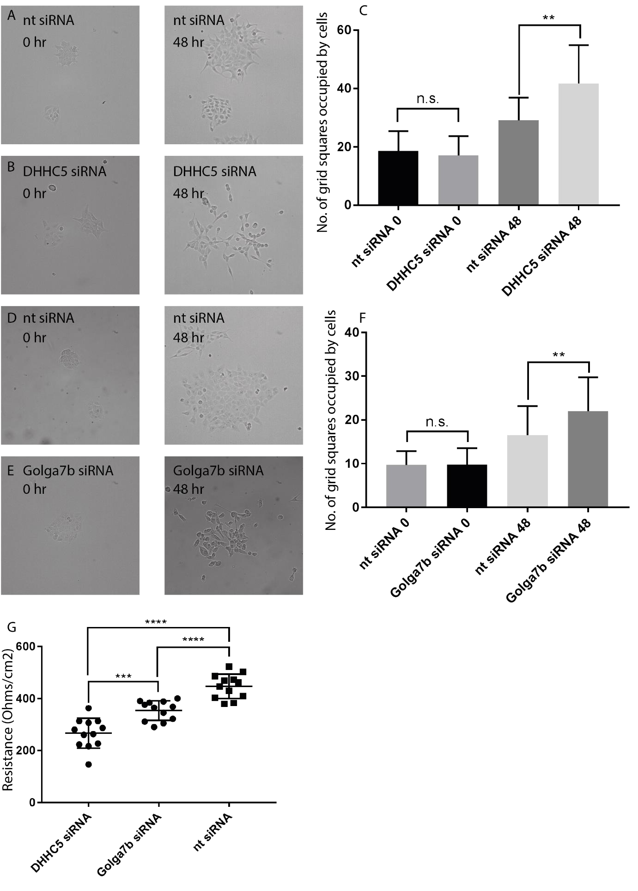

Figure 7.9: The DHHC5/Golga7b complex impacts cell adhesion. A – 10x brightfield images of A431 cells treated with non-targeting siRNA at time zero (0 hr) or 48 hours (48 hr) after 10ng/ml treatment with EGF. B - 10x brightfield images of A431 cells treated with DHHC5 siRNA at time zero (0 hr) or 48 hours (48 hr) after 10ng/ml treatment with EGF. C – Quantification of the degree of scattering of cells when treated with DHHC5 or nontargeting siRNA by the number of grid squares occupied by cells in a 10x10 grid overlayed on the images. **=p<0.005, n.s.= not significant, t-test. D – 10x brightfield images of A431 cells treated with non-targeting siRNA at time zero (0 hr) or 48 hours (48 hr) after 10ng/ml treatment with EGF. E - 10x brightfield images of A431 cells treated with Golga7b siRNA at time zero (0 hr) or 48 hours (48 hr) after 10ng/ml treatment with EGF. F – Quantification of the degree of scattering of cells when treated with Golga7b or non-targeting siRNA by the number of grid squares occupied by cells in a 10x10 grid overlayed on the images. **=p<0.005, n.s.= not significant, t-test. G – trans-epithelial electrical resistance of A431 cells treated with DHHC5 siRNA, Golga7b siRNA or non-targetting siRNA. T-test, ****=p<0.001, ***=p<0.01, all n=12, average of 3 measurements from each well.

7.5 Discussion

While the effects of palmitoylation on various cell adhesion proteins has been investigated in the past, very few PATs had been identified that control these palmitoylation events. Here it is demonstrated that DHHC5 palmitoylates the desmosomal cadherin desmoglein-2, but also that it palmitoylates the desmosomal protein plakophilin 3. In concert, the loss of these palmitoylation events leads to profound effects on the localisation, clustering and trafficking of DSG2 in epithelial cells. Further from this, it was also shown that depletion of DHHC5 by siRNA causes a reduction of overall cell:cell adhesion. While this could be due to the effects on desmosomes and desmosomal proteins that have been shown here, it could equally be due to DHHC5 having roles in other cell adhesion processes.

Given the number of adhesion proteins found previously in the AP-MS survey of DHHC5 interactors, and that it has been shown here that DHHC5 palmitoylates 2 of the 6 known palmitoylated desmosomal proteins (Roberts et al., 2014), it is possible that a portion of the population of DHHC5 could be present at, or integral to, desmosomal plaques. Work has been done on the interactions of DSG2 in the past and DHHC5 was not found as a probably interactor of this protein (Hein et al., 2015), however, large scale affinity capture-MS studies can miss bona fide interactors. The previous study was also performed by using mouse versions of proteins as bait but they were expressed in the human HeLa cell line. While in almost all cases the mouse and human proteins are very similar, for example in the previous study the median sequence identity was 94%, the differences between the species may have an effect on the interaction of each protein. This could explain why DHHC5 has not been found as an interactor of DSG2 up until this point, and why this work is the first to detect such an interaction. It does seem highly unlikely, however, that DHHC5 is an integral member of desmosomal plaques as if that were the case it would be likely that more proteins than just DSG2 should have been pulled down as DHHC5 interactors.

The previous data on the effects of palmitoylation of DSG2 showed that preventing palmitoylation of DSG2 did not prevent trafficking to the plasma membrane but did appear to impair the ability of DSG2 to incorporate into functional desmosomes (Roberts et al., 2016). This makes it possible that palmitoylation of DSG2 takes place at the plasma membrane, where DHHC5 is resident. This is backed up by the fact that DSG2 is significantly less palmitoylated when cells are kept in low calcium conditions, which is a condition when DSG2 would not be present at the plasma membrane, but DHHC5 still is, as is shown in Figure 4. Additionally, if DHHC5 was able to palmitoylate DSG2 in other portions of the cell, a much less severe effect would be expected to be seen after Golga7b knockdown, which causes DHHC5 to be present in other regions of the cell. The other possibility in this situation is that DHHC5 requires Golga7b not only for its correct localisation but for the correct action of DHHC5 and the palmitoylation of its substrates.

Two independent strands of evidence both independently showed that DHHC5 is required for cells to maintain proper cell adhesion and presumably to form a fully functional epithelial layer. This makes it possible that DHHC5 regulates other adhesion proteins or processes apart from desmosomes which was established here. This is supported by the previous AP-MS data which shows interactions between DHHC5 and a range of other adhesion proteins, including the tight junction protein ZO-1, while very few palmitoylated adhesion proteins have had a PAT identified which palmitoylates them. If DHHC5 palmitoylates ZO-1 that could also have an effect on the transepithelial electrical resistance data shown here, with a similar result to what is seen here. As mentioned above, inhibiting desmosomal cadherin adhesion, particularly DSG2, does lead to a reduction in TEER measurements (Schlegel et al., 2010). The mechanism of this reduction was still shown to be mediated through downstream defects in tight junction proteins, including the key tight junction protein TJP1, also known as ZO-1. This shows that if the effects of DHHC5 knockdown by siRNA are solely restricted to desmosomes, it could still have wider effects on other adhesion processes, which impact the results of not only the TEER results presented here, but also the cell scatter assay, where tight junctions also have a role to play (Tsukamoto & Nigam, 1999).

The reduction in adhesion that is driven by loss of DHHC5 could have a number of implications in a number of different diseases. Desmosomes, and desmoglein 2 and plakophilin in particular, have been implicated in the serious heart condition arrhythmogenic right ventricular cardiomyopathy (ARVC) (Kant et al., 2016). Mutations in these proteins have been shown to impair the adhesion of the cardiac muscle which leads to damage of the cardiac muscle. As far as is known, palmitoylation of desmosomal components has not been implicated in ARVC to date but the results presented above open this up as a possibility and DHHC5, which is enriched in the cardiac muscle and is involved in other important processes there (Hilgemann et al., 2013; Lin et al., 2013) could be involved In this process. Further screening of ARVC patient samples would be required to confirm or deny this hypothesis.

Another disease process that could be impacted by the effects of DHHC5 depletion induced loss of adhesion is the phenomenon of epithelial to mesenchymal transition in cancer. This process closely mimics that seen in the cell scatter assays presented above (Figure 7a, b, d, e) so it is possible that loss or reduction of DHHC5 in a tumour setting will lead to a higher chance of metastasis. This discovery may allow DHHC5 levels to be used as a marker for how likely EMT is to occur in tumour biopsies. DHHC5 has been implicated in non-small cell lung cancer is the past, as a loss of DHHC5 in a selection of lung cancer cell lines caused an inhibition of cell and tumour xenograft growth (Tian et al., 2015). The research presented here does not directly look at growth rate, although the colony size assay suggest that there is no significant drop in the growth rate of A431 epithelial cell lines. The earlier work did not look at cell adhesion, only growth rate and only looked in a small selection of cell lines, so it is possible that DHHC5 has a role in growth of lung, and potentially other cancers, but also plays a role in adhesion which could affect EMT.

8 Discussion

8.1 DHHC5 localisation is controlled by palmitoylation of its C-terminal tail and Golga7b

DHHC5 is a palmitoyl-acyl transferase which is generally localised to the plasma membrane (Ohno et al., 2006), however it is also known to be internalised from the post-synaptic density, likely through the AP2 mediated clathrin endocytic pathway, which is triggered by dephosphorylation of a site on the DHHC5 C-terminal tail (Brigidi et al., 2015). However, what was not known was if there was other factors that contribute to DHHC5 maintenance at the plasma membrane in other cell types or if catalytic activity or palmitoylation of DHHC5 (Yang et al., 2010; Collins et al., 2017) has any impact on its sub cellular localisation. Investigations centred on the suspected DHHC5 interactor and palmitoylated protein Golga7b (Huttlin et al., 2015; Morrison et al., 2015; Collins et al., 2017) which is closely related to Golga7, the protein interactor that is required by DHHC9 in order for it to palmitoylate the protein Ras (Swarthout et al., 2005) by stabilising the DHHC9-acyl chain intermediate (Mitchell et al., 2012).

The results presented in this chapter confirm that Golga7b is a palmitoylated protein and that this palmitoylation is lost when the cysteine residues in the sequence are mutated through an ABE assay. It is also demonstrated that DHHC5 is one of the PATs that palmitoylates Golga7b and the interaction between Golga7b and DHHC5 is confirmed. The interaction between DHHC5 and Golga7b is not dependent on the palmitoylation of Golga7b as the nonpalmitoylatable mutant Golga7b is still able to co-immunoprecipitate efficiently with DHHC5, however preventing palmitoylation of the three palmitoylated sites on the DHHC5 C-terminal tail does appear to prevent the interaction between DHHC5 and Golga7b. This could be due to the loss of palmitoylation or possibly disruption of a secondary structure element which is essential for the stabilisation of the interaction.

The role of Golga7b is not just as a DHHC5 substrate, but also as a regulator of DHHC5 location within the cell. Over-expression of DHHC5 generally causes a mislocalisation of the protein leading to it being present in other compartments of the cell away from the plasma membrane. This is a feature that has been seen by others previously (Hou et al., 2009), but the reasons for this were unknown. It has been shown here that over-expression induced mislocalisation of DHHC5 can be reversed by co-expressing WT Golga7b, but that co-expression of the palmitoylation deficient mutant Golga7b. This result is the same with endogenous DHHC5 as mutant Golga7b causes DHHC5 to localise away from the plasma membrane. Further, depletion of Golga7b with siRNA causes DHHC5 to be localised in a similar manner and this is unable to be reversed by the expression of the closely related protein Golga7. This suggests that when DHHC5 is over-expressed, it is the lack of Golga7b that causes the mislocalisation phenotype that is seen and that this effect on DHHC5 is likely to be specific to
Golga7b and not a more general feature of the Golgin protein family (Witkos & Lowe, 2015).
DHHC5 does not need to be active in order for this to happen as the catalytically dead mutant
DHHS5 is affected by Golga7b in the same manner and is mis-localised similar to the WT DHHC5 when over-expressed alone. However, the C-terminal DHHC5 mutant is unaffected by either WT or mutant Golga7b expression and is also exclusively present at the plasma membrane even when over-expressed. When these experiments were repeated without endogenous DHHC5 no real differences were seen apart from when the DHHS5 catalytic mutant was co-expressed with WT Golga7b. This caused significantly less DHHS5 to be present at the plasma compared to when endogenous DHHC5 is present which shows that palmitoylation of Golga7b by DHHC5 is an important determinant of maintenance of DHHC5 at the plasma membrane.

These results allow a number of conclusions to be drawn. Firstly, plasma membrane localisation of DHHC5 is stabilised by Golga7b, but only when Golga7b is palmitoylated. Secondly, if palmitoylation of Golga7b is prevented then DHHC5 is internalised and appears to be present essentially throughout the cell. It is also apparent that the level of Golga7b in the cell is important in ensuring that DHHC5 is present at the plasma membrane, as depletion of Golga7b with siRNA causes endogenous DHHC5 to be mis-localised to other membrane systems in the cell away from the plasma membrane and over-expression of DHHC5 without corresponding over-expression of WT Golga7b leads to a similar phenotype. This points to simply the presence of palmitoylated Golga7b being a protective factor from DHHC5 being internalised to areas within the cell. Also, palmitoylation of the C-terminal tail of DHHC5 is an important factor in its interaction with Golga7b, but perhaps more interestingly, it also plays a role in maintaining the plasma membrane localisation of the protein. When the C-terminal is unable to be palmitoylated traffic of DHHC5 appears to be unaffected as DHHC5 is seen at the plasma membrane. However, this palmitoylation is likely to be important in the endocytosis of DHHC5, similar to what has been seen with phosphorylation of a different part of the DHHC5 C-terminal (Brigidi et al., 2015), as when the palmitoylation sites are mutated DHHC5 is unaffected by either WT or mutant Golga7b and is always present at the plasma membrane. This points to palmitoylation of the DHHC5 C-terminal as being an important regulator or trigger for DHHC5 endocytosis.

8.2 DHHC5 interacts with a wide range of proteins dependent on its localisation

Different palmitoyl acyltransferases have different methods by which they recognise and interact with their substrates, which usually involve a well-known interaction motif such as
Ankyrin repeats in DHHC17 (Verardi et al., 2017) and other motifs (Greaves & Chamberlain, 2011). DHHC5 contains one such well characterised interaction motif as it contains a PDZ binding domain at its extreme C-terminus, which is how it interacts with the regulatory protein PSD-95 (Li et al., 2010; Brigidi et al., 2014). This shows that these motifs are not exclusively used by PATs to interact with their substrates but are also used to interact with regulating proteins.

As the difference in DHHC5 subcellular localisation was so stark when over-expressed alone or co-expressed with WT or mutant Golga7b, this was leveraged to demonstrate that DHHC5 can pull down more of the known substrate and plasma membrane protein Flotillin-2 (Li et al., 2012) when it is co-expressed with WT Golga7b and therefore at the plasma membrane compared to when it is co-expressed with mutant Golga7b and is within the cell. This was then extended to AP-MS experiments from HeLa cell lysates which were over-expressing a Cterminally triple-FLAG tagged DHHC5, either alone, or with WT or mutant Golga7b. Each of these distinct localisations of gave a distinct set of proteins that DHHC5 interacts with. When DHHC5 is expressed with WT Golga7b, and therefore at its endogenous location at the plasma membrane, it interacts with the highest number of proteins, with DHHC5 over-expressed alone next then when DHHC5 is co-expressed with mutant Golga7b with the lowest number of interacting proteins. The differences between the three conditions could be down to a number of factors, the most obvious of which is simply the difference in localisation of DHHC5 in each condition. The majority of DHHC5 is endogenously localised to the plasma membrane so it is likely that it would interact with more proteins at this location than in other areas of the cell. However, it is also possible that interaction with Golga7b and its palmitoylation state has a role in mediating interactions between DHHC5 and a subset of proteins. To validate the differences in the proteins seen when DHHC5 is co-expressed with WT Golga7b and present at the plasma membrane, and when it is co-expressed with mutant Golga7b and present at areas within the cell, IPs were performed that proved that DHHC5 interacts with both desmoglein-2 and the clathrin heavy chain more when it is at the plasma membrane compared to when it is within the cell.

When DHHC5 is at the plasma membrane, it interacts with 4 known substrates (Flot1 and 2, Golga7b and CTNND1 (Brigidi et al., 2014)) as well as some other proteins that are known interactors. It has been demonstrated that DHHC5 interacts with the AP2 complex at the postsynaptic density (Brigidi et al., 2015), but this hasn’t been shown in any other cell type or system. These pulldown found many members of this complex as interactors of DHHC5 at the plasma membrane, suggesting that DHHC5 endocytosis is mediated by this complex in other cell types. What was perhaps the most striking among the interactors of DHHC5 when it is at the plasma membrane is the large number of adhesion proteins, which are highly enriched in these pulldowns.

The results of these pulldowns point to a number of potentially interesting processes that DHHC5 is involved with. It shows that DHHC5 does interact with different proteins at different subcellular locations, without significant overlap between these. It opens up the possibility that DHHC5 is endocytosed by the AP2 complex in other cell types apart from neurons (Brigidi et al., 2015), which would expand the scope of potential DHHC5 substrates from just plasma membrane proteins to proteins in other regions of the cell. Further, the presence of such a large number of adhesion proteins, many of which are palmitoylated (Roberts et al., 2014; Roberts et al., 2016), suggests that DHHC5 may be involved in cell:cell adhesion in some way, possibly as the PAT which mediates some of the palmitoylation events.

8.3 DHHC5 may palmitoylate a wide range of proteins

An important part of building up the knowledge on any enzyme is understanding the breadth of their substrates and using this to find potential consensus sequences. With PATs, there is often very little known or understood about the substrates of each PAT, and previous work on the substrates of DHHC5 likely severely underestimated the number of substrates it has (Li et al., 2012). There was a number of potential reason why that is which could be addressed by more sophisticated techniques and a slightly different strategy. Firstly, there was a noticeable amount of DHHC5 expression still present in the previous work. Secondly, the technique used focussed on whole proteins which would mean that if DHHC5 palmitoylates a single site in a multiply palmitoylated protein, it would still be recognised as a palmitoylated protein so would be missed as a potential DHHC5 substrate. Despite this, this work was able to confirm the lipid raft marker Flotillin 2 (Carbonnelle et al., 2017) as a DHHC5 substrate (Li et al., 2012).

An obvious way to improve on this work would be to leverage the range of techniques that have been developed since this work that allow the investigation of palmitoylation with site level resolution. Among these is the PEG switch technique (Burgoyne et al., 2013), which replaces the palmitate on cysteines with 5kDa PEG molecules, and a subsequent immunoblot is able to reveal the palmitoylation state of any particular protein. This technique was combined with a siRNA mediated knockdown of DHHC5 in HeLa cells, and this revealed that DHHC5 is appears to be essential for the palmitoylation of a single cysteine site on Flot2. While the previous work suggested that loss of DHHC5 leads to essentially a complete loss of FLot2 palmitoylation (Li et al., 2012), this work was done in a different cell line. Additionally, the previous work showed that DHHC5 appeared to primarily palmitoylate a single site at the Flot2 N-terminal (Li et al., 2012) and the data presented here appears to confirm this. In summary, this experiment shows that palmitoylation of proteins is affected by knockdown of DHHC5, but only if techniques that give site level resolution are used in conjunction with knockdown.

To find out if this technique could be scaled up to find substrates on a whole proteome level, knockdown of DHHC5 in HeLa cells was combined with the ssABE technique (Collins et al., 2017) which is able to investigate the whole palmitoylated proteome at a site level, in a single replicate pilot study. By comparing the potential palmitoylation sites in lysates from HeLa cells treated with a negative control non-targeting siRNA to those from cells treated with DHHC5 siRNA, a picture could be built of possible palmitoylation sites and proteins that are substrates for DHHC5. This initial pilot study found 221 sites on 207 proteins that are potentially regulated by DHHC5, almost all of which are known to be palmitoylated. These included a number of sites on desmosomal proteins that are known to be palmitoylated, and one desmosomal protein which was thought to not be palmitoylated (Roberts et al., 2014). Combined with DSG2 being confirmed as a DHHC5 interactor, it does suggest DHHC5 may play an important regulatory role in this cell:cell adhesion protein complex.

This was then scaled up for replicate data collection to obtain a list of high confidence palmitoylation sites that may be DHHC5 substrates and to hopefully obtain a potential consensus sequence for palmitoylation by DHHC5. However, while the ssABE procedure appeared to work well for the replicates of lysates from DHHC5 siRNA treated cells, with excellent enrichment of proteins in the +HA treatment compared to the –HA treatment. However, the lysates from the non-targeting siRNA treatments showed no proteins significantly enriched in +HA compared to –HA. There could be several reasons for this, as ssABE is a multistep process. Analysis of the data was able to narrow this down slightly, with potential issues with blocking of free cysteines, reduction of di-sulphide bonds or washes of the streptavidin bead, or even a combination of one or more of these steps. As a result of this, no conclusions can be drawn from the replicate data, but the pilot data at least shows that this method has the potential to successfully investigate the substrates of PATs. Also, despite it being a single replicate study, the pilot data may point to potential DHHC5 substrates, particularly among proteins that were seen in both this dataset and the data gained from the AP-MS in the previous chapter.

8.4 DHHC5 in endocytosed by a system dependent on dynamin and the AP2 complex

Previous work in neurons had pointed to DHHC5 being internalised through the AP2 complex and that this endocytosis is inhibited by phosphorylation of the DHHC5 C-terminal tail (Brigidi et al., 2015). The confocal microscopy results when DHHC5 is expressed with mutant Golga7b presented here in the first results chapter pointed to DHHC5 being internalised by some mechanism as it is present at areas within the cell. Paired with the results gained from the AP-MS, which showed that DHHC5 interacts with a number of members of the AP2 complex while present at the plasma membrane, plus additional members when within the cell, is points to this being the main method of DHHC5 internalisation in the cell.

Initially, it was necessary to investigate whether the mis-localisation of DHHC5 caused by mutant Golga7b can be reversed by inhibiting endocytosis. This was first achieved by treating cells expressing DHHC5 and mutant Golga7b with methyl-β-cyclodextrin, a cholesterol depletion agent (Mahammad & Parmryd, 2015) and a drug which is known to prevent clathrin mediated endocytosis (Rodal et al., 1999). This treatment was able to restore the majority of
DHHC5 back to the plasma membrane when it is co-expressed with mutant Golga7b.
However, methyl-beta-cyclodextrin has numerous off target effects including affecting the Golgi and the ability of newly synthesised proteins to the plasma membrane (Shogomori & Futerman, 2001).

To address this issue, dynasore was used as a more specific inhibitor of endocytosis as it targets the protein dynamin (Macia et al., 2006). Treatment of HeLa cells co-expressing DHHC5 and mutant Golga7b with dynasore led to a rapid movement of DHHC5 to the plasma membrane, which adds to the idea that mutant Golga7b affects DHHC5 localisation by causing it to be less stable at the plasma membrane and encouraging the endocytosis of DHHC5. To fully confirm that the AP2 complex is involved in the endocytosis of DHHC5 as has been seen at the post-synaptic density in neurons (Brigidi et al., 2015), the AP2µ subunit was knocked down with siRNA in HeLa cells expressing mutant Golga7b. Confocal images showed that this knockdown restored DHHC5 completely to the plasma membrane which proves that the endocytosis of DHHC5 occurs through this system.

The results also throw up some more interesting implications for the mechanism by which Golga7b could regulate the localisation of DHHC5. It suggests that mutant Golga7b does not prevent DHHC5 reaching the plasma membrane but is instead destabilising DHHC5 when it reaches the plasma membrane, which would mean that palmitoylation of Golga7b by DHHC5 is important for stabilising DHHC5 at the plasma membrane, or that palmitoylation of Golga7b allows DHHC5 to be trafficked back to the plasma membrane in a rapid manner which would shift the balance of DHHC5 localisation to the plasma membrane. The former hypothesis is much more likely given the results obtained from the biotin endocytosis assay. This showed that WT Golga7b or preventing palmitoylation of DHHC5 prevents, or significantly impairs, the endocytosis of DHHC5 while preventing palmitoylation of Golga7b increases the endocytosis of DHHC5. While long exposure of the membrane showed a very low level of DHHC5 being endocytosed when it is co-expressed with WT Golga7b, the C-terminal palmitoylation deficient mutant of DHHC5 does not appear to be endocytosed at all. This result shows the central importance of the palmitoylation of DHHC5 to its endocytosis and to the

8.5 DHHC5 palmitoylates desmosomal proteins and is important for proper cell adhesion

As the AP-MS screen in chapter 2 showed a highly significant enrichment of adhesion proteins, including desmosomal proteins, as interactors of DHHC5 when it is co-expressed with WT Golga7b and therefore present at the plasma membrane. This is a potentially interesting finding as a large number of adhesion proteins are known to be palmitoylated (Van Itallie et al., 2005; Aramsangtienchai et al., 2017), including 6 proteins from desmosomes (Roberts et al., 2014; Roberts et al., 2016).

As the desmosomal cadherin desmoglein-2 was found as a DHHC5 interactor by AP-MS and subsequently confirmed by co-IP and western blot in chapter 2 and is a known palmitoylated protein (Roberts et al., 2014), initial investigations focussed on this protein. It was shown that
DHHC5 is the PAT responsible for palmitoylation of DSG2, which this palmitoylation likely occurs at the plasma membrane and depletion of DHHC5 leads to a mislocalisation of DSG2 in A431 cells. It also causes a significant inhibition in the trafficking of DSG2 back to the plasma membrane after calcium depletion and reintroduction. This trafficking defect was also seen when Golga7b was knocked down siRNA which pointed to location of DHHC5 being linked to this defect. This did contradict the hypothesis put forward in previous work done on the subject (Roberts et al., 2016) which put forward the idea that DSG2 is palmitoylated at the Golgi. It was shown that the majority of DSG2 palmitoylation likely takes place at the plasma membrane as when DSG2 is internalised by low calcium conditions, palmitoylation is significantly reduced.

However, the mislocalisation of DSG2 caused by knockdown of DHHC5 is more severe than has been seen previously with palmitoylation deficient mutants of DSG2 (Roberts et al., 2016), but did more closely match the phenotype seen when palmitoylation of another desmosomal protein, plakophilin-3 (PKP3), is prevented (Roberts et al., 2014). Because of this, it was thought that DHHC5 could be a PAT for PKP3. This turned out to be the case, with palmitoylation of PKP3 abolished with siRNA mediated knockdown of DHHC5. This points to the effects seen on the localisation of DSG2 being a combination of the loss of palmitoylation of both PKP3 and DSG2, and positions DHHC5 as the PAT for a number of desmosomal proteins.

As desmosomes are essential for proper cell adhesion and other cell adhesion components were found as interactors of DHHC5 in the AP-MS in the previous chapter, it was hypothesised that loss of DHHC5 could have an effect on global cell adhesion. This was tested by a pair of methods which showed that loss of DHHC5 or Golga7b leads to a reduction in cell:cell adhesion, implicating DHHC5 and its location not only in desmosomal protein localisation but in the wider process of cell adhesion.

Until this point, no PATs had been assigned to desmosomal proteins, but it was demonstrated that at least two of these proteins are palmitoylated by DHHC5. As dysfunction in cell adhesion is known to be a key factor in several diseases (Etzioni, 1996; Ishida-Yamamoto & Igawa, 2014), it could mean that DHHC5 could play a role in a number of these diseases. While this would need to be confirmed through genetic screens if it is confirmed it opens up a potential avenue to treatment for these diseases. It also has implications in cancer metastasis as the cell scatter assay used to show that loss of DHHC5 leads to decreased cell:cell adhesion mimics this process and thus DHHC5 could be potentially used in the future as a biomarker for cancer metastatic potential and prognosis.

8.6 Mechanism of DHHC5 regulation by Golga7b palmitoylation

In this manuscript, results are presented showing that the plasma membrane localisation of DHHC5 is regulated and maintained by the palmitoylation of the substrate and interacting protein Golga7b. In this system, preventing Golga7b palmitoylation leads to the internalisation of DHHC5 and Golga7b palmitoylation causes DHHC5 to be localised to the plasma membrane, showing that palmitoylation and deplamitoylation of Golga7b is an important way of modulating the plasma membrane localisation in HeLa and A431 cells.

In neurons, this process of controlling and maintaining DHHC5 plasma membrane localisation has been shown to be mediated by phosphorylation of DHHC5 by the post-synaptic density kinase Fyn which blocks the interaction between DHHC5 and the AP2 complex (Brigidi et al., 2015). It is therefore possible that interaction with palmitoylated Golga7b prevents the interaction between DHHC5 and the endocytosis machinery. However, the AP-MS and coimmunoprecipitation results showed that showed that co-expression of DHHC5 and WT Golga7b does not prevent the interaction between DHHC5 and the clathrin endocytosis system. This suggests that there is another mechanism in play by which WT palmitoylated Golga7b causes more DHHC5 to be present at the plasma membrane.

It is plausible that palmitoylation of Golga7b is involved in preventing the triggering of endocytosis of DHHC5 by stabilising DHHC5 at the plasma membrane and that when Golga7b is not palmitoylated, as is seen with the mutant Golga7b, DHHC5 is endocytosed freely or more rapidly. This hypothesis would mean that when Golga7b is de-palmitoylated, either by one of a number of de-palmitoylation enzymes such as APT1 or 2 which can be localised to membranes (Kong et al., 2013) or by random hydrolysis of the thioester bond, would trigger DHHC5 endocytosis from the plasma membrane. If this was an enzyme controlled process, it could be linked to external stimuli or various signalling pathways.

The other possibility is that Golga7b palmitoylation increases the rate of trafficking of DHHC5 back to the plasma membrane and has no effect on the internalisation rate (Grant & Donaldson, 2009). In this scenario, Golga7b palmitoylation would allow DHHC5 to enter the rapid endocytic recycling pathway (Hao & Maxfield, 2000), while without Golga7b palmitoylation DHHC5 would be forced through the slower recycling pathway, which would lead to a build-up of DHHC5 within the cell if this recycling rate is lower than the rate of endocytosis. This particular scenario is highly unlikely, however, as the biotin endocytosis assay suggested that the internalisation rate of DHHC5 is much lower when it is co-expressed with WT, and therefore palmitoylated, Golga7b compared to when it is co-expressed with unpalmitoylatable mutant Golga7b. This single result makes it far more likely that Golga7b palmitoylation influences the rate of endocytosis of DHHC5 by stabilising it at the plasma membrane rather than shifting the dynamics of recycling of DHHC5 back to the plasma membrane. However, the precise mechanism by which Golga7b palmitoylation prevents DHHC5 endocytosis is unknown. As discussed previously, it could involve some mechanism of preventing the association of DHHC5 with certain lipid microdomains where endocytosis is known to occur (Lajoie & Nabi, 2010), which would also explain the results seen with the Cterminal mutant, as a non-palmitoylated protein is much less likely to associate with these domains (Levental et al., 2010) and would therefore be less likely to be endocytosed if partitioning into these domains is required for DHHC5 endocytosis.

It must be noted that the interaction site between DHHC5 and Golga7b appears to involve the palmitoylated alpha helix in the C-terminal tail of DHHC5. If the architecture of DHHC5 matches known structures of other PATs (Rana et al., 2018), this region of the cell is on the opposite side of the protein to the active site. It has been shown here that DHHC5 is the major
PAT for Golga7b, and is likely the majority PAT for Golga7b, however, due to the location of probable the interaction site and the active site of DHHC5 it makes it unlikely that the individual DHHC5 protein that a Golga7b interacts with is the one that palmitoylates it. The most likely solution to this is that a second DHHC5 protein palmitoylates Golga7b while it interacts with the C-terminal of the first. Another, possibly less likely, solution is that the Cterminal of DHHC5 acts as some kind of scaffold and the interaction between DHHC5 and Golga7b allows Golga7b to be palmitoylated by another PAT. This possibility would open up a number of intriguing questions about the role of PATs as more than just enzymes and as scaffolding proteins.

If a dimerization event of DHHC5 is required to allow palmitoylation of Golga7b by DHHC5, this could have implications into stabilising DHHC5 at the plasma membrane, and modulating this potential dimerization event could be another layer of regulation of DHHC5. Dimerization has been shown to occur in other PATs DHHC2 and DHHC3 (Lai & Linder, 2013), so could occur in other members of the protein family. If, for example, a DHHC5 mutation prevented dimerization of the protein, this could prevent palmitoylation of Golga7b and lead to internalisation of DHHC5. This would produce a system where oligomerisation of DHHC5 is required for its plasma membrane localisation and the breakup of this higher order structure would likely lead to loss of Golga7b palmitoylation and subsequent endocytosis of DHHC5 from the plasma membrane. In this hypothetical scenario, the majority of DHHC5 at the plasma membrane would be dimerised and internalised DHHC5 would predominantly be monomers, which could be investigated by FRET or another similar technique, as was done with previous work on PAT oligomerisation (Lai & Linder, 2013), or by cell fractionation and native PAGE or other technique to differentiate between monomeric DHHC5 and higher order structures of the protein.

Given that it is known that a Fyn kinase controlled phosphorylation event is responsible for the prevention of DHHC5 endocytosis in neurons, it is an intriguing possibility that this event plays a role in regulating DHHC5 in other cell types. This possibility was not investigated here but is unlikely to control DHHC5 endocytosis in all cell and tissue types as Fyn is not expressed ubiquitously throughout the human body (Uhlen et al., 2015). However, Fyn is not the only Src family kinase at the plasma membrane (Thomas & Brugge, 1997) and the AP-MS data showed that DHHC5 interacts with both YES and Lyn when it is co-expressed with WT Golga7b and is therefore present at the plasma membrane. This makes it possible that the DHHC5 phosphorylation event that inhibits endocytosis is mediated by one of these other Src family kinases in other cell types apart from neurons. This potential mechanism of regulation would need to be fully investigated and how the palmitoylation of Golga7b and DHHC5 could be involved in this would also need to be considered.

As has been demonstrated here, palmitoylation of Golga7b is not the only palmitoylation event that impacts the localisation of DHHC5 as preventing palmitoylation of DHHC5 itself leads to it being trapped at the plasma membrane. As the mutation which leads to DHHC5 being unable to be palmitoylated is not within any of the endocytic motifs in DHHC5 (Brigidi et al., 2014), it is unlikely that this mutation is affecting the interaction between DHHC5 and the endocytosis machinery. It has been demonstrated in this manuscript that this palmitoylation of the DHHC5 C-terminal tail appears to prevent association with Golga7b so the mechanism of inhibiting endocytosis of DHHC5 would not be connected to the effects of palmitoylated Golga7b. It is therefore likely that the palmitoylation of the DHHC5 C-terminal is essential for its internalisation. The palmitoylation state of proteins has been shown to mediate their partitioning into lipid microdomains (Fragoso et al., 2003) and that in some instances lipid microdomains are areas that are targeted for endocytosis by the clathrin endocytic system (Rollason et al., 2007) which has been demonstrated above and by others is the mechanism for DHHC5 internalisation from the plasma membrane (Brigidi et al., 2015). Therefore it is a possibility that the palmitoylation state of DHHC5 is an important regulator of its endocytosis and that preventing this palmitoylation of DHHC5 effectively stops internalisation of the protein. It has been shown that in a neural setting, where DHHC5 is known to be internalised at the post-synatic density (Brigidi et al., 2015), essentially all DHHC5 is palmitoylated on at least one residue and much of it is dually palmitoylated (Collins et al., 2017), which adds weight to this possible hypothesis. How Golga7b palmitoylation fits into this potential system is unknown, but it is possible that palmitoylation of Golga7b and the subsequent interaction with DHHC5 leads to a change in the palmitoylation state of DHHC5, likely by encouraging depalmitoylation of the C-terminal or by preventing its palmitoylation. This second scenario is more likely as mutation of the area where DHHC5 is palmitoylated prevents interaction between DHHC5 and Golga7b. This could make it more difficult for palmitoylating enzymes to reach the areas of DHHC5 that are palmitoylated due to Golga7b being present in the area. The same would also hold true for de-palmitoylating enzymes so this hypothesis would need to robustly test palmitoylation and de-palmitoylation rates of DHHC5 in the presence of either WT or mutant Golga7b.

It would also be interesting to map the interaction site between DHHC5 and Golga7b. This could be achieved by protein:protein crosslinking (Sinz, 2006) and would reveal the exact sites of the interaction between the two proteins. This would show whether palmitoylation of the DHHC5 c-terminal tail “pins” it to the plasma membrane and reveals the location of the interaction site between DHHC5 and Golga7b or alternatively that Golga7b interacts directly with the area of the DHHC5 c-terminal that is palmitoylated. Either of these possible outcomes would guide future research into the mechanism of how the palmitoylation of Golga7b influences DHHC5 localisation and how it is stabilised at the plasma membrane.

A point that is not discussed here is the possibility that Golga7b and DHHC5 have a relationship similar to that of DHHC9 and Golga7 (Swarthout et al., 2005), where Golga7b and DHHC5 form a complex that enables the palmitoylation of DHHC5 substrates. Investigations into this possibility could be performed in a number of different ways. As mutation of the DHHC5 C-terminal palmitoylation sites prevents interaction with Golga7b removal of endogenous DHHC5 and replacement with the C-terminal mutant or point mutation of the endogenous DHHC5 gene to mimic this mutant, and testing of the palmitoylation state of known DHHC5 substrates such as Flotillin-2 (Li et al., 2012) or δ-catenin (Brigidi et al., 2014) would reveal whether interaction between Golga7b and DHHC5 is required for DHHC5 palmitoylation. Alternatively, an in vitro system could be set up containing DHHC5 without Golga7b and the palmitoylation of a known substrate investigated, such as with the incorporation of H³-palmitate as has been done previously with other PATs (Jennings et al., 2009). This system would have the advantage of no compensation from other PATs occurring, which is something potentially seen with the DHHC5 knockdown performed here and the effect on Flotillin-2 palmitoylation, where a loss of the triply palmitoylated form is seen when DHHC5 is depleted with siRNA in HeLa cells. This contrasts with what has been shown in previous work in Cos-1 cells where palmitoylation of Flot2 was reduced more than 3 fold after depletion of DHHC5 (Li et al., 2012). This system would not be perfect however as it would ignore other features that can influence the substrate specificity of PATs, such as their subcellular localisation. Shifting the localisation of DHHC3, for example, has been shown to have specific effects on the palmitoylation state of its substrates, as has restricting the localisation of its substrates to certain compartments (Gorleku et al., 2011). This is a phenomenon also seen with DHHC5 in neurons as only after endocytosis of DHHC5 from the post-synaptic density and subsequent trafficking to dendritic spines does DHHC5 palmitoylate δ-catenin (Brigidi et al., 2014; Brigidi et al., 2015). This feature of substrate selectivity would be entirely lost in an in vitro system, as Golga7b has a key role to play in controlling DHHC5 localisation and may act to allow DHHC5 to palmitoylate its substrates through that path rather than acting as a co-factor of some kind.

In all, this work presents a likely set of mechanisms by which the localisation of DHHC5 is regulated by palmitoylation of its C-terminal and by the palmitoylation of the novel interactor Golga7b. Put simply, palmitoylation of Golga7b by DHHC5 or the prevention of palmitoylation of the DHHC5 C-terminus stabilises DHHC5 at the plasma membrane. Endocytosis of DHHC5, which occurs through the AP2 mediated clathrin endocytosis system, is encouraged by preventing palmitoylation of Golga7b and also by depletion of Golga7b. While the palmitoylation of DHHC5 and Golga7b have not been linked in this work, it does represent an interesting possibility that palmitoylation of Golga7b reduces the palmitoylation of DHHC5, thus helping to prevent DHHC5 endocytosis.

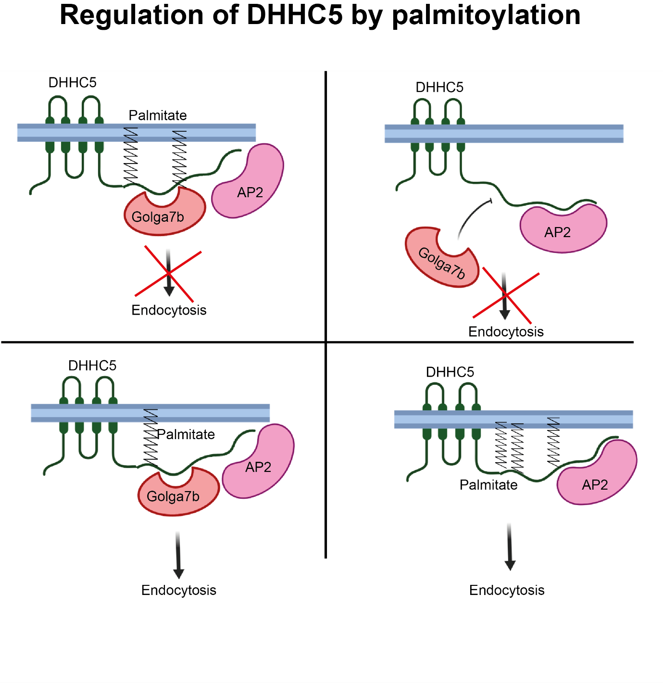
Figure 8.1: Simplified summary of how the palmitoylation states of DHHC5 and Golga7b alter the endocytosis of DHHC5. Upper left panel shows palmitoylated Golga7b interacting with DHHC5 at the plasma membrane. This situation doesn’t prevent interaction with the endocytic machinery, but does prevent endocytosis, although the exact mechanism of this inhibition is unknown. This is the state of the majority of endogenous DHHC5 in cells. Upper right panel shows un-palmitoylated DHHC5, such as the C-terminal mutant used in this work, which is unable to interact with Golga7b. Again, DHHC5 is unable to be endocytosed in this scenario. While this work does not test if the DHHC5 C-terminal mutant can still interact with AP2, it is likely that they can as the AP2 recognition region is not altered. The lower left panel shows what happens when Golga7b cannot be palmitoylated. In this situation, Golga7b can still interact with DHHC5, but does not prevent DHHC5 endocytosed and it is endocytosed freely from the plasma membrane using the AP2 mediated clathrin endocytosis system. The lower left panel shows what occurs when there is insufficient Golga7b in the cell, such as when it is depleted with siRNA or when DHHC5 is over-expressed. DHHC5 is again endocytosed by the clathrin endocytosis system, which shows that Golga7b has to be both present and palmitoylated for DHHC5 to be stabilised at the plasma membrane.

8.7 DHHC5 may be linked to a number of diseases

This work suggests that DHHC5, and by extension Golga7b, may play a role in a number of important and serious human diseases. Among these is the serious heart condition arrhythmogenic right ventricular cardiomyopathy (ARVC) and a high percentage of cases of which are caused by a genetic mutation in desmosomal proteins (Ohno, 2016). As has been shown in this work, DHHC5 is responsible for the palmitoylation of a pair of desmosomal proteins in plakophilin 3 (PKP3) and desmoglein 2 (DSG2) and other desmosomal proteins are palmitoylated but have no known PAT which palmitoylates them (Roberts et al., 2014) making palmitoylation by DHHC5 a possibility for this. While mutation of the palmitoylation sites of these proteins has not been linked to ARVC (Walsh et al., 2017), it does not remove the possibility that DHHC5 or indeed Golga7b could be involved. If any of the mutations in the desmosomal proteins would affect the interaction between DHHC5 and the desmosomal protein it could lead to a loss of palmitoylation. As has been demonstrated here, a loss of DHHC5 leads to a reduction in cell adhesion which is likely mediated through the loss of palmitoylation of desmosomal proteins, and possibly other adhesion proteins. This loss of palmitoylation causes a mislocalisation of desmosomal components and a reduction in cell adhesion (Roberts et al., 2014). It has been demonstrated that mutations in desmosomal proteins causes defects in desmosomal assembly and their ability to adhere to one another (Hall et al., 2009). As the phenotype of loss of palmitoylation and some ARVC mutations are very close and match, it opens up the possibility that palmitoylation of desmosomal is an undiscovered cause of ARVC. Given that DHHC5 is expressed highly in the heart (Uhlen et al., 2015) and is involved in other processes in the heart (Lin et al., 2013; Howie et al., 2014) it is certainly a possibility that should be investigated further. The potential role of Golga7b would also need to be investigated in this case as it has been shown here that knockdown of Golga7b does impact the localisation of DSG2 and cell adhesion, although the effect was not as strong as DHHC5 knockdown.

Further links between DHHC5 and diseases that involve abnormal cell adhesion can be gained from mouse phenotyping data at the International Mouse Phenotyping Consortium (Dickinson et al., 2016). Gene trap mice are prone to a number of different conditions and physiological effects that are statistically significant. One that stands out from a cellular adhesion angle is the significantly reduced thickness of the retina. Thinning of retinal tissue is associated in humans with age related macular degeneration (Acton et al., 2012), a disease which has been linked to dysfunction of cell adhesion, specifically tight junctions and the DHHC5 interactor ZO-1 (Obert et al., 2017). While changes to tight junctions were not specifically linked to loss of DHHC5, the interaction between DHHC5 and ZO-1 makes it possible that loss of DHHC5 could lead to damaging effects on ZO-1 and tight junctions more generally. ZO-1 is not a known palmitoylated protein, nor has it been found in any palmitoylproteome studies (Blanc et al., 2015), but it is predicted to be palmitoylated on a single site by the CSS-Palm software (Ren et al., 2008). It could be worthwhile for further research to investigate ZO-1 as a potential palmitoylated protein with DHHC5 as the PAT mediating its palmitoylation. Further work could then focus on the molecular and cellular effects of preventing ZO-1 palmitoylation and how this could lead to disease related effects linked to reduced adhesion stemming from ZO-1.

Further from this, expression of the known palmitoylated protein junctional adhesion molecule-C (JAM-C) in a neuronal setting has been shown to be important for the proper development and thickness of the retina (Li et al., 2018). JAM-C is a known palmitoylated protein (Aramsangtienchai et al., 2017) that is palmitoylated by DHHC7. However, knockdown of DHHC7 did not completely prevent JAM-C palmitoylation, making it likely that JAM-C is the substrate of one or more other PATs. As JAM-C is a plasma membrane localised transmembrane protein (Arrate et al., 2001), it does make it a potential DHHC5 substrate. JAM-C was not found as a potential DHHC5 interactor, but detectable interactions are not always seen between PATs and their substrate, as has been shown with SNAP25 and two of its PATs (Lemonidis et al., 2014). With DHHC5 interacting with so many adhesion proteins, their shared cellular location and a shared enrichment in the neural setting (Ohno et al., 2006; Wyss et al., 2012), it does make a compelling case for DHHC5 to be investigated as a possible PAT for JAM-C. When this is established, the effect of preventing JAM-C palmitoylation on retinal thickness would directly link this palmitoylation event to DHHC5 expression.

Another condition that DHHC5 gene trap mice are significantly more prone to is polycystic kidneys (Dickinson et al., 2016). This disease has been linked in a number of studies to dysfunction in the desmosome complex (Scheffers et al., 2000; Russo et al., 2005; Silberberg et al., 2005). While the cause of polycystic kidney disease has been established as a genetic mutation in one of the Polycystin proteins (Ghata & Cowley, 2017), the downstream effects of this impact desmosomes and cell:cell adhesion (Silberberg et al., 2005). The previous work has demonstrated that Polycystin mutations causes mislocalisation of demosomes and disrupts their cell polarity, which ultimately causes a decrease in cell:cell adhesion. This phenotype does appear to match what is shown here when DHHC5 is depleted within cells, with a mislocalisation of desmosomal components and a subsequent loss of cell:cell adhesion. The desmosomal mislocalisation seen with DHHC5 knockdown is to move DSG2 from the plasma membrane to areas within the cell, which does differ from polycystic kidney disease where desmosome complexes are shifted to apical and basolateral plasma membranes in a mis-polarisation event, but it is likely that the downstream effects of either mislocalisation event would be similar as is seen here. The link between DHHC5 gene trap mice and their preponderance to polycystic kidneys is likely to be grounded in the effects that both loss of DHHC5 and Polycystin mutations have on desmosomes, their localisation and overall cell adhesion.

DHHC5 has been previously implicated in lung cancer (Tian et al., 2015) and has been shown to be downregulated in breast cancer cell lines after treatment with liver X receptors (Carbonnelle et al., 2017). With the link between DHHC5 and cell adhesion that has been demonstrated in this manuscript, loss of DHHC5 could lead to increased metastatic potential in cancers. This could lead to potential treatments targeting palmitoylation as a way to prevent cancer metastasis in certain situations. Before this could come to fruition, further work would be needed to fully characterise the effects of palmitoylation on cancer metastasis and how DHHC5 fits into this. Any treatment that would target DHHC5 could prove difficult as it has been shown that growth of certain lung cancers is dependent on its presence (Tian et al., 2015). When DHHC5 is knocked down in either certain lung cancer cell lines or in tumour xenografts, it severely inhibits their growth. As it has been shown here that DHHC5 knockdown causes severe defects in cell adhesion and as a result would very likely lead to an increase in metastasis, this would need to be balanced with the growth inhibition. It is likely that the dependence on DHHC5 for growth is limited to a narrow group of lung cancer cell lines as the previous study which discovered this dependence found that it was not common to all lung cancer cell lines that they tested (Tian et al., 2015). This could open up targeting DHHC5 to a subset of lung cancers with lower metastatic potential or using it in combination with other therapies. If DHHC5 was to be introduced into cancer cells, or the transcription or translation of it stimulated, as a therapy, it would likely be used in cancers with a higher metastatic potential which are not lung cancers. Alternatively, if the depalmitoylation of certain adhesion proteins such as DSG2 and PKP3 could be prevented or reduced, possibly by inhibition of the currently unknown thioesterase which mediates the depalmitoylation of DSG2. This potential approach would lead to a number of off-target effects as any protein depalmitoylated by the thioesterase would be potentially affected, which could lead to other issues such as over-active Ras signalling (Song et al., 2013) if they share a thioesterase which could lead to other diseases downstream. A possible alternative strategy would be to target DSG2 or PKP3 and design a small molecule that would prevent binding of the thioesterase or otherwise stabilise the palmitoylated form of the protein.

8.8 The proteins that DHHC5 interacts with and palmitoylates are overlapping yet

distinct

A pair of different proteomic scale techniques have been used here to try and gain an insight into the substrates and regulators of DHHC5. The affinity purification experiments performed could have potentially found both regulatory proteins and substrates, along with proteins that could use DHHC5 as some kind of scaffold. The data presented here show that this technique is capable of discovering novel and known substrates as both known substrates, such as Flotillin-2 (Li et al., 2012) and δ-catenin (Brigidi et al., 2014), and known palmitoylated proteins that were subsequently shown to be DHHC5 substrates such as desmoglein 2 were found in this assay. It is, of course, unable to find all substrates, as it has been shown previously that not all PATs interact robustly with their substrates, such as is the case with DHHC3 and SNAP25 (Lemonidis et al., 2014). Thus, multiple overlapping and complementary strategies are likely to give the best chances of finding substrates of PATs, as has been shown by using overlapping methods of studying the palmitoylated proteome (Jones et al., 2012).

The replicate ssABE assay was largely unsuccessful, however the pilot data can be used to guide some future research, although no strong conclusions can be drawn from such an experiment. However, plakophilin 3 was seen in this dataset, with the potential DHHC5 mediated site being a known palmitoylated site (Roberts et al., 2014). DHHC5 palmitoylation of PKP3 was later confirmed in this work. Along with this a number of other desmosomal proteins were seen in the ssABE pulldown, including plakoglobin and desmoplakin. However, none of these proteins were found with the AP-MS strategy, and DSG2 was not found in the pilot ssABE data, showing that these two techniques both provide individual insights into DHHC5 action despite both recognising proteins from the same complex. It should be noted that in this case, the investigation into DHHC5 palmitoylation of PKP3 was not solely driven by the discovery of this protein as a potential substrate in the pilot ssABE data, and owed a large amount to the other data gathered here, including the mis-localisation of DSG2 after knockdown of DHHC5 by siRNA being much stronger than what has been shown in previous work when DSG2 palmitoylation was prevented (Roberts et al., 2016).

The Venn diagram of overlapping proteins between predicted palmitoylated proteins in the pilot ssABE and DHHC5 interactors from the AP-MS when it was co-expressed with WT Golga7b and therefore present at the plasma membrane shows 32 proteins in common between both (Figure 8.2, Appendix A8). Among these is the important cell:matrix adhesion protein, Talin (Klapholz & Brown, 2017). While the work presented here focussed on cell:cell adhesion processes and in particular desmosomal complexes, the results seen in the cell scatter assay could also be indicative of possible defects in cell:matrix adhesion as this assay is unable to differentiate between the two. Talin has also not been confirmed as a palmitoylated proteins despite having been found in other palmitoylated proteome studies (Thinon et al., 2018; Won & Martin, 2018), but does fit the profile of a potential DHHC5 substrate, as it has been found in both assays here and is also a plasma membrane localised protein. If Talin is palmitoylated, and this palmitoylation event has an effect on its regulation and cell:matrix adhesion and if DHHC5 mediates this palmitoylation event it would put the cell scatter assay results here in a new context and would expand the role of DHHC5 from just regulating cell:cell adhesion to cell:matrix adhesion also.

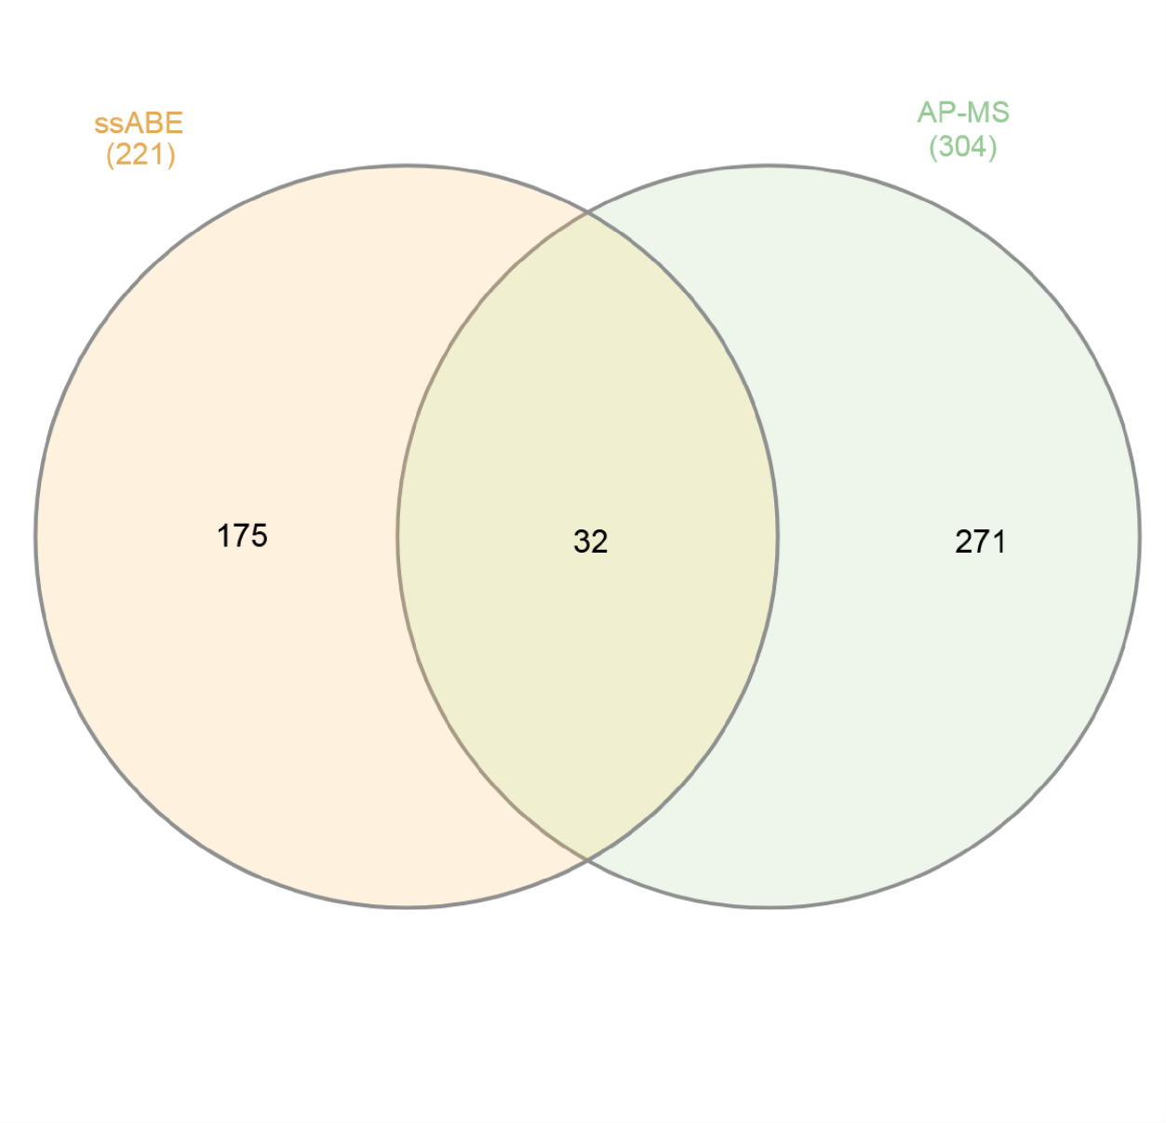
Figure 8.2: Venn diagram of proteins found as potential DHHC5 substrates in the pilot ssABE study (left side) and the AP-MS of DHHC5 co-expressed with WT Golga7b (right side), with proteins found in both in the central region.

The most noticeable overlapping GO terms between the two different techniques were cell adhesion terms, which validates effects that DHHC5 depletion has on both desmosomes and cell:cell, and possibly even cell:matrix, adhesion. While the individual proteins in from these terms in each dataset are distinct, they do show that DHHC5 likely plays a very important role in these processes by potentially regulating a diverse set of proteins. Although some work has been presented here showing the effects DHHC5 has on DSG2 and PKP3 in desmosomes, and on generalised cell adhesion, further work may be warranted given the range of proteins, and adhesion complexes, which could be involved with DHHC5. For example, it might be interesting to look at how the assembly dynamics of desmosomes are affected by the depletion of DHHC5 or by the presence of a DHHC5 catalytic mutant, and if palmitoylation of one of the components sets off a cascade that allows the palmitoylation of the other components.

As mentioned in a previous chapter, it would be interesting to compare the palmitoylated proteome after DHHC5 siRNA treatment to the palmitoylated proteome after Golga7b siRNA treatment. As has been shown by the biotin endocytosis assays and confocal images, even after depletion of Golga7b, there is still some DHHC5 at the plasma membrane, although the biotin endocytosis assay did reveal that the rate of endocytosis of DHHC5 is appears to be greatly increased, so it could be interesting to investigate whether DHHC5 is present at the plasma membrane for long enough to palmitoylate its normal substrates at this localisation. Given that after Golga7b siRNA there is significantly more DHHC5 present within the cell, it could be assumed that there would be an increase in palmitoylation of a range of proteins present within the cell. However, the AP-MS data suggest that DHHC5 interacts with a restricted set of proteins within the cell which could mean that DHHC5 will only palmitoylate a similarly small number of non-plasma membrane proteins. This hypothesis can be supported and opposed with a number of different studies from previously published work.
It has been shown that despite moving the localisation of a PAT, it was still able to palmitoylate its substrates (Lemonidis et al., 2014). However, in this case, the PAT was moved from the Golgi to the endoplasmic reticulum, so proteins in the exocytosis pathway will still likely be palmitoylated as they will encounter the appropriate PAT. This is could also happen in this case, as if DHHC5 is present within the cell, it could still palmitoylate nay of its substrates it encounters as they are trafficked to the plasma membrane. Where a difference could be seen is if DHHC5 is not present at the plasma membrane to re-palmitoylate substrates that have been de-palmitoylated at the plasma membrane. It must also be noted that despite the low number of interactors when DHHC5 is expressed with mutant Golga7b, and is therefore within the cell, it will not necessarily mean that DHHC5 has few substrates in this location, as PATs do not always interact robustly with their substrates, as has been shown with DHHC7 and SNAP25 (Lemonidis et al., 2014). Despite these points, this proposed experiment could have great value by investigating what happens to the palmitoylated proteome when a PAT is localised to another area of the cell.

8.9 Summary

In summary, this work expands the current knowledge on the regulation of DHHC5,
particularly with respect to its localisation, and how this is shaped by the palmitoylation state of a novel substrate and interactor Golga7b. It also shows the importance of palmitoylation of the C-terminal tail of DHHC5 in the regulation of DHHC5 endocytosis, but shows that it is not important in establishing the localisation of DHHC5 which must be due to other factors. The AP-MS survey found distinct interactors for DHHC5 in different cellular compartments and was also able to show the possible involvement of the AP2 complex in endocytosis of DHHC5. This was later confirmed through a series of experiments. It also revealed the importance of DHHC5 as a PAT and regulator of the desmosomal cell adhesion complex as depletion of DHHC5 leads to severe localisation defects in the desmosomal cadherin desmoglein-2. Furthermore, it was shown that DHHC5 also plays a wider role in general cell adhesion. This work establishes new roles for DHHC5 that could have impacts in numerous specialised cell types and human diseases.

9 References

Abrami L, Dallavilla T, Sandoz PA, Demir M, Kunz B, Savoglidis G, Hatzimanikatis V & van der Goot FG. (2017). Identification and dynamics of the human ZDHHC16-ZDHHC6 palmitoylation cascade. eLife 6.

Acton JH, Smith RT, Hood DC & Greenstein VC. (2012). Relationship between retinal layer thickness and the visual field in early age-related macular degeneration. Investigative ophthalmology & visual science 53, 7618-7624.

Ahearn IM, Tsai FD, Court H, Zhou M, Jennings BC, Ahmed M, Fehrenbacher N, Linder ME & Philips MR. (2011). FKBP12 binds to acylated H-ras and promotes depalmitoylation. Molecular cell 41, 173-185.

Antorini M, Breme U, Caccia P, Grassi C, Lebrun S, Orsini G, Taylor G, Valsasina B, Marengo E, Todeschini R, Andersson C, Gellerfors P & Gustafsson JG. (1997). Hydroxylamine-induced cleavage of the asparaginyl-glycine motif in the production of recombinant proteins: the case of insulin-like growth factor I. Protein expression and purification 11, 135-147.

Aramsangtienchai P, Spiegelman NA, Cao J & Lin H. (2017). S-Palmitoylation of Junctional Adhesion Molecule C Regulates Its Tight Junction Localization and Cell Migration. The Journal of biological chemistry 292, 5325-5334.

Ares GR & Ortiz PA. (2012). Dynamin2, clathrin, and lipid rafts mediate endocytosis of the apical Na/K/2Cl cotransporter NKCC2 in thick ascending limbs. The Journal of biological chemistry 287, 37824-37834.

Arrate MP, Rodriguez JM, Tran TM, Brock TA & Cunningham SA. (2001). Cloning of human junctional adhesion molecule 3 (JAM3) and its identification as the JAM2 counter-receptor.
The Journal of biological chemistry 276, 45826-45832.

Babina IS, McSherry EA, Donatello S, Hill AD & Hopkins AM. (2014). A novel mechanism of regulating breast cancer cell migration via palmitoylation-dependent alterations in the lipid raft affiliation of CD44. Breast cancer research : BCR 16, R19.

Baliga BS, Pronczuk AW & Munro HN. (1969). Mechanism of cycloheximide inhibition of protein synthesis in a cell-free system prepared from rat liver. The Journal of biological chemistry 244, 4480-4489.

Bayes A, Collins MO, Reig-Viader R, Gou G, Goulding D, Izquierdo A, Choudhary JS, Emes RD & Grant SG. (2017). Evolution of complexity in the zebrafish synapse proteome. Nature communications 8, 14613.

Bem D, Yoshimura S, Nunes-Bastos R, Bond FC, Kurian MA, Rahman F, Handley MT, Hadzhiev Y, Masood I, Straatman-Iwanowska AA, Cullinane AR, McNeill A, Pasha SS, Kirby GA, Foster K,
Ahmed Z, Morton JE, Williams D, Graham JM, Dobyns WB, Burglen L, Ainsworth JR, Gissen P, Muller F, Maher ER, Barr FA & Aligianis IA. (2011). Loss-of-function mutations in RAB18 cause Warburg micro syndrome. American journal of human genetics 88, 499-507.

Berchtold LA, Storling ZM, Ortis F, Lage K, Bang-Berthelsen C, Bergholdt R, Hald J, Brorsson CA, Eizirik DL, Pociot F, Brunak S & Storling J. (2011). Huntingtin-interacting protein 14 is a type 1 diabetes candidate protein regulating insulin secretion and beta-cell apoptosis. Proceedings of the National Academy of Sciences of the United States of America 108, E681688.
Berthiaume L, Deichaite I, Peseckis S & Resh MD. (1994). Regulation of enzymatic activity by active site fatty acylation. A new role for long chain fatty acid acylation of proteins. The Journal of biological chemistry 269, 6498-6505.

Bhattacharyya R, Barren C & Kovacs DM. (2013). Palmitoylation of amyloid precursor protein regulates amyloidogenic processing in lipid rafts. The Journal of neuroscience : the official journal of the Society for Neuroscience 33, 11169-11183.

Biasini M, Bienert S, Waterhouse A, Arnold K, Studer G, Schmidt T, Kiefer F, Gallo Cassarino T, Bertoni M, Bordoli L & Schwede T. (2014). SWISS-MODEL: modelling protein tertiary and quaternary structure using evolutionary information. Nucleic acids research 42, W252-258.

Blanc M, David F, Abrami L, Migliozzi D, Armand F, Burgi J & van der Goot FG. (2015).
SwissPalm: Protein Palmitoylation database. F1000Res 4, 261.

Bolte S & Cordelieres FP. (2006). A guided tour into subcellular colocalization analysis in light microscopy. Journal of microscopy 224, 213-232.

Bonne S, Gilbert B, Hatzfeld M, Chen X, Green KJ & van Roy F. (2003). Defining desmosomal plakophilin-3 interactions. The Journal of cell biology 161, 403-416.

Bonne S, van Hengel J, Nollet F, Kools P & van Roy F. (1999). Plakophilin-3, a novel armadillolike protein present in nuclei and desmosomes of epithelial cells. Journal of cell science 112 ( Pt 14), 2265-2276.

Breusegem SY & Seaman MN. (2014). Genome-wide RNAi screen reveals a role for multipass membrane proteins in endosome-to-golgi retrieval. Cell reports 9, 1931-1945.

Brigidi GS, Santyr B, Shimell J, Jovellar B & Bamji SX. (2015). Activity-regulated trafficking of the palmitoyl-acyl transferase DHHC5. Nature communications 6, 8200.

Brigidi GS, Sun Y, Beccano-Kelly D, Pitman K, Mobasser M, Borgland SL, Milnerwood AJ & Bamji SX. (2014). Palmitoylation of delta-catenin by DHHC5 mediates activity-induced synapse plasticity. Nature neuroscience 17, 522-532.

Broussard JA, Getsios S & Green KJ. (2015). Desmosome regulation and signaling in disease.
Cell and tissue research 360, 501-512.

Burgoyne JR, Oviosu O & Eaton P. (2013). The PEG-switch assay: a fast semi-quantitative method to determine protein reversible cysteine oxidation. Journal of pharmacological and toxicological methods 68, 297-301.

Burridge K & Connell L. (1983). A new protein of adhesion plaques and ruffling membranes.
The Journal of cell biology 97, 359-367.

Carbonnelle D, Luu TH, Chaillou C, Huvelin JM, Bard JM & Nazih H. (2017). LXR Activation Down-regulates Lipid Raft Markers FLOT2 and DHHC5 in MCF-7 Breast Cancer Cells.
Anticancer research 37, 4067-4073.

Cashman NR, Durham HD, Blusztajn JK, Oda K, Tabira T, Shaw IT, Dahrouge S & Antel JP. (1992). Neuroblastoma x spinal cord (NSC) hybrid cell lines resemble developing motor neurons. Developmental dynamics : an official publication of the American Association of Anatomists 194, 209-221.

Chen B, Zheng B, DeRan M, Jarugumilli GK, Fu J, Brooks YS & Wu X. (2016). ZDHHC7-mediated S-palmitoylation of Scribble regulates cell polarity. Nature chemical biology 12, 686-693.
Chen HC. (2005). Cell-scatter assay. Methods in molecular biology 294, 69-77.

Cihil KM & Swiatecka-Urban A. (2013). The cell-based L-glutathione protection assays to study endocytosis and recycling of plasma membrane proteins. Journal of visualized experiments :
JoVE, e50867.

Collins MO, Woodley KT & Choudhary JS. (2017). Global, site-specific analysis of neuronal protein S-acylation. Scientific reports 7, 4683.

Cox J & Mann M. (2008). MaxQuant enables high peptide identification rates, individualized
p.p.b.-range mass accuracies and proteome-wide protein quantification. Nature biotechnology 26, 1367-1372.

Dekker FJ, Rocks O, Vartak N, Menninger S, Hedberg C, Balamurugan R, Wetzel S, Renner S,
Gerauer M, Scholermann B, Rusch M, Kramer JW, Rauh D, Coates GW, Brunsveld L, Bastiaens
PI & Waldmann H. (2010). Small-molecule inhibition of APT1 affects Ras localization and signaling. Nature chemical biology 6, 449-456.

Deshaies RJ & Joazeiro CA. (2009). RING domain E3 ubiquitin ligases. Annual review of biochemistry 78, 399-434.

Dickinson ME, Flenniken AM, Ji X, Teboul L, Wong MD, White JK, Meehan TF, Weninger WJ, Westerberg H, Adissu H, Baker CN, Bower L, Brown JM, Caddle LB, Chiani F, Clary D, Cleak J,
Daly MJ, Denegre JM, Doe B, Dolan ME, Edie SM, Fuchs H, Gailus-Durner V, Galli A,
Gambadoro A, Gallegos J, Guo S, Horner NR, Hsu CW, Johnson SJ, Kalaga S, Keith LC, Lanoue L, Lawson TN, Lek M, Mark M, Marschall S, Mason J, McElwee ML, Newbigging S, Nutter LM,
Peterson KA, Ramirez-Solis R, Rowland DJ, Ryder E, Samocha KE, Seavitt JR, Selloum M, SzokeKovacs Z, Tamura M, Trainor AG, Tudose I, Wakana S, Warren J, Wendling O, West DB, Wong
L, Yoshiki A, International Mouse Phenotyping C, Jackson L, Infrastructure Nationale
Phenomin ICdlS, Charles River L, Harwell MRC, Toronto Centre for P, Wellcome Trust Sanger I, Center RB, MacArthur DG, Tocchini-Valentini GP, Gao X, Flicek P, Bradley A, Skarnes WC, Justice MJ, Parkinson HE, Moore M, Wells S, Braun RE, Svenson KL, de Angelis MH, Herault Y, Mohun T, Mallon AM, Henkelman RM, Brown SD, Adams DJ, Lloyd KC, McKerlie C, Beaudet AL, Bucan M & Murray SA. (2016). High-throughput discovery of novel developmental phenotypes. Nature 537, 508-514.

Dowal L, Yang W, Freeman MR, Steen H & Flaumenhaft R. (2011). Proteomic analysis of palmitoylated platelet proteins. Blood 118, e62-73.

Drisdel RC & Green WN. (2004). Labeling and quantifying sites of protein palmitoylation.
Biotechniques 36, 276-285.

Dunn JD, Reid GE & Bruening ML. (2010). Techniques for phosphopeptide enrichment prior to analysis by mass spectrometry. Mass spectrometry reviews 29, 29-54.

Eisenberg S, Laude AJ, Beckett AJ, Mageean CJ, Aran V, Hernandez-Valladares M, Henis YI & Prior IA. (2013). The role of palmitoylation in regulating Ras localization and function.
Biochemical Society transactions 41, 79-83.

Etzioni A. (1996). Adhesion molecules--their role in health and disease. Pediatric research 39, 191-198.

Fernandez-Larrea J, Merlos-Suarez A, Urena JM, Baselga J & Arribas J. (1999). A role for a PDZ protein in the early secretory pathway for the targeting of proTGF-alpha to the cell surface.
Molecular cell 3, 423-433.

Forrester MT, Hess DT, Thompson JW, Hultman R, Moseley MA, Stamler JS & Casey PJ. (2011). Site-specific analysis of protein S-acylation by resin-assisted capture. Journal of lipid research 52, 393-398.

Forrester MT, Thompson JW, Foster MW, Nogueira L, Moseley MA & Stamler JS. (2009). Proteomic analysis of S-nitrosylation and denitrosylation by resin-assisted capture. Nature biotechnology 27, 557-559.

Fragoso R, Ren D, Zhang X, Su MW, Burakoff SJ & Jin YJ. (2003). Lipid raft distribution of CD4 depends on its palmitoylation and association with Lck, and evidence for CD4-induced lipid raft aggregation as an additional mechanism to enhance CD3 signaling. Journal of immunology 170, 913-921.

Fredericks GJ, Hoffmann FW, Hondal RJ, Rozovsky S, Urschitz J & Hoffmann PR. (2017). Selenoprotein K Increases Efficiency of DHHC6 Catalyzed Protein Palmitoylation by Stabilizing the Acyl-DHHC6 Intermediate. Antioxidants 7.

Fromer, M., Pocklington, A.J., Kavanagh, D.H., Williams, H.J., Dwyer, S., Gormley, P., Georgieva, L., Rees, E., Palta, P., Ruderfer, D.M. and Carrera, N., 2014. De novo mutations in schizophrenia implicate synaptic networks. Nature, 506(7487), p.179.

Fukata M, Fukata Y, Adesnik H, Nicoll RA & Bredt DS. (2004). Identification of PSD-95 palmitoylating enzymes. Neuron 44, 987-996.
Furuse M, Furuse K, Sasaki H & Tsukita S. (2001). Conversion of zonulae occludentes from tight to leaky strand type by introducing claudin-2 into Madin-Darby canine kidney I cells. The Journal of cell biology 153, 263-272.

Garrod D & Chidgey M. (2008). Desmosome structure, composition and function. Biochimica et biophysica acta 1778, 572-587.

Getsios S, Amargo EV, Dusek RL, Ishii K, Sheu L, Godsel LM & Green KJ. (2004). Coordinated expression of desmoglein 1 and desmocollin 1 regulates intercellular adhesion.
Differentiation; research in biological diversity 72, 419-433.
Ghata J & Cowley BD, Jr. (2017). Polycystic Kidney Disease. Comprehensive Physiology 7, 945975.

Gonzalez Montoro A, Chumpen Ramirez S & Valdez Taubas J. (2015). The canonical DHHC motif is not absolutely required for the activity of the yeast S-acyltransferases Swf1 and Pfa4.
The Journal of biological chemistry 290, 22448-22459.

Gorleku OA, Barns AM, Prescott GR, Greaves J & Chamberlain LH. (2011). Endoplasmic reticulum localization of DHHC palmitoyltransferases mediated by lysine-based sorting signals. The Journal of biological chemistry 286, 39573-39584.

Gottlieb CD, Zhang S & Linder ME. (2015). The Cysteine-rich Domain of the DHHC3 Palmitoyltransferase is Palmitoylated and Contains Tightly Bound Zinc. The Journal of biological chemistry.

Grant BD & Donaldson JG. (2009). Pathways and mechanisms of endocytic recycling. Nature reviews Molecular cell biology 10, 597-608.

Greaves J, Gorleku OA, Salaun C & Chamberlain LH. (2010). Palmitoylation of the SNAP25 protein family: specificity and regulation by DHHC palmitoyl transferases. The Journal of biological chemistry 285, 24629-24638.
Greaves J, Munro KR, Davidson SC, Riviere M, Wojno J, Smith TK, Tomkinson NC & Chamberlain LH. (2017). Molecular basis of fatty acid selectivity in the zDHHC family of Sacyltransferases revealed by click chemistry. Proceedings of the National Academy of Sciences of the United States of America 114, E1365-E1374.

Greaves J & Chamberlain LH. (2006). Dual role of the cysteine-string domain in membrane binding and palmitoylation-dependent sorting of the molecular chaperone cysteine-string protein. Molecular biology of the cell 17, 4748-4759.

Greaves J & Chamberlain LH. (2011). DHHC palmitoyl transferases: substrate interactions and (patho)physiology. Trends Biochem Sci 36, 245-253.

Gubitosi-Klug RA, Mancuso DJ & Gross RW. (2005). The human Kv1.1 channel is palmitoylated, modulating voltage sensing: Identification of a palmitoylation consensus sequence.
Proceedings of the National Academy of Sciences of the United States of America 102, 59645968.

Hallak H, Muszbek L, Laposata M, Belmonte E, Brass LF & Manning DR. (1994). Covalent binding of arachidonate to G protein alpha subunits of human platelets. The Journal of biological chemistry 269, 4713-4716.

Hall C, Li S, Li H, Creason V & Wahl JK, 3rd. (2009). Arrhythmogenic right ventricular cardiomyopathy plakophilin-2 mutations disrupt desmosome assembly and stability. Cell communication & adhesion 16, 15-27.

Hansen GH, Niels-Christiansen LL, Thorsen E, Immerdal L & Danielsen EM. (2000). Cholesterol depletion of enterocytes. Effect on the Golgi complex and apical membrane trafficking. The Journal of biological chemistry 275, 5136-5142.

Hao M & Maxfield FR. (2000). Characterization of rapid membrane internalization and recycling. The Journal of biological chemistry 275, 15279-15286.
Hein MY, Hubner NC, Poser I, Cox J, Nagaraj N, Toyoda Y, Gak IA, Weisswange I, Mansfeld J, Buchholz F, Hyman AA & Mann M. (2015). A human interactome in three quantitative dimensions organized by stoichiometries and abundances. Cell 163, 712-723.

He M, Abdi KM & Bennett V. (2014). Ankyrin-G palmitoylation and betaII-spectrin binding to phosphoinositide lipids drive lateral membrane assembly. The Journal of cell biology 206, 273288.

Hemsley PA, Weimar T, Lilley KS, Dupree P & Grierson CS. (2013). A proteomic approach identifies many novel palmitoylated proteins in Arabidopsis. New Phytol 197, 805-814.

Hernandez JL, Davda D, Cheung See Kit M, Majmudar JD, Won SJ, Gang M, Pasupuleti SC, Choi
AI, Bartkowiak CM & Martin BR. (2017). APT2 Inhibition Restores Scribble Localization and SPalmitoylation in Snail-Transformed Cells. Cell chemical biology 24, 87-97.

Hilgemann DW, Fine M, Linder ME, Jennings BC & Lin MJ. (2013). Massive endocytosis triggered by surface membrane palmitoylation under mitochondrial control in BHK fibroblasts. eLife 2, e01293.

Hou H, John Peter AT, Meiringer C, Subramanian K & Ungermann C. (2009). Analysis of DHHC acyltransferases implies overlapping substrate specificity and a two-step reaction mechanism.
Traffic 10, 1061-1073.

Howie J, Reilly L, Fraser NJ, Vlachaki Walker JM, Wypijewski KJ, Ashford ML, Calaghan SC, McClafferty H, Tian L, Shipston MJ, Boguslavskyi A, Shattock MJ & Fuller W. (2014). Substrate recognition by the cell surface palmitoyl transferase DHHC5. Proceedings of the National Academy of Sciences of the United States of America 111, 17534-17539.

Huang K, Sanders SS, Kang R, Carroll JB, Sutton L, Wan J, Singaraja R, Young FB, Liu L, ElHusseini A, Davis NG & Hayden MR. (2011). Wild-type HTT modulates the enzymatic activity of the neuronal palmitoyl transferase HIP14. Human molecular genetics 20, 3356-3365.
Huttlin EL, Ting L, Bruckner RJ, Gebreab F, Gygi MP, Szpyt J, Tam S, Zarraga G, Colby G, Baltier K, Dong R, Guarani V, Vaites LP, Ordureau A, Rad R, Erickson BK, Wuhr M, Chick J, Zhai B,
Kolippakkam D, Mintseris J, Obar RA, Harris T, Artavanis-Tsakonas S, Sowa ME, De Camilli P, Paulo JA, Harper JW & Gygi SP. (2015). The BioPlex Network: A Systematic Exploration of the Human Interactome. Cell 162, 425-440.

Ishida-Yamamoto A & Igawa S. (2014). Genetic skin diseases related to desmosomes and corneodesmosomes. Journal of dermatological science 74, 99-105.

Ishino Y, Hayashi Y, Naruse M, Tomita K, Sanbo M, Fuchigami T, Fujiki R, Hirose K, Toyooka Y, Fujimori T, Ikenaka K & Hitoshi S. (2014). Bre1a, a histone H2B ubiquitin ligase, regulates the cell cycle and differentiation of neural precursor cells. The Journal of neuroscience : the official journal of the Society for Neuroscience 34, 3067-3078.

Ivaldi C, Martin BR, Kieffer-Jaquinod S, Chapel A, Levade T, Garin J & Journet A. (2012). Proteomic analysis of S-acylated proteins in human B cells reveals palmitoylation of the immune regulators CD20 and CD23. PloS one 7, e37187.

James G & Olson EN. (1989). Myristoylation, phosphorylation, and subcellular distribution of the 80-kDa protein kinase C substrate in BC3H1 myocytes. The Journal of biological chemistry 264, 20928-20933.

Jennings BC, Nadolski MJ, Ling Y, Baker MB, Harrison ML, Deschenes RJ & Linder ME. (2009). 2-Bromopalmitate and 2-(2-hydroxy-5-nitro-benzylidene)-benzo[b]thiophen-3-one inhibit DHHC-mediated palmitoylation in vitro. Journal of lipid research 50, 233-242.

Jennings BC & Linder ME. (2012). DHHC protein S-acyltransferases use similar ping-pong kinetic mechanisms but display different acyl-CoA specificities. The Journal of biological chemistry 287, 7236-7245.

Jones ML, Collins MO, Goulding D, Choudhary JS & Rayner JC. (2012). Analysis of protein palmitoylation reveals a pervasive role in Plasmodium development and pathogenesis. Cell host & microbe 12, 246-258.

Kang R, Wan J, Arstikaitis P, Takahashi H, Huang K, Bailey AO, Thompson JX, Roth AF, Drisdel RC, Mastro R, Green WN, Yates JR, 3rd, Davis NG & El-Husseini A. (2008). Neural palmitoylproteomics reveals dynamic synaptic palmitoylation. Nature 456, 904-909.

Kant S, Krusche CA, Gaertner A, Milting H & Leube RE. (2016). Loss of plakoglobin immunoreactivity in intercalated discs in arrhythmogenic right ventricular cardiomyopathy: protein mislocalization versus epitope masking. Cardiovascular research 109, 260-271.

Kawauchi T. (2012). Cell adhesion and its endocytic regulation in cell migration during neural development and cancer metastasis. International journal of molecular sciences 13, 45644590.

Klapholz B & Brown NH. (2017). Talin - the master of integrin adhesions. Journal of cell science 130, 2435-2446.

Kong E, Peng S, Chandra G, Sarkar C, Zhang Z, Bagh MB & Mukherjee AB. (2013). Dynamic palmitoylation links cytosol-membrane shuttling of acyl-protein thioesterase-1 and acylprotein thioesterase-2 with that of proto-oncogene H-ras product and growth-associated protein-43. The Journal of biological chemistry 288, 9112-9125.

Korycka J, Lach A, Heger E, Boguslawska DM, Wolny M, Toporkiewicz M, Augoff K, Korzeniewski J & Sikorski AF. (2012). Human DHHC proteins: a spotlight on the hidden player of palmitoylation. European journal of cell biology 91, 107-117.

Kostiuk MA, Keller BO & Berthiaume LG. (2010). Palmitoylation of ketogenic enzyme HMGCS2 enhances its interaction with PPARalpha and transcription at the Hmgcs2 PPRE. FASEB journal : official publication of the Federation of American Societies for Experimental Biology 24, 19141924.

Kottke MD, Delva E & Kowalczyk AP. (2006). The desmosome: cell science lessons from human diseases. Journal of cell science 119, 797-806.

Kowalczyk AP, Hatzfeld M, Bornslaeger EA, Kopp DS, Borgwardt JE, Corcoran CM, Settler A & Green KJ. (1999). The head domain of plakophilin-1 binds to desmoplakin and enhances its recruitment to desmosomes. Implications for cutaneous disease. The Journal of biological chemistry 274, 18145-18148.

Kowalczyk AP, Stappenbeck TS, Parry DA, Palka HL, Virata ML, Bornslaeger EA, Nilles LA & Green KJ. (1994). Structure and function of desmosomal transmembrane core and plaque molecules. Biophysical chemistry 50, 97-112.

Kowalczyk AP & Nanes BA. (2012). Adherens junction turnover: regulating adhesion through cadherin endocytosis, degradation, and recycling. Sub-cellular biochemistry 60, 197-222.

Lagendijk AK, Yap AS & Hogan BM. (2014). Endothelial cell-cell adhesion during zebrafish vascular development. Cell adhesion & migration 8, 136-145.

Lahtinen AM, Lehtonen E, Marjamaa A, Kaartinen M, Helio T, Porthan K, Oikarinen L, Toivonen L, Swan H, Jula A, Peltonen L, Palotie A, Salomaa V & Kontula K. (2011). Population-prevalent desmosomal mutations predisposing to arrhythmogenic right ventricular cardiomyopathy.
Heart rhythm 8, 1214-1221.

Lai J & Linder ME. (2013). Oligomerization of DHHC protein S-acyltransferases. The Journal of biological chemistry 288, 22862-22870.

Lajoie P & Nabi IR. (2010). Lipid rafts, caveolae, and their endocytosis. International review of cell and molecular biology 282, 135-163.

Lamaze C, Dujeancourt A, Baba T, Lo CG, Benmerah A & Dautry-Varsat A. (2001). Interleukin 2 receptors and detergent-resistant membrane domains define a clathrin-independent endocytic pathway. Molecular cell 7, 661-671.

Lariccia V, Fine M, Magi S, Lin MJ, Yaradanakul A, Llaguno MC & Hilgemann DW. (2011). Massive calcium-activated endocytosis without involvement of classical endocytic proteins.
The Journal of general physiology 137, 111-132.

Larue L & Bellacosa A. (2005). Epithelial-mesenchymal transition in development and cancer: role of phosphatidylinositol 3' kinase/AKT pathways. Oncogene 24, 7443-7454.

Lemonidis K, Gorleku OA, Sanchez-Perez MC, Grefen C & Chamberlain LH. (2014). The Golgi S-acylation machinery comprises zDHHC enzymes with major differences in substrate affinity and S-acylation activity. Molecular biology of the cell 25, 3870-3883.

Levental I, Lingwood D, Grzybek M, Coskun U & Simons K. (2010). Palmitoylation regulates raft affinity for the majority of integral raft proteins. Proceedings of the National Academy of Sciences of the United States of America 107, 22050-22054.

Lievens PM, Kuznetsova T, Kochlamazashvili G, Cesca F, Gorinski N, Galil DA, Cherkas V,
Ronkina N, Lafera J, Gaestel M, Ponimaskin E & Dityatev A. (2016). ZDHHC3 Tyrosine Phosphorylation Regulates Neural Cell Adhesion Molecule Palmitoylation. Molecular and cellular biology 36, 2208-2225.

Lin MJ, Fine M, Lu JY, Hofmann SL, Frazier G & Hilgemann DW. (2013). Massive palmitoylationdependent endocytosis during reoxygenation of anoxic cardiac muscle. eLife 2, e01295.

Liu Z, Oh SM, Okada M, Liu X, Cheng D, Peng J, Brat DJ, Sun SY, Zhou W, Gu W & Ye K. (2009). Human BRE1 is an E3 ubiquitin ligase for Ebp1 tumor suppressor. Molecular biology of the cell 20, 757-768.

Li Y, Hu J, Hofer K, Wong AM, Cooper JD, Birnbaum SG, Hammer RE & Hofmann SL. (2010). DHHC5 interacts with PDZ domain 3 of post-synaptic density-95 (PSD-95) protein and plays a role in learning and memory. The Journal of biological chemistry 285, 13022-13031.

Li Y, Martin BR, Cravatt BF & Hofmann SL. (2012). DHHC5 protein palmitoylates flotillin-2 and is rapidly degraded on induction of neuronal differentiation in cultured cells. The Journal of biological chemistry 287, 523-530.

Li Y, Zhang F, Lu W & Li X. (2018). Neuronal Expression of Junctional Adhesion Molecule-C is Essential for Retinal Thickness and Photoreceptor Survival. Current molecular medicine 17, 497-508.

Lobo S, Greentree WK, Linder ME & Deschenes RJ. (2002). Identification of a Ras palmitoyltransferase in Saccharomyces cerevisiae. The Journal of biological chemistry 277, 41268-41273.

Lutcke A, Parton RG, Murphy C, Olkkonen VM, Dupree P, Valencia A, Simons K & Zerial M. (1994). Cloning and subcellular localization of novel rab proteins reveals polarized and cell type-specific expression. Journal of cell science 107 ( Pt 12), 3437-3448.

Macia E, Ehrlich M, Massol R, Boucrot E, Brunner C & Kirchhausen T. (2006). Dynasore, a cellpermeable inhibitor of dynamin. Developmental cell 10, 839-850.

Magee AI, Gutierrez L, McKay IA, Marshall CJ & Hall A. (1987). Dynamic fatty acylation of p21N-ras. The EMBO journal 6, 3353-3357.

Mahammad S & Parmryd I. (2015). Cholesterol depletion using methyl-beta-cyclodextrin. Methods in molecular biology 1232, 91-102.
Matter C, Pribadi M, Liu X & Trachtenberg JT. (2009). Delta-catenin is required for the maintenance of neural structure and function in mature cortex in vivo. Neuron 64, 320-327.

McCarthy KM, Francis SA, McCormack JM, Lai J, Rogers RA, Skare IB, Lynch RD & Schneeberger EE. (2000). Inducible expression of claudin-1-myc but not occludin-VSV-G results in aberrant tight junction strand formation in MDCK cells. Journal of cell science 113 Pt 19, 3387-3398.

McNew JA, Sogaard M, Lampen NM, Machida S, Ye RR, Lacomis L, Tempst P, Rothman JE &
Sollner TH. (1997). Ykt6p, a prenylated SNARE essential for endoplasmic reticulum-Golgi transport. The Journal of biological chemistry 272, 17776-17783.

Meckler X, Roseman J, Das P, Cheng H, Pei S, Keat M, Kassarjian B, Golde TE, Parent AT & Thinakaran G. (2010). Reduced Alzheimer's disease ss-amyloid deposition in transgenic mice expressing S-palmitoylation-deficient APH1aL and nicastrin. The Journal of neuroscience : the official journal of the Society for Neuroscience 30, 16160-16169.

Mellacheruvu D, Wright Z, Couzens AL, Lambert JP, St-Denis NA, Li T, Miteva YV, Hauri S, Sardiu ME, Low TY, Halim VA, Bagshaw RD, Hubner NC, Al-Hakim A, Bouchard A, Faubert D,
Fermin D, Dunham WH, Goudreault M, Lin ZY, Badillo BG, Pawson T, Durocher D, Coulombe B, Aebersold R, Superti-Furga G, Colinge J, Heck AJ, Choi H, Gstaiger M, Mohammed S, Cristea IM, Bennett KL, Washburn MP, Raught B, Ewing RM, Gingras AC & Nesvizhskii AI. (2013). The CRAPome: a contaminant repository for affinity purification-mass spectrometry data. Nature methods 10, 730-736.

Merrick BA, Dhungana S, Williams JG, Aloor JJ, Peddada S, Tomer KB & Fessler MB. (2011). Proteomic profiling of S-acylated macrophage proteins identifies a role for palmitoylation in mitochondrial targeting of phospholipid scramblase 3. Molecular & cellular proteomics : MCP 10, M110 006007.

Mertens C, Kuhn C & Franke WW. (1996). Plakophilins 2a and 2b: constitutive proteins of dual location in the karyoplasm and the desmosomal plaque. The Journal of cell biology 135, 10091025.

Meyle J, Gultig K, Rascher G & Wolburg H. (1999). Transepithelial electrical resistance and tight junctions of human gingival keratinocytes. Journal of periodontal research 34, 214-222.

Mi H, Muruganujan A & Thomas PD. (2013). PANTHER in 2013: modeling the evolution of gene function, and other gene attributes, in the context of phylogenetic trees. Nucleic acids research 41, D377-386.

Mitchell DA, Hamel LD, Ishizuka K, Mitchell G, Schaefer LM & Deschenes RJ. (2012). The Erf4 subunit of the yeast Ras palmitoyl acyltransferase is required for stability of the Acyl-Erf2 intermediate and palmitoyl transfer to a Ras2 substrate. The Journal of biological chemistry 287, 34337-34348.

Mizumaru C, Saito Y, Ishikawa T, Yoshida T, Yamamoto T, Nakaya T & Suzuki T. (2009). Suppression of APP-containing vesicle trafficking and production of beta-amyloid by AID/DHHC-12 protein. Journal of neurochemistry 111, 1213-1224.

Morrison E, Kuropka B, Kliche S, Brugger B, Krause E & Freund C. (2015). Quantitative analysis of the human T cell palmitome. Scientific reports 5, 11598.

Mukai J, Liu H, Burt RA, Swor DE, Lai WS, Karayiorgou M & Gogos JA. (2004). Evidence that the gene encoding ZDHHC8 contributes to the risk of schizophrenia. Nature genetics 36, 725731.

Nabi IR & Le PU. (2003). Caveolae/raft-dependent endocytosis. The Journal of cell biology 161, 673-677.

Nakatani Y, Konishi H, Vassilev A, Kurooka H, Ishiguro K, Sawada J, Ikura T, Korsmeyer SJ, Qin J & Herlitz AM. (2005). p600, a unique protein required for membrane morphogenesis and cell survival. Proceedings of the National Academy of Sciences of the United States of America 102, 15093-15098.

Neumann-Giesen C, Falkenbach B, Beicht P, Claasen S, Luers G, Stuermer CA, Herzog V & Tikkanen R. (2004). Membrane and raft association of reggie-1/flotillin-2: role of myristoylation, palmitoylation and oligomerization and induction of filopodia by overexpression. The Biochemical journal 378, 509-518.

Nikcevic G, Kovacevic-Grujicic N & Stevanovic M. (2003). Improved transfection efficiency of cultured human cells. Cell biology international 27, 735-737.
Nitoiu D, Etheridge SL & Kelsell DP. (2014). Insights into desmosome biology from inherited human skin disease and cardiocutaneous syndromes. Cell communication & adhesion 21, 129140.

Obert E, Strauss R, Brandon C, Grek C, Ghatnekar G, Gourdie R & Rohrer B. (2017). Targeting the tight junction protein, zonula occludens-1, with the connexin43 mimetic peptide, alphaCT1, reduces VEGF-dependent RPE pathophysiology. Journal of molecular medicine 95, 535-552.

Ohno S. (2016). The genetic background of arrhythmogenic right ventricular cardiomyopathy.
Journal of arrhythmia 32, 398-403.

Ohno Y, Kihara A, Sano T & Igarashi Y. (2006). Intracellular localization and tissue-specific distribution of human and yeast DHHC cysteine-rich domain-containing proteins. Biochimica et biophysica acta 1761, 474-483.

Ory S, Brazier H & Blangy A. (2007). Identification of a bipartite focal adhesion localization signal in RhoU/Wrch-1, a Rho family GTPase that regulates cell adhesion and migration.
Biology of the cell 99, 701-716.

Pasdar M & Nelson WJ. (1989). Regulation of desmosome assembly in epithelial cells: kinetics of synthesis, transport, and stabilization of desmoglein I, a major protein of the membrane core domain. The Journal of cell biology 109, 163-177.

Pepino MY, Kuda O, Samovski D & Abumrad NA. (2014). Structure-function of CD36 and importance of fatty acid signal transduction in fat metabolism. Annual review of nutrition 34, 281-303.

Pepinsky RB, Zeng C, Wen D, Rayhorn P, Baker DP, Williams KP, Bixler SA, Ambrose CM, Garber EA, Miatkowski K, Taylor FR, Wang EA & Galdes A. (1998). Identification of a palmitic acidmodified form of human Sonic hedgehog. The Journal of biological chemistry 273, 1403714045.

Puri C. (2009). Loss of myosin VI no insert isoform (NoI) induces a defect in clathrin-mediated endocytosis and leads to caveolar endocytosis of transferrin receptor. The Journal of biological chemistry 284, 34998-35014.

Putilina T, Wong P & Gentleman S. (1999). The DHHC domain: a new highly conserved cysteine-rich motif. Molecular and cellular biochemistry 195, 219-226.

Rana MS, Kumar P, Lee CJ, Verardi R, Rajashankar KR & Banerjee A. (2018). Fatty acyl recognition and transfer by an integral membrane S-acyltransferase. Science 359.

Rana MS, Lee CJ & Banerjee A. (2019). The molecular mechanism of DHHC protein acyltransferases. Biochemical Society transactions 47, 157-167.

Ren J, Wen L, Gao X, Jin C, Xue Y & Yao X. (2008). CSS-Palm 2.0: an updated software for palmitoylation sites prediction. Protein engineering, design & selection : PEDS 21, 639-644.

Ren W, Jhala US & Du K. (2013). Proteomic analysis of protein palmitoylation in adipocytes.
Adipocyte 2, 17-28.

Resh MD. (1999). Fatty acylation of proteins: new insights into membrane targeting of myristoylated and palmitoylated proteins. Biochimica et biophysica acta 1451, 1-16.

Rice P, Longden I & Bleasby A. (2000). EMBOSS: the European Molecular Biology Open Software Suite. Trends in genetics : TIG 16, 276-277.

Rickman L, Simrak D, Stevens HP, Hunt DM, King IA, Bryant SP, Eady RA, Leigh IM, Arnemann J, Magee AI, Kelsell DP & Buxton RS. (1999). N-terminal deletion in a desmosomal cadherin causes the autosomal dominant skin disease striate palmoplantar keratoderma. Human molecular genetics 8, 971-976.

Roberts BJ, Johnson KE, McGuinn KP, Saowapa J, Svoboda RA, Mahoney MG, Johnson KR & Wahl JK, 3rd. (2014). Palmitoylation of plakophilin is required for desmosome assembly.
Journal of cell science 127, 3782-3793.

Roberts BJ, Svoboda RA, Overmiller AM, Lewis JD, Kowalczyk AP, Mahoney MG, Johnson KR & Wahl JK, 3rd. (2016). Palmitoylation of Desmoglein 2 Is a Regulator of Assembly Dynamics and Protein Turnover. The Journal of biological chemistry 291, 24857-24865.

Rocks O, Peyker A, Kahms M, Verveer PJ, Koerner C, Lumbierres M, Kuhlmann J, Waldmann H, Wittinghofer A & Bastiaens PI. (2005). An acylation cycle regulates localization and activity of palmitoylated Ras isoforms. Science 307, 1746-1752.

Rodal SK, Skretting G, Garred O, Vilhardt F, van Deurs B & Sandvig K. (1999). Extraction of cholesterol with methyl-beta-cyclodextrin perturbs formation of clathrin-coated endocytic vesicles. Molecular biology of the cell 10, 961-974.

Rollason R, Korolchuk V, Hamilton C, Schu P & Banting G. (2007). Clathrin-mediated endocytosis of a lipid-raft-associated protein is mediated through a dual tyrosine motif.
Journal of cell science 120, 3850-3858.

Roth AF, Wan J, Bailey AO, Sun B, Kuchar JA, Green WN, Phinney BS, Yates JR, 3rd & Davis NG.
(2006a). Global analysis of protein palmitoylation in yeast. Cell 125, 1003-1013.

Roth AF, Wan J, Green WN, Yates JR & Davis NG. (2006b). Proteomic identification of palmitoylated proteins. Methods 40, 135-142.

Rubio I, Wittig U, Meyer C, Heinze R, Kadereit D, Waldmann H, Downward J & Wetzker R. (1999). Farnesylation of Ras is important for the interaction with phosphoinositide 3-kinase gamma. European journal of biochemistry / FEBS 266, 70-82.

Russo RJ, Husson H, Joly D, Bukanov NO, Patey N, Knebelmann B & Ibraghimov-Beskrovnaya O. (2005). Impaired formation of desmosomal junctions in ADPKD epithelia. Histochemistry and cell biology 124, 487-497.

Salaun C, Greaves J & Chamberlain LH. (2010). The intracellular dynamic of protein palmitoylation. The Journal of cell biology 191, 1229-1238.

Salzer U & Prohaska R. (2001). Stomatin, flotillin-1, and flotillin-2 are major integral proteins of erythrocyte lipid rafts. Blood 97, 1141-1143.

Sanders SS, Martin DD, Butland SL, Lavallee-Adam M, Calzolari D, Kay C, Yates JR, 3rd & Hayden MR. (2015). Curation of the Mammalian Palmitoylome Indicates a Pivotal Role for Palmitoylation in Diseases and Disorders of the Nervous System and Cancers. PLoS computational biology 11, e1004405.

Scheffers MS, van der Bent P, Prins F, Spruit L, Breuning MH, Litvinov SV, de Heer E & Peters DJ. (2000). Polycystin-1, the product of the polycystic kidney disease 1 gene, co-localizes with desmosomes in MDCK cells. Human molecular genetics 9, 2743-2750.

Schindelin J, Arganda-Carreras I, Frise E, Kaynig V, Longair M, Pietzsch T, Preibisch S, Rueden C, Saalfeld S, Schmid B, Tinevez JY, White DJ, Hartenstein V, Eliceiri K, Tomancak P & Cardona A. (2012). Fiji: an open-source platform for biological-image analysis. Nature methods 9, 676682.

Schlegel N, Meir M, Heupel WM, Holthofer B, Leube RE & Waschke J. (2010). Desmoglein 2mediated adhesion is required for intestinal epithelial barrier integrity. American journal of physiology Gastrointestinal and liver physiology 298, G774-783.

Schlipp A, Schinner C, Spindler V, Vielmuth F, Gehmlich K, Syrris P, McKenna WJ, Dendorfer A, Hartlieb E & Waschke J. (2014). Desmoglein-2 interaction is crucial for cardiomyocyte cohesion and function. Cardiovascular research 104, 245-257.

Schmidt MF, Bracha M & Schlesinger MJ. (1979). Evidence for covalent attachment of fatty acids to Sindbis virus glycoproteins. Proceedings of the National Academy of Sciences of the United States of America 76, 1687-1691.

Schneider CA, Rasband WS & Eliceiri KW. (2012). NIH Image to ImageJ: 25 years of image analysis. Nature methods 9, 671-675.

Shipston MJ. (2013). Regulation of large conductance calcium- and voltage-activated potassium (BK) channels by S-palmitoylation. Biochemical Society transactions 41, 67-71.

Shogomori H & Futerman AH. (2001). Cholesterol depletion by methyl-beta-cyclodextrin blocks cholera toxin transport from endosomes to the Golgi apparatus in hippocampal neurons. Journal of neurochemistry 78, 991-999.

Silberberg M, Charron AJ, Bacallao R & Wandinger-Ness A. (2005). Mispolarization of desmosomal proteins and altered intercellular adhesion in autosomal dominant polycystic kidney disease. American journal of physiology Renal physiology 288, F1153-1163.

Singaraja RR, Hadano S, Metzler M, Givan S, Wellington CL, Warby S, Yanai A, Gutekunst CA,
Leavitt BR, Yi H, Fichter K, Gan L, McCutcheon K, Chopra V, Michel J, Hersch SM, Ikeda JE & Hayden MR. (2002). HIP14, a novel ankyrin domain-containing protein, links huntingtin to intracellular trafficking and endocytosis. Human molecular genetics 11, 2815-2828.

Sinz A. (2006). Chemical cross-linking and mass spectrometry to map three-dimensional protein structures and protein-protein interactions. Mass spectrometry reviews 25, 663-682.

Song SP, Hennig A, Schubert K, Markwart R, Schmidt P, Prior IA, Bohmer FD & Rubio I. (2013). Ras palmitoylation is necessary for N-Ras activation and signal propagation in growth factor signalling. The Biochemical journal 454, 323-332.

Stypulkowski E, Asangani IA & Witze ES. (2018). The depalmitoylase APT1 directs the asymmetric partitioning of Notch and Wnt signaling during cell division. Science signaling 11.

Sutton LM, Sanders SS, Butland SL, Singaraja RR, Franciosi S, Southwell AL, Doty CN, Schmidt ME, Mui KK, Kovalik V, Young FB, Zhang W & Hayden MR. (2013). Hip14l-deficient mice develop neuropathological and behavioural features of Huntington disease. Human molecular genetics 22, 452-465.
Swaney DL & Villen J. (2016). Enrichment of Modified Peptides via Immunoaffinity Precipitation with Modification-Specific Antibodies. Cold Spring Harbor protocols 2016, pdb prot088013.

Swarthout JT, Lobo S, Farh L, Croke MR, Greentree WK, Deschenes RJ & Linder ME. (2005). DHHC9 and GCP16 constitute a human protein fatty acyltransferase with specificity for H- and N-Ras. The Journal of biological chemistry 280, 31141-31148.

Tai G, Lu L, Wang TL, Tang BL, Goud B, Johannes L & Hong W. (2004). Participation of the syntaxin 5/Ykt6/GS28/GS15 SNARE complex in transport from the early/recycling endosome to the trans-Golgi network. Molecular biology of the cell 15, 4011-4022.
Termini CM, Cotter ML, Marjon KD, Buranda T, Lidke KA & Gillette JM. (2014). The membrane scaffold CD82 regulates cell adhesion by altering alpha4 integrin stability and molecular density. Molecular biology of the cell 25, 1560-1573.

Thankamony SP & Knudson W. (2006). Acylation of CD44 and its association with lipid rafts are required for receptor and hyaluronan endocytosis. The Journal of biological chemistry 281, 34601-34609.

Thinon E, Fernandez JP, Molina H & Hang HC. (2018). Selective Enrichment and Direct Analysis of Protein S-Palmitoylation Sites. Journal of proteome research 17, 1907-1922.

Thomas GM, Hayashi T, Chiu SL, Chen CM & Huganir RL. (2012). Palmitoylation by DHHC5/8 targets GRIP1 to dendritic endosomes to regulate AMPA-R trafficking. Neuron 73, 482-496.

Thomas P & Smart TG. (2005). HEK293 cell line: a vehicle for the expression of recombinant proteins. Journal of pharmacological and toxicological methods 51, 187-200.

Thomas PD, Campbell MJ, Kejariwal A, Mi H, Karlak B, Daverman R, Diemer K, Muruganujan A & Narechania A. (2003). PANTHER: a library of protein families and subfamilies indexed by function. Genome research 13, 2129-2141.
Thomas SM & Brugge JS. (1997). Cellular functions regulated by Src family kinases. Annual review of cell and developmental biology 13, 513-609.

Tian H, Lu JY, Shao C, Huffman KE, Carstens RM, Larsen JE, Girard L, Liu H, Rodriguez-Canales J, Frenkel EP, Wistuba, II, Minna JD & Hofmann SL. (2015). Systematic siRNA Screen Unmasks NSCLC Growth Dependence by Palmitoyltransferase DHHC5. Molecular cancer research : MCR 13, 784-794.

Tobey NA, Argote CM, Hosseini SS & Orlando RC. (2004). Calcium-switch technique and junctional permeability in native rabbit esophageal epithelium. American journal of physiology Gastrointestinal and liver physiology 286, G1042-1049.

Topinka JR & Bredt DS. (1998). N-terminal palmitoylation of PSD-95 regulates association with cell membranes and interaction with K+ channel Kv1.4. Neuron 20, 125-134.

Tsukamoto T & Nigam SK. (1999). Cell-cell dissociation upon epithelial cell scattering requires a step mediated by the proteasome. The Journal of biological chemistry 274, 24579-24584.

Tyanova S, Temu T, Sinitcyn P, Carlson A, Hein MY, Geiger T, Mann M & Cox J. (2016). The Perseus computational platform for comprehensive analysis of (prote)omics data. Nature methods 13, 731-740.

Uhlen M, Fagerberg L, Hallstrom BM, Lindskog C, Oksvold P, Mardinoglu A, Sivertsson A,
Kampf C, Sjostedt E, Asplund A, Olsson I, Edlund K, Lundberg E, Navani S, Szigyarto CA, Odeberg J, Djureinovic D, Takanen JO, Hober S, Alm T, Edqvist PH, Berling H, Tegel H, Mulder
J, Rockberg J, Nilsson P, Schwenk JM, Hamsten M, von Feilitzen K, Forsberg M, Persson L, Johansson F, Zwahlen M, von Heijne G, Nielsen J & Ponten F. (2015). Proteomics. Tissue-based map of the human proteome. Science 347, 1260419.

Van Itallie CM, Gambling TM, Carson JL & Anderson JM. (2005). Palmitoylation of claudins is required for efficient tight-junction localization. Journal of cell science 118, 1427-1436.
Veit M. (2004). The human SNARE protein Ykt6 mediates its own palmitoylation at C-terminal cysteine residues. The Biochemical journal 384, 233-237.

Verardi R, Kim JS, Ghirlando R & Banerjee A. (2017). Structural Basis for Substrate Recognition by the Ankyrin Repeat Domain of Human DHHC17 Palmitoyltransferase. Structure 25, 13371347 e1336.

Vercauteren D, Vandenbroucke RE, Jones AT, Rejman J, Demeester J, De Smedt SC, Sanders NN & Braeckmans K. (2010). The use of inhibitors to study endocytic pathways of gene carriers: optimization and pitfalls. Molecular therapy : the journal of the American Society of Gene Therapy 18, 561-569.

Vollner F, Ali J, Kurrle N, Exner Y, Eming R, Hertl M, Banning A & Tikkanen R. (2016). Loss of flotillin expression results in weakened desmosomal adhesion and Pemphigus vulgaris-like localisation of desmoglein-3 in human keratinocytes. Scientific reports 6, 28820.
Walsh R, Thomson KL, Ware JS, Funke BH, Woodley J, McGuire KJ, Mazzarotto F, Blair E, Seller A, Taylor JC, Minikel EV, Exome Aggregation C, MacArthur DG, Farrall M, Cook SA & Watkins H. (2017). Reassessment of Mendelian gene pathogenicity using 7,855 cardiomyopathy cases and 60,706 reference samples. Genetics in medicine : official journal of the American College of Medical Genetics 19, 192-203.

Wang J, Hao JW, Wang X, Guo H, Sun HH, Lai XY, Liu LY, Zhu M, Wang HY, Li YF, Yu LY, Xie C,
Wang HR, Mo W, Zhou HM, Chen S, Liang G & Zhao TJ. (2019). DHHC4 and DHHC5 Facilitate Fatty Acid Uptake by Palmitoylating and Targeting CD36 to the Plasma Membrane. Cell reports 26, 209-221 e205.

Wan J, Roth AF, Bailey AO & Davis NG. (2007). Palmitoylated proteins: purification and identification. Nature protocols 2, 1573-1584.

Webb Y, Hermida-Matsumoto L & Resh MD. (2000). Inhibition of protein palmitoylation, raft localization, and T cell signaling by 2-bromopalmitate and polyunsaturated fatty acids. The Journal of biological chemistry 275, 261-270.

Wehrle-Haller B. (2012). Structure and function of focal adhesions. Current opinion in cell biology 24, 116-124.

Witkos TM & Lowe M. (2015). The Golgin Family of Coiled-Coil Tethering Proteins. Frontiers in cell and developmental biology 3, 86.

Won SJ & Martin BR. (2018). Temporal Profiling Establishes a Dynamic S-Palmitoylation Cycle.
ACS chemical biology 13, 1560-1568.

Woodley KT & Collins MO. (2019). Quantitative Analysis of Protein S-Acylation Site Dynamics Using Site-Specific Acyl-Biotin Exchange (ssABE). Methods in molecular biology 1977, 71-82.

Wyss L, Schafer J, Liebner S, Mittelbronn M, Deutsch U, Enzmann G, Adams RH, Aurrand-Lions M, Plate KH, Imhof BA & Engelhardt B. (2012). Junctional adhesion molecule (JAM)-C deficient C57BL/6 mice develop a severe hydrocephalus. PloS one 7, e45619.

Yamamoto E, Akimoto T, Kalli AC, Yasuoka K & Sansom MS. (2017). Dynamic interactions between a membrane binding protein and lipids induce fluctuating diffusivity. Science advances 3, e1601871.

Yang W, Di Vizio D, Kirchner M, Steen H & Freeman MR. (2010). Proteome scale characterization of human S-acylated proteins in lipid raft-enriched and non-raft membranes.
Molecular & cellular proteomics : MCP 9, 54-70.

Yang X, Kovalenko OV, Tang W, Claas C, Stipp CS & Hemler ME. (2004). Palmitoylation supports assembly and function of integrin-tetraspanin complexes. The Journal of cell biology 167, 1231-1240.

Yan SM, Tang JJ, Huang CY, Xi SY, Huang MY, Liang JZ, Jiang YX, Li YH, Zhou ZW, Ernberg I, Wu
QL & Du ZM. (2013). Reduced expression of ZDHHC2 is associated with lymph node metastasis and poor prognosis in gastric adenocarcinoma. PloS one 8, e56366.

Yeste-Velasco M, Mao X, Grose R, Kudahetti SC, Lin D, Marzec J, Vasiljevic N, Chaplin T, Xue L,
Xu M, Foster JM, Karnam SS, James SY, Chioni AM, Gould D, Lorincz AT, Oliver RT, Chelala C,
Thomas GM, Shipley JM, Mather SJ, Berney DM, Young BD & Lu YJ. (2014). Identification of ZDHHC14 as a novel human tumour suppressor gene. The Journal of pathology 232, 566-577.
Ye X, Tam WL, Shibue T, Kaygusuz Y, Reinhardt F, Ng Eaton E & Weinberg RA. (2015). Distinct EMT programs control normal mammary stem cells and tumour-initiating cells. Nature 525, 256-260.

Yin Z & Chen L. (2017). Simple Meets Single: The Application of CRISPR/Cas9 in Haploid Embryonic Stem Cells. Stem cells international 2017, 2601746.

Zhang B, Kirov S & Snoddy J. (2005). WebGestalt: an integrated system for exploring gene sets in various biological contexts. Nucleic acids research 33, W741-748.

Zhao Y, He A, Zhu F, Ding M, Hao J, Fan Q, Li P, Liu L, Du Y, Liang X, Guo X, Zhang F & Ma X. (2018). Integrating genome-wide association study and expression quantitative trait locus study identifies multiple genes and gene sets associated with schizophrenia. Progress in neuro-psychopharmacology & biological psychiatry 81, 50-54.

Zhou X, Chen M, Song H, Wang B, Chen H, Wang J, Wang W, Feng S, Zhang F, Ju W, Li M, Gu K, Cao K, Wang DW & Yang B. (2015). Comprehensive analysis of desmosomal gene mutations in Han Chinese patients with arrhythmogenic right ventricular cardiomyopathy. European journal of medical genetics 58, 258-265.

Zimmermann P, Tomatis D, Rosas M, Grootjans J, Leenaerts I, Degeest G, Reekmans G, Coomans C & David G. (2001). Characterization of syntenin, a syndecan-binding PDZ protein, as a component of cell adhesion sites and microfilaments. Molecular biology of the cell 12, 339-350.

Zou C, Ellis BM, Smith RM, Chen BB, Zhao Y & Mallampalli RK. (2011). AcylCoA:lysophosphatidylcholine acyltransferase I (Lpcat1) catalyzes histone protein Opalmitoylation to regulate mRNA synthesis. The Journal of biological chemistry 286, 2801928025.

Zulueta JJ, Yu FS, Hertig IA, Thannickal VJ & Hassoun PM. (1995). Release of hydrogen peroxide in response to hypoxia-reoxygenation: role of an NAD(P)H oxidase-like enzyme in endothelial cell plasma membrane. American journal of respiratory cell and molecular biology 12, 41-49.

10 Appendices

10.1 Appendix A1 – Cell type selection
Gene names |  |  |  | Inten  sity hek | Inten  sity hela | Inten  sity nsc
 |  |  | Sep-02 | 21635 000 | 43579 000 | 24695  0
 |  |  | Sep-06 | 0 | 62684 00 | 0
 |  |  | Sep-07 | 19795 00 | 81597 00 | 0
 |  |  | Sep-09 | 23090 000 | 20587 000 | 0
 |  |  | Sep-11 | 74502 00 | 23447 000 | 72995  0
 |  |  | Sep-15 | 39744 00 | 0 | 0
A2ML1 |  |  |  | 0 | 16218 00 | 0
AAK1 |  |  |  | 0 | 11580 00 | 0
AAR2 |  |  |  | 0 | 46208 00 | 0
AARS |  |  |  | 46728 000 | 25293 000 | 84885 00
AARS2 |  |  |  | 93700 00 | 0 | 0
AASDHPPT |  |  |  | 0 | 11819 00 | 0
ABCB6 |  |  |  | 0 | 12854 00 | 0
ABCB7 |  |  |  | 0 | 38823  0 | 0
ABCC1 |  |  |  | 12896 000 | 16586 00 | 0
ABCD1 |  |  |  | 0 | 29115 00 | 0
ABCD3 |  |  |  | 12571 00 | 68052 00 | 0
ABCE1 |  |  |  | 25474 00 | 13444 000 | 41758  0
ABCF1 |  |  |  | 74097 00 | 34506 000 | 10609 00
ABCF2 |  |  |  | 0 | 70669 00 | 0
ABCF3 |  |  |  | 0 | 46630  0 | 0

ABHD10 | 15447 000 | 0 | 0
ABHD14B | 43218 000 | 20461 00 | 0
ABLIM1 | 41412 000 | 43496 00 | 41578 00
ABRACL | 17133 000 | 0 | 0
ACAA1 | 0 | 85250  0 | 0
ACAA2 | 0 | 11358 000 | 0
ACACA | 12435 000 | 10690 000 | 0
ACAD11 | 10680 00 | 0 | 0
ACADM | 12019 00 | 29052 000 | 0
ACADVL | 18205 00 | 28843 000 | 0
ACAP2 | 25293 00 | 62759 000 | 0
ACAT1 | 18032 00 | 12016 000 | 0
ACAT2 | 20152  0 | 71470 00 | 0
ACBD3 | 29001 00 | 56219 00 | 0
ACIN1 | 97728 00 | 0 | 43589  0
ACLY | 1.49E  +08 | 96439 000 | 35778 00
ACO1 | 13430 00 | 51752 00 | 0
ACO2 | 67258 00 | 77387 00 | 17425 00
ACOT7 | 0 | 44999 00 | 0
ACOT9 | 0 | 13933 00 | 0
ACOX1 | 0 | 32542  0 | 0
ACP1 | 31363 000 | 31900 00 | 38648  0
ACSL3 | 17516 00 | 10524 000 | 0
ACSL4 | 0 | 10611 00 | 0
ACTB | 3.26E  +10 | 1.08E  +10 | 6.82E  +09

ACTBL2 | 2.78E  +09 | 1.1E+  08 | 1.73E  +09
ACTC1;ACTA1;ACTG2;ACTA2 | 6.29E  +09 | 2.38E  +08 | 41603 000
ACTG1 | 0 | 84758 00 | 43961 000
ACTL6A | 15951  0 | 64218 00 | 0
ACTN1 | 4.31E  +08 | 2.6E+  08 | 17417 000
ACTN2 | 22199  0 | 77510  0 | 0
ACTN4 | 19687 00 | 0 | 0
ACTN4 | 5.27E  +09 | 4.81E  +08 | 11142 000
ACTR1A | 23181 00 | 14727 00 | 0
ACTR1B | 21330  0 | 0 | 0
ACTR2 | 19927 00 | 88563 00 | 10248 00
ACTR3 | 26565 00 | 93241 00 | 57471  0
ADA | 0 | 12837 00 | 0
ADAM9 | 0 | 16631 00 | 0
ADAR | 67861  0 | 17726 00 | 0
ADD1 | 1.87E  +08 | 87729 00 | 35905 000
ADD2 | 71772 00 | 0 | 0
ADD3 | 36173 00 | 0 | 0
ADD3 | 62086 000 | 28729 00 | 77291 00
ADH5 | 96108 00 | 15533 00 | 0
ADI1 | 12288 000 | 0 | 0
ADNP | 56592 00 | 12647 00 | 66170  0
ADPRHL2 | 0 | 13051 00 | 0
ADRM1 | 51186 | 73280  0 | 0
ADSL | 18742 00 | 11641 000 | 0

AFAP1 | 16415 00 | 11019 000 | 0
AFAP1L1 | 77616  0 | 0 | 0
AFG3L2 | 0 | 37026 00 | 0
AGFG1 | 0 | 30176 00 | 0
AGK | 33859 00 | 0 | 0
AGL | 15249 000 | 51790 00 | 0
AGMAT | 0 | 91451  0 | 0
AGPAT6 | 0 | 99337  0 | 0
AGPS | 0 | 54372 00 | 0
AGTRAP | 35114 00 | 0 | 0
AHCY | 16859 000 | 62269 000 | 23740  0
AHCYL1 | 0 | 38506 00 | 0
AHNAK | 1.66E  +09 | 1.99E  +09 | 50251  0
AHSA1 | 50746 00 | 16136 00 | 0
AIF1L | 1.46E  +08 | 20148 00 | 0
AIFM1 | 15473 000 | 89243 000 | 0
AIMP1 | 83188 00 | 21375 000 | 11058 00
AIMP2 | 26089 000 | 0 | 0
AIP | 0 | 14019 00 | 0
AK1 | 26625 000 | 37027 00 | 0
AK2 | 1.25E  +08 | 22190 000 | 0
AK3 | 27968 00 | 0 | 0
AK4 | 19509 000 | 75905  0 | 0
AKAP12 | 4.71E  +08 | 42894 00 | 0
AKAP13 | 0 | 34375 00 | 0

AKAP2 | 74339 00 | 0 | 0
AKAP2 | 4.87E  +08 | 0 | 0
AKAP8 | 0 | 10986 00 | 0
AKAP8L | 13035 000 | 41838 00 | 0
AKAP9 | 0 | 24219 00 | 0
AKR1A1 | 21482  0 | 34109 00 | 0
AKR1B1 | 70372  0 | 57499 00 | 0
AKR1C3;AKR1C1;AKR1C4 | 0 | 15241 00 | 0
AKR7A2 | 0 | 29780 00 | 0
AKT2 | 0 | 50718 00 | 0
ALDH16A1 | 79352  0 | 94924  0 | 0
ALDH18A1 | 61146 000 | 25886 000 | 0
ALDH1B1 | 14053 000 | 21937 00 | 0
ALDH1L1 | 20799 000 | 0 | 67098  0
ALDH1L2 | 40298 000 | 15794 00 | 27366  0
ALDH2 | 85249  0 | 15995 00 | 0
ALDH5A1 | 0 | 27669  0 | 0
ALDH7A1 | 12314 00 | 37258 00 | 0
ALDH9A1 | 0 | 15489 000 | 0
ALDOA | 75046 000 | 7.03E  +08 | 15311 00
ALDOC | 0 | 15820 000 | 0
ALKBH5 | 0 | 23723 00 | 0
ALPL | 61654 00 | 0 | 0
ALPP | 0 | 8.03E  +09 | 69917 000
ALPPL2 | 0 | 43431 00 | 0

ALYREF | 4.33E  +08 | 31606 00 | 66925 00
AMFR | 0 | 45384 00 | 0
AMOT | 1.28E  +08 | 0 | 0
AMOTL1 | 57254 00 | 0 | 0
AMY1A;AMY2B;AMY2A | 0 | 16591 000 | 49863 00
ANAPC1 | 45083 00 | 36556 00 | 0
ANAPC15 | 22196  0 | 0 | 0
ANAPC7 | 0 | 48703  0 | 0
ANK2 | 68612 00 | 54638  0 | 0
ANK3 | 74883 000 | 0 | 0
ANKFY1 | 0 | 86212 00 | 33286  0
ANKHD1;ANKRD17 | 28129 00 | 36026 00 | 0
ANKRD17 | 0 | 25447 00 | 0
ANKRD28 | 25161 00 | 11761 000 | 25696 000
ANKZF1 | 0 | 54762 00 | 0
ANLN | 0 | 21615 00 | 0
ANP32A | 54488 000 | 68866  0 | 0
ANP32B | 90058 000 | 0 | 0
ANP32E | 33309 000 | 31043 00 | 0
ANXA1 | 0 | 1.1E+  08 | 27445 00
ANXA11 | 0 | 54156 00 | 0
ANXA2;ANXA2P2 | 17333 000 | 7.04E  +08 | 17754 00
ANXA3 | 0 | 51149 000 | 0
ANXA4 | 0 | 14434 000 | 0
ANXA5 | 1.58E  +08 | 78890 000 | 48407  0

ANXA6 | 22228 00 | 40608 000 | 0
ANXA8L1;ANXA8L2;ANXA8 | 0 | 42132 00 | 0
AP1B1 | 10988 00 | 12147 00 | 43514  0
AP1M1;AP1M2 | 0 | 64908 00 | 0
AP1S1 | 47892 00 | 88257  0 | 0
AP1S2 | 59965 00 | 0 | 0
AP2A1 | 22497 00 | 81445 000 | 0
AP2A2 | 0 | 21321 00 | 12639  0
AP2B1 | 70885 00 | 97055 000 | 89510  0
AP2M1 | 34924  0 | 32364 000 | 0
AP3B1 | 19979 00 | 57074 00 | 0
AP3B2 | 0 | 0 | 72236 00
AP3D1 | 78480  0 | 95209  0 | 0
AP3S1 | 66621 00 | 0 | 0
APEH | 34066 00 | 39846 00 | 0
APEX1 | 79951 00 | 21165 000 | 0
API5 | 23107 00 | 22711 00 | 0
APMAP | 0 | 22098 00 | 0
APOA1BP | 23144 000 | 41578  0 | 0
APOO | 11327 000 | 0 | 0
APRT | 85156 000 | 64969 00 | 0
AQR | 13997 00 | 11396 00 | 0
ARCN1 | 42502  0 | 17796 000 | 25122  0
ARF1;ARF3;ARF4;ARF5 | 45050 000 | 20283 00 | 61872  0
ARF5 | 13335 00 | 0 | 0

ARFGAP1 | 0 | 10061 00 | 0
ARFGEF1 | 0 | 40232 00 | 0
ARFGEF2 | 0 | 91916 00 | 0
ARFIP1 | 0 | 28292 00 | 0
ARFIP2 | 0 | 10134 00 | 0
ARG1 | 0 | 84592 00 | 28333 00
ARHGAP11A | 24318  0 | 0 | 0
ARHGAP18 | 0 | 98158  0 | 10192 000
ARHGAP21 | 1.05E  +08 | 73944 00 | 0
ARHGAP42 | 0 | 60821 00 | 0
ARHGDIA | 1.8E+  08 | 15698 000 | 16106 00
ARHGEF1 | 0 | 72217  0 | 0
ARHGEF11 | 2.26E  +08 | 0 | 79665  0
ARHGEF17 | 13949 000 | 0 | 0
ARHGEF2 | 70851 000 | 0 | 12250 000
ARID1A | 36407 00 | 0 | 0
ARID2 | 0 | 28818 00 | 0
ARL1 | 38830 00 | 0 | 0
ARL13B | 0 | 41772  0 | 0
ARL3 | 64850 00 | 54514  0 | 0
ARL6IP4 | 38249 00 | 17808 00 | 0
ARL6IP5 | 18637 000 | 51938  0 | 0
ARMC1 | 0 | 30860  0 | 0
ARMC6 | 0 | 20230 00 | 0
ARMCX3 | 0 | 23318  0 | 0

ARPC1A | 30902 00 | 0 | 0
ARPC1B | 26453 00 | 14524 00 | 18889  0
ARPC2 | 12159 000 | 15803 00 | 39304 00
ARPC3 | 1.29E  +08 | 37881  0 | 15489 000
ARPC4-TTLL3;ARPC4 | 1.08E  +08 | 34532 00 | 22567 000
ARPC5 | 39404 000 | 13090 00 | 33307 00
ARPC5L | 77590 000 | 0 | 11276 00
ARRDC3 | 0 | 70834  0 | 0
ASNA1 | 20322  0 | 29566 00 | 0
ASNS | 15124 000 | 0 | 0
ASPH | 0 | 81299 00 | 0
ASS1 | 0 | 16681 000 | 0
ATAD3A | 50601 000 | 62892 00 | 21328 00
ATAD3A;ATAD3C | 87037 00 | 0 | 89024  0
ATAD3B | 35656  0 | 0 | 0
ATG3 | 0 | 14701 00 | 0
ATIC | 19706 000 | 36266 000 | 82819  0
ATL3 | 0 | 20847 00 | 0
ATP1A1 | 1.84E  +08 | 1.5E+  08 | 40949  0
ATP1A2 | 0 | 0 | 15099 000
ATP1B3 | 20854 00 | 60221 00 | 0
ATP2A2 | 85453 000 | 64366 000 | 0
ATP2B1 | 15147 000 | 12999 000 | 0
ATP5A1 | 67627 000 | 2.83E  +08 | 96541 00
ATP5B | 1.45E  +08 | 6.31E  +08 | 58994 00

ATP5C1 | 48039 000 | 24773 00 | 0
ATP5D | 0 | 44241 00 | 0
ATP5F1 | 82842 000 | 14305 00 | 0
ATP5H | 87299 000 | 27591 00 | 0
ATP5I | 10811 000 | 49042 00 | 0
ATP5J2-PTCD1;ATP5J2 | 29766 000 | 50311  0 | 0
ATP5L | 30941 000 | 25820 00 | 0
ATP5O | 2.12E  +08 | 12660 000 | 45496  0
ATP6AP2 | 18547 00 | 37982  0 | 0
ATP6V0A1 | 45444 000 | 70559 00 | 0
ATP6V0A2 | 16848 00 | 0 | 0
ATP6V0C | 47231 000 | 0 | 0
ATP6V0D1 | 15141 00 | 15052 00 | 0
ATP6V1A | 16772 000 | 27830 000 | 48139  0
ATP6V1B2 | 24202 00 | 55865 00 | 0
ATP6V1D | 25546 000 | 13039 00 | 0
ATP6V1E1 | 37622 000 | 26697 00 | 0
ATP6V1G1;ATP6V1G2-DDX39B;ATP6V1G2 | 62958 000 | 67400  0 | 0
ATP6V1H | 56866 | 31425 00 | 0
ATXN10 | 20089 000 | 59504 00 | 0
ATXN2 | 67312 00 | 61695 00 | 0
ATXN2L | 47125 000 | 15815 000 | 12384 00
AUP1 | 56914 00 | 51905 00 | 0
AURKA | 0 | 15640 00 | 0
AURKAIP1 | 36933 00 | 0 | 0

AVIL | 0 | 0 | 17152  0
AZGP1 | 0 | 19455 000 | 32430 00
BABAM1 | 0 | 28976 00 | 0
BAG2 | 84313 000 | 40418 000 | 0
BAG3 | 10424  0 | 92395 00 | 68046  0
BAG5 | 0 | 52697 00 | 0
BAG6 | 43350 000 | 10877 000 | 0
BAIAP2 | 11169  0 | 0 | 0
BAIAP2L1 | 48745 | 11933 00 | 0
BANF1 | 1.5E+  08 | 0 | 0
BASP1 | 20370 000 | 1.17E  +08 | 0
BAX | 82647 00 | 0 | 0
BBX | 0 | 40825  0 | 0
BCAM | 0 | 17026 00 | 0
BCAP31 | 11840 000 | 61104 00 | 0
BCAS2 | 35759 00 | 0 | 0
BCLAF1 | 14898 000 | 1.27E  +08 | 38330 000
BICD2 | 33959 00 | 0 | 0
BID | 28456 00 | 21390 00 | 0
BIN1 | 0 | 30638 00 | 0
BLMH | 0 | 21583 000 | 10189 00
BLOC1S2 | 30214 00 | 0 | 0
BLVRA | 0 | 50437 00 | 0
BLVRB | 83103 00 | 20374 00 | 0
BMP2K | 0 | 19674 000 | 0

BNC2 | 0 | 35791 00 | 0
BOLA2;BOLA2B | 0 | 40076 00 | 0
BPNT1 | 0 | 35894 00 | 0
BRAT1 | 0 | 37393 00 | 0
BRD2 | 29884 00 | 0 | 0
BRD9 | 34987 00 | 0 | 0
BRE | 0 | 48162  0 | 0
BRIX1 | 59942 | 11800 00 | 0
BROX | 0 | 16728 00 | 0
BSG | 98485 00 | 37217 000 | 0
BST2 | 0 | 19872 000 | 0
BTAF1 | 22656 000 | 0 | 0
BTF3 | 1.91E  +08 | 48741 00 | 20825  0
BTF3L4 | 60194 000 | 16820 00 | 0
BTN1A1 | 0 | 30953 00 | 18368 00
BTN2A1;BTN2A2 | 20943 00 | 0 | 0
BUB3 | 48549  0 | 34271 00 | 0
BUD31 | 51142 00 | 0 | 0
BZW2 | 0 | 25155 00 | 0
C11orf52 | 87666 00 | 0 | 0
C11orf58;SMAP | 22473 000 | 25172 00 | 0
C11orf84 | 0 | 19509 000 | 0
C11orf98 | 11192 000 | 14201 00 | 0
C12orf10 | 0 | 44928 00 | 0
C12orf43 | 0 | 71628  0 | 0

C12orf75;OCC1 | 44202 00 | 0 | 0
C14orf166 | 64113 000 | 0 | 0
C15orf38-AP3S2;ARPIN | 21779 000 | 0 | 0
C17orf49;BAP18 | 37692 00 | 0 | 0
C19orf25 | 35973 00 | 0 | 0
C1orf123 | 21476 000 | 0 | 0
C1orf21 | 47804 000 | 0 | 0
C1orf226 | 22454 000 | 62697  0 | 0
C1QBP | 5.5E+  08 | 13568 000 | 0
C20orf27 | 44025 00 | 0 | 0
C21orf33 | 39749 000 | 0 | 0
C2orf49 | 48207 00 | 0 | 0
C5orf51 | 0 | 11734 00 | 0
C6orf120 | 28598 000 | 0 | 0
C7orf50 | 54306 000 | 44578 00 | 0
C8orf33 | 20290 000 | 28916 00 | 0
C9orf64 | 0 | 78506  0 | 0
CA2 | 92021 000 | 0 | 0
CACNA2D1 | 3.65E  +08 | 96584 000 | 0
CACNA2D2 | 64785 000 | 0 | 0
CACYBP | 3.03E  +08 | 60711 00 | 0
CAD | 8.35E  +08 | 1.37E  +08 | 16183 00
CADM1 | 47122 00 | 0 | 0
CALD1 | 15280 000 | 28936 00 | 0
CALM2;CALM1;CALM3 | 6.91E  +08 | 32936 00 | 99459  0

CALML5 | 40385 00 | 15986 000 | 65684 00
CALR | 59121 00 | 95829 000 | 27910  0
CALU | 46144  0 | 15904 000 | 0
CAMSAP3 | 29342 000 | 75014 000 | 0
CAND1 | 1.33E  +08 | 26761 000 | 58977  0
CANX | 56232 000 | 48945 000 | 0
CAP1 | 46864 00 | 17073 000 | 0
CAPG | 0 | 11702 000 | 0
CAPN1 | 65191  0 | 32577 00 | 0
CAPN2 | 0 | 46877 00 | 0
CAPN5 | 32768 00 | 67622  0 | 0
CAPNS1 | 71975 00 | 0 | 0
CAPRIN1 | 10104 000 | 46510 000 | 23673 00
CAPZA1 | 2.19E  +08 | 88233 000 | 35492 000
CAPZA2 | 34178 000 | 81158 00 | 44599 000
CAPZB | 1.23E  +09 | 32996 000 | 1.09E  +08
CARD6 | 21350 00 | 0 | 0
CARHSP1 | 52823 00 | 0 | 0
CARM1 | 60456  0 | 40384 00 | 0
CARS | 47204 00 | 0 | 0
CASC3 | 24123  0 | 14591 00 | 0
CASK | 81050 00 | 0 | 0
CAT | 0 | 25637 000 | 38575 00
CAV1 | 0 | 10831 000 | 0
CAV1 | 0 | 17385 000 | 0

CBFB | 31442 00 | 0 | 0
CBR1 | 2.04E  +08 | 29428 000 | 0
CBR3 | 0 | 56090 00 | 0
CBS | 12798 000 | 52446 00 | 0
CBWD1;CBWD2;CBWD3;CBWD7;CBWD5;CBWD6 | 0 | 11042 00 | 0
CBX3 | 25708 000 | 98237 00 | 14298 00
CBX5 | 23124 00 | 0 | 0
CC2D1B | 0 | 14430 00 | 0
CCAR1 | 55836 00 | 15389 000 | 43250 00
CCAR2 | 17310 000 | 16111 000 | 48351 00
CCBL2 | 0 | 28830 00 | 0
CCDC115 | 18569 00 | 0 | 0
CCDC124 | 24075 000 | 29664 00 | 0
CCDC43 | 63855 00 | 0 | 0
CCDC47 | 61546 00 | 10249 000 | 0
CCDC50 | 0 | 75729  0 | 0
CCDC51 | 0 | 81328  0 | 0
CCDC6 | 0 | 14724 00 | 0
CCDC8 | 16392 00 | 0 | 0
CCDC86 | 0 | 24943 00 | 0
CCDC88A | 11267 000 | 37382 000 | 42193 00
CCDC88C | 23044 00 | 28905 000 | 0
CCNT1 | 0 | 11859 00 | 0
CCNT2 | 0 | 11228 00 | 0
CCNY | 65603 000 | 33402 00 | 0

CCNYL1 | 11367 000 | 33078  0 | 0
CCPG1 | 0 | 82104  0 | 0
CCT2 | 54284 000 | 1.32E  +08 | 44933 00
CCT3 | 74106 000 | 2.5E+  08 | 58085 00
CCT4 | 36088 000 | 1.72E  +08 | 33259 00
CCT5 | 19026 000 | 1.93E  +08 | 35917 00
CCT6A | 43103 000 | 1.96E  +08 | 37511 00
CCT7 | 38103 000 | 1.33E  +08 | 17651 00
CCT8 | 42356 000 | 1.76E  +08 | 48123 00
CD109 | 42752 00 | 27360 000 | 0
CD2AP | 0 | 43993  0 | 0
CD2BP2 | 32801  0 | 74336 00 | 0
CD3EAP | 18870 00 | 68296  0 | 0
CD44 | 0 | 30098 000 | 0
CD55 | 0 | 22223 000 | 0
CD58 | 0 | 79754 00 | 0
CD81 | 24424 00 | 0 | 0
CDC2;CDK1 | 73783 000 | 33155 000 | 98855  0
CDC37 | 18022 00 | 19024 000 | 0
CDC42 | 72699 000 | 23114 00 | 34260  0
CDC42BPA | 43741 000 | 0 | 0
CDC42BPB | 76638 00 | 0 | 0
CDC42EP1 | 64918 00 | 10634 00 | 0
CDC42EP4 | 0 | 10835 00 | 0
CDC42SE2 | 10152 000 | 0 | 0

CDC5L | 11173 000 | 36972 00 | 15892 00
CDC7 | 16419 00 | 0 | 0
CDC73 | 0 | 12177 00 | 0
CDIPT | 72077 00 | 0 | 0
CDK5 | 68509 00 | 51357  0 | 0
CDK9 | 17872  0 | 64266  0 | 0
CDKL5 | 0 | 14065 00 | 0
CDKN2A | 35546 00 | 11948 00 | 0
CDKN2AIP | 0 | 59282  0 | 0
CDS2 | 41837 00 | 0 | 0
CDSN | 0 | 97332 00 | 87577  0
CDV3 | 73191 00 | 62840 00 | 0
CEBPG | 28819 00 | 0 | 0
CECR5 | 0 | 13117 00 | 0
CEP170 | 10775 000 | 49850 00 | 39602 00
CEP70 | 0 | 20401 00 | 0
CERS2 | 0 | 62304 00 | 0
CFAP20 | 65281 00 | 0 | 0
CFL1 | 8.21E  +08 | 76519 000 | 20501 000
CFL2 | 1.4E+  08 | 0 | 12154 00
CGGBP1 | 51497 00 | 0 | 0
CGN | 1.75E  +08 | 24445 000 | 0
CGREF1 | 0 | 98755  0 | 0
CHAF1B | 52112  0 | 0 | 0
CHCHD2;CHCHD2P9 | 47235 00 | 79745  0 | 0

CHCHD3 | 81384 000 | 83245  0 | 0
CHCHD4 | 66967 00 | 0 | 0
CHCHD6 | 43796 00 | 0 | 0
CHD3 | 32725 00 | 12452 00 | 72888  0
CHD4 | 1.54E  +08 | 20115 000 | 62858 00
CHERP | 73193  0 | 78185 00 | 98713  0
CHMP1A | 0 | 33241  0 | 0
CHMP4A;TM9SF1 | 0 | 32066 00 | 0
CHMP4B | 0 | 54395 00 | 0
CHMP5 | 12881 000 | 51378  0 | 0
CHMP6 | 37573 000 | 0 | 0
CHORDC1 | 0 | 38495 00 | 0
CHP1 | 95382 00 | 40539  0 | 0
CHTF18 | 16175 00 | 99835 | 0
CHTOP | 42183 000 | 0 | 25496 00
CIAPIN1 | 0 | 96003 00 | 0
CIRBP | 68910 000 | 0 | 0
CISD1 | 72065 00 | 0 | 0
CKAP4 | 34159 000 | 41191 000 | 0
CKAP5 | 1.52E  +08 | 45625 000 | 37674  0
CKB | 1.01E  +08 | 1.14E  +08 | 0
CKMT1A;CKMT1B | 18170 000 | 85682 00 | 0
CLASP1 | 0 | 33160 00 | 12098  0
CLASP2 | 29704 000 | 0 | 34064 000
CLCC1 | 0 | 21692 00 | 0

CLDN12 | 0 | 31922  0 | 0
CLDND1 | 13061 000 | 0 | 0
CLGN | 95633  0 | 0 | 0
CLIC1 | 27273 000 | 23146 000 | 0
CLIC4 | 27224 000 | 0 | 0
CLINT1 | 52769 00 | 1.15E  +08 | 0
CLIP1 | 96465  0 | 32795 00 | 0
CLN6 | 10156 000 | 0 | 0
CLNS1A | 4.61E  +08 | 5.43E  +08 | 30176 00
CLPP | 17293 000 | 0 | 0
CLPTM1L | 0 | 15070 00 | 0
CLPX | 0 | 36496 00 | 0
CLTA | 16307 000 | 14262 000 | 0
CLTB | 0 | 13884 00 | 0
CLTC | 2.56E  +09 | 1.77E  +09 | 17728 000
CLU | 0 | 19072 00 | 0
CLUH | 0 | 42326 00 | 0
CMAS | 0 | 58362  0 | 0
CMBL | 0 | 60156  0 | 0
CMPK1 | 24947 00 | 88274  0 | 0
CMTM6 | 46099 00 | 13529 00 | 0
CNDP2 | 0 | 51117  0 | 0
CNIH4 | 30371 000 | 20034 00 | 0
CNN2 | 27377 00 | 49156 00 | 0
CNN3 | 0 | 0 | 57611  0

CNOT1 | 35001 000 | 48188 00 | 30422  0
CNOT10 | 0 | 14265 00 | 0
CNOT2 | 0 | 27675 00 | 0
CNOT3 | 0 | 20666 00 | 0
CNP | 15999  0 | 64960 00 | 0
CNPY2 | 59253 00 | 45062 00 | 44933  0
CNRIP1 | 71172 00 | 0 | 0
CNTFR | 18818 00 | 0 | 0
CNTN1 | 37030 000 | 21393 00 | 0
COG1 | 0 | 17590 00 | 0
COG5 | 0 | 92835  0 | 0
COG6 | 0 | 60809  0 | 0
COIL | 17240 000 | 0 | 0
COLGALT1 | 0 | 33265 000 | 0
COMMD2 | 49009 00 | 0 | 0
COMMD3-BMI1;COMMD3 | 61660 00 | 0 | 0
COMT | 53532 00 | 58849 00 | 0
COPA | 1.77E  +08 | 82811 000 | 18220 00
COPB1 | 1.52E  +08 | 50123 000 | 0
COPB2 | 22511 000 | 17133 000 | 0
COPE | 46619 000 | 11778 000 | 0
COPG1 | 26587 000 | 40267 000 | 0
COPG2 | 10030 000 | 87521  0 | 0
COPRS | 91299 00 | 70377 000 | 0
COPS3 | 80909 | 17609 00 | 0

COPS4 | 16099 00 | 35365 00 | 0
COPS5 | 33997  0 | 81979  0 | 0
COPS7A | 0 | 45014  0 | 0
COPS7B | 38403 000 | 0 | 0
COPS8 | 88404 000 | 53462  0 | 0
COPZ1 | 15851 000 | 23769 00 | 0
CORO1B | 0 | 54162  0 | 0
CORO1C | 79764 000 | 14671 00 | 12162 000
CORO2A | 88144  0 | 60592 00 | 0
CORO2B | 0 | 0 | 76169 00
COTL1 | 11235 00 | 0 | 0
COX4I1 | 97587 000 | 0 | 0
COX5A | 59608 000 | 0 | 0
COX5B | 41743 000 | 0 | 0
COX6C | 65310 00 | 0 | 0
COX7A2 | 24969 00 | 0 | 0
COX7A2L | 83448 00 | 0 | 0
CPA4 | 0 | 22830 00 | 0
CPM | 21424 00 | 1.61E  +08 | 0
CPNE1 | 0 | 35936 00 | 0
CPNE3 | 33021  0 | 50114 00 | 0
CPS1 | 0 | 4.17E  +08 | 0
CPSF1 | 57843 00 | 20556 00 | 0
CPSF6 | 62635 00 | 85006 00 | 92192  0
CPSF7 | 11101 00 | 11240 000 | 0

CPT1A | 42070 00 | 24077 000 | 0
CREBBP | 19489 00 | 0 | 0
CREG1 | 37868 00 | 0 | 0
CRIP2 | 10033 000 | 0 | 0
CRK | 35725 00 | 12308 00 | 0
CRKL | 0 | 33981 00 | 0
CRMP1 | 0 | 0 | 81736  0
CRNN | 0 | 13747 000 | 16773  0
CRTAP | 0 | 68263  0 | 0
CRYZ | 0 | 19367 00 | 0
CS | 38202 00 | 68917 00 | 14249  0
CSDE1 | 18115 00 | 18675 000 | 16131 00
CSE1L | 4.01E  +08 | 21274 000 | 0
CSNK1A1 | 0 | 75843  0 | 0
CSNK1A1;CSNK1A1L | 0 | 27198 00 | 0
CSNK1G2;CSNK1G1 | 51468  0 | 10388 00 | 0
CSNK1G3 | 23455  0 | 54291 00 | 0
CSNK1G3 | 21615 00 | 72592 00 | 0
CSNK2A1;CSNK2A3 | 85649 00 | 63226 00 | 44104  0
CSNK2A2 | 0 | 55378  0 | 0
CSNK2B;CSNK2B-LY6G5B-1181 | 57117 000 | 0 | 0
CSRP1 | 0 | 62393 00 | 39337  0
CSRP2 | 16102 000 | 0 | 0
CST1 | 0 | 33120 00 | 0
CSTA | 0 | 67688 00 | 19297  0

CSTB | 49262 000 | 35123 00 | 0
CSTF1 | 43635  0 | 74408  0 | 0
CSTF2;CSTF2T | 97444  0 | 60879  0 | 0
CSTF3 | 22587 00 | 11140 00 | 0
CTDSP1 | 18964 000 | 0 | 0
CTH | 54535 00 | 90628 00 | 0
CTNNA1 | 17091 000 | 28547 000 | 0
CTNNA2 | 37407  0 | 0 | 0
CTNNB1 | 10124 000 | 21141 00 | 0
CTNND1 | 14086 000 | 93669 00 | 34518  0
CTPS1 | 51611 00 | 31079 00 | 0
CTSD | 28130 000 | 51407  0 | 0
CTSZ | 0 | 24318 00 | 0
CTTN | 39949 000 | 82260 000 | 21674 00
CTTNBP2NL | 0 | 10016 00 | 0
CUL1 | 93244  0 | 25338 00 | 0
CUL3 | 0 | 14947 00 | 0
CUL4A;CUL4B | 0 | 20333 00 | 0
CUL5 | 11750 00 | 0 | 0
CUTA | 34745 00 | 40134  0 | 0
CUX1 | 99685 00 | 16959 00 | 65164  0
CWC15 | 40995 00 | 0 | 0
CWC22 | 0 | 22778  0 | 0
CWC27 | 63112  0 | 0 | 0
CXADR | 37883 00 | 30299 00 | 0

CYB5A | 13408 000 | 0 | 0
CYB5B | 57666 000 | 16349 00 | 0
CYB5R1 | 42066 00 | 0 | 0
CYB5R3 | 75450 000 | 17528 00 | 0
CYBRD1 | 0 | 25982 000 | 0
CYC1 | 25161 000 | 0 | 0
CYCS | 14209 000 | 12988 00 | 0
CYFIP1 | 38126 000 | 39083 00 | 0
CYFIP2 | 52476 00 | 0 | 0
DAAM1 | 26039 000 | 37481  0 | 0
DAB2 | 0 | 18810 000 | 0
DAD1 | 23469 000 | 45503  0 | 0
DAP3 | 0 | 94967  0 | 0
DAPK1 | 59756 000 | 0 | 23391 00
DARS | 27791 000 | 30263 000 | 78241  0
DARS2 | 91516  0 | 42790  0 | 0
DAZAP1 | 26695 00 | 0 | 0
DBI | 0 | 68512  0 | 0
DBN1 | 5.84E  +09 | 1.53E  +08 | 1.67E  +08
DBNL | 0 | 44018 00 | 92194  0
DBR1 | 0 | 58089  0 | 0
DBT | 0 | 62146  0 | 0
DCAF16 | 18812 00 | 0 | 0
DCD | 74688 00 | 2.71E  +08 | 61190 000
DCP1A | 48337  0 | 17703 00 | 0

DCTN1;DKFZp686E0752 | 1.14E  +08 | 95935 00 | 72928  0
DCTN2 | 0 | 19186 00 | 0
DCTN3 | 12161 000 | 0 | 0
DCTN4 | 14385 00 | 31626 00 | 0
DCTN5 | 22133 00 | 0 | 0
DCTN6 | 10638 000 | 59111  0 | 0
DCTPP1 | 67535 000 | 72506  0 | 0
DCXR | 14083 000 | 0 | 0
DDAH1 | 90184 00 | 76973 00 | 0
DDAH2 | 82033 00 | 0 | 0
DDB1 | 31303 000 | 55623 000 | 39681  0
DDOST | 39780 00 | 16102 000 | 0
DDRGK1 | 85625 00 | 58222 00 | 0
DDT;DDTL | 89399 000 | 83014  0 | 0
DDX1 | 13344 000 | 20058 000 | 29385  0
DDX17 | 1.11E  +08 | 79223 000 | 13318 000
DDX18 | 13335 00 | 19989 00 | 18197  0
DDX19A;DDX19B | 0 | 49723 00 | 0
DDX20 | 11834 000 | 19093 000 | 0
DDX21 | 40473 000 | 47667 000 | 10197 000
DDX23 | 25854 00 | 82419 00 | 52027  0
DDX24 | 48341  0 | 16260 00 | 0
DDX39A | 0 | 11672 00 | 0
DDX39B | 64936 00 | 15877 000 | 83504  0
DDX3X;DDX3Y | 21250 000 | 42186 000 | 10873 000

DDX42 | 95364 00 | 39697 00 | 0
DDX46 | 38150 00 | 13338 000 | 0
DDX47 | 23396  0 | 0 | 0
DDX5 | 11754 000 | 31979 000 | 10577 000
DDX55 | 70893  0 | 0 | 0
DDX6 | 17825 00 | 11734 000 | 0
DECR1 | 16450 000 | 10337 000 | 0
DEK | 19164  0 | 40514 00 | 22032 00
DENR | 49760 | 93050  0 | 0
DERA | 53604 00 | 0 | 0
DERL2 | 58977 00 | 0 | 0
DFFA | 0 | 49041 00 | 0
DGKI | 0 | 0 | 20363  0
DHCR7 | 0 | 36265 00 | 0
DHFR | 11854 000 | 0 | 0
DHPS | 0 | 11380 00 | 0
DHRS2 | 59792 00 | 0 | 0
DHRS4;DHRS4L2 | 0 | 0 | 13541  0
DHX15 | 43838 000 | 72723 000 | 31835 00
DHX16 | 0 | 59426 00 | 0
DHX30 | 0 | 47823 00 | 66320 00
DHX36 | 20091 00 | 36627 00 | 30877 00
DHX38 | 0 | 0 | 92238  0
DHX9 | 4.51E  +08 | 58807 000 | 21424 00
DIABLO | 23887 000 | 0 | 0

DIAPH1 | 20531 000 | 23802 00 | 0
DIMT1 | 0 | 0 | 18547 00
DIS3 | 70718 00 | 99915  0 | 0
DKC1 | 12268 00 | 14305 00 | 0
DKFZp686J1372 | 35830 00 | 20345 00 | 0
DLAT | 12283 00 | 87662 00 | 0
DLD | 51093 00 | 15666 000 | 0
DLG1 | 49984 000 | 0 | 0
DLG3 | 0 | 16452  0 | 0
DLST | 22659 00 | 18723 000 | 0
DMD | 33735 000 | 1.73E  +08 | 0
DNAAF5 | 0 | 13066 00 | 0
DNAH5 | 0 | 11744 00 | 27030 00
DNAJA1 | 37423  0 | 27209 000 | 0
DNAJA2 | 0 | 12875 000 | 24582  0
DNAJA3 | 0 | 90326 00 | 0
DNAJB1 | 0 | 50633 00 | 0
DNAJB11 | 26334  0 | 48378 00 | 0
DNAJB14 | 0 | 67768  0 | 0
DNAJB2 | 0 | 43018  0 | 0
DNAJB6 | 10481 000 | 39393 00 | 0
DNAJC10 | 0 | 17764 00 | 0
DNAJC13 | 0 | 0 | 22149 00
DNAJC2 | 0 | 74672  0 | 0
DNAJC7 | 0 | 19363 000 | 0

DNAJC8 | 50208 000 | 0 | 0
DNAJC9 | 19209 000 | 14321 00 | 0
DNASE1L1 | 0 | 33696 00 | 0
DNASE2 | 0 | 12167 00 | 0
DNER | 0 | 39534  0 | 0
DNM1L | 35350  0 | 19136 00 | 15835  0
DNM2 | 78573 00 | 42035 00 | 0
DNMBP | 0 | 66857 00 | 0
DNMT1 | 63671  0 | 25363 00 | 23956  0
DNPEP | 0 | 11950 00 | 0
DNPH1 | 31918 000 | 0 | 0
DOCK4 | 0 | 0 | 69268 00
DOCK6 | 80603  0 | 0 | 0
DOCK7 | 1.5E+  08 | 69593 00 | 70289 00
DPCD | 20993 00 | 0 | 0
DPF2 | 0 | 60826  0 | 0
DPM1 | 50988 000 | 17230 00 | 0
DPP3 | 0 | 59715 00 | 0
DPP7 | 0 | 11197 00 | 0
DPP9 | 0 | 16634 00 | 0
DPYSL2 | 0 | 16818 000 | 0
DPYSL3 | 0 | 0 | 89995 00
DR1 | 15404 000 | 0 | 0
DRAP1 | 92103 00 | 0 | 0
DRG1 | 56389  0 | 10968 000 | 0

DSC1 | 0 | 28130 000 | 17026 00
DSC2 | 31098 00 | 0 | 0
DSC3 | 0 | 15768 00 | 23667  0
DSG1 | 0 | 97928 000 | 24946 000
DSG2 | 2.84E  +09 | 4.86E  +08 | 28527  0
DSP | 23165 000 | 7.99E  +08 | 63582 00
DST | 51650 000 | 11265 000 | 20189 00
DTD1 | 62871 | 0 | 0
DTYMK | 41075 00 | 53986  0 | 0
DUSP3 | 70117 00 | 54806  0 | 0
DUSP9 | 0 | 59463  0 | 0
DUT | 44840 000 | 34958  0 | 0
DYNC1H1 | 1.03E  +09 | 2.81E  +08 | 44973 00
DYNC1I2 | 21235 000 | 21312 000 | 62663  0
DYNC1LI1 | 47717 00 | 87818 00 | 43067  0
DYNC1LI2 | 0 | 68753 00 | 0
DYNLL1 | 14131 000 | 18701 00 | 0
DYNLL2 | 26738 00 | 0 | 0
DYNLT1 | 99119 00 | 0 | 0
E2F7 | 0 | 23992 00 | 0
EBNA1BP2 | 0 | 56783 00 | 0
ECH1 | 48224 000 | 42654 00 | 0
ECHDC1 | 39033 00 | 0 | 0
ECHS1 | 68687 000 | 64984 00 | 0
ECI1;DCI | 66027 000 | 42791 00 | 0

ECI2 | 0 | 13397 00 | 0
EDC4 | 60864 000 | 45024 00 | 0
EDF1 | 23160 000 | 38077 00 | 0
EEF1A1P5;EEF1A1 | 1.31E  +09 | 8.15E  +08 | 56941 000
EEF1A2 | 33250  0 | 16864 000 | 81746  0
EEF1B2 | 3.9E+  08 | 50272 00 | 14377 00
EEF1D | 1.88E  +08 | 2.1E+  08 | 16437 00
EEF1E1;EEF1E1-BLOC1S5 | 1.08E  +08 | 0 | 0
EEF1G | 3.22E  +08 | 1.71E  +08 | 26002 00
EEF2 | 3.54E  +08 | 4.15E  +08 | 95284 00
EEPD1 | 32533 000 | 25038 00 | 0
EFCAB5 | 11423 000 | 0 | 0
EFHD1 | 5.44E  +08 | 0 | 0
EFHD2 | 5.07E  +08 | 57484 00 | 14024 000
EFNA3 | 0 | 11643 00 | 0
EFR3A | 1.45E  +08 | 10245 000 | 0
EFR3B | 24497 000 | 0 | 0
EFTUD2 | 30477 000 | 18821 000 | 13996 00
EGFR | 0 | 19238 000 | 0
EHD1 | 0 | 91348 00 | 0
EHD2 | 0 | 50570 00 | 0
EHD4 | 0 | 48921 00 | 0
EHMT1 | 0 | 13935 00 | 0
EIF1 | 43194 000 | 0 | 0
EIF1AX;EIF1AY | 43959 000 | 21525 00 | 0

EIF1B | 38153 00 | 0 | 0
EIF2A | 12883 00 | 23719 000 | 0
EIF2AK3 | 0 | 0 | 71518  0
EIF2B1 | 35847 00 | 15515 00 | 0
EIF2B2 | 0 | 66909  0 | 0
EIF2B3 | 0 | 51802  0 | 0
EIF2B4 | 56028 00 | 25634 00 | 0
EIF2S1 | 22615 000 | 60713 000 | 37018 00
EIF2S2 | 0 | 19389 000 | 63164  0
EIF2S3;EIF2S3L | 33118 00 | 1.11E  +08 | 0
EIF3A | 5.64E  +08 | 72137 000 | 44460 00
EIF3B | 28747 000 | 53558 000 | 15383 00
EIF3C;EIF3CL | 44221 000 | 56096 000 | 18362 00
EIF3D | 83967 00 | 40355 000 | 15749 00
EIF3E | 39905 00 | 21892 000 | 0
EIF3F | 37121 00 | 10475 000 | 0
EIF3G | 27632  0 | 21271 000 | 0
EIF3H | 43079  0 | 87198 00 | 0
EIF3I | 90959 00 | 26761 000 | 0
EIF3J | 0 | 35489  0 | 0
EIF3K | 43398 000 | 49625 00 | 44089  0
EIF3L | 43375 00 | 15418 000 | 0
EIF3M | 44998  0 | 30006 00 | 0
EIF4A1 | 38856 000 | 79015 000 | 15121 00
EIF4A3 | 39296 00 | 38441 00 | 0

EIF4B | 27341 000 | 1E+08 | 18102 000
EIF4E | 79117 00 | 11206 00 | 0
EIF4G1 | 1.34E  +08 | 70647 000 | 52227 00
EIF4G2 | 31822 00 | 93750 00 | 0
EIF4H | 95872 000 | 22400 000 | 23346 00
EIF5 | 0 | 18482 00 | 0
EIF5A | 1.6E+  08 | 37432 00 | 0
EIF5B | 2.12E  +08 | 66016 000 | 97664 00
EIF6 | 55212 000 | 15104 00 | 0
ELAC2 | 17105 00 | 15980 00 | 0
ELAVL1 | 12276 000 | 27919 000 | 37265 00
ELAVL2 | 0 | 0 | 26921 00
ELMO2 | 0 | 92942  0 | 11759 00
ELMOD2 | 19627 00 | 0 | 0
ELOVL5 | 0 | 65725  0 | 0
ELP2 | 0 | 22499 00 | 0
EMC2 | 67694 00 | 0 | 0
EMC3 | 26458 00 | 0 | 0
EMC8 | 18797 00 | 0 | 0
EMD | 26163 000 | 79602 00 | 0
EMG1 | 26158 00 | 30691 00 | 0
EML4 | 0 | 14516 00 | 0
ENAH | 69035 00 | 30949 00 | 46835  0
ENDOD1 | 0 | 40100  0 | 0
ENO1 | 1.94E  +08 | 1.05E  +09 | 83254 00

ENO2 | 0 | 15768 00 | 80909  0
ENO3 | 0 | 0 | 21094  0
ENOPH1 | 18960 000 | 0 | 0
EPB41 | 2.61E  +08 | 13723 000 | 0
EPB41L1 | 0 | 22028 00 | 0
EPB41L2 | 1.88E  +09 | 25059 00 | 0
EPB41L3 | 51122 000 | 0 | 0
EPHA2 | 79310 00 | 13886 000 | 0
EPHB4 | 0 | 11202 00 | 0
EPHX1 | 0 | 11034 00 | 0
EPN1 | 0 | 30176 00 | 0
EPRS | 4.83E  +08 | 76919 000 | 35249 00
EPS15L1 | 26078 00 | 28948 00 | 0
EPT1 | 0 | 11606 00 | 11473 00
ERC1 | 42024 000 | 26112 00 | 0
ERCC6L | 14258 00 | 0 | 0
ERF | 0 | 0 | 48544  0
ERGIC1 | 0 | 33132 00 | 0
ERH | 1.83E  +08 | 1.03E  +08 | 47084 000
ERICH5 | 26012 00 | 0 | 0
ERLIN1 | 75736 00 | 37973 00 | 0
ERLIN2 | 30972 000 | 50081 00 | 0
ERMP1 | 0 | 54414  0 | 0
ERO1L | 0 | 87851 00 | 0
ERP29 | 65201 000 | 19590 000 | 0

ERP44 | 0 | 81428  0 | 0
ESD | 19518 000 | 32257 00 | 0
ESYT1 | 26234  0 | 16267 000 | 0
ESYT2 | 39445 00 | 29317 000 | 0
ETF1 | 14600 00 | 13265 000 | 0
ETFA | 71420 000 | 94529 00 | 0
ETFB | 1.1E+  08 | 14513 000 | 0
EWSR1 | 28081 000 | 26977 000 | 15418 00
EXOC2 | 61616 00 | 0 | 0
EXOC3 | 18859  0 | 17702 00 | 0
EXOC4 | 0 | 48234 00 | 0
EXOC6 | 43567 00 | 21612 00 | 0
EXOC7 | 78668  0 | 45834 00 | 0
EXOSC1 | 80634 00 | 0 | 0
EXOSC10 | 0 | 52289 00 | 29261 00
EXOSC2 | 29067 000 | 10253 00 | 22632  0
EXOSC3 | 19255 000 | 29227 00 | 0
EXOSC4 | 30403 000 | 0 | 32469  0
EXOSC5 | 76072 00 | 0 | 0
EXOSC6 | 53375 000 | 26922 00 | 0
EXOSC8 | 34362 00 | 0 | 0
EXOSC9 | 0 | 62646  0 | 0
EZR | 19294 000 | 45397 000 | 0
FABP3 | 0 | 61383 00 | 28206 00
FABP5 | 0 | 14204 000 | 0

FADD | 10551 00 | 0 | 0
FADS1 | 0 | 85003  0 | 0
FAF1 | 50021  0 | 0 | 0
FAF2 | 84409 00 | 59719 00 | 0
FAHD1 | 75407 00 | 0 | 0
FAHD2A;FAHD2B | 0 | 70701  0 | 0
FAM101B | 20540 000 | 0 | 0
FAM120A | 13395 00 | 31638 000 | 0
FAM126A | 40732 00 | 92353  0 | 0
FAM129A | 10780 000 | 0 | 0
FAM129B | 0 | 13952 000 | 0
FAM136A | 0 | 81211  0 | 0
FAM213A | 14499 00 | 0 | 0
FAM49B | 0 | 14899 00 | 0
FAM83B | 0 | 55909  0 | 0
FAM83H | 0 | 21941 00 | 0
FAM91A1 | 0 | 53446  0 | 0
FAM92A1 | 0 | 48277 00 | 19759 00
FAM96B | 57113 000 | 13447 00 | 0
FAM98A | 0 | 29984 00 | 0
FAM98B | 13141  0 | 27973 00 | 0
FANCI | 35750 000 | 11071 00 | 0
FANCM | 10884 00 | 21315 00 | 18120 00
FAR1 | 0 | 68102 00 | 64803  0
FARP1 | 1.79E  +08 | 32005 000 | 0

FARP2 | 51585 00 | 41701 00 | 0
FARP2 | 19319 000 | 15762 000 | 0
FARSA | 20435 00 | 61999 00 | 0
FARSB | 0 | 90045 00 | 29624  0
FASN | 1.71E  +09 | 3.18E  +08 | 28410 00
FAU | 1.73E  +08 | 25786 000 | 75387 00
FBL | 53467 00 | 0 | 0
FBXO46 | 22699 000 | 0 | 0
FCAMR | 90759  0 | 0 | 0
FDPS | 67723  0 | 98291 00 | 0
FEN1 | 18109 00 | 14127 000 | 0
FERMT2 | 75856  0 | 29294 00 | 0
FGFR1OP | 31637  0 | 0 | 0
FH | 11478 00 | 40601 000 | 0
FHL1 | 10757 000 | 0 | 0
FIP1L1 | 50835 00 | 41571 00 | 53553  0
FIS1 | 87843 00 | 0 | 0
FKBP10 | 22384  0 | 11290 000 | 0
FKBP15 | 46120 00 | 82924  0 | 55797  0
FKBP1A;FKBP12-Exin;FKBP12-Exip2 | 47295 000 | 78713 00 | 0
FKBP3 | 1.28E  +08 | 53427 00 | 0
FKBP4 | 68647 00 | 28054 000 | 0
FKBP8 | 61733 00 | 67930  0 | 0
FLII | 41939 000 | 19124 000 | 1.39E  +08
FLNA | 30928 000 | 13054 000 | 30379 00

FLNA | 3.02E  +09 | 1.02E  +09 | 1.57E  +08
FLNB | 5.02E  +09 | 1.33E  +08 | 77086  0
FLNC | 7.9E+  08 | 6.68E  +08 | 42155 00
FLOT1 | 1.34E  +08 | 38313 000 | 0
FLOT2 | 33427 000 | 10206 000 | 0
FMNL2 | 0 | 44110 00 | 0
FMR1 | 0 | 11367 00 | 0
FN3K | 0 | 18677 00 | 0
FNBP4 | 0 | 0 | 23833  0
FNTA | 0 | 51183  0 | 0
FOCAD | 0 | 82584  0 | 0
FOXK1 | 0 | 41400 00 | 0
FRG1 | 0 | 0 | 23402  0
FRMD4A | 0 | 0 | 25119 00
FRS2 | 0 | 75884  0 | 0
FRY | 0 | 58073 00 | 60697  0
FRYL | 0 | 23318 00 | 0
FSCN1 | 0 | 40925 000 | 0
FSTL5 | 0 | 94715  0 | 0
FTH1 | 29537 000 | 10432 000 | 0
FTSJ1 | 14975 000 | 0 | 0
FTSJ3 | 19745 00 | 25199 00 | 29488  0
FUBP1 | 30141 000 | 71735 000 | 0
FUBP3 | 16069 00 | 10558 000 | 0
FUS | 1.46E  +08 | 35675 000 | 62770 00

FXR1 | 10024 000 | 42491 000 | 72295 00
FXR2 | 80319 00 | 13237 000 | 38485  0
FYN | 64921 00 | 30229 00 | 0
G3BP1 | 12329 000 | 1.49E  +08 | 31880 00
G3BP2 | 28602  0 | 38806 000 | 68947  0
G6PD | 0 | 27068 000 | 0
GAB1 | 72275 00 | 0 | 0
GADD45GIP1 | 13779 000 | 20118 00 | 0
GAGE13;GAGE2D;GAGE2A;GAGE2E;GAGE2B | 0 | 84769  0 | 0
GAK | 0 | 15500 00 | 0
GALK1 | 0 | 35777 00 | 0
GALM | 0 | 20090 00 | 0
GALNT2 | 0 | 13186 000 | 0
GANAB | 56304  0 | 0 | 0
GANAB | 1.14E  +08 | 64845 000 | 0
GAP43 | 18966 00 | 0 | 0
GAPDH | 3.79E  +08 | 9.94E  +08 | 15227 000
GAPVD1 | 20308 000 | 63836  0 | 0
GARS | 32919 000 | 99699 00 | 22512  0
GART | 34320 000 | 12178 000 | 24654  0
GAS2L3 | 44970 00 | 0 | 0
GATAD2A | 12084 00 | 10978 000 | 0
GATAD2B | 68756 00 | 33455 000 | 0
GBA | 0 | 19032 00 | 0
GBAS | 91636 00 | 0 | 0

GBE1 | 0 | 84969 00 | 0
GBF1 | 19716 000 | 88266 00 | 0
GBP1 | 0 | 50101 00 | 70680  0
GCAT | 38093 00 | 0 | 0
GCC2 | 0 | 0 | 14870 00
GCDH | 0 | 11974 00 | 0
GCLM | 65197 00 | 38040 00 | 0
GCN1L1 | 5.65E  +08 | 98298 000 | 18478 00
GDI2 | 69142 00 | 61972 000 | 0
GEMIN2 | 0 | 10584 00 | 0
GEMIN4 | 20843 000 | 17165 000 | 0
GEMIN5 | 24841 000 | 91314 00 | 0
GEMIN6 | 59181 00 | 16093 00 | 0
GEMIN7 | 15780 00 | 0 | 0
GET4 | 0 | 33837 00 | 0
GFPT1 | 38914 00 | 17112 000 | 0
GGCT | 89157 00 | 85342  0 | 0
GGCX | 0 | 56761 00 | 0
GID8 | 11207 000 | 0 | 0
GIGYF2 | 23282 000 | 12463 000 | 0
GINS4 | 78596 00 | 66546  0 | 0
GJA1 | 22334 00 | 0 | 0
GJC1;DKFZp686P0738 | 15970 00 | 0 | 0
GLG1 | 79229 00 | 0 | 0
GLIPR2 | 3.38E  +08 | 79881 00 | 0

GLO1 | 62238 000 | 36768 00 | 0
GLOD4 | 22509 000 | 84153  0 | 0
GLRX3 | 0 | 70649 00 | 0
GLS | 0 | 23478 00 | 0
GLS | 0 | 10644 000 | 0
GLTP | 20909 00 | 0 | 0
GLUD1;GLUD2 | 58179 00 | 12258 00 | 0
GLUL | 0 | 20705 00 | 0
GLYR1 | 0 | 0 | 52962 00
GMFB | 63641 00 | 0 | 0
GMPPA | 12215  0 | 15665 00 | 0
GMPS | 79276 00 | 11777 000 | 0
GNA11 | 42644 000 | 12903 000 | 0
GNA13 | 21935 000 | 48031 00 | 0
GNAI1 | 1.18E  +08 | 44378 000 | 0
GNAI2 | 3.57E  +08 | 76202 000 | 0
GNAI3 | 6.35E  +08 | 2.32E  +08 | 13232 00
GNAO1 | 1.87E  +08 | 70868  0 | 0
GNAQ | 32778 000 | 20068 00 | 0
GNAS | 11582 00 | 52481 00 | 0
GNAS | 4.07E  +08 | 1.74E  +08 | 11615 00
GNAZ | 22775 000 | 0 | 0
GNB1 | 2.28E  +09 | 54134 000 | 66253  0
GNB2 | 1.19E  +09 | 85278 000 | 10642 00
GNB2L1 | 1.34E  +08 | 18178 000 | 61874  0

GNB4 | 25307 000 | 15982 000 | 0
GNG12 | 5.62E  +08 | 77633 00 | 0
GNG4 | 28513 00 | 0 | 0
GNG7 | 60005 000 | 0 | 0
GNL3 | 17424 000 | 39163 00 | 77315  0
GNPDA1 | 72655 00 | 35203  0 | 0
GNPNAT1 | 39108 00 | 0 | 0
GOLGA2 | 26438 00 | 37481 00 | 0
GOLGA3 | 0 | 30146 000 | 21120 00
GOLGA7 | 51143 000 | 15606 00 | 0
GOLGB1 | 0 | 14877 00 | 0
GOLT1B | 45680 00 | 14974 00 | 0
GORASP2 | 38220  0 | 0 | 0
GOSR1 | 52989 00 | 0 | 0
GOT1 | 10464 00 | 17907 000 | 28010  0
GOT2 | 71249 00 | 15677 000 | 0
GP2 | 0 | 15671 00 | 0
GPATCH11 | 0 | 83079  0 | 0
GPC1 | 63256 00 | 0 | 0
GPC4;GPC6 | 12429 000 | 0 | 0
GPC6 | 51215 00 | 0 | 0
GPD2 | 0 | 24724 00 | 0
GPHN | 17627 00 | 0 | 44606  0
GPI | 27111 000 | 4.15E  +08 | 0
GPKOW | 0 | 18241 00 | 0

GPRC5A | 0 | 54907 000 | 0
GPRC5B | 0 | 59648  0 | 0
GPRC5C | 20740 00 | 15524 00 | 0
GPRIN1 | 47885 00 | 0 | 0
GPX1 | 37705 000 | 0 | 0
GPX4 | 47472 000 | 0 | 0
GRB2 | 80525 00 | 45623  0 | 0
GRHPR | 0 | 66501  0 | 0
GRPEL1 | 32384 000 | 36688 00 | 0
GRSF1 | 0 | 18356 000 | 0
GRTP1 | 64782 000 | 69382  0 | 0
GRWD1 | 44922  0 | 61351  0 | 0
GSDMA | 0 | 10290 00 | 91102  0
GSK3B | 0 | 15563 00 | 0
GSN | 32640 00 | 0 | 25253 00
GSN | 2.23E  +08 | 99595 00 | 21957 000
GSPT1;GSPT2 | 72068  0 | 31878 00 | 0
GSR | 0 | 80311 00 | 0
GSS | 0 | 52315 00 | 0
GSTK1 | 60064 00 | 78596 00 | 0
GSTM2 | 13231 000 | 0 | 0
GSTM3 | 49208  0 | 0 | 0
GSTO1 | 0 | 16085 00 | 0
GSTP1 | 6.78E  +08 | 0 | 0
GSTZ1 | 53830 00 | 0 | 0

GTF2B | 0 | 43990  0 | 0
GTF2E1 | 0 | 57783  0 | 0
GTF2F1 | 12878 000 | 54127 00 | 0
GTF2F2 | 21121 000 | 25630 00 | 0
GTF2I | 18158 000 | 26896 000 | 44289  0
GTF3C1 | 13163 000 | 49886  0 | 0
GTF3C2 | 0 | 24744 00 | 0
GTF3C3 | 0 | 26283 00 | 0
GTF3C4 | 28318 00 | 31247 00 | 0
GTF3C5 | 0 | 36097 00 | 0
GTPBP1 | 17260 000 | 67077  0 | 0
GTPBP4 | 0 | 35461 00 | 0
GUK1 | 99177 00 | 82727  0 | 0
GYPC | 21095 00 | 0 | 0
GYS1 | 26139 00 | 35489 00 | 0
H1F0 | 36847 00 | 11722 000 | 20166 00
H1FX | 54002 000 | 24643 00 | 28264 00
H2AFV;H2AFZ | 51180 000 | 0 | 0
H3F3B;H3F3A;HIST2H3PS2;H3F3C;HIST2H3A;HIST3H3;HIST1H3A | 22858  0 | 21748 00 | 16870 00
HACD3 | 17742 000 | 57127 00 | 0
HACL1 | 0 | 52431 00 | 0
HADHA | 1.15E  +08 | 43721 000 | 0
HADHB | 11095 000 | 30394 000 | 0
HARS | 32368  0 | 14114 000 | 0
HARS2 | 0 | 36330 00 | 0

HAT1 | 64429  0 | 71656 00 | 0
HAUS1 | 55801 00 | 0 | 0
HAX1 | 17093 000 | 10522 000 | 0
HBS1L | 13739 00 | 15560 00 | 0
HCFC1 | 30582 000 | 33890 00 | 0
HDAC1 | 56184 00 | 60921 00 | 0
HDAC2 | 31649 00 | 20914 000 | 36888  0
HDDC2 | 12195 000 | 11816 00 | 0
HDGF | 20327  0 | 24552 000 | 0
HDGFRP2 | 30404 00 | 0 | 0
HDLBP | 1.01E  +08 | 33355 000 | 28394 00
HEATR1 | 44564 00 | 0 | 0
HEATR5B | 0 | 30166 00 | 0
HEBP1 | 91606 00 | 0 | 0
HEBP2 | 10896 000 | 0 | 0
HERC2 | 0 | 43305  0 | 43728  0
HEXIM1 | 0 | 47495 00 | 0
HGH1 | 0 | 10336 00 | 0
HGS | 24915 00 | 29872 00 | 0
HIBADH | 24171 00 | 39749  0 | 0
HIC2 | 0 | 0 | 80087  0
HID1 | 0 | 32178  0 | 0
HINT1 | 59737 000 | 75659 00 | 0
HIP1R | 0 | 76251  0 | 0
HIST1H1A | 0 | 76589  0 | 0

HIST1H1B | 0 | 30133 000 | 83357 00
HIST1H1C | 2.17E  +08 | 17939 000 | 0
HIST1H1E;HIST1H1D | 1.27E  +08 | 58209 000 | 74442 000
HIST1H2AC;HIST3H2A;HIST1H2AB | 17699 000 | 0 | 20632 00
HIST1H2BN;HIST1H2BL;HIST1H2BM;HIST1H2BH;HIST2H2BF;HIST1H2BC; HIST1H2BD;H2BFS;HIST1H2BK;HIST1H2BA | 0 | 24308 00 | 0
HIST1H4A | 2.93E  +08 | 10228 000 | 13239 000
HIST2H2AC;HIST2H2AA3;HIST1H2AJ;HIST1H2AH;H2AFJ;HIST1H2AD;HIST 1H2AG | 1.24E  +09 | 39772 000 | 53239 000
HIST2H2BD;HIST2H2BC | 18925 000 | 0 | 45043  0
HIST3H2BB;HIST2H2BE;HIST1H2BB;HIST1H2BO;HIST1H2BJ | 5.32E  +08 | 16593 000 | 99839 00
HK1 | 11314 00 | 51060 00 | 0
HK2 | 0 | 63311 00 | 0
HKDC1 | 0 | 12544 00 | 0
HLA-A | 14649 000 | 48766 000 | 0
HLA-B | 0 | 13414 000 | 0
HLA-C | 0 | 51519 00 | 0
HLA-C;HLA-B | 0 | 13325 00 | 0
HLA-F | 0 | 79198  0 | 0
HM13 | 12366 000 | 14395 00 | 0
HMGA1 | 20991 000 | 0 | 0
HMGB1 | 6.39E  +08 | 31609 000 | 0
HMGB2 | 21167 000 | 22969 00 | 0
HMGB3 | 17515 000 | 61611  0 | 0
HMGCL | 32854 00 | 0 | 0
HMGCS1 | 0 | 22410 00 | 0
HMGN5 | 0 | 27758 00 | 0

HMOX2 | 0 | 36952 00 | 0
HN1L | 94163 00 | 46243 00 | 0
HNRNPA0 | 30762 000 | 85324 00 | 54018  0
HNRNPA1;HNRNPA1L2 | 2.15E  +08 | 41860 000 | 44357 00
HNRNPA2B1 | 1.68E  +08 | 1.47E  +08 | 56478 00
HNRNPA3 | 41833 000 | 11302 000 | 44308 00
HNRNPAB | 15834 000 | 12631 000 | 67254  0
HNRNPC | 39231 000 | 35738 00 | 50672  0
HNRNPD | 28622 000 | 26823 000 | 33072  0
HNRNPDL | 0 | 10610 00 | 0
HNRNPF | 17488 000 | 22807 000 | 15654  0
HNRNPH1 | 1.24E  +08 | 2.85E  +08 | 60808 00
HNRNPH2 | 15349 00 | 74715 00 | 0
HNRNPH3 | 79597 00 | 0 | 0
HNRNPK | 68347 000 | 2.02E  +08 | 35068 000
HNRNPL | 21164 000 | 36266 000 | 39413 00
HNRNPM | 3.83E  +08 | 1.59E  +08 | 44245 000
HNRNPR | 12229 000 | 60716 00 | 15266 00
HNRNPU | 3.18E  +08 | 2.27E  +08 | 1.12E  +08
HNRNPUL1 | 38522 000 | 28419 000 | 0
HNRNPUL2-BSCL2;HNRNPUL2 | 37122 00 | 10849 00 | 0
HOMER3 | 0 | 35504 00 | 0
HOOK2 | 0 | 42885  0 | 0
HP1BP3 | 38025 00 | 18565 00 | 39998  0
HPDL | 0 | 15891 00 | 0

HPRT1 | 45646 000 | 85302  0 | 0
HRAS;NRAS;KRAS | 59986 000 | 22003 00 | 0
HRSP12 | 14218 000 | 0 | 0
HSD17B10 | 2E+08 | 88923 00 | 0
HSD17B12 | 18463 000 | 0 | 0
HSD17B4 | 0 | 29758 000 | 0
HSDL2 | 0 | 25669 00 | 0
HSP90AA1 | 8.47E  +08 | 1.23E  +09 | 22819 000
HSP90AB1 | 5.47E  +08 | 6.75E  +08 | 22327 000
HSP90AB2P | 24626 000 | 27462 000 | 11138 00
HSP90B1 | 2.21E  +08 | 2.92E  +08 | 53768 00
HSPA1B;HSPA1A | 6.74E  +08 | 3.21E  +08 | 0
HSPA2 | 0 | 12245 000 | 26768  0
HSPA4 | 1.43E  +08 | 1.27E  +08 | 19041 00
HSPA4L | 18578 000 | 34113 000 | 0
HSPA5 | 3.94E  +08 | 1.05E  +09 | 81074 000
HSPA6;HSPA7 | 1.02E  +08 | 13272 00 | 32707 00
HSPA8 | 1.41E  +09 | 2.71E  +09 | 1.66E  +08
HSPA9 | 2.82E  +08 | 9.07E  +08 | 26080 000
HSPB1 | 2.97E  +08 | 2.89E  +08 | 61911 00
HSPB8 | 0 | 23736 00 | 35185  0
HSPBP1 | 0 | 13829 00 | 0
HSPD1 | 2.9E+  08 | 5.55E  +08 | 24000 000
HSPE1 | 87602 000 | 16001 000 | 43386  0
HSPH1 | 18120 000 | 18667 000 | 85234 00

HTATSF1 | 94846  0 | 51770 00 | 0
HTRA2 | 0 | 19262 00 | 0
HUWE1 | 2.61E  +08 | 43304 000 | 0
HYOU1 | 49262 000 | 85267 00 | 0
HYPK | 13225 000 | 0 | 0
IARS | 2.14E  +08 | 23120 000 | 74149  0
IARS2 | 25610 00 | 29926 00 | 0
ICT1 | 12722 000 | 0 | 0
IDE | 26944  0 | 12888 00 | 0
IDH1 | 0 | 26270 000 | 0
IDH2 | 42152 00 | 21681  0 | 0
IDH3A | 44760  0 | 52523 00 | 0
IFITM1;IFITM2;IFITM3 | 10890 000 | 0 | 0
IFT27 | 63180 00 | 0 | 0
IGBP1 | 0 | 12343 000 | 0
IGF1R | 67183 00 | 26653 00 | 0
IGF2BP1 | 1.12E  +08 | 58853 000 | 0
IGF2BP2 | 19878 00 | 40426 00 | 0
IGF2BP3 | 16381 000 | 43305 00 | 0
IGF2R | 57619 00 | 33142 00 | 0
IGHA1 | 0 | 14077 000 | 19888 00
IGHA2 | 0 | 11597 00 | 0
IGHG2 | 0 | 75978 00 | 40632 00
IGHMBP2 | 0 | 50174  0 | 0
IGKV2D-24 | 73992  0 | 11752 000 | 32390 000

IGKV2D-29;IGKV2D-26 | 4.44E  +09 | 2.94E  +09 | 1.54E  +09
IK | 12569 00 | 0 | 0
IKBKAP | 91146 00 | 28145 00 | 36965  0
IL18 | 0 | 41519 00 | 0
ILF2 | 14002 000 | 21248 000 | 60713  0
ILF3 | 85651 000 | 91100 000 | 12795 00
ILK | 0 | 40608  0 | 0
IMMT | 75921 000 | 75646  0 | 52087  0
IMPA2 | 0 | 76710  0 | 0
IMPDH1 | 0 | 78204 00 | 0
IMPDH2 | 34659 000 | 44783 000 | 39595  0
IMUP | 0 | 15141 00 | 0
INA | 13562 00 | 0 | 38632 00
INADL | 34919 00 | 13631 00 | 0
INF2 | 23286 00 | 64995 00 | 20437  0
INPPL1 | 0 | 10875 00 | 0
INTS1 | 0 | 11488 00 | 0
INTS3 | 13423 000 | 52840 00 | 0
INTS7 | 0 | 70562  0 | 0
IPO11 | 84873 00 | 11540 00 | 0
IPO13 | 48553 00 | 0 | 0
IPO4 | 60407 000 | 16131 000 | 0
IPO5 | 77459 000 | 58721 00 | 26689  0
IPO7 | 1.46E  +08 | 64205 000 | 40707  0
IPO8 | 21401 000 | 93168 00 | 0

IPO9 | 48122 000 | 19861 000 | 11190  0
IQGAP1 | 1.3E+  09 | 2.28E  +08 | 53224 00
IQGAP2 | 31886 000 | 0 | 0
IRS4 | 4.84E  +08 | 0 | 0
ISOC1 | 41684 000 | 62543  0 | 0
ISOC2 | 95907 00 | 0 | 0
ISY1 | 0 | 75030  0 | 0
ISYNA1 | 31306  0 | 30544 00 | 0
ITCH | 0 | 31025 00 | 0
ITGA3 | 0 | 10305 00 | 0
ITGA5 | 53739 00 | 0 | 0
ITGB1 | 39905 00 | 27310 000 | 0
ITM2B | 0 | 80343  0 | 0
ITPKA | 40616  0 | 0 | 0
ITPR1 | 40106 000 | 48419 00 | 0
ITPR2 | 98970 000 | 0 | 0
ITPR3 | 4.81E  +08 | 40706 00 | 0
IVNS1ABP | 0 | 1.69E  +08 | 98515  0
IWS1 | 0 | 37556  0 | 0
JAK1 | 98066 00 | 23234 000 | 82299 00
JCHAIN;IGJ | 0 | 59978 00 | 0
JUP | 1.36E  +09 | 4.79E  +08 | 47946 00
KARS | 19643 000 | 45214 000 | 0
KATNAL2 | 13515 000 | 16807 000 | 24450  0
KCTD17 | 0 | 0 | 32587 000

KCTD2 | 0 | 14491 00 | 68911 00
KCTD5 | 32706 00 | 12549 00 | 19649 000
KDM1A | 0 | 26132 00 | 41842  0
KDM3B | 45251 00 | 0 | 0
KHDRBS1 | 33454 000 | 60776 00 | 18213 00
KHSRP | 1.12E  +08 | 60227 000 | 16760 00
KIAA0368;ECM29 | 70403 000 | 11527 000 | 0
KIAA1211 | 63103 000 | 0 | 0
KIAA1279;KIF1BP | 71587  0 | 19114 00 | 0
KIAA1462 | 65956 00 | 0 | 0
KIAA1522 | 24225 000 | 0 | 0
KIAA1524 | 43737 000 | 0 | 0
KIAA1671 | 97696 000 | 0 | 0
KIDINS220 | 1.23E  +08 | 0 | 0
KIF11 | 6.69E  +09 | 5.94E  +09 | 32364 00
KIF13B | 24863 00 | 0 | 0
KIF20B | 0 | 0 | 26268  0
KIF21A | 0 | 33557 00 | 0
KIF23 | 35883 00 | 0 | 0
KIF2A | 10215 00 | 0 | 0
KIF4A;KIF4B | 40572 00 | 0 | 31384  0
KIF5B | 32172 000 | 27517 000 | 26885  0
KIF7 | 18774 00 | 0 | 0
KLC1 | 0 | 10410 00 | 0
KNTC1 | 24587 000 | 30225 00 | 0

KPNA1 | 0 | 11091 00 | 0
KPNA2 | 25714 000 | 20934 000 | 0
KPNA4;KPNA3 | 0 | 26982 00 | 0
KPNB1 | 1.97E  +08 | 77998 000 | 32330 00
KPRP | 0 | 30712 00 | 0
KRT18 | 32912 00 | 2.4E+  09 | 21816 00
KRT2 | 1.58E  +08 | 2.58E  +09 | 5.86E  +08
KRT6B | 0 | 16494 00 | 0
KTN1 | 1.03E  +08 | 14314 000 | 44548  0
KYNU | 0 | 20113 00 | 0
LAGE3 | 11829 000 | 0 | 0
LAMA5 | 12719 000 | 23191  0 | 0
LAMB1 | 13287 00 | 0 | 0
LAMC1 | 10518 000 | 20775 00 | 0
LAMP1 | 0 | 24910 00 | 0
LAMP2 | 0 | 96608  0 | 0
LAMTOR1 | 2.42E  +09 | 32772 00 | 0
LAMTOR2 | 63916 000 | 0 | 0
LAMTOR3 | 7.76E  +08 | 46777 00 | 0
LAMTOR4 | 73332 000 | 14921 00 | 0
LAMTOR5 | 35126 000 | 0 | 0
LANCL1 | 40328  0 | 73062 00 | 0
LAP3 | 41724  0 | 67680 00 | 0
LARP1 | 60211 000 | 71159 000 | 51258 00
LARP4 | 21624 00 | 10646 000 | 0

LARP4B | 20419 00 | 65285  0 | 0
LARP7 | 15189 00 | 11695 00 | 0
LARS | 2.17E  +08 | 27097 000 | 0
LAS1L | 21632 00 | 0 | 0
LASP1 | 0 | 31291 000 | 0
LBR | 38421 000 | 33882 00 | 0
LCN1P1;LCN1 | 0 | 23800 00 | 70316  0
LDHA | 4.79E  +08 | 5.7E+  08 | 22517 00
LDHB | 4.48E  +08 | 1.74E  +08 | 0
LDLR | 0 | 83437  0 | 0
LEO1 | 0 | 13808 00 | 0
LEPRE1 | 0 | 60088 00 | 0
LEPREL1 | 0 | 25721 00 | 0
LETM1 | 10242 00 | 38927 00 | 0
LETM2 | 0 | 64577  0 | 0
LGALS1 | 0 | 38025 00 | 29991  0
LGALS3 | 0 | 1.65E  +08 | 0
LGALS7 | 0 | 19601 00 | 86173  0
LIG3 | 25668 00 | 55330  0 | 86300  0
LIMA1 | 1.94E  +09 | 3.8E+  08 | 30160 000
LIMCH1 | 0 | 21913 000 | 34720  0
LIMD2 | 45488 00 | 0 | 0
LIMK2 | 0 | 0 | 85547  0
LIN7C | 1.29E  +08 | 38612  0 | 0
LLGL1 | 14964 00 | 0 | 0

LMAN1 | 33138 000 | 99737 00 | 0
LMAN2 | 18874  0 | 18727 00 | 0
LMBRD2 | 0 | 18095 00 | 0
LMF2 | 44867  0 | 0 | 0
LMNA | 10028 000 | 84631 000 | 66026  0
LMNB1 | 10424 000 | 0 | 0
LMO7 | 32281 00 | 0 | 0
LMO7 | 2.33E  +08 | 3.23E  +08 | 0
LMTK2 | 52554 000 | 52400 00 | 0
LNP | 0 | 98415  0 | 0
LNPEP | 32282 00 | 0 | 0
LONP1 | 39857 00 | 67160 00 | 0
LOXL2 | 0 | 15273 00 | 0
LPCAT4 | 0 | 62022  0 | 0
LPGAT1 | 0 | 82722  0 | 0
LPL | 0 | 31267 00 | 15131 00
LPO | 0 | 0 | 19920  0
LRBA | 0 | 59691 00 | 0
LRCH2 | 29351 000 | 0 | 0
LRCH3 | 0 | 47928  0 | 0
LRCH4 | 0 | 0 | 15542  0
LRP10 | 0 | 34121 00 | 0
LRPAP1 | 0 | 94529 00 | 0
LRPPRC | 3.57E  +08 | 81986 000 | 0
LRRC1 | 71961 00 | 0 | 0

LRRC47 | 0 | 11638 000 | 0
LRRC57 | 59501 000 | 0 | 0
LRRC59 | 32079 000 | 11892 000 | 0
LRRFIP1 | 12343 000 | 97290 00 | 89139  0
LRRFIP2 | 0 | 24308 00 | 27667 000
LSM1 | 26715 00 | 31064  0 | 0
LSM11 | 0 | 19290 00 | 0
LSM12 | 21224 000 | 82312  0 | 0
LSM14A | 0 | 38668 00 | 0
LSM2 | 20057 000 | 0 | 0
LSM3 | 43993 00 | 0 | 0
LSM4 | 28945 000 | 27799 000 | 0
LSM8 | 36141 00 | 0 | 0
LSR | 30732 00 | 58474 00 | 0
LTA4H | 0 | 79068 00 | 0
LTBP1 | 0 | 24141 00 | 0
LTN1 | 27880 00 | 0 | 0
LTV1 | 0 | 20906 00 | 0
LUC7L | 26368  0 | 0 | 0
LUC7L2 | 37465 00 | 0 | 0
LUC7L2;C7orf55-LUC7L2 | 37524 00 | 49208 000 | 0
LUC7L3 | 28227 00 | 97336 00 | 16716 00
LUZP1 | 68053 00 | 64795 000 | 32089 00
LYAR | 29403  0 | 89401  0 | 0
LYN | 1.24E  +08 | 56933 000 | 0

LYPLA1 | 50121 000 | 0 | 0
LYPLA2 | 63074 00 | 0 | 0
LYPLAL1 | 20237 00 | 0 | 0
LYRM7 | 0 | 14491 00 | 0
LYZ | 0 | 17696 000 | 29610 00
LZIC | 30602  0 | 0 | 0
LZTS2 | 43785 000 | 0 | 0
MACF1 | 3.27E  +08 | 60844 00 | 84171  0
MACROD1 | 19952 000 | 0 | 0
MAGEB2 | 0 | 42425 000 | 0
MAGED2 | 26796 000 | 36602 000 | 0
MAGOH;MAGOHB | 59869 000 | 0 | 0
MAGT1 | 66160 00 | 0 | 0
MAN2A1 | 38427 00 | 87311  0 | 0
MAP1B | 5.74E  +08 | 33329  0 | 1.4E+  09
MAP2 | 0 | 0 | 32851 00
MAP2K1 | 43916  0 | 45610 00 | 0
MAP2K2 | 0 | 40544 00 | 0
MAP2K7 | 0 | 72482  0 | 22563  0
MAP3K7;DKFZp586F0420 | 0 | 65305 000 | 33035 00
MAP4 | 2.75E  +08 | 50238 000 | 21410 00
MAP4K4 | 25676 00 | 40204 00 | 0
MAP7 | 0 | 51423 000 | 0
MAP7D2 | 10691 00 | 0 | 0
MAPK1 | 11882 00 | 13582 000 | 0

MAPK14 | 24070  0 | 49053 00 | 0
MAPK1IP1L | 0 | 16451 00 | 0
MAPK3 | 30903  0 | 83928  0 | 0
MAPRE1 | 1.37E  +08 | 32986 000 | 29005  0
MAPRE2 | 0 | 85961  0 | 0
MARCKS | 18222 000 | 31225 00 | 0
MARCKSL1 | 45199 00 | 0 | 0
MARK2 | 30946 00 | 53720 00 | 0
MARK3 | 0 | 13801 00 | 0
MARS | 1.93E  +08 | 22059 000 | 0
MAT2A | 13241 00 | 39937 000 | 0
MAT2B | 47380  0 | 67804 00 | 0
MATR3 | 70828 000 | 17043 000 | 77828 00
MBD3 | 78986 00 | 28284 00 | 20107  0
MBNL1 | 0 | 24265 00 | 0
MCAM | 87327  0 | 0 | 0
MCCC2 | 0 | 43473  0 | 0
MCF2L | 86352 00 | 0 | 0
MCM2 | 62046 00 | 31911 000 | 69643  0
MCM3 | 97341 00 | 35797 000 | 24486 00
MCM4 | 65525 00 | 19188 000 | 0
MCM5 | 93469 00 | 20747 000 | 27902 00
MCM6 | 64612 00 | 15312 000 | 0
MCM7 | 45507 000 | 76534 000 | 44932  0
MCTS1 | 15905 000 | 0 | 0

MDH1 | 47404 000 | 27561 000 | 0
MDH2 | 1.79E  +08 | 76650 000 | 0
MDM4 | 40965 00 | 20701 00 | 0
MDN1 | 10625 000 | 0 | 0
ME2 | 0 | 26605 00 | 0
MED15 | 72531  0 | 21556  0 | 0
MED20 | 28879 00 | 0 | 0
MED24 | 0 | 65412  0 | 0
MED8 | 0 | 29499  0 | 0
MEPCE | 0 | 10693 00 | 0
METAP2 | 0 | 50139 00 | 0
METTL1 | 10395 000 | 0 | 0
METTL13 | 0 | 52787  0 | 0
MFAP1 | 36227  0 | 0 | 0
MFGE8 | 73170  0 | 0 | 0
MFI2 | 15459 000 | 56240  0 | 0
MGA | 0 | 33750 00 | 0
MGEA5 | 26552 00 | 15967 00 | 0
MGST3 | 19947 00 | 0 | 0
MIA3 | 80418  0 | 0 | 0
MIB1 | 0 | 21348 00 | 0
MICAL3 | 69282 000 | 0 | 0
MIF | 5.85E  +08 | 43845 000 | 36215 00
MIOS | 0 | 84629  0 | 0
MISP | 0 | 44263 000 | 0

MKI67 | 27604  0 | 46114  0 | 33964  0
MKLN1 | 0 | 30512 00 | 0
MLEC | 14082 000 | 0 | 0
MLF2 | 0 | 40596 00 | 0
MLLT11 | 82966  0 | 0 | 0
MLLT4 | 99315 000 | 0 | 81698  0
MMAB | 19945 00 | 0 | 0
MME | 16594 00 | 0 | 0
MMGT1 | 38814 000 | 14237 00 | 0
MMS19 | 43142 000 | 17257 00 | 0
MMTAG2 | 12512 00 | 0 | 0
MOB2 | 66518 00 | 16917 00 | 36892 00
MOGS | 35600 00 | 0 | 0
MON2 | 0 | 67102 00 | 0
MORC2 | 0 | 14041 00 | 0
MOV10 | 32879 00 | 11649 000 | 21787 00
MOXD1 | 40199 000 | 0 | 0
MPDZ | 37430 000 | 0 | 0
MPI | 63769  0 | 0 | 0
MPLKIP | 0 | 16900 00 | 0
MPP5 | 35463 00 | 60353 00 | 0
MPP7 | 46228  0 | 0 | 0
MPRIP | 3.52E  +08 | 91275 000 | 28225  0
MPST | 64565 00 | 16134 00 | 0
MRC2 | 25187 00 | 0 | 0

MRE11A | 41999  0 | 20513 00 | 0
MRFAP1 | 32142 00 | 0 | 0
MRI1 | 0 | 60040  0 | 0
MRPL1 | 13491 000 | 10108 00 | 0
MRPL11 | 51889 000 | 92297  0 | 0
MRPL12 | 58288 000 | 0 | 0
MRPL13 | 48718 000 | 96024  0 | 0
MRPL15 | 53959 00 | 31763 00 | 0
MRPL17 | 10542 000 | 0 | 0
MRPL18 | 29329 000 | 0 | 0
MRPL19 | 56583 00 | 0 | 0
MRPL2 | 32261 000 | 0 | 0
MRPL21 | 12754 000 | 0 | 0
MRPL22 | 64975 00 | 0 | 0
MRPL28 | 79119 00 | 0 | 0
MRPL32 | 36616 00 | 0 | 0
MRPL4 | 0 | 55071  0 | 0
MRPL40 | 13292 000 | 0 | 0
MRPL41 | 18978 000 | 0 | 0
MRPL43 | 63354 00 | 0 | 0
MRPL45 | 35734 00 | 46852  0 | 0
MRPL46 | 21937 000 | 0 | 0
MRPL47 | 85455 00 | 0 | 0
MRPL48 | 87820 00 | 0 | 0
MRPL49 | 19905 000 | 0 | 0

MRPL50 | 11011 000 | 0 | 0
MRPL53 | 12800 00 | 0 | 0
MRPS11 | 91714 00 | 0 | 0
MRPS14 | 15817 000 | 0 | 0
MRPS16 | 17166 000 | 0 | 0
MRPS18B | 12943 000 | 53542  0 | 0
MRPS2 | 40435 00 | 0 | 0
MRPS21 | 63490 00 | 0 | 0
MRPS22 | 25148  0 | 11433 00 | 0
MRPS23 | 21114 000 | 0 | 0
MRPS25 | 15857 000 | 0 | 0
MRPS26 | 14779 000 | 0 | 0
MRPS27 | 73201  0 | 0 | 0
MRPS30 | 0 | 95045  0 | 0
MRPS31 | 0 | 45626  0 | 0
MRPS33 | 73059 00 | 0 | 0
MRPS34 | 87916 00 | 0 | 0
MRPS7 | 60986 000 | 0 | 0
MRTO4 | 21280 000 | 10622 00 | 0
MSH2 | 26122 000 | 27776 000 | 0
MSH6 | 28472 000 | 32483 000 | 0
MSLN | 0 | 27411 000 | 0
MSN | 31417 000 | 1.43E  +08 | 18843  0
MTA1 | 17703 00 | 56586  0 | 0
MTA2 | 83600 00 | 24254 000 | 0

MTAP | 49386 000 | 44506 00 | 0
MT-ATP6 | 17430 000 | 22048  0 | 0
MTCH2 | 98517 00 | 0 | 0
MTCL1 | 0 | 51900 00 | 11223 00
MT-CO2 | 2.88E  +08 | 0 | 0
MTDH | 34778 00 | 33571 000 | 10561 00
MTHFD1 | 1.41E  +08 | 88578 000 | 19298 00
MTHFD1L | 33224 00 | 44972 00 | 62804 000
MTHFD2 | 38857 00 | 0 | 0
MTOR | 15374 000 | 15779 00 | 0
MTPAP | 0 | 58732  0 | 0
MTPN | 21887 000 | 55238  0 | 0
MTUS1 | 0 | 93892  0 | 0
MTX1 | 0 | 42579  0 | 0
MTX2 | 69013 000 | 0 | 0
MTX3 | 17945 00 | 25216 00 | 0
MUC13 | 0 | 15454 000 | 0
MUS81 | 24147  0 | 0 | 0
MVP | 0 | 7.83E  +08 | 0
MYADM | 1.42E  +08 | 35210 00 | 0
MYBBP1A | 1.55E  +08 | 16814 000 | 0
MYCBP | 54257 00 | 39664 00 | 0
MYCBP2 | 67203 00 | 31743 00 | 27465  0
MYDGF | 99038 00 | 10421 00 | 0
MYEF2 | 17652 00 | 0 | 46135 00

MYH10 | 3.45E  +09 | 3.78E  +08 | 4.92E  +08
MYH14 | 1.05E  +08 | 22762 000 | 60976 000
MYH16 | 0 | 0 | 37782  0
MYH9 | 3.06E  +09 | 1.55E  +09 | 2.01E  +09
MYL1;MYL3 | 81185 000 | 19296 00 | 21791 00
MYL12A;MYL12B;MYL9 | 3.64E  +08 | 21080 000 | 31530 000
MYL6 | 9.83E  +08 | 66118 000 | 77633 000
MYL6B | 75852 00 | 0 | 19990 00
MYO18A | 2.62E  +09 | 58893 000 | 23706 000
MYO1B | 1.14E  +09 | 3.08E  +08 | 64763 000
MYO1C | 32696 00 | 10127 00 | 10278 00
MYO1C | 5.81E  +08 | 5.08E  +08 | 48831 000
MYO1D | 8.36E  +08 | 0 | 0
MYO1E | 0 | 2.65E  +08 | 0
MYO5A | 0 | 43645 000 | 2.26E  +08
MYO5B | 29679 000 | 34214 00 | 48046  0
MYO5C | 0 | 40339 00 | 0
MYO6 | 1.59E  +08 | 92498 000 | 22090 000
MYO9B | 53429 00 | 21849 00 | 0
MYOF | 0 | 1.3E+  08 | 0
MYPN | 0 | 98120 00 | 0
MYRIP | 0 | 0 | 21815  0
MZT2B;MZT2A | 18302 000 | 0 | 0
NAA10 | 96700 000 | 25830 00 | 0
NAA15 | 29187 00 | 53063 00 | 0

NAA40 | 71606 00 | 0 | 0
NAA50 | 18703 000 | 0 | 0
NACA | 55752 000 | 31100 000 | 56761  0
NADK2 | 0 | 62367  0 | 0
NAGK | 0 | 20831 00 | 0
NAMPT | 64533 000 | 39199 00 | 0
NANS | 13980 00 | 72608 00 | 0
NAP1L1 | 0 | 89086  0 | 0
NAP1L1 | 13794 000 | 40831 000 | 23745  0
NAP1L4 | 15185 000 | 27109 000 | 0
NAPA | 97114 00 | 0 | 0
NAPRT | 0 | 94871  0 | 0
NARFL | 0 | 19883 00 | 0
NARS | 18927 00 | 19085 000 | 0
NASP | 42949 000 | 21855 000 | 0
NAT10 | 77072  0 | 11873 00 | 64672  0
NCAM1 | 12065 000 | 0 | 0
NCAPD2 | 36314 000 | 17421 00 | 0
NCAPD3 | 21475 000 | 48598 00 | 0
NCAPG | 48601  0 | 75110  0 | 0
NCAPG2 | 19250 00 | 0 | 0
NCAPH | 33459 000 | 79752  0 | 0
NCBP1 | 0 | 50311 00 | 0
NCCRP1 | 0 | 13435 00 | 0
NCEH1 | 0 | 53157 00 | 0

NCKAP1 | 48554 00 | 0 | 0
NCKIPSD | 0 | 11225 00 | 0
NCL | 6.46E  +08 | 7.09E  +08 | 68947 000
NCLN | 36235 00 | 65091 00 | 0
NCOR1 | 0 | 67326  0 | 0
NCS1 | 11607 000 | 0 | 0
NDE1 | 0 | 70129  0 | 0
NDFIP1 | 0 | 84013  0 | 0
NDRG1 | 10655  0 | 12651 000 | 0
NDRG2 | 0 | 82640  0 | 0
NDRG3 | 0 | 96834  0 | 0
NDUFA10 | 63132 00 | 0 | 0
NDUFA12 | 20751 000 | 0 | 0
NDUFA13 | 44044 000 | 0 | 0
NDUFA2 | 15823 000 | 85679  0 | 0
NDUFA4 | 13615 000 | 0 | 57945  0
NDUFA5 | 31811 000 | 0 | 0
NDUFA6 | 58059 00 | 0 | 0
NDUFA7 | 14379 00 | 0 | 0
NDUFA8 | 18908 000 | 0 | 0
NDUFA9 | 13730 00 | 0 | 0
NDUFAF3 | 14839 000 | 0 | 0
NDUFAF4 | 11998 000 | 0 | 0
NDUFB1 | 91465 00 | 0 | 0
NDUFB10 | 26909 000 | 11436 00 | 0

NDUFB11 | 37633 00 | 0 | 0
NDUFB4 | 18756 000 | 0 | 0
NDUFB6 | 23541 000 | 0 | 0
NDUFB8 | 23817 000 | 0 | 0
NDUFB9 | 54253 000 | 22907  0 | 0
NDUFS1 | 14996 000 | 30046 00 | 0
NDUFS3 | 1.44E  +08 | 89311  0 | 0
NDUFS4 | 36636 00 | 0 | 0
NDUFS5 | 52249 00 | 0 | 0
NDUFS6 | 58714 00 | 0 | 0
NDUFS7 | 18097 000 | 0 | 0
NDUFS8 | 14285 000 | 0 | 0
NDUFV2 | 44924 000 | 0 | 0
NEDD4L | 35543 00 | 51193  0 | 0
NEFH | 0 | 0 | 78929 00
NEFL | 0 | 0 | 43051 00
NEFM | 0 | 0 | 13149 000
NEK7 | 0 | 20022 00 | 0
NEK9 | 20150 000 | 0 | 0
NELFA | 0 | 14782 00 | 0
NELFB | 10870  0 | 0 | 0
NELFE | 20476  0 | 83192  0 | 0
NEO1 | 35374 00 | 0 | 0
NEU1 | 0 | 78485  0 | 0
NEU3 | 0 | 32413  0 | 0

NEURL4 | 0 | 0 | 11310 00
NEXN | 16079 00 | 10930 00 | 0
NEXN | 24506 00 | 0 | 0
NEXN | 68795 000 | 52568 00 | 0
NF1 | 60285  0 | 0 | 0
NF2 | 10325 00 | 0 | 0
NHP2 | 18495 000 | 0 | 0
NHP2L1 | 33436 000 | 64206  0 | 0
NHSL1 | 43320 00 | 0 | 0
NIF3L1 | 42491  0 | 78074  0 | 0
NIP7 | 74261 00 | 0 | 0
NIPBL | 0 | 0 | 14298  0
NIPSNAP1 | 30978 000 | 14999 00 | 0
NIPSNAP3A | 36312 00 | 0 | 0
NIPSNAP3B | 47324 00 | 0 | 0
NISCH | 81816 00 | 0 | 0
NIT1 | 15191 00 | 0 | 0
NIT2 | 27520 00 | 10996 00 | 0
NKRF | 10315 00 | 0 | 0
NMD3 | 0 | 13303 00 | 0
NME1-NME2;NME2;NME1 | 1.53E  +09 | 76960 000 | 32284 00
NME3 | 82470 00 | 22112 00 | 0
NME4 | 21180 00 | 0 | 0
NMRAL1 | 0 | 99954  0 | 0
NMT1 | 78331  0 | 12361 000 | 0

NNMT | 0 | 90866  0 | 0
NOB1 | 0 | 89051  0 | 0
NOL9 | 11542 000 | 28281  0 | 0
NOLC1 | 95701 000 | 21719  0 | 0
NOM1 | 20248 00 | 0 | 0
NOMO3;NOMO2;NOMO1 | 87942  0 | 12197 00 | 0
NONO | 92312 000 | 52473 000 | 31380  0
NOP10 | 95478 00 | 0 | 0
NOP14 | 12853 00 | 0 | 41327 00
NOP16 | 56361 00 | 0 | 0
NOP2 | 11384 000 | 98901 00 | 13885 00
NOP56 | 11438 000 | 0 | 19252 00
NOP58 | 52529 00 | 53088  0 | 72564  0
NOS1AP | 30811 000 | 24137 00 | 0
NOTCH2 | 0 | 37595 00 | 0
NPC1 | 0 | 14529 00 | 0
NPEPPS | 13154 000 | 28027 000 | 16971  0
NPLOC4 | 97202  0 | 0 | 0
NPM1 | 1.05E  +09 | 1.36E  +08 | 19203 000
NPM3 | 27647 000 | 0 | 0
NQO1 | 0 | 62279 00 | 0
NRD1 | 0 | 34865 00 | 0
NSF | 12727 000 | 10965 000 | 0
NSFL1C | 96171  0 | 11219 000 | 0
NSUN2 | 71573 00 | 32143 000 | 0

NSUN5;NSUN5P2 | 0 | 17790 00 | 0
NT5C2 | 0 | 39259 00 | 33067  0
NT5C3A | 0 | 11188 00 | 0
NT5DC1 | 0 | 20366 00 | 0
NT5E | 28817 00 | 64359 00 | 0
NTMT1 | 83792 00 | 16989 00 | 0
NTPCR | 18278 000 | 85848  0 | 0
NUBP2 | 0 | 13011 00 | 0
NUCB2;HEL-S-109 | 11266 00 | 94806  0 | 0
NUCKS1 | 0 | 86037 00 | 0
NUDC | 23351 00 | 19663 000 | 0
NUDCD1 | 0 | 58022  0 | 0
NUDCD2 | 11670 000 | 0 | 0
NUDT21 | 1.57E  +08 | 61910 00 | 33743  0
NUDT5 | 71839 000 | 40191 00 | 0
NUFIP2 | 0 | 50183 00 | 10272 00
NUMA1 | 2.17E  +08 | 13713 000 | 0
NUMB | 0 | 76811 00 | 0
NUP153 | 30081 00 | 0 | 0
NUP155 | 98867 00 | 68902 00 | 30921  0
NUP205 | 28714 00 | 0 | 0
NUP210 | 62499 00 | 29028 00 | 0
NUP214 | 13009 00 | 20730 00 | 0
NUP43 | 0 | 22400  0 | 0
NUP93 | 14463 000 | 32243 00 | 0

NUTF2 | 44197 00 | 99780  0 | 16075  0
NVL | 88862  0 | 10659 00 | 64334  0
NXF1 | 0 | 10456 00 | 0
NXN | 20007  0 | 27272 00 | 0
OCRL | 0 | 18429 00 | 0
ODR4 | 0 | 71831 00 | 0
OGDH | 12217 00 | 54891 00 | 0
OGFR | 0 | 65911  0 | 0
OGT | 0 | 41281 000 | 0
OLA1 | 92605  0 | 65821 00 | 23499  0
ORMDL1;ORMDL2 | 10579 000 | 14343 00 | 0
OSBP | 10202 00 | 20290 00 | 0
OSBPL8 | 16486 000 | 17114 00 | 16101  0
OSBPL9 | 0 | 44686  0 | 0
OSTF1 | 15241 000 | 0 | 0
OTUB1 | 18739 000 | 22362 00 | 0
OTUD4 | 20862 000 | 1.89E  +08 | 0
OTULIN | 0 | 35683 00 | 0
OXCT1 | 0 | 93480 00 | 0
P2RX6 | 28768 000 | 32841 000 | 0
P4HA1 | 0 | 19057 000 | 0
P4HA2 | 0 | 33185 00 | 0
P4HB | 11621 000 | 1.69E  +08 | 18704 00
PA2G4 | 17282 000 | 41169 000 | 0
PABPC1 | 1.26E  +08 | 2.93E  +08 | 1.24E  +08

PABPC4 | 12471 000 | 63429 000 | 39049 00
PABPN1 | 24444  0 | 39787 00 | 16111 00
PACSIN2 | 94848  0 | 0 | 0
PACSIN3 | 13276 000 | 32501 000 | 0
PAF1 | 0 | 96446  0 | 0
PAFAH1B1 | 89542  0 | 0 | 0
PAFAH1B2 | 36312 000 | 65219  0 | 12887  0
PAFAH1B3 | 16586 000 | 31244 00 | 12648  0
PAG1 | 43234  0 | 0 | 0
PAICS | 10479 000 | 1.15E  +08 | 0
PAK2 | 10527 00 | 73591 00 | 0
PALD1 | 36106  0 | 0 | 0
PALLD | 0 | 17931 000 | 0
PALM | 43912 000 | 13275 000 | 0
PALM2-AKAP2;PALM2 | 1.07E  +08 | 0 | 0
PALM3 | 73340 00 | 96905  0 | 0
PAM16;CORO7-PAM16 | 24124 000 | 0 | 0
PANK4 | 79235  0 | 11634 00 | 0
PAPSS1 | 0 | 96961  0 | 0
PARD6B | 0 | 19093 00 | 0
PARK7 | 1.02E  +08 | 34531 000 | 0
PARP1 | 3.4E+  08 | 61000 000 | 78509 00
PARP4 | 0 | 41036 000 | 0
PAWR | 95086 | 53469  0 | 0
PAXBP1 | 74430  0 | 0 | 0

PBDC1 | 20438 00 | 0 | 13223  0
PBK | 0 | 46406 00 | 0
PBRM1 | 25233 00 | 0 | 12955 00
PC | 79811  0 | 61676 00 | 0
PCBD1 | 51427 00 | 27578 00 | 0
PCBP1 | 23623 000 | 92737 00 | 0
PCBP2;PCBP3 | 42851 000 | 68426 000 | 23762 00
PCDHB4 | 0 | 30982 00 | 0
PCGF6 | 0 | 70425  0 | 0
PCID2 | 0 | 26355 00 | 0
PCK2 | 10892 000 | 47274  0 | 0
PCM1 | 0 | 10601 00 | 36677  0
PCMT1 | 3.21E  +08 | 20254 00 | 0
PCNA | 1.35E  +08 | 11228 000 | 13172 00
PCNP | 41066 00 | 16822 00 | 0
PCYOX1 | 0 | 76900  0 | 0
PCYT1B | 0 | 0 | 54527 00
PCYT2 | 0 | 32392  0 | 0
PDAP1 | 26595 00 | 10125 000 | 0
PDCD10 | 18334 000 | 0 | 0
PDCD2L | 59181 | 0 | 0
PDCD4 | 0 | 75917 00 | 0
PDCD6 | 27976 000 | 14278 00 | 0
PDCD6IP | 24550 00 | 21546 000 | 0
PDE12 | 0 | 10634 00 | 0

PDE3A | 0 | 65356 00 | 0
PDE8A | 29492 000 | 38837 00 | 0
PDGFA | 0 | 33920  0 | 0
PDHA1 | 24969 00 | 11504 00 | 0
PDHB | 49049 00 | 76932 00 | 0
PDIA3 | 22392 00 | 24956 000 | 0
PDIA3 | 45664 000 | 1.96E  +08 | 34090 00
PDIA4 | 33938 000 | 77360 000 | 0
PDIA6 | 97907 00 | 1.71E  +08 | 61535  0
PDK3 | 0 | 64762  0 | 0
PDK4 | 0 | 23973  0 | 0
PDLIM1 | 18182 000 | 13567 000 | 0
PDLIM3 | 0 | 65301  0 | 0
PDLIM5 | 0 | 23696 000 | 0
PDLIM7 | 0 | 10102 000 | 0
PDS5A | 93148 00 | 78664 00 | 0
PDS5B | 18341 000 | 0 | 52157  0
PDXDC1 | 0 | 15392 000 | 0
PDXK | 0 | 12622 000 | 0
PDXP | 90062 00 | 0 | 0
PDZD11 | 11278 000 | 47991  0 | 0
PEBP1 | 3.3E+  08 | 54535 00 | 0
PEF1 | 32640 00 | 0 | 0
PEG10 | 0 | 11546 00 | 0
PELP1 | 51706 00 | 0 | 0

PEX14 | 0 | 40088  0 | 0
PFAS | 35548 000 | 14402 000 | 0
PFDN1 | 50762 00 | 18342 00 | 0
PFDN2 | 22165 000 | 93035  0 | 0
PFDN4 | 24665 00 | 0 | 0
PFDN5 | 30534 00 | 0 | 0
PFDN6 | 34804 00 | 0 | 0
PFKFB2 | 0 | 14890 000 | 0
PFKFB3 | 0 | 59059 00 | 47828  0
PFKL | 34173 000 | 89784 00 | 0
PFKM | 10403 00 | 15709 000 | 0
PFKP | 22288 000 | 81723 000 | 78147  0
PFN1 | 3.71E  +08 | 19586 000 | 0
PFN2 | 11633 000 | 75838 00 | 0
PGAM1 | 6.28E  +08 | 82106 000 | 0
PGAM5 | 58447 000 | 55517  0 | 0
PGD | 25777 00 | 17668 000 | 0
PGK1 | 13690 000 | 6.09E  +08 | 0
PGLS | 52319 000 | 11639 000 | 0
PGM1 | 32567 00 | 30842 000 | 0
PGM2 | 74195  0 | 79776  0 | 0
PGRMC1 | 74019 000 | 28036 00 | 0
PGRMC2 | 31748 000 | 40535 00 | 0
PHAX | 0 | 10036 00 | 0
PHB | 2.53E  +08 | 49167 00 | 0

PHB2 | 1.79E  +08 | 36479 00 | 0
PHF6 | 33653  0 | 26222 00 | 0
PHGDH | 4.28E  +08 | 1.17E  +08 | 89981 00
PHLDB1 | 24115 000 | 0 | 17214  0
PHLDB2 | 72356 000 | 0 | 0
PHPT1 | 24041 000 | 30620  0 | 0
PI4K2B | 0 | 0 | 1.03E  +08
PI4KA | 4.41E  +08 | 14310 000 | 0
PICALM | 0 | 14888 00 | 0
PICALM | 0 | 33331 00 | 0
PIGR | 0 | 73594  0 | 45122  0
PIK3C2A | 0 | 54927 000 | 0
PIN1 | 51577 000 | 90503  0 | 27171 00
PIN4 | 25843 000 | 0 | 0
PINX1 | 0 | 63040  0 | 0
PIP | 0 | 98958 00 | 67545 00
PIP4K2B | 0 | 60214  0 | 0
PIP5K1A;PIP5K1B;PIP5K1C | 0 | 27296 00 | 0
PIR | 0 | 48024 00 | 0
PITPNB | 30447 000 | 41884 00 | 0
PITRM1 | 55250  0 | 0 | 0
PJA2 | 0 | 15313 00 | 0
PKM | 88601 000 | 7.72E  +08 | 12208 000
PKN2 | 0 | 62775 00 | 0
PKP1 | 0 | 67664 00 | 60309  0

PKP2 | 14108 000 | 15672 00 | 0
PKP3 | 0 | 36577 000 | 0
PKP4 | 84638 000 | 27706 00 | 30441 00
PLA2G4A | 0 | 40100 00 | 0
PLAA | 0 | 59371 00 | 0
PLCD1 | 19372 000 | 0 | 0
PLCD3 | 38849 000 | 22731 000 | 0
PLD1 | 43301 00 | 28246 00 | 0
PLD3 | 0 | 47262 00 | 0
PLEC | 3.49E  +09 | 8.54E  +08 | 89399 000
PLEKHA7 | 0 | 90750  0 | 0
PLEKHA7 | 0 | 28793 000 | 0
PLEKHG3 | 39009 000 | 0 | 0
PLEKHG4 | 14030 00 | 0 | 0
PLIN2 | 0 | 82479  0 | 0
PLIN3 | 29287  0 | 74498 00 | 0
PLOD1 | 26774  0 | 18986 000 | 17594  0
PLOD3 | 33257  0 | 32335 000 | 0
PLP2 | 0 | 11469 000 | 0
PLS1 | 0 | 24167 000 | 0
PLS3 | 1.46E  +08 | 70652 000 | 0
PLXNB2 | 0 | 36140 00 | 0
PMPCA | 0 | 19882 00 | 0
PMVK | 12311 00 | 0 | 0
PNKP | 0 | 71533  0 | 0

PNN | 74925 00 | 10263 00 | 13534 00
PNP | 69251 000 | 78931 00 | 0
PNPLA6 | 0 | 28119 00 | 27979  0
PNPO | 13633 000 | 20750 00 | 0
PNPT1 | 0 | 67325 00 | 0
POFUT1 | 0 | 95415  0 | 0
POLD1 | 28219 000 | 31271 00 | 0
POLD2 | 0 | 34135 00 | 0
POLDIP3 | 43598  0 | 15966 00 | 13132 00
POLE | 13350 000 | 0 | 0
POLE3 | 20444 000 | 63863  0 | 0
POLR1A | 47799 00 | 0 | 0
POLR1C | 62665 | 61916 00 | 0
POLR2A | 45169 000 | 40156 00 | 0
POLR2B | 45323 000 | 87047 00 | 0
POLR2E | 31493 000 | 14638 00 | 0
POLR2H | 33314 00 | 0 | 0
POLR2I | 44337 00 | 0 | 0
POLR3F | 0 | 22506  0 | 0
PON2 | 0 | 20136 00 | 0
POP1 | 21032 00 | 63776 00 | 47721  0
POP7 | 36030 00 | 42888  0 | 0
POR | 14575 00 | 18460 00 | 0
POTEE | 8.24E  +08 | 9.85E  +08 | 3.53E  +08
POTEKP | 65437  0 | 0 | 41709 00

PPA1 | 86379 000 | 13224 000 | 0
PPA2 | 0 | 63813  0 | 0
PPAT | 35280  0 | 32145 00 | 0
PPFIA1 | 12133 000 | 85963 00 | 55170  0
PPIA | 1.06E  +09 | 1.83E  +08 | 19989 000
PPIB | 3.65E  +08 | 21976 000 | 27646  0
PPID | 24942  0 | 46776  0 | 0
PPIF | 18678 000 | 12053 00 | 0
PPIG | 0 | 0 | 52835  0
PPIH | 24141 000 | 0 | 0
PPIL1 | 19634 000 | 0 | 0
PPIL3 | 15335 000 | 0 | 0
PPIL4 | 0 | 26249 00 | 0
PPIP5K2 | 0 | 13402 00 | 0
PPL | 0 | 16219 000 | 0
PPM1B | 13099  0 | 2.56E  +08 | 65994 000
PPM1G | 16111 00 | 38738 00 | 0
PPME1 | 98332  0 | 13031 000 | 0
PPP1CA | 88813 000 | 16158 000 | 0
PPP1CB | 50073 000 | 0 | 0
PPP1CC | 11918 000 | 0 | 0
PPP1R11 | 42344 00 | 0 | 0
PPP1R12A | 2.97E  +08 | 75814 000 | 22582 000
PPP1R12C | 55448  0 | 0 | 26627  0
PPP1R13L | 0 | 15851 00 | 0

PPP1R14B | 23498 000 | 13020 00 | 0
PPP1R15B | 0 | 10019 00 | 0
PPP1R18 | 68818 00 | 26193 000 | 0
PPP1R35 | 17964 000 | 46521  0 | 0
PPP1R3D | 0 | 18710 00 | 0
PPP1R9A | 42601 000 | 0 | 22262 00
PPP1R9B | 9.31E  +08 | 56010  0 | 11926 000
PPP2CA;PPP2CB | 19078 000 | 94354  0 | 0
PPP2R1A | 29081 000 | 43832 000 | 31887 00
PPP2R1B | 0 | 57722 00 | 0
PPP2R2A | 18338  0 | 54424 00 | 0
PPP2R5D;PPP2R5C | 0 | 52380  0 | 0
PPP2R5E | 0 | 96784  0 | 0
PPP3CA;PPP3CB | 73256  0 | 77354  0 | 0
PPP4C | 32457 00 | 57639  0 | 0
PPP6C | 12347 000 | 16832 00 | 42825  0
PPP6R1 | 15620 000 | 83193 00 | 31110  0
PPP6R2 | 0 | 27885 00 | 12798 00
PPP6R3 | 95911 00 | 48122 00 | 14402 00
PPT1 | 25127 00 | 84098  0 | 0
PQBP1 | 0 | 36995 00 | 0
PRAF2 | 37819 00 | 0 | 0
PRB1;PRB2 | 0 | 72711  0 | 0
PRDX1 | 3.41E  +08 | 2.82E  +08 | 10455 000
PRDX2 | 51044 000 | 41793 000 | 32447  0

PRDX3 | 1.29E  +08 | 52009 00 | 45908  0
PRDX4 | 1.78E  +08 | 30707 000 | 29252 00
PRDX5 | 47350 000 | 36027 00 | 0
PRDX6 | 3.84E  +08 | 25939 000 | 0
PRKAA1 | 0 | 23796 00 | 0
PRKACA | 75597  0 | 11831 000 | 0
PRKACB | 0 | 27722 00 | 0
PRKACG | 16150 00 | 0 | 0
PRKAR1A | 72617  0 | 43545 00 | 0
PRKAR2A | 16332 000 | 20818 000 | 0
PRKCDBP | 0 | 65225 00 | 0
PRKCSH | 59289 00 | 29799 000 | 0
PRKD3 | 0 | 29907 00 | 0
PRKDC | 1.1E+  09 | 2.98E  +08 | 0
PRKRA | 71429 00 | 26701 00 | 0
PRMT1 | 26820 00 | 17088 000 | 0
PRMT5 | 7.23E  +08 | 5.15E  +09 | 64953 000
PRMT7 | 0 | 96254  0 | 0
PRNP | 1.49E  +08 | 0 | 0
PROC | 0 | 0 | 29555  0
PROCR | 67616 00 | 67301 00 | 0
PROSC | 44719 00 | 0 | 0
PRPF19 | 31035 00 | 72067 00 | 71137  0
PRPF3 | 16020 00 | 10890 00 | 0
PRPF31 | 42666 00 | 88211 000 | 17540 00

PRPF4 | 0 | 82298  0 | 0
PRPF40A | 10908 000 | 32550 00 | 31725  0
PRPF4B | 60064  0 | 0 | 11041 00
PRPF6 | 17549 00 | 10207 000 | 38928  0
PRPF8 | 3.33E  +08 | 80358 00 | 16738 00
PRPH | 0 | 0 | 24314 00
PRPH | 0 | 0 | 6.17E  +08
PRPS1 | 0 | 28453 000 | 0
PRPS2 | 29198 000 | 2.91E  +08 | 0
PRPSAP1 | 98940 00 | 1.32E  +08 | 20575 00
PRPSAP2 | 39109  0 | 2.03E  +08 | 30984 00
PRRC1 | 0 | 42781 00 | 0
PRRC2A | 1.37E  +08 | 17450 000 | 59042 00
PRRC2B | 0 | 57366 00 | 41490  0
PRRC2C | 28159 000 | 35351 000 | 28221 00
PRSS21 | 0 | 69292  0 | 0
PRSS8 | 49863 000 | 0 | 0
PSAT1 | 25079 000 | 10969 000 | 0
PSIP1 | 0 | 13234 00 | 44359  0
PSMA1 | 94839 000 | 12170 000 | 59993  0
PSMA2 | 1.78E  +08 | 86540 00 | 14516 00
PSMA3 | 58622 000 | 18082 000 | 60823  0
PSMA4 | 33082 000 | 13134 000 | 16647 00
PSMA5 | 2.05E  +08 | 19253 000 | 11909  0
PSMA6 | 1.31E  +08 | 10182 000 | 96642  0

PSMA7;PSMA8 | 1.37E  +08 | 16075 000 | 45589  0
PSMB1 | 2.54E  +08 | 11318 000 | 18810  0
PSMB2 | 1.07E  +08 | 52718 00 | 27005  0
PSMB3 | 82769 000 | 68978  0 | 11800  0
PSMB4 | 2.06E  +08 | 56958 00 | 0
PSMB5 | 74482 000 | 14360 00 | 0
PSMB6 | 44053 000 | 13690 000 | 50858  0
PSMB7 | 15713 000 | 0 | 0
PSMC1 | 95586 00 | 29056 000 | 11275 00
PSMC2 | 17106 000 | 20548 000 | 42071  0
PSMC3 | 80443 00 | 22851 000 | 24472 00
PSMC4 | 83547 00 | 16813 000 | 36331  0
PSMC5 | 13140 000 | 17013 000 | 15854  0
PSMC6 | 32442 000 | 37760 000 | 0
PSMD1 | 24334 000 | 28308 000 | 54415 00
PSMD10 | 82215 00 | 0 | 0
PSMD11 | 33778 00 | 99840 000 | 56786  0
PSMD12 | 23984 00 | 71559 00 | 0
PSMD13 | 29132  0 | 76292 00 | 0
PSMD14 | 43614 00 | 10461 000 | 0
PSMD2 | 39995 000 | 46408 000 | 52336 00
PSMD3 | 94496 00 | 22489 000 | 0
PSMD4 | 28995 00 | 17057 000 | 0
PSMD5 | 0 | 50946 00 | 0
PSMD6 | 35069 00 | 13859 000 | 27481 00

PSMD7 | 74215 00 | 17615 000 | 28604  0
PSMD8 | 34533 000 | 0 | 0
PSMD9 | 0 | 18665 00 | 0
PSME1 | 58481 00 | 45644 00 | 0
PSME2 | 13667 000 | 0 | 0
PSME3 | 25659 000 | 12096 000 | 0
PSME4 | 34264  0 | 96803  0 | 0
PSMF1 | 85413 00 | 0 | 0
PSMG1 | 28703 00 | 0 | 0
PSMG2 | 10804 00 | 0 | 0
PSPC1 | 11227 000 | 15080 000 | 0
PSPH | 22434 000 | 0 | 0
PTBP1 | 22850 000 | 60533 000 | 68951 00
PTCD3 | 87302  0 | 0 | 0
PTDSS1 | 0 | 60215  0 | 0
PTEN | 18996 000 | 41844  0 | 0
PTGES2 | 10749 000 | 11611 00 | 0
PTGES3 | 13365 000 | 0 | 0
PTK7 | 10741 000 | 0 | 0
PTMA | 87625 000 | 18226 000 | 23009 00
PTPMT1 | 33694 00 | 0 | 0
PTPN11 | 0 | 87715  0 | 0
PTPN13 | 54704 00 | 0 | 0
PTPN23 | 49456 00 | 14923 00 | 0
PTPRF | 98422 00 | 22320 000 | 0

PTPRG | 49175 00 | 0 | 0
PTRF | 0 | 33539 000 | 0
PTRH2 | 13535 000 | 0 | 0
PTS | 0 | 50871 00 | 0
PTTG1IP | 0 | 17020 00 | 0
PUF60 | 33774  0 | 30698 00 | 57908  0
PUF60 | 54183 00 | 23619 000 | 25993 00
PUM1 | 29528 00 | 28563  0 | 17018  0
PURA | 80471  0 | 87495 00 | 90778  0
PUS7 | 21353 00 | 16310 000 | 0
PYCR1 | 87537 000 | 72935 00 | 37237  0
PYCR2 | 50613 000 | 34756 00 | 0
PYCRL | 54263 00 | 14550 00 | 0
PYGL | 30394 000 | 12099 000 | 0
QARS | 10913 000 | 26082 000 | 0
QDPR | 63316 00 | 10497 00 | 0
QKI | 54065 00 | 62986  0 | 0
QPCTL | 0 | 63556 00 | 0
QSOX1 | 0 | 20260 00 | 0
R3HDM1 | 0 | 39115 00 | 69427  0
RAB10 | 19042 000 | 0 | 0
RAB11B;RAB11A | 51772 000 | 71891 00 | 30382  0
RAB13 | 47228 00 | 18501 00 | 0
RAB14 | 63710 000 | 36734 00 | 15597  0
RAB18 | 25960 00 | 43226  0 | 0

RAB1A | 1.15E  +08 | 10702 00 | 0
RAB1B;RAB1C | 34905 000 | 0 | 0
RAB21 | 51917 00 | 0 | 0
RAB24 | 19279 00 | 0 | 0
RAB2A | 28259 000 | 23682 00 | 0
RAB2B;DKFZp313C1541 | 28766 00 | 0 | 0
RAB35 | 72982 000 | 23302  0 | 0
RAB3GAP2 | 10119 000 | 94417  0 | 0
RAB5A | 12165 000 | 34342  0 | 0
RAB5B | 51157 00 | 0 | 0
RAB5C | 21656 000 | 16897 000 | 0
RAB6A | 1.2E+  08 | 87000 00 | 0
RAB6C | 47668 00 | 0 | 0
RAB7A | 1.09E  +08 | 46604 00 | 44759  0
RAB8A | 0 | 68263  0 | 0
RAB9A | 18286 00 | 95067 00 | 0
RABEP2 | 0 | 84586  0 | 0
RABGGTB | 0 | 23415 00 | 0
RABIF | 79111 00 | 60586  0 | 0
RAC1 | 4.9E+  08 | 14327 000 | 0
RAC3;RAC2 | 23413 000 | 0 | 0
RACGAP1 | 15287 00 | 0 | 0
RAD23B | 34132 00 | 13370 000 | 0
RAD50 | 39964 000 | 49912 00 | 0
RAF1 | 66735 00 | 13633 00 | 0

RAI14 | 3.12E  +08 | 45632 000 | 21001 00
RALA;RALB | 9.09E  +08 | 10915 000 | 0
RALB | 54417 000 | 10495 00 | 0
RALBP1 | 0 | 43309 00 | 0
RAN | 3.48E  +08 | 31106 000 | 56036 00
RANBP1 | 3.45E  +08 | 47573 00 | 91132  0
RANBP10 | 0 | 35444 00 | 0
RANBP2 | 72164 00 | 71075 00 | 0
RANBP6 | 0 | 84542  0 | 0
RANBP9 | 0 | 29901 00 | 0
RANGAP1 | 64951 00 | 53741 00 | 0
RAP1A | 3.93E  +08 | 39000 00 | 32997  0
RAP1B | 72367 00 | 0 | 0
RAP2B | 64578 000 | 0 | 0
RAP2C | 75571 00 | 0 | 0
RAPH1 | 96084 00 | 0 | 0
RARS | 31053 000 | 34649 000 | 54646  0
RASA3 | 17685 000 | 0 | 0
RAVER1 | 18265 00 | 42230  0 | 0
RB1CC1 | 0 | 44670 00 | 94979  0
RBBP4 | 15949 000 | 30719 000 | 33248 00
RBBP7 | 80008 00 | 1.18E  +08 | 13909 00
RBFOX1;RBFOX2 | 0 | 27089  0 | 0
RBM10 | 37692 000 | 3.91E  +08 | 15014 000
RBM14 | 35386 000 | 28966 00 | 13885 00

RBM15 | 78839 00 | 0 | 47977  0
RBM17 | 11824  0 | 12328 000 | 0
RBM18 | 51564 00 | 0 | 0
RBM25 | 11728 000 | 15721 000 | 0
RBM27 | 81325 00 | 64350 00 | 0
RBM28 | 82976  0 | 0 | 0
RBM39 | 15883 000 | 74293 00 | 50595 00
RBM4 | 19947 00 | 52325 00 | 0
RBM47 | 0 | 43812  0 | 0
RBM5 | 11126 00 | 53258  0 | 0
RBM7 | 23779 00 | 0 | 0
RBM8A | 77868 000 | 22448 00 | 91815  0
RBMX;RBMXL1 | 14805 000 | 52255 00 | 34017  0
RBX1 | 32352 000 | 44191 00 | 0
RCC1 | 79948 00 | 30305 00 | 0
RCC2 | 22219 00 | 98012 00 | 0
RCL1 | 0 | 70920  0 | 0
RCN1 | 21259 00 | 21344 000 | 0
RCN2 | 35679 00 | 89923 00 | 0
RCN3 | 0 | 33215 000 | 0
RCOR1 | 0 | 13833 00 | 0
RDH11 | 70300 00 | 17087 00 | 0
RDH13 | 0 | 10245 00 | 0
RDH14 | 0 | 73083  0 | 0
RDX | 67937 00 | 16309 000 | 0

RECQL | 91950 00 | 0 | 0
REEP2 | 97872  0 | 0 | 0
REPIN1 | 0 | 18929 00 | 0
REPS1 | 0 | 58145 00 | 0
RER1 | 18602 000 | 0 | 0
REXO2 | 0 | 85951  0 | 0
RFC1 | 96629  0 | 14849 00 | 0
RFC2 | 19129  0 | 24534 00 | 0
RFC3 | 77279 | 0 | 0
RFC4 | 0 | 10569 00 | 0
RFC5 | 20610 | 32615 00 | 0
RFTN1 | 36737 00 | 0 | 0
RGPD3;RGPD4 | 0 | 20869 00 | 0
RGS17 | 49955 00 | 0 | 0
RGS19 | 36231 000 | 38134 00 | 0
RHEB | 0 | 21261 00 | 0
RHOA | 11078 000 | 0 | 0
RHOB;RHOC;RHOA | 39170 000 | 19528 00 | 0
RHOF | 0 | 67405  0 | 0
RHOG | 66219 000 | 16095 00 | 0
RHOQ | 85881 00 | 0 | 0
RIC8A;RIC8B | 36903 00 | 14421 00 | 0
RICTOR | 0 | 23675 00 | 0
RIF1 | 24582 000 | 53222 000 | 0
RIOK1 | 15305 000 | 3.06E  +08 | 0

RNASEH2A | 26792 00 | 0 | 0
RNASEH2C | 43650 00 | 0 | 0
RNF11 | 50742 000 | 12928 00 | 0
RNF130 | 0 | 25999  0 | 0
RNF149 | 0 | 10863 00 | 0
RNF167 | 0 | 48047  0 | 0
RNF170 | 92202 00 | 0 | 0
RNF2 | 0 | 21778 00 | 26700  0
RNF20 | 0 | 12347 00 | 0
RNF213 | 0 | 56834  0 | 0
RNH1 | 21676  0 | 36556 00 | 0
RNPEP | 13459 00 | 10264 00 | 0
RNPS1 | 67947 00 | 0 | 71411  0
ROCK1 | 16545 000 | 10523 00 | 0
ROCK2 | 12073 000 | 10724 000 | 0
RP2 | 34673 000 | 75374 00 | 0
RPA1 | 0 | 73716 00 | 79920  0
RPA2 | 52568 000 | 0 | 0
RPA3 | 39441 000 | 0 | 0
RPAP1 | 41888  0 | 0 | 0
RPAP3 | 0 | 29587 00 | 0
RPIA | 40985 00 | 0 | 0
RPL10 | 2.28E  +08 | 13793 000 | 63726 00
RPL10A | 9.74E  +08 | 70069 000 | 24870 000
RPL11 | 6.03E  +08 | 18501 000 | 10335 000

RPL12 | 8.33E  +08 | 50981 000 | 16525 000
RPL13 | 6.33E  +08 | 80861 000 | 16742 000
RPL13A;RPL13a;RPL13AP3 | 2.06E  +08 | 13664 000 | 42574 00
RPL14 | 1.39E  +08 | 47763 00 | 40275 00
RPL15 | 2.46E  +08 | 10687 00 | 0
RPL17;RPL17-C18orf32 | 5.24E  +08 | 13171 000 | 65601 00
RPL18 | 7.69E  +08 | 43004 000 | 44251 00
RPL18A | 78442 000 | 0 | 11571 00
RPL19 | 2.77E  +08 | 12037 000 | 45461 00
RPL21 | 3.7E+  08 | 18671 000 | 60740 00
RPL22 | 4.31E  +08 | 22654 000 | 17305 000
RPL22L1 | 35317 000 | 0 | 0
RPL23 | 2.91E  +08 | 22955 000 | 71868 00
RPL23A | 5.79E  +08 | 82663 000 | 48369 000
RPL24 | 4.41E  +08 | 26736 000 | 12025 000
RPL26;RPL26L1 | 2.06E  +08 | 12101 000 | 44483 00
RPL27 | 1.09E  +09 | 38940 000 | 59229 00
RPL27A | 4.66E  +08 | 32772 000 | 0
RPL28 | 1.16E  +08 | 68285 00 | 38249 00
RPL29 | 63109 000 | 1.51E  +08 | 0
RPL3 | 1.31E  +08 | 1.15E  +08 | 90295 00
RPL30 | 1.58E  +08 | 82223  0 | 80811  0
RPL31 | 1.57E  +08 | 35188 000 | 13712 000
RPL32 | 3.94E  +08 | 94610 00 | 45330 00
RPL34 | 25833 00 | 10184 000 | 44519 00

RPL35 | 3.25E  +08 | 37745 000 | 13970 000
RPL35A | 11870 000 | 0 | 0
RPL36 | 2.27E  +08 | 34675 000 | 10568 000
RPL37A | 44173 000 | 12843 00 | 94334  0
RPL38 | 2.1E+  08 | 11149 000 | 42370 00
RPL39P5;RPL39 | 1.18E  +08 | 16231 00 | 78376  0
RPL4 | 1.92E  +08 | 1.23E  +08 | 92624  0
RPL5 | 1.3E+  08 | 1.42E  +08 | 13387 000
RPL6 | 1.6E+  08 | 2.02E  +08 | 10599 000
RPL7 | 6.64E  +08 | 2.06E  +08 | 29647 000
RPL7A | 9.88E  +08 | 86610 000 | 23998 000
RPL8 | 1.76E  +08 | 70706 000 | 10744 000
RPL9 | 3.43E  +08 | 22232 000 | 46646 00
RPLP0;RPLP0P6 | 75630 000 | 81172 000 | 20861 00
RPLP1 | 2.77E  +08 | 82128 00 | 0
RPLP2 | 6.82E  +08 | 46680 00 | 0
RPN1 | 88866 000 | 67462 000 | 24067  0
RPN2 | 27305 000 | 27589 000 | 0
RPP14 | 30822 00 | 0 | 0
RPP14 | 34597 00 | 0 | 0
RPP30 | 14843 000 | 0 | 0
RPRD1B | 0 | 16101 00 | 0
RPS10;RPS10-NUDT3 | 5.48E  +08 | 50070 000 | 59722 00
RPS11 | 32117 00 | 59026 000 | 11829 000
RPS12 | 84726 000 | 93042 00 | 0

RPS13 | 6.89E  +08 | 57604 000 | 15291 000
RPS14 | 8.5E+  08 | 1.01E  +08 | 42036 000
RPS15 | 3.4E+  08 | 21724 00 | 59520 00
RPS15A | 3E+08 | 81585 00 | 45839 00
RPS16;ZNF90 | 4.04E  +08 | 42105 000 | 11410 000
RPS17L;RPS17 | 6.49E  +08 | 48605 00 | 66777 00
RPS18 | 6.4E+  08 | 67117 000 | 25515 000
RPS19 | 5.42E  +08 | 1.05E  +08 | 33306 000
RPS2 | 2.97E  +08 | 55420 000 | 11850 000
RPS20 | 3.51E  +08 | 40865 000 | 16323 000
RPS21 | 22178 000 | 40796  0 | 0
RPS23 | 82301 000 | 36767 00 | 19172 00
RPS24 | 2.03E  +08 | 27245 000 | 13867 000
RPS25 | 3.87E  +08 | 32317 000 | 70398 00
RPS26;RPS26P11 | 85189 000 | 21360 000 | 48583 00
RPS27 | 77896 000 | 17795 000 | 11276 00
RPS27L | 0 | 37534 00 | 0
RPS28 | 47810 000 | 15324 00 | 0
RPS29 | 31509 000 | 42902 00 | 0
RPS3 | 7.53E  +08 | 2.28E  +08 | 40001 000
RPS3A | 2.57E  +08 | 63258 000 | 18071 000
RPS4X | 5.51E  +08 | 51681 000 | 24882 000
RPS5 | 75466 000 | 89148 00 | 0
RPS6 | 3.69E  +08 | 24614 000 | 74993 00
RPS6KA1 | 0 | 40792  0 | 0

RPS7 | 1.1E+  09 | 72684 00 | 31826  0
RPS8 | 7.14E  +08 | 28492 000 | 91817 00
RPS9 | 2.62E  +08 | 10453 000 | 60343 00
RPSA;RPSAP58 | 35665 000 | 1.76E  +08 | 41370 00
RQCD1 | 22790 000 | 83984  0 | 0
RRAGA;RRAGB | 29921 000 | 0 | 0
RRAGC;RRAGD | 58681  0 | 0 | 0
RRAS | 29799 000 | 45410 00 | 0
RRAS2 | 2.09E  +08 | 49652 00 | 0
RRBP1 | 21592 00 | 61579 000 | 37933 00
RRM1 | 0 | 10298 000 | 0
RRP12 | 14112 000 | 33911 00 | 0
RRP15 | 0 | 68889  0 | 0
RRP1B | 0 | 15892 00 | 0
RRP8 | 0 | 21445 00 | 0
RSL1D1 | 62882 00 | 56021  0 | 0
RSPRY1 | 67022 00 | 19672 00 | 0
RSU1 | 23909 000 | 36529  0 | 0
RTCA | 0 | 18245 00 | 0
RTCB | 32519 00 | 20849 000 | 18700 00
RTFDC1 | 0 | 34001 00 | 0
RTN3 | 10537 000 | 0 | 0
RTN4 | 29704  0 | 24198 000 | 0
RTN4RL2 | 0 | 47006 00 | 0
RUVBL1 | 89953 00 | 54181 000 | 35278  0

RUVBL2 | 11004 000 | 88848 000 | 22810  0
RYBP | 0 | 77597  0 | 0
S100A4 | 0 | 30479 00 | 0
S100A6 | 0 | 17420 00 | 0
S100A9 | 0 | 10603 000 | 30417 00
SAAL1 | 71388 00 | 0 | 0
SACM1L | 90537  0 | 84067  0 | 0
SAE1 | 43374 00 | 54550 00 | 0
SAMHD1 | 28863 000 | 12887 000 | 0
SAMM50 | 36172  0 | 0 | 0
SAP18 | 13307 000 | 0 | 0
SAR1A | 14685 000 | 0 | 0
SARNP | 26516 000 | 30575 00 | 50872  0
SARS | 24095 00 | 35671 00 | 14046  0
SART1 | 75843  0 | 59567 00 | 0
SART3 | 19271 000 | 54420 00 | 0
SBDS | 85818 00 | 82484  0 | 0
SBSN | 0 | 32132 00 | 49610  0
SCAF8;SCAF4 | 87117 00 | 0 | 0
SCAMP3 | 32312 00 | 12147 000 | 0
SCARB1 | 0 | 23887 00 | 0
SCCPDH | 0 | 91525 00 | 0
SCFD1 | 44530 00 | 37896 00 | 0
SCO1 | 22205 000 | 0 | 0
SCP2 | 16212 00 | 0 | 0

SCRIB | 1.09E  +09 | 27709 000 | 37906  0
SCRN1 | 0 | 22754  0 | 0
SCYL1 | 0 | 15787 00 | 0
SCYL2 | 16013 00 | 15313 00 | 36030 000
SDC3 | 31784 000 | 0 | 0
SDCBP | 34836 000 | 90890 00 | 0
SDF2L1 | 57568 000 | 18272 00 | 0
SDF4 | 53368 00 | 19180 000 | 0
SDHA | 0 | 18531 00 | 0
SDHB | 14336 000 | 0 | 0
SDK2 | 11332 00 | 0 | 0
SEC13 | 84337 00 | 12355 000 | 0
SEC16A | 82648 00 | 94815 00 | 0
SEC16A | 16678 000 | 1.44E  +08 | 0
SEC22B | 87082 000 | 25177 000 | 0
SEC23A | 48265  0 | 14019 000 | 0
SEC23B | 0 | 18953 00 | 0
SEC23IP | 20925 00 | 0 | 0
SEC24A | 0 | 35794 00 | 0
SEC24C | 46556 00 | 90847 00 | 0
SEC24D | 0 | 22322 00 | 0
SEC31A | 0 | 11714 000 | 0
SEC61A1;SEC61A2 | 11863 000 | 45808 00 | 0
SEC61G | 11048 00 | 0 | 0
SELENBP1 | 0 | 13340 00 | 0

SEPHS1 | 0 | 16261 00 | 0
SERBP1 | 71332 00 | 35291 000 | 28918 00
SERPINB1 | 0 | 20396 00 | 0
SERPINB12 | 0 | 52444 00 | 77754  0
SERPINB3 | 0 | 52366 00 | 69586  0
SERPINB5 | 0 | 85098  0 | 0
SERPINB6 | 0 | 23813 000 | 0
SERPINH1 | 16896 000 | 42072 000 | 0
SET;SETSIP | 64914 000 | 18404 000 | 0
SETX | 0 | 0 | 98921 00
SF1 | 12119 000 | 36698 00 | 0
SF3A1 | 33282 000 | 22344 000 | 21862 00
SF3A3 | 51760 00 | 59303 00 | 30965  0
SF3B1 | 1.54E  +08 | 49696 000 | 11306 000
SF3B2 | 2.04E  +08 | 56200 000 | 50373 00
SF3B3 | 37088 000 | 47887 000 | 95726 00
SF3B4 | 84399  0 | 0 | 0
SF3B5 | 35933 00 | 0 | 0
SFN | 0 | 16215 00 | 0
SFPQ | 3.07E  +08 | 90142 000 | 12442 000
SFSWAP | 0 | 11416 00 | 24991  0
SFXN1 | 43030 000 | 59949 00 | 0
SFXN3 | 78968 00 | 0 | 35398  0
SGK223 | 0 | 0 | 10380 00
SGPP1 | 0 | 12823 00 | 0

SH3BGRL | 52117 00 | 0 | 0
SH3BGRL3 | 14993 00 | 0 | 0
SH3BP4 | 0 | 37608 00 | 0
SH3GL1;SH3GL2 | 37574  0 | 14166 00 | 0
SH3GLB1 | 0 | 24961 00 | 0
SHC1 | 0 | 10877 00 | 0
SHMT1 | 0 | 27596 00 | 0
SHMT2 | 41135 00 | 33024 000 | 88511  0
SHOC2 | 0 | 20967 00 | 0
SHROOM3 | 0 | 10673 00 | 0
SIGMAR1 | 25324 000 | 0 | 0
SIPA1 | 27833 000 | 86771  0 | 0
SIPA1L1 | 65372 000 | 0 | 84590 00
SIPA1L3 | 38885 000 | 0 | 40105  0
SKIV2L | 86791 00 | 0 | 0
SKIV2L2 | 27611 00 | 24187 00 | 0
SKP1 | 59076 000 | 64238 00 | 33509 00
SLAIN2 | 0 | 37966 000 | 25178  0
SLC12A2 | 0 | 24087 00 | 0
SLC16A1 | 2.29E  +08 | 24585 000 | 0
SLC16A10 | 31842 00 | 0 | 0
SLC16A6 | 0 | 38167  0 | 0
SLC16A7 | 0 | 66979  0 | 0
SLC19A2 | 0 | 12820 00 | 67268  0
SLC1A5 | 32349 000 | 98148 00 | 0

SLC22A2 | 10989 00 | 0 | 48159  0
SLC25A1 | 18125 000 | 0 | 0
SLC25A11 | 97720 000 | 65012 00 | 34558  0
SLC25A12 | 0 | 0 | 25168 00
SLC25A13 | 30215 000 | 0 | 19369 00
SLC25A22 | 39024 00 | 0 | 0
SLC25A3 | 4.02E  +08 | 36901 000 | 13049 000
SLC25A4 | 49182 00 | 0 | 0
SLC25A5 | 5.3E+  08 | 19481 000 | 14676 000
SLC25A6 | 50317 000 | 29273 00 | 13037 00
SLC29A1 | 0 | 11189 00 | 0
SLC2A1 | 96677  0 | 94495 000 | 0
SLC2A3;SLC2A14 | 0 | 16580 00 | 0
SLC35E1 | 57053 00 | 48503 00 | 0
SLC38A2 | 0 | 23632 00 | 0
SLC3A2 | 0 | 10646 00 | 0
SLC3A2 | 1.68E  +08 | 2.52E  +08 | 0
SLC4A1AP | 0 | 12655 00 | 20410 00
SLC4A2 | 0 | 67868 00 | 0
SLC4A7 | 0 | 12816 00 | 0
SLC7A3 | 31825 00 | 0 | 0
SLC7A5 | 17353 000 | 32861 000 | 0
SLC9A3R1 | 0 | 14172 000 | 0
SLC9A3R2 | 0 | 53755  0 | 0
SLIRP | 61799 000 | 42517 00 | 0

SLK | 32575 00 | 13938 00 | 0
SLTM | 11249 00 | 0 | 11147 00
SMAD2;SMAD3;SMAD9 | 0 | 11813 00 | 0
SMARCA4 | 27280 000 | 72533  0 | 10769  0
SMARCA5;SMARCA1 | 0 | 97197  0 | 28344 00
SMARCC1 | 38459 00 | 0 | 14627 00
SMARCC2 | 85882 00 | 12430 00 | 26916  0
SMARCD1;SMARCD3;SMARCD2 | 0 | 58802  0 | 40309  0
SMARCE1 | 19139 000 | 0 | 55721  0
SMC1A | 19549 000 | 32998 00 | 0
SMC2 | 1.03E  +08 | 19047 000 | 0
SMC3 | 77162 00 | 31918 00 | 0
SMC4 | 1.67E  +08 | 13772 000 | 69232  0
SMC6 | 0 | 57847  0 | 10137 000
SMCHD1 | 14076 00 | 0 | 22281  0
sm-M20;PPP1R12B | 89314  0 | 0 | 0
SMN2;SMN1 | 12163 000 | 13716 000 | 0
SMPDL3B | 47575 000 | 10515 000 | 0
SMS | 0 | 33539 00 | 0
SMTN | 0 | 0 | 15435  0
SNAP23 | 4.92E  +08 | 16869 000 | 0
SNAP29 | 37283 00 | 42736  0 | 0
SNAPIN | 25489 000 | 0 | 0
SNCA | 30250 00 | 0 | 0
SND1 | 1.18E  +08 | 1.48E  +08 | 30740 00

SNRNP200 | 2.93E  +08 | 26440 000 | 14933 00
SNRNP40;DKFZp434D199 | 73608  0 | 83589  0 | 0
SNRNP70 | 51101 00 | 12297 000 | 0
SNRPA | 1.15E  +08 | 27121 000 | 0
SNRPA1 | 1.53E  +08 | 15211 00 | 0
SNRPB;SNRPN | 2.37E  +08 | 39761 000 | 50590  0
SNRPB2 | 1.39E  +08 | 57240 00 | 12007 00
SNRPC | 11461 000 | 0 | 0
SNRPD1 | 2.08E  +08 | 63371 00 | 0
SNRPD2 | 2.18E  +08 | 68360 00 | 22587  0
SNRPD3 | 3E+08 | 75303 000 | 10281 00
SNRPE | 1.54E  +08 | 57499 00 | 0
SNRPF | 24426 000 | 44943  0 | 0
SNRPG;SNRPGP15 | 24141 000 | 0 | 0
SNTB2 | 21055 00 | 72715  0 | 0
SNW1 | 0 | 23453 00 | 0
SNX1 | 0 | 11049 00 | 0
SNX12 | 41479 00 | 53708  0 | 0
SNX18 | 0 | 17526 00 | 0
SNX2 | 37775 00 | 21709 000 | 34235  0
SNX27 | 0 | 40950 00 | 0
SNX3 | 59964 00 | 0 | 12407  0
SNX33 | 0 | 26365 00 | 0
SNX5 | 0 | 17271 00 | 0
SNX6 | 0 | 24388 00 | 0

SNX9 | 12177 00 | 98675 00 | 0
SOAT1 | 11483 000 | 62576  0 | 0
SOD1 | 0 | 20597 00 | 0
SOGA3 | 0 | 0 | 47763 00
SORBS2 | 0 | 13818 00 | 0
SORBS2 | 0 | 20598 000 | 0
SORBS2 | 0 | 1.24E  +08 | 0
SORD | 36345 00 | 52479 00 | 0
SOWAHC | 0 | 72438  0 | 0
SP1 | 16725 00 | 0 | 0
SPAG7 | 11934 00 | 0 | 0
SPAG9 | 43970 000 | 81180  0 | 0
SPATA31A3;SPATA31A5;SPATA31A4;SPATA31A7 | 0 | 35181 00 | 0
SPATA5 | 0 | 95566  0 | 23609  0
SPATS2 | 0 | 22973 00 | 0
SPC24 | 55285 00 | 0 | 0
SPCS2 | 16012 000 | 41147  0 | 0
SPCS3 | 27083 00 | 0 | 0
SPECC1 | 5.76E  +08 | 10504 000 | 0
SPECC1L;SPECC1L-ADORA2A | 8.91E  +08 | 84426 000 | 32330 000
SPG20 | 0 | 16230 00 | 0
SPIN1 | 77509 000 | 31190 000 | 81828 00
SPIN3 | 13861 000 | 20864 00 | 0
SPIN4 | 0 | 13857 00 | 0
SPNS1 | 29826 00 | 15210 00 | 0

SPR | 37544 00 | 79274  0 | 0
SPRYD7 | 19446 00 | 0 | 0
SPTA1 | 57829 000 | 37781 00 | 18941 00
SPTAN1 | 67919 000 | 0 | 33617 00
SPTAN1 | 7.08E  +08 | 0 | 0
SPTAN1 | 5.68E  +10 | 1.34E  +09 | 3.42E  +08
SPTB | 71531 000 | 0 | 89941  0
SPTBN1 | 4.22E  +10 | 9.92E  +08 | 2.83E  +08
SPTBN2 | 4.78E  +09 | 0 | 0
SPTLC1 | 78077 00 | 30702 00 | 0
SQRDL | 0 | 90636 00 | 0
SQSTM1 | 13353 000 | 40089 000 | 0
SRA1 | 0 | 81903  0 | 0
SRC | 12337 00 | 13779 00 | 0
SREK1 | 13955 00 | 0 | 0
SRGAP1 | 0 | 31096  0 | 0
SRGAP2 | 33889 000 | 12364 00 | 0
SRM | 19351 000 | 11035 000 | 0
SRP14 | 1.95E  +08 | 16449 000 | 0
SRP19 | 13120 000 | 45348  0 | 0
SRP54 | 86736  0 | 18580 00 | 0
SRP68 | 39895 00 | 24905 00 | 0
SRP72 | 74758 00 | 92918  0 | 0
SRP9 | 29913 000 | 0 | 0
SRPK1 | 25741 00 | 81493  0 | 0

SRPK2 | 41812  0 | 13687 00 | 0
SRPR | 0 | 43271 00 | 0
SRPRB | 22229 000 | 40738 00 | 0
SRRM1 | 47674 000 | 18332 00 | 14882  0
SRRM2 | 60776 000 | 1.22E  +08 | 1.14E  +08
SRRT | 86432 00 | 0 | 0
SRSF1 | 1.18E  +08 | 77326 00 | 92220 00
SRSF10;FUSIP1 | 13161 000 | 0 | 0
SRSF11 | 17809 00 | 38951 00 | 0
SRSF2 | 1.86E  +08 | 23167 000 | 46263 00
SRSF3 | 4.07E  +08 | 13018 000 | 83119 00
SRSF4 | 13442 00 | 0 | 0
SRSF5 | 31289  0 | 38807 00 | 33508  0
SRSF6 | 67023 00 | 33379 000 | 69650 00
SRSF7 | 1.36E  +08 | 25722 00 | 15115 000
SRSF9 | 1.37E  +08 | 0 | 65610  0
SSB | 23152 00 | 22791 000 | 0
SSBP1 | 1.19E  +08 | 58392 00 | 0
SSFA2 | 2.48E  +08 | 45112 00 | 0
SSH1 | 77733 00 | 0 | 0
SSH2 | 58082 00 | 0 | 12488 00
SSR1 | 28001 00 | 0 | 0
SSR3 | 43621 000 | 29177 00 | 0
SSR4 | 84138 000 | 93302  0 | 0
SSRP1 | 55385 000 | 16439 000 | 0

ST13;ST13P4;ST13P5 | 69990 00 | 11363 000 | 0
ST20-MTHFS;MTHFS | 21794 00 | 0 | 0
STAG2 | 19017 00 | 0 | 0
STAM | 94607  0 | 11880 00 | 0
STAM2 | 0 | 78176  0 | 0
STAMBPL1 | 0 | 29568  0 | 0
STARD3NL | 38101 00 | 0 | 0
STAT1 | 19005  0 | 26730 00 | 0
STAT3 | 55776 00 | 41963 000 | 0
STAU2 | 0 | 47514 00 | 0
STEAP3 | 0 | 51825  0 | 0
STIM1 | 25150 00 | 0 | 0
STIP1 | 62334 000 | 64570 000 | 60380  0
STK26;STK25;STK24 | 0 | 81478 00 | 0
STK38 | 67092 00 | 1.79E  +09 | 19974 000
STK38L | 57253  0 | 2.41E  +08 | 0
STK4;STK3 | 44115 00 | 14321 00 | 93555  0
STMN1 | 26555 000 | 56892 00 | 11855 00
STOM | 35729 000 | 18047 00 | 0
STOML2 | 38409 000 | 0 | 0
STRAP | 21254 00 | 18071 000 | 0
STRN | 0 | 35588 00 | 0
STRN3 | 72447  0 | 0 | 0
STRN4 | 33341 00 | 0 | 0
STT3A | 52779 000 | 28286 00 | 0

STT3B | 0 | 22184 00 | 0
STUB1 | 16052 000 | 20942 00 | 0
STX10 | 42962  0 | 12076 00 | 0
STX16;STX16-NPEPL1 | 0 | 17255  0 | 0
STX18 | 0 | 12363 00 | 0
STX4 | 26505  0 | 28092 00 | 0
STX7 | 0 | 89522  0 | 0
STXBP1 | 0 | 21637 00 | 0
STXBP3 | 0 | 14162 00 | 0
SUB1 | 2.44E  +08 | 70017 00 | 0
SUCLA2 | 0 | 15518 00 | 0
SUCLG1 | 62377 00 | 0 | 0
SUCLG2 | 0 | 65299  0 | 0
SUGT1 | 46665  0 | 10699 000 | 0
SULT1A1;SULT1A2 | 27945 00 | 0 | 0
SUMF2 | 11433 000 | 30430 00 | 0
SUMO1 | 40966  0 | 0 | 0
SUMO4;SUMO3;SUMO2 | 23941 000 | 45168 00 | 0
SUN2 | 0 | 14383 00 | 0
SUN2 | 10927 00 | 23813 000 | 0
SUPT16H | 70608 000 | 40801 000 | 10328 00
SUPT4H1 | 59327 00 | 0 | 0
SUPT5H | 0 | 31771 00 | 0
SUPT6H | 57830 00 | 0 | 0
SURF4 | 71255 00 | 95988 00 | 0

SUSD2 | 0 | 24651 00 | 0
SVIL | 5.51E  +08 | 22185 000 | 0
SVIP | 45339 000 | 0 | 0
SWAP70 | 25250 00 | 0 | 0
SYAP1 | 85416  0 | 37149 00 | 0
SYBU | 0 | 15451 00 | 13031 00
SYMPK | 51667 00 | 55580  0 | 0
SYNCRIP | 0 | 18727 00 | 0
SYNCRIP | 25858 000 | 58570 000 | 86312 00
SYNJ1 | 0 | 10863 00 | 21975 00
SYNPO | 0 | 54873 000 | 0
SYNRG | 0 | 55616  0 | 0
TAB1 | 72281  0 | 1.1E+  08 | 10206 00
TAB2 | 0 | 11897 000 | 10005 00
TAB3 | 0 | 47723 000 | 45176  0
TACC3 | 27609 00 | 49143 00 | 0
TADA2B | 0 | 10631 00 | 0
TAF15 | 47182 000 | 82306 00 | 0
TAF4 | 0 | 37279 000 | 12069 00
TAGLN2 | 2.09E  +08 | 1.22E  +08 | 18089 00
TALDO1 | 48954 00 | 20962 000 | 0
TAP1 | 0 | 16370 00 | 0
TARDBP | 53143 00 | 10298 000 | 11005 00
TARS | 90058 00 | 34225 000 | 15092  0
TARS2 | 0 | 87784  0 | 0

TBC1D10B | 41922 00 | 18876 00 | 0
TBC1D4 | 64662 00 | 0 | 0
TBC1D9B | 0 | 29748 00 | 0
TBCA | 24762 000 | 0 | 0
TBCB | 93607 00 | 90376  0 | 0
TBL2 | 0 | 66274 00 | 0
TCAF1 | 0 | 25949 00 | 0
TCEA1 | 0 | 32390 00 | 0
TCEB2 | 26530 00 | 15489 00 | 0
TCERG1 | 0 | 15746 00 | 0
TCOF1 | 95948 000 | 22838 000 | 0
TCP1 | 43100 000 | 1.52E  +08 | 92761 00
TECR | 15360 000 | 62107 00 | 0
TEKT1 | 0 | 0 | 28454 00
TELO2 | 0 | 26411 00 | 0
TERF2IP | 36013  0 | 10050 00 | 0
TES | 12246 00 | 79655 00 | 0
TET2 | 0 | 29721 000 | 0
TFAM | 10663 000 | 0 | 0
TFB1M | 0 | 27497  0 | 0
TFG | 59796 00 | 29287 00 | 0
TFIP11 | 0 | 13425 00 | 29682  0
TFRC | 51481 000 | 3.22E  +08 | 0
TGM1 | 0 | 35829 00 | 0
TGM3 | 0 | 10476 000 | 16202 00

THADA | 0 | 64346  0 | 0
THOC2 | 12763 000 | 57968  0 | 0
THOP1 | 27505 00 | 47983 00 | 0
THRAP3 | 70362 000 | 2.58E  +08 | 17734 000
THUMPD1 | 0 | 96533  0 | 0
THUMPD3 | 0 | 14319 00 | 0
TIGAR | 44315 00 | 0 | 0
TIMM13 | 20730 00 | 0 | 0
TIMM23B;TIMM23 | 73985 00 | 0 | 0
TIMM44 | 41445  0 | 16732 00 | 0
TIMM50 | 45360 00 | 91864 00 | 0
TIPARP | 0 | 0 | 22167 00
TIPRL | 73896 00 | 0 | 0
TJP1 | 7.19E  +08 | 55199 000 | 32657  0
TJP2 | 15510 000 | 88221 00 | 0
TK1 | 37869 00 | 0 | 0
TKT | 93150 000 | 4.02E  +08 | 26660 00
TLE3 | 15824 00 | 46260 00 | 0
TLN1 | 7E+08 | 30797 000 | 0
TMA16 | 19574 000 | 0 | 0
TMCO1 | 13932 000 | 20048 00 | 0
TMED10 | 1.02E  +08 | 73435  0 | 0
TMED4 | 17742 000 | 0 | 0
TMED9 | 47086 000 | 19189 00 | 0
TMEM109 | 0 | 16665 00 | 0

TMEM11 | 17228 000 | 0 | 0
TMEM165 | 11155 000 | 11729 000 | 0
TMEM205 | 59641 000 | 28070 00 | 0
TMEM214 | 0 | 76151  0 | 0
TMEM263 | 53605 000 | 26073 00 | 0
TMEM33 | 16793 000 | 33335 00 | 0
TMEM43 | 0 | 23352 00 | 0
TMEM59 | 0 | 14059 000 | 0
TMOD1 | 65902  0 | 0 | 28352  0
TMOD2 | 12829 000 | 51822  0 | 14447 000
TMOD3 | 1.58E  +08 | 41026 000 | 1.77E  +08
TMPO | 56440 00 | 16069 00 | 0
TMPO | 99154 000 | 40607 000 | 54400 00
TMUB1 | 16925 000 | 0 | 0
TMX1 | 0 | 39953 00 | 0
TNFAIP3 | 0 | 0 | 28645 000
TNIK | 78688 | 0 | 0
TNKS1BP1 | 31981 000 | 17639 000 | 0
TNPO1 | 16974 000 | 10369 000 | 37266  0
TNPO3 | 17975 000 | 21423 00 | 0
TNRC6B | 17861 000 | 37927 00 | 0
TNS3 | 0 | 87207  0 | 0
TOE1 | 24356 00 | 45283 00 | 0
TOLLIP | 10728 000 | 0 | 0
TOM1 | 31689 00 | 34965 00 | 0

TOMM20 | 37781 000 | 0 | 0
TOMM22 | 1.43E  +08 | 0 | 0
TOMM34 | 39843  0 | 38053 00 | 0
TOMM7 | 12985 00 | 0 | 0
TOMM70A | 55983 00 | 35166 00 | 0
TOP1 | 12757 000 | 19428 000 | 53242 00
TOP2A | 1.16E  +08 | 58541 00 | 41085 00
TOP2B | 16600 000 | 21583 00 | 0
TOP3B;TOP3A | 0 | 69405  0 | 26599  0
TOR1AIP1 | 28324 00 | 69715 00 | 0
TOR1AIP2 | 10428 00 | 0 | 0
TP53 | 35402 00 | 0 | 0
TP53BP1 | 39188 00 | 48204 00 | 0
TP53RK | 14932 000 | 0 | 0
TPD52 | 44118 00 | 67073  0 | 0
TPD52 | 28668 000 | 0 | 0
TPD52L1 | 10610 000 | 0 | 0
TPD52L2 | 17862 000 | 16966 00 | 0
TPI1 | 9.35E  +08 | 46406 000 | 15339 00
TPM1 | 0 | 10813 000 | 23499 00
TPM1 | 71643 000 | 37588 00 | 17921 00
TPM3 | 92421 00 | 0 | 0
TPM3 | 44092 000 | 0 | 0
TPM3 | 2.27E  +09 | 4.24E  +08 | 1.02E  +08
TPM4 | 1.59E  +08 | 62011 000 | 80177 00

TPP2 | 13674 000 | 20357 00 | 0
TPR | 70628 000 | 10342 000 | 0
TPRN | 47735 00 | 0 | 0
TPT1 | 57514 000 | 0 | 0
TRA2A | 18264  0 | 74541  0 | 81765  0
TRA2B | 57704  0 | 22399 00 | 0
TRABD | 0 | 10478 00 | 0
TRAFD1 | 0 | 47815 00 | 0
TRAM1 | 0 | 75228 00 | 0
TRAP1 | 29382 000 | 42942 000 | 0
TRAPPC3 | 0 | 0 | 30573  0
TRAPPC6B | 43540  0 | 0 | 0
TRIM21 | 66108  0 | 19738 000 | 0
TRIM25 | 0 | 16021 00 | 0
TRIM28 | 1.5E+  08 | 45928 000 | 90286 00
TRIM32 | 0 | 38915  0 | 0
TRIM33 | 0 | 26615 00 | 42839  0
TRIM56 | 0 | 10872 00 | 0
TRIOBP | 12858 00 | 0 | 0
TRIP10 | 74350  0 | 0 | 0
TRIP12 | 22625 000 | 0 | 18158 00
TRIP13 | 20382 000 | 99465  0 | 0
TRMT1 | 76738  0 | 44291 00 | 0
TRMT10C | 97755 00 | 11849 00 | 0
TRMT112 | 68936 00 | 19604 00 | 0

TRMT1L | 22636 00 | 97155  0 | 0
TRMT6 | 22117 00 | 11258 00 | 0
TRMT61A | 20429 000 | 0 | 0
TRNT1 | 0 | 25376  0 | 0
TRPS1 | 0 | 0 | 22403 00
TSC2 | 38545 00 | 0 | 0
TSEN15 | 20007 00 | 0 | 0
TSFM | 17568 000 | 20995 00 | 0
TSN | 28811 000 | 0 | 0
TSNAX;DISC1 | 31459 000 | 0 | 0
TSR1 | 38056 00 | 98646 00 | 0
TST | 25347 00 | 92085 00 | 0
TSTA3 | 0 | 17796 00 | 0
TTC1 | 0 | 33556 00 | 0
TTC27 | 34106 00 | 55740 00 | 0
TTC28 | 14553 00 | 17720 00 | 0
TTC37 | 87957 00 | 55199  0 | 0
TTC7A | 0 | 23255 00 | 0
TTC7B | 19104 000 | 0 | 0
TTI1 | 61650 00 | 32577 00 | 0
TTLL12 | 78628 00 | 61491 00 | 0
TUBA1A;TUBA3C;TUBA3E | 15445 00 | 12810 00 | 0
TUBA1B | 3.97E  +09 | 1.94E  +09 | 3.1E+  08
TUBA1C;TUBA1B | 75247 00 | 53046 00 | 0
TUBA4A | 21472 00 | 1.19E  +08 | 12378 000

TUBB | 7.73E  +09 | 3.31E  +09 | 2.34E  +08
TUBB2A | 5.12E  +08 | 31827 000 | 14809 00
TUBB2B | 10468 000 | 0 | 0
TUBB3 | 0 | 24162 000 | 13134 000
TUBB4A | 21358 000 | 27559 000 | 0
TUBB4B | 6.38E  +08 | 7.07E  +08 | 23051 000
TUBB6 | 18247 000 | 88174 000 | 13047 00
TUBG2;TUBG1 | 0 | 44820 00 | 0
TUBGCP2 | 15162 00 | 10995 00 | 0
TUFM | 64079 000 | 59136 000 | 51111  0
TVP23C;TVP23B;TVP23C-CDRT4 | 0 | 51735  0 | 0
TWF1 | 93100 00 | 24579 000 | 80204 00
TWF2 | 44249  0 | 31533 00 | 0
TWSG1 | 0 | 80153  0 | 0
TXLNA | 13238 000 | 38741 00 | 0
TXLNG | 75174  0 | 0 | 0
TXN | 27424 000 | 64675 00 | 0
TXNDC17 | 10811 000 | 22152 00 | 0
TXNDC5 | 54316  0 | 53610 00 | 0
TXNL1 | 32213 000 | 51392 00 | 85298  0
TXNRD1 | 0 | 75978 00 | 0
TYMP | 0 | 52288 00 | 0
TYMS | 0 | 97288  0 | 40145 00
U2AF1;U2AF1L4 | 36973 000 | 0 | 0
U2AF2 | 73643 00 | 39783 00 | 59616  0

U2SURP | 59237 000 | 11333 000 | 21428 00
UACA | 20825 000 | 0 | 0
UAP1 | 0 | 57216 00 | 0
UBA1 | 3.32E  +08 | 2.78E  +08 | 56138 00
UBA2 | 54396 00 | 25923 00 | 0
UBA5 | 0 | 59125  0 | 0
UBAC1 | 0 | 10076 00 | 0
UBAP2 | 0 | 34715 00 | 0
UBAP2L | 99048 00 | 34911 000 | 97670  0
UBB;RPS27A;UBC;UBA52;UBBP4 | 2.84E  +08 | 1.99E  +08 | 55126 000
UBE2D3;UBE2D2 | 17873 000 | 91889  0 | 0
UBE2G1 | 0 | 12798 00 | 0
UBE2G2 | 25654 00 | 33893  0 | 0
UBE2I | 16295 000 | 0 | 0
UBE2K | 25810 000 | 26532 00 | 0
UBE2L3 | 43060 000 | 0 | 0
UBE2M | 41528 000 | 0 | 0
UBE2N;UBE2NL | 80044 000 | 61532 00 | 87497  0
UBE2O | 61362 000 | 0 | 0
UBE2S | 13567 000 | 0 | 0
UBE2V1;TMEM189-UBE2V1;UBE2V2 | 35435 00 | 24049 000 | 0
UBE2V2 | 32097 000 | 10218 000 | 0
UBE3C | 0 | 20604 00 | 0
UBFD1 | 0 | 16554 00 | 0
UBL4A | 40774 00 | 0 | 0

UBP1;TFCP2 | 10508 00 | 0 | 61766  0
UBQLN1 | 19037 000 | 12739 000 | 0
UBQLN2 | 15276 00 | 61762 00 | 0
UBR4 | 1.01E  +08 | 12000 000 | 0
UBR5 | 54902 000 | 22654 000 | 0
UBTD1 | 1.53E  +08 | 60805 00 | 0
UBTD2 | 14503 000 | 0 | 0
UBTF | 26148 000 | 0 | 17916 00
UBXN1 | 0 | 33514 00 | 0
UCHL1 | 88277 000 | 0 | 16143 00
UCHL3 | 25810 000 | 19353 00 | 0
UCK2 | 0 | 28508 00 | 0
UFC1 | 64358 00 | 0 | 0
UFD1L | 26170  0 | 34937  0 | 0
UFL1 | 75112  0 | 0 | 0
UFM1 | 42071 00 | 0 | 0
UGDH | 0 | 59301 000 | 0
UGGT1 | 44083 000 | 70163 00 | 96475  0
UGP2 | 0 | 18331 000 | 0
ULBP1 | 86228 00 | 0 | 0
ULBP2 | 2.35E  +08 | 30166 00 | 0
ULBP3 | 22583 000 | 44970  0 | 0
UMPS | 59181 00 | 35137 00 | 0
UNC45A | 28489 000 | 12694 000 | 0
UPF1 | 31397 000 | 41831 000 | 21139 000

UPF2 | 70237 00 | 0 | 0
UQCC3 | 27628 00 | 0 | 0
UQCRC1 | 29983 00 | 56038  0 | 0
UQCRC2 | 15523 000 | 32362 00 | 0
UQCRQ | 54131 00 | 0 | 0
USE1 | 21142 00 | 0 | 0
USO1 | 16563 000 | 26765 000 | 97037  0
USP10 | 19482 000 | 67695 00 | 17217 00
USP14 | 10003 00 | 12374 000 | 0
USP15 | 0 | 15999 000 | 24661 00
USP19 | 0 | 86430  0 | 0
USP26 | 0 | 22201 000 | 0
USP33 | 0 | 71891  0 | 0
USP39 | 18163 00 | 0 | 0
USP5 | 10188 000 | 14221 000 | 0
USP6NL | 67236  0 | 0 | 0
USP7 | 64236 000 | 0 | 40903  0
USP9X | 26433 000 | 47009 00 | 0
UTP20 | 0 | 0 | 30945  0
UTRN | 2.04E  +08 | 0 | 22506  0
VAC14 | 33361 00 | 41460  0 | 0
VAMP2 | 38545 00 | 0 | 0
VAMP3;VAMP2 | 17618 000 | 26587 00 | 0
VAPA | 15348 000 | 61582 00 | 0
VAPB | 40466 000 | 30743 00 | 46567  0

VARS | 70752 000 | 44785 000 | 53232 00
VASP | 0 | 47594 00 | 0
VAT1 | 22224 00 | 19995 000 | 0
VBP1 | 38340 00 | 0 | 0
VCL | 11550 000 | 44077 000 | 39598  0
VCP | 1.48E  +08 | 1.68E  +08 | 34397 00
VDAC1 | 1.78E  +08 | 18705 00 | 0
VDAC2 | 1.6E+  08 | 0 | 0
VDAC3 | 15643 000 | 0 | 31833  0
VIM | 2.06E  +09 | 22423 000 | 9.48E  +08
VOPP1 | 0 | 12013 00 | 0
VPS16 | 0 | 12747 00 | 0
VPS25 | 11890 000 | 0 | 0
VPS26A | 0 | 32323 00 | 0
VPS28 | 15203 000 | 46197  0 | 0
VPS29 | 10715 000 | 0 | 0
VPS35 | 67625 00 | 10566 000 | 22063  0
VTA1 | 16314 00 | 0 | 0
VWA8 | 28861 00 | 0 | 0
WARS | 62627 00 | 23626 000 | 23904  0
WASF2 | 40388 00 | 0 | 0
WBP11 | 66834  0 | 0 | 0
WBSCR22 | 0 | 59983  0 | 0
WDR1 | 30436 00 | 33956 000 | 13972 00
WDR4 | 0 | 77791  0 | 0

WDR44 | 0 | 11970 00 | 0
WDR48 | 60202  0 | 0 | 0
WDR5 | 0 | 32129  0 | 0
WDR6 | 40295 000 | 0 | 0
WDR61 | 10710 000 | 0 | 0
WDR62 | 40321 00 | 0 | 0
WDR77 | 3.15E  +08 | 1.71E  +09 | 0
WDR82 | 27068 00 | 0 | 0
WFS1 | 26801 00 | 82059  0 | 0
WIBG | 12597 000 | 20180 00 | 53571  0
WIZ | 19585 00 | 1.36E  +08 | 0
WNK1 | 0 | 48002 00 | 0
WRNIP1 | 0 | 43052 00 | 0
XPNPEP1 | 28659 00 | 0 | 0
XPO1 | 3.52E  +08 | 57078 000 | 73630  0
XPO4 | 76508 00 | 0 | 0
XPO5 | 26544 000 | 16889 00 | 0
XPOT | 77123 000 | 52476 00 | 0
XPR1 | 13268 000 | 0 | 0
XRCC1 | 12993 00 | 0 | 0
XRCC5 | 2.15E  +08 | 1.68E  +08 | 0
XRCC6 | 2.14E  +08 | 1.39E  +08 | 99587  0
XRN2 | 74905 00 | 19278 000 | 30346 00
YAP1 | 33225 00 | 0 | 0
YARS | 17501 000 | 98273 00 | 71687  0

YBX1 | 90359 000 | 1.81E  +08 | 23460 000
YBX2 | 0 | 58957  0 | 0
YBX3 | 64153 00 | 14493 000 | 75157  0
YES1 | 1.13E  +08 | 74235 000 | 0
YIF1B | 20945 00 | 0 | 0
YIF1B | 12278 000 | 78730  0 | 0
YIPF5 | 0 | 24198 00 | 0
YIPF6 | 0 | 10839 00 | 0
YKT6 | 42340 00 | 0 | 0
YLPM1 | 20720 000 | 0 | 0
YPEL5 | 0 | 78276  0 | 0
YTHDC2 | 0 | 11493 00 | 0
YTHDF1 | 26799  0 | 31594 00 | 0
YTHDF2 | 57575 00 | 10937 000 | 83079  0
YTHDF3 | 0 | 13807 00 | 0
YWHAB | 1.97E  +08 | 78204 00 | 21757  0
YWHAE | 9.25E  +08 | 86766 000 | 50130 00
YWHAG | 1.98E  +08 | 63191 000 | 32413 00
YWHAH | 2.93E  +08 | 31674 000 | 28272 00
YWHAQ | 1.47E  +08 | 41383 000 | 84968 00
YWHAZ | 5.18E  +08 | 80060 000 | 34940 00
YY1 | 0 | 89023  0 | 0
ZC3H11A | 11876 000 | 0 | 14862 00
ZC3H15 | 14256 00 | 43080 00 | 0
ZC3H18 | 34808  0 | 0 | 0
ZC3H4 | 0 | 82758 00 | 0
ZC3HAV1 | 54570 00 | 31846 000 | 0
ZC3HAV1L | 47079 00 | 13170 00 | 0
ZCCHC11 | 20910 000 | 0 | 11122 00
ZCCHC8 | 0 | 51360 00 | 0
ZDHHC5 | 6.08E  +09 | 3.68E  +09 | 42400 000
ZFP91-CNTF;ZFP91 | 16743 00 | 18407 00 | 0
ZFR | 62101  0 | 18777 00 | 12296 00
ZG16B | 0 | 17419 00 | 0
ZMYND8 | 84616  0 | 78364  0 | 0
ZNF207 | 32133 00 | 33621 00 | 0
ZNF326 | 80025  0 | 11378 00 | 0
ZNF622 | 0 | 0 | 63755  0
ZNF768 | 19081 00 | 0 | 0
ZPR1 | 0 | 90920  0 | 0
ZRANB2 | 11077 000 | 18166 00 | 0
ZW10 | 0 | 92608  0 | 0
ZYX | 15412 000 | 95448 00 | 0
 | 0 | 93304  0 | 67727  0
Appendix Table A1 – Cell type selection – Summary table from AP-MS experiments using DHHC-3xFLAG as bait expressed in HEK, HeLa and nsc34 cell lines. Table includes Gene Name and intensity of each protein in each cell type.

10.2 Appendix table A2 – DHHC5 alone AP-MS
Gene names | -Log Student's T-test p-value 5_C | Student's T-test qvalue 5_C | Student's T-test Difference 5_C
ACACA | 2.259824 | 0.0209 | 1.212385
ACOT7 | 1.982185 | 0.000793 | 2.198196
ACSL3 | 4.075555 | 0 | 3.39608
ALDH18A1 | 2.090325 | 0.001216 | 2.063105
ATP5L | 1.909794 | 0.009414 | 1.535192
ATP6V1A | 1.691508 | 0.029611 | 1.160179
ATP6V1B2 | 2.196966 | 0.006744 | 1.617767
ATXN10 | 2.003719 | 0.001552 | 2.03195
CD44 | 3.081601 | 0.000819 | 2.720357
COPB1 | 2.968422 | 0.000486 | 1.997636
DARS | 1.074718 | 0.048837 | 1.115202
DDB1 | 2.783553 | 0.014924 | 1.27947
DDOST | 2.218785 | 0.000627 | 2.456142
DDX50 | 3.214814 | 0.000488 | 1.970189
DYNLL1 | 2.298928 | 0.0006 | 2.36761
EFR3A | 1.181325 | 0.011787 | 1.67683
FTSJ3 | 4.942368 | 0.000553 | 1.917981
GANAB | 1.371869 | 0.045725 | 1.080396
GCN1L1 | 4.722522 | 0.000776 | 2.626413
GEMIN4 | 3.715153 | 0.000718 | 2.2672
GFPT1 | 2.128227 | 0.00293 | 1.88825
GSTM3 | 1.54973 | 0.014089 | 1.464739
GSTO1 | 1.703987 | 0.002916 | 2.010234
GTF3C4 | 1.99505 | 0.006015 | 1.674092
GTPBP4 | 4.938203 | 0.000723 | 2.963588
HYOU1 | 1.551781 | 0.002876 | 2.04425
IARS | 1.799384 | 0.039967 | 1.064607
IKBKAP | 2.809729 | 0.000548 | 3.160743
INF2 | 3.056324 | 0.000907 | 2.83612
IPO8 | 2.073522 | 0.007625 | 1.599573
KPNB1 | 2.131961 | 0.018164 | 1.27974
MCM2 | 1.528342 | 0.030279 | 1.175873
MSH2 | 2.099138 | 0.000636 | 2.769531
PAFAH1B1 | 3.231256 | 0.000669 | 2.277966
PDXDC1 | 1.899206 | 0.000532 | 2.366278
PFKL | 4.620761 | 0.000747 | 2.198123
PFKM | 4.362811 | 0 | 3.767065
PFN2 | 2.807063 | 0.000517 | 2.083284
PRMT1 | 2.154591 | 0.001219 | 2.049015
RAB1A | 1.409424 | 0.008168 | 1.730066
RAB6A;RAB6B | 4.174912 | 0 | 3.819209

RANBP2 | 4.707036 | 0.000586 | 2.804198
RPS15A | 2.226235 | 0.00942 | 1.482869
SAMHD1 | 3.535917 | 0.000636 | 2.187233
SEC23A | 5.867533 | 0 | 3.716242
SLC16A1 | 1.724207 | 0.001042 | 2.262529
SLC25A13 | 2.180857 | 0.02861 | 1.123989
SMC3 | 3.101777 | 0.000743 | 2.388187
SMPDL3B | 2.231292 | 0.006719 | 1.611244
SNRNP200 | 3.954297 | 0.00134 | 1.788718
SRSF5 | 1.046839 | 0.049594 | 1.118615
TMEM33 | 0.8447 | 0.03346 | 1.337702
TOP1 | 4.900576 | 0.000523 | 1.884919
TRIM25 | 2.348294 | 0.00081 | 2.948548
TRIP13 | 1.115806 | 0.029092 | 1.276342
TRMT112 | 3.159585 | 0.000615 | 2.395803
U2AF1 | 2.531459 | 0.001401 | 1.925381
UBR4 | 1.80917 | 0.000545 | 2.425796
XPO1 | 4.215025 | 0.000604 | 2.057832
ZDHHC5 | 2.164239 | 0.000583 | 2.35707
SLC25A6 | 0.637401 | 0.027853 | 1.582029
SMC2 | 2.938715 | 0 | 3.570043
AP2S1 | 3.129153 | 0 | 3.525466
PRDX4 | 2.240424 | 0.017098 | 1.286762
SRM | 1.07219 | 0.040288 | 1.179201
SRPK1 | 3.139753 | 0.000845 | 2.732315
ALDH3A2 | 2.612304 | 0.009449 | 1.436641
ANP32B | 1.549363 | 0.004471 | 1.964257
ANP32E | 2.611123 | 0.00616 | 1.572053
ANXA11 | 3.124776 | 0.000737 | 2.381
ANXA4 | 2.215124 | 0.009304 | 1.490658
AP3D1 | 1.942392 | 0.003856 | 1.879977
ARF4 | 1.227873 | 0.025304 | 1.299751
ARPC5 | 2.936749 | 0.000689 | 2.353127
ASS1 | 3.526976 | 0 | 3.637568
CAST | 2.927836 | 0.000782 | 2.695039
DIAPH1 | 2.06183 | 0.000613 | 2.737251
DLD | 1.526256 | 0.004424 | 1.934903
DNMT1 | 3.610811 | 0.000613 | 3.076791
EIF3M | 2.938778 | 0.000932 | 2.892641
EXOSC10 | 2.311468 | 0.00054 | 2.232311
HACD3 | 2.127681 | 0.004203 | 1.807234
MSH6 | 6.766921 | 0 | 5.317363
MYO5A | 1.097904 | 0.008196 | 1.887337
NCBP1 | 2.802951 | 0.011764 | 1.360649

NME1-NME2;NME2 | 2.817197 | 0.000564 | 2.161133
NOMO3;NOMO2;NOMO  1 | 2.489033 | 0.009248 | 1.46525
NUDT5 | 1.217116 | 0.024121 | 1.318567
NUP210 | 1.534216 | 0.011259 | 1.572694
PRPF8 | 3.878454 | 0.000509 | 1.931874
PSAT1 | 1.668592 | 0.009171 | 1.602696
PSMD10 | 2.53103 | 0.000644 | 2.389061
PSMD14 | 3.472482 | 0.000607 | 3.069005
PSMD6 | 0.834754 | 0.018251 | 1.635403
PSME1 | 3.35459 | 0 | 3.789949
PSME2 | 2.048746 | 0.000558 | 2.350387
PTP4A1 | 1.855248 | 0.001123 | 2.151308
PTPRF | 1.832276 | 0.00739 | 1.661799
PYGL | 1.661815 | 0.000542 | 2.502408
QARS | 1.400272 | 0.011727 | 1.57286
ASPH | 2.039314 | 0.000664 | 2.602108
ACAA2 | 1.074703 | 0.027664 | 1.310885
COPS8 | 1.920731 | 0.021366 | 1.241407
EIF5A;EIF5AL1;EIF5A2 | 2.196762 | 0.010122 | 1.464058
GOLGA7 | 2.59539 | 0.000901 | 2.987398
ITGB1 | 1.879839 | 0.020483 | 1.264036
NAA15 | 1.36391 | 0.036238 | 1.152778
PRDX5 | 2.36606 | 0.000512 | 2.16567
SNRPA1 | 1.296176 | 0.005786 | 1.904126
AP2B1 | 4.293934 | 0 | 4.471252
TUBG2;TUBG1 | 2.314531 | 0.001003 | 2.032832
SSR4 | 4.190824 | 0.000834 | 2.525624
AHCYL1;AHCYL2 | 1.328229 | 0.018103 | 1.416081
CPSF3 | 3.873488 | 0.00943 | 1.36207
CSE1L | 4.388892 | 0.000551 | 1.951565
CTH | 2.921988 | 0.000649 | 2.304777
CYFIP1;CYFIP2 | 4.722836 | 0.000951 | 2.574222
HSD17B4 | 3.043235 | 0.034171 | 1.033396
HUWE1 | 3.043615 | 0.000581 | 3.159269
LAP3 | 2.375075 | 0.016407 | 1.289322
LARS | 2.820697 | 0.000609 | 2.253752
LONP1 | 2.416769 | 0.000971 | 3.152682
LSM4 | 3.99467 | 0.000596 | 2.94492
LTA4H | 3.306989 | 0 | 3.440326
PLOD1 | 1.523618 | 0.003848 | 2.022921
POR | 2.24184 | 0.000639 | 2.477051
RDH10 | 3.492352 | 0.000813 | 2.893155
RPL30 | 4.31733 | 0 | 5.35275
RPS27 | 2.087945 | 0.012545 | 1.416442

RTCA | 2.972473 | 0.0091 | 1.428983
TTC28 | 1.34091 | 0.025187 | 1.274941
DYNC1H1 | 1.725262 | 0.047828 | 1.027467
HMGCS1 | 3.094703 | 0.000654 | 2.475025
SF3B6 | 2.387391 | 0.000611 | 2.366163
UGGT1 | 4.272149 | 0 | 3.381304
STAT1 | 3.174534 | 0.00075 | 2.385577
STAT3 | 2.803761 | 0.000677 | 2.604963
TBL2 | 2.70223 | 0.000566 | 2.185648
TCEB2 | 2.151469 | 0.002475 | 1.90428
ATXN2 | 3.547688 | 0.00067 | 2.421605
ATXN2L | 5.837658 | 0 | 3.336216
BASP1 | 1.80165 | 0.042148 | 1.051752
CDC42 | 1.678718 | 0.002511 | 2.059305
CGN | 2.916646 | 0.000716 | 3.461467
CHD4 | 1.925821 | 0.001044 | 2.195043
CHORDC1 | 3.231909 | 0.000598 | 2.154745
CKAP4 | 2.840233 | 0.00775 | 1.490502
CKAP5 | 3.947472 | 0.018405 | 1.165734
CLASP1 | 1.541052 | 0.033548 | 1.146714
CLINT1 | 3.82238 | 0 | 4.430167
CLTC | 3.160778 | 0.001025 | 1.914505
CLUH | 1.732006 | 0.034478 | 1.115961
CNBP | 2.655539 | 0.000638 | 2.562323
CNN2 | 3.17926 | 0.000519 | 2.025228
CNP | 1.683516 | 0.013735 | 1.447703
COBL | 2.101258 | 0.000592 | 2.418857
COLGALT1 | 2.39755 | 0.030305 | 1.090496
DDT;DDTL | 1.176354 | 0.034869 | 1.203155
DDX21 | 3.386415 | 0.020273 | 1.158758
DDX23 | 1.028457 | 0.007694 | 1.993056
DDX46 | 3.403493 | 0.000651 | 2.408053
DECR1 | 3.740741 | 0.000883 | 2.656853
DEK | 2.80764 | 0.000554 | 2.142436
FLOT2 | 2.685802 | 0 | 4.149835
GRPEL1 | 5.008594 | 0.000866 | 2.46229
HIST1H1B | 3.918299 | 0.036555 | 0.991519
HK1 | 1.611884 | 0.012503 | 1.501918
IARS2 | 1.40816 | 0.028802 | 1.21222
IPO5 | 2.908045 | 0.000575 | 2.165461
IPO9 | 3.413351 | 0.000734 | 2.323141
IQGAP1 | 5.59262 | 0.004098 | 1.551789
ISOC1 | 1.900515 | 0.013819 | 1.405744
ITPR1 | 1.936843 | 0.011566 | 1.478707

KIAA0368;ECM29 | 2.450906 | 0.000629 | 2.382856
KIF5B | 2.598665 | 0.016136 | 1.272926
MACF1 | 4.728506 | 0.000832 | 2.703406
MAGED2 | 0.897551 | 0.02148 | 1.501657
MAP4 | 4.40788 | 0.000622 | 2.073312
MAPK1 | 2.092657 | 0.007652 | 1.59738
MAT2B | 1.779943 | 0.002889 | 1.961605
MCM4 | 1.016534 | 0.049755 | 1.124916
MCM6 | 1.59025 | 0.011306 | 1.555043
MCM7 | 1.917843 | 0.021408 | 1.240401
PHGDH | 2.415246 | 0.004827 | 1.635182
PICALM | 2.752069 | 0 | 3.793856
PPP1CB | 3.012393 | 0 | 3.713966
PPP1CC | 2.73338 | 0.004701 | 1.625214
PPP1R12A | 3.707642 | 0.000694 | 3.164329
PPP1R18 | 1.326901 | 0.003408 | 2.140642
PRKACA | 2.010226 | 0.00052 | 2.290221
PRKDC | 5.15149 | 0.000727 | 2.141616
PROCR | 2.459848 | 0.001212 | 1.973911
RAB14 | 1.788237 | 0.014901 | 1.383392
RAC1;RAC2;RAC3 | 3.390627 | 0 | 4.498508
RAD50 | 3.246947 | 0.000618 | 3.1882
RAE1 | 2.349115 | 0.005774 | 1.620291
RAI14 | 3.926044 | 0 | 4.25908
RALA | 2.905988 | 0.0008 | 2.717858
RANGAP1 | 4.283248 | 0 | 3.7006
RAP1B | 1.551318 | 0.001053 | 2.376331
RBBP4 | 0.729959 | 0.023931 | 1.570734
RBM25 | 2.101383 | 0.011708 | 1.430284
RCC1 | 1.847797 | 0.001008 | 2.178447
RCC2 | 5.091973 | 0 | 3.787792
RPS14 | 2.322478 | 0.016887 | 1.285933
RUVBL2 | 3.198667 | 0.001784 | 1.80329
SART1 | 3.121853 | 0.002493 | 1.757932
SCAMP3 | 2.493578 | 0.000791 | 2.056791
TPR | 1.585989 | 0.002238 | 2.136918
TSR1 | 2.02519 | 0.019244 | 1.266391
TTLL12 | 1.673867 | 0.000547 | 2.500168
TXNRD1 | 2.013713 | 0.000889 | 3.308803
UPF1 | 3.702761 | 0.001408 | 1.785372
UQCRC2 | 1.55328 | 0.040019 | 1.091281
USP15 | 1.10421 | 0.03356 | 1.23601
VAT1 | 2.006362 | 0.000535 | 2.329774
VDAC1 | 2.478195 | 0.007777 | 1.531533
VPS35 | 1.36608 | 0.017399 | 1.420712
XRCC5 | 4.767976 | 0.020506 | 1.114905
YES1 | 4.655809 | 0 | 4.819401
ZFR | 1.733149 | 0.000493 | 2.339542
ZNF207 | 1.149023 | 0.029563 | 1.261646
ANP32A | 1.706691 | 0.007496 | 1.689101
PRNP | 1.722088 | 0.001059 | 2.297768
SNRNP40 | 3.782247 | 0.00063 | 3.062206
TPD52L2 | 2.920718 | 0.000965 | 2.930418
RPL37A | 1.914767 | 0.000525 | 2.338536
SLC7A5 | 3.813619 | 0.000978 | 2.743766
NAP1L4 | 1.600608 | 0.000527 | 2.515078
ACADM | 1.978378 | 0.023394 | 1.204913
TES | 3.691848 | 0.000571 | 2.963026
XPOT | 0.8863 | 0.03413 | 1.306407
SRGAP2 | 1.668996 | 0.004443 | 1.88328
PSMB2 | 0.622989 | 0.045468 | 1.358065
TET2 | 0.96991 | 0.038703 | 1.227687
H1FX | 3.603751 | 0.000642 | 3.121423
ALDOA | 2.786952 | 0.014699 | 1.289896
RPL35 | 2.291656 | 0.001415 | 1.994434
RPS25 | 2.633868 | 0.000487 | 2.059754
Appendix table A2 – DHHC5 interactors when expressed alone in HeLa cells. AP-MS results from HeLa cells expressing DHHC5-3xFLAG. Table shows gene names, -logp value, t-test q value and t-test difference compared to control enrichments form cells not expressing the DHHC5 construct.

10.3 Appendix table A3 – DHHC5 + WT Golga7b AP-MS
Gene names | -Log Student's T-test p-value WT132_C | Student's T-test qvalue WT132_C | Student's T-test  Difference WT132_C
Sep-07 | 3.308128 | 0.00241 | 2.591992
AARS | 3.002808 | 0.002733 | 3.694498
ACACA | 3.325723 | 0.022761 | 1.45944
ACLY | 5.040054 | 0.003238 | 2.071902
ACO2 | 2.642656 | 0.005924 | 2.064417
AHCY | 3.116086 | 0.049058 | 1.211382
AIMP1 | 1.269865 | 0.023916 | 1.798042
AKR1B1 | 1.162216 | 0.018313 | 1.996572
AKR1C3;AKR1C1 | 3.306521 | 0.002759 | 2.765265
ALDH18A1 | 1.754121 | 0.043614 | 1.394494
ALDH1B1 | 2.107461 | 0.010151 | 1.938625
ALPP | 3.476239 | 0.002025 | 3.223386
ANXA4 | 2.470371 | 0.007799 | 1.980982
AP1B1 | 3.774929 | 0.003281 | 2.395517
AP2A1 | 1.623952 | 0.004931 | 2.522785
AP2A2 | 1.294739 | 0.003254 | 3.194478
AP2M1 | 2.179485 | 0.003347 | 4.642114
ASNA1 | 2.300176 | 0.007053 | 2.080271
ASNS | 1.882099 | 0.007852 | 2.142935
ASS1 | 5.050965 | 0.003905 | 3.372612
ATIC | 3.433623 | 0.028878 | 1.377395
ATXN10 | 1.578962 | 0.009469 | 2.156405
BAG6 | 2.771692 | 0.005033 | 2.158506
BMP2K | 2.418947 | 0.003037 | 4.241558
CACNA2D1 | 3.887313 | 0.005778 | 5.677522
CD44 | 1.818115 | 0.008654 | 2.106013
CHD4 | 2.856636 | 0.002412 | 3.680494
CLTB | 1.404573 | 0.004644 | 2.796642
CSE1L | 3.685452 | 0.012916 | 1.605384
CUX1 | 1.536192 | 0.003191 | 3.239421
DAB2 | 2.414968 | 0.002278 | 3.88479
DDX19A;DDX19B | 3.053138 | 0.003523 | 2.386784
DNMT1 | 1.82461 | 0.011934 | 1.87967
DSG2 | 4.245091 | 0.00713 | 3.994037
DST | 2.843494 | 0.004 | 4.151409
DYNC1H1 | 3.425732 | 0.047021 | 1.212441
ECH1 | 2.52928 | 0.006119 | 2.061722
EEF2 | 3.161591 | 0.041038 | 1.283759
EIF2S3;EIF2S3L | 5.442004 | 0.021212 | 1.397111
EIF3I | 1.16158 | 0.031895 | 1.718679
EIF5 | 3.51038 | 0.002161 | 2.815708

EML4 | 4.106854 | 0.001745 | 2.948367
EPRS | 4.30054 | 0.008975 | 1.717011
ERO1L | 2.393042 | 0.01222 | 1.752172
ESYT1 | 2.886549 | 0.002703 | 2.869313
ETFB | 3.538689 | 0.003154 | 3.608269
EXOSC10 | 4.127331 | 0.001928 | 2.629601
FAU | 2.167903 | 0.006766 | 2.118824
FLOT1 | 3.298243 | 0.002689 | 3.56099
FLOT2 | 2.030339 | 0.002548 | 3.17722
GCN1L1 | 5.048421 | 0.001929 | 2.902326
GIGYF2 | 1.417452 | 0.00792 | 2.361411
GLO1 | 3.21882 | 0.00233 | 2.957009
GNAI1 | 2.676545 | 0.0065 | 5.376551
GNAI2 | 4.102616 | 0.0065 | 5.653069
GNAI3 | 2.66975 | 0.005857 | 4.735707
GNAS | 2.693856 | 0.005474 | 4.996579
GNB1 | 1.477021 | 0.004992 | 2.669031
GNB2 | 1.819178 | 0.002 | 3.558222
GNB4 | 1.58215 | 0.002381 | 3.416391
HADHB | 4.780094 | 0.004727 | 4.607731
HCFC1 | 2.310433 | 0.002103 | 3.853811
HEXIM1 | 1.055214 | 0.046112 | 1.558674
HIP1 | 1.496108 | 0.008139 | 2.265878
HMGB3 | 1.668612 | 0.004951 | 2.503075
HNRNPAB | 2.840899 | 0.002877 | 3.836852
HYOU1 | 1.611294 | 0.009498 | 2.145084
IGKV2D-24 | 1.831889 | 0.001964 | 3.819922
IKBKAP | 2.485079 | 0.003676 | 2.633271
KHSRP | 2.539263 | 0.040903 | 1.327316
KIF21A | 1.983928 | 0.010296 | 1.949346
KPNB1 | 3.186893 | 0.046167 | 1.238033
KTN1 | 7.645531 | 0.004462 | 1.883453
LARS | 3.467843 | 0.003617 | 2.376928
LGALS1 | 1.739921 | 0.002038 | 4.051164
LYN | 4.198243 | 0.004 | 4.793951
MAT2B | 1.742016 | 0.010971 | 1.996376
MPRIP | 3.143972 | 0.004205 | 4.007614
MSH2 | 4.054935 | 0.002603 | 3.310527
MSH6 | 4.708723 | 0.002247 | 3.05345
MYBBP1A | 2.00685 | 0.004664 | 2.424554
MYO5A | 3.217446 | 0.003644 | 3.846318
MYO6 | 1.751666 | 0.033738 | 1.494634
MYOF | 5.496644 | 0.004519 | 1.949708
NAA15 | 0.878548 | 0.041841 | 1.736364

NASP | 2.565657 | 0.046434 | 1.269555
NCAPD2 | 5.406203 | 0.003565 | 3.269267
NCEH1 | 1.250587 | 0.024721 | 1.773841
NOMO3;NOMO2;NOMO  1 | 2.742394 | 0.003383 | 2.402879
NOP2 | 5.039211 | 0.004686 | 3.473168
NUMB | 2.816792 | 0.004556 | 4.271494
NUP210 | 5.026997 | 0.001971 | 2.540203
OGDH | 2.885176 | 0.002685 | 2.867072
OLA1 | 1.971269 | 0.006164 | 2.215713
OXCT1 | 2.888456 | 0.009524 | 1.817103
PARP1 | 2.806299 | 0.005244 | 2.071005
PC | 3.115979 | 0.002019 | 3.079958
PDE8A | 2.997332 | 0.004971 | 2.094761
PDIA3 | 1.811025 | 0.002144 | 3.655169
PDXDC1 | 4.591558 | 0.005286 | 1.88915
PFAS | 1.29086 | 0.019758 | 1.870073
PFKM | 4.982913 | 0.00328 | 3.314723
PFKP | 2.063628 | 0.011811 | 1.826977
PIK3C2A | 3.750963 | 0 | 6.037512
PLA2G4A | 4.088056 | 0.002929 | 3.378826
PLCD3 | 3.48911 | 0.002182 | 3.054733
PLEC | 2.75744 | 0.011753 | 1.722342
PLOD1 | 0.500355 | 0.037151 | 2.586946
PNPT1 | 3.99868 | 0.002094 | 2.702597
POLR2A | 2.957495 | 0.031688 | 1.382654
PSMD12 | 2.217316 | 0.0267 | 1.499185
PTRF | 1.421924 | 0.00603 | 2.524902
PYCR1 | 1.707002 | 0.006211 | 2.330552
PYGL | 1.345233 | 0.015609 | 1.967792
RAC1;RAC3 | 1.285659 | 0.022692 | 1.815233
RAD50 | 3.199105 | 0.002227 | 3.146954
RAI14 | 2.238069 | 0.004316 | 4.804493
RANBP2 | 1.274991 | 0.048122 | 1.451495
REPS1 | 2.785993 | 0.00278 | 3.821383
RRAS2 | 3.869221 | 0.002077 | 2.920084
RUVBL2 | 3.593897 | 0.011762 | 1.651924
SART3 | 4.587996 | 0.002158 | 3.038036
SCAMP3 | 1.496626 | 0.02029 | 1.777477
SEC16A | 3.554172 | 0.003714 | 5.136672
SEC22B | 2.89955 | 0.028814 | 1.412381
SFN | 2.025482 | 0.024046 | 1.576611
SLC1A5 | 3.780591 | 0.002523 | 3.361833
SLC2A1 | 2.237903 | 0.002667 | 3.143168
SLK | 3.868718 | 0.002271 | 2.777775

SMC1A | 1.929791 | 0.011696 | 1.875363
SMC3 | 2.977742 | 0.002179 | 2.966047
SMC4 | 1.733463 | 0.00231 | 4.760486
SMPDL3B | 2.451851 | 0.002632 | 2.964343
SNAP23 | 2.68908 | 0.0041 | 4.294635
SP1 | 1.922946 | 0.006633 | 2.197425
STAT1 | 2.602974 | 0.006141 | 2.049013
SUPT16H | 2.434856 | 0.026059 | 1.479043
SYAP1 | 2.769914 | 0.021112 | 1.526602
TCOF1 | 3.386919 | 0.003094 | 3.653081
TJP1 | 1.702123 | 0.022707 | 1.662382
TNKS1BP1 | 2.762193 | 0.00944 | 1.842571
TP53BP1 | 5.685062 | 0.002563 | 3.045871
TPI1 | 2.009861 | 0.046012 | 1.334757
TPP2 | 4.297116 | 0.002351 | 2.737583
TPR | 3.447167 | 0.002057 | 3.016223
TTC28 | 1.399834 | 0.036629 | 1.548822
TXNRD1 | 1.605593 | 0.007905 | 2.271112
UBR4 | 4.785794 | 0.005655 | 3.713167
USP7 | 5.422847 | 0.002111 | 2.48415
VAT1 | 2.387308 | 0.002395 | 2.871555
XPOT | 3.128626 | 0.003636 | 2.456145
YES1 | 3.663034 | 0.005778 | 4.437269
ZDHHC5 | 3.0899 | 0.03738 | 1.312409
ANKHD1 | 3.08088 | 0.00203 | 2.87973
ANXA11 | 1.081166 | 0.035358 | 1.690917
APEH | 2.041747 | 0.00913 | 1.997859
ARPC5 | 3.287191 | 0.002454 | 2.611092
BST2 | 1.584338 | 0.0025 | 3.544785
DIAPH1 | 3.846377 | 0.002532 | 2.568545
MAP2K1 | 2.159602 | 0.034493 | 1.426659
NANS | 2.069538 | 0.004072 | 2.470582
NCAPH | 1.763234 | 0.010216 | 2.029627
NKRF | 2.901118 | 0.006187 | 1.999088
NUDC | 1.156427 | 0.029339 | 1.755119
NUFIP2 | 3.100763 | 0.003263 | 2.507526
NUMA1 | 2.936654 | 0.006308 | 4.630404
PACSIN3 | 2.306226 | 0.001952 | 3.784008
PEX5 | 3.656723 | 0.002484 | 2.562702
PGK1 | 3.377718 | 0.017797 | 1.530687
PHGDH | 2.873507 | 0.019099 | 1.546687
PODXL | 2.733401 | 0.005088 | 2.105721
UBQLN1 | 3.456879 | 0.005125 | 3.995167
CLPX | 1.833782 | 0.042704 | 1.388781

CLTC | 3.052172 | 0.001985 | 2.872626
DFFA | 2.162273 | 0.003656 | 2.76344
DNAJB1 | 1.495921 | 0.037303 | 1.508507
EBNA1BP2 | 1.834529 | 0.011049 | 1.926716
GOLGA7B | 2.210019 | 0.002127 | 3.304599
MYO5B | 3.265223 | 0.00213 | 3.346365
PGD | 3.103784 | 0.003455 | 2.261483
PI4KA | 2.16047 | 0.007826 | 2.05213
ATXN2L | 1.893952 | 0.003855 | 2.580297
BLVRA | 1.971608 | 0.029729 | 1.509395
BNC2 | 2.294862 | 0.01879 | 1.623461
CDC37 | 3.052165 | 0.002982 | 3.787419
CSNK1G3 | 3.367462 | 0.001864 | 3.166615
CYBRD1 | 2.279304 | 0.001946 | 3.418849
DDX24 | 2.788707 | 0.007947 | 1.922571
DDX42 | 2.873269 | 0.009159 | 1.842204
DEK | 1.6008 | 0.012481 | 1.941441
DLST | 2.019067 | 0.004871 | 2.312613
DPYSL2 | 1.513952 | 0.018884 | 1.809837
ECHS1 | 1.184285 | 0.048573 | 1.473908
EIF5A;EIF5AL1;EIF5A2 | 2.08849 | 0.01916 | 1.648564
FAM129B | 2.375043 | 0.00356 | 2.625705
GNG12 | 1.78632 | 0.001822 | 4.230548
UBE2V1;TMEM189UBE2V1;UBE2V2 | 3.801307 | 0.001802 | 3.029311
UGGT1 | 2.437061 | 0.004851 | 2.182323
VAMP3;VAMP2 | 2.218206 | 0.002564 | 3.060115
YTHDC2 | 1.222189 | 0.029404 | 1.722866
AKAP13 | 2.663006 | 0.01012 | 1.832003
ALPPL2 | 1.484153 | 0.00274 | 3.92773
AP2B1 | 1.951911 | 0.003209 | 2.90829
CAP1 | 1.79368 | 0.004036 | 2.586261
CBS | 1.687086 | 0.007987 | 2.184663
FH | 3.419293 | 0.010182 | 1.744842
GAPVD1 | 2.384782 | 0.006074 | 2.092111
HADHA | 3.701866 | 0.010185 | 1.710215
IARS2 | 4.11036 | 0.002215 | 2.726835
PSAT1 | 1.930806 | 0.003006 | 2.970717
HAT1 | 2.48194 | 0.004384 | 2.299741
HK2 | 3.255743 | 0.002485 | 3.516885
HMGA1 | 5.999449 | 0.00497 | 3.389124
HMGB1 | 2.556157 | 0.00205 | 3.625828
HSPE1 | 3.080197 | 0.006008 | 1.985009
HUWE1 | 4.920036 | 0.00781 | 3.837951
KIAA0368;ECM29 | 4.069419 | 0.004824 | 3.733069

RAB1B | 1.432645 | 0.010907 | 2.114086
RABGGTB | 2.07716 | 0.004109 | 2.478421
RCC1 | 1.539903 | 0.007936 | 2.251639
RHOA | 1.159763 | 0.036874 | 1.633481
RNF20 | 2.47023 | 0.013717 | 1.697254
RPL26;RPL26L1 | 4.032736 | 0.002828 | 3.365888
AIMP2 | 1.445067 | 0.006729 | 2.448128
CLINT1 | 1.461079 | 0.005076 | 2.71998
CLUH | 3.754642 | 0.006657 | 1.873464
CNN2 | 3.170415 | 0.007809 | 1.889507
GTF3C4 | 3.635157 | 0.002233 | 2.814764
KIF5B | 2.249838 | 0.024368 | 1.528852
LAMTOR1 | 3.840968 | 0.003814 | 3.646996
LAP3 | 1.411092 | 0.027009 | 1.670081
LONP1 | 2.739338 | 0.002097 | 3.273492
LRBA | 4.488046 | 0.003469 | 2.186998
LRRFIP2 | 1.293943 | 0.015676 | 1.978673
MAPK1 | 3.39765 | 0.011003 | 1.70906
MSLN | 2.518254 | 0.002187 | 3.741372
MUC13 | 2.320018 | 0.003366 | 2.515872
MYADM | 1.249296 | 0.008065 | 2.475794
MYO6 | 2.761696 | 0.01108 | 1.746321
PPAT | 2.623885 | 0.018826 | 1.577044
PTPRF | 2.18845 | 0.012286 | 1.785551
PURA | 2.418294 | 0.003269 | 2.467679
QDPR | 1.330468 | 0.003472 | 3.119905
RPL30 | 1.233555 | 0.006096 | 2.668933
RPL32 | 2.1669 | 0.00304 | 2.844963
RPL34 | 2.829565 | 0.003489 | 4.050519
SCRIB | 1.72109 | 0.013512 | 1.87221
SEC31A | 2.950767 | 0.003665 | 2.274662
SHMT2 | 3.24922 | 0.011035 | 1.72635
SMARCA5 | 3.339434 | 0.001907 | 3.212809
SPECC1L;SPECC1LADORA2A | 1.4503 | 0.007266 | 2.402318
SRP14 | 2.839768 | 0.002216 | 3.58321
SSBP1 | 0.955285 | 0.028668 | 1.900946
SVIL | 2.009291 | 0.015651 | 1.748626
TCEA1 | 1.460182 | 0.015813 | 1.897547
THOP1 | 2.249782 | 0.003317 | 2.535351
TLN1 | 4.022167 | 0.003174 | 2.325142
TPD52L2 | 2.797414 | 0.002581 | 2.813712
CNOT1 | 3.951057 | 0.003598 | 2.119537
DDX46 | 2.714956 | 0.009554 | 1.844757
EIF2S2 | 0.972898 | 0.037227 | 1.724345
FASN | 3.217898 | 0.045506 | 1.24741
PSMD14 | 1.185993 | 0.019174 | 1.945374
PSME3 | 1.149682 | 0.027069 | 1.78436
SMC2 | 2.1572 | 0.003434 | 2.622964
STMN1 | 2.591141 | 0.032034 | 1.401089
TES | 1.526556 | 0.011877 | 1.999325
UBA1 | 3.583583 | 0.046308 | 1.21407
MCM7 | 3.045889 | 0.04835 | 1.225886
UBA2 | 1.61708 | 0.045595 | 1.406761
ADD1 | 1.85274 | 0.043448 | 1.379742
AGL | 4.503039 | 0.002139 | 2.842532
AKAP8L | 3.613511 | 0.002597 | 2.613339
AKR1A1 | 1.014414 | 0.048288 | 1.551415
ANP32A | 2.64355 | 0.0034 | 2.445993
ATP1A1 | 3.441015 | 0.018837 | 1.509199
C12orf10 | 2.646412 | 0.007292 | 1.993649
CARS | 3.47104 | 0.010994 | 1.684285
CD109 | 1.496873 | 0.009411 | 2.190586
CHTOP | 1.978638 | 0.045516 | 1.346476
CLTCL1 | 1.16092 | 0.008039 | 2.560531
CUL3 | 4.320144 | 0.007455 | 3.993339
CYFIP1;CYFIP2 | 2.864558 | 0.0045 | 2.199771
DDX39B | 2.011372 | 0.007603 | 2.120084
DENND1A | 1.410368 | 0.020566 | 1.804607
EDC4 | 2.688184 | 0.007961 | 1.913809
EIF2B3 | 3.577829 | 0.004442 | 2.113885
FAM83H | 2.286116 | 0.016667 | 1.658017
FBXO2 | 1.15947 | 0.032496 | 1.694954
GAK | 2.228606 | 0.006803 | 2.11499
GBF1 | 2.481161 | 0.046089 | 1.283073
HK1 | 2.059077 | 0.019241 | 1.645722
HOOK1 | 2.797755 | 0.008013 | 1.905169
IDE | 1.538656 | 0.031716 | 1.572313
IPO9 | 3.302257 | 0.003023 | 2.48386
MYO18A | 2.550802 | 0.002372 | 3.224497
NUP188 | 1.952633 | 0.014398 | 1.785382
ZNF207 | 1.019701 | 0.038886 | 1.683184
MYO1B | 1.302479 | 0.033074 | 1.625705
PTMA | 1.354411 | 0.002614 | 4.001807
WARS | 1.053028 | 0.02676 | 1.848437
RTN4 | 2.121546 | 0.019288 | 1.635769
RPS25 | 0.97213 | 0.012252 | 2.385556
RPS21 | 4.163751 | 0.002118 | 2.871809

Appendix table A3 – DHHC5 interactors when expressed with WT Golga7b in HeLa cells. APMS results from HeLa cells expressing DHHC5-3xFLAG and HA-WT Golga7b. Table shows gene names, -logp value, t-test q value and t-test difference compared to control enrichments form cells not expressing the DHHC5 construct.

10.4 Appendix table A4 – DHHC5 + mutant Golga7b AP-MS
Gene names | -Log Student's T-test p-value M_C | Student's T-test qvalue M_C | Student's T-test Difference M_C
CDKN2A | 2.472992 | 0.023125 | 2.235963
CLINT1 | 1.324375 | 0.03433 | 1.749374
EEF1E1;EEF1E1-BLOC1S5 | 4.58614 | 0.022462 | 1.879658
HADHB | 3.731958 | 0.0336 | 3.078035
MYADM | 1.971363 | 0.021043 | 2.775208
PURA | 1.31667 | 0.053046 | 1.46709
RAB18 | 1.782236 | 0.023111 | 2.398713
SLC16A3 | 1.287499 | 0.176014 | 0.871665
SLC7A5 | 4.166322 | 0.029 | 3.35131
SSR3 | 2.95306 | 0.021 | 2.68744
ZDHHC5 | 5.247855 | 0.026 | 4.17329
GOLGA7 | 3.644672 | 0.041 | 3.842377
EHD2 | 1.694533 | 0.020711 | 2.300931
HMGB1 | 4.787703 | 0.0464 | 3.433372
LGALS1 | 2.995471 | 0.038667 | 3.989358
PRDX5 | 2.351148 | 0.020308 | 2.47931
CHCHD3 | 3.640731 | 0.021674 | 1.919058
IPO9 | 1.51899 | 0.049267 | 1.455832
STOM | 2.176622 | 0.021867 | 2.379232
XPOT | 2.37827 | 0.022621 | 2.317017
HNRNPAB | 5.991324 | 0.017333 | 3.89373
RPL26;RPL26L1 | 5.033014 | 0.033143 | 3.266256
LASP1 | 2.562745 | 0.027284 | 1.677847
AP2M1 | 1.415744 | 0.037072 | 1.674607
CNN2 | 2.169185 | 0.033418 | 1.606902
CS | 3.615552 | 0.028 | 2.911702
EIF3M | 3.533346 | 0.02483 | 1.706053
GNAI1 | 3.837494 | 0.016 | 2.33415
GNAI2 | 2.903766 | 0.018182 | 2.46856
H1FX | 2.905849 | 0.022295 | 1.709002
HM13 | 2.907443 | 0.024296 | 2.210567
IDH3A | 1.317741 | 0.16834 | 0.893537
IGKV2D-24 | 1.786295 | 0.024 | 3.327145
SDCBP | 3.533346 | 0.02483 | 1.706053
SLC25A4 | 2.064524 | 0.023771 | 2.2989
TMEM189-  UBE2V1;UBE2V1;UBE2V  2 | 2.789622 | 0.0224 | 2.751537
TXNRD1 | 2.05377 | 0.025308 | 1.952273
YKT6 | 2.106818 | 0.034517 | 1.554462
DNAJA2 | 2.073386 | 0.021366 | 2.216105
Appendix table A4 – DHHC5 interactors when expressed with mutant Golga7b in HeLa cells. AP-MS results from HeLa cells expressing DHHC5-3xFLAG and HA-mutant Golga7b. Table shows gene names, -logp value, t-test q value and t-test difference compared to control enrichments form cells not expressing the DHHC5 construct.

10.5 Appendix table A5 – Significantly different proteins between DHHC5 + WT

Golga7b and DHHC5 + mutant Golga7b
Gene names | -Log Student's T-test p-value WT132_M | Student's T-test qvalue WT132_M | Student's T-test  Difference WT132_M
ZDHHC5 | 4.567603 | 0.000565 | -2.69548
STOM | 4.684202 | 0.002261 | -3.81319
CDKN2A | 1.395818 | 0.026441 | -1.65426
CHCHD3 | 2.768865 | 0.005861 | -2.24684
EHD2 | 1.476938 | 0.022943 | -1.70562
RAB18 | 2.032448 | 0.010838 | -2.03049
RPS7 | 0.774306 | 0.030133 | -1.98491
SLC7A5 | 3.174394 | 0.000788 | -3.24268
SSR3 | 1.427631 | 0.046258 | -1.36279
ASS1 | 3.815136 | 0.018319 | 1.485401
BST2 | 1.614384 | 0.000448 | 3.619069
CLTC | 2.467189 | 0.005611 | 2.259047
FLOT1 | 1.79308 | 0.007513 | 2.311081
GNAI1 | 1.737631 | 0.001652 | 3.003707
GNAI2 | 2.379784 | 0.000444 | 3.004071
GNAI3 | 2.027077 | 0.000409 | 3.07927
GNAS | 1.86785 | 0.002222 | 2.836668
NUMA1 | 1.970816 | 0.008977 | 2.103056
PACSIN3 | 2.061632 | 0.000547 | 3.506345
PODXL | 1.566948 | 0.016 | 1.872047
SNAP23 | 2.906948 | 0.001182 | 3.78695
YES1 | 0.929991 | 0.017208 | 2.245603
DSG2 | 3.616637 | 0.000813 | 3.136561
FLOT2 | 1.132864 | 0.011972 | 2.411451
FASN | 4.590151 | 0.040337 | 1.181315
LAMTOR1 | 3.31886 | 0.001 | 3.389287
SHMT2 | 3.483237 | 0.011557 | 1.761124
VAMP3;VAMP2 | 1.089312 | 0.0152 | 2.22272
Sep-07 | 2.910209 | 0.000495 | 2.907275
AARS | 4.52459 | 0.000907 | 2.27564
ACLY | 5.08755 | 0.001273 | 2.211948
AIMP2 | 1.74934 | 0.00225 | 2.936051
AKAP13 | 2.105132 | 0.005733 | 2.333364
AKR1C3;AKR1C1 | 3.354639 | 0.000852 | 3.243145
ALDH1B1 | 2.835852 | 0.006804 | 2.083364
ALPP | 2.750857 | 0.000426 | 2.817642
ALPPL2 | 1.622045 | 0.000675 | 4.312006
ANKHD1 | 2.925561 | 0.007581 | 2.038813

AP1B1 | 3.406174 | 0.032637 | 1.290906
AP2A1 | 1.238308 | 0.016034 | 2.024592
AP2A2 | 1.113109 | 0.019466 | 1.973563
AP2B1 | 1.298708 | 0.017113 | 1.943005
AP2M1 | 1.513646 | 0.004435 | 2.86616
APEH | 2.396783 | 0.003774 | 2.490773
ASNA1 | 1.660391 | 0.016227 | 1.832887
ASNS | 2.020347 | 0.008398 | 2.151315
BAG6 | 3.823123 | 0.0004 | 2.454236
BMP2K | 2.617146 | 0.002167 | 4.760141
CACNA2D1 | 2.333613 | 0.001209 | 4.234181
CDC37 | 3.027879 | 0.000963 | 3.48826
CHD4 | 2.891996 | 0.002264 | 2.467836
CLPX | 3.696872 | 0.009438 | 1.814709
CLTB | 1.518447 | 0.005833 | 2.760652
CLUH | 4.492583 | 0.016046 | 1.515394
CSNK1G3 | 2.437226 | 0.000391 | 2.764772
CUX1 | 1.583334 | 0.001015 | 3.317728
CYBRD1 | 1.982351 | 0.000441 | 3.242764
DAB2 | 0.95356 | 0.035689 | 1.676333
DDX42 | 1.671966 | 0.011986 | 2.052627
DDX46 | 1.998638 | 0.031265 | 1.431544
DEK | 1.809806 | 0.010448 | 2.129644
DFFA | 2.620296 | 0.000571 | 3.180324
DIAPH1 | 4.721554 | 0.0013 | 3.299549
DST | 2.972906 | 0.002364 | 4.627997
EBNA1BP2 | 2.208587 | 0.005759 | 2.298694
EIF2S3;EIF2S3L | 6.342518 | 0.01808 | 1.413569
EIF5 | 1.714162 | 0.007641 | 2.35439
EML4 | 4.974314 | 0.00208 | 3.623335
ENAH | 2.718668 | 0.003979 | 2.356481
EPRS | 3.497007 | 0.035536 | 1.259755
ESYT1 | 2.985184 | 0.007667 | 1.99881
ETFB | 2.376533 | 0.032857 | 1.360197
EXOSC10 | 2.641099 | 0.004087 | 2.385927
FAM129B | 3.59946 | 0.027782 | 1.346792
FH | 3.051659 | 0.026108 | 1.411554
GCN1L1 | 4.346629 | 0.042773 | 1.166005
GNB1 | 1.089756 | 0.01163 | 2.508371
GNB2 | 1.572026 | 0.000406 | 3.48985
GNB4 | 1.911079 | 0.000825 | 4.165142
GNG12 | 2.29947 | 0.002737 | 5.661221
GOLGA7B | 2.407832 | 0.000839 | 3.697672
GTF3C4 | 5.499828 | 0.001156 | 3.096624

GYS1 | 2.003842 | 0.0059 | 2.328186
HADHB | 4.605146 | 0.021207 | 1.405042
HAT1 | 4.348579 | 0.000634 | 2.803295
HCFC1 | 1.267651 | 0.015134 | 2.068298
HK2 | 2.728645 | 0.025952 | 1.45051
HMGA1 | 2.373954 | 0.0302 | 1.407609
HMGB3 | 1.628361 | 0.007603 | 2.374897
HSPE1 | 1.963359 | 0.030462 | 1.447896
HUWE1 | 4.806967 | 0.000743 | 2.869139
IARS2 | 1.908333 | 0.008224 | 2.199336
KHSRP | 2.309309 | 0.048673 | 1.225518
KIF21A | 3.62612 | 0.005692 | 2.062478
LARS | 3.642704 | 0.014793 | 1.64753
LONP1 | 1.652886 | 0.041298 | 1.358986
LRRFIP2 | 1.624583 | 0.007935 | 2.351078
LYN | 4.017113 | 0.004333 | 5.044478
MAP2K1 | 2.604517 | 0.007707 | 2.08439
MAT2B | 0.9935 | 0.035353 | 1.661417
MPRIP | 2.351746 | 0.005559 | 2.274798
MSH2 | 3.36368 | 0.00536 | 2.162246
MSH6 | 4.514401 | 0.004109 | 2.114701
MSLN | 3.077933 | 0.001733 | 4.105975
MUC13 | 1.745787 | 0.005592 | 2.626716
MYO18A | 1.794134 | 0.015025 | 1.887739
MYO1B | 1.186879 | 0.033644 | 1.588217
MYO5A | 2.73502 | 0.000605 | 3.160042
MYO5B | 4.197722 | 0.002889 | 4.282763
MYO6 | 1.914558 | 0.015229 | 1.833501
NAA15 | 3.929975 | 0.021149 | 1.432576
NAA50 | 1.110742 | 0.026596 | 1.778847
NCAPD2 | 2.738092 | 0.001974 | 2.533084
NCAPH | 3.358568 | 0.000477 | 2.739576
NCEH1 | 0.962213 | 0.041579 | 1.576263
NKRF | 1.685216 | 0.021153 | 1.681172
NOP2 | 4.785751 | 0.003247 | 2.149999
NUFIP2 | 3.201734 | 0.000464 | 2.767274
NUMB | 2.182236 | 0.000722 | 3.721771
NUP210 | 1.580568 | 0.010799 | 2.198025
OGDH | 1.387701 | 0.035375 | 1.498325
OXCT1 | 2.82857 | 0.005638 | 2.178952
PARP1 | 4.426403 | 0.012822 | 1.634854
PC | 2.736022 | 0.006743 | 2.100741
PDE8A | 2.658416 | 0.000965 | 2.626492
PEG10 | 3.586203 | 0.000932 | 2.403196

PFKM | 4.374403 | 0.005533 | 1.973678
PGD | 3.273285 | 0.004188 | 2.225494
PGK1 | 3.164095 | 0.019166 | 1.511993
PHGDH | 3.312633 | 0.035704 | 1.265618
PI4KA | 1.969814 | 0.004209 | 2.599727
PIK3C2A | 2.396806 | 0.000981 | 3.880306
PLA2G4A | 3.260796 | 0.000684 | 3.114233
PLCD3 | 4.878162 | 0.003059 | 4.113503
PLEC | 1.949822 | 0.039578 | 1.34348
PNPT1 | 2.368492 | 0.021258 | 1.557811
PSMD12 | 2.216555 | 0.033342 | 1.371635
PTMA | 1.719433 | 0.001238 | 5.284969
QDPR | 1.432387 | 0.000901 | 3.362585
RAD50 | 3.627353 | 0.000627 | 2.919504
RAI14 | 2.152183 | 0.00104 | 4.133407
RCC1 | 4.28575 | 0.000897 | 3.07602
REPS1 | 1.659129 | 0.000978 | 3.181112
RHOA | 2.036812 | 0.005387 | 2.506691
RNF20 | 1.877057 | 0.00568 | 2.403129
RPL32 | 1.57375 | 0.027399 | 1.580545
RPL34 | 3.526355 | 0.001926 | 3.977285
RPS21 | 2.676034 | 0.0005 | 3.017377
RRAS2 | 4.09073 | 0.0026 | 4.058393
RUVBL2 | 3.540536 | 0.017451 | 1.525103
SART3 | 2.743114 | 0.00046 | 2.900505
SEC16A | 2.212208 | 0.000433 | 3.070687
SEC31A | 3.089988 | 0.015954 | 1.598085
SFN | 2.336995 | 0.007572 | 2.107429
SLC2A1 | 1.916277 | 0.00052 | 3.523607
SMARCA5 | 1.781107 | 0.00043 | 3.374483
SMC1A | 2.252068 | 0.000938 | 2.764222
SMC3 | 3.549753 | 0.001333 | 3.678462
SMPDL3B | 1.852244 | 0.002195 | 2.835839
SP1 | 1.011887 | 0.03563 | 1.642468
STAT1 | 2.334581 | 0.007699 | 2.12621
SYAP1 | 2.785951 | 0.016092 | 1.632845
TCOF1 | 4.094244 | 0.001625 | 3.619506
TLN1 | 4.275557 | 0.014745 | 1.608204
TP53BP1 | 3.120637 | 0.000693 | 3.172273
TPP2 | 5.060233 | 0.002476 | 3.79508
TPR | 2.657144 | 0.004132 | 2.386546
UBA1 | 3.384051 | 0.037141 | 1.24226
UBQLN1 | 1.923857 | 0.002293 | 2.857604
UBR4 | 2.741436 | 0.000598 | 3.134695
VAT1 | 2.937062 | 0.002236 | 2.433341
WARS | 4.955656 | 0.007576 | 1.831848
Appendix table A5 – Significantly different DHHC5 interactors when expressed with mutant Golga7b compared to WT Golga7b in HeLa cells. Table shows gene names, -logp value, t-test q value and t-test difference. Proteins significantly enriched in the “+ mutant Golga7b” condition are filled in blue with a negative –logp value.

10.6 Appendix Table A6 – Pilot ssABE
Gene names | Intens  ity  KD+H  A | Intensi ty KDHA | KD +/- | Intens  ity  WT+H  A | Intens  ity  WT-  HA | WT +/- | WT/K  D +/+
ABCC1 | 0 | 251550 | 0 | 17183 | 0 | #DIV/0  ! | #DIV/0  !
ACAA2 | 14699 | 74712 | 0.1967 42 | 51799 | 0 | #DIV/0  ! | 3.5239 81
ACAT2 | 24782 | 851720 | 0.0290 96 | 12190  0 | 0 | #DIV/0  ! | 4.9188 93
AHCYL1 | 18552 | 496980 | 0.0373 29 | 89053 | 19246 | 4.6270 91 | 4.8001 83
AKR1B1 | 67374 | 915870 | 0.0735 63 | 19777  0 | 76163 | 2.5966 68 | 2.9354 05
ALDH7A1 | 0 | 297620 | 0 | 46953 | 0 | #DIV/0  ! | #DIV/0  !
ANXA7 | 17566 | 223000 | 0.0787 71 | 53555 | 0 | #DIV/0  ! | 3.0487 87
AP2A1 | 25250 | 412850 | 0.0611  6 | 53252 | 0 | #DIV/0  ! | 2.1089  9
APOA1BP | 23576 | 790850 | 0.0298 11 | 92557 | 24158 | 3.8313 19 | 3.9258 99
APOA1BP | 49683 | 200640  0 | 0.0247 62 | 23023  0 | 56183 | 4.0978 59 | 4.6339 79
ARMC9 | 0 | 197340 | 0 | 5390. 6 | 0 | #DIV/0  ! | #DIV/0  !
ATIC | 7426 | 146400 | 0.0507 24 | 30856 | 0 | #DIV/0  ! | 4.1551 31
ATP13A1 | 0 | 250020 | 0 | 11327 | 0 | #DIV/0  ! | #DIV/0  !
ATP2A2;ATP2A3;ATP2A1 | 19072 | 463380 | 0.0411 58 | 42847 | 0 | #DIV/0  ! | 2.2465 92
ATP2B1;ATP2B2;ATP2B3;ATP2B  4 | 0 | 139490 | 0 | 17421 | 0 | #DIV/0  ! | #DIV/0  !
BIRC2 | 37431 | 392460 | 0.0953 75 | 10358  0 | 0 | #DIV/0  ! | 2.7672 25
BIRC2 | 37431 | 392460 | 0.0953 75 | 10358  0 | 0 | #DIV/0  ! | 2.7672 25
BIRC2 | 37431 | 392460 | 0.0953 75 | 10358  0 | 0 | #DIV/0  ! | 2.7672 25
BUB1 | 5004. 9 | 0 | #DIV/0  ! | 63747 | 0 | #DIV/0  ! | 12.736 92
C9orf114 | 15738 | 128790 | 0.1221 99 | 47979 | 0 | #DIV/0  ! | 3.0486 08
CAD | 0 | 103560 | 0 | 22783 | 0 | #DIV/0  ! | #DIV/0  !
CAPZB | 57387 | 593650 | 0.0966 68 | 11520  0 | 48325 | 2.3838 59 | 2.0074 23

CAT | 0 | 165300 | 0 | 12463 | 0 | #DIV/0  ! | #DIV/0  !
CCS | 54046 | 803270 | 0.0672 82 | 13645  0 | 55077 | 2.4774 41 | 2.5247 01
CCT2 | 26371 | 493330 | 0.0534 55 | 12269  0 | 10345 | 11.859 84 | 4.6524 59
CCT4 | 0 | 0 | #DIV/0  ! | 44289  0 | 0 | #DIV/0  ! | #DIV/0  !
CDC16 | 37408 | 359520 | 0.1040  5 | 15925  0 | 72060 | 2.2099 64 | 4.2571 11
CDC5L | 27729 | 287470 | 0.0964 59 | 68345 | 0 | #DIV/0  ! | 2.4647 48
CDR2L | 92127 | 145870  0 | 0.0631 57 | 36091  0 | 11059  0 | 3.2634 96 | 3.9175 27
CDT1 | 20065 | 422800 | 0.0474 57 | 46635 | 0 | #DIV/0  ! | 2.3241 96
CELF1 | 0 | 0 | #DIV/0  ! | 16474  0 | 0 | #DIV/0  ! | #DIV/0  !
CLIC1 | 0 | 874910 | 0 | 84131 | 0 | #DIV/0  ! | #DIV/0  !
COPA | 42897 | 126220  0 | 0.0339 86 | 24500  0 | 41426 | 5.9141  6 | 5.7113 55
COPB1 | 8192. 2 | 301240 | 0.0271 95 | 29732 | 0 | #DIV/0  ! | 3.6293 06
COPB1 | 0 | 131570  0 | 0 | 14919  0 | 0 | #DIV/0  ! | #DIV/0  !
COPG1 | 9970. 5 | 104490 | 0.0954 21 | 20732 | 0 | #DIV/0  ! | 2.0793 34
COPS6 | 0 | 305580 | 0 | 15040 | 0 | #DIV/0  ! | #DIV/0  !
CPS1 | 12509  0 | 425870  0 | 0.0293 73 | 56514  0 | 35322 | 15.999 66 | 4.5178 67
CPSF6 | 15917  0 | 291890  0 | 0.0545 31 | 45886  0 | 33943 | 13.518 55 | 2.8828  3
CRYZ | 0 | 180200  0 | 0 | 42686  0 | 13982  0 | 3.0529 25 | #DIV/0  !
CSRP1 | 0 | 112860  0 | 0 | 89985 | 27572 | 3.2636 37 | #DIV/0  !
CTNNA1 | 0 | 0 | #DIV/0  ! | 11248  0 | 0 | #DIV/0  ! | #DIV/0  !
CTNND1 | 21938 | 313160 | 0.0700 54 | 63448 | 21063 | 3.0122 96 | 2.8921 51
CTPS1 | 25714 | 0 | #DIV/0  ! | 63995 | 30040 | 2.1303 26 | 2.4887 22
DDX17;DDX5 | 22958  0 | 110450 00 | 0.0207 86 | 77043  0 | 27637  0 | 2.7876 76 | 3.3558 24
DDX19A | 14263 | 409890 | 0.0347 97 | 12098  0 | 0 | #DIV/0  ! | 8.4820 87
DDX24 | 30127 | 430130 | 0.0700 42 | 85862 | 15231 | 5.6373 19 | 2.8500 02

DDX42 | 36377 | 579950 | 0.0627 24 | 93803 | 41735 | 2.2475 86 | 2.5786 35
DDX5 | 57421  0 | 604570  0 | 0.0949 78 | 17201 00 | 41345  0 | 4.1603 58 | 2.9955 94
DDX52 | 18285 | 450340 | 0.0406 03 | 97011 | 33532 | 2.8930 87 | 5.3054 96
DHX15 | 47863 | 389270 | 0.1229 56 | 99534 | 19624 | 5.0720 55 | 2.0795  6
DHX36 | 10820 | 636730 | 0.0169 93 | 40714 | 0 | #DIV/0  ! | 3.7628 47
DHX9 | 12415  0 | 903880  0 | 0.0137 35 | 61150  0 | 25738  0 | 2.3758 64 | 4.9254 93
DIAPH1 | 38627 | 602180 | 0.0641 45 | 15293  0 | 22457 | 6.8099 03 | 3.9591 48
DNAJA2 | 32062 | 425560 | 0.0753 41 | 70552 | 0 | #DIV/0  ! | 2.2004 87
DNAJB1 | 11202  0 | 261710  0 | 0.0428 03 | 33028  0 | 0 | #DIV/0  ! | 2.9484 02
DNAJB4 | 0 | 235620  0 | 0 | 25682  0 | 0 | #DIV/0  ! | #DIV/0  !
DNM1L | 0 | 0 | #DIV/0  ! | 21982  0 | 0 | #DIV/0  ! | #DIV/0  !
DOCK5 | 0 | 191440 | 0 | 16073 | 0 | #DIV/0  ! | #DIV/0  !
DOCK7 | 12236 | 261000 | 0.0468 81 | 25689 | 0 | #DIV/0  ! | 2.0994 61
DPF2 | 16776 | 362110 | 0.0463 28 | 34703 | 0 | #DIV/0  ! | 2.0686  1
DSP | 64338 | 594040 | 0.1083 06 | 13486  0 | 47498 | 2.8392 77 | 2.0961 17
DSP | 0 | 351600 | 0 | 24199 | 0 | #DIV/0  ! | #DIV/0  !
DSP | 32072 | 491500 | 0.0652 53 | 11818  0 | 0 | #DIV/0  ! | 3.6848 34
DYNC1H1 | 29134 | 702630 | 0.0414 64 | 13678  0 | 0 | #DIV/0  ! | 4.6948 58
EDC4 | 0 | 744350 | 0 | 52459 | 0 | #DIV/0  ! | #DIV/0  !
EFTUD2 | 12144  0 | 317250  0 | 0.0382 79 | 34713  0 | 62300 | 5.5719  1 | 2.8584 49
EIF2S1 | 20177 | 219440 | 0.0919 48 | 50882 | 0 | #DIV/0  ! | 2.5217 82
EIF4A1 | 12640 | 0 | #DIV/0  ! | 13694  0 | 0 | #DIV/0  ! | 10.833 86
EIF5B | 10596 | 260670 | 0.0406 49 | 27378 | 0 | #DIV/0  ! | 2.5838 05
FARSA | 18216 | 355400 | 0.0512 55 | 66169 | 0 | #DIV/0  ! | 3.6324 66
FASN | 28478 | 633560 | 0.0449 49 | 11792  0 | 12011 | 9.8176 67 | 4.1407  4

FASN | 36247  0 | 724160  0 | 0.0500 54 | 79167  0 | 36445  0 | 2.1722 32 | 2.1840 98
FDPS | 32611 | 396590 | 0.0822 28 | 76434 | 0 | #DIV/0  ! | 2.3438  1
FHL1 | 24650 | 380940 | 0.0647 08 | 54291 | 0 | #DIV/0  ! | 2.2024 75
FLNB | 0 | 996880 | 0 | 91870 | 0 | #DIV/0  ! | #DIV/0  !
FPGT-TNNI3K;FPGT | 10565 | 212580 | 0.0496 99 | 47241 | 0 | #DIV/0  ! | 4.4714 62
FSCN1 | 56773 | 0 | #DIV/0  ! | 14236  0 | 0 | #DIV/0  ! | 2.5075  3
G6PC3 | 42831 | 228070 | 0.1877 98 | 11858  0 | 0 | #DIV/0  ! | 2.7685 55
GALNT2 | 57994 | 176650  0 | 0.0328  3 | 32697  0 | 15459  0 | 2.1150 79 | 5.6379 97
GAPDH | 86935 | 106430 00 | 0.0081 68 | 10503 00 | 76073 | 13.806 48 | 12.081 44
GCN1L1 | 12832 | 220580 | 0.0581 74 | 36074 | 17006 | 2.1212 51 | 2.8112 53
GLS | 37975 | 113410  0 | 0.0334 85 | 12552  0 | 0 | #DIV/0  ! | 3.3053 32
GMFB | 0 | 0 | #DIV/0  ! | 13710  0 | 0 | #DIV/0  ! | #DIV/0  !
GMPS | 61392 | 127430  0 | 0.0481 77 | 20312  0 | 99098 | 2.0496 88 | 3.3085 74
GNB1 | 8444. 7 | 217280 | 0.0388 66 | 27131 | 11771 | 2.3049 02 | 3.2127 84
GPR75-ASB3;ASB3 | 26529 | 114950  0 | 0.0230 79 | 16662  0 | 0 | #DIV/0  ! | 6.2806 74
H2AFY | 16867 | 510220 | 0.0330 58 | 38902 | 0 | #DIV/0  ! | 2.3063 97
HADHA | 17567 | 681350 | 0.0257 83 | 94585 | 0 | #DIV/0  ! | 5.3842 43
HADHA | 0 | 384630 | 0 | 42358 | 0 | #DIV/0  ! | #DIV/0  !
HBS1L | 0 | 449090 | 0 | 12304 | 0 | #DIV/0  ! | #DIV/0  !
HEATR5B | 9084. 1 | 149080 | 0.0609 34 | 21780 | 0 | #DIV/0  ! | 2.3975 96
HK1 | 22209 | 708170 | 0.0313 61 | 16111  0 | 0 | #DIV/0  ! | 7.2542 66
HNRNPD | 17245 | 100910 | 0.1708 95 | 59405 | 0 | #DIV/0  ! | 3.4447 67
HNRNPF | 0 | 0 | #DIV/0  ! | 13402  0 | 0 | #DIV/0  ! | #DIV/0  !
HSD17B12 | 0 | 109300 | 0 | 24729 | 0 | #DIV/0  ! | #DIV/0  !
HSP90AB1 | 0 | 282310 | 0 | 22123 | 0 | #DIV/0  ! | #DIV/0  !

HSPA4 | 71486 | 166670  0 | 0.0428 91 | 24279  0 | 0 | #DIV/0  ! | 3.3963 29
HSPA8 | 34396 | 473000 | 0.0727 19 | 14154  0 | 0 | #DIV/0  ! | 4.1150 13
HSPBP1 | 13045 | 178480 | 0.0730 89 | 30345 | 0 | #DIV/0  ! | 2.3261 79
HSPH1 | 0 | 516330 | 0 | 54729  0 | 0 | #DIV/0  ! | #DIV/0  !
IFIT1 | 9896. 2 | 427600 | 0.0231 44 | 54198 | 0 | #DIV/0  ! | 5.4766 48
ILF3 | 0 | 242250 | 0 | 36902 | 0 | #DIV/0  ! | #DIV/0  !
IMPDH2 | 34985 | 773320 | 0.0452  4 | 20056  0 | 0 | #DIV/0  ! | 5.7327 43
INTS3 | 0 | 346010 | 0 | 33037 | 0 | #DIV/0  ! | #DIV/0  !
IPO5 | 89120 | 368140  0 | 0.0242 08 | 21044  0 | 0 | #DIV/0  ! | 2.3613 11
IPO7 | 12305 | 368760 | 0.0333 69 | 37518 | 0 | #DIV/0  ! | 3.0490 04
JUP | 8023 | 279140 | 0.0287 42 | 18102 | 0 | #DIV/0  ! | 2.2562 63
KIF14 | 12159 | 345040 | 0.0352 39 | 31884 | 0 | #DIV/0  ! | 2.6222 55
KIF14 | 12159 | 345040 | 0.0352 39 | 31884 | 0 | #DIV/0  ! | 2.6222 55
KLC4;KLC3;KLC1 | 12428 | 99237 | 0.1252 36 | 29961 | 0 | #DIV/0  ! | 2.4107 66
KLHL22 | 25913 | 272860 | 0.0949 68 | 11508  0 | 0 | #DIV/0  ! | 4.4410 14
LANCL1 | 15401 | 648310 | 0.0237 56 | 50435 | 12320 | 4.0937  5 | 3.2747 87
LARS | 0 | 116810 | 0 | 5735 | 0 | #DIV/0  ! | #DIV/0  !
LGALS1 | 32604  0 | 631760  0 | 0.0516 08 | 10079 00 | 33933  0 | 2.9702 65 | 3.0913 38
LMAN1 | 16918 | 152330  0 | 0.0111 06 | 39787 | 0 | #DIV/0  ! | 2.3517 56
LRPPRC | 42444 | 742470 | 0.0571 66 | 93720 | 29100 | 3.2206 19 | 2.2080 86
MCM2 | 72161 | 192280  0 | 0.0375 29 | 19075  0 | 83360 | 2.2882 68 | 2.6433 95
MCM3AP | 44242 | 126360  0 | 0.0350 13 | 13459  0 | 54562 | 2.4667 35 | 3.0421 32
MCM3AP | 44242 | 126360  0 | 0.0350 13 | 13459  0 | 54562 | 2.4667 35 | 3.0421 32
MCM4 | 24712 | 388750 | 0.0635 68 | 54587 | 0 | #DIV/0  ! | 2.2089 27
MCM7 | 45450 | 108560  0 | 0.0418 66 | 98152 | 47549 | 2.0642 28 | 2.1595  6

METAP1 | 0 | 116070  0 | 0 | 25985  0 | 0 | #DIV/0  ! | #DIV/0  !
MGA | 16142 | 796210 | 0.0202 74 | 13841  0 | 21712 | 6.3748 16 | 8.5745 26
MGA | 16142 | 796210 | 0.0202 74 | 13841  0 | 21712 | 6.3748 16 | 8.5745 26
MITF | 25541 | 533620 | 0.0478 64 | 86532 | 30708 | 2.8178 98 | 3.3879 64
MRPL3 | 5011 | 463680 | 0.0108 07 | 26593 | 0 | #DIV/0  ! | 5.3069 25
MYBBP1A | 46011 | 976580 | 0.0471 14 | 24201  0 | 17724 | 13.654 37 | 5.2598 29
MYH9 | 35602 | 376640  0 | 0.0094 53 | 11423  0 | 0 | #DIV/0  ! | 3.2085 28
MYO6 | 0 | 146800 | 0 | 31230 | 0 | #DIV/0  ! | #DIV/0  !
MYOF | 27582 | 565950 | 0.0487 36 | 74078 | 0 | #DIV/0  ! | 2.6857 37
NAA10 | 0 | 107350  0 | 0 | 58071 | 0 | #DIV/0  ! | #DIV/0  !
NAIP | 86485 | 843610 | 0.1025 18 | 17985  0 | 50971 | 3.5284 77 | 2.0795 51
NAPRT | 12600 | 399150 | 0.0315 67 | 62703 | 26353 | 2.3793  5 | 4.9764 29
NOL11 | 0 | 187690 | 0 | 27679 | 0 | #DIV/0  ! | #DIV/0  !
NOSIP | 0 | 198800 | 0 | 40738 | 0 | #DIV/0  ! | #DIV/0  !
NUDT12 | 0 | 219540 | 0 | 29797 | 0 | #DIV/0  ! | #DIV/0  !
NUP160 | 30587 | 773130 | 0.0395 63 | 99174 | 46528 | 2.1314 91 | 3.2423 58
NUP62 | 16110 | 386010 | 0.0417 35 | 62878 | 18647 | 3.3720 17 | 3.9030 42
NUP98 | 0 | 375740 | 0 | 30782 | 0 | #DIV/0  ! | #DIV/0  !
PAICS | 0 | 147270 | 0 | 26150 | 0 | #DIV/0  ! | #DIV/0  !
PANK4 | 10272 | 259260 | 0.0396  2 | 25367 | 0 | #DIV/0  ! | 2.4695 29
PARP1 | 47377 | 656550 | 0.0721 61 | 18391  0 | 17118 | 10.743 66 | 3.8818 41
PDCD4 | 41293 | 108110  0 | 0.0381 95 | 18023  0 | 42068 | 4.2842 54 | 4.3646 62
PDXK | 12212 | 355170 | 0.0343 84 | 46044 | 0 | #DIV/0  ! | 3.7703  9
PGP | 31252 | 300730 | 0.1039  2 | 85123 | 0 | #DIV/0  ! | 2.7237 62
PHF6 | 49558 | 0 | #DIV/0  ! | 10426  0 | 0 | #DIV/0  ! | 2.1037 98

PHGDH | 7816. 7 | 181660  0 | 0.0043 03 | 98506 | 0 | #DIV/0  ! | 12.601 99
PKP3 | 69689 | 290950 | 0.2395 22 | 15975  0 | 61158 | 2.6120 87 | 2.2923 27
PLCD3 | 8312. 2 | 169060 | 0.0491 67 | 24709 | 0 | #DIV/0  ! | 2.9726 19
PLEC | 0 | 312880 | 0 | 40408 | 0 | #DIV/0  ! | #DIV/0  !
PMPCA | 26056 | 608720 | 0.0428 05 | 10087  0 | 0 | #DIV/0  ! | 3.8712 77
PPA1 | 0 | 477730 | 0 | 81332 | 0 | #DIV/0  ! | #DIV/0  !
PPM1A | 23151 | 270310 | 0.0856 46 | 63281 | 0 | #DIV/0  ! | 2.7334 02
PPP2CA;PPP2CB;PPP4C | 24293  0 | 132280  0 | 0.1836 48 | 48690  0 | 22442  0 | 2.1695 93 | 2.0042 81
PRKDC | 19322 | 70522 | 0.2739 85 | 44681 | 20891 | 2.1387 68 | 2.3124 42
PRKDC | 47425 | 204840  0 | 0.0231 52 | 16872  0 | 0 | #DIV/0  ! | 3.5576 17
PRPS1 | 18154 | 235920 | 0.0769  5 | 38460 | 0 | #DIV/0  ! | 2.1185 41
PSMB1 | 24007 | 0 | #DIV/0  ! | 56742 | 21646 | 2.6213 62 | 2.3635 61
PSMD1 | 0 | 184680  0 | 0 | 22762  0 | 96200 | 2.3661 12 | #DIV/0  !
PSMD4 | 10718  0 | 336350  0 | 0.0318 66 | 24439  0 | 0 | #DIV/0  ! | 2.2801 83
PTBP1 | 50961  0 | 130550 00 | 0.0390 36 | 18513 00 | 38375  0 | 4.8242 35 | 3.6327 78
PYGL | 0 | 457090 | 0 | 16161 | 0 | #DIV/0  ! | #DIV/0  !
QARS | 15624 | 121620  0 | 0.0128 47 | 91944 | 0 | #DIV/0  ! | 5.8847 93
QTRT1 | 30205 | 516180 | 0.0585 16 | 61742 | 0 | #DIV/0  ! | 2.0440 99
RAB21 | 0 | 0 | #DIV/0  ! | 36557 | 0 | #DIV/0  ! | #DIV/0  !
RAD50 | 23994 | 467680 | 0.0513 04 | 63945 | 16010 | 3.9940 66 | 2.6650 41
RANBP6 | 20830 | 0 | #DIV/0  ! | 65028 | 0 | #DIV/0  ! | 3.1218 43
RBM47 | 4813. 9 | 358870 | 0.0134 14 | 26656 | 0 | #DIV/0  ! | 5.5372 98
RCC2 | 25126 | 169300  0 | 0.0148 41 | 67414 | 0 | #DIV/0  ! | 2.6830 37
RDH14 | 0 | 159060 | 0 | 20415 | 0 | #DIV/0  ! | #DIV/0  !
RFC2 | 15553 | 283520 | 0.0548 57 | 43570 | 0 | #DIV/0  ! | 2.8013 89

RNH1 | 0 | 117340 | 0 | 10229 | 0 | #DIV/0  ! | #DIV/0  !
RNMT | 16376 | 560150 | 0.0292 35 | 36927 | 0 | #DIV/0  ! | 2.2549 46
RPL11 | 14306 | 455010 | 0.0314 41 | 76286 | 0 | #DIV/0  ! | 5.3324 48
RPL11 | 23525 | 463920 | 0.0507 09 | 11119  0 | 0 | #DIV/0  ! | 4.7264 61
RPL17;RPL17-C18orf32 | 20327 | 306990 | 0.0662 14 | 76768 | 28879 | 2.6582 64 | 3.7766 52
RPL32 | 99245 | 196480  0 | 0.0505 12 | 23179  0 | 35765 | 6.4809 17 | 2.3355 33
RPL36A;RPL36A-  HNRNPH2;RPL36AL | 38201 | 694130 | 0.0550 34 | 10838  0 | 27144 | 3.9927 79 | 2.8370 99
RTCB | 10352 | 73643 | 0.1405  7 | 21583 | 10241 | 2.1075 09 | 2.0849 11
RUVBL1 | 10695  0 | 925960 | 0.1155 02 | 29940  0 | 40832 | 7.3324 84 | 2.7994 39
SCYL1 | 32184 | 623580 | 0.0516 12 | 14008  0 | 67523 | 2.0745 52 | 4.3524 73
SERPINB5 | 13824 | 0 | #DIV/0  ! | 63976 | 0 | #DIV/0  ! | 4.6278 94
SH3BP4 | 10506 | 234690 | 0.0447 65 | 34502 | 0 | #DIV/0  ! | 3.2840 28
SLC35B2 | 0 | 0 | #DIV/0  ! | 58684 | 0 | #DIV/0  ! | #DIV/0  !
SMARCA5 | 34766 | 315290 | 0.1102 67 | 10447  0 | 37658 | 2.7741 78 | 3.0049 47
SNRNP200 | 47626 | 660120 | 0.0721 47 | 18845  0 | 58517 | 3.2204 32 | 3.9568 72
SOD1 | 34187 | 448950 | 0.0761 49 | 73796 | 0 | #DIV/0  ! | 2.1585 98
SRSF1 | 36255 | 494150 | 0.0733 68 | 99092 | 0 | #DIV/0  ! | 2.7331 95
STAT5A;STAT5B | 0 | 568480 | 0 | 9088. 3 | 0 | #DIV/0  ! | #DIV/0  !
SUPT16H | 7646. 1 | 184660 | 0.0414 06 | 33626 | 0 | #DIV/0  ! | 4.3977 98
SUPT5H | 15089 | 426760 | 0.0353 57 | 43199 | 0 | #DIV/0  ! | 2.8629 47
SYNE1 | 0 | 231850 | 0 | 23263 | 0 | #DIV/0  ! | #DIV/0  !
SYNE2 | 0 | 163830 | 0 | 22551 | 0 | #DIV/0  ! | #DIV/0  !
TCP1 | 0 | 260530 | 0 | 17461 | 0 | #DIV/0  ! | #DIV/0  !
TCTN1 | 23025  0 | 256040  0 | 0.0899 27 | 82482  0 | 32315  0 | 2.5524 37 | 3.5822  8
TES | 0 | 53691 | 0 | 10764 | 0 | #DIV/0  ! | #DIV/0  !
TKT | 58010 | 192890  0 | 0.0300 74 | 13032  0 | 0 | #DIV/0  ! | 2.2465 09
TLN1 | 11990  0 | 442210  0 | 0.0271 14 | 43918  0 | 16137  0 | 2.7215 72 | 3.6628 86
TPT1 | 33564 | 150470  0 | 0.0223 06 | 11526  0 | 0 | #DIV/0  ! | 3.4340 36
TRIP6 | 0 | 516910 | 0 | 45216 | 0 | #DIV/0  ! | #DIV/0  !
TUBA1C | 25829 | 823820 | 0.0313 53 | 13104  0 | 0 | #DIV/0  ! | 5.0733 67
TUBA4A;TUBA1B;TUBA1A;TUBA 3E;TUBA3C | 79327 | 396210  0 | 0.0200 21 | 38404  0 | 12708  0 | 3.0220 33 | 4.8412 27
UBE2D3;UBE2D2;UBE2D1;UBE2 D4 | 58401 | 118010  0 | 0.0494 88 | 21328  0 | 0 | #DIV/0  ! | 3.6519 92
UBE2E1 | 0 | 312400 | 0 | 12339 | 0 | #DIV/0  ! | #DIV/0  !
UBE3C | 0 | 166350 | 0 | 26921 | 0 | #DIV/0  ! | #DIV/0  !
UBR4 | 0 | 106720 | 0 | 17183 | 0 | #DIV/0  ! | #DIV/0  !
UGDH | 0 | 0 | #DIV/0  ! | 18050  0 | 0 | #DIV/0  ! | #DIV/0  !
UHRF1 | 0 | 252740 | 0 | 40856 | 0 | #DIV/0  ! | #DIV/0  !
USP14 | 13352 | 247100 | 0.0540 35 | 63924 | 0 | #DIV/0  ! | 4.7875 97
VARS | 16937 | 592950 | 0.0285 64 | 94295 | 0 | #DIV/0  ! | 5.5673 97
VCP | 56145 | 126320  0 | 0.0444 47 | 27192  0 | 14909 | 18.238 65 | 4.8431 74
VEZT | 0 | 153030 | 0 | 19502 | 0 | #DIV/0  ! | #DIV/0  !
VPS35 | 40158 | 216080 | 0.1858 48 | 90875 | 41903 | 2.1686 99 | 2.2629 36
WDR1 | 0 | 224660 | 0 | 21920 | 0 | #DIV/0  ! | #DIV/0  !
WDR1 | 20093  0 | 107830  0 | 0.1863  4 | 40272  0 | 13060  0 | 3.0836 14 | 2.0042  8
WDR3 | 0 | 105140 | 0 | 15808 | 0 | #DIV/0  ! | #DIV/0  !
XPNPEP1 | 0 | 183400 | 0 | 18815 | 0 | #DIV/0  ! | #DIV/0  !
YWHAQ | 0 | 249950  0 | 0 | 13661 | 0 | #DIV/0  ! | #DIV/0  !
ZC3HAV1 | 12667  0 | 890920  0 | 0.0142 18 | 95459  0 | 0 | #DIV/0  ! | 7.5360 39
ZNF596 | 0 | 237330 | 0 | 12931  0 | 0 | #DIV/0  ! | #DIV/0  !

Appendix table A6 – Pilot ssABE data. Table of data from the pilot ssABE experiment from HeLa cells treated with DHHC5 siRNA or non-targeting siRNA. Showing gene name, intensities of the +HA and –HA conditions from both siRNA treatments, the ratio of these and the ratio of the +HA conditions from both siRNA treatments.

10.7 Appendix table A7 – ssABE data from DHHC5 siRNA replicates
Gene name | -Log Student's T-test p-value DHHC5 sirna +HA_DHHC5 sirna -HA | Student's T-test qvalue DHHC5 sirna +HA_DHHC5 sirna -HA | Student's T-test Difference DHHC5 sirna +HA_DHHC5  sirna -HA
AAMDC | 3.042279 | 0.042762 | 1.529957
ACSF2 | 2.425776 | 0.046212 | 1.590667
ACTR5 | 2.722361 | 0.046986 | 2.157698
ADGRG6 | 2.434827 | 0.047287 | 1.606361
AGK | 2.173013 | 0.047519 | 1.603897
AIMP1 | 2.469251 | 0.050387 | 0.72288
ALDH6A1 | 2.360349 | 0.04552 | 1.242208
ALDH6A1 | 2.772836 | 0.047032 | 0.862043
ALDH9A1 | 2.296362 | 0.045647 | 2.060891
ALKBH5 | 3.397712 | 0.037913 | 1.233336
AMDHD2 | 4.000225 | 0.028 | 5.128965
ANKLE2 | 3.224144 | 0.04097 | 1.911044
ANKRD28 | 2.257577 | 0.047038 | 0.894482
ARAF | 2.171757 | 0.047576 | 1.163454
ATAD2B | 2.959012 | 0.039837 | 0.996353
ATXN10 | 2.386274 | 0.045399 | 1.709215
BDH1 | 2.715542 | 0.046849 | 1.787763
BORCS6 | 2.545276 | 0.051608 | 1.02977
BPNT1 | 2.545802 | 0.052119 | 2.374105
C11orf54 | 3.737859 | 0.029846 | 1.392294
C8orf33 | 2.960997 | 0.040667 | 5.915392
CAD | 2.435134 | 0.047656 | 0.663504
CAP1 | 5.006058 | 0.022 | 3.415405
CARMIL1 | 2.695151 | 0.0456 | 1.404878
CCDC58 | 2.17363 | 0.047963 | 2.862982
CCT7 | 2.202389 | 0.047567 | 1.386568
CD44 | 2.303 | 0.04519 | 2.074784
CD99 | 2.455428 | 0.049554 | 2.565076
CDA | 2.223641 | 0.047938 | 1.31179
CDA | 2.413976 | 0.046044 | 3.630351
CDA | 2.659391 | 0.045975 | 2.310608
CDC5L | 3.327718 | 0.037241 | 2.301659
CEP55 | 5.740878 | 0.036 | 6.683052
CFL2 | 2.342697 | 0.045729 | 2.485393
CHCHD2 | 3.058064 | 0.042244 | 1.315796
CLUH | 2.304558 | 0.045461 | 0.7537
CNNM3 | 2.440294 | 0.048031 | 1.360641
COPB1 | 2.178874 | 0.047662 | 2.928418
COPG1 | 2.123391 | 0.04986 | 3.181756

CPSF1 | 4.024198 | 0.030545 | 3.933203
CSNK1A1 | 2.480226 | 0.048752 | 1.677658
CT45A10 | 2.681761 | 0.045179 | 4.814893
CTCF | 2.644142 | 0.045835 | 1.487033
CTPS2 | 2.123417 | 0.050079 | 1.562471
CTTNBP2NL | 2.422229 | 0.046647 | 1.793701
DCLRE1A | 2.621326 | 0.046022 | 2.003522
DDAH1 | 3.339904 | 0.04 | 2.436443
DDAH2 | 2.755111 | 0.046727 | 2.028194
DDX1 | 2.857468 | 0.047481 | 4.063168
DDX20 | 5.152039 | 0.044 | 3.700476
DHX29 | 2.430739 | 0.046565 | 1.016274
DICER1 | 2.507398 | 0.052302 | 1.016811
DNAJB14 | 2.243493 | 0.046574 | 2.15227
DNM2 | 2.584251 | 0.04975 | 1.606378
DNTTIP2 | 2.472484 | 0.049661 | 1.287134
DONSON | 2.267186 | 0.047186 | 1.10578
DYNLL1 | 2.484095 | 0.049172 | 1.588561
ECH1 | 2.212803 | 0.047858 | 1.050878
EEF1A1 | 2.182675 | 0.048343 | 0.887973
EFHD2 | 2.236436 | 0.04836 | 1.392169
EHD2 | 3.359533 | 0.040667 | 1.649532
EIF5 | 2.203408 | 0.047802 | 1.382565
EIF5B | 2.601702 | 0.047956 | 1.163538
EPPK1 | 2.766303 | 0.047302 | 1.36384
ESRP2 | 2.260441 | 0.0476 | 0.600283
ETFB | 2.362933 | 0.045892 | 1.725304
ETFB | 2.621483 | 0.046545 | 1.618109
EXOC7 | 2.158145 | 0.048308 | 1.913382
EXOC7 | 3.011163 | 0.041067 | 1.200901
EXOSC1 | 2.224172 | 0.048188 | 2.662076
EZH2 | 2.18027 | 0.048114 | 1.669497
FAM49B | 2.199868 | 0.048176 | 0.451615
FKBP4 | 2.323487 | 0.044393 | 1.886442
FLYWCH2 | 2.444715 | 0.048384 | 1.728776
GALNT1 | 2.150915 | 0.04836 | 6.193301
GART | 2.146918 | 0.04861 | 1.37523
GCFC2 | 2.687348 | 0.045684 | 1.315052
GIN1 | 2.715523 | 0.046216 | 1.907671
GLCCI1 | 2.289904 | 0.045895 | 1.005432
GNA11 | 2.677237 | 0.044608 | 2.972476
GPKOW | 2.498695 | 0.050414 | 1.773308
GRHPR | 4.047196 | 0.0336 | 2.821331
GRN | 2.5435 | 0.051612 | 1.272973

GRPEL1 | 2.257951 | 0.047297 | 2.524055
HADHA | 4.297244 | 0.028667 | 2.913015
HNRNPK | 2.306432 | 0.046012 | 3.449479
IDH3A | 2.179672 | 0.047887 | 1.675755
IGFBP7 | 2.136498 | 0.049375 | 2.168135
ILK | 2.26197 | 0.047575 | 0.725484
IPO7 | 2.609611 | 0.047333 | 1.039397
IRF3 | 2.855154 | 0.046618 | 1.107191
KIF4A | 2.355531 | 0.045263 | 1.384696
KLHDC4 | 2.62403 | 0.047628 | 0.737913
LARS | 2.758677 | 0.046646 | 2.610233
LDHB | 2.721156 | 0.046333 | 1.378056
LSM7 | 2.267942 | 0.047455 | 2.887535
MACROD1 | 2.283814 | 0.046535 | 1.878384
MAD1L1 | 2.552993 | 0.05168 | 1.85301
MAD1L1 | 4.064272 | 0.037333 | 2.211133
MANF | 2.3208 | 0.045659 | 0.914422
MCCC2 | 2.760043 | 0.047375 | 3.474204
MED17 | 2.381857 | 0.045131 | 1.177867
MED24 | 2.205731 | 0.04828 | 1.079644
MPP1 | 2.597659 | 0.049118 | 2.952698
MRPL53 | 2.68664 | 0.045091 | 1.672364
MRPS6 | 2.738653 | 0.046087 | 2.834535
MT-ATP8 | 2.44478 | 0.048774 | 1.866793
MTCH2 | 2.329417 | 0.045308 | 2.385936
MYBBP1A | 2.266537 | 0.047213 | 2.750698
NAPA | 2.572648 | 0.049773 | 2.777806
NAPRT | 2.173516 | 0.04774 | 1.490394
NCAPD2 | 4.223651 | 0.024571 | 5.937926
NCAPH2 | 2.80547 | 0.048 | 3.312783
NDC1 | 2.324954 | 0.044944 | 3.937709
NMRAL1 | 2.4503 | 0.049171 | 2.154118
NOB1 | 2.131118 | 0.049434 | 1.22799
NPM1 | 2.337444 | 0.045885 | 1.886711
NPM1 | 3.625122 | 0.021556 | 1.561412
NPRL3 | 2.663025 | 0.0459 | 2.717198
NT5DC1 | 2.658206 | 0.045415 | 2.35451
NUDCD1 | 2.121263 | 0.04993 | 0.772794
NUDCD2 | 2.167699 | 0.048349 | 2.349894
NUDCD2 | 3.515993 | 0.036 | 4.236299
NUMB | 2.622155 | 0.04708 | 1.891366
NUP188 | 3.694561 | 0.025867 | 4.704769
NUP214 | 2.223219 | 0.047689 | 1.058264
OMA1 | 2.216014 | 0.047795 | 6.196106

PACSIN3 | 3.316922 | 0.036 | 3.324863
PAPOLA | 2.212947 | 0.048102 | 0.812625
PARP4 | 2.416257 | 0.046382 | 1.171005
PCBP1 | 2.433537 | 0.046923 | 1.175564
PCCA | 2.848848 | 0.046786 | 0.615182
PDCD4 | 3.082499 | 0.043222 | 1.085025
PDCL3 | 2.454598 | 0.049574 | 1.029281
PDE12 | 2.869931 | 0.048377 | 0.699379
PDK4 | 2.342885 | 0.046026 | 2.728434
PDLIM7 | 3.062495 | 0.0433 | 4.268965
PEX5 | 2.250105 | 0.046811 | 1.425414
PIGT | 2.504036 | 0.050862 | 0.723758
PKN3 | 2.280768 | 0.046266 | 1.461253
PLPBP | 2.926712 | 0.043137 | 3.879473
POLR3D | 2.442651 | 0.048 | 2.055278
POLRMT | 2.591181 | 0.049179 | 0.748697
PPHLN1 | 2.505146 | 0.051813 | 0.852474
PPIF | 2.599629 | 0.048 | 0.825236
PPP4R1 | 2.460965 | 0.049967 | 0.824738
PPP5C | 2.347461 | 0.045307 | 0.952719
PPP6R3 | 3.075202 | 0.043676 | 1.684417
PREP | 2.300299 | 0.045302 | 0.73587
PRKD3 | 2.485665 | 0.0496 | 0.660547
PRUNE1 | 3.341214 | 0.041538 | 2.031622
PSIP1 | 2.356125 | 0.045563 | 1.465253
PSMB1 | 2.339369 | 0.046179 | 0.813178
PSMC1 | 3.027359 | 0.041767 | 3.166186
PSME3 | 3.110193 | 0.044457 | 2.459856
PSME4 | 2.493572 | 0.050464 | 0.708835
PSME4 | 3.068797 | 0.042526 | 2.689813
RAB3GAP1 | 2.192042 | 0.048777 | 0.63142
RAB3GAP1 | 2.649327 | 0.045762 | 3.098319
RAVER1 | 2.204325 | 0.04804 | 0.912211
RBM24 | 2.209582 | 0.048221 | 0.98523
RBM42 | 2.809571 | 0.048759 | 1.353635
RCC1 | 2.251407 | 0.047065 | 1.279184
REXO4 | 2.409286 | 0.046087 | 2.023151
RFC1 | 2.365587 | 0.046164 | 2.757071
RGPD8 | 2.245975 | 0.046588 | 1.914681
RMND5A | 2.247506 | 0.046839 | 2.351215
RPL24 | 2.184112 | 0.048574 | 2.272862
RPL4 | 2.162172 | 0.048145 | 1.63758
RRP1B | 3.020386 | 0.042 | 1.512873
RUVBL2 | 2.211758 | 0.048202 | 1.037326

SAMHD1 | 4.616667 | 0.0176 | 2.956548
SCAF11 | 2.654282 | 0.046313 | 1.073988
SEC24A | 2.808849 | 0.047932 | 1.714882
SEC24C | 2.397783 | 0.046043 | 3.559585
SERPINB5 | 2.328428 | 0.045025 | 1.698875
SFT2D3 | 2.977134 | 0.041532 | 0.92186
SIRT1 | 2.399576 | 0.046371 | 1.108437
SLC25A5 | 2.361989 | 0.045584 | 2.84554
SLC9A3R2 | 2.953479 | 0.04008 | 1.988757
SMC1A | 2.165362 | 0.048128 | 1.245043
SMG1 | 2.502596 | 0.0504 | 1.398426
SPAG7 | 3.670783 | 0.02425 | 1.300493
SPART | 2.490773 | 0.049579 | 0.968087
SRP54 | 2.131691 | 0.049422 | 2.872751
SRPK1 | 2.195541 | 0.048254 | 0.999935
STAT3 | 2.408301 | 0.046245 | 2.792769
STAU2 | 2.122065 | 0.049869 | 2.184807
STIM1 | 2.565794 | 0.051306 | 1.177077
STXBP3 | 3.358479 | 0.03904 | 4.702638
SUCLA2 | 2.363244 | 0.046204 | 1.311513
SUCLG1 | 2.803586 | 0.047213 | 1.717449
SYPL1 | 2.504209 | 0.051333 | 1.943793
TACC3 | 2.272656 | 0.047429 | 3.286927
TAF5L | 3.066249 | 0.042769 | 1.185338
TAF7 | 2.187628 | 0.049043 | 1.063321
TAOK1 | 2.536964 | 0.051615 | 1.505127
TARDBP | 2.385286 | 0.045083 | 0.822989
TBC1D2 | 2.386777 | 0.045718 | 3.406462
TCERG1 | 2.421219 | 0.046299 | 1.430758
TM9SF3 | 3.613989 | 0.022737 | 1.518478
TMPO | 3.224864 | 0.04225 | 0.581419
TPR | 2.231528 | 0.048105 | 1.296752
TPRKB | 3.262038 | 0.04 | 3.84093
TRMT13 | 3.176168 | 0.040706 | 1.114388
TWF2 | 2.520329 | 0.052305 | 0.75313
UBE3C | 2.913356 | 0.043308 | 1.079498
UBIAD1 | 2.74037 | 0.046765 | 1.322413
UBXN4 | 2.335603 | 0.045595 | 1.127353
UPF1 | 3.56599 | 0.03 | 3.111712
UQCRC2 | 3.328961 | 0.038571 | 1.414465
USP11 | 2.324818 | 0.044667 | 2.850294
USP16 | 2.277443 | 0.047103 | 1.619157
UTRN | 2.30558 | 0.045735 | 1.078578
UTRN | 2.753122 | 0.04603 | 1.16008
VAT1 | 2.258847 | 0.047337 | 2.681882
VPS36 | 2.596025 | 0.048596 | 2.057488
WASHC5 | 3.7249 | 0.027714 | 1.087255
WFS1 | 2.998866 | 0.040174 | 4.48332
ZC3H11A | 2.726148 | 0.046914 | 3.046359
ZDHHC6 | 4.179064 | 0.029 | 1.348992
Appendix table A7 – Significantly different palmitoylation sites between +HA and –HA treatment conditions when HeLa cells are treated with DHHC5 siRNA. Table shows gene names, -logp value, t-test q value and t-test difference.

10.8 Appendix table A8 – Proteins shared between Pilot ssABE and DHHC5 + WT

Golga7b AP-MS
Gene name
AKR1B1
AP2A1
ATIC
DYNC1H1
GCN1L1
GNB1
LARS
LGALS1
MYBBP1A
MYO6
MYOF
PARP1
PLCD3
PLEC
PYGL
RAD50
SUPT16H
UBR4
DIAPH1
PHGDH
DNAJB1
DDX24
DDX42
HADHA
RPL32
SMARCA5
TLN1
FASN
TES
MCM7
EDC4
HK1
Appendix table A8 – Table showing the gene names of proteins found in both the pilot ssABE data and the AP-MS data from cells expressing DHHC5 and WT Golga7b.

