Investigating protein survival into deep time and the potential of proteomics in palaeontology

Samantha Louise Presslee

PhD

University of York
Archaeology
March 2019

Abstract

Palaeoproteomics is a relatively new field of research in archaeological science, but has great potential for phylogenetic analysis of fossil taxa, particularly beyond the preservation limit of ancient DNA. This PhD collects proteomic data from a wide variety of fossils (e.g. bone, eggshell, soft tissue), from a range of localities (e.g. Pleistocene tar seeps, Antarctica) and ages (Holocene-Eocene). The resulting data is used to evaluate different proteomic methods for the successful retrieval of palaeo-proteins, and what these proteins can inform us about protein preservation mechanisms and use in phylogenetic reconstructions. Testing protein endogeneity is also considered, as this is a key area of research in palaeoproteomics.

This assessment of different methods has shown AA analysis to be a reliable screening tool for selecting samples for further proteomic analysis, and that the use of enzymes other than trypsin, as well as gel-based extraction methods, may allow for greater retrieval of fossil proteins. Protein survival is dependent on a number of factors, including environment, age and the substrate in which the proteomic information is preserved. The age of the fossil was found to be more of an influencing factor than the environment, and perhaps unexpectedly, analyses of samples from tar seeps were able to recover whole proteomes. A number of considerations are presented for investigating the endogeneity of fossil peptides.

The data obtained from fossil collagen sequences were successfully used to reconstruct the relationships between extinct sloths and their extant relatives (Choloepus sp. and Bradypus sp.), with the results suggesting a new placement of both extant taxa in relation to their ancestors. The use of non-collagenous proteins in phylogenetic reconstruction was also considered, but low sequence coverage prevents successful phylogenetic resolution. This thesis provides recommendations for sample screening and testing peptide endogeneity as well as showcasing the use of proteomics in palaeontology.

Table of Contents
Abstract 2
Table of Contents 3
List of Tables 6
List of Figures 7
Acknowledgements 9
Declaration 11
Chapter 1. The development and application of palaeoproteomics 12
1.1. General Introduction 12
1.1.1 What is a protein? 13
1.1.2 Proteins as a source of phylogenetic information. 14
1.1.3 The structure of bone and collagen 15
1.1.4 The process of fossilisation 16
1.2 Protein degradation and mechanisms for protein survival 17
1.2.1 How do proteins survive into the palaeontological record? 19
1.2.1.1 Bone (an open system) 20
1.2.1.2 Eggshell (a closed system) 21
1.2.1.3 Skin and soft tissues 22
1.3 Phylogenetic analysis 23
1.4 The development of methods 27
1.4.1 Determining protein survival 27
1.4.2 Extraction methods 31
1.4.3 Proteomic analysis 34
1.5 Paleontological protein studies to date 35
1.6 The issue of authentication vs. contamination 37
1.7 Conclusion 39
1.8 Thesis overview 40
1.8.1 Aims and objectives 40
Chapter 2. The evaluation of methods for the recovery of palaeo proteins 43
2.1 Introduction 43
2.1.1 Overview 43
2.1.2 Article submission details 43
2.2 Methods 44
2.2.1 RP-HPLC/AA analysis 44
2.2.2 MALDI-ToF MS 45
2.2.3 ATR-FTIR 47
2.2.4 LC-MS/MS 48
2.2.4.1 LC-MS/MS data analysis 49
2.3 The evaluation of different analytical techniques 50
2.3.1 Overall results 52
2.3.2 Assessment of different screening methods 53
2.3.2.1 LC-MS/MS results 56
2.3.2.2 ATR-FTIR results 58
2.3.2.3 MALDI-ToF MS results 60
2.3.2.4 Amino acid analysis results 63
2.3.2.5 Conclusions 71
2.4 Evaluation of protein extraction methods 72
2.4.1 Protein preservation vs. protein extraction 72
2.4.1.1 Detailed sample information 73
2.4.1.2 Methods 74
2.4.1.3 Results and discussion 76
2.4.2 Different digestion enzymes 82
2.5 Interpretation of the LC-MS/MS results 83
2.5.1 A comparison of data analysis software packages 83
2.5.2 The evaluation of LC-MS/MS data for proof of endogeneity 86
2.6 Conclusion 90
Chapter 3. Exploring protein diagenesis and survival in the palaeontological record 92
3.1 Introduction 92
3.1.1 Overview 92
3.1.2 Article submission details 92
3.2 Evaluating general trends in protein diagenesis 94
3.2.1 ATR-FTIR results 94
3.2.2 AA analysis results 96
3.2.3 MALDI-ToF results 99
3.2.3.1 Assessment of glutamine deamidation 101
3.2.4 Analysis of sequence data 104
3.2.4.1 Post translational modification (PTM) analysis 106
3.2.4.2 Peptide backbone cleavage 108
3.2.4.3 In depth sequence analysis of Venta Micena and Antarctic samples 110
3.2.5 Conclusions 116
3.3 Do closed systems exist outside of biominerals? 118
3.3.1 Recovery of the bone proteome in fossils from tar pits 118
3.3.1.1 Site information 119
3.3.1.2 Development of tar removal and protein extraction methods 124
3.3.1.3 The effect of tar saturation and post excavation treatment 126
3.3.1.4 Analytical methods 126
3.3.1.5 Results 128
3.3.1.6 Discussion 136
3.3.1.7 Conclusions 147
3.3.3 Conclusions 149
3.4 Conclusion 149
Chapter 4. Ancient protein phylogenetics 151
4.1 Introduction 151
4.1.1 Overview 151
4.1.2 Article submission details 151
4.2 The phylogenetic potential of collagen 152
4.2.1 The original Folivoran (sloth) family tree 152
4.2.2 Constructing the proteomic phylogenetic tree 154
4.2.3 Calibrating the molecular clock 158
4.2.4 Resolving the phylogenetic placement of Folivorans 160
4.2.5 Molecular clock results and divergence estimates 163
4.2.6. Conclusions 165
4.3 The phylogenetic potential of NCPs 165
4.3.1 The bear family tree 166
4.3.2 Selecting proteins for phylogenetic analysis 167
4.3.3 NCP sequence analysis 169
4.3.4 Conclusions 171
4.4 Conclusion 171
Chapter 5. Conclusion and future work 173
5.1 Overall conclusion 173
5.2 Future work 177
Appendices 179
References 180

List of Tables
Table 1.1 Ancient protein phylogenetic studies published to date ..................................25
Table 1.2 Summary of proteomic studies carried out on fossil samples to date ..........36
Table 2.1 The number of samples analysed as part of this PhD ..................................45
Table 2.2 The success rate of the analytical methods used in this study ......................52
Table 2.3 The samples analysed in the screening methods study ..................................55
Table 2.4 The screening methods LC-MS/MS results ..............................................58
Table 2.5 A comparison of two MALDI-ToF MS spectra ..............................................63
Table 2.6 Sample information for the PCA analysis ..........................................................68
Table 2.7 Sample information for the Venta Micena samples ..................................73
Table 2.8 Sample information for the Antarctica samples ..............................................74
Table 2.9 The different protein extraction methods tested in this study ......................76
Table 2.10 Protein extraction method comparison; MALDI-ToF results ......................78
Table 2.11 The Venta Micena samples Proteinase K digested MALDI-ToF MS results ..79
Table 2.12 The Venta Micena samples LC-MS/MS results of the different protein
extraction methods ..................................................................................80
Table 2.13 The Antarctic samples LC-MS/MS results of the different protein extraction
methods ..........................................................................................................81
Table 2.14 Sample information for the LC-MS/MS data software comparison ..........84
Table 2.15 A comparison of the collagens identified in the different software packages ..85
Table 2.16 A comparison of the peptides identified in the different software packages ....85
Table 2.17 A summary of the identified proteins in the Venta Micena samples ..........88
Table 2.18 A summary of the identified proteins in the Antarctic samples ......................89
Table 3.1 Sample information for the samples selected for sequence analysis ........105
Table 3.2 Sample information for the tar seep samples analysed in this study ........123
Table 3.3 The tar seep insect sample information ........................................................124
Table 3.4 A summary of the tar removal and demineralisation solvents tested ........125
Table 3.5 All the tar seep specific proteins from Rancho La Brea and Binagadi ........138
Table 3.6 The laboratory comparison results ........................................................146
Table 3.7 The proteomic results of the tar seep insect samples ................................147
Table 4.1 The LC-MS/MS results of the sequenced sloth samples ................................157
Table 4.2 The fossil taxa used in the molecular clock analysis ................................159
Table 4.3 Sample information for the bear samples analysed ................................168
Table 4.4 The % coverage of proteins identified in all the sequenced bear samples ........169

List of Figures
Figure 1.1 The basic structure of the 20 amino acids found in living organisms ..........13
Figure 1.2 The formation of a peptide bond ......................................................................14
Figure 1.3 The translation of mRNA to form a protein ..............................................15
Figure 1.4 A general overview of bone ......................................................................16
Figure 1.5 The different types of mineralisation ..........................................................17
Figure 1.6 A general overview of the protein extraction protocol ..................................31
Figure 1.7 A summary of all the samples analysed in this thesis ..................................41
Figure 2.1 An example of an RP-HPLC chromatogram ..............................................45
Figure 2.2 A schematic of a MALDI-ToF MS ..........................................................47
Figure 2.3 An example of an MS/MS spectrum ..........................................................48
Figure 2.4 The interpretation of results for each analytical technique ......................51
Figure 2.5 A comparison of the MALDI-ToF, AA and FTIR results ......................53
Figure 2.6. A flow chart for determining a good or poor LC-MS/MS result ......................57
Figure 2.7 The ATR-FTIR results ..................................................................................59
Figure 2.8 The amide/phosphate results ......................................................................60
Figure 2.9 The MALDI-ToF MS results ......................................................................61
Figure 2.10 A comparison of two MALDI-ToF spectra ..............................................62
Figure 2.11 The Glx D/L results ..................................................................................64
Figure 2.12 A comparison of the Asx, Glx and Ala D/L values ..................................65
Figure 2.13 The % comparison and total concentration AA results ..................................65
Figure 2.14 PCA charts of the different sequenced samples AA datasets ......................66
Figure 2.15 PCA charts of the D/L values and % composition datasets ......................70
Figure 2.16 The MALDI-ToF results for the Venta Micena samples ......................77
Figure 2.17 The MALDI-ToF results for the Antarctic samples ..................................81
Figure 2.18 A comparison of tryptic and elastase digested MALDI-ToF spectra ..........83
Figure 2.19 The SDS PAGE results of the LC-MS/MS data comparison samples ..........86
Figure 3.1 The ATR-FTIR results compared to time and temperature ......................95
Figure 3.2 The AA results % success rate ......................................................................97
Figure 3.3 The location of the Haitian samples and their AA results ......................98
Figure 3.4 The MALDI-ToF MS results % success rate ............................................100
Figure 3.5 The location of the Haitian samples and their MALDI-ToF MS results ........101
Figure 3.6 Deamidation results of the RLB collagen samples ................................103
Figure 3.7 The % of altered peptides in samples compared to age and temperature ........106
Figure 3.8 Diagenetic PTMs compared to location and age ............................................107
Figure 3.9 The % of tryptic and non-tryptic cleavage ............................................108
Figure 3.10 A comparison of the AA’s found at the cleavage sites ................................109
Figure 3.11 A comparison of the non-tryptic cleavage and number of PTMs ........110
Figure 3.12 Collagen type 1 coverage of the Venta Micena samples ....................111
Figure 3.13 Collagen type 1 coverage of the Antarctic samples ................................112
Figure 3.14 The mean AA properties of the Venta Micena and Antarctic samples ........113
Figure 3.15 The thermostability of the Venta Micena and Antarctic samples ........114
Figure 3.16 A PTM comparison between the Venta Micena and Antarctic samples .......115
Figure 3.17 Smilodon humerus sampled from Rancho La Brea ................................126
Figure 3.18 Samples after tar removal using different solvents ................................129
Figure 3.19 The SDS PAGE results of the tar removal experiments ................................129
Figure 3.20 The MS/MS results of the tar removal experiments ................................130
Figure 3.21 The MS/MS results from a sample with no post excavation treatment ........130
Figure 3.22 The SDS PAGE results of the demineralisation experiments ....................131
Figure 3.23 The MS/MS results of the demineralisation experiments ....................132
Figure 3.24 The AA results of samples with and without tar removal ....................132
Figure 3.25 The AA results of samples from the four tar seep locations ....................133
Figure 3.26 The SDS PAGE results for the samples from RLB, BAL and TTS ........134
Figure 3.27 The total protein and peptide results for RLB and BAL ....................135
Figure 3.28 A comparison of the MS/MS results from all the tar seep sites ....................135
Figure 3.29 A string diagram showing all the proteins identified during method development ............................................................................................138
Figure 3.30 A comparison of the SDS PAGE and GASP protocol results ....................139
Figure 3.31 A comparison between the different tar seeps at RLB ................................140
Figure 3.32 A Venn diagram comparing the MS/MS results of the saturated sample......141
Figure 3.33 A string diagram of all the proteins from RLB and BAL ....................142
Figure 4.1 The traditional Xenarthran family tree ........................................................152
Figure 4.2 Sample information for all the sloth samples analysed ................................155
Figure 4.3 Strict consensus of the 80 most parsimonious trees ................................161
Figure 4.4 Time scaled maximum clade credibility tree ............................................164
Figure 4.5 The traditional ursid family tree ....................................................................166
Figure 4.6 The morphological ursid family tree ........................................................167
Figure 4.7 The NCP sequence comparison between the different bear samples ........170

Acknowledgements
There are so many people to thank for helping me with my PhD. First of all, I want to thank my supervisors for all their help and support. Matthew, thank you for all your ideas and suggestions and introducing me to the world of ancient proteins. Kirsty, thank you for all your support, especially during my write up, this thesis would not be like it is today without all your comments, suggestions and pep talks! Bea thank you for your continued support, your encouragement and help made it possible for me to carry out this PhD! Ross thank you for providing me with so many interesting and amazing samples and for being such a supportive host when I was at the AMNH.

I was lucky enough to be a visiting student at Rockefeller University and for that I am very grateful to Brian Chait. Thank you Brian, I learnt so much from you, Kelly and the rest of the lab group and you were all so welcoming and supportive. Thank you to my Rockefeller housemates, Sam and Mariya who made me feel at home in NYC, and Analia for making me stop for lunch and exploring the city with me. Thank you to Alberto and Maria for giving me a place to stay when I was in Copenhagen and all the Cph ancient proteomics group for being so friendly and welcoming. Thank you Meaghan for all your MS/MS help and Frido for your help with building protein sequences. Thank you to all my fellow BioArchers at York; Krista, Matt and Luke for all your lab support, Ioannis for training me on ATR-FTIR and Camilla for teaching me the GASP protocol. A huge thank you goes to all the York chemistry crew, you guys welcomed me back to York and made my final year so enjoyable. It has been great sharing an office with you all. Sheila, thank you for training me up on AAR and for all your help in the lab. Marc, thank you for all your help and for being my thesis writing buddy. Lucy and Eden, thank you guys for being supportive and providing cake and a distraction from work when needed! Kirsty H, thank you for all your help and advice especially when it came to how to write a thesis!

A massive thank you goes to all my collaborators on all the projects covered in this thesis, it has been a pleasure to work with you all. A huge thank you to Graham Slater, your phylogenetic knowhow made Chapter 4 of this thesis possible! Thank you to Roman Fischer for providing LC-MS/MS analysis, Aisling Farrell and Emily Lindsey from the Rancho La Brea tar seeps for providing a wealth of samples, Anna Holden for introducing me to tar seep samples and the potential of insect proteomics, and Victoria McCoy for introducing me to amber fossils and for letting me be a part of your exciting project.

Finally I wish to thank all my friends and family that have supported me throughout this thesis. I consider myself very fortunate to be part of a loving supportive family that encouraged me to go back to university to do my Masters and then to stay and do my PhD. Without your love and support, none of this would have been possible. A huge thank you goes to Max, you have supported me through all the ups and downs of my PhD and my many moves to various different countries, always making York my home to come back to. Noemie, thank you for many a board gaming session and for the fun-filled weekend trips up to Montreal when I was in the states. Thank you to Amy, Kate, Rachel and Jane for your continued friendship and to Sophie and Liam for providing relaxing weekend breaks to the Isle of Man, when PhD life got a little overwhelming! Thank you to Simon for providing great day trips out when I was back down South and to Leila, you have helped me through school, university and life! Finally a thank you goes to fellow board gamers Jane and Ben for many a great evening in the pub discussing board games and philosophy, I feel honoured to have met you and you are both greatly missed.

Declaration
I declare that this thesis is a presentation of original work and I am the sole author. This work has not previously been presented for an award at this, or any other, University. All sources are acknowledged as references. The work carried out as part of this thesis has resulted in the following publications:

Presslee S., Slater G., Pujos F., Forasiepi A.M., Fischer R., Olsen J., Molloy K., Mackie M., Kramarz A., Taglioretti M., Scaglia F., Lezcano M., Hajduk A., Southon J., Feranec R., Bloch J., Lanata J.L., Martin F.M., Gismondi R.S., Reguero M., de Muizon C., Billet G., Greenwood A., Chait B., Collins M. and MacPhee R.DE. (2019). Collagen proteomics resolves relationships of tree sloths and their extinct relatives. Nature, Ecology and Evolution 1.

Demarchi, B., Hall, S., Roncal-Herrero, T., Freeman, C.L., Woolley, J., Crisp, M.K., Wilson, J., Fotakis, A., Fischer, R., Kessler, B.M., Rakownikow Jersie-Christensen, R., Olsen, J.V., Haile, J., Thomas, J., Marean, C.W., Parkington, J., Presslee, S., Lee-Thorp, J., Ditchfield, P., Hamilton, J.F., Ward, M.W., Wang, C.M., Shaw, M.D., Harrison, T., Domínguez-Rodrigo, M., MacPhee, R.D.E., Kwekason, A., Ecker, M., Kolska Horwitz, L., Chazan, M., Kröger, R., Thomas-Oates, J., Harding, J.H., Cappellini, E., Penkman, K., and Collins, M.J. (2016) ‘Protein Sequences Bound to Mineral Surfaces Persist into Deep Time’. eLife [online] 5.

The following papers are in the process of being prepared for submission:

Presslee S., MacPhee R., Fischer R., Kontopoulos I., Slidel-Richards E., Southon J., Penkman K. and Collins M. The assessment of different screening methods for the selection of palaeontological bone samples for proteomic analysis. Being submitted to PLOSone

Presslee S. MacPhee R. Demarchi B. Farrell A. Holden A. Sinding M. Molloy K. Penkman K. Collins M. and Chait B. The recovery of a bone proteome from tar seep specimens. Being submitted to Journal of proteome research.

Chapter 1. The development and application of palaeoproteomics

1.1. General Introduction
As early as 1954, Abelson reported amino acids recovered from fossils millions of years old, and based on his results, he proposed some amino acids might be stable for millions of years (Abelson 1954, 1955). This pioneering work was followed by many studies on amino acid stability and protein survival (Jones and Vallentyne 1960, Vallentyne 1964, 1969, Marin et al. 2007, Wang et al. 2012, Tomassetti et al. 2013). There is little doubt that amino acids as well as intact peptide sequences can persist far back in time and they have been successfully analysed using Edman sequencing (Huq et al. 1990), mass spectrometry (Ostrom et al. 2000, He et al. 2007, Buckley et al. 2009, Hill et al. 2015) and amino acid racemisation (AAR) (Penkman et al. 2011, Demarchi et al. 2011).

The majority of ancient proteomics to date has focused on archaeological specimens; for the identification of indeterminate fragmentary remains of bone and eggshell (Buckley et al. 2009, Stewart et al. 2013, Welker et al. 2015a, Presslee et al. 2018) as well as studies of phylogeny (Buckley and Wadsworth 2014), trade (Cappellini et al. 2010), disease (Bona et al. 2014, Hendy et al. 2016), art and cultural heritage (Gambino et al. 2013, Kirby et al. 2013) and protein degradation predictions (Collins et al. 1995, 1999, 2002, Nielsen-Marsh et al. 2007, Dobberstein et al. 2009). While the concept of proteins being applied to molecular palaeontology is not new (Ambler and Daniel 1991), it is only now, due to advances in mass spectrometric techniques, that proteomics can be applied further back into the palaeontological record.

Initially termed “palaeoproteomics” by Ostrom et al. (2000), the overall goal is to obtain sequence data from fossil samples, which has the potential to provide information on the rate of evolutionary change, ancient diversity, climate change and the conditions needed for biomolecular preservation. This project will investigate the application of proteomics to palaeontological samples, examining the best way to select samples for analysis (screening), as well as how to extract these ancient proteins. The resulting proteomic data will be evaluated and used to predict how far back in time proteins can survive and what these palaeo-proteins can tell us about the relationship between extant taxa and their extinct relatives.

1.1.1 What is a protein?
Proteins are formed from amino acids. Amino acids consist of a central carbon atom with four groups attached ; a hydrogen atom, an amino group (NH₂), a carboxyl group (COOH) and a side chain (R). This side chain is different for each of the 20 amino acids found in living organisms and determines the individual properties of that amino acid (Jones 1994). The basic structure of an amino acid and the different side chains are shown in Figure 1.1.

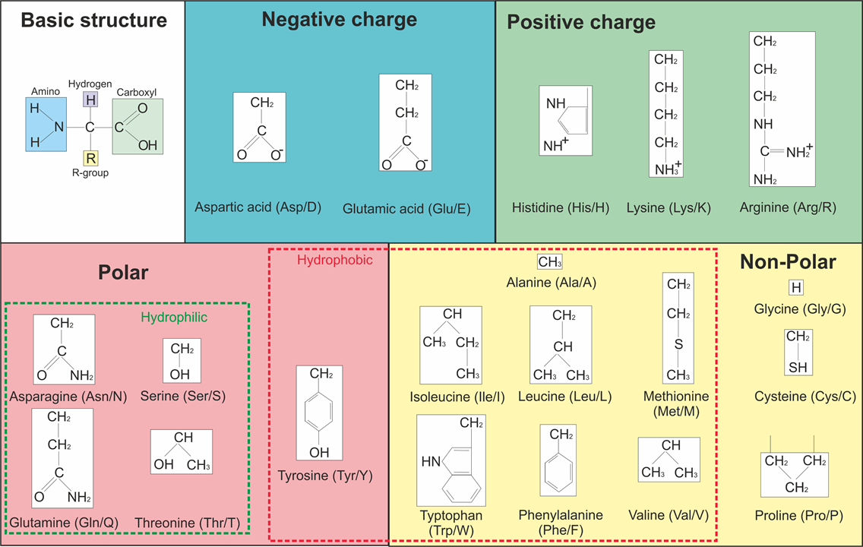
Figure 1.1 The basic chemical structure of an amino acid and the different R groups for each of the 20 amino acids found in living organisms. The R groups are split into their different chemical properties. The three letter and one letter code are shown in parentheses next to the each of the amino acids.

Amino acids can react with each other via a condensation reaction between the amino group of one amino acid and the carboxyl acidic group of another to form a peptide bond between the two amino acids, releasing water (the addition of water by hydrolysis can reverse this reaction (Pan et al. 2011)). Long chains of amino acids can form, creating the primary structure of a peptide/protein.

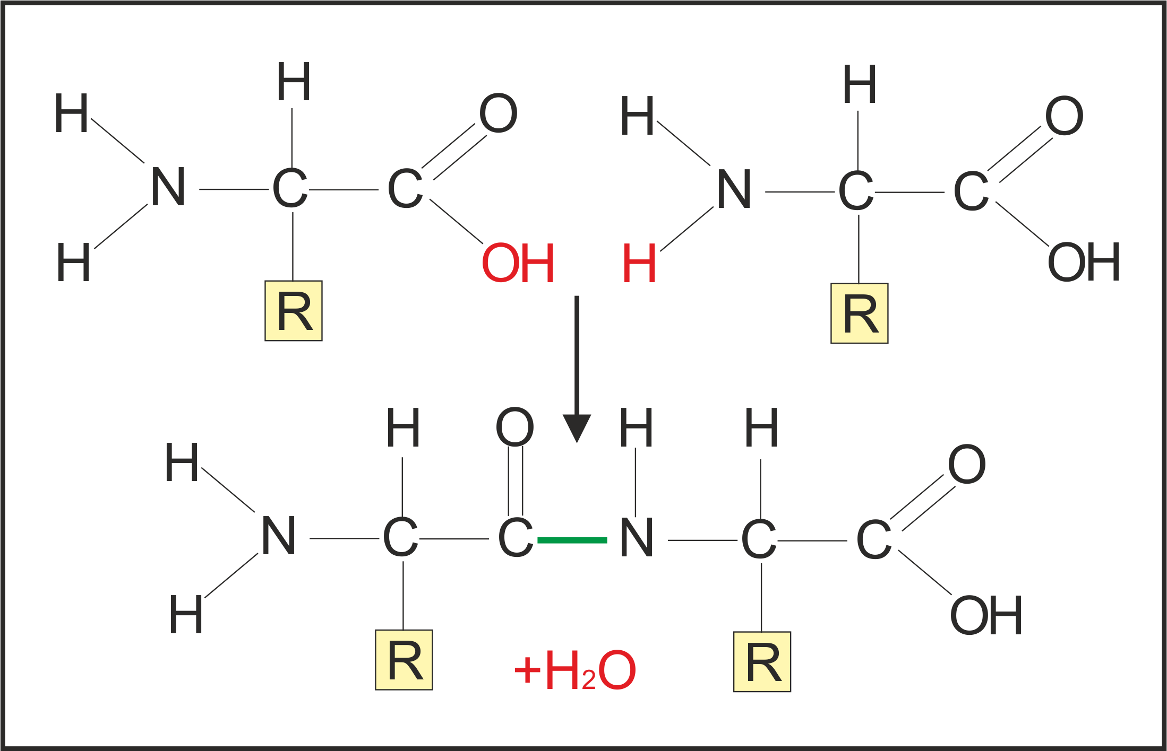
Figure 1.2 The formation of a peptide bond between two amino acids with the release of water.

The primary amino acid sequence influences the higher structure of a protein. Amino acids can interact with each other via hydrogen bonding, disulphide bonds and other modifications to form a secondary structure, forming either an alpha helix or a beta sheet. The combination of these secondary structures make up the tertiary structure of the overall protein. Sometimes two different proteins can interact with each other to form a more complex molecule and this is known as the quaternary structure; an example of this would be haemoglobin which is made from four globular protein subunits.

1.1.2 Proteins as a source of phylogenetic information.
DNA codes for all proteins in the organism. The process by which a protein is formed from this genetic information is called translation (Figure 1.3). The codons of messenger RNA (mRNA) are matched to an anticodon of transfer RNA (tRNA) to which a specific amino acid is attached. These amino acids are then joined together via a peptide bond to form the primary protein structure.

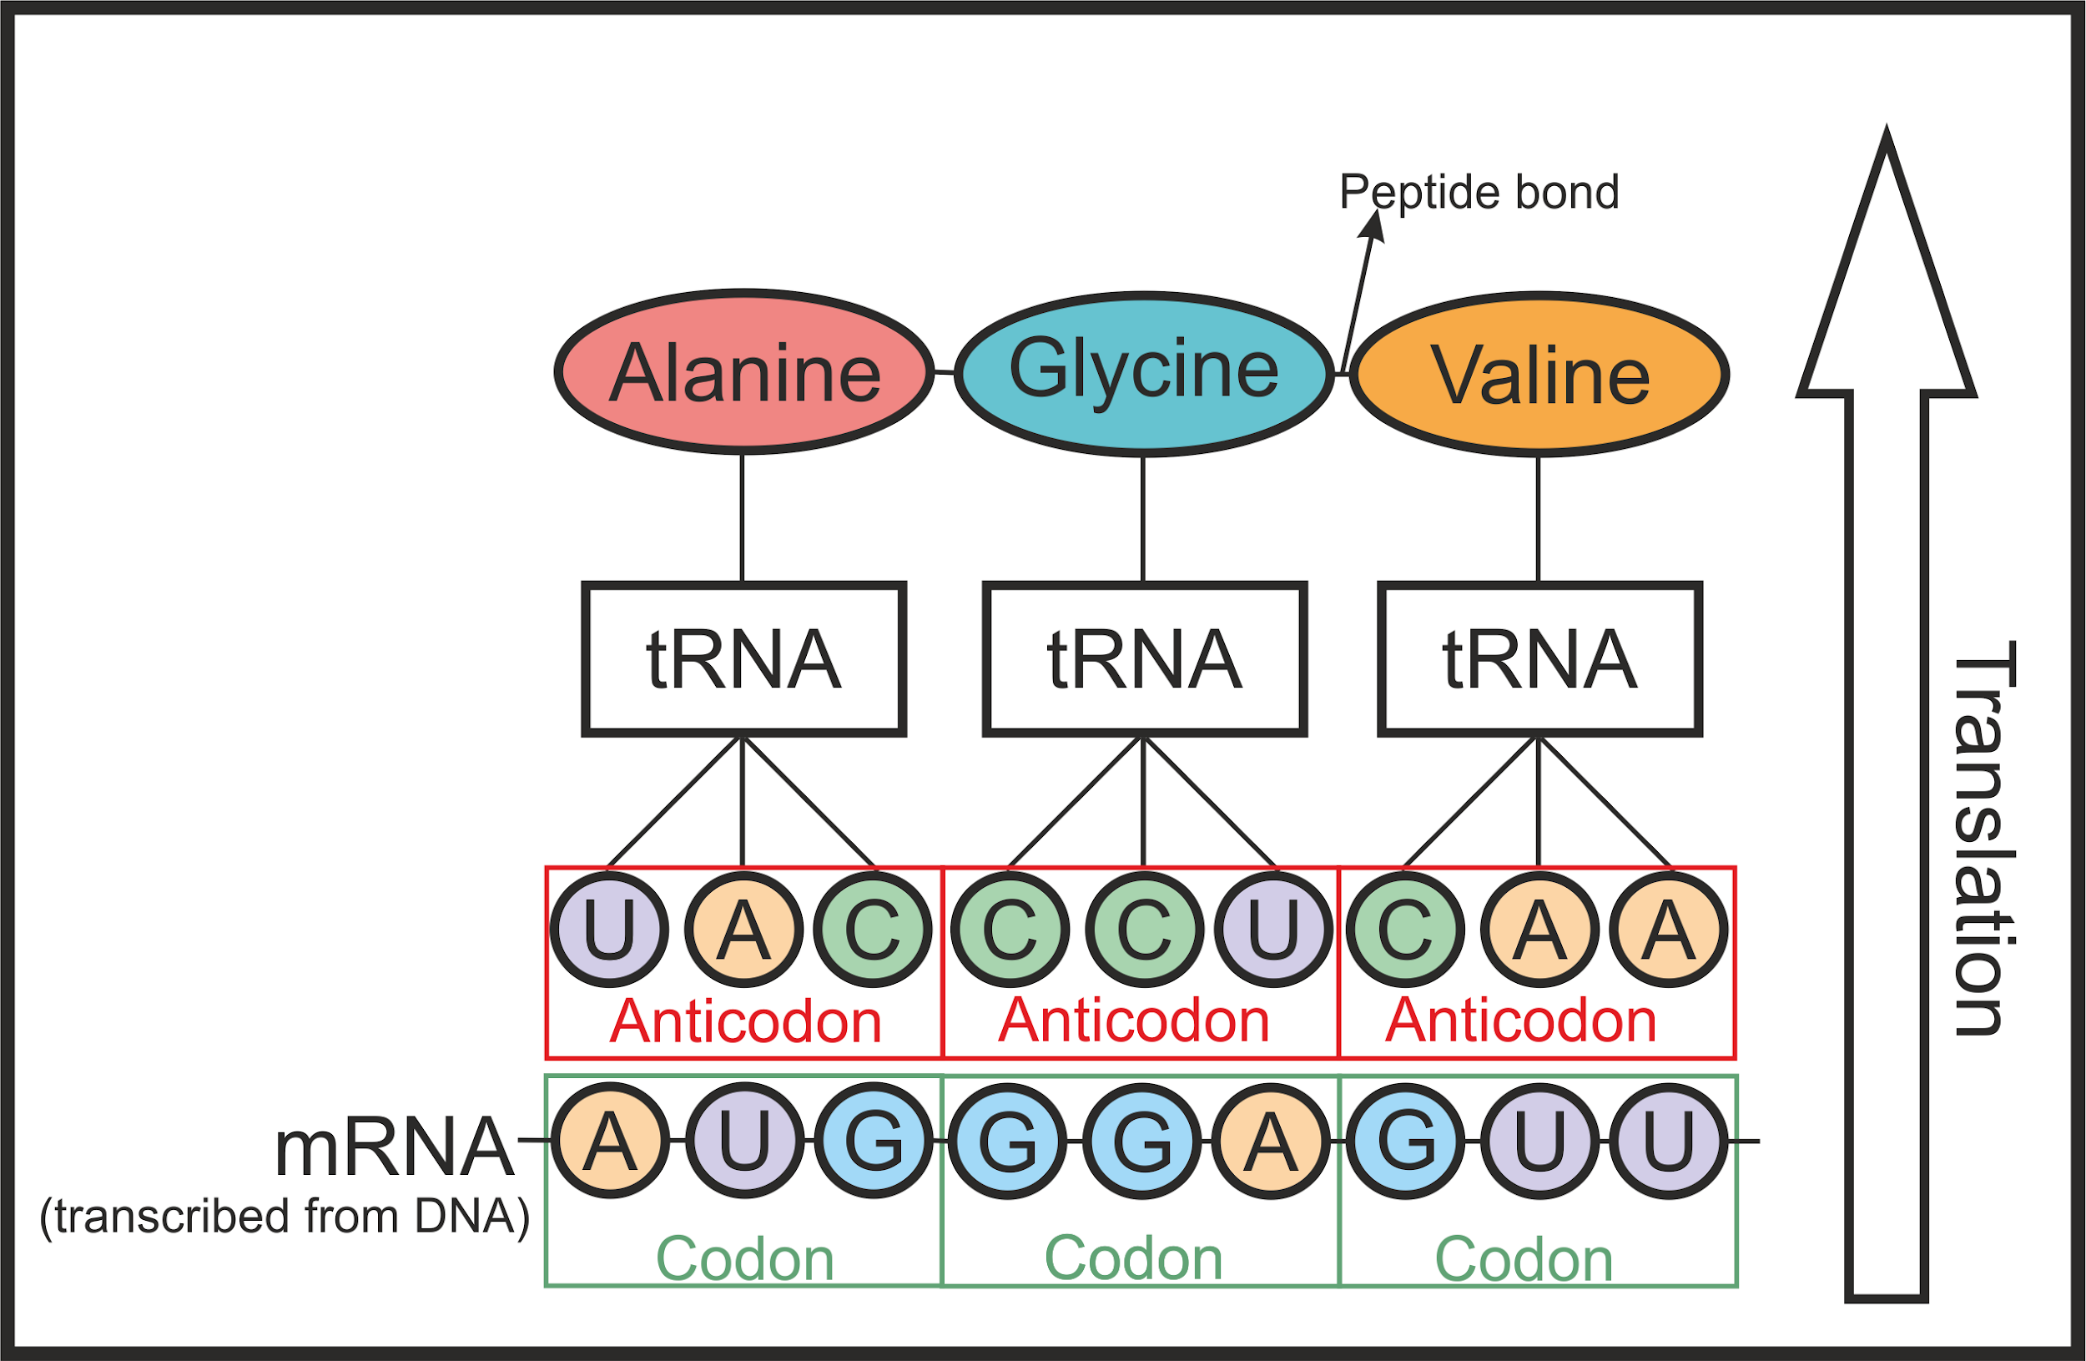
Figure 1.3 The translation of mRNA to form proteins. Each codon of mRNA matches an anticodon of a tRNA molecule which has a specific amino acid attached. The amino acids form a peptide bond and the primary structure of a protein. The tRNA then detached from the growing peptide chain and the proteins can form their higher structure.
Proteins therefore, are a direct result of the genetic information of an organism and retain some genetic data, which can be used to reconstruct phylogenetic relationships. As proteins are more resistant to decay than DNA, proteomics provides another means of phylogenetic analysis of taxa beyond the limits of DNA. Currently, the oldest surviving DNA sequence dates to ~700 000 years ago (Orlando et al. 2013) whereas the oldest surviving protein sequences have been dated to over 3 million years (Asara et al. 2007, Schweitzer et al. 2009, Demarchi et al. 2016, Schroeter et al. 2017). Exactly how far back in time proteins survive is still a matter for debate (Asara et al. 2007, Buckley et al. 2008, Bern et al. 2009, Schweitzer et al. 2009, Bertazzo et al. 2015, Schroeter et al. 2017), but the inherent longevity of proteins over DNA means that palaeoproteomics is enormously useful in archaeological and palaeontological research (See Section 1.3).

1.1.3 The structure of bone and collagen
The main substrate studied in this thesis is bone, which is by far the most common and thus well studied substrate in both archaeological and palaeo-proteomics. The structure of bone is well documented and is made up of three components: a mineral component (64%), mainly comprising apatite (Ca₁₀(PO₄)₆(OH)₂); an organic component (26%), primarily proteins (of which collagen makes up 90% (Tuross and Stathoplos 1993), ~23% of the whole bone); and water (10%) (Kendall et al. 2018). The mineral component provides the strength of bone while the organic portion allows limited flexibility.

There are two main types of bone, cancellous (trabecular) bone and cortical (compact) bone, which can be differentiated by the degree of density and porosity as well as histological examination of the microstructure. The main component of bone are lamellae which are sheets of mineralised collagen fibres. Lamellae can form different structures within bone, including woven bone, osteons and trabeculae (See Rho et al. 1998 for details). Cancellous bone comprises irregular scaffolds of lamellae while cortical bone is very structured with regular cylindrically shaped lamellae (Rho et al. 1998). The mineralised collagen fibres that make up lamellae are made from collagen fibrils with crystals of apatite forming at their C terminus (Reznikov et al. 2018). These fibrils are in turn made from microfibrils which are comprised of triple helices of 3 individual collagen chains, generally two alpha-1 chains and one alpha-2 chain, although some taxa, such as fish, can have three different chains (e.g. alpha-1, alpha-2 and alpha 3 (Richter et al. 2011)). A summary of bone and collagen structure is shown in Figure 1.4.

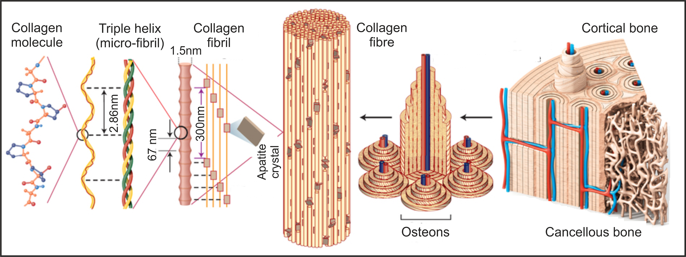
Figure 1.4 The general overview of bone, highlighting the close relationship between collagen and the bone mineral (apatite). Figure adapted from https://naukas.com/fx/uploads/2017/07/nmat4089-f2-1.jpg (accessed 21/10/2018).

1.1.4 The process of fossilisation
The majority of the samples analysed in this thesis are from palaeontological specimens that have undergone fossilisation. The definition of a fossil is the remains or impression of prehistoric taxa preserved in rock. Although this definition suggests total loss of endogenous organics, the term used to describe palaeontological samples in this thesis will be fossil as, until the specimen has been analysed it is unclear whether there are any endogenous organics surviving, and if the fossilisation process is complete. The process of fossilisation requires anoxia, rapid burial followed by rapid mineralisation (Trueman and Martill 2002, Trueman et al. 008a, Turner-Walker 2012, Bobroff et al. 2016). There are two main types of mineralisation: permineralisation and authigenic mineralisation (Figure 1.5). The initial dehydration of a sample followed by the rehydration and rapid mineralisation of the remains can also aid fossilisation, as seen in sites which have extreme seasonal weather differences (Lingham-Soliar and Glab 2010). The recrystallization and incorporation of other minerals can help the mineralisation process. For example, fluoride substitutions to form francolite and fluoroapatite significantly increases the stability of the mineral.

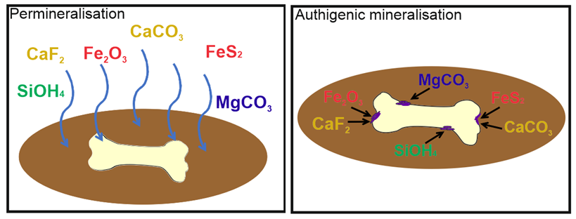
Figure 1.5 Permineralisation occurs through early infiltration of tissues by mineral-charged water (Briggs 2003, Schweitzer et al. 2007a). Authigenic mineralisation relies on decay microbes and the rapid in situ growth of minerals replicating the specimens original morphology (Briggs 2003, Daniel and Chin 2010).

1.2 Protein degradation and mechanisms for protein survival
One of the main areas of study in palaeoproteomics is trying to understand the mechanisms behind protein degradation, and hence possible reasons why proteins may survive into the palaeontological record. In this thesis the term “protein degradation” is used to encompass all chemical alterations and transformations that proteins may undergo to cause the breakdown of the protein into peptides, individual amino acids and ultimately amino acid decomposition. All proteins are affected by the same methods of diagenesis, but the extent of diagenesis via these breakdown pathways is governed by the protein structure, surrounding matrix (McMahon et al. 2016), mineral interactions (Demarchi et al. 2016) and the influence of the wider environment, such as access to water and oxygen (Raff et al. 2008, Kendall et al. 2018), pH (High et al. 2015) and temperature (Smith et al. 2003). To date, the most successful palaeontological molecular studies have been from samples from exceptional environments, such as the arctic, marine sediments, and amber (Stankiewicz et al. 1997, Collins et al. 2003, Lindgren et al. 2011, Smejkal et al. 2011, Rybczynski et al. 2013) where access of water, high temperatures, and availability of oxygen is limited.

Proteins can undergo degradation due to microbial activity, especially when not protected by surrounding hard tissues (Child et al. 1993, Butler et al. 2015, Saitta et al. 2017), and this is often one of the first degradation pathways to act in protein diagenesis (Pfretzschner 2004). This type of decay can be affected by external factors such as cold environments which hinder microbial decay (Cappellini et al. 2012), while the presence of water supports microbial metabolism (Turner-Walker 2008). Protein diagenesis does not stop once the fossil has been excavated, and other factors to consider are post excavation treatments and museum storage conditions (Cleland et al. 2016, Wadsworth et al. 2017). Chemical degradation can also occur, either attacking the surrounding matrix (such as the bone mineral) which will allow the infiltration of bacteria and water, causing protein degradation, or direct chemical degradation of the organic content of the fossil (Collins et al. 2002). Changes in environmental conditions, such as pH or temperature, can affect the protein higher structure; once denatured (loss of higher structure), the protein is more liable to enzymatic attack and chemical degradation (Pan et al. 2011, Bobroff et al. 2016). The degradation of proteins will start with the breakdown of a protein into peptides, and then this will eventually result in the formation of free unbound amino acids and the complete loss of primary sequence.

Either microbial or chemically derived, the main degradation pathway for proteins is due to hydrolysis. This process is defined as a reaction with water which causes the chemical breakdown of a compound. In proteins, hydrolysis results in breakages of the peptide bonds. This can occur at an internal bond (Bada 1991), at the C terminus (Kahne and Still 1988) or the N terminus (Steinberg and Bada 1983) via different hydrolytic processes. The extent to which one of these processes occurs depends on the extent of degradation; hydrolysis at the N and C termini increases in significance as more peptides are formed due to the breakdown of internal bonds (Bada 1991). The protein structure and primary sequence can influence the rates of hydrolysis. For example, the main hydrolytic pathway at the N terminus is via an internal aminolysis reaction resulting in diketopiperazine (DKP, an organic cyclic dipeptide). This has been shown to be more likely to occur in small peptides with hydrophobic amino acids (Bada 1991, Demarchi et al. 2013a), whereas amino acids with larger chains are more resistant to hydrolysis (Hill 1965, van Duin and Collins 1998). The electrostaticity of the amino group and the environmental pH can also affect hydrolysis (Riley and Collins 1994).

Free amino acids can also undergo degradation via a variety of degradation pathways, and the rates of this can be increased due to the presence of heat, metal ions and carbonyl compounds (Bada 1991). Outlined below are the degradation pathways of the amino acids which are commonly analysed during amino acid analysis. Amino acids with alkyl groups (leucine, valine, phenylalanine, glycine, alanine) decompose via decarboxylation and the rate is increased in the presence of oxygen (Conway and Libby 1958). Serine and threonine can also decompose via decarboxylation, but dehydration of these amino acids is more common (Bada 1991). Asparagine and glutamine can break down via deamidation to form aspartic acid and glutamic acid respectively (Hill 1965), which can undergo further decomposition via deamination (Bada and Miller 1968). Arginine is hydrolysed to form either ammonia and citrulline or urea and ornithine (Warner 1942). The rate of decomposition of these amino acids differs depending on the amino acid and the degradation process (Bada 1991 and references therein).

1.2.1 How do proteins survive into the palaeontological record?
Many studies have focused on lab based diagenetic experiments to try to predict how and why proteins in a variety of fossils degrade, including bone (Riley and Collins 1994, Dobberstein et al. 2009), soft tissues (Butler et al. 2015), amber-encased specimens (Saitta et al. 2017; McCoy et al. 2019) and biominerals such as eggshell (Brooks et al. 1990), shell (Demarchi et al. 2013b) and corals (Tomiak et al. 2013). It is now widely believed that closed systems are the best area to target for these studies (Sykes et al. 1995, Penkman et al. 2008) due to the lack of interaction between the organic component and the outside environment, either physically or chemically. This limits the variables affecting diagenesis to time and temperature, allowing for realistic predictions to be made (Miller et al. 1999). A recent study by Parry et al. (2018) has shown that the variables that can affect open systems, such as soft tissues, are interlinked and complex and therefore cannot be accurately replicated in a lab setting. However, this is currently being addressed (Saitta et al. 2018a).

As water and/or microbes are needed for fossilisation to occur, this implies protein survival will be minimal. However, the protein may be protected due to close interaction with the original biomineral (Demarchi et al. 2016), and it is predicted that should the remineralisation be suitably rapid, microbial decay of proteins is actually limited; instead the degradation of proteins is purely via chemical hydrolysis (Collins et al. 1995, 2000, Trueman and Martill 2002, Harbeck and Grupe 2009). This slow chemical hydrolysis of proteins may allow crosslinking and secondary reactions with other substances, such as humics (Maillard 1912, van Klinken and Hedges 1995, Evershed et al. 1997, Zang et al. 2000) and trace elements, that may allow for protein survival into geological time (Bada et al. 1999, Schweitzer et al. 2007a, 2007b, Schweitzer et al. 2014a, Trueman et al. 2008a, Bergmann et al. 2010, Weaver et al. 2011, Bobroff et al. 2016). It is thought that once a biomolecule has undergone cross-linking, this limits the reactive sites, reducing further degradation (San Antonio et al. 2011). This is corroborated by evidence of other highly cross-linked biomolecules in the palaeontological record, such as melanins (Briggs and Summons 2014). Different fossils can preserve proteins in different ways, and these are discussed in detail below.

1.2.1.1 Bone (an open system)
As it is known that recrystallisation occurs in modern bone in vivo (Neuman and Weikel 1955), recrystallisation and fossilisation of fossil bone can occur even in the presence of proteins. A study by Berna et al. (2004) showed that recrystallized fossil bones were less soluble than modern bones, with calcite-containing bones not dissolving in any of the solvents tested. Calcite has been found in fossil bone where proteins have also been detected, showing that, by protecting the mineral content, calcite may also protect proteins associated with the mineral (Schweitzer et al. 2007a, Edwards et al. 2011). Conversely other studies have linked the decomposition of organic matter to calcite crystallisation (Sagemann et al. 1999, Owocki et al. 2016), so it may be that protein preservation is dependant on the competing rates of organic decay vs mineralisation.

By far the most analysed bone protein in palaeoproteomics is collagen. Collagen makes up 90% of the organic component of bone (Tuross and Stathoplos 1993) and has many properties, such as water insolubility (Ehrlich 2010), making its degradation by enzymatic or bacterial processes much slower that other proteins (Bobroff et al. 2016). Combined with its close interaction with the bone mineral (Leikina et al. 2002), robust triple helix structure (Persikov et al. 2002, 2005, Dobberstein et al. 2009) and potential for cross-linking (Trębacz and Wójtowicz 2005, Nair et al. 2013), this protein has been a focus of degradation studies for several decades (Rudakova and Zaikov 1987, Riley and Collins 1994, Miles and Ghelashvili 1999, Covington et al. 2008, Perez Hurtado and O’Connor 2012), as well as of interest for molecular palaeontology (See Table 1.2). Other bone proteins, such as osteocalcin, known for its close interaction with bone mineral and collagen (Chen et al. 2015), may also survive into the geological time scale (Muyzer et al. 1992, Prigodich and Vesely 1997, Schweitzer et al. 1997, Collins et al. 2000, Embery et al. 2000, 2003, Wadsworth and Buckley 2014).

Molecular models of supposed dinosaur collagen peptides (see Buckley et al. 2008; Bern et al. 2009) from two previous studies (Asara et al. 2007, Schweitzer et al. 2009) were constructed by San Antonio et al. (2011). They showed that the peptides contained hardly any acidic residues but consisted mainly of hydrophobic amino acids, indicating preferential survival of the less reactive water-insoluble amino acids. This agrees with other studies which show that hydrophobic interactions and hydrogen bonding of proteins is linked to protein survival (Bada et al. 1999, Macko et al. 1999, Nguyen and Harvey 2001). Another data-based study of the same peptides by Wang et al. (2012) showed they also contained a high percentage of thermally stable amino acids (alanine, glycine, valine, leucine, phenylalanine and proline), with collagen type 1 having a higher abundance of these thermostable amino acids than other proteins analysed in the study, therefore potentially aiding the preferential survival of this protein over geological time.

1.2.1.2 Eggshell (a closed system)
Biominerals have long been shown to contain proteins from the palaeontological record (Matter et al. 1969, Akiyama and Wyckoff 1970, Weiner et al. 1976). Therefore fossilised eggs provide another major target for palaeontological study. The survival of these proteins (particularly C-type lectin proteins) has been linked to the close interaction with the mineral (Freeman et al. 2010, Ruiz-Arellano et al. 2015, Demarchi et al. 2016, Wallace and Schiffbauer 2016). This mineral interaction protects the proteins from water hydrolysis (Schmidt et al. 1990) and it is possible that the protein-mineral interaction alters the protein’s secondary structure, inhibiting enzyme activity (Collins et al. 2002). Modern eggshells have antimicrobial properties and it is possible this may help protect against initial bacterial degradation in the short term (Wellman-Labadie et al. 2008). The biomolecular preservation power of eggshell is even greater than bone, with ancient DNA (aDNA) being found preserved in eggshell in environments that were not conducive to aDNA survival in bone (Oskam et al. 2010, 2011). This utility is increased as, in certain environments, fossilised eggshell is more common than fossilised bone (Jackson et al. 2002). For example, a study by Tennyson et al. (2010) at the site of St Bathans, New Zealand, found 154 moa eggshell fragments to only 6 moa bone fragments. This shows that eggshell provides an as yet undervalued resource in the study of palaeoproteomics.

1.2.1.3 Skin and soft tissues
The preservation of soft tissue (i.e. the non-biomineralised parts of an organism (Parry et al. 2018)) has also been reported in fossils (Sasso and Signore 1998, Schweitzer et al. 2005a, 2007b, Manning et al. 2009, Edwards et al. 2011). These soft tissues have either been in contact with other mineral surfaces such as embryos in eggshell (Stephen et al. 2005, Schweitzer et al. 2005b, Coria and Chiappe 2007) or undergone rapid mineral transformation, with environments favouring the formation of mineral precipitates (such as calcium and iron) which have all been linked to soft tissue preservation (Briggs and Wilby 1996, Schweitzer et al. 1999, Zhu et al. 2005, Dornbos et al. 2006, Lingham-Soliar and Wesley-Smith 2008). Microbially-mediated mineralisation has also been suggested as a stabilizing factor for organic substances (Davis and Briggs 1995); the microbial growth of the decaying organic matter results in negatively charged exopolymeric substances (EPS) being secreted from the decay microbes which in turn facilitate the deposition of positively charged mineral ions promoting remineralisation (Pacton et al. 2007). In substances with low mineral interaction, preservation has been linked to hydrogen bonding and hydrophobic interactions between the proteins and surrounding organics (Nguyen and Harvey 2001), as well as preservation as carbonaceous compressions via keroginization. Keroginization has recently been argued as a better preservation pathway than mineralisation (Anderson and Smith 2017) with studies showing the possible preservation not only of soft tissues but also proteins (Wilson and and Butterfield 2014).

Cells and blood vessels from fossil bones of considerable age (up to 86 million years) have been reported in the literature (Schweitzer et al. 2005a, 2013, Cleland et al. 2015a). It is not clear how these soft tissues are preserved into the geological record, but there have been several theories postulated, including a possible correlation with sandstone (Schweitzer et al. 2007a), marine environments (Lindgren et al. 2011), mineral and iron interactions (Schweitzer et al. 2013, Surmik et al. 2016), microbial activity (Peterson et al. 2010) and possibly the mineralisation taking place in vivo (Bell et al. 2008). However, these results are not without contestation (see Section 1.6).

The main protein that has been identified in soft tissues is keratin (see Table 1.2). Keratins are a group of structural proteins of which there are two types: alpha and beta (Crewther et al. 1965). Beta keratin is only found in turtles, scaled reptiles and archosaurs (crocodilians and birds) and therefore can be a target of molecular study without the risk of modern human contamination (Schweitzer et al. 1999). This protein, like collagen, is known for its unreactive properties; beta keratin contains a high number of cysteine residues which readily form disulfide bonds (Strasser et al. 2015), as well as a high number of hydrophobic amino acids (Fraser and Parry 2008), making it water insoluble, unreactive and structurally stable, helping to preserve the protein. A degradation study by Moyer et al. (2016a) showed that even after 10 years at 350^{O}C, some keratin was still detected in samples of feathers using immunofluorescence, showing either the preservation capabilities of this protein or the limitations of immunoassay (see Section 1.4)

Exceptional soft tissue preservation can also be found in copal (resins less than 2 Ma) and amber (See Martı́nez-Delclòs et al. (2004) for a review of amber deposits) (Arnold et al. 2002, Perrichot and Néraudeau 2005, Poinar et al. 2007a). Examples of feathers, insects, leaves, small organisms and spiders’ webs have all been found morphologically preserved (Grimaldi et al. 1994, 2002, Cano et al. 1995, Alonso et al. 2000, Thomas et al. 2013, Saint Martin et al. 2014 and references therein). It is thought that cross-linking is responsible for the preservation of soft tissues within amber, including disulphide bridges with sulphur possibly from cysteine residues (Stankiewicz et al. 1998). Resins also contain antiseptic and antibiotic properties which will slow the rates of microbial decay, as well as terpenoids, labdanoids, and phenolics which help to dehydrate the inclusion (Smejkal et al. 2011) preventing both protolysis and non-enzymatic hydrolysis (Martı́nez-Delclòs et al. 2004, Saint Martin et al. 2014). Diagenetic minerals have also been found associated with amber (for example pyrite (Edwards et al. 2007), which has also been linked to protein survival), but as yet no proteomic study has been conducted on these samples. Pioneering work by Bada et al. (1994) and Wang et al. (1995) showed the amino acid racemisation rate of samples in amber is retarded by a factor of >10⁴ compared to other environments, indicating the potential of proteins to survive over long time periods. This was supported by Smejkal et al. (2011) who reported 84 identified peptide fragments from plant extracts preserved in Dominican amber. However, there may be complicating factors, with evidence of chemical alterations occurring even once the sample is encapsulated (Edwards et al. 2007), possible contamination (McCoy et al. 2019) and different types of amber present differing levels of biomolecular preservation (Stankiewicz et al. 1998, Alonso et al. 2000).

1.3 Phylogenetic analysis
The other main focus of palaeoproteomics is the reconstruction of the phylogenies of extinct taxa. As proteins are coded from DNA (Figure 1.3), they are still able to retain some genetic information, which allows phylogenetic relationships to be investigated. The most analysed protein in phylogenetics to date is collagen type I (Welker et al. 2015b, Buckley 2015, Buckley et al. 2015, Welker et al. 2017a) which is generally highly conserved among multiple taxa, therefore will only give restricted higher level phylogenetic resolution. However, recently, other proteins have also been investigated, such as enamel proteins (Cappellini, et al. 2018) and other bone non collagenous proteins (NCPs), which have been shown to have great phylogenetic potential (Buckley and Wadsworth 2014).

The first step in any phylogenetic analysis is the alignment of the sequences. There are several softwares available for sequence alignment, including Geneious (Kearse et al. 2012), Vector NCI (Lu and Moriyama 2004) and MEGA4 (Tamura et al. 2007) (See Table 1.1). The ease at which the protein sequences can be aligned can depend on how closely related the taxa are (Hillis et al. 1993), as well as sequence coverage; when reconstructing protein sequences from extinct taxa, not all the sequence for the protein in question will be recovered (e.g. Buckley et al. 2015). It has been recommended that maximizing coverage of a specific protein (rather than using multiple proteins that are poorly covered) will result in more confident phylogenetic results (Cappellini et al. 2018a). The level of phylogenetic signal can be established using a variety of methods, including pairwise comparisons and tree length distribution (Hillis et al. 1993).

Once sequences have been determined to contain relevant phylogenetic differences, there are many different types of phylogenetic analyses that can be applied to the sequences. The method chosen to analyse the data will depend on the type of question that is being asked. In general, the type of analysis can be split into two groups: those that analyse the discrete characters (amino acids) and those that analyse the whole sequence (called the distance approach) (Hillis et al. 1993). Summarised in Table 1.1 are the phylogenetic studies carried out using ancient proteins to date, along with the different phylogenetic analyses carried out by each study.

Study | Taxa | Protein | Alignment software | Phylogenetic analysis
Welker et al. 2015b | South American native ungulates (SANU) | COL1A1  COL1A2 | mafft  Geneious  PartitionFinder | - Bayesian (MrBayes)  - Maximum likelihood (RAxML v. 7.0.4)  - Maximum parsimony (PAUP* v. 4.0b10)
Buckley 2015 | SANU | COL1A1  COL1A2 | BioEdit  (v. 7.1.3.0)  PartitionFinder (v.1.1.1) | - Bayesian (MrBayes v. 3.2.2)  - Maximum likelihood (PHyML)  - Maximum parsimony (Phylip v. 3.695)
Welker et al. 2017a | Rhinocerotidae | COL1A1  COL1A2  COL3A1  PEDF  AHSG | PartitionFinder | - Bayesian (MrBayes)  - Maximum likelihood (RAxML)
Buckley et al. 2015 | Xenarthrans | COL1A2 | BioEdit  (v. 7.1.3.0)  PartitionFinder (v.1.1.1) | - Bayesian (MrBayes v. 3.2.2)  - Maximum likelihood (PHyML)
Buckley 2013 | Plesiorycteropus sp. | COL1A1  COL1A2 | Geneious (v5.5.6) | - Bayesian (MrBayes)  - Maximum likelihood (PHyML v. 2.0.7)  - Distance-based neighbour-joining (Neighbor-Net/SplitsTree 4)
Cleland et al. 2016 | Castoroides ohioensis | COL1A1  COL1A2 | Seaview (v4.5.4) | - Bayesian (MrBayes v. 3.2.2)
Cappellini et al. 2018 | Rhinocerotidae | Enamel proteome | Geneious  mafft | - Bayesian (MrBayes v. 3.2.6)  - Maximum likelihood (PHyML v. 3.1)  - Distance-based neighbour-joining (phangorn)
Table 1.1 Ancient protein phylogenetic studies published to date. The software used for the phylogenetic analysis is shown in parentheses and the references for all the different softwares are listed here: BioEdit (Hall 1999); Geneious (Kearse et al. 2012); mafft (Katoh and Frith 2012); MrBayes (Ronquist et al. 2012); Neighbor-Net/SplitsTree4 (Bryant and Moulton 2004, Huson and Bryant 2006); PartitionFinder (Lanfear et al. 2012); PAUP* (Swofford 2001); phangorn (Schliep 2011); Phylip (Felsenstein 1995); PHyML (Guindon et al. 2010); RAxML (Rokas 2011, Stamatakis 2014); SeaView (Gouy et al. 2010).

As there are many different types of phylogenetic analyses, an overview of just those analyses used in palaeoproteomics to date will be discussed here. The method used by all the studies is Bayesian analysis, which requires prior knowledge and assumptions being made on the data (for example, that Castoroides ohioensis will fall within Rodentia (Cleland et al. 2016)). All studies used the MrBayes software for Bayesian analysis, which analyses discrete characters and is based on Markov chain Monte Carlo (MCMC) methods, as this has been shown to successfully analyse multiple taxa while providing secure statistical inferences (Mau et al. 1999). This software is also very user friendly, allowing the user to manipulate the data easily (Ronquist et al. 2012).

Maximum parsimony (MP) analysis relies on phylogenetically informative characters and assumes that change is improbable, selecting the phylogeny that minimises the number of evolutionary changes for the dataset (Cavalli-Sforza and Edwards 1967). There are various algorithms that can be used to perform this analysis, the two most common being branch and bound searches which has shown good results with a small dataset (<20) (Hendy and Penny 1982) and an heuristic approach which is better for larger datasets (Foulds et al. 1979). The branch and bound approach requires two inputs of a branching rule (i.e. the addition of more sequences) and a bound rule (a set of rules which limits the search criteria). There are several criteria that can be used as bound rules, for example, limiting the number of allowed evolutionary changes. The use of these different criteria are used to limit the search and find the "most parsimonious" tree(s) (Hendy and Penny 1982).

Maximum likelihood (ML) is a statistical method that involves finding the evolutionary tree which shows the highest probability of evolving the observed data. This method is better applied to larger datasets containing less closely related taxa (Felsenstein 1981, Kishino et al. 1990) and analyses discrete characters. Maximum likelihood is now considered as one of the best methods to use for phylogenetic reconstruction; when tested using a simulated dataset it recovered the correct tree more often than other methods tested (Guindon and Gascuel 2003). ML also has the advantage of being able to statistically compare different evolutionary models and trees.

Most of the ancient proteomic phylogenetic studies to date analyse the individual amino acids themselves (discrete characters), but a couple of studies also utilised distance based methods using neighbour-joining, which analyses the protein sequence as a whole. The neighbour-joining algorithm was first established by Saitou and Nei (1987) and this method starts with a star like tree and then at each stage of neighbour clustering (neighbours are defined as operational taxonomic units), selects the neighbours that minimises the total branch length. Branch lengths and topology of trees can be quickly obtained by using this method. Neighbour-joining also has the advantage of not assuming all the lineages evolved at the same rate, and therefore can be used to imply molecular clocks.

Molecular clocks use the mutation rate of biomolecules to determine when two or more taxa diverged from each other. This was first established by Zuckerkandl and Pauling (1965) and has become an important aspect of phylogenetic analysis. Distance based and maximum likelihood analyses were first used as molecular clocks, and these assume a constant rate of evolution (or strict clock) and are calibrated using fossil ages (dos Reis et al. 2016). However, it was found that the rate of evolution is often not constant and as such, several methods were proposed to deal with rate variation (e.g. Rambaut and Bromham (1998)). The introduction of Bayesian methods allowed the strict clock model to be ‘relaxed’ and take rate variation into account when establishing divergence times (Thorne et al. 1998), and this is now the most common method when constructing molecular clocks (e.g. Welker et al. 2015b).

1.4 The development of methods
There are many different analytical and extraction methods that can be used for the preparation and analysis of palaeontological samples. Palaeontological samples can, by their nature, be rare and valuable specimens and it is important to use methods that maximise the recovery of proteomic information with minimal destruction to the sample. In order to do this, many methods have been developed to screen palaeontological samples for any potential surviving proteins, before subsequent proteomic analysis. Outlined below are the most current methods used to screen, extract and analyse proteomic information from palaeontological samples.

1.4.1 Determining protein survival
The first methods to detect ancient proteins focused on the analysis of the amino acids using both gas chromatography (GC) and liquid chromatography (LC) either by themselves or coupled with mass spectrometry (GC-MS and LC-MS) (Abelson 1954, 1955, Weiner et al. 1976, Hare and Gil-Av 1979, Gurley et al. 1991, Zhao and Bada 1995). Amino acid analysis is a technique that is still employed today and is commonly analysed using reverse phase high performance liquid chromatography (RP-HPLC) (Kaufman and Manley 1998). AAR is the most widely applied amino acid analysis in ancient samples, especially biominerals (Brooks et al. 1990, Clarke and Murray-Wallace 2006, Tomiak et al. 2013, Ortiz et al. 2018, Dickinson et al. 2019). Racemisation is the process in which the L-enantiomer of an amino acid converts to the D-form (and vice versa). In living organisms (except certain bacteria, (Johnson and Miller 1997)), amino acids are synthesised in the L-form and, racemisation to the D-form, generally only occurs after death (Demarchi and Collins 2014) as a result of protein degradation. For example, hydrolysis via DKP has been linked to increases in racemisation (Steinberg and Bada 1983, van Duin and Collins 1998). As hydrolysis breaks the peptide chain, amino acids at the terminal ends of these peptides are able to racemise (with the exception of Asx and Ser which can racemise in chain (Dobberstein et al. 2009, Demarchi et al. 2013a).

As such, AAR has been used in the prediction of protein degradation and is commonly used as a form of dating in archaeological and palaeontological closed system samples (Sykes et al. 1995, Demarchi et al. 2011, Penkman et al. 2011, Crisp et al. 2013, Demarchi et al. 2016). However, in open systems, such as bone, this is not possible. As the protein breaks down, the free (more racemised) amino acids are lost to the surrounding environment (Collins and Riley 2000). Instead, racemisation values have been used to screen samples and investigate levels of ancient protein and potentially ancient DNA preservation (Dobberstein et al. 2009, Collins et al. 2009, Wadsworth et al. 2017). Amino acid concentration (High et al. 2015) and composition (Saitta et al. 2018b), rather than just the extent of racemisation, has also been suggested as indicators of protein survival in open systems.

Before the advent of soft ionisation mass spectrometry, a popular method for detecting ancient proteins was via immunoassay (see Child and Pollard (1992) for a review). First published in 1974 (DeJong and Kumler 1974), this led to a number of works on fossil samples (Muyzer et al. 1992, Tuross and Stathoplos 1993, Borja et al. 1997, Torres et al. 2002, Collins et al. 2003) and is still used today to assess protein survival in dinosaurs using enzyme-linked immunosorbent assay (ELISA) (Schweitzer et al. 2005a, 2007a, Schweitzer et al. 2014b, Schroeter et al. 2017). Some of these studies showed evidence of proteins such as immunoglobulin G (IgG), haemoglobin and albumin (Lowenstein 1981, Muyzer and Westbroek 1989, Borja et al. 1997) which have yet to be detected in palaeontological samples using other methods.These proteins have been recovered from younger archaeological samples (Wadsworth and Buckley 2014, Brown et al. 2016), but have been shown to be highly degraded (Kendall et al. 2016). This casts doubt on the ability of these proteins to survive intact in the palaeontological record and immunoassay results have been contested (Fiedel 1996, Palmqvist 1997, Brandt et al. 2002), with evidence of contaminants such as fungi also reacting to antibodies (Sepúlveda et al. 1995) and the possibility of yielding false positive results (Montgelard et al. 1997), especially for samples over 2 million years old (Collins et al. 1991).

Time of flight secondary ion mass spectrometry (ToF-SIMS) has also started to be used in ancient proteomics. This mass spectrometric method doesn’t produce sequence data but rather detects surface ions associated with molecular fragmentation. This can localise chemical compounds related to amino acids in samples, without undergoing chemical extraction (Schweitzer et al. 1999, Bertazzo et al. 2015, Surmik et al. 2016). ToF-SIMS can also be used to detect the presence of other biomolecules. For example, Schweitzer et al. (2007) showed the presence of a number of nitrogen- and iron-containing molecules that were associated with the dinosaur matrix. The authors argue that the presence of these iron-containing substances may have helped to preserve the soft tissues (see Section 1.2.1.3). ToF-SIMS has also been used to detect the remains of heme-derived porphyrins, providing direct evidence of hematophagy in the palaeontological record (Greenwalt et al. 2013). Other mass spectrometric techniques have also been used to screen for proteins and these can aid in proving authenticity (Buckley and Collins 2011, Rybczynski et al. 2013). The most common is MALDI-ToF mass spectrometry (matrix assisted laser desorption ionisation-time of flight) which is commonly used in identifying archaeological specimens (Hynek et al. 2004, Buckley et al. 2009, Richter et al. 2011, Solazzo et al. 2013, von Holstein et al. 2014, Welker et al. 2015a, 2016, Presslee et al. 2018).

Several other methods can also be used to screen for the presence of proteins. Microscopy often provides a reliable non-destructive first step in analysing fossils, giving an initial morphological assessment of the possibility of surviving biomolecules (Schweitzer et al. 1999; 2009; Briggs et al. 2000; Manning et al. 2009; Zylberberg and Laurin 2011; Bertazzo et al. 2015; Moyer et al. 2016a; Kontopoulos et al. 2019). The most common methods used are scanning and transmission electron microscopy (SEM and TEM respectively). SEM can also be coupled with energy dispersive X-ray (EDX), which can provide an elemental analysis of the fossil’s surrounding environment, providing information on the presence of trace metals and other minerals (Lingham-Soliar and Wesley-Smith 2008). Other non destructive techniques such as Raman spectroscopy (Edwards et al. 2007) and autofluorescence (Saint Martin et al. 2014) have also been used on delicate samples such as amber to test for the presence of proteins. Autofluorescence has the added advantage of being able to identify and highlight dehydrated proteins, therefore providing evidence for protein survival mechanisms. py-GC/MS (pyrolysis gas chromatography mass spectrometry) has also been applied to the study of proteins in amber, as this method is capable of analysing several different biomolecules in a single analysis while only needing a sample size of micrograms (Stankiewicz et al. 1996, 1998).

Other techniques can be used to complement molecular methods; XRF (X-ray fluorescence) XRD (X-ray diffraction), NMR (nuclear magnetic resonance) and FTIR (Fourier transform infrared spectrometry) are all minimally destructive techniques that can be used to assess the composition and preservation of the mineral component of the fossil (Schweitzer et al. 1997, Botha et al. 2004, Manning et al. 2009, Bergmann et al. 2010, Lebon et al. 2010, 2014, 2016, Edwards et al. 2011, Lindgren et al. 2011, Reisz et al. 2013, Bobroff et al. 2016). Using these techniques it can be possible to assess the levels of mineral alteration, authigenic francolite (fluorapatite), calcite and trace elements such as iron (Elorza et al. 1999, Piga et al. 2011, 2014, 2016), substances which have been linked to possible molecular preservation (see Section 1.2.). This information on the diagenetic pathways of the mineral content can then be used to assess the likelihood of biomolecular survival (Thomas et al. 2011). FTIR has also started to be used in cultural heritage (Yang et al. 2011, Rao et al. 2015) and to assess the chemical characterisation of amber (van der Werf et al. 2016). There are several different FTIR methods that are in use in palaeontology, including attenuated total reflection-FTIR (ATR-FTIR) (Lebon et al. 2016), infrared mapping (Edwards et al. 2011) and FTIR synchrotron microscopy (Lee et al. 2017).

Another complementary technique is the analysis of rare earth elements (REE) which can be carried out using laser ablation sampling coupled with mass spectrometry. The preservation of REE is indicative of the early depositional environment and a pilot study by Trueman et al. (2008) used REE concentrations to assess the rates of water uptake/rate of recrystallisation. They concluded that those samples with a steep concentration gradient of REE showed less interaction between the fossil and ground water and increased rates of recrystallisation, therefore providing good samples for biomolecular analysis. Other proxies can also be considered; for example, studies show that the presence of collagen will affect the morphology of crystal growth in vivo (Natali et al. 2014), and when combined with certain trace elements (such as magnesium) will inhibit calcite growth and promote aragonite crystals (Jiao et al. 2006). Combining REE with mineral analysis may therefore provide evidence of surviving collagen.

1.4.2 Extraction methods
Once proteins have been identified in a fossil sample there are many methods available for protein extraction. The best way to sample a fossil and extract the proteins for proteomic analysis is a matter of ongoing research. To date, studies comparing different extraction protocols have focused on bone, with several papers all concluding that the extraction method used will affect the amount and type of protein identified (Schroeter et al. 2016, Wadsworth and Buckley 2017). Therefore, depending on the focus of palaeoproteomic study, different extraction methods may be better suited than others. Other considerations also need to be taken into account when selecting an appropriate extraction protocol, such as those that reduce the extent of lab-induced degradation of peptides, especially if diagenetic modifications are being investigated (Simpson et al. 2016, Procopio and Buckley 2017). An overview of the general protein extraction procedure from bone is outlined in Figure 1.6.

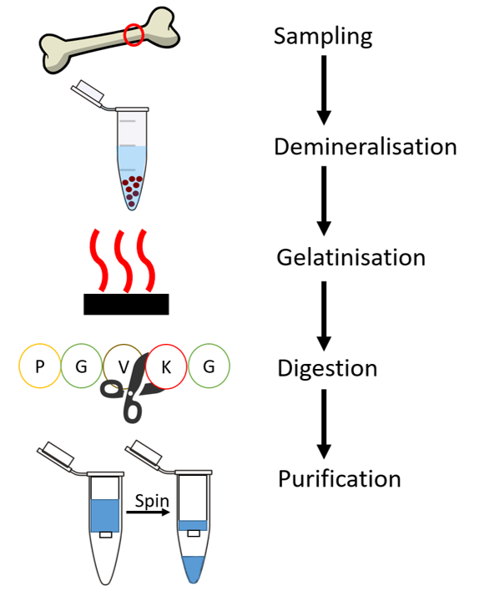
Figure 1.6 A general overview of the protein extraction procedure from ancient bone samples. A more detailed description of each step can be found below.
There have been a few studies that have looked at variation of protein recovery depending on where the sample was taken from the bone (Simpson et al. 2016, Procopio et al. 2017), which has been reported as an important factor for other techniques (e.g. FTIR (Lebon et al. 2014), aDNA (Hansen et al. 2017)). A recent study by Procopio et al. (2017) suggested the midshaft of the tibia as the best place for sampling, while another study by Kontopoulos et al. (2019) suggests the petrous bone as having good biomolecular preservation. Selective sampling is not always possible for palaeontological studies, as many samples are from museum collections. This means that sampling is usually limited to areas considered not morphologically important. The size of the bone is also likely to have an impact on protein preservation; for example a study by Buckley et al. (2017) noted bones from smaller taxa were more degraded than those from larger taxa, regardless of the type of bone.

In order to access the organic fraction of bone, the majority of palaeoproteomic methods use a demineralisation solvent which removes the mineral component of the bone while retaining the organics, or a denaturing buffer which acts to solubilise the organics into solution. However, it has recently been shown that some proteins are also removed during this step (Schroeter et al. 2016, Cleland 2017) and a study by Cleland and Vashishth (2015) suggest this step is not needed for successful protein extraction from bone. Demineralisation solvents include ethylenediaminetetraacetic acid (EDTA) (Cappellini et al. 2012), and hydrochloric acid (HCl) (Jiang et al. 2007, Welker et al. 2015a), while ammonium bicarbonate (Ambic or ABC) (van Doorn et al. 2011, Welker et al. 2017a), guanidine hydrochloric acid (GuHCl) (Cleland et al. 2012, Schroeter et al. 2017) and sodium dodecyl sulfate (SDS) (Cleland et al. 2012) have all been used as buffers for extraction in ancient samples. However, there can be disadvantages to some of these solvents for ancient proteomic analysis; SDS has been found to modify proteins by forming adducts that may hinder protein recovery (Fridriksson et al. 1999), while GuHCl has been shown to be a tryptic inhibitor, which can prevent full digestion of any surviving proteins and prevent their identification (Ren et al. 2009)

Different methods of digestion can also be used to try to maximise the number of peptides created, increasing the overall proteomic information recovered. The standard digestion method for bone samples consists of gelatinisation (heating) of the sample which releases proteins into solution (Welker et al. 2015a). This solution is then digested overnight at 37^{O}C. The digestion solvent is usually either Ambic (van Doorn et al. 2011, Cleland and Vashishth 2015) or guHCl (Cleland et al. 2012). Recently, another method has been developed by Fischer and Kessler (2015) termed gel aided sample preparation (GASP). This protocol binds the extracted proteins to a gel, and the digestion is carried out while the proteins are in the gel. Sodium dodecyl sulfate polyacrylamide gel electrophoresis (SDS PAGE) can also be used as another protein extraction and in-gel digestion method (He et al. 2007); the individual protein band under analysis can be cut from the gel and directly digested (Schroeter et al. 2017). However, as ancient proteins are degraded, most, but not all studies (e.g. the surprising data of Schmidt-Schultz and Schultz 2004) have noted no clear separation of proteins, but rather a ‘smearing’ of the proteins in the gel (Smejkal et al. 2011, Cleland et al. 2012, Kendall et al. 2016), compromising the cutting out of selected protein bands. Instead, it has been shown that a more effective method is to apply the electric field to the ancient sample on the gel only for a short time; this concentrates all the proteins into one area of the gel while removing potential non-proteinous contaminants. The concentrated protein band can then be cut and digested.

The most used digestion enzyme in proteomic analysis is trypsin (Ostrom et al. 2006, Cappellini et al. 2012, Rybczynski et al. 2013), which cuts C-terminal to lysine and arginine residues (Ren et al. 2009). The most common use of tryptic-digested peptides in ancient proteomics is for peptide mass fingerprinting (Buckley et al. 2009), which matches the m/z values of MALDI-ToF spectra to known tryptic peptides (usually bone collagen, but other archaeological substrates have also been analysed (Presslee et al. 2018)). Other enzymes are also used but are much less common; elastase cuts at hydrophobic residues (Rietschel et al. 2009), and has been used in some phylogenetic studies to increase protein coverage for sections of the sequence that are not targeted by trypsin (i.e. that do not contain lysine and arginine residues) (Welker et al. 2015b, Demarchi et al. 2016). Other enzymes include proteinase K (Nguyen and Harvey 2001) and chymotrypsin (Li et al. 2015). The use of enzymes other than (or as well as) trypsin is gaining popularity and has been termed “middle down proteomics” as it increases sequence coverage, providing more information on PTMs etc., without the need for new analytical methods (Tsiatsiani and Heck 2015). A study by Cappellini et al. (2018) on ancient enamel samples has shown no digestion is needed due to the degraded nature of the surviving enamel proteins. This has yet to be tested on other substrates, such as bone, but may offer another method of evaluating protein degradation.

The final extraction step is purification to reduce any possible remaining contaminants and concentrate the digested peptides. There are several methods that can be used for this step, including ultra-filtration (Fuller et al. 2015), solid phase extraction using Ziptips (van Doorn et al. 2011) or stage tips (Cappellini et al. 2012). The resulting digested and purified peptides can then be analysed using mass spectrometry.

1.4.3 Proteomic analysis
The most commonly used / robust method for palaeoproteomics today is mass spectrometric (MS) based. An increase in sensitivity of the MS techniques, coupled with improvements in bioinformatics, has seen huge advances in molecular palaeontology; not only can protein sequences be recovered, but these sequences can be assessed for evolutionary significance. The standard mass spectrometric analysis for ancient proteomics is liquid chromatography tandem mass spectrometry (LC-MS/MS) and this has successfully been used to retrieve protein sequences from fossils over 3 million years old (Asara et al. 2007, Schweitzer et al. 2009, Demarchi et al. 2016, Schroeter et al. 2017). To date, there is no standardised LC-MS/MS method for palaeoproteomics, but this is starting to be addressed (Cleland and Schroeter 2018).

Analysis of the protein sequence data recovered from MS analysis has also developed over time. Protein identification can be carried out by following two main approaches: database searching and de novo sequencing. A database search looks through a selected set of peptides for the best match to the MS/MS spectrum, while de novo reconstructs the peptide sequence directly from the MS/MS spectrum. Database searching was developed first and it is considered as the simpler of the two methods, but there are problems with high false discovery rate (FDR) and low sensitivity (Kapp et al. 2005). De novo sequencing is a way to compensate for altered sequences that are not present in extant databases and is commonly used for ancient proteins. A combination of database searching and de novo is also used for ancient proteomics, which tries to match de novo sequences to a protein database (Zhang et al. 2012). De novo is more reliable for predicting post translational modifications (PTMs), and can be used in conjunction with other methods such as NMR to validate PTMs and detect new or uncommon PTMs (Vanacore et al. 2009, Cleland et al. 2015b).

There are many different data analysis softwares available including MASCOT (www.matrixscience.com), PEAKS (Ma et al. 2003, Zhang et al. 2012), MaxQuant (Cox and Mann 2008) and the global proteome machine (GPM; www.thegpm.org (Beavis 2006, Fenyö et al. 2010)). There are also many different databases that are available to search against including NCBI (national center for biotechnology information; www.ncbi.nlm.nih.gov), UniProt (www.uniprot.org) and SwissProt (www.uniprot.org/uniprot/?query=reviewed:yes). The type of software and database used for the search will influence the quality and quantity of the proteomic results. Recommendations for the best practices for data analysis in ancient proteomics have recently been developed (Hendy et al. 2018a), for example, by using a database that contains a list of common contaminants and including diagenetic protein modifications as part of the search.

Analysis of LC-MS/MS sequence data can be used to assess protein degradation by looking at peptide backbone cleavage and post translational modifications. In order for backbone cleavage of peptides to occur, the higher level protein structure must be lost (Schweitzer 2004). Therefore, analysing the rates of peptide cleavage (not analytically-derived) can give a good indication of the extent of diagenesis. Many mass spectrometric techniques are now sensitive enough to allow the identification and evaluation of PTMs which can provide a wealth of diagenetic information (Wilson et al. 2012, Cleland et al. 2015b, Schroeter and Cleland 2016). Some PTMs can occur in vivo as part of the protein higher structure, such as hydroxylation of proline in collagen (Gorres and Raines 2010) and collagen glycosylation (galactosyl-hydroxylysine (+178) and glucosylgalactosyl -hydroxylysine (+340)) (Hill et al. 2015), which has been linked with collagen stability and is thought to play a role in collagen mineralisation (Terajima et al. 2014). Other PTMs are due to protein degradation, such as advanced glycation end products (AGEs), carboxymethyllysine (CML), oxidation and deamidation (Verzijl et al. 2000, Cleland et al. 2015b).

1.5 Paleontological protein studies to date
Summarised in Table 1.2 are the published palaeoproteomic studies to date. Most studies have evaluated the presence of proteins in fossils and investigated possible ways in which these proteins have survived into geological time. Many studies have also published sequence data from fossils (Buckley 2013, 2015, Welker et al. 2015b, Buckley et al. 2015, Welker et al. 2017a, Cappellini et al. 2018b). While bone collagen is the most common protein assessed for sequence analysis, other proteins and materials have started to be examined, including eggshell proteins (Demarchi et al. 2016) as well as proteins from amber (Smejkal et al. 2011; McCoy et al. 2019 ) and enamel (Cappellini, et al. 2018).
More confidence of endogeneity can be assigned to those studies which provide amino acid and sequence information (See Table 1.2 sequence data column). However, these methods (AAR, MS) are destructive and not always possible due to the delicate nature of the fossil being analysed e.g. soft tissues. Therefore the method of analysis has to strike the delicate balance of minimal destruction with the maximum retrieval of information. Imaging methods such as SR-FTIR, ToF-SIMS and microscopy can provide direct evidence of preserved proteins with minimal destruction. If the recovery of sequence information is not possible, then it is recommended that a combination of imaging methods are used, to increase the confidence of how likely proteins are preserved in the fossil material. However, only sequence information can differentiate between endogenous and contamination proteins.
 | Taxa | Location | Age  (years BP) | Proteins identified | Method | Sequence data? | Reference
Bone
 | Castoroides ohioensis | New York, USA | 10,150 ± 50 | Collagen | LC-MS/MS | Y | (Cleland et al. 2016)
 | Toxodon | Buenos Aires, Argentina | 12,000 | Collagen | MALDI-ToF, LC-MS/MS | Y | (Welker et al. 2015b)
 | Mammoth | Siberian permafrost | 43,000 | 126 bone proteins | LC-MS/MS | Y | (Cappellini et al. 2012)
 | Bison latifrons | Ziegler Reservoir, Colorado, USA | 120,000 | Collagen + 33 other bone proteins | LC-MS/MS | Y | (Hill et al. 2015)
 | Bovine | West Runton, Weybourne Crag, UK | 1.5 Mya | Collagen | MALDI-ToF | N | (Buckley and Collins 2011)
 | Camelid | Arctic circle | 3 Mya | Collagen | MALDI-ToF | N | (Rybczynski et al. 2013)
 | T. rex | Museum of the Rockies specimen 1125 | 68 Mya | Collagen | LC-MS/MS | Y | (Asara et al. 2007)
 | Mosasaur | Ciply Phosphatic Chalk, Belgium. | 70 Mya | Collagen | SEM, TEM, AA, IF, SR-FTIR | N | (Lindgren et al. 2011)
 | T. rex | Hell Creek Formation, Montana, USA | 65-67 Mya | Haemoglobin | HPLC, UV/Vis, NMR, Raman, ELISA | N | (Schweitzer et al. 1997)
 | Centrosaurus apertus | Dinosaur Park Formation, Alberta, Canada | 72-83 Mya | Contaminants | FTIR, SEM-EDX, Py-GC/MS, RP-HPLC, DNA sequencing | N | (Saitta, et al. 2018b)
 | 8 different dinosaurs | Dinosaur Park Formation, Canada and Lance Formation, USA | 75 Mya | Collagen | SEM, TEM, ToF-SIMS | N | (Bertazzo et al. 2015)
 | B. canadensis | Museum of the Rockies specimen 2598 | 80 Mya | Collagen | SEM, IA,  LC-MS/MS | Y | (Schweitzer et al. 2009, Schroeter et al. 2017)
 | B. canadensis | Museum of the Rockies specimen 2598 | 80 Mya | Various blood vessel proteins | IF, LC-MS/MS | Y | (Cleland et al. 2015a)
 | Lufengosaurus | China | 195Mya | Collagen | SR-FTIR | N | (Lee et al. 2017)
Eggshell
 | Ostrich | Laetoli, Africa | 3.8 Mya | Struthiocalcin | AAR,  LC-MS/MS | Y | (Demarchi et al. 2016)
 | Sauropod | Anacleto formation, Argentina | 72 - 83 Mya | Unspecified eggshell protein (s?) | ELISA | N | (Schweitzer et al. 2005b)
Enamel
 | Stephanorhinus sp. | Dmanisi , Georgia | 1.77 Mya | Amelogenin, enamelin, amelotin, amelotin, matrix metalloproteinase-20 and kallikrein 4 | AAR,  LC-MS/MS | Y | (Cappellini et al. 2018b)
Soft Tissues
 | Lizard skin | Green river formation, USA | 50 Mya | Beta keratin | FTIR, SRS-XRF, Py-GC/MS | N | (Edwards et al. 2011)
 | Shuvuuia deserti (Alvarezsaurid) feather | Ukhaa Tolgod, Mongolia | 66 - 100 Mya Late Cretaceous | Beta Keratin | SEM, TEM, ToF-SIMS, IA | N | (Schweitzer et al. 1999, Moyer et al. 2016a)#
 | Edmontosaurus sp. fossilised skin | Hell Creek Formation, North Dakota, USA | 66 - 100 Mya Late Cretaceous | Beta Keratin? | SEM, XRD, FTIR, AAR, Py-GC/MS, MALDI-ToF,  LC-MS/MS | N^ | (Manning et al. 2009)
 | Rahonavis ostromi claw | Madagascar | 66 - 100 Mya Late Cretaceous | Beta Keratin | SEM, IF, ToF-SIMS | N | (Schweitzer et al. 1999)
 | Citipati osmolskae claw | Djadokhta Formation, Mongolia | 66 - 100 Mya Late Cretaceous | Beta Keratin | SEM-EDX, TEM, IF | N | (Moyer et al. 2016b)
 | Sinosauropteryx skin | Yixian Formation, Liaoning province, China | 100 - 145 Mya Early Cretaceous | Collagen | SEM | N | (Lingham-Soliar et al. 2007)
 | Sauropodomorph dinosaur embryo | Lower Lufeng Formation, Yunnan Province, China | 190 - 197 Mya Early Jurassic | Unspecified protein* | Synchrotron imaging, FTIR | N | (Reisz et al. 2013)
 | Ichthyosaurus skin | Lower Lias beds, Severn Valley, Gloucestershire | 200 Mya | Collagen | SEM-EDX | N | (Lingham-Soliar and Wesley-Smith 2008)
 | Eurypterid cuticle | Unknown | 417 Mya | Chitin- protein complex | XANES | N | (Cody et al. 2011)
Table 1.2 A summary studies that have identified proteinaceous material infossil samples to date. Definitions of methods are as follows: LC-MS/MS Liquid Chromatography tandem Mass Spectrometry; MALDI-ToF Matrix Assisted Laser Desorption Ionisation-Time of Flight mass spectrometry; SEM-(EDX) Scanning Electron Microscopy- (Energy Dispersive X-ray); TEM Transmission Electron Microscopy; AA Amino Acid analysis; IF Immunofluorescence; (SR) - FTIR (Synchrotron Radiation-based)-Fourier Transform InfraRed spectrometry; HPLC High Performance Liquid Chromatography; UV/Vis UltraViolet-Visible spectrophotometry; NMR Nuclear Magnetic Resonance; ELISA Enzyme-Linked ImmunoSorbent Assay; ToF-SIMS Time of Flight Secondary Ion Mass Spectrometry; IA ImmunoAssay; AAR Amino Acid Racemisation; (SRS)-XRF (Synchrotron Rapid Scanning) X-Ray Fluorescence; Py-GCMS Pyrolysis Gas Chromatography Mass Spectrometry; XRD X-Ray Diffraction; XANES X-ray Absorption Near Edge Structure microscopy. For more information about the methods refer to the text. *These results are contested by Bobroff et al. 2016 due to the lack of amide bands in the FTIR spectra. ^ LC-MS/MS did not produce any identifiable spectra. #These results are contested by (Saitta et al. 2018c).

1.6 The issue of authentication vs. contamination
The issue of overcoming contamination, both due to modern, bacterial and cross contamination, has been a matter of concern for several years in terms of microscopic analysis (Girard et al. 2009), aDNA (Veiga-Crespo et al. 2004), and of course, proteomics, with several palaeoproteomic studies claiming ancient protein survival, being contested as contamination (Schweitzer et al. 2005a, 2007a, Asara et al. 2007, Buckley et al. 2008, Kaye et al. 2008, Raff et al. 2008). As a result of this, several methods have been developed to test for contamination and support authenticity of the ancient biomolecules. Many eggshell and other biomineral studies focus on the intra-crystalline fraction which is protected from outside influences, such as interactions/alterations with other organic substances. This allows more reliable results for dating and taxonomic studies in archaeological samples and provides evidence of authenticity to fossil samples (Sykes et al. 1995, Collins et al. 2003, Penkman et al. 2011, Demarchi et al. 2011, Stewart et al. 2013, Demarchi et al. 2016).

For an open system like bone, the situation is more complex, as amino acids from the surrounding environment can be incorporated into the bone and trapped due to the mineralisation process (van Klinken and Hedges 1995, Bada et al. 1999, Collins et al. 2002). In the past, studies have tried to disprove contamination by the use of multiple controls, analyses being carried out in a designated ancient protein lab, replication of results in another lab, analysis of the surrounding environment and using multiple analytical methods (Schweitzer et al. 1999, 2007a, 2009, Smejkal et al. 2011, Lindgren et al. 2011, 2015, Moyer et al. 2016b, Hendy et al. 2018a). The use of more than one data analysis software and the application of strict tolerances can also aid authentication (Cleland et al. 2015a, Hill et al. 2015).

Proteins preserved in fossils will undergo changes to their structure over these geological time periods, and analysis of preserved alterations and damage patterns of recovered peptides (deamidation, oxidation etc) can be used to indicate the age of the protein (Schweitzer et al. 1997, Cleland et al. 2015b, Demarchi et al. 2016). For example Embery et al. (2000) did not claim to have found native non-collagenous proteins during the analysis of a ~125-130 mya dinosaur bone due to the lack of structural alteration of the proteins recovered. One method of assessing these damage patterns is PTMs analysis. Glutamine deamidation is the PTM studied in most detail both in terms of a predictor of age (van Doorn et al. 2011, Wilson et al. 2012) and preservation (Mikšík et al. 2014, Schroeter and Cleland 2016, Welker et al. 2016, 2017b). However this PTM is complicated by a variety of factors, such as neighbouring amino acids, the 3D structure of the protein, pH, temperature and the analytical methods used (Stephenson and Clarke 1989, Xie and Schowen 1999, Robinson and Robinson 2001, Silva et al. 2005, Ren et al. 2009, Perez Hurtado and O’Connor 2012, Solazzo et al. 2014, Simpson et al. 2016) therefore it can be difficult to make intersite/interstudy comparisons. Further work needs to be carried out looking at other commonly occurring PTMs as well as other measures of degradation, such as non-enzymatic cleavage, for use authenticating ancient proteins.

Sequence data provides a wealth of information that can help support authenticity. However, this data is not always available for fossil specimens (Zheng and Schweitzer 2012). An alternative can be to look at the individual amino acids themselves. The amino acid composition can provide valuable information; for example Embery et al. (2000) used the lack of the amino acid cysteine (found in high quantities in keratins) in fossil dinosaur bone as evidence for minimal contamination. The extent of amino acid racemisation can also be used (Demarchi et al. 2016). Amino acids racemise at different rates, and so higher D/L values in slower racemising amino acids (such as alanine, or valine) over faster racemising amino acids (e.g. aspartic acid) indicates microbial contamination (Bada et al. 1973, Manning et al. 2009). High racemisation values of Glx (glutamine and glutamic acid combined) and alanine may indicate bacterial contamination as the D form of these amino acids are found in the cell walls of bacteria (Johnson and Miller 1997).

One of the main areas of contention is the authenticity of proteins recovered from soft tissues (For example, Schweitzer et al. 1999 vs. Saitta et al. 2018c). The presence of blood vessels and cells has been used as evidence of the survival of ancient biomolecules (Schweitzer et al. 2007b). However, some studies suggest these are the results of bacterial biofilms (Kaye et al. 2008, Raff et al. 2008). Owocki et al. (2016) presented the first study of fungi occurring on ancient bones, with preservation pathways of these fungi being linked to calcite mineralisation, Fe interactions and francolite, which have also been linked to soft tissue and biomolecular preservation. A study by Peterson et al. (2010) complicates matters further by suggesting that biofilms colonise on the outer layer of bone producing minerals which seals off the inner bone, protecting it from further degradation, a process the authors termed ‘microbial masonry’. Could the studies, demonstrating contamination in the form of these biofilms, actually be used as another line of evidence for the presence of ancient biomolecules?

1.7 Conclusion
Palaeoproteomics is a growing field of research with many substrates and environments open to successful retrieval of proteomic information. These palaeontological samples can be analysed using a variety of techniques, both analytical and methodical, and the results can be used to establish possible preservation mechanisms and, recently with the recovery of sequence information, has allowed for phylogenetic analysis of extinct taxa beyond the limits of ancient DNA. As seen with ancient DNA decades earlier, palaeoproteomics still has issues of authentication vs. contamination. However, these are beginning to be addressed and standardised procedures will help to overcome this problem. Overall, there are many avenues of research that can be explored using paleo-proteins and some of these will be addressed in this thesis.

1.8 Thesis overview

1.8.1 Aims and objectives
This thesis came about from an NSF grant which aimed to increase the use of proteomics in palaeontology. In order to do this, proof of concept data was required on a wide range of topics. This data had to be collected, interpreted and then presented to both palaeontologists and others in ancient proteomic research, in order to build connections and expand palaeoproteomics as a research field. In total 292 samples (218 bone, 44 purified collagen, 21 eggshell, 4 insect, 3 tooth and 2 soft tissue) have been analysed as part of this PhD thesis. The samples are from many different locations and have a date range of ~400 years to the Eocene (Figure 1.7). An overview of all the samples are presented here; more detailed sample information can be found in appendix 1 and in relevant sections throughout the thesis.

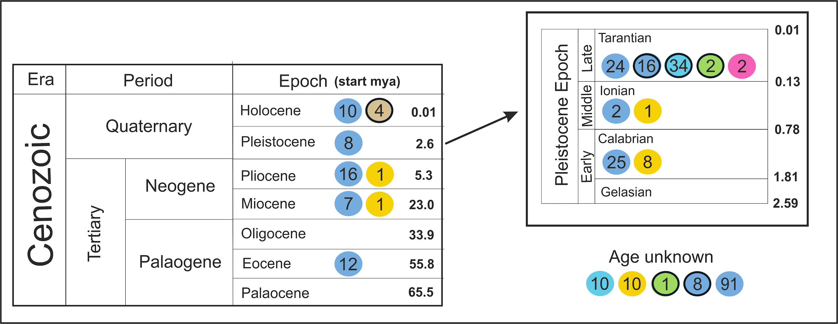
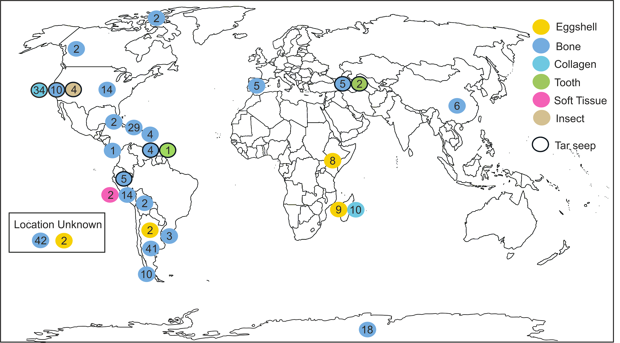
Figure 1.7 The number of samples analysed in this study split into their different locations and ages (if known). The majority of the samples were dated to the Pleistocene, and these samples were split into early, middle and late Pleistocene if the information was available.

Three main objectives were chosen for in depth study and each objective is explored in different chapters of this thesis:

- Examining different analytical techniques for palaeoproteomic analysis.
Chapter 2 explores some of the methods that are used in ancient proteomics and their use in screening samples for further analysis and successful extraction of proteins. Different softwares used to analyse LC-MS/MS data are also compared, to determine which, if any, are better for analysing ancient proteins.

- Exploring how and why proteins may be able to survive into geological time
Chapter 3 investigates protein diagenesis and survival. The results of all samples are evaluated to make predictions about overall levels of protein survival in different locations and time periods. Several case studies are also presented:
- The use of glutamine deamidation as a means of predicting degradation
- LC-MS/MS data is evaluated in terms of peptide backbone cleavage and PTMs.
- The possible preservation mechanisms for proteins over 1 million years old
- The recovery of proteins from tar seep material.
- A kinetics experiment evaluating the preservation potential of amber

- The use of these ancient proteins in phylogenetics
Chapter 4 showcases the use of palaeoproteomics in phylogenetic analysis. The main case study investigates the relationships of now extinct giant ground sloths both with each other and in relation to their modern descendants using collagen. A smaller case study analyses modern and extinct bear taxa to try and resolve their phylogenies, including the use of non collagenous proteins (NCPs) as a means of increasing phylogenetic resolution.

Chapter 2. The evaluation of methods for the recovery of palaeo proteins

2.1 Introduction

2.1.1 Overview
Many analytical methods can be used to evaluate the presence of proteins in fossils and successfully retrieve proteomic information (Section 1. 4). However, as seen by the ancient DNA field nearly two decades earlier (Poinar and Cooper 2000), some of these earlier published proteomic studies, and the methods therein, are being called into question (Bern et al. 2009, Buckley et al. 2017a), Therefore there is a growing need for the standardisation of palaeoproteomic protocols (Hendy et al. 2018a), an evaluation of the suitability of methods for the retrieval of proteins from palaeontological specimens and guidelines to interpret fossil data to distinguish between endogenous proteins and modern contamination.
This chapter aims to address some of these issues by evaluating a variety of the most common palaeoproteomic analytical techniques (AA analysis, FTIR, MALDI MS, LC-MS/MS). The success rate of ATR-FTIR, AA analysis and MALDI-ToF MS as a screening technique to select samples for further proteomic analysis will be evaluated and different protein extraction methods will be compared. Criteria will also be considered for how best to interpret the LC-MS/MS data for proof of endogenous peptides.

2.1.2 Article submission details
The comparison of the different screening methods (ATR-FTIR, AA analysis and MALDI-ToF MS) is going to be submitted to PLOSone for publication:

Presslee S., MacPhee R., Fischer R., Kontopoulos I., Slidel-Richards E., Southon J., Penkman K. and Collins M. The assessment of different screening methods for the selection of palaeontological bone samples for proteomic analysis.

Author contributions as follows: SP, MC, RM, and KP designed the experiments. SP, and RF performed the analyses, SP, KP, IK, ES-R and MC analysed the data. JS and RM provided samples and sample information. The draft of this manuscript was written by SP with help and contributions from all authors.

2.2 Methods
An overview of the different analytical techniques are outlined below. More in depth methodologies are presented where applicable later in the thesis. Table 2.1 shows the number of samples analysed using the different analytical methods.

 | RP-HPLC | MALDI-ToF | ATR-FTIR | LC-MS/MS
Eggshell | 12 | 21 |  | 4
Bone | 201 | 184 | 74 | 58
Tooth (dentine) | 3 |  |  | 2
Collagen | 34 | 44 |  | 6
Soft tissue | 2 | 2 |  | 2
Insect |  |  |  | 4

Table 2.1. The number of samples analysed as part of this PhD, split into the different substrates and types of analysis; RP-HPLC is used for chiral amino acid analysis.

2.2.1 RP-HPLC/AA analysis
AA analysis can analyse two amino acid fractions, Frees and Hyds. Frees are the amino acids which are not bound to intact peptides and can be detected without hydrolysis. Hyds are the amino acid fraction detected after hydrolysis. The Hyds fraction will include all amino acids found in the fossil, both free and contained in peptides. The majority of the samples analysed in this thesis are open system samples, i.e. the organic component of the fossil can interact with the outside environment. As a result, only the Hyd amino acid fraction is analysed, as any free amino acids are likely to be non-endogenous. The only samples in which both Frees and Hyds were analysed were the eggshell samples. These samples were bleached so that only the intracrystalline proteins were analysed, as is standard with biominerals (Sykes et al. 1995, Penkman et al. 2008). These intracrystalline proteins are protected from the outside environment (i.e. a closed system) which allows for the analysis of Hyds and Frees.

For the Free analysis, samples (1-10mg) were demineralised in 2 M HCl (50 µl per mg) and then the acid was removed by centrifugal evaporation. Hyd samples (1-10mg) was hydrolysed in 7 M hydrochloric acid (100 µl per mg (bone); 20 µl per mg (eggshell)) for 18 hours (24 hours for eggshell) at 110^{O}C under N₂. After hydrolysis, the samples were dried down using a centrifugal evaporator. Both Frees and Hyds were re-hydrated in 0.01 mM L-homo-arginine (an internal standard). The samples were analysed by RP-HPLC using an Agilent 1100 HPLC and fluorescence detection, following a slightly modified protocol set out by Kaufman and Manley (1998). An example of a chromatogram showing the amino acids that can be analysed is shown in Figure 2.1.

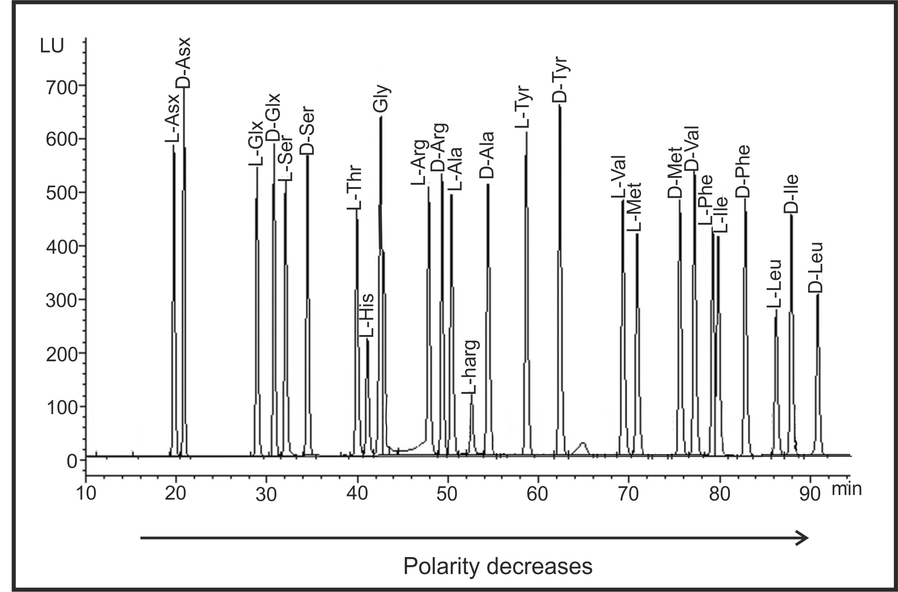
Figure 2.1. An example of a RP-HPLC chromatogram showing the separation of the chiral amino acids. Lharg is an internal standard. Asx; asparagine and aspartic acid, Glx; glutamine and glutamic acid, Ser: serine, Thr; threonine, His; histidine, Gly; glycine, Arg; arginine, Ala; alanine, Tyr; tyrosine, Val; valine, Met; Methionine, Phe; phenylalanine, Ile; isoleucine, Leu; Leucine.

2.2.2 MALDI-ToF MS
Several different protein extraction protocols were tested as part of this thesis prior to MALDI-ToF analysis. In general the extraction method for bone, collagen and soft tissue followed the protocol outlined by Welker et al. (2015b). Between 15-30 mg of bone was demineralised in 0.6M hydrochloric acid (HCl), washed in 0.01 M sodium hydroxide to remove any potential humic contaminants and three times in 50 mM ammonium bicarbonate (Ambic). The samples were then heated at 65^{O}C for 1 hour to allow any available proteins to solubilise into solution. After heating, the samples were digested overnight at 37^{O}C and the digestion was stopped by the addition of trifluoroacetic acid (TFA) at a concentration of 0.5-1% of the total solution. The samples were desalted using C18 zip-tips (van Doorn et al. 2011) and eluted using 100 µl of 50% acetonitrile (ACN)/0.1% TFA (v/v).

The extraction protocol for the eggshell samples followed the method outlined in Presslee et al. (2018). In brief, the samples were bleached for 100 hours, washed and demineralised in 0.6M HCl, neutralised and freeze-dried before being resuspended in 50mM Ambic. The samples were reduced, alkylated and digested overnight at 37^{O}C, followed by solid phase extraction using C18 ziptips and eluted in 100 µl of 50% acetonitrile (ACN)/0.1% TFA (v/v).

A schematic of how MALDI-ToF MS works is shown in Figure 2.2. 1 µl of sample was pipetted in triplicate onto a MTP384 Bruker ground steel MALDI target plate, before being mixed with 1 µl of α-cyano-4-hydroxycinnamic acid matrix solution (1% in 50% acetonitrile / 0.1% trifluoroacetic acid (v/v/v)). The samples were analysed on a Bruker Ultraflex III MALDI-ToF mass spectrometer using the following parameter settings: ion source, 25 kV; ion source, 21.4 kV; lens voltage, 9 kV, laser intensity 40–55% and mass range 800–4000 Da. Peptide masses below 650 Da were suppressed. Each sample was externally calibrated against an adjacent spot containing a mixture of six peptides (des-Arg1 Bradykinn m/z = 904.681, Angiotensin I m/z = 1295.685, Glu1-Fibrinopeptide B m/z = 1750.677, ACTH (1–17 clip) m/z = 2093.086, ACTH (18–39 clip) m/z = 2465.198 and ACTH (7–38 clip) m/z = 3657.929). The resulting spectra was analysed using the open source software mMass (Strohalm et al. 2010).

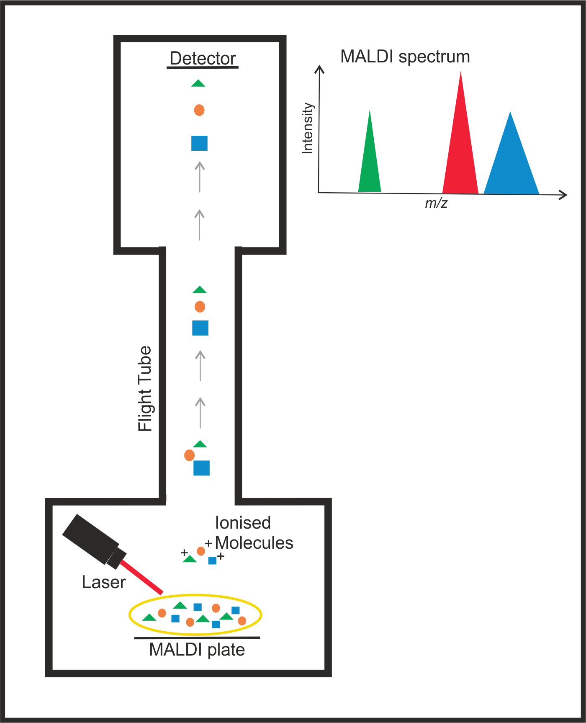
Figure 2.2. A schematic of MALDI-ToF MS (excluding the ion mirror for simplicity). The sample is spotted onto a MALDI plate and mixed with a matrix. This matrix is targeted by a laser, causing the sample (and the matrix) to become ionised. As the ions travel towards the detector, they become separated out due to mass, with the smaller molecules traveling faster. As they hit the detector they are recorded on the resulting mass spectrum.

2.2.3 ATR-FTIR
For this study attenuated total reflection-Fourier transform infrared spectroscopy (ATR-FTIR) was used to analyse the samples. This method has been shown to be a fast, minimally destructive technique for assessing archaeological and palaeontological bones (Hollund et al. 2013). ATR-FTIR measures the internal reflection of an infrared beam when it comes into contact with the sample (Bruno 1999). The extent of reflection will be determined by the crystallinity and organic composition of the medium. The presence of organics (such as proteins) can be inferred through the presence of amide peaks (Chadefaux et al. 2009, Edwards et al. 2011), as well as an evaluation of the inorganic content via assessment of the infrared splitting factor (IRSF) and carbonate to phosphate ratio (C/P) (Beasley et al. 2014).

All samples were crushed using a cleaned pestle and mortar before being analysed. Approximately 2-3mg of bone powder was placed on the sample plate. In order to ensure good contact between the diamond crystal used to pass the IR beam into the sample and the sample itself, the pressure of the applicator was controlled using a pressure control spot. Both the applicator and the plate was cleaned with ethanol between samples. The resulting spectra was analysed using OPUS 7.5 software and the IRSF, C/P and amide/phosphate (Am/P) were calculated using the formulas outlined in Kontopoulos et al. (2018).

2.2.4 LC-MS/MS
Tandem MS works by selecting a peptide of specific m/z (called a parent ion) during the first mass spectrometric analysis (MS1) and then fragmenting it further. After fragmentation the ions are re-analysed in the mass spectrometer (MS2; hence MS/MS). The fragmentation is usually carried out using collision with neutral gas molecules (collision-induced dissociation (CID) or higher energy collisional dissociation (HCD)). The peptide is commonly fragmented at the amide bond between the two amino acids, and the resulting ions are called b-ions (charge is retained on the N-terminal) or y-ions (charge is retained on the C terminal). The mass of these ions correlate to the mass of the amino acid, therefore if all the fragmentary ions can be detected the amino acid sequence of the original peptide can be identified (Figure 2.3). This is called de novo sequencing. Unfortunately, especially for palaeontological samples, not all the ions are usually detected. Internal cleavage of the peptide and diagenetic modifications (such as deamidation) can also complicate the interpretation of the MS/MS spectrum.

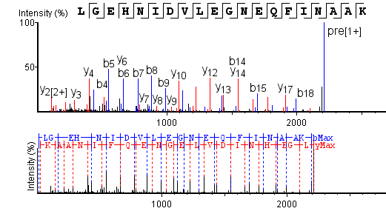
Figure 2.3. An example of an MS/MS spectrum showing the b (blue) and y (red) ions. The mass differences between the ions correlates to the mass of the amino acid, allowing for the identification of the peptide primary sequence. Pre (1⁺) is the unfragmented peptide selected for analysis (Parent ion).

Four different mass spectrometry labs were used in the LC-MS/MS analysis of these samples; the Discovery proteomic facility at Oxford University, the Chait laboratory of mass spectrometry and gaseous ion chemistry at Rockefeller University, the Novo Nordisk foundation center for protein research at the University of Copenhagen and the mass spectrometry biomolecules core facility, molecular biotechnology and health sciences department at the University of Turin.

Discovery proteomic facility at Oxford
Samples analysed at this facility were run on either an Orbitrap Fusion Lumos or Q-Exactive. Both use electrospray and fragmentation in CID mode.
Chait lab of mass spectrometry and gaseous ion chemistry
Samples analysed at this facility were run on a Q-Exactive plus using electrospray and CID fragmentation
Novo Nordisk foundation center for protein research
Samples analysed at this facility were run on a Q-Exactive HF using electrospray and fragmentation in CID mode.
Mass spectrometry biomolecules core facility
Samples analysed at this facility were run on a Ultimate 3000 Dionex nanoHPLC instrument coupled with an Orbitrap Fusion using electrospray and HCD fragmentation.

2.2.4.1 LC-MS/MS data analysis
LC-MS/MS data was analysed using 3 different data analysis softwares and used a combination of de novo sequencing and database searches.

- The Global Proteome Machine (GPM; www.thegpm.org (Beavis 2006, Fenyö et al. 2010)) which had the advantage of being open source (now no longer available 09.06.18); however, the databases were limited to only a few taxa.
- PEAKS which is a commercial software that combines de novo sequencing with databases searches (Ma et al. 2003, Zhang et al. 2012).
- MaxQuant is another open source software (Cox and Mann 2008) which has many different options for searching the data (Tyanova et al. 2015, 2016) and is especially useful when comparing different datasets.

All the samples were analysed using PEAKS, 6 were analysed using both PEAKS and MaxQuant and 21 were analysed using all three softwares. The LC-MS/MS .raw files were converted to mascot generic format (.mgf) files using Proteowizard (Chambers et al. 2012). The .mgf files were then searched against the proteome of the relevant taxa (i.e. Bison was searched against the Bos genome) if applicable. If no proteome was available for the taxa being analysed, it was searched against a collagens database. As well as the proteins of interest, all the searches contained a list of common contaminants (http://www.thegpm.org/crap/) and trypsin and elastase sequences.

The following tolerances and search criteria were used for the analysis. PEAKS searches used mass tolerances set at 0.5 Da for the fragment ions and 10 ppm for precursor ions and up to 3 missed cleavages were permitted. Searches allowed various post translational modifications (PTMs) including oxidation (at amino acids-MHW) and hydroxylation of proline (both +15.99), deamidation (of N/Q; +0.98) and pyro-glu from glutamic acid (-18.01) as well as a fixed PTM of carbamidomethylation (+57.02) which occurs as part of the sample preparation. A maximum of 3 PTMs were allowed per peptide. Protein tolerances were set at 0.5% false discovery rate (FDR), >50% average local confidence (ALC; de novo only) and a protein score of -10lgP ≥ 20 (Welker et al. 2017a). The GPM searches used a mass tolerance of 10 ppm for both the fragment ions and the precursor mass. The search was set at semi-tryptic with up to 3 missed cleavages permitted. The same PTMs were allowed as mentioned in the PEAKS searches. The GPM searches also included a decoy database in the form of reversed sequences. The protein tolerance was set at log(e) < -4. MaxQuant does not support the use of .mgf files therefore the .raw files were used. The tolerances used were the same as the PEAKS analysis with the exception of maximum PTM allowance which was set to 5. The protein score was set to ≥ 20.

2.3 The evaluation of different analytical techniques
Different criteria were used to determine the success of each analytical method (Figure 2.4). Infrared splitting factor (IRSF) and carbonate phosphate ratio (C/P) was used for the FTIR data, in line with other studies (Surovell and Stiner 2001, Lebon et al. 2010, Beasley et al. 2014). MALDI-ToF spectra were evaluated visually; the number of peaks and the highest intensity was considered as factors of success as well as comparing the peak lists to the a list of collagen peptide mass fingerprints (PMF) for the identification of possible collagen peptides (Buckley et al. 2009). AA data for open system fossils, such as bone and dentine samples, were evaluated using amino acid composition data comparing the results to modern samples as first suggested by Kessels and Dungworth (1980) (See Figure 2.4). The extent of racemisation was used for eggshells as they are a closed system (Demarchi et al. 2016).

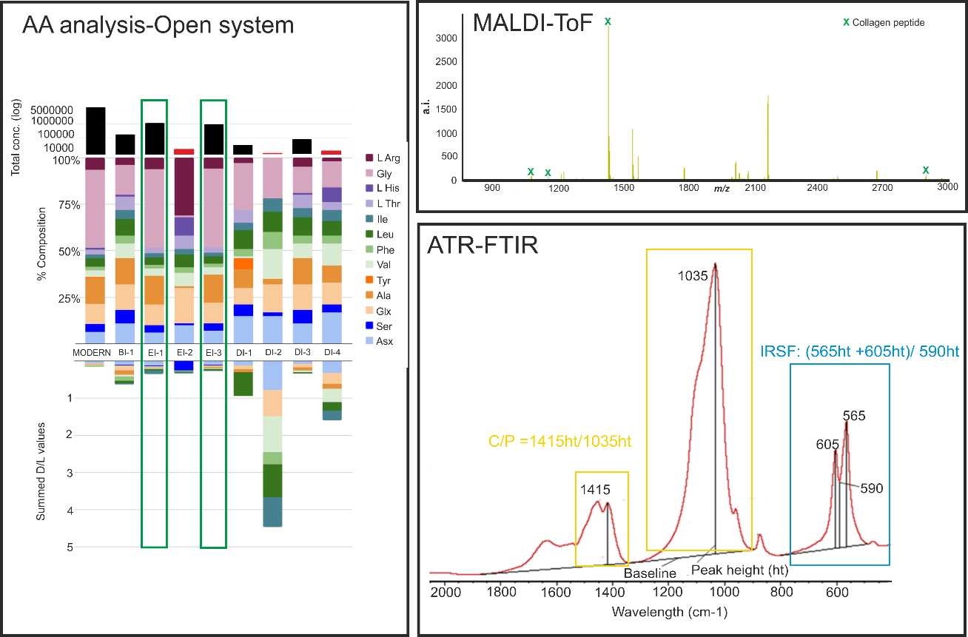
Figure 2.4. The method used to interpret the results for each of the analytical techniques (with the exception of LC-MS/MS; discussed later). Amino acid composition, D/L values and total concentration was compared to modern bone. Samples with an amino acid composition similar to the modern sample with high total concentration and low overall D/L values was considered successful. . The MALDI results were evaluated for total number of peaks, highest intensity and if any collagen peaks could be identified. IRSF and carbonate/phosphate was used to evaluate the FTIR data. The FTIR image was adapted from Beasley et al. (2014).

The evaluation of LC-MS/MS results is more complicated, with several considerations needed before a conclusive identification can be made. In order for a protein to be confirmed as present, it had to have at least 2 identified peptides, and these peptides had to be identified using more than 1 peptide spectral match (PSM). Degradation analysis was also used to evaluate the age of the peptide using PTMs and non-tryptic cleavage. Criteria for determining the success of an LC-MS/MS analysis included the number of proteins and peptides recovered and the number of contaminants. In general if a sample had more than 100 non contaminant peptides it was considered successful.

The amount of correlation between all these different analytical methods is compared below and the evaluation of ATR-FTIR, AA analysis and MALDI-ToF MS as screening techniques is discussed in detail (Section 2.3.2). The success rates of each of the samples are assessed in terms of protein preservation in chapter 3.

2.3.1 Overall results
The success rates of each of the analyses are summarised in Table 2.2. Most samples were only analysed by LC-MS/MS if they showed promising results in other analyses, hence the high success rate for LC-MS/MS. Out of the other methods, amino acid analysis using RP-HPLC in general produced the highest success rates, and this may be due to the method which destroys and analyses all the available amino acids in the sample, while ATR-FTIR and MALDI-ToF are more open to sampling bias; such as the contact between the crystal and the sample for ATR-FTIR and where the laser hits the sample for MALDI-ToF MS.

 | RP-HPLC | MALDI-ToF | ATR-FTIR | LC-MS/MS
Eggshell | 0% | 43% |  | 0%
Bone | 34% | 23% | 36% | 72%
Tooth (dentine) | 67% |  |  | 100%
Collagen | 100% | 98% |  | 100%
Soft tissue | 50% | 0% |  | 100%
Insect |  |  |  | 0%
Table 2.2 The success rates (defined as providing “good” results (see Figure 2.4)) for the analytical methods, split into the different substrates analysed.

The low success rates for eggshell samples is somewhat surprising as eggshell is a closed system and it is thought that proteins would survive for longer in closed system samples (Penkman et al. 2008). However in general the eggshell samples analysed dated to over 1 million years (if known) and were from hot environments. Therefore, this may have biased the results. Even though the LC-MS/MS results for eggshell is recorded as 0% due to low levels of peptide recovery, some peptides (<10) were identified (Demarchi et al. 2016). In terms of open system fossils, bone produced the worst success rates. This may be partly due to the number of samples, over 200 bone samples were analysed in this study compared to other substrates which had a much lower number of samples (Section 1.8; Figure 1.7.). However, this also highlights the variability in protein recovery in open system fossils and indicates that protein survival is affected by a variety of factors (discussed in more detail in Chapter 3).

Overall 76 samples have been analysed using LC-MS/MS with 50 (66%) producing good sequence data. The results of the 4 sequenced eggshell samples are shown in Demarchi et al. (2016). The majority of the samples analysed were bone and 72% produced over 100 collagen peptides. Six purified collagen samples were also analysed:, 4 from Rancho La Brea, which produced collagen coverage of ~90%, and 2 collagen samples of Aepyornis from Madagascar which produced less collagen coverage (~57%). The two teeth (dentine) samples analysed were from Binagadi tar seep, Azerbaijan, and produced ~50% collagen coverage. The detection of non collagenous proteins from the bone, collagen and teeth samples was limited to samples for which genomes were available (31/58). 6 non hard tissue samples were also sequenced, 4 insects and 2 soft tissue samples. The soft tissue samples produced good LC-MS/MS results while out of 4 Rancho La Brea insect samples, only 1 produced more than 10 peptides. This may be due to the extraction method; this was the first time proteins have been recovered from tar seep insects and it is likely that method development is needed to extract all the available proteomic information (see Section 3.3.1.6).

The different analyses carried out on the same sample were also compared. The correlation between MALDI ToF, AA analysis and FTIR are compared in Figure 2.5. MALDI-ToF and AA analysis gave similar results for the majority of the samples, while FTIR was more varied. This is not too surprising as both AA analysis and MALDI-ToF directly analyse surviving proteomic information while FTIR is an indirect method of predicting protein survival. A more in depth look at this data and how it relates to LC-MS/MS results are discussed in the next section (Section 2.3.2).

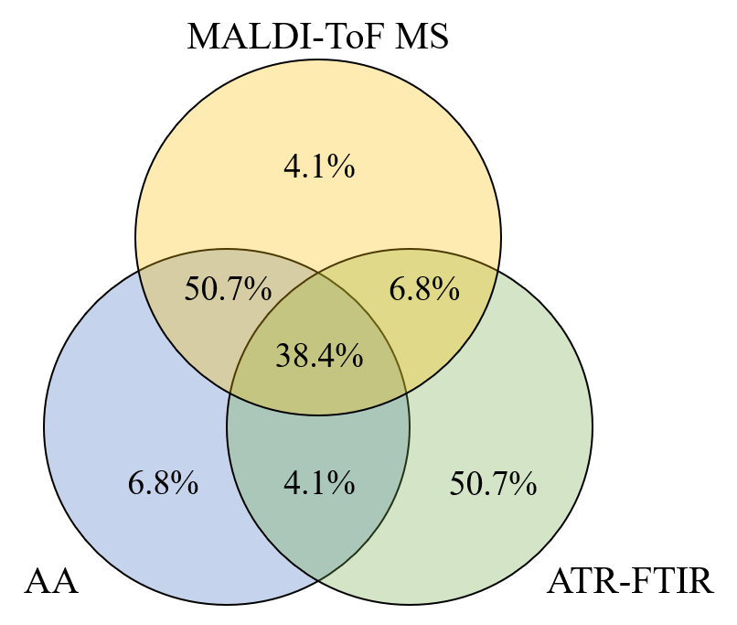
Figure 2.5. A comparison of the MALDI-ToF MS, AA and FTIR results and the extent to which the results of the different analyses agree with each other.

2.3.2 Assessment of different screening methods
The leading method for palaeoproteomics is mass spectrometry, namely liquid chromatography tandem mass spectrometry (LC-MS/MS) which can characterise peptides and ultimately whole proteomes (Cappellini et al. 2012, Rybczynski et al. 2013, Warinner et al. 2014, Cleland et al. 2016, Sawafuji et al. 2017). However, this is a costly and destructive technique to use on precious ancient material. Therefore several methods have been developed to act as screening methods to select promising palaeontological samples for proteomic analysis (Lingham-Soliar and Wesley-Smith 2008, Zylberberg and Laurin 2011, Piga et al. 2011, Edwards et al. 2011, Lee et al. 2017), but the reliability of these methods to accurately predict protein survival has yet to be evaluated.

20 bone samples from various locations (Haiti, USA, Argentina, Spain, Antarctica and the Arctic circle) and different ages (~4500 BP - Eocene) were screened using AA analysis and MALDI-ToF MS before being analysed by LC-MS/MS (Table 1; Table S1). Half of the samples were also analysed using ATR-FTIR (Table 1; in bold); not all samples were analysed using ATR-FTIR due to limited availability of the IR. As well as bone samples, 4 purified collagen samples from Rancho La Brea were also analysed, as it has been shown that proteomic information may be retrieved from collagen samples purified for radiocarbon analysis, which would otherwise be discarded (Brock et al. 2013, Wadsworth and Buckley 2017).

Group | Sample ID | Species | Age (if known) | Location
Haiti | H 1 | Neocnus comes |  | Trouing de la Scierie, Haiti
 | H 2 | Parocnus serus |  | Trouing Marassa, Haiti
 | H 3 | Acratocnus ye |  | Haiti
 | H 4 | Megalocnus zile |  | Trou Gallery, Haiti
 | H 5 | Acratocnus ye |  | Trouing Marassa, Haiti
 | H 6 | Neocnus comes | 4486 +/- 39BP | Trouing Deron, Haiti
 | H 7 | Neocnus Dousman | 9867 +/- 65BP | Trouing Marassa, Haiti
North America | NA 1 | Paramylodon sp. |  | Roseburgh, Oregon
 | NA 2 | Nothrotheriops shastensis |  | Rampart Cave, Arizona
South America | SA 1 | Glyptodon sp. | Lujanian  (8.5-128Ka) | Buenos Aires, Argentina
 | SA 2 | Scelidotherium sp. | Ensenadan  (0.4-1.8Ma) | Argentina
 | SA 3 | Glossotherium sp. | Bonarean  (128-400Ka) | Argentina
 | SA 4 | Megatherium americanum | 18000yrs | Loc Las Chacras, Bariloche
 | SA 5 | Doedicurus sp. | Lujanian  (8.5-128Ka) | Argentina
Purified Collagen (Rancho La Brea) | RLB 1 | Panthera atrox | 34860 ± 710 | Rancho La Brea; Project 23: Deposit 1
 | RLB 2 | Canis dirus | 33380 ± 800 | Rancho La Brea; Project 23: Deposit 1
 | RLB 3 | Equus occidentalis | 42700 ± 1400 | Rancho La Brea; Project 23: Deposit 1
 | RLB 4 | Smilodon fatalis | 36050 ± 600 | Rancho La Brea; Project 23: Deposit 1
Spain | VM 1 | Equus sp. | 1.6Ma | Venta Micena
 | VM 2 | Equus sp. | 1.6Ma | Venta Micena
Arctic | Arc 1 | Paracamelus sp. | Pliocene | Central Alberta
 | Arc 2 | Protarctos abstrusus | 3.4Ma  +0.6/-0.4 | Beaver Pond, Ellesmere Island
Antarctica | Ant 1 | Palaeosphenicus biloculata | Early Miocene | Gaiman Fm., Patagonia
 | Ant 2 | Palaeeudyptes gunnari | Eocene | Marambio
Table 2.3. Samples analysed in this study; in bold are those selected for FTIR analysis. Radiocarbon dates for samples H 6 and H 7 are from (Steadman et al. 2005), and the date for sample Arc 2 is from (Wang et al. 2017). The South American samples are dated using South American Land Mammal Ages (SALMA), which is the geological time scale used to date prehistoric South American fauna, their rough equivalent in years BP are given in parentheses (Tonni et al. 2009).

The results from these 24 samples were plotted alongside other bone and collagen samples also analysed using ATR-FTIR, AA analysis and MALDI-ToF MS as part of this thesis. This allowed the evaluation of these methods for predicting which samples had a high probability of containing endogenous peptides. The amino acid analysis, ATR-FTIR and MALDI-ToF MS was carried out as outlined above and the samples selected for LC-MS/MS was run at the Discovery proteomic facility at Oxford University and analysed using PEAKS.

2.3.2.1 LC-MS/MS results
The LC-MS/MS results were evaluated using the number of collagen 1 peptides (both A1 and A2 chains), % coverage of collagen 1 and the number of common contaminants (cRAP). The evaluation of proteins other than collagen was limited. Proteomes are not yet available for the American and Haitian species (14 samples) and 4 samples for which proteomes were available produced poor sequence data (Ant 1; Ant 2; VM 1; VM 2). The Rancho La Brea (RLB) purified collagen samples resulted in identification of very few non-collagenous proteins (NCPs). This is not surprising as the extraction protocol used 2 filtration steps in order to remove the tar, but it is likely that any surviving NCPs were also removed. By far the best preserved sample is Arc 2, which produced the most collagen 1 peptides, the best coverage and the most NCPs (Table 2.4). The number of collagen 1 peptides recovered by LC-MS/MS were compared to the different screening methods in order to assess their capability for predicting collagen survival. Figure 2.6 shows how the LC-MS/MS data was analysed and how a good or poor MS/MS results was determined.
Figure 2.6. A flow chart showing the data analysis protocol for determining a good or poor LC-MS/MS result. Contaminant proteins were any that were a match to the cRAP contaminants database (the GPM).

Sample ID | Species | # Col1 Peptides | % Col1 Coverage | # cRAP proteins | # NCPs
H 1 | Neocnus comes | 699 | 84 | 6
H 2 | Parocnus serus | 575 | 82 | 7
H 3 | Acratocnus ye | 696 | 86 | 7
H 4 | Megalocnus zile | 6 | 6 | 14
H 5 | Acratocnus ye | 629 | 87 | 6
H 6 | Neocnus comes | 591 | 84 | 4
H 7 | Neocnus dousman | 614 | 74 | 4
NA 1 | Paramylodon sp. | 642 | 87 | 13
NA 2 | Nothrotheriops shastensis | 528 | 79 | 6
SA 1 | Glyptodon sp. | 731 | 84 | 8
SA 2 | Scelidotherium sp. | 475 | 76 | 8
SA 3 | Glossotherium sp. | 837 | 88 | 6
SA 4 | Megatherium americanum | 520 | 81 | 6
SA 5 | Doedicurus sp. | 867 | 90 | 4
RLB 1 | Panthera atrox | 788 | 89 | 8 | 1
RLB 2 | Canis dirus | 895 | 89 | 2 | 0
RLB 3 | Equus occidentalis | 793 | 92 | 6 | 0
RLB 4 | Smilodon fatalis | 861 | 90 | 7 | 1
VM 1 | Equus sp. | 4 | 2 | 11 | 0
VM 2 | Equus sp. | 0 | 0 | 4 | 0
Arc 1 | Paracamelus sp. | 449 | 74 | 3 | 0
Arc 2 | Protarctos abstrusus | 1255 | 96 | 5 | 29
Ant 1 | Palaeosphenicus biloculata | 3 | 2 | 12 | 0
Ant 2 | Palaeeudyptes gunnari | 1 | 1 | 9 | 0
Table 2.4. LC-MS/MS results. NCP stands for non-collagenous proteins. cRAP proteins are common contaminants. Col1 includes both the alpha1 and alpha2 chains.

2.3.2.2 ATR-FTIR results
The mineral content of the samples were analysed using IRSF and C/P, the results of which were plotted against other samples in regards to both age and location. The IRSF and the C/P both show a correlation with the age of the sample, and the IRSF also shows that the location (i.e. temperature) of where the specimen was excavated has an influence on the mineral content. When the mineral content of the samples are compared to the level of proteomic recovery, there is no clear trend between mineral preservation and surviving collagen (Figure 2.7). Indeed the ‘best’ FTIR results were from samples that provided poor sequence data.

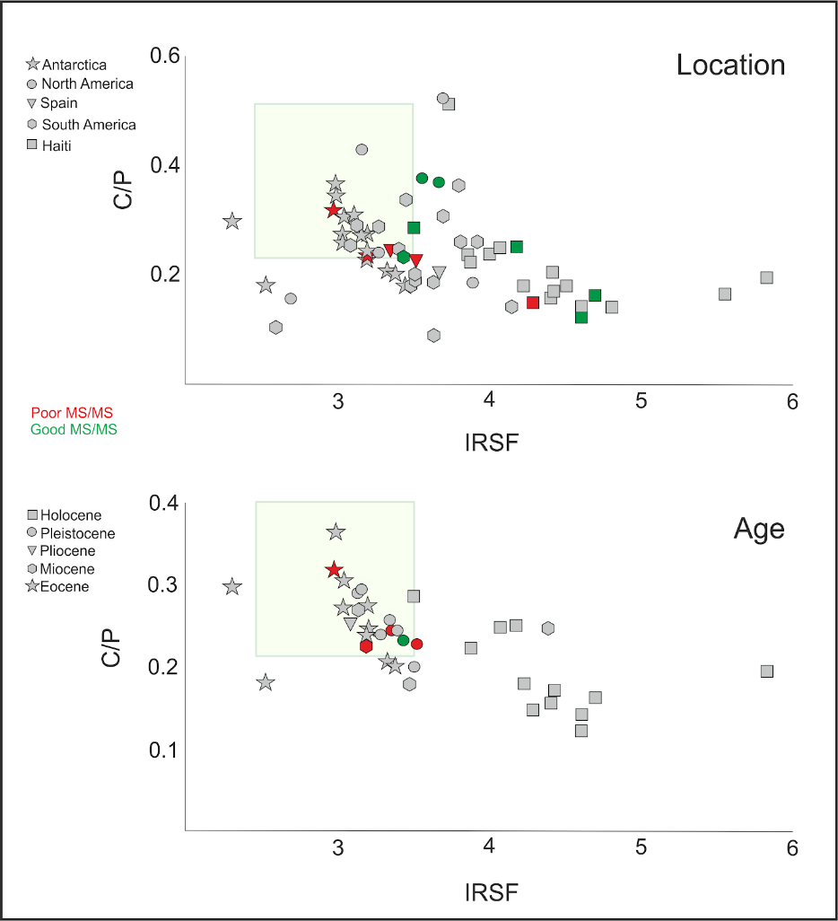
Figure 2.7. The ATR-FTIR results of infrared splitting factor (IRSF) and carbonate to phosphate ratio (C/P). The green boxes show the values that indicate unaltered bone mineral. The results are compared to time (lower) and location (upper). The samples with sequence information are highlighted; red for poor sequence results and green for good sequence results. Date information for some of the sequenced samples was not known and therefore these samples are not shown.

This suggests that IRSF and C/P may be unreliable indicators of surviving collagen, with a strong influence of age on these results. The younger samples show signs of diagenetic alterations as expected (i.e. a higher splitting factor and lower C/P), but interestingly as the age of the fossil increases, the FTIR values fall more in line with modern bone. This suggests that FTIR can detect early diagenetic changes to bone mineral, but the complex process of fossilization can affect the bone crystallinity in a way that moves the pattern towards that of modern material. Other studies have also shown modern bone values in ancient samples which they attributed to possible trace element uptake (Lebon et al. 2010). Therefore it is likely that IRSF and C/P cannot determine between endogenous and exogenous apatite (Trueman et al. 2008b) or the addition of other foreign ions such as trace elements (King et al. 2011). These results suggest that while ATR-FTIR can be used to distinguish between modern and archaeological bone (Beasley et al. 2014), it may not be a reliable proxy for the determination of surviving collagen in palaeontological samples using IRSF and C/P.

ATR-FTIR can also give an indication of surviving organic content by looking at the amide bands and the amide to phosphate ratio (Trueman et al. 2004, Kontopoulos et al. 2018). In order to test this, the samples that had been sequenced were re-analysed to measure the amide/phosphate. As seen with the C/P and the IRSF, there is no clear trend between the amount of proteomic recovery and the Am/P (Figure 2.8).

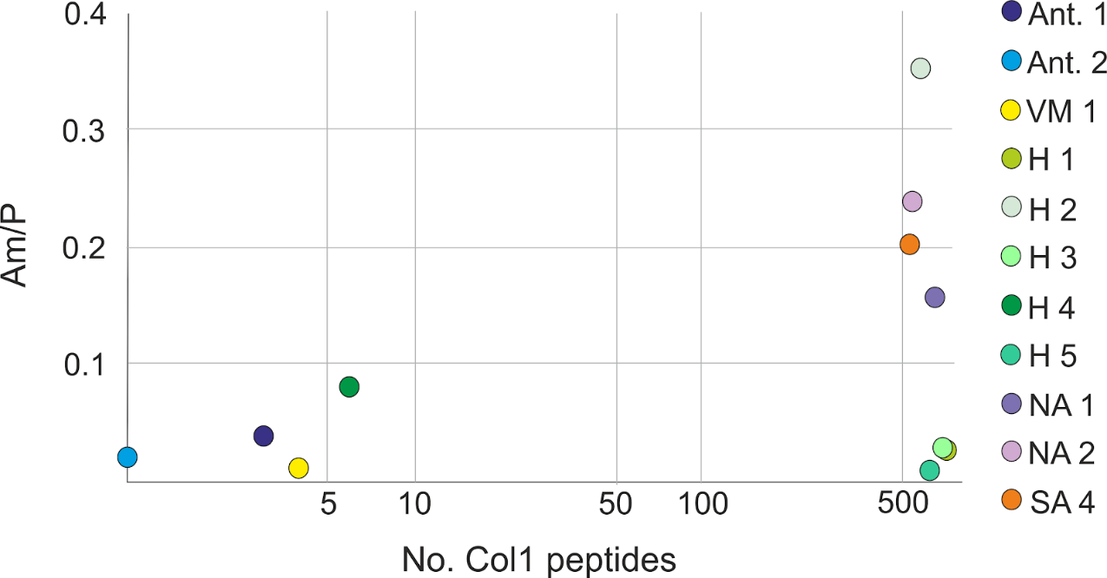
Figure 2.8. The amide/phosphate values for the samples compared to number of identified collagen type I peptides. Increasing Am/P values indicate survival of the organic content (Trueman et al. 2004).

An increase in Am/P indicates the presence of organic content, and initially this can be clearly seen following the trend of increasing number of identified collagen peptides. However, three of the samples show a high number of peptides but a low Am/P value.. This cannot be correlated to age or location, as the best Am/P value (H2) and the best proteomic sample (H1) all date to a similar age and are from similar localities (sinkhole sites in Haiti). Therefore this variation may be due to other factors that can influence the ATR-FTIR results. Where and how the bone has been sampled can affect ATR-FTIR data, with the interior of the bone being shown to produce better results (Lebon et al. 2014). As the samples were ground before analysis, the collagen preservation signal may have been lost due to the mixing of the interior and exterior sections of bone. Also, the extent to which the sample was ground (Kontopoulos et al. 2018) and other macroscopic effects such as electrostaticity (Aufort et al. 2018) could also have affected the results. Overall, these variables and the inability to differentiate between endogenous and exogenous apatite, makes this technique an unreliable proxy for determining proteomic retrieval in fossil remains.

2.3.2.3 MALDI-ToF MS results
While MALDI-ToF MS is more commonly used in analysis of archaeological remains (Welker et al. 2015a, Buckley et al. 2016, 2017a, Presslee et al. 2018), it has also started to be used as a screening method for fossil samples (Welker et al. 2015b, 2017). In order to evaluate the MALDI spectra, the number of peaks and the highest peak intensity were compared (Figure 2.9). It must be noted that peak intensity is not a measure of concentration, but rather a mixture of both peptide abundance and how well the peptide can be detected using MS.

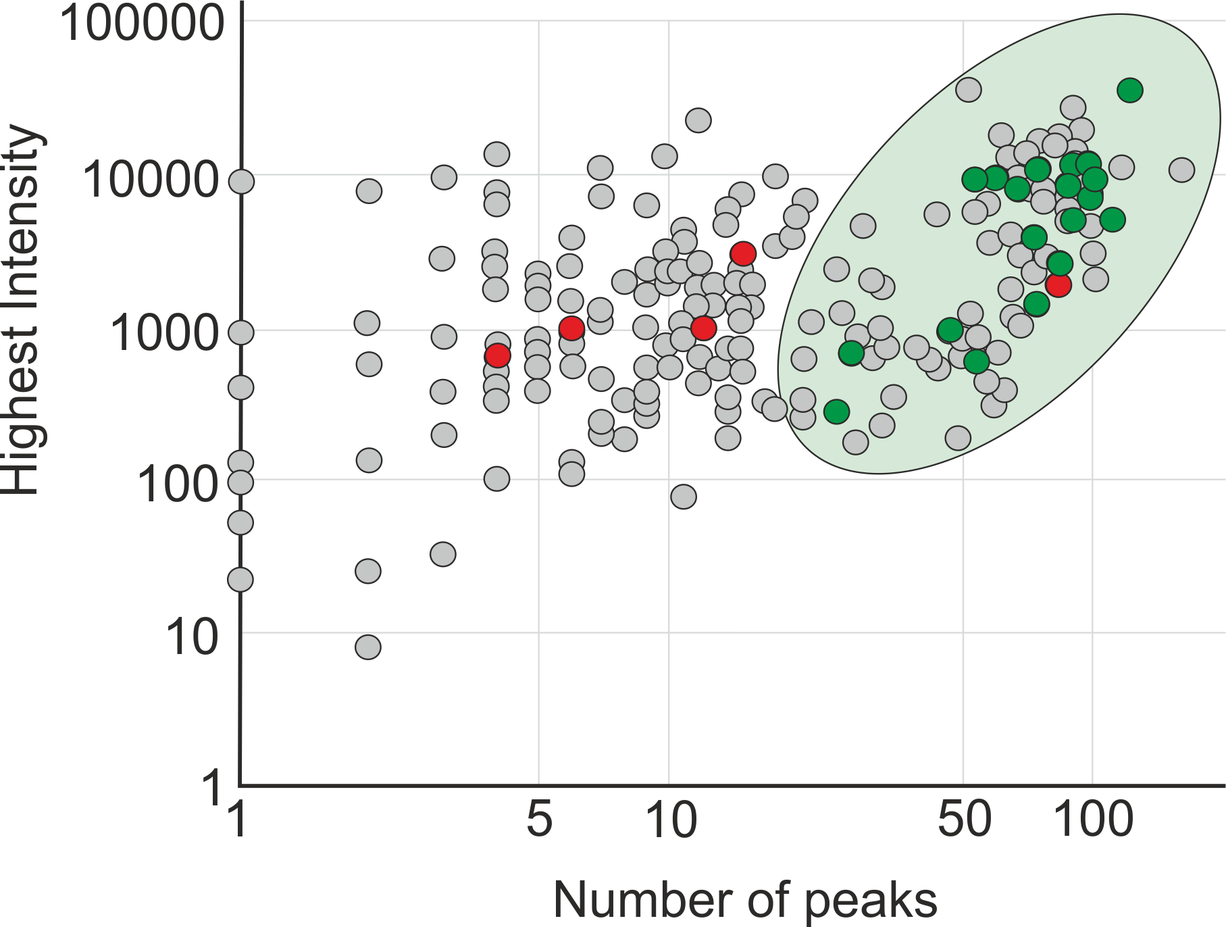
Figure 2.9. The number of MALDI peaks and the highest observed intensity for each of the sample were compared. The sequenced samples are highlighted; red indicates poor sequence data and green for good sequence data. Samples within the outline are predicted to have good surviving sequence information. However, note the false positive which is discussed in text.

Overall, the samples that produced poor sequence data also produced poor MALDI-ToF spectra and vice versa. However, Sample H 4 is an exception. The MALDI spectrum of H 4 is comparable to the MALDI spectrum of SA 4, which produced good LC-MS/MS results. The peak list of both spectra were compared to all possible ZooMS collagen peptides currently available (Buckley et al. 2009). This resulted in 6 potential collagen peaks for both samples (see Figure 2.10). When the spectra were compared to possible contaminants, H 4 had matches to both trypsin and keratin, while only tryptic peaks were identified in SA 4. However, RLB 1 and RLB 2 also contained keratin peaks in their MALDI spectra, but produced high sequence coverage. Therefore the identification of keratin peaks does not always mean low levels of endogenous protein retrieval.

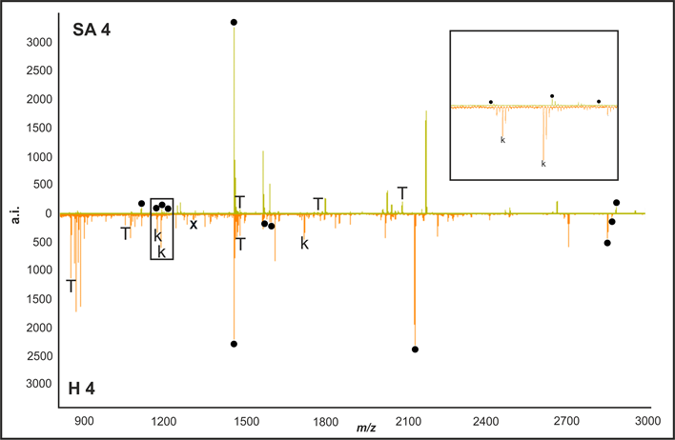
Figure 2.10. A comparison between the MALDI spectra of SA 4 (good sequence coverage) and H 4 (poor sequence coverage). The circles show potential collagen peaks, with trypsin peaks marked by T and the keratin peaks marked by K.

For sample H 4 there is little correlation between the number of collagen peptides identified using LC-MS/MS and the number of peaks or the highest intensity of the MALDI spectrum. While these are both mass spectrometric techniques, they use different methods of ionisation and detection, which affects the level of proteomic information retrieved. When the MALDI-ToF and LC-MS/MS data are compared, all potential collagen peaks in the MALDI spectra for the SA 4 sample were matched to collagen peptides in the MS/MS dataset, while only 1 peptide was matched for the H 4 sample (Table 2.5). The majority of the potential collagen peaks for H 4 were either not detected in the MS/MS analysis or were a match to cRAP proteins. Therefore, in general MALDI-ToF results are in agreement with LC-MS/MS data, but caution is needed when analysing samples that are not currently in the ZooMS database (such as Folivorans) and contain a high number of contaminant peaks.

 | MALDI-ToF marker |  |  | LC-MS/MS results
Species | m/z | Protein | Match to LC-MS/MS? | Mass | Protein | Peptide
Megatherium | 1105.6 | Collagen | Y | 1104.6 | Collagen | GRPGPIGPAGAR
Megatherium | 1161.6 | Collagen | Y | 1160.6 | Collagen | GQAGVMGFPGPK
Megatherium | 1182.6 | Collagen | Y | 1181.6 | Collagen | LGPGPMGLMGPR
Megatherium | 1198.6 | Collagen | Y | 1197.6 | Collagen | LGPGPMGLMGPR
Megatherium | 1453.7 | Collagen | Y | 1452.7 | Collagen | GLPGEFGLPGPAGPR
Megatherium | 2885.4 | Collagen | Y | 2884.4 | Collagen | GLTGPIGPPGPAGAPGDKGESGPSGPAGPTGAR
Megatherium | 1469.7 | Trypsin | N
Megatherium | 1768.8 | Trypsin | N
Megatherium | 2083.0 | Trypsin | N
Megalocnus | 1453.7 | Collagen | Y | 1452.7 | Collagen | GLPGEFGLPGPAGPR
Megalocnus | 1566.8 | Collagen | Y | 1565.8 | Trypsin | LGEHNIDVLEGNEQ
Megalocnus | 1592.8 | Collagen | Y | 1591.8 | Keratin | SMDNNRSLDLDSII
Megalocnus | 2131.1 | Collagen | N
Megalocnus | 2853.4 | Collagen | N
Megalocnus | 2869.4 | Collagen | N
Megalocnus | 842.5 | Trypsin | Y | 841.5 | Trypsin | VATVSLPR
Megalocnus | 1045.5 | Trypsin | Y | 1044.5 | Trypsin | LSSPATLNSR
Megalocnus | 1469.7 | Trypsin | N
Megalocnus | 1165.6 | Keratin | Y | 1164.6 | Keratin | LENEIQTYR
Megalocnus | 1179.6 | Keratin | Y | 1178.6 | Keratin | YEELQITAGR
Megalocnus | 1300.5 | Keratin | N
Megalocnus | 1716.9 | Keratin | N
Table 2.5. The MALDI-ToF MS possible collagen and contaminant m/z markers compared to the LC-MS/MS sequence data from the same sample. P in bold represents an hydroxylated proline. Trypsin is highlighted in orange and keratin contamination is highlighted in red.

2.3.2.4 Amino acid analysis results
Three datasets are generated as a result of amino acid analysis: concentration data, racemisation data and amino acid composition data. All these datasets can be informative when assessing the extent of surviving protein. Concentration data is perhaps the least informative, but samples with low AA concentrations are unlikely to produce meaningful proteomic data. In the past several amino acid studies have focused on Asx racemisation to predict both ancient protein and ancient DNA survival (Poinar et al. 1996, Dobberstein et al. 2009, Collins et al. 2009, Wadsworth et al. 2017). However, the majority of the these studies suggest limited correlation between protein recovery, proteome complexity, Asx racemisation and ancient DNA survival. As Asx can racemise in chain (Stephenson and Clarke 1989), other amino acid racemisation reactions are better suited for tracking peptide bond hydrolysis. In this study it has been found that Glx (glutamic acid and glutamine) is a good indicator of protein survival (Figure 2.11).

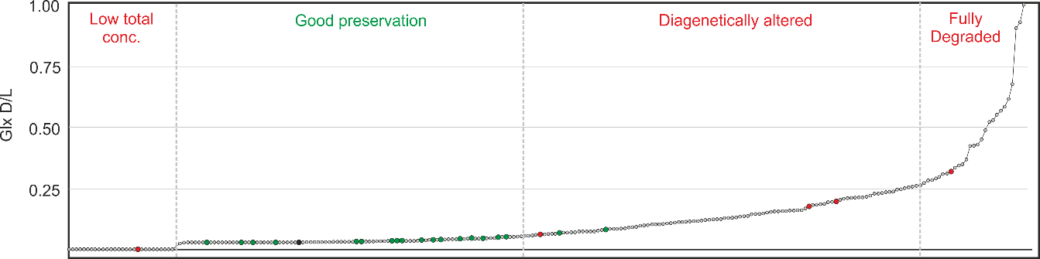
Figure 2.11. The Glx D/L values of all the samples analysed, with poor MS/MS results shown in red and good MS/MS results shown in green.

The samples which showed no Glx racemisation all had very low amino acid concentrations, so rather than the low values being due to good preservation, they were the result of a high proportion of the endogenous protein being lost from the sample. All the samples that produced good sequence data had Glx D/L values between 0.01 and 0.09. One sample (Ant 1) had low D/L values but still produced poor sequence data. This sample showed a highly altered amino acid composition (Figure 2.13) and therefore it is likely the low D/L values were due to modern contamination rather than being well preserved.

Analysis of the extent of racemisation of the different amino acids can be informative not only of protein degradation, but also the possible inclusion of microbes and other contaminants into the bone. Both Asx and serine have both been found to racemise in chain (Stephenson and Clarke 1989, Demarchi et al. 2013a), so racemisation of these two amino acids may be indicative of loss of protein higher structure, i.e. loss of cross linking and the start of protein diagenesis (High et al., 2016). The racemisation of more hydrophobic amino acids, such as valine, phenylalanine and leucine, would be indicative of more substantial protein breakdown. The D-form of alanine and glutamic acid can be found in certain bacterial cell walls (Johnson and Miller 1997) therefore an increase in the racemisation values of these amino acids, over other faster racemising amino acids, may imply bacterial infiltration of the bone (Figure 2.12).

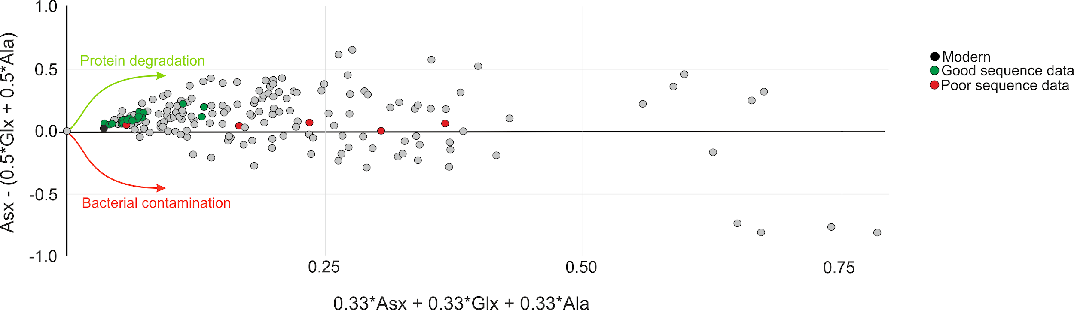
Figure 2.12. The values of Asx, Glx and alanine are compared. Those samples with higher racemisation values of Glx and Ala over Asx suggest the presence of bacterial contamination. The overall higher D/L values imply increased degradation.

To express the predicted chemical degradation signal compared to a bacterially degraded sample, a plot of Asx, Glx and Ala has been used (Willerslev et al. 2007). The modern sample and the samples that produced good sequence data all group together (Fig. 2.12) suggesting that samples with well preserved collagen all show low amino acid racemisation and no bacterial signal. The one sample that gave poor results but grouped with the well preserved samples was sample Ant 1; as already mentioned this sample shows signs of modern (non bacterial) contamination and it is important that amino acid composition is also taken into account when interpreting the AA data. The amino acid composition and total concentration results are shown in Figure 2.13.

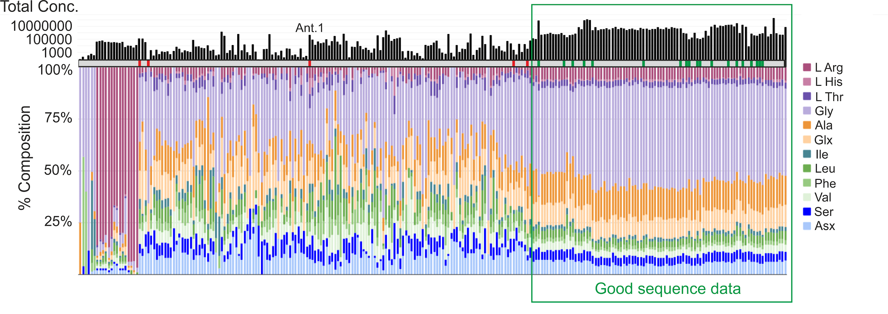
Figure 2.13. The % composition and total concentration results for all analysed samples. Samples which provided poor MS/MS results are shown by a red marker and those that produced good sequence data are highlighted by a green marker. A modern comparison is shown with a black marker. Blue AA’s racemise in chain, green AA’s are hydrophobic and more resistant to racemisation, orange AA’s can be a sign of potential bacterial contamination and purple AA’s do not have any racemisation data. Note the AA concentration data is in log scale.

All samples that produced good sequence data show a very similar amino acid composition, characterised by a high glycine content, and similar overall total concentrations. Two samples that produced poor MS/MS results also had a high glycine content but showed low levels of amino acids, suggesting loss of endogenous proteins.

PCA analysis was also carried out on the three AA datasets, initially just the sequenced samples were analysed. The D/L values and the percentage composition showed a grouping of the good data points, but the concentration data was shown to be too varied (Figure 2.14).

Figure 2.14. PCA charts of the different AA datasets; D/L values, % composition and AA concentration. Good sequenced samples are shown in green, poor results are shown in yellow and a modern sample is shown in blue. Each sample was given a number and this is shown in Table 2.6.

PCA # | Sample ID | Age | Location | MS/MS result
1 | NA 1 |  | Roseburgh, Oregon | Good
2 | NA 2 |  | Rampart Cave, Arizona | Good
3 | RLB 1 | 36840 +/- 710 | Rancho La Brea, Project 23 Deposit 1 | Good
4 | RLB 2 | 33380 +/- 800 | Rancho La Brea, Project 23 Deposit 1 | Good
5 | RLB 3 | 42700 +/- 1400 | Rancho La Brea, Project 23 Deposit 1 | Good
6 | RLB 4 | 36050 +/- 600 | Rancho La Brea, Project 23 Deposit 1 | Good
7 | SA 5 | 8.5-128Ka | Argentina | Good
8 | SA 1 | 8.5-128Ka | Buenos Aires, Argentina | Good
9 | SA 2 | 0.4-1.8Ma | Argentina | Good
10 | SA 3 | 128-400Ka | Argentina | Good
11 | SA 4 | 18000 BP | Loc Las Chacras, Bariloche | Good
12 | Ant 1 | Early Miocene | Gaiman Fm. Patagonia | Poor
13 | Ant 2 | Eocene | Marambio | Poor
14 | H 1 |  | Trouing de la Scierie, Haiti | Good
15 | H 2 |  | Trouing Marassa, Haiti | Good
16 | H 3 |  | Haiti | Good
17 | H 4 |  | Trou Gallery, Haiti | Poor
18 | H 5 |  | Trouing Marassa, Haiti | Good
19 | VM 1 | 1.6Ma | Venta Micena, Spain | Poor
20 | VM 2 | 1.6Ma | Venta Micena, Spain | Poor
21 | Arc 1 | Pliocene | Central Alberta | Good
22 | H 6 | 4486 +/- 39BP | Trouing Deron, Haiti | Good
23 | H 7 | 9867 +/- 65BP | Trouing Marassa, Haiti | Good
24 | Arc 2 | 3.4Ma +0.6/-0.4 | Beaver Pond, Ellesmere Island | Good
25 | Bos | Modern | York
Table 2.6. The sequenced samples with their corresponding PCA number, age and location information.

There are a number of outliers in the D/L PCA (Figure 2.14). Samples 2, 8 and 10 (see Table 2.6 for sample information) all show a relatively high racemisation value of the hydrophobic amino acids (Val, Phe, Leu) which suggests some protein degradation. The poor sample 18 has no recorded D/L values as very little amino acid data was recoverable for this sample, hence why it places nearer the good samples. Poor sample 12 shows a higher racemisation value of valine over the faster racemising amino acids which suggests substantial loss of endogenous protein. The other poor samples all place towards Glx and Ala which are signs of bacterial contamination. The % composition PCA only shows 1 outlier, sample 11, which has a very low percentage of alanine. This is probably a chromographic issue rather than an indication of protein degradation, as all the other AA data suggest good protein preservation.

The PCA analysis was then carried out on the whole dataset for both the D/L values and the % composition as these datasets showed promising results (Figure 2.15). The D/L PCA shows the same outliers as above, with the exception that the sample with no D/L values was removed from the analysis. Most of the good samples and the modern sample group closely together (circled in green on the chart) and it is recommended that samples from this area are chosen for further proteomic analysis. The composition PCA also shows a grouping of the good samples, but not as close as the D/L chart. There is also another grouping in the composition chart (circled in orange), all these samples composition is dominated by arginine and the samples are either from the Trinidad tar sands or date to the Miocene, suggesting this to be some form of contamination.

Figure 2.15. PCA charts of the D/L values and % composition datasets. Good sequenced samples are shown in green, poor results are shown in yellow and a modern sample is shown in blue. The groupings of the good samples are shown circled in green. The composition dataset shows another grouping of samples which is circled in orange.

Overall, AA analysis can provide a wealth of information about the sample being studied. Rather than using Asx racemisation as a marker for protein preservation, Glx is suggested as it has a strong trend with the MS/MS results. Comparison of the Glx, Ala and Asx racemisation data can also be used to give an indication of protein breakdown and possible bacterial contamination. The D/L values PCA showed a very tight grouping of most of the good sequenced data, showing racemisation to be a good indicator of protein preservation. However the strength of the amino acid analysis approach is in the complementary information sources; racemisation data is not the only proxy for predicting protein survival in an open system like bone, but the amino acid composition and total concentration data also shows a strong relationship with good sequence recovery.

2.3.2.5 Conclusions
Bone and collagen samples were analysed using ATR-FTIR, MALDI-ToF MS and AA analysis; 24 of these samples from various locations and ages were also analysed by LC-MS/MS and the different screening techniques were evaluated for their ability to predict protein retrieval (namely collagen). Five of the sequenced samples produced poor data, with four of these samples dated to over 1 Ma old. ATR-FTIR has the benefit of not destroying the sample during analysis, which allows it to be used in conjunction with other analytical methods. Unfortunately, in this study, it has been shown to be an unreliable proxy for detecting surviving collagen in palaeontological samples, due to the complex nature of fossilisation and the FTIR results being affected by a number of analytical variables. AA analysis and MALDI-ToF MS requires the loss of sample (albeit in small amounts), but they give a better indication of protein survival. MALDI-ToF screening identified a false positive, with a sample that produced poor MS/MS results but produced a good MALDI spectrum (Figure 2.9). Therefore, AA analysis appears to be the best screening method, out of those tested, for the prediction of protein recovery. This technique is minimally destructive (only 1 mg of sample is needed for hydrolysis) and the analysis produces a lot of data that can be used to evaluate the sample. The total amino acid concentration, amino acid composition and racemisation data can all be used to assess protein (collagen) survival in bone, and the PCA analysis suggests the D/L values to give the best indication of good preservation. However, neither MALDI-ToF or AA analysis can predict the extent of collagen coverage. Detailed NCP analysis was not possible due to the limited number of NCPs identified.

Contamination is also an important consideration when selecting samples for proteomic analysis. ATR-FTIR is not a reliable indicator of this, although if a sample of known antiquity produces modern-like bone results, it may be indicative of the replacement of the endogenous bone mineral with exogenous contamination. MALDI-ToF MS provides direct identification of possible keratin peaks. However this does not necessarily mean that collagen will not be able to be recovered. The major amino acid in keratins is cysteine which is not identified using the standard method of AA analysis (Block and and Bolling 1939, Robbins and Kelly 1970). However, AA analysis can be used to identify bacterial contamination using Glx and Ala racemisation. In addition, if a fossil sample shows no racemisation but a high amino acid concentration of differing composition, this can be another indicator of modern contamination. Overall AA analysis has been shown to be the most reliable screening method for both the identification of proteins in paleontological bone samples as well as potential contaminants, but only when all the amino acid data is taken into consideration, not just Asx racemisation. It is therefore recommended that AA analysis is used, where possible, to screen samples for palaeoproteomic study and the AA data is presented alongside the palaeontological proteomic results to provide evidence of endogeneity.

2.4 Evaluation of protein extraction methods
There are many different protein extraction methods used in palaeoproteomics, with many studies now showing the extraction method chosen will influence the level of proteomic recovery (e.g. Schroeter et al. 2016, see Section 1.4.2 for details). The majority of the samples analysed in this study used the filter aided sample preparation (FASP) protocol (Wiśniewski et al. 2009) which has been successfully used in past palaeoproteomic studies (Welker et al. 2015a). Two in depth studies are presented which examines different extraction protocols, one project looks at the best extraction method to use when targeting potentially highly degraded proteins, and the other study compares the use of two different digestion enzymes.

2.4.1 Protein preservation vs. protein extraction
There have been a number of published papers on the presence and recovery of proteomic information from fossils dating to millions of years ago (Asara et al. 2007, Manning et al. 2009a, Edwards et al. 2011, Schroeter et al. 2017, Lee et al. 2017). With these claims have come a number of possible reasons for the proteomic survival, including cross linking with other substances, the presence of iron and other trace elements, mineral interactions and so on (Maillard 1912, Schweitzer et al. 2007a, San Antonio et al. 2011). What if the preservation mechanisms that allow these proteins to survive into the fossil record influences our ability to successfully extract peptides for analysis? To investigate this, fossil bone from 2 locations are considered in detail; samples dating to 1.6 Ma from the site of Venta Micena (VM), Spain and samples dating to the Miocene/Eocene from Antarctica. Protein survival at these sites is expected to be minimal due to temperature (VM) and the age (Antarctica) of the fossils, and the preservation pathways of any recovered peptides are likely to differ due to the very different environmental conditions. Several methods are assessed to determine which produces the best proteomic data, and whether the ‘best’ method changes due to different preservation pathways.

2.4.1.1 Detailed sample information
The site of Venta Micena, Spain, is situated around an ancient lake basin and contains a vast wealth of fossils accumulated over time (Zihlman and Lowenstein 1996). The sequences of sediments are dated from the Middle Pliocene to the Middle Pleistocene and the samples analysed for this study are 4 Equus sp. bones from a stratigraphic layer dated to 1.6 Ma (Table 2.7). This is not the first time samples from this site have been analysed proteomically; amino acid racemisation was used to date shells from the site (Torres et al. 1997) and immunoassay has been successfully used on fossil Equus bone with albumin and immunoglobulin G being reported as present (Borja et al. 1997, Torres et al. 2002).

Sample ID | Species | Location | Latitude | Longitude | Age | Bone type
15570 | Equus sp. | Venta Micena, Spain | 34.7422∘ N | 2.4153∘ W | 1.6 Ma | Metacarpal
15571 |  |  |  |  |  | Radius
15572 |  |  |  |  |  | Long bone frag.
15573 |  |  |  |  |  | Long bone frag.
Table 2.7. The samples analysed in this study from Venta Micena, Spain. The samples in bold were selected for LC-MS/MS analysis.

Sixteen bone samples (15 tarsometatarsus; 1 tibiotarsus) from 4 different sites in Antarctica were selected for analysis (Table 2.8). These samples are from extinct Sphenisciformes and Gaviiformes and date from the Early Miocene to the Eocene. The samples were collected from Antarctica in 2016.

Sample ID | Species | Location | Latitude | Longitude | Age
15248 | Palaeosphenicus biloculata | Gaiman fm. Patagonia | 43.4383∘ S | 65.1019∘ W | Early Miocene
15249 | Palaeosphenicus bergi
15261 | Eretiscus tonii
15250 | Palaeeudyptes klekowskii | Marambio | 64.2408∘ S | 56.6271∘ W | Eocene
15251 | Palaeeudyptes klekowskii
15252 | Palaeeudyptes klekowskii
15253 | Palaeeudyptes klekowskii
15254 | Palaeeudyptes klekowskii
15255 | Palaeeudyptes gunnari
15256 | Delphinornis sp.
15257 | Crosvallia unienwillia
15258 | Anthropornis grandis
15259 | Anthropornis grandis
15260 | Mesetaornis polaris
15262 | Polaornis sp. | López de Bertodano Fm. | 64.2667∘ S | 56.7500∘ W | Unknown
15263 | Gaviiformes
Table 2.8. The samples analysed in this study from Antarctica. The samples in bold were selected for LC-MS/MS analysis.

2.4.1.2 Methods
In general two different extraction methods were used for these samples: filter aided sample preparation or FASP (Wiśniewski et al. 2009) and gel extraction. The FASP protocol follows the method outlined in Welker et al. (2015b) (see Section 2.2.2). Two methods of gel based protein extraction was tested; SDS PAGE (sodium dodecyl sulfate polyacrylamide gel electrophoresis) and gel aided sample preparation or GASP (Fischer and Kessler 2015). The majority of the samples were analysed with MALDI-ToF MS as a means of determining peptide survival, with two samples from both sites also selected for LC-MS/MS analysis (shown in bold in the tables).

SDS-PAGE: Bone samples were crushed using a liquid nitrogen cooled Retsch PM100 ball mill to ~1 µm sized particles and 50 mg of powdered sample was heated at 70^{O}C for 10 minutes in 200 µl SDS solubilizing buffer (0.5 M Tris base, 5% SDS, 130 mM DTT), before being alkylated and 200 µl of dye solution (0.05% bromophenol blue, 5% glycerol) was added. 20 µl of the samples were run on a Bis-Tris gel (NuPAGE) for 10 minutes to concentrate the samples into a gel plug which was washed in fixing solution and water. The gel was stained using Coomassie stain, and each sample was cut into approximately 1 mm sized cubes and washed in a de-staining solution followed by wash steps of ACN, HPLC grade water, and 50 mM ammonium bicarbonate. The samples were digested overnight with trypsin in 50 mM ammonium bicarbonate at 37^{O}C and the digest was transferred to a cleaned 2 ml microcentrifuge tube. The gel pieces were heated for 1 hour at 37^{O}C in the following solutions; 100 µl of 70%ACN/1.7% formic acid/0.1% TFA, 100 mM triethylammonium bicarbonate (TEAB) and ACN. The supernatant was collected after each solvent heating step and dried down. The extracted peptides were resuspended in 5% formic acid/0.1% TFA, desalted and purified on C18 membranes (Empore) before being eluted in 80% ACN/0.5% acetic acid.

GASP: This protocol follows the method outlined in Fischer and Kessler (2015). In brief, samples were demineralised in EDTA (0.5 M). The proteins were solubilized using dithiothreitol (DTT), sodium dodecyl sulfate (SDS) and a commercial lysis buffer (M PER lysis buffer, Thermo Fisher). A polyacrylamide gel was set in the 2 ml microcentrifuge tube containing the sample trapping the solubilised proteins, and the gel was cut into small pieces. The gel was washed with urea and TEAB before being digested overnight with trypsin at 37^{O}C. The peptides were extracted from the gel by dehydrating the gel pieces in ACN and the extracted peptides were desalted and purified using ziptips and eluted using 100 µl of 50%ACN/0.1% TFA (v/v).

Variations on these methods including different demineralisation solvents and different digestion enzymes are summarised in Table 2.9. Due to the small sample size of the Antarctic samples, some of the method variations were only tested on the Venta Micena samples.

Method ID | Method | Solvent | Enzyme | Venta Micena | Antarctica | MS method
FASP HCl T | FASP | HCl | Trypsin | Y | Y | MALDI-ToF
FASP HCl E | FASP | HCl | Elastase | Y | Y | MALDI-ToF and LC-MS/MS
FASP HCl P | FASP | HCl | Proteinase K | Y | Y | MALDI-ToF and LC-MS/MS*
FASP HCl | FASP | HCl | None | Y |  | MALDI-ToF
FASP ABC T | FASP | ABC | Trypsin | Y |  | MALDI-ToF
FASP ABC E | FASP | ABC | Elastase | Y |  | MALDI-ToF
GASP T | GASP | None | Trypsin | Y |  | MALDI-ToF
GASP EDTA T | GASP | EDTA | Trypsin | Y |  | MALDI-ToF
SDS T | SDS PAGE | SDS | Trypsin | Y | Y | LC-MS/MS
SDS E | SDS PAGE | SDS | Elastase | Y |  | LC-MS/MS
Table 2.9. A summary of the different methods used to analyse the samples, including variations in protein extraction method, solvent used to demineralise/solubilise the sample and the digestion enzyme. HCl; 0.6M hydrochloric acid, ABC; 50mM ammonium bicarbonate, EDTA; 0.5M ethylenediaminetetraacetic acid, SDS; 5% sodium dodecyl sulfate. Samples were either analysed for proteomic content using MALDI-ToF MS or LC-MS/MS. *VM samples were analysed using both MALDI-ToF and LC-MS/MS while the Antarctic samples were analysed using LC-MS/MS only.

Samples were analysed using MALDI-ToF MS as outlined in Section 2.2.2, with the exception of the SDS PAGE samples which were analysed using LC-MS/MS only. LC-MS/MS analysis was carried out at the Discovery proteomic facility at Oxford, the Novo Nordisk foundation centre for protein research, University of Copenhagen and the Laboratory of mass spectrometry and gaseous ion chemistry, Rockefeller University. The resulting .raw files were analysed as outlined in Section 2.2.4.1.

2.4.1.3 Results and discussion
The four Venta Micena samples (15570-3) were analysed using a variety of different extraction methods and the resulting MALDI-ToF spectra were evaluated by number of peaks and the highest recorded intensity (Figure 2.16).
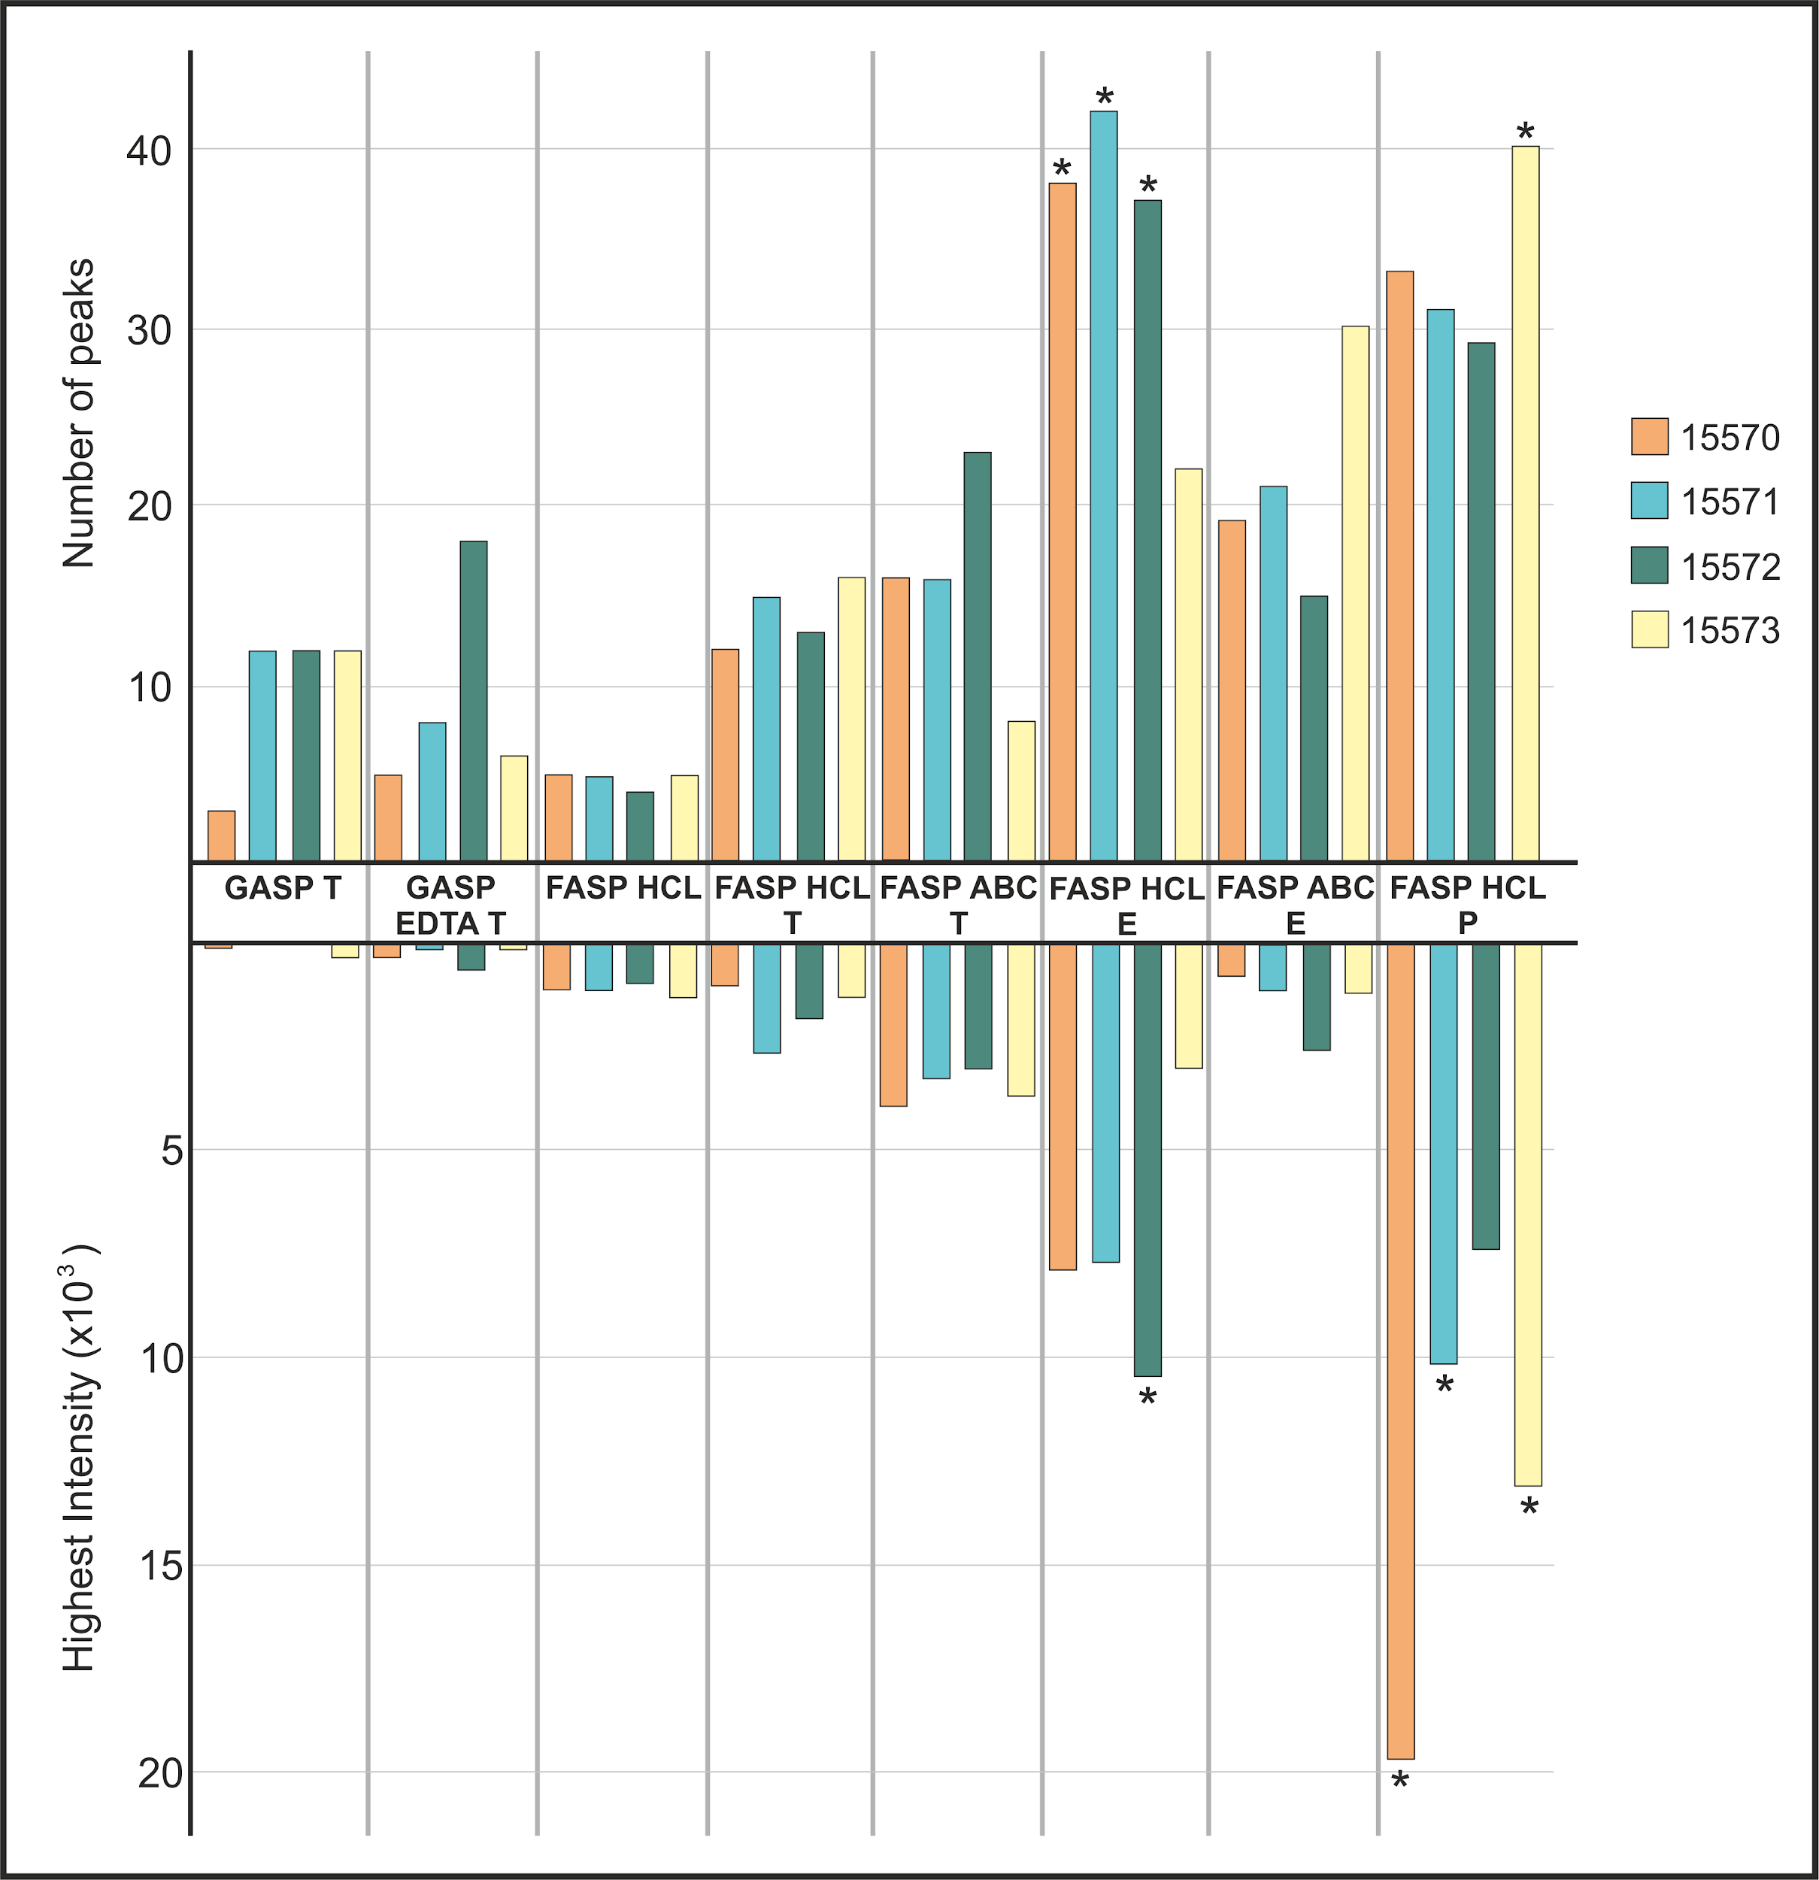
Figure 2.16 The MALDI-ToF results of the Venta Micena samples. The highest intensity and the number of peaks were used to compare the different methods. The method abbreviations are explained in Table 2.8. * shows the best result for each sample. The extraction method used is either gel aided sample preparation (GASP) or filter aided sample preparation (FASP), the solvents used include 0.6M hydrochloric acid (HCl) 0.5M Ethylenediaminetetraacetic acid (EDTA) or 50mM ammonium bicarbonate (ABC). T is tryptic digests, E is elastase digests and P is proteinase K digests. The method FASP HCl had no digestion enzyme and the method GASP T had no solvent step.

Overall the use of enzymes other than trypsin produced better spectra, both in terms of number of peaks and intensity. FASP produced better results than GASP and demineralisation in HCl was better than ABC buffer extraction using elastase digestion, but the reverse was true for tryptic digestion. This may be due to elastase preferring more acidic conditions. When the MALDI peak lists of all the tryptic spectra are compared, GASP and FASP showed a very different peptide mass fingerprint. Only 1 unidentified peak at 1794.8 m/z was shared with both GASP methods and FASP ABC. This suggests that these two methods extract different peptides/proteins, and backs up other studies which also show different ‘exactomes’ (Schroeter et al. 2016).

To investigate this further, the sequence results from the tryptic SDS PAGE LC-MS/MS analyses and a database of known collagen peaks (PMF database; (Buckley et al. 2009)) was compared to the peak lists of the tryptic samples. Overall 7 m/z values were matched to peptides, 6 belonging to collagen and 1 peptide at 2299.1 m/z matched to cartilage oligomeric matrix protein (COMP) (Table 2.10). This peptide was found only in the GASP samples and again suggests the influence of protein extraction methods on which proteins are recovered. Six other m/z values were matched to collagen peaks in the PMF database but were no match to horse. It is possible that these m/z values were not a match due to amino acid sequence changes between modern horse and it’s 1.6 million year old ancestors. However, as there was no definite match, it was decided these m/z values would be disregarded. Although this may have restricted the overall proteomic results, it gives confidence of endogeneity to those peptides that were recovered.

m/z | Match to Horse | FASP HCl T | FASP ABC T | GASP T | GASP EDTA T
1427.7 | PMF database | 15572 | 15570  15571  15572
1453.7 | PMF database | 15573
1459.7 | LC-MS/MS results |  | 15570
1561.8 | LC-MS/MS results |  | 15570  15571  15572
1562.8 | LC-MS/MS results |  | 15570
1707.7 | LC-MS/MS results |  |  | 15571  15572  15573 | 15570  15571  15572  15573
2299.1* | LC-MS/MS results |  |  | 15573 | 15572
TOTAL IDENTIFICATIONS |  | 2 | 8 | 4 | 5
Table 2.10. The seven m/z values that were matched to collagen peptides, showing in which of the samples they were found and which protein extraction method was used. All m/z were matched to collagen peptides except * which matched a peptide from cartilage oligomeric matrix protein.
The peak lists of the elastase and proteinase K peak lists were compared to the peptide sequence data and experimental m/z values were calculated for Proteinase K using PeptideMass (Wilkins et al. 1997). Even though the elastase and proteinase K samples produced a greater number of peaks, the only peaks matched to the LC-MS/MS data was for the digestion enzyme elastase. This may be due to the limited number of collagen peptides identified during the LC-MS/MS analysis. Ten m/z peaks were matched to the calculated PeptideMass peptides (Table 2.11). The identification of potential collagen peaks combined with the high number of peaks and intensity suggests FASP-HCl-P as the best extraction method for the recovery of peptides and their subsequent identification using MALDI-ToF MS.
 |  | Sample
m/z | Protein | 15570 | 15571 | 15572 | 15573
958.4 | COL1A1 | Y | Y | Y | Y
998.5 | COL1A1 | Y | Y | Y | Y
1142.6 | COL1A2 | Y |  | Y | Y
1185.7 | COL1A2 | Y | Y | Y | Y
1313.8 | COL1A2 | Y |  |  | Y
1471.8 | COL1A1 | Y | Y | Y | Y
1499.8 | COL1A1 | Y | Y | Y | Y
1643.9 | COL1A1 | Y | Y | Y | Y
1803.0 | COL1A1 |  | Y |  | Y
2359.1 | COL1A1 |  | Y |  | Y
TOTAL MATCHES |  | 8 | 8 | 7 | 10
Table 2.11. The m/z values of the peaks matched from the proteinase K spectra to PeptideMass calculated collagen peptides.
Two of the four Venta Micena samples were analysed using SDS PAGE followed by LC-MS/MS, and the results were compared to the combined LC-MS/MS results of FASP HCl P and FASP HCl E. In order to maximise the proteomic information available three search databases were used to analyse the LC-MS/MS results: the GPM, MaxQuant and PEAKS (Table 2.12). SDS PAGE with tryptic digestion showed much a higher level of protein recovery for sample 15570, while the combined results of FASP HCl EP was slightly better for sample 15571. While FASP extraction with HCl and enzymes other than trypsin produced the best MALDI-ToF MS spectra, SDS PAGE with tryptic digestion produced the best LC-MS/MS results.

 |  | FASP HCl EP |  | SDS T |  | SDS E
 |  | 15570 | 15571 | 15570 | 15571 | 15570
Total Proteins | GPM | 3 | 2 | 9 | 0 | 7
 | PEAKS | 1 | 2 | 22 | 2 | 2
 | MaxQuant | 1 | 1 | 10 | 0 | 2
Total Peptides | GPM | 6 | 4 | 47 | 0 | 43 (11)
 | PEAKS | 6 | 5 (3) | 251 (14) | 7 | 8
 | MaxQuant | 2 | 2 | 47 (1) | 0 | 10
Table 2.12. Comparison of the LC-MS/MS results between extraction protocol FASP-HCl-E/P and SDS PAGE with both trypsin and elastase. A protein was only included as present if 2 or more peptides were identified; the results don’t include keratins and other common contaminants. The number of horse specific peptides identified is shown in parentheses.
Not all the extraction methods were tested on the Antarctic samples, but they also followed a similar trend, with non tryptic digestion producing better MALDI-ToF spectra (with the exception of sample 15259) (Figure 2.17) and SDS PAGE with tryptic digestion producing the best LC-MS/MS data (Table 2.13).
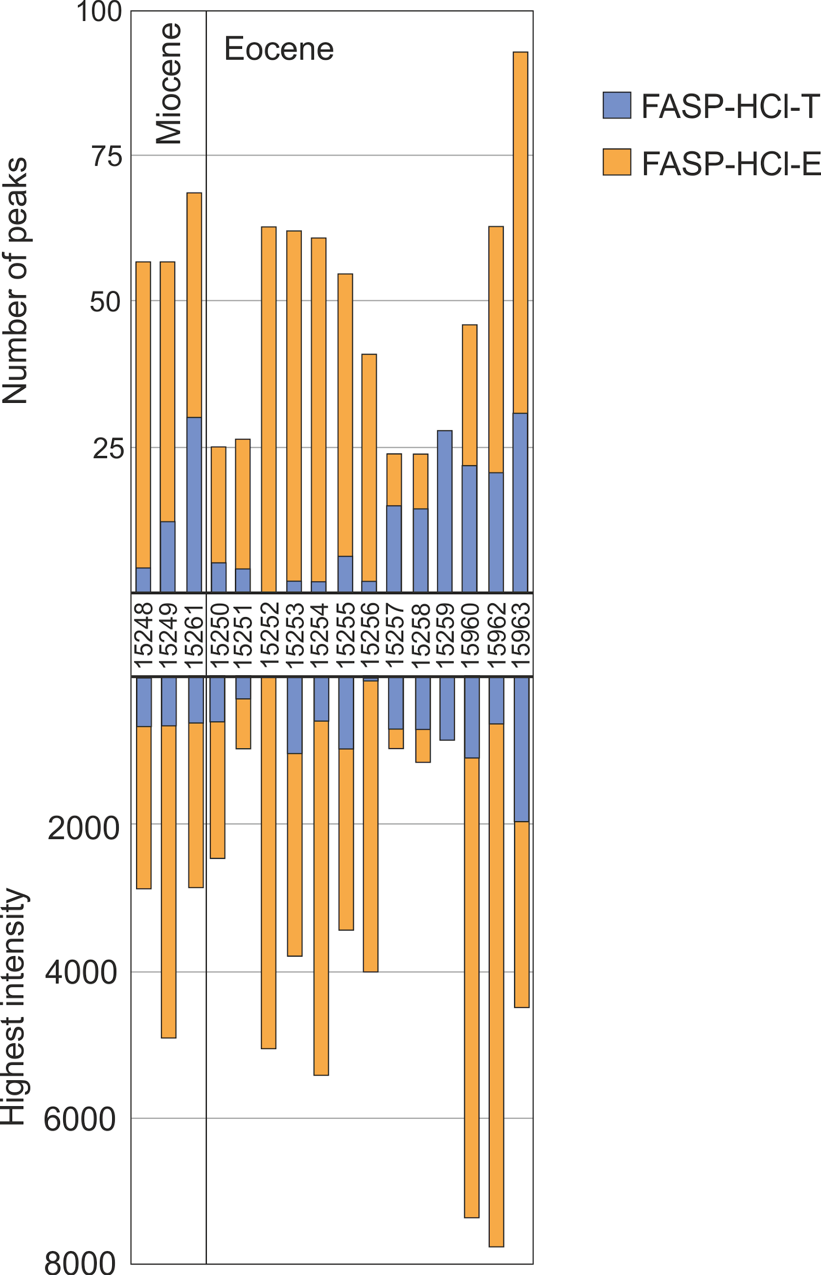
Figure 2.17. The MALDI-ToF results for the Antarctic samples. The highest intensity and the total number of peaks were used to compare the different methods. Method FASP HCl T; filter aided sample preparation using HCl as the demineralisation solvent and tryptic digestion. FASP HCl E; filter aided sample preparation using HCl as the demineralisation solvent and samples were digested using elastase.

 |  | FASP HCl EP |  | SDS T
 |  | 15248 | 15255 | 15248 | 15255
Total Proteins | GPM | 3 | 11 | 8 | 13
 | PEAKS | 1 | 0 | 4 | 10
 | MaxQuant | 0 | 0 | 1 | 1
Total Peptides | GPM | 6 (1) | 22 | 33 (10) | 74 (15)
 | PEAKS | 3 | 0 | 24 (1) | 57 (5)
 | MaxQuant | 0 | 0 | 6 (1) | 9 (3)
Table 2.13. Comparison of the LC-MS/MS results between extraction protocol FASP-HCl-E/P and SDS PAGE with tryptic digestion. A protein was only included as present if 2 or more peptides were identified; results don’t include keratins and other common contaminants. The number of aves specific peptides identified is shown in parentheses.

The results presented here are only from two sites and serve as a case study for the comparison of extraction methods. Many archaeological bone studies use HCl demineralisation, trypsin digestion and FASP for the retrieval of proteins (Wadsworth et al. 2017). However, in this study it has been shown that this may not be the best method to use for degraded fossil samples. A comparison of MALDI-ToF spectra has shown the identification of different peptides (and in one case, a different protein) depending on the extraction protocol used. Elastase and proteinase K produced better MALDI-ToF spectra, but the sequence data was minimal from these samples when they were analysed during LC-MS/MS. This has been seen in other studies which have used screening methods such as MALDI-ToF before LC-MS/MS analysis; while the screening methods have shown promising results, the proteomic retrieval using LC-MS/MS has been minimal (Manning et al. 2009b, Kendall et al. 2016). SDS PAGE extraction with tryptic digestion produced the best LC-MS/MS results, and this method used no demineralisation step, which has been suggested before for ancient protein analysis (Cleland and Vashishth 2015). The demineralisation step has been shown to remove proteins (Schroeter et al. 2016), and as these are ancient samples with not many surviving peptides, this demineralisation step may remove a large percentage of surviving proteomic information. The proteins were able to be concentrated by using the SDS PAGE gel, allowing maximum retrieval of proteomic information. This method was the best for peptide sequence recovery in all samples tested and suggests no influence of protein preservation mechanisms at the level of protein retrieval.

2.4.2 Different digestion enzymes
Following the successful MALDI-ToF MS results of the Venta Micena samples, a range of other samples were also analysed using elastase digestion. 32 bone samples from various locations and dating from the Holocene (Haiti) to the Eocene (Antarctica) (Figure 2.18). Elastase gave good spectra (i.e. a high number of peaks with a high overall intensity) for all but 3 of the samples tested, whereas trypsin was more variable. The fact that elastase gave good results for all but 3 samples suggests the increase in cleavage points can result in many more peptides being identified. However, PMF needs to be developed further to be able to identify non-tryptic collagen peptides before elastase can be used as a reliable enzyme for MALDI ToF screening.

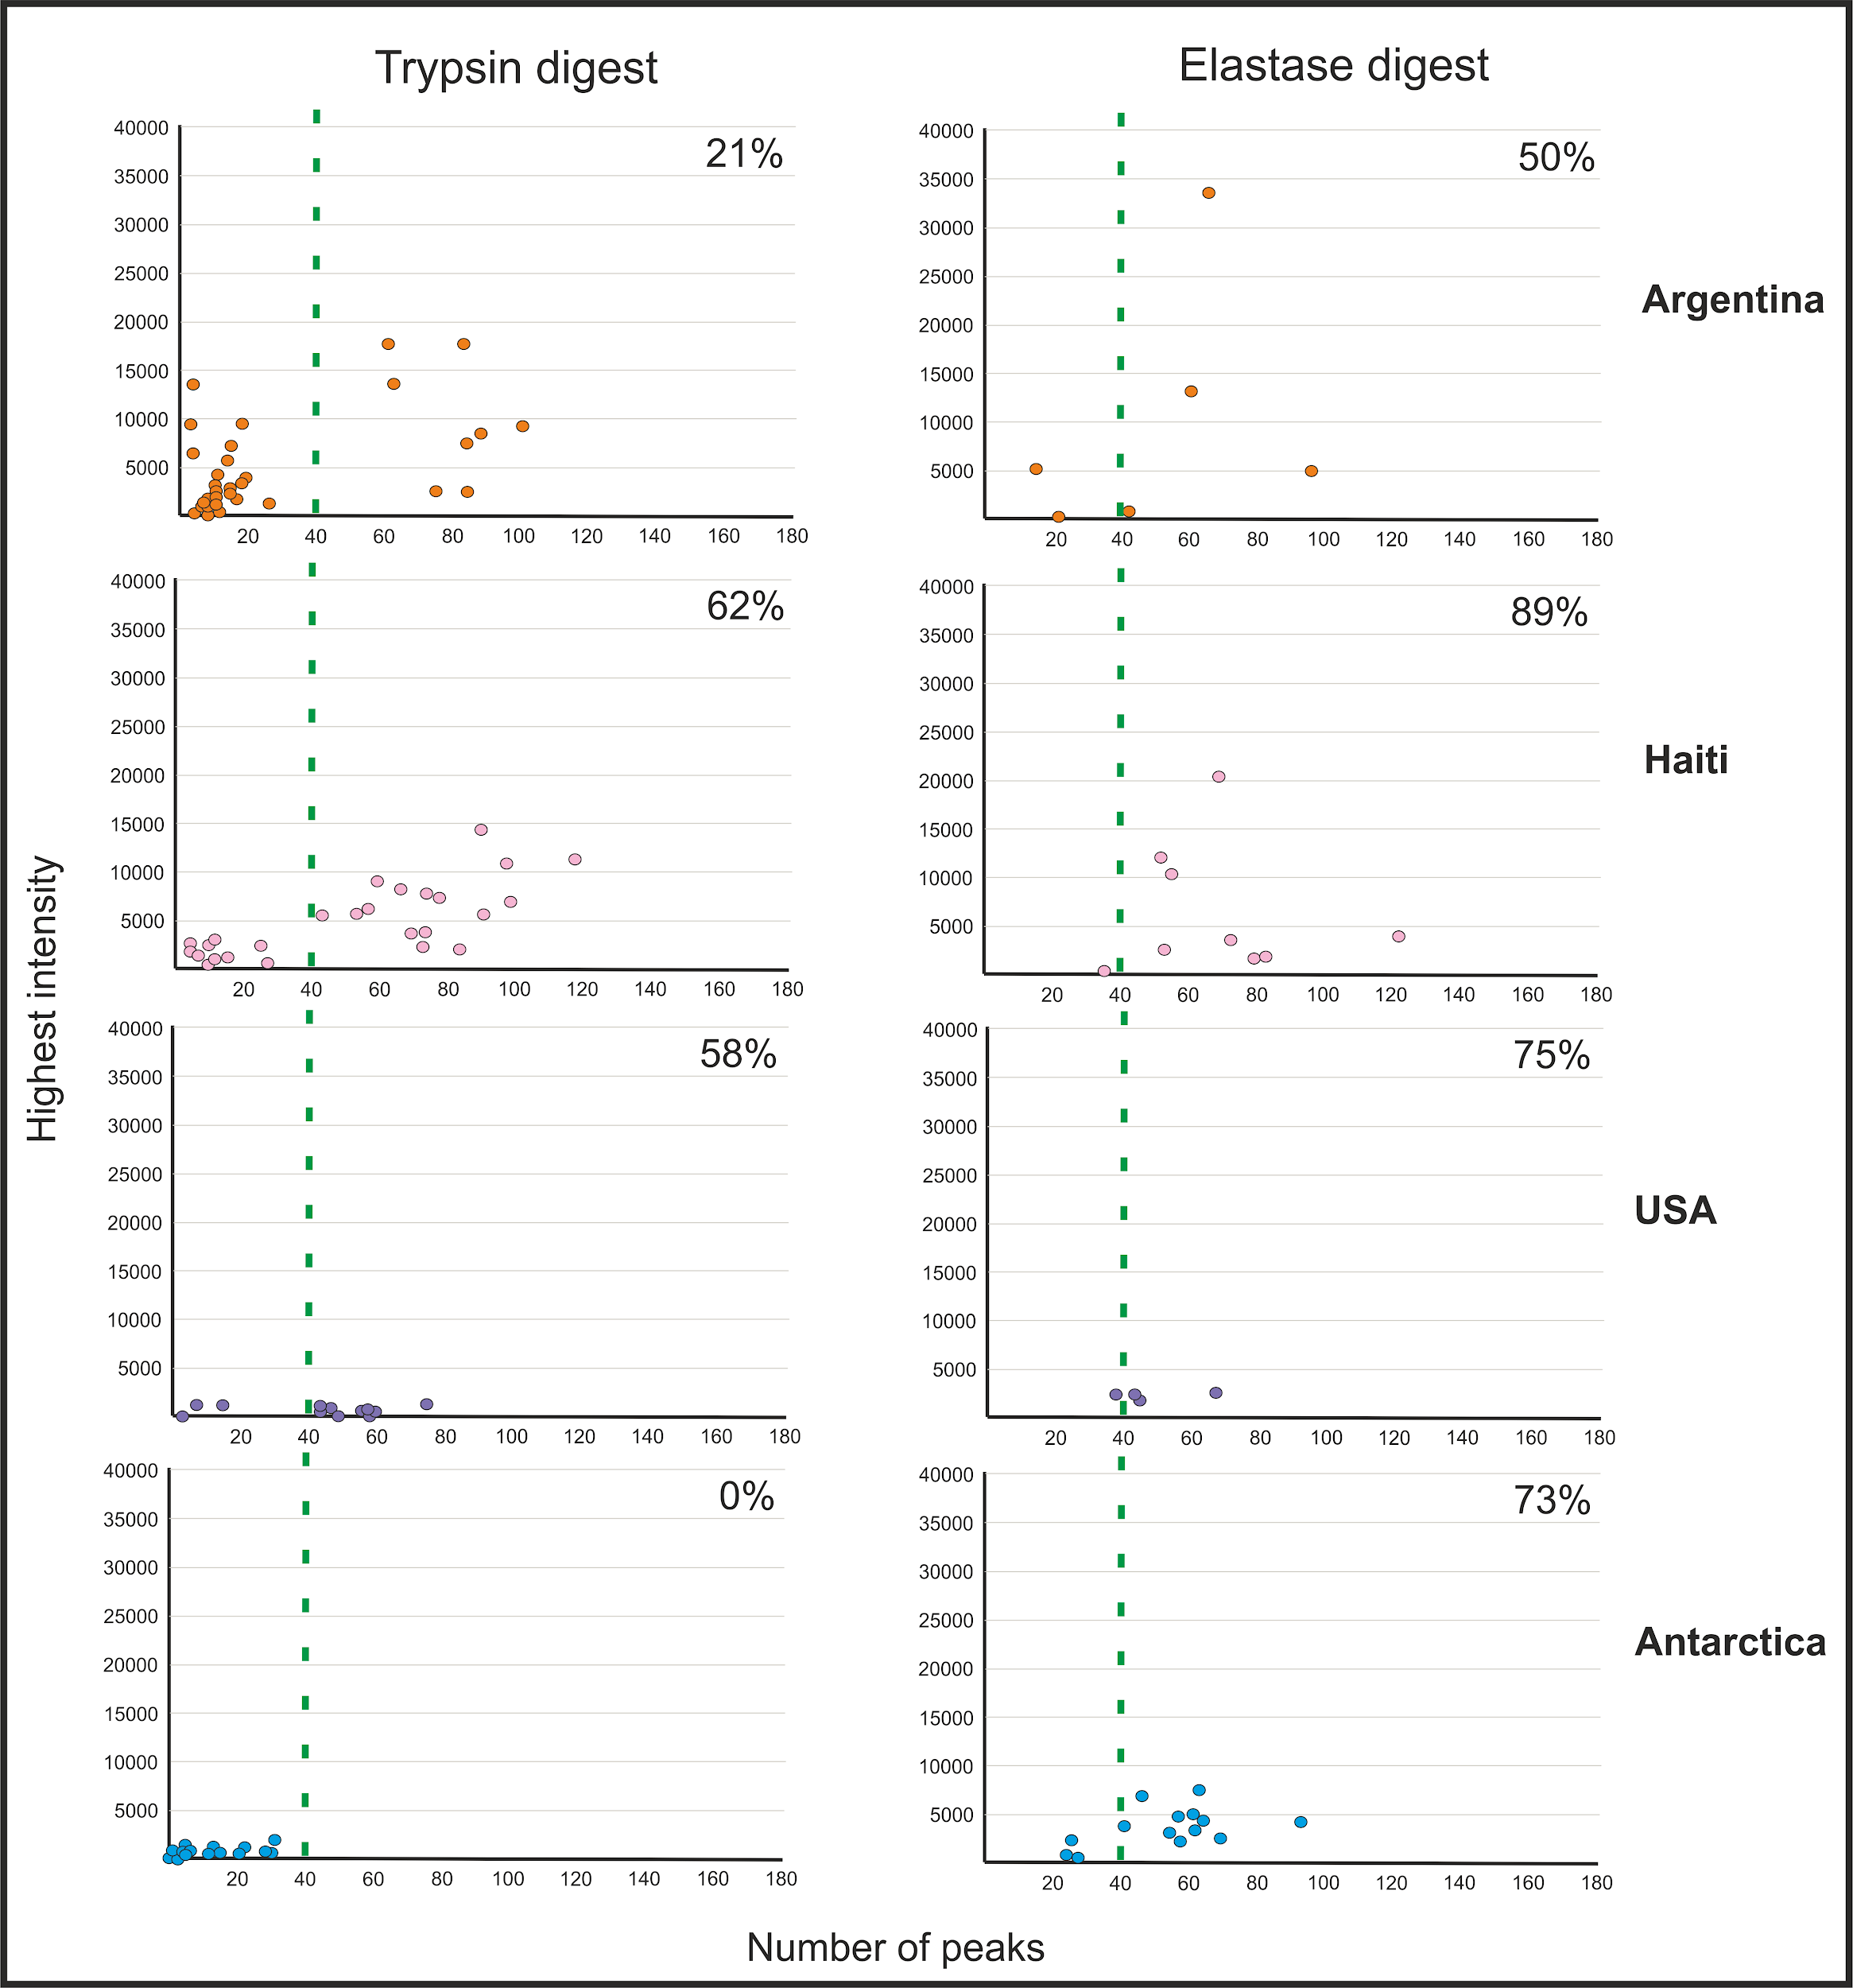
Figure 2.18. A comparison of MALDI-ToF MS results of the same set of samples analysed with both trypsin and elastase. In order for a sample to be shown as successful it had to have over 40 peaks and a highest intensity over 1000. The % success rate for all samples is shown in the top right of each graph.

2.5 Interpretation of the LC-MS/MS results

2.5.1 A comparison of data analysis software packages
The LC-MS/MS data were analysed using three different software packages (the GPM, MaxQuant, PEAKS) and each of these software tools have their advantages and disadvantages when analysing proteomic data. PEAKS and MaxQuant have the clear advantage of being able to select your own database in which to search against. However, the GPM is by far the easiest software to use and the quickest, therefore making it the best software to use when trying to confirm the presence of proteins (if the relevant database is available). MaxQuant provides a direct comparison between different samples and is therefore very useful when trying to look at protein preservation between different species/sites etc. PEAKS uses de novo sequencing as well as a database search and this allows for the identification of novel PTMs and substitutions, which is of key importance in phylogenetic studies.

Several samples were analysed using all three softwares, allowing a direct comparison to be made. In order to have a comparable dataset, 6 samples from the same location (Rancho La Brea) are compared which all had the same protein extraction protocol (SDS PAGE) and were analysed using the same tolerances and search database (Felidae proteome; NCBI). Only collagens were used in the comparison, as these are the most common bone proteins (Table 2.14).

 |  | Total proteins |  |  | Total peptides
Sample ID | Species | GPM | PEAKS | MQ | GPM | PEAKS | MQ
RLB-1 | Smilodon fatalis | 28 | 8 | 6 | 4727 | 708 | 271
RLB-2 | Smilodon fatalis | 26 | 5 | 6 | 2830 | 38 | 269
RLB-3 | Smilodon fatalis | 25 | 4 | 6 | 3585 | 28 | 333
RLB-4 | Smilodon fatalis | 16 | 4 | 5 | 2580 | 39 | 263
RLB-5 | Smilodon fatalis | 18 | 3 | 3 | 3480 | 128 | 165
RLB-6 | Panthera atrox | 22 | 3 | 5 | 2767 | 259 | 315
Table 2.14 The total protein and total peptide results for 6 samples using the GPM, PEAKS and MaxQuant (MQ) software.

The GPM produced the most collagens and the most peptides by far. Unfortunately, further analysis of these results was unable to be carried out as the GPM servers are now offline (09/06/2018) and the data is unobtainable. Apart from Sample RLB-1, MaxQuant identified more peptides and slightly more proteins than PEAKS, even though the same search database was used for all the samples. When this is analysed further, although MaxQuant identified more proteins for each sample, these were the same set of collagen proteins for all samples, with 6 being identified in total (COL1A1; COL1A2; COL2A1; COL3A1; COL5A1; COL5A2). PEAKS identified 9 collagen proteins overall in all the samples; the same 6 as MaxQuant but also COL5A3, COL4A5 and COL4A6 (Table 2.15). 57% of proteins identified were seen in both analyses, with 27% being identified using MaxQuant only and 16% seen in only the PEAKS analysis.

 | RLB-1 | RLB-2 | RLB-3 | RLB-4 | RLB-5 | RLB-6
alpha-1 (I) | MP | M | M | M | MP | M
alpha-2 (I) | MP | M | M | M | M | MP
alpha-1 (II) | MP | MP | MP | MP | MP | MP
alpha-1 (III) | MP | MP | MP | P |  | M
alpha-5 (IV) | P
alpha-6 (IV) |  | P
alpha-1 (V) | MP | MP | MP | MP |  | M
alpha-2 (V) | MP | MP | MP | MP | P | P
alpha-3 (V) | P
Table 2.15 A comparison of the collagens identified in all samples using MaxQuant (blue) and PEAKS (orange). Proteins seen in both analyses are shown in green.

The most surprising result is the lack of identification of COL1A1 for the majority of samples using PEAKS. COL1A1 is by far the most common bone protein and the alpha 2 chain was positively identified in all samples. The correlation between the identified peptides was also investigated (Table 2.16). In order for the results to be directly comparable, any novel amino acid substitutions were removed from the PEAKS analysis and the original peptide sequence was compared to MaxQuant.

 | RLB-1 | RLB-2 | RLB-3 | RLB-4 | RLB-5 | RLB-6
Shared peptides | 19% | 20% | 3% | 2% | 1% | 24%
PEAKS only | 76% | 74% | 4% | 3% | 11% | 66%
MQ only | 5% | 6% | 93% | 93% | 88% | 10%
Table 2.16. A comparison of the peptides identified in each of the samples. Shared peptides are those that are seen in both MaxQuant (MQ) and PEAKS.

The peptide comparison results show 2 patterns; RLB samples 1, 2 and 6 all have ~20% of shared peptides, and a higher percentage (~70%) identified only in PEAKS. In contrast, RLB samples 3,4 and 5 all show very little shared peptides, with the majority of peptides being identified in MaxQuant only (~90%). The SDS PAGE results (Figure 2.19) show RLB samples 1, 3 and 6 as being well preserved, while samples 2, 4 and 5 show only slight staining suggesting minimal protein recovery. PEAKS recovered, in general, more peptides from the well preserved samples, while MaxQuant recovered more proteomic information from the samples that produced poor SDS PAGE results. This suggests that MaxQuant is better at analysing more degraded samples.

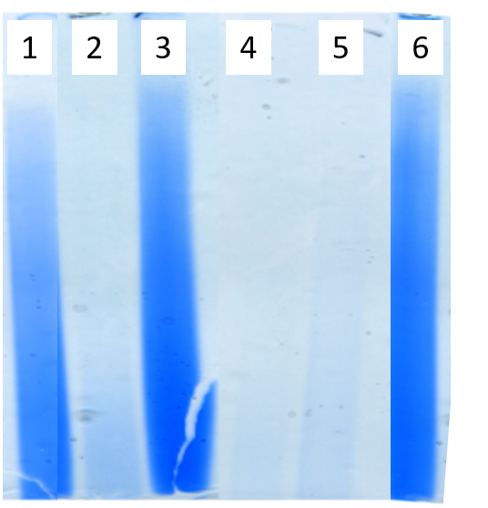
Figure 2.19 The SDS PAGE results of the LC-MS/MS data software comparison samples (amalgamated from different gels). The lane numbers represent the sample numbers.

All samples had collagens identified in one software that were not seen in the other therefore, where possible, both softwares should be used to maximize proteomic information. When dealing with samples of known antiquity or samples that show poor protein recovery during screening, MaxQuant may provide more proteomic information. PEAKS has the added advantage of identifying novel amino acid substitutions, therefore this software is recommended when conducting phylogenetic analyses.

2.5.2 The evaluation of LC-MS/MS data for proof of endogeneity
It must be noted that the identification of ancient peptides using LC-MS/MS can be hindered due to the extinct taxon not being present in the search database. This can start to be addressed using de novo sequencing (Medzihradszky and Chalkley 2015) and error tolerant searches, which uses a database but allows amino acid substitutions (Zhang et al. 2012). However, at increasing evolutionary distances, this can still be a problem (Welker 2018a). Therefore it is possible that more proteins are preserved in these ancient samples, which will only be identified when the comparison database is expanded.
The LC-MS/MS results from Venta Micena and Antarctica are analysed here (see Section 2.4.1.1 for sample details) as they represent very degraded samples. Therefore, any peptides recovered need to be securely identified to make sure they are not contamination. In order to increase the confidence in the endogeneity of the proteins identified from these samples, the peptides were analysed using NCBI to see if they were a match to either Perissodactyla specifically Equidae (Equus caballus, Equus asinus, and Equus przewalskii) for the Venta Micena samples, or a member of Aves or Spheniscidae (Aptenodytes forsteri and Pygoscelis adeliae) for the Antarctic samples. Any peptides that were not a match were removed. Proteins were then assessed using the following criteria:
- How likely the protein was to be found in bone (i.e. collagen type 1)
- If it was seen in more than 1 search (i.e. PEAKS and the GPM)
- If the protein contained a peptide unique to the Order or Family of the selected sample.
Any protein that did not match one or more of these criteria was removed. All peptides were compared against the results of the sample blanks. The protein ubiquitin was commonly recovered from both the Venta Micena samples and the Antarctic samples with the same two peptides (TITLEVEPSDTIENVK and ESTLHLVLR). These two peptides were also seen in the sample blanks and therefore this protein was removed as a contaminant. The proteins desmoglein-1 and desmoplakin were also removed as contaminants due to their association with skin and keratins (Hendy et al. 2018a). The LC-MS/MS data was combined from all the database searches for each of the extraction methods and the results are summarised in Tables 2.17 (VM samples) and 2.18 (Antarctic samples).

ID | Protein | Common bone protein? | Extraction method | Search | Total peptides | Order/ Family specific?
VM 15570 | Actin (ACT) |  | SDS T | M/P/G | 10
 | Annexin A2 (ANKA2) |  | SDS T | G/M | 5
 | Biglycan (BGN) | Y | SDS T | P | 5
 | Cartilage oligomeric matrix protein (COMP) | Y | SDS T | P | 4
 | Collagen type 1 A1 (COL1A1) | Y | SDS T/SDS E/FASP | M/P/G | 28 | Y
 | Collagen type 1 A2 (COL1A2) | Y | SDS T/SDS E | M/P/G | 19 | Y
 | Collagen type 2 A1 (COL2A1) | Y | SDS T | P | 2
 | Collagen type 6 A1 (COL6A1) | Y | SDS T | P | 7 | Y
 | Collagen type 6 A3 (COL6A3) | Y | SDS T | P | 22 | Y
 | Decorin (DCN) | Y | SDS T | P | 7
 | Fibronectin (FN1) | Y | SDS T | P | 25 | Y
 | Lumican (LUM) | Y | SDS T | P | 8 | Y
 | Mediator complex subunit 12 (MED12) |  | SDS E | G | 3 | Y
 | Mimecan (OGN) | Y | SDS T | P | 2
 | Transcription factor 20 (TCF20) |  | SDS E | G | 16 | Y
 | Transforming growth factor beta induced protein ig-h3 (TGFBI) |  | SDS T | P | 6 | Y
VM 15571 | Collagen type 1 A1 (COL1A1) | Y | SDS T | P | 5
 | Collagen type 1 A2 (COL1A2) | Y | SDS T | P | 2
 | Vacuolar protein sorting -associated protein 13D (VPS13D) |  | FASP | P | 3 | Y
Table 2.17 A summary of all the identified proteins for each of the Venta Micena (VM) samples after data validation. M: Maxquant, G: the GPM, P: PEAKS. FASP is short for the analysis FASP HCl EP. The gene names of the proteins are given in parentheses. Order/family specific denotes whether that protein contains a peptide that is specific to Perissodactyla or Equidae respectively.

ID | Protein | Common bone protein? | Extraction method | Search | Total peptides | Class/  Order specific?
Ant. 15248 | Collagen type 1 A1 (COL1A1) | Y | FASP/SDS T | P/M | 12 | Y
 | Collagen type 1 A2 (COL1A2) | Y | SDS T | G/P | 9 | Y
 | Collagen type 2 A1 (COL2A1) | Y | SDS T | G | 4
 | Collagen type 5 A1 (COL5A1) | Y | SDS T | G | 2
 | Collagen type 5 A2 (COL5A2) | Y | SDS T | G/P | 6 | Y
 | Collagen type 7 A1 (COL7A1) |  | SDS T | G | 2 | Y
 | Collagen type 22 A1 (COL22A1) |  | SDS T | G | 3 | Y
Ant. 15255 | Collagen type 1 A1 (COL1A1) | Y | SDS T | P/M | 24 | Y
 | Collagen type 1 A2 (COL1A2) | Y | SDS T | G/P | 33 | Y
 | Collagen type 2 A1 (COL2A1) | Y | SDS T | G | 3
 | Collagen type 4 A5 (COL4A5) |  | SDS T | G | 2 | Y
 | Collagen type 5 A1 (COL5A1) | Y | SDS T | G | 3
 | Collagen type 5 A2 (COL5A2) | Y | SDS T | G/P | 10 | Y
 | Collagen type 7 A1 (COL7A1) |  | SDS T | G | 3 | Y
 | Collagen type 11 A1 (COL11A1) | Y | SDS T | G | 3 | Y
 | Collagen type 12 A1 (COL12A1) | Y | SDS T | G | 2 | Y
Table 2.18 A summary of all the identified proteins for each of the Antarctic (Ant.) samples after data validation. M: Maxquant, G: the GPM, P: PEAKS. FASP is short for the analysis FASP HCl EP. The gene names of the proteins are given in parentheses. Class/Order specific denotes whether that protein contains a peptide that is specific to Aves or Sphenisciformes respectively.
By far the most confidence can be given to collagen type 1(alpha 1 and alpha 2), which in three out of the four samples contained Order and/or Family specific peptides and were identified in multiple searches. This protein is the most abundant in bone (Tuross and Stathoplos 1993) and has been shown to have a preservation limit of possibly millions of years (Asara et al. 2007, Schroeter et al. 2017). The much older Antarctic samples contained only collagen peptides, while the younger Venta Micena samples showed evidence of endogenous non-collagenous proteins (NCPs). Actin and annexin A2 in the sample VM 15570 are seen in more than 1 search, but all the peptides recovered are commonly seen in a variety of taxa, as well as Equidae. Therefore the confidence that these proteins are endogenous is low. The other NCPs not commonly seen in bone in the VM samples all contain a peptide(s) unique to either Perissodactyla (TGFBI) or Equidae (MED12, TCF20, VSP13D). Three of these proteins were only found using non-tryptic digestion (MED12, TCF20 and VSP13D), and this may be why these proteins are not seen in other ancient bone studies, which all use trypsin digestion (e.g. Hill et al. 2015, Wadsworth and Buckley 2017). TGFBI, while not commonly recovered, has been previously identified in bone (Alves et al. 2011) and ancient bone (Cappellini et al. 2012), so it is possible that this protein is endogenous to the sample. All the other NCPs are common to ancient bone studies, although only fibronectin (FN1) contained an Equidae specific peptide.

2.6 Conclusion
In total 292 samples were analysed using a variety of different analytical techniques; AA analysis, ATR-FTIR, MALDI-ToF MS and LC-MS/MS. ATR-FTIR can be used to analyse the mineral component of a sample, while AA analysis shows amino acid data and MALDI and LC-MS/MS can provide peptide sequence information. When ATR-FTIR, AA analysis and MALDI-ToF are compared, AA and MALDI-ToF show a higher correlation between their results than FTIR. When the results of these three methods are compared to the amount of sequence data recovered, AA analysis is shown to be the best screening method for predicting protein (collagen) survival and ATR-FTIR is shown to be influenced by the recrystallization of the bone mineral. A combination of racemisation values, AA concentration and amino acid composition data allows for an overall understanding of protein survival.

The mechanisms behind peptides surviving into the fossil record are thought to be complex, involving reactions such as crosslinking and mineral interactions. Therefore the methods used to extract these ancient proteins may need to be different from that of archaeological proteomics. Here we show the use of alternate enzymes for extraction, other than trypsin, which may provide better MALDI-ToF data. SDS PAGE was shown to be the better method of protein extraction from ancient samples for LC-MS/MS analysis. This method did not use a demineralisation step, but rather crushed the sample prior to solubilisation in SDS. As demineralisation steps have been shown to remove some proteomic information, here it is suggested that this step is not needed for palaeoproteomics, or alternatively the demineralisation solvent is also analysed.

The choice of software and database for the data analysis can affect the amount of proteomic recovery. The GPM is unfortunately no longer available, but did provide the quickest, most user-friendly search and was very useful at getting initial comparison data for further analysis. MaxQuant and PEAKS produced surprisingly different results, even though the same search database was used. Half the samples produced better data with PEAKS, while the other half performed better with MaxQuant. This may be linked to the preservation of the samples, with MaxQuant providing more data in samples that showed evidence of being more degraded in the screening process. However, MaxQuant does not provide as much information on post translational modifications and novel amino acid substitutions, both of which are important in ancient proteomics. Therefore, it is suggested that more than one software is used for all ancient proteomic searches to maximise the data available from fossil samples.

Another key issue when analysing ancient proteomic sequence data is the proof of endogeneity. Here we provide some characteristics that may be used to help substantiate any peptides recovered from ancient samples. These include: evaluating the likelihood of the protein being present in the substrate analysed (i.e. collagen in bone), the number of peptides that are recovered from the protein (the more peptides the more likely the protein is present in the sample), whether the protein/peptide is seen in multiple database searches, and BLASTing all recovered peptides to determine if they are order or family specific to the taxon being analysed. By providing additional checks to any ancient sequence data, and only presenting data with the highest of confidence, this will allow a more realistic and accurate measure of how far back in time proteins can survive, as well as give information on possible mechanisms behind protein preservation.

Chapter 3. Exploring protein diagenesis and survival in the palaeontological record

3.1 Introduction

3.1.1 Overview
How and why biomolecules are able to survive into the archaeological and palaeontological record has been a subject of investigation for decades (Schwarcz et al. 1989, Evershed et al. 1995, Wang et al. 1995, Bada et al. 1999, Nielsen-Marsh and Hedges 2000, Hedges 2002, Dobberstein et al. 2009). In this chapter, the pathways of protein diagenesis will be explored in different substrates, including bone, eggshell, teeth and soft tissues, using a combination of ATR-FTIR, chiral amino acid analysis and mass spectrometry. The effect of temporal and environmental conditions will be investigated, with samples being analysed from many different sites spanning a variety of ages (Section 3.2). It is predicted that in order for proteins/peptides to survive far back in time, they must undergo some form of chemical alteration, (e.g. cross-linking), or only proteins with hydrophobic and thermally stable peptides are preferentially preserved (e.g. San Antonio et al. (2011)). In order to investigate this further, samples from two sites near the predicted limits of protein survival (Venta Micena and Antarctica) were analysed in detail to determine what they can tell us about the preservation pathway of proteins (Section 3.2.4.3). An in depth case study will also be investigated in samples from tar seeps, as these environments have been suggested as targets for preferential protein survival (Section 3.3).

3.1.2 Article submission details
This chapter comprises several projects which have been published or are in the process of being published:

1. The investigation of the bone proteome from tar seep material is being prepared for submission to the Journal of Proteome Research:

Presslee S. Penkman K. MacPhee R. Collins M. Demarchi B. Farrell A. Holden A. Sinding M. Molloy K. and Chait B. The recovery of a bone proteome from tar seep specimens.
SP, MJC, RM, KM and BC designed the experiments. SP, KM and BD carried out the experiments. SP, KP, KM, BC, BD and MJC analysed the data. AH, AF, MS and RM provided samples and sample information. The manuscript was written by SP with help and contributions from all authors.

2. The results of the eggshell analysis was published as part of a wider study investigating the interaction of proteins with a mineral surface as a mechanism for protein preservation into deep time:

Demarchi, B., Hall, S., Roncal-Herrero, T., Freeman, C.L., Woolley, J., Crisp, M.K., Wilson, J., Fotakis, A., Fischer, R., Kessler, B.M., Rakownikow Jersie-Christensen, R., Olsen, J.V., Haile, J., Thomas, J., Marean, C.W., Parkington, J., Presslee, S., Lee-Thorp, J., Ditchfield, P., Hamilton, J.F., Ward, M.W., Wang, C.M., Shaw, M.D., Harrison, T., Domínguez-Rodrigo, M., MacPhee, R.D.E., Kwekason, A., Ecker, M., Kolska Horwitz, L., Chazan, M., Kröger, R., Thomas-Oates, J., Harding, J.H., Cappellini, E., Penkman, K., and Collins, M.J. (2016) ‘Protein Sequences Bound to Mineral Surfaces Persist into Deep Time’. eLife [online] 5.

The author contributions are as follows: BD, KP, Conception and design, Acquisition of data, Analysis and interpretation of data, Drafting or revising the article; SH, CLF, Conception and design, Analysis and interpretation of data, Drafting or revising the article; TR-H, MKC, AF, RF, RRJ-C, JH, JT, SP, MWW, CMW, MDS, MD-R, Acquisition of data, Analysis and interpretation of data, Drafting or revising the article; JWo, JWi, JVO, CWM, JP, JL-T, PD, JFH, JT-O, EC, Analysis and interpretation of data, Drafting or revising the article, Contributed unpublished essential data or reagents; BMK, TH, RDEM, AK, ME, LKH, MC, RK, Acquisition of data, Drafting or revising the article, Contributed unpublished essential data or reagents; JHH, MJC, Conception and design, Analysis and interpretation of data, Drafting or revising the article, Contributed unpublished essential data or reagents

3.2 Evaluating general trends in protein diagenesis
Samples from a variety of locations, ages and depositional histories (Figure 1.7) were analysed using a combination of different methods (see Chapter 2). ATR-FTIR was used to evaluate the mineral component of the fossils (if applicable) and amino acid analysis and MALDI-ToF MS was used to directly evaluate the protein content. The overall results of each of these analyses are outlined below and assessed for general trends in protein degradation, in order to assess the possible causes of degradation and therefore establish criteria that may allow proteins to survive into geological time.

3.2.1 ATR-FTIR results
74 bone samples were analysed using ATR-FTIR (See appendix 1 for details). There are many ways to interpret IR spectra for evaluation of the survival of organic matter, including looking at the amide peaks, the amide to phosphate ratio (Am/P), the infrared splitting factor (IRSF) and the carbonate to phosphate ratio (C/P) (Weiner et al. 1993, Edwards et al. 2011, Beasley et al. 2014, Surmik et al. 2016). In this thesis, in line with many other ancient bone FTIR studies (Trueman et al. 2004, 2008, Hollund et al. 2013, Beasley et al. 2014), the infrared splitting factor and C/P are used to assess the mineral component of the sample and predictions are made for the survival of the organic content. The FTIR results were compared to age and location of the sample if known (Figure 3.1).

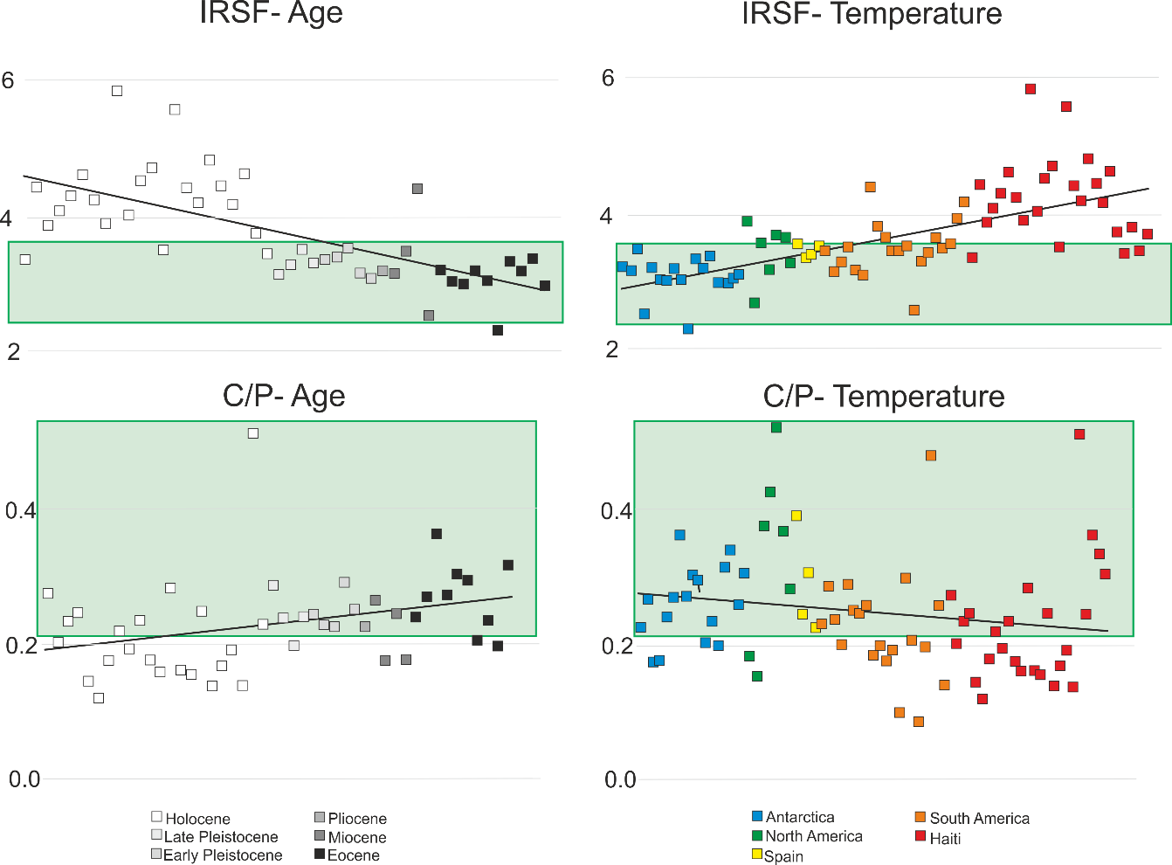
Figure 3.1 The infrared splitting factor (IRSF) and carbonate to phosphate ratio (C/P) results colour coded by the different ages (left to right; young to old) ) and climates (left to right; cold to hot) . The green outlines show the values thought to be indicative of unaltered bone mineral (Beasley et al. 2014).

The assessment of ATR-FTIR as a screening method has shown that this technique is unreliable as a proxy for determining the quantity of surviving protein in fossil samples, due to the complex nature of recrystallization. Therefore these results are considered for extent of mineral alteration. The IRSF shows a clear trend of a lower IRSF for colder environments and the older the sample. The observation that the oldest samples show less alteration of the bone mineral is surprising and is may be due to the re-crystallization of the bone with exogenous mineral and trace elements (Briggs 2003). However, the oldest samples are also from Antarctica and therefore the cold environments may have helped to protect the mineral from alteration. In contrast, the Holocene samples are from Haiti, and therefore the tropical environment is likely to have influenced mineral degradation. When the results of samples from both a hot environment (Spain) and of a considerable age (1.6 Ma; Early Pleistocene) are considered, the samples place close to the boundary of unaltered mineral and show results more in keeping with the older samples from the cold environment than the younger samples from the hot environment. Therefore IRSF appears to be more influenced by the extent of recrystallization allowing the survival of the fossil to these geological ages, rather than environmental conditions. The C/P is more variable both in terms of age and location. However, the average trend shows a similar pattern of alteration to that of the IRSF.

3.2.2 AA analysis results
Of all the 292 samples analysed, 252 were analysed using amino acid analysis; 201 bone, 34 collagen, 12 eggshell, 3 tooth and 2 soft tissue. The eggshell samples, being a closed system (Crisp et al. 2013), were assessed for extent of protein degradation using levels of racemisation, namely Glx (glutamic acid/glutamine), alanine and valine (see Demarchi et al. 2016) as these amino acids were commonly seen in all samples analysed and are known to racemise at different rates (Crisp et al. 2013). If a sample had low D/L values then this was recorded as having surviving proteins. The bone, collagen, soft tissue and tooth samples (being dentine and not enamel (Dickinson et al. 2019)) were evaluated in terms of amino acid composition (Chapter 2, Figure 2.4) and total AA concentration. The bone, collagen and dentine samples were evaluated for a collagen-like AA profile (Solazzo et al. 2016, Saitta et al. 2018b) and the soft tissue samples were compared to modern keratin as well as collagen. If a sample showed high AA concentrations and an AA profile matching collagen/keratin then this sample was recorded as successful i.e. having surviving proteins. If a sample had a slightly altered amino acid profile or a good profile but low AA concentration, this was considered as evidence of the beginning of protein degradation, but not complete diagenesis, and samples showing a non collagen like profile was considered to have undergone complete protein diagenesis. The % success rate for all the samples were calculated from these AA results and are summarised in Figure 3.2. The samples showing an altered AA profile or low AA concentrations are shown as a poor result in order to give conservative estimates of protein survival.

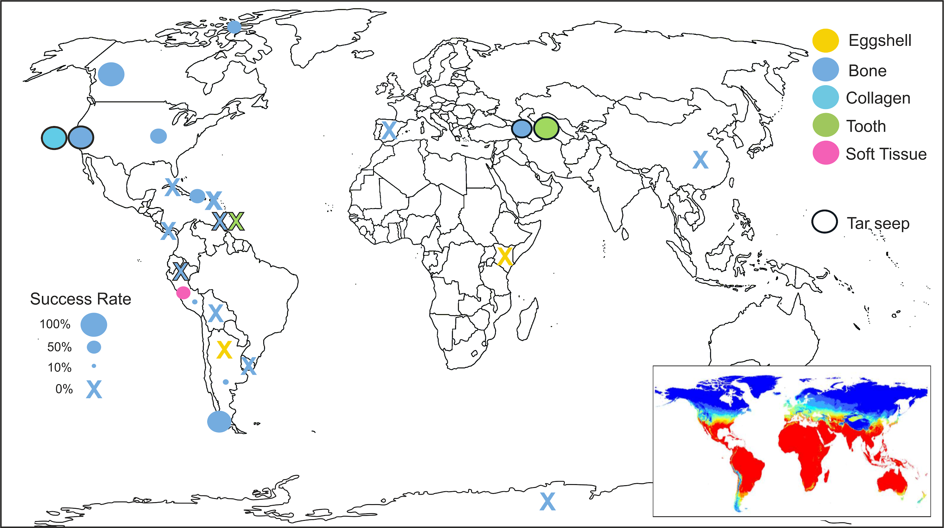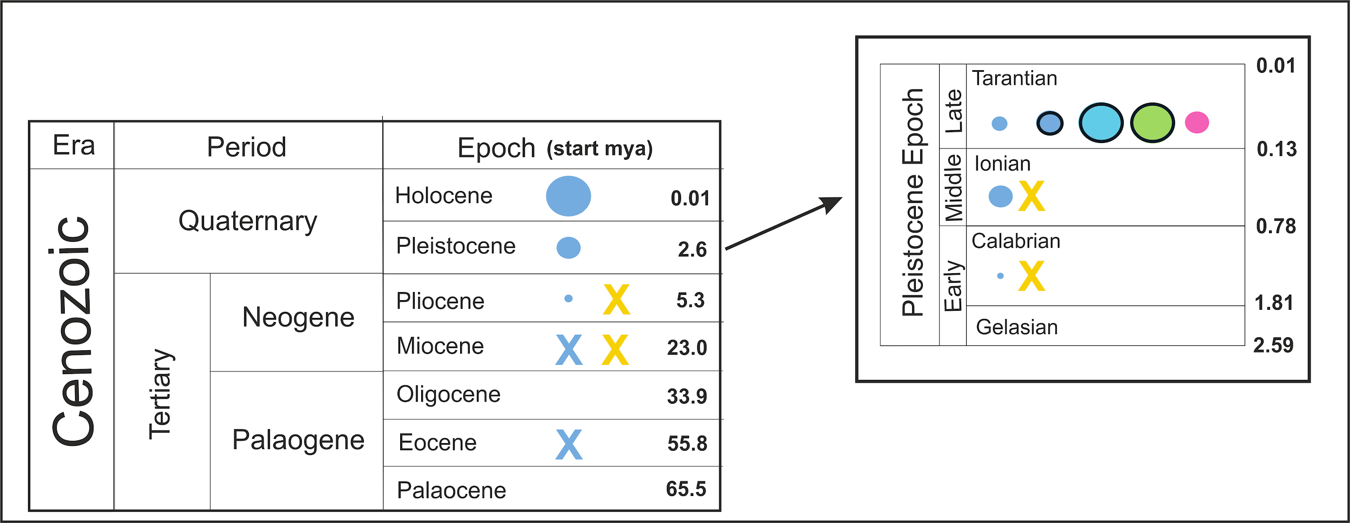
Figure 3.2. The % success rates of the AA results. The eggshell samples were assessed using racemisation, all the other samples were assessed using AA composition. The map insert shows the likelihood of DNA survival across the world, ranging from good (blue) to poor (red) (taken from Hofreiter et al. (2015)). The samples dated to the Pleistocene were split into early, middle and late Pleistocene if the information was available. Not all the samples had location or age information known and therefore are not displayed here.

When these AA results are evaluated in terms of time, there is a clear decrease in successful AA results as we go further back in time. It must be noted that although all the eggshell samples produced fully racemised results, limited sequence information was still able to be retrieved from the Olduvai samples, due to close interaction of the peptides with the mineral, protecting it from hydrolysis (Demarchi et al. 2016). Therefore, while AA analysis can give a good indication of protein diagenesis, this does not mean all proteomic information is lost, other factors need to also be considered, such as the closed vs. open system nature of the fossil and interactions with the surrounding matrix.

The geographical location also has an impact on success rates, with the majority of the samples showing a similar trend to ancient DNA (aDNA) survival (see map insert). However there are some exceptions. The tar seep samples are in locations which are not conducive to aDNA survival (Gold et al. 2014) and yet two of these sites produced very high % success rates (Discussed in more detail in Section 3.3.1). A small % of samples from South America also produced good results. These successful samples are from a range of different sites and, where information is available, date to the Pleistocene. The Chilean samples showed a higher success rate than the other South American samples, and this may be due to the high elevation of the samples (which is also conducive to aDNA survival), but also all the samples were found in cave environments which has been shown to aid biomolecular survival (Solazzo et al. 2016).

The Haitian samples showed a surprisingly high success rate (~53%). This may be partly due to age as, if known, the samples date to ~15,000 BP or younger, but these samples also came from protected environments. Most of the samples had specific site location information and as such, the differences in AA analysis success and location was investigated further (Figure 3.3). There is a clear pattern between location and good AA preservation between the different sites. All the cave sites (Trou) produced poor results while the sinkhole sites (Trouing) produced good results. Depth information for two of these sites is known; Deron (20 m) and Jeremie (16.5 m) (MacPhee et al. 2000). It is likely that due to the depth of these sinkholes, the bones were somewhat protected from the hot and humid environment (Trueman et al. 2004, Pestle and Colvard 2012, Buckley et al. 2017b), therefore aiding biomolecular preservation.

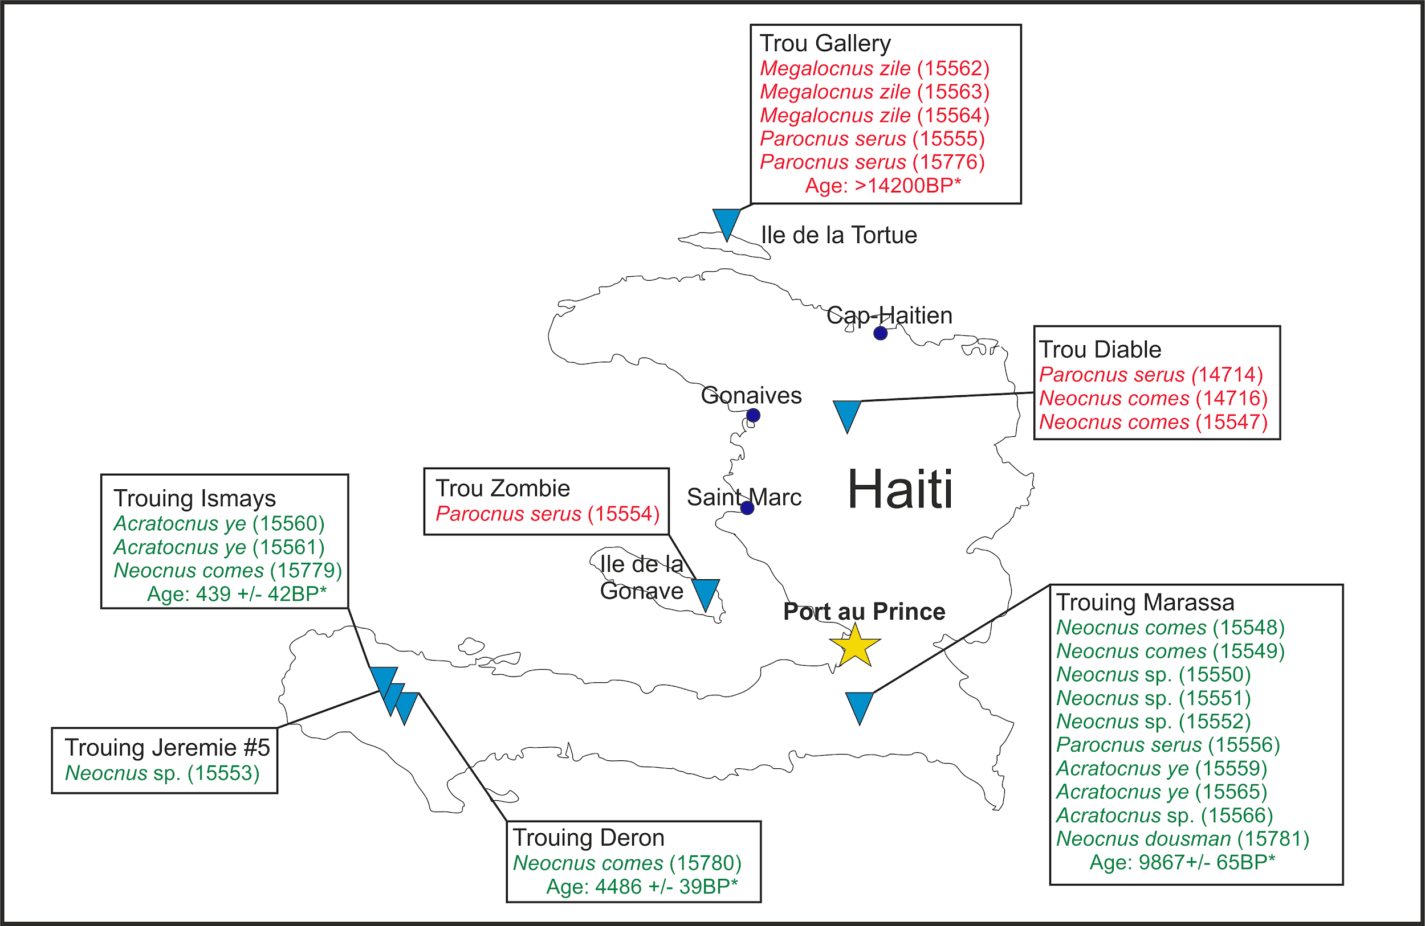
Figure 3.3. The location of the Haitian sloths and their age if known. Good AA results are shown in green and poor results in red. Sample ID is shown in parentheses. Trou in Creole is a large cave, while Trouing refers to a vertical shaft or sinkhole (MacPhee et al. 2000). * Dates taken from Steadman et al. (2005).

It is generally thought that cold environments will aid protein survival (Cappellini et al. 2012, Rybczynski et al. 2013), and this is the case for the Arctic samples. However none of the Antarctic samples produced a good AA “collagen-like” profile or had a low total AA concentration. This may be due the age of these samples; all the Antarctic samples dated to either the Miocene or the Eocene, in contrast to the Pliocene for the Arctic samples, therefore showing while cold temperatures can slow protein degradation it cannot be stopped completely.

3.2.3 MALDI-ToF results
223 samples were analysed using MALDI-ToF MS and the results were evaluated in terms of number of peaks and the highest intensity. The results of the screening methods assessment (Section 2.3.2.3; Figure 2.8) was used to determine a conservative cut off point for successful or unsuccessful spectra. If a sample had a high number of peaks (>40) then it also had to have a high intensity (>1000) in order for it to be considered as well preserved.

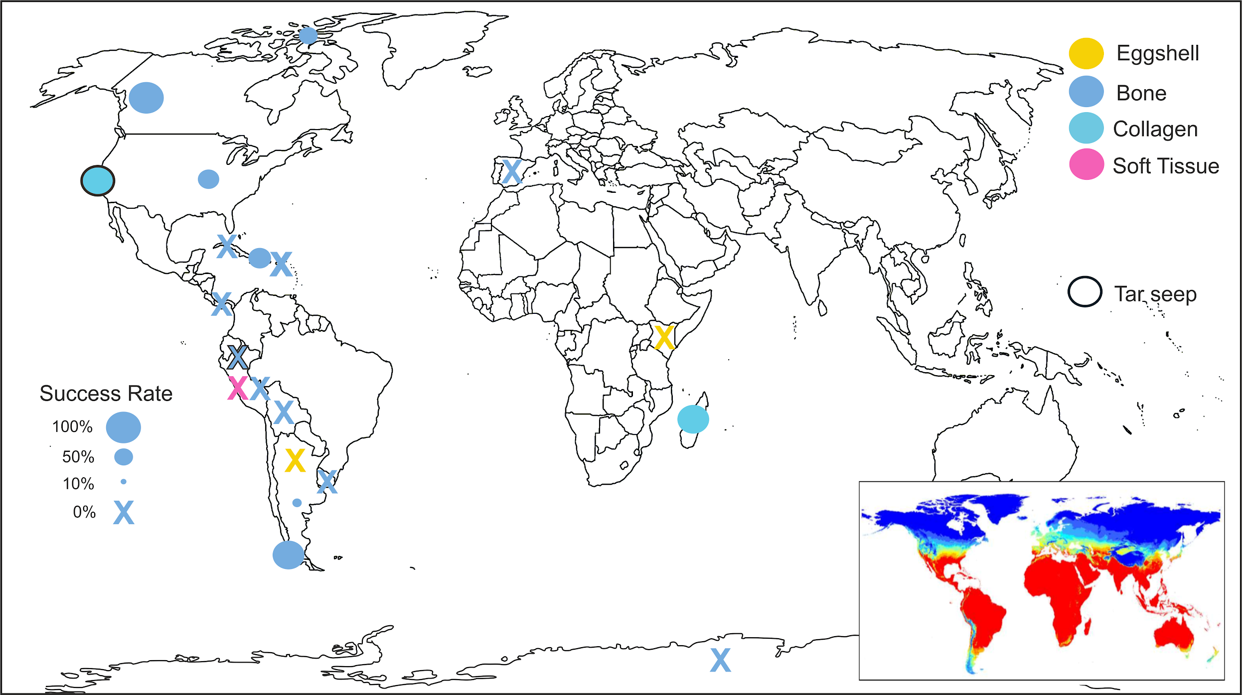
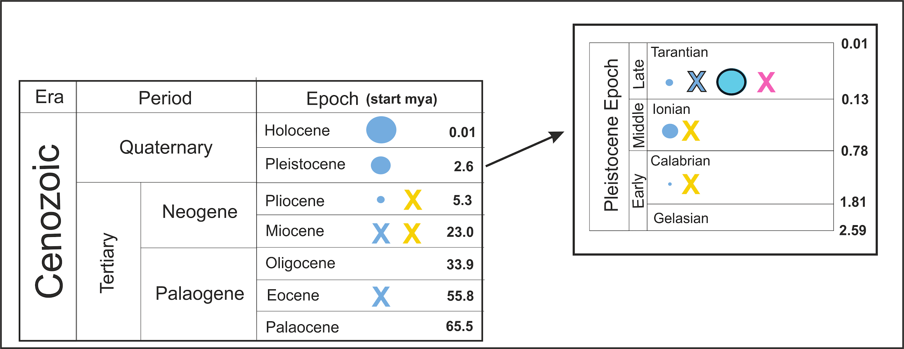
Figure 3.4. The % success rates of the MALDI-ToF results. The samples were assessed using number of peaks and highest intensity. The map insert shows the likelihood of DNA survival across the world, ranging from good (blue) to poor (red) (taken from Hofreiter et al. (2015)). The samples dated to the Pleistocene were split into early, middle and late Pleistocene if the information was available. Not all the samples had location or age information known and therefore were left out.

Overall the MALDI-ToF results are similar to the AA results (Figure 3.2), with some slight differences. A greater success rate was seen in the Argentinian and Haitian samples, while the Peruvian (non tar seep) bone samples were all unsuccessful. Both sets of collagen samples (from RLB and Madagascar) also showed a high success rate, even though these samples are from hot environments. This shows proteins are much more resistant to temperature degradation than DNA.

The successful Argentinian samples were from a variety of locations and if age information was available they all dated to the Late Pleistocene (SALMA age: Lujanian). However, other samples also dating to this age range from the same sites produced poor results so it is unclear why these samples are well preserved. The Haitian samples followed the same trend as with the AA results, showing sinkholes as areas which allow good protein preservation (Figure 3.5). But there were two exceptions, Neocnus dousman from Trouing Marassa produced poor spectra (27 peaks and HI of 668) while Megalocnus zile from Trou Gallery produced good spectra (83 peaks and HI of 1895). However, when these samples were sequenced, N. dousman produced good MS/MS results while M. zile produced poor results (discussed in Section 2.3.2.3). The MALDI-ToF results also show similar levels of success to the AA results for all samples from cold environments, with the majority of samples having a low success rate. This shows that protein preservation is not merely temperature dependant. In terms of age and protein preservation, there is a trend of decreasing success rate with increasing age, in agreement with the AA results, and shows that the age of the sample will affect protein preservation despite environmental conditions.

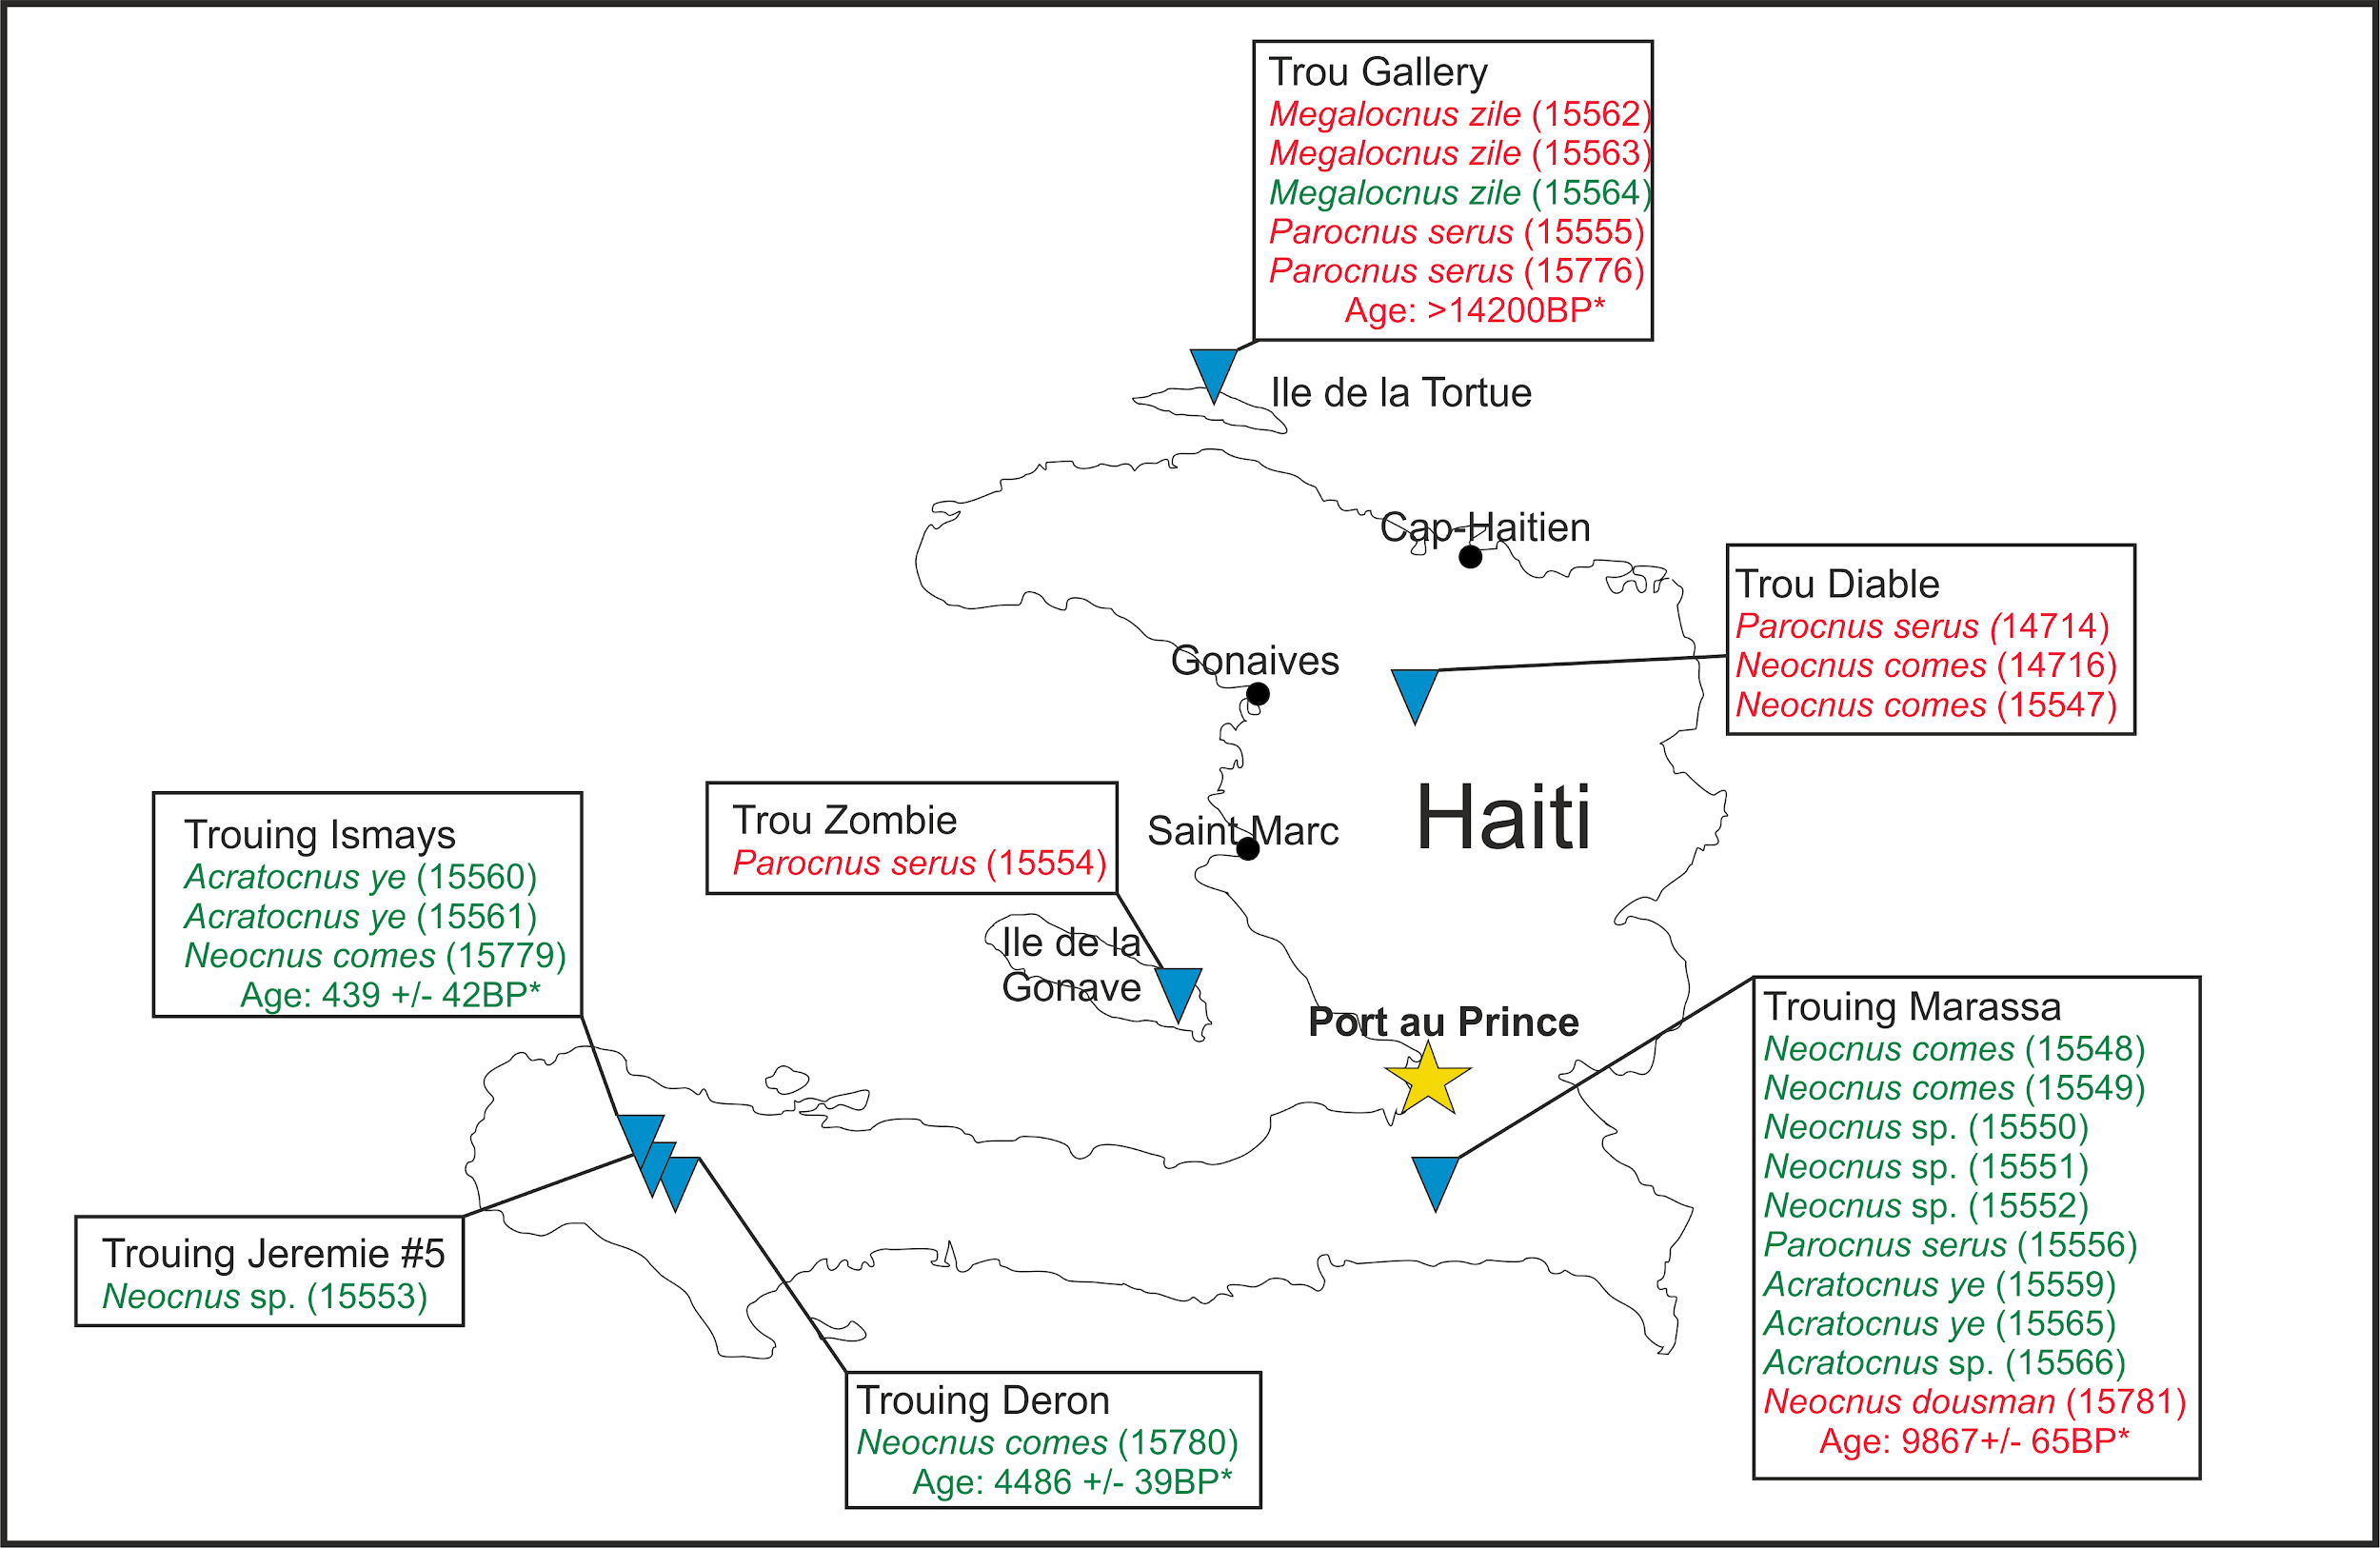
Figure 3.5. The location of the Haitian sloths and their age if known. Good MALDI mass spectra are shown in green and poor results in red. Sample ID is shown in parentheses. Trou in Creole is a large cave while Trouing refers to a vertical shaft or sinkhole (MacPhee et al. 2000). * Dates taken from Steadman et al. (2005).

3.2.3.1 Assessment of glutamine deamidation
As MALDI-ToF analysis can give direct peptide information it was possible to assess samples further for diagenetic alteration using deamidation. Deamidation is one of the main breakdown pathways of asparagine and glutamine and can occur via internal cyclisation or hydrolysis (Robinson and Robinson 2001). Deamidation introduces a negative charge and causes a mass shift of 0.984 Da which can be detected using MS. Asparagine deamidation is shown to have a short half life (Geiger and Clarke 1987) and therefore, glutamine deamidation has been used to study long term protein degradation in archaeological samples (Wilson et al. 2012, Solazzo et al. 2014, Simpson 2015, Schroeter and Cleland 2016, Simpson et al. 2016). The collagen samples from Rancho La Brea were selected for deamidation analysis as they were left over from radiocarbon analysis and therefore had reliable date information. The samples came from three different excavations: the Hancock collection, Pit 91 and Project 23 (Heric 1969, Shaw 1982, Harris et al. 2011), and the extent of deamidation from these different areas were compared. Two peptides were chosen, as these peptides were found in all the samples analysed. The deamidation values were compared to age and Asx (asparagine and aspartic acid combined) racemisation (Figure 3.6).

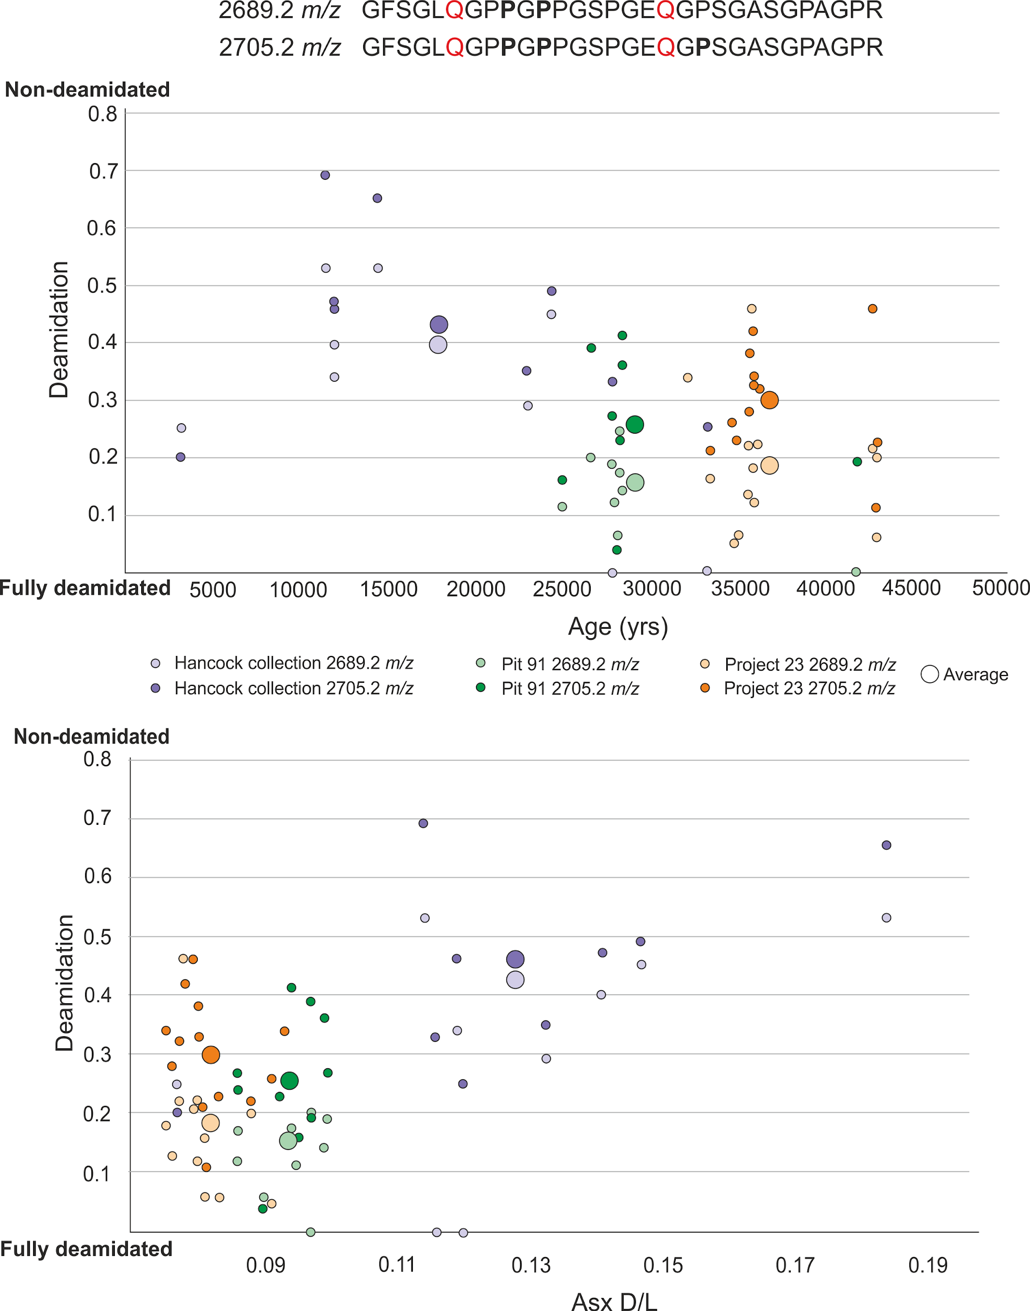
Figure 3.6. The extent of deamidation in the RLB collagen samples, colour-coded by the different excavations and peptides. The P in bold represents hydroxylation of proline. The data from each sample is shown by small circles, with larger circles representing the average for each tar pit. The upper graph compares deamidation values to age, while the lower graph compares the deamidation values to Asx racemisation.

Glutamine deamidation is known to vary both between sites (Doorn et al. 2012) and within the same site due to a number of variables, such as sampling and bone size (Simpson et al. 2016, Buckley et al. 2017c, Welker et al. 2017b), as well as age and level of preservation (Wilson et al. 2012, Schroeter and Cleland 2016). However, in general the results show the peptide with an extra hydroxyproline has less deamidation. Hydroxyproline provides stability to the collagen molecule (Gorres and Raines 2010) and therefore may act to protect this peptide from degradation. This data supports the hypothesis that peptide sequence and the presence of post translational modifications (PTMs) affects protein degradation. On average the Pit 91 samples show the most deamidation, even though Project 23 samples are the oldest, suggesting deamidation is affected by more than just age. Other influencing factors on deamidation rates include the different post excavation treatments between the sites, as well as sampling variation.

Only Asx from these collagen samples showed any variation in racemisation data between samples, and when these values are compared to the deamidation results (Figure 3.6), the Hancock collection samples show a very different preservation profile to both Pit 91 and Project 23. These Hancock samples show contradictory results, with generally lower levels of deamidation but the highest levels of racemisation. However, the MS/MS results from the Hancock collection produced the best data, suggesting that the low levels of deamidation represents low levels of protein breakdown. Asx racemisation can occur in chain, and the higher levels of Asx seen in these samples may be due to time since excavation or post excavation techniques (See section 3.3.1 for details) rather than showing protein breakdown, also indicated by the lack of racemisation in the other amino acids studied. Deamidation, therefore can provide an indication of protein survival/breakdown but is best applied in conjunction with other techniques due to the different factors that can affect the results.

3.2.4 Analysis of sequence data
76 samples have been analysed using LC-MS/MS as part of this thesis. Out of these, 20 samples have been selected to be analysed in detail, as they have both age and location information known (Table 3.1). Samples from Venta Micena and Antarctica have been analysed using two different protein extraction methods and the results of both sets of analyses are reported (see Section 3.2.4.3 for more in depth interpretation of these samples). A modern sample has also been included as a comparison. The peptides from collagen 1 (both the alpha 1 and 2 chain) have been assessed by the extent and variation of PTMs and non-tryptic cleavage. Collagen type 1 was chosen as it is the most abundant and well studied bone protein in palaeoproteomic studies.
ID | Species | Age | Location | Col1 peptides
17009 | Choloepus hoffmanni | Modern | America | 2089
15780 | Neocnus comes | 4486 ±39 BP* | Trouing Deron (Haiti) | 956
15781 | Neocnus dousman | 9867 ± 65 BP* | Trouing Marrasa (Haiti) | 937
16849 | Megalonyx jeffersonii | 11255 ± 25 BP# | Newburgh, NY, USA | 1287
16638 | Panthera atrox | 15200 BP | Rancho La Brea, USA | 929
15225 | Megatherium americanum | 19050 ± 80 BP# | Bariloche, Argentina | 847
15191 | Doedicurus sp. | 25370 ± 180 BP# | Camet Norte, Argentina | 1485
16645 | Smilodon fatalis | 28000 BP | Rancho La Brea, USA | 1249
16895 | Arctodus simus | 28690 ± 250 BP | Yukon | 1168
16646 | Smilodon fatalis | 36000 BP | Rancho La Brea, USA | 1089
16857 | Panthera leo | 96-120000 BP | Binagadi asphalt lake, Azerbaijan | 631
16860 | Equus hydruntinus | 96-120000 BP | Binagadi asphalt lake, Azerbaijan | 853
15216 | Glossotherium robustum | Bonarean (128-400 Ka) | Argentina | 1250
15202 | Scelidotherium sp. | Ensenadan (0.4-1.8 Ma) | Argentina | 740
17480 | Scelidodon sp. | Pleistocene  (11.7 Ka-2.6 Ma) | Cueva Rosello, Peru | 1947
15570 | Equus sp. | 1.6 Ma | Venta Micena, Spain | 8
15570 | Equus sp. | 1.6 Ma | Venta Micena, Spain | 45
15571 | Equus sp. | 1.6 Ma | Venta Micena, Spain | 0
15571 | Equus sp. | 1.6 Ma | Venta Micena, Spain | 7
15930 | Protarctos abstrusus | 3.4 +0.6/-0.4 Ma^ | Ellesmere Island | 1797
15746 | Paracamelus sp. | Pliocene (2.6-5.3 Ma) | Central Alberta | 486
15248 | Palaeosphenicus biloculata | Early Miocene  (15.97-23.03 Ma) | Gaiman fm. Patagonia | 6
15248 | Palaeosphenicus biloculata | Early Miocene  (15.97-23.03 Ma) | Gaiman fm. Patagonia | 19
15255 | Palaeeudyptes gunnari | Eocene  (33.9-56 Ma) | Marambio, Antarctica | 1
15255 | Palaeeudyptes gunnari | Eocene  (33.9-56 Ma) | Marambio, Antarctica | 57
Table 3.1. The samples that have been selected for sequence analysis from various locations and range from Modern to the Eocene. *(Steadman et al. 2005), ^(Wang et al. 2017), # (Presslee et al. 2019). Samples were analysed following the MALDI-ToF bone protocol or the SDS PAGE protocol (highlighted in orange) outlined in Chapter 2. The samples in bold were digested using trypsin only, allowing for the analysis of tryptic vs. non tryptic cleavage of the peptides.

3.2.4.1 Post translational modification (PTM) analysis
The extent of post translational modifications seen in the samples were evaluated as well as the number of different PTMs. This was compared to both age and the environmental conditions (Figure 3.7).

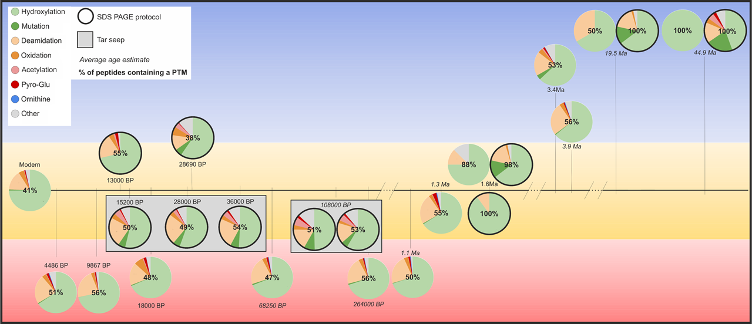
Figure 3.7. The % of altered peptides per sample (in bold) compared to time (left-right) and average climate (up-down; cold-hot) The ratio of the most common PTMs identified in each sample are shown in the pie charts.

Overall, if we compare the number of PTMs to time, there is a slight trend of % altered peptides increasing with age. However, the temperature and environmental conditions are also an influencing factor; the sample with the least number of altered peptides is Arctodus simus which dates to 28,690 BP from the Yukon. The PTM profiles of the three samples from RLB are all very similar despite an age difference of ~20,000 years, also suggesting environmental factors influence PTMs and protein degradation.

The main PTM in all samples is hydroxylation, which is common in collagens as part of the formation of the protein’s higher structure (Gorres and Raines 2010) and, as such, does not imply protein degradation. Indeed hydroxylation may help the peptide to survive into geological time, with one of the oldest samples showing the only PTM present to be hydroxylation. This also supports the MALDI-ToF deamidation data mentioned above (Section 3.2.3.1) which shows less deamidation in the peptide with more hydroxylated prolines. Mutations are amino acid substitutions and are more likely to be due to species differences than degradation (See Chapter 4). However, it is of interest to note that, of the samples that were analysed using both the FASP protocol and SDS PAGE, more mutations were identified in the SDS PAGE samples. The SDS PAGE samples also show a higher number of peptides and a different PTM profile, with a greater number of PTMs being identified (Figure 3.7, bold outline). This suggests that SDS PAGE allows the retention of more proteomic information. The PTM ornithine from arginine was included to try to assess levels of amino acid breakdown, but very low levels of this PTM was found, suggesting little amino acid degradation detectable through this marker.

Common PTMs that are indicative of protein breakdown are deamidation, oxidation, acetylation and pyro-glu from either glutamine (Q) or glutamic acid (E). These PTMs are assessed in terms of time and temperature (Figure 3.8).

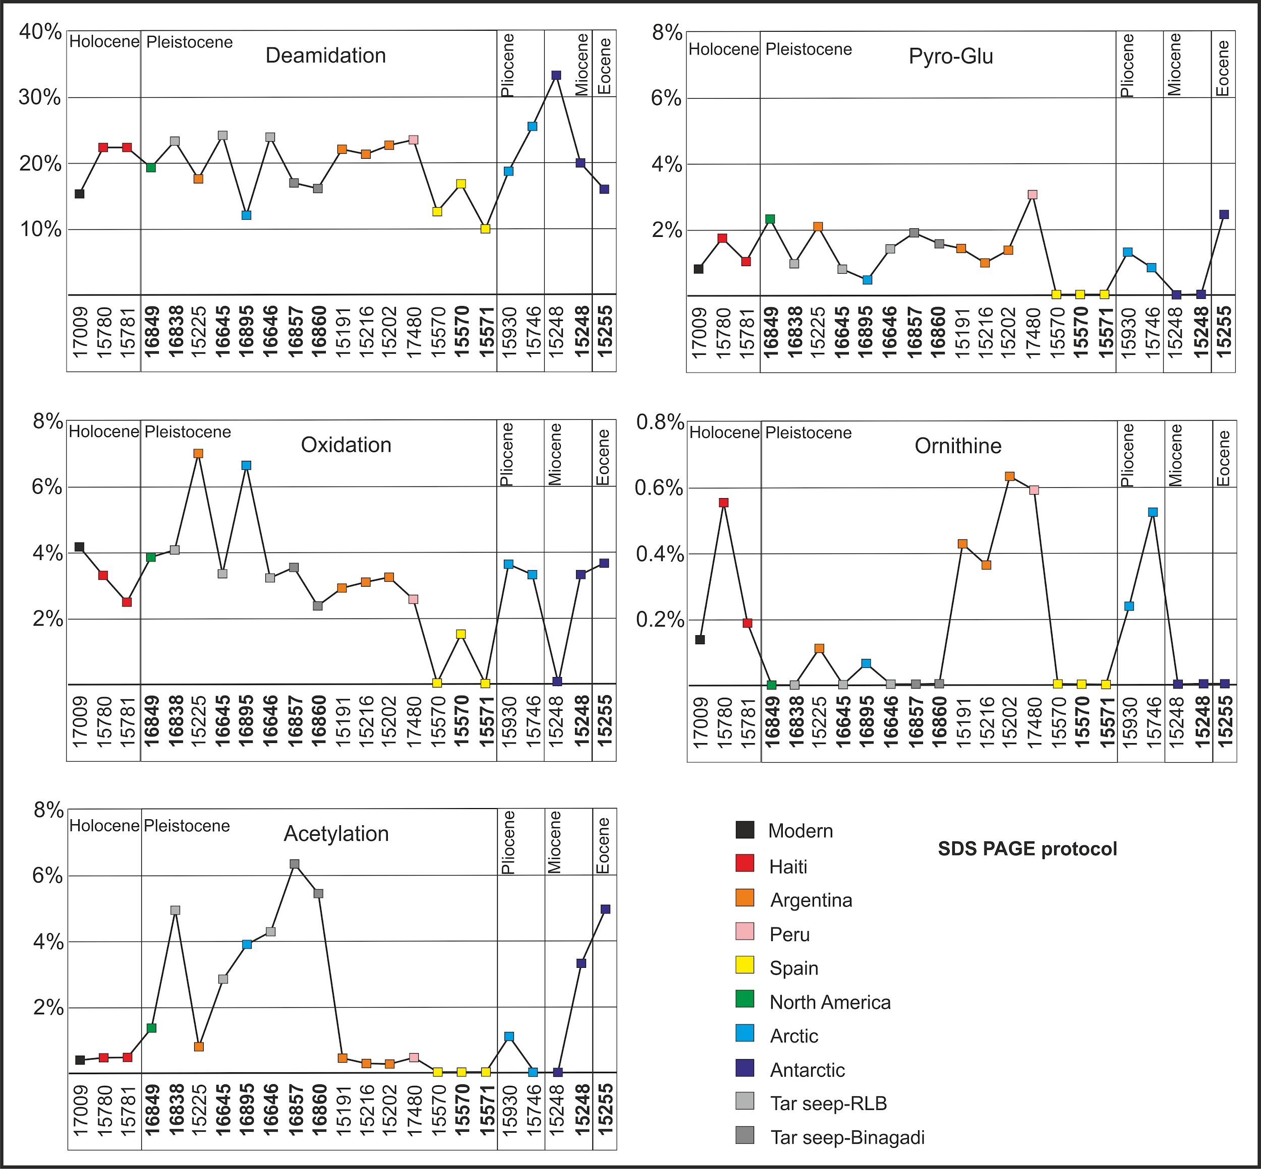
Figure 3.8. Diagenetic PTMs compared to both location and age. The samples range from modern on the left to Eocene on the right and the different locations are colour coded. Samples analysed using the SDS PAGE extraction protocol are in bold.

By far the most studied PTM is deamidation. Overall there is a slight increase in deamidation with time, however the oldest sample shows deamidation levels similar to the modern sample. This again suggests that deamidation is also affected by other preservation factors such as temperature and sample treatment, as shown with the MALDI-ToF results, and also in recent studies (Simpson et al. 2016; Mackie et al. 2018). Therefore, this PTM may be better suited to intra-site analysis (Welker et al. 2017b) rather than inter-site comparisons between samples with different sampling and post excavation histories. Other diagenetic PTMs show no clear correlation with age or environmental conditions. A slight trend can be seen for acetylation which shows the highest levels in the tar seep samples and the samples from the cold environments. Slightly higher levels of ornithine from arginine can be seen in samples not analysed using SDS PAGE, and this may be an extraction bias rather than evidence of diagenesis.

3.2.4.2 Peptide backbone cleavage
11 of the samples (Table 3.1 in bold) were only digested with trypsin and therefore the extent of non-tryptic peptide backbone cleavage could be investigated (Figure 3.9).

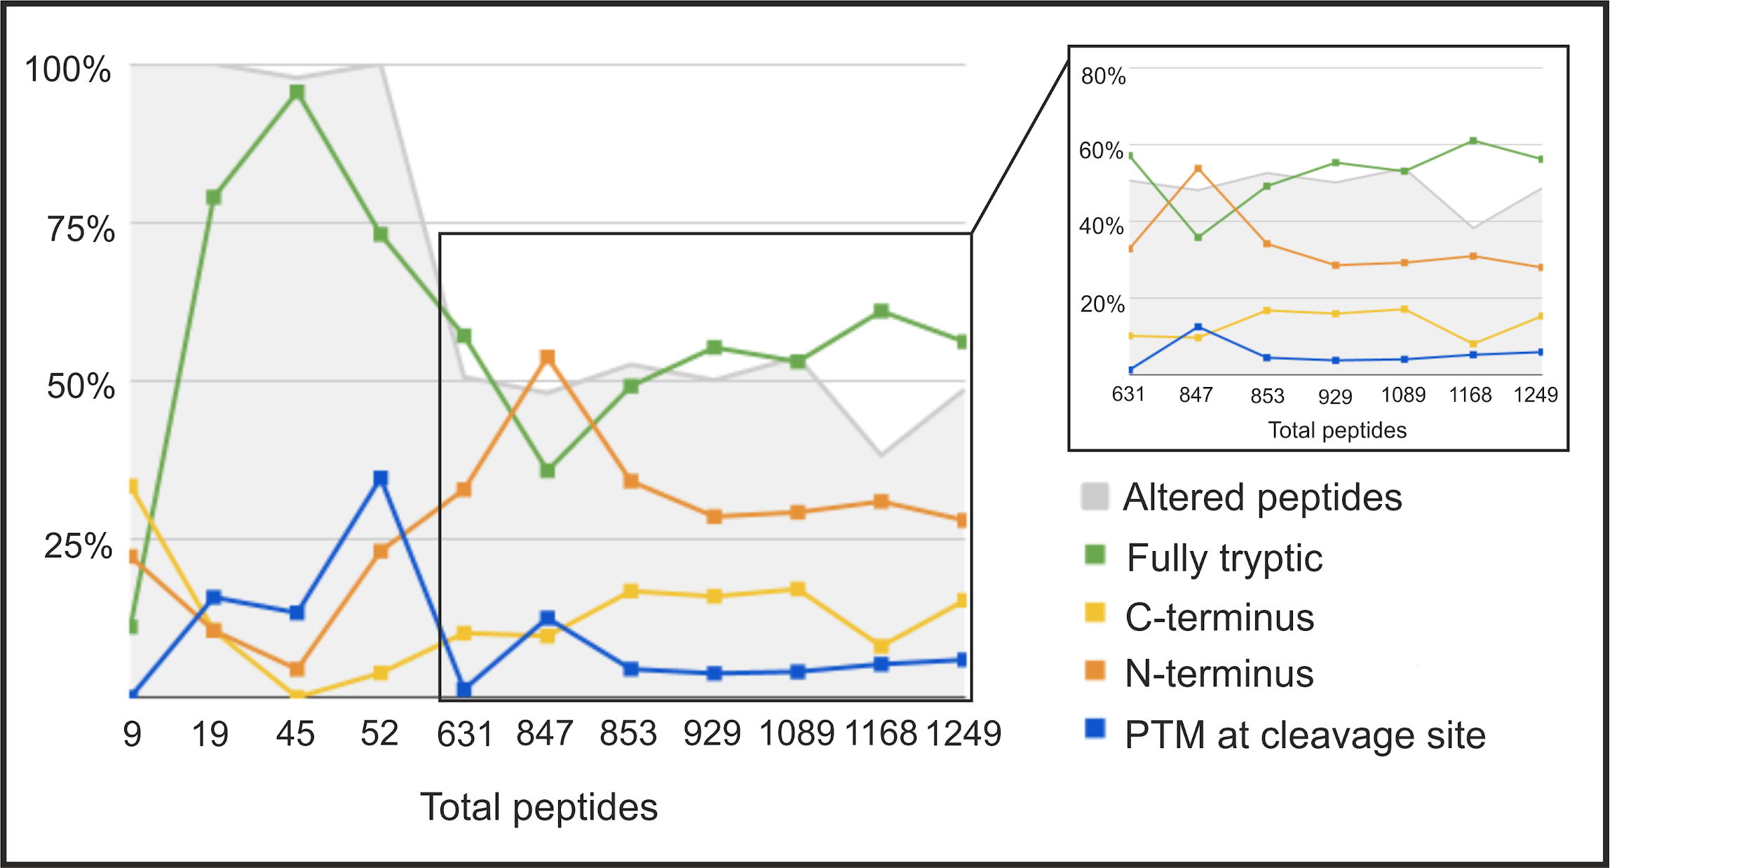
Figure 3.9. The % of tryptic and non-tryptic cleavage compared to overall levels of altered peptides (i.e. those peptides containing a PTM). The number of PTMs at the end of a peptide is also recorded. The insert shows all the successful samples (>100 peptides).

The samples that showed the most tryptic peptides were the samples that produced the least peptides, with the exception of sample 15571 (9 peptides; 1.6 Ma from Venta Micena). This is somewhat surprising, as fully tryptic peptides might suggest well preserved collagen sequences. The samples with less than 100 identified peptides were the two samples from Venta Micena (15570 and 15571) and the two Antarctic penguin samples (15248 and 15255). These samples showed a much higher level of altered peptides and a very different peptide cleavage profile to the other samples. A more in depth investigation of protein preservation in these 4 samples is presented in Section 3.2.4.3. All the samples with a high number of identified peptides (Figure 3.9, insert), show similar levels of fully tryptic peptides (~50-60%) and non-tryptic cleavage at both the C and N terminus. When the non-tryptic cleavages are investigated further, and split into different amino acid groups (Figure 3.10), all successful samples (>100 peptides) show a similar profile, suggesting that collagen peptide backbone breakage occurs at the same/similar points along the protein (at least initially) before extensive protein degradation occurs.

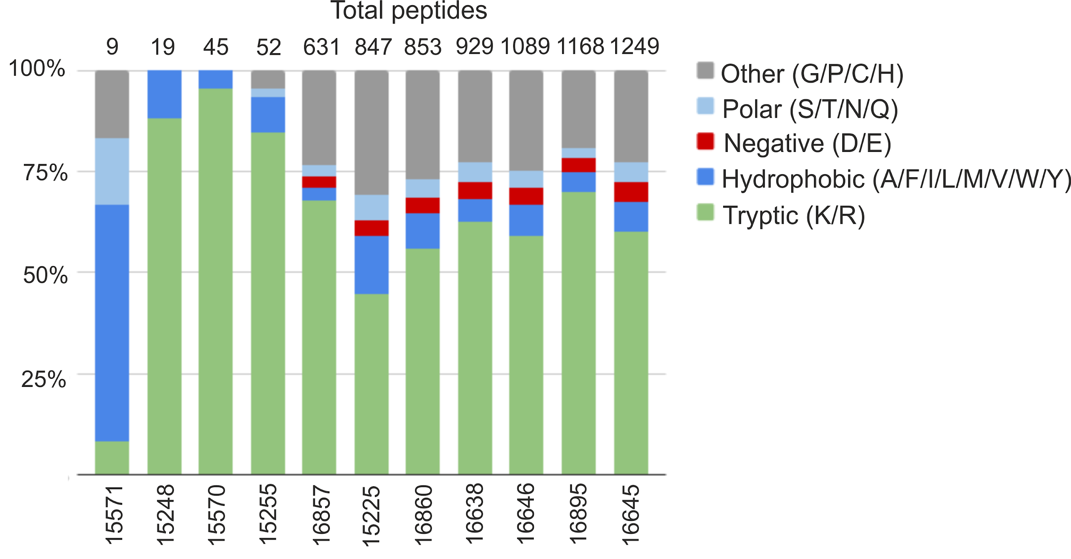
Figure 3.10. The cleavage sites of peptides, split into amino acids with similar chemical characteristics (AA’s are shown by their single letter code see Figure 1.1). The samples are ordered in increasing number of peptides. There is a clear difference between successful samples (>100 peptides) and unsuccessful samples. The total number of peptides is recorded at the top of the chart.

There is more non-tryptic cleavage at the N terminus of a peptide than the C terminus. This may be due to sample preparation rather than a marker for degradation. Olsen et al. (2004) found that non tryptic cleavage occurred at the N termini due to the breakup of fully tryptic peptides at an internal proline bond. Cleavage at a proline is more likely to occur at an aspartic acid-proline bond (D-P) as it is well known that the amide bond between these two amino acids is the weakest peptide bond and can easily be hydrolysed (Han et al. 1983). The peptide bond between asparagine and glycine is also susceptible to hydrolysis at the N terminus (Butler 1969, Bornstein 1969). Sample 15225 (847 peptides; 18000 BP from Argentina) showed fewer tryptic peptides than the other successful samples (Figure 3.9, insert). This sample was analysed using the FASP protocol which involves demineralisation in HCl, while all the other samples were analysed using SDS PAGE. This may suggest that the protein extraction method will influence the formation of non tryptic cleavage, especially at those amino acids with easily hydrolysed peptides bonds and this must be taken into account when predicting protein degradation.

The relationship between PTMs and non-tryptic cleavage was investigated further (Figure 3.11). There is a general correlation between a decrease in fully tryptic peptides and the increase in the presence of a PTM at the end of the peptide. This suggests that the formation of PTMs occurs once the peptide chain has been disrupted and broken. The formation of these PTMs can then cause further breakdown of the protein molecule.

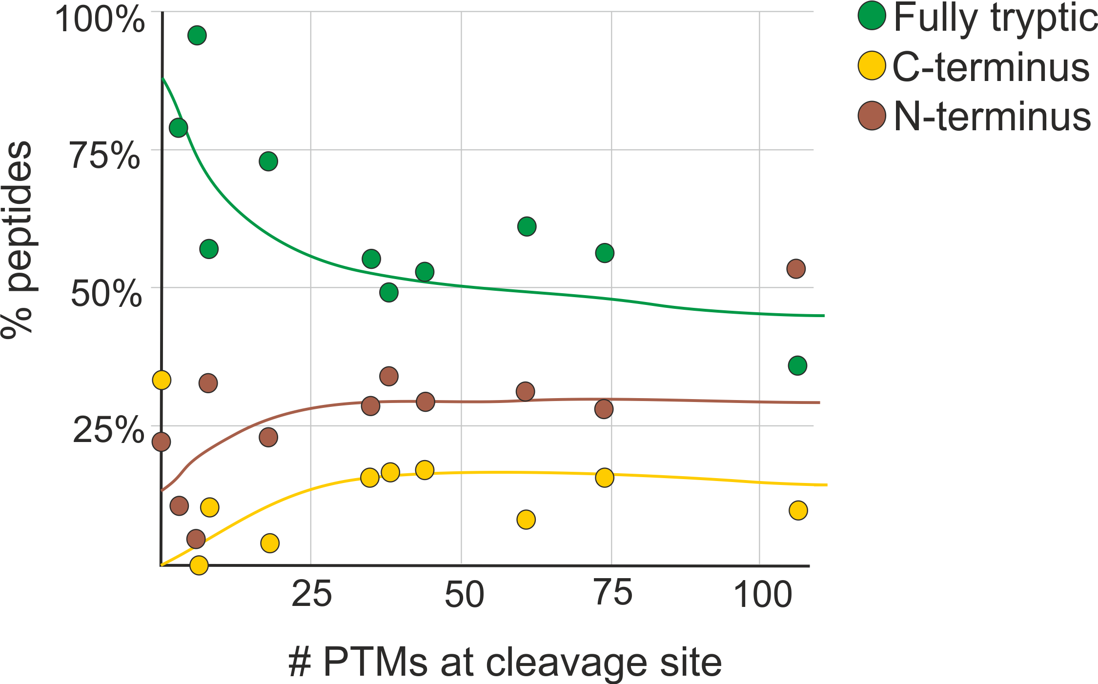
Figure 3.11. The number of PTMs identified at the end of the peptide compared to fully tryptic and non-tryptic peptides.

It must also be noted that PTMs may affect the ability of trypsin to cut the peptides. Trypsin cuts at arginine and lysine, but lysine undergoes several post translational modifications during the formation of collagen (Persikov et al. 2005, Yamauchi and Sricholpech 2012). One of these PTMs is acetylation (Yang and Seto 2008). This addition of an acetyl group prevents a positive charge from forming on the amino group and therefore may hinder the ability of trypsin to cleave the peptides for mass spectrometric analysis (Yang and Seto 2008). However, good sequence coverage was still seen in samples which were only digested with trypsin, suggesting this has minimal effect on peptide recovery.

3.2.4.3 In depth sequence analysis of Venta Micena and Antarctic samples
As mentioned previously, there can be database limitations for data interpretation of ancient proteins. There can also be limitations due to the ionisation potential of the surviving peptides. Some peptides are more easily ionised than others, and therefore the MS results will show a bias towards these peptides, portraying them as the best ‘preserved’ when in reality they are the best ionised. The surrounding matrix and the type of substrate will influence the ionisation potential of peptides. This needs to be considered when comparing different samples and may influence the comparison between the two sites. However this bias should be minimal when comparing samples from the same site.
Collagen type 1 (both alpha 1 and 2) coverage for the Venta Micena samples are shown in Figure 3.12 and the collagen coverage of the Antarctic samples in Figure 3.13. There is much higher coverage of COL1A1 than COL1A2 in the Venta Micena samples, which is not surprising as the collagen triple helix is made from two alpha 1 strands and only one alpha 2 strand, allowing more chance of alpha 1 peptides to survive and be recovered. The coverage in the penguin samples is much more even for both alpha chains.
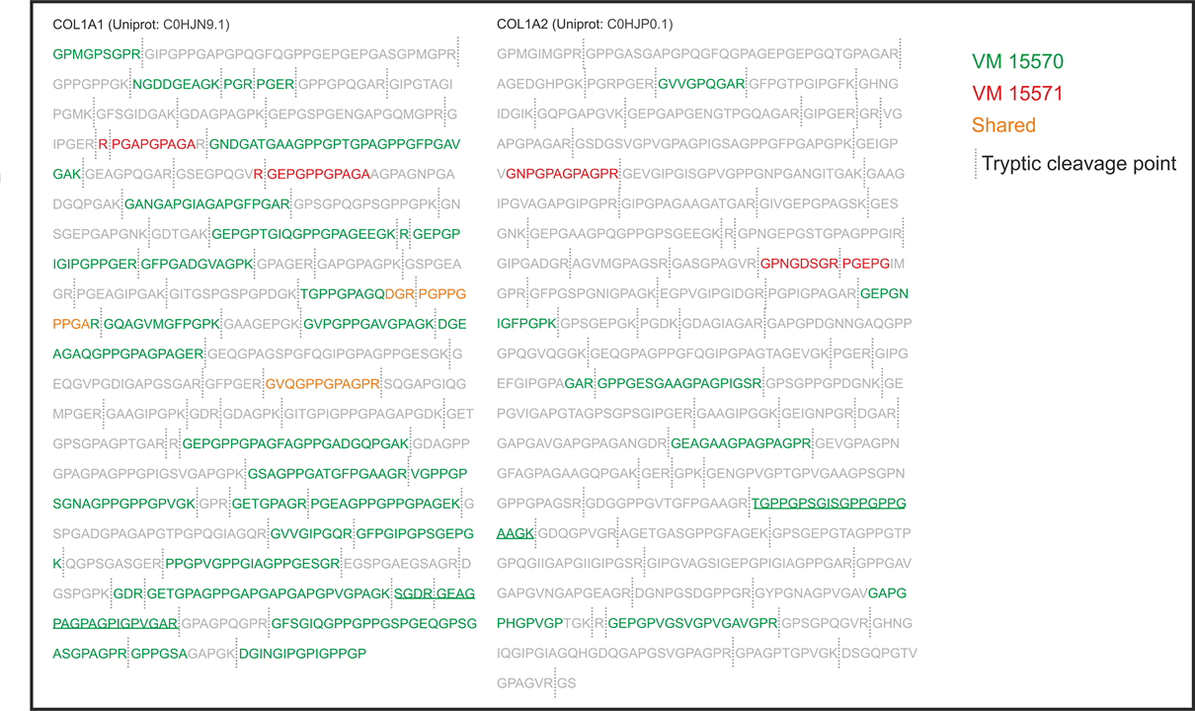
Figure 3.12. Collagen coverage for the Venta Micena samples (15570 in green; 15571 in red; both in orange). The sequence underlined are peptides that are unique to Equidae.
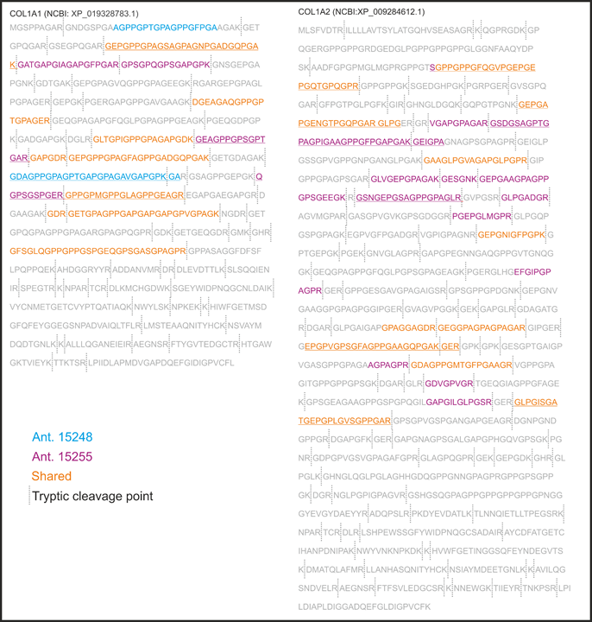
Figure 3.13. Coverage of collagen type 1 (A1 and A2) from the penguin samples. Sample 15248 shown in blue, 15255 shown in purple, shared between both shown in orange. Sequence underlined contains a peptide that is unique to Aves or Sphenisciformes.
Sample 15248 contained less recoverable peptides than 15255, however the majority of the peptides identified in 15248 is also shared with sample 15255 (Figure 3.13 shown in orange), with only 2 peptides being found in this sample only (Figure 3.13 shown in blue). This is not the case for the Venta Micena samples. 15571 is the least well preserved of all the samples, resulting in only 7 collagen type 1 peptides and very low sequence coverage. However, only 2 peptides matched sequence also covered by sample 15570, the remaining 5 peptides covered sequence not identified in the other Venta Micena (VM) sample. This suggests that the Antarctic samples may have undergone similar degradation pathways, resulting in a similar set of preserved peptides, while the big contrast in the VM samples suggest that these two samples were influenced by different degradation factors, for example the presence of water.
The collagen type 1 peptides recovered from the samples were assessed further to determine possible evidence for how these peptides were preserved. Previous studies have shown the lack of negatively charged (acidic) amino acids in recovered ancient peptides (Asara et al. 2007, San Antonio et al. 2011), suggesting these acidic amino acids are more readily lost to the environment. In order to test this, the peptides were analysed in terms of amino acid properties (Figure 3.14).
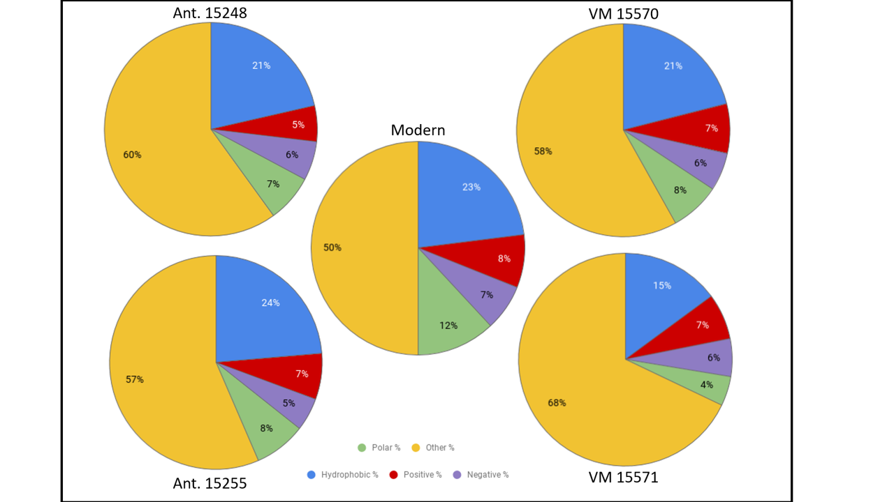
Figure 3.14. The mean amino acid properties of all the peptides for each sample, compared to an averaged modern sample. Polar (Ser, Thr, Asn, Gln); hydrophobic (Ala, Ile, Leu, Val, Met, Phe, Tyr, Trp); positive (Arg, His, Lys); negative (Asp, Glu); other (Gly, Pro, Cys). VM-Venta Micena samples; Ant.-Antarctic samples.
Unlike the San Antonio et al. (2011) paper, no reduction in acidic peptides was seen in these samples, instead the biggest change was seen in the percentage of ‘other’ amino acids (glycine, proline and cysteine) which made up a greater percentage of the ancient samples. There was also a slight reduction in polar amino acids in all the fossil samples, suggesting these potentially more reactive amino acids are lost (or no longer easily ionised). Glycine and proline are very common amino acids in collagen. The preferential preservation of peptides with a high number of these amino acids may be linked to thermostability. A previous study had shown that ancient peptides have a higher percentage of thermally stable amino acids than modern samples and present this as evidence of how these proteins are preserved (Wang et al. 2012). All the identified peptides in this study were assessed to determine the percentage content of the top six thermally stable amino acids (Ala, Gly, Pro, Val, Leu, Phe) and an average for each of the samples is shown in Figure 3.15.
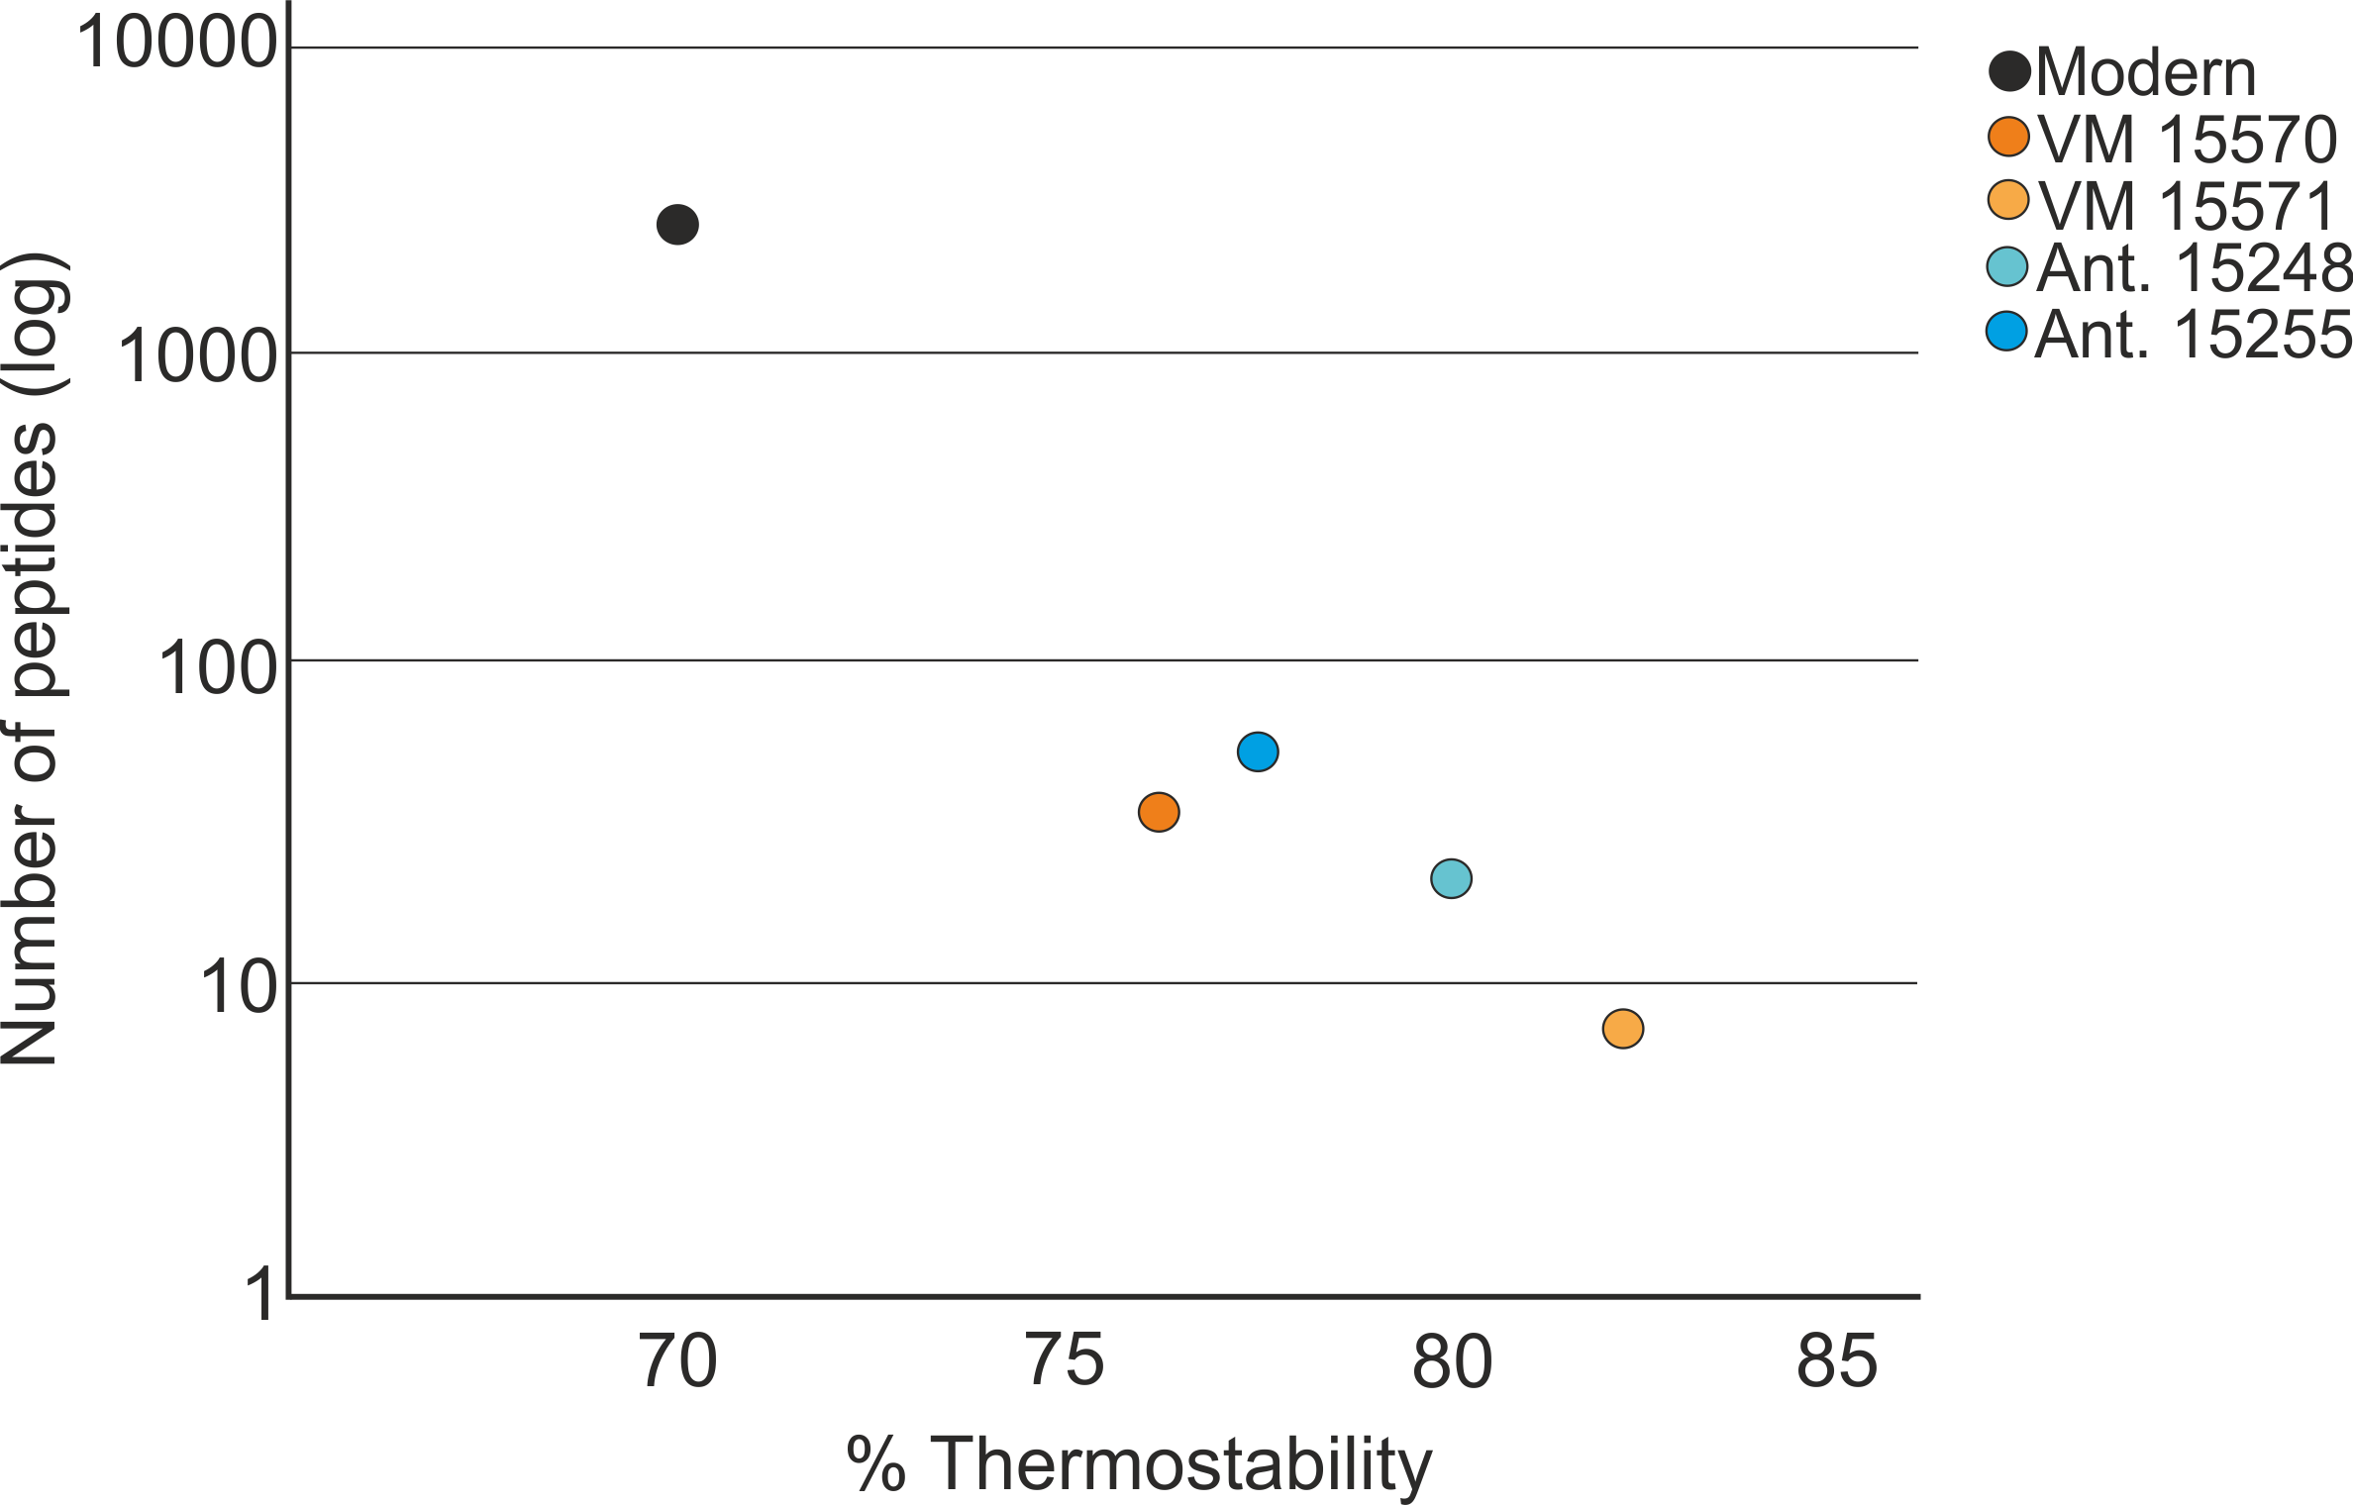
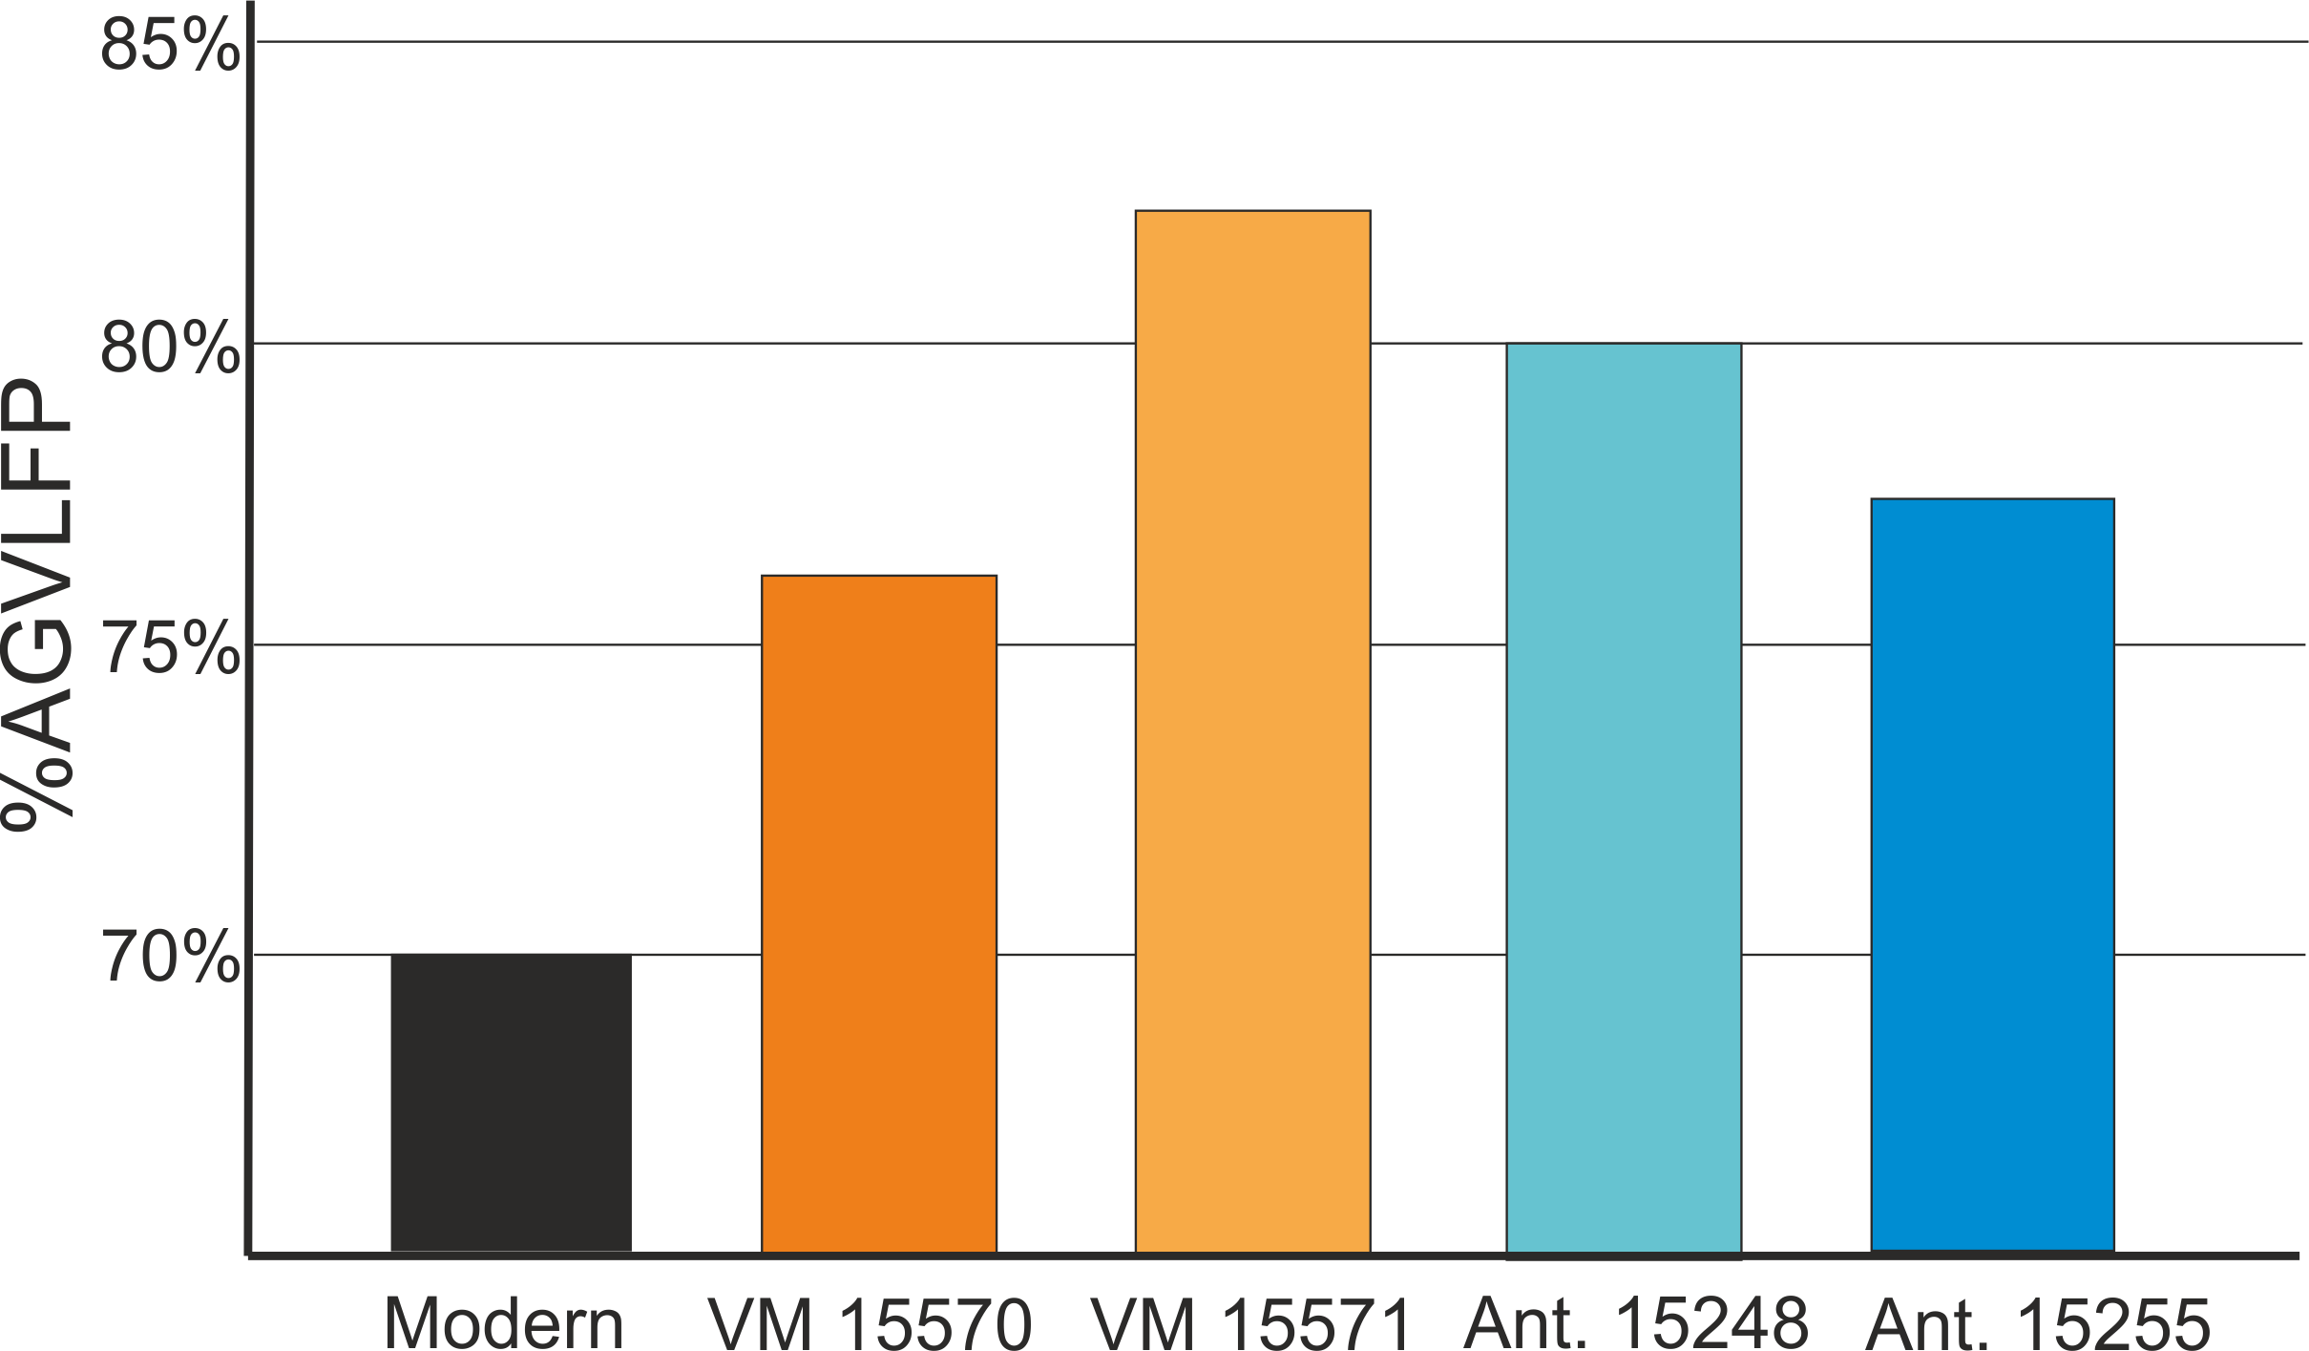
Figure 3.15. The average content of the top six thermally stable amino acids in the collagen peptides for each of the samples. A;alanine, G;glycine; V;valine, L; leucine, F; phenylalanine, P; proline. This % thermostability is compared to the number of recovered peptides. VM-Venta Micena samples, Ant.-Antarctic samples.
All fossil samples showed a higher percentage of thermostable amino acids than the modern sample. The results show a general trend of the higher number of peptides recovered from a sample, the lower the average thermal stability. However, sample 15570 yielded slightly fewer collagen peptides than 15255 but shows a lower % thermostability. This suggests that the thermally stable peptides are the most resistant to decay, but other factors, such as ionisation needs to also be considered. The fact that the two Venta Micena samples do not recover the same peptides suggests that it is not the same set of highly stable peptides that are preserved in samples, even from the same site and species, this is contra to studies on other substrates such as eggshell (Demarchi et al. 2016) and may be due to the more open system nature of bone.
More in depth analysis of the PTMs occurring in these samples was also conducted. The results of the PEAKS analysis of the SDS PAGE tryptic digest samples were chosen to be compared for PTMs. PEAKS was used, as this software allows a wide number of post translational modification (PTMs) to be identified (Zhang et al. 2012), and the tryptic SDS PAGE samples were chosen as this analysis resulted in peptides for all samples. A total of nine different PTMs were found in the samples. Hydroxylation, acetylation and methyl esters are known to occur in vivo and may help to stabilise the peptide and prevent the action of enzymatic degradation (McFadden and and Clarke 1986, Yang and Seto 2008, Gorres and Raines 2010). Ethylation, formylation and the addition of a sodium adduct was found in the Antarctic samples, but these PTMs are known to be introduced during sample preparation and LC-MS/MS and so were removed from the PTM analysis (Schug and and McNair 2002, Xing et al. 2008, Parker et al. 2011). The remaining PTMs (deamidation, oxidation and pyro-glu from Q) are all modifications that occur during degradation and can be used to assess the level of peptide alteration. A comparison of the PTMs is shown in Figure 3.16.

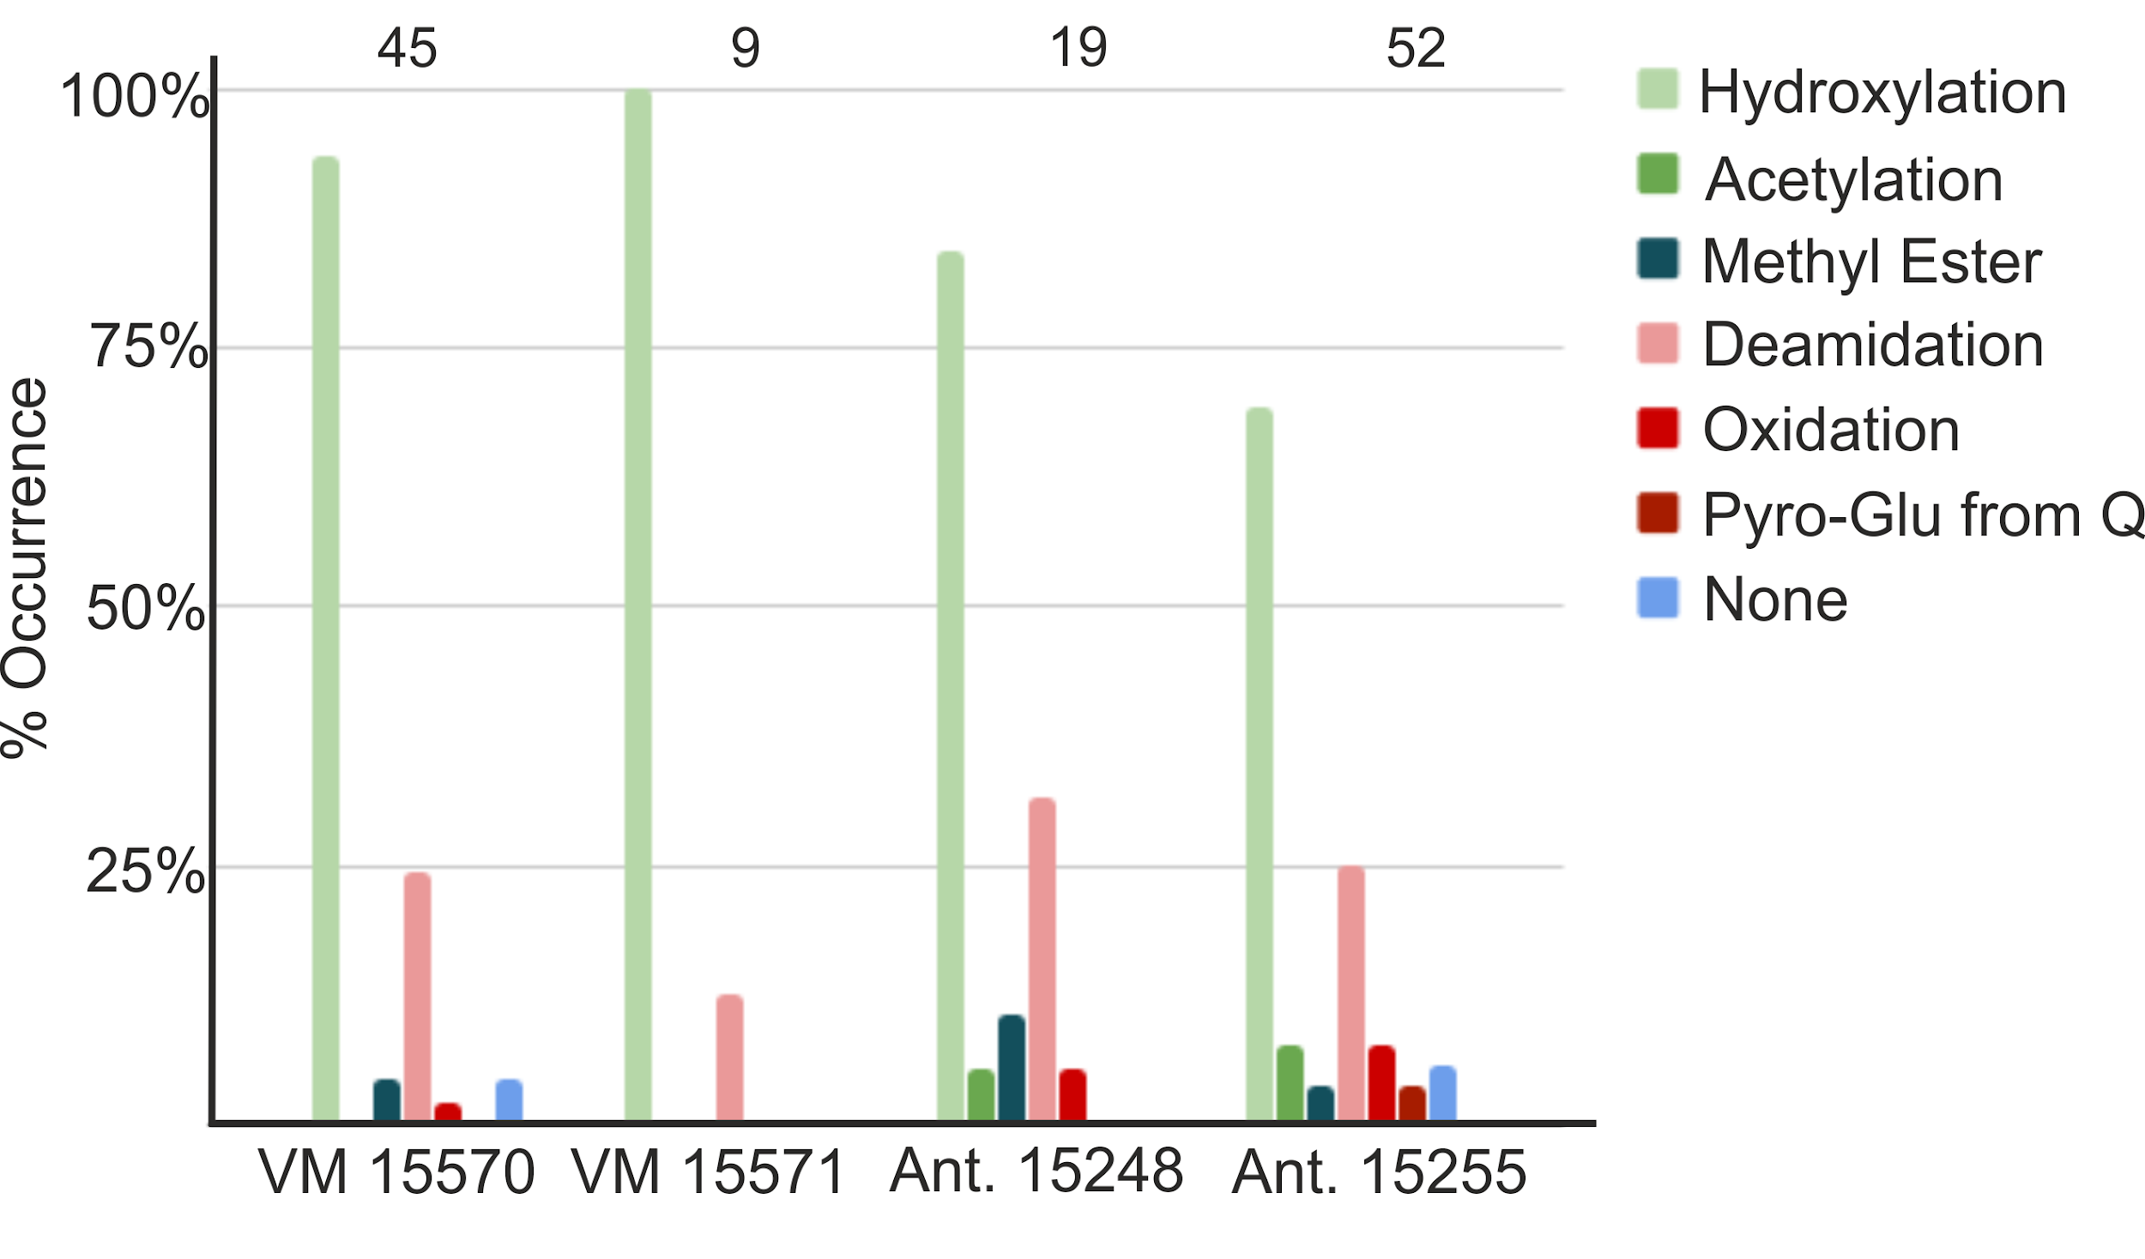
Figure 3.16. The comparison of PTMs in the samples. PTMs in green are those that can occur in vivo and may help to preserve the peptide. PTMs in red are known diagenetic PTMs and blue represents peptides with no identified PTM. The total number of identified peptides is shown at the top of the chart. VM-Venta Micena samples, Ant.-Antarctic samples.
Sample 15571 showed the greatest % of hydroxylation, with all peptides recovered containing this PTM. The only other PTM in sample 15571 was deamidation, which was seen in 1 peptide, and other peptides containing an asparagine or glutamine remained un-deamidated. This may suggest that peptides which have undergone diagenetic alterations have been lost from the sample or are less easily ionised. Both the Antarctic samples contained more diagenetic PTMs than VM and the same overall % occurrence was seen in both samples (37%). This may suggest that the presence of these diagenetic PTMs, while showing clear evidence of protein degradation, do not directly influence the level of proteomic recovery. Instead the presence of in vivo PTMs may be more or an influencing factor, with peptides containing in vivo PTMs being preserved for the longest periods of time. As seen with thermostability, in general there is a trend between an increase in % hydroxylation and a decrease in peptide recovery, with the exception of 15570. The exception of 15570 may be due the different environmental conditions between the two sites. Therefore % occurrence of hydroxylation (and possibly thermostability) may be better at intra-site comparisons of preservation, rather than comparisons of samples from different sites.
The results presented here are only from two sites and serve as a case study for the interpretation of sequence data for possible mechanisms of protein preservation in samples dated over 1 million years old. At the site of Venta Micena, it is believed the bones were collected by hyenas and deposited in shallow dens, near the Pleistocene lake of Orce (Arribas and Palmqvist 1998). The scavenging of the bones by these hyena and the presence of water at the site, are likely to have influenced protein survival in these fossils. However, previous immunological analysis of samples from this site have shown promising results. Unlike the study by Torres et al. (2002), which found no differences in the survival of proteins within different areas of the site, the two samples analysed in detail here show very contrasting results. Sample 15570 produced a total of 169 peptides, including multiple NCPs, while sample 15571 produced a total of 10 peptides, and of these 7 were from type 1 collagen. When the coverage of collagen was compared for these samples, very little of the covered sequence is shared between the samples and this suggests that these two samples were affected by different environments, which influenced the level of protein survival. This contrast is surprising, as the AA results (Chapter 2) show a high glycine content for both samples and it may be that a different extraction method, not tested in this thesis, is needed to recover more information from sample 15571.
Cold environments are known to aid protein preservation far back in time, with success being seen in amino acid studies (Poinar et al. 1996) as well as proteomics (Cappellini et al. 2012, Rybczynski et al. 2013). Unlike previous studies, which have shown high collagen sequence coverage and the presence of NCPs, in samples from cold environments dating to the Pliocene, these samples are much older (Miocene and Eocene) and only collagen peptides were recovered, with a low overall coverage of collagen type 1. Both the Antarctic samples show similar sequence coverage, and this may suggest that these fossils have undergone the same mechanisms of preservation.

3.2.5 Conclusions
Many studies have tried to find the answer to how peptides are preserved in bone. Some have concluded that environmental conditions (humidity, pH, access to water) is more critical than age for the possible preservation of proteins (e.g. Eglinton & Logan, 1991; Muyzer et al., 1992). However, others suggest that age is still an important factor, and both age and environmental conditions need to be assessed (Torres et al. 2002). Here we look at several analyses (ATR-FTIR, AA analysis and mass spectrometry, both MALDI-ToF and LC-MS/MS) to try and assess levels of proteomic degradation in fossils (bone, eggshell, soft tissues, teeth) dating from the Holocene to the Eocene and from a range of environments . ATR-FTIR results were clearly affected by the re-mineralisation process and it is recommended that C/P and IRSF is not used to evaluate collagen preservation. Both AA analysis and MALDI-ToF showed similar preservation patterns and LC-MS/MS was able to provide the most information regarding protein survival and degradation.

When overall levels of proteomic recovery were evaluated, in general protein survival mimicked that of ancient DNA. However some proteins were found preserved in hotter environments, such as Argentina and Haiti, that were not conducive to aDNA survival. When the Haitian samples were examined further it was shown that samples from sinkholes, rather than the cave sites, allowed for better protein preservation. This shows the micro-climate of each site needs to be considered when evaluating protein survival and also highlights samples from these sites as a possible target for aDNA analysis. The AA and MALDI-ToF results also show that even in cold environments, proteins still degrade and are unlikely to survive (in an open system) into deep time.

PTM analysis and non-tryptic cleavage of the bone samples was used to evaluate protein degradation further. The presence of hydroxylation may allow preferential peptide survival as this PTM provides stability to the protein structure. Diagenetic PTMs, such as oxidation and deamidation, do not show a clear correlation with either age or environmental conditions. When the samples dating to over 1 million years are evaluated further, there was a possible trend in the preservation of certain peptides over others. As the collagen degrades the peptides with low thermostability and those most susceptible to diagentic PTMs are lost first to the environment (in an open system), resulting in preferential survival of highly thermally stable peptides, with very few diagenetic PTMs. There is an increased % occurrence of proline hydroxylation and other in vivo PTMs within these preserved peptides, which may help to prevent decay. This is also seen in other studies of samples dating to over 1 million years (Wang et al. 2012, Schroeter et al. 2017).

Sample preparation has an effect on the levels and number of PTMs identified, with SDS PAGE resulting in more proteomic recovery and the identification of more PTMs. Therefore, this needs to be taken into account when comparing different data sets. Non tryptic cleavage also influences the number of PTMs, with an increase in peptide backbone breaks allowing more PTMs to form due to the disruption in the protein structure. PTMs can also influence tryptic cleavage; modifications to lysine may affect the ability of trypsin to cut a peptide. Surprisingly the most tryptic peptides were recovered from the samples with the least number of total peptides and all successful samples (>100 peptides) showed similar levels of % AA cleavage sites. Overall these results suggest that non-tryptic cleavage occurs initially at the same/similar points along the collagen molecule in all samples. As samples degrade further only certain peptides resistant to the occurrence of diagenetic PTMs (possibly due to the presence of hydroxylation), and by extension backbone breakage, survive. The presence of these diagenetic PTMs is influenced by a variety of factors with no clear correlation with age. However, over time even in cold environments the majority of the protein, if not all, will be lost.

3.3 Do closed systems exist outside of biominerals?
Closed systems have been shown to be beneficial to protein preservation (Brooks et al.. 1990; Penkman et al. 2008; Demarchi et al. 2016), however these closed systems have been limited to non-mammalian biominerals such as shell (Demarchi et al. 2011) and eggshell (Crisp et al. 2013). What if there was a way to obtain a closed system for other types of fossil such as bone and soft tissues? Two types of fossil were selected for in depth proteomic analysis; tar seep samples, including bone and insects, and feathers preserved in amber. It was hoped both the tar and the amber would act to seal off the proteins from the outside environment and form a quasi-closed system.

3.3.1 Recovery of the bone proteome in fossils from tar pits
Specimens recovered from tar seeps have been a focus of study for palaeontologists for many years (Churcher 1966, Campbell 1979, McMenamin et al. 1982, Czaplewski 1990, Spencer et al. 2003, Friscia et al. 2008, Brown et al. 2017). These samples have also been a target for biomolecular study, including isotopic analysis (Coltrain et al. 2004, Feranec et al. 2009), radiocarbon dating (Ho et al. 1969, O’Keefe et al. 2009, Fuller et al. 2014, 2015, Holden and Southon 2016) and the attempted recovery of ancient DNA, although this has yet to be successful (Gold et al. 2014). The study of proteins from tar seep specimens has been limited to transmission electron microscopy (TEM) (Wyckoff et al. 1963) and amino acid analysis of both bone (Ho et al. 1969, Kvenvolden and Peterson 1973, McMenamin et al. 1982) and insects (Stankiewicz et al. 1997). These early studies yielded variable results. The TEM and amino acid analysis of bone samples showed promising results with low levels of racemisation and an amino acid profile indicative of collagen (McMenamin et al. 1982), but the insect study concluded the preservation of amino acids in tar seep soft tissue fossils was poor (Stankiewicz et al. 1997).

This project represents the first mass spectrometric based proteomic analysis of tar seep samples, focusing on the retrieval of the bone proteome in fossils from Rancho La Brea (RLB), Binagadi asphalt lake, Azerbaijan (BAL), Trinidad tar sands (TTS) and La Brea de Talara, Peru (TLB). The recovery of proteins from tar seep specimens is complicated by the presence of the tar, so, as part of this study, the best method of tar removal (while retaining maximum proteomic information) is assessed, as well as the influence of the tar itself on overall protein recovery and preservation.

3.3.1.1 Site information

RANCHO LA BREA (RLB), USA
In the Miocene, the areas of Rancho La Brea were part of a shallow and highly productive nearshore basin (now on land as the Los Angeles basin). The basin includes part of the Salt Lake Oil Field, formed from biomass incarcerated in the marine sediments. At RLB, crude oil from this oil field migrates to the surface due to faults in local rock formations, resulting in numerous surface oil seeps. The lighter fractions of the crude oil in these oil seeps evaporate, leaving a sticky asphalt residue that can trap and immobilise even large mammals. As a result, Rancho La Brea constitutes one of the richest collections of Pleistocene specimen deposits (Stock and Harris 1992, Harris et al. 2011). Not all the tar seep deposits, or pits, were active at the same time; radiocarbon analysis of RLB samples (Holden and Southon 2016; and references therein) have shown that some pits had periods of rapid entrapment, while others appear to have been active semi-continuously. Some fossils may also have been washed into the pits as evidenced by fluvial sediments. These sediments then became impregnated with tar, thus preserving the specimens (McMenamin et al. 1982). The majority of the remains recovered from RLB are disarticulated due to the constant movement of the tar (Friscia et al. 2008, Brown et al. 2017). Also, there is significant evidence of carnivore scavenging and subsequent entrapment (Spencer et al. 2003), with a high number of predator species being recorded.

RLB was first excavated in the early 20th century and between 1905-1930 several excavations took place in the area now known as Hancock Park. The specimens recovered from the 1913-1915 and the 1929-1930 excavations are housed at the Natural History Museum of Los Angeles County (LACM) and number over three quarters of a million specimens consisting primarily of large bones and plants (Shaw 1982). Collectively these samples are known as the Hancock collection. In 1969, one of the original Hancock collection pits, Pit 91, was reopened. This pit, a major fossil deposit, was originally excavated in 1915 (Shaw 1982), and remains an active excavation today, with many new remains still being excavated (Friscia et al. 2008). In 2006, as part of the construction of a nearby car park, 16 previously unknown deposits were discovered. The complete in-situ excavation of these fossil deposits was not possible due to financial constraints, so 23 wooden boxes were built around sections of the deposits and they were removed intact for future detailed excavation (Fuller et al. 2014). This has become known as Project 23 and is the most recent excavation to be carried out at RLB.

Samples for this study are from the Hancock collection, Pit 91(recent excavation) and Project 23 (Table 3.2). The post excavation treatment of the specimens and initial tar removal differs for each of the excavations and it is possible the different post excavation treatments may influence protein survival and recovery. Records suggest that specimens from the Hancock collection were boiled in kerosene (boiling point between 150°C-300°C) in order to remove the tar (Heric 1969), while Shaw (1982) records that the removal of tar from the Pit 91 samples was carried out in a vapour degreaser unit at 73°C using 1,1,1-trichloroethane or trichloroethane. Remains recovered from Project 23 are cleaned using a variety of different chemicals including soaking in N-propyl bromide at room temperature (Holden et al. 2017) and being heated at 70°C in biodiesel (Rice et al. 2015). Ten samples from all three excavations have been analysed as part of this study (Table 3.2), and differences in protein preservation from the different excavations will be considered.

BINAGADI ASPHALT LAKE (BAL), AZERBAIJAN
The asphalt lake is situated in the centre of the western part of the Absheron Peninsula, in the vicinity of Baku, and was discovered in 1938 (Gorobets and Yanenko 2018). Several excavations have been carried out since; 1938-1942, 1947-1949 and 1951-1954 (Boev 2010). Based on the presence of certain taxa, the accumulated remains are dated to ~120,000-96,000 years BP with an estimated 50,000 bones being recorded (Nasibov 2007) including a high number of avian taxa (Boev 2010). The specimens were distributed among a number of institutions and records show them being curated in Russia (Saint-Petersburg), Azerbaijan (Baku), Georgia (Tbilisi), Hungary (Budapest), Bulgaria (Sofia) and Ukraine (Kiev) (Gorobets and Yanenko 2018).

It is commonly accepted that the Binagadi asphalt lake appeared during the elevation of the Apsheron Peninsula, combined with the lowering of the level of the Caspian Sea (Boev 2010). This small freshwater lake was contaminated by oil leaking out along the faults and, as with RLB, the lighter fractions of the oil evaporated leaving sticky asphalt. Animals and birds entering the lake became trapped and drowned (Nasibov n.d.). Reports also suggest the transport of faunal remains into the lake via a river (Gromov 1952), or that animals were overcome by poisonous gas from eruptions of a nearby volcano and fell into the lake (Sultanov 1947). Unlike RLB, which had periods of inactivity, BAL was an active tar seep year round and throughout the time period in question, as evidenced by the presence of different fruits, plants and insects (Boev 2010). Also in contrast to RLB, complete carcasses are present, with less evidence of carnivore activity (Boev 2010). Cleaning of the samples was carried out by submerging the bones in kerosene and benzene followed by boiling in a potash solution (boiling point unknown) (Boev 2010). Seven samples from Binagadi have been analysed as part of this study (Table 3.2) and this is believed to be the first biomolecular analysis of these fossils.

TRINIDAD TAR SANDS (TTS), TRINIDAD
The first specimens from the Trinidad tar sands were collected in 1922 (Blair 1927). The sands of interest are situated south of the Fyzabad Junction village and ~90 m west of the road leading to the Fyzabad Oilfield (Blair 1927). Blair (1927) concluded that the deposition of tar-impregnated sands must have occurred rapidly, suggesting flooding as the cause, which brought down the sand and fresh oil trapping and drowning anything unlucky enough to get in the way. The samples analysed in this study came from a locality called Forest Reserve, which was discovered in 1957 when the site was being cleared for an oil well. The site consists of a river bed cut (~4.5 m) into Miocene sands and clays, and filled with oil-impregnated silt, sand, clay stone pebbles, plant and animal remains (Wing 1962). Specimens included Glyptodon, Megatherium and many smaller vertebrates, with the Megatherium being dated to ~34,000 years (Wing 1962). However, this date is in need of revision due to the improved accuracy of radiocarbon dating methods (Fuller et al. 2014). It is unclear how the samples were treated post-excavation. However, Wing (1962) reports soaking large clumps of tar-impregnated sands for several days in gasoline, followed by boiling the clumps to break them up, and washing the residue through screens. This suggests a method similar to Binagadi and the Hancock collection at RLB. Five samples were analysed in this study, including Glyptodon and Megatherium. In 1981 Ross MacPhee (AMNH) revisited the Wing site and collected a small number of fossils. To do so the surface was cut back with a backhoe for a few centimetres and the samples excavated by trowel. All were completely impregnated with oil, which seeped out of broken elements (R. Macphee, pers comms).

TALARA LA BREA (TLB), PERU
The Talara tar pit in Peru was first excavated in 1958 by A.G. Edmund and since then over 27,000 bones have been excavated, making Talara the second largest tar seep collection (after RLB) (Lemon and Churcher 1961, Seymour 2015). Radiocarbon dating of wood associated with fossil remains, suggest a date of 13,000-14,000 years BP (Churcher 1966). However, a new method of radiocarbon dating tar seep remains using ultrafiltration has since been developed (Fuller et al. 2014, Holden and Southon 2016), and these dates may need to be revised. Talara is situated on a marine terrace (or tablazo) which is made up from sands, fine conglomerates, sandy limestones, sandstone and marine molluscs. This tablazo overlies deposits dating to the Miocene/Eocene and the oil that seeps to the surface of the terrace is thought to emanate from these Tertiary deposits (Lindsey and Seymour 2015, Lindsey and Lopez 2015).

The Talara assemblage is dominated with carnivores and contains a high percentage of juvenile remains (Seymour 2015). The high percentage of carnivores suggests that Talara acted as a tar seep trap (as seen at RLB) and fossils accumulated due to animals becoming trapped in the tar, which in turn attracted carnivores and other animals (Lindsey and Seymour 2015). Despite the wealth of material recovered from Talara, there are very few published studies on samples from this site. As such, it is unclear how these samples were excavated or any post-excavation treatment that may have been undertaken in order to remove the tar. This is the first study to examine the recovery of ancient biomolecular information from Talara specimens.

Sample ID | Taxon | Age | Location Info
RLB-HC-BA1 | Bison antiquus | Pleistocene | Rancho La Brea, Hancock Collection; Deposit 3 : Grid D-5 : D1 21.5
RLB-HC-BA2 | Bison antiquus | Pleistocene | Rancho La Brea, Hancock Collection; Deposit 67
RLB-HC-BA3 | Bison antiquus | Pleistocene | Rancho La Brea, Hancock Collection; Deposit 61 : Grid F-13 : D1 14
RLB-HC-BL1 | Bison latifrons | Pleistocene | Rancho La Brea, Hancock Collection; Deposit unknown
RLB-HC-PA1 | Panthera atrox | 15200 BP | Rancho La Brea, Hancock Collection; Deposit 4 : Grid C-2 : D1 11.5
RLB-HC-SF1 | Smilodon fatalis | 28000 BP | Rancho La Brea, Hancock Collection; Deposit 4 : Grid D-2 : D1 15.5
RLB-HC-SF2 | Smilodon fatalis | 36000 BP | Rancho La Brea, Hancock Collection; Deposit 4 : Grid F-4 : D1 20
RLB-HC-SF3 | Smilodon fatalis | 28600 BP | Rancho La Brea, Hancock Collection; Deposit 4 : Grid E-5 : D1 23.5
RLB-P23-SF1 | Smilodon fatalis | 28320 BP | Rancho La Brea, Project 23; Deposit 1 : Field No. JPQ060225 : Grid B-2 : Level 3
RLB-P91-SF1 | Smilodon fatalis | 35840 BP | Rancho La Brea, Pit 91; Deposit 91 : Field No. GJM 901 : Grid I-7
BAL-CL1 | Canis lupus | ~96-120 000 BP | Binagadi Asphalt Lake
BAL-CL2 | Canis lupus | ~96-120 000 BP | Binagadi Asphalt Lake
BAL-PL1 | Panthera leo/spelaea | ~96-120 000 BP | Binagadi Asphalt Lake
BAL-EF1 | Equus ferus | ~96-120 000 BP | Binagadi Asphalt Lake
BAL-EF2 | Equus ferus | ~96-120 000 BP | Binagadi Asphalt Lake
BAL-EH1 | Equus hydruntinus | ~96-120 000 BP | Binagadi Asphalt Lake
BAL-RB1 | Rhinoceros binagadensis | ~96-120 000 BP | Binagadi Asphalt Lake
TTS-FR-Gly1 | Glyptodon sp. |  | Forest Reserve; Trinidad Tar sands
TTS-FR-Gly2 | Glyptodon sp. |  | Forest Reserve; Trinidad Tar sands
TTS-FR-M1 | Megatherium sp. | 34 000? BP | Forest Reserve; Trinidad Tar sands
TTS-FR-M2 | Megatherium sp. | 34 000? BP | Forest Reserve; Trinidad Tar sands
TTS-FR-G1 | Glossotherium sp. |  | Forest Reserve; Trinidad Tar sands
TLB- H1 | Holmesina sp. | L. Pleistocene | Talara La Brea, Peru
TLB-E1 | Equidae | L. Pleistocene | Talara La Brea, Peru
TLB-P1 | Puma sp. ? | L. Pleistocene | Talara La Brea, Peru
TLB-C1 | Canis dirus ? | L. Pleistocene | Talara La Brea, Peru
TLB-S1 | Smilodon sp. ? | L. Pleistocene | Talara La Brea, Peru
Table 3.2. Sample information from the four tar seep locations analysed in this study. The sample in bold was selected for the method development experiments.

As a smaller pilot project to complement the bone study, four insect samples from Rancho La Brea (Table 3.3) were selected for proteomic analysis in order to compare the preservation of soft tissue fossils to that of hard fossils such as bone.

Site | La Brea ref | Species
P23 | 25769 | Unknown
Hancock | 8270E | Unknown
Hancock (pit A) | 5319 | Eleodes acuticaudus
Hancock (pit 4) | 13194 | Apsena laticornis
Table 3.3. The four tar seep insect samples from Rancho La Brea analysed in this study.

3.3.1.2 Development of tar removal and protein extraction methods
As this is the first study to use proteomics on tar seep specimens, several methods were assessed for their ability to remove tar while retaining proteomic information. A sample from Rancho La Brea was chosen for testing different tar and protein extraction methods (Table 3.2 in bold), as RLB samples are the best catalogued and well dated. This sample was fully ground (resulting in ~24 g of sample) to ~1 µm sized particles using a Retsch PM100 ball mill cooled using liquid nitrogen to reduce heat degradation of the proteins. In total 12 different experiments were undertaken, using a combination of different tar extraction and demineralisation solvents (Table 3.4).

Sample reference | Tar removal solvent | Demineralisation solvent
Control (C) | none | none
T | toluene | none
TM | 2:1 toluene: methanol | none
TTM | 2:1 toluene: methanol; methanol | none
M | methanol | none
D | dichloromethane | none
TM HCL | 2:1 toluene: methanol | 0.6 M hydrochloric acid
TM EDTA | 2:1 toluene: methanol | 0.5 M ethylenediaminetetraacetic acid
TM GuHCL | 2:1 toluene: methanol | 0.4 M guanidine hydrochloride
HCL | none | 0.6 M hydrochloric acid
EDTA | none | 0.5 M ethylenediaminetetraacetic acid
GuHCL | none | 0.4 M guanidine hydrochloride
Table 3.4. A summary of the different tar removal and demineralisation solvents tested for the recovery of proteins from tar seep fossils. 2:1 toluene: methanol followed by methanol was tested as this was the method used in Fuller et al. (2015).

50 mg of bone sample was selected for analysis, with 500 µl of the selected solvent being added. Tar removal was carried out by shaking the sample in the selected solvent at 4 °C for 30 minutes. The sample was then centrifuged and the waste solvent was removed. This process was repeated until no further colour change was seen after shaking, indicating that no more tar was being removed. Demineralisation was carried out by shaking the sample in the selected solvent for 2 hours at 4 °C, before being centrifuged and the solvent removed. All these samples were run through SDS PAGE before LC-MS/MS.

Once the best extraction method from these different experiments was established, this method was used to analyse the samples from BAL, TTS and TLB. Prior to LC-MS/MS analysis, all the samples were run through a gel to remove any remaining tar; either SDS PAGE or analysed using gel aided sample preparation (GASP, see Fischer and Kessler (2015)) and a brief comparison of these two gel methods are considered. Chiral amino acid analysis (AA) was also carried out on samples from all sites, in line with previous biomolecular analysis of tar seep material (Ho et al. 1969, McMenamin et al. 1982, Stankiewicz et al. 1997).

3.3.1.3 The effect of tar saturation and post excavation treatment
In order to investigate the effect of tar removal further, a Smilodon fatalis sample from Project 23 (RLB) was analysed which had come straight from the tar seep without any of the usual post excavation tar removal (i.e. washing using N-propyl bromide or biodiesel). Two subsamples were taken; one subsample was fully saturated in tar and one was unsaturated (Figure 3.17; highlighted by green and yellow dots). The saturated sample was analysed both with and without tar removal using 2:1 toluene:methanol and no demineralisation solvent was used. The samples were analysed using SDS PAGE.

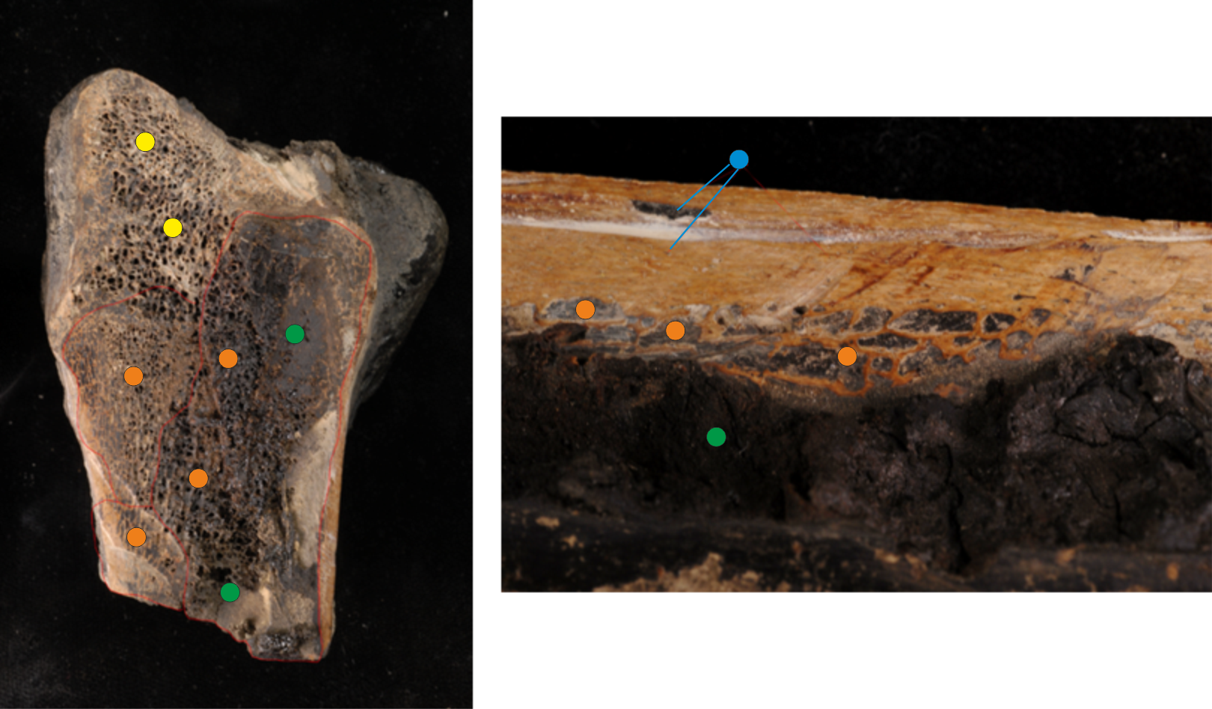Figure 3.17 Smilodon humerus bone from RLB (Project 23) with no post-excavation tar removal. Blue; tar in tiny foramina. Green; medullary cavity, filled with tar. Orange; cancellous tissue. Yellow; area in head of humerus incompletely saturated by tar.

3.3.1.4 Analytical methods
Most samples were analysed using SDS PAGE. This method followed the protocol developed at the Laboratory of mass spectrometry and gaseous ion chemistry, Rockefeller University (Presslee et al. 2019 in prep). In brief, 20-50 mg of powdered sample (after tar removal and/or demineralisation) was heated at 70 °C for 10 mins in 200 µl SDS solubilizing buffer (0.5 M Tris base, 5% SDS, 130 mM dithiothreitol (DTT)), alkylated for 30 minutes in the dark (6 µl 1 M indole-3-acetic acid (IAA)) before the addition of 200 µl of dye (0.05% bromophenol blue, 5% glycerol). The samples were run on an SDS PAGE gel for 55 minutes, washed in a fixing solution (16% methanol, 10% acetic acid) and then washed twice in boiling water. The gel was stained using Coomassie stain for 20 minutes before being de-stained in 1% acetic acid for 2 hours. The gel was scanned and the results recorded. Any sample that produced a positive result (i.e. produced a smear in the gel; see Figure 3.19) was re-run through an SDS PAGE gel for for 10 minutes to concentrate the samples onto the gel which was then washed and stained as mentioned above.

The concentrated sample in the gel was cut into approximately 1 mm sized cubes in a fume hood with a scalpel and the gel cubes placed in a microcentrifuge tube. The gel pieces were washed in a destaining solution (66% ammonium bicarbonate (ABC) 33% acetonitrile (ACN)) until no more dye could be seen. The de-stained gel pieces were then washed in the following solvents; ACN, HPLC grade water and 50 mM ABC, for 10 minutes per solvent. The samples were digested overnight with trypsin (3.125 µg/µl) in 100 µl 50 mM ABC at 37 °C and the tryptic digest was pipetted into a cleaned Eppendorf. 100 µl of 70% ACN/1.7% formic acid/0.1% TFA was added to the gel pieces and the gel was heated at 37 °C for 1 hour with the supernatant being collected and added to the tryptic digest. This step was repeated with triethyl ammonium bicarbonate (TEAB) and ACN. The extracted and digested peptides were dried down and resuspended in 5% Formic acid/0.1% TFA desalted and purified using stage tips. The samples were eluted in 80% ACN/0.5% acetic acid, and dried down ready for LC-MS/MS analysis.

A selection of samples were analysed using GASP, outlined by Fischer and Kessler (2015). In brief, samples were demineralised in 0.5 M EDTA for 24 hours, then the proteins were solubilised using 1 M DTT, 20% SDS and a lysis buffer (M-PER lysis buffer, Thermo Fisher). A polyacrylamide gel was cast within the sample tube, trapping the solublised proteins, and the gel was cut into small pieces before being washed using 6 M urea, 50 mM ABC and ACN. The gel pieces were digested overnight at 37 °C with trypsin (0.5 µg/µl) and the tryptic digest was extracted by dehydrating the gel in ACN. The extracted peptides were desalted using zip-tips (van Doorn et al. 2011), eluted in 100 µl of 50% ACN/0.1% trifluoroacetic acid (v/v) and then dried down ready for LC-MS/MS. The results of the LC-MS/MS analysis were analysed as outlined in chapter 2 (Section 2.2.4.1).

Samples were prepared for AA analysis using a modified version of the protocol outlined in Chapter 2 (Section 2.2.1). After hydrolysis, the samples were dried down using a centrifugal evaporator and re-hydrated in 100 µl 0.01 mM L-homo-arginine. 50 µl of the rehydrated sample was pipetted into a separate microcentrifuge tube and this was centrifuged for 3 minutes. 20 µl of the supernatant was collected and added to a sampler vial before the additional of a further 80 µl of 0.01 mM L-homo-arginine. This dilution step (final dilution 1:4) was carried out as a precaution to prevent any potential remaining tar from blocking the column.

3.3.1.5 Results
The sequence results of all three data analysis searches were combined for each sample. All the identified proteins were only included if they could be identified by more than 1 peptide (after tolerances were applied). Unlike other ancient proteomic studies on fossil bone (Cappellini et al. 2012, Cleland et al. 2016, Sawafuji et al. 2017), the tar seep samples do not contain a ‘standard’ bone proteome. As such, strict parameters were used to assess the endogeneity of the proteins identified. Any proteins not commonly seen in bone proteomic studies (Alves et al. 2011, Cappellini et al. 2012, Hill et al. 2015, Schroeter et al. 2016, Cleland 2017, Procopio et al. 2017, Sawafuji et al. 2017, Wadsworth and Buckley 2017) were assessed to see if they were linked to possible modern contamination (Lacombe et al. 2017), and only kept if they contained a species-specific peptide (i.e. a peptide specific to Felidae in a Smilodon fatalis sample). The AA results and the number of proteins and peptides identified using LC-MS/MS were used to evaluate the different tar removal and protein extraction methods and compare levels of proteomic recovery between the different tar seep sites.

TAR REMOVAL AND PROTEIN RECOVERY
Figure 3.18 shows the different subsamples of RLB-HC-SF1 after tar removal using different solvents along with the colour of the waste solvents. Visually 2:1 toluene:methanol followed by methanol (TMM) shows the most colour change. The 2:1 toluene:methanol and the dichloromethane waste solvent shows the darkest colour, suggesting more tar was successfully extracted using these solvents. Methanol shows very little colour change.
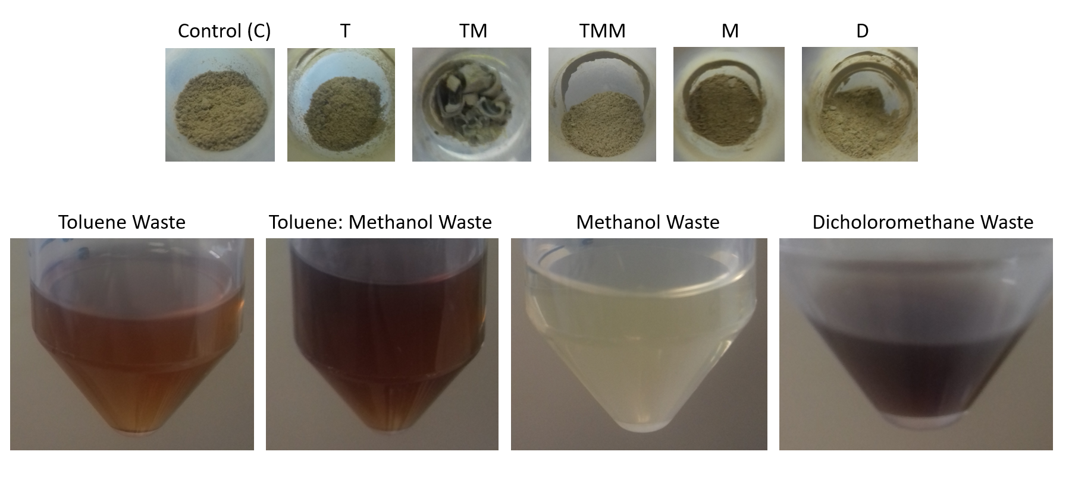
Figure 3.18. RLB-HC-SF1 subsamples after tar removal using different solvents; toluene (T), 2:1 toluene:methanol (TM), 2:1 toluene:methanol followed by methanol (TMM), methanol (M) and dichloromethane (D). The waste solvents show different levels of tar removal.

The SDS PAGE results are shown in Figure 3.19. No positive results were seen in the blanks or the waste solvents, suggesting minimal protein loss with the tar removal, and the tar does not react with the stain. However, no sample produced bands, and there was no clear ‘better’ tar removal solvent.

B
A

Figure 3.19. The SDS PAGE results of the tar extraction experiment on sample RLB-HC-SF1. Lane 1 is the weight marker. Gel A represents the different solvent wastes, showing no staining which suggests minimal protein loss with the tar removal, 2-running buffer, 3-T waste, 4-TM waste, 5-M waste, 6-D waste. Gel B shows the positive results of the samples post tar removal, 2-T blank, 3-TM blank, 4-T sample, 5-TM sample, 6-TMM sample, 7-M sample, 8-D sample 9-M blank, 10-D blank.

The LC-MS/MS results for the tar removal samples are shown in Figure 3.20. The success of the tar removal solvents were evaluated using the number of proteins and peptides identified. The most proteins (both collagens and non-collagenous proteins (NCPs)) and the most peptides were recovered from the control sample (no tar removal), suggesting some protein loss did occur with tar removal. Out of the solvents, dichloromethane resulted in the recovery of the most proteins, and toluene showed the recovery of the most peptides.

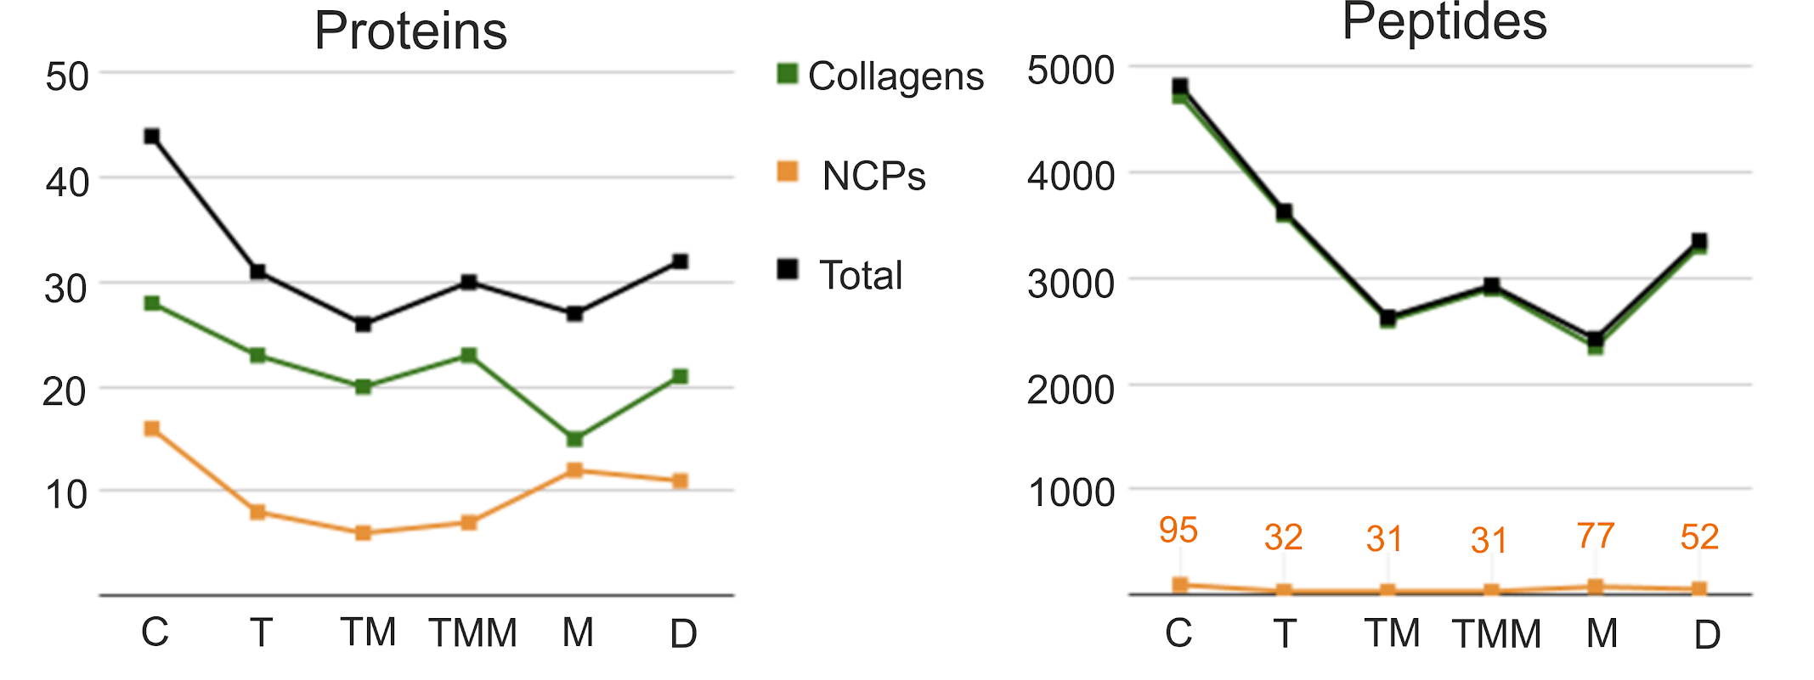
Figure 3.20. The number of proteins and peptides identified using different tar removal solvents. C-control (no tar removal), T-toluene, TM-2:1 toluene:methanol, TMM-2:1 toluene:methanol, then methanol. M-methanol, D-dichloromethane.

The effect of the tar and subsequent tar removal on the recovery of proteins was investigated further by analysing a sample of bone from Project 23 with no tar removal or post-excavation. The MS/MS results are shown in Figure 3.21, with a comparison to a Project 23 sample which has undergone post-excavation tar removal. Overall the number of proteins and peptides increases with the removal of the tar, with the unsaturated sample identifying the most proteins. The post excavation tar removal (using N-propyl bromide) resulted in more proteins and peptides being identified than the tar removal used in this study (2:1 toluene:methanol). The results of these experiments suggest the initial removal of tar from the bone post-excavation is beneficial for proteomic recovery. However, as shown above, further tar removal can be detrimental.

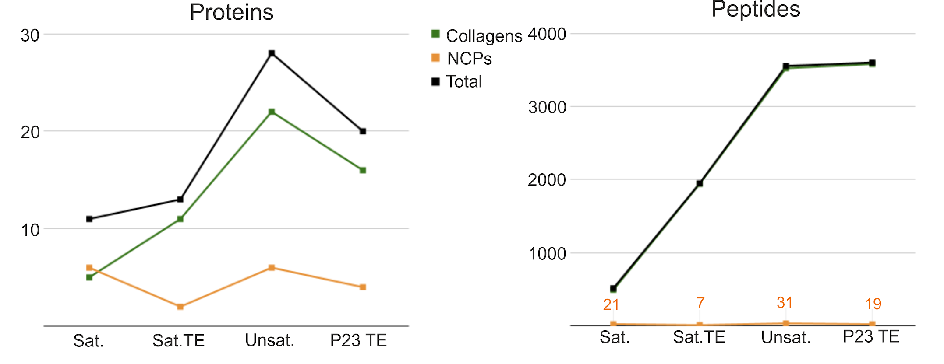
Figure 3.21. The number of proteins and peptides identified in a tar seep sample with no post-excavation tar removal (see Figure 3.17). Sat.- No tar removal, Sat. TE- Tar removal using 2:1 toluene:methanol, Unsat- A subsample of the same bone that was not saturated with tar, P23 TE- A different bone from the same tar pit (P23) which had undergone post-excavation treatment but no further tar removal.

DEMINERALISATION WITH AND WITHOUT TAR REMOVAL
The SDS PAGE results of the three demineralisation solvents both with and without tar removal (2:1 toluene:methanol) are shown in Figure 3.22. Again, all samples showed a smearing in the gel, with no bands. HCl demineralisation shows better results than EDTA which in turn shows better results than GuHCl. This is also reflected in the LC-MS/MS results (Figure 3.23).

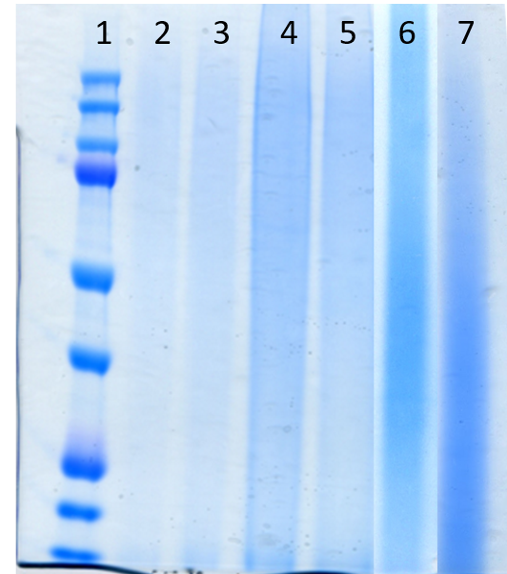

Figure 3.22. The SDS PAGE results of the demineralisation extraction experiment on sample RLB-HC-SF1. 1- Weight marker, 2-GuHCl demin with tar removal, 3-GuHCl demin without tar removal, 4-EDTA demin with tar removal, 5-EDTA demin without tar removal, 6-HCl demin with tar removal, 7-HCl demin without tar removal.

The LC-MS/MS results (Figure 3.23) show that demineralisation reduces the level of proteomic recovery. Out of the demineralisation solvents, 0.6 M HCl shows the best results in line with other proteomic studies (Jiang et al. 2007) and the SDS PAGE results. Tar removal and demineralisation also results in less proteomic recovery than the control. However, demineralisation with HCl after tar removal increases the number of proteins and peptides identified over tar removal alone.

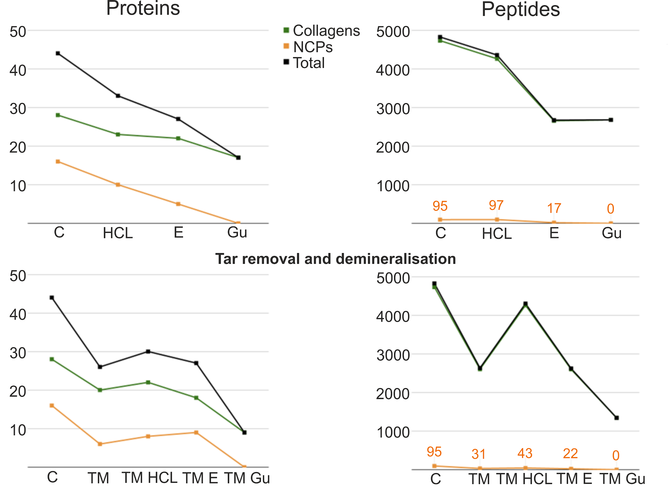
Figure 3.23. The results of the demineralisation experiments. C-Control, HCl-0.6 M Hydrochloric acid, E-0.5 M EDTA, Gu-0.4 M GuHCl. TM-2:1 toluene:methanol.

AA analysis was carried out on the TTS samples both with and without tar removal (using 2:1 toluene:methanol) to see if tar removal affected amino acid recovery. The level of racemisation and overall amino acid composition was the same for both subsamples (with and without tar removal), but the overall concentration differed (Figure 3.24). This supports the tar extraction MS results which shows the level of proteomic information is influenced by tar removal.

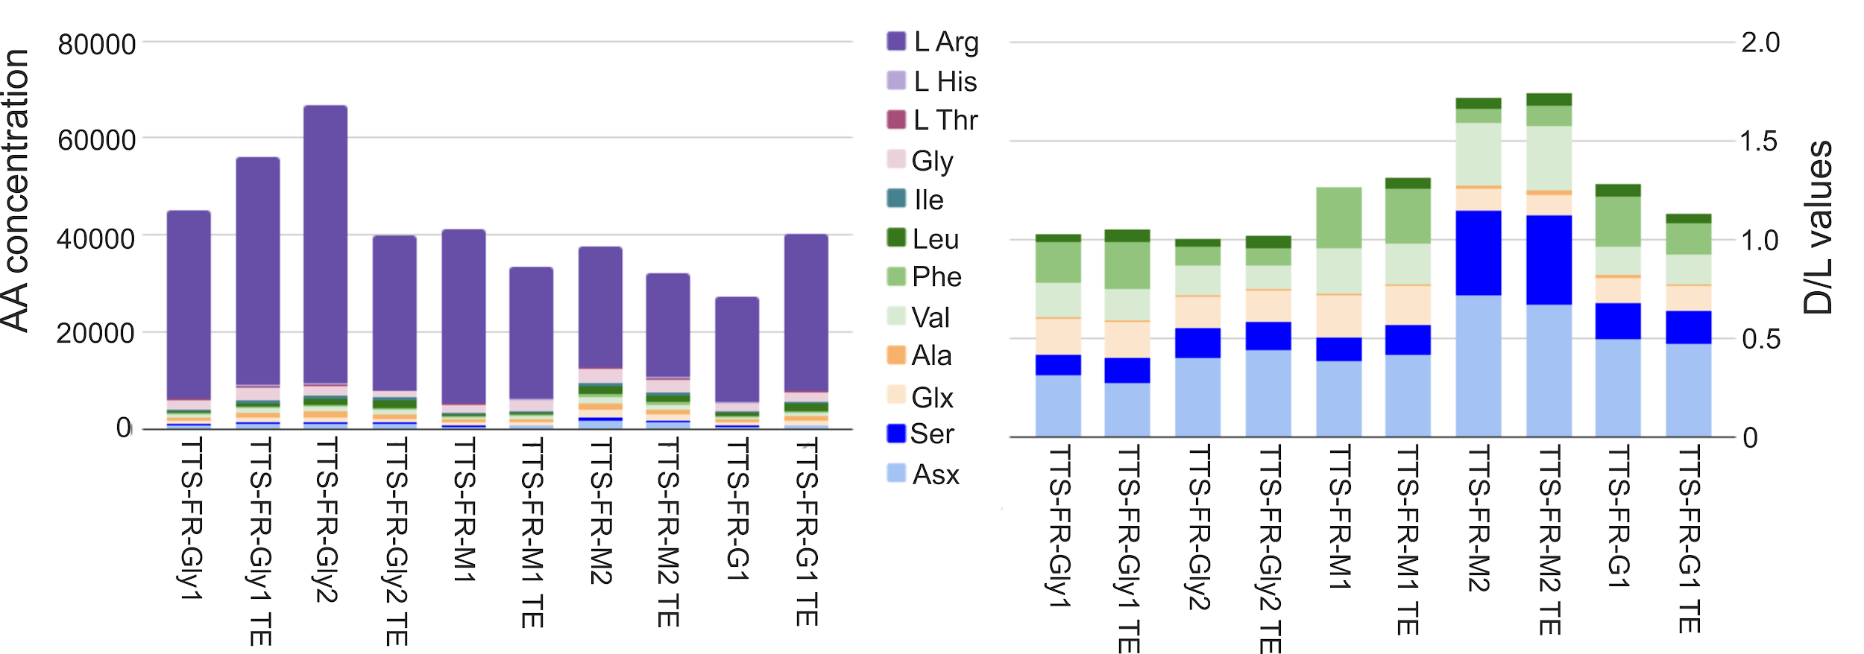
Figure 3.24 The AA results of the TTS samples both without and with (denoted by TE) tar extraction.

Based on the results of the tar and demineralisation experiments, it was decided that the tar seep samples from all sites would be analysed with no further tar removal (after post-excavation treatments) and no demineralisation, as these steps were shown to potentially decrease the number of proteins identified.

INTERSITE COMPARISON OF TAR SEEPS
AA analysis was carried out on samples from all 4 sites. The levels of racemisation and the amino acid composition of the samples clearly differ between the sites (Figure 3.25). The best preserved (low racemisation values and the most collagen-like amino acid profile) is from RLB. The BAL samples also show low levels of racemisation but a more variable composition. Both the TLB and TTS samples are highly altered, suggesting high levels of protein degradation.

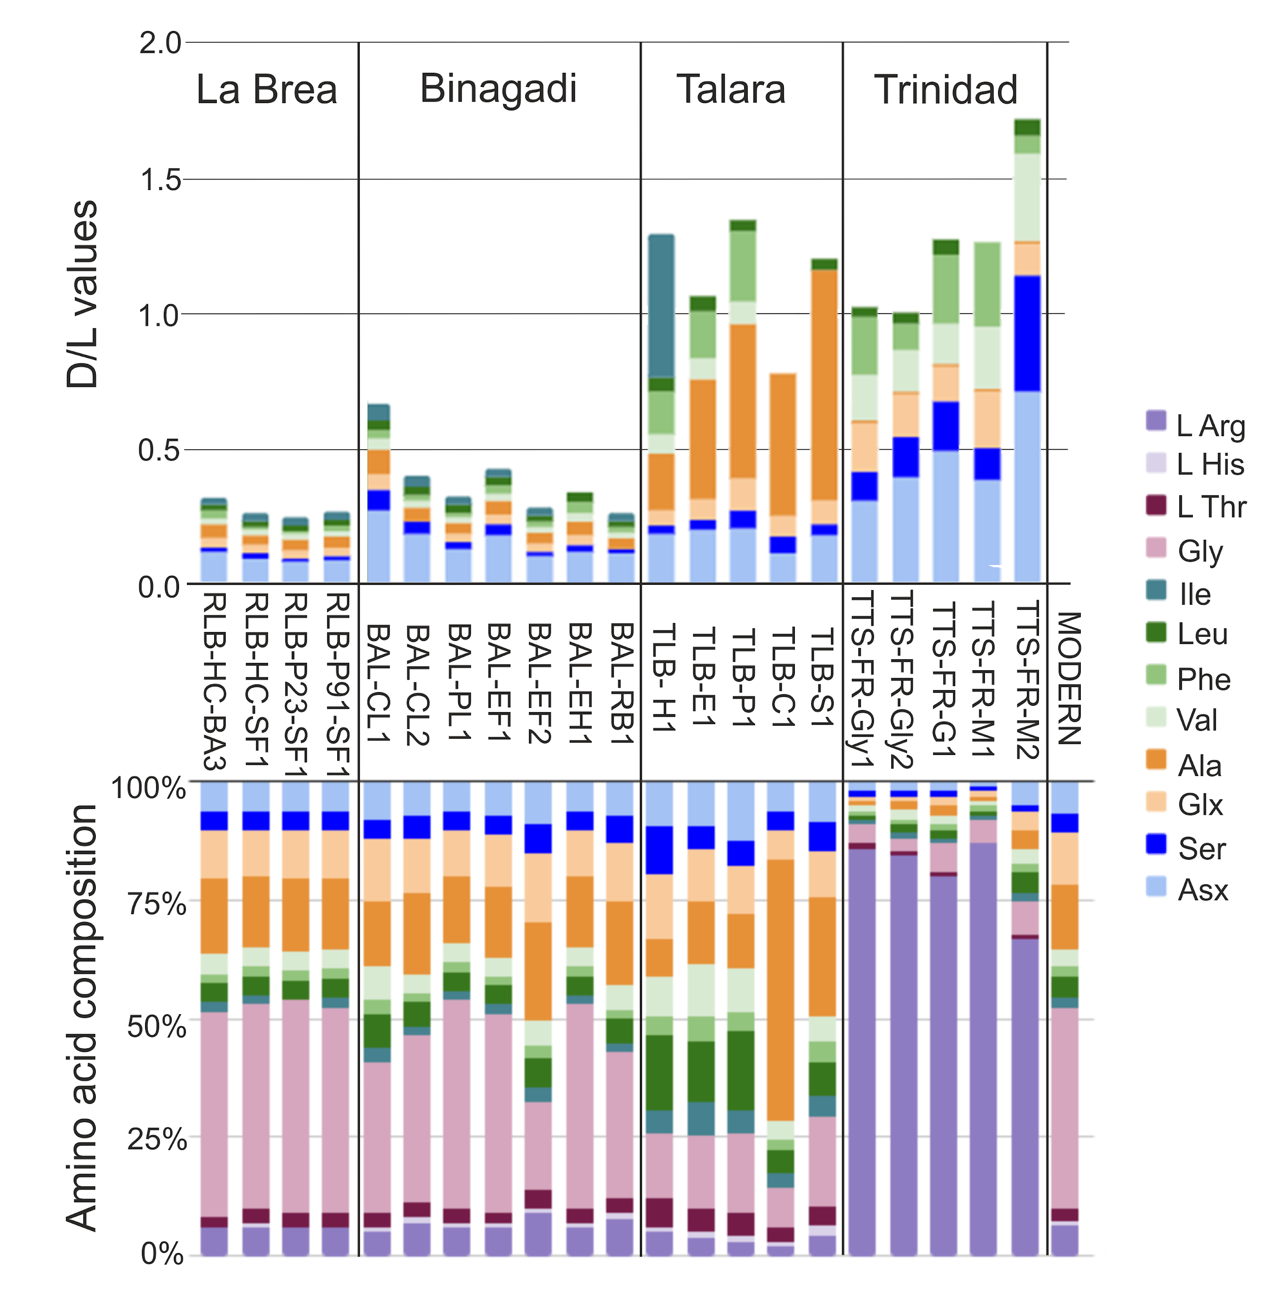
Figure 3.25 The AA results from all 4 sites, showing levels of racemisation and % amino acid composition. The amino acid composition of modern bone is shown as a comparison.

The SDS PAGE results reflect the AA results, with the Trinidad tar sands showing no positive results and the BAL samples giving a lower response than RLB (Figure 3.26). The TLB samples were analysed with GASP only.

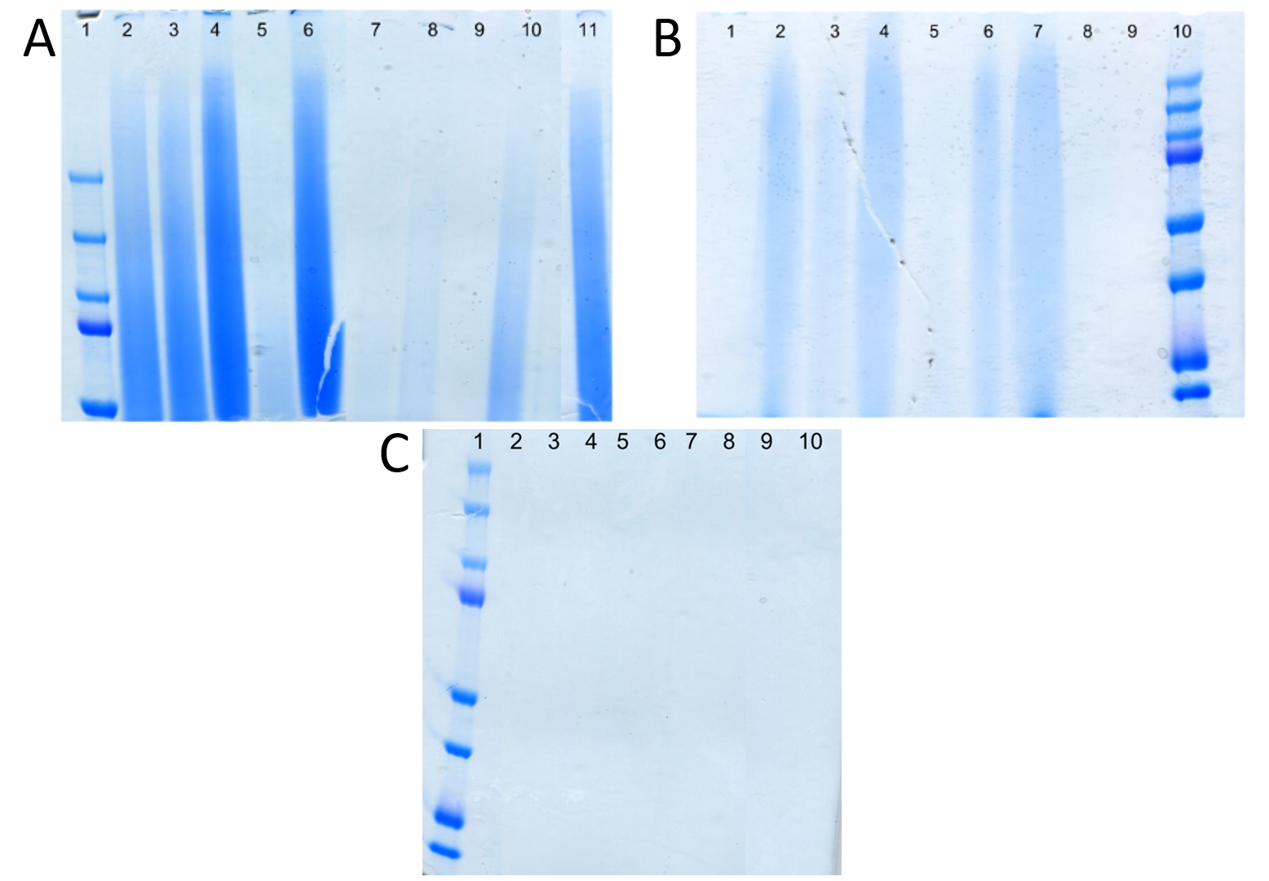
Figure 3.26. The SDS PAGE gels for RLB (A), BAL (B) and TTS (C). Gel A (image amalgamated from different gels), 1-Weight marker, 2- RLB-HC-BA2, 3-RLB-HC-BA3, 4-RLB-HC-PA1, 5-RLB-HC-SF2, 6-RLB-HC-SF3, 7-RLB-P23-SF1, 8-RLB-P91-SF1, 9-RLB-HC-BL1, 10-RLB-HC-BA1, 11-RLB-HC-SF1. Gel B: 1-BAL-CL1, 2- BAL-PL1, 3-BAL-CL2, 4-BAL-EF2, 5-BAL-EF1, 6-BAL-RB1, 7-BAL-EH1. 8 and 9 are blank, 10-Weight marker. Gel C: 1- Weight marker, 2-TTS-FR-M2, 3- TTS-FR-Gly1 ,4-TTS-FR-Gly2, 5-TTS-FR-G1, 6- TTS-FR-M1, 7-10 are blank. This shows protein preservation between tar seeps is varied both between sites as well as in the same site. Overall RLB gave the best SDS PAGE results, in line with the MS/MS results.

Due to the poor results from Talara and Trinidad, the main comparison of proteomic recovery was between RLB and BAL. The RLB and BAL samples were prepared for LC-MS/MS using SDS PAGE and the results analysed using PEAKS, MaxQuant and the GPM. RLB shows greater recovery of proteomic information than BAL (Figure 3.27), with the exception of one sample (BAL-PL1). The majority of the RLB samples show high levels of proteomic recovery. However, it is interesting to note that the three RLB samples that group lower in the chart are all Bison antiquus samples. The Bison latifrons sample produced no result with SDS PAGE (Figure 3.26) and so was not analysed further. This may suggest a possible predator/prey bias in protein preservation. A comparison of the proteins identified between the RLB and BAL can be seen in Figure 3.33.

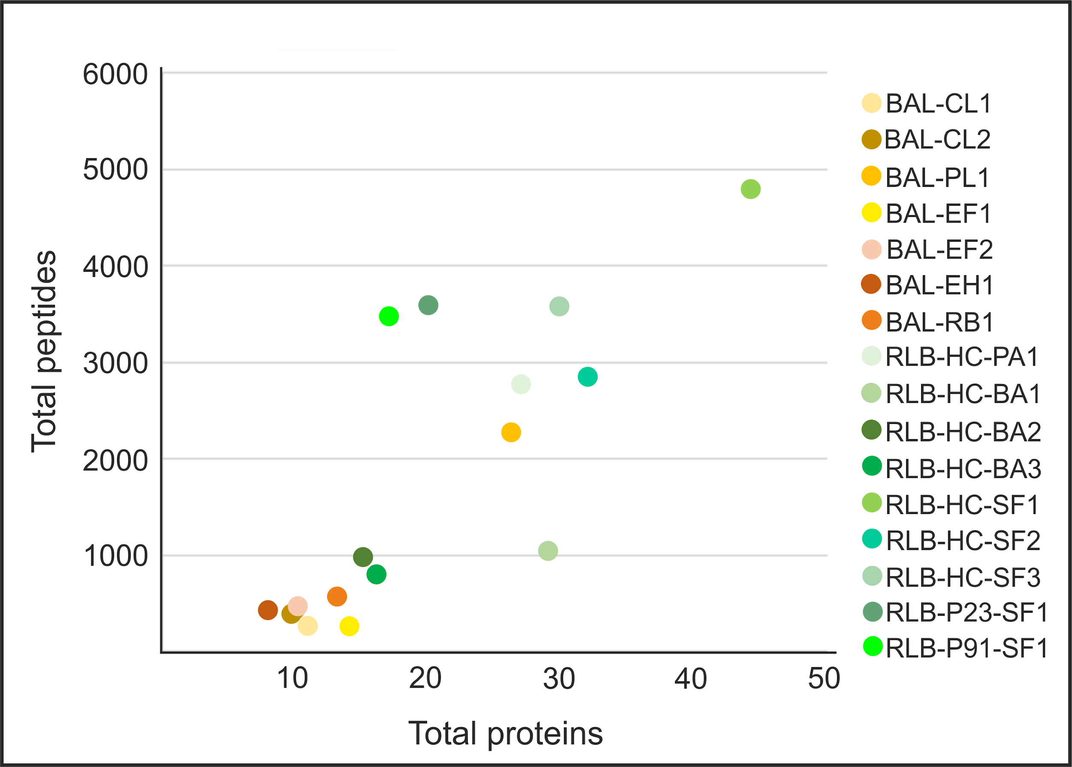
Figure 3.27 The total proteins and peptides recovered for the RLB (green) and BAL (orange) samples.

The TLB samples and one Trinidad sample (TTS-FR-Gly2, due to the poor AA and SDS PAGE results from the other samples) were analysed using GASP prior to LC-MS/MS, along with one sample from RLB and one from BAL. The GASP results were analysed using PEAKS and are summarised in Figure 3.28. The BAL and RLB samples showed much higher levels of peptide recovery (Figure 3.28, insert). As expected from the AA and SDS-PAGE data, the TTS and TLB samples produced poor results, with the majority of proteins identified for all the samples being collagens. Only TLB-S1 and TLB-C1 yielded an NCP (EEF1A1 and ACTB respectively). However it must be noted that due to the limited genomic information, NCPs could not be identified for Glyptodon (TTS-FR-Gly2) or Holmesina (TLB-H1).

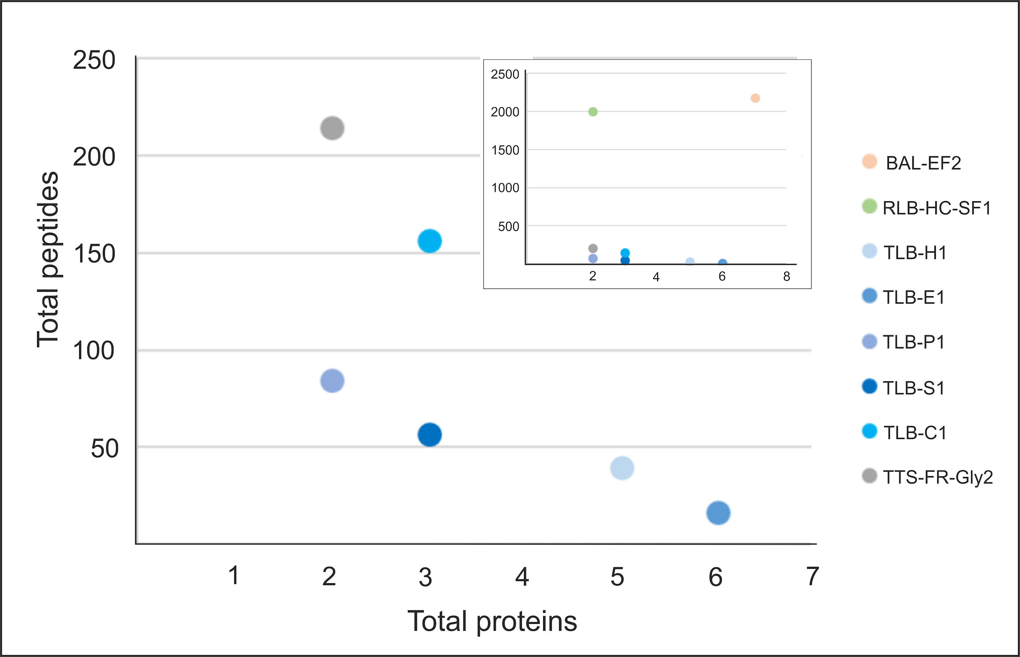
Figure 3.28. Comparison of all the tar seep sites; RLB (green), BAL (orange), TLB (blue) and TTS (Grey) analysed using GASP. BAL and RLB, had much higher levels of peptide recovery (insert).

3.3.1.6 Discussion
Recovery of proteins from tar-seep deposits was thought to have potential as the tar could act to seal the bone and protect proteins from the outside environment (Demarchi et al. 2016). However, the results are highly variable between the sites; in terms of proteomic information recovered, RLB>BAL>TTS≥TLB. There are many variables that may influence protein preservation, including how the samples were deposited in the tar, the post-excavation tar removal, and the method used to analyse the samples. These are discussed in more detail below.

DEVELOPMENT OF THE PROTEIN EXTRACTION METHOD
As this is the first time proteomic information has been recovered from tar seep samples, several methods were tested to assess the best way to achieve maximum protein recovery. The results of the different tar removal solvents show a general trend; as the tar is removed so too are proteins. Out of the different tar removal solvents samples TMM and M show a slight increase in recovery of collagen and NCP peptides respectively.. This may be due to the solvent as Rietschel et al. (2009) showed an increase in the number of peptides recovered, when the tryptic digest was carried out in the presence of methanol. The use of demineralisation solvents also resulted in a general decline in the amount of proteomic information recovered. When the different demineralisation solvents are compared HCl was shown to be the best, both with and without tar removal, in line with many other proteomic studies (Jiang et al. 2007, Cleland et al. 2012, Welker et al. 2015a).

When all the proteins identified from sample RLB-HC-SF1 using all the different methods are compared (Figure 3.29), the majority of the proteins seen in all the methods are collagens, with only 2 NCPs detected in all the different extraction samples: ALB and GLDN. The majority of the ‘common’ NCPs, (i.e. those that are seen in other ancient bone proteomic studies) are identified after using demineralisation only. As the comparison studies use demineralisation in their extraction protocol, this suggests that these proteins are preferentially extracted when the sample is demineralised (Cleland 2017).. A number of non-collagenous proteins were identified in the RLB sample that were not present in the comparison studies. With the exception of SFTPD, all these proteins were identified in the tar seep sample using no demineralisation. This may suggest that some proteins are not being identified or are being lost in ancient proteomic studies due to this demineralisation step. Therefore in order to achieve maximum proteomic recovery, it may be necessary to analyse samples both with and without demineralisation. However, for this study it was decided no demineralisation allowed good retrieval of an overall proteome.

The extraction method using no tar removal or demineralisation yielded the most proteins (Figure 3.20, Figure 3.23), both collagens and those usually less well preserved (actins/histones etc), but did not result in the detection of some commonly detected proteins such as IBSP or SPARC. This suggests that proteins that do not normally get preserved in ancient bone studies (for example because they are not closely linked to the bone mineral (Collins et al. 2002)), may get trapped by the tar rather than being lost to the environment. However, it must be noted that some of these proteins, such as actins, are highly conserved and therefore cannot be ruled out as contamination. The use of a gel as part of the extraction procedure is enough to remove the tar for subsequent LC-MS/MS analysis, allowing the possible retention of these proteins.

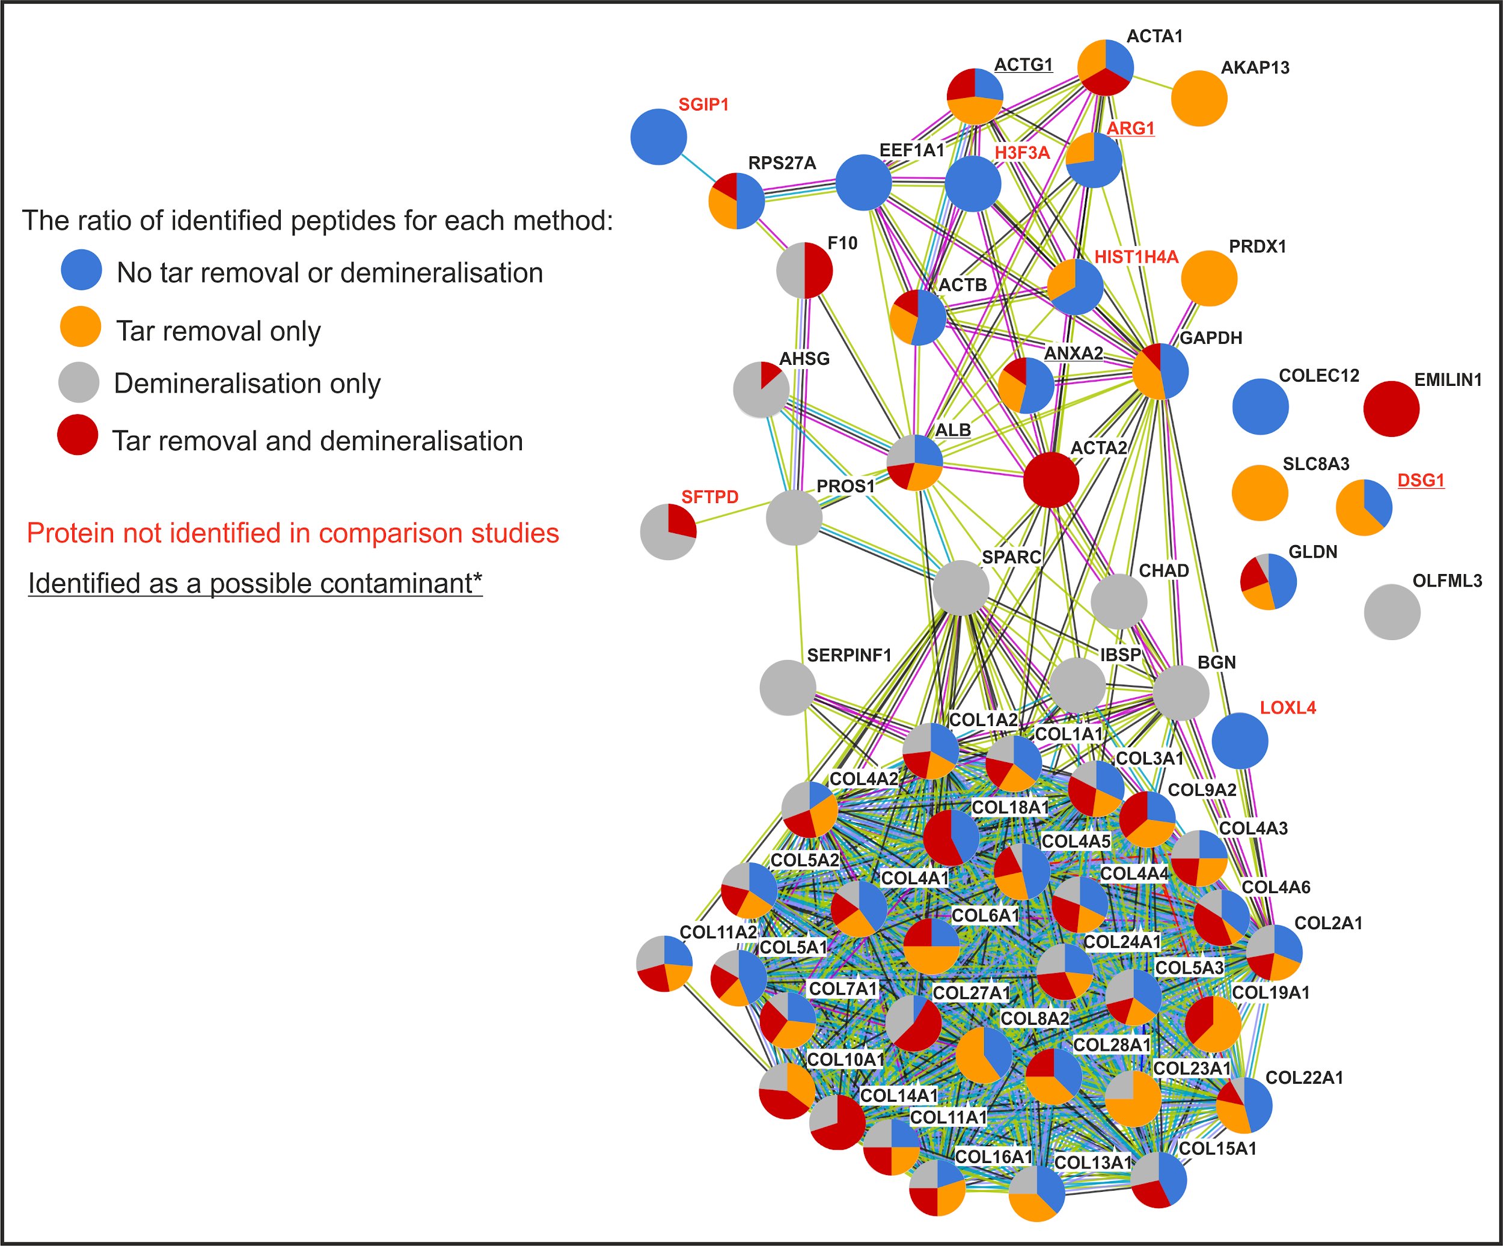
Figure 3.29. A string diagram of all the proteins identified from sample RLB-HC-SF1 using different extraction methods. To be included in the string diagram, the protein had to be identified by two or more peptides and either be commonly seen in bone studies (Alves et al. 2011, Cappellini et al. 2012, Hill et al. 2015, Schroeter et al. 2016, Cleland 2017, Procopio et al. 2017, Sawafuji et al. 2017, Wadsworth and Buckley 2017) or contain a species-specific peptide (shown in red on the figure). *Although these proteins contained a species-specific peptide it was noted that they may be a contaminant based on a recent study by Lacombe et al. (2017). This was to ensure strict criteria for evaluating the endogeneity of these tar seep proteins.

Two gel extraction methods were used as part of this study; SDS PAGE and GASP (Fischer and Kessler 2015). One sample from RLB (RLB-HC-SF1) and one sample from BAL (BAL-EF2) were analysed using both methods to assess level of proteomic recovery (Figure 3.30). The RLB sample produced better results with SDS PAGE than GASP, with more collagens and NCPs being identified. In contrast, the BAL GASP sample identified the same number of collagens and an increase in NCPs. Both samples yielded many more collagen peptides using GASP than SDS PAGE. The NCPs identified in the BAL GASP sample included common bone proteins such as ALB, C9, BGN and SERPINF1 as well as a pulmonary surfactant-associated protein, which is not seen in comparison studies but is present in the RLB sample (SFTPD see Figure 3.29). BAL-EF2 has a less collagen-like AA composition than RLB-HC-SF1 (Figure 3.25), suggesting this sample is more degraded. Therefore, GASP may be an extraction method, which is better suited to extract degraded proteins/peptides, while SDS PAGE is better at extracting proteins in well preserved samples, such as RLB. The level of tar saturation and the differences in the gel-based protein extractions, may have also influenced the protein recovery. Using the GASP protocol, the gel was cast around the sample, trapping both the proteins and the tar, while the SDS PAGE analysis allowed some separation of the proteins from the tar during gel electrophoresis prior to further analysis. The inclusion of the tar within the gel using GASP may have hindered the tryptic digestion and removal of the peptides for further analysis depending on the level of tar saturation.

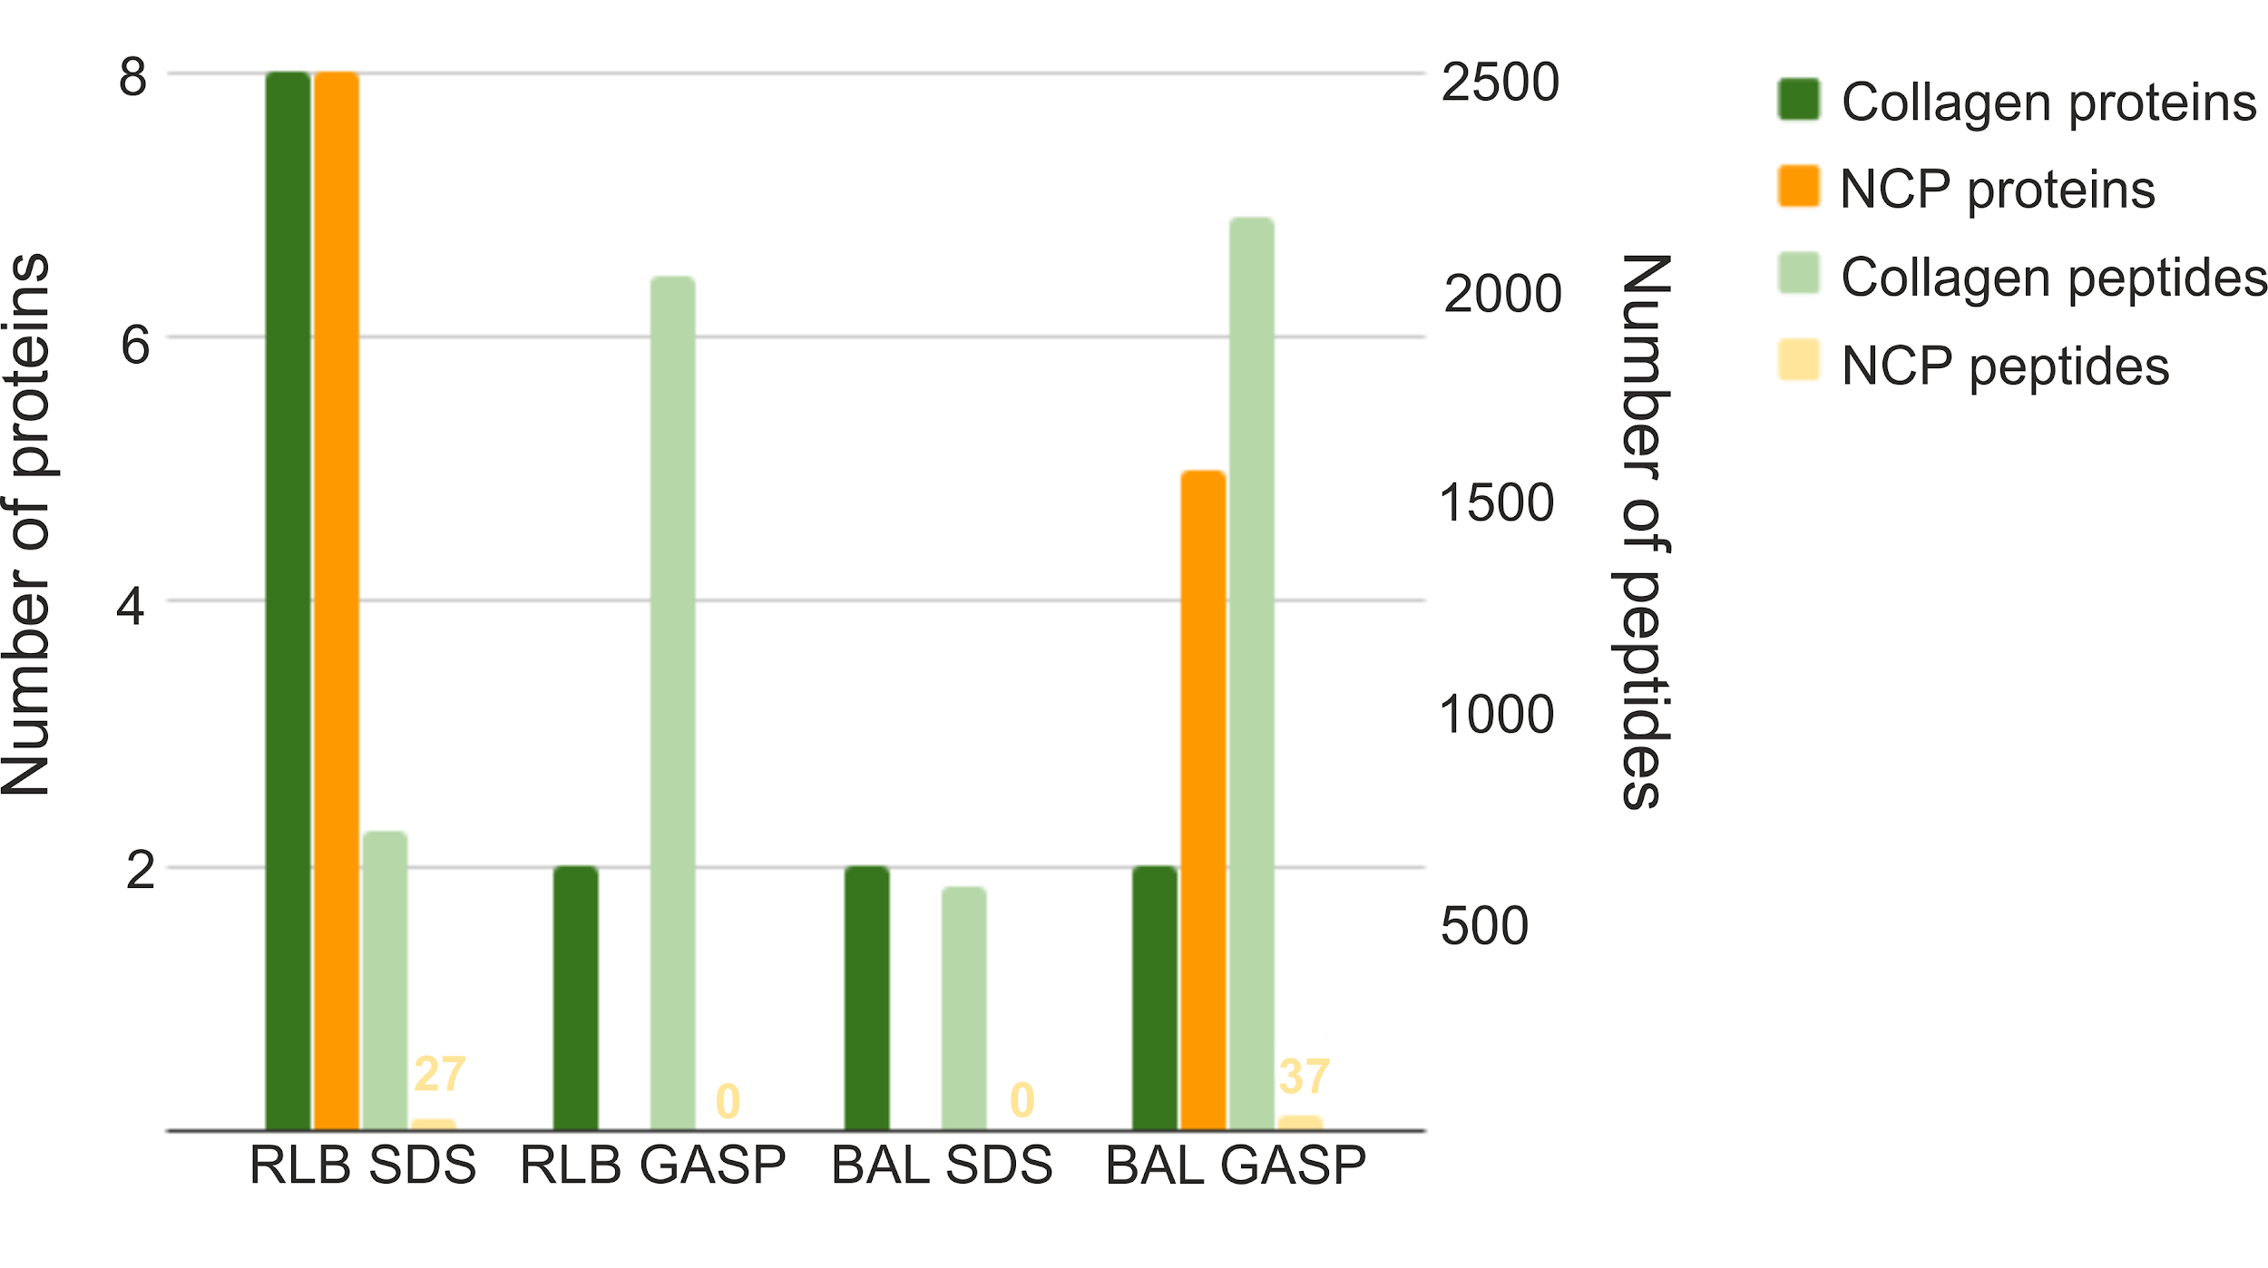
Figure 3.30. A comparison of SDS PAGE and the GASP method on 1 sample from RLB (RLB-HC-SF1) and 1 sample from BAL (BAL-EF2). The GASP samples were analysed using PEAKS only therefore only the PEAKS results are shown for the SDS PAGE samples.

THE EFFECT OF TAR SATURATION AND POST-EXCAVATION TECHNIQUES
The AA results show the RLB samples from all the different tar pits (Hancock/Pit 91/Project 23) are well preserved, with a good collagen-like AA composition and low levels of racemisation (Figure 3.25). However, the proteomic recovery from these different deposits varied greatly. The SDS PAGE of the RLB samples shows only a weak result for both the Pit 91 and Project 23 sample (Figure 3.26, Gel A, lanes 7&8). When the MS/MS results are compared between all three pits (Figure 3.31) proteomic recovery is best for HC>P23>P91. This may reflect the age of the samples (~28,000>28,320>35,840 years BP respectively). However, it is somewhat surprising that the Hancock collection samples were the best preserved, as these samples would have been excavated in the early 20th Century and tar removal was carried out via boiling the bones in kerosene (Heric 1969). This method of tar removal was also utilised at BAL and TTS; BAL also produced good proteomic results but the TTS results were poor (a more in depth comparison of the different tar-seep sites is given below). The number of contaminants (cRAP database) and keratins identified were also considered, and it was shown that the Hancock collection resulted in the most contaminants (Figure 3.31). This may be related to time since excavation (TSE) and museum storage. Further analysis of samples from Pit 91 and Project 23 are needed. However, it would appear that boiling bones in kerosene or benzene (as at BAL) is not detrimental and may actually be preferential to other tar removal methods, for proteomic recovery.

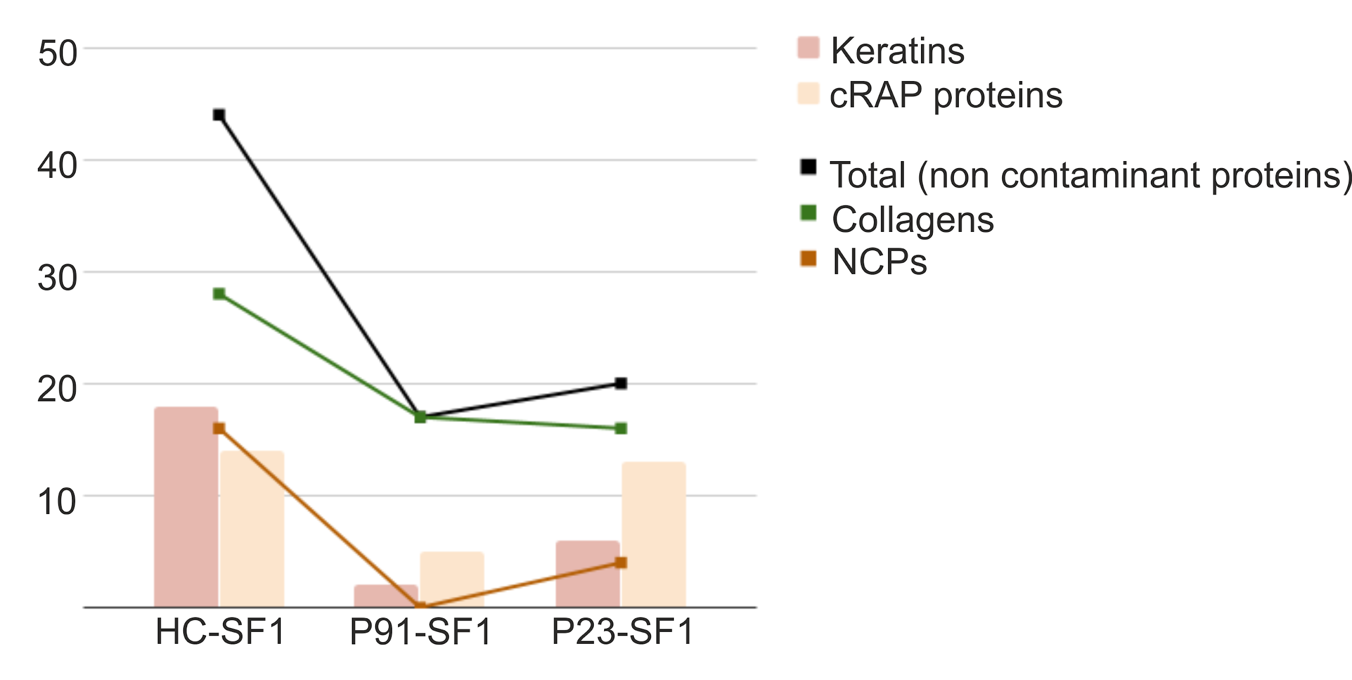
Figure 3.31 A comparison between the different tar seep deposits at RLB. The keratins and cRAP proteins were not included in the calculation of total proteins or NCPs identified.

The results of the saturated bone experiments showed that the tar influences the retrieval of proteins, as the unsaturated sample yielded the most proteins. When the proteomic results are compared (Figure 3.32), the only proteins shared between all the subsamples are collagens. Only one NCP was shared with the unsaturated sample and the saturated sample (GLDN) which has also been found in other samples from RLB (see appendix 2). The four NCPs that were only found in the saturated sample were either identified as possible contaminants (ATP5A1, ENO1 and HSPA5; Lacombe et al. (2017)) or not seen in any of the bone comparison studies used in this project (MYO15A). The NCP seen only in the tar extracted saturated sample was not found in any of the comparison studies (HSPD1). The unsaturated sample contained the most proteins and all the proteins identified are present in comparison studies. These results show that the tar does affect proteomic recovery, but may act as a means of preserving proteins that are not often recovered in other ancient samples. However, the identification of these proteins must be treated with caution, as it is possible that the tar also acts as a trap for modern contaminant proteins. The tar may also hinder the extraction of ‘traditional’ bone proteins.

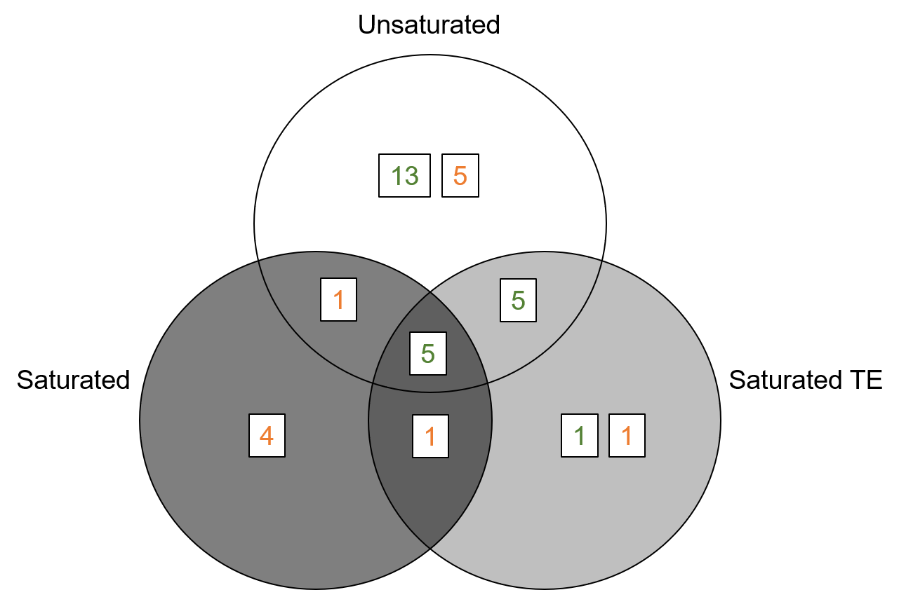
Figure 3.32. A Venn diagram comparing the proteins found in the saturated sample both with (Saturated TE) and without (Saturated) tar removal and a subsample of the same bone that was not saturated with tar (Unsaturated). Collagens are shown in green and NCPs are shown in orange.

TAR-SEEP SITE COMPARISON
The preservation of proteins across the different tar seeps varied greatly. Both the Talara and Trinidad material showed high levels of degradation. It is somewhat surprising that the TLB samples were so degraded, as it is believed the method of bone deposition at TLB is very similar to that of RLB, which gave the best results, and the sites both date to the Late Pleistocene. The AA results from the TLB samples show an altered AA composition and high levels of racemisation (Figure 3.25). The high D/L values of Glx (glutamine and glutamic acid) and alanine in the TLB samples relative to those of Asx and Ser are indicative of bacterial contamination (Johnson and Miller 1997)), and may help explain why these samples appear so degraded. It is not clear whether the bacterial contamination may have occurred while in the tar seep or after excavation. The TTS samples also showed high levels of racemisation and the AA composition was dominated by arginine. This may be due to this site being a tar sands rather than a tar seep, as the saturation of the tar was less than the other samples analysed in this study (personal observation). The samples analysed from TTS were found near the surface, and therefore would have been exposed to the hot humid environment which would also contribute to their degraded nature.

The majority of the RLB samples produced good sequence results, with the exception of RLB-HC-BL1. Possible explanations for this may be either this sample is much older and therefore more degraded or this sample may have ended up in the tar seep via a different process, i.e. been washed in from another location. The BAL samples also gave good sequence results, although in general were more degraded than RLB (Figure 3.27). This was expected to a certain degree as the BAL site is reportedly much older. The taphonomic analysis of bones from both these sites have shown minimal weathering and good levels of preservation (Spencer et al. 2003, Boev 2010). This suggests that these bones were buried in the tar relatively rapidly and therefore may explain the good recovery of proteomic information from both these sites.

The proteins from the SDS PAGE analysis (no tar removal, no demineralisation) of all the RLB and BAL samples are shown in Figure 3.33. Proteins that were matched to the cRAP contaminants database (the GPM) were removed from the analysis and the remaining proteins were compared to a recent study on contaminant proteins from human breath (Lacombe et al 2017). If any RLB or BAL proteins matched this study, they were identified as a potential modern contaminant (underlined in Figure 3.33). The majority of the proteins that are shared between both sites are collagens, with only 10 NCPs being seen in both sets of samples. However, out of these 10, five are identified as possible modern contamination. All the proteins that were only identified in modern bone comparison studies were found at RLB only. This shows the tar may be able to protect certain proteins, that are not able to be preserved in other archaeological environments. Nine proteins were only recovered at BAL: two collagens and seven NCPs. Of these nine, only three have been found in other bone studies, and one of these three has been identified as possible contamination. Only one of these NCPs has a connection to collagens (ADAMTS1) and all the other ‘common’ collagen related NCPs, such as DCN, FN1 etc are seen in RLB only. This raises questions as to the endogeneity of these proteins, which is discussed below.

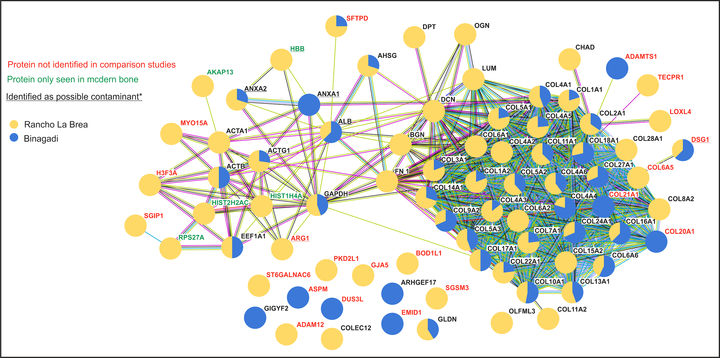
Figure 3.33. A string diagram showing all the proteins identified from RLB (Yellow) and BAL (Blue). If a protein was identified at both sites, the ratio of identified peptides is shown. Interactions between the different proteins are shown by the connecting lines. For example, myosin (MYO15A) and actin (ACTA1) are both commonly expressed muscle proteins, therefore they are shown to interact with each other. The greater the number of interactions, the greater the confidence that the protein was present in the sample. Proteins highlighted in red were not identified in comparison studies (Alves et al. 2011, Cappellini et al. 2012, Hill et al. 2015, Schroeter et al. 2016, Cleland 2017, Procopio et al. 2017, Sawafuji et al. 2017, Wadsworth and Buckley 2017) . Green proteins were found in only modern bone comparison studies. Those proteins underlined are identified as possible modern contaminants *(Lacombe et al. 2017).

THE SOURCE OF PROTEINS- THE BONE OR THE TAR?
It is most probable that the proteins identified in this study are both a mixture of endogenous proteins and contamination from either the tar or post excavation and museum storage. As previously mentioned, a protein was only included in this study if it was either seen in other bone proteomic studies or contained a species-specific peptide. The majority of the proteins shown here have been identified in other archaeological bone studies (Figure 3.33) suggesting they are endogenous. However the ‘tar seep specific’ proteins (i.e not seen in other studies), require further analysis (Table 3.5) and each of these proteins were assigned a level of confidence. Confidence was based on the protein function (i.e. how likely the protein will be expressed in bone), the location of the protein in the string diagram (i.e. multiple links to other common bone proteins) and if seen in samples from both sites. Proteins which match two out of the three criteria were given a confidence rating of high, one match was shown as medium confidence and no matches or if identified as a possible modern contaminant, the confidence rating was shown as low.
Site | Protein | Name | Function | Location | Confidence
BAL | ADAMTS1 | A disintegrin and metalloproteinase with thrombospondin motifs 1 | Cleaves aggrecan, a cartilage proteoglycan | Extracellular | Medium
BAL | ASPM | Abnormal spindle-like microcephaly-associated protein | Involved in mitotic spindle regulation | Intracellular | Low
BAL | COL20A1 | Collagen alpha-1(XX) chain | extracellular matrix structural constituent | Extracellular | High
BAL | COL21A1 | Collagen alpha-1(XXI) chain | extracellular matrix structural constituent | Extracellular | High
BAL | DUS3L | tRNA-dihydrouridine(47) synthase | Catalyzes the synthesis of dihydrouridine | Intracellular? | Low
BAL | EMID1 | EMI domain-containing protein 1 | Unknown | Extracellular | Low
BAL | GIGYF2 | GRB10-interacting GYF protein 2 | Part of a complex that represses translation | Intracellular | Low
RLB | ADAM12 | Disintegrin and metalloproteinase domain-containing protein 12 | Involved in skeletal muscle regeneration | Extracellular | Medium
RLB | ARG1 | Arginase-1 | Key element of the urea cycle | Intracellular | Low
RLB | BOD1L1 | Biorientation of chromosomes in cell division protein 1-like 1 | DNA binding | Intracellular | Low
RLB | COL6A5 | Collagen alpha-5(VI) chain | Cell binding | Extracellular | High
RLB | GJA5 | Gap junction alpha-5 protein | Transports low MW substances between cells | Membrane | Low
RLB | H3F3A | Histone H3.3 | Transcription regulation and DNA repair | Intracellular | Medium
RLB | LOXL4 | Lysyl oxidase homolog 4 | Involved in the formation of EC matrix. | Extracellular | High
RLB | MYO15A | Unconventional myosin-XV | Serves in intracellular movements. | Intracellular | Medium
RLB | PKD2L1 | Polycystic kidney disease 2-like 1 protein | Calcium binding | Membrane | Low
RLB | SGIP1 | SH3-containing GRB2-like protein 3-interacting protein 1 | Phospholipid and SH3 domain binding | Membrane | Low
RLB | SGSM3 | Small G protein signaling modulator 3 | May play a role in suppression of cells. | Intracellular | Low
RLB | ST6GALNAC1 | Alpha-N-acetylgalactosaminide alpha-2,6-sialyltransferase 1 | Involved in the protein glycosylation pathway | Intracellular | Low
RLB | TECPR1 | Tectonin beta-propeller repeat-containing protein 1 | Tethering factor involved in autophagy. | Intracellular | Low
Both | DSG1 | Desmoglein-1 | Component of desmosome junctions. | Membrane | Low
Both | SFTPD | Pulmonary surfactant-associated protein D | Contributes to the lung's defense | Extracellular | Medium

Table 3.5. (on previous page) A list of all the proteins recovered from RLB and BAL that were not seen in the bone comparison studies, termed ‘tar seep specific’ proteins . Those in bold, are possible contamination as they match proteins seen in Lacombe et al. (2017). Confidence is based on the protein function (i.e. how likely the protein will be expressed in bone), the location of the protein in the string diagram (i.e. multiple links to other common bone proteins) and if seen in samples from both sites. Proteins which match two out of the three criteria were given a confidence rating of high, one match was shown as medium confidence and no matches or if identified as a possible modern contaminant, the confidence rating was shown as low.

Two proteins, SFTPD and DSG1, are seen in both tar seeps, but DSG1 has also been shown to be a possible modern contaminant (Lacombe et al. 2017). As SFTPD is seen at both sites (and SFTPA was identified in the BAL GASP sample) and not identified as a possible contaminant, this gives confidence that this pulmonary surfactant associated protein is preserved across tar seep samples. This protein contributes to the lung’s defences against inhaled microorganisms and toxins, as well as being involved in immune response and it is interesting to note that of the 4 types of this protein (A-D) the two identified (A&D) are both collagenous and carbohydrate binding (rather than hydrophobic-B&C) suggesting potential interaction with the bone mineral. Other tar specific proteins, such as the collagens COL20A1, COL21A1 and COL6A5, and those associated with collagens such as LOXL4 and ADAMTS1 can also be given a high level of confidence as these are expected to be seen in bone and are unlikely contaminants.

MYO15A and H3F3A may also be present in the samples, as other histones and myosins have been identified in other bone studies (Sawafuji et al. 2017)). ADAM12 is linked with skeletal muscle regeneration, therefore it is plausible that this protein would be found in the bone samples. The majority of the tar seep specific proteins have a low confidence and constitute a wide range of proteins with different functions that are not usually associated with bone. It may be possible that these proteins are genuine, as they do contain species-specific peptides. It is also possible that these proteins come from the tar, having been trapped there as the remains of animals in the tar decompose. This may explain why such a variety of different proteins are recovered.

In order to explore the types of NCPs recovered further the control sample was prepared for analysis using the GASP method at York and sent to two different labs for LC-MS/MS analysis; Turin and Copenhagen. The GASP protocol was chosen as it has been proven to successfully extract complex proteomes from archaeological material (Hendy et al. 2018b). A subsample of the micro-ground control was also sent to Turin for GASP prep and subsequent MS/MS analysis. The results are shown in Table 3.6.

 | COL1 | COL2 | COL3 | COL4 | COL5
Turin | 653 |  |  | 4
York_Turin | 1398 | 35 | 2 |  | 18
York_Cph | 3743
Table 3.6. The lab comparison results showing the number of peptides identified for each protein. TURIN was both prepared and run on the LC-MS/MS at the University of Turin, YORK_TURIN was prepared using the GASP method at York and sent to Turin University for LC-MS/MS and YORK_CPH was prepared using the GASP method at York and sent to Copenhagen University for LC-MS/MS.

No NCPs were found in any of the GASP samples and the level of collagen coverage varied between the samples. Although the LC-MS/MS results from Copenhagen produced the most collagen peptides overall, the only protein identified was collagen type 1. Both subsamples analysed at the University of Turin identified multiple collagens. The fact that no NCPs were found in any GASP analysis, raises questions about the sample preparation protocol, although GASP did produce NCPs for the BAL sample (see Figure 3.30). It is also possible than the NCPs identified (especially those with a low confidence) may be contaminants introduced during SDS PAGE preparation and analysis, although steps were taken during the preparation to prevent this. Based on these results, it is suggested that only proteins with a high confidence (Table 3.5) are reported as present in these samples as a conservative estimate of proteome survival in tar seep specimens.

PROTEIN PRESERVATION IN TAR SEEP INSECTS
Overall less proteomic information was recovered for insects in tar seeps than bone (Table 3.7). This corroborates the previously published amino acid data (McMenamin et al. 1982, Stankiewicz et al. 1997). However, one of the main problems when dealing with these insect samples is the lack of an extensive database; currently on NCBI there are only 1,330 cuticle proteins recorded for beetles. In comparison, there are nearly 32,000 records for mammalian collagen. Therefore this variation in protein recovery may be impacted by database limitations rather than lack of protein retrieval, although this can be partly overcome due to de novo sequencing as used in PEAKS (Ma et al. 2003). Out of the 13 proteins that were able to be identified, ten were unreviewed in Uniprot.

Site | La Brea ref | Species | # proteins | # peptides
P23 | 25769 | Unknown | 1 | 2
Hancock | 8270E | Unknown | 10 | 53
Hancock (pit A) | 5319 | Eleodes acuticaudus | 3 | 134
Hancock (pit 4) | 13194 | Apsena laticornis | 1 | 88
Table 3.7. The proteomic results of the four tar seep insect samples from Rancho La Brea.

When all the identified proteins are combined, four proteins were identified as potential cuticle proteins. An insect cuticle mainly consists of the molecule chitin and proteins, which have a strong interaction with each other through covalent cross links (Stankiewicz et al. 1996). Chitin is a one of the most resistant natural polymers, and only certain snails and fungi are known to generate chitinases, which will break it down. Therefore it is not surprising that chitin has been shown to survive into the geological record (Cody et al. 2011, Briggs and Summons 2014, Mazur et al. 2014). As the interaction between chitin and proteins is through these strong covalent bonds, it is possible that this polymer may act in a similar fashion to bone mineral and protect proteins from decay. Experiments on modern insects have shown promising results, with MALDI ToF being used to identify insects through peptide mass fingerprinting and specifically cuticle proteins have been shown to contain species differences (Willis 2010, Steinmann et al. 2013). Therefore in the future, there is the potential that the retrieval of these decay-resistant cuticle proteins from tar seep fossil insects may be able to be used for identification and potential phylogenetic reconstructions. However, this will only be possible with the expansion of the reference database and further method development.

3.3.1.7 Conclusions
This study shows the results of the first proteomic analysis of tar seep specimens. A sample from RLB was used to test various different methods of tar removal and protein extraction. The result of these method development experiments showed no further tar removal was needed to recover proteins from these samples. The use of a gel (either SDS PAGE or GASP) enabled separation of the proteins from the tar for LC-MS/MS analysis. Demineralisation of the sample resulted in a more traditional bone proteome, with HCl shown as the best solvent. It is possible that two subsamples (one with demineralisation and one without) will produce the best recovery of the proteome. However for this study, it was decided no demineralisation allowed for the successful retrieval of a wide range of proteins.

The effect of the tar and the different post-excavation protocols used to preserve tar seep fossils have been considered. The results show that a sample with no tar removal whatsoever, results in recovery of very few proteins and an unsaturated section of the same bone produced better results, showing the level of tar saturation affects protein recovery. The different post-excavation tar removal processes were compared at RLB, and although more samples are needed before clear conclusions can be drawn (and the different age of the samples need to be considered) it appears that boiling bones in kerosene (RLB) or benzene (BAL) is not detrimental to the preservation of proteins, but may be the prefered method of tar removal for protein survival. Some proteins identified at RLB and BAL have not been commonly seen in other bone studies, suggesting that the tar may preserve proteins not recovered from other palaeontological environments. However, the identification of these proteins must follow strict criteria (species-specific peptide, associated with bone), as it is likely contaminant proteins also get trapped in the tar.

The proteomic recovery from different tar seeps varied greatly. Both RLB and BAL gave good sequence information and the proteins identified were able to be compared. Both TLB and TTS gave poor results for AA analysis, SDS PAGE and LC-MS/MS. This cannot be linked to the method of deposition (as TLB is believed to act as a traditional tar pit trap as at RLB), or post-excavation (as TTS post excavation was similar to that used on the Hancock Collection at RLB). It is possible that tar sands may not allow for the same degree of tar saturation, and as all the TTS samples were found close to the surface, this may have allowed increased hydrolysis and degradation of proteins. The AA results of TLB show possible bacterial contamination, which may explain why these samples gave poor results, but it remains unclear when this bacterial contamination occurred.

In summary, despite the seemingly harsh burial environment and post-excavation cleaning of some material, tar seep specimens do provide another avenue for proteomic analysis. However, like other environments, proteomic recovery is dependant on a variety of factors. Contamination, both modern and from the tar, needs to be considered when the proteome of these samples are being analysed. Tar seeps show promising results with soft tissue specimens, but this was a preliminary study and further method development and database building is needed before proteomics can be widely applied to tar seep insect remains.

3.3.3 Conclusions
While it is becoming clear that closed system fossils are a good source of ancient proteins, it appears this method of protein survival is limited to biominerals. While tar seeps can provide a protective casing for palaeontological samples, they do not form a completely closed system, and still allow proteins to interact with the outside environment. However, this protective casing can still provide some resistance to decay, with many bone proteins being able to be recovered from tar seep samples dating to ~100,000 BP from an environment (warm, presence of water) otherwise not conducive to biomolecular survival (Gold et al. 2014).

3.4 Conclusion
Proteins can undergo degradation via a number of pathways, such as chemical hydrolysis and microbial decay. Historically several analytical techniques have been used to try and measure the extent of protein degradation in ancient samples, including microscopic analysis, the use of lab based diagenetic experiments and analysis of sequence data. In this chapter ATR-FTIR, AA analysis, MALDI-ToF MS and LC-MS/MS was used to try and determine general patterns of protein survival. FTIR analysis of the mineral component of palaeontological bone was shown to be an unreliable proxy for protein survival due to the recrystallization and fossilisation processes of the bone. AA analysis and MALDI-ToF MS showed similar levels of protein recovery, which was mainly in agreement with predicted levels of ancient DNA survival, but some proteomic recovery was possible from hotter environments. When examined further it was shown that the preservation of the proteins in these hotter environments may be due to the micro-climate of the sites, with sinkholes providing protection from the extremes of the heat and humidity. Age, at least for an open system like bone, will affect levels of proteomic recovery even in cold environments.

Sequence data can provide a lot of information about protein degradation by analysing the extent of non-tryptic cleavage and the number and type of PTMs identified. It appears that non-tryptic cleavage of the peptide backbone in collagen occurs at similar points along the protein, at least initially, and the presence of PTMs correlates with the extent of cleavage. A variety of factors appear to influence the presence of diagenetic PTMs with no clear trend with either environmental conditions or age. The analysis of peptides from samples over 1 million years show limited diagenetic alteration, such as deamidation and oxidation. Instead they show a high number of thermally stable amino acids in the peptides that are preferentially preserved in these fossils. However, whether these peptides will eventually also be lost over time or be able to be preserved for millions of years has yet to be conclusively proven.

A closed system is able to protect proteins from environmental factors which has been shown to promote diagenesis. However, these closed systems appear to be limited to biominerals. While tar seeps have been shown here to allow a resistance to protein degradation, they do not form a completely closed system. Proteins from within these samples can still interact with the environment and there is the potential for the inclusion of contaminants into the fossil.

Chapter 4. Ancient protein phylogenetics

4.1 Introduction

4.1.1 Overview
Molecular phylogenetics is traditionally carried out using DNA sequences (Hillis et al. 1993, Cappellini et al. 2018a). However, DNA does not persist into the fossil record unless in extreme circumstances (for example preserved in permafrost (Orlando et al. 2013)). Therefore, proteins, being much more stable than DNA, provide an alternate choice when analysing the phylogenetic relationships of extinct palaeontological taxa (Buckley 2013, Welker et al. 2015b, 2017). In this chapter, the phylogenetic placement of several extinct xenarthran species (giant ground sloths) will be investigated using collagen sequences. Both their relationship with each other as well as with the two still extant modern relatives (the two toed sloth Choloepus and the three-toed sloth Bradypus) will be investigated (Section 4.2). A smaller phylogenetic study was also carried out on modern and extinct bears. In this investigation, the use of other non-collagenous proteins were also tested to see if this could increase phylogenetic resolution (Section 4.3).

4.1.2 Article submission details
The sloth phylogenetic study was submitted to Nature Ecology and Evolution:

Presslee S., Slater G., Pujos F., Forasiepi A.M., Fischer R., Olsen J., Molloy K., Mackie M., Kramarz A., Taglioretti M., Scaglia F., Lezcano M., Hajduk A., Southon J., Feranec R., Bloch J., Lanata J.L., Martin F.M., Gismondi R.S., Reguero M., de Muizon C., Billet G., Greenwood A., Chait B., Collins M. and MacPhee R.DE. (Submitted 02.10.18). Collagen proteomics resolves relationships of tree sloths and their extinct relatives. Nature, Ecology and Evolution (Under revision).

The author contributions are as follows; RDEM, MC, and SP conceived the project. SP undertook AA analysis and proteomic analysis and concatenated collagen sequences, with laboratory and technical assistance from RF, JO, KM, MM, MC, and BC. GJS conducted phylogenetic analyses. FP and AMF supplied paleontological information. AK, MT, FS, ML, AH, AI, RF, JB, JLL, FMM, RSG, MR, AG, CdM, and GB supplied palaeontological samples, locality information, species identifications, and commentary on the manuscript. SP, GJS, and RDEM wrote the manuscript, with input from all authors.

4.2 The phylogenetic potential of collagen
Collagen is the main protein that is used in ancient phylogenetic reconstruction. It is the protein of choice, as it is abundant in bone and often well preserved due to the interaction with the bone mineral (See Chapter 3). In this thesis, collagen phylogenetics was chosen to try to resolve the relationship of tree sloths and their extinct relatives.

4.2.1 The original Folivoran (sloth) family tree
Sloths come from the Suborder Folivora, part of the Order Pilosa , which in turn is part of the Superorder Xenarthra. Other Xenarthrans include anteaters (Vermilingua) and armadillos (Cingulata). Nowadays Folivora are only made up of two species the two toed (Choloepus) and the three-toed (Bradypus) tree sloth. However, before the Late Quaternary, Folivorans were a highly successful and diverse group of placental mammals comprising multiple families and species and covering North and South America as well as the West Indies (Figure 4.1).

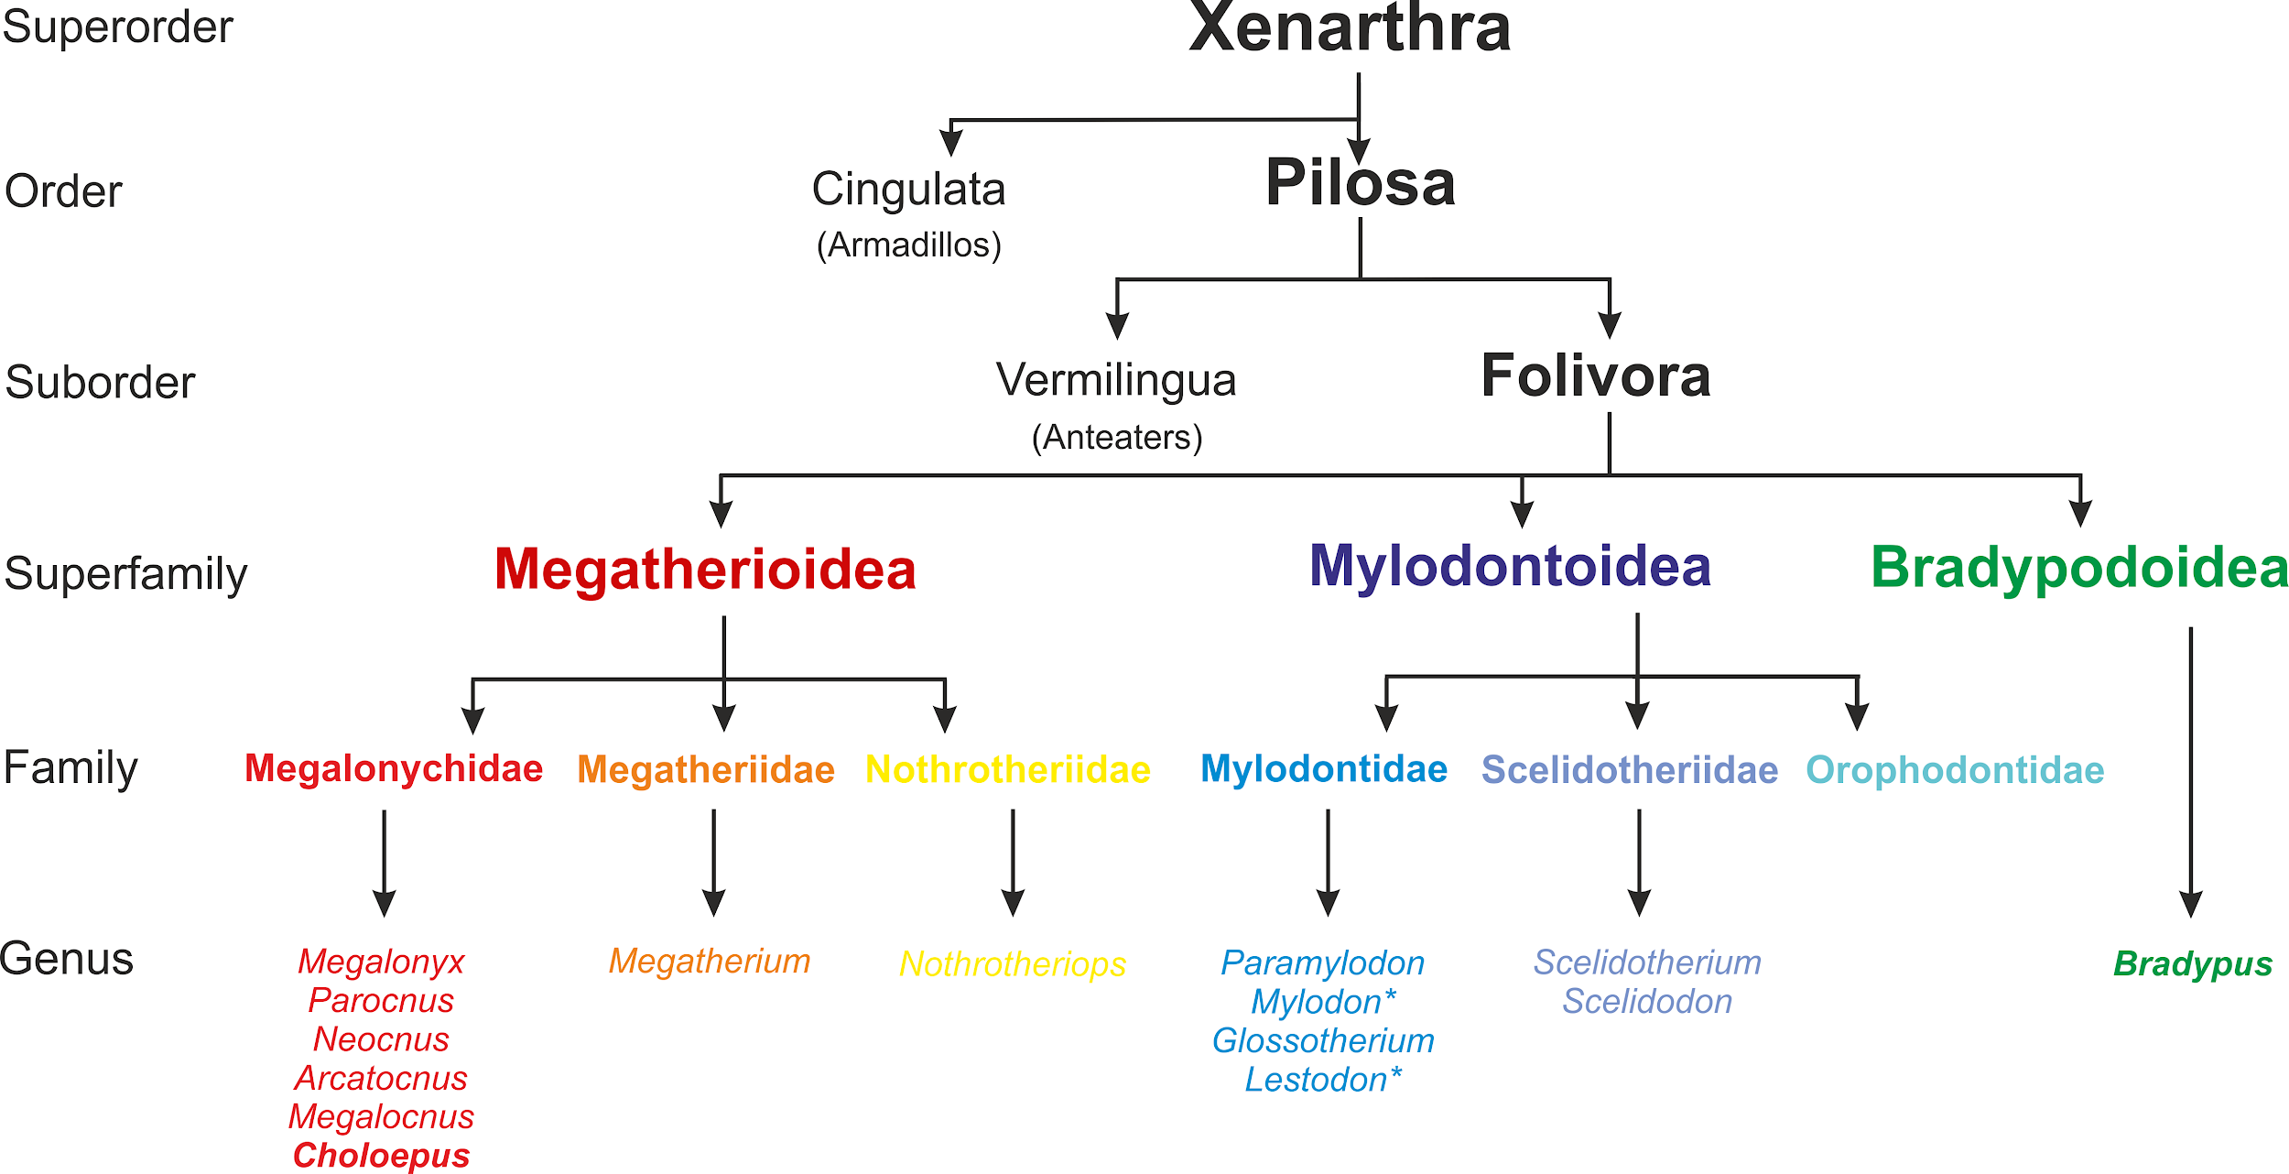
Figure 4.1. The xenarthran family tree based on Gaudin and MacDonald 2010. Only genera that have been successfully sequenced are shown. Genera in bold are modern extant sloths. * indicates sloths that have been sequenced in other studies and used as part of this study. Mylodon sequence was taken from Welker et al. (2015) and the Lestodon sequence was taken from Buckley et al. (2015).
Most extinct taxa were giant ground sloths, very different from the two extant tree-dwelling species seen today. This radical change to tree dwelling suspensory locomotion and the lack of pre-Quaternary fossil records have obscured the evolutionary history of sloths. Despite their similarity in body plans, it is generally believed that tree sloths acquired their locomotor adaptations separately, one of many indications that the course of folivoran evolution has been marked by detailed convergences (Patterson and Pascual 1968; Pujos et al. 2012); yet another reason why the sloth family tree remains ambiguous. The current consensus for the modern sloths is to place Bradypus as sister to all other folivorans (Gaudin 2004) and Choloepus has traditionally been situated in the otherwise extinct megatherioid family Megalonychidae (Brandoni 2014; Gaudin 2004; Patterson et al. 1992; Webb 1985; White and MacPhee 2001).
Although sloth paleontology is an active field of inquiry (Brandoni 2011; De Iuliis et al. 2011; McDonald and Carranza-Castaneda 2017; Pujos et al. 2011; Rincón et al. 2018), the phylogenetic placement of many taxa has, to date, mainly been restricted to morphological traits (Gaudin and McDonald 2010). Limited DNA sequence data (both mitochondrial and nuclear) are now available for most well-defined species of tree sloths (Delsuc and Douzery 2010; Delsuc et al. 2018; Moraes-Barros et al. 2011; Slater et al. 2016), and recent work on armadillo systematics have proved molecular approaches are capable of discovering relationships within xenarthran clades that morphological analyses have missed (Delsuc et al. 2016; Mitchell et al. 2016). Unfortunately, the vast majority of extinct sloth species lived in temperate or tropical environments that are not conducive to ancient DNA (aDNA) preservation. Therefore, for most extinct taxa the likelihood of recovering DNA data is negligible (with a couple of exceptions; Mylodon darwinii in southernmost South America; Nothrotheriops shastensis in western North America whose remains have been found in favorable taphonomic contexts such as caves (McDonald and De Iuliis 2010).
As a result of the acknowledged concerns about the possible effects of undetected convergences on folivoran phylogenetic reconstruction (Engelmann 1985; Patterson and Pascual 1968; Gaudin 2004) and the lack of DNA sequence information, ancient proteomics was applied to a range of sloth species (both extant and extinct) to try to resolve their phylogenetic tree. The timing for the divergence of the major clades was also calculated from the proteomic information, as seen in other molecular studies (Slater et al. 2016; Delsuc et al. 2018).

4.2.2 Constructing the proteomic phylogenetic tree
A total of 120 xenarthran samples comprising 24 different genus-level taxa were screened for protein survival using both AA analysis and MALDI-ToF mass spectrometry; additional xenarthran published sequences were also added to the analysis (See Figure 4.1 and Dasypus novemcinctus (9 banded armadillo; Cingulata); Cyclopes didactylus (Silky anteater; Vermilingua)). 34 or 28.3% of the total number of samples screened (including 31.0% of 103 folivoran samples) produced promising results for both AA analysis and MALDI-ToF MS. From these, the best sample per taxon was selected for LC-MS/MS analysis to derive protein sequences (Figure 4.2), with some additions to maximize taxonomic coverage. The Megatherium sample is from the same specimen utilized in Buckley et al. (2015), but was analyzed independently for this report. The samples of Neocnus dousman and Megalocnus zile did not pass both MALDI-ToF and AA screening criteria, but it was decided to analyse them because they were the best representatives of their species (Figure 4.2. See appendix 1). To provide modern comparisons, samples of Bradypus variegatus and Choloepus hoffmanni were also subjected to LC-MS/MS analysis.

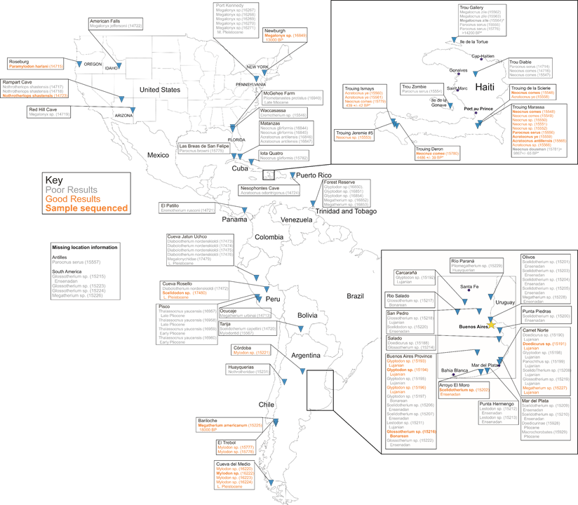
Figure 4.2. Location map of all samples screened in this phylogenetic project. Successful samples (collagen like AA profile and produced good quality MS spectra) are shown in orange. Samples in bold were sent for LC-MS/MS.
PEAKS v7.5. was used to analyse the LC-MS/MS data using the search tolerances outlined in Chapter 2. Sequences of both Col1A1 and A2 were concatenated using previously published mammal collagen consensus sequences, including sequences for the xenarthrans Dasypus novemcinctus (GenBank: XP_004470764) and Cyclopes didactylus (Uniprot: COHJP1/COHJP2 (Welker et al. 2015b)) and Lestodon armatus (Buckley et al. 2015). Isoleucine and leucine cannot be differentiated using low energy mass spectrometry as both amino acids have the same mass but a different higher structure. Therefore the identification of these amino acids were consistent among all sequences. Once a potential collagen sequence was compiled for a given sloth taxon, the sequence was added to the collagen database and the sample was re-run through PEAKS to check for coverage and sequence substitutions. Any differences noted in either the consensus sequences or between different species of sloths were inspected manually. In order for a difference to be considered authentic, it had to occur in more than 1 product ion spectrum and be covered by both b and y ions.
PEAKS has the advantage of combining de novo sequencing with a database search (Ma et al. 2003, Zhang et al. 2012). This allows for novel amino acid substitutions to be found which may not occur in the collagen database. The most common of these substitutions was serine/alanine (S/A), which is frequently found in collagen (Hendy et al. 2018a). However, the only difference between these two amino acids is the presence of an hydroxyl group in serine. Therefore, sequences containing hydroxyproline-alanine or proline-serine are identical in mass and PEAKS is not able to differentiate between the two. Also, as we are dealing with ancient proteins, the hydroxyl group can be lost from serine as part of protein degradation, in which case the resultant peptide sequence will register as alanine. In order to try to overcome these difficulties for S/A, as well as in the identification of other novel substitutions, several criteria was used:
- The number of product ion spectra. A minimum of 2 spectra had to be identified for either alanine or serine.
- The presence of b and y ions. If product ion spectra was found for both possible substitutions, a higher confidence was given to spectra that identified the selected amino acid using both b and y ions.
- The location of hydroxyproline. The locations of hydroxyproline are generally conserved in collagens, therefore if a HyP-A sequence was identified, the chance of this being genuine was checked against other collagen sequences.
If a possible substitution was unclear then it was shown as missing sequence data (x). This reduced the level of sequence variation, and therefore possible phylogenetic resolution, but it increased the confidence in our concatenated sequences. The results of the LC-MS/MS analysis and sequence concatenation are shown in Table 4.1.The collagen sequences have been published on Uniprot (See appendix 2 for details)

Museum Reference | ID | Species | # Col1 peptides | % coverage | Protein score
MMP 5672 | 15191 | Doedicurus sp. | 867 | 90 | 430.01
MACN-PV 7 | 15194 | Glyptodon sp. | 731 | 84 | 453.34
UF 76796 | 15559 | Acratocnus ye | 696 | 86 | 343.16
UF 76385 | 15565 | Acratocnus sp. | 629 | 87 | 361.54
AMNH 20820 | 16265 | Bradypus variegatus | 793 | 88 | 409.26
AMNH 139772 | 17009 | Choloepus hoffmanni | 1109 | 94 | 465.40
MACN-PV 2652 | 15216 | Glossotherium robustum | 837 | 88 | 462.76
NYSM-VP 46 | 16849 | Megalonyx jeffersonii | 874 | 85 | 438.28
MAPBAR 3965 | 15225 | Megatherium americanum | 520 | 81 | 488.21
UMAG-AH 5854 | 16222 | Mylodon darwinii | 1371 | 96 | 479.33
UF 171347 | 15548 | Neocnus comes | 699 | 84 | 353.61
UF 75469 | 15781 | Neocnus dousman | 614 | 74 | 293.47
USNM 244372 | 14723 | Nothrotheriops shastensis | 528 | 79 | 367.40
USNM 3000 | 14715 | Paramylodon harlani | 642 | 87 | 509.29
UF 75526 | 15556 | Parocnus serus | 575 | 82 | 363.93
MUSM 1386 | 17480 | Scelidodon sp. | 1324 | 92 | 451.40
MACN-PV 1791 | 15202 | Scelidotherium sp. | 475 | 76 | 429.79
Table 4.1. The LC-MS/MS results of all sequenced taxa. The megalocnus zile sample failed to produce sequence data despite passing MALDI-ToF MS screening (see Section 2.3.2)
Sequences developed from the MS/MS analyses were analysed by Graham Slater (University of Chicago) and the methods used are summarised here. The sequences were aligned in Geneious v. 9.1.7 (Kearse et al. 2012) using the MUSCLE algorithm (Edgar 2004) with default settings and then checked by eye. Three sets of phylogenetic analyses were conducted on the resulting alignment; Strict Parsimony (PAUP v4.0a), a heuristic search with random sequence addition (100 replicates) and TBR branch swapping (all sites treated as unordered and equally weighted). To assess clade support, 1000 bootstrap replicates with the same settings were performed and a weighted 50% majority rule (MR) consensus tree was generated from the resulting sample of most-parsimonious trees.
Two forms of model-based phylogenetic analyses, both in a Bayesian framework, were also performed. PartitionFinder v. 2.1.1 (Lanfear et al. 2012; 2017) was used to determine the most appropriate model(s) of amino-acid substitution and partitioning scheme for the concatenated alignment, resulting in selection of separate Dayhoff models (Dayhoff et al. 1978) with gamma-distributed rates for Col1a1 and Col1a2. The first set of Bayesian phylogenetic analyses used MrBayes v 3.2.5 (Ronquist et al. 2012). Two Markov Chain Monte Carlo (MCMC) runs were conducted, each of a single chain, for 500,000 generations, sampling from the chain every 1000 generations. After checking for convergence of the two chains based on Gelman-Rubin statistics and ensuring that effective sample sizes for all parameters were sufficient (> 200), the first 25% of each chain was discarded as burn-in, The remaining combined posterior samples were summarized as a 50% majority rule consensus tree, with clade frequencies interpreted as posterior probabilities for a given clade.
To determine whether the unconstrained topology provided a better explanation of the data than a previously proposed morphological topology in which Bradypus is the sister lineage to all other folivorans and Choloepus was placed with Megalocnidae, the marginal likelihood of the data was estimated on unconstrained and constrained topologies using the stepping stone algorithm in MrBayes. Two runs were performed, each with four chains (three heated, one cold) for 10,000,000 generations over 50 steps, with default settings for the Alpha parameter of the Beta distribution (0.4) and burn-in (-1). 2*Ln(lnLk_{unconstrained} - lnLk_{constrained}) was calculated from the resulting estimates and assessed support using the scale in Kass and Raftery (1995).

4.2.3 Calibrating the molecular clock
A series of Bayesian tree searches assuming a relaxed uncorrelated molecular clock was also performed. The searches had exponentially distributed rates under the fossilized birth-death framework (Gavryushkina et al. 2014; 2017; Heath et al. 2014), as implemented in BEAST v 2.4.5 (Bouchaert et al. 2014). This framework allowed sampling from the posterior distribution of time-scaled trees for taxa in this study’s proteomic dataset, inferred using their sequences and stratigraphic ages, while also using phylogenetically constrained fossil taxa that lack amino acid data to provide additional information on relative branch lengths and divergence times. The choice of fossil taxa and topological constraints broadly followed the approach utilized in Slater et al. (2016) for sloth mitogenomes. However, the initial parsimony and Bayesian topology analyses suggested novel phylogenetic hypotheses for higher level sloth relationships (see Section 4.2.4.) which meant that many of the constraints applied in Slater et al. (2016) could not be used here.
As a result, the analyses were restricted to a minimal set of constraints. Most of these constraints reflect genus level affiliations (e.g., Glossotherium chapadmalense with the sampled Glossotherium robustum) or family-level associations that are robust across phylogenetic analyses (e.g., Mionothropus is traditionally a member of Nothrotheriidae and so was placed with the sampled Nothrotheriops shastensis). The use of these family associated constraints resulted in considerable uncertainty regarding the relationships of Late Oligocene and Early Miocene folivorans, such as Octodontotherium and Eucholoeps, to Plio-Pleistocene taxa. All fossil taxa use to calibrate higher level divergences are summarised in Table 4.2.

Fossil taxon | Clade | Min | Max
Riostegotherium yanei | Cingulata | 58.5 | 61.5
Kuntinaru boliviensis | Cingulata | 23 | 30
Propalaeohoplophorus sp. | Cingulata (Glyptodontinae) | 16.3 | 17.5
Stegotherium sp. | Cingulata (Dasypodidae) | 16.3 | 17.5
Protamandua rothi | Vermilingua | 11.61 | 17.5
Neotamandua conspicua | Vermilingua | 3 | 6.8
Palaeomyrmidon incomptus | Vermilingua | 3 | 6.8
Palaeomyrmidon chilensis | Folivora (Stem) | 31.5 | 31.5
Thalassocnus carolomartini | Nothrotheriidae | 4.86 | 6.76
Thalassocnus antiquus | Nothrotheriidae | 7.3 | 7.46
Thalassocnus natans | Nothrotheriidae | 6.45 | 8.7
Thalassocnus littoralis | Nothrotheriidae | 5.93 | 7.1
Mionothropus cartellei | Nothrotheriidae | 5.3 | 8
Megathericulus promaevus | Megatheriidae | 14 | 15.5
Pyramiodontherium bergi | Megatheriidae | 5.3 | 8
Megatheriops recidens | Megatheriidae | 5.3 | 8
Megatherium tarijense | Megatheriidae | 0.021 | 2.6
Megatherium americanum | Megatheriidae | 0.008 | 0.4
Megatherium altiplanicum | Megatheriidae | 4.5 | 5.28
Megatherium celendinese | Megatheriidae | 0.011 | 0.128
Eremotherium laurillardi | Megatheriidae | 0.011 | 0.78
Eremotherium eomigrans | Megatheriidae | 0.5 | 1.6
Deseadognathus riggsi | Megalonychidae (Stem) | 24.2 | 29.4
Imagocnus zazae | Megalonychidae | 17.5 | 18.5
Eucholoeops ingens | Megalonychidae | 16 | 18
Pliometanastes protistus | Megalonychidae | 4.9 | 10.3
Megalonyx leptostomus | Megalonychidae | 1.8 | 4.9
Pliomorphus mutilatus | Megalonychidae | 5.3 | 9.47
Neocnus comes | Megalonychidae | 0.005 | 2.6
Megalocnus rodens | Megalonychidae | 0.004 | 2.6
Parocnus browni | Megalonychidae | 0.005 | 2.6
Acratocnus simorhynchus | Megalonychidae | 0.019 | 2.6
Octodontotherium grande | Mylodontoidea (Stem) | 24.2 | 29.4
Paramylodon harlani | Mylodontidae | 0.012 | 2.6
“Glossotherium” garbanii | Mylodontidae | 3.6 | 4.7
Glossotherium robustum | Mylodontidae | 0.012 | 0.7
Glossotherium chapadmalense | Mylodontidae | 3.3 | 4.5
Thinobadistes segnis | Mylodontidae | 4.9 | 10.3
Table 4.2. The fossil taxa used in the molecular clock analysis, with the minimum and maximum age and their associated clade.

The use of a Bayesian approach requires the specification of prior probabilities on model parameters. Default priors on substitution model parameters were used but specified the following: net diversification ~ Exp(1); turnover ~ beta(2,1); sampling proportion ~ U(0,1); origin ~ U(61.5, 150); UCED mean ~ exp(1). In addition, the analysis was conditioned on the number of extant taxa sampled (Rho = 0.129 in the xenarthran analyses, Rho = 0.333 in the folivoran analyses). Two MCMC analysis were run for 10 million generations each, sampling every 1000 generations, after which the first 25% of the retained samples were discarded as burn-in, the samples combined, and maximum clade credibility trees constructed.

4.2.4 Resolving the phylogenetic placement of Folivorans
Of the 2096 amino acids in the alignment of the type 1 collagen molecule, 1961 (93.6%) were constant and 76 (56 % of variable sites, 3.6% of total) were parsimony informative for the taxa represented. Because parsimony and Bayesian topology searches resulted in congruent topologies, Figure 4.3 shows the more conservative strict consensus of 80 Most Parsimonious Trees (score = 215, CI = 0.712, RC = 0.505, RI = 0.710).

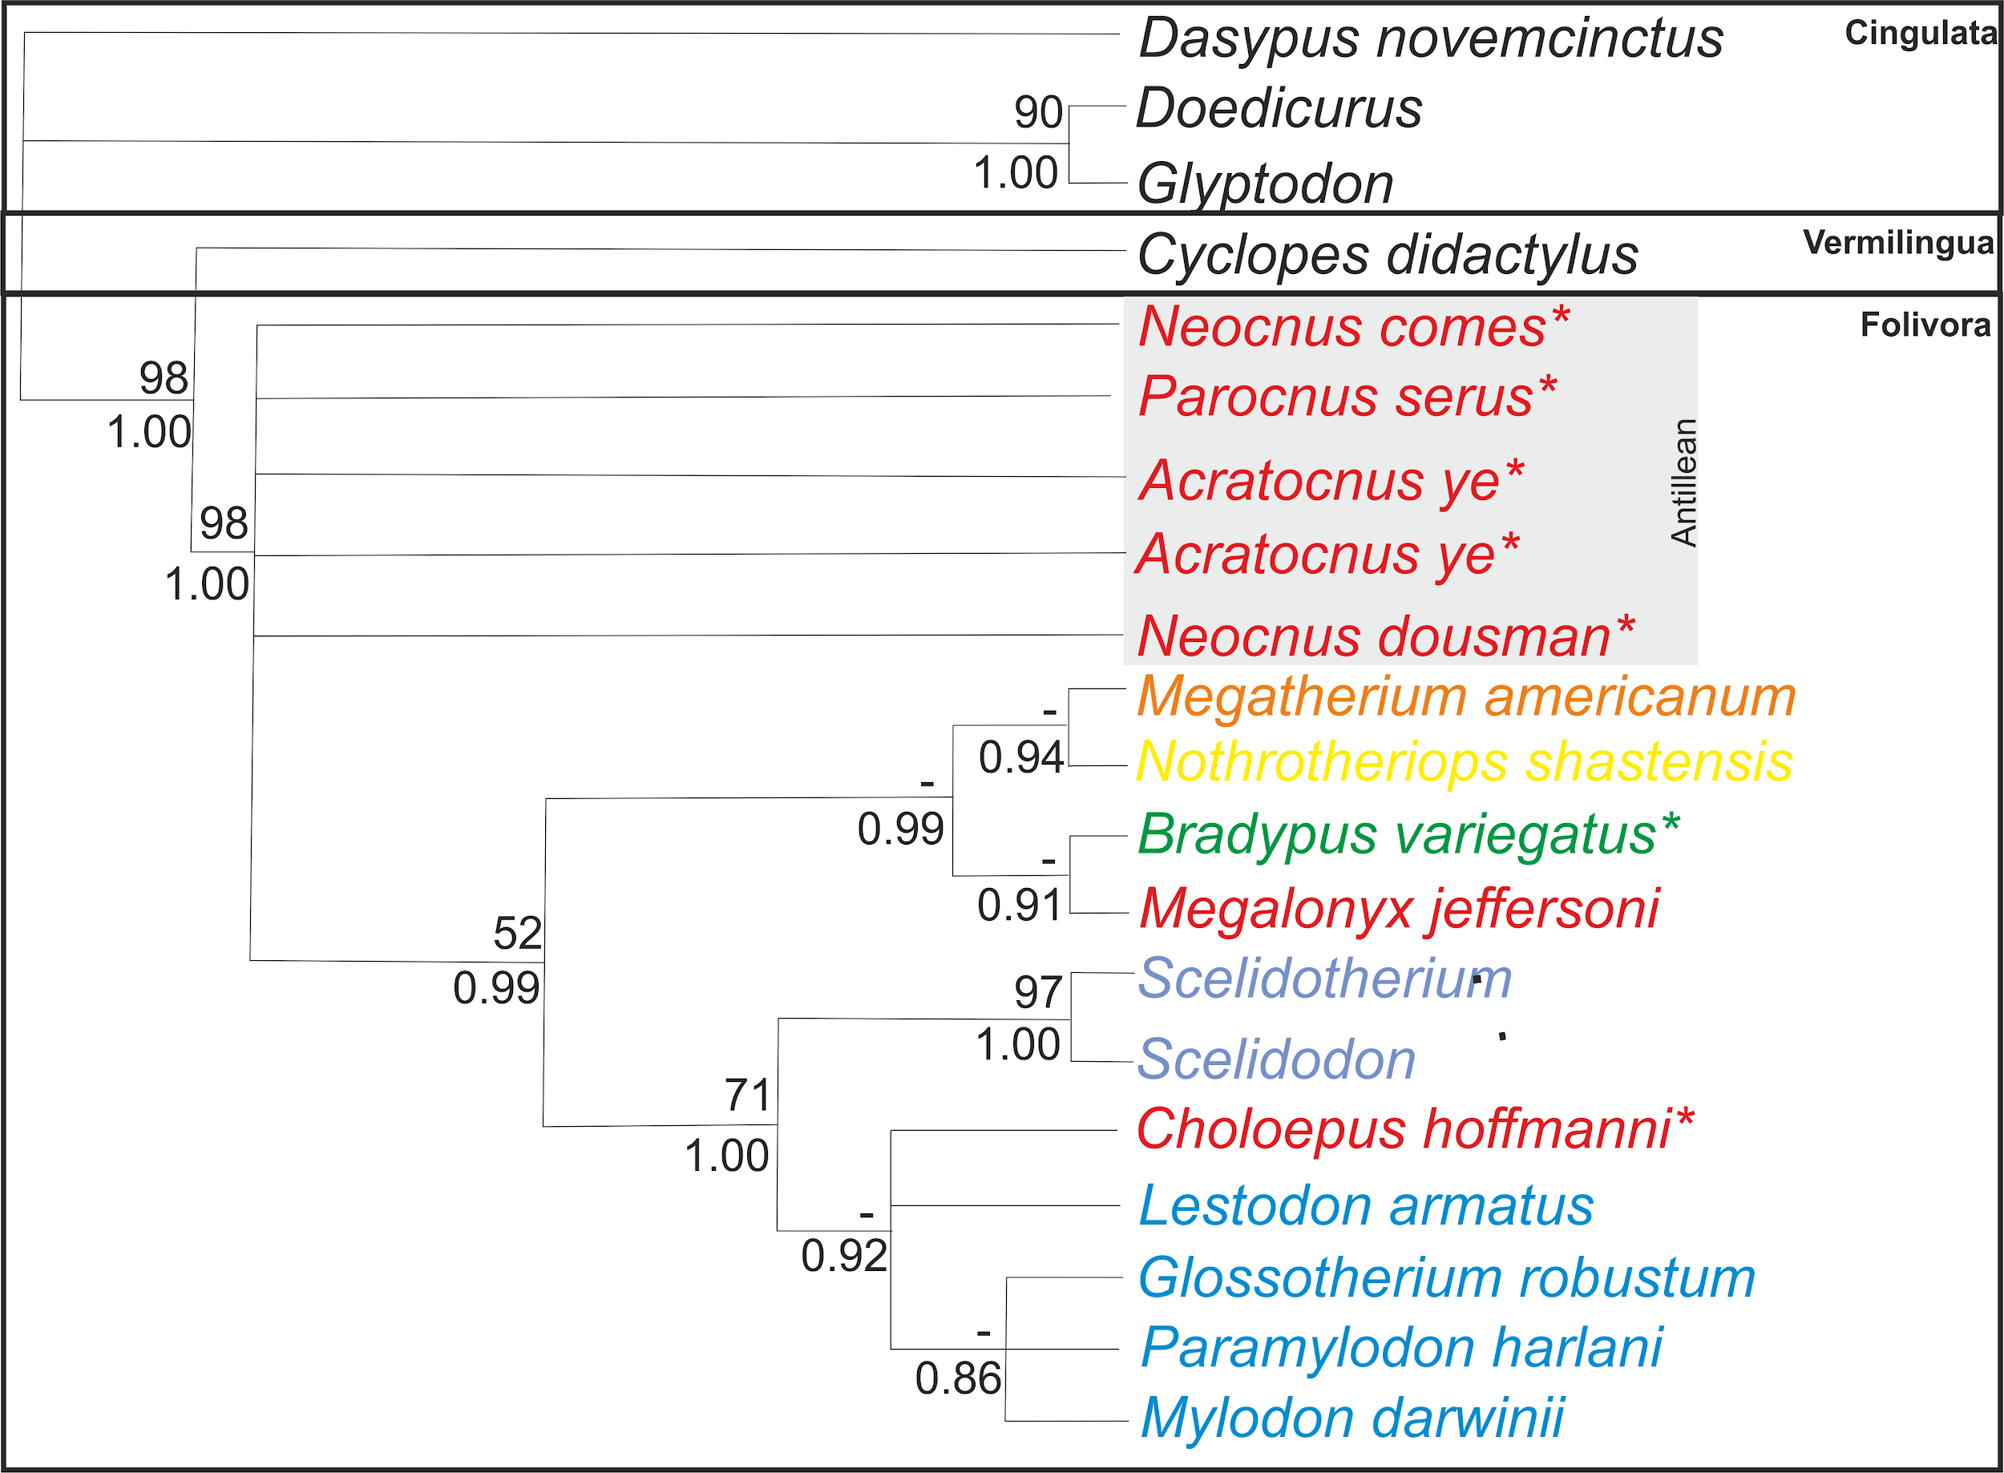
Figure 4.3. Strict consensus of 80 most parsimonious trees. Values above nodes represent bootstrap support derived from 1000 bootstrap replicates. A dash (-) indicates that a node was not represented in the 50% majority rule consensus. Values below nodes are Bayesian posterior probabilities. The colour scheme matches the traditional groupings of Figure 4.1. Megatherioidea is shown in red/orange/yellow, Mylodontoidea is shown in blue and Bradypodoidea is shown in green. *Represents a new possible placement.

In the parsimony analysis, Cingulata, Vermilingua and Folivora all receive strong support. Among Folivora, the Antillean sloth relationships are unresolved (highlighted in grey in Figure 4.3), while the other taxa are split into two main groups. The first consists of taxa traditionally considered megatherioid (PP = 0.99) (Shown in red/orange/yellow in Figure 4.3). The sister group relationship of Megatherium and Nothrotheriops (PP = 0.94) is well established from morphological data (Gaudin 2004), but the previously unreported pairing of Megalonyx with the extant three-toed sloth Bradypus (PP = 0.91) was unexpected, as traditionally Bradypus is recovered as separate to all other sloth taxa (Figure 4.1). The second grouping consists of traditional mylodontoids (shown in blue in Figure 4.3) plus Choloepus (PP = 1), a traditional megatherioid. Inclusion of Choloepus in this group markedly contrasts with results achieved using morphological datasets. Scelidotherium + Scelidodon is the earliest diverging branch (conventionally given subfamilial status Scelidotheriidae (Figure 4.1), and Choloepus is recovered as part of a clade (PP = 0.98) consisting of (Lestodon, (Glossotherium, Paramylodon, Mylodon)) which matches the traditional grouping of Mylodontinae (McKenna and Bell 1997; Gaudin 2004).

For the most part, the phylogenetic placements of these sloth taxa using proteomics are consistent with other studies on folivoran phylogenies. However, they differ sharply in regard to where tree sloths should be positioned among their relatives. The placement of the Antillean sloths also deviates from traditional results. These marked differences could have a big impact on Folivoran systematics and are summarised in the following points:
Choloepus is a mylodontoid. The possibility that the two-toed sloth is closer to traditional mylodontids than to megalonychids is in agreement with sloth aDNA studies (Clack et al. 2012; Delsuc et al. 2018; Hofreiter et al. 2003; Hoss et al. 1996; Poinar et al. 1998), but due to the limited range of taxa included in those investigations the exact nature of their relationship has remained indeterminate. Due to wide taxonomic sampling in this study, proteomics has been able to verify the ancient DNA evidence that Choloepus is indeed a mylodontoid. This shows that ancient DNA and proteomics can serve as mutual credibility tests (Westbury 2017) and provide a means for increasing both taxonomic coverage and time depth. The precise positioning of Choloepus will require further sampling and analysis. Three families are commonly recognised as part of Mylodontoidea; Mylodontidae, Scelidotheriidae and Orophodontidae (McKenna and Bell 1997; Varela et al. 2018). In this study, only Mylodontidae and Scelidotheriidae are represented by extinct taxa (Figure 4.1). The results of this study suggest Choloepus is a member of Mylodontidae. However, it will be interesting to know whether the inclusion of an orophodontid would influence the placement of Choloepus within Mylodonoidea or if it would remain a member of Mylodontidae. Orophodontidae contains the earliest mylodontiods, such as Octodontotherium, which is of L. Oligocene age, and so far the youngest accepted orophodontid, Octodontobradys, is dated to L. Miocene/E. Pliocene in age (Guilherme et al. 2011). Currently this is beyond the limit of ancient proteomics in non frozen environments. However, as proteomic methods continue to improve, these extinct taxa may also come within the range of proteomic analysis.
Antillian sloths are not part of traditional Megalonychidae. Antillian sloths are sometimes referred to as a separate subfamily called Megalocninae. This subfamily has had a complex taxonomic history (White and MacPhee 1999) and is sometimes regarded as diphyletic, with different island taxa having diverged from different mainland relatives (Kraglievich 1923; McKenna and Bell 1997; White and MacPhee 1999; Varona 1974). The phylogenetic results suggest this is not likely and is in line with other recent morphological studies (McDonald et al. 2017). In light of these results, it may be appropriate to raise Megalocninae to family level (Megalocnidae) to show the divide between Antillian sloths and traditional Megalonychidae (Megalonyx and Choloepus). This new family-level separation is in contrast to traditional morphology-based studies, which could be due to unrecognised homoplasy, as suggested by the proteomic results.
Megalonyx and Bradypus are megatherioids. Recent morphological analysis places Bradypus as sister to all other sloths (Gaudin 2004; Pujos et al. 2017). However, genomic analyses have shown a relationship between Bradypus and Nothrotheriops, a traditional megatherioid (Greenwood et al. 2001; Slater et al. 2016), which suggests that Bradypus may have its roots in Megatherioidea as originally thought (Guth 1961; Patterson et al. 1992; Patterson and Pascual 1968; Webb 1985). The megatherioid clade recovered in this study includes Megatherium, Nothrotheriops, Megalonyx, and Bradypus showing support for both the original morphological analysis and recent genomic analyses. Bradypus as sister to all other sloth taxa within the superfamily Bradypodoidea is rejected by the proteomic phylogenetic results, on the basis of both parsimony (13 additional steps) and Bayesian inference (2*lnBayes Factor = 6.72, support = Strong). However, this is the first study in which Bradypus and Megalonyx have been recovered as sisters and additional megatherioids need to be added to the analysis to determine if this relationship is genuine.

4.2.5 Molecular clock results and divergence estimates
Overall, the proteomic results are in line with traditional placement of sloth taxa but with key differences, as outlined above. This has then impacted the positioning of fossil taxa used in calculating and calibrating the molecular clock. For example, Eucholoeops, is usually interpreted as a basal megalonychid (De Iuliis et al, 2014; Hirschfeld and Webb 1968), a clade that was not found to be monophyletic in this study. In order to try to overcome these issues, a minimal set of constraints was employed on the positioning of fossil folivorans in the Bayesian estimation of topology and divergence times (Figure 4.4). The resulting BEAST analysis recovered a topology nearly identical to that seen in the non-clock analyses (Figure 4.3). However, the molecular clock analysis shows conclusively the monophyletic nature of the Antillean sloths (PP = 0.98), although within-clade relationships were not satisfactorily resolved. Support for megatherioid (PP = 0.98) and mylodontoid (PP = 1) monophyly is also strong, as is support for the constituent sub-clades referenced in the tree.

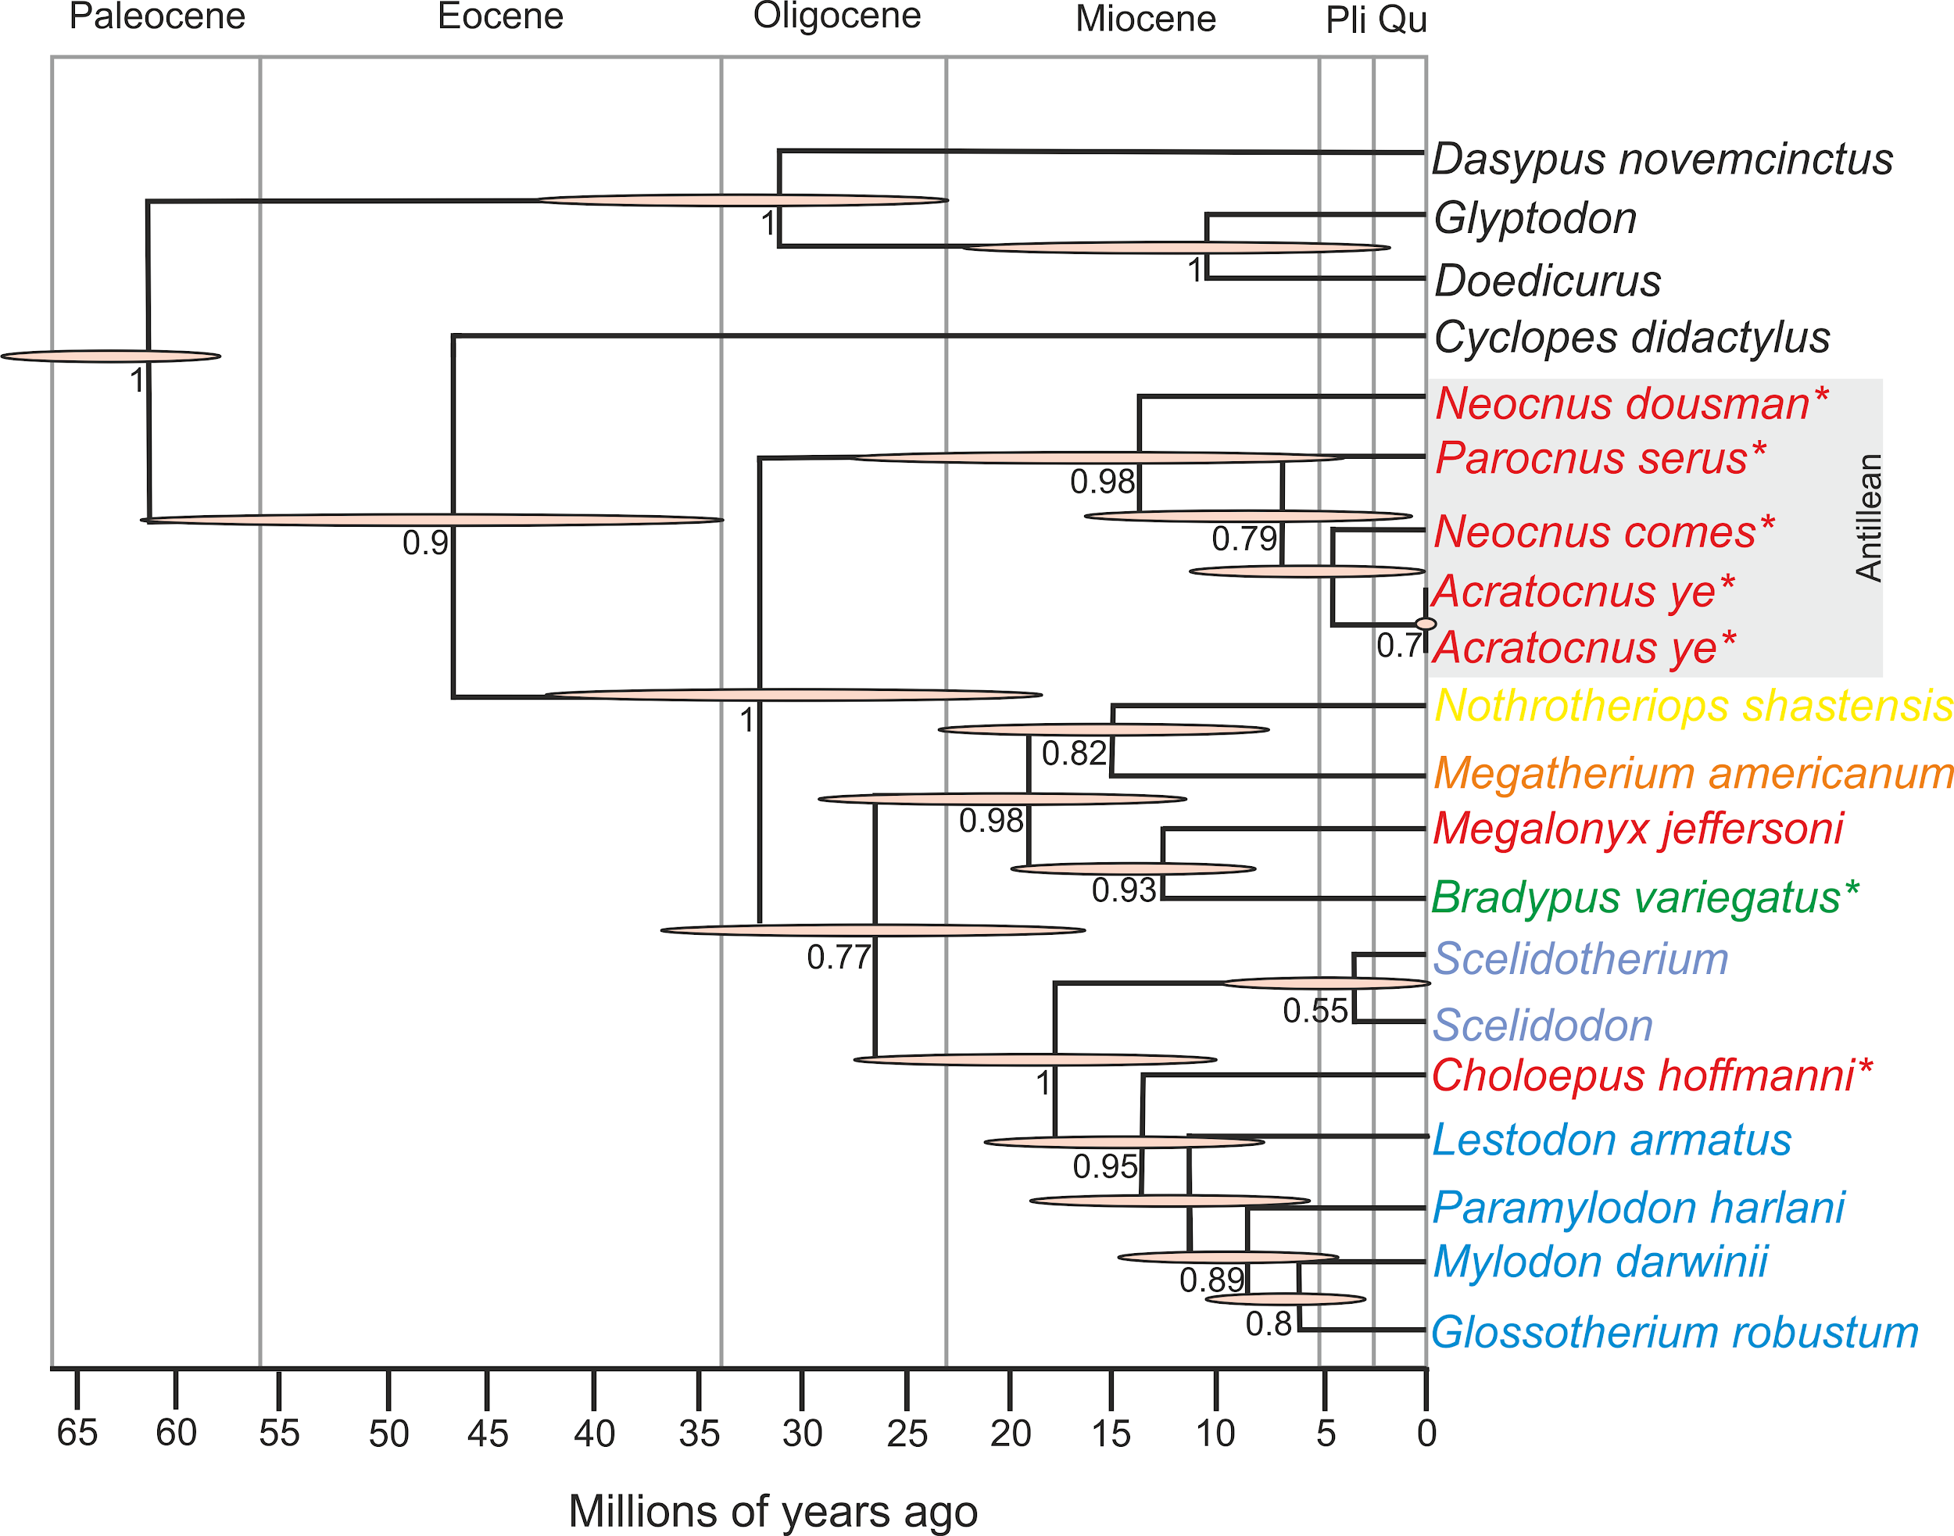
Figure 4.4. Time scaled maximum clade credibility tree from BEAST analysis of 20 extant and extinct xenarthran collagen sequences. Branch lengths are the mean values from the retained posterior sample, while pink bars represent 95% highest posterior density intervals. Values below nodes are posterior probabilities. The colour scheme matches the traditional groupings of Figure 4.1. Megatherioidea is shown in red/orange/yellow, Mylodontoidea is shown in blue and Bradypodoidea is shown in green. *Represents a new possible placement.

An unexpected result of the molecular clock analysis was the placement of the Antillean clade as sister to Megatherioidea and Mylodontoidea, rather than pairing it with the one or the other. The BEAST tree (Figure 4.4) implies that the fundamental split within Folivora is not between Megatherioidea and Mylodontoidea as classically understood, but instead between these two clades together and Megalocnidae. It must be noted that this result is not highly supported based on the proteomic data and more analysis will have to be carried out in the future. However, it is interesting to mention that the mean divergence estimates for megalocnids (~31Ma see Figure 4.4) is broadly in line with both fossil evidence for early presence of sloths in the West Indies, but also with a previously published GAARlandua hypothesis (Iturralde-Vinent and MacPhee 1999). This hypothesis states that northwestern South America and the Greater Antilles were briefly connected by a landbridge during the Eocene-Oligocene transition (~33–34 Ma). Therefore these results could represent an in situ Antillean radiation derived from the first folivoran colonisers of the West Indies.
The molecular clock analysis was also able to estimate divergence times. However, these divergence times, in the form of 95% Highest Posterior Density (HPD) intervals, are generally rather broad (Figure 4.4 shown as pink bars). Posterior mean node ages suggest an E. Oligocene origin for all folivorans, with megatherioids and mylodontoids diverging in the L. Oligocene with the commonly recognised families originating in the E. Miocene, in agreement with Varela et al. (2018) and Nowak (2018). General conclusions could also be drawn about the diversification rates of the different sloth taxa. The mean ages are reasonably consistent with inferences based on genomic data. For example, the age of the Choloepus–Bradypus split was ~ 26.8 Ma (95% HPD = 17–36.6 Ma) in this study, which is similar to recent estimates based on mitochondrial and nuclear DNA (Delsuc et al. 2018).

4.2.6. Conclusions
Collagen phylogenetics has been able to resolve the general placement of the extant tree sloth taxa with their extinct relatives. More analyses are needed to conclusively prove the exact placements of each of these genera, but collagen phylogenetics has been shown to provide key phylogenetic information from taxa in which ancient DNA would not survive and in which morphological analysis is hindered due to convergences of traits. The placement of the extant sloths were resolved as:
- The two-toed sloth (Choloepus) is a member of Mylodontoidea not Megatherioidea.
- The three-toed sloth (Bradypus) is a member of Megatherioidea, not sister to all other sloths.
The placement of extinct taxa were mainly in line with traditional sloth systematics, with the exception of the megatherioid family Megalonychidae. The Antillean sloths have been shown to possibly be a separate family having their own in situ radiation. The South American megalonychids, Megalonyx and Choloepus, are shown to be possible members of Megatherioidea and Mylodontidae respectively. More extinct taxa traditionally placed in Megalonychidae need to be analysed but, the results of this study suggest this family may need re-classification.

4.3 The phylogenetic potential of NCPs
While collagen is still the most commonly used protein in ancient phylogenetic studies, recently enamel proteins have also been used (Cappellini et al. 2018b) and it is likely that as proteomic methods improve, non-collagenous proteins (NCPs) will become more common in palaeoproteomic phylogenetics. In this section a case study is presented looking at the phylogenetic placement of modern and extinct ursids using NCPs.

4.3.1 The bear family tree
Bears are part of the larger Order Carnivora and can be split into several different sub families (Figure 4. 5).

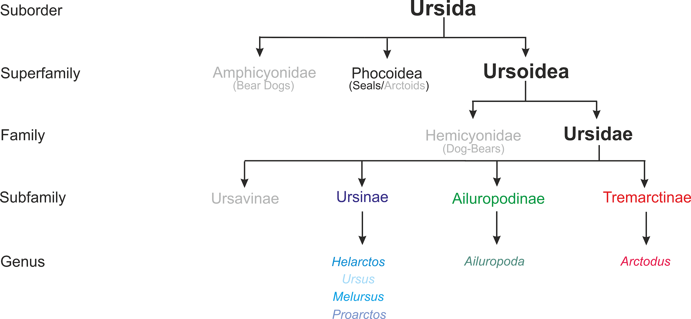

Figure 4.5. The ursid family tree, based on relationships stipulated by McKenna and Bell (1997). The names in grey represent groups which are now completely extinct. For simplicity, only the genera that are analysed in this case study are shown in their traditional groupings.

Unlike sloths which are shown to diversify in the Oligocene/Miocene, mitochondrial genome analysis has shown that surviving ursidan clades display relatively recent divergences, mostly within the Pliocene (Heath et al. 2014) as well as extensive gene flow between species (Kumar et al. 2017). The most extensive phylogenetic study (using the same Protarctus abstrusus sample presented in this case study) was carried out using morphological traits from both extinct and extant taxa (Figure 4.6).

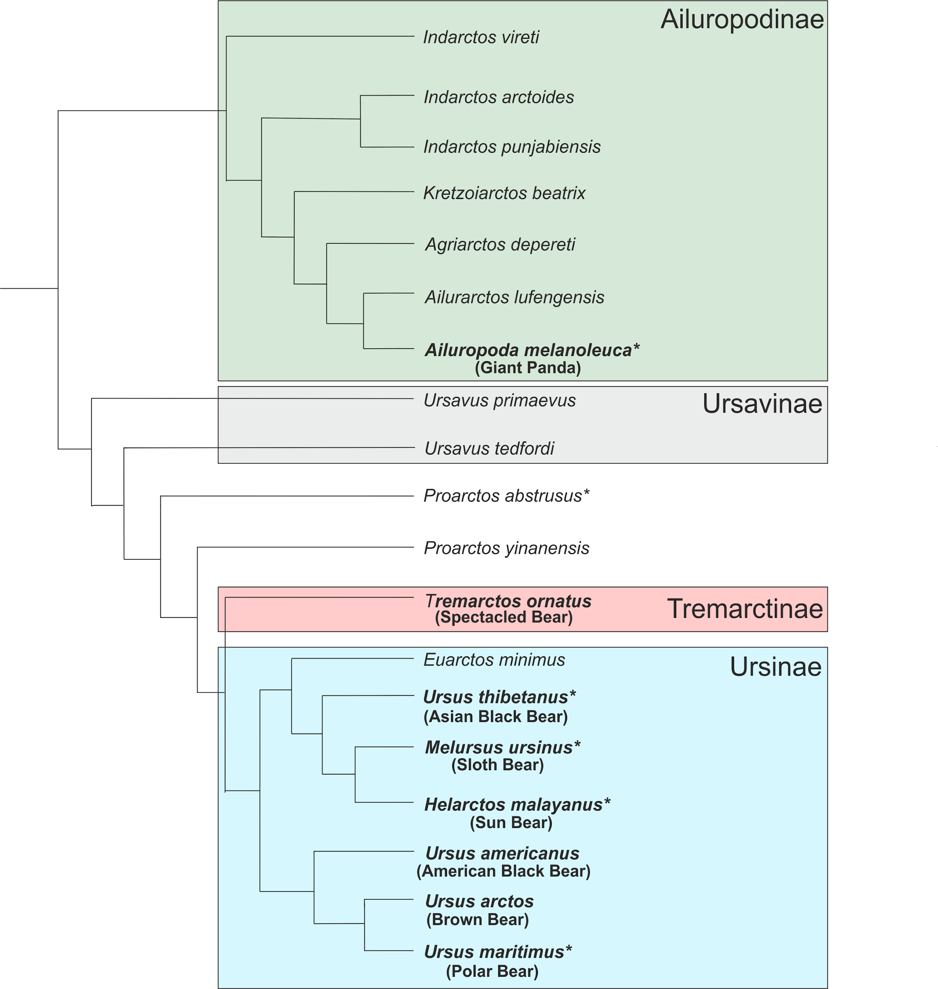
Figure 4.6. The results of the morphological analysis of both extant and extinct bears from Wang et al. (2017). The species in bold are extant and those with an * are also analysed in this study.

This morphological study is in general agreement with the genomic analysis of modern bears. However, the placement of the American black bear (Ursus americanus) is shown as sister to the Asian black bear (Ursus thibetanus) in genomic studies and the Sloth bear (Melursus ursinus) is shown as sister to all other Ursidae (Heath et al. 2014; Kumar et al. 2017). Protarctos sp. was shown to be basal to Ursinae and Tremarchtinae.

4.3.2 Selecting proteins for phylogenetic analysis
As bears have recent divergence dates, collagen does not show enough variation between species to adequately resolve phylogenetic relationships, due to its highly conserved nature (only 4 substitutions were found between all bear taxa; see appendix 2). NCPs however are more variable and it has been predicted that these proteins will be more useful in resolving phylogenetic relationships, possibly to the species level (Buckley and Wadsworth 2014). Protein sequences were analysed from the three subfamilies of which there are still living taxa. These sequences were either taken from the literature or concatenated using LC-MS/MS data and de novo sequencing (Table 4.3).

Species | Published? | Location | Age
Ailuropoda melanoleuca | Y: NCBI:txid9646 |  | Modern
Arctodus simus | N | Yukon | 28690 +/- 250
Protarctos abstrusus | N | Beaver Pond Site, Ellesmere Island | 3.4Ma +0.6/-0.4
Helarctos maylayanus | N |  | Modern
Ursus thibetanus | N |  | Modern
Ursus maritimus | Y: NCBI:txid29073 |  | Modern
Ursus spelaeus | N |  | Modern
Ursus deningeri | N | Sima de los Huesos | Palaeolithic
Melursus ursinus | N |  | Modern
Table 4.3. Sample information of the bear samples used in this case study. Ursus deningeri is shown in grey as this sample failed to produce meaningful sequence data.

All the unpublished samples (with the exception of Ursus deningeri) were searched against a bear proteome database using PEAKS using the same criteria as the sloth samples mentioned above. The results were compared to determine which proteins were commonly seen in all of the bear samples. A wide variety of proteins were recovered from all the samples. However, only a small selection were seen in all the samples analysed (Table 4.4) and from these only 3 NCPs were seen in all samples; ASHG, BGN and SERPINF1.

 | % coverage
 | Melursus ursinus | Ursus spelaeus | Ursus thibetanus | Helarctos maylayanus | Protarctos abstrusus | Arctodus simus
COL1A2 | 63 | 72 | 75 | 75 | 75 | 67
COL2A1 | 39 | 11 | 23 | 54 | 17 | 20
COL3A1 | 31 | 22 | 21 | 22 | 13 | 5
COL5A1 | 6 | 9 | 9 | 6 | 8 | 5
COL5A2 | 14 | 26 | 9 | 10 | 17 | 8
ASHG | 52 | 11 | 49 | 64 | 39 | 48
BGN | 72 | 3 | 52 | 67 | 43 | 42
SERPINF1 | 43 | 8 | 30 | 48 | 30 | 42
Table 4.4. The % coverage of the proteins identified in all of the sequenced bear samples

The MS/MS data for these unpublished samples were then re-analysed and searched against a database containing the three selected NCPs from a variety of taxa in order to maximise the amount of sequence information recoverable for all these proteins.

4.3.3 NCP sequence analysis
The resulting sequence coverage of the three NCPs was variable between the different samples. While there are multiple sequence differences between the two published bear sequences (Ailuropoda melanoleuca and Ursus maritimus) not all these sequence variations were identified in the samples that were analysed de novo and the majority of the de novo sequences shared a high similarity (Figure 4.7.).

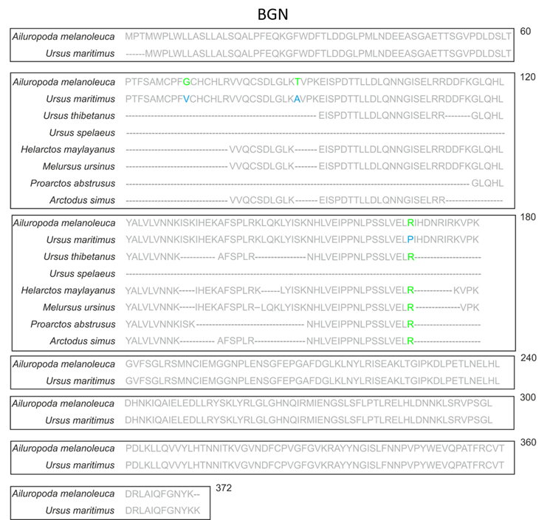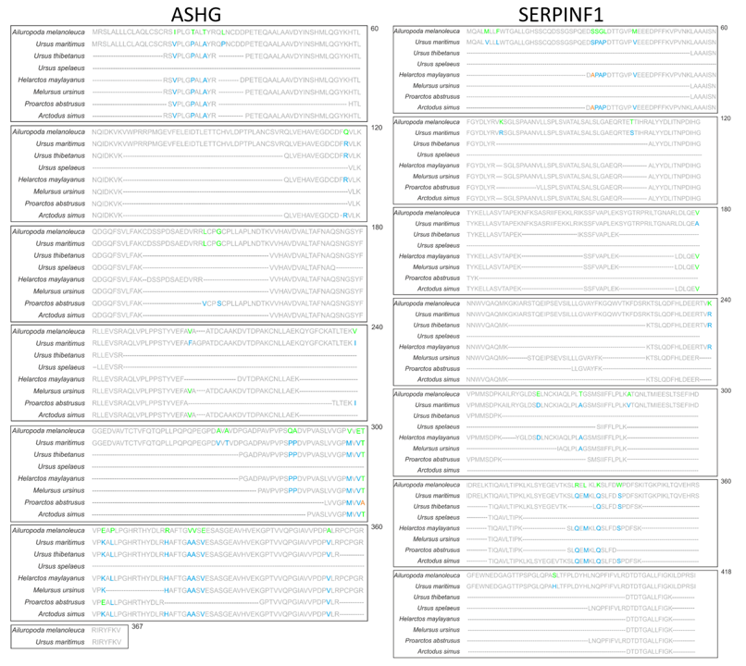
Figure 4.7. The sequence comparison of the NCPs shared between all the bear samples; Biglycan (BGN), alpha-2-HS-glycoprotein (ASHG) and pigment epithelium-derived factor (SERPINF1). Sequence differences are highlighted in green/blue/orange. Ailuropoda melanoleuca and Ursus maritimus are published sequences, the sequences for the other samples were concatenated using de novo sequencing.

There are many differences between the Ailuropoda melanoleuca sequence and the rest of the bear sequences, which suggests that Ailuropodinae split from the other ursidan taxa further back in time than the other subfamilies. This is supported by the genomic and morphological analysis. Differentiation between the other subfamilies and individual taxa was not possible due to the lack of sequence differences. This is due to lack of sequence coverage, which is a little surprising for the modern samples. However, this may be due to collagen being so abundant that it masked other proteins. Therefore, in order to increase sequence coverage of NCPs it may be necessary to alter the protein extraction method in order to preferentially extract NCPs. This has been attempted in previous studies but has yet to be proven successful in archaeological samples (Wadsworth and Buckley 2014). The lack of comparison sequences of ASHG, BGN and SERPINF1 which can be used to concatenate the de novo sequences are also a factor for lack of sequence coverage and this will only be rectified with an increase in fully sequenced proteomes. The use of other digestion enzymes can also increase sequence coverage.

4.3.4 Conclusions
Overall, NCPs have greater sequence variation than collagen and have the potential to show differences between taxa at a much higher level than collagen, as shown by the differences between Ailuropoda melanoleuca and Ursus maritimus. However, in archaeological samples, NCPs rarely survive and very few non collagenous proteins survived in all the bear samples analysed in this case, with varying degrees of coverage. Due to this, differentiation between the taxa was not possible despite the increased variation seen in the published samples. Future phylogenetic studies utilising NCPs may need to alter the protein extraction protocols to preferentially extract NCPs of interest. As more proteomes become publicly available this will increase the comparison search database used to concatenate de novo ancient sequences and therefore potentially increase sequence coverage.

4.4 Conclusion
Proteins are known to survive further back in time than ancient DNA while still providing phylogenetic information. Therefore proteins offer a means to study the relationships between extinct taxa as well as taxa that inhabit environments not conducive to DNA survival. The main protein used in these studies to date is collagen, due to its high level of preservation potential in palaeontological taxa. Collagen phylogenetic analysis was carried out on several sloth taxa, both extant and extinct, which allowed the higher level relationships between these taxa to be resolved. Species level differentiation is not possible using collagen, as it is a highly conserved protein. The results of this analysis placed Choloepus (two-toed sloth) as a member of Mylodontoidea, which is in line with previous DNA studies, and Bradypus (three-toed sloth) as a member of Megatherioidea. The result for Bradypus and the possible placement of the contents of the traditional megatheriioid family Megalonychidae goes against previous morphological studies. Further work is needed to conclusively prove the placement of these taxa. For example, including more taxa in the proteomic analysis and trying to retrieve ancient DNA from some of the selected specimens.

The divergence estimates show sloths diversified from each other in the Oligocene. Diversification this far back in time allowed sufficient amino acid changes to occur in collagen, making the phylogenetic analysis possible. However, this is not the case for all taxa. The second case study presented in this chapter attempted to resolve the phylogenetic placement of bears. Surviving bear clades did not diversify until the Pliocene and as such, no significant phylogenetic differences were seen in the collagen sequences of the analysed taxa. Therefore non collagenous proteins were chosen to be analysed, as these proteins contained many more sequence variations. However, the coverage of these proteins was much lower than that of collagen as NCPs are not so well preserved in fossils, and many of the potential sequence variations were not recovered from the fossil taxa. NCPs have huge potential, due to their increased variation, to resolve phylogenetic relationships possibly down to the species level. However, this will not be possible for taxa until protein extraction methods improve or are adapted to preferentially extract NCPs and significantly increase their sequence coverage.

Chapter 5. Conclusion and future work

5.1 Overall conclusion
This thesis aimed to provide proof of concept data showcasing the potential of proteomics in palaeontology and better understand its limitations. In order to do this, three areas were investigated in detail:
- The use of different analytical and extraction techniques to screen fossil samples for further proteomic analysis and maximise protein retrieval.
- How and why proteins are able to survive far back into geological time
- The use of proteomics for phylogenetic analysis of fossil taxa.

Several analytical methods were used to analyse fossil samples in this thesis: chiral amino acid analysis, ATR-FTIR, MALDI-ToF MS and LC-MS/MS. Evaluating different screening methods to identify which method is the most informative, regarding the level of proteomic data recoverable from fossil material was a key area of focus (Chapter 2). The data obtained from bone using ATR-FTIR was shown to be heavily influenced by recrystallisation (Section 2.3.2.2) and as such is an unreliable proxy for determining levels of alteration and potential protein loss in palaeontological bone specimens. This is in line with other FTIR studies on fossil material (Trueman et al. 2008b, Lebon et al. 2010, King et al. 2011). Chiral amino acid results showed a strong correlation with levels of peptide sequence retrieval from fossils (Section 2.3.2.4). The combination of racemisation values, amino acid concentration and amino acid composition data provided an overall understanding of protein survival, enabling identification of both original and contaminant proteins in samples. The PCA analysis of the racemisation values and composition data showed a strong grouping of the good sequenced data. While AA analyses in this thesis focused on fossil bone, it is a well-established technique and can be used on a wide variety of fossil specimens. Therefore it is recommended that all palaeontological samples are screened using amino acid analysis and samples with low D/L values and an AA composition matching modern comparison samples should be assessed further for surviving proteins.

Protein extraction methods were also evaluated to determine if they had an influence on protein retrieval from fossils. SDS PAGE extraction was shown to be better for protein extraction from bone, rather than the traditional FASP method used in archaeological proteomics (e.g. Harvey et al. (2018)) (Section 2.4.1). The demineralisation step commonly used in archaeological proteomics may potentially remove peptides from fossils along with the mineral component of the bone. Therefore it is suggested that demineralisation may not be necessary for palaeontological samples, or that the demineralisation solvent is analysed as well as the fossil sample. This has also been seen in other studies, for example Schroeter et al. (2016). The use of different or multiple digestion enzymes will also improve the amount of protein recovery from fossils (Section 2.4.2) and is gaining popularity in proteomic studies (Tsiatsiani and Heck 2015).

It is clear that the data analysis and interpretation of the resulting proteomic data is just as important as the analytical method itself. A case study comparing different data analysis software showed surprisingly different results (Section 2.5.2). MaxQuant identified the most peptides from degraded samples but PEAKS provided more information on post translational modifications (PTMs) and novel amino acid substitutions. Therefore it is recommended that proteomic data is analysed using more than one software, where applicable, to maximise the proteomic information from palaeontological samples.

Proof of endogeneity is always going to be an issue when dealing with palaeo-proteins and some ancient proteomics studies being contested in the past (Buckley et al. 2008, Bern et al. 2009, Buckley et al. 2017a, Saitta et al. 2018c). In this thesis, some criteria are presented when analysing ancient proteomic data that may be used to help give confidence to protein/peptide identifications:
- Evaluate the likelihood of the protein identified being present in the substrate analysed (e.g. collagen in bone)
- The number of peptides that are recovered from the protein, with a suggested minimum of two peptides needed for a positive protein identification
- Whether the protein/peptide is seen in multiple database searches (e.g. in a MaxQuant search and a PEAKS search)
- BLASTing the recovered peptides to determine if they are order or family specific to the taxon being analysed.
Providing additional checks, such as those suggested above, to ancient proteomic data will increase confidence in the proteomic data published. This will then allow a more realistic measure of which proteins persist into deep time and the preservation pathways acting on these palaeo-proteins. Overall when analysing palaeontological samples for proteomic analysis, the following guidelines are recommended:
- Screen the sample using AA analysis, selecting samples with an expected AA composition for the sample being studied, and D/L values showing no signs of bacterial or modern contamination for further analysis.
- Analyse the sample without demineralisation, such as with SDS PAGE, or analyse the demineralisation solvent used alongside the sample being studied.
- Digest the sample with multiple enzymes as this will increase the potential sequence recovery
- Use more than one data analysis software to increase recovery of proteomic information as well as increase confidence of protein identification
- Critically assess any proteins recovered. For example, by BLASTing the peptides to see if they match the taxon being analysed.

The substrate of the fossil will influence how well proteomic information is preserved. Open systems, such as bone and soft tissue, are more exposed to both chemical and microbial degradation. Therefore, these substrates are less likely to have proteins preserved far back into the palaeontological record, unless in extreme circumstances such as frozen environments or due to mineral interaction. Closed system fossils, such as shells, eggshell and recently enamel, have been shown to have good protein preservation reaching far back into time (3.8 Ma for eggshell (Demarchi et al. 2016) and 1.77Ma for enamel (Cappellini et al 2018)). Therefore, if palaeoproteomics is to reach far back into geological time, it is suggested that proteomic analysis is focused on closed system fossils.

Protein preservation in the fossils analysed in this study generally followed similar patterns to ancient DNA preservation, with the exception of successful protein retrieval from fossils in hot environments, not conducive to aDNA recovery (e.g. Gold et al. (2014)). This can be attributed to the more stable nature of proteins over DNA. In this study, the age of the fossil, rather than the environment, was found to be more of an influencing factor for protein preservation in an open system such as bone (Section 3.2). It was hoped that samples preserved in tar seeps would act as a quasi-closed system, allowing protection from degradation. However, this was not the case (Section 3.3). Samples preserved in tar showed a resistance to degradation, but interaction with the environment and the potential inclusion of contaminants still occurred, in line with other semi closed system environments, such as amber (McCoy et al. 2019).
Collagen degradation was further evaluated by analysing peptide sequence data. It appears that initial protein breakdown via backbone cleavage occurs at similar points along the molecule (Section 3.2.4) and this breakage of the higher protein structure allows for an increase in post translational modifications (PTMs). No clear trend was established between the presence and type of diagenetic PTM and the age of the sample or the environmental conditions. Interestingly, the samples dated to over 1 million years showed very few diagenetic PTMs. Instead, the peptides recovered from these samples showed a high number of thermally stable (decay resistant) amino acids. Whether these peptides will eventually also be lost over time, or be able to be preserved for millions of years, has yet to be conclusively proven.

One of the main uses of well-preserved proteins from fossils is in the reconstruction of phylogenetic relationships between extant and extinct taxa. In this thesis collagen phylogenetic analysis successfully resolved the placement of the two species of extant tree sloth with their Folivoran ancestors, as well as suggested new evidence for a possible in situ radiation of the extinct sloth family megalonychidae (Section 4.2). Divergence estimates were also able to be calculated and it was shown that Folivorans diversified from their Xenarthran relatives in the early Oligocene. Species-level differentiation was not possible using collagen as it is highly conserved among closely related taxa (Welker 2018b). The phylogenetic potential of non collagenous proteins (NCPs) was also investigated, but the lack of surviving NCPs and the low sequence coverage meant that phylogenetic analysis using NCPs was not possible for these palaeontological bone samples. However, in other substrates such teeth, the use of proteins other than collagen have been successfully used for phylogenetic reconstruction (Cappellini et al. 2018b). As extraction methods continue to improve, it may be possible in the near future to use a range of bone proteins for phylogenetic reconstruction.

This thesis has shown that there is great potential for the use of proteomics in palaeontology. Proteins (for example collagen) are able to survive for over 1 million years in environments and substrates in which ancient DNA would not be preserved. Collagen can be used to reconstruct phylogenetic relationships between extinct taxa that is not possible using any other method to date and, there is high potential for other proteins to also be used in phylogenetic reconstruction in the future. Amino acid analysis has been shown to be a fast, reliable analytical technique for the screening of palaeontological samples for further analysis without unnecessary destruction of important ancient specimens. There are still many more areas to research and investigate in this new field of palaeoproteomics. Techniques are being developed all the time that will allow more and more proteomic information to be recovered further back in time and in new environments and substrates. It is hoped that the results of this study will encourage palaeontologists to provide samples for further study and promote the use of palaeoproteomics to the wider palaeo community.

5.2 Future work
Methods applied to modern proteins may also have an application in palaeoproteomics. Analysis of cross-linking in modern proteins has often been used to assess the 3D structure and mechanical properties of proteins (Chu et al. 2010, Depalle et al. 2015). Could these methods be applied to fossil specimens, to analyse the extent of cross-linking to other organic substances? (Smejkal et al. 2011) ran their samples through a gel and noted that all the proteins later identified and sequenced were from a band of high molecular weight near the very edge of the gel, suggesting a great degree of cross-linking. This is a simple and yet effective way of determining cross-linking which can then be investigated further for mechanisms behind protein survival.

In this thesis only a small number of analytical techniques used to analyse fossil specimens could be evaluated, but there is scope in the future to investigate more of these techniques in depth. Other screening techniques, especially non or minimally destructive methods, will be needed to help determine which samples to analyse further. If it could be possible to screen palaeontological samples quickly and confidently with minimal destruction, this could open up vast museum collections to analysis and help promote the use of palaeoproteomics to the wider palaeontological community. For example, autofluorescence which can also provide information on protein dehydration. Development of new extraction methods, for example to preferentially select non-collagenous proteins (NCP’s) from ancient specimens (Righetti and Boschetti 2008), will also increase the potential of palaeoproteomics by allowing more peptide sequence information to be used to recreate phylogenetic relationships.

Authenticity of ancient proteins will continue to be a huge area of development (Hendy et al. 2018a). Although several suggestions have been made in this thesis to try and prove authenticity, for the field to progress with confidence, agreed upon standards and protocols need to be introduced. This should include the use of controls and blanks, dedicated labs, environmental analysis, and multiple analyses on the same sample. More in depth study of PTMs and other forms of degradation, such as non enzymatic cleavage, will also help to prove authenticity as well as give insights to the preservation pattern of ancient proteins.

As methods develop and authenticity issues are overcome, substrates other than bone will be able to be explored in more detail. For example, while peptides were reported to survive in dinosaur eggs (Schweitzer et al. 2005b), it is not until very recently that fossil eggshell has been selected for proteomic study, looking at both survival mechanisms (Demarchi et al. 2016) and using proteins as a form of identification (Stewart et al. 2014, Presslee et al. 2018). The proteomic analysis of these ancient eggshell samples was made possible due to the release of several bird genomes (Jarvis et al. 2014, Eöry et al. 2015). As more genomic information becomes available, other biominerals will also be able to be investigated, such as corals and mollusc shells which have shown promising results with amino acid analysis (Tomiak et al. 2013, Demarchi et al. 2013b,c). Proteomic analysis of these biominerals will be able to provide information on their phylogenies, past environmental conditions, climate change and protein survival in closed systems.

This thesis aimed to provide proof of concept data for the use of proteomics in palaeontology. The results of this study shows there are many areas in which proteomics can be applied to fossil specimens. The biggest use to the wider palaeontology community is the ability to recreate phylogenetic relationships between extinct taxa, as most palaeontological taxa are beyond the limit of aDNA, unless in exceptional circumstances (Orlando et al. 2013). AA analysis has proven to be a reliable and minimally destructive (1μm of sample) screening technique for bone, with potential for other substrates such as eggshell and soft tissues, and this can be applied to a large number of samples quickly and easily to find good targets for phylogenetic analysis. Protein degradation and survival is an active field of enquiry (e.g. Saitta et al. (2018)) and palaeoproteomics can provide detailed information about the limits of protein survival in multiple substrates, such as bone and amber (McCoy et al. 2019), in a variety of environments (e.g. tar seeps). The development and improvement of extraction and analytical proteomic techniques, coupled with the publication of more genomic and proteomic data, will increase the application of palaeoproteomics and this field of study will become increasingly influential in both biomolecular studies and palaeontology.

Appendices
The appendices are attached in electronic form on a USB in the form of spreadsheets

Appendix 1: Sample information, the AAR, ATR-FTIR and MALDI-ToF MS results
Appendix 2: The MS/MS results

The .raw MS/MS files and MS/MS search results are available from the author upon request

References
Abelson, P.H. (1954) ‘Amino Acids in Fossils’. Science 119 (3096), 576
Abelson, P.H. (1955) ‘Paleobiochemistry: Organic Constituents of Fossils’. in Carnegie Institution of Washington, Yearbook, No. 54. Carnegie Institution of Washington, 107–109
Akiyama, M. and Wyckoff, R.W. (1970) ‘The Total Amino Acid Content of Fossil Pecten Shells’. Proceedings of the National Academy of Sciences of the United States of America 67 (3), 1097–1100
Alonso, J., Arillo, A., Barrón, E., Corral, J.C., Grimalt, J., López, J.F., López, R., and Martınez-Delclos, X. (2000) ‘A New Fossil Resin with Biological Inclusions in Lower Cretaceous Deposits from Alava (northern Spain, Basque-Cantabrian Basin)’. Journal of Paleontology 74, 158–178
Alves, R.D.A.M., Demmers, J.A.A., Bezstarosti, K., van der Eerden, B.C.J., Verhaar, J.A.N., Eijken, M., and van Leeuwen, J.P.T.M. (2011) ‘Unraveling the Human Bone Microenvironment beyond the Classical Extracellular Matrix Proteins: A Human Bone Protein Library’. Journal of Proteome Research 10 (10), 4725–4733
Ambler, R.P. and Daniel, M. (1991) ‘Proteins and Molecular Palaeontology’. Philosophical Transactions of the Royal Society of London. Series B, Biological Sciences 333 (1268), 381–389
Anderson, E.P. and Smith, D.M. (2017) ‘The Same Picture through Different Lenses: Quantifying the Effects of Two Preservation Pathways on Green River Formation Insects’. Paleobiology 1–24
Arnold, E.N., Azar, D., Ineich, I., and Nel, A. (2002) ‘The Oldest Reptile in Amber: A 120 Million Year Old Lizard from Lebanon’. Journal of Zoology 258 (1), 7–10
Arribas, A. and Palmqvist, P. (1998) ‘Taphonomy and Palaeoecology of an Assemblage of Large Mammals: Hyaenid Activity in the Lower Pleistocene Site at Venta Micena (Orce, Guadix-Baza Basin, Granada, Spain)’. Geobios . Memoire Special 31, Supplement 3, 3–47
Asara, J.M., Schweitzer, M.H., Freimark, L.M., Phillips, M., and Cantley, L.C. (2007) ‘Protein Sequences from Mastodon and Tyrannosaurus rex Revealed by Mass Spectrometry’. Science 316 (5822), 280–285
Aufort, J., Lebon, M., Gallet, X., Ségalen, L., Gervais, C., Brouder, C., and Balan, E. (2018) ‘Macroscopic Electrostatic Effects in ATR-FTIR Spectra of Modern and Archeological Bones’. The American Mineralogist 103 (2), 326–329
Bada, J.L. (1991) ‘Amino Acid Cosmogeochemistry’. Philosophical Transactions of the Royal Society of London. Series B, Biological Sciences 333 (1268), 349–358
Bada, J.L. and Miller, S.L. (1968) ‘Ammonium Ion Concentration in the Primitive Ocean’. Science 159 (3813), 423–425
Bada, J.L., Kvenvolden, K.A., and Peterson, E. (1973) Racemization of Amino Acids in Bones. Nature 245 (5424), 308–310
Bada, J.L., Wang, X.S., and Hamilton, H. (1999) ‘Preservation of Key Biomolecules in the Fossil Record: Current Knowledge and Future Challenges’. Philosophical Transactions of the Royal Society of London. Series B, Biological Sciences 354 (1379), 77–86; discussion 86–7
Bada, J.L., Wang, X.S., Poinar, H.N., Paabo, S., and Poinar, G.O. (1994) ‘Amino Acid Racemization in Amber-Entombed Insects: Implications for DNA Preservation’. Geochimica et Cosmochimica Acta 58 (14), 3131–3135
Beasley, M.M., Bartelink, E.J., Taylor, L., and Miller, R.M. (2014) ‘Comparison of Transmission FTIR, ATR, and DRIFT Spectra: Implications for Assessment of Bone Bioapatite Diagenesis’. Journal of Archaeological Science 46, 16–22
Beavis, R.C. (2006) ‘Using the Global Proteome Machine for Protein Identification’. Methods in Molecular Biology 328, 217–228
Bell, L.S., Kayser, M., and Jones, C. (2008) ‘The Mineralized Osteocyte: A Living Fossil’. American Journal of Physical Anthropology 137 (4), 449–456
Bergmann, U., Morton, R.W., Manning, P.L., Sellers, W.I., Farrar, S., Huntley, K.G., Wogelius, R.A., and Larson, P. (2010) ‘Archaeopteryx Feathers and Bone Chemistry Fully Revealed via Synchrotron Imaging’. Proceedings of the National Academy of Sciences of the United States of America 107 (20), 9060–9065
Bern, M., Phinney, B.S., and Goldberg, D. (2009) ‘Reanalysis of Tyrannosaurus rex Mass Spectra’. Journal of Proteome Research 8 (9), 4328–4332
Berna, F., Matthews, A., and Weiner, S. (2004) ‘Solubilities of Bone Mineral from Archaeological Sites: The Recrystallization Window’. Journal of Archaeological Science 31 (7), 867–882
Bertazzo, S., Maidment, S.C.R., Kallepitis, C., Fearn, S., Stevens, M.M., and Xie, H.-N. (2015) ‘Fibres and Cellular Structures Preserved in 75-Million-Year-Old Dinosaur Specimens’. Nature Communications 6, 7352
Blair, K.G. (1927) ‘Insect Remains from Oil Sand in Trinidad’. Transactions of the Royal Entomological Society of London 75 (1), 137–142
Block, R.J. and and Bolling, D. (1939) ‘The Amino Acid Composition of Keratins’. J. Biol. Chem 127, 685– 693
Bobroff, V., Chen, H.-H., Javerzat, S., and Petibois, C. (2016) ‘What Infrared Spectroscopy Can Do for Characterizing Organic Remnant in Fossils?’ Trends in Analytical Chemistry: TRAC 82, 443–456
Boev, Z. (2010) ‘Prof. Nikolay Burchak-Abramovich’s Private Collection of Late Pleistocene Birds from Binagada (Azerbaijan) - a Lost Treasure of Avian Paleontology: General Review of the Exploration of the Site and Its Scientific Value’. Proc. 5th Int. Meet. Europ. Bird Curators, Nat. Hist. Mus. Vienna 169–198
Bona, A., Papai, Z., Maasz, G., Toth, G.A., Jambor, E., Schmidt, J., Toth, C., Farkas, C., and Mark, L. (2014) ‘Mass Spectrometric Identification of Ancient Proteins as Potential Molecular Biomarkers for a 2000-Year-Old Osteogenic Sarcoma’. PloS One 9 (1), e87215
Borja, C., García-Pacheco, M., Olivares, E.G., Scheuenstuhl, G., and Lowenstein, J.M. (1997) ‘Immunospecificity of Albumin Detected in 1.6 Million-Year-Old Fossils from Venta Micena in Orce, Granada, Spain’. American Journal of Physical Anthropology 103 (4), 433–441
Bornstein, P. (1969) ‘The Nature of a Hydroxylamine-Sensitive Bond in Collagen’. Biochemical and Biophysical Research Communications 36 (6), 957–964
Botha, J., Lee-Thorp, J., and Sponheimer, M. (2004) ‘An Examination of Triassic Cynodont Tooth Enamel Chemistry Using Fourier Transform Infrared Spectroscopy’. Calcified Tissue International 74 (2), 162–169
Bouckaert, R., Heled, J., Kühnert, D., Vaughan, T., Wu, C.-H., Xie, D., Suchard, M. A., Rambaut, A., & Drummond, A. J. (2014) BEAST 2: A Software Platform for Bayesian Evolutionary Analysis. PLoS Comput. Biol. 10 (4) e1003537.
Brandoni, D. (2011) The Megalonychidae (Xenarthra, Tardigrada) from the Late Miocene of Entre Ríos Province, Argentina, with Remarks on their Systematics and Biogeography. Geobios 44, 33-44.
Brandoni, D. (2014) A New Genus of Megalonychidae (Mammalia, Xenarthra) from the Late Miocene of Argentina. Rev. Bras. Paleontol. 17 (1), 33-42.
Brandt, E., Wiechmann, I., and Grupe, G. (2002) ‘How Reliable Are Immunological Tools for the Detection of Ancient Proteins in Fossil Bones?’ International Journal of Osteoarchaeology 12 (5), 307–316
Briggs, D.E.G. (2003) ‘The Role of Decay and Mineralization in the Preservation of Soft-Bodied Fossils’. Annual Review of Earth and Planetary Sciences 31, 275–301
Briggs, D.E.G. and Summons, R.E. (2014) ‘Ancient Biomolecules: Their Origins, Fossilization, and Role in Revealing the History of Life’. BioEssays: News and Reviews in Molecular, Cellular and Developmental Biology 36 (5), 482–490
Briggs, D.E.G. and Wilby, P.R. (1996) ‘The Role of the Calcium Carbonate-Calcium Phosphate Switch in the Mineralization of Soft-Bodied Fossils’. Journal of the Geological Society 153 (5), 665–668
Briggs, D.E.G., Evershed, R.P., and Lockheart, M.J. (2000) ‘The Biomolecular Paleontology of Continental Fossils’. Paleobiology 26 (sp4), 169–193
Brock, F., Geoghegan, V., Thomas, B., Jurkschat, K., and Higham, T.F.G. (2013) ‘Analysis of Bone “Collagen” Extraction Products for Radiocarbon Dating’. Radiocarbon 55 (2), 445–463
Brooks, A.S., Hare, P.E., Kokis, J.E., Miller, G.H., and Ernst, R.D. (1990) ‘Dating Pleistocene Archaeological Sites by Protein Diagenesis in Ostrich Eggshell’. Science 248 (4951), 60-64.
Brown, C., Curd, E., and Friscia, A. (2017) ‘An Actualistic Experiment to Determine Skeletonization and Disarticulation in the La Brea Tar Seeps’. Palaios 32 (3), 119–124
Brown, S., Higham, T., Slon, V., Pääbo, S., Meyer, M., Douka, K., Brock, F., Comeskey, D., Procopio, N., Shunkov, M., Derevianko, A., and Buckley, M. (2016) ‘Identification of a New Hominin Bone from Denisova Cave, Siberia Using Collagen Fingerprinting and Mitochondrial DNA Analysis’. Scientific Reports 6, 23559
Bruno, T.J. (1999) ‘Sampling Accessories for Infrared Spectrometry’. Applied Spectroscopy Reviews 34 (1- 2), 91–120
Bryant, D. and Moulton, V. (2004) ‘Neighbor-Net: An Agglomerative Method for the Construction of Phylogenetic Networks’. Molecular Biology and Evolution 21 (2), 255–265
Buckley, M. (2013) ‘A Molecular Phylogeny of Plesiorycteropus Reassigns the Extinct Mammalian Order “Bibymalagasia”’. PloS One 8 (3), e59614
Buckley, M. (2015) ‘Ancient Collagen Reveals Evolutionary History of the Endemic South American “Ungulates”’. Proceedings. Biological Sciences / The Royal Society 282 (1806), 20142671
Buckley, M. and Collins, M.J. (2011) ‘Collagen Survival and Its Use for Species Identification in Holocene- Lower Pleistocene Bone Fragments from British Archaeological and Paleontological Sites’. Antiqua 1 (1), 1
Buckley, M. and Wadsworth, C. (2014) ‘Proteome Degradation in Ancient Bone: Diagenesis and Phylogenetic Potential’. Palaeogeography, Palaeoclimatology, Palaeoecology 416, 69–79
Buckley, M., Collins, M., Thomas-Oates, J., and Wilson, J.C. (2009) ‘Species Identification by Analysis of Bone Collagen Using Matrix-Assisted Laser Desorption/Ionisation Time-of-Flight Mass Spectrometry’. Rapid Communications in Mass Spectrometry: RCM 23 (23), 3843–3854
Buckley, M., Cooke, R.G., Martínez, M.F., Bustamante, F., Jiménez, M., Lara, A., and Martín, J.G. (2017a) ‘Archaeological Collagen Fingerprinting in the Neotropics; Protein Survival in 6000 Year Old Dwarf Deer Remains from Pedro González Island, Pearl Islands, Panama’. in Zooarchaeology in the Neotropics. Springer, Cham, 157–175
Buckley, M., Fariña, R.A., Lawless, C., Tambusso, P.S., Varela, L., Carlini, A.A., Powell, J.E., and Martinez, J.G. (2015) ‘Correction: Collagen Sequence Analysis of the Extinct Giant Ground Sloths Lestodon and Megatherium’. PloS One 10 (12), e0144793
Buckley, M., Gu, M., Shameer, S., Patel, S., and Chamberlain, A.T. (2016) ‘High-Throughput Collagen Fingerprinting of Intact Microfaunal Remains; a Low-Cost Method for Distinguishing between Murine Rodent Bones’. Rapid Communications in Mass Spectrometry: RCM 30 (7), 805–812
Buckley, M., Harvey, V.L., and Chamberlain, A.T. (2017b) ‘Species Identification and Decay Assessment of Late Pleistocene Fragmentary Vertebrate Remains from Pin Hole Cave (Creswell Crags, UK) Using Collagen Fingerprinting’. Boreas 46 (3), 402-411
Buckley, M., Walker, A., Ho, S.Y.W., Yang, Y., Smith, C., Ashton, P., Oates, J.T., Cappellini, E., Koon, H., Penkman, K., Elsworth, B., Ashford, D., Solazzo, C., Andrews, P., Strahler, J., Shapiro, B., Ostrom, P., Gandhi, H., Miller, W., Raney, B., Zylber, M.I., Gilbert, M.T.P., Prigodich, R.V., Ryan, M., Rijsdijk, K.F., Janoo, A., and Collins, M.J. (2008) ‘Comment on “Protein Sequences from Mastodon and Tyrannosaurus rex Revealed by Mass Spectrometry”’. Science 319 (5859), 33; author reply 33
Buckley, M., Warwood, S., van Dongen, B., Kitchener, A.C., and Manning, P.L. (2017c) ‘A Fossil Protein Chimera; Difficulties in Discriminating Dinosaur Peptide Sequences from Modern Cross- Contamination’. Proceedings. Biological Sciences / The Royal Society 284 (1855), 20170544
Butler, A.D., Cunningham, J.A., Budd, G.E., and Donoghue, P.C.J. (2015) ‘Experimental Taphonomy of Artemia Reveals the Role of Endogenous Microbes in Mediating Decay and Fossilization’. Proceedings. Biological Sciences / The Royal Society 282 (1808), 20150476
Butler, W.T. (1969) ‘The Identity of a Hydroxylamine-Sensitive Bond in the α1 Chain of Rat Skin Collagen’. The Journal of Biological Chemistry 244 (12), 3415–3417
Campbell, K.E. (1979) ‘Non-Passerine Pleistocene Avifauna of the Talara Tar Seeps, Northwestern Peru’. R. Ont. Mus. Life Sci. Contríb 118, 1–203
Cano, R.J. and Borucki, M.K., (1995) ‘Revival and Identification of Bacterial-Spores in 25-Million-Year-Old to 40-Million-Year-Old Dominican Amber’. Science 268 (5215), 1265–1265
Cappellini, E., Gilbert, M.T.P., Geuna, F., Fiorentino, G., Hall, A., Thomas-Oates, J., Ashton, P.D., Ashford, D.A., Arthur, P., Campos, P.F., Kool, J., Willerslev, E., and Collins, M.J. (2010) ‘A Multidisciplinary Study of Archaeological Grape Seeds’. Die Naturwissenschaften 97 (2), 205–217
Cappellini, E., Jensen, L.J., Szklarczyk, D., Ginolhac, A., da Fonseca, R.A.R., Stafford, T.W., Holen, S.R., Collins, M.J., Orlando, L., Willerslev, E., Gilbert, M.T.P., and Olsen, J.V. (2012) ‘Proteomic Analysis of a Pleistocene Mammoth Femur Reveals More than One Hundred Ancient Bone Proteins’. Journal of Proteome Research 11 (2), 917–926
Cappellini, E., Prohaska, A., Racimo, F., Welker, F., Pedersen, M.W., Allentoft, M.E., de Barros Damgaard, P., Gutenbrunner, P., Dunne, J., Hammann, S., Roffet-Salque, M., Ilardo, M., Moreno-Mayar, J.V., Wang, Y., Sikora, M., Vinner, L., Cox, J., Evershed, R.P., and Willerslev, E. (2018a) ‘Ancient Biomolecules and Evolutionary Inference’. Annual Review of Biochemistry 87, 1029–1060
Cappellini, E., Welker, F., Pandolfi, L., and Madrigal, J.R. (2018b) ‘Early Pleistocene Enamel Proteome Sequences from Dmanisi Resolve Stephanorhinus Phylogeny’. bioRxiv [online] 407692.
Cavalli-Sforza, L.L. and Edwards, A.W.F. (1967) ‘Phylogenetic analysis: Models and estimation procedures’. Evolution; International Journal of Organic Evolution 21 (3), 550–570
Chadefaux, C., Le Hô, A.-S., Bellot-Gurlet, L., and Reiche, I. (2009) ‘Curvefitting Micro-ATR-FTIR Studies of the Amide I and II Bands of Type I Collagen in Archaeological Bone Materials’. Science 6, 129– 137
Chambers, M.C., Maclean, B., Burke, R., Amodei, D., Ruderman, D.L., Neumann, S., Gatto, L., Fischer, B., Pratt, B., Egertson, J., Hoff, K., Kessner, D., Tasman, N., Shulman, N., Frewen, B., Baker, T.A., Brusniak, M.-Y., Paulse, C., Creasy, D., Flashner, L., Kani, K., Moulding, C., Seymour, S.L., Nuwaysir, L.M., Lefebvre, B., Kuhlmann, F., Roark, J., Rainer, P., Detlev, S., Hemenway, T., Huhmer, A., Langridge, J., Connolly, B., Chadick, T., Holly, K., Eckels, J., Deutsch, E.W., Moritz, R.L., Katz, J.E., Agus, D.B., MacCoss, M., Tabb, D.L., and Mallick, P. (2012) ‘A Cross-Platform Toolkit for Mass Spectrometry and Proteomics’. Nature Biotechnology 30 (10), 918–920
Chen, L., Jacquet, R., Lowder, E., and Landis, W.J. (2015) ‘Refinement of Collagen–mineral Interaction: A Possible Role for Osteocalcin in Apatite Crystal Nucleation, Growth and Development’. Bone 71, 7–16
Child, A.M. and Pollard, A.M. (1992) ‘A Review of the Applications of Immunochemistry to Archaeological Bone’. Journal of Archaeological Science 19 (1), 39–47
Child, A.M., Gillard, R.D., and Pollard, A.M. (1993) ‘Microbially-Induced Promotion of Amino Acid Racemization in Bone: Isolation of the Microorganisms and the Detection of Their Enzymes’. Journal of Archaeological Science 20 (2), 159–168
Chu, F., Baker, P.R., Burlingame, A.L., and Chalkley, R.J. (2010) ‘Finding Chimeras: A Bioinformatics Strategy for Identification of Cross-Linked Peptides’. Molecular & Cellular Proteomics: MCP 9 (1), 25–31
Churcher, C.S. (1966) ‘The Insect Fauna from the Talara Tar Seeps, Peru’. Canadian Journal of Zoology 44 (6), 985–993
Clack, A. A., MacPhee, R. D. E., & Poinar, H. N. (2012) Case Study: Ancient Sloth DNA Recovered from Hairs Preserved in Paleofeces. Methods Mol. Biol. 840, 51-56.
Clarke, S.J. and Murray-Wallace, C.V. (2006) ‘Mathematical Expressions Used in Amino Acid Racemisation geochronology—A Review’. Quaternary Geochronology 1 (4), 261–278
Cleland, T.P. (2017) ‘Solid Digestion of Demineralized Bone as a Method To Access Potentially Insoluble Proteins and Post-Translational Modifications’. Journal of Proteome Research 17 (1), 536-542. Cleland, T.P. and Vashishth, D. (2015) ‘Bone Protein Extraction without Demineralization Using Principles from Hydroxyapatite Chromatography’. Analytical Biochemistry 472, 62–66
Cleland, T.P., Schroeter, E.R., and Schweitzer, M.H. (2015a) ‘Biologically and Diagenetically Derived Peptide Modifications in Moa Collagens’. Proc. R. Soc. B 282, 20150015
Cleland, T.P., Schroeter, E.R., Feranec, R.S., and Vashishth, D. (2016) ‘Peptide Sequences from the First Castoroides ohioensis Skull and the Utility of Old Museum Collections for Palaeoproteomics’. Proceedings. Biological Sciences / The Royal Society [online] 283 (1832), 20160593
Cleland, T.P., Schroeter, E.R., Zamdborg, L., Zheng, W., Lee, J.E., Tran, J.C., Bern, M., Duncan, M.B., Lebleu, V.S., Ahlf, D.R., Thomas, P.M., Kalluri, R., Kelleher, N.L., and Schweitzer, M.H. (2015b) ‘Mass Spectrometry and Antibody-Based Characterization of Blood Vessels from Brachylophosaurus canadensis’. Journal of Proteome Research 14 (12), 5252–5262
Cleland, T.P., Voegele, K., and Schweitzer, M.H. (2012) ‘Empirical Evaluation of Bone Extraction Protocols’. PloS One 7 (2), e31443
Cody, G.D., Gupta, N.S., Briggs, D.E.G., Kilcoyne, A.L.D., Summons, R.E., Kenig, F., Plotnick, R.E., and Scott, A.C. (2011) ‘Molecular Signature of Chitin-Protein Complex in Paleozoic Arthropods’. Geology 39 (3), 255–258
Collins, M.J. and Riley, M.R. (2000) ‘Amino Acid Racemization in Biominerals: The Impact of Protein Degradation and Loss’. in Perspectives in Amino Acid and Protein Geochemistry. ed. by Goodfriend, G.A., Collins, M.J., Fogel, M., Macko, S.A., and Wehmiller, J.F. Oxford University Press, 120–142
Collins, M.J., Gernaey, A.M., Nielsen-Marsh, C.M., Vermeer, C., and Westbroek, P. (2000) ‘Slow Rates of Degradation of Osteocalcin: Green Light for Fossil Bone Protein?’ Geology 28 (12), 1139–1142
Collins, M.J., Muyzer, G., Westbroek, P., Curry, G.B., Sandberg, P.A., Xu, S.J., Quinn, R., and Mackinnon, D. (1991) ‘Preservation of Fossil Biopolymeric Structures: Conclusive Immunological Evidence’. Geochimica et Cosmochimica Acta 55 (8), 2253–2257
Collins, M.J., Nielsen–Marsh, C.M., Hiller, J., Smith, C.I., Roberts, J.P., Prigodich, R.V., Wess, T.J., Csapò, J., Millard, A.R., and Turner–Walker, G. (2002) ‘The Survival of Organic Matter in Bone: A Review’. Archaeometry 44 (3), 383–394
Collins, M.J., Penkman, K.E.H., Rohland, N., Shapiro, B., Dobberstein, R.C., Ritz-Timme, S., and Hofreiter, M. (2009) ‘Is Amino Acid Racemization a Useful Tool for Screening for Ancient DNA in Bone?’ Proceedings. Biological Sciences / The Royal Society 276 (1669), 2971–2977
Collins, M.J., Riley, M.S., Child, A.M., and Turner-Walker, G. (1995) ‘A Basic Mathematical Simulation of the Chemical Degradation of Ancient Collagen’. Journal of Archaeological Science 22 (2), 175–183
Collins, M.J., Waite, E.R., and van Duin, A.C. (1999) ‘Predicting Protein Decomposition: The Case of Aspartic-Acid Racemization Kinetics’. Philosophical Transactions of the Royal Society of London. Series B, Biological Sciences 354 (1379), 51–64
Collins, M.J., Walton, D., Curry, G.B., Riley, M.S., Von Wallmenich, T.N., Savage, N.M., Muyzer, G., and Westbroek, P. (2003) ‘Long-Term Trends in the Survival of Immunological Epitopes Entombed in Fossil Brachiopod Skeletons’. Organic Geochemistry 34 (1), 89–96
Coltrain, J.B., Harris, J.M., Cerling, T.E., Ehleringer, J.R., Dearing, M.-D., Ward, J., and Allen, J. (2004) ‘Rancho La Brea Stable Isotope Biogeochemistry and Its Implications for the Palaeoecology of Late Pleistocene, Coastal Southern California’. Palaeogeography, Palaeoclimatology, Palaeoecology 205 (3), 199–219
Conway, D. and Libby, W.F. (1958) ‘The Measurement of Very Slow Reaction Rates; Decarboxylation of Alanine’. Journal of the American Chemical Society 80 (5), 1077–1084
Coria, R.A. and Chiappe, L.M. (2007) ‘Embryonic Skin from Late Cretaceous Sauropods (Dinosauria) of Auca Mahuevo, Patagonia, Argentina’. Journal of Paleontology 81 (6), 1528–1532
Covington, A.D., Song, L., Suparno, O., Koon, H., and Collins, M.J. (2008) ‘Link-Lock: An Explanation of the Chemical Stabilisation of Collagen’. Journal of the Society of Leather Technologists and Chemists 92 (1), 1–7
Cox, J. and Mann, M. (2008) ‘MaxQuant Enables High Peptide Identification Rates, Individualized P.p.b.- Range Mass Accuracies and Proteome-Wide Protein Quantification’. Nature Biotechnology 26 (12), 1367–1372
Crewther, W.G., Fraser, R.D., Lennox, F.G., and Lindley, H. (1965) ‘The Chemistry of Keratins’. Advances in Protein Chemistry 20, 191–346
Crisp, M., Demarchi, B., Collins, M., Morgan-Williams, M., Pilgrim, E., and Penkman, K. (2013) ‘Isolation of the Intra-Crystalline Proteins and Kinetic Studies in Struthio camelus (ostrich) Eggshell for Amino Acid Geochronology’. Quaternary Geochronology 16 (0), 110–128
Czaplewski, N.J. (1990) ‘Late Pleistocene (Lujanian) Occurrence of Tonatia Silvicola in the Talara Tar Seeps, Peru’. Anais Da Academia Brasileira de Ciencias 62, 235–238
Daniel, J.C. and Chin, K. (2010) ‘The Role of Bacterially Mediated Precipitation in the Premineralization of Bone’. Palaios 25 (8), 507–516
Davis, P.G. and Briggs, D.E.G. (1995) ‘Fossilization of Feathers’. Geology 23 (9), 783–786
Dayhoff, M. O., Schwartz, R. M. & Orcutt, B. C. (1978) A Model of Evolutionary Change in Proteins In:Dayhoff M.O. (Ed) Atlas of Protein Sequence and Structure National Biomedical ResearchFoundation: Washington 345-352.
De Iuliis G., Pujos F., Toledo N., Bargo M. S., & Vizcaíno S. F. (2014). Eucholoeops ameghino, 1887 (Xenarthra, Tardigrada, Megalonychidae) from the Santa Cruz Formation, Argentine Patagonia: Implications for the Systematics of Santacrucian Sloths. Geodiversitas 36, 209-255.
De Iuliis, G., Gaudin, T. J., & Vicars, M. J. (2011) A New Genus and Species of Nothrotheriid Sloth (Xenarthra, Tardigrada, Nothrotheriidae) from the Late Miocene (Huayquerian) of Peru. Palaeontology 54, 171-205.
DeJong, P.J. and Kumler, P.L. (1974) ‘Preparation of Immobilized Enzymes, and Determination of Their pH Activity Profile: An Integrated Organic-Biology Experiment’. Journal of Chemical Education 51 (3), 200
Delsuc, F. & Douzery, E. J. P. (2010) Recent Advances and Future Prospects in Xenarthran Molecular Phylogenetics. In: Vizcaino, S. F. & Loughry, W. J. (Eds) The Biology of Xenarthra. University Press of Florida: Gainesville 11-23.
Delsuc, F., Gibb, G. C, Kuch, M., Billet, G., Hautier, L., Fernicola, J. C., Vizcaíno, S. F., MacPhee, R. D. E. & Poinar, H. N (2016). Ancient Mitogenomics Uncovers the Phylogenetic Affinities of Enigmatic Glyptodonts. Curr. Biol. 26 (4), 155-156.
Delsuc, F., Kuch, M., Gibb, G. C., Hughes, J., Szpak, P., Southon, J., Enk, J., Duggan, A. T. & Poinar, H. N. (2018) Resolving the Phylogenetic Position of Darwin’s Extinct Ground Sloth (Mylodon darwinii) Using Mitogenomic and Nuclear Exon Data. Proc. Roy. Soc. B 285, 20180214.
Demarchi, B. and Collins, M. (2014) ‘Amino Acid Racemization Dating’. in Encyclopedia of Scientific Dating Methods. Springer Netherlands, 1–22
Demarchi, B., Collins, M., Bergström, E., Dowle, A., Penkman, K., Thomas-Oates, J., and Wilson, J. (2013) ‘New Experimental Evidence for in-Chain Amino Acid Racemization of Serine in a Model Peptide’. Analytical Chemistry 85 (12), 5835–5842
Demarchi, B., Collins, M.J., Tomiak, P.J., Davies, B.J., and Penkman, K.E.H. (2013) ‘Intra-Crystalline Protein Diagenesis (IcPD) in Patella Vulgata. Part II: Breakdown and Temperature Sensitivity’. Quaternary Geochronology 16 (100), 158–172
Demarchi, B., Hall, S., Roncal-Herrero, T., Freeman, C.L., Woolley, J., Crisp, M.K., Wilson, J., Fotakis, A., Fischer, R., Kessler, B.M., Rakownikow Jersie-Christensen, R., Olsen, J.V., Haile, J., Thomas, J., Marean, C.W., Parkington, J., Presslee, S., Lee-Thorp, J., Ditchfield, P., Hamilton, J.F., Ward, M.W., Wang, C.M., Shaw, M.D., Harrison, T., Domínguez-Rodrigo, M., MacPhee, R.D.E., Kwekason, A., Ecker, M., Kolska Horwitz, L., Chazan, M., Kröger, R., Thomas-Oates, J., Harding, J.H., Cappellini, E., Penkman, K., and Collins, M.J. (2016) ‘Protein Sequences Bound to Mineral Surfaces Persist into Deep Time’. eLife [online] 5.
Demarchi, B., Rogers, K., Fa, D.A., Finlayson, C.J., Milner, N., and Penkman, K.E.H. (2013) ‘Intra- Crystalline Protein Diagenesis (IcPD) in Patella Vulgata. Part I: Isolation and Testing of the Closed System’. Quaternary Geochronology 16 (100), 144–157
Demarchi, B., Williams, M.G., Milner, N., Russell, N., Bailey, G., and Penkman, K. (2011) ‘Amino Acid Racemization Dating of Marine Shells: A Mound of Possibilities’. Quaternary International: The Journal of the International Union for Quaternary Research 239 (1-2), 114–124
Depalle, B., Qin, Z., Shefelbine, S.J., and Buehler, M.J. (2015) ‘Influence of Cross-Link Structure, Density and Mechanical Properties in the Mesoscale Deformation Mechanisms of Collagen Fibrils’. Journal of the Mechanical Behavior of Biomedical Materials 52, 1–13
Dickinson, M.R., Lister, A.M., and Penkman, K.E.H. (2019) ‘A New Method for Enamel Amino Acid Racemization Dating: A Closed System Approach’. Quaternary Geochronology 50, 29–46
Dobberstein, R.C., Collins, M.J., Craig, O.E., Taylor, G., Penkman, K.E.H., and Ritz-Timme, S. (2009) ‘Archaeological Collagen: Why Worry about Collagen Diagenesis?’ Archaeological and Anthropological Sciences 1 (1), 31–42
Doorn, N.L., Wilson, J., Hollund, H., Soressi, M., and Collins, M.J. (2012) ‘Site-Specific Deamidation of Glutamine: A New Marker of Bone Collagen Deterioration’. Rapid Communications in Mass Spectrometry: RCM 26 (19), 2319–2327
Dornbos, S.Q., Bottjer, D.J., Chen, J.-Y., Gao, F., Oliveri, P., and Li, C.-W. (2006) ‘Environmental Controls on the Taphonomy of Phosphatized Animals and Animal Embryos from the Neoproterozoic Doushantuo Formation, Southwest China’. Palaios 21 (1), 3–14
dos Reis, M., Donoghue, P.C.J., and Yang, Z. (2016) ‘Bayesian Molecular Clock Dating of Species Divergences in the Genomics Era’. Nature Reviews. Genetics 17 (2), 71–80
Edgar, R. C. (2004) MUSCLE: Multiple Sequence Alignment with High Accuracy and High Throughput. Nucl. Acids Res. 32 (5), 1792-1797.
Edwards, H.G.M., Farwell, D.W., and Villar, S.E.J. (2007) ‘Raman Microspectroscopic Studies of Amber Resins with Insect Inclusions’. Spectrochimica Acta. Part A, Molecular and Biomolecular Spectroscopy 68 (4), 1089–1095
Edwards, N.P., Barden, H.E., van Dongen, B.E., Manning, P.L., Larson, P.L., Bergmann, U., Sellers, W.I., and Wogelius, R.A. (2011) ‘Infrared Mapping Resolves Soft Tissue Preservation in 50 Million Year-Old Reptile Skin’. Proceedings. Biological Sciences / The Royal Society 278 (1722), 3209– 3218
Ehrlich, H. (2010) ‘Chitin and Collagen as Universal and Alternative Templates in Biomineralization’. International Geology Review 52 (7-8), 661–699
Elorza, J., Astibia, H., Murelaga, X., and Pereda-Suberbiola, X. (1999) ‘Francolite as a Diagenetic Mineral in Dinosaur and Other Upper Cretaceous Reptile Bones (Lan O, Iberian Peninsula): Microstructural, Petrological and Geochemical Features’. Cretaceous Research 20, 169–187
Embery, G., Milner, A., Waddington, R.J., Hall, R.C., Langley, M.S., and Milan, A.M. (2000) ‘The Isolation and Detection of Non-Collagenous Proteins from the Compact Bone of the Dinosaur Iguanodon’. Connective Tissue Research 41 (3), 249–259
Embery, G., Milner, A.C., Waddington, R.J., Hall, R.C., Langley, M.S., and Milan, A.M. (2003) ‘Identification of Proteinaceous Material in the Bone of the Dinosaur Iguanodon’. Connective Tissue Research 44 Suppl 1, 41–46
Engelmann G. F. (1985) The Phylogeny of the Xenarthra. In: Montgomery G.G. (Ed) The Evolution and Ecology of Armadillos, Sloths and Vermilinguas Smithsonian Institution: Washington 51-63.
Eöry, L., Gilbert, M.T.P., Li, C., Li, B., Archibald, A., Aken, B.L., Zhang, G., Jarvis, E., Flicek, P., and Burt, D.W. (2015) ‘Avianbase: A Community Resource for Bird Genomics’. Genome Biology 16, 21
Evershed, R.P., Bland, H.A., van Bergen, P.F., Carter, J.F., Horton, M.C., and Rowley-Conwy, P.A. (1997) ‘Volatile Compounds in Archaeological Plant Remains and the Maillard Reaction During Decay of Organic Matter’. Science 278 (5337), 432–433
Evershed, R.P., Turner-Walker, G., Hedges, R.E.M., Tuross, N., and Leyden, A. (1995) ‘Preliminary Results for the Analysis of Lipids in Ancient Bone’. Journal of Archaeological Science 22 (2), 277–290
Felsenstein, J. (1981) ‘Evolutionary Trees from DNA Sequences: A Maximum Likelihood Approach’. Journal of Molecular Evolution 17 (6), 368–376
Felsenstein, J. (1995) PHYLIP (Phylogeny Inference Package) Version 3.57c [online] available from <http://www.dbbm.fiocruz.br/molbiol/main.html> [22 October 2018]
Fenyö, D., Eriksson, J., and Beavis, R. (2010) ‘Mass Spectrometric Protein Identification Using the Global Proteome Machine’. Methods in Molecular Biology 673, 189–202
Feranec, R.S., Hadly, E.A., and Paytan, A. (2009) ‘Stable Isotopes Reveal Seasonal Competition for Resources between Late Pleistocene Bison (Bison) and Horse (Equus) from Rancho La Brea, Southern California’. Palaeogeography, Palaeoclimatology, Palaeoecology 271 (1), 153–160
Fiedel, S. (1996) ‘Blood from Stones? Some Methodological and Interpretive Problems in Blood Residue Analysis’. Journal of Archaeological Science 23 (1), 139–147
Fischer, R. and Kessler, B.M. (2015) ‘Gel-Aided Sample Preparation (GASP)—A Simplified Method for Gel-Assisted Proteomic Sample Generation from Protein Extracts and Intact Cells’. Proteomics 15 (7), 1224–1229
Foulds, L.R., Hendy, M.D., and Penny, D. (1979) ‘A Graph Theoretic Approach to the Development of Minimal Phylogenetic Trees’. Journal of Molecular Evolution 13 (2), 127–149
Fraser, R.D.B. and Parry, D.A.D. (2008) ‘Molecular Packing in the Feather Keratin Filament’. Journal of Structural Biology 162 (1), 1–13
Freeman, C.L., Harding, J.H., Quigley, D., and Rodger, P.M. (2010) ‘Structural Control of Crystal Nuclei by an Eggshell Protein’. Angewandte Chemie, International Edition 49 (30), 5135–5137
Fridriksson, E.K., Baird, B., and McLafferty, F.W. (1999) ‘Electrospray Mass Spectra from Protein Electroeluted from Sodium Dodecylsulfate Polyacrylamide Gel Electrophoresis Gels’. Journal of the American Society for Mass Spectrometry 10 (5), 453–455
Friscia, A.R., Van Valkenburgh, B., Spencer, L., and Harris, J. (2008) ‘Chronology and Spatial Distribution of Large Mammal Bones in Pit 91, Rancho La Brea’. Palaios 23 (1), 35–42
Fuller, B.T., Fahrni, S.M., Harris, J.M., Farrell, A.B., Coltrain, J.B., Gerhart, L.M., Ward, J.K., Taylor, R.E., and Southon, J.R. (2014) ‘Ultrafiltration for Asphalt Removal from Bone Collagen for Radiocarbon Dating and Isotopic Analysis of Pleistocene Fauna at the Tar Pits of Rancho La Brea, Los Angeles, California’. Quaternary Geochronology 22, 85–98
Fuller, B.T., Harris, J.M., Farrell, A.B., Takeuchi, G., and Southon, J. (2015) ‘Sample Preparation for Radiocarbon Dating and Isotopic Analysis of Bone from Rancho La Brea’. La Brea and beyond: The Paleontology of Asphalt-Preserved Biotas, Ed. JM Harris. Natural History Museum of Los Angeles County, Science Series (42), 151–167
Gambino, M., Cappitelli, F., Cattò, C., Carpen, A., Principi, P., Ghezzi, L., Bonaduce, I., Galano, E., Pucci, P., Birolo, L., Villa, F., and Forlani, F. (2013) ‘A Simple and Reliable Methodology to Detect Egg White in Art Samples’. Journal of Biosciences 38 (2), 397–408
Gaudin T. J., & McDonald, H. G. (2010) Fossil history of sloths In: Vizcaíno, S. F. & Loughry, W. J. (Eds) The Biology of Xenarthra University Press of Florida: Gainesville, 24-36.
Gaudin, T.J. (2004) ‘Phylogenetic Relationships among Sloths (Mammalia, Xenarthra, Tardigrada): The Craniodental Evidence’. Zoological Journal of the Linnean Society 140 (2), 255–305
Gavryushkina, A., Heath, T. A., Ksepka, D. T., Stadler, T., Welch, D.. & Drummond, A. J. (2017) Bayesian Total-Evidence Dating Reveals the Recent Crown Radiation of Penguins. Syst. Biol. 66 (1), 57-73.
Gavryushkina, A., Welch, D., Stadler, T. & Drummond, A. J. (2014) Bayesian Inference of Sampled Ancestor Trees for Epidemiology and Fossil Calibration. PLoS Comput. Biol. 10 (12), e1003919
Geiger, T. and Clarke, S. (1987) ‘Deamidation, Isomerization, and Racemization at Asparaginyl and Aspartyl Residues in Peptides. Succinimide-Linked Reactions That Contribute to Protein Degradation’. The Journal of Biological Chemistry 262 (2), 785–794
Girard, V., Néraudeau, D., Breton, G., Martin, S.S., and Martin, J.-P.S. (2009) ‘Contamination of Amber Samples by Recent Microorganisms and Remediation Evidenced by Mid-Cretaceous Amber of France’. Geomicrobiology Journal 26 (1), 21–30
Gold, D.A., Robinson, J., Farrell, A.B., Harris, J.M., Thalmann, O., and Jacobs, D.K. (2014) ‘Attempted DNA Extraction from a Rancho La Brea Columbian Mammoth (Mammuthus Columbi): Prospects for Ancient DNA from Asphalt Deposits’. Ecology and Evolution 4 (4), 329–336
Gorobets, L.V. and Yanenko, V.O. (2018) ‘Late Pleistocene Birds from Binagada (Azerbaijan) in Collection of the National Museum of Natural History (Kyiv, Ukraine)’. Vestnik Zoologii 52 (1), 65
Gorres, K.L. and Raines, R.T. (2010) ‘Prolyl 4-Hydroxylase’. Critical Reviews in Biochemistry and Molecular Biology 45 (2), 106–124
Gouy, M., Guindon, S., and Gascuel, O. (2010) ‘SeaView Version 4: A Multiplatform Graphical User Interface for Sequence Alignment and Phylogenetic Tree Building’. Molecular Biology and Evolution 27 (2), 221–224
Greenwalt, D.E., Goreva, Y.S., Siljeström, S.M., Rose, T., and Harbach, R.E. (2013) ‘Hemoglobin-Derived Porphyrins Preserved in a Middle Eocene Blood-Engorged Mosquito’. Proceedings of the National Academy of Sciences of the United States of America 110 (46), 18496–18500
Greenwood, A. D., Castresana, J., Feldmaier-Fuchs, G., & Pääbo, S. (2001) A Molecular Phylogeny of Two Extinct Sloths. Mol. Phylogen. Evol. 18 (1), 94–103
Grimaldi, D., Bonwich, E., Delannoy, M., and Doberstein, S. (1994) ‘Electron Microscopic Studies of Mummified Tissues in Amber Fossils’. American Mus. Novit 3097, 1–31
Grimaldi, D.A., Engel, M.S., and Nascimbene, P.C. (2002) ‘Fossiliferous Cretaceous Amber from Myanmar (Burma): Its Rediscovery, Biotic Diversity, and Paleontological Significance’. American Mus. Novit 1–71
Gromov, I.M. (1952) ‘Fauna Gryzunov (Rodentia) Binagadinskogo Plejstocena I Ego Priroda’. Proc. of Nature History Museum of the NAS of Azerbaijan 5, 203–349
Guilherme, E., Bocquentin, J., & Porto, A. S. (2011) A New Specimen of the Genus Octodontobradys (Orophodontidae, Octodontobradyinae) from the Late Miocene-Pliocene of the Southwestern Amazon Basin, Brazil. Anuário do Instituto de Geociências 34 (1), 64-71.
Guindon, S. and Gascuel, O. (2003) ‘A Simple, Fast, and Accurate Algorithm to Estimate Large Phylogenies by Maximum Likelihood’. Systematic Biology 52 (5), 696–704
Guindon, S., Dufayard, J.-F., Lefort, V., Anisimova, M., Hordijk, W., and Gascuel, O. (2010) ‘New Algorithms and Methods to Estimate Maximum-Likelihood Phylogenies: Assessing the Performance of PhyML 3.0’. Systematic Biology 59 (3), 307–321
Gurley, L.R., Valdez, J.G., Spall, W.D., Smith, B.F., and Gillette, D.D. (1991) ‘Proteins in the Fossil Bone of the Dinosaur, Seismosaurus’. Journal of Protein Chemistry 10 (1), 75–90
Guth, C. (1961) La Région Temporale des Edentés Université de Paris: Paris.
Hall, T.A. (1999) ‘BioEdit: A User-Friendly Biological Sequence Alignment Editor and Analysis Program for Windows 95/98/NT’. Nucleic Acid Symposium Series 41, 95–98
Han, K.-K., Richard, C., and Biserte, G. (1983) ‘Current Developments in Chemical Cleavage of Proteins’. The International Journal of Biochemistry 15 (7), 875–884
Hansen, H.B., Damgaard, P.B., Margaryan, A., Stenderup, J., Lynnerup, N., Willerslev, E., and Allentoft, M.E. (2017) ‘Comparing Ancient DNA Preservation in Petrous Bone and Tooth Cementum’. PloS One 12 (1), e0170940
Harbeck, M. and Grupe, G. (2009) ‘Experimental Chemical Degradation Compared to Natural Diagenetic Alteration of Collagen: Implications for Collagen Quality Indicators for Stable Isotope Analysis’. Archaeological and Anthropological Sciences 1 (1), 43–57
Hare, P.E. and Gil-Av, E. (1979) ‘Separation of D and L Amino Acids by Liquid Chromatography: Use of Chiral Eluants’. Science 204 (4398), 1226–1228
Harris, J., Farrell, A., Howard, C., Scott, K., and Shaw, C. (2011) ‘Contributions from Project 23 to our understanding of the Rancho La Brea biota’. Journal of Vertebrate Paleontology 31, 122
Harvey, V.L., Daugnora, L., and Buckley, M. (2018) Species Identification of Ancient Lithuanian Fish Remains Using Collagen Fingerprinting. Journal of Archaeological Science 98, 102-111
He, N., Botelho, J.M.C., McNall, R.J., Belozerov, V., Dunn, W.A., Mize, T., Orlando, R., and Willis, J.H. (2007) ‘Proteomic Analysis of Cast Cuticles from Anopheles gambiae by Tandem Mass Spectrometry’. Insect Biochemistry and Molecular Biology 37 (2), 135–146
Heath, T. A, Huelsenbeck, J. P., & Stadler, T. (2014) The Fossilized Birth-Death Process for Coherent Calibration of Divergence-Time Estimates. Proc. Nat. Acad. Sci. USA. 111 (29), E2957-E2966.
Hedges, R.E.M. (2002) ‘Bone Diagenesis: An Overview of Processes’. Archaeometry 44 (3), 319–328
Hendy, J., Collins, M., Teoh, K.Y., Ashford, D.A., Thomas-Oates, J., Donoghue, H.D., Pap, I., Minnikin, D.E., Spigelman, M., and Buckley, M. (2016) ‘The Challenge of Identifying Tuberculosis Proteins in Archaeological Tissues’. Journal of Archaeological Science 66, 146–153
Hendy, J., Colonese, A.C., Franz, I., Fernandes, R., Fischer, R., Orton, D., Lucquin, A., Spindler, L., Anvari, J., Stroud, E., Biehl, P.F., Speller, C., Boivin, N., Mackie, M., Jersie-Christensen, R.R., Olsen, J.V., Collins, M.J., Craig, O.E., and Rosenstock, E. (2018b) ‘Ancient Proteins from Ceramic Vessels at Çatalhöyük West Reveal the Hidden Cuisine of Early Farmers’. Nature Communications 9 (1), 4064
Hendy, J., Welker, F., Demarchi, B., Speller, C., Warinner, C., and Collins, M.J. (2018a) ‘A Guide to Ancient Protein Studies’. Nature Ecology & Evolution 1
Hendy, M.D. and Penny, D. (1982) ‘Branch and Bound Algorithms to Determine Minimal Evolutionary Trees’. Mathematical Biosciences 59, 211–290
Heric, T.M. (1969) Rancho La Brea, Its History and Its Fossils. Journal of the West
High, K., Milner, N., Panter, I., and Penkman, K.E.H. (2015) ‘Apatite for Destruction: Investigating Bone Degradation due to High Acidity at Star Carr’. Journal of Archaeological Science 59, 159–168
Hill, R.C., Wither, M.J., Nemkov, T., Barrett, A., D’Alessandro, A., Dzieciatkowska, M., and Hansen, K.C. (2015) ‘Preserved Proteins from Extinct Bison Latifrons Identified by Tandem Mass Spectrometry; Hydroxylysine Glycosides Are a Common Feature of Ancient Collagen’. Molecular & Cellular Proteomics: MCP 14 (7), 1946–1958
Hill, R.L. (1965) ‘Hydrolysis of Proteins’. Advances in Protein Chemistry 20, 37–107
Hillis, D.M., Allard, M.W., and Miyamoto, M.M. (1993) ‘[34] Analysis of DNA Sequence Data: Phylogenetic Inference’. in Methods in Enzymology. vol. 224. Academic Press, 456–487
Hirschfeld, S. E. & Webb, S. D. (1968) Plio-Pleistocene Megalonychid Mloths of North America. Bull. Florida Mus. Nat. Hist. Biol. Sci. 12, 213-294.
Ho, T.Y., Marcus, L.F., and Berger, R. (1969) ‘Radiocarbon Dating of Petroleum-Impregnated Bone from Tar Pits at Rancho La Brea, California’. Science 164 (3883), 1051–1052
Hofreiter, M, Betancourt, J.L., Sbriller A. P., Markgraf, V., & McDonald, H.G. (2003) Phylogeny, Diet, and Habitat of an Extinct Ground Sloth from Cuchillo Cura, Neuquen Province, Southwest Argentina.Quat. Res. 59 (3): 364-378.
Hofreiter, M., Paijmans, J.L.A., Goodchild, H., Speller, C.F., Barlow, A., Fortes, G.G., Thomas, J.A., Ludwig, A., and Collins, M.J. (2015) ‘The Future of Ancient DNA: Technical Advances and Conceptual Shifts’. BioEssays: News and Reviews in Molecular, Cellular and Developmental Biology 37 (3), 284–293
Holden, A.R. and Southon, J.R. (2016) ‘Radiocarbon Dating and Stable Isotopic Analysis of Insect Chitin from the Rancho La Brea Tar Pits, Southern California’. Radiocarbon 58 (1), 99–113
Holden, A.R., Southon, J.R., Will, K., and Kirby, M.E. (2017) ‘A 50,000 Year Insect Record from Rancho La Brea, Southern California: Insights into Past Climate and Fossil Deposition’. Quaternary Science Reviews 168, 123-136
Hollund, H.I., Ariese, F., Fernandes, R., Jans, M.M.E., and Kars, H. (2013) ‘Testing an Alternative High- Throughput Tool for Investigating Bone Diagenesis: FTIR in Attenuated Total Reflection (ATR) mode’. Archaeometry 55 (3), 507–532
Höss, M., Dilling, A., Currant, A., & Pääbo, S. (1996) Molecular phylogeny of the extinct ground sloth Mylodon darwinii. Proc. Nat. Acad. Sci. USA 93 (1), 181-185.
Huq, N.L., Tseng, A., and Chapman, G.E. (1990) ‘Partial Amino Acid Sequence of Osteocalcin from an Extinct Species of Ratite Bird’. Biochemistry International 21 (3), 491–496
Huson, D.H. and Bryant, D. (2006) ‘Application of Phylogenetic Networks in Evolutionary Studies’. Molecular Biology and Evolution 23 (2), 254–267
Hynek, R., Kuckova, S., Hradilova, J., and Kodicek, M. (2004) ‘Matrix-Assisted Laser Desorption/ionization Time-of-Flight Mass Spectrometry as a Tool for Fast Identification of Protein Binders in Color Layers of Paintings’. Rapid Communications in Mass Spectrometry: RCM 18 (17), 1896–1900
Iturralde-Vinent, M. A., & MacPhee, R. D. E. (1999) Paleogeography of the Caribbean region: implications for Cenozoic biogeography. Bull. Amer. Mus. Nat. Hist. 238, 1-95.
Jackson, F.D., Schweitzer, M.H., and Schmitt, J.G. (2002) ‘Dinosaur Eggshell Study Using Scanning Electron Microscopy’. Scanning: The Journal of Scanning Microscopies 24 (5), 217-223.
Jarvis, E.D., Mirarab, S., Aberer, A.J., Li, B., Houde, P., Li, C., Ho, S.Y.W., Faircloth, B.C., Nabholz, B., Howard, J.T., Suh, A., Weber, C.C., da Fonseca, R.R., Li, J., Zhang, F., Li, H., Zhou, L., Narula, N., Liu, L., Ganapathy, G., Boussau, B., Bayzid, M.S., Zavidovych, V., Subramanian, S., Gabaldón, T., Capella-Gutiérrez, S., Huerta-Cepas, J., Rekepalli, B., Munch, K., Schierup, M., Lindow, B., Warren, W.C., Ray, D., Green, R.E., Bruford, M.W., Zhan, X., Dixon, A., Li, S., Li, N., Huang, Y., Derryberry, E.P., Bertelsen, M.F., Sheldon, F.H., Brumfield, R.T., Mello, C.V., Lovell, P.V., Wirthlin, M., Schneider, M.P.C., Prosdocimi, F., Samaniego, J.A., Vargas Velazquez, A.M., Alfaro- Núñez, A., Campos, P.F., Petersen, B., Sicheritz-Ponten, T., Pas, A., Bailey, T., Scofield, P., Bunce, M., Lambert, D.M., Zhou, Q., Perelman, P., Driskell, A.C., Shapiro, B., Xiong, Z., Zeng, Y., Liu, S., Li, Z., Liu, B., Wu, K., Xiao, J., Yinqi, X., Zheng, Q., Zhang, Y., Yang, H., Wang, J., Smeds, L., Rheindt, F.E., Braun, M., Fjeldsa, J., Orlando, L., Barker, F.K., Jønsson, K.A., Johnson, W., Koepfli, K.-P., O’Brien, S., Haussler, D., Ryder, O.A., Rahbek, C., Willerslev, E., Graves, G.R., Glenn, T.C., McCormack, J., Burt, D., Ellegren, H., Alström, P., Edwards, S.V., Stamatakis, A., Mindell, D.P., Cracraft, J., Braun, E.L., Warnow, T., Jun, W., Gilbert, M.T.P., and Zhang, G. (2014) ‘Whole-Genome Analyses Resolve Early Branches in the Tree of Life of Modern Birds’. Science 346 (6215), 1320–1331
Jiang, Xiaogang, Ye, M., Jiang, Xinning, Liu, G., Feng, S., Cui, L., and Zou, H. (2007) ‘Method Development of Efficient Protein Extraction in Bone Tissue for Proteome Analysis’. Journal of Proteome Research 6 (6), 2287–2294
Jiao, Y., Feng, Q., and Li, X. (2006) ‘The Co-Effect of Collagen and Magnesium Ions on Calcium Carbonate Biomineralization’. Materials Science and Engineering 26 (4), 648–652
Johnson, B.J. and Miller, G.H. (1997) ‘Archaeological Applications of Amino Acid Racemisation’. Archaeometry 39 (2), 265–287
Jones J. (1994) Amino acid and peptide synthesis Oxford University Press: Oxford.
Jones, J.D. and Vallentyne, J.R. (1960) ‘Biogeochemistry of Organic matter—I: Polypeptides and Amino Acids in Fossils and Sediments in Relation to Geothermometry’. Geochimica et Cosmochimica Acta 21 (1-2), 1–34
Kahne, D. and Still, W.C. (1988) ‘Hydrolysis of a Peptide Bond in Neutral Water’. Journal of the American Chemical Society 110 (22), 7529–7534
Kapp, E.A., Schütz, F., Connolly, L.M., Chakel, J.A., Meza, J.E., Miller, C.A., Fenyo, D., Eng, J.K., Adkins, J.N., Omenn, G.S., and Simpson, R.J. (2005) ‘An Evaluation, Comparison, and Accurate Benchmarking of Several Publicly Available MS/MS Search Algorithms: Sensitivity and Specificity Analysis’. Proteomics 5, 3475–3490
Kass, R.E. & Raftery, A. E. (1995) Bayes Factors. J. Amer. Stat. Assoc. 90 (430), 773–795.
Katoh, K. and Frith, M.C. (2012) ‘Adding Unaligned Sequences into an Existing Alignment Using MAFFT and LAST’. Bioinformatics 28 (23), 3144–3146
Kaufman, D.S. and Manley, W.F. (1998) ‘A New Procedure for Determining Dl Amino Acid Ratios in Fossils Using Reverse Phase Liquid Chromatography’. Quaternary Science Reviews 17 (11), 987– 1000
Kaye, T.G., Gaugler, G., and Sawlowicz, Z. (2008) ‘Dinosaurian Soft Tissues Interpreted as Bacterial Biofilms’. PloS One 3 (7), e2808
Kearse, M., Moir, R., Wilson, A., Stones-Havas, S., Cheung, M., Sturrock, S., Buxton, S., Cooper, A., Markowitz, S., Duran, C., Thierer, T., Ashton, B., Meintjes, P., and Drummond, A. (2012) ‘Geneious Basic: An Integrated and Extendable Desktop Software Platform for the Organization and Analysis of Sequence Data’. Bioinformatics 28 (12), 1647–1649
Kendall, C., Eriksen, A.M.H., Kontopoulos, I., Collins, M.J., and Turner-Walker, G. (2018) ‘Diagenesis of Archaeological Bone and Tooth’. Palaeogeography, Palaeoclimatology, Palaeoecology 491, 21–37
Kendall, R., Hendy, J., Collins, M.J., Millard, A.R., and Gowland, R.L. (2016) ‘Poor Preservation of Antibodies in Archaeological Human Bone and Dentine’. STAR: Science & Technology of Archaeological Research 2 (1), 15–24
Kessels, H.J. and Dungworth, G. (1980) ‘Necessity of Reporting Amino Acid Compositions of Fossil Bones Where Racemization Analyses Are Used for Geochronological Applications; Inhomogeneities of D/L Amino Acids in Bones’. in Biogeochemistry of Amino Acids. ed. by Hare, P.E., Hoering, T.C., and King, K., Jr. USA: John Wiley and Sons, 527–541
King, C.L., Tayles, N., and Gordon, K.C. (2011) ‘Re-Examining the Chemical Evaluation of Diagenesis in Human Bone Apatite’. Journal of Archaeological Science 38 (9), 2222–2230
Kirby, D.P., Buckley, M., Promise, E., Trauger, S.A., and Holdcraft, T.R. (2013) ‘Identification of Collagen- Based Materials in Cultural Heritage’. The Analyst 138 (17), 4849–4858
Kishino, H., Miyata, T., and Hasegawa, M. (1990) ‘Maximum Likelihood Inference of Protein Phylogeny and the Origin of Chloroplasts’. Journal of Molecular Evolution 31 (2), 151–160
Kontopoulos, I., Presslee, S., Penkman, K., and Collins, M.J. (2018) ‘Preparation of Bone Powder for FTIR- ATR Analysis: The Particle Size Effect’. Vibrational Spectroscopy 99, 167-177
Kraglievich, L. (1923) Descripción de dos Cráneos y Otros Restos del Género ‘‘Pliomorphus’’ Ameghino, Procedentes de la Formación Entrerriana de las Barrancas del río Paraná. Anal. Mus. Nac. Hist. Nat. Buenos Aires 33, 1–56.
Kumar, V., Lammers, F., Bidon, T., Pfenninger, M., Kolter, L., Nilsson, M.A., and Janke, A. (2017) ‘The Evolutionary History of Bears Is Characterized by Gene Flow across Species’. Scientific Reports 7, 46487
Kvenvolden, K.A. and Peterson, E. (1973) ‘Amino Acids in Late Pleistocene Bone from Rancho La Brea, California’. in Geological Society of America. Abstracts 5 (7), 704-705
Lacombe, M., Marie-Desvergne, C., Combes, F., Kraut, A., Bruley, C., Vandenbrouck, Y., Chamel Mossuz, V., Couté, Y., and Brun, V. (2017) ‘Proteomic Characterization of Human Exhaled Breath Condensate’. Journal of Breath Research 12 (2), 021001
Lanfear, R., Calcott, B., Ho, S. Y. W., & Guindon, S. (2012) PartitionFinder: Combined Selection of Partitioning Schemes and Substitution Models for Phylogenetic Analyses. Mol. Biol. Evol. 29 (6), 1695-1701.
Lanfear, R., Frandsen, P. B., Wright, A. M., Senfeld, T., & Calcott B. (2017) PartitionFinder 2: New Methods for Selecting Partitioned Models of Evolution for Molecular and Morphological Phylogenetic Analyses. Mol. Biol. Evol. 34 (3), 772–773.
Lebon, M., Reiche, I., Bahain, J.-J., Chadefaux, C., Moigne, A.-M., Fröhlich, F., Sémah, F., Schwarcz, H.P., and Falguères, C. (2010) ‘New Parameters for the Characterization of Diagenetic Alterations and Heat-Induced Changes of Fossil Bone Mineral Using Fourier Transform Infrared Spectrometry’. Journal of Archaeological Science 37 (9), 2265–2276
Lebon, M., Reiche, I., Gallet, X., Bellot-Gurlet, L., and Zazzo, A. (2016) ‘Rapid Quantification of Bone Collagen Content by ATR-FTIR Spectroscopy’. Radiocarbon 1–15
Lebon, M., Zazzo, A., and Reiche, I. (2014) ‘Screening in Situ Bone and Teeth Preservation by ATR-FTIR Mapping’. Palaeogeography, Palaeoclimatology, Palaeoecology 416, 110–119
Lee, Y.-C., Chiang, C.-C., Huang, P.-Y., Chung, C.-Y., Huang, T.D., Wang, C.-C., Chen, C.-I., Chang, R.-S., Liao, C.-H., and Reisz, R.R. (2017) ‘Evidence of Preserved Collagen in an Early Jurassic Sauropodomorph Dinosaur Revealed by Synchrotron FTIR Microspectroscopy’. Nature Communications 8, 14220
Leikina, E., Mertts, M.V., Kuznetsova, N., and Leikin, S. (2002) ‘Type I Collagen Is Thermally Unstable at Body Temperature’. Proceedings of the National Academy of Sciences of the United States of America 99 (3), 1314–1318
Lemon, R.R.H. and Churcher, C.S. (1961) ‘Pleistocene Geology and Paleontology of the Talara Region, Northwest Peru’. American Journal of Science 259 (6), 410–429
Li, L., Gong, Y., Yin, H., and Gong, D. (2015) ‘Different Types of Peptide Detected by Mass Spectrometry among Fresh Silk and Archaeological Silk Remains for Distinguishing Modern Contamination’. PloS One 10 (7), e0132827
Lindgren, J., Sjövall, P., Carney, R.M., Cincotta, A., Uvdal, P., Hutcheson, S.W., Gustafsson, O., Lefèvre, U., Escuillié, F., Heimdal, J., Engdahl, A., Gren, J.A., Kear, B.P., Wakamatsu, K., Yans, J., and Godefroit, P. (2015) ‘Molecular Composition and Ultrastructure of Jurassic Paravian Feathers’. Scientific Reports 5, 13520
Lindgren, J., Uvdal, P., Engdahl, A., Lee, A.H., Alwmark, C., Bergquist, K.-E., Nilsson, E., Ekström, P., Rasmussen, M., Douglas, D.A., Polcyn, M.J., and Jacobs, L.L. (2011) ‘Microspectroscopic Evidence of Cretaceous Bone Proteins’. PloS One 6 (4), e19445
Lindsey, E.L. and Lopez R., E.X. (2015) ‘Tanque Loma, a New Late-Pleistocene Megafaunal Tar Seep Locality from Southwest Ecuador’. Journal of South American Earth Sciences 57, 61–82
Lindsey, E.L. and Seymour, K.L. (2015) ‘“Tar Pits” of the Western Neotropics: Paleoecology, Taphonomy, and Mammalian Biogeography’. La Brea and beyond: The paleontology of asphalt-preserved biotas, ed. JM Harris. Natural History Museum of Los Angeles County, Science Series, (42), 111-123.
Lingham-Soliar, T. and Glab, J. (2010) ‘Dehydration: A Mechanism for the Preservation of Fine Detail in Fossilised Soft Tissue of Ancient Terrestrial Animals’. Palaeogeography, Palaeoclimatology, Palaeoecology 291 (3–4), 481–487
Lingham-Soliar, T. and Wesley-Smith, J. (2008) ‘First Investigation of the Collagen D-Band Ultrastructure in Fossilized Vertebrate Integument’. Proceedings. Biological Sciences / The Royal Society 275 (1648), 2207–2212
Lingham-Soliar, T., Feduccia, A., and Wang, X. (2007) ‘A New Chinese Specimen Indicates That “Protofeathers” in the Early Cretaceous Theropod Dinosaur Sinosauropteryx Are Degraded Collagen Fibres’. Proceedings. Biological Sciences / The Royal Society 274 (1620), 1823–1829
Lowenstein, J.M. (1981) ‘Immunological Reactions from Fossil Material’. Philosophical Transactions of the Royal Society of London. Series B, Biological Sciences 292 (1057), 143–149
Lu, G. and Moriyama, E.N. (2004) ‘Vector NTI, a Balanced All-in-One Sequence Analysis Suite’. Briefings in Bioinformatics 5 (4), 378–388
Ma, B., Zhang, K., Hendrie, C., Liang, C., Li, M., Doherty-Kirby, A., and Lajoie, G. (2003) ‘PEAKS: Powerful Software for Peptide de Novo Sequencing by Tandem Mass Spectrometry’. Rapid Communications in Mass Spectrometry: RCM 17 (20), 2337–2342
Macko, S.A., Lubec, G., Teschler-Nicola, M., Andrusevich, V., and Engel, M.H. (1999) ‘The Ice Man’s Diet as Reflected by the Stable Nitrogen and Carbon Isotopic Composition of His Hair’. FASEB Journal: Official Publication of the Federation of American Societies for Experimental Biology 13 (3), 559– 562
MacPhee, R.D.E., White, J.L., and Woods, C.A. (2000) ‘New Megalonychid Sloths (Phyllophaga, Xenarthra) from the Quaternary of Hispaniola’. American Museum Novitates 3303, 1–32
Maillard, L.C. (1912) ‘Action Des Acidesamines Sur Les Sucres : Formation Des Melanoidines Par Voie Methodique’. Compte Rendus de l’Academie Des Sciences. Serie 1. Mathematique/Mathematics 154, 66–68
Manning, P.L., Morris, P.M., McMahon, A., Jones, E., Gize, A., Macquaker, J.H.S., Wolff, G., Thompson, A., Marshall, J., Taylor, K.G., Lyson, T., Gaskell, S., Reamtong, O., Sellers, W.I., van Dongen, B.E., Buckley, M., and Wogelius, R.A. (2009) ‘Mineralized Soft-Tissue Structure and Chemistry in a Mummified Hadrosaur from the Hell Creek Formation, North Dakota (USA)’. Proceedings. Biological Sciences / The Royal Society 276 (1672), 3429–3437
Marin, F., Morin, V., Knap, F., Guichard, N., Marie, B., Luquet, G., Westbroek, P., and Medakovic, D. (2007) ‘Caspartin: Thermal Stability and Occurrence in Mollusk Calcified Tissues’. Biomineralization: From Paleontology to Materials Science Proceedings of the 9th International Symposium on Biomineralization 281–288
Martı́nez-Delclòs, X., Briggs, D.E.G., and Peñalver, E. (2004) ‘Taphonomy of Insects in Carbonates and Amber’. Palaeogeography, Palaeoclimatology, Palaeoecology 203 (1–2), 19–64
Matter, P., 3rd, Davidson, F.D., and Wyckoff, R.W. (1969) ‘The Composition of Fossil Oyster Shell Proteins’. Proceedings of the National Academy of Sciences of the United States of America 64 (3), 970–972
Mau, B., Newton, M.A., and Larget, B. (1999) ‘Bayesian Phylogenetic Inference via Markov Chain Monte Carlo Methods’. Biometrics 55 (1), 1–12
Mazur, N., Nagel, M., Leppin, U., Bierbaum, G., and Rust, J. (2014) ‘The Extraction of Fossil Arthropods from Lower Eocene Cambay Amber’. Acta Palaeontologica Polonica 59 (2), 455–459
McDonald, H. G., & Carranza-Castaneda, O. (2017) Increased Xenarthran Diversity of the Great American Biotic Interchange: a new Genus and Species of Ground Sloth (Mammalia, Xenarthra, Megalonychidae) from the Hemphillian (Late Miocene) of Jalisco, Mexico. J. Paleontol. 91 (5), 1- 14.
McDonald, H. G., & De Iuliis, G. (2010) Paleogeographic Distribution and Anatomical Adaptations in Peruvian Megatheriine Ground Sloths (Xenarthra: Megatherioidea) In: Vizcaino, S. F. & Loughry,W. J. (Eds) The Biology of Xenarthra University Press of Florida, Gainesville 39-55.
McDonald, H.G., Chatters, J. C. & Gaudin, T. J. (2017) A New Genus of Megalonychid Ground Sloth (Mammalia, Xenarthra) from the Late Pleistocene of Quintana Roo, Mexico. J. Vert. Paleontol. e1307206
McFadden, P.N. and and Clarke, S. (1986) ‘Chemical Conversion of Aspartyl Peptides to Isoaspartyl Peptides. A Method for Generating New Methyl-Accepting Substrates for the Erythrocyte D- aspartyl/L-Isoaspartyl Protein Methyltransferase’. The Journal of Biological Chemistry 261, 11503– 11511
McKenna, M.C., & Bell, S.K. (1997) Classification of Mammals above the Species Level Columbia University Press: New York
McMahon, S., Anderson, R.P., Saupe, E.E., and Briggs, D.E.G. (2016) ‘Experimental Evidence That Clay Inhibits Bacterial Decomposers: Implications for Preservation of Organic Fossils’. Geology 44 (10), 867–870
McMenamin, M.A.S., Blunt, D.J., Kvenvolden, K.A., Miller, S.E., Marcus, L.F., and Pardi, R.R. (1982) ‘Amino Acid Geochemistry of Fossil Bones from the Rancho La Brea Asphalt Deposit, California’. Quaternary Research 18 (2), 174–183
Medzihradszky, K.F. and Chalkley, R.J. (2015) ‘Lessons in de Novo Peptide Sequencing by Tandem Mass Spectrometry’. Mass Spectrometry Reviews 34 (1), 43–63
Mikšík, I., Sedláková, P., Pataridis, S., Bortolotti, F., Gottardo, R., and Tagliaro, F. (2014) ‘Prince Cangrande’s Collagen: Study of Protein Modification on the Mummy of the Lord of Verona, Italy (1291--1329 AD)’. Chromatographia 77 (21-22), 1503–1510
Miles, C.A. and Ghelashvili, M. (1999) ‘Polymer-in-a-Box Mechanism for the Thermal Stabilization of Collagen Molecules in Fibers’. Biophysical Journal 76 (6), 3243–3252
Miller, G.H., Beaumont, P.B., Deacon, H.J., Brooks, A.S., Hare, P.E., and Jull, A.J.T. (1999) ‘Earliest Modern Humans in Southern Africa Dated by Isoleucine Epimerization in Ostrich Eggshell’. Quaternary Science Reviews 18 (13), 1537–1548
Mitchell, K. J., Scanferla, A., Soibelzon, E., Bonini, R., Ochoa, J., & Cooper A. (2016) Ancient DNA from the Extinct South American Giant Glyptodont Doedicurus sp. (Xenarthra: Glyptodontidae) Reveals that Glyptodonts Evolved from Eocene Armadillos. Mol. Ecol. 25 (14), 3499-3508.
Montgelard, C., Buchy, M., Gautret, P., and Dauphin, Y. (1997) ‘Biogeochemical Characterization of Ichthyosaur Bones from Holzmaden (Germany, Lias)’. Bulletin de La Societe Geologique de France 168 (6), 759–766
Moraes-Barros, N., Silva, J. A., & Morgante, J. S. (2011) Morphology, Molecular Phylogeny, and Taxonomic Inconsistencies in the Study of Bradypus Sloths (Pilosa: Bradypodidae). J. Mammal. 92, 86-100.
Moyer, A.E., Zheng, W., and Schweitzer, M.H. (2016a) ‘Keratin Durability Has Implications for the Fossil Record: Results from a 10 Year Feather Degradation Experiment’. PloS One 11 (7), e0157699
Moyer, A.E., Zheng, W., and Schweitzer, M.H. (2016b) ‘Microscopic and Immunohistochemical Analyses of the Claw of the Nesting Dinosaur, Citipati osmolskae’. Proc. R. Soc. B 283 (1842), 20161997
Muyzer, G. and Westbroek, P. (1989) ‘An Immunohistochemical Technique for the Localization of Preserved Biopolymeric Remains in Fossils’. Geochimica et Cosmochimica Acta 53 (7), 1699–1702
Muyzer, G., Sandberg, P., Knapen, M.H.J., Vermeer, C., Collins, M., and Westbroek, P. (1992) ‘Preservation of the Bone Protein Osteocalcin in Dinosaurs’. Geology 20 (10), 871–874
Nair, A.K., Gautieri, A., Chang, S.-W., and Buehler, M.J. (2013) ‘Molecular Mechanics of Mineralized Collagen Fibrils in Bone’. Nature Communications 4, 1724
Nasibov, F. (n.d.) Binagadi [online] available from <http://www.window2baku.com/eng/Ancient/9binagadi.htm> [2 July 2018]
Natali, I., Tempesti, P., Carretti, E., Potenza, M., Sansoni, S., Baglioni, P., and Dei, L. (2014) ‘Aragonite Crystals Grown on Bones by Reaction of CO2 with Nanostructured Ca(OH)2 in the Presence of Collagen. Implications in Archaeology and Paleontology’. Langmuir: The ACS Journal of Surfaces and Colloids 30 (2), 660–668
Neuman, W.F. and Weikel, J.H., Jr (1955) ‘Recrystallization in Bone Mineral’. Annals of the New York Academy of Sciences 60 (5), 685–695
Nguyen, R.T. and Harvey, H.R. (2001) ‘Preservation of Protein in Marine Systems: Hydrophobic and Other Noncovalent Associations as Major Stabilizing Forces’. Geochimica et Cosmochimica Acta 65 (9), 1467–1480
Nielsen-Marsh, C.M. and Hedges, R.E.M. (2000) ‘Patterns of Diagenesis in Bone I: The Effects of Site Environments’. Journal of Archaeological Science 27 (12), 1139–1150
Nielsen-Marsh, C.M., Smith, C.I., Jans, M.M.E., Nord, A., Kars, H., and Collins, M.J. (2007) ‘Bone Diagenesis in the European Holocene II: Taphonomic and Environmental Considerations’. Journal of Archaeological Science 34 (9), 1523–1531
Nowak, R. (2018) Walker’s Mammals of the World: Monotremes, marsupials, afrotherians, xenarthrans, and sundatherians Johns Hopkins University: Baltimore
O’Keefe, F.R., Fet, E.V., and Harris, J.M. (2009) Compilation, Calibration, and Synthesis of Faunal and Floral Radiocarbon Dates, Rancho La Brea, California. Contrib Sci 518: 1–16.
Olsen, J.V., Ong, S.-E., and Mann, M. (2004) ‘Trypsin Cleaves Exclusively C-Terminal to Arginine and Lysine Residues’. Molecular & Cellular Proteomics: MCP 3 (6), 608–614
Orlando, L., Ginolhac, A., Zhang, G., Froese, D., Albrechtsen, A., Stiller, M., Schubert, M., Cappellini, E., Petersen, B., Moltke, I., Johnson, P.L.F., Fumagalli, M., Vilstrup, J.T., Raghavan, M., Korneliussen, T., Malaspinas, A.-S., Vogt, J., Szklarczyk, D., Kelstrup, C.D., Vinther, J., Dolocan, A., Stenderup, J., Velazquez, A.M.V., Cahill, J., Rasmussen, M., Wang, X., Min, J., Zazula, G.D., Seguin-Orlando, A., Mortensen, C., Magnussen, K., Thompson, J.F., Weinstock, J., Gregersen, K., Røed, K.H., Eisenmann, V., Rubin, C.J., Miller, D.C., Antczak, D.F., Bertelsen, M.F., Brunak, S., Al-Rasheid, K.A.S., Ryder, O., Andersson, L., Mundy, J., Krogh, A., Gilbert, M.T.P., Kjær, K., Sicheritz- Ponten, T., Jensen, L.J., Olsen, J.V., Hofreiter, M., Nielsen, R., Shapiro, B., Wang, J., and Willerslev, E. (2013) ‘Recalibrating Equus Evolution Using the Genome Sequence of an Early Middle Pleistocene Horse’. Nature 499 (7456), 74–78
Ortiz, J.E., Sánchez-Palencia, Y., Gutiérrez-Zugasti, I., Torres, T., and González-Morales, M. (2018) ‘Protein Diagenesis in Archaeological Gastropod Shells and the Suitability of This Material for Amino Acid Racemisation Dating: Phorcus lineatus (da Costa, 1778)’. Quaternary Geochronology 46, 16-27 Oskam, C.L., Haile, J., McLay, E., Rigby, P., Allentoft, M.E., Olsen, M.E., Bengtsson, C., Miller, G.H., Schwenninger, J.-L., Jacomb, C., Walter, R., Baynes, A., Dortch, J., Parker-Pearson, M., Gilbert, M.T.P., Holdaway, R.N., Willerslev, E., and Bunce, M. (2010) ‘Fossil Avian Eggshell Preserves Ancient DNA’. Proceedings. Biological Sciences / The Royal Society 277 (1690), 1991–2000
Oskam, C.L., Jacomb, C., Allentoft, M.E., Walter, R., Paul Scofield, R., Haile, J., Holdaway, R.N., and Bunce, M. (2011) ‘Molecular and Morphological Analyses of Avian Eggshell Excavated from a Late Thirteenth Century Earth Oven’. Journal of Archaeological Science 38 (10), 2589–2595
Ostrom, P.H., Gandhi, H., Strahler, J.R., Walker, A.K., Andrews, P.C., Leykam, J., Stafford, T.W., Kelly, R.L., Walker, D.N., Buckley, M., and Others (2006) ‘Unraveling the Sequence and Structure of the Protein Osteocalcin from a 42ka Fossil Horse’. Geochimica et Cosmochimica Acta 70 (8), 2034– 2044
Ostrom, P.H., Schall, M., Gandhi, H., Shen, T.-L., Hauschka, P.V., Strahler, J.R., and Gage, D.A. (2000) ‘New Strategies for Characterizing Ancient Proteins Using Matrix-Assisted Laser Desorption Ionization Mass Spectrometry’. Geochimica et Cosmochimica Acta 64 (6), 1043–1050
Owocki, K., Kremer, B., Wrzosek, B., Królikowska, A., and Kaźmierczak, J. (2016) ‘Fungal Ferromanganese Mineralisation in Cretaceous Dinosaur Bones from the Gobi Desert, Mongolia’. PloS One 11 (2), e0146293
Pacton, M., Fiet, N., and Gorin, G.E. (2007) ‘Bacterial Activity and Preservation of Sedimentary Organic Matter: The Role of Exopolymeric Substances’. Geomicrobiology Journal 24 (7-8), 571–581
Palmqvist, P. (1997) ‘A Critical Re-Evaluation of the Evidence for the Presence of Hominids in Lower Pleistocene Times at Venta Micena, Southern Spain’. Journal of Human Evolution 33 (1), 83–89
Pan, B., Ricci, M.S., and Trout, B.L. (2011) ‘A Molecular Mechanism of Hydrolysis of Peptide Bonds at Neutral pH Using a Model Compound’. The Journal of Physical Chemistry. B 115 (19), 5958–5970
Parker, C.E., Mocanu, V., Mocanu, M., Dicheva, N., and Warren, M.R. (2011) ‘Mass Spectrometry for Post- Translational Modifications’. in Neuroproteomics. ed. by Alzate, O. Boca Raton (FL): CRC Press/Taylor & Francis
Parry, L.A., Smithwick, F., Nordén, K.K., Saitta, E.T., Lozano-Fernandez, J., Tanner, A.R., Caron, J.-B., Edgecombe, G.D., Briggs, D.E.G., and Vinther, J. (2018) ‘Soft-Bodied Fossils Are Not Simply Rotten Carcasses - Toward a Holistic Understanding of Exceptional Fossil Preservation: Exceptional Fossil Preservation Is Complex and Involves the Interplay of Numerous Biological and Geological Processes’. BioEssays: News and Reviews in Molecular, Cellular and Developmental Biology 40 (1), 1700167
Patterson, B. and Pascual, R. (1968) ‘The Fossil Mammal Fauna of South America’. The Quarterly Review of Biology 43 (4), 409–451
Patterson, B., Turnbull, W. D., Segall, W., & Gaudin, T. J. (1992) ‘The ear region in xenarthrans (= Edentata: Mammalia). Part II. Pilosa (sloths, anteaters), palaeanodonts, and a miscellany’. Fieldiana Geol. 24, 1-79.
Penkman, K.E.H., Kaufman, D.S., Maddy, D., and Collins, M.J. (2008) ‘Closed-System Behaviour of the Intra-Crystalline Fraction of Amino Acids in Mollusc Shells’. Quaternary Geochronology 3 (1-2), 2–25
Penkman, K.E.H., Preece, R.C., Bridgland, D.R., Keen, D.H., Meijer, T., Parfitt, S.A., White, T.S., and Collins, M.J. (2011) ‘A Chronological Framework for the British Quaternary Based on Bithynia Opercula’. Nature 476 (7361), 446–449
Perez Hurtado, P. and O’Connor, P.B. (2012) ‘Deamidation of Collagen’. Analytical Chemistry 84, 3017−3025
Perrichot, V. and Néraudeau, D. (2005) ‘Reptile Skin Remains in the Cretaceous Amber of France’. Comptes Rendus. Palevol 4 (1-2), 47–51
Persikov, A.V., Ramshaw, J.A.M., Kirkpatrick, A., and Brodsky, B. (2002) ‘Peptide Investigations of Pairwise Interactions in the Collagen Triple-helix1’. Journal of Molecular Biology 316 (2), 385–394
Persikov, A.V., Ramshaw, J.A.M., Kirkpatrick, A., and Brodsky, B. (2005) ‘Electrostatic Interactions Involving Lysine Make Major Contributions to Collagen Triple-Helix Stability’. Biochemistry 44 (5), 1414–1422
Pestle, W.J. and Colvard, M. (2012) ‘Bone Collagen Preservation in the Tropics: A Case Study from Ancient Puerto Rico’. Journal of Archaeological Science 39 (7), 2079–2090
Peterson, J.E., Lenczewski, M.E., and Scherer, R.P. (2010) ‘Influence of Microbial Biofilms on the Preservation of Primary Soft Tissue in Fossil and Extant Archosaurs’. PloS One 5 (10), e13334
Pfretzschner, H.-U. (2004) ‘Fossilization of Haversian Bone in Aquatic Environments’. Comptes Rendus. Palevol 3 (6), 605–616
Piga, G., Brunetti, A., Lasio, B., Malfatti, L., Galobart, À., Dalla Vecchia, F.M., and Enzo, S. (2014) ‘New Insights about the Presence of Celestite into Fossil Bones from Molí Del Baró 1 Site (Isona I Conca Dellá, Lleida, Spain)’. Applied Physics A: Materials Science & Processing 118 (2), 487–496
Piga, G., Marmi, J., Galobart, À., Brunetti, A., Lasio, B., Malfatti, L., and Enzo, S. (2016) ‘New Data on the Presence of Celestite into Fossil Bones from the Uppermost Cretaceous Molí Del Baró-1 Site (Spain) and an Alternative Hypothesis on Its Origin’. Spectrochimica Acta. Part B: Atomic Spectroscopy 119, 41–49
Piga, G., Santos-Cubedo, A., Brunetti, A., Piccinini, M., Malgosa, A., Napolitano, E., and Enzo, S. (2011) ‘A Multi-Technique Approach by XRD, XRF, FT-IR to Characterize the Diagenesis of Dinosaur Bones from Spain’. Palaeogeography, Palaeoclimatology, Palaeoecology 310 (1–2), 92–107
Poinar, G., Lambert, J.B., and Wu, Y. (2007b) ‘Araucarian Source of Fossiliferous Burmese Amber: Spectroscopic and Anatomical Evidence’. Journal of the Botanical Research Institute of Texas 1 (1), 449–455
Poinar, G.O., Jr, Marshall, C.J., and Buckley, R. (2007a) ‘One Hundred Million Years of Chemical Warfare by Insects’. Journal of Chemical Ecology 33 (9), 1663–1669
Poinar, H.N. and Cooper, A. (2000) ‘Ancient DNA: Do It Right or Not at All’. Science 5482 (1139), 416
Poinar, H.N., Hofreiter, M., Spaulding, W.G., Martin, P.S., Stankiewicz, B.A., Bland, H., Evershed, R.P., Possnert, G., and Pääbo, S. (1998) ‘Molecular Coproscopy: Dung and Diet of the Extinct Ground Sloth Nothrotheriops Shastensis’. Science 281 (5375), 402–406
Poinar, H.N., Höss, M., Bada, J.L., and Pääbo, S. (1996) ‘Amino Acid Racemization and the Preservation of Ancient DNA’. Science 272 (5263), 864–866
Presslee, S., Wilson, J., Woolley, J., Best, J., Russell, D., Radini, A., Fischer, R., Kessler, B., Boano, R., Collins, M., and Demarchi, B. (2018) ‘The Identification of Archaeological Eggshell Using Peptide Markers’. STAR: Science & Technology of Archaeological Research 4 (1), 13–23
Prigodich, R.V. and Vesely, M.R. (1997) ‘Characterization of the Complex between Bovine Osteocalcin and Type I Collagen’. Archives of Biochemistry and Biophysics 345 (2), 339–341
Procopio, N. and Buckley, M. (2017) ‘Minimizing Laboratory-Induced Decay in Bone Proteomics’. Journal of Proteome Research 16 (2), 447–458
Procopio, N., Chamberlain, A.T., and Buckley, M. (2017) ‘Intra- and Interskeletal Proteome Variations in Fresh and Buried Bones’. Journal of Proteome Research 16 (5), 2016–2029
Pujos, F., De Iuliis, G. & Cartelle, C. (2017) A Paleogeographic Overview of Tropical Forest Sloths: Towards an Understanding of the Origin of Extant Suspensory Sloths? J. Mammal. Evol. 24 (1), 19-38.
Pujos, F., De Iuliis, G., & Mamani Quispe, B (2011). Hiskatherium saintandrei, gen. et sp. nov.: An Unusual Sloth from the Santacrucian of Quebrada Honda (Bolivia) and an Overview of Middle Miocene, Small Megatherioids. J. Vert. Paleontol. 31 (5), 1131-1149.
Pujos, F., Gaudin, T.J., De Iuliis, G., and Cartelle, C. (2012) ‘Recent Advances on Variability, Morpho- Functional Adaptations, Dental Terminology, and Evolution of Sloths’. Journal of Mammalian Evolution 19 (3), 159–169
Raff, E.C., Schollaert, K.L., Nelson, D.E., Donoghue, P.C.J., Thomas, C.-W., Turner, F.R., Stein, B.D., Dong, X., Bengtson, S., Huldtgren, T., Stampanoni, M., Chongyu, Y., and Raff, R.A. (2008) ‘Embryo Fossilization Is a Biological Process Mediated by Microbial Biofilms’. Proceedings of the National Academy of Sciences of the United States of America 105 (49), 19360–19365
Rambaut, A. and Bromham, L. (1998) ‘Estimating Divergence Dates from Molecular Sequences’. Molecular Biology and Evolution 15 (4), 442–448
Rao, H., Yang, Y., Abuduresule, I., Li, W., Hu, X., and Wang, C. (2015) ‘Proteomic Identification of Adhesive on a Bone Sculpture-Inlaid Wooden Artifact from the Xiaohe Cemetery, Xinjiang, China’. Journal of Archaeological Science 53, 148–155
Reisz, R.R., Huang, T.D., Roberts, E.M., Peng, S., Sullivan, C., Stein, K., LeBlanc, A.R.H., Shieh, D., Chang, R., Chiang, C., Yang, C., and Zhong, S. (2013) ‘Embryology of Early Jurassic Dinosaur from China with Evidence of Preserved Organic Remains’. Nature 496 (7444), 210–214
Ren, D., Pipes, G.D., Liu, D., Shih, L.-Y., Nichols, A.C., Treuheit, M.J., Brems, D.N., and Bondarenko, P.V. (2009) ‘An Improved Trypsin Digestion Method Minimizes Digestion-Induced Modifications on Proteins’. Analytical Biochemistry 392 (1), 12–21
Reznikov, N., Bilton, M., Lari, L., Stevens, M.M., and Kröger, R. (2018) ‘Fractal-like Hierarchical Organization of Bone Begins at the Nanoscale’. Science [online] 360 (6388).
Rho, J.Y., Kuhn-Spearing, L., and Zioupos, P. (1998) ‘Mechanical Properties and the Hierarchical Structure of Bone’. Medical Engineering & Physics 20 (2), 92–102
Rice, K., Sessions, A., Lai, K., and Takeuchi, G.T. (2015) ‘New Technique to Remove Asphalt from Microfossil-Rich Matrix from Rancho La Brea’. Natural History Museum of Los Angeles County, Science Series 42 , 169–174
Richter, K.K., Wilson, J., Jones, A.K.G., Buckley, M., van Doorn, N., and Collins, M.J. (2011) ‘Fish’n Chips: ZooMS Peptide Mass Fingerprinting in a 96 Well Plate Format to Identify Fish Bone Fragments’. Journal of Archaeological Science 38 (7), 1502–1510
Rietschel, B., Arrey, T.N., Meyer, B., Bornemann, S., Schuerken, M., Karas, M., and Poetsch, A. (2009) ‘Elastase Digests: New Ammunition for Shotgun Membrane Proteomics’. Molecular & Cellular Proteomics: MCP 8 (5), 1029–1043
Righetti, P.G. and Boschetti, E. (2008) ‘The ProteoMiner and the FortyNiners: Searching for Gold Nuggets in the Proteomic Arena’. Mass Spectrometry Reviews 27 (6), 596–608
Riley, M. and Collins, M.J. (1994) ‘The Polymer Model of Collagen Degradation’. Polymer Degradation and Stability 46, 93–97
Rincón, A. D., Solórzano, A., McDonald, H. G. & Montellano-Ballesteros, M. (2018) Two New Megalonychid Sloths (Mammalia: Xenarthra) from the Urumaco Formation (Late Miocene), and their Phylogenetic Affinities. J. Syst. Palaeontol. 1-13.
Robbins, C.R. and Kelly, C.H. (1970) ‘Amino Acid Composition of Human Hair’. Textile Research Journal 40 (10), 891–896
Robinson, N.E. and Robinson, A.B. (2001) ‘Prediction of Protein Deamidation Rates from Primary and Three-Dimensional Structure’. Proceedings of the National Academy of Sciences of the United States of America 98 (8), 4367–4372
Rokas, A. (2011) ‘Phylogenetic Analysis of Protein Sequence Data Using the Randomized Axelerated Maximum Likelihood (RAXML) Program’. Current protocols in molecular biology 96 (1), 11-19
Ronquist, F., Teslenko, M., Van Der Mark, P., Ayres, D.L., Darling, A., Höhna, S., Larget, B., Liu, L., Suchard, M.A., & Huelsenbeck, J.P. (2012) MrBayes 3.2: Efficient Bayesian Phylogenetic Inference and Model Choice Across a Large Model Space. Sys. Biol. 61 (3), 539-542
Rudakova, T.Y. and Zaikov, G.Y. (1987) ‘Effect of an Aggressive Medium and Mechanical Stress on Polymers’. Polymer Science USSR 29 (1), 1–19
Ruiz-Arellano, R.R., Medrano, F.J., Moreno, A., and Romero, A. (2015) ‘Structure of Struthiocalcin-1, an Intramineral Protein from Struthio camelus Eggshell, in Two Crystal Forms’. Acta Crystallographica. Section D, Biological Crystallography 71 (Pt 4), 809–818
Rybczynski, N., Gosse, J.C., Harington, C.R., Wogelius, R.A., Hidy, A.J., and Buckley, M. (2013) ‘Mid- Pliocene Warm-Period Deposits in the High Arctic Yield Insight into Camel Evolution’. Nature Communications 4, 1550
Sagemann, J., Bale, S.J., Briggs, D.E.G., and Parkes, R.J. (1999) ‘Controls on the Formation of Authigenic Minerals in Association with Decaying Organic Matter: An Experimental Approach’. Geochimica et Cosmochimica Acta, 63 (7-8), 1083-1095
Saint Martin, J.-P., Saint Martin, S., Bolte, S., and Néraudeau, D. (2014) ‘Spider Web in Late Cretaceous French Amber (Vendée): The Contribution of 3D Image Microscopy’. Comptes Rendus. Palevol 13 (5), 463–472
Saitou, N. and Nei, M. (1987) ‘The Neighbor-Joining Method: A New Method for Reconstructing Phylogenetic Trees’. Molecular Biology and Evolution 4 (4), 406–425
Saitta, E. T., Kaye, T.G., and Vinther, J. (2018a) ‘Sediment-Eencased Maturation: A Novel Method for Simulating Diagenesis in Organic Fossil Preservation’. Palaeontology 62 (1), 135-150
Saitta, E.T., Fletcher, I., Martin, P., Pittman, M., and Vinther, J. (2018c) Preservation of Feather Fibers from the Late Cretaceous Dinosaur Shuvuuia deserti Raises Concern about Immunohistochemical Analyses on Fossils. Organic geochemistry, 125, 142-151.
Saitta, E.T., Liang, R., Lau, C.Y., Brown, C.M., Longrich, N.R., Kaye, T.G., Novak, B.J., P, S.S.D., Dickinson, M., Vinther, J., Bull, I.D., Brooker., R.A., Martin, P., Abbot, G.D., Knowles, T.D.J., Penkman, K., and Onstott, T.C. (2018b) ‘Life inside a Dinosaur Bone: A Thriving Microbiome’. bioRxiv, p.400176
Saitta, E.T., Rogers, C., Brooker, R.A., Abbott, G.D., Kumar, S., O’Reilly, S.S., Donohoe, P., Dutta, S., Summons, R.E., and Vinther, J. (2017) ‘Low Fossilization Potential of Keratin Protein Revealed by Experimental Taphonomy’. Palaeontology 60 (4), 547–556
San Antonio, J.D., Schweitzer, M.H., Jensen, S.T., Kalluri, R., Buckley, M., and Orgel, J.P.R.O. (2011) ‘Dinosaur Peptides Suggest Mechanisms of Protein Survival’. PloS One 6 (6), e20381
Sasso, C.D. and Signore, M. (1998) ‘Exceptional Soft-Tissue Preservation in a Theropod Dinosaur from Italy’. Nature 392 (6674), 383–387
Sawafuji, R., Cappellini, E., Nagaoka, T., Fotakis, A.K., Jersie-Christensen, R.R., Olsen, J.V., Hirata, K., and Ueda, S. (2017) ‘Proteomic Profiling of Archaeological Human Bone’. Royal Society Open Science 4 (6), 161004
Schliep, K.P. (2011) ‘Phangorn: Phylogenetic Analysis in R’. Bioinformatics 27 (4), 592–593
Schmidt, C.F., Zimmermann, R.M., and Gaub, H.E. (1990) ‘Multilayer Adsorption of Lysozyme on a Hydrophobic Substrate’. Biophysical Journal 57 (3), 577–588
Schroeter, E.R. and Cleland, T.P. (2016) ‘Glutamine Deamidation: An Indicator of Antiquity, or Preservational Quality?’ Rapid Communications in Mass Spectrometry: RCM 30 (2), 251–255
Schroeter, E.R., DeHart, C.J., Cleland, T.P., Zheng, W., Thomas, P.M., Kelleher, N.L., Bern, M., and Schweitzer, M.H. (2017) ‘Expansion for the Brachylophosaurus canadensis Collagen I Sequence and Additional Evidence of the Preservation of Cretaceous Protein’. Journal of Proteome Research 16 (2), 920–932
Schroeter, E.R., DeHart, C.J., Schweitzer, M.H., Thomas, P.M., and Kelleher, N.L. (2016) ‘Bone Protein “extractomics”: Comparing the Efficiency of Bone Protein Extractions of Gallus gallus in Tandem Mass Spectrometry, with an Eye towards Paleoproteomics’. PeerJ 4, e2603
Schug, K. and and McNair, M.H. (2002) ‘Adduct Formation in Electrospray Ionization. Part 1: Common Acidic Pharmaceuticals’. Journal of Separation Science 25 (12), 759–766
Schwarcz, H.P., Hedges, R.E.M., Ivanovich, M., and Piepenbrink, H. (1989) ‘Examples of Chemical Changes during Fossilisation’. Applied Geochemistry: Journal of the International Association of Geochemistry and Cosmochemistry 4 (3), 273–280
Schweitzer, M.H (2004) ‘Molecular Paleontology: Some Current Advances and Problems’. Annales de Paléontologie 90 (2), 81–102
Schweitzer, M.H., Chiappe, L., Garrido, A.C., Lowenstein, J.M., and Pincus, S.H. (2005b) ‘Molecular Preservation in Late Cretaceous Sauropod Dinosaur Eggshells’. Proceedings. Biological Sciences / The Royal Society 272 (1565), 775–784
Schweitzer, M.H., Marshall, M., Carron, K., Bohle, D.S., Busse, S.C., Arnold, E.V., Barnard, D., Horner, J.R., and Starkey, J.R. (1997) ‘Heme Compounds in Dinosaur Trabecular Bone’. Proceedings of the National Academy of Sciences of the United States of America 94 (12), 6291–6296
Schweitzer, M.H., Schroeter, E.R., and Goshe, M.B. (2014b) ‘Protein Molecular Data from Ancient (>1 Million Years Old) Fossil Material: Pitfalls, Possibilities and Grand Challenges’. Analytical Chemistry 86 (14), 6731–6740
Schweitzer, M.H., Suo, Z., Avci, R., Asara, J.M., Allen, M.A., Arce, F.T., and Horner, J.R. (2007b) ‘Analyses of Soft Tissue from Tyrannosaurus rex Suggest the Presence of Protein’. Science 316 (5822), 277–280
Schweitzer, M.H., Watt, J.A., Avci, R., Forster, C.A., Krause, D.W., Loren Knapp, Rogers, R.R., Iwona Beech, and Marshall, M. (1999) ‘Keratin Immunoreactivity in the Late Cretaceous Bird Rahonavis ostromi’. Journal of Vertebrate Paleontology 19 (4), 712–722
Schweitzer, M.H., Wittmeyer, J.L., and Horner, J.R. (2007a) ‘Soft Tissue and Cellular Preservation in Vertebrate Skeletal Elements from the Cretaceous to the Present’. Proc. R. Soc. B 274, 183–197
Schweitzer, M.H., Wittmeyer, J.L., Horner, J.R., and Toporski, J.K. (2005a) ‘Soft-Tissue Vessels and Cellular Preservation in Tyrannosaurus rex’. Science 307 (5717), 1952–1955
Schweitzer, M.H., Zheng, W., Cleland, T.P., and Bern, M. (2013) ‘Molecular Analyses of Dinosaur Osteocytes Support the Presence of Endogenous Molecules’. Bone 52 (1), 414–423
Schweitzer, M.H., Zheng, W., Cleland, T.P., Goodwin, M.B., Boatman, E., Theil, E., Marcus, M.A., and Fakra, S.C. (2014a) ‘A Role for Iron and Oxygen Chemistry in Preserving Soft Tissues, Cells and Molecules from Deep Time’. Proceedings. Biological Sciences / The Royal Society 281 (1775), 20132741
Schweitzer, M.H., Zheng, W., Organ, C.L., Avci, R., Suo, Z., Freimark, L.M., Lebleu, V.S., Duncan, M.B., Vander Heiden, M.G., Neveu, J.M., Lane, W.S., Cottrell, J.S., Horner, J.R., Cantley, L.C., Kalluri, R., and Asara, J.M. (2009) ‘Biomolecular Characterization and Protein Sequences of the Campanian Hadrosaur B. Canadensis’. Science 324 (5927), 626–631
Sepúlveda, P., Murgui, A., López-Ribot, J.L., Casanova, M., Timoneda, J., and Martínez, J.P. (1995) ‘Evidence for the Presence of Collagenous Domains in Candida Albicans Cell Surface Proteins’. Infection and Immunity 63 (6), 2173–2179
Seymour, K.L. (2015) ‘Perusing Talara: Overview of the Late Pleistocene Fossils from the Tar Seeps of Peru’. La Brea and beyond: The Paleontology of Asphalt-Preserved Biotas, Ed. JM Harris. Natural History Museum of Los Angeles County, Science Series (42), 97–109
Shaw, C.A. (1982) ‘Techniques Used in Excavation, Preparation, and Curation of Fossils From Rancho La Brea’. Curator: The Museum Journal 25 (1), 63–77
Silva, T., Kirkpatrick, A., Brodsky, B., and Ramshaw, J.A.M. (2005) ‘Effect of Deamidation on Stability for the Collagen to Gelatin Transition’. Journal of Agricultural and Food Chemistry 53 (20), 7802– 7806
Simpson, J.P. (2015) Investigating the Relationship between Glutamine Deamidation and Collagen Breakdown in Bone Unpublished PhD: University of York.
Simpson, J.P., Penkman, K.E.H., Demarchi, B., Koon, H., Collins, M.J., Thomas-Oates, J., Shapiro, B., Stark, M., and Wilson, J. (2016) ‘The Effects of Demineralisation and Sampling Point Variability on the Measurement of Glutamine Deamidation in Type I Collagen Extracted from Bone’. Journal of Archaeological Science 69, 29–38
Slater, G.J., Cui, P., Forasiepi, A.M., Lenz, D., Tsangaras, K., Voirin, B., de Moraes-Barros, N., MacPhee, R.D.E., and Greenwood, A.D. (2016) ‘Evolutionary Relationships among Extinct and Extant Sloths: The Evidence of Mitogenomes and Retroviruses’. Genome Biology and Evolution 8 (3), 607–621
Smejkal, G.B., Poinar, G.O., Jr, Righetti, P.G., and Chu, F. (2011) ‘Revisiting Jurassic Park: The Isolation of Proteins from Amber Encapsulated Organisms Millions of Years Old’. in Sample Preparation in Biological Mass Spectrometry Springer Netherlands, 925–938
Smith, C.I., Chamberlain, A.T., Riley, M.S., Stringer, C., and Collins, M.J. (2003) ‘The Thermal History of Human Fossils and the Likelihood of Successful DNA Amplification’. Journal of Human Evolution 45 (3), 203–217
Solazzo, C., Courel, B., Connan, J., van Dongen, B.E., Barden, H., Penkman, K., Taylor, S., Demarchi, B., Adam, P., Schaeffer, P., Nissenbaum, A., Bar-Yosef, O., and Buckley, M. (2016) ‘Identification of the Earliest Collagen- and Plant-Based Coatings from Neolithic Artefacts (Nahal Hemar Cave, Israel)’. Scientific Reports 6, 31053
Solazzo, C., Wadsley, M., Dyer, J.M., Clerens, S., Collins, M.J., and Plowman, J. (2013) ‘Characterisation of Novel α-Keratin Peptide Markers for Species Identification in Keratinous Tissues Using Mass Spectrometry’. Rapid Communications in Mass Spectrometry: RCM 27 (23), 2685–2698
Solazzo, C., Wilson, J., Dyer, J.M., Clerens, S., Plowman, J.E., von Holstein, I., Walton Rogers, P., Peacock, E.E., and Collins, M.J. (2014) ‘Modeling Deamidation in Sheep α-Keratin Peptides and Application to Archeological Wool Textiles’. Analytical Chemistry 86 (1), 567–575
Spencer, L.M., Van Valkenburgh, B., and Harris, J.M. (2003) ‘Taphonomic Analysis of Large Mammals Recovered from the Pleistocene Rancho La Brea Tar Seeps’. Paleobiology 29 (4), 561–575
Stamatakis, A. (2014) ‘RAxML Version 8: A Tool for Phylogenetic Analysis and Post-Analysis of Large Phylogenies’. Bioinformatics 30 (9), 1312–1313
Stankiewicz, A.B., Briggs, D.E.G., Evershed, R.P., and Duncan, I.J. (1997) ‘Chemical Preservation of Insect Cuticle from the Pleistocene Asphalt Deposits of California, USA’. Geochimica et Cosmochimica Acta 61 (11), 2247–2252
Stankiewicz, A.B., Poinar, H.N., Briggs, D.E.G., Evershed, R.P., and Poinar, G.O. (1998) ‘Chemical Preservation of Plants and Insects in Natural Resins’. Proceedings of the Royal Society B: Biological Sciences 265 (1397), 641
Stankiewicz, A.B., van Bergen, P.F., Duncan, I.J., Carter, J.F., Briggs, D.E.G., and Evershed, R.P. (1996) ‘Recognition of Chitin and Proteins in Invertebrate Cuticles Using Analytical Pyrolysis/Gas Chromatography and Pyrolysis/Gas Chromatography/Mass Spectrometry’. Rapid Communications in Mass Spectrometry: RCM 10 (14), 1747–1757
Steadman, D.W., Martin, P.S., MacPhee, R.D.E., Jull, A.J.T., McDonald, H.G., Woods, C.A., Iturralde- Vinent, M., and Hodgins, G.W.L. (2005) ‘Asynchronous Extinction of Late Quaternary Sloths on Continents and Islands’. Proceedings of the National Academy of Sciences of the United States of America 102 (33), 11763–11768
Steinberg, S.M. and Bada, J.L. (1983) ‘Peptide Decomposition in the Neutral pH Region via the Formation of Diketopiperazines’. The Journal of Organic Chemistry 48 (13), 2295–2298
Steinmann, I.C., Pflüger, V., Schaffner, F., Mathis, A., and Kaufmann, C. (2013) ‘Evaluation of Matrix- Assisted Laser Desorption/ionization Time of Flight Mass Spectrometry for the Identification of Ceratopogonid and Culicid Larvae’. Parasitology 140 (3), 318–327
Stephen, D., David, B., Chen, J.-Y., Paola, O., Feng, G., and Chia-Wei, L.I. (2005) ‘Precambrian Animal Life: Taphonomy of Phosphatized Metazoan Embryos from Southwest China’. Lethaia 38 (2), 101– 109
Stephenson, R.C. and Clarke, S. (1989) ‘Succinimide Formation from Aspartyl and Asparaginyl Peptides as a Model for the Spontaneous Degradation of Proteins’. The Journal of Biological Chemistry 264 (11), 6164–6170
Stewart, J.R.M., Allen, R.B., Jones, A.K.G., Kendall, T., Penkman, K.E.H., Demarchi, B., O’Connor, T., and Collins, M.J. (2014) ‘Walking on Eggshells: A Study of Egg Use in Anglo-Scandinavian York Based on Eggshell Identification Using ZooMS’. International Journal of Osteoarchaeology 24 (3), 247–255
Stewart, J.R.M., Allen, R.B., Jones, A.K.G., Penkman, K.E.H., and Collins, M.J. (2013) ‘ZooMS: Making Eggshell Visible in the Archaeological Record’. Journal of Archaeological Science 40 (4), 1797– 1804
Stock, C. and Harris, J.M. (1992) Rancho La Brea: A Record of Pleistocene Life in California. Science Series No. 37. Natural History Museum of Los Angeles County, Los Angeles, CA.
Strasser, B., Mlitz, V., Hermann, M., Tschachler, E., and Eckhart, L. (2015) ‘Convergent Evolution of Cysteine-Rich Proteins in Feathers and Hair’. BMC Evolutionary Biology 15, 82
Strohalm, M., Kavan, D., Novák, P., Volný, M., and Havlícek, V. (2010) ‘mMass 3: A Cross-Platform Software Environment for Precise Analysis of Mass Spectrometric Data’. Analytical Chemistry 82 (11), 4648–4651
Surmik, D., Boczarowski, A., Balin, K., Dulski, M., Szade, J., Kremer, B., and Pawlicki, R. (2016) ‘Spectroscopic Studies on Organic Matter from Triassic Reptile Bones, Upper Silesia, Poland’. PloS One 11 (3), e0151143
Surovell, T.A. and Stiner, M.C. (2001) ‘Standardizing Infra-Red Measures of Bone Mineral Crystallinity: An Experimental Approach’. Journal of Archaeological Science 28 (6), 633–642
Swofford, D.L. (2001) PAUP*: Phylogenetic Analysis Using Parsimony (and Other Methods) 4.0.b5. [online] available from <http://citeseerx.ist.psu.edu/viewdoc/summary?doi=10.1.1.458.6867> [22 October 2018]
Sykes, G.A., Collins, M.J., and and Walton, D.I. (1995) ‘The Significance of a Geochemically Isolated Intracrystalline Fraction within Biominerals’. Organic Geochemistry 23 (11), 1059–1065
Tamura, K., Dudley, J., Nei, M., and Kumar, S. (2007) ‘MEGA4: Molecular Evolutionary Genetics Analysis (MEGA) Software Version 4.0’. Molecular Biology and Evolution 24 (8), 1596–1599
Tennyson, A.J.D., Worthy, T.H., Jones, C.M., Scofield, R.P., and Hand, S.J. (2010) ‘Moa’s Ark: Miocene Fossils Reveal the Great Antiquity of Moa (Aves: Dinornithiformes) in Zealandia’. Records of the Australian Museum 62, 105–114
Terajima, M., Perdivara, I., Sricholpech, M., Deguchi, Y., Pleshko, N., Tomer, K.B., and Yamauchi, M. (2014) ‘Glycosylation and Cross-Linking in Bone Type I Collagen’. The Journal of Biological Chemistry 289 (33), 22636–22647
Thomas, D.B., McGoverin, C.M., Fordyce, R.E., Frew, R.D., and Gordon, K.C. (2011) ‘Raman Spectroscopy of Fossil Bioapatite — A Proxy for Diagenetic Alteration of the Oxygen Isotope Composition’. Palaeogeography, Palaeoclimatology, Palaeoecology 310 (1–2), 62–70
Thomas, D.B., McGraw, K.J., James, H.F., and Madden, O. (2013) ‘Non-Destructive Descriptions of Carotenoids in Feathers Using Raman Spectroscopy’. Analytical Methods 6 (5), 1301–1308
Thorne, J.L., Kishino, H., and Painter, I.S. (1998) ‘Estimating the Rate of Evolution of the Rate of Molecular Evolution’. Molecular Biology and Evolution 15 (12), 1647–1657
Tomassetti, M., Marini, F., Campanella, L., and Coppa, A. (2013) ‘Study of Modern or Ancient Collagen and Human Fossil Bones from an Archaeological Site of Middle Nile by Thermal Analysis and Chemometrics’. Microchemical Journal, 108, 7-13
Tomiak, P.J., Penkman, K.E.H., Hendy, E.J., Demarchi, B., Murrells, S., Davis, S.A., McCullagh, P., and Collins, M.J. (2013) ‘Testing the Limitations of Artificial Protein Degradation Kinetics Using Known-Age Massive Porites Coral Skeletons’. Quaternary Geochronology 16, 87–109
Tonni, E.P., Soibelzon, E., Cione, A.L., Carlini, A.A., Scillato Yané, G.J., Zurita, A.E., and Ríos, F.P. (2009) ‘Preliminar Correlation of the Pleistocene Sequences of the Tarija Valley (Bolivia) with the Pampean Chronological Standard’. Quaternary International: The Journal of the International Union for Quaternary Research 210 (1), 57–65
Torres, J.M., Borja, C., and Olivares, E.G. (2002) ‘Immunoglobulin G in 1·6 Million-Year-Old Fossil Bones from Venta Micena (Granada, Spain)’. Journal of Archaeological Science 29 (2), 167–175
Torres, T. de, Llamas, J.F., Canoira, L., García-Alonso, P., García-Cortés, A., and Mansilla, H. (1997) ‘Amino Acid Chronology of the Lower Pleistocene Deposits of Venta Micena (Orce, Granada, Andalusia, Spain)’. Organic Geochemistry 26 (1), 85–97
Trębacz, H. and Wójtowicz, K. (2005) ‘Thermal Stabilization of Collagen Molecules in Bone Tissue’. International Journal of Biological Macromolecules 37 (5), 257–262
Trueman, C.N. and Martill, D.M. (2002) ‘The Long–term Survival of Bone: The Role of Bioerosion’. Archaeometry 44 (3), 371–382
Trueman, C.N., Palmer, M.R., Field, J., Privat, K., Ludgate, N., Chavagnac, V., Eberth, D.A., Cifelli, R., and Rogers, R.R. (2008a) ‘Comparing Rates of Recrystallisation and the Potential for Preservation of Biomolecules from the Distribution of Trace Elements in Fossil Bones’. Comptes Rendus. Palevol 7 (2–3), 145–158
Trueman, C.N., Privat, K., and Field, J. (2008b) ‘Why Do Crystallinity Values Fail to Predict the Extent of Diagenetic Alteration of Bone Mineral?’ Palaeogeography, Palaeoclimatology, Palaeoecology 266 (3–4), 160–167
Trueman, C.N.G., Behrensmeyer, A.K., Tuross, N., and Weiner, S. (2004) ‘Mineralogical and Compositional Changes in Bones Exposed on Soil Surfaces in Amboseli National Park, Kenya: Diagenetic Mechanisms and the Role of Sediment Pore Fluids’. Journal of Archaeological Science 31 (6), 721– 739
Tsiatsiani, L. and Heck, A.J.R. (2015) ‘Proteomics beyond Trypsin’. The FEBS Journal 282 (14), 2612–2626
Turner-Walker, G. (2008) ‘The Chemical and Microbial Degradation of Bones and Teeth’. Advances in Human Palaeopathology 592
Turner-Walker, G. (2012) ‘Early Bioerosion in Skeletal Tissues: Persistence through Deep Time’. Neues Jahrbuch Für Geologie Und Paläontologie - Abhandlungen 265 (2), 165–183
Tuross, N. and Stathoplos, L. (1993) ‘[9] Ancient Proteins in Fossil Bones’. in Methods in Enzymology. vol. 224. Academic Press, 121–129
Tyanova, S., Temu, T., and Cox, J. (2016) ‘The MaxQuant Computational Platform for Mass Spectrometry- Based Shotgun Proteomics’. Nature Protocols 11 (12), 2301–2319
Tyanova, S., Temu, T., Carlson, A., Sinitcyn, P., Mann, M., and Cox, J. (2015) ‘Visualization of LC-MS/MS Proteomics Data in MaxQuant’. Proteomics 15 (8), 1453–1456
Vallentyne, J.R. (1964) ‘Biogeochemistry of Organic matter—II Thermal Reaction Kinetics and Transformation Products of Amino Compounds’. Geochimica et Cosmochimica Acta 28 (2), 157– 188
Vallentyne, J.R. (1969) ‘Pyrolysis of Amino Acids in Pleistocene Mercenaria Shells’. Geochimica et Cosmochimica Acta 33 (11), 1453–1458
van der Werf, I.D., Monno, A., Fico, D., Germinario, G., De Benedetto, G.E., and Sabbatini, L. (2016) ‘A Multi-Analytical Approach for the Assessment of the Provenience of Geological Amber: The Collection of the Earth Sciences Museum of Bari (Italy)’. Environmental Science and Pollution Research, 24(3), pp.2182-2196
van Doorn, N.L., Hollund, H., and Collins, M.J. (2011) ‘A Novel and Non-Destructive Approach for ZooMS Analysis: Ammonium Bicarbonate Buffer Extraction’. Archaeological and Anthropological Sciences 3 (3), 281–289
van Duin, A.C.T. and Collins, M.J. (1998) ‘The Effects of Conformational Constraints on Aspartic Acid Racemization’. Organic Geochemistry 29 (5–7), 1227–1232
van Klinken, G.J. and Hedges, R.E.M. (1995) ‘Experiments on Collagen-Humic Interactions: Speed of Humic Uptake, and Effects of Diverse Chemical Treatments’. Journal of Archaeological Science 22 (2), 263–270
Vanacore, R., Ham, A.-J.L., Voehler, M., Sanders, C.R., Conrads, T.P., Veenstra, T.D., Sharpless, K.B., Dawson, P.E., and Hudson, B.G. (2009) ‘A Sulfilimine Bond Identified in Collagen IV’. Science 325 (5945), 1230–1234
Varela, L., Tambusso, P. S., McDonald, H. G., & Fariña, R. A. (2018) Phylogeny, macroevolutionary trends and historical biogeography of sloths: Insights from a Bayesian morphological clock analysis. Systematic biology, 25 (11), 204-218.
Varona, L. (1974) Catálogo de los Mamíferos Vivientes y Extinguidos de las Antillas Academia de Ciencias de Cuba: La Habana.
Veiga-Crespo, P., Poza, M., Prieto-Alcedo, M., and Villa, T.G. (2004) ‘Ancient Genes of Saccharomyces cerevisiae’. Microbiology 150 (Pt 7), 2221–2227
Verzijl, N., DeGroot, J., Thorpe, S.R., Bank, R.A., Shaw, J.N., Lyons, T.J., Bijlsma, J.W., Lafeber, F.P., Baynes, J.W., and TeKoppele, J.M. (2000) ‘Effect of Collagen Turnover on the Accumulation of Advanced Glycation End Products’. The Journal of Biological Chemistry 275 (50), 39027–39031
von Holstein, I.C.C., Ashby, S.P., van Doorn, N.L., Sachs, S.M., Buckley, M., Meiri, M., Barnes, I., Brundle, A., and Collins, M.J. (2014) ‘Searching for Scandinavians in Pre-Viking Scotland: Molecular Fingerprinting of Early Medieval Combs’. Journal of Archaeological Science 41, 1–6
Wadsworth, C. and Buckley, M. (2014) ‘Proteome Degradation in Fossils: Investigating the Longevity of Protein Survival in Ancient Bone’. Rapid Communications in Mass Spectrometry: RCM 28 (6), 605–615
Wadsworth, C. and Buckley, M. (2017) ‘Characterization of Proteomes Extracted through Collagen-Based Stable Isotope and Radiocarbon Dating Methods’. Journal of proteome research 17 (1), 429-439.
Wadsworth, C., Procopio, N., Anderung, C., Carretero, J.-M., Iriarte, E., Valdiosera, C., Elburg, R., Penkman, K., and Buckley, M. (2017) ‘Comparing Ancient DNA Survival and Proteome Content in 69 Archaeological Cattle Tooth and Bone Samples from Multiple European Sites’. Journal of Proteomics 158, 1–8
Wallace, A.F. and Schiffbauer, J.D. (2016) ‘Proteins from the Past’. eLife [online] 5.
Wang, S., Cappellini, E., and Zhang, H. (2012) ‘Why Collagens Best Survived in Fossils? Clues from Amino Acid Thermal Stability’. Biochemical and Biophysical Research Communications 422, 5–7
Wang, X., Rybczynski, N., Harington, C.R., White, S.C., and Tedford, R.H. (2017) ‘A Basal Ursine Bear (Protarctos abstrusus) from the Pliocene High Arctic Reveals Eurasian Affinities and a Diet Rich in Fermentable Sugars’. Scientific Reports 7 (1), 17722
Wang, X.S., Poinar, H.N., Poinar, G.O., and Bada, J.L. (1995) ‘Amino Acids in the Amber Matrix and in Entombed Insects’. in Amber, Resinite, and Fossil Resins. 255–262
Warinner, C., Rodrigues, J.F.M., Vyas, R., Trachsel, C., Shved, N., Grossmann, J., Radini, A., Hancock, Y., Tito, R.Y., Fiddyment, S., Speller, C., Hendy, J., Charlton, S., Luder, H.U., Salazar-García, D.C., Eppler, E., Seiler, R., Hansen, L.H., Castruita, J.A.S., Barkow-Oesterreicher, S., Teoh, K.Y., Kelstrup, C.D., Olsen, J.V., Nanni, P., Kawai, T., Willerslev, E., von Mering, C., Lewis, C.M., Jr, Collins, M.J., Gilbert, M.T.P., Rühli, F., and Cappellini, E. (2014) ‘Pathogens and Host Immunity in the Ancient Human Oral Cavity’. Nature Genetics 46 (4), 336–344
Warner, R.C. (1942) ‘The kinetics of the hydrolysis of urea and or arginine’. The Journal of Biological Chemistry 142 (2), 705–723
Weaver, P.G., Doguzhaeva, L.A., Lawver, D.R., Tacker, R.C., Ciampaglio, C.N., Crate, J.M., and Zheng, W. (2011) ‘Characterization of Organics Consistent with β-Chitin Preserved in the Late Eocene Cuttlefish Mississaepia mississippiensis’. PLoS ONE 6 (11), e28195
Webb, S. D. (1985) in Montgomery G.G. (Ed) The Evolution and Ecology of Armadillos, Sloths, and Vermilinguas Smithsonian Institution Press: Washington, 105-112
Weiner, S., Goldberg, P., and Bar-Yosef, O. (1993) ‘Bone Preservation in Kebara Cave, Israel Using On-Site Fourier Transform Infrared Spectrometry’. Journal of Archaeological Science 20 (6), 613–627
Weiner, S., Lowenstam, H.A., and Hood, L. (1976) ‘Characterization of 80-Million-Year-Old Mollusk Shell Proteins’. Proceedings of the National Academy of Sciences of the United States of America 73 (8), 2541–2545
Welker, F. (2018a) ‘Elucidation of Cross-Species Proteomic Effects in Human and Hominin Bone Proteome Identification through a Bioinformatics Experiment’. BMC Evolutionary Biology 18 (1), 23
Welker, F. (2018b) ‘Palaeoproteomics for Human Evolution Studies’. Quaternary Science Reviews 190, 137–147
Welker, F., Collins, M.J., Thomas, J.A., Wadsley, M., Brace, S., Cappellini, E., Turvey, S.T., Reguero, M., Gelfo, J.N., Kramarz, A., Burger, J., Thomas-Oates, J., Ashford, D.A., Ashton, P.D., Rowsell, K., Porter, D.M., Kessler, B., Fischer, R., Baessmann, C., Kaspar, S., Olsen, J.V., Kiley, P., Elliott, J.A., Kelstrup, C.D., Mullin, V., Hofreiter, M., Willerslev, E., Hublin, J.-J., Orlando, L., Barnes, I., and MacPhee, R.D.E. (2015b) ‘Ancient Proteins Resolve the Evolutionary History of Darwin’s South American Ungulates’. Nature 522 (7554), 81–84
Welker, F., Hajdinjak, M., Talamo, S., Jaouen, K., Dannemann, M., David, F., Julien, M., Meyer, M., Kelso, J., Barnes, I., Brace, S., Kamminga, P., Fischer, R., Kessler, B.M., Stewart, J.R., Pääbo, S., Collins, M.J., and Hublin, J.-J. (2016) ‘Palaeoproteomic Evidence Identifies Archaic Hominins Associated with the Châtelperronian at the Grotte Du Renne’. Proceedings of the National Academy of Sciences of the United States of America 113 (40), 11162–11167
Welker, F., Smith, G.M., Hutson, J.M., Kindler, L., Garcia-Moreno, A., Villaluenga, A., Turner, E., and Gaudzinski-Windheuser, S. (2017a) ‘Middle Pleistocene Protein Sequences from the Rhinoceros Genus Stephanorhinus and the Phylogeny of Extant and Extinct Middle/Late Pleistocene Rhinocerotidae’. PeerJ 5, e3033
Welker, F., Soressi, M., Rendu, W., Hublin, J.-J., and Collins, M. (2015a) ‘Using ZooMS to Identify Fragmentary Bone from the Late Middle/Early Upper Palaeolithic Sequence of Les Cottes, France’. Journal of Archaeological Science 54, 279–286
Welker, F., Soressi, M.A., Roussel, M., van Riemsdijk, I., Hublin, J.-J., and Collins, M.J. (2017b) ‘Variations in Glutamine Deamidation for a Châtelperronian Bone Assemblage as Measured by Peptide Mass Fingerprinting of Collagen’. STAR: Science & Technology of Archaeological Research 3 (1), 15–27
Wellman-Labadie, O., Lakshminarayanan, R., and Hincke, M.T. (2008) ‘Antimicrobial Properties of Avian Eggshell-Specific C-Type Lectin-like Proteins’. FEBS Letters 582 (5), 699–704
Westbury, M., Baleka, S., Barlow, A., Hartmann, S., Paijmans, J.L.A., Kramarz, A., Forasiepi, A.M., Bond, M., Gelfo, J.N., Reguero, M.A., López-Mendoza, P., Taglioretti, M., Scaglia, F., Rinderknecht, A., Jones, W., Mena, F., Billet, G., de Muizon, C., Aguilar, J.L., MacPhee, R.D.E., and Hofreiter, M. (2017) ‘A Mitogenomic Timetree for Darwin’s Enigmatic South American Mammal Macrauchenia patachonica’. Nature Communications 8, 15951
White, J. & MacPhee, R.D.E (2001) ‘The sloths of the West Indies: A systematic and phylogenetic review’ In: Woods, C.A. and Sergile, F.E. (Eds) Biogeography of the West Indies: Patterns and Perspectives, Second Edition. CRC Press: Boca Raton LA, 201-236
Wilkins, M.R., Lindskog, I., Gasteiger, E., Bairoch, A., Sanchez, J., Hochstrasser, D.F., and Appel, R.D. (1997) ‘Detailed Peptide Characterization Using PEPTIDEMASS – a World‐Wide‐Web‐accessible Tool’. Electrophoresis 18 (3/4), 403–408
Willerslev, E., Cappellini, E., Boomsma, W., Nielsen, R., Hebsgaard, M.B., Brand, T.B., Hofreiter, M., Bunce, M., Poinar, H.N., Dahl-Jensen, D., Johnsen, S., Steffensen, J.P., Bennike, O., Schwenninger, J.-L., Nathan, R., Armitage, S., de Hoog, C.-J., Alfimov, V., Christl, M., Beer, J., Muscheler, R., Barker, J., Sharp, M., Penkman, K.E.H., Haile, J., Taberlet, P., Gilbert, M.T.P., Casoli, A., Campani, E., and Collins, M.J. (2007) ‘Ancient Biomolecules from Deep Ice Cores Reveal a Forested Southern Greenland’. Science 317 (5834), 111–114
Willis, J.H. (2010) ‘Structural Cuticular Proteins from Arthropods: Annotation, Nomenclature, and Sequence Characteristics in the Genomics Era’. Insect Biochemistry and Molecular Biology 40 (3), 189–204
Wilson, J., van Doorn, N.L., and Collins, M.J. (2012) ‘Assessing the Extent of Bone Degradation Using Glutamine Deamidation in Collagen’. Analytical Chemistry 84 (21), 9041–9048
Wilson, L.A. and and Butterfield, N.J. (2014) ‘Sediment Effects on the Preservation of Burgess Shale-Type Compression Fossils’. Palaios 29 (4), 145–154
Wing, E.S. (1962) Succession of Mammalian faunas on Trinidad, West Indies. PhD: University of Florida.
Wiśniewski, J.R., Zougman, A., Nagaraj, N., and Mann, M. (2009) ‘Universal Sample Preparation Method for Proteome Analysis’. Nature Methods 6 (5), 359–362
Wyckoff, R.W., Wagner, E., Matter, P., 3rd, and Doberenz, A.R. (1963) ‘Collagen in fossil bone’. Proceedings of the National Academy of Sciences of the United States of America 50, 215–218
Xie, M. and Schowen, R.L. (1999) ‘Secondary Structure and Protein Deamidation’. Journal of Pharmaceutical Sciences 88 (1), 8–13
Xing, G., Zhang, J., Chen, Y., and Zhao, Y. (2008) ‘Identification of Four Novel Types of in Vitro Protein Modifications’. Journal of Proteome Research 7 (10), 4603–4608
Yamauchi, M. and Sricholpech, M. (2012) ‘Lysine Post-Translational Modifications of Collagen’. Essays in Biochemistry 52, 113–133
Yang, L., Wang, L., Huang, J., Yu, S., and Li, Y. (2011) ‘The Investigation of Fish Bladder Glue, a Kind of Binder Commonly Used in Painted Relics, by Using FTIR, micro-Raman Spectroscopy and Amino Acid Analysis’. Journal of Northwest University (Natural Science Edition) 1, 17
Yang, X.-J. and Seto, E. (2008) ‘Lysine Acetylation: Codified Crosstalk with Other Post-translational Modifications’. Molecular Cell 31 (4), 449–461
Zang, X., van Heemst, J.D.H., Dria, K.J., and Hatcher, P.G. (2000) ‘Encapsulation of Protein in Humic Acid from a Histosol as an Explanation for the Occurrence of Organic Nitrogen in Soil and Sediment’. Organic Geochemistry 31 (7–8), 679–695
Zhang, J., Xin, L., Shan, B., Chen, W., Xie, M., Yuen, D., Zhang, W., Zhang, Z., Lajoie, G.A., and Ma, B. (2012) ‘PEAKS DB: De Novo Sequencing Assisted Database Search for Sensitive and Accurate Peptide Identification’. Molecular & Cellular Proteomics: MCP 11 (4), M111.010587
Zhao, M. and Bada, J.L. (1995) ‘Determination of a-Dialkylamino Acids and Their Enantiomers in Geological Samples by High-Performance Liquid Chromatography after Derivatization with a Chiral Adduct of O-Phthaldialdehyde’. Journal of Chromatography. A 690, 55–63
Zheng, W. and Schweitzer, M.H. (2012) ‘Chemical Analyses of Fossil Bone’. Methods in Molecular Biology 915, 153–172
Zhu, M., Babcock, L.E., and Steiner, M. (2005) ‘Fossilization Modes in the Chengjiang Lagerstatte (Cambrian of China): Testing the Roles of Organic Preservation and Diagenetic Alteration in Exceptional Preservation’. Palaeogeography, Palaeoclimatology, Palaeoecology 220, 31–46
Zihlman, A.L. and Lowenstein, J.M. (1996) ‘A Spanish Olduvai?’ Current Anthropology 37 (4), 695–697
Zuckerkandl, E. and Pauling, L. (1965) ‘Evolutionary Divergence and Convergence in Proteins’. in Evolving Genes and Proteins. ed. by Bryson, V. and Vogel, H.J. Academic Press, 97–166
Zylberberg, L. and Laurin, M. (2011) ‘Analysis of Fossil Bone Organic Matrix by Transmission Electron Microscopy’. Comptes Rendus. Palevol 10 (5–6), 357–366

