

The Development and Assessment of a 3-D Bone-On-A-Chip Device

Hossein Bahmaee
A thesis submitted in partial fulfilment of the requirements for the degree of Doctor of Philosophy

The University of Sheffield

Faculty of Engineering

Department of Materials Science and Engineering

January 2019

Abstract
Microfluidic-based organ-on-a-chip devices have generated significant research interest for biomedical applications such as pre-clinical pharmaceutical development. These platforms are ideal for studying the effects of pharmaceutical agents on tissue-mimics. These organ-on-a-chip devices are evolving, advancing from basic 2D cell cultures incorporated into microfluidic devices to complex 3D approaches. Additionally, modern chips are also designed to recapitulate the complex dynamic and mechanical environment of the native tissue they represent. Research in organ-on-a-chip devices has concentrated on the development of organs crucial for drug uptake, metabolism and removal (e.g. lung, skin, liver and kidney); however, reliable models of target organs will provide information on efficacy of the drugs. Therefore, this thesis explored the feasibility of developing a bone-on-a-chip microfluidic device that recapitulates both the 3D cell environment and fluid shear stresses present in bone.
This inexpensive, easy to fabricate system based on polymerised High Internal Phase Emulsions (polyHIPEs) produced by emulsion templating supports the proliferation and differentiation of mesenchymal progenitor cells (hES-MPs), and their extracellular matrix production, over extended time periods (up to 21 days). Cells exhibited a positive response to both chemical and mechanical stimuli of osteogenic differentiation, with an intermittent flow profile containing rest periods between bouts of loading strongly promoting differentiation and matrix formation in comparison to static and continuous flow. Primary cilia, mechanosensory organelles, were detectable on cells within the channels of the microfluidic device demonstrating this mechanosensor is present in the complex 3D culture environment. Flow behaviour and corresponding shear stresses within the chip were modelled using computational fluid dynamics.
Our data suggests that this device could serve as a powerful in vitro tool for investigating novel therapeutics for bone and sequestering of toxins into bone in comparison to standard in vitro and in vivo testing. Therefore, five therapeutic compounds, lactoferrin, icariin, oestrogen, menaquinone-4, lithium chloride were first tested on hES-MPs in 2D static models. Subsequently, preliminary comparison of lithium chloride treatment result, between 2D static model and 3D bone-on-a-chip device, showed the suitability of the device for bone pharmaceutical investigations. However, longer and more in-depth studies are required to approve the device for such studies.

Acknowledgements
I would like to thank my supervisor, Dr. Frederik Claeyssens, for providing me with the opportunity to undertake this PhD. Your patience, optimism, endless encouragement, and guidance has helped me to finish the project. Without your support, and insightful comments and suggestion, I would not be able to overcome the hard days and be in the position I am in today. I would like to thank you especially, for giving me the opportunity to attend international conferences and workshops, which helped me with my PhD and building my future career. I would also like to express my gratitude to Dr. Gwendolen Reilly, my second supervisor for her input, motivation, and support during the projects, especially cell works period. Without her guidance and persistent help, this project would not have been possible. A special thanks also to Dr. Cecile Perrault for her ideas, and enthusiasm that helped guide this project. Additionally, I would like to thank and acknowledge Dr. Andres Amador Garcia Garanada, for his excellent job and support with simulation and computational studies of the project.
In addition to my supervisors I owe a huge thanks to my friends, and lab members whose helps, advice, and support were endless throughout my work here at Sheffield University. My friends and colleagues: Rob and Liam, thank you for everything you have done for me, especially taking care of my experiments while I was away. You both made all good memories for me during the last four years, and particularly without you the conferences would not be as exciting as they were. Bhaskar for his advice and enthusiasm that support me during the hard days. Zena, for her help with cell works once I did not have time. Marwah, for her support, assistant, and patience with confocal imaging. Betul, for teaching me how to use the Biobots 3D printer and cryostats. Collin, your limitless knowledge of chemistry and PolyHIPEs helped me to build the important part of my project, which was manufacturing the 3D scaffold. In the end, I would also like to express my gratitude to all my friends who I did not mention before, Fatma, Jonny, Mehri, Goerge, Ahssad, Sarina, Marcella, Darren, Serkan, Jose, Sam, Tom, Dirrar for being around. Your advice, constructive comments, and support were a great help and made this journey enjoyable for me.
I would like to thank the University of Sheffield for giving me the Master and PhD opportunity. A special thanks to lab technicians who made sure the labs run smoothly, and safely for everyone, Mark, Robert, Vanessa and Julie.
I owe my deepest gratitude to my family, particularly my mother and father, who always encourage me and support me in all way to reach to the position that I am in now. Words will never be able to express my gratitude and thanks to you. I deeply and sincerely appreciate everything you have done for me, particularly giving me the opportunity to study abroad. Your endless love always enlightens me during my life. A special thanks to my sisters, Fatemeh and Mohadeseh, who always encourage me during my study life.
“Knowledge is a great treasure that does not end with spending” Imam Ali

Outputs

Publications
- Pashneh-Tala, S., Owen, R., Bahmaee, H., Rekštyte, S., Malinauskas, M., & Claeyssens, F. (2018). Synthesis, characterization and 3D micro-structuring via 2-photon polymerization of poly (glycerol sebacate)-methacrylate-an elastomeric degradable polymer. Frontiers in Physics, 6.

- Bhaskar, B., Owen, R., Bahmaee, H., Rao, P. S., & Reilly, G. C. (2018). Design and Assessment of a Dynamic Perfusion Bioreactor for Large Bone Tissue Engineering Scaffolds. Applied biochemistry and biotechnology, 1-9.

- Bhaskar, B., Owen, R., Bahmaee, H., Wally, Z., Sreenivasa Rao, P., & Reilly, G. C. (2018). Composite porous scaffold of PEG/PLA support improved bone matrix deposition in vitro compared to PLA‐only scaffolds. Journal of Biomedical Materials Research Part A, 106(5), 1334-1340.

Publications in preparation
- Bahmaee, H., Owen, R., Boyle, L., Perrault, C. P., Granada, A. A. G., Reilly, G. C., & Claeyssens, F. Design and assessment of tissue-on-a-chip microfluidic device incorporating 3D cell culture to study bone mechanobiology.

- Owen, R. #, Bahmaee, H. #, & Reilly, G., C., Comparison of osteoblast-acting therapeutics for bone. #= Joint First Authors

Oral presentations
- Development of a 3D Bone on a chip device. 22nd Congress of the European Society of Biomechanics. Lyon, France. 10th – 13th July, 2016.

- Fabrication and Assessment of a Microfluidic Chip for 3D Bone Cell Culture. Tissue Engineering and Regenerative Medicine International Society (TERMIS) – EU 2017. Davos, Switzerland. 26th – 30th June 2017.

- Fabrication and Assessment of a Microfluidic Platform for 3D Bone Cell Culture and Drug Evaluation. 29th European Conference on Biomaterials, (ESB) – ESB 2018. Maastricht, The Netherlands, 09th – 13th September 2018.

Poster presentations

- 3D microfabrication for biomedical applications. 10th World Biomaterials Congress, (WBC) – WBC 2016. Montreal, Canada, 17th – 22nd May 2016.

- Microfluidic chip and 3D cell culture, Lab on a chip (LOC). 10th World Biomaterials Congress, (WBC) – WBC 2016. Montreal, Canada, 17th – 22nd May 2016.

- Development and Assessment of a Microfluidic Device for 3D Bone Cell Culture. 28th Annual Conference of the European Society for Biomaterials (ESB) – ESB 2017. Athens, Greece, 04th – 08th September 2017.

- Comparison of five compounds reported to be osteogenic: only menaquinone-4 has an anabolic effect. ORS 2019 Annual Meeting. Texas, Austin, USA, 2nd -5th February 2019.

Workshop and short-term visits
- Annual Retreat of the UBC MRI Research Centre. UBC, Vancouver, Canada, 25th – 27th May, 2016.

- Short-Term Project at Laser Labs Europe. Vilnius, Lithuania, 6th – 20th March, 2017.

- 5th Annual Workshop on “Micro- and Nanotechnologies for Medicine: Emerging Frontiers and Applications”. Wyss Institute, Harvard-MIT, Boston, USA, 17th – 21st July, 2017.

Contents

Abstract iii
Acknowledgements v
Outputs vii
Contents ix
List of Figures xv
List of Tables xxiv
Abbreviations xxv
1. Introduction 30
2. Background 32
2.1 Microfluidic technology 32
2.1.1 Fluid flow principles in microfluidics 34
2.1.2 Microfluidic chips for cell culture 35
2.1.3 Common microfluidic applications 38
2.1.3.1 Point of Care Testing (POCT) diagnostics 38
2.1.3.2 Genetic engineering 39
2.1.3.3 Cancer research 39
2.1.3.4 Molecular biology 40
2.1.3.5 Drug screening 40
2.1.3.6 Stem cell biology and tissue engineering 40
2.1.4 Advantages and disadvantages of microfluidics 41
2.1.4.1 Advantages 42
2.1.4.1.1 Cost and time reduction 42
2.1.4.1.2 Parallelisation 42
2.1.4.1.3 Compact and convenient to use 42
2.1.4.1.4 Reduced human error 42
2.1.4.1.5 High throughput and fast response times 43
2.1.4.1.6 Low volume samples 43
2.1.4.1.7 Flexibility of design 43
2.1.4.2 Disadvantages 43
2.1.4.2.1 Human behaviour and ethics 44
2.1.4.2.2 Long term stability 44
2.1.4.2.3 Difficult transition 44
2.1.5 Organ-on-a-chip 44
2.1.5.1 Lung-on-a-chip 47
2.2 Bone: physiology and tissue engineering 50
2.2.1 Anatomy physiology and structure 50
2.2.2 Bone cell biology 58
2.2.3 The bone remodelling process 62
2.2.4 Bone tissue engineering 66
2.2.5 Cells for bone tissue engineering 69
2.2.5.1 Osteoblasts 69
2.2.5.2 Stem cells 70
2.2.5.2.1 Adult stem cells 70
2.2.5.2.2 Embryonic stem cells 71
2.2.5.2.3 Induced pluripotent stem cells 72
2.2.6 Bone-on-a-chip 73
2.2.6.1 Bone marrow-on-a-chip 74
2.2.6.2 Bone-on-a-chip for bone metastasis 77
2.3 Summary 81
3. Aims and Objectives 83
4. Materials and Methods 85
4.1 Materials 85
4.2 Methods 85
4.2.1 Osteoblast cell line 85
4.2.2 Culture media preparation 85
4.2.3 General cell culture 86
4.2.3.1 Passaging of cells 86
4.2.3.2 Long-term storage of cells 87
4.2.4 Assessment of metabolic activity 87
4.2.4.1 Resazurin-reduction assay 88
4.2.4.2 MTT assay 88
4.2.5 Cell digestion 89
4.2.6 Alkaline phosphatase activity 89
4.2.7 DNA quantification 90
4.2.8 Cell fixation 91
4.2.9 Mineral deposition (Alizarin Red S staining) 91
4.2.10 Collagen deposition (Direct Red 80 staining) 92
5. 3D BMC design, fabrication and characterisation 94
5.1 Introduction 94
5.1.1 Scaffolds for bone tissue engineering 95
5.1.1.1 Emulsion-templated porous polymers 97
5.1.2 Microfabrication 101
5.1.2.1 Conventional lithography (photolithography) 102
5.1.2.2 Moulding and embossing (soft lithography and nano-imprint lithography) 103
5.1.2.3 Stereolithography and photopolymerisation 106
5.1.3 Conclusions 108
5.2 Aims and Objectives 109
5.3 Materials and Methods 109
5.3.1 3D BMC design 109
5.3.2 BMC component fabrication 111
5.3.2.1 Laser/Blade cutter 111
5.3.2.2 Preparation of pre-polymer solutions and substrates for moulds 112
5.3.2.3 Moulds fabrication 112
5.3.2.4 Titanium coating 113
5.3.2.5 Polydimethylsiloxane stamping 113
5.3.2.6 PolyHIPE scaffold fabrication 114
5.3.3 Mechanical characterisation 115
5.3.4 Physical characterisation 116
5.3.5 Plasma modification of polyHIPE scaffold for cell culture 116
5.3.6 Water contact angle to characterise hydrophilicity 117
5.3.7 Assembly of the BMC 118
5.3.8 BMC sterilisation for cell culture 118
5.3.9 General BMC cell seeding 118
5.3.10 SEM cell imaging 120
5.3.11 Live cell tracking using fluorescence microscopy 121
5.4 Results 122
5.4.1 Moulds fabricated with PEG-DA and PDMS 122
5.4.2 Stamping the microfluidic bioreactor and scaffold 124
5.4.3 Successful assembly of 3D BMC 126
5.4.4 Physical and mechanical characterisation of the scaffold and bioreactor 127
5.4.5 pcAir and the hydrophilic scaffold 130
5.4.6 3D BMC supports cell growth and proliferation 131
5.5 Discussion 132
5.6 Summary 140
6. Assessment of 3D BMC; bone mechanobiology 142
6.1 Introduction 142
6.1.1 Bone mechanobiology 143
6.1.2 Mechanical forces in bone 144
6.1.2.1 Matrix strain 144
6.1.2.2 Fluid shear stress 145
6.1.3 Bone mechanotransduction 146
6.1.4 Cell mechanoreceptors 149
6.1.4.1 Integrins 149
6.1.4.2 The cytoskeleton 150
6.1.4.3 Ion channels and connexins 150
6.1.4.4 Glycocalyx 151
6.1.4.5 Primary cilia 151
6.1.5 In vitro bone cell response to fluid shear stress 154
6.1.6 Mechanical loading profiles 157
6.1.7 Conclusions 158
6.2 Aims and Objectives 159
6.3 Materials and Methods 160
6.3.1 Culture media preparation 160
6.3.2 Static cell culture 160
6.3.3 Dynamic cell culture 161
6.3.4 Confocal microscopy 161
6.3.5 Lightsheet microscopy 162
6.3.6 Histology, haematoxylin and eosin staining 162
6.3.7 Particle tracking 163
6.3.8 Computational modelling 164
6.3.9 Statistical analysis 165
6.4 Results 165
6.4.1 Qualitative comparisons of static controls and dynamic culture 165
6.4.2 Higher flow rates compromise seeding efficiency but not long-term growth 167
6.4.3 An intermittent flow profile promotes differentiation more than continuous stimulation 170
6.4.4 An intermittent flow profile enhances mineralised-matrix deposition 171
6.4.5 Cells penetrate the polyHIPE network and fill the channels within the chip 174
6.4.6 Fluid flow shear stress alone is insufficient to induce osteogenic differentiation 175
6.4.7 Primary cilia are present within the BMC 176
6.4.8 Particle tracking shows a laminar flow profile 177
6.4.9 Computational fluid dynamic estimates of flow parameters 179
6.5 Discussion 180
6.6 Summary 187
7. Anabolic bone drug evaluation 189
7.1 Introduction 189
7.1.1 Bone anabolic drugs 191
7.1.1.1 Lactoferrin 193
7.1.1.2 Icariin 196
7.1.1.3 Menaquinone-4 200
7.1.1.4 Oestrogen 204
7.1.1.5 Lithium chloride 207
7.1.2 Conclusions 209
7.2 Aims and Objectives 209
7.3 Materials and Methods 210
7.3.1 Cell culture in 2D 210
7.3.2 Drug preparation 211
7.3.3 LiCl in bone-on-a-chip device 212
7.3.4 LiCl in a static 3D cell culture model 212
7.3.5 Statistical analysis 212
7.4 Results 213
7.4.1 Dimethyl sulfoxide (DMSO) at 0.01%, 0.1%, and 1% final concentration 213
7.4.2 Lactoferrin at 10, 100, and 1000 μg/mL 215
7.4.3 Icariin at 100 nM, 1, and 10 μM 217
7.4.4 Menaquinone-4 (Mk-4) at 100 nM, 1, and 10 μM 219
7.4.5 Oestrogen at 1, 10, and 100 nM 222
7.4.6 Lithium chloride (LiCl) at 100 μM, 1, 10 mM in a 2D static cell culture model 223
7.4.7 Lithium chloride (LiCl) at 1 mM a 3D dynamic and static cell culture model 226
7.5 Discussion 227
7.5.1 DMSO alone lowers cell viability and differentiation at high concentration 227
7.5.2 Lactoferrin exerts no anabolic effects in hES-MP cells 228
7.5.3 Icariin exerts no anabolic effects in hES-MP cells 229
7.5.4 Menaquinone-4 increases mineralisation in hES-MP cells 230
7.5.5 Oestrogen exerts no anabolic effects in hES-MP cells 231
7.5.6 Lithium chloride in static 2D culture exerts no anabolic effects 233
7.5.7 Lithium chloride treatment improves osteogenic differentiation inside the chip 234
7.6 Summary 236
8. Conclusion 238
9. Future work 240
10. References 241
11. Appendix 277
11.1 Computational Fluid Dynamics 277

List of Figures
Figure 2.1. A microdevice representation of human lungs on a breathing chip. (A) A microfabricated lung mimicking device to create an alveolar-capillary barrier on a thin, porous, flexible PDMS membrane coated with ECM. By applying a vacuum to the side chambers, the device causes the PDMS membrane to stretch, recreating physiological breathing movements. (B) Inhalation by a living lung and diaphragm contraction decreases intrapleural pressure (Pip), physically stretching the interface of the alveolar-capillary and the distension of the alveoli. (C) The alignment of three PDMS layers, which are bonded irreversibly, microchannels and side microchambers with a 10-µm-thick porous PDMS separation membrane, (D) The PDMS etchant was passed through the side channels result in selective etching of the membrane layers to fabricate a space for the application of a vacuum for mechanical stretching. Scale bar = 200 mm. (E) An aerial view of the “lung-on-a-chip” microfluidic device (This figure is reprinted from [17] with permission). 48
Figure 2.2. The concept schematic representation of different organs-on-a-chip connected by a microfluidic circulatory system to build a body-on-a-chip. The system can be used for drug toxicity testing, drug absorption, distribution, metabolism and excretion (The figure is reprinted from [12] with permission). 50
Figure 2.3. The proximal end of a human femur showing the location of cortical and cancellous bone (This figure is adopted from [131] with permission). 51
Figure 2.4. An adult long bone. A) Macroscopic view of a human femur showing the main regions B) Cross section of epiphysis presenting the detail structure C) Cross section of diaphysis presenting the detail structure. (This figure is sketched by the author.) 53
Figure 2.5. Hierarchical structure of cortical bone (This figure is reprinted from [147] with permission). 56
Figure 2.6. Cortical and cancellous bone microstructure. (This figure is sketched by the author) 57
Figure 2.7. Osteoclastic and osteoblastic cell lineages from different pathways A) Pre-osteoblasts, osteoblasts, osteocytes and bone lining cells are derived from mesenchymal progenitors (MPs) and osteoclasts from hematopoietic stem cells (HSCs) B) Different pathways of osteoblastic differentiation from MPs. (This figure is reprinted from [149] with permission.) 59
Figure 2.8. Osteocytes embedded inside the bone matrix. Dendritic processes can penetrate the canaliculi in the bone matrix. They interconnect with other osteocytes, osteoblasts, and the marrow space and vasculature via gap junctions. (This figure is reprinted from [157] with permission) 61
Figure 2.9. Multicellular bone units in cortical bone and trabecular bone. In cortical bone, BMUs initiate at points within Haversian canals, and in trabecular bone at points beneath the canopy of lining cells. (This figure is reprinted from [165] with permission) 63
Figure 2.10. Schematic representation of how osteoclasts are activated and controlled by RANKL/RANK/OPG and M-CSF pathways. (This figure is sketched by the author.) 64
Figure 2.11. The different steps of bone remodeling; quiescent, activation, resorption, formation, and mineralisation (This figure is reprinted from [173] with permission). 66
Figure 2.12. Representation of the tissue engineering process including cell isolation, expansion, tissue growth, and implantation. (This figure is sketched by the author.) 69
Figure 2.13. Embryonic stem cells have pluripotent characteristics, meaning they can develop into many types of tissue (This figure is reprinted from [201]). 71
Figure 2.14. A workflow for A) engineered bone marrow formed in a PDMS device in vivo and then cultured in a microfluidic device B) left, a PDMS device containing bone-inducing materials before implantation; centre, bone and bone marrow formed eight weeks after implantation, right, bone marrow chip device for in vitro culture. Scale bar = 2 mm. (The figure is adopted from [119] with permission) 76
Figure 2.15. A multiorgan chip A) the device viewed from below contains microchannels, micropumps and culture compartments. The bone marrow model was placed in the culture compartment opposite the micro pump. B) Different views of the model containing bone marrow (The figure is adapted from [120] with permission). 77
Figure 2.16. The bone on a chip design A) a simplistic side view of the chambers separated by a dialysis membrane B) an exploded view of the chip components C) the assembled device. (This figure is reprinted from [121] with permission.) 79
Figure 2.17. Schematic of the device channel plus cells. Human MSCs (brown) were pre-cultured and differentiated in osteogenic media for two weeks. Cells were suspended and seeded in the microfluidic device to deposit extracellular matrix. After three days, endothelial cells (red) were introduced to produce a monolayer covering the media channel. Finally, three days later, cancer cells (green) were seeded and their extravasation ability and micro-metastasis were observed for one to five days. (This figure is reprinted from [122] with permission.) 80
Figure 2.18. A bone perivascular (BoPV) niche-on-a-chip for breast cancer colonisation study A) human bone marrow-derived MSCs were co-cultured with endothelial cells in 3D decellularised bone matrix and placed inside the microfluidic chip. Breast cancer cells were introduced one week after co-culture. B) & C) the microfluidic chip. (The figure is adapted from [123] with permission.) 81

Figure 4.1. Haemocytometer counting chamber. Each square is counted separately and to assess the number of cells, counted numbers are averaged. To avoid double counting of cells at the border, only cells on top and left border were counted at each square. 87
Figure 4.2. ALP standard curve to convert plate reader outputs to a known concentration of ALP activity. 90
Figure 4.3. DNA standard curve to convert plate reader outputs to ng of DNA. 91
Figure 4.4. ARS standard curve to convert plate reader outputs to the concentration of ARS 92
Figure 4.5. DR80 standard curve to convert plate reader outputs to the concentration of DR80. 93

Figure 5.1. The 80% porous polyHIPE fabrication process. Internal phase is added drop-wise to continuous phase and mixed and emulsified with the aid of an emulsifier and finally polymerised using UV-light embossing over the mould. SEM image of an acrylate-based polyHIPE material of 80% porosity, showing different pore sizes, with interconnected porosity. 101
Figure 5.2. The principles of photolithography. A photosensitive resin is exposed to UV light through a negative or positive mask, causing development of the desired structure on the substrate. There are three methods in photolithography A) contact printing, B) proximity printing, C) projection printing. Final structures can be different based on the photomask characteristics D) fabrication with positive mask E) fabrication with negative mask. 103
Figure 5.3. Schematic explaining the moulding and embossing process using a hard pattern transfer technique. The rigid master is pressed on the substrate, spin coated with the polymer. The temperature is increased above the glass transition temperature of the polymer and cooled down before removal of the master, resulting in the desired structure. 105
Figure 5.4. Schematic explaining the process of soft pattern transfer (soft lithography). PDMS stamps of the samples is produced to be used as new replicas or be used for stamping or transferring molecules to other substrates. 106
Figure 5.5. Simplistic schematic of Stereolithography components. A UV light is focused on a computer-controlled stage filled with photocurable polymer for polymerising (printing) a structure. 107
Figure 5.6. The final 3D microfluidic chip model. A) A 2D view of the structure, including internal and external parts B) Preliminary AutoCAD designs for 3D scaffold’s channels, circular pillars (left) and hexagonal pillars (right) C) A 3D view of the structure D) An exploded view of the 3D bone microfluidic chip showing all components. All dimensions are in mm. 111
Figure 5.7. Direct laser-writing setup based on the stereolithography technique A) simplified schematic B) setup showing the beam direction, prism, shutter and pinhole. 113
Figure 5. 8. Chemical structure of A) 2-Ethylhexyl acrylate (EHA) and B) Isobornyl acrylate (IBOA) 115
Figure 5.9. Mechanical testing; A) samples inside the BOSE instrument B) sample before mechanical testing C) sample after mechanical testing. 116
Figure 5.10. Custom made plasma instrument. Scaffolds was placed inside the glass chamber and plasma treatment performed at right pressure (1.8 × 10⁻¹mbar) and power (50 W). A) The plasma instrument during the plasma treatment B) Scaffolds under plasma treatment. The pink/purple colour is due to the excitation of humid air molecules including N2 and O2 and OH (humid air). 117
Figure 5.11. Commercial Ibidi pump system used for cell culture of the BMCs A) components of the Ibidi pump system, four fluidic units (front), pump system (middle), controller computer (back) B) Single fluidic unit C) higher magnification of a BMC connected to the fluidic unit. (fluidic units were kept at an incubator during the cell culture) 120
Figure 5.12. The negative replica fabricated for the microfluidic bioreactor A) Outer structures were prepared using direct laser writing, B) the final structure was filled with PEG-DA and cured using the UV belt curer. Scale bar = 2 mm. 123
Figure 5.13. Moulds prepared for the scaffold A) Positive replica mould made of PEG-DA fabricated by single-photon stereolithography and B) a higher magnification of a subsection of A (C) PDMS negative replica stamped from a Ti enhanced PEG-DA mould. 124
Figure 5.14. PDMS microfluidic bioreactor A) full view of the oval shaped structure B) & C) higher magnification of the inlet and outlet, and channels. Scale bar = 500 µm. 125
Figure 5.15. 3D EHA/IBOA polyHIPE scaffold stamped from PDMS negative replica A) full view scaffold image B) optical microscopy image of the scaffold, B) SEM image of the hexagonal structures and channels D) higher hexagonal and channel SEM magnification images. 126
Figure 5.16. An assembled BMC placed next to a £1 coin for size comparison. 127
Figure 5.17. SEM images of a 3D polyHIPE scaffold A) & B) show the porous hexagonal pillars and channels at different magnifications. Images shows the porous morphology of the scaffold with interconnected pores. Higher magnifications images (B-F) focus on channel morphology, where cells are cultured. 128
Figure 5.18. Graph showing void diameter (pore size) distribution based on 10 different SEM images. 129
Figure 5.19. A Water droplet on the polyHIPE scaffold A) the scaffold before pcAir treatment, displaying hydrophobic characteristics B) the scaffold after treatment. The water droplet was completely absorbed by the porous scaffold, suggesting a hydrophilic scaffold. 131
Figure 5.20. hES-MP cells were seeded inside the BMC to demonstrate proof of concept A) SEM images of fixed cells at day 14. Cells were growing and attached to channels B) higher magnification. Live cell tracking of fluorescently stained cells using a fluorescence microscope at C) day one and D) day five. (Yellow hexagons were added to delineate channels and fluorescent cells). 132
Figure 5. 21.. Unsuccessful polyHIPE scaffolds made with A) single-photon direct writing, B) DMD setup, C) polymerising HIPE over a PEG-DA mould. Scale bar = 10 mm. 136
Figure 6.1. Schematic representation of the mechanical strain transduction process in bone osteocytes. Mechanical loading results in fluid shear stress and is sensed by osteocytes and translated to biochemical stimuli promoting bone remodelling processes. (This figure is prepared by the author). 148
Figure 6.2. Schematic representation of important bone cell mechanotransduction mediators. (This figure is prepared by the author). 149
Figure 6.3. Primary cilia are microtubule-based structures found on most mammalian cells, A) Schematic representation detailing the structure of primary cilia, B) Immunofluorescence staining, anti-acetylated α tubulin, showing the osteocyte primary cilium (arrows). (This figure is reproduced from [421] with permission). 152
Figure 6.4. Seeding methods A) Schematic representation of the static droplet seeding method, where cells were placed on the scaffold and left four hours for attachment, prior to media addition. B) Cells were injected through a sealed device and left for four hours for attachment, prior to media perfusion. 161
Figure 6.5. Metabolic activity after 24h of hES-MPs cultured in sealed BMCs in static and low-flow conditions. 166
Figure 6.6. Cell growth in dynamic and open culture static conditions. Top; SEM (low and high magnification) and bottom MTT images of A) static droplet culture confirming the attachment of the cells all over the scaffolds B) Dynamic culture confirming the cells through the channels. Cells on SEM images are artificially coloured. Images were taken at day seven after culture. 167
Figure 6.7. Cell metabolic activity on day seven was normalised to the static control for four different flow rates (0.8, 1.6, 2.4 and 3.2 mL/min). As flow rates increased, metabolic activity and therefore cell numbers decreased (* = p < 0.05, ** = p < 0.01) (N=4). 168
Figure 6.8. Comparison of metabolic activity over time with different flow profiles. A) Day seven metabolic activity. Both the intermittent (0.8–3.2 mL/min) and continuous (3.2 mL/min) flow profiles had significantly fewer cells after one week, when compared to the static control. However, the intermittent was significantly higher than continuous flow. B) By day 21, cell numbers had recovered for both intermittent and continuous flow profiles, resulting in no significant differences in metabolic activity at this time point. Recovery was achieved sooner for intermittent conditions. (n = 8) (* = p < 0.05, ** = p < 0.01). 169
Figure 6.9. Comparison of different flow conditions on osteogenic behaviour of hES-MPs in OIM using the early osteogenic marker ALP A) At day 14, ALP activity was normalised to total DNA. The intermittent flow profile resulted in significantly higher normalised activity than the static control and continuous flow profile. There was no significant difference between static and continuous flows. B) Total DNA was extracted for each flow profile at day 14 of culture. Both intermittent and continuous flows were significantly lower than static, with continuous significantly lower than intermittent. (n = 8) (** = p < 0.01). 171
Figure 6.10. Comparison of matrix deposition of hES-MPs in OIM, in three different flow conditions, at day 21. A) Alizarin Red S (ARS) staining, the calcium content was significantly higher for intermittent flow. There were no calcium content differences between static and continuous flow. B) Direct Red 80 (DR80) staining; collagen deposition was significantly higher for intermittent flow. No differences were observed between static and continuous flow. Representative images inserted below the flowed conditions. (n = 8) (** = p < 0.01). 173
Figure 6.11. Representative images of hES-MPs seeded in BMC in OIM under an intermittent flow profile after 14 days culture. A – D) confocal images of nuclei stained with DAPI (blue) and actin with phalloidin-TRITC (red). Individual colour channels and composites shown (C). Control was not autofluorescent blue or red, hence it appears black. Cells were visible in the channels of the polyHIPE. E) low magnification and F) high magnification of 8 μm histology sections stained with H&E. Cells were seen throughout the channels to the height of the pillars, and within the interconnected porous networks of the polyHIPE bulk material. 174
Figure 6.12. Comparison of day 14 normalised ALP activities of cells cultured inside BMCs, maintained under intermittent flow profile, in either OIM or SM. Similar to figure 6.9, ALP activity was significantly higher under intermittent flow for OIM. However, there was minimal ALP activity in BMCs maintained in SM, regardless of flow profile. (n = 4) (** = p < 0.01). 176
Figure 6.13. Representative light-sheet images of A) low and B) & C) high magnifications of nuclei stained with DAPI (blue) and primary cilia stained with anti-acetylated alpha tubulin (green). Arrow heads indicate primary cilia. 177
Figure 6.14. Particle tracking for A) for flow rates of 0.8 mL/min, each small circle reflects the position of particles at each frame B) 3.2 mL/min, small circles are representative and do not reflect the position of particles at each frame. Particles represent the laminar flow inside the channels. Arrows show the particles pass through the porous hexagonal pillars of the scaffold. 3D view of computational results for velocities for the 0.8 mL/min flow rate inside the BMC for C) non-porous and D) porous scaffolds. 178
Figure 6.15. CFD results for the BMC at inlet flow rate of 3.2 mL/min. A) Velocity and B) pressure as media passes through the BMC (left to right). C) Shear stress cannot be calculated for the bottom surface of the channels as there is also flow through the porous polyHIPE base. D) Shear stresses at the bottom of the channels when the polyHIPE is assumed to be non-porous. 179
Figure 6.16. Shear stress profiles at the bottom of the channels when the polyHIPE was assumed to be non-porous for four different flow rates A) 0.8 mL/min, B) 1.6 mL/min, C) 2.4 mL/min, and D) 3.2 mL/min. 180

Figure 7.1. Chemical structure and functional groups of A) icariin, B) icaritin and C) desmethylicaritin. By comparing functional groups, it was noted that the prenyl group was common to all structures, suggesting a common functionality for this group. 199
Figure 7.2. Molecular structure of vitamin K A) Menadione B) Vitamin K1 C) Vitamin K2 (n=1 to 14) 201
Figure 7.3. The role of oestrogen in bone and postmenopausal osteoporosis. The dates represent when these effects were first discovered. (This figure is reprinted from [173] under Creative Commons Attrition Licence.) 205
Figure 7.4. The effects of DMSO on (A) metabolic activity, (B) Day 15 ALP activity, (C) Day 15 total DNA, (D) Day 15 normalised ALP activity, (E) Day 22 ARS with representative well-plate images and (F) Day 22 DR80 with representative well-plate images. No significant effects were observed for any conditions for 0.01% or 0.1% DMSO. At 1% DMSO, metabolic activity was significantly reduced from Day 7 onwards and ALP, DNA, mineral and collagen levels were all significantly reduced. 215
Figure 7.5. Effects of lactoferrin on (A) metabolic activity, (B) Day 15 ALP activity, (C) Day 15 total DNA, (D) Day 15 normalised ALP activity, (E) Day 22 ARS with representative well-plate images and (F) Day 22 DR80 with representative well-plate images. At 1 mg/mL, metabolic activity was significantly lowered from Day 15 onwards, ALP, DNA, mineral and collagen were all significantly lowered. No significant effects were observed at any other concentrations. (VC=vehicle control) 217
Figure 7.6. The effects of icariin on (A) metabolic activity, (B) Day 15 ALP activity, (C) Day 15 total DNA, (D) Day 15 normalised ALP activity, (E) Day 22 ARS with representative well-plate images and (F) Day 22 DR80 with representative well-plate images. At 1 µM, metabolic activity was significantly higher than the vehicle control (VC) on days 8 and 22. No significant effects on any other parameters were observed at any other concentrations. 219
Figure 7.7. The effects of menaquinone-4 on (A) metabolic activity, (B) Day 15 ALP activity, (C) Day 15 total DNA, (D) Day 15 normalised ALP activity, (E) Day 22 ARS with representative well-plate images and (F) Day 22 DR80 with representative well-plate images. No significant effects were observed on metabolic activity at any concentration. However, total ALP activity, at 10 µM, was significantly increased, but no significant effects on total DNA or normalised ALP activity were observed. Mineralisation at 10 µM was significantly increased when compared to the vehicle control (VC), but no significant effects on collagen were observed over all concentrations. 221
Figure 7.8. The effects of 17β-estradiol on (A) metabolic activity, (B) Day 15 ALP activity, (C) Day 15 total DNA, (D) Day 15 normalised ALP activity, (E) Day 22 ARS with representative well-plate images and (F) Day 22 DR80 with representative well-plate images. No significant effects on any parameter at any 17 β-estradiol concentration were demonstrated. (VC=vehicle control) 223
Figure 7.9. The effects of lithium chloride on (A) metabolic activity, (B) Day 15 ALP activity, (C) Day 15 total DNA, (D) Day 15 normalised ALP activity, (E) Day 22 ARS with representative well-plate images and (F) Day 22 DR80 with representative well-plate images. Metabolic activity was significantly increased when compared to the vehicle control (VC) at 100 µM and 1 mM on Day 22. At 10 mM, metabolic activity was significantly reduced from D15 onwards. At 10 mM, total and normalised D15 ALP was significantly higher than VC, but total DNA was significantly lower. No significant effects were observed on mineral or collagen production, except at 10 mM, where both conditions were significantly reduced. 225
Figure 7.10. The effects of 1mM lithium chloride on (A) Day 15 normalised ALP activity (B) Day 15 total DNA under static 3D open culture and intermittent dynamic conditions inside the 3D bone microfluidic chip. No significant effects were observed on normalised ALP activity under static conditions, while normalised ALP was significantly increased in lithium chloride treatment when compared to controls under dynamic conditions. No differences in total DNA were observed under dynamic and static conditions. (n=2) 226

Figure 11. 1. Simulation results for non-porous polyHIPE at Q: 3.2 mL/min with A) velocities on mid-section, B) pressure drop on mid-section and C) shear stress on bottom polyHIPE surface and D) top PDMS surface. 279
Figure 11. 2. Pressure drop across polyHIPE. A) experimental setup, B) experimental results and curve fit, C) simulation results of pressure drop and D) simulation velocities. 280
Figure 11. 3. Simulation results for porous polyHIPE at Q: 3.2ml/min with A) velocities on sectioned part, B) pressure drop on sectioned part and shear stress on, C) bottom polyHIPE surface and, D) top PDMS surface. 281
Figure 11. 4. Theoretical and simulation values for different flow rates for A) maximum velocity, B) Reynolds (only theory), C) maximum shear stress and, D) pressure drop. 281

List of Tables
Table 2.1. A comparison between conventional cell culture and microfluidic cell culture. 37
Table 2.2. Signaling factors and their function in bone development. 55

Table 5.1. Common natural and synthetic scaffolds used in bone tissue engineering 98
Table 5.2. Mechanical properties of the internal 3D polyHIPE scaffold. 130

Table 7.1. Drugs and drug concentrations used in this study. 211

Abbreviations
2D Two-dimensional
3D Three dimensional
PDMS Polydimethylsiloxane
LOC Lab on a chip
Re Reynolds number
SAV Surface area to volume
ECM Extracellular matrix
POCT Point of care testing
HSC Hematopoietic stem cells
MSC Primary mesenchymal stromal cells
HUVEC Human umbilical vein endothelial cells
PCL Polycaprolactone
ST Styrene
DVB Divinyl benzene
HIPE High internal phase emulsion
CAD/CAM Computer aided design/Computer aided manufacture
O/W Oil in water
W/O Water in oil
AM Additive manufacturing
BMC Bone microfluidic chip
PEG-DA Poly ethylene glycol diacrylate
MPTMS 3-(trimethoxysilyl) propyl-methacrylate
PMMA Polymethyl methacrylate
EHA 2-Ethylhexyl acrylate
IBOA Isobornyl acrylate
pcAir Air plasma clean
BCM Basal culture media
SEM Scanning electron microscopy
FBS Foetal bovine serum
DMSO Dimethyl sulfoxide
DMD Digital micromirror device
ALP Alkaline phosphatase
BMU Basic multicellular units
BRU Bone remodelling unit
ASC Adult stem cells
ESC Embryonic stem cells
iPSC Induced pluripotent stem cells
CAGR Compound annual growth rate
FDA Food & drug administration
FGF Fibroblast growth factors
BMP Bone morphogenic proteins
DMP-1 Dentin matrix protein-1
IGF Insulin-like growth factors
PDGF Platelet-derived growth factors
TGF-β Transforming growth factor-β
PGE2 Prostaglandin E2
DEX Dexamethasone
NO Nitric oxide
ERK Extracellular signal-regulated kinase
cAMP Adenosine 3', 5'- cyclic monophosphate
βGP β-glycero phosphate
AA2P Ascorbic acid 2 phosphate
OIM Osteogenesis induction media
PBS Phosphate buffered saline
DMSO Dimethyl sulfoxide
RR Resazurin reduction
NADH Nicotinamide adenine dinucleotide
CDB Cell digestion buffer
CAB Cell assay buffer
ARS Alizarin Red S stating
DR80 Direct Red 80
ISF Interstitial fluid
LCN Lacunar-canalicular network
FSS Fluid shear stress
ATP Adenosine triphosphate
COX-2 Cyclooxygenase-2
NO Nitric oxide
IC Integrated circuit
IFT Intraflagellar transport
PC Polycystin
OPN Osteopontin
FSS Fluid shear stress
OC Osteocalcin
Fps Frame per second
CFD Computational fluid dynamic
R&D Research and development
TCM Traditional Chinese medicine
LRP Low-density lipoprotein receptor-related proteins
MAP Mitogen-activated protein
RANKL Receptor activator of NF-κB ligand
OPG Osteoprotegerin
OVX Ovariectomised rat
INF-γ Interferon gamma
IL Interleukin
VKDP Vitamin K-dependent proteins
hAFMSCs Human amniotic fluid mesenchymal stem cells
hMCs Human monocyte cells
BMD Bone mineral density
cOC Carboxylated osteocalcin
ucOC Undercarboxylated osteocalcin
TNF Tumour necrosis factor
M-CSF Macrophage colony-stimulating factor
ER Oestrogen receptor
GSK-3β Glycogen synthase kinase-3β
LiCl Lithium chloride

Introduction
Two main challenges of pharmaceutical companies are the cost and time of developing a new compound. Currently, due to lack of suitable pre-clinical models, testing protocols are inefficient. According to statistics, it takes between 10 to 15 years to develop a new drug to the stage of food & drug administration (FDA) approval. A costly process of research and development, where it is estimated that only five compounds from potential 5000-10000 compounds enter the clinical trials and between those, often only one will be approved by the FDA [1]. Therefore, companies looking for higher throughput platforms to decrease the costs and time of drug development.
In vivo animal models are limited due to many reasons including being expensive, time-consuming or ethically controversial. However, the main obstacle of in vivo animal model is the imprecise representation of human responses due to their differential pathophysiological responses [2].
On the other hand, conventional two-dimensional (2D) in vitro cell culture models, which now being used as gold standard methods for pre-animal testing in pharmaceutical companies, were developed almost a century ago [3]. Despite being informative, they cannot accurately predict in vivo tissue function required for drug development. These restrictions led to the development of 3D models over 50 years ago [4], which better represent the chemical and spatial complexity of living tissues. However, 3D models also have limitations. For example, cells in conventional 3D models are not exposed to mechanical cues, including fluid shear stress, compression, and tension, which are vital in organ development and function. Therefore, an alternative in vitro model was required to overcome the limitations. Microfluidic organ-on-chips offers the possibility of modelling key physiological functions of tissues and organ under control condition. The concept aim was to recapitulate the minimal functional units that synthesize tissue- and organ-level function.
Since the introduction of the organ-on-a-chip concept, in most existing studies, researchers have placed emphasis on replicating organs such as lung, kidney, heart, and liver to mimic human organs on a chip, because of the popularity of these organs in most clinical trials [5-7]. Pharmaceutical research for bone drug development still heavily relies on in vivo animal models. Besides the availability and accessibility of animal models, this is mainly because the exact sequences, biochemical and mechanical cues in bone physiology are still unknown. However, bone-on-a-chip models by closely mimicking the essential micro functional units of the bone tissue have the potential to represent the bone physiology required for bone drug development. This could lead to a breakthrough in the field and further pharmacological research in the area of osteogenesis. However, research on bone-on-a-chip still has been limited.
Bone is a composite tissue where living cells are embedded in a mineralised organic matrix. One of most common methods for the development of bone tissue constructs is the static culturing of progenitor cells on porous scaffolds, grown in specialised media providing essential chemical cues for bone development. Critically, the approach allows for bone cell maturation and differentiation, to promote osteogenic lineages [8-12]. However, these methodologies do not provide the mechanical cues required for the normal homeostatic formation of cells implicated in bone tissue development. It has now been well accepted that biomechanical stimuli are also essential elements of in-vivo bone remodelling [13-16], and are necessary to stimulate cells to correct cellular differentiation and function [17]. Therefore, to model bone in-vitro, 3D scaffolding and mechanical stimulation are as crucial as chemical cues.
In other organ-on-chip research, it has been possible to model chips to create more physiological features that improve survival in microenvironments [12, 18], but not a precise model for bones. This thesis addresses this problem by determining whether it is possible to remodel bone on a microfluidic chip by providing more physiologically relevant environments than conventional 2D or 3D cell cultures. The thesis tries to address this gap in research by outlining procedures that can lead to the production of a microfluidic chip with an embedded 3D scaffold. Finally, the device is assessed and tested with bone mechanobiology and preliminary in vitro drug studies.

Background
This chapter is mainly focused on general background of the project, including microfluidic technology, organ-on-a-chip concept, and bone anatomy and physiology. Specific literature review is provided at the beginning of each chapter individually.

Microfluidic technology
Since the emergence of semiconductor in the mid-1950s, ICs and electro-chips have driven the route for miniaturisation and many fabrication technologies have developed for microelectronics, e.g. photolithography, which they have had significant impact on development of other technologies. The fields of microfabrication and bioengineering have merged to produce minute microfluidic chip technologies that can revolutionised the in vitro study of complex biological and biochemical processes occurring in living bodies. Therefore, microfluidic chip technologies make it easier for researchers to adopt more risk-free and cost-effective ways of diagnosing and treating diseases [19].
Microfluidics encompasses the design, manufacturing and fabrication of devices and processes where low volume of fluids i.e. microliters (10⁻⁶ L) to picoliters (10⁻¹² L) are controlled, manipulated and analysed in multiscale microchannels, submicrons to millimetres in length. The first microfluidic technology was devised in the 1950s, where efforts to dispense small volumes of liquids in the nano- and picolitre range were made, thereby providing the basis for current ink-jet technologies [20]. However, in terms of fluidic microchannels and microfabrication, this research-oriented topic with variety of applications, originated in the 1990s through the production of different microstructures, including microvalves [21] and micropumps [22, 23]. These early discoveries have resulted in the development of microelectronic technologies and new microscale analytical chemistry methods. (Micro)fluidic analytical systems emerged at the same time and were based on capillary liquid transport, e.g. pregnancy test strips [24] and drug tests [25, 26].
Recently, with advancements in microfabrication, scientists have designed and investigated different novel models for microfluidic chips [12, 27, 28]. The materials used for fabrication are usually glass, silicon, paper or polymers such as polydimethylsiloxane (PDMS). For microfluidic chips, microchannels are usually connected neatly together so as to achieve a continuity of fluid flow. Microfluidics in the biological sciences has received considerable attention because precise and controlled experiments can be performed rapidly, at lower costs. Microfluidics enables fluids to mix, pump, sort cells and proteins and control biochemical environments. Therefore, this technology allows scientists to accurately perform laboratory tests precisely at the cellular level, for example, capillary electrophoresis devices and gene sequencing chips which analyse RNA/DNA sequencing [29-31].
To understand microfluidic systems, there are three main elements of a typical system that should be considered:
- Methods to introduce samples and reagents
- Methods for transporting and combining fluids on chips
- Detection and analysis using devices
Lab-On-a-Chip (LOC) is a subcategory of microfluidic technology and can performs laboratory operations on a miniature scale. On these small chips, network channels are patterned or moulded so that fluids pass via different channels of varying diameters. These miniature devices have diverse uses in biology [32, 33], medicine [34, 35] and chemistry [36, 37]. A scientist usually carries out scientific tasks using beakers, test tubes and pipettes resulting in time, labour and methods that are often prone to human errors [38]. A LOC system accurately carries out all such laboratory operations on a miniature scale, via shrinking pipettes, test tubes and beakers into small and narrow microchannels on a chip. The process involves very little or no human intervention, it is low cost and the methods are much more precise and result oriented. For example, if medical staff want to know if an individuals’ blood sample contains the HIV or Ebola virus, they must engage laboratory staff in time consuming assays that are costly in both financial and health terms (risk of infection). In such a scenario, a LOC can test and detect viral RNA in a blood sample in a short period, resulting in a drastic reduction of costs and risks [39-43].

Fluid flow principles in microfluidics
To understand microfluidics, the physical phenomena that governs microscale should be explained. Laminar flow, surface tension, surface to volume ratio and fluidic resistance are dominant effects in microfluidics.
The Reynolds (Re) number of a flow describes the flow regime, be it laminar or turbulent. Laminar flow is the condition that the velocity of a particle in a fluid stream is a function of time. Turbulent flow on the other hand is unpredictable and chaotic flow, where the positioning of a particle in a fluid stream is unpredictable as a function of time. Fluid flow behaviour through microfluidic channels can be explained using a concept well elaborated by the Re number. The Re formula is:
$Re=\frac{{LV}_{avg}ρ}{μ}$ (Eq. 2.1)
Where L represents the length of the fluidic chip, µ is the fluid viscosity, ρ is the density (mass per volume) of the fluid and V_{avg} is the average velocity of the flow. For most microchannels, L (length) is equal to$\frac{4A}{P}$, where, A is the area of the channel and P is the channel perimeter. For Re number less than 2300, the flow is categorised as laminar, whereas by reaching to 2300, turbulent behaviour is observed, and a Re above 2300 is considered turbulent. In microfluidic chips, due to their small size, the Re number is significantly less than 2300, allowing fluid flow to be categorised as laminar with no turbulence [44-46].
Surface tension at the microscale level is dominant. Surface tension is the outcome of cohesion between liquid molecules at the liquid interface. Capillary forces through capillaries is the most significant phenomenon of surface tension. This is directly related to surface free energy and inversely related to the capillary radius. In a microchannel, liquids can transfer significantly based on capillary forces.
Surface area to volume (SAV) is another considerable factor in microscale fluidics, for instance the SAV ratio of a 35 mm diameter petri dish of 2.5 mL volume is 4.2 cm⁻¹, whereas in a microchannel with dimensions of 30×50×50 µm and a 75 nL volume, the SAV ratio is 800 cm⁻¹. This significant increase in the SAV ratio has huge advantages at the microscale, such as removing heat rapidly during capillary electrophoresis. However, high SAV ratios in microfluidics can enhance absorbance and macromolecule diffusion. This is important because it decreases pumping fluid efficiencies inside the channel [47, 48].
The average liquid flow rate inside the micro channel is proportional to the pressure gradient imposed on both ends of the channels. Moreover, fluid resistance (viscous effects) becomes a dominant factor at defining liquid flow at the microscale level. Therefore, fluid flow inside a microchannel can be described as a classical Ohm’s law [49]:
$Q= \frac{∆P}{R}$ (Eq. 2.2)
Where ΔP is the pressure drop across the channel, and R is the microfluidic resistance, which depends on the geometry of the channel and viscosity of the fluid. For example, in circular tube geometry, the resistance can be calculated using the equation:
$R=\frac{8μL}{πr^{4}}$ (Eq. 2.3)
Where µ is fluid viscosity, L is the channel length and r is the channel radius. In a network of micro-channels, the resistance can be calculated similar to electrical resistance. For example, in two channels in series, resistance can be computed as$R=R_{1}+ R_{2}$, while in parallel as$\frac{1}{R}=\frac{1}{R_{1}}+\frac{1}{R_{2}}$. This property provides useful tool for the design and understanding of complex microfluidic networks.
Understanding the principles of microenvironments and microfluidics is key to understanding their applications in cell culture and biology. The significance and advantages of microfluidic chips are explained below.

Microfluidic chips for cell culture
Since the establishment of in vitro cell culture more than a century ago [50], different methods have been developed for culturing, expanding, freezing, and differentiating cells. Significant improvements have occurred in cell culture media and materials, as well as controlling bacteria and yeast contamination. In pharmaceutical research, the growing demands of biological research and drug development has led to the development of liquid handling robotics, automating cell culture and analysis [51]. Although, these developments enable massive parallel analyses for high throughput applications, and also provide relief from the tedium of cell culture, the high capital costs and the large volumes of reagents consumed and not suitability for all applications, limited their benefits [52]. Moreover, in conventional in vitro cell culture studies, the shape of cell culture dishes has remained mostly unchanged, and also due to the nature of bulk cell culture, analysing individual cells is not possible, therefore population-averaged bulk assays can lead to inaccurate results.
To understand dynamic intracellular signalling and biochemical reactions, e.g. biochemical and mechanical interactions with extracellular matrices and cell-cell contacts, an in-depth dynamic culture method is required to overcome issues in conventional in vitro studies [53, 54]. Therefore, from the recent findings and studies in systems and quantitative biology, it has been mentioned and highly recommended to enhance in vitro models to have more efficient platforms. With comprehensive research in genetic engineering, stem cells, cancer detection and molecular biology, there has been an increasing trend towards quantitative and automated cell culture technology. By introducing microfluidics, these fundamental issues can be addressed. Microfluidic cell culture allows the control of fluid flow in precise environments, facilitating the analysis of single cells, larger cell populations or tissues. The approach reduces reagents and therefore costs are significantly reduced. Table 2.1 summarises the benefits of microfluidic methods.
Table 2.1. A comparison between conventional cell culture and microfluidic cell culture.
Requirements | Conventional Cell Culture | Microfluidic Cell Culture
Temperature and gas control | Fast changes are prevented due to large volumes | Dynamic control possible - due to small volumes
Removal of metabolites and addition of nutrients | Large volumes of fluids are manually exchanged with less frequency | Exact and precise measures are possible with continuous and or transient media exchange
Simultaneous imaging and stimulation with drugs and proteins | Possible, but not for all cases as fixing required prior to imaging | Feasible - transparency and design
Cellular assay parallelisation | Unfeasible | Feasible
Analysis and manipulation of single cells | Inaccurate, error prone due to manual involvement, and low throughput [55] | High throughput and accurate [55, 56]
Reduced cost | May not be feasible due to the amount of reagents, assays, and equipment | Cost efficient, due to significantly lower volumes of reagents, assays and equipment

The use of microfluidic devices for culturing cells has resulted in diverse applications in systems biology, pharmacology and biomedical research [53, 57, 58]. Therefore, a significant upward trend has been seen across markets. In 2013, the market value of microfluidics was $1.6 billion. In 2017, this reached to $8.2 billion and is expected to grow to $27.91 billion by 2023, an anticipated compound annual growth rate (CAGR) of 22.6% [59]. This significant growth rate is thanks to rapid advances in biotechnology and microfabrication and significant interests shown by researchers.

Common microfluidic applications
Microfluidic technologies are sophisticated, reliable and efficient tools that is applied in different areas such as the below disciplines. Since it is multidisciplinary areas, they may overlap each other.

Point of Care Testing (POCT) diagnostics
POCT diagnostic systems provide rapid in vitro diagnostic results at patient sites, such as the home, hospital or ambulance [60]. Traditionally, diagnostic tests are usually performed in equipped laboratories and the results are received some days later. Therefore, it is important to ensure to come up with a reliable and fast diagnostic results for efficient disease diagnosis and treatment. In this respect, microfluidic chips play significant roles in meeting the essential requirements and conditions of POCT.
As described, microfluidic chip technology enables the miniaturisation and integration of crucial laboratory functions onto a single chip [61]. Therefore, microfluidic systems, such as POCT provide rapid and accurate quantitative test results, avoiding false diagnostics and ensuring patients receive immediate treatment at the point of care. Moreover, due to the inherent advantages of microfluidics systems, such as low sample and reagent requirements, these systems significantly reduce diagnostic costs, they also are portable and easy to use, and they can be used by an untrained user. POCT systems are versatile and can be used in different situations; for instance they can be used as disease markers for cancer to improve the chance of treatment by early diagnostic [35, 62-65], they can monitor therapies [66] and they can detect chemical and biological hazards [67].
In biology and medicine, proteins are major biomarkers of POCT microfluidic systems. Compared to nucleic acid detection, which incorporates multiple steps such as lysis preparation, purification and DNA amplification, protein detection is faster and relatively simpler. For example, i-STAT® is a commercial portable immunoassay that uses disposable cartridges to quantitatively detects cardiac marker proteins [68]. Considerably, microfluidic POCT systems provide low cost platforms in poor and developing countries such as development of microfluidic chips for HIV and syphilis diagnostics with similar sensitivities and specificities to bench top assays that successfully tested at Rwanda [69]. These low-cost systems detect antibodies against HIV and the Treponema pallidum bacterium (causing syphilis amongst other diseases) from a needle-prick sample of blood.

Genetic engineering
In the last two decades, genetic engineering has become an important tool in biology. The application of genetic engineering varies, from the expression of protein structures to the production of therapeutics and industrial enzymes. Genetic engineering usually includes many different manipulation steps, plasmid and competent cell preparation, transformation, electroporation, addition of selection markers, cell culture and protein expression [70]. These steps are typically performed in laboratories, requiring extensive labour and costs. Recently, significant improvements in microfluidics technology has substituted standard laboratory procedures. Similarly, microfluidic chip systems have made significant developments in rapid gene engineering, such as DNA synthesis [71]. Gene synthesis and gene delivery are now commonly performed in microfluidic environments using chemical heat-shock and electroporation [72]. This trend has resulted in substantial reductions in experimental time, reagents and costs.

Cancer research
Cancer research is an important area in biology, where researchers are constantly seeking solutions to prevent, diagnose and develop new and better treatments to effectively optimise current cancer treatments. In 2016/2017, Cancer Research UK (CRUK) provided £386 million in funding, of which £38 million went to clinical trials, £37 million went to new drug development and £17 million went on cancer prevention [73]. Conventional laboratory studies have led to outstanding progress such as finding a common genetic fault in melanoma, discovering the number of preventable cancers, finding different distinct types of prostate cancer [74], but have yet to be fully translated into advances at the clinic.
Single-cell analysis allows cell biologists to study and examine cells on an individual basis. To detect and diagnose cancer at an early stage, cell-by-cell diagnostics are important. Microfluidic chips have the most appropriate and precise dimensions to carry out the required analyses in cancer research, especially for single-cell analysis [75]. Due to controlled microfluidic environments, these systems provide vital tools for dynamic real-time drug screening in a better in vitro environment for cancer research studies [76].

Molecular biology
Since the 1970s, when the first bacterial gene transformation occurred [77], many techniques such as heat shock or electroporation were developed for recombinant DNA construction and the transformation of genetic materials into target cells. Microfluidics can significantly reduce sample and reagent volumes to several micro or nano litres, thereby accelerating the process when compared to conventional bench top methods. Microfluidic systems can perform whole processes; including sample measurements, ligation and transformation, thereby automating/streamlining molecular biology. Microfluidic chips are cost-effective, reliable and fast and have been developed for electrophoresis, PCR amplification and transcriptome analysis [78-80].

Drug screening
Standard methods for the identification of drug effects in vitro require significant research before they reach in vivo animal testing and clinical trials. For example, with chemotherapy, drug combinations can be more effective; providing different drug combinations depends on the efficacy of chemotherapeutic drugs and their doses [81, 82]. However, standard methods are limited due to requirements for large spaces for analyses, high amounts of different drugs and high costs. Microfluidic systems can provide high-throughput assays for identifying suitable drug concentrations and combinations. Importance of microfluidic developments is their ability for drug screening and delivery at the cellular level in vitro. The technology allows precise control of drug flow to the culture chamber, allowing the researcher to real time monitor and study cellular responses [83-85].

Stem cell biology and tissue engineering
The combination of stem cells and microfluidic technology provides appropriate conditions for stem cell culture in tissue engineering. Different parameters affect stem cells culture; including, chemical and mechanical cues such as shear stress, growth factor stimulation, and culture microenvironments [86, 87]. Microfluidics provides precise control over cells and growth conditions, allowing researchers to track cell responses and growth, essentially observing and controlling in vivo conditions [32].
Tissue engineering is an interdisciplinary field that uses the biological sciences and engineering to develop tissues that restore, maintain or enhance tissue function. Hence, tissue engineering is a potential alternative to tissue or organ transplantation. Tissue engineering can be performed using different approaches, such as the use of isolated stem cells as cellular replacement parts, or the use of biomaterials capable of inducing tissue growth [88, 89]. Despite considerable advancements in tissue engineering, there are a number of challenges that needs to be addressed such as the lack of renewable sources of functional cells compatible with the patient, or a lack of biomaterials of desirable properties and the inability to generate large, vascularised tissue with the architectural complexity of native tissues.
Microscale technologies are powerful tools which can investigate and address these limitations. They may provide suitable environments like in vivo for cell culture due to larger SAV and fluidic behaviour. For example, cell patterning techniques using microfluidic techniques can selectively deliver materials for cell adhesion on desired areas of a substrate. Microfluidics can be used to deliver different dyes or drugs to different regions of the same cell [87]. Microfluidic bioreactors have advantages over conventional bioreactors in providing adequate nutrients and oxygen for cells. Microfluidics bioreactors are important in the field of tissue engineering, such as PDMS microfluidic networks to culture hepatocytes [90], or using microfluidics in neuro-generation, allowing the generation of uniform populations of neural and glial cells [86].

Advantages and disadvantages of microfluidics
In recent years, microfluidics in biology and tissue engineering has increased due to advances in device production and rapid prototyping which has enabled researchers to perform complex experiments on microfluidic chips [46, 78, 87, 91]. When compared to conventional technologies, microfluidic technology offers several advantages and disadvantages;

Advantages

Cost and time reduction
Microfluidics allows automated on-site measurements using reduced reagents and labour, especially in POCT areas. Moreover, complex immunoassay protocols have been implemented on microfluidics chip such as, the commercial device, i-STAT® [68]. Thus, analyses costs have drastically decreased when compared to conventional methods. All iterations and laborious lab procedures and operations are integrated onto small chips, and thus has reduced the costs of individual analysis [39].

Parallelisation
Due to the excellent design of microchannels and drastic size reductions, many laboratory operations can be carried out simultaneously in parallel on microfluidic chips. For POCT, doctors can timely diagnose different diseases and immediately prescribe the most appropriate treatments [92]. In cell biology, parallel experiments can be performed on cells under controlled conditions, allowing the study of cell behaviours such as thermodynamics, kinetics, cell locomotion [93] and estimate the reliability of biological measurements.

Compact and convenient to use
LOC is a subcategory of microfluidics. It has significant advantages such as being able to perform laboratory procedures on a single integrated circuit e.g. POCT. This is due to miniaturisation, ease of use and its portable nature. The LOC can be used on-site by non-professionals. LOC also eliminates the need for laboratory maintenance and other complex procedures performed in conventional laboratories [94].

Reduced human error
The integration of techniques for sample introduction, mixing, pumping and sorting allows microfluidic chips to automatically perform some procedures. As all operations are automated and integrated on microfluidic chips, there is a reduced or zero human involvement, resulting in reduced error-prone procedures, when compared to classical analytical laboratory procedures involving human error [95].

High throughput and fast response times
Two important shortcomings of conventional analysis are that they are labour and time intensive. Microfluidic technology, due to reductions in size and sample, can provide high throughput analysis that limits analysis times to seconds or minutes, rather than hours or days. Heat and chemical diffusion and flow switches are much faster at the microscale, e.g. for DNA amplification, temperatures can be changed in 100s of milliseconds, much faster than conventional PCR machines [96]. Most macroscopic high throughput settings depend on microplate readings which require liquid handling devices. This increases reagent consumption and labour. Alternatively, microfluidic technology allows the design and fabrication of miniature devices allowing high throughput analysis with reduced reagent consumption and labour costs. Therefore, microfluidic systems provide platforms for faster analysis and monitoring, without sacrificing sensitivity or reliability.

Low volume samples
In conventional laboratories, analysis is often performed in large volumes of samples. However, microfluidics uses much lower sample volumes for analysis and examination, thus decreasing sample volumes for analysis [97]. Low sample requirements not only reduce costs by reducing reagent waste and preserving precious samples, it also helps in experiments where high sample concentrations are not feasible.

Flexibility of design
Using microfluidics for cell culture provides great flexibility in design and fabrication. This can be useful for tissue engineering to tailor the needs of individual cell types, and possible co-culture on the same chip. For example, biosensors can be incorporated inside microfluidic chips to study physiological parameters and analyse external stimuli, non-invasively [98]. Hence, this great flexibility opens ways for researchers to better analyse and understand in vitro mechanisms in a way close in vivo conditions.

Disadvantages
Despite several advantages and cost saving benefits, microfluidic chip technology has several disadvantages:

Human behaviour and ethics
Due to the absence of proper regulation, the relatively ease of access, implementation and availability, and real time processing, microfluidic technology has given rise to fears of untrained staff diagnosing issues at home. For example, with advancement in microfluidic devices anyone could easily perform DNA sequencing by taking a drop of an individual’s saliva without the requirement for extensive laboratory equipment [53]. Moreover, ethical and moral issues such as medical confidentiality may be broken when using microfluidics by untrained and non-professional users.

Long term stability
One critical point of microfluidics is long term stability of the device and its compartments, especially in tissue engineering fields. Micro-channels and pumps may become blocked over time due to high SAV. Moreover, surface behaviours and chemistries such as wettability can change over time. For example, plasma coated surfaces can become degraded over time and thus reduce the efficiency of microfluidic chips [99].

Difficult transition
The transition from macroscopics to microfluidics raises concerns in terms of culture methods and analysis, usually requiring revision of cell culture protocols. As mentioned previously, several factors are important in microfluidics such as SAV, media volume, flow rates and media exchange methods. These factors should be evaluated before the translation of experiments from macroscopic culture to microfluidic culture. This process might be time consuming and costly due to a lack of standard microfluidic methods. Despite an increasing number of microfluidic cell culture devices, efforts to compare cell behaviours in different microfluidics systems have been few. This could be due to the large variety of devices, parameters and cell responses.

Organ-on-a-chip
The introduction of microfluidic technology in tissue engineering has enabled significant improvements in in vitro cell culture models. This has led to a new concept termed “organ-on-a-chip”. The system integrates micro-engineering, microfluidics, and biomimetics to reproduce key aspects of living organs including microarchitecture, extracellular microenvironments and spatiotemporal cell-cell interactions on a small chip [12, 100]. The concept aims to recapitulate organ-level structures and functions to develop better and beneficial in vitro models for healthy or disease organs, enabling the investigation of fundamental mechanisms in small environments.
The organ-on-a-chip concept has now come to the attention of the pharmaceutical industry and drug development. To release a new drug to the market, prior intensive testing is essential. According to U.S. Food & Drug Administration (FDA) procedures [101], a new drug should go through five essential steps. Four occur before market release and include, i) laboratory research for a new drug, ii) laboratory and animal testing for basic safety checks, iii) human testing for drug efficiency and safety, and finally, iv) FDA review of all tests and data related to the new drug, before approval. Step five involves FDA post market safety monitoring, which routinely monitors the safety of products available to use by the public. These factors are essential for safe drug development processes. Considering all these five steps, so far, many pharmaceutical products have been banned, withdrawn, restricted, or not approved by governments, due to toxicity side effects [102], which significantly increase the cost and time of drug development.
For pharmaceutical companies, one of the main challenges of drug development is the cost of assessing drug hazards, associated with pre-clinical toxicity testing. Due to a lack of accurate pre-clinical model systems, current pre-clinical testing protocols are inefficient. For every ten drugs developed and entering clinical trials, only one or two will proceed to human use [103]. In vivo animal models are limited due to many reasons such as being expensive, time consuming or ethically controversial. However, the main obstacle of in vivo animal model is the imprecise representation of human responses due to e.g. their differential genomic responses [2]. Any variation in immune phenotypes or immunological processes restricts a drugs applicability to human immune systems.
The most common models used for in vitro studies have incorporated two dimensional (2D) approaches. While being informative, these models cannot be used as valid models for drug development because of a lack of complexity of living systems. Usually cells in basic in vitro models do not respond in the same way as they are in the body environments. Moreover, cells living under conventional in vitro conditions are held in a configuration that prevents their full function, which makes predicting in vivo functions difficult [104, 105].
The organ-on-a-chip concept could be a strong practical solution for pharmaceutical companies to combat many issues presented by either basic in vitro or in vivo animal models. These systems are designed to simulate the key activities and physiological responses of an entire organ in a microfluidic environment. Therefore, they can reduce testing costs while increasing model precision and predictability. A considerable advantage of this device is the unique accurate methods of biomimicry, which replicates organ structure and records biological responses [12, 100]. In contrast to animal testing that relies on predictions based on extrapolated data, microfluidics can precisely measure the toxicity and effectiveness of a new drug on specific organs and tissues. As mentioned previously, the drug development process is expensive and time consuming, especially at the clinical trial phase. Organ-on-a-chip is still a new topic in drug development, however with further improvements and careful testing, the technology could decrease the time required for the development and release of new drugs, reducing costs and increasing accuracy. The approach may eliminate in vivo animal testing or at least provide a better toxicity prediction metric for new drugs, prior to animal testing. Adopting this strategy could prevent expensive drug development clinical phases.
Since the introduction of organ-on-a-chip, different groups, including the Wyss Institute at Harvard University, and Hμrel (company founded in California) have investigated the topic extensively and promoted the concept [106, 107]. This technology has significantly contributed to the advanced research of organ physiology, disease aetiology and tissue development [108]. These highly advanced devices make it possible to view tissue and organ functionality, previously unachievable using 2D or three-dimensional (3D) culture systems. Advancements in this technology have enabled the culturing and positioning of many cell types, arranged side by side in microchambers. Thanks to this major development, researchers have designed organ models to analyse and study pathophysiological processes [12, 100]. Since introduction of the concept, many drug studies have focused on liver and kidney models [109-111] due to their pivotal roles in drug metabolism and clearance. Other models, such as lung [112, 113], gastrointestinal (GI) tract [114, 115], skin [116, 117], heart [118], bone marrow [119, 120], and bone [121-123] have been introduced, having huge application in disease areas. The well-known “lung-on-a-chip” model [17] is explained below.

Lung-on-a-chip
The term “lung-on-a-chip” is a technology representing a sophisticated 3D breathing and living lung model mounted on a microfluidic chip. Huh et al., [17] at Harvard University developed a multifunctional microfluidic chip that mimic key structural, functional, and mechanical properties of the fundamental functional unit of the living lung, the human alveolar-capillary interface. This study served two primary purposes: i) to determine processes involved in the absorption of airborne nanoparticles, and ii) to analyse how microbial pathogens trigger inflammatory responses.
The living lung tissue at alveolar-capillary interface has two layers. The first layer comprises the lung’s air sac lining and the second layer consists of surrounding blood vessels that flow across alveoli and porous boundary. The system developed by the group consists of two apposed microchannels, separated by a thin, porous, flexible PDMS membrane coated with fibronectin or collagen and two lateral microchambers. The lining cells of the lung (human alveolar epithelial cells) were seeded on the top microchannel and air were introduced. Human pulmonary microvascular endothelial cells were cultured on the bottom microchannel with rich culture medium to create air-liquid interface. Finally, a cyclic mechanical stretching was created by a vacuum applied to the side chambers to mimic dynamic mechanical distortion of the alveolar-capillary interface caused by breathing physiological movements [17] (Figure 2.1).
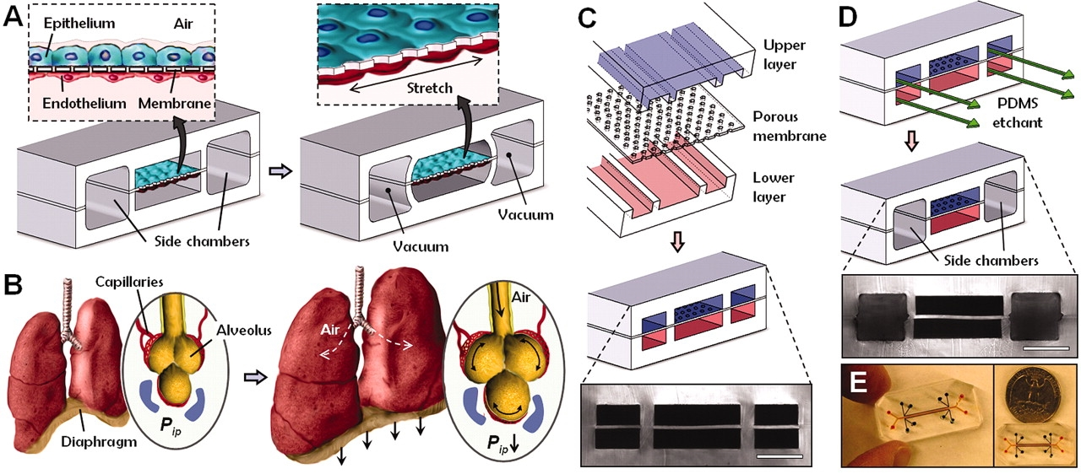
Figure 2.1. A microdevice representation of human lungs on a breathing chip. (A) A microfabricated lung mimicking device to create an alveolar-capillary barrier on a thin, porous, flexible PDMS membrane coated with ECM. By applying a vacuum to the side chambers, the device causes the PDMS membrane to stretch, recreating physiological breathing movements. (B) Inhalation by a living lung and diaphragm contraction decreases intrapleural pressure (Pip), physically stretching the interface of the alveolar-capillary and the distension of the alveoli. (C) The alignment of three PDMS layers, which are bonded irreversibly, microchannels and side microchambers with a 10-µm-thick porous PDMS separation membrane, (D) The PDMS etchant was passed through the side channels result in selective etching of the membrane layers to fabricate a space for the application of a vacuum for mechanical stretching. Scale bar = 200 mm. (E) An aerial view of the “lung-on-a-chip” microfluidic device (This figure is reprinted from [17] with permission).
The system has been considered as an alternative or supportive method of in vivo animal testing for breathing functions. Therefore, the group tested the ability of the device by performing an experiment to mimic the responses of the lung tissue while inhaling the living pathogens (pulmonary inflammation and infection). They introduced Escherichia. coli (labelled with green fluorescent protein (GFP)) into the device, using lung air sac top channels (alveolar microchannel). Consequently, immune cells (neutrophils) introduced and circulated in the bottom channel (blood vessel). The presence of the pathogens activated the underlying endothelium after 5 hours as neutrophils were squeezed and transmigrated through the porous membrane into the top alveolar microchannel and engulfed the bacteria over a period of a few minutes [17] showing the successful ability of the device to mimic the innate cellular response to pulmonary infection.
The “lung-on-a-chip” system (Figure 2.1) is an important concept for toxicology applications. By studying how a lung responds to nanoparticles, researchers can investigate health risks posed by certain environments. Although use of nanomaterials is common, knowledge about their risks to health and environment is still limited and most of existing toxicology methods rely on lengthy and costly animal testing or oversimplified in vitro models. As the lung-on-a-chip can accurately simulate a living lung’s mechanical properties, physiological reactions are much faster and more precise. The group findings confirmed the effects of nanoparticles in induction of lung inflammation. They also showed that the mechanical strain enhancing cellular uptake of nanoparticles.
Although the lung-on-a-chip did not completely mimic alveolar-capillary barrier in vivo (e.g., cellular composition, changes in air pressure and flow, and lack of alveolar macrophages), the device could fully reproduce multiple physiological functions observed in the whole breathing lung, which conventional in vitro models fail to offer [17].
Contemporary pharmaceutical in vitro models still consist of isolated single cells from a single organ. This does not reflect organ complexity, and therefore lack the accuracy. Despite significant advances in organ and tissue models, much remains to be done in the development of complex models that reconstitute whole-organ and body metabolism physiology. Single organ-on-a-chip provides an ideal microenvironment to mimic human-specific organ and disease states for development of new therapeutics. Although they significantly improved current in vitro studies, they are not ideal as a model for whole human body physiology as toxicity responses arise from a complex series of events, involving multiple organs, including dynamic testing of drug absorption, distribution, metabolism, and excretion. Therefore, investigators have tried to connect different model organs in one device to study the effects of drugs and their metabolites on these organs [124, 125]. This could lead to another concept; “body-on-a-chip” or “human-on-a-chip”. Body-on-a-chip concepts could ultimately revolutionise current drug developments by mimicking tissue-tissue interactions as a consequence of metabolites traveling from one tissue to another (Figure 2.2). However, there are still significant challenges that need to be overcome; e.g., identification of a common medium with the formulation that can preserve different cell types, while devices are connected.
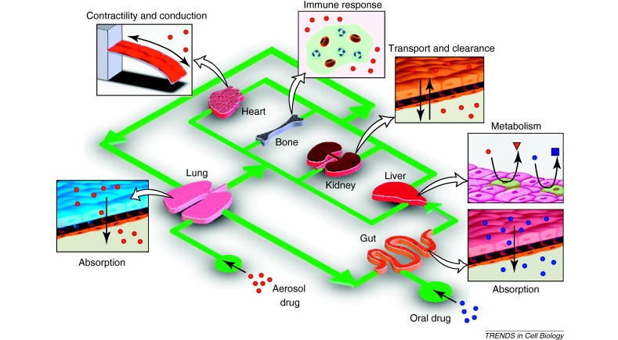
Figure 2.2. The concept schematic representation of different organs-on-a-chip connected by a microfluidic circulatory system to build a body-on-a-chip. The system can be used for drug toxicity testing, drug absorption, distribution, metabolism and excretion (The figure is reprinted from [12] with permission).

Bone: physiology and tissue engineering

Anatomy physiology and structure
Bone is a highly vascular and dynamic tissue that performs several roles in the human body. It provides structural support, bears load and protects vital organs. It also stores minerals such as calcium and phosphorus and it also stores growth factors. The bone facilitates movement by supporting muscular contraction [126]. Bone also contains cells (explained below), haematopoietic red marrow and lipid filled yellow marrow which produces blood and stores energy, respectively.
Bone can be divided into two different types of osseous tissue known as cancellous bone (spongy or trabecular bone) and cortical bone (compact or lamellar bone) (Figure 2.3). Cortical bone is located on the outer regions of the bone and has a dense and solid structure with a porosity of less than 5%, hence it forms approximately 80% of the bone mass in adult skeletons [127, 128]. The porosity of cortical bone reflects micro-architectural channels for bone cells and blood vessels.
Cancellous bone is located inside the bone and forms the remaining 20% bone mass, but with a much higher porosity, approximately 50–90%. Cancellous bone is less dense and has a higher SAV, compared to cortical bone. This makes it weaker in terms of compressive strength, yet more flexible. It is made of thin (50–400 µm) interconnecting rods, open cell structures, trabeculae plates and closed cell structures. The space between the trabeculae is filled with bone marrow and blood vessels [126-130].
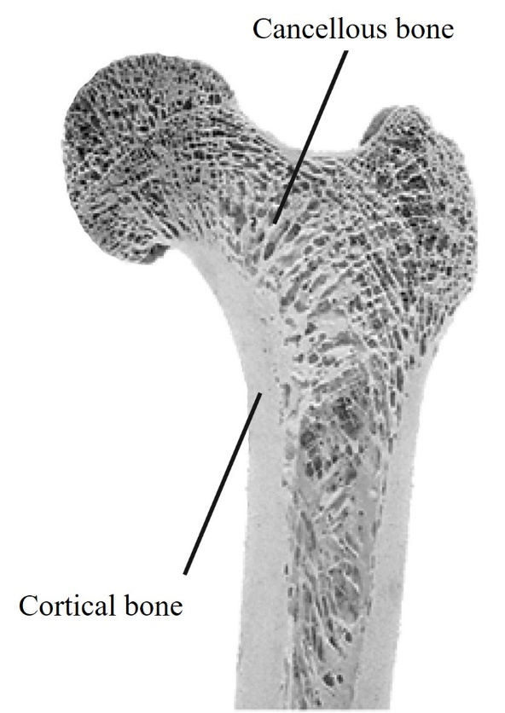
Figure 2.3. The proximal end of a human femur showing the location of cortical and cancellous bone (This figure is adopted from [131] with permission).
The adult human skeleton contains 206 bones, which are categorised into five types, according to shape: i) short, ii) long, iii) flat, iv) irregular and v) sesamoid.
i) Short bones have approximately the same dimensions in all three axes. Their main role and function is to provide stability and support, but with limited movement. They are located in the wrists and ankles.
ii) Long bones (Figure 2.4) are longer than they are wide. They are typically found in the arms, legs, fingers, and toes. They are subjected to most of the daily activity loads and are vital for skeletal mobility. Long bones consist of three main regions, diaphysis, metaphysis, and epiphysis. Diaphysis is the midsection of the bone, a hollow tube with the outside made up of cortical bone and the medullary cavity usually filled with red and yellow marrow. Diaphysis connects to the epiphysis (proximal and distal) via the metaphysis (proximal and distal). Epiphysis is the end part of the long bone, with a specialised shape depending on the function and location. The structure of the epiphysis is comprised of cancellous bone, with an outer surface composed of cortical bone. The metaphysis is the narrow portion that connects the diaphysis to the epiphysis. It is also known as an epiphyseal plate and contains the growth plate, the part of the bone that grows during childhood and stops growing and ossifies into solid bone at adulthood.
iii) Flat bones are composed of two thin outer layers of cortical bone, enclosing a layer of cancellous bone, containing bone marrow. Their main function is protection and support or providing a broad surface for muscular attachment. They are found mainly in the skull, shoulder blades, pelvis, sternum, and ribs.
iv) Irregular bones are complex and are not categorised as the above such as the vertebrae or facial bones. They support and protect and consist of cancellous bone supported by a layer of cortical bone.
v) Sesamoid bones are small, round bones embedded in tendons and muscles. They response to strain. Therefore, except for patellae (kneecap) their numbers and locations differ from person to person.
The outer surface of all bones is covered by connective tissue called the periosteum membrane, except at the joints of long bones which are covered by articular cartilage. The periosteum membrane consists of two layers, an outer and inner layer. The outer layer contains fibroblasts, forming irregular collagenous tissue with blood vessels and nerves, while the inner layer contains progenitor cells, differentiating to osteoblasts. The osteoblasts in adult human skeleton are responsible for width increases in long bones and the size of other bones. The outer layer of the periosteum is continuous with attached ligaments and tendons. The ligament and tendons’ attachment is also penetrated to the underlying bone and supported by collagenous fibres called Sharpy’s fibre. The outer layer also provides pathways for blood vessels and lymphatic tissues. The inner surface of bone comprises bone cells and is covered by a thin vascular membrane termed the endosteum [132].
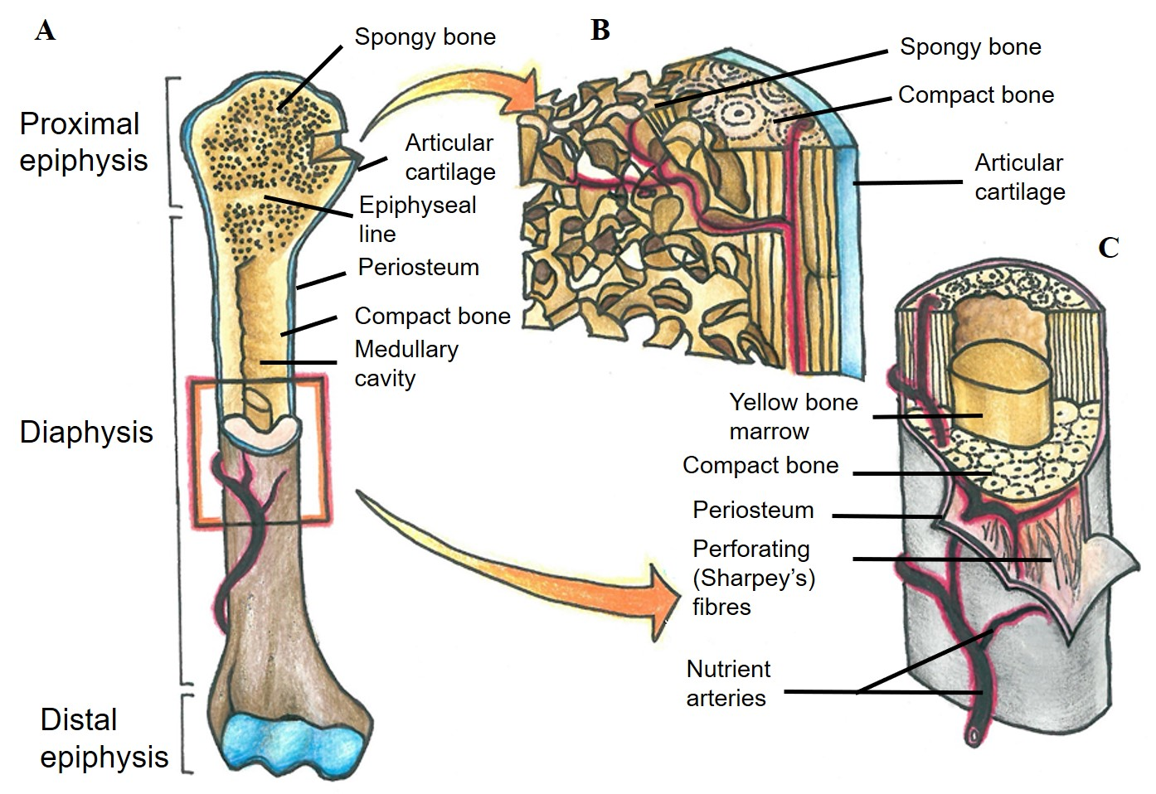
Figure 2.4. An adult long bone. A) Macroscopic view of a human femur showing the main regions B) Cross section of epiphysis presenting the detail structure C) Cross section of diaphysis presenting the detail structure. (This figure is sketched by the author.)
At the microscopic level, bone is composed of different types of materials, organic, inorganic, and cellular. The organic materials provide tensile strength for the bone and reduces brittleness, allowing the bone to bend. Inorganic materials provide compressive strength. Bone matrix or osteoid is provided by a combination of organic and inorganic materials. The cellular phase in the bone, deposits, preserves and resorb these materials. In dry osseous tissue, by weight two thirds is inorganic, mainly hydroxyapatite (~85%), calcium carbonate (~10%), and small quantities of other minerals [132]. The remaining one third consists of an organic phase which mainly includes ~90% type I collagen, with trace amounts of type III and V collagen, and ~10% non-collagenous proteins such as proteoglycans, glycosaminoglycans, and glycoproteins. The majority of these proteins contain the acidic residues, either aspartic or glutamic acid giving them a high affinity for calcium ions [133].
Other proteins in the bone include osteopontin, osteocalcin, osteonectin, and alkaline phosphatase (ALP). Osteopontin, also known as bone sialoprotein, is a linking protein for cell attachment to bone matrix and bone remodelling [134]. Osteocalcin, or bone gamma-carboxyglutamic acid-containing (gla) protein, is secreted by osteoblasts and can be used as a late-biomarker of bone formation. It is implicated in bone mineralisation and calcium ion homeostasis. To control mineralisation, the inhibition of osteocalcin can be used [89, 135]. Osteonectin is a glycoprotein mainly involved in the mineralisation process, initiating mineralisation and promoting crystal formation due to its binding affinity with hydroxyapatite, calcium and collagen. ALP, specifically tissue non-specific alkaline phosphatase, is a glycoprotein enzyme secreted from osteoblasts to promote hydroxyapatite crystal formation in the bone matrix. It is considered a sensitive and reliable biomarker of bone metabolism and formation [135, 136]. Hence, ALP activity measurement is often used in vitro as an early indicator of osteogenic differentiation [137]. The essential substrate for ALP in bone is considered to be inorganic pyrophosphate (PPi). PPi inhibits hydroxyapatite formation, but ALP hydrolyses PPi to inorganic phosphate (Pi) which is required for hydroxyapatite formation [138, 139]. The key signalling factors and their functions during the bone development is summarised in Table 2. 2.
Table 2.2. Signaling factors and their function in bone development.
Signaling factors | Functions | Reference
Fibroblast growth factors (FGF) | Stimulate proliferation of MSCs and enhanced bone regeneration | [140]
Bone morphogenic proteins (BMP) | Enhance matrix production  Induces stem cells differentiation into osteoblasts  Stimulates osteoblast proliferation | [141]
Dentin matrix protein-1 (DMP1) | Mineralisation regulator  Induces stem cell differentiation into osteoblasts | [142]
Insulin-like growth factors (IGF) | Stimulates osteoblasts proliferation | [141]
Platelet-derived growth factors (PDGF) | Stimulates osteoblasts proliferation | [142]
Transforming growth factors-β (TGF-β) | Induces osteoblast proliferation  Enhances bone resorption | [143]
Dexamethasone (DEX) | Promotes stem cell differentiation | [142]
Prostaglandin E2 (PGE2) | Induce stem cell differentiation, collagen synthesis, and ALP activity  Stimulates osteoblast proliferation | [144]
Nitric oxide (NO) | Stimulates stem cells differentiation  Enhances PGE2 release | [145]
Extracellular signal regulated kinase (ERK) | Induces stem cells differentiation  Improves calcium deposition | [146]
Adenosine 3', 5'- cyclic monophosphate (cAMP) | Stimulates osteoblast proliferation | [142]

Bone has a hierarchical structure, a macrostructure composed of cancellous and cortical bone, a microstructure (500 µm - 10 µm) composed of osteons and trabeculae, a sub-microstructure (10 µm - 1 µm) which is lamellae, a nanostructure (1 µm - ~500 nm) which comprises collagen fibres, and finally a sub-nanostructure (below ~500 nm) which is composed of fibrils and molecules that form collagen fibres (Figure 2.5).
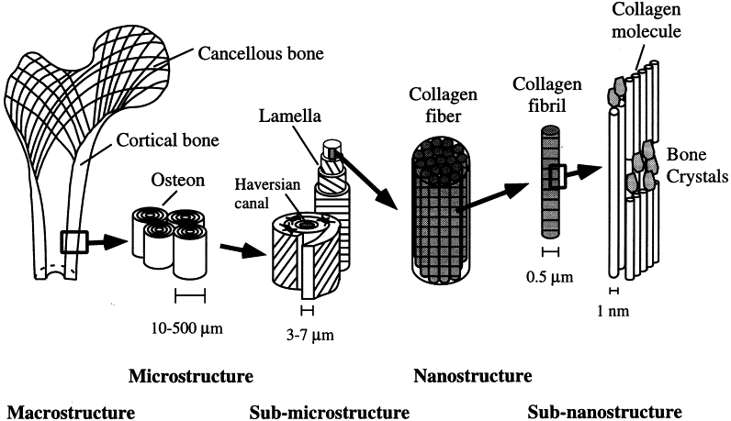
Figure 2.5. Hierarchical structure of cortical bone (This figure is reprinted from [147] with permission).
Bone structure at the microscopic level can be classified into two forms, woven and lamellar, depending on organisation of collagen fibrils within the bone matrix. Woven bone is immature bone formed during foetal development or fracture repair, and contains randomly oriented collagen fibrils and cells. It is laid down rapidly and randomly in response to the urgent need for stiff tissue in short time. The random order of collagen fibrils generates isotropic mechanical properties and higher flexibility to woven bones. In contrast, lamellar bone has a high number of organised, stress-oriented collagen fibrils. Hence, lamellar bones yield anisotropic mechanical properties, meaning its mechanical properties and performance is oriented by the applied force. Each layer (lamellae) has a thickness of 3 to 7 µm, while collagen fibres are positioned in parallel. In adjacent layers, collagen fibres are also parallel, but with an angle to the neighbouring lamellae. Due to anisotropic mechanical properties, lamellae bones are much stronger than woven bone, but they have less flexibility [126].
In the adult human, cortical bone and cancellous bone microstructures are significantly different (Figure 2.6). Osteons are the building blocks of cortical bone. Lamellae is wrapped concentrically around a canal that contains blood supply and bone nerves, which in combination forms an osteon. There are two groups of osteons, primary and secondary. Primary osteons first occur during cartilage mineralisation, while secondary osteons are the main building blocks and occur when the existing bone is replaced during bone remodelling. These osteons are also known as Haversian systems and have more lamellae and larger canals when compared to primary osteons. Cancellous bone also contains lamellae, however since they are not concentric there are not called osteons. In cortical bone, osteons run parallel to the long axis of the bone and join via Volkmann’s canals. Volkmann’s and Haversian canals contain blood supplies, bone nerves and lymph vessels. In osteons, lacunae (where osteocytes reside), are found between the lamellae and are connected by canaliculi to facilitate the exchange of nutrients and metabolic wastes.
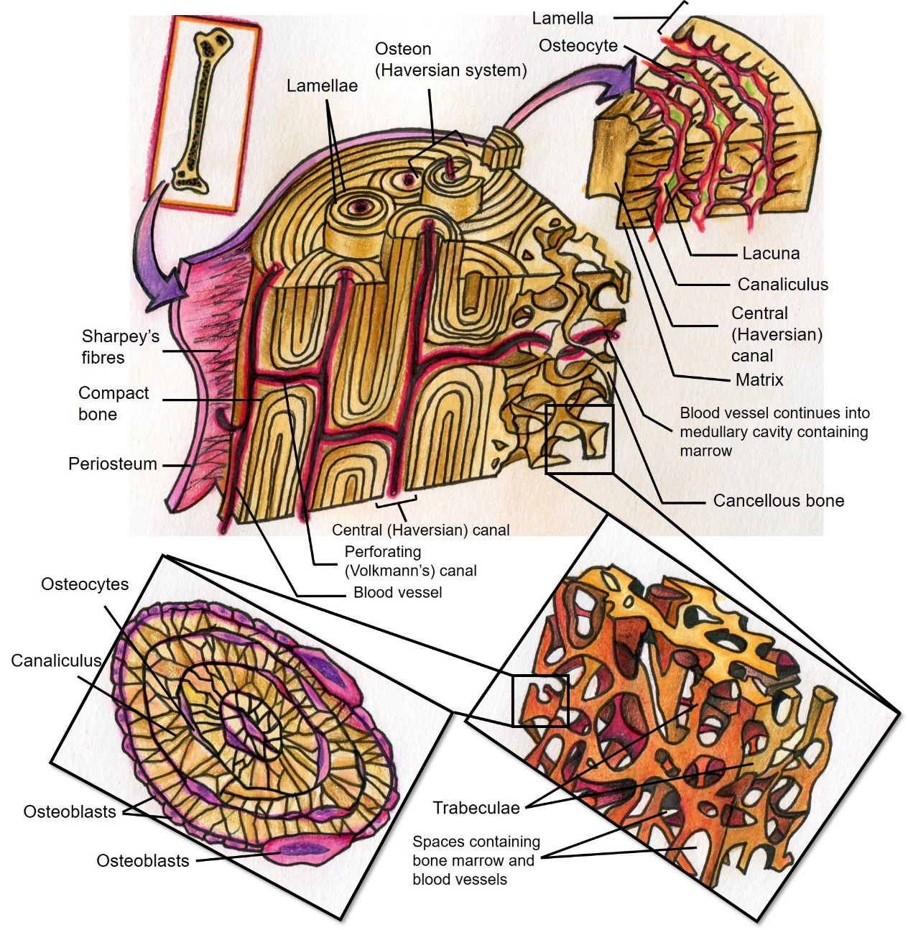
Figure 2.6. Cortical and cancellous bone microstructure. (This figure is sketched by the author)

Bone cell biology
There are four main cell types in bone, with different roles and functions; i) mesenchymal progenitors, ii) osteoblasts, iii) osteoclasts, and iv) osteocytes.
Mesenchymal progenitors undergo osteogenesis and differentiate into pre-osteoblasts and osteoblasts. They can also develop into myocytes, adipocytes, and chondrocytes [148]. Osteoblasts eventually differentiate into osteocytes, with the remainder developing into bone lining cells or they undergo apoptosis (programmed cell death). In contrast to these cells, osteoclasts are derived from haematopoietic stem cells (HSCs) (Figure 2.7).
In the human body, mesenchymal progenitors differentiate to osteoblasts by two different processes; i) direct differentiation; mesenchymal progenitor cells directly differentiate to osteoblasts and occurs during inter-membranous ossification which is limited to the skull bones and the clavicle. ii) Indirect differentiation occurs by endochondral ossification in all other parts of the skeleton. In this way, mesenchymal progenitor cells initially differentiate to chondrocytes and pre-chondral cells. Theses chondrocytes are at first proliferative, but they become hypertrophic by exiting the cell cycle. This process causes the differentiation of osteoblasts from pre-chondral cells [126, 149].
Due to the significant ability of mesenchymal progenitors to differentiate into osteoblasts and the ease of their isolation and expansion in culture, they have been considered significantly in the field of bone engineering. Nevertheless, their proliferative and differentiation abilities reduce during ex vivo expansion, limiting their clinical use [150].
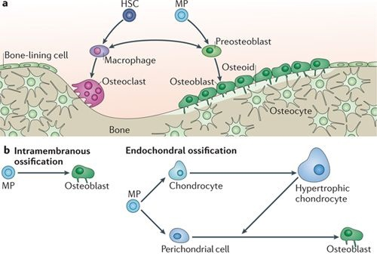
Figure 2.7. Osteoclastic and osteoblastic cell lineages from different pathways A) Pre-osteoblasts, osteoblasts, osteocytes and bone lining cells are derived from mesenchymal progenitors (MPs) and osteoclasts from hematopoietic stem cells (HSCs) B) Different pathways of osteoblastic differentiation from MPs. (This figure is reprinted from [149] with permission.)
Bone extracellular matrix is deposited and regulated by osteoblasts at a rate of 0.5 to 1.5 µm/day [151]. Osteoblasts produce collagen and non-collagenous proteins that form the organic phase of bone. They have a cuboidal morphology and are located on the surface of the bone matrix. They also are required to be anchored, cell-matrix or cell-cell contacts, to maintain their function. This occurs through specific signalling receptors, such as hormones, cytokines and growth factors, or transmembrane proteins receptors such as cadherins, connexins and integrins.
It is widely reported that mature osteoblasts are post-mitotic [152, 153]. Hence, mesenchymal progenitor differentiation is essential to create mature osteoblasts. Although the progression of mesenchymal progenitor differentiation is a continuous process, there are no well-defined characters for each phenotype of the cells during the differentiation process, to better discuss bone biology. The process is classically divided into four phenotypes, progenitor, pre-osteoblast, mature osteoblast and osteocyte [149].
As mesenchymal progenitors differentiate to osteoblastic lineages, there is a period where the cells actively proliferate. Genes associated with extracellular matrix production, which are fundamental to osteoblast phenotypes, such as collagen type I, are expressed. After this period, proliferation rates reduce, and genes are down-regulated, whilst ALP expression rapidly increases. At this stage, the extracellular matrix is prepared for mineralisation. It appears to activate genes specific to bone mineralisation, the cessation of cell proliferation is essential [154].
Osteocytes develop, while osteoblasts change phenotypes, by becoming fully embedded and entrapped within their own calcified osteoid [126, 151]. They reside in lacunae and account for approximately 90% of all cells in human bone. Although they are formed from osteoblasts, osteocytes have different morphology and function. They are star shaped (stellate) with multiple cytoplasmic extensions. Compared to osteoblasts they are smaller, but with a larger nucleus-to-cytoplasm ratio [155]. Their cytoplasmic extensions penetrate the canaliculi, where they connect lacunae to make contact with other osteocytes, osteoblasts and cells lining the bone surface [156] (Figure 2.8). Osteocytes can survive for decades; oxygen and nutrients diffuse through interstitial fluid in lacuno-canalicular surrounding the osteocytes [157]. The osteocyte network provides a complex communications system, allowing osteocytes to sense and respond to stresses placed on the bone. It is believed that the sensory mechanisms react to changes in the interstitial fluid flow surrounding the osteocytes. Any load on the bone can cause bone deformation, initiating changes to interstitial fluid flow, flowing from high to low pressure areas. Based on the stimulus, osteocytes produce signalling molecules that regulate bone formation and resorption activities, by osteoblasts and osteoclasts, respectively [158]. Signalling molecules produced by osteocytes can affect significantly bone remodelling process due to the high surface-area-to-volume ratio of lacunae/canaliculi systems [159].
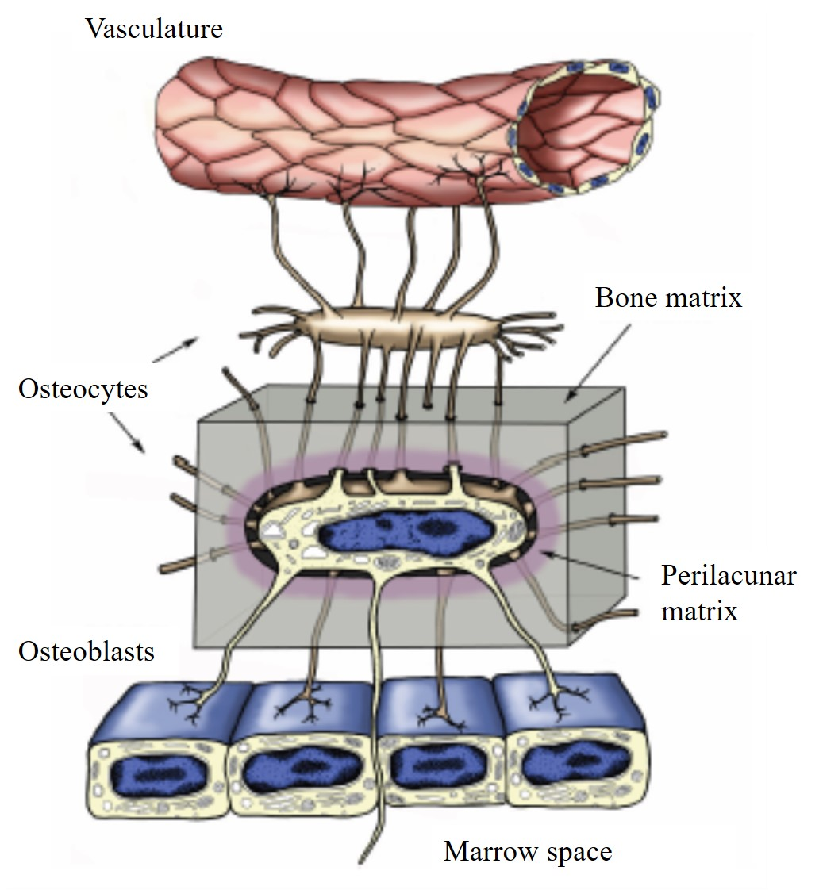
Figure 2.8. Osteocytes embedded inside the bone matrix. Dendritic processes can penetrate the canaliculi in the bone matrix. They interconnect with other osteocytes, osteoblasts, and the marrow space and vasculature via gap junctions. (This figure is reprinted from [157] with permission)
Osteoclasts are derived from HSCs and are multinucleated bone resorption cells that form from fused monocyte progenitors. They have an average lifespan of 15–20 days. An active osteoclast can resorb bone matrix at a rate of up to 200,000 µm³/day. They degrade and resorb osteoid using protons and enzymes. Osteoclasts attach tightly to bone and form an isolated microenvironment by rearranging the cytoskeleton to form actin rings. Inside the ring, the plasma membrane enlarges and becomes convoluted to form a ruffled membrane with finger-like projections. This causes an increase in surface area and makes contact with the bone matrix. After osteoclast attachment, through the ruffled border, the resorption process is initiated by releasing protons, acidifying the sealed environment to dissolve the mineral content of the matrix. Later, proteolytic enzymes, such as matrix metalloproteinase 9 (MMP-9), tartrate-resistant acid phosphatase (TRAP), gelatinase and cathepsin K, degrade the organic component of the bone. The degradation process results in the formation of resorption cavities termed, Howslip’s lacunae [151, 160-162].

The bone remodelling process
After bone formation, bone remodelling is an essential physiological process that occurs throughout life. The process occurs by the action of an osteoblast-osteoclast complex, which replaces primary, micro-damaged or fractured and immature old bone, to maintain or improve bone strength. Furthermore, bone remodelling helps maintain mineral homeostasis. In a healthy human skeleton, approximately 20% of cancellous bone remodels each year, indicating the importance of bone remodelling for calcium and phosphorous metabolism. Approximately 5% of cortical bone remodelling is sufficient and essential to maintain bone strength. Although bone remodelling is a balanced process in healthy individuals, formation and resorption can change throughout life. In the first three decades, formation dominates until peak bone mass is achieved. This bone mass is maintained for almost 20 years, before resorption begins to outweigh formation, decreasing bone mass [163].
The bone remodelling unit (BRU) or the basic multicellular unit (BMU) are cell groups responsible for bone remodelling. They are composed of discrete units of osteoblasts and osteoclasts, along with a blood supply and supporting connective tissue. BMUs remove and replace bone structural units through cortical and cancellous bone. In the process, osteoclasts form a tunnel or trench in the case of the trabecular BMUs, and then osteoblasts fill the space. Cortical BMUs can move in all three axes, while trabecular BMUs move in two axes, as they are located on the surface [126, 164] (Figure 2.9).
Figure 2.9. Multicellular bone units in cortical bone and trabecular bone. In cortical bone, BMUs initiate at points within Haversian canals, and in trabecular bone at points beneath the canopy of lining cells. (This figure is reprinted from [165] with permission)
The collaboration of osteoblasts and osteoclasts within the BMU is tightly controlled through several biochemical pathways. Osteoblasts are key for controlling bone remodelling, resorption and formation. Mature multinucleated osteoclasts are produced from osteoclast precursors. The process is predominantly initiated by the attachment of two factors to the precursors, macrophage-colony stimulating factor (M-CSF) binds to colony-stimulating factor-1 receptor (C-FMS), and the receptor activator of nuclear factor kappa-B ligand (RANKL) binds to the receptor activator of nuclear factor kappa-B (RANK). M-CSF and RANKL have important roles in osteoclastogenesis, M-CSF promotes the survival and proliferation of precursors [166, 167] and RANKL commits the precursors to the osteoclast lineage. Both factors are expressed by osteoblasts and their continued exposure stimulates the precursors to fuse and produce mature osteoclasts for bone resorption. To inhibit osteoclastogenesis, osteoblasts express another factor called osteoprotegerin (OPG), a decoy receptor for RANKL [168], as OPGs bind to RANKLs and deactivate their functionality . Therefore osteoblasts, by controlling the ratio of RANKL: OPG, regulate osteoclast resorption (Figure 2.10).
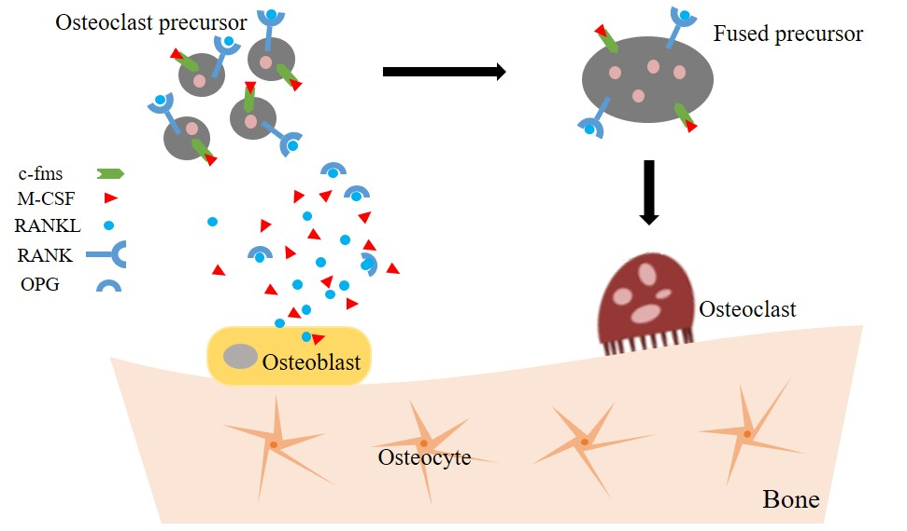
Figure 2.10. Schematic representation of how osteoclasts are activated and controlled by RANKL/RANK/OPG and M-CSF pathways. (This figure is sketched by the author.)
The bone remodelling cycle is composed of different stages (Figure 2.11): quiescent, activation, resorption, formation and mineralisation phases.
Quiescent: The phase where bone is inactive. The exact factors for remodelling initiation are not well known. Several factors are effective in bone remodelling; micro-fractures, a deficient diet or mechanical stimuli sensed by osteocytes. These factors can result in the expression of molecules to activate bone lining cells such as tumour necrosis factor-α, insulin growth factor-1, interleukin-6 and parathyroid hormone [169, 170].
Activation: The phase where the bone surface is prepared for resorption. Hormonal and physical stimuli recruit osteoclast precursors from the circulation. Elongated mature osteoblasts, which make the bone lining cells, retracts and mineralised bone matrix is exposed by breaking down the endosteal membrane. Monocyte-macrophage osteoclast precursors are activated and fuse to form multinucleated osteoclasts. They bind to the exposed bone matrix, ready for resorption [126].
Resorption: The phase where resorption of bone matrix begins, caused by multinucleated osteoclasts using protons and lysosomal enzymes. Osteoclasts degrade and dissolve the bone matrix, making resorption cavities. Afterwards, they undergo apoptosis and leave growth factors, monocytes, osteocytes that have been freed from the bone matrix, and pre-osteoblasts. At the end of resorption, the transition from resorption to formation can take up to five weeks. This period is termed the reversal phase, where the surface is smoothed by macrophages, preparing for matrix deposition. The signals that couple the resorption phase to the formation phase are not yet understood, but are believed to be bone matrix-derived factors [163, 171].
Formation and mineralisation: The phase where the new bone matrix is formed and mineralised by osteoblasts. Chemotactic growth factors released from the bone matrix attract pre-osteoblasts to synthesise foundations for the new tissue formation, and express differentiation proteins. Some days later, osteoblasts lay down the new bone matrix to fill cavities, by depositing collagenous matrix and regulating its mineralisation. The mineralisation begins 30 days after collagenous matrix deposition and osteoid deposition is fully completed after 90 days for cancellous bone, or 130 days for cortical bone. Throughout the process, some osteoblasts become embedded within the bone matrix and differentiate to osteocytes, while the remaining osteoblasts either undergo apoptosis or turn into bone lining cells [129, 163, 171, 172].
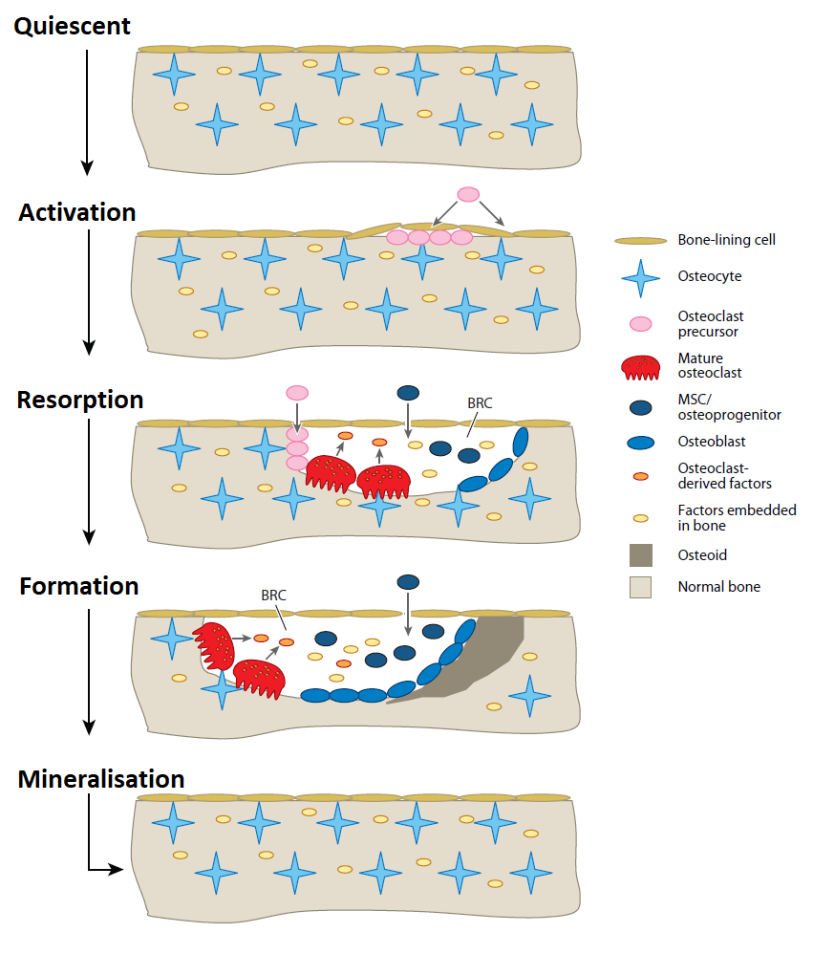
Figure 2.11. The different steps of bone remodeling; quiescent, activation, resorption, formation, and mineralisation (This figure is reprinted from [173] with permission).

Bone tissue engineering
In the United Kingdom (UK), approximately 38.2% of people suffer a bone fracture in their lifetime [174]. Bone fractures can be categorised into traumatic fractures and pathologic fractures. The former are the consequences of excessive loads on the bone due e.g. vehicle accidents or falls [132]. The latter fractures occur in unhealthy bones and are due to conditions such as osteoporosis. Bone fractures result from stresses that are lower than the required load to fracture a healthy bone. Bone fractures and disease are a major health concerns in the UK, and due to an ageing population, the frequency is likely to increase into the future [174]. The treatment for bone fracture depends on the severity. Although bone exhibits a significant regenerative capacity, most complex fractures, such as defects caused by bone cancer, may be treated by bone grafts [175, 176]. Bone grafts are currently the second most transplanted tissue, after blood as estimated by the 2.2 million grafts performed worldwide each year [177]. Several different types of bone graft are used.
Autologous grafts: This is known as the gold standard of bone grafts. The bone is taken from a part of the patients’ own body, commonly sourced from the iliac crest (superior border of the wing of ilium). These grafts contain all the essential components such as osteoblasts, osteoid and growth factors and hence are said to be osteogenic, osteoinductive and osteoconductive for bone healing and regeneration. Furthermore, as the bone graft is taken for the patients’ own body, there is no concerns regarding the disease transmission, and bone healing and fusion rate are relatively high. However, this method is limited due to the limited availability of tissue, donor site morbidity and associated pain and multiple surgeries [178-180].
Allograft: For this type of graft, bone is taken from another persons’ body, mainly cadavers. While less surgeries are required, and bone is readily available, the cost of the bone graft is often higher than autografts, and the rate of successful graft fusion and incorporation is lower. Moreover, there are concerns regarding immuno-rejection, disease transmission and tissue compatibility. For this reason, allograft bones are decellularised and sterilised prior to grafting, however this can compromise mechanical properties and bone bioactivity.
Xenogeneic grafts: In this method, bone is taken from another species. Tissue is readily available and bone mineral components, in the case of bovines, are similar to human bone. Therefore, they are better candidates when compared to synthetic grafts. However, for this method, the bone is similarly treated to allografts and should be decellularised and sterilised extensively prior to grafting. This method may compromise osteoconductivity and mechanical properties. Furthermore, strong immune responses restrict their use [181].
Synthetic grafts: The restoration of tissue using biomaterials goes back 2000 years or more, e.g. the use of gold as a replacement for teeth by the Chinese and Romans [182]. With advancements in science and technology, a variety of materials have been developed and used as synthetic grafts. Metal, ceramics, bioactive glasses, hydroxyapatite derivatives are just a small selection from this group. These materials aim to provide osteoinductive, osteoconductive, and biocompatible nature while removing the possibility of immune rejection, morbidity and pain associated with other techniques. For example, bioactive glass is osteoinductive and can be used as bone graft substitutes [183]. Furthermore, to improve their graft properties synthetic grafts can be combined with polymers such as poly (lactic-co-glycolic acid) (PLGA) to increase their mechanical properties [184]. However, synthetic bone graft alternatives are yet to be successful, due to poor wear properties and brittleness, limiting their use in locations with high torsion, shear stress or bending [185, 186].
Tissue engineering is a multidisciplinary field, drawing knowledge from several areas including chemistry, physics, engineering, medicine, materials science and biology [88, 89]. The aim of tissue engineering is to improve the current medical treatments and therapies to restore the original function of damaged tissues and organs by creating, repairing, regenerating of them. Bone tissue engineering, as an emerging field, is another promising alternative for bone grafting that could overcome associated disadvantages of different types of bone grafts.
Tissue engineering principles involve obtaining cells from a patient, expanding them in vitro, seeding onto a scaffold and implanting back into the patient (Figure 2.12) [187]. These scaffolds are biocompatible, biodegradable and provide chemical and physical cues for cell adhesion, growth and differentiation, to form 3D tissues [188]. Although tissue engineering and regenerative medicine is known as the future of medicine, excluding medical devices and implant industries, their products are currently limited to skin substitutes. This is due to different factors such as the challenges of preparing effective scaffolds with proper mechanical properties and porosity, that suit individual patients [189]. Therefore, more effort is required to prepare an “off the shelf” product that satisfies all requirements while having considerable lifespan.
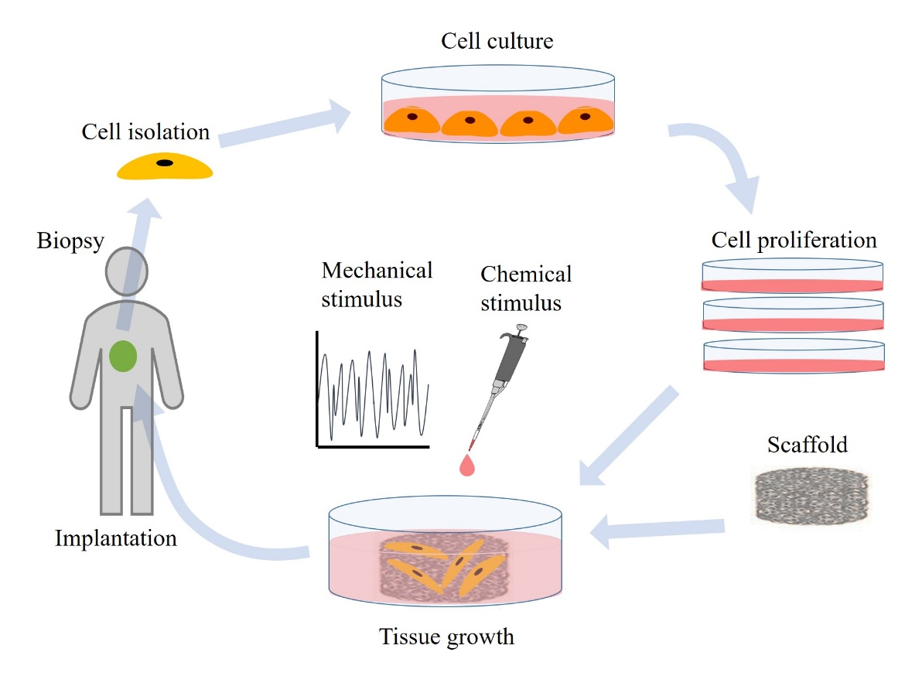
Figure 2.12. Representation of the tissue engineering process including cell isolation, expansion, tissue growth, and implantation. (This figure is sketched by the author.)

Cells for bone tissue engineering
For bone tissue engineering, different cell sources are required. The ideal cell source should be easily expandable to higher passages and express similar bone protein patterns as required in the bone tissue.

Osteoblasts
The isolation of osteoblasts from a bone patient’s biopsy sample can be an appropriate choice due to their non-immunogenicity. However, there are a number of limitations to this procedure, such as low availability of cells from biopsy samples and relatively low cell expansion rates. Moreover, osteoblasts derived from a patient with bone disease may not be appropriate [190]. Alternative options for human osteoblasts could come from animal osteoblasts, however immunogenicity issues and ethical problems limit this approach [191].

Stem cells
A potential ideal candidate to overcome osteoblast limitations is the stem cell. Stem cells are undifferentiated cells that have the potential to become different cell types. Once they divide, each cell has the ability to remain a stem cell or become another cell type, such as red blood cells, muscle cells or brain cells. Stem cells have two special characteristics, distinguishing them from other cell types. Firstly, is their ability to self-renew after long periods of inactivity. Secondly, under certain conditions they can be encouraged to become tissue or organ specific cells, with special characteristics [192]. Scientists are primarily working with two kinds of stem cells, embryonic stem cells (ESCs), derived from zygote (mainly fertilised in vitro), and non-embryonic somatic or adult stem cells (ASCs), found in fully differentiated tissues. Furthermore, another type of stem cell was recently identified. Known as induced pluripotent stem cells (iPSCs), they genetically reprogram some adult cells to assume a stem cell-like state [193].

Adult stem cells
Adult stem cells (ASCs) are believed to be undifferentiated cells and are located among differentiated cells in organs and tissues of the body. The primary role of these cells is to maintain and repair surrounding tissue in which they are located. ASCs are distributed in tissues and organs such as the bone marrow, periosteum, fat, blood vessels, peripheral blood, liver, gut, skeletal muscle, skin, brain, and heart [194]. Bone marrow contains at least two types of stem cell; the first are haematopoietic stem cells that form all types of blood cells and osteoclasts, and the second are bone marrow stromal stem cells (also known as mesenchymal stem cells (MSCs)) that differentiate to osteoblasts, osteocytes, chondrocytes and adipocytes. Therefore, in the bone tissue engineering field, MSCs have become very interesting [150].
Studies have shown that MSCs can be expanded in vitro while remaining undifferentiated [195, 196]. Furthermore, it has been suggested that MSCs may possess immunosuppressive effects, making them suitable for allogenic or xenogeneic transplantation [196]. Although MSCs have many advantages in tissue engineering, they have limitations, including the challenging and time-consuming expansion process and donor and age dependency (it is isolated from different donor). The MSC content in bone marrow is as few as 1 in 100,000 cells, and their proliferation and differentiation abilities are lower when isolated from elderly donors [197, 198].

Embryonic stem cells
Embryonic stem cells (ESCs) (Figure 2.13) are pluripotent cells that have the potential to differentiate to all cell types, including haematopoietic cells, cardiomyocytes, endothelial cells, chondrocytes, hepatocytes, adipocytes, neurons, and osteoblasts [199]. ESCs can be grown relatively easily in vitro, and they have a considerable ability in the proliferation and type of differentiation. However, the direct differentiation of pure ESCs still poses challenges; in recipients there is a risk of tumour formation from undifferentiated ESCs [200]. Furthermore, there are concerns about immunological rejection after transplantation, as they are not taken from the same patient.
Figure 2.13. Embryonic stem cells have pluripotent characteristics, meaning they can develop into many types of tissue (This figure is reprinted from [201]).

Induced pluripotent stem cells
Induced pluripotent stem cells (iPSCs) are somatic cells, reprogrammed into an embryonic stem (ES) cell-like state by transduction with a combination of transcription factors [193]. Therefore, they meet the defining criteria for pluripotent stem cells. The main advantages of iPSCs is their accessibility and therapeutic potential, as they are isolated from patients undergoing therapy. Furthermore, they address the limitation of MSCs, due to their self-renewal capacity, patient specificity and non-dependence on a patients’ age [202]. Several studies have shown they can differentiate into a variety of cell types, such as adipocytes, vascular lineages, skeletal muscles and osteoblasts [203-207]. However, since the cell type is relatively novel, several obstacles have to be overcome before iPSCs can be used as a reliable therapy source, e.g. their persistent phenotype in vivo should be studied.
The limitations and disadvantages of ESCs and MSCs can be overcome by using progenitor cells. Progenitor cells are undeveloped cells, in a transitional phase of development. They are between stem cells and fully mature differentiated cells. Progenitors are similar to stem cells in terms of self-renewal and differentiation, but they have a finite lifespan and more lineage restricted progeny, termed as multipotency. Progenitor cultures are expected to be more stable and easier to expand in vitro [208].
Human embryonic stem cell-derived mesenchymal progenitors (hES-MPs) have been developed and are used as alternative cell sources in bone tissue engineering [208]. It has been shown that this cell type can undergo osteogenic differentiation under certain conditions. They have also been shown to have relatively high mineralisation abilities [209]. To develop an osteoblastic phenotype in vitro, hES-MPs are cultured in osteogenesis induction medium, basal culture medium supplemented with three known compounds to favour the expression of osteoblastic phenotype, naming, ascorbic acid, required for synthesis of collagen, β-glycerophosphate (βGP), and dexamethasone, required to induce osteogenic differentiation [210]. The osteoblastic differentiation of hES-MPs is marked by three stages. First is the growth phase; the proliferating cells express mRNA signalling molecules such as histones, c-fos, c-myc, fibronectin, procollagen I and transforming growth factor-β (TGF-β), amongst others. Second is the matrix phase; cells differentiate into osteoblasts and secrete ALP and produce collagen type I. Finally, the mineralisation stage commences by the secretion of collagenous proteins such as osteocalcin and osteopontin, and deposition of calcium/phosphate minerals [208, 211].
In this project, the osteogenic differentiation of hES-MPs will be investigated under controlled conditions.

Bone-on-a-chip
Although 3D cell culturing offers greater opportunities over planar 2D models, microfluidics and organ-on-a-chip represents significant improvements by recapitulating organ-level functionality in vitro [12]. Recently, through significant improvements in microengineering approaches, different complex microfluidic devices have been developed for the proliferation and manipulation of various cell types, tissues and organs [17, 212]. The aim of these devices is to develop alternative in vitro models by reproducing key structural, functional, mechanical, and biochemical features of living organ, in a single device. They could provide a better understanding of tissues and organs at the cellular level and help pharmaceutical companies enhance the drug developments process.
In human body, bone can suffer with different diseases such as osteoporosis, osteogenesis imperfecta, Paget’s diseases, cancer and infection. For example, osteoporosis is the most common disease affecting bone strength through bone mass reduction and microstructure weakening. It is estimated that three million people in the UK suffer with osteoporosis, and approximately three hundred thousand suffer annually with fractures [213]. Treating hip fractures caused by osteoporosis alone costs more than £2.3 billion per year in the UK. Since the population is aging, further cost increases are expected [214].
The other disease that affects bone is cancer. Although bone cancers such as osteosarcoma, chondrosarcoma, and Ewing’s sarcoma are rare, making up less than 1% of all cancers, other cancers such as lung, breast, and prostate can metastasise to bone causing severe pain, bone fractures, spinal cord compression and rapid degradation in patient quality of life [215, 216]. Although 3D in vitro models and bioreactors have helped to improve the knowledge of bone physiology, the exact sequences, biochemical and mechanical cues in bone physiology are still unknown. Therefore, pharmaceutical companies still rely on in vivo animal research to develop drugs for bone diseases. This places them under intense economic and ethical pressure [119].
Therefore, the development of a microfluidic device that could closely mimic the functional structure of bone and associated biochemical and mechanical cues could revolutionise the treatment of bone disease. However, there have been few studies reporting on bone-on-a-chip devices until very recently (mainly post 2017) [119-123]. Some groups have developed and fabricated microfluidic devices for bone marrow and bone (breast cancer metastasis). These studies are summarised below.

Bone marrow-on-a-chip
Bone marrow plays an important role in maintaining the viability and function of the hematopoietic system [217, 218]. HSCs are regulated by the hematopoietic niche, maintaining and producing mature blood cells. Bone marrow comprises a complex set of chemical, physical and cellular cues. To recreate bone marrow complex in vitro, a proper microenvironment is needed to support the formation and maintenance of the hematopoietic niche [219]. Due to the niches complexity, conventional in vitro culture systems are limited to normal physiological marrow responses, therefore haematopoietic studies must rely on animal models to ensure the presences of an intact bone marrow microenvironment [220-222]. Hence, fabrication of a microfluidic chip that reconstitutes natural marrow structures and function in vitro would be a powerful platform for haematopoiesis studies and therapeutic testing.
Torisawa et al., [119], recently reported the development of a “bone marrow-on-a-chip” culture system. The device offers a new approach for drug responses and toxicity analysis in bone marrow. Furthermore, it enables in vitro studies of haematopoiesis and hematologic diseases. The group engineered artificial bone marrow by implantation of a scaffold into a mouse (Figure 2.14 A). The implantation process for new bone formation, encasing a marrow compartment was eight weeks. Following formation, the bone marrow was surgically removed from the mouse, punched with surgical needles in multiple places for fluid access and placed in a cylindrical chamber of the microfluidic device. Finally, cell culture medium was perfused at optimal rates from top and bottom channels. A central chamber was separated from overlying and underlying channels, by porous membranes (Figure 2.14 B). Bone marrow was cultured at these conditions for four or seven days, according to in vitro toxicity testing for drug efficacies and toxicities [223, 224]. This method used for the bone formation (in vivo formation by implantation) was in contrast with other organ-on-a-chip methods, where in most studies, microengineering and microfluidics techniques are used to model tissue structures and cell-cell interactions by populating cell lines in the device. However, the group’s initial in vivo approach enabled reconstitution of a haematopoietic niche physiology. The authors said this method significantly lowered costs by removing or reducing expensive growth supplements conventionally used in in vitro methods.
The bone-marrow-on-a-chip device developed by this group is a powerful in vitro device, supporting HSCs and progenitor cells in in vivo-like conditions and maintaining their spatial positions in a fully formed 3D bone marrow niche. In summary, the device could preserve complex functionalities of the whole organ and be an interesting alternative to animal models. The device offers the ability to manipulate individual haematopoietic cell populations in vitro, or to introduce other cell types for in-depth analysis.

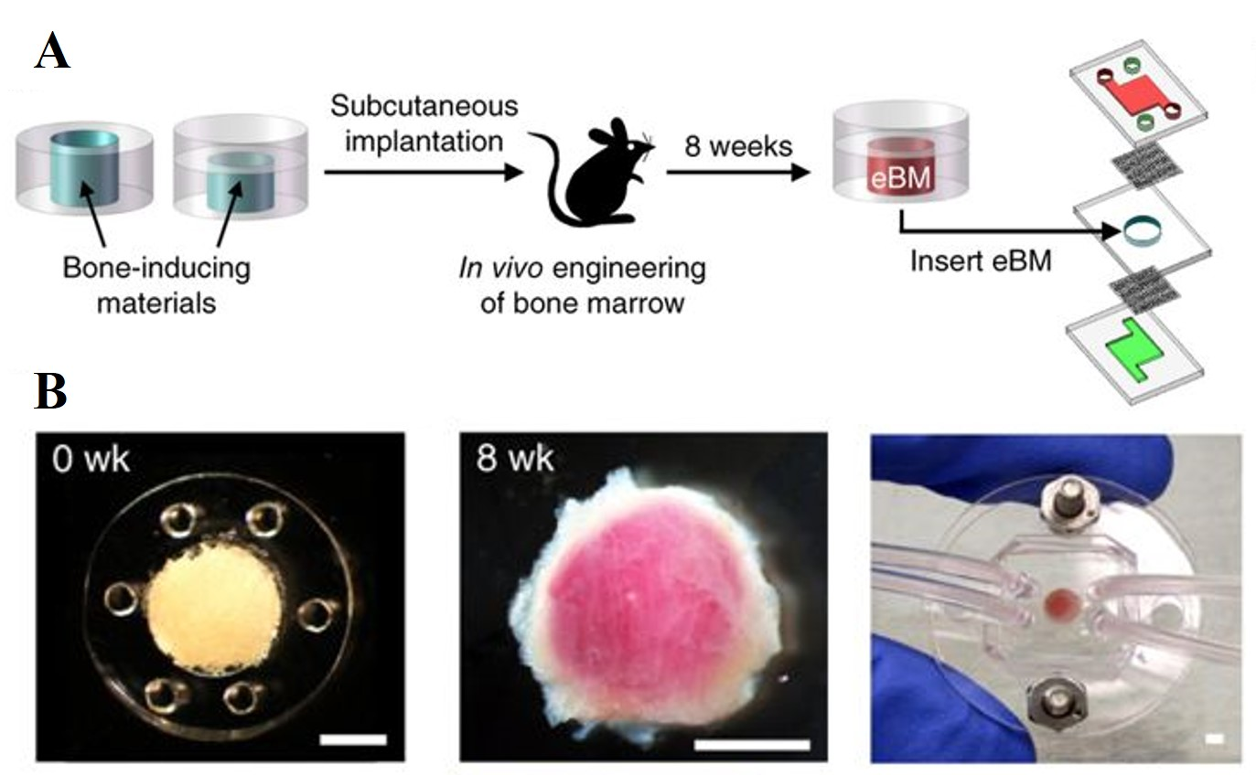
Figure 2.14. A workflow for A) engineered bone marrow formed in a PDMS device in vivo and then cultured in a microfluidic device B) left, a PDMS device containing bone-inducing materials before implantation; centre, bone and bone marrow formed eight weeks after implantation, right, bone marrow chip device for in vitro culture. Scale bar = 2 mm. (The figure is adopted from [119] with permission)
Sieber et al., [120] developed a device for bone marrow using microfluidic technology. The device was used for 3D co-culture based on a hydroxyapatite coated zirconium oxide ceramic scaffold. The scaffold was designed and produced so as to mimic cancellous bone microstructures, porous yet rigid. Unlike the previous group, primary MSCs were isolated from bone marrow and cultured to generate a niche-like microenvironment for successful haematopoietic stem and progenitor cell (HSPC) cultivation for up to 28 days. The microfluidic device used in this study was developed by Wagner et al., [117] as a multi-organ chip (Figure 2.15). The scaffold was seeded with high density MSCs and the media changed every two days. The MSCs were cultured for seven days prior to the seeding of low density HSPCs. After seeding HSPCs, the scaffold was left overnight for cell adhesion. The next day, scaffolds were transferred to microfluidic devices for up to 28 days experiment. The in vitro bone marrow models developed by the group were capable of long-term culture of primitive HSPCs. The co-culture of MSCs with HSPCs produced an in vivo-like bone marrow niche environment.
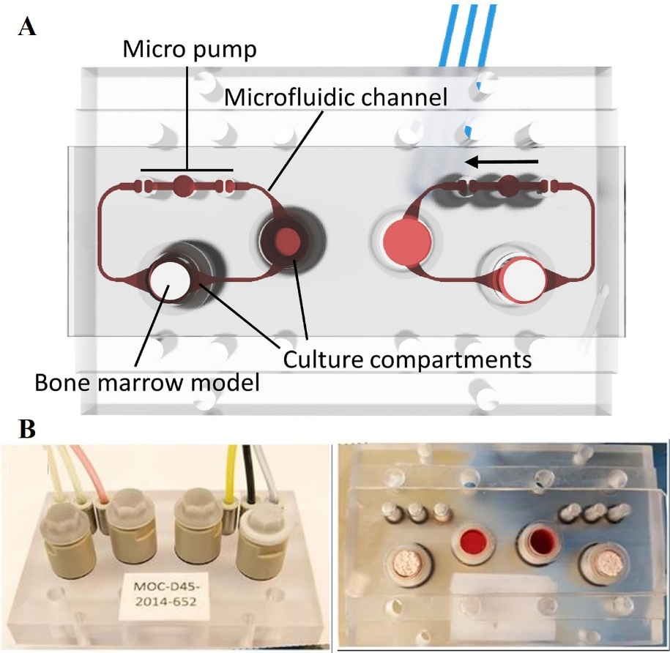
Figure 2.15. A multiorgan chip A) the device viewed from below contains microchannels, micropumps and culture compartments. The bone marrow model was placed in the culture compartment opposite the micro pump. B) Different views of the model containing bone marrow (The figure is adapted from [120] with permission).

Bone-on-a-chip for bone metastasis
Breast, prostate, lung, and melanoma carcinomas often metastasise to the bone [225]. Metastases cause approximately 90% of all cancer related mortalities [226], due to its systematic nature and resistance to most therapeutics. For example, in breast cancer, bone metastasis can decrease a patients’ survival rate from 98% to 26%, leading to an 80% chance of death in five years [227]. Additionally, bone metastases are usually associated with symptoms such as bone pain, bone deformity and nerve compression syndromes [228]. Cancer cells homing to the bone may remain in bone marrow as dormant cells, and not immediately form metastases [229]. These dormant cells are usually resistant to chemotherapy [230]. There is scant knowledge on underlying metastatic mechanisms controlling cell cycle and dormancy and associated pathophysiological changes. Regardless of the clinical importance of metastases, current studies have mainly focused on primary tumours.
There are several obstacles limiting the study of cancer metastasis in bone; the physical difficulty of bone tissue manipulation, the limited number of in vivo and ex vivo models and the difficult process of monitoring cancer cells in in vivo models. Microfluidics are powerful tools for investigating complex phenomena under controlled microenvironments, if accompanied by high-resolution real-time imaging. Hence, a bone-on-a-chip device can be a useful device for bone metastasis studies.
Hao et al., [121] developed a miniaturised bone-on-a-chip device to study bone metastasis. The device contains two parts, a bottom cell-growth chamber and a top media reservoir, separated by a dialysis membrane, supporting cell culture for up to one month (Figure 2.16). The group examined the co-culture of osteoblastic tissue with metastatic human breast cancer cells to assess the device validity by comparing results with in vivo models.
Murine calvaria pre-osteoblasts (MC-3T3-E1) were seeded for 720 hours on the bottom chamber of the device. Following this, two types of green fluorescent protein (GFP) - labelled cell lines; metastatic breast cancer cells, MDA-MB-231^{GFP}, and metastasis-suppressed breast cancer cells, MDA-MB-231-BRMS1^{GFP}, were separately introduced and co-cultured with osteoblastic tissue for up to two weeks. Over this period, the group observed cancer cell interactions with osteoblastic tissue using fluorescence microscopy. The results were consistent with previous in vivo reports showing MDA-MB-231-BRMS1^{GFP} maintained dormancy with no noticeable changes in osteoblastic tissue, seen in vivo [231]. MDA-MB-231^{GFP} cells entered osteoblastic tissue and consumed surrounding matrix creating large holes. The group successfully demonstrated a microfluidic device for the long-term co-culturing of osteoblasts and metastatic breast cancer cells to study the breast cancer metastasis in bone.

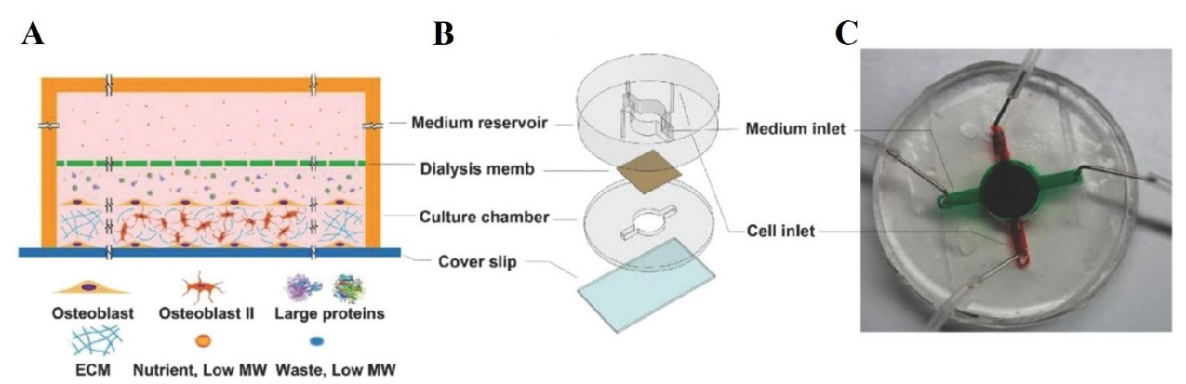
Figure 2.16. The bone on a chip design A) a simplistic side view of the chambers separated by a dialysis membrane B) an exploded view of the chip components C) the assembled device. (This figure is reprinted from [121] with permission.)
Bersini et al., [122] developed a microfluidic model for the in vitro study of breast cancer metastasis in bone. The device was tri-culture microfluidic, consisting of three media channels and four independent gel channels. The authors modelled the extravasation process of breast cancer cells into an osteo-cell conditioned microenvironment. For cancer cells to metastases, they must enter blood vessels after invasion of the primary tissue, survive the blood circulation and leave the blood stream to secondary site, which later process known as extravasation [232]. Bone marrow-derived human MSCs were cultured and pre-differentiated for two weeks. They were detached and re-suspended in a collagen gel and seeded inside the device gel ports for six days to recreate an osteo-cell conditioned microenvironment, before cancer cells were injected. Cells were cultured in osteogenic medium for three days. At day three, red fluorescent protein (RFP)-transfected human umbilical vein endothelial cells (HUVECs) were introduced to generate an endothelium monolayer (medium was replaced by endothelial cell medium). At day six, green fluorescent protein (GFP) - expressing human mammary adenocarcinoma cells, MDA-MB-231^{GFP}, were injected and the extravasation rate and the micro-metastasis were analysed over one to five days, using high resolution confocal imaging and other assays (Figure 2.17).
This group had presented an advanced in vitro microfluidic device model to analyse the extravasation process of highly metastatic breast cancer cells into bone. The findings showed the breast cancer cell surface receptor, CXCR2 and bone-secreted chemokine CXCL5 had important roles in the extravasation process. Moreover, the proliferation ability of extravasated cancer cells into osteo-cell conditioned microenvironments to generate micro-metastases was observed.
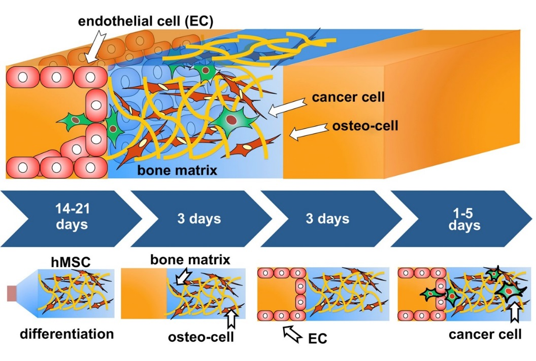
Figure 2.17. Schematic of the device channel plus cells. Human MSCs (brown) were pre-cultured and differentiated in osteogenic media for two weeks. Cells were suspended and seeded in the microfluidic device to deposit extracellular matrix. After three days, endothelial cells (red) were introduced to produce a monolayer covering the media channel. Finally, three days later, cancer cells (green) were seeded and their extravasation ability and micro-metastasis were observed for one to five days. (This figure is reprinted from [122] with permission.)
Marturano-Kruik et al., [123] investigated breast cancer metastasis by developing another tri-culture model called the “bone perivascular (BoPV) niche-on-a-chip”, considering the physiological interstitial flow. Human endothelial cells and MSCs were co-cultured in native bone matrix (decellularised bone) for one week, in endothelial medium. They were then placed into the microfluidic device for one week, exposed to fluid flow in serum reduced medium (Figure 2. 18).
The group exposed the cells to physiologically relevant flow velocities and oxygen gradients to self-assemble microvascular networks, forming BoPV niche-on-a-chip. Interstitial flow promoted the formation of uniformly dense vascular networks, with cells expressing endothelial and perivascular markers. To simulate metastatic colonisation, GFP-labelled breast cancer cells, MDA-MB-231^{GFP} were introduced and tracked using confocal microscopy. The group found that fluid flow caused a slow-proliferative state in breast cancer cells to escape targeted therapy, which were then less sensitive to the commonly used cancer drug, sunitinib (targets tumour vasculature and proliferative cancer cells). The result was consistent with in vivo results [233]. In contrast, in 2D in vitro culture and a statically cultured BoPV niche, sunitinib treatment inhibited breast cancer cells showing the disadvantages of the traditional models.
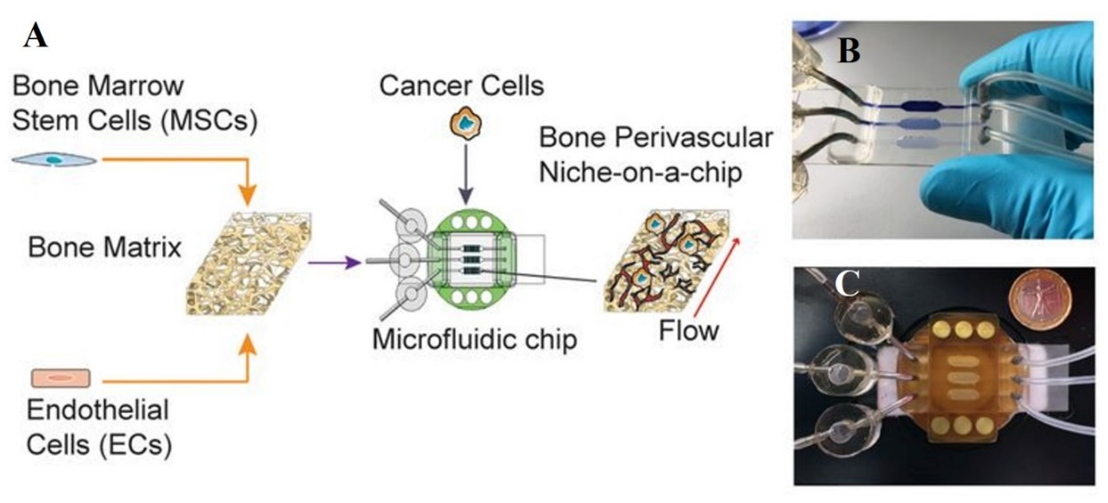
Figure 2.18. A bone perivascular (BoPV) niche-on-a-chip for breast cancer colonisation study A) human bone marrow-derived MSCs were co-cultured with endothelial cells in 3D decellularised bone matrix and placed inside the microfluidic chip. Breast cancer cells were introduced one week after co-culture. B) & C) the microfluidic chip. (The figure is adapted from [123] with permission.)

Summary
Microfluidics focusses on fluid behaviour and manipulation in geometrically small channels, typically sub-millimetre in size. During such processes, surface tension, energy dissipation and fluidic resistance are dominant. Microfluidic chips are small platforms comprising microchannel systems connected to liquid reservoirs. They offer several benefits over traditionally sized systems such as, faster reaction times, enhanced temperature control, enhanced analytical sensitivity, reduced sample volumes, enhanced throughput, easier automation and parallelisation. Considering the significant benefits of microfluidic systems, a novel concept, without macroscopic equivalent, have recently been developed by integration of lab procedure in a microfluidic device, known as lab-on-a-chip.
Pharmaceutical industries seek better in vitro models to circumvent the limitations of in vivo animal testing, to reduce costs and drug development times. A successful outcome of the lab-on-a-chip device has led to the introduction of a new concept known as organ-on-a-chip. The primary goal of these devices is to create the primary function of a tissue or an organ in a microenvironment that replicates human in vivo surroundings. By utilising significant benefits of microfluidics devices such as automation protocols and the optical transparency, cells can be monitored, investigated and cultured in real time in condition similar to in vivo. Consequently, it would allow systematic investigation of cell morphology and biochemical functions in an appropriately controlled microenvironment.
Since conception, many devices have been developed for different organs. As technology is dynamic and continues to grow and expand, this field has the potential to significantly improve. Recently, researchers introduced another concept known as human-on-a-chip by connecting the different organ-on-a-chip devices in a new microfluidic system. This concept has the potential to significantly enhance drug development by providing a substrate for dynamic testing of a new compound from the absorption phase till excretion phase in vitro.
Bones provide protection, structural support, mineral storage, nutrients and lipids. They facilitate movement and produce blood cells. Bone disease can lead to severe pain, fractures and death. Since organ-on-a-chip models were introduced, there have been limited attempts to produce a bone-on-a-chip model, until recently. In this project, the development of a 3D microfluidic chip, closely mimicking biochemical and mechanical stimuli in human bones, will be investigated.

Aims and Objectives
This thesis focuses on the production of a novel 3D microfluidic device to potentially model bone on a microfluidic chip, by providing more physiological relevant environments when compared to conventional 2D or 3D cell culture. The study aims to design and fabricate the 3D microfluidic device using highly reproducible, high throughput technique, micro-stereolithography and stamping technique. Moreover, it focuses on the characterisation of the device by techniques such as SEM and CFD. Additionally, the suitability of the device is tested by measuring cell proliferation, and osteogenic differentiation. Finally, prior to the drug assessment, the device is tested and compared to similar assessing the mechanobiology. This study contributes to a long-term goal of reducing in vivo animal models, reducing costs and drug development times and satisfying ethical concerns associated with conventional animal models. Furthermore, the successful device may be connected to other devices to produce a complete human-on-a-chip model.
To achieve this aim, the project was divided into the following objectives:
- To develop a 3D microfluidic chip for bone tissue (proof of concept)
    - Design and fabricate a microfluidic chip suitable for the 3D culture of osteoblasts.
    - Characterisation and exploration of the 3D bone microfluidic chip (BMC).
    - Assess the feasibility of cell culture and growth inside the 3D BMC using the hES-MP cell line.
- Evaluate the fabricated device for stem cell culture and osteogenic differentiation, by focusing on bone mechanobiology.
    - Assess the effects of flow magnitude and frequency on stem cells in short- and long-term.
    - Investigate the existence of mechanotransducers, focusing on primary cilia.
    - Anticipate the fluid flow behaviour inside the device and comparison with in vivo condition.
- Determine the response of hES-MPs to various anabolic drugs and preliminary studies of the microfluidic device for pharmaceutical research.
    - Investigate the effects of five compounds, lactoferrin, icariin, menaquinone-4, oestrogen, lithium chloride on proliferation and differentiation of hES-MPs in 2D cell culture system.
    - Assess the predictability of the BMC in pharmaceutical studies with testing the effects of lithium chloride on hES-MPs under biochemical and biomechanical stimuli.

Materials and Methods
This section contains the general and common materials and methods for the following chapters. Specific protocols can be found in the respective chapter.

Materials
All chemical and reagents were purchased from Sigma-Aldrich (UK) unless otherwise stated. Tissue culture plastics and flasks were obtained from ThermoFisher Scientific (UK).

Methods

Osteoblast cell line
Human embryonic stem cell derived mesenchymal progenitors (hES-MPs) (Cellartis, Sweden) were used for all studies. hES-MPs overcome limitations of other stem cell types. They are developed from embryonic stem cell lines by multiple enzymatic passaging that enable them to undergo chondrogenic, osteogenic, and adipogenic differentiation. Phenotypically they resemble mesenchymal stem cells, with a fibroblast-like morphology [209].

Culture media preparation
hES-MPs were expanded in expansion media during passage. Expansion media is basal culture media (BCM) supplemented with human fibroblastic growth factor (hFGF). BM refers to the simplest formulation of medium required for each cell line to survive. It consists of a minimum essential medium (MEM), 10% foetal bovine serum (FBS), 2 mM L-glutamine, and antibiotics (100 U/mL penicillin, 100 µg/mL streptomycin). Two different types of MEM were used in this project, minimum alpha medium without l-glutamine (α-MEM, Lonza, UK) (chapter 5&6) and Dulbecco’s modified eagle medium (DMEM, Gibco) (chapter 7). Furthermore, FBS used in the project were obtained from two suppliers, Labtech (chapter 5&6) and Gibco (chapter 7).
hES-MPs were differentiated to osteoblasts in differentiation media termed as osteogenesis induction media (OIM). OIM is BCM supplemented with 5mM β-glycerol phosphate (βGP), 50 µg/mL ascorbic acid 2-phosphate (AA2P), and 100 nM corticosteroid dexamethasone (Dex).

General cell culture
Cells were cultured in accordance to common aseptic technique for mammalian cell culture [234].

Passaging of cells
Cells were expanded in gelatine coated T75 flasks. To passage cells, BCM were removed and cells were washed gently two times with phosphate buffered saline (PBS). To detach the cells from the culture vessel, 3 ml trypsin (Trypsin-EDTA solution) was added and incubated for 5 minutes under standard conditions (37°C, 5% CO₂). Flask was checked under the microscope to ensure the cells detachment before adding 6 ml of pre-warmed BCM to deactivate trypsin. The cell suspension was then centrifuge (Eppendorf centrifuge 5702, Germany) for 5 minutes at 1000 rpm. Afterwards, the supernatant was discarded, and the remaining cell pellet was resuspended in a known volume of pre-warmed BCM. 20 µl of the cell suspension was mixed with 20 µl of Trypan Blue® in 1.5 ml tube and then added to haemocytometer (Figure 4.1) and counted under a light microscope. Trypan Blue® selectively dye dead cells leaving live cells bright under microscope to avoid miscounting. Briefly, to determine the cells number, at least three squares of haemocytometer counting chamber were counted and the average was calculated. To avoid double counting of cells at the border, only cells at top and left borders were counted. Afterwards, the average was multiplied by two (the dilution factor) and subsequently by 10,000 to find the number of cells per millilitre (volume of each square is 10⁻⁴ mL). Finally, according to the volume of the cell suspension, the cell number was scaled. Suspended cells could then be used for the experiment or split to new flasks at the density of 500,000 cells per flasks.
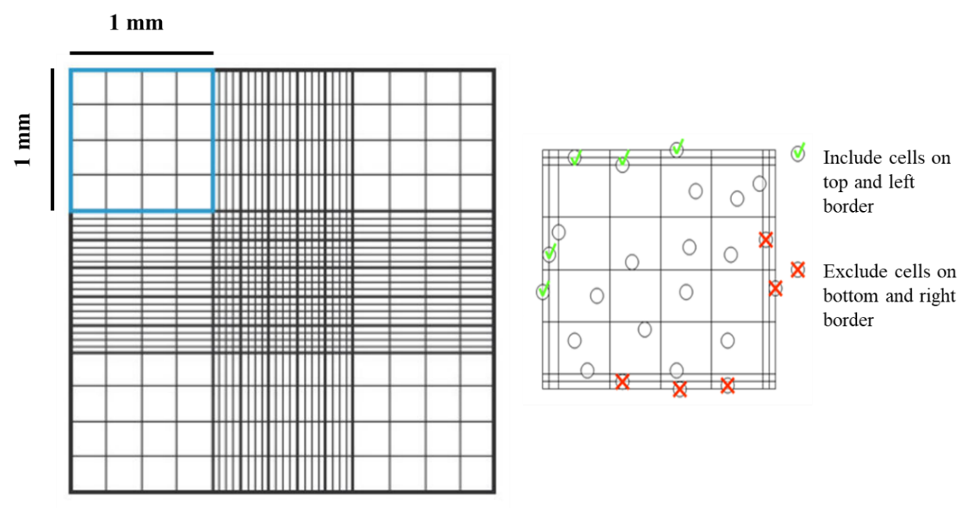
Figure 4.1. Haemocytometer counting chamber. Each square is counted separately and to assess the number of cells, counted numbers are averaged. To avoid double counting of cells at the border, only cells on top and left border were counted at each square.

Long-term storage of cells
Cells were stored for long time periods in liquid nitrogen at -196°C. To freeze down, after cells detachment and counting, cells were resuspended in freezing media (10% dimethyl sulfoxide (DMSO), 90% FBS) at a concentration of 1 × 10⁶ cells/ml. 1 ml aliquots were transferred to freezing vials and placed into an isopropanol container and stored at – 80°C for 24 hours before transferring to liquid nitrogen for long-term storage.
To reanimate cells, partially thawed cells were immediately placed into 20 ml of pre-warmed culture medium and centrifuged at 1000 rpm for 5 minutes. Afterwards, they were resuspended and seeded into a T75 culture flask. Medium was changed 24 hours later to ensure no residue of DMSO left in the culture.

Assessment of metabolic activity
Cell viability was assessed by measuring the metabolic activity of the cells using resazurin based assays such as resazurin reduction (RR) or MTT assay. In these assays the salt is reduced by redox enzymes such as nicotinamide adenine dinucleotide (NADH), which are active only in live cells. NADH plays as integral role in cellular metabolism as electron carrier in redox reaction. Therefore, metabolically active cells changing the non-fluorescent medium to a highly fluorescent pink. The intensity of the fluorescence is correlated with metabolic activity [235, 236].

Resazurin-reduction assay
To prepare a RR working solution, 10 vol. % resazurin stock solution (1mM resazurin sodium salt in diH₂O) was dissolved in pre-warmed BCM. To perform the assay on 2D experiments, BCM was removed from each well and replaced with a known volume of the working solution. The well-plate was then wrapped in aluminium foil and incubated under standard condition for 4 hours. For 3D experiments, scaffolds were transferred to a new well-plate prior the addition of the working solution to ensure the viability measurement of the cells, which only adhered to the scaffold. In both protocols, after 4 hours 200 µl of the reduced solution was transferred into a clear 96 well-plates in triplicate and read using a microplate reader (Tecan infinite 200-pro) at λ_{ex}: 540 nm and λ_{em}: 590 nm. The measurements were adjusted for background fluorescence by including a control well containing only resazurin solution without any cells (with scaffold in 3D experiments) at each experiment. Finally, if cells were further cultured, for 2D experiments, wells were washed with PBS two times before media was replaced to eliminate any residue of the RR solution. For 3D experiments, scaffolds were washed with PBS twice and left at incubator for 5 minutes with PBS (only for the first wash) to eliminate any solution from the 3D structure before media replaced.

MTT assay
This technique was only used for qualitative test (visual comparison) of cell culture during the project. Under the MTT assay, mitochondrial activity in the living cells converts yellow MTT (tetrazolium dye) into insoluble formazan crystals that have a purple/pink colour. To make the working solution, MTT powder was dissolved in PBS at ratio of 5 mg/ml. Note that MTT is toxic and the process should be performed inside a fume hood. Similar to RR assay, scaffolds were placed in a new well-plate and 1 ml MTT working solution was added to each well. The well-plate then was wrapped in aluminium foil and incubate at standard condition (37 °C, 5% CO₂) for 1 hour. Then media was removed, and visual comparison was performed. After the assay, samples were discarded.

Cell digestion
Cellular DNA had to be released from cells before, ALP activity and DNA measurement. Cells were digested by breaking down the cell membranes using cell lysis, freeze-thaw cycles and mechanical agitation. For 2D samples, cell culture medium was removed, and the cells were washed twice with PBS. Cell digestion buffer (CDB) (10 vol. % cell assay buffer (CAB) (1.5 M Tris-HCL, 1 mM ZnCl₂, 1 mM MgCl₂ in diH₂O) in diH₂O with 1 vol. % Triton-X100) was prepared fresh at the day of the experiments and 1 ml was added to each well. Samples were incubated for 30 minutes and wells were then scraped off using a pipette tips and the lysates transferred to 1.5 ml tubes. Samples were vortexed briefly and refrigerated overnight. For 3D experiments, media was removed, and scaffolds were washed twice with PBS. 1 ml CDB was added to 1.5 ml tubes and scaffolds was transferred to the tubes and broken down using a tweezer. Samples were then incubated for 30 minutes, vortexed and refrigerated overnight. For both experiments, next day, samples were undergone three times freeze-thaw cycles (-80°C 10 mins, 37°C 15 mins). Samples were then centrifuged at 10,000 rpm for 5 minutes and vortexed again afterwards. Samples could be analysed or stored at -80°C.

Alkaline phosphatase activity
The enzyme alkaline phosphatase (ALP) is widely used as early osteogenic biomarker. In order to quantify ALP activity, a commercially available Pierce™ pNPP Substrate Kit (ThermoFisher Scientific) was used according to manufacturer’s instructions. This assay measures the rate of hydrolysis from p-nitrophenyl phosphate to p-nitrophenol by the enzyme ALP. P-nitropehonl is chromogenic substance with absorbance at 405 nm. Hence, ALP activity of a sample is indicated by the change in absorbance over time. To form the assay buffer, one tablet, which contains 5 mg p-nitrophenol phosphate (pNPP), was dissolved into 5 ml of 20 vol. % diethanolamine buffer diluted in diH₂O. 20 µl of the cell lysate (chapter 4, § 4.2.5) was transferred in triplicate to the 96 well-plate. 180 µl of ALP substrate was then added to the cell lysate and left at room temperature until a colour change to yellow or 30 minutes has passed. The absorbance of each well was then measured every minute for 30 minutes using the microplate reader (Tecan infinite 200-pro) at 405 nm. ALP activity is indicated as nmol p-nitrophenol (PNP) per minute (nmol PNP/min), which one absorbance value equals 19.75 nmol of product (K, standard curve, figure 4.2), the volume of the sample is the volume of digestion buffer added (V _{Sample}) and the measured volume is the volume combined with the pNPP phosphatase solution (V _{Measured}) (Eq. 4. 1).

$ALP Activity= \frac{Maximum Slope ×K ×V_{Sample}}{V_{Measured}}$ (Eq. 4. 1)

Figure 4.2. ALP standard curve to convert plate reader outputs to a known concentration of ALP activity.

DNA quantification
To be able to normalise ALP activity based on cell number, DNA quantities were also measured in parallel with ALP activity using the same cell lysate. To determine the DNA quantities, a Quant-iT® high sensitivity dsDNA assay kit (ThermoFisher Scientific, UK) was used according to the manufacturer instructions. This assay is based on green fluorophores turning fluorescent upon binding to double-stranded DNA (dsDNA). Since the fluorescence intensity is directly proportional to the amount of dsDNA available, DNA quantities could be determined with a plate reader. Briefly, the Quanti-iT reagent was diluted 1:200 in Quanti-iT buffer to create a working solution. Then, 90 µl of the solution was added in triplicate to a black 96 well-plate before adding 10 µl of the cell lysate (Chapter 4, § 4.2.5). The plate then shaken for 15 seconds with a 1mm linear amplitude, DNA was allowed to conjugate with the reagent for 10 minutes and shaken again before the fluorescence was measured at 𝜆_{𝑒𝑥}: 485 nm, 𝜆_{𝑒𝑚}: 535 nm using a microplate reader (Tecan infinite 200-pro). Fluorescence was converted to ng of DNA using a standard curve (Figure 4.3). Finally, the whole sample DNA was calculated similar to ALP activity (Eq. 4. 2).

$Total DNA \left(ng\right)= \frac{DNA in 20 μl \left(ng\right)× V_{Sample}}{V_{Measured}}$ (Eq. 4. 2)

Figure 4.3. DNA standard curve to convert plate reader outputs to ng of DNA.

Cell fixation
To fix the samples for analysis, cell culture medium was removed, and samples were washed with PBS twice. Samples were then submerged and fixed in 10 % formalin solution or 3.7 % formaldehyde solution for either 20 minutes (2D experiments) or 30 minutes (3D experiments) at room temperature. The fixative was then removed, and samples were washed twice with PBS and refrigerated in PBS until required. Samples were analysed in 2 weeks after fixation.

Mineral deposition (Alizarin Red S staining)
Calcium phosphate crystals are deposited by osteoblasts during the mineralisation process. Therefore, the mineralisation can be quantified by measuring the amount of calcium within the sample. Alizarin red S (ARS) is an organic dye, which has high affinity for calcium, hence can stain mineral deposited. The main advantage of this technique is that the dye can be extracted and assayed colorimetrically, allowing quantification of how much stain, and hence calcium, is present [237]. Furthermore, stained calcium minerals are red and can be easily visualised by an optical microscope.
To prepare the working solution, ARS was dissolved at 1 w/v % in diH₂O. The solution was filtered (0.45 µm filters) to remove undissolved particulates and then pH was adjusted to 4.1. Fixed samples were rinsed with diH₂O twice, submerged in a known amount of ARS stain and left for 30 minutes on an orbital shaker (IKA, Germany) at 100 rpm at room temperature. Afterwards, the stain was removed, and the samples was washed with diH₂O every five minutes until the wash-water remain clear, whilst orbitally shaking at 100 rpm. A defined volume of 5% perchloric acid was then added to destain the samples on orbital shaker at 100 rpm for 15 minutes. Finally, 150 µl of the destain solution was then transffered in triplicate to a clear 96 well-plate and read using microplate reader (Tecan infinite 200-pro) at an absorbance of 405 nm. The concentration of ARS was quantified via a standard curve (Figure 4.4) created by serially diluting the staining solution during destaining. Therefore, the absorbance units can be converted to a quantity of ARS.
Figure 4.4. ARS standard curve to convert plate reader outputs to the concentration of ARS

Collagen deposition (Direct Red 80 staining)
Direct red 80 (DR80) is a collagen stain that is not specific to a particular type of collagen [238]. As it is clear from the name, collagen fibres stained by DR80 appear bright red. To prepare the stain, DR80 powder was dissolved in saturated picric acid at 1 w/v %. The solution was then filtered (0.45 µm filters) to ensure that no undissolved particulates remained. Samples were then washed twice with diH₂O and the staining solution was added in a known volume. Samples were left on orbital shaker for 1 hour at 100 rpm and room temperature. Afterwards, the stain was removed, and the samples was washed with diH₂O every five minutes until the wash-water remain clear, whilst orbitally shaking at 100 rpm. To quantify the amount of stained collagen, a defined volume of 0.2 M sodium hydroxide (NaOH) and methanol (MeOH) in a 1:1 ratio was added and left for 15 minutes on orbital shaker at 100 rpm to destain the samples. Finally, 150 µl of destain solution was then transferred in triplicate to a clear 96 well-plate and read using microplate reader (Tecan infinite 200-pro) at an absorbance of 405 nm. The concentration of DR80 was quantified via a standard curve (Figure 4.5) created by serially diluting the staining solution during the destaining. Therefore, the absorbance units can be converted to a quantity of DR80.
Figure 4.5. DR80 standard curve to convert plate reader outputs to the concentration of DR80.

3D BMC design, fabrication and characterisation

Introduction
The pharmaceutical industry is under economic, scientific and ethical pressure to improve drug development processes to develop and produce safer and more effective drugs for humans. The industry is looking for better alternative in vitro models for pre-clinical studies to reduce the cost and time of drug developments, by increasing the efficiency. Currently, the majority of pre-clinical tests are performed on in vivo animals, of which 89% are mice and rats [239]. Despite in vivo animal models being the gold standard for studying diseases and testing new therapies, their physiology and pathophysiology does not accurately represent those of humans. Therefore, poor translation of pre-clinical animal studies to human clinical trials, can cause failures in promising discoveries for clinical use in humans [240-242]. Furthermore, new European legislation has been adopted to protect animals used for scientific report (Directive 2010/63/EU). The legislation supports the 3R principle for studying diseases and testing new therapies, reducing, refining and replacing animal testing [243]. Besides pharmaceutical companies, chemical and cosmetics industries face similar challenges in using in vivo animal models. Therefore, they are also looking for better alternative in vitro methods that could be more predictive in clinical outcomes.
Limitations on in vivo models has given rise to the developments and enhancements of in vitro alternatives. Recent advances in additive manufacturing (AM), bioprinting and microfluidics has resulted in a surge in the production of microfluidic cell culture platforms and organ-on-a-chip devices that closely mimicking human in vivo condition thereby enhancing in vitro drug screening [12, 244-246]. Since the introduction of microfluidics, different devices have been fabricated and tested for a variety of organs [12]. However, bone model designs have been limited to a few numbers of studies [119-123]. This could be due to tissue complexity and the need for long term culture of bone tissue. The popularity of rodent models for bone disorders due to the relatively minimal public opposition to their use, and ease and low cost of housing compared to the other larger animals [247] might be another reason for slight efforts for the developments of bone-on-a-chip systems. However, these in vivo models are not ideal for pre-clinical studies during the drug development processes. Therefore, through the development of a bone-on-a-chip design, animal in vivo studies can be ideally eliminated or at least minimised, by increasing the outcome predictability of a new drug on pre-studies performed on developed microfluidic devices prior the in vivo animal models.
To study bone diseases and new therapies, the model often defined and designed based on the requirements and the aim of the study. It might be ideal if the model would be able to mimic the bone with a fully functional physiology such as bone remodelling, e.g. the culture of osteoblast, osteocytes and osteoclasts as well as endothelial cells for vascularisation. However, culturing of osteoblasts and osteoclasts as well as osteocytes at the same time is not straightforward and with the absence of a proper basic in vitro model [248], this has meant currently fabrication of microfluidic chips for bone remodelling has been next to near impossible or has required considerable efforts, which was out of the scope of this project.
Therefore, the main goal of this chapter is to outline the development of a 3D bone microfluidic chip (BMC) for studying osteogenesis in an environment similar to in vivo conditions.
To fabricate and design a proper microfluidic device, several important factors should be considered. The most common method for developing tissue engineered bone constructs is via the static culture of osteoprogenitor cells on porous scaffolds in specialised media providing chemical cues for bone development. However, to accurately model bone in vitro, the presence of mechanical stimuli such fluid flow and a 3D microenvironment is necessary. Therefore, scaffolds development for bone tissue engineering and different methods of microfabrication will be further explained.

Scaffolds for bone tissue engineering
Bone tissue engineering requires cells to expand and grow in vitro. Autogenous cells are one of the most promising cell types in bone tissue engineering. Cells such as osteoblasts and MSCs can be expanded in culture and seeded onto physiologically relevant scaffolds, allowing the bone tissue to grow in vivo or in vitro. Hence, scaffolds and more importantly 3D scaffolds, are critical for bone tissue engineering as they guide cell growth and formation of the tissue [188]. Factors such as architecture, materials selection and fabrication techniques all influence the scaffold properties and performance. Importantly, these factors can be manipulated to achieve the desired scaffold requirements.
An ideal scaffold needs to fulfil a number of requirements. Biocompatibility is the most important element of a scaffold since in its absence the growth of cells and integration of the tissue are impossible [249]. Another crucial element of a scaffold is its biodegradability; since they biodegrade into biocompatible products at the same rate as tissue formation, enabling full regeneration [89]. Additionally, for 3D scaffolds porosity is another important factor. This can be classified in terms of pore size, percentage porosity and pore interconnectivity. Porosity is crucial, it enables cell growth, cell attachment and osteointegration. It also assists in metabolic waste removal and mass-transportation of nutrients, matrix production and vascularisation [250]. However, porosity impacts on mechanical properties which is a major characteristic of bone tissue engineering [251]. A conflict arises between these two factors; mechanical strength is harmed by increased pore porosity and since bone formation depends on force and shear stress [252], the scaffold must maintain its strength until full osteogenesis is achieved. Therefore, these two factors must be balanced, based on the final requirements of the scaffold. Lastly, material surface properties, both chemical and topographical, are crucial to the osteoconductivity of the scaffold. The surface is also key in allowing the cell attachment and proliferation [253].
Thus, for bone tissue engineering, biocompatibility, porosity, mechanical properties and a good surface chemistry are important factors for effective scaffold development. All properties are not essential for in vitro models such as biodegradability once the tissue produced is not implanted into a patient for experiments, for example in drug assessments models. However, once biodegradability is required, the scaffold should biodegrade at a similar rate to tissue formation. Additionally, to ensure that there is a limited variation between scaffolds it is essential to attain and maintain a high level of reproducibility [254].

Emulsion-templated porous polymers
As mentioned previously, 3D cell culturing platforms allow cells to grow and function, expressing a true morphological representation of the original tissue. Creating 3D cell growth systems requires structure supporting scaffolds. For bone tissue engineering, besides biocompatibility and maybe biodegradability, scaffolds should have a highly porous structure and a suitable mechanical stability. A high porosity and appropriate pore size allow enough room to accommodate cells and consequently allow them freely to attach to scaffolds, freely interact with the neighbouring cells in a 3D environment, enhancing nutrient diffusion and metabolic waste removal and vascularisation. Pore sizes of at least 20 µm are recommended for osseous tissue deposition, however, pore sizes greater than 300 µm are recommended for the vascularisation [255]. Scaffolds properties and performance are affected by material selection, structure and architecture and fabrication techniques. Several materials have been introduced and investigated for 3D bone tissue engineering, consisting of natural/synthetic polymers, titanium and ceramics [256, 257]. Polymeric materials have received significant attention and are now widely used in bone tissue engineering studies [258]. Between them synthetic polymers show considerable flexibility as their composition and structure can be easily adjusted as required. A list of commonly used scaffolds in bone tissue engineering is provided (Table 5.1).
Table 5.1. Common natural and synthetic scaffolds used in bone tissue engineering
Material | Origin | Characteristics | Outcome of study | References
Fibrin | Natural | Osteoconductive | Promoted vascularisation | [259-262]
Collagen | Natural | Low immune response  Low mechanical properties | Enhanced cell attachment  Promoted bone formation | [263-266]
Chitosan | Natural | Osteoconductive | Promoted wound healing  Enhanced bone regeneration | [267, 268]
Hyaluronic acid (HA) | Natural | Weak mechanical properties | Low immunogenicity | [269]
Starch | Natural | Good mechanical properties  Thermoplastic behaviour | Improved cell adhesion | [89]
Demineralised bone | Natural | Good mechanical properties  Osteoconductive | Promoted osteogenic differentiation | [270]
Polyurethane | Synthetic | Limited mechanical properties  Degradable and nondegradable | Enhanced cell adhesion  Promoted cell growth and integration | [271]
Poly (α-hydroxy acid) | Synthetic | Degradable (by hydrolysis) | Improved osteogenesis  No evidence of inflammation | [272]
Titanium | Synthetic | Good mechanical properties | Promoted bone ingrowth and integration | [273, 274]
Polylactic acid | Synthetic | Controllable biodegradability  Weak mechanical properties | Enhanced bone matrix production  Enhanced bone ingrowth | [275]
Bioactive glass | Synthetic | Osteoconductive  Controlled biodegradability | Enhanced bone apposition  Improved bone bonding properties | [276]
Poly (ɛ-caprolactone) | Synthetic | Degradable (by hydrolysis)  Slow degradation  Good mechanical properties | Improved bone cell attachment  Enhanced osteogenesis | [277]

Recently, a new type of porous polymer called polymerised high internal phase emulsion (polyHIPE) was introduced as a successful polymeric scaffold for bone tissue engineering [9, 278]. The process of mixing water and oil in presence of a surface-active agent (surfactant) or an emulsifier results in the formation of emulsions. These emulsions comprise of continuous and internal phase. The internal phase often creates droplets inside the continuous. Regardless of the type of emulsion (e.g. water-in-oil (W/O) known as “reversed” and oil-in-water (O/W) known as “direct”) the Bancroft rule can be applied to determines the continuous phase, which is the phase in which the surfactant is more soluble [279, 280]. The interfacial tension between the internal and continuous phase is usually lowered by surfactants through a process known as amphiphilic nature, which are comprised of lipophilic and hydrophilic groups. Therefore, it allows them to adsorb at the oil-water interface causing the stabilization of the emulsion thereby avoiding any possible phase separation. Therefore, due to the amphiphilic nature of surfactants, they can be oil and water-soluble.
Calculations on the solubility of surfactants involves determining the hydrophilic-lipophilic balance. It is often represented “on a scale of 0 to 20, where 3 – 6 represents hydrophobicity, oil soluble W/O surfactants and 12 – 16 represents hydrophilicity, water soluble O/W surfactants” [281]. Since the process of inverting W/O to O/W or the other way around can occur at high internal phase volumes, care must be taken when choosing a suitable surfactant [282]. A high internal phase emulsion (HIPE) represents a situation whereby the internal phase takes almost over 74% of the volume. It is because at this ratio above, droplets are forced to interact and become either polydisperse or polyhedral in shape. The formation mechanism of interconnecting pores is still under debate. One theory explains that during HIPE polymerisation, droplets coalescence usually occurs at the internal phase due to density differences between phases, causing ruptures at the thinnest points of the external phase. Widespread droplet formation alters the internal phase, forcing discrete droplets into a continuous interconnected phase [283] By removing the internal phase (new formed continuous phase), a highly interconnected, open pored, emulsion-templated porous structure is fabricated.This theory was supported by investigation of HIPE with cryo-scanning electron microscopy (SEM) images before complete polymerisation and washing and drying process. Although the first theory is more accepted between the groups [284], another theory proposed that interconnecting pores form after the polymerisation during the washing and drying process due to shrinkage [285]. If polymerisation is initiated while the continuous stage of a HIPE consists of one or more monomers, it results in the formation of a polyHIPE [286] (Figure. 5.1). The internal phase generates the pores within the polymer; hence it determines the porosity. PolyHIPEs are made up of either an open or closed pore structure. Key factors influence the degree of polyHIPE openness are first, phase volume ratio of the HIPE and second, type and amount of surfactant [285]. Closed pores are often entirely enclosed, hence they trap the internal phase, whereas open pores allow fully interconnection with the pores, allowing the greatest possible removal of internal phase [287]. The latter results in the development of permeable polymers that contains intersected low density microarchitecture with hierarchical pore distribution suitable for 3D cell culture [288].
Curing or polymerisation of HIPEs can be done using different polymerisation mechanisms such as step growth [289], atom transfer radical polymerisation [290], and ring-opening metathesis polymerisation [291]. In the case free-radical polymerisation of HIPEs, acrylate or methacrylate based materials are now extensively used and curing can be initiated either thermally or photochemically, through a radical initiation addition reaction [284]. For photochemical curing, exposing the continuous phase to a photo initiator so as to achieve curing by light allows the structuring of the material through the process of stereolithography [292]. Photocurable HIPEs provide important features for fabricated scaffolds with hierarchical porosity, where the microstructure has an inherent porosity, governed by emulsion templating, and macrostructure porosity, governed by stereolithography techniques. However, a side effects of photochemical polymerisation of HIPE is the possibility of a side skin formation at the surface. The phenomena could fully/semi cover the porous surface and impede cell ingrowth by acting as a physical barrier. However, the internal porosity of the polyHIPE is unaffected. Close surface could happen during the polymerisation by partial polymerisation of the HIPE at the surface, as the UV light can be scattered. It also could happen at the HIPE and mould interface, due to the destabilisation and collapses of the emulsion at the material interface forming a closed thin film at the surface [293, 294]. Therefore, proper care should be taken to avoid the formation of closed pore surfaces on the scaffold. In this chapter, combination of two acrylate based polyHIPE, 2-Ethylhexyl acrylate (EHA), elastic character, Isobornyl acrylate (IBOA), brittle character, were developed and used as the 3D scaffold for osteogenesis.
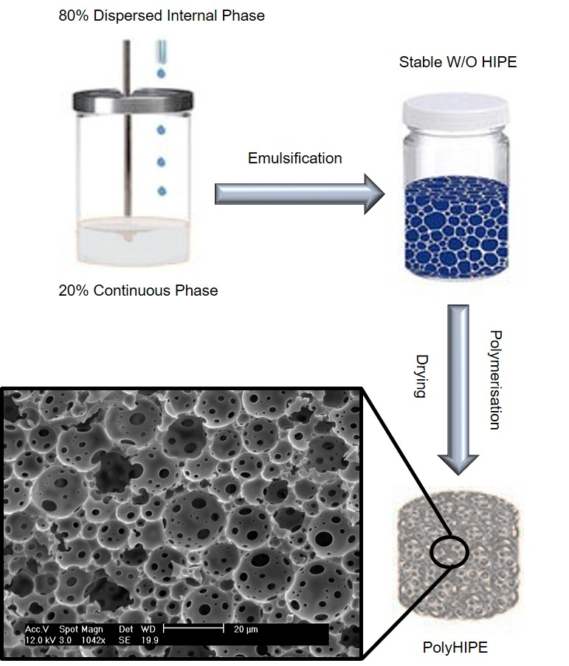
Figure 5.1. The 80% porous polyHIPE fabrication process. Internal phase is added drop-wise to continuous phase and mixed and emulsified with the aid of an emulsifier and finally polymerised using UV-light embossing over the mould. SEM image of an acrylate-based polyHIPE material of 80% porosity, showing different pore sizes, with interconnected porosity.

Microfabrication
3D fabrication can be categorised by two techniques, random or user-controlled structuring. In random structuring, such as solvent casting and particulate leaching, fabrication in bulk is generally easier, however there is less control over micro and macro structures and properties. User-controlled structuring, a principle adopted in the structuring of high-resolution biomaterials or 3D substances, is the layer-wise addition of substances (user-controlled) [295]. A common method of user-controlled structuring is additive manufacturing (AM). AM is a terminology used to describe a series of laid down technologies that develop 3D substances through the layer-wise addition of a substance, where the architecture is defined by computer aided design and manufacture (CAD/CAM). Therefore, the effects of controlled architecture and geometry can be investigated in cells. In AM techniques, 3D structures are made by depositing 2D cross sections, in a layer-by-layer fashion. Therefore, the final structure is highly controlled. For example, porous scaffolds can be made using this method, with high levels of pore interconnectivity without the need for solvents; whereas in solvent casting and leaching, pore interconnectivity and size are limited and random [250].
Currently several methods of user-controlled microfabrication have been developed [296]. The major methods include photolithography, moulding and embossing, stereolithography and 3D printing. These techniques overlap or use similar principles.
The next section presents a brief explanation of the methods with a deeper analysis of and emphasis on direct laser writing, and stereolithography due to their relevance to this chapter.

Conventional lithography (photolithography)
Photolithography was explored in the 1980s for pattern generation in microelectronics, semiconductor and IC industry [297]. Photolithography is a process where desired geometric patterns are defined (usually on silicon wafers) by exposing a light sensitive polymer to ultraviolet (UV) light. The structure can then be used or stamped on other materials, such as PDMS. The process is similar to analogue photography, where an image is recorded using a silver-coated substrate. However, in photolithography, the silver substrate is replaced by a photoresist developer and the image is developed by differential radiation. Despite its simple definition, photolithography involves a broad range of complex activities and processes, including the need for a clean room and the preparation and alignment of the mask [298]. Photolithography can be divided into three forms, A) contact printing, B) proximity printing, and C) projection printing (Figure 5.2 A-C). The general fabrication steps are [299]:
i) A wafer surface is chemically cleaned to remove dust and traces of organic, ionic and metallic impurities.
ii) The substrate is covered with a layer of photoresists, which may be positive or negative (Figure 5.2 D & E).
iii) The mask is placed on or above resists and the sample is exposed to UV light.
iv) The microstructure is copied onto the substrate and is hard-baked to harden the photoresists and improve adhesion between the resist and silicon wafer.
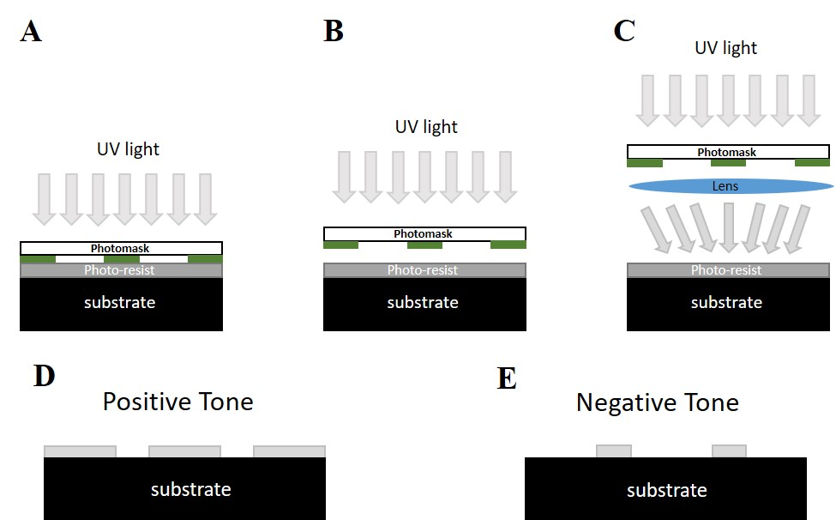
Figure 5.2. The principles of photolithography. A photosensitive resin is exposed to UV light through a negative or positive mask, causing development of the desired structure on the substrate. There are three methods in photolithography A) contact printing, B) proximity printing, C) projection printing. Final structures can be different based on the photomask characteristics D) fabrication with positive mask E) fabrication with negative mask.

Moulding and embossing (soft lithography and nano-imprint lithography)
Two microfabrication techniques (moulding and embossing) are mostly used together and in parallel to achieve microstructures. Moulding entails curing a precursor against a topographically patterned substrate process. Embossing refers to a process where a mould is transferred, basing the transfer process the structured topography produced, on a flat polymer film [300]. So as to pattern microscale structures using both moulding and embossing jointly, development of a tangential procedure is necessary for both methods [301]. Thus, Gates et al., [302] proposed two practical techniques for moulding and embossing, where microstructures are fabricated through the use of either soft and hard moulds.
Subsequently, the term “hard pattern transfer element” was derived to represent embossing micro/nanostructures using hard moulds [301]. It is also called nano-imprint lithography, which uses the hard mould to imprint micro/nanoscale patterning. This technique is used as a low-cost micro/nano-structuring method with high-throughput and high-resolution [302-304]. Therefore, a process that entails any rigid topography conversion patterns into a pre-polymer, monomer or entire polymer substrate is called the process of “hard pattern transfer elements” [305]. The most common materials for moulds are hard materials such as silicon and quartz. Generally, the main obstacles and difficulty of this method is fabrication of rigid moulds, which is usually done by conventional lithography, such as photolithography. In hard pattern process, briefly, the thermoplastic polymer is headed above its glass transition temperature, the mould, coated with a thin release layer to ease, is placed on heated polymer to stamp the structure. After this, the temperature is lowered, and transferred replicated patterns are solidified on the polymer film. Finally, the mould is carefully removed. The release layer facilitates the removing process. Figure 5.3 illustrates the process of hard pattern transfer using stamps. Hard pattern transfer has several commercial applications, such as patterning of digital versatile discs, fabricating plastic parts, compact discs and holographic grating [302].
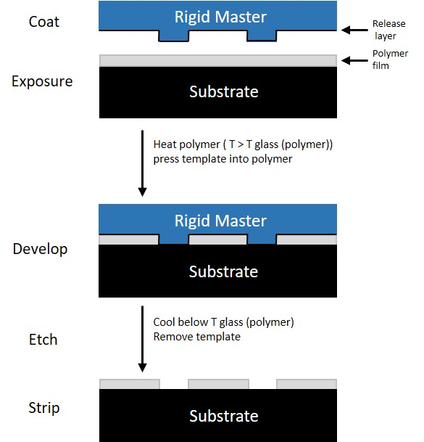
Figure 5.3. Schematic explaining the moulding and embossing process using a hard pattern transfer technique. The rigid master is pressed on the substrate, spin coated with the polymer. The temperature is increased above the glass transition temperature of the polymer and cooled down before removal of the master, resulting in the desired structure.
Similarly, soft lithography transfer refers to situations where soft moulds are used in micro-structuring [306]. Research in this area, first introduced in 1989, asserted that “soft pattern transfer involved casting a liquid polymer precursor against a topographically patterned master”. [306]. The technique has two main steps, the fabrication of a pattern polymer stamp and a fabricated stamp to transfer the structure or molecules (Figure 5.4).
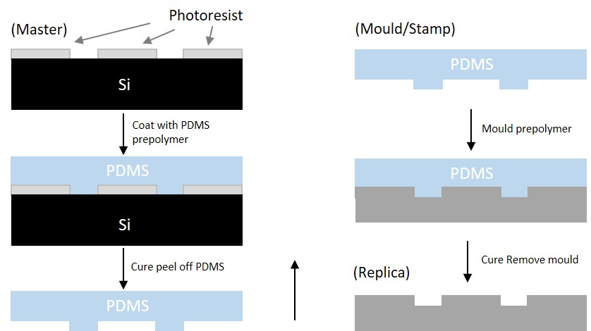
Figure 5.4. Schematic explaining the process of soft pattern transfer (soft lithography). PDMS stamps of the samples is produced to be used as new replicas or be used for stamping or transferring molecules to other substrates.
Using UV and UV-curable monomers to emboss the pattern from the mould in soft or hard lithography could reduce the imprint pressure and time significantly, as well as reducing induced stress during the high temperature cycle (for hard pattern transfer). Hence, recently, low viscosity UV-curable materials are used in soft lithography and nano-imprint lithography.
This technique and stereolithography will be investigated in this chapter for the fabrication of the BMC.

Stereolithography and photopolymerisation
Stereolithography is one of the first 3D printing technology, which was introduced in the late 1980s and allows high resolution printing. Stereolithography is therefore mostly utilised in industrial processes requiring rapid prototyping and product development [307]. The technology works on the principle of transforming or translating designs, generated by a computer, to physical objects or physical equivalents. The technology employs software technologies in conjunction with laser and photochemistry processes. Stereolithography is mainly used because of its many advantages, such as its efficiency, high precision and comparably low costs [308]. In simple terms, stereolithography processes involve CAD software to design an object and then create a 3D model. In the course of 3D modelling, an ultraviolet laser is passed through the surface of the photosensitive resin, hence resulting in hardening the material [309]. The process creates a new layer and the subsequent layer is also exposed to the same conditions. The development continues with the formation of successive layers until the desired object is produced (Figure 5.5).
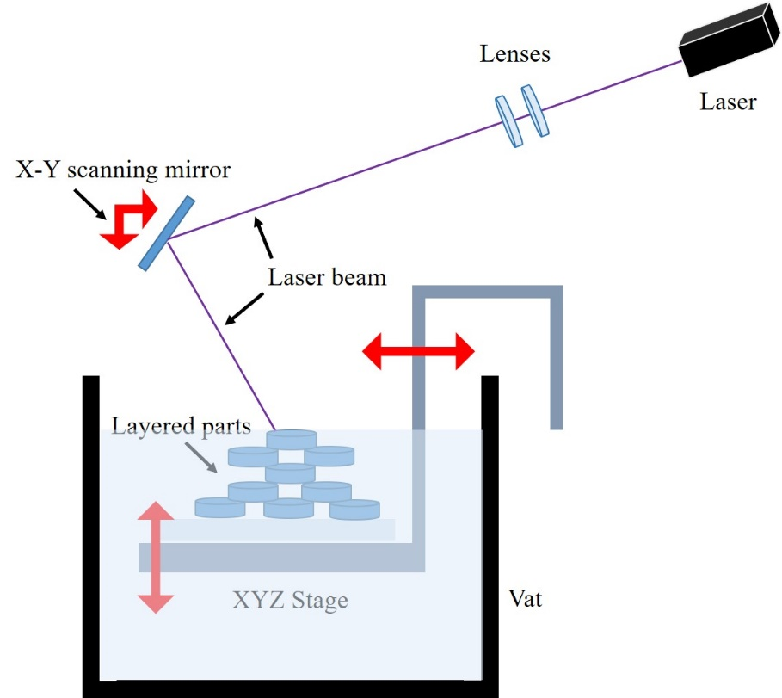
Figure 5.5. Simplistic schematic of Stereolithography components. A UV light is focused on a computer-controlled stage filled with photocurable polymer for polymerising (printing) a structure.
The printing process involves passing a laser on the surface of the photopolymer resin in successive layers, to create model layers which are successively cured. The UV laser is projected on a particular point (focal point) on the resin’s surface which reacts and solidifies [310]. The final product has various properties such as water resistance, high impact resistance and thermal resistance [311]. Some common applications of stereolithography are projection, direct write and scanning.
For projection, a structure can be fabricated by reflecting laser light off a digital micromirror device, which only allows a cross-section reflection of the structure. The image is focused on a photocurable prepolymer and the stage slowly moves away from the focal point (down/up), allowing a 3D fabrication with a resolution of 1 to 25 µm [292].
A direct laser writing method implements a computer-controlled stage with a prepolymer that moves under the laser beam, while the laser is focused onto a single focal spot.
Scanning is similar to direct laser writing, except the focal spot is transferred instead of the stage and prepolymer [312]. Direct laser and scanning can be used together to enhance fabrication efficiency and reduce time. Moreover, in these methods, single-photon or two photon polymerisations can be used. For single-photon polymerisation, higher energy beams are used to polymerise the resin, where the resolution decreases while improve the fabrication speed. However, in two-photon polymerisation, a laser beam with half the intensity of the single-photon technique is used. Polymerisation proceeds via light pulses and two-photon absorption leading to 3D polymerisation only at or close to the focal point. Therefore, 3D structures can be produced at higher resolutions of up to 100 nm [313]. However, in this method speed of fabrication is relatively slow.
Direct laser writing will be investigated extensively as the main manufacturing technique for the moulds in this chapter.

Conclusions
The primary goal of microfluidic systems (organ-on-a-chip) is to create a replica microenvironment of in vivo surroundings. Through automated protocols, the growth of different types of cells can be monitored and investigated in real time. Consequently, this approach allows the systematic investigation of cell morphology and function in an appropriately controlled microenvironment.
These microfluidic devices are highly affordable, relatively easy to use and manufacture. Microfluidics has many different applications in chemistry, biology and medicine. Therefore, as technology is dynamic and continues to expand, this field can improve overtime. Since the organ-on-a-chip models were introduced, there have been few attempts (very recent, mainly 2018) to produce a 3D bone-on-a-chip model [119-123]. Although current attempts represent the importance and demand of the subject, current models are still lacking important factors such as 3D environment or physiological mechanical cues required for bone development. Therefore, in this chapter, we investigate the possibility of a microfluidic chip with an embedded 3D scaffold to assess in vitro models of bone tissue on a chip.

Aims and Objectives
Stereolithography and 3D printing are advanced methods used for the microfabrication of microfluidic chips. Therefore, the main aim of this chapter is to first design, fabricate and characterise a reproducible microfluidic chip, using a combination of photopolymerisation, moulding and embossing techniques. Second evaluate the 3D bone microfluidic chip model to support cell growth for bone cell culture. To achieve this the following objectives were addressed.
- Design and fabrication a microfluidic chip suitable for 3D culture of osteoblasts.
- Characterisation and exploration of the 3D BMC.
- Assessed the feasibility of cell culture and growth inside the 3D BMC using the hES-MP cell line.

Materials and Methods
Further to general materials and methods in chapter 4, the following were used in this chapter. All chemical and reagents were purchased from Sigma-Aldrich (UK) unless otherwise stated.

3D BMC design
To make a proper design the device was simplified in three parts. The BMC consists of a top medium reservoir (microfluidic bioreactor) made of biocompatible elastomer PDMS, a middle 3D porous scaffold made of EHA/IBOA polyHIPE, and a bottom glass slide for the sealing during the assembly. The design was sketched in AutoCAD. An exploded view of the BMC (Figure 5.6) shows the component arrangements. The microfluidic bioreactor has an inlet and an outlet connected to its chamber using three channels. The cell culture chamber has a capacity of 47.85 µL considering the porous structure of the scaffold. The size of the channels in the microfluidic bioreactor are 430 µm and the channels on the scaffold are 310 µm.
During the design of the 3D porous scaffold, instead of simply using a flat sheet of polyHIPE scaffold with rough surface topography suitable for cell attachment (porosity up to 30 µm), the porosity was enhanced by introducing micropillars of 310 µm spacing that could also be used as channels. The channels enhanced fluid circulation, increased shear stress for a given flow rate and provided space for possible early micro-vascularisation in co-culture with endothelial cells (if required).
Knowing the material and criteria for scaffolds, two designs were prepared and compared (Figure 5.6 B) using circular or hexagonal pillars. While both designs met design requirements, hexagonal pillars were chosen as channels were uniform and consistent throughout the scaffold as by using hexagonal pillar design, the channels size would be 310 μm throughout the whole scaffold. Moreover, although the turbulence is usually not possible in microfluidics, and therefore, circular or hexagonal designs both cannot change the laminar characteristics of flow, by using hexagonal pillar design, fluid flow is better directed through the channels, especially around the pillars.

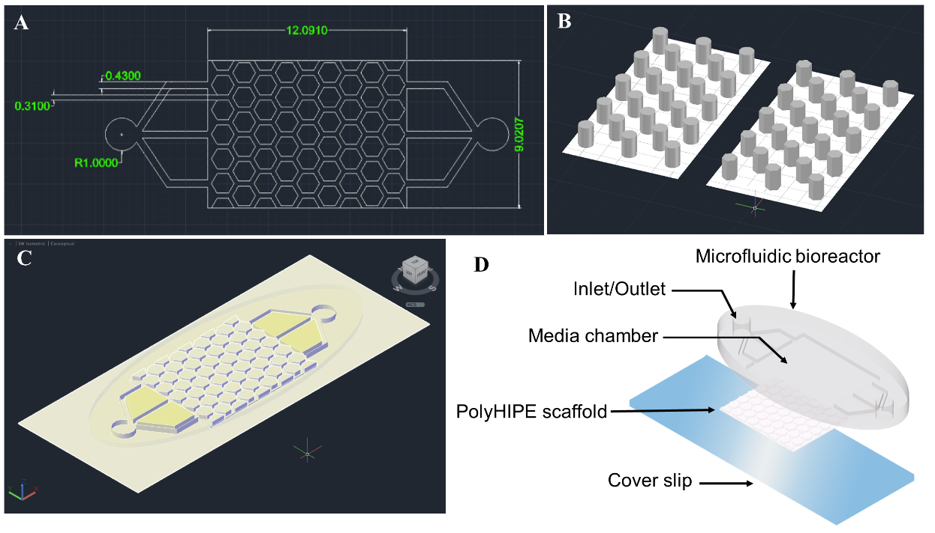
Figure 5.6. The final 3D microfluidic chip model. A) A 2D view of the structure, including internal and external parts B) Preliminary AutoCAD designs for 3D scaffold’s channels, circular pillars (left) and hexagonal pillars (right) C) A 3D view of the structure D) An exploded view of the 3D bone microfluidic chip showing all components. All dimensions are in mm.

BMC component fabrication
The following steps were used to fabricate the 3D BMC. First, two separate moulds were fabricated using stereolithography techniques. Secondly, the final structure was stamped out of moulds (moulding and embossing technique). Other techniques were also used.

Laser/Blade cutter
This method was not used in this study; however, it was investigated and therefore, will be briefly discussed. First, sticky lithography was used to prepare the moulds. For this method, two machines were used to cut patterns from 50 µm vinyl paper rolls. Multiple papers were stuck to the substrate to achieve the desired thickness of 500 µm. The Epilog Laser Mini 19 (Epilog Laser, USA), a digitally controlled laser with tuneable wattage, was used to cut the required structures for the moulds. Different intensities and speeds were tested during the cutting process. The second machine used was a desktop digital draft cutter (Robocut, Graphtech, Japan).
Both instruments could cut samples, but with limited resolution, especially for the scaffold mould. For the laser cutter, sample preparation of the preferred thickness and size was not possible. In the case of the digital draft cutter, although the correct channel size was cut, the desired thickness was not achievable because the machine's blade was not sharp enough to cut through multiple layers. Hence, stereolithography was used for the fabrication of moulds.

Preparation of pre-polymer solutions and substrates for moulds
Poly (ethylene glycol) diacrylate (PEG-DA), average M_{n} 700 g/mol was mixed with 4% diphenyl (2,4,6-trimethylbenzoyl)-phosphine oxide/2-hydroxy-2-methylpropiophenone, 50/50 photo-initiator. The mixture was placed in photoprotective vials and stored at room temperature. Next, PEG-DA was used as a polymer to prepare a stereolithography complex structure on a functionalised glass slide. Functionalisation involved washing glass slides in piranha solution (80% H₂SO₄ and 20% H₂O₂) for four hours. After removing undesirable organic matter and exposing the surface to hydroxyl groups, the piranha solution was rinsed from the glass slides using deionised water, before immersion in 10% 3-(trimethoxysilyl) propyl-methacrylate 98% (MPTMS) in toluene solution (Fisher Scientific, UK) at room temperature for at least 24 hours. This was to allow the development of a MPTMS monolayer (methacrylate groups). Prior to use, glass slides were washed in methanol (Fisher Scientific, UK) and dried.

Moulds fabrication
Moulds were fabricated using single-photon direct writing (Figure 5.7). A picosecond pulse laser device (PULSEAS-P355-300, ALPHALAS, Germany) was implemented as a source to generate different wavelength including 1064, 532 and 355 nm. A Pellin-Borca optical prism (ADB-10, THORLABS, UK) was applied to separate beams of 355 nm. Beam delivery was controlled using a shutter (UNTBLITZ LS6, VincentAssociate, Canada) linked to a shutter driver (VCM-D1, Vincent Associate, Canada). To modulate beam intensity a pinhole was used. Finally, a beam was focused on the sample using an objective lens (EC-Plan NEOFLUAR 10×, N.A. = 0.3, Carl Zeiss Ltd, UK). A high precision stage (Aerotech, UK) that could move in XYZ direction was controlled by a motion controller and software (A3200 Movement Composer, 4.04.002 Aerotech, UK) to translate the focal spot.
To fabricate the moulds, a bath of prepared prepolymer PEG-DA, with 500 µm thickness, was prepared on a functionalised coverslip and subsequently placed onto the stage. Computer codes for two different moulds were written; negative replica for the microfluidic bioreactor and positive replica for the scaffold. Then the structures were polymerised on the coverslip by emitting a controlled beam and appropriate codes provided by the software. For each sample, the code was run five times while adjusting the Z accordingly to reach the desired thickness. Each writing process fabricate the structure with the thickness of 100 µm. A 2.65 µA current and 3 mm pinhole size was used for all samples.
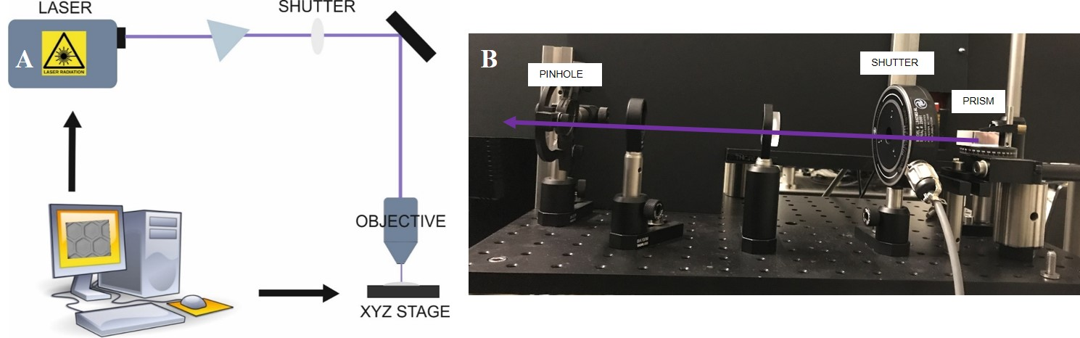
Figure 5.7. Direct laser-writing setup based on the stereolithography technique A) simplified schematic B) setup showing the beam direction, prism, shutter and pinhole.

Titanium coating
The moulds were coated by a thin layer of titanium, using a thermal evaporator (Wordentec, UK). The coating prevented contraction between PDMS and polymerised PEG-DA and it lengthened the mould’s durability for stamping. Samples, clean blowed with pressurised N₂, were stuck onto a sample holder using polymethyl methacrylate (PMMA). The sample was then placed inside the top chamber while the bottom chamber contained a titanium pot. The titanium was heated and evaporated to form a thin coating on the sample, according to manufacturer’s instructions.

Polydimethylsiloxane stamping
After fabrication and enhancement of two separate PEG-DA moulds, a negative replica for the microfluidic bioreactor and a positive replica for the scaffold samples were stamped using PDMS (Sylgard 184, Dow Corning, USA). Moulds were placed (stuck using a double-sided tape) in petri dishes to provide a confined space for the PDMS uncured solution. Moreover, the microfluidic bioreactor mould was confined with an oval shaped acrylic sheet to make an oval structure around the final PDMS microfluidic bioreactor. For improved stamping and peeling of PDMS, moulds should have hydrophobic characteristics to avoid bonding between PDMS and moulds. An efficient method to increase hydrophobicity is the introduction of release layer on the moulds using silane functionalisation process. Moulds were therefore cleaned using compressed air. A drop of trichloro (1H,1H,2H,2H-perfluorooctyl) silane was placed in a separate petri dish and left adjacent to the moulds under vacuum for 30 minutes. Then, PDMS was prepared by mixing a curing agent and elastomer in a ratio of 10:1 (weight). The PDMS was poured on the moulds and left under vacuum in a desiccator (Diener, Germany) for 15 minutes. When bubbles were eliminated from PDMS (poured on the moulds), samples were placed inside the oven (Memmert, Germany) at 60°C for three hours to solidify. After solidifying, the PDMS was left to cool and carefully peeled from the moulds.

PolyHIPE scaffold fabrication
To prepare the 3D scaffold, polyHIPE containing 70 wt. % 2-Ethylhexyl acrylate (EHA) (Sigma Aldrich, UK) and 30 wt. % Isobornyl acrylate (IBOA) (Figure 5.8) with 80% porosity was prepared. HIPE was created by adding the internal phase (diH₂O) to the continuous phase. The continuous phase comprised organic compounds including the monomers EHA and IBOA and trimethylolpropane triacrylate (cross linker) at 18.28%. The surfactant (Hypermer B246-SO-(MV), Croda, UK) and photo-initiator (diphenyl (2, 4, 6-trimethylbenzoyl)-phosphine oxide/2-hydroxy-2-methylpropiophenone, 50/50) were added at 3 wt. % and 5 wt. % of the organic mass, respectively. The internal phase was added drop-wise at a constant rate to the continuous phase, while stirring at 350 rpm with a paddle stirrer (Pro40, SciQuip, UK). Stirring continued for a further five minutes after addition of the internal phase. HIPEs were transferred to foil wrapped tubes and if not used the same day, they were stirred at 350 rpm for five minutes before use.
To polymerise HIPE for scaffold fabrication, the required quantity of HIPE was poured on the PDMS negative scaffold replica to fill the mould and then polymerised using the UV belt curer (GEW Mini Laboratory, GEW engineering, UK). The sample was passed several times under the UV lamp until it was cured. PolyHIPE was peeled away from the PDMS, washed three times with acetone to clean away uncured residue and then stored in methanol. Prior to use, scaffolds were dried overnight at room temperature.
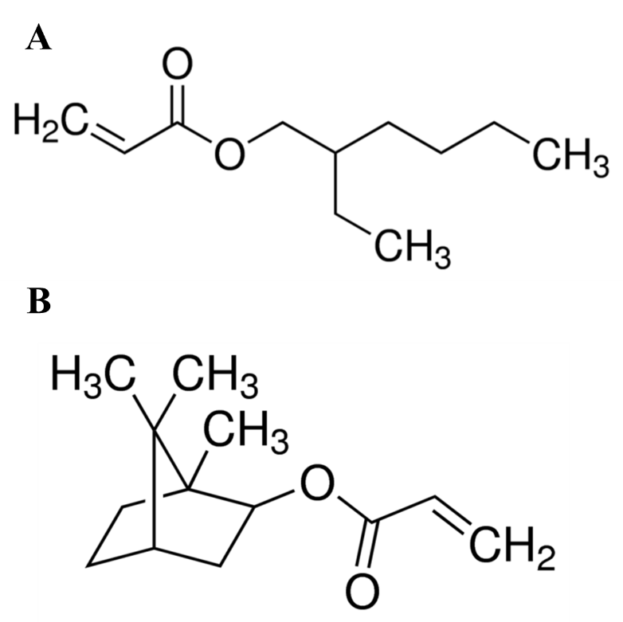
Figure 5. 8. Chemical structure of A) 2-Ethylhexyl acrylate (EHA) and B) Isobornyl acrylate (IBOA)

Mechanical characterisation
For mechanical tensile tests, specimens were cut from polyHIPE sheets using laser cutting (Epilog Laser Mini 19, Epilog laser, USA). Specimens were prepared according to ASTM D63-10 (standard test method for tensile properties of plastics). Specimens were reduced in size according to Owen et al., [9]. This was due to maximum sample height restrictions in the mechanical testing machine.
Specimen were tested using the BOSE ElectroForce 3200 mechanical testing instrument (Figure 5.9). The parameters used were 450 N load cell, an extension rate of 0.02 mm/sec, a grip distance of 10 mm and a maximum extension of 6 mm. To determine Young’s modulus, linear regions of the force-displacement curve were used. The initial point was at an extension of 0.02 mm and final point was taken at yield.
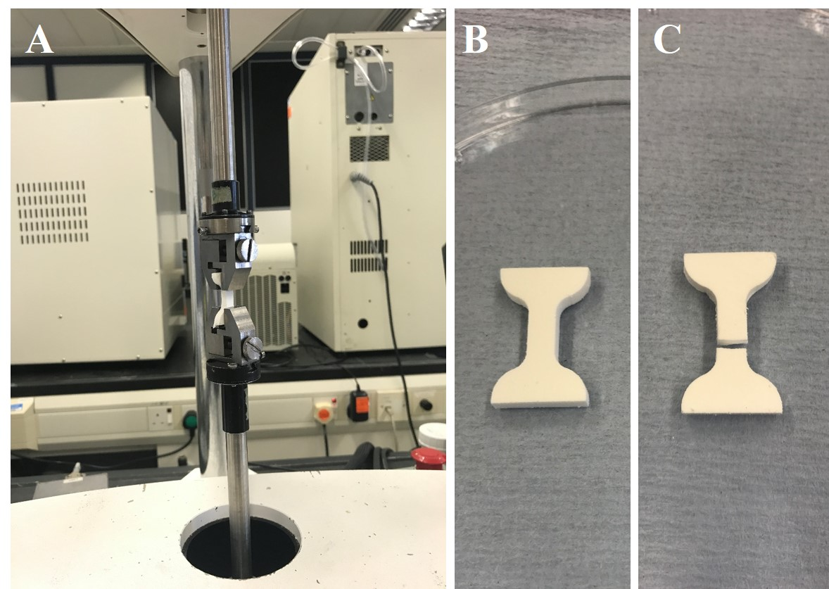
Figure 5.9. Mechanical testing; A) samples inside the BOSE instrument B) sample before mechanical testing C) sample after mechanical testing.

Physical characterisation
To physically characterise scaffolds, SEM images of 10 different scaffolds were analysed to determine channel sizes and pore size distributions. For imaging, each scaffold was dried and mounted on a carbon tab, coated with gold (SC500, Emscope, UK) and imaged using a Philips XL-30 FEG SEM with a beam energy of 15 kV and analysed using the imageJ program.
To characterise the channel size for the microfluidic bioreactor, images were taken using a compact stereo microscope (Stemi 350, Carl Zeiss) and analysed using the imageJ program.

Plasma modification of polyHIPE scaffold for cell culture
Since the continuous phase of the HIPE is intrinsically hydrophobic, permitting the formation of emulsion in water, altering the surface chemistry would provide a suitable template for cell attachment, spreading, growth and ingrowth. This was achieved through plasma modification of the scaffold using air plasma cleaning (pcAir).
Scaffolds were placed in the middle of a plasma chamber on a wrapped platform (aluminium foil). The chamber was wrapped in a coiled wire connected to a 13.56 MHz generator (Coaxial Power Systems Ltd, UK). The chamber had a regulated gas inlet (APG100 Active Pirani Vacuum Gauge, Edwards, UK) and a needle valve (LV10K, Edwards, UK). The pressure in the chamber was monitored using the gauge controller (AGC Active Gauge Controller, Edwards, UK). An isolation valve (Speedivalve, Edwards, UK) was placed between the vacuum pump and the chamber.
To implement pcAir treatment, the pressure was reduced to 1.8 × 10⁻¹ mbar and plasma was generated by setting the power to 50 W. Scaffolds were exposed to five minutes treatments (Figure 5.10).
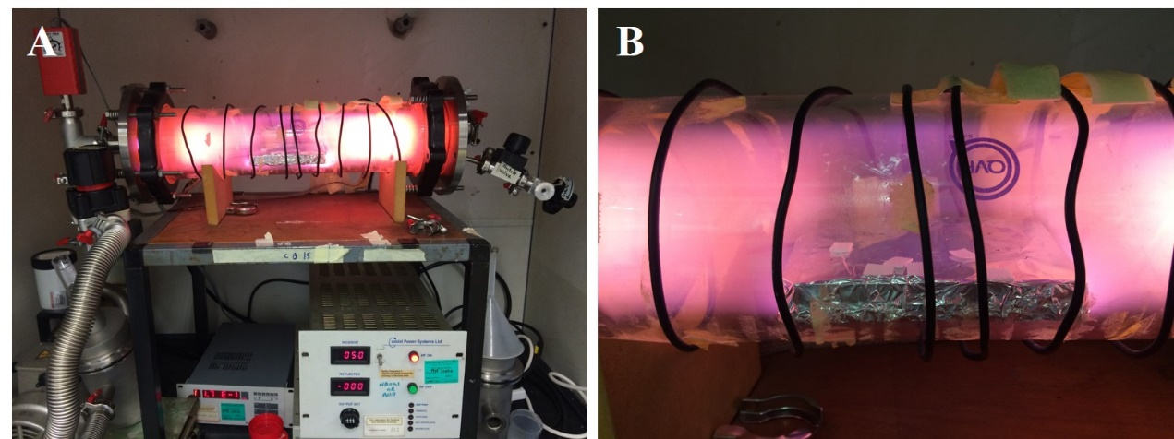
Figure 5.10. Custom made plasma instrument. Scaffolds was placed inside the glass chamber and plasma treatment performed at right pressure (1.8 × 10⁻¹mbar) and power (50 W). A) The plasma instrument during the plasma treatment B) Scaffolds under plasma treatment. The pink/purple colour is due to the excitation of humid air molecules including N2 and O2 and OH (humid air).

Water contact angle to characterise hydrophilicity
To confirm the suitability of scaffolds for cell culture after pcAir treatment, surface energy analysis was required. Therefore, the contact angle of water, using the drop shape method (KRUSS GmbH, Germany) was measured. A pcAir treated scaffold and an untreated scaffold (control) were placed on glass slides and mounted in the machine holder. Test fluid (diH₂O) was placed in a 10 mL syringe, with a dispensing needle. The needle location, light, camera angle and focus plane were adjusted to observe the sample surface and needle position. By inputting the syringe type and needle size into the software, the parameters were selected for fluid loading. Images were taken after loading a water droplet and water contact angles were measured using imageJ program.

Assembly of the BMC
This step involved punching the inlet and outlet of the microfluidic bioreactor using a 2 mm biopsy punch (Well Tech, UK). To remove dust and residue, 70 vol. % ethanol was used to clean the microfluidic bioreactor and glass slide. A pcAir treated scaffold was then placed into the PDMS microfluidic bioreactor chamber. Components of the BMC were inserted in the plasma chamber, top microfluidic bioreactor, 3D polyHIPE scaffold and bottom glass slide. Plasma treatments were performed at 100 W for 30 seconds at 1 mbar. The plasma hydroxylates the PDMS surface which allows for formation of strong covalent bond between the glass and the PDMS (or O-Si bond) when the PDMS is pressed against the glass. For improved covalent bonding, samples were left for 10 seconds at 100 °C. Successful bonding indicated complete covalent sealing of the device. In most cases, a strong bond (75 psi) formed, reflecting correct plasma functioning.

BMC sterilisation for cell culture
For cell culture, the device was sterilised. This was performed using 70 vol. % ethanol. This was run through the assembled BMC for an hour using an Ibidi pump system (Ibidi, Germany). Afterwards, devices were rinsed three times using sterile PBS at intervals of 15 minutes. Plasma treatment, assembly and sterilisation were always performed on the same day to avoid changes in surface chemistry.

General BMC cell seeding
The BMC’s ability to promote cell growth was determined using hES-MP cells. Reanimating, passaging, counting and freezing down were performed using a general hES-MPs culture protocol (Chapter 4, §4.2.3). MEMs used in this chapter were minimum alpha medium without l-glutamine (α-MEM, Lonza, UK). FBS used in the chapter were obtained from Labtech. To provide proper biochemical and mechanical cue on cells seeded inside the BMCs during the experiment a commercial air perfusion pump (Ibidi) was used (Figure 5.11). An Ibidi pump system can support up to four samples at a time. Four sterilised assembled BMCs were soaked in sterile FBS overnight, prior to seeding. Subsequently (15 mins before seeding), BCM media was perfused through the BMCs for 15 minutes. Afterwards, BMCs were disconnected from the pump and 120,000 hES-MP cells in 30 µL BCM media were injected through the inlet. Cells were incubated for four hours at 37°C, 5% CO₂ to allow attachment. Afterwards, the pump was connected to the BMCs and experiments were conducted at the lowest feasible flow rate, 0.8 mL/min for up to 14 days.

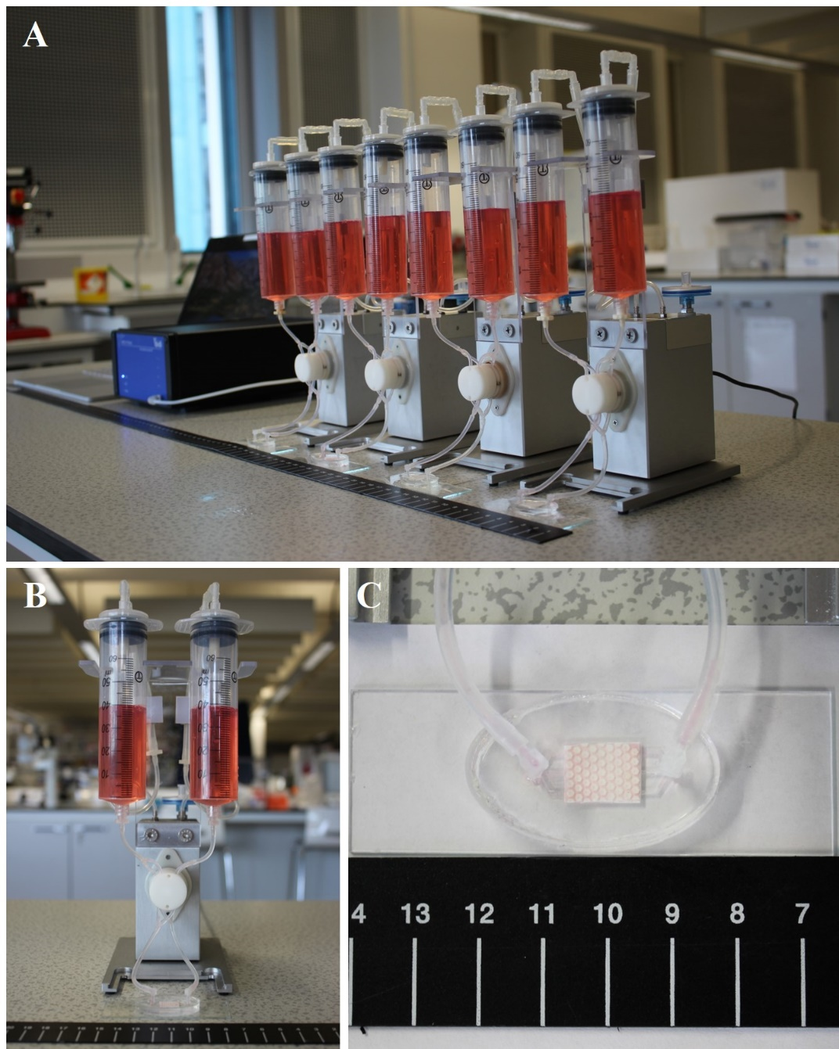
Figure 5.11. Commercial Ibidi pump system used for cell culture of the BMCs A) components of the Ibidi pump system, four fluidic units (front), pump system (middle), controller computer (back) B) Single fluidic unit C) higher magnification of a BMC connected to the fluidic unit. (fluidic units were kept at an incubator during the cell culture)

SEM cell imaging
To image cells using SEM, cell cultured BMCs were disassembled and scaffolds with cells were fixed for two hours in 2.5 % glutaraldehyde. Then, diH₂O was used to wash samples three times. To enhance contrast during imaging, a secondary one-hour fixation was applied using osmium tetroxide solution. The samples were washed three times in diH₂O. Samples were then dehydrated at increasing concentrations of ethanol; 50, 70, 80, 90, 100, 100 vol. % ethanol in diH₂O for 10 minutes. Samples were rehydrated in 3:1, 1:1, 1:3 ethanol:hexamethyldisilazane (HMDS) for 10 minutes. Finally, samples were incubated in HMDS for 10 minutes and allowed to air dry overnight.
To image samples, each dried scaffold was mounted on a carbon tab, coated with gold (SC500, Emscope, UK) and imaged using a Philips XL-30 FEG SEM with a beam energy of 15 kV.

Live cell tracking using fluorescence microscopy
To monitor cell movement and location, cells were stained prior to seeding, using the red fluorescent dye (CellTracker™ Red CMTPX Dye, ThermoFisher Scientific, UK). Firstly, a vial of cell tracker was defrosted and 20 µL DMSO was added to make a 1 mM stock solution. This stock solution was diluted to a working concentration of 1 µM in serum-free medium (10 µL of stock solution was added to 10 mL of serum-free medium). The working solution was warmed to 37°C. Cells were detached from the T75 flask (see Chapter 4, §4.2.3 for detachment protocol) and resuspended in a pre-warmed working solution. Cells were incubated for 45 minutes at 37°C, in a 5% CO₂ incubator. Afterwards cells were centrifuged at 1000 rpm for 5 minutes. The cell tracker supernatant was removed and BCM media added. Approximately 120,000 stained cells in 30 µL were seeded inside the BMC, according to the BMC cell culture protocol.
Cells were imaged using a Ti-E Nikon inverted microscope (Nikon, Japan). Stage control and image capture was performed with MetaMorph® Microscopy Automation & Image Analysis Software (Molecular Devices LLC). Fluorescent signals were detected using a filter system with a 630 nm excitation wavelength and a 660 nm emission wavelength. To effectively track cell growth over time, specific areas of the BMC were marked and imaged every day for five days. Images were analysed using the image J program.

Results

Moulds fabricated with PEG-DA and PDMS
Fabrication of the final designs for the two different moulds was performed by providing the essential computer code to direct the XYZ stage under the laser beam. Figure 5.12 shows the mould (negative replica) prepared for the microfluidic bioreactor. Although the whole structure could be made by writing the appropriate computer codes, only the outer frame was prepared with the laser (Figure 5.12 A). The focal point of the laser was focused on the interface of the glass slide and polymer solution to ensure attachment of the structure to the glass slides. The polymer bath thickness was 500 µm and each line fabricated by the laser was 100 µm thick. Therefore, the appropriate code was run five times. Each time the stage moved down from the focal point by 100 µm. Therefore, the outer frame with the thickness of 500 µm in Z direction was fabricated layer by layer. The thickness of the line in the XY direction was considered in the codes for the stage movement to fabricate according to the required dimension provided by the CAD design. Finally, the inner part of the microfluidic bioreactor was filled with PEG-DA and polymerised using the UV belt curer (Figure 5.12 B). This method significantly increased the efficiency and decreased the fabrication time.

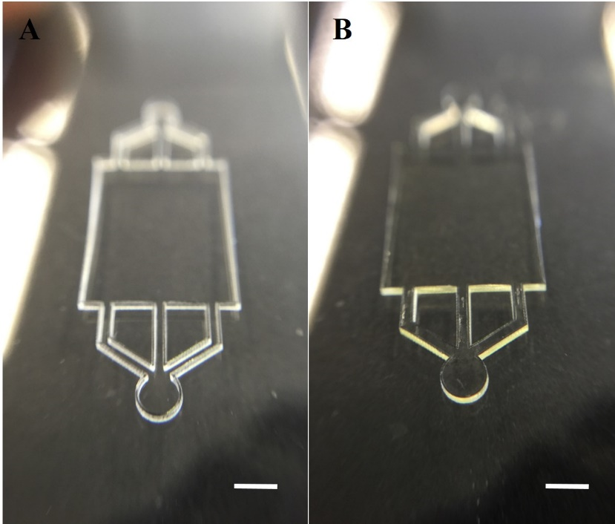
Figure 5.12. The negative replica fabricated for the microfluidic bioreactor A) Outer structures were prepared using direct laser writing, B) the final structure was filled with PEG-DA and cured using the UV belt curer. Scale bar = 2 mm.
As previously mentioned, fabrication of the mould for the 3D scaffold was performed in two separate steps: preparation of a positive replica made of PEG-DA using stereolithography, and fabrication of the negative replica made of PDMS, by stamping from PEG-DA mould. Figure 5.13 A & B shows the first PEG-DA step. The positive replica was prepared by direct laser writing, similar to the bioreactor. Briefly, the proper computer code was run five times to fabricate the appropriate thickness in the Z direction. For the XY plane, the hexagonal structures were prepared by writing the appropriate computer codes, considering the line thickness to fill the hexagonal structures. Finally, the enhanced Ti-coated positive replica mould was stamped with PDMS, thereby preparing the negative replica mould for polyHIPE stamping of the scaffold (Figure 5.13 C).
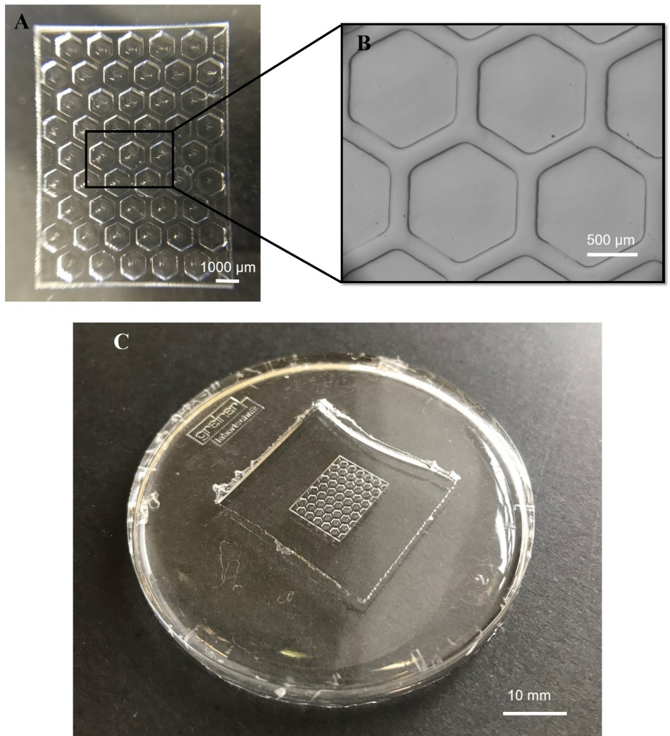
Figure 5.13. Moulds prepared for the scaffold A) Positive replica mould made of PEG-DA fabricated by single-photon stereolithography and B) a higher magnification of a subsection of A (C) PDMS negative replica stamped from a Ti enhanced PEG-DA mould.

Stamping the microfluidic bioreactor and scaffold
For the microfluidic bioreactor component of the BMC, the negative PEG-DA mould was fabricated and enhanced with a Ti nano-layer. The structure was then stamped with PDMS, providing the oval shaped top microfluidic bioreactor. Figure 5.14 shows the PDMS fabricated microfluidic bioreactor, with associated precision of channels and chambers.
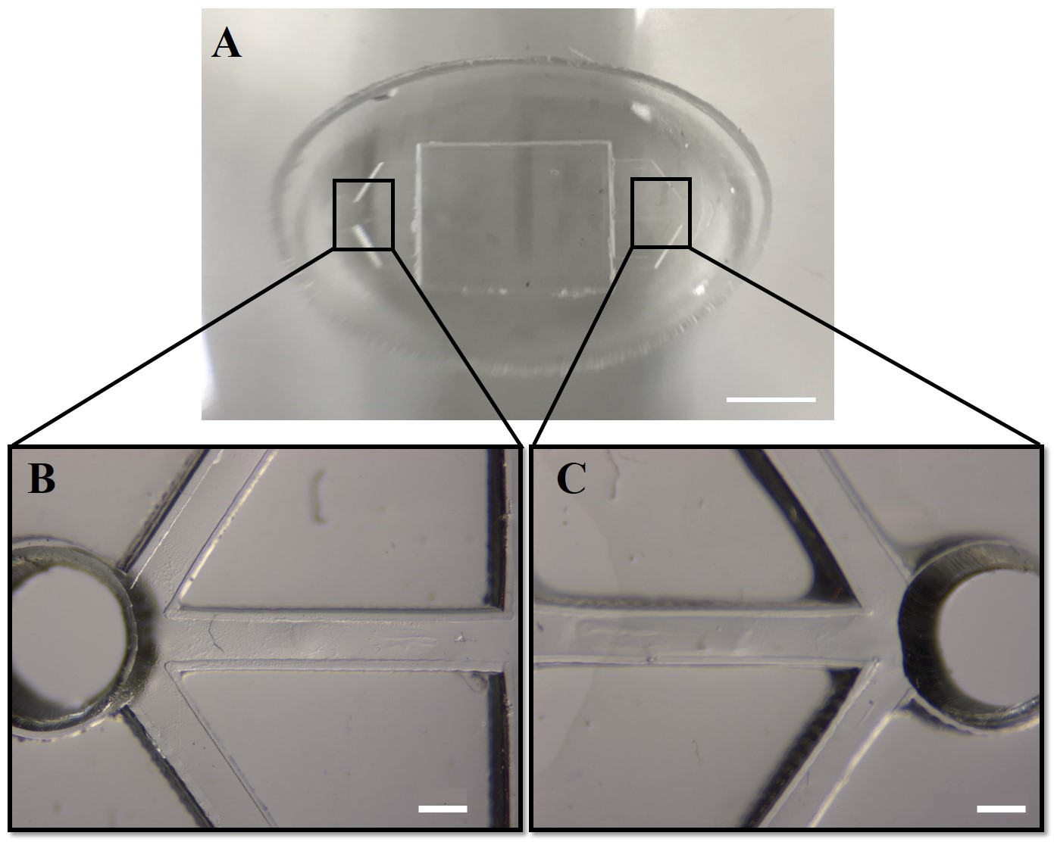
Figure 5.14. PDMS microfluidic bioreactor A) full view of the oval shaped structure B) & C) higher magnification of the inlet and outlet, and channels. Scale bar = 500 µm.
To fabricate the 3D scaffold, the PDMS negative replica mould was used. EHA/IBOA HIPE was poured into the mould and polymerised using UV. Due to low surface energy of PDMS, the scaffold was easily removed. Each PDMS stamped was used to fabricate four scaffolds, before surface chemistry was altered. Therefore, several PDMS negative moulds were prepared using the PEG-DA mould for polyHIPE scaffold fabrication. Figure 5.15 shows a fabricated scaffold of desired morphology.
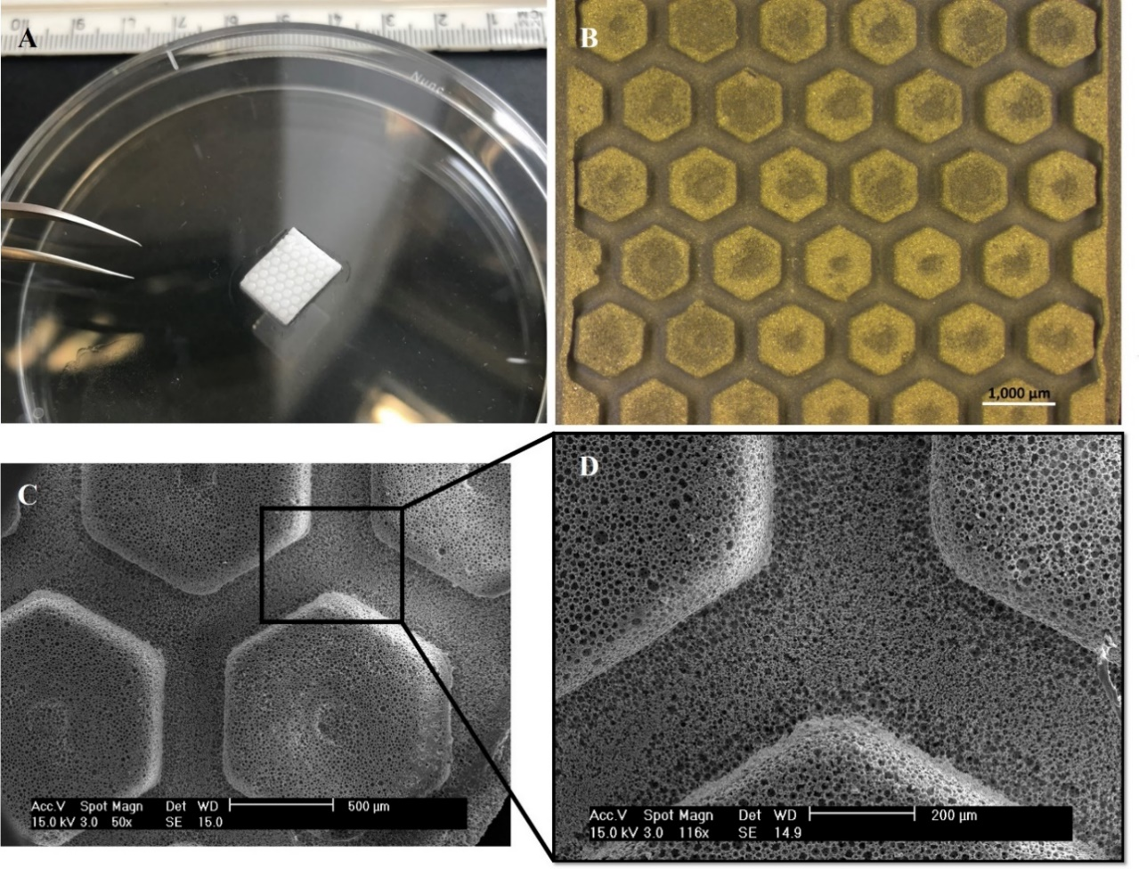
Figure 5.15. 3D EHA/IBOA polyHIPE scaffold stamped from PDMS negative replica A) full view scaffold image B) optical microscopy image of the scaffold, B) SEM image of the hexagonal structures and channels D) higher hexagonal and channel SEM magnification images.

Successful assembly of 3D BMC
The internal scaffold and external microfluidic bioreactor stamped from the moulds revealed good construction and geometry. Both the internal scaffold and external microfluidic bioreactor could be reproduced with low failure rate and with high sample-to-sample reproducibility. The final stage of fabrication was the assembly of all separate parts. This step was implemented using plasma treatment. The scaffold had been treated with pcAir, to promote cell adhesion. Afterwards, the PDMS bioreactor, with the scaffold embedded inside the chamber, was sealed (covalently bonded) to a glass slide using pcAir. Figure 5.16 shows an assembled BMC, ready for cell culture.
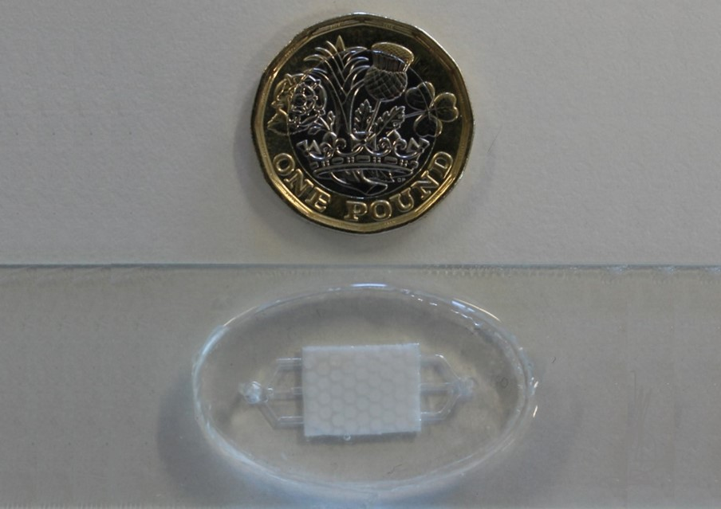
Figure 5.16. An assembled BMC placed next to a £1 coin for size comparison.

Physical and mechanical characterisation of the scaffold and bioreactor
To study the porosity of the scaffold and the size of the channels, SEM images were analysed. Figure 5.17 shows scaffold channels and porosity. 3D scaffold channels were measured using the Image J program, from different parts of 10 different scaffolds. Based on these measurements, the mean size (width) of channels was 310 ± 4.5 µm. The pillar height was 280 ± 5.2 µm and the thickness of the polyHIPE scaffold was 500 ± 12.1 µm.
For the microfluidic bioreactor, optical images were analysed using the image J program. The size (width) of the channels connecting the inlet and outlet to the chamber was 420 ± 6.7 µm. The thickness (height) of the chamber and channels was 500 ± 10.3 µm. These measurements ensured a tight fit for the scaffold inside the chamber. Finally, the chamber capacity (embedded with the scaffold) was 47.85 ± 0.5 µL, considering the porosity of the scaffold.
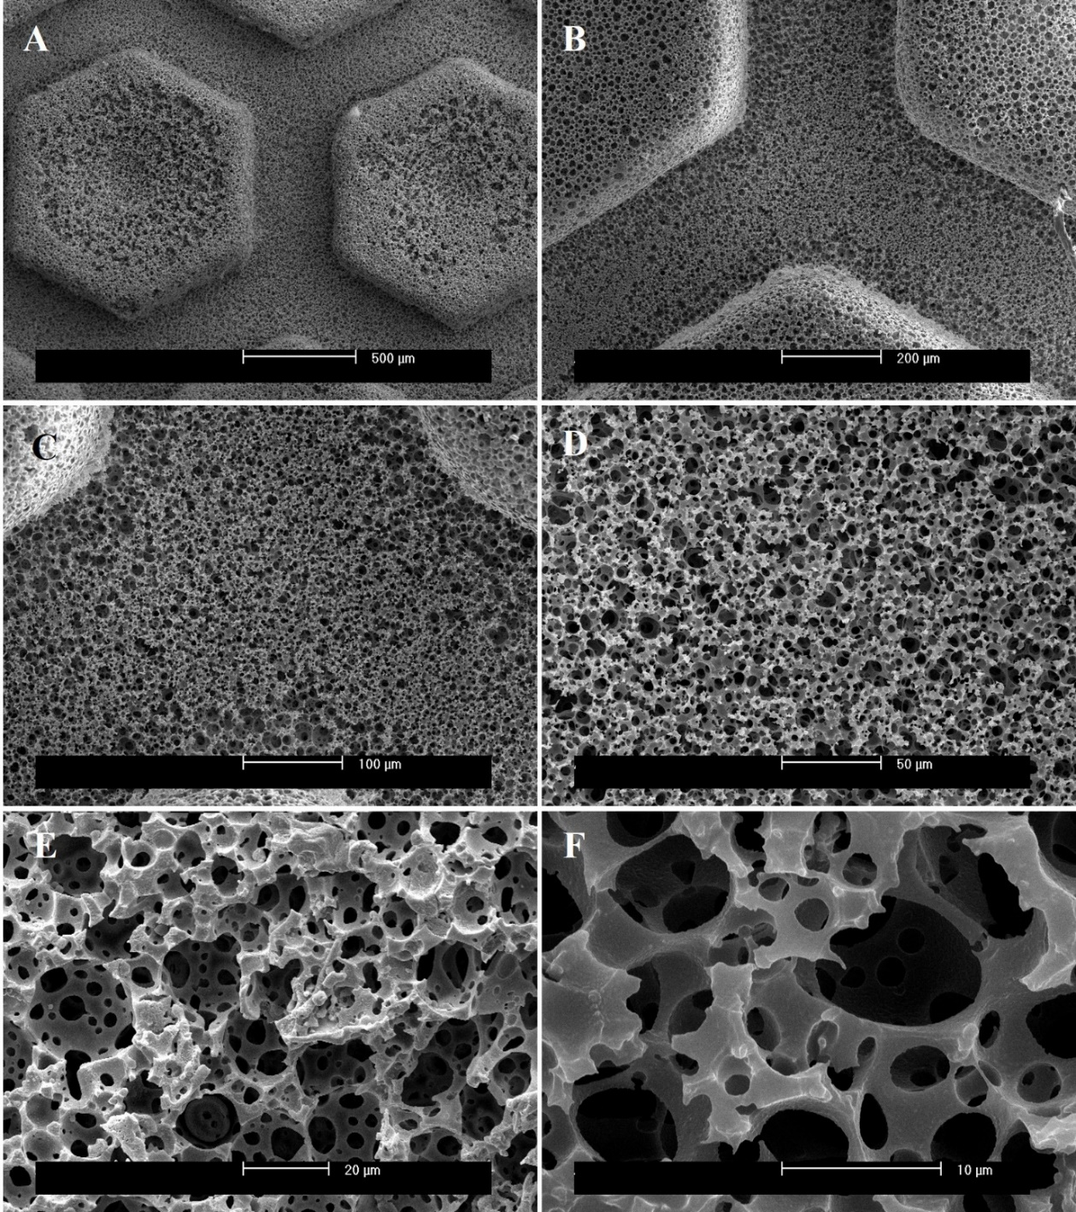
Figure 5.17. SEM images of a 3D polyHIPE scaffold A) & B) show the porous hexagonal pillars and channels at different magnifications. Images shows the porous morphology of the scaffold with interconnected pores. Higher magnifications images (B-F) focus on channel morphology, where cells are cultured.
Pore size distribution is an important factor affecting cell attachment, proliferation and growth. Measuring the void diameter, from SEM images, was inaccurate. The figure was underestimated of the real value because the fracture surface was random during the sample preparation and unlikely to bisect exactly each pore. Therefore, a statistical correction was necessary [314]. This was performed by supposing the cavities are spherical and therefore, assessing the average of the ratio$\frac{R}{r}$, where R is the equatorial value of pore diameter and r is the diameter measured from SEM. Using a simple mathematical calculation, the fracture centre distance from the void centre was calculated from equation (Eq. 5.1):
$$h^{2}=R^{2}-r^{2} (Eq. 5.1)$$
The probability that sectioning (fracture) takes place at any distance from the void centre is the same no matter of h; therefore, the average probability value of h is$\frac{R}{2}$. Replacing this value in equation (5.1) generates equation (Eq. 5.2).
$$R= \frac{2}{\sqrt{3}} × r (Eq. 5.2)$$
According to equation 5.2, pore size was measured from 10 different SEM images, from different scaffolds. The distribution is shown in Figure 5.18. multiscale micro-porosity up to 30 µm were observed on the scaffolds. The average pore size was calculated as 17.68 ± 4.2 µm.
Figure 5.18. Graph showing void diameter (pore size) distribution based on 10 different SEM images.
Scaffold mechanical properties were tested using BOSE mechanical testing instrument. Young’s modulus, Ultimate tensile stress (UTS) and percentage elongation at failure were calculated and are presented (Table 5.2). Young’s modulus defines the stiffness of the scaffold measured at the linear elasticity regime of stress-strain diagram, UTS is the indication of the maximum stress that the scaffold can withstand before breaking while being stretched, and percentage elongation (ductility) at failure is an indication of ductility of the scaffold, which shows the ability of the materials to deform plastically during the tensile test without fracturing. Therefore, it is measured by the maximum elongation of the gage length divided by the original gage length.
Table 5.2. Mechanical properties of the internal 3D polyHIPE scaffold.
Mechanical property | Quantity
Stiffness (Effective young modulus) | 15 ± 2.17 MPa
Ultimate tensile stress | 0.15 ± 0.01 MPa
Ductility | 16.11 ± 0.85 %

pcAir and the hydrophilic scaffold
To investigate the effects of air plasma treatment on scaffold surface chemistry, water contact angles were measured before and after treatment. Untreated scaffolds (Figure 5.19 A) had a contact angle of 131°± 2 which is considered hydrophobic. After treatment, the water droplet was completely absorbed (contact angle of 0, Figure 5.19 B), exhibiting scaffold hydrophilicity. This meant the scaffold was suitable for cell culture.

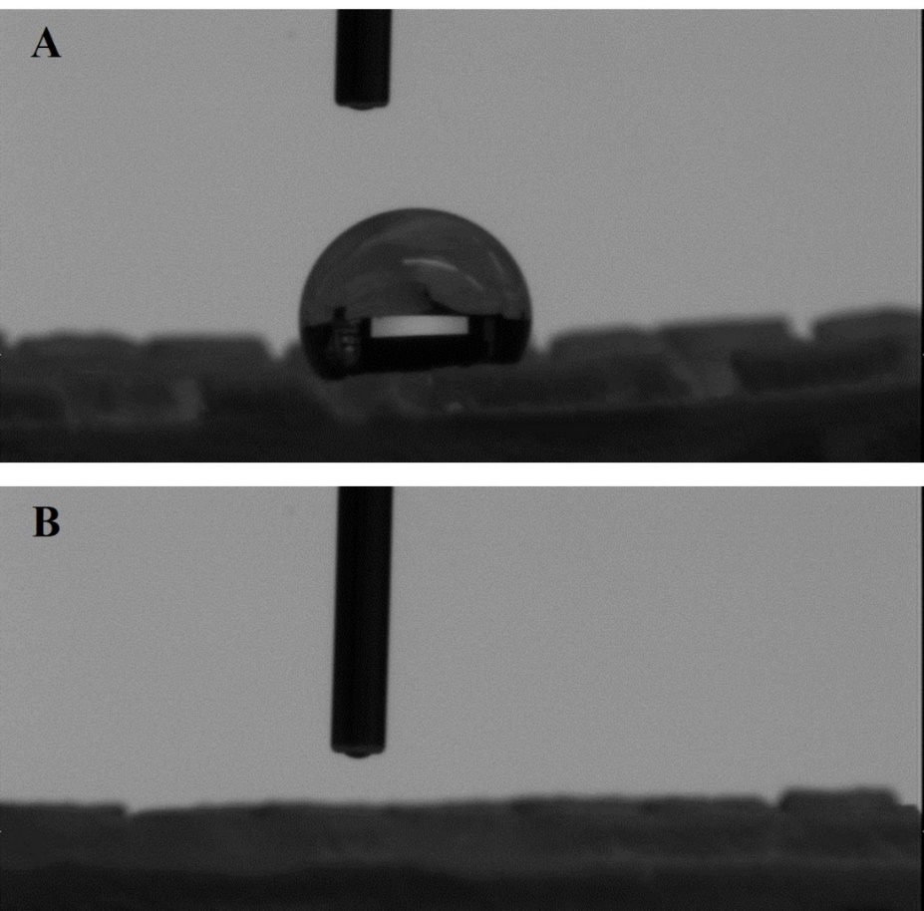
Figure 5.19. A Water droplet on the polyHIPE scaffold A) the scaffold before pcAir treatment, displaying hydrophobic characteristics B) the scaffold after treatment. The water droplet was completely absorbed by the porous scaffold, suggesting a hydrophilic scaffold.

3D BMC supports cell growth and proliferation
The main scope of this thesis was to investigate the possibility of using 3D BMC for in vitro osteogenesis. To determine the suitability of the 3D BMC, embryonic progenitors stem cells (hES-MP) cells were seeded for up to 14 days at a flow rate of 0.8 mL/min, the lowest possible flow rate. To qualitatively confirm the suitability of the BMC for cell growth, two imaging approaches were selected. SEM images were recorded at day 14 to investigate the possibility of long-term cell culture. Also, real-time cell growth was assessed over five days by the live tracking of cells, using a fluorescent cell tracker. Figure 5.20 shows cell growth and proliferation inside the 3D BMC.
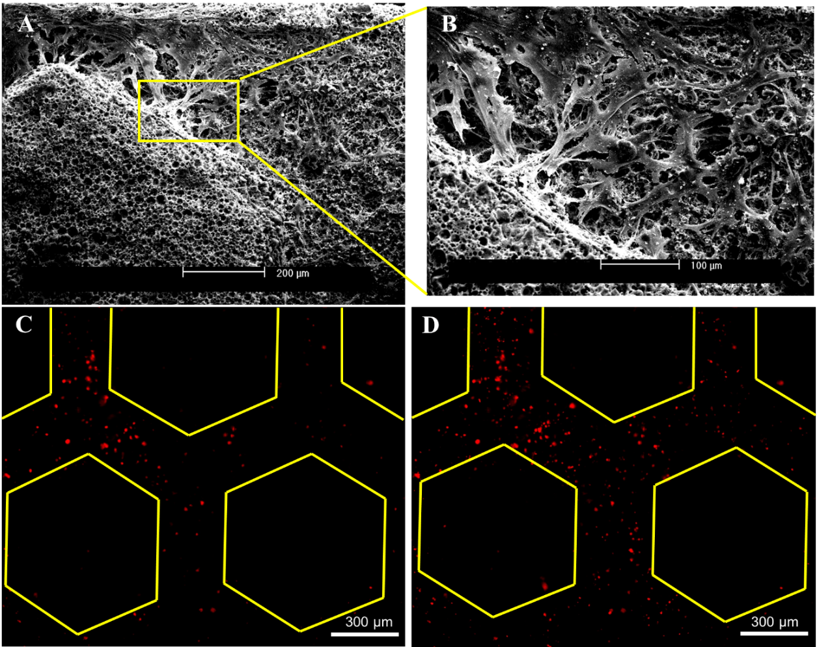
Figure 5.20. hES-MP cells were seeded inside the BMC to demonstrate proof of concept A) SEM images of fixed cells at day 14. Cells were growing and attached to channels B) higher magnification. Live cell tracking of fluorescently stained cells using a fluorescence microscope at C) day one and D) day five. (Yellow hexagons were added to delineate channels and fluorescent cells).

Discussion
Pharmaceutical investigations have determined that clinical outcomes from in vivo animal experiments are not reliable in predicting human responses [12]. Through microengineering, scientists have sought to engineer new disease models that could step in the place or improve the predictability for animal experiments currently employed as forms of developing drugs and testing of toxins. The main aim of this project was to develop an improved in vitro model for osteogenesis and osteogenic drug development. The work in this chapter shows the design, fabrication and characterisation of a microfluidic chip, with a 3D environment embedded within. Furthermore, preliminary cell studies evaluated the suitability of the fabricated 3D BMC for cell culture. Once confirmed as suitable, further studies were performed (Chapter 6).
Microfluidic cell culture systems have been developed for culturing, maintaining and analysing cells in microenvironments, similar to in vivo conditions. Therefore, the designed environment must meet critical parameters, the provision of nutrients and the removal of metabolic waste, and oxygen and carbon dioxide exchange. There are many advantages to microfluidics, such as reduced consumption of reagents, reduced contamination risks, efficient experimentation, and automation. However, the greatest advantage is their design flexibility, which can be tailored to specific needs.
A well-functioning microfluidic device should have proper channels, controlling nutrient and metabolic waste and chambers for cell culture, maintenance and analysis. As the main aim of this chapter was the generation of a 3D environment in a microfluidic chip, the design consisted of two parts, the microfluidic bioreactor and the 3D scaffold (Figure 5.6). In accordance with bioreactor criteria, the design consisted of a chamber connected to an inlet and outlet through three channels at each side. Therefore, enough space was provided for cell culture. Flow could be perfused for nutrient distribution and metabolic waste removal. The bioreactor design was sketched with consideration for fabrication, cost, reproducibility, and cell culture.
Since the bioreactor was not for cell culture and was designed to provide nutrients and remove wastes and provide sufficient space for the 3D scaffold, PDMS was used. PDMS was suitable for many reasons; its low cost and ease of prototyping, flexibility, ease of replica moulding and embossing and ease of sealing to other PDMS or glass materials. This latter aspect was performed by plasma or thermal covalent bonding. The process did not required adhesive that may have been cytotoxic. Additionally, PDMS is bio-inert, non-toxic and has high gas permeability, allowing free exchange of oxygen and carbon dioxide suitable for cell culture [315-317]. Moreover, due to its transparency, it provided a window for real time cell observation and imaging.
To generate a 3D BMC, a synthetic polymeric extracellular matrix that supports the growth of cells was required. As mentioned earlier, the ideal scaffold for bone tissue engineering, should be biocompatible, highly interconnected and contain pores of multiple sizes, while providing suitable mechanical properties and support. Cells can embed and grow inside the scaffold while nutrients and metabolic waste diffuse in and out of the scaffolds.
Several candidates could have been used as scaffolds, e.g. metals, ceramics, and polymers [318]. Metals and ceramic scaffolds have major disadvantages, they have limited processing ability and flexibility and are expensive to fabricate [319]. Polymeric scaffolds have greater flexibility in terms of fabrication, which makes them a suitable 3D scaffold for bone tissue engineering. Recently, a new type of polymeric scaffold was developed. It was reported as polymerised high internal phase emulsion (polyHIPE) material for bone tissue engineering [278, 320]. PolyHIPEs are inherently porous materials, formed by emulsion templating; the emulsion consists of a curable continuous phase that encapsulates an immiscible internal droplet phase, where the internal phase volume ratio exceeds 0.74. The continuous phase is polymerised to produce a highly porous material with extensive pore interconnectivity, where the percentage porosity is simply the internal phase volume ratio. By making the continuous phase photocurable, it was possible to additive manufacture polyHIPEs using stereolithography techniques, permitting the production of lattice scaffolds with tuneable mechanical properties, supporting superior osteoblast performance over their non-porous counterparts [9, 293, 321]. Although, polyHIPEs have inherent micro porosity with interconnected pores essential for bone tissue engineering, a suitable 3D scaffold requires multiscale porosity sizes, from micro (pore size <100 µm) to macro (pore size >100 µm) [318, 322]. As mentioned earlier in the method section, during the design, instead of simply using a flat sheet of polyHIPE scaffold with rough surface topography, the porosity was enhanced by introducing hexagonal micropillars of 310 µm spacing that could also be used as channels.
Finally, with respect to all criteria and requirements, the final design for the BMC was chosen (Figure 5.6) and fabricated.
For fabrication, to ensure consistency between samples, moulding and embossing techniques were used. This made the fabrication process easier, faster and reproducible. The preparation of moulds was done using single-photon laser writing of PEG-DA; a negative replica for the bioreactor and a positive replica for the scaffold. The thickness of a single line (100 µm) in single-photon polymerisation was considered to construct the right dimensions for the moulds. After fabrication of PEG-DA moulds, a 1.7 nm titanium layer was coated onto the surface, to enhance durability and avoid contraction of PEG-DA with PDMS. The stamping of bioreactors with PDMS was successful. During the PDMS stamping process, care was taken to avoid any amount of uncured polymer to be left. PDMS blends contain low levels of ethylbenzene and xylene that may leach out and contaminate culture media (toxic to cells) once the PDMS is not fully cured and crosslinked. The bioreactor was structurally suitable, and dimensions were in accordance with CAD design criteria.
For scaffold fabrication, different stereolithography techniques, such as single-photon laser writing and digital micromirror device (DMD) were used to directly structure and polymerise HIPE. However, the suitable precision was not fabricated (Figure 5.21 A & B). This limitation was due to the high light scattering nature of HIPE, which reduced resolution. With more effort such as manipulation of laser power or addition of UV-light absorber or radical scavenger [293], HIPE may be directly polymerised and structured using stereolithography techniques, however moulding was preferred here as it reduced fabrication times and dimensions were found to be consistent throughout with this method. An additional obstacle was the polymerisation and replication of HIPE on top of the PEG-DA mould since the photocured polyHIPE tended to stick to the mould. The removal procedure was not successful (Figure 5.21 B), due to the surface energy of the PEG-DA and affinity of polyHIPE, which was probably due to cross linking in between PEG-DA and acrylic monomers of the polyHIPE. The solution to this was to use a material with low surface energy, e.g. PDMS. Therefore, positive replicas of the design were prepared with single-photon writing of PEG-DA, PDMS negative moulds were stamped from PEG-DA replica and finally, HIPE scaffolds were successfully polymerised and removed from the PDMS mould. The scaffold structure showed good architecture in accordance with CAD design that precisely matched with the chamber size.
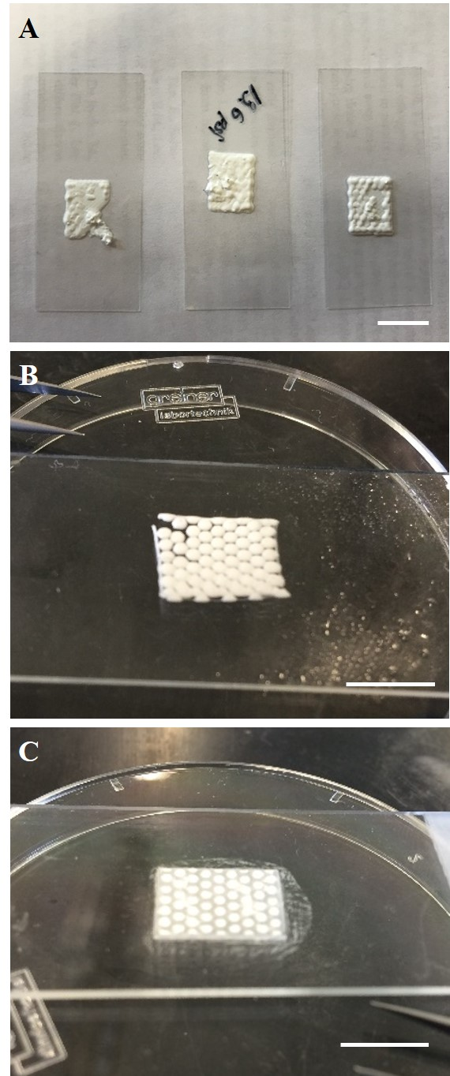
Figure 5. 21.. Unsuccessful polyHIPE scaffolds made with A) single-photon direct writing, B) DMD setup, C) polymerising HIPE over a PEG-DA mould. Scale bar = 10 mm.
Finally, the scaffold and bioreactor were assembled and exposed to an air plasma, which allowed to covalently seal the device to a glass slide. The culture area not only allowed the tracking of seeded cells, but it also allowed the tracking of multiple regions in the culture area over time.
Over the past 20 years, PolyHIPE scaffolds have been extensively reported to be used successfully for 3D cell culture [323]. This is for a variety of reasons; the ease of fabrication of a 3D (porous) structure, control and flexibility on microporosity size. PolyHIPEs have been fabricated from different materials such as styrene/divinyl benzene (ST/DVB) [324], and acrylates containing poly(ɛ-caprolactone) (PCL) [325, 326]. Due to the high success of these scaffolds, a commercial polyHIPE scaffold (ALVETEX®), comprising a flat porous polystyrene disk was developed. HIPE are polymerised and prepared using two techniques, thermally induced radical polymerisation and photo induced polymerisation. Acrylate or methacrylate-based HIPE can be polymerised using photocuring techniques such as stereolithography. Recently, a mix of two acrylate-based monomers, 2-ethylhexyl acrylate (EHA) and isobornyl acrylate (IBOA) were reported as polyHIPE scaffolds to be osteogenic, osteoconductive and osteoinductive in bone tissue engineering studies [9, 293, 320]. Using these monomers, EHA for its elastic characteristics and IBOA for its brittle characteristics, allows control over mechanical properties of polyHIPEs to finely tune scaffolds according to different applications. As reported by Owen et al., [327], IBOA polyHIPE was a good candidate for osteogenic differentiation due to its high stiffness qualities. However, the brittle characteristic of IBOA scaffolds made them inappropriate for stamping from moulds, transferring to the bioreactor, and fluid shear stress. Therefore, the use of EHA was necessary. In accordance to the data achieved by mechanically testing of the different combination of EHA/IBOA polyHIPE scaffold in our group [9, 321], 70 wt.% EHA with 30 wt.% IBOA polyHIPE with 80% porosity was used as the combination of the scaffold in this chapter. The mechanical properties were in line with the reported mechanical properties in the group.
polyHIPE scaffolds have hydrophobic surfaces, due to the hydrophobic nature of the continuous phase of the HIPE. However, this must be overcome for biomaterials used in tissue engineering [319]. Bi-functionality at the polymer surface can be performed via chemical functionalisation or adsorption of biomolecules onto surfaces. Therefore, pcAir plasma treatment was performed as a chemical functionalisation. Plasma (electrically excited gas) contains mixtures of electrons, neutral compounds, photons, radicals and ions, with a range of different masses and energies [328]. Detailed understanding of the roles is difficult and there are different models explaining the process, which is outside the scope of this chapter. Once plasma is generated using non-organic compounds such as pcAir, oxygen-containing hydroxyl groups will be deposited onto the surface, which support cell growth and enhance wettability [329, 330]. Moreover, it was reported that plasma treated surfaces were not degraded by gamma-irradiation and ethylene oxide sterilisation [329]. Since, sterilisation is vital in tissue engineering, this is important for polymeric materials to have a suitable surface chemistry, e.g. by using plasma treatment, which are not affected by the process of sterilisation. Therefore, plasma treatment effectively changed the surface chemistry of polyHIPE scaffolds to make them hydrophilic, ultimately improving cell attachment.
The water contact angle measurement confirmed successful plasma treatment of the scaffolds. Further experiments showed that the hydrophobicity of the dried polyHIPE scaffold recovered with time. Water contact angles measured at day five showed a 90% recovery of scaffold hydrophobic properties. Therefore, scaffolds were used on the same day, after plasma treatment. Biomolecule adsorption on the scaffold surface was performed to enhance the effects of pcAir, and fully satisfy the surface requirements for cell culture. It is well known that proteins play an important role as meditators in cell-scaffold interactions. Cells require specific proteins for anchorage and extracellular matrix interactions [331]. Cells recognise and bind to extracellular matrix proteins, they adsorb proteins on the surface of scaffolds through surface receptors, such as integrins. Therefore, cell adhesion, proliferation and signalling are affected and enhanced by the protein layer adsorbed onto the surface of the scaffold. Foetal bovine serum was a good source of structural proteins such as laminin, fibronectin and vitronectin. Importantly these proteins could interact with cell surface integrins and induce cell attachment to the scaffold [331-333]. Although the culture media is supplemented with FBS, pre-coating the scaffold (in the BMC) in FBS overnight was performed. PcAir and protein coating enhanced cell attachment, which was essential for the cell culture inside 3D BMCs and cell growth under fluid shear stress.
The physical characterisation of scaffolds showed a high level of interconnectivity and porosity. The introduction of channels and pillars provided a macro-porosity suitable for bone tissue engineering. SEM scaffold images showed a multiscale micro-porosity that produced a surface roughness, necessary for cell attachment, cell in/growth, nutrient diffusion and waste removal. polyHIPEs made with stereolithography techniques, using UV light, may produce a side skin formation at the surface. This could be due to partial polymerisation of the HIPE at the surface, where the UV light focuses on or where the HIPE is in contact with the mould, resulting in destabilisation of the emulsion at the material interface and subsequently collapses and forms a closed thin film at the surface, negating the advantage of the high porous polyHIPE materials. However, the bulk morphology of the polyHIPE is not affected [293, 294]. PolyHIPE scaffolds made by stamping HIPE from the PDMS, displayed open porous surfaces with no signs of skin formation at the surface.
Since the introduction of microfluidic chip devices for tissue engineering, a variety of models have been fabricated and tested [12]. However, due to design diversity, there are no standard methods of cell culture for these devices, therefore each device has its own optimised cell culture method. The BMC designed in this chapter was successfully fabricated and was physically characterised. Furthermore, the ability of the microfluidic device for cell growth and maintenance was tested by growing hES-MPs for up to 14 days.
Assembly of the device after seeding was not possible, and scaffolds could not be seeded and placed inside the microfluidic device. Therefore, a new ideal method for cell culture was developed and used. Due to limitations of the equipment, four devices were tested in each study. For sterilisation, 70% ethanol was perfused through the four BMCs. The pump perfused 70% ethanol at the highest flow rate to eliminate air bubbles inside the 3D scaffold. Subsequently samples were visually checked to ensure removal of all air bubbles and, the flow rate was reduced to 0.8 mL/min and sterilisation performed for 1 hour before washing three times with sterile PBS at 15 minutes interval. Following this, the scaffolds were soaked in FBS overnight. Prior to seeding, BCM media was perfused for 15 minutes inside the BMCs and then disconnected from the pumps.
Cells were injected through the inlet and left for four hours to attach prior to the introduction of a 0.8 mL/min fluid flow. While this method demonstrated that cell attachment efficiencies were lower than static culture (scaffold outside the chip), the results still showed acceptable cell attachment inside the BMCs. This attachment loss was observed for similar dynamic seeding studies [14, 334]. Reasons for this included, nature of dynamic seeding as fluid flow can cause primarily cells detachment and also in process of seeding less cells can attach during the cells injection. For example, some cells can remain inside PDMS channels, and die due to lack of attachment to the PDMS. Since the chamber size of the BMC device was small, leaving the cells for long time (more than 12 hours) for cell attachment, while the pump was not connected, caused cell apoptosis due to the lack of nutrients. Based on these limitation control studies were performed by testing the scaffold in static condition outside the BMC, which is explained in more detail at chapter 6. Static seeding of the scaffolds outside the BMC recommended that four hours was enough for 90% cell attachment. Therefore, four hours also was tested and used as a standard step for cell attachment inside the device.
Qualitative preliminary studies were performed to assess the suitability of the BMC for cell growth. SEM cell images showed successful cell attachments and growth inside the BMCs and scaffold channels over a 14 days period. Real time cell imaging was possible by tracking the red stained cells. Images showed cells proliferating over time. Tracking for more than five days was not possible with the same stained cells as fluorescence was progressively eliminated from cells during the cell cycles. However, for longer live cell tracking, similar staining on the seeded cells inside the BMCs could be repeated according to the manufacturer’s manual for staining attached cells process [335]. Preliminary results confirmed the BMC could support cell growth for a long period, including real time analysis and tracking of cells. Moreover, the ability of the pump for long term supporting of four BMCs were tested and confirmed. Further studies were performed assessing bone mechanobiology, including the effects of mechanical stimuli such as shear stress on cell growth and osteogenic differentiation (Chapter 6).

Summary
This chapter described the design and fabrication of a novel 3D BMC in vitro model for bone tissue engineering. Stereolithography technique along with moulding and embossing were used to fabricate the device. By using moulds, time and costs of fabrication was reduced significantly, while reproducibility and resolution were enhanced. Moreover, using moulds helped to keep the dimensions consistent for all samples. Microfluidic bioreactors were made of PDMS, while 3D porous scaffolds were made of EHA/IBOA polyHIPE, with hexagonal channels design containing multiscale porosity, micro and macro, suitable for osteogenesis. The scaffolds surface morphology showed interconnected pores with no side skin effects at the surface, ideal for the cell culture. Prior the assembly and cell culture, scaffolds were pcAir plasma treated to overcome the inherent hydrophobic characteristics of the EHA/IBOA polyHIPE scaffold to become hydrophilic as required for cell culture. The device (3D BMC) was then successfully assembled using pcAir plasma treatment for covalent sealing to the glass slide. Preliminary cell culture results confirmed the ability of the device to support the cell growth. SEM images of fixed cells qualitatively confirmed cell growth and support inside the BMC for long-term culture. Moreover, live cell tracking allowed real time analysis of the device, showing cell growth and proliferation in the BMC.

Assessment of 3D BMC; bone mechanobiology

Introduction
Bone is a dynamic tissue that senses and adapts to mechanical stimuli by modulating its mass, structural strength and geometry. This adaption is an important part of bone protection against fatigue fractures. It is known that in vivo these mechanical cues are mainly transmitted to bone cells via fluid shear stress (FSS) [135]. Mechanical stimulation via shear stress has been shown to enhance bone differentiation and mineralisation [15, 336, 337]. Once a load is applied to bone in vivo, interstitial fluid, through pore structures flows and respective FSS, is sensed by terminally differentiated osteoblasts, called osteocytes. As a consequence of FSS, osteocytes communicate with osteoblasts and osteoprogenitor cells to initiate bone remodelling and osteogenesis. According to the literature, the shear stress sensed by bone cells in vivo is estimated to range from 0.8 to 3 Pa [338, 339]. Similarly, it has also been shown through in vitro studies that osteoblasts and stem cells directly respond to shear stress [336, 340-345]. Therefore, an optimal in vitro model should provide an adequate 3D environment, biochemical and biomechanical stimuli such as in vivo microenvironment.
As previously mentioned, microfluidic cell culture systems provide significant advantages over macroscopic cultures. Microfluidic systems, specifically organ-on-a-chip designs, have great flexibility in their design as they provide optimal environments that are closer to natural microenvironments, such as creating mechanical and chemical stimuli in vitro, with high temporal and spatial resolution, thanks to automation and parallelisation. Furthermore, these systems offer efficient high throughput experimentation with significant reductions in reagent consumption and contamination [315]. Moreover, due to their design flexibility, computational modelling of fluid flow combined with advanced imaging techniques can provide greater understandings of physiological conditions, such as shear stress and mass transport during in vitro culture.
Therefore, since microfluidics can provide better in vitro conditions for cells relatively close to in vivo conditions, this chapter assesses and tests fabricated 3D BMC structure by studying the mechanobiology of bone tissue. The results were compared to the literature to assess the suitability of the device for further experiments, e.g. therapeutic drug assessment.

Bone mechanobiology
The human body comprises cells and tissues which are continuously subjected to different external forces. These forces influence cell and tissues growth, development and maintenance. For example, in tissues such as muscle, skin, tendon and blood vessels, cells constantly adapt to biological functions according to alternations in mechanical forces. Studies have shown that mechanical strain can induce cardiac myocyte hypertrophy [346, 347]. Furthermore, endothelial cells alter their morphology and orientation and therefore determine vascular physiology as a result of blood shear stress and pressure [348].
Bone tissue can also adapt to external forces. In the 19th century, Julius Wolff [349] for the first time hypothesised that bone architecture was the result of mechanical stress using a mathematical law. Although recent findings have disagreed with some of Wolff’s assumption, the main idea that mechanical forces are closely linked to bone adaptation is still widely accepted. Many in vivo studies have shown that gravitational forces and mechanical loads are essential for bone remodelling and maintenance. For example, there is greater bone density in the femur of a weightlifter when compared to a non-weightlifter, and similar trends are seen in the arms of professional tennis players. In contrast, reduced loading due to different factors such as bed rest or microgravity in space or limb paralysis can cause reductions in bone formation and increase in bone resorption that lead to bone loss [350-352].
It is recognised that osteoblasts and osteocytes both sense and respond to mechanical loading, however, it is widely known that osteocytes are the main mechanosensory cells of bone through the lacuna-canalicular porosity structures. The current hypothesis is that in vivo mechanical loads can cause deformations in bone, inducing fluid flow inside the bone canaliculae, causing shear stresses on osteocytes inside the bone matrix [157]. Osteocytes communicate directly with osteoblasts or with other osteoprogenitor cells to induce osteogenic differentiation, resulting in a new bone formation. Furthermore, osteocyte responses can inhibit osteoclast function to avoid bone resorption. The cyclic loading of bone not only produces shear stress, but it also pumps nutrients and oxygenated fluid from micro-vessels to networks and remove metabolic waste products [353].

Mechanical forces in bone
Mechanical stimuli induced by muscle contractions and gravitational forces result in small bone deformations which generate interstitial fluid flow and matrix strains within the bone porous structure.

Matrix strain
Small deformations lead to tissue strain, which to some extent can be directly sensed by bone cells. It has been hypothesised through “mechanostat theory”, that bone growth and loss is governed by local mechanical elastic deformation of bone, which allows bone to adapt in terms of mechanical properties. It has been observed that in vivo physiological strains range between 0.03% and 0.15%, which below this range bone resorption is initiated, while above 0.15% up to 0.3% bone mass is increased [354-356]. However, in vitro data shows that to induce osteogenic responses, much higher strains are required when compared to in vivo (1%-10%) [357, 358]. This strain magnitude would cause bone fractures in vivo. A possible explanation for these differences is that during strain measurement, sensors and gauges average the strain over the large areas of bone. The structure of bone is inhomogeneous, therefore the localised strains inside the bone are underestimated. At cellular levels, the surrounding bone matrix is heterogeneous leading to magnified local tissue strains [359, 360]. Therefore, the strain is affected through microstructural strains near lacunae, canaliculi, and osteons within the bone. These strains are several times higher than the measured strain and would be the reason for osteocyte and osteoblast stimulation [361].

Fluid shear stress
Interstitial fluid (ISF) is distributed throughout the extracellular matrix (ECM), transports nutrients to cells and removes metabolic waste. In bone, the ISF is found in porosities within the tissue. There are three main levels of bone porosity [362]:
- Vascular porosities within the Volkmann’s canal and the Haversian canals (~15–50µm)
- The lacunar-canalicular network (LCN), the channels within mineralised bone tissue that surround osteocytes and their dendritic extensions (~0.1µm)
- Tiny spaces between collagen fibres and crystallites of mineral hydroxyapatite (~0.01µm)
ISF flow is generally connected to lymphatic vessels, where fluid that has moved out of capillaries is returned to the blood circulation [363]. Hydrostatic and osmotic pressure interactions in capillaries, lymphatics and interstitium are driving forces for the slow but constant ISF present in soft tissues. Furthermore, and in a similar manner, the fluid flow inside the vascular porosity and the small channels of the LCN, especially during rest periods (no activity), is governed by hydrostatic and osmotic pressure [364].
In contrast to most soft tissue, in bone, significantly higher flow rates can be generated by mechanical stimuli [353, 365]. External forces on the bone can result in bone bending and matrix deformation. As the bone bends, a compressive stress is generated at one side, while tensile stress is exerted on the other. As a consequence, the pressure gradient in the ISF drives the fluid from compression to tension regions [366]. The ISF must flow through narrow spaces, canaliculi, which connect osteocytes residing in lacunae within the mineralised bone matrix. Therefore, due to the small size of channels and spaces, the shear stress generated by the ISF is relatively higher than vascular shear stress. Several analytical and numerical models have been developed to predict fluid shear stress (FSS) in bone. However, due to the complexity of bone microstructure, such as the configuration of osteocytes inside the bone matrix or changes in lacunar and canalicular number with age, the prediction numbers are not accurate. Therefore, models are continuously modified based on new information. Currently the FSS pressure sensed by osteocytic processes within proteoglycan filled canaliculi is estimated to range between 0.8 Pa and 3 Pa [338, 339, 367, 368].
Defining direct mechanical stimuli on osteoblasts is more challenging than for osteocytes, because osteoblasts unlike osteocytes are not located within tiny channels inside a stiff classified bone matrix. Therefore, the conventional osteocytes’ mathematical models are not likely to be suitable for osteoblasts. Osteoblasts are located on the surface of soft osteoid and newly-formed bone mineral at remodelling sites, where larger porosities can cause reduced fluid flow and therefore FSS [369]. Since the osteoblast microenvironment is under constant change from remodelling processes, the mechanical properties of soft osteoid is not well defined and the estimation of FSS on osteoblasts is complicated. Based on experimental and computational studies, it is hypothesised that osteoblast mechanical environments are distinctively different to osteocytes [370]. Moreover, it has been mentioned that osteoblasts may not be subjected to high FSS in vivo, and more so, the magnitude of FSS is considerably different from what osteocytes sense in the LCN [371]. Although medium to high FSS (>0.8 Pa) may be the dominant stimulus for osteocytes inside the LCN, where induce from the mechanical loading during physical activity, osteoblasts are likely to encounter lower interstitial-like FSS.
Both matrix strain and fluid shear stress cause cell deformation and stimulation. However, the nature of deformation is different; matrix strain is applied directly through cell attachments, while FSS is sensed through the cell membrane [372]. Therefore, both mechanisms stimulate different signalling pathways [370]. Unfortunately, there are only a few in vitro studies comparing these mechanisms. However, greater and faster responses have been reported under fluid flow [358, 373, 374]. This may be because it was easier to manipulate shear stress in vitro when compared to matrix strain manipulations. Hence, most in vitro studies have focussed on fluid shear stress as the main mechanism in bone cell behaviour. This chapter assesses the suitability of the 3D BMC model by investigating the effects of FSS on osteogenic differentiation in stem cells.

Bone mechanotransduction
Mechanotransduction is a mechanism whereby cells convert mechanical stimuli into biochemical responses and signals [375]. For example, with auditory systems, mechanotransduction is vital for hearing; changes in sound pressure bend hair cells in the inner ear to initiate a process of biochemical signalling such as Ca²⁺ release [376, 377]. The adult skeleton in healthy adult has the unique ability to adaptively remodel in response to or lack of mechanical stimuli. Bone cells, such as osteoblasts and osteocytes, have the potential to sense and translate mechanical loads into biochemical signals. Although osteoblasts may be directly activated by mechanical loading, leading to increased proliferation and mineralisation, they are predominantly activated indirectly by biochemical signals. Due to the complex distribution and extensive interconnectivity of osteocytes, they are believed to be the major cell type that senses mechanical stimuli, signalling resorption and formation. They are found in the lacunae and form an interconnected network through canaliculi to maintain gap junction connections with each other, osteoblasts (on bone surfaces) and osteoclast (through bone marrow). This arrangement allows the exchange of physical and biochemical signals. Mechanotransduction by osteocytes is described in three stages [357]:
- External forces must be over a threshold to induce cell-level physical signals sensed by osteocytes.
- Osteocytes translate the physical signal to biochemical signals.
- Osteocytes communicate with other bone cells such as osteoblasts by transferring biochemical signals.
Osteocytes responding to mechanical stimuli activate multiple signalling pathways that maintain or increase bone mass by osteogenic and anti-resorptive responses. Upon sensing a physical signal, cellular reactions occur through the osteocyte-mediated release of signalling molecules such as intracellular Ca²⁺, adenosine triphosphate (ATP), growth factors, prostaglandins (PGs) and nitric oxide (NO) [145, 378-381]. One of the earliest responses by osteocytes to mechanical loading is the increase in intracellular Ca²⁺. PGs and NO are important candidates for intercellular communication as they are rapidly released by mechanically stressed cells (soon after rapid changes in Ca²⁺ signalling). Briefly, in mechanically induced osteocytes, prostaglandin E2 (PGE2) is synthesised and released. The released molecule is transmitted via the cytoskeleton. PGE2 mediates gap junctional intercellular communications between bone cells, which include osteocytes-osteoblasts and osteocytes-osteocytes by increasing the number of functional gap junctions and the expression of the gap junction protein, connexin 43 [382, 383]. The release of PGE2 has significant anabolic effects in bone such as the recruitment of osteoblast precursor cells, the enhancement of osteoblastic proliferation and mineralisation and collagen synthesis [366, 384-386].
Additionally, it has been observed that NO synthesis increases in response to mechanical loading of osteocytes and osteoblasts. The high concentrations of NO, induced by mechanical stimuli under non-inflammatory conditions, is important for enhancement of bone formation [387, 388]. Although NO signalling can improve bone formation, it also effects bone resorption. Studies have shown that low canalicular flow reduces NO production, leading to local osteocyte apoptosis. Furthermore, this low flow may result in receptor activator of nuclear factor kappa B ligand (RANKL) production by osteocytes, thereby attracting osteoclasts to resorb bone matrix and dying osteocytes [380, 389-391]. However, in contrast, high canalicular flow increases NO production, which prevents osteocyte apoptosis [392, 393]. Therefore, osteocytes under low mechanical loading, can support osteoclastogenesis, but not after being under enhanced mechanical loading. Furthermore, increased NO could also promote the release of signalling molecules that stimulate the retraction and detachment of osteoclasts from the bone matrix surface [380, 394]. In summary, proteins involved in bone formation are up-regulated by the response of bone cells, mainly osteocytes, in response to mechanical loading and vice versa for unloading (Figure 6.1).
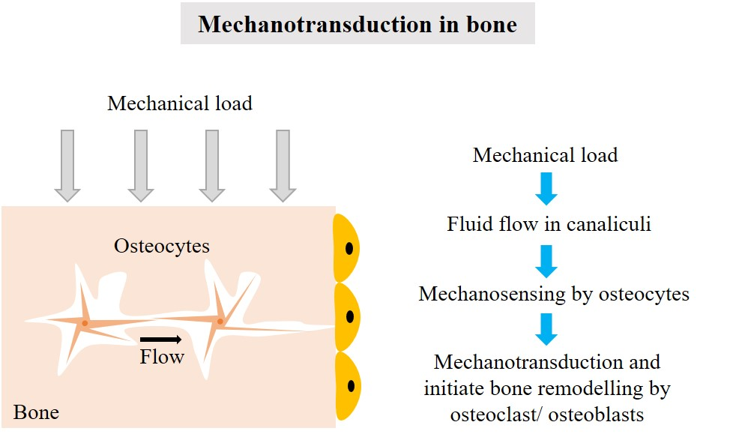
Figure 6.1. Schematic representation of the mechanical strain transduction process in bone osteocytes. Mechanical loading results in fluid shear stress and is sensed by osteocytes and translated to biochemical stimuli promoting bone remodelling processes. (This figure is prepared by the author).

Cell mechanoreceptors
Mechanical forces at the cellular level can be sensed and transduced into biochemical signals by mechanoreceptors. There are several proposed mechanotransduction mechanisms at the cellular level, including the matrix-integrin-cytoskeleton pathway [395], membrane bound proteins through the cell-cell adhesion pathway [396], the cytoskeleton pathway (actin, microtubules and intermediate filaments) [397], membrane pathways (ion channels and caveolae) [398], glycocalyx [399, 400] and primary cilium [401, 402] (Figure 6.2).
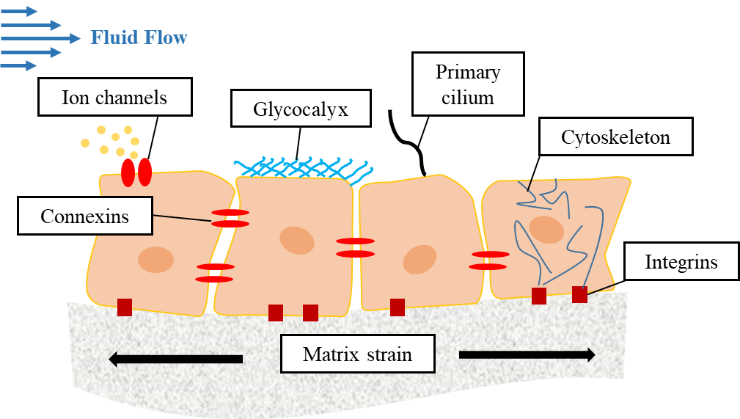
Figure 6.2. Schematic representation of important bone cell mechanotransduction mediators. (This figure is prepared by the author).

Integrins
The linkage of ECM to cells occurs via transmembrane cell adhesion proteins that tether the matrix to the cytoskeleton. The principal receptors for ECM binding are the integrin family [395]. These are receptor glycoproteins that bind and respond to ECM dynamics. Integrins are composed of non-covalent subunits called α and β. Each subunit has a large extracellular domain and binds to ECM proteins such as fibronectin, laminin, collagen and vitronectin. They also have short cytoplasmic domains that interact with signalling molecules and cytoskeletal proteins [403]. By connecting the ECM to actin filaments in the cell cortex, integrins regulate cell orientation, cell movement and cell shape. Furthermore, integrins clustering at receptor binding sites can activate intracellular signalling pathways. Integrins play important roles in cell adhesion, migration, and mechanotransduction and they serve as mechanoreceptors in a variety of cells such as fibroblasts [404], myocytes [405] and bone cells [406]. Studies have shown that mechanical stimuli can activate integrins, which further activate mechanosensitive integrins-Shc association and RhoA activation. These events form new focal adhesions that contribute to the remodelling of the actin-based cytoskeleton and thereby transfer signals into the nucleus to initiate changes in gene expression [407, 408].

The cytoskeleton
The cytoskeleton is primarily composed of actin, intermediate filaments and microtubules that provide cell structure and bear loads induced in cells, e.g. microtubules are intracellular compression elements, whereas actin and intermediate filaments are tension elements. The cytoskeleton not only connects all mechanosensing system components, but it also has an important role in cellular mechanotransduction [409]. The internal actin cytoskeleton is linked to integrins, therefore mechanical stimuli can be transduced through the cytoskeleton and integrins. It has been shown that actin filaments have crucial roles in bone cell mechanosensing [397]. Actin filaments, in osteocytes and osteoblasts under shear stress, can reorganise into contractile stress fibres, whereas actin filaments disruption decreases cellular responses to shear stress [410, 411].

Ion channels and connexins
Mechanosensitive ion channels, present in cell membranes, are responsible for the production of ion flux signals in response to stimuli [412]. Mechanical forces can cause cell deformation, directly or via FSS, leading to the activation and deactivation of ion channels, especially potassium and calcium thereby generating negative action potentials that spread to neighbouring cells [413, 414]. Therefore, cells not directly deformed by mechanical stimuli can exhibit similar biochemical responses. Ion channel activation can contribute to the biochemical transmission of external mechanical stimuli. Connexins are transmembrane proteins that form gap junctions via the alignment of its pores with counterparts in transmembrane cells. Gap junctions allow for the exchange of small molecules and ions, including calcium, ATP and PGE2 [382, 414-416]. Mechanical stimuli can increase connexin expression to enhance transmission of biochemical stimuli in neighbouring cells.

Glycocalyx
The glycocalyx, also known as the pericellular matrix, is considered an important component in mechanosensory complexes in endothelial cells [417]. Moreover, the glycocalyx is known to control cytoskeletal reorganisation and regulate cellular signalling pathways during mechanical stimuli [418]. It has been reported that a hyaluronic acid rich glycocalyx, present on bone cells, contribute to bone cell mechanotransduction via fluid flow, whereas the disruption of the glycocalyx results in decreased shear stress driven PGE2 release, in osteocytes [400]. Hexameric forms of connexins are termed connexons and once they are present on unopposed cell membranes, they are called hemi-channels (instead of gap junctions) [419]. Therefore, hemi-channels communicate with ECM to include the exchange of molecules. These hemi-channels are mechanosensitive; their openings are determined by the magnitude of mechanical stimulation [382, 383, 420]. Recent studies in osteocytes have shown that mechanical loading sensed by dendritic processes are transduced through glycocalyx, leading to hemi-channel openings on the cell body [399].

Primary cilia
Recent studies have suggested that primary cilium (Figure 6.3), a microtubule-based structure that dynamically extends from the cell membrane (similar to cellular antenna), is a key extracellular sensor candidate for mechanical loading to transmit signals into biochemical responses [421-423].
Primary cilia are found on most cell types in the human body, however exceptions include hepatocytes, cells in suspension, intercalated cells of the kidney collecting duct and cells expressing motile cilia. The cilia are microtubule-based structures that originate at the cell membrane and extend into the extracellular space. Primary cilia are classified as non-motile. Both cilia types (motile and non-motile) have a microtubule axoneme core, comprising nine sets of microtubule doublets which provide rigidity and structure. However, primary cilia lack a central microtubule pair and other machinery such as radial spokes, central pair projections and inner and outer dynein arms [424]. Unlike motile cilia, only one primary cilium is found per cell.
For primary cilia, the basal body, a modified form of mother centriole, is well recognised for its role as a microtubule organising centre of mitotic spindles. When not involved in mitosis, the basal body/mother centriole moves towards cell membranes and acts as a template for ciliogenesis and an anchor for the primary cilium [425]. Intra-flagellar transport (IFT), a bidirectional system that directs transport along the microtubules of the ciliary axoneme [424, 426], is a process that forms and maintains primary cilia. Since primary cilia do not contain the necessary machinery for protein synthesis, ciliary proteins are synthesised in the cell body and transported to the distal tip through IFT.
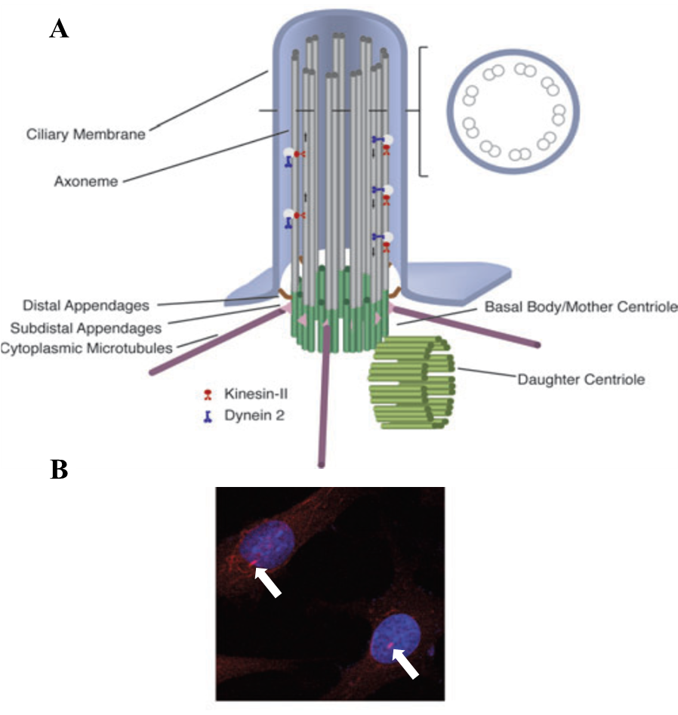
Figure 6.3. Primary cilia are microtubule-based structures found on most mammalian cells, A) Schematic representation detailing the structure of primary cilia, B) Immunofluorescence staining, anti-acetylated α tubulin, showing the osteocyte primary cilium (arrows). (This figure is reproduced from [421] with permission).
Primary cilia were first discovered over a century ago, however until recently their function was unknown, and they were believed to be vestigial organelles. Although the involvement of primary cilia in signalling pathways and calcium homeostasis was first hypothesised in the rat osteocyte over 40 years ago [427], only recently has their role been elucidated in several developmental processes such as the establishment of the left-right axis in the embryonic node [428]. Additionally, it has been shown that ciliary dysfunction results in ciliopathies, characterised by bone abnormalities during skeletal growth, such as shortened limb length or early loss of postnatal growth plates, leading to dwarfism [429-431].
Much of previous study regarding primary cilia as a mechanosensors has focused on the kidney, renal epithelia. It was reported that deflection of the primary cilia with fluid flow resulted in significant increases in intracellular calcium levels [432, 433]. Moreover, this response was reversed by the removal of primary cilia. Calcium responses are facilitated by mechanosensory complexes, which are located at the cilium base [432]. Complexes are made up of polycystin 1 (PC1), a large membrane protein and polycystin 2 (PC2), a cationic channel which is part of the transient receptor potential channel family. Similar mechanosensory complexes were reported in liver cholangiocytes. It was reported that PC1/2, and the stretch-activated ion channel are located at the primary cilium and can sense osmotic pressure and fluid shear stress [434, 435]. Primary cilia respond to fluid flow, resulting in increased intracellular calcium and the suppression of pharmacologically (forskolin) stimulated increases in cAMP [434].
Although most of initial studies focused on the role of primary cilia in skeletal development, recent studies have demonstrated their role as mechanosensor in adult bone homeostasis [421]. It was shown that cilia bending in response to fluid flow shear stress, resulted in increased cyclooxygenase-2 (COX-2) gene expression and PGE2 release in osteoblasts [401]. Additionally, the disruption of cilia caused an elimination in OPG/RANKL ratio flow-induced increase. Interestingly, flow-induced cilia-dependent responses were independent of intracellular calcium levels [401], suggesting that mechanotransduction pathways in bone cells vary between kidney and liver cells. In vitro studies in human MSCs have demonstrated that primary cilia can mediate fluid flow-increases in osteogenic differentiation [436-438], showing the importance of primary cilia as a mechanosensor in mechanosensory complexes.
However, the roles of the primary cilia in bone mechanotransduction are still underreported. For example, the pericellular spacing between osteocytes and the lacunar wall was found to be approximately 0.1 µm–2.7 µm [439]. Additionally, in vitro studies have shown that the length of primary cilia in osteocytes were approximately 2–9 µm [401, 440]. Therefore, where primary cilia are situated within lacuna, and how they flex with fluid flow is an interesting and challenging subject that requires investigation.

In vitro bone cell response to fluid shear stress
It has been shown that in vitro bone cells respond to a wide range of shear stresses. Shear stresses ranging from 0.5 Pa to 2 Pa have been suggested to impact in vitro bone cells, which correlate well with values expected to occur in vivo (0.8–3 Pa) [441]. 2D and 3D in vitro studies have shown that FSS causes changes in biochemical factors and gene expression, such as rapid increases in intracellular calcium [442, 443], increases in NO, PGE2 and ATP levels [145, 381, 383, 444]. It has also been shown that fluid flow regulates expression of osteoblast genes including, COX-2, osteopontin (OPN) and c-FOS, as well as matrix metabolism related genes, such as collagen I [374, 443]. In vitro stem cell studies are traditionally used to overcome limitations associated with in vitro osteoblasts and osteocytes. Therefore, since stem cell-based studies for bone tissue engineering are relatively common, there are several in vitro studies detailing the osteogenic differentiation impact of fluid shear stress on primary cell lines (human and non-human).
It has been shown that FSS on stem cells increases OPN, osteocalcin (OC), PGE2, Col I and NO levels, followed by calcium phosphate deposition [445-447]. Most in vitro fluid flow studies are performed over short time periods due to difficulties and challenges associated with long-term studies. Most cell systems respond to fluid flow by releasing factors such as PGE2 and NO within hours [381], however to better understand bone formation and mineralisation, more long term studies are required. Longer term studies allow osteoblasts to lay down collagen matrices, which may mineralise to become osteocytes. Therefore, the application and timing of shear stress is one of the critical points to be considered. Cells can respond to shear stress within seconds, cellular influxes, to weeks, matrix deposition. Although there are no specific definitions for timing within studies, long-term refers to a 7–21-day duration, while short term refers to <48 hours. However, in this chapter, we consider studies up to seven days as short-term studies and others as long-term.
An important factor that should be considered is the cell seeding method prior to the introduction of FSS, for short- or long-term studies. Although cell seeding techniques in dynamic systems vary based on bioreactor systems, most dynamic studies allow 24–72 hours for cell attachment prior to shear stress. However, in some primary cell studies, the static period or low flow period has been extended up to 14 days to enhance cell attachment and proliferation, in normal or differentiation medium [441]. Moreover, in some studies, dynamic seeding has been recommended to increase cell seeding efficiencies [448, 449].
Long-term studies, performed inside bioreactors on 3D scaffolds, have shown that perfusion significantly increased osteogenic differentiation and deposition of calcified ECM matrix [336, 447, 450]. However, perfusion bioreactor studies were not generally able to differentiate between the effects caused by nutrient transport or the stimulatory effects of FSS on cultured cells [450, 451]. To distinguish between these factors, the outcome of FSS on osteogenic differentiation was verified by holding nutrient transport constant and increasing shear stress by the addition of thickening agents such as dextran [452]. Dextran itself does not affect osteoblastic differentiation, however it increases media viscosity and as a consequence shear stress [453]. A further study showed that increasing the flow rate, while keeping the shear stress constant, initially, increases osteogenic marker levels, including ALP and OPN, however at higher flow rates the flow had an inhibitory effect [454]. This was possibly due to interference from high mass transport rates of cell-cell signalling mechanisms. Therefore, optimal nutrient transport rates should be considered during dynamic culturing. Similarly, it is likely that maximum shear stress exists above which either inhibitory effects can be observed or no further enhancement of cell signalling. However, current studies have not reported such effects.
To determine shear stress in 3D bioreactor models, computational fluid dynamic (CFD) modelling can be applied. Although computation modelling is informative in anticipating shear stress on scaffolds, its precise measurement can be difficult since shear stress profiles are frequently inhomogeneous. This is due to random porous structures within scaffold architecture, which makes modelling and estimations of shear stress difficult [455]. Furthermore, cell growth and matrix deposition alter scaffold porosity, and therefore change the flow profile and magnitude of shear stress. These factors cause difficulties in mathematical models. A possible solution would be a combination of computational models combined with advanced imaging techniques, such as microcomputed tomography. This approach would map cell growth and matrix deposition to adjust modelling during the experiment [368, 455, 456]. Although most of current CFD models are still limited, they could provide cell behavioural mechanistic insights into 3D bioreactors and microfluidic systems. Modelling short-term cell, stem cell or osteoblast studies, exposed to FSS on monolayers (2D) have provided considerable insights into cell signalling pathways. Therefore, by improving models and analysis in perfusion 3D systems, a greater understanding of cell behaviour can be achieved to improve in vitro models for bone tissue engineering.
Over the last decades, several studies and bone cell models have been performed to investigate the effects of FSS on bone formation. These studies have provided improved understandings of how bone cells respond to different dynamic conditions, such as different shear stress magnitudes, flow rates and biochemical pathway profiles. For example, shear stress magnitudes recommended by the literature, in in vitro models are below 2 Pa (and above thresholds sensed by bone cells, ~0.5 Pa), thereby increasing matrix production and osteoblastic differentiation. However, due to difficulties with high flow rates and shear stress, including cell detachment or inhibitory effects, it is important to anticipate localised shear stress effects to generate proper fluid control inside the system [457]. Therefore, by improving computational models to include the effects of continual deposition of mineralised tissue on shear stress, more detailed analyses can be performed to understand the effects of FSS in in vitro 3D environments. This is where microfluidics are useful model systems when compared to bioreactors.

Mechanical loading profiles
Bone architectures and skeletal frames were designed partially based on the genetic program of bone cells. However, epigenetic factors also affect skeletal designs, which are continuously updated in response to mechanical stimuli exerted on bones [458]. Therefore, bone cells can detect mechanical signals induced by FSS or matrix deformation, and more so they can adapt these signals into appropriate surface changes. It has been shown that FSS, induced by ISF and pressure in the bone marrow and the lacunar-canalicular bone networks, stimulates the release of NO which is important for osteoblast differentiation [388]. Equally, NO inhibits osteoclast bone resorption, thereby improving bone mineral density and health [394]. Therefore, in vitro fluid flow not only mitigates nutrient transport limitations in 3D culture, it also provides key mechanical stimulation for seeded cells, via shear stress. The net effect appears to enhance both the transcriptional regulation of genes associated with bone formation and the expression of transcription factors that support osteoblast differentiation and function, thereby increasing the deposition of mineralised matrices. Although the influence of mechanical loading on osteogenesis is well established, in vitro mechanical stimulation is sensitive to several parameters, such as mechanical load cycles, frequency, and magnitude (already explained).
Once mechanical forces are exerted on in vivo bone tissue, fluids inside the lacunar canalicular network experience a heterogeneous pressurisation in response to matrix deformation, where pressure forces fluid flow along pressure gradients. By removing the load, pressure gradients and flows are reversed, therefore these fluid flows are dynamic and oscillatory in nature. However , in vitro, there are contradicting reports about whether oscillating flow profiles are superior to other flow modalities at promoting osteogenesis, with studies finding it both better and no different to unidirectional flow [459, 460]. Despite this, it is important to note that when applying fluid flow in vitro, the inclusion of rest periods between flow sessions enhances flow effects. It is believed these intermittent flow profiles allow a ‘reset’ of mechanical signalling pathways, stopping them from becoming saturated and allowing reactivation when flow resumes [459, 461-467]. Intermittent flow also induces a reorganisation of the actin cytoskeleton [468], whereas continuous flow may cause cell detachment and therefore, diminish the cell viability. It has also been shown that upon mechanical stimulation, the primary cilium decreases in length, tuning its sensitivity to the ECM environment, which based on alternation in length and possibly other mechanical properties could regulate cellular mechanosensitivity [469]. Therefore, constant flow may disable the primary cilium mechanisms. Additionally, continuous flow may block vital autocrine signalling pathways by constantly removing secreted signalling factors within cell microenvironments, e.g. ATP and PGE2 [470, 471], therefore matrix deposition may not be enhanced under continuous flow profiles.
Some studies have shown that intermittent flow types can enhance matrix deposition as rest periods provide enough time for cells to re-establish adhesive contacts and re-assemble actin cytoskeletons. Additionally, rest periods allow restoration of autocrine signalling and enhancements in calcium transients and PGE2 release [462, 472, 473]. To elucidate the bone cells response to the mechanical stimulus, they must be in their receptive state. In vivo studies have shown that bone cell densities quickly respond to mechanical stimuli, to the point where osteogenic effects of stimuli are ignored by cells. For example, in vivo studies have shown that animal bone limbs exhibit large gains in bone mass once loaded for 10–50 load cycles per day, however, once the load number increased beyond ~ 50 cycles/day, bone mass increases were low [474-477]. Therefore, the mechanical load cycle and frequency is as important as the magnitude and should be considered in dynamic culture studies of bone tissue engineering.

Conclusions
The shape, size, and strength of the adult mammalian skeleton is influenced by mechanical forces during growth. Therefore, mechanical loading of the skeleton during childhood and adulthood can improve bone mass and potentially delay age-related bone loss and fractures later in life. Since bone cells adapt to mechanical loads, it is important to understand mechanisms where cells sense changes in mechanical environments and respond accordingly. Mechanosensation and mechanotransduction mechanisms are important topics in this area that have been investigated for a long time. Governing stem cell differentiation in vitro through biomechanical cues such as FSS (in addition to biochemical stimuli) is dependent on several factors. The magnitude, cycle, flow type and timing of stress are important factors that influence cellular responses. 2D experiments provide valuable indications regarding trends in relation to these factors on cellular responses. Moreover, 2D experiments provide important insights regarding mechanotransduction pathways inside bone cells such as primary cilia roles. However, direct translation of 2D results into 3D clinical systems has not been successful. Therefore, dynamic studies should focus on filling knowledge gaps on 3D systems. Microfluidics and organ-on-a-chip provide microenvironments that are similar to 3D in vivo conditions and can be used as powerful substrates to investigate bone mechanobiology. Moreover, computational fluid dynamics can be joined to microfluidic systems to investigate the effects of shear stress factors on bone cells in a 3D substrate.
In this chapter, we assess the suitability of fabricated bone microfluidic chips and compare them with studies using intermittent and continuous flow profiles on osteogenic behaviour of stem cells.

Aims and Objectives
The aim of this chapter is to assess the suitability of the fabricated BMC for stem cell culture and osteogenic differentiation in the short- and long-term. The study focusses on bone mechanobiology, emphasising flow profiles on the osteogenic differentiation of primary cells. Therefore, the following objective were generated;
- Assess the effects of different flow magnitudes on hES-MP cell viability in short-term studies

- Assess the effects of different flow profiles, intermittent and continuous, in the osteogenic differentiation of hES-MP cells in long-term studies

- Investigate the existence of primary cilia of cells inside the BMC device during dynamic cell culture

- Anticipate fluid shear stress and velocity profiles inside the device using computational models and experimental studies

Materials and Methods
Further to general materials and methods in chapter 4, the following were used in this chapter. All chemical and reagents were purchased from Sigma-Aldrich (UK) unless otherwise stated.

Culture media preparation
In addition to basal culture media (BCM) and osteogenic induction media (OIM) detailed in chapter 4, hES-MPs were also cultured in supplemented media (SM) to investigate the biochemical and biomechanical roles in the osteogenic differentiation of hES-MPs. SM is OIM excluding dexamethasone (Dex), the main chemical stimulant for osteogenic differentiation. MEMs used in this chapter were minimum alpha medium without l-glutamine (α-MEM, Lonza, UK). FBS used in the chapter was obtained from Labtech.

Static cell culture
The hES-MP cells were used to assess the suitability of the device by studying bone mechanobiology. To control and compare dynamic seeding characteristics, static culture was used. However, without flow, cells only survived approximately 24 hours inside the chip, therefore open culture of plasma treated polyHIPE scaffolds with cells was tested in a static culture. Similar to dynamic culturing, detailed in chapter 5. §5.3.9 prior to seeding, 70 vol.% ethanol was used to sterilise the scaffolds for one hour and then scaffolds were washed three times in sterile PBS at 15-minute intervals. Scaffolds were then soaked in sterile FBS overnight, during which a protein layer was laid down on the surface, improving seeding efficiencies. Scaffolds were placed in six well plates and seeded using the static droplet method (Figure 6.4 A). Approximately 120,000 cells were counted and resuspended in 30 μL BCM. They were then added to the scaffold and incubated for four hours to attach at 37°C, 5% CO₂. Subsequently, scaffolds were placed in another six well plate containing 2 mL either OIM or SM. The media were changed every two days.

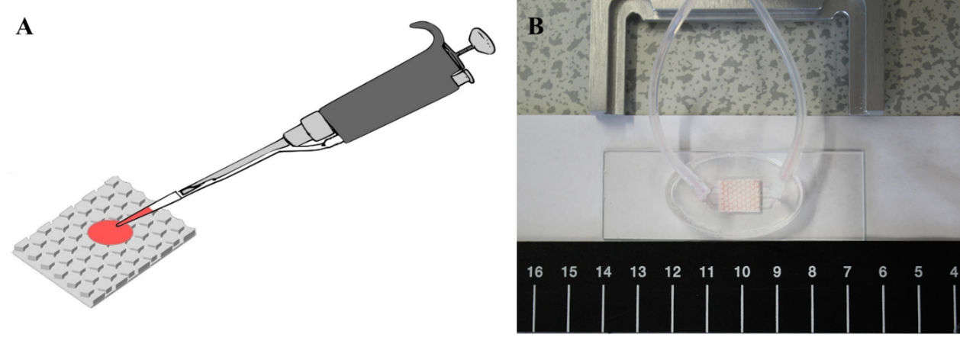
Figure 6.4. Seeding methods A) Schematic representation of the static droplet seeding method, where cells were placed on the scaffold and left four hours for attachment, prior to media addition. B) Cells were injected through a sealed device and left for four hours for attachment, prior to media perfusion.

Dynamic cell culture
Commercial Ibidi perfusion pump systems were used to perform dynamic cell culture as explained in detail in chapter 5. §5.3.9. The experiment was conducted in either OIM or SM for up to three weeks with two different unidirectional flow regimens; intermittent and continuous. Continuous flow occurred at 0.8, 1.6, 2.4, and 3.2 mL/min and intermittent flow was repeated cycling of 270 minutes at 0.8 mL/min and 90 minutes at 3.2 mL/min intermittently during the experiment.

Confocal microscopy
Scaffolds with the highest levels of cell proliferation inside the BMC, as determined from day 14 RR assay results were imaged using confocal microscopy to view cell location on the scaffold. Samples were stained with DAPI (40-, 6-diamidino-2- phenylindole dihydrochloride and Phalloidin-TRITC (Phalloidin–Tetramethylrhodamine B iso-thiocyanate) to view nuclei and f-actin, respectively. Two-photon microscopy was used to assess cell attachment to scaffold pores using the same staining protocol. Cells were fixed (chapter 3) and 1 mL immunocytochemistry (ICC) buffer (1% BSA, 0.1% Triton-X100 in PBS) was added and left for 20 minutes before removing. To this suspension, 500 μL of phalloidin working solution (1:1000 phalloidin stock solution (1 mg phalloidin-TRIT in 1.5 mL methanol) in ICC buffer), was added and wrapped in foil. After four hours, the staining solution was removed, and the scaffold washed twice in PBS. Then 1 mL DAPI working solution (0.1 vol.% DAPI in PBS) was added and left in darkness (foil) for 30 minutes. The DAPI was removed and the scaffolds washed once in PBS. Samples were then submerged in PBS, wrapped in foil and refrigerated until required. Confocal images (512 × 512 pixels) were obtained using an upright microscope (Axioskop 2 FS MOT Microscope, Carl Zeiss Ltd, UK) using a 10× objective (EC Plan-Neofluar 10×/0.30, Carl Zeiss Ltd, UK). DAPI signals were detected using a tuneable Ti-Sapphire two-photon laser (λ_{ex}: 358 nm, λ_{em}: 435–485 nm) and Phalloidin-TRITC signals were detected using a single photon laser (λ_{ex}: 543 nm, λ_{em}: 565–615 nm).

Lightsheet microscopy
To detect primary cilia on cells seeded inside BMC devices after seven days culture, a device was disassembled, and the scaffold were fixed and permeabilised in 0.5 vol. % Triton-X100, in PBS for 10 minutes. Blocking with 5 vol. % goat serum was performed for one hour at room temperature before a primary antibody (anti-acetylated α-tubulin clone 6-11B-1 produced in mouse (1 µg/mL), Abcam, UK) was applied at 5°C for 24 hours. The secondary antibody (goat anti-mouse IgG H&L Alexa Fluor® 488 (2 µg/mL, Abcam, UK) was then applied for one hour at room temperature, followed by DAPI counterstaining. Three PBS washes were performed between each step. Samples were imaged using a Z.1 lightsheet microscope (Carl Zeiss Ltd, UK). Samples were mounted in 0.8 % agarose (0.8 g agarose in 100 mL deionised water (diH₂O)) in glass capillaries (size four, Carl Zeiss Ltd, UK). Two 10× NA 0.2 illumination optics (Carl Zeiss Ltd, UK) were used to illuminate the samples in combination with a W plan-apochromat 20×/1.0 objective (Carl Zeiss Ltd, UK). Samples were excited using a 405 nm (20 mW) and a 488 nm (50 mW) laser. Z-stacks were taken, and a maximum projection image created using the accompanied ZEN software.

Histology, haematoxylin and eosin staining
Fixed scaffolds were placed into cryosectioning moulds and covered with optimal cutting temperature (OCT) compound (Leica). Moulds were left under vacuum for one hour to allow OCT to permeate the polyHIPE pores. Samples were then snap-frozen in a bath of liquid nitrogen before 8 µm sections were cut using a cryostat (Leica CM1860UV) and collected on glass slides. These were then stained with haematoxylin and eosin solution (H&E) for the identification of cell nuclei and cell structures attached and penetrated the scaffold.
To stain with H&E, samples typically must undergo a rehydration process. However, since samples were frozen, they did not need any rehydration steps. Therefore, samples were rinsed in water for one minute to remove the remaining OCT. Next, slides were submerged on a rack in haematoxylin for one minute after which prior being placed in a container with constant flow of tap water to rinse excess haematoxylin until the water flow became clear. Following this, slides were submerged on a rack in eosin for five minutes prior being dipped in two separate tap water containers to remove excess stain. Next, slides were sequentially dipped in 70 vol. % industrial methylated spirits (IMS), then 95% IMS and lastly, submerged in 100% IMS for 30 seconds each. Finally, slides were dipped in two separate containers of xylene and removed for imaging using a light microscope (Motic).

Particle tracking
Flow patterns in the device were visualised by tracking the motion of fluorescent particles using Ibidi pumps at two flow rates; 0.8 and 3.2 mL/min. A suspension of 10 µm polystyrene particles (FluoSpheres, Fisher Scientific) of 3.6 × 10⁶ particles/mL was agitated using a mixer (Lab Dancer S42, IKA). 83.3 µL of the suspension was added to 10 mL of BCM and transferred to the pump reservoir. The pump was set at 5 mL/min for five minutes to circulate the fluid, distribute the particles inside the device and eliminate air bubbles. Afterwards, flow rates were set to 0.8 mL/min or 3.2 mL/min.
Image sequences were taken using a Ti-E Nikon inverted microscope using the 4× objective lens (Plan Fluor, 4×/0.13, Nikon) at a frame rate of 20 frames per second (fps) for ten seconds. Stage control and image capture were performed using MetaMorph® Microscopy Automation & Image Analysis Software (Molecular Devices LLC). Fluorescence signals were detected using a filter system with an excitation λ: 365 nm and an emission λ: 415 nm.
To analyse particle motion, image sequences were opened as stacks in the Image J program. Multiple particles were individually tracked over a known distance inside the channels as consecutive images in the sequence, creating a line connecting these points. To determine the velocity inside the channel, particles were tracked over the desired distance (L) and by knowing the time (t) the particle takes to travel over the desired distance, the velocity (V) was measured using the equation 6.1:
$$V=\frac{L}{t} (Eq. 6.1)$$

Computational modelling
The computational model of the microchip was developed in collaboration with Prof. Garcia Granada (University Ramon Llull, Barcelona, Spain) and the computational fluid dynamics simulations were all run by Prof. Garcia Granada. We include these simulations in this thesis to provide a computational comparison with our experimental work and to estimate a shear stress, which is difficult to obtain experimentally.
Simulations of culture medium (modelled as water) flowing along the channels and through the porous polyHIPE were carried out at various volumetric flow rates (Q: 0.8, 1.6, 2.4 and 3.2 mL/min) which were assumed to be laminar with environmental pressure at the outlet fixed at 101325 Pa (atmospheric pressure). A constant temperature of 37℃ was used for all simulations using adiabatic walls with surface roughness from 0.5 µm to 100 µm. The geometries of all parts were generated in 3D, including inlet and outlet tubes of diameter 2 mm (area 3.142 mm²). A spreadsheet was generated to estimate velocity, Reynolds numbers, shear stress and pressure drops. This spreadsheet used volumetric flow velocities on entrance and exit faces and approximate values along narrow channels of approximately h: 0.3 mm × w: 0.38 mm (area reduced to A: 0.114 mm²) with estimated equivalent length from the 3D CAD L: 27 mm. Water was assumed to have a dynamic viscosity µ: 7.75×10⁻⁴ kg/(m.s) and density ρ: 1000 kg/m³.

Statistical analysis
Statistical analysis was performed using Graphpad Prism (version 7.00). All data was tested for normality (D’Agostino-Pearson omnibus normality test) and outliers was removed (ROUT method, Q = 1%). To assess differences, normally distributed data was analysed with either one-way or two-way ANOVA (depending on whether a response was affected by one or two factors) with implementation of Tukey’s multiple comparison test to evaluate the statistical significance. Differences were considered significant when p < 0.05 and notable significant differences are indicated on the figures or legends. All graphs are presented as mean ± standard deviation. All experiments were performed a minimum of two times in at least duplicate for each condition. The total number of replicates (n) is mentioned in the figure legend.

Results

Qualitative comparisons of static controls and dynamic culture
To generate controlled conditions for dynamic studies, cells were seeded inside a sealed device and left under static conditions. After 24 hours, the metabolic activity of hES-MPs was compared in sealed BMCs at 0 mL/min (static, N=1) and 0.8 mL/min (the lowest flow rate achievable, N=3). For static BMCs, metabolic activity was significantly lower, suggesting cell death (Figure 6.5). Therefore, static controls were performed in open culture.
Figure 6.5. Metabolic activity after 24h of hES-MPs cultured in sealed BMCs in static and low-flow conditions.
A qualitative (visual) seeding comparison was performed using the MTT assay and SEM imaging. Figure 6.6 shows that cells were confined through channels in dynamic cultures in sealed BMCs, while they were spread all over the scaffolds in static condition.
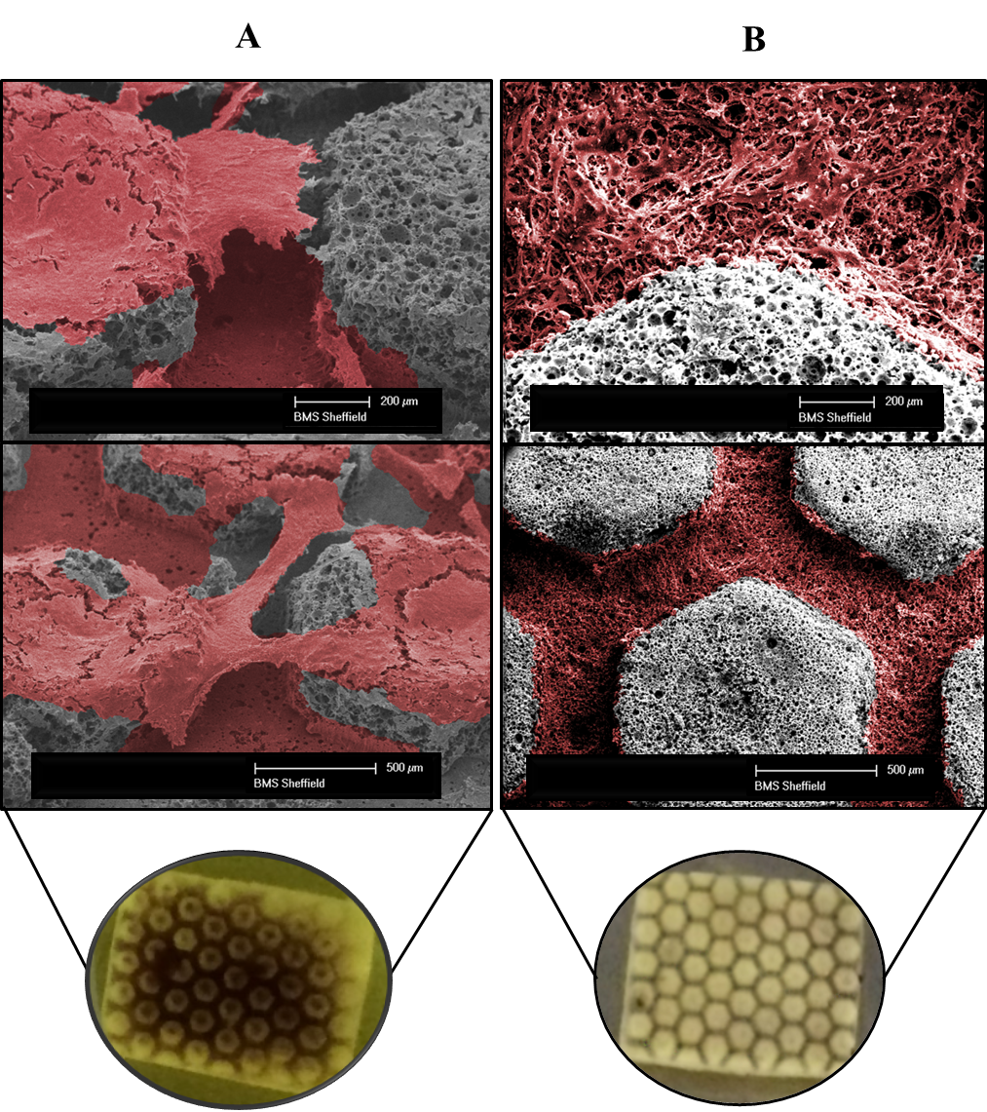
Figure 6.6. Cell growth in dynamic and open culture static conditions. Top; SEM (low and high magnification) and bottom MTT images of A) static droplet culture confirming the attachment of the cells all over the scaffolds B) Dynamic culture confirming the cells through the channels. Cells on SEM images are artificially coloured. Images were taken at day seven after culture.

Higher flow rates compromise seeding efficiency but not long-term growth
To find an optimum flow rate and pattern for dynamic cultures, different flow rates were tested over a short time period. Flow rates were initiated at the lowest flow rates feasible, using the pump set up. Continuous flow rates of 0.8, 1.6, 2.4, 3.2 mL/min were studied over a short term (seven days) period and metabolic activities were assessed and compared to a static control on day seven (Figure 6.7).
Figure 6.7. Cell metabolic activity on day seven was normalised to the static control for four different flow rates (0.8, 1.6, 2.4 and 3.2 mL/min). As flow rates increased, metabolic activity and therefore cell numbers decreased (* = p < 0.05, ** = p < 0.01) (N=4).
As shown in Figure 6.7, once the continuous flow rate increased, cell numbers as indicated by metabolic activity decreased, with significantly fewer cells in comparison to static at flow rates above 1.6 mL/min. At the highest flow rate, 3.2 ml/min, after seven days, metabolic activity was approximately 50% that of the static control.
To assess whether the initial disruption in cell numbers would impact the long-term performance of cells inside the BMC, studies at the highest flow rate, 3.2 mL/min were extended to 14 and 21 days, examining metabolic activity at each time point. Moreover, intermittent flow patterns were studied and compared with continuous flow patterns to investigate the effects of flow profiles, that if the impact of high flow rate can be alleviated by introducing rest periods.
Intermittent flow was cycled between the lowest flow rate at 0.8 mL/min for 270 minutes and the highest flow rate at 3.2 mL/min for 90 minutes. By day seven, cell numbers were significantly lower for the intermittent and continuous flow profiles, when compared to static controls (Figure 6.8 A). However, interestingly the intermittent flow profile had significantly more cells, indicating that rest periods appeared to minimise the negative impact of continuous flow rate on cell proliferation. Despite this, by day 21, there were no significant difference in cell numbers between any conditions, indicating the initial lower cell number was recovered over time (Figure 6.8 B). Therefore, BMC devices were suitable for long-term cell culture.
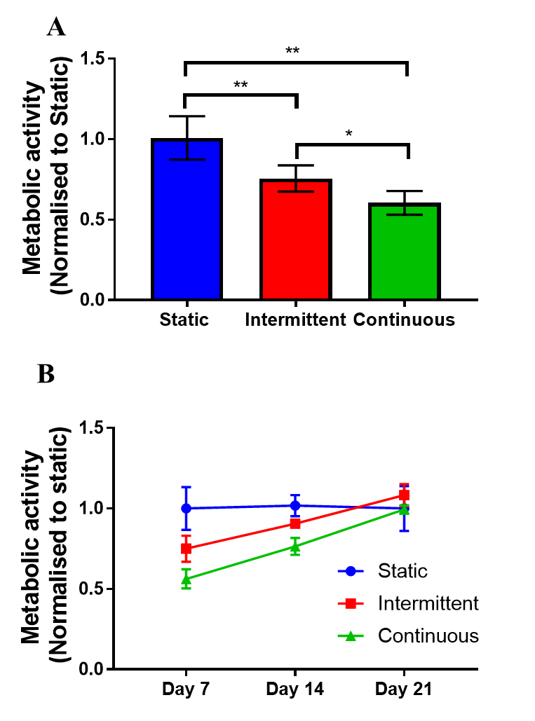
Figure 6.8. Comparison of metabolic activity over time with different flow profiles. A) Day seven metabolic activity. Both the intermittent (0.8–3.2 mL/min) and continuous (3.2 mL/min) flow profiles had significantly fewer cells after one week, when compared to the static control. However, the intermittent was significantly higher than continuous flow. B) By day 21, cell numbers had recovered for both intermittent and continuous flow profiles, resulting in no significant differences in metabolic activity at this time point. Recovery was achieved sooner for intermittent conditions. (n = 8) (* = p < 0.05, ** = p < 0.01).

An intermittent flow profile promotes differentiation more than continuous stimulation
The impact of dynamic culturing on osteogenic differentiation of hES-MPs was investigated in long-term studies using two different flow profiles; intermittent and continuous. BMCs were maintained in OIM for 14 days, with either intermittent (0.8–3.2 mL/min) or continuous flow (3.2 mL/min). Upon completion, systems were assessed for ALP activity, an early biomarker of osteogenic differentiation known to peak prior to mineralisation, showing a mature osteoblastic phenotype [478, 479]. By day 14, normalised ALP activity was significantly higher for cells inside BMCs under intermittent flow profile, when compared to all other conditions (Figure 6.9 A). Interestingly, there were no significant differences between static conditions and continuous flow profiles. To normalised ALP activity based on cell number, total DNA were measured. Moreover, total extracted DNA confirmed the resazurin data as indicated by cell viability (Figure 6.8), where, cell numbers were lower for cells exposed to flow, intermittent and continuous (Figure 6.9 B).
These data demonstrated that cells exposed to shear stresses induced by the 3.2 mL/min flow rate, had the potential to significantly promote osteogenic differentiation when compared to static conditions but only when combined with intermittent rest periods.
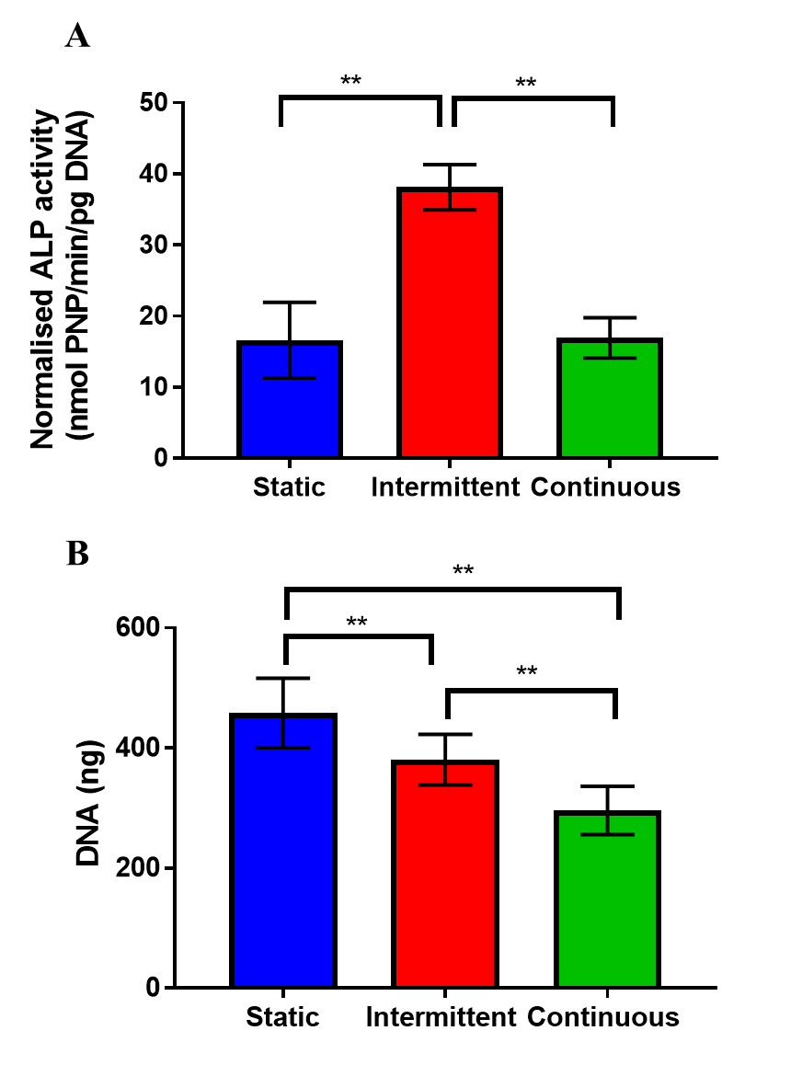
Figure 6.9. Comparison of different flow conditions on osteogenic behaviour of hES-MPs in OIM using the early osteogenic marker ALP A) At day 14, ALP activity was normalised to total DNA. The intermittent flow profile resulted in significantly higher normalised activity than the static control and continuous flow profile. There was no significant difference between static and continuous flows. B) Total DNA was extracted for each flow profile at day 14 of culture. Both intermittent and continuous flows were significantly lower than static, with continuous significantly lower than intermittent. (n = 8) (** = p < 0.01).

An intermittent flow profile enhances mineralised-matrix deposition
To understand the effects of flow profiles on matrix production in differentiated cells, hES-MPs were maintained for 21 days in OIM under either static, intermittent, or continuous flow conditions, before quantifying calcium deposition and collagen production. Mineralisation, Alizarin red S staining, and collagen production, Direct Red 80 staining, were significantly higher for intermittent flow profiles when compared to static and continuous flows. This is clearly visible in the representative images of the stained scaffolds (Figure 6.10). As for normalised ALP activity, there were no significant differences in matrix production between static and continuous flow profiles. However, both confirmed that matrix production was induced by biochemical cues.

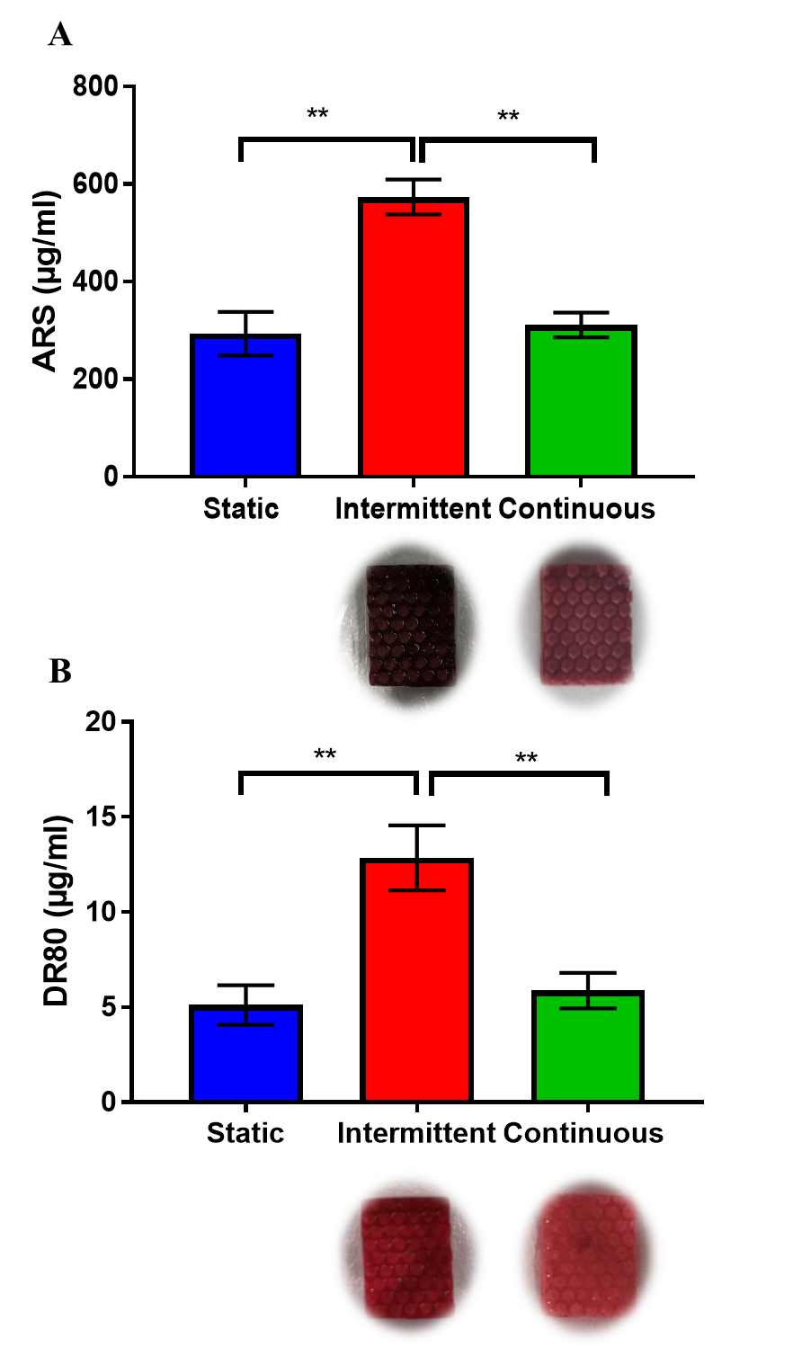
Figure 6.10. Comparison of matrix deposition of hES-MPs in OIM, in three different flow conditions, at day 21. A) Alizarin Red S (ARS) staining, the calcium content was significantly higher for intermittent flow. There were no calcium content differences between static and continuous flow. B) Direct Red 80 (DR80) staining; collagen deposition was significantly higher for intermittent flow. No differences were observed between static and continuous flow. Representative images inserted below the flowed conditions. (n = 8) (** = p < 0.01).

Cells penetrate the polyHIPE network and fill the channels within the chip
Based on results from long-term studies, the intermittent flow type displayed considerable effects on osteogenic differentiation of hES-MPs. Therefore, to determine how cells behave within the microfluidic unit, hES-MPs were cultured for 14 days in OIM under an intermittent flow profile (0.8–3.2 mL/min) before fixing and examining cells using confocal microscopy and histology (Figure 6.11).
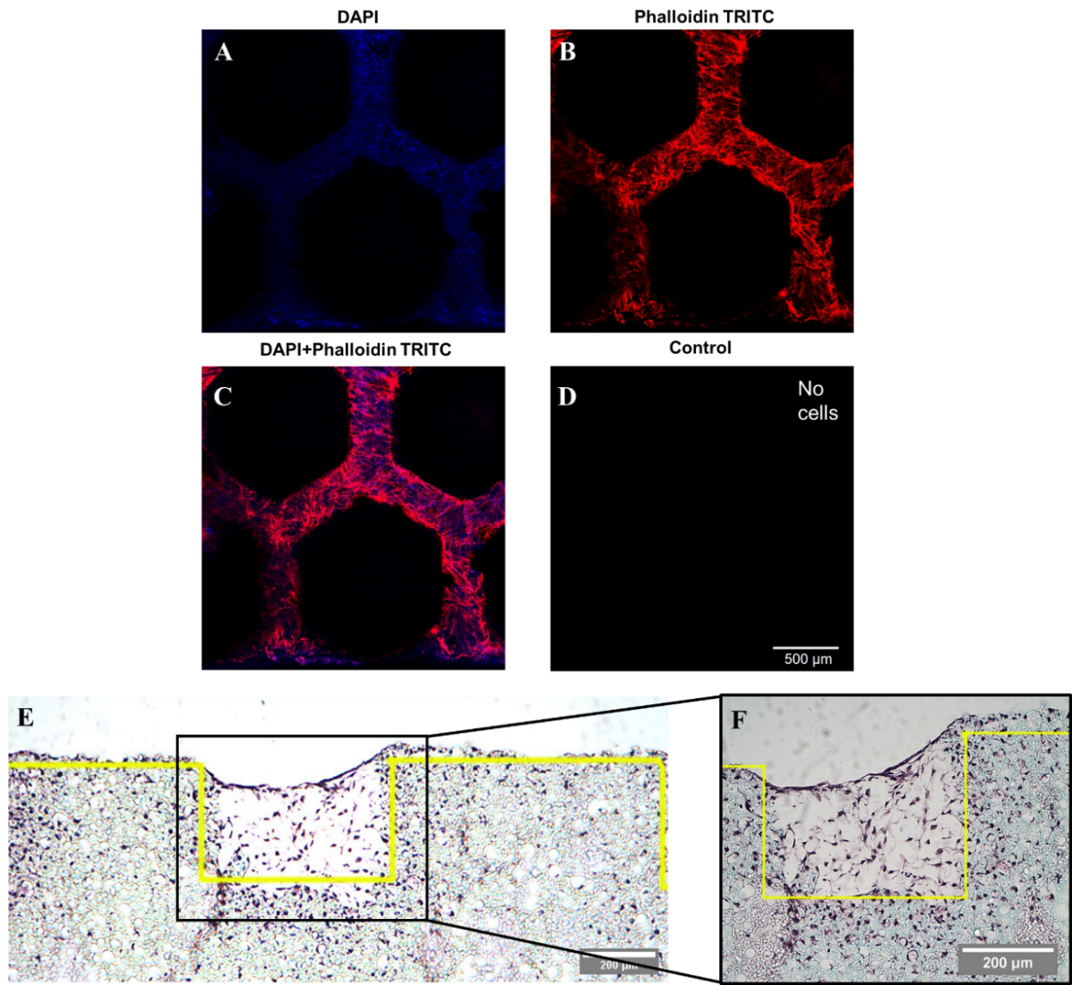
Figure 6.11. Representative images of hES-MPs seeded in BMC in OIM under an intermittent flow profile after 14 days culture. A – D) confocal images of nuclei stained with DAPI (blue) and actin with phalloidin-TRITC (red). Individual colour channels and composites shown (C). Control was not autofluorescent blue or red, hence it appears black. Cells were visible in the channels of the polyHIPE. E) low magnification and F) high magnification of 8 μm histology sections stained with H&E. Cells were seen throughout the channels to the height of the pillars, and within the interconnected porous networks of the polyHIPE bulk material.
Confocal microscopy revealed cells throughout the channels, within the polyHIPE scaffold, through the staining of nuclei (blue) and the cytoskeleton (red) (Figure 6.11 A–D). This was confirmed by SEM, where cells (artificially coloured red) clearly covered the base of the channels (Figure 6.6 B), the walls and the top surfaces of the pillars. To investigate the growth of cells inside the porous scaffold, histology was performed. This approach allowed a cross-sectional view of the scaffold, revealing not only cells present within the channels, but also within the interconnected porous networks of the bulk polyHIPE material, indicating full penetration of the material (Figure 6.11 E & F).

Fluid flow shear stress alone is insufficient to induce osteogenic differentiation
Since the intermittent flow profile elicited such a significant effect on cell growth and matrix deposition, it was interesting to investigate whether mechanical stimulation alone was sufficient to induce osteogenic differentiation of hES-MPs, by maintaining BMCs in either OIM or SM for 14 days with the intermittent flow profile (Figure 6.12). The differences between these media is that OIM contains dexamethasone, a glucocorticoid that promotes osteogenic differentiation. Both mediums contained βGP and AA2P, which were osteogenic supplements required for matrix mineralisation and collagen synthesis, respectively.

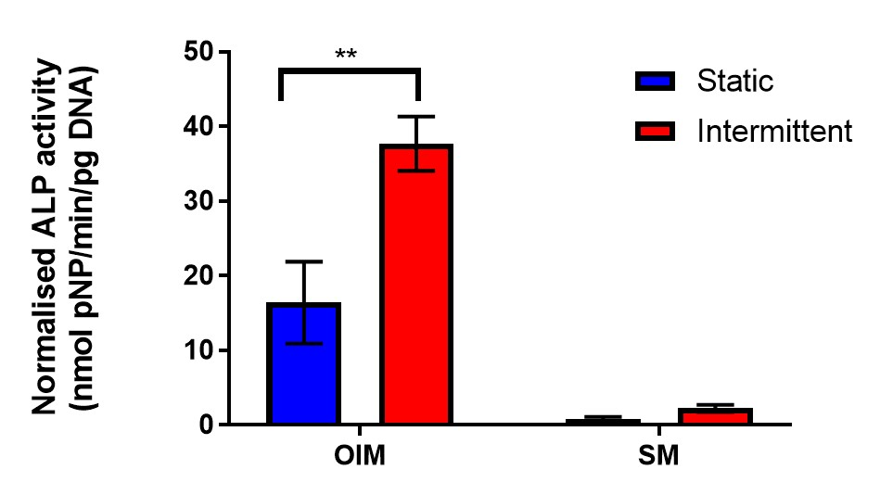
Figure 6.12. Comparison of day 14 normalised ALP activities of cells cultured inside BMCs, maintained under intermittent flow profile, in either OIM or SM. Similar to figure 6.9, ALP activity was significantly higher under intermittent flow for OIM. However, there was minimal ALP activity in BMCs maintained in SM, regardless of flow profile. (n = 4) (** = p < 0.01).
As in Figure 6.9A, normalised ALP activity was significantly higher when cells inside BMCs were maintained in OIM for 14 days, under intermittent flow profile. However, ALP activities were significantly lower in SM than OIM, regardless of flow profiles, with no significant effects of intermittent flow on ALP activity in comparison to the static control. This observation indicated the importance of correct biochemical stimulation for osteogenic differentiation of hES-MPs.

Primary cilia are present within the BMC
One of the key mechanisms by which FSS is believed to be transduced is via the primary cilium. To identify whether this mechanosensor is present within cells in BMCs, cultures were examined after seven days by light sheet microscopy using antibody staining for the mechanosensory organelle. Primary cilia were present within the channels, meaning they were exposed and could react to fluid flow through the BMC (Figure 6.13).
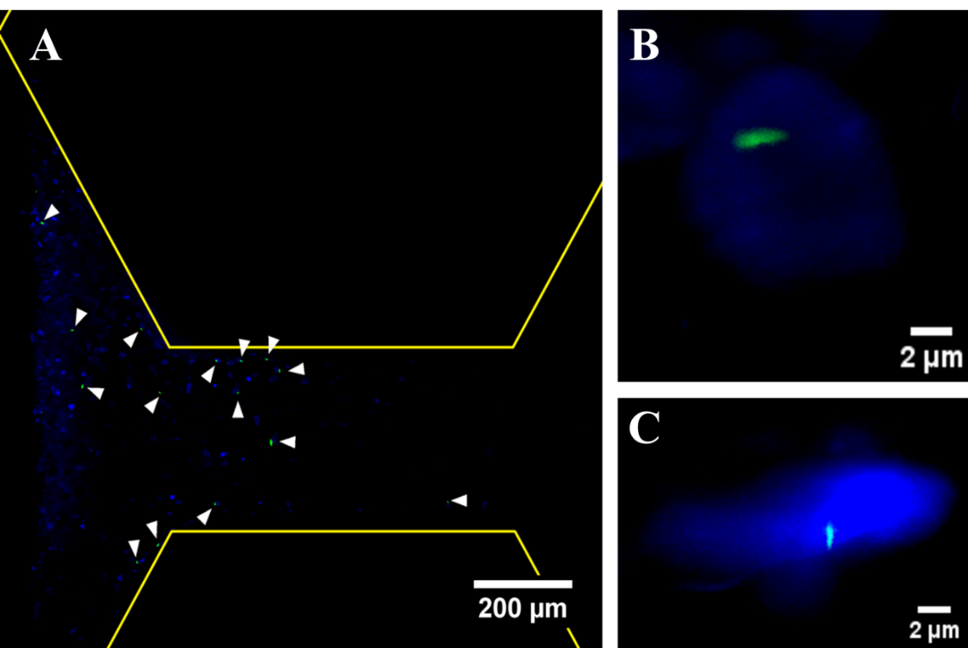
Figure 6.13. Representative light-sheet images of A) low and B) & C) high magnifications of nuclei stained with DAPI (blue) and primary cilia stained with anti-acetylated alpha tubulin (green). Arrow heads indicate primary cilia.

Particle tracking shows a laminar flow profile
Laminar flow is the key characteristic of microfluidics. To visualise flow patterns inside BMCs, particle tracking was performed for the lowest (0.8 mL/min) and highest flow rates, (3.2 mL/min) used for cell culture (Figure 6.14). For the 0.8 mL/min velocity inside the channels, in midsection of the scaffold, was measured to be between 0.004 to 0.010 m/s depending the position of the particle. The result was compared with velocity profiles estimated by CFD results (Figure 6.14 C & D). Fluid flow through the 3D polyHIPE scaffold was difficult to track as the particles passed through XYZ directions, therefore focusing on the XY plane was difficult and lead to underestimation of velocity, complicating the quantitative gathering of data.
Flow patterns for both flow rates showed laminar flow inside the channels with different velocities as expected. However, for the 3.2 mL/min flow rate (Figure 6.14 B), the quantitative analysis of particles through the 3D polyHIPE scaffold channel was not possible due to high velocity of the particles, which required a camera with higher fps. Nevertheless, the laminar flow pattern was observed. To visualise the flow pattern, the representative lines were sketched in figure 6.14 B, which therefore, the small circles do not represent the position of the particles at each frame. To have a better view of the particle’s behaviour inside the channels, the video can be watched at https://youtu.be/_ZGxn7NSymY. On the other hand, for 0.8 mL/min flow rate, small circles on each line represent the position of fluorescent particles at each frame during recording, which allows the quantitative analysis of the velocity.
During the particle tracking, further to flow pattern visualisation, it was observed that some particles passed through pillars and porous polyHIPE, as can be seen on the video (3.2 mL/min) and depicted by arrows in Figure 6.14 A (0.8 mL/min). This confirmed the interconnected porosity of the scaffold.
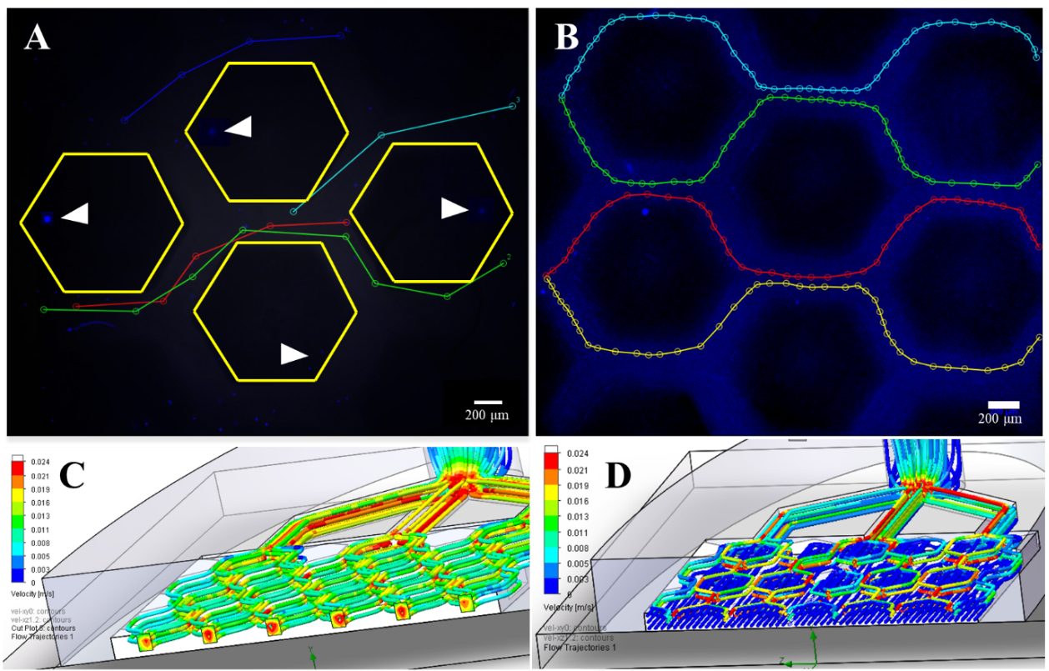
Figure 6.14. Particle tracking for A) for flow rates of 0.8 mL/min, each small circle reflects the position of particles at each frame B) 3.2 mL/min, small circles are representative and do not reflect the position of particles at each frame. Particles represent the laminar flow inside the channels. Arrows show the particles pass through the porous hexagonal pillars of the scaffold. 3D view of computational results for velocities for the 0.8 mL/min flow rate inside the BMC for C) non-porous and D) porous scaffolds.

Computational fluid dynamic estimates of flow parameters
The detail information regarding the CFD model is included in the appendix.
CFD model was used to approximate the fluid velocity and FSS distributions within the BMC during the high flow period of the intermittent flow profile (Figure 6.15). Flow through the bulk polyHIPE material was determined experimentally via a pressure drop experiment through a defined thickness disk of the polyHIPE. The pressure drop was then simulated, and the material porosity adjusted in the simulation to correlate with the experimental results (Appendix).
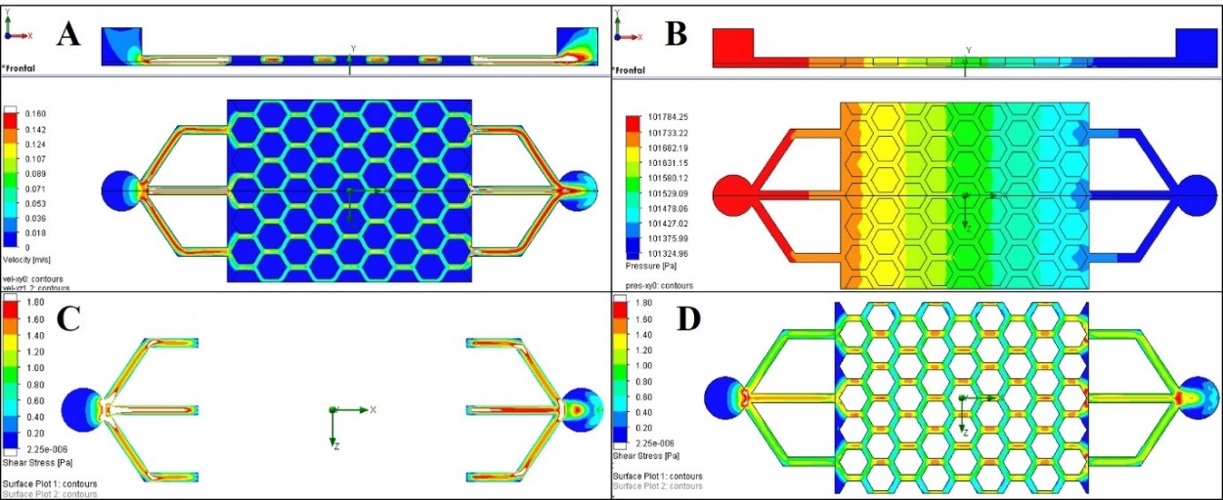
Figure 6.15. CFD results for the BMC at inlet flow rate of 3.2 mL/min. A) Velocity and B) pressure as media passes through the BMC (left to right). C) Shear stress cannot be calculated for the bottom surface of the channels as there is also flow through the porous polyHIPE base. D) Shear stresses at the bottom of the channels when the polyHIPE is assumed to be non-porous.
For an inlet flow rate of 3.2 mL/min, media velocity through the bulk polyHIPE pillars was very slow in comparison to the velocity profile in the channels (Figure 6.15 A). Although there was minimal variation in media velocity through the BMC scaffold, pressure decreased by approximately 450 Pa as it progressed (Figure 6.15 B). Shear stress at the interface between channels and the surface of the polyHIPE could not be plotted, as flow was not tangential as it also goes through the porous polyHIPE material (Figure 6.15 C). Therefore, the simulation was repeated where the polyHIPE components were assumed to be non-porous to allow shear stress to be approximated on the channels. At the base of the channels, this was approximately 0.8 to 1.4 Pa (Figure 6.15 D). It was interesting to note that the shear stress experienced by cells on the surface of the chip scales linearly with the flow, from 0.2–0.4 Pa at 0.8 mL/min to 0.8–1.4 Pa at 3.2 mL/min (Figure 6.16).
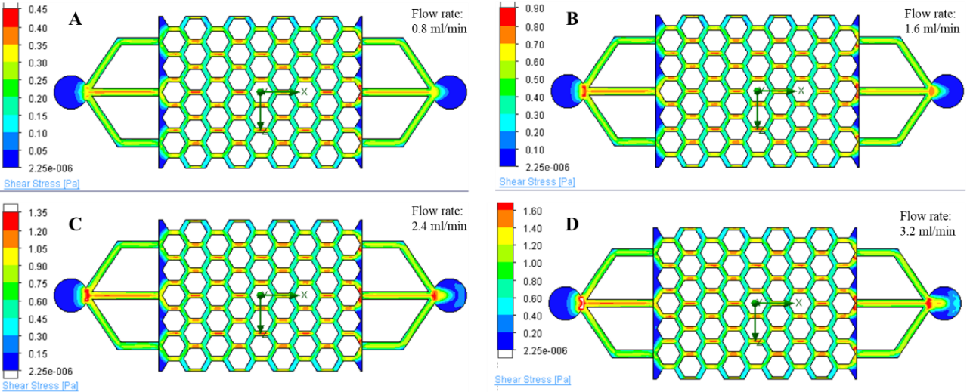
Figure 6.16. Shear stress profiles at the bottom of the channels when the polyHIPE was assumed to be non-porous for four different flow rates A) 0.8 mL/min, B) 1.6 mL/min, C) 2.4 mL/min, and D) 3.2 mL/min.

Discussion
The development of microfluidic devices for the improved study of tissues and organs in vitro has been thoroughly studied for multiple tissue types, including liver, kidney, lung and skin [109-113, 116, 117]. Moreover, recently microfluidic devices have been developed to study haematopoiesis and cancer metastasis in bone [119-122].
In previous chapter we designed, developed and characterised a microfluidic device that incorporated an interconnected multiscale 3D porous scaffold. In this chapter, to assess the suitability of the device prior to pharmaceutical studies, the BMCs were tested with parameters that were well investigated and accepted in bone tissue engineering; bone mechanobiology. The human body is constantly subjected to a variety of physical loads, which affect cell growth, tissue development and maintenance. Therefore, bone that provides protection and facilitates body movement is well adapted to physical loads, where based on the loads or lack of it the bone structure is continuously remodelled and maintained. It is hypothesised that mechanical loads induced by muscle contractions and gravitational forces in vivo are transmitted to bone cells via two mechanisms, matrix deformation and fluid shear stress [135]. However, the transmission mechanisms are different, matrix strain is applied directly through cells and their nuclei, while FSS is first sensed through the cell membrane, and transmitted throughout the cells [372]. Few studies have compared these mechanisms in vitro, while it has been reported that greater and faster responses can be seen under fluid flow [358, 373, 374]. Therefore, most in vitro studies have focused on FSS as the main mechanism in bone cell behaviour.
In this study we focused on FSS as the mechanism for osteogenic differentiation, to compare outcomes with previous findings. Microfluidic systems have great flexibility in their designs, and they can provide suitable environments that recapitulate natural microenvironments. Therefore, both mechanical and chemical stimuli can be properly investigated and manipulated using these in vitro systems.
The main research question in this chapter was to ask whether the device was appropriate for bone tissue studies. We investigated the effects of FSS as a biomechanical cue, in addition to biochemical cues on proliferation and osteogenic differentiation of stem cells in short- and long-term studies. Flow magnitudes and profiles were tested as parameters of biomechanical stimuli, while the use of Dex was tested as a parameter for biochemical stimuli. The outcomes of these studies were then compared to similar in vivo and in vitro studies.
To determine the optimum flow rate for BMCs experimentally, five different continuous flow rates were compared, 0.0, 0.8, 1.6, 2.4, and 3.2 mL/min in a seven-day short-term study. A zero-flow rate inside the BMC was chosen as a static control, which resulted in cell death, probably due to the lack of nutrition (Figure 6.5). Therefore, to have static control conditions for comparison with dynamic cultures, the scaffolds were seeded outside the chip in well plates and enough nutrients were provided. As flow rates increased, the data showed that after seven days, cell numbers were lower. Although FSS had previously been demonstrated to promote osteoblast proliferation [343], the cell decreases described here were most likely due to the detachment of poorly attached cells at fluid flow onset, an effect exacerbated by higher flow rates [14, 334].
To determine flow conditions inside the channels of BMCs, particle tracking was performed for two flow rates, 0.8 and 3.2 mL/min over a known distance. Laminar flow inside the channels was observed in both conditions. To define the velocity inside the scaffold channels, only flow rate of 0.8 mL/min could be used. To be able to quantitatively analysis the particles to obtain the velocity, it is required to obtain the particle positions at each frame in a certain distance, therefore, since the distance was short, for flow rates above 0.8 mL/min, such as 3.2 mL/min cameras with higher fps was needed to acquire particles movement precisely at each frame over the specific distance. To obtain the velocity of particles for 0.8 mL/min flow rate, four different particles, which were not trapped in 3D structure or moved slowly inside the interconnected porous scaffold, were chosen and tracked over time. According to equation 6.1, velocity calculated and ranged between 0.004 and 0.010 mm/s depending on the position of the particles inside the channels. It is required to be mentioned that quantitative analysis based on particle tracking is prone to inherent errors. This is because that, as particles moves on XYZ planes, interpreting the 3D particle tracking using 2D videos (XY) will cause underestimation in velocity magnitude which leads to errors. Therefore, it is believed the velocity could be higher. Another interesting observation from particle tracking, was the movement of particles inside the pores. It was observed that few numbers of particles were passing through the porous pillars showing an interconnectivity of the porous scaffold. However, due to random micro-porosity and interconnectivity, particles passing through pillars passed slowly and in relatively random directions. Additionally, as the pore size varies, a few numbers of particles were traped inside pores less than 10 μm (particles dimension).
Considering the short-term cell culture and cell tracking results, computational studies were performed to estimate the FSS inside the channels of the scaffold, for different flow rates. Based on the results of particle tracking for the 0.8 mL/min flow rate, the velocity magnitude inside the channel ranged between 0.004 and 0.010 mm/s. The results obtained from CFD models using the same flow rate, 0.8 mL/min, showed that the velocity inside the scaffold channels ranged between 0.005 and 0.021 mm/s. The difference between experimental and simulation could be due to several reasons. Firstly, as mentioned velocity obtained from particle tracking was not accurate as the images only represent 2D views, however, the particles moved on 3D plane. Subsequently, the CFD models were based on dimension from the CAD files, which could be slightly different from the fabricated models. During the fabrication process, from the fabrication of the bioreactor and scaffold to assembly, minor errors may occur such as small gaps between the scaffold and bioreactor during the assembly. These minor errors could accumulate and affect the velocity profile inside the devices. Moreover, in the simulation study condition is presumed as ideal, while in experiment, different parameters can affect the outcomes, including the tube resistance, temperature, and the pump condition. Therefore, as CFD models represented the ideal condition, minor differences from the experimental conditions could be observed. To overcome part of the limitations, a possible solution was to have more realistic CFD models, similar models as the experiments, by using imaging techniques such as micro computed tomography scan of the fabricated device to model a realistic 3D structure, instead of using the CAD model. Considering all these parameters and errors, results obtained from the CFD were accountable, therefore, shear stress was estimated on the scaffold channel using CFD models. For shear stress anticipation, the scaffold was assumed non-porous due to the difficulty of the flow behaviour in porous scaffold; in particular the porous surface makes it difficult to determine the tangential flow as it also goes through the porous polyHIPE material. Moreover, the effect of cell growth over time was not considered for shear stress estimation. Although imaging techniques such as micro computed tomography could be used to study the effect of cell growth and mineralisation in the CFD study, but due to a lack of equipment close to the cell culture condition, it was not feasible. The imaging should be regularly performed and the CFD model should adjusted based on its results. Although the results were not accurate for the experiment, they were informative in anticipating localised shear stress induced in cells. Results showed that shear stress varied from 0.2 to 0.4 Pa for the 0.8 mL/min flow rate, and from 0.8 to 1.4 Pa for the 3.2 mL/min flow rate. It has been estimated that shear stress in in vivo bone, ranges from 0.8 to 3 Pa [5, 6] and most dynamic in vitro studies and bioreactor experiments suggest that shear stress affects bone cells in the ranges between 0.5 and 2 Pa [441]. Higher flow rate was not tested in this experiment as extremely high flow rates may cause inhibitory effects on osteogenic differentiation, despite other negative effects on proliferation such as cell detachment [454]. Therefore, based on computational studies for shear stress, the 3.2 mL/min flow rate was chosen for long-term 21-day studies to investigate cell proliferation inside the BMC in the long term prior to the osteogenic differentiation studies. The results suggested that despite the initial loss of cells, cell numbers recovered to the level of the static control over a 21-day culture period, indicating that proliferation rates were enhanced under flow (Figure 6.8).
Despite the FSS magnitude, the mechanical stimuli cycle is also an important factor in dynamic bone tissue engineering. Studies have suggested that the continuous mechanical stimuli and FSS can be ignored by cells as the cells and their mechanotransducers, such as primary cilia quickly adapt and desensitise to stimuli. Therefore, it is recommended to place the loads in cycles, while keeping the load cycle under 50 loads per day to reveal cells’ response and consequent bone mass gain [474-477]. Therefore, to have cyclic force in the study rest periods between flow sessions were introduced by performing intermittent flow profiles. It is known that rest periods may allow mechanical signalling pathways to reset and prevent desensitisation to FSS [459, 461-467]. The benefit of introducing rest periods to break up continuous stimulation is likely due to it preventing the osteogenic response of cells from becoming saturated and also allowing the mechanotransducers to recover. When initially exposed, both continuous and intermittent flow profiles have the same osteogenic effects, as the FSS was mechanotransduced. However, under continuous flow, this stimulation is subject to diminishing returns, whereas under intermittent flow where the cells are allowed to recover, the subsequent bouts of stimulation are as effective as the initial treatment [480]. The flow rate magnitude, 3.2 mL/min was chosen based on experimental and computational results, and also to test mechanical profiles, intermittent flows along with continuous one was tested. In vivo, it has been found that rest periods of four to eight hours are required to regain mechanosensitivity of osteoblasts [461], therefore in this study, the BMC was subjected to high flow conditions (3.2 mL/min) for 90 minutes, followed by low flow conditions (0.8 mL/min) for 270 minutes, in a repeating cycle for the duration of the experiment. This allowed cellular recovery. Low flows rather than static flows were selected for rest periods to prevent the negative effects of zero flow, cell death, at the expense of minimal continuous stimulation, the lowest achievable with the set-up. Moreover, the CFD results for the 0.8 mL/min flow rate showed that the shear stress inside the channels was between 0.2 to 0.4 Pa, which was below the recommended threshold shear stress in vitro (0.5 Pa) and in vivo (0.8 Pa). Additionally, the metabolic activity of cells at the 0.8 mL/min flow rate was not affected considerably. Although the metabolic activity, a fair representation of cell number, decreased, the difference compare to the static was not significant (Figure 6.7). Therefore, osteogenic differentiation could not significantly be affected by minimal continuous stimulation of flow during intermittent conditions.
The metabolic results were first tested under intermittent mechanical stimuli profile to compare with static and continuous data. Results showed the lower metabolic activities compare to static conditions in short-term studies, which was primarily due to cell detachment. However, the differences were recovered faster when compared to continuous. Although the metabolic activity of cells cultured under intermittent flow profiles recovered to the levels of static controls first, this appeared to be due to a smaller initial loss of cells, due to the resting profile, rather than a faster recovery rate as the gradients of the intermittent and continuous profiles are comparable.
As well as promoting proliferation, FSS has also been demonstrated to improve osteogenic differentiation and mitigate nutrient diffusion limitations. Therefore, despite the metabolic studies, the efficacy of FSS in promoting osteogenic differentiation of hES-MPs was investigated under different flow conditions; intermittent, continuous and static. Long-term studies were performed to examine the osteogenic differentiation. It was found that after 14 days, the ALP activity, early biomarker of osteogenic differentiation, in continuous and static condition was similar. In line with ALP activity, after 21 days, while all conditions showed bone development, there were no significant differences in mineralised matrix deposition between static and continuous flow profiles. However, when an intermittent flow profile was applied, ALP activity, calcium deposition and collagen synthesis were approximately 2.3, 1.8 and 2.2 times higher than continuous flow profiles, respectively. These data agreed with previous studies that found that the introduction of rest periods, in mechanical stimulation protocols, significantly promoted osteogenesis of progenitor cells in comparison to continuous flow approaches, and importantly rest periods were more effective in triggering mechanotransductive pathways [345, 459, 465-467, 473]. These observations demonstrated the importance of appropriate mechanical stimuli in bone tissue engineering studies.
Images of scaffolds after seven days culture, performing MTT assay and SEM (Figure 6.6), represented differences between the cells’ position on the scaffold in different conditions, dynamic and static. It was also obvious that less cells were confined through scaffold channels under dynamic culture conditions, when compared to static conditions; cells were spread all over the scaffold. However, interestingly, at day 14, histology and confocal imaging (Figure 6.11) revealed that cells have filled the channels and fully penetrated the scaffold, infiltrating the porous pillars, reaching the top and bottom of the scaffold and depositing significant quantities of extracellular matrix within the channels, despite low initial cell attachment. Therefore, our qualitative data confirmed the quantitative outcomes showing the positive effects of the intermittent flow on cell proliferation and hES-MP osteogenesis. Moreover, it was interesting to note from histology data that cells penetrated inside the interconnected porous scaffold, possibly resembling osteocyte conditions inside mineralised bone. Therefore, further studies can be done using the BMCs to investigate cell phenotypes and behaviours inside these porous scaffolds.
An additional study performed during BMC assessment was to investigate whether biomechanical stimuli had synergic effects with biochemical stimuli, or whether it could directly stimulate progenitor cells towards osteogenic lineages. Therefore, to examine biomechanical stimuli, dexamethasone, a key biochemical stimulant that promotes stem cell differentiation, was removed from OIM and 14 days experiment performed in static and intermittent flow conditions. The effect of biochemical and mechanical stimuli was assessed by ALP activity of hES-MPs. Results showed that despite intermittent flow profiles resulting in normalised ALP activity and matrix production of the cells doubling while performed along with biochemical stimuli (in OIM), it was not sufficient to stimulate osteogenic differentiation when dexamethasone was not present (in SM). This was in agreement with other studies examining the effects of FSS on hES-MPs [481, 482], demonstrating that FSS may enhance differentiation and bone formation but is not sufficient to induce osteogenic differentiation. This showed that biochemical stimuli are necessary for osteogenesis, while a lack of biomechanical stimuli can lead to an underestimation of results in vitro.
Mechanical forces at the cellular level are sensed and transduced into biochemical signals by mechanoreceptors or mechanotransducers. Mechanotransduction is the mechanism that describes the process. However, the mechanotransduction mechanisms are still poorly understood, which microfluidics could provide models to study these mechanisms properly in vitro. In bone cells, one potential mechanotransducer is the primary cilium: a solitary, immotile organelle that emanates from the cell body in the majority of mammalian cells. Fluid flow models have been shown that FSS induce primary cilia bending [483] and increases in Ca²⁺ within the cilia of cultured osteocytes [438]. A detailed investigation by Coughlin et al., [484] indicated that approximately 4% of osteocytes in bone expressed visible cilia. However, investigating cilia roles in in vivo 3D models is complicated. For example, imaging primary cilium is difficult as osteocytes are embedded within bone matrices and necessary tissue preparations for this process can destroy its fragile structure. Moreover, primary cilia detection is complicated due to their size, relative to the cell body. Therefore, with these difficulties in mind, we investigated whether primary cilia could be detectable and more easily imaged using 3D BMC culture systems. The use of lightsheet microscopy confirmed the presence of primary cilia and allowed for the rapid acquisition of images when compared to other imaging techniques. Our approach involved minimal sample manipulation which was advantageous when imaging delicate organelle. The ability to detect the presence of primary cilia indicates that the BMC could be a valuable tool for investigating their morphology in 3D. For example, although the primary cilium is thought to play roles in FSS mechanotransduction, it is unknown whether the cilium bending observed in vitro is possible in vivo due to spatial confinements of osteocytes within lacunae. With a typical cilium length of 2–9 µm [401] observed in 2D in vitro culture and an estimated pericellular space of 0.1–2.7 µm [439] between the osteocyte cell body and lacunar wall, the primary cilium may not have sufficient room for bending and may also be anchored [485] to the lacunae wall itself [486, 487]. The cilia length in our study as indicated in Figure 6.13 B and C is 2 µm. Histology results showed cell proliferation and penetration inside the porous structure of the polyHIPE scaffold. Therefore, by altering polyHIPE micropore sizes to mimic lacunae in vivo, primary cilia length, presentation and position could be studied in a more in vivo like environment to provide mechanistic insights on cilia mechanotransduction.

Summary
This chapter described the assessment of fabricated BMCs by investigating bone mechanobiology, where both mechanical stimuli magnitude and frequency influenced proliferation and osteogenic differentiation of progenitor cells. Therefore, different magnitudes and frequencies were tested. The study showed that dynamic culture in any condition causes cell detachment, possibly induced by the flow and due to the nature and efficiency of dynamic seeding. For example, a short term seven-day study indicated reduced cell levels in dynamic culture due to early detachment. However, less cells were reduced under intermittent conditions when compared to continuous flow conditions. Moreover, it was shown that cell losses were recovered in the long-term experiments, up to 21 days, for both intermittent and continuous flow studies, while recovery was faster under intermittent conditions. The effects of frequency on osteogenic behaviour of hES-MPs was investigated by comparing dynamic, continuous and intermittent, with static conditions. Studies showed that osteogenic behaviour was the same for both continuous and static conditions, indicating a desensitisation of cells to constant stimuli. While, intermittent flow profile enhanced osteogenic differentiation of hES-MPs, compared to other conditions, due to the introduction of rest periods. Critically, this allowed cells to reset mechanotransduction mechanisms and signalling pathways. This chapter also showed that, although biomechanical stimuli are important, their effects alone were not enough for osteogenic differentiation; suggesting both biochemical and biomechanical stimuli are required for precise osteogenic developments in in vitro studies.
To have a view of cells and their behaviour inside the BMCs, imaging techniques were used, which histology, confocal microscopy and SEM results confirmed that PolyHIPE scaffolds provided adequate substrates for cell growth, ingrowth and osteogenic differentiation. Moreover, primary cilia, a key mechanotransducer in bone cells, were detected using imaging technique, meaning primary cilia mechanotransduction roles could be investigated in detail using BMCs.
To investigate the behaviour of flow inside the devices, fluorescent particles tracking and CFD studies were performed, which both demonstrated flow behaviour inside the channels as laminar flow. Additionally, CFD results anticipated the velocity and shear stress inside the scaffolds, demonstrating a flow rate of 3.2 mL/min produced a shear stress between 0.8-1.4 Pa, suitable for dynamic culture studies. In general, BMC assessment results showed the suitability of BMCs as proper investigatory in vitro models for bone pharmaceutical studies.

Anabolic bone drug evaluation

Introduction
Scientists rely on basic in vitro cell culture platforms and in vivo animal models to investigate and understand biological processes to develop new therapeutic strategies. Current in vitro models are unquestionably informative, as they provide molecular insights into intracellular physiological and pathological processes. However, these models often do not replicate the complex cell-cell and cell-matrix interactions, seen in in vivo systems [488, 489]. On the other hand, in vivo animal models address this limitation by providing both a complex environment and integrated multi-organ responses. However, in vivo models have their own shortcomings, e.g. the isolation of specific tissues or cell groups can be difficult and may lead to gene knockouts or transgenic animals. Besides obvious ethical concerns, the different biological behaviours of animals [488, 489], limits the extrapolation of data from animal models to the human condition. Additionally, regulatory restrictions limit the use of animal models in studies, thereby supporting the 3R principles, reduce, refine and replace [243]. Such collective limitations associated with in vivo and in vitro models, undoubtedly lead to failures in the development of new drug candidates reaching the market. Therefore, scientists have developed new in vitro models, known as organ-on-a-chip, to model human-based tissue-like constructs for drug development and testing [488, 489]. Organ-on-a-chip technology closely mimics key microstructures of human organs and tissues, and could provide not only increased biological relevance, but also a high throughput platform to testing novel therapeutics prior to market.
Currently, pharmaceutical companies spend 10–15 years developing new drugs for FDA approval. Despite the high cost of research and development (R&D), it is estimated that only five drug compounds, from a potential of 5,000–10,000 compounds will enter clinical trials. Critically, of these five, only one will be approved by the FDA [1]. Therefore, companies seeking high throughput platforms, to reduce costs and drug development times, must find alternative strategies. This is where the organ-on-a-chip platform provides a promising alternative in addressing these gaps, when compared to conventional in vitro and in vivo models [488, 489].
Drug discovery strategies usually involve biochemical assays which are used to identify lead compounds [490]. However, biochemical assays cannot represent the cellular impact of a drug on its immediate surroundings. Therefore, companies must test the new compound using in vitro models, prior to animal testing and human clinical trials. The use of primary cells, derived from humans, is often limited and are subject to availability and phenotypic heterogeneity. Additionally, primary cells often rapidly lose phenotypic properties during conventional cell culture [491]. However, with recent progress in embryonic stem cell technology, this technique has the potential to be a large-scale human cell source for cell-based assays in R&D studies [491].
Two-dimensional (2D) in vitro static cultures are first used, after biochemical assays, to identify cellular characteristics such as cytotoxicity of new compounds. 2D static models are simple to operate, and are accompanied by well-established, automated plate reader and liquid handling technologies and multi-well microplate technology for high-throughput screening. The main advantages of these models are their reproducibility and easy manipulation of large quantities of cell samples for high throughput drug screening. This is due to the monolayer characteristics of the cell culture, which facilitates the direct observation of cells using conventional microscopy. However, 2D models are poor representations of in vivo conditions; in preliminary studies they are limited in their predictive value of drug compounds, such as the assessment of cytotoxicity at different drug doses [492]. This is mainly due to their simplified monolayer environment which significantly differs from 3D in vivo environments.
Mammalian cells, in their native environments, are subject to many biological cues such as growth factors, cytokines, hormones, cell-cell interactions and biomechanical cues such as fluid shear stress (FSS), pressure or compression surrounding ECM [493]. These signals determine, amongst others, cell proliferation, differentiation, and/or apoptosis in the native environment. Hence, the scientist requires a better culturing environment to understand and faithfully replicate cellular responses to new drug compounds. Conventionally, pharmaceutical companies used to test drugs in animal models after preliminary studies. However, due to high costs, ethical concerns and new regulations associated with animal models, 3D culture models are recognised to provide a better understanding of drug impact under in vivo conditions [493-495]. 3D models provide more physiologically relevant conditions for cell culture and therefore, provide better platforms for the quantitative modelling of in vitro to in vivo conditions. For example, cancer cells in a 3D model are more resistant to the cytotoxic side effects of anticancer drugs, than in 2D models, similar to in vivo conditions [496]. Although, there is growing evidence showing that 3D models can anticipate drug responses better that their 2D counterparts, 2D models are still favoured in industrial settings, because of their simplicity and lower operational costs. Additionally, most microfluidic platforms introduced for drug research to facilitate the drug development, by providing innovative, and efficient assays for cell study, initially adopted 2D cell culture formats for toxicity tests and cellular responses [497-501]. However, recently scientists have developed 3D based microfluidic systems to provide more in vivo like cell culture conditions to reduce the time and cost of drug development, by improving the efficiency of preliminary in vitro studies [120, 121, 502-504]. Although microfluidic based systems, such as organ-on-a-chip models are still at early development and proof of concept stages, these approaches will become high throughput in in vitro drug testing platforms and will be better able to predict human cellular and physiological responses.

Bone anabolic drugs
Healthy bone is continuously resorbed and rebuilt for normal function. Resorption is performed by haematopoietically derived osteoclasts, whereas osteoblast formation of lost bone is derived from bone marrow stromal cells. In healthy young adults, there is a balance between bone resorption and formation which is governed by mechanical and chemical (homeostatic) factors [505, 506]. As the adult gets older, bone resorption slowly outweighs formation, and both women and men start to lose 0.5-1% bone mass yearly [507]. Besides age-related bone loss, diseases such as osteoporosis influences bone quality and quantity by affecting the bone resorption and formation balance, which leads to bone fractures and possible bone grafts [175, 176]. Although the exact definition of bone quality remains elusive, it may be defined in terms of bone tissue characteristics such as composition, morphology, architecture, microdamage, remodelling dynamics that contribute to bone strength in addition to density [508]. Women following the menopause start to rapidly lose trabecular bone of the vertebrae, pelvis and distal forearms [509]. Approximately 8 –10 years following menopause, a slow, age related bone loss becomes apparent in both trabecular and cortical bone and continues throughout life. Bone loss in men is usually related to a slow age-related phase [510]. In addition to bone disease, several cancers involving solid tumours or hematopoietic malignancy exert negative impacts on bone quality, either locally by bone metastasis or systematically as in the case of humoral hypercalcemia of malignancy. These diseases affect bone health, causing bone resorption and loss of calcium, leading to fractures and severe pain [215, 216].
To treat common bone diseases such as osteoporosis, existing therapies may increase bone mass by stimulating osteoblastic bone formation, or limiting bone loss. Currently, most therapies focus on bone resorption inhibition by via either targeting osteoclast generation e.g. with oestrogen or osteoclast activity, e.g. with bisphosphonates to limit osteoclast formation and function, respectively. Despite the therapeutic effects of anti-resorptive medication, these treatments are often limited in restoring bone mass, and at best they reduce the incidence of osteoporotic fractures by up to 50% [511]. Moreover, patients with severe osteoporosis do not benefit significantly from inhibitory treatment [512]. The ideal treatment for these patients is one that stimulates bone formation and restores trabecular connectivity. Therefore, there is considerable interest in developing anabolic compounds to increase bone formation and mineral density [512, 513].
Another important factor regarding these treatments that should be considered is their side effects, which should be minimised. For example, bisphosphonates are common anti-resorptive drugs used for osteoporosis patients, as they reduce bone turnover, lower fracture risks and increase bone mineral density (BMD) in postmenopausal women [514]. However, orally administrated bisphosphonates cause side effects such as gastrointestinal intolerance, including dyspepsia and abdominal pain. Moreover, intravenous bisphosphonate administration can lead to influenza-like symptoms [514]. Therefore, there is great interest in developing natural osteoporosis compounds, with minimal side effects.
In addition to bone disease treatments, complex conditions such as vehicle accidents, falls and serious bone defects could challenge effective therapies. Bone grafts are usually ideal solutions for such critical conditions [175, 176] and are currently the second most commonly transplanted tissue [177]. However, due to high demand and the limitations associated with bone graft techniques, especially autograft, such as limited availability, morbidity, possible infection and immune response, an alternative treatment was required. Hence, bone tissue engineering was introduced to meet the demand and overcome the associated disadvantages of different types of bone grafts. Tissue engineering principles involve the acquisition of cells, expanding them in vitro, seeding onto scaffolds and implanting back into the patient [187]. Scaffolds should have different inherent characteristics, including osteoconductivity and osteoinductivity. However, the osteoinductivity of scaffolds may require enhancements by the introduction of anabolic therapeutic agents [515-517].
To date, several anabolic compounds have been introduced for bone diseases, especially osteoporosis. In this chapter, we focus on the potential of several therapeutic agents including, lactoferrin, icariin, meanquinone-4 (MK-4), oestrogen and lithium chloride (LiCl). We investigate their anabolic effects on the osteogenic differentiation of stem cells and osteoblastic bone formation.

Lactoferrin
Milk contains many growth factors and provides vital nutrients for rapid neonate skeletal growth and development. Therefore, milk is considered a viable source for anabolic factors that affect bone [518-520]. One such factor, found in milk and colostrum in high concentrations, is the glycoprotein, lactoferrin [520], which is a member of the transferrin family that binds transferrin iron (Fe³⁺) ions [521]. This glycoprotein is produced by various exocrine glands and is also the main constituent of secondary granules from neutrophilic leukocytes [521]. In healthy subjects, lactoferrin serum levels range between 2–7 μg/mL. These mainly originate in neutrophils, but during inflammation and some viral infections, local concentrations may range between 1–100 μg/mL [522]. Therefore, lactoferrin is classified as an acute-phase protein by some authors [523]. It has been reported that lactoferrin affects embryonic development [524], cell growth and differentiation [525], endothelial cell adhesion [526], myelopoiesis [527], chemokine and cytokine production [528-530], regulation of the immune system [531] and modulation of inflammatory responses [532].
Recently, the anabolic effects of lactoferrin in bone, has been investigated in in vivo and in vitro studies [533-535]. It has been reported that lactoferrin is an osteoblast growth promoter, increasing local bone formation and as well as inhibiting osteocalstogenesis [520, 533, 534]. Additionally, lactoferrin reduces osteoblast apoptosis by 50–70% [520]. Although lactoferrin inhibits osteoclastogenesis, no effects of lactoferrin has been seen to inhibit bone resorption by mature osteoclasts [536]. The molecular mechanisms by which lactoferrin functions at the cellular level are not yet fully known. Currently, it has been suggested that lactoferrin is able to binds reversibly to selected lactoferrin receptors [537]; e.g. low-density lipoprotein receptor-related proteins-1 and -2 (LRP1 and LRP2), which are multi-ligand members of the Low-density lipoprotein receptor-related proteins (LRP) family of endocytic receptors [538]. Recent studies have suggested that LRP1 functions both as an endocytic receptor and a signalling receptor [538, 539].
The expression of LRP1 and LRP2 in primary osteoblasts and other osteoblast cell lines was investigated using PCR and it is shown that either both or one of them is always available [534]. Naot et al. [519] showed that lactoferrin is endocytosed by osteoblasts via a mechanism that involves functional LRP1/LRP2. LRP1/LRP2 act as signalling receptors, which mediate mitogenic signals [540]. Additionally, it has been reported that lactoferrin, in primary osteoblasts, induces the phosphorylation of p42/44 mitogen-activated protein (MAP) kinases, which transduce mitogenic signals and enhance proliferation, which is mediated via LRP1/LRP2 [534]. Several studies have suggested that of these two proteins, LRP1 functions as a mitogenic receptor for lactoferrin in osteoblastic cells [519, 541]. Therefore, two different pathways are activated as a consequence of LRP1/LRP2 interactions with lactoferrin. Moreover, it has been shown that these pathways, endocytosis and phosphorylation of p42/44 MAP kinases, operate independently [519].
Osteoporosis is characterised by a decrease in bone mass and a weakening in the bone microstructure. There is a tight interaction between bone and immune cells. Osteoblasts are derived from mesenchymal stem cells, while osteoclasts come from hematopoietic stem cells, where they share monocyte and macrophage lineages. Osteoimmunology studies the relationship between the bone and immune system [542, 543]. Osteoclast development and activation are regulated by the binding of RANKL to RANK, which leads to bone resorption. RANKL is expressed on osteoblasts and is activated by T cells. RANK is the receptor for RANKL and is expressed on osteoclasts and dendritic cells. OPG binds to RANKL, thereby preventing its interaction with the RANK receptor [544], inhibiting subsequent RANKL/RANK signalling.
Many cytokines such as interleukin-1 (IL-1) and tumour necrosis factor (TNF) [545] affect bone metabolism and osteocalstogenesis by regulating RANK/RANKL/OPG systems. Therefore, this system is the central and primary regulator of bone and immune function in osteoporosis. In their study, Fan et al. [546] investigated the direct/indirect protective effects of lactoferrin on in vivo ovariectomised (OVX) rats, by studying RANK/RANKL/OPG. The study showed that oral administration of lactoferrin, significantly decreased RANKL levels, while increasing OPG levels, therefore, RANKL/OPG ratios reduced as an indicator of good bone status. Moreover, lactoferrin significantly increases interferon gamma (INF-γ), the cytokine that blocks RANKL/RANK signalling by down-regulating TRAF6 (RANK adaptor protein) [547]. Lactoferrin also stimulates interleukin IL-5 and IL-10. IL-5 is known to inhibit osteocalstogenesis either directly or indirectly; however, the mechanism is unclear [548]. Previous studies have indicated that IL-10 inhibits bone resorption by up-regulating OPG levels, while down regulating RANKL [549]. Therefore, lactoferrin supresses RANKL expression and increases OPG levels by stimulating IL-5 and IL-10. Fan et al. [546] also demonstrated the anabolic effects of lactoferrin, in a dose-dependency manner; the anabolic effects were observed in OVX mice orally administrated with 20 mg/kg/day and 100 mg/kg/day lactoferrin.
Lactoferrin appears to have several functions, including an antimicrobial antioxidant, iron transportation and metabolism, anticancirogen with anti-inflammatory properties, enzymatic activities, regulation of lipid metabolism and immunoregulation [550-552]. Moreover, lactoferrin stimulates the proliferation and differentiation of osteoblasts and reduces in vitro osteoclast differentiation [536, 540, 553, 554]. Similarly, in vivo data have demonstrated lactoferrins’ anabolic and inhibitory effects on bone formation and resorption, respectively [518, 533, 555]. At physiological concentrations, lactoferrin may be useful as an anabolic compound for the treatment of osteoporosis. However, the development of lactoferrin as a therapeutic agent is still in early stages. Further in vitro and in vivo studies are required to investigate optimised lactoferrin formulations and doses. Moreover, the mechanisms of action of lactoferrin requires more investigation, especially its inhibitory effects on osteoclastogenesis.

Icariin
Traditional Chinese medicine (TCM) originated in ancient China and has advanced over thousands of years. The use of herbal medicines and different mind and body practices, such as acupuncture, have been used to treat or prevent health problems. The genus Epimedium, also known as horny goat weed, is one herb that has long been used in TCM to treat sexual dysfunction, such as impotence, improve erectile function and sexual desire. It is also believed that Epimedium strengthens bones and tendons in bone fractures and prevent osteoporosis.
In TCM, osteoporosis is believed to be caused by kidney yang deficiency (based on the theory of kidney yin and kidney yang [556]). Epimedium has been used to tonify the kidney yang, for more than 1000 years. Interestingly, modern studies have also investigated the advantages of this herb, and found that its therapeutic effect might be due to flavonoids contained in its composition [557]. One major flavonoids which can be found in the herb is called icariin, prenytal flavonol glycoside [558]. It has been reported that icariin possesses many positive advantages such as immunoenhancement, neuro-protection, cardio-protection, antihepatotoxic effects, anti-aging, anti-cancer or anti-inflammatory and treatment of erection dysfunction [559-562]. Moreover, its positive effects on bone-related cells have attracted worldwide attention.
Bone loss is mainly due to the excess resorption of osteoclasts, over the formation of osteoblasts (except conditions such as accidents). One situation where bone resorption exceeds bone formation occurs in postmenopausal women where decreased concentrations of circulating oestrogen induces bone loss, leading to osteoporosis. Hormone replacement therapy is the gold standard treatment method for oestrogen-deficiency in postmenopausal osteoporosis [563]. However, the health risks from hormone replacement therapy [564] have led to demands for alternative natural therapies for osteoporosis. One such natural compound is phytoestrogen, notably icariin. These are non-toxic compounds which have received considerable attention as alternative treatments for osteoporosis [565].
An in vivo study has shown that the administration of icariin stimulated bone formation and increased bone mass in osteoporotic rats [566]. Icariin also enhanced osteogenic differentiation of bone marrow stem cells, as well as enhancing important proteins, such as osteopontin in bone matrix deposition [567, 568]. Furthermore, icariin decreased bone resorption rates by inhibiting osteoclast formation and activation, by increasing OPG and decreasing RANKL [565, 567, 569]. Icariin has also exhibited dose-dependent anabolic effects on osteogenesis. In their study, Chen et al. [568] investigated the dose effects of icariin on in vitro rat marrow stromal cells (rMSC). These authors tested rMSCs in medium supplemented with icariin at 0, 10⁻⁷, 10⁻⁶, 10⁻⁵ M doses. The data indicated the stimulating effects of icariin, as higher cell proliferation was observed at 10⁻⁶ and 10⁻⁵ M doses. The study also showed similar results for the osteogenic differentiation of rMSCs by measuring ALP activity and other osteogenic biomarkers such as calcium deposition. Both indices were improved in a dose dependent manner. This study concluded that icariin is an effective component in bone-strengthening as it enhanced the proliferation and osteogenic differentiation of rMSCs. Similar studies have shown similar results, where icariin significantly promoted osteogenic differentiation of human and murine MSCs, while enhancing osteogenic markers such as ALP activity, calcium deposition, OCN and collagen synthesis [566, 570-572]. Additionally, icariin significantly elevated the expression levels of genes and proteins such as Runx-2, Osterix, BMP-2 and IGF-I [570, 573].
It has been reported that in vitro studies, using icariin, promoted osteogenic differentiation and the maturation of MSCs possibly through several signalling pathways. For example, it was reported that the osteogenic effects of icariin were generated through Runx-2 expression, the production of BMP-4 and the activation of BMP signalling [574]. Another study indicated that icariin exerted osteogenic effects through BMP and NO signalling pathways [575].
Orally administrated icariin is metabolised to icariside I, icariside II, icaritin and desmethylicaritin, prior to absorption [576-578]. To determine the effects of icariin derivatives, Huang et al. [571] tested and compared three compounds, icaritin, icariside II and icariin to investigate their effects on in vitro osteogenesis. The study showed that all compounds enhanced osteoblastic mineralisation, by assessing matrix calcification and ALP activity of osteoblasts. Icaritin was the more potent at concentration of 10⁻⁶ M. Moreover, it was found that all compounds inhibited osteoclastogenesis by increasing OPG mRNA expression, while decreases in RANKL mRNA expression were also observed. Additionally, pharmacokinetic studies indicated that the metabolites or derivatives of icariin, were the active forms of the compound when icariin was orally administered [576, 579, 580]. Currently, icariin mechanisms of action remain unclear. To determine icariin functional groups, its chemical structure was studied [571]. Icariin is a prenyl flavonoid glycoside with a glucosyl, a methoxyl and rhamnosyl group. As reported, icariin derivatives are more potent than icariin alone in enhancing osteogenic differentiation [571, 581]. Icaritin and desmethylicaritin chemical structures have also been studied. By comparing structures (Figure 7.1), it was observed that the glucosyl group, the rhamnosyl group and the methoxyl group were not necessary for osteogenic activity, as they were not present in desmethylicaritin. Therefore, the functional prenyl group may be required for osteogenic activity of these compounds.
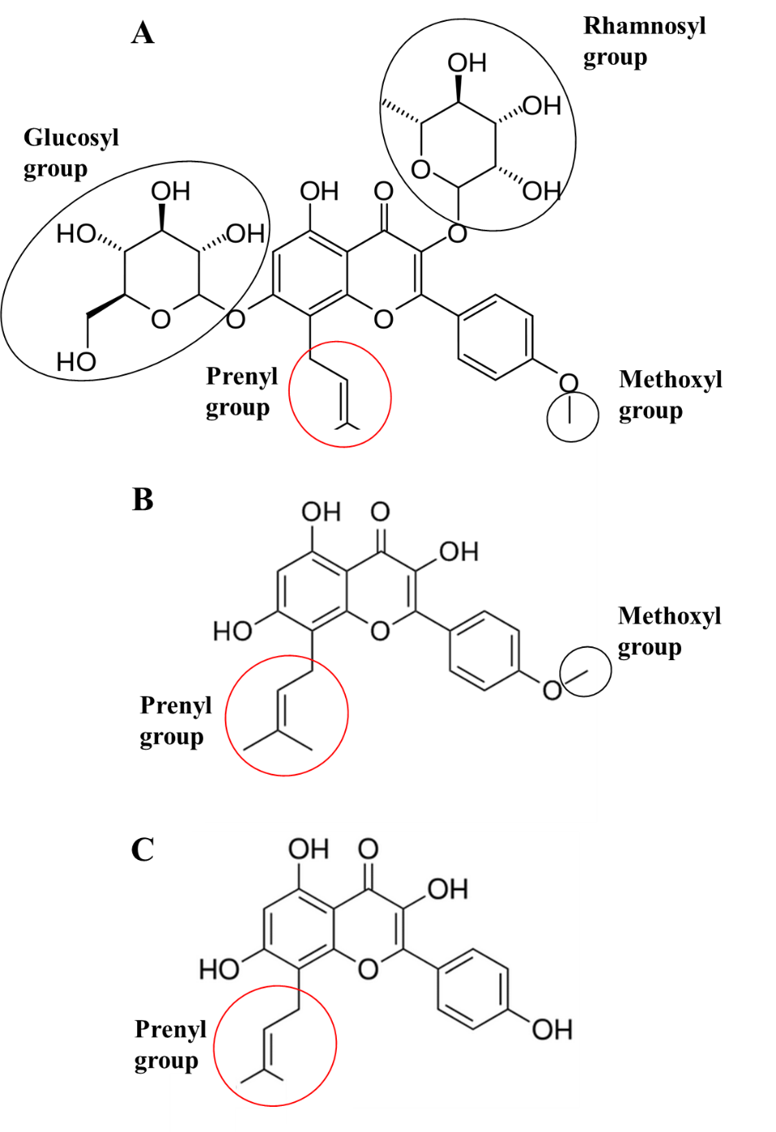
Figure 7.1. Chemical structure and functional groups of A) icariin, B) icaritin and C) desmethylicaritin. By comparing functional groups, it was noted that the prenyl group was common to all structures, suggesting a common functionality for this group.
Most in vitro studies have investigated the osteogenic effects of icariin in OIM, while Ma et al. [582] investigated the effects of icariin at two different concentration, 10⁻⁸ and 10⁻⁵ M, on the osteogenic differentiation of rat primary osteoblasts in OIM and SM (OIM without dexamethasone (Dex)) It was demonstrated that glucocorticoids, including Dex, regulated gene expression in cell differentiation, via the glucocorticoid receptor, which either stimulated or suppressed osteoblast formation and activity, based on the administered dose [583-585]. βGP modulates mineral deposition during osteogenesis and provide a potential source of phosphate ions [586]. AA2P functions as a cofactor in the hydroxylation of two main amino acids precursors, proline and lysine residues in the production of collagen type I, the major structural proteins in the ECM [587, 588]. It has been reported that AA2P and βGP cannot induce osteogenesis, without Dex. [583, 589]. However, this study revealed that 10⁻⁵ M icariin, supported osteogenic differentiation and mineralisation without the Dex. Additionally, icariin (10⁻⁵ M) was more pronounced in inducing osteoblastic differentiation, when compared to Dex (10⁻⁸ M). However, further studies are required to clarify whether icariin induce osteogenesis through the glucocorticoids receptor, similar to Dex.
Most in vitro and in vivo animal studies have shown the positive effects of icariin on bone formation and bone loss inhibition [566-569, 574, 590]. However, for icariin to be used as an effective therapy in osteoporosis, more clinical studies are required. For example, a 24 month randomised double-blind placebo-controlled clinical trial indicated that icariin exerted significant effects on bone turnover markers in late postmenopausal women, without detectable hyperplasia on the endometrium [591].

Menaquinone-4
One group of bone protective factors that possess both pro-osteoblastic and anti-osteoclastogenic attributes are the vitamin K family [592, 593]. The vitamin K group are fat-soluble compounds called naphthoquinones, which are found in two natural forms, vitamin K1 (phylloquinone, PK) and vitamin K2 (menaquinone, MK). Both types of vitamin K have a methylated naphthoquinone nucleus, called menadione, where vitamin K1 has a phytyl side chain and vitamin K2 has a side chain based on repeating units of unsaturated 5-carbons (prenyl) (Figure 7.2). Although vitamin K1 is a single compound, vitamin K2 represents a series of isoprenoid unsaturated side chains, isoprene units from 1-14 (MK-n, n=1-14).
Vitamin K1 is found in green leafy vegetables and vegetable oils, while vitamin K2 is highly abundant in legumes and fermented soybean products, and is found at low concentration in some animal products. Vitamin K2, MK-n, are produced by bacterial fermentation; the amount and type of MKs produced depends on the bacteria. For example, Natto, a traditional Japanese food which is made of fermented soybean, is rich in MK-7. Additionally, MK-4 is not just produced by fermentation alone , but is also found in fish, eggs, liver, milk, butter and fermented cheeses or vegetable [594]. Long chain menaquinone, MK-n, n >10, are poorly absorbed and have little vitamin K bioactivity [595, 596]. Vitamin K1, MK-4, and MK-7 are available as dietary supplements.
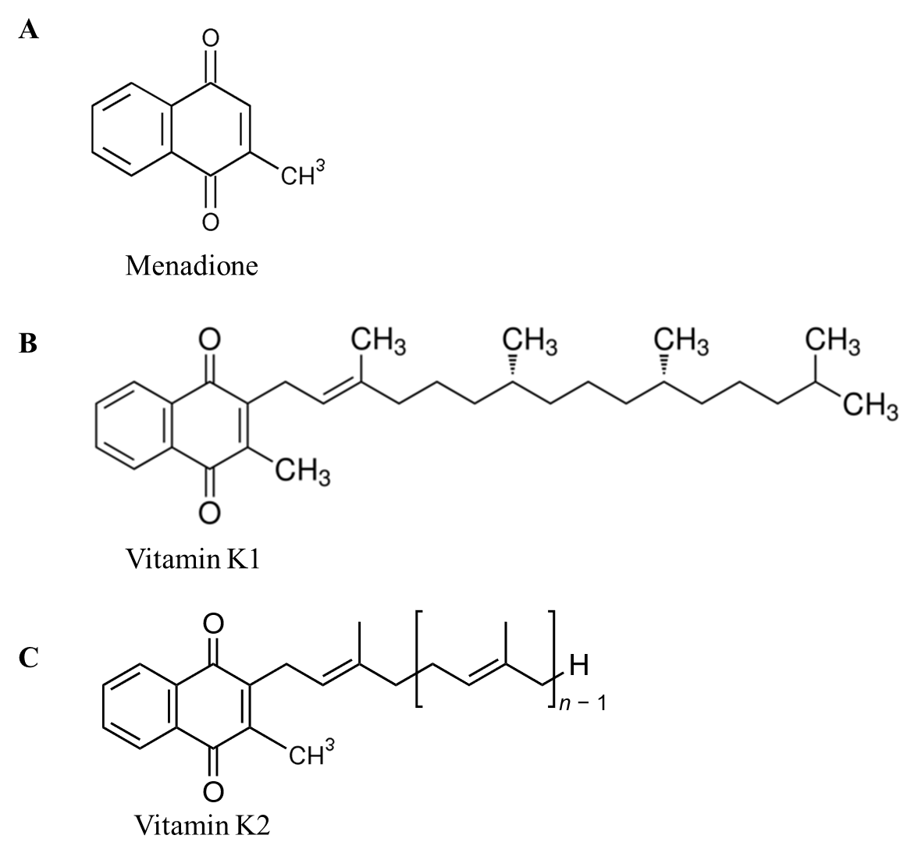
Figure 7.2. Molecular structure of vitamin K A) Menadione B) Vitamin K1 C) Vitamin K2 (n=1 to 14)
Since 1929, vitamin K has been known for its coagulation properties [597]. It was recently observed that vitamin K played vital functions in the regulation of calcium homeostasis in “bone-vascular cross-talk” by reducing arterial calcium deposit while increasing calcium deposition in bone tissues [598]. Vitamin K activates vitamin K-dependent proteins (VKDP) [599], by acting as a co-factor for γ-glutamyl carboxylase (GGCX) [598], through the carboxylation of glutamic acid residues in γ-carboxyglutamate. At present, 17 types of VKDPs are known to exist [600]. In bone tissue, VKDP is also known as osteocalcin (OC), which was first described by Price et al. and Haushka et al. [601, 602].
The mineralised bone extracellular matrix contains organic matrices of collagen and non-collagenous fibres. Although non-collagenous proteins are present at approximately 10% of the organic matrix, their roles in bone turnover and mineralisation regulation is essential [603, 604]. OC is the most abundant non-collagenous protein in the bone matrix [605], however its precise role is not yet fully understood, but it appears to regulate bone mineralisation and the growth of hydroxyapatite crystals by binding to these crystals [606]. OC is preferentially expressed by osteoblasts, therefore, its expression is used as a therapeutic biomarker of osteoblastic metabolic activity and mineralisation [607]. Carboxylated OC (cOC) confers an affinity for calcium in promoting bone mineralisation, when compared to uncarboxylated OC (ucOC) [608]. Therefore, cOC serum levels are used as bone formation biomarkers, while ucOC serum level are used as biomarkers of vitamin K deficiency and are good predictors of bone fracture [609, 610].
MKs recently received considerable attention for their positive effects on bone health, which were confirmed by several in vitro and in vivo studies [611-616]. The most abundant isoform of MKs vitamins are the MK-4s [617]. Currently MK-4 is approved in Japan for osteoporosis treatment. In addition to the anabolic effects of MK-4 on bone formation, in vitro results have shown that MK-4 significantly and dose dependently inhibited osteoclastogenesis, by blocking cell differentiation and/or cell fusion [618]. Most in vitro studies related to the anabolic effects of MKs were performed in osteoblastic cells [619, 620]. Recently, an interesting in vitro study was performed by Mandator et al. [611], where they investigated MK-4 capabilities in the osteogenic induction of MSCs. These authors investigated the osteogenic effects of MK-4 at three concentrations, 0.1, 1, and 10 μM, in human amniotic fluid mesenchymal stem cells (hAFMSCs), in both 2D and 3D in vitro models. Conventional 2D results showed non-cytotoxic effects of MK-4 at all concentrations and demonstrated significant improvements in the osteogenic response of hAFMSCs at 10 μM MK-4, via GGCX dependent pathways. Osteogenic responses were measured using mineralisation levels (ARS), and expression of osteogenic markers including, ALP, RUNX2, OC, COL1A1 and OPN. Moreover, MK-4 positive effects were also confirmed using physiologically relevant 3D co-cultures; hAFMSCs and human monocyte cells (hMCs) in a dynamic model. The study demonstrated the negative effects of MK-4 treatment on osteoclastogenesis while improving osteogenesis.
Besides in vivo animal studies [621, 622], many groups have investigated the positive effects of MK-4 on bone health in human clinical studies. Osteoporotic fractures are believed to occur for several reasons. Among the contributing factors, bone mineral density (BMD) is the most reliable predictor [623]; therefore, increasing BMD is believed to be effective in reducing fracture risks. Shiraki et al. [612] performed a clinical trial investigating the effects of MK-4 on the prevention of osteoporotic bone fractures, by measuring lumbar BMD and the occurrence of new fractures. The study was performed in osteoporotic patients (Japanese postmenopausal women), a control group (no treatment) and a treatment group (oral 45 mg/day over 24-months). The study revealed new fractures occurred less in treated groups, when compared to control groups. Moreover, the level of lumbar BMD was maintained in the treated group, while it decreased in the control group. OC serum levels showed a 40% increase, indicating that bone formation may be accelerated in this cohort. Additionally, ucOC serum levels were lowered significantly for the treatment group, indicating that MK-4 may have enhanced carboxylation of OC. It has been reported that cOC is a cause of osteoporotic bone fractures [609, 624, 625]. Undercarboxylated OC serum levels are indicators of vitamin K deficiencies in the bones of healthy individuals [610], while high levels of ucOC are associated with low BMD [626] and increased risks of osteoporotic fractures. Although bone resorption has been reported to be inhibited by MK-4 treatment in vitro [618, 627], no significant changes in bone resorption markers and urinary pyridinium excretion were observed in this study, suggesting the treatment may not entirely inhibit bone resorption. Other studies have reported similar results regarding the positive bone effects of 45 mg/day MK-4 in postmenopausal women with osteoporosis [613, 614, 616].
In a Japanese study, Koitaya et al. [615] investigated the effects of lower doses of MK-4 supplementation on bone health in healthy postmenopausal women. Currently in Japan, 45 mg/day MK-4 is administered for osteoporosis. This study investigated the effects of 1.5 mg/day MK-4 on healthy postmenopausal women for 12 months and showed that long-term administration of low daily MK-4 doses, decreased ucOC serum concentrations. Additionally, the study showed that forearm BMD decreased significantly in the control group, while there was no significant decrease in BMD in the MK-4 treatment group at 12 months, suggesting the positive effects of low MK-4 doses in maintaining bone health and strength in healthy postmenopausal Japanese women. A similar study showed the positive effects of low MK-4 doses (1.5 mg/day) on bone health in individuals in their 30s and 50s [628]. Moreover, Nakamura et al. [629] showed the beneficial effects of lower MK-4 doses (0.6 mg/day) on the bone health of young males, aged 25. Accordingly, MK-4 has received considerable attention as an anabolic compound for its positive effects on bone formation both in vitro and in vivo.

Oestrogen
A decline in oestrogen was first hypothesised in the 1940s as a key reason for postmenopausal osteoporosis, primarily due to the cessation of ovarian function [173]. Thereafter in 1941, the use of sex hormones for postmenopausal osteoporosis was first reported [630]. Since then, oestrogen has been the main therapy for this disease. Oestrogen or oestrogen-progesterone/progestin treatments are two types of menopausal hormone replacement therapies (HRT) [631] which have been utilised to prevent BMD loss or treatment of postmenopausal osteoporosis [630, 632, 633]. However, since oestrogen receptors are widely distributed, oestrogen related therapies affect many tissues. For example, the beneficial effects of oestrogen on osteoporosis and colon cancer are counterbalanced by changes in cardiovascular and cerebrovascular function [563, 564], suggesting that oestrogen HRT is associated with an increased risk of stroke, whereas oestrogen-progesterone/progestin HRT has been associated with heart disease and breast cancer [634]. Therefore, physicians do not advocate oestrogen HRT as a protective therapy, especially for those patients with a family history of relevant side effects, such as breast cancer. Therefore, it is recommended that HRT be administered at minimum effective doses after in-depth discussions with patients regarding benefits, side effects and family history [635].
Osteoclastogenesis is regulated by several cytokines, including tumour necrosis factor (TNF), macrophage colony stimulating factor (M-CSF), IL-1 and IL-6. TNF and IL-1 are powerful stimulators of bone resorption and inhibitors of bone formation. They enhance osteoclastogenesis by stimulating the proliferation of precursors and inducing other cytokines such as IL-6, that regulate precursor differentiation into mature osteoclasts [636]. Oestrogen is the key inhibitor for these cytokines, suggesting its possible protective role in modulating cytokine production. As described previously, the dissection of the RANK/RANKL/OPG complex was a significant finding in postmenopausal osteoporosis pathogenesis [173].
Oestrogen stimulates OPG expression and reduces osteoclastogenesis, therefore oestrogen deficiency leads to increased osteoclast formation [637]. Oestrogen also decreases RANKL production, therefore in postmenopause, RANKL expression is elevated, thereby increasing osteoclastogenesis [638]. In addition to its effects on osteoclastogenic factors by osteoblasts, oestrogen directly inhibits osteoclastogenesis by affecting protein transcription downstream of the RANK receptor [639, 640]. Similarly, oestrogen affects osteoclast life span by promoting apoptosis via the Fas/Fas ligand (FasL) complex, suggesting an important preventive role against osteoporosis [641]. Oestrogen induces FasL transcription in osteoblasts, which after cleavage of the soluble FasL, induces osteoclast apoptosis. Figure 7.3 summarises some of the main findings regarding oestrogens role in postmenopausal osteoporosis.
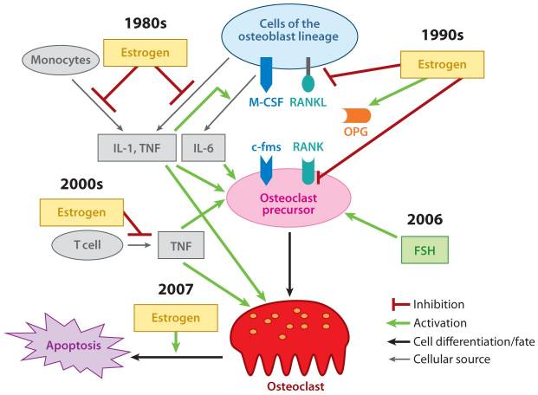
Figure 7.3. The role of oestrogen in bone and postmenopausal osteoporosis. The dates represent when these effects were first discovered. (This figure is reprinted from [173] under Creative Commons Attrition Licence.)

Following the onset of postmenopausal osteoporosis, declines in oestrogen levels have been associated with increased bone turnover and bone loss, in turn weakening whole bone mechanical properties [642, 643]. Changes in osteoclast activity, following oestrogen decline has been explored intensively [639, 644, 645]. However, the anabolic effects of oestrogen on osteoblasts still remains unclear. Some in vivo animal studies have suggested oestrogen HRT increases bone formation and bone mass [646, 647]. The anabolic effects of oestrogen in humans, prior to skeletal maturation, have been suggested by observing low peak bone mass on oestrogen deficient adolescent girls and males with a genetic syndrome of oestrogen deficiency [648, 649]. Additionally, increased OC serum levels in postmenopausal women, two weeks after oestrogen HRT, suggests a possible anabolic role for oestrogen in bone formation stimulation [650]. However, clinical studies have failed to show any anabolic effects of orally administered oestrogen in postmenopausal women [651-653]. Therefore, sc oestradiol implants were introduced to enhance circulating oestradiol levels and therefore increase BMD [654]. It has been shown that the effects of oestradiol implants on BMD continues as long as the therapy is administered in a dose response manner [655, 656]. Since oestrogen suppresses bone resorption and reduces bone turnover rates, comprehensive evidence of its anabolic effects may take time to materialise. In healthy humans, the cancellous bone surface is renewed every 2–3 years; and it has been shown that oestrogen HRT doubles this turnover period, by suppressing bone resorption [651, 657]. Therefore, it is recommended to allow a minimum of 4–6 years to demonstrate a clear anabolic effect of oestrogen on humans. A study by Khastgir et al. [658] investigated putative bone anabolic effects of oestrogen, by evaluating cancellous bone mass, bone architecture and bone turnover in 22 osteoporotic postmenopausal women, of mean age 65.4 years, following sc oestradiol implants (75 mg) for six years. It was found that oestrogen administration over this period increased cancellous bone volumes from 10.75% to 17.31%, and improved BMD to 31.4 % at the lumbar spine, and 15.1 % at the proximal femur. These data confirmed the anabolic effects of oestrogen on the human skeleton and showed that oestrogen levels, at the higher end of the physiological range, were needed for oestrogen mediated anabolic effects. At the cellular level, this increase may have been due to increased osteoblast activity and/or increased life span of active osteoblasts. These findings have suggested increased osteoblast activity may contribute to bone formation and mineralisation. Moreover, other studies have shown that oestrogen reduces osteoblastic apoptosis and maintains their active state for longer periods [659, 660].
Although some in vivo studies have viewed the anabolic effects of oestrogen as controversial [661], prolonged periods of relatively high oestrogen doses in humans, appear to induce anabolic effects on bone formation [662-664]. Therefore, in vitro studies are required to elucidate oestrogen anabolic mechanisms. In vitro bone cell culture studies have shown contradictory results, e.g. oestrogen can slow down [665] or accelerate [666, 667] cell proliferation. Although oestrogen upregulates ALP activity [645, 665, 666, 668], it suppresses OC production [666], and both it enhances [669] and does not affect [670] mineralisation. Additionally, it has been demonstrated that oestrogen is anti-apoptotic towards osteoblasts, in contrast to its effects on osteoclasts [671, 672].
An in vitro study by Rao et al. [667] compared the effects of intermittent and continuous oestrogen (0.1 nM to 1 μM) treatments in long term in vitro cultures. It was shown that the intermittent exposure (not continuous) to oestrogen significantly stimulated the differentiation and mineralisation of bone cells (SaOS-2) in a dose-dependent manner. The study provided strong evidence that the oestrogen receptor α (ERα), and not ERβ, was implicated in the mechanism behind oestrogen induced human osteoblast bone formation. Moreover, blocking oestrogen receptors using the oestrogen agonist fulvestrant decreased mineralisation [673].

Lithium chloride
Since the 1970s, lithium salts, specifically lithium chloride (LiCl) has been the gold standard for the treatment of bipolar disorders and acute mania, which mooted as a mood stabiliser, and it was shown to reduce suicidal tendencies [674]. It was reported that the therapeutic effects of lithium is dose-dependent and that therapeutic serum concentrations should typically be in the range of 0.8–1.2 mM, whereas lithium mild toxicity has been reported at levels between 1.5–2.5 mM, and moderate to acute toxicity, at concentrations above 2.5 mM [675, 676].
Lithium treatment influences calcium homeostasis. The therapy may be associated with adverse side effects on calcium metabolism, therefore patients taking lithium may develop mild, reversible hyperparathyroidism [677-679]. However, it has been observed that patients on lithium for psychiatric disorders, develop higher BMDs [680]. Detailed in vitro and in vivo studies have revealed that these osteogenic enhancements [681, 682] and bone turnover reductions are due to the inhibitory effects of lithium on glycogen synthase kinase-3β (GSK-3β) [683, 684], which inhibition of GSK-3β upregulate Wnt/β-catenin signalling, well known regulator of bone metabolism [685]. Inhibition of GSK-3β stabilises β-catenin, which translocates to the nucleus and regulates the expression of genes involved in bone regeneration, through interaction with the lymphoid enhancer-binding factor/T-cell factor 7 transcription factor [686]. Therefore, lithium treatment increases osteoblast differentiation in vitro and bone formation in vivo, ultimately leading to decreases in bone fracture risks [687].
Moreover, it has been reported that in vivo and in vitro lithium, LiCl or other lithium salts, induces cilia elongation [688-690], however, this mechanism is not fully understood. Some studies have hypothesised that the inhibition of GSK-3β by LiCl, causes cilia elongation [689, 691], however other studies have suggested that increases in cilia length induced by LiCl, are due to adenylyl cyclase III inhibition and cAMP reduction, which are independent of GSK-3β inhibition [688, 690]. These findings contradict previous studies suggesting that cAMP increases lead to cilia elongation [469]. These conflicting results show the complex interactions between adenylyl cyclase, cAMP and cilia length and therefore highlight feedback mechanisms that may play roles in cilia elongation. Consequently, further research is required to investigate these mechanisms.
Primary cilia are key mechanotransducers in cells, therefore increases in osteogenesis, induced by lithium treatment, can be linked to cilia length increases and possible enhancements in bone cell mechanosensitivity. A study by Spasic et al. [692] investigated the effects of cilia elongation induced by LiCl, in the osteogenic behaviour of osteocytes. It was observed that mechanically stimulated cells, treated with LiCl, induced higher osteogenic gene expression, such as COX-2 and OPN, when compared to only mechanically stimulated cells. Reasons as to why longer cilia are more mechanosensitive are not forthcoming, however, two mechanisms have been proposed. Firstly, longer cilia experience greater membrane strain under fluid flow, therefore increasing the opening of stretch-activated ion channels [486].Alternatively, increases in mechanosensitivity may be due to the enhanced presence of cilia-specific proteins and signalling molecules induced by longer cilia, which may enhance signal transduction, thereby modifying mechanosensitivity [693, 694]. It is possible that improved bone formation in patients, treated with lithium, may be due to the direct inhibition of GSK-3β and enhancements in mechanosensitivity due to cilia elongation.

Conclusions
So far, several anti-resorptive drugs have been developed for bone disease treatment, especially osteoporosis. However, they do not lead to satisfying clinical outcomes due to side effects and similarly, they do not completely diminish bone fracture incidences [695]. Therefore, there is a need to study natural compounds to enhance bone formation, as well as reducing bone resorption, with minimal associated side effects. Currently, anabolic compounds and stem cells are of interest in pharmaceutical studies, for in vitro and in vivo bone disease treatments [696].
During drug development, 2D in vitro static culture were first used after biochemical assays to identify the early results such as cytotoxicity of the new compound at cellular level. After this, successful drugs require testing in animals and if successful, they will reach human clinical trials. Cost efficient organ-on-a-chip devices could help improve drug predictability prior to in vivo testing. In previous chapters, we successfully designed, developed, characterised and assessed a new bone-on-a-chip device for bone pharmaceutical studies. In this chapter, we investigate the possible anabolic effects of lactoferrin, icariin, MK-4, oestrogen and LiCl in bone formation.

Aims and Objectives
The aim of this chapter is to assess the anabolic osteogenic effects of five known compounds, lactoferrin, icariin, MK-4, oestrogen (17β-estradiol), LiCl in hES-MPs in 2D cultures. Furthermore, we test the predictability of the fabricated bone-on-a-chip device. The following objective were generated;

- The assessment of DMSO cytotoxicity on hES-MPs, to determine ideal DMSO concentrations for downstream procedures.

- The preparation of compounds, at different concentrations for 2D culture.

- The investigation of the effects of compounds on proliferation (cytotoxicity) and differentiation of hES-MPs in 2D cultures.

- To assess the predictability of the 3D bone microfluidic chip (BMC), with a preliminary study investigating the effects of LiCl in hES-MPs under intermittent flow conditions

Materials and Methods
Further to general materials and methods outlined in chapter 4, the following materials and methods were used in this chapter. All chemical and reagents were purchased from Sigma-Aldrich (UK), unless otherwise stated.

Cell culture in 2D
hES-MPs were passaged in accordance with previously described methods (Chapter 4). Media used in this chapter were recommended expansion media (EM): basal media (BM, Dulbecco’s Modified Eagle Medium (DMEM, Gibco, UK) supplemented with 10% qualified, heat inactivated, US origin foetal bovine serum (FBS, Gibco, UK), plus 100 U/mL penicillin and 100 μg/mL streptomycin (Gibco, UK) and 4 ng/mL basic fibroblast growth factor (FGF) (Peprotech, UK).
For all experiments, hES-MPs were used at the sixth or seventh passage. Cells were seeded in gelatine-coated 24 well plates at 30,000 cells/cm², in basal media. They were left at incubator conditions overnight to attach. Following the day 1 metabolic activity assay, cells were maintained in OIM containing the appropriate drug, for the remainder of the experiment. Full media changes were performed three times a week, with metabolic activity determined on days 1, 8, 15, and 22. ALP activity and total DNA were measured on day 15, and calcium and collagen depositions were quantified on day 22 (Chapter 4).

Drug preparation
Five compounds were compared in this chapter: lactoferrin, icariin, MK-4, 17β-estradiol (oestrogen) and LiCl. Each drug was applied at three concentrations, over three orders of magnitude, encompassing anabolic ranges as recorded in the literature (Table 7.1). All concentrations and controls were in the same volume as the vehicle, regardless of the final drug concentration.
Table 7.1. Drugs and drug concentrations used in this study.
Drug | Low | Medium | High
17β-estradiol | 1 nM | 10 nM | 100 nM
Icariin | 100 nM | 1 µM | 10 µM
Lactoferrin | 10 µg/mL | 100 µg/mL | 1 mg/mL
LiCl | 100 µM | 1 mM | 10 mM
Mk-4 | 100 nM | 1 µM | 10 µM

To create stock solutions, lactoferrin from bovine colostrum (cat# L4765) was dissolved in BM at 5 mg/mL. Lithium chloride (cat# L9650) was dissolved in BM at 1 M. 17β-estradiol (cat# E2758) was dissolved in ethanol (Fisher Scientific, UK) and diluted in BM to a final concentration of 10 μM 17β-estradiol and 2% ethanol. Icariin and MK-4 were dissolved in DMSO to generate 10 mM. All stock solutions were filter sterilised using a 0.2 μM ultra-low adsorption polyether sulfone filter (Whatman® Puradisc). Samples were divided into single-use aliquots and stored at -20°C.
Due to the poor solubility of icariin and MK-4 in aqueous solutions (culture media), these drugs were dissolved in a vehicle (dimethyl sulfoxide (DMSO)); therefore, the effects of this compound alone were also assessed in cells. 17β-estradiol also had poor aqueous solubility and was dissolved in ethanol before diluting in BM. However, due to the very final concentration of ethanol (0.02%) during experiments, effects of ethanol were not tested.

LiCl in bone-on-a-chip device
The effects of LiCl under dynamic condition were tested in hES-MPs, using four fabricated 3D BMCs. Cell seeding was conducted in accordance to the dynamic culture method detailed in chapter 5. §5.3.9 using a commercial Ibidi perfusion pump, at intermittent conditions (0.8 mL/min, 270 minutes-3.2 mL/min and 90 minutes mL/min) over 14 days. During the experiment, four devices were tested; two were subjected to LiCl at concentrations of 1 mM as well as the intermittent fluid flow, while the other two were subjected to dynamic flow conditions (control conditions). On day 15, the effects of LiCl were assessed using ALP activity and total DNA quantification assays.

LiCl in a static 3D cell culture model
To compare the effects of LiCl in hES-MPs with results obtained from 3D BMCs (dynamic condition, chapter 7. §7.3.3), 3D static cell culture (open culture) on the polyHIPE scaffolds were performed in accordance to chapter 6. §6.3.2 four scaffolds were seeded in well-plates, which two were subjected to OIM supplemented with 1 mM LiCl, while the other two were only subjected to OIM for 14 days. The media was changed every 2 days. On day 15, the effects of LiCL were assessed using ALP activity and total DNA quantification assays.

Statistical analysis
All statistical analysis was performed in GraphPad Prism (version 7.00).
In 2D experiments, for resazurin reduction assays, results were normalised to the day 1 mean of the vehicle control, for each repeat. Significant differences were evaluated by two-way analysis of variance (ANOVA) with Dunnett’s multiple comparisons tests to compare each drug concentration with the vehicle control. For all other assays, results were normalised to the mean of the vehicle control, for each repeat. To assess whether results were normally distributed, the Shapiro-Wilk normality test was performed. As not all groups fitted a Gaussian distribution, significant differences were evaluated by the Kruskal-Wallis test with Dunn’s multiple comparisons test to compare each drug concentration with the vehicle control. All graphs are presented as mean ± standard deviation and, significant differences are indicated on graphs and in figure legends. Differences were considered significant when p < 0.05 (*). Other designated p-values were ** = p < 0.01, *** = p < 0.001, *** = p < 0.0001. All experiments were repeated twice, in quadruplicate for each condition.
3D dynamic experiments were performed once using four devices, two with LiCl and two without. To assess differences between experiments, normally distributed data was analysed by one-way ANOVA, with Tukey’s multiple comparison test to evaluate statistical significances. Differences were considered significant when p < 0.05 (*). All graphs are presented as mean ± standard deviation and notable significant differences were indicated on graphs or in figure legends.

Results

Dimethyl sulfoxide (DMSO) at 0.01%, 0.1%, and 1% final concentration
DMSO is a common amphiphilic solvent for dissolving both polar and nonpolar compounds. In drug discovery processes, poorly-water soluble drugs are often dissolved in DMSO or ethanol, however, they both may be cytotoxic to specific cell lines [697]. It has been reported that DMSO interacts with cell membrane and metabolism of cells, leading to cell damage [698, 699]. Therefore, the concentration of DMSO used to dissolve compounds should be kept to a minimum. Different concentrations have been reported including 1% and 5% for different cell types, but most studies have reported final DMSO concentrations of 1% as the maximal non-toxic level [698, 700, 701]. In this study, we evaluated the cytotoxic effects of DMSO on cell proliferation and the osteogenic differentiation of hES-MPs at three concentrations; 0.01%, 0.1%, and 1% (Figure 7.4). We then chose the appropriate, least cytotoxic concentration to dissolve menaquinone-4 and icariin.
No significant effects were observed on metabolic activity, ALP activity, DNA content, mineralisation or collagen production at DMSO concentrations of 0.01% and 0.1%. However, significant decreases were observed in all assays at DMSO concentrations of 1%. Decreases in metabolic activity were observed at day seven onward at this DMSO concentration.

Figure 7.4. The effects of DMSO on (A) metabolic activity, (B) Day 15 ALP activity, (C) Day 15 total DNA, (D) Day 15 normalised ALP activity, (E) Day 22 ARS with representative well-plate images and (F) Day 22 DR80 with representative well-plate images. No significant effects were observed for any conditions for 0.01% or 0.1% DMSO. At 1% DMSO, metabolic activity was significantly reduced from Day 7 onwards and ALP, DNA, mineral and collagen levels were all significantly reduced.

Lactoferrin at 10, 100, and 1000 μg/mL
Recently, it has been shown that lactoferrin exerts anabolic effects on bone at concentrations of 1–100 µg/mL [533, 534, 702]. For example, lactoferrin at concentrations of 1, 10, and 100 µg/mL significantly increased the in vitro proliferation of rat and human osteoblasts-like cells [533, 534], while osteogenic differentiation and bone formation of rat osteoblast-like cells were enhanced at concentrations of 100 and 1000 µg/mL [533]. It was also shown that lactoferrin at 100 µg/mL, enhanced the in vitro proliferation and osteogenic differentiation of pluripotent mesenchymal cells [702]. Therefore, in this study, the anabolic effects of lactoferrin at 10 µg/mL, 100 µg/mL and 1 mg/mL were investigated (Figure 7.5).
No significant effects were observed on metabolic activity, ALP activity, DNA content, mineralisation or collagen production at 10 µg/mL and 100 µg/mL. However, significant decreases were observed in all assays at 1 mg/mL lactoferrin. Metabolic activity was lowered from day 15 onward at this concentration.

Figure 7.5. Effects of lactoferrin on (A) metabolic activity, (B) Day 15 ALP activity, (C) Day 15 total DNA, (D) Day 15 normalised ALP activity, (E) Day 22 ARS with representative well-plate images and (F) Day 22 DR80 with representative well-plate images. At 1 mg/mL, metabolic activity was significantly lowered from Day 15 onwards, ALP, DNA, mineral and collagen were all significantly lowered. No significant effects were observed at any other concentrations. (VC=vehicle control)

Icariin at 100 nM, 1, and 10 μM
It has been shown that icariin in vitro exerts anabolic effects on rat marrow stromal cell proliferation and osteogenic differentiation, at 1 µM and 10 µM concentrations [568]. Other similar studies have shown that icariin significantly promotes osteoblastic proliferation at 1 µM [571], while differentiation and mineralisation qualities are promoted at 10 µM [571, 572, 574]. Therefore, in this study the anabolic effects of icariin at 100 nM, 1 µM, and 10 µM were investigated (Figure 7.6).
At 1 µM, metabolic activity was significantly higher than the vehicle control (VC) on days 8 and 22. For the other concentrations, no significant effects were observed for metabolic activity, ALP activity, DNA content, mineralisation or collagen production.

Figure 7.6. The effects of icariin on (A) metabolic activity, (B) Day 15 ALP activity, (C) Day 15 total DNA, (D) Day 15 normalised ALP activity, (E) Day 22 ARS with representative well-plate images and (F) Day 22 DR80 with representative well-plate images. At 1 µM, metabolic activity was significantly higher than the vehicle control (VC) on days 8 and 22. No significant effects on any other parameters were observed at any other concentrations.

Menaquinone-4 (Mk-4) at 100 nM, 1, and 10 μM
Besides assessments in animal studies [621, 622], the positive effects of MK-4 on bone health in postmenopausal osteoporosis women have been confirmed, demonstrating anabolic effects at 45 mg/day [612-614, 616]. Moreover, the osteogenic effects of MK-4 on MSCs has been revealed in vitro, at 10 µM in 2D [611, 703] and 3D cell culture models [611]. Therefore, in this study, the anabolic effects of MK-4, at 100 nM, 1 µM and 10 µM, were investigated (Figure 7.7).
The results showed no significant effects on metabolic activity at any concentration. For the 10 µM MK-4 concentration, total ALP activity was significantly increased, but no significant effects on total DNA or normalised ALP activities were otherwise demonstrated. Interestingly, mineralisation at 10 µM was significantly increased, when compared to the vehicle control (VC), but no significant effects on collagen were observed.
Figure 7.7. The effects of menaquinone-4 on (A) metabolic activity, (B) Day 15 ALP activity, (C) Day 15 total DNA, (D) Day 15 normalised ALP activity, (E) Day 22 ARS with representative well-plate images and (F) Day 22 DR80 with representative well-plate images. No significant effects were observed on metabolic activity at any concentration. However, total ALP activity, at 10 µM, was significantly increased, but no significant effects on total DNA or normalised ALP activity were observed. Mineralisation at 10 µM was significantly increased when compared to the vehicle control (VC), but no significant effects on collagen were observed over all concentrations.

Oestrogen at 1, 10, and 100 nM
17 β-estradiol is the most abundant of the oestrogen family and is the primary molecule produced by the ovaries. Therefore, it is the form typically associated with post-menopausal osteoporosis and the most commonly used molecule in bone scientific studies [704]. Although primarily known for its anti-resorptive role in repressing pro-osteoclastic cytokines and upregulating osteoclastic apoptosis [173], there is evidence to suggest 17 β-estradiol is pro-osteoblastic, via its anti-apoptotic properties [672] and its ability to induce ALP transcription [668]. In in vivo studies, anabolically effective concentrations have been identified at 1 nM in ovariectomised mice [646], whilst in vitro, 10 nM 17 β-estradiol is effective in MC3T3-E1 murine pre-osteoblasts [705], SaOS-2 human osteosarcoma cells [667] and primary human mesenchymal stem cells [706] and have been shown to promote bone formation. Therefore, in this study three concentrations of 17 β-estradiol were investigated; 1 nM, 10 nM and 100 nM (Figure 7.8).
No significant effects were observed on metabolic activity, ALP activity, DNA content, mineralisation or collagen production over any 17 β-estradiol concentration.
Figure 7.8. The effects of 17β-estradiol on (A) metabolic activity, (B) Day 15 ALP activity, (C) Day 15 total DNA, (D) Day 15 normalised ALP activity, (E) Day 22 ARS with representative well-plate images and (F) Day 22 DR80 with representative well-plate images. No significant effects on any parameter at any 17 β-estradiol concentration were demonstrated. (VC=vehicle control)

Lithium chloride (LiCl) at 100 μM, 1, 10 mM in a 2D static cell culture model
It was reported, based on clinical lithium therapy for bipolar disorder, that the therapeutic effects of lithium is dose-dependent, and that therapeutic serum concentrations should be maintained in the range 0.8–1.2 mM [675, 676]. It has been shown that LiCl exerts positive effects on in vitro osteogenic differentiation of MSCs, at concentrations between 4–14 mM [682]. In this study, the anabolic effects of LiCl, at 100 µM, 1 mM, and10 mM were investigated on 2D well plates (Figure 7.9).
The results demonstrated that on day 22, cell metabolic activity at 100 µM and 1 mM concentrations were significantly increased, when compared to control conditions. However, at 10 mM, metabolic activity was significantly reduced from day 15 onward. Additionally, at 10 mM, total and normalised ALP was significantly higher than control condition, but total DNA was significantly lower (in line with metabolic activity). Finally, no significant effects on mineral or collagen production were observed except at the 10 mM concentration, where both conditions were significantly reduced.

Figure 7.9. The effects of lithium chloride on (A) metabolic activity, (B) Day 15 ALP activity, (C) Day 15 total DNA, (D) Day 15 normalised ALP activity, (E) Day 22 ARS with representative well-plate images and (F) Day 22 DR80 with representative well-plate images. Metabolic activity was significantly increased when compared to the vehicle control (VC) at 100 µM and 1 mM on Day 22. At 10 mM, metabolic activity was significantly reduced from D15 onwards. At 10 mM, total and normalised D15 ALP was significantly higher than VC, but total DNA was significantly lower. No significant effects were observed on mineral or collagen production, except at 10 mM, where both conditions were significantly reduced.

Lithium chloride (LiCl) at 1 mM a 3D dynamic and static cell culture model
It has been reported that lithium administration, including LiCl, induces both in vivo and in vitro cilia elongation [688-690] which may increase cell mechanosensitivity. Therefore, LiCl, at the therapeutic serum concentration, 1 mM was tested inside the bone microfluidic chip to investigate osteogenic differentiation effects, under more therapeutically relevant conditions and compared with 3D static condition (Figure 7.10).
At open culture static condition, no significant differences were observed at 1 mM on normalised ALP and total DNA conditions. However, under dynamic intermittent conditions, cells treated with LiCl at 1 mM showed higher ALP activity when compared to non-treated conditions. No significant differences were observed in total DNA under dynamic or static conditions.
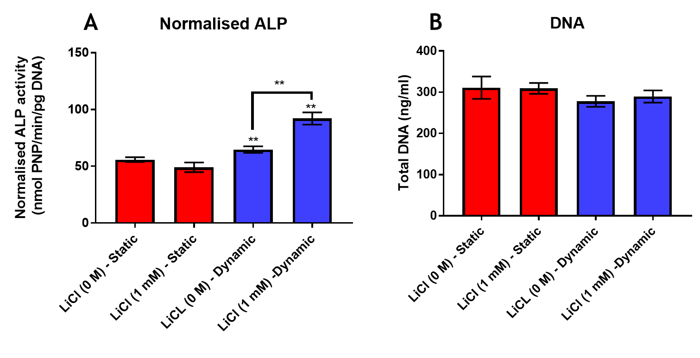
Figure 7.10. The effects of 1mM lithium chloride on (A) Day 15 normalised ALP activity (B) Day 15 total DNA under static 3D open culture and intermittent dynamic conditions inside the 3D bone microfluidic chip. No significant effects were observed on normalised ALP activity under static conditions, while normalised ALP was significantly increased in lithium chloride treatment when compared to controls under dynamic conditions. No differences in total DNA were observed under dynamic and static conditions. (n=2)

Discussion
Until recently, treatments for bone diseases such as osteoporosis attempted to slow down or inhibit the resorption process. However, despite great therapeutic effects, anti-resorptive therapies cannot provide the ideal solution. For example, they cannot restore bone mass and avoid bone fracture incidences [695]. Additionally, patients with severe osteoporosis require more treatments to stimulate bone formation, rather than bone resorption inhibitory treatments. Therefore, there is a significant interest in the development of anabolic compounds with minimal side effects, to increase bone formation and mineral density [512, 513].
During drug development processes, an important step in the use of 2D in vitro models, is to identify early cytotoxicity effects and stem cell differentiation behaviours, at different compound doses. Moreover, embryonic stem cells are frequently used in pharmaceutical studies, thanks to their huge potential in drug development [707]. Therefore, in this study the anabolic effects of five compounds, lactoferrin, icariin, MK-4, oestrogen, LiCl were first investigated on bone formation in hES-MPs in 2D cultures.

DMSO alone lowers cell viability and differentiation at high concentration
Some chemicals are insoluble in water, therefore DMSO is used to solubilise a wide variety of polar and non-polar molecules [697]. However, DMSO is cytotoxic to cells, therefore, three concentrations, 0.01%, 0.1%, and 1%, were tested to determine appropriate concentrations to dissolve icariin and MK-4. According to in vitro studies, DMSO cytotoxicity is mainly observed at concentrations of 1% and above [700, 701, 708]. Similarly, in this study, hES-MP metabolic activity was significantly lowered from day 7 onwards, at a DMSO concentration of 1% (Figure 7.4 A). Additionally, the osteogenic differentiation of cells, observed by normalised ALP activity and mineral and collagen deposition, was also significantly decreased at this concentration (Figure 7.4 D-F). At the concentration of 0.1% DMSO, calcium mineralisation was also reduced (Figure 7.4 E), however the reduction was not significant.
Although minimal DMSO concentrations are preferential during these studies, due to limitations in dissolving MK-4 and icariin, a 0.1% DMSO concentration was chosen to dissolve these compounds. The vehicle control involved cells treated with 0.1% DMSO alone. Under these conditions, treated cell effects were more likely due drugs alone and not DMSO.

Lactoferrin exerts no anabolic effects in hES-MP cells
Lactoferrin is an iron-biding glycoprotein found in high concentrations in milk and colostrum. Although the anabolic effects of lactoferrin have been shown in in vivo and in vitro bone studies [533, 534], in this study no anabolic effects in hES-MPs cells were observed. Despite the positive effects of lactoferrin on cell proliferation at concentrations of 10 and 100 µg/mL [520, 533, 534] cell metabolic activities, at any lactoferrin concentration, were not higher than non-treated samples. Additionally, metabolic activity was significantly lowered in cells from day 15 onwards, at the concentration of 1 mg/mL. It has been shown that osteogenic differentiation and bone formation of osteoblast-like cells, improve at concentrations of 100 µg/mL and 1 mg/mL lactoferrin [533, 535]. However, in this study no significant effects in osteogenic differentiation were observed at 10 and 100 µg/mL. Moreover, ALP activity, DNA, mineral and collagen levels were significantly lower at 1 mg/mL. While the precise reasons behind these contradicting results are not clear, different theories are hypothesised. Firstly, to the authors’ knowledge, no study has investigated the effects of lactoferrin in hES-MPs, as most studies have performed analyses on osteoblastic cells or cells in vivo [519, 520, 533, 534, 540]. Therefore, the effects of lactoferrin on hES-MPs are not well characterised.
Studies in our group have revealed that in 2D static studies, Dex, is a considerably potent compound that may mask or disrupt the beneficial effects of weaker compounds, possibly such as lactoferrin. In the literature, the differential effects of Dex on osteoblast genes in different species has been well reported [709-711]. In some studies and in our laboratory, Dex at 100 nM promotes and enhances osteogenic differentiation in hES-MPs, whereas it has been shown that 100 nM Dex and higher concentrations can inhibit osteoblastic differentiation [712, 713]. Therefore, this hypothesis requires further investigation, perhaps with studies pre-treating hES-MPs with Dex, until the commencement of osteogenic differentiation (using OIM), and afterwards withdrawing Dex (using SM), while adding lactoferrin or similar compounds. Another possibility may involve a study using Dex at lower concentrations, e.g. 10 nM while supplementing the media with anabolic compounds.
Moreover, two types of lactoferrin from bovine and human sources have been used in several studies [520, 533, 540, 714]. Although some studies do not show significant anabolic differences between these two sources [520, 714, 715], a potential reason for no effects in this particular experiment may have been due to the use of bovine lactoferrin in human ES-MPs. So far, no lactoferrin mediated cytotoxic effects have been reported in in vitro studies. However, most studies have investigated lactoferrin effects at concentrations between 1 to 100 µg/mL, which fall in with in vivo inflammatory ranges [522]. Although one study demonstrated lactoferrin anabolic effects on osteogenic differentiation at 1 mg/mL, in rat osteoblasts [533], since 1 mg/mL is above in vivo conditions, lactoferrin mediated cytotoxic effects at 1 mg/ml in hES-MP cells would be expected.
Finally, 2D static studies are not ideal for investigating specific effects such as anabolic or inhibitory effects, they are mostly used to investigate cytotoxicity of new compounds [716-719]. Therefore, since no cytotoxic effects were observed at concentrations up to 100 µg/mL lactoferrin, further investigations should be performed in 3D dynamic conditions, such as inside 3D BMC devices to understand lactoferrin mediated osteogenic effects in hES-MP cells.

Icariin exerts no anabolic effects in hES-MP cells
Icariin is a non-toxic natural phytoestrogen for the alternative treatment of postmenopausal osteoporosis [565, 566, 579, 581]. It was introduced to eliminate side effects associated with conventional osteoporosis therapies [565]. Icariin has both inhibitory and anabolic effects on bone resorption and formation, respectively, both in vivo and in vitro [568, 569, 571-575]. Icariin mediated anabolic effects on cell proliferation and osteogenic differentiation have been reported at 1 and 10 µM [568, 571, 572, 574]. In this study, 2D static results demonstrated no cytotoxicity, with no significant anabolic effects at any concentrations, on metabolic activity, osteogenic differentiation and bone formation in hES-MPs, when compared to vehicle controls. The reason for these contradicting data could be similar to lactoferrin above.
No previous icariin studies have been performed in hES-MPs. Similarly, the effects of Dex on hES-MPs may have overcome the anabolic effects of icariin in these cells. For example, in similar 2D static studies, Dex, at 10 nM rather than 100 nM, was used to prepare the OIM [568, 572, 582], where, media supplemented with 100 nM Dex may already saturated the osteogenic behaviour of hES-MPs under 2D static condition, causing no effects of icariin. Therefore, further investigations are required to clarify the exact effects of Dex on osteogenic differentiation compare to icariin. This could be performed by cell pre-treatment with Dex and withdrawal, prior to drug studies, or simply using Dex at lower concentrations. Additionally, Ma et al. [582] showed that 10 µM icariin, promoted and enhanced osteogenic differentiation in the absence of Dex. Therefore, further studies are required to compare the osteogenic differentiation pathways of Dex and icariin. Similar to lactoferrin, in vitro 2D static studies are limited in deciphering these affects, as they are mainly used to study cytotoxicity. Therefore, by using 3D dynamic approaches, the effects of icariin may be thoroughly investigated.

Menaquinone-4 increases mineralisation in hES-MP cells
MK-4 as the most abundant vitamin K2 in humans can be found in high concentrations in fermented products and at lower concentrations in fish, eggs, liver and butter. MK-4 has received considerable attention for its inhibitory and anabolic effects on bone resorption and formation, respectively [594, 611-616, 703]. Additionally, it has been approved and prescribed in Japan for osteoporosis treatment. Besides a large number of studies reporting the positive effects of MK-4 in bone health in in vivo animal models [621, 622], and human trials [612-614, 616], its osteogenic effects in MSCs has been shown at concentrations of 10 µM in 2D [611, 703] and 3D models [611].
In this study, the 2D static experiment showed no cytotoxic effects of MK-4, at any concentrations. Moreover, no significant effects were observed for cell metabolic activity at any concentrations. Regarding osteogenic differentiation effects, 10 µM MK-4 significantly enhanced ALP activity and mineralisation similar to other studies, demonstrating potent osteogenic differentiation at this concentration [611, 703]. However, normalised ALP and collagen were not increased, when compared to the vehicle control. No significant effects were observed at any other concentrations. Interestingly, in other studies showing the positive effects of MK-4 on osteogenic cell differentiation, the media was supplemented with 100 nM Dex [611, 703], similar to our study. Therefore, in-depth studies are required to compare mechanisms of action and Dex pathways and chemical compounds. One possible hypothesis suggests that the MK-4 pathway in hES-MPs is not disrupted or saturated by Dex, therefore, MK-4 anabolic effects are demonstrated, similar to other studies.
In this study, lower MK-4 doses exhibited no significant effects on osteogenic differentiation when compared to the vehicle control. In vivo studies have shown that MK-4, at lower doses, improves bone health [615, 628, 629]. Moreover, it has been shown that MK-4, at 1 µM, enhanced the mineralisation of in vitro stem cells [611]. The reason why this effect was not observed in this study is not yet clear, however explanations may include the Dex concentration, the cell type or the use of a 2D model. Therefore, further studies are required to understand the effects of each factor in MK-4 outcomes on bone in vitro.

Oestrogen exerts no anabolic effects in hES-MP cells
A decline in oestrogen levels is the key reason for osteoporosis in post menopause women [173, 631], although its main role is its anti-resorptive effects by repressing osteoclastogenesis and upregulating osteoclast apoptosis [173]. There is also evidence demonstrating anabolic bone formation effects, such as its anti-apoptotic effects on osteoblasts apoptotic [672], or by inducing ALP transcription [668]. The most abundant oestrogen type is 17 β-estradiol which is the form typically used for scientific studies on bone and postmenopausal osteoporosis [704]. The anabolic effects of oestrogen have been identified in animal models at 1 nM [646], whereas in in vitro models, these effects have been demonstrated on bone formation at 10 nM in stem cells and osteoblastic cell types [667, 705, 706, 720].
However, in this 2D static study, no significant effects were observed on metabolic activity, ALP activity, DNA content, mineralisation or collagen production at the concentrations tested. Although no cytotoxicity effects were observed at any concentrations, 17 β-estradiol showed no anabolic effects on bone formation, when compared to control conditions.
As mentioned earlier, the in vitro results are contradictory regarding the effects of oestrogen on osteoblasts. Although most studies have demonstrated bone formation effects, several studies have revealed that oestrogen has either no effects [721] or slows down cell proliferation [665]. Additionally, oestrogen has no positive effects on ALP activity [665] or only increases ALP activity under intermittent (6 hours per 48 hour period) rather than continuous treatment [667].
With regard to mineralisation, studies showed that oestrogen enhances [669] and has no impact on [670] this process. In this study, no significant data was observed, which can be explained. Firstly, similar to other compounds, Dex may have disrupted or masked the beneficial actions of oestrogen on cell proliferation or differentiation. In fact, Dex acts as an anti-oestrogen molecule by inhibiting the Wnt/β-catenin signalling pathway [722, 723], therefore, Dex may inhibit the positive effects of oestrogen in hES-MPs. As mentioned previously, further investigations are required to understand the effects of Dex in combination with other compounds in cell proliferation and osteogenic differentiation in hES-MPs. This can be done by either withdrawing Dex at certain points during experimental procedures, or using lower Dex concentration or using Dex alternatives as osteogenic stimuli.
Besides the possible molecular interference between oestrogen and Dex, another reason explaining these observations could be the effects of possible oestrogen or oestrogen-like sources in the culture media. For example, oestrogen are found in FBS [724] and phenol red has weak oestrogenic activity [725]. Since these two factors were present in the culture media, further studies are required with phenol red-free media and oestrogen free FBS, to test the intrinsic effects of oestrogen on cells. Additionally, human MSCs produce and secrete their own oestrogens which could complicate the assessment of exogenous oestrogen [726]. Therefore, different oestrogen assay may need to be assessed in determining and differentiating the effects of oestrogen compounds with those inherent effects.
As stated above, 2D static experiments are not ideal culture models to investigate the effects of compounds in cells. The use of 3D models and/or 3D dynamic models, close to in vivo conditions are recommended.

Lithium chloride in static 2D culture exerts no anabolic effects
Lithium chloride (LiCl) exerts positive effects on bone health by enhancing bone mineral density [680] and reducing the risk of bone fracture [687]. The therapeutic effects of LiCl are observed at serum concentration of 0.8–1.2 mM [675, 676]. Both in vitro and in vivo studies have confirmed the positive effects of lithium salts, including LiCl on bone formation [681-684]. However, some studies suggest that prolonged treatments (21 days) are effective [682], while short exposures (4–5 days) generate no positive effects on osteogenic differentiation [727].
In this 2D static study, positive effects of LiCl on metabolic activity were observed at low concentrations of 100 µM and 1 mM at the end of experiment, while at 10 mM, negative effects were observed from day 15 onwards. These observations were in accordance with other findings, showing the positive effects of LiCl on MSCs proliferation at concentrations below 5 mM, while suppression in dose-dependency manner at concentration above 5 mM [681, 727, 728]. Moreover, a 10 mM concentration was expected to be toxic, as in clinical trials lithium concentrations above therapeutic serum concentrations (0.8–1.2 mM) were toxic (moderate to acute) [675, 676]. The effect of lithium on osteogenic differentiation at different concentrations revealed that while ALP activity (total and normalised) was significantly increased at 10 mM on day 15, an inhibitory effect was observed for mineralisation, calcium deposition and collagen production by day 22. No significant effects were observed at other concentrations when compared to controls. Although the role of ALP activity in bone formation and mineralisation is well characterised [729], the total DNA and metabolic data revealed cytotoxic effects of 10 mM LiCl, suggesting that less cells were available for mineralisation and bone formation. Therefore, lower mineralisation was expected due to lower cell numbers, when compared to other conditions.
In fact, few studies have investigated the effects of lithium on MSCs; these studies have shown contradictory results regarding the effects of lithium on cell proliferation and osteogenic differentiation [681, 682, 727]. Some possible reasons for these observations include cell type, passage number, expansion media and cell densities. Moreover, Dex may inhibit the Wnt/β-catenin signalling pathway [722, 723], which is one possible pathway reportedly upregulated by lithium [683, 684, 727]. Therefore, their effects may contradict each other in their influence on the osteogenic differentiation cells, but similar to other compounds further studies are required to evaluate the impacts.
In general, different factors affect cellular behaviours to new compounds. For example, cell density is important as it could result in the lower or higher effective compounds encountered per cell under the experimental condition. All differences could be related to experimental conditions such as the cell system, expansion medium, cell density and passage numbers, which was beyond the scope of this study, but it should be evaluated in further studies.

Lithium chloride treatment improves osteogenic differentiation inside the chip
Mechanotransduction is an important factor in bone formation, where primary cilia play an important role in a variety of cell types [401, 402, 422]. It has been shown that cilia elongation may upregulate cilia-specific proteins, thereby increasing mechanical stimuli transduction by cilia [693, 694]. Cilia elongation is an important effect of LiCl administration, which has been reported recently [688-690], therefore, an increase in cellular mechanosensitivity may be expected.
To assess the effects of LiCl on mechanosensitivity induced by cilia elongation, 1 mM LiCl was chosen, in accordance with therapeutic ranges and previous data showing that this concentration elongated cilia in other cell types [690, 692]. Moreover, in 2D study no cytotoxic effects was observed at 1 mM of LiCl in hES-MPs. In this study, four microfluidic devices were used to assess LiCl effects; in two devices, OIM was supplemented with 1 mM LiCl, while the other two contained OIM only (control). Moreover, 3D static open culture experiment was performed to analyse the effects of LiCl treatment in 3D static condition, prior the 3D dynamic model. However, no significant effects were observed in 3D static condition similar to 2D condition, showing no positive effects of 3D environments in behaviour of hES-MPs treated with LiCl. In the dynamic study, cilia elongation was not assessed directly, however increased mechanosensitivity was observed by comparing ALP activities on day 15, under static and dynamic conditions. As can be seen (Figure 7.10), ALP activity increased under dynamic conditions when compared to static conditions, as expected and as explained in the previous chapter.
Additionally, under intermittent flow conditions, cells treated with 1 mM LiCl showed significantly higher ALP activity when compared to non-treated cells, while total DNA was not decreased. ALP is considered a sensitive and reliable biomarker of bone metabolism and formation [135, 136]. Hence, ALP activity measurement is often used in vitro as an early indicator of osteogenic differentiation [137]. Therefore, it was concluded that LiCl increased osteogenic differentiation by enhancing cell mechanosensitivity, possibly through cilia elongation. This data supports the hypothesis that specific LiCl concentrations increase cell mechanosensitivity, possibly through cilia elongation. However, further studies are required to assess cilia elongation and its effects on mineralisation in bone formation. For example, although elongated cilia are more mechanosensitive, there is an upper limit for cilia elongation; above this limit, the drag force induced by shear stress may detach cilia from cells [730]. However, many factors such as shear stress intensity can interfere with this phenomenon.
Although evidence has shown the anabolic effects of lithium on bone, these effects have not yet been investigated in depth. Primary cilia are mainly affected by lithium treatment, which could explain the reason why lithium treatment under static condition, does not increase bone formation, while introducing mechanical stimuli osteogenic behaviour of cells treated with lithium enhances it (compared to mechanically stimulated cells without lithium treatment).
In general, the use of 2D static in vitro models are informative in investigating the cytotoxic effects of new compounds. To assess the effects of such compounds on osteogenic behaviour, in vivo models or improved in vitro models are required. The fabricated 3D bone microfluidic chip is such a device and has shown positive results in preliminary studies on LiCl treatment in hES-MPs. The device could be used as a suitable model for analysing and assessing new compounds in bone drug development.

Summary
This chapter assessed cytotoxicity and osteogenic anabolic effects of five possible therapeutic candidates, lactoferrin, icarrin, menaquinone-4, oestrogen (17 β-estradiol), lithium chloride, in hES-MP 2D models. To investigate their effects, compounds needed to be dissolved in media. However, poorly water-soluble compounds such as menaquinone-4 and icariin could not directly dissolve in media, therefore, DMSO was used. To find out the non-cytotoxic concentration, the DMSO toxicity effects on hES-MPs were tested, as it was shown that in the 2D static model, 1% DMSO exhibited cytotoxic effects on cells viability, as well as reducing cellular osteogenic differentiation. Therefore, 0.1% DMSO was chosen and used for dissolving the specific compounds.
The studies of five different compounds in the 2D static models on hES-MPs, demonstrated that, 1 mg/mL lactoferrin induced cytotoxic effects on metabolic activity and significantly lowered osteogenic activity. While, no significant cellular effects were observed at other lactoferrin concentrations. The study on icariin showed no cytotoxic effects at any concentration and no significant effects were observed on hES-MP osteogenic differentiation. Regarding menaquinone-4, studies showed no cytotoxic effects at any concentration. At 10 µM, total ALP activity was significantly increased, but no significant effects on total DNA or normalised ALP activity were observed. At 10 µM, mineralisation was significantly increased. No significant effects at other concentrations were observed. The study on oestrogen also showed no cytotoxic effects at any concentration. No significant anabolic effects were observed on osteogenic differentiation in hES-MPs. Finally, lithium chloride studies showed cytotoxic effects at concentration of 10 mM from day 15 onwards. At other concentrations, metabolic activity was significantly increased, and no effects were observed on osteogenic behaviour in hES-MPs, except at 10 mM, where mineralisation and ALP activity were significantly reduced.
To investigate the suitability of 3D BMCs for pharmaceutical studies, experiments were performed using 1 mM lithium chloride on hES-MPs inside the device. The preliminary results showed that using 1 mM lithium chloride under the proper condition significantly enhanced cellular osteogenic differentiation, while in static 2D model, such behaviour was not observed. Moreover, since preliminary results showed no effects of lithium chloride in hES-MPs osteogenic differentiation at static 3D models, suggesting the possible effects of primary cilia elongation and enhancement in cells mechanosensitivity in osteogenic behaviour of cells treated with lithium.
In general, bone microfluidic devices could be powerful 3D models for recapitulating in vivo conditions for the assessment and testing of new bone drugs, and the 3D Bone microfluidic chip tested in this chapter has the potential for such studies.

Conclusion
Organ/tissue-on-a-chip technologies have the potential to revolutionise pharmaceutical pre-clinical testing by increasing throughput whilst minimising the financial and ethical concerns associated with in vivo evaluation. Since its inception, great efforts have gone into developing this expertise for many organs, but not many for bone. By the time, the project had started, only two models were designed and introduced, for bone metastasis, and bone marrow. However, research has shown the need and the competition in the area at the recent years. Within this thesis, a new microfluidic platform for bone has been developed and assessed. The device contains the necessary 3D architecture and provide mechanical stimulation suitable for bone tissue engineering, drug development, and long-term culture. Microfluidic models aim to reconstitute functional units of a tissue/organ that cannot be modelled easily in conventional cell culture models or animals. Bone is a composite tissue where living cells are embedded in a mineralised organic matrix. Therefore, one of the most common methods for the bone tissue development is the static culturing of progenitor cells on porous scaffolds, in specialised media providing essential chemical cues for bone development. Although, the approach allows for bone cell maturation and differentiation toward osteogenesis, these methodologies do not provide the mechanical cues required for bone tissue development. Therefore, the bone microfluidic chip within this study was devised to closely mimic the bone microenvironment, in particular the 3D environment and the fluid shear stress experienced by the cells residing within the bone.
This device has the potential to provide more accurate methods of investigating novel therapeutics for bone and sequestering of toxins into bone, in comparison to standard in vitro and in vivo testing, which could lead to a breakthrough in the field of osteogenesis. HES-MPs cultured inside the device examined under two different flow condition, continuous and intermittent. Studies, within the thesis, demonstrated that continuous shear stress promote similar osteogenic behaviour as static, suggesting that constant stress caused desensitisation of cells. However, both short-term and long-term studies showed that intermittent flow condition enhanced the bone formation abilities of cells. This could be due to the rest periods that break up continuous stimulation and prevent desensitisation, which allow mechanical signalling pathways to reset. Moreover, during the assessing the microfluidic device, primary cilia as one of the key mechanosensory elements of bone cells were tracked, showing the ability of the device for in depth studies of mechanotransduction in a 3D microenvironment close to the bone condition.
To investigate the suitability of the device for pharmaceutical studies, therapeutic effects of five compounds, lactoferrin, icariin, menaquinone-4, oestrogen, and lithium chloride were first studied in basic 2D models. This was mainly to investigate the non-cytotoxic dose and ideally, anabolic dose for osteogenic differentiation of hES-MPs. Subsequently, lithium chloride at 1 mM were tested inside the bone microfluidic chip to compare the results with basic 2D models. Preliminary studies showed the anabolic effects of lithium chloride on the osteogenic differentiation of cells inside the device, while no effects were observed in 2D or 3D static models at 1 mM. This proved the advantage of microfluidic models over conventional ones in in vitro experiments, especially pharmaceutical studies.
Although microfluidic-based cell culture models have the potential to be used as a suitable platform for drug research, the implementation of such new devices has not yet caused an evolutionary shift from traditional methods of drug studies, neither academically nor commercially. Microfluidic systems are still at an early stage of development and most of models are still for proof-of-concept demonstrations. To reach the ultimate and practical goal of microfluidic-based cell culture models, which is becoming a high-throughput in vitro drug testing models similar to in vivo condition, capable of better predicting cellular responses to new drugs, there are still many obstacles to overcome. Therefore, further studies are required to overcome these hurdles in the future.

Future work
The current model, design, fabricated, and assessed in this thesis, showed a potential to be used as a platform for bone pharmaceutical studies. However, further studies are needed to improve the model, investigate bone physiology, and test different therapeutic compounds. To improve the model, it is recommended to change the design of the microfluidic bioreactor, especially the inlet and outlet channels to have similar flow condition inside each channel. This may help for better tracking the flow behaviour and its effects inside the bioreactor. Additionally, the scaffold design or materials can be changed according to the experiments. For example, different type of polyHIPE such as biodegradable ones can be 3D fabricated and used for pharmaceutical studies. Moreover, to estimate the shear stress inside the device, micro CT scan technique could be used to overcome the limitation of using CAD models. By using imaging technique to build the real 3D model, realistic structure could be modelled for CFD studies, which lead to real estimation of the flow behaviour, shear stress and velocity inside the device. Further to improving the device, different studies can be performed inside the bone microfluidic chip. Primary cilia roles in mechanotransduction is well known, however, the exact behaviour of a primary cilium under the stress is not well studied. This is due to the position and delicate nature of primary cilia, which make the isolation and imaging of them complicated in in vivo condition. The bone microfluidic device provides a platform to mimic in vivo condition, thereby, studying the primary cilia in detail could be feasible.
Since the device is fabricated and successfully assessed, different bone cell types can also be tested and investigated under different mechanical and biochemical stimulation. Additionally, co-culture of osteoblasts and osteoclasts can also be investigated inside the device. Finally, while the device showed positive results in preliminary studies of pharmaceuticals, further studies can be performed to investigate the effects of different therapeutic compounds at different doses on bone cells.

References
1. Pharmaceutical Research and Manufacturers of America. PhRMA Pharmaceutical Industry Profile. 2016, [cited 2018, 10 October]; Available from: phrma-docs.phrma.org/sites/default/files/pdf/biopharmaceutical-industry-profile.pdf.
2. Seok, J., et al., Genomic responses in mouse models poorly mimic human inflammatory diseases. Proceedings of the National Academy of Sciences, 2013. 110(9): p. 3507-3512.
3. Harrison, R.G., The outgrowth of the nerve fiber as a mode of protoplasmic movement. Journal of Experimental Zoology, 1910. 9(4): p. 787-846.
4. Ehrmann, R.L. and G.O. Gey, The growth of cells on a transparent gel of reconstituted rat-tail collagen. Journal of the National Cancer Institute, 1956. 16(6): p. 1375-1403.
5. Bowes, J., et al., Reducing safety-related drug attrition: the use of in vitro pharmacological profiling. Nature reviews Drug discovery, 2012. 11(12): p. 909-922.
6. Muller, P.Y. and M.N. Milton, The determination and interpretation of the therapeutic index in drug development. Nature reviews Drug discovery, 2012. 11(10): p. 751-761.
7. Folch, A. and M. Toner, Microengineering of cellular interactions. Annual review of biomedical engineering, 2000. 2(1): p. 227-256.
8. Turner, C., M. Forwood, and M. Otter, Mechanotransduction in bone: do bone cells act as sensors of fluid flow? The FASEB Journal, 1994. 8(11): p. 875-878.
9. Owen, R., et al., Emulsion templated scaffolds with tunable mechanical properties for bone tissue engineering. Journal of the mechanical behavior of biomedical materials, 2016. 54: p. 159-172.
10. Robinson, J.L., et al., Osteoinductive PolyHIPE Foams as Injectable Bone Grafts. Tissue Engineering Part A, 2016. 22(5-6): p. 403-414.
11. Moyer, M.W., Organs-on-a-chip. Scientific American, 2011. 304(3): p. 19-19.
12. Huh, D., G.A. Hamilton, and D.E. Ingber, From 3D cell culture to organs-on-chips. Trends in cell biology, 2011. 21(12): p. 745-754.
13. Nalayanda, D.D., et al., An open-access microfluidic model for lung-specific functional studies at an air-liquid interface. Biomedical microdevices, 2009. 11(5): p. 1081.
14. Cartmell, S.H., et al., Effects of medium perfusion rate on cell-seeded three-dimensional bone constructs in vitro. Tissue engineering, 2003. 9(6): p. 1197-1203.
15. Bancroft, G.N., V.I. Sikavitsas, and A.G. Mikos, Design of a flow perfusion bioreactor system for bone tissue-engineering applications. Tissue engineering, 2003. 9(3): p. 549-554.
16. Sikavitsas, V.I., et al., Influence of the in vitro culture period on the in vivo performance of cell/titanium bone tissue‐engineered constructs using a rat cranial critical size defect model. Journal of Biomedical Materials Research Part A, 2003. 67(3): p. 944-951.
17. Huh, D., et al., Reconstituting organ-level lung functions on a chip. Science, 2010. 328(5986): p. 1662-1668.
18. Yum, K., et al., Physiologically relevant organs on chips. Biotechnology journal, 2014. 9(1): p. 16-27.
19. Bennett, M.R. and J. Hasty, Microfluidic devices for measuring gene network dynamics in single cells. Nature Reviews Genetics, 2009. 10(9): p. 628-638.
20. Le, H.P., Progress and trends in ink-jet printing technology. Journal of Imaging Science and Technology, 1998. 42(1): p. 49-62.
21. Shoji, S., M. Esashi, and T. Matsuo, Prototype miniature blood gas analyser fabricated on a silicon wafer. Sensors and Actuators, 1988. 14(2): p. 101-107.
22. Van Lintel, H., F. Van de Pol, and S. Bouwstra, A piezoelectric micropump based on micromachining of silicon. Sensors and actuators, 1988. 15(2): p. 153-167.
23. Zengerle, R., et al., A bidirectional silicon micropump. Sensors and Actuators A: Physical, 1995. 50(1-2): p. 81-86.
24. Hicks, J. and M. Iosefsohn, Reliability of home pregnancy-test kits in the hands of laypersons. The New England journal of medicine, 1989. 320(5): p. 320-321.
25. Litman, D., et al., An internally referenced test strip immunoassay for morphine. Clinical chemistry, 1983. 29(9): p. 1598-1603.
26. Wilhelm, L., S. Jenckel, and R. Junker, Test strip handling in screening for drugs of abuse in the clinical toxicological setting 1. Laboratoriumsmedizin, 2008. 32(3): p. ---.
27. Andersson, H. and A. Van den Berg, Microfluidic devices for cellomics: a review. Sensors and actuators B: Chemical, 2003. 92(3): p. 315-325.
28. Meyvantsson, I. and D.J. Beebe, Cell culture models in microfluidic systems. Annu. Rev. Anal. Chem., 2008. 1: p. 423-449.
29. Obeid, P.J., et al., Microfabricated device for DNA and RNA amplification by continuous-flow polymerase chain reaction and reverse transcription-polymerase chain reaction with cycle number selection. Analytical chemistry, 2003. 75(2): p. 288-295.
30. Dolník, V., S. Liu, and S. Jovanovich, Capillary electrophoresis on microchip. ELECTROPHORESIS: An International Journal, 2000. 21(1): p. 41-54.
31. Heller, C., Principles of DNA separation with capillary electrophoresis. Electrophoresis, 2001. 22(4): p. 629-643.
32. Gupta, K., et al., Lab-on-a-chip devices as an emerging platform for stem cell biology. Lab on a Chip, 2010. 10(16): p. 2019-2031.
33. Craighead, H., Future lab-on-a-chip technologies for interrogating individual molecules. Nature, 2006. 442(7101): p. 387.
34. Weigl, B.H., R.L. Bardell, and C.R. Cabrera, Lab-on-a-chip for drug development. Advanced drug delivery reviews, 2003. 55(3): p. 349-377.
35. Chin, C.D., V. Linder, and S.K. Sia, Lab-on-a-chip devices for global health: Past studies and future opportunities. Lab on a Chip, 2007. 7(1): p. 41-57.
36. Chow, A.W., Lab‐on‐a‐chip: Opportunities for chemical engineering. AIChE Journal, 2002. 48(8): p. 1590-1595.
37. Oosterbroek, R.E. and A. Berg, Lab-on-a-chip: miniaturized systems for (bio) chemical analysis and synthesis. 2003: Elsevier.
38. Rhee, S.W., et al., Patterned cell culture inside microfluidic devices. Lab on a Chip, 2005. 5(1): p. 102-107.
39. Goral, V.N., et al., Perfusion-based microfluidic device for three-dimensional dynamic primary human hepatocyte cell culture in the absence of biological or synthetic matrices or coagulants. Lab on a Chip, 2010. 10(24): p. 3380-3386.
40. Ahrberg, C.D., A. Manz, and P. Neužil, Palm-sized device for point-of-care Ebola detection. Analytical chemistry, 2016. 88(9): p. 4803-4807.
41. Du, K., et al., Multiplexed efficient on-chip sample preparation and sensitive amplification-free detection of Ebola virus. Biosensors and Bioelectronics, 2017. 91: p. 489-496.
42. Mauk, M., et al., Miniaturized devices for point of care molecular detection of HIV. Lab on a Chip, 2017. 17(3): p. 382-394.
43. Rohrman, B.A. and R.R. Richards-Kortum, A paper and plastic device for performing recombinase polymerase amplification of HIV DNA. Lab on a chip, 2012. 12(17): p. 3082-3088.
44. Whitesides, G.M., The origins and the future of microfluidics. Nature, 2006. 442(7101): p. 368-373.
45. Squires, T.M. and S.R. Quake, Microfluidics: Fluid physics at the nanoliter scale. Reviews of modern physics, 2005. 77(3): p. 977.
46. Beebe, D.J., G.A. Mensing, and G.M. Walker, Physics and applications of microfluidics in biology. Annual review of biomedical engineering, 2002. 4(1): p. 261-286.
47. Locascio, L.E., C.E. Perso, and C.S. Lee, Measurement of electroosmotic flow in plastic imprinted microfluid devices and the effect of protein adsorption on flow rate. Journal of chromatography A, 1999. 857(1-2): p. 275-284.
48. Bange, A., H.B. Halsall, and W.R. Heineman, Microfluidic immunosensor systems. Biosensors and Bioelectronics, 2005. 20(12): p. 2488-2503.
49. Ajdari, A., Steady flows in networks of microfluidic channels: building on the analogy with electrical circuits. Comptes Rendus Physique, 2004. 5(5): p. 539-546.
50. "John Hopkins University". Animals and Alternatives in Testing: History, Science, and Ethics. 2006 [cited 2018 20 July]; Available from: https://web.archive.org/web/20060225204205/http://caat.jhsph.edu/pubs/animal_alts/appendix_c.htm.
51. Chapman, T., Lab automation and robotics: Automation on the move. Nature, 2003. 421(6923): p. 661.
52. Paul, S.M., et al., How to improve R&D productivity: the pharmaceutical industry's grand challenge. Nature reviews Drug discovery, 2010. 9(3): p. 203-214.
53. Mehling, M. and S. Tay, Microfluidic cell culture. Current opinion in Biotechnology, 2014. 25: p. 95-102.
54. El-Ali, J., P.K. Sorger, and K.F. Jensen, Cells on chips. Nature, 2006. 442(7101): p. 403-411.
55. Brouzes, E., et al., Droplet microfluidic technology for single-cell high-throughput screening. Proceedings of the National Academy of Sciences, 2009. 106(34): p. 14195-14200.
56. Hung, P.J., et al., Continuous perfusion microfluidic cell culture array for high‐throughput cell‐based assays. Biotechnology and bioengineering, 2005. 89(1): p. 1-8.
57. Mehta, G., et al., Hard top soft bottom microfluidic devices for cell culture and chemical analysis. Analytical chemistry, 2009. 81(10): p. 3714-3722.
58. Langhans, S.A., Three-dimensional in vitro cell culture models in drug discovery and drug repositioning. Frontiers in Pharmacology, 2018. 9: p. 6.
59. MarketsandMarkets™ Research Private Ltd. Microfluidics Market by Application (Genomics, Proteomics, Capillary Electrophoresis, IVD (POC, Clinical Diagnostics), Drug Delivery, Microreactor, Lab Tests), Component (Chips, Pump, Needle), Material (Polymer, Glass, Silicon) - Global Forecast to 2023. 2018 [cited 2018 10 June]; Available from: https://www.marketsandmarkets.com/Market-Reports/microfluidics-market-1305.html?gclid=Cj0KCQjwmPPYBRCgARIsALOziAO0MIYPaiD-Ia06sXA5FB6l9upB3ctjzVQbSweWE5WeTFrQFCBNOQMaAg5lEALw_wcB.
60. Gubala, V., et al., Point of care diagnostics: status and future. Analytical chemistry, 2011. 84(2): p. 487-515.
61. Ren, K., et al., Whole-Teflon microfluidic chips. Proceedings of the National Academy of Sciences, 2011. 108(20): p. 8162-8166.
62. Liu, C., et al., A timer-actuated immunoassay cassette for detecting molecular markers in oral fluids. Lab on a Chip, 2009. 9(6): p. 768-776.
63. Hanash, S.M., S.J. Pitteri, and V.M. Faca, Mining the plasma proteome for cancer biomarkers. Nature, 2008. 452(7187): p. 571.
64. Lim, W.Y., B.T. Goh, and S.M. Khor, Microfluidic paper-based analytical devices for potential use in quantitative and direct detection of disease biomarkers in clinical analysis. Journal of Chromatography B, 2017. 1060: p. 424-442.
65. Kaushik, A.M., K. Hsieh, and T.H. Wang, Droplet microfluidics for high‐sensitivity and high‐throughput detection and screening of disease biomarkers. Wiley Interdisciplinary Reviews: Nanomedicine and Nanobiotechnology, 2018: p. e1522.
66. VanDijken, J., et al., Microfluidic chips for detecting the t (4; 14) translocation and monitoring disease during treatment using reverse transcriptase-polymerase chain reaction analysis of IgH-MMSET hybrid transcripts. The Journal of Molecular Diagnostics, 2007. 9(3): p. 358-367.
67. Weibel, D.B. and G.M. Whitesides, Applications of microfluidics in chemical biology. Current opinion in chemical biology, 2006. 10(6): p. 584-591.
68. Abbott Point of Care inc. i-STAT. 2018 [cited 2018 12 June]; Available from: https://www.pointofcare.abbott/int/en/home.
69. Chin, C.D., et al., Microfluidics-based diagnostics of infectious diseases in the developing world. Nature medicine, 2011. 17(8): p. 1015.
70. Luo, D. and W.M. Saltzman, Synthetic DNA delivery systems. Nature biotechnology, 2000. 18(1): p. 33.
71. Shih, S.C., et al., A versatile microfluidic device for automating synthetic biology. ACS synthetic biology, 2015. 4(10): p. 1151-1164.
72. Easley, C.J., et al., A fully integrated microfluidic genetic analysis system with sample-in–answer-out capability. Proceedings of the National Academy of Sciences, 2006. 103(51): p. 19272-19277.
73. Cancer Research UK. How much we spend on research 2018 [cited 2018 12 June]; Available from: http://www.cancerresearchuk.org/how-much-we-spend-on-research.
74. "Cancer Research UK". Beating cancer: our progress,. 2018 [cited 2018 20 July]; Available from: https://www.cancerresearchuk.org/our-progress.
75. Thorsen, T., S.J. Maerkl, and S.R. Quake, Microfluidic large-scale integration. Science, 2002. 298(5593): p. 580-584.
76. Weltin, A., et al., Cell culture monitoring for drug screening and cancer research: a transparent, microfluidic, multi-sensor microsystem. Lab on a Chip, 2014. 14(1): p. 138-146.
77. Mandel, M. and A. Higa, Calcium-dependent bacteriophage DNA infection. Journal of molecular biology, 1970. 53(1): p. 159-162.
78. Hong, J.W., et al., Molecular biology on a microfluidic chip. Journal of Physics: Condensed Matter, 2006. 18(18): p. S691.
79. Wang, H., et al., Application of poly (dimethylsiloxane)/glass microchip for fast electrophoretic separation of serum small, dense low-density lipoprotein. Journal of Chromatography A, 2009. 1216(35): p. 6343-6347.
80. Poe, B.L., D.M. Haverstick, and J.P. Landers, Warfarin genotyping in a single PCR reaction for microchip electrophoresis. Clinical chemistry, 2012. 58(4): p. 725-731.
81. Naka, T., et al., Effects of tumor necrosis factor-related apoptosis-inducing ligand alone and in combination with chemotherapeutic agents on patients’ colon tumors grown in SCID mice. Cancer research, 2002. 62(20): p. 5800-5806.
82. Taylor, D.J., et al., Parallel screening of FDA-approved antineoplastic drugs for identifying sensitizers of TRAIL-induced apoptosis in cancer cells. BMC cancer, 2011. 11(1): p. 470.
83. Workman, V.L., et al., Microfluidic chip-based synthesis of alginate microspheres for encapsulation of immortalized human cells. Biomicrofluidics, 2007. 1(1): p. 014105.
84. Sugiura, S., et al., Pressure‐driven perfusion culture microchamber array for a parallel drug cytotoxicity assay. Biotechnology and bioengineering, 2008. 100(6): p. 1156-1165.
85. Kim, J., et al., A programmable microfluidic cell array for combinatorial drug screening. Lab on a Chip, 2012. 12(10): p. 1813-1822.
86. Park, J.W., et al., Advances in microfluidics-based experimental methods for neuroscience research. Lab on a Chip, 2013. 13(4): p. 509-521.
87. Harink, B., et al., Regeneration-on-a-chip? The perspectives on use of microfluidics in regenerative medicine. Lab on a Chip, 2013. 13(18): p. 3512-3528.
88. Nerem, R.M., Tissue engineering: the hope, the hype, and the future. Tissue engineering, 2006. 12(5): p. 1143-1150.
89. Salgado, A.J., O.P. Coutinho, and R.L. Reis, Bone tissue engineering: state of the art and future trends. Macromolecular bioscience, 2004. 4(8): p. 743-765.
90. Leclerc, E., Y. Sakai, and T. Fujii, Microfluidic PDMS (polydimethylsiloxane) bioreactor for large‐scale culture of hepatocytes. Biotechnology progress, 2004. 20(3): p. 750-755.
91. Demirci, U., et al., Microfluidic technologies for human health. 2012: World Scientific.
92. Kim, S.M., S.H. Lee, and K.Y. Suh, Cell research with physically modified microfluidic channels: a review. Lab on a Chip, 2008. 8(7): p. 1015-1023.
93. Nishimura, S.I., M. Ueda, and M. Sasai, Cortical factor feedback model for cellular locomotion and cytofission. PLoS computational biology, 2009. 5(3): p. e1000310.
94. Kimura, H., et al., An integrated microfluidic system for long-term perfusion culture and on-line monitoring of intestinal tissue models. Lab Chip, 2008. 8(5): p. 741-746.
95. Frisk, T., et al., A microfluidic device for parallel 3‐D cell cultures in asymmetric environments. Electrophoresis, 2007. 28(24): p. 4705-4712.
96. Li, P.C., et al., Transport, retention and fluorescent measurement of single biological cells studied in microfluidic chips. Lab on a Chip, 2004. 4(3): p. 174-180.
97. Yi, C., et al., Microfluidics technology for manipulation and analysis of biological cells. Analytica Chimica Acta, 2006. 560(1): p. 1-23.
98. Liu, Q., et al., Cell-based biosensors and their application in biomedicine. Chemical reviews, 2014. 114(12): p. 6423-6461.
99. Haeberle, S. and R. Zengerle, Microfluidic platforms for lab-on-a-chip applications. Lab on a Chip, 2007. 7(9): p. 1094-1110.
100. Esch, E.W., A. Bahinski, and D. Huh, Organs-on-chips at the frontiers of drug discovery. Nature Reviews Drug Discovery, 2015. 14(4): p. 248-260.
101. Administration, U.S.F.D. The Drug Developement Process. 2018 [cited 2018 03/07/2018]; Available from: https://www.fda.gov/ForPatients/Approvals/Drugs/default.htm.
102. Economic, U.N.D.o., Consolidated List of Products Whose Consumption And/or Sale Have Been Banned, Withdrawn, Severely Restricted Or Not Approved by Governments: Pharmaceuticals. Vol. 10. 2004: United Nations Publications.
103. DiMasi, J.A. and H.G. Grabowski, The cost of biopharmaceutical R&D: is biotech different? Managerial and decision Economics, 2007. 28(4‐5): p. 469-479.
104. Khoruzhenko, A., 2D-and 3D-cell culture. Biopolymers and Cell, 2011(27): p. 17-24.
105. Haycock, J.W., 3D cell culture: a review of current approaches and techniques, in 3D Cell Culture. 2011, Springer. p. 1-15.
106. Wyss Institute for Biologically Inspired Engineering. 05/02/2016]; Available from: http://wyss.harvard.edu/.
107. Khamsi, R., Labs on a chip: meet the stripped down rat. 2005, Nature Publishing Group.
108. Altman, G.H., et al., Silk-based biomaterials. Biomaterials, 2003. 24(3): p. 401-416.
109. Novik, E., et al., A microfluidic hepatic coculture platform for cell-based drug metabolism studies. Biochemical pharmacology, 2010. 79(7): p. 1036-1044.
110. Chao, P., et al., Evaluation of a microfluidic based cell culture platform with primary human hepatocytes for the prediction of hepatic clearance in human. Biochemical pharmacology, 2009. 78(6): p. 625-632.
111. Ferrell, N., et al., Albumin handling by renal tubular epithelial cells in a microfluidic bioreactor. Biotechnology and bioengineering, 2012. 109(3): p. 797-803.
112. Hinderer, S., et al., Engineering of fibrillar decorin matrices for a tissue-engineered trachea. Biomaterials, 2012. 33(21): p. 5259-5266.
113. Huh, D., et al., A human disease model of drug toxicity–induced pulmonary edema in a lung-on-a-chip microdevice. Science translational medicine, 2012. 4(159): p. 159ra147-159ra147.
114. Pusch, J., et al., The physiological performance of a three-dimensional model that mimics the microenvironment of the small intestine. Biomaterials, 2011. 32(30): p. 7469-7478.
115. Esch, M.B., et al., On chip porous polymer membranes for integration of gastrointestinal tract epithelium with microfluidic ‘body-on-a-chip’devices. Biomedical microdevices, 2012. 14(5): p. 895-906.
116. Brauchle, E., et al., Design and analysis of a squamous cell carcinoma in vitro model system. Biomaterials, 2013. 34(30): p. 7401-7407.
117. Wagner, I., et al., A dynamic multi-organ-chip for long-term cultivation and substance testing proven by 3D human liver and skin tissue co-culture. Lab on a Chip, 2013. 13(18): p. 3538-3547.
118. Giridharan, G.A., et al., Microfluidic cardiac cell culture model (μCCCM). Analytical chemistry, 2010. 82(18): p. 7581-7587.
119. Torisawa, Y.-s., et al., Bone marrow–on–a–chip replicates hematopoietic niche physiology in vitro. Nature methods, 2014. 11(6): p. 663.
120. Sieber, S., et al., Bone marrow‐on‐a‐chip: Long‐term culture of human haematopoietic stem cells in a three‐dimensional microfluidic environment. Journal of tissue engineering and regenerative medicine, 2018. 12(2): p. 479-489.
121. Hao, S., et al., A Spontaneous 3D Bone‐On‐a‐Chip for Bone Metastasis Study of Breast Cancer Cells. Small, 2018.
122. Bersini, S., et al., A microfluidic 3D in vitro model for specificity of breast cancer metastasis to bone. Biomaterials, 2014. 35(8): p. 2454-2461.
123. Marturano-Kruik, A., et al., Human bone perivascular niche-on-a-chip for studying metastatic colonization. Proceedings of the National Academy of Sciences, 2018. 115(6): p. 1256-1261.
124. Maschmeyer, I., et al., A four-organ-chip for interconnected long-term co-culture of human intestine, liver, skin and kidney equivalents. Lab on a Chip, 2015. 15(12): p. 2688-2699.
125. Esch, M.B., et al., How multi-organ microdevices can help foster drug development. Advanced drug delivery reviews, 2014. 69: p. 158-169.
126. Clarke, B., Normal bone anatomy and physiology. Clinical journal of the American Society of Nephrology, 2008. 3(Supplement 3): p. S131-S139.
127. Iolascon, G., et al., The contribution of cortical and trabecular tissues to bone strength: insights from denosumab studies. Clinical cases in mineral and bone metabolism, 2013. 10(1): p. 47.
128. Seeman, E., Growth and age-related abnormalities in cortical structure and fracture risk. Endocrinology and Metabolism, 2015. 30(4): p. 419-428.
129. PIGNOLO, R., M. KEENAN, and N. HEBELA, Fractures in the Elderly: A Guide to Practical Management. Ann R Coll Surg Engl, 2012. 94: p. 70-72.
130. Gibson, L.J., The mechanical behaviour of cancellous bone. Journal of biomechanics, 1985. 18(5): p. 317-328.
131. Willems, N.M., et al., The microstructural and biomechanical development of the condylar bone: a review. European journal of orthodontics, 2013. 36(4): p. 479-485.
132. Marieb, E.N. and K. Hoehn, Human anatomy & physiology. 2007: Pearson Education.
133. Farbod, K., et al., Interactions between inorganic and organic phases in bone tissue as a source of inspiration for design of novel nanocomposites. Tissue Engineering Part B: Reviews, 2013. 20(2): p. 173-188.
134. Sodek, J. and M.D. Mckee, Molecular and cellular biology of alveolar bone. Periodontology 2000, 2000. 24(1): p. 99-126.
135. Sikavitsas, V.I., J.S. Temenoff, and A.G. Mikos, Biomaterials and bone mechanotransduction. Biomaterials, 2001. 22(19): p. 2581-2593.
136. Roudsari, J.M. and S. Mahjoub, Quantification and comparison of bone-specific alkaline phosphatase with two methods in normal and paget’s specimens. Caspian journal of internal medicine, 2012. 3(3): p. 478.
137. Hoemann, C., H. El-Gabalawy, and M. McKee, In vitro osteogenesis assays: influence of the primary cell source on alkaline phosphatase activity and mineralization. Pathologie Biologie, 2009. 57(4): p. 318-323.
138. Orimo, H., The mechanism of mineralization and the role of alkaline phosphatase in health and disease. Journal of Nippon Medical School, 2010. 77(1): p. 4-12.
139. Millán, J.L., Mammalian alkaline phosphatases: from biology to applications in medicine and biotechnology. 2006: John Wiley & Sons.
140. Charoenlarp, P., A.K. Rajendran, and S. Iseki, Role of fibroblast growth factors in bone regeneration. Inflammation and regeneration, 2017. 37(1): p. 10.
141. Rawadi, G., et al., BMP‐2 controls alkaline phosphatase expression and osteoblast mineralization by a Wnt autocrine loop. Journal of Bone and Mineral Research, 2003. 18(10): p. 1842-1853.
142. Bilezikian, J.P., L.G. Raisz, and T.J. Martin, Principles of bone biology. 2008: Academic Press.
143. Chen, X., et al., Stretch‐induced PTH‐related protein gene expression in osteoblasts. Journal of bone and mineral research, 2005. 20(8): p. 1454-1461.
144. Goessling, W., et al., Genetic interaction of PGE2 and Wnt signaling regulates developmental specification of stem cells and regeneration. Cell, 2009. 136(6): p. 1136-1147.
145. Bacabac, R.G., et al., Nitric oxide production by bone cells is fluid shear stress rate dependent. Biochemical and biophysical research communications, 2004. 315(4): p. 823-829.
146. Simmons, C.A., et al., Cyclic strain enhances matrix mineralization by adult human mesenchymal stem cells via the extracellular signal-regulated kinase (ERK1/2) signaling pathway. Journal of biomechanics, 2003. 36(8): p. 1087-1096.
147. Rho, J.-Y., L. Kuhn-Spearing, and P. Zioupos, Mechanical properties and the hierarchical structure of bone. Medical engineering & physics, 1998. 20(2): p. 92-102.
148. Ducy, P., T. Schinke, and G. Karsenty, The osteoblast: a sophisticated fibroblast under central surveillance. Science, 2000. 289(5484): p. 1501-1504.
149. Long, F., Building strong bones: molecular regulation of the osteoblast lineage. Nature reviews Molecular cell biology, 2011. 13(1): p. nrm3254.
150. Mauney, J.R., V. Volloch, and D.L. Kaplan, Role of adult mesenchymal stem cells in bone tissue engineering applications: current status and future prospects. Tissue engineering, 2005. 11(5-6): p. 787-802.
151. Sommerfeldt, D. and C. Rubin, Biology of bone and how it orchestrates the form and function of the skeleton. European Spine Journal, 2001. 10(2): p. S86-S95.
152. Rutkovskiy, A., K.-O. Stensløkken, and I.J. Vaage, Osteoblast differentiation at a glance. Medical science monitor basic research, 2016. 22: p. 95.
153. Sell, S., et al., Different behavior of human osteoblast-like cells isolated from normal and heterotopic bone in vitro. Calcified tissue international, 1998. 62(1): p. 51-59.
154. Lian, J.B., et al., Gene expression during development of the osteoblast phenotype: an integrated relationship of cell growth to differentiation. Molecular and cellular approaches to the control of proliferation and differentiation/edited by Gary S. Stein, Jane B. Lian, 1992.
155. Tanaka‐Kamioka, K., et al., Osteocyte shape is dependent on actin filaments and osteocyte processes are unique actin‐rich projections. Journal of Bone and Mineral Research, 1998. 13(10): p. 1555-1568.
156. Doty, S.B., Morphological evidence of gap junctions between bone cells. Calcified tissue international, 1981. 33(1): p. 509-512.
157. Dallas, S.L., M. Prideaux, and L.F. Bonewald, The osteocyte: an endocrine cell… and more. Endocrine reviews, 2013. 34(5): p. 658-690.
158. Santos, A., A.D. Bakker, and J. Klein-Nulend, The role of osteocytes in bone mechanotransduction. Osteoporosis international, 2009. 20(6): p. 1027-1031.
159. Noble, B.S., The osteocyte lineage. Archives of biochemistry and biophysics, 2008. 473(2): p. 106-111.
160. Bull, H., et al., Acid phosphatases. Molecular Pathology, 2002. 55(2): p. 65.
161. Jeon, O.H., et al., Quantification of temporal changes in 3D osteoclastic resorption pit using confocal laser scanning microscopy. Tissue Engineering and Regenerative Medicine, 2012. 9(1): p. 29-35.
162. Stenbeck, G. Formation and function of the ruffled border in osteoclasts. in Seminars in cell & developmental biology. 2002. Elsevier.
163. Hernández-Gil, I., et al., Physiological bases of bone regeneration II. The remodeling process. Med Oral Patol Oral Cir Bucal, 2006. 11: p. E151-215.
164. Parfitt, A., Targeted and nontargeted bone remodeling: relationship to basic multicellular unit origination and progression. Bone, 2002. 30(1): p. 5-7.
165. Sims, N.A. and T.J. Martin, Coupling the activities of bone formation and resorption: a multitude of signals within the basic multicellular unit. BoneKEy reports, 2014. 3.
166. Hodge, J.M., M.A. Kirkland, and G.C. Nicholson, Multiple roles of M‐CSF in human osteoclastogenesis. Journal of cellular biochemistry, 2007. 102(3): p. 759-768.
167. Ross, F.P., M‐CSF, c‐Fms, and signaling in osteoclasts and their precursors. Annals of the New York Academy of Sciences, 2006. 1068(1): p. 110-116.
168. Mizuno, A., et al., Severe osteoporosis in mice lacking osteoclastogenesis inhibitory factor/osteoprotegerin. Biochemical and biophysical research communications, 1998. 247(3): p. 610-615.
169. Rucci, N., Molecular biology of bone remodelling. Clinical cases in mineral and bone metabolism, 2008. 5(1): p. 49.
170. Mahadevan, S., V. Kumaravel, and R. Bharath, Calcium and bone disorders in pregnancy. Indian journal of endocrinology and metabolism, 2012. 16(3): p. 358.
171. Kini, U. and B. Nandeesh, Physiology of bone formation, remodeling, and metabolism, in Radionuclide and hybrid bone imaging. 2012, Springer. p. 29-57.
172. Dempster, D.W., J. Lian, and S. Goldring, Anatomy and functions of the adult skeleton. Primer on the metabolic bone diseases and disorders of mineral metabolism, 2006. 7(11).
173. Feng, X. and J.M. McDonald, Disorders of bone remodeling. Annual Review of Pathology: Mechanisms of Disease, 2011. 6: p. 121-145.
174. Donaldson, L., et al., The epidemiology of fractures in England. Journal of Epidemiology & Community Health, 2008. 62(2): p. 174-180.
175. Paderni, S., S. Terzi, and L. Amendola, Major bone defect treatment with an osteoconductive bone substitute. Musculoskeletal Surgery, 2009. 93(2): p. 89-96.
176. Nishida, J. and T. Shimamura, Methods of reconstruction for bone defect after tumor excision: a review of alternatives. Medical Science Monitor, 2008. 14(8): p. RA107-RA113.
177. Van der Stok, J., et al., Bone substitutes in the Netherlands–a systematic literature review. Acta biomaterialia, 2011. 7(2): p. 739-750.
178. Bauer, T., Bone graft substitutes. Skeletal radiology, 2007. 36(12): p. 1105-1107.
179. Grabowski, G. and C.A. Cornett, Bone graft and bone graft substitutes in spine surgery: current concepts and controversies. JAAOS-Journal of the American Academy of Orthopaedic Surgeons, 2013. 21(1): p. 51-60.
180. Petite, H., et al., Tissue-engineered bone regeneration. Nature biotechnology, 2000. 18(9): p. 959.
181. Bauer, T.W. and G.F. Muschler, Bone graft materials: an overview of the basic science. Clinical Orthopaedics and Related Research®, 2000. 371: p. 10-27.
182. Anderson, D.G., J.A. Burdick, and R. Langer, Smart biomaterials. Science, 2004. 305(5692): p. 1923-1924.
183. Łączka, M., K. Cholewa-Kowalska, and A. Osyczka, Bioactivity and osteoinductivity of glasses and glassceramics and their material determinants. Ceramics International, 2016. 42(13): p. 14313-14325.
184. Filipowska, J., et al., Incorporation of sol–gel bioactive glass into PLGA improves mechanical properties and bioactivity of composite scaffolds and results in their osteoinductive properties. Biomedical Materials, 2014. 9(6): p. 065001.
185. Giannoudis, P.V., H. Dinopoulos, and E. Tsiridis, Bone substitutes: an update. Injury, 2005. 36(3): p. S20-S27.
186. Ryan, G., A. Pandit, and D.P. Apatsidis, Fabrication methods of porous metals for use in orthopaedic applications. Biomaterials, 2006. 27(13): p. 2651-2670.
187. Hutmacher, D.W., Scaffolds in tissue engineering bone and cartilage, in The Biomaterials: Silver Jubilee Compendium. 2006, Elsevier. p. 175-189.
188. Griffith, L., Polymeric biomaterials. Acta materialia, 2000. 48(1): p. 263-277.
189. Griffith, L.G. and G. Naughton, Tissue engineering--current challenges and expanding opportunities. science, 2002. 295(5557): p. 1009-1014.
190. Heath, C.A., Cells for tissue engineering. Trends in biotechnology, 2000. 18(1): p. 17-19.
191. Platt, J.L., The immunological barriers to xenotransplantation. Critical reviews in immunology, 1996. 16(4): p. 331-358.
192. Blau, H.M., T. Brazelton, and J. Weimann, The evolving concept of a stem cell: entity or function? Cell, 2001. 105(7): p. 829-841.
193. Takahashi, K. and S. Yamanaka, Induction of pluripotent stem cells from mouse embryonic and adult fibroblast cultures by defined factors. cell, 2006. 126(4): p. 663-676.
194. Weissman, I.L., Stem cells. cell, 2000. 100(1): p. 157-168.
195. Bruder, S.P., N. Jaiswal, and S.E. Haynesworth, Growth kinetics, self‐renewal, and the osteogenic potential of purified human mesenchymal stem cells during extensive subcultivation and following cryopreservation. Journal of cellular biochemistry, 1997. 64(2): p. 278-294.
196. Pittenger, M.F., et al., Multilineage potential of adult human mesenchymal stem cells. science, 1999. 284(5411): p. 143-147.
197. Quarto, R., D. Thomas, and C. Liang, Bone progenitor cell deficits and the age-associated decline in bone repair capacity. Calcified tissue international, 1995. 56(2): p. 123-129.
198. D'ippolito, G., et al., Age‐related osteogenic potential of mesenchymal stromal stem cells from human vertebral bone marrow. Journal of bone and mineral research, 1999. 14(7): p. 1115-1122.
199. Rippon, H. and A. Bishop, Embryonic stem cells. Cell proliferation, 2004. 37(1): p. 23-34.
200. Herberts, C.A., M.S. Kwa, and H.P. Hermsen, Risk factors in the development of stem cell therapy. Journal of translational medicine, 2011. 9(1): p. 29.
201. Embryonic Stem Cells. [cited 2018 12 August]; Available from: http://sgugenetics.pbworks.com/w/page/38198357/Embryonic%20Stem%20Cells.
202. Marion, R.M., et al., Telomeres acquire embryonic stem cell characteristics in induced pluripotent stem cells. Cell stem cell, 2009. 4(2): p. 141-154.
203. Li, F., S. Bronson, and C. Niyibizi, Derivation of murine induced pluripotent stem cells (iPS) and assessment of their differentiation toward osteogenic lineage. Journal of cellular biochemistry, 2010. 109(4): p. 643-652.
204. Mizuno, Y., et al., Generation of skeletal muscle stem/progenitor cells from murine induced pluripotent stem cells. The FASEB Journal, 2010. 24(7): p. 2245-2253.
205. Tashiro, K., et al., Efficient adipocyte and osteoblast differentiation from mouse induced pluripotent stem cells by adenoviral transduction. Stem cells, 2009. 27(8): p. 1802-1811.
206. Taura, D., et al., Adipogenic differentiation of human induced pluripotent stem cells: comparison with that of human embryonic stem cells. FEBS letters, 2009. 583(6): p. 1029-1033.
207. Taura, D., et al., Induction and isolation of vascular cells from human induced pluripotent stem cells—brief report. Arteriosclerosis, thrombosis, and vascular biology, 2009. 29(7): p. 1100-1103.
208. Karlsson, C., et al., Human embryonic stem cell-derived mesenchymal progenitors—potential in regenerative medicine. Stem cell research, 2009. 3(1): p. 39-50.
209. de Peppo, G.M., et al., Osteogenic potential of human mesenchymal stem cells and human embryonic stem cell-derived mesodermal progenitors: a tissue engineering perspective. Tissue Engineering Part A, 2010. 16(11): p. 3413-3426.
210. Coelho, M. and M. Fernandes, Human bone cell cultures in biocompatibility testing. Part II: effect of ascorbic acid, β-glycerophosphate and dexamethasone on osteoblastic differentiation. Biomaterials, 2000. 21(11): p. 1095-1102.
211. Kajic, K., et al., 20.5 In vitro characterization of human embryonic stem cell derived Mesenchymal progenitors (hES-MP). Osteoarthritis and Cartilage, 2007. 15: p. B77.
212. Huh, D., et al., Microengineered physiological biomimicry: organs-on-chips. Lab on a chip, 2012. 12(12): p. 2156-2164.
213. National Osteoporosis Society, "National Osteoporosis Society 25th anniversary report - A fragile fracture". 2011.
214. Egermann, M., J. Goldhahn, and E. Schneider, Animal models for fracture treatment in osteoporosis. Osteoporosis international, 2005. 16(2): p. S129-S138.
215. Ripamonti, C. and F. Fulfaro, Malignant bone pain: pathophysiology and treatments. Current review of pain, 2000. 4(3): p. 187-196.
216. Coleman, R.E., Clinical features of metastatic bone disease and risk of skeletal morbidity. Clinical cancer research, 2006. 12(20): p. 6243s-6249s.
217. Wang, L.D. and A.J. Wagers, Dynamic niches in the origination and differentiation of haematopoietic stem cells. Nature reviews Molecular cell biology, 2011. 12(10): p. 643.
218. Méndez-Ferrer, S., et al., Mesenchymal and haematopoietic stem cells form a unique bone marrow niche. nature, 2010. 466(7308): p. 829.
219. Di Maggio, N., et al., Toward modeling the bone marrow niche using scaffold-based 3D culture systems. Biomaterials, 2011. 32(2): p. 321-329.
220. Askmyr, M., J. Quach, and L.E. Purton, Effects of the bone marrow microenvironment on hematopoietic malignancy. Bone, 2011. 48(1): p. 115-120.
221. Cao, X., et al., Irradiation induces bone injury by damaging bone marrow microenvironment for stem cells. Proceedings of the National Academy of Sciences, 2011. 108(4): p. 1609-1614.
222. Greenberger, J.S. and M. Epperly. Bone marrow–derived stem cells and radiation response. in Seminars in radiation oncology. 2009. Elsevier.
223. Olaharski, A.J., et al., In vitro to in vivo concordance of a high throughput assay of bone marrow toxicity across a diverse set of drug candidates. Toxicology letters, 2009. 188(2): p. 98-103.
224. Hoeksema, K.A., et al., Systematic in-vitro evaluation of the NCI/NIH Developmental Therapeutics Program Approved Oncology Drug Set for the identification of a candidate drug repertoire for MLL-rearranged leukemia. OncoTargets and therapy, 2011. 4: p. 149.
225. Patel, L.R., et al., Mechanisms of cancer cell metastasis to the bone: a multistep process. Future oncology, 2011. 7(11): p. 1285-1297.
226. Chaffer, C.L. and R.A. Weinberg, A perspective on cancer cell metastasis. Science, 2011. 331(6024): p. 1559-1564.
227. Roodman, G.D., Mechanisms of bone metastasis. New England Journal of Medicine, 2004. 350(16): p. 1655-1664.
228. Mundy, G.R., Metastasis: Metastasis to bone: causes, consequences and therapeutic opportunities. Nature Reviews Cancer, 2002. 2(8): p. 584.
229. Croucher, P.I., M.M. McDonald, and T.J. Martin, Bone metastasis: the importance of the neighbourhood. Nature reviews Cancer, 2016. 16(6): p. 373.
230. Braun, S., et al., Lack of effect of adjuvant chemotherapy on the elimination of single dormant tumor cells in bone marrow of high-risk breast cancer patients. Journal of clinical oncology, 2000. 18(1): p. 80-80.
231. Sanders, H.M., et al., The binding of CNA35 contrast agents to collagen fibrils. Chemical communications, 2011. 47(5): p. 1503-1505.
232. Nguyen, D.X., P.D. Bos, and J. Massagué, Metastasis: from dissemination to organ-specific colonization. Nature Reviews Cancer, 2009. 9(4): p. 274.
233. Ebos, J.M., et al., Accelerated metastasis after short-term treatment with a potent inhibitor of tumor angiogenesis. Cancer cell, 2009. 15(3): p. 232-239.
234. Freshney, R.I., Culture of animal cells: a manual of basic technique and specialized applications. 2015: John Wiley & Sons.
235. O'brien, J., et al., Investigation of the Alamar Blue (resazurin) fluorescent dye for the assessment of mammalian cell cytotoxicity. European journal of biochemistry, 2000. 267(17): p. 5421-5426.
236. Mosmann, T., Rapid colorimetric assay for cellular growth and survival: application to proliferation and cytotoxicity assays. Journal of immunological methods, 1983. 65(1-2): p. 55-63.
237. Gregory, C.A., et al., An Alizarin red-based assay of mineralization by adherent cells in culture: comparison with cetylpyridinium chloride extraction. Analytical biochemistry, 2004. 329(1): p. 77-84.
238. Lattouf, R., et al., Picrosirius red staining: a useful tool to appraise collagen networks in normal and pathological tissues. Journal of Histochemistry & Cytochemistry, 2014. 62(10): p. 751-758.
239. Home Office UK. Annual statistics relating to scientific procedures performed on living animals, Great Britain 2016. 2017; Available from: https://www.gov.uk/government/statistics/statistics-of-scientific-procedures-on-living-animals-great-britain-2016.
240. McGonigle, P. and B. Ruggeri, Animal models of human disease: challenges in enabling translation. Biochemical pharmacology, 2014. 87(1): p. 162-171.
241. Burkhardt, A.M. and A. Zlotnik, Translating translational research: mouse models of human disease. Cellular & molecular immunology, 2013. 10(5): p. 373.
242. Benam, K.H., et al., Engineered in vitro disease models. Annual Review of Pathology: Mechanisms of Disease, 2015. 10: p. 195-262.
243. Peric, M., et al., The rational use of animal models in the evaluation of novel bone regenerative therapies. Bone, 2015. 70: p. 73-86.
244. Yamada, K.M. and E. Cukierman, Modeling tissue morphogenesis and cancer in 3D. Cell, 2007. 130(4): p. 601-610.
245. Griffith, L.G. and M.A. Swartz, Capturing complex 3D tissue physiology in vitro. Nature reviews Molecular cell biology, 2006. 7(3): p. 211.
246. Neužil, P., et al., Revisiting lab-on-a-chip technology for drug discovery. Nature reviews Drug discovery, 2012. 11(8): p. 620.
247. Bonucci, E. and P. Ballanti, Osteoporosis—bone remodeling and animal models. Toxicologic pathology, 2014. 42(6): p. 957-969.
248. Owen, R. and G.C. Reilly, In vitro models for studying bone remodelling. Frontiers in Bioengineering and Biotechnology, 2018. 6: p. 134.
249. Jayamohan, H., H.J. Sant, and B.K. Gale, Applications of microfluidics for molecular diagnostics, in Microfluidic Diagnostics. 2013, Springer. p. 305-334.
250. Hollister, S.J., Porous scaffold design for tissue engineering. Nature materials, 2005. 4(7): p. 518-524.
251. Lin, B., Microfluidics: technologies and applications. Vol. 304. 2011: Springer.
252. Kim, K.M., et al., Shear stress induced by an interstitial level of slow flow increases the osteogenic differentiation of mesenchymal stem cells through TAZ activation. PloS one, 2014. 9(3): p. e92427.
253. Carletti, E., A. Motta, and C. Migliaresi, Scaffolds for tissue engineering and 3D cell culture, in 3D cell culture. 2011, Springer. p. 17-39.
254. Streets, A.M. and Y. Huang, Chip in a lab: Microfluidics for next generation life science research. Biomicrofluidics, 2013. 7(1): p. 011302.
255. Roosa, S.M.M., et al., The pore size of polycaprolactone scaffolds has limited influence on bone regeneration in an in vivo model. Journal of Biomedical Materials Research Part A, 2010. 92(1): p. 359-368.
256. Ferrera, D., et al., Three-dimensional cultures of normal human osteoblasts: proliferation and differentiation potential in vitro and upon ectopic implantation in nude mice. Bone, 2002. 30(5): p. 718-725.
257. Lutolf, M. and J. Hubbell, Synthetic biomaterials as instructive extracellular microenvironments for morphogenesis in tissue engineering. Nature biotechnology, 2005. 23(1): p. 47.
258. Burg, K.J., S. Porter, and J.F. Kellam, Biomaterial developments for bone tissue engineering. Biomaterials, 2000. 21(23): p. 2347-2359.
259. Haisch, A., et al., Preparation of a pure autologous biodegradable fibrin matrix for tissue engineering. Medical and Biological Engineering and Computing, 2000. 38(6): p. 686-689.
260. Tayapongsak, P., et al., Autologous fibrin adhesive in mandibular reconstruction with particulate cancellous bone and marrow. Journal of oral and maxillofacial surgery, 1994. 52(2): p. 161-165.
261. Hojo, M., et al., Induction of vascular endothelial growth factor by fibrin as a dermal substrate for cultured skin substitute. Plastic and reconstructive surgery, 2003. 111(5): p. 1638-1645.
262. Senior, R.M., et al., Effects of fibrinogen derivatives upon the inflammatory response. Studies with human fibrinopeptide B. The Journal of clinical investigation, 1986. 77(3): p. 1014-1019.
263. Deporter, D.A., et al., Reconstituted bovine skin collagen enhances healing of bone wounds in the rat calvaria. Calcified tissue international, 1988. 42(5): p. 321-325.
264. Murata, M., et al., Bone augmentation by recombinant human BMP‐2 and collagen on adult rat parietal bone. International Journal of Oral & Maxillofacial Surgery, 1999. 28(3): p. 232-237.
265. Ueda, H., et al., Use of collagen sponge incorporating transforming growth factor-β1 to promote bone repair in skull defects in rabbits. Biomaterials, 2002. 23(4): p. 1003-1010.
266. Sachlos, E., et al., Novel collagen scaffolds with predefined internal morphology made by solid freeform fabrication. Biomaterials, 2003. 24(8): p. 1487-1497.
267. Zhang, M., et al., Structure of insect chitin isolated from beetle larva cuticle and silkworm (Bombyx mori) pupa exuvia. International Journal of Biological Macromolecules, 2000. 27(1): p. 99-105.
268. Park, Y.J., et al., Platelet derived growth factor releasing chitosan sponge for periodontal bone regeneration. Biomaterials, 2000. 21(2): p. 153-159.
269. Stevens, M.M., et al., In vivo engineering of organs: the bone bioreactor. Proceedings of the National Academy of Sciences, 2005. 102(32): p. 11450-11455.
270. Mauney, J., et al., Mechanical stimulation promotes osteogenic differentiation of human bone marrow stromal cells on 3-D partially demineralized bone scaffolds in vitro. Calcified tissue international, 2004. 74(5): p. 458-468.
271. Zhang, J., et al., A biodegradable polyurethane‐ascorbic acid scaffold for bone tissue engineering. Journal of Biomedical Materials Research Part A: An Official Journal of The Society for Biomaterials, The Japanese Society for Biomaterials, and The Australian Society for Biomaterials and the Korean Society for Biomaterials, 2003. 67(2): p. 389-400.
272. Yu, N.Y., et al., Biodegradable poly (α‐hydroxy acid) polymer scaffolds for bone tissue engineering. Journal of Biomedical Materials Research Part B: Applied Biomaterials: An Official Journal of The Society for Biomaterials, The Japanese Society for Biomaterials, and The Australian Society for Biomaterials and the Korean Society for Biomaterials, 2010. 93(1): p. 285-295.
273. Lopez-Heredia, M.A., et al., Rapid prototyped porous titanium coated with calcium phosphate as a scaffold for bone tissue engineering. Biomaterials, 2008. 29(17): p. 2608-2615.
274. Ryan, G.E., A.S. Pandit, and D.P. Apatsidis, Porous titanium scaffolds fabricated using a rapid prototyping and powder metallurgy technique. Biomaterials, 2008. 29(27): p. 3625-3635.
275. Kim, H.W., H.H. Lee, and J. Knowles, Electrospinning biomedical nanocomposite fibers of hydroxyapatite/poly (lactic acid) for bone regeneration. Journal of Biomedical Materials Research Part A: An Official Journal of The Society for Biomaterials, The Japanese Society for Biomaterials, and The Australian Society for Biomaterials and the Korean Society for Biomaterials, 2006. 79(3): p. 643-649.
276. Farag, M. and C. Rüssel, Glass-ceramic scaffolds derived from Bioglass® and glass with low crystallization affinity for bone regeneration. Materials Letters, 2012. 73: p. 161-165.
277. Ciapetti, G., et al., Osteoblast growth and function in porous poly ε-caprolactone matrices for bone repair: a preliminary study. Biomaterials, 2003. 24(21): p. 3815-3824.
278. Malayeri, A., et al., Osteosarcoma growth on trabecular bone mimicking structures manufactured via laser direct write. International Journal of Bioprinting, 2016. 2(2).
279. Rusconi, R., M. Garren, and R. Stocker, Microfluidics expanding the frontiers of microbial ecology. Annual review of biophysics, 2014. 43: p. 65.
280. Davies, J. A quantitative kinetic theory of emulsion type, I. Physical chemistry of the emulsifying agent. in Gas/Liquid and Liquid/Liquid Interface. Proceedings of the International Congress of Surface Activity. 1957.
281. Griffin, W.C., Calculation of HLB values of non-ionic surfactants. Am Perfumer Essent Oil Rev, 1955. 65: p. 26-29.
282. Cameron, N. and D. Sherrington, High internal phase emulsions (HIPEs)—structure, properties and use in polymer preparation, in Biopolymers liquid crystalline polymers phase emulsion. 1996, Springer. p. 163-214.
283. Cameron, N., et al., Study of the formation of the open-cellular morphology of poly (styrene/divinylbenzene) polyHIPE materials by cryo-SEM. Colloid and Polymer Science, 1996. 274(6): p. 592-595.
284. Pulko, I. and P. Krajnc, High internal phase emulsion templating–a path to hierarchically porous functional polymers. Macromolecular rapid communications, 2012. 33(20): p. 1731-1746.
285. Menner, A. and A. Bismarck. New evidence for the mechanism of the pore formation in polymerising high internal phase emulsions or why polyHIPEs have an interconnected pore network structure. in Macromolecular symposia. 2006. Wiley Online Library.
286. Baret, J.-C., Surfactants in droplet-based microfluidics. Lab on a Chip, 2012. 12(3): p. 422-433.
287. Williams, J.M. and D.A. Wrobleski, Spatial distribution of the phases in water-in-oil emulsions. Open and closed microcellular foams from cross-linked polystyrene. Langmuir, 1988. 4(3): p. 656-662.
288. Zhang, Q. and R.H. Austin, Applications of microfluidics in stem cell biology. Bionanoscience, 2012. 2(4): p. 277-286.
289. Audouin, F., et al., Synthesis of porous materials by 2‐nitroresorcinol/cyanuric chloride thermal polycondensation in emulsions. Journal of applied polymer science, 2008. 108(5): p. 2808-2813.
290. Gurevitch, I. and M.S. Silverstein, Nanoparticle-based and organic-phase-based AGET ATRP polyHIPE synthesis within pickering HIPEs and surfactant-stabilized HIPEs. Macromolecules, 2011. 44(9): p. 3398-3409.
291. Benmachou, K., H. Deleuze, and V. Heroguez, Ring opening polymerisation of highly concentrated inverse emulsions to obtain microcellular foams. Reactive and Functional Polymers, 2003. 55(2): p. 211-217.
292. Johnson, D.W., et al., Macrostructuring of Emulsion‐templated Porous Polymers by 3D Laser Patterning. Advanced Materials, 2013. 25(23): p. 3178-3181.
293. Sherborne, C., et al., Light-based additive manufacturing of PolyHIPEs: Controlling the surface porosity for 3D cell culture applications. Materials & Design, 2018.
294. Sherborne, C., The development and characterisation of biocompatible emulsion templated foams for additive manufacturing. 2015, University of Sheffield.
295. Meyers, M.A., et al., Biological materials: structure and mechanical properties. Progress in Materials Science, 2008. 53(1): p. 1-206.
296. Vaezi, M., H. Seitz, and S. Yang, A review on 3D micro-additive manufacturing technologies. The International Journal of Advanced Manufacturing Technology, 2013. 67(5-8): p. 1721-1754.
297. Acton, Q.A., Organophosphorus Compounds—Advances in Research and Application: 2013 Edition. 2013: ScholarlyEditions.
298. Rodgers, P., Nanoelectronics: single file. Nature Nanotechnology, 2006.
299. Hakey, M.C., et al., System and apparatus for photolithography. 2006, Google Patents.
300. Kim, D.-H., et al., Nanoscale cues regulate the structure and function of macroscopic cardiac tissue constructs. Proceedings of the National Academy of Sciences, 2010. 107(2): p. 565-570.
301. Saini, R., S. Saini, and S. Sharma, Nanotechnology: The future medicine. Journal of cutaneous and aesthetic surgery, 2010. 3(1): p. 32.
302. Gates, B.D., et al., New approaches to nanofabrication: molding, printing, and other techniques. Chemical reviews, 2005. 105(4): p. 1171-1196.
303. Pease, R.F. and S.Y. Chou, Lithography and other patterning techniques for future electronics. Proceedings of the IEEE, 2008. 96(2): p. 248-270.
304. Menon, R., et al., Maskless lithography. Materials Today, 2005. 8(2): p. 26-33.
305. Binnig, G. and H. Rohrer, Scanning tunneling microscopy. IBM Journal of research and development, 2000. 44(1-2): p. 279-293.
306. Kühnel, W., Color atlas of cytology, histology, and microscopic anatomy. 2003: Thieme.
307. Jacobs, P.F., Stereolithography and other RP&M technologies: from rapid prototyping to rapid tooling. 1995: Society of Manufacturing Engineers.
308. Bártolo, P.J., Stereolithography: materials, processes and applications. 2011: Springer.
309. Miles, B.A., J.E. Cillo, and D.P. Sinn, Stereolithography in Treatment Planning for Craniomaxillary Surgery. 2005: University of Texas Southwestern Medical Center at Dallas.
310. Hashmi, S., Comprehensive Materials Processing. 2014: Elsevier Science.
311. Corbel, S., O. Dufaud, and T. Roques-Carmes, Materials for stereolithography, in Stereolithography. 2011, Springer. p. 141-159.
312. Melchels, F.P., J. Feijen, and D.W. Grijpma, A review on stereolithography and its applications in biomedical engineering. Biomaterials, 2010. 31(24): p. 6121-6130.
313. Wu, S., J. Serbin, and M. Gu, Two-photon polymerisation for three-dimensional micro-fabrication. Journal of Photochemistry and Photobiology A: Chemistry, 2006. 181(1): p. 1-11.
314. Barbetta, A. and N.R. Cameron, Morphology and surface area of emulsion-derived (PolyHIPE) solid foams prepared with oil-phase soluble porogenic solvents: Span 80 as surfactant. Macromolecules, 2004. 37(9): p. 3188-3201.
315. Halldorsson, S., et al., Advantages and challenges of microfluidic cell culture in polydimethylsiloxane devices. Biosensors and Bioelectronics, 2015. 63: p. 218-231.
316. Hassler, C., T. Boretius, and T. Stieglitz, Polymers for neural implants. Journal of Polymer Science Part B: Polymer Physics, 2011. 49(1): p. 18-33.
317. Charati, S. and S. Stern, Diffusion of gases in silicone polymers: molecular dynamics simulations. Macromolecules, 1998. 31(16): p. 5529-5535.
318. Bose, S., M. Roy, and A. Bandyopadhyay, Recent advances in bone tissue engineering scaffolds. Trends in biotechnology, 2012. 30(10): p. 546-554.
319. Liu, X. and P.X. Ma, Polymeric scaffolds for bone tissue engineering. Annals of biomedical engineering, 2004. 32(3): p. 477-486.
320. Wang, A.-j., et al., Photocurable high internal phase emulsions (HIPEs) containing hydroxyapatite for additive manufacture of tissue engineering scaffolds with multi-scale porosity. Materials Science and Engineering: C, 2016. 67: p. 51-58.
321. Owen, R., et al., Data for the analysis of PolyHIPE scaffolds with tunable mechanical properties for bone tissue engineering. Data in brief, 2015. 5: p. 616-620.
322. Karageorgiou, V. and D. Kaplan, Porosity of 3D biomaterial scaffolds and osteogenesis. Biomaterials, 2005. 26(27): p. 5474-5491.
323. Silverstein, M.S., PolyHIPEs: Recent advances in emulsion-templated porous polymers. Progress in Polymer Science, 2014. 39(1): p. 199-234.
324. Sergienko, A.Y., et al., Polymerized high internal‐phase emulsions: Properties and interaction with water. Journal of applied polymer science, 2002. 84(11): p. 2018-2027.
325. Busby, W., N.R. Cameron, and C.A. Jahoda, Emulsion-derived foams (PolyHIPEs) containing poly (ε-caprolactone) as matrixes for tissue engineering. Biomacromolecules, 2001. 2(1): p. 154-164.
326. Xiao, C., S. Zhang, and J. Chen. Synthesis of Emulsion-templated Porous Polycaprolactone. in MATEC Web of Conferences. 2016. EDP Sciences.
327. Owen, R., Tissue Engineering an In Vitro Model of Osteoporosis. 2017, University of Sheffield.
328. Michelmore, A., et al., Nanoscale deposition of chemically functionalised films via plasma polymerisation. Rsc Advances, 2013. 3(33): p. 13540-13557.
329. Haddow, D.B., et al., Plasma‐polymerized surfaces for culture of human keratinocytes and transfer of cells to an in vitro wound‐bed model. Journal of Biomedical Materials Research Part A: An Official Journal of The Society for Biomaterials, The Japanese Society for Biomaterials, and The Australian Society for Biomaterials and the Korean Society for Biomaterials, 2003. 64(1): p. 80-87.
330. Beck, A.J., et al., Development of a Plasma-Polymerized Surface Suitable for the Transplantation of Keratinocyte–Melanocyte Cocultures for Patients with Vitiligo. Tissue engineering, 2003. 9(6): p. 1123-1131.
331. Wilson, C.J., et al., Mediation of biomaterial–cell interactions by adsorbed proteins: a review. Tissue engineering, 2005. 11(1-2): p. 1-18.
332. Pompe, T., et al., Fibronectin anchorage to polymer substrates controls the initial phase of endothelial cell adhesion. Journal of Biomedical Materials Research Part A: An Official Journal of The Society for Biomaterials, The Japanese Society for Biomaterials, and The Australian Society for Biomaterials and the Korean Society for Biomaterials, 2003. 67(2): p. 647-657.
333. Siebers, M., et al., Integrins as linker proteins between osteoblasts and bone replacing materials. A critical review. Biomaterials, 2005. 26(2): p. 137-146.
334. Jaasma, M.J. and F.J. O'brien, Mechanical stimulation of osteoblasts using steady and dynamic fluid flow. Tissue Engineering Part A, 2008. 14(7): p. 1213-1223.
335. ThermoFisherScientific. CellTracker™ Red CMTPX Dye. 2018 [cited 2018 20/05/2018]; Available from: https://www.thermofisher.com/order/catalog/product/C34552.
336. Bancroft, G.N., et al., Fluid flow increases mineralized matrix deposition in 3D perfusion culture of marrow stromal osteoblasts in a dose-dependent manner. Proceedings of the National Academy of Sciences, 2002. 99(20): p. 12600-12605.
337. Bilodeau, K. and D. Mantovani, Bioreactors for tissue engineering: focus on mechanical constraints. A comparative review. Tissue engineering, 2006. 12(8): p. 2367-2383.
338. Rubin, J., C. Rubin, and C.R. Jacobs, Molecular pathways mediating mechanical signaling in bone. Gene, 2006. 367: p. 1-16.
339. Weinbaum, S., S. Cowin, and Y. Zeng, A model for the excitation of osteocytes by mechanical loading-induced bone fluid shear stresses. Journal of biomechanics, 1994. 27(3): p. 339-360.
340. Datta, N., et al., In vitro generated extracellular matrix and fluid shear stress synergistically enhance 3D osteoblastic differentiation. Proceedings of the National Academy of Sciences of the United States of America, 2006. 103(8): p. 2488-2493.
341. Zhao, F., R. Chella, and T. Ma, Effects of shear stress on 3‐D human mesenchymal stem cell construct development in a perfusion bioreactor system: Experiments and hydrodynamic modeling. Biotechnology and bioengineering, 2007. 96(3): p. 584-595.
342. Grellier, M., et al., Responsiveness of human bone marrow stromal cells to shear stress. Journal of tissue engineering and regenerative medicine, 2009. 3(4): p. 302-309.
343. Kapur, S., D.J. Baylink, and K.-H.W. Lau, Fluid flow shear stress stimulates human osteoblast proliferation and differentiation through multiple interacting and competing signal transduction pathways. Bone, 2003. 32(3): p. 241-251.
344. Kreke, M.R., W.R. Huckle, and A.S. Goldstein, Fluid flow stimulates expression of osteopontin and bone sialoprotein by bone marrow stromal cells in a temporally dependent manner. Bone, 2005. 36(6): p. 1047-1055.
345. Kreke, M.R., et al., Effect of intermittent shear stress on mechanotransductive signaling and osteoblastic differentiation of bone marrow stromal cells. Tissue Engineering Part A, 2008. 14(4): p. 529-537.
346. Kjaer, M., Role of extracellular matrix in adaptation of tendon and skeletal muscle to mechanical loading. Physiological reviews, 2004. 84(2): p. 649-698.
347. Sadoshima, J.-i., et al., Autocrine release of angiotensin II mediates stretch-induced hypertrophy of cardiac myocytes in vitro. Cell, 1993. 75(5): p. 977-984.
348. Davies, P.F., Flow-mediated endothelial mechanotransduction. Physiological reviews, 1995. 75(3): p. 519-560.
349. Wolff, J., Das gesetz der transformation der knochen. A Hirshwald, 1892. 1: p. 1-152.
350. Jones, H.H., et al., Humeral hypertrophy in response to exercise. J Bone Joint Surg Am, 1977. 59(2): p. 204-208.
351. Leblanc, A.D., et al., Bone mineral loss and recovery after 17 weeks of bed rest. Journal of Bone and Mineral Research, 1990. 5(8): p. 843-850.
352. Vico, L., et al., Effects of long-term microgravity exposure on cancellous and cortical weight-bearing bones of cosmonauts. The Lancet, 2000. 355(9215): p. 1607-1611.
353. Burger, E.H. and J. Klein-Nulend, Mechanotransduction in bone—role of the lacuno-canalicular network. The FASEB Journal, 1999. 13(9001): p. S101-S112.
354. Frost, H.M., Bone “mass” and the “mechanostat”: a proposal. The anatomical record, 1987. 219(1): p. 1-9.
355. Frost, H.M., Bone's mechanostat: a 2003 update. The anatomical record part A: discoveries in molecular, cellular, and evolutionary biology, 2003. 275(2): p. 1081-1101.
356. Al Nazer, R., et al., Direct in vivo strain measurements in human bone—a systematic literature review. Journal of biomechanics, 2012. 45(1): p. 27-40.
357. Klein-Nulend, J., et al., Sensitivity of osteocytes to biomechanical stress in vitro. The FASEB Journal, 1995. 9(5): p. 441-445.
358. You, J., et al., Substrate deformation levels associated with routine physical activity are less stimulatory to bone cells relative to loading-induced oscillatory fluid flow. Journal of biomechanical engineering, 2000. 122(4): p. 387-393.
359. Nicolella, D.P., et al., Osteocyte lacunae tissue strain in cortical bone. Journal of biomechanics, 2006. 39(9): p. 1735-1743.
360. Nicolella, D.P., et al., Machine vision photogrammetry: a technique for measurement of microstructural strain in cortical bone. Journal of biomechanics, 2001. 34(1): p. 135-139.
361. Bonivtch, A.R., L.F. Bonewald, and D.P. Nicolella, Tissue strain amplification at the osteocyte lacuna: a microstructural finite element analysis. Journal of biomechanics, 2007. 40(10): p. 2199-2206.
362. Cowin, S.C. and L. Cardoso, Blood and interstitial flow in the hierarchical pore space architecture of bone tissue. Journal of biomechanics, 2015. 48(5): p. 842-854.
363. Swartz, M.A. and M.E. Fleury, Interstitial flow and its effects in soft tissues. Annu. Rev. Biomed. Eng., 2007. 9: p. 229-256.
364. Xing, J., et al., Surface chemistry modulates osteoblasts sensitivity to low fluid shear stress. Journal of Biomedical Materials Research Part A, 2014. 102(11): p. 4151-4160.
365. Tate, M.K., et al., In vivo demonstration of load-induced fluid flow in the rat tibia and its potential implications for processes associated with functional adaptation. Journal of Experimental Biology, 2000. 203(18): p. 2737-2745.
366. Duncan, R. and C. Turner, Mechanotransduction and the functional response of bone to mechanical strain. Calcified tissue international, 1995. 57(5): p. 344-358.
367. Steck, R., P. Niederer, and M.K. Tate, A finite element analysis for the prediction of load-induced fluid flow and mechanochemical transduction in bone. Journal of Theoretical Biology, 2003. 220(2): p. 249-259.
368. Williams, C., et al., Time-Dependent Shear Stress Distributions during Extended Flow Perfusion Culture of Bone Tissue Engineered Constructs. Fluids, 2018. 3(2): p. 25.
369. Liegibel, U., et al., Fluid shear of low magnitude increases growth and expression of TGFβ1 and adhesion molecules in human bone cells in vitro. Experimental and clinical endocrinology & diabetes, 2004. 112(07): p. 356-363.
370. McGarry, J.G., et al., A comparison of strain and fluid shear stress in stimulating bone cell responses—a computational and experimental study. The FASEB journal, 2005. 19(3): p. 482-484.
371. Bonewald, L.F. and M.L. Johnson, Osteocytes, mechanosensing and Wnt signaling. Bone, 2008. 42(4): p. 606-615.
372. Mullender, M., et al., Mechanotransduction of bone cellsin vitro: mechanobiology of bone tissue. Medical and Biological Engineering and Computing, 2004. 42(1): p. 14-21.
373. Ehrlich, P. and L. Lanyon, Mechanical strain and bone cell function: a review. Osteoporosis international, 2002. 13(9): p. 688-700.
374. Owan, I., et al., Mechanotransduction in bone: osteoblasts are more responsive to fluid forces than mechanical strain. American Journal of Physiology-Cell Physiology, 1997. 273(3): p. C810-C815.
375. Ingber, D.E., Cellular mechanotransduction: putting all the pieces together again. The FASEB journal, 2006. 20(7): p. 811-827.
376. Vollrath, M.A., K.Y. Kwan, and D.P. Corey, The micromachinery of mechanotransduction in hair cells. Annu. Rev. Neurosci., 2007. 30: p. 339-365.
377. Gillespie, P.G. and U. Müller, Mechanotransduction by hair cells: models, molecules, and mechanisms. Cell, 2009. 139(1): p. 33-44.
378. Mikuni-Takagaki, Y., Mechanical responses and signal transduction pathways in stretched osteocytes. Journal of bone and mineral metabolism, 1999. 17(1): p. 57-60.
379. Ajubi, N., et al., Signal transduction pathways involved in fluid flow-induced PGE2 production by cultured osteocytes. American Journal of Physiology-Endocrinology And Metabolism, 1999. 276(1): p. E171-E178.
380. Burger, E.H., J. Klein-Nulend, and T.H. Smit, Strain-derived canalicular fluid flow regulates osteoclast activity in a remodelling osteon—a proposal. Journal of biomechanics, 2003. 36(10): p. 1453-1459.
381. Bakker, A.D., et al., The production of nitric oxide and prostaglandin E2 by primary bone cells is shear stress dependent. Journal of biomechanics, 2001. 34(5): p. 671-677.
382. Loiselle, A.E., J.X. Jiang, and H.J. Donahue, Gap junction and hemichannel functions in osteocytes. Bone, 2013. 54(2): p. 205-212.
383. Cherian, P.P., et al., Mechanical strain opens connexin 43 hemichannels in osteocytes: a novel mechanism for the release of prostaglandin. Molecular biology of the cell, 2005. 16(7): p. 3100-3106.
384. Cui, L., et al., Cancellous bone of aged rats maintains its capacity to respond vigorously to the anabolic effects of prostaglandin E 2 by modeling-dependent bone gain. Journal of bone and mineral metabolism, 2001. 19(1): p. 29-37.
385. Yao, W., et al., Anabolic effect of prostaglandin E2 on cortical bone of aged male rats comes mainly from modeling-dependent bone gain. Bone, 1999. 25(6): p. 697-702.
386. Li, M., D. Thompson, and V. Paralkar, Prostaglandin E 2 receptors in bone formation. International orthopaedics, 2007. 31(6): p. 767-772.
387. Ralston, S. and P. Grabowski, Mechanisms of cytokine induced bone resorption: role of nitric oxide, cyclic guanosine monophosphate, and prostaglandins. Bone, 1996. 19(1): p. 29-33.
388. Watanuki, M., et al., Role of inducible nitric oxide synthase in skeletal adaptation to acute increases in mechanical loading. Journal of Bone and Mineral Research, 2002. 17(6): p. 1015-1025.
389. Tan, S., et al., Fluid shear stress inhibits TNFα-induced osteocyte apoptosis. Journal of dental research, 2006. 85(10): p. 905-909.
390. Nakashima, T., et al., Evidence for osteocyte regulation of bone homeostasis through RANKL expression. Nature medicine, 2011. 17(10): p. 1231.
391. Xiong, J., et al., Matrix-embedded cells control osteoclast formation. Nature medicine, 2011. 17(10): p. 1235.
392. Tan, S., et al., Inhibition of osteocyte apoptosis by fluid flow is mediated by nitric oxide. Biochemical and biophysical research communications, 2008. 369(4): p. 1150-1154.
393. Marathe, N., et al., Pro-survival effects of 17β-estradiol on osteocytes are mediated by nitric oxide/cGMP via differential actions of cGMP-dependent protein kinases I and II. Journal of Biological Chemistry, 2012. 287(2): p. 978-988.
394. Tan, S.D., et al., Osteocytes subjected to fluid flow inhibit osteoclast formation and bone resorption. Bone, 2007. 41(5): p. 745-751.
395. Alberts, B., et al., Integrins. 2002.
396. Huveneers, S. and J. de Rooij, Mechanosensitive systems at the cadherin–F-actin interface. J Cell Sci, 2013: p. jcs. 109447.
397. Klein-Nulend, J., R. Bacabac, and A. Bakker, Mechanical loading and how it affects bone cells: the role of the osteocyte cytoskeleton in maintaining our skeleton. Eur Cell Mater, 2012. 24(12): p. 278-291.
398. Walker, L., et al., Calcium‐channel activation and matrix protein upregulation in bone cells in response to mechanical strain. Journal of cellular biochemistry, 2000. 79(4): p. 648-661.
399. Burra, S., D.P. Nicolella, and J.X. Jiang, Dark horse in osteocyte biology: glycocalyx around the dendrites is critical for osteocyte mechanosensing. Communicative & integrative biology, 2011. 4(1): p. 48-50.
400. Reilly, G.C., et al., Fluid flow induced PGE 2 release by bone cells is reduced by glycocalyx degradation whereas calcium signals are not. Biorheology, 2003. 40(6): p. 591-603.
401. Malone, A.M., et al., Primary cilia mediate mechanosensing in bone cells by a calcium-independent mechanism. Proceedings of the National Academy of Sciences, 2007. 104(33): p. 13325-13330.
402. Delaine-Smith, R.M., A. Sittichokechaiwut, and G.C. Reilly, Primary cilia respond to fluid shear stress and mediate flow-induced calcium deposition in osteoblasts. The FASEB Journal, 2014. 28(1): p. 430-439.
403. Hynes, R.O., Cell adhesion: old and new questions. Trends in Genetics, 1999. 15(12): p. M33-M37.
404. Tadokoro, S., et al., Talin binding to integrin ß tails: a final common step in integrin activation. Science, 2003. 302(5642): p. 103-106.
405. Aikawa, R., et al., Integrins play a critical role in mechanical stress–induced p38 MAPK activation. Hypertension, 2002. 39(2): p. 233-238.
406. Lee, D.Y., et al., Integrin‐mediated expression of bone formation‐related genes in osteoblast‐like cells in response to fluid shear stress: Roles of extracellular matrix, Shc, and mitogen‐activated protein kinase. Journal of Bone and Mineral Research, 2008. 23(7): p. 1140-1149.
407. Shyy, J.Y.-J. and S. Chien, Role of integrins in endothelial mechanosensing of shear stress. Circulation research, 2002. 91(9): p. 769-775.
408. Guilluy, C., et al., The Rho GEFs LARG and GEF-H1 regulate the mechanical response to force on integrins. Nature cell biology, 2011. 13(6): p. 722.
409. Alenghat, F.J. and D.E. Ingber, Mechanotransduction: all signals point to cytoskeleton, matrix, and integrins. Science Signaling, 2002. 2002(119): p. pe6-pe6.
410. Malone, A.M., et al., The role of actin cytoskeleton in oscillatory fluid flow-induced signaling in MC3T3-E1 osteoblasts. American Journal of Physiology-Cell Physiology, 2007. 292(5): p. C1830-C1836.
411. Myers, K.A., et al., Osteoblast-like cells and fluid flow: cytoskeleton-dependent shear sensitivity. Biochemical and biophysical research communications, 2007. 364(2): p. 214-219.
412. Kung, C., A possible unifying principle for mechanosensation. Nature, 2005. 436(7051): p. 647.
413. Donahue, H., Gap junctions and biophysical regulation of bone cell differentiation. Bone, 2000. 26(5): p. 417-422.
414. Jiang, J.X., A.J. Siller-Jackson, and S. Burra, Roles of gap junctions and hemichannels in bone cell functions and in signal transmission of mechanical stress. Frontiers in bioscience: a journal and virtual library, 2007. 12: p. 1450.
415. Song, E.-K., et al., Connexin-43 hemichannels mediate cyclic ADP-ribose generation and its calcium mobilizing activity by NAD+/cyclic ADP-ribose transport. Journal of Biological Chemistry, 2011: p. jbc. M111. 307645.
416. Genetos, D.C., et al., Oscillating fluid flow activation of gap junction hemichannels induces ATP release from MLO‐Y4 osteocytes. Journal of cellular physiology, 2007. 212(1): p. 207-214.
417. Florian, J.A., et al., Heparan sulfate proteoglycan is a mechanosensor on endothelial cells. Circulation research, 2003. 93(10): p. e136-e142.
418. Tarbell, J.M. and M. Pahakis, Mechanotransduction and the glycocalyx. Journal of internal medicine, 2006. 259(4): p. 339-350.
419. Goodenough, D.A. and D.L. Paul, Beyond the gap: functions of unpaired connexon channels. Nature reviews Molecular cell biology, 2003. 4(4): p. 285.
420. Siller-Jackson, A.J., et al., Adaptation of connexin 43-hemichannel prostaglandin release to mechanical loading. Journal of Biological Chemistry, 2008. 283(39): p. 26374-26382.
421. Temiyasathit, S. and C.R. Jacobs, Osteocyte primary cilium and its role in bone mechanotransduction. Annals of the New York Academy of Sciences, 2010. 1192(1): p. 422-428.
422. Anderson, C.T., et al., Primary cilia: cellular sensors for the skeleton. The Anatomical Record: Advances in Integrative Anatomy and Evolutionary Biology, 2008. 291(9): p. 1074-1078.
423. Uzbekov, R., et al., Centrosome fine ultrastructure of the osteocyte mechanosensitive primary cilium. Microscopy and Microanalysis, 2012. 18(6): p. 1430-1441.
424. Praetorius, H.A. and K.R. Spring, A physiological view of the primary cilium. Annu. Rev. Physiol., 2005. 67: p. 515-529.
425. Mahoney, N.M., et al., Making microtubules and mitotic spindles in cells without functional centrosomes. Current Biology, 2006. 16(6): p. 564-569.
426. Pedersen, L.B. and J.L. Rosenbaum, Chapter two intraflagellar transport (IFT): role in ciliary assembly, resorption and signalling. Current topics in developmental biology, 2008. 85: p. 23-61.
427. Federman, M. and G. Nichols, Bone cell cilia: vestigial or functional organelles? Calcified tissue research, 1974. 17(1): p. 81-85.
428. Marszalek, J.R., et al., Situs inversus and embryonic ciliary morphogenesis defects in mouse mutants lacking the KIF3A subunit of kinesin-II. Proceedings of the National Academy of Sciences, 1999. 96(9): p. 5043-5048.
429. Haycraft, C.J. and R. Serra, Cilia involvement in patterning and maintenance of the skeleton. Current topics in developmental biology, 2008. 85: p. 303-332.
430. Haycraft, C.J., et al., Intraflagellar transport is essential for endochondral bone formation. Development, 2007. 134(2): p. 307-316.
431. Song, B., et al., Development of the post-natal growth plate requires intraflagellar transport proteins. Developmental biology, 2007. 305(1): p. 202-216.
432. Praetorius, H. and K.R. Spring, Bending the MDCK cell primary cilium increases intracellular calcium. The Journal of membrane biology, 2001. 184(1): p. 71-79.
433. Praetorius, H. and K.R. Spring, Removal of the MDCK cell primary cilium abolishes flow sensing. The Journal of membrane biology, 2003. 191(1): p. 69-76.
434. Masyuk, A.I., et al., Cholangiocyte cilia detect changes in luminal fluid flow and transmit them into intracellular Ca2+ and cAMP signaling. Gastroenterology, 2006. 131(3): p. 911-920.
435. Gradilone, S.A., et al., Cholangiocyte cilia express TRPV4 and detect changes in luminal tonicity inducing bicarbonate secretion. Proceedings of the National Academy of Sciences, 2007. 104(48): p. 19138-19143.
436. Hoey, D.A., et al., Primary cilia‐mediated mechanotransduction in human mesenchymal stem cells. Stem cells, 2012. 30(11): p. 2561-2570.
437. Hoey, D.A., D.J. Kelly, and C.R. Jacobs, A role for the primary cilium in paracrine signaling between mechanically stimulated osteocytes and mesenchymal stem cells. Biochemical and biophysical research communications, 2011. 412(1): p. 182-187.
438. Lee, K.L., et al., The primary cilium functions as a mechanical and calcium signaling nexus. Cilia, 2015. 4(1): p. 7.
439. Wassermann, F. and J. Yaeger, Fine structure of the osteocyte capsule and of the wall of the lacunae in bone. Zeitschrift für Zellforschung und Mikroskopische Anatomie, 1965. 67(5): p. 636-652.
440. Xiao, Z., et al., Cilia-like structures and polycystin-1 in osteoblasts/osteocytes and associated abnormalities in skeletogenesis and Runx2 expression. Journal of Biological Chemistry, 2006.
441. McCoy, R.J. and F.J. O'Brien, Influence of shear stress in perfusion bioreactor cultures for the development of three-dimensional bone tissue constructs: a review. Tissue Engineering Part B: Reviews, 2010. 16(6): p. 587-601.
442. Hung, C.T., et al., Real-time calcium response of cultured bone cells to fluid flow. Clinical orthopaedics and related research, 1995(313): p. 256-269.
443. You, J., et al., Osteopontin gene regulation by oscillatory fluid flow via intracellular calcium mobilization and activation of mitogen-activated protein kinase in MC3T3–E1 osteoblasts. Journal of Biological Chemistry, 2001. 276(16): p. 13365-13371.
444. Klein‐Nulend, J., et al., Pulsating fluid flow stimulates prostaglandin release and inducible prostaglandin G/H synthase mRNA expression in primary mouse bone cells. Journal of Bone and Mineral Research, 1997. 12(1): p. 45-51.
445. Yourek, G., et al., Shear stress induces osteogenic differentiation of human mesenchymal stem cells. Regenerative medicine, 2010. 5(5): p. 713-724.
446. Lu, H., et al., Microfluidic shear devices for quantitative analysis of cell adhesion. Analytical chemistry, 2004. 76(18): p. 5257-5264.
447. Yeatts, A.B. and J.P. Fisher, Bone tissue engineering bioreactors: dynamic culture and the influence of shear stress. Bone, 2011. 48(2): p. 171-181.
448. Wendt, D., et al., Uniform tissues engineered by seeding and culturing cells in 3D scaffolds under perfusion at defined oxygen tensions. Biorheology, 2006. 43(3, 4): p. 481-488.
449. Zhao, F. and T. Ma, Perfusion bioreactor system for human mesenchymal stem cell tissue engineering: dynamic cell seeding and construct development. Biotechnology and bioengineering, 2005. 91(4): p. 482-493.
450. Sikavitsas, V.I., et al., Flow perfusion enhances the calcified matrix deposition of marrow stromal cells in biodegradable nonwoven fiber mesh scaffolds. Annals of biomedical engineering, 2005. 33(1): p. 63.
451. Ban, Y., et al., Response of osteoblasts to low fluid shear stress is time dependent. Tissue and Cell, 2011. 43(5): p. 311-317.
452. Sikavitsas, V.I., et al., Mineralized matrix deposition by marrow stromal osteoblasts in 3D perfusion culture increases with increasing fluid shear forces. Proceedings of the national academy of sciences, 2003. 100(25): p. 14683-14688.
453. Li, D., K. Dai, and T. Tang, Effects of dextran on proliferation and osteogenic differentiation of human bone marrow-derived mesenchymal stromal cells. Cytotherapy, 2008. 10(6): p. 587-596.
454. Li, D., et al., Effects of flow shear stress and mass transport on the construction of a large-scale tissue-engineered bone in a perfusion bioreactor. Tissue Engineering Part A, 2009. 15(10): p. 2773-2783.
455. Voronov, R., et al., Computational modeling of flow-induced shear stresses within 3D salt-leached porous scaffolds imaged via micro-CT. Journal of biomechanics, 2010. 43(7): p. 1279-1286.
456. Porter, B.D., et al., Noninvasive image analysis of 3D construct mineralization in a perfusion bioreactor. Biomaterials, 2007. 28(15): p. 2525-2533.
457. Melchels, F.P., et al., The influence of the scaffold design on the distribution of adhering cells after perfusion cell seeding. Biomaterials, 2011. 32(11): p. 2878-2884.
458. Modlesky, C.M. and R.D. Lewis, Does exercise during growth have a long-term effect on bone health? Exercise and Sport Sciences Reviews, 2002. 30(4): p. 171-176.
459. Case, N., et al., Steady and oscillatory fluid flows produce a similar osteogenic phenotype. Calcified tissue international, 2011. 88(3): p. 189-197.
460. Du, D., K.S. Furukawa, and T. Ushida, 3D culture of osteoblast‐like cells by unidirectional or oscillatory flow for bone tissue engineering. Biotechnology and Bioengineering, 2009. 102(6): p. 1670-1678.
461. Robling, A.G., D.B. Burr, and C.H. Turner, Recovery periods restore mechanosensitivity to dynamically loaded bone. Journal of Experimental Biology, 2001. 204(19): p. 3389-3399.
462. Donahue, S.W., H.J. Donahue, and C.R. Jacobs, Osteoblastic cells have refractory periods for fluid-flow-induced intracellular calcium oscillations for short bouts of flow and display multiple low-magnitude oscillations during long-term flow. Journal of biomechanics, 2003. 36(1): p. 35-43.
463. Plunkett, N.A., S. Partap, and F.J. O'Brien, Osteoblast response to rest periods during bioreactor culture of collagen–glycosaminoglycan scaffolds. Tissue Engineering Part A, 2009. 16(3): p. 943-951.
464. Gong, X., et al., Inserted rest period resensitizes MC3T3-E1 cells to fluid shear stress in a time-dependent manner via F-actin-regulated mechanosensitive channel (s). Bioscience, biotechnology, and biochemistry, 2014. 78(4): p. 565-573.
465. Srinivasan, S., et al., Rest-inserted loading rapidly amplifies the response of bone to small increases in strain and load cycles. Journal of applied physiology, 2007. 102(5): p. 1945-1952.
466. Robling, A.G., D.B. Burr, and C.H. Turner, Partitioning a daily mechanical stimulus into discrete loading bouts improves the osteogenic response to loading. Journal of Bone and Mineral Research, 2000. 15(8): p. 1596-1602.
467. Batra, N.N., et al., Effects of short-term recovery periods on fluid-induced signaling in osteoblastic cells. Journal of biomechanics, 2005. 38(9): p. 1909-1917.
468. Chen, N.X., et al., Ca2+ regulates fluid shear-induced cytoskeletal reorganization and gene expression in osteoblasts. American Journal of Physiology-Cell Physiology, 2000. 278(5): p. C989-C997.
469. Besschetnova, T.Y., et al., Identification of signaling pathways regulating primary cilium length and flow-mediated adaptation. Current Biology, 2010. 20(2): p. 182-187.
470. Kaneki, H., et al., Prostaglandin E2 stimulates the formation of mineralized bone nodules by a cAMP‐independent mechanism in the culture of adult rat calvarial osteoblasts. Journal of cellular biochemistry, 1999. 73(1): p. 36-48.
471. Genetos, D.C., et al., Fluid shear‐induced ATP secretion mediates prostaglandin release in MC3T3‐E1 osteoblasts. Journal of Bone and Mineral Research, 2005. 20(1): p. 41-49.
472. Vance, J., et al., Mechanical stimulation of MC3T3 osteoblastic cells in a bone tissue-engineering bioreactor enhances prostaglandin E2 release. Tissue engineering, 2005. 11(11-12): p. 1832-1839.
473. Bao, X., C.B. Clark, and J.A. Frangos, Temporal gradient in shear-induced signaling pathway: involvement of MAP kinase, c-fos, and connexin43. American Journal of Physiology-Heart and Circulatory Physiology, 2000. 278(5): p. H1598-H1605.
474. Clinton, T. and L. Lanyon, Regulation of bone formation by applied dynamic loads. J Bone Joint Surg Am, 1984. 66: p. 397-402.
475. Umemura, Y., et al., Five jumps per day increase bone mass and breaking force in rats. Journal of Bone and Mineral Research, 1997. 12(9): p. 1480-1485.
476. Turner, C., Three rules for bone adaptation to mechanical stimuli. Bone, 1998. 23(5): p. 399-407.
477. Robling, A.G., et al., Improved bone structure and strength after long‐term mechanical loading is greatest if loading is separated into short bouts. Journal of Bone and Mineral Research, 2002. 17(8): p. 1545-1554.
478. Owen, T.A., et al., Progressive development of the rat osteoblast phenotype in vitro: reciprocal relationships in expression of genes associated with osteoblast proliferation and differentiation during formation of the bone extracellular matrix. Journal of cellular physiology, 1990. 143(3): p. 420-430.
479. Quarles, L.D., et al., Distinct proliferative and differentiated stages of murine MC3T3‐E1 cells in culture: An in vitro model of osteoblast development. Journal of Bone and Mineral Research, 1992. 7(6): p. 683-692.
480. Robling, A.G. and C.H. Turner, Mechanical signaling for bone modeling and remodeling. Critical reviews in eukaryotic gene expression, 2009. 19(4): p. 319.
481. Delaine-Smith, R., S. MacNeil, and G. Reilly, Matrix production and collagen structure are enhanced in two types of osteogenic progenitor cells by a simple fluid shear stress stimulus. Eur Cell Mater, 2012. 24: p. 162-174.
482. Puwanun, S., et al., A simple rocker‐induced mechanical stimulus upregulates mineralization by human osteoprogenitor cells in fibrous scaffolds. Journal of tissue engineering and regenerative medicine, 2018. 12(2): p. 370-381.
483. Corrigan, M., et al., Fluid flow-induced bending of the primary cilium triggers a distinct intraciliary calcium flux in mesenchymal stem cells. Cilia, 2015. 4(1): p. P22.
484. Coughlin, T.R., et al., Primary cilia exist in a small fraction of cells in trabecular bone and marrow. Calcified tissue international, 2015. 96(1): p. 65-72.
485. McGlashan, S.R., C.G. Jensen, and C.A. Poole, Localization of extracellular matrix receptors on the chondrocyte primary cilium. Journal of Histochemistry & Cytochemistry, 2006. 54(9): p. 1005-1014.
486. Schwartz, E.A., et al., Analysis and modeling of the primary cilium bending response to fluid shear. American Journal of Physiology-Renal Physiology, 1997. 272(1): p. F132-F138.
487. Downs, M.E., et al., An experimental and computational analysis of primary cilia deflection under fluid flow. Computer methods in biomechanics and biomedical engineering, 2014. 17(1): p. 2-10.
488. Ghaemmaghami, A.M., et al., Biomimetic tissues on a chip for drug discovery. Drug Discovery Today, 2012. 17(3): p. 173-181.
489. Wu, M.-H., S.-B. Huang, and G.-B. Lee, Microfluidic cell culture systems for drug research. Lab on a Chip, 2010. 10(8): p. 939-956.
490. Bhadriraju, K. and C.S. Chen, Engineering cellular microenvironments to improve cell-based drug testing. Drug discovery today, 2002. 7(11): p. 612-620.
491. Jensen, J., J. Hyllner, and P. Björquist, Human embryonic stem cell technologies and drug discovery. Journal of cellular physiology, 2009. 219(3): p. 513-519.
492. Marx, U. and V. Sandig, Drug testing in vitro: breakthroughs and trends in cell culture technology. 2007: John Wiley & Sons.
493. Abbott, A., Cell culture: biology's new dimension. 2003, Nature Publishing Group.
494. Cukierman, E., et al., Taking cell-matrix adhesions to the third dimension. Science, 2001. 294(5547): p. 1708-1712.
495. Kim, M.S., J.H. Yeon, and J.-K. Park, A microfluidic platform for 3-dimensional cell culture and cell-based assays. Biomedical microdevices, 2007. 9(1): p. 25-34.
496. Imparato, G., F. Urciuolo, and P. Netti, In vitro three-dimensional models in cancer research: a review. International Materials Reviews, 2015. 60(6): p. 297-311.
497. Lee, P.J., et al., Microfluidic system for automated cell-based assays. JALA: Journal of the Association for Laboratory Automation, 2007. 12(6): p. 363-367.
498. Shamloo, A., et al., Endothelial cell polarization and chemotaxis in a microfluidic device. Lab on a chip, 2008. 8(8): p. 1292-1299.
499. Walker, G.M., et al., A linear dilution microfluidic device for cytotoxicity assays. Lab on a Chip, 2007. 7(2): p. 226-232.
500. Liu, D., et al., Parallel microfluidic networks for studying cellular response to chemical modulation. Journal of biotechnology, 2007. 131(3): p. 286-292.
501. Khetani, S.R. and S.N. Bhatia, Microscale culture of human liver cells for drug development. Nature biotechnology, 2008. 26(1): p. 120.
502. Wu, M.H., et al., Development of PDMS microbioreactor with well-defined and homogenous culture environment for chondrocyte 3-D culture. Biomedical microdevices, 2006. 8(4): p. 331-340.
503. Vickerman, V., et al., Design, fabrication and implementation of a novel multi-parameter control microfluidic platform for three-dimensional cell culture and real-time imaging. Lab on a Chip, 2008. 8(9): p. 1468-1477.
504. Chung, S., et al., Cell migration into scaffolds under co-culture conditions in a microfluidic platform. Lab on a Chip, 2009. 9(2): p. 269-275.
505. Ducy, P., et al., Leptin inhibits bone formation through a hypothalamic relay: a central control of bone mass. Cell, 2000. 100(2): p. 197-207.
506. Burr, D., A.G. Robling, and C.H. Turner, Effects of biomechanical stress on bones in animals. Bone, 2002. 30(5): p. 781-786.
507. McGarry, K.A. and D.P. Kiel, Postmenopausal osteoporosis: strategies for preventing bone loss, avoiding fracture. Postgraduate medicine, 2000. 108(3): p. 79-91.
508. Bouxsein, M.L., Bone quality: where do we go from here? Osteoporosis international, 2003. 14(5): p. 118-127.
509. Atmaca, A., et al., Soy isoflavones in the management of postmenopausal osteoporosis. Menopause, 2008. 15(4): p. 748-757.
510. Khosla, S. and B.L. Riggs, Pathophysiology of age-related bone loss and osteoporosis. Endocrinology and Metabolism Clinics, 2005. 34(4): p. 1015-1030.
511. Grey, A. and I.R. Reid, Emerging and potential therapies for osteoporosis. Expert opinion on investigational drugs, 2005. 14(3): p. 265-278.
512. Rosen, C.J. and J.P. Bilezikian, Anabolic therapy for osteoporosis. The Journal of Clinical Endocrinology & Metabolism, 2001. 86(3): p. 957-964.
513. Rosen, C.J., What's new with PTH in osteoporosis: where are we and where are we headed? Trends in Endocrinology & Metabolism, 2004. 15(5): p. 229-233.
514. McClung, M., et al., Bisphosphonate therapy for osteoporosis: benefits, risks, and drug holiday. The American journal of medicine, 2013. 126(1): p. 13-20.
515. Byers, B.A., R.E. Guldberg, and A.J. García, Synergy between genetic and tissue engineering: Runx2 overexpression and in vitro construct development enhance in vivo mineralization. Tissue engineering, 2004. 10(11-12): p. 1757-1766.
516. Lieberman, J.R., A. Daluiski, and T.A. Einhorn, The role of growth factors in the repair of bone: biology and clinical applications. JBJS, 2002. 84(6): p. 1032-1044.
517. Yamamoto, M., et al., Bone regeneration by transforming growth factor β1 released from a biodegradable hydrogel. Journal of Controlled Release, 2000. 64(1-3): p. 133-142.
518. Bharadwaj, S., et al., Milk ribonuclease-enriched lactoferrin induces positive effects on bone turnover markers in postmenopausal women. Osteoporosis international, 2009. 20(9): p. 1603-1611.
519. Naot, D., et al., Lactoferrin–a novel bone growth factor. Clinical medicine & research, 2005. 3(2): p. 93-101.
520. Cornish, J., Lactoferrin promotes bone growth. Biometals, 2004. 17(3): p. 331-335.
521. Metz‐Boutigue, M.H., et al., Human lactotransferrin: amino acid sequence and structural comparisons with other transferrins. European Journal of Biochemistry, 1984. 145(3): p. 659-676.
522. Caccavo, D., et al., Increased levels of lactoferrin in synovial fluid but not in serum from patients with rheumatoid arthritis. International Journal of Clinical and Laboratory Research, 1999. 29(1): p. 30-35.
523. Kanyshkova, T., V. Buneva, and G. Nevinsky, Lactoferrin and its biological functions. Biochemistry (Moscow), 2001. 66(1): p. 1-7.
524. Ward, P.P., et al., Restricted spatiotemporal expression of lactoferrin during murine embryonic development. Endocrinology, 1999. 140(4): p. 1852-1860.
525. Bi, B.Y., et al., Effect of lactoferrin on proliferation and differentiation of the Jurkat human lymphoblastic T cell line. Archivum immunologiae et therapiae experimentalis, 1997. 45(4): p. 315-320.
526. Baveye, S., et al., Human lactoferrin interacts with soluble CD14 and inhibits expression of endothelial adhesion molecules, E-selectin and ICAM-1, induced by the CD14-lipopolysaccharide complex. Infection and immunity, 2000. 68(12): p. 6519-6525.
527. Sawatzki, G. and I. Rich, Lactoferrin stimulates colony stimulating factor production in vitro and in vivo. Blood cells, 1989. 15(2): p. 371-385.
528. Guillén, C., et al., Enhanced Th1 response to Staphylococcus aureus infection in human lactoferrin-transgenic mice. The Journal of Immunology, 2002. 168(8): p. 3950-3957.
529. Kimber, I., et al., Lactoferrin: influences on Langerhans cells, epidermal cytokines, and cutaneous inflammation. Biochemistry and cell biology, 2002. 80(1): p. 103-107.
530. Elass, E., et al., Lactoferrin inhibits the lipopolysaccharide-induced expression and proteoglycan-binding ability of interleukin-8 in human endothelial cells. Infection and immunity, 2002. 70(4): p. 1860-1866.
531. Frydecka, I., et al., Lactoferrin-induced up-regulation of zeta (zeta) chain expression in peripheral blood T lymphocytes from cervical cancer patients. Anticancer research, 2002. 22(3): p. 1897-1901.
532. Baveye, S., et al., Lactoferrin: a multifunctional glycoprotein involved in the modulation of the inflammatory process. Clinical Chemistry and Laboratory Medicine, 1999. 37(3): p. 281-286.
533. Cornish, J., et al., Lactoferrin is a potent regulator of bone cell activity and increases bone formation in vivo. Endocrinology, 2004. 145(9): p. 4366-4374.
534. Grey, A., et al., The low-density lipoprotein receptor-related protein 1 is a mitogenic receptor for lactoferrin in osteoblastic cells. Molecular Endocrinology, 2004. 18(9): p. 2268-2278.
535. Ying, X., et al., Effect of lactoferrin on osteogenic differentiation of human adipose stem cells. International orthopaedics, 2012. 36(3): p. 647-653.
536. Lorget, F., et al., Lactoferrin reduces in vitro osteoclast differentiation and resorbing activity. Biochemical and biophysical research communications, 2002. 296(2): p. 261-266.
537. Suzuki, Y.A. and B. Lönnerdal, Characterization of mammalian receptors for lactoferrin. Biochemistry and Cell Biology, 2002. 80(1): p. 75-80.
538. Strickland, D.K., S.L. Gonias, and W.S. Argraves, Diverse roles for the LDL receptor family. Trends in Endocrinology & Metabolism, 2002. 13(2): p. 66-74.
539. Herz, J., M. Gotthardt, and T.E. Willnow, Cellular signalling by lipoprotein receptors. Current opinion in lipidology, 2000. 11(2): p. 161-166.
540. Naot, D., et al., Molecular mechanisms involved in the mitogenic effect of lactoferrin in osteoblasts. Bone, 2011. 49(2): p. 217-224.
541. Orr, A.W., et al., Low density lipoprotein receptor–related protein is a calreticulin coreceptor that signals focal adhesion disassembly. The Journal of cell biology, 2003. 161(6): p. 1179-1189.
542. Takayanagi, H., Osteoimmunology: shared mechanisms and crosstalk between the immune and bone systems. Nature Reviews Immunology, 2007. 7(4): p. 292.
543. Takayanagi, H., Osteoimmunology and the effects of the immune system on bone. Nature Reviews Rheumatology, 2009. 5(12): p. 667.
544. Guerrini, M.M. and H. Takayanagi, The immune system, bone and RANKL. Archives of biochemistry and biophysics, 2014. 561: p. 118-123.
545. Walsh, M.C. and Y. Choi, Biology of the TRANCE axis. Cytokine & growth factor reviews, 2003. 14(3-4): p. 251-263.
546. Fan, F., et al., Lactoferrin preserves bone homeostasis by regulating the RANKL/RANK/OPG pathway of osteoimmunology. Food & function, 2018. 9(5): p. 2653-2660.
547. Takayanagi, H., et al., T-cell-mediated regulation of osteoclastogenesis by signalling cross-talk between RANKL and IFN-γ. Nature, 2000. 408(6812): p. 600.
548. Caetano-Lopes, J., H. Canhao, and J. Fonseca, Osteoimmunology—the hidden immune regulation of bone. Autoimmunity reviews, 2009. 8(3): p. 250-255.
549. Liu, D., S. Yao, and G.E. Wise, Effect of interleukin‐10 on gene expression of osteoclastogenic regulatory molecules in the rat dental follicle. European journal of oral sciences, 2006. 114(1): p. 42-49.
550. Mayeur, S., et al., Lactoferrin, a pleiotropic protein in health and disease. Antioxidants & redox signaling, 2016. 24(14): p. 813-836.
551. Ono, T., S. Morishita, and M. Murakoshi, Novel function of bovine lactoferrin in lipid metabolism: visceral fat reduction by enteric-coated lactoferrin. PharmaNutrition, 2013. 1(1): p. 32-34.
552. Ke, C., et al., Iron metabolism in infants: influence of bovine lactoferrin from iron-fortified formula. Nutrition, 2015. 31(2): p. 304-309.
553. Wang, X., et al., Effect of iron saturation level of lactoferrin on osteogenic activity in vitro and in vivo. Journal of dairy science, 2013. 96(1): p. 33-39.
554. Blais, A., et al., Oral bovine lactoferrin improves bone status of ovariectomized mice. American Journal of Physiology-Endocrinology and Metabolism, 2009. 296(6): p. E1281-E1288.
555. Li, W., S. Zhu, and J. Hu, Bone regeneration is promoted by orally administered bovine lactoferrin in a rabbit tibial distraction osteogenesis model. Clinical Orthopaedics and Related Research®, 2015. 473(7): p. 2383-2393.
556. Zou Yanquan. Understading kidney yin and kidney yang. [cited 2018 15 October]; Available from: http://www.shen-nong.com/eng/principles/kidneyyinyang.html.
557. Ma, H., et al., Studies on the theraputic effect of total flavonoids of herba epimedii on experimental osteoporosis in rats. West China Journal of Pharmaceutical Sciences, 2002. 17(3): p. 163-167.
558. Guo, B., et al., Determination of flavonids and quality evaluation of sagittate epimedium (Epimedium sagittatum). Chinese traditional and herbal drugs, 1996. 27(10): p. 584-586.
559. Kuroda, M., et al., Flavonol Glycosides from Epimedium sagittatum and Their Neurite Outgrowth Activity on PC12h Cells. Planta Med, 2000. 66(06): p. 575-577.
560. Lee, M.-K., et al., Antihepatotoxic Activity of Icariin, a Major Constituent of Epimedium koreanum. Planta Med, 1995. 61(06): p. 523-526.
561. Liang, H.R., et al., Isolation and Immunomodulating Effect of Flavonol Glycosides from Epimedium hunanense. Planta Med, 1997. 63(04): p. 316-319.
562. Xin, Z.C., et al., Effects of icariin on cGMP-specific PDE5 and cAMP-specific PDE4 activities. Asian Journal of Andrology, 2003. 5(1): p. 15-18.
563. Investigators, W.G.f.t.W.s.H.I., Effects of conjugated equine estrogen in postmenopausal women with hysterectomy: the Women's Health Initiative randomized controlled trial. JAMA, 2004. 291: p. 1701-1712.
564. Rossouw, J.E., Writing Group for the Women's Health Initiative Investigators. Risks and benefits of estrogen plus progestin in healthy postmenopausal women: principal results From the Women's Health Initiative randomized controlled trial. Jama, 2002. 288: p. 321-333.
565. Ming, L.G., K.M. Chen, and C.J. Xian, Functions and action mechanisms of flavonoids genistein and icariin in regulating bone remodeling. Journal of cellular physiology, 2013. 228(3): p. 513-521.
566. Bao, J., et al., Effects of Icariin on ovariectomized osteoporotic rats. Wei sheng yan jiu= Journal of hygiene research, 2005. 34(2): p. 191-193.
567. Qiangbing, X., C. Anmin, and G. Fengjin, Effects of icariin on expression of OPN mRNA and type I collegen in rat osteoblastsin vitro. Journal of Huazhong University of Science and Technology [Medical Sciences], 2005. 25(6): p. 690-692.
568. Chen, K., et al., Icariin, a flavonoid from the herb Epimedium enhances the osteogenic differentiation of rat primary bone marrow stromal cells. Die Pharmazie-An International Journal of Pharmaceutical Sciences, 2005. 60(12): p. 939-942.
569. Chen, K., et al., Icariin inhibits the osteoclast formation induced by RANKL and macrophage-colony stimulating factor in mouse bone marrow culture. Die Pharmazie-An International Journal of Pharmaceutical Sciences, 2007. 62(5): p. 388-391.
570. Sheng, H., et al., Phytochemical molecule icariin stimulates osteogenic but inhibits adipogenic differentiation of mesenchymal stem cells. Bone, 2008. 43: p. S42-S43.
571. Huang, J., et al., Icaritin and its glycosides enhance osteoblastic, but suppress osteoclastic, differentiation and activity in vitro. Life sciences, 2007. 81(10): p. 832-840.
572. Ma, H.P., et al., Icariin is more potent than genistein in promoting osteoblast differentiation and mineralization in vitro. Journal of cellular biochemistry, 2011. 112(3): p. 916-923.
573. Zhai, Y., et al., Icariin promotes osteogenic differentiation of rat bone marrow stromal cells in vitro. Zhongguo Zhong yao za zhi= Zhongguo zhongyao zazhi= China journal of Chinese materia medica, 2010. 35(23): p. 3219-3222.
574. Zhao, J., et al., Icariin induces osteogenic differentiation in vitro in a BMP-and Runx2-dependent manner. Biochemical and biophysical research communications, 2008. 369(2): p. 444-448.
575. Hsieh, T.-P., et al., Icariin isolated from Epimedium pubescens regulates osteoblasts anabolism through BMP-2, SMAD4, and Cbfa1 expression. Phytomedicine, 2010. 17(6): p. 414-423.
576. Xu, W., et al., LC–MS/MS method for the simultaneous determination of icariin and its major metabolites in rat plasma. Journal of pharmaceutical and biomedical analysis, 2007. 45(4): p. 667-672.
577. Zhao, H., et al., Liquid chromatography–tandem mass spectrometry analysis of metabolites in rats after administration of prenylflavonoids from Epimediums. Journal of Chromatography B, 2010. 878(15-16): p. 1113-1124.
578. Qiu, F., et al., Metabolism of orally administered icariin in rats. Acta Pharmaceutica Sinica, 1999. 34: p. 222-226.
579. Liu, M., et al., Simultaneous determination of icariin, icariside II and osthole in rat plasma after oral administration of the extract of Gushudan (a Chinese compound formulation) by LC–MS/MS. Journal of Chromatography B, 2007. 860(1): p. 113-120.
580. Shen, P., et al., Simple and sensitive liquid chromatography–tandem mass spectrometry assay for simultaneous measurement of five Epimedium prenylflavonoids in rat sera. Journal of Chromatography B, 2009. 877(1-2): p. 71-78.
581. Ye, H. and Y. Lou, Estrogenic effects of two derivatives of icariin on human breast cancer MCF-7 cells. Phytomedicine, 2005. 12(10): p. 735-741.
582. Ma, X.-N., et al., Icariin induces osteoblast differentiation and mineralization without dexamethasone in vitro. 2013.
583. Maniatopoulos, C., J. Sodek, and A. Melcher, Bone formation in vitro by stromal cells obtained from bone marrow of young adult rats. Cell and tissue research, 1988. 254(2): p. 317-330.
584. Anderson, R., et al., Effects of cortisol and fluoride on ion-transporting ATPase activities in cultured osteoblastlike cells. In vitro, 1984. 20(11): p. 847-855.
585. CHEN, T.L., C.M. CONE, and D. FELDMAN, Glucocorticoid modulation of cell proliferation in cultured osteoblast-like bone cells: differences between rat and mouse. Endocrinology, 1983. 112(5): p. 1739-1745.
586. Chung, C.-H., et al., Mechanism of action of β-glycerophosphate on bone cell mineralization. Calcified Tissue International, 1992. 51(4): p. 305-311.
587. Jaiswal, N., et al., Osteogenic differentiation of purified, culture‐expanded human mesenchymal stem cells in vitro. Journal of cellular biochemistry, 1997. 64(2): p. 295-312.
588. Schwarz, R.I., Procollagen secretion meets the minimum requirements for the rate-controlling step in the ascorbate induction of procollagen synthesis. Journal of Biological Chemistry, 1985. 260(5): p. 3045-3049.
589. Abe, Y., et al., Development of mineralized nodules in fetal rat mandibular osteogenic precursor cells: requirement for dexamethasone but not for β-glycerophosphate. Calcified tissue international, 2000. 66(1): p. 66-69.
590. Chen, K.M., et al., Icarlin, a flavonoid from the herb Epimedium enhances the osteogenic differentiation of rat primary bone marrow stromal cells. Pharmazie, 2005. 60(12): p. 939-942.
591. Zhang, G., L. Qin, and Y. Shi, Epimedium‐derived phytoestrogen flavonoids exert beneficial effect on preventing bone loss in late postmenopausal women: a 24‐month randomized, double‐blind and placebo‐controlled trial. Journal of bone and mineral research, 2007. 22(7): p. 1072-1079.
592. Yamaguchi, M. and Z.J. Ma, Inhibitory effect of menaquinone-7 (vitamin K2) on osteoclast-like cell formation and osteoclastic bone resorption in rat bone tissues in vitro. Molecular and cellular biochemistry, 2001. 228(1-2): p. 39-47.
593. Yamaguchi, M., E. Sugimoto, and S. Hachiya, Stimulatory effect of menaquinone-7 (vitamim K2) on osteoblastic bone formation in vitro. Molecular and cellular biochemistry, 2001. 223(1-2): p. 131-137.
594. Iwamoto, J., Vitamin K2 therapy for postmenopausal osteoporosis. Nutrients, 2014. 6(5): p. 1971-1980.
595. Booth, S.L. and J. Suttie, Dietary intake and adequacy of vitamin K. The Journal of nutrition, 1998. 128(5): p. 785-788.
596. Beulens, J.W., et al., The role of menaquinones (vitamin K 2) in human health. British Journal of Nutrition, 2013. 110(8): p. 1357-1368.
597. Dam, H. and F. Schønheyder, The occurrence and chemical nature of vitamin K. Biochemical Journal, 1936. 30(5): p. 897.
598. Flore, R., et al., Something more to say about calcium homeostasis: the role of vitamin K2 in vascular calcification and osteoporosis. Eur Rev Med Pharmacol Sci, 2013. 17(18): p. 2433-2440.
599. Dalmeijer, G., et al., The effect of menaquinone-7 supplementation on circulating species of matrix Gla protein. Atherosclerosis, 2012. 225(2): p. 397-402.
600. Vermeer, C.V., Vitamin K: the effect on health beyond coagulation–an overview. Food & nutrition research, 2012. 56(1): p. 5329.
601. Price, P.A., J.W. Poser, and N. Raman, Primary structure of the gamma-carboxyglutamic acid-containing protein from bovine bone. Proceedings of the National Academy of Sciences, 1976. 73(10): p. 3374-3375.
602. Hauschka, P.V., J.B. Lian, and P.M. Gallop, Direct identification of the calcium-binding amino acid, gamma-carboxyglutamate, in mineralized tissue. Proceedings of the National Academy of Sciences, 1975. 72(10): p. 3925-3929.
603. Young, M.F., Bone matrix proteins: their function, regulation, and relationship to osteoporosis. Osteoporosis international, 2003. 14(3): p. 35-42.
604. Gorski, J.P., Biomineralization of bone: a fresh view of the roles of non-collagenous proteins. Frontiers in bioscience (Landmark edition), 2011. 16: p. 2598.
605. Wolf, G., Function of the bone protein osteocalcin: definitive evidence. Nutrition reviews, 1996. 54(10): p. 332-333.
606. Hauschka, P.V. and S.A. Carr, Calcium-dependent. alpha.-helical structure in osteocalcin. Biochemistry, 1982. 21(10): p. 2538-2547.
607. Cantatore, F.P., et al., Osteocalcin synthesis by human osteoblasts from normal and osteoarthritic bone after vitamin D 3 stimulation. Clinical rheumatology, 2004. 23(6): p. 490-495.
608. Neve, A., A. Corrado, and F.P. Cantatore, Osteocalcin: skeletal and extra‐skeletal effects. Journal of cellular physiology, 2013. 228(6): p. 1149-1153.
609. Vergnaud, P., et al., Undercarboxylated osteocalcin measured with a specific immunoassay predicts hip fracture in elderly women: the EPIDOS Study. The Journal of Clinical Endocrinology & Metabolism, 1997. 82(3): p. 719-724.
610. Knapen, M., et al., Correlation of serum osteocalcin fractions with bone mineral density in women during the first 10 years after menopause. Calcified tissue international, 1998. 63(5): p. 375-379.
611. Mandatori, D., et al., Menaquinone‐4 enhances osteogenic potential of human amniotic fluid mesenchymal stem cells cultured in 2D and 3D dynamic culture systems. Journal of tissue engineering and regenerative medicine, 2018. 12(2): p. 447-459.
612. Shiraki, M., et al., Vitamin K2 (menatetrenone) effectively prevents fractures and sustains lumbar bone mineral density in osteoporosis. Journal of bone and mineral research, 2000. 15(3): p. 515-521.
613. Cockayne, S., et al., Vitamin K and the prevention of fractures: systematic review and meta-analysis of randomized controlled trials. Archives of Internal Medicine, 2006. 166(12): p. 1256-1261.
614. Ishida, Y. and S. Kawai, Comparative efficacy of hormone replacement therapy, etidronate, calcitonin, alfacalcidol, and vitamin K in postmenopausal women with osteoporosis: The Yamaguchi Osteoporosis Prevention Study. The American journal of medicine, 2004. 117(8): p. 549-555.
615. Koitaya, N., et al., Low-dose vitamin K 2 (MK-4) supplementation for 12 months improves bone metabolism and prevents forearm bone loss in postmenopausal Japanese women. Journal of bone and mineral metabolism, 2014. 32(2): p. 142-150.
616. Huang, Z.-B., et al., Does vitamin K2 play a role in the prevention and treatment of osteoporosis for postmenopausal women: a meta-analysis of randomized controlled trials. Osteoporosis international, 2015. 26(3): p. 1175-1186.
617. Thijssen, H., Vitamin K status in human tissues: tissue-specific accumulation of phylloquinone and menaquinone-4. British Journal of Nutrition, 1996. 75(1): p. 121-127.
618. Akiyama, Y., et al., Effect of vitamin K2 (menatetrenone) on osteoclast-like cell formation in mouse bone marrow cultures. European journal of pharmacology, 1994. 263(1-2): p. 181-185.
619. Katsuyama, H., et al., Menaquinone-7 regulates gene expression in osteoblastic MC3T3E1 cells. International journal of molecular medicine, 2007. 19(2): p. 279-284.
620. Koshihara, Y. and K. Hoshi, Vitamin K2 enhances osteocalcin accumulation in the extracellular matrix of human osteoblasts in vitro. Journal of Bone and Mineral Research, 1997. 12(3): p. 431-438.
621. Fujikawa, T., T. Sakurai, and I. Kashima, Effects of a supplement containing vitamin K 2 (MK7) and calcium phosphate (salmon bone powder) on the femur trabecular structure in ovariectomized mice: a study using three-dimensional imaging analysis. Oral radiology, 2004. 20(1): p. 37-43.
622. Yamaguchi, M., et al., Anabolic effects of bee pollen Cistus ladaniferus extract on bone components in the femoral-diaphyseal and-metaphyseal tissues of rats in vitro and in vivo. Journal of Health Science, 2006. 52(1): p. 43-49.
623. Ross, P.D., et al., Pre-existing fractures and bone mass predict vertebral fracture incidence in women. Annals of internal medicine, 1991. 114(11): p. 919-923.
624. Plantalech, L., Impaired carboxylation of serum osteocalcin in elderly women: effect of vitamin K1 treatment. Osteoporosis, 1990: p. 345-347.
625. Szulc, P., et al., Serum undercarboxylated osteocalcin is a marker of the risk of hip fracture in elderly women. The Journal of clinical investigation, 1993. 91(4): p. 1769-1774.
626. Szulc, P., et al., Serum undercarboxylated osteocalcin correlates with hip bone mineral density in elderly women. Journal of bone and mineral research, 1994. 9(10): p. 1591-1595.
627. Hara, K., et al., Menatetrenone inhibits bone resorption partly through inhibition of PGE2 synthesis in vitro. Journal of Bone and Mineral Research, 1993. 8(5): p. 535-542.
628. Takeuchi, A., et al., Minimal effective dose of vitamin K2 (menaquinone-4) on serum osteocalcin concentration in Japanese subjects and safety evaluation of vitamin K2 supplemented in calcium tablet. J Jpn Soc Clin Nutr, 2005. 26: p. 254-260.
629. Nakamura, E., et al., Low-dose menaquinone-4 improves γ-carboxylation of osteocalcin in young males: a non-placebo-controlled dose–response study. Nutrition journal, 2014. 13(1): p. 85.
630. Albright, F., P.H. Smith, and A.M. Richardson, Postmenopausal osteoporosis: its clinical features. Journal of the American Medical Association, 1941. 116(22): p. 2465-2474.
631. Marjoribanks, J., et al., Long term hormone therapy for perimenopausal and postmenopausal women. Cochrane Database Syst Rev, 2012. 7(7).
632. Wells, G., et al., Meta-analyses of therapies for postmenopausal osteoporosis. V. Meta-analysis of the efficacy of hormone replacement therapy in treating and preventing osteoporosis in postmenopausal women. 2002.
633. Eastell, R., Treatment of postmenopausal osteoporosis. New England journal of medicine, 1998. 338(11): p. 736-746.
634. Hamoda, H. and M. Savvas, What should we be advising women about hormone replacement therapy? InnovAiT, 2014. 7(5): p. 295-300.
635. Lewiecki, E.M., Current and emerging pharmacologic therapies for the management of postmenopausal osteoporosis. Journal of women's health, 2009. 18(10): p. 1615-1626.
636. Pacifici, R., Estrogen, cytokines, and pathogenesis of postmenopausal osteoporosis. Journal of Bone and Mineral Research, 1996. 11(8): p. 1043-1051.
637. Saika, M., et al., 17β-Estradiol stimulates expression of osteoprotegerin by a mouse stromal cell line, ST-2, via estrogen receptor-α. Endocrinology, 2001. 142(6): p. 2205-2212.
638. Eghbali-Fatourechi, G., et al., Role of RANK ligand in mediating increased bone resorption in early postmenopausal women. The Journal of clinical investigation, 2003. 111(8): p. 1221-1230.
639. Shevde, N.K., et al., Estrogens suppress RANK ligand-induced osteoclast differentiation via a stromal cell independent mechanism involving c-Jun repression. Proceedings of the National Academy of Sciences, 2000. 97(14): p. 7829-7834.
640. Palacios, V.G., et al., Negative regulation of RANKL-induced osteoclastic differentiation in RAW264. 7 cells by estrogen and phytoestrogens. Journal of Biological Chemistry, 2005.
641. Nakamura, T., et al., Estrogen prevents bone loss via estrogen receptor α and induction of Fas ligand in osteoclasts. Cell, 2007. 130(5): p. 811-823.
642. Wronski, T., et al., Long-term effects of ovariectomy and aging on the rat skeleton. Calcified tissue international, 1989. 45(6): p. 360-366.
643. Brennan, O., et al., Biomechanical properties across trabeculae from the proximal femur of normal and ovariectomised sheep. Journal of biomechanics, 2009. 42(4): p. 498-503.
644. Riggs, B.L., The mechanisms of estrogen regulation of bone resorption. The Journal of clinical investigation, 2000. 106(10): p. 1203-1204.
645. Rickard, D., et al., Estrogens and progestins, in Principles of Bone Biology (Second Edition). 2002, Elsevier. p. 655-675.
646. Takano-Yamamoto, T. and G.A. Rodan, Direct effects of 17 beta-estradiol on trabecular bone in ovariectomized rats. Proceedings of the National Academy of Sciences, 1990. 87(6): p. 2172-2176.
647. Chow, J., J. Lean, and T. Chambers, 17 beta-estradiol stimulates cancellous bone formation in female rats. Endocrinology, 1992. 130(5): p. 3025-3032.
648. Morishima, A., et al., Aromatase deficiency in male and female siblings caused by a novel mutation and the physiological role of estrogens. The Journal of clinical endocrinology & metabolism, 1995. 80(12): p. 3689-3698.
649. Smith, E.P., et al., Estrogen resistance caused by a mutation in the estrogen-receptor gene in a man. New England Journal of Medicine, 1994. 331(16): p. 1056-1061.
650. Hannon, R., et al., Response of biochemical markers of bone turnover to hormone replacement therapy: impact of biological variability. Journal of Bone and Mineral Research, 1998. 13(7): p. 1124-1133.
651. Steiniche, T., et al., A randomized study on the effects of estrogen/gestagen or high dose oral calcium on trabecular bone remodeling in postmenopausal osteoporosis. Bone, 1989. 10(5): p. 313-320.
652. Holland, E., et al., Histomorphometric changes in the skeleton of postmenopausal women with low bone mineral density treated with percutaneous estradiol implants. Obstetrics and gynecology, 1994. 83(3): p. 387-391.
653. Vedi, S. and J. Compston, The effects of long-term hormone replacement therapy on bone remodeling in postmenopausal women. Bone, 1996. 19(5): p. 535-539.
654. Studd, J., et al., The relationship between plasma estradiol and the increase in bone density in postmenopausal women after treatment with subcutaneous hormone implants. American Journal of Obstetrics & Gynecology, 1990. 163(5): p. 1474-1479.
655. Garnett, T., et al., A cross-sectional study of the effects of long-term percutaneous hormone replacement therapy on bone density. Obstetrics and gynecology, 1991. 78(6): p. 1002-1007.
656. Studd, J.W., et al., The dose–response of percutaneous oestradiol implants on the skeletons of postmenopausal women. BJOG: An International Journal of Obstetrics & Gynaecology, 1994. 101(9): p. 787-791.
657. Eriksen, E.F., Normal and pathological remodeling of human trabecular bone: three dimensional reconstruction of the remodeling sequence in normals and in metabolic bone disease. Endocrine reviews, 1986. 7(4): p. 379-408.
658. Khastgir, G., et al., Anabolic effect of estrogen replacement on bone in postmenopausal women with osteoporosis: histomorphometric evidence in a longitudinal study. The Journal of Clinical Endocrinology & Metabolism, 2001. 86(1): p. 289-295.
659. Tomkinson, A., et al., The role of estrogen in the control of rat osteocyte apoptosis. Journal of Bone and Mineral Research, 1998. 13(8): p. 1243-1250.
660. Spyridopoulos, I., et al., Estrogen-receptor–mediated inhibition of human endothelial cell apoptosis: estradiol as a survival factor. Circulation, 1997. 95(6): p. 1505-1514.
661. Turner, R.T., Mice, estrogen, and postmenopausal osteoporosis. Journal of Bone and Mineral Research, 1999. 14(2): p. 187-191.
662. Bord, S., et al., Mechanisms by which high-dose estrogen therapy produces anabolic skeletal effects in postmenopausal women: role of locally produced growth factors. Bone, 2001. 29(3): p. 216-222.
663. Samuels, A., M. Perry, and J. Tobias, High‐dose estrogen induces de novo medullary bone formation in female mice. Journal of Bone and Mineral Research, 1999. 14(2): p. 178-186.
664. Tobias, J. and J. Compston, Does estrogen stimulate osteoblast function in postmenopausal women? Bone, 1999. 24(2): p. 121-124.
665. Robinson, J.A., et al., Estrogen regulation of human osteoblastic cell proliferation and differentiation. Endocrinology, 1997. 138(7): p. 2919-2927.
666. Chen, F.-P., et al., Effect of estrogen and 1α, 25 (OH) 2-vitamin D3 on the activity and growth of human primary osteoblast-like cells in vitro. Fertility and sterility, 2002. 77(5): p. 1038-1043.
667. Rao, L.G., et al., Estrogen added intermittently, but not continuously, stimulates differentiation and bone formation in SaOS-2 cells. Biological and Pharmaceutical Bulletin, 2003. 26(7): p. 936-945.
668. Krum, S.A., et al., Unique ERα cistromes control cell type-specific gene regulation. 2008. 22(11): p. 2393-2406.
669. Patlas, N., et al., The response to sex steroid hormones and vitamin D of cultured osteoblasts derived from ovariectomized mice with and without 17β-estradiol pretreatment. Odontology, 2005. 93(1): p. 16-23.
670. Park, J.-B., Effects of low doses of estrone on the proliferation, differentiation and mineralization of osteoprecursor cells. Experimental and therapeutic medicine, 2012. 4(4): p. 681-684.
671. Kousteni, S., et al., Reversal of bone loss in mice by nongenotropic signaling of sex steroids. Science, 2002. 298(5594): p. 843-846.
672. Kousteni, S., et al., Nongenotropic, sex-nonspecific signaling through the estrogen or androgen receptors: dissociation from transcriptional activity. 2001. 104(5): p. 719-730.
673. Park, J.-B., The effects of fulvestrant, an estrogen receptor antagonist, on the proliferation, differentiation and mineralization of osteoprecursor cells. Molecular medicine reports, 2013. 7(2): p. 555-558.
674. Stokes, P.E., J.H. Kocsis, and O.J. Arcuni, Relationship of lithium chloride dose to treatment response in acute mania. Archives of general psychiatry, 1976. 33(9): p. 1080-1084.
675. Aral, H. and A. Vecchio-Sadus, Toxicity of lithium to humans and the environment—a literature review. Ecotoxicology and Environmental Safety, 2008. 70(3): p. 349-356.
676. Reddy, D.S. and M. Reddy, Serum lithium levels: Ideal time for sample collection! Are we doing it right? Indian journal of psychological medicine, 2014. 36(3): p. 346.
677. Christiansen, C., P.C. Baastrup, and I. Transbøl, Development of ‘primary’hyperparathyroidism during lithium therapy: longitudinal study. Neuropsychobiology, 1980. 6(5): p. 280-283.
678. Mallette, L.E. and E. Eichhorn, Effects of lithium carbonate on human calcium metabolism. Archives of internal medicine, 1986. 146(4): p. 770-776.
679. Nordenström, J., et al., Biochemical hyperparathyroidism and bone mineral status in patients treated long-term with lithium. Metabolism, 1994. 43(12): p. 1563-1567.
680. Zamani, A., G.R. Omrani, and M.M. Nasab, Lithium's effect on bone mineral density. Bone, 2009. 44(2): p. 331-334.
681. Satija, N.K., et al., High throughput transcriptome profiling of lithium stimulated human mesenchymal stem cells reveals priming towards osteoblastic lineage. PLoS One, 2013. 8(1): p. e55769.
682. Baghaban Eslaminejad, M., M. Talkhabi, and B. Zeynali, Effect of Lithium chloride on proliferation and bone differentiation of rat marrow-derived mesenchymal stem cells in culture. Iranian Journal of Basic Medical Sciences, 2008. 11(3): p. 143-151.
683. Arioka, M., et al., Acceleration of bone development and regeneration through the Wnt/β-catenin signaling pathway in mice heterozygously deficient for GSK-3β. Biochemical and biophysical research communications, 2013. 440(4): p. 677-682.
684. Tatsumoto, N., et al., Inhibition of GSK‐3β increases trabecular bone volume but not cortical bone volume in adenine‐induced uremic mice with severe hyperparathyroidism. Physiological reports, 2016. 4(21).
685. Klein, P.S. and D.A. Melton, A molecular mechanism for the effect of lithium on development. Proceedings of the National Academy of Sciences, 1996. 93(16): p. 8455-8459.
686. Krishnan, V., H.U. Bryant, and O.A. MacDougald, Regulation of bone mass by Wnt signaling. The Journal of clinical investigation, 2006. 116(5): p. 1202-1209.
687. Vestergaard, P., L. Rejnmark, and L. Mosekilde, Reduced relative risk of fractures among users of lithium. Calcified tissue international, 2005. 77(1): p. 1-8.
688. Ou, Y., et al., Adenylate cyclase regulates elongation of mammalian primary cilia. Experimental cell research, 2009. 315(16): p. 2802-2817.
689. Nakakura, T., et al., The elongation of primary cilia via the acetylation of α-tubulin by the treatment with lithium chloride in human fibroblast KD cells. Medical molecular morphology, 2015. 48(1): p. 44-53.
690. Thompson, C.L., et al., Lithium chloride modulates chondrocyte primary cilia and inhibits Hedgehog signaling. The FASEB Journal, 2015. 30(2): p. 716-726.
691. Ou, Y., et al., Targeting of CRMP-2 to the primary cilium is modulated by GSK-3β. PloS one, 2012. 7(11): p. e48773.
692. Spasic, M. and C.R. Jacobs, Lengthening primary cilia enhances cellular mechanosensitivity. European cells & materials, 2017. 33: p. 158.
693. Breslow, D.K., et al., An in vitro assay for entry into cilia reveals unique properties of the soluble diffusion barrier. J Cell Biol, 2013. 203(1): p. 129-147.
694. Kee, H.L., et al., A size-exclusion permeability barrier and nucleoporins characterize a ciliary pore complex that regulates transport into cilia. Nature cell biology, 2012. 14(4): p. 431.
695. Ito, H., Clinical considerations of regenerative medicine in osteoporosis. Current osteoporosis reports, 2014. 12(2): p. 230-234.
696. Caplan, A.I., Mesenchymal stem cells: cell–based reconstructive therapy in orthopedics. Tissue engineering, 2005. 11(7-8): p. 1198-1211.
697. Da Violante, G., et al., Evaluation of the cytotoxicity effect of dimethyl sulfoxide (DMSO) on Caco2/TC7 colon tumor cell cultures. Biological and pharmaceutical bulletin, 2002. 25(12): p. 1600-1603.
698. Brayton, C.F., Dimethyl sulfoxide (DMSO): a review. The Cornell Veterinarian, 1986. 76(1): p. 61-90.
699. Penninckx, F., et al., The effects of different concentrations of glycerol and dimethylsulfoxide on the metabolic activities of kidney slices. Cryobiology, 1983. 20(1): p. 51-60.
700. Artursson, P. and J. Karlsson, Correlation between oral drug absorption in humans and apparent drug permeability coefficients in human intestinal epithelial (Caco-2) cells. Biochemical and biophysical research communications, 1991. 175(3): p. 880-885.
701. Szkolnicka, D., et al., Accurate prediction of drug‐induced liver injury using stem cell‐derived populations. Stem cells translational medicine, 2014. 3(2): p. 141-148.
702. Yagi, M., et al., Effects of lactoferrin on the differentiation of pluripotent mesenchymal cells. Cell biology international, 2009. 33(3): p. 283-289.
703. Rasouli-Ghahroudi, A.A., et al., The Effect of Vitamin K2 on Osteogenic Differentiation of Dental Pulp Stem Cells: An In Vitro Study. Regeneration, Reconstruction, & Restoration. 2(1): p. 26-29.
704. Khalid, A.B. and S.A.J.B. Krum, Estrogen receptors alpha and beta in bone. 2016. 87: p. 130-135.
705. Brennan, M.A., et al., Estrogen withdrawal from osteoblasts and osteocytes causes increased mineralization and apoptosis. Horm Metab Res, 2014. 46(8): p. 537-45.
706. Hong, L., A. Colpan, and I.A. Peptan, Modulations of 17-β estradiol on osteogenic and adipogenic differentiations of human mesenchymal stem cells. Tissue engineering, 2006. 12(10): p. 2747-2753.
707. Genschow, E., et al., Validation of the embryonic stem cell test in the international ECVAM validation study on three in vitro embryotoxicity tests. ATLA-NOTTINGHAM-, 2004. 32: p. 209-244.
708. Galvao, J., et al., Unexpected low-dose toxicity of the universal solvent DMSO. The FASEB Journal, 2014. 28(3): p. 1317-1330.
709. Jørgensen, N.R., et al., Dexamethasone, BMP-2, and 1, 25-dihydroxyvitamin D enhance a more differentiated osteoblast phenotype: validation of an in vitro model for human bone marrow-derived primary osteoblasts. Steroids, 2004. 69(4): p. 219-226.
710. Alm, J.J., et al., Transient 100 nM dexamethasone treatment reduces inter-and intraindividual variations in osteoblastic differentiation of bone marrow-derived human mesenchymal stem cells. Tissue Engineering Part C: Methods, 2012. 18(9): p. 658-666.
711. Hintze, V., et al., Artificial extracellular matrices of collagen and sulphated hyaluronan enhance the differentiation of human mesenchymal stem cells in the presence of dexamethasone. Journal of tissue engineering and regenerative medicine, 2014. 8(4): p. 314-324.
712. Luppen, C.A., et al., Bone morphogenetic protein‐2 restores mineralization in glucocorticoid‐inhibited MC3T3‐E1 osteoblast cultures. Journal of Bone and Mineral Research, 2003. 18(7): p. 1186-1197.
713. Cooper, M.S. and R. Hardy, Glucocorticoid-induced osteoporosis–a disorder of mesenchymal stromal cells? Frontiers in endocrinology, 2011. 2: p. 24.
714. Tomita, M., et al., Twenty-five years of research on bovine lactoferrin applications. Biochimie, 2009. 91(1): p. 52-57.
715. Cornish, J., et al., Lactoferrin and bone; structure–activity relationships. Biochemistry and cell biology, 2006. 84(3): p. 297-302.
716. Imamura, Y., et al., Comparison of 2D-and 3D-culture models as drug-testing platforms in breast cancer. Oncology reports, 2015. 33(4): p. 1837-1843.
717. Roth, A. and T. Singer, The application of 3D cell models to support drug safety assessment: opportunities & challenges. Advanced drug delivery reviews, 2014. 69: p. 179-189.
718. Fitzgerald, K.A., et al., Life in 3D is never flat: 3D models to optimise drug delivery. Journal of controlled release, 2015. 215: p. 39-54.
719. Skardal, A., T. Shupe, and A. Atala, Organoid-on-a-chip and body-on-a-chip systems for drug screening and disease modeling. Drug discovery today, 2016. 21(9): p. 1399-1411.
720. Hong, L., et al., The effects of 17-β estradiol on enhancing proliferation of human bone marrow mesenchymal stromal cells in vitro. Stem cells and development, 2010. 20(5): p. 925-931.
721. Wang, Y., et al., 10− 7 m 17β‐oestradiol enhances odonto/osteogenic potency of human dental pulp stem cells by activation of the NF‐κB pathway. Cell proliferation, 2013. 46(6): p. 677-684.
722. Gong, H., et al., Glucocorticoids antagonize estrogens by glucocorticoid receptor–mediated activation of estrogen sulfotransferase. Cancer research, 2008. 68(18): p. 7386-7393.
723. Ohnaka, K., et al., Glucocorticoid suppresses the canonical Wnt signal in cultured human osteoblasts. Biochemical and biophysical research communications, 2005. 329(1): p. 177-181.
724. Dang, Z. and C. Lowik, Removal of serum factors by charcoal treatment promotes adipogenesis via a MAPK-dependent pathway. Molecular and cellular biochemistry, 2005. 268(1-2): p. 159-167.
725. Berthois, Y., J.A. Katzenellenbogen, and B.S. Katzenellenbogen, Phenol red in tissue culture media is a weak estrogen: implications concerning the study of estrogen-responsive cells in culture. Proceedings of the National Academy of Sciences, 1986. 83(8): p. 2496-2500.
726. Li, J., et al., Estrogen secreted by mesenchymal stem cells necessarily determines their feasibility of therapeutical application. Scientific reports, 2015. 5: p. 15286.
727. De Boer, J., H.J. Wang, and C. Van Blitterswijk, Effects of Wnt signaling on proliferation and differentiation of human mesenchymal stem cells. Tissue engineering, 2004. 10(3-4): p. 393-401.
728. Neth, P., et al., Wnt signaling regulates the invasion capacity of human mesenchymal stem cells. Stem cells, 2006. 24(8): p. 1892-1903.
729. Golub, E.E. and K. Boesze-Battaglia, The role of alkaline phosphatase in mineralization. Current Opinion in Orthopaedics, 2007. 18(5): p. 444-448.
730. Hierck, B.P., et al., Primary cilia sensitize endothelial cells for fluid shear stress. Developmental dynamics: an official publication of the American Association of Anatomists, 2008. 237(3): p. 725-735.

Appendix

Computational Fluid Dynamics
The computational model of the microchip was developed in collaboration with Prof. Garcia Granada (University Ramon Llull, Barcelona, Spain) and the computational fluid dynamics simulations were all run by Prof. Garcia Granada. We include these simulations in this thesis to provide a computational comparison with our experimental work and to estimate a shear stress, which is difficult to obtain experimentally.
Simulations of culture medium (modelled as water) flowing along the channels and through the porous polyHIPE were carried out at various volumetric flow rates (Q: 0.8, 1.6, 2.4 and 3.2 mL/min) which were assumed to be laminar with environmental pressure at the outlet fixed at 101325 Pa. A constant temperature of 37℃ was assumed for all simulations using adiabatic walls with surface roughness from 0.5 µm to 100 µm. The geometry of all parts was generated in 3D including inlet and outlet tubes of diameter 2 mm (area 3.142mm²). A spreadsheet table was generated to estimate values of velocity, Reynolds number, shear stress and pressure drop. This spreadsheet used volumetric flow velocities on entrance and exit faces and approximate values along narrow channels of around h: 0.3 mm x w: 0.38 mm (area reduced to A: 0.114 mm²) with and estimated equivalent length from the 3D CAD L: 27 mm. Water was assumed to have a dynamic viscosity μ: 7.75e-4 kg/(m.s) and density ρ: 1000 kg/m³.
Assuming the flow only goes over the polyHIPE material, Reynolds number was estimated for the maximum flow and the minimum height as follows assuming six hexagonal channels with the same flow rate:
$$Re=\frac{ρvh}{μ}=\frac{ρQ}{wμ}=\frac{1000×(3.2×1e-6/60)}{6×0.0003×7.75e-4}=38.23 (Eq. 11.1)$$
This theoretical calculation demonstrates that flow can be assumed as laminar in simulations as it is well below the Re = 2000 transition from laminar to turbulent flow.
The velocities are estimated at three different locations: inlet, three straight channels and six narrow hexagonal channels.
$$v_{i}=\frac{Q}{A}=\frac{(3.2×1e-6/60)}{π×{0.001}^{2}}=0.01697 \text{m/s}\text{ (Eq. 11.2)}$$
$$v_{s}=\frac{Q}{A}=\frac{(3.2×1e-6/60)}{3×0.00042×0.0005}=0.08422 \text{m/s}\text{ (Eq. 11.3)}$$
$v_{h}=\frac{Q}{A}=\frac{(3.2×1e-6/60)}{6×0.0003×0.00038}=0.07794 \text{m/s}\text{ (Eq. 11.4)}$
The theoretical values obtained for velocities represent the average velocity in the channel and are multiplied by 2 in order to obtain the maximum velocity in the middle of the channel ($v_{max}=0.168 m/s$). Velocity is assumed to be zero at the walls as part of the no-slip boundary condition.
Theoretical approximate values of shear stress were also calculated prior to simulation as follows:
$τ=\frac{6vμ}{h}=\frac{6Qμ}{6wh^{2}}=\frac{6×\left(3.2×1e-6/60\right)×7.75e-4}{6×0.0003×{0.00038}^{2}}=0.9541 \text{Pa}\text{ (Eq. 11.5)}$
Finally, the pressure drop along the length of the BMC was calculated using the Darcy friction factor:
$∆P_{f}=\frac{kLρv^{2}}{Re2h}=\frac{kLρQ^{2}}{Re2w^{2}h^{3}6^{2}}=\frac{57×0.027×1000×{\left(3.2×1e-6/60\right)}^{2}}{38.23×2×{0.0003}^{2}×{0.00038}^{3}×6^{2}}=322 \text{Pa}\text{ (Eq. 11.6)}$
Where k: shape factor (64 for circular pipe, 57 for square pipe), ρ: density, v: velocity, h: height, µ: dynamic viscosity, Q: flow rate, w: width.
3D simulations were then performed using the material properties and boundary conditions above in order to compare results to the calculated values. The initial simulations assumed that the polyHIPE material is non-porous and that the water flows along the channels. The velocities shown in figure 11.1 A are very close to the theoretical values of 0.168 m/s in the centre of the channel. These velocities were quite similar in all hexagonal channels in flow (X) direction. The pressure-drop shown in figure 11.1 B, 101662-101325=337 Pa, was close to the theoretical value of 322 Pa. The shear stresses shown in figure 11.1 C & D are in range of 1.5 Pa in the centre of the channel instead of 0.95 Pa estimated with simplifications.
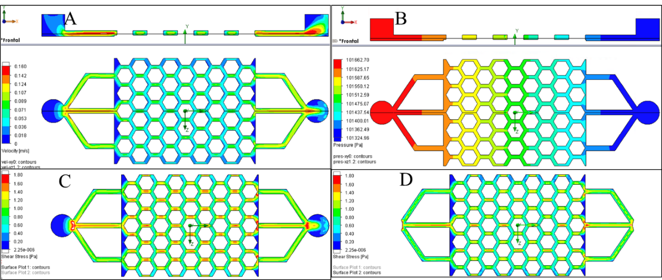
Figure 11. 1. Simulation results for non-porous polyHIPE at Q: 3.2 mL/min with A) velocities on mid-section, B) pressure drop on mid-section and C) shear stress on bottom polyHIPE surface and D) top PDMS surface.
Once the model was validated for a non-porous polyHIPE, we expanded it to permit the use of porous polyHIPEs. For this, a second validation was required to understand how water flows through the polyHIPE. A pressure drop device was manufactured to fit disks of polyHIPE of different thickness to allow a circular section of diameter 10.5 mm. This setup is shown in figure 11.2 A. Water flow was modulated by means of a pump to obtain velocities in the range of 0 to 0.012 m/s. The pressure drop was measured using a differential pressure meter PCE-917 with a range of ±7000 mbar (±700000 Pa) and precision ±5 mbar (±500 Pa) or ±0.05 psi (±344.7 Pa). With these tolerances it was found that measurements were readable for the range of velocities of this study with a minimum thickness of 5 mm. A curve fit of experimental results (Figure 11.2 B) with an acceptable regression coefficient (R²=0.945) showed a linear dependency of pressure drop for each mm that the flow goes into the polyHIPE with velocity as follows:
$$∆P_{p}=stv=st\frac{Q}{A}=47761×5×0.0006=143.3 \text{Pa}\text{ (Eq. 11.7)}$$
Were s: slope of curve fit, v: velocity, t: thickness of polyHIPE, Q: flow rate, A: cross section.
A model of the experiment was prepared to evaluate the pressure drop. The simulation predicted a pressure drop of 101456-101325=131 Pa (Figure 11.2 C) instead of the 143.3 Pa calculated theoretically for a constant speed of 0.0006 m/s. Simulation results for velocities found a deviation in shape of velocities from the parabolic around the porous polyHIPE (Figure 11.2 D). In a parabolic profile the velocities in the centre should be 2×0.0006=0.0012 m/s.
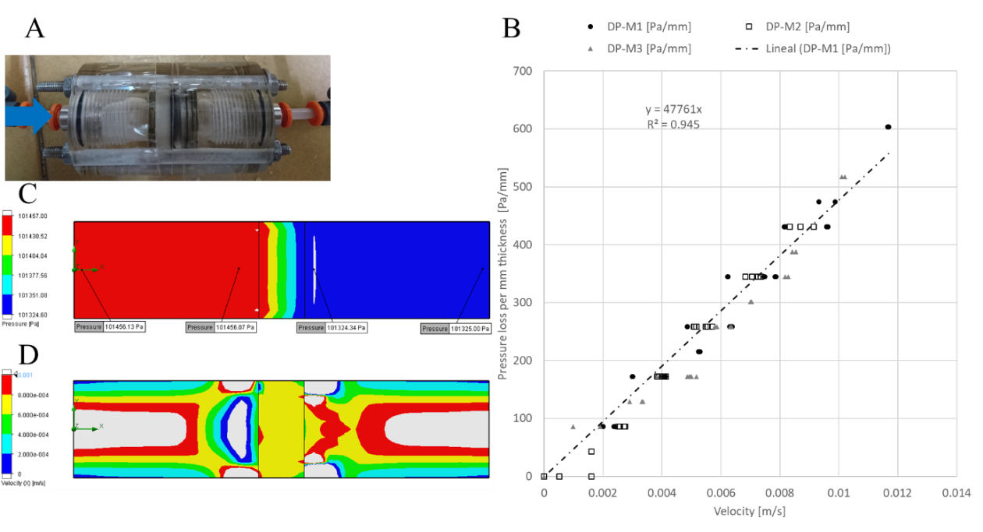
Figure 11. 2. Pressure drop across polyHIPE. A) experimental setup, B) experimental results and curve fit, C) simulation results of pressure drop and D) simulation velocities.
Once the simulation of flow through the polyHIPE was calibrated, the simulation could be repeated with the scaffold assumed to be porous. For a flow rate of 3.2 mL/min, it was observed in the simulation that water was flowing through bulk polyHIPE material but with very low speed (Figure 11.3 A). Surprisingly, the presence of the porous polyHIPE changed the velocity profile, obtaining slightly higher velocities in other regions. The inlet pressure also increased from 101666 to 101784 Pa (ΔP from 337 to 450 Pa, Figure 11.3 B). The shear stress also increased to around 1.8 Pa, slightly higher than the 1.6 Pa observed with non-porous polyHIPE due to higher velocities on entrance channels. It is not possible to plot shear stress on the polyHIPE surface as flow is not tangential as it also goes through the polyHIPE (Figure 11.3 C). On the PDMS surface shear stress increases up to 2.17 Pa due to the change in velocity profile due to the vicinity of porous polyHIPE. This is observed in figure 11. 3 D, where channels seem to be narrower than the non-porous configuration.
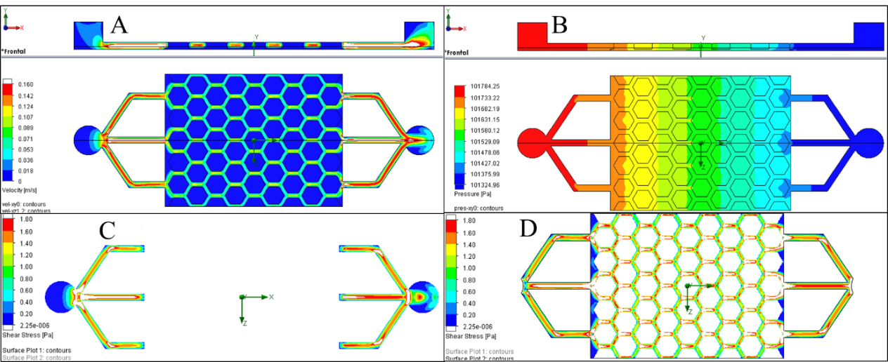
Figure 11. 3. Simulation results for porous polyHIPE at Q: 3.2ml/min with A) velocities on sectioned part, B) pressure drop on sectioned part and shear stress on, C) bottom polyHIPE surface and, D) top PDMS surface.
All simulations were repeated for the lower flow rates (Q: 0.8, 1.6, 2.4 mL/min), showing in all cases laminar flow, and therefore all values of Reynolds, velocity, shear stress and pressure drop, were linear with flow rate. This is in agreement with linearity shown through equations 1 to 5 and shown in figure 11.4.
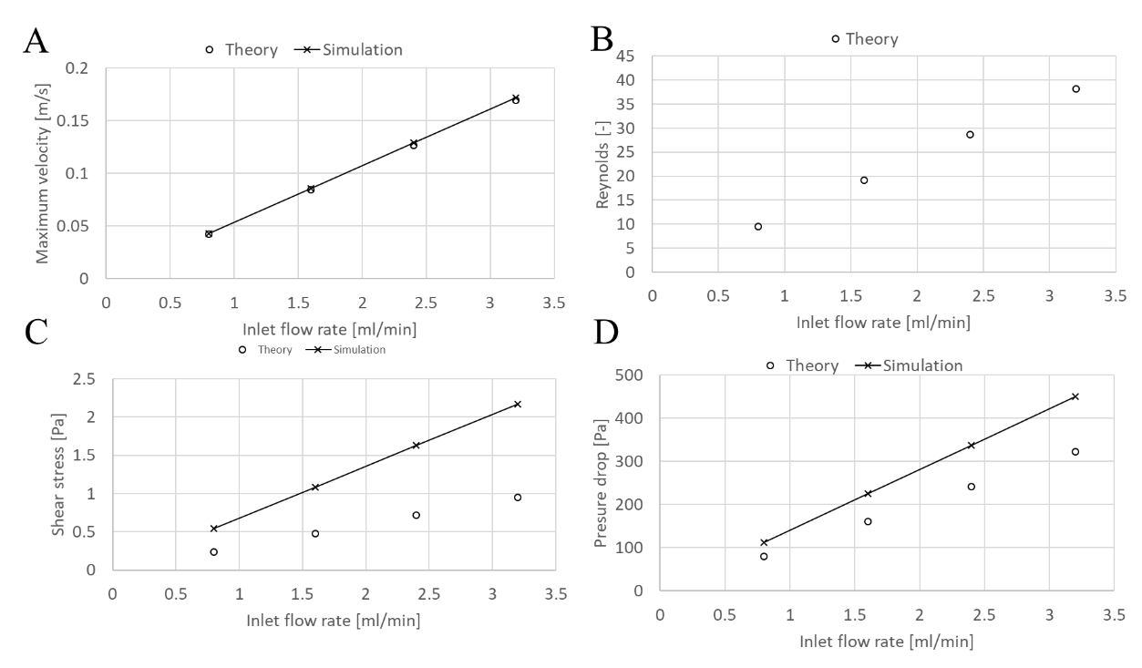
Figure 11. 4. Theoretical and simulation values for different flow rates for A) maximum velocity, B) Reynolds (only theory), C) maximum shear stress and, D) pressure drop.

