

**The comparative hybrid life cycle assessments and sustainability of functional devices and related materials**

***Lucy Smith***

***A thesis submitted in partial fulfilment of the requirements for the degree of Doctor of Philosophy***

***Supervisors***

***Professor I. M. Reaney***

***Professor S. C. L. Koh***

***Department of Materials Science and Engineering***

***The University of Sheffield***

***May 2019***

**Acknowledgements**

To begin, I would like to express my sincere gratitude to Professor Ian M. Reaney and Professor S. C. Lenny Koh for their supervision and support throughout this PhD journey. Their knowledge and experience in their respective fields has helped me tremendously in developing as a researcher. Furthermore, I am extremely thankful for the opportunities that they have provided through attending and presenting at global conferences and applying my skills to wider projects. Finally, I am thankful for the financial support provided through the SUbST grant, allowing me to achieve the goal of completing a PhD.

Special thanks go to Dr. Taofeeq Ibn-Mohammed for his help and support throughout this process. His knowledge and expertise in the application of hybrid life cycle assessment helped me to further my own understanding and produce robust and reliable results.

I would further like to thank Professor Derek C. Sinclair and Dr. Fan Yang for their help in my understanding of intermediate temperature SOFCs. To Jean Simpson, I give my thanks for providing additional opportunities and funding alongside my studies. To the Armourers and Brasiers’ Company for the travel grant which allowed me to present at the “Second Global Conference on the Theory and Applications of OR/OM for Sustainability” in Beijing in September 2017. Also, to my friend Dr. Giulia Poerio, who set me off on the right track for the statistical analysis required for the development of the MSI.

My family and friends, both outside and inside of the University of Sheffield, have been unwavering in their continued support and understanding throughout the period of my PhD, especially when (I thought) things were getting tough.

Finally, I wouldn’t be here today without the person who puts up with me on a day to day basis, provides me with ongoing support, grounds me when needed and always makes me laugh. Tony, thank you.

**Abstract**

The world-wide demand for complex products is a challenge in the race to achieve global “sustainability”. As a society, our natural resource consumption and environmental pollution must be hampered in order to achieve a number of the United Nations Sustainable Development Goals. To date, a single methodology for the assessment of sustainability has not been presented, furthermore, a specific calculation to determine the sustainability of a material is absent.

As functional materials, and their associated devices, underpin many of the technologies that we rely on in modern life, from energy generation to communication and transportation, their contribution to global sustainability is of high importance. Despite this, the impact of these components on the environment are not widely studied.

With this in mind, the information presented in this thesis is three-fold. To begin, three comparative hybrid life cycle assessments (HLCAs) of; multi-layered ceramic capacitors (MLCCs) and tantalum electrolytic capacitors (TECs), high temperature and intermediate temperature solid oxide fuel cells (SOFCs) and lithium ion batteries (LIBs) and solid state batteries (SSBs) are outlined. The results of these HLCA are assessed within each system boundary. Secondly, a simple, robust calculation to assess the sustainability of a material, referred to from this point on as the Material Sustainability Index (MSI), is presented along with the underpinning methodology and detailed assessment of the final results. Finally, the results of the HLCA, the MSI and other existing measurements are compared.

Comparison of the environmental impacts of MLCCs and TECs shows that, from cradle-to-grave, the use of tantalum in TECs and nickel in MLCCs lead to the material carbon hot-spots within each supply chain. The results of this study show that the electrical energy requirement of MLCCs is higher than that of TECs but the material embedded energy requirement is found to be twenty times that of MLCCs. The impact of dysprosium use within the MLCC structure was diluted by the high electrical energy requirements and therefore not highlighted as a carbon hot-spot, this emphasises the need for modellers to consider assessing materials and components using multiple methodologies, for example criticality.

When the environmental impacts of high and intermediate temperature SOFCs were compared, the results indicated that the use of novel material structures for intermediate temperature SOFCs results in an impact reduction when compared to high temperature SOFC material architectures. This is due to a reduction in primary energy demand, though an increase in electrical energy is required to allow for the increasingly complicated manufacturing processes employed for the production of these novel structures.

While the results of the comparative HLCA of LIBs and SSB found that the environmental impacts of material use in SSBs are lower than those relating to LIBs, the high electrical and thermal energy demand relating to SSBs far outweighs that relating to LIBs. Despite this, this energy requirement is likely to decrease in an industrial manufacturing environment through the use of more efficient processing techniques and processing aids.

The MSI, a composite indicator consisting of four individual indicators, provides a single result relating to the sustainability of a material. Overall, a large percentage of materials have a final MSI value of 0 points, due to a recycling rate of 0%. In general, it is the social aspect, which is accounted for using the Human Development Index that has the highest impact on the final result with the Global Warming Potential and National Economic Importance of each material having a smaller impact.

Over the period of 2005 to 2015, sustainability decreases for those materials assessed which are linked to an increase of the environmental impact of a process when output is low. Furthermore, the sustainability of a material can be improved through increasing its recycling rate and decreasing the environmental impact relating to its extraction.

When the results of the MSI are compared to those of the HLCAs and other available data sets, it is clear to see that the simple and robust MSI tool should not be viewed as a replacement for other metrics, but as a complementary tool, highlighting the need for concern and further study.

**Contents**

**Publications to date** 11

**List of Tables** 12

**List of Figures** 15

**Abbreviations** 19

**1.** **Introduction** 1

*1.1.* *Aims and objectives* 1

*1.2.* *Novelty and contributions* 2

**2.** **A review of published literature** 4

*2.1.* *Sustainability* 4

*2.2.* *Measuring sustainability* 6

2.2.1. Life cycle assessment 7

2.2.1.1. Life cycle assessment methodologies 8

2.2.1.2. Life cycle assessment data collection 10

2.2.1.3. Application of life cycle assessment to functional ceramics and related devices 11

2.2.1.3.1. Environmental impact categories 12

2.2.1.3.2. Component level analysis 13

2.2.1.3.3. Material level analysis 17

2.2.1.4. Limitations of Life Cycle Assessment 18

2.2.1.5. Sustainability of functional ceramics and related devices 18

2.2.1.6. Use of critical materials 19

2.2.1.7. Summary of the application of LCA to functional ceramics and related devices 20

2.2.2. Life cycle costing 20

2.2.3. Social life cycle assessment 20

2.2.4. Sustainability indicators 21

2.2.4.1. General sustainable development indices 21

2.2.4.2. Material sustainability assessment specific literature 23

2.2.5. The impact of sustainability on policy 45

*2.3.* *Developing a composite indicator* 47

2.3.1. Theoretical framework 50

2.3.2. Missing data 52

2.3.3. Normalisation 53

2.3.4. Weighting and aggregation 56

2.3.5. Uncertainty and sensitivity 58

2.3.6. Revisiting the data 59

2.3.7. Links to other indicators 59

2.3.8. Visualisation of the results 61

*2.4.* *Summary of reviewed literature* 61

**3.** **Hybrid life cycle assessment methodology** 63

*3.1.* *General HLCA methodology* 63

3.1.1. General limitations of the HLCA methodology 65

3.1.2. Overview the HLCA studies 66

*3.2.* *Hybrid Life Cycle Assessment and Environmental Profile Evaluations of High Volumetric Efficiency Capacitors* 67

3.2.1. Introduction 67

3.2.2. Methodology 70

3.2.3. Results 86

3.2.4. Discussion 94

3.2.4.1. Primary energy consumption 94

3.2.4.2. Component level analysis 95

3.2.4.3. Comparison of environmental profiles 97

3.2.4.4. Impacts of end of life methodologies 97

3.2.4.5. Limitations of this study 100

3.2.5. Conclusion 100

3.2.6. Further research 101

*3.3.* *Comparative Environmental Profile Assessments of Commercial and Novel Material Structures for Solid Oxide Fuel Cells* 102

3.3.1. Introduction 102

3.3.2. Methodology 103

3.3.2.1. Commercial SOFC manufacturing process 104

3.3.2.2. IT-SOFC, with ESB electrolyte, manufacturing process 105

3.3.2.3. IT-SOFC, with NBT electrolyte, manufacturing process 106

3.3.2.4. Production of a functioning SOFC 106

3.3.2.5. Data collection 106

3.3.3. Results 118

3.3.4. Discussion 123

3.3.4.1. Comparison of environmental profiles 124

3.3.4.2. Primary energy consumption 125

3.3.4.3. Component level analysis 126

3.3.4.4. Use of critical materials 127

3.3.4.5. Limitations 128

3.3.5. Conclusion 129

3.3.6. Further research 129

*3.4.* *Comparative Hybrid Life Cycle Assessment of Solid State Batteries as a replacement for Lithium-Ion Batteries* 131

3.4.1. Introduction 131

3.4.2. Methodology 132

3.4.2.1. Lithium-ion battery manufacturing process 134

3.4.2.2. Solid state battery manufacturing process 135

3.4.2.3. Common features 137

3.4.2.4. Data collection 137

3.4.3. Results 148

3.4.4. Discussion 152

3.4.4.1. Component level analysis 153

3.4.4.2. Process level analysis 155

3.4.4.3. Comparison of environmental profiles 156

3.4.4.4. End of life management scenarios 157

3.4.4.5. Limitations 158

3.4.5. Conclusion 158

3.4.6. Further work 159

*3.5.* *Summary of the application of the hybrid life cycle assessment methodology* 160

***4.*** ***The Material Sustainability Index*** 162

*4.1.* *Methodology: Building the MSI* 162

4.1.1. Development of the theoretical framework 163

4.1.2. Data selection 165

4.1.3. Imputation of missing data 167

4.1.4. Understanding the underlying structure of the indicators 170

4.1.5. Normalisation 172

4.1.6. Weighting and aggregation 173

4.1.7. Internal coherence assessment 174

4.1.8. Uncertainty and sensitivity analysis 174

4.1.8.1. Sensitivity analysis 179

4.1.8.2. Uncertainty analysis 179

4.1.9. Visualisation of the results 180

4.1.10. Revisiting the data 180

4.1.11. Trend analysis 181

4.1.12. Links to other techniques 182

*4.2.* *Results* 182

4.2.1. Data selection 182

4.2.2. Imputation of missing data 188

4.2.3. Principal Component Analysis 204

4.2.4. Normalisation 217

4.2.5. Weighting and aggregation 222

4.2.6. Uncertainty and sensitivity analysis 224

4.2.6.1. Sensitivity analysis 224

4.2.6.2. Uncertainty analysis 233

4.2.7. Final MSI framework 236

4.2.8. Visualisation of the results 237

4.2.9. Trend analysis 243

4.2.10. Revisiting the data 244

*4.3.* *Discussion* 247

4.3.1. The use of a composite indicator 247

4.3.2. The theoretical framework 248

4.3.3. Data selection 249

4.3.3.1. USGS material production data 250

4.3.3.2. Human development index 252

4.3.3.3. Policy perception index 255

4.3.3.4. Global innovation index 256

4.3.3.5. Global warming potential 258

4.3.3.6. National economic importance 259

4.3.3.7. Recycling rate 259

4.3.4. Imputation of missing data 261

4.3.4.1. Material production data 261

4.3.4.2. Country specific indicators 261

4.3.4.3. Material specific indicators 265

4.3.4.4. Indicator correlation 265

4.3.5. Principal Component Analysis 266

4.3.6. Normalisation 269

4.3.7. Weighting and aggregation 270

4.3.8. Uncertainty and sensitivity 271

4.3.8.1. Sensitivity analysis 271

4.3.8.1.1. Imputation methodology 271

4.3.8.1.2. Normalisation methodology 272

4.3.8.1.3. Aggregation methodology 273

4.3.8.1.4. Indicator exclusion 273

4.3.8.1.5. Indicator substitution 274

4.3.8.1.6. Recycling Rate data source 275

4.3.8.2. Uncertainty analysis 275

4.3.9. Visualisation of the results 277

4.3.10. Trend analysis 278

4.3.11. Revisiting the data 284

4.3.12. Links to other techniques 286

4.3.12.1. Life cycle assessment 287

4.3.12.2. Relationship between the NEI and RR indicators 289

4.3.12.3. Relationship between the MSI and other metrics 292

*4.4.* *Limitations* 294

*4.5.* *Conclusions* 295

**5.** **Further work** 297

**References** 300

**Appendix A** 319

# **Publications to date**

Published journal papers:

**Smith, L**.; Ibn-Mohammed, T.; Koh, S. C. L.; Reaney, I. M., ***Life cycle assessment and environmental profile evaluations of high volumetric efficiency capacitors***. Applied Energy, **2018**, 220, 496-513. DOI: <https://doi.org/10.1016/j.apenergy.2018.03.067>

**Smith, L**.; Ibn-Mohammed, T.; Yang, F.; Reaney, I. M.; Sinclair, D. C.; Koh, S. C. L., ***Comparative Environmental Profile Assessments of Commercial and Novel Material Structures for Solid Oxide Fuel Cells***. Applied Energy, **2019**, 235, 1300-1313. DOI: <https://doi.org/10.1016/j.apenergy.2018.11.028>

Ibn-Mohammed, T.; Reaney, I.M; Koh, S.C.L; Acquaye, A.; Sinclair, D.C.; Randall, C.; Abubakar, F.; **Smith, L**.; Schileo, G.; Ozawa-Meida, L., ***Life cycle assessment and environmental profile evaluation of lead-free piezoelectrics in comparison with lead zirconate titanate.*** Journal of the European Ceramic Society **2018**, 38, 4922-4938. DOI: <https://doi.org/10.1016/j.jeurceramsoc.2018.06.044>

Journal papers under review:

**Smith, L**.; Ibn-Mohammed, T.; Koh, S. C. L.; Reaney, I. M., ***Life cycle assessment of functional materials and devices: opportunities, challenges and current and future trends***. Journal of the American Ceramic Society

Journal papers in preparation:

**Smith, L**.; Ibn-Mohammed, T.; Koh, S. C. L.; Reaney, I. M., ***Comparative hybrid life cycle assessment and techno-economic analysis of lithium ion batteries and solid state batteries***.

**Smith, L**.; Ibn-Mohammed, T.; Koh, S. C. L.; Reaney, I. M., ***A Material Sustainability Index: a simple, robust metric to assess the substitution and sustainability of materials in product development***.

**Smith, L**.; Ibn-Mohammed, T.; Koh, S. C. L.; Reaney, I. M., ***Material Sustainability Measurement: A comparative review of available methodologies and applications***.

# **List of Tables**

|  |  |
| --- | --- |
| Table 1 | Overview of the result of the sustainability assessment given by Kovotzek *et al.*, scores range from 0-100 (where 0 indicates a low risk and 100 indicates a high risk) |
| Table 2 | Examples of the results of criticality assessment given by Zepf *et al.* |
| Table 3 | Indicators chosen by Goe and Gaustad to quantify the criticality of materials used in solar PV cells |
| Table 4 | The list of critical materials for the EU. Those highlighted in italics in the “2014 critical raw materials for the EU” column have not been brought forward into the 2017 result. Those highlighted in bold in the “2017 critical raw materials for the EU column” were not included in the 2014 result |
| Table 5 | List of indicators highlighted in this literature review |
| Table 6 | Pros and cons of a CI |
| Table 7 | The effect of different normalisation methodologies on the “Composite Indicators of Country Performance” adapted from Freudenberg |
| Table 8 | MLCC dimensions based on Figure 9. |
| Table 9 | TEC dimensions according to Figure 10. |
| Table 10 | Life cycle inventory to produce a 1kg batch of MLCCs including any substitutions made |
| Table 11 | Life cycle inventory to produce a 1kg batch of TECs including any substitutions made |
| Table 12 | Calculations of BaCO3 GWP 100a impact |
| Table 13 | Laboratory process and energy use in the manufacturing of MLCCs |
| Table 14 | Laboratory process and energy use in the manufacturing of TECs |
| Table 15 | Life cycle inventory of the incineration, hydrometallurgy and pyrometallurgy recovery methods for a 1kg batch of high efficiency volumetric capacitors |
| Table 16 | List of the environmental impact categories and their corresponding units and LCIA methodologies used in the comparative analysis of a 1kg batch of MLCCs and TECs |
| Table 17 | List of additional inputs added to the SCEnAT*i* software in this study to produce the HLCA |
| Table 18 | SCEnAT*i* HLCA calculation for a MLCC from Cradle to Grave, Incineration, Hydro- and Pyro-metallurgy |
| Table 19 | SCEnAT*i* HLCA calculation for a TEC from Cradle to Grave, Incineration, Hydro- and Pyro-metallurgy |
| Table 20 | MLCC production, sensitivity analysis to determine the effect of manufacturing location on the environmental impact of electrical energy use |
| Table 21 | Life cycle inventory to produce 100kW of energy from a commercially available HT SOFC, including any substitutions made |
| Table 22 | Life cycle inventory to produce 100kW of energy from an IT SOFC using an NBT electrolyte, including any substitutions made |
| Table 23 | Life cycle inventory to produce 100kW of energy from an IT SOFC using an ESB-BRO7 electrolyte, including any substitutions made |
| Table 24 | Calculations of Bi2Ru2O7 GWP 100a impact |
| Table 25 | Laboratory process and energy use in the manufacturing of a commercial HT SOFC |
| Table 26 | Laboratory process and energy use in the manufacturing of an IT SOFC with an NBT electrolyte |
| Table 27 | Laboratory process and energy use in the manufacturing of an IT SOFC with an ESB electrolyte |
| Table 28 | List of the environmental impact categories and their corresponding units and LCIA methodologies used in the comparative analysis of three SOFC architectures |
| Table 29 | Functional attributes for each battery type |
| Table 30 | Life cycle inventory to produce a 1kg LIB of approximately 3.4V, including any substitutions made |
| Table 31 | Life cycle inventory to produce a 1kg SSB of approximately 3.4V, including any substitutions made |
| Table 32 | List of processes for LIB and SSD manufacture, for which LCI data was held in the Ecoinvent database |
| Table 33 | Laboratory process and energy use in the manufacturing of LiFePO4 for use in the positive electrode paste of a LIB |
| Table 34 | Laboratory process and energy use in the manufacturing of a SSB |
| Table 35 | Life cycle inventory of the incineration, hydrometallurgy, pyrometallurgy and reuse EOL management scenarios for both LIBs and SSBs |
| Table 36 | List of the environmental impact categories and their corresponding units and LCIA methodologies used in the comparative analysis of LIBs and SSBs |
| Table 37 | MSI indicator selection criteria matrix |
| Table 38 | Example of weight averaging the HDI using 2014 cobalt production data |
| Table 39 | Example of weight averaging the PPI using 2015 gallium production data |
| Table 40 | Min-max “goal-posts” applied to each indicator in the normalisation process |
| Table 41 | Input factor $X_{1}$, imputation methodology for the HDI indicator: case deletion, average value and geographic value imputation |
| Table 42 | Input factor $X_{2}$, normalisation: change of “goal posts”, ranking and raw indicator values |
| Table 43 | Realigned min-max goalposts for the GWP and NEI indicators |
| Table 44 | Input factor $X_{3}$, aggregation: linear and ranking summation |
| Table 45 | Input factor $X_{4}$, exclusion of indicator: HDI, GWP, NEI and RR |
| Table 46 | Input factor $X_{5}$, substitution of the PPI and GII indicators for the HDI indicator and substitution of the ADP and TOX indicators for the GWP indicator |
| Table 47 | Input factor $X_{6}$, alternative data sources for the RR indicator |
| Table 48 | Justification for the dismissal of MSI indicators based on the selection criteria detailed in Table 35 |
| Table 49 | Summary of data characteristics for the chosen indicators |
| Table 50 | Case deletion data descriptive statistics 2014 |
| Table 51 | Case deletion data descriptive statistics 2015 |
| Table 52 | Indicator average value imputed data descriptive statistics 2014 |
| Table 53 | Indicator average value imputed data descriptive statistics 2015 |
| Table 54 | Geographically imputed data descriptive statistics 2014 |
| Table 55 | Geographically imputed data descriptive statistics 2015 |
| Table 56 | Pearson’ Correlation Coefficient of the indicator correlation using the case deletion imputation method 2014 |
| Table 57 | Pearson’ Correlation Coefficient of the indicator correlation using the case deletion imputation method 2015 |
| Table 58 | Pearson’ Correlation Coefficient of the indicator correlation using the indicator average imputation method 2014 |
| Table 59 | Pearson’ Correlation Coefficient of the indicator correlation using the indicator average imputation method 2015 |
| Table 60 | Pearson’ Correlation Coefficient of the indicator correlation using the geographic imputation method 2014 |
| Table 61 | Pearson’ Correlation Coefficient of the indicator correlation using the geographic imputation method 2015 |
| Table 62 | Communalities of the case deletion imputation methodology 2014 and 2015 |
| Table 63 | Total variance explained of the case deletion imputation methodology 2014 |
| Table 64 | Total variance explained of the case deletion imputation methodology 2015 |
| Table 65 | Component matrix of the case deletion imputation methodology 2014 and 2015 |
| Table 66 | Rotated component matrix of the case deletion imputation methodology 2014 and 2015 |
| Table 67 | Communalities of the average value imputation methodology 2014 and 2015 |
| Table 68 | Total variance explained of the average value imputation methodology 2014 |
| Table 69 | Total variance explained of the average value imputation methodology 2015 |
| Table 70 | Component matrix of the average value imputation methodology 2014 and 2015 |
| Table 71 | Rotated component matrix of the average value imputation methodology 2014 and 2015 |
| Table 72 | Communalities of the geographic imputation methodology 2014 and 2015 |
| Table 73 | Total variance explained of the geographic imputation methodology 2014 |
| Table 74 | Total variance explained of the geographic imputation methodology 2015 |
| Table 75 | Component matrix of the geographic imputation methodology 2014 and 2015 |
| Table 76 | Rotated Component matrix of the geographic imputation methodology 2014 and 2015 |
| Table 77 | Normalised data set using the case deletion imputation methodology for 2014 |
| Table 78 | MSI results of the weighting and aggregation process for each of the imputation methodologies for 2014 and 2015 |
| Table 79 | 2014 and 2015 MSI results for the four and three indicator MSI frameworks, for each material or group studied |
| Table 80 | Minimum and maximum values set for the scaling of the dimension indices in the 2014 HDI calculation |
| Table 81 | Summary of the method, calculation and availability of each RR indicator data source |
| Table 82 | Comparison of the underlying data points used to provide the final NEI indicator raw value for titanium per metric ton from 2005 to 2015 |
| Table 83 | Normalised HDI, GWP, NEI and RR indicator values for molybdenum and palladium in 2014 and 2015 |
| Table 84 | Summary of the 2014 MSI results, for both MSI frameworks, of the main constituents used in the production of KNN and PZT |
| Table 85 | Comparison of the results of the Kolotzek *et al.* assessment methodology with the results of the 2015 MSI four indicator framework |
| Table 86 | The top environmental concerns in 1998 and those in 2014, adapted from Jeswiet *et al.* |

# **List of Figures**

|  |  |
| --- | --- |
| Figure 1 | Venn diagram of sustainability to show the interaction of the three concepts of sustainability; the environment, economy and society |
| Figure 2 | The four phases of an LCA |
| Figure 3 | Schematic of an SOFC |
| Figure 4 | EPI Framework |
| Figure 5 | Weighting example |
| Figure 6 | Comparison of the environmental resource efficiency index and the social resource efficiency index results to aid in the understanding of the resource efficiency index |
| Figure 7 | Characteristics of different capacitor types (a) replacement of ECs (AEC and TEC) due to the advent of large-capacitance MLCCs; (b) rated voltage range of sample capacitors. MLCCs possess higher voltage ratings in comparison with ECs. It is also endowed with longevity and superior reliability; (c) relationship between ESR and ripple voltage. A lower ESR allows the ripple voltage to be maintained to a smaller amount, an attribute of MLCCs which enhances its optimal performance as a replacement for ECs |
| Figure 8 | HLCA system boundary, capturing the materials and energy flows associated with the fabrication processes of both TEC and MLCC |
| Figure 9 | Schematic of a MLCC |
| Figure 10 | Schematic of a TEC |
| Figure 11 | Fabrication route of MLCC (LHS) and TEC (RHS) volumetric efficiency capacitors. The procedures broadly follow those anticipated in industry but where information is not available since it is commercially sensitive, laboratory based data is substituted which approximates that used in industry |
| Figure 12 | Distribution of the primary energy consumption for the fabrication of a 1kg batch of MLCCs (a) Total primary energy consumption including thermal and electrical energy and materials embedded all expressed in MJ kg-1. (b-d) indicate the percentage contributions of each process or material relative to (a) |
| Figure 13 | Distribution of the primary energy consumption for the fabrication of a 1kg batch of TECs (a) Total primary energy consumption including thermal and electrical energy and materials embedded all expressed in MJ kg-1. (b-d) indicate the percentage contributions of each process or material relative to |
| Figure 14 | Percentage contribution of each MLCC manufacturing component of the environmental impacts investigated |
| Figure 15 | Percentage contribution of each TEC manufacturing component of the environmental impacts investigated. The y axis is shown from 75% to 100% to show the impact contribution from all materials |
| Figure 16 | Comparison of TEC versus MLCC. a) Primary energy demand, b) toxicological footprint, c) eco-indicator 99 comparisons, d) input-output (IO) upstream greenhouse gas (GHG) comparison |
| Figure 17 | A screen shot of the resulting supply chain map for the MLCC to hydrometallurgy process, provided by the SCEnAT*i* tool |
| Figure 18 | Schematic of the three SOFC architectures studied; from left to right: the commercial HT-SOFC; the IT-SOFC with a strontium-doped sodium bismuth titanate (NBT); the IT-SOFC with an erbia-stabilised bismuth (ESB) electrolyte |
| Figure 19 | The system boundary applied to the HLCA of three SOFC material architectures |
| Figure 20 | The comparison of the Commercial, NBT and ESB SOFC material structures for a) primary energy demand, b) toxicological footprint, c) ReCiPe Endpoint (E,A) and d) input-output (IO) upstream greenhouse gas (GHG) emissions |
| Figure 21-23 | The percentage contribution of each process step in relation to the primary energy consumption shown in Figure 20a |
| Figure 24 | The percentage contribution of each component of a commercial HT SOFC, for the environmental impacts investigated in this study. The y axis is shown from 80% to 100% to show the impact contribution from all three components |
| Figure 25 | The percentage contribution of each component in an IT SOFC with an NBT electrolyte, for the environmental impacts investigated in this study |
| Figure 26 | The percentage contribution of each component in an IT SOFC with an ESB electrolyte, for the environmental impacts investigated in this study |
| Figure 27 | The system boundary applied to the comparative HLCA of a 1kg LIB and a 1kg SSB of approximately 3.4V |
| Figure 28 | Schematic of an LIB, excluding “common features” |
| Figure 29 | Schematic of an SSB, excluding “common features” |
| Figure 30 | The percentage contribution of each material component of a 1kg LIB of approximately 3.4 V, for the environmental impacts investigated in this study |
| Figure 31 | The percentage contribution of each material component of a 1kg SSB of approximately 3.4V, for the environmental impacts investigated in this study |
| Figure 32 | The percentage contribution of each process step, in relation to the GWP, for the production if a 1kg LIB of approximately 3.4V |
| Figure 33 | The percentage contribution of each process step, in relation to the GWP, for the production if a 1kg SSB of approximately 3.4V. Others refers to those processes with a percentage contribution of less than 1% i.e. anode, current collectors, cell, BMS and packaging |
| Figure 34 | The comparison of the LIB and SSB for a) cumulative energy demand, b) toxicological footprint, c) ReCiPe Endpoint (E,A) and d) input-output (IO) upstream greenhouse gas (GHG) emissions |
| Figure 35 | The impact of the GWP for the EOL management scenarios relating to both a 1kg LIB or SSB of approximately 3.4V |
| Figure 36 | Methodological steps to build a composite indicator |
| Figure 37 | Scope of the MSI |
| Figure 38 | Box and whisker plot of case deletion imputation methodology for the HDI, PPI and GII indicators 2014 |
| Figure 39 | Box and whisker plot of case deletion imputation methodology for the HDI, PPI and GII indicators 2015 |
| Figure 40 | Box and whisker plot of average imputation methodology for the HDI, PPI and GII indicators 2014 |
| Figure 41 | Box and whisker plot of average imputation methodology for the HDI, PPI and GII indicators 2015 |
| Figure 42 | Box and whisker plot of geographic imputation methodology for the HDI, PPI and GII indicators 2014 |
| Figure 43 | Box and whisker plot of geographic imputation methodology for the HDI, PPI and GII indicators 2015 |
| Figure 44 | Box and whisker plot of GWP indicator 2014 |
| Figure 45 | Box and whisker plot of GWP indicator 2015 |
| Figure 46 | Box and whisker plot of RR indicator 2014 |
| Figure 47 | Box and whisker plot of RR indicator 2015 |
| Figure 48 | Box and whisker plot of NEI indicator 2014 |
| Figure 49 | Box and whisker plot of NEI indicator 2015 |
| Figure 50 | Scree plot of the of the case deletion imputation methodology 2014 |
| Figure 51 | Scree plot of the of the case deletion imputation methodology 2015 |
| Figure 52 | Scree plot of the average value imputation methodology 2014 |
| Figure 53 | Scree plot of the average value imputation methodology 2015 |
| Figure 54 | Scree plot of the geographic imputation methodology 2014 |
| Figure 55 | Scree plot of the geographic imputation methodology 2015 |
| Figure 56 | Box and whisker plot of the InvGWP dataset 2014 |
| Figure 57 | Box and whisker plot of the InvGWP dataset 2015 |
| Figure 58 | Box and Whisker plot of the *log*InvGWP dataset 2014 |
| Figure 59 | Box and Whisker plot of the *log*InvGWP dataset 2015 |
| Figure 60 | Histogram of the 2014 InvGWP dataset; skew = 5.442 |
| Figure 61 | Histogram of the 2015 InvGWP dataset; skew = 5.334 |
| Figure 62 | Histogram of the 2014 *log*InvGWP dataset; skew = -0.719 |
| Figure 63 | Histogram of the 2015 *log*InvGWP dataset; skew = -0.699 |
| Figure 64 | Sensitivity analysis of input factors $X_{1}$ 2014 for chromium, cobalt, gold, iron, nickel and zinc |
| Figure 65 | Sensitivity analysis of input factors $X_{1}$ 2015 for chromium, cobalt, gold, iron, nickel and zinc |
| Figure 66 | Sensitivity analysis of input factors $X_{2}$ for 2014 |
| Figure 67 | Sensitivity analysis of input factors $X_{2}$ for 2015 |
| Figure 68 | Sensitivity analysis of input factors $X_{3}$ for 2014 |
| Figure 69 | Sensitivity analysis of input factors $X_{3}$ for 2015 |
| Figure 70 | Sensitivity analysis of input factors $X_{4}$ for 2014 |
| Figure 71 | Sensitivity analysis of input factors $X_{4}$ for 2015 |
| Figure 72 | Sensitivity analysis of input factors $X_{5}$ for 2014 |
| Figure 73 | Sensitivity analysis of input factors $X_{5}$ for 2015 |
| Figure 74 | Sensitivity analysis of input factors $X_{6}$ for 2014 |
| Figure 75 | Sensitivity analysis of input factors $X_{6}$ for 2015 |
| Figure 76 | Result of the uncertainty analysis for 2014 for the materials investigated using the four indicator framework (HDI, GWP, NEI and RR) |
| Figure 77 | Result of the uncertainty analysis for 2014 for the materials investigated using the three indicator framework (HDI, GWP and NEI) |
| Figure 78 | Result of the uncertainty analysis for 2015 for the materials investigated using the four indicator framework (HDI, GWP, NEI and RR) |
| Figure 79 | Result of the uncertainty analysis for 2015 for the materials investigated using the three indicator framework (HDI, GWP and NEI) |
| Figure 80 | The four indicator MSI framework |
| Figure 81 | The three indicator MSI framework |
| Figure 82 | Visualisation of the result of the 2014 MSI, for both the four and three indicator frameworks, using a bar chart |
| Figure 83 | Visualisation of the result of the 2015 MSI, for both the four and three indicator frameworks, using a bar chart |
| Figure 84 | Visualisation of the 2014 MSI result according to the four indicator MSI framework, using a colour coded periodic table |
| Figure 85 | Visualisation of the 2014 MSI using the three indicator MSI framework, using a colour coded periodic table |
| Figure 86 | Visualisation of the 2015 MSI result using the four indicator MSI framework, using a colour coded periodic table |
| Figure 87 | Visualisation of the 2015 MSI result using the three indicator MSI framework, using a colour coded periodic table |
| Figure 88 | The MSI result for aluminium, chromium, copper, lead, magnesium, nickel, tin, titanium and zinc from 2005 to 2015 using the four indicator MSI framework |
| Figure 89 | The MSI result for aluminium, chromium, copper, lead, magnesium, nickel, tin, titanium and zinc from 2005 to 2015 using the three indicator MSI framework |
| Figure 90 | Decomposition of the MSI result, using the four indicator MSI framework, into the four underlying indicators to show their percentage contribution to the MSI result (HDI, *log*InvGWP, NEI and RR) for the 2014 dataset |
| Figure 91 | Decomposition of the MSI result, using the three indicator MSI framework, into the three underlying indicators to show their percentage contribution to the MSI result (HDI, *log*InvGWP and NEI) for the 2014 dataset |
| Figure 92 | Decomposition of the MSI result, using the four indicator MSI framework, into the four underlying indicators to show their percentage contribution to the MSI result (HDI, *log*InvGWP, NEI and RR) for the 2015 dataset |
| Figure 93 | Decomposition of the MSI result, using the three indicator MSI framework, into the three underlying indicators to show their percentage contribution to the MSI result (HDI, *log*InvGWP and NEI) for the 2015 dataset |
| Figure 94 | Heat map of copper mine production in 2014 |
| Figure 95 | Heat map of silver mine production in 2014 |
| Figure 96 | The 2014 HDI structure |
| Figure 97 | 2014 global distribution of HDI results |
| Figure 98 | 2014 global distribution of PPI results |
| Figure 99 | The structure of the GII |
| Figure 100 | 2014 global distribution of GII results |
| Figure 101 | Contribution of the underlying indicators relating to the MSI result for titanium between 2005 and 2015 using the four indicator MSI framework |
| Figure 102 | Contribution of the underlying indicators relating to the MSI result for titanium between 2005 and 2015 using the three indicator MSI framework |
| Figure 103 | Contribution of the underlying indicators relating to the MSI result for magnesium between 2005 and 2015 using the four indicator MSI framework |
| Figure 104 | Contribution of the underlying indicators relating to the MSI result for magnesium between 2005 and 2015 using the three indicator MSI framework |
| Figure 105 | Results of the GWP indicator (kg CO2-eq/kg) for aluminium, chromium, copper, lead, magnesium, nickel, tin, titanium and zinc between 2005 and 2015 |
| Figure 106 | Relationship between the production tonnes of copper and the GWP of copper production between 2005 and 2015 |
| Figure 107 | Scatter graph to show the relationship between the RR and NEI indicators in 2014 |
| Figure 108 | Scatter graph to show the relationship between the RR and NEI indicators in 2015 |

# **Abbreviations**

|  |  |  |  |
| --- | --- | --- | --- |
| Abiotic depletion potential | ADP | Marine sediment ecotoxicity potential | MSETP |
| Acidification potential | AP | Material Sustainability Index | MSI |
| Anode functional layer | AFL | Multidimensional energy poverty index | MEPI |
| Battery management system | BMS | Multilayer ceramic capacitor | MLCC |
| Circular Economy | CE | Multiregional Input Output | MRIO |
| Composite indicator | CI | National Economic Importance | NEI |
| Cumulative energy demand | CED | Organisation for Economic Cooperation and Development | OECD |
| Ecological Footprint | EF | Ozone depletion potential | ODP |
| End-of-life | EOL | Particulate matter | PM |
| Energy development index | EDI | Perovskite solar cells | PSCs |
| Eutrophication potential | EP | Photochemical ozone creation potential | POCP |
| Environmental Sustainability Index | ESI | Photovoltaic | PV |
| Erbia-stabilised bismuth | ESB | Platinum group metals | PGMs |
| Environmental Performance Index | EPI | Policy Perception Index | PPI |
| Equivalent | eq | Principal Component Analysis | PCA |
| Equivalent series resistance | ESR | Rare Earth Elements | REE |
| Freshwater aquatic ecotoxicity potential | FAETP | Recycling Rate | RR |
| Freshwater sediment ecotoxicity potential | FSETP | Registration, Evaluation, Authorisation and Restriction of Chemicals | REACH |
| Gadolinium-doped ceria | GDC | Reserves-to-production | R/P |
| Global Innovation Index | GII | Restriction of Hazardous Substances Directive | RoHS |
| Global reporting initiative | GRI | Royal Society of Chemistry | RSC |
| Global warming potential | GWP | Social life cycle assessment | SLCA |
| Greenhouse gas | GHG | Sodium potassium niobate | KNN |
| Gross domestic product | GDP | Solid oxide fuel cell | SOFC |
| Gross National Income | GNI | Solid state battery | SSB |
| High temperature | HT | Sodium potassium niobate | KNN |
| Human Development Index | HDI | Strontium-doped lanthanum manganite | LSM |
| Human toxicity potential | HTP/TOX | Strontium-doped sodium bismuth titanate | NBT |
| Hybrid life cycle assessment | HLCA | Supply Chain Environmental Analysis Tool | SCEnAT |
| Input output | IO | Sustainable development goals | SDG |
| Intermediate temperature | IT | Sustainable development indicators | SDI |
| Lead zirconate titanate | PZT | Sustainable energy development index | SEDI |
| Life cycle assessment | LCA | Tantalum electrolytic capacitor | TEC |
| Life cycle costing | LCC | Terrestrial Ecotoxicity Potential | TAETP |
| Life cycle inventory | LCI | Triboelectric nanogenerator | TENG |
| Life cycle impact assessment | LCIA | Triple bottom line | TBL |
| Life cycle sustainability assessment | LCSA | United States Geological Survey | USGS |
| Lithium ion battery | LIB | Waste Electrical and Electronic Equipment | WEEE |
| Living Planet Index | LPI | Yttrium stabilised zirconia | YSZ |
| Marine aquatic ecotoxicity potential | MAETP |  |  |

# **Introduction**

As products become more complex, our demand on a wider range of natural materials increases. Every element in the periodic table has now been in use since 1971 when the radioactive actinides were isolated. The full use of the material spectrum allows for piezoelectric, magnetic, semiconducting, thermoelectric and optoelectric materials to be exploited. 75 years ago, iron based alloys simply contained iron and carbon; now they can contain aluminium, cobalt, chromium, manganese, nickel and more [1].

To add to this complexity, materials are sourced from across the world to manufacture goods that are often traded globally [1] and while recycling is now widespread, materials continue to be made from virgin resources [2].

The challenge to achieve global “sustainability” requires a complete transformation in the way we live including, but not limited to, reduction in consumption of natural resources, environmental depletion and pollution. While resource shortages and perceived scarcity may be mitigated by a reduction in consumption, this can also tend towards poor efficiency outcomes and restricted benefits for macro-level sustainability due to the interrelated nature of the three pillars of sustainability; the environment, economy and society [3].

In 2013, Gijzen [4] stated that “We should be collecting big data that can be used to model and test an array of different scenarios for sustainability, transforming the production and consumption of energy”. A review of literature has found that, at present, there is no “holy grail” of sustainability assessments and this therefore, presents a gap in current knowledge.

# *Aims and objectives*

This research arose from the global advancement in technology, and production innovation which requires smaller products and devices with increasingly complex supply chains. These supply chains regularly require the unsustainable production of critical raw materials through virgin mineral mining, due to price volatility and availability, which is both harmful to the environment and has a negative impact on climate change [5].

The overall aim of this work is to develop a new method for quantifying the materials flows and environmental trade-offs associated with material substitution and recycling within the resource efficient and circular economy frameworks. This aim has been achieved through the completion of the following objectives:

* Application of the hybrid life cycle assessment (HLCA) methodology in a comparative capacity to determine the environmental impacts of:
  + Multilayer ceramic capacitors and tantalum electrolytic capacitors
  + High temperature solid oxide fuel cells (SOFCs) and intermediate temperature SOFCs
  + Lithium ion batteries and solid state batteries
* To develop a simple, robust methodology for the calculation of the sustainability of a material
  + To illustrate how the sustainability of a material changes over time using trend analysis between 2005 and 2015
  + To understand how the sustainability of a material can be improved
* To compare the results of the sustainability calculation with the results of the HLCAs and other published methodologies which aim to measure sustainability, criticality etc.

With these requirements in mind, the following thesis is arranged as such: to begin, existing literature relating to the aims and objectives of the study have been explored in section 2; section 3.1 outlines the methodological requirements of a HLCA and sections 3.2-3.4 detail the specific methodologies, results, discussions and conclusions of the three applications of HLCA to the functional materials and devices highlighted above. Section 4 details the methodology, results, discussion, limitations and conclusions relating to the Material Sustainability Index (MSI) and arising from its application across the time period of 2005-2015. The results of the MSI are compared to those of other published indices and, specifically, the results of the applied HLCAs outlined in this thesis. Finally, the potential future direction of this investigation is detailed in section 5.

# *Novelty and contributions*

The novelty and contributions to knowledge of this thesis are three-fold:

1. Three comparative HLCAs have been performed to analyse the environmental impacts of electro-ceramic devices, namely capacitors, solid oxide fuel cells and solid state batteries. This work is important due to their ever-increasing demand within global supply chains; their use of critical raw materials (most importantly rare earth elements); and the low recovery rates of these materials at each products end of life phase. Assessment of the environmental impacts of these components on a global scale, using HLCA, provides decision makers with pertinent information with respect to environmental hotspots within the supply chain and potential mitigation strategies that could be implemented to reduce the overall impact of those devices.
2. To date, no single calculation to determine the sustainability of a material has been published. The Material Sustainability Index is a robust and simple methodology that aims to quantify how sustainable a material is with respect to the triple bottom line (TBL); the environment, economy and society. A robust methodology has been presented to determine the indicators required to produce a meaningful assessment; sensitivity and uncertainty analysis is shown to indicate how the chosen methodology affects the final result and the underlying indicators are assessed to analyse the results and understand how each has an effect on the final value.
3. Lastly, the results of the MSI are compared to the results of the three HLCAs and other quantitative methods of determining sustainability, and related concepts, to understand what value the MSI result brings. It is discussed that, by using the MSI in conjunction with the HLCA methodology and measures, material issues within the supply chain may be highlighted which were not highlighted by the HLCA alone.

# **A review of published literature**

This section of the thesis will review published literature relevant to the performance of the Life Cycle Assessment (LCA) of functional materials and devices and for the development of a Material Sustainability Index (MSI).

Section 2.1 develops an introduction to sustainability; section 2.2 discusses how sustainability can be measured, including life cycle assessment, its available methodologies and its application to functional ceramics and related devices; life cycle costing; social life cycle assessment; sustainability indicators; sustainable development indices and specific material sustainability assessment. The development of composite indicators, including published examples, is outlined in section 2.3. Finally, the findings of the literature review are summarised in section 2.4.

# *Sustainability*

The most widely accepted definition of sustainability was given by the World Commission of Environment and Development (the Brundtland Report, 1987) as: “development that meets the needs of the present without compromising the ability of future generations to meet their own needs” [6]. Alternatives have been proposed, a number of which focus on the concepts of “three pillars” or the “triple bottom line” (TBL) identifying environmental, social and economic factors as those underpinning sustainability [7]. Herva *et al.* [8] and Valentin and Spangenberg [9] included a fourth dimension; “institutional”; while Nurse [10] suggested a fourth “cultural” pillar. Five pillars have been suggested by Ilsokg [11], technical, economic, social, environmental and institutional. Further still, Perlas’ [12] seven component model suggested that sustainable development should be socially just and equitable, respectful of cultures, ecological, economical, account for material and non-material life equally, technological and empower and develop human capacity and potential.

The overall aim of sustainable development is to strike a balance between these issues. It could be argued that the additional parameters expressed in the four, five and seven component frameworks can be slotted into the original three e.g. ecological can fall under environmental and cultural respect can be captured within social [13].

The “Triple Bottom Line” (TBL) concept was coined by Elkington [14, 15], who presented a balanced view of the economic, environmental and social facets of a business. For a system to be environmentally sustainable a stable resource base must be maintained, renewable resources should not be over-exploited and non-renewable resources should only be depleted to the point at which suitable substitutes are invested in. Biodiversity and other ecosystems must also be maintained. Economically, sustainability can be achieved through the continued production of goods and services whilst managing debt and avoiding imbalances in the system which could hinder production. On a social level, for a system to be sustainable, it must be fair in the distribution of suitable provision of services such as education and health and achieve gender equality and political participation and accountability [16]. Figure 1 is a graphical representation of how the three concepts of sustainability (environment, society and economy) interact [17].

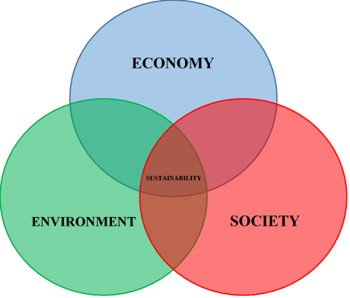

Figure 1: Venn diagram of sustainability to show the interaction of the three concepts of sustainability; the environment, economy and society, adapted from [17].

Taken alone, these elements can lead to trade-offs, for example the rigorous environmental and social laws of one country may lead to a company outsourcing or moving their polluting processes to a different economy where the rules are either not implemented or not properly policed [18]. Taken together, through the acknowledgement of the interdisciplinary nature of the sustainability model, this can lead to sustainable development. A sustainable economy must produce, maintain and enhance manufactured, natural, human and social capital; environmental sustainability is vital for capital production and by limiting the human population and resource depletion, ecosystems can be maintained; socially, meeting basic human needs to achieve development are interrelated with both the economy and the environment [16].

This interconnected nature of sustainability, leading to sustainable development, is key to the measurement of this complex paradigm.

# *Measuring sustainability*

Hanson [19] suggested that the “holy grail” of sustainability measurement would be a single accepted indicator, something that has not yet been achieved. Singh *et al.* [7] reviewed the subject in detail explaining two main methodologies; monetary aggregation (used by economists) and physical indicators (used by scientists and researchers). Ness *et al.* [20] reported that sustainability assessment can be approached in a number of different ways, including but not limited to, temporal properties, scope (e.g. product or region) and level of integration. Warhurst [21] simply suggested a combination of the triple bottom line indicators [21].

The sustainability of materials is addressed by BS 8905:2011 [22] which outlines the requirements of sustainability decision making to be made with a balance of social, economic and environmental impacts. Scoping, data collection and assessment, and reporting are required within the phases of each sustainability assessment to meet the requirements of the standard. The standard describes the three pillars of sustainability as symbiotic; a change to one aspect may have an effect on another, but a specific process to assess all three of these aspects is yet to be defined (only guidance given). The standard advocates the separate calculation of each of the three aspects e.g. using the Global Reporting Initiative (GRI) G3 Guidelines for the social consideration (also known as social life cycle assessment (SLCA)), life cycle assessment (LCA) for the environmental examination and life cycle costing (LCC) for the economic calculation, followed by an amalgamation of the results. This approach appears counterintuitive to the statement of symbiosis as it assesses each pillar individually and therefore does not take into account that fact that a change in one pillar may have an effect on another pillar [22].

The methodology advocated in BS 8905:2011 [22] is more widely known as Life Cycle Sustainability Assessment (LCSA), a framework which is still evolving within the scientific community with the aim of broadening and deepening the existing LCA methodology to progress LCSA [23]. The LCA methodology can be expanded to include social and economic impacts and deepened to capture the understanding of the shifting nature of the economy, society and environment and the overriding mechanisms linking them [23].

Onat *et al.* [23] stated that the current disadvantages of LCSA are the simple approach of assessing the three pillars (through LCA, SLCA and LCC) separately and the lack of understanding of the interconnected nature of the concept [23]. In contrast to this, Kloepffer [24] supported this approach under the constraint that consistent system boundaries between the three assessment methodologies are set.

Hannouf and Assefa [25] developed a decision analysis framework based around the LCSA process. This requires an LCSA to be performed, according to the methodology prescribed in BS 8905:2011 [22], followed by a five step decision analysis process; defining the problem, identifying the objectives, generating potential solutions, evaluation of the potential solutions and analysis of the trade-offs. The aim of the framework is to manage the complexity of the symbiotic nature of the triple bottom line through a structured process [25]. While the LCA, LCC and SLCA are still conducted individually using this framework, the five additional steps to aid decision making allow the three results to be considered as a whole.

Wulf *et al.* [26] related fourteen of the seventeen country level Sustainable Development Goals (SDGs) to LCSA indicators at the product level. For example, the particulate matter indicator used for LCA assessment was assigned to SDG indicators 3.4.1 (mortality rate attributed to cardiovascular disease, cancer, diabetes or chronic respiratory disease); 3.9.1 (mortality rate attributed to household and ambient air pollution) and 11.6.2 (annual mean levels of fine particulate matter (e.g. PM2.5 and PM10) in cities (population weighted)). Their results found, based on a case study for hydrogen production, that although the economic requirements of the SDGs are difficult to relate to LCCs due to the differences between the macro natures of the SDGs and the micro nature of LCCs, relating the SDGs to LCSA indicators can provide better overall knowledge of the SDGs.

# Life cycle assessment

LCA is advocated in BS 8905:2011 as the appropriate methodology to be used in the calculation of the environmental aspect of sustainability [22]; it is a structured framework for the assessment and estimation of the environmental impacts associated with the life cycle of a material, product or service. Since the turn of the century LCA has been put into practice through implementation in policy throughout the world [27]. Different LCA methods are proposed and implemented throughout literature. This section describes these techniques and their implementation within the spectrum of functional ceramics and related devices.

# Life cycle assessment methodologies

BS EN ISO 14040:2006 outlines four phases in an LCA study: goal and scope definition; inventory analysis; impact assessment; and interpretation [28-30], as shown in Figure 2.

Phase one, goal and scope definition, requires a system boundary to be established which determines which processes will be included in the system. This may include the whole life cycle of the product, cradle to grave or cradle to cradle, or it may only include certain steps in the production process e.g. cradle to gate. The setting of this boundary can depend on the application, assumptions made regarding the system or the audience of the final output and may be refined throughout the process [28].

Goal and scope definition

Inventory analysis

Impact assessment

Interpretation

Figure 2: The four phases of an LCA, adapted from [28].

Inventory analysis requires those inputs and outputs identified within the system boundary to be collated and quantified. The impact assessment involves grouping emissions and resources into impact categories to be translated into common units for analysis. Finally, the results must be interpreted throughout the modelling procedure to ensure that the objectives of the study are met [31].

A wide range of LCA techniques have been developed as this can be a time consuming, complicated and costly task [32].

The traditional process based (bottom-up) methodology is labour intensive with regards to data collection, an attribute that does not lend itself well to prompt decision making. To perform a bottom-up process LCA, the system boundary is set to include all known process and material inputs within the supply chain to achieve a required functional unit, this may be, for example, the generation of 100 kW of electricity in the case of a solid oxide fuel cell. While this may produce an accurate result within the system boundary, the inevitable data missing from up and down stream in the supply chain leads to truncation errors of approximately 50% [32-35].

Consequently, the Leontief [36] application of economic input output (IO) data to environmental analysis has been widely adopted to remove this truncation error by incorporating the entire supply chain into the life cycle assessment [32]. IO modelling is a quantitative approach to detail how to the products and services of one economic sector flow from one to another [37]; the environmental IO modelling method is performed by relating the IO tables to emission intensities, the result is the computation of the upstream, indirect emissions associated with the supply chain being studied [31].

While the IO methodology is faster than the process based technique, it doesn’t afford the same level of detail and can become quickly out of date as IO data is often only issued every 3-5 years [32]. Therefore, the hybrid (H)LCA methodology was developed to create a composite approach which is both consistent and robust, accounting from direct and indirect energy consumption. By combining the two methodologies, consistent allocation of impacts is achieved, double counting is avoided but complex data manipulation is required [29, 31, 32, 38].

In their review, Crawford *et al.* [39] outline four different HLCA techniques: tiered, path exchange, matrix augmentation and integrated. The tiered approach expands the system boundary by combining IO and process coefficients; the path exchange method mathematically disaggregates an IO matrix which enables pathways to be identified and modified (the aggregation of which represents the full matrix); matrix augmentation creates sectors of the economy through modification of the IO matrix and finally the integrated approach produces a single matrix of integrated process and IO data. These hybrid methodologies, while widely discussed in literature, have not yet been integrated into BS EN ISO 14040 [39].

The use of multi-regional input-output (MRIO) models in the HLCA methodology allows full traceability of the supply chain of a product which may span over multiple regions or counties. Consequently, a more thorough output is produced [31, 40].

Yang *et al.* [41] argue that in certain circumstances, the HLCA methodology may not produce more accurate results than the traditional process LCA technique; that the significant value of the hybrid process is based around whether the IO model used, accurately represents the missing section of the supply chain in question. As the hybrid methodology involves the addition of IO models to produce sector data, to account for the missing sections of the supply chain, the final outcome will be larger than the process-based methodology. The group discuss that this introduces aggregation errors and that the IO model must be as detailed as the process system boundary to achieve a meaningful result [41].

In their review, Crawford *et al.* [39] state that, despite a 20 year research grounding, hybrid analysis can suffer from reduced uptake due to the use of inconsistent and unclear terminology and the complexity of the methodology, but its application has the ability to provide value within the LCA community.

The Supply Chain Environmental Assessment Tool (SCEnAT) was developed by Koh *et al.* [42] to bridge the gap between literature approaches and practical application. The framework consists of five steps; supply chain mapping (representation of the supply chain supplied by the firm in question, suppliers and researchers), carbon calculation (identification of carbon hot-spots using a HLCA methodology), low carbon interventions, evaluation of the supply chain performance and informed decision making. This tool has been successfully implemented with a number of companies yielding environmental improvements within their supply chains [33, 42].

The tool, now on its third iteration as SCEnAT*i*- intelligence, produces a supply chain carbon map which graphically indicates the carbon hotspots within the supply chain. The indirect, upstream impacts, provided by the multi-regional IO analysis, are related to over 220 sectors (aggregated to 18 sectors) to provide an overview of the environmental impact across the wider supply chain [33].

Overall, the hybrid methodology is employed widely and has been shown to provide more accurate results when compared to a process LCA by widening the scope of the system boundary [31]. With this in mind, section 2.2.1.3 reviews the application of both process and HLCA to functional ceramics and related devices.

# Life cycle assessment data collection

The global supply chains of today are increasing in complexity, they interact with thousands of different human activities and therefore their data collection, in full, is rarely obtained due to the high cost and time requirements relating to it. Those process steps in the foreground system, i.e. those immediately available to the modeller, have been estimated to only address 1-5% of the full life cycle of a product. With this in mind, any background system processes must be addressed using generic data available through databases [43].

Resources such as the Ecoinvent database can be used to provide data on environmental impact categories [44]: 746 environmental impact categories are provided by version 3.3 of the databased, based on 44 life cycle inventory (LCI) methodologies [45].

ISO 14040 standard defines “selection of impact categories and classification” and states that the impacts chosen should be of relevance to the study [28]. The CML2001 and EDIP97 LCI methodologies represent impacts at the midpoint, i.e. somewhere between the source and receptor; the Eco-indicator 99 represents impacts at the end-point, i.e. the receptor. Different environmental impact categories are available within each methodology, for example, the CML2001 methodology holds a “land use” impact category, but this is not available in the EDIP97 methodology [46].

In a case where the LCI of a material is not available through other data sources, the information can be calculated using mass flows or stoichiometry, published literature can be sourced or the data for similar materials, based on chemical or functional characteristics, can be substituted [31].

While it is important to choose the most relevant LCI methodology for the study in question, no universal list of environmental impact categories is available to choose from based on the scope of a study [31, 47].

# Application of life cycle assessment to functional ceramics and related devices

The current applications of functional materials and devices are widespread; from piezoelectric materials in medical process monitoring and energy harvesting, to microwave dielectrics used in satellite communications [48, 49].

In this section, the application of life cycle assessment in the field of functional ceramics and their related devices will be explored. Work performed by Ibn-Mohammad *et al.* [31] has demonstrated, through comparative HLCA, that although a material such as lead zirconate titanate (PZT) is known to be hazardous to human health, alternatives such as sodium potassium niobate (KNN) can pose a greater risk on the environment. Consequently, a design decision must be made based on whether or not the risk to human health is a higher impact than the risk to the environment. This case, and others, are described below along with pertinent environmental impact categories that can be used for analysis, the limitations of LCA, the sustainability of functional ceramics and related devices and finally the impact of using critical materials in their architectures.

# Environmental impact categories

Some of the most commonly analysed environmental impacts with respect to functional materials are devices are those from the CML 2001 methodology: global warming potential (GWP 100a), the acidification potential (AP), eutrophication potential (EP), ecotoxicity potential and human toxicity potential (HTP 100a) [50].

It has been suggested by Buchgeister [51] that more than one LCI methodology should be employed within a study to ensure that the final result is robust and of high quality. A sample of different environmental impact categories are explained below.

One of the most commonly applied environmental impact categories is GWP 100a; the measure of climate change i.e. the effect that the release of greenhouse gasses, by human activity, has on the change in temperature of the earth. This model is based on the UN’s Intergovernmental Panel on Climate Change factors with a time horizon of 100 years (other time horizons can also be used); the unit of measurement is kg CO2-equlivaent (eq) [52].

When acidic gases, such as sulphur dioxide, react with water in the atmosphere they form acid rain (this is also referred to as acid deposition), usually this rain falls in a foreign area to which it was formed. The acidification potential (kg SO2-eq) measures this phenomenon which leads to ecosystem damage and the reduction of local biodiversity [52].

Ecosystem damage can also be caused by the release of ammonia, NOx, nitrates and phosphorus into both air and water. These emissions lead to a build-up of nutrients in water sources, which is called eutrophication. The eutrophication potential (EP), measured as kg PO43-eq or kg N-eq, analyses this change which reduces animal populations and water quality [52].

Marine, freshwater aquatic and terrestrial ecosystems can be affected by the release of substances, such as heavy metals, into the ecosystem. This damage is calculated according to the maximum tolerable concentration of polluting substances in water (based on the EUs toxicity model) which provides the ecotoxicity impact categories which are measured as kg 1,4-DB-eq of PDF (potentially disappeared fraction of species), depending on the model. The impact categories relating to this damage are: Freshwater Aquatic Ecotoxicity Potential (FAETP 100a), Freshwater Sediment Ecotoxicity Potential (FSETP 100a), Marine Aquatic Ecotoxicity Potential (MAETP 100a), Marine Sediment Ecotoxicity Potential (MSETP 100a) and Terrestrial Ecotoxicity Potential (TAETP 100a) [52].

The human toxicity potential (HTP) 100a, measures the toxicity of a compound, its likely dose and therefore the potential harm that it could cause if released to the environment. Cancer, respiratory diseases, non-carcinogenic and ionising radiation effects are used to determine this impact category which is measured in kg 1,4-DB-eq [52].

Summer smog, known as photochemical ozone creation potential (POCP), is created in atmospheres containing NOx and volatile organic compounds when sunlight is present and can lead to crop damage and respiratory issues. POCP is calculated using the United Nations Economic Commission for Europe trajectory model and is expressed as kg ethane-eq [53].

The endpoint methodology, Eco-indicator 99, measures human health, ecosystem quality and resources. This environmental impact category uses a points system to calculate the impact which makes it suitable for comparing products [52].

Using a statistical methodology called principal component analysis, which determines any redundancies within a data set, Genovese *et al.* [54] were able to show that the GWP environmental impact category is able to sufficiently represent the 215 other available environmental indicators held in the Ecoinvent database. Therefore, the use of other impact categories within the same study may be redundant to the modeller. Despite this as mentioned above, the use of more than one LCI methodology can produce a robust and quality result [51].

# Component level analysis

Perovskite solar cells (PSCs) are being dubbed as the “third generation solar cell” and so, alongside their development, the environmental impacts of these materials and devices are under scrutiny [55].

Zhang *et al.* [56] compared the environmental impacts of five PSCs; methylammonium tin triiodide, methylammonium lead iodide, formamidinium lead iodide, caesium lead iodide and methylammonium lead iodide chloride. Similarly, work by Ibn-Mohammed *et al.* [55] details the comparison of methylammonium lead iodide and caesium formamidinium lead iodide bromide PSCs using the HLCA methodology.

When the results of these two studies are compared, it can be seen that, although both groups use laboratory production and published data and a HLCA was performed, there is a difference of approximately 270 MJ/m2 in the presented results [55, 56]. These differences may be due to use of the International Reference Life Cycle Data System methodology in the GaBi 6.1 database by Zhang *et al.* [56] compared to the use of the Ecoinvent database by Ibn-Mohammed *et al.* [55]. Further differences could also be attributed to variations in the laboratory equipment considered in each case [31].

Overall, while the methodology given by Zhang *et al.* [56] states the use of a HLCA, the system boundary and results do not reflect this. The study published by Ibn-Mohammed *et al.* [55] clearly employs the HLCA methodology (as shown in the system boundary) and therefore it would be expected that these results would be more accurate than those presented in the process LCA by Zhang *et al.* [56] as the HLCA methodology is able to capture the wider environmental impacts of the supply chain [31].

Capacitors are used extensively in the modern world. In the automotive sector, for example, Aluminium Electrolytic Capacitors are using in air conditioning systems, window wipers, automatic windows etc. [57]. For applications needing large capacitance, for smoothing for example, Tantalum Electrolytic Capacitors (TECs) are used. Similarly, Multilayer Ceramic Capacitors (MLCCs) are found in mobile phones, laptops and cars on account of their small dimensions and high capacitance and reliability [58]. Their capacitance, voltage rating, operating temperature and dimensions contribute to their different applications and therefore they’re significant to the manufacturing industry and worthy of study with respect to their environmental impacts [58].

In contrast to the wide-spread use of capacitors in today’s electronic devices, only one study, outlining the environmental impact of MLCCs was found in literature [59]. The results of this work showed that it is the electricity consumption and use of ceramic powder required in the production phase that leads to the highest overall environmental impact. This study used the Eco-indicator 99 LCI methodology in conjunction with primary data and published literature to fill in any data gaps.

The use of nanoparticles to replace conventional materials in capacitor manufacturing was explored by Alaviitala *et al.* [60]. This work falls in line with market requirements to increase functionality whilst decreasing size, cost and transportation and maintenance requirements. The group discovered that by manufacturing power capacitors with nano-SiO2, the environmental impacts of the capacitor were reduced by 20% for the majority of impact categories.

Overall, while capacitor technology improves alongside higher market demand, understanding the environmental impacts of these components is essential to ensure sustainability into the future [58].

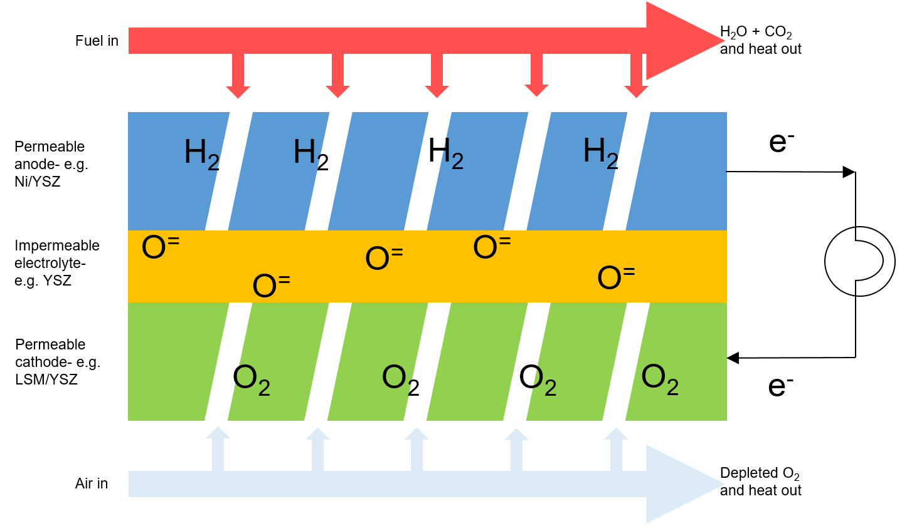Advancements in energy generation techniques have led to the development of Solid Oxide Fuel Cells (SOFCs) which are able to generate energy whilst reducing the environmental impacts associated with conventional energy production methods. These devices are highly efficient and almost completely eradicate NOx and SOx emissions from the energy production process [61, 62]. Figure 3 provides a schematic of an SOFC.

Figure 3: Schematic of an SOFC [63].

The current trend in published SOFC LCA studies is to investigate the impact of the energy sources used to power SOFCs, the processing methods and choice of materials [50].

Strazza *et al.* [64] analysed fuel production, fuel storage, SOFC manufacturing, operation and maintenance of SOFCs using a range of environmental impact categories. Fuels such as methanol, natural gas and hydrogen were studied. This study shows that the configuration required for natural gas and biogas fuels have the lowest environmental impact over all of the categories investigated, except ozone depletion potential (ODP). This high ODP impact was attributed to the required transportation of methanator.

At present, SOFCs operate between 800-1000°C and therefore research is underway to develop SOFCs that can operate at lower temperatures (as low as approximately 350°C in some cases) to enable higher operating efficiencies, lower costs and reduced risk of failure due to thermal cycling [65]. Novel material architectures, such as erbium-stabilised bismuth oxide and strontium doped sodium bismuth titanate, allow these improvements to be attained, the environmental impacts of these structures are yet to be quantified. As demonstrated by Ibn-Mohammed *et al.* [31] the impact of a new design must be quantified prior to implementation on a commercial level to ensure that the risk to the environment is not increased by the product development.

Self-powered devices can be used to harvest energy through the use of triboelectric nanogenerators (TENGs), but to date, very little information has been published on their environmental impacts [66]. Ahmed *et al.* [66] studied the LCA and technoeconomic analysis of two types of TENG models; a thin-film-based micro-grating TENG and a structure based on electrodes generating periodically charged triboelectric potential. This work discovered that 90% of the primary energy demand for each TENG type is caused by the material embedded energy of the raw materials; acrylic is used in both structures and this leads to the highest environmental impact. The use of the copper coating of each module leads to the highest energy demand during manufacturing [66].

The technoeconomic analysis performed in this study demonstrates that the payback period of TENG modules is shorter compared to PV technologies [66]. Future developments of TENGs must relate to lifetime and efficiency improvements rather than the identification of cheaper materials and manufacturing processes [66].

Lithium-ion batteries are widely used in today’s technology, but there are concerns relating to their safety due to dissolution of the electrolyte which has the potential to ignite following a leak [67, 68], consequently, new technologies are under development. Solid state batteries (SSBs) are similar to Li-ion batteries but the liquid electrolyte is replaced with a solid electrolyte and therefore they are less hazardous and have improved properties [67].

Only two published pieces of work were available relating to the environmental impacts of SSBs, [68] and [69]. Troy *et al.* [68] analysed the environmental impacts of a SSB in a pouch bag housing using laboratory, ideal laboratory and industrial processing data. Their work focussed on the use of an LCO/LLZ cathode with a LLZ solid state electrolyte. Their results showed that the electrolyte production leads to the highest GWP (kg CO2-eq) impact of all of the manufacturing steps, followed by the production of the cathode. Further inspection details the electricity requirements for LLZ production and the tapecasting process for both the electrolyte and the cathode afford the highest overall GWP impact. Efficiency enhancements for each processing step were used to determine the impact of the ideal laboratory manufacturing steps. With respect the industrial manufacturing steps, assumptions are made based on energy efficiency, reduced release of solvents and material input; these assumptions are made in absence of referenced evidence.

In their work, Lastoskie and Dai [69] compared the environmental impacts of the lamination and thin-film vapour deposition processes. For the lamination process, cathodes manufactured from lithium manganese oxide, lithium cobalt oxide and lithium nickel-cobalt oxide were investigated and these, plus other materials such as lithium vanadium oxide and silver vanadium oxide were studied with respect to the use of the vapour deposition process. The results of the study found that lithium vanadium oxide SSBs have the lowest environmental impact for GWP and cumulative energy demand compared to lithium manganese oxide and lithium cobalt oxide SSBs.

This dearth of published information on the topic may be environmentally detrimental as development progresses and therefore this gap should be filled appropriately.

# Material level analysis

The use of lead in piezoelectric devices is currently exempt from the European Restriction of Hazardous Substances Directive (RoHS) (2002/95/EC) by Exemption 7c-1 [70]. To maintain this exemption into the second round of the directive, manufacturers must show that the environmental impact of lead based piezoelectric materials is lower than potential alternatives. Sodium potassium niobate (KNN), sodium bismuth titanate (NBT), bismuth ferrite (BiFeO3) and (Ba,Ca)(Ti,ZR)O3 (BCTZ) are some of the lead-free potential alternatives to PZT which have been developed over the last twenty years [71].

Ibn-Mohammad *et al.* [31] studied the comparative HLCA of PZT and KNN. The results of the work show that the use of niobium leads to a higher impact over the sixteen impact categories analysed than PZT. In this work, the HLCA model was applied to impact categories such as greenhouse gas emissions (kg CO2-eq), material use (MJ-eq kg-1), acidification (kg SOx-eq), eutrophication (kg NOx-eq) and land use (m2a). The results showed that 1467.89 MJ-eq kg-1 is required in the fabrication of laboratory-based PZT ceramics, in comparison to 4123.65 MJ kg-1 for the production of laboratory based KNN. Investigations into the toxicities of the two materials show that PZT scores lower on all five toxicity indications (marine sediment, marine aquatic, freshwater sediment, freshwater aquatic ecotoxicities and human toxicity) than KNN; sediment ecotoxicity of KNN is over 278 kg 1,4-DCB-eq and for PZT, this is led than 60 kg 1,4-DCB-eq.

Consequently, the comment made by the expert committee of the RoHS review that PZT replacement may still not be practical for most applications [71] can be extended to encompass the environmental impacts of the materials. Before a lead-free replacement for PZT is fully implemented, the environmental impacts of the remaining potential substitutes must be established [31].

# Limitations of Life Cycle Assessment

The limitations relating to the LCAs reviewed above include access to data and the necessary subjectivity of the analysis. In some cases, (specifically [31] and [58]), laboratory manufacturing data is used in place of industrial manufacturing data. While laboratory data is a primary data source, it may not adequately reflect an industrial process as conventional processes might involve batch production using machinery that is more efficient when compared to a laboratory [58]. Industrial manufacture of electroceramics may also involve the use of sintering aids and low temperature processing which would further reduce the impact of the manufacturing process [58].

The lack of availability of other primary data can be substituted for publicly available data and information published in literature. The use of the Ecoinvent database provides additional information relating to the LCI of materials and energy sources [58].

While HLCA benefits from the study of the full supply chain, a level of subjectivity is introduced to the analysis according to the choice of missing input applied by the modeller. Consequently, if the LCA were to be reproduced, a second modeller may chose alternative missing inputs to add to the supply chain and therefore provide a different result to the initial analysis [58].

# Sustainability of functional ceramics and related devices

Each of the above pieces of work primarily relate to the environmental implications of functional materials and devices which is of high importance within a global supply chain, despite this, the sustainability of these materials and components is becoming increasingly important in line with the concept of the triple bottom line (TBL); economy, society and environment [72].

Life cycle sustainability assessment (LCSA) publications date back to the mid-2000s although the social implications of a supply chain were rarely captured. This may be due to the fact that social issues can only be slightly related to the technical processes in use, i.e. an identical product may be produced by the same process, in numerous companies, but each company may encounter different social impacts [73].

A corporate-oriented raw material assessment is presented by Kolotzek *et al.* [72] which assesses environmental risk, social risk and supply risk. A total of 44 indicators are assessed across the three risk categories to provide three separate scores (where 0 indicates a low risk and 100 indicates a high risk) for each category. Although this is a step forward in attempts to quantify the sustainability of raw materials, only two pillars of sustainability are measured: the environment and society; the economy is not specifically assessed.

A case study is outlined which assesses the raw materials of three capacitor types; aluminium, niobium and tantalum. The visualisation of the results uses a colour code (red for high and blue for low risk) which may make the results easy to interpret [72]. Despite this, the three separate scores leave the decision maker to come to their own conclusion regarding which of the three materials is “best”; the aggregation of these three scores may aid the decision maker further. The results are summarised in Table 1.

Table 1: Overview of the result of the sustainability assessment given by Kovotzek *et al.*, scores range from 0-100 (where 0 indicates a low risk and 100 indicates a high risk) [72].

|  |  |  |  |
| --- | --- | --- | --- |
| **Assessment** | **Aluminium** | **Niobium** | **Tantalum** |
| Social risk | 52 | 40 | 50 |
| Environmental risk | 4 | 11 | 28 |
| Supply risk | 47 | 56 | 65 |

Although this approach further quantifies two of the pillars of sustainability, one overall “sustainability” measure is not provided and therefore the decision maker must make a final assessment on which of the three measures is of overriding importance. Furthermore, while the triple bottom line is cited within the paper as the economy, society and environment, there is no link to the “supply risk” to the economic pillar [72].

# Use of critical materials

Many electroceramic devices, including multi-layer ceramic capacitors, solid state batteries and solid oxide fuel cells utilise critical materials [58, 65, 68].

The addition of rare earth oxides to functional antennas and capacitors is known to improve their properties; 2-3wt% of dysprosium, holmium or erbium oxide are used in MLCCs to achieve this [58]. The US Department of Energy Department of Energy in the USA has labelled dysprosium as the most critical obtainable element [74]. This is due to the separation and refining processes required for rare earth elements which are challenging and environmentally damaging. Additionally, these materials are found in economically unfriendly concentrations in the earth’s crust (and with China holding a monopoly on the market) [75, 76]. Despite these issues, the use of rare earth elements continues to grow [77, 78], but their recovery from devices during the recycling phase is not well documented. In the development of rare earth recycling, Rocchetti *et al.* [79] investigated the precipitation of yttrium using oxalic acid, but unfortunately it was found that the environmental impact of the manufacturing process of oxalic may outweigh the benefits of yttrium recovery.

The EU list 27 critical materials in their 2017 report [80]; cobalt, used in SSBs, bismuth, used in bismuth ferrite (BiFeO3) for piezoelectrics and tantalum, used in TECs are only a few of those materials in this list link to electroceramics. The concept of criticality measurements is explored in more detail in section 2.2.4.2.

# Summary of the application of LCA to functional ceramics and related devices

It can be seen from this small review, that despite LCAs longevity, methodologies are not applied consistently. Furthermore, the HLCA methodology is not wholly implemented in academic analysis despite the additional benefits that it provides to the final result of an LCA. In the case of functional materials and devices, a wealth of LCA studies are available relating to batteries but there is a lack of those of more niche applications like TENGs. As the application of these niche technologies begin to grow, so may the interest in their environmental impacts.

The vital information to be gleaned from this review is the advantages of applying LCA methodologies prior to any change within a supply chain, therefore saving time and cost in the longer term [31]. Furthermore, Guinee *et al.* [27] state that moving forward, LCA must account for the three pillars of sustainability; people, planet and profit.

# Life cycle costing

Similarly, to LCA, life cycle costing (LCC) can be utilised to calculate the cost and/or benefit impacts throughout the life cycle of an investment. Essentially, as in LCA, the “hot-spots” which have the highest impact on the whole life cycle are identified. Overall, the methodology provides important economic information for decision makers [81].

# Social life cycle assessment

A social LCA (SLCA) assesses the social impacts of the life cycle of a product to provide decision support to the end user allowing for the improvement of social conditions for all stakeholders [73]. The indicators relating to the social aspect of sustainability are relatively under-researched in comparison to those of the environmental and economic pillars [15] As noted above, it has been argued that social impacts may not be, or are only marginally, related to technical processes but to the management of the company in which those process are performed [73].

# Sustainability indicators

In practice, the wide variety of available sustainability indicators can be problematic in the production of an unambiguous, aggregated index that can easily be communicated to the public [82]. This section provides an overview of different sustainable development indices; “general” indices that do not specifically relate to the sustainability of materials and “specific” indices that relate to the sustainability of materials. Finally, Table 5 provides a list of those indices found in literature.

# General sustainable development indices

Böhringer and Jochem [82] examined eleven sustainable development indices with respect to consistency and significance; the Living Planet Index (LPI), City Development Index, Human Development Index (HDI), Environmental Sustainability Index (ESI), Ecological Footprint (EF), Environmental Performance Index (EPI), Well-Being Index, Environmental Vulnerability Index, Index of Sustainable Economic Welfare/Genuine Progress Index, Genuine Savings Index, and Environmental Adjusted Domestic Product (this is not a comprehensive list of sustainable development indices) [82]. A selection of these are discussed below. Through comparison of these indices, the group highlighted three main concerns: input variable selection, transparent normalisation and weighting procedures that undergo robust sensitivity analysis and equal treatment of each variable [82].

The aim of the LPI, which was developed by the World Wildlife Foundation, is to measure the change in population abundance of vertebra over time [83], the results of which are reported every two years [84]. This scope is limited and specific in comparison to other available indices.

The EF quantifies the amount of land and water needed to sustain a national living standard, endlessly, with the implementation of efficiency improvements. Ecological sustainability is calculated as the ratio of required resources to available resources i.e. if the ratio is larger than one, the living standards are unsustainable. The national consumption statistics are normalised to convert it to land use, therefore affecting the weighting parameter and aggregation is done by simply adding up the requirements [82, 85]. Experts believe that this is a useful communication tool for policy makers and non-experts [86].

The effective preservation of the environment is measured by the ESI over multiple decades. 76 data sets are integrated into 21 environmental sustainability indicators allowing for the comparison of environmental systems and stresses, human vulnerability to these stresses, the capacity of society to respond to environmental changes and global stewardship. The standard deviation of each variable is calculated for normalisation and each aggregation phase is calculated using the arithmetic mean with equal weighting [82, 87]. The environmental systems component takes into account NOx, SOx, particulates concentration and indoor air quality to account for air quality. This differs from other approaches that use NOx and SOx emissions as an indicator, depending on the outcome that the index is trying to achieve. Data has not been published since 2005 and therefore its use in more modern indices would not be relevant.

While the EPI, which sits alongside the ESI, has progressed since the Böhringer and Jochem [82] review, it continues to be policy based. The two principal themes are environmental health and ecosystem vitality, these are then broken down into nine subjects that address policy issues and finally these are supported by twenty indicators. A scale of 0-100 is used for normalisation, weighting is performed using statistical mechanisms or through consultation with experts and then aggregated using the weighted sum. Up to date research data is made available through the EPI website making it an accessible candidate in the construction of a novel indicator [87].

The United Nations originally published the Human Development Report in 1990, proposing the Human Development Index (HDI); a composite indicator measuring development based on adult literacy, life expectancy and purchasing power [88]. This information is now published annually. The concept of this index is that, for development, humans essentially need to live long, healthy lives, attain knowledge and have access to resources [89, 90]. The HDI has been critically reviewed by many teams since its inception, one of the most criticised aspects is its lack of reference to environmental impacts; despite this, it is one of the most popular used measures of national social capital [3].

The Global Goals for Sustainable Development were agreed upon between 193 world leaders. Themes such as the eradication of poverty, quality education and affordable clean energy are examples of the goals; the aim is to achieve the 17 goals by 2030 [91]. These are challenging goals that are only achievable if all stakeholders are determined to take action [92]. Furthermore, the measurement of the goals is a challenge within itself, requiring data on a wide range of topics; data collection issues relating to death, for example, include 60% of deaths being unaccounted for and vague causes of death being assigned [93]. If the data collection methodology is not reliable, it should not be used in the construction of a composite indicator [15, 83, 94].

The Global Reporting Initiative (GRI) focusses on sustainability reporting as “an organisation’s practice of reporting publicly on its economic, environmental, and/or social impacts, and hence its contributions- positive or negative- towards the goal of sustainable development” [95]. The GRI is broken down into each topic and then broken down further into disclosures, examples of these include direct (scope 1) greenhouse gas emissions, environmental non-compliance with laws and regulations, ratio of wage by gender, spend on local suppliers, diversity of employees and risk for incidents of child labour [96-101]. These results are not aggregated but reported within a company’s annual report. This may result in different collection methods or applied units between different companies which brings additional complication to the production of a composite indicator [15, 83, 94].

The Department of Environment Food & Rural Affairs (Defra) published a report on sustainable development indicators (SDIs) in 2013; the SDIs are split into headline measures of economy, society and the environment and supplementary measures for each of the aspects [102]. The indicators were chosen to provide a benchmark for the UKs progress as a nation. To determine which indicators were the most relevant to the UK, a consultation was made available to stakeholders to give them an opportunity to comment. The consultation received 302 responses from central, local and regional government, businesses and the private sector, charities and the general public. The stakeholders supported a consolidated set of indicators, proposed the requirement of targets and also the need to publish the data [103]. Again, these SDIs are not aggregated but intended for standalone reporting and benchmarking.

Overall, there are a wide range of available sustainability indicators and indices that can be used to measure social, environmental and economic issues, either on their own or within the context of sustainability. The data collection methods range from company based collection to academic collection with differing methodologies and in some cases it is unclear how reliable that data might be.

# Material sustainability assessment specific literature

Arena and Azzone [104] proposed modifying the GRI to tailor it to the steel industry. The group first conducted competitive analysis to identify indicators relevant to the steel industry and their operating country (Italy) and exclude indicators that do not differentiate between competitors. Process and technology analysis was undertaken by experts to identify key processes and technologies within the steel industry. Each process was evaluated and any social issues that could be improved were identified. A preliminary set of sustainability indicators were proposed at this point, followed by a cost-benefit analysis, through conversations with experts and reviews of published sustainability reports, to ensure that the indicators were measurable, reliable and affordable [104].

Biodiversity was excluded from the GRI list as Italian protected areas are not usually impacted on by steel production activities; characteristics of the product or service were removed as steel was seen as undergoing a relatively simple production process and the overall analysis for reporting environmental spend was deemed to be ambiguous and therefore excluded [104]. With regards to the social aspects, issues were excluded that did not distinguish between different companies in the Italian steel industry [104]. Process and technology analysis allowed the authors to understand how each of the issues related to process implications. The process/sustainability maps showed that the blast furnace and electric arc furnace had the strongest environmental issues, while the social issues did not discriminate by process. Conversations with industry professionals highlighted a lack of indirect energy consumption, emissions, absenteeism and workplace incident data; it was felt that waste was too general [104]. Although the GRI accounts for economic issues, these are analysed within the social context and therefore are shown as both social and economic. Furthermore, there are several GRI aspects that are broken down into sub-aspects, only a small number of these are reported.

Area and Azzone did not propose an aggregation method for the identified sustainability indicators. In a later paper, the team discussed implementing these methods in small to medium enterprises to determine appropriate sustainability indicators [105].

Long *et al.* [15] focused on the sustainability of Chinese Iron and Steel companies. Within their review of literature, they identified six existing sustainability assessments at the operational and organisational level, all of which covered the three dimensions of the triple bottom line (TBL). Their criticism of these assessments were that they were either too industry specific (Ford Product Sustainability Index [106]), focussed on investors and stakeholders (Dow Jones Sustainability Indexes [107]) or have too many indicators to identify the most suitable for the iron and steel industry (Global Reporting Initiative [95]).

The selection criteria employed by Long *et al.* [15] was structured as follows; the economic indicators chosen were based on the Chinese Ministry of Finance’s Enterprise rules and Chinese and other Asian literature. The social indicators chosen were adapted from [Székely](http://www.sciencedirect.com.eresources.shef.ac.uk/science/article/pii/S0959652616300907#bib54)and Knirsch [108] and Xiao [109]. The team proposed that the environmental sub-group should be reflected by investment in pollution control and environmental protection, energy consumption and waste emissions [15].

Kuhndt *et al.* [94] examined the sustainability agendas and expectations of stakeholders in the aluminium industry to establish a framework of indicators. The team briefly discuss the difference between core and specific indicators. Core indicators being those that relate to global sustainability issues and are internationally agreed; specific indicators depend on the particular nature of a business. Examples of such are not presented in the journal paper [94].

Karai *et al.* [110] estimated the sustainability of copper with respect to the automobile, electrical appliances and construction industries (these industries were chosen because of relevant Japanese recycling laws). A model was developed based on the material flow of copper and this was projected forward to 2030 to estimate demand. The simulation results showed a shortage of copper by 2030, even when taking into account any improvements in the recycling system, leading to the conclusion that the Japanese copper resource is not sustainable. The team suggested reduced copper usage in vehicles and sharing of resources amongst different industries as possible actions to correct this [110]. It could be argued that this method of calculating sustainability is adequate for materials as it is able to predict if, and when, they may no longer be available for use. On the other hand, it does not take into account the underlying sustainability issues such as the social and environmental impacts of mining or the economic performance.

In comparison to the work performed by Karai *et al.* [110], Kishita *et al.* [111] developed an integrated model to evaluate metal demand from an economic development and dissemination of new products (electric vehicles) point of view. Their work showed that copper consumption would exceed copper reserves by 2040 [111].

Northey *et al.* [112] used the sustainability reports of copper mining companies to evaluate the environmental aspect of copper mining. The report focussed on energy intensity (GJ/t Cu), greenhouse gas (GHG) intensity (CO2-e/t Cu) and water use (L/t Cu). The group reported that differences in the results were caused by the type of copper being made, the grade of the ore, fuel sources, location, reporting method and climate.

The Mwitwa group [113] conducted interviews and observed multiple copper mining sites in Zambia and the Democratic Republic of Congo and found that mining leads to deforestation, the decline of both wood products due to degraded woodland and non-wood products such as fruit, mushrooms and medicines due to wood removal and population growth; ecological effects such as stunted growth of forests and flora because of air pollution, death of aquatic life due to water pollution, fall in wildlife numbers due to noise pollution (i.e. end-point indicators caused by mid-point indicators such as global warming potential). The team also looked into the social impact of mining in communities, these included the decline of agriculture and the reduction of household income due to the reduced quality of non-timber forest products; water pollution was seen to have increased health issues [113].

Koh *et al.* [3] used a composite indicator (CI) to capture the economic, environmental, socio-cultural, energy, material, technical and capital impacts of resource management on a global scale. The team highlighted the importance of regional interdependencies of water, minerals and energy materials and the coinciding impact of consumption and production on national sustainability.

Another concept that could be captured under stainability is criticality. There is no universally agreed definition of criticality, the term is usually used to describe a material with high economic importance at risk of shortage of supply. With this in mind, it is clear how criticality can be related to all three of the triple bottom line aspects, although addressing the issues is complicated by the relationships between the supply chains, infrastructure and material [114]. The concept is usually assessed on two dimensions: availability (or supply risk) and the importance of its use (or vulnerability to supply restriction), although Graedel *et al.* [115], Zepf *et al.* [116] and Goe and Gaustad [114] also include an environmental implications dimension [117]. Erdmann and Graedel [118] reviewed published assessments of criticality up to 2010 and Sonnemann *et al.* [117] reviewed those published between 2010 and 2015.

It is clear to see the importance of material criticality in light of the number of studies that have been conducted on the subject; in the last three years alone, at least five have been published. The results of these studies are not identical as this depends on the requirements of the nation in question and the methodology employed.

The work by Zepf *et al.* [116] focusses on material criticality in the energy industry. A high, medium or low classification is attributed to six different criteria (reserves, trade, ecological impact, processing, substitutability and recyclability) according to predetermined boundaries. For example, reserves are seen to have a high impact if the reserves-to-production (R/P) ration is less than 20 years, a medium impact if R/P is 20-80 years and a low impact if R/P is more than 80 years. With respect to the ecological impact, the impact is high if the element is toxic, or ores contain toxic or radioactive substances or the risk of bioactivity is not refuted; medium impact if low toxicity is known, or data is uncertain, or toxicity is in the process and finally low if no toxicity and no handling problems are known [116].

The materials chosen for this study were filtered based on their use in a commercial energy pathway, their abundance in the earth’s crust and their global distribution [116]. A selection of the results is shown in Table 2.

Table 2: Examples of the results of criticality assessment given in [116].

|  |  |  |
| --- | --- | --- |
| **Material** | **Criteria** | **Result** |
| Copper | Reserves | M |
|  | Trade | L |
|  | Ecological impact | M |
|  | Processing | L |
|  | Substitutability | L |
|  | Recyclability | L |
| Nickel | Reserves | M |
|  | Trade | L |
|  | Ecological impact | H |
|  | Processing | L |
|  | Substitutability | M |
|  | Recyclability | L |
| Platinum | Reserves | M |
|  | Trade | M |
|  | Ecological impact | H |
|  | Processing | M |
|  | Substitutability | H |
|  | Recyclability | M |
| Rare Earths* | Reserves | M |
|  | Trade | H |
|  | Ecological impact | M |
|  | Processing | L |
|  | Substitutability | M |
|  | Recyclability | M |

*All rare earth elements are reported as one material.

The handbook presented by Zepf *et al.* [116] uses a wide range of visuals to help the reader to understand the context of the results. Despite this, the scoring method used does not allow a ranking system to be employed or all of the results to be displayed concurrently and therefore may not serve well for policy making and communication to stakeholders.

Goe and Gaustad [114] compared criticality metrics for Photovoltaic (PV) technologies by characterising the supply, economic and environmental risks using data over a 20 year period. The material analysis is limited to those used in the manufacture of solar PV cells and includes materials such as aluminium, gold and selenium. The indicators chosen by the pair are shown in Table 3 [114].

Table 3: Indicators chosen by Goe and Gaustad [114] to quantify the criticality of materials used in solar PV cells (adapted from [114]).

|  |  |  |
| --- | --- | --- |
| **Risk** | **Component** | **Indicator** |
| Supply | Institutional inefficiency | Net import reliance |
|  |  | Hirfindahl–Hirshmann index of primary material and ore producers |
|  | Physical scarcity | Recycling rate |
|  |  | Ratio of production to reserves |
| Environmental | Human toxicity | CERCLA points |
|  | Energy intensity | Primary embodied energy |
|  |  | Energy savings |
| Economic | Material specific | Primary material price |
|  | Economy-wide | Domestic consumption |
|  |  | Economic value by sector |

The 2014 European Commission report on critical raw materials for the EU highlighted 20 materials as critical, by plotting the materials on two axes; supply risk against importance. This process identified rare earth elements, platinum group metals, natural graphite and silicon as being critical materials [76]. The 2017 report [80] lists 27 materials, as shown in Table 4.

Table 4: The list of critical materials for the EU. Those highlighted in italics in the “2014 critical raw materials for the EU” column have not been brought forward into the 2017 result. Those highlighted in bold in the “2017 critical raw materials for the EU column” were not included in the 2014 result.

|  |  |
| --- | --- |
| **2014 critical raw materials for the EU** | **2017 critical raw materials for the EU** |
| Antimony | Antimony |
| Beryllium | **Baryte** |
| Borates | Beryllium |
| *Chromium* | **Bismuth** |
| Cobalt | Borate |
| Coking coal | Cobalt |
| Fluorspar | Coking coal |
| Gallium | Fluorspar |
| Germanium | Gallium |
| Indium | Germanium |
| *Magnesite* | **Hafnium** |
| Magnesium | **Helium** |
| Natural Graphite | Indium |
| Niobium | Magnesium |
| Platinum Group Metals | Natural graphite |
| Phosphate rock | **Natural rubber** |
| Heavy Rare Earth Elements | Niobium |
| Light Rare Earth Elements | Phosphate rock |
| Silicon metal | **Phosphorus** |
| Tungsten | **Scandium** |
|  | Silicon metal |
|  | **Tantalum** |
|  | Tungsten |
|  | **Vanadium** |
|  | Platinum Group Metals |
|  | Heavy Rare Earth Elements |
|  | Light Rare Earth Elements |

The calculation for economic importance in the 2014 methodology required the amount of material associated with an EU industrial sector to be combined with the gross value added of that sector to the EU’s Gross Domestic Product (GDP) [76]. This result was then scaled using the total EU GDP. In the 2017 methodology, the share of materials in a NACE (derived from “Nomenclature générale des Activités économiques dans les Communautés Européennes”- statistical classification of economic activities in the European Communities) revision 2 sector was combined with the sectors value added. This was then corrected using a substitution index which takes into account the share of the material in an application and the cost performance and sub-share of any potential substitute materials [119].

The supply risk in the 2014 methodology was assessed by the combination of substitutability, end of life recycling rates and concentration of producing countries with poor governance. The supply risk decreases with increased recycling, if the material can be substituted and if production takes place in area of strong governance [76]. A less subjective methodology is presented in the 2017 report [119] which calculates the supply risk as shown in equation 1 where GS denotes global supply, EUsourcing represents the actual supply to the EU, HII stands for the Herfindahl-Hirschman Index, WGI for the scaled World Governance Index, t is the trade parameter which adjust the WGI, IR indicated the import reliance, the end-of life recycling input rate is given by EOLRIR and finally the substitution index relating to supply risk is given by SISR.

(1)

As the methodologies to calculate both aspects of criticality have been changed between 2014 and 2017, this is likely to lead to a change in the final results, this change can be seen in Table 4.

Jin *et al.* [120] reviewed critical material studies such as the National Research Council [121], European Commission [76], Nuss *et al.* [122] and Graedel *et al.* [115]. While indicator selection, determination and mitigation have been covered extensively in literature, Jin *et al.* [120] suggested that a dynamic approach is needed that takes into account the shorter term rather than just the long term [120]. Using the Graedel group as an example, criticality is split into three components; supply risk, vulnerability to supply restrictions and environmental implications. The environmental implications are determined using the human health and ecosystems ReCiPe categories. The supply risk component is broken down into sub-categories which are then broken down into the appropriate indicators (such as depletion time, policy potential index and human development index); there is also a temporal element to this component, medium-term (5-10 years) and long term (a few decades). While the vulnerability to supply restriction component has sub-categories and corresponding indicators, it relates to the corporate, national and global levels rather than a temporal measure [115].

On an ad-hoc basis, the British Geological Survey produce a “Risk List”; at the time of publication, the latest available version is the 2015 Risk List [123]. This list details the risk of 41 elements relative to one another in 2015. The elements were ranked based on their supply risk between one and three over seven criteria, where one denotes a low contribution to the supply risk and three denotes a high contribution i.e. the higher the score, the greater the supply risk. The seven criteria used, with equal weighting, were: production, distribution of reserves, rate of recycling, substitutability, governance and companion metal fraction. The overall supply risk was calculated by aggregating the score of the seven criteria e.g. if all of the individual criterions scored 3, the aggregated score would be 21. These scores were then normalised to produce a range between one (low risk) to ten (high risk) [123]. The final result attributes the highest supply risk to the rare earth elements (index score of 9.5) and the lowest supply risk to gold (4.5).

The result provided by the risk list is limited by data availability, for example, certain elements had to be substituted with suitable alternative; barium was represented using barytes, titanium by rutile and ilmenite and the rare earth elements by the rare earth oxides [123].

The Graedel *et al.* [115] criticality methodology is applied to the copper family [124]. Of the six elements measured, copper has the lowest score across the global, national and corporate scales (32, 44 and 47) respectively. Similarly, in the Zepf *et al.* [116] study, copper scores only medium and low in the different criterions and has a risk list result of 4.8 in 2015 [123]. Comparatively, gold scores higher using the Graedel *et al.* methodology [115, 124] (54 for the global vector and 57 for the national vector) than in the risk list for 2015 (4.5) [123]. In this case, the additional factors taken into account by aggregating supply risk with environmental impacts and vulnerability to supply restrictions provide an opposing result. One example of this can be seen from the point of view of the environmental impacts; this vector has a score of 76 for gold, this is due to a human health score of 6,497.57 (compared to 6.33 for copper) and an ecosystems score of 71.07 (compared to 0.02 for copper).

The Graedel *et al.* methodology [115] uses the apparent consumption indicator to assess material flows, though recent work from this team suggest that this methodology is no longer appropriate and therefore suggest the development of a multi-tiered material consumption database is required to understand material demand [125]. The team acknowledge that this challenge will face issues such as sensitive data collection, the development of overlapping data due to the wide spread use of materials and database maintenance. Despite these issues, the aim of the database is to track the flow of raw materials into components and different pieces of equipment [125].

Furthermore, the national level considered by the Graedel *et al.* methodology [115, 124] is representative for the United States and therefore, if this model were reproduced for the EU or China, it may not provide the same results.

Data outlining recycling rates are able to show the efficiency of material reuse and may outline the effect of recycling on resource sustainability; provide information for different stakeholders (government and industry for example); enable further research into improving recycling; aid policy making and offer data for life cycle assessments [126].

Graedel *et al.* [126] outlined three recycling efficiency measurements; old scrap collection rate: the amount of end-of-life (EOL) material in waste products collected to be recycled; recovery rate: the efficiency of the recycling process; EOL-recycling rate: the ratio of the amount of material collected for recycling to the metal content of EOL products (functional recycling). The group also define non-functional recycling as material that is collected in the recycling process but is lost as an impurity within the dominant recycling material e.g. some alloying elements in steel.

The metal recycling rates published by the Graedel group [126] are taken from global-average metal recycling statistics between 2000-2005 and the quality of the data varies. This work shows the recycling rates of material in metallic form i.e. as titanium, not titanium dioxide or barium, not barium sulphate.

A good example to use to illustrate this point is titanium. Titanium is produced from ilmenite and rutile concentrates, 95% of which goes on to produce TiO2 pigments and 5% to carbide, chemical and metal production. The United States Geological Survey (USGS) Mineral Commodity Summary for Titanium Mineral Concentrates [127] states the recycling of these concentrates to be “none”. Therefore, if Graedel *et al.* [126] quote a 60% titanium recycling rate, this may be referring to less than 5% of the total amount of titanium mineral removed from the earth’s store.

The concept of Circular Economy (CE) is becoming more relevant in society, the theory has been defined in a number of ways; Geng and Doberstein [128] defined CE as “realisation of closed loop material flow in the whole economic system”, while Yuan *et al.* [129], suggested that “the core of CE is the circular (closed) flow of materials and the use of raw materials and energy through multiple phases”. The Ellen Macarthur Foundation [130] suggested that CE is “an industrial economy that is restorative or regenerative by intention and design” [131]. This is not a new way of thinking, prior to the industrial revolution, waste from manufacturing processes was practically unknown; following the industrial revolution, a disposable approach was adopted. The resultant pollution to the environment caused government initiatives to be introduced in the promotion of waste reduction and recycling. In 2009, China implemented the “Circular Economy Promotion Law of the People’s Republic of China”, this has led to a copious amount of research focusing on its application (54% of all CE research articles published between 1950 and 2015) [131].

Lieder and Rashid [131] determined that CE research is disjointed with granular discussion that does not reach the required level for implementation. Similarly, to SDIs, they proposed a top-down, bottom-up approach to ensure that the interests of all stakeholders are taken into account [131]. Although CE can be considered as a standalone concept, it may also be considered as a SDI as it contributes to all three of the aspects of sustainability e.g. reduction in waste, reduced costs, improved lifestyles.

Ahmad and Wong [132] recently reviewed sustainability assessments performed in the manufacturing industry. They found that overall, the majority of sustainability assessments focus on products, manufacturing plants and processes, but sector and economy level assessments are not frequently conducted. It was found that gate-to-gate was the most commonly applied system boundary, metal manufacturing was found to be the most common industry analysed and more work is needed to make economic and social assessments more useful in an industrial setting [132].

Table 5 lists the indicators that were highlighted during this literature review. Within much of the studied material the same, or very similar indicators have been given different names or descriptors. To simplify this, the indicators in Table 5 have been grouped together where possible and therefore the unit column either lists multiple unit parameters or the most common of the references identified. Furthermore, the units of measurement are not consistently reported and consequently the author has used additional resources to determine these units. If multiple units are available for an indicator, a “*” is used to denote this and further information is given in the comments column.

Table 5: List of indicators highlighted in this literature review.

|  |  |  |  |  |
| --- | --- | --- | --- | --- |
| **Sustainability Indicator** | **Unit/Measure** | **Aspect** | **Reference** | **Comments** |
| Materials/Natural Resource Use | kg | Env | [91, 94, 95, 102, 104, 133] |  |
| Proportion of Recycled Content (product and packaging) | % of recycled materials used | Env | [95] |  |
| Energy consumption or Energy intensity | MJ (kWh) or MJ (kWh)/Tonne | Env | [15, 91, 94, 95, 104, 112, 133] |  |
| Energy generation | kWh | Env | [85, 87, 94] | Fossil fuels, nuclear and renewable |
| Scope 1, 2 and 3 GHG emissions or emissions intensity | Tonne CO2-eq or Tonnes CO2-eq/tonne | Env | [87, 94, 95, 102, 104, 112, 133] | CO2, CH4, N2O, HFCs, PFCs, SF6, NF3 |
| Emissions of ozone depleting substances | kg-CFC-eq | Env | [95] |  |
| Emissions of Significant air emissions | ppm (kg) (points) | Env | [15, 87, 95, 104] | NOx, SOx, POP, VOC, HAP, PM etc. [134] |
| GHG emissions/GDP | kg CO2-eq/GDP | Env | [87] |  |
| Transboundary sulphur dioxide spill over | Tonnes | Env | [87] | [135] |
| Polluting goods imports | % polluting goods imported | Env | [87] | [136] |
| Indoor air quality | % population using solid fuel | Soc | [87, 137] |  |
| Investment in pollution control | £($,€)/total operating revenue | Eco/Env | [15, 133] |  |
| Water use (withdrawal by source, recycled and reused) | m3/t or m3 | Env | [15, 87, 91, 94, 95, 102, 104, 112, 133] |  |
| Water sources (significantly affected by withdrawal of water) | m3 | Env | [91, 95] |  |
| Water discharge | m3/t or m3 | Env | [91, 94, 95, 104] |  |
| Water bodies affected by water discharge and/or runoff | m3 | Env | [85, 87, 91, 95] |  |
| Wastewater treatment | % of waste water treated | Env | [137] |  |
| Water quality | mg/l | Env | [87, 102] | Dissolved oxygen, suspended solids, electrical conductivity, phosphorous concentration. [138] |
| Acidification | kg SO2-eq | Env | [87] | [139] |
| Human toxicity potential | kg 1,4-DB-eq | Env/Soc | [31] |  |
| Ecotoxicity potential | kg PO43-eq or kg N-eq | Env | [31] |  |
| Significant impacts on biodiversity | Extent and duration of impact | Env | [95, 102, 133] |  |
| Sites operated in or adjacent to protected area and areas of high biodiversity | Number of sites/size of site | Env | [91, 95] |  |
| Habitats protected and restored | % of area protected | Env | [91, 95, 137] |  |
| Waste generation, reduction and recycling | Tonnes | Env | [15, 85, 87, 91, 94, 95, 102, 104, 133] |  |
| Hazardous waste | Tonnes | Env | [87] |  |
| Transport of hazardous waste | Tonnes | Env | [95] |  |
| Significant spills | Number and volume of spills | Env | [95] |  |
| Environmental Compliance | Total cost of fines | Env | [95, 104] |  |
| Transport | Tonnes CO2 eq | Env | [87, 91, 94, 95, 104] |  |
| Deforestation | % forest loss | Env | [87, 91, 113, 137] |  |
| Decline in non-mined material product quality | % | Eco/Soc | [113] |  |
| Stunted forest growth (due to air pollution) | % | Env | [113] |  |
| Fish stocks | % fish stocks | Env | [87, 91, 102, 113, 137] |  |
| GNI Index | GNI per capita (PPP $) | Eco/Soc | [15, 89, 94, 113] |  |
| Increased health issues (due to water contamination) | Number of health issues | Soc | [87, 113] |  |
| Increased health issues (due to respiratory problems) | Number of health issues | Soc | [87] |  |
| Unsafe sanitation | % of population | Soc | [137] |  |
| Environmental Risk Exposure (Health impacts) | Unitless value | Soc | [137] |  |
| PM2.5 Exposure | mg/m3 | Soc | [137] |  |
| NO2 Exposure | ppb | Soc | [137] |  |
| Wildlife population | [2]- ratio between population in pairs | Env | [83, 87, 91, 102, 113] |  |
| Species protection | % of species protected | Env | [137] |  |
| Employment (turnover, benefits and parental leave) | * | Soc | [94, 95, 104, 133] | Rate of employment, turnover rate, cost of benefits, weeks parental leave |
| Labour/ management relations | Notice periods (in weeks) | Soc | [94, 95, 133] |  |
| Change management | Notice periods (in weeks) | Soc | [95] |  |
| Occupational health and safety (communication and reporting) | * | Soc | [15, 94, 95, 104, 133] | Injury rate, occupational disease rate, lost day rate etc. |
| Training and education | Hours of training per employee | Soc | [85, 87, 91, 94, 95, 104, 133] |  |
| Diversity and equal opportunity | % of individuals | Soc | [94, 95, 104] |  |
| Investment and procurement practices- spend on local suppliers | £/$/€ | Soc | [94, 95] |  |
| Environmental supply chain management | % of suppliers screened for environmental criteria | Env | [94, 95] |  |
| Social supply chain management | % of suppliers screened for social criteria | Soc | [91, 94, 95] |  |
| Abolition of child labour | Number of operations at risk of | Soc | [91, 94, 95] |  |
| Prevention of forced and compulsory labour | Number of operations at risk of | Soc | [95] |  |
| Complaints and grievance practices | Number of complaints | Soc | [94, 95, 104] |  |
| Indigenous rights (equality) | Number of violations of rights | Soc | [95] |  |
| Community engagement, impact and development | * | Soc | [94, 95, 104] | Social impact assessments, public disclosure, programme development etc. |
| Negative impact on the local community | Actual or potential impact | Soc | [95, 133] |  |
| Corruption- assessment, training and reporting | Number of operations at risk | Soc/Eco | [87, 91, 95, 133] |  |
| Policy | Coordination and coherence | Soc/Eco/Env | [87, 91, 94, 95] |  |
| Anticompetitive behaviour | Number of legal actions pending or completed during the reporting period regarding anti-competitive behaviour and violations of anti-trust and monopoly legislation in which the organization has been identified as a participant | Soc | [91, 95] |  |
| Customer health and safety | Number or incidents | Soc | [94, 95, 104] |  |
| Product and service labelling (compliance) | Number of incidents or non-compliance | Soc | [95] |  |
| Marketing and communications | Non-compliance concerning marketing communications | Soc | [94, 95] |  |
| Customer privacy | Number of complaints | Soc | [95] |  |
| Socioeconomic Compliance | Total cost of fines | Soc | [95, 104] |  |
| Violence | Rate of acts committed | Soc | [91] |  |
| Economic prosperity (e.g. GDP) | Market value of final goods and services produced in a period | Eco | [3, 85, 102, 133] |  |
| Long term unemployment | % of adults unemployed for over 12 months | Eco | [91, 102] |  |
| Poverty | Proportion of children in low income households | Eco | [91, 102] |  |
| Poverty | £/$/€ | Soc | [91] |  |
| Knowledge and skills (training) | Value of human capital (£) | Eco | [102] |  |
| Population demographics | Total population and number of households | Eco | [102] |  |
| Debt | Public sector net debt (PNSD) and public sector net borrowing (PSNB) | Eco | [15, 102] |  |
| Pension provision (employee) | Percentage of eligible workers in a workplace pension | Eco | [95, 102] |  |
| Physical infrastructure | Asset net worth by structure type | Eco | [91, 102] |  |
| Research, development and technology | Research and development in cash and real terms | Eco | [87, 91, 94, 102] |  |
| Environmental goods and services sector | Sales of low carbon and environmental goods and services sector | Eco | [102] |  |
| Social capital | * | Soc | [102, 133] | Well-being Index |
| Percentage literacy | % | Soc | [85] |  |
| Social mobility in adulthood | Proportion of adults in managerial or professional positions by social background | Soc | [91, 102] |  |
| Housing provision | Annual net additional dwellings | Soc | [91, 102] |  |
| Avoidable mortality | Number of mortality from causes considered avoidable | Soc | [102] |  |
| Obesity | % of overweight adults/children | Soc | [102] |  |
| Lifestyles (e.g. adult smokers) | * | Soc | [102] | % adult smokers, proportion of trips under 5 miles taken by walking/cycling, proportion of inactive adults |
| Infant health/mortality | Full term babies with birth weight less than 2500g | Soc | [85, 87, 102] |  |
| Air quality | Avg. number of pollution days | Soc | [91, 102] |  |
| Nuisance | Number of people affected by nuisance | Soc | [102, 133] | e.g. noise |
| Fuel poverty | Number of households with higher fuel costs than average &/or where spending that amount puts them below the poverty line | Soc | [102] |  |
| Deaths from environmental disaster vulnerability | Number of deaths | Soc | [87] |  |
| Housing energy efficiency | Mortality from causes considered avoidable | Env | [102] |  |
| Land use and development | m2 | Env | [85, 87, 91, 94, 102, 133] |  |
| Origins of food consumed | Proportion of food consumed in the UK from each region | Env | [102] |  |
| Significant indirect economic impacts e.g. change in social or environmental conditions | £/$/€ | Eco | [95] |  |
| Ratio of wage by gender (equality above) | Ratio of wages | Eco | [95] |  |
| Economic value generation and distribution | £/$/€ | Eco | [95, 133] |  |
| Risk due to climate change | Unit-less measure | Eco/Soc/Env | [91, 95] |  |
| Financial assistance (from government or developed countries) | £/$/€ | Eco | [91, 95] |  |
| Political contributions | £/$/€ | Soc | [15, 95] |  |
| Human rights (review, assessment, training and investment) | * | Eco | [94, 95, 133] | Number of reviews conducted, hours of training, % of employees trained and amount of investment |
| Corporate profitability | Net profit/ net assets or net profit/ average total assets | Eco | [15, 94, 133] |  |
| Corporate capital turnover | Net revenue/ average total assets or net revenue / average current assets | Eco | [15] |  |
| Contribution to society | Total contribution/ total assets | Eco | [15, 94, 109, 133] |  |
| Environmental cost accounting | £/$/€ | Env/Eco | [94] |  |
| Social cost accounting | £/$/€ | Soc/Eco | [94] |  |
| External effects | Tonne CO2-eq | All | [94] |  |
| Risk Management | Unit-less measure | All | [94] |  |
| Household connection to amenities | % of population | Soc | [85, 135] | Inc. drinking water |
| Ecological footprint | Ratio of available to used natural resources | Env | [87] |  |
| Depletion time (reserves) | Years | Env | [115] |  |
| Companion Metal Fraction | % of companion metal | Env | [115] |  |
| Policy Potential Index | * | Soc | [115] | Standalone index |
| HDI | * | Soc | [115] | Standalone index |
| Political Stability | * | Soc | [115] | Reported rankings |
| Global Supply Concentration | HHI* | Soc | [115] | Herfindahl-Hirschman Index |
| Depletion time (reserves base) | Years | Env | [115] |  |
| Environmental implications | ReCiPe Endpoint | Env | [115] |  |
| Percentage revenue impacted | % | Eco | [115] |  |
| Ability to pass through cost increases | Qualitative evaluation | Eco | [115] |  |
| Importance to corporate strategy | Qualitative evaluation | Eco | [115] |  |
| Substitute performance | * | Env | [115] | Determination of end-uses, % of use total, primary substitute |
| Substitute availability | Supply risk | Env | [115] |  |
| Environmental impact ratio | EI of substitute: primary material | Env | [115] |  |
| Price ratio | Price of substitute: primary material | Eco | [115] |  |
| Corporate innovation | Qualitative evaluation | Eco | [115] | Bloomberg Business Week Index available |
| National economic importance | £/GDP | Eco | [115] |  |
| Percentage of population utilizing (PPU) | % | Soc | [115] |  |
| Net import reliance ratio | Tonnes of substitute: primary material | Eco | [115] |  |
| Net import reliance | Tonnes | Eco | [115] |  |
| Global innovation index | GII* | Soc | [115] | Separate index |
| Carbon productivity | GDP per unit CO2 emitted | Env/Eco | [3] |  |
| Energy productivity | GDP per unit of primary energy supply (TPES) in ktoe | Env/Eco | [3, 87] |  |
| Material productivity | GDP generated for a unit of material consumed | Env/Eco | [3] | Non-energy materials |
| Total population | Number of people | Soc | [3, 87] |  |
| Fertility rate | Rate per woman | Soc | [87] | [140] |
| Mean education attainment | Average number of years of education received at 25 years and older | Soc | [3] |  |
| Expected education attainment | Number of years of schooling of a child | Soc | [3, 89] | e.g. Education Index |
| Life expectancy at birth | Number of years a new-born infant could expect to live | Soc | [3, 85, 89, 91, 102] |  |
| Circularity | Material Circularity Indicator | Env | [130] |  |
| Value added | £/$/€ | Eco | [133] |  |
| Shareholder value | £/$/€ | Eco | [133] |  |

This section of the literature review revealed 140 indicators or indices which relate to at least one of the three pillars of sustainability, these are listed in Table 5. The wide variety of available sustainability indicators can be problematic in the production of an unambiguous aggregated index that can easily be communicated to the public [82]. With this in mind, a robust methodology to develop a composite indicator to assess material sustainability is discussed in section 4.

# The impact of sustainability on policy

Over the last ten years, the concept of sustainability has become more prevalent in policy making, though the complexity of this multidisciplinary theory has led to challenges, for example, resolution of the conflict between the three pillars of sustainability, without prioritising a single pillar. The Europe 2020 Strategy for smart, sustainable and inclusive growth tends towards a reinforced economic pillar while the discourse surrounding climate change supports a shift towards a carbon-conscious world [141].

Globally, the current most important political decision process surrounding sustainability are the SDGs [26]. The aim of the SDGs is to promote prosperity while protecting the planet [91]; The SDGs consist of seventeen goals developed based on 169 targets achieved through 330 indicators; unfortunately, the quality of those indicators have been brought into question to ensure proper measurement of each goal over time [142]. Studies have assigned these SDGs to life cycle sustainability assessment (LCSA) impact categories at the product level. The results found that indicator selection is paramount for the completion of a LCSA because of the difference in goal and indicator oriented assessment. Furthermore, issues arise as the SDGs relate to country level assessment compared to the product level assessment of LCSAs, especially with regards to life cycle costing. Despite this, the SDGs provide an adequate guide for LCSA indicator selection [26].

Life cycle assessment (LCA) is now applied within global policy [27], for example, in the European Restriction of Hazardous Substances Directive (2002/95/EC) which was passed in 2003, restricting the use of materials in electrical and electronic components. Lead, mercury, cadmium, hexavalent chromium, polybrominated biphenyls and polybrominated diphenyl ethers have been captured under this piece of legislation [143]. It is possible to apply for a time-restricted exemption and this requires an LCA to be completed which explores the possible impacts of the exemption by comparing the environmental impacts relating to the use of the restricted material, for which the exemption has been requested, and the environmental impacts of any potential substitute materials throughout the lifecycle of a component [144].

The exemption of “lead in a glass or ceramic other than dielectric ceramic in capacitors e.g. piezoelectronic devices” (exemption No. 7c-1) [70] is supported by the findings of Ibn-Mohammed *et al.* [31] whereby it has been shown through the application of hybrid (H)LCA that using lead-based piezoelectric materials in electronic devices has a reduced impact on both the environment and humans, when compared to substitutes such as niobium-based materials.

A similar piece of legislation called “The Environmental Design of Electrical Equipment Act”, was brought to the House of Representatives in 2009 but was not enacted. This act aimed to restrict the use of the same materials listed above by RoHS for manufacturing in the electronics industry in the United States [145].

At the end of 2006, the EU launched the REACH (Registration, Evaluation, Authorisation and Restriction of Chemicals) Directive. This directive requires chemicals (substances and mixtures) produced or imported into the EU to be registered to the EU’s Chemicals Agency. Both the environmental exposure and human exposure potentials should be included in the registration and poignant information with regards to the safe usage of the chemical or mixture [146]. Although the scopes and frameworks of the LCA methodology and the REACH directive are different, Askham [146] concludes that they assess the same issues and therefore could be complimentary in some cases but could result in conflicting results in other cases. Toxicity data gathered through the implementation of the REACH directive can significantly, positively impact on the results provided by a LCA, and the functionality of the LCA methodology would aid the completion of a REACH registration. The incorporation of the LCA methodology into the REACH registration process can deliver a competitive edge to a company and also provide societal benefits.

With an annual growth rate of 3-5% per year, waste electrical and electronic equipment (WEEE) is thought to be one of the fastest growing waste streams in the world [147]. The European waste directive 2008/98/EC outlines the waste hierarchy which gives priority to the prevention of waste over preparing for reuse, recycling, other recovery and disposal, in that order. It has been argued that, while the waste hierarchy promotes the avoidance of waste to landfill, it does not aid in natural resource consumption reduction and its impact on the environment [148].

Moving forward, more and more policy is beginning to take on aspects of sustainability within its framework, this is likely to continue in a world where global, complex supply chains rely on the use of a wide range of materials and processes. While this implementation is not yet global (the Environmental Design of Electrical Equipment Act (similar to RoHS) was not enacted in the United States), the contribution of functional materials and devices to a low carbon economy must be met with the use of life cycle thinking and endorsed by policy makers.

# *Developing a composite indicator*

The Organisation for Economic Cooperation and Development (OECD) defines a composite indicator (CI) as a compilation of individual indicators into a single index based on an fundamental concept [149]. Policy making, academia, communication and benchmarking can be aided with the use of CIs as the output is one overall number relating to a complex, multi-disciplinary concept, rather than a range of figures; they are not the end goal, they are a vehicle to facilitate discussion and interest in a subject [150, 151].

While CIs are able to ease the interpretation of results they can be deceptive if poorly built or misjudged [151]; simply combining a range of indicators may not necessarily produce an outcome that is fully representative of the subject under scrutiny [21]. Subjective decisions must be made in indicator selection, management of data gaps, mode of aggregation and weighting, for example, which can lead to an unrepresentative outcome. The pros and cons of a CI are noted in Table 6.

Table 6: Pros and cons of a CI [149].

|  |  |
| --- | --- |
| **Pros** | **Cons** |
| Able to summarise complex or multi-dimensional problems | Can result in misleading, ineffective policy when poorly built or misunderstood |
| Able to assess progress over time | The big picture can lead to simplistic conclusions and therefore should be examined in conjunction with its sub-indicators |
| Show the big picture | Subjective decision making is required which must be transparent and principally sound |
| Help to attract public interest | Scope may be limited due to data availability |
| Reduce the number of indicators to be examined | Large amounts of data are required |

CIs can be deficient in showing the complicated interactions of indicators and may not clearly reflect on their performance. At the most basic level, a CI can be developed as an average of the standalone indicators which assumes that the individual indicators are substitutable for one another. An example of this might be that clean air can compensate for poor water quality [152]. Despite these disadvantages, CIs are used in many different fields to summarise a complicated process into one quantity which can be used for benchmarking [153].

Sustainability is usually reported as three separate entities: environment, economic and social but based on the explanation above, CIs can be used to analyse the multi-disciplinary nature of sustainability [3, 154]. Ashby stated that “there is no simple, “right” answer to questions of sustainable development- instead, there is a thoughtful, well-researched response that recognises the concerns of stakeholders, the conflicting priorities and economic, legal and social constraints of technology as well as its environmental legacy” [1].

The Composite Indicators Research Group [155] provided the ten commandments for the development of a CI; these were extended from the OECD Handbook [149]. This guidance has been used to audit indicators such as the EPI, outlined above, the UN Multidimensional Poverty Assessment Tool and others. The steps are outlined in the following paragraphs [155].

Step 1: Theoretical/conceptual framework. The indicator framework must be fit for purpose; this requires precise understanding and definition of the concept in question, the structure and selection criteria of the underlying variables and the impact of the final model [155].

Step 2: Data selection. While this should follow the selection criteria outlined in step 1, it must also be analytically sound and measurable. The data quality should be assessed along with its strengths and weaknesses (a summary table of each indicator is advised) [155].

Step 3: Data treatment. The management of any missing data, outliers and scale changes is crucial and the methodology must be consistent. At this point, it may be necessary to revisit step 2 [155].

Step 4: Multivariate analysis. This involves the simultaneous study of many variables (in this case indicators) to determine any possible relationships between them. Again, at this point, it may necessary to revisit steps 1 and 2 [155, 156].

Step 5: Normalisation. To make the indicators comparable, normalisation may be required. This may require direction adjustment to show that higher values relate to better performance (or vice versa); the method chosen must reflect the model and the properties of the data [155].

Step 6: Weighting and aggregation. Although weighting may not be necessary [7] compensability and correlation should be considered. If weighting and aggregation is required, the method should reflect the model and properties of the data. Common weighting methods are factor analysis, expert opinion, data envelopment analysis; common aggregation methods are arithmetic average, geometric average and Copeland’s method [155].

Intermediate step: Internal coherence assessment. Consideration of whether any dominance problems are present is necessary e.g. are a small number of indicators dominating the result? Similarly, are any indicators resulting in noise? Are any indicators causing bias? Again, at this point, it may necessary to revisit steps 1 and 2 [155].

Step 7: Uncertainty and sensitivity analysis. It is important to ensure that the model is robust and to identify which assumptions affect the final result. The multidisciplinary aspect to a CI means that there must be trade-offs between robustness and any assumptions made. The methodology employed to this point should be scrutinized, discussion should be made around which assumptions affect the overall result and sensitivity analysis should show how the sources of uncertainty affect the final result [155].

Step 8: Relation to other indicators. The composite indicator should be compared to existing models of its type to show any similarities or differences [155].

Step 9: Decomposition of the underlying indicators. This step will show the drivers for good or bad performance, strengths and limitations [155].

Step 10: Visualisation of the results. Relevant imagery of the output can influence or enhance the interpretability of the CI to the relevant stakeholders. The techniques employed may vary based on the audience but a clear, easy to understand and accurate method should be used [155].

The following sections of this report discuss how these steps have been implemented in previously published indices.

# Theoretical framework

The first step in developing a CI is to produce a framework which outlines the subject matter to be measured and any sub-components [149].

While the concept of sustainability is multi-dimensional, interactive and sometimes badly scoped, a framework that appreciates the interdependent and complex nature of the concept whilst allowing for critical thinking will ease the burden [1]. Ashby [1] described a layering approach to structuring a framework; starting with the definition of the problem at the base. The second layer being that of context; why and how has the problem emerged and who are the stakeholders? The next layer is researching the facts; environmental, social, economic, stakeholder and infrastructure factors. The next step is synthesis; compilation of the facts to reach a considered decision on the overall impact on sustainability. The final layer is that of reflection to assess any alternative actions and determine if a sustainable course of action has been mapped.

Alam *et al.* [157] produced the Ecosystem Services Composite which aims to meaningfully analyse ecological, physical, social and economic indicators with regards to urban ecosystem services. They reported a two-level framework; level-1 being simpler, with less indicators and less dada inputs; level-2 being more complex, with more indicators and measurements. The group stated that the level-2 framework could be used in a real world context with more confidence [157].

The framework for the Environmental Performance Index (EPI) (2016) is a four tier structure; this is summarised in Figure 4, the weighting of each component is shown in brackets [87]. As outlined in the Handbook on Constructing Composite Indicators [149], this framework is broken down into two sub-groups and then the underlying indicators associated with each sub-group. Sub-groups can be used to split a multi-dimensional concept into appropriate categories but the chosen sub-groups do not need to be statistically independent of each other.

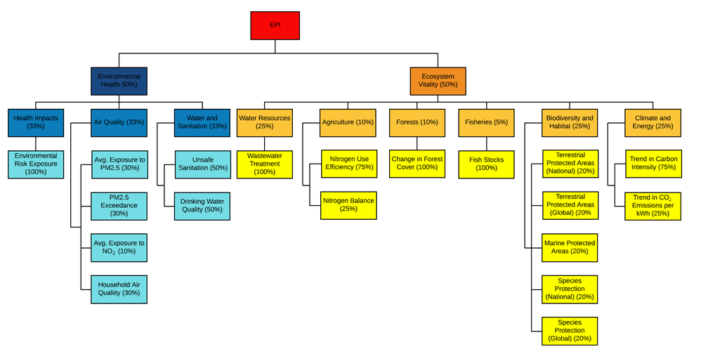Figure 4: EPI Framework adapted from [87].

To this point, this literature review has clearly demonstrated a wide range of sustainability indicators that have been proposed or are in use. While academics agree that guidance is needed on how to choose which indicators are the most relevant to a particular study, agreement has not yet been reached on how to address the issue [15].

The quality of a CI depends on the quality of the base data and the reliability of the procedure used to construct it. In this case, quality means “fit for purpose”; out of date, inaccessible and conflicted data is of no use when constructing a quality CI [149]. Most guidelines follow a similar trajectory for selection criteria; a sample of these are noted below.

The Data Quality Assessment Framework [158] outlines six quality dimensions; prerequisites (legality, resources, relevance and management), integrity (professionalism, transparency and ethics), methodological soundness (concepts and definitions, scope, classification and recording methods), accuracy and reliability (comprehensive source data, assessment of data, use of statistical techniques, assessment and validation, and revision management), serviceability (timeliness, consistency and revision management) and finally accessibility (of data, meta-data and support).

The OECD (Organisation for Economic Co-operation and Development) deem relevance, accuracy, credibility, timeliness, accessibility, interpretability, coherence and cost-efficiency as the most important quality dimensions for indicators [159].

Within published literature, authors have implemented selection criteria based on the requirements of their concept; some examples are discussed below.

Long *et al.* [15] used the widely referenced work of Schomaker [160] as the selection criteria for their work on sustainability indicators for Chinese Iron and Steel organisations. The criteria have been listed below and generalised:

* Relevance: a meaningful and purposeful indicator that is directly related to an aspect of sustainability
* Accessibility: information must be easily identifiable
* Measurability: easy to measure either qualitatively or quantitatively
* Reliability: from a trustworthy source
* Understandable: easily interpreted by stakeholders

Kuhndt *et al.* [94] argued that indicator selection should be based on reliability, availability, relevance, validity, comprehensibility and cost. The aggregation level e.g. product, process, company, site or sector, should also be taken into account [94].

The Living Planet Index data selection was limited by the following criteria; at least two years of data was available, the data collection method, units and geographical location were known, a consistent collection method was used within a time series and the source was referenced and traceable [83].

Overall, the chosen indicators should be a comprehensive set which is focussed and supports the evaluation of the significant economic, environmental and social issues [15].

# Missing data

Data can be missing for various reasons and can obstruct the production of a robust and meaningful CI. Data can be missing completely at random, missing at random or not missing at random but it is not always possible to determine which is correct. Case deletion, single imputation and multiple imputation are the three main methodologies used to impute missing data. Case deletion requires the removal of the missing record from the analysis, this may result in biased estimates and produce larger errors in the data. Generally, cases should not be deleted if more than 5% of values are missing. Value imputation might be the use of the mean, median or mode of the data set i.e. single imputation or regression imputation or multiple imputation [149].

Variance estimates can be used to understand the uncertainty due to data imputation; single imputation can underestimate variance while multiple imputation can be more representative of the uncertainty [149].

The methodology used in the production of the GII allows for the most recent data point, available in the last 10 years, to be used in place of a missing data point [161]. Missing data in the Human Development Index (HDI) is imputed using cross-country regression modelling [162]. In the 2018 EPI report, missing data is treated differently according to its type; when multiple indicators relate to one issue category, the weighting is redistributed around the missing values, the performance of similar countries is used in some cases and also regression modelling [163].

# Normalisation

To make single variables comparable, they may need to be normalised i.e. changing x number of scales (where x is the number of indicators) into one scales that fits all of the indicators [82].

Cherchye *et al.* [164] demonstrated the importance of the normalisation method used in their work by using a simple, two indicator example. The use of a “re-scaling” formula in comparison to a “distance to the leader” formula with equal weighting for normalisation which produced an equal result for the former and a difference of 5% in the latter.

The simplest normalisation technique is ranking which is not affected by outliers and allows performance to be tracked over time. The standardisation method (standard deviation from the mean) produces a common scale with a mean of 0 and a standard deviation of 1. This causes those indicators with more extreme values to have a larger effect on the CI; appropriate weighting can counteract this [165].

A “min-max” technique, where the indicator value has the minimum value of the data set subtracted from it and then is divided by the range of all of the indicator values, can be employed. This technique produces indicators within an identical range of [0,1]. As with the standardisation method, extreme values can misconstrue the final indicator but it can also increase the number of indicators within a small interval, having a positive effect on the indicator [149].

The distance to a reference point can be used as a normalisation method, this reference point may be a target figure (e.g. the Kyoto Protocol which requires an 8% target); a benchmark figure; the average or the leader of the group. Distance from the leader might assign 100 to the leading data set with the remain data sets ranked as a percentage value away from the leader [165].

A categorical scale attributes a score to each indicator (this could be qualitative or quantitative) based on the distributions of the data and the percentiles e.g. the Supply Chain Environmental Analysis Tool (SCEnAT) uses coloured markers to depict the environmental impact, with respect to global warming potential, of a material on a supply chain; green = 1%, yellow 1≤5%, orange 5≤10%, red <10% [42, 149, 165].

Freudenberg [165] gives an example of four different normalisation methods in his work on “Composite Indicators of Country Performance”, this is reproduced in Table 7.

Table 7: The effect of different normalisation methodologies on the “Composite Indicators of Country Performance” adapted from [165].

|  |  |  |  |  |  |
| --- | --- | --- | --- | --- | --- |
|  | **Initial Data** | **Normalisation methods** | | | |
|  | **Business R&D expenditures as % of GDP** | **Standard deviation from the mean** | **Distance from the leader (100)** | **Distance from the best (100) and worst (0) performers** | **Distance from the mean (100)** |
| Sweden | 2.81 | 2.59 | 100 | 100 | 248.3 |
| Japan | 2.04 | 1.48 | 72.8 | 71.9 | 180.8 |
| Switzerland | 1.93 | 1.32 | 68.8 | 67.8 | 170.8 |
| US | 1.93 | 1.31 | 68.6 | 67.6 | 170.4 |
| Finland | 1.90 | 1.27 | 67.7 | 66.7 | 168.2 |
| Korea | 1.85 | 1.20 | 66.0 | 64.8 | 163.7 |
| Germany | 1.58 | 0.80 | 56.1 | 54.7 | 139.4 |
| France | 1.38 | 0.52 | 49.3 | 47.6 | 122.4 |
| Belgium | 1.35 | 0.48 | 48.2 | 46.5 | 119.7 |
| Denmark | 1.24 | 0.31 | 44.1 | 42.3 | 109.5 |
| UK | 1.23 | 0.30 | 43.9 | 42.0 | 108.9 |
| Austria | 1.14 | 0.17 | 40.6 | 38.7 | 100.9 |
| Netherlands | 1.10 | 0.10 | 39.0 | 37.0 | 96.9 |
| Canada | 1.03 | 0.01 | 36.7 | 34.6 | 91.2 |
| Ireland | 1.01 | -0.02 | 36.0 | 33.9 | 89.4 |
| Norway | 0.95 | -0.12 | 33.7 | 31.5 | 83.6 |
| Iceland | 0.86 | -0.24 | 30.7 | 28.4 | 76.1 |
| Czech Republic | 0.74 | -0.42 | 26.2 | 23.8 | 65.1 |
| Australia | 0.72 | -0.45 | 25.6 | 23.1 | 63.5 |
| Slovak Republic | 0.59 | -0.64 | 21.0 | 18.4 | 52.2 |
| Italy | 0.53 | -0.72 | 18.9 | 16.2 | 46.9 |
| Spain | 0.43 | -0.87 | 15.4 | 12.6 | 38.3 |
| New Zealand | 0.32 | -1.04 | 11.2 | 8.3 | 27.9 |
| Poland | 0.30 | -1.07 | 10.5 | 7.6 | 26.1 |
| Hungary | 0.28 | -1.09 | 10.0 | 7.0 | 24.8 |
| Turkey | 0.17 | -1.25 | 6.1 | 2.9 | 15.0 |
| Portugal | 0.16 | -1.27 | 5.5 | 2.4 | 13.7 |
| Greece | 0.15 | -1.28 | 5.2 | 2.1 | 13.0 |
| Mexico | 0.09 | -1.37 | 3.2 | 0.0 | 8.0 |

The standardisation approach is the most popular as it does not introduce aggregation distortions into the data set from the differences in variable means. When the factor takes into account the range of the data set (e.g. distance from the leader), extreme values can have a large effect on the final index [165]. Categorical scales can be subjective and can withhold important information; in the case of the MSI, a qualitative categorical scale would not aid the communication of the index [165].

The Human Development Index (HDI) is composed of the life expectancy index, education index and gross national income index. The life expectancy at birth index is normalised using minimum (20 years) and maximum (85 years) “goal posts” i.e. the “min-max” methodology (an example for Norway, where in 2015 the Life Expectancy at Birth was 81.7 years, is shown in equation 2) [162].

$Life expectancy Index=\frac{81.7-20}{85-20}=0.949$ (2)

The education index is calculated as the average of the normalised values of the mean years of schooling index and the expected years of schooling index, this is shown in more detail in equations 3-5 using Georgia as an example. The expected years of schooling index “goal posts” are 0 (minimum) and 18 (maximum) and the mean years of schooling index “goal posts” are 0 (minimum) and 15 (maximum). Each of the four underlying indicators are normalised using this method [162].

$Expected years of schooling index=\frac{13.905-0}{18-00}=0.77249$ (3)

$Mean years of schooling index=\frac{12.246-0}{15-0}=0.81643$ (4)

$Education index=\frac{0.81643+0.77249}{2}=0.7945$ (5)

# Weighting and aggregation

Following treatment of the individual indicators, they must be combined appropriately in line with the theoretical framework that has been developed [149].

Weighting methods could be assigned according to correlation coefficients or expert opinion, to avoid double counting or based on the quality of the data [151]; statistical methods such as factor analysis can also be used [149]. Despite this, the majority of CIs are equally weighted which signposts that each indicator is worth the same but does not necessarily assume no weighting [149].

Highly correlated indicators within a sub-group may give rise to double counting if equal weighting is used; this can be tested using the Pearson correlation coefficient and addressed by indicator choice or appropriate weighting [149].

Equal weighting can be applied if the sub-indicators have been appropriately scaled. This is appropriate if all of the sub groups have the same number of underlying indicators associated with them. If this is not the case, equal weighing suggests that the sub group with the most underlying indicators is the most important. This method is also used if the sub groups describe different aspects of the output [151]. Principal components analysis is useful for combining variables, indicators are weighted by the proportion of variance to the first principal component [151, 166, 167].

Koh *et al.* [3] do not apply weights to each of the six underlying indicators in their integrated resource efficiency index and the Graedel group [115] apply equal weights to the top level components and also the underlying indicators within each axis of the criticality calculation (an example is shown in Figure 5).

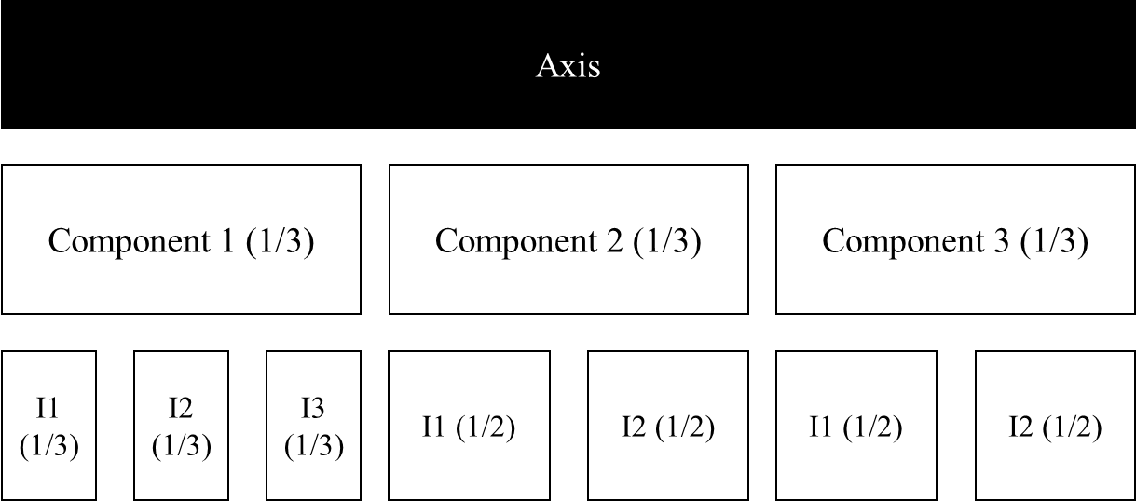

Figure 5: Weighting example adapted from [115].

Long *et al.* [15] used the analytic hierarchy process which involved constructing a hierarchy model, collecting data from experts using a questionnaire and finally calculating the final weights. Their sustainability assessment for the Chinese iron and steel industry gives a weighting of 0.480 for the economic sub-indicator system; 0.192 for the social sub-indicator system and 0.328 for the environmental sub-indicator system. Uncertainty analysis is not provided to clarify how these weights affect the final result and the authors discuss the need for further work to assess the comprehensiveness and parsimony of the indicators used.

Andrade *et al.* [168] compared three existing building sustainability assessments (SBToolPT-H, BREEAM’s Code for Sustainable Homes and LEED for homes v4). In each assessment methodology the weightings used vary; the Code for Sustainable Homes applies higher weight to environmental issues and the SBToolPT-H gives the highest importance to social indicators compared to the other two methods. This difference in weighting methodologies has been found to lead to the same building scoring differently over all three tools.

Aggregation can be conducted in many ways; sub-indicators can be summed and multiplied or through non-linear techniques. The chosen techniques suggest certain assumptions and leads to specific consequences. Linear aggregation (summation) can be used if the same unit is shared by all of the indicators and other uncertainties with respect to scaling have been removed. This suggests compensability between in the indicators i.e. that the reduced performance of certain indicators can be compensated for by the higher performance of others. Multiplication (geometric aggregation) can be used with positive indicators or differing ratio-scales with partial compensability [149].

From an environmental point of view, there are numerous CIs available but the principles required for the relevant aggregation methodology have not been developed [169]. Work by Ebert and Welsch [170] shows that an environmental CI that uses the weighted sum aggregation method may not be meaningful, but the weighted geometric mean methodology (with positive and ratio-scale incomparable indicators) does produce a meaningful result.

Profit *et al.* [171] detail the development of a CI for paediatric quality of care. They state that the aggregation method chosen is dependent on whether care providers should be able to compensate for the poor performance of one metric, with the better performance of another i.e. fully compensative (linear aggregation), partially compensative (multiplication) or not compensative (non-linear techniques).

Koh *et al.* [3] used the geometric aggregation method to establish an integrated resource efficiency index using the following indicators; carbon (CPI), energy (EPI) and material productivity (MPI), expected education attainment (EI), life expectancy at birth (LEI) and the pre-2010 income index (AII). This index is calculated as shown in equation 6 [3].

$IRE_ Index=\sqrt[6]{CPI ×EPI ×MPI ×LEI ×EI ×AII}$ (6)

The aggregation method employed by Long *et al.* [15] in their sustainability assessment of Chinese iron and steel firms, is shown in equation 7; S represents sustainability performance (with respect to an organisation), $X_{i}^{'}$ is the dimensionless indicator and wi represents the weight of the indicator [15].

$S=\sum_{i=1}^{j}{X_{i}^{'}w_{i}}$ (7)

Zhou *et al.* [169] analysed the results of three multiple attribute decision making methodologies and were able to show that the weighted product aggregation methodology led to the least amount of information loss when compared with the simple additive weighting and the weighted displaced ideal aggregation method.

Overall, aggregation requires the same scale for each indicator and therefore the results of the aggregation step highly depended on the normalisation method employed in the previous step of the CI construction [149]. As no finite principles have been developed for the appropriate choice of an aggregation method [169], the modeller must use the most appropriate, based on the chosen indicators and indicator framework.

# Uncertainty and sensitivity

The subjective nature of the construction of a CI, such as indicator selection and the choice of normalisation, weighting and aggregation methodologies, requires the application of sensitivity and uncertainty analysis to ensure that the final result is robust. Uncertainty analysis provides information on how the input variables proliferate through the structure of the CI and therefore affect the results, while sensitivity analysis determines the influence of the source of the uncertainty to any variance in the output. If possible, all sources of uncertainty should be assessed and the following steps could be followed [149]:

1. Inclusion and/or exclusion of indicators

2. Modelling data error according to the variance estimation

3. Use of different imputation methods

4. Use of different normalisation methods

5. Use of different weighting methods

6. Use of different aggregation methods

The sensitivity analysis relating to these uncertainties can then be determined to show the change in the results according to each step outlined above; scatter plots can be used to visualise this information [149].

Kolotzek *et al.* [72] use bar charts to display the sensitivity analysis performed on uncertainty analysis that determines the effect of equally weighted sub-indicators, equally weighted criteria and the removal of sub-indicators. The bar charts allow the reader to see how the results of the indicator changes when each of these adjustments are applied.

Work has been performed to understand the robustness of the HDI by assessing the uncertainty of the use of the log transformation, the application on minimum “goal posts” and the assigned weights. The results show that the HDI is a robust measure and that it is not affected by the choices made during its construction; the results are driven by the weighting methodology [172].

While the use of this analysis will provide important information regarding the subjective choices made during the construction of the CI, it does not ensure a perfect indicator. Though, the results can be used to determine whether or not the original conceptual framework is appropriate for the aim of the CI [149].

# Revisiting the data

Extension of the data analysis can be achieved by deconstructing the CI to understand how the underlying indicators contribute to the final result; this can be shown using bar charts, spider diagrams and traffic light presentations. Tools such as path analysis and Beyesian Networks can be used to understand causality within a relationship. Overall, the results can show how influential one indicator is over another [149].

# Links to other indicators

Linking the results of a CI to other published indicators can help to further explain them, examples of this are given in [149] using cross-plots.

A Monte Carlo framework can be employed to understand the effect of weights or the normalisation method on the correlation of the results. Finally, it is likely that a CI will include some of the sub-indicators with which they are being compared e.g. comparing a CI which has GDP as a sub-indicator with GDP; in this case this sub-indicator should be removed from the composite indicator prior to the comparative analysis [149].

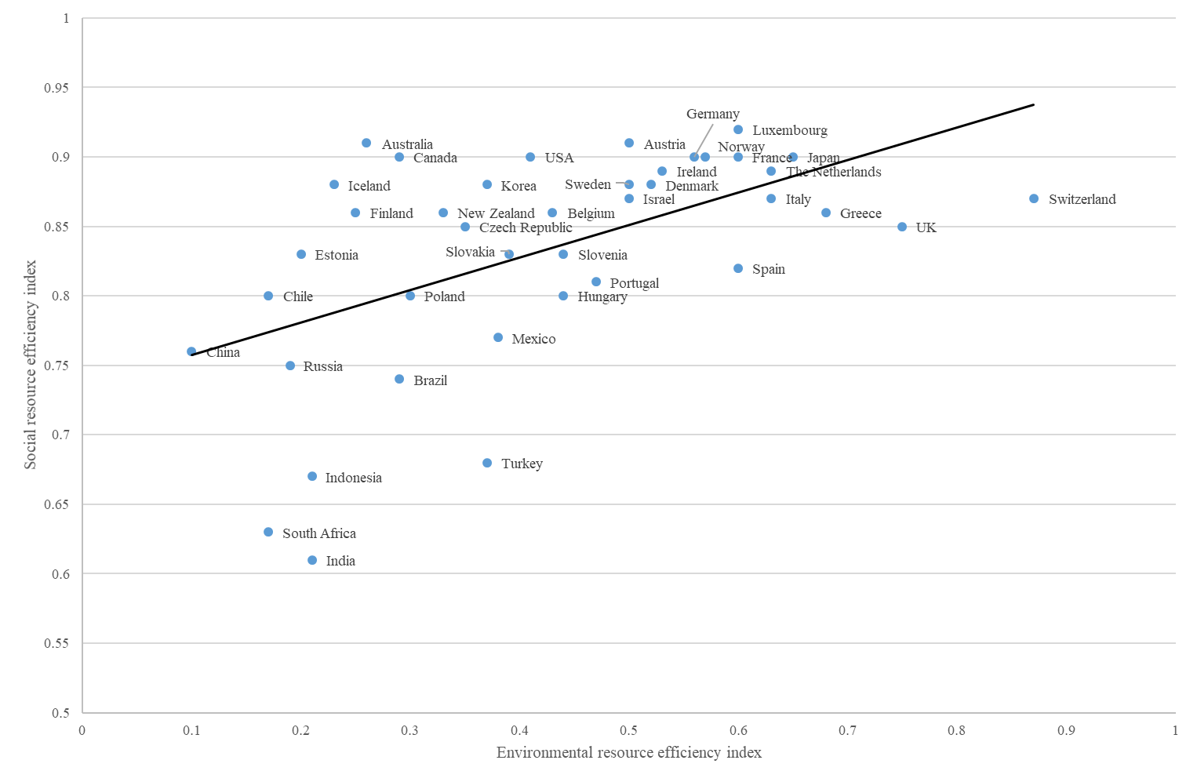Koh *et al.* [3] use the environmental resource efficiency index and the social resource efficiency index to provide further information relating to the results of their resource efficiency index. They were able to show that due to high social resource efficiency index results, the results of the resource efficiency index are mainly driven by the wide range of results of the environmental resource efficiency index. Figure 6 (taken from [3]) demonstrates this comparison.

Figure 6: Comparison of the environmental resource efficiency index and the social resource efficiency index results to aid in the understanding of the resource efficiency index (taken from [3]).

Iddrisu and Bhattacharyya [173] presented a sustainable energy development index (SEDI) to track and trace energy sustainability. The results were compared to the rankings of three other composite indicators; the HDI, the energy development index (EDI) and the multidimensional energy poverty index (MEPI). When the indicators are compared based on the rankings of the SEDI, HDI and EDI, the correlations are positive e.g. high sustained access to energy is positively correlated to human development. When the indicators are compared on the ranking of the MEPI, the SEDI, EPI and HDI are positively correlated but the MEPI is negatively correlated, this is due to the fact that at higher values of MEPI, SEDI and HDI are low i.e. as energy poverty reduces, access to energy is increased and sustained which leads to human development.

Overall, the comparison of a new CI to existing measure will allow for the development of data-driven narrative of the results [149].

# Visualisation of the results

The visualisation of the results of a CI is crucial; the information must be communicated clearly to the stakeholders. This could be in the form of a table, graph or using infographics [149]. Commonly, a combination of these methods are used.

The results of the HDI are available online [174] as a line chart and a table which both show the data back to 1990 (the option to view the data as a bar chart is currently under development). In addition to this, the data for each of the underlying indicators is also available.

The results of the Policy Perception Index (PPI) are published as part of the “Survey of Mining Companies” each year in the form of a descending bar chart (with the highest performing country at the top) and in a table; the results are then discussed further as part of the report [175].

An example of the results of the criticality index by Graedel *et al.* [115] are shown on a three axis chart. This type of chart is also shown in the work published by Nassar *et al.* [124], using the same methodology as [115], to calculate the criticality of the geological copper family. This work also details the results in tabular form.

The EPI report uses colourful infographics to relay the results of the index for policymakers and more formal reports for press releases [176].

Overall, the results of this review show that it is useful to use different visual aids to present the final results of a CI; it may be necessary to tailor this to the type of stakeholder.

# *Summary of reviewed literature*

The review in this section provides a snapshot of the currently available literature relating to sustainability, sustainability measurement, life cycle assessment and composite indicators.

It is clear to see that there are a wide range of indicators that are available to measure one, two or all three pillars of sustainability, 140 of these are listed in Table 5 of this section. While BS 8905:2011 advocates the use of LCA, LCC and SLCA to accomplish the measurement of sustainability [22], the complex, interconnectivity of the three pillars is clear and therefore the guidance provided by this standard may not take this into account.

To date, the “holy grail” of sustainability assessment is yet to have been agreed upon. In addition to this, there is no calculation available to assess how sustainable a material is in relation to the triple bottom line, leaving a gap in the available knowledge.

# **Hybrid life cycle assessment methodology**

# *General HLCA methodology*

The general methodological requirements to fulfil a hybrid life cycle assessment (HLCA) are discussed in this section. Sections 3.2, 3.3 and 3.4 describe any specific methodological practices which were implemented for each of the three separate HLCAs which have been performed:

* Hybrid Life Cycle Assessment (HLCA) and Environmental Profile Evaluations of High Volumetric Efficiency Capacitors
* Comparative Environmental Profile Assessments of Commercial and Novel Material Structures for Solid Oxide Fuel Cells
* Comparative HLCA of Solid State Batteries as a Replacement for Lithium-Ion Batteries

The aim of sections 3.2-3.4 is to achieve the following underlying objective to the overall aim of the project:

* Application of the HLCA methodology to three functional material components in a comparative capacity to determine their environmental impacts.

The main aim of a LCA is to understand the environmental impacts of a chosen system which delivers a defined function. Therefore, the most important quantity that defines the scope of the chosen system is called the “functional unit”. The functional unit defines the size and type of the system under investigation [29]. In each of these studies, an appropriate functional unit has been chosen to represent the system, this is described in each individual section.

The goal and scope was determined and a graphical system boundary was provided for each of the three HLCA investigations, all of which align with the functional unit and the aim of the study. This may be from cradle to gate, cradle to grave or even certain aspects of the life cycle may not be included within the boundary, for example, the use phase [177].

While it is preferential to use primary data to complete the life cycle inventory of a HLCA this is not always available (due to data restrictions and confidentiality) and therefore secondary data can be employed. The primary data for these three studies was derived from the Materials Science and Engineering laboratory at the University of Sheffield and augmented with published literature, study assumptions and upstream emissions data from the Ecoinvent database [139] Where emissions intensity data was unavailable, stoichiometric reaction calculations based on previously published guidelines and substitutions based on chemical characteristics or functional similarities were employed [31, 178]. The environmental input-output (IO) dataset was based on the supply and use tables for 2008 which is embedded within the overall framework of the SCEnAT*i* modelling tool.

To determine the environmental impacts using the process LCA methodology, the known process inputs and emissions intensities of environmental and sustainability indicators were calculated using equation 8:

$Process LCA=\sum_{i=1}^{n}{A_{p(i)}×E_{p(i)}}$ (8)

where Ap denotes the inputs ($i$) of a supply chain, for example any raw materials or the consumption of energy, $n$ represents the total number of process inputs ($i$) and Ep denotes the emissions intensity of the chosen environmental and sustainability indicators [31].

Equation 9 represents the mathematical expression of the environmental IO LCA:

$EIO LCA={E_{iO}∙(I-A)}^{-1}∙y$ (9)

In this case, if Aio denotes the technical coefficient IO matrix, $I$ represents the identity matrix, Eio represents the direct emission intensities relating to the environmental indicators selected for the study, and $y$ denotes the final demand [31].

To calculate the results of the HLCA, equation 10 was used which combines the process LCA (equation 8), the environmental IO LCA (equation 9). The matrix representation of the upstream cut-offs relating to the process system (Cu) and the matrix representation of the downstream cut-offs relating to the process system (Cd) to provide a fully integrated HLCA methodology. Within equation 10, Ep denotes the process inventory environmental extension matrix and Eio shows the MRIO environmental extension matrix, for the applied environmental indicator(s); Ap is the square matrix representation for the inventory of the process LCA; Aio represents the IO technology coefficient matrix; *I* is the identity matrix and finally, the $\left[\begin{matrix}y \\ 0\end{matrix}\right]$ functional unit column matrix.

$Hybrid LCA=\left[\begin{matrix}E_{P} & 0 \\ 0 & E_{io}\end{matrix}\right]{\left[\begin{matrix}A_{P} & {-C}_{d} \\ {-C}_{U} & {I-A}_{io}\end{matrix}\right]}^{-1}\left[\begin{matrix}y \\ 0\end{matrix}\right]$ (10)

Each of the manufacturing processes described for the functional devices investigated were performed using electrical equipment in the laboratory or taken from published literature. Where electrical and thermal energy requirements were calculated, equations 11 and 12 were used, respectively.

$E=P ×t$ (11)

$Q= C_{p}×m×∆T$ (12)

The electrical energy consumption, $E$ (kWh), is calculated by multiplying the electrical power, $P$ (W) of the specified device as stated by the manufacturer by the time, $t$ (seconds). Thermal energy used in the manufacturing process requires energy, $Q$ (J), to be calculated by multiplying the specific heat capacity of the material heated, $C_{p}$, (J/kg∙K), mass, $m$, of material (kg) heated in the process and temperature difference, $∆T$ (K). Alternatively, molar heat capacity may be used in which case Cp is given as J/mol∙K and the molar mass of the material should be used to represent m.

Calculation of the thermal energy requirement relating to the system is necessary alongside the electrical energy calculation as it is a function of the specific heat capacity of the material and not related to the energy of the machine in which it the process is performed [179].

While there is no set list of impact categorise that must be used in a LCA, those presented in each study are relevant to the scope of the investigation [31].

The SCEnAT*i* decision support tool was used to determine the full extent of the environmental impacts over the whole supply chain of each of the components analysed. This process step requires the LCI of the studied system to be inputted into the tool, along with the chosen additional impacts, and then the full impact of the supply chain is calculated with respect to the GWP 100a.

Finally, all results are provided in-line with the scope of the investigation and according to the data availability. This enables the environmental hotspots within the supply chain to be identified and analysed with the view to reducing their overall impact on the total.

# General limitations of the HLCA methodology

The limitations specific to each of the three HLCA studies are documented within the relevant section, though there are a number of general limitation that are present for all three sets of results.

The main limitation across all three studies is the lack of primary data from industrial parties. Primary data from the laboratory has been used and then supplemented with secondary data from publically available data and literature. Regardless of this, the investigations make use of a robust and transparent methodology.

Each case uses the HLCA methodology, as discussed in section 2.2.1.1, this allows the full supply chain to be studied by extending the limitation of a process LCA using environmental IO data. While this is a well-documented process, it requires a level of subjectivity in the modellers choice of which missing inputs to include in the study, without double counting the existing inputs.

# Overview the HLCA studies

The following three chapters outline each of the three comparative HLCA investigations in full, including the specific methodology applied, the results, discussion and limitations. Overall, the reliance on critical materials, throughout the three types of functional devices that were investigated, is the overriding issue. This is discussed in more detail, relevant to each investigation, as is the use of materials and processes that lead to the highest environmental impacts. Mitigation strategies, to reduce the total impact, are also discussed.

# *Hybrid Life Cycle Assessment and Environmental Profile Evaluations of High Volumetric Efficiency Capacitors*

# Introduction

The application of functional materials into the fabrication of capacitors has allowed for the growth and development of many modern devices; the global market share of ceramic capacitors is estimated to be US$9.2 billion by 2023 [180]. Simply, capacitors are passive devices composed of two terminals which store energy within an electric field; the ratio of electric charge to the voltage difference between two electrical conductors, separated by a dielectric is known as the capacitance and is measured in farads (F) [60].

While a number of different capacitor types are available on the market, multilayer ceramic capacitors (MLCCs) and tantalum electrolytic capacitors (TECs) both have high volume efficiency, high reliability and good temperature characteristics, therefore they are able to compete in the same market [181]. Despite this, MLCCs have a large rate of change in capacitance due to DC and temperature bias and have low equivalent series resistance (ESR) which can lead to anomalous oscillations in power supply circuits [182]. Figure 7 outlines the characteristics of different capacitor types.

Capacitors contribute to the generation of waste electrical and electronic equipment (WEEE) as they are soldered on printed circuit boards to provide a vital function within the electronic circuit [183, 184]. Limited data is currently available regarding the environmental impacts of capacitors and their disposal/recovery techniques as a robust recycling method has yet to be developed, despite this, precious metal recovery can be achieved through the hydrometallurgy and pyrometallurgy processes [79, 183].

While TECs are still used within the industry, there is a move towards their replacement with MLCCs due to a reduction in cost and size and an increase in the device’s life span [182]. With this in mind, it is important to determine if the switch to MLCCs has a lower impact on the environment when compared to TECs within the same functional arena [58]. Consequently, the aim of this section is to provide a comparative hybrid life cycle assessment (HLCA) of a MLCC and a TEC, from cradle to grave, to determine the environmental hotspots within each supply chain.

Section 3.2.3 provides the methodology employed to deliver a robust HLCA, including the system boundary, chosen functional unit and associated life cycle inventories for each capacitor type. The results of the HLCA are provided in section 3.2.3 and then discussed in detail in section 3.2.4 along with the specific limitations surrounding this work. Finally, the findings of the work are concluded in section 3.2.5 and further research to support this investigation is outlined in section 3.2.6.

This comparative life cycle assessment and environmental profile evaluations of MLCCs and TECs is the first of its type and provides information to be implemented at the design phase of each capacitor type with the aim of reducing their environmental impacts. The highest environmental hotspots, within each supply chain are highlighted and appropriate mitigation strategies are provided. Use of the HLCA process expands the process level system boundary to ensure that the whole supply chain is considered in the final result. Overall, the results of this work provide the evidence to show that the industrial move from TECs to MLCCs is appropriate to the aim of reducing environmental impacts.

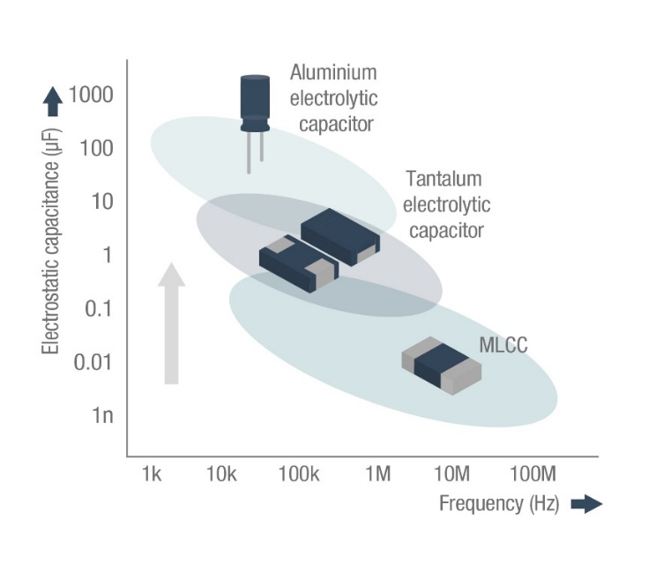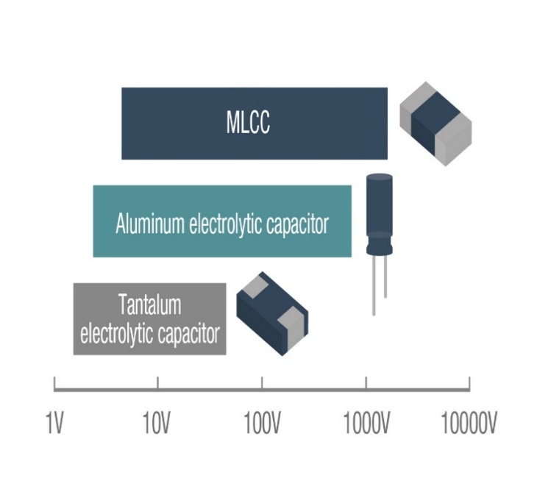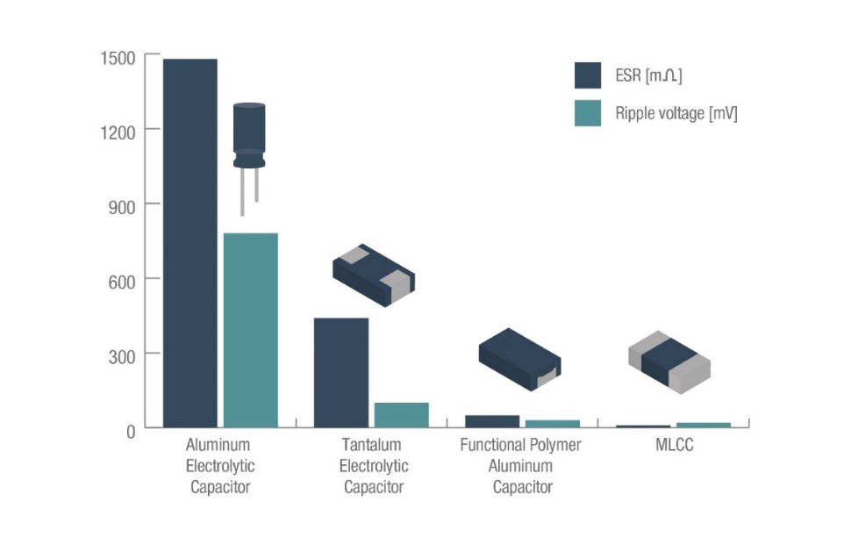

1. Relationship between ESR and ripple voltage
2. Rated voltage range
3. Frequency band and range of capacitance

Figure 7: Characteristics of different capacitor types (a) replacement of electrolytic capacitors (aluminium electrolytic capacitors and TEC) due to the advent of large-capacitance MLCCs; (b) rated voltage range of sample capacitors. MLCCs possess higher voltage ratings in comparison with electrolytic capacitors. It is also endowed with longevity and superior reliability; (c) relationship between ESR and ripple voltage. A lower ESR allows the ripple voltage to be maintained to a smaller amount, an attribute of MLCCs which enhances its optimal performance as a replacement for electrolytic capacitors [58].

# Methodology

The comparative HLCA of MLCCs and TECs was performed using the framework outlined in section 2.2.1.1. The HLCA system boundary, relating to the goal and scope of this investigation, is shown in Figure 8. This system boundary addresses a cradle-to-grave approach by taking into account three potential end of life scenarios; incineration, hydrometallurgy and pyrometallurgy.

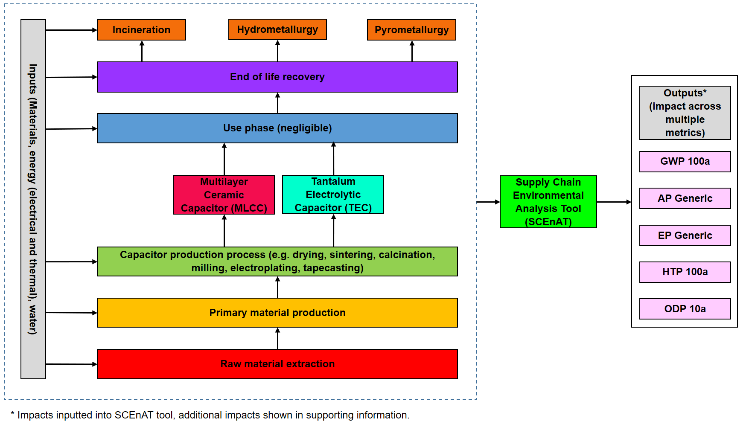

Figure 8: HLCA system boundary, capturing the materials and energy flows associated with the fabrication processes of both TEC and MLCC [58].

Capacitors are passive electrical components possessing two terminals for energy storage within an electric field; their capacitance is measured in farads (F). While the functional unit used in LCAs is often related to the function of a device which in this case would lead to a functional unit of capacitance of 1µF, the miniature dimensions of these capacitors means that the LCI for this functional unit would be insignificant. Therefore, as the capacitors are manufactured in batches, the functional unit was chosen as a 1kg batch of each capacitor. With respect to MLCCs, 1 kg of the entire material inventory produces 670,630 capacitors, each with a capacitance of 1 µF, and for TECs, the total number of capacitors produced is 33,697. This information was calculated based on Figures 9 and 10.

The dimensions of the MLCC were provided by [185] and the TEC dimensions were given by [186]. Table 8 provides the dimensions of an MLCC according to Figure 9 where T is 0.5mm, MB is 0.25mm, L is 1mm and W is 0.5mm [185]. Similarly, Table 9 outlines the dimensions of a TEC according to Figure 10 where Lmax is 2.2mm, Dref is 1.6mm, A is 0.4mm, B is 1.07mm, W is 1.1mm Jmax is 0.1mm and H is 1.1mm [186].

Table 8: MLCC dimensions based on Figure 9.

|  |  |  |
| --- | --- | --- |
| **Feature** | **Dimension** | **Unit** |
| T | 0.5 | mm |
| MB | 0.25 | mm |
| L | 1.00 | mm |
| W | 0.5 | mm |

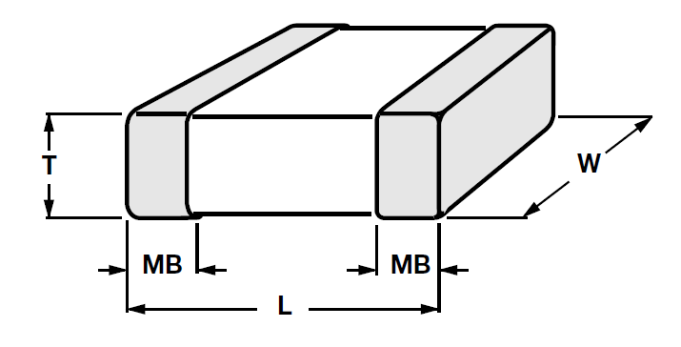

Figure 9: Schematic of a MLCC [185].

Table 9: TEC dimensions according to Figure 10.

|  |  |  |
| --- | --- | --- |
| **Feature** | **Dimension** | **Unit** |
| Lmax | 2.2 | mm |
| Dref | 1.6 | mm |
| A | 0.4 | mm |
| B | 1.07 | mm |
| W | 1.1 | mm |
| Jmax | 0.1 | mm |
| H | 1.1 | mm |

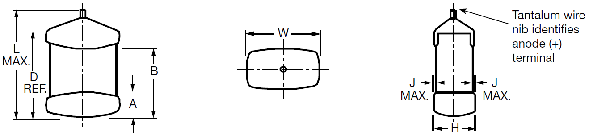Figure 10: Schematic of a TEC [186].

The thickness of the MLCC end terminations (tin, nickel and copper) and the internal electrode thickness were given by [187]; such data was not available for TECs and therefore assumptions were made using the Lee *et al.* [187] data and applied to the TEC termination for coatings and electrode thicknesses.

The manufacturing routes for both MLCCs and TECs is summarised in Figure 11. This information broadly follows those employed in industry; missing data was derived from the laboratory processes performed at the University of Sheffield and published literature [182, 188-194].



Figure 11: Fabrication route of MLCC (LHS) and TEC (RHS) volumetric efficiency capacitors. The procedures broadly follow those anticipated in industry but where information is not available since it is commercially sensitive, laboratory based data is substituted which approximates that used in industry [195].

A capacitor is an energy storage device and therefore does not, in itself, use energy and so the dielectric loss (tan δ, the reduction in power between the applied a.c. voltage and current [57, 196]) must be considered for the use phase. Equation 13 outlines the calculation to determine the amount of energy stored, using barium titanate (with a tan δ of 0.012 i.e. 1.2% [197]) as an example, with capacitance of 1µF and voltage of 0.707 volts.

$E= \frac{1}{2}C.V^{2}$ (13)

In this case, for one cycle, $E=0.000025$, 1.2% of which is 0.0000003 J. If a cycle life of 1,000,000 cycle is assumed, this equates to 0.3 J. This amount of energy is negligible in comparison to the amounts used during the manufacturing process and therefore is omitted from the scope of the investigation [182]. Furthermore, as most capacitors have only reached approximately 5% of their designed lifespan at the point of disposal [198] the cycle life of each capacitor is also omitted from the investigation.

Tables 10 and 11 list the bill of materials required for the production of a 1 kg batch of each capacitor type. In each case the details of each constituent are listed and any substitutions that were required to be made based on a lack of data in the Ecoinvent databased. The required amount of that constituent to produce a 1 kg batch of each capacitor is shown and the associated reference is provided. All of the generated inventories were adjusted to fit the chosen functional unit and all material use was assumed to be virgin.

Table 10: Life cycle inventory to produce a 1kg batch of MLCCs including any substitutions made.

|  |  |  |  |  |
| --- | --- | --- | --- | --- |
| Constituent | Details | Substitution Made | kg/1kg batch MLCCs | Ref. |
| Dielectric- Barium Titanate | | | | |
| BaCO3 | Barium Carbonate | Stoichiometric calculation | 0.64 | * |
| TiO2 | Titanium Dioxide | None | 0.26 |
| Dy2O3 | Dysprosium Oxide | Samarium, europium, gadolinium concentrate, 94% rare earth oxide | 0.02 |
| Borosilicate | Borosilicate | Borosilicate glass tube production | 0.02 |
| Solvent | MEK-EtOH (50:50 v/v) | None | 0.36 |
| Dispersant | Hypermer KD1 | Polyol | 0.02 |
| Plasticizer | Butylbenzyl phthalate | Ethylene Glycol | 0.05 |
| Plasticizer | PEG400 | Ethylene Glycol | 0.06 |
| Binder | Butvar | Polyvinyl chloride | 0.10 |
| Internal Electrode | | | | |
| Nickel sulphamate | Electrolyte | Nickel sulphate | 0.24 | [199, 200] |
| Nickel Chloride |  | Not applied |  |
| Boric acid | Electrolyte | None | 0.04 |
| BaTiO3 Powder | Functional material | As calculated with the above information | 0.06 |
| Ethyl cellulose | Vehicle | None | 0.02 |
| Terpineol | Vehicle | Polyethylene glycol | 0.02 |
| Emphos PS-21A | Dispersant | Polyol | 5.00E-3 |
| External Electrode | | | | |
| Sulphuric acid | Electrolyte | None | 0.02 | [200, 201] |
| Copper | Electrolyte | None | 3.00E-3 |
| Water | Electrolyte | None | 0.12 |
| BaTiO3 Powder | Functional material | As calculated with the above information | 2.00E-2 |
| Ethyl cellulose | Vehicle | None | 5.00E-4 |
| Polyethylene glycol acetate | Vehicle | Polyethylene glycol | 5.00E-4 |
| Electroplated Nickel Termination | | | | |
| Nickel sulphamate | Electrolyte | Nickel sulphate | 0.04 | [199] |
| Nickel Chloride |  | Not applied |  |
| Boric acid | Electrolyte | None | 7.00E-3 |
| Electroplated Tin Termination | | | | |
| Tin | Electrolyte | None | 0.04 | [202] |
| Methane sulfonic acid | Electrolyte | None | 0.13 |
| Wetting agent |  | Not applied |  |
| Grain refiner |  | Not applied |  |

*Data regarding the production of Barium Titanate was provided by the University of Sheffield Materials Science and Engineering Functional Materials and Devices Laboratory.

Table 11: Life cycle inventory to produce a 1kg batch of TECs including any substitutions made.

|  |  |  |  |  |
| --- | --- | --- | --- | --- |
| Constituent | Details | Substitution Made | kg/1kg batch TECs | Ref. |
| Tantalum Powder | Capacitor Grade | None | 0.80 | [194, 203] |
| Binder | Butvar (assumed as MLCC) | Polyvinyl chloride | 0.08 | [181] |
| Tantalum Powder (lead production) | Capacitor Grade | None | 0.03 | [203] |
| 0.1% Phosphoric Acid | Assumed 10l for submersion | 85% Solution State | 0.01 | [181] |
| Water | Dilution of 85% Phosphoric Acid | None | 9.99 |
| Manganese nitrate | Assumed 10l for submersion | Manganese Oxide | 0.97 | [192] |
| Graphite | Graphite layer | None | 0.72 | [192, 194, 204] |
| Paraffin | Graphite layer | None | 0.31 | [204] |
| Silver | Silver layer | None | 3.00E-3 | [192, 194, 205] |
| Acrylic binder | Sliver layer | None | 2.00E-3 | [205] |
| Ethylene glycol | Silver layer | Poly Ethylene Glycol | 1.00E-3 | [205] |
| Epoxy resin | Encapsulation | None | 1.00E-3 | [192, 194] |
| Tin | Tin termination- electrolyte | None | 0.16 | [202] |
| Methanesulfonic acid | Electrolyte | None | 0.61 |

The environmental impact of barium carbonate is not available within the Ecoinvent database and therefore a stoichiometric reaction equation was developed to impute this data gap [178], this is detailed in Table 12. The environmental impact data for the production of BaSO4 is available in the Ecoinvent database and it is known that BaCO3 can be produced from BaSO4 following the steps below.

BaSO4 + 2C → BaS + 2CO2

BaS + Na2CO3 → BaCO3 + Na2S

As the atomic mass of each element is known, this can be related to the environmental impact of the compound, shown in Table 12.

Table 12: Calculations of BaCO3 GWP 100a impact.

|  |  |  |  |  |
| --- | --- | --- | --- | --- |
| **Species** | **Atomic mass** | **Mass for 1kg of BaS** | **GWP 100a (kg CO2eq)** | **Impact** |
| BaSO4 + 2C → BaS + 2CO2 | | | | |
| Ba | 137.33 |  |  |  |
| S | 32.06 |  |  |  |
| O | 16.00 |  |  |  |
| BaSO4 | 233.39 | 1.378 | 1.38 | 0.36 |
| C | 24.00 | 0.283 | 2.49 | 0.70 |
| 2C | 48.00 |  |  |  |
| BaS | 169.39 | 1.00 |  | 1.07 |
| 2CO2 | 88.00 | 0.52 |  |  |
|  |  | **Mass for 1kg of BaCO3** |  |  |
| BaS + Na2CO3 → BaCO3 + Na2S | | | | |
| Na | 22.99 |  |  |  |
| BaS | 169.39 | 0.86 | 1.07 | 0.92 |
| Na2CO3 | 105.98 | 0.54 | 0.58 | 0.31 |
| BaCO3 | 197.33 | 1.00 |  | 1.23 |
| Na2S | 78.05 | 0.40 |  |  |

The life cycle inventory was completed by collecting data relating to the laboratory manufacturing processes for each capacitor type. The steps required for the manufacturing processes are shown in Figure 11 and Tables 13 and 14 provide the energy requirements relating to each step. This includes the associated machine wattage, time spent in the machine and the temperature if necessary. This information allows the electrical and thermal energies associated with the manufacturing processes to be calculated according to equations 11 and 12.

Table 13: Laboratory process and energy use in the manufacturing of MLCCs.

|  |  |  |  |  |  |  |  |  |  |  |
| --- | --- | --- | --- | --- | --- | --- | --- | --- | --- | --- |
| **BaTiO3 Process Flow** | **Power (W)** | **Time (s)** | **Temp (K)** | **Comments** | **Elect’ Energy (J)** | **Elect’ Energy (kWh)** | **Specific heat capacity**  **(J kg-1 K-1)** | **Mass (kg)** | **Thermal Energy (J)** | |
| Weigh BaCO3 | 230 | 60 |  |  | 13,800 | 0.004 |  |  |  | |
| Weigh TiO2 | 230 | 60 |  |  | 13,800 | 0.004 |  |  |  | |
| Dry BaCO3- stage 1 | 1,500 | 43,200 | 453 |  | 64,800,000 | 18.00 | 205 | 0.64 | 59,071 | |
| Dry TiO2- stage 1 | 1,955 | 43,200 | 1,073 |  | 84,456,000 | 23.46 | 690 | 0.26 | 190,614 | |
| Weigh BaCO3 | 230 | 60 |  |  | 13,800 | 0.004 |  |  |  | |
| Weigh TiO2 | 230 | 60 |  |  | 13,800 | 0.004 |  |  |  | |
| Mix (and mill) attrition mill | 1,100 | 3,600 |  |  | 3,960,000 | 1.10 |  |  |  | |
| Dry- BaTiO3- stage 2 | 1,500 | 43,200 | 353 |  | 64,800,000 | 18.00 | 430 | 0.75 | 114,103 | |
| Sieve | Manual in the lab | | |  |  |  |  |  |  | |
| Calcine- BaTiO3 | 1,955 | 21,600 | 1,173 | 5°C increase per min | 42,228,000 | 11.73 | 430 | 0.75 | 379,159 | |
| Mill | 1,100 | 3,600 |  |  | 3,960,000 | 1.10 |  |  |  | |
| Dry BaTiO3 | 1,500 | 43,200 | 353 |  | 64,800,000 | 18.00 | 430 | 0.75 | 114,103 | |
| Sieve | Manual in the lab | | |  |  |  |  |  |  | |
| High speed mixing | 2,300 | 900 |  |  | 2,070,000 | 0.58 |  |  |  | |
| Tapecasting | 4,600 | 1,800 |  |  | 8,280,000 | 2.30 |  |  |  | |
| Ni printing | 2,990 | 5,400 |  | 1800 sec for approx. 3 layers | 16,146,000 | 4.49 |  |  |  | |
| Layering | Manual in the lab | | |  |  |  |  |  |  | |
| Cold isostatic pressing- compressor | 1,500 | 300 |  | HPC SK24 now available not SK26 | 450,000 | 0.13 |  |  |  | |
| Cold isostatic pressing- maximator | 2,300 | 600 |  |  | 1,380,000 | 0.38 |  |  |  | |
| Cutting | Manual in the lab | | |  |  |  |  |  |  | |
| Sintering | 2,070 | 7,200 | 873 |  | 14,904,000 | 4.14 | 430 | 0.75 | 282,188 | |
|  | 2,070 | 21,600 | 1,673 |  | 44,712,000 | 12.42 | 430 | 0.75 | 193,943 | |
| **Borosilicate glass grinding** |  |  |  |  |  |  |  |  |  | |
| Mill (attrition mill) | 1,100 | 3,600 |  |  | 3,960,000 | 1.10 |  |  | , | |
| **Ni Paste** |  |  |  |  |  |  |  |  |  | |
| Ni powder- electroplating | 1,000 | 7,200 |  | Room temp. | 7,200,000 | 2.00 |  |  |  | |
| Ni paste production- mixing | Manual in the lab | | |  |  |  |  |  |  | |
| Aging of mixture | 1,955 | 600 | 323 |  | 1,173,000 | 0.326 | 445 | 0.19 | 27,235 | |
| **Copper paste** |  |  |  |  |  |  |  |  |  | |
| Copper powder electroplating | 1,000 | 7,200 | 323 |  | 7,200,000 | 2.00 | 384 | 0.0029 | 357 | |
| Copper paste mixing | Manual in the lab | | |  |  |  |  |  |  | |
| Aging of mixture | 1,955 | 600 | 323 |  | 1,173,000 | 0.326 | 384 | 0.01 | 751 | |
| **Electroplated Ni** | | | | | | | | | |
| Electroplating process | 1,000 | 7,200 |  | Room temp. | 7,200,000 | 2.00 | 445 |  |  | |
| **Electroplated Tin** | | | | | | | | | |
| Tin electroplating | 1,000 | 7,200 | 333 |  | 7,200,000 | 2.00 | 217 | 0.04 | 2,593 | |

Table 14: Laboratory process and energy use in the manufacturing of TECs.

|  |  |  |  |  |  |  |  |  |  |  |
| --- | --- | --- | --- | --- | --- | --- | --- | --- | --- | --- |
| **TEC Process Flow** | **Power (W)** | **Time (s)** | **Temp (K)** |  | **Elect’ Energy (J)** | **Elect’ Energy (kWh)** | **Specific heat capacity**  **(J kg-1 K-1)** | **Mass (kg)** | **Thermal Energy (J)** | |
| Weigh Ta powder | 230 | 60 |  |  | 13,800 | 0.004 |  |  |  | |
| Dry Ta powder | 1,500 | 43,200 | 453 |  | 64,800,000 | 18.00 | 140 | 0.80 | 51,029 | |
| Mix | Manual in the lab | | | | | | | | |
| Insert Ta leads | Manual in the lab | | | | | | | | |
| Cold isostatic pressing- compressor | 1,500 | 300 |  |  | 450,000 | 0.13 |  |  |  | |
| Cold isostatic pressing- maximator | 2,300 | 600 |  |  | 1,380,000 | 0.38 |  |  |  | |
| Sinter | 80,000 | 1,800 | 1,973 |  | 144,000,000 | 40.00 | 140 | 0.80 | 222,252 | |
| Electrolysis (Anodizing) | 1,000 | 7,200 | 363 |  | 7,200,000 | 2.00 | 140 | 0.80 | 40,891 | |
| Saturation in Manganese Nitrate | Manual in the lab | | | | | | | | |
| Water evaporation | 1,955 | 60 | 373 |  | 117,300 | 0.03 | 479 | 0.97 | 173,311 | |
| Carbon paste mixing | Manual in the lab | | | | | | | | |
| Carbon paste application | Manual in the lab | | | | | | | | |
| Silver paste mixing | Manual in the lab | | | | | | | | |
| Silver paste application | Manual in the lab | | | | | | | | |
| Epoxy resin application | Manual in the lab | | | | | | | | |
| Tin electroplating | 1,000 | 7,200 | 333 |  | 7,200,000 | 2.00 | 217 | 0.16 | 11,820 | |

Although the industrial manufacturing process of MLCCs is reported as 20% efficient [206], the laboratory process is significantly more efficient and therefore only plating solution and passivation solution waste (TEC production) are considered, both of which are used to saturation.

Three end-of-life methods were considered in this work; incineration, hydrometallurgy and pyrometallurgy. Ecoinvent datasets relating to the processes for the “treatment of used capacitors, to hazardous waste incineration” and the “treatment of average incineration residue” were used to take into account the impact of the waste arising from the incineration process. In Table 15, the details of these waste management methodologies, the substitutions made in the event of missing information in the Ecoinvent database, the amount of material under investigation and the associated references are listed. This information forms part of the life cycle inventory according to the system boundary shown in Figure 8.

Table 15: Life cycle inventory of the incineration, hydrometallurgy and pyrometallurgy recovery methods for a 1kg batch of high efficiency volumetric capacitors.

|  |  |  |  |  |
| --- | --- | --- | --- | --- |
| Method | Details | Substitution Made | Mass (kg) | Ref. |
| Incineration | Treatment of used capacitor | None | 1 | [139] |
| Treatment of average incineration residue | None | 1 |
| Hydrometallurgy | Hydrometallurgical treatment of capacitor | Treatment of used lithium ion battery | 1 | [79] |
| Treatment of average incineration residue |  | 1 | [139] |
| Pyrometallurgy | Pyrometallurgical treatment of capacitor | Treatment of used lithium ion battery | 1 | [79] |
| Treatment of average incineration residue |  | 1 | [139] |

Data limitations in the Ecoinvent database required the use of datasets corresponding to hydrometallurgical and pyrometallurgical treatment of a lithium-ion battery to represent MLCCs and TECs in this case. The hydrometallurgical treatment of Li-ion accumulators is a similar process to that of printed circuit boards using sulphuric acid leaching, neutralisation, metal recovery and waste water treatment [79] and the pyrometallurgical process of Li-ion battery recycling utilises higher temperatures when compared to other electronic components [207]. The resulting residue from hydro- and pyrometallurgical processes is untreatable and therefore must be sent to landfill, consequently the “treatment of average incineration residue” dataset has been taken as an appropriate representation of this impact [208].

Seventeen environmental impact categories were chosen and collected from the Ecoinvent website; each impact category, their unit of measurement and the associated life cycle impact assessment (LCIA) methodology are listed in Table 16. While the Eco-indicator 99 impact categories cannot be directly compared to the CML 2001 impact categories, they are presented as complementary information to facilitate further assessment.

Table 16: List of the environmental impact categories and their corresponding units and LCIA methodologies used in the comparative analysis of a 1kg batch of MLCCs and TECs.

|  |  |  |
| --- | --- | --- |
| **Impact category** | **Unit** | **LCIA Method** |
| GWP 100a | kg CO2-eq | CML2001 |
| AP generic | kg SO2-eq |
| EP generic | kg PO4-eq |
| ODP 10a | kg CFC-11-eq |
| High NOx POCP | kg ethylene-eq |
| Low NOx POCP | kg ethylene-eq |
| FAETP 100a | kg 1,4-DCB-eq |
| HTP 100a | kg 1,4-DCB-eq |
| Land use (competition) | m2a |
| MAETP 100a | kg 1,4-DCB-eq |
| FSETP 100a | kg 1,4-DCB-eq |
| MSETP 100a | kg 1,4-DCB-eq |
| Cumulative Energy Demand | MJ-eq | Cumulative Energy Demand |
| Ecosystem Quality Total | points | Eco-indicator 99, (E,E) |
| Human Health Total | points |
| Resources Total | points |
| Eco-indicator Total | points |

The chosen environmental impact categories were applied to the LCI according to equation 8 and then inputted into the SCEnAT*i* decision support tool to enable the HLCA to be completed according to equation 10. Table 17 lists the additional supply chain inputs that were used in the SCEnAT*i* software to determine the environmental impact of the full supply chain.

Table 17: List of additional inputs added to the SCEnAT*i* software in this study to produce the HLCA.

|  |  |  |
| --- | --- | --- |
| **Industry Type** | **Description** | **Domestic (D)/ Import (I)** |
| Business Services | Computer services and related activities | D |
|  | Research and Development | D |
|  | Collection of Waste | D |
| Transport & Communication | Freight transport by road | D |
|  | Telecommunications | D |

Component level analysis of the different environmental impact categories were normalised to identify the significance of each element of both capacitor types and the total primary energy demand within the system boundary was determined.

# Results

This section outlines the results of the methodologically robust comparative HLCA of a 1kg batch of MLCCs and a 1kg batch of TECs produced in a laboratory. The environmental hotspots within the supply chain of the two similar capacitors (based on application) are identified.

Figure 12 outlines the total primary energy demand and thermal, electrical and material embedded energy distributions for the fabrication of a 1kg batch of MLCCs and Figure 13 describes the same impacts of a 1kg batch of TECs.

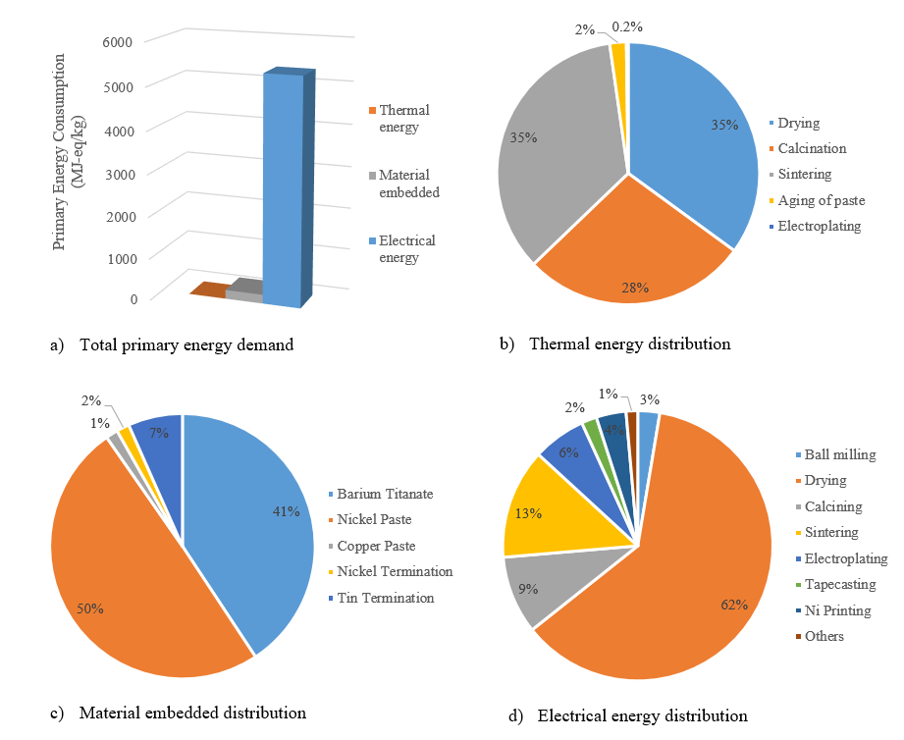

Figure 12: Distribution of the primary energy consumption for the fabrication of a 1kg batch of MLCCs (a) Total primary energy consumption including thermal and electrical energy and materials embedded all expressed in MJ kg-1. (b-d) indicate the percentage contributions of each process or material relative to (a).

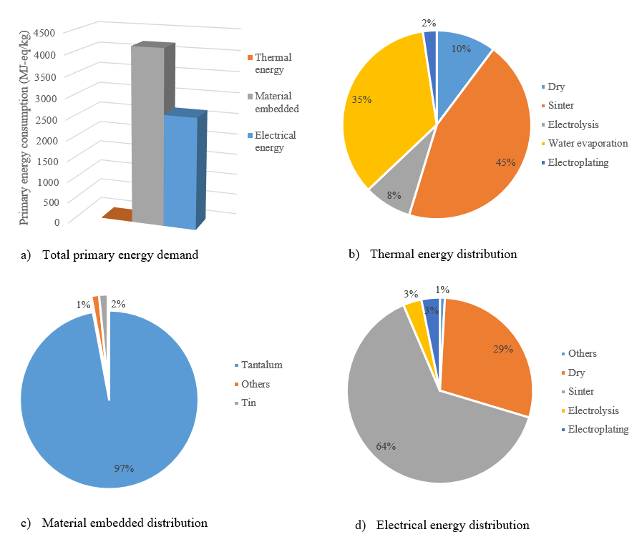

Figure 13: Distribution of the primary energy consumption for the fabrication of a 1kg batch of TECs (a) Total primary energy consumption including thermal and electrical energy and materials embedded all expressed in MJ kg-1. (b-d) indicate the percentage contributions of each process or material relative to (a).

Figures 12 and 13 display the total distribution of the primary energy consumption for the fabrication of a laboratory-based MLCC and TEC. Figures 12a and 13a show the total primary energy consumption, including materials embedded (i.e. embodied energy in natural resources attributed to extraction) [31], thermal and electrical energy relating to each of the manufacturing process; MLCC totalling 5567.65 MJ-eq/kg and TEC totalling 6862.29 MJ-eq/kg. The thermal and electrical energy relating to each process step is broken down in Figures 12b and 13b and 12d and 13d. The material embedded energy of each material is shown in Figures 12c and 13c; approximately 97%, 4069 MJ-eq, of the material embedded energy in TEC fabrication is attributed to the use of tantalum while the highest contributor to the impact of MLCCs is the nickel paste at 50%, 106 MJ-eq.

Figures 14 and 15 detail the component level analysis of the environmental impacts of MLCCs and TECs. In this case, the impact of the energy use (shown in Figures 12 and 13) has been omitted. Each figure shows the thirteen comparable environmental impact categories which are listed in Table 12 (excluding the Eco-indicator 99 impact categories as these category types are not comparable), each of which have been normalised to show the absolute indicator of each category of impact is 100%. Both Figures 14 and 15 show that overall, the constituent leading to the highest contribution over the impacts investigated are nickel and tantalum respectively, which mirrors the results shown in Figures 12c and 13c.

Figure 14: Percentage contribution of each MLCC manufacturing component of the environmental impacts investigated.

Figure 15: Percentage contribution of each TEC manufacturing component of the environmental impacts investigated. The y axis is shown from 75% to 100% to show the impact contribution from all materials.

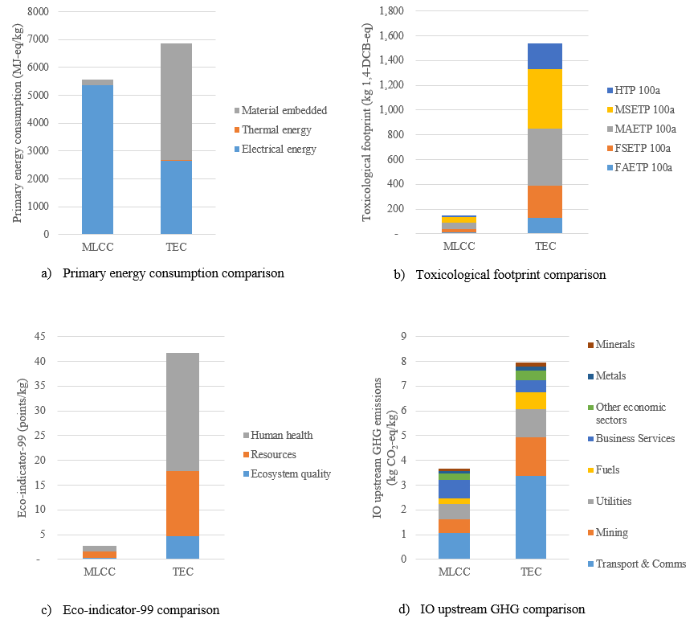Figure 16: Comparison of MLCC versus TEC. a) Primary energy demand, b) toxicological footprint, c) eco-indicator 99 comparisons, d) input-output (IO) upstream greenhouse gas (GHG) comparison.

The charts shown in Figure 16 show how each capacitor type compares with respect to primary energy consumptions (Figure 16a), the toxicological footprints (Figure 16b), the eco-indicator impacts (Figure 16c) and IO upstream GHG emissions (Figure 16d). In all cases, it can be seen that overall, TECs have a higher impact than MLCC.

The SCEnAT*i* decision support tool mapped the two capacitor supply chains from cradle-to-grave and cradle-to-incineration, hydrometallurgical recovery and pyrometallurgical recovery. Tables 18 and 19 outline the results provided by the tool for five environmental impact categories. In both cases, the cradle-to-incineration method leads to the highest impact of CO2 emissions and land use. The use of pyrometallurgical methods for capacitor recovery leads to the highest human toxicological impact when compared with other potential methods.

Table 18: SCEnAT*i* HLCA calculation for a MLCC from Cradle to Grave, Incineration, Hydro- and Pyro-metallurgy.

|  |  |  |  |  |  |
| --- | --- | --- | --- | --- | --- |
| **Parameter** | **Units** | **Cradle to Gate** | **Cradle to Incineration** | **Cradle to Hydro’** | **Cradle to Pyro’** |
| Total Emissions | kg CO2-eq | 97.00 | 100.70 | 98.20 | 98.73 |
| AP Generic | kg SO2-eq | 0.77 | 0.78 | 0.78 | 0.78 |
| EP Generic | kg PO4-eq | 0.13 | 0.14 | 0.14 | 0.14 |
| HTP 100a | kg 1,4-DCB-eq | 22.87 | 23.92 | 23.78 | 25.13 |
| Land Use | m2a | 10.14 | 10.39 | 10.22 | 10.25 |

Table 19: SCEnAT*i* HLCA calculation for a TEC from Cradle to Grave, Incineration, Hydro- and Pyro-metallurgy.

|  |  |  |  |  |  |
| --- | --- | --- | --- | --- | --- |
| **Parameter** | **Units** | **Cradle-to-Gate** | **Cradle to Incineration** | **Cradle to Hydro’** | **Cradle to Pyro’** |
| Total Emissions | kg CO2-eq | 311.99 | 315.69 | 313.19 | 313.72 |
| AP Generic | kg SO2-eq | 2.20 | 2.21 | 2.21 | 2.20 |
| EP Generic | kg PO4-eq | 0.72 | 0.73 | 0.73 | 0.73 |
| HTP 100a | kg 1,4-DCB-eq | 214.54 | 215.58 | 215.45 | 216.80 |
| Land Use | m2a | 77.96 | 78.20 | 78.04 | 78.06 |

Sensitivity analysis was performed to determine how the location of electricity generation affects the impact of the global warming potential (measured in kg CO2-eq) of the electricity used in MLCC production, this is outlined in Table 20.

Table 20: MLCC production, sensitivity analysis to determine the effect of manufacturing location on the environmental impact of electrical energy use [58].

|  |  |  |  |  |
| --- | --- | --- | --- | --- |
| **Component** | **£/kWh** | **kWh for 1 kg of MLCC** | **GWP 100a** | **Impact** |
| **BaTiO3** |  |  |  |  |
| Electrical Energy GB | 2.861 | 116.934 | 0.650 | 75.952 |
| Electrical Energy US |  |  | 0.689 | 80.547 |
| Electrical Energy CN |  |  | 1.194 | 139.619 |
| Electrical Energy JP |  |  | 0.744 | 87.035 |
| Electrical Energy FR |  |  | 0.117 | 13.680 |
| **Ni Paste** |  |  |  |  |
| Electrical Energy GB | 2.861 | 2.326 | 0.650 | 1.511 |
| Electrical Energy US |  |  | 0.689 | 1.602 |
| Electrical Energy CN |  |  | 1.194 | 2.777 |
| Electrical Energy JP |  |  | 0.744 | 1.731 |
| Electrical Energy FR |  |  | 0.117 | 0.272 |
| **Cu Paste** |  |  |  |  |
| Electrical Energy GB | 2.861 | 2.326 | 0.650 | 1.511 |
| Electrical Energy US |  |  | 0.689 | 1.602 |
| Electrical Energy CN |  |  | 1.194 | 2.777 |
| Electrical Energy JP |  |  | 0.744 | 1.731 |
| Electrical Energy FR |  |  | 0.117 | 0.272 |
| **Electroplated Ni** |  |  |  |  |
| Electrical Energy GB | 2.861 | 2.000 | 0.650 | 1.299 |
| Electrical Energy US |  |  | 0.689 | 1.378 |
| Electrical Energy CN |  |  | 1.194 | 2.388 |
| Electrical Energy JP |  |  | 0.744 | 1.489 |
| Electrical Energy FR |  |  | 0.117 | 0.234 |
| **Electroplated Tin** |  |  |  |  |
| Electrical Energy GB | 2.861 | 2.000 | 0.650 | 1.299 |
| Electrical Energy US |  |  | 0.689 | 1.378 |
| Electrical Energy CN |  |  | 1.194 | 2.388 |
| Electrical Energy JP |  |  | 0.744 | 1.489 |
| Electrical Energy FR |  |  | 0.117 | 0.234 |

It can be seen in Table 20 that electrical energy generated in China leads to the highest GWP impact for each component and electrical energy generated in France leads to the lowest GWP impact for each component.

# Discussion

As no previous work has been published, this detailed, comparative hybrid life cycle assessment of MLCCs and TECs provides important information to stakeholders. In this study it has been shown that the electrical energy impact of a 1kg batch TECs is 2666 MJ-eq; lower than that of a 1kg batch of MLCCs at 5353 MJ-eq, but the cumulative energy demand of a 1kg batch of TECs is 20 times that of the same mass of MLCCs and consequently the overall primary energy demand of a TECs (6862 MJ-eq) exceeds that of an MLCCs (5567 MJ-eq). This detail is outlined in Figures 12 and 13.

Furthermore, across the range of environmental indicators that were studied in this case, TECs perform worse than MLCCs; these results and mitigation methods to reduce the environmental impact of each capacitor type will be discussed in more detail below.

# Primary energy consumption

The total primary energy consumption for the fabrication of 1kg batches of both MLCCs and TECs are shown in Figures 12a and 13a. This is then broken down into energy type in Figures 12b and 13b (thermal energy consumption), Figures 12c and 13c (material embedded energy and Figures 12d and 13d (electrical energy consumption).

The total primary energy consumption for the production of a 1kg batch of MLCCs is 5567.65 MJ-eq/kg (Figure 12a). The majority of this impact is caused by the use of electrical energy in the manufacturing process. The percentage impact of each manufacturing process step has been outlined in Figure 12d, this shows that the drying stages of MLCC production lead to the highest impact (62%). The drying stages also have a high impact on the total thermal energy use (Figure 12b), along with sintering and calcination. “Others” in Figure 12d represent those inputs lower than 1%, namely: weighing, high speed mixing, cold isostatic pressing and aging of the paste.

This “carbon-hotspot” in the production of MLCCs was also noted by Philips [206]. High electricity use is required due to the length of time required to dry, calcine and sinter the barium titanate. Despite this, the industrial scale impact is likely lower than reported at a laboratory scale due to larger, more efficient machinery with high batch throughput [209].

The electrical and thermal energy impact could also be reduced by the use of optimised sintering approaches such as the use of sintering aids and low temperature processing technology [31]. One such technology is cold sintering, involving the addition of a small amount of water to aid the key transport processes that densify ceramic materials, which has been developed for lowering sintering temperatures [210-212].

Comparatively to MLCC production, while the total primary energy consumption for the production of a 1kg batch of TECs is 6862.29 MJ-eq/kg, this is due to the high material embedded energy rather than the electrical energy. Figure 13c shows that approximately 97% of the material embedded energy in TEC fabrication is attributed to the use of tantalum (“Others” in Figure 13c represents those inputs lower than 1%, namely: graphite paste, silver paste, epoxy resin and silver termination).

In this case, raw material extraction, prior to manufacturing, is the major source of environmental impact. Tantalum is usually found in nature with niobium as they have similar chemical characteristics [213], their extraction is highly energy intensive and requires activities such as blasting and crushing prior to smelting and separation [31, 214].

While the sintering process leads to the highest electrical energy impact with drying in second place (Figure 13d, “Others” represents weighing, pressing and water evaporation; again, those inputs under 1%); the water evaporation step, required in the production of TECs, leads to a high percentage impact. As with the production of MLCCs, these are process steps which require high electrical energy and thermal energy and therefore optimised processing technology at an industry scale may lead to a reduction in the environmental impact [209].

Table 20 shows the results of the sensitivity analysis performed on the electricity use relating to the manufacturing of MLCCs. The aim of the analysis was to understand how the manufacturing location i.e. location of electrical energy generation, affected the overall impact of the component. The Ecoinvent Great Britain data for “market for electricity, low voltage” was compared to the same datasets for the United States, China, Japan and France. Energy generation, and therefore manufacturing, in China caused the highest impact at 44.44 kg CO2-eq and the lowest impact was generated through manufacturing in France at 4.35 kg CO2-eq. Therefore, of the countries compared, the most appropriate manufacturing location for energy consumption is France.

# Component level analysis

Component level analysis was performed to understand the impact of the materials used in each capacitor structure across a range of metrics relating to sustainability. The metrics were normalised to ensure that the absolute indicator of each impact category was 100%. The removal of the electrical and thermal energy impacts allows only the materials used to be compared.

In Figure 14, the use of nickel paste in the MLCC structure can be seen to have the highest impact over the climate change (51%), acidification (75%), eutrophication (58%), high NOx photochemical ozone creation potential (71%), land use (65%), fresh water aquatic ecotoxicity (69%), fresh water sediment ecotoxicity (69%), human toxicity (52%), marine aquatic ecotoxicity (68%), marine sediment ecotoxicity (69%) and cumulative energy demand (50%) indicators.

Modern technology and infrastructure rely on the use of nickel for a large number of applications and it has been shown that the environmental impact of mining nickel has improved. Despite this, historical activities have caused local issues such as SO2 emissions leading to acid rain, acidification, heavy metal soil contamination and a reduction in biodiversity [215]. From a human point of view, nickel inhalation is reported to lead to cancer of the nose and lungs [216].

The percentage impact of the constituents used in TEC manufacturing are broken down in Figure 15. It is the use of tantalum, for the pellet and leads, that causes the highest impact of all of the components across all impact; climate change (97%), acidification (95%) eutrophication (89%), ozone depletion potential (98%), high NOx photochemical ozone creation potential (95%), low NOx photochemical ozone creation potential (98%), land use (99%), fresh water aquatic ecotoxicity (85%), fresh water sediment ecotoxicity (86%), human toxicity (98%), marine aquatic ecotoxicity (86%), marine sediment ecotoxicity (87%) and cumulative energy demand (97%). Silver is the second largest contributor to the impacts of TEC manufacturing.

The processes employed in metal mining are often determined by the properties of the ore that is available, the tonnage, grade and depth at which the ore can be mined. Surface and underground mining (or a combination of the two) are the most common methods used, with underground mining leading to the highest overall environmental impact [217, 218]. As the depth of the available ore increases, so do the production and environmental costs [215].

Specifically, tantalum is mined in high volumes by artisanal and small scale mining (ASM), this process is usually an informal activity performed in developing countries by small groups to provide jobs and therefore income for millions of people. Due to economic limitations and without access to better technologies and techniques, waste and effluent are often dumped in rivers, landscapes are destroyed and land is polluted. This technique is likely to negatively impact the environmental indicators of tantalum techniques [219, 220].

As a large proportion of the environmental impact is caused by the metal extraction process, rather than during its application, mitigation strategies should be implemented at the extraction phase. Soil stripping and stockpiling, prior to extraction, could reduce the environmental impact imparted on the land, for example. Suppression systems can be implemented to reduce dust emissions and therefore reduce air pollution; waste disposal should be conducted off site and in a responsible manner to avoid ground and water contamination [177].

# Comparison of environmental profiles

The primary energy consumptions, toxicological footprints, eco-indicator impacts and IO upstream GHG emissions of a 1kg batch of MLCCs and a 1kg batch of TECs are compared in Figure 16. The primary energy consumption of the MLCC and TEC manufacturing processes are discussed in detail in section 3.2.4.1. Furthermore, Figure 16a shows that the thermal energy consumption of both manufacturing methods leads to the lowest impact of the three types measured. The thermal energy associated with MLCCs is 0.60 MJ-eq/kg compared to 4.39 MJ-eq/kg for that of TECs, due to the increased processing temperatures and material masses required in TEC production. The higher electrical energy requirement associated with MLCC production (5352.77 MJ-eq/kg), compared to TEC production (2665.82 MJ-eq/kg), is caused by the need for additional drying, milling, tapecasting, printing and calcining process steps.

Figure 16b shows that the toxicological footprint of a 1kg batch of TECs is considerably higher than that of MLCCs. This can be attributed to the use of tantalum in the structure; approximately 70% of each of the ecotoxicity potential impact categories is caused by tantalum, while 95% of the human toxicity potential is also caused by this material. Silver and manganese also have an effect on these impact categories (when compared to the minor constituents used, such as graphite and paraffin), although to a much lower extent.

Figure 16d outlines the effect of the production of MLCCs and TECs on different economic sectors based on the upstream IO greenhouse gas emissions, using the SCEnAT*i* decision support tool. The upstream impact of TECs within the supply chain is associated to its overall increased cost of production and materials when compared to MLCCs. This is particularly important given that economic data, such as cost of materials, are converted into physical quantities (e.g. kg of material) in IO analysis. Therefore, a higher conversion output will lead to higher upstream emissions across the supply chain of the material under consideration [31]. The “transport and communication sector” has the highest impact on both the MLCC and TEC supply chains, followed by the “business services” and “utilities” sectors. The use of the HLCA methodology allows a holistic approach to be applied to the life cycle of a product and therefore a more robust result can be reported [38].

# Impacts of end of life methodologies

The MLCC and TEC supply chains were mapped in the SCEnAT*i* decision support tool for cradle-to-gate, incineration, hydrometallurgy and pyrometallurgy. This allowed the HLCA carbon calculations to be made. A screen shot of the resulting supply chain map for the MLCC to hydrometallurgy process, provided by the tool, is shown in Figure 17.

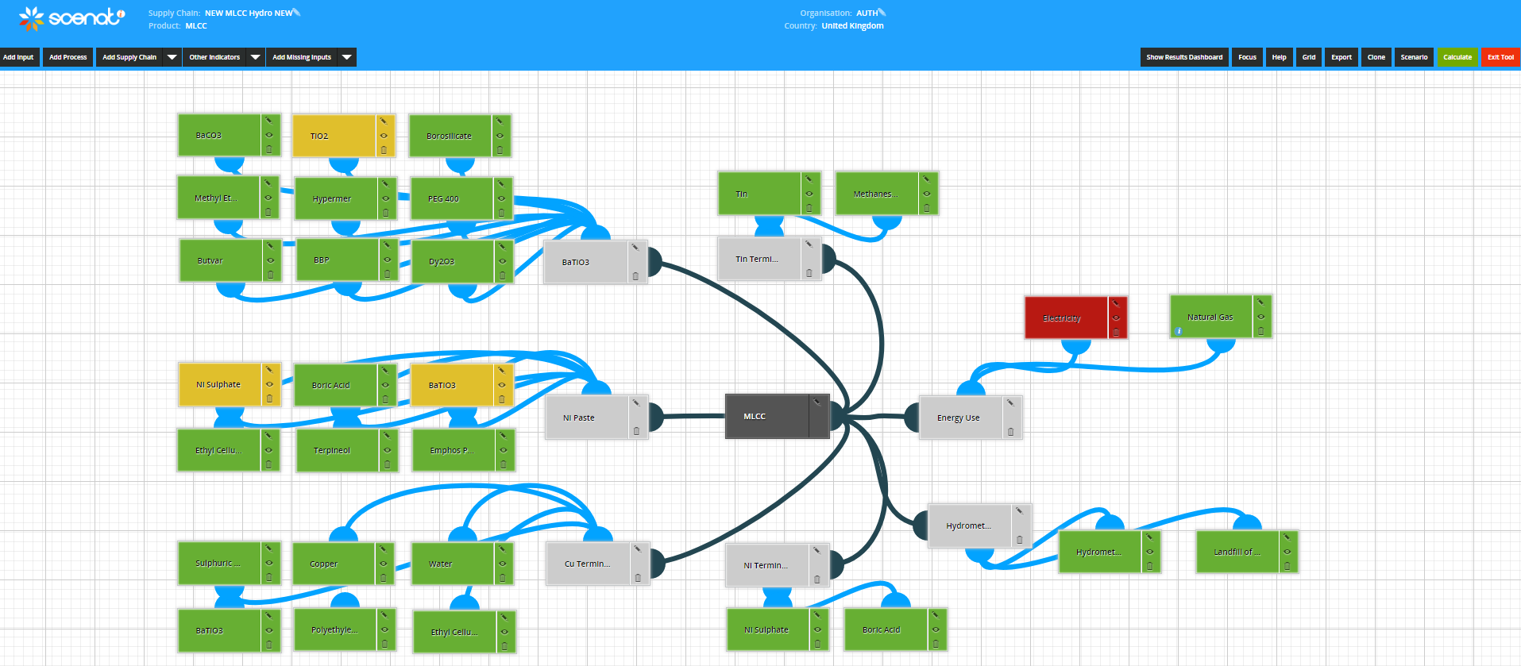

Figure 17: A screen shot of the resulting supply chain map for the MLCC to hydrometallurgy process, provided by the SCEnAT*i* tool.

The SCEnAT*i* tool uses a colour coding system to help the user to quickly identify the carbon hotspots within the modelled system; green represents <1% impact, yellow represents 1-5% impact, orange represents 5-10% impacts and red represents >10% impact.

The results of this analysis are shown in Tables 18 and 19 for each capacitor type. The incineration disposal method of MLCCs and TECs leads to the highest CO2 and land use impacts when compared to hydrometallurgical and pyrometallurgical recover methods. The pyrometallurgical route leads to the highest human toxicity potential at 25.13 kg 1, 4-DCB-eq and 216.80 kg 1, 4-DCB-eq for MLCCs and TECs respectively. Pyrometallurgy relies on techniques such as incineration, smelting, drossing, sintering, melting and high temperature reaction in the gas phase. Halogens are present in the flue dust and waste gases, this can lead to the accumulation of dioxins in the food chain and may cause reproduction issues, immune system damage and cancer [221, 222].

Toxic and corrosive substances are used in the hydrometallurgy process which would have a profound environmental impact on the ground and surrounding water systems [221]; The HTP 100a impact of hydrometallurgy may be lower than that of pyrometallurgy due to the possible wider spread impact of flue emissions compared to process fumes.

All three end of life processes lead to the same impact for the acidification and eutrophication potential. These two impact categories are caused by the emissions of SO2, NOx, HCl, dioxins and furans; for incineration and pyrometallurgy this impact can be attributed to the emissions to atmosphere during combustions, for hydrometallurgy, it can be linked to the use of oxalic acid [52, 79, 221-223].

Capacitor size is a key factor in the development of the device; proposals have been made to embed capacitors into substrates and therefore reduce the overall size of the substrate [224]; while this would achieve the objectives of the market it would increase the difficulty of the dismantling of waste electrical and electronic equipment and consequently lead to further loss of materials to landfill or energy recovery. This is an important example where is it important to observe the full lifecycle of the component using LCA to understand the long term impacts of design changes.

As the recycling of capacitors, separately to printed circuit boards, is not fully established, the results of this study support the use of the hydrometallurgical recycling process which leads to the lowest environmental impact when compared to incineration and pyrometallurgy methods. Further research is needed to understand the material recovery potentials of waste capacitors.

# Limitations of this study

Along with those limitations mentioned in section 3.1.1, the specific limitations of this study relate to the production methods of the capacitors and the use of critical materials in their structure.

Industrially, a well-established manufacturing route would likely be used in the production of each type of capacitor and therefore would be manufactured on a much larger scale than in a laboratory. Consequently, the use of electricity in industry for the manufacturing process based on a 1kg batch of MLCCs and TECs is likely to be lower because of the use of larger, more efficient machinery with high batch throughput [209]. Despite this, discussions with engineers in Murata Manufacturing Co., Ltd. (a global leader in capacitors manufacturing) [225] confirm that the findings made in this work are in-line with those in industry.

The literature review highlighted the importance of the use of dysprosium in MLCCs, but the use of Dy is diluted by the high impact of electricity in the HLCA results. It is not highlighted as a carbon hotspot in the supply chain due to its low volume in the barium titanate of the MLCC. Despite this, Dy has been highlighted as a critical material [74-76, 80] and therefore this highlights the requirement for LCAs to be used in conjunction with other analysis methods such as criticality assessment to fully understand the impact of the materials being used.

# Conclusion

The cradle to grave analysis of the environmental impacts of the production of a 1kg batch of MLCCs and TECs has been presented, this work is the first of its kind with respect to the comparison of the two capacitor types and the use of the HLCA methodology.

The results show that the electrical energy impact of a 1kg batch of MLCCs is 5353 MJ-eq, while that for a 1kg batch of TECS is only 2666 MJ-eq. Comparatively, the material embedded energy (also known as the cumulative energy demand) of TECs is twenty times that of MLCCs. Consequently, the total primary energy demand of TECs is 6863 MJ-eq and 5567 MJ-eq for MLCCs. Overall, the thermal energy requirements for both capacitor types is minimal in comparison to the electrical and material embedded energy requirements.

Tantalum leads to over 97% of the GWP of TECs in the pellet and leads, this impact can be attributed to the high energy requirements relating to the extraction and purification processes at the start of the supply chain. This is a supply chain hotspot and therefore, the reduction of tantalum use in TECs will lead to a large reduction of the environmental impact of the capacitor. With respect to MLCCs, the supply chain environmental hotspot can be attributed to nickel and therefore, effort to reduce the amount required in the manufacturing process will reduce the overall environmental impact.

Improved sintering techniques, such as the use of sintering aids and cold sintering processes can be employed to reduce the impact of the manufacturing processes in each case. At the end of life, this work has shown that the hydrometallurgical recycling process leads to the lowest environmental impact when compared to other end of life management techniques.

The use of dysprosium in the MLCC structure is not highlighted as a hotspot in the supply chain; its use (which is only a small percentage of the barium titanate component of the MLCC) is diluted by the high electrical energy requirements. Therefore, the modeller may not highlight this material as an issue but, dysprosium has been identified as a critical material [74-76, 80] and therefore further consideration, using complementary assessment methodologies such as criticality assessment may be beneficial.

# Further research

The main focus of future work in this area would be the use of industrial primary data to understand how the impact between laboratory and industrial manufacturing route differ. In addition to this, work should be carried out to look to reduce the impact of MLCCs further by reducing, or eliminating, their use of rare earth elements and high impact metal electrodes.

Further development of rare earth recycling, which currently relies on the use of oxalic acid, is required to ensure that the impact of the recycling process is not more impactful to the environment than the benefits of the material recovery [79].

The environmental impacts of any future development of all capacitor types should be assessed prior to full commercialisation to ensure that the product development has not led to an increase in environmental damage that is not outweighed by a suitably improved function of the newly developed device [31].

# *Comparative Environmental Profile Assessments of Commercial and Novel Material Structures for Solid Oxide Fuel Cells*

# Introduction

Solid oxide fuel cells (SOFCs) generate energy using electrochemical reactions in a much more efficient process when compared to the well-established combustion process [226]. Furthermore, they are able to do this whilst reducing CO2 and eliminating the emissions of NOx, SOx and other pollutants completely in comparison to the convention methods of energy generation [61, 62, 227]. These characteristics make them a perfect contender for energy production in a global society with increasing energy demand under the threat of climate change [228].

SOFCs are constructed from three essential components: a porous cathode, a porous anode and an impermeable electrolyte (shown in Figure 3). The operating temperature of the device is influenced by the temperature required by the electrolyte to achieve the necessary ionic conductivity to function. Yttrium stabilised zirconia (YSZ) is a common electrolyte material with high conductivity at 800°C and negligible conductivity from 800-1500°C. The composite, strontium-doped lanthanum manganite (LSM) and YSZ is a popular cathode material, whilst nickel oxide (NiO)-YSZ composites are frequently used in anode manufacture [229].

While operating at temperatures of 800-1000°C, these structures tolerate thermal stresses throughout the cyclical operation, often leading to catastrophic failure. Due to this high operating temperature range the components require expensive ceramic interconnects that undergo manufacturing processes which are complex [230].

To reduce the operating temperatures of these components, research is underway to develop novel materials which will achieve operating temperatures of around 500°C. In this work, the impacts of a commercially available, high temperature (HT) SOFC [231] are analysed alongside two intermediate temperature (IT) SOFCs [65, 232]. The structures of each SOFC type are shown in Figure 18. The commercially available HT SOFC has a composite anode of NiO-YSZ, an electrolyte of YSZ and a LSM-YSZ composite cathode. The first IT SOFC utilises an anode of the composite NiO-gadolinium doped ceria (GDC), an electrolyte of strontium-doped sodium bismuth titanate (NBT) and a composite cathode of LSM-YSZ. Finally, the second IT SOFC has a five-layer structure requiring an anode of NiO-GDC, an anode functional layer (AFL) of the same material, one electrolyte produced from GDC and a second electrolyte made of erbia-stabilised bismuth (ESB), the cathode utilised ESB; with bismuth ruthenate oxide (BRO7).

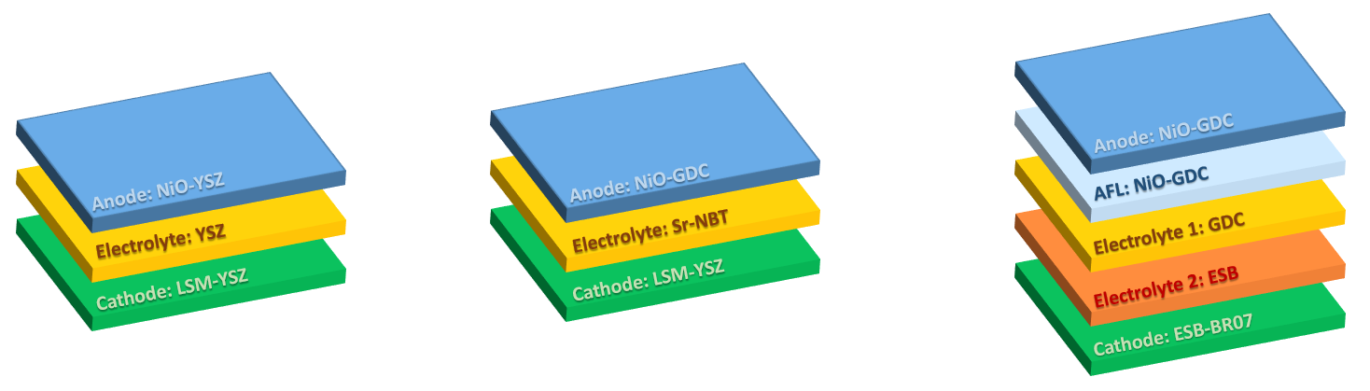

Figure 18: Schematic of the three SOFC architectures studied; from left to right: the commercial HT-SOFC; the IT-SOFC with a strontium-doped sodium bismuth titanate (NBT); the IT-SOFC with an erbia-stabilised bismuth (ESB) electrolyte [63].

Cost and energy savings will be made through reducing the operating temperatures of commercial SOFCs, furthermore the life span of the device will also be extended [61, 233]; despite this, it is important to assign the environmental impact of the existing and future structures to the materials used within them. With this in mind, section 3.3.2 outlines the robust and systematic methodology employed in the development of a comparative HLCA of the three SOFC structures discussed briefly above, this includes the choice of functional unit and system boundary, the manufacturing processes required for each SOFC type and the associate life cycle inventory (LCI). Sections 3.3.3 and 3.3.4 present and discuss the results of the HLCA respectively and finally the findings are concluded in section 3.3.5 and further work required to enhance this study is outlined in section 3.3.6.

The results of this study provide a novel contribution to knowledge as they are the first to address the environmental impacts of the materials proposed to be utilised in novel IT SOFC structures and compared to a commercially available HT SOFC structure. The environmental impacts of these material structures provide vital data for decision makers, policy makers and designers in the development of new energy generation devices [63].

# Methodology

This section outlines the detailed methodological framework for the comparative environmental profile evaluations of three SOFC material architectures.

The comparative HLCA of these structures was performed using the HLCA framework outlined in section 2.2.1.1. The HLCA system boundary, relating to this investigation is shown in Figure 19 and includes the extraction of raw materials and the SOFC production phase; the use and end-of-life phases and interconnects have been excluded from within the system boundary [63]. Although the whole life cycle of a product [234], or service can be modelled using LCA, the aim of this study is to understand the impacts of the different material structures of the IT SOFCs, compared to the HT SOFCs and therefore the use phase, end-of-life management and SOFC interconnects are excluded from the system boundary.

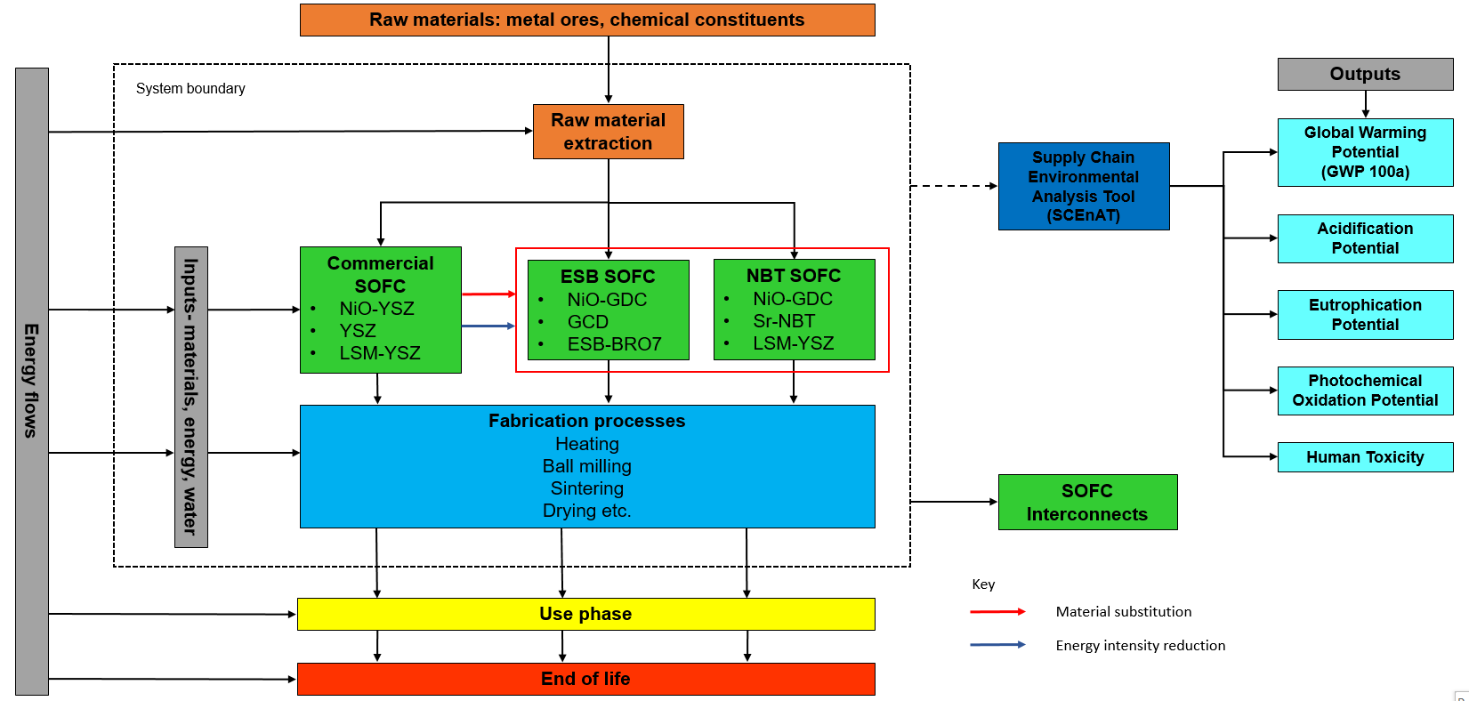

Figure 19: The system boundary applied to the HLCA of three SOFC material architectures. N.B. the example production processes shown are those common to all three structures [63].

In conjunction with the system boundary, outlined in Figure 19, a functional unit of “kg of material required in the production of a 100kW-class SOFC stack at installed capacity” was used; all fuel energy values refer to the lower heating value. The manufacturing processes of each SOFC, vital for the construction of the LCI, are described in sections 3.3.2.1 to 3.3.2.4.

# Commercial SOFC manufacturing process

NiO, coarse YSZ and fine YSZ, mixed at a ratio of 56:22:22 wt%, are required for the production of the commercial anode. This resulting powder is then ball milled for 24 hours in solvents and granulated using liquid granulation with a thermoset polymer. The granules are then compacted, uni-axially pressed and sintered in a reducing atmosphere for 3 hours at 900°C [235]. ZrO2 (with 8 mol% Y2O3) powder which is ball milled with ethanol for 30 hours, produces the YSZ for the electrolyte. The mixture is then ultrasonically suspended in ethanol for 30 minutes in a mixture of 1 wt% ethylcellulose and 3 wt% polyvinyl butyral and finally sprayed on to the NiO/YSZ anode. The electrolyte is then sintered for 4 hours at 1400°C [236-238]. Finally, La0.7Sr0.3MnO3 (LSM) and YSZ powders are mixed at a weight ratio of 6:4. The mixture is ground for 1 hour with 6 wt% ethylcellulose and 94 wt% terpineol. The resulting paste is applied to the YSZ electrolyte by brush printing and the final substrate is sintered for 2 hours at 1200°C [238].

# IT-SOFC, with ESB electrolyte, manufacturing process

To begin, the anode support is produced by tapecasting NiO and Ce0.9Gd0.1O1.95 powders at a 65:35 wt.% ratio. The weighed powders are then ball milled with a dispersant, in this case, a mixture of Solsperse, toluene and ethyl alcohol, for 24 hours. Di-n butyl phthalate, polyethylene glycol and polyvinyl butral are added to the suspension which is ball milled for a further 24 hours. De-airing then takes place in a vacuum chamber, the slurry must be stirred continuously to prevent solidification. Tapecasting of the slurry then takes place, the green bodies are then dried for 2 hours at 100°C, shaped into discs and finally sintered at 900°C for 2 hours [239]. The anode functional layer (AFL) is also produced using GDC powder, which is sprayed on to the anode after preparation with ethanol, this structure is then pre-sintered at 900°C for 1 hour. To produce the first electrolyte later, GDC powder must be ball milled for 24 hours with Solsperse in ethanol; Di-n butyl phthalate and polyvinyl butral are then added prior to a further 24 hours of ball milling. This slurry is then spray coated on to the NiO-GDC AFL. The Electrolyte-AFL-Anode substrate is heat-treated in a vacuum oven for 5 hours at 120°C and then sintered at 1450°C for 4 hours [239, 240].

Weighed Er2O3 and Bi2O3 powders are ball milled in ethanol using yttria-stabilized zirconia (YSZ) media for 24 hours, dried on a hot plate with stirring and then calcined at 800°C for 15 hours. This process is followed by uniaxially pressing (at around 10kpsi); firing at 890°C for 4 hours to produce the ESB green pellet for the second electrolyte layer [241, 242].

To deposit the ESB electrolyte on to the GDC electrolyte, Pulsed Laser Deposition is used. This structure is then heated to 630°C.

To produce the BRO7-ESB cathode, stoichiometric amounts of Bi2O3 and RuO2.XH2O are combined to produce BRO7; the powder is ball milled in ethanol for 24 hours with YSZ grinding media, dried on a hotplate whilst being stirred and then calcined at 900°C for 10 hours. Following this, the powder is crushed and sieved. The BRO7 powder is mixed with ESB powder (production following that outlined above) and isopropanol and then ultrasonicated. The slurry is applied to the electrolyte by paint brushing and the substrate is then dried for 1 hour at room temperature, dried at 120°C for 1 hour and fired at 800°C for 2 hours [242].

# IT-SOFC, with NBT electrolyte, manufacturing process

The NBT IT SOFC is in the concept phase and to date, the electrolyte alone has been manufactured. For this initial study, this electrolyte will be assumed to be used with a NiO-GDC anode and a LSM-YSZ cathode as these are the most commonly used materials in each case.

The NiO-GDC anode is produced via the method described in section 3.3.1.2. Solid state synthesis of Na2CO3, Bi2O3, SrCO3 and TiO2 is required to produce the Sr-doped NBT electrolyte. Before weighing, each constituent is dried at 300°C (Na2CO3, Bi2O3), 180°C (SrCO3) and 800°C (TiO2). The powders are then mixed together and this mixture is ball milled for 6 hours, dried (12 hours at 80°C), sieved and calcined for 2 hours at 800°C. A second calcination step takes place at 850°C for 2 hours, followed by ball milling for 6 hours. Finally, pellets are sintered at 1150°C for 2 hours in air [243].

The commercial SOFC LSM-YSZ cathode, produced using the method described in section 3.3.2.1, is assumed as the cathode for this IT SOFC. Following production of the cathode, the final substrate is dried at room temperature for 1 hour, dried at 120°C for 1 hour and then fired at 850°C for 2 hours.

# Production of a functioning SOFC

In sections 3.3.2.1 to 3.3.2.3 the production of one cell of a SOFC is outlined, to produce a fully functioning SOFC, cells are stacked to form modules to achieve the required power output. To scale this up, in-line with the functional unit, the commercial HT SOFC LCI was developed from [231] and details were taken from [65] and applied to both IT SOFCs to develop the appropriate LCI. For the IT SOFCs, the dimensions of one cell are reported as 10cm x 10cm x 0.2cm (width x length x height); each component within the cell has a reported height of 800µm (anode), 1µm (anode functional layer), 10µm (GDC electrolyte), 4µm (ESB electrolyte) and 49µm (cathode), the remaining height represents the interconnect (which is out of scope of this study). 100kW (the functional unit) can be produced with one module which contains 10 stacks, 1 stack hold 50 cells and so there are 500 cells in 1 module [65].

# Data collection

Primary data for an LCA is always the preferred source, where this is unavailable for a study, secondary sources can be used as an alternative [44]. For this investigation, the LCI was collated using primary laboratory data which was supplemented with secondary data from published literature and upstream emissions data from the Ecoinvent database [139]. In the absence of upstream emissions data, published guidelines on the use of stoichiometric reactions, chemical characteristics and functional parallels were followed [31, 178].

Tables 21 to 23 provide the bill of materials required for the production of a 100kW energy from each SOFC type. In each case the details of each constituent are listed and any substitutions that were required based on a lack of data in the Ecoinvent database. The life cycle inventory is completed by collecting data relating to the laboratory manufacturing processes for each capacitor type. The steps required for the manufacturing processes are outlined in sections 3.3.2.1 to 3.3.2.3. All of the generated inventories were adjusted to fit the chosen functional unit and all material use was assumed to be virgin.

Table 21: Life cycle inventory to produce 100kW of energy from a commercially available HT SOFC, including any substitutions made.

|  |  |  |  |  |
| --- | --- | --- | --- | --- |
| **Component** | **Composition** | **Substitution made** | **kg/100 kW** | **Ref.** |
| Anode  (NiO-YSZ) | NiO | Ni mine operation | 68.88 | [231] |
| YSZ |  | 54.12 |
| Isopropanol |  | 28.29 |
| PVA | Polyvinyl chloride | 8.61 |
| Methyl methacrylate (binder) |  | 6.16 |
| Ethylene glycol (plasticiser) |  | 9.86 |
| Trichloroethylene (solvent) |  | 43.10 |
| Ethanol (solvent) |  | 43.10 |
| Electrolyte  (YSZ) | ZrO2 |  | 1.85 |
| Y2O3 |  | 0.29 |
| Ethanol |  | 0.75 |
| Elthylcellulose | Polyethylene glycol | 0.01 |
| Polyvinyl butyral | Polyvinyl chloride | 0.02 |
| Methyl methacrylate (binder) |  | 0.11 |
| Ethylene glycol (plasticiser) | Polyethylene glycol | 0.17 |
| Trichloroethylene (solvent) |  | 0.75 |
| Ethanol (solvent) |  | 0.75 |
| Cathode  (LSM-YSZ) | Lanthanum oxide |  | 3.82 |
| Strontium nitrate | Strontium carbonate | 2.48 |
| Mn3O4 |  | 1.35 |
| Polyethylene glycol (plasticiser) |  | 1.03 |
| Graphite |  | 0.79 |
| PVA (binder) | Polyvinyl chloride | 0.44 |
| Water |  | 2.93 |
| YSZ |  | 2.63 |
| Ethylcellulose | Polyethylene glycol | 0.01 |
| Terpineol | Polyethylene glycol | 0.17 |
| Ethylene glycol diethyl ether (solvent) | Polyethylene glycol | 1.58 |
| Ethanol (solvent) |  | 3.68 |

Table 22: Life cycle inventory to produce 100kW of energy from an IT SOFC using an NBT electrolyte, including any substitutions made.

|  |  |  |  |  |
| --- | --- | --- | --- | --- |
| **Component** | **Composition** | **Substitution made** | **kg/100 kW** | **Ref.** |
| Anode  (NiO-GDC) | NiO | Ni mine operation | 10.94 | [232] |
| CeGdO |  | 5.89 |
| Solsperse | Polyethylene glycol | 3.87 |
| Toluene | Methyl ethyl ketone | 3.87 |
| Ethyl alcohol |  | 3.87 |
| Di-n butyl phthalate | Polyethylene glycol | 1.35 |
| Polyethylene glycol |  | 1.35 |
| Polyvinyl butral | Polyvinyl chloride | 1.18 |
| Electrolyte  (Sr-NBT) | Na2CO3 |  | 0.06 |
| Bi2O3 |  | 0.25 |
| SrCO3 |  | 0.01 |
| TiO2 |  | 0.19 |
| Isopropanol |  | 0.12 |
| Cathode  (LSM-YSZ) | Lanthanum oxide |  | 3.82 |
| Strontium nitrate | Strontium carbonate | 2.48 |
| Mn3O4 |  | 1.35 |
| Polyethylene glycol (plasticiser) |  | 1.03 |
| Graphite |  | 0.79 |
| PVA (binder) | Polyvinyl chloride | 0.44 |
| Water |  | 2.93 |
| YSZ |  | 2.63 |
| Ethylcellulose | Polyethylene glycol | 0.01 |
| Terpineol | Polyethylene glycol | 0.17 |
| Ethylene glycol diethyl ether (solvent) | Polyethylene glycol | 1.58 |
| Ethanol (solvent) |  | 3.68 |

Table 23: Life cycle inventory to produce 100kW of energy from an IT SOFC using an ESB-BRO7 electrolyte, including any substitutions made.

|  |  |  |  |  |
| --- | --- | --- | --- | --- |
| **Component** | **Composition** | **Substitution made** | **kg/100 kW** | **Ref.** |
| Anode  (NiO-GDC) | NiO | Ni mine operation | 10.94 | [65] |
| CeGdO |  | 5.89 |
| Solsperse | Polyethylene glycol | 3.87 |
| Toluene | Methyl ethyl ketone | 3.87 |
| Ethyl alcohol (ethnol) |  | 3.87 |
| Di-n butyl phthalate | Polyethylene glycol | 1.35 |
| Polyethylene glycol |  | 1.35 |
| Polyvinyl butral | Polyvinyl chloride | 1.18 |
| AFL  (GDC) | GDC |  | 0.03 |
| Ethanol |  | 0.003 |
| Electrolyte 2  (GDC) | GDC |  | 0.34 |
| Solsperse | Polyethylene glycol | 0.08 |
| Ethanol |  | 0.08 |
| Di-n butyl phthalate | Polyethylene glycol | 0.03 |
| Polyvinyl butral | Polyvinyl chloride | 0.02 |
| Electrolyte 1  (ESB) | Er2O3 |  | 0.03 |
| Bi2O3 |  | 0.14 |
| Ethanol |  | 0.04 |
| Cathode  (ESB-BRO7) | Bi2O3 |  | 4.90 |
| RuO2.XH2O | MoO3 | 2.80 |
| ESB |  | 5.13 |
| Ethanol |  | 2.95 |
| Isopropanol |  | 2.95 |

Bi2Ru2O7 and its constituents are missing from the Ecoinvent database and therefore a stoichiometric reaction equation was developed to impute this data gap, this is outlined in Table 24 and the associated reaction equation is outlined below. Emissions data for Bi2O3 was acquired through a public data source and that for RuO2 was replaced by MoO3.

Bi2O3 + RuO2.XH2O → Bi2Ru2O7

As the atomic mass of each element is known, this can be related to the environmental impact of the compound, shown below.

Table 24: Calculations of Bi2Ru2O7 GWP 100a impact.

|  |  |  |  |  |
| --- | --- | --- | --- | --- |
| **Species** | **Atomic mass** | **Mass for 1kg of Bi2Ru2O7** | **GWP 100a (kg CO2eq)** | **Impact** |
| Bi2O3 + RuO2.XH2O → Bi2Ru2O7 | | | | |
| Bi | 208.98 |  |  |  |
| O | 16.00 |  |  |  |
| Bi2O3 | 465.96 | 0.64 | 21.99 | 14.00 |
| Ru | 101.00 |  |  |  |
| RuO2 | 133.00 | 0.18 | 44.73 | 8.13 |
| Bi2Ru2O7 | 731.96 | 1.00 |  | 22.13 |

Tables 25 to 27 provide the energy requirements relating to each step. This includes the associated machine wattage, time spent in the machine and the temperature if necessary; allowing the electrical and thermal energies associated with the manufacturing processes to be calculated.

The “market for electricity, low voltage [kWh]” Ecoinvent dataset was used to represent electricity which represents electricity fed to the network, including all upstream activities. The “heat and power co-generation, natural gas, combined cycle power plant, 400MW electrical [MJ]” Ecoinvent dataset was used to represent thermal energy consumption and represents high voltage heat and electricity production in a combined cycle natural gas power plant. Both the electrical and thermal energy datasets represent energy generation in Great Britain.

Table 25: Laboratory process and energy use in the manufacturing of a commercial HT SOFC.

|  |  |  |  |  |  |  |  |  |  |  |
| --- | --- | --- | --- | --- | --- | --- | --- | --- | --- | --- |
| **Element** | **Process Flow** | **Power (W)** | **Time (s)** | **Temp (K)** | **Elect'**  **Energy (kWh)** | **SHC\***  **(J kg-1 K-1)** | **Mass (kg)** | **Mol** | **Thermal**  **Energy (MJ)** | |
| Anode  NiO-YSZ | Ni heating | 2,070 | 21,600 | 673 | 12.42 | 26.10 | 68.88 | 1,173 | 20.61 | |
| Mixing of NiO-YSZ | By hand | | | | | | | |
| Ball milling of NiO-  YSZ | 50 | 86,400 |  | 1.20 |  | 123.00 |  |  | |
| Granulation of NiO-  YSZ | By hand | | | | | | | |
| Uni-axial pressing of  NiO-YSZ | By hand | | | | | | | |
| Sintering of NiO-YSZ | 2,070 | 10,800 | 1,173 | 6.21 | 51.23 | 123.00 | 1,647 | 98.94 | |
| Electrolyte  YSZ | Ball milling of YSZ | 50 | 108,000 |  | 1.50 |  | 2.14 |  |  | |
| Ultrasonic suspension  of YSZ | 250 | 1,800 |  | 0.13 |  | 2.14 |  |  | |
| Spraying of YSZ | By hand |  |  |  |  |  |  |  | |
| Sintering of YSZ | 2,070 | 14,400 | 1,673 | 8.28 | 59.90 | 2.14 | 17.40 | 1.74 | |
| Cathode  LSM-YSZ | Mixing of LSM-YSZ | By hand | | | | | | | |
| Brush printing of  LSM-YSZ | By hand | | | | | | | |
| Sintering of LSM-YSZ | 2,070 | 7,200 | 1,473 | 4.14 | 78.75 | 5.25 | 16.10 | 1.87 | |

*Specific heat capacity

Table 26: Laboratory process and energy use in the manufacturing of an IT SOFC with an NBT electrolyte.

|  |  |  |  |  |  |  |  |  |  |
| --- | --- | --- | --- | --- | --- | --- | --- | --- | --- |
| **Element** | **Process Flow** | **Power (W)** | **Time (s)** | **Temp (K)** | **Elect'**  **Energy (kWh)** | **SHC\***  **(J kg-1 K-1)** | **Mass (kg)** | **Mol** | **Thermal**  **Energy (MJ)** |
| Anode  NiO-GDC | Ni heating | 2,070 | 21,600 | 673 | 12.42 | 26.10 | 10.94 | 186 | 3.27 |
| Weigh NiO | 230 | 60.00 |  | 0.004 |  |  |  |  |
| Weigh GDC | 230 | 60.00 |  | 0.004 |  |  |  |  |
| Ball mill  NiO-GDC | 50 | 172,800 |  | 2.40 |  |  |  |  |
| De-airing with  continuous stirring  of NiO-GDC | 1,020 | 86,400 |  | 24.48 |  |  |  |  |
| Tapecasting of  NiO-GDC | 4,600 | 1,800 |  | 2.30 |  |  |  |  |
| Dry NiO-GDC | 2,070 | 7,200 | 373 | 4.14 | 52.25 | 16.84 | 67.99 | 1.33 |
| Cut NiO-GDC | By hand |  |  |  |  |  |  |  |
| Sinter NiO-GDC | 2,070 | 7,200 | 1,173 | 4.14 | 52.25 | 16.84 | 67.99 | 4.17 |
| Electrolyte  Sr-NBT | Dry Na2CO3 | 2,070 | 43,200 | 573 | 24.84 | 112 | 0.06 | 0.58 | 0.04 |
| Dry Bi2O3 | 2,070 | 43,200 | 573 | 24.84 | 114 | 0.25 | 0.55 | 0.04 |
| Dry SrCO3 | 2,070 | 43,200 | 453 | 24.84 | 81.40 | 0.01 | 0.05 | 0.002 |
| Dry TiO2 | 2,070 | 43,200 | 1,073 | 24.84 | 55.00 | 0.19 | 2.31 | 0.14 |
| Weigh Na2CO3 | 230 | 60.00 |  | 0.004 |  |  |  |  |
| Weigh Bi2O3 | 230 | 60.00 |  | 0.004 |  |  |  |  |
| Weigh SrCO3 | 230 | 60.00 |  | 0.004 |  |  |  |  |
| Weigh TiO2 | 230 | 60.00 |  | 0.004 |  |  |  |  |
| Ball mill Sr-NBT | 50.00 | 21,600 |  | 0.300 |  |  |  |  |
| Dry Sr-NBT | 2,070 | 43,200 | 353 | 24.84 | 101.40 | 0.51 | 2.00 | 0.07 |
| Sieve Sr-NBT | By hand |  |  |  |  |  |  |  |
| Calcine Sr-NBT | 2,070 | 7,200 | 1,073 | 4.14 | 101.40 | 0.51 | 2.00 | 0.22 |
|  | 2,070 | 7,200 | 1,123 | 4.14 | 101.40 | 0.51 | 2.00 | 0.23 |
| Ball mill Sr-NBT | 50.00 | 21,600 |  | 0.30 |  |  |  |  |
| Sinter Sr-NBT | 2,070 | 7,200 | 1,423 | 4.14 | 101 | 0.51 | 2.00 | 0.29 |
| Cathode  LSM-YSZ | Mix LSM-YSZ | By hand |  |  |  |  |  |  |  |
| Brush print  LSM-YSZ | By hand |  |  |  |  |  |  |  |
| Sinter LSM-YSZ | 2,070 | 7,200 | 1,473 | 4.14 | 78.75 | 5.25 | 16.10 | 1.87 |
| Substrate | Dry | 2,070 | 3,600 | 298 | 2.07 | 63.04 | 27.61 | 320.78 | 6.03 |
| Dry | 2,070 | 3,600 | 393 | 2.07 | 63.04 | 27.61 | 320.78 | 7.95 |
| Sinter | 2,070 | 7,200 | 1,123 | 4.14 | 63.04 | 27.61 | 320.78 | 22.71 |

*Specific heat capacity

Table 27: Laboratory process and energy use in the manufacturing of an IT SOFC with an ESB electrolyte.

|  |  |  |  |  |  |  |  |  |  |
| --- | --- | --- | --- | --- | --- | --- | --- | --- | --- |
| **Element** | **Process Flow** | **Power (W)** | **Time (s)** | **Temp (K)** | **Elect'**  **Energy (kWh)** | **SHC\***  **(J kg-1 K-1)** | **Mass (kg)** | **Mol** | **Thermal**  **Energy (MJ)** |
| Anode NiO-GDC | Ni heating | 2,070 | 21,600 | 673 | 12.42 | 26.10 | 10.94 | 186 | 3.27 |
| Weigh NiO | 230 | 60.00 |  | 0.004 |  |  |  |  |
| Weigh GDC | 230 | 60.00 |  | 0.004 |  |  |  |  |
| Ball mill NiO-GDC | 50.00 | 172,800 |  | 2.40 |  |  |  |  |
| De-airing with continuous  stirring of NiO-GDC | 1,020 | 86,400 |  | 24.48 |  |  |  |  |
| Tapecast NiO-GDC | 4,600 | 1,800 |  | 2.30 |  |  |  |  |
| Dry NiO-GDC | 2,070 | 7,200 | 373 | 4.14 | 52.25 | 16.84 | 67.99 | 1.33 |
| Cut NiO-GDC | By hand |  |  |  |  |  |  |  |
| Sinter NiO-GDC | 2,070 | 7,200 | 1,173 | 4.14 | 52.25 | 16.84 | 67.99 | 4.17 |
| AFL GDC | Mix GDC | By hand |  |  |  |  |  |  |  |
| Spray GDC | By hand |  |  |  |  |  |  |  |
| Presinter GDC | 2,070 | 3,600 | 1,173 | 2.07 | 66.34 | 0.03 | 0.20 | 0.02 |
| Electrolyte 2 GDC | Ball mill GDC | 50.00 | 172,800 |  | 2.40 |  |  |  |  |
| Spray coat GDC | By hand |  |  |  |  |  |  |  |
| Heat treat GDC | 2,070 | 18,000 | 393 | 10.35 | 66.34 | 0.34 | 1.99 | 0.05 |
| Sinter GDC | 2,070 | 14,400 | 1,723 | 8.28 | 66.34 | 0.34 | 1.99 | 0.22 |
| Electrolyte 1 ESB | Weigh Er2O3 | 230 | 60 |  | 0.004 |  |  |  |  |
| Weigh Bi2O3 | 230 | 60 |  | 0.004 |  |  |  |  |
| Ball mill ESB | 50.00 | 86,400 |  | 1.20 |  |  |  |  |
| Dry ESB on hot plate  while stirring | 1,020 | 86,400 | 373 | 24.48 | 112.65 | 0.17 | 0.38 | 0.02 |
| Calcine ESB | 2,070 | 54,000 | 1,073 | 31.05 | 112.65 | 0.17 | 0.38 | 0.05 |
| Uniaxial pressing of ESB | By hand |  |  |  |  |  |  |  |
| Sinter ESB | 2,070 | 14,400 | 1,163 | 8.28 | 112.65 | 0.17 | 0.38 | 0.05 |
| Pulsed Laser Deposition of ESB | 30,000 | 2,700 | 903 | 22.50 | 112.65 | 0.17 | 0.38 | 0.04 |
| Cathode BRO7-ESB | Ball mill BRO7-ESB | 50 | 86,400 |  | 1.20 |  |  |  |  |
| Dry BRO7-ESB on hot  plate while stirring | 1,020 | 86,400 | 373 | 24.48 | 98.49 | 12.82 | 20.72 | 0.76 |
| Calcine BRO7-ESB | 2,070 | 36,000 | 1,173 | 20.70 | 98.49 | 12.82 | 20.72 | 2.39 |
| Crush BRO7-ESB | By hand |  |  |  |  |  |  |  |
| Sieve BRO7-ESB | By hand |  |  |  |  |  |  |  |
| Mix BRO7-ESB | By hand |  |  |  |  |  |  |  |
| Ultrasonication of  BRO7-ESB | 250 | 1,800 |  | 0.13 |  |  |  |  |
| Brush BRO7-ESB | By hand |  |  |  |  |  |  |  |
| Dry BRO7-ESB | 2,070 | 3,600 | 298 | 2.07 | 98.49 | 12.82 | 20.72 | 0.61 |
|  | 2,070 | 3,600 | 393 | 2.07 | 98.49 | 12.82 | 20.72 | 0.80 |
| Sinter BRO7-ESB | 2,070 | 7,200 | 1,073 | 4.14 | 98.49 | 12.82 | 20.72 | 2.19 |

*Specific heat capacity

Fourteen environmental impact categories were chosen and collected from the Ecoinvent website, these are listed in Table 28. While the ReCiPe Endpoint (E,A) impact categories cannot be directly compared to the CML 2001 impact categories, they are presented as complementary information to facilitate further assessment. These impacts were chosen as those which were highlighted in literature as the most commonly utilised in SOFC LCA analysis.

Table 28: List of the environmental impact categories and their corresponding units and LCIA methodologies used in the comparative analysis of three SOFC architectures.

|  |  |  |
| --- | --- | --- |
| **Impact category** | **Unit** | **LCIA Method** |
| GWP 100a | kg CO2-eq | CML2001 |
| AP generic | kg SO2-eq |
| EP generic | kg PO4-eq |
| FAETP 100a | kg 1,4-DCB-eq |
| HTP 100a | kg 1,4-DCB-eq |
| Land use (competition) | m2a |
| MAETP 100a | kg 1,4-DCB-eq |
| FSETP 100a | kg 1,4-DCB-eq |
| MSETP 100a | kg 1,4-DCB-eq |
| Cumulative Energy Demand | MJ-eq | Cumulative Energy Demand |
| Ecosystem Quality Total | points | ReCiPe Endpoint (E,A) |
| Human Health Total | points |
| Resources Total | points |
| ReCiPe Endpoint (E,A) Total | points |

The fourteen environmental impact categories were applied to the LCI according to equation 8 and then into the SCEnAT*i* decision support tool to enable the HLCA to be completed. The additional domestic supply chain inputs that were used in the SCEnAT*i* software to determine the environmental impact of the full supply chain were: telecommunication, freight transport by road, research and development, computer services and related activities and collection of waste.

Component level analysis of different environmental impact categories were normalised to identify the significance of each element of the SOFCs and the total primary energy demand within the system boundary was determined.

# Results

This section outlines the results of the methodologically robust comparative HLCA of three SOFC architectures according to the functional unit of kg/100kW of energy generated. The environmental hotspots within the supply chains of the three examined architectures are identified.

Figures 20-26 graphically evaluate the environmental impacts of the three SOFC architectures in this study; a HT commercial SOFC, an IT SOFC with NBT electrolyte and an IT SOFC with ESB electrolyte within the chosen functional unit of kg/100kW energy produced. To reduce the complexity of these charts, the materials which constitute each component i.e. anode, cathode etc. have been grouped together. Therefore, the environmental impact of the component is shown and the impact of the individual materials is discussed in more detail in section 3.3.4.

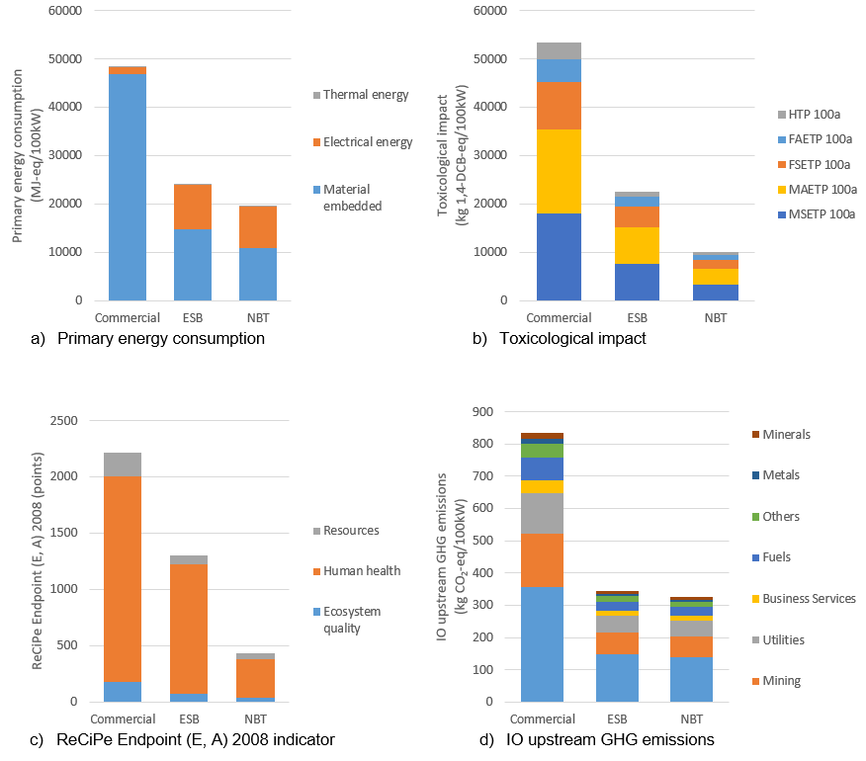

Figure 20: The comparison of the Commercial, NBT and ESB SOFC material structures for a) primary energy demand, b) toxicological footprint, c) ReCiPe Endpoint (E,A) and d) input-output (IO) upstream greenhouse gas (GHG) emissions [63].

Figure 20 compares the primary energy demand (Figure 20a), toxicological footprint (Figure 20b), ReCiPe Endpoint (E, A) (Figure 20c) and IO upstream GHG emissions (Figure 20d) for the three SOFC structures investigated in this study. In each case, the commercial SOFC material structure leads to the highest impacts and the NBT structure leads to the lowest overall impact.

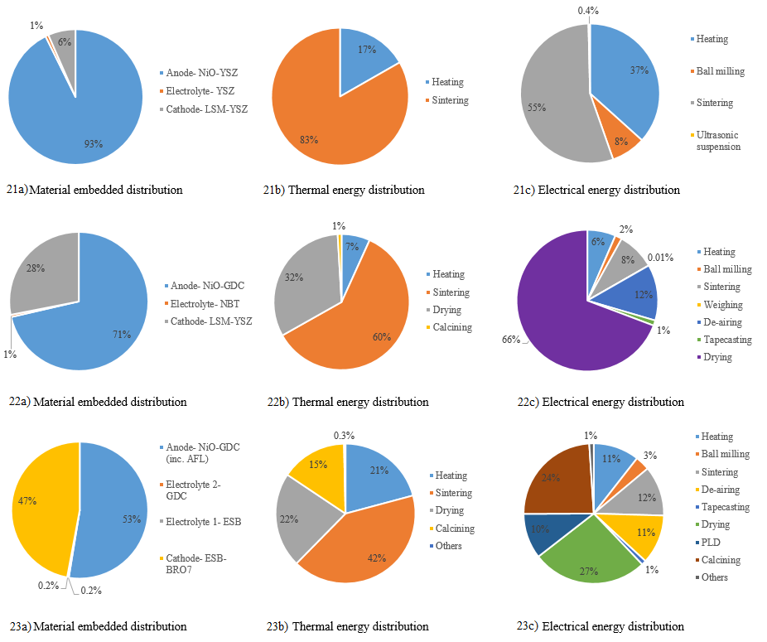

Figure 21-23: The percentage contribution of each process step in relation to the primary energy consumption shown in Figure 20a [63]. Figure 21 relates to the Commercial HT SOFC; Figure 22 relates to the NBT IT SOFGC and Figure 23 relates to the ESB IT SOFC.

Where Figure 20a outlines the primary energy demand of each of the three SOFC structures, Figures 21-23 break down this information to provide the percentage contribution of the material embedded energy of each material component (21-23a); the thermal energy distribution of each process step (21-23 b) and the electrical energy distribution of each process step (21-23 c). For all three structures, the sintering step leads to the highest thermal energy impact and the anode of each structure provides the highest contribution to the material embedded energy.

Figure 24: The percentage contribution of each component of a commercial HT SOFC, for the environmental impacts investigated in this study. The y axis is shown from 80% to 100% to show the impact contribution from all three components [63]. *Cumulative energy demand

Figure 25: The percentage contribution of each component in an IT SOFC with an NBT electrolyte, for the environmental impacts investigated in this study [63]. *Cumulative energy demand

Figure 26: The percentage contribution of each component in an IT SOFC with an ESB electrolyte, for the environmental impacts investigated in this study [63]. *Cumulative energy demand

Figure 24 shows that, overwhelmingly, the anode material requirements lead to the highest environmental impact over all categories for the commercial SOFC structure. This is also the case for the NBT SOFC structure (as shown in Figure 25), though to a lesser extent than the commercial structure. Finally, the environmental impacts of the ESB SOFC are more evenly spread across the material requirements for the anode and cathode, as shown in Figure 26.

These results are analysed and discussed in more detail in section 3.3.4.

# Discussion

This section analyses the results presented in section 3.3.3. While a range of different LCA studies have been performed on SOFCs, this is the first study to compare the materials used in commercial HT SOFCs and novel IT SOFCs. This information is pertinent to material researchers and SOFC developers regarding the environmental hotspots of the different material structures to ensure that future changes to the chosen materials do not cause more harm to the environment than necessary [63].

This study has shown that the use of novel materials, such as GDC and ESB, in the production of IT SOFCs leads to a reduction in the primary energy requirements when compared with commercial SOFC production materials. The toxicological impacts and upstream IO GHG emissions are reduced and therefore this work shows that the move to IT SOFCs leads to a reduction of the overall environmental impact of these components [63].

# Comparison of environmental profiles

The total primary energy demand, electrical energy, thermal energy and material embedded energy, for the production of a commercial HT SOFC is shown in Figure 20a to be 48,368 MJ-eq/100kW. This is predominantly due to the material embedded energy which accounts for nearly 97% of the total primary energy demand. Comparatively, the highest contributor to the primary energy demand of the IT SOFC with an NBT electrolyte is the electrical energy demand which account for 44% of the total 19,481 MJ-eq/100kW. This is similar to the IT SOFC with an ESB electrolyte, where the electrical energy demand constitutes 38% of the total primary energy demand of 24,064 MJ-eq/100kW. Across all three SOFC architectures, the thermal energy demand is lower than 1% of the total [63].

It can be seen in sections 3.3.2.1 to 3.3.2.3 that the manufacturing steps required to produce the IT SOFCS, are more complex than those for the commercial HT SOFC. It is these additional steps that lead to a higher electrical energy demand. The NiO-GDC anode of the IT SOFC structures are produced with a de-airing and tapecasting stage which is not required for the HT SOFC. Additionally, the electrolytes of the IT SOFCs require calcination but the electrolyte of the HT SOFC does not [63].

While these additional process stages require more electrical energy, the total primary energy demand of the HT SOFC is much higher than those of the IT SOFCs because of the lower material embedded energy of the IT SOFC architectures. The switch from the NiO-YSZ anode to the NiO-GDC anode leads to a reduction in material embedded energy due to the reduction in the amount of material required to achieve the same power output. Although the percentage contribution of the environmental impact of YSZ is higher than GDC, the IT SOFC anodes require a much smaller amount of GDC in the manufacturing process and therefore the overall impact is lowered. To achieve the power output chosen for the functional unit in this study (kg/100kW), 123kg of Ni-YSZ is used to manufacture the anode of the HT SOFC but only 17kg of NiO-GDC is needed for the IT SOFC anodes. These amounts were calculated based on those provided in published literature.

The toxicological footprints of the three SOFC architectures are compared in Figure 20b. The human toxicity potential (HTP), freshwater aquatic ecotoxicity potential (FAETP), freshwater sediment ecotoxicity potential (FSETP), marine aquatic ecotoxicity potential (MAETP) and marine sediment ecotoxicity potential (MSETP) (all measured in kg 1,4-DCB-eq) are shown, of which the MAETP and MSETP have the highest result for each of the three SOFC architectures. The main contributor to these impacts in the HT SOFC and the IT SOFC with an NBT electrolyte is the use of NiO in the anodes, 97% and 88% respectively. Relating to the IT SOFC with an ESB electrolyte, it is again the use of NiO in the anode that leads to the highest HTP impact (approximately 75%), but the remaining four environmental impact categories are most highly affected by the use of ruthenium oxide in the cathode [63]. Ruthenium is a platinum group metal, compounds of which have been found to lead to carcinogenic and mutagenic effects [244].

The results of the ReCiPe Endpoint (E,A) 2008 environmental impact category are shown in Figure 20c [63]. These results mirror those provided by the CML2001 indicators analysed in Figure 20b. The results of these two environmental impact categories cannot be directly compared as their methodologies and units of measurements differ, but it is necessary to provide the results of a range of methodologies [58].

The SCEnAT*i* decision support tool was used to determine the IO upstream GHG emission of each of the SOFC structures, the results are compared in Figure 20d. The “transport and communication sector” has the highest impact on all three of the SOFC types, followed by the “mining” and “utilities” sectors. The result of the HT SOFC is, again, higher than that of the IT SOFCs because of the higher amount of material required for manufacturing and therefore this has an increased impact on the supply chain. The use of the HLCA methodology allows a holistic approach to be applied to the life cycle of a product and therefore a more robust result can be reported [38].

# Primary energy consumption

Figures 21, 22 and 23a outline the material embedded contributions for each of the material structures of the three SOFC architectures studied in this investigation. Overall, all three SOFC architectures have the highest environmental impact attributed to the anode. Further inspection of these results indicate that the YSZ in the HT SOFC anode, contributes 58% of the overall impact while the NiO in the NiO-YSZ composite provides 25% of the impact. For the IT SOFC with an NBT electrolyte, the GDC in the NiO-GDC composite leads to 68% of the impact. The NiO-GDC composite anode causes 53% of the impact in the IT SOFC with an EBS electrolyte and 47% of the impact is caused by the cathode (ESB has the overriding effect on this impact) [63].

As discussed above (and shown in Figure 20a), the thermal energy requirement of each material structure is negligible when compared to the material embedded energy and the electrical energy requirements. For each architecture, Figures 21, 22 and 23b show that the highest thermal energy impact is caused by the sintering process. “Others” in Figure 23b refers to processes below 1%, namely: presintering and pulsed laser deposition. Figure 21c illustrates that, for the electrical energy requirement of a commercial HT SOFC, sintering is also the highest impact; Figures 22 and 23c show that for both IT SOFCs, the highest electrical energy contribution is caused by the drying stages. “Others” in Figure 23c refers to those processes below 1%, namely: weighing, presintering and ultrasonication [63].

It is clear to see in Figures 21, 22 and 23b and c, that the manufacturing processes become more complicated as the operating temperature decreases; this is due to the electrical energy requirements [63]. Commercialisation of these IT SOFC architectures would likely lead to a reduction in the thermal and electrical energy demands due to the use of more energy efficient machinery and a batch manufacturing process with a higher output [209]. Additionally, it has been shown by Ibn-Mohammed *et al.* [31] that the use of sintering aids and low temperature manufacturing technology can further optimise the sintering process and consequently reduce the thermal and electrical energy requirements.

# Component level analysis

Figure 24 displays the percentage contribution of each component of a commercial HT SOFC, for the environmental impacts investigated in this study. It is clear that the NiO-YSZ anode leads to the highest environmental impact. Further analysis of this data explains that NiO has the highest contribution to the AP (89%), EP (78%), FAETP 100a (86%), HTP 100a (81%), MAETP 100a (88%), FSETP 100a (86%) and MSETP 100a (87%) [63].

Although the environmental impact of nickel mining has decreased, historic activity has caused heavy metal soil contamination, a reduction in biodiversity and acid rain [112]. From the point of view of human toxicology, nickel inhalation has been linked to lung and nose cancer [216].

The use of YSZ in the component contributes to 55% of the GWP 100a of the commercial SOFC anode, the cumulative energy demand of this material contributes to 58% of the overall anode total and the land use category, which expresses land damage (e.g. occupation) in square meter of land per year, is 61% [63].

It is the use of ZrO2 in YSZ that leads to the highest impact across the GWP (56%), AP (44%), EP (59%), FAETP (60%), MAETP (61%), CED (35%), FSETP (61%) and MSETP (61%) indicators. The production of ZrO2 requires the calcination of zirconium hydroxide which is synthesised during the zirconium-hafnium separation process [245]. High energy use is required in zirconium mining due to production activities such as dredging and diesel to power trucks and excavators; this directly affects the associated GWP and CED impacts. Heavy metals are released during the mineral separation phase, contributing to the ecotoxicity impacts (FAETP, MAETP, FSETP and MSETP) of the material. The AP impact is also directly affected by the release of greenhouse gases into the atmosphere [52, 245].

The use of the NiO-GDC anode in the IT SOFC with an NBT electrolyte structure leads to the highest overall environmental impact; GWP 100a (73%), AP (95%), EP (88%), FAETP 100a (92%), HTP 100a (88%), MAETP 100a (92%), CED (71%), FSETP 100a (92%), MSETP 100a (92%) and Land use (61%); this can be seen in Figure 25. As with the NiO-YSZ anode in the commercial HT SOFC structure, the majority of this impact can be attributed to the NiO use. Despite this, the cumulative energy demand (68%), land use (46%) and GWP 100a (58%) impact categories are affected by the use of GDC. In turn, it is the use of cerium in this part of the structure that causes this high impact [63].

Comparatively, the structure of the IT SOFC with an ESB electrolyte leads to high environmental impacts across both the anode (NiO-GDC) and the ESB-BRO7 cathode. The majority of the cathode impacts are influenced by the use of RuO2.XH2O. Very small quantities of ruthenia are found in ores in combination with other platinum metals; it is difficult to separate from those ores [246, 247]. The high environmental impacts associated with the mining of platinum group metals are caused by an energy and labour intensive process that can take up to six months due to its complexity [248].

Overall, when comparing the environmental impact categories studied in this work, the IT SOFC with an NBT electrolyte leads to the lowest impact of the three structures that were investigated [63]. Though, further improvements could be made to the commercially available HT SOFC to make the manufacturing process more environmentally friendly; reduced temperature sintering techniques, for example, would reduce the burden of electrical and thermal energy required on the final impact [63].

# Use of critical materials

Each of these SOFC structures has one thing in common, their use of critical raw materials; rare earth elements (REEs) are classified as critical by the European Union and other organisations [74, 76]. REEs are abundant in the earth’s crust but their extraction is not always economically feasible due to their concentrations and the difficulty of the mining process [249, 250]. Mining wastes, chemical pollution, greenhouse gas emission, discharge of hazardous waste and resource depletion are just some of the environmental impacts caused by the mining of REEs [251]. This study has shown that, alongside nickel, the use of REEs in the structure of SOFCs leads to the highest environmental impacts.

Bismuth, used in both IT SOFC structures, and platinum group metals, used in the IT SOFC with an ESB electrolyte, are also classified as critical by the European Union [76]. The environmental impacts of platinum group metals are discussed in sections 3.3.4.1 and 3.3.4.3. These materials tend to be used in the automotive and electrical and electronics sectors. Although they can be easily extracted from these applications, and it is economically viable to do so, they have a recycling rate of 11% in the EU. 60% of bismuth is used in the production of chemicals and it has a reported recycling rate of 1% due to dissipative applications. 95% of bismuth production comes as a by-product of lead mining and the processes involved in bismuth processing have been reported as being very energy intensive [177, 225].

The criticality of a material does not simply take into account its effect of that material on the environment, but assesses the economic importance and supply risk of those materials. Due to the importance of these material in the energy sector, and their obvious supply risk, researchers would benefit from the development of IT SOFC structure that did not involve critical materials.

# Limitations

In this case, the lack of industrial data for the production of a commercial HT SOFC is one of the main limitations; primary published data was used as the source in this case. Furthermore, published literature was used to develop the bill of materials for the IT SOFC with an ESB electrolyte. As the IT SOFC with an NBT structure is in the conceptual phase, data regarding its manufacture was taken both from literature and developed further by expert knowledge of the functional requirements [63].

Subjectivity is introduced into the HLCA methodology through the choice of missing inputs added into the SCEnAT*i* decision support tool to capture the full supply chain. It is possible that if this work were performed by a second modeller, they may choose different missing inputs, leading to a different end result. Despite this, the use of the HLCA is a robust methodology and important to understand the effect of the entire supply chain on the environment [63].

# Conclusion

This study presents a comparison of the environmental impacts of three SOFC material architectures; a high temperature commercial structure and two intermediate temperature laboratory scale structures. The aim of the investigation was to determine if the material requirement of the new intermediate temperature technologies, which would not only reduce the energy requirements associated with the operation of an SOFC but also improve other functions, results in a change in the environmental impact when compared to that of a commercial, high temperature structure.

The results show that the use of novel material combinations, in the search for operating temperature reduction, also leads to a reduction in the associated environmental impact. These savings can be related to a reduction in the primary energy requirements of the intermediate temperature structures. Overall, an increase in the electrical energy demand is required for the new, laboratory based SOFCs, due to the increasingly complicated manufacturing processes, but this increase is overshadowed by the material embedded energy requirements of the high temperature SOFC.

It is the NBT IT SOFC structure that has the lowest overall environmental impact across the impact categories that were investigated; therefore, in the development of IT SOFCs, these novel material combinations should be considered for development. Furthermore, the ESB IT SOFC structure also provides a significant reduction in environmental impacts when compared with the commercial HT SOFC material structure.

Despite this, further improvements of the environmental hotspots within the commercial HT SOFC structure should also be considered whilst still in production. Specifically, the materials used in the anode production lead to over 90% of the environmental impact across all of the categories studied and therefore an improvement of this input would greatly improve the final environmental impact of the whole supply chain.

Overall, the use of the HLCA process provides novel results relating to the whole supply chain of commercial SOFCs and IT SOFCs. These results should be used by designers and material scientists as a decision tool to direct future development of SOFC material structures.

# Further research

As the IT SOFCs structures are developed to the point of commercialisation, more representative conclusions will be available to the modeller to enable further decisions to be made with respect to the design of the component. Important comparative analysis will also be able to be calculated based on the lifespans of each model in service, something that is not yet possible whilst the IT structures are still in the development phase.

Furthermore, in the event of the IT SOFCs being commercialised, the employed industrial processes should be compared to provide an accurate view of the thermal and electrical energy demands; although this may be hampered by the lack of primary industrial data.

Future work could also expand the system boundary to include the use and end of life phases of an SOFC.

With regards to the subjectivity of the use of additional inputs into the SCENAT*i*, additional work could include a wider, expert audience to reduce the level of subjectivity imparted on the model.

# *Comparative Hybrid Life Cycle Assessment of Solid State Batteries as a replacement for Lithium-Ion Batteries*

# Introduction

A wide range of battery technologies exist, including lead-acid batteries, lithium ion batteries, vanadium redox batteries and sodium-sulphur batteries, to name a few. Batteries store electricity allowing supply to be balanced according to demand and allowing for flexibility within the power generation network [252, 253].

Lithium-ion batteries (LIBs) are currently used in a wide range of devices ranging from small portable gadgets such as mobile phones, up to grid-scale implementation [254]. Despite their wide application in modern society, concerns relating to the use of LIBs include, the loss of battery quality caused by continuous charging and discharging cycles which can lead to dissolution of the electrolyte and the potential to ignite following a leak of the flammable liquid electrolyte [67, 68]. Consequently, the development of new technologies, to achieve the same and improved goals, are under development.

The solid state battery (SSB) is similar to the LIB but the liquid electrolyte is replaced with a solid electrolyte and therefore these structures are deemed to be less hazardous. Furthermore, they have a higher storage capacity, ensure less operational stress and therefore last longer, can operate over a wider temperature range and are less affected by vibration and shocks [67].

Energy storage is a pertinent topic in a society working towards greenhouse gas emission reduction and a more sustainable way of living [255]. With this in mind, the implementation of hybrid life cycle assessment (HLCA), a well-established methodology used to determine the environmental impacts of a product or service throughout its life cycle, can help to identify the hotspots of an emerging technology prior to commercialisation [58].

While it has been stated that the LCA of products in the development stage should be assessed cautiously due to the unrepresentative nature of the laboratory process when compared with the industrial process steps [68], poignant work has also demonstrated the requirement to apply LCA during the design phase of a product to determine the environmental impacts of a design in the early stages of the decision making process [31].

The aim of this study is to understand the environmental impacts of both LIBs and SSBs to determine if the safety improvements made by the industrial move to SSBs is mirrored in the impact on the environment. To achieve this, a methodologically robust HLCA is applied to the production of a single cell LIB and a single cell SSB and the potential end of life (EOL) management scenarios are assessed.

The systematic methodology applied to develop a robust HLCA, including the system boundary, chosen functional unit and associated life cycle inventories for each battery type is described in section 3.4.2. Section 3.4.3 shows he results of the HLCA and these are then discussed in detail in section 3.4.4 along with the specific limitations surrounding this work. The conclusions of this work are outlined in section 3.4.5 and section 3.4.6 provides areas of further research which could be explored to enhance this study further.

This study provides a comparative HLCA of LIBs and SSBs, both the results and the employed methodology are novel in the arena of published literature. While the environmental impacts of LIBs have been widely published, and those of SSBs are beginning to gain traction, a comparison of the two competing technologies has yet to be distributed. The replacement of LIBs with solid state technology is under exploration due to the unsafe nature of the liquid electrolyte used in LIBs. The results of this work show that while the environmental impact of the materials used in the SSB structure are lower than those used in LIBs, the environmental burden of the processing techniques required for SSB fabrication are much higher than those required for LIB manufacture. This leads to a design conundrum under which the trade-off of safety or the environment must be made.

# Methodology

This section outlines the comparative HLCA methodology applied to an LIB and an SSB to establish their impact on the environment and to provide comparative analysis of these two devices. The HLCA framework, which is outlined in section 2.2.1.1, was applied; the system boundary, which was developed to achieve the aim of the study, is shown in Figure 27.

The basic structures of each battery type (excluding the “common features” are shown in Figures 28 for the LIB and 29 for the SSB. To determine the appropriate functional unit to apply to this study, the functional attributes of each battery type are summarised in Table 29. The cell energy density was calculated using equation 14; E represents energy density which is calculated as the product of call capacity, C, at a rate of 1 coulomb and cell voltage, V, divided by the mass of the cell (kg).

Table 29: Functional attributes for each battery type [255, 256].

|  |  |  |
| --- | --- | --- |
|  | **LIB** | **SSB** |
| Voltage (V) | 3.40 | 3.40 |
| Cell capacity (1C rate) (Ah/kg) | 32.30 | 100.00 |
| Mass (kg) | 1.00 | 0.001 |
| Cell energy density (Wh/kg) | 110 | 340.00 |

$E= \frac{C ×V}{m}$ (14)

The results in Table 29 show that, with substantially less material, the energy density of the SSB is over three times that of the LIB. Therefore, the two battery types cannot be compared with respect to this function. Consequently, in line with the previous studies in this manuscript (outlined in section 3.2 and 3.3), this system boundary will focus on the material requirement with respect to the mass of the battery.

With this in mind, the functional unit studied is defined as “material required for the production of a single cell battery, of approximately 3.4V, with a mass of 1kg”, studied from cradle-to-grave. The production phase and end of life (EOL) management including disposal to landfill, reuse, incineration and material recovery (hydrometallurgy and pyrometallurgy) are included within this system boundary; mirrored in the diagram of the system boundary in Figure 27.

The impact of a battery’s use phase is often related to the use of the product in which it is employed. For example, Zackrisson *et al.* [257] determined the impact of the battery use phase during its use in an electric vehicle by modelling the loss of electricity as a function of lifetime of the battery and the additional fuel required to carry the battery during service [257]. Other strategies to calculate the use phase of a battery include that by Majeau-Bettez *et al.* [255] who estimated the electrical energy waste caused by the internal resistance of a battery as the use phase impact, this was calculated as a function of the lifetime specific energy capacity, battery assembly and shipping of the component [255]. Other studies, such as that provided by Raugei and Winfield [258], do not include the use phase of the battery in the system boundary as it does not provide relevant information with respect to the goal and scope of the study.

At present, SSBs are not commercially employed in the products that we use on a day-to-day basis and, as noted above, the use phase of a battery is often related to the product in which it is employed e.g. an electric vehicle; therefore, the use phase has been omitted from the scope of this study as a comparative use product is not available.

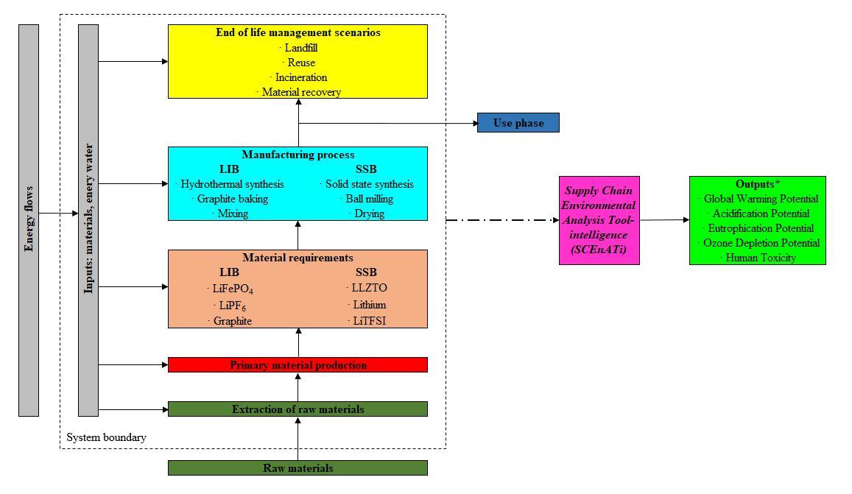

*Environmental impact categories inputted into the SCEnAT*i* tool only

Figure 27: The system boundary applied to the comparative HLCA of a 1kg LIB and a 1kg SSB of approximately 3.4V.

The manufacturing route required to produce a LIB and SSB are outlined in sections 3.4.2.1 and 3.4.2.2 respectively, the common features of each battery are explained in section 3.4.2.3.

# Lithium-ion battery manufacturing process

Hydrothermal synthesis of FeSO4 · 7H2O (an iron sulphate salt), reacted with phosphoric acid (H3PO4) and lithium hydroxide (LiOH) in a water filled, sealed reactor at 150-200°C for 5 hours, produces LiFePO4 (lithium iron phosphate) which is the key component of the LIB anode paste. A binder and carbon black (which act as an aid to increase conductivity) are then mixed with the LiFePO4 before a solvent is added to produce a slurry. The solvent is then evaporated following application of the material to the substrate [255].

The cathode paste is produced from graphite which is first baked at 1100°C in a reducing or inert atmosphere to remove impurities. The baked graphite is then combined with a binder, usually polytetrafluoroethylene, and a solvent, N-methylpyrrolidinon which is removed by evaporation when the material is applied to the substrate [255].

The anode substrate is made of aluminium sheet and the cathode substrate is made of copper sheet, each approximately 15-20µm in thickness. Finally, a mixture of LIPF6 and an alkylcarbonate solvent is used as the liquid electrolyte [255].

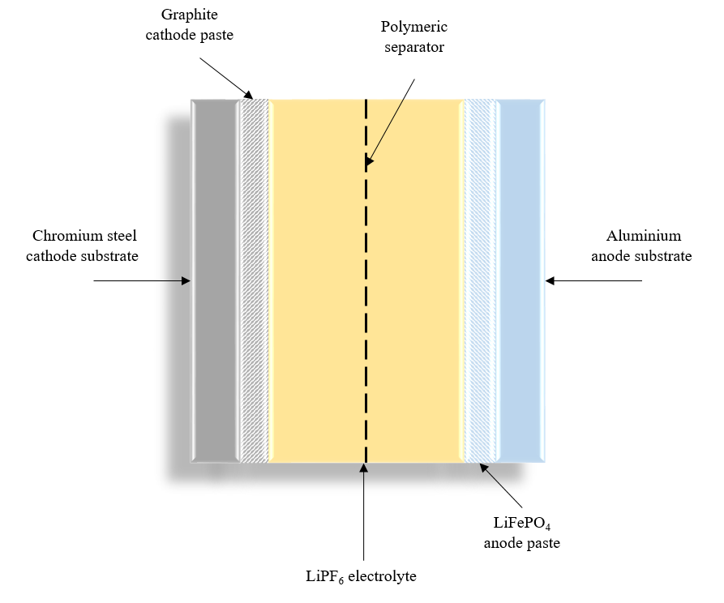

Figure 28: Schematic of an LIB, excluding “common features”.

# Solid state battery manufacturing process

This study focusses on a SSB utilising a Li6.4La3Zr1.4Ta0.6O12 (LLZTO) electrolyte [259] which is prepared through solid state reaction from LiOH, La(OH)3, ZrO2 and Ta2O5, with a 15wt% excess of LiOH to compensate for volatile Li components during synthesis. All of the powders are ball milled for 12 hours and then heated in air for another 12 hours at 900°C, with the aim of ensuring the formation of the cubic LLZTO phase. A final ball milling stage takes place for another 12 hours. The powder is sintered by the hot-pressing process at 1140°C for 9 hours [253].

To produce the composite cathode, polyvinylidene fluorine is dissolved in N-methyl-2 pyrrolidon and stirred for 24 hours. The LiTFSI must be pre-baked in a vacuum for 48 hours at 80°C and then the LiTFSI, LFP and KB are then added to the mixture which is ground in an agate mortar for 1 hour. The slurry is then coated to one side of the LLZTO electrolyte using blades before it is dried for 2 hours at 80°C to remove the N-methyl-2 pyrrolidon. A stainless steel plate is then used to press the composite cathode, prior to further drying at 80°C for 12 hours in a vacuum over, the aim of this is to fully remove the N-methyl-2 pyrrolidon and any additional moisture.

To apply the lithium anode to the other side of the electrolyte, high pressure is used in an argon filled glove box; this anode is approximately 2µm thick [260]. Stainless steel foils, assumed to be 12µm in thickness [261], were used as the current collectors to avoid any potential reaction that may occur between the alternative material, Al, and the polyvinylidene fluorine:LiTFSI. Finally, a stainless steel coin cell was used for the container; extensive information regarding SSB containers is not available, though Oudenhoven *et al.* [262] has discussed how a relatively high volume of such a battery is associated with the packaging and therefore the weight percentages provided by [255] for a LIB have also been applied to the SSB.

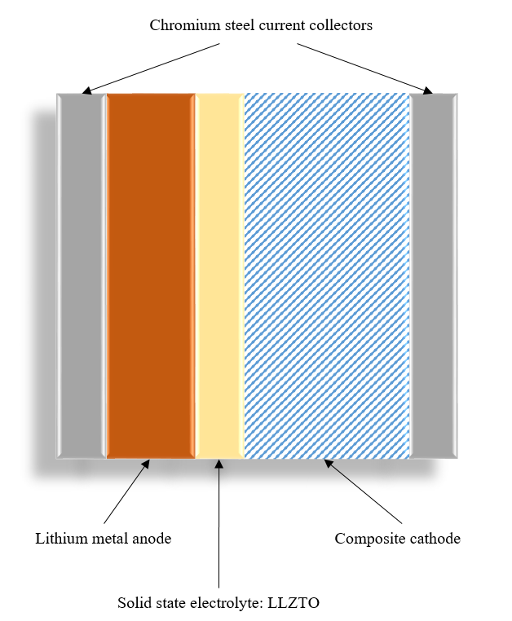

Figure 29: Schematic of an SSB, excluding “common features”.

# Common features

The battery management system (BMS) and battery packs are assumed to be common across both battery types therefore the weight percentages of these features, given by [255] for a LIB, have also been applied to the SSB.

# Data collection

Due to the lack of primary, industry data in this case, the LCI of the LIB was taken from literature [255] while that of the SSB was derived from both literature [256, 259-261] and the extensive knowledge of the Materials Science and Engineering laboratory at the University of Sheffield. All manufacturing materials are assumed to be virgin in origin and are outlined in Tables 30 and 31.

Table 30: Life cycle inventory to produce a 1kg LIB of approximately 3.4V, including any substitutions made [255].

|  |  |  |  |
| --- | --- | --- | --- |
| **Constituent** | **Details** | **Substitution Made** | **kg/3.4V LIB** |
| **Anode paste** | | | |
| Binder | Polytetrafluoroethylene | Tetrafluoroethylene film production, on glass | 0.02 |
| Carbon black |  | None | 0.01 |
| LiFePO4 |  | Calculated using [255] | 0.22 |
| Solvent | N-methyl-2 pyrrolidon | Methyl ethyl ketone production | 0.07 |
| **Cathode paste** | | | |
| Binder | Polytetrafluoroethylene | Tetrafluoroethylene film production, on glass | 4.00E-4 |
| Graphite |  | None | 0.08 |
| Solvent | N-methyl-2 pyrrolidon | Methyl ethyl ketone production | 0.02 |
| **Anode substrate** | | | |
| Aluminium |  | None | 0.04 |
| **Cathode substrate** | | | |
| Copper |  | None | 0.08 |
| **Electrolyte** | | | |
| LiPF6 |  | Chemical production, inorganic | 0.01 |
| Solvent | e.g. dimethyl carbonate ethylmethylene carbonate or propylene carbonate | Chemical production, organic | 0.12 |
| **Separator** | | | |
| Polyethylene |  | None | 0.02 |
| Polypropylene |  | None | 0.02 |
| **Cell container** | | | |
| Aluminium |  | None | 0.20 |
| **BMS** | | | |
| Circuit board |  | None | 3.00E-3 |
| Copper |  | None | 0.02 |
| Chromium steel (18/8) |  | None | 0.01 |
| **Packaging** | | | |
| PET |  | None | 0.17 |

Table 31: Life cycle inventory to produce a 1kg SSB of approximately 3.4V, including any substitutions made [255, 256, 259-261].

|  |  |  |  |
| --- | --- | --- | --- |
| **Constituent** | **Details** | **Substitution Made** | **kg/3.4V SSB** |
| **Anode** | | | |
| Lithium |  | Electrolysis of lithium chloride | 1.21E-04 |
| **Cathode** | | | |
| Polyvinylidene fluorine |  | Polyvinylfluoride production | 6.10E-05 |
| Solvent | N-methyl-2 pyrrolidon | Methyl ethyl ketone production | 5.55E-04 |
| LiTFSI |  | Chemical production, inorganic | 1.37E-03 |
| LFP |  | None | 4.58E-04 |
| KB |  | Carbon black used | 9.15E-05 |
| **Electrolyte** | | | |
| LiOH |  |  | 0.08 |
| La(OH)3 |  | Rare earth oxides production from bastnäsite concentrate | 0.25 |
| ZrO2 |  |  | 0.08 |
| Ta2O5 |  | Aluminium oxide production | 0.21 |
| **Current collectors** | | | |
| Chromium steel (18/8) |  | None | 0.01 |
| **Cell container** | | | |
| Chromium steel (18/8) |  | None | 0.21 |
| **BMS** | | | |
| Circuit board |  | None | 3.17E-3 |
| Copper |  | None | 1.59E-2 |
| Chromium steel (18/8) |  | None | 1.27E-2 |
| **Packaging** |  |  |  |
| PET |  | None | 0.18 |

The energy requirements for each battery type were constructed using two methods, where the required process data was held in the Ecoinvent database, the relevant dataset was used, these are outlined in Table 32 [139, 255]. Where process data was not available through this source, the electrical and thermal energy requirements of the relevant process steps were calculated (using equations 11 and 12) according to the required processing parameters; this information is shown in Table 33 for the LIB and Table 34 for the SSB manufacturing processes. The energy requirements for the production of the LIB positive electrode paste and electrolyte were considered to be negligible [255]. In the absence of accurate processing data relating to the application of the lithium anode in the SSB manufacturing process, the proxy of “sheet rolling, copper” was used from the Ecoinvent database, as per [68].

Table 32: List of processes for LIB and SSD manufacture, for which LCI data was held in the Ecoinvent database.

|  |  |  |  |  |  |
| --- | --- | --- | --- | --- | --- |
| **LIB** | | | **SSB** | | |
| **Component** | **Process** | **Ecoinvent dataset name** | **Component** | **Process** | **Ecoinvent dataset name** |
| Negative electrode paste | Graphite baking | Anode production, prebake, for aluminium electrolysis | Anode | Application | Sheet rolling, copper |
| Positive electrode substrate | Aluminium sheet rolling | Sheet rolling, aluminium | Current collectors | Chromium steel sheet rolling | Sheet rolling, chromium steel |
| Negative electrode substrate | Copper sheet rolling | Sheet rolling, copper | Cell container | Chromium steel sheet rolling | Sheet rolling, chromium steel |
| Separator | Injection moulding | Injection moulding | Battery pack | Injection moulding | Injection moulding |
| Cell container | Aluminium sheet rolling | Sheet rolling, aluminium | BMS | Wire drawing | Wire drawing, copper |
| Battery pack | Injection moulding | Injection moulding |  | Chromium steel sheet rolling | Sheet rolling, chromium steel |
| BMS | Wire drawing | Wire drawing, copper |  |  |  |
|  | Chromium steel sheet rolling | Sheet rolling, chromium steel |  |  |  |

Table 33: Laboratory process and energy use in the manufacturing of LiFePO4 for use in the positive electrode paste of a LIB.

|  |  |  |  |  |  |  |  |
| --- | --- | --- | --- | --- | --- | --- | --- |
| **LIB Process** | **Power (W)** | **Time (s)** | **Temp’ (K)** | **Elect’ Energy (kWh)** | **Specific heat capacity**  **(J kg-1 K-1)** | **Mol** | **Thermal Energy (MJ)** |
| Hydrothermal synthesis | 2,070 | 18,000 | 473 | 10.35 | 270 | 0.03 | 4.35E-3 |
| Mixing | By hand | | | | | | |

Table 34: Laboratory process and energy use in the manufacturing of a SSB.

|  |  |  |  |  |  |  |  |
| --- | --- | --- | --- | --- | --- | --- | --- |
| **SSB Process** | **Power (W)** | **Time (s)** | **Temp (K)** | **Elect’ Energy (kWh)** | **Specific heat capacity**  **(J kg-1 K-1)** | **Mol** | **Thermal Energy (MJ)** |
| **LLZTO Production** | | | | | | | |
| Ball milling: |  |  |  |  |  |  |  |
| LiOH | 50 | 43,200 |  | 0.60 |  |  |  |
| La(OH)3 | 50 | 43,200 |  | 0.60 |  |  |  |
| ZrO2 | 50 | 43,200 |  | 0.60 |  |  |  |
| Ta2O5 | 50 | 43,200 |  | 0.60 |  |  |  |
| Heating: |  |  |  |  |  |  |  |
| LiOH | 2,070 | 43,200 | 1,173 | 24.84 | 49.70 | 3.27 | 0.19 |
| La(OH)3 | 2,070 | 43,200 | 1,173 | 24.84 | 109 | 1.33 | 0.17 |
| ZrO2 | 2,070 | 43,200 | 1,173 | 24.84 | 56.20 | 0.62 | 0.04 |
| Ta2O5 | 2,070 | 43,200 | 1,173 | 24.84 | 135 | 0.48 | 0.08 |
| Heating of LLZTO | 50 | 43,200 |  | 0.60 | 104 |  |  |
| Sintering of LLZTO | 2,070 | 32,400 | 1,173 | 18.63 | 104 | 0.55 | 0.08 |
| **Cathode** |  |  |  |  |  |  |  |
| Stirring of polyvinylidene fluorine and N-methyl-2 pyrrolidon | 1,020 | 86,400 |  | 24.48 |  |  |  |
| Prebaking of LiTFSI | 2,070 | 172,800 | 353 | 99.36 | 421.6 | 3.93E-4 | 5.86E-5 |
| Grinding of LiTFSI | By hand | | | | | | |
| Coating of LiTFSI | By hand | | | | | | |
| Drying of LiTFSI | 2,070 | 7,200 | 353 | 4.14 | 421 | 5.69E-4 | 8.47E-5 |
| Pressing of LiTFSI | By hand | | | | | | |
| Drying of LiTFSI | 2,070 | 43,200 | 353 | 24.84 | 421 | 5.69E-4 | 8.47E-5 |

Device incineration, material recovery through the use of hydrometallurgy and pyrometallurgy and reuse of the device were considered as potential EOL management scenarios for each battery type. A brief overview of each scenario is given below and the associated LCI is outlines in Table 35.

When 70-80% of a battery’s original energy capacity is reached, this is classed as its EOL [263]. Providing batteries do no show signs of leakage, internal short circuits or high internal impedance, they can be reused. This requires disassembly and testing to ensure the battery is fit for purpose and additional packaging and electrical hardware [264].

The incineration of batteries leads to the emissions of halogens, mercury, lead and dioxins to the environment and does not result in material recovery [58, 207]; hydrometallurgical and pyrometallurgical recycling processes allow metals to be recovered from batteries. The pyrometallurgical process involves incineration, smelting, drossing, sintering, melting and high temperature reactions in the gas phase. The process results in waste gases and flue dusts which contain halogens leading to potential human health issues. Furthermore, recycling of WEEE by pyrometallurgy and hydrometallurgy leads to the production of an untreatable residue which must be landfilled [58]. During waste incineration, the mass of the waste is reduced by approximately 70% and therefore, 0.3kg of incineration ash is assumed to be sent to landfill for each EOL management scenario, excluding reuse [265].

The Ecoinvent database holds a dearth of information of the end of life management scenarios of LIB, as the recycling requirements of SSBs are currently unknown, the LIB data is used as a proxy.

Table 35: Life cycle inventory of the incineration, hydrometallurgy, pyrometallurgy and reuse EOL management scenarios for both LIBs and SSBs [79, 139].

|  |  |  |  |
| --- | --- | --- | --- |
| Method | Details | Substitution Made | Mass of LIB/SSB (kg) |
| Incineration | Treatment of hazardous waste, hazardous waste incineration | None | 1.00 |
| Treatment of average incineration residue, residual material landfill | None | 0.30 |
| Hydrometallurgy | Treatment of waste electric and electronic equipment, shredding | None | 1.00 |
|  | Treatment of used Li-ion battery, hydrometallurgical treatment | None | 1.00 |
| Treatment of average incineration residue, residual material landfill | None | 0.30 |
| Pyrometallurgy | Treatment of waste electric and electronic equipment, shredding | None | 1.00 |
|  | Treatment of used Li-ion battery, pyrometallurgical treatment | None | 1.00 |
| Treatment of average incineration residue, residual material landfill | None | 0.30 |
| Reuse | Disassembly (assumed by hand) |  |  |
|  | Testing (assumed by hand) |  |  |
|  | Electrical hardware | Material and energy requirements of BMS | 0.03 |
|  | Packaging | As original battery packaging | 0.17 |

The Ecoinvent website was used to provide the upstream emissions data of each supply chain for sixteen environmental impact categories, these are listed in Table 36. The CML 2001 and ReCiPe Endpoint (E,A) impact categories are provided as complementary information to enable further assessment. These impacts were emphasised as the most commonly utilised in battery LCA analysis.

Table 36: List of the environmental impact categories and their corresponding units and LCIA methodologies used in the comparative analysis of LIBs and SSBs.

|  |  |  |
| --- | --- | --- |
| **Impact category** | **Unit** | **LCIA Method** |
| GWP 100a | kg CO2-eq | CML2001 |
| AP generic | kg SO2-eq |
| EP generic | kg PO4-eq |
| FAETP 100a | kg 1,4-DCB-eq |
| HTP 100a | kg 1,4-DCB-eq |
| TAETP 100a | kg 1,4-DCB-eq |
| MAETP 100a | kg 1,4-DCB-eq |
| FSETP 100a | kg 1,4-DCB-eq |
| MSETP 100a | kg 1,4-DCB-eq |
| ODP | kg CFC-11-eq |
| High NOx POCP | kg ethylene-eq |
| Cumulative Energy Demand | MJ-eq | Cumulative Energy Demand |
| Ecosystem Quality Total | points | ReCiPe Endpoint (E,A) |
| Human Health Total | points |
| Resources Total | points |
| ReCiPe Endpoint (E,A) Total | points |

Equation 8 was used to apply the sixteen environmental impact categories to each of the inputs into the supply chains. The SCEnAT*i* decision support tool was employed to complete the requirements of the HLCA. The following additional supply chain inputs (at the domestic level) were applied to the HLCA through the SCEnAT*i* software to expand the system boundary: telecommunication, freight transport by road, research and development, computer services and related activities and collection of waste.

The environmental impacts of the material inputs into each supply chain were normalised to highlight which input provides the highest impact. The impact of each processing step, with respect to the GWP, was determined; a comparison of the ecotoxicity, CED, ReCiPe Endpoint (E,A) and environmental input-output (IO) upstream greenhouse gas emissions (GHG) was conducted and the significance of each EOL management scenario was outlined with respect to the GWP impact. Each of these assessments are depicted in section 3.4.3 and discussed in detail in section 3.4.4.

# Results

This section outlines the results of the methodologically robust comparative HLCA of the “material required for the production of a single cell battery, of approximately 3.4V, with a mass of 1kg”. The environmental hotspots within the supply chains of the two battery types are identified.

Figures 30 and 31 provide the results of the environmental analysis relating to the materials used in the production of each battery type. In Figure 30 it can be seen that the cathode substrate, BMS and cell provide a high contribution to the majority of the environmental impacts considered. For the SSB, Figure 31 shows that the electrolyte and BMS lead to the majority of the environmental impact over the chosen impact categories.

Figure 30: The percentage contribution of each material component of a 1kg LIB of approximately 3.4 V, for the environmental impacts investigated in this study.

With respect to the normalised values shown in Figure 30, the total GWP of the LIB is 16.19 kg CO2-eq; the AP impact is 1.11 kg SO2-eq, the EP impact is 0.11 kg PO4-eq, the FAETP impact is 29.66 kg 1,4-DCB-eq, the FSETP impact is 57.60 kg 1,4-DCB-eq, the HTP impact is 105.93 kg 1,4-DCB-eq, the ODP impact is 0.0001 kg CFC-11-eq, the high NOx POCP impact is 0.01 kg ethylene-eq, the TAETP impact is 0.01 kg 1,4-DCB-eq, the MAETP impact is 109.68 kg 1,4-DCB-eq, the MSETP impact is 108.43 kg 1,4-DCB-eq and the CED impact is 174.72 MJ-eq.

Figure 31: The percentage contribution of each material component of a 1kg SSB of approximately 3.4V, for the environmental impacts investigated in this study.

With respect to the normalised values shown in Figure 31, the total GWP of the SSB is 11.90 kg CO2-eq; the AP impact is 0.07 kg SO2-eq, the EP impact is 0.08 kg PO4-eq, the FAETP impact is 22.96 kg 1,4-DCB-eq, the FSETP impact is 45.68 kg 1,4-DCB-eq, the HTP impact is 31.17 kg 1,4-DCB-eq, the ODP impact is 2.00E-6 kg CFC-11-eq, the high NOx POCP impact is 0.003 kg ethylene-eq, the TAETP impact is 0.02 kg 1,4-DCB-eq, the MAETP impact is 81.22 kg 1,4-DCB-eq, the MSETP impact is 80.50 kg 1,4-DCB-eq and the CED impact is 207.66 MJ-eq.

Figures 32 and 33 outline the GWP impact of the processes relating to each of the material components. The production of the cathode paste leads to the highest GWP impact in the LIB manufacturing process, followed by the cell production (Figure 32); the cathode and electrolyte production processes dominate the GWP impact of the fabrication of an SSB (Figure 33).

Figure 32: The percentage contribution of each process step, in relation to the GWP, for the production if a 1kg LIB of approximately 3.4V.

Figure 33: The percentage contribution of each process step, in relation to the GWP, for the production if a 1kg SSB of approximately 3.4V. Others refer to those processes with a percentage contribution of less than 1% i.e. anode, current collectors, cell, BMS and packaging.

The environmental profiles of both LIBs and SSBs are shown in Figure 34, in all four cases, the impact of the SSB outweighs that of the LIB.

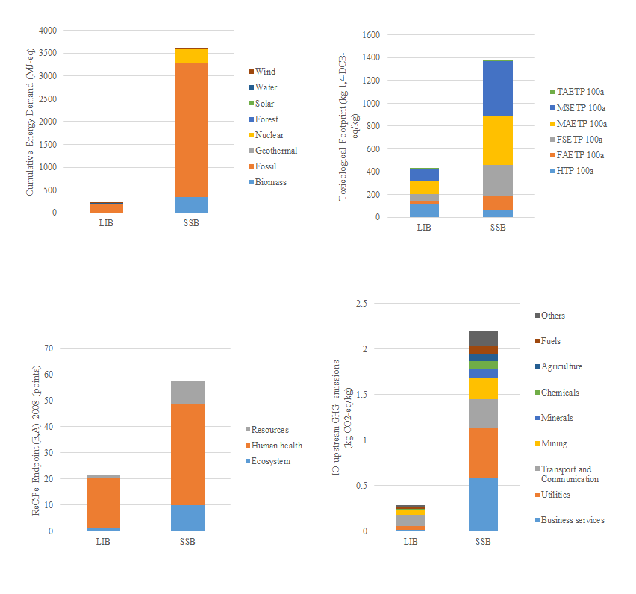

1. Cumulative energy demand
2. Toxicological footprint
3. ReCiPe Endpoint (E,A)
4. IO upstream GHG emissions

Figure 34: The comparison of the LIB and SSB for a) cumulative energy demand, b) toxicological footprint, c) ReCiPe Endpoint (E,A) and d) input-output (IO) upstream greenhouse gas (GHG) emissions.

Figure 34a shows the total cumulative energy demand (CED) for each battery type; the fossil fuel element of the CED has the highest impact of those fuel types included within this indicator. The toxicological footprint of each battery is outlined in Figure 34b; importantly, this indicates that the total HTP of a LIB is higher than that of a SSB despite the overall footprint total. The ReCiPe Endpoint (E,A) indicator, shown in Figure 34c, mirrors the results shown in Figure 34b, with a high impact shown for the human health indicator of both battery types. Finally, in Figure 34d, the IO upstream GHG emissions of each battery are shown; this data reflects the environmental impact of the additional inputs that may have been missing through the application of a simple process LCA and were calculated using equation 10. In this chart “others” relates to the sum of the remaining ten categories of which have minor impact on the overall result.

Finally, the GWP associated with each EOL management scenario is depicted in Figure 35.

Fig 35: The impact of the GWP for the EOL management scenarios relating to both a 1kg LIB or SSB of approximately 3.4V.

It can be seen from Figure 35 that overall, reuse of the battery (independent of type) leads to the highest GWP impact compared to the incineration, pyrometallurgy and hydrometallurgy management scenarios.

Each of these results are analysed and discussed in more detail in section 3.4.4.

# Discussion

Many LCAs on the environmental impacts of LIBs have been previously published but few have been carried out relating to the LCA of SSB and the work presented here is the first to compare the two technologies. Furthermore, the use of the HLCA methodology allows the initial process LCA system boundary to be expanded to provide a more realistic result relating to the impact of the whole supply chain. The results of this study provide information to aid to the future development of LIBs and SSBs. Being aware of the environmental hotspots present within the two supply chains will aid researchers and developers in their decision making processes.

The results of this investigation show that the environmental burden of the materials used in the production of a 1kg LIB of approximately 3.4V is higher than that of an SSB of the same weight and voltage. Despite this, the environmental impacts of the processing steps relating to the manufacture of each battery type is higher for an SSB than an LIB. Finally, the EOL management scenario with the highest environmental impact is battery reuse; the hydrometallurgy process used for material recovery leads to the lowest impact of those investigated.

# Component level analysis

In total, 16.19 kg CO2-eq can be attributed to the material aspects of an LIB and 11.90 kg CO2-eq can be attributed to that of an SSB. Therefore, with respect to the materials used in the production of each battery type, SSB materials provide a lower environmental burden compared to LIB materials. This is also true across all of the impact categories studied, except the cumulative energy demand (CED). The CED, also known as material embedded energy, of the LIB material components equates to 174.72 MJ-eq and that of the SSB equates to 207.66 MJ-eq. The CED represents the primary energy requirement of the withdrawal of embodied energy of raw materials, yet to be converted to a usable energy source. It is calculated as the sum of the energy sources such as fossil fuels, nuclear and wind energy [31]. In the case of the SSB, the result of this environmental indicator is predominantly influenced by the use of lanthanum hydroxide in the LLZTO electrolyte. Lanthanum is a rare earth element (RRE), the mining and downstream processing requirements of which are energy intensive, consequently leading to a high CED result. Furthermore, as the quality of the ore decreases, energy consumption and the related CO2 emissions increase [266].

Figures 30 and 31 show the results of the component level analysis (with respect to the environmental impact of only the materials used within the structure), which have been normalised to provide the percentage contribution of each component. Figure 30 shows that the cathode substrate and BMS provide a high contribution to the environmental impact of an LIB over the AP, EP, FAETP, FSETP, high NOx POCP, TAETP, MAETP and MSETP indicators.

It is the impact of the circuit board within the BMS that leads to the highest impact across all of the impact categories studied, apart from HTP. With respect to the HTP, the use of copper is the highest impact; copper is also used in the production of the cathode substrate. Low doses of copper in humans can lead to deficiencies, but high doses can lead to adverse effects for example, liver toxicity [267]. Furthermore, research has reported increased levels of arsenic in the urine of those living close to copper smelters [268]. Circuit boards contain precious metals, but overall, the highest metal content by mass is copper [269]. Further to the human impacts of copper, it has been shown that the environmental impact of copper is dependent on the ore grade, production rates and the processes employed. Overall, more than 50% of the GWP impact can be attributed to the mining and milling processes [270].

The cell provides an additional high contribution to the GWP, AP, HTP, high NOx POCP and CED indicators. The cell is manufactured from an aluminium sheet, a material that requires high energy demand which directly contributes to the impact of the GWP and CED indicators [271]. The environmental impact of this material can be reduced through the use of secondary in the place of virgin materials, thereby reducing the requirements of bauxite extraction [271]. With respect to the HTP impact of the cell, while aluminium is usually considered to be innocuous, it has been found that the material is known to be an inflammagen, pro-oxidant and mutagen [272].

Finally, the ODP indicator is dominated by the anode paste. When the results are analysed further, the high ODP impact relating to the anode paste can be attributed to the use of the polytetrafluoroethylene binder (99%), furthermore, its use in the cathode paste also leads to a high impact in the ODP impact category. This result is mirrored in the results provided by Majeau-Bettez *et al.* [255]. Ellingsen *et al.* [273] used a proxy for a polyvinylidene paste which reduced the ODP impact of the LIB under investigation by two orders of magnitude.

With respect to the SSB material structure, again, the BMS leads to a high percentage contribution of each of the environmental impacts considered. In addition to this, the electrolyte and cell also lead to significant impacts. The cell is produced from chromium steel which requires a two-step manufacturing process: an electric arc furnace, followed by an argon-oxygen decarbonisation step, both of which contribute to the high environmental impacts relating to its production. Furthermore, the material requires the addition of chromite and laterite to achieve its required properties, resulting in additional environmental burden. Direct smelting, using bath smelting technologies, as a fabrication process for ferronickel and ferrochromium, has been found to reduce the gross energy requirement, GWP and AP of stainless steel by around 20-25% due to the replacement of electrical energy with direct thermal energy [274].

The solid electrolyte of the SSB results in a high percentage contribution of the environmental impacts relating to the material used in this type of battery. Further inspection of these results show that, overall, it is the use of lanthanum hydroxide in the LLZTO structure that causes this high impact. Lanthanum is a rare earth element and as such has been listed as a critical material by numerous institutions [74-76]. The separation and refining processes of rare earth elements are energy and water intensive, require extensive chemical use and result in the emission of heavy metals, SO2 and dust among other pollutants [75, 76, 266]. Regardless of these environmental impacts the use of REEs is continuing to increase [77, 78].

These environmental hot-spots, identified by the process LCA of the materials used in the production of both LIBs and SSBs, should be implemented into the decision making process when furthering either technology, to ensure that their burden on the environment is reduced as far as possible.

# Process level analysis

A total of 0.61 kg CO2-eq is required in the manufacturing processes employed to produce a 1kg LIB of approximately 3.4V. This impact is relatively low as each process, excluding the fabrication of lithium iron phosphate for the anode paste (the impact of which is then applied to anode paste according to the mass requirements of the component), was taken from the Ecoinvent dataset and therefore represents industrial scale data.

Figure 32 shows that the packaging requirements of an LIB result in the highest process impact i.e. injection moulding. The electrical energy requirements for the injection moulding process relate to 97% of the total energy demand, though the overall process energy equates to approximately 23% of the total cumulative energy demand [275].

The energy requirement for the production of SSBs is overpowered by the production of the LLZTO electrolyte and the composite cathode because this production steps was not available in the Ecoinvent database and therefore were calculated using equations 11 and 12. A total of 225.08 kg CO2-eq is attributed to this production. As shown in Figure 33, the cathode production contributes to 55.69% of this total and the electrolyte 44.10%. The GWP impact can be further broken down into the electrical and thermal energy requirements; the electrolyte production requires 120.99 kWh of electricity and 0.56 MJ of thermal energy, compared to 152.82 kWh of electrical energy for the composite cathode production and only 2.2E-4 MJ of thermal energy.

Troy *et al.* [68] estimate a reduction of 30% with respect to the energy demands when moving from an ideal laboratory process to an industrial process. With this in mind, the GWP relating to the processes of the SSB would be reduced to approximately 157.23 kg CO2-eq. On an industrial scale, this reduction would be achieved through the use of more efficient machinery and batch manufacturing processes. Specifically, with respect to heating processes e.g. sintering, energy requirements can be reduced by using low temperature processing techniques and sintering aids [58].

It has been shown that the production location of components can also affect the process requirements and consequential impact relating to electricity use. For example, the GWP of electricity generation in China is almost twice that of electricity generation in Great Britain [58].

Overall, while the environmental burden of the SSB processing requirements dwarfs that of the LIB, an industrial scale manufacturing process would significantly reduce this and therefore the viability of the SSB production as a competitor of LIBs would be increased from an environmental point of view.

# Comparison of environmental profiles

A comparison of the environmental profiles of each battery type allows a wide range of impacts to be analysed and discussed.

Figure 34a compares the result of the CED indicator for both battery types. A total of 212.35 MJ-eq is required for LIB production, compared to 3619.69 MJ-eq for SSB production. The high result for the SSB is related to the high electrical and thermal energy demand required in the production of the electrolyte and composite cathode. The CED indicator quantifies the primary energy use of a product or service throughout its life cycle and therefore it can be seen in Figure 34a that the use of fossil fuels for both battery types has the highest overall impact [52].

The toxicological footprints of LIBs and SSBs are shown in Figure 34b. While the overall result of this measure is higher for an SSB than an LIB, it can be seen that the result of the HTP indicator is higher for an LIB than an SSB. Further inspection of this result shows that this high value is due to the cell and cathode substrate, which are fabricated from aluminium and copper respectively, the impact of which, with respect to humans is discussed above. Therefore, to reduce the toxicological footprint of each of these battery types, effort should be concentrated on the reduction of these materials within the structure.

Although the results of the CML2001 and the ReCiPe Endpoint (E,A) indicators cannot be directly compared as they are measured using different scales, the two can be employed to provide a robust and well-rounded analysis. Figure 34c shows that the results of the ReCiPe Endpoint (E,A) indicator mirror those provided by the toxicological footprint in Figure 34b, therefore supporting these results. Additionally, the human health indicator provides the majority of the impact when compared to the other ReCiPe Endpoint indicators, thereby further supporting the conclusions regarding the HTP of each battery type.

The SCEnAT*i* decision support tool was used to provide the data shown in Figure 34d; the total sum of the indirect impacts relating to an LIB is 0.28 kg CO2-eq, while that of an SSB is 2.20 kg CO2-eq according to additional inputs applied in this case. The high IO upstream impact of the SSB is caused by the high electrical and thermal energy requirements relating to the manufacturing process, which leads to a higher impact across the supply chain. In all, this additional step of including the HLCA in this assessment aims to expand the reach of the system boundary to provide a more representative assessment of each battery’s impact when compared to a process LCA alone.

# End of life management scenarios

Thus far, the results shown in the study have related to cradle-to-gate, by considering the potential end of life (EOL) management scenarios i.e. reuse, incineration and material recover through hydrometallurgy or pyrometallurgy, the system boundary is expanded to cradle-to-cradle/grave.

Figure 35 clearly shows that the environmental impact of reuse is higher than that of incineration or material recovery; reuse requires disassembly of the original battery, testing and new hardware and packaging. It is this new hardware and packaging that contributes to the total GWP of the reuse EOL management scenario. The toxicological impact of the reuse scenario is also much higher than the alternative studied, this can be attributed to the requirement of a new circuit board installation, the impacts of which are discussed above.

The incineration process, which takes place in a rotary kiln at approximately 1200°C, does not result in the recovery of any materials and therefore could be considered as the least sustainable EOL management scenario. Furthermore, the process releases a range of emissions such as carbon monoxide, hydrogen chloride, mercury and particulate matter, to name a few, and so contributes to the GWP, AP, HTP and other impact category results [52]. Effluent treatment takes place and relies on acid neutralisation and results in the production of a dewatered cake, thereby contribution to the EP impact category [276].

Incineration, smelting and sintering are just a small number of the processes that take place during pyrometallurgy, which has the third highest environmental impact of the four EOL management scenarios measured. The HTP of the pyrometallurgy process is the highest when compared to the incineration and hydrometallurgy processes, this can be attributed to the resulting flue dust and waste gases comprise of halogens; halogens lead to the accumulation of dioxins in the food chain [58].

Comparatively, the hydrometallurgy process has the highest impact across the MAEPT, MSETP, FAETP and FSETP categories when assessed in line with the incineration and pyrometallurgy scenarios. These indicators relate to ecosystems which are affected by the emission of heavy metals and therefore a release of the leaching solutions used in hydrometallurgy would result in a high environmental impact across these indicators [52, 58].

While the total environmental impact of the reuse EOL management scenario is higher than that of the others tested, the waste hierarchy requires the reuse of products preferentially over “other recovery” methods or disposal. The reuse of the battery types will reduce the consumption of virgin materials and the additional processing requirements relating to material recovery following the hydro- and pyrometallurgy processes [148].

Therefore, the development of SSBs must consider the potential for reuse of the battery when a suitable EOL energy capacity is reached. The reuse of LIB is well documented in literature and this provides a platform on to which the replacement with SSB can aim to further reduce the environmental burden of the SSB.

# Limitations

The SSB is not yet in commercial production and therefore, the data employed in this work is based on literature and knowledge of production processed used at the laboratory scale. Furthermore, primary industrial data for LIB production was not available and therefore the Ecoinvent database and literature sources were used to determine the LCI of this product. While it has been discussed that the comparison of laboratory based production with industrial scale manufacturing should be approached with caution [68], other studies have highlighted the importance of comparing the environmental impacts of a product in the early stage of its development to ensure that resources are not directed into the research of a material that leads to an increased impact on the environment than the current solution [31].

In this case, the comparison of the environmental impacts has been based on the amount of material (1kg) required to produce a functioning battery, this functional unit was chosen due to the inconsistent functional attributes of the two battery types as outlined in Table 29. While this can be seen as a limitation to the results of the HLCA from the point of view of the application, it does provide more relevant results with respect to the material use within the battery.

Following further research and finally commercialisation of SSBs, increased material use in the production phase will impact on the environment, but this will also lend well to the development of more efficient processing routes which will tend towards a reduction in the environmental impact.

# Conclusion

This work has presented the first comparative HLCA of a 1kg LIB and a 1kg SSB of approximately 3.4V with the aim of understanding the environmental impacts of each battery type in light of the development of SSBs to replace LIBs in the market due to safety concerns.

In total, the environmental impact of the materials used in the production of a 1kg SSB of approximately 3.4V, is lower than that relating to a LIB. This improvement is then outweighed by the heavy electrical and thermal energy requirements in the production of the SSB, consequently overall, the environmental impact of an SSB is significantly higher than that of an LIB.

This result must be taken in consideration with the future development of SSBs; material use and energy consumption. To begin, SSB material use will increase as the technology is developed and implemented, though LIB material use will likely decrease as the improvements seen through SSB use are implemented throughout industry. With respect to the energy requirements of SSBs, as the industrial process is developed, the environmental burden will be decreased through the use of more efficient processing techniques and processing aids.

In this case, the use of lanthanum in the SSB structure is highlighted as a hotspot within the life cycle of the battery, this is important in light of lanthanum being a critical material. Its environmental impact can be attributed to the energy requirements relating to its extraction, furthermore, from a sustainability point of view, its extraction is not economically feasible in the available volumes and is restricted by supply in countries such as China. Therefore, reducing the SSBs reliance on lanthanum would improve both the environmental and sustainability credentials of the battery.

Abiding by the waste hierarchy leads to the reuse EOL management scenario, in turn this results in the highest GWP impact of the EOL scenarios studied. While the high GWP impact can be related to the requirement of new hardware and packaging, overall the reuse scenario leads to a reduction in virgin material use and the process steps required to recover materials after the hydro- or pyrometallurgy processes.

Although the results show that the total environmental burden of SSBs is higher than that of LIBs, when taking the safety risk of LIBs and the potential savings relating to industrial fabrication of SSBs, the results of this HLCA show that development of SSBs is a positive change. Despite this, due to the use of critical materials in the SSB structure, their development would benefit from a reduction in the reliance of lanthanum through material substitution of less critical materials.

# Further work

Following the commercialisation of SSBs, the industrial scale impacts (assuming data is available from a primary source) should be analysed in comparison to LIBs. This will provide concrete evidence of the reduced environmental burden of the SSB when transferred to an industrial manufacturing process with increased efficiency when compared to a laboratory manufacturing route.

Commercialisation will also provide further information with regards to the use phase of SSBs and LIBs in similar products. As outlined above, the use phase of a battery is often related to the use of the product in which it is employed [257] and therefore this data would be used to provide environmental analysis relating to the service life of an SSB.

Alternative SSB material structures also exist, such as sulphide based systems based on Li4SnS4-Li3-SbS4 [277], lithium niobate cathodes with Li10GeP2S12 solid electrolytes [278] and all solid state sodium batteries [279]. Therefore, future investigations should be conducted to determine the environmental impact of these competing technologies to understand the environmental impact of each.

Finally, if SSB intend to replace LIBs, the recycling process to maximise material recovery from both battery types is paramount, especially with respect to the use of critical materials in SSBs. Therefore, research into this material extraction is necessary moving forward. Furthermore, in line with the development of SSBs it would be prudent to ensure that the reuse potential of these batteries is well known and fully implemented to reduce their final environmental impact.

# *Summary of the application of the hybrid life cycle assessment methodology*

While life cycle assessment is a globally accepted methodology for the assessment of environmental impacts [27], its application in the realm of functional materials and devices is limited and therefore sections 3.2 to 3.4 provide vital results with respect to devices that are used in a wide range of applications.

Through the application of the HLCA methodology, using the SCEnAT*i* decision support tool, a more accurate result is presented in comparison to the use of process LCA alone. By expanding the system boundary using MRIO tables, the whole of the supply chain is considered in the final calculation to provide a more robust and representative output.

The results of each study are visualised in numerous formats to ensure that all of the relevant information is properly depicted. By showing the relative environmental impact of each material component within a device with respect to each environmental impact category the material environmental hotspots within the system can be easily identified. As the primary energy demand can be broken down into the thermal, electrical and material embedded requirements related to each device, this information is provided to understand the highest environmental impact of the manufacturing processes employed. Finally, the toxicological footprint and IO upstream GHG impacts and a complementary environmental impact category are provided for easy comparison of these issues. These complete and comparative assessments provide stakeholders with a wide range of information that will enable them to make informed decisions.

Predominantly, primary data availability was the main limitation in these studies and therefore publically available and literature based data was used in its place. Though the applied methodology is robust and transparent in each case, the results would benefit from industry data in future comparative work.

# ***The Material Sustainability Index***

# *Methodology: Building the MSI*

This section of the thesis presents the methodology used to construct the Material Sustainability Index (MSI) using 2014 and 2015 as “test” years. The 2014 and 2015 results are used to assess the MSI framework against the aims and research questions which are outlined below. These years were chosen as the majority of material production data (obtained from the United States Geological Survey (USGS)) was available for these years at the time of the data selection process.

The MSI is a composite indicator (CI) and so an introduction to CIs is given in section 2.3 and previous methodologies employed to measure sustainability have been discussed in section 2.2 of the literature review.

The “Handbook on Constructing Composite Indicators. Methodology and User Guide” [149], developed by the Organisation for Economic Co-operation and Development, deals with the construction of CIs relating to sustainable development, and aims to improve the understanding of policy makers, academics and other interested stakeholders in the complex nature of CIs. The guide provides a step by step methodology for CI construction (which is described in section 2.3); using the Technology Achievement Index as an example, it clearly shows each step and the problems that could be encountered. While the “Handbook on Constructing Composite Indicators” [149] was the main source of guidance for this implementation, other concepts from published literature and highly cited indexes were also used.

Figure 36 provides a graphical overview of each step of the methodology; below, each methodological step is described according to the development of the MSI.

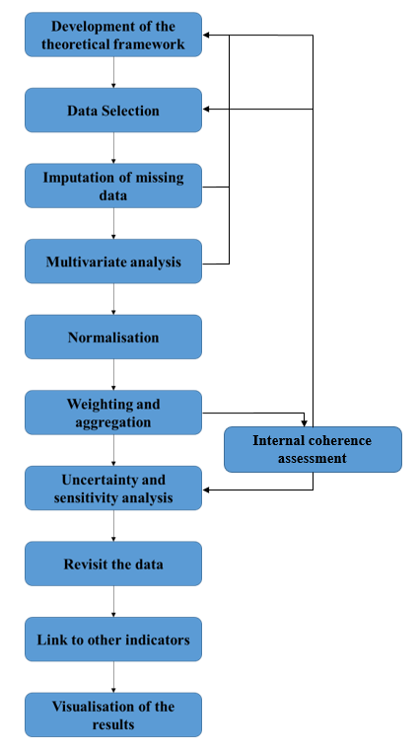

Figure 36: Methodological steps to build a composite indicator [149].

# Development of the theoretical framework

The aim of this process is to clearly define the multidimensional phenomenon that will be measured; the structure of any sub-groups that may be required and to determine a list of selection criteria relating to the underlying variables.

The construction of the MSI is grounded in the theory of sustainability with respect to the triple bottom line (TBL) and its symbiotic nature in that, a change in one of the three aspects, may lead to a change in another [22]. The MSI must measure the sustainability of a given material within the interdependent spectrum of the environment, society and economy.

This strategy links directly to the concept developed within BS 8905:2011 [22], which aims to guide users in the decision making process for the use of materials in a sustainable manner. While other published work has provided methodologies to quantify the sustainability of certain materials, none have submitted an approach that aims to quantify the sustainability of multiple materials using the same calculation.

By quantifying the sustainability of a material within the context of the TBL, policy makers, academics, industry and the general public will have the information required to understand how sustainable a material is with respect to the economy, society and the environment [1].

The main aims of the MSI, which link directly to the aims and objectives of this thesis, are as follows:

* To develop a simple, robust methodology for the calculation of the sustainability of a material
* To illustrate how the sustainability of a material changes over time
* To understand how the sustainability of a material can be improved
* To compare the results of the sustainability calculation with the results of the hybrid life cycle assessments (HLCAs) and other published methodologies which aim to measure sustainability, criticality etc.

The scope of the MSI is shown in Figure 37. This addresses the mining, processing and recycling of a material; product design, component production, use and landfill/repurpose/reuse end of life stages of the supply chain are out of scope. The scope is structured in this way to aid the product design process in order for a designer to understand how sustainable a material is prior to component production. The sustainability impact of the component (i.e. processes employed in the manufacturing, use and end of use phases) should then be considered by the designer based on their knowledge of those processes.

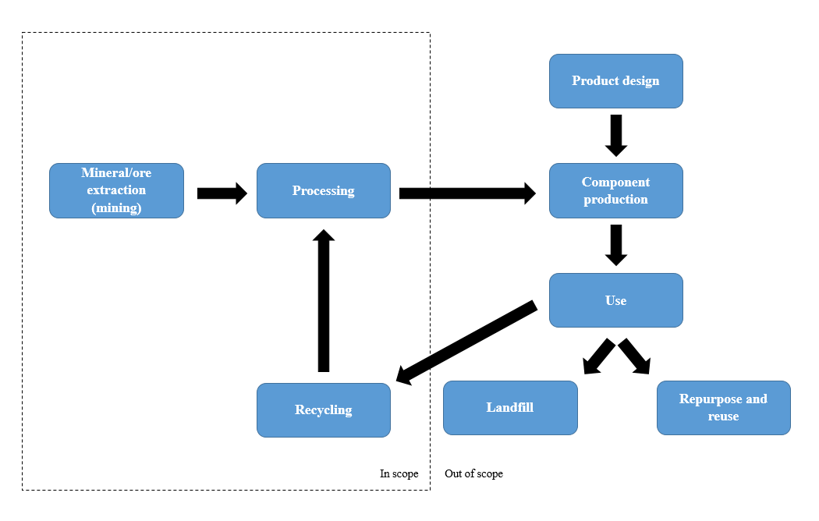

Figure 37: Scope of the MSI

As the aim of the MSI is to measure the sustainability of a material within the context of the triple bottom line (TBL), the associated sub-groups must reflect this. A data selection process, outlined in section 4.1.2, was undertaken to determine which indicators are the most relevant to the MSI to achieve its aims. The final MSI framework is shown in section 4.2.7.

# Data selection

The nature of the MSI requires the use of secondary data due to the wide-spread complexity of material extraction processes around the world. A detailed literature review was conducted to understand which indicators have previously been used in investigations into general sustainability indexes and specific material sustainability indexes (section 2); this constitutes the “research the facts” layer for framework construction described by Ashby [1]. A selection criteria matrix, which was designed using guidance from literature [15, 83, 94], outlined in Table 37, was then used to filter those indicators that were identified during the literature review.

Table 37: MSI indicator selection criteria matrix.

|  |  |  |
| --- | --- | --- |
| **Criteria** | **Description** | **Requirement** |
| Relevance | Is the indicator meaningful and purposeful? | Does the indicator address at least one of the three aspects of sustainability’s triple bottom line? |
| Validity | Is the indicator valid? | Is the indicator usable within the scope of the identified concept? |
| Duplicated | Is the data duplicated? | Is the result of the indicator duplicated by another indicator that has been identified? |
| Accessibility | Is the indicator easily accessible? | Can the data be accessed through an public forum? |
| Measurable | Is the indicator measurable? | Is the indicator measured quantitatively? |
| Reliability | Is the data reliable? | Does the data come from a secure, trustworthy source? |
| Understandable | Can the data be easily interpreted by stakeholders? | Do all identified stakeholders understand the data? |
| Availability | How many years of data are available? | Are data available over a ten year period? |
| Are all of the required countries available? | Are data available for all identified nations? |
| Are all materials available? | Are data available for all materials? |
| Quality | Is the data of high enough quality? | Does the data have gaps? |
| Units | What units are used? | Are standard units used? |
| Collection Method | Is the collection method constant? | Is the data collection constant each year e.g. time, source, location? |

140 indicators, relating to at least one of the three pillars of sustainability, were identified through the literature review. These indicators were assessed based on the selection criteria outlined in Table 37.

# Imputation of missing data

Data was collected for each of the chosen indicators and missing data was treated according to its type i.e. country or material specific data.

Material production data for 2014 and 2015 was taken from the USGS Mineral Commodities Summaries database [127]. 2015 data was not available for manganese, niobium and titanium, therefore the 2014 data was used in its place. USGS data for the production of cadmium, iodine, lithium, magnesium and selenium in the United States is withheld for 2014 and 2015; zirconium data is withheld for the United States for 2014 only. This is to avoid disclosing company proprietary data; therefore, in all cases, the United States tonnage contributions to those materials have not been included in the total. For some countries, the production tonnes are not reported as it is below 0.5 tonnes, in this case 0.5 tonnes are attributed to this country to be included in the total. Where production is reported from “other” countries, the production figure is divided by the number of countries indicated. REEs are grouped into a single category as suggested by literature [125] and while platinum and palladium are afforded their own category, the remaining platinum group metals (PGMs) are grouped due to the availability of data. Information regarding the data collection of each material is detailed in Appendix A.

This data was used to enable the country specific indicators (Human Development Index (HDI), Policy Perception Index (PPI) and Global Innovation Index (GII)) to be directly linked to each material through weight averaging the indicator for each country. Examples of this are shown for the HDI using 2014 cobalt production data in Table 38 and the PPI using 2015 gallium data in Table 39. This methodology is in-line with that used by Graedel *et al.* [115] in the calculation of material criticality.

The reliability of the HDI, PPI and GII indicators are analysed within their own frameworks and therefore this is not discussed further here [161, 172, 280]. Three imputation methods were applied and tested; case deletion (removing the missing records from the analysis), single imputation by applying the mean of the dataset as the missing record and single imputation by applying a geographically similar county’s record as the missing record.

Specifically, for the PPI indicator, where country data was provided regionally, the average of the regional data was used to represent the country. Additionally, where data points were missing from the 2015 data set (e.g. Egypt, Mozambique and Hungary), the 2014 data point was used.

Across all three indicators, North Korea presents a missing data point and therefore, in line with the methodology used in the 2014 EPI report, it has been removed from this analysis. This is due to the poor reliability and availability of data in North Korea which is well documented [281].

The reliability of these imputation methods for the HDI, PPI and GII indicators, when weight averaged to link directly to the material studied, are analysed by comparing the box and whisker plots, the descriptive statistics and the Pearson’s correlation coefficient of each of the three indicators, to determine the relationship between the indicators. Descriptive statistics were produced using the IMB SPSS Statistic 24 software; this provides the number of data points, minimum and maximum data points and the mean and standard deviation of each indicator. The IMB SPSS 24 software was also used to produce a bivariate correlation using The Pearson’s correlation, 2-tailed tests were used because a relationship in the indicators is expected but the direction of the relationship has not been predicted [282]. As the HDI indicator is provided on a scale of 0-1, these results were transformed to a 0-100 scale to enable them to be shown on the same axis as the PPI and GII indicators.

Table 38: Example of weight averaging the HDI using 2014 cobalt production data.

|  |  |  |  |  |
| --- | --- | --- | --- | --- |
| **Country** | **Production (metric tons)** | **% of total production** | **HDI** | **Fractional Contribution** |
| Australia | 5,978 | 4.90 | 0.94 | 4.59 |
| Botswana | 196 | 0.16 | 0.70 | 0.11 |
| Brazil | 3,828 | 3.14 | 0.75 | 2.37 |
| Canada | 6,907 | 5.66 | 0.92 | 5.20 |
| China | 7,700 | 6.31 | 0.73 | 4.63 |
| Congo (Kinshasa) | 61,000 | 50.00 | 0.59 | 29.50 |
| Cuba | 3,700 | 3.03 | 0.77 | 2.34 |
| Finland | 770 | 0.63 | 0.89 | 0.56 |
| Indonesia | 1,300 | 1.07 | 0.69 | 0.73 |
| Madagascar | 3,100 | 2.54 | 0.51 | 1.30 |
| Morocco | 2,150 | 1.76 | 0.65 | 1.14 |
| New Caledonia* | 4,040 | 3.31 |  | 0.00 |
| Papua New Guinea | 2,134 | 1.75 | 0.52 | 0.90 |
| Philippines | 4,600 | 3.77 | 0.68 | 2.56 |
| Russia | 6,300 | 5.16 | 0.81 | 4.16 |
| South Africa | 3,000 | 2.46 | 0.67 | 1.64 |
| United States | 120 | 0.10 | 0.92 | 0.09 |
| Vietnam | 223 | 0.18 | 0.68 | 0.12 |
| Zambia | 4,600 | 3.77 | 0.58 | 2.17 |
| Zimbabwe | 358 | 0.29 | 0.51 | 0.15 |
| **Total** | **122,004** |  |  | **64.26** |

*There is no data point for the HDI of New Caledonia and therefore, using the case deletion data imputation method, was left blank.

Table 39: Example of weight averaging the PPI using 2015 gallium production data.

|  |  |  |  |  |
| --- | --- | --- | --- | --- |
| **Country** | **Production (metric tons)** | **% of total production** | **PPI** | **Fractional Contribution** |
| China | 600 | 82.87 | 46.22 | 38.30 |
| Germany* | 40 | 5.52 | 63.81 | 3.53 |
| Hungary* | 8 | 1.10 | 63.81 | 0.71 |
| Japan* | 10 | 1.38 | 63.81 | 0.88 |
| Kazakhstan | 25 | 3.45 | 70.00 | 2.42 |
| Korea, Rep of* | 16 | 2.21 | 63.81 | 1.41 |
| Russia | 10 | 1.38 | 52.15 | 0.72 |
| Ukraine* | 15 | 2.07 | 63.81 | 1.32 |
| **Total** | **724** |  |  | **49.28** |

*There are no data points for the PPI of these countries and therefore the average PPI value was imputed.

The methodology used in the production of the GII allows for the most recent data point available in the last 10 years to be used in place of a missing data point and therefore using literature published since 2004 to obtain these values is considered to be appropriate [161].

Where GWP data was not available for a material through the Ecoinvent database (beryllium, bismuth, niobium, platinum group metals (excluding platinum and palladium), rhenium, strontium, tungsten and vanadium) [139] published literature was used [177, 283]. To ensure that all indicators described a “higher the better” result, the inverse of the GWP (InvGWP) indicator was used in this analysis.

The USGS database was used to represent the recycling rate (RR) indicator [127] for both the 2014 and 2015 datasets. Missing data was supplemented using literature [126], specifically for antimony, cadmium, mercury, rhenium, tantalum and zirconium; the data points for palladium and platinum were taken as equal to the value of PGMs. The 2014 data points for manganese and mercury were taken as an average of the additional data sources used to perform sensitivity analysis; the 2015 data point was taken as equal to the 2014 data point. It is important to note that this database only contains data for the United States and therefore, where available, analysis will be performed to determine how that affects the final result of the MSI (see section 4.1.8) [126].

The USGS database was used to gather the National Economic Importance (NEI) data. The NEI dataset is calculated using equation 15, this is then multiplied by the price per unit to give the unit value of the material and finally this taken as a percentage of the GDP. The USGS statistics of each material were used to determine the apparent consumption and value of the materials and the world bank database was used to understand the GDP of the United States [284]. The data required to complete equation 15 was not available for boron, cadmium, iodine, mercury, niobium, selenium, titanium, tungsten and zirconium for 2014 or 2015; for boron, cadmium, iodine, niobium, selenium, tungsten and zirconium, the least squared method was used to calculate the required data point. For mercury the average value from 1980 to 2000 was utilised. Finally, in the titanium dataset the missing information was the unit value of the material and therefore publically available data [285] was used to fill this gap.

$$Apparent consumption=Primary refinery production+$$

$Second production \left(old scrap\right)+Imports-$ (15)

$$Exports ±Changes in government and industry stocks$$

The characteristics of the RR, NEI and InvGWP indicators are analysed with box and whisker plots, descriptive statistics and the Pearson’s correlation coefficient. Descriptive statistics were produced using the IMB SPSS Statistic 24 software; this provides the number of data points, minimum and maximum data points and the mean and standard deviation of each indicator. The IMB SPSS 24 software was also used to produce a bivariate correlation using The Pearson’s correlation, 2-tailed tests were used because a relationship in the indicators is expected but the direction of the relationship has not been predicted [282]. These results are shown in section 4.2.2.

# Understanding the underlying structure of the indicators

Principal component analysis (PCA) was performed on the case deletion, average and geographic imputation methodologies for 2014 and 2015 to understand how, or if, an underlying structure exists between indicators and groups of indicators with respect to their correlation [149]. This is an accessible and low-cost methodology which produces a more manageable dataset according to the underlying structure of the original data [54]. The methodology is described below.

If there are Q indicators $(x_{1},⋯, x_{Q})$, PCA determines a smaller number of uncorrelated variables (principal components) which can be used to account for the variation of the existing indicators. This uncorrelated property means that the new principal components $(Z_{1},⋯,Z_{Q})$ are measuring different statistical dimensions in the original data i.e. if the principal components do not correlate, they are measuring different statistical dimensions in the data.

As PCA relies on identifying common underlying dimensions, common variance (variance that is shared with other indicators) is required. In PCA, communalities are initially assumed to be 1 and following extraction are seen to be lower than 1 due to the loss of data when factors of insubstantial eigenvalues (which identifies its functional importance of a factor) are removed from the analysis. Communalities are extracted to show the proportion of each indicator’s variance which is accounted for by the components, according to the retained set of factors. If all variance in the dataset is common variance then the extraction value will be 1 [286].

Factor loadings $(a_{ij})$ (also known as component loadings) are applied to the impacts $x_{j}$ according to equation 16 in order for $Z_{i}$ to satisfy:

1. Z1, …, Z*Q* are uncorrelated (orthogonal);
2. Z1 represents the maximum amount of variance of the indicators, Z2 represents the maximum remaining variance and so on until 100% of the variance is accounted for and

$a_{i1}^{2}+ a_{i2}^{2}+…+ a_{iQ}^{2}=1,2,…, Q$ (16)

Where $a_{ij}$ are the factor loadings, $(x_{1},⋯, x_{Q})$ are the indicators and $Q$ is the number of variables.

$$Z_{1}= a_{11}x_{1}+ a_{12}x_{2}+⋯+ a_{iQ}x_{Q}$$

$Z_{2}= a_{21}x_{1}+ a_{22}x_{2}+⋯+ a_{2Q}x_{Q}$ (17)

$$⋯$$

$$Z_{Q}= a_{Q1}x_{1}+ a_{Q2}x_{2}+⋯+ a_{QQ}x_{Q}$$

The eigenvalues (utilised to reduce the variance in a correlation matrix) must then be found, $λ_{j}, j=1,…,Q,$ of the covariance matrix,

$Covariance Matrix=\begin{matrix}{cm}_{11} & {cm}_{11}… & {cm}_{1Q} \\ {cm}_{21} & {cm}_{22}… & {cm}_{2Q} \\ {\begin{aligned}… \\ cm\end{aligned}}_{Q1} & {\begin{aligned} \\ cm\end{aligned}}_{Q2} & {\begin{aligned} \\ cm\end{aligned}}_{QQ}\end{matrix}$ (18)

where ${cm}_{ii}$ is the variance of $x_{i}$ and ${cm}_{ij}$ is the covariance of variables $x_{i}$ and $x_{j}$. The eigenvalues of the matrix covariance matrix are the variances of the principal components. Of the Q eigenvalues, some are negligible; the sum of the eigenvalues is equal to the sum of the diagonal elements of covariance matrix (equation 18).

Standardising the variables prevents the unnecessary influence of one indicator over the principal components, by changing the covariance matrix to a correlation matrix all indicators are given equal weights in the formation of the principal components.

A varimax rotation can be used to minimise the number of fields that have high loadings on each of the factors, thereby, simplifying the interpretation of the results [287]. Variables are plotted along the classification axis of the factor, the factor axis is then rotated to provide maximum loading on only one factor, thereby discriminating between the factors. In this case, the varimax rotation methodology was applied to the dataset as this methodology aims to provide a smaller number of variables highly loaded on to each factor, and therefore produces more interpretable results [282].

The communalities, total variance, a scree plot to graphically represent the eigenvalues in descending order, a component matrix and a rotated component matrix are shown in section 4.2.3 for each of the imputation methodologies (case deletion, average and geographic imputation). The results of this analysis will allow the final structure of the MSI to be devised according to the underlying structure of the dataset.

# Normalisation

The normalisation process is required to ensure that the variables are comparable.

The InvGWP indicator is positively skewed and therefore the scale was transformed prior to normalisation using equation 19 to bring all values above 0 [149]. This reduces the potential for outliners in the dataset to distort the result of the transformation.

$InvGWP=\log_{10}{I}+5$ (19)

The min-max normalisation methodology was employed as it is a simple methodology and provides a set of indicators within the range of 0 and 1. Alternative methodologies include ranking and standardisation. Although the ranking methodology is not affected by outliers, information is lost in absolute terms and comparatively, extreme values have a large effect on the standardisation methodology and furthermore, this method cannot be used with the geometric aggregation strategy. The min-max normalisation methodology is shown in equation 20 where $I$ represents the indicator value, to allow the materials to be measured in relation to each other. The min-max “goal-posts” were determined based on the theoretical minimum and maximum values of the HDI and RR. The *log*InvGWP indicator min-max “goal-posts” were determined according to the maximum and minimum data available for the materials in this study. For example, the highest GWP data point belongs to platinum at 18,188 kg CO2-eq, therefore, the maximum “goal post” was set at 20,000 kg CO2-eq to provide lee-way in the flexibility in the dataset. Similarly, the minimum data point for the GWP dataset relates to boron at 0.092207 kg CO2-eq, and therefore the minimum “goal post” was set to 0.00001 kg CO2-eq, again allowing for flexibility in the data set. With regards to the NEI indicator, it could be envisaged that a material may provide 0% NEI and therefore the minimum “goal post” was set at 0% and technically the value of a material could contribute to 100% of the GDP and therefore the theoretical maximum would be 100%. To allow for flexibility in the dataset, the maximum “goal post” was set at 0.1% (the actual maximum being 0.072% in 2014 and 0.057% in 2015) and the minimum “goal post” was set to 0%. The employed limits are detailed in Table 40. This method provides a range between 0 and 1 as the minimum value is subtracted from the indicator and then divided by the range of the set of values.

$T_{I}=\frac{I-min⁡(I)}{\max\left(I\right)-\min{(I)}}$ (20)

Where indicator $I$ is transformed to $T_{I}$.

Table 40: Min-max “goal posts” applied to each indicator in the normalisation process.

|  |  |  |  |  |  |  |  |  |
| --- | --- | --- | --- | --- | --- | --- | --- | --- |
| **Indicator** | **2014 Actual** | | **2015 Actual** | | **Theoretical** | | **“Goal Post”** | |
| **Max** | **Min** | **Max** | **Min** | **Max** | **Min** | **Max** | **Min** |
| RR | 100 | 0 | 93 | 0 | 100 | 0 | 100 | 0 |
| NEI | 0.072 | 0.00002 | 0.057 | 0.00002 | 100 | 0 | 0.1 | 0 |
| GWP | 18188 | 0.09 | 15199 | 0.10 | 20000 | 0.00001 | 20000 | 0.00001 |
| InvGWP† | 10.85 | 5.50E-05 | 10.58 | 6.58E-05 | 100000 | 0.00005 | 100000 | 0.00005 |
| logInvGWP | 6.04 | 0.74 | 6.02 | 0.82 | 10 | 0.70 | 10 | 0.70 |
| HDI* | 0.90 | 0.57 | 0.90 | 0.57 | 1 | 0 | 1 | 0 |

*Actual maximum and minimum values according to the case deletion imputation methodology, given as an example.

† When the inverse of the maximum GWP value is taken, this becomes the minimum value of the InvGWP.

# Weighting and aggregation

It is necessary to employ a weighting and aggregation scheme that reflects the requirements of the theoretical framework. The majority of CIs employ equal weighting [149]; this weighting scheme was chosen for the MSI to reflect the results of the PCA, the balance of the three pillars of sustainability and to account for the recycling rate (RR) of the material.

The chosen aggregation method must depend on whether or not the poor performance of one (or more) indicator(s) can be compensated by the increased performance of another indicator(s). A geometric aggregation methodology, shown in equation 21, was employed for the MSI to ensure that a poor result in one component is not fully compensated for by a good result in another component. For example, the high NEI result for gold, should not fully compensate for its poor environmental credentials. This also reflects the interdependability of the concept of sustainability, where a change in one element may result in the change of another [22].

In equation 21, “GWP” refers to the *log*InvGWP. The result is multiplied by 100 to provide a final scale of 0-100.

$MSI=\sqrt[4]{HDI ×GWP ×NEI ×RR} × 100$ (21)

Different aggregation methodologies may be applicable to the MSI; these are explored in detail through the sensitivity.

# Internal coherence assessment

The results of the MSI, using the calculation shown in equation 21 are provided in different visual formats in section 4.2.8. Due to the use of the RR indicator, as many materials have a 0% RR indicator value, an overwhelming number of materials are provided with a final MSI value of 0 points. In the case of materials such as REE and gallium, this does not pose a significant issue as these are critical materials and therefore their recycling is of paramount importance; this result could be conflicting for materials such as sodium where abundance, and therefore short-term sustainability, is not an issue.

Furthermore, the positive correlation of the NEI and RR indicators may lead to double counting when equal weighting is used [149] and although it is important to consider that correlation does not necessarily indicate causation, the relationship must be analysed in more detail.

With this in mind, the MSI is also assessed according to equation 22, to ensure that the use of the RR indicator does not lead to anomalous results.

$MSI=\sqrt[3]{HDI ×GWP ×NEI } × 100$ (22)

# Uncertainty and sensitivity analysis

Up to this point in the production of the MSI, a number of judgements have been made to construct the final outcome and therefore, it is necessary to test the robustness of these judgements to ensure that the final result is accurate and transparent. This will be achieved through uncertainty and sensitivity analysis. Uncertainty analysis determines how the uncertainty of the inputs moves though the structure to affect the result; sensitivity analysis determines how each source of uncertainty determines the variance in the final result [149].

The measured sources of potential uncertainty, i.e. the input quantities on which the measurement depends, in the MSI are: imputation of missing data, exclusion of indicators, substitution of indicators, normalisation scheme and aggregation scheme employed and the source of the RR indicator. A probability distribution function was assigned to each input factor, $X_{i}, i=1,2…k$, these are summarised in Tables 41, 42 and 44-47. Other potential uncertainty sources that were not assessed are discussed in section 4.3.8.

Three imputation methodologies have been applied to the weight averaging of the USGS production data according to the availability of the HDI, PPI and GII indicators. The first input factor, $X_{1}$, referring to the imputation methodology for the HDI indicator i.e. case deletion, average value imputation or geographic value imputation, is outlined in Table 41; each imputation methodology will be tested to determine its effect on the MSI value.

Table 41: Input factor $X_{1}$, imputation methodology for the HDI indicator: case deletion, average value and geographic value imputation.

|  |  |  |
| --- | --- | --- |
| $$X_{1}$$ | **Imputation methodology for HDI indicator** | **Abbreviation** |
| 1 | Case deletion | DEL |
| 2 | Average value | AVG |
| 3 | Geographic | GEOG |

The second input factor, $X_{2}$, refers to the normalisation methodology; the min-max normalisation method was employed to develop the indicator using specific “goal posts”. The standardisation normalisation methodology cannot be applied when the geometric aggregation methodology is used because the methodology provides negative results, and therefore it is not tested within this analysis. The min-max normalisation methodology with new “goal posts” for the GWP and NEI indicators (outlined in Table 43) are tested using equation 20, the ranking normalisation methodology was tested using equation 23, the raw indicator values were assessed according to equation 24 and the original “goal posts” outlined in Table 40 were tested, as outlined in Table 42. Each normalisation method will be applied and tested to determine its effect on the MSI value. For this input factor, the case deletion imputation methodology was chosen for comparison and the *log*InvGWP indicator was used.

Table 42: Input factor $X_{2}$, normalisation: change of “goal posts”, ranking and raw indicator values.

|  |  |  |  |  |
| --- | --- | --- | --- | --- |
| $$X_{2}$$ | **Normalisation** |  |  | **Abbreviation** |
| 1 | Change of “goal posts” | $$T_{I}=\frac{I-min⁡(I)}{\max\left(I\right)-\min{(I)}}$$ | (20) | GOAL |
| 2 | Ranking | $$T_{I}=Rank(I)$$ | (23) | RANK |
| 3 | Raw indicator values | $$T_{I}= I$$ | (24) | RAW |
| 4 | Original “goal posts” | $$T_{I}=\frac{I-min⁡(I)}{\max\left(I\right)-\min{(I)}}$$ | (20) | ACT |

Table 43: Realigned min-max goalposts for the GWP and NEI indicators.

|  |  |  |  |  |
| --- | --- | --- | --- | --- |
| **Indicator** | **2014 Actual** | | **2015 Actual** | |
| **Max** | **Min** | **Max** | **Min** |
| NEI | 0.07 | 2.11E-05 | 0.06 | 2.05E-05 |
| GWP | 18188 | 0.09 | 15199 | 0.09 |
| InvGWP | 10.85 | 5.49E-05 | 10.58 | 6.58E-05 |
| logInvGWP | 6.04 | 0.74 | 6.02 | 0.82 |

The geometric aggregation methodology was employed to ensure that the good performance of one indicator does not fully compensate for the poor performance of another indicator (as would be the case if a linear aggregation methodology was employed). To ensure that this method adequately accounts for the requirements of the theoretical framework, it was tested (equation 27) alongside two other aggregation methodologies using input factor $X_{3}$; linear aggregation (equation 25) and ranking summation (equation 26); this information is detailed in Table 44. For this input factor, the case deletion imputation methodology was chosen for comparison as the results shown in 4.2.2 indicates that the data imputation had no effect on the distribution of the HDI values.

Table 44: Input factor $X_{3}$, aggregation: linear and ranking summation.

|  |  |  |  |  |
| --- | --- | --- | --- | --- |
| $$X_{3}$$ | **Aggregation** |  |  | **Abbreviation** |
| 1 | Linear aggregation | $$MSI=\sum_{q=1}^{Q}{T_{I}}$$ | (25) | LIN |
| 2 | Ranking summation | $$MSI=\sum_{q=1}^{Q}{{Rank}_{T_{I}}}$$ | (26) | RANK |
| 3 | Geometric aggregation | $$MSI= \prod_{q=1}^{Q}{T_{I}}$$ | (27) | GEOM |

To understand the consequence of each indicator on the MSI, the exclusion of each (HDI, GWP, NEI and RR) is tested, alongside the actual calculation i.e. no exclusion, using input factor $X_{4}$, outlined in Table 45 using equations 21, 22 and 28-30. Furthermore, the substitution of the PPI and GII indicators (which were removed from the calculation following the principal component analysis) in place of the HDI indicator is tested within input factor $X_{5}$, using equations 31 and 32 and the original MSI equation (equation 21), as outlined in Table 46. Although literature [54] indicates the redundancy of environmental impact categories additional to the GWP indicator, the substitution of the abiotic depletion potential (ADP) and the human toxicity potential (TOX) in place of the GWP indicator is used to test this in the case of the MSI according to equations 33 and 34 in Table 46.

The ADP indicator measures a substance’s scarcity and therefore is affected by the amount of the resource that is available. Its rate of extraction is measured (depending on the model) in kg antimony-eq.

The TOX indicator, in this case represents the human toxicity potential; this indicator measures how toxic a compound is, the anticipated dosage and the consequential harm that it could cause if released to the environment; the indicator is measured in kg 1,4-DB-eq [52].

Both the ADP and TOX indicators were inversed to provide a “higher is better” result and transformed using equation 19 to reduce the skew of the data set i.e. *log*InvADP and *log*InvTOX were assessed. The min-max “goal posts” were applied according to the actual minimum and maximum values of the *log*InvADP and *log*InvTOX datasets. Finally, the result of “no substitution” (i.e. the original calculation) was also assessed.

Table 45: Input factor $X_{4}$, exclusion of indicator: HDI, GWP, NEI and RR.

|  |  |  |  |  |
| --- | --- | --- | --- | --- |
| $$X_{4}$$ | **Exclusion of indicator** | **Resulting MSI Calculation** |  | **Abbreviation** |
| 1 | HDI | $$MSI=\sqrt[3]{GWP ×NEI×RR}$$ | (28) | HDI |
| 2 | GWP | $$MSI=\sqrt[3]{HDI ×NEI×RR}$$ | (29) | GWP |
| 3 | NEI | $$MSI=\sqrt[3]{GWP ×HDI×RR}$$ | (30) | NEI |
| 4 | RR | $$MSI=\sqrt[3]{GWP ×NEI×HDI}$$ | (22) | RR |
| 5 | NO EXCLUSION | $$MSI=\sqrt[4]{GWP ×NEI×HDI ×RR}$$ | (21) | X4 NON |

Table 46: Input factor $X_{5}$, substitution of the PPI and GII indicators for the HDI indicator and substitution of the ADP and TOX indicators for the GWP indicator.

|  |  |  |  |  |
| --- | --- | --- | --- | --- |
| $$X_{5}$$ | **Substitution of indicators** | **Resulting MSI Calculation** |  | **Abbreviation** |
| 1 | PPI for HDI | $$MSI=\sqrt[4]{GWP ×NEI×RR ×PPI}$$ | (31) | PPI |
| 2 | GII for HDI | M $SI=\sqrt[4]{GWP ×NEI×RR ×GII}$ | (32) | GII |
| 3 | ADP for GWP | $$MSI=\sqrt[4]{ADP ×NEI×RR ×HDI}$$ | (33) | ADP |
| 4 | TOX for GWP | $$MSI=\sqrt[4]{TOX ×NEI×RR×HDI}$$ | (34) | TOX |
| 5 | NO  SUBSTITUTION | $$MSI=\sqrt[4]{GWP ×NEI×HDI ×RR}$$ | (21) | X5 NON |

Input factor $X_{6}$ relates to the available sources of RR indicator data. The sources and availability of RR are inconsistent and therefore, to understand how this data affects the overall value of the MSI, alternative sources are tested. Table 47 defines these sources as those reported in literature by Graedel *et al.* [126], the Royal Society of Chemistry (RSC) database [288], the EU critical/non-critical raw material database [76] and the actual MSI data provided by the USGS database [127].

Table 47: Input factor $X_{6}$, alternative data sources for the RR indicator.

|  |  |  |  |
| --- | --- | --- | --- |
| $$X_{6}$$ | **Source of RR data** | **References** | **Abbreviation** |
| 1 | Graedel *et al.* | [126] | GRD |
| 2 | Royal Society of Chemistry | [288] | RSC |
| 3 | EU Materials profiles | [76] | EU |
| 4 | USGS database | [127] | USGS |

The application of sensitivity analysis and uncertainty analysis using these input factors is described below.

# Sensitivity analysis

For the sensitivity analysis, each of the sources of uncertainty outlined above were tested to determine their impact on the final result for both 2014 and 2015. The MSI was calculated, using the four indicator framework, according to the requirements of each individual input factor ( $X_{1}$ to $X_{6}$; Tables 41, 42 and 44-47) and the results are displayed as bar charts to clearly show the change in the final result. The impact of the removal of the RR indicator (i.e. the result of the three indicator MSI framework) is shown as part of impact factor $X_{4}$.

# Uncertainty analysis

A Monte Carlo Simulation, using random inputs to explore the behaviour of a complex system [289] was used to assess the full uncertainty of those MSI inputs which were deemed to be relevant through the sensitivity analysis; $X_{1}, X_{2}$-1 and $X_{2}$-3, $X_{4}$, $X_{5}$ and $X_{6}$ (see section 4.3.8.1 for a full commentary on the results of the sensitivity analysis).

10,000 random combinations of the relevant input factors were generated for each material, using the “randbetween” function in Microsoft Excel to randomly assign indicator inputs into the MSI calculation. For each random combination, the MSI model was evaluated [149].

The four and three indicator MSI frameworks are assessed by comparing the original MSI values with the mean value of the Monte Carlo simulation and the 5th and 95th percentiles of the distributions of the materials investigated for both 2014 and 2015.

# Visualisation of the results

Efficient visualisation of the results is important to aid correct and swift stakeholder interpretation. Here, the 2014 and 2015 MSI results are provided, for both the four and three indicator MSI frameworks, in a tabulated format, in a bar chart and in the form of colour coded periodic tables using a traffic light-type system, where each measured material is highlighted according to its MSI result. Red indicates a result of 0 points, orange indicates a result of >0 and up to 20 points, yellow indicates a result of >20 and up to 40 points, light green indicates a result of >40 and up to 60 points and dark green indicates a result above >60 points. Grey is used to identify those materials that have not been analysed in this study.

The aim of providing different visual aids to present the MSI results is to ensure that all stakeholders are able to comprehend them. Furthermore, the aim of these visual aids is to allow the reader to quickly assess the sustainability of a material, according to the calculation employed, without digging deep into the details. If the reader requires information relating to the underlying indicators, they can read 7.3.11 which provides an overview of the contribution of each indicator to the final result for a selection of materials.

# Revisiting the data

The aim of revisiting the data is to fully understand how the underlying indicators of the MSI drive the final result. This allows for full transparency of the final output to aid robust analysis and decision making. Each of the underlying indicators is disaggregated to enable the strengths and weaknesses of each material to be assessed, this is shown using stacked bar charts. This disaggregation is performed and analysed for both the four and three indicator MSI frameworks [149].

To determine the contribution of each indicator to the final MSI result, the normalised indicator was taken as a percentage of the sum of the indicators and multiplied by the MSI result. Specifically, for the four indicator MSI framework, the final chart does not show the indicator disaggregation of those materials with a 0 point MSI as it is not possible to show the percentage contribution of 0 points.

# Trend analysis

To this point, the MSI has investigated the sustainability of those materials analysed for the years 2014 and 2015 only. To determine how the sustainability of these materials may have changed over time, trend analysis was performed between 2005 and 2015.

Due to the availability of consistent and reliable data, the trend analysis was limited to those materials where the majority of the data was available; aluminium, chromium, copper, lead, magnesium, nickel, tin, titanium and zinc using the USGS data set. The MSI was calculated (for both the four and three indicator MSI frameworks) using the case deletion imputation methodology for the HDI indicator, the GWP indicator was transformed using equation 19, the min-max normalisation methodology was applied using the “goal posts” in Table 40 and the geometric aggregation methodology was used. The individual treatment of each indicator is outlined below.

The HDI indicator is publically available back to 1990 and therefore this data set was downloaded directly from the HDI website [174].

The relevant versions of the Ecoinvent database were used to determine the GWP indicator for each material; in all cases, data was missing for 2012, 2011 and 2008 and therefore 2009 data was used to represent 2011 and 2012; 2007 data was used to represent 2008 (in line with the methodology employed by the GII indicator). The 2005 and 2006 data points for titanium were missing and previous years’ data was not available; to fill these gaps, regression analysis was used through the least squared method.

The NEI indicator was treated as per the description in section 4.1.3; no data points were missing for the materials studied.

The RR indicator was fulfilled using the USGS data set as this provided the most robust data over the period of time studied. Nickel data was missing from the 2014 data set and therefore the 2013 data point was used; the 2008 and 2009 data points were missing for titanium and therefore the 2007 data point was used.

The results are shown in line charts to depict how the sustainability of the analysed materials changes over this time; this analysis were performed for both the four and three indicator MSI frameworks.

# Links to other techniques

Comparing the results of both the four and three indicator MSI frameworks, and the underlying indicators indicators, with other available techniques (including both simple or composite indicators) allows data-driven narratives to be developed based on the results [149]. As stated in the introduction to this thesis, the MSI is a unique piece of work that aims:

* To calculate the sustainability of a material, within the context of the triple bottom line (TBL)
* To show how the sustainability of a material has changed over time
* To understand how the sustainability of a material can be improved
* To be accessible to all stakeholders

There is no direct comparison to be made against an existing, published indicator and therefore the results of the MSI are considered as described below.

Importantly, the results of the three HLCAs, relating to functional materials and ceramics (detailed in sections 3.2, 3.3 and 3.4), are re-considered in light of the results provided by the MSI calculation. Despite this comparison, it is important to note that the MSI is not intended as a replacement for the HLCA process, rather a complimentary measure. The relationship between the NEI and RR indicators is discussed in more detail and finally, the MSI results from both the four and three indicator frameworks, and the results of the sensitivity analysis, for individual materials are compared with other published sustainability assessment methods.

# *Results*

The results generated through the application of the methodology described in section 4.1 are displayed below.

# Data selection

As described in section 4.1.2, following the literature review, the selection criteria detailed in Table 37 was used to filter out any indicators that did not meet the necessary criteria to take forward into the MSI. Three criteria resulted in the dismissal of indicators; relevance, duplication and accessibility, and overview of this information is detailed in Table 48.

Table 48: Justification for the dismissal of MSI indicators based on the selection criteria detailed in Table 37.

|  |  |  |
| --- | --- | --- |
| **Selection criteria** | **Indicator removed** | **Justification** |
| Duplication | Cumulative energy demand | See Genovese *et al.* [54]. Remaining term: GWP 100a. |
|  | Abiotic depletion potential (and equivalent) |
|  | Emission of ozone depleting substances |
|  | Human toxicity potential |
|  | Land use |
|  | Waste generation (including hazardous waste) |
|  | Acidification (and equivalent) |
|  | Water use |
|  | Water discharge (inc. quality of) |
|  | Ecotoxicity potential |
|  | Stunted forest growth (due to air pollution) | Endpoint effect of polluting emissions. Remaining term: GWP 100a. |
|  | Increased health issues (due to water contamination and respiratory problems) |
|  | PM2.5 and NO2 exposure |
|  | Risk due to climate change |
|  | Environmental implications (ReCiPe endpoint) |
|  | Deaths from environmental disaster vulnerability |
|  | Air quality |
|  | GHG emissions/GDP | Captured by GWP. Remaining term: GWP 100a. |
|  | Carbon productivity |
|  | Ecological footprint |
|  | Energy consumption |  |
|  | Energy productivity |
|  | Physical infrastructure | Duplicated in GII. Remaining term: GII. |
|  | Investment and procurement |
|  | Corporate innovation |
|  | Dept |
|  | Political stability | Duplication of PPI. Remaining term: PPI. |
|  | Economic prosperity | Duplication of NEI. Remaining term: NEI. |
|  | Economic value generation and distribution |
|  | Net import reliance |
|  | Value added |
|  | Material productivity |
|  | Expected education attainment | Duplication of HDI. Remaining term: HDI. |
|  | Life expectancy at birth |
|  | Mean education attainment |
|  | GNI |
|  | Social capital |
|  | Depletion time | Captured by RR. Remaining term: RR. |
| Relevance | Energy generation | Not the primary requirement of material extraction companies |
|  | Polluting good import |
|  | Species protection |
|  | Indoor air quality | Cannot be directly influenced by material extraction companies |
|  | Unsafe sanitation |
|  | Violence |
|  | Percentage literacy |
|  | Social mobility in adulthood |
|  | Housing provision |
|  | Avoidable mortality |
|  | Obesity |
|  | Lifestyle |
|  | Population demographics |
|  | Infant health/mortality |
|  | Fuel poverty |
|  | Housing energy efficiency |
|  | Origins of foods consumed |
|  | Household connection to amenities |
|  | Fertility rate |
|  | Total population |
|  | Poverty |
|  | Long-term unemployment |
|  | Knowledge, skills and training (national level) |
|  | Human rights |
|  | Environmental goods and services sector |
|  | External effects | Out of scope |
|  | Product toxicity |
|  | Significant indirect economic impacts |
|  | Percentage of population utilising |
|  | Transport |
|  | Transport of hazardous waste |
|  | Global supply concentration | Pertaining to criticality and therefore out of scope |
|  | Circularity | Pertaining to whole life cycle and therefore out of scope |
|  | Price ratio | Material substitute comparisons are currently out of scope |
|  | Environmental impact ratio |
|  | Substitute availability |
|  | Substitute performance |
|  | Net import reliance ratio |
|  | Companion metal fraction | The production tonnes of each metal is measured separately |
| Accessibility | Investment in pollution control | Site specific information |
| Significant impacts on biodiversity |
| Sites operated in or adjacent to protected areas and areas of high biodiversity |
| Habitats protected and restored |
| Significant spills |
| Environmental compliance (inc. wastewater treatment) |
| Labour/management relations |
| Employment (turnover, benefits and parental leave |
| Change management |
| Occupational health and safety (communication and reporting) |
| Training and education |
| Diversity and equal opportunity |
| Anti-competitive behaviour |
| Policy |
| Fish stocks |
| Wildlife population |
| Deforestation |
| Decline in non-mined material product quality |
| Customer health and safety |
| Product and service labelling (compliance) |
| Marketing and communications |
| Customer privacy |
| Socio-economic compliance |
| Environmental supply chain management |
| Social supply chain management |
| Complaints and grievances practices |
| Community engagement, impact and development |
| Negative impact on the local community |
| Corruption- assessment training and reporting |
| Pension provision |
| Nuisance |
| Contribution to society |
| Environmental cost accounting |
| Social cost accounting |
| Risk management |
| Ability to pass through cost increases |
| Importance to corporate strategy |
| Percentage revenue impacted |
| Corporate profitability |
| Corporate capital turnover |
| Stakeholder involvement |
| Knowledge, skills and training (corporate level) |
| Financial assistance |
| Political contributions |
| Ratio of wage by gender |
| Shareholder value |  |
| Abolition of child labour | (also associated with the indicators used in the HDI) |
| Prevention of forced and compulsory labour | (also associated with the indicators used in the HDI) |
|  | Research and development | Not enough data available |

The remaining indicators chosen to take forward into the next step of analysis were:

* Global Warming Potential (GWP)
* Global Innovation Index (GII)
* Policy Potential Index (PPI)
* Recycling Rate (RR)
* Human Development Index (HDI)
* National Economic Importance (NEI)

A summary of the data characteristics of these indicators is shown in Table 49; further details relating to each indicator, including the collection methodology used in their development, are discussed in more detail in 4.3.3.

Table 49: Summary of data characteristics for the chosen indicators

|  |  |  |  |  |  |
| --- | --- | --- | --- | --- | --- |
| **Indicator** | **Unit** | **Source** | **Accessed** | **% Data available** | |
| **2014** | **2015** |
| GWP | kg CO2-eq | Ecoinvent v3.1 2014- CML 2001 | 17/04/18- 18/04/18 | 80 | 80 |
| RR | % | USGS database | 22/10/18 | 77.5 | 77.5 |
| HDI | None, score 0-100 | UN Development Programme; Human Development Reports | 14/07/17 | 95 | 95 |
| PPI | None, score 0-100 | Fraser Institute; Annual Survey of Mining Companies | 24/07/17 | 49 | 43 |
| GII | None, score 0-100 | Global Innovation Index | 04/04/17 | 81 | 81 |
| NEI | % of GDP | United States Geological Survey | 25/06/18 | 77.5 | 77.5 |

# Imputation of missing data

The methodology followed to impute missing data for each indicator type is discussed in section 4.1.3; the following results provide analysis of the imputation methods and are discussed further in section 4.3.4.

Box and whisker plots were produced for each of the imputation methodologies for the HDI, PPI and GII indicators for 2014 and 2015 when weight averaged to link them directly to the materials under investigation, these are shown in Figures 38 to 43.

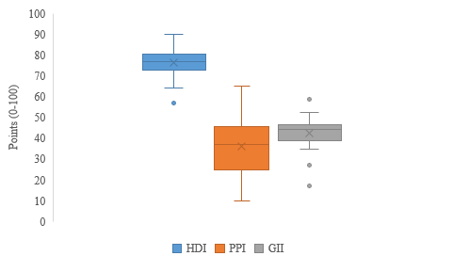

Figure 38: Box and whisker plot of case deletion imputation methodology for the HDI, PPI and GII indicators 2014.

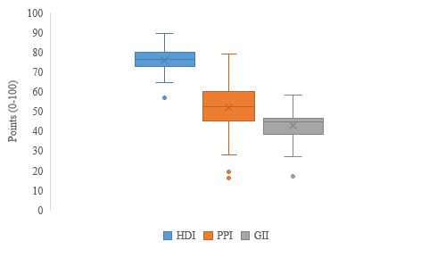

Figure 39: Box and whisker plot of case deletion imputation methodology for the HDI, PPI and GII indicators 2015.

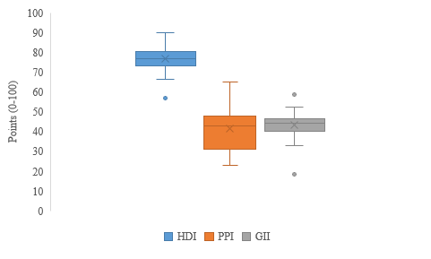

Figure 40: Box and whisker plot of average imputation methodology for the HDI, PPI and GII indicators 2014.

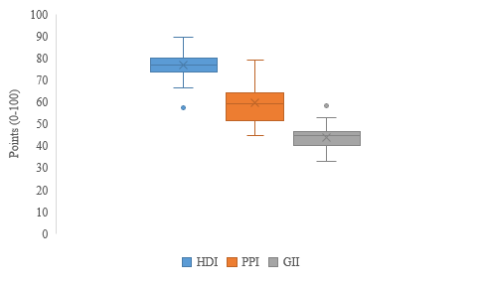

Figure 41: Box and whisker plot of average imputation methodology for the HDI, PPI and GII indicators 2015.

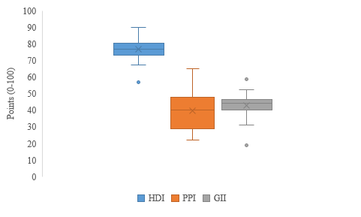

Figure 42: Box and whisker plot of geographic imputation methodology for the HDI, PPI and GII indicators 2014.

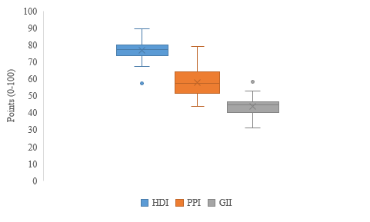

Figure 43: Box and whisker plot of geographic imputation methodology for the HDI, PPI and GII indicators 2015.

Figures 38 to 43 provide an overview of the data distributions when the three different imputation methodologies are applied to the HDI, PPI and GII indicators when they are weight averaged to link them directly to the materials under investigation for 2014 and 2015. Each of the outliers shown in the 2014 and 2015 HDI indicator data set, across all three imputation methodologies, relate to the results for tantalum. Only the 2015 case deletion methodology causes outliers in the PPI indicator; tantalum and selenium. The upper outliers identified across the GII indicator data sets in 2014 and 2015, for all imputation methodologies, are caused by the results of beryllium; the lower outliers are caused by cobalt (except for the 2014 case deletion methodology which has a second lower outlier relating to tantalum).

The box and whisker plots relating to the 2014 and 2015 GWP indicator are shown in Figures 44 and 45; Figures 46 and 47 show the box and whisker plots relating to the RR indicator and Figures 48 and 49 display the box and whisker plots for the NEI indicator.

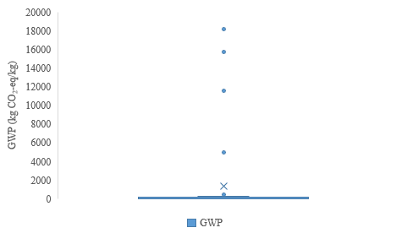

Figure 44: Box and whisker plot of GWP indicator 2014.

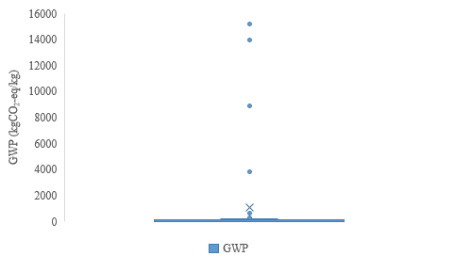

Figure 45: Box and whisker plot of GWP indicator 2015.

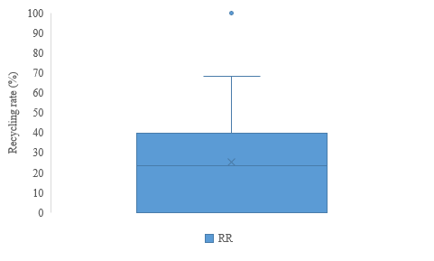

Figure 46: Box and whisker plot of RR indicator 2014.

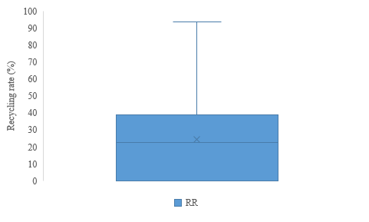

Figure 47: Box and whisker plot of RR indicator 2015.

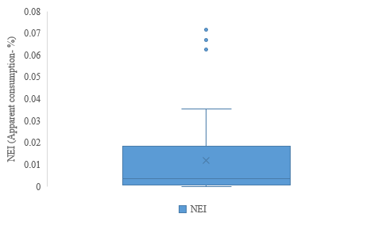

Figure 48: Box and whisker plot of NEI indicator 2014.

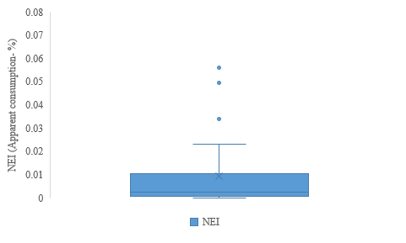

Figure 49: Box and whisker plot of NEI indicator 2015.

The box and whisker plot for the 2014 GWP indicator (Figure 44) shows that the majority of the data points have a result of less than 2000 kg CO2-eq but six outliers are shown within the dataset (platinum, gold, other PGMs, palladium, rhenium and silver). In the 2015 GWP indicator dataset, the results for gold, platinum, PGMs, palladium, silver, tantalum and rhenium lead to the presence of outliers.

Three outliers are present in the 2014 NEI indicator data set, relating to the copper, aluminium and titanium data points; the 2015 NEI indicator data set has copper, aluminium, titanium and tantalum outlier results.

The 2014 RR data set shows one outlier which represents the data point for gold; no outliers are present in the 2015 data set.

To determine the effects of the chosen data imputation methodologies (deletion, geographic, average) for the HDI, PPI and GII indicators, the data descriptive statistics, when applied to each material according to the weight average methodology, were investigated for 2014 and 2015.

Tables 50 to 55 show the descriptive statistics of each set of data for the three data imputation methodologies for 2014 and 2015; each table provides the number of data points (N), the minimum and maximum data points and the mean and standard deviation of the data set.

Table 50: Case deletion data descriptive statistics 2014.

|  |  |  |  |  |  |
| --- | --- | --- | --- | --- | --- |
| **Indicator** | **N** | **Minimum** | **Maximum** | **Mean** | **Std. Deviation** |
| HDI | 40 | 0.57 | 0.90 | 0.76 | 0.065 |
| PPI | 40 | 9.78 | 65.25 | 36.02 | 13.27 |
| GII | 40 | 17.19 | 58.57 | 42.59 | 6.86 |
| InvGWP | 40 | 0.0001 | 10.85 | 0.52 | 1.77 |
| NEI | 40 | 0.00002 | 0.072 | 0.012 | 0.018 |
| RR | 40 | 0.00 | 100.00 | 25.32 | 24.29 |
| Valid N (listwise) | 40 |  |  |  |  |

Table 51: Case deletion data descriptive statistics 2015.

|  |  |  |  |  |  |
| --- | --- | --- | --- | --- | --- |
| **Indicator** | **N** | **Minimum** | **Maximum** | **Mean** | **Std. Deviation** |
| HDI | 40 | 0.57 | 0.90 | 0.76 | 0.064 |
| PPI | 40 | 16.18 | 79.23 | 51.93 | 13.19 |
| GII | 40 | 16.96 | 58.16 | 42.69 | 7.10 |
| InvGWP | 40 | 0.0001 | 10.58 | 0.52 | 1.74 |
| NEI | 40 | 0.00002 | 0.057 | 0.009 | 0.015 |
| RR | 40 | 0.00 | 93.00 | 24.22 | 23.64 |
| Valid N (listwise) | 40 |  |  |  |  |

Table 52: Indicator average value imputed data descriptive statistics 2014.

|  |  |  |  |  |  |
| --- | --- | --- | --- | --- | --- |
| **Indicator** | **N** | **Minimum** | **Maximum** | **Mean** | **Std. Deviation** |
| HDI | 40 | 0.57 | 0.90 | 0.77 | 0.063 |
| PPI | 40 | 22.94 | 65.25 | 41.48 | 11.70 |
| GII | 40 | 18.67 | 58.57 | 43.18 | 6.18 |
| InvGWP | 40 | 0.0001 | 10.85 | 0.52 | 1.77 |
| NEI | 40 | 0.00002 | 0.072 | 0.012 | 0.018 |
| RR | 40 | 0.00 | 100.00 | 25.32 | 24.29 |
| Valid N (listwise) | 40 |  |  |  |  |

Table 53: Indicator average value imputed data descriptive statistics 2015.

|  |  |  |  |  |  |
| --- | --- | --- | --- | --- | --- |
| **Indicator** | **N** | **Minimum** | **Maximum** | **Mean** | **Std. Deviation** |
| HDI | 40 | 0.57 | 0.90 | 0.77 | 0.063 |
| PPI | 40 | 44.86 | 79.23 | 59.42 | 8.91 |
| GII | 40 | 33.13 | 58.16 | 43.80 | 5.08 |
| InvGWP | 40 | 0.0001 | 10.58 | 0.52 | 1.74 |
| NEI | 40 | 0.00002 | 0.057 | 0.009 | 0.015 |
| RR | 40 | 0.00 | 93.00 | 24.22 | 23.64 |
| Valid N (listwise) | 40 |  |  |  |  |

Table 54: Geographically imputed data descriptive statistics 2014.

|  |  |  |  |  |  |
| --- | --- | --- | --- | --- | --- |
| **Indicator** | **N** | **Minimum** | **Maximum** | **Mean** | **Std. Deviation** |
| HDI | 40 | 0.57 | 0.90 | 0.77 | 0.062 |
| PPI | 40 | 22.03 | 65.25 | 39.94 | 11.58 |
| GII | 40 | 18.90 | 58.57 | 43.13 | 6.24 |
| InvGWP | 40 | 0.0001 | 10.85 | 0.52 | 1.77 |
| NEI | 40 | 0.00002 | 0.072 | 0.012 | 0.018 |
| RR | 40 | 0.00 | 100.00 | 25.32 | 24.29 |
| Valid N (listwise) | 40 |  |  |  |  |

Table 55: Geographically imputed data descriptive statistics 2015.

|  |  |  |  |  |  |
| --- | --- | --- | --- | --- | --- |
| **Indicator** | **N** | **Minimum** | **Maximum** | **Mean** | **Std. Deviation** |
| HDI | 40 | 0.57 | 0.90 | 0.77 | 0.062 |
| PPI | 40 | 43.78 | 79.23 | 58.03 | 9.10 |
| GII | 40 | 31.07 | 58.16 | 43.61 | 5.39 |
| InvGWP | 40 | 0.0001 | 10.58 | 0.52 | 1.74 |
| NEI | 40 | 0.00002 | 0.057 | 0.009 | 0.015 |
| RR | 40 | 0.00 | 93.00 | 24.22 | 23.64 |
| Valid N (listwise) | 40 |  |  |  |  |

Tables 50 to 55 show that the InvGWP, RR and NEI indicators are not affected by the imputation methodology as they relate directly to the material under investigation, not the mining country, and therefore the minimum, maximum, mean and standard deviation values are not affected by the imputation methodology. Though a comparison of these results relating to the two years studied show that the minimum values for the InvGWP, NEI and RR data sets remain constant but the maximum, mean and standard deviation values increase in 2015, when compared to 2014.

It can be seen across Tables 50 to 55 that the maximum and minimum values of the HDI data sets in both 2014 and 2015 are not affected by the imputation methodology; in both 2014 and 2015 there is a small increase in the mean when comparing the case deletion methodology to the average and geographical imputation methodologies and a small decrease in that of the standard deviation.

Furthermore, the results in Tables 50 to 55 show that there is a large difference between the 2014 minimum values of the PPI depending on the imputation methodology; case deletion, 9.78; average value imputation, 22.94 and geographic imputation, 22.03, but the maximum values do not vary with imputation method. This is mirrored in the 2015 results.

Finally, Tables 50 to 55 show that in 2014 the GII indicator minimum values increase slightly from the case deletion methodology to the average value imputation methodology and then to the geographic value imputation methodology; the maximum values are not affected by the methodology employed (which is also the case in 2015). The highest minimum value for the GII in 2015 can be attributed to the average value imputation methodology. There is only a slight increase each year of the mean value when the average value and geographic imputation methodologies are employed, when compared to the case deletion methodology; this is also the case with the standard deviation value.

For each indicator the number of data points is 40 i.e. the number of materials measured. The Pearson’s Correlation Coefficients of each indicator (according to the imputation methodology) are shown in Tables 56 to 61; 2-tailed tests were used because a relationship in the indicators is expected but the direction of the relationship has not been predicted [282]. Significant correlations, at the 0.01 level are highlighted in bold and indicated with **.

Table 56: Pearson’ Correlation Coefficient of the indicator correlation using the case deletion imputation method 2014.

|  |  |  |  |  |  |  |  |
| --- | --- | --- | --- | --- | --- | --- | --- |
| **Indicator** | | **HDI** | **PPI** | **GII** | **InvGWP** | **NEI** | **RR** |
| HDI | Pearson Correlation |  |  |  |  |  |  |
| Sig. (2-tailed) |  |  |  |  |  |  |
|
| PPI | Pearson Correlation | **0.520\*\*** |  |  |  |  |  |
| Sig. (2-tailed) | 0.001 |  |  |  |  |  |
|
| GII | Pearson Correlation | **0.795\*\*** | 0.263 |  |  |  |  |
| Sig. (2-tailed) | 0.000 | 0.100 |  |  |  |  |
|
| InvGWP | Pearson Correlation | 0.012 | 0.107 | -0.101 |  |  |  |
| Sig. (2-tailed) | 0.941 | 0.511 | 0.533 |  |  |  |
|
| NEI | Pearson Correlation | -0.074 | 0.195 | -0.112 | -0.069 |  |  |
| Sig. (2-tailed) | 0.650 | 0.228 | 0.492 | 0.674 |  |  |
|
| RR | Pearson Correlation | -0.147 | 0.186 | -0.158 | -0.206 | **0.525\*\*** |  |
| Sig. (2-tailed) | 0.365 | 0.251 | 0.331 | 0.202 | 0.000 |  |
|
| **\*\*. Correlation is significant at the 0.01 level (2-tailed).** | | | | | | | |

Table 57: Pearson’ Correlation Coefficient of the indicator correlation using the case deletion imputation method 2015.

|  |  |  |  |  |  |  |  |
| --- | --- | --- | --- | --- | --- | --- | --- |
| **Indicator** | | **HDI** | **PPI** | **GII** | **InvGWP** | **NEI** | **RR** |
| HDI | Pearson Correlation |  |  |  |  |  |  |
| Sig. (2-tailed) |  |  |  |  |  |  |
|
| PPI | Pearson Correlation | **0.467\*\*** |  |  |  |  |  |
| Sig. (2-tailed) | 0.002 |  |  |  |  |  |
|
| GII | Pearson Correlation | **0.782\*\*** | 0.285 |  |  |  |  |
| Sig. (2-tailed) | 0.000 | 0.074 |  |  |  |  |
|
| InvGWP | Pearson Correlation | 0.015 | 0.198 | -0.110 |  |  |  |
| Sig. (2-tailed) | 0.926 | 0.220 | 0.498 |  |  |  |
|
| NEI | Pearson Correlation | -0.044 | 0.129 | -0.090 | -0.060 |  |  |
| Sig. (2-tailed) | 0.789 | 0.427 | 0.580 | 0.712 |  |  |
|
| RR | Pearson Correlation | -0.138 | 0.155 | -0.159 | -0.205 | **0.492\*\*** |  |
| Sig. (2-tailed) | 0.394 | 0.340 | 0.328 | 0.205 | 0.001 |  |
|
| **\*\*. Correlation is significant at the 0.01 level (2-tailed).** | | | | | | | |

Table 58: Pearson’ Correlation Coefficient of the indicator correlation using the indicator average imputation method 2014.

|  |  |  |  |  |  |  |  |
| --- | --- | --- | --- | --- | --- | --- | --- |
| **Indicator** | | **HDI** | **PPI** | **GII** | **InvGWP** | **NEI** | **RR** |
| HDI | Pearson Correlation |  |  |  |  |  |  |
| Sig. (2-tailed) |  |  |  |  |  |  |
|
| PPI | Pearson Correlation | **0.527\*\*** |  |  |  |  |  |
| Sig. (2-tailed) | .000 |  |  |  |  |  |
|
| GII | Pearson Correlation | **0.741\*\*** | 0.109 |  |  |  |  |
| Sig. (2-tailed) | 0.000 | 0.503 |  |  |  |  |
|
| InvGWP | Pearson Correlation | 0.004 | 0.053 | -0.133 |  |  |  |
| Sig. (2-tailed) | 0.978 | 0.748 | .414 |  |  |  |
|
| NEI | Pearson Correlation | -0.067 | 0.116 | -0.086 | -0.069 |  |  |
| Sig. (2-tailed) | 0.680 | 0.474 | 0.597 | 0.674 |  |  |
|
| RR | Pearson Correlation | -0.132 | 0.018 | -0.155 | -0.206 | **0.525\*\*** |  |
| Sig. (2-tailed) | 0.417 | 0.913 | 0.339 | 0.202 | 0.000 |  |
|
| **\*\*. Correlation is significant at the 0.01 level (2-tailed).** | | | | | | | |

Table 59: Pearson’ Correlation Coefficient of the indicator correlation using the indicator average imputation method 2015.

|  |  |  |  |  |  |  |  |
| --- | --- | --- | --- | --- | --- | --- | --- |
| **Indicator** | | **HDI** | **PPI** | **GII** | **InvGWP** | **NEI** | **RR** |
| HDI | Pearson Correlation |  |  |  |  |  |  |
| Sig. (2-tailed) |  |  |  |  |  |  |
|
| PPI | Pearson Correlation | **0.587\*\*** |  |  |  |  |  |
| Sig. (2-tailed) | 0.000 |  |  |  |  |  |
|
| GII | Pearson Correlation | **0.760\*\*** | 0.204 |  |  |  |  |
| Sig. (2-tailed) | 0.000 | 0.206 |  |  |  |  |
|
| InvGWP | Pearson Correlation | 0.007 | 0.187 | -0.199 |  |  |  |
| Sig. (2-tailed) | 0.963 | 0.249 | 0.218 |  |  |  |
|
| NEI | Pearson Correlation | -0.042 | 0.083 | -0.136 | -0.060 |  |  |
| Sig. (2-tailed) | 0.797 | 0.611 | 0.404 | 0.712 |  |  |
|
| RR | Pearson Correlation | -0.121 | -0.063 | -0.179 | -0.205 | **0.492\*\*** |  |
| Sig. (2-tailed) | 0.455 | 0.700 | 0.270 | 0.205 | 0.001 |  |
|
| **\*\*. Correlation is significant at the 0.01 level (2-tailed).** | | | | | | | |

Table 60: Pearson’ Correlation Coefficient of the indicator correlation using the geographic imputation method 2014.

|  |  |  |  |  |  |  |  |
| --- | --- | --- | --- | --- | --- | --- | --- |
| **Indicator** | | **HDI** | **PPI** | **GII** | **InvGWP** | **NEI** | **RR** |
| HDI | Pearson Correlation |  |  |  |  |  |  |
| Sig. (2-tailed) |  |  |  |  |  |  |
|
| PPI | Pearson Correlation | **0.596\*\*** |  |  |  |  |  |
| Sig. (2-tailed) | 0.000 |  |  |  |  |  |
|
| GII | Pearson Correlation | **0.747\*\*** | 0.206 |  |  |  |  |
| Sig. (2-tailed) | 0.000 | 0.201 |  |  |  |  |
|
| InvGWP | Pearson Correlation | 0.002 | 0.080 | -0.130 |  |  |  |
| Sig. (2-tailed) | 0.990 | 0.623 | 0.423 |  |  |  |
|
| NEI | Pearson Correlation | -0.065 | 0.178 | -0.084 | -0.069 |  |  |
| Sig. (2-tailed) | 0.690 | 0.271 | 0.605 | 0.674 |  |  |
|
| RR | Pearson Correlation | -0.127 | 0.086 | -0.142 | -0.206 | **0.525\*\*** |  |
| Sig. (2-tailed) | 0.435 | 0.598 | 0.384 | 0.202 | 0.000 |  |
|
| **\*\*. Correlation is significant at the 0.01 level (2-tailed).** | | | | | | | |

Table 61: Pearson’ Correlation Coefficient of the indicator correlation using the geographic imputation method 2015.

|  |  |  |  |  |  |  |  |
| --- | --- | --- | --- | --- | --- | --- | --- |
| **Indicator** | | **HDI** | **PPI** | **GII** | **InvGWP** | **NEI** | **RR** |
| HDI | Pearson Correlation |  |  |  |  |  |  |
| Sig. (2-tailed) |  |  |  |  |  |  |
|
| PPI | Pearson Correlation | **0.707\*\*** |  |  |  |  |  |
| Sig. (2-tailed) | 0.000 |  |  |  |  |  |
|
| GII | Pearson Correlation | **0.781\*\*** | 0.292 |  |  |  |  |
| Sig. (2-tailed) | 0.000 | 0.067 |  |  |  |  |
|
| InvGWP | Pearson Correlation | 0.005 | 0.219 | -0.180 |  |  |  |
| Sig. (2-tailed) | 0.975 | 0.174 | 0.267 |  |  |  |
|
| NEI | Pearson Correlation | -0.041 | 0.146 | -0.116 | -0.060 |  |  |
| Sig. (2-tailed) | 0.801 | 0.368 | 0.478 | 0.712 |  |  |
|
| RR | Pearson Correlation | -0.116 | 0.005 | -0.158 | -0.205 | **0.492\*\*** |  |
| Sig. (2-tailed) | 0.477 | 0.974 | 0.331 | 0.205 | 0.001 |  |
|
| **\*\*. Correlation is significant at the 0.01 level (2-tailed).** | | | | | | | |

Tables 56 to 61 show that, for all three imputation methodologies, in both 2014 and 2015, the RR indicator is significantly, positively correlated with the NEI indicator. These correlations do not vary within a year as the data is material dependent and not country dependent and therefore the imputation methodology does not affect the result.

The HDI indicator is significantly, positively correlated with both the PPI and GII indicators. In both 2014 and 2015, the case deletion imputation methodology gives the lowest correlation between the HDI and PPI indicators; the average value imputation methodology gives the second highest correlation between these two indicators for both years and finally the geographic imputation methodology gives the highest HDI and PPI correlation for 2014 and 2015. In comparison, the case deletion imputation methodology provides the highest correlation between the HDI and GII indicators for both 2014 and 2015; the second highest correlation for these two indicators in both 2014 and 2015 is given by the geographic imputation methodology and the average value imputation methodology gives the lowest correlation for the HDI and GII indicators for 2014 and 2015.

The GWP indicator does not significantly correlate with any other indicator.

# Principal Component Analysis

Principal component analysis (PCA) was performed on the six chosen indicators to determine if an underlying structure exists within the indicators according to their correlations. The results of the PCA are shown below for the analysis of all six indicators using the thee imputation methodologies for 2014 and 2015. The resulting communalities are outlined in Tables 62, 67 and 72; the eigenvalues of each data set are shown in Tables 63, 64, 68, 69, 73 and 74 and Figures 50-55 provide the scree plots of each dataset. Finally, Tables 65, 70 and 75 show the component matrix and Tables 66, 71 and 76 provide the associated rotated component matrix for each dataset. Standardised indicator values are used.

Table 62: Communalities of the case deletion imputation methodology 2014 and 2015.

|  |  |  |  |  |  |
| --- | --- | --- | --- | --- | --- |
|  | **2014** | | **2015** | |  |
| **Standardised Indicator** | **Initial** | **Extraction** | **Initial** | **Extraction** |  |
| Zscore(HDI) | 1.000 | 0.912 | 1.000 | 0.883 |  |
| Zscore(PPI) | 1.000 | 0.724 | 1.000 | 0.724 |  |
| Zscore(GII) | 1.000 | 0.832 | 1.000 | 0.854 |  |
| Zscore(InvGWP) | 1.000 | 0.912 | 1.000 | 0.888 |  |
| Zscore(NEI) | 1.000 | 0.709 | 1.000 | 0.685 |  |
| Zscore(RR) | 1.000 | 0.762 | 1.000 | 0.766 |  |
| Extraction Method: Principal Component Analysis. | | |  |  |  |

Table 63: Total variance explained of the case deletion imputation methodology 2014.

|  |  |  |  |  |  |  |  |  |  |
| --- | --- | --- | --- | --- | --- | --- | --- | --- | --- |
| **Component** | **Initial Eigenvalues** | | | **Extraction Sums of Squared Loadings** | | | **Rotation Sums of Squared Loadings** | | |
| **Total** | **% of Variance** | **Cumulative %** | **Total** | **% of Variance** | **Cumulative %** | **Total** | **% of Variance** | **Cumulative %** |
| 1 | 2.104 | 35.062 | 35.062 | 2.104 | 35.062 | 35.062 | 2.089 | 34.821 | 34.821 |
| 2 | 1.671 | 27.858 | 62.919 | 1.671 | 27.858 | 62.919 | 1.672 | 27.860 | 62.681 |
| 3 | 1.077 | 17.946 | 80.865 | 1.077 | 17.946 | 80.865 | 1.091 | 18.184 | 80.865 |
| 4 | 0.566 | 9.432 | 90.297 |  |  |  |  |  |  |
| 5 | 0.433 | 7.219 | 97.516 |  |  |  |  |  |  |
| 6 | 0.149 | 2.484 | 100.000 |  |  |  |  |  |  |
| Extraction Method: Principal Component Analysis. | | | | | | | | | |

Table 64: Total variance explained of the case deletion imputation methodology 2015.

|  |  |  |  |  |  |  |  |  |  |
| --- | --- | --- | --- | --- | --- | --- | --- | --- | --- |
| **Component** | **Initial Eigenvalues** | | | **Extraction Sums of Squared Loadings** | | | **Rotation Sums of Squared Loadings** | | |
| **Total** | **% of Variance** | **Cumulative %** | **Total** | **% of Variance** | **Cumulative %** | **Total** | **% of Variance** | **Cumulative %** |
| 1 | 2.079 | 34.645 | 34.645 | 2.079 | 34.645 | 34.645 | 2.043 | 34.048 | 34.048 |
| 2 | 1.586 | 26.439 | 61.084 | 1.586 | 26.439 | 61.084 | 1.596 | 26.608 | 60.656 |
| 3 | 1.136 | 18.932 | 80.016 | 1.136 | 18.932 | 80.016 | 1.162 | 19.360 | 80.016 |
| 4 | 0.597 | 9.942 | 89.958 |  |  |  |  |  |  |
| 5 | 0.414 | 6.901 | 96.859 |  |  |  |  |  |  |
| 6 | 0.188 | 3.141 | 100.000 |  |  |  |  |  |  |
| Extraction Method: Principal Component Analysis. | | | | | | | | | |

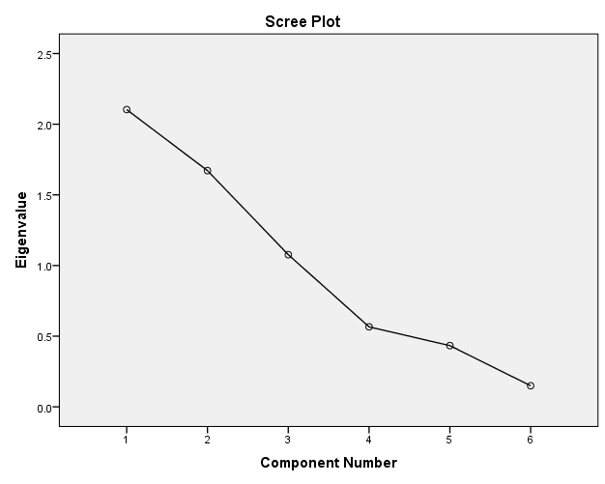

Figure 50: Scree plot of the of the case deletion imputation methodology 2014.

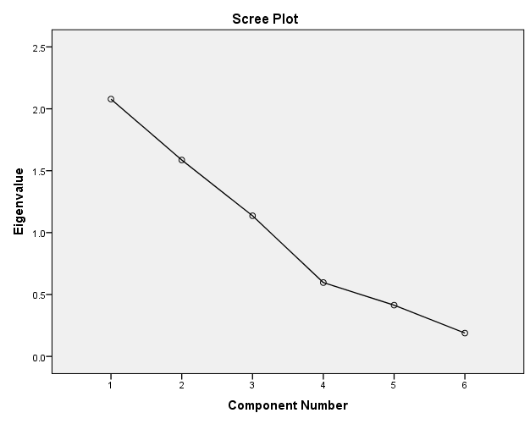

Figure 51: Scree plot of the of the case deletion imputation methodology 2015.

Table 65: Component matrix of the case deletion imputation methodology 2014 and 2015.

|  |  |  |  |  |  |  |  |  |
| --- | --- | --- | --- | --- | --- | --- | --- | --- |
|  | **2014** | | |  |  | **2015** | | |
| **Standardised Indicator** | **Component** | | |  |  | **Component** | | |
| **1** | **2** | **3** |  |  | **1** | **2** | **3** |
| Zscore(HDI) | **0.951** | 0.076 | -0.027 |  |  | **0.930** | 0.100 | -0.085 |
| Zscore(PPI) | **0.592** | 0.480 | 0.378 |  |  | **0.595** | 0.411 | 0.449 |
| Zscore(GII) | **0.873** | -0.015 | -0.263 |  |  | **0.873** | 0.028 | -0.302 |
| Zscore(InvGWP) | 0.042 | -0.261 | **0.918** |  |  | 0.090 | -0.239 | **0.907** |
| Zscore(NEI) | -0.164 | **0.816** | 0.131 |  |  | -0.160 | **0.806** | 0.103 |
| Zscore(RR) | -0.238 | **0.838** | -0.061 |  |  | -0.252 | **0.837** | -0.041 |
| Extraction Method: Principal Component Analysis. | | | |  |  |  |  |  |
| a. 3 components extracted. | | | |  |  |  |  |  |

Table 66: Rotated component matrix of the case deletion imputation methodology 2014 and 2015.

|  |  |  |  |  |  |  |
| --- | --- | --- | --- | --- | --- | --- |
|  | **2014** | | | **2015** | | |
| **Standardised Indicator** | **Component** | | | **Component** | | |
| **1** | **2** | **3** | **1** | **2** | **3** |
| Zscore(HDI) | **0.951** | -0.081 | 0.029 | **0.935** | -0.067 | 0.057 |
| Zscore(PPI) | **0.646** | 0.426 | 0.355 | **0.588** | 0.345 | 0.510 |
| Zscore(GII) | **0.870** | -0.190 | -0.198 | **0.898** | -0.148 | -0.161 |
| Zscore(InvGWP) | -0.045 | -0.137 | **0.944** | -0.087 | -0.165 | **0.924** |
| Zscore(NEI) | -0.031 | **0.841** | 0.016 | -0.024 | **0.827** | 0.023 |
| Zscore(RR) | -0.091 | **0.849** | -0.182 | -0.088 | **0.860** | -0.136 |
| Extraction Method: Principal Component Analysis.  Rotation Method: Varimax with Kaiser Normalization.a | | | |  |  |  |
| a. Rotation converged in 4 iterations. | | | |  |  |  |

Table 67: Communalities of the average value imputation methodology 2014 and 2015.

|  |  |  |  |  |
| --- | --- | --- | --- | --- |
|  | **2014** | | **2015** | |
| **Standardised Indicator** | **Initial** | **Extraction** | **Initial** | **Extraction** |
| Zscore(HDI) | 1.000 | 0.920 | 1.000 | 0.920 |
| Zscore(PPI) | 1.000 | 0.703 | 1.000 | 0.754 |
| Zscore(GII) | 1.000 | 0.803 | 1.000 | 0.845 |
| Zscore(InvGWP) | 1.000 | 0.774 | 1.000 | 0.814 |
| Zscore(NEI) | 1.000 | 0.731 | 1.000 | 0.755 |
| Zscore(RR) | 1.000 | 0.751 | 1.000 | 0.746 |
| Extraction Method: Principal Component Analysis. | | |  |  |

Table 68: Total variance explained of the average value imputation methodology 2014.

|  |  |  |  |  |  |  |  |  |  |
| --- | --- | --- | --- | --- | --- | --- | --- | --- | --- |
| **Component** | **Initial Eigenvalues** | | | **Extraction Sums of Squared Loadings** | | | **Rotation Sums of Squared Loadings** | | |
| **Total** | **% of Variance** | **Cumulative %** | **Total** | **% of Variance** | **Cumulative %** | **Total** | **% of Variance** | **Cumulative %** |
| 1 | 2.019 | 33.651 | 33.651 | 2.019 | 33.651 | 33.651 | 1.975 | 32.912 | 32.912 |
| 2 | 1.575 | 26.251 | 59.902 | 1.575 | 26.251 | 59.902 | 1.600 | 26.670 | 59.582 |
| 3 | 1.087 | 18.112 | 78.014 | 1.087 | 18.112 | 78.014 | 1.106 | 18.431 | 78.014 |
| 4 | 0.735 | 12.245 | 90.258 |  |  |  |  |  |  |
| 5 | 0.452 | 7.528 | 97.787 |  |  |  |  |  |  |
| 6 | 0.133 | 2.213 | 100.000 |  |  |  |  |  |  |
| Extraction Method: Principal Component Analysis. | | | | | | | | | |

Table 69: Total variance explained of the average value imputation methodology 2015.

|  |  |  |  |  |  |  |  |  |  |
| --- | --- | --- | --- | --- | --- | --- | --- | --- | --- |
| **Component** | **Initial Eigenvalues** | | | **Extraction Sums of Squared Loadings** | | | **Rotation Sums of Squared Loadings** | | |
| **Total** | **% of Variance** | **Cumulative %** | **Total** | **% of Variance** | **Cumulative %** | **Total** | **% of Variance** | **Cumulative %** |
| 1 | 2.135 | 35.588 | 35.588 | 2.135 | 35.588 | 35.588 | 2.071 | 34.511 | 34.511 |
| 2 | 1.502 | 25.041 | 60.629 | 1.502 | 25.041 | 60.629 | 1.544 | 25.735 | 60.246 |
| 3 | 1.196 | 19.936 | 80.565 | 1.196 | 19.936 | 80.565 | 1.219 | 20.318 | 80.565 |
| 4 | 0.561 | 9.352 | 89.916 |  |  |  |  |  |  |
| 5 | 0.480 | 7.992 | 97.908 |  |  |  |  |  |  |
| 6 | 0.125 | 2.092 | 100.000 |  |  |  |  |  |  |
| Extraction Method: Principal Component Analysis. | | | | | | | | | |

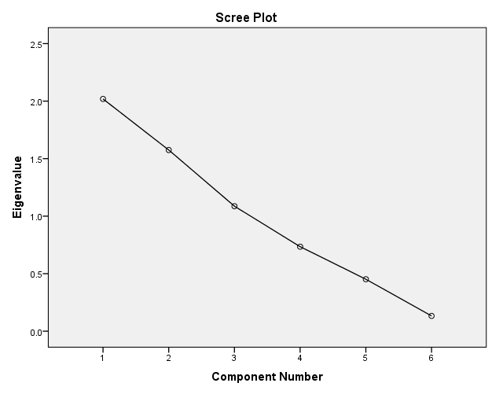

Figure 52: Scree plot of the average value imputation methodology 2014.

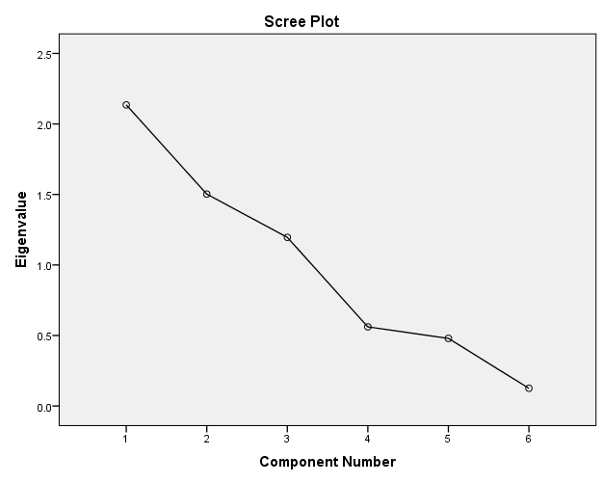

Figure 53: Scree plot of the average value imputation methodology 2015.

Table 70: Component matrix of the average value imputation methodology 2014 and 2015.

|  |  |  |  |  |  |  |
| --- | --- | --- | --- | --- | --- | --- |
|  | **2014** | | | **2015** | | |
| **Standardised Indicator** | **Component** | | | **Component** | | |
| **1** | **2** | **3** | **1** | **2** | **3** |
| Zscore(HDI) | **0.931** | 0.225 | 0.040 | **0.925** | 0.254 | 0.019 |
| Zscore(PPI) | **0.532** | 0.380 | 0.525 | **0.636** | 0.251 | 0.535 |
| Zscore(GII) | **0.811** | 0.118 | -0.361 | **0.815** | 0.145 | -0.400 |
| Zscore(InvGWP) | 0.019 | -0.365 | **0.800** | 0.050 | -0.370 | **0.821** |
| Zscore(NEI) | -0.264 | **0.790** | 0.194 | -0.253 | **0.785** | 0.273 |
| Zscore(RR) | -0.375 | **0.781** | -0.034 | -0.381 | **0.775** | 0.011 |
| Extraction Method: Principal Component Analysis. | | | |  |  |  |
| a. 3 components extracted. | | | |  |  |  |

Table 71: Rotated component matrix of the average value imputation methodology 2014 and 2015.

|  |  |  |  |  |  |  |
| --- | --- | --- | --- | --- | --- | --- |
|  | **2014** | | | **2015** | | |
| **Standardised Indicator** | **Component** | | | **Component** | | |
| **1** | **2** | **3** | **1** | **2** | **3** |
| Zscore(HDI) | **0.956** | -0.074 | 0.036 | **0.957** | -0.047 | 0.039 |
| Zscore(PPI) | **0.635** | 0.288 | 0.465 | **0.679** | 0.166 | 0.515 |
| Zscore(GII) | **0.800** | -0.213 | -0.342 | **0.821** | -0.216 | -0.352 |
| Zscore(InvGWP) | -0.081 | -0.191 | **0.855** | -0.077 | -0.155 | **0.885** |
| Zscore(NEI) | 0.002 | **0.854** | 0.030 | 0.009 | **0.866** | 0.063 |
| Zscore(RR) | -0.111 | **0.837** | -0.197 | -0.115 | **0.833** | -0.200 |
| Extraction Method: Principal Component Analysis.  Rotation Method: Varimax with Kaiser Normalization.a | | | |  |  |  |
| a. Rotation converged in 5 iterations. | | | |  |  |  |

Table 72: Communalities of the geographic imputation methodology 2014 and 2015.

|  |  |  |  |  |  |
| --- | --- | --- | --- | --- | --- |
|  | **2014** | |  | **2015** | |
| **Standardised Indicator** | **Initial** | **Extraction** |  | **Initial** | **Extraction** |
| Zscore(HDI) | 1.000 | 0.924 |  | 1.000 | 0.952 |
| Zscore(PPI) | 1.000 | 0.734 |  | 1.000 | 0.818 |
| Zscore(GII) | 1.000 | 0.787 |  | 1.000 | 0.836 |
| Zscore(InvGWP) | 1.000 | 0.862 |  | 1.000 | 0.870 |
| Zscore(NEI) | 1.000 | 0.739 |  | 1.000 | 0.752 |
| Zscore(RR) | 1.000 | 0.752 |  | 1.000 | 0.747 |
| Extraction Method: Principal Component Analysis. | | |  |  |  |

Table 73: Total variance explained of the geographic imputation methodology 2014.

|  |  |  |  |  |  |  |  |  |  |
| --- | --- | --- | --- | --- | --- | --- | --- | --- | --- |
| **Component** | **Initial Eigenvalues** | | | **Extraction Sums of Squared Loadings** | | | **Rotation Sums of Squared Loadings** | | |
| **Total** | **% of Variance** | **Cumulative %** | **Total** | **% of Variance** | **Cumulative %** | **Total** | **% of Variance** | **Cumulative %** |
| 1 | 2.083 | 34.718 | 34.718 | 2.083 | 34.718 | 34.718 | 2.071 | 34.512 | 34.512 |
| 2 | 1.630 | 27.172 | 61.890 | 1.630 | 27.172 | 61.890 | 1.626 | 27.105 | 61.617 |
| 3 | 1.085 | 18.089 | 79.979 | 1.085 | 18.089 | 79.979 | 1.102 | 18.361 | 79.979 |
| 4 | 0.620 | 10.325 | 90.304 |  |  |  |  |  |  |
| 5 | 0.451 | 7.518 | 97.822 |  |  |  |  |  |  |
| 6 | 0.131 | 2.178 | 100.000 |  |  |  |  |  |  |
| Extraction Method: Principal Component Analysis. | | | | | | | | | |

Table 74: Total variance explained of the geographic imputation methodology 2015.

|  |  |  |  |  |  |  |  |  |  |
| --- | --- | --- | --- | --- | --- | --- | --- | --- | --- |
| **Component** | **Initial Eigenvalues** | | | **Extraction Sums of Squared Loadings** | | | **Rotation Sums of Squared Loadings** | | |
| **Total** | **% of Variance** | **Cumulative %** | **Total** | **% of Variance** | **Cumulative %** | **Total** | **% of Variance** | **Cumulative %** |
| 1 | 2.239 | 37.318 | 37.318 | 2.239 | 37.318 | 37.318 | 2.213 | 36.891 | 36.891 |
| 2 | 1.551 | 25.846 | 63.164 | 1.551 | 25.846 | 63.164 | 1.561 | 26.012 | 62.903 |
| 3 | 1.186 | 19.766 | 82.930 | 1.186 | 19.766 | 82.930 | 1.202 | 20.027 | 82.930 |
| 4 | 0.488 | 8.140 | 91.070 |  |  |  |  |  |  |
| 5 | 0.456 | 7.600 | 98.671 |  |  |  |  |  |  |
| 6 | 0.080 | 1.329 | 100.000 |  |  |  |  |  |  |
| Extraction Method: Principal Component Analysis. | | | | | | | | | |

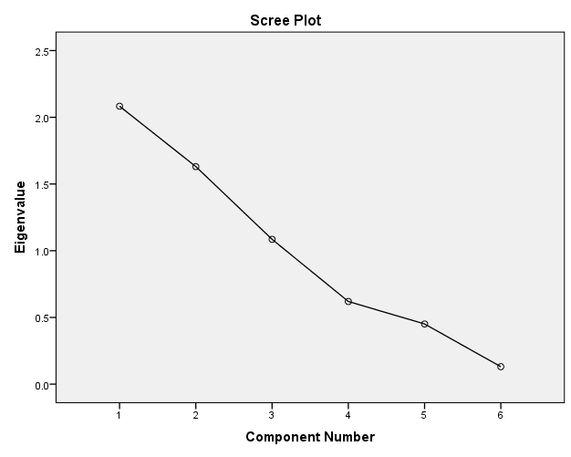

Figure 54: Scree plot of the geographic imputation methodology 2014.

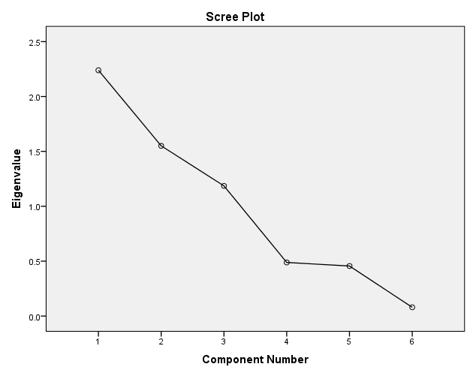

Figure 55: Scree plot of the geographic imputation methodology 2015.

Table 75: Component matrix of the geographic imputation methodology 2014 and 2015.

|  |  |  |  |  |  |  |
| --- | --- | --- | --- | --- | --- | --- |
|  | **2014** | | | **2015** | | |
| **Standardised Indicator** | **Component** | | | **Component** | | |
| **1** | **2** | **3** | **1** | **2** | **3** |
| Zscore(HDI) | **0.958** | 0.077 | 0.010 | **0.967** | 0.124 | -0.034 |
| Zscore(PPI) | **0.645** | 0.376 | 0.440 | **0.741** | 0.276 | 0.438 |
| Zscore(GII) | **0.824** | -0.020 | -0.329 | **0.819** | 0.006 | -0.406 |
| Zscore(InvGWP) | 0.003 | -0.311 | **0.875** | 0.064 | -0.289 | **0.885** |
| Zscore(NEI) | -0.128 | **0.831** | 0.180 | -0.124 | **0.833** | 0.210 |
| Zscore(RR) | -0.231 | **0.834** | -0.051 | -0.251 | **0.826** | -0.41 |
| Extraction Method: Principal Component Analysis. | | | |  |  |  |
| a. 3 components extracted. | | | |  |  |  |

Table 76: Rotated Component matrix of the geographic imputation methodology 2014 and 2015.

|  |  |  |  |  |  |  |
| --- | --- | --- | --- | --- | --- | --- |
|  | **2014** | | | **2015** | | |
| **Standardised Indicator** | **Component** | | | **Component** | | |
| **1** | **2** | **3** | **1** | **2** | **3** |
| Zscore(HDI) | **0.958** | -0.081 | 0.015 | **0.974** | -0.054 | 0.020 |
| Zscore(PPI) | **0.702** | 0.331 | 0.361 | **0.759** | 0.215 | 0.443 |
| Zscore(GII) | **0.806** | -0.211 | -0.305 | **0.824** | -0.207 | -0.338 |
| Zscore(InvGWP) | -0.040 | -0.152 | **0.915** | -0.031 | -0.138 | **0.922** |
| Zscore(NEI) | 0.013 | **0.859** | 0.033 | 0.022 | **0.865** | 0.062 |
| Zscore(RR) | -0.091 | **0.840** | -0.197 | -0.093 | **0.838** | -0.193 |
| Extraction Method: Principal Component Analysis.  Rotation Method: Varimax with Kaiser Normalization.a | | | |  |  |  |
| a. Rotation converged in 5 iterations. | | | |  |  |  |

The communalities of each indicator, shown in Tables 62, 67 and 72 are all above 0.5 and therefore show that all indicators are well represented by the three extracted factors.

Tables 63, 64, 68, 69, 73 and 74 show that, for each imputation methodology in both 2014 and 2015, the first three components explain the majority of the variance. The lowest total cumulative percentage of the initial eigenvalues is related to the 2014 average value imputation methodology which explains 78.014% of the variance; the highest total cumulative percentage of the initial eigenvalues is related to the 2015 geographic imputation methodology which explains 82.930% of the variance. In each case, the sum of the eigenvalues is equal to the number of indicators i.e. 6. The scree plots in Figures 50-55 are a graphical representation of the information shown in Tables 63, 64, 68, 69, 73 and 74, according to the associated imputation methodology.

The component matrices in Tables 65, 70 and 75 show the component loadings for each indicator with respect to the three components which explain the most variance; moderate to high loadings, i.e. above 0.50, are shown in bold. For each imputation methodology, in both 2014 and 2015, component 1 can be represented by the HDI, PPI and GII indicators; component 2 accounts for the RR and NEI indicators and the InvGWP indicator can be accounted for by component 3.

To ensure a clear pattern of the existing loadings, rotation was performed which produced the rotated component matrices in 64, 69 and 74; this process does not alter the sum of eigenvalues. The results of the component loadings are not changed from the initial component matrices (63, 68 and 73) by the rotation process.

# Normalisation

The HDI, NEI, GWP and RR indicators are measured on different scales and therefore normalisation was used to ensure that they were comparable. Figures 56 to 59 show the distribution of the InvGWP and transformed *log*InvGWP (using equation 19) for 2014 and 2015. Figures 58 and 59 clearly demonstrate that the transformation protocol has eliminated the outliers from the dataset and the skewness of the data is reduced, which is shown in Figures 60 and 62, for 2014 and Figures 61 and 63 for 2015.



Figure 56: Box and whisker plot of the InvGWP dataset 2014.



Figure 57: Box and whisker plot of the InvGWP dataset 2015.

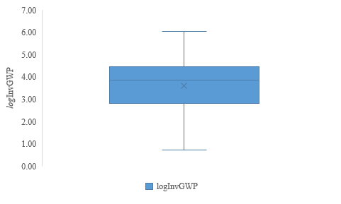

Figure 58: Box and Whisker plot of the *log*InvGWP dataset 2014.

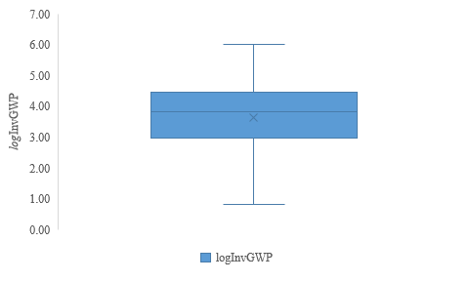

Figure 59: Box and Whisker plot of the *log*InvGWP dataset 2015.

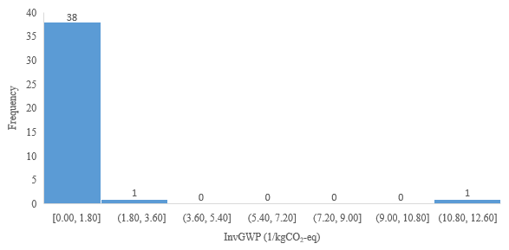

Figure 60: Histogram of the 2014 InvGWP dataset; skew = 5.442.

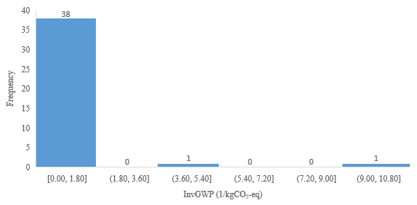

Figure 61: Histogram of the 2015 InvGWP dataset; skew = 5.334.

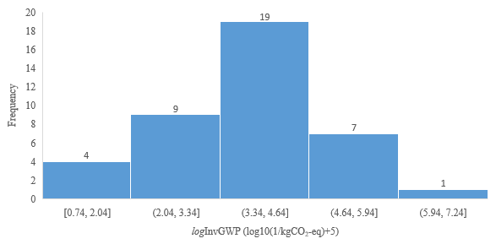

Figure 62: Histogram of the 2014 *log*InvGWP dataset; skew = -0.719.

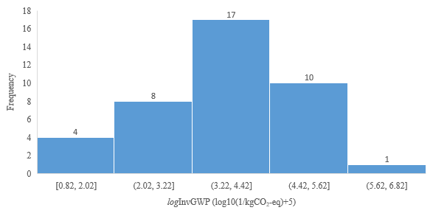

Figure 63: Histogram of the 2015 *log*InvGWP dataset; skew = -0.699.

Figures 60 to 63 show the change in the distribution of the data between the InvGWP and *log*InvGWP datasets for both 2014 and 2015, and in fact, the positive skew of the data is minimised from 5.442 to -0.719 in 2014 and 5.334 to -0.669 in 2015 through this transformation.

Table 77 outlines the resulting figures for each indicator, using the case deletion imputation methodology, following normalisation using the min-max normalisation method for 2014 and the “goal posts” outlined in Table 40.

Table 77: Normalised data set using the case deletion imputation methodology for 2014.

|  |  |  |  |  |
| --- | --- | --- | --- | --- |
| **Material** | **HDI Normalised** | ***log*InvGWP Normalised** | **NEI Normalised** | **RR Normalised** |
| Al | 0.78 | 0.37 | 0.67 | 0.52 |
| Sb | 0.73 | 0.35 | 0.01 | 0.10 |
| Ba | 0.73 | 0.52 | 0.02 | 0.00 |
| Be | 0.90 | 0.24 | 0.01 | 0.25 |
| Bi | 0.73 | 0.32 | 0.00 | 0.10 |
| B | 0.77 | 0.57 | 0.04 | 0.00 |
| Cd | 0.81 | 0.46 | 0.00 | 0.20 |
| Cr | 0.71 | 0.30 | 0.08 | 0.28 |
| Co | 0.64 | 0.35 | 0.02 | 0.27 |
| Cu | 0.79 | 0.37 | 0.72 | 0.33 |
| Ga | 0.76 | 0.22 | 0.00 | 0.00 |
| Au | 0.74 | 0.01 | 0.36 | 1.00 |
| In | 0.81 | 0.21 | 0.00 | 0.00 |
| I | 0.86 | 0.38 | 0.01 | 0.01 |
| Fe | 0.81 | 0.43 | 0.19 | 0.50 |
| Pb | 0.78 | 0.44 | 0.21 | 0.68 |
| Li | 0.88 | 0.22 | 0.00 | 0.00 |
| Mg | 0.75 | 0.27 | 0.03 | 0.46 |
| Mn | 0.74 | 0.40 | 0.06 | 0.33 |
| Hg | 0.74 | 0.34 | 0.00 | 0.10 |
| Mo | 0.81 | 0.26 | 0.04 | 0.30 |
| Ni | 0.70 | 0.34 | 0.23 | 0.45 |
| Nb | 0.77 | 0.34 | 0.00 | 0.20 |
| Pd | 0.77 | 0.06 | 0.18 | 0.40 |
| PGMs | 0.69 | 0.03 | 0.18 | 0.40 |
| Pt | 0.70 | 0.00 | 0.18 | 0.40 |
| REEs | 0.75 | 0.32 | 0.01 | 0.00 |
| Re | 0.85 | 0.18 | 0.01 | 0.60 |
| Se | 0.90 | 0.40 | 0.00 | 0.00 |
| Si | 0.79 | 0.34 | 0.11 | 0.00 |
| Ag | 0.78 | 0.16 | 0.25 | 0.20 |
| Na | 0.80 | 0.43 | 0.18 | 0.00 |
| Sr | 0.78 | 0.41 | 0.00 | 0.00 |
| Ta | 0.57 | 0.20 | 0.01 | 0.00 |
| Sn | 0.70 | 0.31 | 0.05 | 0.27 |
| Ti | 0.72 | 0.45 | 0.63 | 0.63 |
| W | 0.74 | 0.34 | 0.04 | 0.53 |
| V | 0.73 | 0.30 | 0.02 | 0.40 |
| Zn | 0.77 | 0.39 | 0.13 | 0.22 |
| Zr | 0.80 | 0.45 | 0.01 | 0.00 |

# Weighting and aggregation

Weighting and aggregation of the four single indicators was performed to provide an appropriate, single value. The results of the weighting and aggregation procedures employed for the MSI in both 2014 and 2015 are detailed in Table 78 for each of the imputation methodologies.

Table 78 shows that, independent of imputation methodology, due to the chosen aggregation method, if one of the four indicators (specially the RR indicator in this case) is 0 the final MSI result is 0 points. In some cases, e.g. aluminium, cadmium and mercury, the MSI result is again independent of the imputation methodology, caused by the use of a complete HDI dataset for that material. As part of both the uncertainty and sensitivity analysis, the effect of the imputation methodology on the final MSI result is assessed.

Table 78: MSI results of the weighting and aggregation process for each of the imputation methodologies for 2014 and 2015.

|  |  |  |  |  |  |  |
| --- | --- | --- | --- | --- | --- | --- |
|  | **DEL** | | **AVG** | | **GEOG** | |
| **Material** | **2014** | **2015** | **2014** | **2015** | **2014** | **2015** |
| Al | 56.26 | 50.77 | 56.26 | 50.77 | 56.26 | 50.77 |
| Sb | 13.66 | 12.43 | 13.66 | 12.43 | 13.66 | 12.43 |
| Ba | 0.00 | 0.00 | 0.00 | 0.00 | 0.00 | 0.00 |
| Be | 14.67 | 13.50 | 14.67 | 13.50 | 14.67 | 13.50 |
| Bi | 8.25 | 7.36 | 8.25 | 7.36 | 8.25 | 7.36 |
| B | 0.00 | 0.00 | 0.00 | 0.00 | 0.00 | 0.00 |
| Cd | 6.30 | 6.26 | 6.30 | 6.26 | 6.30 | 6.26 |
| Cr | 26.62 | 25.29 | 26.62 | 25.29 | 26.62 | 25.29 |
| Co | 17.51 | 18.05 | 17.66 | 18.19 | 17.71 | 18.24 |
| Cu | 51.12 | 48.91 | 51.12 | 48.91 | 51.12 | 48.91 |
| Ga | 0.00 | 0.00 | 0.00 | 0.00 | 0.00 | 0.00 |
| Au | 23.34 | 23.43 | 23.34 | 23.43 | 23.34 | 23.43 |
| In | 0.00 | 0.00 | 0.00 | 0.00 | 0.00 | 0.00 |
| I | 6.91 | 6.92 | 6.91 | 6.92 | 6.91 | 6.92 |
| Fe | 42.76 | 42.49 | 42.76 | 42.49 | 42.76 | 42.49 |
| Pb | 47.00 | 44.65 | 47.00 | 44.65 | 47.00 | 44.65 |
| Li | 0.00 | 0.00 | 0.00 | 0.00 | 0.00 | 0.00 |
| Mg | 23.45 | 23.83 | 23.45 | 23.83 | 23.45 | 23.83 |
| Mn | 28.16 | 26.07 | 28.16 | 26.07 | 28.16 | 26.07 |
| Hg | 5.99 | 5.92 | 5.99 | 5.92 | 5.99 | 5.92 |
| Mo | 22.71 | 18.70 | 22.71 | 18.70 | 22.71 | 18.70 |
| Ni | 39.66 | 34.50 | 40.42 | 35.21 | 40.64 | 35.41 |
| Nb | 11.32 | 11.27 | 11.32 | 11.27 | 11.32 | 11.27 |
| Pd | 24.57 | 19.37 | 24.57 | 19.37 | 24.57 | 19.37 |
| PGMs | 18.95 | 15.80 | 18.95 | 15.80 | 18.95 | 15.80 |
| Pt | 12.27 | 12.90 | 12.27 | 12.90 | 12.27 | 12.90 |
| REEs | 0.00 | 0.00 | 0.00 | 0.00 | 0.00 | 0.00 |
| Re | 15.13 | 15.20 | 15.13 | 15.20 | 15.13 | 15.20 |
| Se | 0.00 | 0.00 | 0.00 | 0.00 | 0.00 | 0.00 |
| Si | 0.00 | 0.00 | 0.00 | 0.00 | 0.00 | 0.00 |
| Ag | 27.95 | 25.59 | 27.95 | 25.59 | 27.95 | 25.59 |
| Na | 0.00 | 0.00 | 0.00 | 0.00 | 0.00 | 0.00 |
| Sr | 0.00 | 0.00 | 0.00 | 0.00 | 0.00 | 0.00 |
| Ta | 0.00 | 0.00 | 0.00 | 0.00 | 0.00 | 0.00 |
| Sn | 23.50 | 22.30 | 23.50 | 22.30 | 23.50 | 22.30 |
| Ti | 59.80 | 56.29 | 59.80 | 56.29 | 59.80 | 56.29 |
| W | 26.48 | 27.25 | 26.48 | 27.25 | 26.48 | 27.25 |
| V | 19.24 | 18.33 | 19.24 | 18.33 | 19.24 | 18.33 |
| Zn | 30.46 | 27.69 | 30.46 | 27.69 | 30.46 | 27.69 |
| Zr | 0.00 | 0.00 | 0.00 | 0.00 | 0.00 | 0.00 |

# Uncertainty and sensitivity analysis

# Sensitivity analysis

The different sources of uncertainty are outlined in Tables 41, 42 and 44-47, these were tested individually to determine their impact on the final result. The MSI was calculated according to the requirements of each individual input factor. To show the patterns in the input-output relationships of the input factors, the results are displayed as bar chars to clearly identify the change in the final result are shown in bar charts in Figures 64 to 75.

Figure 64: Sensitivity analysis of input factors $X_{1}$ 2014 for chromium, cobalt, gold, iron, nickel and zinc.

Figure 65: Sensitivity analysis of input factors $X_{1}$ 2015 for chromium, cobalt, gold, iron, nickel and zinc.

Figures 64 and 65 show the sensitivity analysis for input factor $X_{1}$ (imputation methodology) in 2014 and 2015 for chromium, cobalt, gold, iron, nickel and zinc. These materials are the only ones where the result of the weight averaged HDI was affected by the imputation methodology due to missing countries in the HDI data set.

Figure 66: Sensitivity analysis of input factors $X_{2}$ for 2014.

Figure 67: Sensitivity analysis of input factors $X_{2}$ for 2015.

Figures 66 and 67 outline the sensitivity analysis for input factor $X_{2}$ (normalisation) for 2014 and 2015. The methodology employed for $X_{2}$-2 (ranking) did not multiply the final result by 100 to ensure clarity within this chart.

Figure 68: Sensitivity analysis of input factors $X_{3}$ for 2014.

Figure 69: Sensitivity analysis of input factors $X_{3}$ for 2015.

Figures 68 and 69 outline the sensitivity analysis for input factor $X_{3}$ (aggregation) for 2014 and 2015. For all except two cases, the results follow the same pattern for both 2014 and 2015; the result of the linear aggregation methodology is higher than the ranking aggregation methodology, followed by the original MSI result.

Figure 70: Sensitivity analysis of input factors $X_{4}$ for 2014.

Figure 71: Sensitivity analysis of input factors $X_{4}$ for 2015.

Figures 70 and 71 outline the sensitivity analysis for input factor $X_{4}$ (indicator exclusion) for 2014 and 2015. It can be seen from these charts that, overall, there is no clear pattern presented by the set of materials when a different indicator is excluded from the calculation, but in the majority of cases, exclusion of the NEI indicator leads to the highest result. By excluding the RR indicator, those materials with a result of 0 points for the original MSI are provided with a result of >0 points.

Figure 72: Sensitivity analysis of input factors $X_{5}$ for 2014.

Figure 73: Sensitivity analysis of input factors $X_{5}$ for 2015.

Figures 72 and 73 show the sensitivity analysis for input factor $X_{5}$ (indicator substitution) for 2014 and 2015. In general, a similar pattern is observed for each material although the $X_{5}$-1 and $X_{5}$-2 results often switch positions. In both 2014 and 2015, rhenium and gold lead to a result of 0 points for $X_{5}$-3 and $X_{5}$-4 respectively.

Figure 74: Sensitivity analysis of input factors $X_{6}$ for 2014.

Figure 75: Sensitivity analysis of input factors $X_{6}$ for 2015.

Figures 74 and 75 show the sensitivity analysis for input factor $X_{6}$ (RR indicator source) for 2014 and 2015. As with input factor $X_{4}$, there is no clear pattern across the materials investigated.

# Uncertainty analysis

While the sensitivity analysis above outlines the effect of the individual input factors on the result of the MSI, the uncertainty analysis addresses the full uncertainty of the input factors. The Monte Carlo Simulation, which used random inputs to understand the behaviour of the MSI framework [289] fully assessed the uncertainty of the MSI with respect to input factors $X_{1}, X_{2}$-1 and $X_{2}$-3, $X_{4}$, $X_{5}$ and $X_{6}$ (see section 4.3.8.1 for a full commentary on the results of the sensitivity analysis).

Figures 76 to 79 show the results of the uncertainty analysis for 2014 and 2015 according to the use of both the four and three indicator MSI frameworks; the results are shown by comparing the original MSI values (shown by a dot for each material) with the mean value of the Monte Carlo simulation and the 5th and 95th percentiles (shown within the box associated with each material).

Figure 76: Result of the uncertainty analysis for 2014 for the materials investigated using the four indicator framework (HDI, GWP, NEI and RR).

Figure 77: Result of the uncertainty analysis for 2014 for the materials investigated using the three indicator framework (HDI, GWP and NEI).

Figure 78: Result of the uncertainty analysis for 2015 for the materials investigated using the four indicator framework (HDI, GWP, NEI and RR).

Figure 79: Result of the uncertainty analysis for 2015 for the materials investigated using the three indicator framework (HDI, GWP and NEI).

Figures 76 and 78 show that when using the four indicator MSI framework, in both 2014 and 2015 the largest range in MSI values can be attributed to titanium, followed by aluminium and copper. In both years, the highest variation between the original MSI result and the mean result, provided by the Monte Carlo simulation, can be attributed to those materials with an original MSI value of 0 points. In addition to this in 2014 cadmium, platinum, silver and vanadium also have a higher variation in the original MSI result and the mean result provided by the Monte Carlo simulation; in 2015, this is the case for cadmium, cobalt, platinum, niobium, silver and vanadium. When the RR indicator is remove and the MSI is recalculated using the three indicator framework, it can be seen in Figures 77 and 79 that the overall uncertainty in the results is increased, especially with respect to titanium and copper.

# Final MSI framework

The four and three indicator MSI frameworks are shown in Figures 80 and 81. These frameworks were produced with the aim of describing the underlying data sources of the MSI in a simple format. Both frameworks address the multidimensional phenomenon of sustainability with respect to the triple bottom line and its symbiotic nature in that a change in one of the three aspects, may lead to a change in another [22]. The four indicator framework provides a simple, robust methodology based on the requirements of published literature in the construction of a composite indicator. The removal of the RR indicator in the three indicator framework allows for the effect of this indicator to be visualised [149].

Figure 80: The four indicator MSI framework.

Figure 81: The three indicator MSI framework.

# Visualisation of the results

Visualisation of the final results can be achieved in a number of ways; multiple methodologies can be employed to ensure that stakeholders have the best opportunity to interoperate the results [149]. Table 79 simply states the results of the four and three indicator MSI frameworks for both 2014 and 2015. These results, in descending order i.e. most sustainable material at the top, are then shown in a bar chart in Figures 82 and 83 for both 2014 and 2015. Periodic tables, presenting the four and three indicator MSI framework results (Figures 84 to 87), provide a visual representation of the MSI results using a colour coded traffic light-type system; red indicates a result of 0 points, orange indicates a result of >0 and up to 20 points, yellow indicates a result of >20 and up to 40 points, light green indicates a result of >40 and up to 60 points and dark green indicates a result above >60 points. Grey is used to identify those materials that have not been analysed in this study.

Table 79: 2014 and 2015 MSI results for the four and three indicator MSI frameworks, for each material or group studied.

|  |  |  |  |  |
| --- | --- | --- | --- | --- |
| **Material** | **MSI Result (four indicator)** | | **MSI Result (three indicators)** | |
| **2014** | **2015** | **2014** | **2015** |
| Al | 56.26 | 50.77 | 57.76 | 52.0954 |
| Sb | 13.66 | 12.43 | 15.16 | 13.3616 |
| Ba | 0.00 | 0.00 | 21.13 | 17.4822 |
| Be | 14.67 | 13.50 | 12.28 | 10.9925 |
| Bi | 8.25 | 7.36 | 7.74 | 6.6437 |
| B | 0.00 | 0.00 | 25.15 | 25.1658 |
| Cd | 6.30 | 6.26 | 4.29 | 4.2528 |
| Cr | 26.62 | 25.29 | 26.18 | 22.6923 |
| Co | 17.51 | 18.05 | 15.15 | 15.5935 |
| Cu | 51.12 | 48.91 | 59.15 | 55.7673 |
| Ga | 0.00 | 0.00 | 4.97 | 4.4939 |
| Au | 23.34 | 23.43 | 14.37 | 14.7769 |
| In | 0.00 | 0.00 | 9.35 | 8.5137 |
| I | 6.91 | 6.92 | 13.17 | 13.1954 |
| Fe | 42.76 | 42.49 | 40.59 | 40.5230 |
| Pb | 47.00 | 44.65 | 41.55 | 38.8041 |
| Li | 0.00 | 0.00 | 4.67 | 4.9475 |
| Mg | 23.45 | 23.83 | 18.73 | 18.4866 |
| Mn | 28.16 | 26.07 | 26.77 | 24.1561 |
| Hg | 5.99 | 5.92 | 5.05 | 4.9712 |
| Mo | 22.71 | 18.70 | 20.70 | 15.9695 |
| Ni | 39.66 | 34.50 | 38.03 | 32.0537 |
| Nb | 11.32 | 11.27 | 9.37 | 9.3062 |
| Pd | 24.57 | 19.37 | 20.95 | 17.4714 |
| PGMs | 18.95 | 15.80 | 14.82 | 13.3185 |
| Pt | 12.27 | 12.90 | 8.30 | 10.1660 |
| REEs | 0.00 | 0.00 | 14.98 | 14.6281 |
| Re | 15.13 | 15.20 | 9.56 | 9.6137 |
| Se | 0.00 | 0.00 | 8.77 | 8.7758 |
| Si | 0.00 | 0.00 | 30.56 | 29.0995 |
| Ag | 27.95 | 25.59 | 31.25 | 30.5726 |
| Na | 0.00 | 0.00 | 39.64 | 38.9423 |
| Sr | 0.00 | 0.00 | 6.63 | 6.5035 |
| Ta | 0.00 | 0.00 | 9.56 | 9.3419 |
| Sn | 23.50 | 22.30 | 22.44 | 20.1984 |
| Ti | 59.80 | 56.29 | 58.78 | 54.2139 |
| W | 26.48 | 27.25 | 21.01 | 21.0636 |
| V | 19.24 | 18.33 | 15.08 | 14.1330 |
| Zn | 30.46 | 27.69 | 33.94 | 31.9684 |
| Zr | 0.00 | 0.00 | 12.57 | 12.3653 |

Figure 82: Visualisation of the result of the 2014 MSI, for both the four and three indicator frameworks, using a bar chart.

Figure 83: Visualisation of the result of the 2015 MSI, for both the four and three indicator frameworks, using a bar chart.

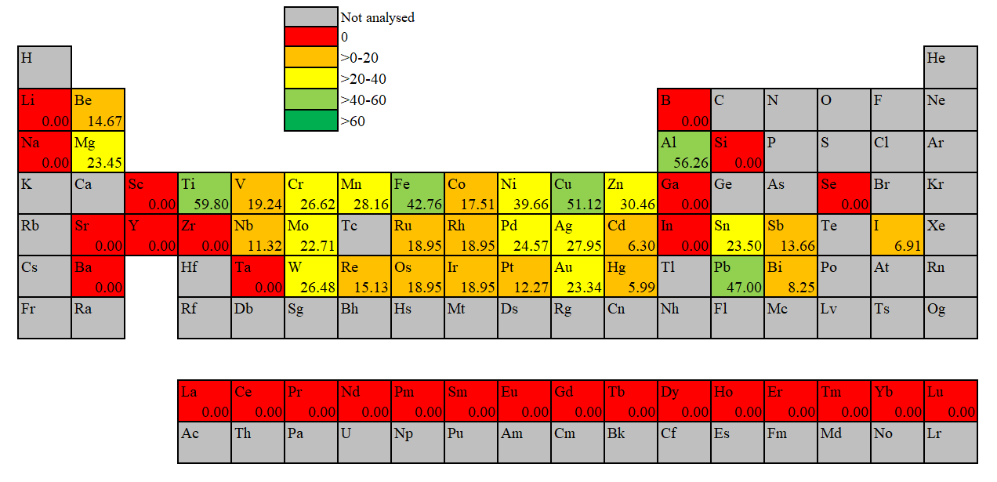

Increasing

sustainability

Figure 84: Visualisation of the 2014 MSI result according to the four indicator MSI framework, using a colour coded periodic table.

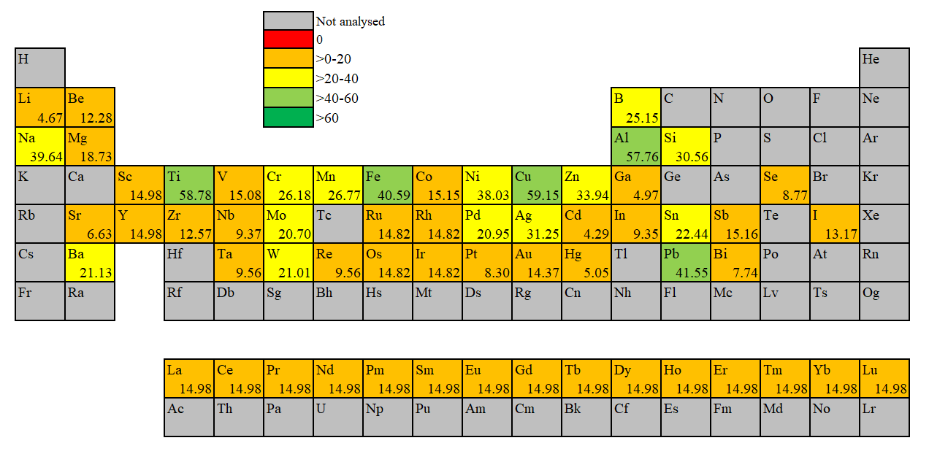

Increasing

sustainability

Figure 85: Visualisation of the 2014 MSI using the three indicator MSI framework, using a colour coded periodic table.

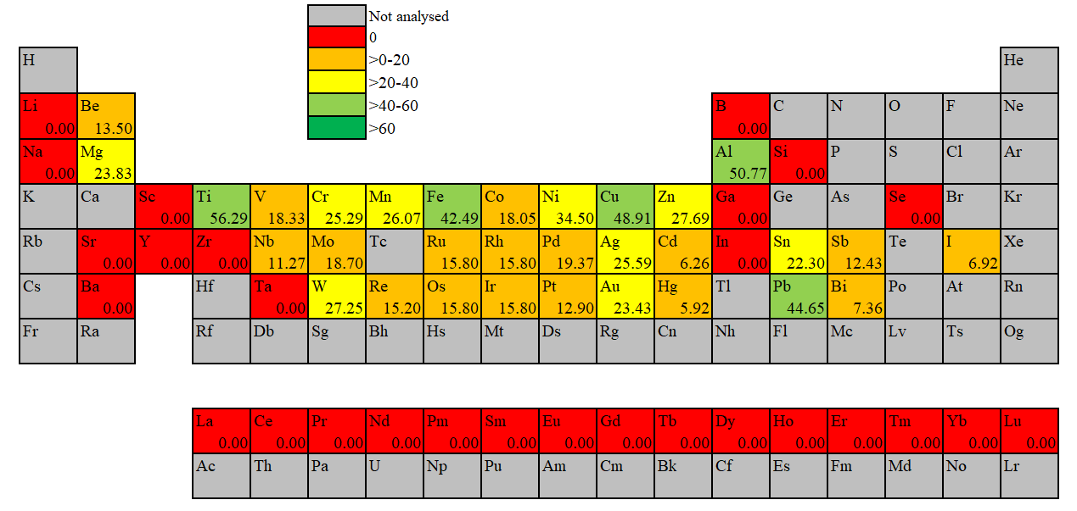

Increasing

sustainability

Figure 86: Visualisation of the 2015 MSI result using the four indicator MSI framework, using a colour coded periodic table.

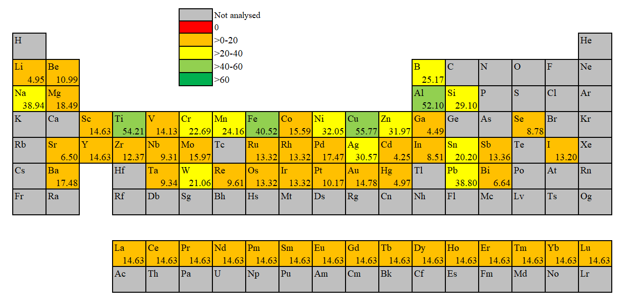Figure 87: Visualisation of the 2015 MSI result using the three indicator MSI framework, using a colour coded periodic table.

Increasing

sustainability

The use of three alternative visualisation techniques aims to present the results of the MSI in a way that will appeal to different stakeholders. The simple, tabulation format in Table 79 allows for the swift comparison of the results of the same materials over 2014 and 2015 and between MSI frameworks. The use of bar charts to display the results, Figures 82 and 83, provides a relative graphic for the result of materials within the same year and differing MSI frameworks. The colour coded periodic tables shown in Figures 84 to 87 allow the low MSI results to be quickly identified.

# Trend analysis

Trend analysis was performed to determine how the sustainability of select materials changed between 2005 and 2015. The results of this analysis are shown in Figure 88 for the four indicator MSI framework and in Figure 89 for the three indicator MSI framework.

Figure 88: The MSI result for aluminium, chromium, copper, lead, magnesium, nickel, tin, titanium and zinc from 2005 to 2015 using the four indicator MSI framework.

Figure 89: The MSI result for aluminium, chromium, copper, lead, magnesium, nickel, tin, titanium and zinc from 2005 to 2015 using the three indicator MSI framework.

Figure 88 shows that, over the 11 years analysed using the four indicator MSI framework, there is a general decrease in the MSI for aluminium, copper, nickel, tin, titanium and zinc. Chromium, lead and magnesium show a slight increase in the 2015 result compared to the 2005 result. Only lead and magnesium see an increase in the overall MSI values between 2005 and 2015 using the three indicator framework, as shown in Figure 89.

# Revisiting the data

Deconstruction of the composite indicator into the individual indicators provides an additional basis for analysis of the final result [149]; Figures 90 and 92 are used to show how the underlying indicators, specifically the HDI, *log*InvGWP, NEI and RR, contribute to the final MSI result using the four indicator MSI framework. Those materials with an MSI result of 0 points are not shown as the result cannot be broken down to show the percentage contributions of each indicator. Figures 91 and 93 denote this indicator contribution for the HDI, *log*InvGWP and NEI for 2014 and 2015 using the three indicator MSI framework.

Figure 90: Decomposition of the MSI result, using the four indicator MSI framework, into the four underlying indicators to show their percentage contribution to the MSI result (HDI, *log*InvGWP, NEI and RR) for the 2014 dataset.

Figure 91: Decomposition of the MSI result, using the three indicator MSI framework, into the three underlying indicators to show their percentage contribution to the MSI result (HDI, *log*InvGWP and NEI) for the 2014 dataset.

Figure 92: Decomposition of the MSI result, using the four indicator MSI framework, into the four underlying indicators to show their percentage contribution to the MSI result (HDI, *log*InvGWP, NEI and RR) for the 2015 dataset.

Figure 93: Decomposition of the MSI result, using the three indicator MSI framework, into the three underlying indicators to show their percentage contribution to the MSI result (HDI, *log*InvGWP and NEI) for the 2015 dataset.

In both 2014 and 2015 using the four indicator MSI framework, Figures 90 and 92 show that the HDI has a high percentage contribution to the final MSI result for each of the materials, except for gold in 2015, where the RR indicator has the highest percentage contribution to the final MSI result. Of the remaining three indicators, there is no prevalent contribution to the final MSI result for each indicator. Removal of the RR indicator, as shown in Figures 91 and 93, shows HDI is still a predominant contributor to the overall MSI score but the *log*InvGWP indicator has the larger increase in contribution compared to the NEI indicator.

# *Discussion*

The aim of this work is to develop a new method for quantifying the materials flows and environmental trade-offs associated with material substitution and recycling within the resource efficient and circular economy framework. This section will discuss how the development of the MSI has attained this aim and the following underlying objectives:

* To develop a simple, robust methodology for the calculation of the sustainability of a material
* To illustrate how the sustainability of a material changes over time
* To understand how the sustainability of a material can be improved
* To compare the results of the sustainability calculation with the results of the HLCAs and other published methodologies which aim to measure sustainability, criticality, recyclability etc.

The results of each step in the methodological process will be discussed in this section.

# The use of a composite indicator

The pros and cons of CI are outlined in Table 6. Taking these aspects into account, a CI was chosen as the appropriate method to determine the sustainability of a material because it allows for the contributing implications (e.g. the environment, society and economy), which are measured using different methodologies, to be normalised and aggregated to provide the “big picture” result. The sustainability of materials is calculated over the time period of 2005-2015 and the methodology has allowed a simple and robust calculation to be attained. The disadvantage; “can result in misleading, ineffective policy when poorly built or misunderstood”, was addressed in this case by following the step by step process outlined in [149]. This methodology requires the sub-indicators to be examined in detail, and therefore the disadvantage of the “big-picture being simplified” is overcome. The uncertainty and sensitivity analysis steps address the potential subjectivity that may arise through the decision making process and, in this case where necessary, multiple data sources have been referenced to tackle both data availability and uncertainty in the dataset.

The three main issues highlighted through the analysis of indices were input variable selection, transparent normalisation and weighting procedures that undergo robust sensitivity analysis and equal treatment of each variable [82]. The methodology outlined above aimed to eliminate these issues through a robust and transparent process.

# The theoretical framework

Hanson [19] suggested that the “holy grail” of sustainability measurement would be a single accepted indicator. According to Elkington’s [14, 15] concept of the “Triple Bottom Line” (TBL) sustainability requires a balanced view of economic, environmental and social aspects. Environmental sustainability requires a maintained, stable resource base in which renewable resources are not over-exploited and non-renewable resources are not depleted beyond the availability of a substitute. An environmentally sustainable system also needs biodiversity and other ecosystems to be maintained. The continued production of goods and services, whilst managing debt and avoiding imbalances in the system which could hinder production, is key to economic sustainability and socially, a sustainable system must be fair in the distribution of suitable provision of services such as education and health whilst achieve gender equality and political participation and accountability [16].

By developing the MSI under the auspices of [149], the theoretical framework was established to clearly define the multidimensional phenomenon of sustainability with respect to the TBL and its symbiotic nature in that, a change in one of the three aspects, may lead to a change in another [22]. The final theoretical frameworks allow the sustainability of a given material to be calculated under these parameters, providing policy makers, academics, industry and the general public with robust information to understand how sustainable a material is with respect to the economy, society and the environment.

Long *et al.* [15] criticises some sustainability assessments as too industry specific, focussed on investors and stakeholders or as having too many indicators. The MSI framework, based on the system boundary in Figure 37, avoids these three issues whilst achieving a robust and reliable result.

While the basis of the framework was developed by the results of the literature review, the final frameworks were primarily determined by the data selection and multivariate analysis steps, which aided in the application of a single tier format. The selection of the HDI, PPI, GII, GWP, NEI and RR indicators reflect the requirements of the MSI through the issue that they address.

# Data selection

The selection criteria employed in the data selection stage of the MSI development was implemented to ensure that a robust, representative result was established. The literature review highlighted 140 indicators which had been previously been used in investigations into general sustainability indexes and specific material sustainability indexes; the use of the selection criteria in Table 37 was important to filter out any indicators that did not directly help to achieve the aims of the MSI.

Of the eleven selection criteria used in the matrix, three resulted in the dismissal of indicators; relevance, duplication and accessibility.

By addressing the results provided by [54], the environmental indicators deemed to be redundant in the assessment of environmental impact were removed from the list by duplication. To ensure that this action is applicable in the context of the MSI, the abiotic depletion potential and human toxicological potential of each material were tested in the uncertainty and sensitivity analysis.

Environmental indicators such as “stunted forest growth” and “increased health issues” were also deemed as duplication as they address the endpoint effect of polluting emissions. A midpoint indicator provides links within the cause-effect chain, before the endpoint of the impact. The endpoint impact category addresses the cause-effect at the end of this cause-effect chain. Currently, impacts such as global warming can’t be quantified at the end point of the cause-effect chain [290].

Some indicators are duplicated within the frameworks of other indicators e.g. investment and infrastructure is covered by the framework of the GII indicator and political stability is addressed with the PPI indicator.

The depletion time of a specific material i.e. a material’s availability [115] was also removed from the MSI assessment under duplication. While this is an important factor to take into account for the assessment of sustainability, it is also currently only possible to estimate the availability of resources as a multiple of crustal abundance [291]. Furthermore, while many believe material reserves to be a static value, discovery of new reserves, improvements in process efficiencies and political implications can lead to a fluctuation in resource availability. Therefore, in this case, it is argued that by assessing the recycling rate (and in turn, aiming to increase that recycling rate) the depletion time of a material becomes less important.

Many metals are mined alongside their “companion metals”, of which they are similar both physically and chemically [115]. The companion metal fraction indicator has been removed from the MSI calculation as the USGS mineral commodities data set supplies production data for individual materials and therefore each material can be assessed individually.

Relevance, i.e. does the indicator address at least one of the three aspects of sustainability’s triple bottom line, was the second criteria under which indicators were removed. Examples of this include energy generation; it is not the primary function of mining companies to generate energy. Furthermore, indoor air quality, housing provision and fertility rates (for example) cannot be directly influenced by this industry.

The external effects (i.e. those impacts not covered by the producer [292]), significant indirect economic impacts and percentage of the population utilising indicators for example, were deemed to be out of the scope of this work. The potential substitutes for a material (and therefore any ratio comparisons that could be made) are also out of scope of this work as the scope does not stretch into the manufacturing phase of a materials life cycle.

Due to the wide spread nature of material mining and processing, data accessibility for individual, site based processes, becomes almost impossible and so, site specific data was also removed from the assessment. This is supported by [104] which highlighted that indicators such as absentee rate, indirect energy consumption and workplace incidents were lacking in available data.

Data accessibility was also a problem for wider issues such as child and forced labour; in this case it is argued that these issues are associated with the sub-indicators of the HDI, namely “decent standard of living” and “knowledge”.

The individual aspects of the six chosen indicators are discussed below, along with those of the production data.

# USGS material production data

Production data and the associated country information is required to correctly attribute the HDI, PPI and GII indicators to the materials under investigation, in line with the methodology presented by Graedel *et al.* [115]; the United States Geological Survey (USGS) data archives were used to achieve this with the publically available Mineral Production Data.

Each year the USGS publish their survey methods. Domestic data (the United States) are taken from around 20,000 government and private organisations using a survey relating to production, consumption and recycling activities. Data gaps are mitigated using estimation or imputation techniques. International data collection is completed by country specialists and coordinators and gathered from roughly 180 government agencies, international organisations and personal contacts. Historical trends and specialist knowledge is used to treat any data gaps [293].

Figures 94 and 95 show heat maps for the mining of copper and silver in 2014; a total of approximately 26,800 tonnes of silver and 18,500,000 tonnes of copper were produced. Figure 94 shows that the highest producer of copper in 2014 was Chile at over 31% of the global production, while the highest producers of silver were Mexico at almost 19%, shown in Figure 95. This spread in the material production figures is important for the weight averaging step for the HDI, PPI and GII indicators to relate each of them to a material.

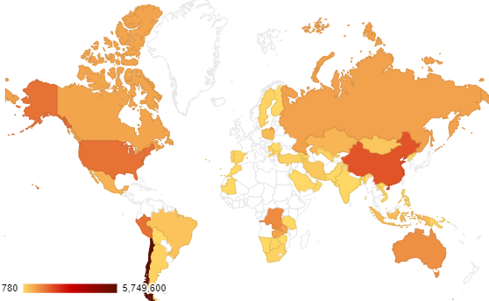

Figure 94: Heat map of copper mine production in 2014.

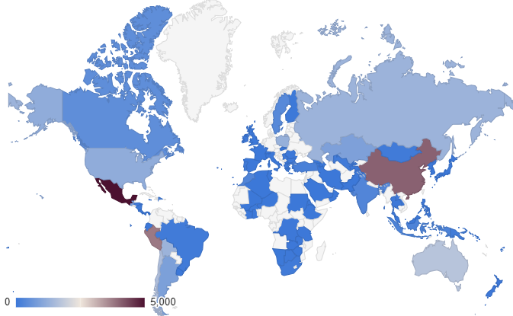

Figure 95: Heat map of silver mine production in 2014.

# Human development index

The United Nations first published their Human Development Report in 1990, proposing the Human Development Index (HDI); a composite indicator measuring development based on adult literacy, life expectancy and purchasing power [88]. This information is now published annually. The structure of the 2014 HDI is shown below in Figure 96 [162].

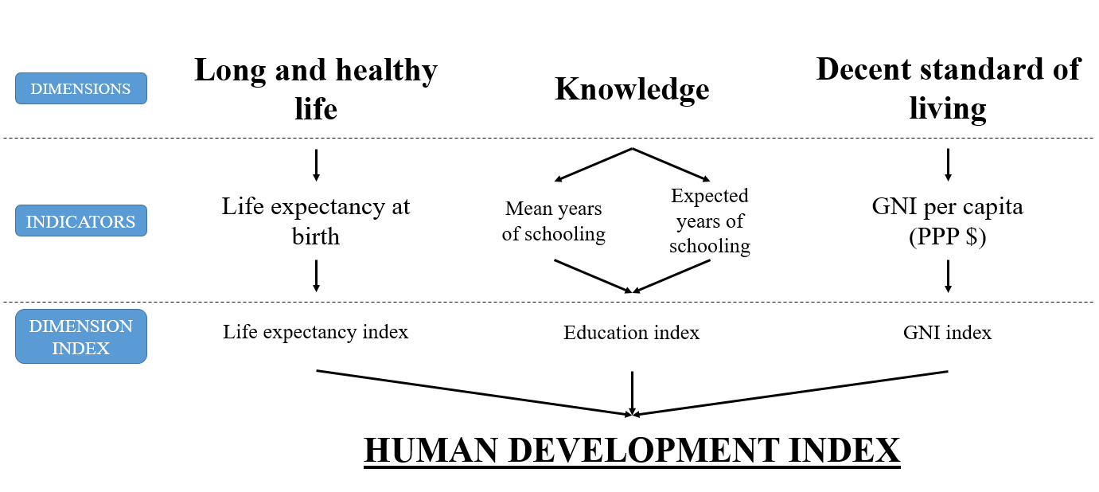

Figure 96: The 2014 HDI structure [162]: NB. Gross national income (GNI); purchasing power parity (PPP).

The three dimensions shown in Figure 96 are thought to be key to human development. The final index is the geometric mean of normalised indices for the three dimensions. The dimension indices are transformed using minimum and maximum values to achieve a scale between 0 and 1; 0 represents a “natural zero” and 1 represents an “aspirational goal”. Table 80 outlines the minimum and maximum values used in the 2014 HDI calculation [162].

Table 80: Minimum and maximum values set for the scaling of the dimension indices in the 2014 HDI calculation [162].

|  |  |  |  |
| --- | --- | --- | --- |
| **Dimension** | **Indicator** | **Min’** | **Max’** |
| Health | Life expectancy (years) | 20 | 85 |
| Education | Expected years of schooling | 0 | 18 |
|  | Mean years of schooling | 0 | 15 |
| Standard of living | Gross national income per capita (PPP 2011 $) | 100 | 75,000 |

Evidence shows that, in the 20th century, all countries had a life expectancy of at least 20 years. As communities exist without education, the minimum expected and mean years of schooling can be 0; in most countries, 18 is equivalent to obtaining a master’s degree and therefore this is set as the maximum expected years of schooling; the maximum mean years of schooling is set to the projected maximum of the indicator in 2025. It has been shown that human development and well-being do not increase above an annual income of $75,000 and therefore this value is set as the maximum goalpost for the gross national income (GNI); the minimum “goal post” is set at $100 due to the unmeasured subsidence and nonmarket production of economies close to the minimum [162].

These minimum and maximum values are then used in equation 35 to determine the dimension indices. As the knowledge dimension includes two indicators, equation 35 is used to calculate each indicator and the arithmetic mean of the two results is taken. The natural logarithm of the minimum and maximum values is used for the GNI index because each additional dollar of income has a smaller effect on the expanding capabilities of the dimension, this is shown in equation 36 [162].

$Dimension index=\frac{actual value-minimum value}{maximum value-minimum value}$ (35)

$GNI index=\frac{\ln{(actual value)-}\ln{(minimum value)}}{\ln{(maximum value)}-\ln{(minimum value)}}$ (36)

Finally, the geometric mean is derived from the three dimensional indices, this is shown in equation 37 [162].

$HDI={(I_{Life expectacy}×I_{Education}×I_{GNI})}^{\frac{1}{3}}$ (37)

When measuring national social capital, the HDI is one of the most popular methodologies used, despite criticism of its lack of consideration of environmental issues [3]. The data sources used to create the HDI are cited in the associated technical notes [162].

Where gross national income (GNI) data is missing for certain countries the nominal GNI per capita is converted to purchasing power parity (PPP) for the base year (2011) and then a time series of GNI data in 2011 PPP terms is produced through applying the real growth rates to the GNI per capita in PPP terms for 2011. The ratio of nominal growth of current GNI per capita in local currency terms to the gross domestic product (GDP) deflator implies the real growth rate. Cross-country regression modelling is used where other country data is missing [162]. The global results of the 2014 HDI are shown in Figure 97.

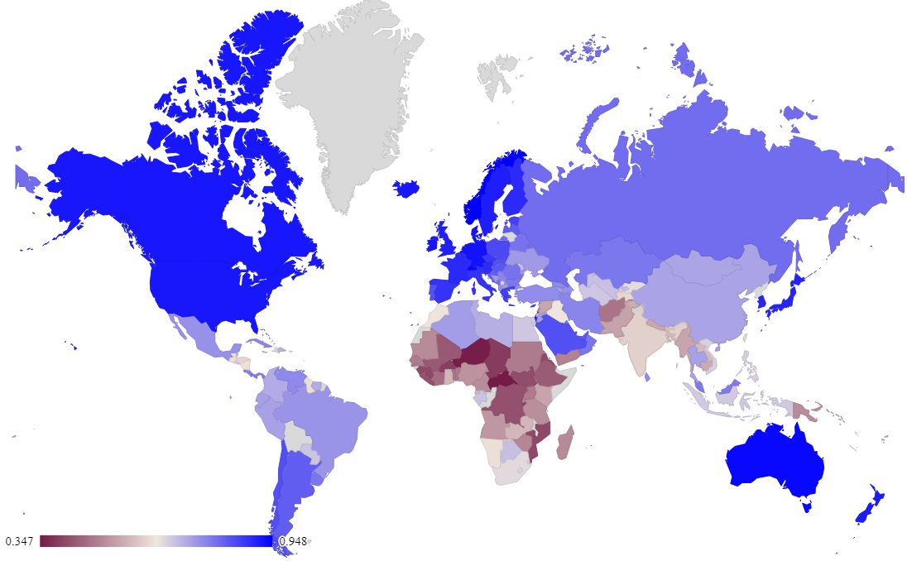

Figure 97: 2014 global distribution of HDI results.

For this study, HDI results are available for 95% of the countries which were highlighted by the USGS as those mining the materials under investigation in this study. It can be seen from Figure 97 that the lowest HDI results are mainly clustered around Africa and South Asia, which has an overall effect on the final HDI result for each material, depending on where it is mined, due to the weight average methodology used to relate the country specific indicators to each material. For example, if a country has a low HDI and produces a high percentage of the world’s gold, gold would have a lower HDI result than a material which is predominantly produced in a country with a high HDI.

# Policy perception index

In 1997, the Fraser Institute began surveying mining companies to assess how public policies (such as regulation and taxation) and mineral endowments may affect investment in exploration. The aim of these surveys was to improve mining-related policies which would increase mining sector investment to improve productivity and employment [175].

122 dominions are now included in the survey, reaching to all continents except Antarctica. The survey design aims to identify policies that encourage investment in mining exploration and production and is sent to around 4200 managers and executives [175].

The policy potential index (PPI) uses a ranking system and is calculated to achieve a maximum score of 100. Regions are ranked by the percentage of responses which judge a policy factor to encourage investment, where the highest percentage is ranked first and the lowest percentage is ranked last. The average rankings are then taken and normalised to 100 [175].

The PPI data set has the lowest data availability of the six indicators chosen for further analysis at 49%; the distribution of these results are shown in Figure 98. This shows that the lowest PPI results are found in Asia and South America, while the highest results are found in the Scandinavian region.

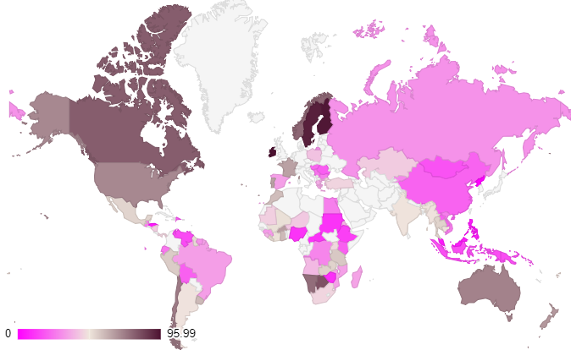

Figure 98: 2014 global distribution of PPI results.

# Global innovation index

The global innovation index (GII) is published by Cornell University, INSEAD and the World Intellectual Property Organization (a United Nations agency). The aim of the index is to summarise the multi-dimensional aspects of innovation to aid policy makers and business leaders in taking a holistic view of innovation metrics [161].

The GII is composed of seven pillars, these pillars are divided into three sub-pillars (the structure to this point is shown in Figure 99), each of which are made up of three to five indicators. In total the structure includes 81 indicators. The scores of the sub-pillars are weighted average calculations of the underlying indicators. In turn, the scores of the seven pillars are weight averaged from the sub-pillar scores. Finally, the Innovation Input Sub-Index is taken as an average of the five underlying pillar scores and similarly, the Innovation Output Sub-Index is taken as the average of the two underlying pillar scores and finally, the Global Innovation Index is the average if the Input and Output Sub-indices [161].

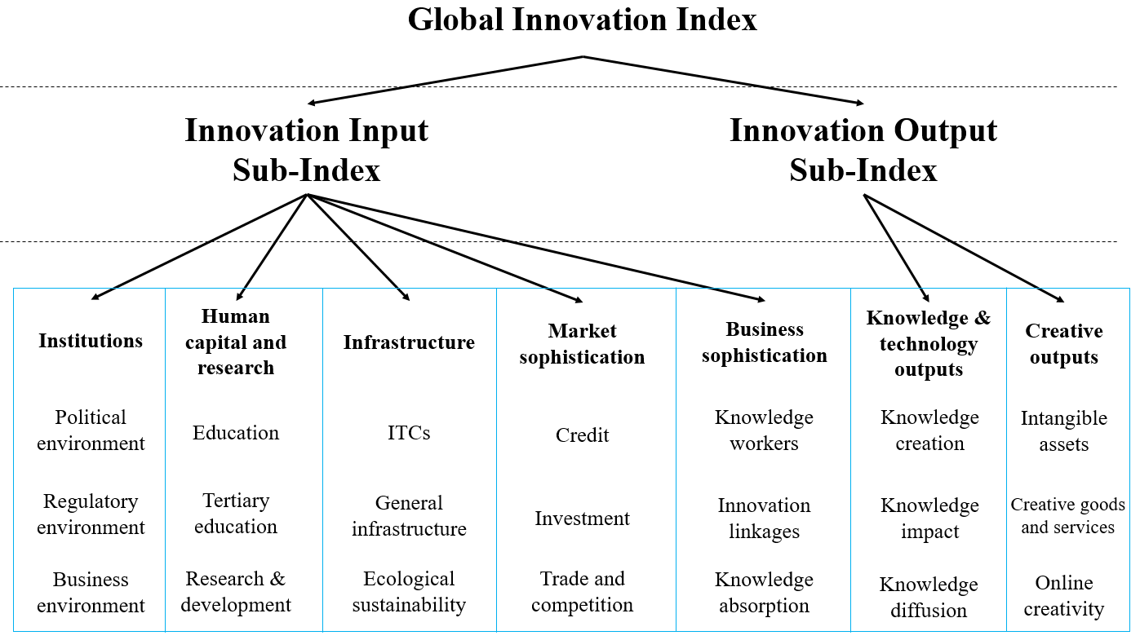

Figure 99: The structure of the GII [161].

In the case of missing data, relative index scores are produced and therefore missing values from one economy have an effect on the index scope of other economies and normalisation is conducted using either the GDP or population [161].

81% of the GII indicator data is available for the construction of the MSI, the distribution of this data is shown in Figure 100. It is clear that the highest GII results can be found in the western hemisphere i.e. developed countries, while the developing and under developed countries have lower results.

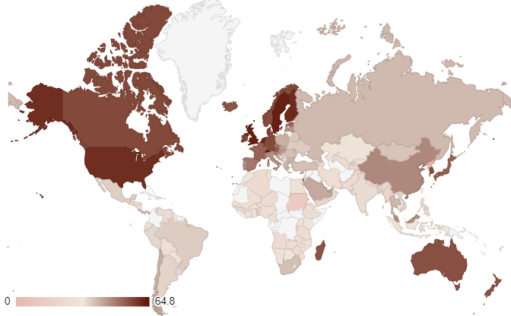

Figure 100: 2014 global distribution of GII results.

# Global warming potential

Published literature [54] shows that, while over 200 environmental indicators are available to the modeller, the use of the global warming potential (GWP) indicator provides the relevant information required to assess the environmental impacts of a product or service, leaving the remaining indicators redundant. With this in mind, the GWP indicator was chosen to represent the environmental pillar of sustainability to avoid over complication of the data collection requirements of the MSI.

The CML 2001 methodology was used to determine the GWP for the production of 1kg of each material studied. The methodology produces midpoint impact categories by restricting quantitative modelling to the primary stages of the cause-effect chain and therefore limits uncertainties. Data is updated when new substance level knowledge is available [294]. The GWP of greenhouse gases is expressed over time through the CLM 2001 methodology; in this case the GWP 100a (100 years) was used to determine the climate change caused by the extraction of each mineral [52]. The Ecoinvent database (version 3.1, 2014 and version 3.2, 2015) [139] holds 80% of the required data was available and therefore published literature was used to fill the gaps. A comparison of the environmental impacts of mining companies have found differences in results relating to material type, grade, fuel, location and climate [112], therefore whenever possible, the “global” or “rest of world” Ecoinvent database for each material was reference to ensure that an average value of the impact was taken into account.

# National economic importance

The national economic importance (NEI) attempts to quantify the importance of a material to an economy by taking its value as a percentage of the country’s GDP. This measure fits within the scope of the MSI because it does not quantify the importance of the material throughout the supply chain. Furthermore, the use of apparent consumption lends itself well to the analysis of bulk materials as the analysis is straightforward [125].

This data was obtained from the USGS statistics database and the world bank database for the United States [284]. In a perfect situation the data for the imports, exports and government stock changes of the materials under investigation would be available for each country using them. This would allow the NEI to be weight averaged to find the fractional contribution per country; the methodology used to attribute the HDI to each material. Until a time where this data is robust and available, the United States data is used as a proxy for the NEI of each material.

77.5% of the NEI indicator data is available for 2014 and 2015; missing data is filled using either previous years’ data points either by taking the mean, using regression analysis or direct imputation was used to fill these gaps.

# Recycling rate

Literature has discussed the importance of recycling in the context of sustainability [295] and therefore the recycling rate (RR) indicator was added to the MSI calculation to address the global requirements of dematerialisation, or the minimisation of waste (i.e. high recycling rates).

The USGS database [127] was used to provide the RR indicator data in this investigation because it provides annual data for 80% of the materials studied in this work. Other potential source options include literature from Graedel *et al.* [126], the RSC database [288] or the EU material profiles [76]. These data sources are summarised in Table 81.

Table 81: Summary of the method, calculation and availability of each RR indicator data source.

|  |  |  |  |  |
| --- | --- | --- | --- | --- |
| **Source** | **Method** | **Calculation** |  | **Availability** |
| USGS | Recycling rate (%) | $$\frac{Metal recovered from new+ old scrap}{Production+net imports+stock changes}$$ | (38) | All years, 80% |
| RSC | Recycling rate (%) | Unspecified |  | Unspecified year, 90% |
| EU | End of life recycling input rate (EOL-RIR) | $$\frac{\begin{aligned}Input of secondary material to EU \\ [from old scrap]\end{aligned}}{\begin{aligned}Input of primary material to EU \\ +Input of secondary material to EU\end{aligned}}$$ | (39) | Unspecified year, 82.5% |
| GRD | End of life recycling rate (EOL-RR) | $$\frac{Recycled EOL metal (old scrap)}{EOL products (metal content)}$$ | (40) | 2000-2005, 90% |

The major disadvantage of using this indicator is the different methodologies that have been used to calculate the same concept, as outlined in Table 81. The advantage of using the USGS data source [127] is its consistency across a wide number of years, its data availability and its accessibility. The USGS database was used to represent the RR indicator in the final MSI calculation for both the 2014 and 2015 datasets; 20% of the data was missing.

Furthermore, the results provided by the USGS [127] and EU [76] data sources are region specific (USA and EU respectively), the Graedel *et al.* [126] is a global average but the RSC [288] data does not specify this information. This highlights further issues in the data collection process and potential uncertainty in this dataset. Although the USGS data is specific to the United States, due to the consistent data availability, it is deemed to be the most appropriate dataset to use in the MSI calculation. Furthermore, this national level data use is employed by the Graedel *et al.* methodology [115, 124], representative of the United States; it can be concluded that if country specific data were available the may be different.

The uncertainty and sensitivity analysis performed in this investigation takes these different courses of RR indicator into consideration through input factor $X_{6}$, these results are discussed further in section 4.3.8.

Despite these issues, the overall dependence of material sustainability on recycling is paramount and therefore the RR indicators inclusion in the MSI indicator selection process is a necessity to enable the aims and objectives of the calculation to be achieved though the theoretical framework.

# Imputation of missing data

In an ideal world, published datasets would be complete in line with the requirements of a study; where data is missing from a dataset, it can be appropriately imputed to fill the gaps. This section discusses the results of the missing data imputation methods employed in this study. The percentage of available data is shown in Table 49 and the data imputation methods are outlined in section 4.1.3 and the impact of the imputation methodology is tested in the sensitivity and uncertainty analysis in section 4.2.6.

# Material production data

The USGS database provided the global mineral production data from 2005 to 2015. This dataset was chosen as it is accessible to the public, addresses the materials under investigation in this study and is available for the years beyond those applied in the scope of the trend analysis. Only three material datasets were missing for 2015 and therefore the 2014 data was used in its place. Consequently, it is envisaged that when the 2015 data is made available for magnesium, niobium and titanium, the end MSI result for each material may change slightly. This is a minor limitation in the use of this data as the indicator requires wide reaching data collection, this may hinder the speed in which the results can be provided to the public by the USGS.

In addition to this limitation, due to the avoidance of disclosing company proprietary data, the United States production data for cadmium, iodine, lithium, magnesium and selenium is withheld for both 2014 and 2015. As discussed in the methodology, this data has been excluded from the final calculation. Therefore, if this data were to be published, the final MSI result for these materials may change slightly depending on the impact of the United States production on the overall percentage of global production.

# Country specific indicators

The HDI, PPI and GII indicators are calculated in relation to countries, not materials and therefore, the USGS mineral production data was used to weight average these three indicators to make them applicable to the materials studied in this investigation. This methodology is in-line with that used by Graedel *et al.* [115] in the calculation of material criticality.

Case deletion (removing the missing records from the analysis), single imputation by applying the mean of the dataset as the missing record and single imputation by a geographically similar county’s record as the missing record were applied to fill the data gaps in each case. Although case deletion is not advised when more than 5% of the values are missing [149] it was tested in this case to determine the effect on the final outcome.

The minimum, maximum, mean and standard deviation values for each indicator, according to each imputation methodology and in both 2014 and 2015 are shown in Tables 50 to 55. These results, with respect to the HDI, PPI and GII data vary between the imputation method as these indicators relate to countries and have been weight averaged to apply to each material type. For example, where a missing value has been deleted in the case deletion imputation method, this has been replaced by either the average of the data set or a geographically similar data point in the remaining imputation methods.

Tables 50 to 55 show that the maximum and minimum values of the HDI data sets in both 2014 and 2015 are not affected by the imputation methodology (to two decimal places); in both 2014 and 2015 the mean increases from 0.76 to 0.77 when comparing the case deletion methodology to the average and geographical imputation methodologies. Finally, the standard deviation differs from 0.065 for the 2014 case deletion imputation methodology, compared to 0.062 for the 2014 geographic imputation methodology (this decrease in the standard deviation across the imputation methodologies is also seen in 2015). These statistics show that while the increase in the mean indicates that the overall HDI value is higher for the average value and geographical imputation methodologies (when compared to the case deletion imputation methodology) there is the least variation in the geographic imputation methodology over both years but overall the imputation methodology does not significantly affect the HDI result.

The maximum PPI indicator values for both 2014 and 2015 are not affected by the imputation methodology, though there is a large difference between the case deletion methodology and the average value and geometric imputation methodologies in both 2014 and 2015. The lowest variation in the data for 2014 comes from the geographic imputation methodology but in 2015 it is related to the average value imputation methodology. Overall, the results of the PPI indicator are more highly effected by the imputation methodology than the HDI indicator. This is discussed in more detail below.

As with both the HDI and PPI indicator result, the maximum value of the GII indicator is not affected by the imputation methodology for either 2014 or 2015. In comparison, the minimum result for 2015 is more dependent on the imputation methodology than for 2014. For both years, the least variation in the results is seen in through the average value imputation methodology.

Figures 38 to 43 show that the PPI indicator, when weight averaged to provide material specific data, gives the widest range of results. The case deletion methodology for the PPI indicator in 2014 and 2015 gives the lowest result of 9.78 and 16.18 which is related to Tantalum. Interestingly, in 2014, using the average value imputation methodology and the geographic imputation methodology, the lowest results relate to magnesium and in 2015 the lowest results relate to tin. Tantalum also has the lowest result for the HDI indicator in both 2014 and 2015, though the result is independent of the imputation methodology as all data points for the HDI are available. The lowest result for the GII indicator in 2014 is cobalt, independent of the imputation methodology; in 2015 cobalt has the lowest result using the case deletion imputation methodology but tantalum has the lowest result for the average value and geographic imputation methodologies.

As mentioned above, the 2015 results for tantalum are equal to those for 2014 due to missing data in the USGS dataset. The highest percentage of production of tantalum was from Rwanda (50%), Congo (Kinshasa) (17%) and Brazil (12%); the HDI results for these countries are 0.493, 0.590 and 0.754 respectively. These low HDI results, combined with high production percentages lead to a low overall HDI score for the material.

Looking at the PPI indicator, the data points for both Rwanda and Congo (Kinshasa) are missing, leading to a low case deletion imputation methodology result. In 2014, these data points are then replaced with the average value of the PPI dataset (48.850) for the average value imputation methodology and the data point for the Democratic Republic of Congo (27.85) in the geographic imputation methodology, due to the geographic proximity of these countries. Consequently, the final result for these imputation methodologies are much higher than the case deletion methodology.

Comparatively, the missing data points in the 2014 PPI indicator dataset relating to magnesium production relate countries with a much lower percentage of mineral production (Israel (2.6%), the Republic of Korea (1%) and Ukraine (0.7%)) and therefore the difference in the result of each imputation method is much smaller. This is also the case for tin in 2015 for which the missing data points account for only 3.8% of the total production.

The GII indicator is missing a data pint for Congo (Kinshasa) and therefore, during the tantalum weight averaging exercise, the average value of the dataset in 2015 (36.9) and the data point for Zambia (24.6) were applied for the average value and geometric imputation methodologies respective. As only 16.6% of tantalum production took place in Congo (Kinshasa) in 2015, this does not have a large effect on the final results when compared to the case deletion methodology. In comparison, Congo (Kinshasa) produced over 50% of the global cobalt production in 2015 and therefore the elimination of this data point (and consequent application of the average value and geographic value imputation) has a much higher effect on the final result.

The PPI indicator shows the highest change in the mean value of the datasets when the three imputation methodologies are employed, this can be seen from both the box plots in Figures 38 to 43 and also in Tables 50 to 55. Therefore, it can be concluded that the PPI is most susceptible to the chosen imputation methodology. This can be linked to the availability of data in the original dataset; 49% in 2014 and 43% in 2015. An increase in the reach of the PPI to additional mining countries would reduce this effect in the PPI result.

In 2014, beryllium gives the highest result for all three indicators, each of which are not affected by the imputation methodology. In 2015, beryllium, again independent of the imputation methodology has the highest result for the PPI and GII indicators, but it is selenium that has the highest HDI result (independent of imputation methodology).

It can be concluded that, a material predominantly produced in countries with higher HDI, PPI and GII results are less effected by the impact of the imputation methodology as the data points for those countries are more readily available.

In both 2014 and 2015, tantalum is an outlier in the HDI dataset as it falls below the lower fence of the dataset. Only the 2015 case deletion methodology provides outliers for the PPI indicator, these correspond to tantalum and selenium. Finally, tantalum and cobalt sit below the lower fence of the dataset for the case deletion methodology of the GII indicator in 2014, but only cobalt is an outlier for the average value and geographic imputation methodologies. Comparatively in 2015, cobalt is the only outlier in the case deletion methodology. In 2014, beryllium lies above the upper fence of the dataset, independent of the imputation methodology, but in 2015 is only an outlier in the average value and geographic imputation methodologies.

While the HDI of tantalum is independent of the imputation methodology, almost 50% of production takes place in Rwanda which has a 2014 HDI result of 0.493, consequently the weight averaged value of tantalum is low. This is also the case for the GII indicator, for which Rwanda has a result of 29.31 in 2014. As a significant correlation between the HDI and PPI indicators exists (discussed below), it is likely that the missing Rwanda data point for the PPI indicator, leads to an absence of a corresponding outlier for tantalum in this datasets (with the exception of the case deletion methodology in 2015).

The upper outlier in the GII indicator dataset, relating to beryllium can be attributed to around 90% of the materials production taking place in the United States which has a GII value of 60.09 and 60.10 in 2014 and 2015 respectively.

The low available percentage of data for the PPI indicator does not make it a prime candidate for use in the final MSI calculation, as discussed above, this creates discrepancies when the indicator value of a high material producing country is missing. The dataset with the highest available data points in the HDI, therefore leading to the least amount of variation in the final results. Although the case deletion methodology is not advised in circumstances when more than 5% of values are missing, the variation in the results between the three imputation methodologies is minimal and therefore the case deletion methodology will be taken forward due to its relative simplicity in the final data manipulation [149].

# Material specific indicators

The InvGWP, RR and NEI indicators provide data specific to each material in this study and therefore do not require additional manipulation as described for the previous country specific indicators. For the InvGWP, RR and NEI indicators, the minimum, maximum, mean and standard deviation values for each of the three data imputation methods do not change because these indicators are material specific and are not affected by the imputation methods of country data.

There is a wide range of values relating to the GWP indicator of each material; in 2014 the lowest value is 0.092207 kg CO2-eq for boron and 18188 kg CO2-eq for platinum. In 2015, while boron remains the lowest result for the GWP indicator, the highest result changes to gold at 15199 kg CO2-eq. Furthermore, the values are mainly clustered below 200 kg CO2-eq and therefore the dataset is skewed (this is discussed in more detail in section 4.3.6).

The range of the data in the NEI indicator dataset is lower than that of the GWP indicator dataset, though three outliers are present in this dataset on 2014 and four are present in 2015. Only one upper outlier is shown in the 2014 RR indicator dataset for gold.

# Indicator correlation

The correlation coefficients of the indicators were tested; this helps to identify any potential sources of double counting which can occur when equal weighting is used if the indicators of the same sub-group are highly correlated [149].

Tables 56 to 61 show how the indicators are correlated with each imputation methodology for both 2014 and 2015 using Pearson’s Correlation Coefficient, those indicators which are significantly correlated are highlighted in bold. As each variable correlates with itself perfectly, they have been removed from the table to improve read-ability. In each case you can see that the PPI and GII are positively correlated with the HDI; the ** indicates that there is less than 0.001 probability that this correlation occurred by chance in this dataset. As the accompanying significance value of each correlation is 0.000, this means that this correlation is very unlikely to be a “fluke”. This analysis is also the case for the relationship between NEI and RR. There is no correlation between the PPI and GII indicators and the GWP indicator does not correlate with any of the other indicators that have been tested.

As would be expected, the Pearson’s correlation coefficient of the RR and NEI relationships are not affected by the imputation method, but there is a slight decrease in the correlation when 2014 is compared to 2015, though the correlation is still significant. Though correlation does not determine causation, the relationship of these two indicators must be explored in more detail.

While the change in imputation method does not affect the significance of the correlations between the HDI, PPI and GII, the Pearson’s correlation coefficient does change slightly. The highest Pearson’s correlation coefficient between the HDI and PPI is seen in the geographic imputation methodology in both years; the case deletion imputation methodology gives the highest correlation between the HDI and GII indicators for both years.

These results suggest that, in the case of equal weighting, the HDI, PPI and GII indicators should not be combined as this could lead to double counting, nor should the NEI and RR indicators.

# Principal Component Analysis

Principal Component Analysis (PCA) was performed, by including each dataset, for each imputation methodology in both 2014 and 2015, to understand how, or if, an underlying structure is present between the indicators with respect to their correlation [149]. The results of this analysis show that the six indicators can be represented by three components. With each imputation method, the rotated component matrices (Tables 66, 71 and 76) show that of the HDI, PPI and GII indicators, the HDI has the highest loading and therefore can be used as a representative dataset for this component. Similarly, for component 2, the RR indicator has the highest loading and only the InvGWP indicator is represented in component 3.

All six of the chosen indicators were assessed, to define a smaller number of uncorrelated variables, also known as principal components. Tables 62, 67 and 72 show the initial communality (1, as assumed during PCA) and the extracted communalities of the six indicators; the closer the communality value is to 1, the better the indicators are at explaining the original data, independent of data imputation method, all communalities are above 0.5 and therefore all indicators are well represented by the three extracted factors [286].

The eigenvalue of a component identifies its functional importance and therefore only those factors with large eigenvalues should be retained [286]. Tables 63, 64, 68, 69, 73 and 74, show the total variance of the datasets according to imputation methodology and year. As the first three components explain approximately 80% of the total variance of the datasets, these three components are retained. It is recommended that factors with an eigenvalue higher than 1 should be obtained; independent of imputation methodology or year, the first three components have an eigenvalue greater than 1 and the remaining three components have an eigenvalue lower than 1 [282].

The scree plots shown in Figures 50-55 show the eigenvalue (y-axis) plotted against its associated component (x-axis), the aim of a scree plot is to aid in the decision making process with respect to the required number of components to retain. It is argued that the cut-off point for component selection should be the inflexion point, i.e. where the curvature of the line changes. For the case deletion imputation methodology 2014 and 2015 and the geographic imputation methodology 2014, it is clear to see that this point occurs at component number four and therefore, three components should be retained. For the 2014 dataset for the average value imputation methodology does not show a clear point at which it could be determined that the curvature of the line changes. Comparatively, for the average value imputation methodology 2015 and the geographic imputation methodology 2015, it could be argued that there are two points at which the curvature of the line changes. Despite this, the scree plot and the cumulative variance of the eigenvalues should be taken in to consideration in tandem and therefore, across all three imputation methodologies, in both 2014 and 2015, it can be derived that three components are sufficient to address the underlying structure of the data.

The component matrices for each data set and year are shown in Tables 65, 70 and 75; this data outlines the component loadings for each indicator in line with the three components that show the most variance in the dataset. High and moderate loadings are considered to be those over 0.5 and therefore it can be said that, independent of imputation methodology and year, component 1 can be represented by the HDI, PPI and GII indicators; component 2 accounts for the RR and NEI indicators and the InvGWP indicator can be accounted for by component 3.

The rotated component matrices in Tables 66, 71 and 76 are produced to provide results that are more interpretable than those provided by the component matrix. The varimax rotation technique loads a smaller number of variables, highly onto each factor. The results of the rotation mirror the patterns shown in the component matrices for each component across all imputation methodologies and years.

In conclusion, the application of PCA to the chosen datasets has provided three principal components based on the underlying structure of the six indicators in the original data set. This allows the structure of the MSI to be determined in conjunction with the results of the literature review.

Across all three imputation methodologies and years, the HDI, PPI and GII indicators are highly loaded against component 1. HDI has the highest loading of the three indicators and therefore, to achieve the overall aim of the MSI (to develop a simple and robust methodology), this indicator was chosen for application within the MSI calculation; sensitivity analysis will be performed to understand how this has affected the overall result.

As the InvGWP indicator provides the highest loading for component 3 over each imputation methodology and year, this indicator taken forward into the MSI framework.

With respect to component 2, independent of imputation methodology and year, the highest loadings relate to the NEI and RR indicators. While the RR indicator has a higher loading for component 2 than the NEI indicator; both datasets were taken forward to the final calculation. The RR indicator is of high importance to material sustainability as dematerialisation, or the minimisation of waste (i.e. high recycling rates) are key to a sustainable future [295], it is clear that this indicator should also be incorporated into the MSI framework. It could be argued that the inclusion of both the NEI and RR indicators may lead to double counting, as the two indicators fall under the same factor in the factor analysis and are significantly, positively correlated, but correlation does not imply causation. To determine the effect of each indicator, one indicator is removed during the uncertainty and sensitivity analysis and the relationship between the NEI and RR indicators is explored in more detail in section 4.3.12.2.

The main strengths of PCA are that it provides a summary of individual indicators with the highest possible proportion of the total variation of the original data set and that the largest factor loadings are assigned to individual indicators. This has been outlined above where it is clear to see that the HDI indicator has been assigned to component 1, the RR indicator to component 2 and the GWP indicator to component 3 [149].

Despite the strengths of the process, it is sensitive to any changes in the initial data set and the presence of outliers; the contribution of individual indicators which are not affected by any other individual indicators may be minimised and correlations may not represent the actual influence of the individual indicators on the framework being measured. While the MSI dataset will change on an annual basis according to the findings of the underlying indicators, it is not envisioned that the PCA process will have to be repeated each year. The application of the PCA process to the 2014 and 2015 datasets show the same result for each year and therefore the application of the final framework for the preceding years is assumed to be relevant. Despite this, repetition of the PCA process each year would ensure the continued relevance of the MSI dataset or highlight where changes may need to be made in light of a change in the underlying data [149].

Finally, PCA can be sensitive to small-sample problems e.g. a limited set of variables (in this case materials). Despite this, no scientific answer has been provided regarding the number of cases required to perform PCA, therefore, it may be necessary to repeat the process if additional variables are added to the list under investigation [149].

While other methodologies of multivariate analysis exist to the modeller, e.g. Cronbach Coefficient Alpha and Cluster Analysis, the former is only relevant when the aggregation methodology of the composite indicator is based on a scale and the latter is simply a descriptive tool [149]. PCA offers an objective methodology which is not expensive and accessible [54].

# Normalisation

The four final indicators are not measured on the same scale and therefore normalisation was required to enable them to be comparable.

The InvGWP indicator has a number of outliers in the dataset which is positively skewed; transformation was performed using equation 19 to reduce this skewness which is evidenced across Figures 60 to 63 for 2014 and 2015; this process also removed the outliers from the dataset (as shown in Figures 58 and 59). This step was not applied to the NEI and RR indicators, as each dataset had fewer outliers associated with it.

Application of the min-max normalisation methodology was implemented to apply a common scale of 0-1 across all four indicators. The minimum and maximum “goal posts” were applied according to the nature of the dataset; in the case of the RR indicator in 2014, the minimum value was 0% and the maximum value was 100%, consequently these became the minimum and maximum values. Although this was not the case in 2015, while it may not be technologically feasible, maximising the recycling rate of materials as far as possible is important for material sustainability [295].

The minimum and maximum “goal posts” for the GWP indicator were chosen based on the range of the values within the dataset. As the highest data point in 2014 is 18,188 kg CO2-eq, the maximum “goal post” of 20,000 kg CO2-eq accounts for this. As the global trend to monitor and manage CO2 emissions becomes more important in society, this trend would likely reduce into the future and therefore all future data points should be below this maximum limit. With this in mind, if the MSI is annually updated as new indicator results are published, the maximum “goal post” for this indicator may need to be reassessed if the CO2 emissions of the mining industry are dramatically reduced. Furthermore, it could be argued that the actual minimum GWP indicator could be set to 0 (to represent a carbon neutral system) but, as with the maximum “goal post”, this should be reassessed following future improvements in the mining industry.

Similarly, for the NEI indicator, although it is unlikely, a material may provide a neutral (or even negative) economic impact if the apparent consumption of the material is 0% and therefore the minimum “goal post” value was set to an indicator value of 0. Based on the range of data provided, for 2014 and 2015, and to allow scope for the NEI indicator to increase, the maximum “goal post” was set to 0.1%.

Moving forward, should the minimum and maximum limits of these indicators change, the “goal posts” should be reassessed to ensure that the relevant information is captured appropriately. Furthermore, to assess the impact of this methodology on the final MSI result, different minimum and maximum “goal posts” are assessed in the uncertainty and sensitivity analysis. The final, normalised data points all range between 0 and 1 and have been adequately prepared for the weighting and aggregation process discussed below.

# Weighting and aggregation

As previously mentioned, the three pillars of sustainability have been described as symbiotic and therefore, a change in one aspect may have an effect on another [22]. With this in mind, the chosen weighting and aggregation schemes for the MSI were applied to reflect the underlying aims and objectives of the index.

The majority of CIs employ equal weighting [149]; this weighting scheme was chosen for the MSI to reflect the balance of the three pillars of sustainability i.e. all three pillars have equal worth, and to highlight the importance of the implication of a materials recycling rate on its overall sustainability.

Issues such as complexity and lack of meaning to the stakeholder have been identified regarding the combination of weights into a single indicator [296]. Other methodologies such as the budget allocation process could be used, this requires expert selection, allocation of budgets (e.g. one hundred points) to individual indicators and calculation of the weights. Though this is a time consuming process, it may increase the level of meaning to the stakeholder and reduce some subjectivity of the implementation of the weighting process [149].

It has been highlighted [23] that the simple (LCA + LCC + SLCA) approach required for LCSA lacks the understanding of the interconnected nature of the concept. Therefore, the geometric aggregation methodology was applied to the MSI to ensure that a high performance of one indicator does not fully compensate for the low performance of another, as would be the case if a linear aggregation methodology were used. For example, mercury has a relatively high HDI indicator value (0.737), a mid-range GWP indicator result (15.05 kg CO2) but a low NEI result (0.000052%) and a RR indicator value of (10%); therefore, the overall MSI result of 5.99, represents the interconnected nature of these indicators. Other aggregation schemes may be applicable which are explored in the uncertainty and sensitivity analysis.

# Uncertainty and sensitivity

While the procedure followed in the construction of the MSI aimed to reduce the level of subjectivity as far as possible, it is impossible to avoid all judgements in this case and consequently, the robustness of these judgements were tested using uncertainty and sensitivity analysis to ensure that the final MSI result is accurate and transparent [149].

Six possible sources of uncertainty were identified in section 4.1.8; imputation of missing data, exclusion of indicators, substitution of indicators, normalisation scheme and aggregation scheme employed and the source of the RR indicator. Probability distribution functions were allocated to each input factor, $X_{i}, i=1,2…k$, these are summarised in Tables 41, 42 and 44-47.

While the chosen weighting scheme may also be considered as an uncertainty, there is a time constraint attached to the implementation of alternative weighting methodologies (such as the budget allocation process). As such data is not available for comparison in the uncertainty and sensitivity analysis and therefore this area should be considered for future study.

# Sensitivity analysis

Sensitivity measurements were performed to understand how each source of uncertainty effects the final MSI result for each material; therefore, the conditions presented by the six input factors were applied to the MSI calculation individually. The patterns of the input-output relationships of the input factors are shown in bar charts in Figures 64 to 75.

# Imputation methodology

Figures 64 ad 65 show the effect of input factor $X_{1}$ on chromium, cobalt, gold, iron, nickel and zinc; the only materials where, missing data points in the HDI data set, lead to a change in the weight averaged HDI indicator result. The figures show that in 2014 the maximum difference in the result was 0.97 points and in 2015 was 0.91 points, both associated to nickel. This input factor only slightly affects the numerical output of the MSI for each material according to the uncertainty sources tested (i.e. average value imputation and geographic value imputation). Overall, the pattern observed for each material across the three methodologies shows that the original $X_{1}$-1< $X_{1}$-2≤ $X_{1}$-3. It can be determined that input factor $X_{1}$, imputation methodology, does not lead to high levels of uncertainty in the final MSI result. This supports the use of the case deletion methodology for the final MSI calculation.

# Normalisation methodology

Input factor $X_{2}$, assesses the potential uncertainty in the normalisation method used to transform the indicators for comparison in the final MSI calculation. Figures 66 and 67 show overall the results range according to $X_{2}$-1> $X_{2}$-3> $X_{2}$-4> $X_{2}$-2; changing the “goal posts” of the NEI and GWP “goal posts” ($X_{2}$-1) and using the raw indicator values ($X_{2}$-3) does not have an effect on the uniformity of the results of the materials shown in this chart. The change in the NEI and GWP “goal posts” does lead to a slight increase in the results of the MSI, the maximum difference can be seen for titanium at 14.86 points in 2014 and 23.43 points for gold in 2015.

In both 2014 and 2015 gold, iodine, mercury and PGMs do not follow this pattern; in 2015 antimony, bismuth, niobium, palladium, platinum and rhenium and vanadium do not follow this pattern.

$X_{2}$-2, normalisation through a ranking methodology, leads to a decrease in the final MSI result in the majority of cases. The maximum possible result is 40, if all four indicators for one material were the highest within the dataset of 40 indicators (note that the results have not been scaled by multiplying by 100 in this case as the results would be disproportionate to the original MSI values). The use of a ranking system means that those materials with a RR indicator value of 0% are normalised to a score of 1 point as this is the lowest possible RR indicator score. Consequently, materials that were originally scored an MSI value of 0 points (due to the use of the geometric aggregation methodology and at least one indicator value of 0) now have a higher value as the remaining indicator values are taken into account in the calculation.

For the materials with a mid-range MSI result, changing the “goal posts” to the actual minimum and maximum values of the NEI and GWP data sets, renders two materials in each data set with an indicator value of 0 and two materials with an indicator value of 1. This is highlighted here as it is cadmium with the lowest NEI value and platinum with the lowest Inv*log*GWP value (and therefore assigned an indicator value of 0 for the MSI). Consequently, due to the geometric aggregation methodology, their final MSI result is also 0 points. Despite this, the results of the other materials remain uniform to the original MSI calculation. The original GWP and NEI indicator “goal posts” were chosen to ensure that the dataset could be expanded to include more materials if necessary, and therefore it is the view of the author, that to enable the MSI indicator to remain applicable to future applications, the original goal-post should remain.

Finally, the $X_{2}$-3 result for the materials with a mid-range MSI result are all uniform to the original result except for platinum. When the results of the original MSI and the $X_{2}$-3 input factor are compared more closely, this can be attributed to the GWP indicator result. The raw data point for platinum is disproportionately higher than the normalised data point and therefore the $X_{2}$-3 result becomes much higher than the original MSI result. This supports the original use of the min-max normalisation methodology to ensure that the data points are comparable [149].

# Aggregation methodology

Though the results of input factor $X_{3}$-1 (linear aggregation) vary dramatically from the original results in terms of scale, for both 2014 and 2015, the ordering of the three results tested is consistent across all materials in 2014 (according to $X_{3}$-1> $X_{3}$-2> $X_{3}$-3) and only copper an iron do not follow this pattern in 2015. The linear aggregation methodology is compensatory in nature and therefore a high result in one indicator will compensate for the low result of another. While the uncertainty provided by the aggregation methods (input factor $X_{3}$) tested in this analysis are clearly shown in Figures 68 and 69, the original geometric aggregation methodology was chosen to reflect the underlying framework of the MSI because the geometric aggregation method is a partial compensatory methodology and therefore does not allow the good result of one indicator to fully compensate for the poor result of another. Those materials with an RR indicator result of 0 points see an increase in the MSI result through testing $X_{3}$-1, because of the summation of the vales in the linear aggregation approach, i.e. compensatory.

A ranking summation aggregation methodology, as tested by $X_{3}$-2, simply requires each indicator to be ranked and then that rank is summed. Therefore, the maximum possible result is 160 (if all four indicators for one material were the highest within the dataset of 40 indicators). As discussed previously, the summation technique allows for compensation between the indicators which does not support the requirements of the underlying framework.

# Indicator exclusion

Input factor $X_{4}$, relates to the potential uncertainty of excluding one of the four chosen indicators, the results of which are shown in Figures 70 and 71 for 2014 and 2015 respectively. Overall, removal of the NEI indicator leads to the highest increase in the MSI result (with only a small number of exceptions to this rule), this is significant as it highlights the partial compensability of the geometric aggregation methodology and the that its inclusion in the indicator is not overshadowed by the use of the RR indicator with which it is correlated.

The removal of the RR indicator provides each material with an MSI value over 0 points. For this test, the largest difference in the results is seen for those materials with extreme values in one or more of the indicators e.g. removal of the GWP indicator for gold and platinum results in a relatively high MSI value when compared with the actual MSI and the removal of the other indicators, this is due to the high GWP value for this material. Platinum benefits from the removal of the GWP indicator because it has the lowest ranking GWP score (18188 kg CO2-eq in 2014); similarly, the removal of the NEI indicator dramatically increases the result of rhenium, niobium, antimony and cadmium because they have relatively low NEI indicator input values. This supports the use of the partially compensatory nature of the geometric aggregation methodology because it meets the requirements of the original framework in which a change to one pillar of sustainability may have an effect on another.

# Indicator substitution

Input factor $X_{5}$, assesses what happens to the MSI result when the HDI indicator is substituted for either the PPI or GII indicator or the GWP indicator is substituted for either the ADP or TOX indicator. The results of the principal component analysis showed that the HDI indicator can sufficiently represent the component into which the PPI and GII indicators fall and therefore $X_{5}$-1 and $X_{5}$-2 of the sensitivity analysis reflects this. Additionally, the work performed by Genovese *et al.* [54] shows that the GWP indicator accurately represents the results of other environmental indicators and therefore the ADP and TOX indicators were chosen to determine if this was the case for the MSI. Additionally, the results shown in Figures 72 and 73 show the effect of the use of each imputation methodology.

Figures 72 and 73 show that when the HDI indicator is changed to the PPI or GII indicators, the MSI result is reduced, for some materials, the MSI calculation utilising the PPI indicator gives a higher result compared to the GII indicator (e.g. copper and platinum) though sometimes it is lower (e.g. cadmium and mercury). This is dependent on the overall result of the indicator for each material, i.e. if the PPI indicator is higher than the GII indicator, the final MSI result utilising the PPI indicator will be higher than that using the GII indicator; the closer the PPI and GII indicators are in value, the lower the variation in the final result. Overall the largest difference in results is 5.32 points for aluminium. Therefore, it can be concluded that the substitution of the PPI or GII indicators in place of the HDI indicator leads to uncertainty in the final result.

Increased changed can be seen in the results when the GWP indicator is substituted for either the TOX or ADP indicator. While the overall result is higher when the ADP indicator is substituted (in the majority of cases), the largest difference in the result can be seen for gold (24.45 points) because of the use of the “min-max” normalisation methodology. As $X_{5}$ uses the maximum and minimum values of the dataset as the minimum and maximum “goal posts” for the TOX and ADP indicators, gold and rhenium result in a 0 points MSI value as they have the lowest indicator value for these indicators respectively. If the result of these two materials is removed, the highest variation in the results is 7.94 points for titanium. Therefore, it can be concluded that the substitution of the TOX or ADP indicators in place of the GWP indicator leads to uncertainty in the final result. Consequently, future work could determine the variance in the MSI result by incorporating more environmental indicators under the environmental sub-indicator of the MSI. Despite this, it has been shown that additional indicators are redundant [54] and therefore, at this stage the final MSI result is considered to be robust.

# Recycling Rate data source

Section 4.3.3.7 discusses the nature of the RR indicator and its potential sources; Figures 74 and 75 outlines the results of the sensitivity analysis when the source of this indicator is altered. A clear pattern does not emerge in the sensitivity analysis for $X_{6}$ and therefore may result in significant uncertainty in the final result. This inconsistency in the RR indicator results from the sources of this information. The USGS database [127], while the most up to date dataset, only accounts for recycling in the United States; Graedel [126] provides a worldwide estimate (developed using US data); the EU [76] data is specific to that region, but the RSC [288] data does not specify a region(s). While this provides a limitation to the results of the MSI, it also highlights the opportunity to promote global reporting of recycling rates using the same methodology. This aligns with Sustainable Development Goal number 12 (ensure sustainable consumption and production patterns, of which, indicator 12.5.1 requires national recycling rates, tonnes of material recycled [297]). With the implementation of this indicator, a robust global average for the recycling rates of metals will be provided, which will, in turn, reduce the uncertainty of the final MSI result.

# Uncertainty analysis

With the results of the sensitivity analysis and requirements of the underlying framework of the MSI in mind, input factors $X_{1}$, $X_{2}$-1, $X_{2}$-3, $X_{4}$, $X_{5}$ and $X_{6}$ were taken forward into the uncertainty analysis. Input factors $X_{2}$-2 (ranking normalisation) and $X_{3}$ (aggregation methodology) do not align with the requirements of the underlying framework and therefore have been removed from the uncertainty analysis. With respect to $X_{3}$, the linear aggregation of either the normalised indicator results or ranked indicator results rely on a compensatory methodology and this does not account for the symbiotic nature of the triple bottom line. For the ranking normalisation methodology, the resulting values are disproportionate to those provided by the original MSI result.

The uncertainty of the MSI inputs was analysed using a Monte Carlo Simulation [289]; following the results of the sensitivity analysis, input factors $X_{1}, X_{2}$-1 and $X_{2}$-3, $X_{4}$, $X_{5}$ and $X_{6}$ were explored in the uncertainty analysis.

The 2014 and 2015, four indicator MSI results are plotted with the mean value of the Monte Carlo simulation and the 5th and 95th percentiles to illustrate the results of the uncertainty analysis for each material, these are shown in Figures 76 and 78; Figures 77 and 79 show this information for the three indicator MSI framework.

In general, for both 2014 and 2015 using the four indicator MSI framework, there is only a small amount of difference between the original MSI result and the mean of the Monte Carlo Simulation results. For example, the difference in these two values for beryllium is only 0.2 points. The largest differences between the original MSI result and the mean of the Monte Carlo Simulation results are seen for those materials with an original MSI value of 0 points. Conversely, the results for the three indicator MSI framework provide a larger difference between the actual MSI result and the mean of the Monte Carlo Simulation results.

With respect to the four indicator MSI framework, when input factor $X_{4}$ requires the removal of the RR indicator (i.e. the indicator providing value of 0, therefore leading to a MSI result of 0 points), three indicators with values above 0 remain and therefore the final MSI result is above 0 points. This can be linked back to Figures 72 and 73 in the sensitivity analysis, which show that by excluding the RR indicator, those materials with a 0 points result for the original MSI are provided with a result higher than 0 points. Secondly, the values relating to input factor $X_{6}$ (other RR indicator sources) may be above 0 leading to a final MSI result above 0 points; this result relates directly to Figures 74 and 75 which show the variation in the sensitivity analysis when the RR indicator is changed.

Where those materials without an original MSI result of 0 points are found to have a large difference between this value and the mean of the Monte Carlo Simulation results, this is due to an extreme value for one or more of the input factors. Taking cadmium as an example, the $X_{2}$-3 input factor value (raw data point) for the GWP indicator is 4.968, leading to both a high mean and high 95th percentile value of the Monte Carlo Simulation results. This high raw data point for the GWP indicator is also the contributor to the high range of values seen for titanium, aluminium and copper. This result highlights the necessity to ensure that the normalisation methodology employed in the construction of a composite indicator provides values that are scaled appropriately and therefore are comparable.

Overall, the three indicator MSI framework leads to higher variation across the Monte Carlo Simulation results when compared with the four indicator MSI framework. Using 2015 copper as an example, when the HDI indicator is excluded, and $X_{2}$-1 (change of “goal posts”) is implemented, the final MSI result is 207 points, much higher than the 150 points produced by the four indicator framework.

While large variation in the uncertainly results can be seen in Figures 76 to 79, this does not necessarily indicate that the methodology chosen to calculate the MSI is incorrect, it highlights the potential variation in the result if another methodology were employed. As noted above, the use of raw indicator values leads to an extreme in the final result as the initial indicator values are not provided on a comparable scale, thereby supporting the use of the scaling methodology in the construction of the MSI.

# Visualisation of the results

In this case, the use of colour coded periodic tables, using a traffic light-type system to clearly shows the results of the MSI, allows the reader to quickly analyse the range of results without digging deep into the details. Then, should the reader require more detailed information on the underlying indicators, they can read section 4.3.11 to determine how each of the underlying indicators contribute to the final result.

Overall, no materials are shown to be in the >60 points colour band for either 2014 or 2015, despite the framework used. While the figures appear to provide a disappointing overall result through the use of the four indicator MSI framework, with the majority of the materials shown in red (a MSI result of 0 points), seventeen of these materials fall under the REE designation and therefore have been assessed as one material. This picture could change in the future if the REEs are reported separately but this requires individual production, GWP, RR and NEI figures to be produced. The MSI of REEs when the three indicator framework is employed, shows an increase in the result, as would be expected, though due to the impact of the remaining three indicators, this result is still not considered to be high as would be expected for such materials.

In the case of materials such as REEs, the use of the RR indicator within the MSI framework is important as these are critical materials, the recycling of which is paramount to their sustained use in society. With respect to materials such as sodium, the source of which is naturally abundant, the use of the RR indicator paints a dire picture for a material which is practically inexhaustible [298] and therefore the use of the three indicator MSI framework may be more suitable. One potential conundrum to this issue is silicon, a material that is relatively abundant in comparison to its demand [299], and therefore with a RR indicator value of 0 would benefit from the use of the three indicator MSI framework. Despite this, silicon is classed as a critical material [80]; this conundrum further strengthens the idea that the MSI must be used as a complementary tool to other metrics, not as a standalone criterion.

Table 79 shows that for the four indicator framework, the largest change between 2014 and 2015 relates to aluminium, followed by palladium and then nickel. Using the three indicator framework, the largest change between 2014 and 2015 relates to nickel, followed by aluminium and then titanium.

When Figures 84 and 86 (four indicator framework) and Figures 85 and 87 (three indicator framework) are compared, molybdenum and palladium can be identified as having changed from the yellow (>20 and up to 40 points) band in 2014 to the orange (>0 and up to 20 points) band in 2015.

As the ranges used to determine the colour bands are arbitrary, this may provide misleading information concerning which materials show the largest change in the MSI result overtime. This supports the use of multiple visualisation tools to ensure that the information is processed correctly by stakeholders.

Overall, Figures 84 to 87 provide a swift and easily recognisable method for highlighting the MSI result, and therefore the overall sustainability, of a material.

Table 79 is provided as an alternative form of data visualisation, this is a simple format which allows fast comparison between years and frameworks. Finally, the use of the bar charts in Figures 82 and 83 provide a second visual representation of the results. This format allows for easy interpretation between the two MSI frameworks and shows that the highest variation in the final result is related to those materials with an RR indicator value of 0. Where the RR indicator value is above 0%, there is less variation in the final result when the two frameworks are compared.

The presentation of the MSI result is of paramount importance to ensure that stakeholders are able to quickly and easily interoperate the final result, hence the provision of multiple methodologies in this case [149].

# Trend analysis

Thus far, the data provided has been a snapshot in time for the MSI results in 2014 and 2015 using both the four and three indicator framework; Figures 88 and 89 show how the MSI result changes between 2005 and 2015 for nine of the originally analysed materials, using the four and three indicator MSI frameworks. These materials were chosen due to the availability of the RR indicator, through the USGS database, for the decade preceding 2015.

Only chromium, lead and magnesium show an overall increase in the MSI result between 2005 and 2015 using the four indicator MSI framework; when the three indicator MSI framework is employed this applies to only lead and magnesium.

With respect to the four indicator MSI framework, the largest reduction in the MSI result can be attributed to titanium which has a result of 76.40 points in 2005 and only 56.29 points in 2015. The contributions of the underlying indicators for titanium are shown in Figure 101; while the contributions of the HDI, GWP and RR indicators remain relatively stable, it is the reduction in the contribution of the NEI indicator that is the main cause of the reduction of the MSI result. In 2006, the NEI indicator result for titanium was 0.225% while in 2015 it was only 0.049%. This result mirrors the price trend of titanium throughout the same period, this information is detailed in Table 82: as the price of titanium reduces over the period of 2006 and 2015, despite the apparently consumption remaining relatively steady, the NEI indicator value is reduced [285].

This is an important example to show how the construction of the MSI reflects the symbiotic nature of the three pillars of sustainability. While the environmental and social aspects (plus in this case the recyclability of the material) remain marginally constant over a ten-year period, the economic impact of the material has decreased and therefore the MSI result reflects this.

Figure 102 shows the contribution of each indicator to the titanium result when the three indicator MSI framework is used. In all, a general increase is seen when the RR indicator is removed from the equation but the relative contribution of the remaining indicators does not change. Therefore, in the case of titanium, the RR indicator is a relative metric as it has an effect on the final result without affecting the contribution of the other indicators.

Figure 101: Contribution of the underlying indicators relating to the MSI result for titanium between 2005 and 2015 using the four indicator MSI framework.

Figure 102: Contribution of the underlying indicators relating to the MSI result for titanium between 2005 and 2015 using the three indicator MSI framework.

Table 82: Comparison of the underlying data points used to provide the final NEI indicator raw value for titanium per metric ton from 2005 to 2015 [285].

|  |  |  |  |  |  |
| --- | --- | --- | --- | --- | --- |
| **Year** | **Apparent**  **consumption** | **Price**  **($/metric ton)** | **Value ($)** | **GDP**  **($000,000,000)** | **NEI**  **(%)** |
| 2005 | 1,720,000 | 14,400 | 9,912,500 | 13,094 | 0.189 |
| 2006 | 1,870,000 | 16,700 | 9,204,000 | 13,856 | 0.225 |
| 2007 | 1,950,000 | 11,700 | 11,275,000 | 14,478 | 0.158 |
| 2008 | 1,780,000 | 8,800 | 14,136,000 | 14,719 | 0.106 |
| 2009 | 1,700,000 | 8,130 | 9,101,200 | 14,419 | 0.096 |
| 2010 | 1,850,000 | 7,190 | 14,061,000 | 14,964 | 0.089 |
| 2011 | 1,830,000 | 7,460 | 20,068,000 | 15,518 | 0.088 |
| 2012 | 1,940,000 | 8,380 | 17,368,000 | 16,155 | 0.101 |
| 2013 | 1,820,000 | 6,750 | 15,225,000 | 16,692 | 0.072 |
| 2014 | 1,790,000 | 6,100 | 15,976,800 | 17,428 | 0.063 |
| 2015 | 1,720,000 | 5,200 | 15,624,000 | 18,121 | 0.049 |

Figure 103 shows a very different result for the contributions of the underlying indicators of magnesium between 2005 and 2015, the NEI of magnesium peaks at 0.006% in 2008 and, over the decade, provides little contribution to the final MSI result. The material has consistently high HDI and RR indicator results, which both also peak in 2008, while the GWP indicator trend is relatively stable until 2013 where it spikes before returning to a level lower than 2005. To increase the overall contribution of the NEI indicator to the final MSI result, both the apparent consumption and price per ton of material must be increased.

Figure 103: Contribution of the underlying indicators relating to the MSI result for magnesium between 2005 and 2015 using the four indicator MSI framework.

When the RR indicator is removed from the MSI framework (Figure 104), the MSI result for magnesium is decreased; the total contribution of each indicator increases as the RR indicator is removed. When the underlying indicators of titanium and magnesium are compared, while the HDI and RR indicators have similar values, the GWP and NEI indicator values for titanium are much higher than those from magnesium. Therefore, because the geometric aggregation methodology is only partially compensatory, when the RR indicator is removed the final MSI value for magnesium is reduced in line with the results of each indicator i.e. a higher RR indicator result partially compensates for the low GWP and NEI indicator results, but not fully as a liner aggregation methodology would.

Figure 104: Contribution of the underlying indicators relating to the MSI result for magnesium between 2005 and 2015 using the three indicator MSI framework.

Figure 105 outlines the raw data points of the GWP indicator (in kg CO2-eq/kg) for the nine materials studied between 2005 and 2015. Though one might expect to see a general decrease in the associated GWP indicator for each material over this period in time, this is not the case. The trend associated with the production of chromium sees a steady increase in this time and a drop in the aluminium result for 2014 is quickly followed by an increase in 2015 giving a results higher than that of 2013. With respect to the data source, Ecoinvent and the CML methodology, the available data is updated when new information is available at the substance level [43, 294].

Figure 105: Results of the GWP indicator (kg CO2-eq/kg) for aluminium, chromium, copper, lead, magnesium, nickel, tin, titanium and zinc between 2005 and 2015.

Using copper as a specific example, Memary *et al.* [270] demonstrated that as production increases, carbon emissions also increase, despite efficiency improvements. This is mirrored in Figure 106, in which the production tonnes are trended against the GWP result for copper between 2005 and 2015.

Figure 106: Relationship between the production tonnes of copper and the GWP of copper production between 2005 and 2015.

# Revisiting the data

Though the final MSI result is useful to quickly understand the sustainability of a material in comparison to another, it is also valuable to determine how the underlying indicators contribute to that final result. This information is shown in Figures 90 to 93; the contribution of each underlying indicator is accounted for in a stacked bar chart. This chart quickly identifies how the final MSI result is constructed from the four (or three) underlying indicators and therefore it is possible to see where resources should be injected to increase the sustainability of the materials i.e. it identifies the sustainability hotspot. When looking to increase the MSI value of a material, the requirement is for effort to be concentrated into increasing the indicators with the lowest percentage contributions to the final result due to the used of the geometric aggregation methodology [300].

In both 2014 and 2015 using the four indicator MSI framework, the HDI indicator has the highest contribution to all of the materials’ final MSI value, except for gold. This is due to the fact that in the majority, the HDI indicator is the indicator with the value closest to 1 following normalisation. In the case of gold, the high recycling rate (100% in 2014 and 93% in 2015) provides a result higher than that of the HDI indicator and therefore the RR indicator has the highest overall contribution. Therefore, it can be concluded that, for the maximum impact on the final MSI value, it is not necessary at this time to concentrate efforts on increasing the HDI indicator value any further.

With the exception of the three materials with the highest MSI values (titanium, aluminium and copper) the NEI indicator has the lowest contribution of the four indicators to the final MSI result. This is due to the low initial values of the NEI indicator for the remaining materials; for titanium, aluminium and copper, the original NEI indicator values are as high as approximately 0.05%, compared to only 0.00002% for cadmium, for example.

When the RR indicator is removed from the MSI framework in both 2014 and 2015, the NEI indicator becomes the second highest contributor to the final MSI result for a wider range of materials; aluminium, copper, gold, palladium, platinum, the remaining platinum group metals, silver and titanium. In the cases of gold, silver and the platinum group metals, this is due to the high GWP indicator value associated with the materials, leading to the conclusion that, for these materials, it would be prudent to concentrate efforts on this indicator when looking to reduce the final MSI value. With respect to aluminium, copper and titanium, while the GWP indicator value is relatively low, following the normalisation process, this indicator results in a lower value than the NEI indicator and therefore provides a lower contribution.

Overall, to make the largest improvement on the final MSI result, effort should be place on improving the value of the NEI indicator. The NEI indicator is calculated according to equation 15 and then taken as a percentage of the GDP, therefore increased material production from primary and secondary sources, increased imports and a reduction in exports would lead to an increased NEI indicator value. Furthermore, as the current NEI data comes from the US only, this result may differ if a wider database became available relating to the requirements of this indicator. This would allow for the NEI indicator to be weight averaged against the production tonnes of each country (as per the HDI indicator), to provide a more representative result.

When utilising the four indicator MSI framework, many materials are provided with a result of 0 points, this is solely down to an RR indicator value of 0%. The RR indicator was chosen as a necessary inclusion to the MSI due to the reliance on material recycling for sustained material use [295]. Despite this, its use may not be necessary in light of the abundance of certain materials. Sodium, for example, has a final MSI value of 0 points when the four indicator framework is used, but sodium is essentially unlimited [298] and therefore the inclusion of the RR indicator leads to a questionably low MSI result; if the material is extremely abundant, why is its sustainability so low? When the three indicator MSI framework is employed, the MSI result for sodium is increase to 39.64 points in 2014 and 38.94 points in 2015, a relatively high MSI result due to the value of the remaining indicators. The abundance of silicon is also high in comparison to its demand [299] and with an initial four indicator MSI framework value of 0 points, it could be argued that the three indicator MSI framework is more appropriate for the calculation of its sustainability. When the RR indicator is removed from the calculation, the MSI result for silicon increases to 30.56 points in 2014 and 29.10 points in 2015. Despite this, silicon is also deemed to be a critical material [80], a calculation which also takes into account the RR indicator, and therefore the including of the RR indicator in the MSI calculation for silicon is conducive to a robust result.

Figures 84 and 86 show that, using the four indicator MSI framework, only two materials change colour bands between 2014 and 2015; molybdenum and palladium. Molybdenum changes from 22.71 points in 2014, to 18.70 points in 2015, while palladium changes from 24.57 points in 2014 to 19.37 points in 2015; a similar reduction is also seen when the three indicator MSI framework is employed. Table 83 summaries the results of these material with respect to the normalised value of each indicator.

Table 83: Normalised HDI, GWP, NEI and RR indicator values for molybdenum and palladium in 2014 and 2015.

|  |  |  |  |  |
| --- | --- | --- | --- | --- |
|  | **HDI** | ***log*InvGWP** | **NEI** | **RR** |
| **Molybdenum** | | | | |
| 2014 | 0.81 | 0.26 | 0.04 | 0.30 |
| 2015 | 0.80 | 0.26 | 0.02 | 0.30 |
| **Palladium** | | | | |
| 2014 | 0.77 | 0.06 | 0.18 | 0.40 |
| 2015 | 0.76 | 0.08 | 0.09 | 0.26 |

The impact of the RR indicator for molybdenum can be ignored as this value does not change between the two years; the highest change in indicator values can be seen for the NEI indicator and therefore, as there is only a slight increase in the HDI indicator value and the geometric aggregation methodology is only partially compensatory, the result it reduced between the two years. A slightly larger reduction in points is seen for palladium which can be attributed to both the reduction in the RR and NEI indicator values, again, due to the partial compensatory nature of the geometric aggregation methodology, a reduction in the result is seen despite an increase in the HDI and *log*InvGWP indicator values; the reduction in the NEI and RR indicator values, outweighs the increase of the HDI and GWP indicator values.

The low recycling rate of REEs renders the overall MSI value of 0 points when the four indicator MSI framework is used or almost 15 points when the RR indicator is removed; neither of these results provide an optimistic sustainable outlook. Despite this, it is important to consider the fact that REEs underpin critical technologies in the production of clean energy, examples of which are explored in sections 3.3 and 3.4 relating to the HLCA of SOFCs and SSBs. Consequently, material recovery and/or material substitution is key to the continued use of such technologies [266].

# Links to other techniques

The aim of this section is to achieve the requirements of [149] whereby the developed CI is compared, correlated and/or linked with existing techniques, allowing data-driven evidence to be developed. This, in turn, will allow the results of the hybrid life cycle assessments (HLCAs) (sections 3.2-3.4) to be assessed alongside the results of the MSI.

# Life cycle assessment

It is possible to make a comparison between the results of the HLCAs presented in this thesis (and those published in literature) as the GWP indicator is predominantly used in the LCA process [54, 149]. This is an important comparison to determine how the two measures govern the impact of each material, despite this, the MSI methodology is not to be used as a replacement to the HLCA process, merely as a complementary tool.

As the demand for electrical devices increases (~3 trillion multilayer ceramic capacitors (MLCCs) are expected to be required to meet demand by 2020 [301]), so does the demand for the materials used within them. The literature review highlighted the importance of the use of dysprosium in MLCCs, but this use is diluted by the high impact of electricity in the HLCA results. It is not highlighted as a carbon hotspot in the supply chain due to its low volume in the barium titanate of the MLCC. Therefore, a modeller may disregard its impact from this result alone.

If measurements of criticality, relating to rare earth elements (REEs) are considered alongside the HLCA results, this would provide further indication that the presence of dysprosium in MLCCs may have a higher impact than originally anticipated with the results of the HLCA alone. Both the Department of Energy in the US and the EU regard REEs as critical elements [74, 76] and they top the 2015 British Geological Survey’s Risk List [123].

The four indicator MSI framework gives a result of 0 points for REEs in both 2014 and 2015, this is caused by the lack of recycling of this type of material. Therefore, if a modeller used the results of the HLCA in conjunction with a criticality assessment and/or the MSI result, it would be clear to see that the use of dysprosium in MLCCs is a bigger issue than originally thought simply by considering the result of the HLCA.

The increasing use of dysprosium within MLCCs moving into the future, with a continued recycling rate of 0%, will further increase the criticality of the materials due as the earth’s reserves are continually being depleted [198, 302] and the MSI result will remain at 0 points. Recovery of REEs from WEEE will therefore soon become a critical line of investigation for researchers [303].

Comparatively, the use of REEs and other critical materials in solid oxide fuel cells (SOFCs) were highlighted as a hotspot within each supply chain, which is supported by the result of the MSI, irrespective of the framework used. Additionally, the use of nickel in the NiO-YSZ structures were emphasised as an environmental hotspot; the MSI result for nickel ranges from 32.05-39.66 points depending on the year and framework used; this relatively high result is caused by a high NEI indicator value (as high as 0.023% in 2015). This result provides further analysis as to why the MSI should not be used as a standalone tool, while from a sustainability point of view, the result for nickel is relatively high, its individual environmental impact is a mid-range value and therefore the material may present as an environmental hotspot with a HLCA. Additionally, the use of ZrO2 is highlighted as a carbon hotspot, this result is mirrored by the MSI result due to low RR and NEI indicator values relating to zirconium.

With respect to the HLCAs of lithium ion batteries (LIBs) and solid state batteries (SSBs), the results show that the use of copper, aluminium and chromium steel across both battery types lead to a high environmental impact due to the extraction processes relating to these materials which can contribute to around 50% of the GWP indicator result [270]. The GWP indicator value of copper is 8.01 kg CO2-eq in 2014 and 5.14 kg CO2-eq in 2015, mid-range results coupled with high results for the HDI, NEI and RR indicator values, resulting in a high MSI value. Furthermore, there are toxicological issues relating to the use of copper and aluminium which are not highlighted through the MSI calculation. As outlined in sensitivity analysis, the HTP impact category (TOX) was tested to determine if its use in the MSI indicator would result in uncertainty. The results of the sensitivity analysis, in line with the results found by Genovese *et al.* [54] show that the use of the HTP indicator would have been redundant.

Similarly, to the use of REEs in SOFCs and the use of lanthanum hydroxide in the SSB solid electrolyte caused a high environmental impact in the final result. In spite of the high environmental impact of the materials which have been highlighted throughout this thesis, the use of REEs continues to rise [77, 78]. It is with this in mind that the conclusion to use the four indicator MSI framework in the assessment of the sustainability of REEs is of paramount importance.

Though the MSI is not intended to be used as a tool to measure the sustainability of a compound, due to the related processing requirements which cannot be assessed through this methodology, the sustainability of each material within the compound can be evaluated. Taking the assessment of KNN (sodium bismuth titanate) as a replacement for PZT (lead zirconate titanate) as an example, the MSI results of which are summarised in Table 84, although the sustainability of potassium has not been measured due to a lack of data availability, it is clear to see that the materials used in PZT have a much higher sustainability value than those used in KNN, independent of the framework. Furthermore, the reduction of the MSI value for niobium between the two framework types shows that it is the RR indicator that is partially compensating for the higher MSI value, therefore the remaining underlying indicators are much lower pointing towards poor environmental, social and economic impacts.

Table 84: Summary of the 2014 MSI results, for both MSI frameworks, of the main constituents used in the production of KNN and PZT.

|  |  |  |
| --- | --- | --- |
|  | **MSI 2014**  **(4 indicator framework)** | **MSI 2014**  **(3 indicator framework)** |
| **KNN Constituents** | | |
| Potassium | Not studied | Not studied |
| Sodium | 0.00 | 39.64 |
| Niobium | 11.32 | 9.37 |
| **PZT Constituents** | | |
| Lead | 47.00 | 41.55 |
| Zirconium | 0.00 | 12.57 |
| Titanium | 59.80 | 58.78 |

The main driver for moving away from lead-based piezoelectric materials was based on the toxicity of lead, though it has been shown that overall, the environmental impact of KNN far outweighs that of PZT. With respect to the result of the MSI, the HTP (TOX indicator) of lead in 2014 was 2.12 kg 1,4-DB-eq, while that of niobium was 118.41 kg 1,4-DB-eq; the GWP indicator value of lead was 1.56 kg CO2-eq and that of niobium was 12.50 kg CO2-eq. Therefore, as shown by the sensitivity analysis $X_{5}$-4, if the GWP indicator were changed to the TOX indicator, the MSI value of lead would increase to 53.01 points and the MSI result of niobium would slightly increase to 11.87 points.

The consequence of comparing the MSI results to the HLCA results supports the requirement of the MSI to be used as a complementary tool in the decision making process when assessing the sustainability, environmental impact and other associated impacts of a material.

# Relationship between the NEI and RR indicators

The relationship between the NEI and RR indicators was originally highlighted in the results of the Pearson’s correlation coefficient analysis and is shown in Figures 107 and 108; highly correlated indicators within a sub-group may give rise to double counting if equal weighting is used [149] and while it is important to consider that correlation does not necessarily indicate causation, the relationship must be analysed in more detail.

The result of the NEI indicator is driven by the amount of material produced, the price of that material and GDP [115]; between 1995 and 2003 metal prices were fairly steady, a large increase was endured from the end of 2003 to 2011 (with a dip throughout the global recession), followed by a decline and then in 2016, prices began to rise again. Iron ore, copper and aluminium were the highest priced metals over this period. The price can be affected by demand and supply issues. Supply can be affected by social issues such as strikes or policy led decision making can lead to the closure of sites; while the demand for high-grade iron ore following the restructuring of China’s steel industry caused a price rise [304].

The price of the metal can also affect the material’s RR indicator result as it has an impact on metal collection and the efficiency of the recovery process but local, labour- intensive and small scale recycling processes are not usually supported economically and therefore recycling rates tend to be low. Societal norms, product design and recycling process requirements provide the main barriers to increased recycling rates and therefore the increased collection of waste products, designing products for recycling and improvement of recycling technologies will aid in the increase of the RR indicator value [305].

Figure 107: Scatter graph to show the relationship between the RR and NEI indicators in 2014.

Figure 108: Scatter graph to show the relationship between the RR and NEI indicators in 2015.

A specific example of global rhenium mining, which reached 49.4 tonnes in 2015 and is mainly found in deposits of porphyry copper with molybdenum; it is used in the production of nickel superalloys and catalysts [305, 306]. The recycling rate of superalloys containing rhenium is driven by the price, size and shape of the materials; the process results in rhenium recycling at a 68% efficiency rate for rhenium recovery [305]. Due to increasing global demand for rhenium, in 2006 GE Aviation implemented a strategy which aimed to reduce their reliance of rhenium at a rate of 50% per year by reverting, recycling, recovering and reducing rhenium. The “revert” strategy required formally manufactured metal to be diverted back into the manufacturing process; recycling of superalloys containing rhenium was adopted following the scrapping of the material at end-of-life; the use of hydrometallurgical and pyrometallurgical processes were employed to recover rhenium from scrap which would usually have been disposed of through normal scrap metal recovery processes, this yields a high purity metal which reduces the reliance on virgin rhenium and finally, alloy development within the company aimed to reduce the amount of rhenium required in the final product [307].

Therefore, it is possible to conclude that, despite the positive correlation between the two indicators, price is not the only factor relating to the recyclability of a material and so the inclusion of both indicators in the final MSI framework is justified.

# Relationship between the MSI and other metrics

The MSI is the first methodology with the aim of calculating the sustainability of a material using a single calculation and therefore the results cannot be directly compared to any other methodology, but can be compared to similar metrics.

The sustainability of materials can be assessed through BS 8905:2011 [22] which requires the separate calculation of each of the three aspects; using social life cycle assessment (SLCA), life cycle assessment (LCA) and life cycle costing (LCC), followed by a consolidation of the results i.e. Life Cycle Sustainability Assessment (LCSA) [22]. This separate assessment of the three pillars of sustainability lacks the consideration of the interconnected nature of the theory [23]. Therefore, the MSI methodology aims to overcome this issue by aggregating four (or three) indicators to provide a single value that assesses the sustainability of a material.

Using copper as an example, it has been projected that a there will be a shortage of copper by 2030 [110] but other work has shown that that copper consumption won’t exceed reserves until 2040 [111]. Socially, it has been reported that copper mining results in agricultural decline, household income reduction and an increase in health issues caused by water pollution [113]. Finally, it has been shown using copper mining company sustainability reports, that the environmental aspects of copper mining vary according to the type of copper being produced, the ore grade, the fuel type, location, the company’s reporting methodology and climate [112]. With respect to the MSI, copper is the third most sustainable material, irrespective of the MSI framework and the result over the eleven-year period analysed saw only a slight reduction in the result between 2005 and 2015. This trend was mainly affected by the GWP indicator, as addressed above, and therefore this supports the findings relating to the environmental aspects of copper mining by Northey *et al.* [112]. Despite copper availability, continued recycling rates of approximately 33% will help to maintain virgin reserves, despite this, all effort must be made to increase the value of the recycling rate. From a social point of view, the weight averaged HDI value is the 11th highest of all materials studied in 2014, this is affected by the HDI indicator for Chile which is the prominent copper producing country. Chile has a HDI value of 0.843 and is ranked 44th in the world, therefore the weighted average HDI value for copper is high. Finally, copper has the highest 2014 NEI indicator value of 0.07% and therefore, the combination of these four high value indicators provides a high overall result, though taken on their own and in specific contexts the impact may be high.

When comparing the results of the 2017 critical raw materials for the EU [80] with the results of the 2014 and 2015 four indicator MSI framework, it can be seen that the critical materials score 20 points or below with the MSI, with the exception of magnesium, tungsten and palladium (although the result of palladium is reduced to less than 20 points in 2015 as discussed above). Therefore, it can be concluded that the result of the MSI support those provided by the criticality assessment. Although it could be concluded that is it the use of the RR indicator in the four indicator MSI framework that leads to these low results, when the RR indicator is removed, only barium and silicon move above the 20-point threshold and magnesium moves down to below 20 points.

This shows, that for the majority of materials, the use of the RR indicator in the four indicator MSI framework is a necessary addition to the composite indicator. With respect to barium and silicon, both with RR indicator values of 0%, mid-range GWP and NEI indicator values allow for the MSI result to be increased significantly when the RR indicator is removed from the calculation. This is important for silicon due to its relative abundance when compared to demand [299]. With respect to barium, the 2014 global barite production was approximately 2.6% of global reserves, providing just short of 38 years of discovered barium reserves at this rate of extraction [308]. Therefore, it can be concluded that the use of the RR indicator for the calculation of the MSI of barium is necessary.

Kolotzek *et al.* [72] assess material sustainability through environmental risk, social risk and supply risk using 11 supply risk indicators, 15 environmental indicators and 18 social indicators and finally provides three scores between 0-100 (where 0 relates to the least critical score and 100 relates to the most critical score). Their case study measures the use of aluminium, niobium and tantalum in three different types of capacitors. This measurement can be compared to the MSI result in two ways, firstly, the social and environmental risk results can be compared to the HDI and GWP indicator results and secondly, the average of the three risk results can be compared to the final MSI results, this is summarised in Table 85.

The largest discrepancy between the two measurement types is seen between the social risk and the HDI indicator, as the social risk assessment gives aluminium as the highest risk whereas the MSI methodology provides aluminium with the highest HDI indicator value (i.e. the best material of the three). This discrepancy can be attributed to the range of social indicators used in the calculation of social risk, compared to the HDI indicator used for the MSI calculation. For example, the social risk calculation takes into account issues such as working hours and health and safety, assessments that were excluded from the MSI due to them being operator specific.

Despite the differences in the underlying indicators, when an average of the Kolotzek *et al.* result is taken, this matches the results of the MSI. Furthermore, the use of tantalum in capacitors, highlighted in section 3.2 of this thesis, provides a staggering environmental impact when assessed using the HLCA methodology and therefore the three calculation methods complement each other.

Table 85: Comparison of the results of the Kolotzek *et al.* [72] assessment methodology with the results of the 2015 MSI four indicator framework.

|  |  |  |  |
| --- | --- | --- | --- |
| **Assessment** | **Aluminium** | **Niobium** | **Tantalum** |
| Social risk | 52 | 40 | 50 |
| Normalised HDI indicator | 0.78 | 0.77 | 0.57 |
| Environmental risk | 4 | 11 | 28 |
| Normalised *log*InvGWP indicator | 0.33 | 0.34 | 0.19 |
| Average Kolotzek | 34.34 | 35.67 | 47.67 |
| 2015 MSI result (4 indicator framework) | 50.77 | 11.27 | 0.00 |

Overall, it can be determined that the results of the MSI should be used as a complementary decision making tool; the provision of a single value to indicate the sustainability of a material is convenient but that does not remove the responsibility of the modeller to investigate the deeper implications of the material’s use.

# *Limitations*

The primary limitation relating to the construction of the MSI is data availability; 140 sustainability indicators were originally identified as potential candidates for the MSI calculation though many had to be excluded due to the availability of the data. Furthermore, those indicators with enough data to produce a meaningful result still had data gaps that had to be managed appropriately.

While the HDI country indicator values were weight averaged against the material production tonnes to determine the HDI of the material, this step was not possible for the NEI or RR indicators due to a lack of individual country data. Therefore, if the MSI calculation were performed on a specific country the result would be different to the result provided in this thesis. Despite this, care must be taken when looking to compare individual country result, if the data collection methodology differs between countries, the results would not be directly comparable.

The RR indicator is a prime example of discrepancies in data collection methodologies, as shown in Table 81, four different sources provide 3 different collection methodologies and taken from different global regions, this results in inconsistent final RR indicator values. This highlights a requirement for a global standard on data collection. The results of the sensitivity analysis show a wide range of final MSI results when different RR indicator sources are used in the calculation, leading to potential uncertainty in the final result.

A number of different weighting methodologies can be applied in the construction of a composite indicator, though these are time consuming and require the input of a large group of experts, something that was not available during the construction of the MSI. This limitation has not allowed for the weighting schemed to be assessed in the uncertainty and sensitivity analysis. Consequently, a level of uncertainty may be present in the final result that is yet to be assessed. Despite this, the chosen equal weighting structure reflects the framework of the MSI and addresses the key indicators that were highlighted through the selection process.

# *Conclusions*

This section details a simple, robust methodology for the calculation of material sustainability and a comparison of those results to the HLCAs of functional materials and devices provided in sections 3.2-3.4 and other associated metrics.

Hanson [19] suggested that the “holy grail” of sustainability measurement would be a single accepted indicator, the MSI presented within this thesis aims to quantify the sustainability of a material with respect to the triple bottom line; the environment, economy and society. While it could be debated that there is no simple, “right” answer to this issue, the MSI is a simple and robust methodology, the underlying implications are thoroughly researched and were selected using an accepted methodology [1].

The three main issues regarding composite indicators have been highlighted as: input variable selection, transparent normalisation and weighting procedures that undergo robust sensitivity analysis and equal treatment of each variable [82]. The methodology employed in the construction of the MSI aimed to tackle these issues. The selection of the underlying indicators was performed using a selection matrix to reduce the subjectivity of the final variables selected which is thoroughly documented in section 4 of this thesis, thereby providing transparency throughout the variable treatment.

Three visual aids are provided to demonstrate the results of the MSI; a simple tabulated format, a bar chart and a colour coded periodic table for both 2014 and 2015. These multiple methodologies were employed to ensure that all stakeholders are easily able to understand the final MSI result. Furthermore, by displaying the percentage contributions of each underlying indicator to the final MSI result, it is possible to interoperate the sustainability hotspots for each material and therefore determine how it can be improved.

The MSI result relates to the production of 1kg of an element and therefore a different result may be obtained further up the supply chain when the ore is extracted. This would be achieved by collecting data relating to the GWP, NEI and RR (the HDI is not related directly to the material in question) for the production of 1kg the mineral ore under investigation.

Through applying the MSI calculation across 2005-2015, it can be seen that sustainability of material has decreased over this eleven-year period, this is attributed to the increase in global warming potential of material extraction and production output; as production output decreases, the global warming potential increases. Overall, to increase the sustainability of materials moving forward, the major hotspots have been identified as the recycling rate and national economic importance of materials, therefore effort should be concentrated on these indicators to achieve improved sustainability.

The four and three indicator MSI frameworks provided show that, in limited cases, for example sodium, the use of the RR indicator is redundant due to the abundance of the material. Despite this, the overall picture of the results shows that, due to a lack of material recovery, the majority of materials studied are not sustainable.

While this simple and robust methodology must not be treated as a replacement for another calculation e.g. life cycle assessment or criticality, it can be used a s a complementary tool that points the user in the direction of the next steps of assessment.

Comparing the results of the MSI frameworks, and its individual indicators, with other available techniques and the results of the comparative HLCA of functional materials and devices, allows discussion to be advanced, based on known data, and therefore the results to be developed further.

Specifically, with respect to the use of rare earth elements in functional materials and devices, the use of the MSI result supports the findings of the hybrid life cycle assessments as these materials are highlighted as hotspots by both methodologies. Comparatively, while materials such as copper, aluminium and nickel result in a high MSI value i.e. are more sustainable, this does not match the findings of the hybrid life cycle assessments. This is mainly due to the nature of the MSI calculation taking into account more aspects than just the environment, i.e. the symbiotic nature of sustainability through the economy, environment and society.

With these results in mind, it is important to consider the MSI calculation as a complementary tool to other metric such as hybrid life cycle assessment and criticality, not as a stand-alone requirement. Although the current outlook on the sustainability of the materials measured looks poor, as recycling technology and societal norms improve, the final MSI value of these materials will also improve.

# **Further work**

This thesis presents original findings in the environmental and cost impacts of three electro-ceramic components; capacitors, solid oxide fuel cells and batteries. Furthermore, a novel methodology for the determination of material sustainability is presented and this work is compared to both the findings of the environmental and cost impacts of the electro-ceramic components and other published indicators. Below, a list is provided of how this work could be taken forward.

* The work presented in this thesis is a snapshot in time; further work must address the potential of future scenario modelling to provide a robust and comprehensive prediction of future material sustainability scores based on the methodology introduced through this investigation. The temporal nature of environmental issues is highlighted by Jeswiet *et al.* [309] who outlined the top environmental concerns of 1998 and of 2014, these are summarised in Table 86. As with the changes in environmental concerns, in the future the requirements of the MSI may shift overtime e.g. the underlying indicators may need to be altered depending on the concerns relating to sustainability as the subject progresses. Therefore, not only should a methodology to predict the future sustainability of materials be developed, the requirement for the inclusion or exclusion of different indicators must also be periodically assessed to ensure that the MSI is relevant.

Table 86: The top environmental concerns in 1998 and those in 2014, adapted from [309].

|  |  |
| --- | --- |
| **Top Environmental Concerns** | |
| **1998** | **2014** |
| Global climate change | Population |
| Ozone layer | Climate change |
| Biodiversity loss | Biodiversity loss |
| Changed human organisms | Phosphorous-nitrogen cycles |
| Water | Water |
| Soil depletion | Ocean acidification |
| Acid dispersion | Pollution |
| Poor land use | Ozone layer |
| Smog | Over fishing |
| Aesthetic degradation | Deforestation |
| Fossil fuel depletion |  |

* The opportunity to maintain a MSI database which can be accessed by relevant stakeholders should be established and maintained on an annual basis. This will allow policy makers, academics and the general public to both quickly understand the sustainability of the measured materials and also dig deeper into the information, if relevant, to determine the impacts of the underlying indicators. This step may be hindered by the availability of robust data to support the NEI and RR indicators.
* In this work, equal weights have been applied to the four indicators used in the MSI. The application of complementary weighting methodologies such as Principal Component Analysis, data envelopment analysis and the budget allocation process must be explored to ensure the robustness of the MSI and therefore must be considered in the future.
* The results of the sensitivity analysis show that there is a level of uncertainty in the final MSI result when the ADP and TOX indicators are substituted for the GWP indicator. Although it has been shown that the use of additional indicators alongside the GWP is redundant, further work to determine the variance in the MSI result by including additional environmental indicators under the environmental sub-indicator of the MSI could be undertaken.
* Recycling is not wholly an alternative to primary production because in many cases the quality of recycled material is such that it has to be blended with primary metal. Therefore, it is necessary to understand how the recycling process, and consequently the quality of the material produced after recycling, may affect the overall sustainability of a material. This step would require the scope of the MSI to be expanded due to the diverse nature of product development and therefore material extraction for recycling.
* At present, the materials analysed through this framework, were chosen because of their reliable data source and availability; the choice of the underlying indicators means that the scope of materials investigated could be expanded to include other material types such as polymers and composites. Reliable and accurate productivity and recycling rate data is required to ensure that the results for these materials are also reliable.
* It could be argued that moving the production of a material from one region to another to improve that materials sustainability score would be beneficial in achieving the overall goal of sustainability. Unfortunately, the interconnectivity of the three pillars of sustainability means that while the environmental impact of a material might be improved by moving it from one region to another, this could lead to a negative impact on the economy of that region and may also have negative impacts on social issues such as the GNI. An investigation into the alteration of supply chains and its effect on the underlying indicators of the MSI would be beneficial to the global sustainability of all materials.
* While it has been shown that measuring sustainability as a whole provides more information than considering the environmental impact of a material alone, the LCA process is widely accepted in industry, academia and policy and therefore work should continue to highlight the environmental impacts of poignant functional materials devices whilst they continue to utilise critical raw materials and are developed in such high volumes. For example, future work could consider the comparative environmental impacts in the area of high energy density storage capacitors whereby MLCCs are being used to replace batteries in consumer electronics.

The completion of the steps highlighted above would strengthen the MSI framework by expanding its temporal, technical and material aspects. Furthermore, world-wide analysis of the impact of material supply chain on the individual aspects of sustainability would provide impact on a global scale. Finally, continuation of the environmental assessment of functional materials and devices is key to ensure the sustainability of critical raw materials moving forward.

# **References**

[1] M. F. Ashby, D. F. Balas, and J. S. Coral, *Materials and Sustainable Development*. Oxford: Elsevier, 2016.

[2] T. Norgate and N. Haque, "Energy and greenhouse gas impacts of mining and mineral processing operations," *Journal of Cleaner Production,* vol. 18, pp. 266-274, 2010.

[3] S. Koh, J. Morris, S. M. Ebrahimi, and R. Obayi, "Integrated resource efficiency: measurement and management," *International Journal of Operations & Production Management,* vol. 36, pp. 1576-1600, 2016.

[4] H. Gijzen, "Development: big data for a sustainable future," *Nature,* vol. 502, pp. 38-38, 2013.

[5] I. M. Reaney and S. C. L. Koh, "PhD Studentship in Materials Substitution, Resource Efficient and Circular Economy," ed, 2015.

[6] World Comission on Environment and Development, "Our Common Future," Oxford University Press, Oxford, UK, 1987.

[7] R. K. Singh, H. R. Murty, S. K. Gupta, and A. K. Dikshit, "An overview of sustainability assessment methodologies," *Ecological Indicators,* vol. 9, pp. 189-212, 2009.

[8] M. Herva, A. Franco, E. F. Carrasco, and E. Roca, "Review of corporate environmental indicators," *Journal of Cleaner Production,* vol. 19, pp. 1687-1699, 2011.

[9] A. Valentin and J. H. Spangenberg, "A guide to community sustainability indicators," *Environmental Impact Assessment Review,* vol. 20, pp. 381-392, 2000.

[10] K. Nurse, "Culture as the fourth pillar of sustainable development," *Small states: economic review and basic statistics,* vol. 11, pp. 28-40, 2006.

[11] E. Ilskog, "Indicators for assessment of rural electrification—An approach for the comparison of apples and pears," *Energy Policy,* vol. 36, pp. 2665-2673, 2008.

[12] N. Perlas, *Overcoming Illusions about Biotechnology*. Penang, Malaysia: Zed Books Ltd, Third World Network, 1994.

[13] L. Čuček, J. J. Klemeš, and Z. Kravanja, "A review of footprint analysis tools for monitoring impacts on sustainability," *Journal of Cleaner Production,* vol. 34, pp. 9-20, 2012.

[14] J. Elkington, "Towards the Sustainable Corporation: Win-Win-Win Business Strategies for Sustainable Development," *California Management Review,* vol. 36, pp. 90-100, 1994.

[15] Y. Long, J. Pan, S. Farooq, and H. Boer, "A sustainability assessment system for Chinese iron and steel firms," *Journal of Cleaner Production,* vol. 125, pp. 133-144, 2016.

[16] J. M. Harris, "Sustainability and sustainable development," *International Society for Ecological Economics,* vol. 1, pp. 1-12, 2003.

[17] R. Lozano, "Envisioning sustainability three-dimensionally," *Journal of Cleaner Production,* vol. 16, pp. 1838-1846, 2008.

[18] A. Rajeev, R. K. Pati, S. S. Padhi, and K. Govindan, "Evolution of sustainability in supply chain management: A literature review," *Journal of Cleaner Production,* vol. 162, pp. 299-314, 2017.

[19] A. J. Hanson, "Measuring progress towards sustainable development," *Ocean & Coastal Management,* vol. 46, pp. 381-390, 2003.

[20] B. Ness, E. Urbel-Piirsalu, S. Anderberg, and L. Olsson, "Categorising tools for sustainability assessment," *Ecological Economics,* vol. 60, pp. 498-508, 2007.

[21] A. Warhurst, "Sustainability Indicators and Sustainability Performance Management," *Mining, Minerals and Sustainable Development,* vol. 43, pp. 1-129, 2002.

[22] British Standards Institution, "BS 8905:2011, “Framework for the assessment of the sustainable use of materials. Guidance”," 2011.

[23] N. Onat, M. Kucukvar, A. Halog, and S. Cloutier, "Systems Thinking for Life Cycle Sustainability Assessment: A Review of Recent Developments, Applications, and Future Perspectives," *Sustainability,* vol. 9, pp. 706, 2017.

[24] W. Kloepffer, "Life cycle sustainability assessment of products," *The International Journal of Life Cycle Assessment,* vol. 13, pp. 89, 2008.

[25] M. Hannouf and G. Assefa, "A Life Cycle Sustainability Assessment-Based Decision-Analysis Framework," *Sustainability,* vol. 10, pp. 3863, 2018.

[26] C. Wulf, J. Werker, P. Zapp, A. Schreiber, H. Schlör, and W. Kuckshinrichs, "Sustainable Development Goals as a Guideline for Indicator Selection in Life Cycle Sustainability Assessment," *Procedia CIRP,* vol. 69, pp. 59-65, 2018.

[27] J. B. Guinée, R. Heijungs, G. Huppes, A. Zamagni, P. Masoni, R. Buonamici, T. Ekvall anf T. Rydberg, "Life Cycle Assessment: Past, Present, and Future," *Environmental Science & Technology,* vol. 45, pp. 90-96, 2011.

[28] International Organisation for Standardization, "ISO 14040:2006, "Environmental Management- Life cycle assessment- Principles and framework"," ed, 2006.

[29] G. Rebitzer, T. Ekvall, R. Frischknecht, D. Hunkeler, G. Norris, T. Rydberg, W. P. Schmidt, S. Suh, B. P. Weidema and D. W. Pennington, "Life cycle assessment: Part 1: Framework, goal and scope definition, inventory analysis, and applications," *Environment International,* vol. 30, pp. 701-720, 2004.

[30] R. H. Crawford, "Validation of a hybrid life-cycle inventory analysis method," *Journal of Environmental Management,* vol. 88, pp. 496-506, 2008.

[31] T. Ibn-Mohammed, L. S. C. Koh, I. M. Reaney, A. Acquaye, D. Wang, S. Taylor and A. Genovese, "Integrated Hybrid Life Cycle Assessment and Supply Chain Environmental Profile Evaluations of Lead-based (Lead Zirconate Titanate) versus Lead-free (Potassium Sodium Niobate) Piezoelectric Ceramics," *Energy & Environmental Science,* vol. 9, pp. 3495-3520, 2016.

[32] S. Islam, S. Ponnambalam, and H. L. Lam, "Review on life cycle inventory: methods, examples and applications," *Journal of Cleaner Production,* vol. 136, pp. 266-278, 2016.

[33] A. Lake, A. Acquaye, A. Genovese, N. Kumar, and S. C. L. Koh, "An application of hybrid life cycle assessment as a decision support framework for green supply chains," *International Journal of Production Research,* vol. 53, pp. 6495-6521, 2015.

[34] H. Ward, L. Wenz, J. C. Steckel, and J. C. Minx, "Truncation Error Estimates in Process Life Cycle Assessment Using Input‐Output Analysis," *Journal of Industrial Ecology,* vol. 22, pp. 1080-1092,2017.

[35] M. Lenzen and C. Dey, "Truncation error in embodied energy analyses of basic iron and steel products," *Energy,* vol. 25, pp. 577, 2000.

[36] W. Leontief, "Environmental Repercussions and the Economic Structure: An Input-Output Approach," *The Review of Economics and Statistics,* vol. 52, pp. 262-271, 1970.

[37] R. E. Miller and P. D. Blair, *Input-output analysis: foundations and extensions*: Cambridge University Press, 2009.

[38] A. A. Acquaye, T. Wiedmann, K. Feng, R. H. Crawford, J. Barrett, J. Kuylenstierna, A. P. Duffy, S. C. Koh and S. McQueen-Mason, "Identification of ‘Carbon Hot-Spots’ and Quantification of GHG Intensities in the Biodiesel Supply Chain Using Hybrid LCA and Structural Path Analysis," *Environmental Science & Technology,* vol. 45, pp. 2471-2478, 2011.

[39] R. H. Crawford, P.-A. Bontinck, A. Stephan, T. Wiedmann, and M. Yu, "Hybrid life cycle inventory methods – A review," *Journal of Cleaner Production,* vol. 172, pp. 1273-1288, 2018.

[40] G. P. Peters and E. G. Hertwich, "The Application of Multi-regional Input-Output Analysis to Industrial Ecology," in *Handbook of Input-Output Economics in Industrial Ecology*, ed Dordrecht: Springer Netherlands, 2009, pp. 847-863.

[41] Y. Yang, R. Heijungs, and M. Brandão, "Hybrid life cycle assessment (LCA) does not necessarily yield more accurate results than process-based LCA," *Journal of Cleaner Production,* vol. 150, pp. 237-242, 2017.

[42] S. C. L. Koh, A. Genovese, A. A. Acquaye, P. Barratt, N. Rana, J. Kuylenstierna and D. Gibbs, "Decarbonising product supply chains: design and development of an integrated evidence-based decision support system – the supply chain environmental analysis tool (SCEnAT)," *International Journal of Production Research,* vol. 51, pp. 2092-2109, 2013.

[43] G. Wernet, C. Bauer, B. Steubing, J. Reinhard, E. Moreno-Ruiz, and B. Weidema, "The ecoinvent database version 3 (part I): overview and methodology," *The International Journal of Life Cycle Assessment,* vol. 21, pp. 1218-1230, 2016.

[44] B. Steubing, G. Wernet, J. Reinhard, C. Bauer, and E. Moreno-Ruiz, "The ecoinvent database version 3 (part II): analyzing LCA results and comparison to version 2," *The International Journal of Life Cycle Assessment,* vol. 21, pp. 1269-1281, 2016.

[45] Ecoinvent, "LCIA Methods in Ecoinvent 3.3," [xlsx], https://www.ecoinvent.org/files/list_of_methods_and_indicators_ecoinvent_v3.3.xlsx, 2016, accessed: 05/02/2018

[46] L. C. Dreyer, A. L. Niemann, and M. Z. Hauschild, "Comparison of Three Different LCIA Methods: EDIP97, CML2001 and Eco-indicator 99," *The International Journal of Life Cycle Assessment,* vol. 8, pp. 191-200, 2003.

[47] G. M. Peters and H. V. Rowley, "Environmental Comparison of Biosolids Management Systems Using Life Cycle Assessment," *Environmental Science & Technology,* vol. 43, pp. 2674-2679, 2009.

[48] D. Wang, F. Hussain, A. Khesro, A. Feteira, Y. Tian, Q. Zhao and I. M. Reaney, "Composition and temperature dependence of structure and piezoelectricity in (1−x)(K1−yNay)NbO3-x(Bi1/2Na1/2)ZrO3 lead-free ceramics," *Journal of the American Ceramic Society,* vol. 100, pp. 627-637, 2017.

[49] S. J. Nicholls, I. M. Reaney, and O. P. Leisten, "Enhancing Properties in Microwave Ceramics Using a Designer Sintering Aid," *Journal of the American Ceramic Society,* vol. 98, pp. 3891-3896, 2015.

[50] A. Mehmeti, S. J. McPhail, D. Pumiglia, and M. Carlini, "Life cycle sustainability of solid oxide fuel cells: From methodological aspects to system implications," *Journal of Power Sources,* vol. 325, pp. 772-785, 2016.

[51] J. Buchgeister, "Comparison of sophisticated life cycle impact assessment methods for assessing environmental impacts in a LCA study of electricity production," in *Proceedings of the 25th International Conference on Efficiency, Cost, Optimization and Simulation of Energy Conversion Systems and Processes, ECOS 2012*, pp. 15-26, 2012.

[52] A. P. Acero, C. Rodriguez, and A. Ciroth, “LCIA methods Impact assessment methods in Life Cycle Assessment and their impact categories”, [pdf], <http://www.openlca.org/wp-content/uploads/2016/08/LCIA-METHODS-v.1.5.5.pdf>, 2016, accessed: 29/05/2018

[53] BRE Global, “Photochemical Ozone Creation,” [online], https://www.bregroup.com/greenguide/page.jsp?id=2104, accessed: 19/02/2019

[54] A. Genovese, J. Morris, C. Piccolo, and S. C. L. Koh, "Assessing redundancies in environmental performance measures for supply chains," *Journal of Cleaner Production,* vol. 167, pp. 1290-1302, 2017.

[55] T. Ibn-Mohammed, S. C. L. Koh, I. M. Reaney, A. Acquaye, G. Schileo, K. B. Mustapha and R. Greenough, "Perovskite solar cells: An integrated hybrid lifecycle assessment and review in comparison with other photovoltaic technologies," *Renewable and Sustainable Energy Reviews,* vol. 80, pp. 1321-1344, 2017.

[56] J. Zhang, X. Gao, Y. Deng, Y. Zha, and C. Yuan, "Comparison of life cycle environmental impacts of different perovskite solar cell systems," *Solar Energy Materials and Solar Cells,* vol. 166, pp. 9-17, 2017.

[57] A. Nishino, "Capacitors: operating principles, current market and technical trends," *Journal of Power Sources,* vol. 60, pp. 137-147, 1996.

[58] L. Smith, T. Ibn-Mohammed, S. C. L. Koh, and I. M. Reaney, "Life cycle assessment and environmental profile evaluations of high volumetric efficiency capacitors," *Applied Energy,* vol. 220, pp. 496-513, 2018.

[59] J. Nease and T. A. Adams Ii, "Comparative life cycle analyses of bulk-scale coal-fueled solid oxide fuel cell power plants," *Applied Energy,* vol. 150, pp. 161-175, 2015.

[60] T. Alaviitala and T. J. Mattila, "Engineered nanomaterials reduce but do not resolve life cycle environmental impacts of power capacitors," *Journal of Cleaner Production,* vol. 93, pp. 347-353, 2015.

[61] M. Irshad, K. Siraj, R. Raza, A. Ali, P. Tiwari, B. Zhu, A. Rafique, A. Ali, M. K. Ullah and A. Usman, "A brief description of high temperature solid oxide fuel cell's operation, materials, design, fabrication technologies and performance," *Applied Sciences (Switzerland),* vol. 6, pp.75, 2016.

[62] D. J. L. Brett, A. Atkinson, N. P. Brandon, and S. J. Skinner, "Intermediate temperature solid oxide fuel cells," *Chemical Society Reviews,* vol. 37, pp. 1568-1578, 2008.

[63] L. Smith, T. Ibn-Mohammed, F. Yang, I. Reaney, D. C. Sinclair, and S. C. L. Koh, "Comparative Environmental Profile Assessments of Commercial and Novel Material Structures for Solid Oxide Fuel Cells," *Applied Energy,* vol. 235, pp. 1300-1313, 2019.

[64] C. Strazza, A. Del Borghi, P. Costamagna, A. Traverso, and M. Santin, "Comparative LCA of methanol-fuelled SOFCs as auxiliary power systems on-board ships," *Applied Energy,* vol. 87, pp. 1670-1678, 2010.

[65] E. D. Wachsman and K. T. Lee, "Lowering the Temperature of Solid Oxide Fuel Cells," *Science,* vol. 334, pp. 935-939, 2011.

[66] A. Ahmed, I. Hassan, T. Ibn-Mohammed, H. Mostafa, I. M. Reaney, L. S. C. Koh, J. Zu and Z. L. Wang, "Environmental life cycle assessment and techno-economic analysis of triboelectric nanogenerators," *Energy & Environmental Science,* vol. 10, pp. 653-671, 2017.

[67] J. G. Kim, B. Son, S. Mukherjee, N. Schuppert, A. Bates, O. Kwon, M. J. Choi, H. Y. Chung and S. Park, "A review of lithium and non-lithium based solid state batteries," *Journal of Power Sources,* vol. 282, pp. 299-322, 2015.

[68] S. Troy, A. Schreiber, T. Reppert, H.-G. Gehrke, M. Finsterbusch, S. Uhlenbruck and P. Stemzel, "Life Cycle Assessment and resource analysis of all-solid-state batteries," *Applied Energy,* vol. 169, pp. 757-767, 2016.

[69] C. M. Lastoskie and Q. Dai, "Comparative life cycle assessment of laminated and vacuum vapor-deposited thin film solid-state batteries," *Journal of Cleaner Production,* vol. 91, pp. 158-169, 2015.

[70] Oko-Institut e.V, “RoHS Evaluations,” [online], http://rohs.exemptions.oeko.info/index.php?id=245, accessed: 17/07/2018.

[71] J. Koruza, A. J. Bell, T. Frömling, K. G. Webber, K. Wang, and J. Rödel, "Requirements for the transfer of lead-free piezoceramics into application," *Journal of Materiomics,* vol. 4, pp. 13-26, 2018.

[72] C. Kolotzek, C. Helbig, A. Thorenz, A. Reller, and A. Tuma, "A company-oriented model for the assessment of raw material supply risks, environmental impact and social implications," *Journal of Cleaner Production,* vol. 176, pp. 566-580, 2018.

[73] A. Jørgensen, L. C. Dreyer, and A. Wangel, "Addressing the effect of social life cycle assessments," *The International Journal of Life Cycle Assessment,* vol. 17, pp. 828-839, 2012.

[74] D. Bauer, D. Diamond, J. Li, D. Sandalow, P. Telleen, and B. Wanner, US Department of Energy “Critical Materials Strategy," [pdf], https://energy.gov/sites/prod/files/edg/news/documents/criticalmaterialsstrategy.pdf 2010, accessed: 19/02/2019.

[75] European Commossion, "Critical raw materials for the EU," [pdf], <https://ec.europa.eu/growth/tools-databases/eip-raw-materials/en/community/document/critical-raw-materials-eu-report-ad-hoc-working-group-defining-critical-raw>, 2010, accessed: 02/03/2017.

[76] European Commission, "Report on Critical Raw Materials for the EU," [pdf], <http://ec.europa.eu/DocsRoom/documents/10010/attachments/1/translations/en/renditions/native>, 2014 accessed: 02/03/2017.

[77] M. Tanaka, T. Oki, K. Koyama, H. Narita, and T. Oishi, "Chapter 255 - Recycling of Rare Earths from Scrap," in *Handbook on the Physics and Chemistry of Rare Earths*. vol. Volume 43, G. B. Jean-Claude and K. P. Vitalij, Eds., ed: Elsevier, 2013, pp. 159-211.

[78] K. Binnemans, P. T. Jones, B. Blanpain, T. Van Gerven, Y. Yang, A. Walton and M. Buchert, "Recycling of rare earths: a critical review," *Journal of Cleaner Production,* vol. 51, pp. 1-22, 2013.

[79] L. Rocchetti, F. Vegliò, B. Kopacek, and F. Beolchini, "Environmental Impact Assessment of Hydrometallurgical Processes for Metal Recovery from WEEE Residues Using a Portable Prototype Plant," *Environmental Science & Technology,* vol. 47, pp. 1581-1588, 2013.

[80] European Commission, "Communication from the commission to the European Parliament, the Council, The European Economic and Social Committee and the Committee of the Regions on the 2017 list of Critical Raw Materials for the EU," [pdf], <https://eur-lex.europa.eu/legal-content/GA/TXT/?uri=CELEX:52017DC0490>, 2017, accessed: 28/03/2019.

[81] J. H. Miah, S. C. L. Koh, and D. Stone, "A hybridised framework combining integrated methods for environmental Life Cycle Assessment and Life Cycle Costing," *Journal of Cleaner Production,* vol. 168, pp. 846-866, 2017.

[82] C. Böhringer and P. E. P. Jochem, "Measuring the immeasurable — A survey of sustainability indices," *Ecological Economics,* vol. 63, pp. 1-8, 2007.

[83] B. E. N. Collen, J. Loh, S. Whitmee, L. McRae, R. Amin, and J. E. M. Baillie, "Monitoring Change in Vertebrate Abundance: the Living Planet Index," *Conservation Biology,* vol. 23, pp. 317-327, 2009.

[84] Living Planet Index- Publications, [online], http://www.livingplanetindex.org/publications, accessed: 28th February 2018

[85] T. Wiedmann, J. Minx, J. Barrett, and M. Wackernagel, "Allocating ecological footprints to final consumption categories with input–output analysis," *Ecological Economics,* vol. 56, pp. 28-48, 2006.

[86] T. Wiedmann and J. Barrett, "A review of the ecological footprint indicator—perceptions and methods," *Sustainability,* vol. 2, pp. 1645-1693, 2010.

[87] D. C. Esty, M. Levy, T. Srebotnjak, and A. De Sherbinin, “Environmental sustainability index: Benchmarking national environmental stewardship,”  *Yale Center for Environmental Law and Policy,* New Haven, pp. 47-60 2005.

[88] M. McGillivray, "The human development index: Yet another redundant composite development indicator?," *World Development,* vol. 19, pp. 1461-1468, 1991.

[89] *Human Development Reports*, [online], http://hdr.undp.org/en/humandev, accessed: 31/03/2017.

[90] A. D. Sagar and A. Najam, "The human development index: a critical review 1," Ecological Economics, vol. 25, pp. 249-264, 1998.

[91] United Nations, “The Global Goals for Sustainable Development,” [online], http://www.globalgoals.org/, accessed: 01/03/2017

[92] S. J. Bhore, "Global Goals and Global Sustainability," *International Journal of Environmental Research and Public Health,* vol. 13, pp. 991, 2016.

[93] "Towards 2030: counting and accountability matter," *The Lancet,* vol. 386, pp. 1312, 2015.

[94] M. Kuhndt, J. Schäfer, and C. Liedtke, "Developing a system of sectorial sustainability indicators for the European aluminium industry," *Industry and environment,* vol. 25, pp. 67-71, 2002.

[95] "GRI Standards, “GRI 101: Foundation”," in *Global Reporting Initiative*, ed, 2016.

[96] "GRI Standards, “GRI 305: Emissions”," in *Global Reporting Initiative*, ed, 2016.

[97] "GRI Standards, “GRI 307: Environmental Compliance”," in *Global Reporting Initiative*, ed, 2016.

[98] "GRI Standards, “GRI 202: Market Presence”," in*, Global Reporting Initiative*, ed, 2016.

[99] "GRI Standards, “GRI 204: Procurement Practices”," in *Global Reporting Initiative*, ed, 2016.

[100] "GRI Standards, “GRI 405: Diversity and Equal Opportunity”," in *Global Reporting Initiative*, ed, 2016.

[101] "GRI Standards, “GRI 408: Child Labor”," in *Global Reporting Initiative*, ed, 2016.

[102] Department for Environment Food and Rural Affairs, "Consultation on new Sustainable Development Indicators, Government Response," [pdf], <https://www.gov.uk/government/consultations/consultation-on-new-sustainable-development-indicators>, 2013, accessed: 18/02/2019.

[103] Department for Environment Food and Rural Affairs, "Consultation on new Sustainable Development Indicators. Summary of consultation responses," [pdf], <https://www.gov.uk/government/consultations/consultation-on-new-sustainable-development-indicators>, 2013, accessed: 18/02/2019.

[104] M. Arena and G. Azzone, "Process based approach to select key sustainability indicators for steel companies," *Ironmaking & Steelmaking,* vol. 37, pp. 437-444, 2010.

[105] M. Arena and G. Azzone, "A process‐based operational framework for sustainability reporting in SMEs," *Journal of Small Business and Enterprise Development,* vol. 19, pp. 669-686, 2012.

[106] W.-P. Schmidt, "Life Cycle Tools within Ford of Europe's Product Sustainability Index. Case Study Ford S-MAX & Ford Galaxy (8 pp)," *The International Journal of Life Cycle Assessment,* vol. 11, pp. 315-322, 2006.

[107] Dow Jones, “Dow Jones Sustainability Indices,” [online], http://www.djindexes.com/sustainability/, accessed: 31/03/2017

[108] F. Székely and M. Knirsch, "Responsible Leadership and Corporate Social Responsibility: Metrics for Sustainable Performance," *European Management Journal,* vol. 23, pp. 628-647, 2005.

[109] Y. Xiao, "Comprehensive Performance Appraisal of Steel Enterprises in Low-carbon Economy Background," Central South University of Forestry and Technology, China, 2010.

[110] M. N. Tadashi Karai, Fumihiko Kimura, "Estimation on Sustainability for Copper Domestic Supply by Considering Recycling Flow (A Case Study of Automobile, Electric Appliance and Construction Industries)," *The Japan Society of Mechanical Engineers,* vol. 76, pp. 3744-3751, 2010.

[111] Y. I. Yusuke Kishita, Hideki Kobayahi, Shinichi Fukushige, Yasushi Umeda, "Feasibility Assessment of Sustainability Scenarios Based on the Estimation of Metal Demands (Case Analysis of Long-Term Energy Scenarios Focusing on the Risk of Copper Depletion)," *The Japan Society of Mechanical Engineers,* vol. 79, pp. 3221-3233, 2013.

[112] S. Northey, N. Haque, and G. Mudd, "Using sustainability reporting to assess the environmental footprint of copper mining," *Journal of Cleaner Production,* vol. 40, pp. 118-128, 2013.

[113] J. Mwitwa, L. German, A. Muimba-Kankolongo, and A. Puntodewo, "Governance and sustainability challenges in landscapes shaped by mining: Mining-forestry linkages and impacts in the Copper Belt of Zambia and the DR Congo," *Forest Policy and Economics,* vol. 25, pp. 19-30, 2012.

[114] M. Goe and G. Gaustad, "Identifying critical materials for photovoltaics in the US: A multi-metric approach," *Applied Energy,* vol. 123, pp. 387-396, 2014.

[115] T. E. Graedel, R. Barr, C. Chandler, T. Chase, J. Choi, L. Christoffersen, E. Friedlander, C. Henly, C. Jun, N. T. Nassar, D. Schenchner, S. Warren, M. Y. Yang and C. Zhu, "Methodology of metal criticality determination," *Environmental science & technology,* vol. 46, pp. 1063-1070, 2012.

[116] A. R. V. Zepf, C. Rennie, M. Ashfield, J. Simmons, "Materials Critical to the Energy Industry. An Introduction (second ed.)," BP, London, UK, 2014.

[117] G. Sonnemann, E. D. Gemechu, N. Adibi, V. De Bruille, and C. Bulle, "From a critical review to a conceptual framework for integrating the criticality of resources into Life Cycle Sustainability Assessment," *Journal of Cleaner Production,* vol. 94, pp. 20-34, 2015.

[118] L. Erdmann and T. E. Graedel, "Criticality of non-fuel minerals: A review of major approaches and analyses," *Environmental Science and Technology,* vol. 45, pp. 7620-7630, 2011.

[119] European Commission, Directorate-General Joint Research Centre, D. Blagoeva, J, Dewulf, C. Torres de Matos, C. Baranzelli, C. Ciupagea, P. Dias, Y. Kayam, C. E.L. Latunussa, L. Mancini, S. Manfredi, A. Marmier, F. Mathieux, V. Nita, P. Nuss, C. Pavel, L. Talens Peirò, E. Tzimas, B. Vidal-Legaz and D. Pennington, "Methodology for establishing the EU list of critical raw materials; Raw materials Guidelines," 2017.

[120] Y. Jin, J. Kim, and B. Guillaume, "Review of critical material studies," Resources, Conservation and Recycling, vol. 113, pp. 77-87, 2016.

[121] Committee in Critical Material Impacts in the US Economy, Committee on Earth Resources, Board on Earth Sciences and Resources, Division on Earth and Life Studies, Board on Earth Sciences and Resources, Division on Earth and Life Studies, “Minerals, Critical Minerals, and the US Economy,” USA: National Academy of Sciences, 2008.

[122] P. Nuss, E. Harper, N. Nassar, B. K. Reck, and T. Graedel, "Criticality of iron and its principal alloying elements," *Environmental science & technology,* vol. 48, pp. 4171-4177, 2014.

[123] British Geological Survey, "Risk List 2015," [online], http://www.bgs.ac.uk/mineralsuk/statistics/risklist.html, 2015, accessed 27/11/2017.

[124] N. T. Nassar, R. Barr, M. Browning, Z. Diao, E. Friedlander, E. M. Harper, C. Henly, G. Kavlak, S. Kwatra, C. Jun, S. Warren, M. Y. Yang and T. E. Graedel, "Criticality of the Geological Copper Family," *Environmental Science & Technology,* vol. 46, pp. 1071-1078, 2012.

[125] R. T. Nguyen, T. Fishman, F. Zhao, D. D. Imholte, and T. E. Graedel, "Analyzing critical material demand: A revised approach," *Science of The Total Environment,* vol. 630, pp. 1143-1148, 2018.

[126] T. E. Graedel, J. Allwood, J.-P. Birat, M. Buchert, C. Hagelüken, B. K. Reck, S. F. Sibley and G. Sonnemann, "What Do We Know About Metal Recycling Rates?," Journal of Industrial *Ecology,* vol. 15, pp. 355-366, 2011.

[127] United States Geological Survey, “Mineral Commodity Summaries”, [online], https://minerals.usgs.gov/minerals/pubs/mcs/, accessed: 20/12/2017

[128] Y. Geng and B. Doberstein, "Developing the circular economy in China: Challenges and opportunities for achieving 'leapfrog development'," *International Journal of Sustainable Development &amp; World Ecology,* vol. 15, pp. 231-239, 2008.

[129] Z. Yuan, J. Bi, and Y. Moriguichi, "The Circular Economy: A New Development Strategy in China," *Journal of Industrial Ecology,* vol. 10, pp. 4-8, 2006.

[130] Ellen Macarthur Foundation, "Towards the Circular Economy: Economic and Business Rationale for an Accelerated Transition," 2013.

[131] M. Lieder and A. Rashid, "Towards circular economy implementation: a comprehensive review in context of manufacturing industry," *Journal of Cleaner Production,* vol. 115, pp. 36-51, 2016.

[132] S. Ahmad and K. Y. Wong, "Sustainability assessment in the manufacturing industry: a review of recent studies," *Benchmarking: An International Journal,* vol. 25, pp. 3162-3179, 2018.

[133] A. Azapagic, "Developing a framework for sustainable development indicators for the mining and minerals industry," *Journal of Cleaner Production,* vol. 12, pp. 639-662, 2004.

[134] EPA, "Technical Bulletin Nitrogen Oxides (NOx), Why and how they are controlled," 1999.

[135] D. Maddison, "Modelling Sulphur Emissions in Europe: A Spatial Econometric Approach," *Oxford Economic Papers,* vol. 59, pp. 726-743, 2007.

[136] "2005 Sustainability Index Benchmarking National Environmental Stewardship, Appendix H, Critiques and Responses,” [pdf], <http://sedac.ciesin.columbia.edu/es/esi/h_critiques.pdf>, 2005, accessed: 02/04/2019.

[137] Environmental Performance Index, "2016 Environmental Performance Index- Indicator Metadata," [online], <https://epi.envirocenter.yale.edu/epi-downloads>, accessed: 02/04/2019.

[138] E. Sánchez, M. F. Colmenarejo, J. Vicente, A. Rubio, M. G. García, L. Travieso and R. Borja, "Use of the water quality index and dissolved oxygen deficit as simple indicators of watersheds pollution," *Ecological Indicators*, vol. 7, pp. 315-328, 2007.

[139] Ecoinvent, [online], http://www.ecoinvent.org/

[140] Measure Evaluation, “Total Fertility Rate,” [online], <https://www.measureevaluation.org/prh/rh_indicators/specific/fertility/total-fertility-rate>, accessed: 31/03/2017

[141] E. Domorenok, “Governing Sustainability in the EU: From Political Discourse to Policy Practices”, *Routledge*, 2018.

[142] T. Hák, S. Janoušková, and B. Moldan, "Sustainable Development Goals: A need for relevant indicators," *Ecological Indicators*, vol. 60, pp. 565-573, 2016.

[143] V. Kuntz, "European Union RoHS Directive L Understanding Exemptions," *Assent*.

[144] O. Deubzer, C.-O. Gensch, S. Zangl, K. Moch, and Y. Baron, "Standard application format and guidance document for RoHS exemption requests on the basis of Article 5(8) Directive 2011/65/EU," 2012.

[145] “H.R.2420 (111th) - Environmental Design of Electrical Equipment Act (EDEE) Act”, 2009.

[146] C. Askham, "REACH and LCA—methodological approaches and challenges," *The International Journal of Life Cycle Assessment,* vol. 17, pp. 43-57, 2012.

[147] F. Cucchiella, I. D’Adamo, S. C. Lenny Koh, and P. Rosa, "Recycling of WEEEs: An economic assessment of present and future e-waste streams," *Renewable and Sustainable Energy Reviews,* vol. 51, pp. 263-272, 2015.

[148] M. Gharfalkar, R. Court, C. Campbell, Z. Ali, and G. Hillier, "Analysis of waste hierarchy in the European waste directive 2008/98/EC," *Waste Management,* vol. 39, pp. 305-313, 2015.

[149] OECD, "Handbook on constructing composite indicators methodology and user guide," 2008.

[150] L. Hudrliková, "Composite indicators as a useful tool for international comparison: the Europe 2020 example," *Prague economic papers,* vol. 22, 2013.

[151] M. Nardo, M. Saisana, A. Saltelli, and S. Tatantola, "Tools for Composite Indicators Building," European Commission, 2005.

[152] COIN Composite Indicators Research Group, “STEP 1. Theoretical framework,” [online], <https://composite-indicators.jrc.ec.europa.eu/?q=content/step-1-theoretical-framework>, 2016, accessed: 22/02/2017.

[153] P. Zhou and B. W. Ang, "Comparing MCDA Aggregation Methods in Constructing Composite Indicators Using the Shannon-Spearman Measure," *Social Indicators Research,* vol. 94, pp. 83-96, 2009.

[154] R. K. Singh, H. R. Murty, S. K. Gupta, and A. K. Dikshit, "Development of composite sustainability performance index for steel industry," *Ecological Indicators,* vol. 7, pp. 565-588, 2007.

[155] European Commission, Composite Indicator Research Group, [online], <https://composite-indicators.jrc.ec.europa.eu/>, 2019, accessed: 02/04/2019

[156] N. Baur, "Variables," in *The Blackwell Concise Encyclopaedia of Sociology*, G. H. Ritzer, Ed., ed: Blackwell Publishing Ltd, 2009.

[157] M. Alam, J. Dupras, and C. Messier, "A framework towards a composite indicator for urban ecosystem services," *Ecological Indicators,* vol. 60, pp. 38-44, 2016.

[158] International Monetary Fund, "Data Quality Assessment Framwork," *International Monetary Fund*, Ed., ed, 2003.

[159] OECD, "Quality Framework and Guidelines for OECD Statistical Activities," *OECD*, 2012.

[160] M. Schomaker, "Land quality indicators and their use in sustainable agriculture and rural development," *Division of Environment Information and Assessment, United Nations Environment Programme (UNEP)*, Nairobi, Kenya, 1997.

[161] B. L. S. Dutta, S. Wunsch-Vincent, "The Global Innovation Index 2014," 2014.

[162] United Nations Development Programme, "Human Development Report: Technical Notes," 2014.

[163] Environmental Performance Index, “Environmental Performance Index Methodology 2018,” [online], <https://epi.envirocenter.yale.edu/2018-epi-report/methodology>, accessed: 19/07/2018.

[164] L. Cherchye, W. Moesen, N. Rogge, and T. V. Puyenbroeck, "An Introduction to ‘Benefit of the Doubt’ Composite Indicators," *Social Indicators Research,* vol. 82, pp. 111-145, 2007.

[165] M. Freudenberg, “Composite Indicators of Country Performance,” *OECD Publishing*, 2003.

[166] A. M. Njong and P. Ningaye, "Characterizing weights in the measurement of multidimensional poverty: An application of data-driven approaches to Cameroonian data," *Oxford Poverty and Human Development Initiative*, 2008.

[167] F. Booysen, "An Overview and Evaluation of Composite Indices of Development," *Social Indicators Research,* vol. 59, pp. 115-151, 2002.

[168] J. B. Andrade, L. Bragança, and A. Camões, "Steel sustainability assessment — Do BSA tools really assess steel properties?," *Journal of Constructional Steel Research,* vol. 120, pp. 106-116, 2016.

[169] P. Zhou, B. W. Ang, and K. L. Poh, "Comparing aggregating methods for constructing the composite environmental index: An objective measure," *Ecological Economics,* vol. 59, pp. 305-311, 2006.

[170] U. Ebert and H. Welsch, "Meaningful environmental indices: a social choice approach," *Journal of Environmental Economics and Management,* vol. 47, pp. 270-283, 2004.

[171] J. Profit, J. A. Zupancic, J. B. Gould, and L. A. Petersen, "Implementing pay-for-performance in the neonatal intensive care unit," *Pediatrics,* vol. 119, pp. 975-982 2007.

[172] C. G. Aguna and M. Kovacevic, "Uncertainty and Sensitivity Analysis of the Human Development Index," *United Nations Development Programme*, 2010.

[173] I. Iddrisu and S. C. Bhattacharyya, "Sustainable Energy Development Index: A multi-dimensional indicator for measuring sustainable energy development," *Renewable and Sustainable Energy Reviews,* vol. 50, pp. 513-530, 2015.

[174] Human Develipment Index (HDI), [online], <http://hdr.undp.org/en/content/human-development-index-hdi>, accessed: 19/04/2017

[175] T. Jackson, "Survey of Mining Companies," *Fraser Institute*, 2014.

[176] Environmental Performance Index, “Environmental Performance Index 2016,” [pdf], <http://epi2016.yale.edu/downloads>, 2016, accssed: 19/07/2018

[177] T. Ibn-Mohammed, I. Reaney, S. Koh, A. Acquaye, S. Derek, C. Randall, F. H. Abubakar, L. Smith, G. Schileo and L. Ozawa-Meida, "Life cycle assessment and environmental profile evaluation of lead-free piezoelectrics in comparison with lead zirconate titanate," *Journal of the European Ceramic Society,* vol. 38, pp. 4922-4938, 2018.

[178] G. Geisler, T. B. Hofstetter, and K. Hungerbühler, "Production of fine and speciality chemicals: procedure for the estimation of LCIs," *The International Journal of Life Cycle Assessment,* vol. 9, pp. 101-113, 2004.

[179] G. F. Grubb and B. R. Bakshi, "Life Cycle of Titanium Dioxide Nanoparticle Production," *Journal of Industrial Ecology,* vol. 15, pp. 81-95, 2011.

[180] Research and Marlets, “Global Ceramic Capacitor Market 2018-2023: Analysis by Type, Industry Vertical and Geography”, [online], <https://www.businesswire.com/news/home/20181220005777/en/Global-Ceramic-Capacitor-Market-2018-2023-Analysis-Type>, accessed: 11/03/2019.

[181] T. Balaji, R. Govindaiah, M. K. Sharma, Y. Purushotham, A. Kumar, and T. L. Prakash, "Sintering and electrical properties of tantalum anodes for capacitor applications," *Materials Letters,* vol. 56, pp. 560-563, 2002.

[182] K. Hiroshi, M. Youichi, and C. Hirokazu, "Base-Metal Electrode-Multilayer Ceramic Capacitors: Past, Present and Future Perspectives," *Japanese Journal of Applied Physics,* vol. 42, pp. 1, 2003.

[183] J. Wang and Z. Xu, "Disposing and Recycling Waste Printed Circuit Boards: Disconnecting, Resource Recovery, and Pollution Control," *Environmental Science & Technology,* vol. 49, pp. 721-733, 2015.

[184] M. Keimasi, M. H. Azarian, and M. G. Pecht, "Flex Cracking of Multilayer Ceramic Capacitors Assembled With Pb-Free and Tin-Lead Solders," *IEEE Transactions on Device and Materials Reliability,* vol. 8, pp. 182-192, 2008.

[185] Vishay, "Surface Mount Multilayer Ceramic Chip Capacitors for Commodity Applications," [pdf], <https://www.vishay.com/docs/28548/vjw1bcbascomseries.pdf>, 2016, accessed: 21/08/2017.

[186] Vishay, "Solid Tantalum Chip Capacitors Tantamount, Conformal Coated, Maximum CV 595D," [pdf], <https://www.google.co.uk/url?sa=t&rct=j&q=&esrc=s&source=web&cd=1&cad=rja&uact=8&ved=0ahUKEwjd4MXEu-jVAhUGZlAKHQ27C0EQFggqMAA&url=https%3A%2F%2Fwww.vishay.com%2Fdoc%3F40007&usg=AFQjCNHYXyKMFFKFBpQvm8tYlyxm1LCOnw>, 2016, accessed: 21/08/2017.

[187] Y.-C. Lee, W.-H. Lu, and F.-S. Shieu, "Investigation of thin film end-termination on multilayer ceramic capacitors with base-metal-electrode," *Ceramics International,* vol. 35, pp. 869-874, 2009.

[188] M. T. Buscaglia, M. Bassoli, V. Buscaglia, and R. Vormberg, "Solid-State Synthesis of Nanocrystalline BaTiO3: Reaction Kinetics and Powder Properties," *Journal of the American Ceramic Society,* vol. 91, pp. 2862-2869, 2008.

[189] M. J. Pan and C. A. Randall, "A brief introduction to ceramic capacitors," *IEEE Electrical Insulation Magazine,* vol. 26, pp. 44-50, 2010.

[190] Y. Sakabe, "Multilayer ceramic capacitors," *Current Opinion in Solid State and Materials Science,* vol. 2, pp. 584-587, 1997.

[191] S. H. Park, J. H. Kang, S. S. Lee, Y. G. Jung, and U. Y. Paik, "Control of Shrinkage Behavior and Thermal Expansion Coefficient in BaTiO3-Added Ni Electrodes," *Key Engineering Materials,* vol. 336, pp. 765-768, 2007.

[192] J. Both, "Electrolytic capacitors from the postwar period to the present," *IEEE Electrical Insulation Magazine,* vol. 32, pp. 8-26, 2016.

[193] D. A. McLean and F. S. Power, "Tantalum Solid Electrolytic Capacitors," *Proceedings of the IRE,* vol. 44, pp. 872-878, 1956.

[194] K. Mineta and T. H. Okabe, "Development of a recycling process for tantalum from capacitor scraps," *Journal of Physics and Chemistry of Solids,* vol. 66, pp. 318-321, 2005.

[195] L. Spitczok von Brisinski, D. Goldmann, and F. Endres, "Recovery of Metals from Tantalum Capacitors with Ionic Liquids," *Chemie Ingenieur Technik,* vol. 86, pp. 196-199, 2014.

[196] P. J. Grbovic, “Ultra-Capacitors in Power Conversion Systems: Analysis, Modelling and Design in Theory and Practice,” UK: *Wiley*, 2013.

[197] A. Ianculescu, D. Berger, C. Matei, P. Budrugeac, L. Mitoseriu, and E. Vasile, "Synthesis of BaTiO3 by soft chemistry routes," *Journal of Electroceramics,* vol. 24, pp. 46-50, 2010.

[198] M. Chen, J. Wang, H. Chen, O. A. Ogunseitan, M. Zhang, H. Zang and J. Hu, "Electronic Waste Disassembly with Industrial Waste Heat," *Environmental Science & Technology,* vol. 47, pp. 12409-12416, 2013.

[199] Nickel Institute, "Nickel Institute Nickel Plating Handbook," [online], <https://www.nickelinstitute.org/~/media/Files/TechnicalLiterature/NPH_141015.ashx>, 2014, accessed: 06/06/2017.

[200] D.-H. Im, S.-H. Hyun, S.-Y. Park, B.-Y. Lee, and Y.-H. Kim, "Preparation of Ni paste using binary powder mixture for thick film electrodes," *Materials Chemistry and Physics,* vol. 96, pp. 228-233, 2006.

[201] V. M. Maksimović, L. J. Pavlović, M. G. Pavlović, and M. V. Tomić, "Characterization of copper powder particles obtained by electrodeposition as function of different current densities," *Journal of Applied Electrochemistry,* vol. 39, pp. 2545, 2009.

[202] Y. Zhang and J. A. Abys, "A unique electroplating tin chemistry," *Circuit World,* vol. 25, pp. 30-37, 1999.

[203] Vishay Sprague, “Solid Tantalum Capacitors: Frequently Asked Questions”, [pdf], <http://www.vishaystock.com/UploadSysFiles/files/20151015/%E5%BA%94%E7%94%A8%E6%8C%87%E5%8D%97%E5%9B%BA%E4%BD%93%E9%92%BD%E7%94%B5%E5%AE%B9%E5%B8%B8%E8%A7%81%E9%97%AE%E9%A2%98%E5%8F%8A%E8%A7%A3%E7%AD%94.pdf>, 2008, accessed: 01/04/2019.

[204] F. Honarasa, M. Zare, and S. Yousefinejad, "Comparison of different carbon nanostructures influence on potentiometric performance of carbon paste electrode," *Russian Journal of Electrochemistry,* vol. 52, pp. 955-959, 2016.

[205] Y. Freeman, G. F. Alapatt, W. R. Harrell, I. Luzinov, and P. Lessner, "Asymmetric Conduction and Stability of Polymer Tantalum Capacitors," *ECS Journal of Solid State Science and Technology,* vol. 4, pp. N70-N75, 2015.

[206] Philips, "Life cycle assessment of passive components, Environmental Information,” [pdf], <http://extra.ivf.se/lcae/Dokument/lca_passivecomp_philips.pdf>, accessed: 17/11/2016.

[207] A. M. Bernardes, D. C. R. Espinosa, and J. A. S. Tenório, "Recycling of batteries: a review of current processes and technologies," *Journal of Power Sources,* vol. 130, pp. 291-298, 2004.

[208] K. Briffaerts, C. Spirinckx, A. Van der Linden, and K. Vrancken, "Waste battery treatment options: Comparing their environmental performance," *Waste Management,* vol. 29, pp. 2321-2331, 2009.

[209] H. Walker, L. Di Sisto, and D. McBain, "Drivers and barriers to environmental supply chain management practices: lessons from the public and private sectors," *Journal of Purchasing and Supply Management,* vol. 14, pp. 69-85, 2008.

[210] J. Guo, S. S. Berbano, H. Guo, A. L. Baker, M. T. Lanagan, and C. A. Randall, "Cold Sintering Process of Composites: Bridging the Processing Temperature Gap of Ceramic and Polymer Materials," *Advanced Functional Materials,* vol. 26, pp. 7115-7121, 2016.

[211] J. Guo, H. Guo, A. L. Baker, M. T. Lanagan, E. R. Kupp, G. L. Messing and C. A. Randall, "Cold Sintering: A Paradigm Shift for Processing and Integration of Ceramics," *Angewandte Chemie International Edition,* vol. 55, pp. 11457-11461, 2016.

[212] A. Baker, H. Guo, J. Guo, and C. Randall, "Utilizing the Cold Sintering Process for Flexible–Printable Electroceramic Device Fabrication," *Journal of the American Ceramic Society,* vol. 99, pp. 3202-3204, 2016.

[213] T. Makanyire, S. Sanchez-Segado, and A. Jha, "Separation and recovery of critical metal ions using ionic liquids," *Advances in Manufacturing,* vol. 4, pp. 33-46, 2016.

[214] T. Ibn-Mohammed, S. C. L. Koh, I. M. Reaney, D. C. Sinclair, K. B. Mustapha, A. Acquaye and D. Wang, "Are lead-free piezoelectrics more environmentally friendly?," *MRS Communications,* vol. 7, pp. 1-7, 2017.

[215] G. M. Mudd, "Global trends and environmental issues in nickel mining: Sulfides versus laterites," *Ore Geology Reviews,* vol. 38, pp. 9-26, 2010.

[216] A. Anttila, E. Pukkala, A. Aitio, T. Rantanen, and S. Karjalainen, "Update of cancer incidence among workers at a copper/nickel smelter and nickel refinery," *International Archives of Occupational and Environmental Health,* vol. 71, pp. 245-250, 1998.

[217] British Geological Survey, "British Geological Survey Niobium-Tantalum: definition, mineralogy and deposits," [pdf], http://nora.nerc.ac.uk/14327/1/comm_profile_niobium_tantalum%5B1%5D.pdf, 2017, accessed: 01/04/2019

[218] British Geological Survey, “Cobalt”, [pdf], <https://www.google.co.uk/url?sa=t&rct=j&q=&esrc=s&source=web&cd=2&cad=rja&uact=8&ved=0ahUKEwjim5CfsOjVAhUQblAKHTIlCWgQFggrMAE&url=https%3A%2F%2Fwww.bgs.ac.uk%2Fdownloads%2Fstart.cfm%3Fid%3D1400&usg=AFQjCNFIIMlCLmW4IfnE9DuEUM7m--AMaA>, 2009, accessed 21/08/2017.

[219] U. Dorner, G. Franken, M. Liedtke, and H. Sievers, "Polinares- Polinares EU Policy on Natural Resources: Artisanal and Small-Scale Mining (ASM)," [pdf], <http://pratclif.com/2015/mines-ressources/polinares/chapter7.pdf>, 2012, accessed: 06/06/2017.

[220] Mining, Minerals and Sustainable Development, “Global Report on Artisanal and Small-Scale Mining," [pdf], <https://www.commdev.org/userfiles/files/804_file_global_report_on_artisanal.pdf>, 2002, accessed: 06/06/2017.

[221] J. Cui and L. Zhang, "Metallurgical recovery of metals from electronic waste: A review," *Journal of Hazardous Materials,* vol. 158, pp. 228-256, 2008.

[222] World Health Organisation, “Dioxins and their effects on human health*,”* [online], <http://www.who.int/mediacentre/factsheets/fs225/en/>, 2016, accessed 06/06/2017.

[223] I. J. M. d. Boer, "Environmental impact assessment of conventional and organic milk production," *Livestock Production Science,* vol. 80, pp. 69-77, 2003.

[224] Y. Min, R. Olmedo, M. Hill, K. Radhakrishnan, K. Aygun, M. Kabiri-Badr, R. Panat, S. Dattaguru and H. Balkan, "Embedded capacitors in the next generation processor," *Electronic Components and Technology Conference (ECTC), 2013 IEEE 63rd,* pp. 1225-1229, 2013.

[225] European Commission, "Commission Staff Working Document Report on Critical Raw Materials and the Circular Economy," *European Commission*, 2018.

[226] S. C. Singhal, "Solid oxide fuel cells," *The Electrochemical Society Interface,* vol. 16, pp. 41, 2007.

[227] C. Su, Y. Chen, W. Wang, R. Ran, Z. Shao, J. C. Diniz da Costa and S. Liu, "Mixed Fuel Strategy for Carbon Deposition Mitigation in Solid Oxide Fuel Cells at Intermediate Temperatures," *Environmental Science & Technology,* vol. 48, pp. 7122-7127, 2014.

[228] T. Ibn-Mohammed, "Application of mixed-mode research paradigms to the building sector: a review and case study towards decarbonising the built and natural environment," *Sustainable Cities and Society,* vol. 35, pp. 692-714, 2017.

[229] C. Sun, R. Hui, and J. Roller, "Cathode materials for solid oxide fuel cells: a review," *Journal of Solid State Electrochemistry,* vol. 14, pp. 1125-1144, 2010.

[230] A. Tarancón, "Strategies for Lowering Solid Oxide Fuel Cells Operating Temperature," *Energies,* vol. 2, pp. 1130, 2009.

[231] Y. D. Lee, K. Y. Ahn, T. Morosuk, and G. Tsatsaronis, "Environmental impact assessment of a solid-oxide fuel-cell-based combined-heat-and-power-generation system," *Energy,* vol. 79, pp. 455-466, 2015.

[232] F. Yang, H. Zhang, L. Li, I. M. Reaney, and D. C. Sinclair, "High Ionic Conductivity with Low Degradation in A-Site Strontium-Doped Nonstoichiometric Sodium Bismuth Titanate Perovskite," *Chemistry of Materials,* vol. 28, pp. 5269-5273, 2016.

[233] A. J. Jacobson, "Materials for Solid Oxide Fuel Cells," *Chemistry of Materials,* vol. 22, pp. 660-674, 2010.

[234] J. Peters, D. Buchholz, S. Passerini, and M. Weil, "Life cycle assessment of sodium-ion batteries," *Energy and Environmental Science,* vol. 9, pp. 1744-1751, 2016.

[235] K. R. Lee, S. H. Choi, J. Kim, H. W. Lee, and J. H. Lee, "Viable image analyzing method to characterize the microstructure and the properties of the Ni/YSZ cermet anode of SOFC," *Journal of Power Sources,* vol. 140, pp. 226-234, 2005.

[236] M. Juhl, S. Primdahl, C. Manon, and M. Mogensen, "Performance/structure correlation for composite SOFC cathodes," *Journal of Power Sources,* vol. 61, pp. 173-181, 1996.

[237] X. J. Chen, K. A. Khor, S. H. Chan, and L. G. Yu, "Influence of microstructure on the ionic conductivity of yttria-stabilized zirconia electrolyte," *Materials Science and Engineering: A,* vol. 335, pp. 246-252, 2002.

[238] J. Ding and J. Liu, "An anode-supported solid oxide fuel cell with spray-coated yttria-stabilized zirconia (YSZ) electrolyte film," *Solid State Ionics,* vol. 179, pp. 1246-1249, 2008.

[239] J. S. Ahn, H. Yoon, K. T. Lee, M. A. Camaratta, and E. D. Wachsman, "Performance of IT-SOFC with Ce0.9Gd0.1O1.95 Functional Layer at the Interface of Ce0.9Gd0.1O1.95 Electrolyte and Ni-Ce0.9Gd0.1O1.95 Anode," *Fuel Cells,* vol. 9, pp. 643-649, 2009.

[240] J. S. Ahn, D. Pergolesi, M. A. Camaratta, H. Yoon, B. W. Lee, K. T. Lee, D. W. Jung, E. Traversa and E. D. Wachsman, "High-performance bilayered electrolyte intermediate temperature solid oxide fuel cells," *Electrochemistry Communications,* vol. 11, pp. 1504-1507, 2009.

[241] J. S. Ahn, M. A. Camaratta, D. Pergolesi, K. T. Lee, H. Yoon, B. W. Lee, D. W. Jung, E. Traversa and E. D. Wachsman, "Development of High Performance Ceria/Bismuth Oxide Bilayered Electrolyte SOFCs for Lower Temperature Operation," *Journal of The Electrochemical Society,* vol. 157, pp. B376-B382, 2010.

[242] M. Camaratta and E. Wachsman, "High-Performance Composite Bi2Ru2O7 – Bi1.6Er0.4O3 Cathodes for Intermediate-Temperature Solid Oxide Fuel Cells," *Journal of The Electrochemical Society,* vol. 155, pp. B135-B142, 2008.

[243] M. Li, H. Zhang, S. N. Cook, L. Li, J. A. Kilner, I. M. Reaney and D. C. Sinclair, "Dramatic Influence of A-Site Nonstoichiometry on the Electrical Conductivity and Conduction Mechanisms in the Perovskite Oxide Na0.5Bi0.5TiO3," *Chemistry of Materials,* vol. 27, pp. 629-634, 2015.

[244] K. Ravindra, L. Bencs, and R. Van Grieken, "Platinum group elements in the environment and their health risk," *Science of The Total Environment,* vol. 318, pp. 1-43, 2004.

[245] M. Lundberg, "Environmental analysis of zirconium alloy production," Faculty of Science and Technology, UTH unit, Uppsala University, 2011.

[246] R. Thiers, W. Graydon, and F. E. Beamish, "Analytical Methods for Ruthenium," *Analytical Chemistry,* vol. 20, pp. 831-837, 1948.

[247] J. M. Brenan, "The platinum-group elements: "Admirably adapted" for science and industry," *Elements,* vol. 4, pp. 227-232, 2008.

[248] J. G. T. Bossi, "The Environmental Profile of Platinum Group Metals," *Johnson Matthey Technology Review,* vol. 61, pp. 111-121, 2017.

[249] S. Hoenderdaal, L. Tercero Espinoza, F. Marscheider-Weidemann, and W. Graus, "Can a dysprosium shortage threaten green energy technologies?," *Energy,* vol. 49, pp. 344-35, 2013.

[250] L. Talens Peiró and G. Villalba Méndez, "Material and Energy Requirement for Rare Earth Production," *JOM,* vol. 65, pp. 1327-1340, 2013.

[251] Z. Weng, N. Haque, G. M. Mudd, and S. M. Jowitt, "Assessing the energy requirements and global warming potential of the production of rare earth elements," *Journal of Cleaner Production,* vol. 139, pp. 1282-1297, 2016.

[252] A. Poullikkas, "A comparative overview of large-scale battery systems for electricity storage," *Renewable and Sustainable Energy Reviews,* vol. 27, pp. 778-788, 2013.

[253] H. Chen, T. N. Cong, W. Yang, C. Tan, Y. Li, and Y. Ding, "Progress in electrical energy storage system: A critical review," *Progress in Natural Science,* vol. 19, pp. 291-312, 2009.

[254] L. Oliveira, M. Messagie, S. Rangaraju, J. Sanfelix, M. Hernandez Rivas, and J. Van Mierlo, "Key issues of lithium-ion batteries – from resource depletion to environmental performance indicators," *Journal of Cleaner Production,* vol. 108, pp. 354-362, 2015.

[255] G. Majeau-Bettez, T. R. Hawkins, and A. H. Strømman, "Life Cycle Environmental Assessment of Lithium-Ion and Nickel Metal Hydride Batteries for Plug-In Hybrid and Battery Electric Vehicles," *Environmental Science & Technology,* vol. 45, pp. 4548-4554, 2011.

[256] Y. Li, Z. Wang, C. Li, Y. Cao, and X. Guo, "Densification and ionic-conduction improvement of lithium garnet solid electrolytes by flowing oxygen sintering," *Journal of Power Sources,* vol. 248, pp. 642-646, 2014.

[257] M. Zackrisson, L. Avellán, and J. Orlenius, "Life cycle assessment of lithium-ion batteries for plug-in hybrid electric vehicles – Critical issues," *Journal of Cleaner Production,* vol. 18, pp. 1519-1529, 2010.

[258] M. Raugei and P. Winfield, "Prospective LCA of the production and EoL recycling of a novel type of Li-ion battery for electric vehicles," *Journal of Cleaner Production,* vol. 213, pp. 926-932, 2019.

[259] F. Du, N. Zhao, Y. Li, C. Chen, Z. Liu, and X. Guo, "All solid state lithium batteries based on lamellar garnet-type ceramic electrolytes," *Journal of Power Sources,* vol. 300, pp. 24-28, 2015.

[260] D.-R. Shi, J. Fu, Z. Shadike, M.-H. Cao, W.-W. Wang, and Z.-W. Fu, "All-Solid-State Rechargeable Lithium Metal Battery with a Prussian Blue Cathode Prepared by a Nonvacuum Coating Technology," *ACS Omega,* vol. 3, pp. 7648-7654, 2018.

[261] J.-Y. Choi, D. J. Lee, Y. M. Lee, Y.-G. Lee, K. M. Kim, J.-K. Park and K. Y. Cho, "Silicon Nanofibrils on a Flexible Current Collector for Bendable Lithium-Ion Battery Anodes," *Advanced Functional Materials,* vol. 23, pp. 2108-2114, 2013.

[262] J. F. M. Oudenhoven, L. Baggetto, and P. H. L. Notten, "All-Solid-State Lithium-Ion Microbatteries: A Review of Various Three-Dimensional Concepts," *Advanced Energy Materials,* vol. 1, pp. 10-33, 2011.

[263] S. Saxena, C. Le Floch, J. MacDonald, and S. Moura, "Quantifying EV battery end-of-life through analysis of travel needs with vehicle powertrain models," *Journal of Power Sources,* vol. 282, pp. 265-276, 2015.

[264] L. Ahmadi, M. Fowler, S. B. Young, R. A. Fraser, B. Gaffney, and S. B. Walker, "Energy efficiency of Li-ion battery packs re-used in stationary power applications," *Sustainable Energy Technologies and Assessments,* vol. 8, pp. 9-17, 2014.

[265] J. M. Chimenos, M. Segarra, M. A. Fernández, and F. Espiell, "Characterization of the bottom ash in municipal solid waste incinerator," *Journal of Hazardous Materials,* vol. 64, pp. 211-222, 1999.

[266] N. Haque, A. Hughes, S. Lim, and C. Vernon, "Rare Earth Elements: Overview of Mining, Mineralogy, Uses, Sustainability and Environmental Impact," *Resources,* vol. 3, pp. 614, 2014.

[267] P. G. Georgopoulos, S. W. Wang, I. G. Georgopoulos, M. J. Yonone-Lioy, and P. J. Lioy, "Assessment of human exposure to copper: A case study using the NHEXAS database," *Journal Of Exposure Science And Environmental Epidemiology,* vol. 16, pp. 397, 2005.

[268] L. Polissar, K. Lowry-Coble, D. A. Kalman, J. P. Hughes, G. van Belle, D. S. Covert, T. M. Burbacher, D. Bolgiano and N. K. Mottet, "Pathways of human exposure to arsenic in a community surrounding a copper smelter," *Environmental Research,* vol. 53, pp. 29-47, 1990.

[269] R. S. Rubin, M. A. S. d. Castro, D. Brandão, V. Schalch, and A. R. Ometto, "Utilization of Life Cycle Assessment methodology to compare two strategies for recovery of copper from printed circuit board scrap," *Journal of Cleaner Production,* vol. 64, pp. 297-305, 2014.

[270] R. Memary, D. Giurco, G. Mudd, and L. Mason, "Life cycle assessment: a time-series analysis of copper," *Journal of Cleaner Production,* vol. 33, pp. 97-108, 2012.

[271] I. Zabalza Bribián, A. Valero Capilla, and A. Aranda Usón, "Life cycle assessment of building materials: Comparative analysis of energy and environmental impacts and evaluation of the eco-efficiency improvement potential," *Building and Environment,* vol. 46, pp. 1133-1140, 2011.

[272] C. Exley, "Human exposure to aluminium," *Environmental Science: Processes & Impacts,* vol. 15, pp. 1807-1816, 2013.

[273] L. A.-W. Ellingsen, G. Majeau-Bettez, B. Singh, A. K. Srivastava, L. O. Valøen, and A. H. Strømman, "Life Cycle Assessment of a Lithium-Ion Battery Vehicle Pack," *Journal of Industrial Ecology,* vol. 18, pp. 113-124, 2014.

[274] T. E. Norgate, S. Jahanshahi, and W. J. Rankin, "Assessing the environmental impact of metal production processes," *Journal of Cleaner Production,* vol. 15, pp. 838-848, 2007.

[275] Franklin and Associates, "Final Report Life Cycle Inventory of Plastic Fabrication Process: Injection Molding and Thermoforming," *Franklin and Associates*, 2011.

[276] Veolia, “High Temperature Incineration. The Science of Managing Waste; Veolia Environmental Services,” [pdf], <http://veolia.co.uk/birmingham/sites/g/files/dvc501/f/assets/documents/2014/10/High_Temperature_Incineration.pdf>, 2014, accessed 30/01/2019.

[277] Z. Zhang, J. Zhang, Y. Sun, H. Jia, L. Peng, Y. Zhang and J. Xie, "Li4-xSbxSn1-xS4 solid solutions for air-stable solid electrolytes," *Journal of Energy Chemistry,* vol. 41, pp. 171-176, 2020.

[278] X. Li, L. Jin, D. Song, H. Zhang, X. Shi, Z. Wang, L. Zhang and L. Zhu, "LiNbO3-coated LiNi0.8Co0.1Mn0.1O2 cathode with high discharge capacity and rate performance for all-solid-state lithium battery," *Journal of Energy Chemistry,* vol. 40, pp. 39-45, 2020.

[279] X. Xu, Y. Li, J. Cheng, G. Hou, X. Nie, Q. Ai, L. Dai, J. Feng and L. Ci, "Composite solid electrolyte of Na3PS4-PEO for all-solid-state SnS2/Na batteries with excellent interfacial compatibility between electrolyte and Na metal," *Journal of Energy Chemistry,* vol. 41, pp. 73-78, 2020.

[280] T. Jackson, "Fraser Institute Annual Survey of Mining Companies 2014," *Fraser Institute*, 2014.

[281] Environmental Performance and Index, "Environmental Performance Index 2014," [pdf], http://epi2012.yale.edu/content/2014-epi-report, 2014, accessed 02/10/2018.

[282] A. Field, “Discovering statistics using SPSS for Windows : advanced techniques for the beginner,” London: SAGE, 2000.

[283] P. Nuss and M. J. Eckelman, "Life Cycle Assessment of Metals: A Scientific Synthesis," *PLOS ONE,* vol. 9, pp. e101298, 2014.

[284] World Bank, [online] <https://data.worldbank.org/indicator/NY.GDP.MKTP.CD?end=2017&locations=US&start=2017&view=bar>, accessed: 04/07/2018

[285] Metalary, [online], <https://www.metalary.com/titanium-price/>, accessed: 27/06/2018.

[286] IBM, “PCA/Factor Model Nugget Advanced Output,” [online], <https://www.ibm.com/support/knowledgecenter/en/SS3RA7_15.0.0/com.ibm.spss.modeler.help/factor_equation_expert_browser.htm>, accessed: 21/08/2019.

[287] IBM, “PCA/Factor Node Rotation Options,” [online], <https://www.ibm.com/support/knowledgecenter/en/SS3RA7_15.0.0/com.ibm.spss.modeler.help/factor_rotation.htm>, accessed: 21/08/2019.

[288] Royal Society of Chemistry, “Periodic Table,” [online], <http://www.rsc.org/periodic-table>, accessed: 23/10/2018.

[289] Frontline Solvers, “Monte carlo simulation and how it can help you – tutorial”, [online], <https://www.solver.com/monte-carlo-simulation-overview#What_is_Monte_Carlo_Simulation>, accessed: 05/09/2018

[290] J. C. Bare, P. Hofstetter, D. W. Pennington, and H. A. U. de Haes, "Midpoints versus endpoints: The sacrifices and benefits," *The International Journal of Life Cycle Assessment,* vol. 5, pp. 319, 2000.

[291] T. E. Graedel, "Grand Challenges in Metal Life Cycles," *Natural Resources Research,* vol. 27, pp. 181-190, 2018.

[292] European Commission, "Study on External Environmental Effects Related to the Life Cycle of Products and Services- Final Report," *European Commission*, 2003.

[293] J. P. Busse, "Survey Methods for Nonfuel Minerals," *United States Geological Survey*, 2014.

[294] thinkstep, “CML Description of the CML 2001 Method,” [online], <http://www.gabi-software.com/international/support/gabi/gabi-lcia-documentation/cml-2001/>, accessed: 05/03/2019.

[295] M. A. Reuter, "Limits of Design for Recycling and “Sustainability”: A Review," *Waste and Biomass Valorization,* vol. 2, pp. 183-208, 2011.

[296] D. R. Cox, R. Fitzpatrick, A. Fletcher, S. Gore, D. Spiegelhalter, and D. Jones, "Quality-of-life assessment: can we keep it simple?," *Journal of the Royal Statistical Society. Series A (Statistics in Society),* pp. 353-393, 1992.

[297] United Nations, “Sustainable Development Goals Knowledge Platform,” [online], <https://sustainabledevelopment.un.org/sdgs>, accessed: 13/11/2018.

[298] W. P. Bolen, "Salt," *United States Geological Survey*, 2015.

[299] C. A. Tuck, "Silicon," *United States Geological Survey*, 2015.

[300] European Commission, “The European Commission's science and knowledge service,” [online], <https://ec.europa.eu/jrc/en/coin/10-step-guide/step-7#geometric-aggregation>, accessed: 14/11/2018.

[301] J. Ho, T. R. Jow, and S. Boggs, "Historical introduction to capacitor technology," *IEEE Electrical Insulation Magazine,* vol. 26, pp. 20-25, 2010.

[302] I. Birloaga, V. Coman, B. Kopacek, and F. Vegliò, "An advanced study on the hydrometallurgical processing of waste computer printed circuit boards to extract their valuable content of metals," *Waste Management,* vol. 34, pp. 2581-2586, 2014.

[303] C. Tunsu, M. Petranikova, M. Gergorić, C. Ekberg, and T. Retegan, "Reclaiming rare earth elements from end-of-life products: A review of the perspectives for urban mining using hydrometallurgical unit operations," *Hydrometallurgy,* vol. 156, pp. 239-258, 2015.

[304] I. A. Alvarez and F. Skudelny, "What is driving metal prices?," *ECB Economic Bulletin*, 2017.

[305] B. K. Reck and T. E. Graedel, "Challenges in Metal Recycling," *Science,* vol. 337, pp. 690-695, 2012.

[306] D. E. Polyak, "Rhenium," United States Geological Survey, 2016.

[307] P. J. Fink, J. L. Miller, and D. G. Konitzer, "Rhenium reduction—alloy design using an economically strategic element," *JOM,* vol. 62, pp. 55-57, 2010.

[308] M. E. McRae, "Barite," United States Geological Survey, 2015.

[309] J. Jeswiet, J. Archibald, U. Thorley, and E. De Souza, "Energy Use in Premanufacture (Mining)," *Procedia CIRP,* vol. 29, pp. 816-821, 2015.

# **Appendix A**

Table A1: United States Geological Survey Commodity Summaries data relating to each material studied. Unless otherwise stated, all totals and estimated data are rounded to no more than three significant figures; some data may be estimate.

|  |  |  |  |
| --- | --- | --- | --- |
| **Material** | **Material/data information** | **Mining information** | **Impact assessment** |
| Aluminium | Primary aluminium is defined as “the weight of liquid aluminium as tapped from pots, excluding the weight of any alloying materials as well as that of any metal produced from either returned scrap or re-melted material”. | Reporting practices vary from country to country, with some nations conforming to the foregoing definition and others using different definitions. | Cradle to packaged aluminium ingots, wrought alloy. |
| Antimony |  | In addition to the countries listed, antimony may have been produced in Iran, but information is inadequate to make reliable estimates of output levels. | Cradle to smelting of the concentrate and disposal of wastes. |
| Barium |  | In addition to the countries listed, Afghanistan, Egypt, Italy, Nigeria, and some other countries may produce barite, but output data are not reported and available general information is inadequate to formulate reliable production estimates. | Cradle to the production of barite by benefication. |
| Beryllium | Figures represent beryl ore for the production of beryllium and exclude gem-quality beryl. | In addition to the countries listed, Brazil, Kazakhstan, Nigeria, Portugal, Russia, Rwanda, and Uganda may also have produced beryl ore, but information is inadequate to make reliable estimates of production. Other nations that produced gemstone beryl ore may also have produced some industrial beryl ore. | Impact assessment data is not available through the Ecoinvent database, therefore [283] was used. |
| Bismuth | Bismuth is produced as a by-product of mining and processing other metals, mainly lead and tungsten. Not all mines that produce ores containing recoverable bismuth report their production. Therefore, some bismuth production may only be accounted for at the refinery level. | In addition to the countries listed, Belgium and Romania had produced refined bismuth; available information is inadequate to make reliable estimates of output levels. | Impact assessment data is not available through the Ecoinvent database. A publically available database was used [31]. |
| Boron |  |  | Cradle to production of 1kg of sodium borates including raw materials, machineries and energy consumption and emissions to air for production. |
| Cadmium | Data provided includes unwrought production from ores, concentrates, flue dusts, and other materials of both domestic and imported origin. Sources generally do not indicate if secondary metal (recovered from scrap) is included or not. | In addition to the countries listed, Algeria, North Korea, and Turkey produced cadmium, but available information is inadequate to make reliable estimates of output levels. | Cradle to the production of 1kg of high-grade cadmium. |
| Chromium |  |  | Cradle to the production of 1kg of chromium alloying element. |
| Cobalt | This data represents cobalt refined from ores, concentrates, or intermediate products and does not include production of downstream products from refined cobalt. This data excludes production of cobalt in alloys, carbonate, hydroxide, and other materials that would require further refining. |  | Cradle to the production of 1kg of cobalt. |
| Copper | This data represents copper content of concentrates produced (includes cement copper, if applicable), except where otherwise noted. |  | Cradle to the production of 1kg of copper at the refinery used as a pure metal or alloying element. |
| Gallium | Data represents estimated world annual primary gallium production capacity in operating plants and standby plants. |  | Cradle to the production of 1kg of 99.9999% pure gallium. |
| Gold |  | Benin, Cambodia, Chad, Cuba, El Salvador, Equatorial Guinea, Haiti, Macedonia, Malawi, North Korea, Pakistan, Paraguay, Portugal, and South Sudan may produce gold (either as undocumented artisanal or by-product production), but available information is inadequate to make reliable of estimate output levels. | Cradle to the refinement of 1kg of gold. |
| Indium |  | Kazakhstan and Ukraine are known to have produced indium; Italy, the Netherlands, and the United Kingdom may have produced secondary indium, but information is not adequate to estimate output levels. | Cradle to the production of 1kg of indium metal of 99.999% purity. |
| Iodine |  | China and Iran also produce crude iodine, but output is not officially reported and available general information is inadequate for the formulation of reliable estimates of output levels. | Cradle to the production of 1kg of iodine. |
| Iron Ore | Iron content indicates either reported weight of contained iron ore or metal content as calculated based on surveyed and reported figures or estimates. | Data for China are for reported usable ore and crude ore, as opposed to only crude ore used in prior reports. Production includes alternative iron ore source as follows: Greece (nickeliferous iron ore) and New Zealand (titaniferous magnetite beach sands). Others includes the following countries for which inadequate information is available: Bhutan, Guatemala, Kenya, Nigeria, Portugal (manganiferous iron ore), Togo, and Uganda. | Cradle to the casting of 1kg of pig iron produced through the blast furnace process. |
| Lead |  | Nigeria, Serbia, and Uzbekistan may have produced lead, but information is inadequate to formulate reliable estimates of output levels. | Cradle to the production of 1kg of lead. |
| Lithium |  | Additional nations may produce small quantities of lithium minerals, but output is not reported and no valid basis is available for estimating production levels. | Cradle to the direct electrolysis of lithium chloride, the products of which are lithium and chlorine. |
| Magnesium |  |  | Cradle until the factory gate (including infrastructure). |
| Manganese | Data pertain to concentrates or comparable shipping product, except that in a few instances the best data available appear to be for crude ore, possibly after some upgrading. | Cuba, Greece, Pakistan, Panama, and Peru may have produced manganese ore and (or) manganiferous ore, but available information is inadequate to make reliable estimates of output levels. | Cradle to the production of 1kg of manganese by electrolysis from the ore and by the electrothermic process from ferromanganese and slag. |
| Mercury |  | Canada and Spain are thought to produce by-product mercury, but information on production is inadequate to make reliable estimates of output levels. | Cradle to the production of 1kg of liquid mercury. |
| Molybdenum |  | The Republic of Korea, Kyrgyzstan, and Romania are thought to produce molybdenum, but output is not reported quantitatively, and available general information is inadequate to make reliable estimates of output levels. | Cradle to the production of 1kg of molybdenum by the pyro- and hydrometallurgical processes. |
| Nickel | Insofar as possible, data represents recoverable mine production of nickel. Where actual mine output is not available, data related to a more highly processed form have been used to provide an indication of the magnitude of mine output. | North Korea may have an active nickel mine, but information is inadequate to make reliable estimates of output. | Cradle to the production of 1kg of nickel, 99.5%. |
| Niobium and Tantalum (reported together) | Data excludes production of niobium and tantalum contained in tin ores (except for Congo and Rwanda). | Russia also produces, or is thought to produce, niobium and tantalum mineral concentrates, but available information is inadequate to make reliable estimates of output levels. | Niobium- Impact assessment data is not available through the Ecoinvent database, therefore [283] was used.  Tantalum- cradle to the production of 1kg of tantalum powder. |
| Platinum Group Metals (reported together) |  | Production by Germany, Norway, Switzerland, and the United Kingdom is not included because the production is derived wholly from imported metallurgical products and to include it would result in double counting. China, Indonesia, and the Philippines are thought to produce PGMs, and several other countries may also do so, but output is not reported quantitatively, and there is no reliable basis for the formulation of estimates of output levels. A part of this output not specifically reported by country is, however, presumably included in this table credited to Japan. | Palladium- cradle to the production of 1kg of palladium.  Platinum- cradle to the production of 1kg of platinum.  Remaining platinum group metals- Impact assessment data is not available through the Ecoinvent database, therefore an average of the palladium and platinum result was used. |
| Rare Earth Elements (reported together) |  | Indonesia, Nigeria, North Korea, and some Commonwealth of Independent States countries, may also produce REEs but information is inadequate for formulation of reliable estimates of output levels. | REE- cradle to the production of 1kg of REE. |
| Rhenium |  | China and Russia also produce rhenium but output is not officially reported, and available general information is inadequate for the formulation of reliable estimates of output levels. | Impact assessment data is not available through the Ecoinvent database, therefore [283] was used. |
| Selenium | Insofar as possible, data relate to refinery output only; thus, countries that produced selenium contained in copper ores, copper concentrates, blister copper, and (or) refinery residues but did not recover refined selenium from these materials indigenously were excluded to avoid double counting. | In addition to the countries listed, Australia, China, Iran, Kazakhstan, Mexico, the Philippines, and Uzbekistan produced refined selenium, but output was not reported; available information was inadequate for the formulation of reliable estimates of output levels. Australia is known to produce selenium in intermediate metallurgical products and has facilities to produce elemental selenium. In addition to having facilities for processing imported anode slimes for the recovery of selenium and precious metals, the United States has facilities for processing selenium scrap. | Cradle to the production of 1kg of selenium. |
| Silicon |  | In addition to the countries listed, Iran and Uruguay are thought to have produced ferrosilicon and Thailand is thought to have produced silicon metal, but production information was inadequate to make reliable estimates of output. | Cradle to the for 1kg of silicon of 99% purity. |
| Silver | Data represents recoverable content of ores and concentrates produced (unless otherwise specified). | Iran and Kyrgyzstan also produce silver, but available information is inadequate to make reliable estimates of output levels. | Cradle to the mining and refining of silver in open pit mines. |
| Sodium |  | Salt was produced in Guinea, Iceland, Mali, and Venezuela, but available information was inadequate to make reliable estimates of output levels. Some salt brine production data for manufacture of chlorine, caustic soda, and soda ash were not reported because of incomplete reporting by many countries. | Cradle to the production of 1kg of sodium. |
| Strontium |  | Tajikistan was thought to produce celestite, but available information is inadequate to make reliable estimates of output levels. | Impact assessment data is not available through the Ecoinvent database, therefore [283] was used. |
| Tin |  |  | Cradle to gate. |
| Titanium | Total production includes rutile and ilmenite. | Ilmenite is also produced in Canada and South Africa, but this output is not included here because most of it is duplicative of output reported under “Titaniferous slag”, and the rest is used for purposes other than production of titanium commodities, principally steel furnace flux and heavy aggregate. Small amounts of titanium minerals were reportedly produced in various countries, but information is inadequate to make reliable estimates of output levels. | Cradle to the screening, concentration and separation of heavy minerals i.e. rutile. |
| Tungsten |  | Tungsten concentrates are thought to be produced in Colombia, Nigeria, and the Republic of Korea, but information is inadequate to make reliable estimates of production. | Impact assessment data is not available through the Ecoinvent database, therefore [283] was used. |
| Vanadium | To convert vanadium content to gross weight (V2O5 in vanadiferous slag), divide by 0.56. V2O5 content in vanadium slag is estimated to be 17%. |  | Impact assessment data is not available through the Ecoinvent database, therefore [283] was used. |
| Zinc |  |  | Cradle to the production of 1kg of zinc. |
| Zirconium |  | In addition to the countries listed, small amounts of zirconium mineral concentrates were produced in various countries, but available information is not sufficient to make reliable estimates of output. | Cradle to the screening, concentration and separation of heavy minerals |