

Investigating the effect of
small molecule antagonists against AM2R in pancreatic cancer
By
Ameera Binte Ahmad Jailani

A thesis submitted in partial fulfilment of the requirements for the degree of Doctor of Philosophy

The University of Sheffield
Faculty of Medicine, Dentistry and Health
Department of Oncology and Metabolism

Submission Date
March 2019

Acknowledgements
I would first like to thank my supervisors Prof Tim Skerry and Dr Gareth Richards for believing in my ability to contribute to such an ambitious project. Actually being able to meet with them regularly as well as their constant support and guidance was crucial to the completion of this PhD. More importantly, thank you for all the Christmas parties!
What has kept me going every single day are the incredible people I work with in this research group and in the larger department. Thank you Paris Avgoustou for more than half a decade worth of friendship and being the best workmate one could ask for. I couldn’t ask for a better in vivo partner for singing along to cheesy songs on BBC Radio 2. Thank you to our other PhD students and Postdocs (old and new) Ewan Lilley, Kamilla Bigos, Joe Holmes and Jess Warrington for being a treasure (i.e. not being a pain) to work with. Thank you to office mate Dr Karan Shah for your professional and personal guidance, as well as the shots of espressos amongst others. Thank you to everyone in the department for technical help during my PhD. Shout out to Ning Wang for training me in in vivo techniques and Mark Kinch for processing tissue samples from all the in vivo studies – there were quite a bit.
I would also like to thank the Wellcome Trust for funding this research which allowed me to work with an exciting multi-disciplinary team – Sandexis for molecular modelling, Peakdale Molecular and WuXi AppTec for compound synthesis and pharmacokinetic studies.
Lastly, I would like to thank my family and friends in the UK and back home in Singapore for their love, encouragement and endearing nagging towards finishing my PhD. To my husband Dan, thanks for making me a better person. Thank you to everyone else who I have met over the course of this PhD and who had contributed towards this project, even if indirectly.

Statement of attribution
Serum-titration proliferation assays (Section 3.3.3) and characterisation of mRNA by endpoint and quantitative PCR (Section 3.3.4) in pancreatic cancer cell lines were done by Kamilla Bigos, a PhD student under my supervision.
Screening of small molecule antagonists using cAMP assays were done by colleague Dr Paris Avgoustou. Potency data was used in correlation analysis in Section 4.3.1.
In vivo subcutaneous (Section 4.3.4) and orthotopic (Section 5.3.3) studies were conducted together with Dr Paris Avgoustou. Data in Figures 4.3 and 4.4 had previously been published in his PhD thesis (May 2018).

Abstract
Pancreatic cancer (PaCa) survival has not improved since 1970s and has a dismal one-year survival rate of 21%, one of the lowest in the UK. Novel treatment strategies are needed to treat this unmet clinical need. Our group has developed small molecule antagonists against AM2R, based on a rational drug design strategy. Research has shown that AM2R not only regulates tumour growth and survival, but also angiogenesis, immunosuppression and epithelial-to-mesenchymal transition within the tumour microenvironment. Several lead compounds (SHF-638, SHF-771, SHF-1036, and SHF-1041) have been identified to be potent and selective in inhibiting AM2R, against other similar receptors.
This study was done to evaluate the effect of AM2R antagonists on PaCa cell lines in vitro and in vivo. PaCa cell lines were shown to express mRNA of ADM and its receptor components (CLR and RAMPs), and that these receptors were shown to be functional in producing cAMP. AM2R antagonists were able to decrease viability (up to 40% decrease, p<0.05) and increase apoptosis (up to 104% increase, p<0.05) of PaCa cells in vitro, as well as decrease in vivo tumour growth (up to 56% decrease, p=0.05) in a subcutaneous model of PaCa. AM2R antagonists were also evaluated in vitro and in vivo in combination with currently used chemotherapeutics although AM2R antagonists did not appear to significantly enhance chemotherapeutic effects at the doses used in this study. The anti-tumoural effect of AM2R antagonists as a monotherapy were more pronounced in vivo than in vitro, suggesting that AM2R antagonists also has an anti-tumoural effect on pancreatic stroma, not just on PaCa cells.
Overall, the results from this study suggest that AM2R antagonists not only inhibit growth of PaCa cells but also mediate anti-tumoural effects within the tumour microenvironment. Hence, AM2R antagonists could potentially be used to target desmoplasia in PaCa, making the tumours more susceptible to other concurrent treatment (e.g. chemotherapy).

Table of Contents
Acknowledgements ii
Statement of attribution iii
Abstract iv
Table of Contents vi
List of Figures xii
List of Tables xvii
Glossary xix
Chapter 1: Introduction 1
1.1 Pancreatic Cancer 2
1.1.1 Diagnosis and staging of PaCa 6
1.1.2 Treatment 10
1.1.2.1 Surgical resection of PaCa 11
1.1.2.2 Chemotherapeutic agents used to treat PaCa 13
1.1.2.3 Radiotherapy for PaCa patients 18
1.1.3 Risk Factors 19
1.2 Adrenomedullin (ADM) 21
1.2.1 Gene and protein expression 21
1.2.2 Receptors 23
1.2.2.1 G-protein coupled receptors 23
1.2.2.2 Calcitonin receptor-like Receptor (CLR) 24
1.2.2.3 Receptor activity-modifying proteins 24
1.2.2.4 Other Adrenomedullin Receptors 27
1.2.3 Signal Transduction 27
1.2.4 Biological Functions of Adrenomedullin 29
1.3 Adrenomedullin and Cancer 30
1.3.1 Adrenomedullin and Proliferation 31
1.3.2 Adrenomedullin and Apoptosis 34
1.3.3 Adrenomedullin and Angiogenesis 36
1.3.4 Adrenomedullin and Migration/Invasion 42
1.3.5 Adrenomedullin and other Cancer Hallmarks 44
1.3.6 RAMP-3 mediated ADM signalling: therapeutic target in cancer 46
Chapter 2: General Methods 53
2.1 Cell Culture 54
2.1.1 Subculture/Harvesting of Cells 54
2.1.2 Cell Freezing 56
2.1.3 Cell Counting 57
2.2 Compound Screening 57
2.3 In vitro Functional assays 59
2.3.1 Viability assay 59
2.3.2 Apoptosis assay 62
2.4 Statistical Analysis 64
Chapter 3: Characterisation of pancreatic cancer cell lines 65
3.1 Introduction 66
3.1.1 Physiological roles and expression of ADM 66
3.1.1.1 Functions and expression of ADM and its receptor components in normal tissues 66
3.1.1.2 Functions and expression of ADM and its receptor components in the pancreas 71
3.1.2 ADM and its receptors in cancer 72
3.1.2.1 ADM and its receptors in PaCa 78
3.1.3 Hypothesis 82
3.1.4 Aims and objectives 82
3.2 Methods 83
3.2.1 Cell culture 83
3.2.2 Viability assay 83
3.2.3 Serum-titration Proliferation assay 83
3.2.4 RNA Extraction 84
3.2.5 Quantification of RNA 86
3.2.6 Endpoint PCR techniques 87
3.2.6.1 cDNA Synthesis 87
3.2.6.2 Endpoint PCR reaction 88
3.2.6.3 Gel Electrophoresis 89
3.2.7 Quantitative Real-time PCR (qPCR) techniques 91
3.2.7.1 cDNA Synthesis 91
3.2.7.2 qPCR reaction 92
3.2.8 cAMP assay 96
3.3 Results 101
3.3.1 Morphology of PaCa cells 101
3.3.2 PaCa cells growth curves 105
3.3.3 Effect of serum titration on PaCa cell growth 107
3.3.4 mRNA Expression of ADM/CLR/RAMPs 108
3.3.5 Stimulation of PaCa cells with calcitonin superfamily 112
3.4 Discussion 114
3.4.1 Panel of PaCa cell lines vary in morphology and doubling times 114
3.4.2 PaCa cell lines express ADM and its receptor components 117
3.4.3 PaCa cell lines are stimulated by ADM and other calcitonin superfamily peptides 119
3.4.4 Mesenchymal and metastatic PaCa cell lines responded to ADM stimulation 122
3.5 Conclusion 125
Chapter 4: Small molecule antagonist against AM2R as a monotherapy for pancreatic cancer 126
4.1 Introduction 127
4.1.1 Antagonists against CGRP and its receptor components 128
4.1.2 Antagonists against ADM and its receptor components 130
4.1.3 Design Strategy: Rational drug design based on currently available crystal structures 133
4.1.4 Screening Strategy: High-throughput in vitro to in vivo studies 134
4.1.5 Hypothesis and research aims 140
4.2 Methods 141
4.2.1 Viability assay – Single point screening 141
4.2.2 Viability assay – Dose responses 141
4.2.3 Apoptosis assay – Dose responses 142
4.2.4 In vivo subcutaneous model 143
4.2.4.1 Lentiviral transduction of cells with firefly luciferase 143
4.2.4.2 Mice 145
4.2.4.3 Treatment preparation for intraperitoneal injections 145
4.2.4.4 Cell preparation for subcutaneous injections 148
4.2.4.5 Measurement of subcutaneous tumour growth 148
4.2.4.6 In vivo experimental endpoint 149
4.3 Results 150
4.3.1 Single point screening of compounds in in vitro viability assays 150
4.3.2 Effect of lead compounds on viability and apoptosis of pancreatic cancer cell line CFPAC-1 in vitro 151
4.3.3 Effect of SHF-638 on viability and apoptosis of pancreatic cancer cell lines in vitro 154
4.3.4 Effect of lead compounds in vivo 156
4.3.4.1 Safety profile of lead compounds 157
4.3.4.2 Tumour burden 160
4.3.4.4 Vital organs 163
4.4 Discussion 166
4.4.1 Potency in inhibiting ADM does not correlate with efficacy in decreasing PaCa viability in vitro 166
4.4.2 Small molecule antagonists against AM2R inhibit growth of PaCa cells in vitro 168
4.4.3 Small molecule antagonists against AM2R enhances apoptosis of PaCa cells in vitro 169
4.4.4 Small molecule antagonists against AM2R inhibit growth of PaCa cells in vivo 170
4.4.5 Small molecule antagonists appear safe and efficacious in vivo at given doses 172
4.4.6 Small molecule antagonists appear more efficacious in vivo than in vitro 174
4.5 Conclusion 176
Chapter 5: Small molecule antagonist against AM2R in combination with chemotherapy to treat pancreatic cancer 178
5.1 Introduction 179
5.1.1 Therapeutic resistance in PaCa 180
5.1.1.1 Desmoplasia 182
5.1.1.2 Immunosuppresive environment 186
5.1.1.3 Epithelial-to-mesenchymal transition in PaCa 189
5.1.2 Potential of using AM2R antagonists in combination with chemotherapy 193
5.1.3 Hypothesis and research aims 196
5.2 Methods 197
5.2.1 Chemotherapy dose response in vitro viability assays 197
5.2.2 Combination treatment (Small molecule antagonist + chemotherapy) in in vitro viability assays 197
5.2.3 In vivo orthotopic model 198
5.2.3.1 Mice 198
5.2.3.2 Treatment preparation for intraperitoneal injections 198
5.2.3.3 Cell preparation for intrapancreatic injections 201
5.2.3.4 Intrapancreatic injection of cells 202
5.2.3.5 Measurement of tumour growth by IVIS imaging 203
5.2.3.6 In vivo experimental endpoint 203
5.2.3.7 MR-proADM Enzyme-linked Immunosorbent Assay 205
5.3 Results 209
5.3.1 Dose response of chemotherapeutics in in vitro viability assays 209
5.3.2 Combination of chemotherapeutics and SHF-638 in in vitro viability assays…………. 211
5.3.3 Effect of SHF-771 in combination with chemotherapeutic gemcitabine in vivo…………….. 212
5.3.3.1 Safety profile of combination treatment 214
5.3.3.2 Tumour burden 215
5.3.3.3 Vital organs 219
5.3.3.4 Plasma levels of mid-regional pro-adrenomedullin…..………………221
5.4 Discussion 224
5.4.1 Pancreatic cancer cell line CFPAC-1 is not resistant to chemotherapy in vitro and in vivo 224
5.4.2 Small molecule antagonist against AM2R in combination with chemotherapy appear safe and efficacious in vivo at given doses 225
5.4.3 Small molecule antagonist against AM2R appear more efficacious in vivo than in vitro, in combination with chemotherapy 228
5.4.4 Small molecule antagonist against AM2R increases plasma MR-proADM levels in vivo 231
5.5 Conclusion 233
Chapter 6: General Discussion 235
6. General Discussion 236
6.1 Pancreatic cancer cells express adrenomedullin and its receptor components and these are functional 238
6.2 Small molecule antagonists against AM2R inhibit pancreatic cancer growth in vitro and in vivo 241
6.3 Small molecule antagonists against AM2R in combination with chemotherapy inhibits pancreatic cancer growth in vivo 244
6.4 Small molecule antagonists against AM2R are safe at given doses in vivo 245
6.5 Experimental caveats 247
6.6 Future work 249
6.7 Conclusion 251
Appendix 252
Bibliography 263

List of Figures
Figure 1.1: Schematic of a pancreas 3
Figure 1.2: Treatment options for various stages of pancreatic cancer 11
Figure 1.3: Schematic of biogenesis of ADM from primary translational product to biologically active ADM and associated peptides 22
Figure 1.4: ADM mainly activates three signalling pathways: cAMP, MAPK and Akt 28
Figure 1.5: ADM regulates both physiological and pathological functions in various organs 30
Figure 1.6: ADM promotes tumour proliferation through Ras-Raf-MEK-ERK pathway and positive feedback loop via JNK-AP-1 pathway 32
Figure 1.7: ADM regulates apoptosis through NF-κB and Caspase-8 pathways. ADM up-regulates NF-κB pathway, leading to inhibition of pro-apoptotic JNK which down-regulate apoptosis-inhibitors including Bcl-2 34
Figure 1.8: ADM promotes angiogenesis and lymphangiogenesis via several inducers and mediators 36
Figure 1.9: ADM promotes migration and invasion of tumour cells, allowing them to metastasise to secondary sites 44
Figure 1.10: Receptor complexes that ADM mediates signalling through, comprising of CLR and RAMPs 47
Figure 2.1: Cell confluence prior to harvesting or splitting 56
Figure 2.2: Screening cascade for small molecule antagonists against AM2R. Compounds were first screened for potency and selectivity on cells overexpressing AM2R, compared to cells overexpressing the other receptor/RAMP complexes 58
Figure 2.3: Principles of RealTime-Glo™ Cell Viability assay, adapted from Promega manual 60
Figure 2.4: Raw luminescence values (A) and normalised values (B) of human pancreatic cancer cells CFPAC-1 treated with 2μM of gemcitabine daily over three days. 61
Figure 2.5: Principles of Caspase-Glo apoptosis assay, adapted from Promega manual. 63
Figure 3.1: ADM RNA and protein expression in normal tissues 68
Figure 3.2: CLR RNA and protein expression in normal tissues 69
Figure 3.3: RAMP RNA expression in normal tissues 70
Figure 3.4: ADM RNA (A) and protein (B) expression in cancerous tissues 75
Figure 3.5: CLR RNA (A) and protein (B) expression in cancerous tissues 76
Figure 3.6: RAMP RNA expression in cancerous tissues 77
Figure 3.7: (A) RAMP-1 sequencing data visualised on FinchTV software (B) NCBI BLAST alignment results of RAMP-1 sequencing data 90
Figure 3.8: Principle of TaqMan in polymerase chain reactions adapted from Promega (A) Taqman probe contains reporter fluorophore (R) and quencher (Q), hence intact probe signals are quenched. 93
Figure 3.9: qPCR amplification plot (y-axis on log-scale) quantifying ADM in PaCa samples with reverse transcriptase (A) and without (B) 95
Figure 3.10: Principles of time-resolved fluorescence resonance energy transfer (TR-FRET) in cAMP assay, adapted from PerkinElmer manual 97
Figure 3.11: Well setup for cAMP assays measuring agonist stimulation 99
Figure 3.12: Phase-contrast images of panel of seven pancreatic cancer cell lines used in in vitro and in vivo experiments, purchased from American Type Culture Collection (ATCC) 104
Figure 3.13: Growth curves of seven PaCa cell lines measured using RealTime-Glo MT Viability Assay 106
Figure 3.14: Effect of different serum concentrations on cell growth of PaCa cells 107
Figure 3.15: CLR mRNA expression in seven PaCa cell lines detected by end-point polymerase chain reaction 109
Figure 3.16: RAMP-1 mRNA expression in seven PaCa cell lines detected by end-point polymerase chain reaction 110
Figure 3.17: RAMP-2 mRNA expression in seven PaCa cell lines detected by end-point polymerase chain reaction 110
Figure 3.18: RAMP-3 mRNA expression in seven PaCa cell lines detected by end-point polymerase chain reaction 111
Figure 3.19: Effect of calcitonin family peptides (ADM, CGRP, IMD) on cAMP production of seven PaCa cell lines 113
Figure 4.1: Structure of CGRP antagonist MK-3207 showing the domains that bind to residues on CLR and RAMP-1 specifically. 134
Figure 4.2: Plasma concentration of lead compounds (SHF-638, SHF-771, SHF-1036 and SHF-1041) after intraperitoneal dosing of 10 mg/kg in mice 136
Figure 4.3: Growth curves of MDA-MB-231 breast and CFPAC-1 pancreatic subcutaneous tumours in Balb/c nude mice 138
Figure 4.4: Histological analysis of CFPAC-1 subcutaneous tumour sections 139
Figure 4.5: Lentiviral vector map scheme, adapted from Amsbio manual 144
Figure 4.6: Luciferase expression of pancreatic cancer cells CFPAC-1 Luc were checked prior to each in vivo experiment, using D-luciferin as a substrate for the firefly luciferase 145
Figure 4.7: Scatter plot showing relationship between AM2R potency and viability reduction 151
Figure 4.8: Effect of lead compounds (SHF-638, SHF-771, SHF-1036 and SHF-1041) on viability of five human pancreatic cancer cell lines in vitro 152
Figure 4.9: Effect after 24 hour of treatment with different concentrations of lead compounds (SHF-638, SHF-771, SHF-1036 and SHF-1041) on Caspase 3/7 levels (late apoptotic markers) of human pancreatic cancer cell line CFPAC-1 in vitro. 153
Figure 4.10: Effect of SHF-638 on viability of five human pancreatic cancer cell lines in vitro 155
Figure 4.11: Effect of SHF-638 on apoptosis of human pancreatic cancer cell lines CFPAC-1 (A) and Panc10.05 (B) in vitro 156
Figure 4.12: Weight change at endpoint (Day 21) compared to before tumour implantation 158
Figure 4.13: SHF-1041 detected in mice brain homogenate at endpoint by LC-MS/MS 159
Figure 4.14: Growth curves (left) and endpoint data (right) of pancreatic subcutaneous tumours (human PaCa CFPAC-1 Luc) in Balb/c nude mice treated with lead compounds 161
Figure 4.15: Endpoint data of pancreatic subcutaneous tumours (human PaCa CFPAC-1 Luc) in Balb/c nude mice treated with various doses of lead compound SHF-1036 162
Figure 4.16: Tumour masses in mice treated with different doses of lead compounds SHF-1036 (A) and SHF-1041 (B) in pancreatic subcutaneous model using human PaCa cell line CFPAC-1 Luc in Balb/c nude mice 163
Figure 4.17: Liver, kidney and spleen mass in mice treated with different doses of lead compound SHF-1036 in pancreatic subcutaneous model using human PaCa cell line CFPAC-1 Luc in Balb/c nude mice. 164
Figure 4.18: Liver, kidney and spleen mass in mice treated with different doses of lead compound SHF-1041 in pancreatic subcutaneous model using human PaCa cell line CFPAC-1 Luc in Balb/c nude mice 165
Figure 5.1: Barriers to treating pancreatic cancer: 1) fibrosis; 2) immunosuppressive environment; 3) epithelial-mesenchymal transition and cancer stem cells 180
Figure 5.2: Histological tissue samples from normal pancreas (A) and pancreatic tumour (B) 184
Figure 5.3: Schematic of development of chemoresistance in pancreatic cancer 195
Figure 5.4: Expected Balb/c nude mice weights from Charles River showing 5-9 week old mice weighing between 15-20 g during that age range 200
Figure 5.5: Bioluminescence of pancreatic tumours were quantified using Living Image software 204
Figure 5.6: Bioluminescence of resected primary pancreatic tumours at endpoint (A), internal organs (B) and empty body (C) 204
Figure 5.7: Principles of enzyme-linked immunosorbent assay (ELISA). Plates are washed between each step to remove unbound solutes 206
Figure 5.8: Four parameter logistic curve of MR-proADM concentrations ranging from 15.63 to 1000 pg/mL 208
Figure 5.9: Effect of different concentrations of chemotherapeutic agents 5-FU (A) and gemcitabine (B) on viability of human pancreatic cancer cells CFPAC-1 in vitro 210
Figure 5.10: Effect of different concentrations of small molecule antagonist against AM2R SHF-638 in combination with single concentration of chemotherapeutic agents 5-FU (A) and gemcitabine (B) on viability of human pancreatic cancer cells CFPAC-1 in vitro 211
Figure 5.11: Weight change at endpoint (Day 28 – control, SHF-771 only; Day 35 – gemcitabine only, gemcitabine + SHF-771) compared to before surgery in combination in vivo orthotopic experiments 214
Figure 5.12: Growth curve of pancreatic orthotopic tumours from live IVIS imaging of Balb/c mice treated with vehicle-control, SHF-771 (20 mg/kg), gemcitabine (12.5 mg/kg) or a combination of both 216
Figure 5.13: Tumour burden at endpoint in a pancreatic orthotopic xenograft model using human pancreatic cancer cell line CFPAC-1 (Day 28 for groups without gemcitabine, Day 35 for gemcitabine groups)) 216
Figure 5.14: Tumour masses at endpoint in a pancreatic orthotopic xenograft model using human pancreatic cancer cell line CFPAC-1 (Day 28 for groups without gemcitabine, Day 35 for gemcitabine groups). 218
Figure 5.15: Liver, kidney and spleen masses in mice treated with gemcitabine, lead compound SHF-771, a combination or vehicle-control in a pancreatic orthotopic model using human PaCa cell line CFPAC-1 Luc in Balb/c nude mice 220
Figure 5.16: Scatter plot showing relationships between spleen mass and either tumour mass (A) or mice weights (B) 221
Figure 5.17: (A) Plasma levels of mid-regional pro-adrenomedullin (MR-proADM) from mice treated with vehicle control, 12.5 mg/kg gemcitabine, 20 mg/kg SHF-771 or a combination of the two 222
Figure 7.1: (A) ADM sequencing data visualised on FinchTV software (B) NCBI BLAST alignment results of ADM sequencing data 255
Figure 7.2: (A) CLR sequencing data visualised on FinchTV software (B) NCBI BLAST alignment results of CLR sequencing data 256
Figure 7.3: (A) RAMP-1 sequencing data visualised on FinchTV software (B) NCBI BLAST alignment results of RAMP-1 sequencing data 257
Figure 7.4: (A) RAMP-2 sequencing data visualised on FinchTV software (B) NCBI BLAST alignment results of RAMP-2 sequencing data 258
Figure 7.5: (A) RAMP-3 sequencing data visualised on FinchTV software (B) NCBI BLAST alignment results of RAMP-3 sequencing data 259
Figure 7.6: Chemical structures of compounds used in Chapters 4 and 5 260

List of Tables
Table 1.1: Types of exocrine pancreatic tumours 4
Table 1.2: Types of endocrine pancreatic tumours 5
Table 1.3: TNM staging system 7
Table 1.4: Clinical PaCa staging/grading 8
Table 1.5: Types of PaCa surgeries and organs that are resected 12
Table 1.6: Chemotherapeutic agents used to treat PaCa and their modes of action 14
Table 1.7: GPCR superfamily classes 23
Table 1.8: Rank order of calcitonin superfamily potencies for CLR/RAMP and CTR/RAMP receptor complexes 26
Table 2.1: Cell lines, optimal growth media and supplements 55
Table 2.2: Volumes of reagents used for cell culture in different flask sizes 55
Table 2.3: Sub-optimal media and seeding density for viability assay 61
Table 3.1: Association of ADM and its receptors with disease progression in various types of cancers 73
Table 3.2: Volumes of reagents used for RNA extraction using Reliaprep™ RNA Cell Miniprep System 84
Table 3.3: Volumes of reagents used to make DNAse incubation mix 85
Table 3.4: Volume of nuclease-free water used for RNA extraction from different number of cells 86
Table 3.5: Acceptable absorbance ratios for RNA purity 86
Table 3.6: Component volumes for reverse transcriptase reactions per sample 87
Table 3.7: Component volumes for polymerase chain reactions (PCR) per sample 88
Table 3.8: Melting/annealing temperatures, expected product sizes and sequences for primers used in end-point and quantitative PCR 89
Table 3.9: Reagent volumes for annealing reaction prior to qPCR per sample 91
Table 3.10: Reagent volumes for extension reaction prior to qPCR per sample 92
Table 3.11: Reagent volumes for qPCR Master Mix per sample 94
Table 3.12: Stimulation buffer recipe for cAMP assays 98
Table 3.13: Half-log serial dilution of calcitonin family peptides for cAMP assay 99
Table 3.14: Half-log serial dilution of forskolin for cAMP assay 100
Table 3.15: Doubling time, full and serum-reduced media of seven PaCa cells 108
Table 3.16: Relative ADM mRNA expression in seven PaCa cell lines detected by quantitative real-time polymerase chain reaction 109
Table 3.17: ADM, CLR and RAMP mRNA expression in PaCa cell lines 111
Table 3.18: PaCa cell line doubling times from viability and counting experiments compared to literature 116
Table 3.19: PaCa cell lines, morphology, primary or metastatic tumours and ADM EC50 from cAMP assays 123
Table 4.1: Affinities of peptide antagonists against CLR/RAMP receptor complexes 132
Table 4.2: pIC50 of lead compounds against CLR/RAMP and CTR/RAMP receptor complexes 135
Table 4.3: Recipe for Kolliphor vehicle 146
Table 4.4: Treatment concentrations of lead compounds (SHF-771, SHF-1036 and SHF-1041) made in Kolliphor + 5% DMSO for respective doses in vivo 146
Table 4.5: Treatment regimen for single agent pancreatic subcutaneous xenograft experiments using Balb/c nude mice 147
Table 5.1: Pancreatic cancer stem cell markers and their pro-tumoural properties 191
Table 5.2: Recipe for Kolliphor vehicle 199
Table 5.3: Treatment regime for pancreatic orthotopic xenograft experiments using Balb/c nude mice 201
Table 5.4: Serial dilution of MR-proADM standards for ELISA 207
Table 5.5: IC50 of 5-FU on human pancreatic cancer cell line 224
Table 5.6: IC50 of gemcitabine on human pancreatic cancer cell line 225
Table 7.1: Reagents, their manufacturers and respective product codes 253
Table 7.2: List of AM2R antagonists used in single-point viability assay 261

Glossary
5-FU – 5-fluorouracil
a.a. – amino acid
ABC – avidin-biotinylated enzyme complex
ACTB – beta-actin (also known as β-actin)
ADM – adrenomedullin
ADM₂₂₋₅₂ – antagonist fragment of adrenomedullin
ADM-2 – adrenomedullin-2 peptide (also known as intermedin (IMD))
ALDH: aldehyde dehydrogenase 1
AM1R – adrenomedullin-1 receptor (CLR + RAMP-2)
AM2R – adrenomedullin-2 receptor (CLR + RAMP-3)
AMY – amylin
anti-AMR – anti-ADM receptors (anti-CLR, anti-RAMP-2 and anti-RAMP-3)
ANOVA – analysis of variance
αSMA – alpha-smooth muscle actin
β-actin – beta-actin (also known as ACTB)
b-FGF – basic fibroblast growth factor
BSA – bovine serum albumin
CA 19-9 – carbohydrate antigen 19-9
CAF – cancer-associated fibroblast (also known as myofibroblasts or activated pancreatic stellate cells)
cAMP – cyclic adenosine monophosphate
CaSR – calcium sensing receptor
cGMP – cyclic guanosine monophosphate
CGRP – calcitonin gene-related peptide
CGRPR – calcitonin gene-related peptide receptor (CLR + RAMP-1)
CLR – calcitonin receptor-like receptor
CFPAC-1 Luc – CFPAC-1 pancreatic cancer cell line transduced with adenovirus encoding firefly luciferase
CSC – cancer stem cell
CTCAE – Common Terminology Criteria for Adverse Events
CT-proADM – C-terminal glycine-extended pro-adrenomedullin (also known as adrenotensin)
CTR – calcitonin receptor
DAB – 3,3'-diaminobenzidine
DCLK1 – double cortin-like kinase 1
dFdCTP – deoxycytidine triphosphate (also known as gemcitabine triphosphate)
DM – diabetes mellitus
DMEM – Dulbecco’s modified Eagle medium
DMSO – dimethyl sulfoxide
DPX – distyrene, plasticiser and xylene mixture
DTT – dithiothreitol
dUMP – deoxyuridine monophosphate
dUTP – deoxyuridine triphosphate
ECM – extracellular matrix
EDTA – ethylenediaminetetraacetic acid
ELISA – enzyme-linked immunosorbent assay
EMT – epithelial-to-mesenchymal transition
ERK - extracellular signal-regulated kinase
ESA – epithelial-specific antigen (or epithelial-cell adhesion molecule – EpCAM)
ESPAC – European Study Group for Pancreatic Cancer
GM-CSF - granulocyte-macrophage colony-stimulating factor (or colony-stimulating factor 2 – CSF2)
GPCR – G protein-coupled receptor
FACS – fluorescence-activated cell sorting
FAK – focal adhesion kinase
FBS – fetal bovine serum
FDA – Food and Drug Administration (United States)
FdUMP – fluorodeoxyuridine monophosphate
FdUTP – fluorodeoxyuridine triphosphate
FOLFIRINOX – folinic acid (leucovorin), 5-fluorouracil, irinotecan, oxaplatin
GPCR – G protein-coupled receptor
H&E – haematoxylin and eosin staining
HBSS – Hank’s buffered saline solution
hENT1 – human equilibrative nucleoside transporter 1
HEPES – 4-(2-hydroxyethyl)-1-piperazineethanesulfonic acid
HIF – hypoxia-inducible factor
HMEC – human dermal microvascular endothelial cell
HUVEC – human umbilical venous endothelial cell
IBMX – 3-isobutyl-1-methylxanthine
IHC – immunohistochemistry
IMD – intermedin (also known as adrenomedullin-2 peptide (ADM-2))
IVIS – in vivo imaging system
JNK - c-Jun N-terminal kinase
LC-MS/MS – liquid chromatography-tandem mass spectrometry
LOXL2 - lysyl oxidase-like protein-2
MAPK – mitogen-activated protein kinase
MMP – matrix metallopeptidase
MR-proADM – mid-regional pro-adrenomedullin
MPACT – Mayo Physician Alliance for Clinical Trials
MTT - 3-(4,5-dimethylthiazol-2-yl)-2,5-diphenyltetrazolium bromide
nab paclitaxel – nanoparticle albumin-bound paclitaxel
ns – not significant
NFκB – nuclear factor κB
OD – optical density
PBS – phosphate-buffered saline
PaCa – pancreatic cancer
PAMP – pro-ADM N-terminal 20-peptide
PDAC – pancreatic ductal adenocarcinoma
PDGF – platelet-derived growth factor
PDX – patient-derived xenografts
PKA – protein kinase A
PKC – protein kinase C
PP cells – pancreatic polypeptide cells (formerly known as F or γ cells)
PSC – pancreatic stellate cells (activated PSCs are also known as cancer-associated fibroblasts or myofibroblasts in pancreatic tumours)
qPCR – quantitative real-time polymerase chain
rADM – recombinant bioactive ADM
RAMP – receptor activity-modifying protein
ROI – region of interest
RFP – red fluorescent protein
RPMI – Roswell Park Memorial Institute
SBRT – stereotactic body radiation therapy
SEER – Surveillance, Epidemiology and End Results Program (National Cancer Institute)
SMC – smooth muscle cell
SN-38 – Activated irinotecan
SPARC – secreted protein acidic and rich in cysteine (also known as osteonectin)
TAM – tumour-associated macrophage
TBE – Tris-borate EDTA
TBS – Tris-buffered saline
TE – Tris-EDTA
TGF-β – transforming growth factor beta
TGS – Tris/Glycine/SDS
TNF-α – tumour necrosis factor alpha
TS – thymidylate synthase
VEC – vascular endothelial cells
VEGF – vascular endothelial growth factor

Chapter 1: Introduction

Pancreatic Cancer
Pancreatic cancer (PaCa) is the tenth most common cancer and the fifth most common cause of cancer deaths in the UK (Cancer Research UK, 2015b). Unlike most other cancers, incidence rates in the last decade have increased by 8% (Simard et al., 2012). This may reflect increased prevalence in the population of smoking and obesity (risk factors), or survival from what were previously other fatal diseases. One, five- and ten-year survival rates for PaCa in 2010-2011 were 21%, 3% and 1% respectively and unlike most other cancers have not changed since the 1970s (Cancer Research UK, 2015b). This is due to PaCa routinely being diagnosed at a terminal stage, due to non-specific early symptoms. Figure 1.1 shows a schematic of the pancreas. 75% of PaCa develop in the head of the pancreas, 15-20% in the body and 5-10% in the tail (Cancer Research UK, 2015a). PaCa that develop in the head present earlier (Stage 1 or 2) than body and tail tumours (Winer et al., 2019). However, after surgical resection, patients with head tumours have worse overall survival compared to those with body and tail tumours (Winer et al., 2019). This suggests that the location of tumourigenesis affects PaCa’s biological differences, which in turns affects its prognosis.

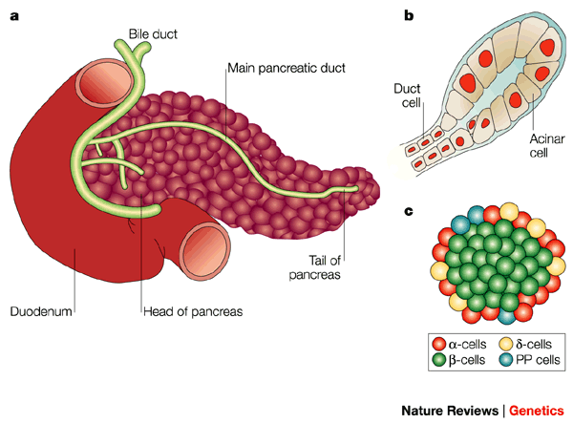
Figure 1.1: Schematic of a pancreas. a) The mature pancreas sits next to the duodenum. b) Exocrine pancreas: Acinar cells produce digestive juices to be secreted via ducts to the duodenum. c) Endocrine pancreas: Islets made up of four hormone-producing cell types: α-cells, β-cells, δ-cells and pancreatic polypeptide (PP) cells. They produce glucagon, insulin, somatostatin and PP respectively. Figure reprinted by permission from Macmillan Publishers Ltd: Nature Publishing Group (Edlund, 2002) ©2002

Table 1.1 lists types of exocrine PaCa, which account for 95% of all PaCa, the most common being ductal adenocarcinoma (PDAC). PDAC originates in ducts that secrete pancreatic digestive enzymes that pass through the pancreatic and then the common bile duct to the duodenum (Figure 1.1b).

Table 1.1: Types of exocrine pancreatic tumours
Types of exocrine tumours | Description
Cancerous
Pancreatic ductal adenocarcinoma | 95% of exocrine PaCa, develop from duct or acinar cells, mostly found in pancreas head
Ampullary cancer | Develops in ampulla of Vater, blocks bile duct leading to jaundice
Benign and pre-cancerous
Intraductal papillary mucinous neoplasm with invasive carcinoma | Develop finger-like projections into  pancreatic duct secreting mucus,  occur mostly in older men
Mucinous cystic neoplasm with invasive carcinoma | Cystic tumours filled with thick mucus  in body of tail of pancreas,  occur almost exclusively in middle-aged women
Pancreatoblastoma | Found predominantly in children, associated with Beckwith-Wiedemann syndrome
Serous cystadenocarcinoma | Develop from benign cysts containing watery fluid
Solid pseudopapillary neoplasm | Parts of tumour are solid and parts are  cystic with finger-like projections,  mostly found in younger woman and not aggressive

Table 1.2 lists types of endocrine tumours that account for the remaining 5% of PaCa and these have a better prognosis (five-year survival rate 42% vs. 4%) compared to PDAC, (SEER, 2018). This is due to a subset of endocrine tumours being functioning (hormone-secreting) and causing a noticeable set of symptoms, allowing the tumours to be detected earlier than non-functioning or exocrine tumours. Endocrine tumours develop in islet cells that produce hormones including insulin, somatostatin and PP (Figure 1.1c).
Table 1.2: Types of endocrine pancreatic tumours
Types of endocrine tumours | Description
Gastrinomas  (Zollinger-Ellison syndrome) | 2nd most common endocrine tumour (half are cancerous), develop in pancreas head or duodenum, over-produce gastrin causing peptic ulcers
Glucagonomas | Most are cancerous, develop in pancreas tail and metastatic, over-produce glucagon which regulates blood sugar, occur mostly in post-menopausal women
Insulinomas | Most common endocrine tumour (mostly benign), over-produce insulin causing hypoglycaemia,  occur mostly in middle-aged women
Somatostatinomas | Most are cancerous, over-produce somatostatin causing gallstones, diabetes, diarrhoea, fatty stool,  occur mostly in women
VIPomas | Most are cancerous, develop in pancreas tail, over-produce VIP (vasoactive intestinal polypeptide) causing watery diarrhoea and Verner-Morrison syndrome,  occur mostly in women
Non-functioning | Does not cause noticeable symptoms as it does not over-produce hormones, often found in tests for other diseases

Diagnosis and staging of PaCa
As mentioned in Section 1.1, early stages of PDAC can be asymptomatic and difficult to diagnose. Most clear symptoms only manifest in advanced disease. This results in PaCa having one of the lowest one-year survival rates (20% vs. 96% in breast cancer) compared to other cancers (Cancer Research UK, 2014). Common early symptoms include perceived back pain, non-specific abdominal discomfort, indigestion and mild weight loss (Loc et al., 2014). Some patients may also have recently diagnosed diabetes, within two years before PaCa diagnosis (Gullo et al., 1994). If jaundice develops, it is usually a sign that the tumour mass has obstructed the bile duct, preventing the flow of bile to the duodenum, leading to bilirubin accumulation in the system (van der Gaag et al., 2009). This coincides with a change in stool colour due to reduction of stercobilin (breakdown product of bilirubin) in the faeces.
Table 1.3 shows how the TNM (tumour, node, and metastasis) system takes into account tumour size as well as its spread into adjacent lymph nodes or distant sites. Table 1.4 shows how clinical PaCa staging correlates with the TNM system, as well as tumour location, percentage of cases at diagnosis and 1-year survival rates. Endocrine tumours are also graded by Ki67 proliferation index, where well- and poorly-differentiated tumours have less or more than 20% Ki6-positive tumour cells, respectively (Hamilton et al., 2012).
Table 1.3: TNM staging system
T (Tumour)
T1 | Tumour completely in pancreas, <2cm
T2 | 2-4cm
T3 | >4cm
T4 | Tumour grown outside pancreas into nearby large blood vessels
N (Nodes)
N0 | No lymph nodes contain cancer cells
N1 | 1-3 lymph nodes contain cancer cells
N2 | >4 lymph nodes contain cancer cells
M (Metastasis)
M0 | Cancer not spread to distant organs
M1 | Cancer spread to distant organs

Table 1.4: Clinical PaCa staging/grading and how it associates with tumour, node and metastasis (TNM) staging system, location and size of tumour, proportion of cases at diagnosis and 1-year survival rates
Stage/ Grade | TNM system | Location of cancer | Size | % cases stage at diagnosis | 1-year survival
1a | T1, N0, M0 | Completely in pancreas | <2cm | 4-6% | 76%
1b | T2, N0, M0 | Completely in pancreas | 2-4cm | 4-6% | 49%
2a | T3, N0, M0 | Gone into surrounding tissues (duodenum, bile duct) | >4cm | 10-11% | 48%
2b | T1-3, N1, M0 | Gone into surrounding tissues and 1-3 nearby lymph nodes | Any size | 10-11% | 45%
3 | T4, NX, M0 | Grown outside pancreas into nearby large blood vessel | Any size | 7-9% | 28%
4 | TX, NX, M1 | Cancer has spread to other areas of body  (e.g. liver, lungs) | Any size | 47-54% | 8%
X in TNM: any category; Data in table summarised from Cancer Research UK and Surveillance, Epidemiology and End Results Program (National Cancer Institute). Data available from:
https://www.cancerresearchuk.org/sites/default/files/cstream-node/inc_by_stage_pancreas.pdf, accessed September 2018;
https://seer.cancer.gov/csr/1975_2015, accessed September 2018

Currently, the only FDA approved biomarker for PaCa is carbohydrate antigen 19-9 (CA 19-9) in serum. However, it is still considered a poor biomarker for PDAC as the median sensitivity and specificity of CA 19-9 is 79% and 82%, respectively (Goonetilleke and Siriwardena, 2007). Using elevated CA 19-9 serum levels to screen for PDAC yields an even more dismal positive predictive value of 0.5-0.9% (Ballehaninna and Chamberlain, 2012). Additionally, CA 19-9 is a sialyl Lewis antigen, meaning PaCa patients with Lewis-null blood type (5-10% of the Caucasian population) do not produce CA 19-9, resulting in false negative results (Goonetilleke and Siriwardena, 2007). Lastly, elevated CA 19-9 levels are also implicated in a variety of diseases including acute and chronic pancreatitis, hepatitis and cholangiocarcinoma. Other PaCa markers – including amylase, immunoreactive elastase and carcinoembryonic antigen – have lower sensitivities and specificities and are also up-regulated in pancreatic diseases and other malignancies (Pezzilli et al., 2016, Hamano et al., 1987, Carpelan-Holmstrom et al., 2002). Currently, no well-established diagnostic test exists for early and accurate PaCa detection, although differences in volatile organic compounds in breath offer the possibility of earlier detection (Markar et al., 2018). Recently, a cohort study protocol was published to detect PaCa in new-onset diabetic patients using adrenomedullin (ADM) as a marker to delineate high or low-risk populations (Antolino et al., 2018).

Treatment
Treatment options for PaCa patients depend on disease stage, as shown in Figure 1.2. Surgery is only an option for patients whose tumours have not spread locally and beyond the pancreas (Stages 1-2, Section 1.1.2.1). Once the tumours have become locally advanced and found in major blood vessels and lymph nodes (Stage 3), chemotherapy is the treatment of choice with surgery only being an option for symptomatic relief of jaundice or bowel blockage (Jinkins et al., 2013). In metastatic PaCa (Stage 4), chemotherapy is not curative and only offered to shrink the tumour or to relieve symptoms associated with advanced disease. The various chemotherapeutics used (alone or in cocktails) to treat or relieve symptoms of PaCa will be explored in Section 1.1.2.2. Interestingly, radiotherapy is not currently offered to treat local or advanced PaCa even though it is used for curative treatment of 20-55% of other cancers worldwide (Delaney et al., 2005), and this will be explained in Section 1.1.2.3.
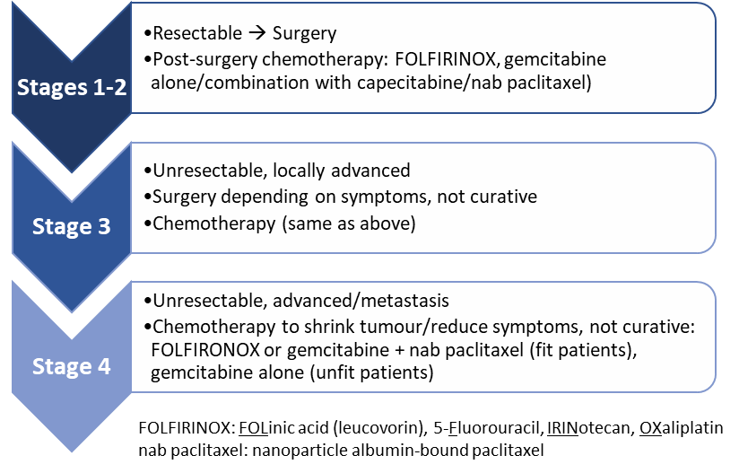
Figure 1.2: Treatment options for various stages of pancreatic cancer

1.1.2.1 Surgical resection of PaCa
Surgery is only available for patients whose PaCa have not metastasised (Stages 1 and 2), and this only occurs in 27% of patients according to pre-recruitment figures for European Study Group for Pancreatic Cancer (ESPAC) trials (Wagner et al., 2004). Depending on where the tumour is located in the pancreas and how much it has spread to surrounding tissues, patients could undergo various types of major operations for resection. The surgery could include partial or complete removal of specific organs adjacent to the pancreas. Table 1.5 shows the types of surgery available for PaCa and the respective tissues that are removed in addition to the primary tumour.
Table 1.5: Types of PaCa surgeries and organs that are resected
 | PPPD | Whipple’s | Distal pancreatectomy | Total pancreatectomy
Pancreas | Head | Head | Body and tail | Whole
Duodenum | Whole | Whole | - | Whole
Gallbladder | Whole | Whole | - | Whole
Bile duct | Part of | Part of | - | Part of
Stomach | - | Part of | - | Part of
Spleen | - | - | Whole | Whole
Surrounding lymph nodes | - | - | - | Many
PPPD: Pylorus Preserving PancreaticoDuodenectomy
Surgical resection has been shown to increase median survival (8.4 vs. 19.1 months, p<0.0001) as well as one-year (69.8% vs. 26.8%, p<0.0001) and five-year survival rates (24.6% vs. 2.9%, p<0.0001) in patients with stage 1 PaCa compared to no surgery (Bilimoria et al., 2007). However, resection has also been shown to induce dissemination of occult tumour cells into the peritoneal cavity in a third of PaCa patients (Steen et al., 2018).
Adjuvant chemotherapy is offered to patients after resection to improve survival and prolong time to recurrence. In the ESPAC-1 trial, adjuvant 5-fluorouracil (5-FU) based chemotherapy has been shown to significantly increase median survival (19.7 vs. 14.0 months, p<0.001) in patients with resected PaCa compared to patients without (Neoptolemos et al., 2001). A retrospective study of stage 1 and 2 PaCa patients who have undergone surgical resection in Ohio State University showed that while recurrence rates (33% vs. 27%) were similar between patients with adjuvant chemotherapy and without, median time to recurrence (13.7 vs. 4.2 months, p<0.001) was significantly improved (Martin et al., 2014).
Obstructive jaundice is a common presenting symptom amongst PaCa patients, thus pre-operative biliary stenting was introduced in the 1960s in a bid to reduce post-operative morbidity and mortality after surgical resection (Denning et al., 1981). Despite its initial positive intentions, pre-operative biliary stenting has recently been shown to result in contrary outcomes with respect to resection, such as increases in pre-operative infection and post-operative complication rates (Scheufele et al., 2017). Thus, it is currently only offered to patients with severe jaundice, undergoing neo-adjuvant therapy or postponed surgical resection (Jinkins et al., 2013).

1.1.2.2 Chemotherapeutic agents used to treat PaCa
Chemotherapy is used in early stages (1 and 2) PaCa post-operatively to decrease chances of recurrence, or in late stages (3 and 4) PaCa to or to shrink tumours and relieve tumour-associated symptoms.
Table 1.6 lists chemotherapeutic agents currently used to treat PaCa, either on their own or in combination chemotherapy regimens shown in Figure 1.2.
Table 1.6: Chemotherapeutic agents used to treat PaCa and their modes of action
TS: thymidylate synthase
FOLFIRINOX: FOLinic acid (leucovorin), 5-Fluorouracil, IRINotecan, OXaliplatin;
Nab paclitaxel: nanoparticle albumin-bound paclitaxel

Chemotherapeutic agent | Other names | Mode of action | Reference
5-fluorouracil | Adrucil, part of FOLFIRINOX | Inhibits TS prevents DNA synthesis cell death | (Sommer and Santi, 1974)
Capecitabine | Xeloda | Inhibits TS prevents DNA synthesis cell death | (Miwa et al., 1998)
Gemcitabine | Gemzar | Masquerades as cytidine + inhibits TS prevents DNA synthesis cell death | (Plunkett et al., 1995, Honeywell et al., 2015)
Irinotecan | Camptosar, part of FOLFIRINOX | Inhibits topoisomerase I prevents DNA synthesis cell death | (Jacob et al., 2001)
Oxaliplatin | Eloxatin, part of FOLFIRINOX | Forms cross-links in DNA prevents DNA synthesis cell death | (Faivre et al., 2003)
Nab-paclitaxel | Abraxane | Inhibits microtubule reorganisation + induces multipolar divisions  cell death | (Horwitz, 1994, Zasadil et al., 2014)
5-FU was the first chemotherapeutic agent evaluated for advanced PaCa. ESPAC-1 trial showed that adjuvant 5-FU improved median survival (19.7 vs. 14.0 months, p<0.001) in patients with resected PaCa compared to no treatment (Neoptolemos et al., 2001). 5-FU’s active metabolite (fluorodeoxyuridine monophosphate, FdUMP) inhibits thymidylate synthase (TS) by forming a stable complex with it, impeding dTMP synthesis and leading to nucleotide imbalance (Sommer and Santi, 1974). FdUMP also prevents deoxyuridine monophosphate (dUMP) from binding to TS, resulting in an accumulation of dUMP. Tri-phosphorylated dUMP and FdUMP (dUTP and FdUTP) can be misincorporated into DNA resulting in irreparable DNA damage and eventually cell death (Lindahl, 1974).
Gemcitabine is another commonly used chemotherapeutic agent used to treat PaCa, especially in patients who are not fit enough to tolerate 5-FU chemotherapy cocktails (e.g. FOLFIRINOX). Gemcitabine, like 5-FU, is a pyrimidine analog. Misincorporation of gemcitabine triphosphate (dFdCTP) results in irreparable DNA damage leading to cell death (Plunkett et al., 1995). Recently, it has also been shown that gemcitabine’s metabolite, dFdUMP, can also inhibit TS in the same manner as 5-FU (Honeywell et al., 2015). In 1997, gemcitabine was the second drug after 5-FU to be approved by the FDA to treat advanced PaCa. In patients with metastatic PaCa, gemcitabine improved survival duration (5.65 vs. 4.41 months, p<0.01) and response (23.8% vs. 4.8%, p<0.01) compared to 5-FU (Burris et al., 1997). ESPAC-3 trial also revealed that in PaCa patients with resected tumours, while adjuvant gemcitabine did not improve overall and progression-free survival compared to adjuvant 5-FU, it did result in less treatment-related serious adverse effects (7.5% vs. 14%, p<0.001) although this did not significantly improve their quality of life (Neoptolemos et al., 2010).
Capecitabine is another chemotherapeutic agent that is offered in PaCa treatment regimens in combination with gemcitabine. Capecitabine is a 5-FU prodrug developed to improve tolerability and intratumour concentrations compared to other 5-FU derivatives (Miwa et al., 1998). ESPAC-4 trial showed in patients with resected PaCa that capecitabine plus gemcitabine increased 5-year overall survival (28.8% vs. 16.3%, p<0.05) and median survival time (28.0 vs. 25.5 months, p<0.05) compared to gemcitabine alone (Cunningham et al., 2009). There were also no differences in treatment-related serious adverse events and quality of life, suggesting that capecitabine has a better safety profile than 5-FU.
Irinotecan and oxaliplatin are two other chemotherapeutics that are part of the FOLFIRINOX regimen. Activated irinotecan (SN-38) binds to topoisomerase I-DNA cleavage complex preventing re-ligation of DNA strands, causing double-strand DNA breakage and cell death (Jacob et al., 2001). Oxaliplatin forms intra- and inter-strand crosslinks in DNA, inhibiting DNA replication and transcription leading to cell death (Faivre et al., 2003, Woynarowski et al., 2000). In 2011, FOLFIRINOX overtook gemcitabine as first-line treatment for advanced PaCa. In the PRODIGE 4/ACCORD 11 trial, FOLFIRINOX resulted in better median overall survival (11.1 vs. 6.8 months, p<0.001), median progression-free survival (6.4 vs. 3.3 months, p<0.001) and response rate (31.6% vs. 9.4%, p<0.001) in patients with metastatic PaCa compared to gemcitabine alone (Conroy et al., 2011). However, FOLFIRINOX had significantly more grade 3 or 4 adverse events compared to gemcitabine. Thus, FOLFIRINOX is first-line treatment only for advanced PaCa patients with good performance status according to Eastern Cooperative Oncology Group guidelines where they are fully active (ECOG grade 0) or able to carry out light or sedentary work but restricted in physically strenuous activities (ECOG grade 1).
Lastly, albumin-bound nanoparticle form of paclitaxel (nab-paclitaxel) is a chemotherapeutic agent approved to treat PaCa. Paclitaxel inhibits reorganisation of the microtubule network, blocking cells in G2/M phase of the cell cycle and leading to cell death (Horwitz, 1994). However, it has been more recently hypothesised that paclitaxel kills breast tumour cells by inducing multipolar divisions resulting in daughter cells with aneuploidy which die due to loss of essential chromosomes (Zasadil et al., 2014). In the MPACT trial, nab-paclitaxel in combination with gemcitabine has also been shown to increase overall survival (8.5 vs. 6.7 months, p<0.05), progression-free survival (5.5 vs. 3.7 months, p<0.001) and response rate (23% vs. 7%, p<0.001) in advanced PaCa patients compared to gemcitabine alone (Von Hoff et al., 2013). Additionally, an important prognostic marker in PaCa patients receiving nab-paclitaxel is osteonectin (SPARC), a protein that binds albumin. This enables SPARC positive tumours to have increased accumulation of paclitaxel due to the binding of SPARC to albumin-conjugated paclitaxel (Desai et al., 2009). In patients treated with nab-paclitaxel and gemcitabine, patients with positive SPARC status had significant increase in overall survival (17.8 vs. 8.1 months, p<0.05) compared to patients with a negative SPARC status (Von Hoff et al., 2011).

1.1.2.3 Radiotherapy for PaCa patients
Compared to other treatment strategies for PaCa (resection or chemotherapy), radiotherapy is not commonly offered to PaCa patients. Radiotherapy has been shown in clinical trials and meta-analyses to offer no additional benefits to PaCa patients when used alone or in combination with other treatment regimens such as chemotherapy or palliative care. In the LAP07 trial, chemoradiation did not improve overall survival (15.2 vs. 16.5 months, not significant) compared to chemotherapy in stage 3 PaCa patients who had previously been treated with gemcitabine with or without tyrosine kinase inhibitor erlotinib (Hammel et al., 2016). Moreover, a safer regimen of radiotherapy which more specifically targets tumour tissues (stereotactic body radiation therapy, SBRT) similarly failed to improve overall survival (18.8 vs. 13.6 months, not significant) in stage 3 PaCa patients compared to conventional chemoradiation (Wild et al., 2016). However, SBRT resulted in significantly less severe radiation-induced lymphopenia (13.8% vs. 71.7%, p<0.001) compared to chemoradiation.

Risk Factors
While survival rates of other cancers have been greatly improved comparing rates from 2010-2011 and 1970s, such as breast (ten-year survival from 40% to 75%) and prostate (ten-year survival from 25% to 80%) cancers, PaCa ten-year survival rates have not changed from 1% (Cancer Research UK, 2015b). Incidence rates of PaCa have also increased by 9-11% comparing incidence rates from 2003-2005 and 2013-2015 (Cancer Research UK, 2015b). This is due to the increase in PaCa-associated risk factors which include smoking, reproductive factors (hormones and parity) and type 2 diabetes mellitus (new-onset DM).
Even though one of the major risk factors for PaCa is smoking, its relationship remains contentious. A pooled analysis of second primary PaCa revealed connections with smoking-related cancers (Shen et al., 2006). One proposed mechanism is that nicotine promotes growth and metastasis of PaCa via hepatocyte growth factor-induced c-Met activation (Delitto et al., 2015).
PaCa has also been shown to have an association with both male and female sex hormones. PaCa is positively associated with previous uterine and ovarian cancer yet has an inverse relationship with prostate cancer (Shen et al., 2006). Higher estradiol levels were found in males and females with PaCa, compared to healthy volunteers (Fyssas et al., 1997). High parity (number of times given birth) is also linked with lower risk of PaCa death (Teras et al., 2005). After ovarian and breast cancer, PaCa is the third cancer associated with germline BRCA1/2 mutations, in addition to sex hormone dysregulation (Lynch et al., 2005, Thompson et al., 2001). The combined evidence suggest that the various sex hormones (estrogens, progestogens and androgens) could be differentially involved in PaCa, having either a positive or negative association.
Diabetes mellitus (DM) is an independent risk factor for PaCa. A meta-analysis of DM and PaCa revealed that the risk increase is two-fold (Ben et al., 2011). However, studies are equivocal on whether PaCa affects development of diabetes or vice versa. Metabolic abnormalities of diabetes, such as hyperglycaemia, could fuel oncogenic pathways promoting cancer growth, migration and invasion (Ryu et al., 2014). On the other hand, PaCa cells have been shown to inhibit insulin signalling in β-cells, a mechanism by which PaCa could lead to new-onset DM (Aggarwal et al., 2012). A biological basis for the epidemiological link between DM and PaCa was identified to be ADM expression.
In addition to being a potential link between PaCa and DM, ADM has also been shown to be up-regulated in many types of cancers and has been shown to augment cancer-promoting pathways resulting in increased proliferation and angiogenesis, apoptosis and immune evasion as well as therapeutic resistance. Section 1.2 will introduce ADM expression, signal transduction and physiological function. The link between dysregulated ADM signalling cancer-promoting pathways will be discussed in Section 1.3.
  - Adrenomedullin (ADM)
ADM is a peptide of 52 amino acids (a.a.) and 6 kDa. It belongs to the calcitonin superfamily which includes amylin (AMY), calcitonin gene-related peptide (CGRP) and intermedin (IMD or adrenomedullin-2) (Muff et al., 2003). They share similar secondary structures consisting of an amino acid ring formed by a disulphide bond and an amidated carboxyl terminus (Roh et al., 2004). Circulating ADM in plasma has a short half-life of 16-20 minutes and binds to complement protein factor H, rendering it undetectable (Pio et al., 2002, Dupuis et al., 2005). Plasma concentrations of ADM in healthy controls have been shown in at least 15 independent studies to range between 1-10 pM (Hinson et al., 2000). Section 1.2.1 will detail the process of ADM gene and protein expression.
    - Gene and protein expression
ADM expression is encoded by ADM gene and is found on human chromosome 11p15.4. Figure 1.3 shows the schematic of how the primary translational ADM product is cleaved and processed into its final circulating forms. Pre-proADM (185 a.a.) is cleaved at N-terminus to form pro-ADM, a precursor of mature ADM (a.a. 95-146) and associated peptides including pro-ADM N-terminal 20-peptide (PAMP, a.a. 22-42), mid-regional pro-ADM (MR-proADM, a.a. 45-92) and C-terminally glycine-extended adrenomedullin (CT-proADM also known as adrenotensin, a.a. 153-185) (Beltowski and Jamroz, 2004). Pro-ADM is further cleaved into circulation into biologically active ADM and associated peptides (PAMP, MR-proADM and CT-proADM).
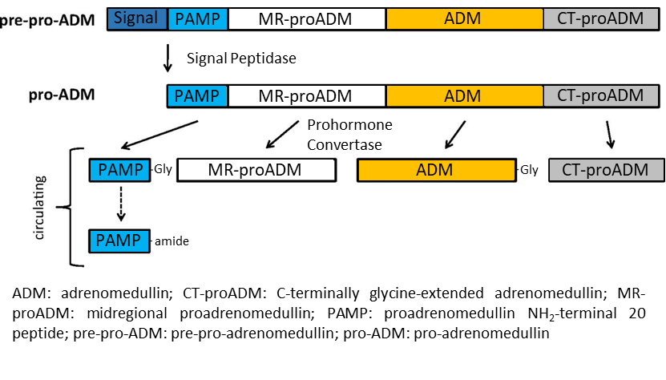Figure 1.3: Schematic of biogenesis of adrenomedullin from primary translational product to biologically active ADM and associated peptides. Figure adapted with permission from Macmillan Publishers Ltd: Elsevier (Weber et al., 2017) ©2017
Oxidative stress and inflammatory molecules like tumour necrosis factor α (TNF-α) can increase ADM secretion (Drimal and Drimal, 2006). Hypoxia is also a potent ADM inducer. This is mediated by hypoxia-inducible-factor-1 (HIF-1) transactivation of ADM promoter and post-transcriptional mRNA stabilisation (Garayoa et al., 2000).
    - Receptors
ADM primarily functions through the combination of a G protein-coupled receptor (GPCR) and a receptor activity-modifying protein (RAMP). These are detailed in the following sections (Section 1.2.2.1 to 1.2.2.3). Section 1.2.2.4 will elaborate on ADM’s association with other receptors.
      - G-protein coupled receptors
GPCRs contain an N-terminal extracellular domain for ligand binding, a seven-transmembrane domain and a C-terminal intracellular domain for signalling to secondary messengers (Liebmann, 2004). Table 1.7 lists the GPCR superfamily classes. Receptors that bind to ADM and other calcitonin superfamily peptides fall in Class B – calcitonin receptor (CTR) and calcitonin receptor-like receptor (CLR).
Table 1.7: GPCR superfamily classes
cAMP: cyclic adenosine monophosphate; CaSR: calcium-sensing receptor; CLR: calcitonin receptor-like receptor; CTR: calcitonin receptor; GABA_{B}: gamma-aminobutyric acid class B; PTHR: parathyroid hormone receptor

Class | Receptor Family | Examples
A | Rhodopsin-like | Rhodopsin, histamine receptors
B | Secretin | CTR, CLR, PTHR
C | Metabotropic glutamate | CaSR, GABA_{B} receptors
D | Fungal pheromone | Mating factor receptors
E | cAMP | Serpentine receptors
F | Frizzled-type | Frizzled and Smoothened receptors
Recent research has purported that the paradigm of GPCR activation is more complex than just an on/off mechanism. A single receptor can bind to different ligands, exist in multiple confirmations and subsequently result in activation/inactivation of G protein signalling pathways. This is thought to be due to the complexing of GPCRs with different RAMPs, resulting in completely different receptor complexes (further elaborated in Section 1.2.2.3).
      - Calcitonin receptor-like Receptor (CLR)
CLR gene is located in human chromosome 2q31 sharing 54% sequence identity with CTR (Sexton et al., 2006). CLR protein is approximately 70 kDa and varies depending on glycosylation (McLatchie et al., 1998). Unlike most GPCRs, CLR requires association with RAMPs (Section 1.2.2.3) for cell-surface trafficking and ligand specificity (Hilairet et al., 2001). This is achieved through terminal or core glycosylation of CLR (Flahaut et al., 2002). Once the CLR/RAMP receptor complex is co-trafficked to the cell surface, ligand binding can then activate downstream signalling as detailed in Section 1.2.3.
      - Receptor activity-modifying proteins
The three members in the human RAMP family (RAMP-1, RAMP-2 and RAMP-3) have low amino acid sequence homology (31% identical, 56% similar) with each other (McLatchie et al., 1998). RAMP-1 and RAMP-3 are 148 a.a. long while RAMP-2 is 175 a.a. long. Genes encoding RAMP-1, -2 and -3 are found in human chromosomes 2q36-q37.1, 17q12-q21.1 and 7p11-7p13 respectively (Derst et al., 2000). RAMPs are approximately 14 to 17 kDa and comprise of a large extracellular N terminus (~100 a.a.), single transmembrane domain and short intracellular domain (~10 a.a.) (McLatchie et al., 1998).
RAMPs are distributed in more sites around the body than CLR, suggesting they have additional roles beyond association with CLR. RAMPs can associate with other GPCRs to alter their pharmacology, trafficking and signalling consequences.
Firstly, the association of different RAMPs to a receptor can subtly change its conformation to result in a pharmacologically different receptor complex that favours different ligands. For example, CLR and CTR can bind to each of the three RAMPs resulting in receptor complexes with different potencies for calcitonin superfamily ligands, as shown in Table 1.8. ADM not only binds to AM1R and AM2R but also with CGRPR, albeit at a lower affinity. This makes it tricky to pinpoint which ligand/receptor combinations are responsible for physiological and pathological manifestations.
Secondly, RAMPs are also responsible for trafficking of GPCRs to the cell surface. RAMP-1 forms heterodimers with CLR before transporting it from endoplasmic reticulum to the cell surface, as shown in co-transfection studies in Xenopus oocytes (Flahaut et al., 2002). RAMP-1 and RAMP-3 have also been shown to traffic calcium sensing receptor (CaSR) for cell surface expression in COS-7 cells (Bouschet et al., 2005). However, presence of RAMPs is not sufficient for cell surface expression of GPCRs. Glycosylation of RAMPs may additionally be required. Co-transfection studies in Xenopus oocytes showed N-glycosylation of RAMP-2 and RAMP-3 is integral for cell surface trafficking prior to binding with CLR (Flahaut et al., 2002).
Table 1.8: Rank order of calcitonin superfamily potencies for CLR/RAMP and CTR/RAMP receptor complexes
ADM: adrenomedullin; AMY: amylin; CGRP: calcitonin gene-related peptide; CLR: calcitonin receptor-like receptor; CT: calcitonin; CTR: calcitonin receptor; IMD: intermedin
Table adapted with permission from Macmillan Publishers Ltd: Elsevier (Hay et al., 2006) ©2006

Receptor complexes | Rank order of potency
CLR/RAMP-1 (CGRPR) | CGRP > ADM ≥ IMD > AMY
CLR/RAMP-2 (AM1R) | ADM > IMD > CGRP, AMY
CLR/RAMP-3 (AM2R) | ADM ≥ IMD ≥ CGRP > AMY
CTR/RAMP-1 (AMY1R) | AMY ≥ CGRP > IMD ≥ CT > ADM
CTR/RAMP-2 (AMY2R) | Poorly defined
CTR/RAMP-3 (AMY3R) | AMY > CGRP ≥ IMD ≥ CT > ADM
CTR only | CT > AMY, CGRP > ADM, IMD
Lastly, RAMPs can also modulate downstream signalling in GPCRs. Co-expression studies showed that interaction of different RAMPs with CTR can alter G-protein coupling efficiencies, resulting in different signalling profile between them or in the absence of RAMPs (Morfis et al., 2008). In COS-7 and HEK-293 cells, CTR co-expressed with RAMP-1 or RAMP-3 had 20- to 30-fold AMY potency for cAMP production, compared to either CTR alone or co-expressed with RAMP-2. However, only a mild increase in AMY potency was seen for ERK1/2 activation and Ca²⁺ mobilisation (2 to 5-fold).
      - Other Adrenomedullin Receptors
ADM has previously been shown to bind to other GPCRs such as ADMR and RDC1. However, they are not considered to be genuine ADM receptors (Hay et al., 2011). ADMR is now known as orphan GPCR GPR182. RDC1 expression does correlate with ADM expression in various cell types including monocytes and pheochromocytomas, but studies have yet to show direct ADM binding effects (Bosco et al., 2006, Thouënnon et al., 2010).
    - Signal Transduction
ADM mainly activates three signalling pathways – cAMP, Akt and mitogen-activated protein kinase (MAPK). These pathways are outlined in Figure 1.4.
Increased cAMP levels lead to relaxation of vascular cells and cardiac monocytes (Shimekake et al., 1995, Ikeda et al., 1996). Increased protein kinase A (PKA) activation is also growth-inhibitory (Shichiri and Hirata, 2003). ADM also stimulates calcium influx via PKA, which has been shown to activate nitric oxide synthase and release in SK-N-SH neuroblastoma cells (Xu and Krukoff, 2005). In vascular endothelial cells (VEC), Akt activation regulates vasodilation, growth, migration and cord-like structure formation (Fernandez-Sauze et al., 2004). ADM can both stimulate and inhibit proliferation through MAPK pathways. ADM promotes VEC proliferation through extracellular signal-regulated kinase (ERK) downstream pathways (Fritz-Six et al., 2008). In glomerular mesangial cells, ADM activates apoptosis through activation of other kinases including PKA, c-Jun N-terminal kinase (JNK) and protein phosphatase 2A (Kitamura et al., 1993).
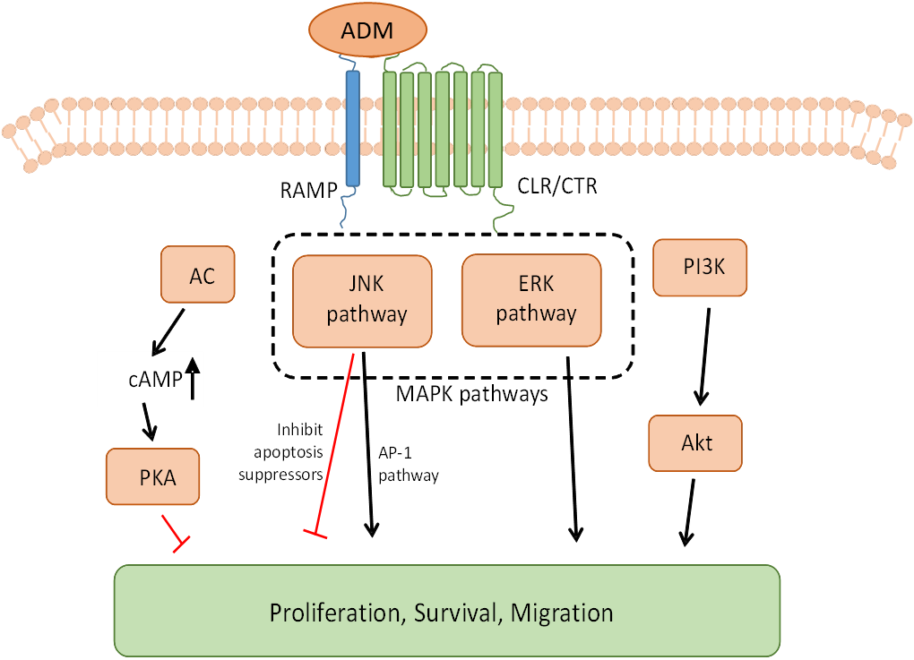
Figure 1.4: ADM mainly activates three signalling pathways: cAMP, MAPK and Akt. Binding of ADM to its receptors can activate pathways that either stimulate or inhibit cell growth. Activating adenylyl cyclase (AC) increases cAMP levels, which in turn activates protein kinase A (PKA). One of PKA’s effects is growth inhibitory. MAPK signalling can be growth-stimulatory [extracellular-related kinase (ERK) and c-Jun N-terminal kinase (JNK)-AP-1 pathways] or growth-inhibitory [JNK inhibition of apoptosis suppressors like Bcl-2]. Lastly, activation of phosphoinositide-3-kinase (PI3K) promotes Akt activation, which stimulates cell growth.
    - Biological Functions of Adrenomedullin
Figure 1.5 shows an overview of ADM’s physiological and pathophysiological functions. Most of ADM’s functions in various organs (e.g. female tissues, kidney and bladder) involve mediation of vasodilation. Similar to CGRP, which is another member of the calcitonin family of peptides, ADM induces hypotension via nitric oxide release (Miura et al., 1995). ADM mediates vasodilation of vascular endothelial cells and smooth muscle cells (SMCs) through cAMP/calcium calmodulin and cAMP/Akt pathways respectively (Yallampalli et al., 2013). More specifically, AM2R have been shown to primarily mediated ADM’s vasodilator effects in SMCs through cAMP/Akt pathways (Chauhan et al., 2015).
Other physiological effects mediated by ADM (e.g. female tissues, kidney, bladder and immunity) will be discussed in Chapter 3. While ADM is crucial for homeostasis, it can also lead to pathological functions when dysregulated. ADM is associated with various diseases including diabetes, hypertension, heart failure and renal failure (Martínez et al., 1999, Kohno et al., 1996, Nishikimi et al., 2003, Nishikimi et al., 2001). The next section will elaborate on its regulation of different cancer hallmarks in various cancers.
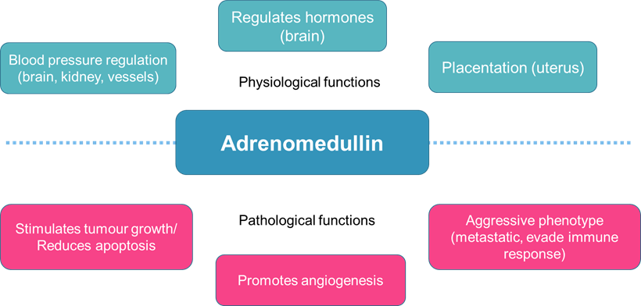
Figure 1.5: ADM regulates both physiological and pathological functions in various organs. While ADM is essential to sustain regulation of blood pressure and hormone secretion, dysregulation of ADM signalling could result in stimulation of pathways that promote cancer growth and metastasis.
  - Adrenomedullin and Cancer
As a tumour grows, it will eventually outgrow its blood supply. This results in regions of the tumour with lower oxygen concentration than normal as oxygen is consumed by the rapidly dividing tumour cells adjacent to existing blood vasculature and this phenomena is called hypoxia. One of the molecules up-regulated to continually promote tumour cell proliferation is ADM. This has been shown in various types of cancers including colorectal and pancreatic (Nouguerède et al., 2013, Keleg et al., 2007). It is currently accepted that ADM’s pro-tumoural effect is primarily driven through its regulation of angiogenesis, leading to the tumour establishing more vasculature to continue supporting its growth and metastasis to distant organs. The subsequent sections will detail the effect of ADM on various cancer hallmarks and the signalling pathways that are involved in each of those hallmarks.
    - Adrenomedullin and Proliferation
ADM regulates proliferation through several pathways, outlined in Figure 1.6. In Du145 prostate cancer and T47D breast cancer cells, ADM significantly increased in vitro proliferation via the Ras-Raf-MEK-ERK pathway. Up-regulation of Raf-1, MEK1/2 and ERK1/2 proteins were detected in Du145 prostate cancer after 10 minutes of ADM treatment (Berenguer-Daizé et al., 2013). Another pathway involves JNK and AP-1, possibly in a positive feedback loop. ADM-overexpressing T47D breast cancer cells had increased levels of Ras, Raf, PKC and MAPKp49 (JNK) oncogenic proteins (Martínez et al., 2002). ADM stimulates glioblastoma proliferation by inducing c-Jun and JNK phosphorylation, which increases activator protein-1 (AP-1) DNA binding activity and cyclin D1 levels (Ouafik et al., 2009). Basic fibroblast growth factor (b-FGF) can induce ADM expression in a time- and dose-dependent manner through the JNK-AP-1 pathway in CAOV3 ovarian cancer cells (Zhang et al., 2009). AP-1 was shown to bind to ADM promoter, which is critical for b-FGF-induced ADM expression.
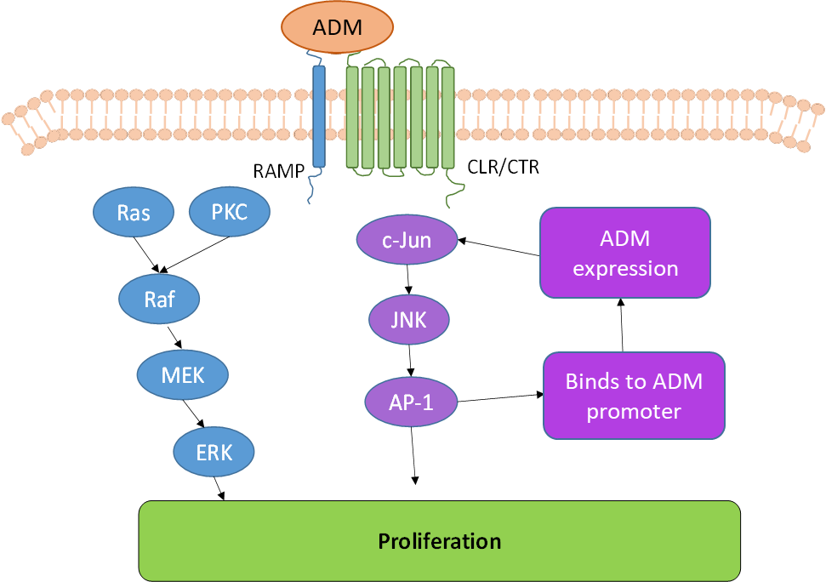
Figure 1.6: ADM promotes tumour proliferation through Ras-Raf-MEK-ERK pathway and positive feedback loop via JNK-AP-1 pathway. Binding of ADM to its receptor can up-regulate Ras and protein kinase C (PKC) activation of the MEK-ERK signalling cascade. c-Jun can also be activated and signal through the JNK-AP-1 pathway. AP-1 has also been shown to bind to ADM promoter, further promoting ADM-expression in a positive feedback loop.

ADM both stimulates and inhibits proliferation of tumour cells, depending on cell type and treatment duration. Short-term ADM treatment (under 20 minutes) increased ERK1/2 phosphorylation, whereas long-term treatment (40-60 minutes) had the opposite effect in PC-3 prostate cancer cells (Abasolo et al., 2004). The same was observed for Raf-1, MEK1/2 and ERK1/2 phosphorylation in Du145 prostate cancer cells (Berenguer-Daizé et al., 2013).
ADM has also been shown to also stimulate and inhibit tumour proliferation in a non-dose responsive manner. In Capan-1, Colo-357 and Panc-1 PaCa cells, recombinant bioactive ADM (rADM) stimulated in vitro growth at lower concentrations (1 nM) and inhibited growth at higher concentrations (100 to 1000 nM) (Keleg et al., 2007).
ADM stimulates growth of clear-cell-carcinomas, colorectal cancer and PDAC. Inhibition of BIZ and 786-O clear-cell-carcinomas proliferation was observed in vitro when anti-ADM or anti-ADM receptors (anti-CLR, anti-RAMP-2 and anti-RAMP-3; also known as anti-AMR) were administered (Deville et al., 2009). The same was observed in HT-26 colorectal cancer cells (Nouguerède et al., 2013). This suggests ADM-induced proliferation in clear-cell-carcinomas and colorectal cancer may be mediated through AM1R or AM2R. rADM antagonised TGFβ-1 inhibition of proliferation by blocking Smad2/3 phosphorylation in Colo-357 PDAC cells (Keleg et al., 2007).
In some ovarian, pheochromocytoma and prostate cancer, ADM inhibits proliferation. Silencing of ADM gene using shRNA reduced in vitro proliferation and decreased phosphorylated ERK in HO8910 ovarian cancer cells (Chen et al., 2012). ADM gene overexpression inhibited PC-3 proliferation in vitro and in vivo (Abasolo et al., 2003). ADM treatment also increased LNCaP doubling time in vitro (Berenguer et al., 2008). ADM treatment (0.1 to 100 nM) increased primary pheochromocytoma cell proliferation significantly in MTT assays (Zeng et al., 2006).
    - Adrenomedullin and Apoptosis
ADM regulates apoptosis through nuclear factor κB (NFκB) and caspase-8 signalling pathways, shown in Figure 1.7. Luciferase reporter assays showed ADM increasing NFκB activity in BxPC-3, MPanc96 and Panc-1 PaCa cells (Ramachandran et al., 2007). ADM-overexpressing T47D breast cancer cells also had lower levels of pro-apoptotic proteins (Bax, Bid, caspase-8) (Martínez et al., 2002).
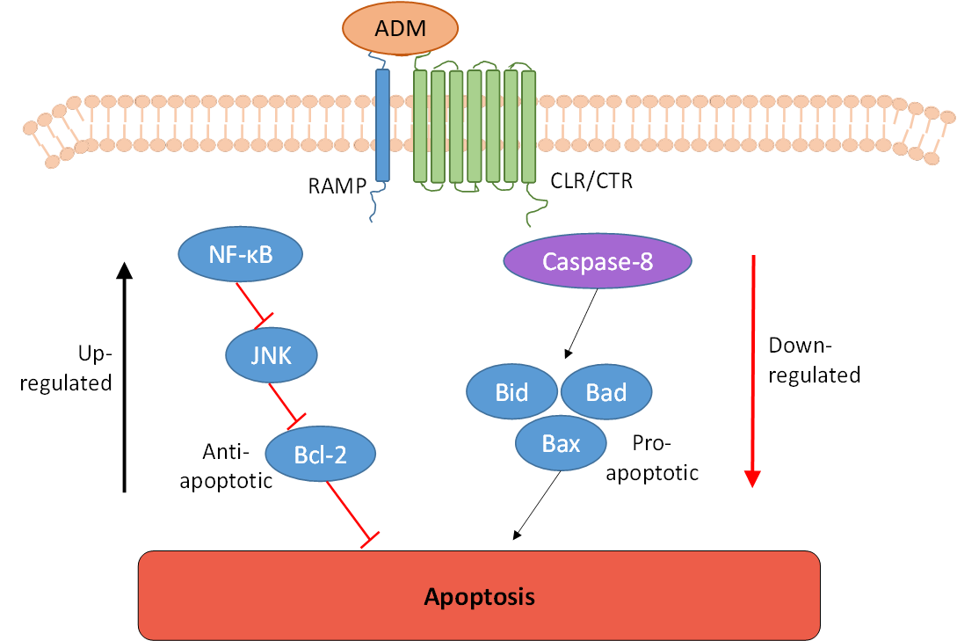
Figure 1.7: ADM regulates apoptosis through NF-κB and Caspase-8 pathways. ADM up-regulates NF-κB pathway, leading to inhibition of pro-apoptotic JNK which down-regulate apoptosis-inhibitors including Bcl-2. ADM also down-regulates Caspase-8 signalling, which inhibits pro-apoptotic proteins such as Bid, Bad and Bax to mediate apoptosis.
ADM has been shown to protect tumour cells from apoptosis induced by chemotherapy, hypoxia and nutrient deprivation. shRNA ADM silencing decreased anti-apoptotic Bcl-2 protein expression in HO8910 ovarian cancer cells (Chen et al., 2012). Co-treatment of shRNA and carboplatin also increased chemosensitivity of HO1890 cells, as shown by MTT assay. ADM overexpression inhibited etoposide-induced apoptosis of PC-3 cells by increasing Bcl-2/Bax ratio (Abasolo et al., 2006). ADM treatment or overexpression in Ishikawa cells decreased hypoxia-induced apoptosis and up-regulation of anti-apoptotic Bcl-2 (Oehler et al., 2001). shRNA knockdown of ADM in T24 bladder cancer cells showed significant increase in hypoxia-induced apoptosis by Annexin-V staining (Liu et al., 2013). ADM overexpressing T47D and MCF-7 breast cancer cells were also protected from serum deprivation-induced apoptosis (Martínez et al., 2002).
ADM expression in tumour sections correlate with low apoptosis levels. IHC staining of clear-cell renal carcinoma tissues revealed epithelial cells with high levels of ADM staining had decreased active caspase-3 staining (Deville et al., 2009). Similar observations in SW480 colorectal tumours revealed increased caspase-3 staining and necrosis in ADM shRNA-knockdown tumours (Wang et al., 2014). Uterine cervix tissues showed high levels of ADM and Bcl-2 cytoplasmic staining in invasive squamous cells (Li et al., 2003).

    - Adrenomedullin and Angiogenesis
While ADM antagonist ADM₂₂₋₅₂ was unable to curb in vitro PaCa growth, it was able to significantly reduce tumour growth in vivo by reducing blood vessel capacity in the tumour (Ishikawa et al., 2003). This suggests that ADM promotes PaCa mainly by mediating its angiogenic properties. Figure 1.8 outlines the pathways through which ADM mediates angiogenesis and lymphangiogenesis in tumours.
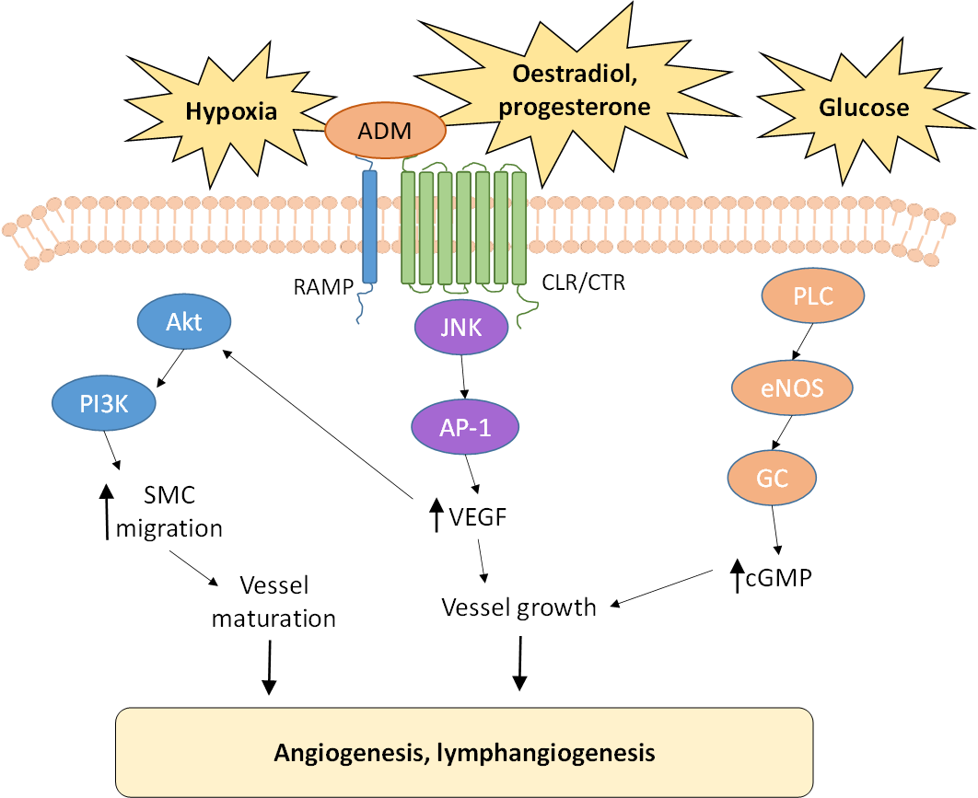
Figure 1.8: ADM promotes angiogenesis and lymphangiogenesis via several inducers and mediators. Hypoxia, reproductive hormones and glucose levels can induce ADM to stimulate angiogenic signalling. Akt-PI3K signalling in smooth muscle cells (SMC) can induce migration towards tumour site and vessel maturation. JNK-AP-1 signalling can increase vascular endothelial growth factor (VEGF) levels, another potent inducer of angiogenesis and lymphangiogenesis. Hence, VEGF can work together with ADM to promote vessel growth. ADM can also stimulate propionyl-L-carnitine (PLC) to induce endothelial nitric oxide synthase (eNOS) activation, further contributing to vessel growth.
A hypoxic tumour environment induces expression of HIF-1α which upregulates ADM expression in a time-dependent manner (Liu et al., 2013, Molitoris et al., 2009). One possible mechanism is decreased ADM promoter histone methylation by JMJD1A (Krieg et al., 2010, Ponnaluri et al., 2011). Two types of ADM transcripts are expressed in normal and cancer cells to regulate ADM expression: full-length with introns removed and a non-protein producing transcript with introns retained (Sena et al., 2014). Interestingly, hypoxia favours the full-length isoform resulting in its increased expression in tumours compared to normal tissues.
Other factors may augment hypoxia-induced ADM expression including thyroid hormone or glucose. Active thyroid hormone-stimulated expression of hepatic leukaemia factor activated thyroid hormone receptor β/retinoid X receptor α heterodimer, which subsequently increased HIF-1α and ADM expressions (Otto and Fandrey, 2008). This is observed in primary human hepatocytes, kidney and lung cancer cells. DNA microarray analysis of Mia-PaCa-2 cells revealed higher ADM expression in glucose-deprived hypoxia than hypoxia only, mediated by 5’ AMP-activated kinase activation (Natsuizaka et al., 2007).
Under normoxia, ADM expression can be regulated by HIF-1α-dependent and -independent mechanisms. IL-1β activates HIF1-α to induce ADM mRNA expression in OVCAR-3 ovarian cancer cells (Frede et al., 2005). Reproductive hormones such as estradiol and progesterone can also regulate ADM expression. Estradiol alone was unable to induce ADM mRNA expression in ECC-1 endometrial cancer cells, but combination of estradiol and HIF-1α induced significantly more ADM expression than HIF-1α alone (Molitoris et al., 2009). Progesterone alone significantly increased ADM protein expression in primary leiomyoma cells (Xu et al., 2006). Co-administration with progesterone receptor modulator CB-2914 antagonised this effect. ADM-induced angiogenesis was also stimulated by HIF-1α-independent mechanisms under normoxia as shown in multiple myeloma cells (Kocemba et al., 2013).
High glucose levels are shown to increase HIF-1α expression in tumour and decrease HIF-1α expression in non-tumour cells, respectively (Dehne et al., 2010). This was revealed to not be due to increased mRNA expression or protein translation, but due to increased HIF-1α stability. Dehne and colleagues also showed that increasing glucose enhanced prolyl hydroxylase degradation of HIF-1α in non-tumour C₂C₁₂ mouse myoblast cells under normoxia, presumably due to oxoglutarate availability. Another study showed that increased glucose levels decreased prolyl hydroxylase activity in C6 rat glioma cells (Lu et al., 2005). This was assumed to be from increased production of other intermediates of the citric acid cycle, which inhibit prolyl hydroxylase activity.
Angiogenesis and lymphangiogenesis are required for tumour growth and metastasis. ADM has been shown to regulate both to promote androgen-independent prostate cancer. Without androgen, ADM-treated LNCaP xenografts were larger and had more blood vessels (Berenguer et al., 2008). Anti-ADM treatment decreased growth of LNCaP tumours in castrated animals (Berenguer-Daizé et al., 2013). Treatment of subcutaneous and orthotopic Du145 prostate cancer xenografts with anti-ADM also significantly reduced tumours and vascularity in both models (Berenguer-Daizé et al., 2013).
In mouse Lewis lung carcinoma cells, ADM gene dosage only influenced tumour lymphangiogenesis, not proliferation or angiogenesis (Karpinich et al., 2013). Subsequent experiments revealed that ADM increased gap junction signalling between tumour cells and lymphatic endothelial cells (LECs) by β-catenin nuclear translocation, promoting lymph node metastasis (Karpinich and Caron, 2015).
ADM promotes angiogenesis independently or together with vascular endothelial growth factor (VEGF). Recombinant bioactive ADM increased VEGF secretion in pancreatic tumour cell lines Mia-PaCa-2, Panc-1 and Colo-357, but not significantly in T3M4 and Capan-1 (Keleg et al., 2007). ADM treatment of HO891 ovarian cancer cells induced VEGF mRNA expression, and this was attenuated by pre-treatment with ADM antagonist ADM₂₂₋₅₂ (Chen et al., 2015). This inhibition was transcriptional rather than post-translational, as pre-treatment with actinomycin D did not increase VEGF mRNA half-life. ADM-induced VEGF expression was attributed to JNK as ADM treatment increased JNK phosphorylation and co-administration with JNK inhibitor abrogated VEGF mRNA expression. ADM treatment increased VEGF secretion of Ishikawa and primary endometrial tumour cells, suggesting possible synergism in ADM and VEGF-mediated tumour progression (Evans et al., 2012).
ADM is able to induce endothelial cell migration into the tumour microenvironment, promoting carcinogenesis via neoangiogenesis and lymphangiogenesis. Co-administration of ADM and VEGF markedly increased in vitro human umbilical venous endothelial cell (HUVEC) differentiation into vascular structures on Matrigel, compared to ADM or VEGF treatment alone (Fernandez-Sauze et al., 2004). This was not due to additional VEGF secretion by ADM, as VEGF levels did not differ between ADM-treated and untreated HUVECs. Additionally, protein expression of CLR, RAMP-2 and RAMP-3 was detected in HUVECs, suggesting that its differentiation could be mediated by AM1R and AM2R. In Boyden chamber experiments, HUVECs migration and invasion was induced by ADM in a dose-dependent manner (Fernandez-Sauze et al., 2004). VEGF-induced mobilisation of CD133+/VEGFR2+ endothelial progenitor cells into circulation was inhibited by ADM₂₂₋₅₂ (Tsuchiya et al., 2010). Conditioned media from LECs mediated migration of human umbilical venous smooth muscle cells in Transwell assays (Berenguer-Daizé et al., 2013). Pre-treatment of LECs with anti-ADM abrogated this effect. This suggests that ADM secreted by LECs can regulate tumour-associated lymphangiogenesis by recruiting SMCs during collecting vessel formation.
There are two stromal cell types in the tumour microenvironment that can enhance ADM levels to mediate tumour growth and angiogenesis: tumour-associated macrophages (TAMs) and cancer-associated fibroblasts (CAFs). Co-culture of B16/F10 mouse melanoma cells or its conditioned media with primary peritoneal macrophages or bone marrow–derived macrophages resulted in up-regulation of ADM secretion detected by ELISA (Chen et al., 2011). Conditioned media from co-cultured RAW264.7 mouse macrophages and B16/F10 cells also promoted migration and tubule formation of human dermal microvascular endothelial cells (HMECs). ADM treatment of HMECs induced endothelial nitric oxide synthase phosphorylation, suggesting that HMEC tubule formation is facilitated by endothelial nitric oxide synthase signalling in vitro. Subcutaneous co-inoculation of RAW264.7 and B16/F10 cells resulted in significantly larger tumours with more blood vessels in vivo, compared to controls with B16/F10 only. These data suggests that TAMs are able to secrete factors into the microenvironment leading to increased ADM expression within the tumour to enhance angiogenesis.
Another stromal cell type shown to mediate tumour growth and angiogenesis through ADM are CAFs. Studies in breast tumours have shown high expression of ADM and its receptors AM1R and AM2R in CAFs prepared from invasive breast carcinomas, compared to normal fibroblasts (Benyahia et al., 2017). Systemic administration of anti-AMR also resulted in reduced vessel structures in in vivo Matrigel plugs containing CAFs. Immunohistochemistry of tumour xenografts containing CAFs and MCF-7 breast cancer cell line revealed that in vivo treatment with anti-AMR or ADM₂₂₋₅₂ also disrupted tumour vasculature by depleting vascular endothelial cells, thereby inhibiting tumour growth. These data suggests that CAFs, like TAMs, are able to secrete factors into the microenvironment leading to increased ADM expression within the tumour to enhance angiogenesis.
    - Adrenomedullin and Migration/Invasion
ADM can promote migration and invasion of breast, cholangiocarcinoma, colorectal, clear-cell renal, pancreatic and prostate tumour cells. In vivo experiments show ADM-overexpressing MDA-MB-231 breast cancer cells metastasised more rapidly to bone (Siclari et al., 2014). Wound healing and Transwell invasion assays reveal significantly increased migration and invasion of ADM-transfected HuCCT1 cholangiocarcinoma cells (Zhou et al., 2015). ADM increased invasiveness of Du145 prostate cancer cells through Matrigel in a dose-dependent manner (Berenguer-Daizé et al., 2013). shRNA silencing of GPR182 inhibited ADM-induced growth and invasion of MPanc96 PaCa cells in vitro and in vivo (Ramachandran et al., 2007, Ramachandran et al., 2009). The same effect was seen in 4/5 human PaCa cell lines treated with rADM in a Matrigel invasion assay, where invasive abilities were increased by 42-107% compared to untreated cells (Keleg et al., 2007). Treatment with anti-CLR decreased invasion in the same cell lines suggesting a role for CLR in ADM-induced invasion, however the effects of RAMPs were not investigated in the study. ADM also induced dose-dependent invasion of HT-26 colorectal carcinoma cells through Matrigel-coated Boyden chamber (Nouguerède et al., 2013). Preincubation with anti-ADM or anti-AMR blocked the ADM-induced invasion. This suggests that ADM induces invasion of colorectal carcinoma through either AM1R or AM2R. Similar results were shown in SW480 colorectal carcinoma cells as well as BIZ and 786-O clear-cell renal carcinoma cells (Wang et al., 2014, Deville et al., 2009).
Figure 1.9 summarises the pathways through which ADM can promote migration and invasion of tumour cells. In HO8910 ovarian cancer cells, ADM-induced migration was mediated by increased integrin α5β1 activation, leading to increased focal adhesion kinase (FAK) and paxillin phosphorylation, as revealed by flow cytometry and western blotting respectively (Deng et al., 2012). Anti-α5β1 abrogated ADM-induced FAK and paxillin phosphorylation. ADM-induced migration of CRT-MG astroglioma cells was influenced by aberrant oncostatin M activation of STAT-3 (Lim et al., 2014). ADM promotes migration and invasion of PC-3 prostate and T24/83 urothelial cancer cells through TRPV2 cell-surface translocation and increased resting calcium levels (Oulidi et al., 2013). ADM can also induce M2-skewed polarisation of mice peritoneal macrophages similar to TAMs, allowing them to promote migration of HO8910 ovarian cancer cells by activating RhoA pathway (Pang et al., 2013).
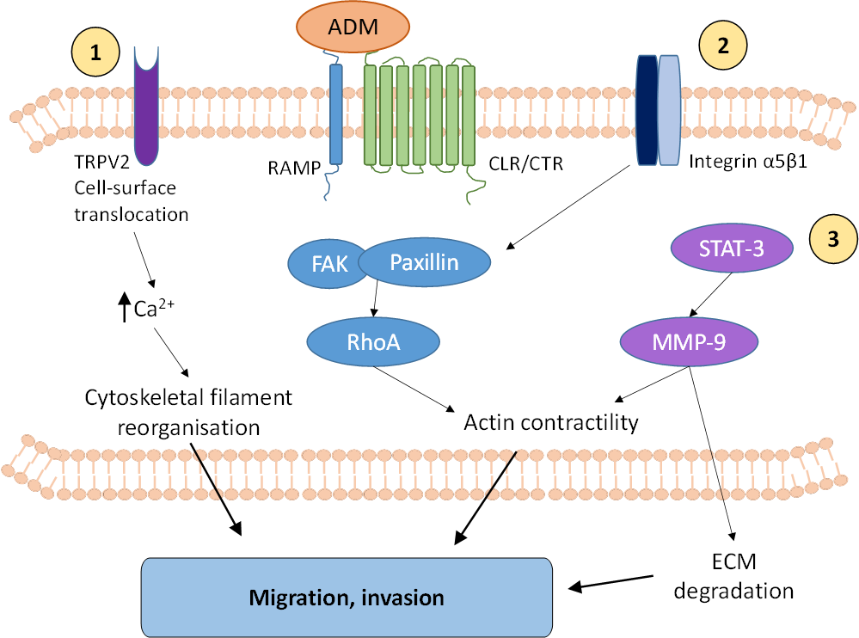
Figure 1.9: ADM promotes migration and invasion of tumour cells, allowing them to metastasise to secondary sites. 1) ADM can induce cell-surface localisation of ion channel TRPV2, increasing calcium levels in the cell promoting cytoskeletal filament reorganisation. 2) ADM can also activate integrin α5β1 to recruit focal adhesion protein complexes [containing focal adhesion kinase (FAK) and paxillin] and activate RhoA, which mediates actin contractility. 3) ADM can also induce STAT-3 (through aberrant oncostatin M signalling) to up-regulate matrix metallopeptidase-9 (MMP-9) expression, which contributes to actin contractility and extracellular matrix (ECM) degradation.
    - Adrenomedullin and other Cancer Hallmarks
Epithelial-mesenchymal transition (EMT) signals the initiation of cancer metastasis. Adenoviral transduction of ADM into HuCCT1 cholangiocarcinoma cells induced EMT in vitro by up-regulation of epithelial markers N-cadherin and vimentin and down-regulation of mesenchymal markers E-cadherin and ZO-1 (Zhou et al., 2015). The same study revealed that this was due to ADM activating EMT-related transcription factor ZEB1.
Neuroendocrine differentiation is associated with progression of androgen-independent prostate cancer. ADM treatment of LNCaP prostate cancer cells resulted in neuroendocrine-like morphological changes (Berenguer et al., 2008). This was reversed by co-administration of ADM with anti-AMR, suggesting that ADM-induced neuroendocrine differentiation is mediated by AM1R or AM2R. Co-treatment with pertussis toxin also ablated neuroendocrine differentiation, indicating that it is facilitated by cGMP production stimulation.
ADM may also be involved in tumour evasion of the immune system. Through cAMP-dependent mechanisms, ADM has been shown to down-regulate macrophage function. ADM suppressed lipopolysaccaride-induced secretion of TNF- α and IL-6 in mouse RAW264.7 and peritoneal macrophages (Kubo et al., 1998). ADM also induced cAMP production in rat alveolar macrophages, inhibiting cytokine-induced neutrophil chemoattractant secretion (Kamoi et al., 1995). ADM is a crosstalk molecule between tumour and mast cells. Confocal microscopy revealed ADM-producing mast cells in human breast and lung cancer tissues. (Zudaire et al., 2006). The same study showed ADM-producing mast cell line HMC-1 augmented A549 lung cancer cell growth in vitro and angiogenesis in vivo.
    - RAMP-3 mediated ADM signalling: therapeutic target in cancer
While it is evident that ADM is involved in signalling of many pro-tumoural processes from enhancing growth through to mediating spread to secondary sites, it is crucial to remember that ADM is also important for homeostasis. Section 1.2.4 detailed the role of ADM in a variety of physiological functions in the body, and that when dysregulated, could result in devastating consequences in promoting cancer growth and spread. It is essential to determine specifically how ADM signalling has been skewed towards being pro-tumoural. Figure 1.10 shows the various receptor complexes that ADM can bind and signal through. There are two therapeutic strategies to targeting ADM – complete inhibition of ADM signalling, or inhibition of the specific receptor complexes (CLR, RAMP-2 and/or RAMP-3) responsible for dysregulated ADM signalling.
A blanket ADM inhibition is not desirable as ADM is important in both physiological and pathological functions (Figure 1.5). Additionally, ADM is also a protective agent in many diseases, including hypertension, renal failure and ischemia reperfusion injuries (Lainchbury et al., 1997, Nishikimi, 2007, Kirisci et al., 2013). ADM knockout mice are also embryonically lethal and this has been shown by independent research groups to be due to cardiovascular abnormalities (Shindo et al., 2001, Caron and Smithies, 2001, Shimosawa et al., 2002).
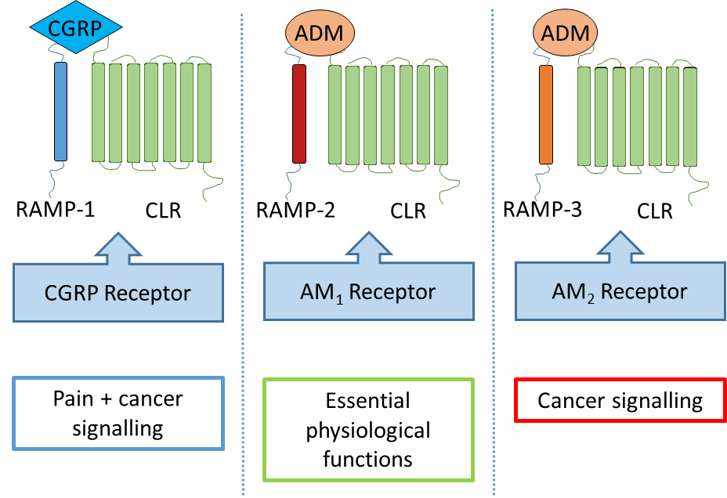
Figure 1.10: Receptor complexes that ADM mediates signalling through, comprising of CLR and RAMPs. While RAMP-2-mediated ADM signalling is essential for physiological processes including blood pressure regulation, aberrant RAMP-3-mediated ADM signalling can result in cancer promoting pathways.
Since ADM exerts its effects through AM1R and AM2R, its actions could be regulated differently by targeting CLR, RAMP-2 or RAMP-3. The range of effects is clear from in vivo studies in mice lacking genes for the different receptor components. Mice with deleted CLR (no functioning AM1R and AM2R) were embryonically lethal with cardiovascular defects, similar to ADM knockout mice (Dackor et al., 2006). RAMP-2 knockout (no functioning AM1R) were also embryonically lethal with cardiovascular defects, suggesting both CLR and RAMP-2 is important in cardiovascular physiology and therefore should not be inhibited (Dackor et al., 2007). Surprisingly, RAMP-3 knockout mice (no functioning AM2R) were normal until old age, where they appeared to exhibit decreased weight (Dackor et al., 2007). Additionally, in vitro and in vivo experiments revealed that RAMP-3 functions downstream of lysyl oxidase-like protein-2 (LOXL2) mediating pro-tumorigenic processes in MDA-MB-231 breast cancer cells, including EMT and invasiveness (Brekhman et al., 2011). Since there were no adverse effects associated with RAMP-3 knockout in mice as well as evidence that RAMP-3 mediates pro-tumoural processes in cancer, RAMP-3 is a good therapeutic target to investigate.
ADM inhibitors used in research include antibodies against ADM (anti-ADM) and its receptor components (e.g. anti-CLR, anti-RAMP-2, anti-RAMP-3 or a combination of the three – anti-AMR) as well as a truncated form of ADM peptide (ADM₂₂₋₅₂) which inhibits receptors that ADM can bind and signal through. Various research groups have shown anti-tumoural effects of anti-ADM, anti-AMR and ADM₂₂₋₅₂ in various cancers including colorectal, glioblastoma and pancreatic (Nouguerède et al., 2013, Ouafik et al., 2002, Ishikawa et al., 2003). Although these ADM inhibitors have shown anti-tumoural effects in vitro and in vivo subcutaneous xenograft models, their development into clinic (specifically as anti-cancer therapy) is stunted due to short half-lives or undesirable modes of delivery.
Using polyclonal anti-ADM to treat U87 human glioblastoma cells lead to a decrease in growth both in vitro and in vivo (Ouafik et al., 2002), although the effect in vivo was more pronounced (70% reduction vs. 33%). Analysis of tumour vasculature revealed that anti-ADM treatment lead to significantly less vessel development than control tumours. The results suggest that the anti-tumoural effect of anti-ADM on U87 glioblastoma cells were due to both a decrease in growth of tumour cells as well as angiogenesis.
Experiments using ADM₂₂₋₅₂ to treat human PaCa cells in vitro (BxPC-3 and PCI-35) and in vivo (PCI-43) showed no effect in vitro but a decrease in growth of PaCa xenografts in vivo (Ishikawa et al., 2003). Unlike the experiments on glioblastoma cells, these results suggest that the anti-tumoural effect of ADM₂₂₋₅₂ was due to its effects on angiogenesis but not on the growth of PaCa cells themselves.
Anti-ADM, anti-AM1R (anti-CLR and anti-RAMP-2), anti- AM2R (anti-CLR and anti-RAMP-3) and ADM₂₂₋₅₂ were investigated to treat HT-29 human colorectal cancer cells in vitro and in vivo (Nouguerède et al., 2013). Treatment with anti-AM1R, anti-AM2R and ADM₂₂₋₅₂ led to decreased cell growth and invasion in vitro and decreased tumour growth in vivo. This suggests that it is the inhibition of the receptor complexes mediating ADM responses (AM1R and AM2R) that resulted in the anti-tumoural effects. Similar to results in both glioblastoma and pancreatic tumours, anti-ADM treated colorectal tumours were significantly less vascular than control tumours.
In both glioblastoma and pancreatic in vivo experiments, treatment of anti-ADM and ADM₂₂₋₅₂ were given intratumourally, which is not a desirable mode of delivery in clinic (Ishikawa et al., 2003, Ouafik et al., 2002). However, similar anti-tumoural effects were seen using systemic intraperitoneal treatment of anti-ADM every three days in A549 lung, U87 glioma and HT-29 colorectal cancer xenografts (Kaafarani et al., 2009).
The aforementioned treatment strategies involve neutralising either ADM or the individual receptor components that ADM binds and signals through (e.g. CLR, RAMP-2 and RAMP-3). Instead, our group is developing small molecule antagonists that specifically block the binding of ADM to the CLR/RAMP-3 receptor complex, without inhibiting its binding and effect through other receptor complexes (e.g. CLR/RAMP-2).
This allows us to investigate the research question of whether targeting RAMP-3-mediated ADM signalling will successfully improve PaCa outcome. To do this, we will address three hypotheses:
- PaCa cells express ADM and receptor components necessary for RAMP-mediated ADM signalling (CLR and RAMPs) and that these constituents are functional
- Small molecule antagonists against AM2R can decrease PaCa growth in vitro and in vivo
- Small molecule antagonists against AM2R can be used in combination with chemotherapy to decrease PaCa growth in vitro and in vivo
Chapter 3 will detail whether PaCa cell lines to be used in in vitro and in vivo experiments with small molecule antagonists express ADM or the receptor components necessary for RAMP-3-mediated ADM signalling, and whether these are functional. Endpoint and quantitative PCR were used detect ADM, CLR and RAMP mRNA transcripts in a panel of seven PaCa cell lines. The functionality of these receptor components were tested by stimulation with ADM or other calcitonin family peptides and measuring the levels of cAMP production. In vitro viability assays were used to determine doubling time and sub-optimal serum concentration in culture conditions of PaCa cell lines, for use in subsequent antagonist experiments.
The design and screening strategy, as well as in vitro and in vivo anti-tumoural effect of the small molecule antagonists, will be detailed in Chapter 4. Single dose screen was done to determine the effect of compounds on viability of one PaCa cell line (CFPAC-1) in vitro. Subsequently, in vitro viability and apoptosis assays were used to further elucidate the effect of lead compounds on a variety of PaCa cell lines. Efficacy of lead compounds were also investigated in vivo in a subcutaneous xenograft model of PaCa.
Chapter 5 will detail whether the small molecule antagonists have the potential to be used in combination with currently existing chemotherapeutic agents to treat PaCa which may have developed therapeutic resistance. In vitro viability assays were used to test efficacy of chemotherapeutic agents (5-fluorouracil and gemcitabine) alone and in combination with lead compound SHF-638. Efficacy of gemcitabine alone and in combination with lead compound SHF-771 was also investigated in vivo in an orthotopic xenograft model of PaCa.

Chapter 2: General Methods
2. Materials and Methods
All reagents and commercial sources are listed in Table 7.1 in the Appendix. Detailed explanations for individual protocols are elaborated in each sub-section or Methods sections in Chapters 3 to 5.

2.1 Cell Culture
PaCa cell lines were obtained from ATCC and genomic verification of origin had been conducted to authenticate the cell lines. PaCa cell lines were cultured in media and supplements listed in Table 2.1, and incubated in a humidified incubator at 37°C with 5% CO₂. Passages 35 and lower were used for experiments. Flasks were washed twice with PBS and media changed twice weekly (Table 2.2). Cells were maintained until 70-80% confluence before harvesting or splitting (Figure 2.1).

2.1.1 Subculture/Harvesting of Cells
To sub-culture or harvest cells for subsequent experiments, cells were washed twice with PBS and detached using TrypLE for 5-10 minutes at 37°C (volume of reagents in Table 2.2). Detachment was confirmed by microscopy. PBS was used to wash cells off the bottom of the flask and the cell suspension was transferred to a 15 mL or 50 mL centrifuge tube. Cells were centrifuged at 250 x g for 5 minutes and the resulting cell pellet was re-suspended in media. For sub-culturing, appropriate volume of cell suspension was transferred to a new sterile flask with warm growth media (Table 2.1). To set up experiments, cells were counted as in Section 2.1.3 before diluting to appropriate volume needed.
Table 2.1: Cell lines, optimal growth media and supplements
Cell Line | Manufacturer | Media and Supplements
Pancreatic Cancer Cells
AsPC-1 | ATCC | RPMI 1640 + 15% FBS (Gibco) + 1 mM NaPyr + 1% P/S
BxPC-3 | ATCC | RPMI 1640 + 10% FBS (Gibco) + 1 mM NaPyr + 1% P/S
Capan-2 | ATCC | McCoy’s 5A + 10% FBS (Sigma-Aldrich) + 1% P/S
CFPAC-1 | ATCC | DMEM + 10% FBS (Gibco) + 1% P/S
HPAF-II | ATCC | RPMI 1640 + 10% FBS (Gibco) + 1 mM NaPyr + 1% P/S
Panc 10.05 | ATCC | RPMI 1640 + 15% FBS (Gibco) + 1 mM NaPyr + 1% P/S
SW1990 | ATCC | DMEM + 10% FBS (Gibco) + 1% P/S

FBS: fetal calf serum; NaPyr: sodium pyruvate; P/S: penicillin/streptomycin; DMEM: Dulbecco’s Modified Eagle Medium

Table 2.2: Volumes of reagents used for cell culture in different flask sizes
Flask | PBS wash (media change) | Media change | TrypLE | PBS wash (after detachment)
T25 | 3 mL | 5 mL | 1 mL | 2 mL
T75 | 5 mL | 10 mL | 3 mL | 3 mL
T175 | 10 mL | 30 mL | 5 mL | 5 mL
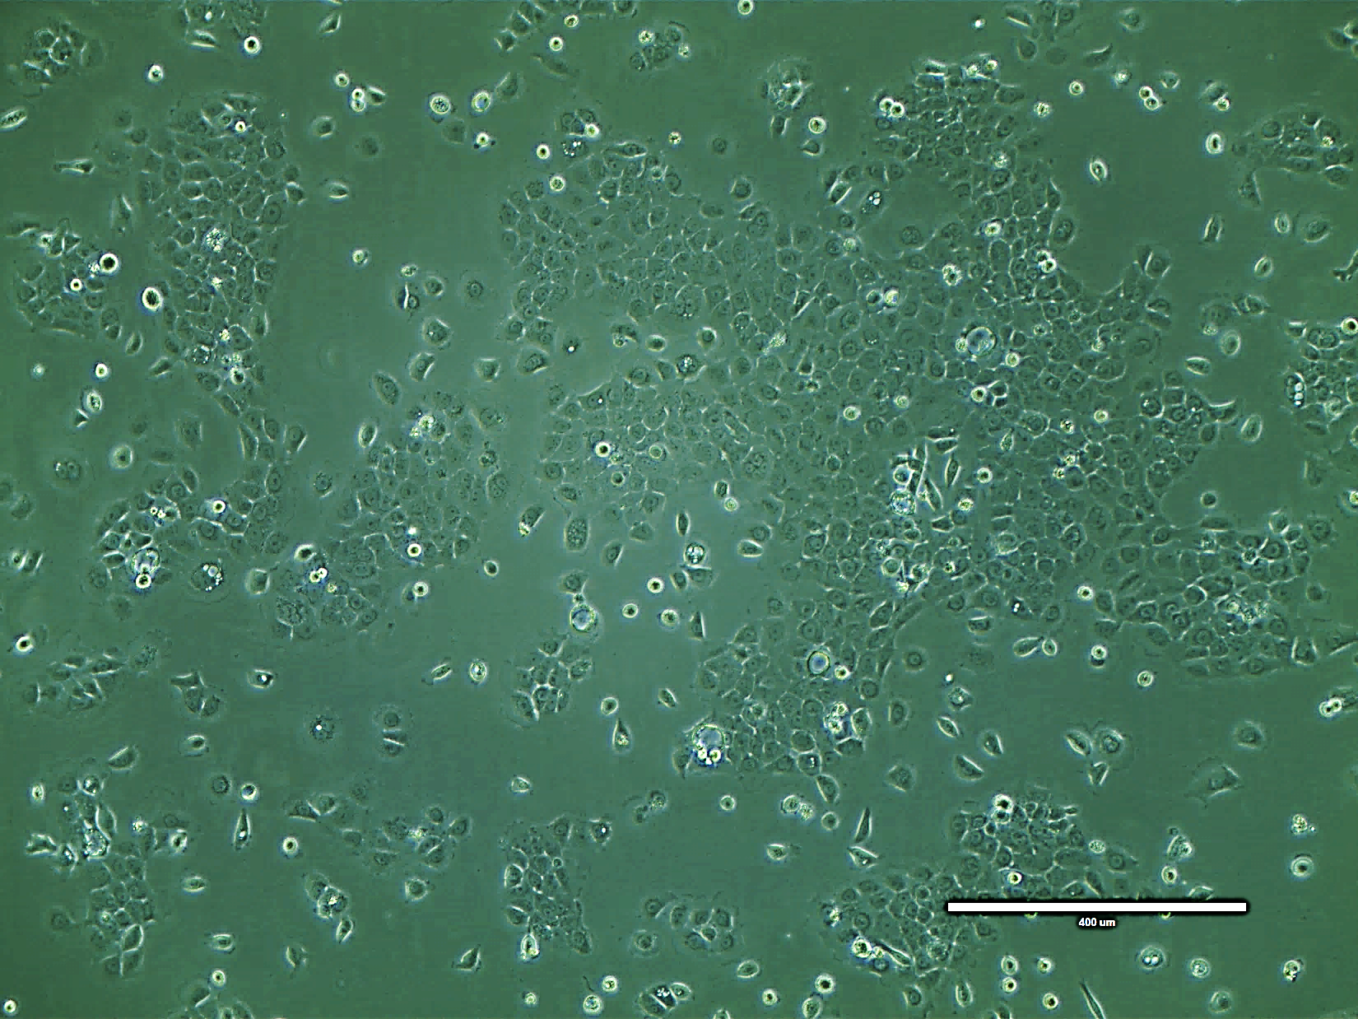
Figure 2.1: Cell confluence prior to harvesting or splitting. Phase-contrast images of BxPC-3 pancreatic cancer cell line at 70% confluence used in in vitro and in vivo experiments. Image was taken at 100x magnification.

2.1.2 Cell Freezing
Cell suspension was prepared as described in Section 2.1.1, but were counted (Section 2.1.3) before centrifuging at 250 x g for 5 minutes. Cell pellet was re-suspended in appropriate volume of freezing media (growth media with 10% DMSO) before transferring 1e6 or 2e6 cells per cryo-tube (1 mL each), to keep as frozen stocks or for use in cAMP assays (Section 3.2.8). Cryo-tubes were labelled with cell line, passage number and date frozen. Cryo-tubes were stored in Mr Frosty™ Freezing Container overnight in -80°C before storage in -80°C freezer (less than one year) or liquid nitrogen Biorepository (longer term).

2.1.3 Cell Counting
Cell viability was assessed using trypan blue exclusion. 10 µL of cell suspension was added to 10 µL of trypan blue in a 0.5 ml centrifuge tube. The mixture was transferred to a disposable counting slide and counted using Countess II Automated Cell-Counter (Thermo Fisher).

2.2 Compound Screening
Small molecular antagonists targeting CLR and RAMP-3 interaction were designed by medicinal and computational chemists in Sandexis Molecular Design (UK) and produced by chemists in Peakdale Molecular (UK) and WuXi AppTec (China). Homology models were built based on computer predictions from available crystal structures of CLR/RAMP receptor complexes with known agonists or antagonists.
The screening cascade is depicted in Figure 2.2. Firstly, high-throughput screening of small molecules was done using the cAMP assay (Section 3.2.8). This allows us to determine potency and specificity of the compounds in inhibiting respective CLR/RAMP complexes. Once we have identified compounds that are potent in inhibiting RAMP-3 mediated ADM stimulation in cAMP assays, their pharmacokinetics were investigated to ensure they are suitable in vivo candidates with reasonable half-lives and clearance. Identified lead compounds were then investigated functionally in in vitro assays measuring effect on cell viability and apoptosis, before moving on to in vivo studies.

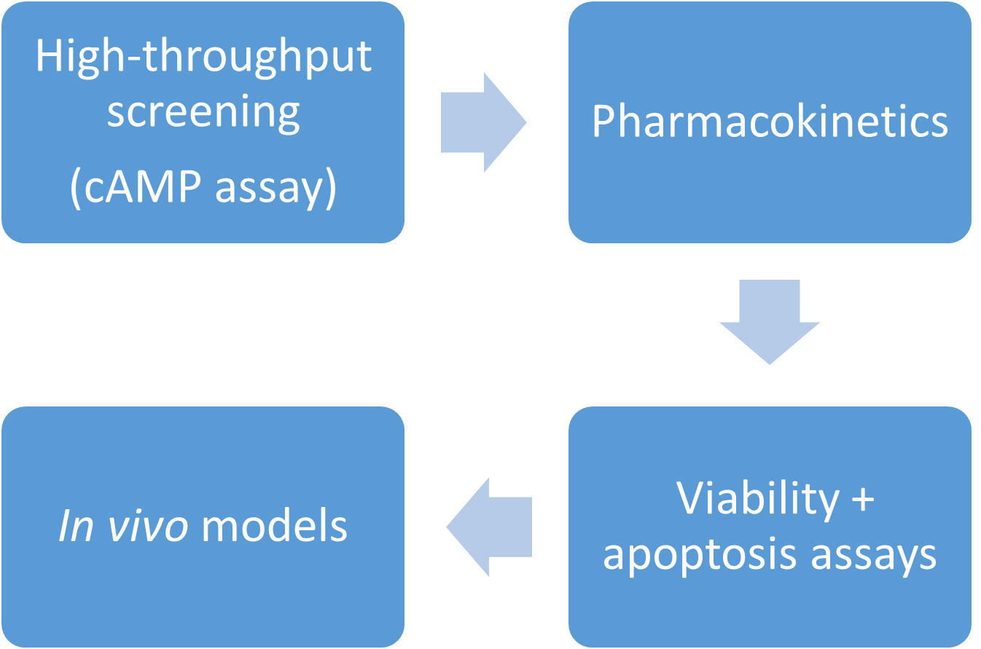
Figure 2.2: Screening cascade for small molecule antagonists against AM2R. Compounds were first screened for potency and selectivity on cells overexpressing AM2R, compared to cells overexpressing the other receptor/RAMP complexes. Compounds with pIC50 more potent than 8.0 were then screened in viability and apoptosis assays, to see their effects on pancreatic cancer cell lines. Pharmacokinetics of lead compounds will then be investigated (e.g. bioavailability, half-life, and clearance) before selecting suitable in vivo candidates.

Powder stocks were stored at room temperature. Compounds were dissolved to 20 mM solutions in 100% DMSO and sonicated for 10 minutes at 37°C to ensure they have completely dissolved. Stocks in DMSO were then stored at -20°C. For use in cAMP, viability and apoptosis assays (Sections 2.3 and 3.2.8), 20 mM stocks were diluted to 2 mM solutions in 100% DMSO and sonicated for 10 minutes at 37°C before further dilutions in respective vehicles.

2.3 In vitro Functional assays

2.3.1 Viability assay
To measure the effect of treatment on cancer cell viability, RealTime-Glo MT Viability Assay (Promega) was used. Figure 2.3 shows the principles of the assay. This viability assay measures reducing potential (metabolism) as a proxy for number of viable cells. Luminescent signal is only produced when the MT Viability pro-substrate is reduced by viable cells into NanoLuc® substrate which is then used by NanoLuc® luciferase in the culture media. The MT Viability pro-substrate cannot be used by the NanoLuc® luciferase to produce luminescence, which is why dead cells will produce no signal. Compared to similar assays measuring reducing potential of cells (e.g. MTT), the luminescence-based RealTime-Glo MT Viability Assay is non-lytic and more sensitive than colorimetric or fluorometric assays.
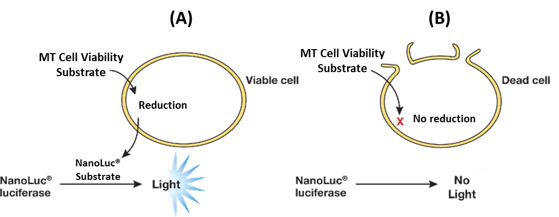
Figure 2.3: Principles of RealTime-Glo™ Cell Viability assay, adapted from Promega manual. (A) Live cells (metabolically active) reduce MT Cell Viability Substrate into NanoLuc® substrate. The NanoLuc® substrate diffuses into the culture media containing NanoLuc® luciferase which produces a luminescent signal. (B) Dead cells do not reduce the MT Cell Viability Substrate, producing no luminescence.
Cells were seeded into 96-well white clear-bottom plates (Corning) in full serum media overnight before washing and changing to sub-optimal media (Table 2.3) containing RealTime-Glo™ reagents (1:1,000 each of enzyme and substrate). Empty wells were filled with PBS to prevent evaporation. A baseline luminescence read was taken using EnSight Multimode Plate Reader (PerkinElmer) after an hour of incubation at 37°C. Cells were then treated with compounds or vehicle-control (PBS + 0.05% DMSO) daily. Luminescence readings were taken daily for 72 hours. Plates were incubated at 37°C for at least an hour before each reading as the assay is temperature-sensitive. After 72 hours, assays can be continued by replacing media with freshly made reagents. Results were normalised to vehicle-treated controls as 100%. Figure 2.4 shows an example of the raw and normalised values of CFPAC-1 cells treated with 2 µM gemcitabine.
Table 2.3: Sub-optimal media and seeding density for viability assay
Cell Line | Media and Supplements | Seeding Density
AsPC-1 | RPMI 1640 + 5% FBS (Gibco) +  1 mM NaPyr + 1% P/S | 2,000 cells/well
BxPC-2 | RPMI 1640 + 5% FBS (Gibco) +  1 mM NaPyr + 1% P/S | 2,000 cells/well
Capan-2 | McCoy’s + 5% FBS (Sigma) + 1% P/S | 2,000 cells/well
CFPAC-1 | DMEM + 5% FBS (Gibco) + 1% P/S | 2,000 cells/well
HPAF-II | RPMI 1640 + 5% FBS (Gibco) +  1 mM NaPyr + 1% P/S | 2,000 cells/well
Panc10.05 | RPMI 1640 + 5% FBS (Gibco) +  1 mM NaPyr + 1% P/S | 2,000 cells/well
SW1990 | DMEM + 5% FBS (Gibco) + 1% P/S | 2,000 cells/well

FBS: fetal bovine serum; NaPyr: sodium pyruvate; P/S: penicillin/streptomycin; DMEM: Dulbecco’s Modified Eagle Medium; RPMI: Roswell Park Memorial Institute

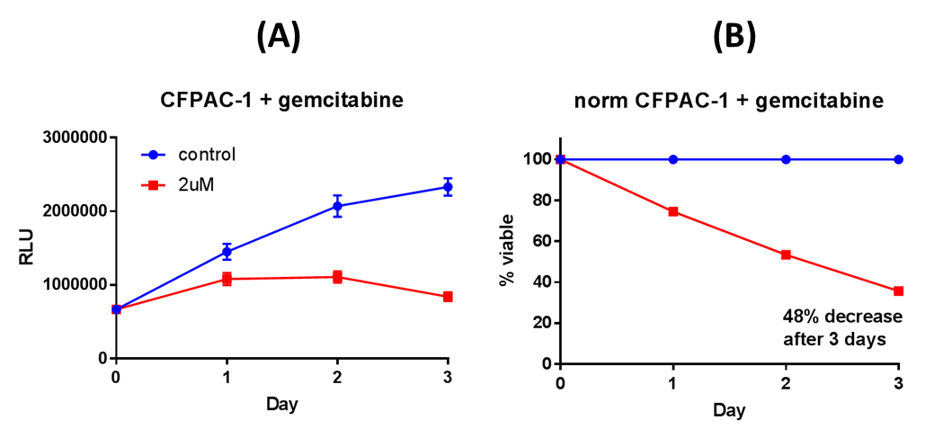
Figure 2.4: Raw luminescence values (A) and normalised values (B) of human pancreatic cancer cells CFPAC-1 treated with 2μM of gemcitabine daily over three days. Results were normalised to vehicle-treated row controls as 100% and blank well values as 0%.

2.3.2 Apoptosis assay
To measure the effect of treatment on apoptosis in cancer cells, luminescence-based Caspase-Glo™ 3/7 Assay (Promega) was used. This end-point assay measures late-stage apoptotic markers – caspases 3 and 7. Figure 2.5 shows the principles of this assay. In order to produce light, luciferase requires not only luciferin as a substrate but also oxygen and magnesium-bound adenosine triphosphate. This reaction results in the production of oxyluciferin, carbon dioxide, adenosine monophosphate and diphosphate. The decay of highly unstable oxyluciferin produces a photon of light, which is measured as luminescence signal.
Cells were seeded into 96-well white clear-bottom plates (Corning) in optimal growth media overnight before washing and changing to 50 μL per well of serum-free media except unstressed control wells (50 μL per well of optimal growth media). Wells with optimal growth media and 0% serum-free media (no cells) were also incubated as baseline Caspase 3/7 negative and positive controls, respectively. Empty wells were filled with PBS to prevent evaporation. Cells were then treated with compounds diluted in PBS or vehicle-control (PBS + 0.05% DMSO). After the treatment duration, plates and Caspase-Glo™ reagents were equilibrated to room temperature. 50 μL of Caspase-Glo™ reagent was added per well and left to incubate for 30 to 60 minutes on a plate shaker (550 rpm). Luminescence read was then taken using EnSight Multimode Plate Reader (PerkinElmer) set to 22°C, as the assay is temperature-sensitive. Baseline readings (well with media only) were subtracted from luminescence readings of all wells. Results were normalised to unstressed controls (optimal growth media) and serum-starved vehicle controls as 0% and 100% apoptosis, respectively.
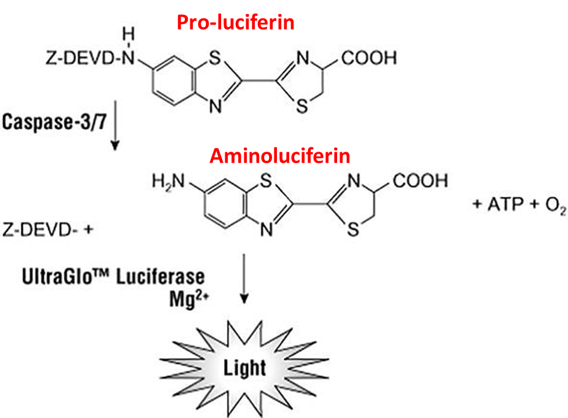
Figure 2.5: Principles of Caspase-Glo apoptosis assay, adapted from Promega manual. Caspase 3/7 in samples cleave DEVD sequence on proluciferin, releasing aminoluciferin which is a substrate for Ultra-Glo™ luciferase. This results in light production, correlating with Caspase 3/7 levels.

2.4 Statistical Analysis
All data in Chapters 3 to 5 are shown as mean and standard error of mean (SEM) unless otherwise stated. Graphpad Prism was used to analyse and display data. Outliers were removed from statistical analysis using robust regression and outlier removal (ROUT) method.
To decide between parametric or non-parametric tests, D’Agostino-Pearson omnibus normality test was done for each data set. Only data sets that passed the test were analysed using parametric statistical tests (Student’s t-test for two groups with same variance, Welch’s t-test for two groups with different variance, one-way ANOVA for three or more groups). Other data sets were analysed using non-parametric statistical tests (Mann-Whitney for two groups, Kruskal-Wallis for three or more groups).
In experiments where there are more than one experimental variable (i.e. combination treatments using chemotherapeutics together with small molecule antagonists), two-way ANOVA was used to analyse individual variables and the interaction between them. Repeated-measures two-way ANOVA was used to analyse time course data. Post-hoc multiple comparisons tests (Dunnett or Tukey) were also used to determine statistical significance of differences.

Chapter 3: Characterisation of PaCa cell lines

3.1 Introduction

3.1.1 Physiological roles and expression of ADM
ADM is expressed in a plethora of tissue types and has numerous physiological roles. Section 3.1.1.1 will elucidate its biological functions in various organs. Section 3.1.1.2 will detail the expression of ADM and its receptor components (CLR and RAMPs) in normal tissues. Section 3.1.1.3 will focus on functions and expression of ADM and its receptor components in the pancreas.

3.1.1.1 Functions and expression of ADM and its receptor components in normal tissues
Figures 3.1 to 3.3 show ADM, CLR and RAMP expression in normal tissue types around the body, from the Human Protein Atlas database (Uhlen et al., 2015). ADM and its receptor components (CLR and RAMPs) are not only expressed in different parts of the body, but also responsible for mediating various functions including pregnancy, gut function, immunity and vascular homeostasis.
Female reproductive organs are one of the body tissues that highly express ADM and its receptor components (Figures 3.1 to 3.3). While ADM mRNA is evenly distributed in the human uterus, CLR and RAMP mRNA are specifically expressed its vasculature suggesting that ADM mediates its vasodilation effects primarily through those receptors (Nikitenko et al., 2001). Vascular relaxation mediated by ADM is greater during pregnancy than non-pregnant state (Yallampalli et al., 2013). Additionally, ADM can also regulate trophoblast proliferation and differentiation, showing it may also be involved in the implantation process (Zhang et al., 2005).
ADM and its receptor components are also expressed in urinary system. In the kidney, ADM has vasodilator, diuretic and natriuretic effects and is found in distal tubules, collecting ducts and urinary tract (Sandner et al., 2004). High levels of ADM are observed both in renal tubular cell lines derived from different species and in plasma from patients with chronic renal failure, showing ADM’s autocrine/paracrine role in renal physiology and pathology (Sato et al., 1998, Cheung et al., 1998).
ADM is also implicated in host defence against microbes (e.g. infection, sepsis). ADM expression in human gastric adenocarcinoma cells increases in response to bacterial infection (Allaker and Kapas, 2003). The same study revealed increased levels of gut ADM in the intestinal epithelium of the ileum of cows with bovine paratuberculosis compared to healthy cows. In vitro disc diffusion and broth microdilution experiments also confirm its anti-microbial properties in both gram-positive and -negative strains of bacteria (Allaker et al., 1999). ADM post-secretory processing was proposed to enhance anti-microbial activity by generating several peptide versions (Wiesner and Vilcinskas, 2010).
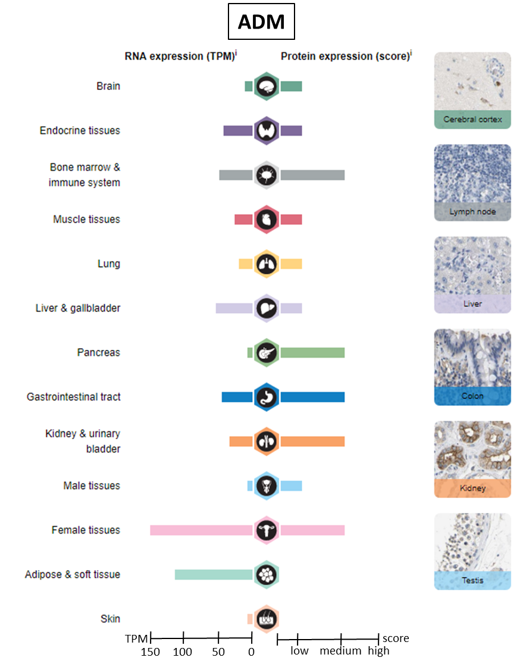
RNA-seq expression is reported as TPM (Transcripts Per kilobase Million); Protein expression score is based on a best estimate of the true protein expression for proteins where the antibody staining pattern has been analyzed by knowledge-based annotation
Figure 3.1: ADM RNA and protein expression in normal tissues. Figure adapted from Human Protein Atlas, images available from:
https://v18.proteinatlas.org/ENSG00000148926-ADM/tissue, accessed Mar 2019
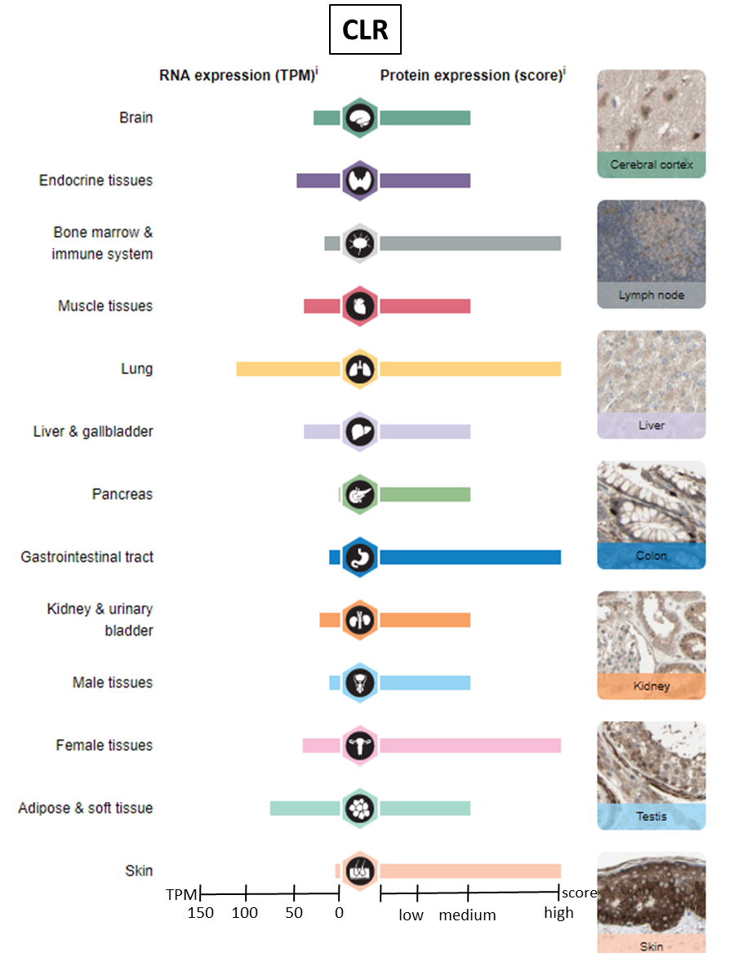
RNA-seq expression is reported as TPM (Transcripts Per kilobase Million); Protein expression score is based on a best estimate of the true protein expression for proteins where the antibody staining pattern has been analyzed by knowledge-based annotation
Figure 3.2: CLR RNA and protein expression in normal tissues. Figure adapted from Human Protein Atlas, images available from:
https://v18.proteinatlas.org/ENSG00000064989-CALCRL/tissue, accessed Mar 2019

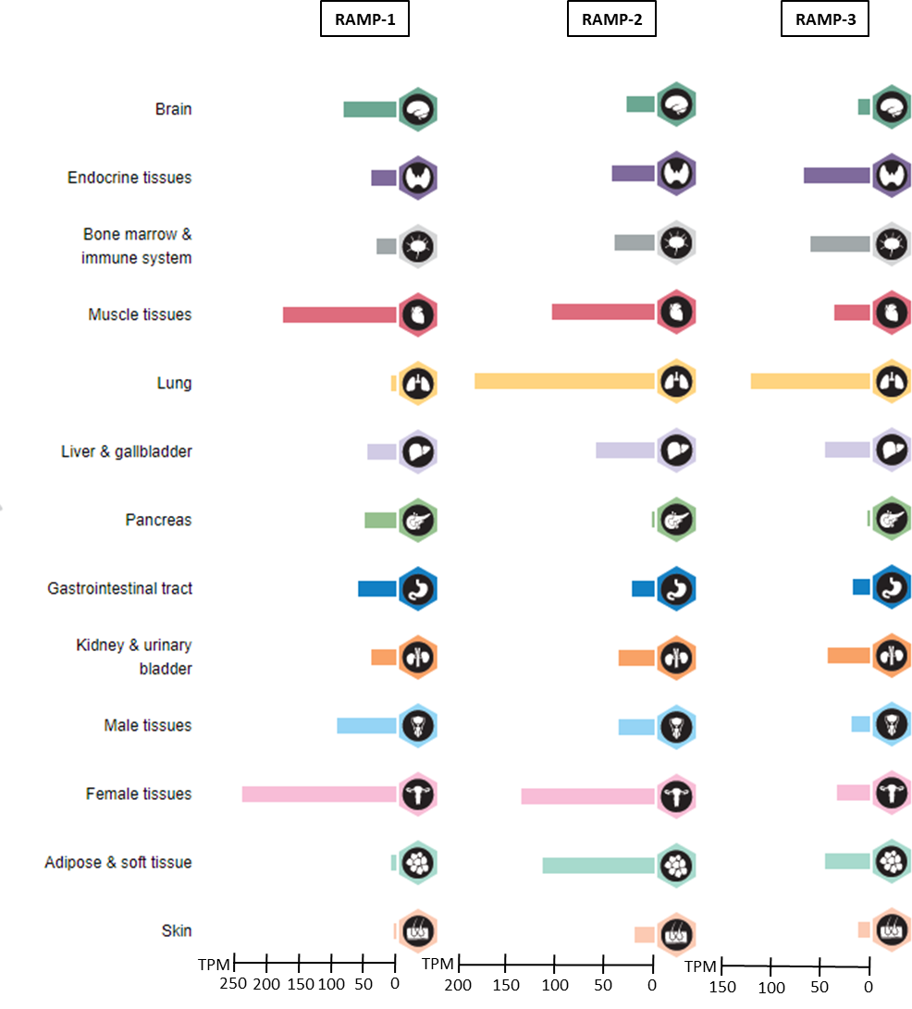
RNA-seq expression is reported as TPM (Transcripts Per kilobase Million)
Figure 3.3: RAMP RNA expression in normal tissues. Figure adapted from Human Protein Atlas, images available from:
https://v18.proteinatlas.org/ENSG00000132329-RAMP1/tissue, accessed Mar 2019;
https://v18.proteinatlas.org/ENSG00000131477-RAMP2/tissue, accessed Mar 2019;
https://v18.proteinatlas.org/ENSG00000122679-RAMP3/tissue, accessed Mar 2019

3.1.1.2 Functions and expression of ADM and its receptor components in the pancreas
As seen in Figures 3.1 to 3.3, ADM and its receptor components are expressed in both exocrine (acini, enzyme-secreting) and endocrine (islet cells, hormone-secreting) cells of the pancreas. CLR has low protein expression in acini and medium expression in islet cells. Conversely, ADM has medium expression in acini and undetectable expression in islet cells.
ADM has been shown to inhibit insulin secretion in studies in vitro (rat islet cells) and in vivo (oral glucose tolerance in rats) (Martinez et al., 1996, Martínez et al., 2000). The mechanism by which ADM inhibits insulin secretion in islet β-cells is through binding with factor H, which protects ADM from proteases (Martínez et al., 2001, Zudaire et al., 2003b). ADM treatment increases circulating glucose levels in a rat diabetes model, which is consistent with insulin inhibition (Zudaire et al., 2003a). PCR and immunohistochemistry reveals that CLR and RAMPs are also found on islet cells (Martínez et al., 2000). This suggests that even though ADM is not highly expressed in islet cells, it is able to exert its insulin inhibitory effects through CLR and RAMP receptor complexes within islet cells.

3.1.2 ADM and its receptors in cancer
Section 3.1.1 detailed how ADM is expressed in various tissue types and important for homeostasis. Section 3.1.2 will reveal the association of ADM and its receptor components development and progression of various cancers and section 3.1.2.1 will focus on ADM’s link to PaCa specifically.
There is strong evidence for the association of ADM and its receptor components in numerous cancers. Table 3.1 summarises the association of ADM and its receptors with progression in various cancers. Figures 3.4 to 3.6 show that ADM, CLR and RAMP-1, -2 and -3 RNA transcripts are expressed in a range of cancers around the body (Uhlen et al., 2015). ADM and its receptor components are expressed not only in tumour cells but stromal components including immune cells and vasculature (Allaker and Kapas, 2003). The effect of ADM and its receptor complexes in various cancer hallmarks (proliferation, apoptosis, angiogenesis, migration/invasion) have previously been reviewed in Section 1.3. The next section will focus on the link between ADM and PaCa specifically.

Table 3.1: Association of ADM and its receptors with disease progression in various types of cancers
Cancer | Receptor expression | ADM association with progression | References
Breast carcinoma |  | Lymph node metastasis | (Oehler et al., 2003)
Bladder urothelial cell carcinoma |  | Progression | (Liu et al., 2013)
Chromophobe renal carcinoma |  | Progression* | (Deville et al., 2009)
Clear-cell renal carcinoma | CLR, RAMPs 2 and 3 | Risk of relapse after nephrectomy | (Deville et al., 2009)
Colorectal carcinoma | CLR, RAMPs 2 and 3 | Progression, clinical survival rate, risk of relapse and cancer-related death after resection | (Nouguerède et al., 2013, Kim et al., 2012, Uemura et al., 2011)
Endometrial carcinoma |  | Progression* | (Evans et al., 2012)
Glioma |  | Progression | (Carlson et al., 2007)
Glioblastoma | CLR, RAMPs 2 and 3 | Progression | (Ouafik et al., 2002)
Hepatocellular carcinoma |  | Progression, invasion, metastasis | (Park et al., 2008, Qu et al., 2015)
Kaposi’s sarcoma | CLR | Progression | (Hagner et al., 2006)
Lung carcinoma, small cell |  | Progression** | (Martinez et al., 1995)
Lung carcinoma, squamous cell |  | Progression** | (Martinez et al., 1995)
Lung adenocarcinoma |  | Progression | (Martinez et al., 1995)
Ganglioneuroblastoma |  | Progression | (Satoh et al., 1995)
Nasopharyngeal carcinoma |  | Progression, long-term survival | (Zhang et al., 2015)
Neuroblastoma |  | Differentiation | (Satoh et al., 1995)
Osteosarcoma |  | Progression, metastasis, larger residual tumour size after cytoreduction, shorter disease-free and overall survival time | (Dai et al., 2013, Deng et al., 2012)
Orbital tumours |  | Progression | (Udono et al., 2000)
Ovarian carcinoma |  | Overall survival, Positive prognostic factor | (Deng et al., 2012, Baranello et al., 2012)
Pancreatic adenocarcinoma | CLR, RAMPs 1 and 2 | Progression, invasion^{mp} | (Aggarwal et al., 2012, Keleg et al., 2007)
Pancreatic insulinoma |  | Progression | (Aggarwal et al., 2012)
Pheochromocytoma | CLR, RAMPs 1, 2, and 3 | Progression | (Letizia et al., 2001, Thouennon et al., 2010)
Pituitary adenomas |  | Progression | (Lombardero et al., 2008)
Prostate adenocarcinoma |  | High Gleason scores | (Sion-Vardy et al., 2004, Rocchi et al., 2001)
Skin carcinomas | CLR, RAMPs 2 and 3 | Progression | (Martínez et al., 1997)
Uterine leiomyoma | CLR | Progression | (Nikitenko et al., 2006)
* increase in ADM mRNA and decrease in AM protein expressions associated with disease progression
** decrease in ADM mRNA associated with disease progression
^{m}: mRNA only; ^{p}: protein only; ^{mp}: mRNA and protein

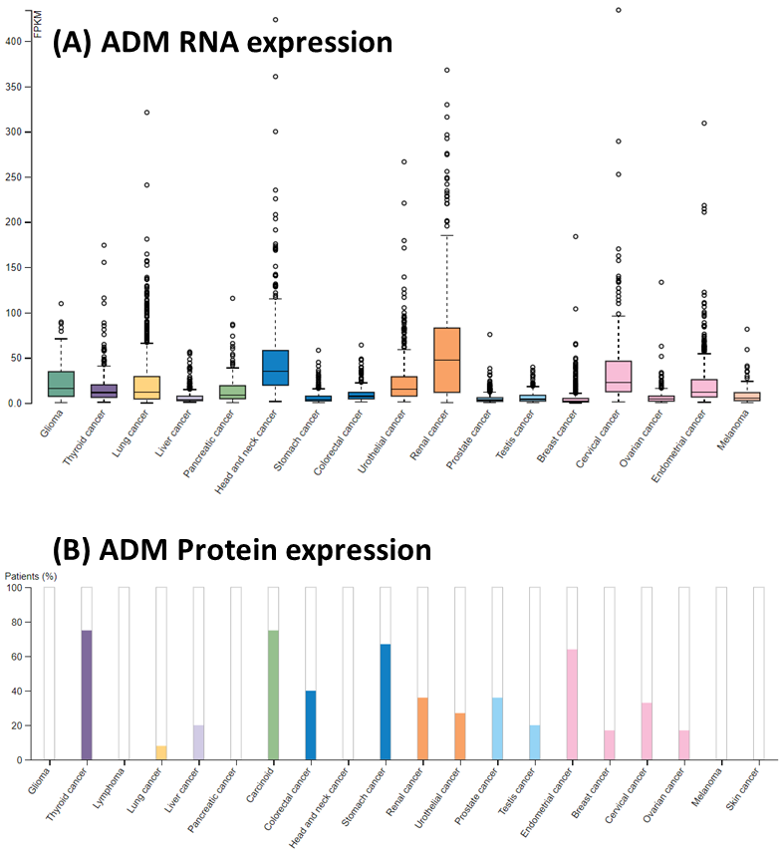
(A) RNA-seq expression is reported as median Fragments Per Kilobase of exon per Million reads (FPKM), generated by The Cancer Genome Atlas (B) Protein expression shows medium/high levels of protein (coloured bar). Low or undetected protein levels are reflected by the white bars. In pancreatic cancer tissue samples, ADM protein levels were low and undetected in 1/8 and 7/8 samples, respectively.
Figure 3.4: ADM RNA (A) and protein (B) expression in cancerous tissues. Figure adapted from Human Protein Atlas, images available from:
https://v18.proteinatlas.org/ENSG00000148926-ADM/pathology, accessed Mar 2019

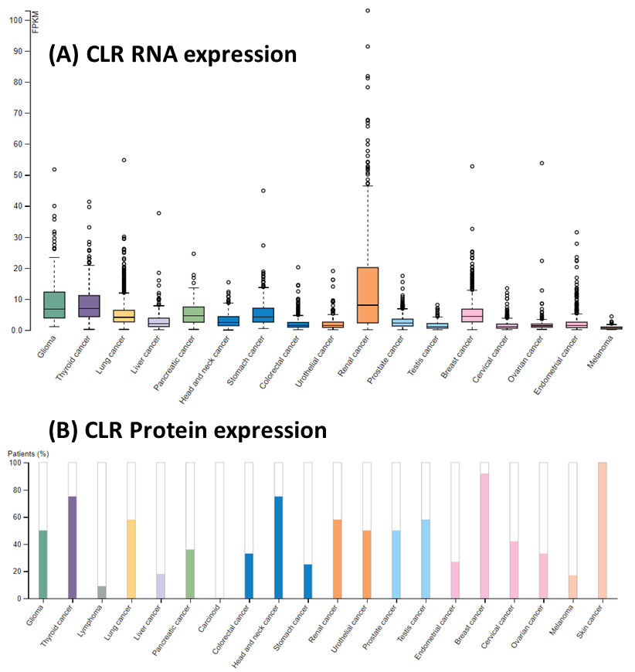
(A) RNA-seq expression is reported as median Fragments Per Kilobase of exon per Million reads (FPKM), generated by The Cancer Genome Atlas (B) Protein expression shows medium/high levels of protein (coloured bar). Low or undetected protein levels are reflected by the white bars. In pancreatic cancer tissue samples, CLR protein levels were medium, low and undetected in 6/11, 4/11 and 1/11 samples, respectively.
Figure 3.5: CLR RNA (A) and protein (B) expression in cancerous tissues. Figure adapted from Human Protein Atlas, images available from:
https://v18.proteinatlas.org/ENSG00000064989-CALCRL/pathology, accessed Mar 2019
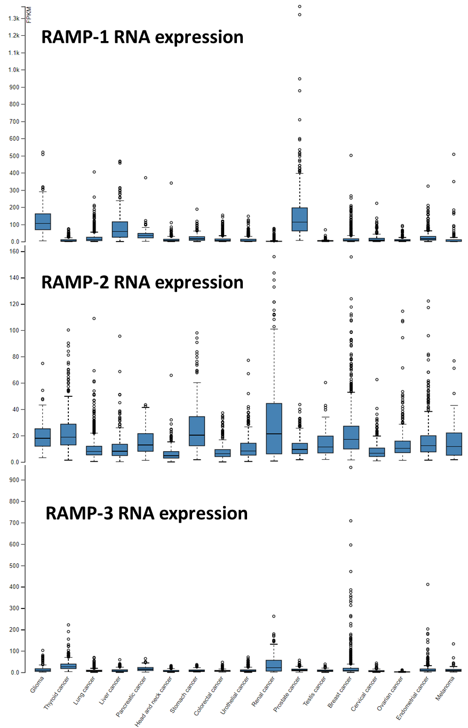
RNA-seq expression is reported as median Fragments Per Kilobase of exon per Million reads (FPKM), generated by The Cancer Genome Atlas
Figure 3.6: RAMP RNA expression in cancerous tissues. Figure adapted from Human Protein Atlas, images available from:
https://v18.proteinatlas.org/ENSG00000132329-RAMP1/pathology, accessed Mar 2019
https://v18.proteinatlas.org/ENSG00000131477-RAMP2/pathology, accessed Mar 2019
https://v18.proteinatlas.org/ENSG00000122679-RAMP3/pathology, accessed Mar 2019

3.1.2.1 ADM and its receptors in PaCa
The previous section detailed the strong evidence for association between ADM and its receptor components in various cancers, including PaCa. Quantitative PCR showed that ADM and CLR mRNA transcript levels were both higher in PaCa tissues (1.5-fold and 2.5-fold respectively) compared to normal pancreatic tissues (Keleg et al., 2007). Interestingly, ADM mRNA levels were also 1.8-fold higher in tissues from PaCa patients with lymph node metastases compared to patients without. These data suggest that ADM expression is not only elevated in PaCa, but correlates with disease progression.
As seen in Section 3.1.1.2, ADM has a crucial role in regulating blood glucose levels in pancreatic islet β-cells. It has also been suggested that ADM could explain the link between PaCa and diabetes mellitus (DM). A study has shown that new-onset DM could be a manifestation of PaCa and this process may be mediated by ADM (Aggarwal et al., 2012).
Radioimmunoassay revealed mean±SEM plasma ADM levels are significantly higher in PaCa patients who develop diabetes (22.9 ± 10.7 fmol/L) than individuals with new-onset DM (14.8 ± 10.7 fmol/L, p<0.001) and healthy controls (12.9 ± 6.6 fmol/L, p<0.001) (Aggarwal et al., 2012). ADM levels in PaCa patients who develop diabetes (22.9 ± 10.7 fmol/L) were also higher (p = 0.057) than those who did not (18.3 ± 7.0 fmol/L). Aggarwal and colleagues concluded that ADM could potentially be used as an early PaCa biomarker since patients develop diabetes an average of 13 months prior to PaCa diagnosis, even though it is inferior to that of late PaCa biomarker CA-19-9 in distinguishing between PaCa and healthy controls. The implication that ADM plasma levels has potential as a biomarker for an earlier detection of PaCa is crucial since most diagnoses are made at locally advanced or metastatic stages, where one-year survival rate of PaCa patients is 20% in the UK (Cancer Research UK, 2015b).
The same study revealed ADM treatment reduced insulin secretion in glucose-stimulated INS1 rat β-cells and isolated mouse β-cells (Aggarwal et al., 2012). This suggests ADM may induce insulin resistance in a subset of PaCa patients leading to development of DM. One possible mechanism is that the tumour cells shed ADM-containing exosomes into circulation, and these have been shown in vitro to readily enter β-cells, resulting in endoplasmic reticulum stress and inhibition of insulin secretion (Javeed et al., 2015). Exosomal ADM secreted by PaCa also induces lipolysis in subcutaneous adipose tissue (Sagar et al., 2015). Together, these data could explain the weight loss phenomena associated with new-onset DM prior to PaCa presentation, despite the primary cause of new-onset DM being obesity (Hart et al., 2011).
ADM has been shown to directly increase proliferation and invasion of PaCa cells. In vitro, human PaCa cell lines (BxPC-3, MPanc96 and Panc-1) increased proliferation and invasion through Matrigel-coated chambers in response to ADM treatment, and this was shown to be mediated through nuclear factor κB (Ramachandran et al., 2007). Interestingly, the same study showed that while ADM mRNA was expressed in both PaCa cells and stromal cells (endothelial and pancreatic stellate cells (PSCs), CLR and RAMP mRNA were only co-expressed in stromal cells. This suggests that paracrine regulation of stromal cells by tumour-derived ADM, but not autocrine regulation of the tumour cells themselves, could be mediated by CLR/RAMPs in PDAC.
ADM has also been shown to strongly induce infiltrating myeloid cells, including tumour-associated macrophages (TAMs), in PDAC to pro-tumour phenotypes, further promoting tumour growth and angiogenesis (Xu et al., 2016). ADM was shown to enhance migration, and invasion of TAMs in vitro. ADM also enhanced the ability of TAMs to adhere and extravasate through endothelial cells in vitro. In vivo experiments using an ADM antagonist also shows significant inhibition of TAMs and angiogenesis, leading to suppression of PDAC progression.
ADM has also been shown to mediate desmoplasia in PaCa, which is a fibroinflammatory response that characterises PaCa. ADM (together with Sonic Hedgehog) mediate the effect of MYB on PaCa cells and PSCs towards PaCa growth and desmoplasia in vitro and in vivo (Bhardwaj et al., 2016). Chapter 5 will elaborate on how ADM and its receptors can mediate PaCa stromal cells to contribute towards PaCa growth and its resistance to conventional therapies.
Identifying receptor components responsible for orchestrating ADM’s pro-tumoural effects could decrease chances of side effects and improve current treatment regimens, prognosis and survival for PaCa patients. While this section revealed how ADM mediates pro-tumoural processes in tumour and stromal cells within the PaCa environment, Section 1.3.6 also showed similarly how RAMP-3 is not only involved in promoting growth and spread of tumour cells, but also in modulating angiogenesis and EMT within the tumour microenvironment. In order to target ADM and its receptor components in PaCa, we first need to characterise both the expression and function of the hormone and receptors in PaCa.

3.1.3 Hypothesis
The null hypothesis is that ADM and its receptor components are not expressed or functional in PaCa cells and thus would not be involved in cancer development and progression.

3.1.4 Aims and objectives
The growth curves of a panel of seven PaCa cell lines were determined to optimise experimental conditions for further in vitro (viability and apoptosis) and in vivo (subcutaneous and orthotopic xenograft models) studies. Serum titration was also done to determine serum-reduced media needed for cell growth, for use in subsequent in vitro experiments with small molecule antagonists against AM2R.
The cell lines were also characterised for expression of ADM and its receptor components. Endpoint and quantitative PCR was used to detect mRNA transcripts. The cell lines were also tested for stimulation with ADM and other calcitonin family peptides using a cAMP assay.

3.2 Methods

3.2.1 Cell culture
Section 2.1 details how the PaCa cell lines were cultured and Table 2.1 lists their respective media and supplements. Cells were sub-cultured or seeded for experiments at 60-80% confluency. Cells were seeded for experiments at passage 35 or less.

3.2.2 Viability assay
Sections 2.1.1 and 2.1.3 detail how the PaCa cell lines were harvested and counted respectively, prior to seeding for viability assays. Section 2.3.1 details how RealTime-Glo MT Viability Assay was used to measure viability of PaCa cell lines to determine population doubling times. For viability assays lasting longer than three days, wells were washed with PBS and given fresh reagents every three days to continue the assay for a total of nine days.

3.2.3 Serum-titration Proliferation assay
Sections 2.1.1 and 2.1.3 detail how the PaCa cell lines were harvested and counted respectively, prior to seeding for proliferation assays. Cells were seeded in media with different serum concentrations into 24-well plates (25,000 per well). Wells were then counted in triplicate every three days, according to Section 2.1.3, to determine cell number per well. Every three days, wells that were not counted at that time point were washed with PBS and given fresh media.

3.2.4 RNA Extraction
To obtain RNA for end-point PCR, ReliaPrep™ RNA Cell Miniprep System was used. All incubations and centrifugation were done at room temperature unless otherwise stated. Cells were detached and counted as in Section 2.1.1 and 2.1.3. Cell suspensions were centrifuged for 5 minutes at 300 x g and re-suspended in ice-cold PBS to wash the cells. Cells were spun down as before and re-suspended in appropriate volume of BL + TG buffer (Table 3.2). Liquid suspensions were vortexed to shear genomic DNA before addition of appropriate volume of 100% isopropanol (Table 3.2).
Table 3.2: Volumes of reagents used for RNA extraction using Reliaprep™ RNA Cell Miniprep System
Cell count | BL + TG buffer (μL) | 100% isopropanol (μL) | DNAse/RNAse free water (μL)
<5e5 | 100 | 35 | 15
5e5 to 2e6 | 250 | 85 | 30
>2e6 | 500 | 170 | 50

Liquid suspensions were vortexed again before transferring to the Minicolumn in a Collection Tube. Tubes were centrifuged for 30 seconds at 14,000 x g. Liquids in Collection Tubes were discarded and Minicolumns were replaced into Collection tubes. 500 μL RNA Wash Solution was added to each Minicolumn and tubes were centrifuged for another 30 seconds at 14,000 x g. Liquids in Collection Tubes were discarded and DNase I incubation mix was made by gentle pipetting (30 μL per sample), according to Table 3.3. DNAse incubation mix (30 μL per sample) was added to each Minicolumn and incubated for 15 minutes. Column Wash Solution (200 μL per sample) was added to each Minicolumn and centrifuged for another 30 seconds at 14,000 x g. RNA Wash Solution (500 μL per sample) was added to each Minicolumn and centrifuged for another 30 seconds at 14,000 x g. Wash solutions and Collection tubes were discarded and Minicolumns were replaced into a new Collection tube.
Table 3.3: Volumes of reagents used to make DNAse incubation mix
Reagent | Volume (μL)
Yellow Core Buffer | 24
MnCl2 | 3
DNAse | 3
Total | 30

RNA Wash Solution (300 µL per sample) was added to each Minicolumn and centrifuged for two minutes at 14,000 x g. Minicolumns were transferred to an Elution tube and nuclease-free water was added to each column according to Table 3.4. Minicolumns and Elution tubes were placed in the centrifuge with the Elution tube lid facing outside, and centrifuged for one minutes at 14,000 x g. RNA was quantified as in Section 3.2.5 before storing at -80°C.
Table 3.4: Volume of nuclease-free water used for RNA extraction from different number of cells
Cell count | Volume of nuclease-free water (μL)
<5e5 | 15
5e5 to 2e6 | 30
>2e6 | 50

3.2.5 Quantification of RNA
Following extractions of RNA (Section 3.2.4), RNA concentrations, as well as their purities, were quantified using Nanodrop® spectrophotometer. Table 3.5 shows acceptable ranges of absorbance ratios for RNA. Section 3.2.6 and 3.2.7 will detail cDNA synthesis and data acquisition techniques used in end-point PCR and quantitative PCR (qPCR), respectively.
Table 3.5: Acceptable absorbance ratios for RNA purity
Nucleic Acids | 260/280 nm absorbance ratio | 260/230 nm absorbance ratio
RNA | Around 2.0 | 2.0 to 2.2

3.2.6 Endpoint PCR techniques

3.2.6.1 cDNA Synthesis
After RNA extraction and quantification detailed in Sections 3.2.4 and 3.2.5, cDNA synthesis was done using High-Capacity RNA-to-cDNA™ Kit (Thermo Fisher). RNase decontamination solution was used on surfaces and equipment before starting the experiment. Reaction mixes were made in microcentrifuge tubes and briefly spun down to mix contents and remove air bubbles. Volumes of each component are detailed in Table 3.6, for both reverse transcriptase positive (RT+) and negative (RT-) samples. Tubes are kept on ice before starting the reaction in a thermal cycler. Samples were incubated for an hour at 37°C, heated for 5 minutes at 95°C, then cooled at 4°C before storing at -20°C.
Table 3.6: Component volumes for reverse transcriptase reactions per sample

RT: reverse transcriptase; x cannot be greater than 9 μL

Component | Volume (μL)
Component | RT+ | RT-
2x RT Buffer | 10 | 10
20x Enzyme Mix | 1 | 0
RNA (2 μg) | x | x
Nuclease-free water | (9 – x) | (10 – x)
Total | 20 | 20

3.2.6.2 Endpoint PCR reaction
End-point PCR was done using GoTaq® G2 Flexi DNA Polymerase Kit. Reaction components were thawed on ice and vortexed thoroughly before use. Reaction mixes were made in nuclease-free microcentrifuge tubes and briefly spun down to mix contents and remove air bubbles. Volumes of each component are detailed in Table 3.7. Tubes are kept on ice before starting the reaction in a thermal cycler according to general amplification temperatures (denaturation at 95°C; annealing at 52-56°C; extension at 72°C). The number of cycles ran for CLR, RAMP-1 and RAMP-2 samples were 35 cycles (40 cycles for RAMP-3 samples). Table 3.8 lists the primers, sequences, expected product sizes and optimised annealing temperatures.
Table 3.7: Component volumes for polymerase chain reactions (PCR) per sample

RT: reverse transcriptase; x: volume containing up to 0.5 μg of cDNA; y: volume topped up to 50 μL total

Component | Volume (μL)
5x GoTaq® G2 Flexi Green Buffer | 10
MgCl₂, 25 mM | 2
PCR Nucleotide Mix, 10 mM | 1
Forward Primer | 5
Reverse Primer | 5
GoTaq® G2 Flexi DNA Polymerase (5u/ μL) | 0.25
cDNA (RT- or RT+; <0.5 μg) | x
Nuclease-free water | y
Total | 50
Table 3.8: Melting/annealing temperatures, expected product sizes and sequences for primers used in end-point and quantitative PCR

T^{M}: melting temperature; T^{A}: annealing temperature; F: forward primer; R: reverse primer

Primers | T^{M} (°C) | T^{A} (°C) | Product size (bp) | Sequence
CLR | 59.4 | 54.4 | 302 | CTTGGCTGGGGATTTCCACT (F)
CLR | 59.4 | 54.4 | 302 | CCTTCAGGTCGCCATGGAAT (R)
RAMP-1 | 59 | 54 | 193 | ATGCAGAGGTGGACAGGTTC (F)
RAMP-1 | 60 | 54 | 193 | GCCTACACAATGCCCTCAGT (R)
RAMP-2 | 61 | 56 | 256 | CTGTCCTGAATCCCCACGAG (F)
RAMP-2 | 60 | 56 | 256 | CTCTCTGCCAAGGGATTGGG (R)
RAMP-3 | 59.6 | 55 | 227 | AAGGTGGACGTCTGGAAGTG (F)
RAMP-3 | 57.2 | 55 | 227 | ATAACGATCAGCGGGATGAG (R)
GAPDH | 57.3 | 52 | 354 | TTGTCAGCAATGCATCCTGC (F)
GAPDH | 57.3 | 52 | 354 | GCTTCACCACCTTCTTGATG (R)

3.2.6.3 Gel Electrophoresis
Gel electrophoresis was used to visualise separated PCR products by size. 1.5g agarose was mixed with 100 mL TBE and fully dissolved in the microwave. Ethidium bromide was added (2.5 μg) and the gel mixture was put into the mould with combs creating wells. After the gel has solidified (30 minutes), combs were removed and samples were loaded. For each reaction, water and GAPDH were used as negative and positive sample controls respectively. DNA ladder (100 to 10,000 bp) was also loaded to confirm PCR product size. Running of gel electrophoresis was done for 30 minutes before visualisation using Gel Doc XR+ System.
To validate endpoint PCR data, Sanger sequencing was used to confirm amplified targets. Samples were analysed by University of Sheffield Core Genomic Facility using BigDye™ Terminator v3.1 Cycle Sequencing Kit and Applied Biosystems 3730 DNA Analyzer. Sequencing data were visualised using FinchTV software and aligned to target sequences using Basic Local Alignment Search Tool (BLAST) in the National Centre for Biotechnology Information (NCBI) website. Figure 3.7 shows an example of RAMP-1 sequencing data and NCBI BLAST results. The same was acquired for CLR, RAMP-2 and RAMP-3 PCR samples (Appendix Figures 7.1 to 7.5).
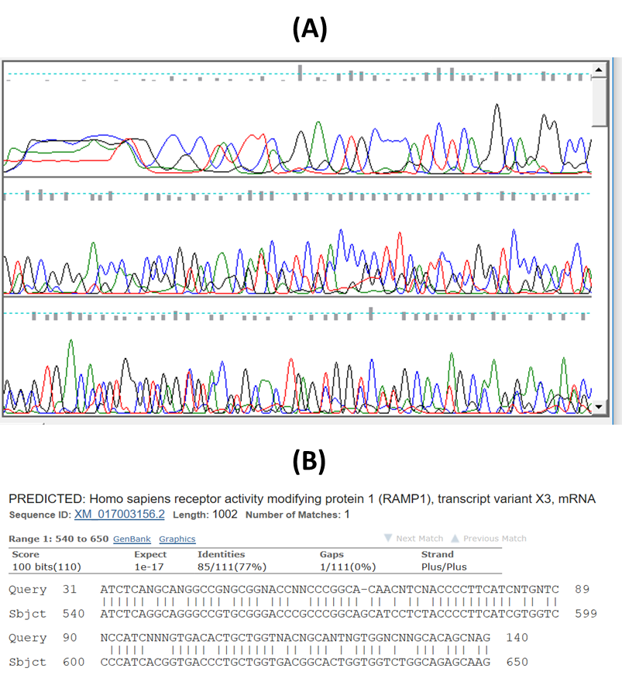
Figure 3.7: (A) RAMP-1 sequencing data visualised on FinchTV software (B) NCBI BLAST alignment results of RAMP-1 sequencing data

3.2.7 Quantitative Real-time PCR (qPCR) techniques

3.2.7.1 cDNA Synthesis
Samples were prepared to a final amount of 1.5 μg using Precision Nanoscript2 Reverse Transcription Kit with oligodT primers, according to Table 3.9. Samples then undergo annealing for five minutes at 65°C and were subsequently placed on ice immediately following the annealing reaction.
Table 3.9: Reagent volumes for annealing reaction prior to qPCR per sample

x: volume containing 1.5μg of RNA

Component | Volume (μL)
RNA (1.5 μg) | x
Reverse transcriptase primer (oligodT) | 1
Nuclease-free water | (9 – x)
Total | 10
Following annealing, extension reaction mix was added to both reverse transcriptase positive (RT+) and negative (RT-) samples accordingly (Table 3.10). Samples then undergo extension for 20 minutes at 42°C, 10 minutes at 72°C and incubated at 4°C until real-time PCR reaction or stored at -20°C.

Table 3.10: Reagent volumes for extension reaction prior to qPCR per sample

RT: reverse transcriptase

Component | Volume (μL)
Component | RT+ | RT-
Nanoscript2 4x Reverse transcriptase Buffer | 5 | 5
Nanoscript2 Enzyme | 1 | 0
dNTP mix (10mM) | 1 | 1
Nuclease-free water | 3 | 4
Total | 10 | 10

3.2.7.2 qPCR reaction
In comparison to end-point PCR, qPCR is a quantitative method of measuring mRNA levels of genes of interest in comparison to a house-keeping gene. Double-dye (Hydrolysis) Probe geNorm 6 Gene Kit was used to determine appropriate house-keeping to use for qPCR of analysed PaCa cell lines. The house-keeping gene selected was ACTB (β-actin) as the mRNA levels expressed were similar in analysed cell lines.
PrecisionPLUS with ROX kit was used for qPCR reaction. ROX (or rhodamine-X) is a reference dye used to normalise (correcting for pipetting errors or instrumental drift) fluorescence intensity of qPCR reporter dyes including Taqman probes, which are used in our qPCR reactions. Figure 3.8 shows the principles of TaqMan detection method used in qPCR. Taqman probes, like primers, were specifically designed for different target sequences.
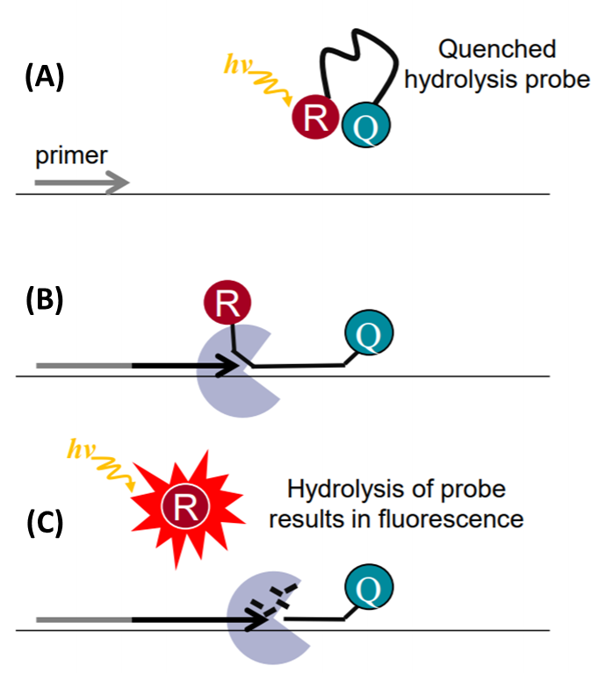
Figure 3.8: Principle of TaqMan in polymerase chain reactions adapted from Promega (A) Taqman probe contains reporter fluorophore (R) and quencher (Q), hence intact probe signals are quenched. (B) Taqman probes anneal to DNA region amplified by primers. Taq polymerase extend these primers and degrades the annealed probes due to its 5’ to 3’ exonuclease activity, releasing reporter fluorophore allowing it to fluoresce (C).

Equipment and nuclease-free water used for qPCR were sterilised under UV light for at least 20 minutes. cDNA samples were diluted to 5 ng/μL in nuclease-free water. qPCR Master Mix was made according to Table 3.11. Samples were added into 384-well plate in triplicate (2.5 μL per well) before addition of qPCR Master Mix (7.5 μL per well). 384-well plate was centrifuged for one minute at 250 x g to ensure uniform mixing of samples and reagents within each well.

Table 3.11: Reagent volumes for qPCR Master Mix per sample
Component | Volume (μL)
PrecisionPLUS qPCR Master Mix | 5
qPCR primer and probes | 0.5
Nuclease-free water | 2
Total | 7.5

Applied Biosystems 7900HT Fast Real-Time PCR System was used for the qPCR reaction. Each reaction was run for 40 cycles, where each cycle consists of incubation at 95°C (130 seconds) and 60°C (60 seconds). Reactions measuring house-keeping gene and samples without reverse transcriptase were used Analysis of qPCR reactions were done using Sequence Detection System (SDS) v2.4. Results of amplification plots are plotted with y-axis on log-scale (Figure 3.9). Thresholds used to interpolate C_{t} values (number of cycles needed to cross background fluorescence threshold) from the x-axis are set crossing linear phases of all plots within the same reaction (green line, Figure 3.9).
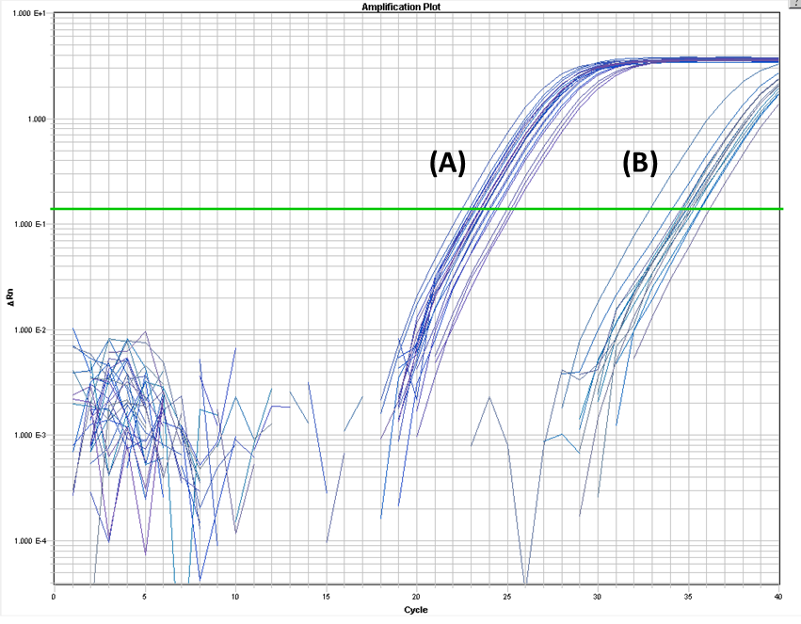
Figure 3.9: qPCR amplification plot (y-axis on log-scale) quantifying ADM in PaCa samples with reverse transcriptase (A) and without (B). Threshold (green line) was set within the linear range to interpolate C_{t} values (number of cycles needed to cross background fluorescence threshold)

3.2.8 cAMP assay
GPCRs, including CLR, can mediate the conversion of adenosine triphosphate into cAMP as a result of adenylyl cyclase activation. Calcitonin superfamily peptides (ADM, CGRP and IMD) were used to stimulate PaCa cells and the resulting intracellular cAMP was quantified using LANCE® cAMP 384 kit. Forskolin was also used as a positive control as it directly activates adenylyl cyclase resulting in maximum possible cAMP production. All reactions, incubations and fluorescence readings were done/taken at room temperature (22-25°C).
LANCE® cAMP assay is a time-resolved fluorescence energy transfer assay. Figure 3.10 shows the principles of the assay. Instead of measuring the direct binding of antibodies to cAMP, this assay is based on competition between europium-labelled cAMP complex (from the kit) and cAMP in samples, for binding sites on Alexa-Fluor 647 labelled cAMP antibodies (from the kit). 340 nm wavelength excites the europium which itself emits 615 nm fluorescence. When the europium-labelled complex is additionally bound to Alexa-Fluor 647 labelled cAMP antibodies, the Alexa Fluor dye emits 665 nm fluorescence. The more cAMP in the sample competing to bind with the antibodies, the lower the 665 nm fluorescence (inversely proportional).
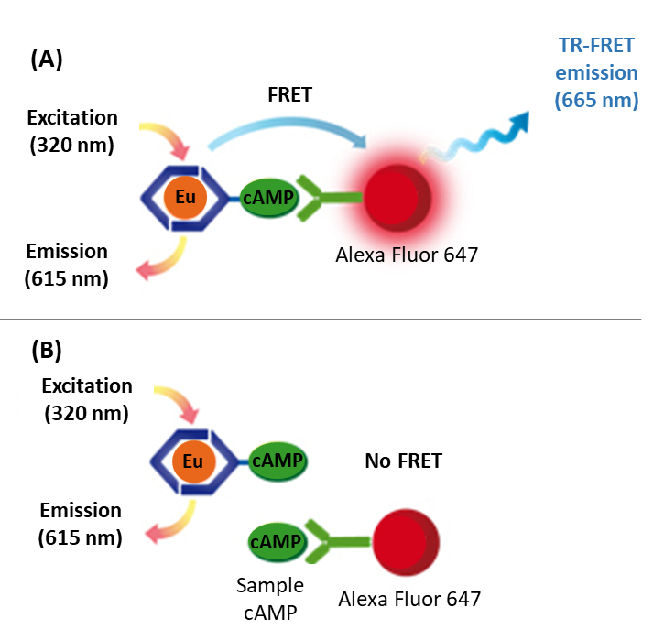
Figure 3.10: Principles of time-resolved fluorescence resonance energy transfer (TR-FRET) in cAMP assay, adapted from PerkinElmer manual. Europium (Eu) excited at 320 nm will emit 615 nm fluorescence. (A) When the excited Eu-labelled cAMP complex is additionally bound to Alexa-Fluor 647 labelled cAMP antibodies, Eu transfers energy to the Alexa Fluor dye resulting in 665 nm TR-FRET signal. (B) When cAMP from samples compete and bind to Alexa-Fluor 647 labelled cAMP antibodies, the 665 nm fluorescence is diminished.

Stimulation buffer was made according to Table 3.12 (pH adjusted to 7.4 with 0.1 M NaOH). Stimulation buffer made with HBSS with Ca²⁺ and Mg²⁺ was used as diluent for ligands as per manufacturer’s protocol. However, buffer using HBSS without Ca²⁺ and Mg²⁺ was used to prepare cells as it discouraged clumping and ensured equal distribution between wells. IBMX was used to inhibit phosphodiesterase degradation of cAMP. BSA was also used to stabilise antibody in the assay process.
Table 3.12: Stimulation buffer recipe for cAMP assays
Reagent | Stock Concentration | Volume added | Final Concentration
HBSS | - | 15 mL | -
HEPES | 1 M | 75 µL | 5 mM
BSA Stabiliser | 7% | 200 µL | 0.1%
IBMX | 250 mM | 30 µL | 0.5 mM

HBSS: Hank’s buffered saline solution

HEPES: 4-(2-hydroxyethyl)-1-piperazineethanesulfonic acid

BSA: bovine serum albumin

IBMX: 3-isobutyl-1-methylxanthine

Figure 3.11 shows the schematic of setting up cAMP assays to measure stimulation by peptide ligands. Half-log serial dilutions of ADM, CGRP, AMY and forskolin were done using INTEGRA VIAFLO 125 multichannel pipette on the ASSIST automated pipette platform, in 96-well plates. Forskolin was used as a positive control as it bypasses receptor activation to directly activate adenylyl cyclase and produce cAMP. Tables 3.13 and 3.14 show the volumes used for serial dilution of calcitonin family peptides and forskolin, respectively. 2X concentration was prepared as addition of cells would result in final concentration. Ligands were then plated into 384-well Optiplates (6 µL per well).

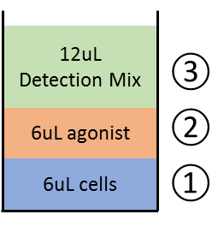
Figure 3.11: Well setup for cAMP assays measuring agonist stimulation. Cells (1) were stimulated with different concentrations of agonists (2) for 30 minutes before adding the Detection Mix (3). Fluorescence (Excitation: 320nm Emission: 615/665nm) was recorded on a plate-reader an hour after addition of Detection Mix.

Table 3.13: Half-log serial dilution of calcitonin family peptides for cAMP assay

Conc: concentration; stimulation buffer was used as diluent

Dilution | 2X conc (M) | Final conc (M) | Volume of dilution | Diluent
1 | 2.00E-06 | 1.00E-06 | 4 μL of 60μM | 116 μL
2 | 6.32E-07 | 3.16E-07 | 30 μL of 1 | 70 μL
3 | 2.00E-07 | 1.00E-07 | 30 μL of 2 | 60 μL
4 | 6.32E-08 | 3.16E-08 | 30 μL of 3 | 70 μL
5 | 2.00E-08 | 1.00E-08 | 30 μL of 4 | 60 μL
6 | 6.32E-09 | 3.16E-09 | 30 μL of 5 | 70 μL
7 | 2.00E-09 | 1.00E-09 | 30 μL of 6 | 60 μL
8 | 6.32E-10 | 3.16E-10 | 30 μL of 7 | 70 μL
9 | 2.00E-10 | 1.00E-10 | 30 μL of 8 | 60 μL
10 | 6.32E-11 | 3.16E-11 | 30 μL of 9 | 70 μL
11 | 2.00E-11 | 1.00E-11 | 30 μL of 10 | 60 μL
blank | - | - | - | 70 μL

Table 3.14: Half-log serial dilution of forskolin for cAMP assay

Conc: concentration; stimulation buffer was used as diluent

Dilution | 2X conc (M) | Final conc (M) | Volume of dilution | Diluent
1 | 2.00E-04 | 1.00E-04 | 80μL of 150μM | 40μL
2 | 6.32E-05 | 3.16E-05 | 30 μL of 1 | 70 μL
3 | 2.00E-05 | 1.00E-05 | 30 μL of 2 | 60 μL
4 | 6.32E-06 | 3.16E-06 | 30 μL of 3 | 70 μL
5 | 2.00E-06 | 1.00E-06 | 30 μL of 4 | 60 μL
6 | 6.32E-07 | 3.16E-07 | 30 μL of 5 | 70 μL
7 | 2.00E-07 | 1.00E-07 | 30 μL of 6 | 60 μL
8 | 6.32E-08 | 3.16E-08 | 30 μL of 7 | 70 μL
9 | 2.00E-08 | 1.00E-08 | 30 μL of 8 | 60 μL
10 | 6.32E-09 | 3.16E-09 | 30 μL of 9 | 70 μL
11 | 2.00E-09 | 1.00E-09 | 30 μL of 10 | 60 μL
blank | - | - | - | 70 μL
Frozen cell aliquots were thawed and counted as in Sections 2.1.1 and 2.1.3, respectively. Alexa Fluor anti-cAMP was added 1:100 to cell suspension before seeding into wells (2,500 cells in 6 µL per well). After this point, reactions were done in the dark. Cells were stimulated by ligands for 30 minutes at room temperature before adding Detection Mix (europium-labelled cAMP tracer complex; 12 µL per well) which had been prepared at least 30 minutes prior to use. After one hour, the plate was read on EnSight Multimode Plate Reader (PerkinElmer) at 320/340 nm excitation and 615/665 nm emission was recorded. Forskolin-stimulated (0.1 mM) and vehicle-control wells were used as controls for 100% and 0% cAMP stimulation, respectively.

3.3 Results

3.3.1 Morphology of PaCa cells
PaCa cell lines cultured in vitro were imaged to determine morphology and monitored regularly to ensure similarity to previous cultures. Figure 3.12 shows the morphology of a panel of seven PaCa cell lines. Morphology of all cell lines are similar to images from ATCC website (where they were purchased from).
AsPC-1 cells grow in a monolayers with disorganised patterns made up of round, polygonal and elongated cells. AsPC-1 monolayers uniformly occupy areas and smaller clusters of proliferating cells can be observed.
Unlike AsPC-1, BxPC-3 cultures have a cobblestone epithelial monolayer. BxPC-3 cells also have a more prominent nuclei and appear slightly bigger than AsPC-1 cells, as they adhere more flatly. BxPC-3 monolayers also uniformly occupy areas and smaller clusters of proliferating cells can be observed.
Capan-2 grows in a cobblestone epithelial monolayer with homogenous round or polygonal cells. Unlike AsPC-1 and BxPC-3 cultures, Capan-2 monolayers tend to be huge distinct islands with empty spaces in between which do not contain many smaller clusters of proliferating cells.
CFPAC-1 grows in monolayers with disorganised patterns. Unlike the other cell lines, CFPAC-1 cultures contain elongated cells which swirl around the boundaries of polygonal cells. Similar to AsPC-1, CFPAC-1 monolayers occupy areas uniformly and smaller clusters of proliferating cells can be observed.
HPAF-II grows in a cobblestone epithelial monolayer with round or polygonal cells. Similar to Capan-2 cultures, HPAF-II monolayers tend to be huge distinct islands with empty spaces in between which do not contain many smaller clusters of proliferating cells. Giant multinucleated cells surrounded by smaller mononuclear cells are also present.
Panc10.05, similar to BxPC-3, grow in a cobblestone epithelial monolayer with round and polygonal cells. Similar to Capan-2 and HPAF-II cultures, Panc10.05 monolayers tend to be huge distinct islands with empty spaces in between which do not contain many smaller clusters of proliferating cells. Similar to HPAF-II, giant multinucleated cells surrounded by smaller mononuclear cells are also present.
SW1990, like BxPC-3, grow in a cobblestone epithelial monolayer with homogenous round and polygonal cells. SW1990 monolayers uniformly occupy areas and smaller clusters of proliferating cells can be observed, also similar to BxPC-3. Similar to HPAF-II and Panc10.05, giant multinucleated cells surrounded by smaller mononuclear cells are also present.
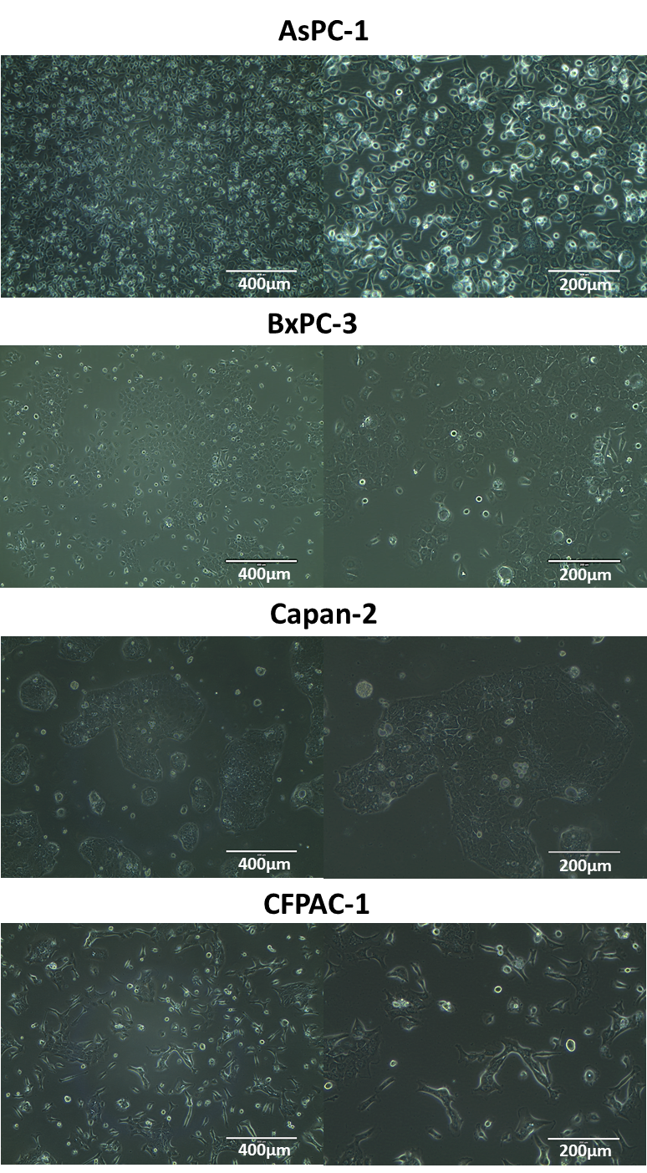
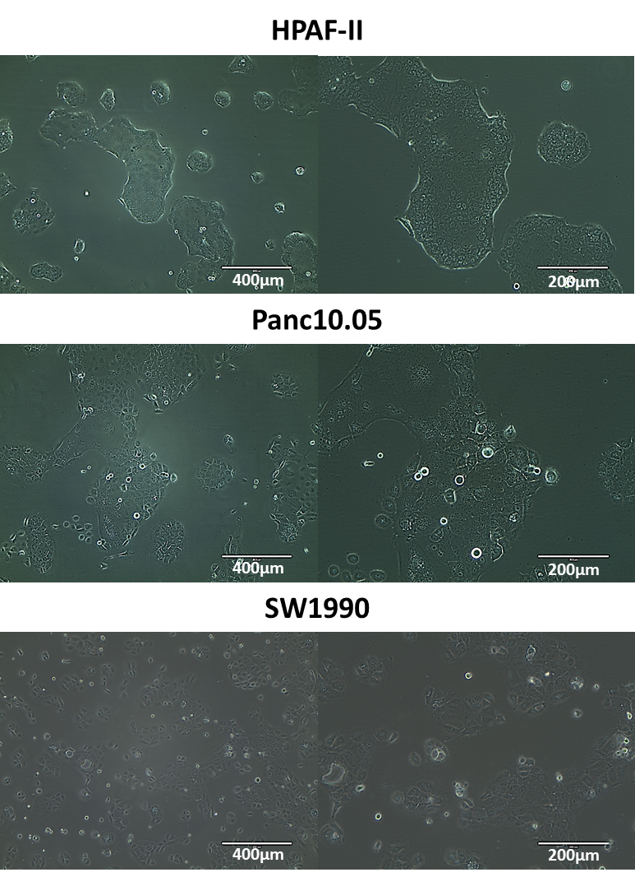
Figure 3.12: Phase-contrast images of panel of seven pancreatic cancer cell lines used in in vitro and in vivo experiments, purchased from American Type Culture Collection (ATCC). Images were taken 2 to 7 days after seeding, at 100x (left) and 200x (right) magnification.

3.3.2 PaCa cells growth curves
In order to determining optimal seeding density and duration of subsequent in vitro experiments (viability and apoptosis), viability assays were done to determine doubling time of PaCa cell lines. Figure 3.13 shows the growth curves for seven PaCa cell lines. Population doubling times were calculated using the formula:
$$Doubling time= \frac{Duration ×log⁡(2)}{\log\left(n2\right)-log⁡(n1)}$$
where n1 and n2 are luminescence readings in the linear growth phase, and duration is the time between n1 and n2 readings. Doubling times for the cell lines are listed in Table 3.15, ranging from 46.1 to 97.6 hours.

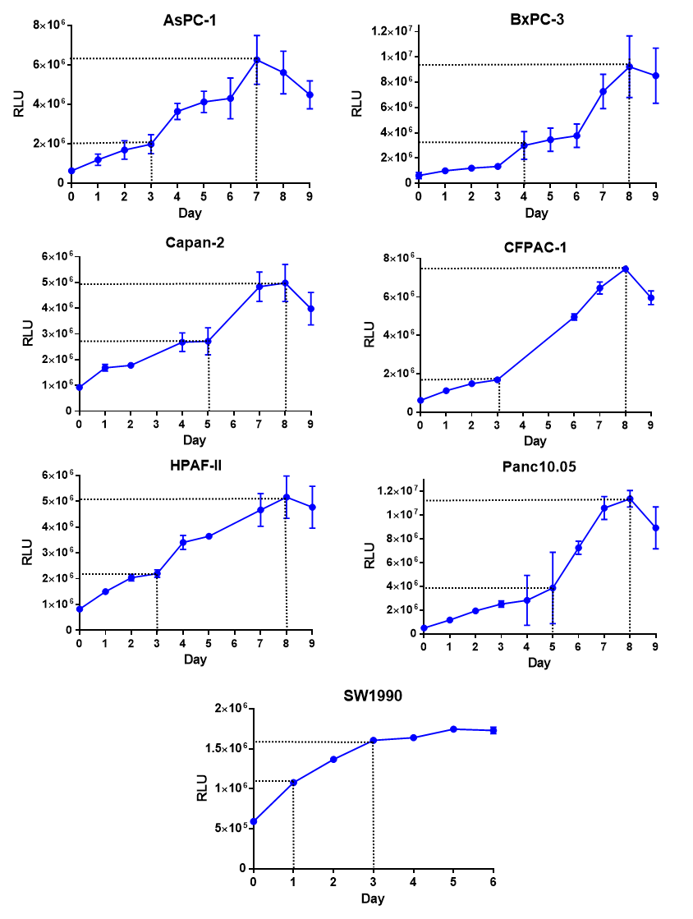
Figure 3.13: Growth curves of seven PaCa cell lines measured using RealTime-Glo MT Viability Assay. Cells were seeded at 2,000 cells per well in 96-well plates in optimal growth media (Chapter 2 Table 2.1). Luminescence readings (corresponding to cell number) were taken until cells have reached stationary or death phase. Doubling time was calculated using the linear log phase of growth as shown between the two sets of dotted lines. Calculated doubling times for PaCa cells are summarised in Table 3.15.

3.3.3 Effect of serum titration on PaCa cell growth
In order to optimise assay conditions to test the effect of small molecule antagonists on PaCa cells in serum-reduced media, viability assays were done on PaCa cells using media with different serum concentrations. As expected, higher serum concentration in the media resulted in faster cell growth (Figure 3.14). Serum-reduced concentrations (summarised in Table 3.15) were chosen based on growth to 50% of maxima, so the effect of small molecule antagonists will not be masked in subsequent functional studies.
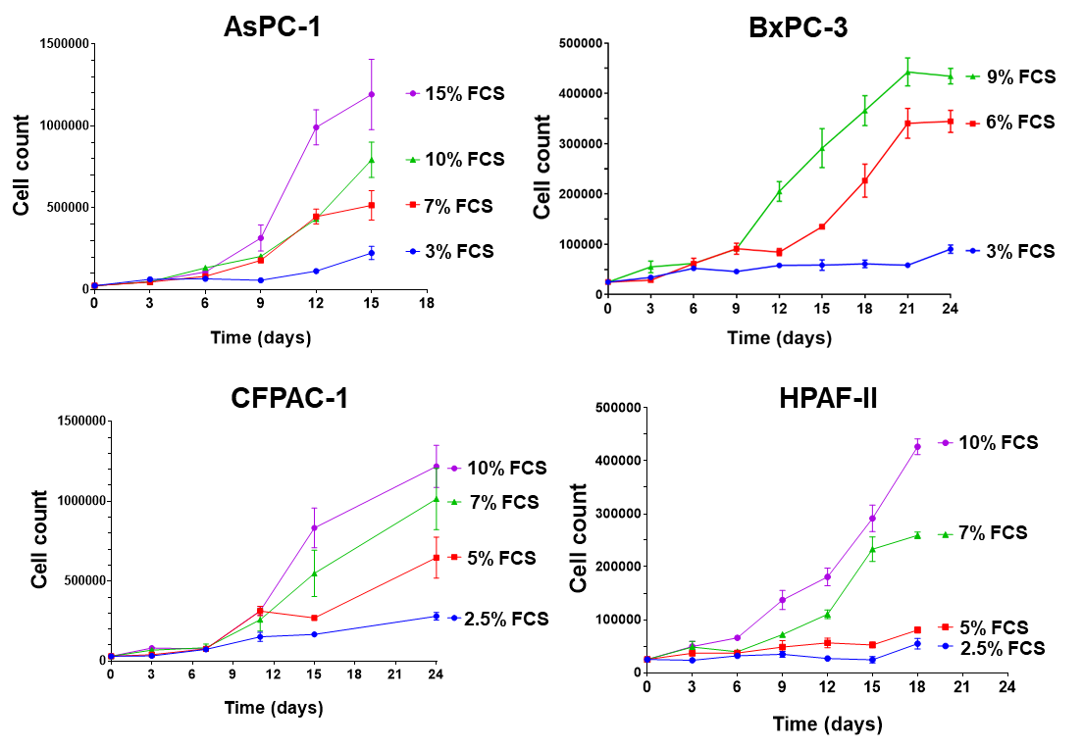
Figure 3.14: Effect of different serum concentrations on cell growth of PaCa cells. Cells were seeded at 25,000 cells per well in 24-well plates in growth media with varying concentrations of foetal calf serum (FCS) and counted in triplicates every three days. Serum-reduced media concentration was chosen based on growth to 50% of maxima for subsequent functional studies using small molecule antagonists.
Table 3.15: Doubling time, full and serum-reduced media of seven PaCa cells
Cell line | Doubling time (hours) | Full media | Serum-reduced media
AsPC-1 | 58.1 | 15% RPMI | 7% RPMI
BxPC-3 | 55.3 | 10% RPMI | 5% RPMI
Capan-2 | 82.0 | 10% McCoy’s | 5% McCoy’s
CFPAC-1 | 56.3 | 10% DMEM | 5% DMEM
HPAF-II | 97.6 | 10% RPMI | 7% RPMI
Panc10.05 | 46.1 | 15% RPMI | 5% RPMI
SW1990 | 70.1 | 10% DMEM | 5% DMEM

3.3.4 mRNA Expression of ADM/CLR/RAMPs
To determine if PaCa cell lines express the ligand and receptor components necessary for ADM signalling (ADM, CLR, RAMP-1, RAMP-2 and RAMP-3), qPCR and endpoint PCR was done to measure mRNA levels. Table 3.16 shows ADM mRNA expression in seven PaCa cell lines as analysed by qPCR, with mean C_{t} values ranging between 23.0 and 26.1. All cell lines had a C_{t} value of below 35, meaning all samples contained detectable amounts of ADM mRNA.
Figures 3.15 to 3.18 show CLR, RAMP-1 and RAMP-2 mRNA expression in seven PaCa cell lines as analysed by end-point PCR. As summarised in Table 3.17, all cell lines express mRNA of all the aforementioned receptor components (CLR, RAMP-1, RAMP-2 and RAMP-3), except BxPC-3 which did not appear to express RAMP-3.
Table 3.16: Relative ADM mRNA expression in seven PaCa cell lines detected by quantitative real-time polymerase chain reaction

Data from three independent experimental repeats and presented as mean±SD (3 s.f.).

C_{t}: number of cycles needed to cross background fluorescence threshold

Cell line | ADM C_{t} value | ACTB C_{t} value | ADM mRNA expression relative to ACTB (%)
AsPC-1 | 23.0±0.55 | 18.1±1.01 | 3.60±1.37
BxPC-3 | 24.1±0.97 | 22.1±0.40 | 57.9±33.0
Capan-2 | 23.5±1.06 | 20.8±0.55 | 32.4±25.4
CFPAC-1 | 23.9±0.61 | 18.5±0.40 | 3.98±1.54
HPAF-II | 26.1±1.05 | 17.6±0.44 | 0.68±0.46
Panc10.05 | 23.5±0.42 | 16.2±0.01 | 0.16±0.04
SW1990 | 25.2±1.82 | 18.1±0.10 | 1.85±1.35

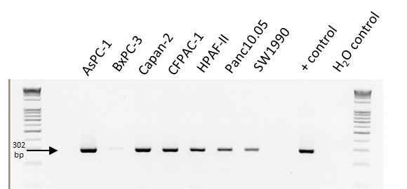
Figure 3.15: CLR mRNA expression in seven PaCa cell lines detected by end-point polymerase chain reaction. PC-3 prostate cancer cell line was used as a positive control. Reaction without template DNA (water control) was done as a negative control. Monochrome images were inverted using MSPaint. Representative data from one of three independent experimental repeats is shown.
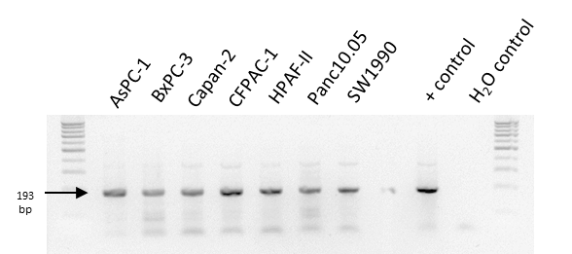
Figure 3.16: RAMP-1 mRNA expression in seven PaCa cell lines detected by end-point polymerase chain reaction. PC-3 prostate cancer cell line was used as a positive control. Reaction without template DNA (water control) was done as a negative control. Monochrome images were inverted using MSPaint. Representative data from one of three independent experimental repeats is shown.

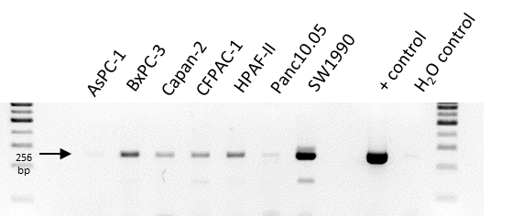
Figure 3.17: RAMP-2 mRNA expression in seven PaCa cell lines detected by end-point polymerase chain reaction. CHO-K1 cell line over-expressing AM1 receptor components (CLR + RAMP-2) was used as a positive control. Reaction without template DNA (water control) was done as a negative control. Monochrome images were inverted using MSPaint. Representative data from one of three independent experimental repeats is shown.

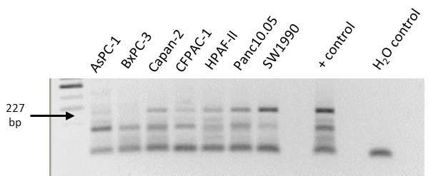
Figure 3.18: RAMP-3 mRNA expression in seven PaCa cell lines detected by end-point polymerase chain reaction. 1321N1 cell line over-expressing AM2 receptor components (CLR + RAMP-3) was used as a positive control. Reaction without template DNA (water control) was done as a negative control. Monochrome images were inverted using MSPaint. Representative data from one of three independent experimental repeats is shown.

Table 3.17: ADM, CLR and RAMP mRNA expression in PaCa cell lines
q: quantitative RT-PCR (C_{t} value)
ep: endpoint RT-PCR

Cell line | ADM^{q} | CLR^{ep} | RAMP-1^{ep} | RAMP-2^{ep} | RAMP-3^{ep}
AsPC-1 | 23.0±0.06 | + | + | + | +
BxPC-3 | 24.1±0.30 | + | + | + | -
Capan-2 | 23.5±0.20 | + | + | + | +
CFPAC-1 | 23.9±0.10 | + | + | + | +
HPAF-II | 26.1±0.15 | + | + | + | +
Panc10.05 | 23.5±0.18 | + | + | + | +
SW1990 | 25.2±0.22 | + | + | + | +

3.3.5 Stimulation of PaCa cells with calcitonin superfamily
To determine if ADM or other calcitonin superfamily peptides mediate downstream signalling in PaCa cell lines, cAMP assays were done to measure the effect of these peptides on cAMP production. Figure 3.19 shows the response of PaCa cell lines when stimulated with calcitonin superfamily peptides (ADM, CGRP and IMD) between 1 μM and 10 pM. Six out of seven cell lines were stimulated by CGRP with EC50 doses between 3.43 nM and 57.1 nM. CGRP stimulation also varied in efficacy, ranging between 20-100% of maximal cAMP production (normalised to forskolin). Five out of seven cell lines were also stimulated by ADM, and the results for IMD stimulation were mirrored in the same cell lines. SW1990 was the only cell line not stimulated with any of the calcitonin family peptides at the tested concentrations.
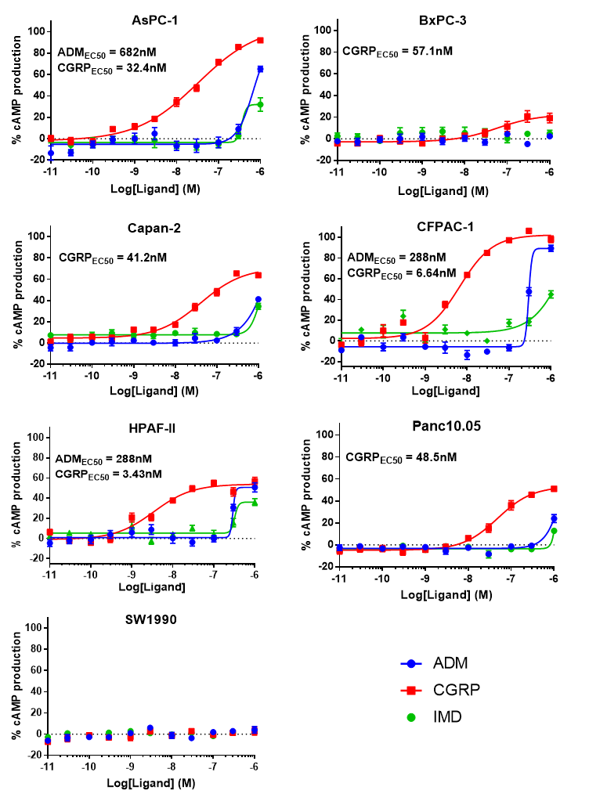
Figure 3.19: Effect of calcitonin family peptides (ADM, CGRP, IMD) on cAMP production of seven PaCa cell lines. Cells were stimulated for 30 minutes at various concentrations and cAMP levels were measured using LANCE Ultra cAMP kit. Cell lines were differently stimulated in potency and efficacy. Two cell lines appear not to be stimulated at concentrations tested (BxPC-3 and SW1990). Data are from three independent experimental repeats and presented as mean±SEM. Data were normalised to stimulation with 100 μM forskolin and blank as 100% and 0% stimulation. Dose response curves were analysed using four-parameter logistic curve. Only unambiguous EC50 values are stated (3 s.f.).

3.4 Discussion

3.4.1 Panel of PaCa cell lines vary in morphology and doubling times
In order to screen small molecule antagonists against AM2R as well as investigate their effects on cancer hallmarks in PaCa, a panel of seven PaCa cell lines were first characterised in vitro before deciding which to use for subsequent in vitro and in vivo experiments.
All seven PaCa cell lines typically grew as cobblestone colonies with epithelial morphology in vitro, except AsPC-1 and CFPAC-1. CFPAC-1 cells were more elongated and grew in a disorganised pattern, suggesting a more mesenchymal appearance. AsPC-1 cells were slightly less elongated than CFPAC-1 but also grew in a disorganised pattern in culture. Three cells lines (Capan-2, HPAF-II and Panc10.05) grew in distinct huge islands with no smaller clusters of proliferating cells. Three cell lines (HPAF-II, Panc10.05 and SW1990) also contained giant multinucleated cells in the cell population. Heterogeneous cell populations have also been observed in other reports characterising PaCa cell lines, where different genetic variants have been observed within the same cell line (Deer et al., 2010). None of the observed in vitro morphological characteristics correlated with tumour background (primary or metastasis, differentiation status). This suggests that the way PaCa cells grow in vivo may not necessarily be recapitulated in vitro in monolayer cultures.
The PaCa cell line doubling times obtained from our viability experiments are similar to values recorded in the literature (Table 3.18). Slight variation observed could have resulted from differences in culture condition and experiment techniques. Culture media we optimised also differed from ones used in literature. Additionally, our doubling times were determined using Promega’s Real-Time Glo MT Viability Assay, whereas ones from literature utilise trypan blue exclusion counting method. Viability assay was the method of choice as it is real-time and faster to acquire results than counting assays (endpoint, laborious). However, it is a surrogate method that assumes cell metabolism as a proxy for cell number (Duellman et al., 2015). We have also acquired doubling times for four cell lines (AsPC-1, BxPC-3, CFPAC-1 and HPAF-II) using both viability and counting assays and obtained similar results (Table 3.18), giving us confidence that results from our viability assays are comparable to results from conventionally used counting assays.
The panel of seven PaCa cell lines have varying doubling times with a range of 46.1 to 97.6 hours. Doubling times, like cell morphology, also did not correlate with differentiation status (well or poor) or whether the cell lines were derived from primary or metastatic tumours. Again, this suggests that for these PaCa cell lines, in vitro monolayer cultures may not necessarily mimic in vivo growth.
Table 3.18: PaCa cell line doubling times from viability and counting experiments compared to literature
Cell line | Viability assay doubling time (hours) | Counting assay doubling time (hours) | Doubling time from references (hours)
AsPC-1 | 58.1 | 41.5 | 38-46 (Chen et al., 1982, Cowley et al., 2014)
BxPC-3 | 55.3 | 72.0 | 48-60 (Tan et al., 1986, Cowley et al., 2014)
Capan-2 | 82.0 | - | 96 (Kyriazis et al., 1986)
CFPAC-1 | 56.3 | 66.2 | 30-45 (Cowley et al., 2014, Schoumacher et al., 1990)
HPAF-II | 97.6 | 112.5 | 70 (Cowley et al., 2014)
Panc10.05 | 46.1 | - | 30 (Cowley et al., 2014)
SW1990 | 70.1 | - | 64-72 (Cowley et al., 2014, Kyriazis et al., 1983)

In summary, the panel of seven PaCa cell lines are varied in background, in vitro morphology and growth characteristics. Additionally, all of these cell lines have also been shown to be successfully inoculated in either subcutaneous or orthotopic PaCa models in vivo (Miknyoczki et al., 1999, Hotz et al., 2003, Shi et al., 2016, Hofmann et al., 2012, Xie et al., 2013). Being able to test using a panel of PaCa cell lines would enable us to have more of an insight during the process of drug development, from in vitro screening through to in vivo studies, as opposed to picking one model PaCa cell line.

3.4.2 PaCa cell lines express ADM and its receptor components
In addition to characterising experimental conditions (doubling times, serum-reduced media concentrations) for subsequent in vitro experiments using the PaCa cell lines, it is also crucial to determine if these cell lines also express the ligand and receptor components necessary for ADM signalling (ADM, CLR, RAMP-1, RAMP-2 and RAMP-3).
Endpoint and quantitative PCR reveal that all PaCa cell lines express ADM, CLR, RAMP-1, RAMP-2 and RAMP-3 mRNA under optimal culture conditions, except BxPC-3 which had undetectable levels of RAMP-3 mRNA. These results are important as they suggest that ADM and its receptor components are present in PaCa cell lines and therefore could be involved in PaCa progression.
RAMP-3 has been shown to be expressed in several cancers including colorectal, glioblastoma and clear-cell renal (Nouguerède et al., 2013, Ouafik et al., 2002, Deville et al., 2009). However, PaCa cell lines have previously been shown to have undetectable levels of RAMP-3 mRNA, except for T3M4 (Ramachandran et al., 2007, Keleg et al., 2007). Ramachandran et al.’s study included three cell lines also analysed in our study – AsPC-1, BxPC-3 and CFPAC-1. Similar to Ramachandran et al.’s study, our study confirms that RAMP-1 and RAMP-2 mRNA is expressed by these cell lines. However, in contrast to Ramachandran et al.’s study, our study shows that CLR and RAMP-3 mRNA were also expressed in AsPC-1 and CFPAC-1. Variation in CLR and RAMP-3 mRNA expression could be due to differences in cell culture and PCR techniques. The same media was used to culture our cells as in Ramachandran et al.’s study. However, different primers were used to detect CLR and RAMP-3 mRNA. To our knowledge, our results are the first to show that RAMP-3 mRNA is expressed in 6 out of 7 tested PaCa cells. The presence of RAMP-3 suggests that this accessory protein may mediate ADM signalling in the PaCa environment.
While RAMP-3 had previously been shown to be undetectable in PaCa cells themselves, RAMP-3 is expressed by stromal cells in the tumour environment including endothelial, PSCs and immune cells. HUVEC endothelial cell line and primary stellate cells cultured from PaCa resections have both been shown to express RAMP-3 mRNA by endpoint PCR (Ramachandran et al., 2007). RAMP-3 protein was also expressed in infiltrating immune cells within renal tumours (Deville et al., 2009). Myelomonocytic cells which commonly infiltrate PaCa also express RAMP-3 mRNA and protein detected by qPCR and western blot respectively (Xu et al., 2016). More crucially, this study also showed that pro-tumoural processes (growth, migration, angiogenesis) mediated by the myelomonocytic cells have been shown in vitro (migration/invasion assay) and in vivo (subcutaneous model) to be mediated by ADM and CLR (Xu et al., 2016). Together with our findings that PaCa cells also express RAMP-3, these data bolster the hypothesis that RAMP-3 could mediate paracellular signalling between tumour and stromal cells in a PaCa microenvironment.
A huge barrier to characterising protein expression of RAMPs is the lack of adequate antibodies available commercially. We attempted characterising protein expression by flow cytometry, immunofluorescence and western blots with commercially available antibodies but results were inconsistent and bands appeared at unexpected heights. Additionally, one of the antibodies against human RAMP-1 (ab156575) has recently been deemed unsuitable to be used for flow cytometry and immunofluorescence applications by abcam. Until more specific and reliable antibodies become available, the only option is to characterise mRNA expression by either endpoint or quantitative PCR as we have done in Section 3.3.4.

3.4.3 PaCa cell lines are stimulated by ADM and other calcitonin superfamily peptides
Since we have shown that the panel of PaCa cell lines express the ligand and receptor components necessary for ADM signalling, the next step would be to determine if these receptor complexes are indeed functional. Pharmacological experiments have confirmed that signalling of ADM through AM1R and AM2R resulted in cAMP response (McLatchie et al., 1998, Kuwasako et al., 2012). Hence, cAMP assays were used to determine if these receptor components were functional in the panel of PaCa cell lines. In addition to ADM, two other members of the calcitonin superfamily (CGRP and IMD) were also tested as these ligands can also signal through the same receptor complexes as ADM.
cAMP assays have shown that 6 out of 7 PaCa cell lines were stimulated by ADM, CGRP and IMD, albeit to a different extent (Figure 3.19). PaCa cell lines were most potently stimulated by CGRP, compared to ADM and IMD. CFPAC-1 and HPAF-II were stimulated most by ADM (EC50 288 nM for both). Despite the similar EC50, ADM stimulation of CFPAC-1 was more efficacious (100% maximum response vs. 60%) than HPAF-II. Since CFPAC-1’s response to ADM was the most potent and efficacious out of all the cell lines, CFPAC-1 was chosen to do high-throughput viability screening of small molecule antagonists, as well as further in vitro and in vivo experiments to elucidate effects of small molecule antagonists on various aspects of PaCa growth and progression.
PaCa cell lines were not only differentially stimulated to produce cAMP in terms of potency but also efficacy. For example, CGRP was more potent in HPAF-II (EC50 3.43 nM) compared to AsPC-1 (EC50 32 nM). However, it was more efficacious in AsPC-1 (100% maximum response) than HPAF-II (60% maximum response). This appears like a theoretical curve for a partial agonistic effect. However, since cAMP results are not normalised to maximal cAMP response of a particular receptor, it is unlikely to be a partial agonist. Instead, results are normalised to forskolin stimulation which bypasses receptor activation and is a measure of maximal cAMP production within the cell.
SW1990 was the only cell line that did not appear to produce cAMP upon stimulation with calcitonin family peptides at the tested concentrations. This shows that mere presence of ADM and its receptor components does not necessarily mean that ADM can function through its receptors, since SW1990 does express ADM, CLR and RAMPs mRNA. This means that additional criteria is needed for ADM to function through its receptors, such as close association of CLR and RAMP to form a functional receptor complex. This can be measured by proximity ligation assay (PLA), where a maximum theoretical distance of 40 nm between two proteins is able to produce an amplified fluorescence signal which can be visualised. However, this requires specific antibodies to CLR and the respective RAMP which will be an issue since such antibodies are still not available for RAMPs, as discussed previously in Section 3.4.2.
It is also crucial to note that calcitonin family peptides can bind to more than one receptor complex (i.e. ADM can bind to CLR complexing with any of the three RAMPs) albeit at different potencies. This makes it hard to elucidate which receptor complexes were responsible for the cAMP responses seen with the different peptides. In the future, knockouts of one or more RAMP could be generated in PaCa cell lines using CRISPR technology before conducting the same cAMP experiments to decide which of the RAMPs are responsible for the various observable effects in each cell line. For example, comparing cAMP production of ADM-stimulated wild-type and RAMP-3 knockout cell lines would reveal if the ADM-stimulatory effect is RAMP-3 mediated or not.
Lastly, cAMP is not the only measure of cell signalling. In fact, ADM is known to exert its effects through either of these three pathways in species- , organ- and tissue-specific manner: Akt, cAMP and MAPK/ERK (Section 1.2.3). In the future, assays measuring Akt or ERK levels could also be used to determine potency and efficacy of calcitonin peptide family stimulation in PaCa cells.

3.4.4 Mesenchymal and metastatic PaCa cell lines responded to ADM stimulation
ADM has been shown to mediate migration, invasion and metastasis in many cancers, such as breast, colorectal and pancreatic (Section 1.3.4). Thus, it would be interesting to investigate if PaCa cell lines derived from metastases were more likely to be stimulated by ADM compared to PaCa cell lines derived from primary tumours.
Out of the four metastatic PaCa cell lines tested, three of them (AsPC-1, CFPAC-1 and HPAF-II) responded to ADM stimulation in the cAMP assay (Figure 3.19). On the other hand, none of the PaCa cell lines derived from primary tumours responded to ADM stimulation (BxPC-3, Capan-2 and Panc10.05). A similar effect was seen for CGRP stimulation, where CGRP was 10x more potent on the metastatic PaCa cell lines compared to the primary ones. This suggests that PaCa that respond to ADM are also likely to respond to CGRP, possibly due to the similar receptor complexes both ligands signal through.
Table 3.19: PaCa cell lines, morphology, primary or metastatic tumours and ADM EC50 from cAMP assays
Cell line | Morphology | Metastatic | ADM EC50
AsPC-1 | Mesenchymal | yes | 682
CFPAC-1 | Mesenchymal | yes | 288
HPAF-II | Epithelial | yes | 288
Capan-2 | Epithelial | no | nd
Panc10.05 | Epithelial | no | nd
BxPC-3 | Epithelial | no | nd
SW1990 | Epithelial | yes | nd
Additionally, both of the mesenchymal-looking PaCa cell lines (AsPC-1 and CFPAC-1) responded to ADM stimulation. This bolsters other studies which have shown that ADM can mediate EMT signalling within a PaCa microenvironment (Section 1.3.5). RAMP-3 has also been implicated in mediating EMT signalling of breast cancer cells (Brekhman et al., 2011). The presence of RAMP-3 mRNA in the mesenchymal-looking PaCa cell lines combined with the fact that these cell lines are stimulated by ADM compared to epithelial-looking PaCa cell lines provides evidence that EMT in PaCa may also be mediated by ADM signalling through RAMP-3.

Table arranged in order from highest to lowest ADM potency in cAMP assays. Excluding SW1990, only metastatic and PaCa cell lines responded to ADM stimulation. Both of the mesenchymal-looking cell lines also responded to ADM stimulation.

EC50: concentration of drug giving half-maximal response; nd: not determined

Aside from whether tumours were derived from metastases or had mesenchymal morphology, response to ADM in cAMP assays did not correlate with other PaCa characteristics such as differentiation status and in vitro doubling time. This suggests that ADM might play a more prominent role in metastasis of PaCa compared to its primary growth. This means that clinical development of small molecular antagonists against RAMP-3 could target PaCa differently than current chemotherapeutic agents. While chemotherapy only targets cancer cells that divide rapidly, RAMP-3 antagonists may be able to target slower-dividing or dormant tumour cells which could be metastatic. A combination of chemotherapy and RAMP-3 antagonists would be a good way forward to target not just rapidly proliferating PaCa cells but also metastatic PaCa cells which may be chemo-resistant. This combination strategy is discussed in detail in Chapter 5.

3.5 Conclusion
The culture conditions (doubling time, serum-reduced media concentration) for PaCa cell lines have been optimised for further in vitro experiments using small molecule antagonists against AM2R (viability and apoptosis assays). These include high-throughput single point screening assays on CFPAC-1 cell line as well as dose response experiments on various PaCa cell lines.
All PaCa cell lines tested express mRNA of ADM and the receptor components responsible for ADM signalling (CLR and RAMPs), except BxPC-3 (RAMP-3 not detected). Therefore, it is possible that ADM and its receptors may be involved in mediating PaCa progression. There is currently an ongoing effort to knockdown and overexpress RAMP-3 in PaCa cells to confirm if the observed effects are due to RAMP-3.
Almost all (6 out of 7) PaCa cell lines tested were stimulated by calcitonin family of peptides (ADM, CGRP and IMD) to produce cAMP. This suggests that ADM and its receptor complexes are indeed functional in PaCa cells and may mediate signalling pathways downstream of cAMP to progress PaCa development.

Chapter 4: Small molecule antagonist against AM2R as a monotherapy for pancreatic cancer

4.1 Introduction
Many PaCa patients are diagnosed at late-stage and therapeutic options for these patients are limited. They are not eligible for surgery as that would not eradicate metastatic lesions. Chemotherapeutic regimens that appear to confer benefits to survival are also too toxic for patients with a poor ECOG performance status (grade 2 and above) according to guidelines on daily living abilities. Although chemotherapy cocktail FOLFIRINOX has been shown to improve overall survival, progression-free survival and response rate in patients with advanced PaCa compared to gemcitabine alone, FOLFIRINOX is first-line treatment only for advanced PaCa patients with good performance status (Conroy et al., 2011). This is due to FOLFIRINOX resulting in significantly more severe or life threatening adverse events (grade 3 and 4 as per CTCAE criteria) compared to gemcitabine alone (Conroy et al., 2011). Radiotherapy is also not currently offered to treat local and advanced PaCa as clinical trials and meta-analyses have shown it does not offer additional benefits compared to chemotherapy and even best supportive care. This shows the need for newer strategies in targeting PaCa especially in patients where options are limited.
Since our group is developing AM2R antagonists using commercially available CGRPR antagonists as a starting point, section 4.1.1 will detail clinical development of antagonists against CGRP and CGRPR to treat various diseases including migraine and sepsis. Section 4.1.2 will discuss preclinical studies using ADM antagonists to target cancers, including PaCa. Sections 4.1.3 and 4.1.4 will elaborate on the design and screening strategies for our development of small molecule antagonists against AM2R from virtual in silico screening, to high-throughput in vitro assays, through to in vivo studies.

4.1.1 Antagonists against CGRP and its receptor components (CLR+RAMP-1)
Calcitonin superfamily antagonists known as the gepants are currently in clinical trials and target the CGRPR in order to treat migraine. Even though they were efficacious in clinical trials, four out of the six gepants (olcegepant, telcagepant, MK-3207, BI44370TA) have been discontinued for various reasons including lack of oral bioavailability and liver toxicity from frequent use (Hewitt et al., 2011, Ho et al., 2016, Ho et al., 2014). Ubrogepant and rimegepant are still in Phase III trials for long-term safety and tolerability studies (NCT03237845, NCT02828020).
While gepants were developed to treat acute migraine, humanised monoclonal antibodies against CGRP (galcanezumab, eptinezumab, and fremanezumab) and CGRPR (erenumab) are also in clinical development for chronic migraine. Gepants are small molecules (534 to 869 g/mol) that can barely cross the blood brain barrier yet are efficacious in the treatment of migraine, suggesting primary site of action is peripheral to central nervous system (Edvinsson and Warfvinge, 2017). Monoclonal antibodies are much larger than gepants (150 kDa vs. 0.2-1 kDa) and therefore likely to exert its effects on the central nervous system outside of the blood brain barrier as well (Tepper, 2018). CGRP and CGRPR antibodies have also completed phase II and III trials with good tolerability (Dodick et al., 2014a, Dodick et al., 2014b). The plasma elimination half-lives of CGRP and CGRPR antibodies are considerably longer than gepants (25-45 days vs. 2.5 hours) (Bigal et al., 2015, Recober and Russo, 2007). A meta-analysis has also shown that treatment using monoclonal antibodies against CGRP and CGRPR result in significantly less monthly migraine days compared to placebo (Hou et al., 2017). Three of these antibodies (erenumab, fremanezumab and galcanezumab) have also been approved in 2018 by FDA for migraine prevention as monthly or quarterly injections (Tepper, 2018).
Antagonists against ADM and its receptors are not as advanced in clinical development compared to CGRP/CGRPR antagonists, as will be revealed in Section 4.1.2. Since clinical development of CGRP and CGRPR antagonists have resulted in FDA approved treatments for migraines, our group decided to develop AM2R antagonists using the backbone of orally bioavailable CGRP antagonist MK-3207 developed by Merck. This will be discussed in Section 4.1.3.

4.1.2 Antagonists against ADM and its receptor components (CLR + RAMP-2 and -3)
Although inhibitors against ADM and its receptors are not as advanced as their CGRP/CGRPR counterparts in clinical development, ADM antagonists have been shown to be efficacious in preclinical studies in inhibiting various cancers, including PaCa.
ADM₂₂₋₅₂ is a peptide fragment of ADM that antagonises ADM on both AM1R and AM2R. ADM₂₂₋₅₂ has been shown to inhibit growth of MCF-7 breast tumours in an in vivo subcutaneous model by disrupting vasculature and inducing apoptosis (Benyahia et al., 2017). Intratumoural ADM₂₂₋₅₂ treatment also suppresses growth of subcutaneous PCI-43 PaCa cells by decreasing numbers of proliferative PaCa cells as well as angiogenesis, compared to vehicle-control (Ishikawa et al., 2003).
Aside from peptide antagonists against ADM, three small molecules non-peptide antagonists of ADM (NSC16311, NSC28086 and NSC37133) have also been shown to inhibit tumour growth and metastasis in vivo. In a tobacco-induced subcutaneous tumour model, A549 lung tumours were greatly reduced in mice given systemic NSC16311 treatment compared to vehicle-control (Portal-Nuñez et al., 2012). The same compound is also able to decrease ADM-induced tubule formation of lymphatic endothelial cells in vitro (Fang et al., 2009). These studies show that ADM inhibitors not only target primary growth of tumour cells but also their local and distal spread through endothelial and lymphatic vasculature.
Antibodies against ADM and its receptor components have also been shown to target cancer in preclinical studies. These include polyclonal antibodies against ADM as well as a cocktail of antibodies that target ADM receptor components (anti-CLR, anti-RAMP-2 and anti-RAMP-3). The use of these antibodies to target cancer – discussed in Section 1.3.6 – have been shown to inhibit tumour growth as well as stromal pro-tumoural processes (e.g. angiogenesis and lymphangiogenesis), similar to small molecule antagonists and peptides against ADM and its receptors. Despite these promising data on tumour inhibition, the development of ADM inhibitors into clinic is stunted due to short half-lives or undesirable modes of delivery (Lopez and Martinez, 2002).
While antagonists against ADM and its receptors have not been used in clinical trials for cancer patients, anti-ADM (adrecizumab) is currently in clinical trials for sepsis patients. Animal and phase I human studies have shown adrecizumab to be safe and well-tolerated in models of systemic inflammation and sepsis (Geven et al., 2018). Interestingly, as it is a non-neutralising antibody, it is not used to completely abrogate ADM signalling but to retain its beneficial effects whilst negating its detrimental effects.
In comparison to the development of CGRP antagonists in clinic, antagonists against ADM and its receptor components (CLR, RAMP-2 and RAMP-3) are not widely available due to their limited selectivity over receptor subtypes. Table 4.1 shows the affinities of ADM/CGRP peptide antagonists against CLR/RAMP receptors. CGRP₈₋₃₇ is 2-4 logs selective in inhibiting CGRPR compared to AM1R/AM2R, whereas ADM₂₂₋₅₂ is only 1-2 logs selective in inhibiting AM1R/AM2R compared to CGRPR (Hong et al., 2012). This shows a need for development of more selective antagonists against ADM and specific receptor complexes in a bid to target dysregulated ADM signalling in diseases such as cancer and sepsis.

Table 4.1: Affinities of peptide antagonists against CLR/RAMP receptor complexes
pKi estimates from radioligand binding studies adapted from (Hong et al., 2012)
CGRPR: CLR/RAMP-1; AM1R: CLR/RAMP-2; AM2R: CLR/RAMP-3
Antagonist | CGRPR | AM1R | AM2R
ADM₂₂₋₅₂ | ~6 | 7-8 | 7-8
CGRP₈₋₃₇ | 9-10 | 6-7 | 6-7

4.1.3 Design Strategy: Rational drug design based on currently available crystal structures
Crystal structures of CGRPR and AM1R bound to calcitonin superfamily peptides and small molecule antagonists have been resolved (ter Haar et al., 2010, Kusano et al., 2008, Booe et al., 2018). However, no crystal structure currently exists of AM2R. A homology model of AM2R has been developed based on crystal structures of CGRPR and AM1R (Booe et al., 2015). In order to develop small molecules selective for AM2R, the AM2R homology model was used to virtually screen compounds before their chemical syntheses.
The starting point for rational drug design was orally bioavailable CGRP antagonist MK-3207 hydrochloride developed by Merck, which is composed of two domains that bind to CLR and RAMP-1 respectively (Figure 4.1). Virtual compounds were conceived by changing the RAMP-1 binding domain to one that would theoretically prefer binding to RAMP-3. Virtual compounds were then docked onto the AM2R homology model to determine potential AM2R selectivity prior to synthesis. Modelling work was done by collaborators from Sandexis. Compounds that were likely to be potent and selective for CLR/RAMP-3 over the other receptor subtypes were then chemically synthesised by medicinal chemistry collaborators in Concept Life Sciences (previously Peakdale Molecular) and WuXi AppTec.

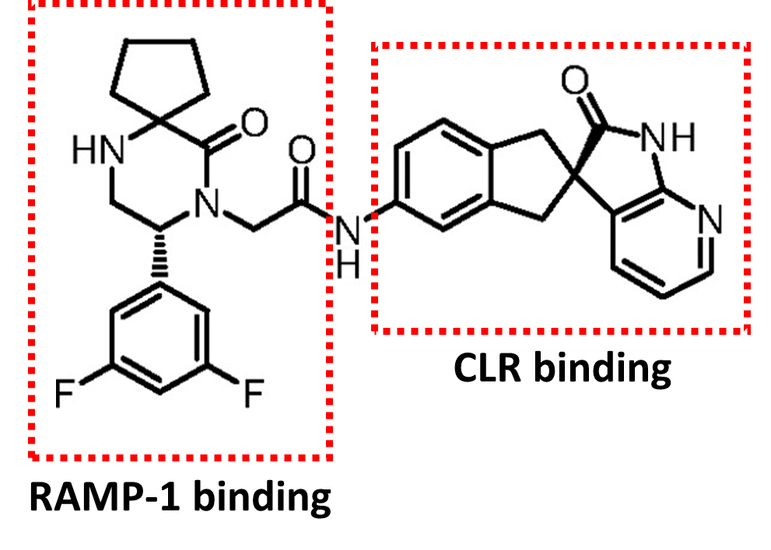
Figure 4.1: Structure of CGRP antagonist MK-3207 showing the domains that bind to residues on CLR and RAMP-1 specifically.

4.1.4 Screening Strategy: High-throughput in vitro to in vivo studies
One of the classical signalling pathways downstream of AM2R is cAMP-dependent (Kuwasako et al., 2012). Therefore, cAMP assay was used in the initial stage to screen for compounds potent and selective in inhibiting ADM stimulation of AM2R in a 1321N1 cell line overexpressing AM2R. In addition to doing counter-screens against cells overexpressing CLR/RAMP receptor complexes (CGRPR and AM1R), cells overexpressing CTR/RAMP receptor complexes (AMY1R and AMY3R) were also tested due to similarities (54% sequence identity) between CTR and CLR (Sexton et al., 2006). Table 4.2 shows the pIC50 values obtained from cAMP screening assays for four lead compounds (SHF-638, SHF-771, SHF-1036 and SHF-1041). They are very selective for AM2R over AM1R, AMY1R and AMY3 (two- to three-logs) and slightly less selective over CGRPR (half- to one-log). More interestingly, unlike ADM₂₂₋₅₂ which has the same affinity for AM1R and AM2R (Table 4.1), our lead compounds are two- to three-log selective for AM2R over AM1R (Table 4.2). Compounds that were potent and efficacious in cAMP screening assays were taken forward to do more in depth in vitro experiments (viability and apoptosis) to determine if they will be suitable in vivo candidates.
Table 4.2: pIC50 of lead compounds against CLR/RAMP and CTR/RAMP receptor complexes
Mean pIC50 values obtained from cAMP assays (minimum three independent experimental repeats). CGRPR: CLR/RAMP-1; AM1R: CLR/RAMP-2; AM2R: CLR/RAMP-3; AMY1R: CTR/RAMP-1; AMY3R: CTR/RAMP-3. Data from Avgoustou, 2018.
Compound | CGRPR | AM1R | AM2R | AMY1R | AMY3R
SHF-638 | 8.23 | < 5.43 | 8.88 | 5.51 | 6.28
SHF-771 | 8.29 | 6.28 | 8.88 | < 5.51 | 5.98
SHF-1036 | 8.61 | 6.04 | 8.85 | 5.41 | 5.95
SHF-1041 | 7.26 | 5.30 | 8.52 | 5.07 | 5.58
Pharmacokinetic studies were conducted by our collaborators in WuXi AppTec to determine dosing in subsequent studies in in vivo tumour models. Figure 4.2 shows the plasma concentrations of lead compounds in mice after a single intraperitoneal dosing at 10 mg/kg, as measured by liquid chromatography-tandem mass spectrometry (LC-MS/MS). Two of the lead compounds (SHF-771 and SHF-1036) were undetectable 8 hours post-treatment, compared to SHF-638 and SHF-1041 which were still detectable 24 hours post-treatment (Figure 4.2). The lead compounds have differing pharmacokinetic properties which may affect their efficacy in vivo, even though they are all potent in inhibiting AM2R in vitro (Table 4.2).

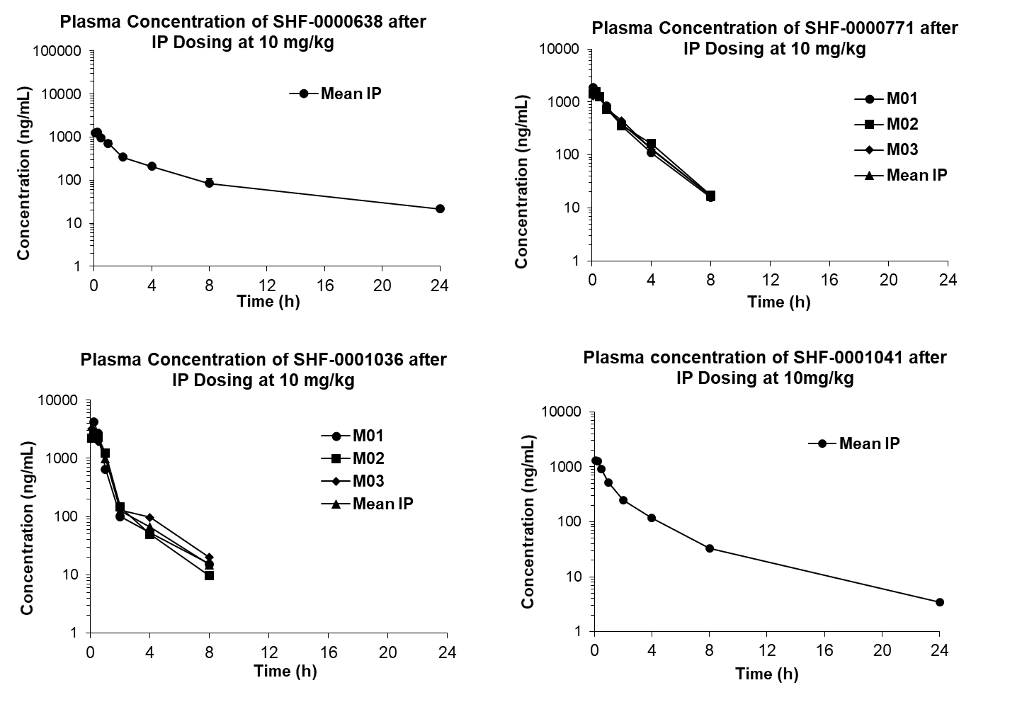
Figure 4.2: Plasma concentration of lead compounds (SHF-638, SHF-771, SHF-1036 and SHF-1041) after intraperitoneal dosing of 10 mg/kg in mice. SHF-638 and SHF-1041 were detectable in plasma 24 hours post-treatment, but SHF-771 and SHF-1036 were undetectable 8 hours post-treatment. Data provided by collaborators from WuXi AppTec.

To complement results from in vitro experiments, in vivo studies were conducted for a more extensive analyses of AM2R antagonists on tumour burden, tumour stroma and to determine safety profile of these compounds. Tumour burden was analysed by measuring volume (twice weekly) and mass at endpoint. Weighing of vital organs (liver, kidney, and spleen) were done to identify organs which may be adversely affected by treatments. Tumour and organs were processed into tissue sections for further immunohistological analysis. Plasma samples were also collected to measure levels of proteins of interest by ELISA.
In vivo studies were conducted together with colleague Dr Paris Avgoustou. We have previously shown using a subcutaneous xenograft model that daily intraperitoneal injection of lead compound SHF-638 (20 mg/kg) was able to decrease in vivo tumour growth of breast (MDA-MB-231) and pancreatic (CFPAC-1) tumours by 56% and 50% (Figure 4.3, p<0.05). Immunohistochemical analysis of CFPAC-1 tumour sections treated with SHF-638 revealed a 39% decrease in proliferative cell numbers (Figure 4.4A, p<0.05) and 41% increase in necrotic regions within the tumour (Figure 4.4B, p<0.05), compared to vehicle-control. Decrease in α-SMA expression (marker for activated PSCs, -35%, p<0.05) and CD31 expression (endothelial marker, -23%, not significant) were also observed in SHF-638 treated CFPAC-1 subcutaneous tumour sections, compared to vehicle-control (Figure 4.4C and Figure 4.4D). This suggests that in addition to inhibiting growth and promoting death of tumour cells, SHF-638 also decreased PSC expression as well as angiogenesis in PaCa tumours.
Altogether, these studies show that small molecule antagonists against AM2R have great potential to be developed to treat PaCa as they not only target growth of PaCa cells but also the microenvironment components that supports PaCa development and spread.

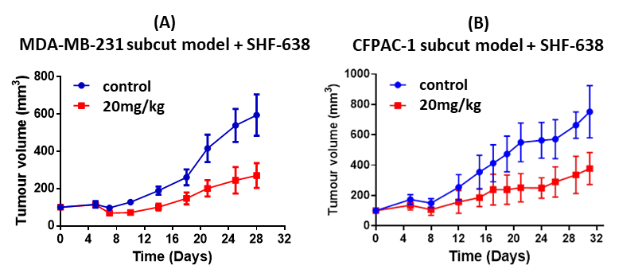
Figure 4.3: Growth curves of MDA-MB-231 breast and CFPAC-1 pancreatic subcutaneous tumours in Balb/c nude mice. After four weeks of daily treatment with 20mg/kg of SHF-638, tumour volumes were decreased by 50-56% compared to vehicle-treated control mice (p<0.05). Data presented as mean±SD. Data from (Avgoustou, 2018)
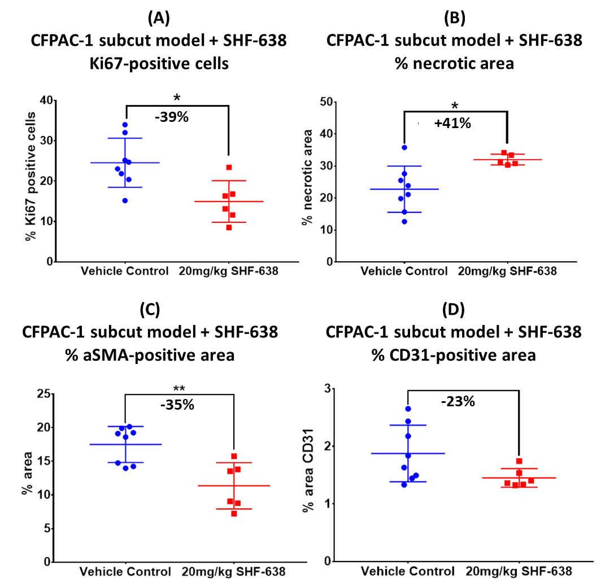
Figure 4.4: Histological analysis of CFPAC-1 subcutaneous tumour sections. After four weeks of 20mg/kg of SHF-638 treatment, CFPAC-1 tumours had less in Ki67-positive proliferative cells (p<0.05) (A), more necrotic area (p<0.05) (B), less αSMA-positive PSCs (p<0.01) (C) and less CD31-positive endothelial cells (not significant) (D), compared to vehicle-treated CFPAC-1 tumours. Data presented as mean±SD. Data from (Avgoustou, 2018)

4.1.5 Hypothesis and research aims
The null hypothesis for this chapter is that small molecule antagonists against AM2R will not affect PaCa growth in vitro and in vivo.
Secondary screening of potent small molecule antagonists against AM2R was done using human PaCa cell line CFPAC-1 in in vitro viability assays. In conjunction with results from primary cAMP screening and pharmacokinetic studies, lead compounds were taken forward to do more thorough in vitro viability and apoptosis assays using other PaCa cell lines to ensure they work across tumours of different genetic complexities.
Efficacy of lead compounds (SHF-771, SHF-1036 and SHF-1041) were investigated in vivo in a subcutaneous xenograft model of PaCa using CFPAC-1 Luc cells. This allows us to determine the effect of AM2R antagonism on PaCa tumour growth in vivo, in addition to in vitro.

4.2 Methods

4.2.1 Viability assay – Single point screening
CFPAC-1 cells were used to screen batches of compounds (listed in Table 7.2) for in vitro efficacy in a viability assay. Each batch consisted of 17 compounds to be screened, two positive controls (SHF-638 and gemcitabine) and a vehicle-control to ensure consistency of the assay and subsequent analyses. CFPAC-1 cells were treated daily and cell viability was assessed daily over three days using RealTime-Glo MT Viability Kit as detailed in Section 2.3.1.
Stocks of small molecule antagonists and gemcitabine were made up to 20mM in 100% DMSO. 50X treatment aliquots (diluted in PBS) were made to treat 2μL per well (100μL total volume per well). Vehicle-controls were made the same way as treatment stocks, and subsequently diluted in PBS. Treatment stocks and aliquots were stored at -20°C. Treatment aliquots were sonicated for 10 minutes in 37°C water bath prior to treatments.

4.2.2 Viability assay – Dose responses
CFPAC-1 cells were treated with various concentrations of SHF-638 daily. Cell viability was assessed daily for 72 hours using RealTime-Glo MT Viability Kit as detailed in Section 2.3.1. Wells were washed with PBS and freshly made reagent was put into wells to continue the assay for an additional 72 hours, if desired.
Stocks were made up to 20mM in 100% DMSO. 50X treatment aliquots (diluted in PBS) were made to treat 2μL per well (100μL total volume per well). Vehicle-controls were made the same way as treatment stocks, and subsequently diluted in PBS. Treatment stocks and aliquots were stored at -20°C. Treatment aliquots were sonicated for 10 minutes in 37°C water bath prior to treatments.

4.2.3 Apoptosis assay – Dose responses
CFPAC-1 cells were treated with different concentrations of SHF-638 for 24 hours. Late apoptosis (Caspase 3/7) levels were assessed using Caspase-Glo 3/7 Assay Kit as detailed in Section 2.3.2.
Stocks were made up to 20mM in 100% DMSO. 25X treatment aliquots (diluted in PBS) were made to treat 2μL per well (50μL total volume per well). Vehicle-controls were made the same way as treatment stocks, and subsequently diluted in PBS. Treatment stocks and aliquots were stored at -20°C. Treatment aliquots were sonicated for 10 minutes in 37°C water bath prior to treatments.

4.2.4 In vivo subcutaneous model
In order to screen suitable lead compounds in vivo, a subcutaneous model was initially chosen bearing in mind that more complex models would be used subsequently, such as an intrapancreatic orthotopic model.
While subcutaneous tumour volume can be measured using vernier calipers, orthotopic tumours are not accessible for regular measurements using the same method. Since we would be using PaCa cells transduced with luciferase to allow imaging of orthotopic tumours using the in vivo luminescence imaging system (IVIS), the same cells were used for the subcutaneous experiments, allowing us to compare between the two models.

4.2.4.1 Lentiviral transduction of cells with firefly luciferase
CFPAC-1 cells were transduced with a lentiviral vector containing firefly Luciferase, fluorescence marker (RFP, excitation maxima 545 nm, emission maxima 620 nm) and antibiotic resistance (blasticidin) for use in orthotopic in vivo models (Figure 4.5). This allows for live imaging of tumour cells in live mice to monitor primary tumour growth and metastases. CFPAC-1 cells were seeded in a 24-well plate to a confluency of 75% the next day. Multiplicity of infection of 3 was used to transduce cells, meaning three virus particles per cell. Three days after transduction, fluorescence microscopy was used to check transduction rate. Cells were then selected for at least a week using 20ug/mL blasticidin, as determined from a kill curve. Once the cells have been harvested from T175 flask, RFP-positive cells were sorted using fluorescence-activated cell sorting (FACS; Excitation: 545 nm, Emission: 620 nm). Wild-type cells were used as a negative control for the cell sorting. Luciferase expression of cells were also checked prior to each in vivo experiment, using D-luciferin (Figure 4.6). The principles of how luciferase activity results in light production had previously been discussed in Section 2.3.2 (Figure 2.5).
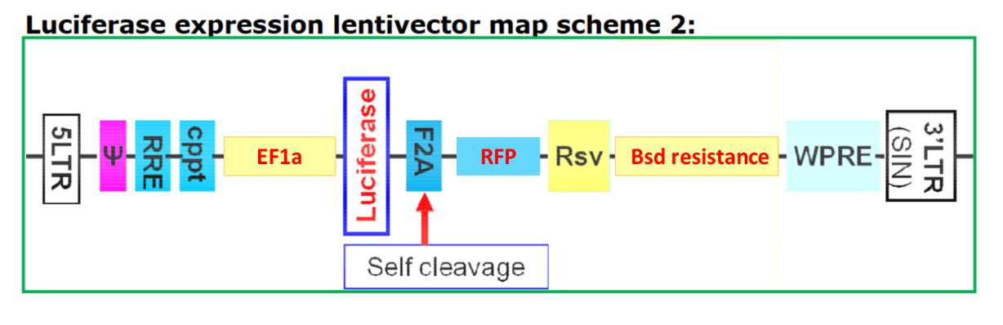
Figure 4.5: Lentiviral vector map scheme, adapted from Amsbio manual. Luciferase and red fluorescent protein (RFP) are constitutively expressed as individual proteins under EF1a promoter. Blasticidin (Bsd) antibiotic marker is expressed under Rsv promoter. Lentiviral particles are replication incompetent with self-inactivating 3’ untranslated region (SIN-3UTR).

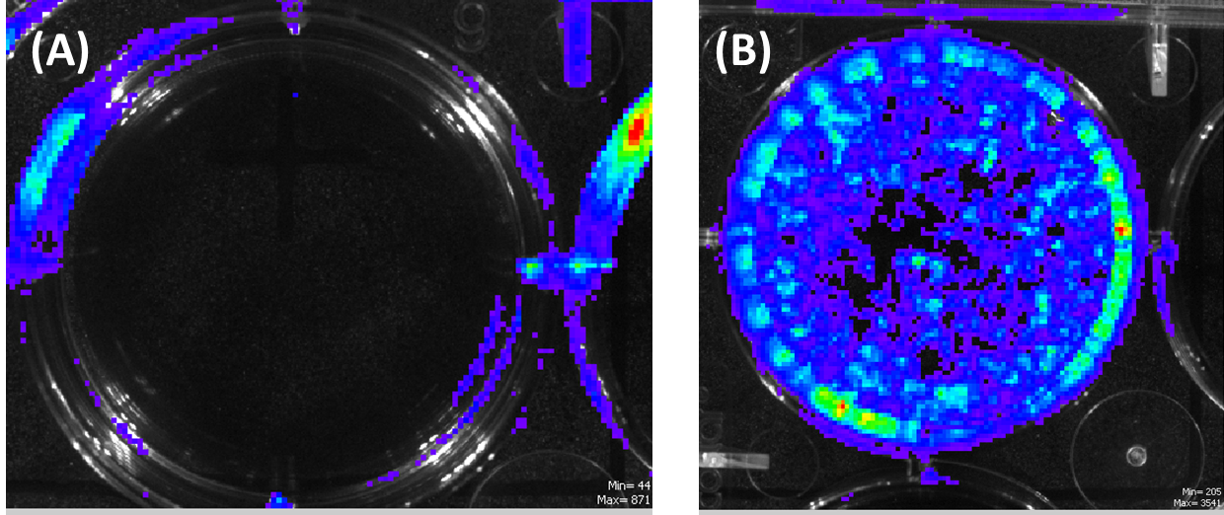
Figure 4.6: Luciferase expression of pancreatic cancer cells CFPAC-1 Luc were checked prior to each in vivo experiment, using D-luciferin as a substrate for the firefly luciferase. (A) Wild-type CFPAC-1 cells (B) CFPAC-1 Luc cells

4.2.4.2 Mice
Subcutaneous pancreatic cancer studies were performed using 5- to 6-week old female BALB/c nude mice from Envigo or Charles River, depending on availability. All procedures were reviewed and approved by the local Research Ethics Committees in the University of Sheffield and complied with the UK Animals (Scientific Procedures) Act 1986. Studies were performed under project license PF61050A3.

4.2.4.3 Treatment preparation for intraperitoneal injections
Lead compounds (SHF-771, SHF-1036 and SHF-1041) were dissolved in Kolliphor vehicle (Table 4.3) + 5% DMSO at respective concentrations shown in Table 4.4. Solid stocks of lead compounds were first dissolved in appropriate volume of 100% DMSO (5% of final volume) and sonicated for 10 minutes in a 37°C water bath before adding to appropriate volume of Kolliphor vehicle (remaining 95% of volume). Vehicle controls were made similarly (Kolliphor vehicle + 5% DMSO). Compound and vehicle mixtures were further sonicated for 10 minutes before adjusting pH to physiological levels (7.4). This is crucial as most of the small compound antagonist treatments were basic (around pH 9.0) whereas the vehicle was slightly acidic (pH 6.0).
Table 4.3: Recipe for Kolliphor vehicle
Reagent | Amount
Kolliphor® HS15 | 11 g
Kollisolv® PEG E 400 | 33 mL
PBS | 66 mL
Kolliphor vehicle | 100 mL

Table 4.4: Treatment concentrations of lead compounds (SHF-771, SHF-1036 and SHF-1041) made in Kolliphor + 5% DMSO for respective doses in vivo
Dose in vivo | Concentration in  Kolliphor vehicle + 5% DMSO
5mg/kg | 0.5mg/mL
10mg/kg | 1mg/mL
20mg/kg | 2mg/mL
30mg/kg | 3mg/mL

Treatment solutions were stored in 5 mL aliquots at -20°C or 4°C once they have been thawed for use. Solutions were prepared at concentrations that would enable us to give 200μL injections per mouse. Before each treatment, aliquots were sonicated for 10 minutes in a 37°C water bath. Mice were injected intraperitoneally in the lower quadrants, alternating between the left and right side. Treatment regimen is shown in Table 4.5.

Table 4.5: Treatment regimen for single agent pancreatic subcutaneous xenograft experiments using Balb/c nude mice
SHF-771 single agent
Treatment Group | Treatment | Frequency | Volume (µL)
Vehicle-control | Kolliphor vehicle + 5% DMSO | Once daily | 200
20mg/kg | 2mg/mL in vehicle | Once daily | 200
30mg/kg | 3mg/mL in vehicle | Once daily | 200
SHF-1036 single agent
Treatment Group | Treatment | Frequency | Volume (µL)
Vehicle-control | Kolliphor vehicle + 5% DMSO | Once daily | 200
5mg/kg | 0.5mg/mL in vehicle | Once daily | 200
10mg/kg | 1mg/mL in vehicle | Once daily | 200
20mg/kg | 2mg/mL in vehicle | Once daily | 200
SHF-1041 single agent
Treatment Group | Treatment | Frequency | Volume (µL)
Vehicle-control | Kolliphor vehicle + 5% DMSO | Once daily | 200
5mg/kg | 0.5mg/mL in vehicle | Once daily | 200
10mg/kg | 1mg/mL in vehicle | Once daily | 200
20mg/kg | 2mg/mL in vehicle | Once daily | 200

4.2.4.4 Cell preparation for subcutaneous injections
CFPAC-1 cells transduced with Luciferase (CFPAC-1 Luc) were harvested from T175 flasks and counted according to Sections 2.1.1 and 2.1.3. Matrigel was thawed on ice or in the fridge overnight. Tubes, tips and PBS used in this protocol had been pre-chilled in the fridge or kept on ice prior to cell harvesting. Cell suspension was prepared at a concentration of 30-50e6 cells/mL in a Matrigel/PBS mixture (3:2 ratio) and kept on ice. Twice the amount of cells needed was prepared to account for dead volume and accidental wastage during injections.
25G needles and 1 mL syringes were used for subcutaneous injection of CFPAC-1 Luc cells into the left dorsal flank of the mice (3-5e6, 100uL per mouse). Mice were then randomised into cages and cages were subsequently randomised into treatment groups.

4.2.4.5 Measurement of subcutaneous tumour growth
Vernier calipers were used to measure tumour volume twice a week using the formula:
$$v=[π({\frac{w}{2})}^{2}×l]$$
where v is tumour volume, w is tumour width, and l is tumour length. This formula assumes a cylindrical shape of the tumour. Mice weights were simultaneously recorded to ensure tumour growth and treatment regimens did not cause mice weight to decrease >20% which would warrant Schedule 1 culling (i.e overdose with isofluorane then cervical dislocation).

4.2.4.6 In vivo experimental endpoint
Mice were anaesthetised with inhaled isofluorane and blood was withdrawn by cardiac puncture (25G needle, 1 mL syringe) and collected in Vacutainer tubes containing anti-coagulant EDTA. Needles were removed prior to collection in tubes to prevent haemolysis. Mice were then culled by cervical dislocation. Liver, kidney and spleen were collected, weighed then fixed with 10% neutral-buffered formalin before sending them off to Histology core facility to be embedded in paraffin, cut into sections and stored at 4°C.
Blood collected were centrifuged (1,600 x g, 15 minutes, 4°C) and resultant plasma were transferred into fresh polypropylene tubes and stored at -80°C for use in ELISA.

4.3 Results

4.3.1 Single point screening of compounds in in vitro viability assays
Single point viability screening was done on human PaCa cells CFPAC-1 to determine efficacy of potent AM2R antagonists (IC50 < 10 nM, listed in Table 7.2) on PaCa cell viability. CFPAC-1 cells were treated daily with 2 μM of each compound over three days. To determine if there is a correlation between AM2R potency and percentage viability decrease in CFPAC-1 cells, Graphpad Prism 7.04 was used to do a linear regression analysis. Figure 4.7 shows the scatter plot of AM2R potency against percentage viability reduction. There appears to be no significant non-zero association between how potent a compound is against AM2R and its ability to decrease viability of PaCa cells in vitro (Figure 4.7, p=0.41).
Viability screening was not used subsequently to inform selection of hit compounds. Lead compounds were selected on the basis of potency and efficacy in cAMP screening assays and additional pharmacokinetic studies done by our collaborators in WuXi AppTec. Lead compounds SHF-638, SHF-771, SHF-1036 and SHF-1041 were taken forward to do more comprehensive in vitro and in vivo experiments.

Figure 4.7: Scatter plot showing relationship between AM2R potency and viability reduction. pIC50 of compounds against AM2R (cAMP assay) was plotted against percentage reduction viability of CFPAC-1 pancreatic cancer cell. Pearson correlation analysis showed no significant correlation between the two.

4.3.2 Effect of lead compounds on viability and apoptosis of pancreatic cancer cell line CFPAC-1 in vitro
Lead compounds SHF-638, SHF-771, SHF-1036 and SHF-1041 (structures in Figure 7.6) were tested on PaCa cell line CFPAC-1 in a viability assay over a longer duration. CFPAC-1 were treated daily with 3 μM of respective lead compound over nine days, compared to three days in the screening assays. Figure 4.8 shows that lead compounds were able to decrease viability of CFPAC-1 by 22-37% over nine days (p<0.05).
Lead compounds were also tested in apoptosis assays using various treatment concentrations (3 μM to 100 nM) on CFPAC-1 cells. Figure 4.9 shows that all tested concentrations of lead compounds increased Caspase 3/7 levels in CFPAC-1 cells by up to 76% 24 hours after treatment.

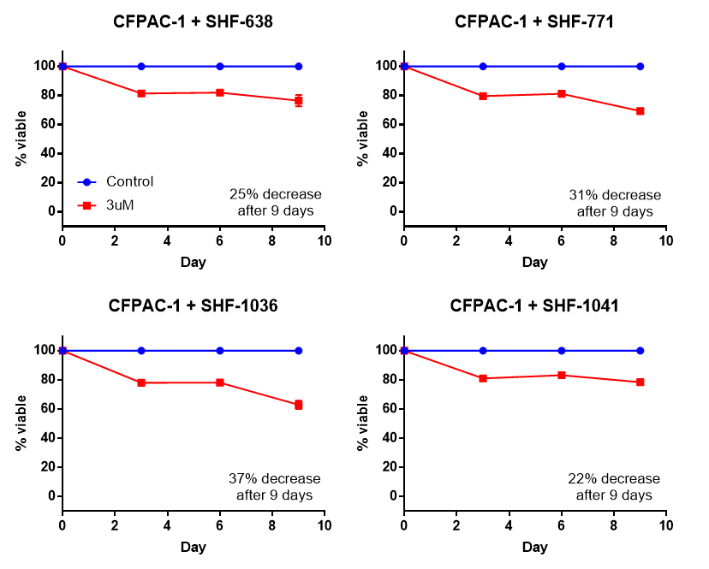
Figure 4.8: Effect of lead compounds (SHF-638, SHF-771, SHF-1036 and SHF-1041) on viability of five human pancreatic cancer cell lines in vitro. Daily treatment with 3 μM significantly decreased viability of pancreatic cancer cell lines by 22-37% after nine days, compared to vehicle-treated controls (p<0.05). Two-way ANOVA was used for all data sets. Data are from three independent experimental repeats and presented as mean±SEM.
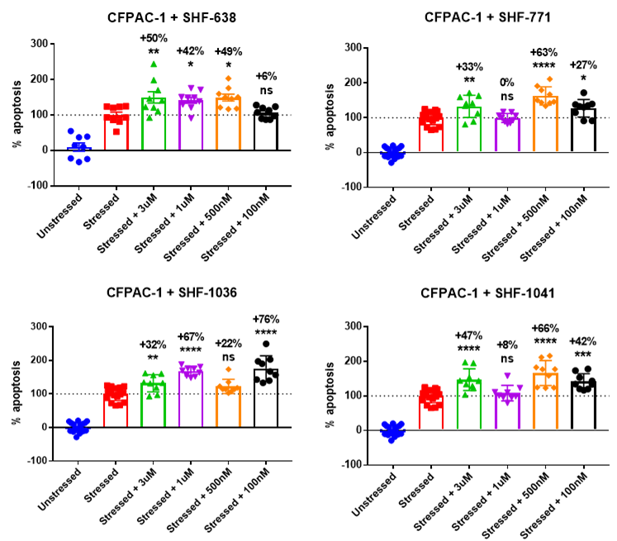
Figure 4.9: Effect after 24 hour of treatment with different concentrations of lead compounds (SHF-638, SHF-771, SHF-1036 and SHF-1041) on Caspase 3/7 levels (late apoptotic markers) of human pancreatic cancer cell line CFPAC-1 in vitro. Cells were serum-starved in stressed conditions. One-way ANOVA was used for all data sets. Data are from three independent experimental repeats and presented as mean±SEM.

4.3.3 Effect of SHF-638 on viability and apoptosis of pancreatic cancer cell lines in vitro
SHF-638 was first of the lead compounds to be tested on four other PaCa cell lines (AsPC-1, Capan-2, HPAF-II and Panc10.05), in addition to previously tested PaCa cell line CFPAC-1. PaCa cells were treated daily with 3 μM of SHF-638 over nine days, compared to three days in the screening assays. Figure 4.10 shows that SHF-638 was able to significantly decrease viability of all five PaCa cell lines by 25-40% over nine days (p<0.05).
SHF-638 was also tested on Panc10.05 cell line in apoptosis assays. Figure 4.11B shows that 3 μM of SHF-638 significantly increased Caspase 3/7 levels of CFPAC-1 and Panc10.05 cell lines by 50% and 104% respectively 24 hours after treatment (p<0.01). Various concentrations of SHF-638 were also tested in an apoptosis assay on CFPAC-1 cells. Figure 4.11A shows that 500 nM and above of SHF-638 was able to significantly increase Caspase 3/7 levels of CFPAC-1 cells 24 hours after treatment (p<0.05).

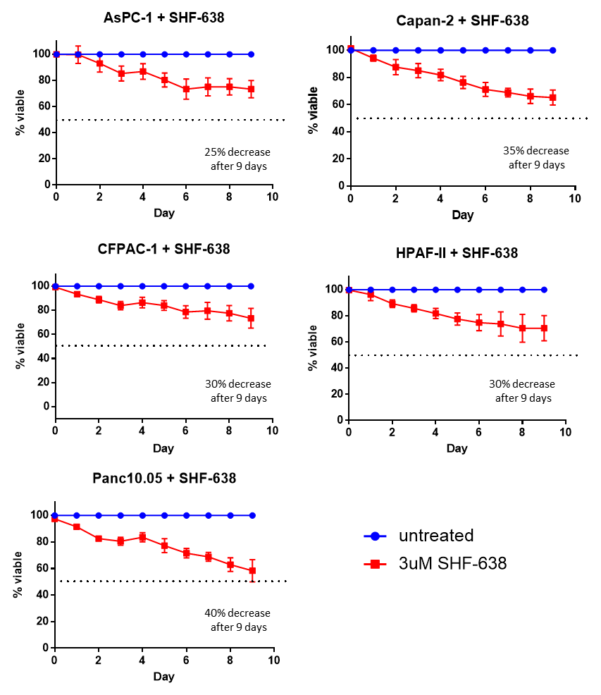
Figure 4.10: Effect of SHF-638 on viability of five human pancreatic cancer cell lines in vitro. Daily treatment with 3 μM SHF-638 significantly decreased viability of pancreatic cancer cell lines by 25-40% after nine days, compared to vehicle-treated controls (p<0.05). Two-way ANOVA was used for all data sets. Data are from three independent experimental repeats and presented as mean±SEM.

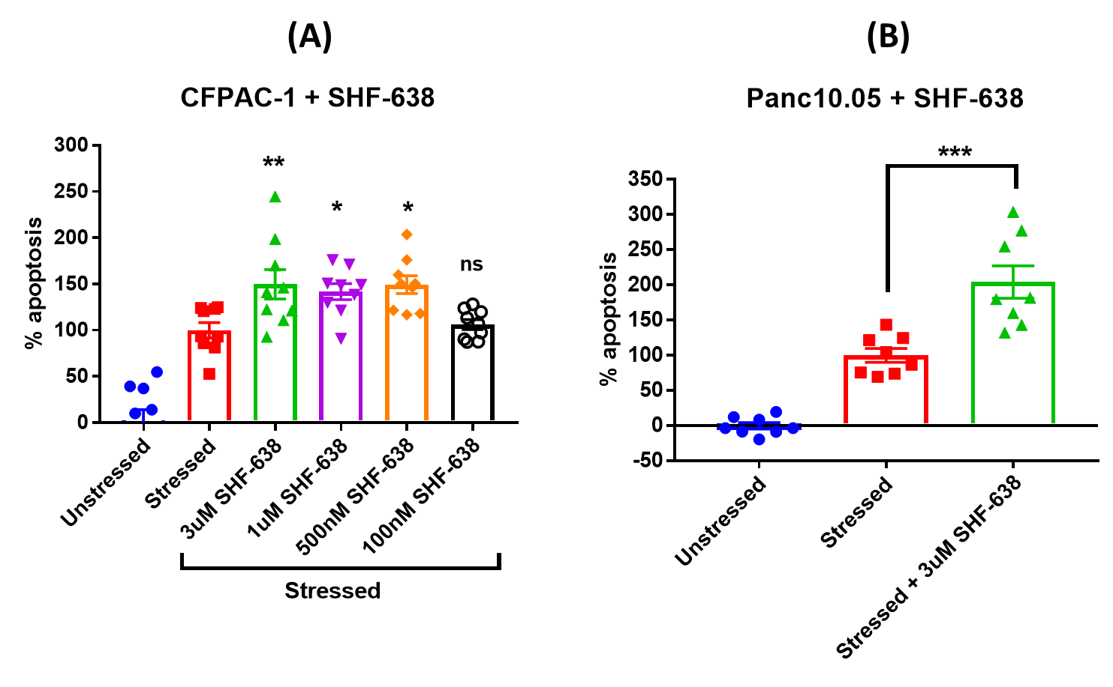
Figure 4.11: Effect of SHF-638 on apoptosis of human pancreatic cancer cell lines CFPAC-1 (A) and Panc10.05 (B) in vitro. (A) SHF-638 treatment between 500 nM and 3μM were able to significantly increase Caspase 3/7 levels after 24 hours in CFPAC-1 cells (+42 to +50%, p<0.05). (B) SHF-638 (3 μM) also increased Caspase 3/7 levels in Panc10.05 24 hours after treatment (+104%, p<0.001). One-way ANOVA and student’s t-test were used for (A) and (B) respectively, compared to stressed control. Data are from three independent repeats and presented as mean±SEM.

4.3.4 Effect of lead compounds in vivo
As seen in the in vitro viability and apoptosis assays, small molecule antagonists against AM2R can decrease viability and increase apoptosis in various PaCa cell lines. A subcutaneous xenograft model using CFPAC-1 Luc cell line was subsequently used to assess the effect of these lead compounds in vivo. All in vivo studies were conducted together with colleague Dr Paris Avgoustou.

4.3.4.1 Safety profile of lead compounds
In order to ensure that treatment regimens or tumour burden did not lead to adverse effects in mice, their weights were recorded twice a week and behaviour observed daily during treatments.
At experimental endpoint (21 days after tumour inoculation), mice treated with 5 and 10 mg/kg doses of either SHF-1036 or SHF-1041 had no significant difference in weight gain compared to vehicle-treated mice (Figure 4.12B and C). However, SHF-771 (20 and 30 mg/kg) treatment had significant changes in weight gain compared to vehicle-treated mice (Figure 4.12A, 0-1% gain vs. 6% gain, p<0.05). There was also a significant trend towards lesser weight gain with increasing doses of SHF-771 and SHF-1041 (p<0.05). Throughout the treatment duration, none of the mice loss weight to warrant Schedule 1 culling (>20% decrease in weight compared to before tumour inoculation).
Subcutaneous tumour inoculation and treatment regimens did not result in any adverse effects such as eating/drinking difficulties, persistent hypothermia or hunching. Thickening of abdominal wall was observed in mice treated with lead compounds after 2-3 weeks of treatment but this did not result in any observable adverse behaviour. This, however, did result in increased peritoneal pressure meaning around 20% treatment volume started to leak out right after 2-3 weeks of treatment.
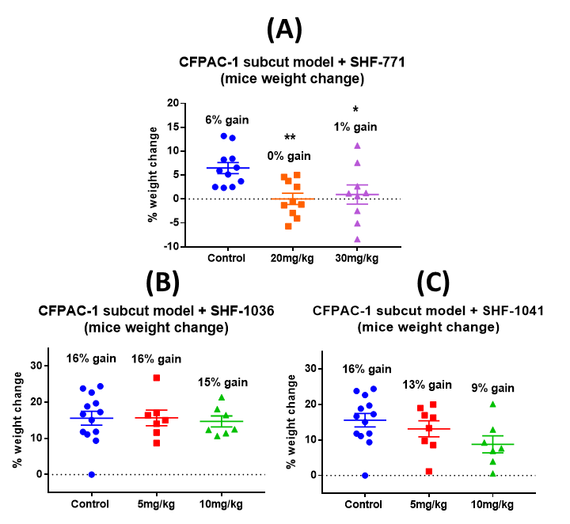
Figure 4.12: Weight change at endpoint (Day 21) compared to before tumour implantation. (A) Mice treated with 20mg/kg and 30mg/kg of SHF-771 had significant weight change compared to vehicle-treated mice. SHF-1036 (B) and SHF-1041 (C) did not lead to significant weight change compared to vehicle-treated mice at tested doses. However, ANOVA post-test analysis showed a significant trend towards lesser weight gain with increasing doses of SHF-771 and SHF-1041 (p<0.05). One-way ANOVA was used. Data presented as mean±SEM.

In order to see if small molecule antagonists against AM2R were soluble across the blood-brain barrier, LC-MS/MS was used to detect the amount of SHF-1041 present in the mice brain homogenate at experimental endpoint. Mouse brains collected at endpoint (24 hours after final treatment) were frozen intact in liquid nitrogen and stored at -80°C until shipping. Samples were shipped in dry ice to York Bioanalytical Solutions (Sandwich, UK) where tissue homogenisation and LC-MS/MS analysis were performed. Pearson correlation analysis shows that SHF-1041 amount in the brain positively correlated with the treatment dose of SHF-1041 given (Figure 4.13, p = 0.003).
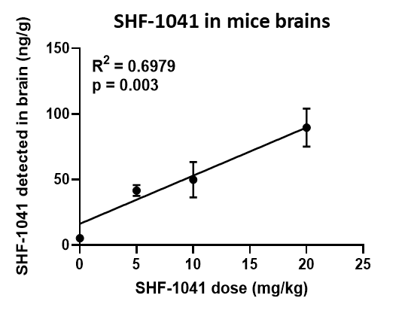
Figure 4.13: SHF-1041 detected in mice brain homogenate at endpoint by LC-MS/MS. Pearson correlation analysis showed that the amount of SHF-1041 detected in the brains correlated positively with the treatment dose of SHF-1041 (p = 0.003). Data are from three samples per treatment dose and presented as mean±SEM.

4.3.4.2 Tumour burden
To investigate if lead compounds could decrease tumour burden in an in vivo subcutaneous model, Balb/c nude mice implanted with human pancreatic cancer cells CFPAC-1 Luc were treated daily intraperitoneally with treatment doses or vehicle-control. Tumour growth was monitored twice a week by vernier calipers. Measured volumes were normalised to baseline volume before mice started any treatment (3 days after tumour inoculation).
Figure 4.14 shows the growth curves and endpoint data for mice treated with various doses of lead compounds. 20mg/kg and 30 mg/kg doses of SHF-771 decreased tumour burden by 44% (p<0.05) and 32% (not significant) respectively after 18 days of treatment, compared to vehicle-control (Figure 4.14A). 5mg/kg and 10mg/kg doses of either SHF-1036 or SHF-1041 also decreased tumour burden by 41-56% after the same treatment duration, compared to vehicle-control (Figure 4.14B and C).
In order to measure if lower doses of small molecular antagonists would still result in treatment efficacy, 0.5 and 1 mg/kg treatment doses of SHF-1036 were also tested. Figure 4.15 shows that 0.5 and 1 mg/kg SHF-1036 were less efficacious than the higher doses (5 and 10 mg/kg) but still managed to decrease tumour burden by 22% (not significant) and 38% (p<0.05) respectively, compared to vehicle control.
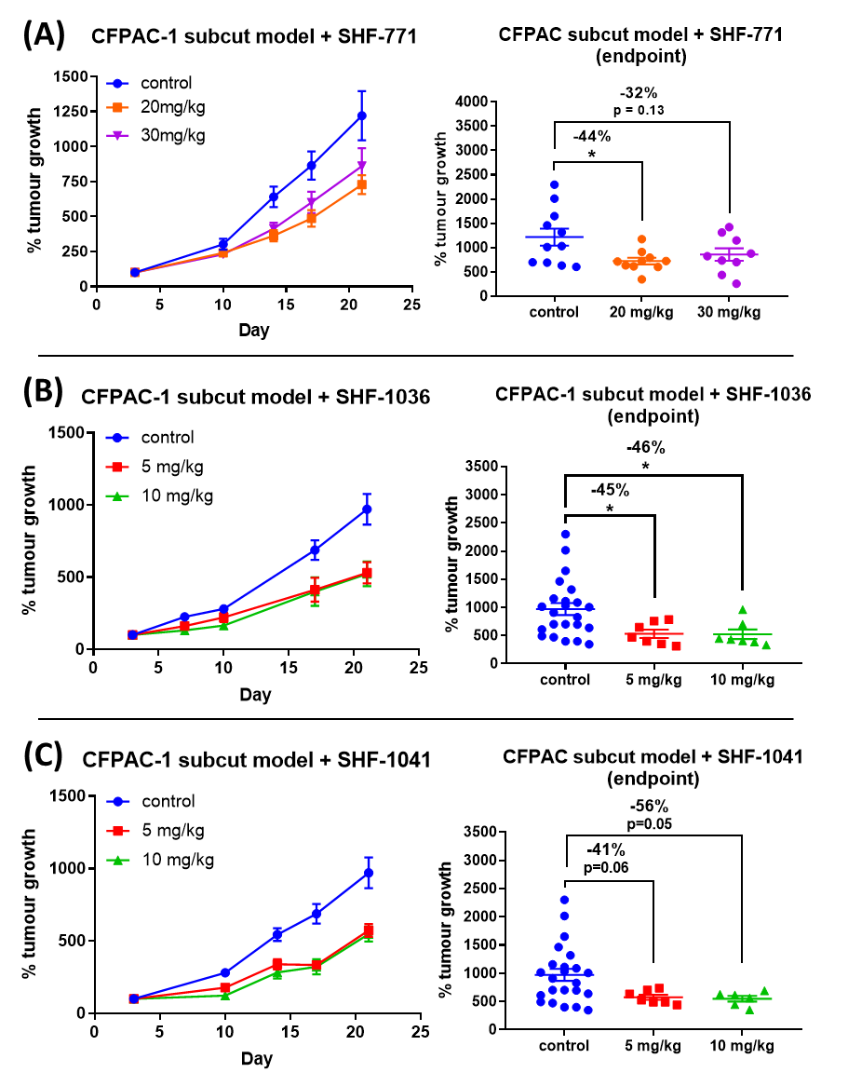
Figure 4.14: Growth curves (left) and endpoint data (right) of pancreatic subcutaneous tumours (human PaCa CFPAC-1 Luc) in Balb/c nude mice treated daily with lead compounds SHF-771 (A), SHF-1036 (B) and SHF-1041 (C). Treatment with various concentrations of lead compounds decreased tumour volume by 32-56% compared to vehicle-treated mice. Two-way ANOVA was used for growth curves. Data presented as mean±SEM.

Figure 4.15: Endpoint data of pancreatic subcutaneous tumours (human PaCa CFPAC-1 Luc) in Balb/c nude mice treated daily with various doses of lead compound SHF-1036. One-way ANOVA was used, post-test analysis showed a significant linear trend (p=0.0013), where increasing doses of SHF1036 lead to greater decreases in tumour growth. Data presented as mean±SEM.

While tumour volume measurements suggest that treatment with small molecule antagonists against AM2R resulted in smaller tumours (Figures 4.14 and 4.15), measurement of tumour masses at endpoint did not show significant differences between the treatment groups (Figure 4.16).
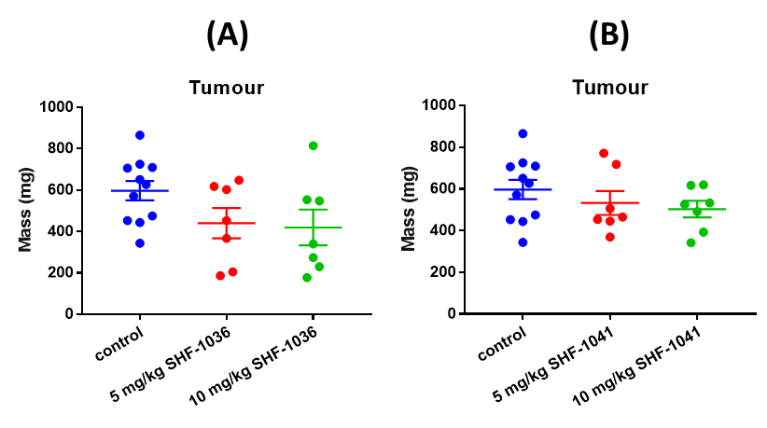
Figure 4.16: Tumour masses in mice treated with different doses of lead compounds SHF-1036 (A) and SHF-1041 (B) in pancreatic subcutaneous model using human PaCa cell line CFPAC-1 Luc in Balb/c nude mice. None of the tested doses significantly affected tumour masses compared to vehicle-control. One-way ANOVA was used, post-test analysis showed no trend with increasing doses. Data presented as mean±SEM.

4.3.4.4 Vital organs
Weighing of vital organs at endpoint can help to identify organs which may have been adversely affected by treatments. Mice treated with lead compounds had no significant differences in the masses of livers, kidneys and spleens compared to control mice (Figures 4.17 and 4.18). However, when compared to naïve mice (no tumours, vehicle-control), control mice (tumour, vehicle-control) had significantly larger kidneys and spleens (Figures 4.17 and 4.18). In general, treatment with small molecule antagonists against AM2R did not significantly alleviate or exacerbate the larger kidneys and spleens resulting from tumour inoculation. However, a further increase was seen in kidney size which positively correlated with SHF-1041 treatment doses (Figure 4.18).
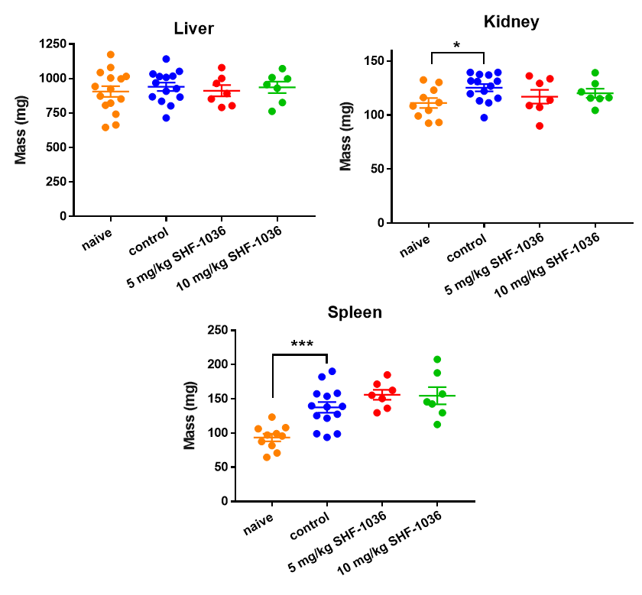
Figure 4.17: Liver, kidney and spleen mass in mice treated with different doses of lead compound SHF-1036 in pancreatic subcutaneous model using human PaCa cell line CFPAC-1 Luc in Balb/c nude mice. Mice with tumours (control) had significantly larger kidneys and spleens than naïve mice. None of the tested doses significantly affected organ masses compared to vehicle-control. Student’s t-test was used to compare mice with tumours (control) and without (naïve). One-way ANOVA was used when comparing mice treated with SHF-1036 to vehicle-control, post-test analysis showed no trend with increasing doses. Data presented as mean±SEM.

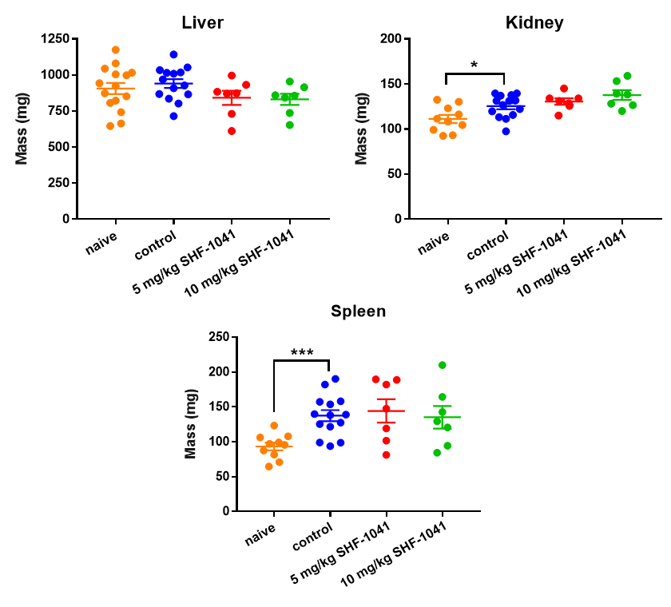
Figure 4.18: Liver, kidney and spleen mass in mice treated with different doses of lead compound SHF-1041 in pancreatic subcutaneous model using human PaCa cell line CFPAC-1 Luc in Balb/c nude mice. Mice with tumours (control) had significantly larger kidneys and spleens than naïve mice. None of the tested doses significantly affected organ masses compared to vehicle-control. Student’s t-test was used to compare mice with tumours (control) and without (naïve). One-way ANOVA was used when comparing mice treated with SHF-1041 to vehicle-control, post-test for linear trend analysis showed increasing SHF-1041 doses correlated with larger kidneys (p<0.05). Data presented as mean±SEM.

4.4 Discussion

4.4.1 Potency in inhibiting ADM does not correlate with efficacy in decreasing PaCa viability in vitro
Our primary screening was done using cAMP assays and compounds that are potent in inhibiting AM2R signalling (pIC50 < 8) were taken forward to do secondary screening in viability assays (Section 4.3.1). Viability assays were chosen as a screening method instead of apoptosis assays primarily as it is real-time and could reveal temporal-dependent changes associated with AM2R. Endpoint apoptosis assay may not be an appropriate method for screening as it may lead to false negatives. For instance, too short a duration would not detect efficacious compounds with a longer on-rate, as these compounds would not have had time to exert their pro-apoptotic effects. While viability assays are adequate for the screening triage due to their slightly extended time-frame (72 hours) and ability to acquire results real-time, apoptosis assays are not as appropriate to be used in a high-throughput setting due to only being able to measure at endpoint at a designated duration which may not be able to detect all truly efficacious compounds.
ADM has been shown to function through cAMP-dependent pathways to mediate pro-tumoural signalling affecting growth, apoptosis and immune evasion (Section 1.3). Interestingly, however, there is no correlation between how potent a compound is in inhibiting ADM-signalling via AM2R in a cAMP assay and how efficacious it is in inhibiting in vitro viability of PaCa cells (Section 4.3.1). This suggests that there may be other differences between the small molecule antagonists that warrant further investigation. Our current screening strategy prioritises investigating the efficacy of compounds on inhibition of ligand stimulation using cAMP assays. Since the potency of a compound is a result of both affinity (binding of compounds to receptor complex) and efficacy (receptor occupancy and ability to initiate downstream response), the affinity of compounds should additionally be investigated. It is possible that less potent compounds against AM2R in a cAMP assay may have better kinetics than their potent counterparts, which may allow them to have increased duration of action resulting in a greater overall decrease in PaCa viability or apoptosis. Measuring affinity can be done using surface plasmon resonance (SPR) technology. Our receptor complex of interest (CLR/RAMP-3) or membranes from cells overexpressing CLR/RAMP-3 can be immobilised on sensor chips. Compounds and buffers can then be flowed over the chips and a change in refractive index can then be detected and quantified to obtain binding affinities. Compared to other binding assays, SPR does not require radioactive of fluorescence labelling of compounds which saves time and increases biological relevance.
Alternatively, there are also cAMP-independent signalling that may be responsible for the effects of ADM on PaCa viability, such as ERK or Akt (Section 1.2.3). In fact, ADM has specifically been shown to promote proliferation of breast and prostate cancer cells through ERK signalling (Berenguer-Daizé et al., 2013, Martínez et al., 2002). Secondary screening could be done to determine the effect of AM2R antagonists on ERK signalling, which may be more able to predict in vitro and in vivo efficacy in inhibiting cancer growth.

4.4.2 Small molecule antagonists against AM2R inhibit growth of PaCa cells in vitro
Small molecule antagonists developed have been shown in earlier studies to be very selective for AM2R over AM1R, AMY1R and AMY3 (two- to three-logs) and slightly less selective over CGRPR (half- to one-log). Unlike truncated peptide antagonist ADM₂₂₋₅₂ which has the same affinity for AM1R and AM2R (pIC50 7-8 for both, Table 4.1), our lead compounds are two- to three-log selective in inhibiting ADM stimulation of AM2R over AM1R (pIC50 8-9 vs. 5-6, Table 4.2). To our knowledge, we have developed the first potent and selective small molecule antagonists against AM2R.
In vitro results show that small molecule antagonists against AM2R are able to decrease viability of PaCa cell lines (Sections 4.3.2 to 4.3.3). This is important as unchecked proliferation is the hallmark of all cancer cells. More interestingly, this feeds into the current narrative of ADM being both pro-proliferative and anti-proliferative depending on the tumour type and doses used. Exogenous treatment (200 nM) decreased growth of PaCa cells (BxPC-3, MPanc96, and Panc-1) in vitro (Ramachandran et al., 2007). However, another study have shown that while higher doses of rADM (100 to 1000 nM) decrease growth of PaCa cell lines (Capan-1, Colo-357 and Panc-1), lower doses of rADM (1 nM) increased growth of the same cells in vitro (Keleg et al., 2007). Keleg et al. concluded that since additional studies using CLR antagonist did not lead to consistent growth-inhibitory effects, ADM has only minor growth regulatory effects in PaCa cells. This study did not elucidate whether AM1R or AM2R was responsible in mediating the observed phenomena. Our results show that antagonising AM2R consistently reduced viability of all five tested PaCa cell lines (AsPC-1, Capan-2, CFPAC-1, HPAF-II, and Panc10.05), suggesting that ADM could mediate pro-proliferative signalling through AM2R.

4.4.3 Small molecule antagonists against AM2R enhances apoptosis of PaCa cells in vitro
Evading apoptosis is another hallmark of cancer cells, resulting in tumours being able to resist cell death. Our results show that small molecule antagonists against AM2R are able to increase apoptosis in vitro in serum-starved PaCa cell lines (Sections 4.3.2 to 4.3.3). Unlike ADM’s inconsistent effect on cancer cell proliferation, ADM has been shown to be anti-apoptotic in many cancers including PaCa. Exogenous treatment of ADM (200 nM) up-regulated NFκB activation (which mediates anti-apoptotic signalling) in PaCa cells in vitro (Ramachandran et al., 2007). This study also showed that ADM antagonist ADM₂₂₋₅₂ (1 μM) decreased basal NFκB activity in the same PaCa cell lines. Our results show that antagonising AM2R increased apoptosis in both PaCa cell lines tested (CFPAC-1, and Panc10.05), suggesting that ADM could mediate anti-apoptotic signalling through AM2R in PaCa.

4.4.4 Small molecule antagonists against AM2R inhibit growth of PaCa cells in vivo
We have shown earlier that small molecules against AM2R are efficacious in decreasing viability and increasing apoptosis in PaCa cell lines in vitro (Section 4.3.1 to 4.3.2). While in vitro experiments reveal the effect of AM2R antagonism on PaCa cells themselves, in vivo experiments can also reveal if the compounds have any additional effects on the tumour microenvironment (e.g. blood/lymph vasculature, PSC activation, infiltrating immune cells).
We have previously shown in vivo using a subcutaneous xenograft model that 20 mg/kg of racemate SHF-638 was able to decrease CFPAC-1 tumour growth by 50% (Figure 4.3, p<0.05). Interestingly, 20 mg/kg of SHF-771, which is a pure enantiomer of SHF-638, decreased CFPAC-1 Luc tumour growth by 44% (Figure 4.14A). The slight difference could be explained by PaCa cells used or pharmacokinetic profile of the compounds. While wild-type CFPAC-1 cells were used in the SHF-638 subcutaneous experiment, luciferase-transduced CFPAC-1 cells were used in the current studies. As mentioned previously, CFPAC-1 Luc cells were used in current subcutaneous experiments bearing in mind that more complex models may be used in the future, such as orthotopic pancreatic models which would require luminescence imaging of tumours to measure tumour growth. Other than the difference in cells used in the two experiments, SHF-638 and SHF-771 have also been shown to have a different pharmacokinetic profile. Studies done by our collaborators in WuXi AppTec showed that pure enantiomer SHF-771 has a faster clearance from plasma than SHF-638 racemate (Figure 4.2). This suggests that the presence of the other enantiomer in the SHF-638 racemate (SHF-770) could be involved in giving SHF-638 a more desirable pharmacokinetic profile even though it itself is not as potent in inhibiting AM2R as either SHF-638 or SHF-771.
In vivo experiments also suggest that treatment with small molecule antagonists against AM2R changes the physical properties of inoculated PaCa xenografts which could be beneficial to patient survival. Tumour volume and mass analyses suggest small molecule antagonists against AM2R caused tumours to be denser than vehicle-control, since smaller tumour volumes were seen in treated mice (Figures 4.14 and 4.15) yet there were no significant differences in mass compared to vehicle-control (Figure 4.16). In clinical observations of PaCa patients, patients with loose stroma have significant worse overall survival (21.4 vs 45.0 months, p<0.001), progression-free survival (15.6 vs 41.8 months, p<0.001), local progression-free survival (19.4 vs 44.4 months, p<0.001) and distant metastasis-free survival (17.0 vs 43.6 months, p<0.001) compared to those with dense stroma (Wang et al., 2016). These observations suggest that denser PaCa stroma may result in better survival in PaCa patients. However, research shows that stroma can either promote or inhibit PaCa progression depending on the mediators. Further histological analysis on tumour sections should be done to confirm which stromal components have changed as a result of AM2R antagonist treatment (i.e. vasculature, EMT and CAF expression).

4.4.5 Small molecule antagonists appear safe and efficacious in vivo at given doses
Drugs under development have to undergo studies in preclinical species before being evaluated in humans, to assess safety and efficacy in vivo. This will reveal any potential toxicity associated with the treatment at given doses. Safety profile of AM2R antagonists as single agents in vivo appear favourable since there were no significant differences in weight and side effects compared to vehicle-control, aside from SHF-771 (Figure 4.12). Higher doses of SHF-771 (20 to 30 mg/kg) had been given compared to the other lead compounds (5 to 10 mg/kg). However, since lower doses of other lead compounds appeared to be as efficacious as higher ones (Figures 4.14 and 4.15), this is unlikely to be an issue with subsequent studies. Despite the differences in weight, none of the mice loss 20% weight compared to the beginning of the experiment (Figure 4.12), which would warrant the mice being culled under Schedule 1.
Aside from the thickening of the abdominal wall, no other adverse effects were observed. This is important as many pancreatic cancer therapeutics in clinic, mainly chemotherapy agents, are riddled with side effects including nausea/vomiting, diarrhoea/constipation and peripheral neuropathy. These can be even more severe when they are used in combination with other therapies (chemotherapeutic cocktail, radiotherapy). More interestingly, liver toxicity was also not observed as a result of repeated treatment with small molecule antagonists against AM2R. This is a different phenomenon to clinical trials with CGRP antagonists such as telcagepant which lead to increases in transaminases (associated with liver toxicity) in some patients upon repeated dosing (Ho et al., 2014).
Small molecule antagonists have also been shown to be soluble across the blood-brain barrier (Figure 4.13). Since no adverse effects were observed in the mice, this may possibly be beneficial to PaCa patients. Current lead compounds, whilst potent in antagonising AM2R, are also potent in antagonising CGRPR (Table 4.2). Since CGRP is implicated in mediating pain pathways (Russell et al., 2014), small molecule antagonists in addition to inhibiting PaCa growth may also alleviate pain associated with the tumour or other concurrent therapy.

4.4.6 Small molecule antagonists appear more efficacious in vivo than in vitro
In vitro results show that lead compounds (SHF-638, SHF-771, SHF-1036 and SHF-1041) were able to significantly decrease viability of CFPAC-1 by 22-37% after nine days of treatment (Figure 4.8, p<0.05). The same compounds were also able to decrease in vivo growth of subcutaneous CFPAC-1 Luc tumours by 32-56% after 21 days of treatment (Figure 4.14, p<0.05). Aside from differences in treatment duration, in vitro results appear to underestimate the observed effect on tumour burden in vivo.
One of the reasons is that small molecule antagonists may also have an effect on stromal cell types responsible for pro-tumoural signalling within the tumour microenvironment, which would not have been present in in vitro assay cultures. ADM has been shown to be able to mediate pro-tumoural signalling in stromal components such as immune cells, vasculature and PSCs (Zudaire et al., 2006, Berenguer et al., 2008, Bhardwaj et al., 2016, Xu et al., 2016). In vitro tumour organoids could be used to delineate which stromal components are responsible in mediating anti-tumoural effect of the compounds. These 3D tumour organoids can vary in complexity from homogenous tumour spheroids (Feng et al., 2017, Wen et al., 2013) to co-culture spheroids incorporating stromal cells such as PSCs (Lee et al., 2018). Additionally, tumour spheroids have been shown to have different therapeutic resistance profiles to monolayer cultures. Chemotherapeutic agents (5-FU and gemcitabine) were shown to be less efficacious in spheroids than monolayers of human PaCa cell lines MIA PaCa-2 and PANC-1 (Wen et al., 2013). Hence, in vitro tumour spheroids may also more accurate predict the efficacy of lead compounds in vivo than the currently used monolayer in vitro viability and apoptosis assays.
Tissues sections and homgenate from the in vivo experiments could also be used to detect changes in stroma and measure drug penetrance. As seen in the previous study, earlier lead compound SHF-638 not only decreased numbers of proliferative PaCa cells but also inhibited stromal constituents such as activated PSCs and angiogenesis (Figure 4.4). The same markers can be detected by immunohistochemistry to analyse differences as a result of treatment with AM2R antagonists. LC-MS/MS can additionally be used to measure drug penetrance within the tumour homogenate, similar to analysis done in brain homogenate (Section 4.3.4.1) to detect if AM2R antagonist was soluble across blood-brain barrier.

4.5 Conclusion
We have established high-throughput in vitro viability and apoptosis screening of small molecule antagonists which had previously been shown to be potent and selective in inhibiting AM2R in cAMP assays.
Lead compounds (SHF-638, SHF-771, SHF-1036 and SHF-1041) have been shown to be effective in decreasing viability of CFPAC-1 human PaCa cell line by 22-37% (p<0.05) after 9 days of 3 μM daily treatment. Early lead compound SHF-638 has also been shown to decrease viability of five PaCa cell lines by 25-40% (p<0.05) after 9 days of 3 μM daily treatment.
In addition to decreasing viability of PaCa cell lines, small molecule antagonists against AM2R are also able to increase apoptosis in PaCa cell lines. Lead compounds (SHF-638, SHF-771, SHF-1036 and SHF-1041) have been shown to be effective in increasing apoptosis of CFPAC-1 human PaCa cell line by up to 76% (p<0.05) after 24 hours of treatment with concentrations between 3 μM and 100 nM. Early lead compound SHF-638 has also been shown to increase apoptosis of two PaCa cell lines up to 104% (p<0.05) after 24 hours of 3 μM treatment.
Interestingly, despite the ability of potent AM2R antagonists in inhibiting viability and increasing apoptosis of PaCa cell lines, there appears to be no non-zero association between how potent a compound is in inhibiting AM2R and its ability to decrease viability of PaCa cells in vitro (p=0.53).
Lead compounds (SHF-771, SHF-1036 and SHF-1041) are not only efficacious at decreasing growth of PaCa cells in vitro but also in vivo in CFPAC-1 subcutaneous xenograft models. Treatment with various concentrations (5mg/kg to 30mg/kg) of lead compounds decreased tumour volume by 32-56% (p<0.05) compared to vehicle-treated mice, after 18 days of daily treatment. Additionally, lead compounds have a good safety profile as they did not result in any observable adverse events in mice.

Chapter 5: Small molecule antagonist against AM2R in combination with chemotherapy to treat pancreatic cancer

5.1 Introduction
PaCa patients typically present late-stage disease as it is asymptomatic at earlier stages where surgery is a feasible option. Even though chemotherapy have been shown in clinical trials to improve survival of PaCa patients, they are still not successful as the chemotherapeutic agents are toxic and patients eventually develop resistance to them. First-line treatment chemotherapy cocktail FOLFIRINOX is only offered to PaCa patients with good performance status as it had been shown to result in significantly more grade 3 or 4 adverse events compared to gemcitabine alone (Conroy et al., 2011). Although FOLFIRINOX results in better progression-free survival than gemcitabine alone (6.4 vs. 3.3 months, p<0.001), the PRODIGE 4/ACCORD 11 trial results show that patients still relapse and eventually die from the disease (Conroy et al., 2011). Current treatment options are not efficient in eradicating the disease due to the different mechanisms of therapeutic resistance within the tumour as a result of desmoplasia, which is a pathological characteristic of PaCa. The next section will detail how signalling within the desmoplastic PaCa microenvironment reinforce each other to create an environment that enhances tumour growth and spread, as well as resistance to anti-tumoural effects from the immune system or cancer therapy.

5.1.1 Therapeutic resistance in PaCa
Despite the efforts in discerning the best therapeutic regimens for PaCa, it is ultimately hard to treat as the tumour microenvironment has developed mechanisms that result in biological and physical resistance to systemic treatments. Figure 5.1 shows how these mechanisms positively reinforce each other to promote proliferation and spread of tumour cells, as well as resisting endogenous (immunity) and exogenous (therapies) anti-tumoural effects.
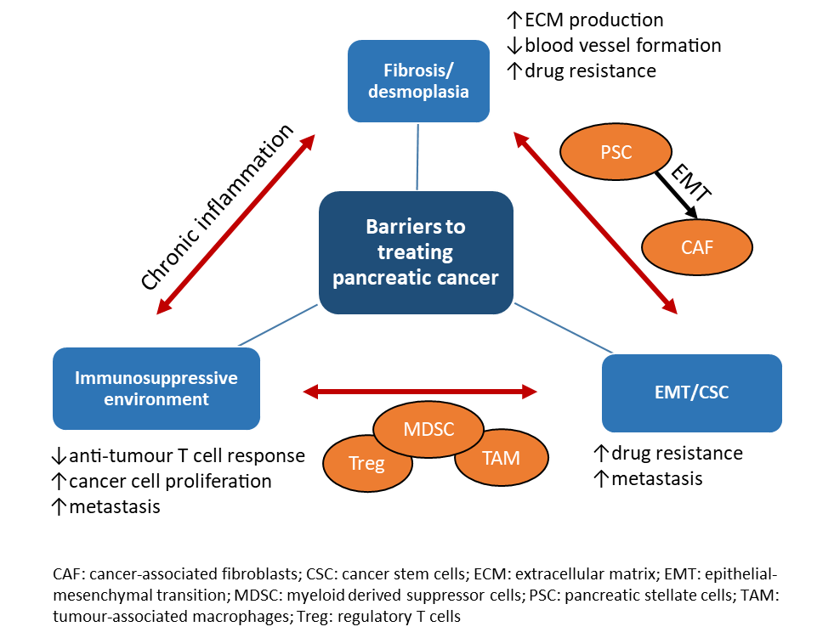
Figure 5.1: Barriers to treating pancreatic cancer: 1) fibrosis; 2) immunosuppressive environment; 3) epithelial-mesenchymal transition and cancer stem cells. These positively reinforce each other in creating a hypoxic microenvironment that promotes growth and spread of pancreatic cancer, as well as drug resistance.
Prior to the development of pancreatic neoplasms, injuries to the pancreas (e.g. genetic susceptibility, smoking, alcohol) can induce a pro-inflammatory environment resulting in an up-regulation in immune signalling (cytokines, chemokines) and extracellular matrix (ECM) production to repair the wounds. Recurrent pancreatic injuries prolong this inflammatory response and cells with sustained DNA damage take advantage of this environment to initiate tumourigenesis. Thereafter, tumour-stromal interactions continue to sustain the chronic inflammation leading to desmoplasia, a common characteristic of PaCa (Section 5.1.1.1). The desmoplastic PaCa microenvironment also promotes proliferation and activation of PSCs into CAFs (also known as myofibroblasts or activated PSCs). In turn, CAFs increase ECM production which further increases the stromal components within the microenvironment. The desmoplastic reaction eventually results in a dense tumour that is 90% composed of fibrous stroma obstructing tumour perfusion and developing hypoxia, thereby impeding delivery of therapeutic agents to the PaCa cells within the tumour (Gnanamony and Gondi, 2017).
Chronic inflammation also involves infiltration of immune cells that create an immunosuppressive PaCa environment (Section 5.1.1.2). Anti-tumour T cell response is inhibited by infiltrated myeloid-derived suppressive cells (MDSCs) and T regulatory (T_{reg}) cells, resulting in even more proliferation of PaCa cells and eventually metastasis. MDSCs and T_{reg} cells also augment CAF activation and ECM production, feeding back into the desmoplastic reaction. MDSCs also induce EMT in a subset of PaCa cells to become cancer stem cells (CSCs), which are more migratory, invasive and chemoresistant compared to the other tumour cells in the population (Section 5.1.1.3).

5.1.1.1 Desmoplasia
Under healthy conditions, the pancreatic architecture is preserved by a balance between ECM degradation and production. PSCs are normally found in periacinar, periductal and perivascular regions of the pancreas in a quiescent state, with low levels of proliferation and production of ECM and growth factors (Algul et al., 2007). When the pancreas encounters infection or tissue damage, acute inflammatory response serves to maintain homeostasis and heal the wound. Damaged acinar cells releases cytokines and chemokines that recruit immune cells to the vicinity in order to remove foreign pathogens, damaged cells and ECM (Ramudo et al., 2009). Activated platelets form a clot where endothelial cells and activated PSCs can migrate into to form new blood vessels and deposit ECM, respectively, to repair damaged tissue. Re-epithelisation of the wound then occurs, aided by activated PSCs which dissolve the clot and degrade ECM, allowing the epithelial cells to migrate into the wound to protect the new tissue. PSCs then migrate out of the once injured tissue and revert back to a quiescent state.
In a diseased pancreas, chronic inflammation results in fibrosis (scarring) rather than healing of damaged tissues as PSCs are consistently activated by transforming growth factor β (TGF-β) signalling and over-produce ECM (Yen et al., 2002, Medicherla et al., 2007). This fibrotic inflammatory response (desmoplasia) is what characterises PaCa, resulting in a dense scarred tumour with reduced elasticity. Figure 5.2B shows the abundance of tumour stroma within the PaCa microenvironment and disruption of the discrete exocrine and endocrine structures found in normal pancreatic tissue shown in Figure 5.2A.
Desmoplasia can lead to physiological chemoresistance in PaCa, as a result of increased interstitial pressure and excessive ECM production. Elevation of interstitial pressure resulting from fibrosis inhibits delivery of therapeutic agents due to reduced exchange of molecules between the tissue and bloodstream boundary, including chemotherapy (Provenzano et al., 2012). ECM within tumours also contribute to physiological chemoresistance by acting like a molecular sieve to therapeutic molecules from the bloodstream. In an orthotopic PaCa model, reduction of collagen content in L3.6pl tumours significantly increased response to intravenous doxorubicin treatment (Diop-Frimpong et al., 2011).

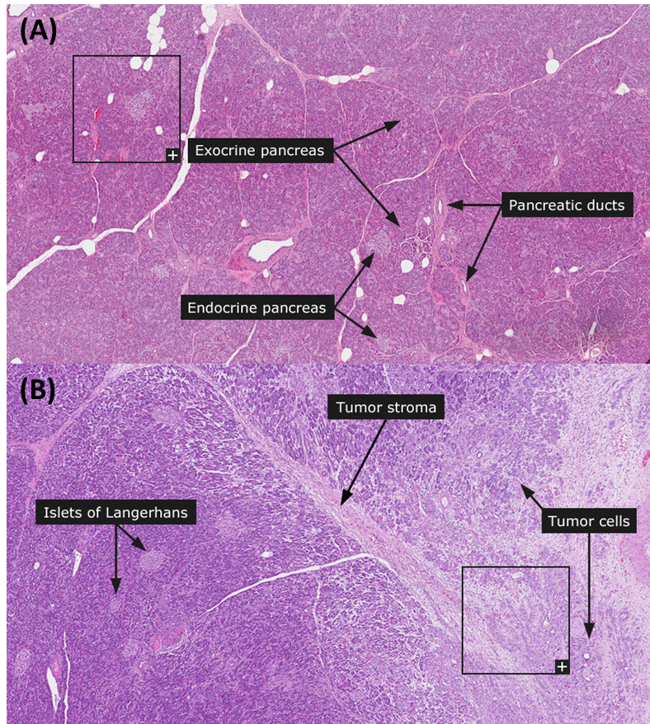
Figure 5.2: Histological tissue samples from normal pancreas (A) and pancreatic tumour (B). (A) Normal pancreas contained discrete exocrine (acini and ducts, enzyme-secreting) and endocrine (islets of Langerhans, hormone-secreting) structures to aid food digestion and hormones to regulate blood glucose levels, respectively. (B) Pancreatic tumours contain cancer cells growing in a disorganised pattern, embedded in a dense desmoplastic tumour stroma. Figure adapted from Human Protein Atlas, images available from:
https://v18.proteinatlas.org/learn/dictionary/normal/pancreas
https://v18.proteinatlas.org/learn/dictionary/pathology/pancreatic+cancer

In addition to physiological resistance to PaCa therapy, desmoplasia can also cause biological resistance due to decreased uptake and increased efflux of chemotherapeutic agents in tumour cells. Gene expression analysis revealed that PaCa patients with low levels of nucleoside transporter which uptakes gemcitabine (hENT1) have significantly shorter median overall survival (8.5 vs. 25.7 months, p<0.001) compared to patients with high hENT1 levels (Giovannetti et al., 2006). Increased expression of efflux transporters such as ATP-binding cassette is also implicated in biological chemoresistance in PaCa. Gemcitabine-resistant populations of PaCa cell lines HPAC and CFPAC-1 also have significantly higher mRNA expression of ATP-binding cassette family members (ABCG2 and ABCB1) compared to wild-type cells (Hong et al., 2009). Interestingly, the same study also showed that PaCa cells not only acquire gemcitabine resistance after being exposed to high doses, but also stem-like properties (CD44⁺ marker, increased in vitro colony formation and in vivo tumour inoculation) that correlate with lower patient survival (25.3 vs. 16.9 months, p<0.05), compared to CD44⁻ populations (Hong et al., 2009). The contribution of EMT within PDAC microenvironment to therapeutic resistance will be discussed further in Section 5.1.1.3.
While ADM has commonly been known to mediate tumour and endothelial cell development in the PDAC microenvironment, it has also recently been shown to mediate both PaCa and PSC’s contributions to desmoplasia. ADM, together with Sonic Hedgehog, mediates the effect of MYB on PaCa and PSCs contributing to existing desmoplasia (Bhardwaj et al., 2016). In vivo orthotopic experiments using MYB over-expressing and -silenced human PaCa cells MiaPaCa show that high MYB expression induces dense desmoplastic regions compared to the minimal desmoplasia seen in low MYB-expressing group. In vitro proliferation experiments assays using ADM and Sonic Hedgehog antagonists reveal that MYB’s increasing of PaCa and PSC proliferation was mediated by cooperation of ADM and Sonic Hedgehog. While it is not known whether this effect is facilitated by AM2R, there is potential in investigating whether small molecule inhibitors against AM2R can ameliorate ADM’s pro-tumoural effects on PaCa cells and PSCs within the desmoplastic PDAC environment.

5.1.1.2 Immunosuppresive environment
The previous section detailed how desmoplasia causes PaCa to be physiologically and biologically resistant to therapies due to the fibrotic architecture. In addition to fibrosis, desmoplasia is also characterised by chronic inflammation. This results in infiltration of immune cells such as MDSCs, TAMs and T_{reg} cells which creates an immunosuppressive PDAC environment that also promotes PaCa growth, spread and chemoresistance.
MDSCs are immature myeloid cells that are precursors to macrophages, dendritic cells and granulocytes. MDSCs are commonly distinguished by subtypes that resemble monocytes (CD11b⁺CD15⁻ in human, Gr1^{lo/int}CD11b⁺ in mice) or polymorphonuclear cells (CD11b⁺CD15⁺ in human, Gr1^{hi}CD11b⁺ in mice). A study using genetically engineered mouse KPC model of PDAC showed that tumour-derived granulocyte-macrophage colony-stimulating factor (GM-CSF) drives the development of Gr1^{hi}CD11b⁺ MDSCs which suppress anti-tumour T cell response (Bayne et al., 2012). While MDSCs themselves do not directly contribute to therapeutic resistance in PaCa, they produce various factors in the tumour environment that induce EMT in a subset of tumour cells. These tumour cells become CSCs which have been shown to be the chemoresistant population in pancreatic tumours (Section 5.1.1.3).
The most populous immune cell type to infiltrate pancreatic tumours are TAMs. Hypoxia in the tumour microenvironment via HIF-1α causes monocytic MDSCs to differentiate into TAMs (Corzo et al., 2010). TAM numbers significantly correlate with tumour size, local and early liver recurrence as well as shortened survival in PaCa patients who underwent surgical resection (Yoshikawa et al., 2012). Like their precursors MDSCs, TAMs can also activate PSCs and CSCs via STAT3 and Sonic Hedgehog pathways, further contributing to desmoplasia and chemoresistance in the PaCa microenvironment (Schmid-Kotsas et al., 1999, Jinushi et al., 2011).

Another infiltrating inflammatory cell population in the PaCa are T_{reg} cells. While they do not themselves induce tumorigenesis, they suppress immune responses that could have occurred in the tumour microenvironment. T_{reg} cells are also implicated in poor clinical response in PDAC to immunotherapy due to their augmented expression in PDAC tissues compared to healthy pancreatic tissues (Liyanage et al., 2002). The same study showed in ex vivo functional experiments that T_{reg} cells suppress proliferation and immune activation of CD4⁺ and CD8⁺ lymphocytes (Liyanage et al., 2002). Additionally, T_{reg} cells release TGF-β that lead to over-production of ECM as well as proliferation of CAFs, both of which contribute to desmoplasia as previously detailed in Section 5.1.1.1.
As well as mediating pro-tumoural signalling between PaCa cells and PSCs in the desmoplastic PDAC environment, ADM has also been shown to induce in vivo tumour infiltration and in vitro transformation of MDSCs and macrophages into pro-tumoural phenotypes expressing CD206 (M2-specific marker) in PDAC (Xu et al., 2016). However, since the study used blanket ADM up-regulation (exogenous treatment, over-expression) as well as inhibition (peptide antagonist ADM₂₂₋₅₂), it is unsure which receptor complexes are responsible for the observed phenomena. Hence, small molecule antagonists against AM2R would enable us to determine if ADM’s effects in converting MDSCs and TAMs into pro-tumoural phenotype in PDAC is in fact mediated by AM2R.

5.1.1.3 Epithelial-to-mesenchymal transition in PaCa
The previous two sections have shown that desmoplasia is characterised by both fibrosis and chronic inflammation which creates an immunosuppressive environment which fuels tumour growth as well as physical and biological resistance to cancer therapy. This complex signalling also induces EMT of tumour and stromal cells within the tumour microenvironment, which positively reinforces the desmoplastic reaction (Figure 5.1). As mentioned in the previous section, factors (e.g. TGF-β) released by tumour and immune cells in the PDAC microenvironment can activate PSCs into CAFs via EMT. CAFs can further induce a subset of tumour cells to undergo EMT into CSCs, which are more migratory, invasive and chemoresistant compared to the other tumour cells in the population.
PSCs are normally found in periacinar, periductal and perivascular regions of the pancreas (Algul et al., 2007). Typically in a quiescent state, PSCs have low levels of proliferation and production of ECM and growth factors. However, once activated into CAFs by factors secreted in a diseased pancreatic environment by both tumour and infiltrating immune cells, CAFs begin to proliferate, migrate and produce ECM and growth factors, thus contributing back to the desmoplastic environment in a vicious cycle. Studies using rat PSCs reveal that TGF-β and PDGF in the PDAC microenvironment released by infiltrating immune cells activate and promote proliferation of CAFs as well as stimulate CAF synthesis of ECM components (Schneider et al., 2001).
CAFs and tumour cells in the PDAC environment have a symbiotic relationship which further fuels desmoplasia and therapeutic resistance. Conditioned media from human PaCa cell lines (MiaPaCa2, Panc1 and SW850) stimulated primary PSC proliferation as well as their ECM protein production (Bachem et al., 2005). Conversely, conditioned media from primary PSCs also promoted in vitro proliferation, invasion and colony formation of human PaCa cell lines BxPC-3 and Panc1 (Hwang et al., 2008). In the same study, in vitro proliferation and apoptosis assays also revealed that gemcitabine and radiation therapy were less effective in BxPC-3 cells treated with PSC conditioned media. These results show the positive feedback loop in which tumour cells activate PSCs which then mediate signalling that subsequently enables a population of tumour cells to become resistant to anti-cancer treatments - CSCs.
Since CSCs are more migratory, invasive and chemoresistant than the other tumour cells in the population, being able to identify CSCs in the PDAC microenvironment would theoretically enable us to target the cells that can evade conventional chemotherapy and more likely to metastasise. Table 5.1 lists the markers commonly associated with pancreatic CSCs.

Table 5.1: Pancreatic cancer stem cell markers and their pro-tumoural properties
Markers | Mechanism | Reference
ALDH⁺ | More clonogenic (in vitro),  more tumour-initiating (in vivo - s) | (Rasheed et al., 2010)
CD24⁺/CD44⁺/ESA⁺ | Up-regulate self-renewal pathways (qPCR of primary PDAC) | (Li et al., 2007)
CD133⁺ | More tumorigenic (primary PDAC,  in vivo - o), gemcitabine-resistant  (in vitro and in vivo - o) | (Hermann et al., 2007)
CD166⁺ | More clonogenic (in vitro),  less invasive and migratory (in vitro), more tumorigenic (in vivo – s/o) | (Fujiwara et al., 2014)
DCLK1^{HI} | More tumour-initiating  (in vitro spheroids, in vivo - o) | (Bailey et al., 2014)
All comparisons are done versus cells negative/low for marker, within the same population
ALDH: aldehyde dehydrogenase 1
DCLK1: double cortin-like kinase 1
ESA: epithelial-specific antigen (also known as epithelial-cell adhesion molecule – EpCAM)
PDAC: pancreatic ductal adenocarcinoma
qPCR: quantitative real-time polymerase chain reaction
s: subcutaneous xenograft model
o: orthotopic xenograft model
Pancreatic CSC markers confer different tumour-promoting characteristics. ALDH⁺ Capan-1 human PaCa cells are more clonogenic in vitro compared to unsorted/ALDH⁻ populations (Rasheed et al., 2010). The same study showed that ALDH⁺ resected primary human pancreatic cancer xenografts also have higher tumour-initiating capacities than unsorted population in a subcutaneous in vivo model. Similarly, in vitro clonogenicity and in vitro/in vivo tumour growth were significantly augmented in CD133⁺ and DCLK1^{HI} primary human/mouse PDAC tissues, as well as CD166⁺ human PaCa cell lines compared to unsorted populations (Fujiwara et al., 2014, Hermann et al., 2007, Bailey et al., 2014). In vitro resistance to gemcitabine was also seen in CD133⁺ primary human PDAC cells compared to CD133⁻ population (Hermann et al., 2007). While the expression of CSC markers confer characteristics that promote tumour growth and resistance to therapies, they may also promote functions which appear anti-tumoural. For example, while CD166⁺ Panc1 cells have been shown to have increased in vitro and in vivo tumour growth compared to CD166⁻ population, in vitro Transwell assays show that CD166⁺ cells were less invasive and migratory, suggesting CSC marker expression regulates functions differently in PaCa cells (Fujiwara et al., 2014).
We have discussed how PSCs can induce EMT in PaCa cells to create a CSC population that are more invasive and chemoresistant than non-CSC cells (Hwang et al., 2008). Conversely, PaCa cells can induce EMT and activate PSCs to become CAFs (Bachem et al., 2005). Additionally, MDSCs and TAMs can also mediate EMT in both PSCs and PaCa cells (Schmid-Kotsas et al., 1999, Jinushi et al., 2011). While ADM has been shown to be able to mediate EMT in cholangiocarcinoma (Zhou et al., 2015), it is unknown whether it does the same in PaCa and whether this could be facilitated by AM2R. Interestingly, RAMP-3 has also been implicated in contributing to EMT in breast cancer. In vitro and in vivo experiments show that RAMP-3 functions as a downstream target of LOXL2, mediating pro-tumorigenic processes such as EMT and invasiveness in MDA-MB-231 breast cancer cells (Brekhman et al., 2011). While a blanket ADM inhibition did not completely abrogate pro-invasive effects of LOXL2, the authors suggested that since this effect is partially mediated by RAMP-3, RAMP-3 inhibitors could function as anti-tumour agents to target EMT in cancer.

5.1.2 Potential of using AM2R antagonists in combination with chemotherapy
Currently used chemotherapeutic regimens have been shown to be unsuccessful in treating PaCa due to high levels of toxicity and patients still end up with recurrence and metastasis within months of starting treatment. Hence, there is great necessity in developing less toxic and more efficacious treatment regimens for PaCa patients. One strategy would be to do a combination treatment using another targeted agent (e.g. AM2R antagonists) together with lower doses of chemotherapy.
We have seen in Sections 5.1.1.1 to 5.1.1.3 that ADM and RAMP-3 have been shown to be implicated in unique features of PDAC stroma including desmoplasia, immunosuppressive microenvironment, as well as EMT of PSCs and PaCa cells into CAFs and CSCs respectively. Therefore, there is great potential in using AM2R antagonists to rewire the PDAC stroma to become anti-tumoural.
Chapter 4 has shown evidence that AM2R antagonists not only inhibits growth and augments apoptosis in PaCa cells in vitro (Figures 4.8 to 4.11), they can also decrease tumour growth, CAF expression and blood vasculature in vivo (Figures 4.3, 4.14 and 4.15). Since subsets of cells in the PDAC environment (e.g. CSCs) have developed mechanisms to evade conventional chemotherapy, it would be interesting to determine if AM2R antagonists are able to re-wire the signalling and revert the resistant tumour cells back to being susceptible to chemotherapy. Figure 5.3 shows a schematic of how chemoresistance develops in PaCa and how AM2R antagonists could be used in combination with chemotherapy to prevent the development of recurrence and metastasis post-treatment. While conventional chemotherapy does work in eliminating tumour bulk, chemo-resistant CSCs left untreated could grow back into a viable tumour that is more aggressive and may even spread to a secondary location. Since this process is aided by stromal cells in the PDAC microenvironment, the addition AM2R antagonists could inhibit pro-tumoural signalling within the PDAC stroma, preventing the CSCs from growing and metastasising. AM2R antagonists could also rewire the CSCs back into an epithelial-like phenotype, which could sensitise them to chemotherapy, thereby eliminating the once resistant PaCa population.
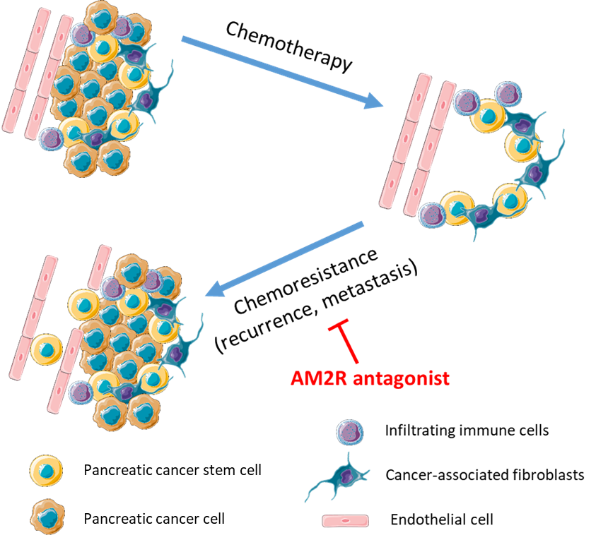
Figure 5.3: Schematic of development of chemoresistance in pancreatic cancer. After undergoing chemotherapy, chemoresistant population of tumour cells (pancreatic cancer stem cells) continue proliferating and may even metastasise to a secondary location. This process is mediated by pro-tumoural stromal cells in the microenvironment such as infiltrating immune cells and cancer-associated fibroblasts. Using an AM2R antagonist in combination with chemotherapy could inhibit development of chemoresistance, preventing recurrence and metastasis post-treatment.

5.1.3 Hypothesis and research aims
The null hypothesis for this chapter is that addition of small molecule antagonist against AM2R will not enhance effects of chemotherapeutic agents on PaCa growth in vitro and in vivo.
Efficacy of chemotherapeutic agents (5-FU and gemcitabine) on PaCa cell viability were first tested in vitro. Thereafter, these chemotherapeutic agents were used in combination with various concentrations of lead compound SHF-638 to investigate their combined effect on PaCa cell viability in vitro.
Efficacy of gemcitabine alone or in combination with lead compound SHF-771 (pure and potent enantiomer of SHF-638) was also investigated in an in vivo orthotopic xenograft model of PaCa using CFPAC-1 Luc cells. Using this model allows us to determine if there are additional effects within a pancreatic tumour microenvironment that a subcutaneous model would not have been able to reveal.

5.2 Methods

5.2.1 Chemotherapy dose response in vitro viability assays
CFPAC-1 cells were treated with chemotherapeutic agents (gemcitabine, 5-FU) daily. Cell viability was assessed daily for 72 hours using RealTime-Glo MT Viability Kit as detailed in Section 2.3.1. Wells were washed with PBS and freshly made reagent was added into wells to continue the assay for an additional 72 hours, if desired.
Stocks of chemotherapeutic agents were made up to 20 mM according to manufacturers’ manual. 50X treatment aliquots (diluted in PBS) were made to treat 2 μL per well (100 μL total volume per well). Vehicle-controls were made the same way as treatment stocks, and subsequently diluted in PBS. Treatment stocks and aliquots were stored at -20°C. Treatment aliquots were sonicated for 10 minutes in 37°C water bath prior to treatments.

5.2.2 Combination treatment (Small molecule antagonist + chemotherapy) in in vitro viability assays
CFPAC-1 cells were treated with a combination of chemotherapeutic agents (gemcitabine, 5-FU) and small molecule antagonist SHF-638 daily. Cell viability was assessed daily for 72 hours using RealTime-Glo MT Viability Kit as detailed in Section 2.3.1.

Stocks of chemotherapeutic agents were made up to 20mM according to manufacturers’ manual. SHF-638 was dissolved in DMSO to make 20 mM stocks. 50X treatment aliquots (diluted in PBS) were made to treat 2 μL per well (100 μL total volume per well). Vehicle-controls were made the same way as treatment stocks, and subsequently diluted in PBS. Treatment stocks and aliquots were stored at -20°C. Treatment aliquots were sonicated for 10 minutes in 37°C water bath prior to treatments.

5.2.3 In vivo orthotopic model

5.2.3.1 Mice
Orthotopic pancreatic cancer studies were performed using 5- to 6-week old female BALB/c nude mice from Envigo or Charles River, depending on availability. All procedures were reviewed and approved by the local Research Ethics Committees in the University of Sheffield and complied with the UK Animals (Scientific Procedures) Act 1986. Studies were performed under project license PF61050A3.

5.2.3.2 Treatment preparation for intraperitoneal injections
Lead compound SHF-771 was dissolved in Kolliphor vehicle + 3% DMSO at a concentration of 4 mg/mL. Kolliphor vehicle (Table 5.2) was chosen after our medical chemistry collaborators (WuXi) tested several formulations and how they affect solubility of our compounds. Kolliphor formulation is a potent non-ionic solubilizer with low toxicity. Solid stock of SHF-771 was first dissolved in appropriate volume of 100% DMSO (3% of final volume) and sonicated for 10 minutes before adding remaining volume of Kolliphor vehicle. Vehicle controls were made similarly (3% DMSO in Kolliphor vehicle). Compound and vehicle mixtures were further sonicated for 10 minutes before adjusting pH to physiological levels (pH 7.4). This is crucial as most of the small compound antagonist treatments were basic (around pH 9.0) whereas the vehicle was slightly acidic (pH 6.0) prior to adjusting pH.
Table 5.2: Recipe for Kolliphor vehicle
Reagent | Amount
Kolliphor® HS15 | 11 g
Kollisolv® PEG E 400 | 33 mL
PBS | 66 mL
Kolliphor vehicle | 100 mL

Gemcitabine HCl was dissolved in PBS at a concentration of 2.5 mg/mL (for 12.5 mg/kg treatment). Treatment solution was sonicated for 10 minutes before adjusting pH to physiological levels (pH 7.4), similar to pH of PBS. Again, this was crucial as the treatment solution was initially acidic (pH 2.5). In previous studies, we had used a treatment dose of 50 mg/kg from a study that used the same PaCa cell line (CFPAC-1) as our orthotopic model, albeit in a subcutaneous model (Shi et al., 2016). However, this dose proved to be too efficacious as tumours did not develop in mice treated with 50 mg/kg gemcitabine. Hence, we decided to decrease the dose to a quarter of 50 mg/kg (12.5 mg/kg) in the current experiment.
Treatment solutions of SHF-771 and gemcitabine were stored in 5 mL aliquots at -20°C (long-term) or -4°C once they have been thawed for use. Solutions were prepared at concentrations that would enable us to give 100 μL injections per mouse, assuming 20 g weight per mouse. This is a fair assumption as the mice were expected to weigh around 15-20 g during the course of the experiment (Figure 5.4). Before each treatment, treatment aliquots were sonicated for 10 minutes in a 37°C water bath. Mice were injected intraperitoneally in the lower quadrants, alternating between the left and right side. Treatment regimens are shown in Table 5.3.
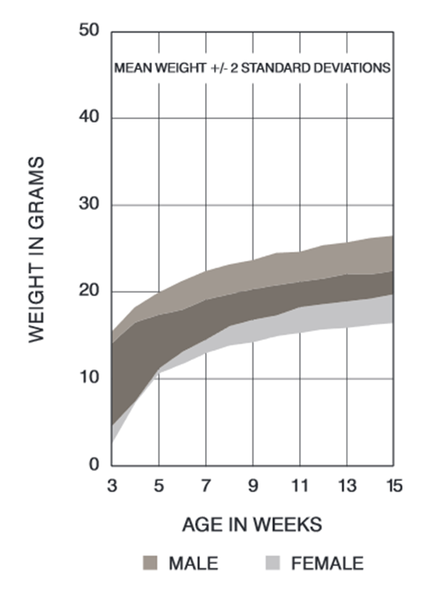
Figure 5.4: Expected Balb/c nude mice weights from Charles River showing 5-9 week old mice weighing between 15-20 g during that age range
Table 5.3: Treatment regime for pancreatic orthotopic xenograft experiments using Balb/c nude mice
SHF-771 (20 mg/kg) alone or in combination
with gemcitabine (12.5 mg/kg)
Treatment Group | Treatment | Frequency | Volume (μL)
Vehicle-control | Kolliphor vehicle + 3% DMSO | Once daily | 100
Vehicle-control | PBS | Twice weekly | 100
Gemcitabine only | Kolliphor vehicle + 3% DMSO | Once daily | 100
Gemcitabine only | 2.5mg/mL gemcitabine | Twice weekly | 100
SHF-771 only | 4 mg/mL SHF-771 | Once daily | 100
SHF-771 only | PBS | Twice weekly | 100
Gemcitabine + SHF-771 | 4 mg/mL SHF-771 | Once daily | 100
Gemcitabine + SHF-771 | 2.5 mg/mL gemcitabine | Twice weekly | 100

5.2.3.3 Cell preparation for intrapancreatic injections
CFPAC-1 cells transduced with Luciferase (CFPAC-1 Luc) were harvested from T175 flasks and counted according to Sections 2.1.1 and 2.1.3. Matrigel was thawed on ice or in the fridge overnight. Tubes, tips and PBS used in this protocol had been pre-chilled in the fridge or kept on ice prior to cell harvesting, to prevent Matrigel mixtures from solidifying prematurely. Cell suspension was prepared at a concentration of 10 million cells/mL in a Matrigel:PBS mixture (3:2 ratio) and kept on ice throughout the intrapancreatic injection procedure. Twice the amount of cells needed was prepared to account for dead volume and accidental wastage during surgery.

5.2.3.4 Intrapancreatic injection of cells
All surgical tools used were autoclaved prior to surgery. Insulin syringes (27 G, 1 mL) used for intrapancreatic injections were pre-chilled on ice. Mice were anaesthetised with inhaled isofluorene, checked for lack of pedal reflex and positioned on a 37°C heating pad. Abdomen was sterilised using surgical spirit. Scalpel and sterile surgical tools were used to make an incision (around 5 mm) in the skin and abdominal wall above where the spleen is (left upper flank). The spleen, connected to the pancreas, was lifted through the incision. The pancreas was spread onto a sterile swab to allow for intrapancreatic injection of 40 μL of CFPAC-Luc cell suspension (400,000 cells) into the pancreas tail, parallel to the vasculature to minimise bleeding. The needle was left in the injection site for at least 10 seconds prior to removal, to prevent further leakage. The spleen and pancreas were placed back into the abdominal cavity. The abdominal cavity was closed by two-layer suture – continuous 5-0 polydioxanone absorbable suture with round needle for the abdominal wall and interrupted 6-0 polypropylene suture with cutting needle for the skin. Iodine was applied to the stitches and mice were observed in a temperature-controlled incubator with access to mash until recovery (30 minutes to an hour). Post-operative status and wound healing were monitored daily. No wound infection was observed.

5.2.3.5 Measurement of tumour growth by IVIS imaging
Before starting treatment (Day 3), bioluminescence of tumours were imaged using PerkinElmer’s Lumina II in vivo imaging system (IVIS). Mice were anaesthetised with inhaled isofluorene and given 100 μL D-luciferin (8.6 μg/mL) subcutaneously. Mice were then placed in the bioluminescent imaging system under anaesthesia. After allowing the D-luciferin to circulate for five minutes, white-light and bioluminescence images were captured. Mice were then removed from inhaled anaesthetic and allowed to recover in their home cages. Following treatment, mice were imaged every week to monitor tumour growth. Bioluminescence signals were quantified using Living Image software (Figure 5.5). Regions of interests were drawn around the primary tumours of each mice and total flux (p/sec) were recorded as an output.

5.2.3.6 In vivo experimental endpoint
Mice were anaesthetised with inhaled isofluorene and given D-luciferin subcutaneously as described in Section 5.2.3.5, for posthumous IVIS imaging. After allowing the D-luciferin to circulate for five minutes, blood was withdrawn by cardiac puncture (25 G needle, 1 mL syringe) and collected in Vacutainer tubes containing anti-coagulant EDTA. Needles were removed prior to collection in tubes to prevent haemolysis. Mice were then culled by cervical dislocation. Pancreas and organs were imaged by IVIS to quantify endpoint tumour bioluminescence and detect presence of metastasis or residual primary tumour, if any (Figure 5.6).

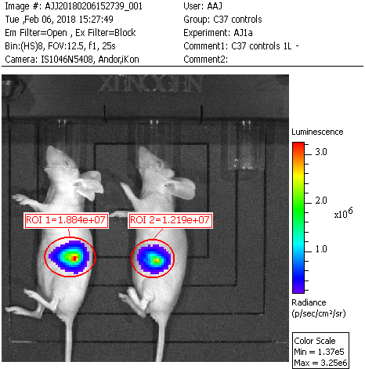
Figure 5.5: Bioluminescence of pancreatic tumours were quantified using Living Image software. Regions of interest (ROIs) were drawn around the tumours and the total flux (p/sec) of each tumour was recorded as an output.

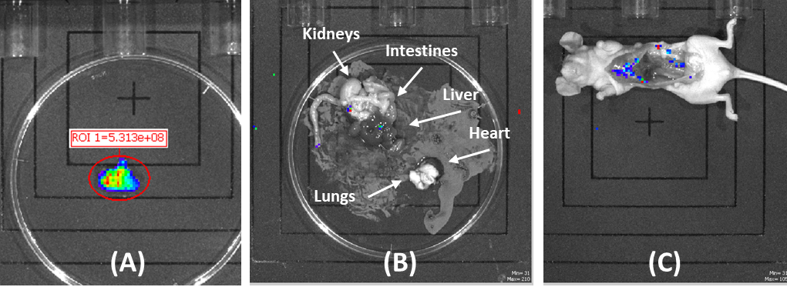
Figure 5.6: Bioluminescence of resected primary pancreatic tumours at endpoint (A), internal organs (B) and empty body (C). (B) and (C) were imaged to confirm absence of metastases or residual primary tumours
Pancreas (with tumour), liver, kidney and spleen were collected, weighed then fixed with 10% neutral-buffered formalin before sending them off to Histology core facility to be embedded in paraffin, cut into sections and stored at 4°C. Blood collected were centrifuged (1,600 x g, 15 minutes, 4°C) and resultant plasma were transferred into fresh polypropylene tubes and stored at -80°C for use in ELISA.

5.2.3.7 MR-proADM Enzyme-linked Immunosorbent Assay
ADM has a circulating half-life of 22 minutes and binds to receptors rapidly after its release (Meeran et al., 1997). Instead of measuring ADM in plasma from in vivo experiments, MR-proADM was measured instead as it is more stable than ADM (half-life of a few hours) and plasma MR-proADM levels correlate with levels of ADM (Valenzuela-Sanchez et al., 2016, Gille et al., 2017).
To measure the concentration of MR-proADM in plasma, human MR-proADM ELISA kit (Amsbio) was used. This method is highly sensitive and specific, due to the use of capture and detection antibodies against the antigen of interest. Figure 5.7 shows the ELISA incubation steps with various antibodies and substrate, resulting in a colorimetric readout correlating to the amount of antigen in the wells.
As mentioned in Section 5.2.3.6, to obtain plasma from in vivo experiments, blood collected by intracardiac withdrawal were put into Vacutainer tubes containing anti-coagulant EDTA. Tube were centrifuged (1,600 x g, 15 minutes, 4°C) and resultant plasma were transferred into fresh polypropylene tubes and stored at -80°C until use in ELISA.
Prior to starting the ELISA, reagents and samples were brought to room temperature. Smaller reagent tubes were centrifuged for one minute (10,000 x g) before making working solutions and standards. 25X wash buffer was diluted with distilled water to 1X wash solution. Different concentrations of MR-proADM standards were made by serial dilution of the 1000 pg/mL stock in provided diluent (Table 5.4). Working solutions of 100X biotinylated detection antibody and 100X HRP conjugate were made by diluting with respective diluents.
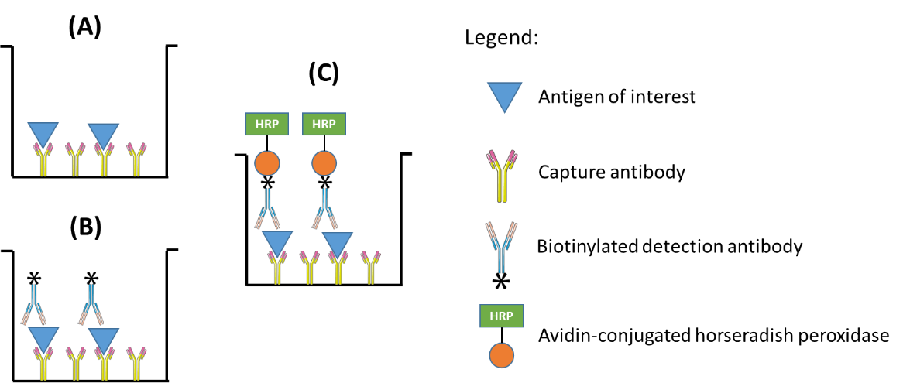
Figure 5.7: Principles of enzyme-linked immunosorbent assay (ELISA). Plates are washed between each step to remove unbound solutes. (A) Plasma samples and standards are added to ELISA plates coated with capture antibody against the antigen of interest. (B) Addition of biotinylated detection antibody will also bind to antigen of interest. (C) Avidin-conjugated horseradish peroxidase is added, where avidin will bind to the biotin on the detection antibody. Addition of substrate for horseradish will result in a colorimetric change that correlates with the amount of antigen in the well.
Table 5.4: Serial dilution of MR-proADM standards for ELISA

Diluent: Reference Standard and Sample Diluent

Concentration of standards (pg/mL) | Volume of previous dilution (µL) | Volume of diluent (µL)
1000 (stock) | - | -
500 | 500 | 500
250 | 500 | 500
125 | 500 | 500
62.5 | 500 | 500
31.25 | 500 | 500
15.63 | 500 | 500
0 | - | 500
100 µL of sample or standard was added to each well of the micro ELISA plate in duplicates, avoiding wall touching and foaming. Plate was sealed and incubated for 90 minutes at 37°C. Multichannel pipette was used to remove liquid from wells before adding 100 µL biotinylated detection antibody working solution per well. Plate was sealed and incubated for one hour at 37°C. Solutions were decanted from wells onto absorbent paper and washed with 350 µL wash buffer for 1 minute. Decanting and washing was repeated three times. 100 µL of HRP conjugate working solution was added per well. Plate was sealed and incubated for 30 minutes at 37°C. Solutions were decanted from wells onto absorbent paper and washed with 350 µL wash buffer for 1 minute. Decanting and washing was repeated five times. 90 µL of substrate reagent was added per well. Plate was sealed and incubated for 15 minutes at 37°C, protected from light using foil. 50 µL of stop solution was added per well. EnSight Multimode Plate Reader (PerkinElmer, set to 450nm and 37°C) was used to determine optical density (OD) value of wells. OD values are proportional to concentration of MR-proADM.
To correlate OD values of standards to their respective concentrations, duplicate readings were averaged before subtracting averaged zero standard OD value from them. Four parameter logistic curve was fit with standard concentration on x-axis and OD values on the y-axis, using GraphPad Prism 7.01 (Figure 5.8). Average OD values of samples were then interpolated if they fall within the OD value range of the standards.
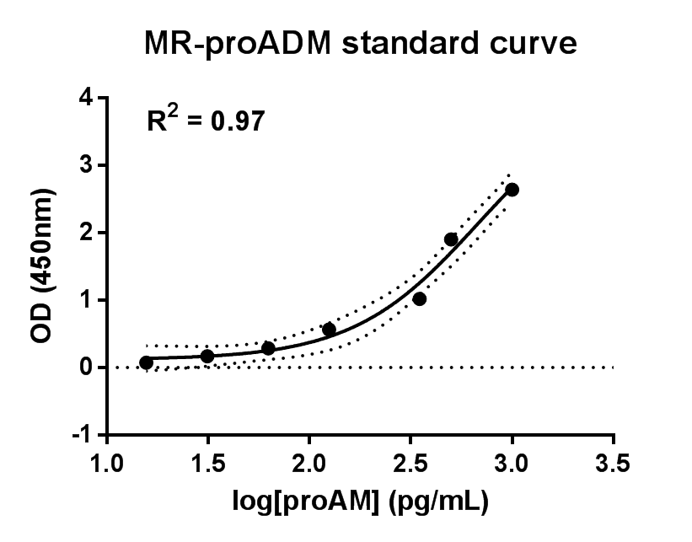
Figure 5.8: Four parameter logistic curve of MR-proADM concentrations ranging from 15.63 to 1000 pg/mL. Average OD readings of samples were interpolated from standard curves on the same plate.

Results

Dose response of chemotherapeutics in in vitro viability assays
We have seen in Chapter 4 that small molecule antagonists against AM2R are able to decrease viability and increase apoptosis of PaCa cells in vitro, as well as decrease in vivo tumour growth in a PaCa subcutaneous xenograft model.
In order to determine if AM2R antagonists could be used in a combination therapy with chemotherapy, we first tested the effects of chemotherapeutic agents (5-FU and gemcitabine) on viability of PaCa cell line CFPAC-1 as detailed in Section 5.2.1. Daily treatment with 500 nM to 3 µM of either 5-FU or gemcitabine significantly decreased viability of CFPAC-1 after seven days, compared to vehicle-treated controls (p<0.05, Figures 5.9A and 5.9B). Dose response analysis of the endpoint data reveal that gemcitabine is more potent than 5-FU at decreasing CFPAC-1 viability (Figure 5.9C).
To subsequently test the combination of chemotherapy with small molecule antagonists against AM2R, 1 μM 5-FU and 500 nM of gemcitabine were chosen for further in vitro combination experiments as they resulted in 50% efficacy (decrease in viability) over the treatment duration (Figure 5.9C).
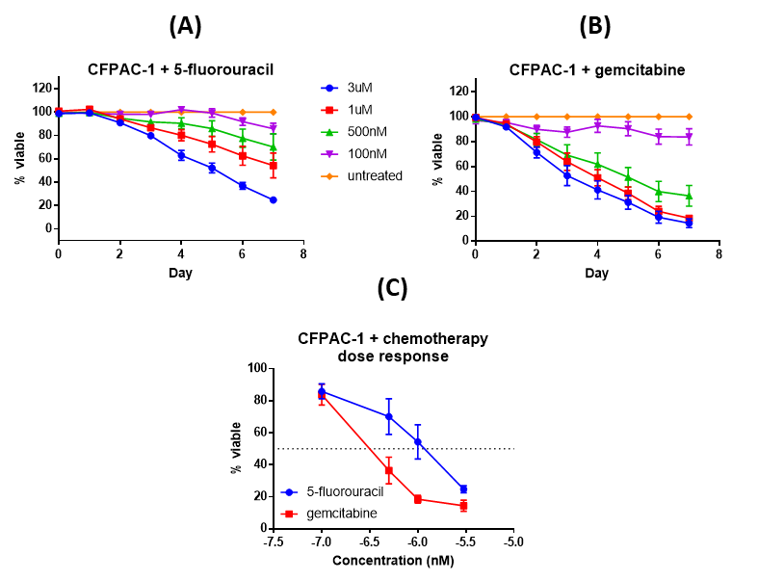
Figure 5.9: Effect of different concentrations of chemotherapeutic agents 5-FU (A) and gemcitabine (B) on viability of human pancreatic cancer cells CFPAC-1 in vitro. Daily treatment with 500 nM to 3 μM of 5-FU and 100 nM to 3 μM of gemcitabine significantly decreased viability of CFPAC-1 after nine days, compared to vehicle-treated controls (p<0.05). (C) Dose response of endpoint data from (A) and (B) reveal that gemcitabine is more potent than 5-FU at decreasing CFPAC-1 viability. Two-way ANOVA was used for all data sets. Data are from three independent experimental repeats and presented as mean±SEM.

Combination of chemotherapeutics and SHF-638 in in vitro viability assays
As mentioned in the previous section, 1 μM 5-FU and 500 nM of gemcitabine were chosen for further in vitro experiments using chemotherapeutics in combination with small molecule antagonists against AM2R, as detailed in Section 5.2.2. Figure 5.10 shows the results for CFPAC-1 cells treated daily with different concentrations of SHF-638 in combination with 1 μM 5-FU or 500 nM gemcitabine.
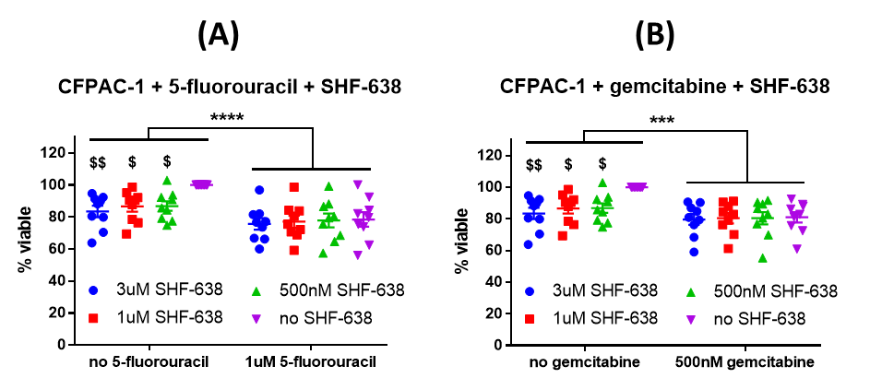
Figure 5.10: Effect of different concentrations of small molecule antagonist against AM2R SHF-638 in combination with single concentration of chemotherapeutic agents 5-FU (A) and gemcitabine (B) on viability of human pancreatic cancer cells CFPAC-1 in vitro. Two-way ANOVA was used. Data are from three independent experimental repeats and presented as mean±SEM.
$ or $$: p<0.05 or p<0.01 compared to control within the group,
*** or ****: p<0.001 or p<0.0001 compared to control group (no chemotherapy)

Multiple comparisons testing shows that SHF-638 treatment alone was able to decrease CFPAC-1 viability dose dependently by 13-17% over three days (p<0.05), compared to vehicle-control. The effect was milder in combination with 1 μM 5-FU, where SHF-638 further decreased viability by 0.7-2.8% (not significant), compared to 1 μM 5-FU alone (21% decrease). The same effect was seen in combination with 500 nM gemcitabine, where SHF-638 doses decreased CFPAC-1 viability by an additional 0.6-1.4% (not significant), compared to 500 nM gemcitabine alone (19% decrease).
Two-way ANOVA also revealed that 5-FU (p<0.0001) and SHF-638 (p<0.05) treatments both significantly decreased viability of CFPAC-1 cells, and that there were no interaction between the treatment groups (p=0.11). The same was also seen in the two-way ANOVA results for gemcitabine (p<0.001) and SHF-638 (p<0.05), with there being no interaction between the two groups (p=0.18).

Effect of SHF-771 in combination with chemotherapeutic gemcitabine in vivo
We have shown in Section 4.3.4 that small molecule antagonists against AM2R can decrease CFPAC-1 tumour burden in an in vivo subcutaneous xenograft model by up to 56% (p<0.05). We have also shown in Section 5.3.2 that small molecule antagonists against AM2R decrease PaCa cell viability in vitro alone or in combination with chemotherapeutics agents. It is likely that our lead compounds will eventually be used in combination with currently available chemotherapeutics in a clinical setting as opposed to being a single agent treatment option. Therefore, a combination of AM2R antagonist (SHF-771) and chemotherapeutic (gemcitabine) was tested in the CFPAC-1 Luc intrapancreatic orthotopic xenograft model.
Since we have shown in a subcutaneous PaCa model that our lead compounds were able to decrease tumour burden in vivo, we were additionally interested in whether a similar effect will be observed in tumours inoculated orthotopically. It is shown that PaCa tumour tissues in subcutaneous and orthotopic models have differing metabonomics and metabolomics due to the differences in tumour microenvironment (Zhan et al., 2017). An orthotopic model will also reveal if other features in the PaCa microenvironment (e.g. desmoplasia, PSCs, immune cells, blood and lymph vessels) that could be affected by treatment with AM2R antagonists alone or in combination with chemotherapeutics.

Safety profile of combination treatment
Similar to Section 4.3.4.1, mice weights were recorded once a week and behaviours observed daily during treatments to ensure treatment regimens did not cause adverse effects. Figure 5.11 shows the mice weight changes at experimental endpoint compared to before surgery. Two-way ANOVA revealed that SHF-771 treatment did not significantly affect mice weight gain but gemcitabine significantly decreased mice weight gain (p<0.05). There was no interaction between gemcitabine and SHF-771 treatments (p=0.65). Throughout the experimental duration, none of the mice loss weight to warrant Schedule 1 culling (>20% decrease in weight compared to before tumour inoculation).
Figure 5.11: Weight change at endpoint (Day 28 – control, SHF-771 only; Day 35 – gemcitabine only, gemcitabine + SHF-771) compared to before surgery in combination in vivo orthotopic experiments. SHF-771 (20 mg/kg) treatment did not significantly affect mice weight change. Gemcitabine (12.5 mg/kg) significantly lowered mice weight change (p<0.05). Two-way ANOVA was used. Data presented as mean±SEM. *: p<0.05

Intrapancreatic tumour inoculation and treatment regimens did not result in any adverse effects including eating/drinking difficulties, persistent hypothermia or hunching. Thickening of abdominal wall was observed in mice treated with SHF-771 alone and in combination with gemcitabine after two weeks of treatment (similar to in vivo subcutaneous model in Section 4.3.4.1), but this did not result in any observable adverse behaviour. The increased peritoneal pressure that stemmed from this resulted in around 20% of treatment volume leaking out after two weeks of treatment, which was also observed in the in vivo subcutaneous model in Section 4.3.4.1.

Tumour burden
To investigate how small molecule antagonist against AM2R (SHF-771) compares to standard chemotherapeutics in affecting tumour burden in an in vivo orthotopic pancreatic model, Balb/c nude mice implanted with human pancreatic cancer cells CFPAC-1 intrapancreatically were subsequently treated intraperitoneally with either 20 mg/kg of SHF-771 (daily), 12.5 mg/kg gemcitabine (twice weekly), a combination of the two, or vehicle-controls. Figure 5.12 shows the tumour growth curves resulting from weekly IVIS imaging. Figure 5.13 shows the individual data points shown in the last time point in Figure 5.12 (Day 28 for groups without gemcitabine, Day 35 for gemcitabine groups).

Figure 5.12: Growth curve of pancreatic orthotopic tumours from live IVIS imaging of Balb/c mice treated with vehicle-control, SHF-771 (20 mg/kg, daily), gemcitabine (12.5 mg/kg, twice weekly) or a combination of both. Data presented as mean±SEM.
Figure 5.13: Tumour burden at endpoint in a pancreatic orthotopic xenograft model using human pancreatic cancer cell line CFPAC-1 (Day 28 for groups without gemcitabine, Day 35 for gemcitabine groups). SHF-771 treatment (20 mg/kg) decreased tumour mass by 38% compared to vehicle-treatment (p<0.05). In comparison, gemcitabine (12.5 mg/kg) decreased tumour mass by up to 98% compared to vehicle-treatment (p<0.0001). Addition of SHF-771 to the gemcitabine treatment further decreased tumour mass by 5% (ns). Two-way ANOVA was used, outliers were excluded by ROUT (1 each from gemcitabine only and gemcitabine + SHF-771 groups). Data presented as mean±SEM.
$: p<0.05 compared to control within the group
****: p<0.0001 compared to control group (no gemcitabine), ns: not significant
SHF-771 treatment alone was able to decrease tumour growth (as measured by bioluminescence) by 38% compared to vehicle-control (Figure 5.13, p<0.05). However, gemcitabine treatment alone was able to significantly decrease tumour growth by 98% to vehicle-treatment (Figure 5.13, p<0.0001). Combination of SHF-771 and gemcitabine decreased tumour growth by 5% compared to gemcitabine treatment only (not significant), but 98% compared to vehicle-control (p<0.0001). Two-way ANOVA revealed that there was no interaction between gemcitabine and SHF-771 treatments (p=0.11).
Comparing tumour masses between the groups (Figure 5.14) revealed a similar trend to tumour bioluminescence results (Figure 5.13), although the differences were less pronounced. Two-way ANOVA revealed once again that gemcitabine but not SHF-771 significantly decreased tumour masses (p<0.0001 and p=0.08 respectively), and that there were no interaction between the two types of treatments (p=0.62). SHF-771 treatment alone decreased tumour mass by 14% compared to vehicle-treatment (not significant). In comparison, gemcitabine treatment alone decreased tumour mass by 66% compared to vehicle-control. Combination of SHF-771 and gemcitabine decreased tumour mass by 24% compared to gemcitabine treatment only (not significant), but 74% compared to vehicle-control (p<0.0001).

Figure 5.14: Tumour masses at endpoint in a pancreatic orthotopic xenograft model using human pancreatic cancer cell line CFPAC-1 (Day 28 for groups without gemcitabine, Day 35 for gemcitabine groups). SHF-771 treatment (20 mg/kg) decreased tumour mass by 14% compared to vehicle-treatment (ns). In comparison, gemcitabine treatment (12.5 mg/kg) decreased tumour mass by 66% compared to vehicle-control (p<0.0001). Combination of SHF-771 and gemcitabine decreased tumour mass by 24% compared to gemcitabine treatment only (ns). Two-way ANOVA was used, outliers were excluded by ROUT (2 from gemcitabine + SHF-771). Data presented as mean±SEM.
****: p<0.0001 compared to control group (no gemcitabine), ns: not significant

Vital organs
Vital organs were weighed to identify organs that may be adversely affected by treatment regimens. Treatment regimens did not cause any significant changes in masses of livers and kidneys (Figure 5.15). However, two-way ANOVA revealed that both gemcitabine and SHF-771 treatments resulted in smaller spleens (p<0.0001 and p<0.05 respectively, Figure 5.15) and that there was no interaction between the two types of treatments (p=0.87).
Multiple comparison tests show that SHF-771 treatment decreased spleen masses by 21% (p<0.05) and 17% (not significant) in gemcitabine and non-gemcitabine groups respectively, compared to vehicle control (Figure 5.15). Multiple comparison tests also showed that gemcitabine treatment decreased spleen masses by 38% (p<0.0001) and 22% (p<0.05) in SHF-771 and non-SHF-771 groups respectively, compared to vehicle control (Figure 5.15).
Inoculation of orthotopic CFPAC-1 tumour also significantly increased liver (22%, p<0.01), kidney (19%, p<0.05) and spleen (103%, p<0.0001) masses of mice, compared to naïve mice without tumours (Figure 5.15). Only gemcitabine treatment (alone and in combination with SHF-771) significantly decreased spleen masses (22-38%, p<0.05), compared to vehicle-treated mice (control).
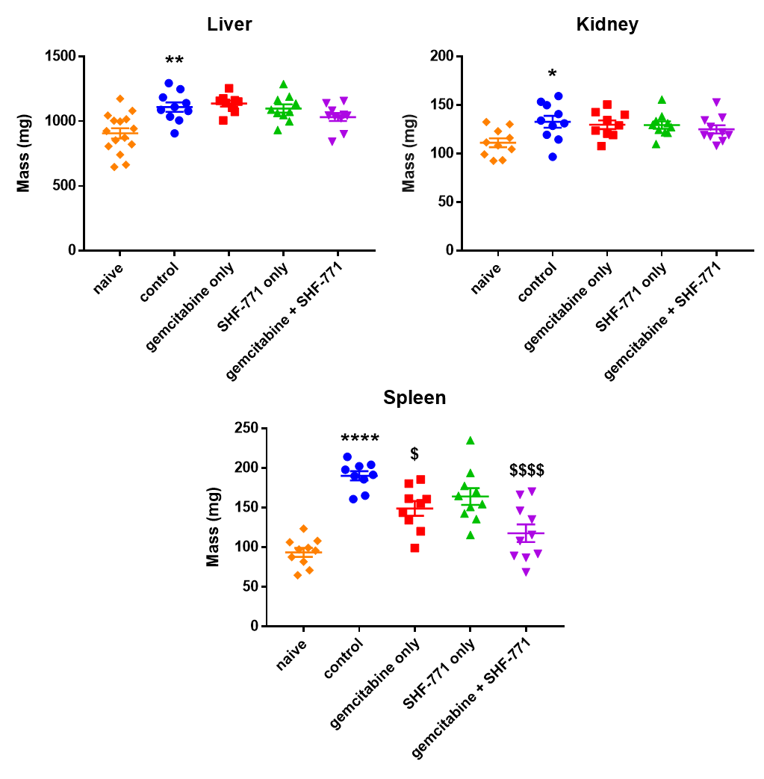

Figure 5.15: Liver, kidney and spleen masses in mice treated with gemcitabine, lead compound SHF-771, a combination or vehicle-control in a pancreatic orthotopic model using human PaCa cell line CFPAC-1 Luc in Balb/c nude mice. Mice inoculated CFPAC-1 tumour (control) had a significant increase in liver (22%, p<0.01), kidney (19%, p<0.05) and spleen (103%, p<0.0001) masses, compared to mice without tumours (naïve). Treatment with gemcitabine, SHF-771 or a combination of the two generally decreased the organ masses towards naïve masses. Only gemcitabine treatment (alone and in combination with SHF-771) significantly decreased spleen masses (22-38%, p<0.05), compared to vehicle-treated mice (control). Student’s t-test was used compared to respective controls (naïve or control). Data presented as mean±SEM.
$ or $$$$: p<0.05 compared to vehicle-treated mice (control)
*, ** or ****: p<0.05, p<0.01 or p<0.0001 compared to naïve mice

To determine if the spleen mass correlates with tumour burden or mice weights, correlation analyses were done. Pearson correlation analysis shows that spleen mass positively correlates with tumour mass significantly (R²=0.335, p<0.0001, (Figure 5.16A) but not mice weights (R²=0.08, p=0.08, Figure 5.16B).
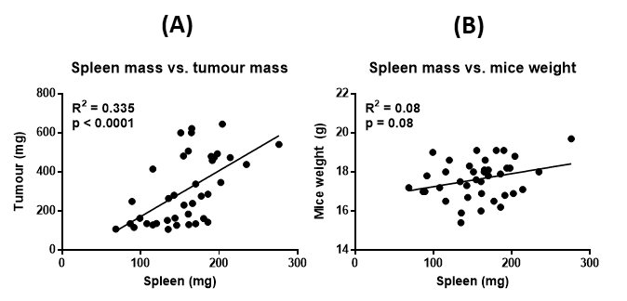
Figure 5.16: Scatter plot showing relationships between spleen mass and either tumour mass (A) or mice weights (B). Pearson correlation analysis shows that spleen mass positively correlates with tumour mass (p<0.0001) but not mice weights (p=0.08).

Plasma levels of mid-regional pro-adrenomedullin (MR-proADM)
In addition to analysing the effect of combination treatment on tumour burden, plasma levels of mid-regional pro-adrenomedullin (MR-proADM) were also analysed by ELISA. Figure 5.17A shows that mice treated with vehicle or SHF-771 alone (46.06 pg/mL) had higher plasma levels of MR-proADM than mice treated with gemcitabine alone (19.22 pg/mL) or in combination with SHF-771 (24.72 pg/mL). However, not all plasma samples had detectable levels of MR-proADM (Figure 5.17B), therefore these samples were plotted as the minimum detectable concentration in Figure 5.17A.
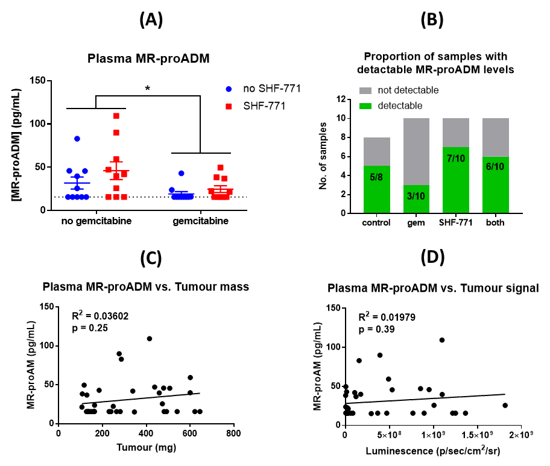
Figure 5.17: (A) Plasma levels of mid-regional pro-adrenomedullin (MR-proADM) from mice treated with vehicle control, 12.5 mg/kg gemcitabine, 20 mg/kg SHF-771 or a combination of the two. Gemcitabine treatment significantly decreased mean plasma levels of MR-proADM by 39-46% (p<0.05). SHF-771 treatment (alone or in combination with gemcitabine) increased mean plasma levels of MR-proADM by 27-45% (ns). (B) Plasma levels from some samples were undetectable in the ELISA and were plotted as the minimum detectable concentration (15.63 pg/mL) shown by the dotted line in (A). Plasma levels of MR-proADM did not correlate with tumour masses (C) or bioluminescence (D). Data presented as mean±SEM. *: p<0.05, ns: not significant

Two-way ANOVA analysis revealed that gemcitabine treatment significantly decreased MR-proADM levels but not SHF-771 treatment (p=0.02 and p=0.15 respectively, Figure 5.17A). There was also no significant interaction between gemcitabine and SHF-771 treatments (p=0.52, Figure 5.17A).
Multiple comparison tests showed that SHF-771 treatment increased mean plasma levels of MR-proADM by 45% and 27% in gemcitabine and non-gemcitabine groups respectively, compared to non-SHF-771 treatment (not significant, Figure 5.17A). Multiple comparison tests also showed that gemcitabine treatment decreased mean plasma levels of MR-proADM by 46% (p<0.05) and 39% (not significant) in SHF-771 and non-SHF-771 groups respectively, compared to non-gemcitabine treatment (Figure 5.17A).
To determine if the plasma levels of MR-proADM correlate with tumour burden, a correlation analysis was done comparing it to either tumour mass or bioluminescence. There does not appear to be a statistically significant non-zero association between plasma levels of MR-proADM and either tumour mass (R²=0.036, p=0.25, Figure 5.17C) or luminescence (R²=0.020, p=0.39, Figure 5.17D).

5.4 Discussion

Pancreatic cancer cell line CFPAC-1 is not resistant to chemotherapy in vitro and in vivo
In vitro and in vivo results show that human PaCa cell line CFPAC-1 is not resistant to chemotherapeutic agents 5-FU and gemcitabine (Sections 5.3.1 and 5.3.3.2). Similar evidence was seen in literature as shown in Tables 5.5 and 5.6. While IC50 of 5-FU on CFPAC-1 viability was similar between our study and that in literature (1 µM, Table 5.5), IC50 of gemcitabine was variable (11 to 950 nM, Table 5.6). Our results were similar to Arumugam and colleagues, although our experiment was done over a longer duration (7 vs. 3 days).

Table 5.5: IC50 of 5-FU on human pancreatic cancer cell line
CFPAC-1 viability
IC50 (nM) | Treatment duration | Reference
1000 | 7-days | Figure 5.9A
1000 | 3-days | (Arumugam et al., 2009)
IC50 data acquired using MTT assay (all references) or RealTime-Glo MT Viability Assay (our data)

Table 5.6: IC50 of gemcitabine on human pancreatic cancer cell line
CFPAC-1 viability
IC50 data acquired using MTT assay (all references) or RealTime-Glo MT Viability Assay (our data)
IC50 (nM) | Treatment duration | Reference
500 | 7-days | Figure 5.9B
10 | 3-days | (Akada et al., 2005)
44.3 | 5-days | (Guo et al., 2012)
33 | 3-days | (Hong et al., 2009)
834 | 2-days | (Li et al., 2018)
300 | 3-days | (Arumugam et al., 2009)

Small molecule antagonist against AM2R in combination with chemotherapy are safe and efficacious in vivo at given doses
Gemcitabine treatment alone was able to decrease in vivo tumour burden more efficaciously compared to SHF-771 alone. The addition of SHF-771 to the gemcitabine regimen appears to further decrease tumour burden, but the effect was not statistically significant. It would be interesting to further decrease the dose of gemcitabine to see if AM2R antagonist would then be able significantly decrease tumour burden. This is clinically important as chemotherapeutics are riddled with side effects (e.g. nausea/vomiting, diarrhoea/constipation and peripheral neuropathy) at efficacious doses. To be able to decrease the chemotherapeutic dose considerably (in a combination therapy) yet retain the therapeutic effect by the addition of another treatment regimen (e.g. small molecule antagonist against AM2R) that does not appear to result in any adverse effects would have a positive effect on patient wellbeing.
Another observation was that after Day 28, tumours in mice treated with gemcitabine alone and in combination with SHF-771 started to grow again, as seen in the increase in tumour bioluminescence at Day 35 (Figure 5.12B). More interestingly, the increase was more drastic in mice treated with gemcitabine alone, compared to mice treated with combination of gemcitabine and SHF-771. One postulation is that the inoculated PaCa tumours started to become resistant to gemcitabine treatment after Day 28, but this effect was slightly mitigated in the mice also treated with SHF-771. Future work could be done to determine if another of SHF-771’s in vivo effects include preventing inoculated pancreatic tumour cells from becoming resistant to gemcitabine treatment. This would require continuing the experiment for longer than 35 days to see if tumours in mice treated only with gemcitabine would eventually grow to the size of vehicle-treated tumours, compared to tumours in mice treated with both gemcitabine and SHF-771.
Similar to the subcutaneous in vivo experiment in Chapter 4, SHF-771 did not lead to weight differences in mice compared to vehicle-treatment. However, gemcitabine treatment significantly decreased weight gain. This mirrors weight- or appetite- related adverse effects that currently plague cancer patients undergoing chemotherapy. It also suggests that small molecule antagonists against AM2R have a good safety profile to use in combination with chemotherapeutic regimens as they did not exacerbate the weight loss effects of gemcitabine.
We also observed a decrease in spleen mass in mice treated with either AM2R antagonist or gemcitabine, and that the effect was more pronounced in mice treated with both. Compared to spleen size of naïve mice (Figure 5.15, mean 93.5g), this suggests that the combination of SHF-771 and gemcitabine not only inhibited PaCa growth but also ameliorated the increase in spleen size of vehicle-treated mice (Figure 5.15, 117.6 vs. 190.1, p<0.0001). One possible reason is that the intrapancreatic tumour growth puts undue pressure on the veins in the spleen, resulting in spleen enlargement. This explanation corroborates with the positive correlation shown between spleen mass and tumour mass (Figure 5.16).
Compared to the subcutaneous PaCa model (Chapter 4, Figure 4.14A), 20 mg/kg SHF-771 was slightly less efficacious in decreasing in vivo growth of orthotopic PaCa tumours (44% vs. 38% decrease in tumour volume, both p<0.05). This could be due to a different tumour microenvironment in the two models. Further immunohistochemical analyses will reveal if this is due to a differing growth and treatment effect on tumour cells or stromal cells (e.g. vasculature, PSCs, immune cells). Pancreatic tumours are also notorious for having low levels of vasculature compared to normal pancreas or benign tumours (Komar et al., 2009). This may make it harder for SHF-771 treatment to penetrate orthotopic tumours compared to subcutaneous tumours, thus being less efficacious in the orthotopic model.

Small molecule antagonist against AM2R appear more efficacious in vivo than in vitro, in combination with chemotherapy
In vitro results show that AM2R inhibition decreases tumour cell viability alone and in combination with chemotherapeutics agents, in a dose dependent manner. However, the effect of AM2R inhibition is less obvious in the presence of a chemotherapeutic agent at the concentrations and treatment durations used. Future experiments could be done lower concentrations of chemotherapeutic agents (IC10 instead of IC50) and for a longer treatment duration (nine days instead of three days).
Perhaps, since CFPAC-1 is already sensitive to chemotherapy, AM2R antagonists would not be able to significantly augment this effect. Future studies could be done using chemo-resistant PaCa cell lines. We have acquired 5-FU and gemcitabine resistant CFPAC-1 lines by exposing the wild-type cells to serially escalated doses of each chemotherapeutic agent. These CFPAC-1 derivative lines are 100X more resistant to the respective chemotherapeutic agent in vitro. Further characterisation will be done to determine differences in vitro and in vivo, using AM2R antagonists as single agents or in combination with chemotherapy. Differences in expression of ADM and its receptor components (CLR, RAMPs) will also be investigated.
Similar to Chapter 4, the effects of AM2R antagonists (in combination with chemotherapy) in inhibiting tumour growth are milder in vitro compared to in vivo. This suggests that AM2R antagonists not only inhibit PaCa cell growth in vivo, but may additionally mediate anti-tumoural signalling of stroma cells in the PaCa microenvironment. To further investigate the effect of AM2R antagonism on pancreatic stroma, immunohistochemical analyses can be done to determine differences in populations of different stromal constituents such as CAFs, endothelial and immune cells.
Differences in α-SMA positive cells (marker for CAFs) could reveal if AM2R antagonism was able to rewire CAFs back to being non-tumour promoting PSCs. We have seen in a previous study that CAF expression was decreased in CFPAC-1 tumours of mice treated with early lead compound SHF-638 compared vehicle-control (Figure 4.4C). However, since this earlier study was done using a subcutaneous model, it would be interesting to see if the effect on CAFs is similar in an orthotopic model
Differences in CD31 positive cells (marker for blood vessels) can also reveal if AM2R antagonism normalises blood vasculature within PaCa. Anti-angiogenic therapies aim to normalise vasculature, which is not as simple as decreasing the number of blood vessels within the tumour. While increased vascular permeability could make the tumour more susceptible to systemic therapy, this may also increase the propensity of tumour cells to migrate and spread through circulation into distant sites leading to metastasis, which is ultimately the cause of PaCa mortality. Conversely, shutting down tumour vasculature would cut off its supply of nutrients and factors from circulation, eventually resulting in tumour necrosis. However, this would make it additionally harder for systemic therapy to get into a tumour that is already resistant to treatment. It is still contentious as to which would be more beneficial in targeting PaCa, which is known for having low levels of vascular permeability (Komar et al., 2009). However, we have seen in a previous study that CD31 expression was decreased in CFPAC-1 tumours of mice treated with early lead compound SHF-638 compared vehicle-control (Figure 4.4D). This suggests that AM2R antagonist decreases PaCa angiogenesis in a subcutaneous model, resulting in inhibition of in vivo tumour growth. It would be interesting to see if the effect on tumour vasculature is similar in an orthotopic model.
Determining the effect of AM2R antagonism on the immune response within a pancreatic tumour is also important, as PaCa typically results in an immunosuppressive environment. This study was done in Balb/c nude mice which are athymic and therefore do not produce T cells. Section 5.1.1.2 revealed that PaCa microenvironment has a diminished anti-tumour T cell response. In order to determine how small molecule antagonists against AM2R function within a functioning immune system, syngeneic (or allograft) in vivo models could be used. This involves inoculating PaCa cells from the same genetic background as the mice, which means tumour rejection should not happen. Currently, there exists a syngeneic orthotopic PDAC model in C57BL/6 mice using Panc02, 6606PDA and 6606l murine PaCa cell lines which can be used to evaluate therapies in a preclinical setting (Partecke et al., 2011, Zechner et al., 2015). Additionally, 6606l is derived from a liver metastasis from mice with PaCa. A drawback of this model is that it is ultimately a murine system and may still not recapitulate what occurs in humans.

Small molecule antagonist against AM2R increases plasma MR-proADM levels in vivo
ELISA quantification of MR-proADM plasma levels reveal that while gemcitabine treatment significantly reduced MR-proADM levels, SHF-771 treatment (alone or in combination with gemcitabine) increased MR-proADM, compared to vehicle-control although it was not statistically significant (Figure 5.17A). The results suggest that smaller tumours (as a result of gemcitabine treatment) correlate with lower levels of MR-proADM. However, correlation analyses revealed that plasma MR-proADM levels are not significantly correlated with tumour mass (Figure 5.17C) or bioluminescence (Figure 5.17D). Additionally, SHF-771 treatment resulted in smaller tumours than vehicle-controls yet plasma levels of MR-proADM were increased.
A similar observation was seen in studies investigating the effect of the absence or downregulation of RAMP-1 and RAMP-2. In RAMP-1 knockout Cre-loxP mice, elevated levels of serum CGRP was detected upon LPS-induction, compared to wild-type RAMP-1 mice (Tsujikawa et al., 2007). Baseline levels of CGRP were similar in RAMP-1 wild-type and knockout mice prior to lipopolysaccharide administration. This result suggests that lipopolysaccharide-induction elevated CGRP levels to regulate the subsequent production of cytokines, but CGRP was not able to function through RAMP-1 in the knockout mice, therefore remaining in circulation. In another study, ADM mRNA expression measured by qPCR was significantly elevated in both RAMP-2 knockout embryos and RAMP-2 heterozygous adult mice, compared to wild-type (Ichikawa-Shindo et al., 2008). The authors suggest that this may be due to a compensatory response to the absence of a functional ADM receptor. The results from these two studies suggest that inhibition of RAMP could result a compensatory mechanism or inability to function through receptor complexes containing that specific RAMP. This could explain the higher plasma levels of MR-proADM observed in SHF-771 treated mice compared to vehicle-controls in our study, even though tumour growth was inhibited.

5.5 Conclusion
We have shown that small molecule antagonist against AM2R are able to decrease PaCa growth on its own or in combination with chemotherapeutic agents, both in vitro and in vivo.
Lead compound SHF-638 was effective in decreasing viability of CFPAC-1 human PaCa cell line in vitro by 13-17% (p<0.05) over three days of daily treatment (500 nM to 3 μM). When used in combination with chemotherapeutic agents (1 μM 5-FU or 500 nM gemcitabine), the effect of SHF-638 treatment in further decreasing CFPAC-1 viability was not statistically significant.
Lead compound SHF-771 (20 mg/kg) was able to decrease in vivo tumour burden by 38% (p<0.05) compared to vehicle-control, in an orthotopic PaCa model. When used in combination with 12.5 mg/kg gemcitabine, SHF-771 treatment further decreased tumour burden by 5%. However, similar to in vitro results, this was not statistically significant.
Interestingly, while gemcitabine treatment decreases plasma MR-proADM levels, SHF-771 treatment increases plasma levels of MR-proADM even though it decreases tumour burden in vivo. Correlation analyses shows that plasma MR-proADM does not correlate with tumour burden, suggesting that there is a feedback loop as a result of SHF-771 treatment that results in systemic increase of MR-proADM levels, and thus ADM levels.

While gemcitabine treatment (alone and in combination with SHF-771) resulted in significant weight loss in mice, SHF-771 treatment alone did not lead to a significant change in weight. This suggests that small molecule antagonists against AM2R have a good safety profile and should be further investigated to be used in combination with sub-effective doses of chemotherapeutic agents.

Chapter 6: General Discussion

6. General Discussion
This study was conducted to develop novel therapeutic agents for the treatment of PaCa, currently classed as an unmet clinical need. Currently used chemotherapeutic agents fail to treat PaCa as they are very toxic and patients still relapse mere months after the initiation of therapy. Median overall survival for metastatic PaCa patients given first-line treatment FOLFIRINOX is just under a year (Conroy et al., 2011). This shows a crucial need to develop novel treatment strategies for the treatment of PaCa, in which most patients are diagnosed at late-stage due to its asymptomatic nature.
ADM has been shown to be up-regulated in many different cancers (Table 3.1) and responsible for mediating various pro-tumoural processes including proliferation, angiogenesis, migration and evasion of apoptosis (Section 1.3). RAMP-3 has also been shown to promote EMT and invasion in breast cancer cells, downstream of LOXL2 (Brekhman et al., 2011). Various groups have shown that the inhibition of ADM and its receptors result in anti-tumoural response in many tumour types including colorectal, glioblastoma and pancreatic (Nouguerède et al., 2013, Ouafik et al., 2002, Ishikawa et al., 2003). More interestingly, this response is not only limited to an effect on the cancer cells themselves, but also on pro-tumoural stromal components such as vasculature, CAFs and TAMs.
Our group has developed antagonists that inhibits ADM signalling specifically through AM2R, and selective enough not to affect its signalling through other receptor complexes such as AM1R (Section 4.1.4, Table 4.2). This is unlike previous attempts to target ADM and its receptors using peptide antagonists (ADM₂₂₋₅₂) or antibodies against the ligand (anti-ADM) and its individual receptor components (anti-CLR, anti-RAMP-2 and anti-RAMP-3). These efforts do more than target ADM signalling through its specific receptors (AM1R or AM2R) – they inhibit signalling of other calcitonin superfamily ligands (AMY, CGRP and IMD) and receptor complexes made up of the same individual components (CGRPR, AMY1R and AMY3R). Such promiscuous inhibition on a variety of unintended targets could lead to undesirable side effects as seen in ADM, CLR and RAMP-2 knockout mice being embryonically lethal due to cardiovascular defects (Shindo et al., 2001, Caron and Smithies, 2001, Shimosawa et al., 2002, Dackor et al., 2006, Dackor et al., 2007).
Using a rational structure-based drug design method, our group has screened over a thousand small molecules and successfully developed hit compounds that are both potent and specific in inhibiting AM2R (Table 4.2, Section 4.1.4). This current study was done to investigate the effects of these AM2R antagonists on PaCa and its associated hallmarks in vitro and in vivo. The hypotheses for this study are:
- PaCa cells express ADM and receptor components necessary for RAMP-mediated ADM signalling (CLR and RAMPs) and that these constituents are functional
- Small molecule antagonists against AM2R can inhibit PaCa growth in vitro and in vivo
- Small molecule antagonists against AM2R can be used in combination with chemotherapy to inhibit PaCa growth in vitro and in vivo

6.1 Pancreatic cancer cells express adrenomedullin and its receptor components and these are functional
In order to verify the potential of targeting AM2R in PaCa, the first objective was to determine if PaCa cells express ADM and receptor components necessary for RAMP-mediated ADM signalling (CLR and RAMPs) and if these constituents are functional. Endpoint and quantitative qPCR were used to detect mRNA transcripts of ADM, CLR and RAMPs in the PaCa cell lines (Section 3.3.4). There are limitations to using mRNA expression as a proxy of protein expression due to additional processes involved in translating mRNA into protein. However, detection of RAMP protein expression is hampered by the lack of adequate antibodies available commercially, therefore the only option currently is to characterise mRNA expression as we have done in this study.

We have shown that a panel of seven PaCa cell lines express mRNA of ADM and its receptor components (CLR, RAMP-1, RAMP-2 and RAMP-3, Section 3.3.4). These characterisation results confirm that ADM and its receptor complexes are expressed in PaCa, and may therefore be viable therapeutic targets for the treatment of PaCa. PaCa cell lines have previously been shown to have undetectable levels of RAMP-3 mRNA, except for T3M4 (Ramachandran et al., 2007, Keleg et al., 2007). To our knowledge, this study is the first to show that RAMP-3 mRNA is expressed in a variety of PaCa cell lines (6 out of 7).
Unlike the expression of RAMP-3 in PaCa cells, RAMP-3 expression has unequivocally been shown in PaCa stromal components such as endothelial, PSCs and infiltrating immune cells (Ramachandran et al., 2007, Xu et al., 2016). This supports the therapeutic strategy to target RAMP-3 in PaCa as it would not only be able to inhibit growth of tumour cells themselves, but may also target stromal cells and desmoplasia, further augmenting anti-tumoural signalling within the PaCa microenvironment.
While this study has shown that ADM and its receptor components are expressed in PaCa, mere presence is not evidence of function. Previous pharmacological studies have shown that signalling of ADM through AM1R and AM2R resulted in cAMP response (McLatchie et al., 1998). Hence, we used a cAMP assay to evaluate the response of PaCa cells stimulated with a variety of calcitonin superfamily peptides (ADM, CGRP and IMD). Results from cAMP assays reveal that the panel of PaCa cell lines are stimulated by the calcitonin superfamily peptides at different potencies and efficacies (Section 3.3.5, Figure 3.19). Interestingly, the results from our study also reiterate the fact that just because ADM receptor components are present in PaCa, it does not necessarily mean that these receptor components are functional. PaCa cell line SW1990 was shown to express ADM, CLR and RAMPs mRNA, yet it was shown in cAMP assays to not be stimulated by any of the tested calcitonin superfamily peptides. This suggest that the receptor complexes are either not present or functional in this cell line (even though mRNA transcripts were detectable), or that there may be other pathways in which the calcitonin superfamily peptides also signal through in PaCa cells, such as Akt and MAPK/ERK (Chauhan et al., 2015, Martínez et al., 2002). ADM has been shown to increase in vitro proliferation of breast and prostate cancer cells by signalling through MAPK/ERK (Berenguer-Daizé et al., 2013, Martínez et al., 2002).
While ADM has been shown to stimulate cAMP production in a variety of cell types including vascular endothelial cells and SMCs (Yallampalli et al., 2013, Chauhan et al., 2015), our study is the first to show that ADM can also stimulate cAMP production in PaCa cells. Together with the mRNA expression results, this study confirms that ADM and its receptor complexes are not only expressed but functional in some PaCa cell lines, and could therefore be viable therapeutic targets for the treatment of PaCa.

6.2 Small molecule antagonists against AM2R inhibit pancreatic cancer growth in vitro and in vivo
AM2R antagonists were first investigated in vitro and in vivo as a monotherapy to treat PaCa. Screening of potent AM2R antagonists in a viability assay revealed compounds that were effective in decreasing viability of a human PaCa cell line CFPAC-1 (Section 4.3.1). Lead compounds (SHF-638, SHF-771, SHF-1036 and SHF-1041) were additionally shown to decrease viability and enhance apoptosis in a variety of PaCa cell lines (Section 4.3.2 and 4.3.3). Lead compounds were also safe and efficacious in inhibiting tumour growth in vivo in a subcutaneous model using CFPAC-1 Luc cells (Section 4.3.5).
Previous efforts to elucidate ADM’s involvement in PaCa has resulted in contradictory observations. Higher concentrations (100 to 1000 nM) of ADM has been shown to be anti-proliferative in PaCa cells in vitro, yet lower concentrations (1 nM) appear to be pro-proliferative (Ramachandran et al., 2007, Keleg et al., 2007). Additionally, ADM₂₂₋₅₂ has been shown to have no effect on in vitro proliferation of BxPC-3 PaCa cell line also used in the previous studies (Ishikawa et al., 2003). Our study is the first to specifically inhibit signalling through AM2R. Treatment with AM2R antagonists have consistently resulted in a decrease in viability in PaCa cell lines (Section 4.3.2). This suggests that AM2R could be the predominant receptor responsible for pro-proliferative ADM signalling in PaCa, bolstering the novel therapeutic strategy to target AM2R in PaCa.
Studies have also shown that ADM’s effect within PaCa is predominantly on stromal components and not the cancer cells themselves. While ADM₂₂₋₅₂ treatment did not have an effect on PaCa growth in vitro, it decreased in vivo growth of PaCa subcutaneous xenografts (Ishikawa et al., 2003). This was shown to be due to a decrease in tumour angiogenesis in the mice treated with ADM₂₂₋₅₂, compared to control mice. Studies in other tumour types (colorectal and glioblastoma) also showed a more drastic in vivo inhibition of tumour growth compared to in vitro (Nouguerède et al., 2013, Ouafik et al., 2002). Our studies using AM2R antagonist SHF-638 have shown that inhibiting AM2R not only inhibits PaCa growth (Figure 4.12 – in vitro, Figure 4.3 – in vivo) but also results in significant anti-tumoural changes of stromal components within the tumours including vasculature and CAF expression (Figure 4.4). Our results suggest that the anti-angiogenic effect seen in Ishikawa and colleagues’ study with ADM₂₂₋₅₂ treatment may be mediated by AM2R. While Ishikawa and colleagues’ have shown that a blanket ADM inhibition did not result in a decrease in in vitro growth of PaCa cells, our study shows that inhibition of AM2R specifically resulted in a reduction in PaCa viability in vitro. This means that a therapeutic strategy to target AM2R in PaCa, and not ADM, would be more extensive than current therapeutic regimens as it not only targets the tumour cells but also the stromal components that are responsible for pro-tumoural signalling within the PaCa environment. This is important as the main reason PaCa treatments fail is due to the treatment not being able to penetrate the surrounding fibrotic stroma.
Interestingly, AM2R inhibition in vivo resulted in an increase in plasma ADM levels compared to control mice, even though tumour sizes were smaller (Figure 5.17). This raises a potential problem with the development of ADM as a biomarker in PaCa. ADM has previously been shown to potentially be useful for early detection of PaCa patients, as the plasma ADM levels were significantly higher in PaCa patients than individuals with new-onset diabetes or healthy controls (Aggarwal et al., 2012). Recently, there has been a cohort study protocol to detect PaCa in new-onset diabetic patients using ADM as a marker to delineate high or low-risk populations (Antolino et al., 2018). Our study shows that while a clear therapeutic response results in lower ADM plasma levels in mice as in the gemcitabine-treated mice (39-46% decrease, Figure 5.17), treatment with AM2R antagonist – whilst decreasing tumour growth (38% decrease, p<0.05, Figure 5.13) – actually increased ADM plasma levels (27% increase, not significant, Figure 5.17). This suggests that while ADM has the potential to be used as a diagnostic biomarker for PaCa, using it to monitor response to PaCa treatment may be problematic depending on the treatment modality.

6.3 Small molecule antagonists against AM2R in combination with chemotherapy inhibits pancreatic cancer growth in vivo
In addition to examining the effect of AM2R antagonists as a monotherapy for PaCa, the potential of using AM2R antagonists in combination with currently used chemotherapeutic agents (5-fluorouracil and gemcitabine) was also investigated. While AM2R antagonists were not as efficacious as chemotherapy in inhibiting tumour growth in vitro and in vivo as monotherapy (Section 5.3.2), combination therapy was more efficacious than the individual therapies in vivo (Section 5.3.3.2). Interestingly, we did not see the additional anti-tumoural benefit of AM2R antagonists in viability assays in vitro (Section 5.3.2), suggesting once again that its AM2R inhibition affects PaCa stroma more than the tumour cells themselves.
While AM2R antagonists have shown to be efficacious in mediating anti-tumoural responses in cancer and stromal cells in the PDAC microenvironment, in reality it is unlikely to be put forth as a monotherapy for PaCa as it is not as efficacious as currently used chemotherapeutic agents as seen from our in vitro and in vivo studies (Sections 5.3.2 and 5.3.3.2). As seen in Figure 5.3, chemotherapy eliminates the tumour bulk leaving behind a chemo-resistant CSC population. Our study has shown that targeting AM2R in PaCa is a novel and viable therapeutic strategy that is efficacious and not toxic, and can therefore be used in combination with chemotherapy to treat PaCa. While chemotherapy targets rapidly dividing cells (tumoural and non-tumoural) and may even cause chemoresistance and subsequent relapse in PaCa patients, AM2R antagonists have the additional potential to impede chemoresistance by targeting slower-growing metastatic tumour cells as well as stromal cells responsible for chemoresistance. Future work will be done to determine if AM2R antagonists can sensitise chemo-resistant PaCa cell lines or populations into being susceptible to chemotherapy. Immunohistochemistry will be done on the tumour sections from our in vivo studies to determine if the tumour growth inhibition effect from AM2R antagonists was due to mediation of anti-tumoural stromal processes involving desmoplasia, vasculature, CAFs, CSCs and infiltrating immune cells. Another treatment strategy will also be investigated by combining lower doses of chemotherapy with temporal-based administration of AM2R antagonists to more effectively eradicate PaCa, compared to tested regimens in the current study.

6.4 Small molecule antagonists against AM2R are safe at given doses in vivo
In addition to determining if AM2R antagonists are efficacious in inhibiting PaCa growth in vivo, it is also crucial that they do not cause any adverse effects. Compared to gemcitabine, AM2R antagonists had a better safety profile in vivo as they did not result in significantly less weight gain compared to vehicle-treated mice (Sections 5.3.3.1 and 5.3.3.3). This is clinically important as chemotherapy is fraught with many adverse effects (e.g. nausea/vomiting, diarrhoea/constipation and peripheral neuropathy) at efficacious doses. Patients with poor performance status are also not offered FOLFIRINOX as it resulted in significantly more grade 3 or 4 adverse events compared to gemcitabine alone (Conroy et al., 2011). Our study shows that AM2R inhibitors are safe when used as monotherapy or in combination with chemotherapy and should therefore be explored in other treatment regimens.
Another observation was that AM2R antagonists can also cross the blood-brain barrier in a dose-dependent manner (Figure 4.16). Since no adverse effects were observed associated with an undesirable effect on the central nervous system, this suggests that AM2R antagonists could also be used to treat primary or secondary brain tumours, where majority of cancer drugs do not readily cross the blood-brain barrier. ADM has been shown to promote glioblastoma and treatment with anti-ADM have resulted in inhibition of subcutaneous glioblastoma growth in vitro and in vivo (Ouafik et al., 2002, Ouafik et al., 2009). Whilst anti-ADM was administered intratumourally in the glioblastoma in vivo experiment done by Ouafik and colleagues, our study shows that AM2R antagonists can be administered systemically (intraperitoneally) and cross the blood-brain barrier in order to exert its anti-tumoural effects.

6.5 Experimental caveats
The in vitro assays employed in this study measured the effect of AM2R antagonists on PaCa viability and apoptosis. These outcomes were important in our understanding of how the small molecules potentially exert their anti-tumoural effect as both sustained proliferative signalling and the ability to resist programmed cell death are established hallmarks of cancer (Hanahan et al., 2011). The viability assay uses cellular reduction capacity (metabolism) as a proxy for proliferation and the apoptosis assay measures activity of late-stage apoptotic markers caspases 3 and 7. While there are experimental limitations associated with these assumptions, these are currently recognised and well-established assays.
In vitro assays measure the effect on individual cancer hallmarks in isolation. Hence, in vivo experiments are also necessary to evaluate the efficacy of anti-cancer treatments systemically. Subcutaneous murine tumour xenograft models are widely used as they are relatively simple and are able to evaluate molecular mechanisms of cancer. This study has shown that AM2R antagonists are able to inhibit tumour growth by 32-56% in subcutaneous models at tested doses (Section 4.3.5.2, Figures 4.17 and 4.18). In a previous study of early lead compound SHF-638, we determined that this is not only a result of decrease in proliferative cell numbers and increase in necrotic areas, but also decrease in anti-tumoural stromal components such as vasculature and CAF expression (Section 4.1.4, Figure 4.4).
Since subcutaneous models involve the inoculation of tumours under the skin which is not clinically relevant, orthotopic xenograft models were also used to evaluate treatment regimens using AM2R antagonists. In this model, SHF-771 (20 mg/kg) was able to inhibit tumour growth by 38% (Section 5.3.3.2, Figure 5.13). Interestingly, the same treatment resulted in a 44% inhibition of subcutaneous tumour (Section 4.3.5.2, Figure 4.17). This reiterates the unique PDAC microenvironment that creates a fibrotic stroma that prevents treatments from penetrating to exert their therapeutic effects. While these tumour inhibition effects appear to be fairly mild, it is crucial to note that there are differences in the pharmacokinetic profile of the AM2R antagonists on mouse and human receptors. Pharmacological studies done by colleagues have shown that AM2R antagonists are one-log more potent on human AM2R receptors compared to mouse receptors (not shown). This suggests that the in vivo murine experiments may in fact underestimate the potential therapeutic effect in humans. Ultimately, these are mouse models and may not translate to effect in humans due to species differences, and only clinical trials can effectually determine whether AM2R antagonists will be successful in the treatment of PaCa in clinic.

6.6 Future work
Currently, our development of AM2R antagonists have yielded small molecules that are potent and selective in inhibiting AM2R over CGRPR by half- to one-log (Table 4.2). This suggests that the anti-tumoural effects seem by the small molecule antagonists cannot for certain be attributed to their inhibition of AM2R only. However, since these compounds are two- to three-log selective for AM2R over AM1R, we can almost certainly conclude that the anti-tumoural effects are not due to AM1R inhibition. In using AM2R antagonists, we also do not know which calcitonin superfamily ligands inhibited from signalling through AM2R are mediating the observed anti-tumoural effects in this study. While we are developing antagonists more selective for AM2R over CGRPR, we will also continue to investigate the concomitant inhibition of both AM2R and CGRPR in the treatment of PaCa as we have essentially done in this study. We are also currently developing ADM and RAMP-3 knock-down PaCa cell lines in order to elucidate which ligands and receptor complexes specifically are responsible in mediating various cancer hallmarks in vitro and in vivo.
While our primary compounds screening was done in cAMP assays, results from our study and others suggest that cAMP-independent signalling (Akt and MAPK/ERK) could also mediate different pro-tumoural signalling in PaCa (e.g. viability, apoptosis, EMT, pro-tumoural stroma). More characterisation will be done in vitro and in vivo on tumour sections from current studies to investigate the downstream effect of AM2R inhibition on individual cancer hallmarks.
This study has shown that AM2R antagonists are therapeutic and have a good pharmacological profile as they not only inhibit PaCa growth in vitro, but are safe at efficacious doses in vivo. It may prove challenging to pursue AM2R antagonists to be incorporated into PaCa treatment regimens as most emerging treatments fail to show efficacy in clinical trials due to desmoplastic nature of PDAC. However, since our preclinical development of AM2R antagonists have hitherto been successful, AM2R antagonists could progress in to clinical trials by developing them to manage other diseases also mediated by AM2R such as an aggressive sub-type of T-cell lymphoma – Sézary syndrome. A hallmark symptom in Sézary patients is erythroderma, an itchy rash that can eventually cover most of the whole body. Patients may also suffer from oedema, enlarged lymph nodes and the inability to regulate body temperature. Interestingly, whole-exome and RNA sequencing of Sézary cells from patient samples have been shown to contain duplication of a chromosomal region containing RAMP-3 (Prasad et al., 2016). Hence, AM2R antagonists could developed as Sézary syndrome treatment with curative intent or to manage the aforementioned symptoms in order to improve the quality of life in these patients.

6.7 Conclusion
This study was done to investigate the research question of whether targeting RAMP-3-mediated ADM signalling will successfully improve PaCa outcome. The null hypotheses for this study have been disproved, we have shown that:
- ADM and its receptor components (CLR, RAMP-1, RAMP-2 and RAMP-3) are expressed or functional in PaCa cells and thus could be involved in cancer development and progression
- Small molecule antagonist against AM2R decreases PaCa growth in vitro and in vivo
- Small molecule antagonist against AM2R enhances effects of chemotherapeutic agents on PaCa growth in vitro and in vivo
This study has shown that PaCa cells express functional ADM and receptor components. Inhibition of AM2R in PaCa cells using potent and selective small molecule antagonists decreased viability and increased apoptosis in vitro, as well as inhibited in vivo tumour growth in both subcutaneous and orthotopic models. Due to their additional effects on stromal cells and desmoplasia in the PDAC environment, these AM2R antagonists can also be used in combination with chemotherapy to further inhibit PaCa growth in vivo. More importantly, unlike currently used chemotherapy, AM2R antagonists are safe and do not result in adverse effects at efficacious doses.

Appendix

Table 7.1: Reagents, their manufacturers and respective product codes
Reagent | Company, Product No.
Cell Culture
Dulbecco’s Modified Eagle Medium, GlutaMAX | Thermo Fisher, 31966
RPMI 1640, GlutaMAX | Thermo Fisher, 61870
McCoy’s 5A (Modified) Medium, GlutaMAX | Thermo Fisher, 36600
Fetal Bovine Serum (FBS) | Gibco, 10270
Sodium Pyruvate (NaPyr) | Thermo Fisher, 11360
Penicillin-Streptomycin (P/S) | Thermo Fisher, 15140
Dulbecco’s Phosphate-Buffered Saline (PBS) | Thermo Fisher, 14040
TrypLE Express Enzyme | Thermo Fisher, 12605
Trypan Blue Solution, 0.4% | Thermo Fisher, 15250
PBS | Thermo Fisher, 10010
Polymerase Chain Reaction (Endpoint and Quantitative)
ReliaPrep™ RNA Cell Miniprep | Promega, Z6012
High-Capacity RNA-to-cDNA™ Kit | Thermo Fisher, 4387406
GoTaq® G2 Flexi DNA Polymerase | Promega, M7801
HighRanger Plus 100 bp DNA Ladder | Norgen Biotek, 12000
Precision nanoScript2 Reverse Transcription Kit | Primerdesign,  RT-NanoScript2
Double-dye (Hydrolysis) probe geNorm 6 gene kit | Primerdesign, ge-DD-6
RNaseZap® RNase Decontamination Solution | Thermo Fisher, AM9780
Gel Electrophoresis
Agarose | Fisher Scientific, BP1356
Tris Acetate EDTA (TAE) | National Diagnostics, EC861
Ethidium Bromide | Sigma Aldrich, E1385
FullRanger 100bp DNA Ladder | GeneFlow, L3-0014
ELISA
Human MR-proADM ELISA Kit | Amsbio, E-EL-H5441
cAMP Assay
LANCE cAMP 384 Kit | PerkinElmer, AD0264
384-well Optiplates | PerkinElmer, 6007299
Hank’s Buffered Saline Solution (HBSS) | Thermo Scientific, 24020
Hank’s Buffered Saline Solution (no Ca²⁺, no Mg²⁺) | Thermo Scientific, 14170
Stabilizer, 7.5% (DTPA-purified BSA) | PerkinElmer, CR84
3-isobutyl-1-methylxanthine | Sigma-Aldrich, I5879
HEPES | Fisher Scientific, BP310-1
Forskolin | Sigma-Aldrich, F3917
Human adrenomedullin | Anaspec, AS-60447
Human calcitonin gene-related peptide | Sigma-Aldrich, SCP0060
Human intermedin | Bachem, H-6064
Viability Assay
RealTime-Glo™ MT Cell Viability Assay | Promega, G9712
Corning™ Costar™ 96-Well White Clear-Bottom Plates | Corning, 3610
Apoptosis Assays
Caspase-Glo™ 3/7 Apoptosis Assay | Promega, G8093
Lentiviral Transduction of Cells
Lentiviral Expression Particles for Luciferase | Amsbio, LVP-009S
Blasticidin S HCl | Thermo Fisher, R21001
Compound preparation (in vitro and in vivo)
Gemcitabine HCl | MedChem Express,  HY-B0003, CS-0735
Kolliphor® HS 15 | Sigma-Aldrich, 42966
Kollisolv® PEG E 400 | Sigma-Aldrich, 06855
Dimethyl Sulfoxide (DMSO) | Sigma-Aldrich, D8418
In vivo (cell injection, IVIS imaging, endpoint)
Corning® Matrigel® Basement Matrix | Corning, 354234
Dulbecco’s PBS | Thermo Fisher, 14040
Isoflurane (IsoFlo) | Zoetis, 50019100
XenoLight D-Luciferin | PerkinElmer, 122799

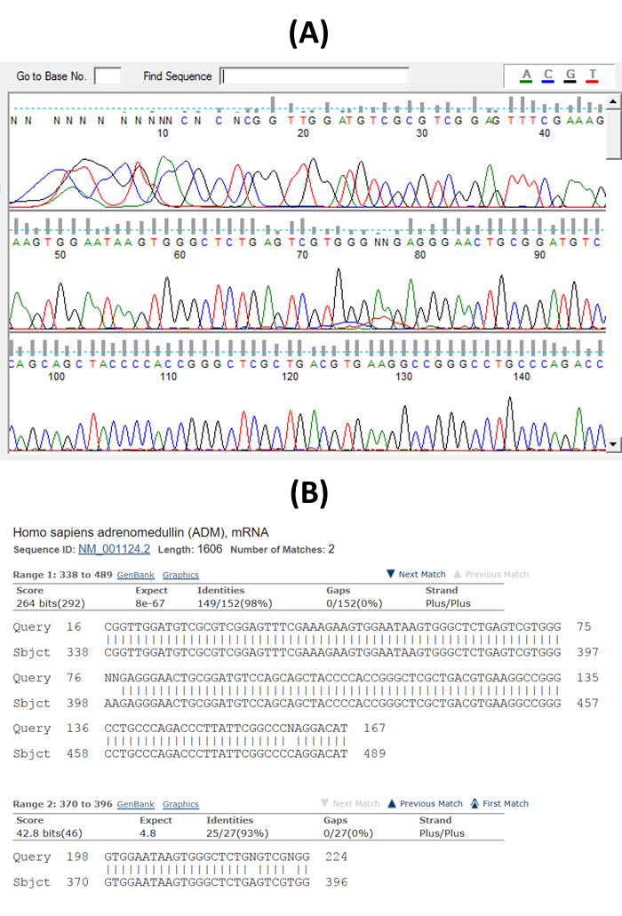
Figure 7.1: (A) ADM sequencing data visualised on FinchTV software (B) NCBI BLAST alignment results of ADM sequencing data

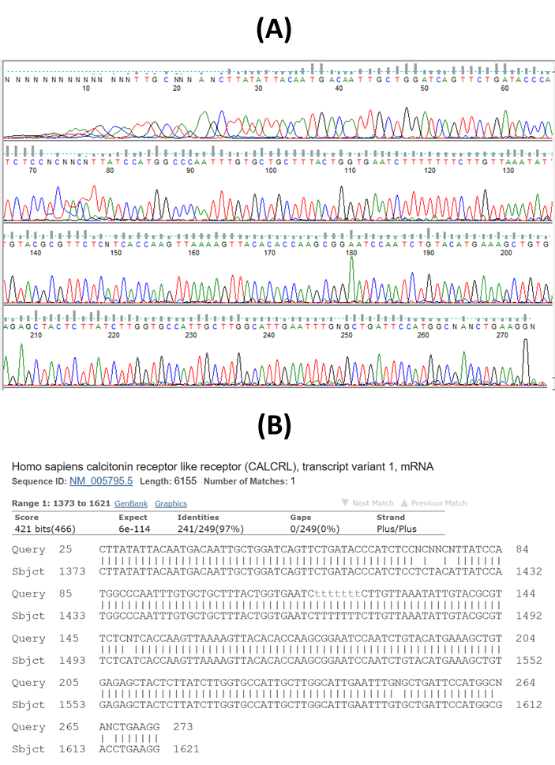
Figure 7.2: (A) CLR sequencing data visualised on FinchTV software (B) NCBI BLAST alignment results of CLR sequencing data

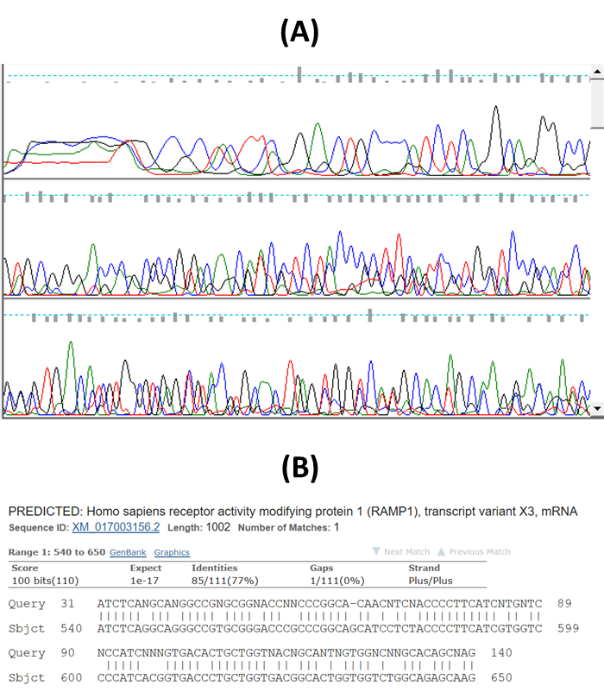
Figure 7.3: (A) RAMP-1 sequencing data visualised on FinchTV software (B) NCBI BLAST alignment results of RAMP-1 sequencing data

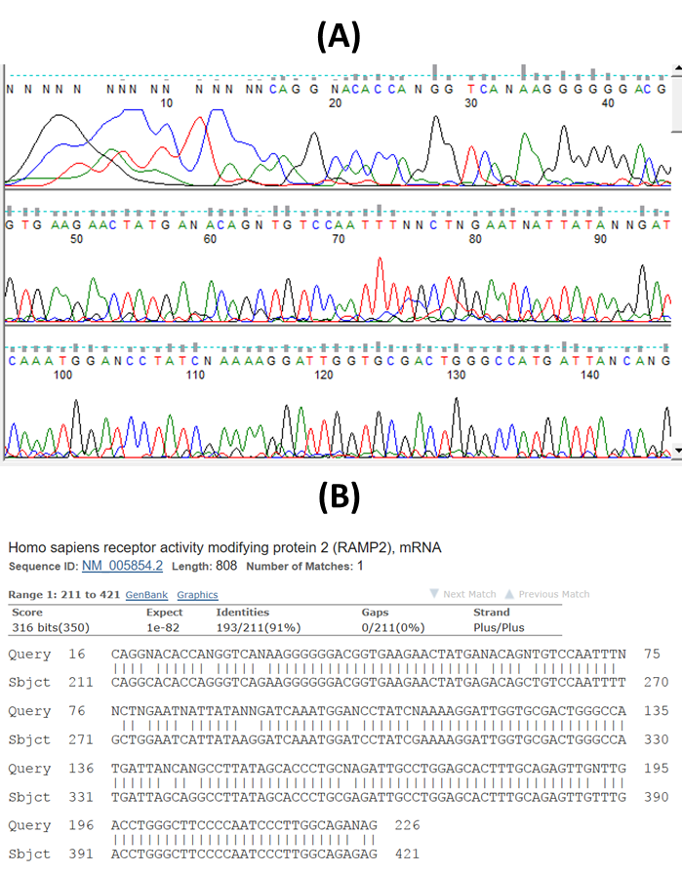
Figure 7.4: (A) RAMP-2 sequencing data visualised on FinchTV software (B) NCBI BLAST alignment results of RAMP-2 sequencing data

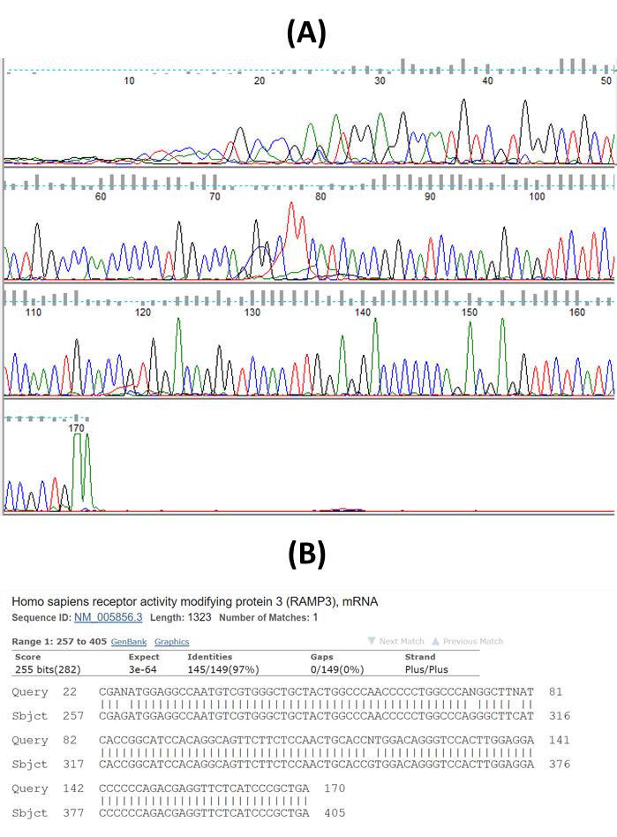
Figure 7.5: (A) RAMP-3 sequencing data visualised on FinchTV software (B) NCBI BLAST alignment results of RAMP-3 sequencing data

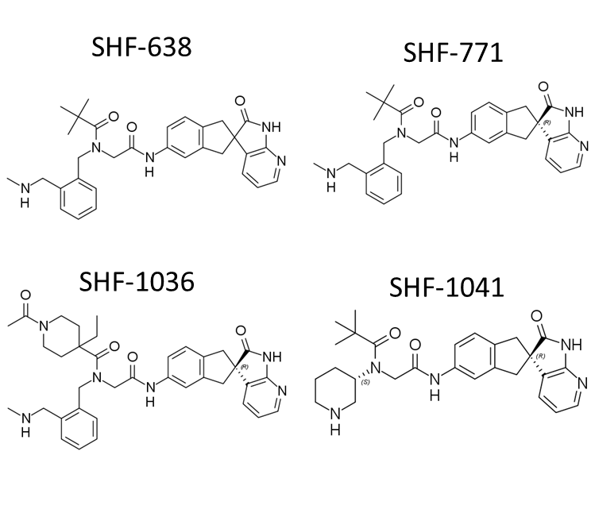
Figure 7.6: Chemical structures of lead compounds (SHF-638, SHF-771, SHF-1036 and SHF-1041) used in Chapters 4 and 5

Table 7.2: List of AM2R antagonists used in single-point viability assay, AM2R pIC50 from cAMP assays and their percentage reduction in PaCa viability
Compound ID | Batch | AM2R pIC50 | % reduction in viability
SHF-0000638 | AA-004 | 8.88 | 14.83
SHF-0000638 | AA-004 | 8.88 | 15.61
SHF-0000638 | AA-004 | 8.88 | 12.33
SHF-0000705 | AA-001 | 9.02 | 11.19
SHF-0000707 | AA-001 | 8.76 | 23.04
SHF-0000771 | AA-001 | 8.88 | 13.71
SHF-0000771 | AA-002 | 8.88 | 13.87
SHF-0000771 | AA-003 | 8.88 | 13.72
SHF-0000771 | AQ-001 | 8.88 | 13.11
SHF-0000771 | CN-001 | 8.88 | 14.36
SHF-0000771 | CN-002 | 8.88 | 13.65
SHF-0000771 | CN-003 | 8.88 | 15.28
SHF-0000771 | CN-004 | 8.88 | 19.92
SHF-0000911 | AA-001 | 8.87 | 17.46
SHF-0000988 | CN-001 | 8.59 | 14.42
SHF-0000989 | CN-001 | 8.47 | 20.94
SHF-0001003 | CN-001 | 9.24 | 4.783
SHF-0001007 | CN-001 | 8.87 | 20.8
SHF-0001013 | CN-001 | 8.83 | 23.31
SHF-0001014 | CN-001 | 8.82 | 23.53
SHF-0001015 | CN-001 | 9.2 | 8.787
SHF-0001016 | CN-001 | 8.63 | 23.8
SHF-0001017 | CN-001 | 9.23 | 11.81
SHF-0001019 | CN-001 | 8.74 | 21.47
SHF-0001022 | CN-001 | 8.94 | -4.793
SHF-0001024 | CN-001 | 8.83 | -1.311
SHF-0001025 | CN-001 | 8.64 | -0.04136
SHF-0001026 | CN-001 | 8.66 | 6.316
SHF-0001028 | CN-001 | 9.12 | 14.08
SHF-0001029 | CN-001 | 8.7 | 3.76
SHF-0001031 | CN-001 | 8.63 | 1.595
SHF-0001034 | CN-001 | 9.03 | 11.8
SHF-0001036 | CN-001 | 8.85 | 12.4
SHF-0001037 | CN-001 | 9.05 | 15.39
SHF-0001038 | CN-001 | 8.96 | 9.03
SHF-0001039 | CN-001 | 8.86 | 13.78
SHF-0001042 | CN-001 | 8.84 | 16.66
SHF-0001049 | CN-001 | 8.63 | 12.19
SHF-0001052 | CN-001 | 8.53 | 10.18
SHF-0001053 | CN-001 | 8.67 | 10.28
SHF-0001054 | CN-001 | 8.08 | 8.588
SHF-0001055 | CN-001 | 8.49 | 11.58
SHF-0001056 | CN-001 | 8.13 | 5.742
SHF-0001058 | CN-001 | 8.2 | 37.08
SHF-0001059 | CN-001 | 8.25 | 11.71
SHF-0001060 | CN-001 | 8.34 | 20
SHF-0001061 | CN-001 | 8.35 | 16.99
SHF-0001065 | CN-001 | 8.42 | 14.27
SHF-0001068 | CN-001 | 8.3 | 14.02
SHF-0001070 | CN-001 | 8.04 | 11.53
SHF-0001073 | CN-001 | 7.59 | 20.28
SHF-0001074 | CN-001 | 8.19 | 13.62
SHF-0001075 | CN-001 | 7.82 | 6.263
SHF-0001076 | CN-001 | 8.22 | 10.14

SHF-638 was used as a control in each of the three viability assay runs (18 compounds per run) and results from each run were listed separately.

AA: free base
AQ: hydrochloride salt
CN: trifluoroacetate salt

Bibliography
ABASOLO, I., MONTUENGA, L. M. & CALVO, A. 2006. Adrenomedullin prevents apoptosis in prostate cancer cells. Regul Pept, 133, 115-22.
ABASOLO, I., WANG, Z., MONTUENGA, L. M. & CALVO, A. 2004. Adrenomedullin inhibits prostate cancer cell proliferation through a cAMP-independent autocrine mechanism. Biochem Biophys Res Commun, 322, 878-86.
ABASOLO, I., YANG, L., HALEEM, R., XIAO, W., PIO, R., CUTTITTA, F., MONTUENGA, L. M., KOZLOWSKI, J. M., CALVO, A. & WANG, Z. 2003. Overexpression of adrenomedullin gene markedly inhibits proliferation of PC3 prostate cancer cells in vitro and in vivo. Mol Cell Endocrinol, 199, 179-87.
AGGARWAL, G., RAMACHANDRAN, V., JAVEED, N., ARUMUGAM, T., DUTTA, S., KLEE, G. G., KLEE, E. W., SMYRK, T. C., BAMLET, W., HAN, J. J., RUMIE VITTAR, N. B., DE ANDRADE, M., MUKHOPADHYAY, D., PETERSEN, G. M., FERNANDEZ-ZAPICO, M. E., LOGSDON, C. D. & CHARI, S. T. 2012. Adrenomedullin is up-regulated in patients with pancreatic cancer and causes insulin resistance in β cells and mice. Gastroenterology, 143, 1510-1517.e1.
AKADA, M., CRNOGORAC-JURCEVIC, T., LATTIMORE, S., MAHON, P., LOPES, R., SUNAMURA, M., MATSUNO, S. & LEMOINE, N. R. 2005. Intrinsic chemoresistance to gemcitabine is associated with decreased expression of BNIP3 in pancreatic cancer. Clin Cancer Res, 11, 3094-101.
ALGUL, H., TREIBER, M., LESINA, M. & SCHMID, R. M. 2007. Mechanisms of disease: chronic inflammation and cancer in the pancreas--a potential role for pancreatic stellate cells? Nat Clin Pract Gastroenterol Hepatol, 4, 454-62.
ALLAKER, R. P. & KAPAS, S. 2003. Adrenomedullin expression by gastric epithelial cells in response to infection. Clin Diagn Lab Immunol, 10, 546-51.
ALLAKER, R. P., ZIHNI, C. & KAPAS, S. 1999. An investigation into the antimicrobial effects of adrenomedullin on members of the skin, oral, respiratory tract and gut microflora. FEMS Immunol Med Microbiol, 23, 289-93.
ANTOLINO, L., ROCCA, M., TODDE, F., CATARINOZZI, E., AURELLO, P., BOLLANTI, L., RAMACCIATO, G. & D'ANGELO, F. 2018. Can pancreatic cancer be detected by adrenomedullin in patients with new-onset diabetes? The PaCANOD cohort study protocol. Tumori, 104, 312-314.
ARUMUGAM, T., RAMACHANDRAN, V., FOURNIER, K. F., WANG, H., MARQUIS, L., ABBRUZZESE, J. L., GALLICK, G. E., LOGSDON, C. D., MCCONKEY, D. J. & CHOI, W. 2009. Epithelial to mesenchymal transition contributes to drug resistance in pancreatic cancer. Cancer Res, 69, 5820-8.
AVGOUSTOU, P. 2018. Developing small molecule antagonists against AM2 receptor for the treatment of pancreatic cancer. PhD, University of Sheffield.
BACHEM, M. G., SCHUNEMANN, M., RAMADANI, M., SIECH, M., BEGER, H., BUCK, A., ZHOU, S., SCHMID-KOTSAS, A. & ADLER, G. 2005. Pancreatic carcinoma cells induce fibrosis by stimulating proliferation and matrix synthesis of stellate cells. Gastroenterology, 128, 907-21.
BAILEY, J. M., ALSINA, J., RASHEED, Z. A., MCALLISTER, F. M., FU, Y. Y., PLENTZ, R., ZHANG, H., PASRICHA, P. J., BARDEESY, N., MATSUI, W., MAITRA, A. & LEACH, S. D. 2014. DCLK1 marks a morphologically distinct subpopulation of cells with stem cell properties in preinvasive pancreatic cancer. Gastroenterology, 146, 245-56.
BALLEHANINNA, U. K. & CHAMBERLAIN, R. S. 2012. The clinical utility of serum CA 19-9 in the diagnosis, prognosis and management of pancreatic adenocarcinoma: An evidence based appraisal. J Gastrointest Oncol.
BARANELLO, C., MARIANI, M., ANDREOLI, M., FANELLI, M., MARTINELLI, E., FERRANDINA, G., SCAMBIA, G., SHAHABI, S. & FERLINI, C. 2012. Adrenomedullin in ovarian cancer: foe in vitro and friend in vivo? PLoS One, 7, e40678.
BAYNE, L. J., BEATTY, G. L., JHALA, N., CLARK, C. E., RHIM, A. D., STANGER, B. Z. & VONDERHEIDE, R. H. 2012. Tumor-derived granulocyte-macrophage colony stimulating factor regulates myeloid inflammation and T cell immunity in pancreatic cancer. Cancer Cell, 21, 822-35.
BELTOWSKI, J. & JAMROZ, A. 2004. Adrenomedullin--what do we know 10 years since its discovery? Pol J Pharmacol, 56, 5-27.
BEN, Q., XU, M., NING, X., LIU, J., HONG, S., HUANG, W., ZHANG, H. & LI, Z. 2011. Diabetes mellitus and risk of pancreatic cancer: A meta-analysis of cohort studies. Eur J Cancer, 47, 1928-37.
BENYAHIA, Z., DUSSAULT, N., CAYOL, M., SIGAUD, R., BERENGUER-DAIZE, C., DELFINO, C., TOUNSI, A., GARCIA, S., MARTIN, P. M., MABROUK, K. & OUAFIK, L. 2017. Stromal fibroblasts present in breast carcinomas promote tumor growth and angiogenesis through adrenomedullin secretion. Oncotarget, 8, 15744-15762.
BERENGUER, C., BOUDOURESQUE, F., DUSSERT, C., DANIEL, L., MURACCIOLE, X., GRINO, M., ROSSI, D., MABROUK, K., FIGARELLA-BRANGER, D., MARTIN, P. M. & OUAFIK, L. 2008. Adrenomedullin, an autocrine/paracrine factor induced by androgen withdrawal, stimulates 'neuroendocrine phenotype' in LNCaP prostate tumor cells. Oncogene, 27, 506-18.
BERENGUER-DAIZÉ, C., BOUDOURESQUE, F., BASTIDE, C., TOUNSI, A., BENYAHIA, Z., ACUNZO, J., DUSSAULT, N., DELFINO, C., BAEZA, N., DANIEL, L., CAYOL, M., ROSSI, D., EL BATTARI, A., BERTIN, D., MABROUK, K., MARTIN, P. M. & OUAFIK, L. 2013. Adrenomedullin blockade suppresses growth of human hormone-independent prostate tumor xenograft in mice. Clin Cancer Res, 19, 6138-50.
BHARDWAJ, A., SRIVASTAVA, S. K., SINGH, S., TYAGI, N., ARORA, S., CARTER, J. E., KHUSHMAN, M. & SINGH, A. P. 2016. MYB Promotes Desmoplasia in Pancreatic Cancer through Direct Transcriptional Up-regulation and Cooperative Action of Sonic Hedgehog and Adrenomedullin. J Biol Chem, 291, 16263-70.
BIGAL, M. E., WALTER, S. & RAPOPORT, A. M. 2015. Therapeutic antibodies against CGRP or its receptor. Br J Clin Pharmacol, 79, 886-95.
BILIMORIA, K. Y., BENTREM, D. J., KO, C. Y., STEWART, A. K., WINCHESTER, D. P. & TALAMONTI, M. S. 2007. National Failure to Operate on Early Stage Pancreatic Cancer. Ann Surg, 246, 173-80.
BOOE, J. M., WALKER, C. S., BARWELL, J., KUTEYI, G., SIMMS, J., JAMALUDDIN, M. A., WARNER, M. L., BILL, R. M., HARRIS, P. W., BRIMBLE, M. A., POYNER, D. R., HAY, D. L. & PIOSZAK, A. A. 2015. Structural Basis for Receptor Activity-Modifying Protein-Dependent Selective Peptide Recognition by a G Protein-Coupled Receptor. Mol Cell, 58, 1040-52.
BOOE, J. M., WARNER, M. L., ROEHRKASSE, A. M., HAY, D. L. & PIOSZAK, A. A. 2018. Probing the Mechanism of Receptor Activity-Modifying Protein Modulation of GPCR Ligand Selectivity through Rational Design of Potent Adrenomedullin and Calcitonin Gene-Related Peptide Antagonists. Mol Pharmacol, 93, 355-367.
BOSCO, M. C., PUPPO, M., SANTANGELO, C., ANFOSSO, L., PFEFFER, U., FARDIN, P., BATTAGLIA, F. & VARESIO, L. 2006. Hypoxia modifies the transcriptome of primary human monocytes: modulation of novel immune-related genes and identification of CC-chemokine ligand 20 as a new hypoxia-inducible gene. J Immunol, 177, 1941-55.
BOUSCHET, T., MARTIN, S. & HENLEY, J. M. 2005. Receptor-activity-modifying proteins are required for forward trafficking of the calcium-sensing receptor to the plasma membrane. J Cell Sci, 118, 4709-20.
BREKHMAN, V., LUGASSIE, J., ZAFFRYAR-EILOT, S., SABO, E., KESSLER, O., SMITH, V., GOLDING, H. & NEUFELD, G. 2011. Receptor activity modifying protein-3 mediates the protumorigenic activity of lysyl oxidase-like protein-2. FASEB J, 25, 55-65.
BURRIS, H. A., 3RD, MOORE, M. J., ANDERSEN, J., GREEN, M. R., ROTHENBERG, M. L., MODIANO, M. R., CRIPPS, M. C., PORTENOY, R. K., STORNIOLO, A. M., TARASSOFF, P., NELSON, R., DORR, F. A., STEPHENS, C. D. & VON HOFF, D. D. 1997. Improvements in survival and clinical benefit with gemcitabine as first-line therapy for patients with advanced pancreas cancer: a randomized trial. J Clin Oncol, 15, 2403-13.
CANCER RESEARCH UK. 2014. Breast cancer survival statistics [Online]. Available: https://www.cancerresearchuk.org/health-professional/cancer-statistics/statistics-by-cancer-type/breast-cancer/survival [Accessed 2018-09-18].
CANCER RESEARCH UK. 2015a. Pancreatic cancer [Online]. Available: http://www.cancerresearchuk.org/about-cancer/type/pancreatic-cancer/ [Accessed 2016-01-03].
CANCER RESEARCH UK. 2015b. Pancreatic cancer statistics [Online]. Available: http://www.cancerresearchuk.org/health-professional/cancer-statistics/statistics-by-cancer-type/pancreatic-cancer [Accessed 2016-01-03].
CARLSON, M. R., POPE, W. B., HORVATH, S., BRAUNSTEIN, J. G., NGHIEMPHU, P., TSO, C. L., MELLINGHOFF, I., LAI, A., LIAU, L. M., MISCHEL, P. S., DONG, J., NELSON, S. F. & CLOUGHESY, T. F. 2007. Relationship between survival and edema in malignant gliomas: role of vascular endothelial growth factor and neuronal pentraxin 2. Clin Cancer Res, 13, 2592-8.
CARON, K. M. & SMITHIES, O. 2001. Extreme hydrops fetalis and cardiovascular abnormalities in mice lacking a functional Adrenomedullin gene. Proc Natl Acad Sci U S A, 98, 615-9.
CARPELAN-HOLMSTROM, M., LOUHIMO, J., STENMAN, U. H., ALFTHAN, H. & HAGLUND, C. 2002. CEA, CA 19-9 and CA 72-4 improve the diagnostic accuracy in gastrointestinal cancers. Anticancer Res, 22, 2311-6.
CHAUHAN, M., YALLAMPALLI, U., BANADAKAPPA, M. & YALLAMPALLI, C. 2015. Involvement of Receptor Activity-Modifying Protein 3 (RAMP3) in the Vascular Actions of Adrenomedullin in Rat Mesenteric Artery Smooth Muscle Cells. Biol Reprod, 93, 116.
CHEN, P., HUANG, Y., BONG, R., DING, Y., SONG, N., WANG, X., SONG, X. & LUO, Y. 2011. Tumor-associated macrophages promote angiogenesis and melanoma growth via adrenomedullin in a paracrine and autocrine manner. Clin Cancer Res, 17, 7230-9.
CHEN, P., PANG, X., ZHANG, Y. & HE, Y. 2012. Effect of inhibition of the adrenomedullin gene on the growth and chemosensitivity of ovarian cancer cells. Oncol Rep, 27, 1461-6.
CHEN, Q., CHEN, P., PANG, X., HU, Y. & ZHANG, Y. 2015. Adrenomedullin Up-regulates the Expression of Vascular Endothelial Growth Factor in Epithelial Ovarian Carcinoma Cells via JNK/AP-1 Pathway. Int J Gynecol Cancer, 25, 953-60.
CHEN, W. H., HOROSZEWICZ, J. S., LEONG, S. S., SHIMANO, T., PENETRANTE, R., SANDERS, W. H., BERJIAN, R., DOUGLASS, H. O., MARTIN, E. W. & CHU, T. M. 1982. Human pancreatic adenocarcinoma: in vitro and in vivo morphology of a new tumor line established from ascites. In Vitro, 18, 24-34.
CHEUNG, P. K., BALLER, J. F. & BAKKER, W. W. 1998. Oxygen-dependent injury by a human plasma factor associated with minimal change disease. Pediatr Nephrol, 12, 452-8.
CONROY, T., DESSEIGNE, F., YCHOU, M., BOUCHE, O., GUIMBAUD, R., BECOUARN, Y., ADENIS, A., RAOUL, J. L., GOURGOU-BOURGADE, S., DE LA FOUCHARDIERE, C., BENNOUNA, J., BACHET, J. B., KHEMISSA-AKOUZ, F., PERE-VERGE, D., DELBALDO, C., ASSENAT, E., CHAUFFERT, B., MICHEL, P., MONTOTO-GRILLOT, C. & DUCREUX, M. 2011. FOLFIRINOX versus gemcitabine for metastatic pancreatic cancer. N Engl J Med, 364, 1817-25.
CORZO, C. A., CONDAMINE, T., LU, L., COTTER, M. J., YOUN, J. I., CHENG, P., CHO, H. I., CELIS, E., QUICENO, D. G., PADHYA, T., MCCAFFREY, T. V., MCCAFFREY, J. C. & GABRILOVICH, D. I. 2010. HIF-1alpha regulates function and differentiation of myeloid-derived suppressor cells in the tumor microenvironment. J Exp Med, 207, 2439-53.
COWLEY, G. S., WEIR, B. A., VAZQUEZ, F., TAMAYO, P., SCOTT, J. A., RUSIN, S., EAST-SELETSKY, A., ALI, L. D., GERATH, W. F., PANTEL, S. E., LIZOTTE, P. H., JIANG, G., HSIAO, J., TSHERNIAK, A., DWINELL, E., AOYAMA, S., OKAMOTO, M., HARRINGTON, W., GELFAND, E., GREEN, T. M., TOMKO, M. J., GOPAL, S., WONG, T. C., LI, H., HOWELL, S., STRANSKY, N., LIEFELD, T., JANG, D., BISTLINE, J., HILL MEYERS, B., ARMSTRONG, S. A., ANDERSON, K. C., STEGMAIER, K., REICH, M., PELLMAN, D., BOEHM, J. S., MESIROV, J. P., GOLUB, T. R., ROOT, D. E. & HAHN, W. C. 2014. Parallel genome-scale loss of function screens in 216 cancer cell lines for the identification of context-specific genetic dependencies. Sci Data, 1, 140035.
CUNNINGHAM, D., CHAU, I., STOCKEN, D. D., VALLE, J. W., SMITH, D., STEWARD, W., HARPER, P. G., DUNN, J., TUDUR-SMITH, C., WEST, J., FALK, S., CRELLIN, A., ADAB, F., THOMPSON, J., LEONARD, P., OSTROWSKI, J., EATOCK, M., SCHEITHAUER, W., HERRMANN, R. & NEOPTOLEMOS, J. P. 2009. Phase III randomized comparison of gemcitabine versus gemcitabine plus capecitabine in patients with advanced pancreatic cancer. J Clin Oncol, 27, 5513-8.
DACKOR, R., FRITZ-SIX, K., SMITHIES, O. & CARON, K. 2007. Receptor activity-modifying proteins 2 and 3 have distinct physiological functions from embryogenesis to old age. J Biol Chem, 282, 18094-9.
DACKOR, R. T., FRITZ-SIX, K., DUNWORTH, W. P., GIBBONS, C. L., SMITHIES, O. & CARON, K. M. 2006. Hydrops fetalis, cardiovascular defects, and embryonic lethality in mice lacking the calcitonin receptor-like receptor gene. Mol Cell Biol, 26, 2511-8.
DAI, X., MA, W., HE, X. J. & JHA, R. K. 2013. Elevated expression of adrenomedullin is correlated with prognosis and disease severity in osteosarcoma. Med Oncol, 30, 347.
DEER, E. L., GONZALEZ-HERNANDEZ, J., COURSEN, J. D., SHEA, J. E., NGATIA, J., SCAIFE, C. L., FIRPO, M. A. & MULVIHILL, S. J. 2010. Phenotype and Genotype of Pancreatic Cancer Cell Lines. Pancreas, 39, 425-35.
DEHNE, N., HINTEREDER, G. & BRÜNE, B. 2010. High glucose concentrations attenuate hypoxia-inducible factor-1alpha expression and signaling in non-tumor cells. Exp Cell Res, 316, 1179-89.
DELANEY, G., JACOB, S., FEATHERSTONE, C. & BARTON, M. 2005. The role of radiotherapy in cancer treatment: estimating optimal utilization from a review of evidence-based clinical guidelines. Cancer, 104, 1129-37.
DELITTO, D., ZHANG, D., HAN, S., BLACK, B. S., KNOWLTON, A. E., VLADA, A. C., SAROSI, G. A., BEHRNS, K. E., THOMAS, R. M., LU, X., LIU, C., GEORGE, T., HUGHES, S. J., WALLET, S. & TREVINO, J. G. 2015. Nicotine Reduces Survival via Augmentation of Paracrine HGF-MET Signaling in the Pancreatic Cancer Microenvironment. Clin Cancer Res.
DENG, B., ZHANG, S., MIAO, Y., HAN, Z., ZHANG, X., WEN, F. & ZHANG, Y. 2012. Adrenomedullin expression in epithelial ovarian cancers and promotes HO8910 cell migration associated with upregulating integrin α5β1 and phosphorylating FAK and paxillin. J Exp Clin Cancer Res, 31, 19.
DENNING, D. A., ELLISON, E. C. & CAREY, L. C. 1981. Preoperative percutaneous transhepatic biliary decompression lowers operative morbidity in patients with obstructive jaundice. Am J Surg, 141, 61-5.
DERST, C., ENGEL, H., GRZESCHIK, K. & DAUT, J. 2000. Genomic structure and chromosome mapping of human and mouse RAMP genes. Cytogenet Cell Genet, 90, 115-8.
DESAI, N., TRIEU, V., DAMASCELLI, B. & SOON-SHIONG, P. 2009. SPARC Expression Correlates with Tumor Response to Albumin-Bound Paclitaxel in Head and Neck Cancer Patients. Transl Oncol, 2, 59-64.
DEVILLE, J. L., BARTOLI, C., BERENGUER, C., FERNANDEZ-SAUZE, S., KAAFARANI, I., DELFINO, C., FINA, F., SALAS, S., MURACCIOLE, X., MANCINI, J., LECHEVALLIER, E., MARTIN, P. M., FIGARELLA-BRANGER, D., OUAFIK, L. & DANIEL, L. 2009. Expression and role of adrenomedullin in renal tumors and value of its mRNA levels as prognostic factor in clear-cell renal carcinoma. Int J Cancer, 125, 2307-15.
DIOP-FRIMPONG, B., CHAUHAN, V. P., KRANE, S., BOUCHER, Y. & JAIN, R. K. 2011. Losartan inhibits collagen I synthesis and improves the distribution and efficacy of nanotherapeutics in tumors. Proc Natl Acad Sci U S A.
DODICK, D. W., GOADSBY, P. J., SILBERSTEIN, S. D., LIPTON, R. B., OLESEN, J., ASHINA, M., WILKS, K., KUDROW, D., KROLL, R., KOHRMAN, B., BARGAR, R., HIRMAN, J. & SMITH, J. 2014a. Safety and efficacy of ALD403, an antibody to calcitonin gene-related peptide, for the prevention of frequent episodic migraine: a randomised, double-blind, placebo-controlled, exploratory phase 2 trial. Lancet Neurol, 13, 1100-1107.
DODICK, D. W., GOADSBY, P. J., SPIERINGS, E. L., SCHERER, J. C., SWEENEY, S. P. & GRAYZEL, D. S. 2014b. Safety and efficacy of LY2951742, a monoclonal antibody to calcitonin gene-related peptide, for the prevention of migraine: a phase 2, randomised, double-blind, placebo-controlled study. Lancet Neurol, 13, 885-92.
DRIMAL, D. & DRIMAL, J. 2006. The regulation of human adrenomedullin (AM) and tumor necrosis factor alpha (TNF-alpha) receptors on human epithelial carcinoma (HeLa) cells. The role of AM secretion in tumor cell sensitivity. Neoplasma, 53, 144-9.
DUELLMAN, S. J., ZHOU, W., MEISENHEIMER, P., VIDUGIRIS, G., CALI, J. J., GAUTAM, P., WENNERBERG, K. & VIDUGIRIENE, J. 2015. Bioluminescent, Nonlytic, Real-Time Cell Viability Assay and Use in Inhibitor Screening. Assay Drug Dev Technol.
DUPUIS, J., CARON, A. & RUEL, N. 2005. Biodistribution, plasma kinetics and quantification of single-pass pulmonary clearance of adrenomedullin. Clin Sci (Lond), 109, 97-102.
EDVINSSON, L. & WARFVINGE, K. 2017. Recognizing the role of CGRP and CGRP receptors in migraine and its treatment. Cephalalgia, 333102417736900.
EVANS, J. J., CHITCHOLTAN, K., DANN, J. M., GUILFORD, P., HARRIS, G., LEWIS, L. K., NAGASE, J., WELKAMP, A. A., ZWERUS, R. & SYKES, P. H. 2012. Adrenomedullin interacts with VEGF in endometrial cancer and has varied modulation in tumours of different grades. Gynecol Oncol, 125, 214-9.
FAIVRE, S., CHAN, D., SALINAS, R., WOYNAROWSKA, B. & WOYNAROWSKI, J. M. 2003. DNA strand breaks and apoptosis induced by oxaliplatin in cancer cells. Biochem Pharmacol, 66, 225-37.
FANG, C., MIGUEL, M. A., AVIS, I., MARTINEZ, A., ZUDAIRE, E. & CUTTITTA, F. 2009. Non-peptide small molecule regulators of lymphangiogenesis. Lymphat Res Biol, 7, 189-96.
FENG, H., OU, B. C., ZHAO, J. K., YIN, S., LU, A. G., OECHSLE, E. & THASLER, W. E. 2017. Homogeneous pancreatic cancer spheroids mimic growth pattern of circulating tumor cell clusters and macrometastases: displaying heterogeneity and crater-like structure on inner layer. J Cancer Res Clin Oncol, 143, 1771-1786.
FERNANDEZ-SAUZE, S., DELFINO, C., MABROUK, K., DUSSERT, C., CHINOT, O., MARTIN, P. M., GRISOLI, F., OUAFIK, L. & BOUDOURESQUE, F. 2004. Effects of adrenomedullin on endothelial cells in the multistep process of angiogenesis: involvement of CRLR/RAMP2 and CRLR/RAMP3 receptors. Int J Cancer, 108, 797-804.
FLAHAUT, M., ROSSIER, B. C. & FIRSOV, D. 2002. Respective roles of calcitonin receptor-like receptor (CRLR) and receptor activity-modifying proteins (RAMP) in cell surface expression of CRLR/RAMP heterodimeric receptors. J Biol Chem, 277, 14731-7.
FREDE, S., FREITAG, P., OTTO, T., HEILMAIER, C. & FANDREY, J. 2005. The proinflammatory cytokine interleukin 1beta and hypoxia cooperatively induce the expression of adrenomedullin in ovarian carcinoma cells through hypoxia inducible factor 1 activation. Cancer Res, 65, 4690-7.
FRITZ-SIX, K. L., DUNWORTH, W. P., LI, M. & CARON, K. M. 2008. Adrenomedullin signaling is necessary for murine lymphatic vascular development. J Clin Invest, 118, 40-50.
FUJIWARA, K., OHUCHIDA, K., SADA, M., HORIOKA, K., ULRICH, C. D., 3RD, SHINDO, K., OHTSUKA, T., TAKAHATA, S., MIZUMOTO, K., ODA, Y. & TANAKA, M. 2014. CD166/ALCAM expression is characteristic of tumorigenicity and invasive and migratory activities of pancreatic cancer cells. PLoS One, 9, e107247.
FYSSAS, I., SYRIGOS, K. N., KONSTANDOULAKIS, M. M., PAPADOPOULOS, S., MILINGOS, N., ANAPLIOTOU, M., WAXMAN, J. & GOLEMATIS, B. C. 1997. Sex hormone levels in the serum of patients with pancreatic adenocarcinoma. Horm Metab Res, 29, 115-8.
GARAYOA, M., MARTÍNEZ, A., LEE, S., PÍO, R., AN, W. G., NECKERS, L., TREPEL, J., MONTUENGA, L. M., RYAN, H., JOHNSON, R., GASSMANN, M. & CUTTITTA, F. 2000. Hypoxia-inducible factor-1 (HIF-1) up-regulates adrenomedullin expression in human tumor cell lines during oxygen deprivation: a possible promotion mechanism of carcinogenesis. Mol Endocrinol, 14, 848-62.
GEVEN, C., VAN LIER, D., BLET, A., PEELEN, R., TEN ELZEN, B., MEBAZAA, A., KOX, M. & PICKKERS, P. 2018. Safety, tolerability and pharmacokinetics/pharmacodynamics of the adrenomedullin antibody adrecizumab in a first-in-human study and during experimental human endotoxaemia in healthy subjects. Br J Clin Pharmacol, 84, 2129-2141.
GILLE, J., OSTERMANN, H., DRAGU, A. & SABLOTZKI, A. 2017. MR-proADM: A New Biomarker for Early Diagnosis of Sepsis in Burned Patients. J Burn Care Res, 38, 290-298.
GIOVANNETTI, E., TACCA, M. D., MEY, V., FUNEL, N., NANNIZZI, S., RICCI, S., ORLANDINI, C., BOGGI, U., CAMPANI, D., CHIARO, M. D., IANNOPOLLO, M., BEVILACQUA, G., MOSCA, F. & DANESI, R. 2006. Transcription Analysis of Human Equilibrative Nucleoside Transporter-1 Predicts Survival in Pancreas Cancer Patients Treated with Gemcitabine.
GNANAMONY, M. & GONDI, C. S. 2017. Chemoresistance in pancreatic cancer: Emerging concepts. Oncol Lett.
GOONETILLEKE, K. S. & SIRIWARDENA, A. K. 2007. Systematic review of carbohydrate antigen (CA 19-9) as a biochemical marker in the diagnosis of pancreatic cancer. Eur J Surg Oncol, 33, 266-70.
GULLO, L., PEZZILLI, R. & MORSELLI-LABATE, A. M. 1994. Diabetes and the risk of pancreatic cancer. N Engl J Med, 331, 81-4.
GUO, Y., XU, X., QI, W., XIE, C., WANG, G., ZHANG, A. & GE, Y. 2012. Synergistic antitumor interactions between gemcitabine and clofarabine in human pancreatic cancer cell lines. Mol Med Rep, 5, 734-8.
HAGNER, S., STAHL, U., GRIMM, T., STÜRZL, M. & LANG, R. E. 2006. Expression of calcitonin receptor-like receptor in human vascular tumours. J Clin Pathol, 59, 1104-7.
HAMANO, H., HAYAKAWA, T. & KONDO, T. 1987. Serum immunoreactive elastase in diagnosis of pancreatic diseases. A sensitive marker for pancreatic cancer. Dig Dis Sci, 32, 50-6.
HAMILTON, N. A., LIU, T. C., CAVATIAO, A., MAWAD, K., CHEN, L., STRASBERG, S. S., LINEHAN, D. C. & CAO, D. 2012. Ki-67 Predicts Disease Recurrence and Poor Prognosis in Pancreatic Neuroendocrine Tumors. Surgery, 152, 107-13.
HAMMEL, P., HUGUET, F., VAN LAETHEM, J. L., GOLDSTEIN, D., GLIMELIUS, B., ARTRU, P., BORBATH, I., BOUCHE, O., SHANNON, J., ANDRE, T., MINEUR, L., CHIBAUDEL, B., BONNETAIN, F. & LOUVET, C. 2016. Effect of Chemoradiotherapy vs Chemotherapy on Survival in Patients With Locally Advanced Pancreatic Cancer Controlled After 4 Months of Gemcitabine With or Without Erlotinib: The LAP07 Randomized Clinical Trial. Jama, 315, 1844-53.
HANAHAN, D., DH@EPFL.CH, THE SWISS INSTITUTE FOR EXPERIMENTAL CANCER RESEARCH (ISREC), S. O. L. S., EPFL, LAUSANNE CH-1015, SWITZERLAND, THE DEPARTMENT OF BIOCHEMISTRY & BIOPHYSICS, U., SAN FRANCISCO, CA 94158, USA, WEINBERG@WI.MIT.EDU & WHITEHEAD INSTITUTE FOR BIOMEDICAL RESEARCH, L. M. C. F. M. O., AND MIT DEPARTMENT OF BIOLOGY, CAMBRIDGE, MA 02142, USA 2011. Hallmarks of Cancer: The Next Generation. Cell, 144, 646-674.
HART, P. A., KAMADA, P., RABE, K. G., SRINIVASAN, S., BASU, A., AGGARWAL, G. & CHARI, S. T. 2011. Weight loss precedes cancer-specific symptoms in pancreatic cancer-associated diabetes mellitus. Pancreas, 40, 768-72.
HAY, D. L., POYNER, D. R. & SEXTON, P. M. 2006. GPCR modulation by RAMPs. Pharmacol Ther, 109, 173-97.
HAY, D. L., WALKER, C. S. & POYNER, D. R. 2011. Adrenomedullin and calcitonin gene-related peptide receptors in endocrine-related cancers: opportunities and challenges. Endocr Relat Cancer, 18, C1-14.
HERMANN, P. C., HUBER, S. L., HERRLER, T., AICHER, A., ELLWART, J. W., GUBA, M., BRUNS, C. J. & HEESCHEN, C. 2007. Distinct populations of cancer stem cells determine tumor growth and metastatic activity in human pancreatic cancer. Cell Stem Cell, 1, 313-23.
HEWITT, D. J., AURORA, S. K., DODICK, D. W., GOADSBY, P. J., GE, Y. J., BACHMAN, R., TARABORELLI, D., FAN, X., ASSAID, C., LINES, C. & HO, T. W. 2011. Randomized controlled trial of the CGRP receptor antagonist MK-3207 in the acute treatment of migraine. Cephalalgia, 31, 712-22.
HILAIRET, S., FOORD, S. M., MARSHALL, F. H. & BOUVIER, M. 2001. Protein-protein interaction and not glycosylation determines the binding selectivity of heterodimers between the calcitonin receptor-like receptor and the receptor activity-modifying proteins. J Biol Chem, 276, 29575-81.
HINSON, J. P., KAPAS, S. & SMITH, D. M. 2000. Adrenomedullin, a multifunctional regulatory peptide. Endocr Rev, 21, 138-67.
HO, T. W., CONNOR, K. M., ZHANG, Y., PEARLMAN, E., KOPPENHAVER, J., FAN, X., LINES, C., EDVINSSON, L., GOADSBY, P. J. & MICHELSON, D. 2014. Randomized controlled trial of the CGRP receptor antagonist telcagepant for migraine prevention. Neurology, 83, 958-66.
HO, T. W., HO, A. P., GE, Y. J., ASSAID, C., GOTTWALD, R., MACGREGOR, E. A., MANNIX, L. K., VAN OOSTERHOUT, W. P., KOPPENHAVER, J., LINES, C., FERRARI, M. D. & MICHELSON, D. 2016. Randomized controlled trial of the CGRP receptor antagonist telcagepant for prevention of headache in women with perimenstrual migraine. Cephalalgia, 36, 148-61.
HOFMANN, I., WEISS, A., ELAIN, G., SCHWAEDERLE, M., STERKER, D., ROMANET, V., SCHMELZLE, T., LAI, A., BRACHMANN, S. M., BENTIRES-ALJ, M., ROBERTS, T. M., SELLERS, W. R., HOFMANN, F. & MAIRA, S. M. 2012. K-RAS Mutant Pancreatic Tumors Show Higher Sensitivity to MEK than to PI3K Inhibition In Vivo. PLoS One.
HONEYWELL, R. J., RUIZ VAN HAPEREN, V. W., VEERMAN, G., SMID, K. & PETERS, G. J. 2015. Inhibition of thymidylate synthase by 2',2'-difluoro-2'-deoxycytidine (Gemcitabine) and its metabolite 2',2'-difluoro-2'-deoxyuridine. Int J Biochem Cell Biol, 60, 73-81.
HONG, S. P., WEN, J., BANG, S., PARK, S. & SONG, S. Y. 2009. CD44-positive cells are responsible for gemcitabine resistance in pancreatic cancer cells. Int J Cancer, 125, 2323-31.
HONG, Y., HAY, D. L., QUIRION, R. & POYNER, D. R. 2012. The pharmacology of adrenomedullin 2/intermedin. Br J Pharmacol, 166, 110-20.
HORWITZ, S. B. 1994. Taxol (paclitaxel): mechanisms of action. Ann Oncol, 5 Suppl 6, S3-6.
HOTZ, H. G., REBER, H. A., HOTZ, B., YU, T., FOITZIK, T., BUHR, H. J., CORTINA, G. & HINES, O. J. 2003. An orthotopic nude mouse model for evaluating pathophysiology and therapy of pancreatic cancer. Pancreas, 26, e89-98.
HOU, M., XING, H., CAI, Y., LI, B., WANG, X., LI, P., HU, X. & CHEN, J. 2017. The effect and safety of monoclonal antibodies to calcitonin gene-related peptide and its receptor on migraine: a systematic review and meta-analysis. J Headache Pain.
HWANG, R. F., MOORE, T., ARUMUGAM, T., RAMACHANDRAN, V., AMOS, K. D., RIVERA, A., JI, B., EVANS, D. B. & LOGSDON, C. D. 2008. Cancer-associated stromal fibroblasts promote pancreatic tumor progression. Cancer Res, 68, 918-26.
ICHIKAWA-SHINDO, Y., SAKURAI, T., KAMIYOSHI, A., KAWATE, H., IINUMA, N., YOSHIZAWA, T., KOYAMA, T., FUKUCHI, J., IIMURO, S., MORIYAMA, N., KAWAKAMI, H., MURATA, T., KANGAWA, K., NAGAI, R. & SHINDO, T. 2008. The GPCR modulator protein RAMP2 is essential for angiogenesis and vascular integrity. J Clin Invest, 118, 29-39.
IKEDA, U., KANBE, T., KAWAHARA, Y., YOKOYAMA, M. & SHIMADA, K. 1996. Adrenomedullin augments inducible nitric oxide synthase expression in cytokine-stimulated cardiac myocytes. Circulation, 94, 2560-5.
ISHIKAWA, T., CHEN, J., WANG, J., OKADA, F., SUGIYAMA, T., KOBAYASHI, T., SHINDO, M., HIGASHINO, F., KATOH, H., ASAKA, M., KONDO, T., HOSOKAWA, M. & KOBAYASHI, M. 2003. Adrenomedullin antagonist suppresses in vivo growth of human pancreatic cancer cells in SCID mice by suppressing angiogenesis. Oncogene, 22, 1238-42.
JACOB, S., AGUADO, M., FALLIK, D. & PRAZ, F. 2001. The role of the DNA mismatch repair system in the cytotoxicity of the topoisomerase inhibitors camptothecin and etoposide to human colorectal cancer cells. Cancer Res, 61, 6555-62.
JAVEED, N., SAGAR, G., DUTTA, S. K., SMYRK, T. C., LAU, J. S., BHATTACHARYA, S., TRUTY, M., PETERSEN, G. M., KAUFMAN, R. J., CHARI, S. T. & MUKHOPADHYAY, D. 2015. Pancreatic Cancer-Derived Exosomes Cause Paraneoplastic β-cell Dysfunction. Clin Cancer Res, 21, 1722-33.
JINKINS, L. J., PARMAR, A. D., HAN, Y., DUNCAN, C. B., SHEFFIELD, K. M., BROWN, K. M. & RIALL, T. S. 2013. Current trends in preoperative biliary stenting in patients with pancreatic cancer. Surgery, 154, 179-89.
JINUSHI, M., CHIBA, S., YOSHIYAMA, H., MASUTOMI, K., KINOSHITA, I., DOSAKA-AKITA, H., YAGITA, H., TAKAOKA, A. & TAHARA, H. 2011. Tumor-associated macrophages regulate tumorigenicity and anticancer drug responses of cancer stem/initiating cells. Proc Natl Acad Sci U S A, 108, 12425-30.
KAAFARANI, I., FERNANDEZ-SAUZE, S., BERENGUER, C., CHINOT, O., DELFINO, C., DUSSERT, C., METELLUS, P., BOUDOURESQUE, F., MABROUK, K., GRISOLI, F., FIGARELLA-BRANGER, D., MARTIN, P. M. & OUAFIK, L. 2009. Targeting adrenomedullin receptors with systemic delivery of neutralizing antibodies inhibits tumor angiogenesis and suppresses growth of human tumor xenografts in mice. FASEB J, 23, 3424-35.
KAMOI, H., KANAZAWA, H., HIRATA, K., KURIHARA, N., YANO, Y. & OTANI, S. 1995. Adrenomedullin inhibits the secretion of cytokine-induced neutrophil chemoattractant, a member of the interleukin-8 family, from rat alveolar macrophages. Biochem Biophys Res Commun, 211, 1031-5.
KARPINICH, N. O. & CARON, K. M. 2015. Gap junction coupling is required for tumor cell migration through lymphatic endothelium. Arterioscler Thromb Vasc Biol, 35, 1147-55.
KARPINICH, N. O., KECHELE, D. O., ESPENSCHIED, S. T., WILLCOCKSON, H. H., FEDORIW, Y. & CARON, K. M. 2013. Adrenomedullin gene dosage correlates with tumor and lymph node lymphangiogenesis. FASEB J, 27, 590-600.
KELEG, S., KAYED, H., JIANG, X., PENZEL, R., GIESE, T., BÜCHLER, M. W., FRIESS, H. & KLEEFF, J. 2007. Adrenomedullin is induced by hypoxia and enhances pancreatic cancer cell invasion. Int J Cancer, 121, 21-32.
KIM, J. Y., PARK, W. D., LEE, S. & PARK, J. H. 2012. Adrenomedullin is involved in the progression of colonic adenocarcinoma. Mol Med Rep, 6, 1030-4.
KIRISCI, M., OKTAR, G. L., OZOGUL, C., OYAR, E. O., AKYOL, S. N., DEMIRTAS, C. Y. & ARSLAN, M. 2013. Effects of adrenomedullin and vascular endothelial growth factor on ischemia/reperfusion injury in skeletal muscle in rats. J Surg Res, 185, 56-63.
KITAMURA, K., KANGAWA, K., KAWAMOTO, M., ICHIKI, Y., NAKAMURA, S., MATSUO, H. & ETO, T. 1993. Adrenomedullin: a novel hypotensive peptide isolated from human pheochromocytoma. Biochem Biophys Res Commun, 192, 553-60.
KOCEMBA, K. A., VAN ANDEL, H., DE HAAN-KRAMER, A., MAHTOUK, K., VERSTEEG, R., KERSTEN, M. J., SPAARGAREN, M. & PALS, S. T. 2013. The hypoxia target adrenomedullin is aberrantly expressed in multiple myeloma and promotes angiogenesis. Leukemia, 27, 1729-37.
KOHNO, M., HANEHIRA, T., KANO, H., HORIO, T., YOKOKAWA, K., IKEDA, M., MINAMI, M., YASUNARI, K. & YOSHIKAWA, J. 1996. Plasma adrenomedullin concentrations in essential hypertension. Hypertension, 27, 102-7.
KOMAR, G., KAUHANEN, S., LIUKKO, K., SEPPANEN, M., KAJANDER, S., OVASKA, J., NUUTILA, P. & MINN, H. 2009. Decreased blood flow with increased metabolic activity: a novel sign of pancreatic tumor aggressiveness. Clin Cancer Res, 15, 5511-7.
KRIEG, A. J., RANKIN, E. B., CHAN, D., RAZORENOVA, O., FERNANDEZ, S. & GIACCIA, A. J. 2010. Regulation of the histone demethylase JMJD1A by hypoxia-inducible factor 1 alpha enhances hypoxic gene expression and tumor growth. Mol Cell Biol, 30, 344-53.
KUBO, A., MINAMINO, N., ISUMI, Y., KANGAWA, K., DOHI, K. & MATSUO, H. 1998. Adrenomedullin production is correlated with differentiation in human leukemia cell lines and peripheral blood monocytes. FEBS Lett, 426, 233-7.
KUSANO, S., KUKIMOTO-NIINO, M., AKASAKA, R., TOYAMA, M., TERADA, T., SHIROUZU, M., SHINDO, T. & YOKOYAMA, S. 2008. Crystal structure of the human receptor activity-modifying protein 1 extracellular domain. Protein Sci, 17, 1907-14.
KUWASAKO, K., HAY, D. L., NAGATA, S., HIKOSAKA, T., KITAMURA, K. & KATO, J. 2012. The third extracellular loop of the human calcitonin receptor-like receptor is crucial for the activation of adrenomedullin signalling. Br J Pharmacol, 166, 137-50.
KYRIAZIS, A. A., KYRIAZIS, A. P., STERNBERG, C. N., SLOANE, N. H. & LOVELESS, J. D. 1986. Morphological, biological, biochemical, and karyotypic characteristics of human pancreatic ductal adenocarcinoma Capan-2 in tissue culture and the nude mouse. Cancer Res, 46, 5810-5.
KYRIAZIS, A. P., MCCOMBS, W. B., 3RD, SANDBERG, A. A., KYRIAZIS, A. A., SLOANE, N. H. & LEPERA, R. 1983. Establishment and characterization of human pancreatic adenocarcinoma cell line SW-1990 in tissue culture and the nude mouse. Cancer Res, 43, 4393-401.
LAINCHBURY, J. G., COOPER, G. J., COY, D. H., JIANG, N. Y., LEWIS, L. K., YANDLE, T. G., RICHARDS, A. M. & NICHOLLS, M. G. 1997. Adrenomedullin: a hypotensive hormone in man. Clin Sci (Lond), 92, 467-72.
LEE, J. H., KIM, S. K., KHAWAR, I. A., JEONG, S. Y., CHUNG, S. & KUH, H. J. 2018. Microfluidic co-culture of pancreatic tumor spheroids with stellate cells as a novel 3D model for investigation of stroma-mediated cell motility and drug resistance. J Exp Clin Cancer Res.
LETIZIA, C., DE TOMA, G., CALIUMI, C., CERCI, S., MASSA, R., LORIA, R. D., ALO, P., MARINONI, E. M., DIACINTI, D. & D'ERASMO, E. 2001. Plasma adrenomedullin concentrations in patients with adrenal pheochromocytoma. Horm Metab Res, 33, 290-4.
LI, C., HEIDT, D. G., DALERBA, P., BURANT, C. F., ZHANG, L., ADSAY, V., WICHA, M., CLARKE, M. F. & SIMEONE, D. M. 2007. Identification of pancreatic cancer stem cells. Cancer Res, 67, 1030-7.
LI, Z., TAKEUCHI, S., OHARA, N. & MARUO, T. 2003. Paradoxically abundant expression of Bcl-2 and adrenomedullin in invasive cervical squamous carcinoma. Int J Clin Oncol, 8, 83-9.
LI, Z., ZOU, X., ZHU, H., CHEN, M. & ZHAO, Y. 2018. Inhibitory effect of baicalein combined with gemcitabine in human pancreatic cancer cell lines. Oncol Lett.
LIEBMANN, C. 2004. G protein-coupled receptors and their signaling pathways: classical therapeutical targets susceptible to novel therapeutic concepts. Curr Pharm Des, 10, 1937-58.
LIM, S. Y., AHN, S. H., PARK, H., LEE, J., CHOI, K., CHOI, C., CHOI, J. H., PARK, E. M. & CHOI, Y. H. 2014. Transcriptional regulation of adrenomedullin by oncostatin M in human astroglioma cells: implications for tumor invasion and migration. Sci Rep, 4, 6444.
LINDAHL, T. 1974. An N-glycosidase from Escherichia coli that releases free uracil from DNA containing deaminated cytosine residues. Proc Natl Acad Sci U S A, 71, 3649-53.
LIU, A. G., ZHANG, X. Z., LI, F. B., ZHAO, Y. L., GUO, Y. C. & YANG, R. M. 2013. RNA interference targeting adrenomedullin induces apoptosis and reduces the growth of human bladder urothelial cell carcinoma. Med Oncol, 30, 616.
LIYANAGE, U. K., MOORE, T. T., JOO, H. G., TANAKA, Y., HERRMANN, V., DOHERTY, G., DREBIN, J. A., STRASBERG, S. M., EBERLEIN, T. J., GOEDEGEBUURE, P. S. & LINEHAN, D. C. 2002. Prevalence of regulatory T cells is increased in peripheral blood and tumor microenvironment of patients with pancreas or breast adenocarcinoma. J Immunol, 169, 2756-61.
LOC, W. S., SMITH, J. P., MATTERS, G., KESTER, M. & ADAIR, J. H. 2014. Novel strategies for managing pancreatic cancer. World J Gastroenterol, 20, 14717-25.
LOMBARDERO, M., KOVACS, K., HORVATH, E., SCHEITHAUER, B. W., ROTONDO, F., SALEHI, F. & LLOYD, R. V. 2008. Adrenomedullin expression in pituitary adenomas and nontumoral adenohypophyses. Histol Histopathol, 23, 11-7.
LOPEZ, J. & MARTINEZ, A. 2002. Cell and molecular biology of the multifunctional peptide, adrenomedullin. Int Rev Cytol, 221, 1-92.
LU, H., DALGARD, C. L., MOHYELDIN, A., MCFATE, T., TAIT, A. S. & VERMA, A. 2005. Reversible inactivation of HIF-1 prolyl hydroxylases allows cell metabolism to control basal HIF-1. J Biol Chem, 280, 41928-39.
LYNCH, H. T., DETERS, C. A., SNYDER, C. L., LYNCH, J. F., VILLENEUVE, P., SILBERSTEIN, J., MARTIN, H., NAROD, S. A. & BRAND, R. E. 2005. BRCA1 and pancreatic cancer: pedigree findings and their causal relationships. Cancer Genet Cytogenet, 158, 119-25.
MARKAR, S. R., BRODIE, B., CHIN, S. T., ROMANO, A., SPALDING, D. & HANNA, G. B. 2018. Profile of exhaled-breath volatile organic compounds to diagnose pancreatic cancer. Br J Surg, 105, 1493-1500.
MARTIN, L. K., LUU, D. C., LI, X., MUSCARELLA, P., ELLISON, E. C., BLOOMSTON, M. & BEKAII-SAAB, T. 2014. The Addition of Radiation to Chemotherapy does not Improve Outcome When Compared to Chemotherapy in the Treatment of Resected Pancreas Cancer: The Results of a Single-Institution Experience. Ann Surg Oncol, 21, 862-7.
MARTINEZ, A., MILLER, M. J., UNSWORTH, E. J., SIEGFRIED, J. M. & CUTTITTA, F. 1995. Expression of adrenomedullin in normal human lung and in pulmonary tumors. Endocrinology, 136, 4099-105.
MARTINEZ, A., WEAVER, C., LOPEZ, J., BHATHENA, S. J., ELSASSER, T. H., MILLER, M. J., MOODY, T. W., UNSWORTH, E. J. & CUTTITTA, F. 1996. Regulation of insulin secretion and blood glucose metabolism by adrenomedullin. Endocrinology, 137, 2626-32.
MARTÍNEZ, A., ELSASSER, T. H., BHATHENA, S. J., PÍO, R., BUCHANAN, T. A., MACRI, C. J. & CUTTITTA, F. 1999. Is adrenomedullin a causal agent in some cases of type 2 diabetes? Peptides, 20, 1471-8.
MARTÍNEZ, A., ELSASSER, T. H., MURO-CACHO, C., MOODY, T. W., MILLER, M. J., MACRI, C. J. & CUTTITTA, F. 1997. Expression of adrenomedullin and its receptor in normal and malignant human skin: a potential pluripotent role in the integument. Endocrinology, 138, 5597-604.
MARTÍNEZ, A., KAPAS, S., MILLER, M. J., WARD, Y. & CUTTITTA, F. 2000. Coexpression of receptors for adrenomedullin, calcitonin gene-related peptide, and amylin in pancreatic beta-cells. Endocrinology, 141, 406-11.
MARTÍNEZ, A., PÍO, R., LÓPEZ, J. & CUTTITTA, F. 2001. Expression of the adrenomedullin binding protein, complement factor H, in the pancreas and its physiological impact on insulin secretion. J Endocrinol, 170, 503-11.
MARTÍNEZ, A., VOS, M., GUÉDEZ, L., KAUR, G., CHEN, Z., GARAYOA, M., PÍO, R., MOODY, T., STETLER-STEVENSON, W. G., KLEINMAN, H. K. & CUTTITTA, F. 2002. The effects of adrenomedullin overexpression in breast tumor cells. J Natl Cancer Inst, 94, 1226-37.
MCLATCHIE, L. M., FRASER, N. J., MAIN, M. J., WISE, A., BROWN, J., THOMPSON, N., SOLARI, R., LEE, M. G. & FOORD, S. M. 1998. RAMPs regulate the transport and ligand specificity of the calcitonin-receptor-like receptor. Nature, 393, 333-9.
MEDICHERLA, S., LI, L., MA, J. Y., KAPOUN, A. M., GASPAR, N. J., LIU, Y. W., MANGADU, R., O'YOUNG, G., PROTTER, A. A., SCHREINER, G. F., WONG, D. H. & HIGGINS, L. S. 2007. Antitumor activity of TGF-beta inhibitor is dependent on the microenvironment. Anticancer Res, 27, 4149-57.
MEERAN, K., O'SHEA, D., UPTON, P. D., SMALL, C. J., GHATEI, M. A., BYFIELD, P. H. & BLOOM, S. R. 1997. Circulating adrenomedullin does not regulate systemic blood pressure but increases plasma prolactin after intravenous infusion in humans: a pharmacokinetic study. J Clin Endocrinol Metab, 82, 95-100.
MIKNYOCZKI, S. J., CHANG, H., KLEIN-SZANTO, A., DIONNE, C. A. & RUGGERI, B. A. 1999. The Trk tyrosine kinase inhibitor CEP-701 (KT-5555) exhibits significant antitumor efficacy in preclinical xenograft models of human pancreatic ductal adenocarcinoma. Clin Cancer Res, 5, 2205-12.
MIURA, K., EBARA, T., OKUMURA, M., MATSUURA, T., KIM, S., YUKIMURA, T. & IWAO, H. 1995. Attenuation of adrenomedullin-induced renal vasodilatation by NG-nitro L-arginine but not glibenclamide. Br J Pharmacol, 115, 917-24.
MIWA, M., URA, M., NISHIDA, M., SAWADA, N., ISHIKAWA, T., MORI, K., SHIMMA, N., UMEDA, I. & ISHITSUKA, H. 1998. Design of a novel oral fluoropyrimidine carbamate, capecitabine, which generates 5-fluorouracil selectively in tumours by enzymes concentrated in human liver and cancer tissue. Eur J Cancer, 34, 1274-81.
MOLITORIS, K. H., KAZI, A. A. & KOOS, R. D. 2009. Inhibition of oxygen-induced hypoxia-inducible factor-1alpha degradation unmasks estradiol induction of vascular endothelial growth factor expression in ECC-1 cancer cells in vitro. Endocrinology, 150, 5405-14.
MORFIS, M., TILAKARATNE, N., FURNESS, S. G., CHRISTOPOULOS, G., WERRY, T. D., CHRISTOPOULOS, A. & SEXTON, P. M. 2008. Receptor activity-modifying proteins differentially modulate the G protein-coupling efficiency of amylin receptors. Endocrinology, 149, 5423-31.
MUFF, R., BORN, W. & FISCHER, J. A. 2003. Adrenomedullin selectivity of calcitonin-like receptor/receptor activity modifying proteins. Hypertens Res, 26 Suppl, S3-8.
NATSUIZAKA, M., OZASA, M., DARMANIN, S., MIYAMOTO, M., KONDO, S., KAMADA, S., SHINDOH, M., HIGASHINO, F., SUHARA, W., KOIDE, H., AITA, K., NAKAGAWA, K., KONDO, T., ASAKA, M., OKADA, F. & KOBAYASHI, M. 2007. Synergistic up-regulation of Hexokinase-2, glucose transporters and angiogenic factors in pancreatic cancer cells by glucose deprivation and hypoxia. Exp Cell Res, 313, 3337-48.
NCT02828020 Efficacy, Safety, and Tolerability Study of Oral Ubrogepant in the Acute Treatment of Migraine - Full Text View - ClinicalTrials.gov.
NCT03237845 Safety and Efficacy in Adult Subjects With Acute Migraines - Full Text View - ClinicalTrials.gov.
NEOPTOLEMOS, J. P., DUNN, J. A., STOCKEN, D. D., ALMOND, J., LINK, K., BEGER, H., BASSI, C., FALCONI, M., PEDERZOLI, P., DERVENIS, C., FERNANDEZ-CRUZ, L., LACAINE, F., PAP, A., SPOONER, D., KERR, D. J., FRIESS, H. & BUCHLER, M. W. 2001. Adjuvant chemoradiotherapy and chemotherapy in resectable pancreatic cancer: a randomised controlled trial. Lancet, 358, 1576-85.
NEOPTOLEMOS, J. P., STOCKEN, D. D., BASSI, C., GHANEH, P., CUNNINGHAM, D., GOLDSTEIN, D., PADBURY, R., MOORE, M. J., GALLINGER, S., MARIETTE, C., WENTE, M. N., IZBICKI, J. R., FRIESS, H., LERCH, M. M., DERVENIS, C., OLAH, A., BUTTURINI, G., DOI, R., LIND, P. A., SMITH, D., VALLE, J. W., PALMER, D. H., BUCKELS, J. A., THOMPSON, J., MCKAY, C. J., RAWCLIFFE, C. L. & BUCHLER, M. W. 2010. Adjuvant chemotherapy with fluorouracil plus folinic acid vs gemcitabine following pancreatic cancer resection: a randomized controlled trial. Jama, 304, 1073-81.
NIKITENKO, L. L., BROWN, N. S., SMITH, D. M., MACKENZIE, I. Z., BICKNELL, R. & REES, M. C. 2001. Differential and cell-specific expression of calcitonin receptor-like receptor and receptor activity modifying proteins in the human uterus. Mol Hum Reprod, 7, 655-64.
NIKITENKO, L. L., CROSS, T., CAMPO, L., TURLEY, H., LEEK, R., MANEK, S., BICKNELL, R. & REES, M. C. 2006. Expression of terminally glycosylated calcitonin receptor-like receptor in uterine leiomyoma: endothelial phenotype and association with microvascular density. Clin Cancer Res, 12, 5648-58.
NISHIKIMI, T. 2007. Adrenomedullin in the kidney-renal physiological and pathophysiological roles. Curr Med Chem, 14, 1689-99.
NISHIKIMI, T., TADOKORO, K., MORI, Y., WANG, X., AKIMOTO, K., YOSHIHARA, F., MINAMINO, N., KANGAWA, K. & MATSUOKA, H. 2003. Ventricular adrenomedullin system in the transition from LVH to heart failure in rats. Hypertension, 41, 512-8.
NISHIKIMI, T., YOSHIHARA, F., KANAZAWA, A., OKANO, I., HORIO, T., NAGAYA, N., YUTANI, C., MATSUO, H., MATSUOKA, H. & KANGAWA, K. 2001. Role of increased circulating and renal adrenomedullin in rats with malignant hypertension. Am J Physiol Regul Integr Comp Physiol, 281, R2079-87.
NOUGUERÈDE, E., BERENGUER, C., GARCIA, S., BENNANI, B., DELFINO, C., NANNI, I., DAHAN, L., GASMI, M., SEITZ, J. F., MARTIN, P. M. & OUAFIK, L. 2013. Expression of adrenomedullin in human colorectal tumors and its role in cell growth and invasion in vitro and in xenograft growth in vivo. Cancer Med, 2, 196-207.
OEHLER, M. K., FISCHER, D. C., ORLOWSKA-VOLK, M., HERRLE, F., KIEBACK, D. G., REES, M. C. & BICKNELL, R. 2003. Tissue and plasma expression of the angiogenic peptide adrenomedullin in breast cancer. Br J Cancer, 89, 1927-33.
OEHLER, M. K., NORBURY, C., HAGUE, S., REES, M. C. & BICKNELL, R. 2001. Adrenomedullin inhibits hypoxic cell death by upregulation of Bcl-2 in endometrial cancer cells: a possible promotion mechanism for tumour growth. Oncogene, 20, 2937-45.
OTTO, T. & FANDREY, J. 2008. Thyroid hormone induces hypoxia-inducible factor 1alpha gene expression through thyroid hormone receptor beta/retinoid x receptor alpha-dependent activation of hepatic leukemia factor. Endocrinology, 149, 2241-50.
OUAFIK, L., BERENGUER-DAIZE, C. & BERTHOIS, Y. 2009. Adrenomedullin promotes cell cycle transit and up-regulates cyclin D1 protein level in human glioblastoma cells through the activation of c-Jun/JNK/AP-1 signal transduction pathway. Cell Signal, 21, 597-608.
OUAFIK, L., SAUZE, S., BOUDOURESQUE, F., CHINOT, O., DELFINO, C., FINA, F., VUAROQUEAUX, V., DUSSERT, C., PALMARI, J., DUFOUR, H., GRISOLI, F., CASELLAS, P., BRÜNNER, N. & MARTIN, P. M. 2002. Neutralization of adrenomedullin inhibits the growth of human glioblastoma cell lines in vitro and suppresses tumor xenograft growth in vivo. Am J Pathol, 160, 1279-92.
OULIDI, A., BOKHOBZA, A., GKIKA, D., VANDEN ABEELE, F., LEHEN'KYI, V., OUAFIK, L., MAUROY, B. & PREVARSKAYA, N. 2013. TRPV2 mediates adrenomedullin stimulation of prostate and urothelial cancer cell adhesion, migration and invasion. PLoS One, 8, e64885.
PANG, X., SHANG, H., DENG, B., WEN, F. & ZHANG, Y. 2013. The Interaction of Adrenomedullin and Macrophages Induces Ovarian Cancer Cell Migration via Activation of RhoA Signaling Pathway. Int J Mol Sci, 14, 2774-87.
PARK, S. C., YOON, J. H., LEE, J. H., YU, S. J., MYUNG, S. J., KIM, W., GWAK, G. Y., LEE, S. H., LEE, S. M., JANG, J. J., SUH, K. S. & LEE, H. S. 2008. Hypoxia-inducible adrenomedullin accelerates hepatocellular carcinoma cell growth. Cancer Lett, 271, 314-22.
PARTECKE, L. I., SENDLER, M., KAEDING, A., WEISS, F. U., MAYERLE, J., DUMMER, A., NGUYEN, T. D., ALBERS, N., SPEERFORCK, S., LERCH, M. M., HEIDECKE, C. D., VON BERNSTORFF, W. & STIER, A. 2011. A syngeneic orthotopic murine model of pancreatic adenocarcinoma in the C57/BL6 mouse using the Panc02 and 6606PDA cell lines. Eur Surg Res, 47, 98-107.
PEZZILLI, R., MELZI D'ERIL, G. & BARASSI, A. 2016. Can Serum Pancreatic Amylase and Lipase Levels Be Used as Diagnostic Markers to Distinguish Between Patients With Mucinous Cystic Lesions of the Pancreas, Chronic Pancreatitis, and Pancreatic Ductal Adenocarcinoma? Pancreas, 45, 1272-1275.
PIO, R., ELSASSER, T. H., MARTINEZ, A. & CUTTITTA, F. 2002. Identification, characterization, and physiological actions of factor H as an adrenomedullin binding protein present in human plasma. Microsc Res Tech, 57, 23-7.
PLUNKETT, W., HUANG, P., XU, Y. Z., HEINEMANN, V., GRUNEWALD, R. & GANDHI, V. 1995. Gemcitabine: metabolism, mechanisms of action, and self-potentiation. Semin Oncol, 22, 3-10.
PONNALURI, V. K., VADLAPATLA, R. K., VAVILALA, D. T., PAL, D., MITRA, A. K. & MUKHERJI, M. 2011. Hypoxia induced expression of histone lysine demethylases: implications in oxygen-dependent retinal neovascular diseases. Biochem Biophys Res Commun, 415, 373-7.
PORTAL-NUÑEZ, S., SHANKAVARAM, U. T., RAO, M., DATRICE, N., ATAY, S., APARICIO, M., CAMPHAUSEN, K. A., FERNÁNDEZ-SALGUERO, P. M., CHANG, H., LIN, P., SCHRUMP, D. S., GARANTZIOTIS, S., CUTTITTA, F. & ZUDAIRE, E. 2012. Aryl hydrocarbon receptor-induced adrenomedullin mediates cigarette smoke carcinogenicity in humans and mice. Cancer Res, 72, 5790-800.
PRASAD, A., RABIONET, R., ESPINET, B., ZAPATA, L., PUIGGROS, A., MELERO, C., PUIG, A., SARRIA-TRUJILLO, Y., OSSOWSKI, S., GARCIA-MURET, M. P., ESTRACH, T., SERVITJE, O., LOPEZ-LERMA, I., GALLARDO, F., PUJOL, R. M. & ESTIVILL, X. 2016. Identification of Gene Mutations and Fusion Genes in Patients with Sezary Syndrome. J Invest Dermatol, 136, 1490-1499.
PROVENZANO, P. P., CUEVAS, C., CHANG, A. E., GOEL, V. K., VON HOFF, D. D. & HINGORANI, S. R. 2012. Enzymatic targeting of the stroma ablates physical barriers to treatment of pancreatic ductal adenocarcinoma. Cancer Cell, 21, 418-29.
QU, Z., JIANG, Y., XU, M., LU, M. Z., ZHOU, B. & DING, Y. 2015. Correlation of adrenomedullin with the erythropoietin receptor and microvessel density in hepatocellular carcinoma. Arch Med Sci, 11, 978-81.
RAMACHANDRAN, V., ARUMUGAM, T., HWANG, R. F., GREENSON, J. K., SIMEONE, D. M. & LOGSDON, C. D. 2007. Adrenomedullin is expressed in pancreatic cancer and stimulates cell proliferation and invasion in an autocrine manner via the adrenomedullin receptor, ADMR. Cancer Res, 67, 2666-75.
RAMACHANDRAN, V., ARUMUGAM, T., LANGLEY, R., HWANG, R. F., VIVAS-MEJIA, P., SOOD, A. K., LOPEZ-BERESTEIN, G. & LOGSDON, C. D. 2009. The ADMR receptor mediates the effects of adrenomedullin on pancreatic cancer cells and on cells of the tumor microenvironment. PLoS One, 4, e7502.
RAMUDO, L., YUBERO, S., MANSO, M. A., VICENTE, S. & DE DIOS, I. 2009. Signal transduction of MCP-1 expression induced by pancreatitis-associated ascitic fluid in pancreatic acinar cells. J Cell Mol Med, 13, 1314-20.
RASHEED, Z. A., YANG, J., WANG, Q., KOWALSKI, J., FREED, I., MURTER, C., HONG, S. M., KOORSTRA, J. B., RAJESHKUMAR, N. V., HE, X., GOGGINS, M., IACOBUZIO-DONAHUE, C., BERMAN, D. M., LAHERU, D., JIMENO, A., HIDALGO, M., MAITRA, A. & MATSUI, W. 2010. Prognostic Significance of Tumorigenic Cells With Mesenchymal Features in Pancreatic Adenocarcinoma. J Natl Cancer Inst, 102, 340-51.
RECOBER, A. & RUSSO, A. F. 2007. Olcegepant, a non-peptide CGRP1 antagonist for migraine treatment. IDrugs, 10, 566-74.
ROCCHI, P., BOUDOURESQUE, F., ZAMORA, A. J., MURACCIOLE, X., LECHEVALLIER, E., MARTIN, P. M. & OUAFIK, L. 2001. Expression of adrenomedullin and peptide amidation activity in human prostate cancer and in human prostate cancer cell lines. Cancer Res, 61, 1196-206.
ROH, J., CHANG, C. L., BHALLA, A., KLEIN, C. & HSU, S. Y. 2004. Intermedin is a calcitonin/calcitonin gene-related peptide family peptide acting through the calcitonin receptor-like receptor/receptor activity-modifying protein receptor complexes. J Biol Chem, 279, 7264-74.
RUSSELL, F. A., KING, R., SMILLIE, S. J., KODJI, X. & BRAIN, S. D. 2014. Calcitonin gene-related peptide: physiology and pathophysiology. Physiol Rev, 94, 1099-142.
RYU, T. Y., PARK, J. & SCHERER, P. E. 2014. Hyperglycemia as a Risk Factor for Cancer Progression. Diabetes Metab J, 38, 330-6.
SAGAR, G., SAH, R. P., JAVEED, N., DUTTA, S. K., SMYRK, T. C., LAU, J. S., GIORGADZE, N., TCHKONIA, T., KIRKLAND, J. L., CHARI, S. T. & MUKHOPADHYAY, D. 2015. Pathogenesis of pancreatic cancer exosome-induced lipolysis in adipose tissue. Gut.
SANDNER, P., HOFBAUER, K. H., TINEL, H., KURTZ, A., THIESSON, H. C., OTTOSEN, P. D., WALTER, S., SKØTT, O. & JENSEN, B. L. 2004. Expression of adrenomedullin in hypoxic and ischemic rat kidneys and human kidneys with arterial stenosis. Am J Physiol Regul Integr Comp Physiol, 286, R942-51.
SATO, K., IMAI, T., IWASHINA, M., MARUMO, F. & HIRATA, Y. 1998. Secretion of adrenomedullin by renal tubular cell lines. Nephron, 78, 9-14.
SATOH, F., TAKAHASHI, K., MURAKAMI, O., TOTSUNE, K., SONE, M., OHNEDA, M., ABE, K., MIURA, Y., HAYASHI, Y. & SASANO, H. 1995. Adrenomedullin in human brain, adrenal glands and tumor tissues of pheochromocytoma, ganglioneuroblastoma and neuroblastoma. J Clin Endocrinol Metab, 80, 1750-2.
SCHEUFELE, F., SCHORN, S., DEMIR, I. E., SARGUT, M., TIEFTRUNK, E., CALAVREZOS, L., JAGER, C., FRIESS, H. & CEYHAN, G. O. 2017. Preoperative biliary stenting versus operation first in jaundiced patients due to malignant lesions in the pancreatic head: A meta-analysis of current literature. Surgery, 161, 939-950.
SCHMID-KOTSAS, A., GROSS, H. J., MENKE, A., WEIDENBACH, H., ADLER, G., SIECH, M., BEGER, H., GRUNERT, A. & BACHEM, M. G. 1999. Lipopolysaccharide-activated macrophages stimulate the synthesis of collagen type I and C-fibronectin in cultured pancreatic stellate cells. Am J Pathol, 155, 1749-58.
SCHNEIDER, E., SCHMID-KOTSAS, A., ZHAO, J., WEIDENBACH, H., SCHMID, R. M., MENKE, A., ADLER, G., WALTENBERGER, J., GRUNERT, A. & BACHEM, M. G. 2001. Identification of mediators stimulating proliferation and matrix synthesis of rat pancreatic stellate cells. Am J Physiol Cell Physiol, 281, C532-43.
SCHOUMACHER, R. A., RAM, J., IANNUZZI, M. C., BRADBURY, N. A., WALLACE, R. W., HON, C. T., KELLY, D. R., SCHMID, S. M., GELDER, F. B., RADO, T. A. & ET AL. 1990. A cystic fibrosis pancreatic adenocarcinoma cell line. Proc Natl Acad Sci U S A, 87, 4012-6.
SEER 2018. SEER Cancer Statistics Review, 1975-2015. National Cancer Institute.
SENA, J. A., WANG, L., PAWLUS, M. R. & HU, C. J. 2014. HIFs enhance the transcriptional activation and splicing of adrenomedullin. Mol Cancer Res, 12, 728-41.
SEXTON, P. M., MORFIS, M., TILAKARATNE, N., HAY, D. L., UDAWELA, M., CHRISTOPOULOS, G. & CHRISTOPOULOS, A. 2006. Complexing receptor pharmacology: modulation of family B G protein-coupled receptor function by RAMPs. Ann N Y Acad Sci, 1070, 90-104.
SHEN, M., BOFFETTA, P., OLSEN, J. H., ANDERSEN, A., HEMMINKI, K., PUKKALA, E., TRACEY, E., BREWSTER, D. H., MCBRIDE, M. L., POMPE-KIRN, V., KLIEWER, E. V., TONITA, J. M., CHIA, K. S., MARTOS, C., JONASSON, J. G., COLIN, D., SCÉLO, G. & BRENNAN, P. 2006. A pooled analysis of second primary pancreatic cancer. Am J Epidemiol, 163, 502-11.
SHI, Y., HE, Z., JIA, Z. & XU, C. 2016. Inhibitory effect of metformin combined with gemcitabine on pancreatic cancer cells in vitro and in vivo. Mol Med Rep.
SHICHIRI, M. & HIRATA, Y. 2003. Regulation of cell growth and apoptosis by adrenomedullin. Hypertens Res, 26 Suppl, S9-14.
SHIMEKAKE, Y., NAGATA, K., OHTA, S., KAMBAYASHI, Y., TERAOKA, H., KITAMURA, K., ETO, T., KANGAWA, K. & MATSUO, H. 1995. Adrenomedullin stimulates two signal transduction pathways, cAMP accumulation and Ca2+ mobilization, in bovine aortic endothelial cells. J Biol Chem, 270, 4412-7.
SHIMOSAWA, T., SHIBAGAKI, Y., ISHIBASHI, K., KITAMURA, K., KANGAWA, K., KATO, S., ANDO, K. & FUJITA, T. 2002. Adrenomedullin, an endogenous peptide, counteracts cardiovascular damage. Circulation, 105, 106-11.
SHINDO, T., KURIHARA, Y., NISHIMATSU, H., MORIYAMA, N., KAKOKI, M., WANG, Y., IMAI, Y., EBIHARA, A., KUWAKI, T., JU, K. H., MINAMINO, N., KANGAWA, K., ISHIKAWA, T., FUKUDA, M., AKIMOTO, Y., KAWAKAMI, H., IMAI, T., MORITA, H., YAZAKI, Y., NAGAI, R., HIRATA, Y. & KURIHARA, H. 2001. Vascular abnormalities and elevated blood pressure in mice lacking adrenomedullin gene. Circulation, 104, 1964-71.
SICLARI, V. A., MOHAMMAD, K. S., TOMPKINS, D. R., DAVIS, H., MCKENNA, C. R., PENG, X., WESSNER, L. L., NIEWOLNA, M., GUISE, T. A., SUVANNASANKHA, A. & CHIRGWIN, J. M. 2014. Tumor-expressed adrenomedullin accelerates breast cancer bone metastasis. Breast Cancer Res, 16, 458.
SIMARD, E. P., SENIOR EPIDEMIOLOGIST, S. R., INTRAMURAL RESEARCH DEPARTMENT, AMERICAN CANCER SOCIETY, ATLANTA, GA, SURVEILLANCE RESEARCH, I. R. D., AMERICAN CANCER SOCIETY, NATIONAL HOME OFFICE, 250 WILLIAMS ST, NW, ATLANTA, GA 30303, WARD, E. M., NATIONAL VICE PRESIDENT, I. R. D., AMERICAN CANCER SOCIETY, ATLANTA, GA, SIEGEL, R., MANAGER, S. I., SURVEILLANCE RESEARCH, AMERICAN CANCER SOCIETY, ATLANTA, GA, JEMAL, A. & VICE PRESIDENT, S. R., AMERICAN CANCER SOCIETY, ATLANTA, GA 2012. Cancers with increasing incidence trends in the United States: 1999 through 2008. CA: A Cancer Journal for Clinicians, 62, 118-128.
SION-VARDY, N., TZIKINOVSKY, A., BOLOTYN, A., SEGAL, S. & FISHMAN, D. 2004. Augmented expression of chromogranin A and serotonin in peri-malignant benign prostate epithelium as compared to adenocarcinoma. Pathol Res Pract, 200, 493-9.
SOMMER, H. & SANTI, D. V. 1974. Purification and amino acid analysis of an active site peptide from thymidylate synthetase containing covalently bound 5-fluoro-2'-deoxyuridylate and methylenetetrahydrofolate. Biochem Biophys Res Commun, 57, 689-95.
STEEN, M. W., VAN DUIJVENBODE, D. C., DIJK, F., BUSCH, O. R., BESSELINK, M. G., GERHARDS, M. F. & FESTEN, S. 2018. Tumor manipulation during pancreatic resection for pancreatic cancer induces dissemination of tumor cells into the peritoneal cavity: a systematic review. HPB (Oxford), 20, 289-296.
TAN, M. H., NOWAK, N. J., LOOR, R., OCHI, H., SANDBERG, A. A., LOPEZ, C., PICKREN, J. W., BERJIAN, R., DOUGLASS, H. O., JR. & CHU, T. M. 1986. Characterization of a new primary human pancreatic tumor line. Cancer Invest, 4, 15-23.
TEPPER, S. J. 2018. History and Review of anti-Calcitonin Gene-Related Peptide (CGRP) Therapies: From Translational Research to Treatment. Headache, 58 Suppl 3, 238-275.
TER HAAR, E., KOTH, C. M., ABDUL-MANAN, N., SWENSON, L., COLL, J. T., LIPPKE, J. A., LEPRE, C. A., GARCIA-GUZMAN, M. & MOORE, J. M. 2010. Crystal structure of the ectodomain complex of the CGRP receptor, a class-B GPCR, reveals the site of drug antagonism. Structure, 18, 1083-93.
TERAS, L. R., PATEL, A. V., RODRIGUEZ, C., THUN, M. J. & CALLE, E. E. 2005. Parity, other reproductive factors, and risk of pancreatic cancer mortality in a large cohort of U.S. women (United States). Cancer Causes Control, 16, 1035-40.
THOMPSON, D., EASTON, D. & CONSORTIUM, B. C. L. 2001. Variation in cancer risks, by mutation position, in BRCA2 mutation carriers. Am J Hum Genet, 68, 410-9.
THOUENNON, E., PIERRE, A., YON, L. & ANOUAR, Y. 2010. Expression of trophic peptides and their receptors in chromaffin cells and pheochromocytoma. Cell Mol Neurobiol, 30, 1383-9.
THOUËNNON, E., PIERRE, A., TANGUY, Y., GUILLEMOT, J., MANECKA, D. L., GUÉRIN, M., OUAFIK, L., MURESAN, M., KLEIN, M., BERTHERAT, J., LEFEBVRE, H., PLOUIN, P. F., YON, L. & ANOUAR, Y. 2010. Expression of trophic amidated peptides and their receptors in benign and malignant pheochromocytomas: high expression of adrenomedullin RDC1 receptor and implication in tumoral cell survival. Endocr Relat Cancer, 17, 637-51.
TSUCHIYA, K., HIDA, K., HIDA, Y., MURAKI, C., OHGA, N., AKINO, T., KONDO, T., MISEKI, T., NAKAGAWA, K., SHINDOH, M., HARABAYASHI, T., SHINOHARA, N., NONOMURA, K. & KOBAYASHI, M. 2010. Adrenomedullin antagonist suppresses tumor formation in renal cell carcinoma through inhibitory effects on tumor endothelial cells and endothelial progenitor mobilization. Int J Oncol, 36, 1379-86.
TSUJIKAWA, K., YAYAMA, K., HAYASHI, T., MATSUSHITA, H., YAMAGUCHI, T., SHIGENO, T., OGITANI, Y., HIRAYAMA, M., KATO, T., FUKADA, S., TAKATORI, S., KAWASAKI, H., OKAMOTO, H., IKAWA, M., OKABE, M. & YAMAMOTO, H. 2007. Hypertension and dysregulated proinflammatory cytokine production in receptor activity-modifying protein 1-deficient mice. Proc Natl Acad Sci U S A, 104, 16702-7.
UDONO, T., TOTSUNE, K., TAKAHASHI, K., ABE, T., SATO, M., SHIBAHARA, S. & TAMAI, M. 2000. Increased expression of adrenomedullin mRNA in the tissues of intraocular and orbital tumors. Am J Ophthalmol, 129, 555-6.
UEMURA, M., YAMAMOTO, H., TAKEMASA, I., MIMORI, K., MIZUSHIMA, T., IKEDA, M., SEKIMOTO, M., DOKI, Y. & MORI, M. 2011. Hypoxia-inducible adrenomedullin in colorectal cancer. Anticancer Res, 31, 507-14.
UHLEN, M., FAGERBERG, L., HALLSTROM, B. M., LINDSKOG, C., OKSVOLD, P., MARDINOGLU, A., SIVERTSSON, A., KAMPF, C., SJOSTEDT, E., ASPLUND, A., OLSSON, I., EDLUND, K., LUNDBERG, E., NAVANI, S., SZIGYARTO, C. A., ODEBERG, J., DJUREINOVIC, D., TAKANEN, J. O., HOBER, S., ALM, T., EDQVIST, P. H., BERLING, H., TEGEL, H., MULDER, J., ROCKBERG, J., NILSSON, P., SCHWENK, J. M., HAMSTEN, M., VON FEILITZEN, K., FORSBERG, M., PERSSON, L., JOHANSSON, F., ZWAHLEN, M., VON HEIJNE, G., NIELSEN, J. & PONTEN, F. 2015. Proteomics. Tissue-based map of the human proteome. Science, 347, 1260419.
VALENZUELA-SANCHEZ, F., VALENZUELA-MENDEZ, B., RODRIGUEZ-GUTIERREZ, J. F., ESTELLA-GARCIA, A. & GONZALEZ-GARCIA, M. A. 2016. New role of biomarkers: mid-regional pro-adrenomedullin, the biomarker of organ failure. Ann Transl Med, 4, 329.
VAN DER GAAG, N. A., KLOEK, J. J., DE CASTRO, S. M., BUSCH, O. R., VAN GULIK, T. M. & GOUMA, D. J. 2009. Preoperative biliary drainage in patients with obstructive jaundice: history and current status. J Gastrointest Surg, 13, 814-20.
VON HOFF, D. D., ERVIN, T., ARENA, F. P., CHIOREAN, E. G., INFANTE, J., MOORE, M., SEAY, T., TJULANDIN, S. A., MA, W. W., SALEH, M. N., HARRIS, M., RENI, M., DOWDEN, S., LAHERU, D., BAHARY, N., RAMANATHAN, R. K., TABERNERO, J., HIDALGO, M., GOLDSTEIN, D., VAN CUTSEM, E., WEI, X., IGLESIAS, J. & RENSCHLER, M. F. 2013. Increased survival in pancreatic cancer with nab-paclitaxel plus gemcitabine. N Engl J Med, 369, 1691-703.
VON HOFF, D. D., RAMANATHAN, R. K., BORAD, M. J., LAHERU, D. A., SMITH, L. S., WOOD, T. E., KORN, R. L., DESAI, N., TRIEU, V., IGLESIAS, J. L., ZHANG, H., SOON-SHIONG, P., SHI, T., RAJESHKUMAR, N., MAITRA, A. & HIDALGO, M. 2011. Gemcitabine Plus nab-Paclitaxel Is an Active Regimen in Patients With Advanced Pancreatic Cancer: A Phase I/II Trial. J Clin Oncol [Online], 29. Available: http://dx.doi.org/10.1200/jco.2011.36.5742.
WAGNER, M., REDAELLI, C., LIETZ, M., SEILER, C. A., FRIESS, H. & BUCHLER, M. W. 2004. Curative resection is the single most important factor determining outcome in patients with pancreatic adenocarcinoma. Br J Surg, 91, 586-94.
WANG, L., GALA, M., YAMAMOTO, M., PINO, M. S., KIKUCHI, H., SHUE, D. S., SHIRASAWA, S., AUSTIN, T. R., LYNCH, M. P., RUEDA, B. R., ZUKERBERG, L. R. & CHUNG, D. C. 2014. Adrenomedullin is a therapeutic target in colorectal cancer. Int J Cancer, 134, 2041-50.
WANG, L. M., SILVA, M. A., D'COSTA, Z., BOCKELMANN, R., SOONAWALLA, Z., LIU, S., O'NEILL, E., MUKHERJEE, S., MCKENNA, W. G., MUSCHEL, R. & FOKAS, E. 2016. The prognostic role of desmoplastic stroma in pancreatic ductal adenocarcinoma. Oncotarget.
WEBER, J., SACHSE, J., BERGMANN, S., SPARWAßER, A., STRUCK, J. & BERGMANN, A. 2017. Sandwich Immunoassay for Bioactive Plasma Adrenomedullin.
WEN, Z., LIAO, Q., HU, Y., YOU, L., ZHOU, L. & ZHAO, Y. 2013. A spheroid-based 3-D culture model for pancreatic cancer drug testing, using the acid phosphatase assay. Braz J Med Biol Res, 46, 634-42.
WIESNER, J. & VILCINSKAS, A. 2010. Antimicrobial peptides: the ancient arm of the human immune system. Virulence, 1, 440-64.
WILD, A. T., HERMAN, J. M., DHOLAKIA, A. S., MONINGI, S., LU, Y., ROSATI, L. M., HACKER-PRIETZ, A., ASSADI, R. K., SAEED, A. M., PAWLIK, T. M., JAFFEE, E. M., LAHERU, D. A., TRAN, P. T., WEISS, M. J., WOLFGANG, C. L., FORD, E., GROSSMAN, S. A., YE, X. & ELLSWORTH, S. G. 2016. Lymphocyte-Sparing Effect of Stereotactic Body Radiation Therapy in Patients With Unresectable Pancreatic Cancer. Int J Radiat Oncol Biol Phys, 94, 571-9.
WINER, L. K., DHAR, V. K., WIMA, K., MORRIS, M. C., LEE, T. C., SHAH, S. A., AHMAD, S. A. & PATEL, S. H. 2019. The Impact of Tumor Location on Resection and Survival for Pancreatic Ductal Adenocarcinoma. J Surg Res, 239, 60-66.
WOYNAROWSKI, J. M., FAIVRE, S., HERZIG, M. C., ARNETT, B., CHAPMAN, W. G., TREVINO, A. V., RAYMOND, E., CHANEY, S. G., VAISMAN, A., VARCHENKO, M. & JUNIEWICZ, P. E. 2000. Oxaliplatin-induced damage of cellular DNA. Mol Pharmacol, 58, 920-7.
XIE, J., WANG, C., YANG, A., ZHANG, B., YIN, Q., HUANG, H. & CHEN, M. 2013. Cucurmosin kills human pancreatic cancer SW-1990 cells in vitro and in vivo. Anticancer Agents Med Chem, 13, 952-6.
XU, M., QI, F., ZHANG, S., MA, X., WANG, S., WANG, C., FU, Y. & LUO, Y. 2016. Adrenomedullin promotes the growth of pancreatic ductal adenocarcinoma through recruitment of myelomonocytic cells. Oncotarget, 7, 55043-55056.
XU, Q., OHARA, N., CHEN, W., LIU, J., SASAKI, H., MORIKAWA, A., SITRUK-WARE, R., JOHANSSON, E. D. & MARUO, T. 2006. Progesterone receptor modulator CDB-2914 down-regulates vascular endothelial growth factor, adrenomedullin and their receptors and modulates progesterone receptor content in cultured human uterine leiomyoma cells. Hum Reprod, 21, 2408-16.
XU, Y. & KRUKOFF, T. L. 2005. Adrenomedullin stimulates nitric oxide release from SK-N-SH human neuroblastoma cells by modulating intracellular calcium mobilization. Endocrinology, 146, 2295-305.
YALLAMPALLI, C., CHAUHAN, M. & SATHISHKUMAR, K. 2013. Calcitonin gene-related family peptides in vascular adaptations, uteroplacental circulation, and fetal growth. Curr Vasc Pharmacol, 11, 641-54.
YEN, T. W., AARDAL, N. P., BRONNER, M. P., THORNING, D. R., SAVARD, C. E., LEE, S. P. & BELL, R. H., JR. 2002. Myofibroblasts are responsible for the desmoplastic reaction surrounding human pancreatic carcinomas. Surgery, 131, 129-34.
YOSHIKAWA, K., MITSUNAGA, S., KINOSHITA, T., KONISHI, M., TAKAHASHI, S., GOTOHDA, N., KATO, Y., AIZAWA, M. & OCHIAI, A. 2012. Impact of tumor-associated macrophages on invasive ductal carcinoma of the pancreas head. Cancer Sci, 103, 2012-20.
ZASADIL, L. M., ANDERSEN, K. A., YEUM, D., ROCQUE, G. B., WILKE, L. G., TEVAARWERK, A. J., RAINES, R. T., BURKARD, M. E. & WEAVER, B. A. 2014. Cytotoxicity of paclitaxel in breast cancer is due to chromosome missegregation on multipolar spindles. Sci Transl Med, 6, 229ra43.
ZECHNER, D., BÜRTIN, F., AMME, J., LINDNER, T., RADECKE, T., HADLICH, S., KÜHN, J. P. & VOLLMAR, B. 2015. Characterization of novel carcinoma cell lines for the analysis of therapeutical strategies fighting pancreatic cancer. Cell Biosci.
ZENG, Z. P., LIU, D. M., LI, H. Z., FAN, X. R., LIU, G. Q., YAN, W. G., TONG, A. L. & ZHENG, X. 2006. Expression and effect of adrenomedullin in pheochromocytoma. Ann N Y Acad Sci, 1073, 270-6.
ZHAN, B., WEN, S., LU, J., SHEN, G., LIN, X., FENG, J. & HUANG, H. 2017. Identification and causes of metabonomic difference between orthotopic and subcutaneous xenograft of pancreatic cancer. Oncotarget.
ZHANG, X., GREEN, K. E., YALLAMPALLI, C. & DONG, Y. L. 2005. Adrenomedullin enhances invasion by trophoblast cell lines. Biol Reprod, 73, 619-26.
ZHANG, Y., ZHANG, S., SHANG, H., PANG, X. & ZHAO, Y. 2009. Basic fibroblast growth factor upregulates adrenomedullin expression in ovarian epithelial carcinoma cells via JNK-AP-1 pathway. Regul Pept, 157, 44-50.
ZHANG, Z. L., HUANG, S. X., LIN, S. & CHAI, L. 2015. Plasma adrenomedullin levels and nasopharyngeal carcinoma prognosis. Clin Chim Acta, 440, 172-6.
ZHOU, C., ZHENG, Y., LI, L., ZHAI, W., LI, R., LIANG, Z. & ZHAO, L. 2015. Adrenomedullin promotes intrahepatic cholangiocellular carcinoma metastasis and invasion by inducing epithelial-mesenchymal transition. Oncol Rep, 34, 610-6.
ZUDAIRE, E., CUTTITTA, F. & MARTÍNEZ, A. 2003a. Regulation of pancreatic physiology by adrenomedullin and its binding protein. Regul Pept, 112, 121-30.
ZUDAIRE, E., MARTÍNEZ, A. & CUTTITTA, F. 2003b. Adrenomedullin and cancer. Regul Pept, 112, 175-83.
ZUDAIRE, E., MARTÍNEZ, A., GARAYOA, M., PÍO, R., KAUR, G., WOOLHISER, M. R., METCALFE, D. D., HOOK, W. A., SIRAGANIAN, R. P., GUISE, T. A., CHIRGWIN, J. M. & CUTTITTA, F. 2006. Adrenomedullin is a cross-talk molecule that regulates tumor and mast cell function during human carcinogenesis. Am J Pathol, 168, 280-91.

