


Design variances and optimisation of the U-Battery

Department of Material Science and Engineering (Shef) & Department of Mechanical and Civil Engineering (Man)

Thesis Produced by Seddon Atkinson
21/07/2018

Table of Contents
Acknowledgements 5
Abstract 6
Symbols and Acronyms 7
1 Chapter 1 Introduction and Literature review 10
1.1 Introduction 10
1.2 The U-Battery 14
1.2.1 10MWth Design from 2011 15
1.2.2 Updated design 17
1.2.3 Advantages of the U-Battery 19
1.2.4 Technology gaps and understanding 20
1.2.5 Licensing 21
1.3 Nuclear modelling theory 22
1.3.1 Modelling of nuclear reactors 27
1.3.2 The neutron transport equation 29
1.3.3 Diffusion equation 32
1.3.4 Multi-group modelling 33
1.3.5 Criticality 33
1.4 Computational neutronics 34
1.4.1 Deterministic methods 34
1.4.2 Monte Carlo methods 36
1.4.3 Software used - Serpent 37
1.4.4 Multi-physic modelling 42
1.5 High-temperature Reactors (HTR) 43
1.5.1 Tristructural-isotropic (TRISO) fuel 43
1.5.2 HTR - Designs used 45
1.5.3 Reflectors 47
1.6 Aims and Objectives 48
2 Chapter 2 – The U-Battery 49
2.1 Evaluation on the original design 49
2.2 Modelling of the U-Battery 50
2.2.1 Modelling of the fuel components 50
2.2.2 Coolant 52
2.2.3 Fuel block 53
2.2.4 Central reflector 54
2.2.5 Reflectors 54
2.2.6 Thermal insulation (Figure 2.12, pink) 55
2.2.7 Barrel (Figure 2.12, green) 56
2.2.8 Helium gas gap (Figure 2.12, grey) 56
2.2.9 Reactor pressure vessel (RPV Figure 2.12, yellow) 56
2.2.10 Overview 57
2.3 Paper overview - A comparison between BeO and nuclear graphite in a small-scale high temperature reactor (See Appendix 7.1) 59
2.4 Chapter conclusion 60
3 Chapter 3 - Optimisation of the U-Battery 61
3.1 Designing the U-Battery control 61
3.1.1 Excess reactivity control 61
3.1.2 Control rod design 62
3.1.3 Fixed burnable poisons 63
3.1.4 Temperature feedback 64
3.1.5 Moderator manipulation 64
3.2 Reactivity control designs 65
3.2.1 Variable reactivity control in small modular high temperature reactors using moderation manipulation techniques. Paper review 66
3.2.2 Reactivity control for prismatic core high temperature small modular reactor, including fixed burnable poisons, spectrum hardening and control rods. Paper review 67
3.2.3 Prismatic core high temperature reactor fuel modelling incorporating fuel rotation. Paper review 68
3.3 Reserve shutdown system (RSS) 69
3.3.1 Methodology 69
3.3.2 Results 71
3.3.3 Conclusion 72
3.4 DYN3D 73
3.4.1 DYN3D neutron physics modelling 73
3.4.2 DYN3D core thermo-hydraulic modelling 74
3.4.3 Steady state analysis 79
3.5 Chapter conclusion 81
4 Chapter 4 - Transient modelling 82
4.1 Point kinetics modelling of the control rod ejection 82
4.2 Loss of coolant flow transient 89
4.3 Chapter conclusion 91
5 Chapter 5 - Conclusions 92
5.1 Evaluation of HTRs and the U-Battery 92
5.2 Design of reactivity control methods for a high loading HTR 93
5.3 Operational characteristics 94
5.4 Concluding remarks 94
6 Chapter 6 -Further work 96
6.1 Further work on the U-Battery concept 96
6.2 Further work on the moveable moderator concept 96
6.3 Further design work required 97
6.4 Further transient analysis work required 97
7 Chapter 7 -Appendices 98
7.1 Small modular High Temperature Reactor Optimisation – Part 1: A comparison between BeO and nuclear graphite in a small-scale high temperature reactor 98
7.2 Variable reactivity control in small modular high temperature reactors using moderation manipulation techniques 113
7.3 Small Modular High Temperature Reactor Optimisation Part 2: Reactivity control for prismatic core high temperature small modular reactor, including fixed burnable poisons, spectrum hardening and control rods. 122
7.4 Prismatic core high temperature reactor fuel modelling incorporating fuel rotation 137
7.5 Validation between Serpent and MONK 153
8 References 172

Acknowledgements
There is a long list of people which deserve recognition for the efforts contributed towards this doctoral thesis. Firstly, Tim who thought of the project and allowed me the opportunity to create my proposal around the U-Battery. Secondly is Karl Whittle who offered me support throughout, I know that I can be difficult at times and Karl has endured that for nearly four years now. I would also like to thank Julian Dean, who after Karl’s departure managed to pick up the reins to see me through the finish line.
I would like to thank the continued support of my family especially Roy Elliott who has been my proof reader throughout the project, which I have the deepest sympathy for.
There are several people which I don’t think I would have made it to this stage without their support. These include Radu Stephan and Nicola Connell through my undergraduate degree and Olga Negri who has supported me throughout this thesis. I would also like to thank Joel Turner who has always made himself available for anything I have needed.
I have made an abundance of amazing friends for life through these four years, there are too many to name. However, through the hardest times you have always been there, including Shishir Mundra and Nazli Altin.
I would also like to thank Mike Eedle, for always giving me the opportunity to “take a break” and let my hair down on our numerous adventures over the last decade and a half.
This thesis is dedicated to David Harrison, who was sadly taken too early to see me achieve this. Your kind words and bravery have been in the back of my mind throughout.
I would like to thank the support offered from the software’s I have used. The Serpent team, especially J. Leppänen and V. Valtavirta who have provided valuable support.
I would also like to thank Kevin Hesketh from the NNL who kindly agreed to read the final thesis.
Continued – I would like to thank Bruno Merk for believing in me through the second stage of the thesis and following this, giving me the opportunity to continue within this industry. Also, thanks to Denis for all his help with DYN3D and concepts.

Abstract
This thesis aims to build on the concept of the U-Battery using their initial conceptual design of a 10MWth nuclear reactor. The U-Battery is a high temperature reactor, with the main aims to utilise the option of remote deployment to meet off grid and speciality applications. This follows the logical step that from the Generation IV reactor designs the VHTR reactor is one of the most easily deployable reactors and the inherent passive safety features of high temperature reactors are promising to gain public support for.
The re-design of the U-Battery was performed using Serpent as a neutronics package, which provides several benefits to that of other codes. These include, free distribution under NEA guidelines, no restrictions on parallelisation and a superb support network provided by the developers. The conceptual design includes; a materials review of Beryllium oxide, fixed burnable poisons, reserve shutdown system, control rod design, fuel rotation and negative temperature coefficient where a variety of options have been analysed. Overall, a maximum once through lifetime of the fuel is 1362 days has been achieved. To improve the control and shutdown behaviour of the small size, long life reactor core an innovative approach to controlling excess reactivity by a moveable moderator have been developed and analysed in detail. This new approach allows improved control of the reactor without reducing the core lifetime like it is in the case for traditional approaches like control rods or burnable poisons.
This thesis investigates the steady state conditions within a newly designed core using the nodal neutronic thermal-hydraulic code DYN3D. DYN3D was used to perform a hot full power analysis of the reactor to determine the TRISO fuel kernels maximum temperature during steady state operation. The analysis is based on the maximum fuel loading period, delivering a kernel temperature of 850 °C, which is sufficiently below the maximum operating temperature of 1900 °C for the TRISO fuel.
The final chapter investigates some transient behaviour in the core. The first example uses point kinetics to determine the behaviour of the core during a control rod ejection accident. In the case of this small core it was determined that the negative temperature feedback of the core can sufficiently reduce the power increase, this is due to the low (500 pcm) control rod worth.

Symbols and Acronyms
Acronym | Description
EPR | European Pressurised Reactors
MWe | Mega Watt Electrical
MWth | Mega Watt Thermal
SMR | Small Modular Reactor
AMR | Advanced Modular Reactor
HTR | High Temperature Reactor
VHTR | Very High Temperature Reactor
TRISO | Tristructuralisotropic
HTTR | High Temperature Engineering Test Reactor
IAEA | International Atomic Energy Agency
AGR | Advanced Gas cooled Reactors
RPV | Reactor Pressure Vessel
AGRFI | Advanced Gas Reactor Fuel Irradiation
INL | Idaho National Laboratory
ONR | Office of Nuclear Regulation
EA | Environmental Agency
RHS | Right Hand Side
LHS | Left Hand Side
VTT | Translation from Finnish to "Technical Research Centre"
ENDF/B | Evaluated Nuclear Data File
JEFF | Joint Evaluated Fission and Fusion
PWR | Pressurised Water Reactor
AVR | Very High Temperature Reactor
NBG | Nuclear Block Graphite
ASME | American Society of Mechanical Engineers
NGNP | Next Generation Nuclear Project
LWR | Light Water Reactor
FBP | Fixed burnable poisons
BWR | Boiling Water Reactors
RSS | Reserve Shutdown System
LOCA | Loss of Coolant Accident
GBP | Great British Pound
CenRef | Central Reflector
PBMR | Pebble Bed Modular Reactor
UKAEA | United Kingdom Atomic Energy Authority
WIMS | Winfrith Improved Multigroup Scheme
RSE | Relative Standard Error
STDV | Standard Deviation
JAEA | Japanese Atomic Energy Agency
FP | Fission Products
GLE | Low enrichment German fuel used within the AVR reactor
Symbol | Description |  | Symbol | Description
Keff | Effective multiplication factor |  | σ_{x} | Cross-sections destroying x
ε | Fast fission factor |  | σ^{(x→y)} | Cross-sections on x creating y
L_{f} | Fast non-leakage fact |  | σ_{x}^{f} | Fission cross-section of x
p | Resonance escape probability |  | Y_{x}^{k} | Independent fission yield of x from k
L_{t} | Thermal non-leakage factor |  | x̄ | Mean
f | Thermal utilization factor |  | σ(X) | Standard deviation of X
ŋ | Reproduction |  | °C | Degrees Celsius
Ω | Directional vector |  | K | Kelvin
Ω' | Directional vector of incoming neutron |  | g/cm | grams per centimetre
x | Position vector |  | % | Percent
E | Energy |  | µm | Micro meters
E' | Energy of incoming neutrons |  | MPa | Mega Pascals
Σ_{t} | Total macroscopic cross-section |  | ρ | Density
Σ_{f} | Fission macroscopic cross-section |  | P | Pressure
Σ_{s} | Scattering macroscopic cross-section |  | T | Temperature
Σ_{a} | Absorption macroscopic cross-section |  | To | Original temperature
σ | Microscopic cross-section |  | Kg | Kilogram
σ_{f} | Microscopic fission cross-section |  | m | Meter
ϕ | Angular neutron flux |  | € | Euro
S | Neutron gain |  | W | Watt
Sext | External neutron gain |  | pcm | Per centimilli
• | Scalar product notation |  | Q | Neutron source
∇ | Gradient notation |  | J | Joules
Δ | Range |  | P^{n} | Power in node n
v | Neutron multiplicity Factor |  | Cp | Specific heat capacity
Xp | Probability of neutron being born |  | k | Effective heat transfer coefficient
V | Volume |  | Nf | Number of fuel particles
t | Time |  | q | Heat produced
∞ | Infinity |  | ƛg | Heat conduction coefficient
Q | Additional neutrons |  | α | Heat transfer coefficient
π | Pi |  | u | Velocity
D | Diffusion coefficient |  | grav | Gravity
J | Current density |  | h | Enthalpy
µ | Average cosine scattering angel |  | s | Second
g | Energy group |  | β | Delayed neutron fraction
1D | One Dimensional |  | pf | Packing fraction
2D | Two Dimensional |  | pfr | Power fraction
3D | Three Dimensional |  | Po | Fractional power deviation
n | Node |  | l0 | Average neutron lifetime in the system
B | Buckling factor |  | λi | Decay constant of the precursor group
ƛ_{j} | Decay constant of nuclide j |  | Ci | Concentration of neutrons
C_{j} | Concentration of nuclide j |  | Βi | Delayed neutron fraction of precursor group
RR_{f} | Reaction rate fission |  | ρ | Reactivity, a measure of criticality change
N | Atomic density |  | L | Mean generation time
N_{x} | Atomic density of isotope x |  | £ | Great British Pound
γ_{x} | Decay constant of isotope x |  | d | Days
γ^{(x→y)} | Decay constant of x to y |  | U | Uranium
 |  |  | FM | Fuelling Machine

Chapter 1
Introduction and Literature review

Introduction
Government policies around the world are aiming to formulate an effective method to provide energy security for the future. Each country has very different potential solution, which depends on many local conditions, ranging from politics to weather. In the UK, the prospect of shale gas can cater for our own needs for several generations. However, some future proposed solutions [1] heavily depend on nuclear energy, continuing the UK’s legacy of being one of the first countries to produce domestic electricity to the national grid in 1956 [2].Currently in the UK, nuclear power provides a steady base load of around 20% of demand [1] which is due to remain constant up until 2020-2024, when the existing nuclear reactors are due to be decommissioned. In 2010, the UK committed to building 16 GW of new nuclear power stations on five sites by 2030 [1], with a potential eight locations for large nuclear power being identified in Figure 1.1.
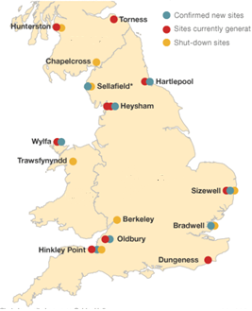
Figure 1.1 - Map of the UK highlighting new sites for large nuclear power plants. Figure adapted from [3]

To date, confirmations has only been made of Hinkley point C to host two European pressurised reactors (EPR). The EPR reactor is a Generation 3+ reactor, capable of producing 1600 MWe, with a twin unit aiming to provide roughly 7% of the UK’s electricity requirements from a nearly zero Carbon source [4]. Advanced talks are now underway regarding a twin unit GE-Hitachi ABWR providing 1300 MWe to be built at Wylfa, but confirmation of the build decision has not yet been announced [5].
In 2010, the nuclear industry was under the consensus that the larger the nuclear power plant, the lower the overnight construction costs were per MWe, as shown in Figure 1.2.
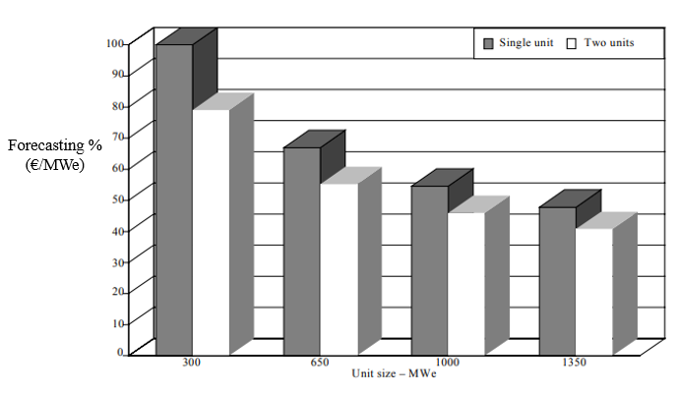
Figure 1.2 - The French’s forecasting % for overnight costs (€/MWe) of a 300-1350 MWe plant capacity [6]
Even with the construction of the Generation 3+ reactors, their colossal size and cost has been driven by the economical assessment in Figure 1.2. The large construction costs have meant that only government supported projects could be built.
This invites the question, is there an alternative to large scale nuclear power plants? One alternative is to utilise the economies of multiples by centralising manufacturing and reducing the construction time/cost by allowing for smaller plants. This idea brought about the concept of the small modular reactor (SMR). A SMR is defined as a reactor producing ≤ 300 MWe (~ 600 MWth), making the physical size significantly smaller, with the option of adding multiple modules to a single site to acquire the required power [7]. By using multiple modules, this practice aims to simplify construction and use specialised expert construction partners to install each unit, thus retaining the experience of these personnel, which will reduce the overall construction time. This practice has yet to be proven, although there is significant literature highlighting the best methods to implement this [6] [8].

The UK government has taken a significant step towards developing SMRs by providing a SMR competition in 2016 [9] which allowed interested parties to apply for government funding for future nuclear projects. However, this was re-designed in 2018 to the Advanced Modular Reactor (AMR) and feasibility and development project and £44 million has been provided towards developing AMR technology. The shift in the government’s priorities highlighted the importance of nuclear technology to utilise other market potential away from conventional electricity generation. This is part of the progression from the current generation (Generation 3+ Hinkley point C) to Generation IV technology, which aims to challenge the idea that nuclear power plants can only be used to produce electricity. This paves the way towards higher technological advancements, with the aim of capitalising on multiple output markets within the future. A brief breakdown of the current AMRs is displayed in Table 1.1.
Table 1.1 - Breakdown of phase 1 of the AMR competition participants and designs [10]
Company name | Project title | Company base | Reactor type | Technology gaps | Thermal capacity (MWth)
Moltex Energy Limited | UK SSR Feasibility | UK | Molten Salt | Medium | 375
Tokamak Energy Ltd | Advanced Modular Fusion - The Spherical Tokamak | UK | Fusion | Very high | 100
Westinghouse Electric Company | An Innovative Nuclear Solution based on Lead Fast Reactor Technology | USA | Lead cooled fast | Medium | <300
Blykalla Reaktorer Stockholm AB (LeadCold) | Small, Economic and Agile Lead-cooled Reactors for the UK (SEALER-UK) | Sweden | Lead cooled | Medium | ~80
U-Battery Developments Ltd | U-Battery | UK | High temperature | Low | 10
Advanced Reactor Concepts LLC | ARC-100: Sodium Cooled Fast Reactor Employing Metallic Fuel | Canada | Sodium cooled fast | Medium | ~200
DBD Limited | High Temperature Gas Cooled Reactors | China | High temperature | Low | ~200
Ultra Safe Nuclear Corporation | MMR, a novel nuclear cogeneration system for multipurpose applications | USA | High temperature | Medium | 15

The AMR competition has provided several new technologies, all with their own benefits and drawbacks. The most advanced option is the inclusion of fusion technology, because this technology not yet being proven economically feasible. The sodium, lead and molten salt designs all show promising progression into Generation IV technology. However, this brings large technological and regulatory gaps to overcome. Due to the inclusion of the requirement for additional applications, the easily deployable high temperature reactor (HTR) has emerged, with existing prototypes already existing within this technology [11] [12]. Focusing on the capacities, the HTRs offer a much smaller thermal capacity than the other AMRs and the U-Battery and MMR reactor are termed “micro” reactors due to their extremely small capacity.
HTRs are a versatile type of reactor due to their ability to provide elevated outlet temperatures of >700 °C. The additional temperature can provide benefits regarding the efficiency of the electrical generation cycle through the utilisation of a Brayton cycle or improved efficiency of the Rankin cycle. One of the most frequently investigated applications is the use of these high temperatures for process heat towards hydrogen production [13]. Hydrogen production is predicted to significantly increase due to the rise of the electrical vehicle market and global hydrogen demand [14] as highlighted in Figure 1.3.
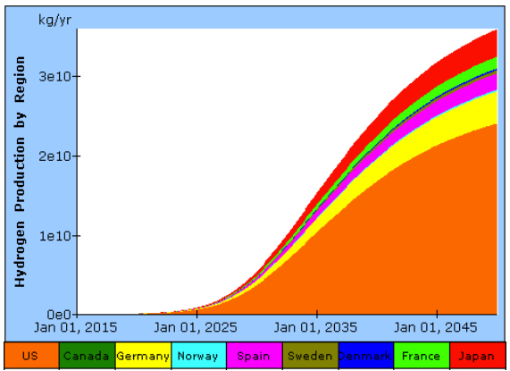
Figure 1.3 - Hydrogen demand per country, highlighting the potential demand increase in major economies [15]
However, this process heat application is not unique for the hydrogen market, as demonstrated by the UK’s existing process heat requirements in Figure 1.4. Other potential applications include a rather novel CO₂ reducing technique called dry reforming, which combines CO₂ with methane to produce hydrogen [16] [17], thus reducing CO₂ to useful by-products.
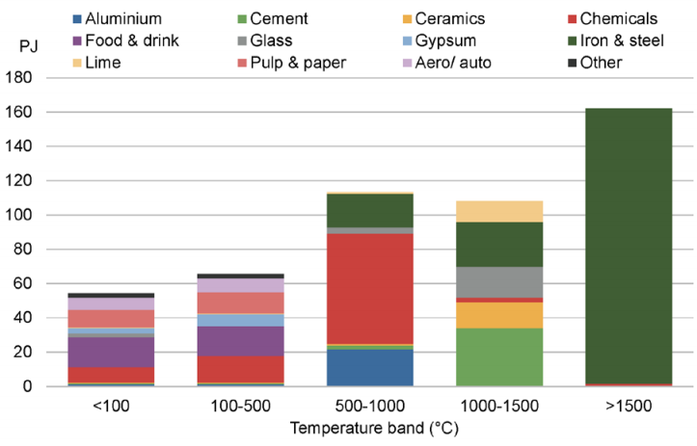
Figure 1.4 - Industrial heat requirements within the UK, excluding existing combine heat and power (CHP) plants [18]
Figure 1.3 and Figure 1.4 provide reasoning behind the UK government’s to aim to capitalise on other products from nuclear power. This leaves the HTR designs in a strong position to capitalise on further markets within these fields and to aid the transition for high Carbon industries to low Carbon alternatives. This PhD thesis will aim to analyse the U-Battery to determine if the micro reactor market is able to provide any additional benefits compared to conventional reactors.

The U-Battery
The U-Battery concept [19] is a set of SMR HTR designs commissioned by Urenco which have been produced by TU-Delft and the University of Manchester. The three designs that exist have power levels of 20, 10 and 5MWth with all designs fitting within the compact idea of the U-Battery. The concept is to take a SMR and compress it even further to a very small or micro reactor to make the U-Battery more suitable for remote deployment and smaller process heat industries. The U-Battery design specifications are presented in Table 1.2.

Table 1.2 - Generic design requirements from the original U-Battery proposal [19]
Parameters | Values
Reactor type | Prismatic core
Thermal power | 5-20 MW_{Th}
Lifetime | 5-10 Years
Coolant | Helium
Diameter of RPV | 3.7 m
Fuel type | UO₂, TRISO
Fuel enrichment | ≤ 20%
Energy conversion | Rankine steam
Energy utilisation | Electricity and process heat

The prismatic core and TRISO fuel are like the High Temperature Engineering Test Reactor (HTTR) fuel but based on a slightly different compact design. The fuel enrichment is below 20% to meet IAEA non-proliferation guidelines to not be classed as highly enriched uranium [20]. This has the benefit of allowing for easier transportation methods. The lifetime aim of 5-10 years requires a high fissile loading content and implies that the core will be able to run without refuelling or user intervention for long periods of time, which suits very remote deployment.
Due to the AMR’s requirement to investigate other market potential, the design is heavily invested in the process of co-generation of electricity and process heat. This can be in the form of domestic or industrial heat, either in conjunction with electricity supply or independently, depending on the customer requirements. This could lead to several “off the shelf” U-Battery units, matching an array of heat/electricity requirements or, by adding complexity to the design, the ability to alter the outputs accordingly.
Due to the wealth of knowledge already produced by the HTTR project, there are very few technology gaps in the current design. One large advantage within this section is that the UK is already a world leader in graphite-moderated, gas-cooled reactors. Therefore, there is a well-established skill set and regulatory procedures already due to the fleet of advanced gas-cooled reactors (AGR) operating within the UK.

10MWth Design from 2011
In 2011 the initial U-Battery report [19] mainly focused on the 20MWth version of the U-Battery, which became economically unfavourable when compared to two 10MWth versions. This project will therefore focus on a new conceptual design of a 10MWth design.
There is only limited literature on the 2011 10MWth design. The only tests performed by the initial design were a simple design layout of the fuel blocks, confirming that a Beryllium oxide (BeO) side reflector grants five years of full power days.
Table 1.3 - Results for the 10MWth lifetime tests with two different layouts within the U-Battery report [19]
Case | Configuration | Material | Thickness | Lifetime Full power years | Mass
F.1 | Layout 6*3 | BeO | 25 cm | 3.5 | 44.5 tonnes
F.2 | Layout 6*4 | BeO | 25 cm | 5 | 54.7 tonnes

Table 1.3 shows the required 5-year fuel life cycle is achieved using the annular core design layout as depicted in Figure 1.5.
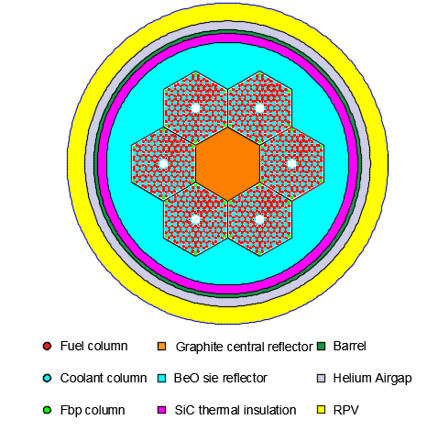
Figure 1.5 – The original 10MWTh U-Battery core design, radial view [19].
Every design of the core used the same fuel blocks as shown in Figure 1.6.
The hexagonal fuel blocks are made from graphite, hold fuel compacts, use B₄C as a fixed burnable poison and use helium as a coolant. The designs use an annular arrangement of six fuel blocks surrounding a central graphite moderator block to aid the thermal spectrum of neutrons. In addition to this, it has a superior side reflector in the form of BeO, which has enhanced neutronic performance compared to conventional graphite.

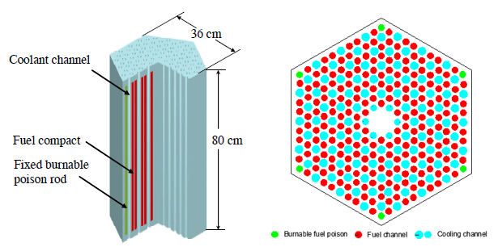
Figure 1.6 – Left: 3D fuel block drawing. Right: Radial cross-section of the fuel block [19].
The total power of the design is 10MWth. It uses four blocks of 80 cm length adding to 320 cm of fuel blocks placed axially to maintain a diameter of the RPV of 180 cm, which is required to maintain ease of transport in an Excellox transport flask.
As shown in Figure 1.5, the SiC thermal insulation aims to protect the barrel, which must be kept within a certain temperature bracket.

Updated design
The U-Battery was originally designed to be transported within an Excellox transport flask, which is commonly used across Europe to transport nuclear material. One issue raised by Urenco was the difficulty of obtaining a safety case for the original design's reflector material [19] BeO, as this is a novel material inside a reactor core. BeO is also listed as a hazardous substance with strict exposure limits in workplace environments due to its carcinogenic properties, thus raising additional safety concerns [21] . Due to these concerns, investigations have been based on the adapted U-Battery design where the BeO reflector is replaced by graphite to ease the deployment. This new design was presented at the SMR conference in June 2016. The change from the BeO to graphite reflector has considerably changed the size of the core, with the approximation that 50 cm top/bottom graphite would give similar neutronics to the 20 cm of BeO. An additional graphite hexagon has been added in the side reflector, increasing the diameter radially by 42 cm. The design changes are shown in Figure 1.7 and Figure 1.8.
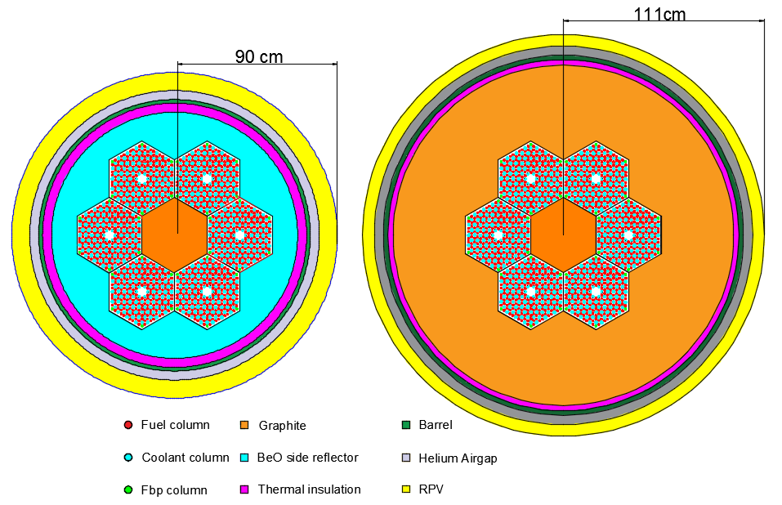
Figure 1.7 – Radial views of: On the Left, Original U-Battery design; On the Right, New design
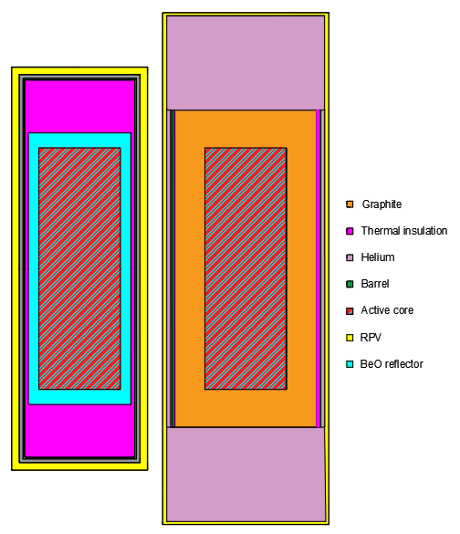
Figure 1.8 - Axial views of: On the Left: Original U-Battery design: On the Right, New design
A brief description of the differences between the two designs:
- From this perspective the top/bottom graphite reflectors have been increased to 50 cm, compared to 20 cm with the BeO. The radial dimensions have been increased from 20 cm to 40 cm.
- The thermal insulation was changed to a porous graphite. The thermal insulation uses porous graphite blocks provided by Graphetech, with a thermal conductivity of ~0.23 W/mK compared 7.5 W/mK for SiC [22][23].
- The RPV has been fully designed to account for the total mass of the core, allowing for the size to be modelled accurately at 4 cm thickness of 304H steel.
The continuation of this work will focus on the new design of the U-Battery using the graphite reflector to avoid repetition and confusion between the two sets of results.

Advantages of the U-Battery
There are currently very few reactors in the market which can compare to the U-Battery, as the concept of a microreactor is quite new. When comparing this design to cogeneration and industrial heating such as gas plants, the U-Battery would be able to emit significantly less CO₂ emissions. The U-Battery could also achieve higher temperatures, which would allow for the opportunity to perform additional industrial applications which would otherwise require more complicated heating procedures.
The Ultra Safe Nuclear Company (USNC) design, the USNC have provided a longer fuel lifecycle of fifteen years compared to the five for the U-Battery. They have not specified how this is achieved and there is very little information about this design, although a fifteen-year life cycle would be a significant advantageous if this could be achieved. The USNC have also stated they wish to use molten salts for the coolant, but this would be a challenge because there is very little experience with salts within nuclear environments and this would make licencing much more complicated. Some advantages are shown in Table 1.4.
Table 1.4 - U-Battery advantages summary
Attribute |  | U-Battery
Deployment |  | Quite fast, dependant of fuel availability
Technology ready level |  | Very well understood
Skills base |  | UK has a high skill set in most areas
Regulatory issues |  | Fuel and helium as a coolant
Emissions |  | Very low
Costs |  | Low ~£70 mil
Other markets |  | Cogeneration, Hydrogen & industrial heat
Coolant |  | Inert and well understood
Safety |  | Aiming to be inherently safe

Technology gaps and understanding
The U-Battery consortium have opened a memorandum of development and understanding with the Japanese Atomic Energy Agency (JAEA). This will allow them to utilise the skills set and test data from Japan allowing them to bridge the technological. The initial HTTR was first brought to criticality in 1998 and has been providing test data for the HTR community ever since then. Table 1.5 provides a comparison between the proposed designs.
Table 1.5 - Comparison between the HTTR and the proposed 10 MWth U-Battery [11] [19]
 | HTTR | U-Battery
Capacity (MWth) | 30 | 10
Pressure MPa | 4 | 4
Core layout | Prismatic | Prismatic
Moderator | Graphite | Graphite
Coolant | Helium | Helium
Inlet temperature (°C) | 395 | 400
Outlet temperature (°C) | 950 | 750
Fuel type | UO₂ | UO₂
Fuel Enrichment max | 10 | 20
Burnup max MWd/KgU | 31500 | 88000

As shown in Table 1.5, the materials have been exposed to much higher temperatures in the HTTR than in the U-Battery. This will allow for a large amount of safety data to be obtained with respect to material performance at elevated temperatures. The cores both use the same design, moderator and coolant, meaning performance data would be readily available. One of the major differences is the fuel, with the U-Battery aiming to provide a much longer fuel life as indicated by the enrichment and the achieved burnup. This would mean that additional testing would be required with the fuel performance. However, from the core structure perspective, the cores are very similar and there are very few knowledge gaps.
One of the largest variances from traditional reactors is the fuel fabrication and performance. HTRs use TRISO fuel, which has not been manufactured in the UK and is only occasionally produced for the prototype reactors in Japan and China. The fuel which is being proposed for us within the U-Battery is currently being tested under the Advanced Gas Reactor Fuel Irradiation (AGRFI) experiments at Idaho National Laboratory (INL). These tests aim to provide data for the Nuclear Regulatory Commission and are currently undertaking the final experiment, where 15.5% enrichment mass produced fuel will be tested up to 1500 °C to determine the failure rates [24]. The limits of these tests are shown in Figure 1.9.
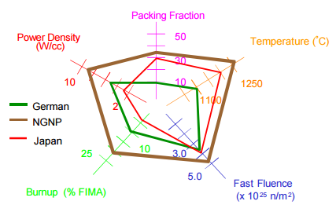
Figure 1.9 - Comparisons of AGRFI tests to the existing operated TRISO fuels [25]
Figure 1.9 shows the extent to which the current irradiation tests provide enough data to make a viable safety case for the currently manufactured fuel. If these conditions were exceeded in the U-Battery design the available data might not provide evidence for safe and reliable operation without additional testing.
Co-generation is one of the main focal perspectives from the U-Battery’s marketing perspective. There are significant safety concerns regarding the production of hydrogen alongside a nuclear power plant due to the volatile nature of hydrogen. Despite this, plans are underway to use the HTTR to supply process heat to a hydrogen production plant. How the U-Battery will prove as a safe working environment to produce high temperature process heat is still an unknown topic. Several important questions with regards to regulation and implementation must be answered, such as if the production sites would have to be in different buildings and how potentially would explosive material production be situated near a nuclear site. To answer this, consultation with the local regulator would be required and this could completely rule out potential markets within that country.

Licensing
The U-Battery is designed within the UK and thus will aim to gain approval from the UK regulator. The UK regulatory approval is undertaken by two establishments, the Office of Nuclear Regulation (ONR) and the Environmental Agency (EA). The ONR is primarily responsible for the design aspects of the reactor regarding safety and UK specifications, whereas the EA focus on location of deployment and on-site licencing.
From the ONR’s perspective, they have the advantage of being one of the most experienced regulators of high temperature gas cooled reactors, due to the operating AGRs within the UK. This implies that there is enough data on the nuclear graphite, coolant mechanics and Rankin power systems to allow this process to be undertaken easily. TRISO fuel has not been assessed by the ONR and this is the largest technology gap; however, the data provided from the AGRFI tests could be presented for approval. This would place the U-Battery at a significant advantage to other AMRs’ due to the simple nature of the coolant and existing regulatory tests already being in their final stages for the fuel. In the case of molten salt or lead cooled reactors, the complexities of using highly toxic and corrosive materials would require significantly more safety precautions and experimental data before regulatory approval.
The regulator would raise the concern of the material limits regarding the high temperatures experienced within a HTR. In the case of an outlet temperature of ~750 °C, the following system will be susceptible to high temperature creep and damage. To account for this, part of the primary circuit should use the expertise and safety cases from the gas turbine industry, where super-alloys are now capable of performing of temperatures in excess of 1000 °C for long periods of time [26]. This could create additional costs due to the novel materials used.
To gain the maximum benefit from the U-Battery, there should be a minimal exclusion zone. The inherent passive safety features on a HTR could allow for this, but this choice is solely made by the regulator. Exclusions zones currently exist for all nuclear reactors, so this will be a particularly interesting regulatory issue.

Nuclear modelling theory
Every atom, excluding hydrogen, is formed out of three key components; neutrons, protons and electrons. Neutrons and protons reside within the centre of the element, called the nucleus, and normally these share the similar atomic weight as one another. The main difference is, that protons are positively charged whereas neutrons have no charge. The atomic number of an atom is determined by the number of protons, which in turn defines the chemical element of the atom. The isotope of the element is determined by the number of neutrons. Electrons are significantly smaller, are negatively charged and can be found surrounding the nucleus.
Each element’s material properties are defined by the structure of the nucleus. The nucleus is a balance between repulsion and attraction. The repulsion comes from the Coulombic force between the protons, whereas the attraction comes from the nuclear force between quarks. As atomic number increases, Coulombic repulsion is significant and subsequently neutron number increases at a ratio of ~1.5. Above an atomic number of 80 there are no stable nuclides. However, in a small set of elements, called radioactive elements, the nucleus is unstable, which leads to radioactive decay. These elements are highlighted by Figure 1.10.
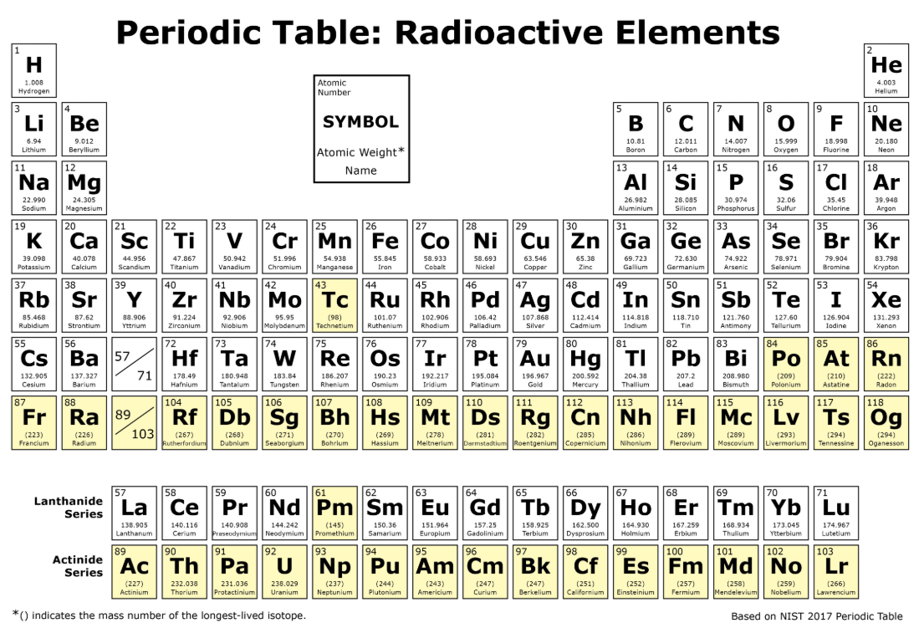
Figure 1.10 - Periodic table highlighting the radioactive elements in yellow [27]
The unstable radioactive elements aim to become stable; this is achieved by radioactive decay, where the element emits a particle or ionising radiation. There are five different types of radioactive decay highlighted in Table 1.6 [28].
Table 1.6 - Radioactive decay types to aid stabilise the nucleus
Radioactive decay method | Description
Alpha (α) | Ejection of an alpha particle
Beta (β) | Neutron converted into an electron and ejected, and a neutron converts to a proton
Gamma (γ) | Electromagnetic wave (gamma ray) releases energy from the nucleus
Beta+ (β⁺) | Ejection of an anti electron and the conversion of a proton to a neutron
Electron capture | Captures an orbiting electron

The emission of an alpha particle takes the form of a helium ion with two neutrons and two protons. This radiation has a positive charge and thus slows down significantly when travelling through materials.
Beta decays are either ejecting electrons or anti-electrons and these also contain charge, but they are much smaller than alpha particles, so this provides additional penetration power.
Gamma rays possess no charge and this allows them to pass through materials without difficulty. This can cause significant damage to materials.
In the case of nuclear modelling, the focus is mainly on the interactions of neutrons which, like gamma rays, do not contain any charge which allows them to travel long distances. Neutron interaction data is obtained by experimental procedures during which neutrons are fired at materials to determine the interactions between the neutron and the matter. Two of the main interactions monitored are capture and scattering.
- Capture/absorption – Is the process of a neutron being captured into the nucleus. This can lead to a complete absorption of the neutron, a fission event, or an ejection of a neutron with a different energy.
- Scattering – Is the process of a neutron interacts with a nucleus and is returned into the system. Neutrons can be scattered elastically or inelastically. Elastic scattering changes the direction but not the magnitude of the wave vector. Inelastic scattering changes both the direction and the magnitude of the neutron wave vector.
Both capture and scattering have distinct probabilities and these are defined by their cross-section data, which is provided in barns (1 x10⁻²⁴ cm²). As a neutron passes through a medium, the cross-sections of that medium are used to determine the probability of an interaction.
One of the key features of the operation of nuclear reactors is whether the element is fissile. Being fissile indicates the element’s ability to capture a neutron and then causing the nucleus to split providing energy, a range of other elements and neutrons.
²³⁵U is the most commonly used fissile isotope within nuclear reactors because it is the only fissile material which is abundant naturally. ²³⁵U absorbs a neutron, and thereafter the nucleus becomes excited. This process causes the nucleus to split, which provides three main by-products: energy in the form of kinetic energy (transferred to heat through friction), typically two lower mass elements and additional neutrons.
The lower mass elements which are produced in the reaction have a distinct probability for the creation of each element; this fits the curve shown in Figure 1.11.
Some of the elements allow the core designer to control the speed of the neutrons in the system. This gives rise to two types of nuclear reactor designs, namely “fast” or “thermal” reactors which relating to the dominant energy spectrum of the neutrons causing the fission reactions.

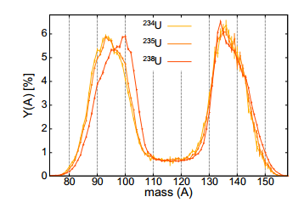
Figure 1.11 - Fission yields of each element when fission occurs within three uranium isotopes [29]
Thermal reactors, like the U-Battery, use slow neutrons to utilise the ²³⁵U’s higher reaction cross-sections in a thermal range, as shown in Figure 1.12. The reduction in the speed of the neutrons is provided by a moderator, which is often in the form of water or graphite, because these materials have a large scattering cross-section. Thermal reactors are the most popular type of reactors for two reasons. The USA deemed breeding reactors a higher proliferation threat in 1978 [30] and fast reactors are more complicated to control from a design and safety perspective. This has led to the refinement of thermal reactors since civil nuclear plants were first conceived.
Figure 1.12 - Fission cross-section of ²³⁵U with highlighted ranges of the different classes on energy [31]

The nuclear cross-sections of fissile materials are typically separated into three regions:
• The thermal region (E<~1eV) where the cross-section linearly decreases with energy.
• The resonance area (~1eV<E<~10keV) where the cross-sections show significant increase. This is due to the incoming neutrons having a specific energy and therefore a higher chance of being absorbed within the nucleus. These energies are called resonance energies.
• The fast region (E>~10keV) where the cross-section is significantly lower than in the thermal region and is mostly characterised by the geometry of the core.
The peaks in the resonance area in Figure 1.12 are sensitive to temperature. This is known as the Doppler broadening phenomenon, which takes place with increasing temperature. This is because the thermal energy of nucleus is elevated with the increase in temperature, so the nucleus vibrates faster. This vibration allows for a broader range of incoming neutron energies to be within the resonance region, hence the widening of the absorption cross-section.
Doppler broadening is a measure of how the resonance peak of the nuclear capture cross-section reduces in height, while the width of the peak increases as the temperature increases. This can be seen in Figure 1.13 which represents a single peak from Figure 1.12. This plays a vital role for the passive safety feature of a HTR. Since all materials increase their resonance cross-sections, this leads to additional parasitic capture in the non-fissile ²³⁸U due to its larger volume than the fissile ²³⁵U, thus reducing the neutron population.
The Doppler broadening is heavily dependent on temperature and thus can only be predicted if simulations combine thermal-hydraulics and neutronics.
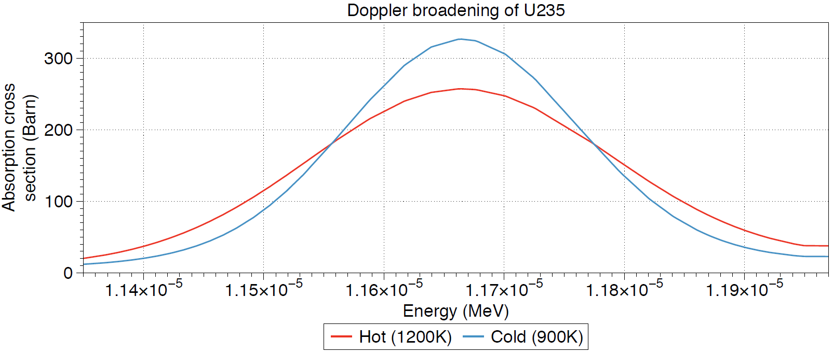
Figure 1.13 - Graph produced for ²³⁵U absorbtion cross-section at 900K and 1600K

Modelling of nuclear reactors
Nuclear reactors contain many different materials within the core and this makes predicting the neutrons behaviour significantly more complicated. One method of overcoming this is to introduce the neutron cycle, which provides a probability for each loss and gain of neutrons per event within the cycle. The cycle and an example are included within Figure 1.14 [32].
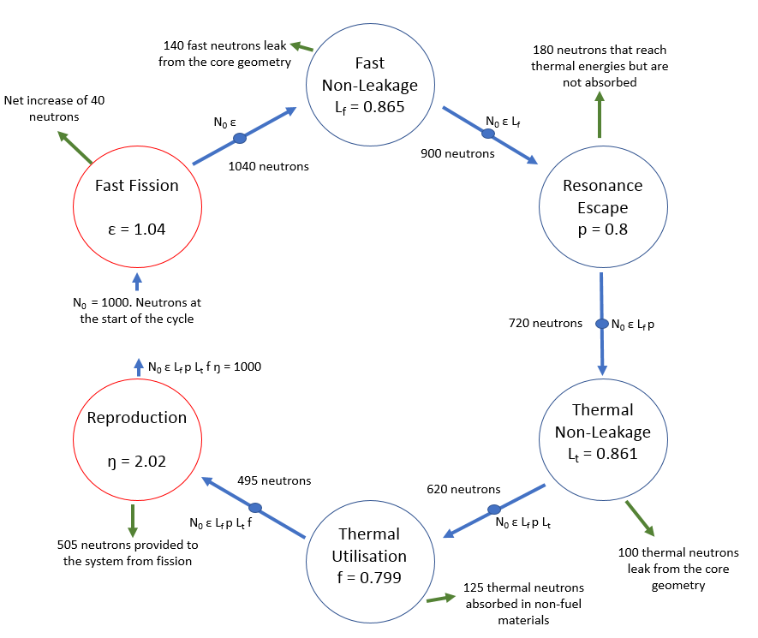
Figure 1.14 - Neutron cycle within a core showing the basic six factor formula including an example
The neutron cycle accounts for each of the events which can occur to a neutron with regards to a gain or loss of neutrons. The red circles represent a gain of neutrons, which occurs due to the process of fission in either the thermal or fast spectrum. The leakage terms represent neutrons which pass out of the core’s boundary conditions, which are considered lost as they cannot take place in further interactions. The resonance escape probability is a representation of how many of the thermalized neutrons are not absorbed within any nucleus. The thermal utilisation factor represents the thermal neutrons which are absorbed within all materials. This is a loss as some of the neutrons are parasitically absorbed in materials such as cladding or coolant. The neutron cycle provides the concept of the effective multiplication factor, K_{eff,} which can be calculated by equation (1.1)
 | $$K_{eff}= ε {KL}_{f} p L_{t} f ŋ$$ | (1.1)
This provides three states which the effective multiplication factor can represent as shown in Table 1.7. Each one of the terms within equation (1.1) can be altered by manipulating the core geometry, for instance providing additional ²³⁵U will increase the thermal fission yield to compensate for other losses.
Table 1.7 - States of effective multiplication factor
State | K_{eff} | Effect
Subcritical | <1 | More neutrons are being lost than produced.
Critical | 1 | A perfect chain reaction is taking place; for each neutron generated, one is lost.
Supercritical | >1 | More neutrons are being produced than are being lost.

K_{eff} is very sensitive to several factors; as shown in Figure 1.13, the temperature feedback plays a clear role in key aspects within the neutron cycle. This can be expanded further, as shown in Figure 1.15, to determine other parts of the neutrons cycle that are also dependant on temperature [33].
The accumulation of the effects of thermal feedback represent the temperature coefficient of reactivity, which describes the change in K_{eff} as the temperature rises. This temperature coefficient of reactivity is often used to provide an immediate safety feature, as the changes in cross-sections occur very fast in comparison to other feedback effects.

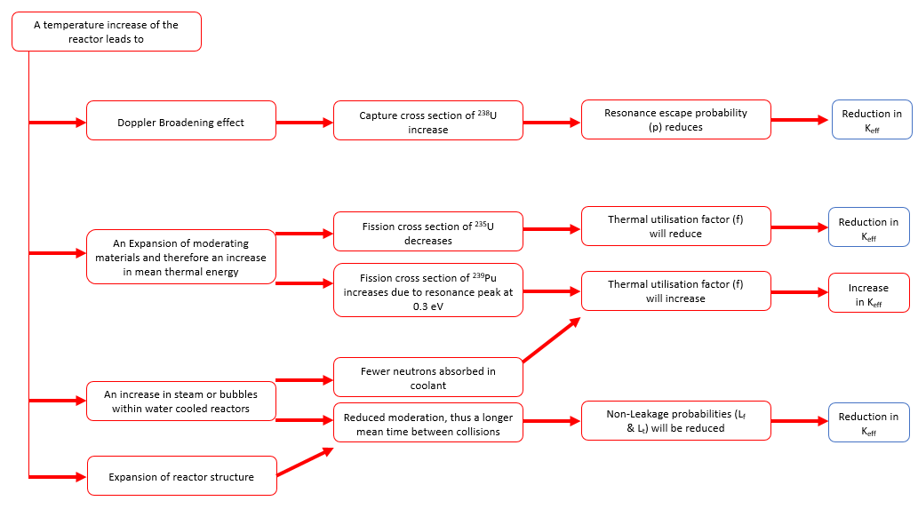
Figure 1.15 - Temperature effects on the neutron cycle, highlighting the impact on the effective multiplication factor

The neutron transport equation
The process of how a neutron interacts with matter is modelled using the neutron transport equation. The neutron transport equation is not limited to nuclear reactor design and was originally formulated by Boltzmann to measure kinetics in gasses. Formally, the steady state neutron transport equation is given in equation (1.2) [34].
 | $$Ω•∇ϕ\left(x, Ω, E\right)+Σ_{t}\left(x,E\right)ϕ\left(x, Ω, E\right) =\int_{0}^{∞}{dE^{'}} \int_{0}^{4π}{dΩ^{'}Σ_{s}}\left(x,Ω^{'}{•Ω, E}^{'}→E\right) ϕ\left(x, Ω^{'}, E^{'}\right) +S\left(x, Ω, E\right)$$ | (1.2)
The left-hand side of equation (1.2) represents the losses from the observed system. The first term represents the neutrons leaking out of the unit sphere (control volume). The second term is the neutrons suffering from any event within the control volume. The right-hand side of the equation represents the neutron gain; the first term represents the scattering procedure producing neutrons within the observed energy range and the second term represents the produced neutrons within that volume.
Neutron gain S
The first term with the neutron gain represents the neutrons scattered from other control volumes to the current control volume. This takes place when an incoming neutron with directions $Ω^{'}$ and energy $E^{'}$ has a distinct probability to be scattered into the control volume’s direction and energy range. This probability is determined by the scattering macroscopic cross-section and the cosine between the directions of the incoming and current control volume as denoted by equation (1.3).
 | $$Σ_{s}\left(x,Ω^{'}{•Ω, E}^{'}→E\right) ϕ\left(x, Ω^{'}, E^{'}\right)$$ | (1.3)
The process for including the fission in the transport equation occurs through the fractional probability that a neutron will occur within the energy range, which is given by equation (1.4).
 | $$\int_{0}^{∞}{X_{p}}\left(E\right)ΔE=1$$ | (1.4)
The limits of integration of equation (1.4) is across all the probable energy ranges that fission occur. The RHS of (1.4) implies that there is a distinct probability of each energy range being produced and this is normalised to 1. In equation (1.4), this term is divided by 4π, due to the isotropic nature of fission, as the direction of the neutron could be anywhere on the unit sphere.
Neutrons are produced on a scale related to their fission cross-section in relation to the energy range and direction within the volume. For each fission event, there is typically an average amount of neutrons produced. This is represented by the neutron multiplicity value ($v$). The macroscopic fission cross-section $Σ_{f}$, of the material is proportional to the flux within the region, as shown in equation (1.5).
 | $$v(E^{'})Σ_{f}(E')Ф\left(x, Ω^{'}, E^{'}\right) dΩ'dE'$$ | (1.5)
The process for including the fission in the transport equation occurs through the fractional probability that a neutron will occur within the direction and correct energy range, which is given by equation (1.6).
 | $$\frac{X_{p}\left(E\right)}{4π}v(E)dΩ dE$$ | (1.6)

Combining equation (1.5) and (1.6) and integrating across all energy ranges and directions gives rise to equation (1.7).
 | $$\left[\frac{Χ\left(E\right)}{4π}\int_{0}^{∞}{\int_{4π}{v(E^{'})Σ_{f}(E}}')Ф\left(x, Ω^{'}, E^{'}\right)dΩ' dE'\right]dVdΩ dE$$ | (1.7)
It is worth noting that there is another neutron gain from fission called delayed neutrons, which must be considered in the case of time dependant reactor physics calculations. Delayed neutrons are provided by the isotopes that ²³⁵U splits into; these are often unstable isotopes in themselves. In order to relax to a more stable state the nucleus ejects neutrons; this is termed delayed as the ejection process can take a range of time. Delayed neutrons only represent a small fraction (>0.01) of all neutrons in the system.
Neutron loss
There are three possibilities with regards to neutron loss within the control volume. These are:
- Neutron passes through the control volume due to having enough energy to leave
- Neutron is scattered out of the control volume
- Neutron is absorbed within the control volume
The first term of equation (1.2) represents the neutrons leaving the control volume through the means of the volume itself. This is given by the equation (1.8).
 | $$Ω•∇ϕ\left(x, Ω, E\right)$$ | (1.8)
The next term represents in equation (1.2) the loss of neutrons from any kind of interaction. Interaction occurs in several ways: absorption leading to fission or leading to a non-fission event, both of which count as a loss of the neutron within the system. Additionally, neutrons can suffer elastic as well as inelastic interactions with matter which change the energy status. All interactions are summed together to represent the total cross-section $Σ_{t}$, as shown in equation (1.9).
 | $$Σ_{t}\left(x,E\right)ϕ\left(x, Ω, E\right)$$ | (1.9)
Combining all these together and expanding the source term leads to equation (1.10) [35].
 | $$Ω•∇ϕ\left(x, Ω, E\right)+Σ_{t}\left(x,E\right)ϕ\left(x, Ω, E\right) =\int_{0}^{∞}{\int_{0}^{4π}{Σ_{s}\left(x,Ω^{'}{•Ω, E}^{'}→E\right) ϕ\left(x, Ω', E'\right){dΩ}^{'}dE'}} +\frac{Χ\left(x,E\right)}{4π}\int_{0}^{∞}{ dE'\int_{4π}{dΩ^{'}v(E^{'})Σ_{f}(E}}')ϕ\left(x, Ω^{'}, E^{'}\right)$$ | (1.10)
Equation (1.10) represents the full steady state neutron transport equation. Equation (1.10) consists of six unknowns, position vector (x), two angles for the direction of flight ($Ω$) and energy (E). In the case of a statistics solution like in the Monte Carlo approach, each of these must be randomly generated, which implies that in a single neutron system this would be quite possible. Due to the heavy dependence on random value and probabilities, a single neutron is not a good system representation. To improve the dependence on the output, as many neutrons as possible should be used. The question of how to create these random inputs was posed and eventually this provided the basis for computational neutronics.
Equation (1.10) represents the steady state neutron transport equation, which is commonly used for a single point in time within a simulation. However, when considering transient simulations, the neutron transport equations is expanded to its original form, the Boltzmann equation as shown in equation (1.11).
 | $$\frac{1}{V}\frac{∂ϕ\left(x, Ω, E, t\right)}{∂t}+Ω•∇ϕ\left(x, Ω, E,t\right)+Σ_{t}\left(x,E\right)ϕ\left(x, Ω, E,t\right) =\int_{0}^{∞}{\int_{0}^{4π}{Σ_{s}\left(x,Ω^{'}{•Ω, E}^{'}→E\right) ϕ\left(x, Ω^{'}, E^{'},t\right)dΩ^{'}dE^{'}}} + \frac{Χ\left(x,E\right)}{4π}\int_{0}^{∞}{dE'\int_{4π}{dΩ'v(E^{'})Σ_{f}(E}}')Ф\left(x, Ω^{'}, E^{'},t\right)dΩ' dE' +\frac{Q (x, E, t)}{4π}$$ | (1.11)
In equation (1.11) the time variables have been added due to these variables changing during a transient simulation. The new first term on the left-hand side of equation (1.11) is the time varying flux within the control volume. A third term has been added to the right-hand side of the equation. This term represents neutrons produced within the volume which are not a direct contribution from neutron flux within the system. One such event in transient simulations is the inclusion of delayed neutrons (see discussion above), which occur as unstable isotopes decay and release neutrons.
Due to the high complexity of the Boltzmann equation being of integro-differential character, several levels of approximation have been developed over time. There are some simplifications which can be used to create reduced equations. One is to split up the continuous energy character of the Boltzmann equation into energy groups, where each energy group uses a single speed from within it. If this was not the case there would need to be a near infinite amount of energy groups required to compensate for the continuous range within the energy groups. This implies that there are certain energies which are not used, so keeping a sensible set of energy groups close to important resonance peaks is important. Another approach, called diffusion approach, is to integrate over the solid angle of neutrons and to rely on the source being isotopic, in the case of a fission event, this is isotopic, however, other reactions such as the scattering behaviour is not fully isotopic. In addition to these simplifications, the system can be deemed as steady state, implying there is no variation in the neutrons flux over time.

Diffusion equation
The diffusion equation is the stationary form in the case when the number of neutrons being produced is equal to the number of neutrons lost (absorbed or escaped), i.e. the system is perfectly critical as written by equation (1.12).
 | $$0= S- Σ_{a}ɸ+D∇^{2} ɸ$$ | (1.12)
The diffusion coefficient is a deviation from Ficks law which in 1D is shown in equation (1.13).
 | $$J= -D\frac{dɸ}{dx}$$ | (1.13)
Ficks law states that the current density, J, flows from a high concentration area to a lower concentration area. In this case, the concentrate is the neutron current, which states that higher concentrations will dilute to lower concentrations. In the case of defined volume, the diffusion coefficient represents how quickly the neutrons can pass through a surface to the other side. This is directly related to the scattering effect as the neutron passes through the medium and thus the leakage. This is defined in equation (1.14) [36].
 | $$D= \frac{1}{{3(Σ}_{a}+{(Σ}_{s}-µ))}$$ | (1.14)
$µ$ represents the average cosine scattering angle across the medium.

Multi-group modelling
Currently the diffusion equation as given in equation (1.12) only investigates a single group of neutrons. This is a vast assumption when considering the neutrons within the volume have a defined energy (called neutron spectrum). In practice, neutrons can occupy a large energy range in a nuclear reactor. To compensate for this large range of neutron energies, the equations are set up into a selection of defined energy bins called groups. Neutrons are produced during fission, where they have the highest energy. Due to the scattering events they usually slow down, crossing a limit to be counted as the next group.
 | $$0= S_{g}- Σ_{ag}ɸ_{g}+D_{g}∇^{2} ɸ -Σ_{sg}ɸ_{g} + \sum_{g^{'}=1}^{G}{Σ_{{ag}^{'}g}ɸ_{g^{'}} } g = 1,2,3…G$$ | (1.15)
In equation (1.15) the first three terms are from the equation (1.12). The fourth term represents the scattering loss out of the volume to other energy groups. The fifth term represents the total scattered neutrons to the defined energy group from all other energy group.

Criticality
A chain reaction is the procedure that means as one nucleus is split, the neutrons present in the system are used to cause fission in another ²³⁵U nucleus. This utilisation process of new neutrons is called a chain reaction, which implies that K_{eff} is ≥ 1.
To incorporate K_{eff} into the neutron transport equation a term is placed in front of the source term to represent a balanced equation in a steady state system as shown in equation (1.16).
 | $$Ω•∇Ф\left(x,Ω,E\right)+{ ∑}_{t }(E)Ф\left(x,Ω,E\right) = \int_{0}^{∞}{\int_{4π}{{ Σ}_{s }\left(Ω^{'}{•Ω, E}^{'}→E\right)Ф(x,}}Ω^{'},E')dΩ^{'}dE' +\frac{1}{K_{eff}}\frac{X_{p}(E)}{4π}\int_{0}^{∞}{\int_{4π}{v{ Σ}_{f}(E')Ф(x,Ω^{'},E')dΩ^{'}dE'}}$$ | (1.16)
K_{eff} is an easy way to represent the behaviour of the neutron transport equation. In the case of unity, the losses balance with the gains, providing an ideal system for a chain reaction to take place.
Equation (1.16) [34] balances the lost neutrons from the core with the new neutrons within the core due to fission and scatter. The value of 1/K_{eff} is used as an iterative process to find where the ideal value is which will bring the system into a stable state. The flux can be calculated by equating K_{eff} and then using an iterative process to determine the magnitude of the flux, which grants a balancing of equation (1.16). Therefore, even a none critical composition can be calculated by manipulating the fission source. This achieved value of the flux can be used, but it is incorrect by a factor proportional to the difference between K_{eff} and unity.

Computational neutronics
Due to the complexities of the neutron transport equation, the use of computational power made solving the neutron transport equation significantly easier. During the early 20th century, computational power was limited, meaning that the codes often used single dimension assumptions and approximations to reduce the computational requirements.
The original codes used were simple and were based off directly solving the neutron transport equation or their approximations in reduced dimensions.

Deterministic methods

Lattice transport codes
Lattice codes work in a deterministic fashion of solving the neutron transport equation across a 2D slice of geometry with a multi-group approximation and an unstructured mesh solver. These techniques are optimised for quickly determining the behaviour of small geometry, such as that of fuel pins or a symmetrical piece of single fuel assembly, which can make use of reflective boundary conditions.
Deterministic methods divide the geometry up into small cells, each of these cells have a defined amount of materials within it. These are then homogenised to produce the macroscopic cross-sections within these cells. The neutron transport equation is then solved for neutrons passing across each of the cells, typically created using a flat-flux approximation. The advantage of this approach is that the results are always the same, due to the average values being used and the cells all containing known cross-sections. The disadvantage can come when considering the process of homogenisation, as fine details such as complex geometry cannot be reproduced upon because their detail is lost while creating the cell. [37]
Deterministic lattice codes are still commonly used today, due to their accuracy of determining simple geometries to a high degree of accuracy and their speed of delivering results.

Nodal methods
Nodal analysis uses a simplified deterministic method to determine the fluxes within nodes of a system, as well as the whole core. A node represents a region within the core; classical nodal examples include nodes the size of a fuel block or assembly. The nodal analysis uses the homogenised cross-sections pre-produced by using lattice code to obtain the probabilities of each interaction within that node. The key of a nodal method lies in the linked approach of a best estimate approximation of the flux within the node using mathematical methods and the iterative solution of the flux distribution in the whole core. In the case of multiple energy groups, the cross-sections are required for each node and energy group provided. The benefits of this system are that each node is usually significantly simplified and the number of nodes is limited, so calculation times are reduced.
The nodal analysis uses the diffusion equation to determine the overall fluxes between each node to determine the overall criticality of the system. The formula for flux within one node (n) is provided in equation (1.17) and is typically approximated by a series of expansions.
 | $$\frac{∂{Ф_{1}}^{n}(x,t)}{{V_{1}}^{n}∂t}+∇{J_{1}}^{n}\left(x,t\right)+{Σ_{r}}^{n}(t){Ф_{1}}^{n}(x,t) = \frac{1}{k_{eff}}\sum_{g=1}^{2}{\left(1-{B_{g}}^{n}\right)v{Σ_{f,g}}^{n}}(t){Ф_{g}}^{n}(x,t) + \sum_{j=1}^{M}{{ƛ_{j}}^{n}{C_{j}}^{n}\left(x,t\right)+ {S_{ext}}^{n}(x)}$$ | (1.17)
In equation (1.17), the first team is the total summed neutron flux within that node. The second term hosts the diffusion process, which represents the loss of neutrons from within that nodal volume. The third term represents the total reaction rate of losses. These include scattering, fission and absorption. On the right-hand side of the equation, the first term represents the fission source within this energy group, the second is the neutrons produced by the decaying isotopes and the third examines if there is an external source within the nodal volume.
Similarly to the neutron transport equation, the nodal flux solution becomes significantly simpler when assuming the steady state version in equation (1.18).
 | $$∇{J_{1}}^{n}\left(x\right)+{Σ_{r}}^{n}{Ф_{1}}^{n}(x) = \frac{1}{k_{eff}}\sum_{g=1}^{2}{v{Σ_{f,g}}^{n}}{Ф_{g}}^{n}(x)$$ | (1.18)
Due to the significantly reduced computational demand of nodal methods, these approaches are often used for full core simulations representing the multi-physics behaviour of the core. Modern nodal core simulators often consist of a neutronic module combined with a reduced thermal hydraulic module [38].

Monte Carlo methods
In 1946 Stan Ulam, an employee of Los Alamos National Laboratory, contemplated the probability that a pack of 52 playing cards could be laid out successively to successfully complete solitaire. The hypothesis related to drawing each card at random and placing this card upon a previously random card and that eventually a continuation of this would lead to the completion of solitaire. From an abstract perspective, if you could repeat this procedure a thousand times, the overall amount of successful completions could be used to predict the probability of victory. This thought process led to the hypothesis that the neutron transport equation could be solved in a similar manner, with the cards representing the unknowns in equation (1.2) [39].
A mathematical model of probabilities and random sampling was created from Ulam’s hypothesis and this was called the Monte Carlo simulation. Monte Carlo simulations provide a neutron with a random location, specific energy and a vector of direction of travel. Using this data, the neutron passes through the materials and the probability of each reaction can be calculated. Using another randomly generated value and comparing this to each interaction probability, the event that occurred could be determined and thus the next interaction or step could be performed. By performing the same simulation repeatedly, the answer converges to a probable outcome. However, for each neutron a simulation must be ran. This means that to obtain an accurate result, a large amount of calculations is required.
Ulam knew about computational power at the time and hypothesised that if a neutron was provided with an eighty-point entry punch card containing completely random information for variables, then the next step of the procedure could be calculated based on this information. Each time the next step produced a fission event, another card would start from this point, until eventually all neutrons were accounted for.
The neutron transport equation is difficult to solve due to the large number of unknowns. This has led to computational methods using statistical probabilities to understand interactions of neutrons within a medium. This is one of the downfalls of Monte Carlo simulations; statistical errors arise because of the random nature of events. In the case where sampling is too low, this statistical uncertainty can provide significant errors within the output.

Software used - Serpent
Serpent is a recently released Monte Carlo neutronics code [40], the development of which started in 2004 by VTT Technical Research Centre of Finland. Serpent is the main neutronics code used throughout this report and thus it is important to understand the code’s performance and limitations. Serpent’s main applications include:
- Neutron transport calculations
- Burn-up calculations
- Full core modelling
- Coupled multi-physics application interfaces.
Serpent requires an input file which allows the user to create a geometrical model via the positioning of regular shapes, including squares, hexagons and cylinders. The user must give each shape physical features such as a temperature and material composition. Following the geometry, the input card maintains all the information regarding the simulation, including burnup stages, input neutron population and conditions of the simulation. The Serpent code is delivered with a set of cross-section master libraries which are based mainly on the American ENDF/B and the European JEFF library sequence.
One of the key aspects of Serpent is the parallel processing feature when running large simulations on a high-performance computer. Serpent allows the user a single software licence, regardless of the amount of computer cores used. This allows the user to utilise as many cores across multiple nodes at their disposal. This allows simulations to be finished much faster and for larger models to be created.
This next section aims to provide a basic understanding of how Serpent finished the calculations to determine the outputs used within this project.
Serpent is a Monte Carlo simulation tool that tries to directly solve equation (1.16) by monitoring a sample of neutrons to determine the K_{eff} which balances out the equation. To achieve this, Monte Carlo techniques are applied. Monte Carlo uses specific probabilities of an event occurring and then, based on random number sampling, either accepts of rejects the outcome, depending on the given probability function. As a simple example, the tossing of a coin has two possibilities, heads or tails, so a probability range of 0-1 is drawn, with > 0.5 being heads and < 0.5 being tails. With enough samples, the distribution should show that 50% of the coins flipped should be tails.
A similar probability range is used to determine the energy range a neutron is born at and the interactions within each material it passes through. This example uses an analogue environment, in which a particle can be in one of two energy states, 1 and 2, as depicted in Figure 1.16 [41].
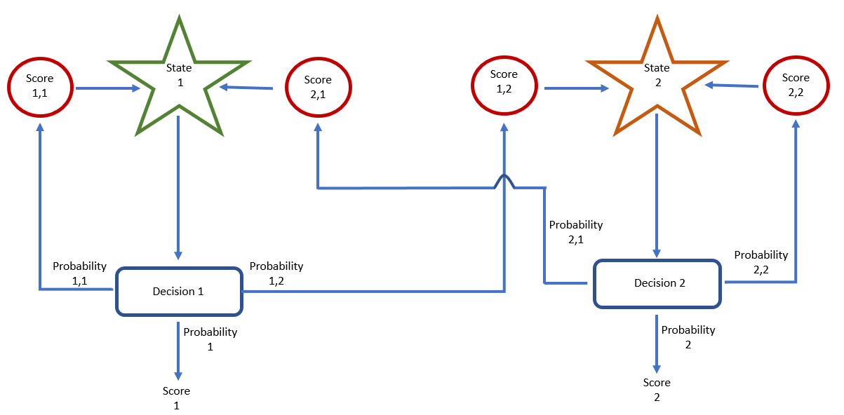
Figure 1.16 - Analogue system probabilities, showing a simplistic approach to scattering and absorption
Each of the decision boxes have three outcomes for the scattering state; it remains within that state’s energy range, the state changes or the particle is absorbed. This leads to six different events that can occur as depicted in Table 1.8.
Table 1.8 - States and probabilities table with reference to Figure 1.16
Event | Event score
Scatters from State 1 to State 2 | 1,2
Scatters from State 2 to State 1 | 2,1
Scatters from State 1 to State 1 | 1,1
Scatters from State 2 to State 2 | 2,2
Absorbed from state 1 | 1
Absorbed from state 2 | 2

Each of the decision boxes will apply a distinct set of probability values between 0 - 1 related to the material properties, thus leading to a set of events occurring at Decision 1 as shown in Figure 1.17, based on the material properties and energy in the case of a scattering event.
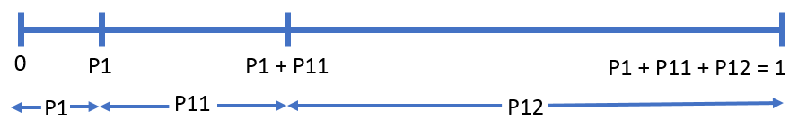
Figure 1.17 - Probability distribution between zero and unity at Decision 1, depending on a random number generation
A similar statistical distribution will occur for Decision 2, but this might be different, depending on the properties of material and state of the particle. Assessing these probabilities across each interaction determines the overall outcome for each neutron history and the overall gain or loss of neutrons within the system.
Serpent uses these analogue probabilities and statistics to determine the outcome of large quantities of neutrons within the geometrical problem. This is determined using the neutron transport cycle for each sampled neutron as shown by Figure 1.18.
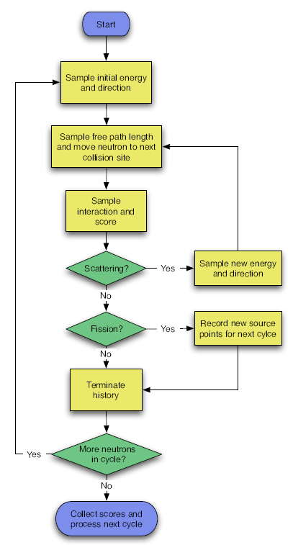
Figure 1.18 - Serpent’s neutron transport cycle [17]
The start of a neutron cycle is the birth of a neutron, which is provided with a random energy and direction. As the neutron passes through materials within the geometry, the material properties determine the probability of an interaction and where this will occur. At the point of an interaction the location is recorded. If the reaction is scattering, a new energy and direction is produced, based on the probabilities of that incoming neutron. If a fission event is recorded the site is recorded, and that history is terminated, but a new neutron is born with a new direction and energy. In the case of a neutron leaving the geometry, this history is terminated and the neutron is recorded as leakage.
This is repeated for as many neutrons as the user specifies, allowing for a map of reaction rates to be recorded across the geometry.
Each neutron is individually tracked and the results across the geometry are then recorded to determine the overall analogue reactions of the total core geometry. Figure 1.18 does not explicitly highlight that is the interaction is outside of the boundary conditions, then this neutron is assumed to be a loss in the form of leakage. By following the neutron cycle for a large sample of neutrons, the overall answer tends to converge on the number of neutrons generated and lost within the core and thus provides a value for K_{eff} to balance equation (1.16)
Neutron reactions within each medium depend on the material properties. Material properties and reactions are read from the data libraries, which correspond to nuclear data which has been obtained through experimental results. One such case of this is the probability of fission of ²³⁵U, which is directly proportional to the neutron flux within these fissile regions and the energy of the incoming neutron. Serpent determines these probabilities using Monte Carlo techniques, but this follows equation (1.19).
 | $${RR}_{f}=\int_{0}^{∞}{Nɸ\left(E\right)}σ_{f}(E)$$ | (1.19)
The reaction rate determines the amount of fission events occurring within the defined region. This is particularly useful when trying to determine small changes within the core, but this is more useful when determining a more useful unit such as power, as a fission event provides a set amount of energy. In the case of the U-Battery, the defined power is 10 MWth. The average energy produced by fission event of ²³⁵U being well known as ~200MeV. fission⁻¹ (3.2 x 10⁻¹¹ J. fission⁻¹), the amount of fission events per second can be determined to meet this criterion. This is shown in equation (1.20) [42].
 | $$n x E_{per fission }={MW}_{th}$$ | (1.20)
 | $$n=\frac{10MW}{3.2 x {10}^{-11}}$$
 | $$n=3.13 x {10}^{17} \frac{Fissions}{second}$$
When monitoring a specific part of the core, the power can be determined by using the same reasoning by combining equations (1.19) and (1.20). The specific power produced is determined directly from the fissile reaction rate within that region. Monte Carlo codes are especially versatile in recording reactions; this is achieved by placing super imposed geometries over regions that require their reaction rates to be monitored. The Monte Carlo code is then able to record each interaction across multiple energy ranges and materials that occur within this super imposed region, allowing for detailed studies within this region. One drawback of super imposing small geometries over a large domain is that the errors can be high due to a low scoring rate within that geometry; in these cases, large numbers of neutron histories are required to overcome this.
From the reaction rates, during the process of fission or other absorption reactions, the number density of the material is varying over time. This is particularly important in the case of ²³⁵U where the fuel is being depleted. It is important to understand this depletion method to determine how long the reactor can remain critical before the fuel needs replacing. Equation (1.21) shows how to determine the change in atomic density of an isotope [43].
 | $$\frac{dN_{i}}{dt}= -N_{i}(ƛ_{i}+σ_{i}Ф)+\sum_{j}{N_{j}\left(ƛ^{i→j}+σ^{i→j}Ф\right)+ \sum_{k}{N_{j}σ_{k}^{f}Ф}}Y_{k}^{i}$$ | (1.21)
Equation (1.21) represents the methods of isotope i turning into isotope k over the depletion step. The first term of the RHS represents the removal of isotope i through self means, decaying and neutronic interactions. The second term is the production of i from nuclide j, through decay or neutronic interactions, for all nuclides which are related to i in these means. The third term represents all the isotopes k which have the fission possibility to turn into i as a yield of fission.
One of the common methods to determine the overall depletion of the fuel is the term burnup. Burnup is a measure of the power produced per unit mass of the fuel (MWd/KgU) and achieving high levels of burnup is a sign of a more efficient system. In the case of Serpent, the overall power of the core determines the amount of fissions per second to provide this power and thus the burnup is a measure of how long this can be achieved for under the current configuration. For this reason, the volume of the fissile content is required, to allow for accurate depletion of this material over time.
One of the main drawbacks of Monte Carlo techniques compared to nodal methods is the statistical error which is produced alongside the result. Due to the random nature of neutron histories, the results of one simulation are unlikely to be identical to the next simulation. This leads to Monte Carlo simulations using multiple batches of the same simulation and comparing these batches against one another to determine the mean value across all batches, as shown by equation (1.22).
 | $$\bar{x}= \frac{1}{N} \sum_{n=1}^{N}{X_{n}}$$ | (1.22)
Where x̄ is the statistical mean, N is the batch number and $X_{n}$ is the mean value for that batch number. The mean result is interesting when considering a single value, however, to quantify how each batch varies from the mean using the standard deviation provides a more accurate representation of the batches results. This is achieved using equation (1.23).
 | $$σ (X)=\sqrt{\frac{1}{N(N-1)}\left[\sum_{n=1}^{N}{X_{n}^{2}-\frac{1}{N}{\left(\sum_{n=1}^{N}{X_{n}}\right)}^{2}}\right]}$$ | (1.23)
The standard deviation is useful for looking at a single statistic, even though this statistic might depend on multiple random statistics. However, one fundamental theorem of central limit theorem states that the sum of multiple random events eventually converges on a normalised distribution [44]. Taking an example of six-sided dice, there is a probability of 1/6 of each face being drawn, if X dice are rolled in N batches, the higher the values of X and N, the more accurate the mean score will be. Central limit theorem states that the distribution should follow a normal distribution as depicted by Figure 1.19.
Figure 1.19 - Central limit theorem of six-sided dice rolls, showing that with a greater frequency, the distribution significantly drops
From Figure 1.19, the standard deviation is significantly reduced as the amount of dice are increased, despite the random nature of the dice being rolled. In the case of Monte Carlo simulations, the number of neutrons (X) and the batches of simulations (N) define that the results should converge in a similar fashion.

Multi-physic modelling
This project aims to incorporate multi-physic modelling into the design process to provide a more accurate representation of modelling. Multi-physics modelling is a combination of thermal-hydraulics and neutronics, which incorporate heat transfer. Heat transfer directly changes the cross-sections of the system, so having a temperature feedback to the system is vital for modelling transient behaviour in.
This process has been performed before with in house-packages such as those used at TU-Delft [45] and the Saturn-FS1[46] packages. However, these are not commercially available, nor have these packages undergone any type of regulatory evaluation. These codes use a combination of tools to combine softwares together to determine the behaviour of the system.
When considering modelling accidental scenarios, the use of multi-physics is important, due to the small changes in the system causing the system to react accordingly. One of the key benefits with an HTR is that the system should be designed so as not to breech safe operational limits. The nature of the HTR fuel design, this provides an inherent safety aspect, where the temperature feedback effectively reduces the criticality below unity, which in turn reduces the temperature once more. One key piece of literature in the field uses TU-Delft’s in house coupling process to access the temperatures during a loss of coolant accident within a HTR [47].
In this article, the thermal-hydraulic approach in transient cases is limited to using basic principles.

High-temperature Reactors (HTR)
The first HTR with a considerable power output was the DRAGON reactor, commissioned in the UK in 1963, as an international collaboration that lasted 17 years [48]; following the completion of the project, a decision was made not to commercialise the HTR. However, interest in HTRs has increased again recently due to the availability of enhanced materials and active prototypes of technology, like the HTTR in Japan [11] and the HTR-10 in China [12]. New simulations of HTR prototypes have indicated that they can be financially viable, with the first SMR HTR currently being constructed in China.
The term HTR is a loose one when compared to the very high temperature reactor (VHTR) which is being considered for Generation IV designs. The term HTR refers to plants producing outlet temperatures over 700 °C, with VHTR now referring to those over 1000 °C [49] compared to a regular PWR at ~330 °C [50]. The elevated outlet temperatures seen in HTRs provide advantages such as improved thermal efficiency, the ability to use a Brayton cycle and a possible utilisation for hydrogen production procedures.

Tristructural-isotropic (TRISO) fuel
Almost all HTRs are based on very specific coated particle fuel, instead of classical fuel rods within a metallic cladding of LWR. The initial design of fuel particles used in the DRAGON reactor is the same basic design proposed for operation today [51]. The inner core of each particle is surrounded by layers, like Russian dolls, where each layer has a specific purpose. A schematic is shown in Figure 1.20
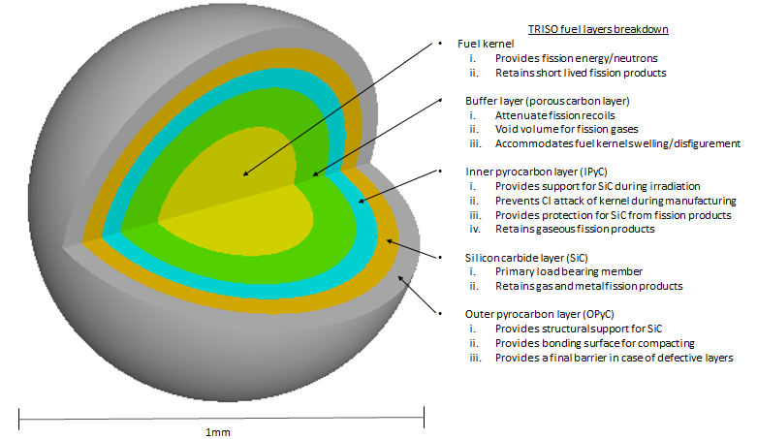
Figure 1.20 - TRISO fuel layers explanation with regards to their physical purpose [52]
From the inside to the outside a TRISO fuel particle consists of;
- The fuel kernel formed from are enriched uranium oxide. Highly enriched uranium is less common now due to proliferation risk, with the upper limit nowadays being 20%. Kernels in the past have also contained highly enriched uranium with thorium. [53]
- The buffer layer of porous Carbon is the main mechanism used for retention of gaseous FP over the lifetime of the fuel particle. Such retention capability is achieved through the layer porosity being enough to contain the FP as they are released from the fuel kernel, without the build-up of significant pressure. As fuel kernels change their shape and swell due to irradiation, this buffer layer accommodates these changes.
- The inner pyrocarbon layer is a highly dense barrier that prevents FP from escaping from the buffer layer.
- The SiC retains any FP which can escape through the inner pyrocarbon layer. For example, silver can leach out if SiC is omitted.
- The outer pyrocarbon layer protects the particle from any mechanical damage that might occur during the subsequent manufacturing and use, generally with a density of 2.2g.cm⁻³. [54]

During the use and the following storage of TRISO fuels the FP should not escape from the micro kernels, with the distribution of FP appearing as shown in Figure 1.21.
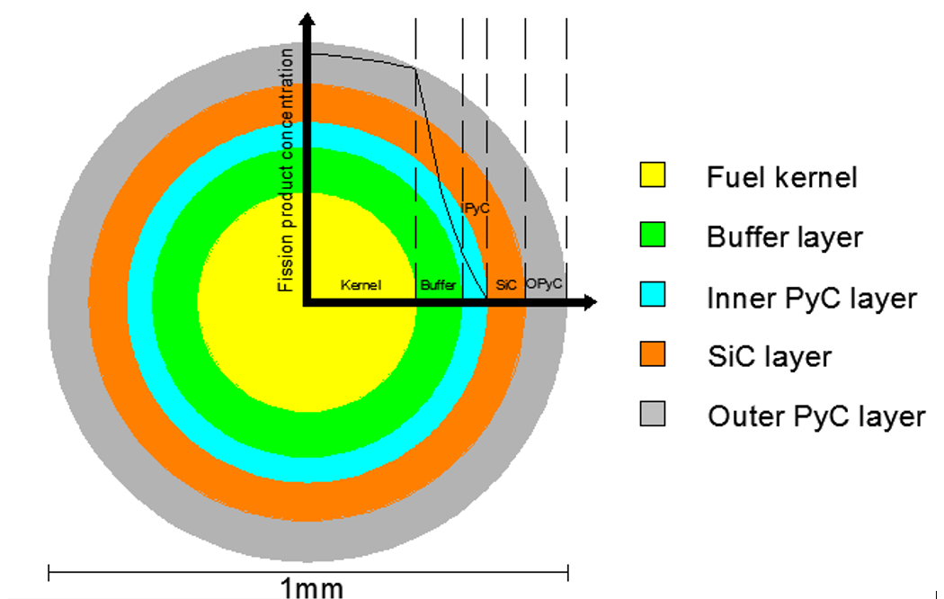
Figure 1.21 - TRISO FP distribution, highlighting the key areas that radionuclides are retained [55]
One key contributor towards the current testing of TRISO fuel is HTTR in Japan, where the fuel is extensively tested under a variety of operational conditions.
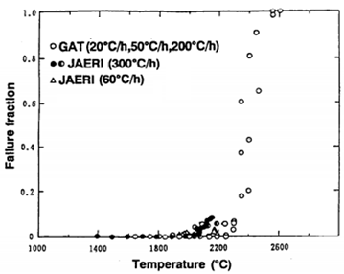
Figure 1.22 – TRISO fuel particle failure fraction rates found by experimental results at JAEA. Figure adapted from [56]
Figure 1.22 indicates that up to ~1800-2000 °C, the fuel failure rate of the currently produced and tested fuel is extremely low and thus most of FP are retained as desired. Historically there is a soft cap on the designed temperature limit at around 1600 °C, so these higher temperatures of the given experiment would be the limit under accident conditions to assure that the TRISO particles are expected to retain the FP. New reactors are designed such that the core will never reach these temperatures to ensure that under all fault conditions, no FP will be released from the fuel particles, making the reactor inherently safe [56].

HTR - Designs used
There are two types of cores used within HTRs. The first, a prismatic core, was demonstrated in the DRAGON reactor, while the second, the pebble bed core, has been demonstrated in the AVR in Jülich, Germany. Both HTR core designs are being considered for future reactors. Both reactor types have successful active working prototypes. In Japan there is a prismatic core design and China is continuing the pebble bed design. Due to the nature of the design having large graphite volumes, HTRs use the thermal energy range of the neutron spectrum, with graphite traditionally being the main contributor of moderation.

Prismatic core
The prismatic core is like a traditional AGR design, where the core is formed out of a certain number of graphite blocks which either contain fuel or act as a reflector. The fuel containing TRISO particles are mixed with graphite, acting as moderator to slow the neutrons to increase the fission cross-section. The fuel compact is a combination of graphite and TRISO particles pressed together and sintered at high temperatures form a solid compact. The compacts are then loaded as a fuel column within a fuel block and the fuel blocks form the reactor core; the process is shown in Figure 1.23. The coolant passes through holes inside the fuel block to remove heat arising from the fission process.
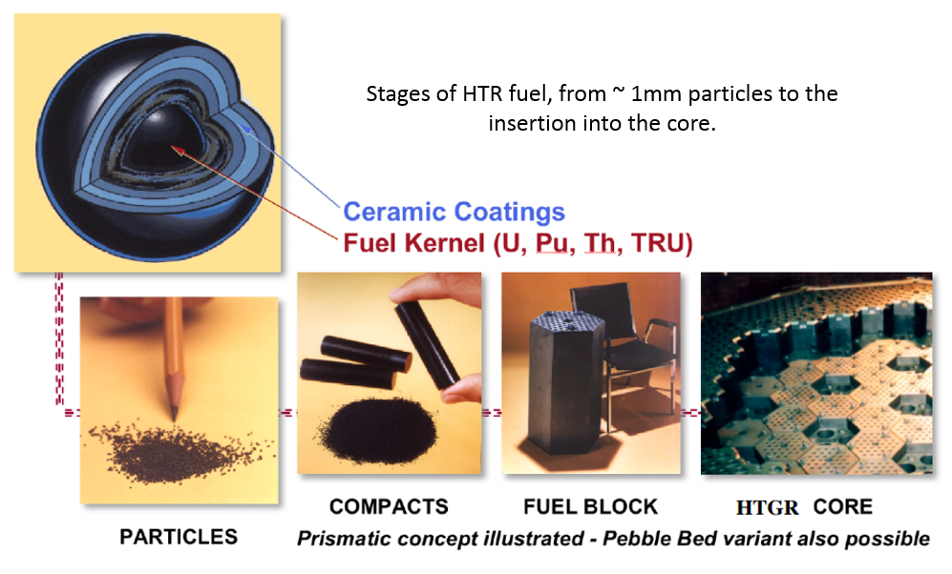
Figure 1.23 - Prismatic HTR fuel assembly design process. Figure modified from [57]
A prismatic core has advantages in that the design is simple and there are no moving parts during operation, which reduces the chances of damage and formation of graphite dust. However, a block type reactor must be loaded in a way that means sufficient reactivity is available throughout the lifetime of the core. To reduce the reaction rate at the start of operation, fixed burnable poisons are used to support the reactor control system in buffering the excess reactivity. The fuel blocks are lowered into the core arrangement, making online refuelling almost impossible due to the need to access the pressure vessel. In this design, during refuelling, the reactor would remain offline for fuel replacement, with used fuel blocks removed to interim storage and replaced by fresh fuel blocks.

Pebble bed
Within pebble bed reactors, TRISO particles are agglomerated within pebbles made of graphite, contain thousands of TRISO particles as seen in the schematic of Figure 1.24.
The outer surface of the pebbles manufactured from graphite provides a protective barrier against mechanical damage to the TRISO particles and also aids moderation.

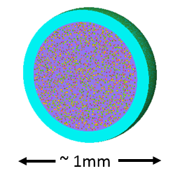
Figure 1.24 - TRISO fuel hosted within a graphite pebble as used in pebble bed designs [58]
Unlike in a prismatic core in a pebble bed reactor, the pebbles successfully wander downwards through the core so that constant refuelling can take place in a controlled fashion at the top of the core. When a pebble is released from the bottom of the core, the pebble is checked for mechanical damage and if the burnup limit has been reached. it is then either replaced by a new pebble or recirculated by being adding to the top of the core again. The design of these cores means that consideration is given to flux flattening, so to avoid hot spots, this is achieved by understanding of the positioning of the pebbles. This adds complexity to the design such as highlighted in Figure 1.25 [59].
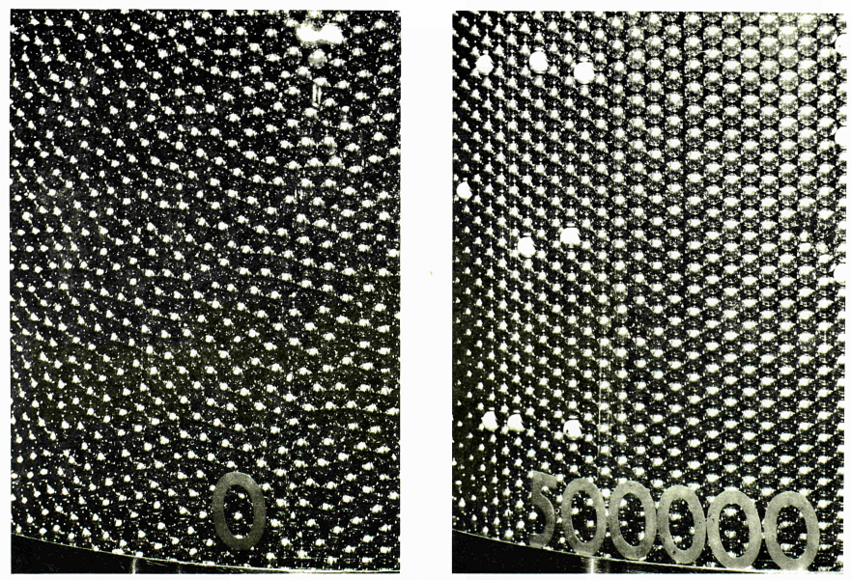
Figure 1.25 – Photographs of pebble distributions. Left, pebble arrangement after circulation, disorganised due to natural positioning. Right, pebble arrangement before circulation, stacked by humans, tight and organised.

Reflectors
Reflectors’ main aim is to increase the number of neutrons which are reflected back into the core. This is important to the design as the fuel surrounding the reflector can utilise these thermal neutrons as they pass back into the fuel blocks, often in a very thermalised state, so have a higher probability of capture. These neutrons would otherwise have been leaked out of the core, so the effectiveness of the reflectors is key to keeping a good neutron economy.
Traditionally in PWR’s water is used due to its scattering properties, as it surrounds each of the fuel rods and fills the gap between the core and the reactor pressure vessel. In a comparable way, the HTR is surrounded by a layer of material which is placed around the outside of the active core, the material is often graphite due to its ease to incorporate around graphite fuel blocks.

Aims and Objectives
The work presented here aims to provide a new conceptual design of the U-Battery with a graphite reflector, capable of providing 10MWth neutronically and operating safely for the duration of the reactor life. This method analyses the material choices with regards to reflecting material to determine the best operational characteristics. The PhD hypothesis is to create and optimise a working 10MWth U-Battery design, based on the original design specifications. To do this there are certain milestones that should be achieved:
- Create a working model of the U-Battery.
  - Determine the advantages or disadvantages of changing from BeO to graphite.
- Create a reactivity control design for the new U-Battery design.
  - Conceptually design several fixed burnable poisons designs to determine their advantages and disadvantages.
  - Undertake a feasibility study of a moveable moderator concept regarding to fuel cycle lifetime.
  - Determine if the moveable moderator will pose any benefits for the U-Battery design.
  - Determine several methods of deploying a reserve shutdown system.
- Provide basic safety features and understand the cores behaviour under transient conditions.
  - Demonstrate the core’s behaviour under fault conditions.

Chapter 2 –
The U-Battery

Evaluation on the original design
It is worth noting at this point that there have been no fixed burnable poisons, reactivity control or fuel information provided in the initial report.
The first steps were to try to reproduce this model; however, vital data was missing from the original report regarding most parts of the core, including the packing factor of the fuel, which varied between 30 and 35%. The initial predictions followed the design carefully and varied the packing factor of the fuel accordingly; the results are shown in Figure 2.1.
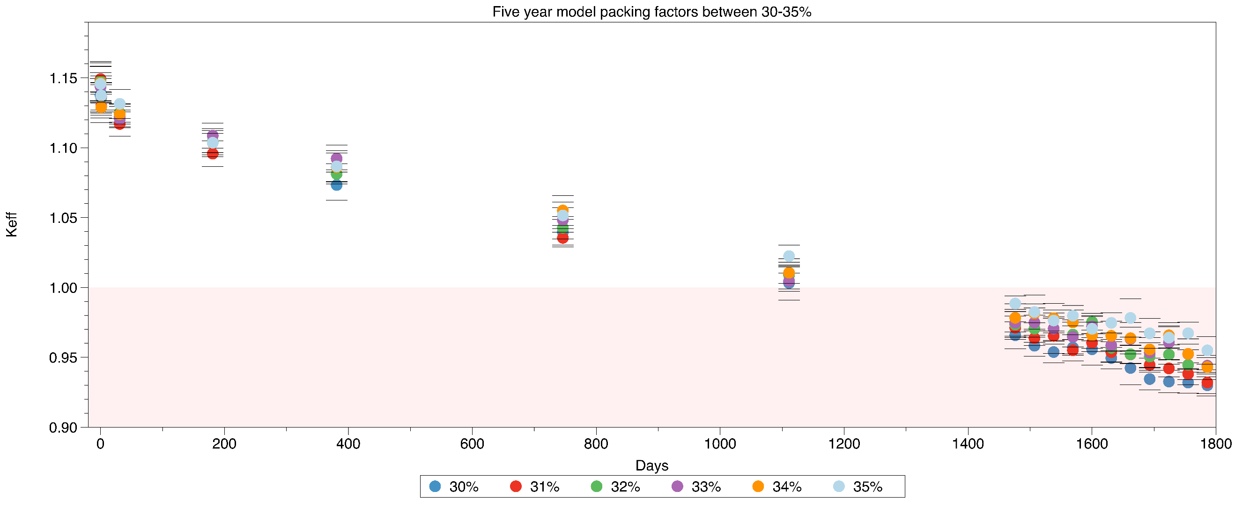
Figure 2.1 – Determining the effective multiplication factor of the original design by varying the packing factor to try to achieve a five-year lifecycle
As seen in Figure 2.1, none of the models reach the required five years of operation. All investigating fuel considerations have fallen significantly below that target. Due to the amount of days required, the contributing factor must be a significant material. A common error within engineering is to use incorrect values of graphite density. After extensive testing, the atomic Carbon density was used and produced the results seen in Figure 2.2. The results indicate a strong influence of graphite density on the achievable lifetime of the core loading.
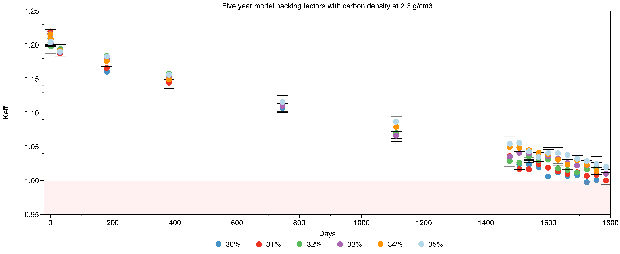
Figure 2.2 – Varying the initial design by increasing the carbon density set to 2.3 g.cm⁻³ to determine the lifecycle
Figure 2.2 provides evidence that the original U-Battery report used a graphite density of 2.3 g.cm⁻³. The graphite blocks manufacturer’s data sheets [60] provide a lower density of ~1.8 g.cm⁻³. After identifying this issue, the initial model’s results are no longer considered viable and thus the design has been restarted from this point using the correct bulk graphite density. The overall effect of using the incorrect Carbon density, with a 30% pf model, reduced the overall lifetime of the core by 706 days, thus reducing the maximum available full power days to just over three years, as opposed to the design criteria of five years.

Modelling of the U-Battery
This next section aims to provide an overview of the U-Battery design to allow for a reference model for the design.

Modelling of the fuel components
The U-Battery aims to use fuel being developed in the AGRFI experiments as discussed above. The final specifications for the fuel have not yet been confirmed; however, they are unlikely to vary dramatically from previously manufactured HTR fuel, although they will possibly be improved to perform under more challenging conditions. The typical TRISO fuel dimensions used are shown in Table 2.1.
The proposed fuel particles are very similar to those produced in the past, although some of the layers within the particles having slight deviations in the size. These are highlighted in Table 2.1.

Table 2.1 - Different dimensions of historically manufactured TRISO particles [61]. GLE is a German low enriched fuel used within the AVR reactor.
Characteristic | Pre-1985 Production |  |  |  | Post-1985 Production |  | Pebble-Bed Design Specification
Designation | GLE 3 |  | LEU Phase I | GLE 4 | GLE 4-2 | Proof Test Phase 2 | Pebble-Bed Design Specification | U-Battery
Kernel Diameter (µm) | 500 | 497 |  | 501 | 502 | 508 | 500 | 500
Kernel Density (g.cm⁻³) | 10.8 | 10.81 |  | 10.9 | 10.87 | 10.72 | >10.5 | 10.5
Coating Thickness (µm)
Buffer Layer | 93 | 94 |  | 92 | 92 | 102 | 95 | 90
Inner PyC Layer | 38 | 41 |  | 38 | 40 | 39 | 40 | 40
SiC Layer | 35 | 36 |  | 33 | 35 | 36 | 35 | 35
Outer PyC Layer | 40 | 40 |  | 41 | 40 | 38 | 40 | 40
Coating Density (g.cm⁻³)
Buffer Layer | 1.01 | 1 |  | 1.01 | 1.1 | 1.02 | <1.05 | 1
Inner PyC Layer | 1.86 | ~1.9 |  | 1.9 | 1.9 | 1.92 | 1.9 | 1.9
SiC Layer | 3.19 | 3.2 |  | 3.2 | 3.2 | 3.2 | >3.18 | 3.2
Outer PyC Layer | 1.89 | 1.88 |  | 1.88 | 1.9 | 1.92 | 1.9 | 1.87
Enrichment (%) | 9.82 | 9.82 |  | 16.8 | 16.76 | 10.6 | 7.8 | 20

Table 2.1 provides a comparison between different types of historic TRISO particle fuel with those specified for the application in the U-Battery. One difference is that the density of the fuel kernel reported in the U-Battery report is set to 10.5 g.cm⁻³ [19]. This is thought to be too low compared to historic experience and thus for fuel modelling this was increased to 10.8 g.cm⁻³.
The TRISO particles are randomly distributed within a graphite matrix to produce fuel compacts with a diameter of 1.25 cm and a height of 5.5 cm. This is a complicated process as all the particles are required to be evenly distributed so that there is a low probability of a large agglomeration of fuel, which would result in a hot spot of fission. The graphite matrix material NBG-18 has a density of 1.862 g/cm³ [62]. However, a density of 1.83 g/cm³ is used to allow the minimum bulk density to be accounted for. By underestimating the density of the graphite, the point of criticality is likely to be lower than expected.
The fuel compacts are formed using a thermosetting resin-based matrix, like that used in Germany, although the final method has not been decided. The fuel compacts are placed one on top of another in the fuel channels within the graphite blocks. There will also be a small radial helium gap to allow for deformation of the fuel compact due to radiation damage, swelling and expansion of the graphite. For modelling purposes this radial gap is ignored, because the helium within it has very little effect on neutron physics. To bridge this gap, the fuel is smeared across the full fuel channel in the calculation. Smearing is when the material’s density is reduced proportionally depending on the variation in volume; in this case the density of the graphite matrix is reduced. Equating the masses between the increased volumes allows us to take the change in the average density into account by reducing the density from 1.83 g.cm⁻³ to 1.745 g.cm⁻³
The fuel temperature is aiming to reach an average outlet temperature of 750 °C. Serpent requires the inputs in Kelvin, so all fuel is modelled at 1024.13 K as average value. This is not physically correct at all places, as the fuel at the top of the core is a lower temperature due to being of the vicinity to a lower temperature coolant. This tends to lead to a slightly axially off-centre power curve in the core. However, for a preliminary analysis 1024.13K provides an accurate first indication.

Coolant
The coolant in the U-Battery is helium; this was decided in a PhD thesis which determined that the NBG-18 graphite for the fuel compacts oxidised rapidly at temperatures over 600 °C when using CO₂ as a coolant [63].
Helium, like most gases, suffers from low thermal conductivity. However, the use of gas does have its benefits; helium does not carry any risk of chemical reactions or phase changes in the way water does and it has a lower capture cross-section. This makes helium more chemically and neutronically inert than water.
Urenco provided an estimate for an initial inlet temperature of 400 °C and an output temperature of 750 °C.
The density of the coolant increases as a function of the pressure in the system. The whole reactor pressure vessel has an elevated pressure of 40 MPa, which increases the density of the gas according to equation (2.1) [64].
 | $$ρ=0.17623 \frac{P}{T/To} {\left[1+ \frac{0.53x {10}^{-3}P}{{\left(T/To\right)}^{1.2}} \right]}^{-1}$$ | (2.1)
The density of the helium changes depending on its position in the coolant channels, due to the increase in temperature at the bottom of the reactor compared to the top. So a median value between the temperature ranges must be set as its density. This equates to 575 °C, which gives an average density of 3.32 g.cm⁻³.

Fuel block
The U-Battery’s analysis on graphite was significantly more detailed than that of the neutronics and provided the data on the graphite used within the side reflector, fuel blocks and central reflector [19].
This density (1.8 g.cm⁻³) and the thermal conductivity (133 W.m⁻¹. k⁻¹) information was used for modelling the U-Battery. One benefit of using graphite is that it is predictable, because it has already been used in nuclear reactors since the Manhattan project in 1942. It is currently used in the fleet of nuclear reactors in the UK. Extensive research has been undertaken into extending the lifetime of nuclear plants and part of this includes predicting the condition of graphite under irradiation. This research has made graphite one of the most well characterised substances in the nuclear industry.
The fuel blocks in the U-Battery (see Figure 2.3) are in the shape of hexagons and the overall width across flat is 36 cm, allowing for the exact area and the volume to be calculated. In the case of the U-Battery, the fuel blocks are 80 cm in height, with four fuel blocks axially stacked on top of each other, giving a total active core height of 320 cm. The hexagonal lattices structures have traditionally been used because of their ability to interconnect with each other and due to the possibility of creating a pseudo circular core structure.
The fuel blocks and compacts are modelled using their whole active height of 320 cm; it is accepted that small gaps between graphite blocks are often inherent to the placement of the fuel blocks. Due to the shrinkage as well, as the expansion of the graphite, these gaps are inconsistent and impractical to model so they have been omitted from the neutronic design as their contribution is minimal.
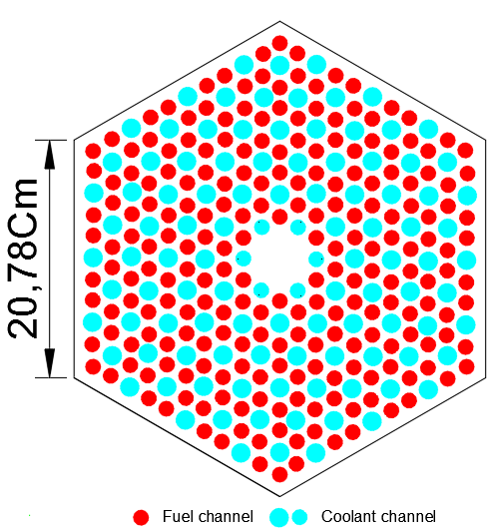
Figure 2.3 – A radial fuel block design with 216 fuel channels and 108 coolant channels.
The fuel block is one of the most challenging regions to predict the temperature in, due to the inlet flow of coolant at 400 °C and the fuel temperature of 750 °C, giving the fuel block a large range of temperatures. For this reason, the average fuel block temperature has been estimated and is modelled at 700 °C, because the coolant at the bottom should reach around 750 °C, indicating that the mean temperature of the fuel block will be significantly higher than at the top.

Central reflector
The central reflector is made of the same graphite as the fuel block and has the same dimensions. The key function of the central reflector is to slow the neutrons as they pass through the centre of the core. The annular core depicted in Figure 2.4 benefits from the neutrons entering the central reflector and then either reflecting into the same fuel block or passing through the central reflector to another fuel block at a reduced speed.
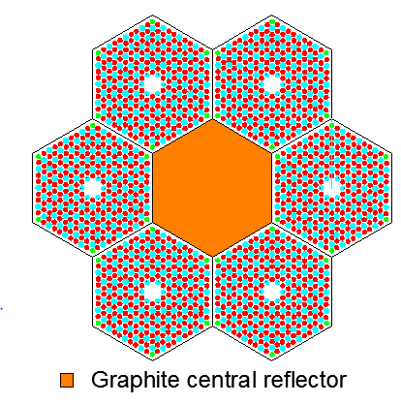

Figure 2.4 - Annular core with the six fuel blocks arranged in a hexagonal array around the central reflector
The central reflector is also assumed to be at 700 °C, because the proximity to the fuel channels is much closer than that of the coolant and the increased temperature will reduce the moderation. The effect of radiation damage will be at its maximum in the central reflector due to the peak fluxes in the centre of the core.

Reflectors
BeO was chosen instead of traditional graphite was due to its superior scattering cross-sections as shown in Figure 2.5, which promise that the dimension of a reflected core can be significantly reduced compared to graphite.
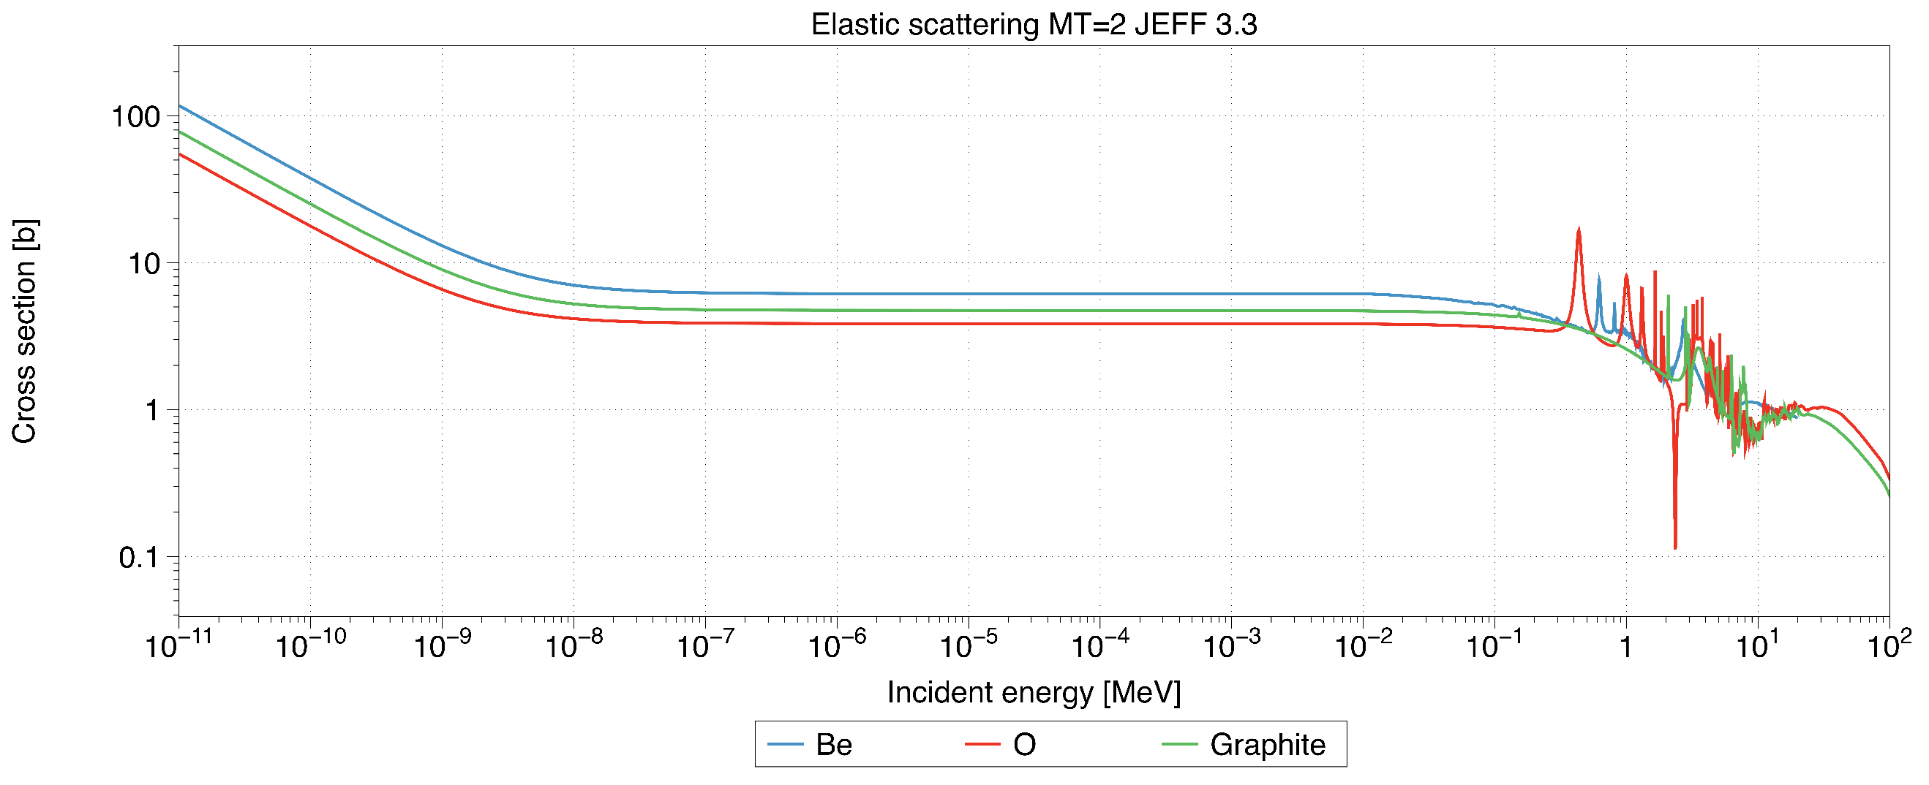
Figure 2.5 - Elastic scattering cross-sections of BeO and graphite across the full energy spectrum
Compared to nuclear grade graphite, BeO is expensive, with a cost of 265 €/kg compared to 65 €/kg for nuclear graphite [19].
The proposed graphite side reflectors are formed in the shape of hexagonal blocks, sharing the same dimensions as the fuel block and central reflector as shown in Figure 2.6. Additional pieces are required to transform the hexagonal structures to the cylindrical vessel shape.
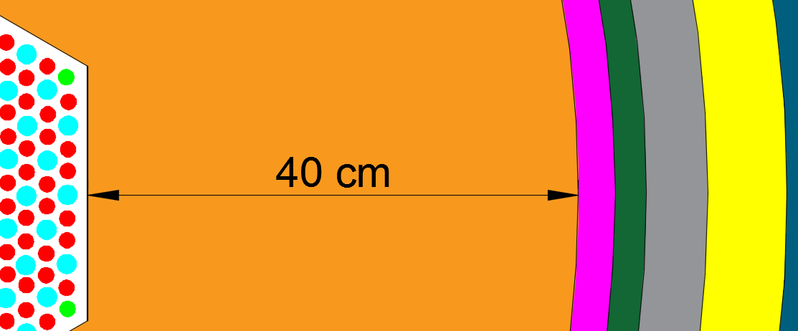
Figure 2.6 – The new graphite reflector dimensions from the fuel block to the side reflector
The top and bottom reflectors are also made of graphite. It is important to keep the volume of these as similar as possible to maintain an equal neutronic performance between the top and the bottom, so as not to experience higher burn up at either axial end of the core. The height of these was 50 cm.

Thermal insulation (Figure 2.12, pink)
The thermal insulation is required to protect the barrel’s temperature from rising too high, to abide by ASME regulations. The thermal insulation information was provided by Urenco with an estimated thickness of 3 cm across the centre line of the core to reduce the temperature load during normal operations on the barrel. The material of the thermal insulation is porous graphite, with low thermal conductivity at around 0.23 W.m⁻¹.K⁻¹.
The thermal insulation surrounds the whole core; however, the depth has not been fully researched, and this could cause some concerns regarding the operating temperature of the barrel.

Barrel (Figure 2.12, green)
The barrel is used to keep the inside core mechanically stable. The design aims to minimalise the temperature and the neutron damage to the barrel in order to achieve an operational lifetime of 60 years. ASME currently are being commissioned by the NGNP to evaluate steels for HTRs, which could influence the selection of steel for the barrel before the production of the first U-Battery. ASME have limited the operating temperatures of steels to ~425 °C due to the steel starting to show signs of graphitisation at higher temperatures [65]. The barrel’s temperature is assumed to be limited to 400 °C and the density is estimated to 8 g.cm⁻³.

Helium gas gap (Figure 2.12, grey)
Helium is enters the bottom of the core and flows up the vessel to the top of the core, where the helium inlet in the core is located. The reason why the helium is flowing upwards the side of the reactor is to aid the cooling of the barrel and the RPV. The helium gap will also accommodate any swelling of the core over time, with the expansion happening due to elevated temperatures and the creep through the life of the core.
The helium in this part of the core is similarly pressurised as that inside the core, so has an elevated density, as previously mentioned. The temperature of the helium will be lower than that of the inlet temperature and a limited heat up will occur while passing axially up the helium gap. However, due to the small change, the helium is simply modelled at the inlet temperature.

Reactor pressure vessel (RPV Figure 2.12, yellow)
The reactor pressure vessel is the largest component of the reactor. This houses the core and connects the primary circuit and all the primary components to the core. The RPV keeps the core pressurised and must be kept within operating conditions for the duration of the reactor’s lifetime. The mechanical design of the RPV is difficult due to the requirements to host the control rod drive mechanisms, reserve shutdown system and refuelling machine.
The RPV is modelled as a cylinder, as opposed to its traditional shape, which has negligible impact on the neutronics. The steel used in the initial report was not definitive or justified, so this has been revised and will be updated in the new design. However, the density is assumed to be the same as the barrel at 8 g.cm⁻³.
The 10 MWth version of the U-Battery was reported in the initial report from Urenco, but a lot of key information was missing regarding the design. From this basic information, a basic design was constructed and adapted accordingly.
There are several key features that Serpent requires to produce the neutronic data for the area for each material. These are density, temperature, volume (if a burnable material) and material composition. This information is used to determine the probabilities of each reaction inside that material during the neutron transport calculation. The following section of the report aims to justify the selection of the data used in the modelling for Serpent.
The overview of this section will undertake an analysis from the internals of the core, spanning outward to gain an understanding of the process used to fill the information gaps.

Overview
The removal of the BeO came at a large physical cost to the U-Battery design, with the overall size increasing dramatically. The total height has risen by 100 cm and the diameter has increased by 42 cm.
The new, more detailed design allows for more accurate modelling of the core, due to finalised design decisions for the cooling system and the additional design of the housing room of the U-Battery. The overall dimensions for reproduction purposes are found in Tables 2.2 – 2.5.
Table 2.2 - Radial new design dimensions used in the following models
Core Attribute | Thickness (cm) | Radius of core used (cm)
Active core | 108
Graphite side reflector | 40 | 94
Graphite insulation | 3 | 97
Barrel | 2.54 | 99.54
Helium Gap | 5 | 104.54
RPV | 5.6 | 110.14

Table 2.3 - Axial new design dimensions used in the following models
Axial attribute | Size (cm)
Total core height | 678
RPV height | 667
Air gap height | 420
Barrel height | 420
Thermal insulation | 420
Helium top area | 183
Helium bottom area | 67
Graphite top reflector | 50
Graphite bottom reflector | 50
Active core | 320
Table 2.4 – Summary of the material and specifications used in the new model for all simulations
Component | Material | wt% | Density (g.cm⁻³) | Temperature (K)
Fuel | ²³⁵U | 0.18 | 10.8 | 1023.15
Fuel | ²³⁸U | 0.70 | 10.8 | 1023.15
Fuel | O | 0.12 | 10.8 | 1023.15
Fuel | Buffer | 100.00 | 1 | 1023.15
Fuel | IpyC | 100.00 | 1.9 | 1023.15
Fuel | Si | 100.00 | 3.2 | 1023.15
Fuel | OpyC | 100.00 | 1.87 | 1023.15
Matrix | C | 100.00 | 1.75 | 1023.15
Coolant | He | 100.00 | 0.0033 | 674.15
Central Reflector | C | 100.00 | 1.8 | 973.15
Side/top/bottom reflector | Be | 36.04 | 3.05 | 873
Side/top/bottom reflector | O | 63.96 | 3.05 | 873
Thermal insulation | Si | 70.05 | 3.2 | 673
Thermal insulation | C | 29.95 | 3.2 | 673
Side coolant | He | 100.00 | 0.0033 | 674.15
Barrel/RPV | Ni | 15.13 | 8 | 673/300
Barrel/RPV | Cr | 0.19 | 8 | 673/300
Barrel/RPV | Mo | 25.98 | 8 | 673/300
Barrel/RPV | Fe | 15.12 | 8 | 673/300
Barrel/RPV | Si | 7.61 | 8 | 673/300
Barrel/RPV | Mn | 14.88 | 8 | 673/300
Barrel/RPV | C | 3.25 | 8 | 673/300
Barrel/RPV | P | 8.39 | 8 | 673/300
Barrel/RPV | S | 17.07 | 8 | 673/300

Paper overview - A comparison between BeO and nuclear graphite in a small-scale high temperature reactor (See Appendix 7.1)
During 1.2.2 the choice to make the choice to change the 10MWth designs reflectors from the original BeO to graphite was made. This decision was taken due to the ease of using graphite and the relaxation of the size requirements by the consortium.
This paper investigates the consequences of this decision by evaluating the two materials closely together to determine which material performs better in the application for this high temperature reactor design. The evaluations originate from the basic thermophysical properties, which do not indicate a significant difference between one another, except with the slightly higher thermal conductivity of the beryllium. The increased thermal conductivity will be slightly beneficial under fault conditions, but during normal operation it would require additional thermal insulation.
The initial test performed was based on creating an equivalent model from neutron physics’ point of view between graphite and BeO reflectors. The same core criticality performance was achieved by increasing the top and bottom reflectors by 75% and the radial reflector by 23%. This additional size came at a mass increase of 12 tonnes.
Simulations were undertaken to determine if there were any long-term differences in core lifetime performance regarding the use of different reflectors. Over the fuel cycle, it became apparent that there was a slight improvement in the criticality curve in the case of the graphite reflector. This could lead to a small gain in full power days.
The final test investigated the influence of the reflector choice on the initial power profile, with the aim of reducing the power production in the highest loaded pins. There was a slight decrease in the power production in the hottest pin when of replacing the beryllium reflector with the graphite reflector, but this was not significant enough to be determined as a real advantage. The analysis of the axial power distribution did identify a slight power increase towards the top and bottom of the pins when using beryllium, due to the additional axial reflectors and a slight power increase in the centre for the graphite case. A detailed analysis of the 3D power distribution over burnup would be the next step to gain a more detailed understanding. However, the computational demand would be very high and thus this step, traditionally performed in a later stage of detailed and well-developed design has been achieved.
The main finding of the paper was that the significant additional cost of beryllium did not provide sufficient benefits towards the system.
Author contributions:
- S. Atkinson – Simulation work, data collection, data analysis, writing
- B. Merk – Manuscript review, study design
- D. Litskevich – Manuscript review

Chapter conclusion
This chapter has assessed each of the components within the U-Battery and has provided a detailed overview of the original and updated U-Battery design. One of the main issues that was discovered was that the original U-Battery design claimed to allow for a five-year fuel cycle, but this could not be replicated using the original design’s criteria. It was determined that similar results to the original report could be obtained if the theoretical density of graphite was used. This would be a significant overestimation, as the model inputs should represent the manufactured density.
The end of this chapter investigated the use of BeO in comparison to graphite as a side reflector material. This investigation concluded that when using graphite, the overall volume of the core would be significantly larger with an increase of 75% in the top and bottom reflector and another 23% in the radial direction to obtain the same neutronic effect when using graphite. However, the overall cost would still be 49.5% cheaper, saving 3.21 M€ on structural materials of the graphite design due to BeO’s excessive cost. Thus, the following sections continue with a graphite side reflector.

Chapter 3 - Optimisation of the U-Battery

Designing the U-Battery control
Due to the U-Battery not having a fully functioning neutronic design for the 10MWth version, the core has been re-designed to meet reasonable design criteria. To account for this, a full design review has been carried out, based on the investigation of different reflector types given above and the development of a control scheme. The next sections discuss the new design chosen on best performance. It is important to understand that any change to the design will influence another part of a core, so the rationale will be explained for some major sections, including reactivity control, fuel rotation, reserve shut down system and control rods.

Excess reactivity control
The excess reactivity is the criticality reserve which is inserted at the beginning of life of the core. This assures maintaining a critical system for the lifetime of the reactor core, indicating that the K_{eff} must be above unity during all stages of operation time. To allow for this, there are existing techniques which are commonly used in nuclear reactors to control the excess reactivity. For an LWR, these include:
- Addition of boron into the coolant
- Control rods
- Temperature and density coefficient
- Fixed burnable poison (FBP)
The aim of an economic and safe reactor design is to identify the different approaches and the building blocks, in order to assure a reasonable power distribution in the core, enough shutdown margin and acceptable inherent feedback effects.
From the neutron transport equation, the K_{eff} can be kept to unity by reducing the number of neutrons within the system by removing excess neutrons. Removing neutrons can be achieved by either parasitic absorption or leakage does affect the neutron economy and thus the cost of reactor operation; however, a runaway in criticality has catastrophic consequences. Reducing the number of neutrons produced by the fissile material limits the lifetime of the core, thus the economics of the fuel cycle, because there will be a limit in the neutron reserve required for the long-term operation.
In the case of PWRs, reactivity control is applied in two major ways. The addition of ¹⁰B into the coolant, which has a high neutron capture cross-section and turns into an inert ¹¹B. Also, by the insertion of the so-called grey control rods, which capture neutrons through the steel and boron at a cost of degrading the control rod. However, the insertion of the control rods is limited due to the power distribution effects, as well as the safety reasons. The amount of boron which can be added is limited due to the influence on the feedback effects. These limitations lead to the insertion of burnable poisons into some special fuel rods, to be able to deal with these limitations and simultaneously to assure as high as possible burnup of the fuel. Temperature and density control are two key factors in the operation of boiling water reactors, due to the phase change of the water, which effects both neutronics and thermal-hydraulics. As the temperature of the water rises, the moderation effect decreases due to the expansion of the water and the increase of void content, thus allowing fewer neutrons to reach the thermal range. As the temperature increases the capture cross-section of ²³⁵U decreases, reducing the probability of fission.
For the U-Battery, including boron to the coolant is not an option. This is due to the coolant being a gas, which is much harder add heavier elements to due to the solubility reasons. However, the option of FBPs exists, meaning the poison will sit in the core and degrade over time by capturing neutrons and turning into a non-absorbing material. The control rods are easy to incorporate within the design and will be required for control as well as shutdown. The graphite reflectors also contain a similar temperature feedback as water, but the effect is rather limited and hard to be tailored. However, the application of a moveable moderator, to reduce the moderation for specific parts of the fuel cycle, is analysed here.
In AGR reactors there are two types of control rods, namely grey rods and black rods [66]. Grey control rods have a low quantity of natural B₄C in ~3.5%; these are used to aid power fluctuations by moving through the core. The power profile is not changed significantly when moving the grey control rods, due to their low absorption effect and thus the small impact on the reactivity. The black control rods are used to completely absorb all neutrons which pass through them; these are used for shutting down procedures and might be slightly inserted during the start-up procedure.

Control rod design
Control rods provide a variable amount of control for the reactor through neutron absorption. Some control rods follow the criticality of the system and vary automatically to compensate for a change in recorded reactivity. Other control rods are used to reduce the power of the system, such as turning down for load following or shutting down the reactor for maintenance.
Control rods are usually inserted from above the core to produce a failsafe feature, allowing gravity to aid the control rod’s insertion into the core if electrical power is lost. For the scope of this project, the rods are only considered within the active core and the reflector, as the effect is minimal when held above the outside reflector. However, a massive insertion of the control rods to reduce excess activity will disturb the power distribution and reduce the fuel lifetime, due to the absorption of neutrons.
The control rods in a HTR must be maintained at high neutron fluxes and must be able to withstand peak temperatures during a loss of coolant accident (LOCA) event without degrading. This requires a material with enough stability, up to an upper limit of around 1873.15 K (1600 °C), with preference for materials with an existing nuclear safety case.
The AP1000 uses Silver-Indium-Cadmium alloy [67] as an absorber and control rod material; the alloy is strong enough to withstand mechanical and radiation damage in a LWR. However, the Cadmium is reported to vaporise at temperatures above 1173 K, [68] which is a temperature highly likely to be seen within a HTR, meaning this is not a viable option.
Other poison materials are well known and their behaviour is easy to predict, as these elements have similar cross-sections to that of fissile materials, just with higher absorption cross-sections. A few to be considered include B₄C, ZrB₂, Gd₂O₃ and Er₂O₃ [69].
Table 3.1 – Various control rod materials and information to allow for choice in the U-Battery design.
Material | Melting temperature (K) | Safety case ready | Long transmutation chain
B₄C | >2700 [70] | Yes | No
ZrB₂ | 3518 [71] | No | No
Gd₂O₃ | 2573 [72] | Yes | Yes
Er₂O₃ | 2773 [73] | No | Yes

Fortunately, all the presented materials are above the maximum operating temperature of 2000 K. The next issue is regarding the safety case, as only two of these materials have been used before within nuclear reactors in the UK. Gd₂O₃ rings are attached to the fuel rods in the AGRs and B₄C has been used in AGR’s control rods. This gives both materials an advantage over the others due to the simplicity and availability of these materials within nuclear scenarios. Another factor is the decay chains ¹⁰B transmutes to ¹¹B, which has a very low capture cross-section, after a single capture. However, Gd₂O₃ has a long chain, with initially ¹⁵⁷Gd capturing a neutron and its isotopes also carrying poisoning attributes, meaning they will be within the control rods for significantly longer.

Fixed burnable poisons
FBPs are burnable materials that possess a large capture cross-section, like the control rods. Using careful placement of small amounts of FBP reduces the neutron population within that region for the lifetime of the FBP. The centre of the core or high-power rods in the fuel assemblies are the location for the insertion of FBPs, because they reduce reactivity and flatten the power distribution. This saves the fuel from burning too quickly when high excess reactivity is not required.
In HTR designs, the FBPs are often placed in graphite mixtures such as the fuel compact and compressed, allowing for insertion alongside or in the same compact as the fuel. FBPs have the added advantage of being able to be placed anywhere in the core, allowing for their inclusion in some regions which would be inaccessible during operation, allowing specific areas to have their contribution to the power production reduced without affecting other surrounding areas, like an invasive control rod. However, burnable poisons will act in the core as a neutron absorber and thus will have a negative effect on the fuel lifetime.

Temperature feedback
Serpent is operated using a steady state simulation, meaning that temperatures for a material are defined at the start of the simulation and then the material’s cross-sections are generated. This means that the self-regulating procedure seen by changes in temperature is not visible, as the temperature is fixed during simulations since there is no thermal calculation provided.
In the case of the fuel, this is expected to be 1024.13 K due to the desired output temperature being around 750 °C. This does influence the criticality of the reactor and will stabilise the reactor operation due to the Doppler broadening effect, as even a small temperature change to 900 K, has a clear either on the k_{eff} of the system, as shown in Table 3.2;
Table 3.2 - K_{eff} variance with varying the fuel temperature within Serpent between 900 and 1024.13 K
Day | K_{eff} at 900K | RSE | K_{eff} at 1024.13K | RSE
0 | 1.2003 | 0.0007 | 1.1943 | 0.0012
1 | 1.1864 | 0.0009 | 1.1818 | 0.0009
31 | 1.1727 | 0.0008 | 1.1682 | 0.0011
181 | 1.1534 | 0.001 | 1.1453 | 0.001
381 | 1.1285 | 0.0009 | 1.1247 | 0.0009
746 | 1.0861 | 0.0009 | 1.0813 | 0.0009

Moderator manipulation
The application of moderator manipulation, as it is applied in boiling water reactors (BWR) by changing the speed of the internal recirculation pumps, seems to be another promising approach for HTRs. However, the process won’t be as easy as in a BWR because a solid moderator is applied in HTRs. Thus, the design cannot rely on a simple density change like in the case of evaporating water. In fact, in a solid moderated reactor, a physical piece of the moderator would have to be moved into or out of the core. This requires the introduction of a passageway at the ideal place of the core (most likely the central reflector column) and a drive mechanism to move the moderator. However, moderator manipulation typically comes with the promising side effect of breeding plutonium, which can be utilised for additional power. The reduction in criticality is achieved by changing the flux spectrum; this promotes breeding, as opposed to traditional methods with FBPs where poisons completely remove neutrons, with no further potential benefits.

Reactivity control designs
When considering reactivity control, the three following aspects were considered;
- Control rods
- Fixed burnable poisons
- Moderator manipulation
All three aspects have direct impacts on each another, so they have to be considered in conjunction with one another. There are a few considerations in relation to the U-Battery that limit some of the options available.
One main concern regarding the U-Battery is the fact that the fuel compacts are currently undergoing testing as part of the NGNP; these compacts do not include poisons in the matrix. From a licensing perspective, the experimental data provided by the NGNP would be put towards the safety case and any adjustments to the fuel compact could see the NGNP performance data not accepted by the regulator. This meant that fuel licensing would be much more difficult if the FBPs were added to the fuel compacts, implying this would impede the speed of deployment, so this was not considered as an option in the initial design.
The refuelling mechanism requires access to the whole central reflector column when refuelling. During normal operation this would not be a problem, however, during the refuelling procedure control rods must be fully inserted to reduce the reactivity or completely turn off the reactor. Thus, the central reflector cannot be used for locating the control rod system even if the highest flux in the core is in the central reflector, which would create the highest impact for the control rods and allow for maximum symmetry across the core. Thus, the given mechanical restriction implies a limitation regarding the most appropriate location for the control rods. In addition to this, the centre of each fuel block is used by the fuel handling machine to grip onto the fuel block, so these positions are unavailable for control rod insertions too, if the design uses the proposed fuel block.
The U-Battery is also limited with regards to places to insert the control rods, due to the small size of the core; anywhere where control rods are placed will affect the symmetry of the power distribution. From a reactivity control perspective, it is desirable to keep the core symmetrical due to the nature of the power profile, which is directly related to the flux.
Reactivity control is a challenging subject and the optimisation of multiple techniques, used in conjunction with one another, must be evaluated. The first case to be examined is a novel new approach into the concept of moderation manipulation. The concept of reducing moderation to allow for a “storage like” situation within the fertile ²³⁸U, leading to fissile ²³⁹Pu. In the case of the U-Battery, the annular core makes this option viable and even shows a small amount of increase in full power days operations. A patent has been filed (16/7/2018) on the work included in this article.
The reactivity control optimisation is far from finished when only the moderation and reactivity control article have been changed, which explains the methods used to complete the reactivity control interplay within the U-Battery system. However, this work concludes that compared to the base model, the total amount of lost full power days (due to parasitic absorption in the burnable poisons) is completely compensated. This is achieved by the “neutron storage” due to moderator manipulation, not including the losses where the control rods are inserted.

Variable reactivity control in small modular high temperature reactors using moderation manipulation techniques. Paper review
A patent application has been filed (16/7/18) for the work undertaken in this article
This paper investigates the use of changing moderation in the system to perform a reduction in reactivity. This is a positive step; instead of the neutrons being lost in poisons or control rods, they are being effectively stored in the fertile ²³⁸U, with the aim of reusing the neutrons once they have formed into fertile ²³⁹Pu. This method is already implemented in BWRs by changing the void content in the core. However, this is the first time this methodology has been applied to HTRs.
The variable moderation is proposed in the form of a cylinder removed from the central reflector. This cylinder can be removed from the core through a passageway and then later reintroduced. This is particularly useful during the time of peak reactivity within the system at ~700 days. In addition to this, as the central reflector is variable, it appears that there is no need for a limit on the minimum reactivity reserve (as required with FBPs). This is to ensure that, in the case of the core becoming subcritical, the reinsertion can make the reactor critical again.
The first test investigated the criticality of the system using poisons. We aimed to provide a curve with the criticality above 1.02, which would be held on the control rods. The moveable moderator was implemented once the core became near subcritical. This showed that a full power day increase of one increment (31 days) was achieved. This was achieved simply by producing more fissile material through the breeding of plutonium. To determine how this hypothesis can be confirmed, the composition of the fuel pin in the centre of the core was recorded to evaluate the plutonium build up. At the point of reinsertion, the plutonium atomic density’s build-up reduced, thus showing the hypothesis was correct.
One of the key aspects investigated was the power distribution, as the central pins provided the highest power in the original design with the massive central reflector. Once the central reflector was removed, the power distribution shifted to the outside of the core, close to the side reflector. This is particularly useful when considering that the loading of the pins is now variable. This method will allow for a better burnup across the core because once the central reflector is inserted the central pins will once again provide the highest power.

Author contributions:
- S. Atkinson – Simulation work, data collection, data analysis, writing
- B. Merk – Manuscript review, study design
- D.Litskevich – Manuscript review and support

Reactivity control for prismatic core high temperature small modular reactor, including fixed burnable poisons, spectrum hardening and control rods. Paper review
Several methods of reactivity control have been investigated in this manuscript, with the aim of finding a workable configuration to compensate for the excess reactivity of the system. The initial investigation aims to provide a base line of maximum full power days for the reactor by not including poisons. This zero-case managed to achieve a maximum amount of full power days of 1362, days but with an initial criticality of ~1.20. This criticality means that there is a massive excess of neutrons being produced within the system, which is taken away by the normalisation of the fission source in the calculation. However, for a real reactor operation, the system criticality needs to be significantly reduced to achieve unity.
A range of three different poison designs were implemented to determine the most appropriate one. Design 1 was able to reduce the initial criticality to the lowest point without breaching the soft limit of 1.02 (criticality reserve), at which the control rods would be used to reduce the criticality. This design aimed to focus on reducing the flux close to the centre and the side reflector by adding thin sleeves of Gd₂O₃ around the compacts close to the reflectors.
It was noted that with Design 1, there was still a significant peak in reactivity at ~700 days, as at this point, the thin sleeves were burnt out of Gd₂O₃. 20 cm rods of 0.4 cm radius were added to specific fuel compacts to reduce this peak. This was effective, but, the penalty on the overall lifetime of the reactor was significant, so only two rods per fuel block were included in the final design.
The final reduction investigated the concept of spectrum hardening as complementary control concept. This approach used a moveable central reflector which changes the moderation across the centre of the core. This in turn reduced the probability of fission, as there were fewer thermal neutrons within the core. In addition to this, a slight increase in plutonium production, which is later used to prompt more fission and increase the fuel lifecycle.
Overall the reactivity was reduced with the inclusion of poisons and flux hardening. The FBPs reduced the overall lifecycle, however, the breeding increased the lifecycle, and this balanced out to equal the base model’s full power days of 1362.

Author contributions:
- S. Atkinson – Simulation work, data collection, data analysis, writing
- B. Merk – Manuscript review, study design
- D.Litskevich – Manuscript review and support

Prismatic core high temperature reactor fuel modelling incorporating fuel rotation. Paper review
During the refuelling process there are several reactors which partially refuel the core. This allows for a longer burnup, due to the additional fissile product which has been introduced because of the new fuel. In the case of HTRs, this practice has not been implemented within prismatic core designs. This paper investigates the effect of rotating the fuel blocks to determine if any additional lifetime can be obtained.
This paper investigates axial and radial fuel rotation through a variety of angles. The initial hypothesis predicted that returning the freshest fuel to the centre would increase the overall burnup on the core, but, this was not the case. The fresh fuel provided a better return on investment when it was not axially rotated due to the poor fissile rate at the edges of the core.
The overall conclusion was that applying a radial rotation at the midpoint in the fuel lifecycle provided a saving of 41% of the overall fuel costs. This might not be well-suited for the remote location of the device, but from a purely economic perspective the option is available.
In the case of once through lifetime, this concept was brought forward for further design analysis and was not implemented and was left for the final design process. The fuel loading strategy would be implemented in the next stages of the design process.
Author contributions:
- S. Atkinson – Simulation work, data collection, data analysis, writing, study design
- K.R. Whittle – Manuscript review
- J.S. Dean – Manuscript review
- T.J. Abram – Manuscript review

Reserve shutdown system (RSS)
The RSS is designed to shut the reactor down in the case of an accident with the worst possible conditions. The worst possible conditions mean the control rods have been removed at the point of highest criticality (day ~700) and the central reflector is inserted.
The RSS principle is flooding the reactor with poisons to shut it down at a speed that would cause minimal harm to the reactor as well as to the working personnel. In the case of the HTTR, the RSS uses hoppers filled with B₄C spheres. In the case of RSS deployment, the hoppers will release the spheres into the core causing it to shut down [11]. The hoppers are placed above the core on top of the RPV with guide tubes placed into the core to direct the descending spheres into their allocated positions.
The U-Battery will probably require a diverse RSS to pass regulatory approval. There is very little information on the requirements with regards to criticality and deployment time that the RSS must abide by. In this instance, the aim is to find a suitable RSS that allows the reactor to safely reach sub-criticality. When not in operation, the RSS will act as a hole in the system filled with helium, thus slightly removing moderation due to the reduction in graphite volume.

Methodology
The RSS needs to be placed in a specific location to have a high effect on the flux, to reduce it as fast as possible. This implies that the RSS should be in a central position. One of the main concerns regarding the RSS is regarding seismic events. In a prismatic core reactor, the chance for the fuel and graphite blocks to slide and twist could impede the deployment of the RSS. This could reduce the total amount of deployable poisons in the case of an accident and could cause the reactor to not become subcritical. For this reason, the design will use extremely small boron spheres (0.08 cm diameter) which reduces the speed of deployment. However, in the case of fuel block twisting, this approach will decrease the available deployment volume as highlighted in Figure 3.1.
The chance of the hole being blocked is significantly smaller in the case of using smaller spheres, due to more movement having to occur to fully block the channel as highlighted in Figure 3.1.
Currently there is no method within Serpent for the particles’ distribution to be placed from the bottom up, with the next particle lying onto the previous layer. Therefore, the only method for modelling this is to look at the case when the RSS is triggered. Randomly dispersed spheres are dropped onto each other and in this case the maximum packing factor is ~64% [74]. However, in an emergency case the minimum value would be preferred. In this case, the very conservative 40% packing factor is used to cater for either a slow deployment or a semi impeded RSS channel. A homogenous mixture of helium and B₄C is used to represent the RSS channel, with 40% of the volume being represented by B₄C, giving the homogenous mixture a density of 0.948 g.cm⁻³.
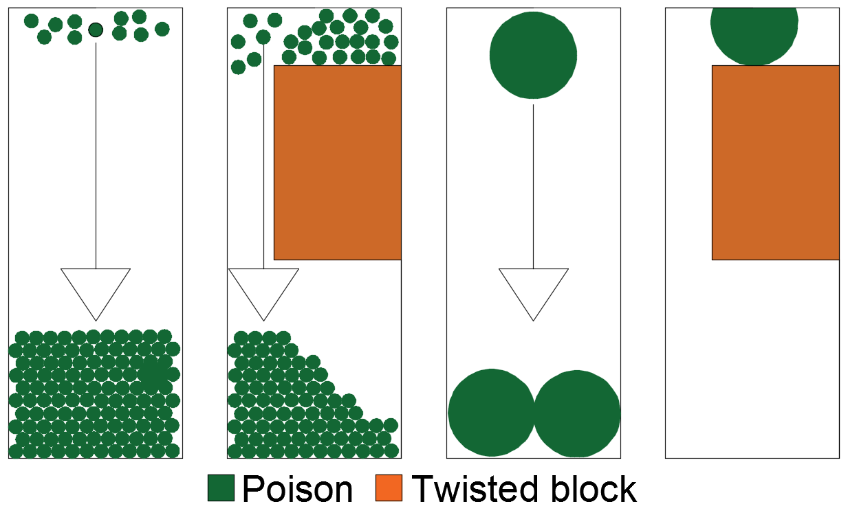
Figure 3.1 – 1) Small poisons during normal deployment, 2) Small poisons with a fuel block twist. 3) Large poison deployment normal deployment 4) Large poison deployment with block twisting
It is important to fully understand the volume of spheres required to achieve a successful RSS. To achieve this a variety of heights of the RSS have been investigated. This is implemented in steps of 60 cm height axially.
The test provides the instantaneous criticality of the system following the deployment of the RSS to the required volume, to give a comparison of the best method.
The method of implementation of the RSS is to provide 2 cm in diameter holes. These holes will then be bent in a U shape to maintain the bottom poisons as they are dropped. The RSS should be designed in a way that the RSS balls can be removed from the core following their deployment. This can be achieved with the suction or the use of helium to blow the balls through the pipes and out of the other side. As the RSS spheres are maintained at the bottom of the core, they will rapidly stack up, providing a thick layer of poisons within the system.
The theory to prove is that the reactor will become sufficiently subcritical with the RSS deployed, with the different deployment heights representing how quickly the deployed RSS takes effect. Following the identification of the most effective RSS design, additional tests are performed once some of the RSS channels are blocked, to determine the volume of poisons required to become subcritical.
The positioning of the three RSS designs can be seen in Figure 3.2.
The U-Battery design has limited space remaining due to the desire to maintain the highest volume of fuel. The central reflector area is already being manipulated for the means of reactivity control. This means the RSS must be deployed within the side reflector, which is also beneficial as there are no moving parts within this region, so the requirement for a fixed set of poisons does not impede any other part of the design.
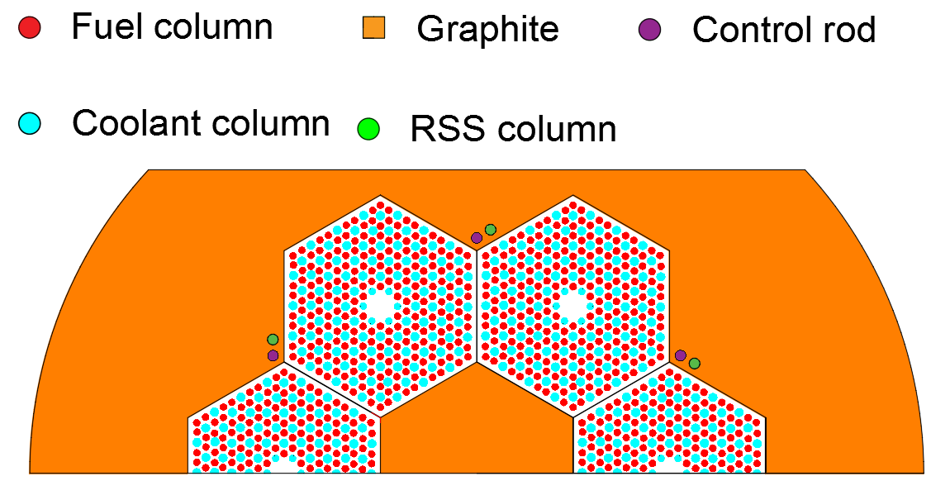
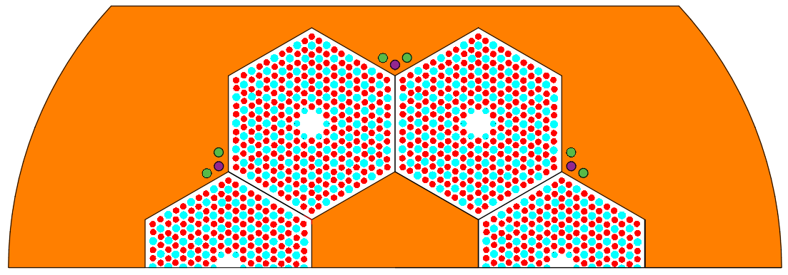
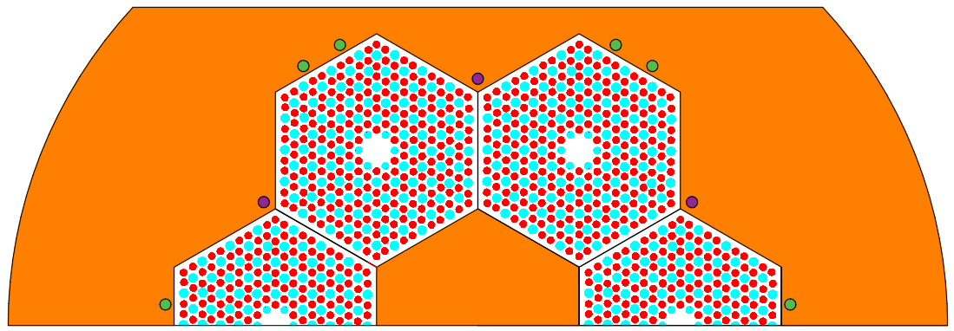

Figure 3.2 - Reserve shutdown systems design, Top; Design 1, three RSS channels alongside the FBP areas, Middle; Design 2, six RSS channels next to the FBP channels, Bottom; Design 3, RSS channels in the outside of the fuel blocks, two per fuel block

Designs 1 and 2 focus on controlling the highest flux areas, which is once again between two fuel blocks. Due to the small volume available for the boron in Design 1, Design 2 looks to pose symmetry within the area and place a second tube directly opposite tube one, creating space for double the volume of boron. This could even be mechanically operated by the same hopper. Design 3 looks to move the RSS to the side reflector, to leverage from the high flux at the side reflector and to reduce the number of components situated above the central region of the reactor.

Results
The first simulations were started at the most conservative point, day 700, with the central reflector inserted and all control rods removed, which represents the highest point of criticality. The results are shown in Table 3.3.
Table 3.3 – Comparison of criticality of each RSS design.
 | Design 1 |  | Design 2 |  | Design 3
Height of RSS (cm) | Criticality | RSE | Criticality | RSE | Criticality | RSE
60 | 1.05055 | 0.00056 | 1.04878 | 0.00065 | 1.05101 | 0.00057
120 | 1.04057 | 0.00057 | 1.03557 | 0.00053 | 1.03859 | 0.00056
180 | 1.02327 | 0.00068 | 1.01347 | 0.00063 | 1.01945 | 0.00059
240 | 0.99262 | 0.00065 | 0.96517 | 0.00068 | 0.98301 | 0.00057
320 | 0.95556 | 0.00083 | 0.88698 | 0.00049 | 0.93861 | 0.00074

As seen in Table 3.3 all three designs sufficiently reduce the criticality once deployed to a depth of 240 cm. However, it must be recognised here that in any rea,l imaginable configuration, the insertion would take place at the point of critical status in the system. The highest suppression is Design 2, which contains the same volume of poisons as Design 3, but in a higher flux area. Design 1 does provide a sufficient reduction, but due to the low amounts of poisons, it is likely to be not as effective as providing redundancy within the system.
An estimation of the efficiency of the systems, in a real accidental configuration with partly inserted rods which will significantly influence the power distribution in the upper core part, leads to the following result. The least efficient Design 1 delivers ~-900 pcm in the lowest quarter of the core, while the most efficient Design 2 delivers ~-1200 pcm. Design 2, as well as Design 3, would be sufficient to achieve an efficient criticality of K_{eff} < 0.99 influencing the core region which will never be controlled by the insertion of the control rods. Based on this, both designs would be sufficient for a rapid, diverse shut down of the core in limited time and with limited amount of absorber material.

Conclusion
The three RSS designs were tested to provide a diverse so-called third level shut down system. All three designs worked to different levels and at least Designs 2 and 3 would provide an efficient third level shutdown when one quarter of the RSS channels are filled.
This work demonstrates that there are opportunities for a third level shut down which is likely to be a requirement by the regulator. This work can be revisited later in the case of a more advanced design and a solid framework for achieving regulatory approval.
Another opportunity for a third level shut down system could be created by using the movable moderator approach applied for control. It would be a very smart approach if a way could be identified for an active, or even better passive, activation of the moderator control, even if this would mean that a fraction of the achievable ~-3000 pcm (see Figure 7.16) could not be used for the control of the reactor. However, this approach would avoid the installation of an additional system into the very small reactor system.

DYN3D
DYN3D is a nodal code simulator which group neutron physics, fluid dynamics (core cooling) and thermodynamics (heat transfer and fuel behaviour) into the same software package. DYN3D provides a nodal solver, which solves the neutron diffusion equation using nodal techniques. Nodal diffusion solvers are based around the nodal diffusion equation (3.1).

DYN3D neutron physics modelling
 | $$∇ . J_{g}\left(x\right)+Σ_{g}^{r}(r)ϕ_{g}(x) = Q_{g}(x)$$ | (3.1)
Where the current density $J_{g}\left(r\right)$ is solved via diffusion approximations in equation (3.2);
 | $$J_{g}\left(x\right)= -D_{g}(r) ∇ϕ_{g}(x)$$ | (3.2)
In this case all the sources are accumulated in $Q_{g}(x)$. These can be broken down to the fission source and the source of all neutrons contributed from all other groups into that energy group, equated by equation (3.3) and can even be expanded to treat the delayed neutron production if required for transient simulations.
 | $$Q_{g}\left(r\right)= \frac{1}{k} \sum_{g^{'}=1}^{G}{X_{g}vΣ_{g}^{f}(x)ϕ_{g}(x)}+\sum_{\begin{aligned}g^{'}=1 \\ g^{'}≠g\end{aligned}}^{G}{Σ_{gx}^{s}(x)ϕ_{gx}(x)}$$ | (3.3)
The second term represents the scattering from other energy groups into the observed energy group [75].
The geometry is treated as an integral volume (the core) which has been separated into homogenised multiple volumes (the nodes). A node (n) has a physical representation within the geometry and in the case of reactor physics, this physical information contains the material’s behaviour, such as the material cross-sections. The cross-sections are obtained through the means of group cross-sections for each energy group, which must be determined in a lattice calculation, using codes such as Serpent to provide the homogenised group cross-sections.
The flux distribution across the core is determined using the nodal flux average across that energy group and node $ϕ_{g}^{k}$, while the node internal processes are represented by mathematical expansion solutions for the homogenised system. Writing equation (3.4) for each individual node we have:
 | $$∇ .J_{g}^{n} \left(x\right)+Σ_{g}^{n}(x)ϕ_{g}^{n}(x) =Q_{g}^{n}(x)$$ | (3.4)
In the case of the U-Battery the geometry is hexagonal. In this case the flux distribution across that node is handled by DYN3D operating on a 2D representation of a hexagon in the radial direction, coupled with a 1D representation in the axial direction. DYN3D comes with two hexagonal solvers, HEXNEM1 and HEXNEM2, which differ in the handling of the intra-nodal neutron currents.
From the steady state equation (3.5), the position vectors (x) are integrated over the x and y directions and energy group to provide the terms within that node.
 | $$-D_{g}(\frac{∂^{2}}{∂x^{2}}+\frac{∂^{2}}{∂y^{2}}) Ф_{g}\left(x,y\right)+ Σ_{g}Ф_{g}(x,y) = Q_{g}(x,y)$$ | (3.5)
Due to the 3D aspect of the problem, the parts in equation (3.5) cannot be solved in the 2D plane, as long as the information of the third dimension is introduced via the transverse leakage term. The hexagonal plane within the node is handled by expanding equation (3.5) using a second order polynomial [38]. This provides constants for each point in the nodal balance equation.
Power in DYN3D is calculated by normalising the input power across each of the nodes, based on the user provided integral power. The distribution of this power is directly related to the reaction rates within that node. The power for each node is calculated using equation (3.6).
 | $$P^{n}(t) =\sum_{g=1}^{2}{E_{g}^{n} }Σ_{f,g}^{n}(t)Ф_{g}^{n}\left(t\right)$$ | (3.6)
E represents the energy released per fission event.

DYN3D core thermo-hydraulic modelling
In this case DYN3D was linked using the DYN3D-HTR model. The HTR model is used to calculate the temperatures of the individual, representative fuel particles for each node which is essential information for a reliable determination of the feedback effects required for transient calculations. This differs from the regular DYN3D solver as DYN3D-HTR determines the temperature distribution within the fuel particles. To resolve the required temperatures, DYN3D-HTR module takes a backwards approach to this. By knowing the overall temperature within a node, you can then work back to the individual layers of the original fuel. To accomplish this, DYN3D-HTR assumes a uniform power distribution across each of the sub structures within the fuel block. The initial process is to apply the thermal triangular solver within the hexagonal blocks, which provides a more detailed set of results e.g. in the case of the thermal impact near to a control rod being ejected. The compacts and helium channels are then homogenised as shown in Figure 3.3.
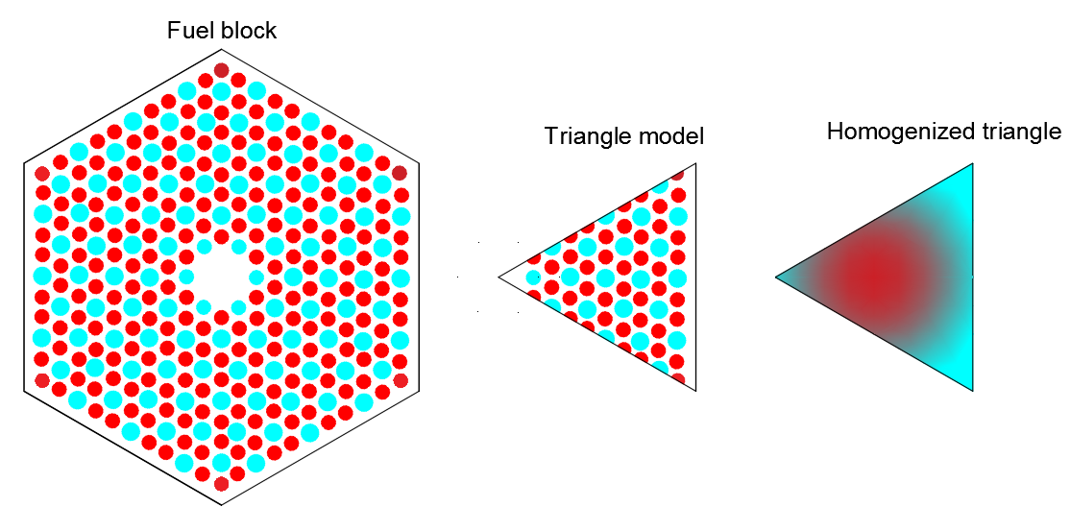
Figure 3.3 - Triangulation process used by DYN3D to homogenise the fuel block for its HTR-Module calculations
The triangles have been homogenised regarding the fuel composition, thermal properties and the design of the compacts preserved to support the neutronic power calculation. This information is then separated out into four sections. From left to right of the right side of Figure 3.4, the first section is the temperature loss coming out of the fuel kernel due to the low thermal conductivity of the UO₂ and the different layers of the TRISO particle. The second section is the thermal loss on the way between the particles and the matrix of the compact, as there is a specific distance between each particle and there is a temperature drop here. The third section is the loss between the compact and the graphite block, which can be due to bypass flow or the helium gap and the fourth loss represents the coolant channels and their ability to remove heat from the fuel block. The whole process is shown in Figure 3.4 for illustration.
Figure 3.4 uses four equations to map the temperature variation from the particles to the surrounding graphite. The initial calculation is the temperature distribution of the fuel kernel which is shown in equation (3.7).
 | $$C_{f}ρ_{f}V_{f}\frac{∂T_{f}}{∂t}= {-k}_{f}\left(T_{f}- T_{i}\right)+ \frac{q_{f}}{N_{f}}$$ | (3.7)
Where $C_{f}$is the specific heat capacity, $ρ_{f}$ is the density, $V_{f}$is the volume, $T_{f}$ is the temperature of the fuel kernel.${ k}_{f}$ is the effective heat transfer coefficient, $T_{i}$ is the temperature of the material between compacts, $q_{f}$ is the nuclear heat generated within the fuel and $N_{f}$ is the number of fuel particles within the volume. The first term represents the change in temperature of the fuel. The right-hand side represents the loss of temperature from the fuel to the graphite outside and the heat source due to fission and decay heat. As this only looks at a single fuel particle, it is divided by all the particles within the region.
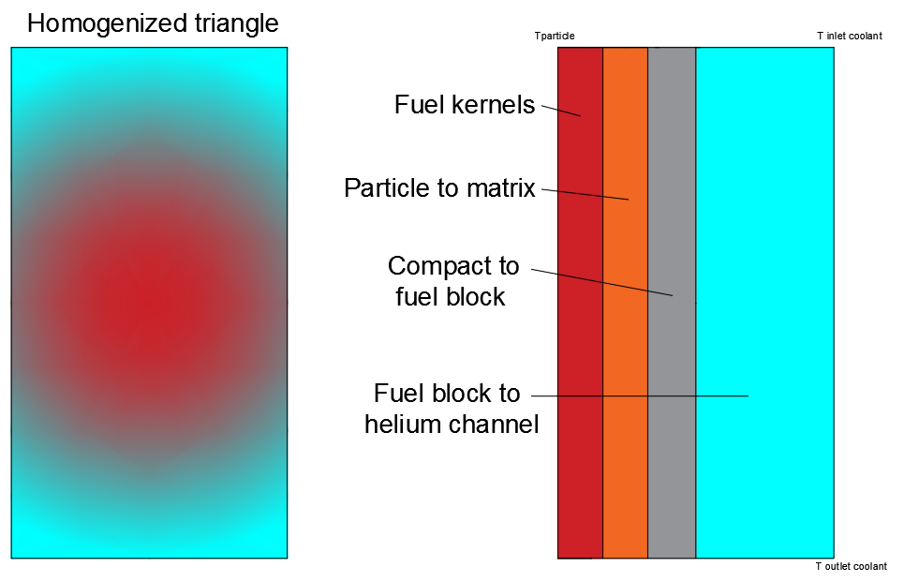
Figure 3.4 – Illustration of the temperature profiling within DYN3D-HTR module. On the left side; view of the triangle. On the right; breakdown of temperature profiling calculations
Equation (3.8) represents the loss of heat between the coating layers and the matrix.
 | $$C_{i}ρ_{i}V_{i}\frac{∂T_{i}}{∂t}= {-k}_{i_i1}\left(T_{i}- T_{i-1}\right){-k}_{ii+i}\left(T_{i}- T_{i+1}\right)$$ | (3.8)
The temperature distribution across the fuel is represented by the losses between each layer.
As the compacts are lowered into the graphite block, there is a loss between the compact and the graphite fuel block. This is shown in equation (3.9).
 | $$C_{c}ρ_{c}V_{c}\frac{∂T_{c}}{∂t}= \frac{{-k}_{c}N_{f}\left(T_{c}- T_{g}\right)}{N_{c}}{-k}_{cg}\left(T_{c}- T_{g}\right)+ \frac{q_{c}}{N_{c}}$$ | (3.9)
The first term on the right-hand side is the effective heat transfer coefficient for the total amount of particles within each compact passing to the graphite. The second term is the effective heat transfer coefficient between the compacts, and the graphite and the third term represent the gamma radiation providing heat within each compact. Finally, T_{g} is the average temperature of the graphite block which is determined through the heat transfer calculations based on the full core consideration.
The final equation models the heat transfer between the graphite block and the helium channel, as shown in equation (3.10).
 | $$C_{g}ρ_{g}V_{g}\frac{∂T_{g}}{∂t}=λ_{g}{∆T}_{g}V_{g}{-N_{c}k}_{cg}\left(T_{g}- T_{c}\right)+ q_{g}-\frac{{λ_{g}α}_{gHe}A\left(T_{g}- T_{He}\right)}{λ_{g}+α_{gHe} }$$ | (3.10)
The first term is the heat generated and transferred from other nodes, the second is the heat conduction in the compacts, the third is the gamma radiation and the fourth is the loss to the coolant channels within the graphite.
In the case of the graphite, if the heat is not removed, then it is passed onto the next compact. The temperature distribution in the triangles is solved using a finite volume method within the triangular model of heat transfer. The DYN3D-HTR thermal solver, provides the equations for the fuel temperature are resolved analytically. The HTR modules results are then interconnected into the core thermal-hydraulics solver.
This brings the HTR module back to the same format as the standard DYN3D solver, which solves 1D heat transfer across the core in representative channels, alternating between fuel and coolant. In this case, the fuel model is taken over using the HTR module, representing coolant channel, like a sub-channel in a traditional fuel assembly, which are averaged to one channel per fuel assembly/node or in the HTR case, per triangle of a block.
The core thermal-hydraulics and fluid dynamics solver models the fuel as a single volume (representative pin), with the coolant channels surround around this area. The solvers are based on 1D parallel coolant channels around each single fuel region, with all the user’s input data provided within the input card, to determine the behaviour of the coolant. In the case of the U-Battery the coolant is simplistic, as helium only has a single phase, compared to that of the more complicated water coolants which the solver is capable of undertaking. Thus, the three main equations the solver is required to solve are as follows:
 | $$\frac{∂}{∂t}\left[ϕρ_{v}u_{v}+\left(1-ϕ{)ρ}_{l}u_{l}\right)\right]+\frac{∂}{∂z}\left[ϕρ_{v}{u_{v}}^{2}+\left(1-ϕ)ρ_{l}{u_{l}}^{2}\right)\right]+ \frac{∂P_{fric}}{∂z}+grav\left[ϕρ_{v}+\left(1-ϕ)ρ_{l}\right)\right]+ \frac{∂p}{∂z}=0$$ | (3.11)
Energy balance
 | $$\frac{∂}{∂t}\left[ϕρ_{v}h_{v}+\left(1-ϕ)ρ_{l}h_{l}\right)\right]+\frac{∂}{∂z}\left[ϕρ_{v}u_{v}h_{v}+\left(1-ϕ{)ρ}_{l}u_{l}h_{l}\right)\right]=Q$$ | (3.12)
Mass balance
 | $$\frac{∂}{∂t}\left[ϕρ_{v}+\left(1-ϕ{)ρ}_{l}\right)\right]+\frac{∂}{∂z}\left[ϕρ_{v}u_{v}+\left(1-ϕ{)ρ}_{l}u_{l}\right)\right]=0$$ | (3.13)
Where h represents the specific enthalpy, $ρ$ the density, $u$ the velocity and Q is the volumetric heat source.
The thermo-hydraulics module works by trying to preserve the known input constants. The mass flow rate of 9.04 kg/s of helium is an input for this case. The mass flow is directed across each of the coolant channels, providing the pressure drop. From this the fluid enthalpy is calculated in each of the nodes. The momentum and mass balance equation are then solved.
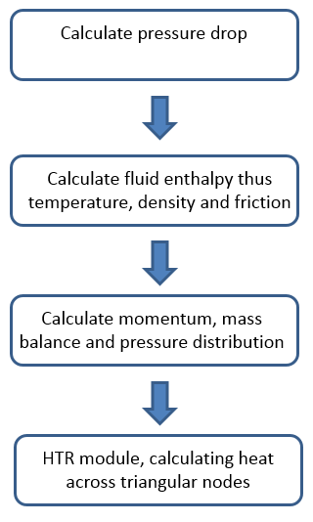
Figure 3.5 - Thermodynamic flow diagram of DYN3D solver
The coupling process between the neutronic and thermal-hydraulic code is performed using iterations between the two. As extensively covered, the doppler broadening effect has a significant effect on the reactivity and thus each iteration of the thermal-hydraulic code changes the power across the fuel block and finally the fuel temperature. This is particularly true in the case of HTRs, where the inlet temperature is significantly lower than the outlet temperature, thus providing a lower temperature profile at the top of the core than the bottom. This in turn increases the power at the top of the core compared to the bottom. These effects are not incorporated into Monte Carlo solvers; thus the nodal calculation provides a much more accurate representation when using DYN3D as a core simulator.
DYN3D handles this coupling in steady state by using the flow diagram shown in Figure 3.6.
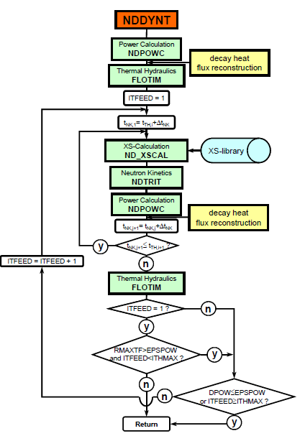
Figure 3.6 - Transient neutronic-thermal hydraulic calculation of DYN3D [38]
Step 1 calculates the initial power distribution from the neutronics code; this is plotted with some decay heat values within transient simulations. After that, the thermal hydraulics is performed to determine the overall temperatures across the core. Based on this process, the new cross-sections are determined by interpolating within the libraries for the case of changes in temperature for the nodes. The neutronics is then performed and power looped again. This is repeated until the acceptable change in temperature has occurred, implying a balanced system between neutronics and thermal hydraulics.

Steady state analysis
DYN3D initially calculates the steady state behaviour of the system. This section briefly describes the model created and the characteristics of the steady state analysis. The core is modelled until the edges of the central reflector blocks as shown in Figure 3.7.
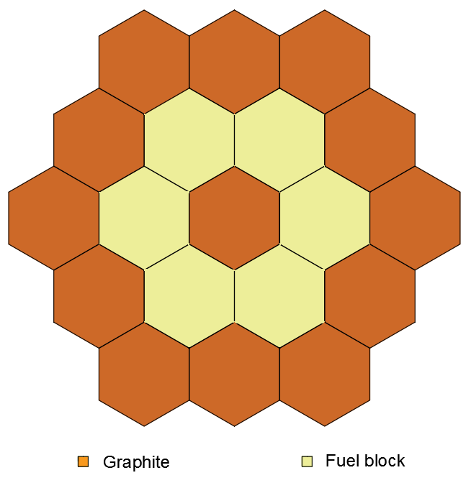
Figure 3.7 - Core layout as DYN3D depicts it, highlighting the different cross-section regions and lack of exterior core materials.
The axial description only goes as far as the top of the reflectors. The core is split up axially into 20 16 cm sections of the fuel blocks and the two axial reflector’s nodes, representing 25 cm each. Due to the symmetry of the design, the cross-sections were obtained for the separate regions using Serpent as a lattice code to provide the homogenised few group cross-section sets. Due to the insertion of the control rods to 150 cm depth, the DYN3D calculation provided a very different axial profile.
In addition, due to the coolant being colder at the top, the power profile forms a slightly off-centre cosine wave, caused by thermal feedback. However, the control rods leads to a shift, the power profile towards the bottom of the core. DYN3D calculated the power profile for of the assemblies as shown in Figure 3.8. Each point indicated is resulting for the power in one axial node.
The peak is at the bottom of the core, thus providing the limiting values for the pins and compacts within the design. As previous designs have not investigated the mass flow rate, this has been set to 4.5 kg.s⁻¹ to provide an outlet temperature of 778 °C. The maximum fuel temperature within the core has been calculated to 851.24 °C, thus proving that the current maximum loading on the TRISO particles is within safe operating limits in the design specification.
Unfortunately, the provided DYN3D-HTR module does not support transient simulations.
Figure 3.8 - Assembly axial power distribution from DYN3D

Chapter conclusion
This chapter has investigated some of the main aspects when considering the design and control of the U-Battery. The complicated nature of reactivity control has been presented in two papers. The novel approach of moving the central reflector to reduce the criticality has provided a significant reduction of the excess reactivity within the system. This method has shown that the total fuel cycle lifetime can be extended by using these methods, due to the breeding of plutonium. The second paper highlights the use of standard reactivity control methods in conjunction with those of the central reflector being manipulated. This has provided a comprehensive overview of the possible control methods which can be utilised within the design.
An initial design of three possible RSSs was created. The most effective RSS had two RSS deployment guide tubes in the fuel blocks.
A third paper in this section tested the viability of fuel rotation from an economical perspective to reduce low burnup areas of the core. It concluded that this is a viable option, but that it should be determined once the reactivity control is also incorporated at a later state of the design process, to understand the full economic benefit.
This chapter has seen the development of a new U-Battery design. Due to Serpent being a new neutronics code, validation tests were performed with MONK, a commercial code provided by the Wood group. Results of these tests showed good agreement between Serpent and MONK and these have been included in the Appendices 7.5.
The application of the nodal core simulator DYN3D-HTR provided first insights into the power distribution. The results were based on a coupled neutronic/thermal hydraulic analysis for steady state operation with partly inserted control rods.

Chapter 4 - Transient modelling
A transient is defined as the change in the system from constant power production at a steady coolant flow. This can occur due to one of the many mechanisms working in the system. In the case of the U-Battery, the transients that are most interesting include control rod ejection accidents and a loss of coolant flow accident without reactivity control measures. The conventional Monte Carlo modelling previously used cannot cope with the transient behaviour of complicated systems, due to the computational power required and the demand for the thermal feedback as described in the 3.4. Due to the increase in computational power available and coupling of Monte Carlo codes and fluid dynamics codes for the determination of feedback effects, transient simulations are becoming available on simple cases but require large periods of time to compute.
DYN3D comprises of coupled neutronic and thermal-hydraulic modules, which would have been enough to provide the transient behavioural analysis for these accident scenarios. However, the code is still under development to include the HTR features with transient modelling. Therefore, transient simulations using nodal core simulator will be included in the Further Work section.
The transient modelling has been performed using point kinetics and reduced order thermal dynamic modelling of the core to determine the behaviour of the core.

Point kinetics modelling of the control rod ejection
This section aims to determine the changes in the power production and the fuel temperature during a control rod ejection accident, to demonstrate the safe conditions of the reactor core. To achieve this, the point kinetics approximations are utilised due to their direct derivative from the neutron transport equation [76]. The point kinetic model is a simplified, zero-dimensional model with regards to neutron lifetime and thus the time evolution of the power production in the reactor, denoted by Figure 4.1.
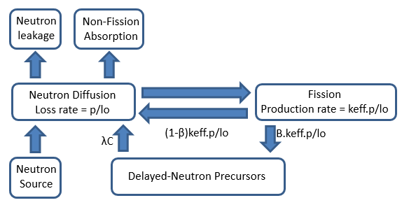
Figure 4.1 – Neutron population lifetime in point kinetics modelling [77]
The life of a neutron starts in the fission event, which is proportional to the number of neutrons being produced per cycle. During fission, a certain amount of the neutrons are produced, but, this is not the only means which the neutron population is changing. A small fraction of the system’s neutrons, the delayed neutrons, are produced by the decay of certain FPs, the precursors to delayed neutrons. These delayed neutrons play a key part in controlling the reactor during transient simulations, due to their significantly different time scale of generation in the core, given by the formation of the precursors and their decay time. There are also neutron losses in the core, which influences the overall neutron lifetime, which considers the loss of neutrons due to absorption and leakage.
This cycle is then formulated into the point kinetics equation shown in equation (4.1), ignoring source neutrons [77].
 | $$\frac{dpo}{dt}=\left(1- β\right)K_{eff} \frac{po}{l_{0}}- \frac{po}{l_{0}}+ \sum_{i}{{}_{i}}C_{i}$$ | (4.1)
Where po, represents the neutron population, which is normalised to be proportional to the power change. The first right hand term represents the total amount of neutrons produced during fission; the second term forms the neutrons lost during this time and the third term represents the delayed neutrons produced due to the decay of precursors during that time step. In the case of the delayed neutrons, there is a balance between precursors lost in that period by decay and the ones gained as a by-product of fission events. This is determined by equation (4.2).
 | $$\frac{dC_{i}}{dt}=\frac{{}_{i}K_{eff}}{l_{0}} .po- C_{i}$$ | (4.2)
The point kinetics equations are sometimes shortened to the simplistic equations (4.5) and (4.6) using the following relationships.
 | $$o = \frac{K_{eff}-1}{K_{eff}}$$ | (4.3)
 | $$l= \frac{l_{0}}{K_{eff}}$$ | (4.4)
Adding the time varying functions
 | $$\frac{dpo}{dt}= \frac{-β}{} . po\left(t\right)+ C\left(t\right)$$ | (4.5)
 | $$\frac{dC}{dt}= \frac{}{} . po\left(t\right)- C\left(t\right)$$ | (4.6)
This form here is simplified to a single delayed neutron group with an averaged decay time.
Equations (4.5) and (4.6) represent the integral neutron population of prompt neutrons and delayed neutrons, with the delayed neutrons providing a control aspect during transients. The input values of the equations listed in Table 4.1 are provided using Serpent’s adjoint weighted values, which have been validated in the literature [78].
The variance in the effective multiplication factor, due to the control rod ejection, is lined with the neutron population, and thus the power, by the point kinetics equations. The first step is to determine the reactivity change during a control rod ejection based on Serpent’s results. In this case, the central reflector is fully inserted and all control rods are placed at the 150 cm position to represent their lowest, most conservative position during operation. The values used are included in Table 4.1.
Table 4.1 – Values of the point kinetics variables produced by Serpent
Term | Unit | Value
Initial criticality | Na | 1.02904
Criticality after removal | Na | 1.03420
Reactivity change | Na | 0.00516
Generation time | s | 0.00037
Delayed neutron fraction | Na | 0.00654
Average decay time () | 1/s | 0.07693

Table 4.1 gives a reactivity insertion of 0.00516. Commonly in point kinetics, the change in reactivity is represented in dollars ($), which is the ρ/β value, thus providing information regarding the reactivity change and the delayed neutron fraction, in this case 0.8 $.
The next stage is to determine the kinetic behaviour of the system when the control rod is ejected with 0.8 $ of reactivity. This is determined by solving equation (4.1) using a python script, providing the neutron population over time. This is shown in Figure 4.2
Figure 4.2 - Power increase due to reactivity removal as a function of time
The initial rise in criticality is caused by the prompt neutrons (prompt jump) up until ~0.2 s, due to the additional fissile content in the system. However, this is limited because of the delayed neutrons which are supplied by the decay of the precursors on a much slower time scale. This acts as a control mechanism, due to the still reduced presence of precursors in the system during the time step, which will build up and decay slowly. From Figure 4.2 it can be identified that from the moment of the control rod ejection, it takes one second to multiply the power by a factor of six, highlighting the amount of energy increase into the system. However, the effect of this would result in a catastrophic event and damage to the reactor. Using this current method, we have made no justifications for how the increase in neutron population will affect the real temperature in the system, since neither the feedback effect of the power increase nor the inertia of the large graphite amounts have been considered.
To understand how the temperature will change, we use an adiabatic approach. In this approach, one assumes that the energy in the system cannot be removed at all, so all the energy produced is deposited within the system, directly into the UO₂ and the graphite. To determine the worst-case scenario, this temperature solely affects only the fuel. This is a reasonable first order assumption, as the thermal conductivity of the fuel is significantly lower than in the rest of the system. To determine the new temperature during the fault, we can determine the change in temperature using the specific heat capacity:
 | $$C_{p}= \frac{E}{m ∆T} \left[\frac{J}{kg K}\right]$$ | (4.7)
At the point of the transient we assume that the core is providing the evaluated amount of power to the system, so we include this into the formula:
 | $$\frac{C_{p}}{s}= \frac{P}{ m ∆T} \left[\frac{MW}{kg K}\right]$$ | (4.8)
Rearranging equation (4.8) to determine the change in temperature:
 | $$∆T \left[K\right]= \frac{P}{ m C_{p}} \left[K\right]$$ | (4.9)
Equation (4.9) provides a linear power increase at a fixed power. The total mass of UO₂ is determined as 282 kg with an average specific heat capacity of 320 J.(kg.K)⁻¹ during these operational limits [79]. This provides the theoretical linear increase in temperature over time, as shown in Figure 4.3.
Figure 4.3 - Temperature increase using the basic specific heat capacity and a linear temperature model
This linear temperature increase is determined using the assumption that the power is constant over the time. As shown in Figure 4.2, this is not the case. To factor this power increase into the equation, we modify the power in the temperature equation to equation (4.10);
 | $$T \left[K\right]= \frac{P. p_{fr}. t}{m . C_{p}}\left[k\right]$$ | (4.10)
This new approach dramatically increases the temperature rise within the system as shown in Figure 4.4.
The steady state analysis from DYN3D provided the maximum fuel temperature of 850 °C, thus allowing for a maximum increase of 750 °C before the fuel would reach the design limits. From Figure 4.4, this would occur within ~1.5 seconds in the case of a single control rod ejection.
The point kinetics model does not consider any feedback effects. However, the Doppler broadening effect should be included, stating that the fission probability reduces with temperature. To further investigate the effect of temperature on the core and the power production, we must evaluate the negative fuel temperature coefficient of the core. This is achieved by studying the criticality at the different temperature levels using Serpent. The calculation determined the difference in criticality, as shown in Figure 4.5.

Figure 4.4 - The new temperature rise, accounting for additional power from the transient
Figure 4.5 - Negative temperature feedback highlighted by the temperature coefficients
The most conservative approach is to determine the feedback effects on the core assuming that that all energy will be stored uniformly in the core. This is in strong contrast to the approach used to investigate the time to fuel damage, where all energy produced was dumped into the fuel, which would lead to the highest possible feedback due to the fuel temperature effect. Going back to equation 4.10, the increase in heat of the whole core based on the mass of graphite in the core (15600 kg) and the specific heat capacity of graphite 1600 J.(kg.K)⁻¹ [80] leads to a temperature of 903 °C which does not lead to any visible feedback.
Due to the very rapid temperature rise of the fuel, it seems a reasonable and conservative estimation that ~80% of the energy will not be able to be transferred from the fuel to the graphite. This approach will lead to about 400 °C temperature rise after 0.5 s. Leaving only 60% of the energy in the fuel would lead to an increase in heat of about 300 °C after the same time span.
Considering the feedback from Figure 4.5, the gradients of each of the lines can be used to determine the change in K_{eff} per Kelvin. This is 2.33 pcm/K when solely considering the fuel and 2.68 pcm/K for the whole core. In the case of a transient, we can analyse different scenarios ranging from 0-40% of the energy deposition within the fuel and assume the resulting temperature of the fuel kernels. Based on this approach, the different feedbacks can be determined in Table 4.2.
Table 4.2 - Reactivity changes with different temperature feedbacks
Energy transferred from the fuel | Temperature rise of the fuel [K] after 0.5 sec | Feedback after 0.5 sec [pcm]
0% | 470 | -1095
20% | 400 | -932
40% | 300 | -699

The fuel temperature feedback for all studied scenarios indicate that the reactor will already be in a sub-critical state after 0.5 s based on the originally inserted positive reactivity of 516 pcm. Thus, the negative fuel temperature feedback would have stopped the reactor from being over critical after a really short time period. Figure 4.6 indicates the power curve which develops after the insertion of the negative reactivity, which results in the scenario that only 20% of the energy is released from the fuel. This first-hand calculation approach imitates the process like it is performed in a transient code with thermal feedback loop, even if the time step procedure would be very much refined.

However, approximate hand calculations must be made. In this case, the point kinetics is not a conservative approach due to its zero-dimensional character, while the control rod ejection is a localised event. To provide a more detailed analysis, the use of a core simulator like DYN3D would be required.
Figure 4.6 - Point kinetics with a second step at 0.5 s to compensate for 80% of the energy released directly into the fuel

Loss of coolant flow transient
The second accident scenario is the loss of coolant accident, as the removal of the forced flow causes an increase in temperature in the core. As seen in this case, the power is dramatically reduced due to the Doppler broadening effect. During a LOCA, the core needs to be able to dissipate the energy within the core through the exterior of the system to an external cooling, system to achieve a state at the surface of the pressure vessel which is below the acceptable temperature load. In this case, we would have to investigate the heat transfer model during a loss of flow transient to determine the surface temperature at the wall of the reactor pressure vessel. Figure 4.7 depicts an axial profile of the core and its materials. The challenge here is the heat transfer from the RPV to the ambient air, which is based on natural convection, which is a real challenge for a hand calculation.
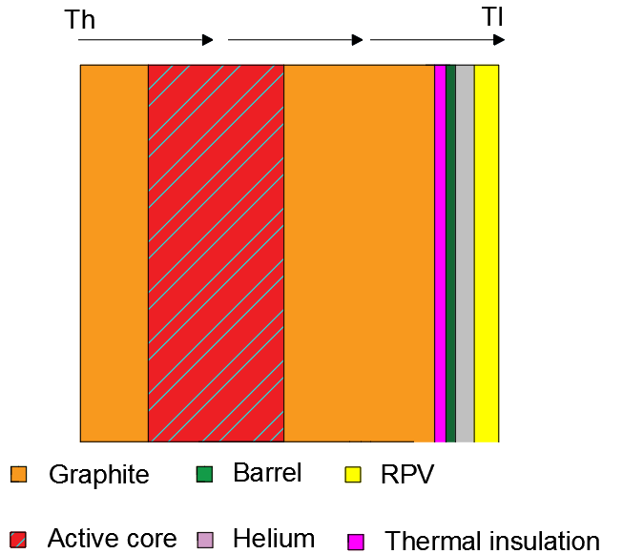
Figure 4.7 - Visual representation of heat transfer across the core Th to the outside of the vessel Tl
In the case it only seems to be reasonable to take credit from existing experiments if the DYN3D-HTR code isn’t available. There has been a very relevant experiment on the loss of flow behaviour to demonstrate the long term walk away safety of HTR-10 in China. From the experimental data [81] it becomes obvious that Doppler broadening effect causes the power to dramatically reduce during a loss of coolant event, as shown in Figure 4.8.
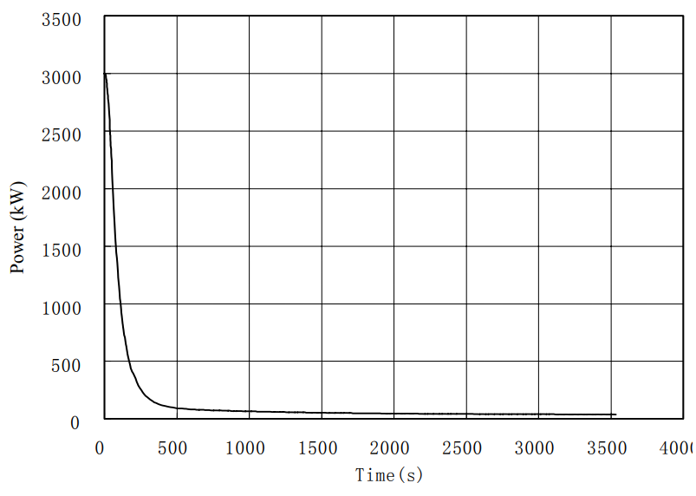
Figure 4.8 - HTR-10 experimental data power after a loss of coolant event
Following the initial transient, the power production has been lowered to the levels produced by the decay heat of the reactor. Under these circumstances the reactor’s insulation needs to be thin enough to allow for decay heat produced to be removed from the core through the vessel wall. The experimental results as shown in Figure 4.9, for the HTR-10 demonstrate that a small sized reactor can cope with this transient without a major increase of the vessel temperature. This is important due to the operating temperature limits of the steel which are significantly below ~600 °C, depending on the steel used [81].
A simulation of the long-term behaviour of the U-Battery in the case of a LOCA event would be a very important application of modelling and simulation, because it can form the basis for the optimisation of the accidental behaviour versus the operational efficiency. The key in this consideration is to identify the ideal dimension of the thermal insulation. On the one hand it should be thick enough to reduce the thermal leakage during normal operation. It must also be thin enough to allow a sufficient heat transfer under accidental conditions to keep the core temperature as well as the reactor pressure vessel temperature within the safety limits.

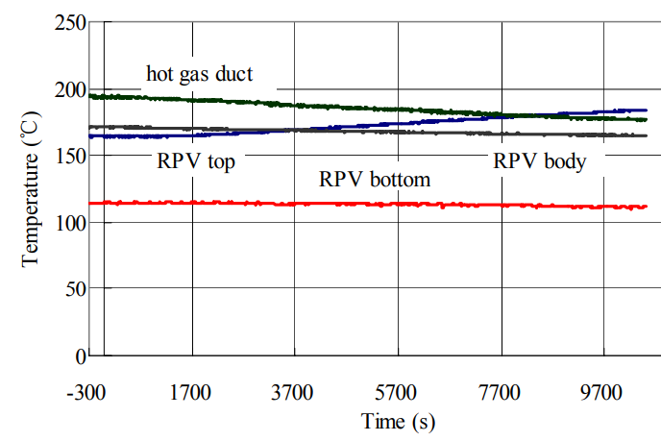
Figure 4.9 - Temperature profile of the RPV during HTR-10 loss of coolant experiment

Chapter conclusion
This chapter has used conventional hand calculations and the study of existing experiments to determine the transient behaviour of the reactor core. Initially, the control rod ejection scenario determined that the core will survive a single control rod ejection, even under critical operation conditions. This is due to the low control rod worth proposed with the design of the core and the newly inserted moderator control system. The Doppler broadening effect can contain the reactivity increase sufficiently during the transient.
The second investigation examined the loss of flow to the system, which requires overall ability for the core to remove the decay heat through the reactor vessel to the ambient air via natural convection. In a literature study an experiment has been identified which shows the transient behaviour of a 10MWth reactor, which is the identical size as the studied U-Battery concept. The vessel temperatures measured during the experiment show that only a very small temperature increase has taken place. However, a detailed study using a 3D core simulator would be key for a new, optimised design of the insulation, which can be increased to allow for minimum losses in the second design stage.

Chapter 5 - Conclusions
The overarching hypothesis of this work, as stated in the aims, is to provide a 10MWth version of the U-Battery based on the initial design specifications. The initial design was found to be incorrect, due to the theoretical density of carbon being used instead of the more realistic bulk density. This PhD thesis saw the development of novel reactivity control mechanisms being established with a moveable moderator, which saw a patent application filed. In addition to this, a comprehensive overview of the implemented reactivity control methods has been provided. The overall design has then been evaluated using hand calculations during a rod ejection accident, which proved the core to be within safe limits due to the low control rod worth.

Evaluation of HTRs and the U-Battery
The UK has made progressive steps to include nuclear power within the country’s energy portfolio. This was initially due to climate change agreements, which have seen the UK pledge to reduce their overall CO₂ emissions by 90% compared to the 1990 rate. This prompted the UK to provide investment opportunities for large scale LWR technology, such as that being built at Hinkley Point C. However, since then, the UK government has shown an interest in nuclear intellectual property by promoting the design of advanced reactors through their AMR competition.
AMRs come in many different forms with a large variety of technology readiness levels, but the most prevalent design was the HTR, which is capable of capitalising on unique markets such as industrial process heat and remote locations. This has its own benefit when considering climate change, because the current methods for producing process heat are carbon intensive. One interesting design currently within the AMR competition is the U-Battery.
The U-Battery aims easy deployment by following the existing prototype, the HTTR operating in Japan. In addition to this, the TRISO fuel particles used within the design are currently under irradiation tests under the NGNP within the USA. These irradiation tests are focused at providing the NRC with a detailed overview of the fuel performance from a regulatory perspective. These two contributions place the U-Battery in a strong position for regulatory approval due to the depth of knowledge within the field already. There are minimal technology gaps within the original U-Battery design, except the unusual choice of a BeO side reflector.
The U-Battery initial literature focused on the 20MWth design, but this report aimed to provide a detailed analysis of the conceptual design of a 10MWth design. In the original work which has been published on this design, it was determined that the original design using a BeO reflector would achieve a core lifetime of five years. A recalculation of the design didn’t achieve the same results as in this initial report, so a complete redesign was undertaken.
The redesign initially evaluated the material choices within the core and performed an in-depth comparison between the now proposed nuclear graphite and the initially chosen BeO. This comparison determined that nuclear graphite is a better choice, due to the financial performance being significantly favourable (49.5%) for the structural materials to achieve the same neutronic properties. However, the core size would have to be increased to allow an increase in the side reflector as well as the axial reflectors. This was seen as a minor initial issue compared to the cost savings and therefore the decision was made to use graphite reflectors.

Design of reactivity control methods for a high loading HTR
The U-Battery’s remote location market means that the lifetime of the fuel must be as long possible. This is achieved through a high initial fissile loading. The original report did not provide any information with regards to reactivity control and therefore the basis of this work was undertaken using similar core designs such as the HTTR. The initial tests determined that the core was significantly supercritical at ~ 1.2 at the beginning of life, to assure enough excess reactivity for long term operation. The small nature of the core and the high excess reactivity required innovative steps to reduce the criticality to unity over the whole life cycle of the core. The first step determined the best methodology for the FBPs throughout the core. This saw the investigation of three different poisoning methods from particles, coatings and locational changes. The overall decision was that coatings towards the centre and edges of the fuel blocks provided the best overall reduction in effective multiplication factor. The FBPs were depleted and the core reached a second criticality peak of ~1.07 which would not have been able to control safely with the control rods only.
To remove the remaining excess reactivity, a novel method of moving the central reflector was proposed, which hardened the flux spectrum within the core and lead to improved breeding of more plutonium. The hypothesis, that the moveable moderator would achieve a longer lifecycle due to plutonium, was deemed to be accurate. The plutonium was used in fission at a later stage in the core’s lifetime, when the central reflector was reinserted into the core, providing an additional 31 days in operational lifetime. This highly innovative approach provided an overall lifetime gain in full power days, allowing for 1362 full power days to be achieved using a once through lifecycle. This would otherwise have to be reduced using FBPs, thus reducing the lifetime of the core significantly. Therefore, a moveable moderator has provided significant benefits to the overall design.
A brief investigation of a novel idea of rotating the fuel blocks was also investigated. This is currently standard practice within LWR technology, so it seemed like an option worth exploring. However, this design did not include the reactivity control measures. This design included a large economic benefit of rotating the fuel blocks by up to 42% of the fuel costs. This method has not yet been considered in conjunction with the reactivity control measures, but, the next steps would investigate loading patterns with fuel block rotations included.
The investigation of an RSS produced two potential designs which would allow the core to become significant once the RSS was deployed. Further work is required to understand the regulatory requirements for an RSS in these conditions, but this work can be used as an initial step.

Operational characteristics
The initial evaluation undertaken used DYN3D to undertake an overview of the maximum fuel temperature in steady state. DYN3D-HTR module provided the temperature feedback of the TRISO particles, making this software suitable for steady state evaluations. It was determined that to achieve the required outlet temperature of 750 °C, the maximum particle temperature was 851 °C, which is much lower than the maximum fuel operating temperature of 1600 °C.
Due to the complicated nature of simulating transients within the high temperature reactor, and limitations with DYN3D meant that simulation results were not obtained. In the absence of this, the point kinetic equations and conservative approximations have been used to discuss the power transients during a control rod ejection event. It was determined that for a single control rod, the estimated control rod worth was 500 pcm at the maximum point in the fuel cycle. Due to the low control rod worth, in the case of a control rod ejection, the Doppler broadening effect will safely compensate for the reactivity removed during the rod ejection.

Concluding remarks
The work undertaken within this thesis has increased the current technology readiness level of the U-Battery, which is currently going through the marketing procedure. This project has provided the basis for a 10MWth design which is currently being marketed. The development of a new method of how to reduce the reactivity within the core will allow for a higher loading of fissile material within the core. This technological advancement will save significant full power days for future SMR HTRs.
The next stages of the development of the U-Battery need to be driven forward by the consortium, as they have not been able to advance the project to the next stages due to lack of funding. The AMR competition seems to be the only way for this funding to come forward at this time. The U-Battery is in a strong position within the AMR competition, as the only UK design for HTRs, but, this progress won’t be known until the summer. The author is keen to work with the U-Battery project, although this work has been produced independently of the consortium.
Due to the lack of available data which could be used for the comparison of this work, it has been difficult to judge the current stage of the design. When compared to the HTTR, the overall burnup is only achieving 31500 MWd/KgU whereas the current design is achieving 55000 MWd/KgU which implies that the fuel utilisation is significantly higher. However, the HTTR is a prototype and therefore providing comparisons is difficult to draw any significant conclusions from.

Chapter 6 -Further work

Further work on the U-Battery concept
The topic of AMRs and HTRs are a popular notion at the moment and therefore this should be monitored closely with regards to the most marketable application for this work. The UK government might decide that AMRs are not worth investing in and therefore it might be more beneficial to look elsewhere for better investment opportunities for the U-Battery. Further defining the best applications of HTRs depends on volatile markets, such as hydrogen production, and therefore the cost of production of both electricity and industrial heat needs to be accounted for when commissioning such a design. This should be undertaken by an independent analysis to determine where the U-Battery can find a viable market.
The work that has been undertaken within this project has not been in conjunction with the U-Battery consortium. Therefore, there might be concepts and ideas which have not been divulged publicly which have not been considered within this design, as this design has only focused on the open literature available. This could mean that there are other studies which are not included within this design, and therefore if these were made public, they could be incorporated within this design in the future.
The current status of the U-Battery seems to be largely unknown. There have been several other designs which have used the “micro” reactor concept, originally hypothesised by the U-Battery consortium, which seem to be progressing significantly faster and have entered licensing stages.

Further work on the moveable moderator concept
A large part of the patent application is based on moving a moderator. This concept has some drawbacks and some quite important unknown features. Firstly, irradiated graphite is fragile and therefore it is unknown if the graphite structural integrity can be maintained. To understand this further, a detailed analysis of the graphite’s conditions during each fuel reloading will be required, to determine if moving the moderator is safe. This will require further knowledge of graphite structures in nuclear environments. Regulatory approval causes another issue with this concept. As each country has their own regulator, it is impossible to know if a regulator would approve the movement of key structural parts. This will largely depend on providing proof that this will not pose additional risks, which would depend on the research undertaken on graphite integrity.

Further design work required
This work has only undertaken a first fuel loading design. The next stage would be to investigate loading patterns of the most economical way to load the core. In the case of remote deployment, it might be beneficial to completely remove the core and ignore loading patterns. In other cases, it might be very economical to consider online refuelling for the design. This will depend significantly on the U-Battery’s business model and target markets.
The reactivity control work only investigated black control rods. In most reactors, these are used in conjunction with grey control rods, which are used to finely adjust the power production. There is a significant amount of work to still be undertaken in the grey control rod design and implementation.

Further transient analysis work required
The current version of the nodal core simulator DYN3D was unfortunately only available for coupled steady state analysis of the core. The transient nature required a conservative approach using mathematical modelling with significant approximations. This modelling does have its drawbacks, due to the high number of assumptions made. It would be of high interest to apply the DYN3D transient modelling to determine the maximum fuel temperature during a loss of coolant accident and to optimise the core insulation on a detailing modelling of a loss of flow event. It would be beneficial to compare to the hand calculations to determine the limits of the hand calculations and those of DYN3D application.

Chapter 7 -Appendices
This article was submitted on 19/10/2018 to Progress in Nuclear Energy

Small modular High Temperature Reactor Optimisation – Part 1: A comparison between BeO and nuclear graphite in a small-scale high temperature reactor
Basic Data on BeO and graphite
Beryllium is an element which is almost exclusively mined in the USA, where they currently retain 90% of the global Beryllium production [82]. Beryllium is classed as a non-scarce mineral, indicating that there is a large supply available, and that at current demand the supply will last for over a thousand years. However, Beryllium is the most expensive mineral due to it being in high demand [83]. A large part of this demand is due to BeO holding some distinct properties which make it attractive for use in several industries. These properties include a low density and high strength, high thermal conductivity and a high permittivity. These properties have led to an increase in demand in industries such as aerospace, military, alloys and microwave applications.
This following section aims to try to provide a comparison between nuclear graphite and BeO to produce an in-depth analysis of the properties of the materials that would directly affect their application within a nuclear environment.
Thermo-physical Properties
The first point for the evaluation will be concentrated around the materials’ properties. With a like to like comparison of the thermo-physical properties within the context of HTRs, see Table 7.1.

Table 7.1 - Properties of BeO [1] and nuclear graphite
 |  | Material
Property | Unit | BeO | Nuclear Graphite
Density | kg/m³ | 2850 [19] | 1800
Thermal conductivity | W/mK | 265 | 133 [19]
Specific heat capacity at 30 °C | J/khK | 750 | 720 [80]
Thermal expansion | 10⁻⁶/K | 7.4 | 2.5x10⁻⁵ [80]
Coefficients of volumetric thermal expansion | 1/K | 24 x 10⁻⁶ [84] | 9.6-14.7 x 10⁻⁶ [84]
Melting temperature | K | 2787 | 4800 [85]
Cost | €/kg | 265 [19]9) | 65 [19]

The density of BeO, given in Table 7.1 is taken quite conservatively at 2850 kg.m⁻³ as this can be as high as 3000 kg.m⁻³, which will have some consequences on the scattering properties. However, the additional density over graphite will have an impact on the total mass of the core. This might be a concern when considering the construction of the core and the transport of a whole assembled core as would be desirable for a micro reactor design.
During the operation for a HTR core, the exterior of the core is surrounded by a barrel, made of steel. In normal operational conditions, this barrel is required to be kept under ~425 °C, this is due to material regulation imposed by ASME due to graphitization of steels occurring at these temperatures [65]. In the case of having a high thermal conductivity of the side reflector, this increases the temperature of the barrel making this limit harder to achieve. This will require additional thermal insulation in the case of BeO, thus allowing for this temperature to be maintained. However, in the case of emergency cooling and decay heat removal a balance between heat removed and heat generated is desired, so that the heat is dissipated and conducted to the surface of the reactor vessel as fast as it is produced. In the case of the VHTR the temperatures will be considerably higher, thus the required increase in size due to the additional thermal conductivity might be significant. Finally, this is a case for the optimisation between operational requests and safety requirements which has to be performed for both cases individually.
In addition, thermal conductivity is also a property that changes two-fold, initially with temperature and secondly with irradiation. The current literature on irradiated BeO’s thermal conductivity change over temperature ranges is limited to 80 °C, however, an annealing process taking place at higher temperatures seems to show lower impact on thermal conductivity cause by radiation damage [86].
Another variance is the specific heat capacity, where values are very similar between graphite and BeO. In the case of a loss of coolant accident, the specific heat capacity governs the rate at which the side reflector can absorb the energy emitted by the fuel, thus a larger number would be preferable.
Another aspect key to the reflector is the coefficient of thermal expansion, as the core heats up the reflector will expand. In the case of normal operation this is undesired as the scattering properties are reduced and additional flow paths could be opened between the core and the reflector when different materials are used in the core and the reflector. In the case of accidental scenarios, a higher value is preferred as the moderation reduction will aid with the reduction in of power. The implications of radiation damage could be problematic due to the volume expansion caused, this could see additional cracking over the sixty-year lifetime of the core. Due to the additional thermal expansion, the gaps between the reflector blocks would be required to be 63% larger in Beryllium to accommodate this additional expansion, thus reducing the overall moderation effects.
Both materials melting temperatures seem to be significantly higher than the of temperatures limits created by other components.
Neutronic Properties
Beryllium is currently being considered as an advanced reflector material for nuclear reactors due to its superior scattering cross-section compared to nuclear graphite, due to the high density and low atomic number of the elements. This is depicted in Figure 7.1.

Figure 7.1 - Scattering cross-sections for Be, O and graphite produced using JEFF 3.3 data libraries

From Figure 7.1, BeO has a higher chance of scattering the neutron down to the thermal range of 0.0025 eV which utilises the capture cross-section of ²³⁵U to initiate fission.
One negative impact of the BeO is the penalty that there is additional capture in both oxygen and Beryllium compared to graphite as highlighted in Figure 7.2.
One method to compare moderator properties is using the moderation ratio, which is a ratio between the scattering to the absorption cross-sections. Due to BeOs higher absorption the moderator ratio is 247, compared to graphite’s 242 [87].
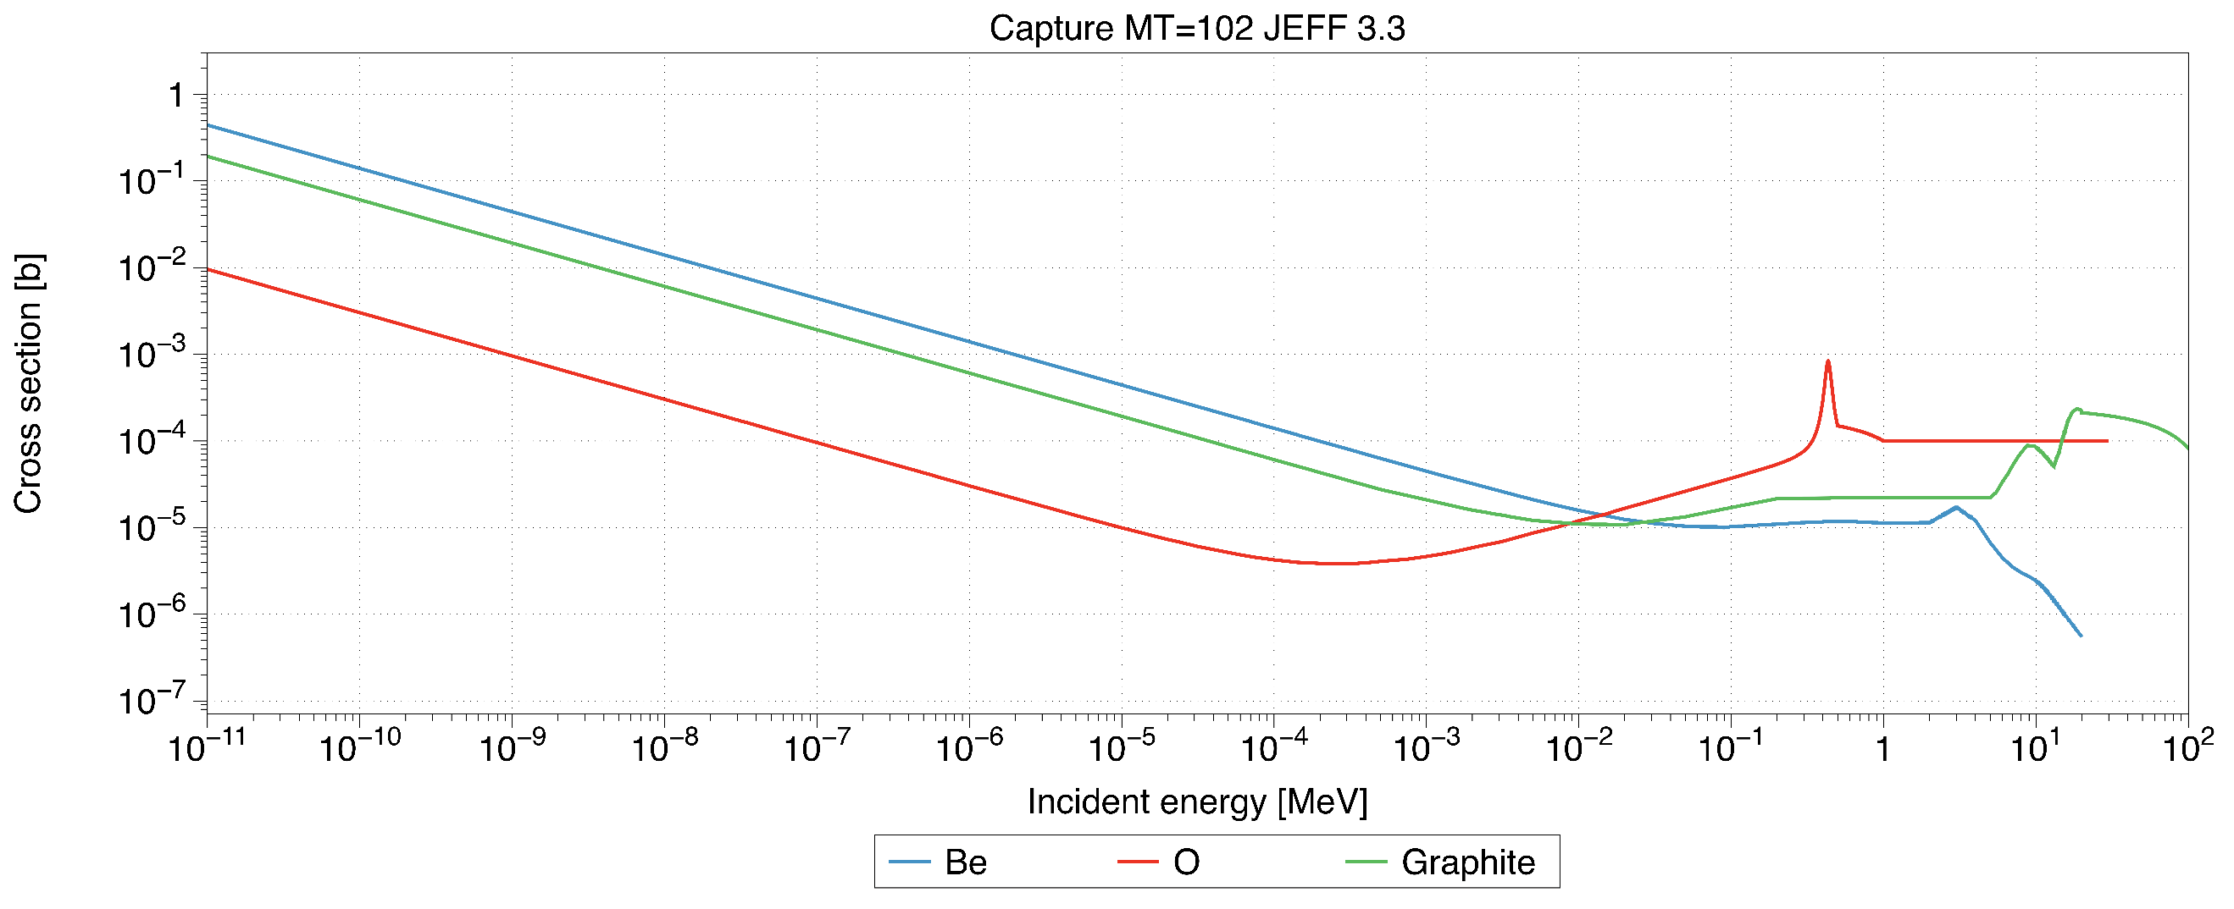
Figure 7.2 – Capture cross-sections for Be, O and graphite produced using JEFF 3.3 data libraries.

Financial Impact
BeO is expensive, with a cost of 265 €/kg compared to 65 €/kg for nuclear graphite [4]. This is a significant price difference when considering the volume of side reflector materials required.
One additional problem that comes with the use of nuclear power is the difficulty of disposing the nuclear waste, this has now been incorporated into the new plants which has to design for decommissioning [88]. With the global stockpile of irradiated graphite reaching 250,000 tonnes the idea of direct repository disposal is currently being considered [89], thus making this material expensive in decommissioning. The current stockpile of nuclear graphite is considered as intermediate level waste [90], implying that it does emit radiation, mainly in the form of C¹⁴. The cost of disposing of this waste has not yet been determined, as there is an ongoing debate regarding the cost of geological disposal of nuclear waste. The nuclear decommissioning authority provided an estimation that intermediate level waste would cost €12345 €* per m³ [90], yet there are reports of the actual cost increasing to €226k €* per m³ [91]. However, alternation approaches to deal with the problem are being investigated [92]. These significant costs could alter the choice of moderating material as decommissioning costs are due to be associated with new build projects.
From the perspective of decommissioning BeO, there has been very little research into the process of how to deal with it as nuclear waste. Due to cost of decommissioning, the overall reduction in the volume of waste while using Beryllium instead of graphite could be a significant driver towards using Beryllium. However, until further research has been conducted into the disposal of BeO, estimates of the total savings cannot be accurately made.

Licencing
Nuclear graphite is one of the most well-known materials in the nuclear industry at least in the UK, due to its extensive use in the Advanced Gas cooled Reactors [66] and the Magnox reactors [89]. These reactors have been operational since the beginning of the civil nuclear era and thus have been extensively performance tested. This has placed the UK as the world leader in graphite moderated cores, thus there is now sufficient data existing for safety cases related to the inclusion of graphite in new nuclear cores.
BeO has currently only been used in test reactors [89] thus the amount of data on performance in nuclear environments is currently minimal. This would make the case for licencing arrangements significantly harder and extensive/expensive tests would need to be performed to provide this data.
*£9,170 in 2011 prices and 1.13 Euros per GBP, applying 3% inflation annually until 2017.
Codes, Data and Models
Design Concept
The design considered is loosely based on the U-Battery concept which aims for a fast deployment using readily available technology. The use of BeO for the reflector goes against the trend, as BeO is not a regular material in nuclear reactors. This means, there is very little operational experience for this material available, so this would require significant experimental support performing an additional safety case. The initial U-Battery report [19] initially stated that the inclusion of a BeO side reflector would increase the overall full power lifecycle to five years. This was investigated and it was determined that to achieve this the Carbon density which was originally used was 2.23 g cm⁻³ which is significantly higher than the usually applied density of nuclear graphite ~1.8 g cm⁻³ [60]. The difference in total reactor lifetime are 706 days between the two models, the detailed calculations results on this difference is included in the appendices.
Methodology
The comparison between the two reflector materials will take place by determining the overall performance difference across the core. All neutronic results presented are simulated through a Monte Carlo simulation routine using the Serpent 2.1.27 [40], using data libraries JEFF 3.1.1.
The analysis will start with the original U-Battery 10MWth design which consists of 25 cm of side reflector [19] as reference configuration. The initial test will look at modelling the 320 cm in active core height, to determine the criticality with the BeO side reflectors. Then the BeO will be replaced by graphite and the reflector dimensions will be extended until the same criticality point is reached. At this point, there will be a known volume of graphite which has to be introduced to obtain the same reflector effect. The same test will be performed axially with the new graphite side reflectors in place, until the same criticality as in the original BeO model is achieved. The idea behind this methodology is that the same initial core performance should be achieved by both models. The finding of the equivalent model is important to perform further operational tests.
Following this, a maximum full power day’s test will be made to determine the overall total fuel lifetime for both configurations. This will allow us to study the effect of the reflector from a neutron economy perspective. graphite has a negligible capture cross-section, compared to the Beryllium in the thermal spectrum range. This would bring forward the hypothesis that the BeO would perform to a lower standard towards the end of the lifetime of the reactor.
The power profile of the core is examined at the start-up, to determine if there are any beneficial effects of the BeO reflector. These could include the advantage of an improved power distribution with lower radial and axial peaking.
The change in volume due to the reflector size change causes other parts of the core to increase too, such as the reactor pressure vessel. This will have an increased cost on the reactor and will then be included in a cost benefit analysis.
Based on a mathematical procedure, the cost analysis of the core will be provided using the assumption that the reactor pressure vessel (RPV) will be located one meter below the bottom reflector and 1.7 m above the top reflector. Thus, the overall material volume changes can be calculated accordingly.
Results and Discussion
The first test aims to find the dimensions of the core which provide the same neutronic performance at the beginning of life with graphite reflector instead of BeO. The first test looks to find a radius of side reflector which leads to a criticality of k_{eff} = 1.10762. Figure 7.3 depicts the core dimension increase with increasing thickness of the reflector until the point of 83.5 cm, where the criticality is nearly identical to that of the BeO reference case.
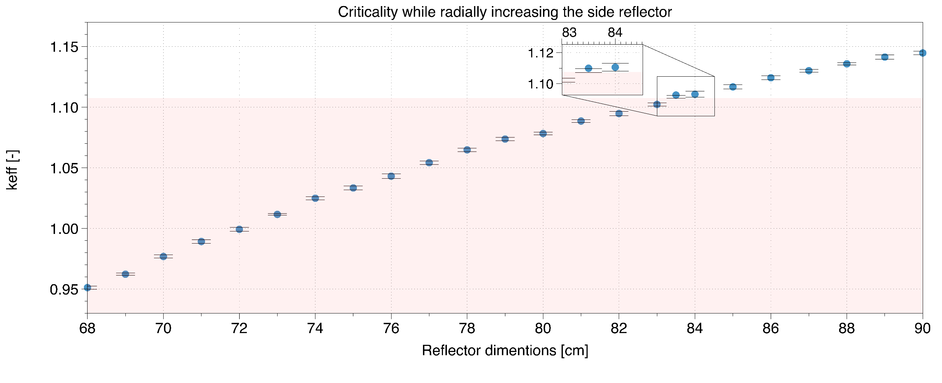
Figure 7.3 - Criticality depending on the thickness of the side reflector, where the pale colour represents the reference point of 1.10762.
In the following search the dimension of the top/bottom reflectors were increased to find a dimension that would provide the same criticality to the original U-Battery reference with k_{eff} = 1.12257, as shown in Figure 7.4.
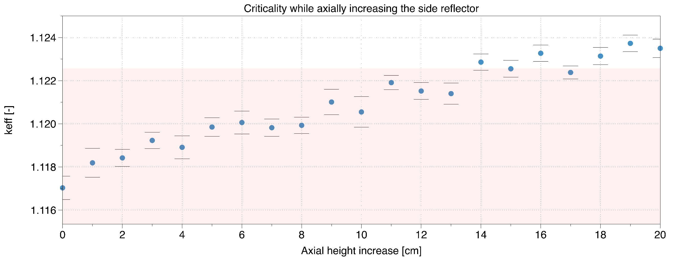
Figure 7.4 - Axial changes of the core and their neutronic implications, where the pale colour represents the point of 1.12257.
Figure 7.4 implies that the axial reflector height provides a far less significant benefit to the system compared to that of radial. The sensitivity Figure 7.4 shows an increase in reactivity with increasing size, but some of this is lost due to the increase in errors due to the small scale of the reflectors benefits.
It was noted from Figure 7.3 and Figure 7.4 that the new dimensions of the alternative U-Battery conceptual design with graphite reflector have increased radially from 68 cm to 83.5 cm and axially from 20 cm to 35 cm. the configuration of the original U-Battery proposal and the alternative system are depicted in Figure 7.5.
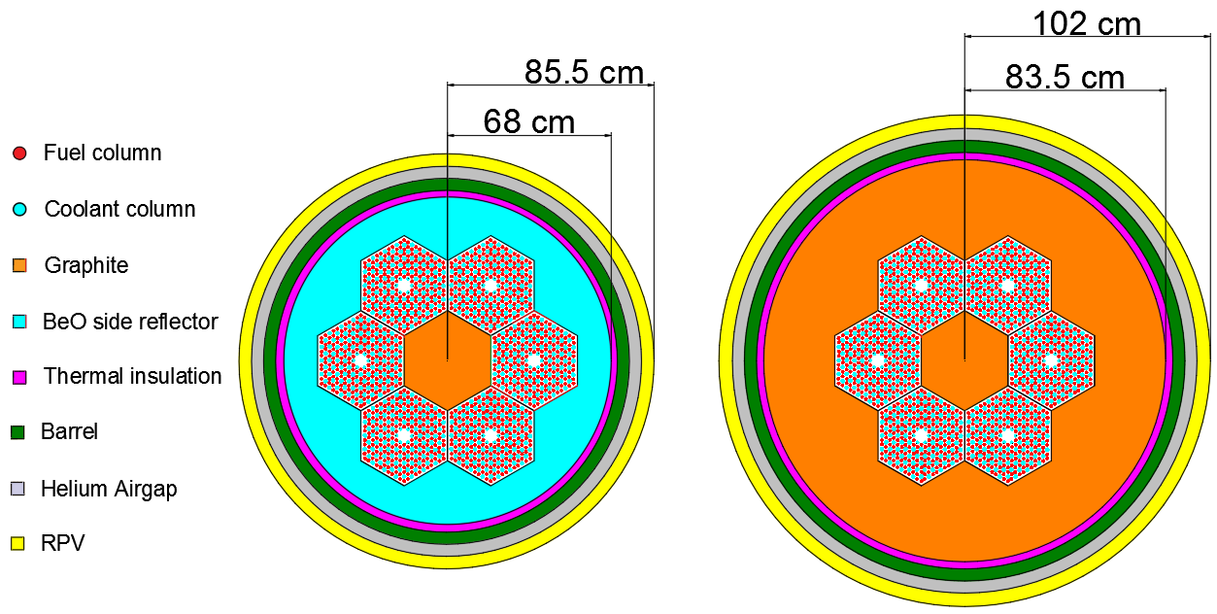
Figure 7.5 - Left: Original U-Battery design, Right: Equivalent model representation with graphite reflector
The next stage investigates the long-term effects on the burnup of the nuclear fuel caused by the changing of the reflector. Beryllium is susceptible to transmutation, so seeing the effect on how this changes the moderation over time should be considered. To calculate this, the volumes of each reflector is calculated and then the reflector material undertakes depletion. The long-term effects are shown in Figure 7.6.
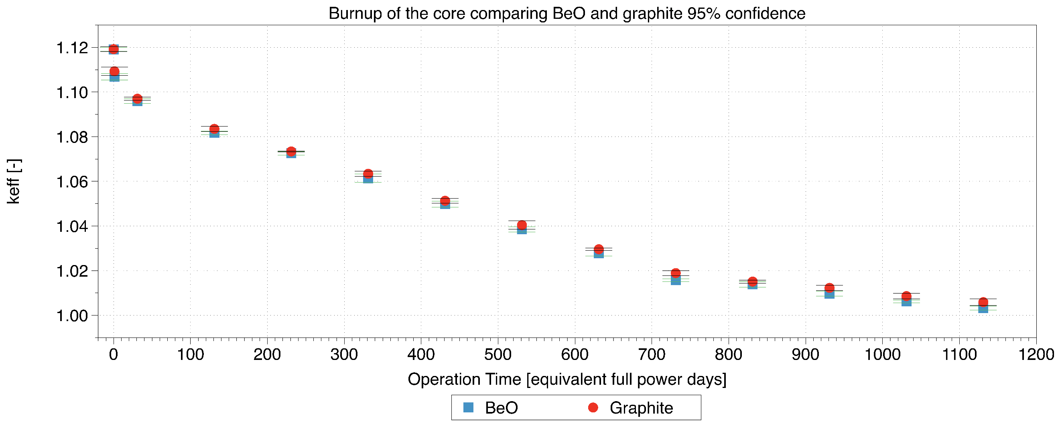
Figure 7.6 - Change of the effective system criticality over operational time for the difference reflectors with 95% confidence in the Monte-Carlo results.
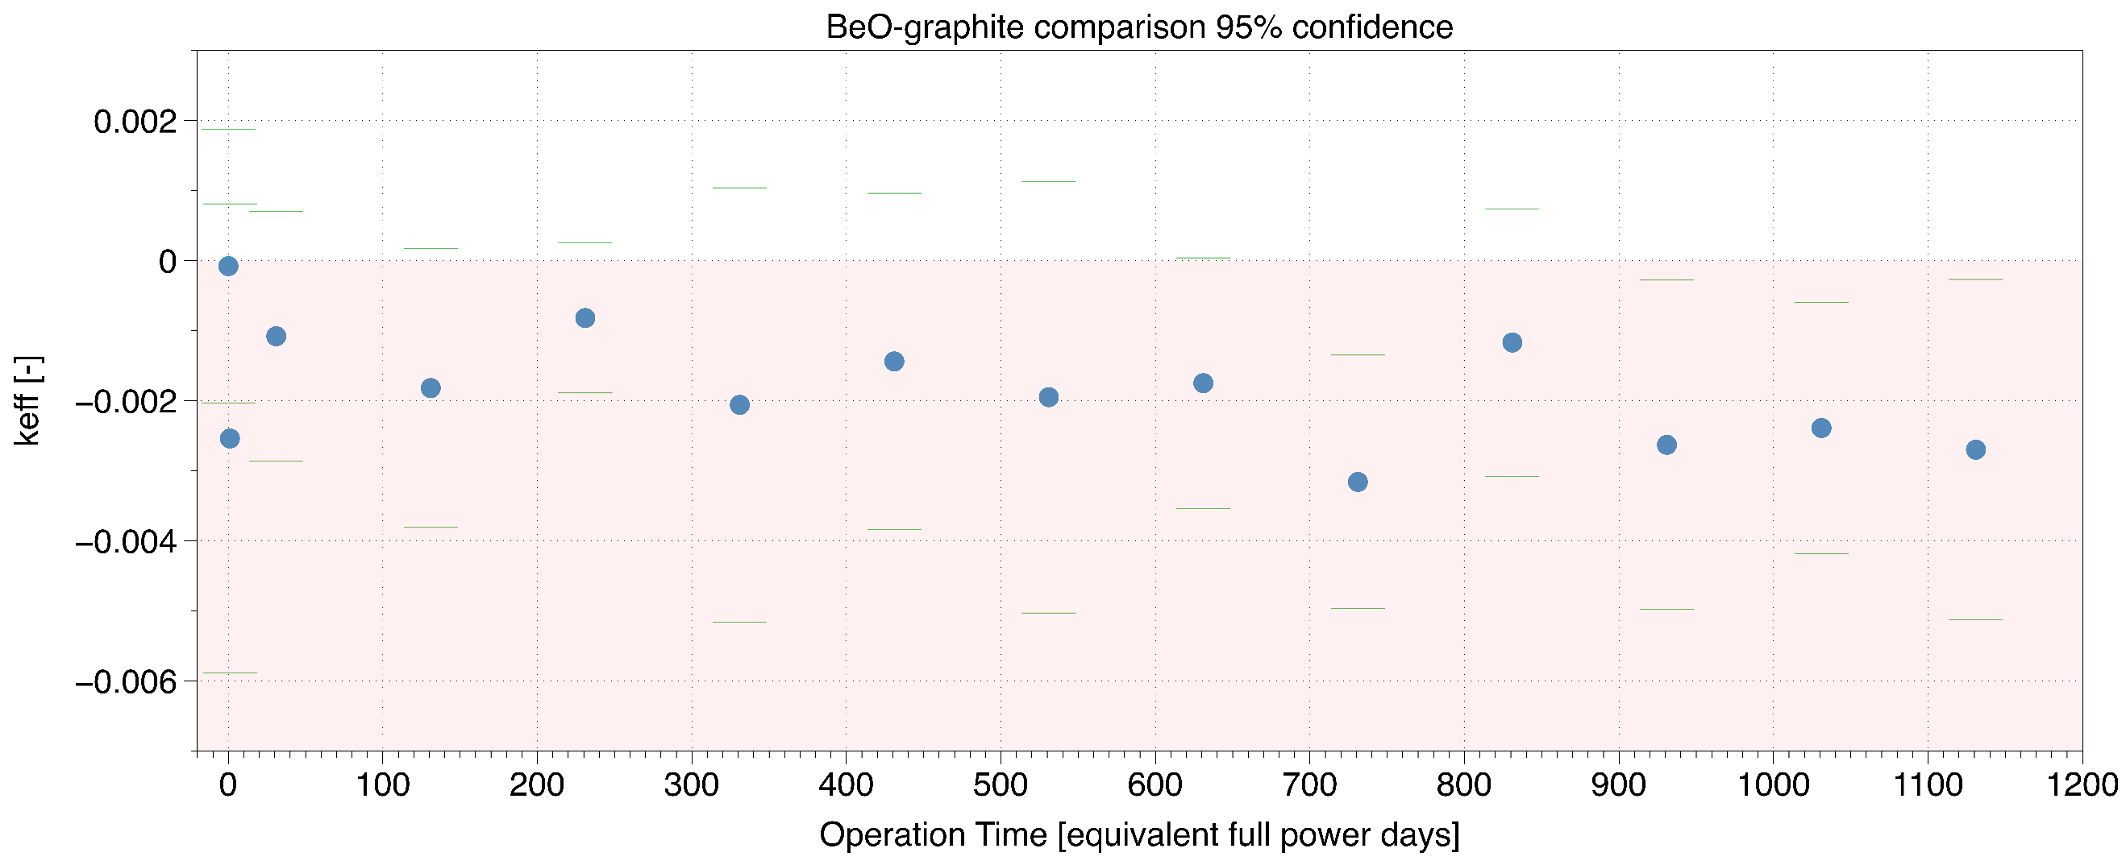
Figure 7.7 - Difference in the change in criticality (BeO case – graphite case) between BeO and graphite reflector case with 95% confidence.
Figure 7.6 implies that the system criticality decreases with increasing operation tie which is to be expected since the fissile material content of the core is reduced to produce energy by fission of the fissile material in the initial loading. Identical fuel loading between the two reflectors which are normalised to the same power, yet due to the increased capture characteristics of the Beryllium reflector, the end of fuel cycle lifecycle is slightly lower than that of graphite as highlighted in Figure 7.7. The reason for this is due to the gradual transmutation of O¹⁶ and B⁹ over the fuel cycle reduce the moderating properties significantly faster than that of the graphite reflector.
Figure 7.7 determines that the difference is small over a period of five years, however, the significance of this over a lifetime of 60 years might require additional fuel loading.
The next test examines how the power production is distributed across the fuel block. Serpent does not allow for implicit modelling of the TRISO fuel when recording the power distribution, so in this case the fuel columns are homogenised in both cases. Figure 6 is a CAD representation of the back half of the fuel block in Figure 7.9, with the orange lines representing the position of the side reflector. The distribution of normalised power was normalised to one with reflective boundary conditions in the Z axis.
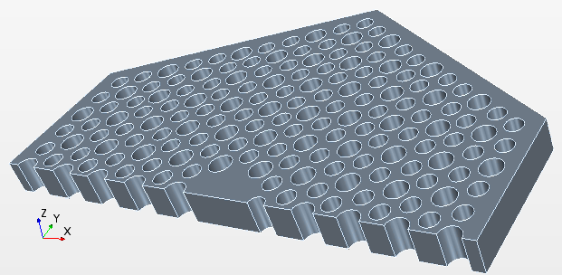
Figure 7.8 - CAD drawing of the half fuel block representation in Figure 7.9
Figure 7.9 - Fuel column wise power distribution in the half fuel block for the graphite reflected core.
Figure 7.9 indicates that the highest power is situated at the centre of the fuel block at the side facing the central reflector in the centre of the where the centre is at (0,0). Due to the reflector materials being situated around the centre and the outsides this provides a high number of thermal neutrons and thus the peaks in power. Due to the small geometry of the core, the centre of the fuel block often does not see as many thermalized neutrons as the sides where prompt neutrons are born and often pass through the centre before thermalisation.
The difference in the fuel column power between the graphite case and the Beryllium case is shown in Figure 7.10.

Figure 7.10 - Fuel column wise difference in the power production across the centre of the graphite fuel block (BeO case – graphite case)
Figure 7.10 indicates that the graphite reflector is producing a larger power at the pins directly adjacent to the side reflector. There are two aspects which could cause this, initially the thicker reflector in the graphite provides less neutrons leaking out from the core and thus a higher percentage returning from the central reflector. The second reason is that the additional absorption from Beryllium is reducing the neutrons returning adjacent to the side reflector. The figure also points to the highest power pins in the centre of the core, see a direct increase in power in the BeO system, this would therefore contribute more towards the burnup of the fuel columns and a higher power peaking in the centre of the core. Both having a negative impact on the overall performance of the core.
In addition, Figure 7.10 highlights that the top of the fuel blocks (maximum Y position) a significantly increase of power due to the beryllium, this is due to the additional scattering between the fuel block regions.
Following the identification of the highest power column power in the radial slice, the next investigation is concentrated towards the hottest column at the central reflector with an axial power distribution as displayed in Figure 7.11Figure 7.12.
Figure 7.11 - Axial power distribution in the most powerful single column in the graphite reflector case
The more detailed investigation in Figure 7.12 shows the delta power between the graphite case and the Beryllium case. Here it must be mentioned that this picture is for one specific fuel column which obviously created a higher power in the BeO case than in the graphite case. However, the overall power in the system is identical in both cases.

Figure 7.12 - Power variance in most powerful pins (BeO case – graphite case)
On the one hand, in the observed column, the main power increase in the Beryllium case comes at the top and bottom compacts, where the fuel burnup is not at its maximum power as with the centre. This is most probably a result of the increased moderation properties of the beryllium. In this case the higher power at the centre in the graphite case is causing additional loading on the highest power pins, despite this additional loading only being small.
Financial Analysis
The next step is to determine the new costs of the reactor core when making the required change in the dimensions of the reflector. Now the equivalent axial and radial dimensions have been calculated, the new costs of each materials can be determined. The new dimensions are shown in Table 7.2.
Table 7.2 - New radial and axial dimensions for the Graphite reflector for comparison with the original proposal using BeO reflector
 | Radial dimensions (m) |  | Axial dimensions (m)
Material | BeO | Graphite | BeO | Graphite
Side reflector | 0.68 | 0.835 | 6.3 | 6.6
Thermal insulation | 0.03 | 0.03 | 6.3 | 6.6
Barrel | 0.05 | 0.05 | 6.3 | 6.6
Helium airgap | 0.05 | 0.05 | 6.3 | 6.6
RPV | 0.056 | 0.056 | 6.3 | 6.6

By assuming that the volumes of the top and bottom of the core form a sphere together, halving this sphere provides an insight into the new volume changes between the two models, presented in Table 7.3.
Table 7.3 - The total volume of each material for the graphite reflector for a comparison with the original proposal using the BeO reflector
 | Volume during cylindrical position (m³) |  | Volume during spherical top/bottom (m³)
Material | BeO design | Graphite Design | BeO design | Graphite Design
Side reflector | 6.636 | 11.941 | N/A | N/A
Thermal insulation | 0.825 | 1.057 | 0.182 | 0.272
Barrel | 1.455 | 1.845 | 0.340 | 0.498
Helium airgap | 1.554 | 1.949 | 0.387 | 0.555
RPV | 1.858 | 2.306 | 0.494 | 0.694

This allows the total cost of each material to be determined, using the basic costs per kg of each design as found in the U-Battery report [19]. A cost breakdown of the new core is presented in Table 7.4.
Table 7.4 - Cost break down of raw materials for both designs
 |  |  | Total mass of each material (Kg) |  | Total cost of materials (€)
Material | Density (Kg/m3) | Cost (€/kg) | BeO design | Graphite design | BeO design | Graphite design
BeO | 2850 | 265 | 18914 | N/A | 5012161 | N/A
Graphite fuel blocks | 1800 | 65 | N/A | 21494 | N/A | 1397121
Thermal insulation | 1800 | 40 | 1813 | 1904 | 72537 | 76148
Barrel | 8000 | 42 | 14354 | 18746 | 602878 | 787313
RPV | 8000 | 42 | 18816 | 24001 | 790261 | 1008031
 | Total mass (tonnes) |  | 54 | 66
 | Total cost of the materials (M€) |  | 6.48 | 3.27

Some assumptions have been made to produce Table 7.4, where the additional thermal conductivity with the Beryllium is likely to require more thermal insulation. However, to quantify this would be difficult at this stage. The overall volume increase of the graphite case is 27.5% larger to achieve the same performance, this has a significant increase on the mass with an additional 12 tonnes. The implications of this would be that transporting the core to the site would be more challenging, however, due to the mass being over 44 tonnes the unit would already be designated as an abnormal load within the UK [93]. Abnormal loads have restrictions on routes which that can be used within the UK.
One of the main issues falls with the cost in Table 7.4, where the cost saving of using graphite is 50%. As costs are one of the main drivers of SMRs, the benefit of a reduced size core is not as beneficial as the total cost of materials.
The margin of costs from Table 7.4 implies that even taking then higher volume and decommissioning costs, graphite is still 31% cheaper than the BeO design.
Conclusion
This paper has investigated the comparison between BeO and nuclear graphite as a side reflector material for a generic high temperature micro reactor based on the U-Battery design. The first test confirmed that a graphite reflected core would be significantly larger than a Beryllium reflected core, with the overall required reflector volume of an additional 5.3 m³ or approximately 80% more to achieve almost the same neutronic performance. These calculations showed that the radial contribution was much more significant in comparison to that of the axial contribution where the criticality changes were much smaller. The reason for this is the tall, thin design of the U-Battery where radial changes have a larger effect due to the proximity to a much higher volume of fuel blocks.
The burnup curve provided an indication over the lifetime of the core that the Beryllium reflector suffered from slightly fewer full power days to that of the graphite reflector. This is likely to be due to the reduction in moderation over time due to transmutation of the Beryllium and oxygen, which is less significant in graphite.
The third test examined the power profiles in radial and axial directions based on the radial slice through an infinite system and the evaluation of the power distribution within the hottest fuel column. The radial distribution saw an increased power profile towards the side reflector due to contributions from the increase in side reflector volume and due to the absorption within the beryllium. There was a slightly higher overall power distribution in the hottest pins within the Beryllium case, this was investigated and determined to be towards the top/bottom of the fuel columns so did not provide any additional loading. The graphite reflector saw a very small increase within the centre of the hottest pins.
The financial analysis took account for the larger core size when using a graphite reflector. However, due to the high premium cost of Beryllium the originally proposed reactor would cost nearly twice as much as the graphite model. Like most industries, the driving force behind material choices is heavily influenced by the cost of the design. In the case of SMRs, the volume reduction does not justify doubling the material costs. Relating to this, this nuclear waste would be significantly reduced. Taking the higher estimation of €226k m³ this adds an additional €1.2 m, in which case graphite would still be the recommended material. There is currently significant research being undertaken in the field of volume reduction of Graphite waste which might reduce these costs. Further work regarding reprocessing and decommissioning of BeO is required to make accurate cost estimations in this field.
One issue highlighted was the novelty of Beryllium within the nuclear industry, with limited data on nuclear scenarios highlighted within the literature, there is still a significant gap in materials knowledge to provide a safety case for the material. Where as in the case of graphite, this material is well understood, and has already multiple safety cases undertaken within the UK. To develop the safety cases required for Beryllium would delay deployment as this report has shown that graphite can perform to the same standards.
Overall this paper has overviewed BeO and has concluded that for a size perspective, then BeO is significantly better than that of Graphite. However, the capital cost of the material is significantly higher than that of graphite and thus the overall performance benefit does not warrant the use of Beryllium when compared to other well-known materials such as nuclear graphite.

This article has published in the Open Source journal Energies 20/7/18 http://www.mdpi.com/1996-1073/11/7/1897 .
The following work was part of a patent application which was filed on 16/7/18 undertaken following the work on this section PhD.

Variable reactivity control in small modular high temperature reactors using moderation manipulation techniques
Design Concept
The design chosen to test the new approach is the U-Battery [19], a prismatic HTR SMR based on the prismatic core design. The U-Battery consortium has decided to focus on their 10 MW_{th} design version, so an imitation model has been created as a starting point. The side reflector has been switched to a graphite over a Beryllium core due to the ease of deployment and additional benefits witnessed previously [94], as shown in Figure 7.13. Additional tests were performed to put the initial design on a more realistic basis as covered in the appendices. The final design dimensions are also available in the appendices.
Figure 7.13- The original (left) and the modified graphite (right) U-Battery design used in this report
Methodology
Due to the U-Battery’s small size, the peak fluxes as well as the resulting power distribution are all heavily dependent on the central reflector (CenRef) of the annular core design. The central reflector block is made solely of graphite, to aid the neutron moderation, this aspect can be utilised by removing the moderation to reduce the criticality by spectral hardening. A similar approach is used during the operation in the boiling water reactor [95], where the reduced coolant flow allows for reduced moderation due to additional void content and thus changes the spectrum to reduce the criticality.
However, graphite is undergoing an altering process which changes physical its conditions during irradiation [96], [97]. This implies that graphite needs to be handled carefully over time, so the concept of moving the whole hexagonal block seems to be unrealistic due to the difficulties of mechanical deformation of the material and the structural integrity of the core itself. It is proposed to maintain structural integrity over time by keeping the outside structure of the hexagonal graphite block, only a 26 cm diameter column is cut out of the centre of the central hexagon as depicted in Figure 7.14. This first approach can be optimised as soon as the first structural integrity evaluation is made available.
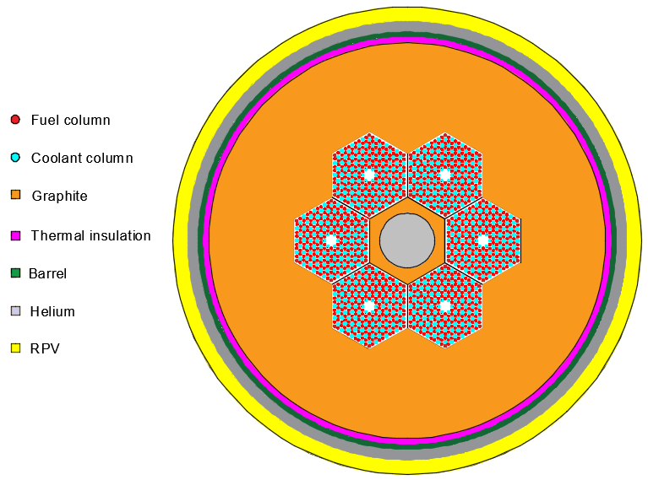
Figure 7.14 - Central reflector removed in the centre of the core and replaced with helium coolant
When considering the task of reactivity control, the requirement for exceptional safety critical systems is paramount. The IAEA safety guide [98] contains regulations that require control rods to be fitted with an interlock to allow the system to be not triggered in unwanted situations. While moving the central reflector block, a similar amount of safety confidence will be required, as the insertion at the wrong time could cause the core to become supercritical. In addition, a fail-safe design system will be essential, it is therefore suggested that the central reflector is inserted from the bottom of the core upwards, this eliminates the risk of the central reflector of entering the core under accidental scenarios.
The control of a central column must be qualified to a similar degree as a control rod drive to pass regulatory standards. This could be achieved in a similar affect as a mechanical jack, where each rotation of the jack is limited to a single turn for the operators input to be limited and controlled. This would provide a high safety factor and remove the potential hazard of unwanted criticality insertions.
There are several important aspects which must be investigated, when changing the system in this manner to create a deeper understanding of the relevant effects. The first is the overall benefit in reactivity control which can be gained from the procedure by producing a fuel lifecycle criticality experiment. This experiment takes place by using an un-poisoned version of the U-Battery and the three CenRef material positional arrangements conditions shown Table 7.5. During the removal of the CenRef the gap left is modelled using helium to represent the coolant in the system.
Table 7.5 – CenRef positions considered
Central reflector position | Height of central reflector (m)
Fully inserted | 3.2
Half inserted | 1.6
Removed | 0

At the point of 1.02 criticality, the central reflector is the directly re-inserted to determine the long-term behaviour of the core and maximum lifetime.
The second test is to determine the effect on the power distribution due to the removal of the central reflector and of the re-insertion. The central compacts are expected to deliver highest power, so removing the moderation will have most probably a positive influence on the overall power distribution in the core the effect will be changed when the moderator is re-inserted. The changes could lead to additional power peaking which could cause overheating.
All neutronic results presented are simulated through a Monte Carlo simulation routine using the Serpent 2.1.27 [40], using data libraries JEFF 3.11 as shown in Figure 7.15.

Figure 7.15- Serpent model of modified U-Battery with the central reflector removed

Results and discussion
The initial test determines the overall criticality changes of the system over the period of the possible reactor operation. This experiment models the total criticality without poisons with the column in, out and half out. At the point in when the criticality is at 1.02, the column is reinserted to determine the overall lifetime achievable.
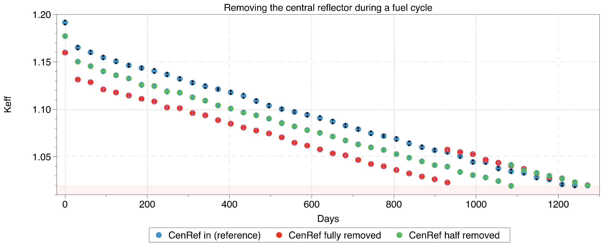
Figure 7.16- Criticality with CenRef column at varying positions, with criticality 1.02 marked
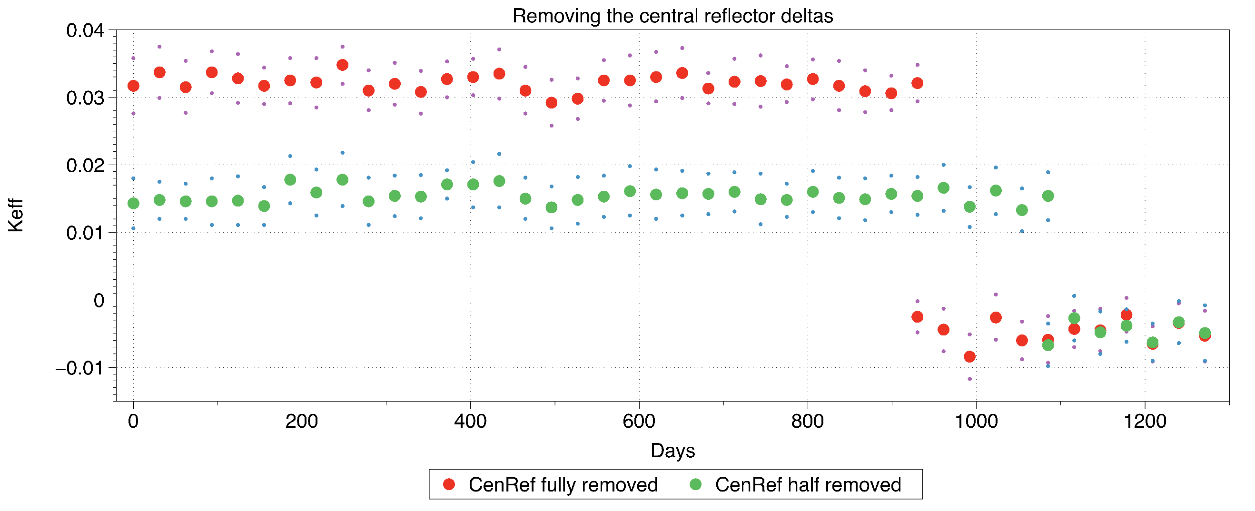
Figure 7.17 - Delta from base of CenRef removal (Reference-Fully removed) & (Reference – Half removed)
Figure 7.16 and 6 show the initial criticality is dropped by 0.032 and 0.014 with the CenRef withdraw full and half with respect to the base model. From the consideration of HTR operation, this is the point at which the reactivity control mechanism would have been activated to accommodate this criticality drop to limit the excess reactivity in the core. There is still a significant distance until reaching unity, which would have to be accommodated in a real design by a combination using FBPs and control rods. However, the applied method of withdrawal of a part of the CenRef has shown a clear drop-in criticality at initial start-up. At day 920 and 1085 the two withdrawn pieces of the central reflector must be reinserted into the centre to keep the criticality above the considered limit level of 1.02. Both models show after reinsertion of the central moderator a slightly higher criticality than the reference case.
The slightly increased criticality is likely due to an increased build-up of ²³⁹Pu as hypothesised earlier. This additional fissile material content allows a slight increase (~31) in full power days compared to the base model.
To analyse the ²³⁹Pu build up dependent on the position on the central moderator piece, a single 10 cm section at the centre of the axial fuel height was monitored to determine the overall ²³⁹Pu content over the burnup of the core. The fuel compact is identified in Figure 7.18.
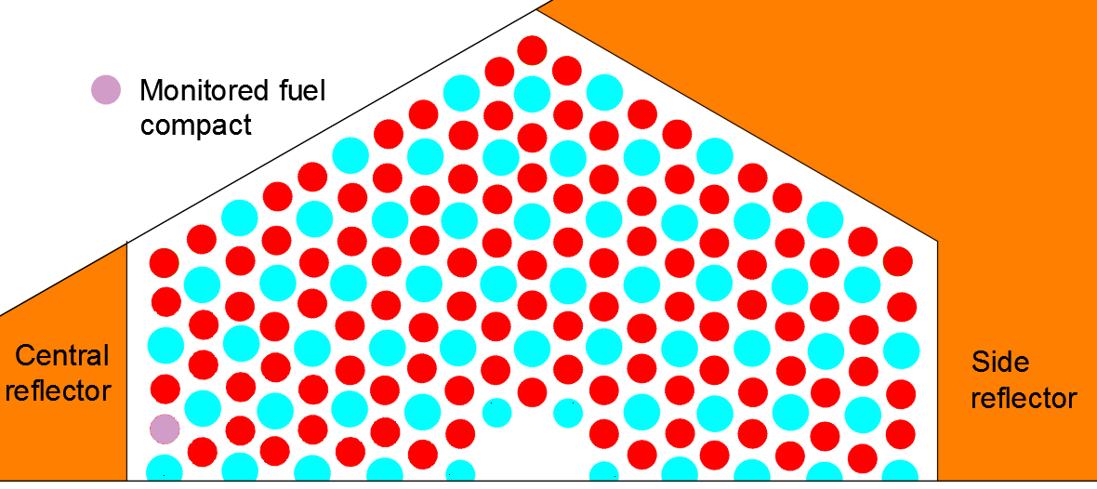
Figure 7.18- Compact monitored for the ²³⁹Pu build up analysis
At the beginning of the life of the core there is zero content in ²³⁹Pu since ²³⁹Pu is not a content in UO₂ fuel. Plutonium is bred time as neutrons are captured in the ²³⁸U atom which is transmuted via Neptunium into ²³⁹Pu. The development of the atomic densities of the ²³⁹Pu is recorded over burnup and compared between the three systems in Figure 7.19.
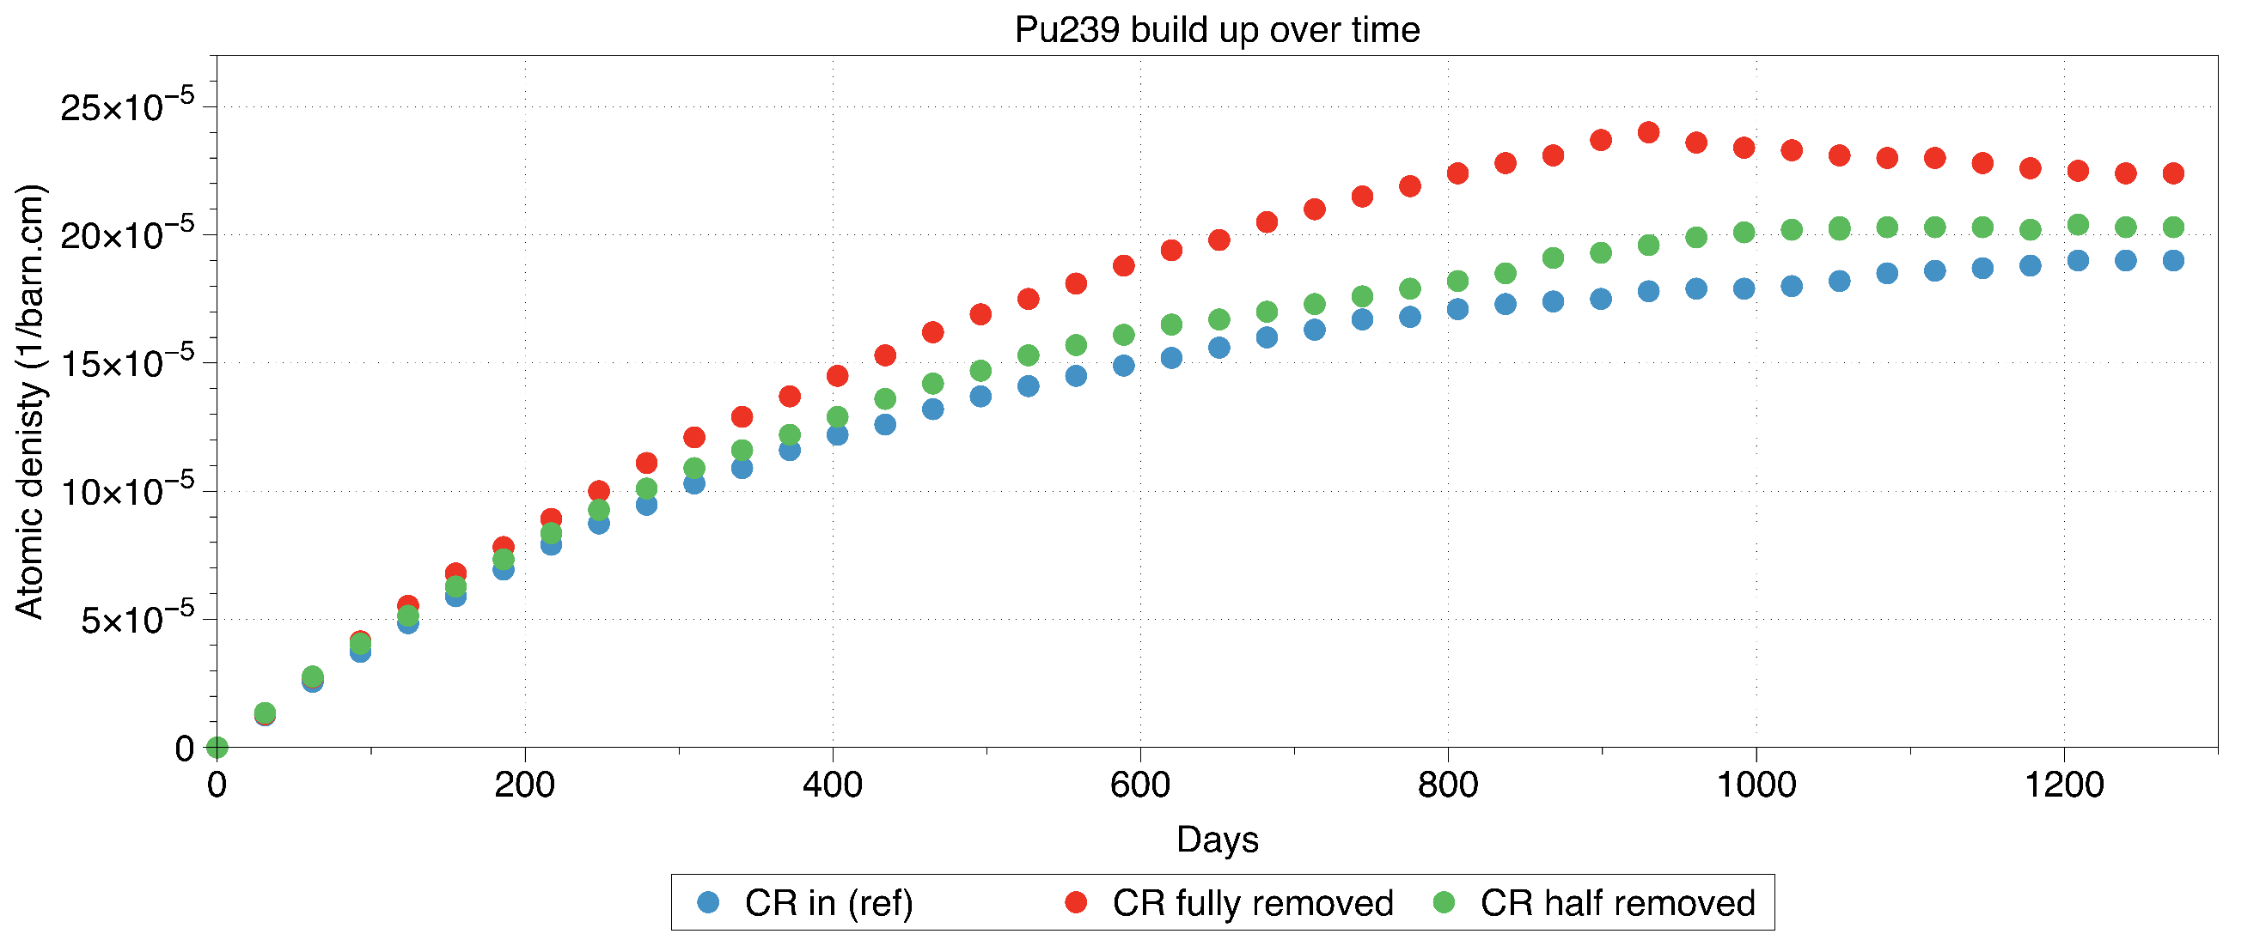
Figure 7.19 - ²³⁹Pu build up over time with the different central reflector arrangements in the monitored central pin.
The positioning of the observed piece of fuel used to monitor the material composition is important as the system with half the reflector in is still partly benefitting from a large thermal spectrum across it since it is close to the upper surface of the movable moderator block. This is shown by the similarities to the base case in the system. When inserting the central reflector again, the half in system provided minimal variation due to the position. In the case of the fully removed central reflector the re-insertion provides an immediate bend in the curve of the ²³⁹Pu concentration build up. Once the central reflector is re-inserted more ²³⁹Pu is consumed than new build. This is an effect of the higher capture cross-section of ²³⁹Pu within the thermal energy range. This result reaffirms the conclusion that the additional criticality is granted from the breeding of additional fissile material and answers the hypothesis that the stored neutrons are capable of being re-deployed at a later stage.
The second step is to investigate the power distribution in the compacts of the fuel assembly at the start-up of the reactor to see the effect of the absence of a major piece of the central reflector on the power distribution in the fuel assembly. The following figures represent the powers in the fuel compacts across one half of the eastern fuel block with withdrawn moderator piece Figure 7.20 and the reference undisturbed case Figure 7.21.
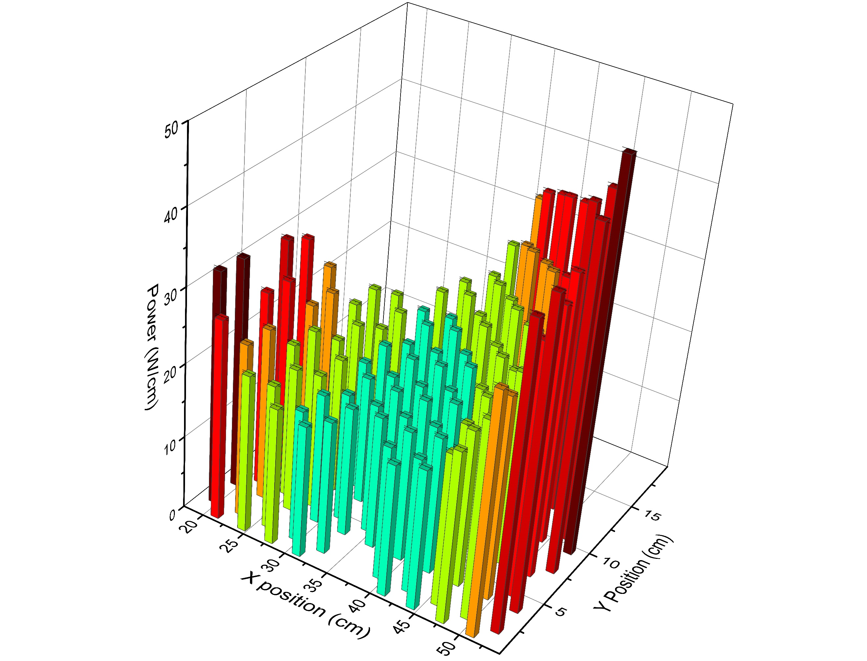
Figure 7.20 - Power distribution with the central reflector fully removed
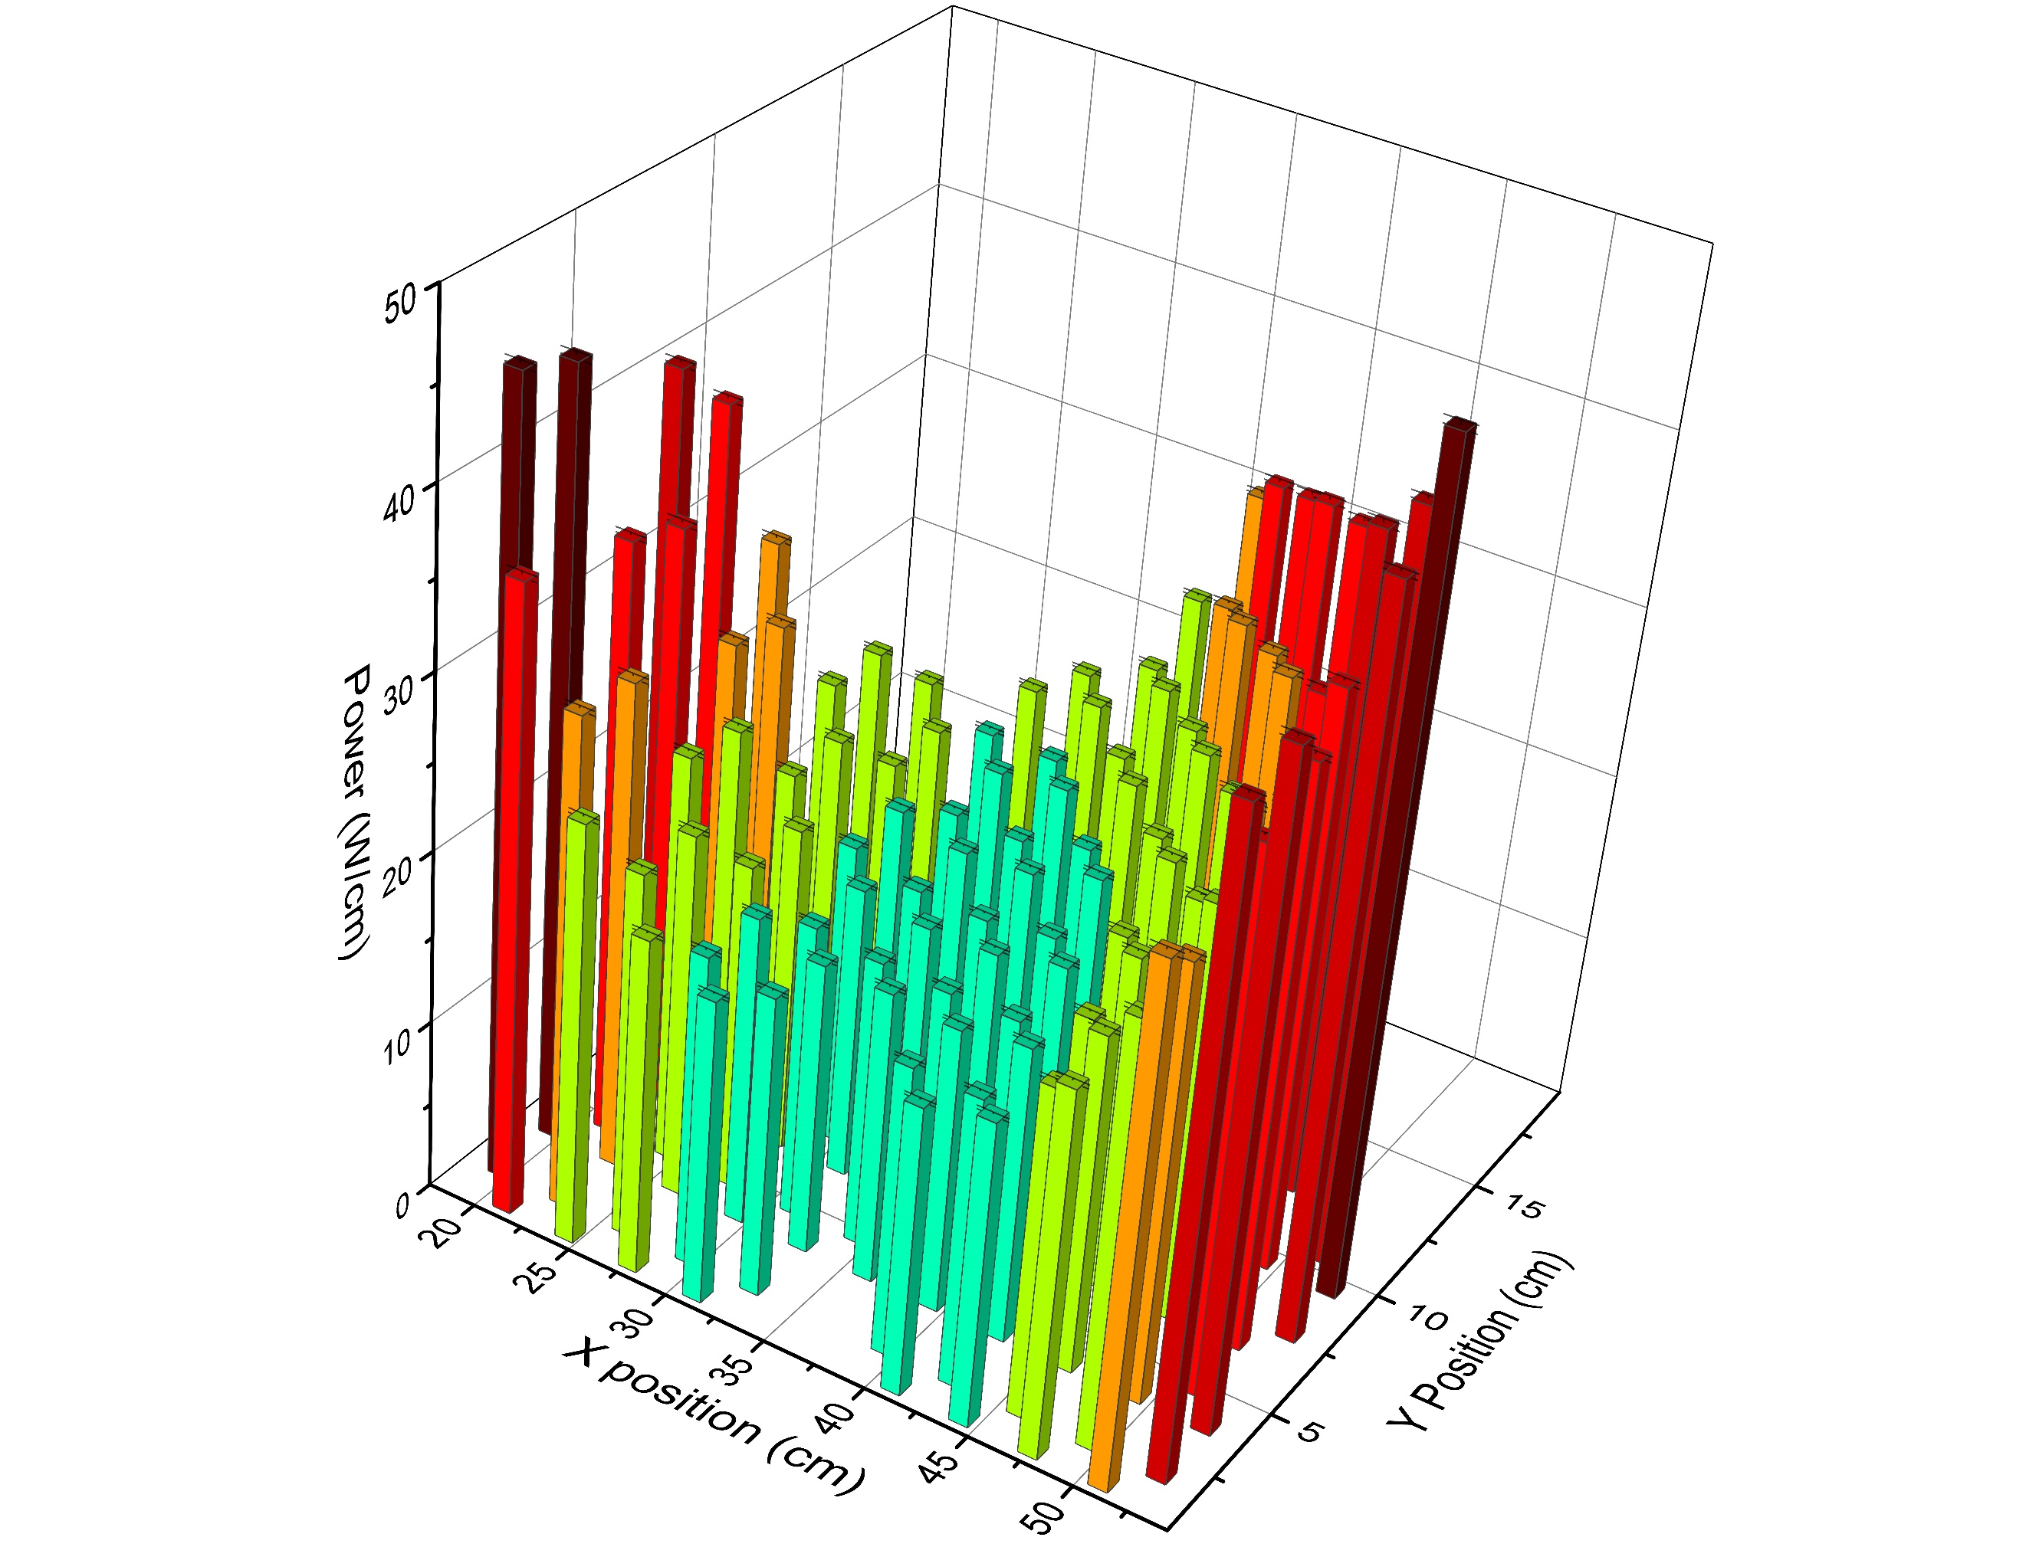
Figure 7.21 - Power distribution with the central reflector fully inserted (undisturbed reference vase)
Both figures show a pronounced power distribution with a reduced power production in the centre of the fuel assembly and a clear increase of the power production in the compacts close to the central and the outer reflector. This characteristic power distribution in a HTR fuel block can be explained with the self-shielding of the fuel against the thermal neutron flux which is created in the pure moderator regions. Highly thermalized neutrons are created in the graphite reflector which has an extremely low absorption cross-section for neutrons. As soon as the thermal neutrons are re-entering the fuel block, there is a high probability to cause fission reactions, thus the thermal neutrons have a low probability to reach the centre of the fuel assembly and cause fissions there. A close comparison of the power production in the innermost row of Figure 7.20 and Figure 7.21 indicates that the removal of a part of the central moderator reduces the power production in the part of the fuel assembly close to the centre of the core. The detailed analysis of the deviation of the power production between the reference case and the case with extracted central moderator piece, given in Figure 7.22 shows a general power shift away from the centre of the core as a part of the moderator is removed. This is important due to the highest power pin being in the centre of the core which leads to a significant load reduction as the power is shifted across the core to the fuel pins close to the side reflector. In addition, the control of the reactivity must be assisted using burnable poisons and control rods. In most of the proposed fuel block designs for block type HTRs, the burnable poisons are in the corner compacts of the hexagons, since these are the positions which are exposed to the highest thermal neutron flux due to the location close to the reflectors while the control rods are located in the side reflector.
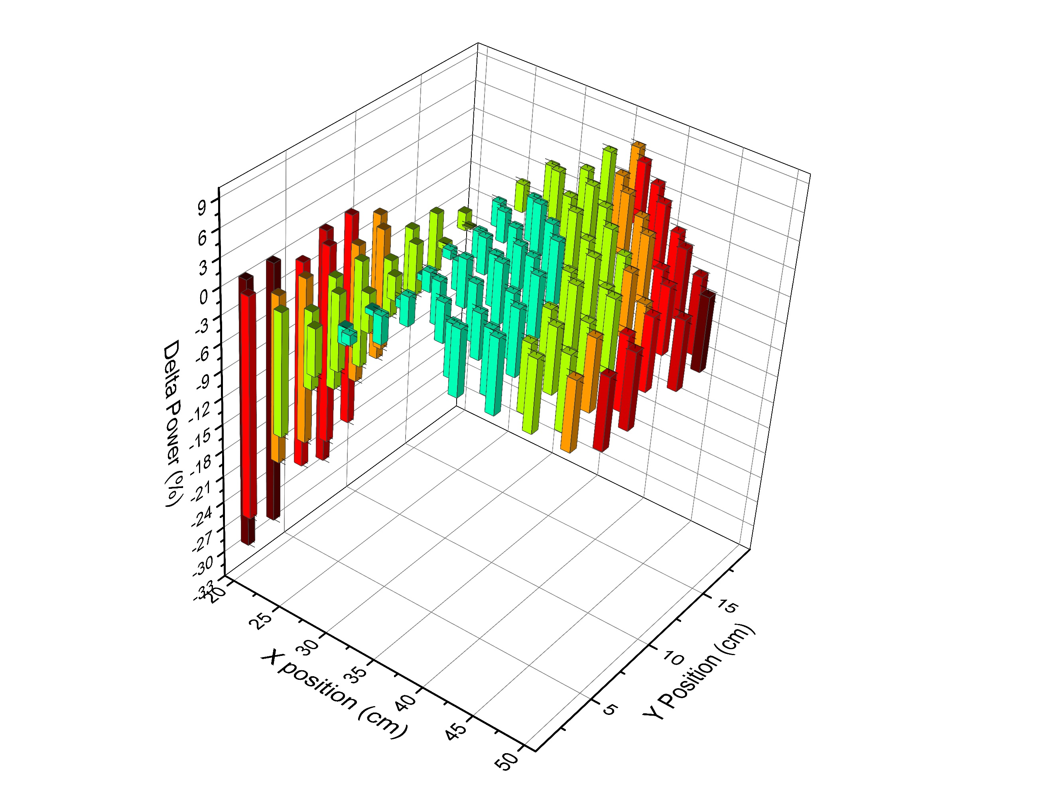
Figure 7.22 - The change in power (Central reflector out- central reflector in)
Figure 7.22 emphasises the drop-in power on the central pins, with an overall power drop of ~30% during the full removal of the central reflector and a power increase of ~7.5% in the pins close to the side reflector.
Axial power distribution is shown in Figure 7.23 for the operational point just before and after the insertion of the central reflector piece. It is obvious that the total power is significantly reduced in the central pins. The removal of the central reflector completely changes the power production in the pin in Figure 7.18. Only the top and bottom of the pins produce identical power which could be explained by the effect of the axial reflectors.
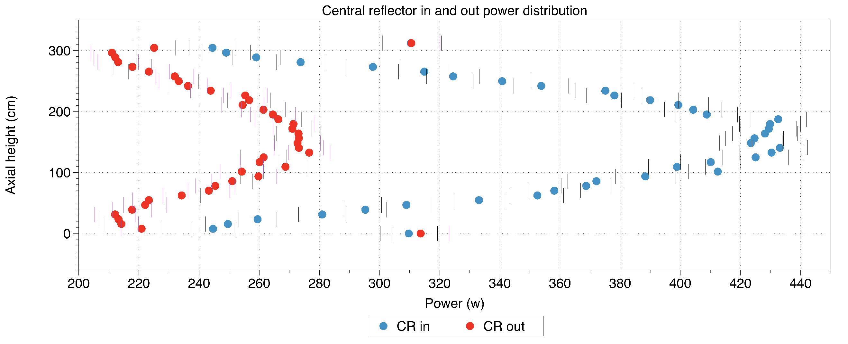
Figure 7.23 - Axial power distribution in the monitored central pin

Conclusion
This paper has briefly investigated a new type of reactivity control mechanism for a conceptually design SMR HTR. The concept touches on the ability to preserve some neutrons during high reactivity periods, for them to be utilised at a period later in the fuel cycle. This is achieved by breeding ²³⁹Pu at a higher rate than would be normally active in the fuel cycle by reducing the neutron moderation. This hypothesis was demonstrated that ~30% higher ²³⁹Pu production was witnessed at the point before the moderator is re-inserted. The ²³⁹Pu concentration depleted once the central reflector was reintroduced and this provided a large reactivity increase. This additional reactivity provided an increase of full power days of the reactor by approximately 31 days which corresponds to a 2.5% longer core lifecycle. It should be noted, that the present article demonstrates the concept of the moveable moderator reactivity control. The design of the moveable moderator can be further optimised, such as introducing the moveable moderator into the graphite reflector regions, concentric rings of graphite in the central reflector to allow for more precise reactivity control. The drawback comes with adding complexity into the control design, with the method demonstrated here focusing on the most simplistic method available.
The second test tried to identify any possible penalties with the fuel power loading within the core. In the case with the reflector removed, the overall power dropped by 30% within the highest loading pins which must be recognised as a positive effect. The power was shifted gradually across the core to the pins by the side reflector, which does not suffer from such high power as well as high burnups. Thus, we have identified a significant advantage when considering the power and resulting burnup distribution as the pins with the highest loading have had their power significantly reduced without the aid of neutron poisons.
In conclusion the overall effect of changing the moderation within the centre of the core provides a two-fold benefit, initially with longer fuel life cycles and secondly with a better power distribution.

This article was published on 09/11/2018 to Progress in Nuclear Energy

Small Modular High Temperature Reactor Optimisation Part 2: Reactivity control for prismatic core high temperature small modular reactor, including fixed burnable poisons, spectrum hardening and control rods.
Design Concept
The design considered is loosely based on the U-Battery concept which aims for a fast deployment using readily available technology. The initial U-Battery report [19] initially stated that the inclusion of a BeO side reflector increased the overall full power lifecycle. This initial design was analysed and it was determined that the overall lifecycle was over predicted 706 days as explained in detail in [94]. To achieve a long operating lifecycle is part of the main design concept, so achieving as near to five years as possible is one of the purposes of this design.
Material selection is important when considering the reactor design and the above-mentioned fast deployment. To allow for easy deployment, the materials should ideally have been used before to allow for a safety case to be carried out. In the case of the poisons, Gd₂O₃ is currently used within the advanced gas-cooled reactor (AGR) fleet [66] as well as LWRs [99]. In addition to this B₄C in the control rods of almost all kinds of reactors.
When considering the design of the control rods, the use of material choices is important. The latest generation of LWRs the AP1000 which passed the generic design assessment, uses Silver-Indium-Cadmium alloy [100] which isn’t suitable due to temperature constraints [68]. The South African PBMR project used B₄C as an absorber with an Inc800H alloy [101] as shown in Figure 7.24.
In the case of the this design the control rods are much smaller, with the main variable being the thickness of the B₄C layer to create a much stronger poisoning presence as shown in Figure 7.24.
Table 7.6 - Control rod description
 | PBMR |  | U-Battery concept
 | Outer radius (cm) | Thickness (cm) | Outer radius (cm) | Thickness (cm)
Inner Inc800h | 4.2 | 0.1 | 0.2 | 0.02
B₄C | 5.05 | 0.85 | 0.98 | 0.96
Outer Inc800h | 5.25 | 0.2 | 1 | 0.02

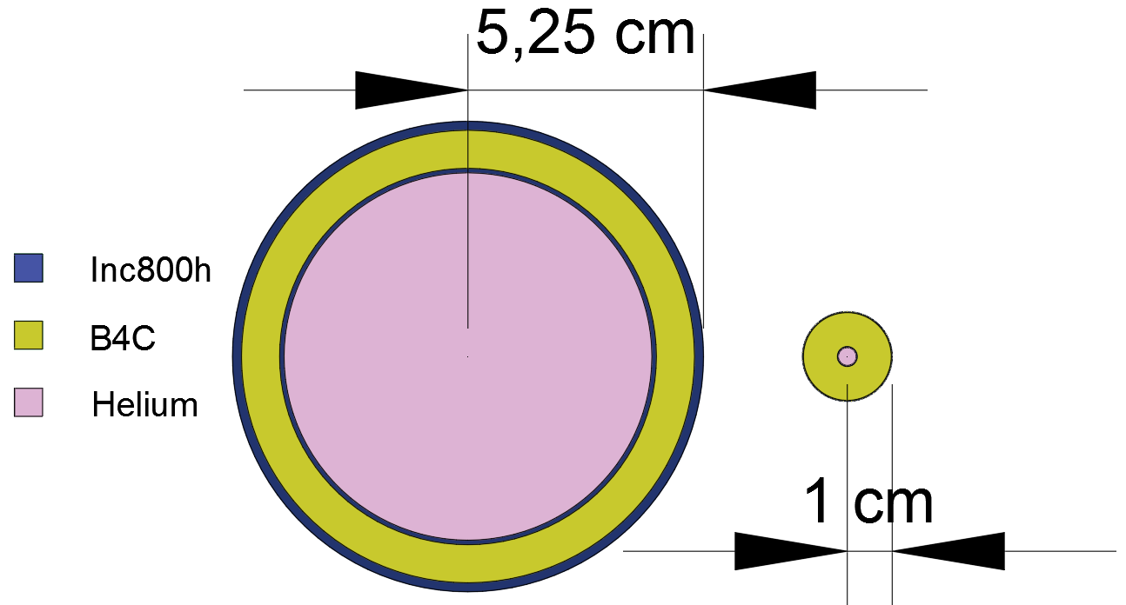
Figure 7.24- Left, PBMR Inc800H control rod. Right, U-Battery control rod
Due to the small size of the core, the control rod positioning becomes difficult to keep the symmetry. We propose six control rods placed at the exterior of the active core within the side reflector as depicted by Figure 7.25.
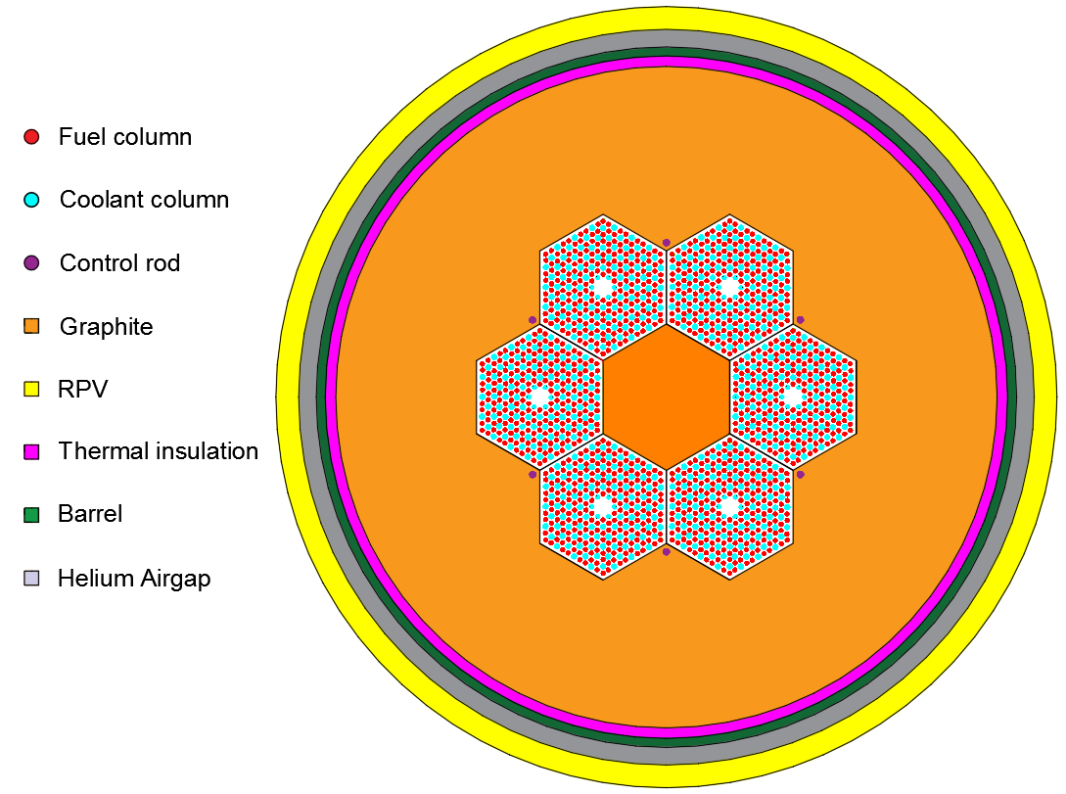
Figure 7.25 - Control rod positions
The control rods design in this article are not varied. All control rods are moved simultaneously to preserve a symmetrical power profile across the radial core. A full breakdown on the geometrical description can be found in the appendices.
All neutronic results presented are simulated through a Monte Carlo simulation routine using the Serpent 2.1.27 [40], using data libraries JEFF 3.11.
Methodology
FBPs are designed to provide sufficient reactivity repression for the start of the lifecycle of the fuel, three different locations are investigated. The aim is to reduce the criticality of the core to a reasonable level, which can then be controlled in conjunction with traditional control rod mechanisms. In this case an arbitrary value of criticality of 1.02 is chosen as a safety margin so avoid the risk of reaching subcriticality. With the inclusion of poisons, the aim was to reduce the initial criticality to ~1.05.
Design 1
Design 1 aims to keep use a small coating of Gd₂O₃ across the centre of the fuel columns. As witnessed in the fuel rotation experiment [102], the centre of the fuel columns is being depleted the fastest, so this is slowed down by the addition of poisons. Initially, all the fuel columns were placed with a 160 cm section of 0.005 cm poisons around them as shown in Figure 7.26. It was noted that the criticality at this point was significantly reduced to 0.98. The process of removing the FBP’s to a point where the criticality reached the desired range, focused on keeping the coating on the highest burnup sections. These were, next to the central reflector and the external reflector [94].

Figure 7.26 - FBP sleeve
The correct criticality range was obtained from the configuration in Figure 7.27.
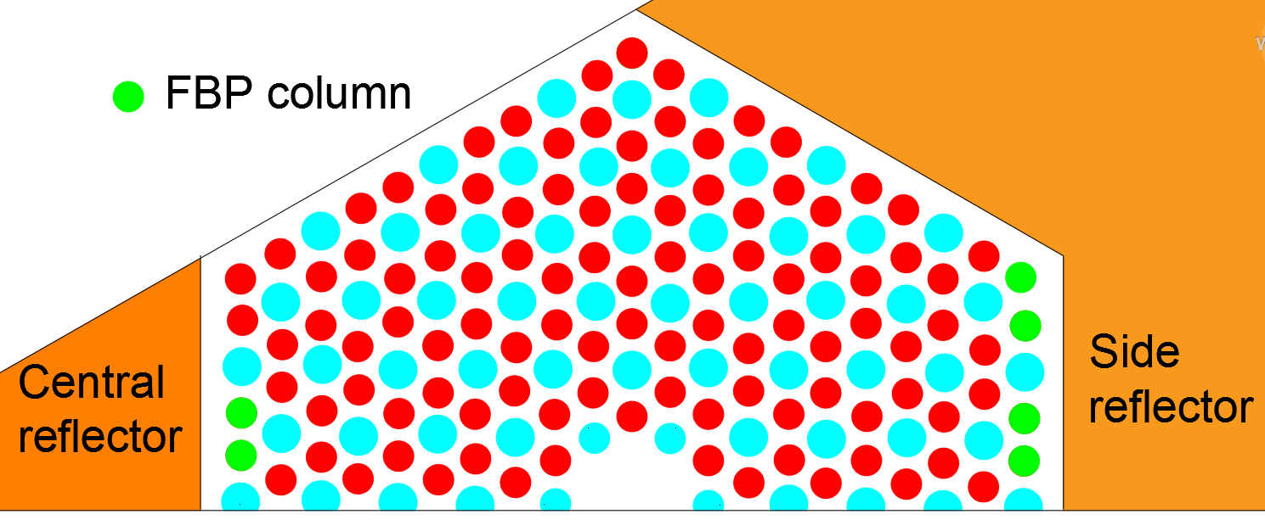
Figure 7.27 - Design 1 poison column locations
Design 2
This design looks to use the same depth coating across specific fuel columns. In this case the inspiration taken from the U-Battery report and used the fuel columns in the initial poison design as shown in Figure 7.28 to avoid any opportunity of rotational misplacement of the fuel blocks.
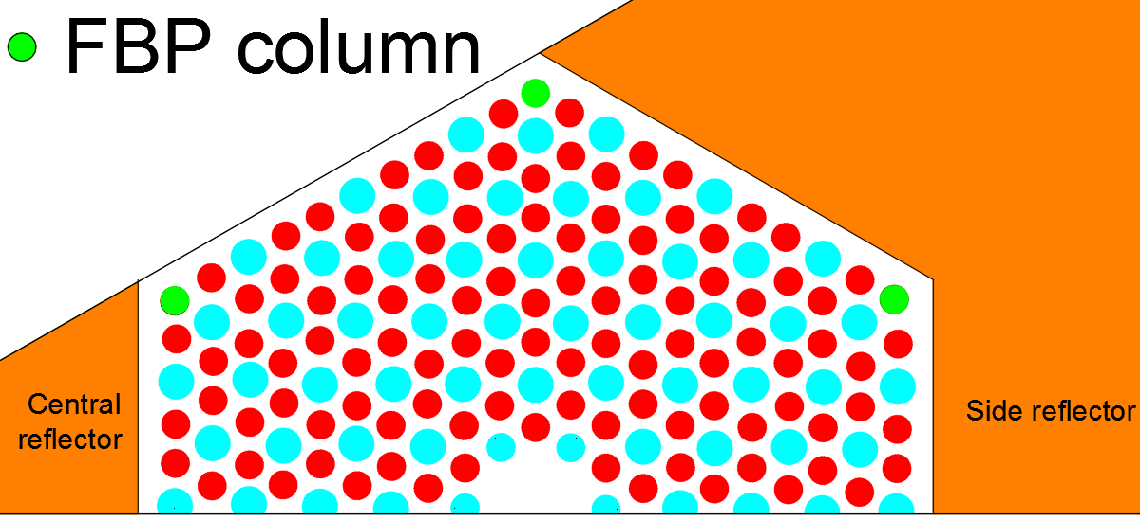
Figure 7.28- Original report FBP locations
The same concept of adding 160 cm of poisons across the centre of these pins was attempted. From earlier work looking at fuel rotation [102], it was noted that at 20-30 cm at the tops of the fuel columns, the burnup was high. A thin coating of poisons was added at the top and bottom of these fuel columns as shown in Figure 7.29 at this point the criticality was at 1.09056.
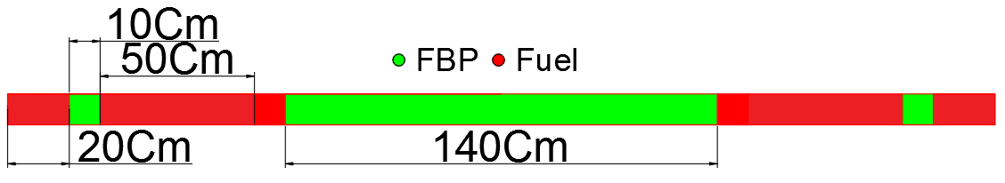
Figure 7.29 - Poison sleeve on the corner design
To remedy this, the 140 cm sleeve was added to the two pins closest to the centre of the central reflector as shown in Figure 7.30. This reduced the criticality to the acceptable level of 1.0514.
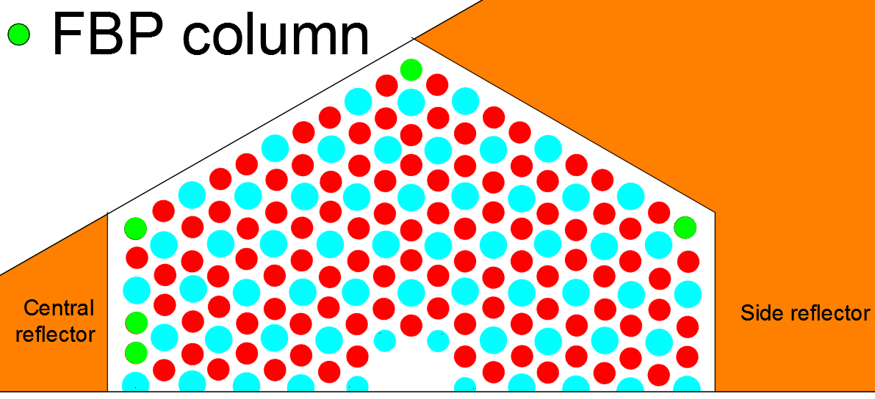
Figure 7.30- Final design 2 FBP locations
Design 3
The third design is a more conceptual design. The concept used the centre 160 cm’s to place small 0.04 Cm radius Gd₂O₃ particles amongst the fuel columns. The fuel particles were to be arranged in such a set up so that the packing factor of the poisons would repress the flux sufficiently at the centre of the reactor core. This initial concept looked to split the centre 160 cm’s of the fuel columns up into sections and then add the packing factor of poisons as shown in Figure 7.31.

Figure 7.31-Poisons packing factor within their 10 Cm fuel region
This set up provided a criticality of 1.04645.
Summary
Each of the designs looks to utilise a different strategy to place the poisons. Design 1 looks to use the side reflectors, design 2 looks to use the corners and design 3 has a steady amount of poisons across the core. The total amount of poisons is summarised in Table 7.7.
Table 7.7- Summary of the poison designs
Design | Volume of poisons (cm³) | Initial K_{eff}
1 | 269 | 1.04482
2 | 207 | 1.05137
3 | 348 | 1.04933

From Table 7.7, it is clear to see that the overall poison volume does not necessarily dictate the starting criticality. This is due to the positioning of the poisons, where design 3 does not heavily load any section with poisons as they are spready out quite evenly across the centre of the core.
Following the initial criticalities, the FBPs are then burnt at 10MWth to determine the overall lifetime of the reactor at this point.
Results and discussion
The initial test is to determine the FBPs behaviour over time. This was done by burning the reactor for 1000 days with the poisons.
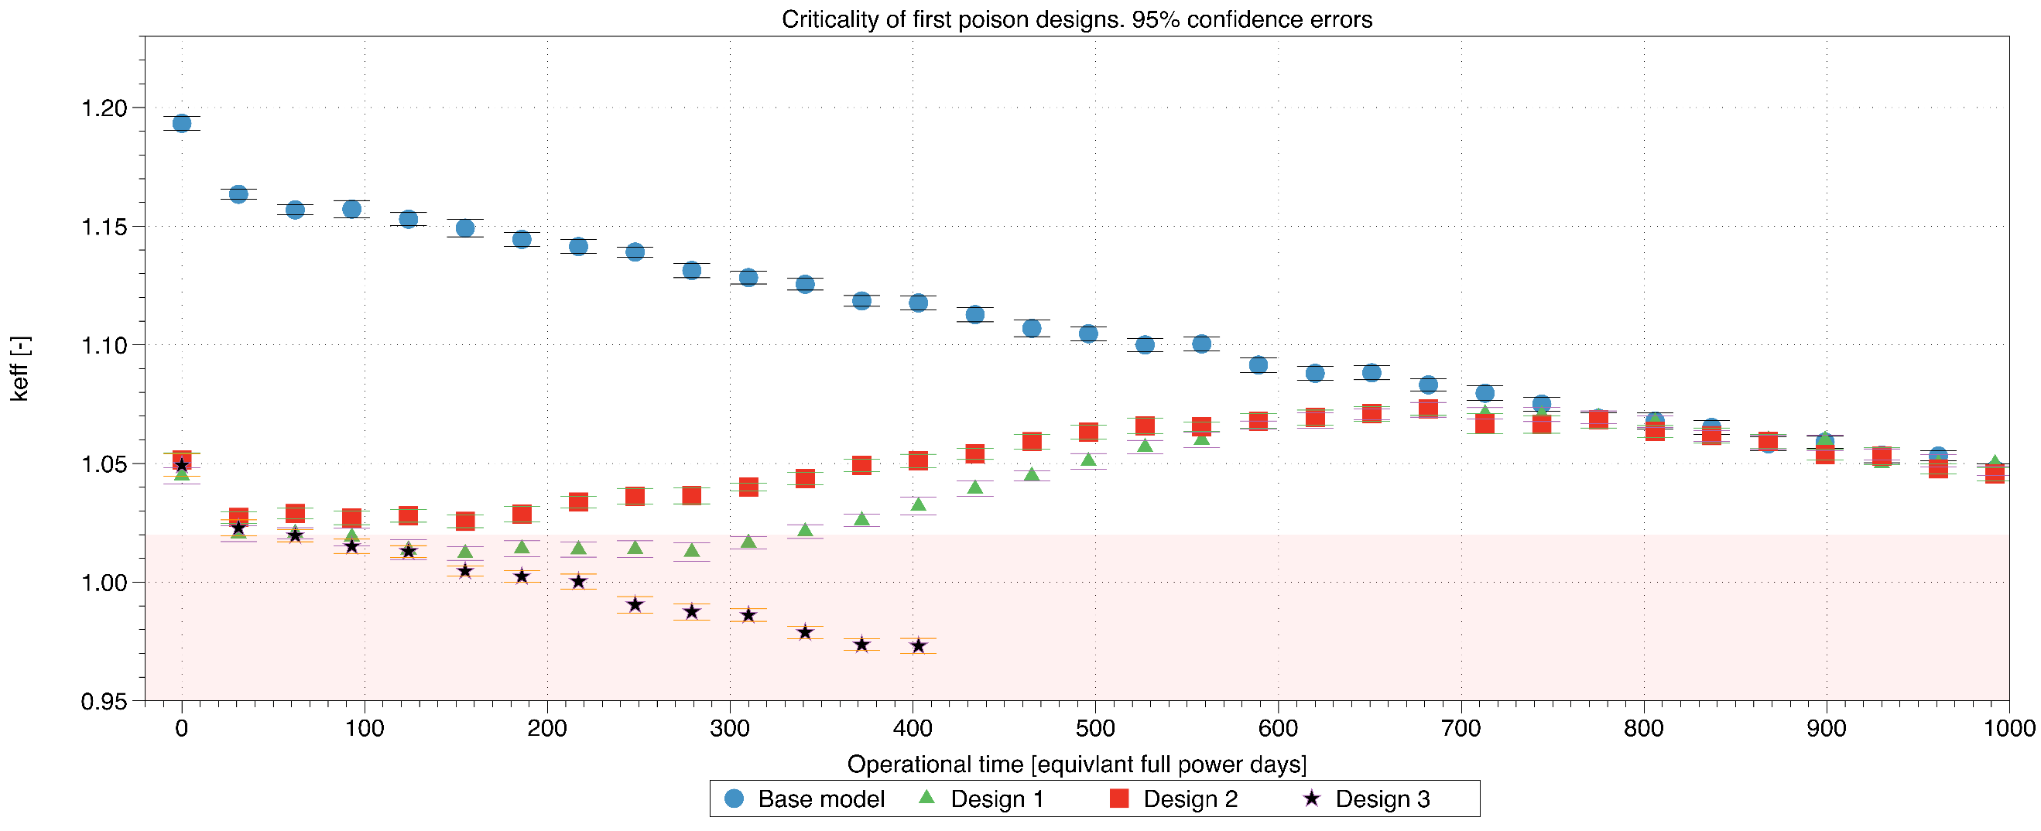
Figure 7.32- Criticality burnup of the three poison designs
Comparing the base model’s criticality to that of the initial criticality, the three poison designs all easily achieved the large reactivity reduction required. However, the worst performer was Design 3 where the criticality didn’t recover, obviously due to the too high poison loading. Designs 1 and 2 both saw a dip in criticality, in the case of Design 2 the criticality is higher between days 100-600, implying this would require a larger amount of work with the control rods to reduce the criticality to unity. For this reason, the most appropriate Design to continue with is design 1.
One worrying trend with Figure 7.32 is that the peaking of the second rise reaches a criticality of 1.0725 at ~700 days and this is larger than that of the initial 1.05 starting target. The reason for this is that the poisons are being burnt up too quickly. To remedy this, the use of small 0.4 cm rods of 20 cm height is placed within the centre of some fuel columns of Design 1. The positioning of these rods models is shown in Figure 7.33.

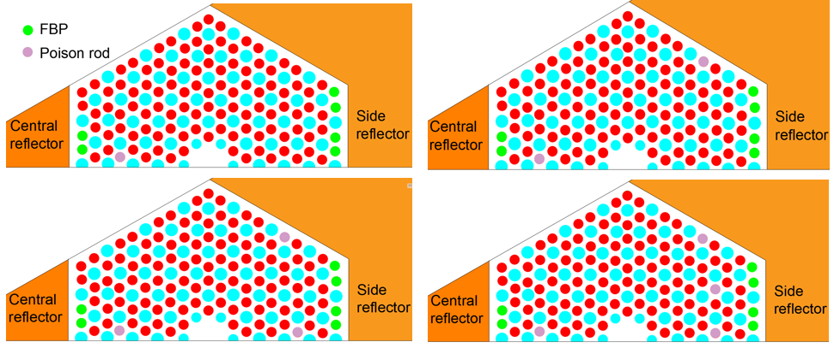
Figure 7.33- Additional poison rod positions included top left, 1 rod, top right, 2 rods, bottom left three rods and bottom right, 4 rods.
The aim in this case is to determine the overall impact of these rods on the criticality.
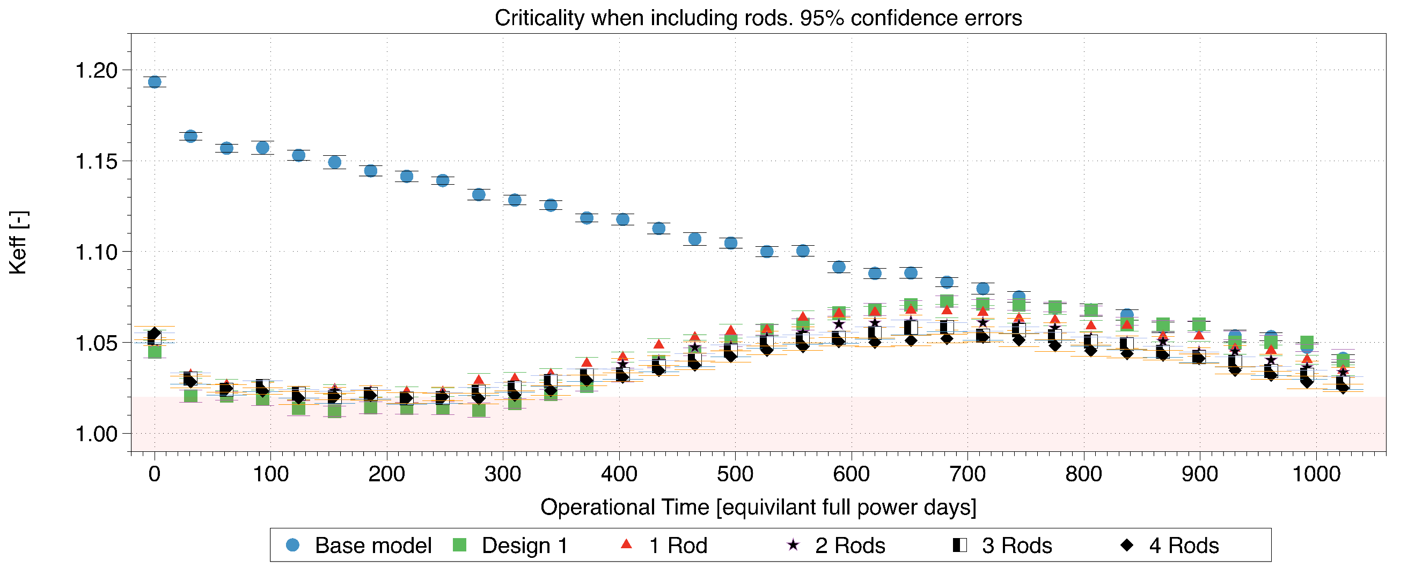
Figure 7.34- Adding poison rods in the centre
Figure 7.34 shows that the rods do reduce the second reactivity peak, however, it was noted that the criticality line does not re-join the base model. The main reason for this was suspected that the poisons were remaining in the core. To determine this, the four rod design poison materials compositions were monitored. The numbering of the poison rods is depicted in Figure 7.35.
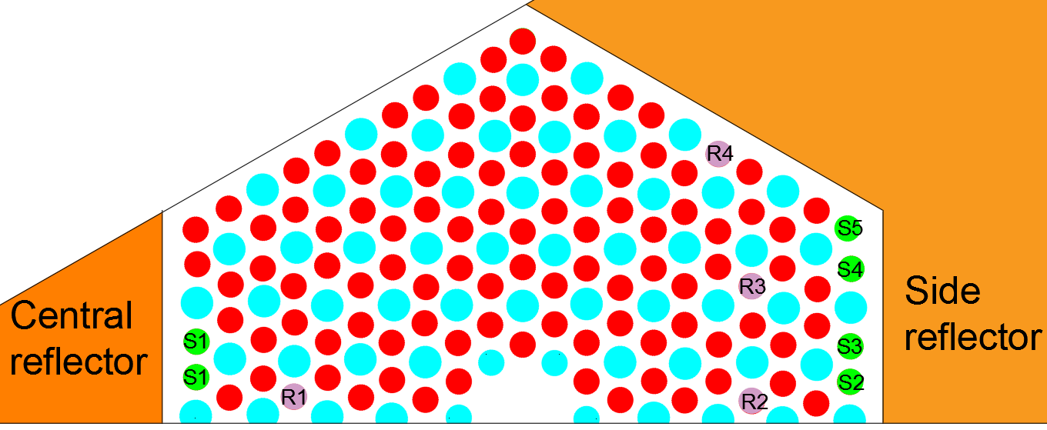
Figure 7.35- Sleeve and rod positions for material compositions in Figure 7.36 and Figure 7.37.
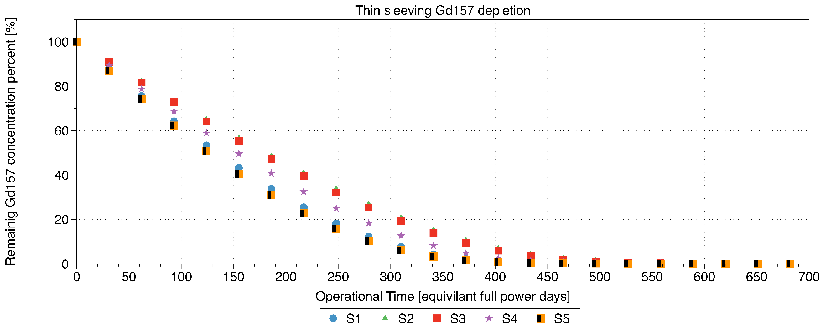
Figure 7.36- Thin sleeving depletion to first peak in criticality
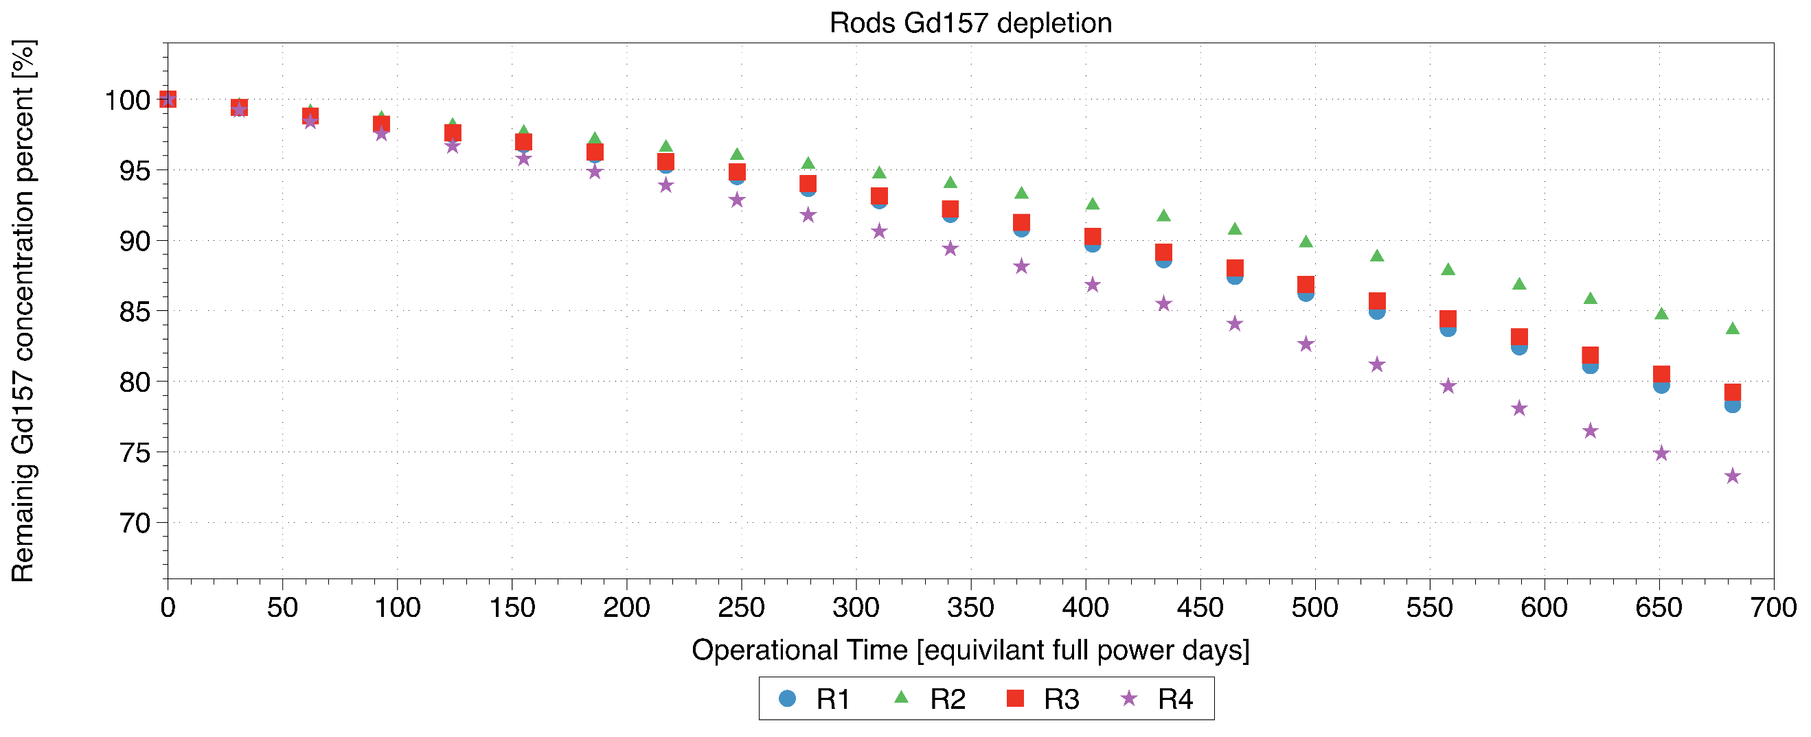
Figure 7.37- Small central rods depletion, up until first peak
Figure 7.36 explains the rise in criticality in Figure 7.32 following day 300. This is due to the poison sleeve having been significantly depleted as shown by Figure 7.36. The criticality then raises up until the point of 700 days. From Figure 7.37, the four rods all have a significant amount of Gd¹⁵⁷ remaining, at this point still, this is penalising the overall equivalent full power days of the system. A further test was performed to determine the overall difference in criticality between the single rod system and that of the four-rod system, as shown in Figure 7.38.
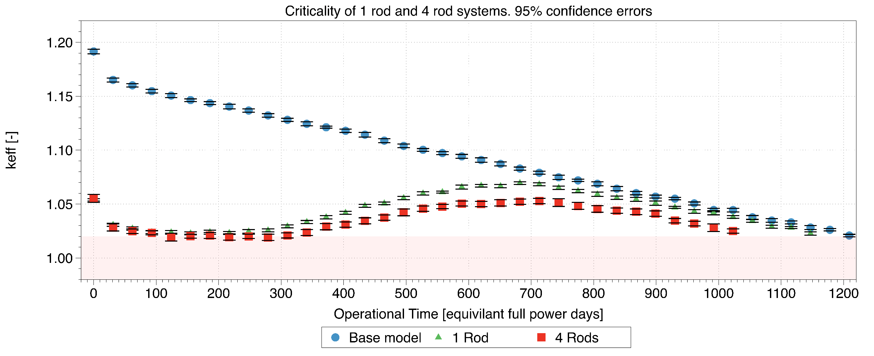
Figure 7.38- 1 and 4 rod models until 1.02 point
From Figure 7.38, each of the designs with rods included, does reduce the total lifetime in days. However, the total loss in days for a single rod is 62 days, whereas this is increased to 186 lost days for four rods. Due to this severe lifetime impact, a single rod design was chosen to be the preferred method of control, if there is no better way for reactivity compensation. However, there is additional space for optimisation. This still leaves a significant increase in criticality at the start of life but reduces the second peak slightly. At this point the control rods were inserted at the peak of the 1 rod design, to the point of maximum depth (320 cm), the criticality was reduced to 0.922, implying that under these conditions the reaction could easily be stopped under the control rods.
When considering the remaining activity, this is still significantly large to be held down by the form of control rods, due to the flux suppression to the bottom of the core which will lead to an unacceptable power distribution. To accommodate this, a novel method of criticality reduction is used in the form of variable moderation [103]. Due to the small size of the core the central reflector has a significant effect on the thermalisation of neutrons. By manipulating the position of the central reflector, the thermal neutrons within the system should dramatically reduce, thus significantly reducing the criticality of the system.
For this case the variable part central reflector has a 26 cm diameter cylinder cut from the centre as shown in Figure 7.39. This cylinder can then be manoeuvred to change the moderation within the centre of the core.
Figure 7.39- Variable central reflector, while removed the centre becomes helium based
The moveable moderator would not be limited to the 1.02 criticality, as with the poisons as this method of control is variable, implying that the central reflector manoeuvring could be used in conjunction with the control rods. Due to the change in moderation not having a significant negative effect in the neutron economy, it would be preferred to move the central reflector than the control rods, however, use of the central reflector should require user input.
Figure 7.40 is the new criticality curve with the central reflector completely removed up until point P1.
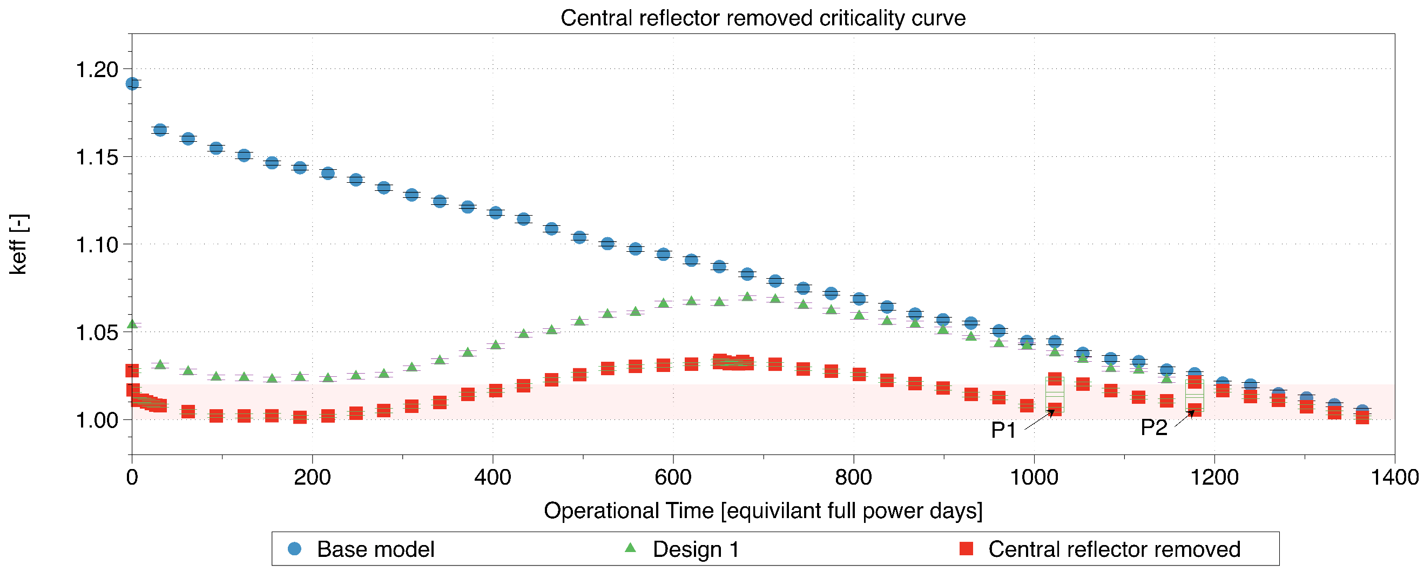
Figure 7.40- Criticality using the central reflector as an effective reactivity control device
From Figure 7.40 it is noted that the initial criticality, even within the first day, drops below that of 1.02, this is due to the build-up of Xenon during the fission process. At this stage the control rods would be used to aid start-up and keep the criticality to unity. The lowest point at which the poisons drop keeps the core above unity due to the central reflectors removal, this is at day 186, where the criticality once again starts to rise. The second rise is now reduced significantly to 1.033 at ~700 days due to the sleeving poisons being significantly reduced as previously shown, this implies that the control rods still need to take a slightly higher amount of reactivity from the core at this point than at the begin of life. Denoted by points P1 and P2 respectively are the positions where the central reflector has been re-inserted by 50% of its total height. This 50% figure was chosen to reduce movement and thus any risk associated with it, this also provided the 0.02 reactivity which was thought to be easily controlled by the control rods. The total lifetime is the same as that of the base model, which shows the small lifetime increase has effectively cancelled out the lifetime lost by the inclusion of FBPs.
Following the curve of Figure 7.40, it is important to appreciate the power distribution across the core during these periods. As previously mentioned, the control rod insertion will dramatically affect the power distribution at certain points in the life cycle, this might imply that certain fuel compacts could face a strong over power, particularly at the bottom of the core. The most well powered pins are those within the centre of the core or the outside, depending on the central reflector position. The power distribution is displayed across half of a fuel block as depicted in Figure 7.41.
Figure 7.41- Half of a fuel block model, with the side reflector position highlighted by the blue lines
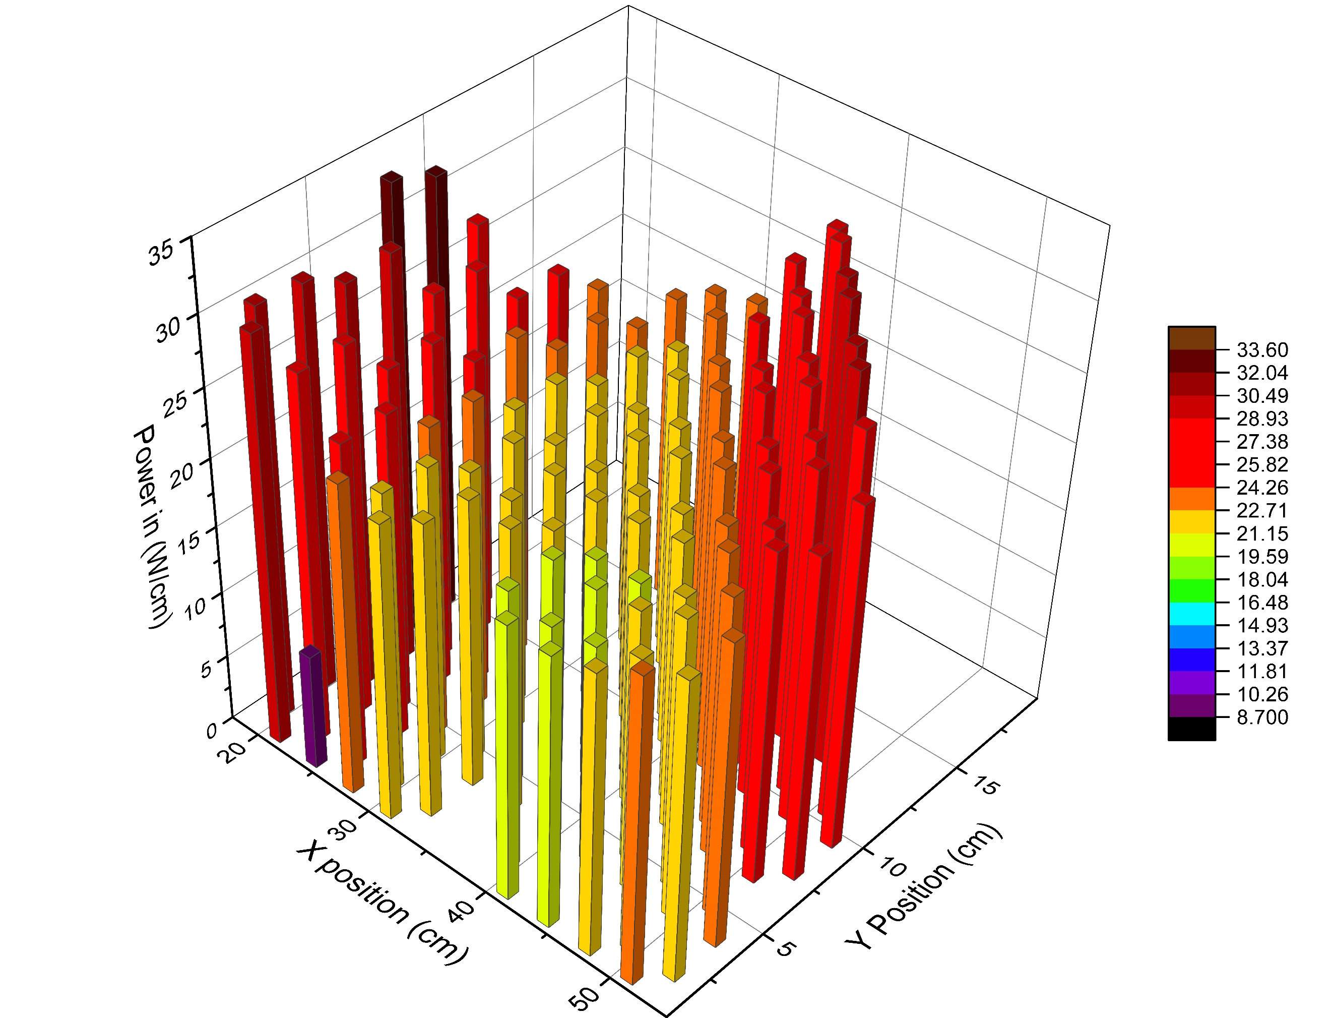
Figure 7.42- Power distribution at day zero with the central reflector fully inserted
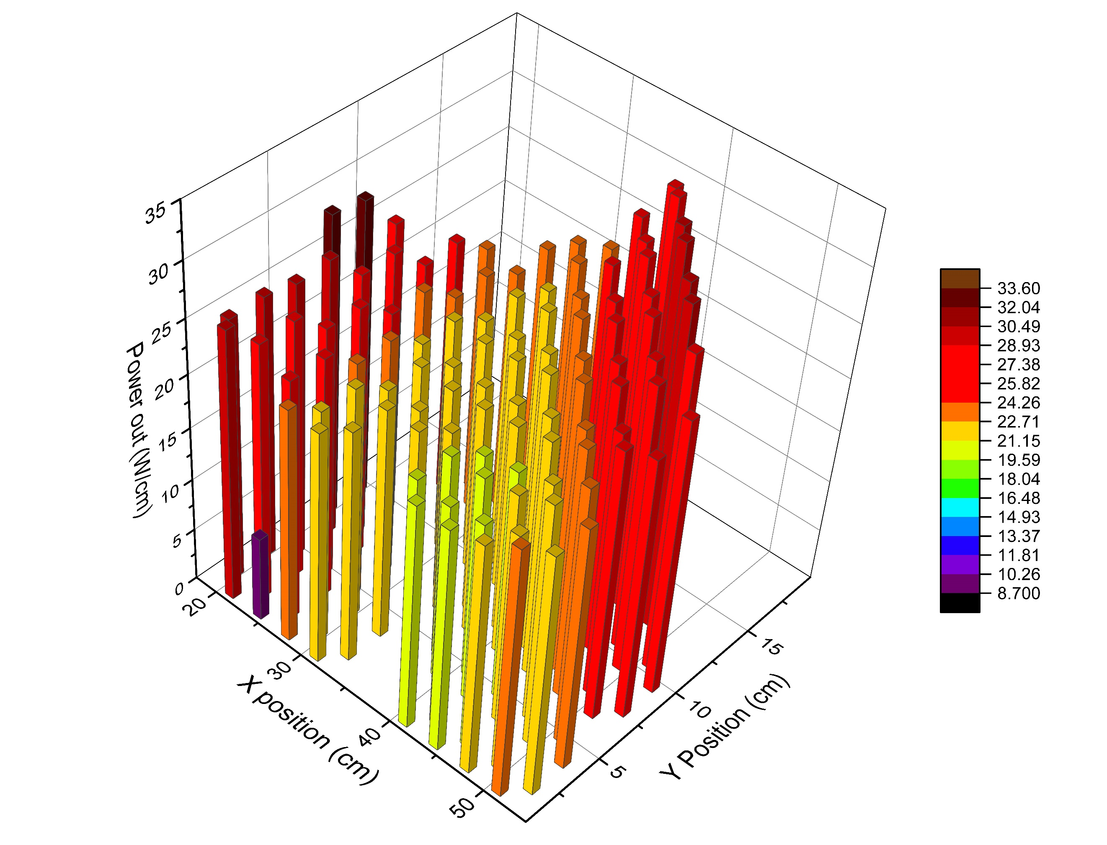
Figure 7.43- Power distribution at day zero with the central reflector fully removed
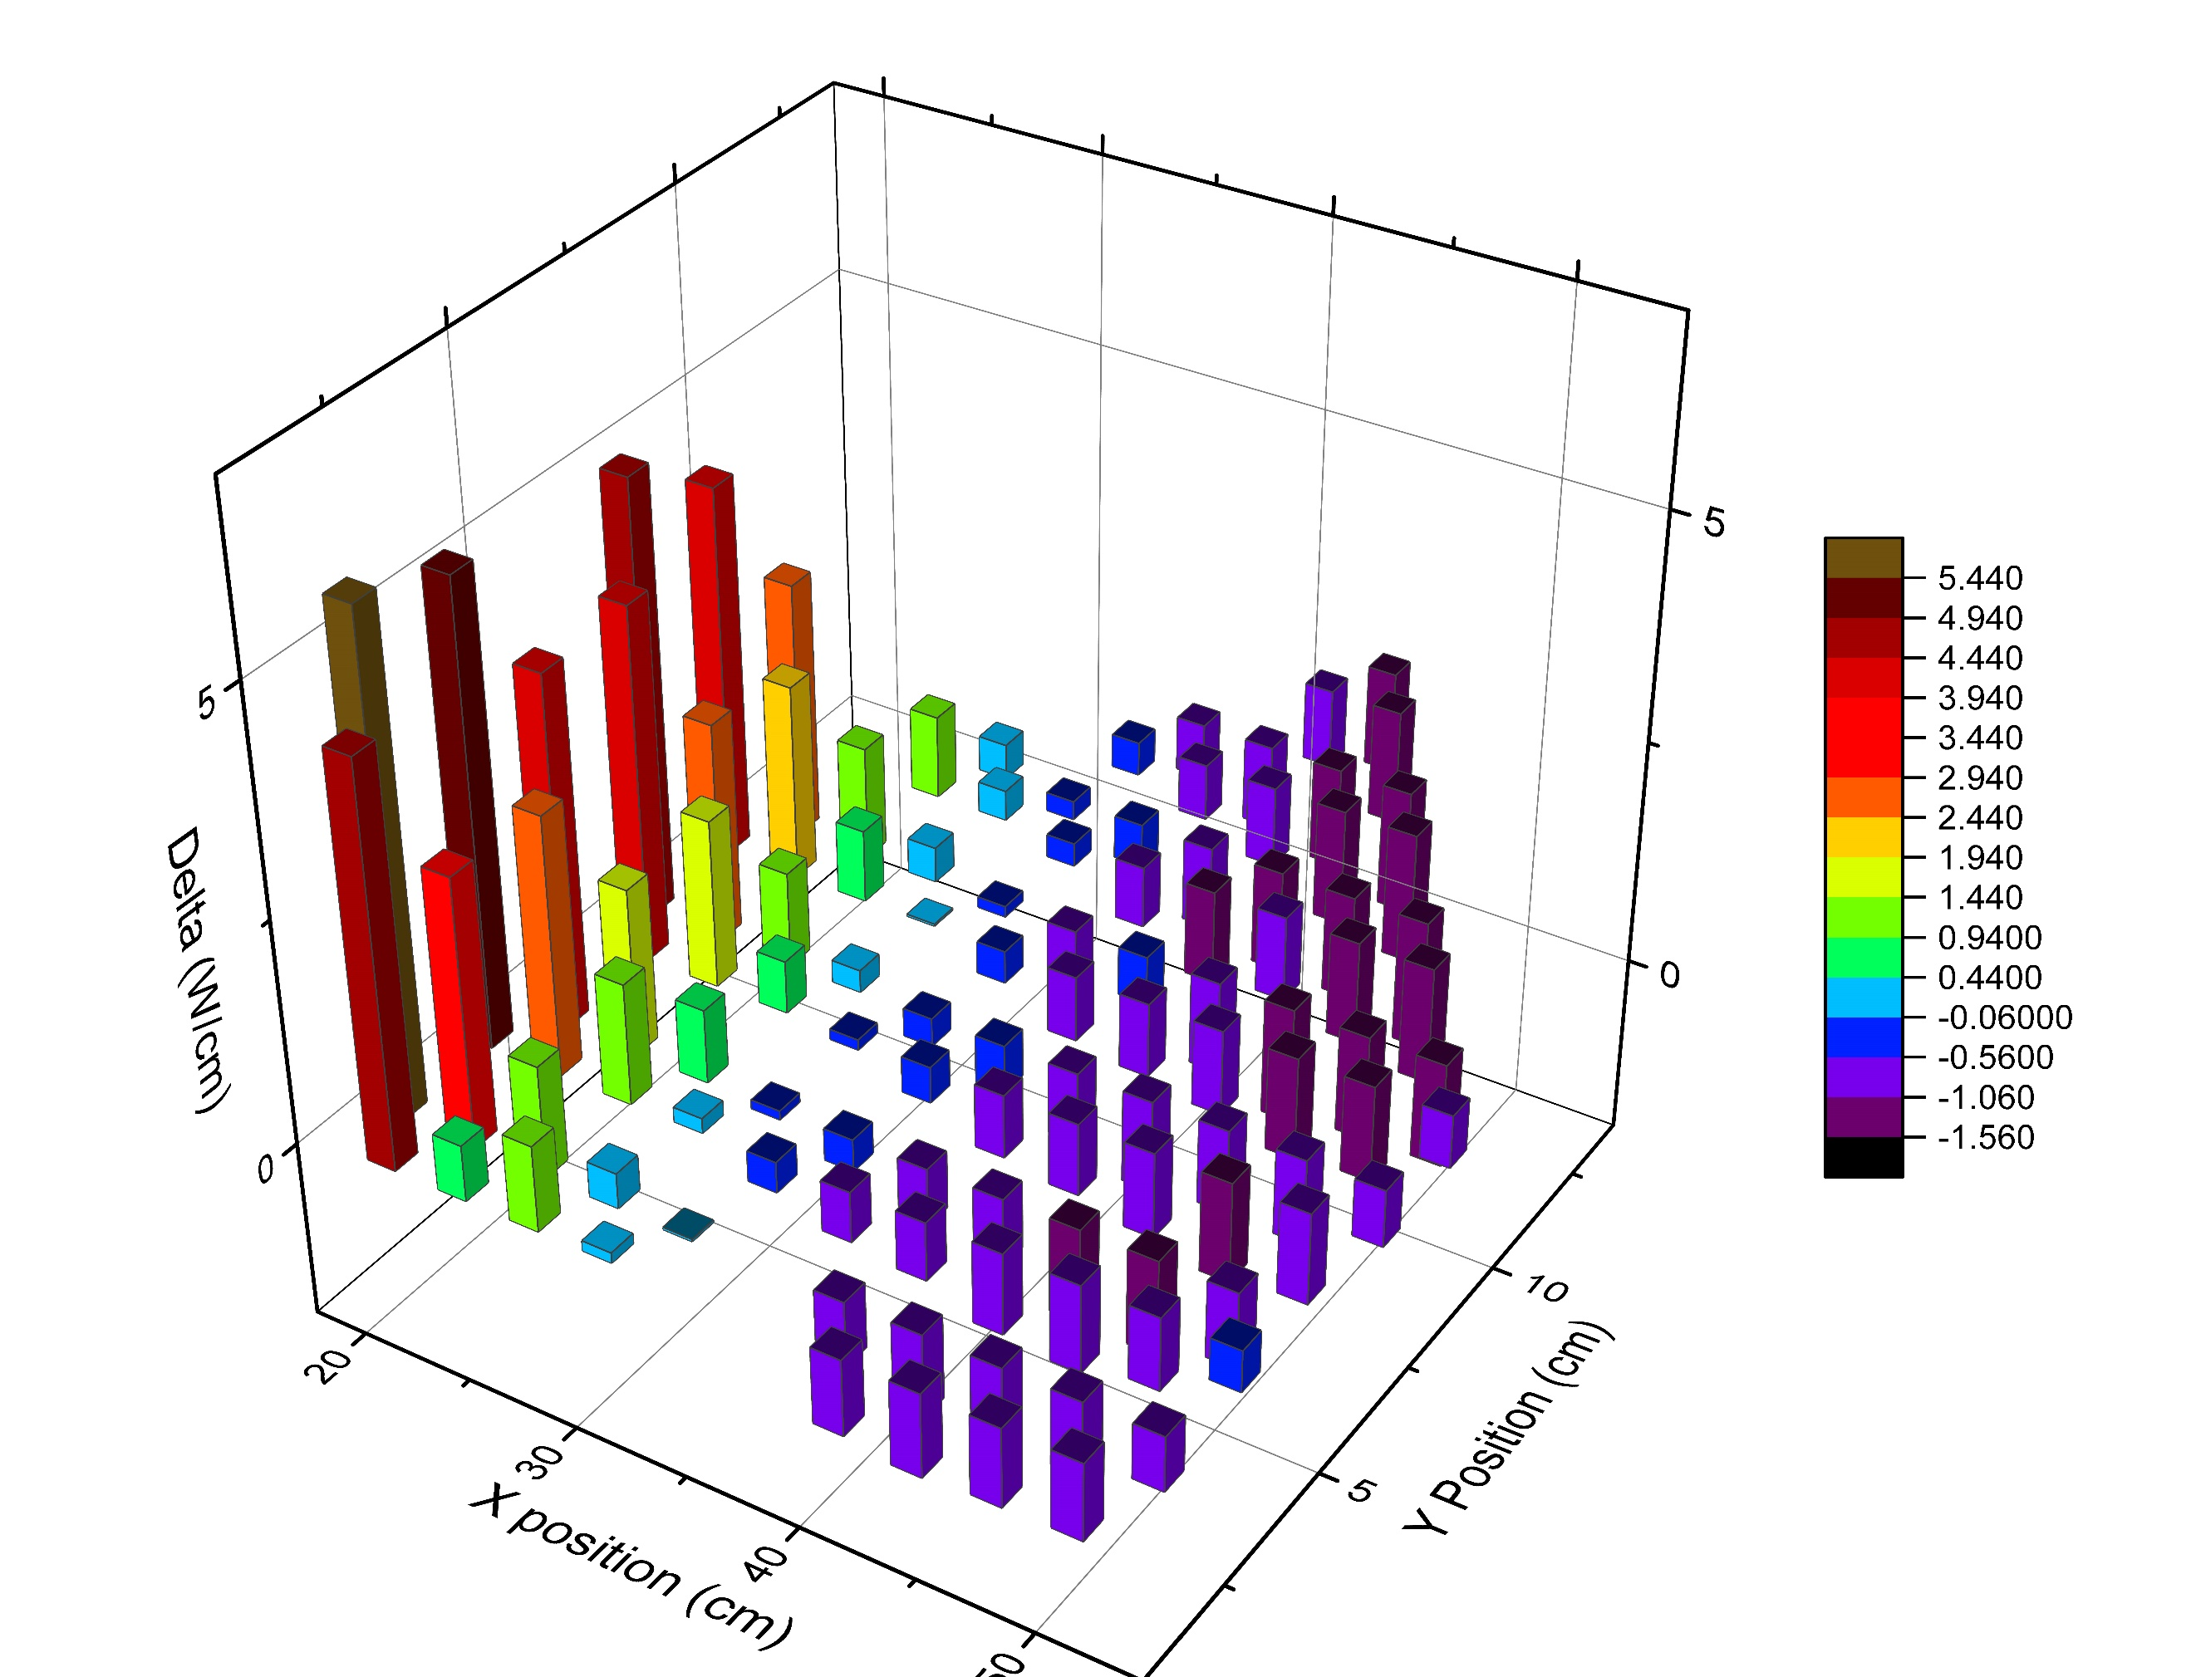
Figure 7.44 - Delta of the power distributions (central reflector in - out)
From figures Figure 7.42 to Figure 7.43, there is an obvious trend that the power distribution shifts across from the centre of the core to the outside when the central reflector is removed. This is useful in the case where the centre of the core is burning up less at the points in time when the central reflector is removed, thus shifting the highest loading pins close to by the side reflector. The closest pin at X 20 cm has a significantly reduced power, this is due to this pin hosting the small poison rod from Figure 7.33. To a lesser degree the other poisons are noticeable, as in the poisons at the centre of the core are not the highest power pins.
Figure 7.44 identifies the change in power with the central reflector in and out. This highlights that when the central reflector is in, the power is heavily dependent on the fuel pins by the central reflector due to the additional moderation, making these the highest burnup pins. When removing the central reflector this trend is reversed as the pins at the side reflector receive the highest loading. This provides a power balancing between two different locations within the core.
The next experiment determines the power distribution under the condition of the maximum criticality case, in this case it is during the second peaking of the system, where the criticality reaches 1.033. At this point the control rods are inserted and the axial power distribution is considered.
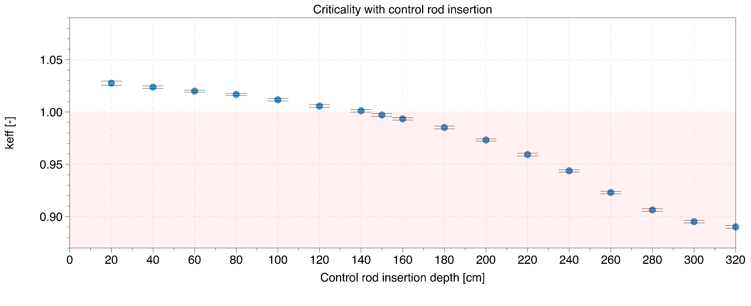
Figure 7.45- Control rod insertion at peak reactivity
Figure 7.45, the core becomes subcritical once the rods are inserted by 150 cm. At this point the power distribution is once again considered since this is the most distorted power distribution during the life of the core. In this case the axial power distribution is most important, due to the deeply inserted control rods. in this operational point the central reflector is removed so the highest power pins were towards the side reflector. This axial power distribution is included in Figure 7.46.
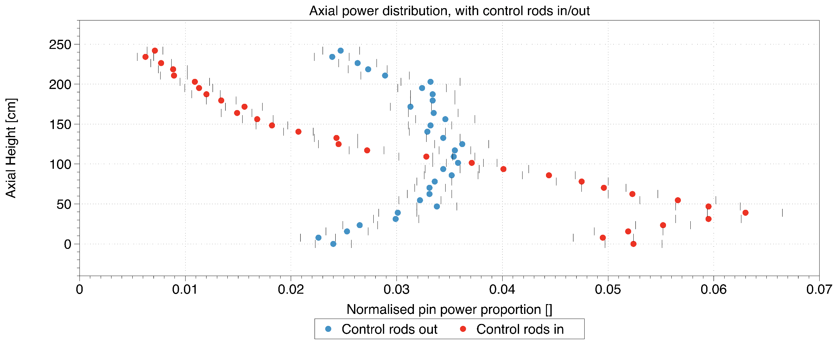
Figure 7.46 - Axial power distribution with the control rods inserted. The power is normalised across the total of that pin
Figure 7.46 clearly shows, the power shifts down significantly due to the insertion of the control rods to 150 cm. The power then almost in a linear fashion rises across the pins below this. This causes over double the power in these pins to be experienced during this period. This must be considered in the design criteria of the fuel compacts/pins to avoid an over powering. It is worth noting that during the insertion of the control rods up until day 700, this will have a smaller effect, but will reduce the power in these pins at day 700. This is concerning due to the additional temperatures imposed on these pins following the insertion of the control rods, further analysis on the thermal effects of this procedure will be required to determine the overall severity of these effects on the system. Thus, we would recommend a full power analysis of the most challenged pins over the whole life time.
Conclusion
This paper has investigated several methods of reactivity control within a small modular HTR based on the adopted U-Battery design. The overall goal aimed to exhibit how different control methods are used and interplay to manipulate the reactivity at different stages of a single fuel cycle, while trying to keep the minimum dependency on the control rods. This brought forward three types of poison designs, which showed a rising peak in criticality once the small sleeves were depleted. It was accepted this peak was too large (~1.07) to overcome by the control rods alone. Following this, the spectrum hardening technique was used by manipulating the central reflector to reduce the probability of fission. This provided significant additional reactivity control within the system. The central reflectors breeding method cancelled out the fuel lifetime penalty which had been introduced by the inclusion of the FBPs, bringing the overall lifetime of the reactor to 1364 days, the same as without any poisons included.
The removal of the central reflector allows the operator to balance the power distribution across the core well radially, this is due to the highest power pins being swapped between the inside to outside of the fuel block.
During the insertion of the control rods at the highest peak, it was shown that the power profile will be significantly distorted leading to a strong power increase in the lower parts of the core. A full thermal analysis (like a fuel performance analysis in a LWR) should be performed to determine the peak temperatures experienced within these fuel regions to determine if safe operating limits are likely to be breeched. This operational point has the potential to be the limiting factor in the core design parameters like the pin/compact power.

The following section has been published in Nuclear Engineering and Design - Volume 331, May 2018, Pages 153–161

Prismatic core high temperature reactor fuel modelling incorporating fuel rotation
Design Concept
The design considered is loosely based off the U-Battery [104] which aims for a fast deployment using readily available technology, by utilising existing prototypes prismatic core reactors such as Japanese high temperature test rector (HTTR) as a source of reliable and pertinent information. The HTTR has been operating since 1998 allowing for critical parts of the design to be well understood and easy to deploy.
A new core design with the radial and axial design shown in Figure 7.47.
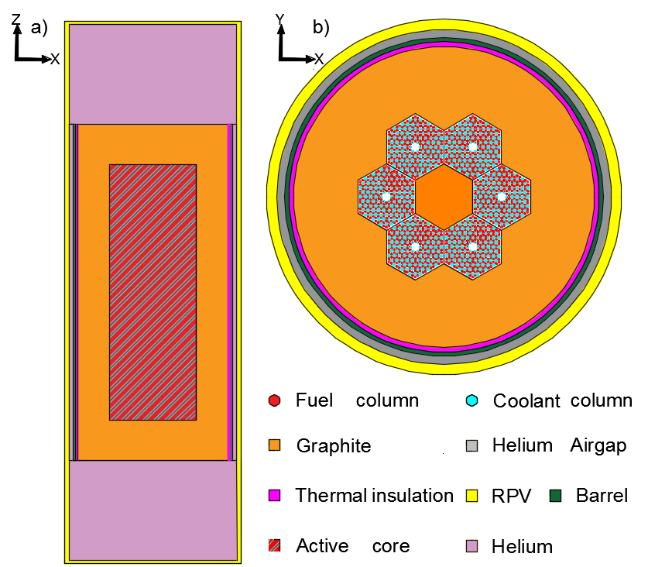
Figure 7.47 - Core layout a) axial schematic of the core. b) Radial representation scaled by a factor of two to highlight the detail.
The design in Figure 7.47 differs significantly from that in the original U-Battery report. This is for two reasons, firstly; this new design focuses on a 10MWth design and secondly; due to the cost and difficulties incurred by using BeO, the more easily option of graphite is chosen as a side reflector.
Methodology
In most operational nuclear reactors, fuel is rotated around the core maximising burnup and ensuring the flux across the core is as even as possible. For example, in the AGR, fresh fuel starts at the edges of the active core to increase the flux, and during operation the fuel then moves inwards, increasing burn up. This allows fresh fuel to provide a higher flux of neutrons in the outside of the core where fission is less common than at the centre of the core, where it would require enhanced management to prevent rapid burnup. Such a process allows for higher levels of burnup to be achieved. In the case of HTRs fuel has not traditionally been used in such a manner, primarily due to the nature of the fuel, i.e. either fused into fuel blocks or the process of fuel rotation being too difficult or not economical.
As in the case of the reactor designed there are large amounts of ²³⁵U remaining after the first cycle. Our first investigation was to identify those areas where the ²³⁵U is not being fully utilised. To model the design, Serpent 2.1.26 was used [105], Serpent is a Monte-Carlo based neutronics package using the JEFF 3.1.1 libraries. In this case the TRISO fuel was heterogeneously in the fuel blocks, each section contains the same fuel material as in TRISO kernels. The material compositions were then compared after the fuel cycle to further elucidate the changes in fuel composition.
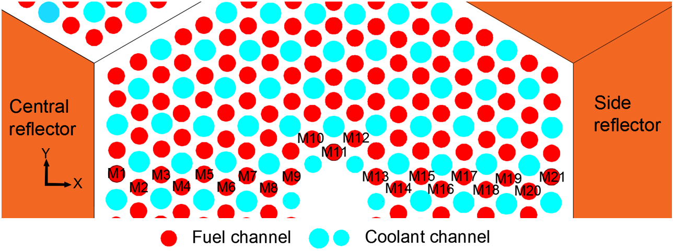
Figure 7.48 - where M1-21 represents the fuel channels under depletion investigation [104]
As shown in Figure 7.48, the sequence M1 to M21 represents fuel channels which have had their material compositions monitored over a full life cycle within the core. This allows for a radial distribution across the core, in addition to this the M channels are split axially into 10 cm sections, providing a full fuel channel representation. As the fuel composition is directly related to the criticality of the system, as the ²³⁵U is depleted, the Monte-Carlo simulation process calculates when the reactor becomes subcritical, shown by the calculated k_{eff}, i.e. subcritical being below 1.
To maintain accuracy of the study, yet at a reasonable computational time, the fuel regions had to be split up radially. The methodology for implementing this uses isolines represented in Figure 7.49. The assumption is that the radial burnup would be similar across these isolines due to the symmetry of the core. If the isoline assumption was correct, the centre letter should reach a similar material depletion to the furthest fuel channel on the isoline. The second study tested this theory by comparing a ratio of the axially averaged averaging depletion across each of the letters shown in Figure 7.49.
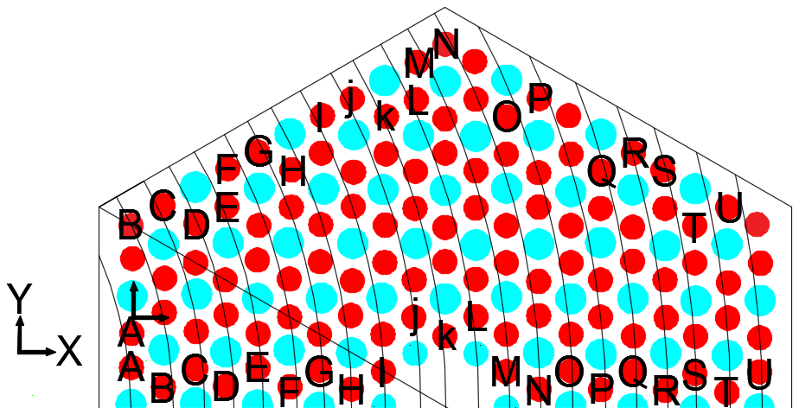
Figure 7.49 - Half a fuel block. The isolines represent the channels with similar burnup. The corresponding letters highlight channels that are assumed to have similar burnup.
The fuel pins at the back four points, U, T, S and R were modelled individually, allowing for maximum accuracy of the rotational process to account for loss of symmetry across the fuel block.
The reactor consists of six fuel blocks placed around a central reflector. Each fuel block is 80 cm in height with 36 cm across each block. Thus, the total height of the active core is 320 cm and 108 cm wide, these measurements make the core thin and tall. This paper aims to identify the best methods to increase the lifetime of the reactor by utilising fuel rotation. Previous studies on PWR’s [106] [107] have highlighted the importance of increasing the axial burnup through the design of the core or operating conditions. From a radial perspective, the centre of the core is often depictured as having the highest power profile, which directly relates to the burnup of the fuel. With this design, the annular central reflector positioning aims to increase the thermal flux in the centre of the core and thus should provide the highest thermal flux within this region.
To increase burnup, and thus overall economic efficiency, rotation of fuel blocks was examined. The design consists of 24 fuel blocks, placed around the central reflector, which are designed to burn symmetrically from the centre outwards. The highest burnup was therefore designed to occur at the centre where the neutrons are easily transferred between fuel blocks and the moderation is highest both increasing burnup, shown in Figure 7.50. Despite the core being made of graphite with varying density, burn up was expected to radially decrease going outwards. Coupled to this was the assumption that axial burnup would be highest at the centre of the core, with concomitant decrease the further the fuel was from the centre point. This led to the hypothesis that fuel blocks could be rotated axially and radially to allow for lower burn up sections to be moved to the centre, thus increasing the utilisation of the ²³⁵U most effectively, shown in Figure 7.50 & Figure 7.51.

Figure 7.50 - Radial fuel rotation hypotheses
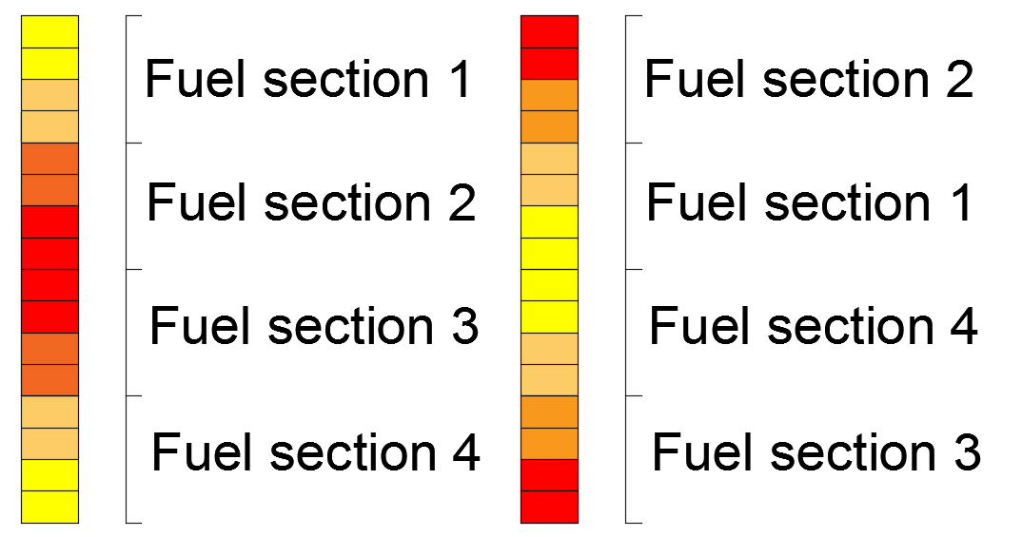
Figure 7.51 - Axial rotation, left initial core burnup and right the rotated version
The fuelling machine (FM) would be attached to the top of the reactor core. Using the central channel, the FM would fully access the entire core allowing for access to each individual fuel block. Since one concern with fuel rotation is increasing the operating costs, a full cost benefit analysis would determine if the process is economically viable.
Due to the differing nature of potential rotation, four different rotational models were investigated, shown in Table 7.8.
Table 7.8 - Rotational models used in the simulations of fuel core rotation
Z axis | Rotational procedure
No rotation | 180-degree rotation
No rotation | 60 degrees clockwise
Axial rotation | 180-degree rotation
Axial rotation | 60 degrees clockwise
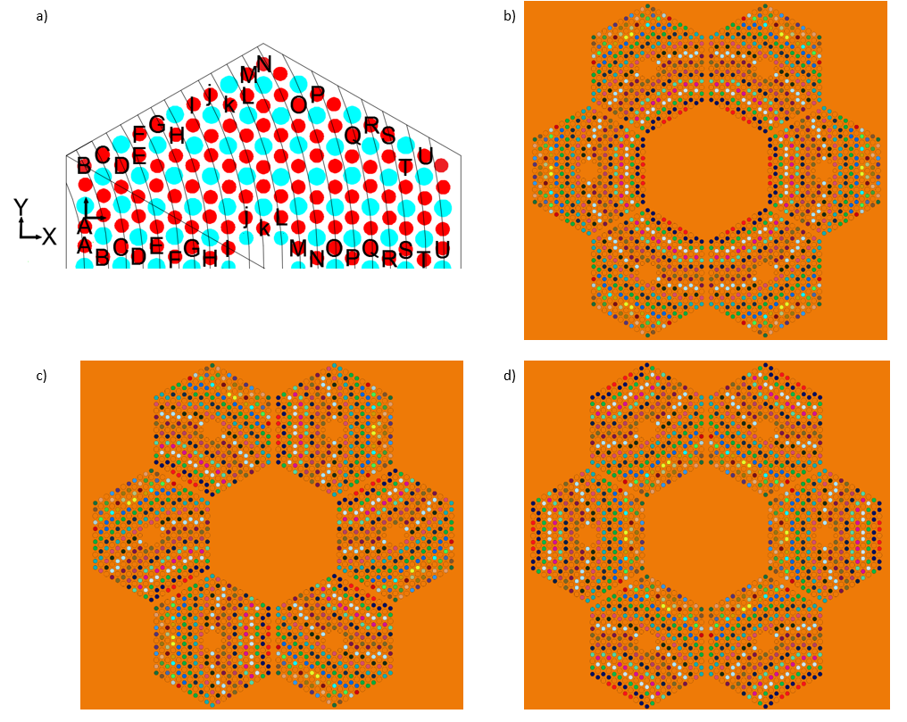
Figure 7.52 - Rotations of the fuel. a) Isolines representation, b) Standard position, c) 60-degree clockwise rotation, d) 180-degree rotation.
The initial loading looks at a simple core layout, shown in Figure 7.52, where the total packing factor in every block is the same and equal to 29%. The simulation then burns the fuel until criticality reduces to below unity, i.e. no longer self-sustaining. At this point the end of cycle has been determined, leading to the next stage where the periods of rotation were isolated.
Two key features in Serpent were used for this, initially a simple universal transformation (utrans) was used to rotate part of the core on the Z axis. The second option was to record material composition after each burnup stage, and then manipulate these compositions location to achieve axial transformation.
The methods used to identify the rotation were considered in reactor-day extension from the initial start, coupled with the overall cost saving over the lifetime of the reactor. Costs included in the U-Battery conceptual design were used and compared these included;

Table 7.9 - Fuel costs based off of the original U-Battery report [104]
Costs | M€
Fuel handling costs | 0.5
264 kg of fuel | 3.2

The costs were based on those proposed in the initial design and scaled accordingly to allow for a comparison to be made, it is important to note that the costs for reloading the fuel are not included in the initial report. Consequently, fuel handling costs are assumed to be the cost of transporting the new fuel to site and loading into the core. Thus, the same value was assumed for moving the fuel to site despite this potentially being estimated, and not realistic. However, with lifetime extension these costs would be reduced, as less fuel movement is required. A further key assumption was the reactor performing for the full expectancy of 60 years as stated in the initial design criteria. After the initial cycle, decisions on how to rotate the fuel and what benefits arose were considered, with further simulations identifying the maximum extension that could be added due to the rotation.
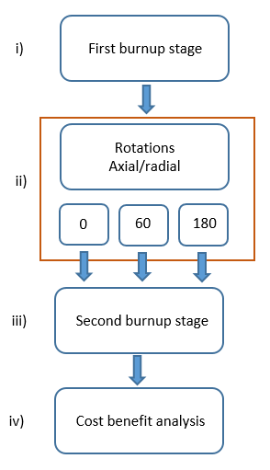
Figure 7.53 - Step by step process of stages undertaken
Figure 7.53 goes through the stages to obtain the most beneficial rotation method. The initial burnup step (i) identifies the time the reactor can run before any intervention is required. This stage is used to calculate the maximum effective full power days.
Fuel rotation is step (ii), before a further burnup is simulated in stage (iii) with simulation being completed when criticality is no longer reached. It is at this point the reactors fuel will require a new loading of fuel.
A cost benefit analysis (iv) examines both the operational costs and risks involved with fuel manipulation. It is a simple method, but one in which the financial benefit for such rotation can be estimated.
Results and discussion
The initial study simulated an unbound criticality test, to examine the lifetime of the reactor, purely through determination of when K_{eff} is no longer above 1, i.e no longer critical.
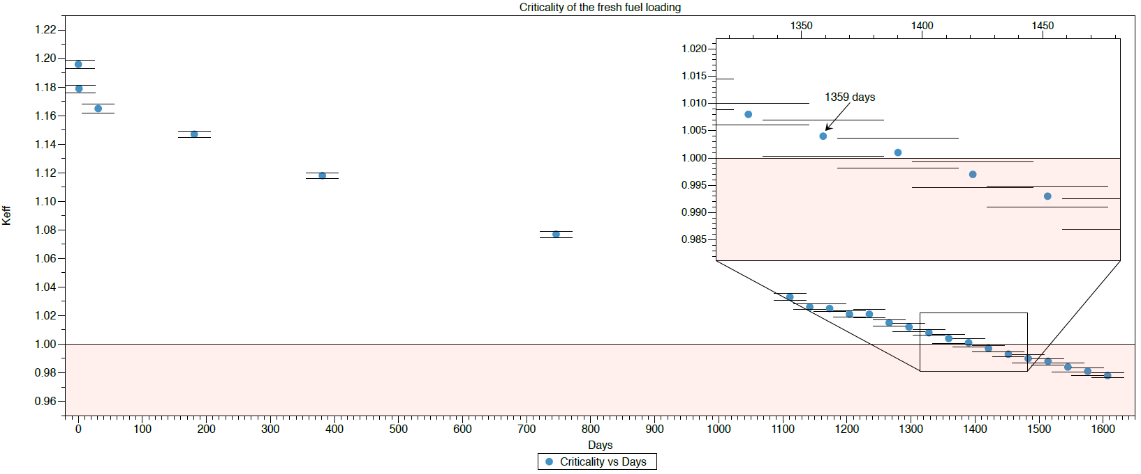
Figure 7.54 - Criticality as function of time within the core, error bars are set at 95% of confidence, with the shaded area representing a non-critical system.
As can be seen in Figure 7.54 the reactor is predicted to remain critical for ~1359 day under the conditions of the simulation. Following this fuel compositions were taken axially across M1-21, focusing on the ²³⁵U content in these 21 fuel rods. An exemplar is shown in Figure 7.55, where the % of ²³⁵U remaining is shown as a function of channel.
Figure 7.55 investigates the depleted ²³⁵U across each of the sections M6-M10 of the core in the fuel channels identified by Figure 7.48. Using the results from this initial simulation, the axial areas identified as the most depleted will be moved to the outer extremities of the core. Thus, following this rotation, the channels reverse such that in M21 in Figure 7.48, becomes M1, as can be seen in Figure 7.52.
The positions towards the centre of the core, positions 10 to 20, contain a significant reduction in ²³⁵U, particularly when compared to the other fuel channels. However, the peaks in % ²³⁵U remaining are ~30cm from the top/bottom of the active core. This arises from the extremities of the core benefitting from the reflector at the top/bottom, which aids fission at the top/bottom. However, at the centre of the fuel blocks such beneficial effects are reduced, indicating that for a reflector to be effective there needs to be a high enough flux that utilises the reflectors.

Figure 7.55 shows the fuels at the very edge of the core, these have the additional benefit of being surrounded by the most moderating material. M20 and 21 are showing a significantly higher burnup than that at the centre, M6. This implies that the side reflector is having significant implications on the burnup of the fuel channels furthest from the centre of the core.

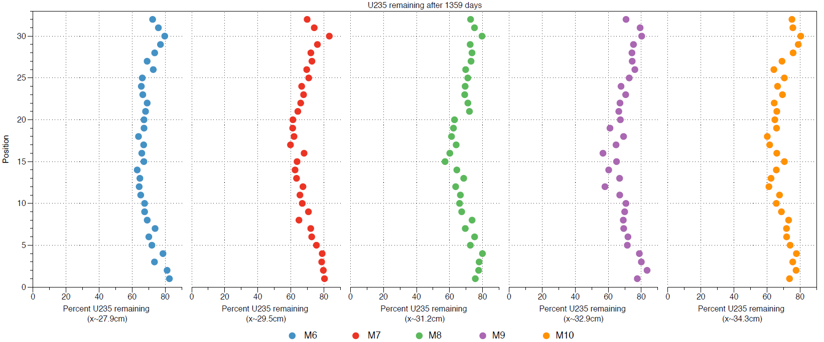
Figure 7.55 - Material compositions of M6-M10
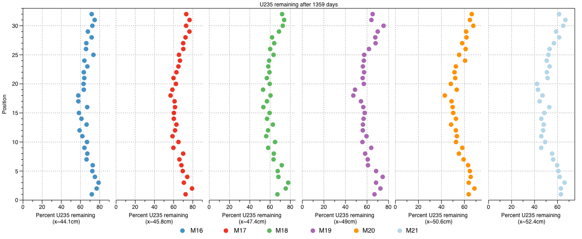
Figure 7.56 - Material compositions of M16-M21
The increase in burnup at the centre is primarily due to additional flux contribution arising from areas close to the centre. Due to the isotropic nature of fission there remains a high probability of neutrons returning into the core from outside as there is the neutron leaving the centre. Consequently, this can cause the centre of the core to burn up faster than the exterior. Coupled with this the central reflector plays a key role with neutrons thermalizing rapidly at the centre of the core.
In order to estimate optimal time for fuel rotation, different durations were used. The rotation stages are outlined in Table 7.10.
Table 7.10 - Stages chosen for switching
Stages | Days | Years | Burnup (MWd/KgU)
1 | 746 | 2 | 32.07
2 | 1111 | 3 | 47.76
3 | 1328 | 3.72 | 58.42

These stages were chosen as they are far enough from the initial commissioning to not to cause too much disruption to reactor operation. A duration of two years approximates to half of the estimated final burn up, thus designed to yield increased burn up after rotation.
Examination of material composition radially after 1359 days in the core, which would traditionally be termed the end of life for the core and comparing gives rise to an average method for comparison. The material compositions of each mirroring 10cm axial section previously shown in Figure 7.48 are compared to each other such via a ratio and then averaged across the fuel channel and the maximum deviation across an isoline was 2.5% over the lifecycle of the fuel, indicating the isoline representation was accurate.
The rotation is split into two stages in Table 7.11 and Table 7.12. The first stage does not include axial rotation, just movement, as shown in Figure 7.50.
The results from such movement shows a high level of consistency, with method giving rise to a similar level of expected life extension, the results are shown in Table 7.12. Table 7.12 investigates rotating the fuel at different points in time, with the years at the top of the graph the time the rotation is implemented. However, a 180-degree rotation would have been expected to experience more burn up in the centre after rotation. This implies however, that if the quantity of ²³⁵U remains high in the centre of the core, life extension is possible.

Table 7.11 - Criticality of none axially rotated systems
Table 7.12 - Life time extensions of the axially rotated options

Table 7.13 - Cost benefit analysis of not axially fuel rotated
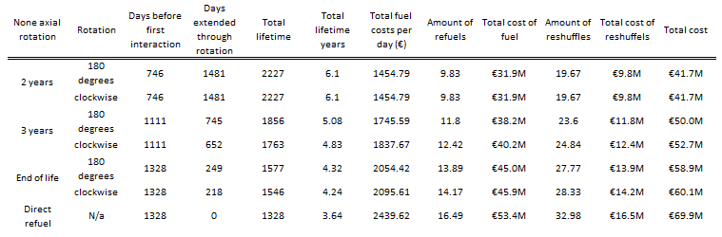
None axial rotation |  | Days before first interaction | Days extended through rotation | Total lifetime | Total lifetime years | Total fuel costs per day (€) | Amount of refuels | Total cost of fuel | Number of reshuffles | Total cost of reshuffles | Total cost
2 years | 180 degrees | 746 | 1481 | 2227 | 6.10 | 1454.79 | 9.83 | €31.9M | 19.67 | €9.8M | €41.7M
2 years | anticlockwise | 746 | 1481 | 2227 | 6.10 | 1454.79 | 9.83 | €31.9M | 19.67 | €9.8M | €41.7M
2 years | clockwise | 746 | 1481 | 2227 | 6.10 | 1454.79 | 9.83 | €31.9M | 19.67 | €9.8M | €41.7M
3 years | 180 degrees | 1111 | 745 | 1856 | 5.08 | 1745.59 | 11.80 | €38.2M | 23.60 | €11.8M | €50.0M
3 years | anticlockwise | 1111 | 714 | 1825 | 5.00 | 1775.24 | 12.00 | €38.9M | 24.00 | €12.0M | €50.9M
3 years | clockwise | 1111 | 652 | 1763 | 4.83 | 1837.67 | 12.42 | €40.2M | 24.84 | €12.4M | €52.7M
End of life | 180 degrees | 1328 | 249 | 1577 | 4.32 | 2054.42 | 13.89 | €45.0M | 27.77 | €13.9M | €58.9M
End of life | anticlockwise | 1328 | 218 | 1546 | 4.24 | 2095.61 | 14.17 | €45.9M | 28.33 | €14.2M | €60.1M
End of life | clockwise | 1328 | 218 | 1546 | 4.24 | 2095.61 | 14.17 | €45.9M | 28.33 | €14.2M | €60.1M
Direct refuel | no rotation | 1328 | 0 | 1328 | 3.64 | 2439.62 | 16.49 | €53.4M | 32.98 | €16.5M | €69.9M

Table 7.14 - Cost benefit analysis of the axially rotated fuel reshuffling
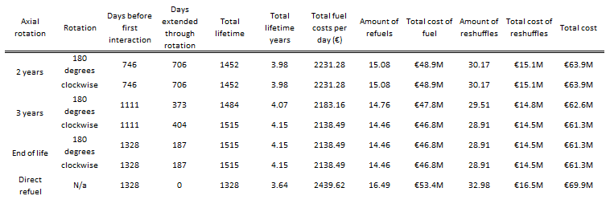
With axial rotation however, there was observed a significantly reduced life extension, contradicting the initial hypothesis. One potential cause could be from a reduced neutron contribution during operation, from the ²³⁵U being depleted, thus reducing the axial contribution when rotated. To test this hypothesis the flux was monitored after the rotation at both the bottom of the core and the centre of the 180-degree rotations. The flux is recorded using a detector in Serpent, these detectors are 10cm cubic shapes positioned across the core as depictured by Figure 7.57. This would then identify the main cause for difference in the two rotation models.
Figure 7.57 - Detector positions

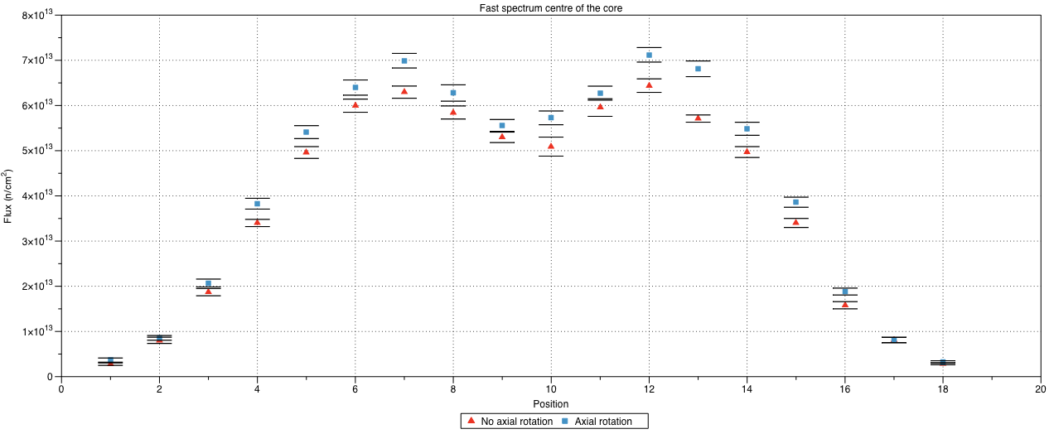
Figure 7.58 - Fast flux from the centre of the core0.4eV – 20 MeV

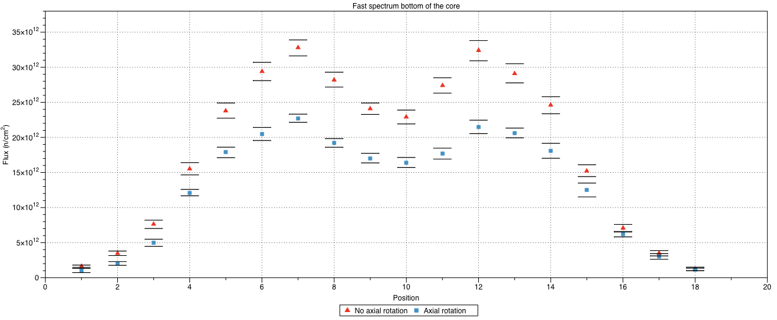
Figure 7.59 - Fast flux at the bottom of the core at 0.4eV – 20 MeV

The longest life extension would be expected to arise from a balanced burn up of fuel through fuel rotation, as shown in Table 7.14. This would then create an effective fuel lifetime of six years, which exceeds that required in the initial design brief. However, the initial hypothesis regarding the axial rotation providing the highest life extension has been shown to be incorrect.
Examination of expected fluxes, shown in Figure 7.58 and Figure 7.59, provides insight into why when the centre of the cores fast flux, representing ²³⁵U undergoing fission, is examined. The axial rotation gains a slightly higher flux at the centre of the core due to the freshest fuel being placed into the centre. However, such fluxes at the bottom of the core in figure 13 highlight the impact of axial rotation which significantly lowers the burn which identifies that rotation is reducing fission rate. With the combination of Figure 7.58 and Figure 7.59, it is noted that there is only a small increase in flux in the centre of the core, compared to a significant drop in flux at the edges. This directly affects the criticality as the depleted materials at the edge of the core are having a higher parasitic effect on the overall criticality of the system, compared to the small benefit to that of the flux in the centre.
Figure 10 has shown that there is a higher amount of depleted fuel at the edges of the fuel block, this implies that the 180-degree rotation specifically benefits from moving the fresher fuel from M6 in figure 9 into the centre. This allows for the external fuel blocks to contribute to a higher degree after the rotation.
Placing more fuel at the edges of the core would provide a higher effect of neutrons being passed back into the centre of the core axially. This then implies that increasing the packing factor of the top and bottom core, will in turn enable an extended lifetime extension and potentially higher burn up in all sectors.
Due to the small size of the design such rotational options of fuel blocks are limited which gives rise to the symmetrical burnup seen in in Figure 7.55. This benefit might not be found if the active core was wider due to the impact of the side reflectors now being less. As seen in figures 9 the axial increased burnup from reflectors, contributes up to 30cm into the core, thus covering just over half of the radial fuel block dimensions hence, giving rise to symmetrical burnup.
From a rotational point of view, where the earlier the rotation the longer the fuel life cycle, is problematic, as the core now requires a FM to be required more frequently. From an operational perspective the cost of a FM would need to be considered.
Financially the most economical approach is a simple rotation after two years, which is also the least technically challenging. The initial lifetime cost of the fuel in the core was estimated to be €69.9mn based on the direct refuel scenario in Table 7.14. It was found that the most cost-effective fuel rotation scenario was in Table 7.13, with an initial two-year fuel rotation, reducing the total fuel cost to €41.7mn, an overall saving of 40.3%. This cost saving could then allow an additional €1mn per fuel reload to be allocated to help offset any risk with the procedure and still save €10mn over the lifetime of the reactor. From these finding, it does seem that the additional cost could be overcome through fuel rotation. There are situations where this might be too difficult, for example military applications where access after two years would be problematic.
Conclusion
Several different rotational techniques have been examined through variation in operational time and rotation within the core. Through this, the most beneficial was rotating the fuel by 180 ° after two years, which was modelled to increase the core lifetime by 40.3%. This increase could lead to a fuel cost reduction of up to €30M over the lifetime of the reactor. However, the full economic risks involved in this process have not been covered but are the focus of a further paper.

Validation between Serpent and MONK
During the development of the nuclear era post war (1945), the UK was one of the more technologically advanced nations, with the UK’s nuclear research being key to the atomic weapon development during World War II. Despite the agreement between the USA and UK, where the UK provided scientists to the USA to aid in the preparation of nuclear weapons, these scientists left without any notes as the nuclear cooperation between the two countries was ceased. This left the UK to develop independently this industry, with most of the motivation coming from government to aid the production of weapons, the UK set up the United Kingdom Atomic Energy Authority (UKAEA). In the 1960s the UKAEA set up a neutronic coding group at Winfrith to create a deterministic code called Winfrith Improved Multigroup Scheme (WIMS) [108]. WIMS was the first of several codes produced by what is now called the ANSWERS software group, which has since been privatised and is now a subsidy of the Wood group. The ANSWERS software group also provide a Monte Carlo simulation package called MONK which is regularly used, in conjunction with WIMS to provide regulatory information regarding nuclear reactor designs.
As MONK is industrial applied software, as opposed to research focused software, it requires a higher level of confidence to attract customers and this comes with the legacy of the software’s reputation. To back up this reputation, MONK offers a comprehensive list of over 800 validation tests that have been performed and are available for users [109]. Validation comes in the form of simulation data matching the results which are produced by experimental procedures. The ANSWERS software group have been providing validation for over fifty years. This has led the software to be depended upon internationally in the field of core design.
There are several disadvantages that come with such a prestigious reputation and software package; editing or reading the source code is prohibited. In addition to this, an open based forum does not exist. Instead any queries encountered are solved by personal responses from the developers, which is advantageous, yet this feature requires an annual premium to access.
Codes comparison
At the beginning of the Monte Carlo simulations there were two main codes, O5R from Oak Ridge National Laboratory and GEM from the UK UKAEA [110]. MONK originally came from GEM as a criticality based simulation package [111] which has continued to be developed and has since simulated some of the most prolific nuclear reactors across the world.
Similar to Serpent, MONK is a Monte Carlo code which uses super histories to determine outcome to the neutron. However, MONK also links with the other software packages provided by the ANSWERS software team. For example, burnup calculations require iterations between WIMS and MONK to process the data for each burnup step.
Starting from the base up, a comparison of Serpent and MONK is produced in this chapter to gain a sense of confidence with the results Serpent is producing. To allow for the most accurate comparison, a large amount of super histories is used at 50000 and both simulations use the data library JEFF3.1.1. Where appropriate burnup calculations were performed by normalising the power of the system for a set amount of days; these are depicted in each section.
The areas tested compare the following areas.
Table 7.15 - Verification tests performed between MONK and Serpent
Test | Body
1 | Fuel column
2 | Fuel block
3 | Active core
4 | Full core
Table 7.15 shows a rationale behind the progressive building up of each of the stages. This should allow for ease of identification of variances between models.
These tests provide results for both homogenous and heterogeneous modelled fuel. The rationale behind this is that, due to the CFD software often only having the capability to model the fuel in a homogenous form, the homogenous accuracy of the results should be analysed.
The ANSWERS software service package also contains a software capable of visually representing models made by MONK called VisualWorkshop. VisualWorkshop provides the ability to view the model created in 3D and use a plane cutting tool to visualise anywhere in the core. VisualWorkshop 3b is used to create the pictures represented in this chapter. Serpent’s visualisation software is more primitive and produces three views; XY, YZ and XZ at half the depth of that plane. This method allows the user to define the number of pixels of the output image, however, does not allow for 3D viewing.
All materials selected in this section are identical to those mentioned in Chapter 3, except the density of the fuel is kept to 10.8 cm³ to provide a more accurate representation of real TRISO fuel.
 | $$RSE x mean=STDV$$ | (7.1)
For this section, errors are converted into the same format to gain a real comparison between the results presented. Serpent outputs its results as relative standard error (RSE) as shown in equation (7.1).
The mean result is printed in the output of Serpent alongside the mean, allowing for the STDV to be produced.
MONK uses a range of 172 energy “groups” to perform calculations, these are used to understand interactions within defined energy ranges. These groups can be reduced to obtain a specific energy range thus increase the speed of simulations. These 172 groups have a range of 0.0001 eV to 19.64 MeV, to keep this range the same, Serpent’s energy limits were set to those of the maximum and minimum of MONKs groups.
Fuel column
The fuel column represents the fuel compacts inside of the core. This test performs a basic criticality test as an infinite lattice, as the boundary conditions allow for the geometry to be represented infinitely. Due to the infinite lattice, there is no leakage as the neutron is returned into the neighbouring lattice; thus, this is denoted as K_{inf}. The materials compositions of ²³⁵U, ²³⁸U and ²³⁹Pu were monitored to provide an indication of any difference between the two codes.
Due to burnup calculations being performed on the fuel, each of the codes requires an initial starting volume of the fissile material to determine the material composition after a set amount of time. The homogeneous fuel is calculated by using the volume of a cylinder.
TRISO fuel is not traditionally modelled in MONK and there is not a standalone method of randomly dispersing articles within a column, as there is in Serpent. To account for this, the TRISO particles are cut out of a pebble, which they are randomly dispersed within. MONK 10a has the option to create pebbles for PBHTRs, the command requires the material outside of the pebble, the pebbles outer layer and then the grains composition within them. Each grain has the same identical composition as the TRISO particles used in Serpent. To create the fuel, the inside layer of the pebble is made to a radius of 2.5cm, obtaining the volume from equation (7.2).
 | $$Volume=\frac{4}{3}πr^{3}$$ | (7.2)
 | $$Volume=\frac{4}{3}π {2.5}^{3}=66 {cm}^{3}$$
The packing factor is kept to 29% so the overall particle volume is $18.98 {cm}^{3}$ giving a total of 48,104 particles of radius 0.0455 cm within the pebble. By cutting a small cylinder of 2 cm height and 0.635 cm radius as depicted in Figure 7.60, these are then stacked on top of each other to produce the fuel columns of 320 cm.
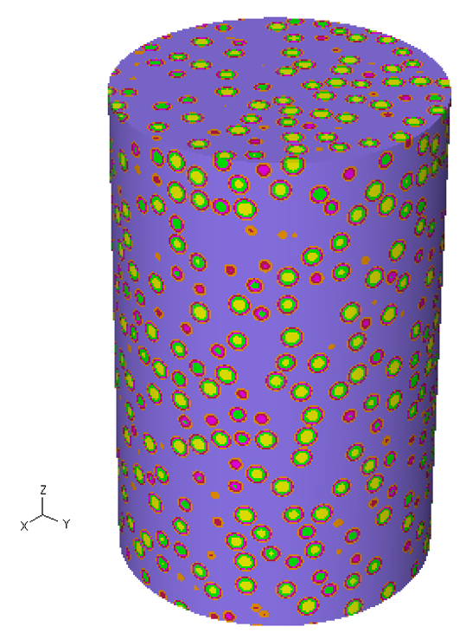
Figure 7.60- A cylinder cut out of a pebble bed sphere with 48104 particles displaced within it. This provides 2 cm of MONK’s fuel compact which are then stacked vertically to provide the 320 cm fuel channels
A significantly larger sphere was attempted, to fit the whole fuel column in, however, there were too many grains, which caused memory issues in the code. This model loses the structure of the particles at the edges of the column as visible in Figure 7.60 as some particles are cut as the sphere is shaped into a cylinder. This will reduce the moderation and spatial shielding of the TRISO particles at the edges of the column, as layers of Carbon and ²³⁸U are missing compared to reality/Serpent model. However, this is the most accurate model of TRISO fuel available to date in MONK.
To aid moderation of the system, the fuel pin is surrounded within a box made of fuel block graphite. The box is 4 cm in the X and Y directions with the box using MONK’s fully reflective boundary properties (Albedo). This was mimicked within Serpent using fully reflective boundary conditions in the X, Y and Z planes.

Figure 7.61 - XY cross-sections of the fuel pin tests, Left MONK; Right Serpent
Figure 7.61 shows fuel column model across the XY plane. Images of the homogeneous models in this chapter have been omitted due to their similarity. It is worth noting that the variances in colour do not mean anything in these images, this is simply the output which choses random colours.
The total burnable material volume is required to perform burnup calculations. In the case of Serpent this is defined within the material, in this case 19.5 ${cm}^{3}$. MONK requires the volume to be provided within the first instance of the part, in this case the first occurrence, which is a 2 cm section of the fuel column with a total fuel volume of 0.12187${cm}^{3}$. For the homogeneous model, the fuel volume is calculated at 405.37 cm³.
It is worth noting that discrepancies with material compositions were noticed when using regular materials library. For better accuracy, the atomic densities were used in MONK from the output files of Serpent, thus keeping the material compositions identical to six decimal places.
The burnup rating of the fuel pins calculation is reduced to 2MW; this is due to the 10MW burnup making the system go subcritical too quickly to gain understanding of the performance and thus acting as an unrealistic demonstration.
Homogenous models are predicted to see closer correlations between MONK and Serpent, due to there not being issues with modelling the heterogeneous fuel. The homogenous fuel tests are also performed using the same surrounding block of graphite as the heterogeneous model.
Results
The initial experiment investigates the criticality of the system over a period of 10 days. In the following results section, the error bars in green represent MONK and black represent Serpent.
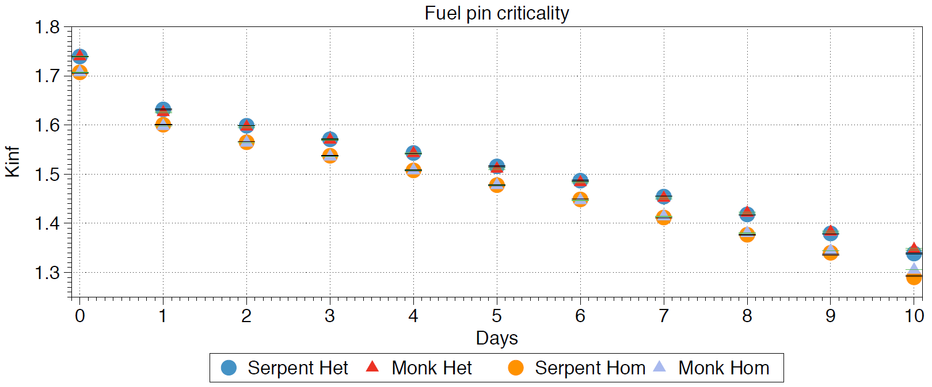
Figure 7.62 - Criticality over 10 days
Viewing the material composition ratio of Serpent in relation to MONK allows for the same composition to be unity and any variances deviate from this. The homogenous ratio uses the circles and the heterogeneous ratio uses the triangles.
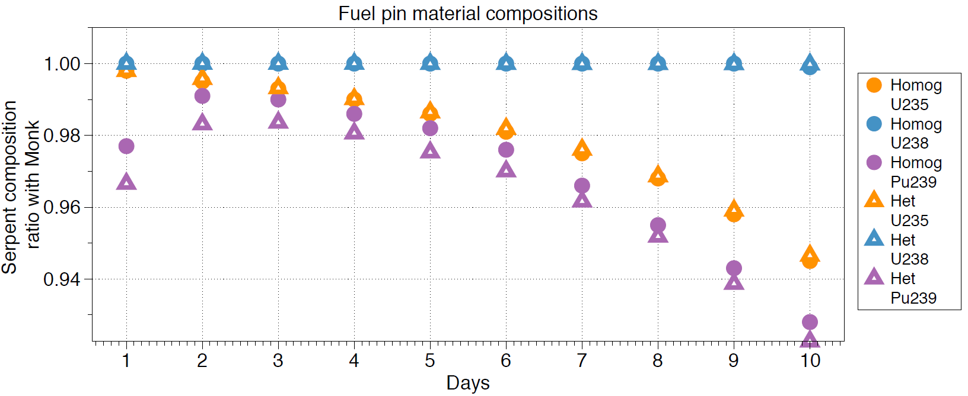
Figure 7.63 - Material compositions ratio of fuel pin
Discussion
Heterogeneous
The criticality test is only a short test but tests the difference in the solvers. For the initial step at time zero, the criticality is identical. This bodes well for the representation of heterogeneous fuel in MONK, as there were initial fears the fuel would perform differently due to the loss of the TRISO fuel structure. This indicates that the main difference between the two codes resides in the burnup methodology.
Material compositions are calculated based on the interactions which have been undertaken in that burnup step. For instance, if during the Monte Carlo simulation ¹⁰B absorbed and captured 10% of all neutrons in that region, the ¹¹B concentration would increase by 10% and the ¹⁰B concentration would decrease by 10%, in the case of these models the initial concentrations are identical thus allowing for a proportional comparison to be made. MONK and Serpent handle these calculations using quite different methods. Serpent has a self-developed method called Chebyshev Rational Approximation Method (CRAM), which focuses on reducing the calculation time of the burnup calculation by approximating constants of decay, which is explained in detail, with validation in the reference [112]. MONK does not explicitly explain the method of solving the burnup calculations; however, it does state that the flux is used to determine the reaction rates and thus the material depletion, which is a standard methodology.
The material concentrations have a maximum error of nearly 8%, in this case with the ²³⁹Pu. The ²³⁹Pu is included to determine the difference in the flux spectrum in the core. As faster neutrons have a higher probability to transmute ²³⁸U into ²³⁹Pu, this is a technique to determine which system is behaving in a more moderated fashion, in this case MONK. The variation over this short period of time does not show anything drastically different between the codes and the ²³⁵U concentrations are sufficiently similar at this stage, although the linear decrease in ²³⁵U indicates the fuel is burning faster in Serpent. This could be due to a slightly different average energy used per fission, thus more fissions are required in Serpent.
For a further investigation between the two models, the analogue reaction rates were investigated. MONK produces reaction rates across each energy range, however, there are only three outputs of the reaction rates in MONK, Capture, Fission and Elastic Scattering. A comparison of these sections between the two codes has been made in Table 7.16.
Table 7.16 - Reaction rates for fuel pin regions
Part | Reaction rate | MONK | Serpent | Variance
Fuel | Fission | 0.004404 | 0.004382 | 0.99
Fuel | Scattering | 0.004125 | 0.004467 | 1.08
Fuel | Capture | 0.001599 | 0.001588 | 0.99
Outside block | Scattering | 0.910000 | 0.919366 | 1.01
Outside block | Capture | 0.000144 | 0.000008 | 0.06
Matrix | Scattering | 0.052826 | 0.053740 | 1.02
Matrix | Capture | 0.000008 | 0.000156 | 19.39
All other parts | Scattering | 0.016144 | 0.029937 | 1.85
All other parts | Capture | 0.000018 | 0.000003 | 0.14

Table 7.16 indicates that there is quite a variance in the capture in the graphite matrix, with this being 19 times higher in Serpent than MONK. However, due to this being such a low order of magnitude, as graphite has a low capture cross-section, this can be put down to error. However, one main concern is the behaviour of the scattering in the TRISO particles layers. The TRISO layers in this example are a small quantity, as this is a single fuel column, however, across the core where there are millions of particles the difference is significant. The method for calculating the cross-sections in MONK creates the hole geometry and then calculates the cross-sections across that geometry after a process of monitoring multiple track lengths through that geometry. As depicted in Figure 7.60 there are a lot of cases where the layers of the fuel are cut in half. This could be contributing towards the significant decrease in modification through the particle in MONK. Conversely to this, Serpent groups all the TRISO Carbon layers together into one Carbon element. This provides all the reaction rates, however, the process of how Serpent determines the cross-sections across the layers is not well documented. The process could be the same as MONK, where Serpent determines the particle universe’s cross-section for each material and then determines the cross-section. In this case the Carbon cross-sections seem to behave differently between the two codes. It is difficult to say which method is the most likely to cause this variation.
The variance provides additional moderation to the Serpent system; this is likely to be contributing towards the increased burnup of ²³⁵U, which prefers more thermal neutrons. This increase in moderation takes place just adjacent to the fuel kernel, adding to the probability of additional fission.
The normalisation of the power is set to 2 MWth is also not a realistic value to be considered within a single fuel pin. This was used to emphasise any effects that extreme burnup might have on the fuel pin, in this case that Serpent significantly burns the ²³⁵U faster. However, in the case of the main simulations, the total power across the whole core is 10MWth, which per fuel column is ~260 times less than shown in this burnup case.
Homogenous
The criticality test over the ten days looks identical between the two codes again, indicating that they agree with each other over a short period of time.
Serpent has similarly depleted the ²³⁵U quicker than that of MONK and slightly underestimated the plutonium build up.
Fuel block
The fuel block is the next logical step up from a fuel column, in this example the fuel block represents a 320 cm length singular fuel block. The tests see the reactor’s power reduced to represent 1/6th the fuel as in this case, leaving the total power as 1.667 MWth.
The fuel block is modelled identically to that in Chapter 3, there is minimal difference in lattice configurations between the two codes. From a modelling perspective, a lattice is a simple method to repeat certain parts with a defined pitch and layout within a defined shape. In this case the lattice distributes the 216 fuel columns and 108 coolant columns.
It is common practice to represent an infinite lattice of hexagonal fuel blocks, as these can be mirrored at each 60-degree angle, however, in this case to keep both cases an Albedo box (0,0,0), (42, 42, 320) was used, as shown in Figure 7.64. The box is not as critical for moderation as in the fuel pin case as the fuel block provides ample moderation throughout the fuel block graphite and the matrix material.

Figure 7.64 - Fuel block left; MONK Right; Serpent
The total volume of fuel is required for Serpent in the heterogeneous and homogenous models are calculated as 4212 ${cm}^{3}$ and 87559 cm³ respectively.
Results
Criticality results of the fuel block
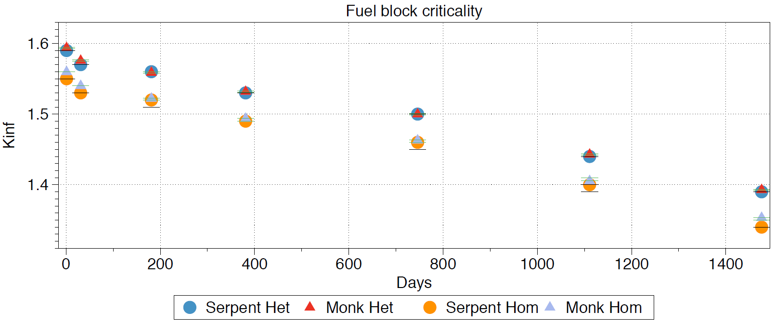
Figure 7.65 - Criticality of fuel block
Material composition results of the fuel block
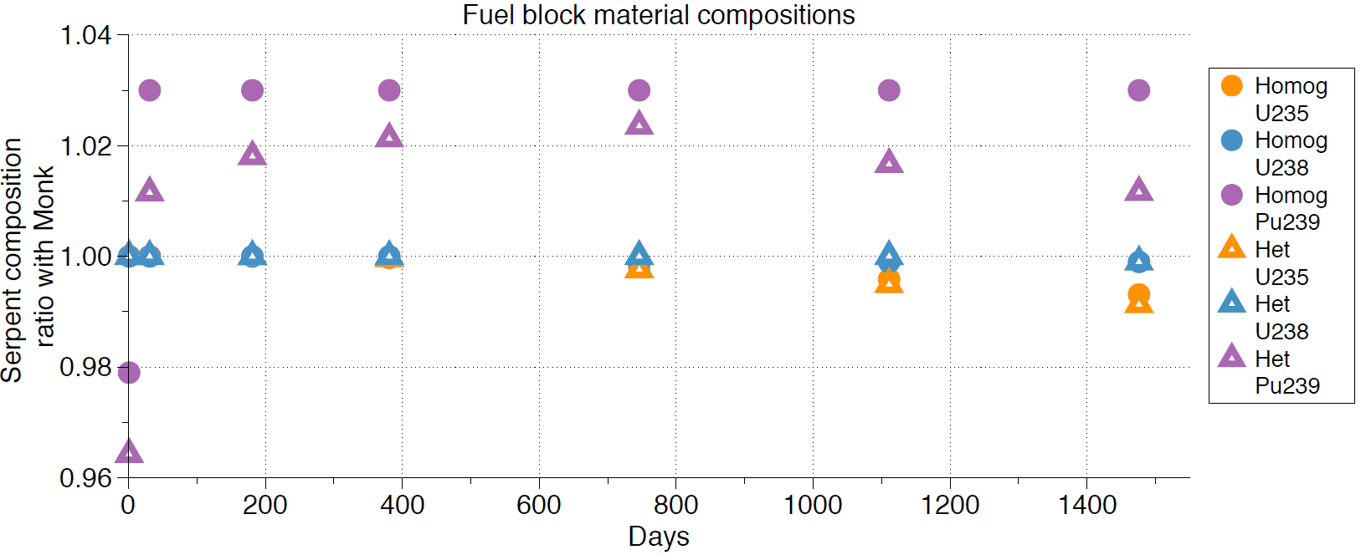
Figure 7.66 - Material compositions variation
Discussion
The fuel pins were added to the fuel block to create a replica of the U-Battery’s fuel block. One of the key parts being tested is how the fuel block interacts with the neutrons; if the graphite behaved differently between the two codes then there would be a large variation in criticality. Over the four years of testing the highest variation in criticality is 0.078% at the last step of the homogeneous fuel. This is due to the concentration of ²³⁵U burning slightly quicker in Serpent, with a ~1% difference in material compensation over the test period. This is a rather harsh test to consider when comparing the models, as their deviance from the initial input is after five years while using different burnup methods, thus providing confidence in the model. The cause for this is likely to be due to the additional moderation experienced in the particle, universe as witnessed in the fuel pins.
The fuel block material composition shows a similar trend to that of the fuel pin with Serpent consuming a higher amount of ²³⁵U, yet with a lower criticality. Checking the fission rates on the first burnup step, the fission rate in MONK is 0.3% higher. This implies that the MONK system is providing a higher number of neutrons into the system due to the amount of fissions required being higher. However, this should see a counter effect as a higher ²³⁵U burnup, but this is not the case. This implies that other elements are providing this additional amount of total fissions than ²³⁵U, such as minor actinides.
The homogenous model is seeing a larger deviation from that of the TRISO model, which contradicts the initial hypothesis that the homogenous models would be the most similar. Serpent has a higher criticality at the end of the life than that of MONK, however, due to the variance in this case the criticality is within error. One method to further investigate this issue is the production of plutonium, which in a faster system would see a lower quantity of ²³⁸U and higher quantity of ²³⁹Pu. However, the quantities of ²³⁹Pu are so low that this is difficult to depend upon. In addition to this, the ²³⁹Pu curve initially is lower in Serpent than MONK and then raises higher. This indicates that a change in the system occurs, as the initial conditions see Serpent having a slower system and then the system become faster than MONK. This is likely to be due to the presence of certain poisons which are not included during the initial step, but which quickly become significant after this. MONK does not produce a full depleted materials list during the burn up stage and uses pseudo materials to reduce the calculation time. This could be one cause of the change in the system, as the inclusion of every element in Serpent after the first burnup step could be causing this additional change.
Active core
The active core represents the six fuel blocks and the central reflector (no top and bottom reflectors in this case). This test was added to determine any difference between the models when it comes to the moderation effect of the central reflector.
The active core is simply modelled with six of the fuel blocks placed in a lattice surrounding a graphite central reflector. The model uses reflective boundaries similarly to the previous case.

Figure 7.67 - Active core; Left MONK, Right, Serpent
The burnup calculation follows the full power of the reactor core at the designated 10MWth. The heterogeneous and homogeneous fuel volumes in Serpent are 25,272 cm³ and 525,354 cm³ respectively.

Results
Criticality of the active core results
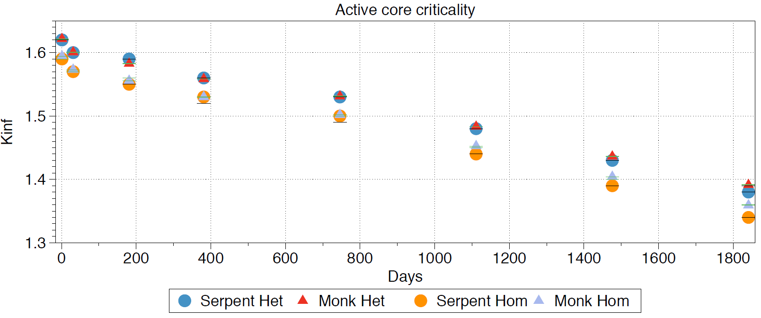
Figure 7.68 - Active core criticality results
Material compositions of the active core results
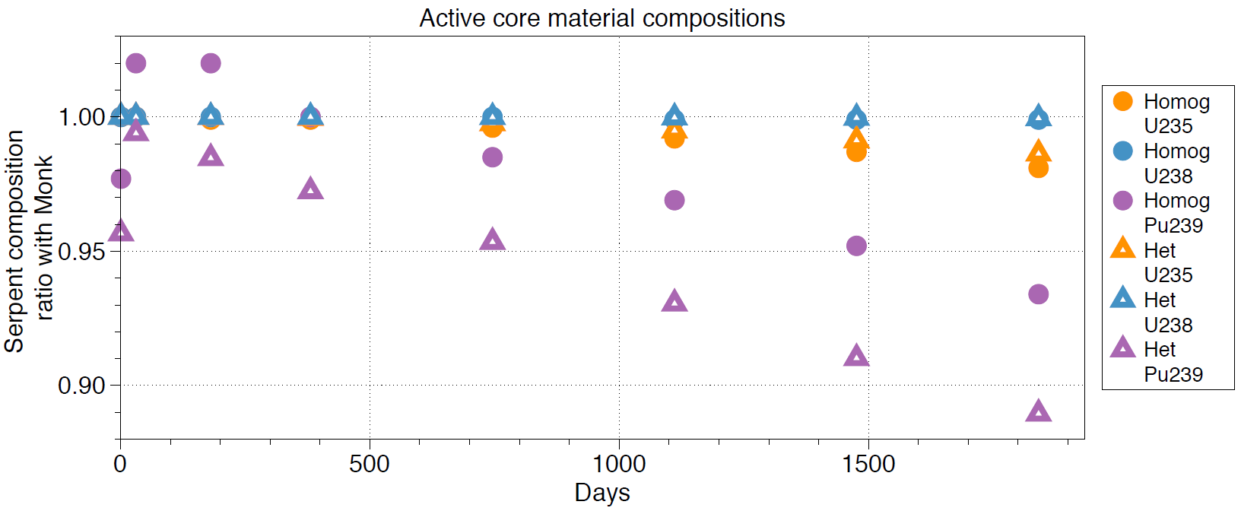
Figure 7.69 - Concentration difference
Discussion
Due to the additional fuel blocks, the ²³⁵U concentration difference in Figure 7.69 is significantly magnified from the fuel block system, with a nearly 2% variance in ²³⁵U between the two codes in the homogeneous model. This has caused a large variation in criticality due to the probability of fission being significantly less in Serpent at the end of life in comparison to MONK. Due to the pattern being familiar from the basic fuel pin design, the chance this is down to the moderation identified is quite likely.
Due to the nature of the homogeneous mixture, the cross-sections are combined to produce an overall effect of a neutron entering the fuel material. These should be identical; however, they are not. There are two reasons which could account for this; the mixtures do not share the same cross-sections or the neutrons they are receiving do not share the same properties. The first reason implies that the cross-section libraries of the method are homogenising the elements represented differently. As the libraries and atomic densities are identical this is unlikely, except in the situation of rounding errors. The second method could be due to the increase of moderating material also leading to an increase in difference between the models. This is an interesting hypothesis that the graphite is behaving differently between the two codes.
An interesting situation occurs with the ²³⁹Pu, where the trend of Serpent producing higher amounts of ²³⁹Pu has stopped and the active core has seen a lower amount of ²³⁹Pu than that of MONK. This indicates that the inclusion of a central reflector has changed the production of ²³⁹Pu, with Serpent’s system benefitting more from this additional moderation. This adds confidence in the argument that the neutrons’ behaviour with the graphite differs between the two models.
Full core
A full core analysis is important to understand any of the more detailed differences between the two models. In this case, for the full core model this implies no reactivity control.
The full core does not use a repeated boundary, as with the case of the previous tests; this means that as the neutrons pass through the final boundary, the RPV are termed “leaked” from the system and subsequently lost. This enables the consideration of flux to be more appropriate as these systems are not infinite as in the cases prior to this. To monitor the flux, Serpent uses detectors; these detectors record all neutrons entering and leaving them in a similar fashion to the neutron transport equations. MONK uses a method called unified tallies. These are lines placed in a grid like formation, with the user determining the position of these lines to account for the area of which the flux is required to be tallied. The unified tally method is more difficult to picture due to there being no method to visualise what you have created, however, both methods are identical to each other. The flux is measured at two points in the system, the bottom of the core and the centre of the core, in 10 cm cuboids across the centre of the XY plane.
The cuboids are depicted in Figure 7.70 with their appropriate location within the active core highlighted.
Figure 7.70 - The detector locations across the core
Figure 7.70 indicates that detectors 5, 6 and 7 represent one side of the core across the fuel block, which provides the most important section due to the process of fission within them.
Neutronic flux is often presented in three forms depending on the energy range; thermal, epithermal and fast flux. There are no defined limits to these energy range descriptions, so the ranges chosen are presented in Table 7.17.
Table 7.17 - Flux energy ranges
 | Energy range (MeV)
Flux type | Maximum | Minimum
Thermal | 1.0 x 10⁻⁹ | 2.5 x 10⁻⁸
Epithermal | 2.5 x 10⁻⁸ | 4.0 x 10⁻⁷
Fast | 4.0 x 10⁻⁷ | 20

Due to the flux being presented in different values between the codes MONK’s flux is multiplied by the average of the Serpent:MONK ratio between the two, across that energy range and each detector value. This provides some error in the sense that the flux will be hard to compare, at exact points due to accuracy being lost during the averaging process.
Due to the programs being run in burnup mode, both software packages produce fluxes for at burnup stage. In this case the relevant flux was taken at day zero, which is the initial criticality of the system.
It was noted that the fluxes were very similar between the homogenous and heterogeneous models. For clarity, and to avoid repetition, only the heterogeneous fluxes were published here.

Figure 7.71 - Full core picture MONK left, Serpent right.
In Figure 7.71 the black surrounding the Serpent drawing represents outside of the core; if a neutron reaches this point the neutron history is terminated. At this point the neutron is recorded as leakage, indicating that it has left the system. A similar system is included in MONK, however, the software automatically detects the outside area (highlighted in purple in Figure 7.71).
Results
Criticality results for full core
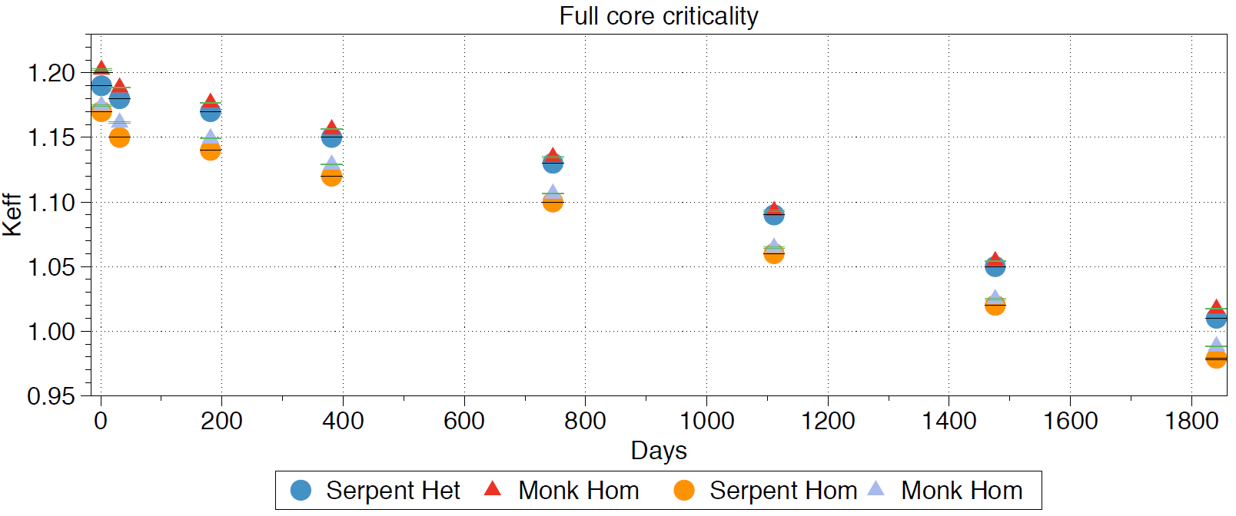
Figure 7.72 - Criticality of full core
Material composition results for full core
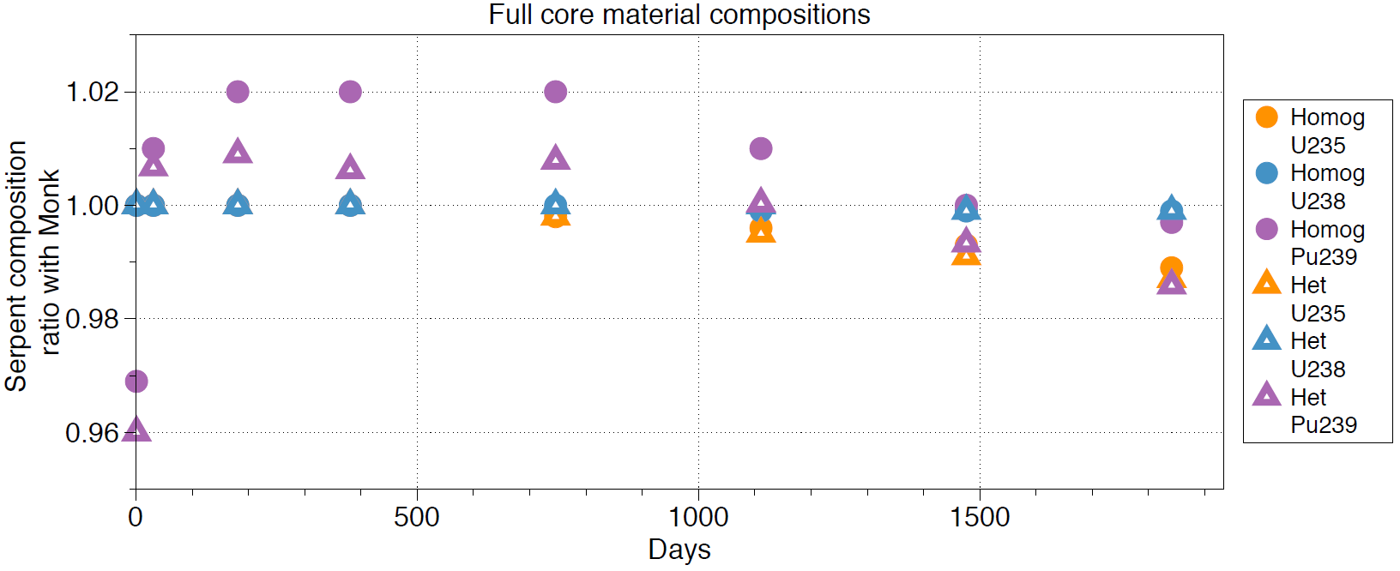
Figure 7.73 - Concentration difference of full core

Flux results at the centre of the full core
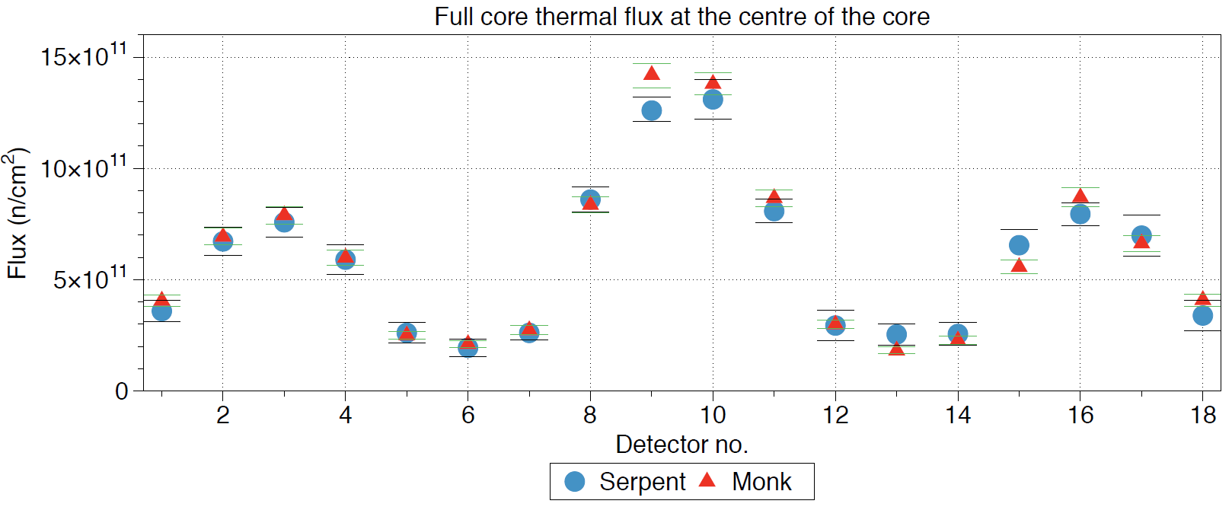
Figure 7.74 - Thermal flux at the centre of the core
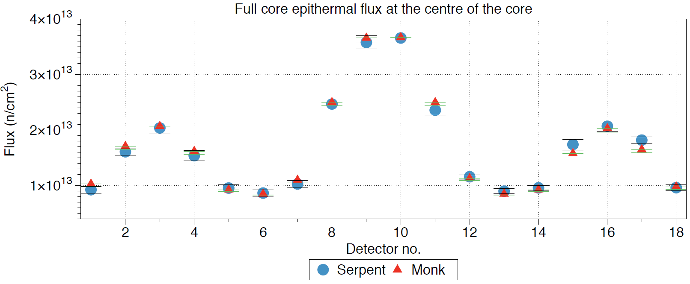
Figure 7.75 - Epithermal flux at the centre of the core
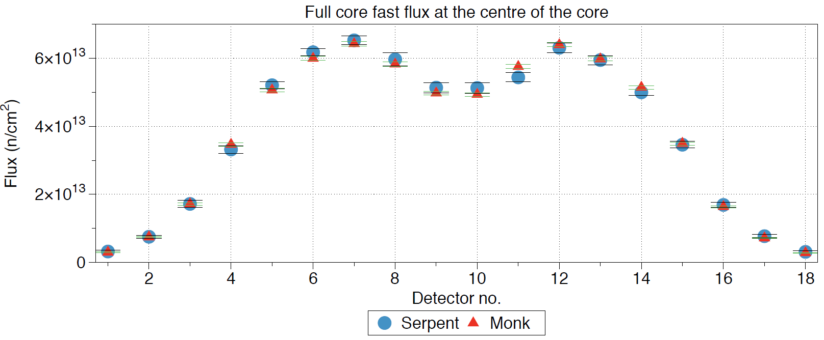
Figure 7.76 - Fast flux at the centre of the core
Flux results at the bottom of the full core
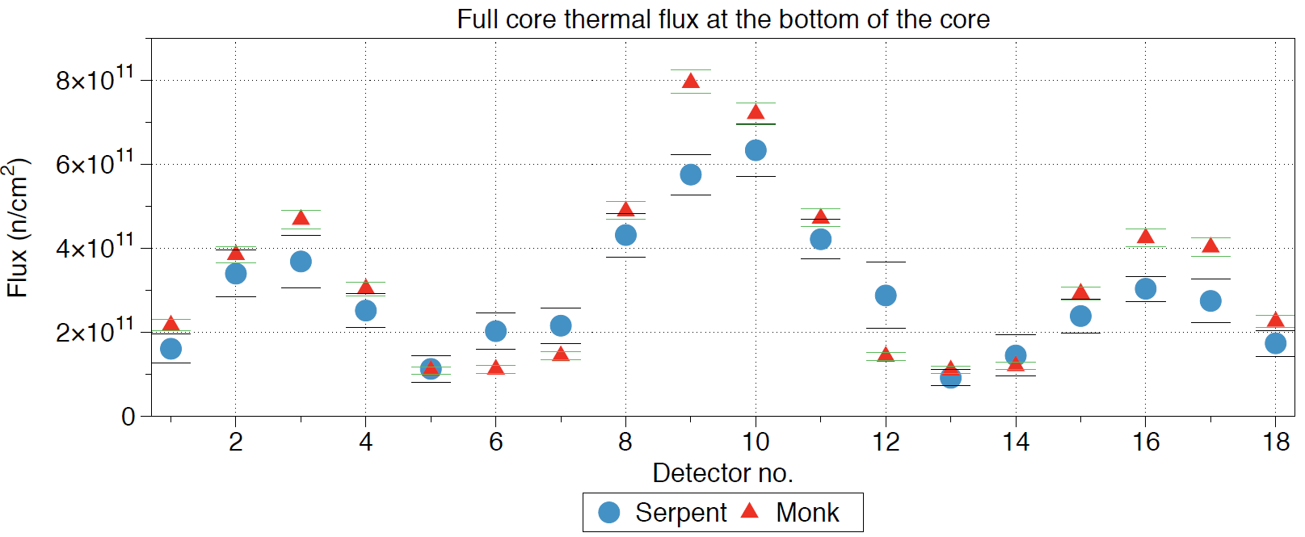
Figure 7.77 - Bottom of the core thermal flux
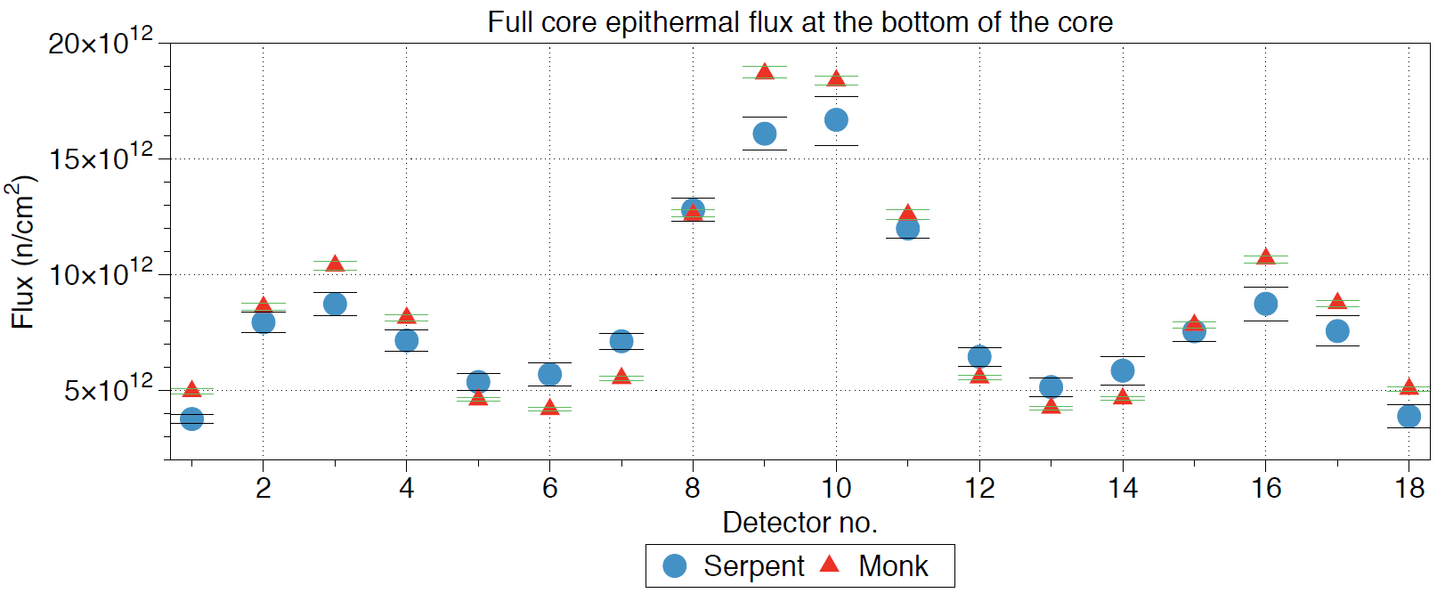
Figure 7.78 - Bottom of the core epithermal flux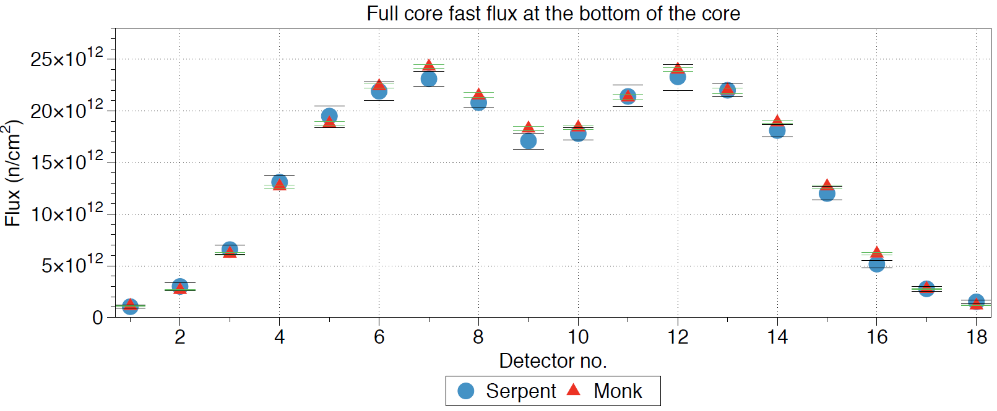
Figure 7.79 - Bottom of the core fast flux
Discussion
Similarly, to the other tests, the amount of ²³⁵U is being used up slightly quicker in Serpent, to MONK Across the centre of the core there is a good agreement within the fluxes. However, at the bottom of the core variance is increased, although the errors are increased in this region due to significantly less neutrons passing to the bottom of the core than to the centre.
The flux explains why the ²³⁵U is burning up higher in Serpent, with the bottom of the core across the fuel block showing an increased flux across all ranges within the fuel block detectors. This implies that the bottom of the core is showing a different behaviour between the two codes. One reason for this is how the codes define their initial starting neutrons. In MONK the starting neutron is defined in a certain fissile part; in this case the part is placed at the centre of the core due to the positioning of the first fuel pin. In Serpent, they do not clarify the starting position of the initial neutron, but this is likely to be anywhere within a fissile material so starting anywhere in the active core. This could see the flux in the bottom rise due to the chance the chain reaction starts in this region being higher.
It is also observed, in this case, that the thermal flux in the central reflector is slightly higher in MONK than Serpent. This implies that the behaviour of poisons will be affected as with a larger flux the higher the impact of the poison will be. This could have been an effect of the cut off energies, however due to them being identical this is unlikely.
The flux is also noticeably higher at the extremities of the core in MONK; this implies that more neutrons are being produced towards the edge of the fuel blocks, allowing them to maintain epithermal energy as far out as detector 16. These neutrons are unlikely to dramatically contribute towards fission due to their position so far away from the active fuel.
The homogenous version has not seen an increase in the end criticality variation as experienced in previous simulations, however, the difference is quite clear. Due to the similarities at the beginning of life, this is likely to be caused by material compositions.
Conclusions
This chapter has aimed to build confidence between Serpent and MONK by building up the core in small steps. The codes behave in a very similar fashion, with MONK having a noticeably higher criticality than Serpent. This has proven problematic when considering the full core with reactivity, due to the criticality being raised over unity when all control rods were fully inserted. Due to MONK’s position on such an important area, it would be advised to reconsider the area of reactivity control when advancing past the conceptual design stage.
It was noted from an early stage that material composition calculations of the two codes vary as the criticality variation is significant at the end of life compared to the initial conditions. Due to the complicated nature of transmutation, material compositions are extremely hard to accurately predict, which can lead to the size of errors encountered in this section. Unfortunately, the amount of error accepted in material compositions has not got a benchmark as such, however, due to the long nature of the burnup tests performed, this has not caused too much concerns. One of the main findings was the difference in ¹⁰B between the two codes, with Serpent significantly burning up boron faster than MONK, reflected in the flux, criticality and control rod worth results.
Serpent has shown a consistently elevated burnup of ²³⁵U compared to MONK in each section. This has been put down to the more accurate modelling of the TRISO fuel particles than that of MONK, however, when MONK is capable of modelling TRISO particles with a dedicated feature, this area should be revisited. It was noted that there has been a large variation between ²³⁹Pu within the two codes. This has been significantly reduced when increasing the neutron population of Serpent and thus reducing the error induced when having large errors within the flux in certain areas of the core.
Calculations regarding the flux between the codes were made, however, these do not use the same representation of flux so must be regarded with caution. However, the flux profiles mainly agreed with each other. The flux at the bottom of the core in Serpent was often higher than that in MONK. This is likely to influence all the calculations performed, due to the bottom and top of the core not suffering such a high burnup as that of the centre. A higher neutron population in the extremities of the core is likely to promote a higher fission rate away from the centre, allowing for a more balanced burnup within the axial dimensions.
MONK showed an elevated flux within the central reflector compared to Serpent, especially when switching between reflective and non-reflective boundary conditions. The exact reason for this has not been identified, however, it is suspected that the loss rate in MONK is significantly higher than that in Serpent, as the increased flux is likely to be lost within the graphite side reflector.
The overall performance of the two codes are in good agreement with one other. Limitations in MONKs fuel modelling showed very few discrepancies to Serpent overall.
Further work
Throughout this chapter the representation of the model in MONK has been slightly hindered due to not having a dedicated method of modelling TRISO particles. The TRISO fuel particle allocation is easy to implement and this could be incorporated within future versions of the code.

References
[1] HM Government, “The UKs Nuclear Future,” Nuclear Industrial Strategy -The UK’s Nuclear Future, 2013. [Online]. Available: https://assets.publishing.service.gov.uk/government/uploads/system/uploads/attachment_data/file/168048/bis-13-627-nuclear-industrial-strategy-the-uks-nuclear-future.pdf. [Accessed: 14-May-2018].
[2] World Nuclear News, “UK marks 60th anniversary of Calder Hall,” 2016. [Online]. Available: http://www.world-nuclear-news.org/ON-UK-marks-60th-anniversary-of-Calder-Hall-18101601.html. [Accessed: 14-May-2018].
[3] BBC News, “New UK nuclear plant sites named,” 2011. [Online]. Available: http://www.bbc.co.uk/news/world-13887579. [Accessed: 11-May-2017].
[4] G. Clark, M. P. Conservative, T. Wells, R. Hon, and D. Curry, “House of Commons Committee of Public Accounts - Hinkley Point C,” 2017. [Online]. Available: https://publications.parliament.uk/pa/cm201719/cmselect/cmpubacc/393/393.pdf. [Accessed: 14-May-2018].
[5] BBC, “Wylfa Newydd_ First minister’s nuclear power talks call - BBC News.” [Online]. Available: https://www.bbc.co.uk/news/uk-wales-north-west-wales-44364447. [Accessed: 18-Jul-2018].
[6] AEN-NEA, “Reduction of Capital Costs of Nuclear Power Plants,” 2015. [Online]. Available: https://www.oecd-nea.org/ndd/pubs/2000/2088-reduction-capital-costs.pdf. [Accessed: 03-Nov-2018].
[7] International Atomic Energy Agency, “Small modular reactors (SMR)AEA.” [Online]. Available: https://www.iaea.org/topics/small-modular-reactors. [Accessed: 03-Nov-2018].
[8] ETI, “Preparing For Deployment of A UK Small Modular Reactor By 2030,” 216AD. [Online]. Available: https://www.eti.co.uk/insights/preparing-for-deployment-of-a-uk-small-modular-reactor-by-2030. [Accessed: 03-Nov-2018].
[9] DECC, “Small Modular Reactors Competition Phase One,” HM Government Webpages, 2016. [Online]. Available: www.nationalarchives.gov.uk/doc/open-government-licence/%0Ahttps://www.gov.uk/government/publications/small-modular-reactors-competition-phase-one. [Accessed: 03-Nov-2018].
[10] BEIS, “Advanced Modular Reactor (AMR) Feasibility and Development (F&D) Project - Abstracts from the Applicant Organisations,” no. August 2018, 2018.
[11] Japan atomic energy research centre - JAERI 1332, “Design of the HTTR,” 1994.
[12] Z. Wu, D. Lin, and D. Zhong, “The design features of the HTR-10,” Nucl. Eng. Des., vol. 218, no. 1–3, pp. 25–32, Oct. 2002.
[13] R. Elder and R. Allen, “Nuclear heat for hydrogen production: Coupling a very high/high temperature reactor to a hydrogen production plant,” Prog. Nucl. Energy, vol. 51, no. 3, pp. 500–525, Apr. 2009.
[14] M. Wietschel and M. Ball, “The future of hydrogen – opportunities and challenges,” Int. J. Hydrogen Energy, vol. 9780521882, no. 2, pp. 613–639, 2009.
[15] T. E. Drennen and S. M. Schoenung, “Global Hydrogen Resource Analysis,” 2014. [Online]. Available: http://ieahydrogen.org/pdfs/Global_Resource_Analysis_Final_updated_July_20-(1).aspx. [Accessed: 03-Nov-2018].
[16] A. Aguilar-Tapia, S. Ould-Chikh, E. Lahera, A. Prat, W. Delnet, O. Proux, I. Kieffer, J. M. Basset, K. Takanabe, and J. L. Hazemann, “A new high temperature reactor for operando XAS: Application for the dry reforming of methane over Ni/ZrO2catalyst,” Rev. Sci. Instrum., vol. 89, no. 3, 2018.
[17] K. Jastrząb, “Utilization of heat from High Temperature Reactors ( HTR ) for dry reforming of methane,” vol. 01016, 2018.
[18] G. P. Hammond and J. B. Norman, “Heat recovery opportunities in UK industry,” Appl. Energy, vol. 116, pp. 387–397, 2014.
[19] M. Ding, J. L. Kloosterman, T. Kooijman, and R. Linssen, “Design of a U-Battery ®,” 2011. [Online]. Available: http://www.janleenkloosterman.nl/reports/ubattery_final_201111.pdf. [Accessed: 11-May-2018].
[20] IAEA, “IAEA-TECDOC-1452,” 2005. [Online]. Available: https://www-pub.iaea.org/MTCD/Publications/PDF/te_1452_web.pdf. [Accessed: 19-Jul-2018].
[21] New Jersey department of health, “BERYLLIUM OXIDE HOW TO DETERMINE IF YOU ARE BEING HEALTH HAZARD INFORMATION,” 2004. [Online]. Available: https://nj.gov/health/eoh/rtkweb/documents/fs/0226.pdf. [Accessed: 13-Jan-2019].
[22] GRAFSHEILD, “GRI Insulation - Technical data sheet.” [Online]. Available: http://www.graftech.com/wp-content/uploads/2014/12/TDS4040-GRI1.pdf. [Accessed: 14-May-2018].
[23] F. Lezhenin and G. Gnesin, “Thermal conductivity of silicon carbide at high temperatures,” Powder Metall. Met. Ceram., vol. 6, no. 2, pp. 114–116, 1967.
[24] M. Davenport, E. Davepettiinlgov, and J. Palmer, “Status of Triso Fuel Irradiations in the Advanced Test Reactor Supporting High-Temperature Gas-Cooled Reactor Designs,” 2016. [Online]. Available: https://www.osti.gov/servlets/purl/1358289. [Accessed: 05-Nov-2018].
[25] D. Petti, “Status of the NGNP Fuel Development and Qualification Program.” [Online]. Available: https://pdfs.semanticscholar.org/presentation/2889/5da6ba816575913a0b75fffe843245c6ee4a.pdf. [Accessed: 14-May-2018].
[26] N. Rao, “Materials for Gas Turbines – An Overview,” Advances in Gas Turbine Technology, 2011. [Online]. Available: http://www.intechopen.com/books/advances-in-gas-turbine-technology/materials-for-gas-turbines-an-overview. [Accessed: 17-Nov-2018].
[27] Enviromental protection agency, “Radioactive Decay Periodic Table.” [Online]. Available: https://www.epa.gov/radiation/radioactive-decay. [Accessed: 02-Feb-2018].
[28] Lumenlearning, “Modes of Radioactive Decay.” [Online]. Available: https://courses.lumenlearning.com/introchem/chapter/modes-of-radioactive-decay/. [Accessed: 09-Mar-2019].
[29] F. A. E, C. Seabra, T. Borgmeier, H. Lüderwaldt, and K. Lenko, “Accurate measurements of fission-fragment yields in 234,235,236,238U(γ,f) with the SOFIA set-up,” 2010. [Online]. Available: http://inspirehep.net/record/1512851/files/epjconf_wonder2016_08001.pdf. [Accessed: 14-May-2018].
[30] E. N. Avrorin and A. N. Chebeskov, “Fast reactors and nuclear nonproliferation problem,” Nucl. Energy Technol., vol. 1, no. 1, pp. 1–7, 2016.
[31] D.J.H. and R.B.S., “Neutron cross sections,” J. Nucl. Energy, vol. 7, no. 3–4, p. 228, 1958.
[32] MIT, “Neutron Life Cycle.” [Online]. Available: https://dspace.mit.edu/bitstream/handle/1721.1/74136/22-05-fall-2006/contents/lecture-notes/lecture07.pdf. [Accessed: 05-Mar-2019].
[33] J. Thomson, “Negative temperature feedback, reactor stability and controllability – an introduction.” .
[34] D. G. Cacuchi, Handbook of nuclear engineering, 2nd ed. Springer, 2010.
[35] E. S. Yousry Azmy, Nuclear Computational Science- A century in review. Springer Science+Business, 2010.
[36] J. J. Duderstadt and L. J. Hamilton, “Nuclear reactor analysis.” p. Medium: X; Size: Pages: 563, 1976.
[37] P. V. T. P, Nuclear Power - System Simulations and Operation. Croatia: InTech, 2011.
[38] U. Grundmann, U. Rohde, S. Mittag, and S. Kliem, “DYN3D Version 3.2 Description of Models and Methods,” no. August. Forschungszentrum Rossendorf, Dresden, 2005.
[39] R. Eckhardt, “STAN ULAM, JOHN VON NEUMANN, and the MONTE CARLO METHOD,” 1983. [Online]. Available: http://permalink.lanl.gov/object/tr?what=info:lanl-repo/lareport/LA-UR-88-9068. [Accessed: 14-May-2018].
[40] J. Leppänen, M. Pusa, T. Viitanen, V. Valtavirta, and T. Kaltiaisenaho, “The Serpent Monte Carlo code: Status, development and applications in 2013,” Ann. Nucl. Energy, vol. 82, pp. 142–150, 2015.
[41] Thomas Edward Booth, “Analysis of Error in Monte Carlo Transport Calculations.” [Online]. Available: https://inis.iaea.org/collection/NCLCollectionStore/_Public/11/501/11501421.pdf?r=1&r=1. [Accessed: 26-Nov-2018].
[42] R. Agrawal, Selected problems in Physics. Muzaffarnagar, India: Krishna Prakashan Media, 2010.
[43] W. M. Stacey, Nuclear reactor physics, 2nd ed. Weinheim: Wiley-VCH Veerlag GmbH & Co. KGaA, 2007.
[44] D. A. Thomas, “Understanding the central limit theorem,” The Mathematical Teacher, 1984. .
[45] E. van der Linden, “Coupled neutronics and computational fluid dynamics for the molten salt fast reactor,” 2012. [Online]. Available: http://www.janleenkloosterman.nl/reports/thesis_linden_2012.pdf. [Accessed: 14-May-2018].
[46] G. India, “Code_Satuena training course,” EDF, 2017. [Online]. Available: https://www.code-saturne.org/cms/news/CodeSaturne-training-courses-China-0. [Accessed: 14-May-2018].
[47] M. Ding, B. Boer, J. L. Kloosterman, and D. Lathouwers, “Evaluation of experiments in the AVR with the DALTON-THERMIX coupled code system,” Nucl. Eng. Des., vol. 239, no. 12, pp. 3105–3115, 2009.
[48] R. . Simon and P. . Capp, “Operating experience with the dragon high temperature reactor experiment,” HTR-2002 Proc. Conf. high Temp. React., p. 695, 2002.
[49] G. I. I. Forum, “GIF Portal - Very-High-Temperature Reactor (VHTR).” [Online]. Available: https://www.gen-4.org/gif/jcms/c_42153/very-high-temperature-reactor-vhtr. [Accessed: 23-Aug-2017].
[50] R. Leverenz, L. Gerhard, and A. Göbel, “The European Pressurized Water Reactor : A Safe and Competitive Solution for Future Energy Needs,” 2004. [Online]. Available: http://www.iaea.org/inis/collection/NCLCollectionStore/_Public/37/086/37086871.pdf. [Accessed: 14-May-2018].
[51] IAEA, “High Temperature Gas Cooled Reactor Fuels and Materials,” 2010. [Online]. Available: https://www-pub.iaea.org/MTCD/Publications/PDF/TE_1645_CD/PDF/TECDOC_1645.pdf. [Accessed: 21-May-2018].
[52] C. . F. G.D Del Cul, B.B Spencer, “TRISO-Coated Fuel Processing to Support High-Temperature Gas-Cooled Reactors,” 2002. [Online]. Available: https://info.ornl.gov/sites/publications/Files/Pub57144.pdf. [Accessed: 14-May-2018].
[53] K. Verfondern, H. Nabielek, and J. M. Kendall, “Coated Particle Fuel for High Temperature Gas Cooled Reactors,” Nucl. Eng. Technol., vol. 39, no. 5, pp. 603–616, Oct. 2007.
[54] J. J. Powers and B. D. Wirth, “A review of TRISO fuel performance models,” J. Nucl. Mater., vol. 405, no. 1, pp. 74–82, Oct. 2010.
[55] H. Nabielek, W. Kühnlein, W. Schenk, W. Heit, a. Christ, and H. Ragoss, “Development of advanced HTR fuel elements,” Nucl. Eng. Des., vol. 121, no. 2, pp. 199–210, Jul. 1990.
[56] JAEA, “Design of High Temperature Engineering Test Reactor (HTTR),” JAEA, 1994.
[57] M. Haynes, “High Temperature Gas-Cooled Reactor (HTGR) Technology,” 2013. [Online]. Available: https://admin.sc.gov/files/nac/NGNP_HTGR_Technology.pdf. [Accessed: 13-Jan-2019].
[58] S. T. Limited, “HTMR100 Fuel project,” 2014. [Online]. Available: http://www.thorium100.com/Pebbles.html. [Accessed: 14-May-2018].
[59] S. U. W. Rausch, “Development of high temperature reactors in Germany,” 1967. [Online]. Available: http://aei.pitt.edu/91270/1/3493.pdf. [Accessed: 21-Jul-2018].
[60] GrefTECH international, “XT Super Fine Grain Graphite,” 2014. [Online]. Available: http://www.graftech.com/wp-content/uploads/2014/12/GRAFSTAR%25e2%2584%25a2-XT-Graphite-Sell-Sheet.pdf. [Accessed: 05-May-2018].
[61] H. Nabielek, “Testing of HTR UO2 TRISO fuels in AVR and in material test reactors,” no. April, 2018.
[62] P. Béghein, G. Berlioux, B. Du Mesnildot, F. Hiltmann, and M. Melin, “NBG-17 - An improved graphite grade for HTRs and VHTRs,” Nucl. Eng. Des., vol. 251, pp. 146–149, 2012.
[63] J. D. Turner, “The Performance of a Fuel-Matrix Material in a Sealed CO2 System,” 2012. [Online]. Available: https://www.escholar.manchester.ac.uk/api/datastream?publicationPid=uk-ac-man-scw:182937&datastreamId=FULL-TEXT.PDF. [Accessed: 14-May-2018].
[64] H. Petersen, “The properties of helium: density, specific heats, viscosity, and thermal conducdivity [sic] at pressures from 1 to 100 bar and from room temperatur,” 1970. .
[65] ASM, ASM Specialty Handbook: Heat-Resistant Materials. ASM International, 1997.
[66] E. Nonbel, “Description of the Advanced Gas Cooled Type of Reactor,” 1996. [Online]. Available: http://www.iaea.org/inis/collection/NCLCollectionStore/_Public/30/052/30052480.pdf. [Accessed: 11-May-2018].
[67] Westinghouse Electric Company LLC, “AP1000 Design Control Document, revision 14,” 2004. [Online]. Available: https://www.nrc.gov/docs/ML0507/ML050750282.pdf. [Accessed: 29-Jun-2018].
[68] T. O. H.Uetsuka, “Vaporization of Silver-Indium-Cadmium control rod material in flowing argon at high temperatures,” JAERI-M-89-150, 1989. [Online]. Available: http://www.iaea.org/inis/collection/NCLCollectionStore/_Public/21/030/21030801.pdf?r=1. [Accessed: 12-May-2018].
[69] J.-P. A. Renier and M. L. Grossbeck, “Development of improved burnable poisons for commercial nuclear power reactors,” 2001. [Online]. Available: https://info.ornl.gov/sites/publications/Files/Pub57165.pdf. [Accessed: 14-May-2018].
[70] H. Werheit, “Boron carbide: Consistency of components, lattice parameters, fine structure and chemical composition makes the complex structure reasonable,” Solid State Sci., vol. 60, pp. 45–54, 2016.
[71] J. K. Sonber and a K. Suri, “Synthesis and consolidation of zirconium diboride: review,” Adv. Appl. Ceram., vol. 110, no. 6, pp. 321–334, 2011.
[72] K. K. M.Kato, S.Kohno, “GdzO3 rod or Gd2O3-ZrO2 rod Annular MOX Pellet,” Power reactor and nuclear fuel development corportation. [Online]. Available: http://www.iaea.org/inis/collection/NCLCollectionStore/_Public/29/054/29054749.pdf. [Accessed: 14-May-2018].
[73] T. Ishikawa, J. T. Okada, Y. Watanebe, and H. Tamaru, “Thermophysical Property Measurements of Oxide Melts at High Temperature by Electrostatic Levitation Furnace on the ISS,” 2015. [Online]. Available: http://www.jasma.info/journal/wp-content/uploads/sites/2/2015/10/2015_p320410.pdf. [Accessed: 14-May-2018].
[74] P. Wang, C. Song, Y. Jin, and H. A. Makse, “Jamming II: Edwards’ statistical mechanics of random packings of hard spheres,” Phys. A Stat. Mech. its Appl., vol. 390, no. 3, pp. 427–455, 2011.
[75] R. D. Lawrence, “Progress in nodal methods for the solution of the neutron diffusion and transport equations,” Prog. Nucl. Energy, vol. 17, no. 3, pp. 271–301, 1986.
[76] J.Svarny, “Reactivity and Derivations of Point Kinetics Equations for Subcritical Systems,” 2005. [Online]. Available: http://www.iaea.org/inis/collection/NCLCollectionStore/_Public/38/059/38059178.pdf. [Accessed: 25-Jun-2018].
[77] David L. Hetrick, Dynamics of nuclear reactors, 1st ed. Chicargo: The University of Chicargo Press, Chicargo and London, 1992.
[78] J. Leppänen, M. Aufiero, E. Fridman, R. Rachamin, and S. Van Der Marck, “Calculation of effective point kinetics parameters in the Serpent 2 Monte Carlo code,” Ann. Nucl. Energy, vol. 65, pp. 272–279, 2014.
[79] T. R. Pavlov, M. R. Wenman, L. Vlahovic, D. Robba, R. J. M. Konings, P. Van Uffelen, and R. W. Grimes, “Measurement and interpretation of the thermo-physical properties of UO2 at high temperatures: The viral effect of oxygen defects,” Acta Mater., vol. 139, pp. 138–154, 2017.
[80] Idaho National Laboratory, “Thermal Properties of G-348 Graphite,” 2016. [Online]. Available: https://www.osti.gov/servlets/purl/1330693. [Accessed: 11-May-2018].
[81] S. Hu, R. Wang, and Z. Gao, “Safety demonstration tests on HTR-10,” 2nd Int. Top. Meet. High Temp. React. Technol., pp. 22–24, 2004.
[82] AZO Materials, “Properties Beryllium Oxide - Beryllia.” [Online]. Available: https://www.azom.com/properties.aspx?ArticleID=263. [Accessed: 11-May-2018].
[83] M. L. C. M. Henckens, E. C. van Ierland, P. P. J. Driessen, and E. Worrell, “Mineral resources: Geological scarcity, market price trends, and future generations,” Resour. Policy, vol. 49, pp. 102–111, 2016.
[84] IAEA, “Thermophysical Properties of Materials for nuclear engineering,” 2006.
[85] A. I. Savvatimskiy, “Measurements of the melting point of graphite and the properties of liquid carbon (a review for 1963-2003),” Carbon N. Y., vol. 43, no. 6, pp. 1115–1142, 2005.
[86] A. r. P. and G. Z. A. S. M.k.Cooper, “The effect of neutron irradiation on the thermal conductivity of beryllium oxide,” J. Nucl. Mater., vol. 64, no. 189657, pp. 320–326, 1963.
[87] V. Apse, V. Artisyuk, E. Kulikov, G. Kulikov, and A. Shmelev, “Lead Containing Mainly Isotope 208 Pb: New Neutron Moderator, Coolant and Reflector for Innovative Nuclear Reactors,” 2011. [Online]. Available: http://www.csvts.cz/spolecnosti/cns/jb/doc/papers/ENYGF2011/06_02_Kulikov_paper.pdf%5Cnpapers3://publication/uuid/37CABE29-4EC6-487B-AD92-B26EEF02066B. [Accessed: 11-May-2018].
[88] Nuclear Energy Agency, “Applying Decommissioning experience to the Design and Operation of new power plants,” 2010. [Online]. Available: https://www.oecd-nea.org/rwm/reports/2010/nea6924-applying-decommissioning.pdf. [Accessed: 11-May-2018].
[89] S. E. Jensen and E. Nonbel, Description of the Magnox Type of Gas Cooled Reactor, no. November. 1999.
[90] NDA, “Assessment of the geological disposal facility implications for the products of reprocessing compared to direct disposal of the spent fuel,” Didcot, 2012.
[91] I. Jackson, Nukenomics: The commercialisation of Britain’s nuclear industry. Progressive Media Markets Ltd, 2008.
[92] A. Theodosiou, A. Jones, and B. Marsden, “Thermal Oxidation of Nuclear Graphite: A Large Scale Waste Treatment Option,” PLoS ONE, 2017. [Online]. Available: http://journals.plos.org/plosone/article?id=10.1371/journal.pone.0182860#sec009. [Accessed: 11-May-2018].
[93] Drivers & Vehicle Standards Agency, “Special types enforcement guide,” 2017. [Online]. Available: https://www.gov.uk/government/publications/special-types-enforcement-guide/special-types-enforcement-guide. [Accessed: 05-May-2018].
[94] B. M. S.Atkinson , T.J.Abram, D.Litskevich, “A comparison between Beryllium oxide and nuclear graphite in a small scale high temperature reactor,” Submitt. to Prgress Nucl. - Ref. No. PNUCENE-D-18-00199.
[95] IAEA, “Boiling Water Reactor Simulator with Passive Safety Systems User Manual,” 2009. [Online]. Available: https://www.iaea.org/NuclearPower/Downloads/Simulators/Advanced.BWR.Manual.2009-10.pdf. [Accessed: 21-May-2018].
[96] M. C. R. Heijna, S. de Groot, and J. A. Vreeling, “Comparison of irradiation behaviour of HTR graphite grades,” J. Nucl. Mater., vol. 492, pp. 148–156, 2017.
[97] L. L. Snead, C. I. Contescu, T. S. Byun, and W. Porter, “Thermophysical property and pore structure evolution in stressed and non-stressed neutron irradiated IG-110 nuclear graphite,” J. Nucl. Mater., vol. 476, pp. 102–109, 2016.
[98] IAEA, “Design of the Reactor Core for Nuclear Power Plants - Safety G,” 2005. [Online]. Available: https://www-pub.iaea.org/MTCD/publications/PDF/Pub1221_web.pdf. [Accessed: 15-May-2018].
[99] G. C. A. PETIT, “PCSR – Sub-chapter 4.3 – Nuclear Design,” Paris & Montroughe, 2012.
[100] Westinghouse, “AP1000 Design Control Document (DCD) Tier 2, Chapter 4,” 1994. [Online]. Available: https://www.nrc.gov/reading-rm/doc-collections/nuregs/staff/sr1793/initial/chapter4.pdf. [Accessed: 07-May-2018].
[101] B. Tyobeka, K. Ivanov, and A. Pautz, “Evaluation of PBMR control rod worth using full three-dimensional deterministic transport methods,” Ann. Nucl. Energy, vol. 35, no. 6, pp. 1050–1055, 2008.
[102] S. Atkinson, K. R. Whittle, J. S. Dean, and T. J. Abram, “Prismatic core high temperature reactor fuel modelling incorporating fuel rotation,” Nucl. Eng. Des., vol. 331, no. July 2017, pp. 153–161, 2018.
[103] B. M. S.Atkinson , D.Litskevich, “Variable reactivity control in small modular high temperature reactors using moderation manipulation techniques,” Submitt. to - xxxxx.
[104] M. Ding, J. L. Kloosterman, T. Kooijman, and R. Linssen, “Appendix A Core Design of the U-Battery ®,” no. July, p. 36, 2011.
[105] J. Leppänen, “Development of a New Monte Carlo reactor physics code,” VTT Publications, 2007. [Online]. Available: http://lib.tkk.fi/Diss/2007/isbn9789513870195/isbn9789513870195.pdf. [Accessed: 14-May-2018].
[106] O. R. N. Laboratory, “Recommendations for Addressing Axial Burnup in the PWR Burnup Credit Analyses,” 2002. [Online]. Available: https://www.nrc.gov/docs/ML0311/ML031110292.pdf. [Accessed: 14-May-2018].
[107] M. Manolova, R. Prodanova, G. Strahilov, N. Mihajlov, and T. Apostolov, “Criticality Safety Analysis of WWER-440 Spent Fuel Cask with Radial and Axial Burnup profile Implementation,” 6th Int. Conf. WWER Fuel Perform., no. September, pp. 19–23, 2005.
[108] G. Meggitt, “Fission, critical mass and safety--a historical review.,” Journal of radiological protection, 2006. [Online]. Available: http://iopscience.iop.org/article/10.1088/0952-4746/26/2/002/meta. [Accessed: 14-May-2018].
[109] AMEC, WIMS Version 10.0 User guide, 10th ed. Dorset: AMEC, 2014.
[110] E. S. Yousry Azmy, Nuclear Computational Science_ A Century in Review, 1st ed. Netherlands: Springer, 2010.
[111] S. D. Richards, C. M. J. Baker, A. J. Bird, P. Cowan, N. Davies, G. P. Dobson, T. C. Fry, A. Kyrieleis, and P. N. Smith, “MONK and MCBEND: Current Status and Recent Developments,” SNA + MC 2013 - Jt. Int. Conf. Supercomput. Nucl. Appl. + Monte Carlo, vol. 2013, p. 06013, 2014.
[112] M. Pusa and J. Leppänen, “Computing the Matrix Exponential in Burnup Calculations,” Nucl. Sci. Eng., vol. 164, no. 2, pp. 140–150, 2010.

