The University of Sheffield


Investigation of Doubly Salient Stator Slot Permanent Magnet Machines

Han Yang

A thesis submitted for the degree of Doctor of Philosophy
Department of Electronic and Electrical Engineering
The University of Sheffield
Mapping Building, Sheffield, S1 3JD, UK

May 2019

Abstract
Variable flux reluctance machines (VFRMs), which have both field and armature windings on the stator, are novel types of magnetless machines with a simple and robust mechanical structure and a low manufacturing cost. However, their electromagnetic performance, especially their overloading capability, is limited by high magnetic saturation due to field excitation. Therefore, circumferentially magnetized permanent magnets (PMs) are placed in the stator slot openings in order to (a) alleviate the magnetic saturation and (b) increase the torque capability based on VFRM, which leads to novel machine topologies, i.e. hybrid excited stator slot PM machines (HESSPMs) and stator slot PM machines (SSPMs).
The effects of PMs in the stator slot openings are comparatively investigated for VFRMs, HESSPMs and SSPMs together with the discussion of the unique fault tolerant feature in stator slot PM machines. Furthermore, the overlapping winding (OW) layouts with coil pitches of 3 stator slot pitches are proposed in the three machine topologies in order to enhance the torque density. The electromagnetic performance of each machine topology, with OW and non-overlapping winding (NOW) and various feasible stator slot/rotor pole number combinations, is comparatively studied by finite element method. It shows that the proposed OW layout can improve the average torque of VFRM, HESSPM and SSPM by 93.5%, 341.6% and 106.3% under the same copper loss P_{Cu} = 60W with the optimal stator/rotor pole number combination. The proposed OW layout will be more competitive for the machines with a longer axial length and reduced end-effect. Prototype machines for these three machine topologies with both NOW and OW are built and tested to validate the finite element predicted results.

Acknowledgements
Writing up this doctoral thesis has been both rewarding and challenging. I would like to take this opportunity to express my gratitude to all people who made the completion of this journey possible.
My heartfelt thanks go first and foremost to Professor Zi-Qiang Zhu, my supervisor, for his illuminating guidance and continuous encouragement during every stage of my PhD study. His erudite knowledge, valuable experience union with systematic philosophy lead me significantly further in the research as well as in my life.
Special thanks are also due to all my fellow colleagues in the Electrical Machines and Drives Research Group for their kind help and assistance, especially to Mr. Shun Cai, Mr. Huayang Li, Mr. Yue Liu, Dr. Yanxin Li, Dr. Liren Huang, Mr. Srinivas M. Satsai, Dr. Zhongze Wu, Dr. Hao Hua, Dr. Di Wu and Dr. Tayfun Gundogdu, and also to Mr. Laurence Obodo and Mr. Clive N. Thompson who offer great help in building prototype machines. My academic progress melt in these good and bad days with them over last four years in Sheffield.
I also would like to thank Powertrain Electrical Systems, Valeo, France, for their advice and supervision, particularly to Dr. Jean-Claude Mipo, Dr. Sophie Personnaz and Dr. Philippe Farah.
Finally, I warmly express my deepest appreciation to my parents for their continuous support and encouragement. Although they are remote in China, I always feel close and connected with them by their unconditional love. I also would like to thank my dear friend, Dr. Xiaolin Mou, for her care and understanding when I was doing experiments and writing this thesis, which I cherish more than words can express.

Contents

Abstract 1
Acknowledgements 2
Contents 3
Nomenclatures 6
1. Introduction 1
1.1 Conventional Rotor Permanent Magnet Machines 1
1.2 Stator Permanent Magnet Doubly Salient Synchronous Machines 6
1.2.1 Doubly Salient Permanent Magnet Machines 7
1.2.2 Flux Reversal Permanent Magnet Machines 8
1.2.3 Switched Flux Permanent Magnet Machines 9
1.2.4 Stator Slot Permanent Magnet Machines 14
1.3 Stator Wound Field Doubly Salient Synchronous Machines 16
1.3.1 Conventional Switched Reluctance Machines 16
1.3.2 Stator Wound Field Variable Flux Reluctance Machines 17
1.3.3 Stator Wound Field Switched Flux Machines 20
1.4 Hybrid Excited Stator PM Doubly Salient Synchronous Machines 22
1.4.1 Hybrid Excited Doubly Salient PM Machines 23
1.4.2 Hybrid Excited Flux Reversal Permanent Magnet Machines 24
1.4.3 Hybrid Excited Switched Flux Permanent Magnet Machines 25
1.4.4 Hybrid Excited Stator Slot PM Machines 28
1.5 Thesis Scope and Contributions 29
1.5.1 Thesis Scope 29
1.5.2 Main Contributions 34
2. Influence of Stator Slot Permanent Magnets in Brushless AC Machines with Doubly Salient Structure 37
2.1 Introduction 37
2.2 Machine Structure and Operational Principle 40
2.3 Comparison of Electromagnetic Performance 47
2.3.1 Open-circuit performance 47
2.3.2 Torque Characteristics 55
2.3.3 Machine Inductance 60
2.3.4 Flux-weakening Capability 63
2.3.5 Losses and Efficiency 66
2.4 Experimental Validation 70
2.5 Open-winding Topology 78
2.6 Conclusion 82
3. Field Excited Variable Flux Reluctance Machines with Overlapping Windings 83
3.1 Introduction 83
3.2 Operational principle of VFRM 86
3.3 Machine Performance with Feasible Stator/Rotor Pole Combinations 92
3.4 Comparison of Electromagnetic Performance 102
3.4.1 Open-circuit Performance 104
3.4.2 Torque Characteristics 118
3.4.3 Winding Inductances 122
3.4.4 Losses and Efficiency 125
3.5 Experimental Validation 128
3.6 Open-Winding Topology 136
3.7 Conclusion 140
4. Stator Slot Permanent Magnet Machines Having Overlapping Windings 141
4.1 Introduction 141
4.2 Operational Principle of SSPM 143
4.3 Winding Connection in Feasible Slot/Rotor Pole Combinations 148
4.4 Comparison of Stator Slot PM Machines 157
4.4.1 Open-circuit Performance 159
4.4.2 Torque Characteristics 165
4.4.3 Machine Inductance 168
4.4.4 Unbalanced Magnetic Force 171
4.4.5 Losses and Efficiency 174
4.5 Experimental Validation 179
4.6 Conclusion 186
5. Hybrid Excited Stator Slot PM Machines with Overlapping Windings 187
5.1 Introduction 187
5.2 Operation Principle of HESSPM 189
5.3 Machine Performance with Feasible Stator /Rotor Pole Combinations 192
5.4 Performance Comparison of HESSPMs 200
5.4.1 Open-circuit Performance 202
5.4.2 Torque Characteristics 212
5.4.3 Machine Inductance 215
5.4.4 Unbalanced Magnetic Force 218
5.4.5 Losses and Efficiency 221
5.5 Experimental Validation 224
5.6 Open-Winding Topology 233
5.7 Conclusion 236
6. General Conclusions and Future Work 237
6.1 General Conclusions 237
6.2 Future Work 242
References 246
Appendix A: Inductance Calculation by Frozen Permeability Method 265
Appendix B: Calculation of Torque Speed Curve 267
Appendix C: Publications 268

Nomenclatures
Variables
Symbol | Meaning | Unit
A_{s} | Slot area | mm²
B_{g} | Average radial air-gap flux density over one-pole pitch | T
B_{m} | Amplitude of AC flux component | T
B_{r} | PM remanence | T
 | Radial and circumferential flux density components | T
D_{gap} | Center diameter of the air-gap | mm
E_{o} | Open-circuit back-EMF | V
f | Switching frequency | Hz
g | Air-gap length | mm
H_{PM} | PM height | mm
I_{A}/I_{B}/I_{C} | Phase A/B/C currents | A
I_{dc}/I_{ac} | DC/AC currents | A
I_{D}/I_{Q} | D-/Q- axis currents | A
I_{sc} | Short-circuit current | A
J_{s} | Slot current density | A/mm²
k_{d} | Distribution factor | -
k_{p} | Pitch factor | -
k_{p} | Packing factor | -
k_{h}/k_{c}/k_{e} | Hysteresis/eddy-current/excess core loss coefficients | -
k_{w} | Fundamental winding factor | -
 | Flux-weakening factor | -
 | Empirical coefficient | -
L_{a} | Axial length | mm
 | Length of end-winding | mm
 | Total length of half turn coil | mm
L_{d/q} | D-/Q- axis inductances | mH
 | FP separated phase A armature self-inductance | mH
 | FP separated phase AB armature mutual-inductance | mH
 | FP separated D- and Q- axis inductances | mH
L_{aa}/L_{bb} | Phase A/B self-inductances | mH
L_{a+b} | Self-inductance by connecting phase A and phase B winding in series | mH
M_{ab} | Mutual inductance between phase A and phase B windings | mH
N_{c} | Cogging torque cycles | -
N_{s} | Number of stator slots | -
N_{r} | Number of rotor poles | -
 | Number of turns per phase | -
N_{dc}/N_{ac} | Number of turns per DC/AC coil | -
OD | Outer diameter | mm
p | Number of pole-pairs | -
P_{rated} | Rated power | W
P_{o} | Output mechanical power | W
P_{Cu} | Total copper loss | W
P_{Cua}/P_{Cuf} | Armature and field excitation copper losses | W
P_{Fe} | Iron loss | W
P_{PM} | PM eddy current loss | W
Q | Number of EMF phasor in adjacent slots | -
r | Air-gap radius | mm
R_{os} | Stator outer radius | mm
R_{bk} | Rotor back iron | mm
R_{shaft} | Shaft radius | mm
S_{bk} | Stator back iron | mm
 | AC and DC slot areas | mm²
t | Time | s
T_{av} | Average torque | Nm
T_{ripple} | Torque ripple coefficient | %
T(PM) | PM torque | Nm
T(i) | Armature reaction torque | Nm
U_{dc} | Inverter DC bus voltage | V
V_{PM} | PM/slot wedge volume | mm³
y_{c} | Coil pitch | -
α | Angle between adjacent EMF phasors | Electrical degree
 | Phase angle of each coil EMF | Electrical degree
 | Coil position along stator circumference | Mechanical degree
𝛾 | Split ratio | -
η | Efficiency | %
 | Coil pitch angle | rad
θ_{s} | Stator tooth arc | Mechanical degree
θ_{R} | Rotor tooth arc | Mechanical degree
λ | Copper loss ratio | -
μ_{r} | PM relative permeability | -
 | Permeability of free space | -
 | Copper resistivity
 | Coil pitch in terms of circumferential length | mm
 | PM flux linkage on open-circuit | mWb
 | Open-circuit flux linkage | mWb
 | d-axis flux linkage | mWb
ω_{m} | Rotor mechanical speed | rpm
 | Stator supply angular frequency | Hz
Ω_{rated} | Rated speed | rpm

Abbreviation
2D | 2 dimensional
A1 | Armature coil pitch of 1 stator slot pitch
A3 | Armature coil pitches of 3 stator slot pitch
AC | Alternating current
BFPM | Biased flux PM machine
BLAC | Brushless alternating current
BLDC | Brushless DC
DC | Direct current
DSPM | Double salient permanent magnet
DSPM | Doubly salient PM machine
DWRM | Dual winding reluctance machine
EMF | Electromotive force
EV | Electrical vehicle
F1 | Field coil pitch of 1 stator slot pitch
F3 | Field coil pitches of 3 stator slot pitches
FEA | Finite element analysis
FP | Frozen permeability
FRPM | Flux reversal PM machine
FW | Field winding
GA | Genetic algorithm
HE | Hybrid excitation
HE-DSPM | Hybrid excitation doubly salient PM machine
HE-FRPM | Hybrid excited flux reversal PM machine
HE-SFPM | Hybrid excited switched flux PM machine
HESSPM | Hybrid excited stator slot permanent magnet machine
IM | Induction machine
IPM | Interior permanent magnet
LCM | Least common multiple
MEA | Measurement
MMF | Magnetomotive force
NdFeB | Neodymium iron boron
NOW | Non-overlapping winding
NVH | Noise, vibration and harshness
OW | Overlapping winding
OW1 | Open-winding with coil pitch of 1 stator slot pitch
OW3 | Open-winding with coil pitches of 3 stator slot pitches
PM | Permanent magnet
PMSM | Permanent magnet synchronous machine
PS | Partitioned stator
SFPM | Switched flux permanent magnet
SFPM | Switched flux PM machine
SPM | Surface mounted permanent magnet
SRM | Switched reluctance machine
SSPM | Stator slot permanent magnet machines
THD | Total harmonic distortion
UCGF | Uncontrolled generator fault
UMF, F | Unbalanced magnetic force
VFRM | Variable flux reluctance machine
WFSFM | Wound field switched flux machine

Introduction
Electrical machines are the key device for electromechanical energy conversion and in high demand in modern industry. In the convention of using electrical machines as electrical motors, high torque/power density and high efficiency are the primary incentives driving the development of novel electrical machines.
In the early 1980s, the introduction of a new permanent magnet material, i.e. Neodymium-Iron-Boron (NdFeB) [SAG84], accelerated the growth of permanent magnet brushless machines, especially permanent magnet synchronous machines (PMSMs). Their high torque density and superior efficiency, and particularly the compact volume and light weight, make the PMSM a promising competitor to induction machines (IMs) with reasonable magnet cost. However, the drawbacks of the PMSM, such as the limited availability of PMs and weak fault-tolerance capability [JAH99], spurred the innovation of other machine topologies, such as stator wound field synchronous machines which have magnet-free structure, and also stator-PM machines which employ salient-pole rotors [CHE11b] [ZHU11]. It is worth noting that the electrical machine as a category has a broad array of opportunities while the scope for each machine topology needs to be addressed with respect to its specific applications. This chapter reviews some representative machine topologies and their features, before presenting the research scope and contributions of this thesis.

Conventional Rotor Permanent Magnet Machines
PMSMs, sometimes grouped as rotor-PM machines, have been widely used in industry, ranging from refrigerator compressors [LEE08] [WAN10] to traction motors [OKA11] [STA17b]. With PM excitation on the rotor side, the carbon brushes and slip rings in the conventional rotor wound field synchronous machines are totally removed and the commutation is achieved by modern power electronic devices. The vast majority of PMSMs are employed with surface-mounted permanent magnet (SPM) rotors due to their high torque capability and simple control. With a SPM rotor, the stator winding layout can be flexible. Take a SPM rotor with the pole number of 4, i.e. N_{r} = 4, as an example. It can be combined with different stator slot numbers N_{s} with overlapping windings (OWs), either distributed or concentrated. The 24 stator-slot/4-pole SPMs, as shown in Fig. 1.1(a), uses a distributed overlapping winding (2 slots/pole/phase). The 12 stator-slot/4-pole SPMs, as shown in Fig. 1.1(b), uses a concentrated overlapping winding (1 slots/pole/phase). The overlapping distributed winding is extensively used due to its sinusoidal back-EMF waveform, which implies lower torque ripple [WU16]. The OW layouts usually have more sinusoidal armature excitation magnetomotive force (MMF) distribution, which is beneficial for lower iron and PM losses. However, long end-winding of the OWs and the resultant copper loss are the main problem which limits the efficiency. Therefore, the non-overlapping windings (NOWs) are employed to reduce the length of the end-winding. The NOW usually applies to machines that have similar N_{s} and N_{r}, for example 6 stator-slot/4-pole. As shown in Fig. 1.2(a) and (b), the NOWs layout can be double layer or single layer. Compared with double layer winding, single layer winding leads to negligible mutual inductance and physically separated phases, which is suitable for fault-tolerant applications [ISH06]. Compared with the conventional OW, the rotor-PM machines with NOWs offer several advantages such as high slot filling factor, smaller copper volume, reduced weight and high efficiency, all of which features are desirable for civil and industrial applications [BIA07] [REF10].
(a) Overlapping winding (q = 2),  distributed | (b) Overlapping winding (q = 1),  concentrated
Fig. 1.1. Overlapping stator winding layout in rotor-PM machines.
(a) Non-overlapping winding (q = 0.5),  double layer | (b) Non-overlapping winding (q = 0.5),  single layer
Fig. 1.2. Non-overlapping stator winding layout in rotor-PM machines.
Having PMs glued or retained on the rotor surface, like SPM rotors, usually requires protection sleeves to enhance the mechanical strength of the rotor whilst PMs are directly exposed in the armature reaction field which increases the demagnetization risks. There are some other rotor topologies which are based on different PM configurations, such as the surface-inset type shown in Fig. 1.3(a). Magnets inset into the rotor iron are more secure and the iron poles between the magnets offer additional reluctance torque. The similar strategy of burying PMs inside the rotor for the sake of utilizing the reluctance torque is used in various interior PM (IPM) rotor designs. Fig. 1.3(b) shows the IPM rotor with simple rectangular magnets and a single airspace barrier. The airspace barrier can be further optimized to improve the reluctance torque while reducing demagnetization risks of the PMs. The flux focusing effect can also be achieved in order to improve the torque capability either by using a spoke type IPM rotor with circumferentially arranged magnets as shown in Fig. 1.3(c), or by the V-shaped configuration shown in Fig. 1.3(d) with increased PM cross-section area. Compared to machines with SPM rotors, the IPMs machines generally have lower PM flux and higher inductance which is desirable for flux-weakening operation. Electrical vehicles equipped with IPM rotors have been successfully commercialized, such as the motors in the Toyota Prius [OKA11] and Nissan Leaf [STA17b]. However, in the conventional rotor PM machines there are still some key issues to be considered, such as:
- Under the fault condition, such as loss of control signals, due to PMs in the rotor at high speed the machine will become a uncontrolled voltage generator, resulting in destructive excessive high voltage to the inverter side causing potential damage of the inverter and the DC link capacitor etc.;
- The risk of irreversible PM demagnetization is high. Consequently, the performance of the rotor-PM machine will be degraded or totally lost;
- The cooling system of a rotor-PM machine needs to be systematically designed. For example, a fan is normally assembled on the shaft to provide air-cooling, which increase the weight and cost.
These challenges in the rotor-PM machines highlight opportunities to investigate other machine topologies, such as stator-PM machines, wound field machines and hybrid excitation machines etc., for different applications.
(a) Surface-mounted type | (b) Inset interior type
(c) Single-barrier type | (d) Spoke type
(e) V-shaped type
Fig. 1.3. Various PM rotor topologies with different PM configuration.

Stator Permanent Magnet Doubly Salient Synchronous Machines
In the previous section, the mainstream topologies of rotor-PM machines were reviewed together with their characteristics. In contrast, the PMs can also be located on the stator side and are therefore described as stator-PM machines. This type of machine has double saliency salient structure in both stator and rotor, and that attribute has ancestry in the conventional switched reluctance machines (SRMs) [ZHU11]. The features of stator-PM machines are as follows.
- With all active parts being on the stator side, including PMs and armature windings, there is easy thermal management with external cooling systems directly on the stator;
- The salient stator poles are wound with concentrated NOW, which increase the slot filling factor and the efficiency of copper usage;
- With stationary PMs on the stator, PMs are more mechanically safe and free of spin-off risks that occur in rotor-PM machines;
- The employment of the reluctance rotor makes the rotor structure simple and robust;
- With three phase bipolar AC excitation from a conventional full bridge converter, the operation of stator-PM machines may reduce the noise/vibration level compared with conventional SRMs;
- PM excitation torque dominates the torque production and the reluctance torque component is negligible.
Based on different PM locations in the stator side, there are four major types of stator-PM machines.
- Doubly salient PM machines (DSPMs) with PMs inserted in the stator yoke;
- Flux reversal PM machines (FRPMs) with PMs mounted on the surface of stator teeth;
- Switched flux PM machines (SFPMs) with PMs sandwiched between stator teeth;
- Stator slot PM machines (SSPMs) with PMs in the stator slot-openings.
With emerging topologies in the stator-PM category, the design flexibility makes these machines versatile in satisfying specific industrial requirements such as high torque density, high efficiency, low manufacturing cost and good fault-tolerance capability, etc.

1.2.1 Doubly Salient Permanent Magnet Machines
The machine topology of the doubly salient PM (DSPM) machine was first introduced in [LIA92] [LIA95], in which two parallel magnetized PMs are located on the stator yoke with opposite polarities, as shown in Fig. 1.4(a). With the PM excitation component involved in the main flux path, the torque density of the DSPM is higher than the conventional SRM. The phase flux waveform in the DSPM is unipolar and the induced back-EMF waveform is trapezoidal. Therefore, the electromagnetic torque of the DSPM can be controlled in the brushless DC (BLDC) mode with bipolar square wave currents. This improves the torque capability in the conventional SRM in which positive torque is only generated when the inductance is rising. It is also necessary to point out that the reluctance torque component in the DSPM mainly contributes to torque ripple with little contribution to the average torque.
However, the peak-to-peak variation of the open-circuit flux linkage in the DSPM is unipolar and the trapezoidal back-EMF waveform makes the control algorithm complicated. The biased flux PM machine (BFPM) is developed by placing the PMs on the middle yoke between every two stator poles. By doubling the PM usage as shown in Fig. 1.4(b), the flux linkage waveform changes to bipolar and the resultant back-EMF becomes sinusoidal which makes the BFPM suitable for brushless AC (BLAC) operation [WU14, SHI14a]. Slot shaping techniques are also employed in order to have a flux-focusing effect and thus higher torque density can be obtained [SHI14a]. By placing the PM fully on the stator yoke, the stator structure becomes segmental and robustness of the doubly salient machine is reduced. The flux leakage fringes out into the air which also degrades its electromagnetic performance.
(a) | (b)
Fig. 1.4. DSPMs topologies. (a) DSPM with unipolar flux linkage. (b) Biased flux PM machine with bipolar flux linkage.

1.2.2 Flux Reversal Permanent Magnet Machines
The flux reversal PM machine (FRPM) was first proposed in [DEO96] as a single phase two stator-slot/three rotor-pole machine as shown in Fig. 1.5(a). The typical three phase 12-stator slots/14-rotor poles (12s14r) FRPM is shown in Fig. 1.5(b), where the two pieces of PMs with alternate polarities are located on the surface of each stator tooth, and double-layer concentrated winding is employed [WAN99]. With the rotation of the reluctance rotor, the bipolar phase flux linkage and sinusoidal back-EMF waveform are produced. Therefore, the FRPM is suitable for BLAC operation. Compared with switched flux PM machines (SFPMs), the presence of the PMs does not consume all the available slot area which leads to a larger slot area for armature winding and a smaller winding resistance. However, the PM location between the stator and rotor leads to an increased equivalent air-gap length. The demagnetization risk for surface-mounted teeth PMs is high due to the fact that armature reaction flux directly goes through the PM flux. The variants of the conventional FRPMs are presented with different PM arrangements [ZHU18c, LI18a] and consequent pole type FRPMs are utilized to reduce the PM usage as well as the leakage flux [GAO16, LI18b].
(a) | (b)
Fig. 1.5. FRPM topologies. (a) Single phase two stator-slot/three rotor-pole FRPM. (b) Three phase twelve stator-slot/fourteen rotor-pole FRPM.

1.2.3 Switched Flux Permanent Magnet Machines
The original idea of the switched flux permanent magnet machine (SFPM) was first introduced in 1955 as a single phase alternator [RAU55]. As shown in Fig. 1.6, the PM flux switches its polarity in the armature windings as the rotor rotates, which generates the back-EMF. However, the PM flux only travels a short coil-pitch in the machine which leads to the poor utilization of stator core. The PM material used at that time has relatively low power density, so the primary industrial application of the SFPMs was overtaken by wound field machines.

(a) | (b)
Fig. 1.6. Single phase SFPM alternator or Laws relay and flux-switching principle.

A three phase SFPM machine was proposed with rare earth PMs in [HOA97] [ZHU10a], which revived the attractive features of this topology. Taking the most popular 12 stator-slot/10 rotor-pole SFPM as an example (see Fig. 1.7(a)), it is clear that the SFPM machine has similarities with other stator-PM machines such as employing the simple and robust salient-pole rotor and adopting NOW. However, the winding layout in the SFPM machine has more freedom in terms of single-layer (alternate tooth wound) and double-layer (all tooth wound) together with different stator slot/rotor pole number combinations [CHE10a] [CHE10b] [OWE10b] [ZHU10a]. The single-layer SFPM machine has higher fault-tolerance capability than double-layer winding with isolated phase coils and reduced mutual coupling [CHE10a] [OWE10b]. Compared with other stator-PM machines, the outstanding characteristic of the SFPM machine is that the PMs are placed circumferentially and magnetized in the opposite polarities in the adjacent stator poles. Therefore, the open-circuit PM flux linkage is bipolar and the flux-focusing effect can be achieved naturally. Thus, the torque density of the SFPM is higher than the conventional DSPM machine and the FRPM machine [ZHU11] [CHE11b]. By carefully choosing the rotor pole number, the three phase back-EMF waveforms of the SFPM machine can be very close to sinusoidal, which is suitable for BLAC operation. The performance of the SFPM machine is compared with different types of rotor-PM synchronous machines in [FAS14], showing that the SFPM machine exhibits similar capability to the SPM and V-shaped IPM machines in terms of torque per weight and the slightly better flux-weakening performance.
However, the SFPM machine has high PM usage which means it suffers from the cost and availability of magnets. Therefore, other SFPM machine topologies have been developed in order to reduce the magnet usage: these are multi-tooth [CHE08], E-core [CHE11d] and C-core SFPM machines [CHE10c]. Alternatively, the PMs can be totally replaced by DC coils, which leads to the wound field DC-excited SFPM machine which will be reviewed in section 1.3.3. Inspired by the hybrid stepping machines [MAI87], the adoption of the multi-tooth topology in FSPM machines can improve the torque density but the PM volume can be halved [CHE08]. However, high rotor pole numbers must be used in order to achieve high output torque. The E-core FSPM machine can be modified from the conventional single-layer FSPM machine by removing the middle PM between two wound stator poles and keeping the rest of the PMs in alternate polarity. The middle teeth are solely laminated stator poles and the single-layer winding remains which are desirable for fault-tolerant application. Furthermore, the middle teeth of the E-core FSPM machine can be completely removed and hence the C-core SFPM machine is derived with increased slot area. The key feature of these three variants of SFPM machines is that the PM volume is significantly reduced compared with the conventional SFPM machine, while the torque performance is improved at low electrical loading. However, the magnetic saturation in the stator side is generally found in these SFPM machine variants at high electrical loading which indicates poor overloading capability [ZHU11]. Another drawback of the SFPM machine is the space conflict between armature winding and the PMs on the stator side, which reduces the available stator slot area and increases copper loss. Thus, various partitioned-stator SFPM machines (PS-SFPM machines) have been developed with magnetically geared principles by utilizing two separated stators [EVA15]. With an enlarged slot area and PM volume, the torque density and efficiency of the PM-SFPM machine is better than the conventional SFPM machine. However, the mechanical robustness of its iron-pieces rotor is weak and its applications are limited in the low speed and high torque application. Besides, majority of PS machine topologies have their origins in the stator-PM machine designs. The relationships between the PS machines and stator PM machines are well explained and categorized in [ZHU18a]. The modular technique has its advantages in easy assembly and easy transportation for large-scale machines such as wind-turbines. This can also be applied to the SFPM machines in either the stator [TAR17] or the rotor [THO12] to achieve specific performance goals. It has been found that the SFPM machine with modular stator can improve fault-tolerance and PM demagnetization withstanding capability due to the phase magnetic separation. Besides, the stator modular structure can protect fragile copper winding during the transportation as shown in Fig.1.7.(g). The SFPM machine with modular rotor can reduce rotor weight and further reduce the iron loss due to partial utilization of the stator back-iron. However, both stator and rotor modular SFPM machines have sacrificed torque performance compared to the conventional SFPM machine.

(a) | (b)
(c) | (d)
(e) | (f)
(g) | (h)
Fig. 1.7. SFPM machine topologies. (a) Double-layer SFPM. (b) Single-layer SFPM. (c) Multi-tooth SFPM. (d) E-core SFPM. (e) C-core SFPM. (f) Partitioned-stator SFPM. (g) Modular-stator SFPM. (h) Modular-rotor SFPM.

1.2.4 Stator Slot Permanent Magnet Machines
PMs in the stator slot-openings of the conventional SRMs with unipolar excitation can be found in the literature [NAK07] [AND14] [DIN17] [ULL18]. Thus, PM-assisted SRMs are derived from a three phase 12 stator-slot/8 rotor-pole (12s8r) SRM with circumferentially magnetized PMs on the slot-opening [NAK07] as shown in Fig. 1.8(a). The primary intention of introducing PMs in the stator slot-openings is to enhance the torque density of conventional SRMs by reducing the magnetic saturation [NAK07]. It is reported that the output torque of the machine with slot PM excitation can be improved by 21% to 25% compared with the machine without slot PMs [NAK07] [ULL18] under the same current density. The stator and rotor of stator slot permanent magnet (SSPM) machines can also be designed in the modular form as shown in Fig. 1.8(b-c).
With three phase bipolar AC excitation, the SSPM machine, as illustrated in Fig. 1.8(d), can also be classified into stator-PM machines. The SSPM machine has features in common with other stator PM machines such as feasible stator rotor pole number combinations, single and double winding layout, etc. The slot PMs function not only as slot wedges to prevent armature winding from dropping off but also reduce the flux leakage between adjacent stator poles. Furthermore, the PM flux is short-circuited by the stator back-iron which leads to negligible back-EMF in open-circuit conditions. This feature can provide reasonable fault-tolerance capability in high speed operation which will be discussed in later chapters. Since the slot-PMs are accommodated close to the air-gap, the risk of demagnetization is high [AFI16a] [ULL18]. Tooth-tip design is utilized to alleviate this problem by moving the slot-PMs backwards from the air-gap. The risk of demagnetization is reduced without sacrificing too much of the available slot area. Moreover, the tooth-tips can have a flux focusing effect and therefore improves average torque by about 10%. The partitioned stator technique is also suitable for slot PM machines, as reported in [HUA18d]. In addition, PMs can also be placed on both stator slot-openings and rotor slot-openings as was the case in Vernier machines [ISH95] [KAT16] in order to have high torque density, high efficiency and high power factor. However, the PM usage for this type of Vernier machine is high and therefore it is outside the scope of this thesis.
(a) | (b)
(c) | (d)
Fig. 1.8. SSPM topologies. (a) PM-assisted SRM with unipolar excitation. (b) Modular stator PM-assisted SRM with unipolar excitation. (c) Modular rotor PM-assisted SRM with unipolar excitation. (d) Stator slot permanent magnet machine with bipolar excitation.

Stator Wound Field Doubly Salient Synchronous Machines

1.3.1 Conventional Switched Reluctance Machines
The conventional switched reluctance machines (SRMs) have a simple and robust salient pole structure in both stator and rotor as shown in Fig. 1.9. Without any copper winding or PMs on the rotor, the passive reluctance rotor is laminated by silicon iron pieces. The stator winding comprises concentrated non-overlapping coils. The operation of the SRM follows the principle by which the rotor rotates towards the position where the reluctance is minimum, requiring the continuous switching of phase currents with respect to rotor positions. An asymmetric half bridge drive circuit is essential to switch the unipolar square wave currents. From the research to date, the features of the conventional SRMs can be summarized as follows:
- Low cost and high reliability. Without the usage of PMs, the manufacturing cost of the SRM is low and the reliability of the SRM is higher than the PM machines. This makes it suitable to work in a harsh environment such as high speed and high temperature for a long life-span [MON03].
- Low torque density. In the conventional SRM, only a small fraction of the stator core is active which results in poor magnetic circuit utilization and therefore low torque density. Accordingly, many machine topologies have been developed based on the conventional SRMs in order to increase the torque density, such as:
  - Using fully-pitched armature winding [MEC93];
  - Using DC winding [OJO97] [FUK10] [FUK10];
  - Using PMs in different locations in the stator [LIA95] [DEO96] [ZHU11];
  - Using both DC winding and PMs [LEO96] [AFI15] etc.
- The conventional SRM has the disadvantage of high noise/vibration levels due to radial magnetic force in the stator core when the phase current is commutating. Therefore, it is always a concern to reduce the noise/vibration level from control scheme [CAM92] [WU95] and machine design [COL96] [WU96]. However, each method may have specific application and requires a sophisticated control algorithm and/or complicated machine structure.
Overall, the potential of the conventional SRM is evolving continuously, in particular via the emerging novel machine topologies designed to overcome its drawbacks and to enhance its performance.
Fig. 1.9. Conventional three phase switched reluctance machine.

1.3.2 Stator Wound Field Variable Flux Reluctance Machines
The idea of using dual-winding in the reluctance machine (DWRM) can be found in [OJO97] [TAB06]. The dual-winding refers to two sets of stator winding, i.e. control winding and power winding. The power winding is connected to the balanced three phase voltage source while the control winding is connected to a constant DC source to achieve synchronous speed operation [OJO97]. It is worth mentioning that the winding topology adopted in the DWRM is a long-pitched overlapping winding for both windings. The corresponding reluctance rotor topologies can include a conventional salient pole [LIA96], an axially laminated [SCI06] or a flux barrier type [FUK08]. Inspired by the work of the DWRM, a 24 stator-slot/20 rotor-pole (24s20r) synchronous machine has been developed for low-speed operation, as shown in Fig. 1.10 [FUK10, FUK12]. The winding layout for this machine is simplified with concentrated NOW for both DC field winding and AC armature winding. Compared with the conventional DWRM with overlapping winding for the same output torque, the proposed winding layout in the 24s20r synchronous machine can improve the efficiency by reducing the copper loss.
Fig. 1.10. Machine topology of 24-stator slot/20 rotor pole synchronous machine with field winding on the stator side.
Inheriting the same mechanical core structure of doubly salient reluctance machines, the variable flux reluctance machine (VFRM) has evolved by way of allocating two sets of concentrated windings on the stator side, i.e. field and armature windings. The typical 6 stator-slot/4 rotor-pole (6s4r) VFRM is shown in Fig. 1.11(a). With DC-excited field winding wound on all stator poles, the flux path for each phase winding is balanced and therefore the symmetrical phase flux linkage and sinusoidal phase back-EMF can be obtained [LIU13a]. Furthermore, the air-gap flux level of the VFRM can be easily adjusted which can achieve good flux-weakening capability and overall efficiency improvement [LIU14a] [RAM16]. With bipolar sinusoidal current excitation supplied from a conventional 3-phase full inverter bridge, the problematic torque ripple can be reduced and the noise/vibration level in the conventional SRM can be suppressed [LIU12]. With all DC and AC excitation sources allocated on the stator side, the thermal management of the VFRMs is made more accessible by placing the cooling system directly on the machine housing. The PM-free characteristic not only makes the VFRM more suitable for working in the high temperature environment but also makes it more competitive in the cost-sensitive applications [RAM16]. Another attractive feature of the VFRM is that there are more feasible stator/rotor pole number combinations available than with the conventional SRM. [LIU13b] states that the rotor pole number N_{r} can be selected as an arbitrary integer number apart from the multiple of the phase number, i.e. (where k = 1, 2, 3…). Therefore, judicious selection of the optimal rotor pole number is one of the key design features in this type of machine since winding configuration and machine performance such as harmonic winding factor, back-EMF waveform, torque ripple and iron loss etc. are all influenced by rotor pole number. By comparative study with the 6-slot VFRMs with different rotor pole numbers, it is apparent that the back-EMF waveforms of 5- and 7-pole are more sinusoidal and hence have less torque ripple for brushless AC (BLAC) operation.
The torque production mechanism of the VFRM is first addressed by the variation of the mutual inductance between the field and armature windings [LIU13a]. This is further analysed by magnetic gear effect, i.e. the stator modulated MMF is like a PM while the reluctance rotor is like an iron piece in the magnetic gear [HUA16]. The separation of the on-load torque into average torque and torque ripple components reveals that the synchronous torque component is dominant in average torque while the reluctance torque component is dominant in the torque ripple. This principle is extended to different stator/rotor pole number combinations and it has been summarised that 6-slot VFRMs with even rotor pole numbers have higher torque ripple, due to the larger reluctance torque component, than the VFRMs with odd rotor pole numbers [HUA17a]. [HUA18b] compares the VFRM with double-layer and single-layer winding design and shows that double-layer winding is superior to single-layer in the dimensions of torque capability and efficiency, while single-layer winding has good fault tolerance due to the physical separation between phases.
The torque density of the VFRM is limited by the confined stator area shared between two sets of windings. The variant of the VFRM with partitioned stators extends its potential by accommodating the field winding and the armature winding in the inner and outer stator [ZHU16b]. The torque density and efficiency is improved by 24.6% and 12.7% compared with the conventional single stator type. This problem can also be resolved by using the open-winding topology [ZHU15b] as shown in Fig. 1.11(b). By opening the neutral point of the star-winding and injecting the DC biased three phase AC current into the single coil, the copper loss is halved and machine efficiency is increased for the same output torque, while the operation speed is extended largely under the same DC bus voltage.
(a) | (b)
Fig. 1.11. VFRM topologies. (a) 6s4r VFRM with separated excitation of field and armature windings. (b) 6s4r VFRM with integrated excitation of field and armature windings.

1.3.3 Stator Wound Field Switched Flux Machines
It is known that the magnetic field produced by PM is equivalent to DC coil and vice versa. The intention driving the development in stator wound field switched flux machines (WFSFM) is to replace PMs by DC coils which bring several advantages such as the reduction in manufacturing cost, the controllable flux level for variable speed operation and the easy fabrication process etc. [ZHO13]. The typical 12 stator-slot/10 rotor-pole (12s10r) SFPM machine in Fig. 1.7(a) can be converted to its WFSFM version as shown in Fig. 1.12. However, the field windings are wound toroidally on the stator back iron and the part exposed in the air causes significant flux leakage. Therefore, the 24 stator-slot/10 rotor-pole (24s10r) WFSFM has been proposed in order to utilize the slot area more efficiently by having both field and armature coils wound on the stator poles as shown in Fig. 1.12(b). The coil pitches of field and armature windings are all equal to 2 stator slot pitches, which is referred to as F2A2 for simplicity. Based on the topologies of the SFPM machines reviewed in section 1.2.3, various WFSFMs can be derived from SFPM machines with feasible combinations of coil pitches in the field and armature windings. Taking an E-core SFPM as shown in Fig. 1.12(c) as an example, the replacement of the PM leads to field coil pitches of 3 stator slot pitches and armature coil pitches of 2 stator slot pitches, which leads to the WFSFM with F3A2. It is worth noting that the VFRM reviewed in the previous section is a special type of WFSFM with F1A1 wound in the same stator pole. Other combinations of WFSFMs have been systemically reviewed, with their torque capabilities compared [ZHU15a]. It is found that the torque performance is degraded at high electrical loading, indicating that magnetic saturation limits the performance of the WFSFMs. This problem can also be solved by using the partitioned stator in WFSFMs as shown in Fig. 1.12(d). By moving the field winding into the inner stator, the space for armature winding in the stator is doubled and the magnetic saturation is alleviated. It was also found that the torque density of the WFSFM is degraded without PMs and therefore the need to re-introduce PMs leads to the hybrid excited machines which will be discussed in section 1.4. Furthermore, the method of classifying stator wound field machines by referring to the combinations of the coil pitches of armature and field winding leads to a new perspective in exploring novel machine topologies.
(a) | (b)
(c) | (d)
Fig. 1.12. WFSFM topologies. (a) WFSFM with DC winding toroidally wound on the stator back-iron. (b) WFSFM with F2A2. (c) E-core type WFSFM with F3A2. (d) Partitioned stator WFSFM.

Hybrid Excited Stator PM Doubly Salient Synchronous Machines
Hybrid excitation (HE) machine topology has the synergy of PMs and field windings (FWs). This section reviews the HE machines developed from conventional stator PM machines in which the PMs, FWs and armature windings are all located in the stator whilst the simple salient reluctance rotor is inherited. Furthermore, HE stator PM machines not only have the advantages of using PMs but also have controllable flux levels due to the FWs. Based on the magnetic flux paths of PMs and field windings, the HE machines can be classified into two groups:
- Series-excited - the DC flux passes PM flux. In this case, the DC flux travels directly through the PM. For a rare-earth PM with high remanence, the reluctance is almost equivalent to the air. This reduces the effectiveness of the field regulation. The risk of PM demagnetization is high when the field current is high and in the opposite direction.
- Parallel-excited - the DC flux does not pass PM flux. In this case, the DC and PM fluxes have different magnetic paths. Field regulation is more effective and the risk of PM demagnetization is reduced.
The primary benefit of using HE machine topologies is that the starting torque and the efficiency can be improved with PMs. The overload torque can be boosted with DC excitation at low speed while the flux-weakening can be achieved by using negative D-axis currents at high speed. This makes HE stator PM machines suitable for high output torque and high speed operation such as traction-like applications. In this section, the advantages and shortcomings are discussed based on different HE stator-PM machines.

Hybrid Excited Doubly Salient PM Machines
The first hybrid excitation topology in doubly salient PM machine (HE-DSPM) was proposed in [LI95a] [LEO96] with the 6 stator-slot/4 rotor-pole (6s4r) combination as shown in Fig. 1.13. Two low-cost ferrite PMs are placed between the stator teeth and the stator yoke. The PMs are magnetized radially to have flux focusing-effect. The fully-pitched FWs are placed inside the stator together with the concentrated armature windings. In this machine, the open-circuit air-gap flux is generated by PMs and can be adjusted by different field excitation. The on-load flux linking with armature coils can be controlled by FWs either in field-enhancing or in field-weakening. It has been shown that the operation range is extended and the field is boosted with FWs. However, the stator space is largely occupied by ferrite PMs and field windings. The available stator slot for armature winding is reduced. The fully-pitched FWs have long end-windings which increase the copper loss and weight. Thus, a three-phase 12-stator-slot/8-rotor-pole (12s8r) HE-DSPM is proposed with high energy density NdFeB in the stator yoke, as shown in Fig. 1.13(b) [CHE14] [ZHU07b]. PMs are magnetized tangentially. Twelve stator teeth are separated into four groups with three parallel teeth in each group. This special design is to make the slot area large enough for FWs. However, this configuration in HE-DSPM results in an asymmetric flux path. The nature of the unipolar flux linkage in the DSPM also compromises the torque density.
(a) | (b)
Fig. 1.13. HE-DSPMs topologies.

Hybrid Excited Flux Reversal Permanent Magnet Machines
The hybrid excited flux reversal PM machine (HE-FRPM) with 12 stator-slot/17 rotor-pole (12s17r) has armature winding, PMs and FWs on the stator as shown in Fig. 1.14. Similar to the conventional FRPM machine topologies, the radially magnetized PMs are inset on the surface of stator tooth whilst the non-overlapping armature windings are utilized. However, the PM arrangement is different, i.e. each stator pole has the same PM polarity while the adjacent stator poles have opposite polarities. This type of PM arrangement with consequent poles reduces the effective air-gap length compared with the conventional FRPM machines and also claims to have larger flux variation and reduced flux leakage [YAN17b]. In addition, the FWs can be wound on the alternate stator poles [GAO16]. With the assistance of field windings, the magnetic field can be adjusted flexibly and therefore the flux weakening capability is extended but this leads to a complicated machine structure and reduced torque density. Based on the similar idea of using FWs, the linear type HE-FRPM is reported in [XU14] for long-stroke applications.
Fig. 1.14. HE-FRPM topology.

Hybrid Excited Switched Flux Permanent Magnet Machines
The conventional switched flux PM machines can be modified into hybrid excited switched flux PM machines (HE-SFPMs) by inserting FWs in various locations on the stator [HOA07] [OWE09, OWE10a] [GAU14] [CHE11a] [HUA09, ZHA11, ZHA14]. As shown in Fig. 1.15(a), a 12 stator-slot/10 rotor-pole (12s10r) HE-SFPM has concentrated FWs wound on the stator back-iron [HOA07]. However, the machine outer diameter for this HE configuration is significantly increased by the FWs while the torque density is decreased. Furthermore, the stator back-iron thickness between field and armature windings is not sufficient, leading to magnetic saturation and negative torque production [SUL10]. By optimizing the stator slot shape for FWs as shown in Fig. 1.15(b), the flux-weakening performance of this machine topology has been investigated for hybrid electric vehicle applications. The various PM locations are studied, i.e. in the top, middle and bottom of the stator slot. [MAE16] found that the torque performance is best when PMs are placed in the middle of the stator slot but this is at the expense of splitting the FWs into two sets as shown in Fig. 1.15(c). [OKA17] also investigates the windage loss reduction for this machine by using shroud rotors in high speed operation.
Another type of HE-SFPM topology is presented in Fig. 1.15(d) with both field and armature windings in the stator slots [GAU14]. With four layers of windings in each stator slot, the space conflict between PMs, FWs and armature windings is the critical issue to limit torque density of this topology. The hybrid E-core SFPM machine is derived from the conventional E-core SFPM machine with the FWs wound on the middle teeth as shown in Fig. 1.15(e) [CHE11d]. Thus, the flux weakening/enhancing capability is obtained by injecting negative/positive D-axis current via the FWs. However, compared to its original form with single layer winding, this topology suffers from a loss of fault tolerance. The FWs can also be placed in conjunction with PMs as shown in Fig. 1.15(f-h) [OWE09, OWE10a] [HUA09, ZHA11, ZHA14]. Here, it is evident that the PM volume is reduced since the FWs occupy the space for PMs. The configurations for FWs and PMs are flexible: PMs can be placed in the top, middle and bottom of the stator slot whilst FWs are wound differently based on flux-switching principles and to achieve flux-focusing effects. In the configuration where PMs are at the top, as shown in Fig. 1.15(f), the iron bridge can be used to create the parallel path for DC and PM flux, thus enhancing the effectiveness of field regulation [OWE10a].

(a) [HOA07] | (b) [SUL10]
(c) [MAE16] | (d) [GAU14]
(e) [CHE11d] | (f) [ZHA14]
(g) [ZHA14] | (h) [OWE10a, ZHA14]
Fig. 1.15. HE-SFPM topologies.

1.4.4 Hybrid Excited Stator Slot PM Machines
The idea of having PMs in the slot-openings can be found in the rotor wound field machine [RAD89, BRU08] and [YAM10, FUK10]. A typical example is the hybrid claw pole alternator in which tangentially magnetized PMs are inserted in between the rotor poles. With the main flux assisted by slot PMs, the torque density is increased whilst the rotor pole-to-pole leakage flux is significantly reduced [RAD89, BRU08]. Another example of this machine topology can be found in the rotor wound field synchronous generator where the PMs are placed in the rotor slot-openings. Apart from assisting with torque improvement, this machine topology has been shown to alleviate magnetic saturation, which is mainly due to field winding excitation, since the PM flux is in the opposite direction to the DC flux [YAM10, FUK10].
Similarly, the torque performance, especially the overload capability, of wound field variable flux reluctance machines (VFRMs) is limited by the magnetic saturation. By using the PMs in the stator slot-openings, the PM flux is opposite to the DC excitation flux from the FWs. Thus, the magnetic saturation caused by FWs is reduced by the slot-PMs while the torque density in the HESSPM is increased in comparison with the VFRM. This leads to the machine topology of the hybrid excited stator slot permanent magnet machine (HESSPM) shown in Fig. 1.16, which was first proposed in [AFI15]. Instead of placing the PMs on the rotor slot-openings, the stationary PMs are in the stator slot-openings where they have better mechanical strength than mounted on the rotor. Having both FWs and PMs on the stator, the HESSPM is in effect a variant of the stator-PM machines which have advantages such as easy cooling via the stator and a simple reluctance rotor. The influence of the stator and rotor pole number combinations for the HESSPMs with single/double layer windings in the HESSPMs are studied in [ZHU16a].
(a) | (b)
Fig. 1.16. HESSPM topologies. (a) Double-layer winding. (b) Single-layer winding.

Thesis Scope and Contributions

Thesis Scope
The scope of this thesis is to investigate the electromagnetic performance of doubly salient stator slot permanent magnet machines and the potential improvement in performance by using overlapping windings (OWs). Based on the existing literature [AFI15, AFI16a] and latest research, the winding topologies of stator slot permanent magnet machines have been limited to non-overlapping windings (NOWs). The possibilities for employing OWs in the doubly salient machines with/without slot PMs, i.e. VFRM and SSPM, and in the hybrid excited form, i.e. HESSPM, will be explored in this thesis. The machine topologies with different winding layouts investigated in the thesis are shown in Fig. 1.18. The outline of the thesis is described as follows:
- Chapter 1:
The topologies of electrical machines, especially machines with salient-pole reluctance rotors, are reviewed and the features of each topology are discussed. The advantages and disadvantages of each topology are analysed in order to understand the fundamental trade-off in the electrical machine design. The development of the stator slot permanent magnet machine is briefly introduced.

- Chapter 2:
The electromagnetic performance of 12 stator-slot/10 rotor-pole (12s10r) VFRM, HESSPM and SSPM is studied comparatively with NOWs. By keeping the same total slot area in these three machines, the function of PMs in the stator slot openings is addressed by comparing the torque performance in HESSPMs and SSPMs with VFRMs. The function of field winding is addressed by comparing flux-weakening performance in VFRMs and HESSPMs with SSPMs. The performance of open-winding topology is also investigated in order to further improve the machine performance. Three small prototype machines with 12s10r and NOW are manufactured and tested for each machine topology.
- Chapter 3:
The winding layouts of NOW and OW in the VFRM are studied and compared, using feasible stator/rotor pole number combinations. The electromagnetic performance of 12s/(7,8)r VFRMs with NOW and OW is investigated, including open-circuit performance, torque and inductance characteristics as well as losses and efficiency. The open-winding topology is employed in order to eliminate the space conflict and enhance the torque performance. The effectiveness of OW in performance improvement is validated in a 12s8r-F1A3 VFRM prototype machine.
- Chapter 4:
In this chapter, the performance of the SSPM is studied, comparing two types of armature winding layouts, i.e. NOW with the coil pitch of 1 stator slot pitch and OW with coil pitches of 3 stator slot pitches. The 12s7r-A3 SSPM is selected from the feasible candidates in the 12s SSPMs, given its merits of high average torque and low torque ripple, and its electromagnetic performance is compared with that of the 12s10r-A1 SSPM. The unique feature of fault tolerance of SSPMs with negligible back-EMF is revealed. The unbalanced magnetic force in the 7-pole SSPM with OW is also studied. The prototype machine of the SSPM 12s7r-A3 is built and its performance is compared with that of the 12s10r-A1 SSPM prototype used in Chapter 2.

- Chapter 5:
In this chapter, the OW with the coil pitches of field and armature windings equal to 3 stator slot pitches (F3A3), is proposed and applied to 12-slot/17-rotor pole (12s17r) hybrid excited stator slot permanent magnet machines (HESSPMs). The influence of stator/rotor pole number combinations on the HESSPMs with both NOW and OW is considered and analysed, including the fundamental winding factor, average torque and torque ripple with the variation of the rotor pole numbers. The detailed electromagnetic performance of 12s17r HESSPMs with NOW and OW is illustrated, revealing aspects of back-EMF waveforms, torque performance and inductance characteristics. The application of open-winding topology with injecting three phase sinusoidal current with biased DC component into a single coil of HESSPM is investigated to enhance torque performance and remove DC copper loss. Two HESSPM prototype machines are built with the same mechanical parameters but with different winding layouts, and their corresponding electromagnetic performance is validated by experiments.
- Chapter 6:
The general conclusions based on the previous chapters are summarized. Suggestions for future work are put forward.
Fig. 1.17. Structure of thesis.

Topology | VFRM | SSPM | HESSPM
Winding Topology | AC+DC  Excitation | AC+PM | AC+DC+PM
Non-overlapping Winding
(F1A1)
Overlapping Winding
(F3A3)
Open Winding with
Non-overlapping Winding
(OW1)
Open Winding with
Overlapping Winding
(OW3)
Fig. 1.18. Schematic of machine topologies investigated.

Main Contributions
Based on the review in this chapter, it shows that many machine topologies are emerging to satisfy different requirements according to various applications. However, it is always important for an individual machine topology to achieve its best potential for higher torque density by proper design methodologies, which means the working efficiency can be improved and the machine size can be reduced under the same power rating. From this perspective, the key research motivation of this thesis is to achieve higher torque density for doubly salient stator slot permanent magnet machines.
The torque performance of existing variable flux reluctance machine (VFRM) is heavily limited by magnetic saturation, which has been investigated in [AFI15, YAN17a]. The primary benefits by placing stator slot PMs is to reduce magnetic saturation level and increase over-loading capability of the VFRM. Besides, the PMs in stator slot-openings are beneficial to improving the torque density of the VFRM and lead to the HESSPM. The existing winding topology in the VFRMs and the stator slot PM machines is usually non-overlapping winding [LIU13a, LIU13b, HUA18a, HUA18b] [AFI15, AFI16a, AFI16b] with popular stator slot/rotor pole number combinations, such as 6s4r and 12s/(10,11,13,14)r. However, the stator slot/rotor pole number combination can be more feasible with sinusoidal excitation. The non-overlapping winding in some stator slot/rotor pole number combinations will lead to poor winding factor and hence degraded torque performance. Following the motivation of improving torque density, the overlapping windings of 3 stator slot pitches are proposed for VFRM, HESSPM and SSPM to increase the fundamental winding factors in certain stator slot/rotor pole number combinations. The utilization of overlapping winding in reluctance machines can be found in [GUP60a, GUP60b] [MEC93] [DU16, WU16, SHA17] [JIA17]. Based on the previous literature, the gap in the literature can be identified as follows:

- The proposed overlapping winding layout is not fully-pitched winding, which is different from [GUP60a, GUP60b, MEC93, DU16]. In [GUP60a, GUP60b], an overlapping winding layout with stator slot pitch of 2 in field winding and stator slot pitch of 6 in armature winding is used for 12 stator-slot alternator and has been in mass production for railway application in India. In [MEC93], an overlapping winding layout with stator slot pitch of 3 is used for 6-stator-slot switched reluctance machine. The winding layout in this thesis is of 3 stator-slot pitches in 12 stator-slot machines, which has short pitch factor than the fully-pitched winding. Taken 12s7r as an example, the proposed winding layout has the advantage in higher winding factor than non-overlapping winding and it does not have the long end-winding length and bulky size as machines with fully-pitched winding, as used in 12s7r switched flux machine in [DU16].
- The idea of long-pitched overlapping winding is reported in recent literature [WU16], [SHA17] and [JIA17]. However, there is no literature in stator slot PM machines with long-pitched winding. The utilization of long-pitched winding with coil pitch of three stator slot-pitches is proposed to improve the torque density and efficiency of stator slot PM machines
- The similarities and differences between VFRM, SSPM and HESSPM machines are investigated with particular focus on the function of slot PMs and the field winding. The detailed electromagnetic performance of three machines is examined and the thesis addresses the trade-off for using slot PMs and field winding.
- The difference between the non-overlapping and overlapping windings is also investigated and is addressed with respect to different stator slot/rotor pole number combinations, which are the novel part of this thesis. An optimal winding layout can be readily chosen for a fixed rotor pole number between non-overlapping and overlapping windings based on the difference in winding factor and torque performance. For the machines in which the stator slot number differs substantially from the rotor pole number, the OW can improve the performance with a higher winding factor than NOW. For the machines in which the stator slot number is similar to the rotor pole number, the NOW can yield higher torque density and efficiency. Apart from that, it is firstly found out that the overlapping winding of 3 stator slot pitches is not applicable to 12s/(2,10,14)r VFRM, HESSPM and SSPM due to the unique field excitation.
- The machine structures of VFRM and HESSPM, having both AC and DC windings on the stator, can be simplified with open-winding topologies. With DC winding removed and with copper loss reduced, the torque density of the machines with open-winding can be further improved.
The expected challenges are as follows:
- The use of overlapping windings can reduce harmonic contents and lead to more sinusoidal back-EMF [WU16]. However, machines with overlapping windings are easier to have high global magnetic saturation level comparing with non-overlapping winding layout, which lead to more iron loss at high speed.
- The use of open-winding needs two sets of inverter, which means more cost and space to drive the machine.

Influence of Stator Slot Permanent Magnets in Brushless AC Machines with Doubly Salient Structure
This chapter presents a comparative study of three brushless AC (BLAC) machines with doubly salient structure, i.e. wound field variable flux reluctance machines (VFRMs), hybrid excited stator slot permanent magnet machines (HESSPMs), and stator slot permanent magnet machines (SSPMs). Two-dimensional finite element (FE) modelling is carried out to investigate the electromagnetic performance of the VFRM and the SSPM based on a global optimized three-phase 12/10 stator slot/rotor pole (12s10r) HESSPM. The comparison results show that the HESSPM has the highest power density which is suitable as traction machine; the VFRM is favorable in low-cost and high-reliability applications due to its PM-free characteristic; by removing the field winding, the SSPM has its unique feature of negligible back-EMF which has the potential in fail-safe operation with high-speed drives, and thus, the over-voltage problem can be avoided. Three prototypes are manufactured and tested to validate the analyses. Further, the machine structures of the VFRM and the HESSPM are simplified and their efficiencies are boosted by injecting the DC-biased sinusoidal current into a single coil with open-winding topology.

2.1 Introduction
Electrical machines with salient poles in both stator and rotor have been receiving much attention from industry and academia since they have attractive features [SAR94] [CHE01] [HOA07] [ZHU15d], including (1) relative high torque/power density; (2) simple and robust salient pole rotor; (3) easy thermal management by accommodating magnets and coils in stator part; and (4) high reliability without carbon brush and slip-ring.
As one of the candidates with doubly salient structure, the wound field variable flux reluctance machines (VFRMs), as shown in Fig. 2.1.(a), eliminate the usage of permanent magnets (PMs) while maintain the aforementioned advantages [ZUL10] [ZHU15d]. Moreover, VFRMs have more degrees of freedom of flux regulation with both armature and field windings in the stator slots, which is favorable for variable speed operation. However, the torque capability of VFRMs is limited by severe magnetic saturation and high copper loss due to the competition of field and armature windings versus the available stator slot area.
To improve the torque of VFRMs, one technical solution is to insert the PMs in-between adjacent stator slots but in the opposite direction against the DC excitation flux [AND14] [AFI15] [AFI16b] [MAE16]. The modified VFRMs are referred as hybrid excited stator slot permanent magnet machines (HESSPMs) [AFI15], as shown in Fig. 2.1.(b). Furthermore, stator slot permanent magnet machines (SSPMs), as shown in Fig. 2.1.(c), are derived from HESSPMs with the removal of field winding [AFI16b]. By only keeping armature winding on the stator, the available slot area is enlarged and the resultant copper loss in DC coils is mitigated.
This chapter aims to make a fair comparison between these three machine topologies with doubly salient structure, i.e. VFRM, HESSPM and SSPM, under fixed total slot area A_{s} and slot current density J_{s}. The stator slot and rotor pole number combination of these three machines are kept as the same, i.e. 12-slot/10-rotor pole (12s10r). The influence of PMs in the stator slots and the corresponding performance differences of the machines are mainly emphasized. In section 2.2, machine topology of the VFRM and the SSPM are derived from the HESSPM and the global optimization is conducted on HESSPM. In section 2.3, the performance comparison of three machines including flux density, back-EMF, electromagnetic torque, torque/power–speed characteristics and overall efficiency is revealed. Experiment validation is then presented in section 2.4 with prototype machines in the reduced specification. In section 2.5, the open-winding topology with DC-biased sinusoidal current excitation is applied to the VFRM and the HESSPM. General conclusions are then given in section 2.6 to summarize the merits and drawbacks of each machine with respect to certain applications.
(a) | (b)
(c)
Fig. 2.1. Machine topologies with 12s10r (a) VFRM, (b) HESSPM, and (c) SSPM.

2.2 Machine Structure and Operational Principle
A 12s10r HESSPM with concentrated winding is demonstrated in Fig. 2.1.(b), in which the circumferentially magnetized PMs are allocated between adjacent stator slot-openings while the rest of slot area is shared by both armature and field windings. Each phase winding consists of four concentrated non-overlapping armature coils which are connected in series. The field coils are wound outside the armature ones to provide DC excitation. Comparing with HESSPM, the only difference of VFRM, as shown in Fig. 2.1.(a), is the removal of the slot PMs. SSPM, as shown in Fig. 2.1.(c), shares the similar doubly salient structure as HESSPM. However, field winding is eliminated and the slot area for armature winding is doubled.
Since all three machines have the same stator slot/rotor pole number combination, i.e. 12s10r. The number of armature pole-pair P_{a} can be found out in the HESSPMs by the principle of flux modulation as (2.1).
(2.1)
where P_{dc} is the DC pole-pair and P_{r} is the rotor pole-pair. The phase angle in electrical degree of each coil EMF can be written as
(2.2)
The 180 electrical degrees in equation (2.2) indicate the opposite phase shift which is caused by either opposite DC polarities or PM polarities in the adjacent stator salient poles in VFRM, HESSPM and SSPM. Hence, the star-of-slot and coil EMF can be illustrated as in Fig. 2.2.
(a) | (b)
Fig. 2.2. Star-of-slot and back EMF phasor of coils in 12s10r VFRM, HESSPM and SSPM with concentrated winding. (a) Star-of-slot. (b) Coil EMF and phase winding layout.
In this section, a 12s10r HESSPM is designed and globally optimized with constrains as follows:
(1) Fixed inverter DC bus voltage, 48V;
(2) Maximum inverter current;
(3) Fixed stator outer radius, axial length and air-gap length;
(4) Fixed slot current density (RMS);
(5) The machines are equipped with water jacket cooling via stator surface.
The global optimization of HESSPM is employed with generic algorithm (GA) by searching the optimal combination of geometric parameters, as shown in Fig. 2.3., to achieve the maximum average torque. For simplicity, the VFRM can be obtained by removing stator slot PMs. The SSPM can be derived from the HESSPM by eliminating the field winding and double the number of turns in the armature winding, as listed in Table 2.1. The number of turns of optimized HESSPM is determined by its optimal flux-weakening performance with respect to the specification and limited by the DC bus voltage. The shape of end-winding is assumed as semi-circle type and the length of half turn coil is calculated as
(2.3)
where is the empirical coefficient, which is selected as 1.35 in the 12 stator-slot VFRM, HESSPM and SSPM [CHE90] and is the coil pitch in unit of rad, which is for the tooth coil in the concentrated winding.
Fig. 2.3. Linear illustration of geometric parameters of HESSPM.

Table 2.1 Design parameters of VFRM, HESSPM and SSPM.
Machine Topologies | VFRM | HESSPM | SSPM
Inverter DC bus voltage, U_{dc} (V) | 48
Current, I_{rated}/I_{dc} (A) | 500
Rated power, P_{rated}(kW) | 11.50
Stator outer radius, R_{os} (mm) | 72
Axial length, L_{a} (mm) | 90
Air-gap length, g (mm) | 0.50
Packing factor | 0.50
Split ratio | 0.58
Stator tooth arc, θ_{s} (ºmech) | 10.70
Stator back iron, S_{bk} (mm) | 4.14
Rotor tooth arc, θ_{R} (ºmech) | 13.74
Rotor back iron, R_{bk} (mm) | 22.00
PM volume (cm³) | - | 108.28
PM N35SH B_{r}/μ_{r} @ 20ºC | - | 1.2T/1.05
Slot area, A_{s} (S_{AC}/S_{DC}) (mm²) | 2615.04/2615.04 |  | 5230.08/-
Number of turns per coil (AC/DC), N_{dc}/N_{ac} | 3/3 |  | -/6
For the HESSPM and the VFRM with both AC and DC coils, the AC and DC slot areas are kept equal, i.e., and the influence of the ratio of armature slot current density to total slot current density k on the machine performance is investigated, as expressed in (2.4).
(2.4)

It can be seen from Fig. 2.3 that the maximum average torques for the VFRM and the HESSPM are achieved when the armature slot current density is equal to the field slot current density under two different total slot current densities. Hence, the armature to field slot current density ratio is kept to be the same during the global optimization.
Fig. 2.4. Comparison of average torque against the ratio of armature to total slot current density of the VFRM and the HESSPM under two different slot current densities.
The phenomena of the FEA results in Fig. 2.4 can also be explained by the following discussion. Without considering the end-winding length and magnetic saturation in the VFRM and HESSPM, the copper loss can be expressed as [CHE10d]
(2.5)
(2.6)
(2.7)
where P_{cuf} and P_{cuf} are the copper losses of the armature and field windings (W), P_{cu} is the total copper loss of AC and DC windings (W), I_{a} is the phase current (A, rms), R_{a} is the phase resistance (Ω), J_{a} and J_{f} are the current densities of AC and DC windings (A/mm², rms), S_{a} and S_{f} are the slot areas of AC and DC windings (mm²), k_{pa} and k_{pf} are the packing factor of AC and DC windings, is the resistivity of copper (Ω·mm), L_{a} is the active length of the machine (mm), and N_{s} is the number of the stator slots, which is 12. If the influence of the magnetic saturation is ignored, the electromagnetic torque T_{e} is proportional to the armature and field current, which
(2.8)
where k_{e} is constant, which is determined by the dimensions of the machines. (2.5) can be rewritten as
(2.9)
Hence, the copper loss can be obtained by substituting (2.9) into (2.7)
(2.10)
In order to minimize the copper loss for a fixed T_{e}, the current density for AC winding can be obtained as follows
 |  | (2.11)
i.e. |  | (2.12)
The current density of DC winding can also be obtained according to (2.9)
(2.13)
The corresponding copper loss of the AC and DC windings can be found
(2.14)
Hence, the minimum copper loss can be obtained when the copper loss of AC windings equals to that of DC windings. When the total slot area S_{t} = N_{s} (S_{a} + S_{f}) is a constant, the slot area of AC and DC windings can be optimized for the minimum copper loss as follows
(2.15)
(2.16)
Therefore, the minimum copper loss can be obtained when the slot area of AC winding equals to that of DC winding. Moreover, the optimized DC current density should be equal to the AC slot current density (rms) when their slot filling factor are the same. However, the optimized ratio of slot areas for DC and AC windings may change due to magnetic saturation.

2.3 Comparison of Electromagnetic Performance

2.3.1 Open-circuit performance
Based on the fixed geometric parameters, the electromagnetic performance of three machines is compared in this section. The equal potential flux line and flux density distribution at d-axis rotor position is shown in Fig. 2.4. and Fig. 2.7. with DC current I_{dc} = 500A in the VFRM (N_{dc} = N_{ac} =3) and the HESSPM (N_{dc} = N_{ac} =3) whereas the SSPM (N_{ac} = 6) is in open-circuit.
Comparing the equal potential flux line distribution in the VFRM and the HESSPM as shown in Fig. 2.5.(a) and (b), it shows that the flux path in the VFRM is changed due to the slot PMs in the HESSPM. The counteraction between the DC and PM flux in the HESSPM reduces the local flux lines in the stator back iron and increase the number of flux lines into the rotor side. The flux line distribution of the SSPM shown in Fig. 2.5.(c) indicates that the PM flux is mainly ‘short-circuited’ on the stator while only a few leakage PM flux travels into the rotor. This implies the negligible back-EMF and hence the ‘self-protection’ characteristic of the SSPM on the open-circuit [AFI16b]. The flux density vectors of these three machines are also illustrated in Fig. 2.6 showing the direction of flux vectors on open-circuit.
This can also be observed in the flux density distribution of three machines as shown in Fig. 2.7. It reveals that the HESSPM, as shown in Fig. 2.7(b), has less magnetic saturation on the stator teeth thanks to the assistance of slot PMs than the VFRM in Fig. 2.7(a). However, rotor teeth of the HESSPM have severer magnetic saturation since that DC flux tends to repulse more PM flux into the rotor side. The SSPM mainly has the flux density distribution via stator core.
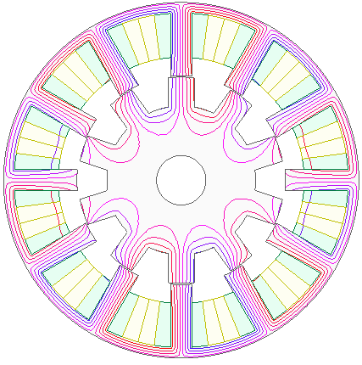 | 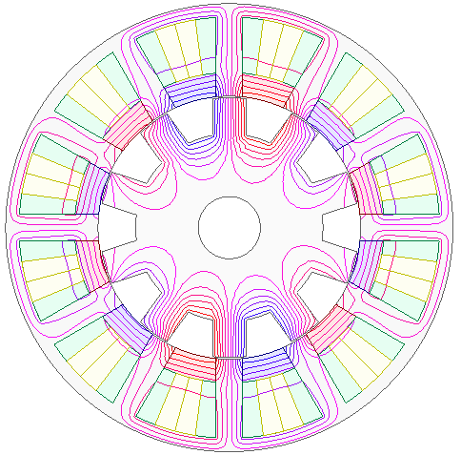
(a) | (b)
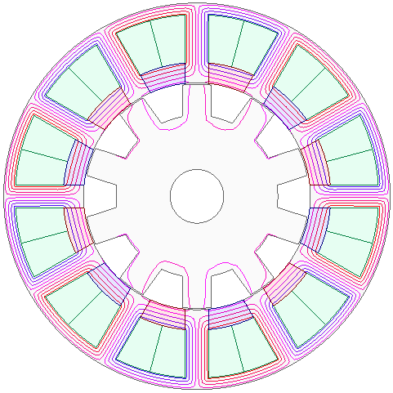
(c)
Fig. 2.5. Equal potential flux line distributions at d-axis rotor position. (a) VFRM with I_{dc} = 500A (N_{dc} = N_{ac} = 3). (b) HESSPM with I_{dc} = 500A (N_{dc} = N_{ac} = 3) and (c) SSPM on open-circuit (N_{ac} = 6).

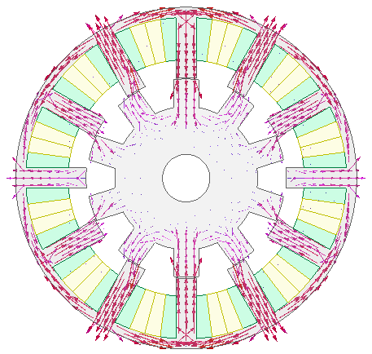 | 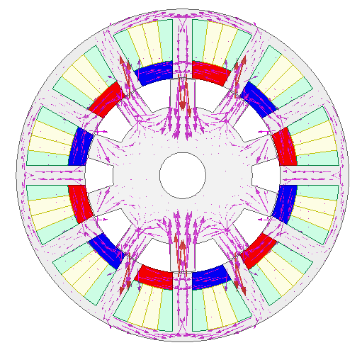
(a) | (b)
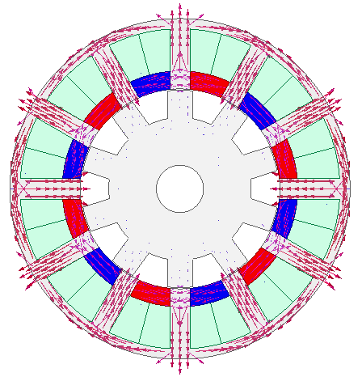
(c)
Fig. 2.6. Flux density vector distributions at d-axis rotor position. (a) VFRM with I_{dc} = 500A (N_{dc} = N_{ac} = 3). (b) HESSPM with I_{dc} = 500A (N_{dc} = N_{ac} = 3) and (c) SSPM on open-circuit (N_{ac} = 6).

(a) | (b)
 | 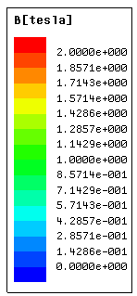
(c) | (d)
Fig. 2.7. Flux density distributions at d-axis rotor position. (a) VFRM with I_{dc} = 500A, (b) HESSPM with I_{dc} = 500A, (c) SSPM on open-circuit, (d) Scale.
The waveforms of phase flux linkage of three machines are illustrated in Fig. 2.8.(a), which are all bipolar. The HESSPM has the maximum peak value whereas the SSPM has the minimum, which can be observed from the spectra in Fig. 2.8.(b). This is the result of the PM flux which is pushed across the air-gap by DC flux in the HESSPM. Only little PM leakage flux links to the rotor side in the SSPM while the majority of PM flux circulates along the stator core. The spectra also show that the higher order harmonics are negligible comparing with the fundamental component for all three machines, which are due to the sinusoidal nature of the flux linkage waveform.
(a)
(b)
Fig. 2.8. Phase A flux linkage of VFRM with I_{dc} = 500A (N_{dc} = N_{ac} = 3); HESSPM with I_{dc} = 500A (N_{dc} = N_{ac} = 3) and SSPM on open-circuit (N_{ac} = 6). (a) Waveforms. (b) Spectra.
The phase back-EMF waveforms at the rotor speed of 2000rpm as well as the spectra are compared in Fig. 2.9. It can be seen that the HESSPM exhibits the highest fundamental component as the result of both DC and PM excitation. The total harmonic distortion (THD) value of the HESSPM is the lowest which implies a small torque ripple. Comparing with the HESSPM, the amplitude of back-EMF in the VFRM drops more than 60% without slot PMs. Additionally, the SSPM has negligible back-EMF value even with the same PM volume as the HESSPM, which is due to the minor flux linkage variation as shown in Fig. 2.8. This feature demonstrates good fault tolerant capability in terms of the avoided uncontrolled generation fault for the high-speed operation under the inverter/controller failure or short-circuit of the winding [WU17]. Under either fault conditions, the short-circuit current I_{sc} can be expressed by (2.17) [MOH03]
(2.17)
where E_{o}, and L_{d} is open-circuit back-EMF, stator supply angular frequency, d-axis inductance respectively. With the ‘self-protected’ slot PMs and negligible back-EMF in the SSPM, it can reduce the risk of feeding high short-circuit and regenerative voltage back to the drive system even at very high operation speed. In addition, for the VFRM and the HESSPM, this can also be achieved by switching off the DC coil excitation.

(a)
(b)
Fig. 2.9. Open-circuit phase A back-EMF waveform of VFRM (I_{dc} = 500A, N_{dc} = N_{ac} = 3), HESSPM (I_{dc} = 500A, N_{dc} = N_{ac} = 3), and SSPM (I_{ac} = 0, N_{ac} = 6) at 2000rpm. (a) Waveforms. (b) Spectra.

The cogging torque characteristics are analyzed in Fig. 2.10. It can be seen that the cycles of cogging torque waveforms are identical for all the three machine, which can be determined by (2.18) [ZHU00]
(2.18)
where N_{c}, N_{s}, N_{r} and LCM is the number of cycles of the cogging torque in one electrical cycle, the number of stator slots, the number of rotor pole and the least common multiple. Fig. 2.10.(a) also shows that the SSPM has the minimum while the VFRM and the HESSPM have the similar variation of cogging torque. The spectra of cogging torque in Fig. 2.10.(b) demonstrates that the 6th harmonic is dominating while other harmonics are negligible.
(a)
(b)
Fig. 2.10. Cogging torque of VFRM with I_{dc} = 500A; HESSPM with I_{dc} = 500A and SSPM on open-circuit. (a) Waveforms. (b) Spectra.

2.3.2 Torque Characteristics
The on-load flux density distributions of three machines are shown in Fig. 2.11. It can be see that the global magnetic saturation of the HESSPM is alleviated which is caused by the counteraction between the DC excitation flux and the PM flux. Local magnetic saturation of VFRM and SSPM is severer on the stator teeth and the back iron, which is calculated by numerical interpolation in Maxwell. Since VFRM and SSPM share the same physical dimensions as the global optimized HESSPM. The over saturated region in VFRM and SSPM is caused by unreasonable dimensions in VFRM and SSPM. For instance, the tooth width in SSPM needs to be increased and the saturation level will be reduced. This issue can be avoided by using individual optimization for each machine topology.
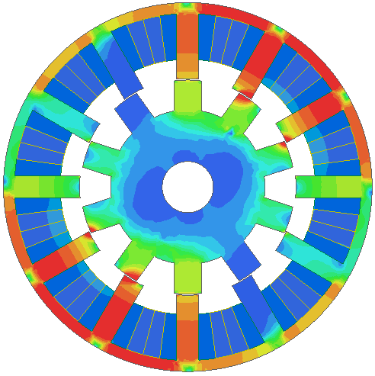 | 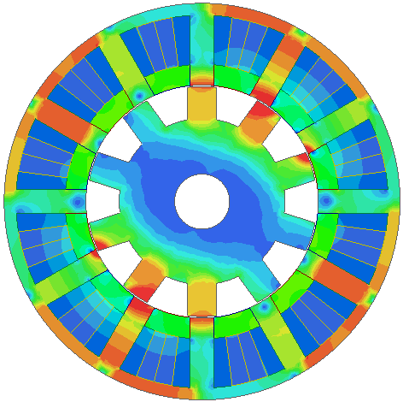
(a) | (b)
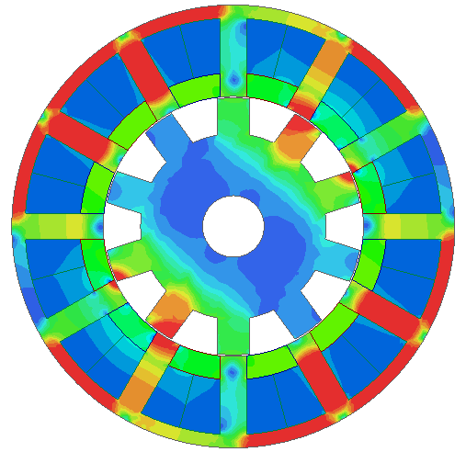
(c) | (d)
Fig. 2.11. On-load flux density distribution at d-axis rotor position of (a) VFRM with I_{dc} = I_{q} = 500A and N_{dc} = N_{ac} = 3, (b) HESSPM with I_{dc} = I_{q} = 500A and and N_{dc} = N_{ac} = 3, (c) SSPM with I_{q} = 500A and N_{ac} = 6, (d) Scale.
The variation of average torque against current angle is illustrated in Fig. 2.12. It shows that the HESSPMs has the highest average torque among all current angles whereas the VFRM is of the lowest value. It is worth mentioning that the reluctance torque of all three machines is negligible since the maximum average torque occurs when current angle equals 90 Elec. Deg. The on-load torque waveforms of three machines are compared in Fig. 2.13. with phase current I_{dc} = I_{ac(rms)} = 500A in the HESSPM/VFRM and I_{ac(rms)} = 500A in the SSPM. It reveals that the HESSPM has the highest average torque as well as the minimum torque ripple in all three machines, which is consistent with its low THD value in the back-EMF waveform. Fig. 2.14. demonstrates the torque capability of three machines with different slot current densities. It is found that the HESSPM has the best torque performance under the same slot current density whereas the torque capability of the VFRM is the most limited. The effects of slot PMs in the reduction of magnetic saturation and hence the improvement of torque capability is observed. However, the SSPM demonstrates lower average torque value than the HESSPM in the high slot current density region which suggests that the overload capability of the SSPM is limited due to the server local saturation under on-load condition, as shown in Fig. 2.11. The torque capability is also compared under the same copper loss as shown in Fig. 2.15. It shows that the SSPM produces higher torque than the VFRM and the HESSPM when the total copper loss is less than 1.4kW and the HESSPM has higher overload capability than the VFRM and the SSPM under the high copper loss region. Since slot PMs are utilized in the HESSPM and the SSPM, the cost of per unit torque is compared in Table 2.2 with the market price of 2017 [STA17a]. It can be seen that the PM price is dominating in the component cost. Hence, wound field VFRM is very competitive in low cost application. It also implies that the VFRM is more reliable to work in the heavy load condition without the risk of demagnetization.
Fig. 2.12. Average torque against current angle.
Fig. 2.13. On-load torque waveforms under the i_{d} = 0 control.
Fig. 2.14. Average torque against slot current density.
Fig. 2.15. Average torque against total copper loss.

Table 2.2. Comparison of Cost per Torque of VFRM, HESSPM and SSPM.
 |  | VFRM | HESSPM |  | SSPM
Average torque (Nm) |  | 26.08 | 66.75 |  | 60.16
Silicon Steel | Volume (cm³) | 746.89
Silicon Steel | Cost (USD) | 6.86
Copper | Volume (cm³) | 213.61
Copper | Cost (USD) | 12.88
PM | Volume (cm³) | - |  | 126.88
PM | Cost (USD) | - |  | 88.67
Torque/cost (Nm/USD) |  | 1.32 |  | 0.62 | 0.55

2.3.3 Machine Inductance
The inductance of three machines can be characterized by self-, mutual-, D- and Q- axis inductance. The inductance parameters, , , and , are phase A armature self-inductance, phase AB armature mutual-inductance, D- and Q- axis inductance. These are calculated by using frozen permeability (FP) method in the 2D FE [AFI16], as expressed in the appendix as the equations (C1)-(C4). The corresponding inductance waveforms within one electrical cycle are shown in Fig. 2.16.

(a) Self-inductance of phase A with I_{a} = 500A.
(b) Mutual-inductance between phase A and B with I_{a} = 500A.
(c) D-axis inductance with I_{d} = 500A.
(d) Q-axis inductance with I_{q} = 500A.
Fig. 2.16. Comparison of machine inductance of VFRM (N_{dc} = N_{ac} = 3), HESSPM (N_{dc} = N_{ac} = 3) and SSPM (N_{ac} = 6).
It is well known that machine inductance is proportional to the turns squared [HEN10]. Consequently, the SSPM with N_{ac} = 6 has larger inductance than the VFRM and the HESSPM with N_{dc} = N_{ac} = 3. The low number of turns per coil is constrained by the low inverter DC bus voltage and the base speed, i.e. U_{dc} = 48V and ω_{m} = 2000rpm. The high variation of the self-inductance in the SSPM also indicates the higher torque ripple as shown in Fig. 2.13. It is notable that D- and Q-axis inductance is almost equivalent in the VFRM and HESSPM, which suggests a low reluctance torque for both machines.

2.3.4 Flux-weakening Capability
The flux-weakening factor is used to evaluate the flux-weakening capability of the conventional PM machines [SOO14]
(2.19)
where is the d-axis inductance under different and is the PM flux linkage on open-circuit. The flux-weakening factor is calculated under different MMF level for the slot PM machines with magnetic saturation taken into account in Fig. 2.17. It can be seen that both slot PM machines have very good flux-weakening capability since infinite speed range can be easily achieved with . However, the HESSPM reveals superior flux-weakening capability than the SSPM with the assistance of DC excitation.
Fig. 2.17. Flux-weakening factor under different MMF levels of HESSPM (I_{dc} = 500A) and SSPM.
Furthermore, torque/power speed characteristics of three machines are compared under the flux-weakening control in Fig. 2.18. In each case, the torque-speed curve is calculated under the inverter DC bus voltage, U_{dc} = 48V and maximum inverter current, I_{max} = 707.1A (500A_{rms}). It can be seen that the HESSPM has the highest torque value in the constant torque region while the VFRM has the lowest torque value with the same number of armature and field coil turns. With the existence of the field winding, both the VFRM and the HESSPM present good flux regulation capability to have the wide constant power region. From i_{d} and i_{q} curves against speed in Fig. 2.18 (c) and (d), it shows that i_{d} current can be fully used to do the flux-weakening without PM excitation and the corresponding i_{q} current component is used to keep the torque performance. However, some i_{d} current component needs to counteract the PM flux in the HESSPM
In contrast, the SSPM has relatively high torque in the constant torque region with the help of slot PMs but poor flux weakening performance in the high speed region. This is because that more i_{d} is demanded to achieve flux-weakening by firstly weakening the slot PM field and secondly regulating voltage level within the DC bus voltage constrain, which results in small torque and power in the high speed region owing to the insufficient i_{q}. The power-speed behavior of SSPM is also degraded by higher inductance and lower PM flux linkage.
(a)
(b)
(c)
(d)
Fig. 2.18. Comparison of flux-weakening capability of VFRM (N_{dc} = N_{ac} = 3), HESSPM (N_{dc} = N_{ac} = 3) and SSPM (N_{ac} = 6) at U_{dc} = 48V, I_{dc} = 707.1A. (a) Torque-speed characteristics. (b) Power-speed characteristics. (c) I_{d} against speed. (d) I_{q} against speed.

2.3.5 Losses and Efficiency
The losses of three machines with zero i_{d} control at various rotor speeds as well as the efficiency map within the whole operation region are investigated. The efficiency η is estimated by (2.20)
(2.20)
where P_{o}, P_{Cu}, P_{Fe} and P_{PM} is the output mechanical power, total copper loss, iron loss and PM eddy current loss respectively. The iron loss component is calculated in 2D FE with the multi-frequency core loss density curves of the electrical steel graded DW31035. The PM material conductivity is set as 699000S/m in magnet eddy current loss. Owing to the identical total slot area and the corresponding same phase resistance, the copper loss of three machines are the same under the same current excitation. Comparing with the iron and PM eddy current losses in Fig. 2.19 and Fig. 2.20, it shows that the copper loss is dominating of all three machines while the PM eddy current loss is always of the minimum value. Although all three machines share the identical iron volume, the SSPM has the higher iron and PM eddy current losses than the VFRM and the HESSPM, which is caused by severer local magnetic saturation under on-load conditions as shown in Fig. 2.11.
Fig. 2.19. Iron loss against rotor speed of VFRM with I_{dc} = 500A and I_{ac(rms)} = 500A; HESSPM with I_{dc} = 500A and I_{ac(rms)} = 500A and SSPM with I_{ac(rms)} = 500A.
Fig. 2.20. PM loss against rotor speed of VFRM (I_{dc} = 500A and I_{ac(rms)} = 500A), HESSPM (I_{dc} = 500A and I_{ac(rms)} = 500A) and SSPM (I_{ac(rms)} = 500A).
Table 2.3 Comparison of Machine Performance of VFRM, HESSPM and SSPM under Flux-weakening Control with I_{q} = 500A at 2000rpm.
 | VFRM | HESSPM | SSPM
Average torque (Nm) | 27.98 | 65.53 | 13.82
Copper loss (kW) | 3.46
Stator iron loss (W) | 159.97 | 181.48 | 225.82
Rotor iron loss (W) | 35.11 | 51.71 | 48.97
PM loss (W) | - | 78.63 | 152.50
Efficiency (%) | 61.60 | 78.45 | 42.69
Efficiency maps of the three machines with overall efficiency above 35%, are shown in Fig. 2.21. – Fig. 2.23. Based on the torque-speed envelop calculated in Fig. 2.18, the loss components are calculated by 2D FE calculation. For the machines with DC coils, i.e. VFRM and HESSPM, the field excitation regulation has been taken account into the efficiency map calculation by the method proposed in [CHU15]. By regulating both DC and AC currents within the maximum current limit I_{dc(max)} = I_{ac(max)} = 707.1A, it can be seen that the maximum efficiency region of the VFRM and the HESSPM, i.e. 80% and 85% is higher than the SSPM in which only AC current is varying. The HESSPM demonstrates higher efficiency in the low-speed high-torque region as well as high-speed low-torque region which is attractive for the electrical vehicle application [ZHU08].
Fig. 2.21. Efficiency map (>=35%) of VFRM with DC and AC current regulating when I_{dc(max)} = I_{ac(max)} = 707.1A.
Fig. 2.22. Efficiency map (>=35%) of HESSPM with DC and AC current regulating when I_{dc(max)} = I_{ac(max)} = 707.1A.
Fig. 2.23. Efficiency map (>=35%) of SSPM with AC current regulating when I_{ac(max)} = 707.1A.

2.4 Experimental Validation
In order to verify the performance and analysis of doubly salient machines with and without stator slot PMs, the prototypes of the VFRM, the HESSPM and the SSPM with the reduced scale specification are manufactured. The design parameters of the small prototype machines are globally optimized individually under the total copper loss P_{Cu} = 60W for the maximum average torque, which are listed in Table 2.4. The prototyped stator and rotor components of three small machines are shown in Fig. 2.24 and Fig. 2.25.

Table 2.4 Design parameters of VFRM, HESSPM and SSPM prototypes
Machine Topologies | VFRM | HESSPM | SSPM
Stator outer radius R_{os} (mm) | 45
Axial length L_{a} (mm) | 25
Air-gap length g (mm) | 0.50
Packing factor | 0.30
Split ratio | 0.54 | 0.51 | 0.52
Stator tooth arc θ_{s} (ºmech) | 12.00 | 11.74 | 10.16
Stator back iron S_{bk} (mm) | 2.54 | 1.56 | 2.74
Rotor tooth arc θ_{R} (ºmech) | 13.37 | 14.36 | 14.64
Rotor back iron R_{bk} (mm) | 5.43 | 9.45 | 6.00
PM N35SH B_{r}/μ_{r} @ 20ºC | - | 1.2T/1.05
PM volume (cm³) | - | 5.31 | 9.59
Number of turns per coil (AC/DC) N_{dc}/N_{ac} | 25/25 |  | -/50

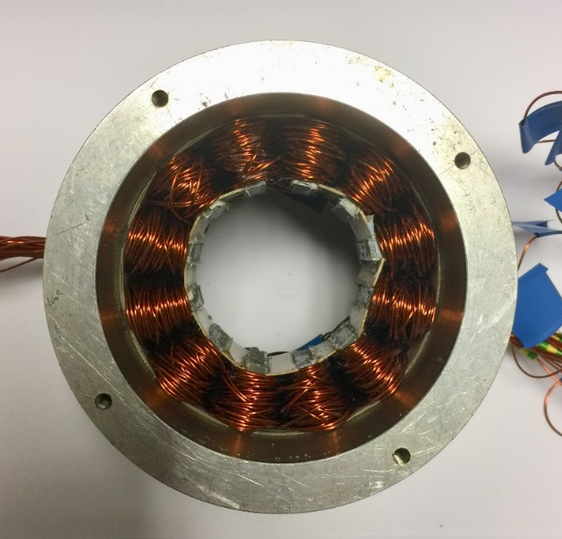 | 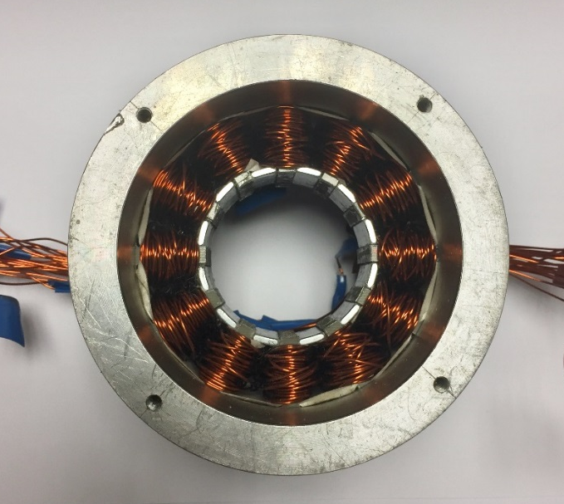
(a) | (b)
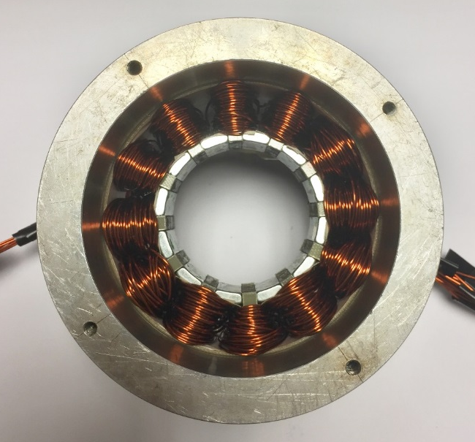
(c)
Fig. 2.24. Stators of prototype machines. (a) VFRM. (b) HESSPM. (c) SSPM.
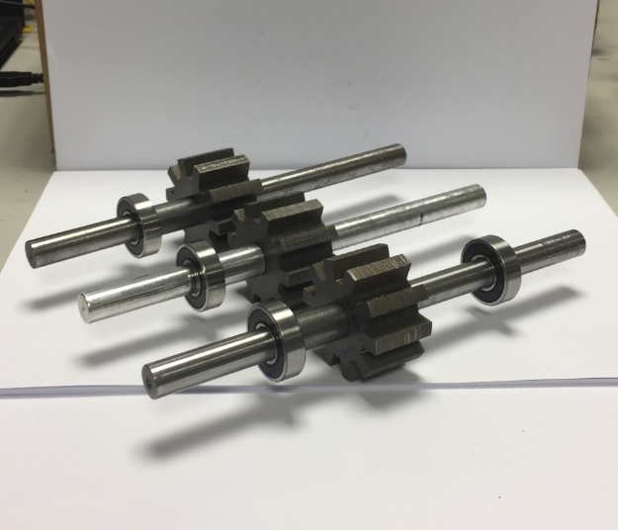
Fig. 2.25. Rotors of prototype machines with 10 salient poles.
Fig. 2.26 shows the measured and 2D FEA predicted back-EMF waveforms of three prototype machines. It shows that the HESSPM has the highest fundamental value of the back EMF with the assistance of both DC and PM excitations. The VFRM has the smallest fundamental back EMF value which is mainly limited by local saturation on the stator back iron. Theoretically, the fundamental back-EMF of the SSPM is negligible as stated in section 2.3.1. However, the measured back-EMF is caused by leakage PM flux straying in the air-gap, which can be observed in the equal potential flux line distribution in Fig. 2.27(c). The similar characteristic can be found in the HESSPM Fig. 2.28, in which the fundamental value of back-EMF is non-zero, i.e. 0.1V, without DC excitation. Overall, the measured back-EMF waveforms and fundamental values are slightly lower that the 2D FEA prediction, which is caused by the end-effect.
Fig. 2.26. Measured and FEA predicted phase back-EMF waveforms of VFRM (I_{dc}=4A), HESSPM (I_{dc}=4A), and SSPM (I_{ac} =0) at rotor speed of 400rpm.

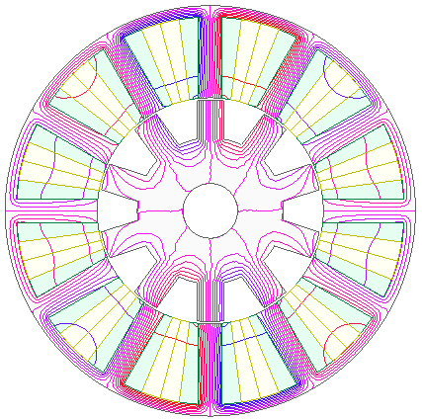 | 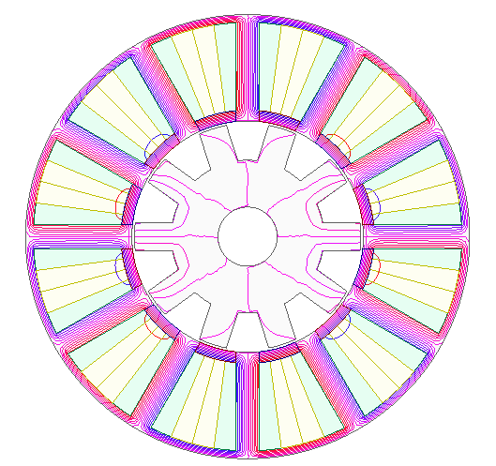
(a) | (b)
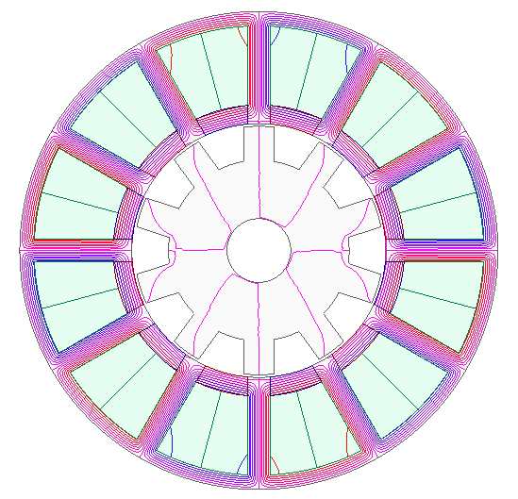
(c)
Fig. 2.27. Equal potential flux line distributions. (a) VFRM with I_{dc} = 4A. (b) HESSPM with I_{dc} = 4A and (c) SSPM on open-circuit.

Fig. 2.28. Fundamental value of phase back-EMF against DC current.
The measured and the predicted static waveforms and peak values of the static torque against different I_{q} (RMS) are shown in Fig. 2.29 and Fig. 2.30. In the static torque measurement, the three phase currents are set as
(2.21)
Since the reluctance torque components of these three machines are negligible, they can be operated in BLAC mode by the i_{d} = 0 control in which the current and phase back EMF waveforms are in the same phase angle. The measured static waveforms in Fig. 2.29 shows that SSPM has the highest peak torque due to the largest armature reaction. The predicted results are obtained by 2D FEA by taking account of end-winding length in the resistance calculation. 3D FEA may be used in more accurate modelling of the machines by including end effect. The torque regulation capabilities of the VFRM and the HESSPM are revealed in Fig. 2.30 under different DC excitation current. It is noticeable that when the DC excitation is zero in the VFRM, the machine remains as purely AC excited. Under this condition, the torque value is very small and the measurement result under that condition is not included.
Fig. 2.29. Static torque waveform of VFRM (i_{d} = 0, i_{dc} = i_{q} = 4A), HESSPM (i_{d} = 0, i_{dc} = i_{q} = 4A) and SSPM (i_{d} = 0, i_{q} = 4A) against rotor position.

(a)
(b)
(c)
Fig. 2.30. Peak value static torque against different q-axis current (i_{d} = 0) for (a) VFRM, (b) HESSPM and (c) SSPM.

2.5 Open-winding Topology
Standard three phase H-bridge is commonly employed to drive a three phase machine as shown in Fig. 2.31. By opening the neutral point of the machine and supporting each phase with an H-bridge, this gives rise to open-winding topology as shown in Fig. 2.32. The utilization of open-winding topology can achieve integrated field and armature current in a single coil, which simplifies the machine structure and reduces copper loss at the expense of using dual inverter sets as reported in [ZHU16c]. Similarly, open-winding topology can be employed in the HESSPM by injecting DC biased sinusoidal current into a single coil as follows.
(2.22)
The mixture of DC and AC current in a single coil eliminates the competition of slot area between field and armature windings and reduces the total copper loss by half. It shows in Fig. 2.34 that with open-winding topology in the VFRM and the HESSPM, torque performance under the same copper loss is boosted compared with the separated excitation for both machines.
Fig. 2.31. Standard three phase inverter using H-bridge.
Fig. 2.32. Open-winding configuration with one power supply.

(a) | (b)
Fig. 2.33 Open-winding topologies of (a) VFRM and (b) HESSPM.
Fig. 2.34. Comparison of average torque against the same copper loss for the VFRM and the HESSPM with separated excitation and open-winding.
The efficiency maps for the VFRM and the HESSPM with open-winding topology is presented in Fig. 2.35. The torque-speed envelop with open-winding topology is calculated under the same MMF range as separated excitation in Section 2.3. The regulation of field current is taken account into efficiency calculation. The loss from inverter side is not included. Comparing with Fig. 2.21 and Fig. 2.22, the highest efficiency for both machines is improved and the high efficiency area is enlarged. Especially for the HESSPM with open-winding topology, the machine can have both high torque and high efficiency in wide speed range.
(a)
(b)
Fig. 2.35. Efficiency map (>=35%) with open-winding of (a) VFRM and (b) HESSPM with DC and AC current regulating when I_{dc(max)} = I_{ac(max)} = 707.1A.

2.6 Conclusion
A global optimized 12s10r HESSPM is presented and compared with the VFRM and the SSPM in this chapter to address the function of slot PMs and field windings. General conclusion can be obtained as: (1) the HESSPM is suitable for application where high torque and power is required, although the copper loss is considerable; (2) the VFRM is more reliable without PMs and attractive in low-cost application, but it tends to have severe magnetic saturation which degrades its overload capability; (3) the SSPM can have relative high constant torque region with the help of slot PMs but its torque performance in constant power region is poor. The unique “fail-safe” or “self-protection” characteristics with negligible back-EMF of the SSPM makes it more attractive in the safety-critical application. (4) With open-winding topology, the machine structure of the VFRM and the HESSPM is simplified and the torque density and efficiency is improved.

Field Excited Variable Flux Reluctance Machines with Overlapping Windings
In this chapter, the overlapping winding (OW), i.e. the coil pitches of both field and armature windings equal to 3 stator slot pitches (F3A3), is proposed and applied to field excited variable reluctance machines (VFRMs) in order to enhance the torque density and increase the machine efficiency. Firstly, the influence of stator/rotor pole number combinations on the VFRMs with both non-overlapping winding (NOW) and OW is comparatively analyzed. The 12s8r VFRMs with NOW and OW are selected from the candidates in 12 stator-slot VFRMs for high average torque and 12s7r VFRMs are selected for low torque ripple under the same copper loss. Then, their electromagnetic performance is studied. By adopting OW, it shows that the proposed 12s/(7,8)r-F3A3 VFRMs improve the fundamental phase back-EMF and the torque density by 176.9% and 95.1% respectively, are 140.2% and 64.6% higher than the counterparts with NOW. Finally, the performance of the VFRMs can be further improved by adopting open-winding technology by removing the redundant DC copper loss.

3.1 Introduction
Variable flux reluctance machines (VFRMs) become a focal point of academic research and industry applications owing to low cost and high reliability with their magnetless machine structure [LIU14a] [RAM16] [HUA17a]. Without the utilization of permanent magnets (PMs), the manufacture cost of the VFRMs is significantly low and the manufacture process is much simpler than conventional PM machines. With all DC field and AC excitation sources allocated on the stator side, the VFRMs have the advantage in thermal management and the PM-free characteristic makes it suitable for working in the high temperature environment [RAM17]. The carbon brushes and slip rings are eliminated for the on-load operation of the VFRMs. Together with the robust salient pole rotor, the reliability and lifetime of the VFRMs are increased and the maintenance cost is reduced than the machines with wound field rotors. However, the torque density of VFRMs is much lower than PM machines which restricts commercial application. Therefore, it is necessary to improve the torque density of the VFRMs by searching novel machine topologies.
In previous literature [LIU13a, LIU13b] [BAO17] [HUA18a, HUA18b], the winding topologies of the VFRMs are commonly presented with concentrated non-overlapping winding (NOW) in order to reduce the end-winding length and increase the slot filling factor. Being driven by the standard AC bridge inverter, there are more feasible stator/rotor pole number combinations can be selected for the VFRMs. Considering different stator/rotor pole number combinations, the NOW is commonly employed for the stator pole number N_{s} closes to the rotor pole number N_{r} in order to have high fundament winding factor k_{w} [LIU14b] [HUA17a]. However, the performance of the NOW is poor for N_{s} differs largely to N_{r} due to a poor k_{w}. On this condition, overlapping winding (OW) is applied to increase k_{w} and therefore enhance the machine performance in stator-PM machines. In [DU16] and [SHA17], it shows that 24-slot/16 rotor pole (24s16r) and 12s7r switched flux PM (SFPM) machines with OW can increase on-load average torque by 65.2% and 269.7% comparing with their counterparts with NOW. In [HUA18c], the OW is utilized to increase the fundamental value and eliminate even harmonics in the back-EMF waveforms of flux reversal PM (FRPM) machine. In [WU16], OW in the FRPM with partitioned stator shows more sinusoidal armature reaction MMF, higher fundamental back-EMF and torque density together with lower torque ripple and cogging torque than the counterpart with NOW. In [JIA17], the basic analytical design equations are given for VFRMs with OW and parametric optimization is done based on the leading design parameters by 2D finite element analysis (FEA) with different stator/rotor pole number combinations.
In this chapter, the basic operation principle of VFRM is explained by flux modulation in section 3.2. The OW with field and armature coil pitches of 3 stator slot pitches, designated as F3A3, and NOW with field and armature coil pitch of 1 stator slot pitch, designated as F1A1, are comparatively studied with feasible stator/rotor pole number combinations in 12-slot VFRMs in section 3.3. In section 3.4, the detailed electromagnetic performance of 12s/(7,8)r VFRMs as shown in Fig. 3.1 is compared by 2D FEA. In section 3.5, the prototypes of 12s8r VFRMs with NOW and OW are built and tested. The performance enhancement in VFRMs are revealed by adopting open-winding topology in section 3.6. General conclusions are given in section 3.7.
(a) | (b)
(c) | (d)
Fig. 3.1. 12-slot VFRMs with NOW or OW. (a) 12s7r-F1A1 VFRM. (b) 12s7r-F3A3 VFRM. (c) 12s8r-F1A1 VFRM. (d) 12s8r-F3A3 VFRM.

3.2 Operational principle of VFRM
The basic operational principle of VFRMs can be explained by the principle of flux modulation as shown in Fig. 3.2. Taking 12s7r VFRM as an example, its field winding forms 6 DC pole-pairs, viz. P_{dc} = 6, whilst the rotor pole-pair is equal to the mechanical salient pole number, viz. P_{r} = 7. Hence, the number of armature pole-pair P_{a} can be found as
(3.1)
The MMF spatial harmonics of field and armature windings are listed in Table 3.1.
Table 3.1. Spatial harmonic contents of armature and field windings for 12s7r VFRM
Windings | Spatial harmonic order | Rotating speed
Armature winding | 1, 13, 25… | Ω_{r}
Armature winding | 11, 23, 35… | - Ω_{r}
Field winding | 6, 18, 30… | 0
All of spatial components in MMF harmonics are modulated by the salient pole type reluctance rotor at the rotor speed of Ωr. The 6th spatial harmonic in field winding is modulated by salient rotor permeance, which generates two magnetic fields with 1 and 13 pole-pairs rotating as the same speed Ωr. Since the winding factors of the 1st and 13th MMF harmonics in armature winding are non-zero, the variation of the flux caused by these two modulated magnetic fields will generate the back-EMF in the armature winding. This is the mechanism of electromagnetic energy conversion and average torque production in the 12s7r VFRM.

Fig. 3.2. Operational principle of 12s7r VFRM

The phase angle in electrical degree of each coil EMF is modified from the conventional machines by adding the term of 180 electrical degrees. This indicates the opposite phase shift in electrical degree due to the specific configuration of the VFRM caused by opposite DC polarities in the adjacent stator salient poles.
(3.2)
Since the DC field windings are wound on 12 stator salient poles, it forms 6 DC pole-pairs, which is half of the stator slot number N_{s}. Hence, the phase angle can be simply rewritten by the number of stator slot N_{s} and the number of armature pole-pair P_{a} by using flux modulation expression in (3.1), leading to
(3.3)
In a 12 stator-slot VFRM, the phase angles of 30 and 360 electrical degrees result in the same star-of-slot, as shown in Fig. 3.3.
(a) | (b)
Fig. 3.3. Start of slot and back EMF phasor of coils in 12s7r-VFRMs. (a) Star-of-slot in 12s7r-VFRMs. (b) Coil EMF and winding layout in 12s7r-VFRMs.

Based on the star-of-slot as shown in Fig. 3.3, armature winding layouts in the VFRMs can be selected with different coil pitches y_{c}, as shown in Table 3.2. However, there are two factors must be considered
- Winding factor, which determines the torque density;
- Length of end-winding, which determines the size of the machine and the copper loss.
It generally shows that the fundamental winding factor increases with the increase of the armature coil pitch. However, the increase of the armature coil pitch leads to the increase of end-winding. The extreme example is the 12 stator-slot VFRM with the armature coil pitches of 6, which is the full pitch winding. This winding layout has a unity pitch factor, but the long end-winding makes the machine size bulky. In this chapter, the trade-off is made between the winding factor and the end-winding length. Therefore, the OW layout is selected with the coil pitch of 3 stator slot pitches. According to the star-of-slot diagram in Fig. 3.3 and equations (3.9) to (3.11), coil-pitches of 4 and 5 are not applicable for 12 stator-slot VFRMs, since these two winding configurations have zero winding pitch factor.
Table 3.2. Armature winding layouts in 12s7r VFRM with different coil pitches.
Winding layout | Notion | Coil pitch of armature coil y_{c} | Configuration of armature winding
Non-overlapping winding (NOW) | A1 | 1
Overlapping winding (OW) | A2 | 2
Overlapping winding (OW) | A3 | 3
Overlapping winding (OW) | A4 | 4 | Not applicable
Overlapping winding (OW) | A5 | 5 | Not applicable
Overlapping winding (OW) | A6 | 6

Table 3.3. Fundamental winding factors in 12s7r VFRM with different armature coil pitches.
Notion | Armature coil pitch  (slot pitch) | Distribution factor | Pitch factor | Winding factor
A1 | 1 | 0.97 | 0.26 | 0.25
A2 | 2 | 0.97 | 0.50 | 0.48
A3 | 3 | 0.97 | 0.71 | 0.68
A4 | 4 | 0.97 | 0 | 0
A5 | 5 | 0.97 | 0 | 0
A6 | 6 | 0.97 | 1.00 | 0.97
The feasible coil pitches of field winding are 1 or 3 stator slot pitches, as shown in Fig. 3.4. However, these two field winding layouts are equivalent since they all establish alternating polarities in each stator poles. The physical difference is only in the end-winding length, which is taken into account in the resistance calculation as shown in equations (3.5) – (3.7).
(a) | (b)
Fig. 3.4 Feasible field winding layout for 12 stator-slot VFRMs. (a) Field coil pitch of 1 stator slot pitch. (b) Field coil pitch of 3 stator slot pitches.

For 12 stator slot VFRMs, the rotor pole number N_{r} can be selected for optimal torque performance by the following three methods:
- By flux modulation principle as shown in equation (3.1), ;
- By using analytical method to find out the maximum permeance variation, as reported in [DAS60];
- By using FEA models to compare torque performance under the same condition as shown in Fig. 3.8.
All these three methods confirm that N_{r} = 7 is a good candidate for 12 stator-slot VFRM. The following chapter will show more details of the machine performance for the 12s7r VFRMs, while use the 12s8r VFRM as a reference.

3.3 Machine Performance with Feasible Stator/Rotor Pole Combinations
The general rule of choosing N_{r} for three phase 12-slot VFRMs is presented in [LIU14b], which is
(3.1)
Consequently, the 12s/(2~20)r VFRMs with feasible NOW and OW are globally optimized individually under the same constrain as shown in
Table 3.4. There is fixed physical space reserved in the stator slot-openings for slot wedge for different stator/rotor pole number combinations. The design parameters of the VFRMs, which are shown in Fig. 3.5, have been optimized by genetic algorithm (GA) in FEA under brushless AC (BLAC) operation mode for the maximum average torque. In 12-slot VFRMs, the total copper loss P_{Cu} can be expressed as the summation of armature and field excitation copper losses, viz. P_{Cua} and P_{Cuf}. Hence, the copper loss ratio λ can be defined as
(3.2)

Table 3.4 Global Optimization Constrains in 12 Stator-Slot VFRMs.
Parameter | Symbol | Unit | Value
Stator outer radius | R_{os} | mm | 45
Axial length | L_{a} | mm | 25
Air-gap length | g | mm | 0.50
Packing factor | k_{p} | - | 0.40
Copper loss | P_{Cu} | W | 60
Volume for slot wedge | V_{PM} | mm³ | 3700
Number of turns per coil | N_{dc}/N_{ac} | - | 46/46

Fig. 3.5. Linear illustration of geometric parameters of VFRM.
With total copper loss fixed at 60W, the optimal λ is obtained with respect to the average torque as shown in Fig. 3.6. It shows that the maximum average torque occurs when armature and field excitation copper losses are approximately equal, viz. optimized λ is about 0.5 in the 12s/(7,8)r VFRMs. Consequently, the slot areas of armature and field windings can be assumed equal with the same number of turns during the global optimization, viz. S_{DC} = S_{AC} and N_{DC} = N_{AC}. Under this assumption, the resistances of DC and AC coils are assumed the same, viz. R_{DC} = R_{AC}, while the magnitudes of DC current and RMS value of AC current are kept the same, viz. I_{DC} = I_{rms}.
Fig. 3.6. Average torque against copper loss ratio.
Consequently, the copper loss expression can be simplified as (3.3). The magnitude field current I_{DC} and the armature current I_{rms} can be calculated by (3.4)
(3.3)
(3.4)
where is the resistivity of copper, is the length of end-winding. Since significant difference between NOW and OW is the end-winding, the length of end-winding cannot be ignored considering machine volume and resistance. The shape of the end-winding is modelled as semi-circle during the global optimization. The total length of half turn coil is
(3.5)
where is the length of half turn end-winding, which can be estimated by
(3.6)
where is the empirical coefficient, which is dependent on N_{s}. For 12-slot VFRMs with NOW and OW, it is selected as 1.35 and 1.25, respectively [CHE90]. is the coil pitch in terms of circumferential length,
(3.7)
where is the coil pitch in unit of rad, which is and for VFRMs-F1A1 and VFRMs-F3A3, respectively. From the results of global optimization, the average torque T_{av} and torque ripple T_{ripple} of VFRMs against different rotor pole numbers are compared in Fig. 3.8, where T_{ripple} is defined as
(3.8)
where T_{max}, T_{min} is the maximum and minimum values of electromagnetic torque. It can be found that:
(a) For 12-slot VFRMs with feasible rotor pole numbers, OW with armature coil pitch of 3 stator slot pitches can improve the fundamental winding factors k_{w} under the same copper loss for 12s/(4,5,7,8,16,17,19,20)r VFRMs. The fundamental winding factors k_{w} which are calculated by (3.9)-(3.11) and shown in Fig. 3.7, where k_{d}, Q, α, k_{p,} and y_{c} are the distribution factor, the number of EMF phasor in adjacent slots, the angle between adjacent EMF phasors, the pitch factor and the coil pitch (y_{c} = 1 in NOW and y_{c} = 3 in OW), respectively. However, k_{w} is degraded in 12s/(11,13)r VFRMs with OW.

(3.9)
(3.10)
(3.11)
Fig. 3.7. Fundamental winding factors against rotor pole numbers with NOW and OW for 12-slot VFRMs.
(b) Among the investigated 12-slot VFRMs, 12s/(10~14)r VFRMs with NOW and 12s/(16~20)r VFRMs with OW show high average torque as shown in Fig. 3.8(a) in the positive correlation to k_{w}. Generally, it is recommended that NOW should be employed when N_{s} close to N_{r} and OW should be employed when N_{s} differs largely from N_{r} in order to obtain high fundamental winding factor and therefore high torque performance. The machines with even rotor pole numbers, viz. 12s/(4,8,16,20)r VFRMs, show significant higher torque ripple than the machines with odd rotor pole numbers, viz. 12s/(5,7,11,13,17,19)r VFRMs, as shown in Fig. 3.8(b).
It is interesting to point out that in Fig. 3.7 that the VFRM-F1A1 with 11- and 13-poles are the optimal for the winding factors, i.e. k_{w(11/13-pole)} = 0.93. However, their average torque in Fig. 3.8 is not the highest. Comparing with VFRM-F1A1 with 14-pole, in which k_{w(14-pole)} = 0.87 and average torque T_{av} = 1.02Nm at total copper loss of 60W, the torque capability is limited by local magnetic saturation in the stator yokes as shown in Fig. 3.10. If the material of the laminations used is linear, the average torque of the machine will be positively correlated to the fundamental winding factor k_{w.}
(a)
(b)
Fig. 3.8. Variation of (a) average torque and (b) torque ripple for 12s/(2~20)r VFRMs with NOW and OW.
Fig. 3.9. Average torque against total copper loss for 12s/(11,13,14)r-F1A1 VFRM.
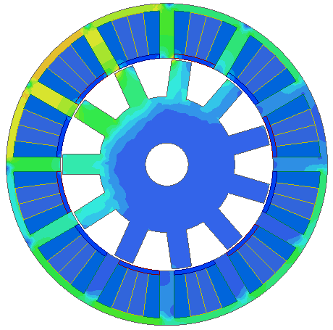
(a) | (b)
 |  |  | 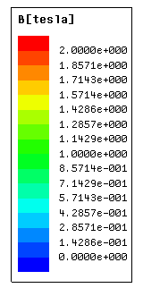
(c) |  | (d)
Fig. 3.10. On-load flux density distribution of (a) 12s11r-F1A1, (b) 12s13r-F1A1 and (c) 12s14r-F1A1 VFRMs. (d) Scale.
(c) Since with the change of the VFRM from NOW to OW under the same stator/rotor pole number combination, the difference only lies in the change of pitch factor k_{p} while the distribution factor k_{d} remains the same. It is worth pointing out that the same coil EMF phasors can be applied to determine the winding layout for NOW and OW under the same stator/rotor pole number combination. OWs with coil pitches of 3 stator slot pitches are not feasible for 12s/(2,10,14)r VFRMs. This is due to the opposite DC polarities in the adjacent stator teeth. Hence, the corresponding EMF vector for a single coil will be cancelled, viz. k_{p} = 0 in 12s/(2,10,14)r VFRMs.
(d) The saturation level of the VFRMs against different rotor pole numbers can be evaluated by the coefficients ‘average torque T_{av} to fundamental winding factor k_{w}’ by rearranging the average torque equation as follows
(3.12)
where p is the rotor pole number N_{r} for the VFRMs; is the d-axis flux linkage; D_{gap} is center diameter of the air-gap; N_{ph} is the number of turns in the phase winding and B_{g} is the average radial air-gap flux density over one-pole pitch. By eliminating the influence of the fundamental winding factor, the torque is proportional to the saturation level which is the product of B_{g} and i_{q.} Under the same space envelope of machine diameter as shown in Table 3.1, it shows the VFRMs with OWs have low coefficients of ‘average torque T_{av} to fundamental winding factor k_{w}’ which means the machines with OWs are very easily to saturated than NOWs. With obtained high coefficients of ‘average torque T_{av} to fundamental winding factor k_{w}’ in VFRMs, it shows that 12s/(7,17)r VFRMs have good potential in torque production and are less sensitive to magnetic saturation.
(e) By changing winding layout from NOW to OW, the increase/decrease of average torque as the result of the increase/decrease of winding factor is shown in Fig. 3.11(b). It shows that the fundamental winding factors k_{w} of 12s/(5,7,17,19)r and 12s/(4,8,16,20)r VFRMs are improved by 173% and 100% respectively by employing OW, i.e. F3A3. As a result of winding factor improvement, the average torque values of these stator/rotor pole number combinations are improved, especially for VFRMs with low salient rotor pole numbers, viz. 12s/(4,5,7)r VFRMs. However, 12s/(11,13)r VFRMs have reduced fundamental winding factors and therefore degraded average torque with OW.
(a)
(b)
Fig. 3.11. Influence of fundamental winding factor on average torque in 12s/(2~20)r VFRMs with NOW and OW. (a) Average torque per winding factor. (b) Winding factor and average torque.
(f) The power factors of 12 stator-slot VFRMs are obtained from the phase angle between the on-load voltage and phase current neglecting the phase resistance. It shows in Fig. 3.12 that the power factor decreases with the increase of the rotor pole number for both NOW and OW which is the result of higher flux leakage in the VFRMs with high rotor pole numbers. Generally, the VFRMs with NOW has higher power factor than those with OW since the inductance in NOW is significant lower than that in OW.
Fig. 3.12. Variation of power factors for 12s/(2~20)r VFRMs with NOW and OW.

3.4 Comparison of Electromagnetic Performance
In the previous section, 12-slot VFRMs have been investigated under different rotor poles with NOW and OW. It shows that 12s/(7,8)r VFRMs has high average torque in VFRMs with NOW and OW while the low pole number has the most significant improvement with the winding layout changing from NOW to OW. The 12s8r VFRMs serve as counterparts in order to show the performance change of even rotor pole number. The corresponding electromagnetic performance of four VFRMs are comparatively investigated in this section.

The phase angle in electrical degree of each coil EMF can be obtained by
(3.13)
where N_{r} is the rotor pole number and is the coil position along the stator circumference. The mechanical salient rotor pole N_{r} is used in (3.13) since the flux distribution is the same within one pole-pitch for sinusoidal driven VFRMs.
The star-of-slot and winding layout in 12s/(7,8)r VFRMs can be derived in Fig. 3.3 and Fig. 3.13. The winding layout can be similarly derived for other stator/rotor pole number combinations. It can be seen that 12s7r VFRMs consist of two sets of balanced three phase windings which are phased shifted by 30º electrical degree. The four phase coils are aligned in the same direction in 12s8r VFRMs which leads to the unity winding factor. The main design parameters of the proposed 12s/(7,8)r VFRMs are listed in Table 3.5, which are obtained from global optimization under the constrain of the same copper loss.
(a) | (b)
Fig. 3.13. Back EMF phasor of coils and slot conductors in 12s8r-VFRMs. (a) Star-of-slot in 12s8r-VFRMs. (b) Coil EMF and winding layout in 12s8r-VFRMs.

Table 3.5 Leading Parameters of 12-slot VFRMs with NOW and OW
Machine Topologies | Unit | 12s7r |  | 12s8r
Machine Topologies | Unit | F1A1 | F3A3 | F1A1 | F3A3
Split ratio, 𝛾 | - | 0.50 | 0.55 | 0.50 | 0.60
Stator tooth arc, θ_{s} | ºmech | 14.00 | 13.00 | 14.00 | 12.00
Stator back iron, S_{bk} | mm | 5.00 | 6.00 | 3.00 | 4.00
Rotor tooth arc, θ_{R} | ºmech | 22.00 | 14.00 | 16.00 | 16.00
Rotor back iron, R_{bk} | mm | 10.00 | 11.00 | 10.00 | 14.00
Slot area, S_{DC}/S_{AC} | mm² | 43.25/  43.25 | 35.06/  35.06 | 51.17/  51.17 | 37.92/  37.92
    - Open-circuit Performance
The rotor initial positions are selected to align d-axis with the salient stator tooth, which are 0º, 25.71º, 0º and 30.0º for 12s7r-F1A1, 12s7r-F3A3, 12s8r-F1A1 and 12s7r-F3A3 VFRMs in order to obtain the maximum phase A flux linkage. The mechanical angles are calculated when the rotor pole is mechanically aligned with stator pole labelled 1 in Fig. 3.1. The radial components of air-gap flux density B_{r} in 12-slot VFRMs with different field excitations are shown in Fig. 3.14(a)-(d). Owing to the modulation effect of the reluctance rotor, the variation of the air-gap flux density in 12-slot VFRMs have similar non-sinusoidal distribution, which presents twelve alternating magnetic poles. It is noticed that the high air-gap flux density can be achieved by field excitation in the VFRMs and air-gap flux density can be easily adjusted via different DC currents. It also shows that the peak value of the radial component of flux density is higher in OW than NOW in both 7- and 8-pole VFRMs. Comparing with NOW, the VFRMs with OW have longer flux path under the open-circuit condition as can be observed from the equal potential distribution in the Fig. 3.15.
(a)
(b)
(c)
(d)
Fig. 3.14. Radial components of open-circuit air-gap flux density B_{r} in 12-slot VFRMs with different field excitations. (a) 12s7r-F1A1 VFRM. (b) 12s7r-F3A3 VFRM. (c) 12s8r-F1A1 VFRM. (d) 12s8r-F3A3 VFRM.
(a) | (b)
(c) | (d)
Fig. 3.15. Open-circuit equal potential flux line distributions of 12-slot VFRMs with field excitation, I_{dc} = 8A. (a) 12s7r-F1A1 VFRM. (b) 12s7r-F3A3 VFRM. (c) 12s8r-F1A1 VFRM. (d) 12s8r-F3A3 VFRM.

 |  | 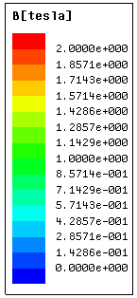
(a) | (b)
(c) | (d) | (e)
Fig. 3.16. Open-circuit flux density distributions of 12-slot VFRMs with field excitation, I_{dc} = 8A. (a) 12s7r-F1A1 VFRM. (b) 12s7r-F3A3 VFRM. (c) 12s8r-F1A1 VFRM. (d) 12s8r-F3A3 VFRM. (e) Scale.

By neglecting the influence of the flux leakage, the open-circuit flux linkage captured by phase coil can be calculated by (3.14)
(3.14)
where is the coil-pitch angle. is for VFRMs with NOW and for VFRMs with OW. This indicates that more DC flux in OW is captured by 3-coil-pitch winding than in NOW, which is verified by the difference in fundamental values between the NOW and OW in Fig. 3.17.
The phase A winding in 12-slot VFRM is constituted by the series connection of four coils A1, A2, A3 and A4. The phase A flux linkage and the flux linkage in each coil are separately presented in Fig. 3.17 in order to show the influence of different rotor pole numbers. It can be seen that half of the coil fluxes are of the same amplitude but of the opposite polarities in 7-pole VFRMs. Consequently, the summation of the coil fluxes leads to the negligible DC component in the phase windings. However, the coil fluxes in 8-pole VFRMs are of the same amplitude and polarity which leads to the existence of the DC biased components in the phase windings. By changing the winding layout from NOW to OW in the 8-pole VFRMs, the variation of phase flux is increased and the polarity of phase winding is changed from unipolar to bipolar, as a result of the increase of the flux path in OW. The harmonic analysis shows that the fundamental harmonic dominates while higher order harmonics are negligible.
(i)
(ii)
(a)
(i)
(ii)
(b)
(i)
(ii)
(c)
(i)
(ii)
(d)
Fig. 3.17. Open-circuit flux linkages in 12s/(7,8)r VFRMs with field excitation, I_{dc} = 8A. (a) 12s7r-F1A1 VFRM. (b) 12s7r-F3A3 VFRM. (c) 12s8r-F1A1 VFRM. (d) 12s8r-F3A3 VFRM. (i) Waveforms. (ii) Spectra.

The back-EMF waveforms and their spectra in a single armature coil A1 are presented in Fig. 3.18 with field excitation of 8A. Although the fundamental values in 7-pole and 8-pole machines are similar within the same winding layout, the harmonic analysis shows the 7-pole machines are dominated by odd harmonics, i.e. 5th harmonics, while 8-pole machines are dominated by even harmonics, i.e. 2nd and 4th harmonics.
(a)
(b)
Fig. 3.18. Back-EMFs of a single armature coil in 12s/(7,8)r VFRMs with NOW and OW at 400rpm with field excitation, I_{dc} = 8A. (a) Waveforms. (b) Spectra.
The phase back-EMF waveforms are shown in Fig. 3.19. The effect of OW is shown by enhancing the fundamental value of 176.9% and 140.2% in 7-pole and 8-pole VFRMs. It shows that 8-pole VFRMs have richer harmonic content than 7-pole ones and it is dominated by even harmonics in the spectra. The total harmonic distortion (THD) values of the 7-pole VFRMs are much lower than 8-pole machines as shown in Table 3.6, which indicates higher torque density and lower torque ripple in 7-pole VFRMs. Comparing with the harmonic analysis of the back-EMF waveforms in the single coil, it is worth noting that the 3rd harmonic is suppressed in the phase winding of 12s7r-F3A3 VFRM. The fundamental value of the back-EMF waveforms in the VFRMs can be adjusted by different DC currents as shown in Fig. 3.20. However, the major disadvantage introduced by field excitation is magnetic saturation which can be observed that the slow increase of the fundament values in back-EMF after DC current higher than 8A for VFRMs with NOW and 12A for VFRMs with OW.
(a)
(b)
Fig. 3.19. Phase A back-EMF in 12s/(7,8)r VFRMs with NOW and OW at 400rpm with field excitation, I_{dc} = 8A. (a) Waveforms. (b) Spectra.
Fig. 3.20. Amplitudes of fundamental component of back EMF against DC current in 12s7r-F1A1, 12s7r-F3A3, 12s8r-F1A1 and 12s8r-F3A3 VFRMs.

Table 3.6 Total Harmonic Distortion of the Back EMF of 12stator -slot VFRMs at 400rpm
 | 12s7r |  | 12s8r
THD (%) | F1A1 | F3A3 | F1A1 | F3A3
THD (%) | 8.25 | 3.83 | 30.86 | 30.61

The cogging torques of 12 stator-slot VFRMs with the field excitation of 8A are compared in Fig. 3.21. The variation cycles N_{c} of permeance is influenced by different rotor poles N_{r} in the VFRMs, which can be determined by [ZHU00]
(3.15)
where LCM is the least common multiple. Therefore, 7-pole VFRMs have N_{c} of 12 while 8-pole VFRMs have N_{c} of 3, which are independent of winding layouts. The amplitude of the cogging torque is quite small. The harmonic analysis shows that 12th harmonic dominates in 7-pole VFRMs while 3rd, 6th and 9th harmonics dominate in 8-pole VFRMs.
(a)
(b)
Fig. 3.21. Cogging torques in 12s/(7,8)r VFRMs with NOW and OW with field excitation, I_{dc} = 8A. (a) Waveforms. (b) Spectra.
    - Torque Characteristics
The variation of average torque against current advance angle is illustrated in Fig. 3.22(a). The optimum current advance angle for maximum average torque in 12 stator-slot VFRMs with NOW lies around 90 elec. deg. However, there is an angle shift around 90 elec. deg. in the VFRMs with OW which is caused by the magnetic saturation [XU91]. Since the d-axis and q-axis inductances for the VFRMs are almost equal, the reluctance torque in the VFRM is negligible. Therefore, both machines with NOW and OW can be operated BLAC mode under i_{d} = 0 control. Consequently, the expression of average electromagnetic torque in VFRMs [LIU13a] can be simplified as
(3.16)
where p is the number of pole-pairs, which is the same as the rotor pole number N_{r} for the VFRMs; is the d-axis flux linkage which is coupled by field current i_{DC} and q-axis current i_{q}. It can be seen that the torque production mechanism of the VFRM is mainly due to the variation of the mutual flux linkage between of the field and armature windings.
The on-load electromagnetic torque waveforms of 12s7r-F1A1, 12s7r-F3A3, 12s8r-F1A1 and 12s8r-F3A3 VFRMs are shown in Fig. 3.22(b) as well as their spectra in Fig. 3.22(c). It shows that the proposed OW in 12s/(7,8)r VFRMs can produce 95.08% and 64.61% higher average torque than NOW at the same total copper loss of 60W. It also shows that the torque ripple is significantly higher in 8-pole VFRMs while very low in 7-pole VFRMs. The harmonic analysis of on-load torque in Fig. 3.22(c) shows the 3rd harmonic is dominating in 8-pole VFRMs while 7-pole VFRMs contain very little torque pulsating components. The overload capability of four VFRMs are comparatively studied in Fig. 3.22(d) with the variation of average torque against total copper loss at the equal copper ratio between the field and armature copper losses (λ = 0.5). It can be seen that the overload capabilities of the VFRMs are enhanced by OW and the 12s8r-F3A3 VFRM demonstrates higher average torque in the whole copper loss range. The torque variation with different armature and field copper loss is also shown in Fig. 3.23, the VFRMs with OW exhibits significant torque improvement comparing with the VFRMs with NOW in all the calculated copper loss range.
(a)
(b)
(c)
(d)
Fig. 3.22. Torque characteristics in 12-slot VFRMs (λ = 0.5). (a) Average torque against current advance angle. (b) On-load torque waveform at total copper loss of 60W under i_{d} = 0 control. (c) Spectra of on-load torque at total copper loss of 60W. (d) Variation of average torque against total copper loss.
(a) | (b)
(c) | (d)
Fig. 3.23. Variations of average torque of 12-slot VFRMs against different field and armature excitation copper losses. (a) 12s7r-F1A1 VFRM. (b) 12s7r-F3A3 VFRM. (c) 12s8r-F1A1 VFRM. (d) 12s8r-F3A3 VFRM.
    - Winding Inductances
The inductances of the VFRMs can be characterized by self-, mutual-, DC self-, DC-AC mutual-inductances, which can be obtained in the equations in the Appendix A by 2D FEA. The corresponding inductance waveforms within one electrical cycle are shown in Fig. 3.24. The proposed OW leads to the increase of self-inductance in 12s/(7,8)r VFRMs than NOW, which is due to the increase of the length of flux path. The variation of the mutual inductance in OW is very large while the mutual inductance in NOW layout is almost constant and close to zero. The increase of mutual inductance in OW indicates the increase of magnetic mutual coupling between phases at on-load condition. The waveforms of DC self-inductance in all four VFRMs are almost constant. The bipolar DC to AC mutual inductance waveforms are observed in 12s7r-F1A1 and 12s/(7,8)r-F3A3 VFRMs while unipolar DC to AC mutual inductance waveform is presented in 12s8r-F1A1 VFRM. The employment of the OW in the 12s VFRMs can effectively enhance the variation of the DC to AC mutual inductance comparing with NOW which indicates the increase of torque capability as shown in torque expression (3.14).
(a)
(b)
(c)
(d)
Fig. 3.24. Inductance characteristic for 12-slot VFRMs. (a) Self-inductance of phase A with I_{a} = 8A. (b) Mutual-inductance between phases A and B with I_{a} = 8A. (c) Self-inductance of DC winding with I_{DC} = 8A. (d) Mutual-inductance between DC and armature windings with I_{DC} = 8A.

    - Losses and Efficiency
The efficiency of the 12-slot VFRMs with NOW and OW can be estimated by
(3.17)
where P_{o}, P_{Cu}, and P_{Fe} is the output mechanical power, the total copper loss and the iron loss, respectively. The stator and rotor core losses P_{Fe} of VFRMs are estimated by three parts in the 2D FEA including hysteresis loss , eddy-current loss and excess core loss ,
(3.18)
where k_{h} = 272.13W/m³, k_{c} = 0.18W/m³ and k_{e} = 3.56W/m³ are the hysteresis, eddy-current and excess core loss coefficients, respectively. The coefficients are obtained from multi-frequency dependent loss density (B-P) curves for 0.35mm lamination steel sheets (DW31035). B_{m} is the amplitude of the AC flux component.
The loss and efficiency of 12s/(7,8)r VFRMs with NOW and OW at 400rpm are presented in Table 3.7. It can be seen that the VFRMs with OW suffers from high iron loss than NOW, which degrade its efficiency in high speed region. The efficiency is low for these small machines and the losses are dominated by copper loss. But the VFRMs with OW have higher efficiency than NOW, which is due to the improvement of output torque/power. The iron loss and the resultant efficiency of the VFRMs are also evaluated under different machine speed as shown in Fig. 3.25. Since the OW has significantly longer end-winding, it degrades its performance for the machine with short stack length. For the same machine cross-section in the VFRMs, the end-winding length L_{end} is separately estimated by the empirical coefficient K_{s}, which is 1.35 and 1.25 for F1A1 and F3A3. It is noticeable that the advantage of OW in torque per copper loss is more obvious for machines with long lamination stack length. The end-effect will be reduced and the torque per copper loss will be enhanced with longer stack length for the proposed 12-slot VFRMs with OW as shown in Fig. 3.26 due to the increase of average torque.
Table 3.7 Loss and efficiency of VFRMs at 400rpm.
 | 12s7r |  | 12s8r
 | F1A1 | F3A3 | F1A1 | F3A3
Average torque (Nm) | 0.48 | 0.94 | 0.64 | 1.05
Copper loss (W) | 60
Iron loss (W) | 1.18 | 2.18 | 0.89 | 1.42
Torque per machine volumn (Nm/L) | 3.01 | 5.88 | 4.03 | 6.63
Overall efficiency (%) | 24.71 | 38.65 | 30.60 | 41.84

(a)
(b)
Fig. 3.25. Comparison of iron loss and efficiency against rotor speed of 12-slot VFRMs. (a) Iron loss. (b) Efficiency.
Fig. 3.26. Average torque/copper loss against lamination active length of 12-slot VFRMs.

  - Experimental Validation
In order to verify the performance difference of VFRMs with NOW and OW, two prototype machines with the same stator slot/rotor pole number, i.e. 12s8r, are built and tested. For the sake of simple manufacture and fair comparison, the mechanical parameters of two stators and rotors are selected to be the same, which is shown in Table 3.8. The coil-pitch of the field windings in VFRM with OW are wound as 1 stator slot pitch, while the armature coil pitches are 3 stator slot pitches, which is designated as F1A3. The purpose of this type of field winding is to increase the packing factor and reduce the end-effect. If the end-winding length is not considered in the FEA, the winding connections of F3A3 and F1A3 are identical and should have the same results. The prototyped stator and rotor components of two VFRMs with NOW and OW are shown in Fig. 3.27 and Fig. 3.28.
Table 3.8 Design parameters of VFRM with non-overlapping and overlapping windings.
Machine Topologies | VFRM 12s8r
Machine Topologies | F1A1 | F1A3
Stator outer radius, R_{os} (mm) | 45
Axial length, L_{a} (mm) | 25
Air-gap length, g (mm) | 0.50
Packing factor | 0.50
Split ratio | 0.50
Stator tooth arc, θ_{s} (ºmech) | 14.00
Stator back iron, S_{bk} (mm) | 5.00
Rotor tooth arc, θ_{R} (ºmech) | 16.00
Rotor back iron, R_{bk} (mm) | 10.00
Number of turns per coil (AC/DC) N_{dc}/N_{ac} | 60/60

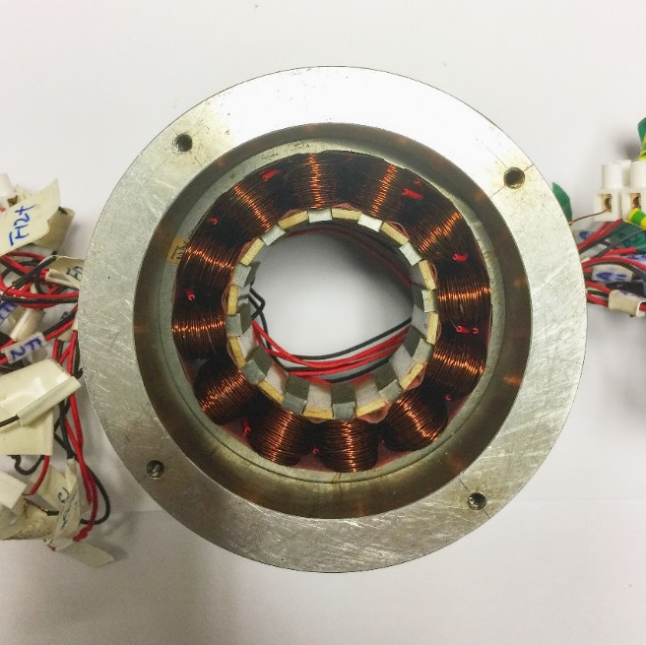
(a)
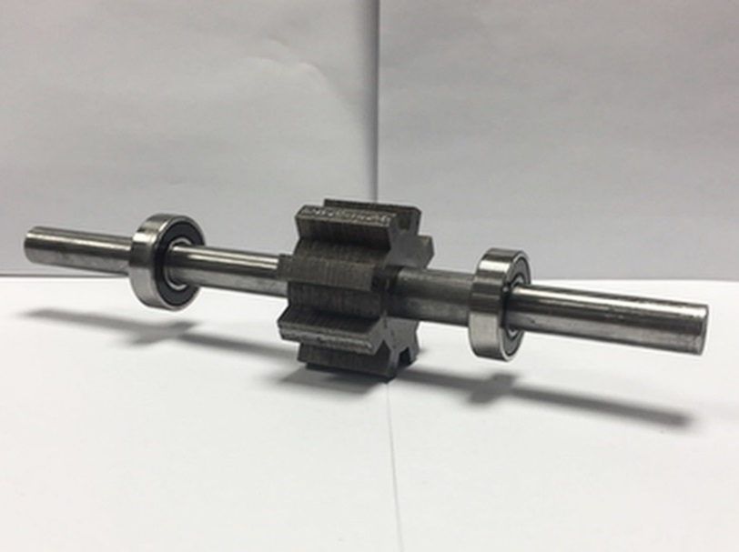
(b)
Fig. 3.27. Prototype parts of VFRMs. (a) 12s8r F1A1 stator. (b) 12s8r F1A1 rotor.

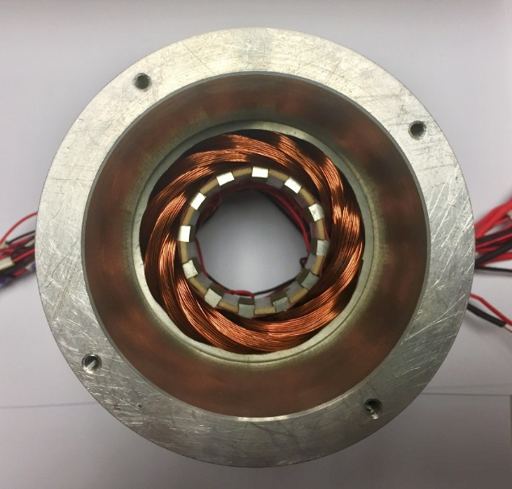
(a)
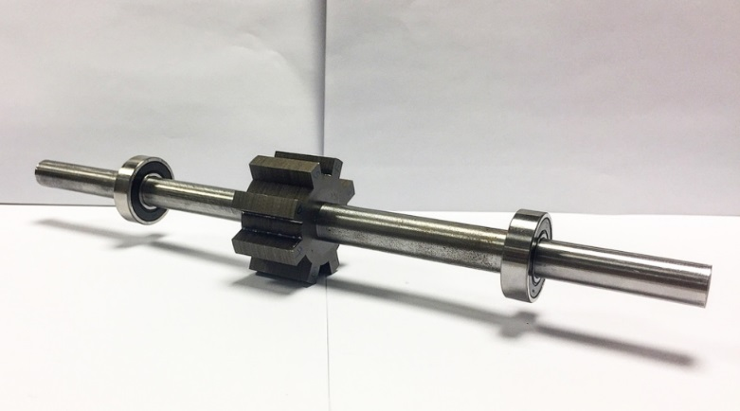
(b)
Fig. 3.28. Prototype parts of VFRMs. (a) 12s8r F1A3 stator. (b) 12s8r F1A3 rotor.
The measured back-EMF waveforms and the corresponding spectra of VFRM 12s8r-F1A1 and VFRM 12s8r-F1A3 at rotor speed of 400rpm with field current excitation of I_{dc} = 4A are presented in Fig. 3.29. It shows that the fundamental value of back EMF in OW is 104.5% higher than the NOW at I_{dc} = 4A. The high fundamental value of back-EMF in OW can also be observed in Fig. 3.30 when field current is varying. The asymmetric back-EMF waveforms can be observed in both 12s8r-F1A1 and 12s-F1A3 VFRMs which are due to even harmonics in even rotor poles. The measured back-EMF waveforms are slightly lower (0.0062% less for 12s8r-F1A1 and 3.82% less for 12s8r-F1A3) than 2D FEA prediction, which is mainly due to the end-effect in the prototype machines. The end-effect is more obvious in 12s8r-F1A3 VFRM since the end-winding length is longer in OW.
(a)
(b)
Fig. 3.29. FEA predicted and measured phase A back-EMF in 12s8r VFRMs with NOW and OW at rotor speed of 400rpm with field excitation I_{dc} = 4A. (a) Waveforms. (b) Spectra.
Fig. 3.30. FEA predicted and measured fundamental value of phase back-EMF against DC current in 12s8r VFRMs with NOW and OW.
The positive cycle of static torque waveform is shown in Fig. 3.31 against different rotor positions. As previously stated in chapter 2, the static torque is measured with the DC current injected in three phase windings as I_{A} = -2I_{B}= -2I_{C.} Since the reluctance torque in investigated machine is negligible, the peak torque occurs at 90 Elec. Deg. which means zero i_{d} control can be applied to these two machines. By injecting DC field current excitation I_{d} = 4A and Q-axis current (RMS) I_{q} = 4A, the peak torque in 12s8r-F1A3 VFRM is 133.95% higher than in 12s8r-F1A1 VFRM. The torque capability of VFRMs are also measured with different combinations of DC and Q-axis currents, which shows that 12s8r-F1A3 VFRM has the significant improvement in torque capability under the same current excitation than 12s8r-F1A1 VFRM.
Fig. 3.31. FEA predicted and measured static torque waveforms against rotor position in 12s8r VFRMs with NOW and OW (I_{d} = 0, I_{dc} = I_{q} = 4A).

(a)
(b)
Fig. 3.32. FEA predicted and measured peak values of static torque against different q-axis currents (I_{d} = 0) for (a) VFRM 12s8r-F1A1, (b) VFRM 12s8r-F1A3 (I_{A} = -2I_{B}= -2I_{C}).
The measured and predicted winding inductance waveforms of VFRM 12s8r-F1A1 and VFRM 12s8r-F1A3 illustrated in Fig. 3.33(a) and (b) respectively. The phase A self-inductance L_{aa} is directly measured by LCR meter. The mutual inductance between phase A and phase B windings M_{ab} is obtained by
(3.19)
where L_{a+b} is the self-inductance by connecting phase A and phase B winding in series, L_{bb} is the phase B self-inductance, respectively. Comparing measured inductance waveforms with the 2D FEA measured ones, it shows the measured self-inductance waveforms are about 17.8% higher than FEA ones, which are owing to the end-effect is not taken into account in the 2D FEA calculations. However, the influence of end-winding is not shown in the mutual-inductance waveforms which leads to good agreement between the FEA predictions and measured ones. Meanwhile, the experimental results confirm the investigations in section 3.3 that 12s8r-F1A1 VFRM has high variation of self-inductance and negligible mutual inductance with NOW. 12s8r-F1A3 VFRM has large variation on mutual inductance and negligible self-inductance.
(a)
(b)
Fig. 3.33. FEA predicted and measured inductance waveforms of for (a) VFRM 12s8r-F1A1, (b) VFRM 12s8r-F1A3.

3.6 Open-Winding Topology
Although the VFRM is flexible in torque regulation via field and armature winding as shown in Fig. 3.1, one major disadvantage is the space conflict between field and armature windings within the stator slot which results in increased copper loss and reduced torque density. Although the simple elimination of the field winding in the doubly salient structure results in the switched reluctance machines (SRMs), it will lose its advantages in the reduction of noise/vibration and the improvement of the overall efficiency [LIU12] during variable speed operation.
One solution is to excite the VFRM with integrated field and armature current into the single coil [ZHU16c] [ZHA17] as shown in Fig. 3.34. The open-winding in VFRMs with NOW is noted as OW1 while the VFRMs with OW is noted as OW3. By having two sets of inverter circuits and opening the neutral point of the Y-connected winding, the three phase sinusoidal currents with DC offset component are injected into the VFRM. The corresponding schematic drawings of inverter circuit is shown in Fig. 3.35. With the integrated field and armature current excitation, the slot area for winding accommodation is enlarged and the redundant DC copper loss is removed.
(a) | (b)
(c) | (d)
Fig. 3.34. Open-winding topologies of 12-slot VFRMs. (a) Open-winding in 12s7r VFRM with coil pitch of 1. (b) Open-winding in 12s7r VFRM with coil pitch of 3 stator slot pitches. (c) Open-winding in 12s8r VFRM with coil pitch of 1. (d) Open-winding in 12s8r VFRM with coil pitch of 3 stator slot pitches.
Fig. 3.35. Open-winding configuration with one power supply.
(3.20)
Fig. 3.36. Variation of DC to AC ratio in integrated field and armature current control.
By varying the ratio of DC offset i_{dc} between RMS value of the AC component i_{q} at the total copper loss of 60W as shown in Fig. 3.36, the optimal DC to AC ratios of VFRMs with open-winding technologies are found to be approximately at 1. The optimal ratio is kept as 1 in the following calculations which indicates i_{dc} = i_{q}. The on-load torque waveform is shown in Fig. 3.37, which can be compared with the on-load torque waveform with separated excitation in Fig. 3.22(b). It shows that the average torque value of 7-pole VFRMs have increased by 134.1% and 64.3% while 8-pole VFRMs have increased by 120.8% and 125.8% by employing open-winding technology. The overload capability of VFRMs with open-winding is revealed in Fig. 3.38. The torque capabilities of VFRMs with open-winding are improved over the calculated copper loss range than the separated excitation owing to the reduction of total copper loss.
Fig. 3.37. Comparison of on-load torque waveform of 12s/(7,8)r VFRMs at total copper loss of 60W with integrated current excitation.
Fig. 3.38. Comparison of average torque against total copper loss of 12s/(7,8)r VFRMs with integrated current excitation.

3.7 Conclusion
In this chapter, three phase 12s/(7,8)r-F3A3 VFRMs with DC field excitation are proposed and the corresponding electromagnetic performance is comparatively investigated with 12s/(7,8)r-F1A1 VFRMs. It shows that the torque density and efficiency in the 12s/(7,8)r VFRMs are improved due to the increase of fundamental winding factor with OW. Furthermore, the advantage of OW shows in in torque enhancement appears with the increase of active length. Since the THD values are much smaller in the back-EMF of the 7-pole VFRMs, the torque ripples are significantly lower than those of 8-pole VFRMs. With open-winding technology, the torque density of VFRM can be further enhanced with reduced copper loss.

Stator Slot Permanent Magnet Machines Having Overlapping Windings
In this chapter, the overlapping winding, i.e. coil pitch equals 3 stator slot pitches, is applied to a 12s7r stator slot permanent magnet machine (12s7r-A3 SSPM) in order to enhance the torque density. The influence of stator slot/rotor pole number combinations on the electromagnetic performance of SSPMs with both non-overlapping and overlapping is investigated. The 12s7r-A3 SSPM is selected for further investigation from the candidates with overlapping winding in 12-stator slot machines for the highest average torque under the same copper loss. Its electromagnetic performance is comparatively studied with the 12s10r-A1 SSPM which has a coil pitch of 1 stator slot pitch and good performance in non-overlapping winding SSPMs. By adopting the overlapping winding, it shows that the proposed 12s7r-A3 SSPM can have 86% improvement in the fundamental phase back-EMF and 125.6% improvement of torque density than the 12s10r-A1 SSPM. Meanwhile, the 12s7r-A3 SSPM has very low torque ripple (2.3%), but suffers from higher losses compared with the 12s10r-A1 SSPM due to higher magnetic saturation.

4.1 Introduction
The design motivations of novel electrical machines are to satisfy the increasing demand for high torque/power density, high efficiency, and improved cost-effectiveness with the response to the emerging industrial applications [ZHU07a] [CHA08] [CAO12] [BOL14] [STR17]. Over the decades, the high energy-product rare earth permanent magnet (PM) material, e.g. NdFeB, has been utilized in the machine design in order to improve torque density and efficiency [JAH86] [SOO01] [GIE10] [HEN10] [KRI17]. In recent years, various machine topologies with PMs at different locations have been studied intensively [FEI09] [WU10] [CAI14] [BUJ15] [DEO15] [YAN16].
In particular, the stator PM machines with doubly salient structure, such as switched flux machines [HOA97] [HUA08] [CHE10a] [ZHU11] and doubly salient machines [LI95b] [SHI14a] [SHI14b] [WU15] [SHU16] [MA16], have been of intensive research interest and industrial attention thanks to its favorable features of robust salient pole rotor structure without PMs and field windings, together with easy thermal dissipation by keeping PMs and coils on the stator side.
Stator slot PM machines (SSPMs) is one of the variants in stator PM machines as proposed in [AFI16a, AFI16b], which is evolved from the conventional switched reluctance machine (SRM). With the accommodation of PMs in the stator slot openings, the slot PMs show ‘self-protect’ characteristic on open-circuit and improve torque performance than the conventional SRM. Besides, the restricted stator slot/rotor pole number combinations in the conventional SRM have been extended into more feasible ones. In parallel, a PM assisted SRM [ULL16] with segmental rotor is proposed for electric aircraft application, which shows preferable fault tolerant with the reduced PM usage than conventional PM machines. SRMs with PMs at the stator slot are also presented in modular stator topology [AND14] [DIN17], which is reported that higher average torque with the assistance of slot PMs and simplified manufacture process in the modular structure. Field windings are introduced in [SUL11] [AFI15] [MAE16] in order to regulate flux level of the PM-assisted SRM, which is beneficial to be applied for wide speed operation, such as electric vehicles.
Non-overlapping winding has advantages such as reduced end-winding length and increased slot fill factor than overlapping winding, which has been commonly used in fractional slot machines with stator slot number N_{s} close to rotor pole number N_{r} to achieve higher fundamental pitch factor k_{p} [CHE10a]. However, non-overlapping winding topology can result in poor winding factor k_{w} when N_{s} differ from N_{r} in a large number. Therefore, the overlapping winding topology is adopted [DU16] [WU16] [LI16] [SHA17] [JIA17] in order to enhance the machine performance. In this paper, the SSPMs equipped with non-overlapping windings in [AFI16a, AFI16b] are extended to overlapping winding with armature coil pitch of 3 stator slot pitches as shown in Fig. 4.1(b). The performance of non-overlapping and overlapping winding is comparatively investigated in 12 stator-slot SSPM.
This chapter is organized as follows. In section 4.2, the operational principle of the SSPM is described. In section 4.3, the general rule for stator and rotor pole number combinations is reviewed as well as the winding selection of non-overlapping and overlapping windings in the feasible slot pole number combinations. In section 4.4, the detailed electromagnetic performance is compared between the 12s10r-A1 SSPM and the 12s7r-A3 SSPM by finite element analysis (FEA). In section 4.5, the prototype machines for the 12s10r non-overlapping machine and the 12s7r overlapping machine are built and tested. The general conclusion is given in section 4.6.

4.2 Operational Principle of SSPM
The machine topologies of two three phase SSPMs investigated in this chapter are shown in Fig. 4.1, in which Fig. 4.1(a) is a 12s10r-A1 SSPM with non-overlapping windings and Fig. 4.1(b) is a 12s7r-A3 SSPM with overlapping windings. Each SSPM has four series connected coils, (A/B/C 1-4), to form one phase winding. PMs are accommodated in the stator slot openings with opposite magnetizing directions in the adjacent stator slots.
(a) | (b)
Fig. 4.1. Cross-sections of non-overlapping 12s10r-A1 SSPMs and overlapping 12s7r-A3 SSPM. (a) 12s10r-A1 SSPM. (b) 12s7r-A3 SSPM.

Since both slot PMs and armature windings are the excitation sources in the SSPM, the basic operational principle of the SSPM can be described by using frozen permeability (FP), which is independent of the winding layouts. The procedure of using FP method in JMAG can be found in appendix A. There are four different conditions for the analysis of 12s10r-A1 SSPM as follows
- Open-circuit, in which PM flux short-circuited in the stator back-iron;
- On-load, in which both slot PMs and armature reaction contributes to the electromechanical energy conversion;
- On-load with FP, with only PM excitation and no AC current excitation;
- On-load with FP, with only AC current excitation and no PM excitation.
Fig. 4.2 to Fig. 4.7 show the electromagnetic behavior of SSPM in each condition, including flux line distribution, flux linkage against rotor position, and back-EMF (or terminal voltage) against rotor position.
Fig. 4.2(a) shows that the PM flux is mainly short-circuited on the stator core and there is little portion of leakage flux in the rotor side on open-circuit. Hence, there is little variation of phase flux linkage as shown in Fig. 4.3(a) and the back-EMF is negligible as shown in Fig. 4.3(b). This is the unique feature of the SSPM, which cannot be found in convention PM machines.
However, the PM flux is pushed into the rotor side by armature excitation at on-load condition as shown in Fig. 4.2(b). The main flux generated by both slot PMs and armature reaction links both stator and rotor sides and contributes to the induced voltage in the electromechanical energy conversion. The on-load terminal voltage is much larger than the back-EMF on open-circuit, but it is highly distorted.
By using FP method, the contribution of PM flux and armature reaction flux in on-load condition can be separated as shown in Fig. 4.5 and Fig. 4.6. It shows that the majority of terminal voltage is generated by the variation of armature reaction flux when electric loading is low, which is further investigated in torque generation as shown in Fig. 4.25. The on-load terminal voltage generated by armature reaction is in the opposite phase to the terminal voltage generated by the slot PMs as shown in the spectra of Fig. 4.7. This is due to the AC current is not high enough (I_{q} = 7A) to push all the PM flux out into the rotor side. The spectra also show that the on-load voltage of the SSPM contains odd number of harmonics, especially the 5th and the 7th.
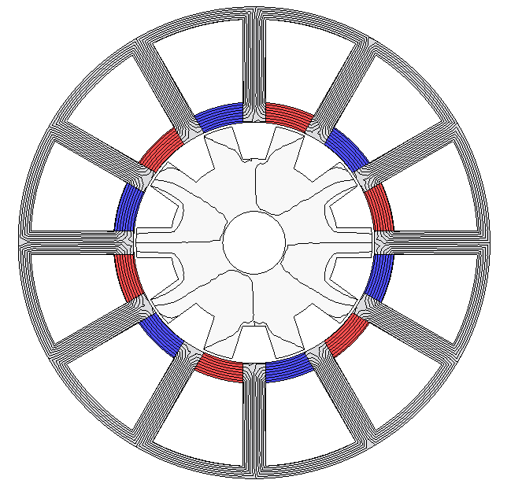 | 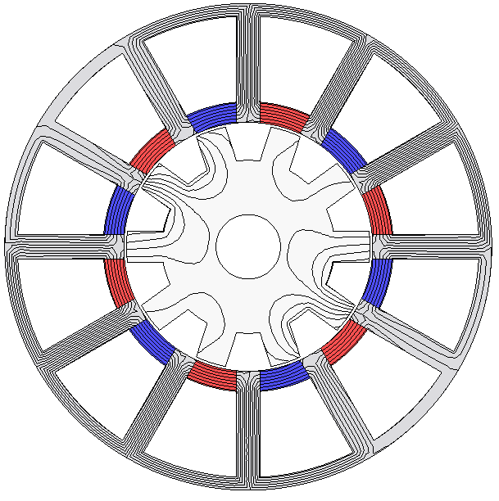
(a) | (b)
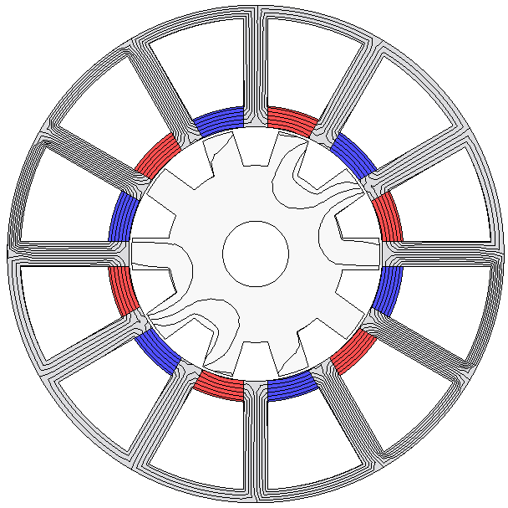 | 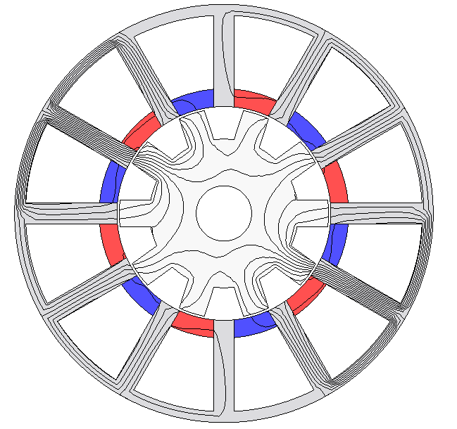
(c) | (d)
Fig. 4.2. Flux line distribution of the SSPM under four different condition. (a) Open-circuit. (b) On-load condition. (c) On-load with FP, with only PM excitation and no AC current excitation. (d) On-load with FP, with only AC excitation (I_{q} =7A) and no PM excitation.
(a) | (b)
Fig. 4.3. Flux linkage and back-EMF waveforms of the SSPM on open-circuit. (a) Flux linkage waveform. (b) Back-EMF waveform at 400rpm.
(a) | (b)
Fig. 4.4. On-load flux linkage and terminal voltage waveforms of the SSPM (I_{q} = 7A). (a) Flux linkage waveform. (b) Terminal voltage waveform at 400rpm.

(a) | (b)
Fig. 4.5. Flux linkage and terminal voltage waveforms with FP (only PM excitation and no current excitation) in the SSPM. (a) Flux linkage waveform. (b) Terminal voltage waveform at 400rpm.
(a) | (b)
Fig. 4.6. Flux linkage and terminal voltage waveforms with FP (only current excitation, I_{q} = 7A and no PM excitation) in the SSPM. (a) Flux linkage waveform. (b) Terminal voltage waveform at 400rpm.

Fig. 4.7. Spectra of open-circuit back-EMF and on-load voltage of the SSPM at 400rpm.

4.3 Winding Connection in Feasible Slot/Rotor Pole Combinations
The general rule for three phase 12s-SSPM is presented in [LIU14b], which is
(4.1)
Consequently, the 12s/(2~20)r SSPMs in which non- and overlapping windings are feasible are global optimized under the same constrain as shown in Table 4.1. The design parameters of the SSPM, which are shown in Fig. 4.8, have been varied by genetic algorithm (GA) in FEA under brushless AC (BLAC) operation mode for maximum average torque.

Table 4.1 Global Optimization Constrains in 12 stator-slot SSPMs.
Parameter | Symbol | Unit | Value
Stator outer radius | R_{os} | mm | 45
Axial length | L_{a} | mm | 25
Air-gap length | g | mm | 0.50
Packing factor | k_{p} | - | 0.40
Copper loss | P_{Cu} | W | 60
Number of turns per phase | N_{ph} | - | 368

Fig. 4.8. Linear illustration of geometric parameters of SSPM.

In a 12 stator-slot SSPM, the armature current can be calculated based on a fixed copper loss as
(4.2)
where is the slot area of armature winding, is the resistivity of copper, is the length of end-winding.
Since the significant difference between the non- and overlapping windings is the length of end-winding. Hence, the shape of end-winding has been modelled as semi-circle during the global optimization. The half turn coil total length is
(4.3)
where is the length of half turn end-winding, which can be estimated by
(4.4)
where is the empirical coefficient, which is dependent on N_{s}. For 12-stator SSPMs with non- and overlapping windings, it is selected as 1.35 and 1.25, respectively [CHE90]. is the coil pitch in terms of circumferential length,
(4.5)
where is the coil pitch in unit of rad, which is and for 12s10r-SSPM-A1 and 12s7r-SSPM-A3, respectively.
From the result of global optimization, the average torque T_{av} and torque ripple T_{ripple} of SSPMs are compared in Fig. 4.9, where T_{ripple} is defined as
(4.6)
where T_{max} and T_{min} are the maximum and minimum values of electromagnetic torque. It can be found that:
(a) For 12 stator-slot SSPMs with feasible rotor pole numbers, overlapping windings with a coil pitch of 3 stator slot pitches can improve the average torque under the same copper loss. This is due to the improvement of the fundamental winding factors k_{w}, which is calculated by (4.7)-(4.9) and shown in Table 4.2. k_{w(A1)} and k_{w(A3)} are the winding factors for non- and overlapping windings, respectively. k_{d}, Q, α, k_{p,} and y_{c} are the distribution factor, the number of EMF phasor in adjacent slots, the angle between adjacent EMF phasors, the pitch factor and the coil pitch (y_{c} = 1 in NOW and y_{c} = 3 in OW), respectively
(4.7)
(4.8)
(4.9)
Table 4.2 Fundamental winding factors of 12 stator-slot SSPMs with non- and overlapping windings
Rotor poles | k_{w(A1)} | k_{w(A3)} | Rotor poles | k_{w(A1)} | k_{w(A3)}
2 | 0.87 | - | 13 | 0.93 | 0.68
4 | 0.50 | 1.00 | 14 | 0.87 | -
5 | 0.25 | 0.68 | 16 | 0.50 | 1
7 | 0.25 | 0.68 | 17 | 0.25 | 0.68
8 | 0.50 | 1.00 | 19 | 0.25 | 0.68
10 | 0.87 | - | 20 | 0.50 | 1.00
11 | 0.93 | 0.68

(b) 12 stator-slot SSPMs with even rotor pole numbers show significantly higher torque ripple than the odd rotor pole number one. 12s/(10~14)r SSPMs with non-overlapping winding and 12s/(5,7,17,19)r SSPMs with overlapping winding show higher average torque as well as lower torque ripple.
(c) From the ‘star-of-slot’ of 12s/(10,14)r SSPM as shown in Fig. 3.13, it can be seen that the overlapping winding with coil pitch of 3 stator slot pitches is not suitable for these two slot/pole number combinations. This is due to the adjacent slot PMs are magnetized in opposite directions and the corresponding EMF vectors for single coils will be cancelled, viz. k_{p} = 0, if overlapping windings with coil pitch of 3 stator slot pitches are employed.
(a)
(b)
Fig. 4.9. Variation of (a) average torque and (b) torque ripple for 12s/(2~20)r SSPMs with non- and overlapping windings.
(d) Since the change of the SSPM from non-overlapping to overlapping winding under the same slot/pole number combination, the difference only lies in the change of pitch factor k_{p} while the distribution factor k_{d} remains the same. It is worthwhile to point out that the same coil EMF phasors can be applied to determine the winding layout for non- and overlapping windings under the same slot/pole number combination. With the average torque value obtained from global optimization, the torque per winding factor versus different rotor pole numbers are plotted in Fig. 4.10. It can be seen that the machines of 12s/(7, 17, 18)r produce higher coefficients of ‘torque per winding factor’ than the rest of slot/pole number combinations with both non- and overlapping windings. Among all investigated 12-stator SSPMs with different rotor pole numbers, 12s7r-A3 SSPM shows higher average torque, lower torque ripple as well as good potential in high average torque and winding factor.

Fig. 4.10. Variation of average torque per winding factor for 12s/(2~20)r SSPMs with non- and overlapping windings.
(e) By changing winding layout from non-overlapping to overlapping, the increase/decrease of average torque as the result of the increase/decrease of winding factor is shown in Fig. 4.11. It shows that the fundamental winding factors k_{w} of 12s/(5,7,17,19)r and 12s/(4,8,16,20)r machines are improved by 172% and 102% respectively by employing overlapping winding (A3) topology. As the result of winding factor improvement, the average torques of these slot/pole number combinations are improved, especially for the 12s5r-A3 and 12s7r-A3 machines. However, the 12s/(11,13)r machine suffers from reduced fundamental winding factor and therefore degraded average torque. In summary, 12s7r-A3 SSPM has the highest average torque and the lowest torque ripple among the 12s-SSPMs with overlapping windings.
Fig. 4.11. Change of winding factor and average torque in 12s/(4~20)r SSPMs from non-overlapping to overlapping winding.
(f) The power factors of the 12s SSPMs are obtained from the phase angle between the on-load voltage U_{ph} and the phase current I_{ph} without considering voltage drop in the phase resistance, which is shown by the phasor diagram in Fig. 4.12 and the power factor can be expressed as follows
(4.10)
By calculating the difference between the phase angle of the on-load voltage and current in 2D FEA, the power factors of the 12s SSPM with different rotor pole numbers are shown in Fig. 4.13. It shows that the power factor becomes lower in the SSPMs with high rotor pole number for both NOW and OW, which is the result of higher frequency and flux leakage level in the SSPMs with high rotor pole numbers.
Fig. 4.12. Phasor diagram in SSPMs with i_{d} = 0 control (phase current vector and phase back-EMF vector aligned).
Fig. 4.13. Variation of power factors for 12s/(2~20)r SSPMs with NOW and OW.

4.4 Comparison of Stator Slot PM Machines
In the previous section, the 12-slot SSPMs have been investigated under different rotor poles with non- and overlapping windings. It shows that 12s7r-A3 SSPM has the highest average torque and the lowest torque ripple which is a competitive candidate to the 12s10r-A1 SSPM. The winding layout and the back EMF phasor of coils and slot conductors for these two SSPMs are shown in Fig. 3.13.
The main design parameters of the proposed 12s7r-A3 SSPM and 12s10r-A1 SSPM are listed in Table 4.3, which is obtained from global optimization under the constrain of the same copper loss, viz. P_{Cu} = 60W. After optimization, the major differences in stator part of SSPMs with overlapping winding from non-overlapping winding are (1) smaller split ratio of rotor outside diameter to stator outside diameter and deeper slot; (2) thicker stator back-iron; (3) higher PM volume. Consequently, the corresponding electromagnetic performance of these two types SSPMs is comparatively investigated in this section.
(a) | (b)
(c) | (d)
Fig. 4.14. Back EMF phasor of coils and slot conductors in 12s10r-SSPM and 12s7r-SSPM. (a) Star-of-slot for 12s10r-SSPM. (b) Coil EMF for 12s10r-SSPM. (c) Star-of-slot for 12s7r-SSPM. (d) Coil EMF for 12s7r-SSPM.

Table 4.3 Main Parameters of 12 stator-slot SSPMs with Non- and Overlapping Windings
Machine Topologies | Symbol | Unit | 12s10r-A1 | 12s7r-A3
Split ratio | 𝛾 | - | 0.50 | 0.40
Stator tooth arc | θ_{s} | ºmech | 11.02 | 12.00
Stator back iron | S_{bk} | mm | 2.35 | 7.00
Rotor tooth arc | θ_{R} | ºmech | 14.49 | 18.00
Rotor back iron | R_{bk} | mm | 10.00 | 6.00
PM remanence | B_{r} | T | 1.20
PM relative permeability | μ_{r} | - | 1.05
PM height | H_{PM} | mm | 3.82 | 6.00
Slot area | S_{A} | mm² | 108.97 | 84.32

    - Open-circuit Performance
The initial position for rotor pole is selected to align the reluctance rotor with d-axis, where is 0º and 8.57º for 12s10r-A1 and 12s7r-A3 SSPMs to reach the maximum phase A flux linkage as shown in Fig. 4.18. The radial component of air-gap flux density B_{r} is shown in Fig. 4.15. Apart from the similar non-sinusoidal distribution, the air-gap flux density in the 12s7r-A3 SSPM is higher than the 12s10r-A1, which is due to the increase of the saturation level by higher PM usage. This can also be observed from flux line and flux density distributions of both machines in Fig. 4.16 and Fig. 4.17. Since PM flux is mainly ‘short-circuited’ by stator yoke on open-circuit, the 12s7r-A3 SSPM shows more flux leakage on the both stator and rotor sides and high local saturation on the stator teeth as the consequence of 57% more PM volume than in the 12s10r-A1 SSPM.
Fig. 4.15. Radial component of open-circuit air-gap flux density B_{r}.

(a) | (b)
Fig. 4.16. Open-circuit flux line distributions of 12s10r-A1 and 12s7r-A3 SSPMs at d-axis position. (a) 12s10r-A1 SSPM. (b) 12s7r-A3 SSPM.

 |  | 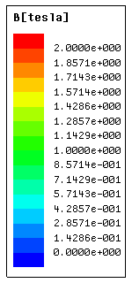
(a) | (b) | (c)
Fig. 4.17. Open-circuit flux density distributions of 12s10r-A1 and 12s7r-A3 SSPMs at d-axis position. (a) 12s10r-A1 SSPM. (b) 12s7r-A3 SSPM. (c) Scale.
By neglecting the influence of flux leakage, the open-circuit PM flux linkage captured by phase coil can be calculated by
(4.11)
where is the coil pitch angle, which is for 12s10r-A1 SSPM, but for 12s10r-A3 SSPM thanks to its 3-coil-pitch winding configuration. This indicates that more PM flux is captured by 3-coil-pitch winding than non-overlapping winding, which is verified by the difference of fundamental values in flux linkage spectrum as shown in Fig. 4.18(b). The waveforms of phase flux linkage of both SSPMs are bipolar and approximately sinusoidal, the resultant higher order harmonics are negligible comparing with the fundamental.

(a)
(b)
Fig. 4.18. Phase A flux linkages of 12s10r-A1 and 12s7r-A3 SSPMs. (a) Waveforms. (b) Spectra.
The phase back-EMF waveforms and spectra of the 12s10r-A1 and the 12s7r-A3 SSPMs at 400rpm are shown in Fig. 4.19. It shows that the fundamental component of the 12s7r-A3 SSPM is improved by 86% than the 12s10r-A1 SSPM as well as the smaller total harmonic distortion (THD) value.
(a)
(b)
Fig. 4.19. Phase A back-EMFs of 12s10r-A1 and 12s7r-A3 SSPMs at 400rpm. (a) Waveforms. (b) Spectra.
The cogging torque is an inherent characteristic of PM machines due to the interaction between the PM and slots. For SSPMs, the amplitude of the cogging torque is negligible and the number of cogging torque cycles N_{c} in one electrical cycle is determined by the stator slot number N_{s} and rotor pole combination N_{r}, which can be expressed by (4.12) [ZHU00]
(4.12)
where LCM is the least common multiple. Therefore, the 12s7r-A3 SSPM has a higher cycle number than the 12s10r-A1 SSPM, which is predicted in Fig. 4.20(a). However, the dominating harmonic orders of the two machines are the same as shown in Fig. 4.20(b), viz. 6th and 12th.
(a)
(b)
Fig. 4.20. Cogging torque of 12s10r-A1 and 12s7r-A3 SSPMs. (a) Waveforms. (b) Spectra.

    - Torque Characteristics
The variation of average torque against current angle 𝛾 is illustrated in Fig. 4.22. The optimum current angle for maximum average torque lies around 90 Elec. Deg., which indicates the SSPMs only contains PM torque T(PM) and armature reaction torque T(i) while reluctance torque is negligible. Therefore, both machines with non- and overlapping windings can be operated in BLAC mode under i_{d} = 0 control. Consequently, the average torque expression of SSPM [AFI16b] can be simplified as
(4.13)
where p is the number of pole-pairs, which is the same as the rotor pole number N_{r} for the SSPMs; is the d-axis flux linkage which is coupled by q-axis current i_{q}. The contributions of PM and armature reaction torques to average torque can be separated by applying frozen permeability (FP) method [CHU13] under different Q-axis currents as shown in Fig. 4.21. As can be seen, the PM torque T(PM) has dominating role in high electrical loading range while the armature reaction torques T(i) of both machines decrease with the increase of the magnetic saturation.
Fig. 4.23 shows the on-load electromagnetic torque of the 12s10r-A1 and the 12s7r-A3 SSPM, in which the average torque is 0.8Nm and 2.2Nm under the same copper loss, viz. P_{Cu} = 60W. It shows that the proposed 12s7r-A3 SSPM with overlapping winding can produce 172.6% higher torque density and 89.2% lower torque ripple than the non-overlapping one. The overload capability of two SSPMs are comparatively studied in Fig. 4.24 with the variation of average torque against the copper loss. The copper loss range is doubled than the level which SSPMs are global optimized. It can be seen that the 12s7r-A3 SSPM demonstrates significantly higher average torque in the whole copper loss range due to the thicker stator back iron and larger fundamental back-EMF.
Fig. 4.22. Average torque against current angle.
Fig. 4.23. On-load torque waveform under i_{d} = 0 control.
Fig. 4.24. Variation of average torque against copper loss.
(a)
(b)
Fig. 4.25. Separation of the average electromagnetic torque under different electrical loading by frozen permeability of (a) 12s10r-A1 SSPM (b) 12s7r-A3 SSPM.
    - Machine Inductance
The inductance characteristics of both SSPMs can be investigated by self-, mutual, d- and q-axis inductance. The inductance characteristics can be calculated by the expressions shown in the appendix A. The corresponding inductance waveforms within one electrical cycle are shown in Fig. 4.26. The proposed 12s7r-A3 SSPM has large inductance value than the 12s10r-A1 SSPM, which is 2.68, 2.08, 2.80 and 2.32 times higher in average self-, mutual-, d-, and q-axis inductance. This phenomena can be explained by the on-load flux line distribution in Fig. 4.27. The flux path in the 12s7r-A3 SSPM is longer than 12s10r-A1 SSPM and therefore there are higher phase A flux linkage linking both stator and rotor in 12s7r-A3 SSPM. The difference between the d- and q-axis inductance for both SSPMs is negligible which is similar to other doubly salient PM machines, such as switched flux machines [CHE10a].
(a) Self-inductance of phase A with I_{a} = 8A.
(b) Mutual-inductance between phase A and B with I_{a} = 8A.
(c) d-axis inductance with I_{d} = -8A.
(d) q-axis inductance with I_{q} = 8A.
Fig. 4.26. Inductance characteristic for 12s10r-A1 and 12s7r-A3 SSPMs.
(a) | (b)
Fig. 4.27. Flux distribution in 12s10r-A1 and 12s7r-A3 SSPMs at d-axis positions with phase A excited (i_{q} = 8A, i_{d} = 0). (a) 12s10r-A1 SSPM (b) 12s7r-A3 SSPM.
    - Unbalanced Magnetic Force
Since electrical machines with odd rotor pole numbers has non-uniform flux line distribution, the unbalanced magnetic force (UMF) commonly exists [LIU14b]. The UMF between the stator and rotor has the impact on the noise/vibration level and leads to the eccentric issues during the operation. Due to the stator/rotor pole number combination of 12s7r-A3 SSPM, the magnetic asymmetry is inevitable and the equal potential flux line distribution under different copper loss is shown in Fig. 4.28.
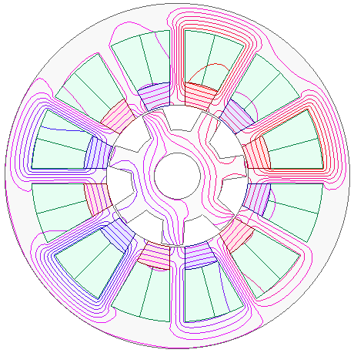 | 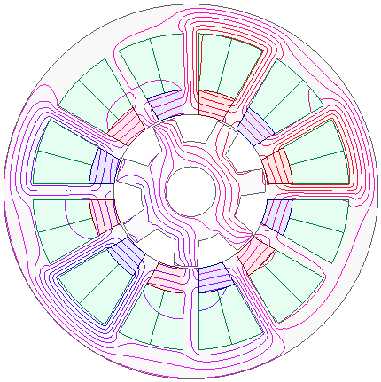
(a) | (b)
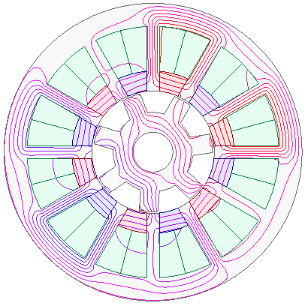
(c)
Fig. 4.28. On-load equal potential flux line distribution of 12s7r A3 SSPM at different copper loss. (a) P_{Cu}=30W. (b) P_{Cu}=60W. (c) P_{Cu}=120W.
The UMF components along the x-axis (F_{x}), y-axis (F_{y}) and the magnitude (F) can be evaluated from 2D FEA as follows [ZHU07c]:
(4.14)
(4.15)
(4.16)
where r, , , and are the air-gap radius, the axial length, the radial and circumferential flux density components, the permeability of free space and the angular position, respectively. The FEA predicted UMF loci and on-load UMF waveforms of the 12s7r A3 SSPMs during one electrical cycle are shown in Fig. 4.29(a) and (b). It shows that the rotation direction of the UMF is anti-clockwise for the 12s7r-A3 SSPM with five peaks. The average UMF against copper loss is shown in Fig. 4.29(c). It reveals the UMF increases with increase of the copper loss. However, the increment of the UMF trends to be slow and flat at high copper loss due to magnetic saturation.
(a)
(b)
(c)
Fig. 4.29. Unbalanced magnetic force (UMF) for 12s7r A3 SSPM. (a) Loci of UMF. (b) Average UMF against copper loss.
    - Losses and Efficiency
The stator and rotor core losses P_{Fe} of two SSPMs are estimated by three parts including hysteresis loss , eddy-current loss and excess core loss ,
(4.17)
where k_{h} = 272.13W/m³, k_{c} = 0.18W/m³ and k_{e} = 3.56W/m³ are the hysteresis, eddy-current and excess core loss coefficients, respectively. The coefficients are obtained from multi-frequency dependent loss density (B-P) curves for 0.35 lamination steel sheets (DW31035). B_{m} is the amplitude of the AC flux component. The PM material conductivity is set as 699000S/m in magnet eddy current loss. It shows that the 12s7r-A3 SSPM has higher core and PM losses than the 12s10r-A1 SSPM, which is significantly influenced by magnetic saturation. Although the 12s7r-A3 SSPM has the reduced rotor pole number N_{r} and therefore reduced switching frequency f, the 12s7r-A3 SSPM has larger iron volume and severer local magnetic saturation than the 12s10r-A1 SSPM as shown in Fig. 4.31. Moreover, the average core loss density in the 12s7r-A3 SSPM is 24.3% higher than the12s10r-A1 SSPM as listed in Table 4.4 which results in lower efficiency of the 12s7r-A3 SSPM (51.87%) than the 12s10r-A1 SSPM (33.65%). Since the overlapping winding topology has significantly long end-winding, it degrades the performance for the machines with short stack length. It is noticeable that the advantage of overlapping winding in torque per copper loss is more obvious for machines with long lamination stack length as shown in Fig. 4.33.
(a)
(b)

(c)
Fig. 4.30. Comparison of machine losses against rotor speed of 12s10r-A1 and 12s7r-A3 SSPMs. (a) Iron loss. (b) PM loss. (c) Efficiency.

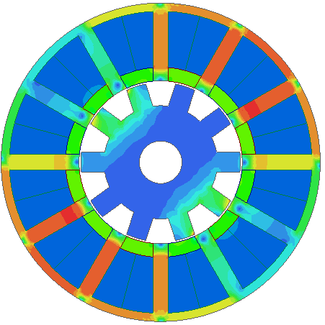 | 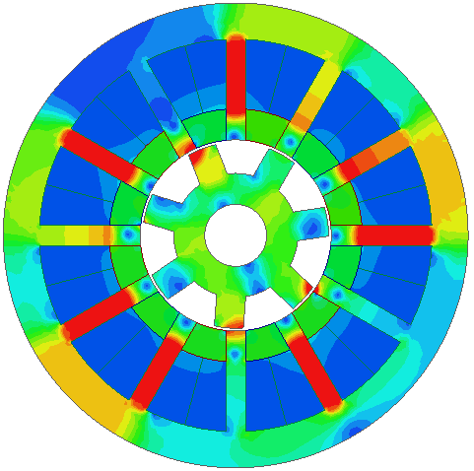 | 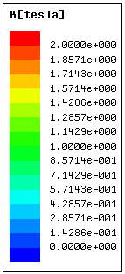
(a) | (b) | (c)
Fig. 4.31. Comparison of on-load flux density distribution of 12s10r-A1 and 12s7r-A3 SSPMs at P_{Cu} = 60W and 400rpm. (a) 12s10r-A1 SSPM. (b) 12s7r-A3 SSPM. (c) Scale.

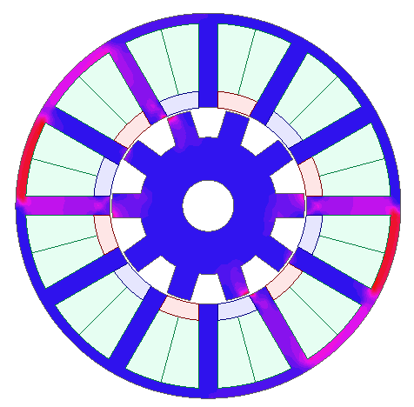 | 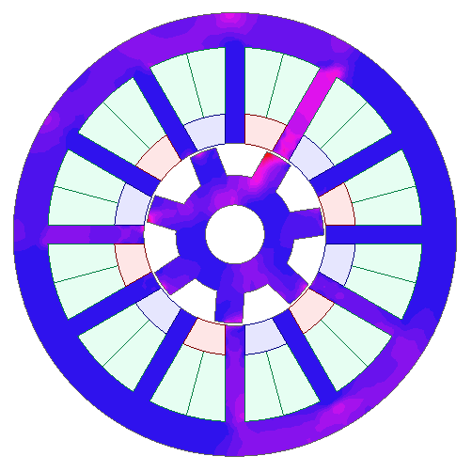 | 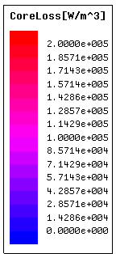
(a) | (b) | (c)
Fig. 4.32. Comparison of on-load iron loss density distributions of 12s10r-A1 and 12s7r-A3 SSPMs at P_{Cu} = 60W and 400rpm. (a) 12s10r-A1 SSPM. (b) 12s7r-A3 SSPM.

Table 4.4 Comparison of Loss and Efficiency of 12 stator slot SSPMs at 400rpm.
 | 12s10r-A1 | 12s7r-A3
Average torque (Nm) | 0.81 | 2.20
Copper loss (W) | 60
Stator iron volume (cm³) | 42.20 | 68.30
Stator iron loss (W) | 0.95 | 1.37
Rotor iron volume (cm³) | 26.50 | 14.40
Rotor iron loss (W) | 0.17 | 0.40
Iron loss density (W/dm³) | 16.20 | 21.40
PM loss (W) | 5.77 | 23.72
Torque/machine volume (Nm/dm³) | 5.09 | 13.83
Overall efficiency (%) | 33.65 | 51.87

Fig. 4.33. Torque/copper loss against lamination active length of 12s10r-A1 and 12s7r-A3 SSPMs.

4.5 Experimental Validation
In this section, the prototype machine of 12s7r-A3 SSPM is manufactured with the parameters shown in Table 4.5. The performance of 12s7r-A3 SSPM is measured and compared with the 12s10r-A1 SSPM prototype machine presented in chapter 2. The stator and rotor parts of two prototyped SSPMs are shown in Fig. 4.34 and Fig. 4.35. The measured electromagnetic performance of both SSPMs are presented as well as the predicted 2D FEA results.
Table 4.5. Design parameters of 12 stator slot SSPM with non-overlapping and overlapping windings.
Machine Topologies | SSPM
Machine Topologies | 12s10r A1 | 12s7r A3
Stator outer radius, R_{os} (mm) | 45
Axial length L_{a} (mm) | 25
Air-gap length g (mm) | 0.50
Packing factor | 0.35 | 0.20
Split ratio | 0.52 | 0.50
Stator tooth arc, θ_{s} (ºmech) | 10.16 | 12.00
Stator back iron, S_{bk} (mm) | 2.74 | 7.00
Slot area, A_{s} (mm²) | 104.27 | 62.33
Rotor tooth arc, θ_{R} (ºmech) | 14.64 | 20.00
Rotor back iron, R_{bk} (mm) | 6.00 | 9.00
PM material, N35SH B_{r}/μ_{r} @ 20ºC | 1.2T/1.05
PM volume, V_{PM} (cm³) | 9.59 | 12.80
Number of turns per armature coil, N_{ac} | 50 | 30

 | 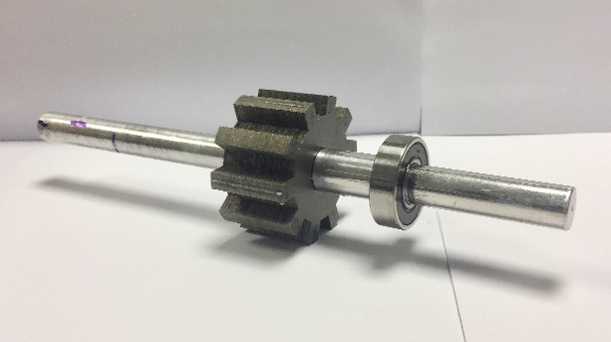
(a) | (b)
Fig. 4.34. Prototypes machine parts of 12s10r-SSPM-A1. (a) 12s10r-SSPM-A1 stator. (b) 12s10r-SSPM-A1 rotor.
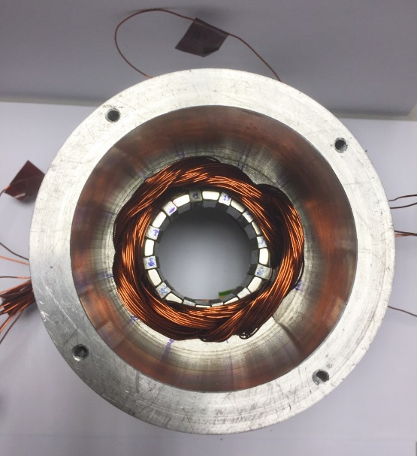 | 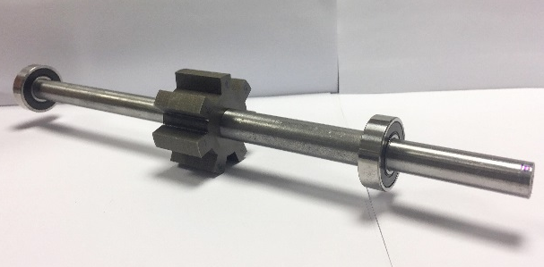
(a) | (b)
Fig. 4.35. Prototypes machine parts of 12s7r-SSPM-A3. (a) 12s7r-SSPM-A3 stator. (b) 12s7r-SSPM-A3 rotor.
Fig. 4.30(a) shows the measured back-EMF waveforms of 12s10r-A1 and 12s7r-A3 SSPMs at the rotor speed of 400rpm and the corresponding spectra are shown in Fig. 4.36(b). It shows that the fundamental component of the back-EMF waveform in the 12s7s-A3 SSPM is 171.9% higher than that of the 12s10r-A1 SSPM. It is worthwhile to mention that the back-EMF is caused by the variation of leakage PM flux which is modulated by the reluctance rotor. This can be explained by the equal potential flux line distribution of both SSPMs in Fig. 4.16. The measured back EMF waveforms are slightly lower than the 2D FEA predictions due to the end-effect.
(a)
(b)
Fig. 4.36. FEA predicted and measured phase A open-circuit back-EMFs in SSPMs with NOW and OW at rotor speed of 400rpm. (a) Waveforms. (b) Spectra.
The static torque measurement is conducted with the same method as equation (2.10) in chapter 2, by injecting DC currents in three phase windings as I_{A} = -2I_{B} = -2I_{C.} The measured static torque waveforms against different rotor positions are shown in Fig. 4.37. It shows that the measured peak torque of the 12s7r-A3 SSPM is 97.47% higher than that of the 12s10r-A1 SSPM. It is found that the peak torque occurs where the rotor position is about 90 Elec. Deg., due to the negligible reluctance torque as analysed in section 3.
By locking the mechanical rotor position where the static torque value is highest, the torque capabilities of two SSPMs are measured by injecting different Q-axis currents. It is interesting to found that the static torque value increases non-linearly with Q-axis currents. By investigating this phenomenon with continuous increasing Q-axis current in 2D FEA as shown in Fig. 4.39 and Fig. 4.40, it reveals that the global saturation is not critical when the current is low, i.e. i_{q} = 5A. The PM torque is dominating under this condition and consequently electromagnetic torque increases non-linearly which is consistent with the results shown in Fig. 4.25. When the electrical loading is high, the armature reaction flux is dominating while all PM flux is pushed out by armature reaction flux. At this region, the torque versus current curve starts to saturate. The magnetic saturation onset point can be observed as 40A for the 12s10r-A1 SSPM and 70A for the 12s7r-A3 SSPM. The on-load flux density distribution at i_{q} = 45A is shown in Fig. 4.40 which shows the global magnetic saturation level after the onset point.
Fig. 4.37. FEA predicted and measured static torque waveforms of SSPM (I_{d} = 0, I_{q} = 4A) against rotor position in SSPMs with NOW and OW (I_{A} = -2I_{B} = -2I_{C}).
Fig. 4.38. FEA predicted and measured peak values of static torque against different q-axis currents (I_{d} = 0) for SSPMs with NOW and OW.
Fig. 4.39. FEA predicted peak values of static torque against different q-axis currents (I_{d} = 0) for SSPMs with NOW and OW.
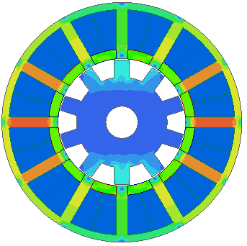 | 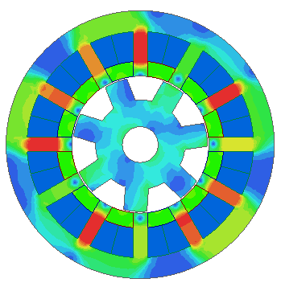
(i) | (ii)
(a)
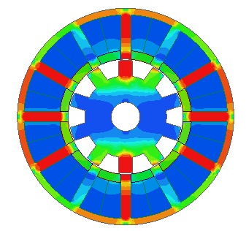 | 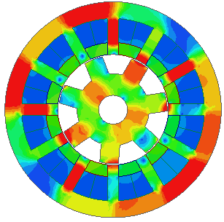
(i) | (ii)
(b)
Fig. 4.40. On-load flux density distribution of (i) 12s10r A1 SSPM and (ii) 12s7r A3 SSPM with q-axis currents. (a) I_{d} = 0, I_{q} = 5A. (b) I_{d} = 0, I_{q} = 45A.
The inductance waveforms of 12s10r A1 and 12s7r A3 SSPMs are shown in Fig. 4.41 with both 2D FEA predictions and test results. The self-inductance waveform is directly recorded from the LCR meter reading with respect to different rotor positions while the mutual inductance is derived from the equation 3.17. It shows that the measured self-inductance waveform is about 16% higher than the 2D FEA calculation. The higher self-inductance value in the measurement is caused the leakage inductance from the end-winding. However, the end-winding leakage inductance is ignored in the 2D FEA calculation. However, the mutual inductance is not influenced by the end-effect and the measured values have good agreement with the FEA calculated results. Comparing the inductance waveforms in the SSPMs with NOW and OW, it shows the 12s7r A3 SSPM has larger inductance variation than the 12s10r A1 SSPM owing to the higher flux linkage in the phase winding which is discussed in section 4.3.3.
(a)
(b)
Fig. 4.41. FEA predicted and measured inductance waveforms of for (a) 12s10r A1 SSPM and (b) 12s7r A3 SSPM.

4.6 Conclusion
Overlapping armature winding design is proposed and analyzed in the 12-stator SSPMs. The change of fundamental winding factors for non- and overlapping windings with feasible rotor pole numbers are investigated and their influence on the average torque is revealed. Comparing with the 12s10r-A1 SSPM, the 12s7r-A3 SSPM has improved torque density and low torque ripple. However, the unbalanced magnetic force exists in the 12s7r-A3 SSPM due to asymmetric on-load flux line distribution. Besides, 12s7r-A3 SSPM has more iron and PM losses than the 12s10r-A1 SSPM which is due to severe magnetic saturation.

Hybrid Excited Stator Slot PM Machines with Overlapping Windings
In this chapter, the overlapping winding (OW), i.e. the coil pitches of field and armature windings equal 3 stator slot pitches (F3A3), is proposed and applied to the 12-slot/17-rotor pole (12s17r) hybrid excited stator slot permanent magnet machines (HESSPMs) in order to enhance the torque density. The influence of stator/rotor pole number combinations on the HESSPMs with both non-overlapping winding (NOW) and OW is analyzed. The 12s17r HESSPMs with NOW and OW are selected from the candidates in 12-slot machines for high average torque and low torque ripple under the same copper loss. Their electromagnetic performance is comparatively studied. By adopting OW, it shows that the proposed 12s17r-F3A3 HESSPM improves the fundamental value of the phase back-EMF and the torque density by 125% and 100.2% compared with the 12s17r-F1A1.

5.1 Introduction
As a candidate in electrically excited (EE) machines, the variable flux reluctance machine (VFRM) [LIU14a] [LIU14b] [RAM16] [HUA17b], which is able to regulate the flux level via field and armature windings, presents attractive characteristics including wide constant power speed range and good overall efficiency. Consequently, VFRMs are suitable for variable speed applications such as electrical vehicle (EV) [LIU14a] [RAM16]. However, magnetic saturation introduced by DC coils on the stator side is one of the reasons which degrades the overall performance of the VFRM. One of the possible solutions to reduce the magnetic saturation in the VFRM is to place the permanent magnets (PMs) in the stator slot openings, which results in the machine topology of hybrid excited stator slot permanent magnet machine (HESSPM) [AFI15] [SUL11] [MAE16] [ZHU16a]. Since the polarities of slot PMs are opposite against the DC flux, the PM assistance effect in the HESSPM not only shows the alleviation of the magnetic saturation but also the enhancement in torque density.
With both DC field winding and PMs allocated on the stator sides, the HESSPM falls into the category of stator-PM machines which inherits the advantages of robust rotor structure and easy thermal management from the stator side. Besides, the flux regulation capability of EE machines is well maintained since the PMs are connected in parallel with DC excitation. In the previous literature, HESSPMs have been studied with machine topologies, design optimization [AFI15] [MAE16] and the influence of stator/rotor pole number combinations [ZHU16a], etc. Similar to conventional stator-PM machines, the majority studies on HESSPMs adopt non-overlapping winding (NOW) [ZHU16a] [SUL11] [MAE16] in order to reduce the end-winding length and increase the slot filling factor. However, the employment of NOW for some stator/rotor number combinations, especially for stator pole N_{s}, differs largely from the rotor pole number N_{r}, causes low coil pitch factors, which confines the torque capability and reduces overall efficiency of the machines. Therefore, overlapping winding (OW) layout [ZHO14] [DU16] [LI16] [SHA17] for stator–PM machines are proposed in order to improve torque/power density. In this chapter, the performance of 12-slot HESSPMs with NOW and OW is comparatively investigated with different rotor pole numbers.
This chapter is organized as follows. The basic operational principle for the HESSPM is explained in section 5.2. In section 5.3, the general rule in selecting rotor pole numbers in the 12s HESSPMs is reviewed as well as the NOW and OW with feasible rotor pole numbers. In section 5.4, the detailed electromagnetic performance between the 12s17r-F1A1 and 12s17r-F3A3 HESSPMs as shown in Fig. 5.1 (a) and (c) is compared by 2D finite element analysis (FEA). The experimental validation is carried out on two prototype machines in section 5.5. Open-winding topology is employed in HESSPMs with both NOW and OW to further increase the torque density in section 5.6. The general conclusion is given in section 5.7.

5.2 Operation Principle of HESSPM
The non-overlapping winding (NOW), sometimes designated as ‘tooth coil’, has a coil span of 1 stator-slot pitch as shown as HESSPM in Fig. 5.1(a). The abbreviation of HESSPM with NOW is F1A1, which means both field coil pitch and armature coil pitch are 1 stator-slot pitch. The overlapping windings (OWs), which have the coil span longer than 1 stator-slot pitch, are shown in Fig. 5.1 (b) and (c). In this chapter, the investigation only focuses on the OW layout where the field and armature coil pitches are equal, i.e. F3A3 as shown in Fig. 5.1 (c). However, the polarities of DC coils in the HESSPM are exactly the same for F1A1, F1A3 and F3A3, as well as the polarities of slot PMs. Hence, the operation principle of HESSPM can be explained by using the simplified model in the flux path in Fig. 5.2, which is independent of winding layouts. It shows in Fig. 5.2 (a) that the majority of PM flux is short-circuited on the stator core on open-circuit. However, only small portion of PM flux leakage links to the rotor side. Hence, the magnitudes of the open-circuit back-EMF and cogging torque in the HESSPM are low without DC excitation. The flux generated by field winding is opposite to the PM flux. When the HESSPM is not saturated by DC flux, the DC flux pushes the PM flux into the rotor side and makes electromagnetic energy conversion as shown in Fig. 5.2 (b). When the HESSPM is well saturated by DC flux, which means the HESSPM is over-excited, all the PM flux is pushed into rotor side and there is no stator short-circuited PM flux as shown in Fig. 5.2 (c). The magnetic equivalent circuit of the HESSPM is shown in Fig. 5.3, where P_{s}, P_{m}, P_{g}, P_{r}, φ_{DC} andφ_{PM} are the stator permeance, PM permeance, air-gap permeance, rotor permeance, DC flux and PM flux, respectively. The balance between the DC and PM fluxes is the key factor which influences the magnetic saturation level in the HESSPM and therefore has the significant influence on the torque performance.
(a) | (b)
(c)
Fig. 5.1. Cross-sections of 12s17r HESSPMs with NOW and OW. (a) 12s17r-F1A1 HESSPM. (b) 12s17r-F1A3 HESSPM. (c) 12s17r-F3A3 HESSPM.

(a) | (b)
(c)
Fig. 5.2 DC and PM flux paths in segmental machine model at open-circuit for 12s17r HESSPM. (a) I_{DC} = 0A. (b) 0A < I_{DC} < I_{sat.} (c) I_{DC} > I_{sat.} (Machine is over saturated).
Fig. 5.3. Magnetic equivalent circuit for the flux path for 12s17s HESSPM.

5.3 Machine Performance with Feasible Stator /Rotor Pole Combinations
The general rule of choosing rotor pole number N_{r} for three phase 12-slot HESSPM is presented in [AFI15], which is
(5.1)
Consequently, the 12s/(2~20)r HESSPMs with feasible NOW and OW are global optimized under the same constrain as shown in Table 5.1. The design parameters of the HESSPM, which is shown in Fig. 5.4., have been optimized by genetic algorithm (GA) in FEA under brushless AC (BLAC) operation mode for the maximum average torque. In a 12-slot HESSPM, the total copper loss P_{Cu} can be expressed as the summation of armature and field excitation copper losses, viz. P_{Cua} and P_{Cuf}. Hence, the copper loss ratio λ can be defined as
(5.2)

Table 5.1 Global Optimization Constrains in 12-Stator HESSPMs.
Parameter | Symbol | Unit | Value
Stator outer radius | R_{os} | mm | 45
Axial length | L_{a} | mm | 25
Air-gap length | g | mm | 0.50
Shaft radius | R_{shaft} | mm | 6.00
Packing factor | k_{p} | - | 0.40
Copper loss | P_{Cu} | W | 60
PM volume | V_{PM} | mm³ | 4565
PM remanence | B_{r} | T | 1.20
PM relative permeability | μ_{r} | - | 1.05
Number of turns per coil | N_{dc}/N_{ac} | - | 46/46

Fig. 5.4. Linear illustration of geometric parameters of HESSPM.

With total copper loss fixed at 60W, the optimal λ is obtained with respect to the average torque as shown in Fig. 5.5. It shows that the maximum average torque occurs when armature and field excitation copper losses are approximately equal, viz. optimized λ is about 0.5 in the 12s17r HESSPMs. Consequently, the slot areas of armature and field windings can be assumed equal with the same number of turns during the global optimization, viz. S_{DC} = S_{AC} and N_{DC} = N_{AC}. Under this assumption, the resistance of DC and AC coils are assumed the same, viz. R_{DC} = R_{AC} while the magnitudes of DC current and RMS value of AC current are kept the same, viz. I_{DC} = I_{rms}. The detail discussion can be found in paragraph below the figure 2.1 in section 2.2.
Fig. 5.5. Average torque against copper loss ratio.
Consequently, the copper loss expression can be simplified as (5.3). The magnitude field current I_{DC} and armature current I_{rms} can be calculated by (5.4)
(5.3)
(5.4)
where is the resistivity of copper, is the length of end-winding. Since significant difference between NOW and OW is observed in the end-winding, the length of end-winding cannot be ignored considering machine volume and resistance. The shape of the end-winding is modelled as semi-circle during the global optimization. The total length of half turn coil is
(5.5)
where is the length of half turn end-winding, which can be estimated by [CHE90]
(5.6)
where is the empirical coefficient, which is dependent on N_{s}. The end-winding length is taken into account for resistance calculation, which differs for NOW and OW. For 12s HESSPMs with NOW, is selected as 1.35 in end-winding length calculation of both field and armature windings. For 12s HESSPMs with OW, is selected as 1.25 for end-winding length calculation of both field and armature windings. is the coil pitch in terms of circumferential length,
(5.7)
where is the coil pitch in unit of rad, which is and for HESSPMs-F1A1 and HESSPMs-F3A3, respectively. From the result of global optimization, the average torque T_{av} and torque ripple T_{ripple} of HESSPMs are compared in Fig. 4.9, where T_{ripple} is defined as
(5.8)
where T_{max}, T_{min} is the maximum and minimum values of electromagnetic torque. It can be found that:
(a) For 12s HESSPMs with feasible rotor pole numbers, OW with armature coil pitch of 3 stator slot pitches can improve the average torque under the same copper loss for 12s/(4,5,7,8,16,17,19,20)r HESSPMs, which are due to the improvement of the fundamental winding factors k_{w} with these stator/rotor pole number combinations. The fundamental winding factors k_{w} which are calculated in (5.9)-(5.11) and shown in Fig. 5.6, where k_{d}, Q, α, k_{p,} and y_{c} are the distribution factor, the number of EMF phasor in adjacent slots, the angle between adjacent EMF phasors, the pitch factor and the coil pitch (y_{c} = 1 in NOW and y_{c} = 3 in OW), respectively. However, the average torque is degraded in 12s/(11,13)r HESSPMs with OW compared with NOW as the consequence of the reduction of the fundamental winding factors k_{w}.
(5.9)
(5.10)
(5.11)
Fig. 5.6. Fundamental winding factors against rotor pole numbers with NOW and OW for 12s HESSPMs.
(b) Among the investigated 12s HESSPMs, 12s/(10~14)r HESSPMs with NOW and 12s/(16~20)r HESSPMs with OW show high average torque as shown in Fig. 4.9.(a). Generally, it is recommended that NOW should be employed when N_{s} close to N_{r} and OW should be employed when N_{s} differs largely from N_{r} in order to obtain high fundamental winding factor and average torque. The machines with even rotor pole numbers, viz. 12s/(4,8,16,20)r HESSPMs, show significant higher torque ripple than the machines with odd rotor pole numbers, viz. 12s/(5,7,11,13,17,19)r HESSPMs, as shown in Fig. 4.9.(b).
(a)
(b)
Fig. 5.7. Variation of (a) average torque and (b) torque ripple for 12s/(2~20)r HESSPMs with NOW and OW.
(c) Since with the change of the HESSPM from NOW to OW under the same stator/rotor pole number combination, the difference only lies in the change of pitch factor k_{p} while the distribution factor k_{d} remains the same. It is worthwhile to point out that the same coil EMF phasors can be applied to determine the winding layout for NOW and OW under the same stator/rotor pole number combination. OWs with coil pitches of 3 stator slot pitches are not feasible for 12s/(2,10,14)r HESSPMs. This is due to the adjacent slot PMs are magnetized in opposite directions. Hence, the corresponding EMF vector for a single coil will be cancelled, viz. k_{p} = 0 in 12s/(2,10,14)r HESSPMs.
(d) The coefficients of ‘average torque by winding factor’ as defined in the expression (3.12) versus different rotor pole numbers is plotted in Fig. 5.8.(a). It can be seen that the ‘average torque per winding factor’ in NOW is higher than that in OW for 12s HESSPMs. It also shows that the HESSPMs with the high rotor pole numbers, viz. 12s/(17,19)r, show higher ‘average torque by winding factor’ than the rest of stator/rotor pole number combinations with both NOW and OW. Among the investigated 12s HESSPMs, 12s/(17,19)r HESSPMs show high average torque, low torque ripple as well as good potential in torque production.
(e) By changing winding layout from NOW to OW, the increase/decrease of average torque as the result of the increase/decrease of winding factor is shown in Fig. 5.8.(b). It shows that the fundamental winding factors k_{w} of 12s/(5,7,17,19)r and 12s/(4,8,16,20)r HESSPMs are improved by 173% and 100% respectively by employing OW, i.e. F3A3. As the result of winding factor improvement, the average torque values of these stator/rotor pole number combinations are improved, especially for odd rotor pole number HESSPMs, viz. 12s/(5,7,17,19)r. However, 12s/(11,13)r HESSPMs have reduced fundamental winding factors and therefore degraded average torque with OW.

(a)
(b)
Fig. 5.8. Influence of fundamental winding factor on average torque in 12s/(2~20)r HESSPMs with NOW and OW. (a) Average torque per winding factor. (b) Winding factor and average torque.
(f) The power factors of 12s HESSPMs are obtained from the phase angle between the on-load voltage and phase current neglecting the phase resistance. It shows in Fig. 5.9 that the power factor decreases with the increase of the rotor pole number for both NOW and OW which is the result of higher flux leakage in the HESSPMs with high rotor pole numbers. Generally, the HESSPMs with NOW has higher power factor than those with OW since the inductance in NOW is significant lower than that in OW.
Fig. 5.9. Variation of power factors for 12s/(2~20)r HESSPMs with NOW and OW.

5.4 Performance Comparison of HESSPMs
In the previous section, 12s HESSPMs have been investigated under different rotor poles with NOW and OW. It shows that 12s17r-F3A3 HESSPM has high average torque and low torque ripple in HESSPMs with OW. The 12s17r HESSPMs with NOW serve as a counterpart in order to show the effect of changing winding layout in the HESSPMs. The corresponding electromagnetic performance of two HESSPMs are comparatively investigated in this section. The phase angle in electrical degree of each coil EMF can be obtained by
(5.12)
where N_{r} is the rotor pole number and is the coil position along the stator circumference. The mechanical salient rotor pole N_{r} is used in (5.12) since the flux distribution is the same within one pole-pitch for sinusoidally driven HESSPM.
The star-of-slot and winding layout in 12s17r HESSPMs can be derived in Fig. 5.10. The winding layout can be similarly derived for other stator/rotor pole number combinations. It can be seen that 12s17r HESSPM consists two sets of balanced three phase windings which are phased shifted by 30º elec. deg. The main design parameters of the proposed 12s17r-F1A1 and 12s17r-F3A3 HESSPMs are listed in Table 5.2, which are obtained from global optimization under the constrain of the same copper loss. After optimization, the main geometric difference lies in thicker stator back-iron of the OW than NOW since there is more flux linked in OW.
(a) | (b)
Fig. 5.10. Back EMF phasor of coils and slot conductors in 12s17r-HESSPM. (a) Star-of-slot. (b) Coil EMF and winding layout.
Table 5.2 Main parameter of 12s17r HESSPMs
Machine Topologies | Symbol | Unit | F1A1 | F3A3
Split ratio | 𝛾 | - | 0.55 | 0.60
Stator tooth arc | θ_{s} | ºmech | 8.00 | 5.00
Stator back iron | S_{bk} | mm | 4.00 | 5.00
Rotor tooth arc | θ_{R} | ºmech | 8.00 | 8.00
Rotor back iron | R_{bk} | mm | 13.00 | 13.00
PM height | H_{PM} | cm | 1.41 | 1.23
Slot area | S_{DC}/S_{AC} | mm² | 50.86/50.86 | 43.92/43.92
Rated speed | Ω_{rated} | rpm | 400 | 400
Rated DC/AC currents | I_{DC}/I_{AC} | A | 5.33/5.33 | 4.96/4.96
Rated power | P_{rated} | W | 27.45 | 54.97

    - Open-circuit Performance
The rotor initial positions are selected to align d-axis with the salient stator tooth, which are 10.58º and 8.82º for 12s17r-F1A1 and 12s17r-F3A3 HESSPMs in order to obtain the maximum phase A flux linkage. The mechanical angles are calculated when the rotor pole is mechanically aligned with stator pole labelled 1 in Fig. 5.1. The radial components of air-gap flux density B_{r} in 12s17r HESSPMs without and with field excitation are shown in Fig. 5.11.(a). and Fig. 5.11.(b). Apart from the similar non-sinusoidal distribution in the conditions with and without field excitation, the air-gap flux density distribution in 12s HESSPMs shows twelve magnetic poles. It is obvious that the magnitude of B_{r} without field excitation in Fig. 5.11.(a). is much lower than the case with field excitation in Fig. 5.11.(b).
(a)
(b)
Fig. 5.11. Radial component of open-circuit air-gap flux density B_{r} in 12s17r-F1A1 and 12s17r-F3A3 HESSPMs. (a) without field excitation, I_{dc} = 0; (b) with field excitation, I_{dc} = rated P_{Cu}.
Without field excitation, the variation of open-circuit PM flux linkage in HESSPMs is very small as shown in Fig. 5.12.(a). The flux linkage waveforms of 12s17r are bipolar and without DC component, which are due to the superposition of the flux in the each single coils with the opposite magnetic polarities and winding directions. By neglecting the influence of the flux leakage, the open-circuit flux linkage captured by phase coil can be calculated by (5.13)
(5.13)
where is the coil pitch angle, which is for HESSPMs with NOW, and for HESSPMs with OW. This indicates that more flux in OW is captured by 3-coil-pitch winding than NOW especially with field excitation, which is verified in the difference of fundamental values in flux linkage spectra as shown in Fig. 5.12.(b). The spectra of the flux linkage show the resultant higher order harmonics are negligible comparing with the fundamental. The equal potential flux line distribution of 12s17r-F1A1 and 12s17r-F3A3 HESSPMs with field excitation are shown in Fig. 5.13 and Fig. 5.14, with positions A and C having positive and negative fluxes linking the phase winding, positions B and D having zero flux linking the phase winding. Consequently, the bipolar phase flux is generated in the phase winding as shown in Fig. 5.12.(b)(i).
(i)
(ii)
(a) Without field excitation, I_{dc} = 0.
(i)
(ii)
(b) With field excitation, I_{dc} = rated P_{Cu}.
Fig. 5.12. Open-circuit phase A flux linkages of 12s17r-F1A1 and 12s17r-F3A3 HESSPMs (a) without field excitation, I_{dc} = 0; and (b) with field excitation, I_{dc} = rated P_{Cu} at d-axis position. (i) Waveforms. (ii) Spectra.

Position A | Position B
Position C | Position D
Fig. 5.13. Open-circuit flux line distributions of 12s17r-F1A1 HESSPM at different rotor positions with field excitation, I_{dc} = rated P_{Cu.}

Position A | Position B
Position C | Position D
Fig. 5.14. Open-circuit flux line distributions of 12s17r-F3A3 HESSPM at different rotor positions with field excitation, I_{dc} = rated P_{Cu}.

The phase back-EMF waveforms and spectra of 12s17r F1A1 and F3A3 HESSPMs at 400rpm are shown in Fig. 5.15. without and with field excitation. Comparing Fig. 12.(a) and (c), it shows that the magnitude of back-EMF is negligible without field excitation. This is the unique ‘self-protect’ feature of slot PM machines since the PMs are short-circuited by the stator core, which demonstrates its fault tolerance capability for high-speed operation. Under the fault conditions such as inverter/controller failure or short-circuit of the winding, the drive and control system is under risk of the regenerative voltage from machine side during high speed operation, which is known as uncontrolled generator fault (UCGF). In the UCGF condition, the short-circuit current I_{sc} [MOH03] can be expressed by (5.14)
(5.14)
where E_{o}, and L_{d} are the open-circuit back-EMF, the stator supply angular frequency, and the d-axis inductance, respectively. With negligible back-EMF in HESSPMs by switching off the field excitation when UCGF happens, the short-circuit current I_{sc} can be suppressed and the problematic regenerative voltage can be mitigated. However, the ‘fault-tolerant’ HESSPMs must be designed and optimized together with the drive circuit in order to fully achieve this unique potential [ZHU18b]. For the same stator/rotor pole number combination with DC excitation, the employment of the OW increases the magnitude of the back-EMF by 125.5%. Furthermore, OW shows more sinusoidal back-EMF waveform in the 12s17r HESSPM with reduced total harmonic distortion (THD) value which indicates very low torque ripple.
(a)
(b)
(c)
(d)
Fig. 5.15. Phase A back-EMFs of 12s17r-F1A1 and 12s17r-F3A3 HESSPMs without and with field excitation. (a) Waveforms without field excitation, I_{dc} = 0. (b) Spectra without field excitation, I_{dc} = 0. (c) Waveforms with field excitation, I_{dc} = rated P_{Cu}. (d) Spectra with field excitation, I_{dc} = rated P_{Cu}.

The cogging torque is an inherent characteristic of PM machines due to the interaction between the PMs and stator slots. For HESSPMs, the amplitude of the cogging torque is negligible without DC excitation and the number of cogging torque cycles N_{c} in one electrical cycle is determined by the stator pole number N_{s} and rotor pole number N_{r} [ZHU00], which is independent of winding layout
(5.15)
where LCM is the least common multiple. Therefore, 12s17r HESSPM has the cycle number of 12, which is predicted in Fig. 5.16.(a). with field excitation. The harmonic analysis in Fig. 5.16.(b). shows the 12th harmonic dominates in 12s17r HESSPM.
(a)
(b)
Fig. 5.16. Cogging torque of 12s17r-F1A1 and 12s17r-F3A3 HESSPMs with field excitation, I_{dc} = rated P_{Cu}. (a) Waveforms. (b) Spectra.
    - Torque Characteristics
The variation of average torque against current advance angle is illustrated in Fig. 5.17.(a). The optimum current advance angle for maximum average torque approximately lies at 90 elec. deg., which indicates the reluctance torque in the HESSPM is negligible. Therefore, both machines with NOW and OW can be operated BLAC mode under i_{d} = 0 control. Consequently, the expression of average electromagnetic torque in HESSPMs [AFI15] can be simplified as
(5.16)
where p is the number of pole-pairs, which is the same as the rotor pole number N_{r} for the HESSPMs; is the d-axis flux linkage which is cross-coupled by q-axis current i_{q} and field current i_{f}. It can be seen that the torque production mechanism of the HESSPM is mainly due to the variation of the mutual flux linkage between of the field and armature windings.
It shows in Fig. 5.17.(b) that the proposed OW in 12s17r HESSPMs can produce 106.34% higher torque than NOW at the same total copper loss of 60W. The overload capability of two HESSPMs are comparatively studied in Fig. 5.17.(c) with the variation of average torque against total copper loss at the equal copper ratio between the field and armature copper losses (λ = 0.5). The total copper loss range is doubled than the level which HESSPMs are global optimized. It can be seen that the overload capability of 12s17r HESSPMs are enhanced by OW and the 12s17r-F3A3 HESSPM demonstrates higher average torque in the whole copper loss range. The torque variation with different copper loss ratio is also shown in Fig. 5.18, the significance of OW in the torque improvement is revealed comparing with NOW in 12s17r HESSPMs.
(a)
(b)
(c)
Fig. 5.17. Torque characteristics in 12s17r-F1A1 and 12s17r-F3A3 HESSPMs (λ = 0.5). (a) Average torque against current advance angle. (b) On-load torque waveform under i_{d} = 0 control. (c) Variation of average torque against total copper loss.

(a)
(b)
Fig. 5.18. Average torque of HESSPMs against different field and armature excitation copper losses. (a) 12s17r-F1A1. (b) 12s17r-F3A3 HESSPM.
    - Machine Inductance
The inductance of HESSPMs can be characterized by self-, mutual-, DC self-, DC-AC mutual-inductance. The corresponding inductance waveforms within one electrical cycle are shown in Fig. 5.19. The proposed OW leads to the increase of self-inductance in 12s17r HESSPMs than NOW, which is due to the increase of the length of flux path. The increase of mutual inductance in OW indicates the increase of magnetic mutual coupling between phases at on-load condition. The increase of variation in DC to AC mutual inductance in 12s17r-F3A3 indicates the increase of torque capability as shown in torque expression (5.15).
(a)
(b)
(c)
(d)
Fig. 5.19. Inductance characteristic for 12s17r-F1A1 and 12s17r-F3A3 HESSPMs. (a) Self-inductance of phase A with I_{a} = 8A. (b) Mutual-inductance between phases A and B with I_{a} = 8A. (c) Self-inductance of DC winding with I_{DC} = 8A. (d) Mutual-inductance between DC and armature windings with I_{DC} = 8A.

    - Unbalanced Magnetic Force
Owing to the magnetic asymmetry in odd rotor pole number machines as shown in Fig. 5.20, the unbalanced magnetic force (UMF) of HESSPMs with NOW and OW is investigated as follows. With the obtained force component by equations (4.13)-(4.15), the UMF loci is plotted with different total copper loss for 12s17r HESSPMs with NOW and OW in Fig. 5.21. The loci is plotted with copper loss ratio () equals to 0.5, where the copper losses of field winding and armature winding are equal. It shows the UMF increases with the increase of the total copper loss. However, the UMF is relatively small in HESSPM F3A3. This phenomenon also exists with the variation of copper loss ratio () for different DC and AC excitations in Fig. 5.22, which indicates the OW-layout has advantages in terms of unbalanced magnetic force reduction.
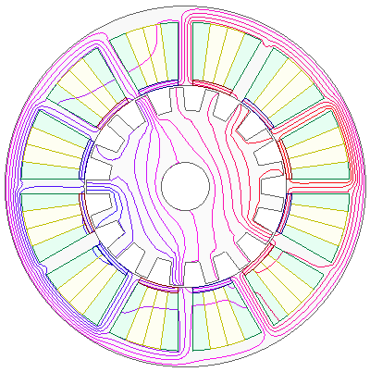 | 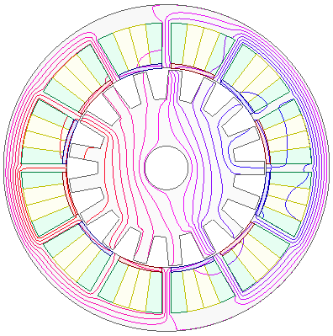
(a) | (b)
Fig. 5.20. On-load open-circuit flux line distribution with . (a) HESSPM 12s17r F1A1. (b) HESSPM 12s17r F1A3.
(a)
(b)
Fig. 5.21. Loci of UMF of 12s17r HSSPMs for different total copper loss P_{Cu} with 𝛾 = 0.5. (a) 12s17r-F1A1 HESSPM. (b) 12s17r-F3A3 HESSPM.

(a)
(b)
Fig. 5.22. Average UMF of 12s17r HSSPMs against different field and armature excitation copper loss. (a) 12s17r-F1A1 HSSPM. (b) 12s17r-F3A3 HSSPM.

    - Losses and Efficiency
The efficiency of the HESSPMs with NOW and OW can be estimated by
(5.17)
where P_{o}, P_{Cu}, P_{Fe} and P_{PM} is the output mechanical power, the total copper loss, the iron loss and the PM eddy current loss, respectively. The stator and rotor core losses P_{Fe} of two HESSPMs are estimated by three parts in the 2D FEA including hysteresis loss , eddy-current loss and excess core loss ,
(5.18)
where k_{h} = 272.13W/m³, k_{c} = 0.18W/m³ and k_{e} = 3.56W/m³ are the hysteresis, eddy-current and excess core loss coefficients, respectively. The coefficients are obtained from multi-frequency dependent loss density (B-P) curves for 0.35mm lamination steel sheets (DW31035). B_{m} is the amplitude of the AC flux component. The PM conductivity is set as 699000S/m for magnet eddy current loss calculation in the 2D FEA. It can be seen that the 12s17r-F3A3 HESSPM suffers from high iron and PM loss than the 12s17r-F1A1. But the HESSPMs with OW have higher machine efficiency at 400rpm than NOW as shown in Table 5.3, which is due to the improvement of output torque/power. The iron loss, PM losses and the resultant efficiency of the HESSPMs are also evaluated under different machine speed as shown in Fig. 5.23. The 12s17r-F3A3 HESSPM shows higher iron and PM losses than the 12s17r-F1A1 HESSPM, which degrade its efficiency in high speed region. The loss and efficiency of 12s17r HESSPMs with NOW and OW at 400rpm are presented in Table 5.3. The efficiency is low for these small machines and the loss is dominated by copper loss. But the 12s17r-F3A3 HESSPM has 51.4% higher efficiency than the 12s17r-F1A1 at 400rpm mainly due to average torque improvement. Since the OW has significantly longer end-winding, it degrades its performance for the machine with short stack length. For the same machine cross-section in 12s17r HESSPM, the end-winding length L_{end} is separately estimated by the empirical coefficient K_{s}, which is 1.35 and 1.25 for F1A1 and F3A3. It is noticeable that the advantage of OW in torque per copper loss is more obvious for machines with long lamination stack length. The end-effect will be reduced and the torque per copper loss will be enhanced with longer stack length for the proposed 12s17r-F3A3 HESSPM as shown in Fig. 5.24. due to the increase of average torque.
Table 5.3 Losses and efficiency of 12s17r HESSPMs at 400rpm.
 | F1A1 | F3A3
Average torque (Nm) | 0.66 | 1.31
Copper loss (W) | 60
Iron loss (W) | 0.25 | 0.59
PM loss (W) | 0.22 | 0.71
Torque per machine volume (Nm/L) | 4.12 | 8.25
Overall efficiency (%) | 31.22 | 47.28

(a)
(b)
(c)
Fig. 5.23. Comparison of machine losses against rotor speed of 12s17r-F1A1 and 12s17r-F3A3 HESSPMs. (a) Iron loss. (b) PM loss. (c) Efficiency.
Fig. 5.24. Average torque/copper loss against lamination active length of 12s17r-F1A1 and 12s17r-F3A3 HESSPMs.
  - Experimental Validation
Two prototype HESSPM machines are manufactured with the identical stator and rotor core diameters in order to evaluate the performance difference between the NOW and OW. The stator slot/rotor pole number combination is selected as 12s17r, which is the same as that in the previous sections. The detailed mechanical parameters are listed in Table 5.4. The winding type in the HESSPM with OW are wounded as F1A3, i.e. the coil-pitch of the field windings is 1 while the armature coil pitches are 3. Without taking the end-winding length of field winding into account, the winding connections of F3A3 and F1A3 will have the same configurations in the HESSPMs. The end-winding lengths between the 12s17r F1A1 and 12s17r F1A3 HESSPMs are compared in Fig. 5.25, which shows the end-winding length in the 12s17r F1A3 HESSPM is 20% longer than that in the 12s17r F1A1. After shrinking the stator cores into the heated housings, the stator components of two HESSPMs are shown in Fig. 5.26 while the rotor parts with shafts are shown in Fig. 5.27. The static torque test platform is shown in Fig. 5.28 by using the method in [ZHU09].
Table 5.4 Design parameters of HESSPM prototypes with NOW and OW.
Machine Topologies | 12s17r F1A1 | 12s17r F1A3
Stator outer radius R_{os} (mm) | 45
Axial length L_{a} (mm) | 25
Air-gap length g (mm) | 0.50
Packing factor | 0.30
Split ratio | 0.55
Stator tooth arc θ_{s} (ºmech) | 8.00
Stator back iron S_{bk} (mm) | 5.00
Rotor tooth arc θ_{R} (ºmech) | 8.00
Rotor back iron R_{bk} (mm) | 13.00
PM N35SH B_{r}/μ_{r} @ 20ºC | 1.2T/1.05
PM volume (cm³) | 6.13
Number of turns per coil (AC/DC) N_{dc}/N_{ac} | 26/26 |  | 20/20

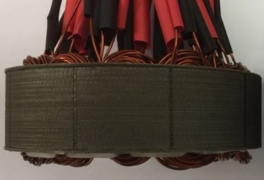 | 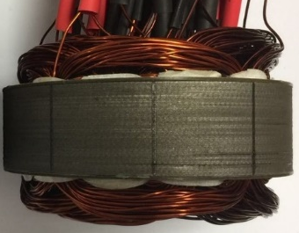
(a) | (b)
Fig. 5.25. Comparison of the end-winding of 12s HESSPM prototype machines. (a) 12s F1A1 HESSPM. (b) 12s F1A3 HESSPM.
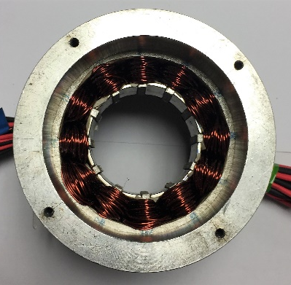 | 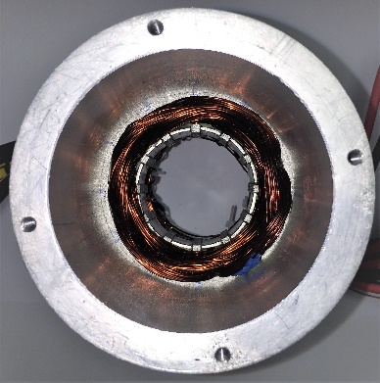
(a) | (b)
Fig. 5.26. Stators of 12s HESSPM prototype machines. (a) 12s F1A1 HESSPM. (b) 12s F1A3 HESSPM.
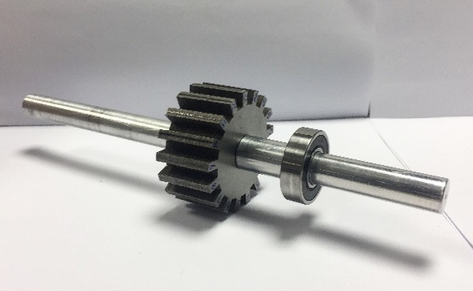 | 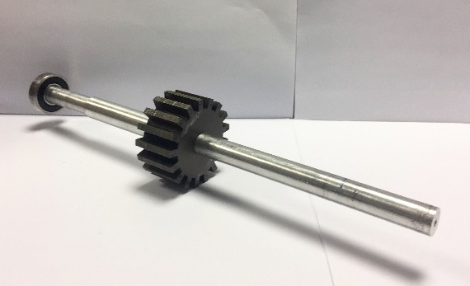
(a) | (b)
Fig. 5.27. Rotors of 12s HESSPM prototype machines. (a) 12s F1A1 HESSPM. (b) 12s F1A3 HESSPM.

Fig. 5.28. Static torque measurement platform.
The measured back-EMF waveforms and the corresponding spectra of the 12s17r-F1A1 and 12s17r-F1A3 HESSPMs at rotor speed of 400rpm with field current excitation of I_{dc} = 8A are shown in Fig. 5.29. The spectra show that the measured fundamental value of the back-EMF in the 12s17r-F1A3 HESSPM is 91.3% larger than that of the 12s17r-F1A1 HESSPM. The effectiveness of the OW can also be observed in Fig. 5.30 when the field current varies. The measured back-EMF waveforms have slightly offset from the 2D FEA predictions, which is 13.8% less for the 12s17r-F1A1 and 9.6% less for the 12s17r-F1A3. This is mainly due to the end-effect and manufacture imperfection in the prototype machines.
(a)
(b)
Fig. 5.29. Phase A back-EMF waveforms of 12s17r-F1A1 and 12s17r-F1A3 HESSPMs at 400rpm with field excitation current I_{dc} = 8A. (a) Waveforms. (b) Spectra.
Fig. 5.30. Fundamental value of phase back-EMF against different DC currents in 12s17r-F1A1 and 12s17r-F1A3 HESSPMs.
The positive cycles of static torque waveforms of HESSPMs with NOW and OW are shown in Fig. 5.31 against different rotor positions. As previously stated in chapter 2, the static torque is measured with the DC current injected in three phase windings as I_{A}= -2I_{B}= -2I_{C.} Since the reluctance torques in the investigated machines are negligible, the peak torque occurs at 90 Elec. Deg. which means zero i_{d} control can be applied to these two machines. Having the HESSPMs operating at BLAC mode with i_{d} =0 control, the phase back-EMF waveforms are in the same phase angle with the phase currents. Therefore, i_{q} component is aligned with torque component in order to achieve the maximum on-load torque. In the static torque measurement here, DC field current excitation I_{dc} = 8A is injected into field winding while three phase armature windings are excited with constant DC source which Q-axis current (RMS) I_{q} = I_{A} = 8A and I_{B} = I_{C} = -4A. The measured peak torque in the 12s17r-F1A3 VFRM (559.1mNm) is 133.95% higher than in 12s17r-F1A1 VFRM (313.5mNm). The torque capabilities of HESSPMs are also measured with different combinations of DC and Q-axis currents, which shows that the 12s17r-F1A3 HESSPM has significant improvement in torque capability under the same current excitation than the 12s17r-F1A1 VFRM in Fig. 5.32.
Fig. 5.31. Comparison of static torque waveforms against rotor positions in 12s17r-F1A1 and 12s17r-F1A3 HESSPMs (I_{d} = 0, I_{dc} = I_{q} = 8A).
(a)
(b)
Fig. 5.32. Peak values of static torque against different q-axis currents for (a) 12s17r-F1A1 HESSPM, (b) 12s17r-F1A3 HESSPM (I_{d} = 0, I_{A} = -2I_{B} = -2I_{C}).
Fig. 5.33(a) and (b) shows the measured results of self- and mutual- inductance variation with respect to different rotor positions of the 12s17r F1A1 and 12s17r F1A3 HESSPMs along with the 2D FEA calculations. The measured results show that the self-inductance is marginally higher than the 2D FEA prediction which is due to the leakage inductance from the end-winding. The mutual-inductance M_{ab} is derived from the measured phase A self-inductance L_{aa}, phase B self-inductance L_{bb} and the series inductance L_{a+b} by equation (3.17). The measured inductance results show small inductance variation in the HESSPMs with 17-pole rotor, which are consistent with the 2D FEA result in section 5.3.3. Comparing the inductance waveforms in Fig. 5.33(a) and (b), it shows the 12s17r F1A3 HESSPM has greater inductance variation than the 12s17r F1A1 HESSPM even with the smaller number of turns per coil. The increase of the inductance value also indicates the increase of the torque performance as discussed in section 5.3.3.
(a)
(b)
Fig. 5.33. FEA predicted and measured inductance waveforms. (a) 12s17r F1A1 HESSPM and (b) 12s17r F1A3 HESSPM.

5.6 Open-Winding Topology
Although the HESSPM is flexible in torque regulation via field and armature winding as shown in Fig. 5.18, one major disadvantage caused by hybrid topology is the space conflict between the field and armature windings within the stator slot, which results in increased copper loss. Although the elimination of the field winding in the doubly salient structure with stator slot PMs will reduce the DC copper loss, the flux-weakening performance is compromised [YAN17a].
One solution is to excite the HESSPM with integrated field and armature current into the single coil [ZHU16c] [ZHA17] as shown in Fig. 5.34. By having two sets of inverter circuits and opening the neutral point of the Y-connected winding as shown in Fig. 3.32, the three phase sinusoidal currents with DC offset component are injected into HESSPM as equation (3.18). With the integrated field and armature current excitation, the cross section of the copper conductors can be doubled while the resistance of windings is reduced to half, and thus, the redundant copper loss is removed.
(a) | (b)
Fig. 5.34. Open-winding topologies of 12-slot HESSPMs. (a) Open-winding in 12s17r HESSPM with coil pitch of 1. (b) Open-winding in 12s17r HESSPM with coil pitch of 3 stator slot pitches.
By varying the ratio of DC offset i_{dc} between RMS value of the AC component i_{q} at the total copper loss of 60W, the optimal ratio is found at 1 which indicates that i_{dc} should be approximately the same as i_{q} for the maximum average torque as shown in Fig. 5.35. The on-load torque waveforms with open-winding topology as well as separated excitation are shown in Fig. 5.36. It shows that the average torque value of the 12s17r HESSPMMs with NOW and OW have increased by 199.6% and 158.9% by employing open-winding topology. The overload capability of HESSPMs with open-winding is revealed in Fig. 5.37. The torque capability of HESSPMMs with open-winding is improved over the calculated copper loss range than that of the separated excitation owing to the reduction of total copper loss.
Fig. 5.35. Variation of DC to AC ratio in integrated field and armature current control.
Fig. 5.36. Comparison of on-load torque waveform of 12s17r HESSPMs at total copper loss of 60W with integrated and separated current excitation.
Fig. 5.37. Comparison of average torque against total copper loss of 12s17r HESSPMs with integrated and separated current excitations.

5.7 Conclusion
In this chapter, overlapping field and armature winding design with the coil pitches of 3 stator slot pitches, i.e. F3A3, is proposed and analyzed for 12s17r HESSPMs. Its inherent fault tolerant capability and high reliability at UCGF of stator slot-PMs is addressed. The variation of fundamental winding factor with NOW and OW under feasible rotor pole numbers are investigated and the influence of torque performance is revealed. Comparing with the 12s17r-F1A1 HESSPM, the 12s17r-F3A3 HESSPM has improved fundamental winding factor and hence torque density. The open-winding topology is introduced in order to further increase the torque density.

General Conclusions and Future Work
This thesis investigates the electromagnetic performance of three machine topologies with doubly salient structure, i.e. VFRMs, SSPMs and HESSPMs, including open-circuit, on-load torque, winding inductance and flux-weakening characteristics. The influence of two different winding layouts, i.e. NOW and OW, are comparatively studied with respective to different rotor pole numbers and the corresponding electromagnetic performance differences are presented by using 2D FEA calculation and experimental validation.

6.1 General Conclusions
Since adjacent stator slot teeth have different magnetic polarities, either by alternating DC excitations or by opposite slot PM excitations, the VFRM, SSPM and HESSPM share the identical armature winding layout under the same stator/rotor pole number combination in both NOW and OW layouts. It makes three machine topologies having a general fundamental winding factor for the same stator/rotor pole number combination as shown in Fig. 6.1. It demonstrates that employing OW in the machines of 12s/(4,5,7,8,16,17,18,19)r leads to higher fundamental winding factors than NOW while NOW has higher fundamental winding factors in 12s/(10,11,13,14)r.
With fundamental winding factors identified against different rotor pole numbers, the on-load torque performance at total copper loss P_{Cu} = 60W under the same space envelope (OD: 90mm, L_{a}: 25mm, and g: 0.5mm) is summarized in Fig. 6.2. Some conclusions can be summarized as follows:
- The fundamental winding factor has positive correlation to the average torque performance, i.e. the higher fundamental winding factor leads to the higher average torque. However, the fundamental winding factor is not the only factor that constrains the torque performance. The effect of magnetic saturation also needs to be taken into account for some stator/rotor pole number combinations. As analyzed in section 3.2, 12s/(10,14)r-F1A1 VFRMs have the highest fundamental winding factor, i.e. k_{w} = 0.93, the corresponding average torque values are similar or slightly lower than the 12s/(10,14)r-F1A1 VFRMs which have k_{w} = 0.87. This is limited by the local saturation in the stator back iron and the stator tooth part in the 12s/(10,14)r-F1A1 VFRMs.
Fig. 6.1. Fundamental winding factor against different rotor pole numbers of investigated VFRMs, SSPMs and HESSPMs with NOW and OW.
- The function of stator slot PMs can be summarized in these aspects as follows
  - Additional excitation source and providing PM torque to increase peak torque, as analyzed in sections 2.3.2 and 4.3.2.
  - Reducing magnetic saturation and improving the over-load performance, as analyzed in sections 2.3.1 and 2.3.2.
  - Having PMs ‘self-protected’ by stator iron and showing fault-tolerant characteristic with negligible back-EMF at high speed in the uncontrolled generator fault as discussed in sections 4.3.1 and 5.3.1.
  - Reducing flux leakage between the stator slots as shown in Fig. 2.4.
  - Working as mechanical slot wedges to stop windings from falling off as shown in Fig. 4.28, Fig. 4.29 and Fig. 5.24.
- The function of DC field winding can be summarized in three aspects as follows
  - Boost peak torque at low-speed as shown in Fig. 2.11.
  - Improve flux-weakening performance by providing additional d-axis current as shown in Fig. 2.16.
  - Improve overall efficiency by on-line regulating different DC currents as shown in Fig. 2.20.
However, DC field winding makes machine structure complicated and limits available stator slot space for armature winding. Therefore, torque density of machines with DC field winding, i.e. VFRM and HESSPM, is degraded. In contrast, average torque performance of the SSPM is most desirable, which is owing to enlarged slot area for armature winding and the assistance of slot PMs. The space conflict of the VFRM and the HESSPM can be solved by using the open-winding topology as investigated in sections 3.5 and 5.5 or by employing partitioned stator topology as reviewed in Chapter 1.
- It is worthwhile to point out that the summary of 2D FEA results in Fig. 6.2 are obtained from the small scale machine specification which are used in Chapters 3, 4 and 5, which are different from the large machine specification used in Chapter 2. For small machines, the optimization condition is under the same total copper loss at low speed and optimization objective is the maximum average torque. This is because the iron loss is negligible at low speed for small machines. The maximum average torque under fixed copper loss is equivalent to the maximum efficiency in the optimization of small machines. The ‘optimal’ set of geometric parameters of each machine topology is only suitable for certain working condition or saturation level and it varies against different optimization conditions. In general, the thermal condition is better and the machines are not easily saturated when the machine outer diameter becomes larger. The effect of slot PMs are more easily and clearly observed in the large machine as shown in Chapter 2.
- By analyzing on-load torque fluctuation at the same copper loss, the plot of torque ripple coefficient shows that the machines with odd pole number have very little torque ripple, which is desirable for smooth operation. The machines with even rotor pole numbers show significantly high torque ripple, in particular for 2- and 4-pole machines.
- The coefficients of ‘average torque divided by fundamental winding factor’ with different rotor pole numbers are shown Fig. 6.2(c), which shows that machines with 12s/(7, 17, 19)r are less sensitive to magnetic saturation and have good potential in torque production. Without the influence of winding factors, the SSPMs with OWs show the best torque performance which indicate good torque capability in SSPMs with small scale machines. However, the torque performance of VFRMs and HESSPMs could be better by adjusting geometric parameters individually since the slot wedge volume/PM is fixed and kept as the same for VFRMs/HESSPMs during the global optimization in section 3.2 and section 4.2.
- The performance characteristics of these three machine topologies are compared in Table 6.1. The potential application of VFRM in electrical vehicles are reported in [RAM16, RAM17], this intuitive overview offers the summary of each machine in order to address its application fields for future development.
Table 6.1 Comparison of three machine topologies with doubly salient structure.
 | VFRM | SSPM |  | HESSPM
Peak torque
Torque ripple
Torque density
Efficiency
Flux-weakening
Fault tolerance
Manufacture cost
Manufacture complexity
--- Good | ---Medium |  | --- Poor

(i) | (ii)
(a)
(b)
(c)
Fig. 6.2. Torque characteristics of investigated VFRMs, SSPMs and HESSPMs against different rotor pole numbers at total copper loss P_{Cu} = 60W. (a) Average torque. (b) Torque ripple. (c) Fundamental winding factor and average torque. (i) Machines with NOW. (ii) Machines with OW.

(a) | (b)
Fig. 6.3. Influence of changing winding layout from NOW to OW against different rotor pole numbers. (a) Fundamental winding factor (the same for three machines, with reference to Fig. 6.1). (b) Average torque (with reference to Fig. 6.2(a) (i) and Fig. 6.2(a) (ii)).
  - Future Work
A. Design optimization for performance improvement
Some design optimization techniques can be applied to the stator slot permanent magnet machines for the performance enhancement, which can be adapted from stator and rotor design.
Since stator slot permanent magnet machines investigated in this thesis adapt open slot design, permanent magnets are placed in the stator slot openings, which may lead to high risk of demagnetization, especially for the PM region exposed in the air-gap [AFI16a] [ULL18]. Therefore, tapered stator teeth can be employed to shift permanent magnets backwards from the air-gap and increase the reliability of permanent magnets from demagnetization. The shape of stator tooth as well as the slot opening ratio should be optimized. For the HESSPM, the influence of field current excitation should also be taken into account for the stator tooth-tip design.
The rotor shaping and stepping techniques can be applied to reluctance rotor in order to mitigate torque ripple, especially for stator slot permanent magnet machines with even rotor pole numbers. The rotor shaping and stepping technique should be detailed investigated to balance the average torque and torque ripple.

B. Stator slot permanent magnet machine with different rotor topologies
The research carried out in this thesis reveals the effectiveness of overlapping armature winding layout to stator slot permanent magnet machines in terms of the torque improvement. As a common feature in doubly salient machines, salient pole reluctance rotor is employed in stator slot PM machines which is regarded as one of the advantages. However, armature winding MMF becomes distributed by using overlapping winding layout and it is advantageous to have equally distributed reluctance/MMF variation in the rotor magnetic circuit. Two different rotor topologies are suggested as follows:
- Similar to synchronous reluctance machine (SynRel) which is also driven by sinewave source, transversally laminated anisotropy (TLA) rotor can be employed in stator slot PM machines with overlapping winding. The optimal stator slot and rotor pole number combination needs to be investigated as well as the optimal barrier layer number for TLA rotor. The performance difference between the non- and salient pole reluctance rotor can be compared and corresponding applications need to be addressed. Furthermore, the TLA rotor can also be designed with PM-assisted type (by Ferrite-assisted or NdFeB-assisted) to enhance the performance.
- Wound field rotor with non-overlapping and overlapping windings. As the most conventional rotor topology, the wound field rotor could also be employed by stator slot PM machines. However, the slip ring and carbon brushes are the essential components for the operation in wound field rotor. The pros and cons by adopting the wound field rotor need to be analyzed. The coil-pitches in the wound field rotor need to be studied with respect to the coil-pitches of stator winding layout in order to achieve the maximum performance.

C. Novel machine topologies
Similar to other doubly salient machines in literature, stator slot permanent magnet machines have great design freedom for different applications. For example, the multi-tooth topology can also be employed with permanent magnets in the stator openings and its performance can be compared with existing stator permanent magnet machines under the same permanent magnet usage. Other feasible machine topologies should be thoroughly investigated in order to achieve the best potential for the stator slot permanent magnet machines. In general, the similarities and differences between the stator permanent magnet machines and other stator permanent magnet machines could be comparatively studied.
Alternate winding design with different PM arrangements could be another interesting research point. For example, the permanent magnets in the slot opening can be magnetized radially. Stator slot permanent magnet machines with radially magnetized magnets can be investigated with different armature and field coil pitches. It is worthwhile to mention that the saturation level needs to be carefully dealt with since the stator tooth is easily saturated at on-load condition.
Rotor modularity can also be extended to stator slot permanent magnet machines with salient pole reluctance rotor in order to reduce rotor weight and losses. By using modular structure in rotor design, the stator/rotor pole number combination needs to be carefully selected.
D. Noise and Vibration
The noise and vibration of stator slot permanent magnet machines can be investigated and systemically compared between three main machine topologies, i.e. VFRM, SSPM and HESSPM. Since stator permanent magnet machines prototyped in this thesis are in reduced scale and rated at low operation speed, the noise and vibration issue is not critical. However, the noise, vibration and harshness (NVH) characteristics are vital for machines with large outer diameter and working at high speed. The NVH characteristics can be predicted and measured for stator slot permanent magnet machines with different winding layouts.
E. Thermal modelling and cooling system design
It is obvious that permanent magnets in the stator slot openings are close to armature winding which is the major heat source on the stator. The permanent magnets are vulnerable to demagnetization risk when exposed to high temperature. It is necessary to build a thermal lumped circuit model to predict the temperature distribution on the stator permanent magnet machine and design the corresponding cooling system to manage heat dissipation issue when machines working at high electric loading.

References
[AFI15] | I. A. A. Afinowi, Z. Q. Zhu, Y. Guan, J. C. Mipo, and P. Farah, "Hybrid-excited doubly salient synchronous machine with permanent magnets between adjacent salient stator poles," IEEE Trans. Magn., vol. 51, no. 10, pp. 1-9, 2015.
[AFI16a] | I. A. A. Afinowi, Z. Q. Zhu, Y. Guan, J. C. Mipo and P. Farah, "Electromagnetic performance of stator slot permanent magnet machines with/without stator tooth-tips and having single/double layer windings," IEEE Trans. on Magn., vol. 52, no. 6, pp. 1-10, June 2016.
[AFI16b] | I. A. A. Afinowi, Z. Q. Zhu, Y. Guan, J. C. Mipo, and P. Farah, "A novel brushless AC doubly salient stator slot permanent magnet machine," IEEE Trans. Energy Convers., vol. 31, no. 1, pp. 283-292, 2016.
[AND14] | P. Andrada, B. Blanqué, E. Martínez and M. Torrent, "A novel type of hybrid reluctance motor drive," IEEE Trans. on Ind. Electron., vol. 61, no. 8, pp. 4337-4345, Aug. 2014.
[BAO17] | J. Bao, B. L. J. Gysen, K. Boynov, J. J. H. Paulides and E. A. Lomonova, "Torque ripple reduction for 12-stator/10-rotor-pole variable flux reluctance machines by rotor skewing or rotor teeth non-uniformity," IEEE Trans. on Magn., vol. 53, no. 11, pp. 1-5, Nov. 2017.
[BIA07] | N. Bianchi, M. Dai Pre, L. Alberti, and E. Fornasiero, “Theory and design of fractional-slot PM machines,” Conf. Rec. IEEE IAS Annu. Meeting, New Orleans, LA, Sep. 23, 2007.
[BOL14] | I. Boldea, L. N. Tutelea, L. Parsa and D. Dorrell, "Automotive electric propulsion systems with reduced or no permanent magnets: an overview," IEEE Trans. Ind. Electron., vol. 61, no. 10, pp. 5696-5711, Oct. 2014.
[BRU08] | A. Bruyere, E. Semail, A. Bouscayrol, F. Locment, J. M. Dubus, and J. C. Mipo, "Modeling and control of a seven-phase claw-pole integrated starter alternator for micro-hybrid automotive applications," IEEE Vehicle Power and Propulsion Conference, Harbin, China, Sep. 2008, pp. 1-6.
[BUJ15] | G. Buja, M. Bertoluzzo and R. K. Keshri, "Torque ripple-free operation of PM BLDC drives with petal-wave current supply," IEEE Trans. Ind. Electron., vol. 62, no. 7, pp. 4034-4043, July 2015
[CAI14] | H. Cai, B. Guan and L. Xu, "Low-cost ferrite PM-assisted synchronous reluctance machine for electric vehicles," IEEE Trans. Ind. Electron., vol. 61, no. 10, pp. 5741-5748, Oct. 2014.
[CAM92] | D. E. Cameron, J. H. Lang and S. D. Umans, "The origin and reduction of acoustic noise in doubly salient variable-reluctance motors," IEEE Trans. on Ind. Appl., vol. 28, no. 6, pp. 1250-1255, Nov.-Dec. 1992.
[CAO12] | W. Cao, B. C. Mecrow, G. J. Atkinson, J. W. Bennett and D. J. Atkinson, "Overview of electric motor technologies used for more electric aircraft (MEA)," IEEE Trans. Ind. Electron., vol. 59, no. 9, pp. 3523-3531, Sept. 2012.
[CHA08] | K. T. Chau, C. C. Chan, and C. H. Liu, “Overview of permanent-magnet brushless drives for electric and hybrid electric vehicles,” IEEE Trans. Ind. Electron., vol. 55, no. 6, pp. 2246–2257, Jun. 2008.
[CHE01] | M. Cheng, K. T. Chau, and C. C. Chan, "Design and analysis of a new doubly salient permanent magnet motor," IEEE Trans. Magn., vol. 37, no. 4, pp. 3012-3020, 2001.
[CHE08] | J. T. Chen, Z. Q. Zhu, and D. Howe, “Stator and rotor pole combinations for multi-tooth flux-switching permanent-magnet brushless ac machines,” IEEE Trans. Magn., vol.44, no.12, pp.4659-4667, Dec. 2008.
[CHE10a] | J.T. Chen, and Z.Q. Zhu, “Winding configurations and optimal stator and rotor pole combination of flux-switching PM brushless AC machines,” IEEE Trans. Energy Convers., vol. 25, no. 2, pp. 293-302, Jun. 2010.
[CHE10b] | J.T. Chen, and Z.Q. Zhu, “Comparison of all- and alternate-poles-wound flux-switching PM machines having different stator and rotor pole numbers,” IEEE Trans. Ind. Appl., vol. 46, no. 4, pp. 1406-1415, Jul./Aug. 2010.
[CHE10c] | J.T. Chen, Z. Q. Zhu, S. Iwasaki and R. Deodhar, "Comparison of losses and efficiency in alternate flux-switching permanent magnet machines," The XIX Int. Conf. on Elec. Mach., Rome, 2010, pp. 1-6.
[CHE10d] | J. T. Chen, Z. Q. Zhu, S. Iwasaki and R. Deodhar, "Low cost flux-switching brushless AC machines," 2010 IEEE Vehicle Power and Propulsion Conference, Lille, 2010, pp. 1-6.
[CHE11a] | J.T. Chen, Z. Q. Zhu, S. Iwasaki and R. P. Deodhar, "A novel hybrid-excited switched-flux brushless AC machine for EV/HEV applications," IEEE Trans. on Veh. Technol., vol. 60, no. 4, pp. 1365-1373, May 2011.
[CHE11b] | M. Cheng, W. Hua, J. Zhang and W. Zhao, "Overview of stator-permanent magnet brushless machines," IEEE Trans. on Ind. Elec., vol. 58, no. 11, pp. 5087-5101, Nov. 2011.
[CHE11c] | J.T. Chen, Z.Q. Zhu, S. Iwasaki, and R. Deodhar, “Influence of slot opening on optimal stator and rotor pole combination and electromagnetic performance of switched-flux PM brushless AC machines,” IEEE Trans. Ind. Appl., vol. 47, no. 4, pp. 1681-1691, Jul./Aug. 2011.
[CHE11d] | J.T. Chen, Z.Q. Zhu, S. Iwasaki, and R. Deodhar, “A novel E-core switched flux PM brushless AC machine,” IEEE Trans. Ind. Appl., vol. 47, no. 3, pp. 1273-1282, May/Jun. 2011.
[CHE14] | Z. Chen, B. Wang, Z. Chen, and Y. Yan, “Comparison of flux regulation ability of the hybrid excitation doubly salient machines,” IEEE Trans Ind. Electron. vol. 61, no. 7, pp. 3155-3166, Jul. 2014.
[CHE90] | S. Chen, Electrical Machine Design. Beijing, China: MI Press, 1990.
[CHU13] | W. Q. Chu and Z. Q. Zhu, "Average torque separation in permanent magnet synchronous machines using frozen permeability," IEEE Trans. on Magn., vol. 49, no. 3, pp. 1202-1210, March 2013.
[CHU15] | W. Q. Chu, Z. Q. Zhu, J. Zhang, X. Liu, D. A. Stone and M. P. Foster, "Investigation on operational envelops and efficiency maps of electrically excited machines for electrical vehicle applications," IEEE Trans. Magn., vol. 51, no. 4, pp. 1-10, April 2015.
[COL96] | R. S. Colby, F. Mottier, and T. J. E. Miller, “Vibration modes and acoustic noise in a four-phase switched reluctance motor,” IEEE Trans. Ind. Appl., vol. 32, no. 6, pp. 1357–1364, Nov./Dec. 1996.
[DEO15] | R. P. Deodhar, A. Pride and J. J. Bremner, "Design method and experimental verification of a novel technique for torque ripple reduction in stator claw-pole pm machines," IEEE Trans. on Ind. Appl., vol. 51, no. 5, pp. 3743-3750, Sept.-Oct. 2015.
[DEO96] | R. P. Deodhar, S. Andersson, I. Boldea, and T. J. E. Miller, “The flux reversal machine: A new brushless doubly-salient permanent-magnet machine,” Conf. Rec. IEEE IAS Annu. Meeting, 1996, pp. 786–793.
[DIN17] | W. Ding, S. Yang, Y. Hu, S. Li, T. Wang and Z. Yin, "Design consideration and evaluation of a 12/8 high-torque modular-stator hybrid excitation switched reluctance machine for EV applications," IEEE Trans. on Ind. Electron., vol. 64, no. 12, pp. 9221-9232, Dec. 2017.
[DU16] | Y. Du, F. Xiao, W. Hua, X. Zhu, M. Cheng, L. Quan and K. T. Chau, "Comparison of flux-switching PM motors with different winding configurations using magnetic gearing principle," IEEE Trans. on Magn., vol. 52, no. 5, pp. 1-8, May 2016.
[EVA15] | D. J. Evans and Z. Q. Zhu, "Novel partitioned stator switched flux permanent magnet machines," IEEE Trans. on Magn., vol. 51, no. 1, pp. 1-14, Jan. 2015.
[FAS14] | A. Fasolo, L. Alberti and N. Bianchi, "Performance comparison between switching-flux and IPM machines with rare-earth and ferrite PMs," IEEE Trans. on Ind. Appl., vol. 50, no. 6, pp. 3708-3716, Nov.-Dec. 2014.
[FEI09] | W. Fei and P. C. K. Luk, "An improved model for the back-emf and cogging torque characteristics of a novel axial flux permanent magnet synchronous machine with a segmental laminated stator," IEEE Trans. on Magn, vol. 45, no. 10, pp. 4609-4612, Oct. 2009.
[FUK08] | T. Fukami, M. Momiyama, K. Shima, R. Hanaoka and S. Takata, "Steady-state analysis of a dual-winding reluctance generator with a multiple-barrier rotor," IEEE Trans. on Energy Convers. vol. 23, no. 2, pp. 492-498, June 2008.
[FUK10] | T. Fukami, T. Hayamizu, Y. Matsui, K. Shima, R. Hanaoka and S. Takata, "Steady-state analysis of a permanent-magnet-assisted salient-pole synchronous generator," IEEE Trans. on Energy Conver., vol. 25, no. 2, pp. 388-393, June 2010.
[GAO16] | Y. Gao, R. Qu, D. Li, J. Li, and G. Zhou, “Consequent-pole flux-reversal permanent-magnet machine for electric vehicle propulsion,” IEEE Trans. Appl. Supercond., vol. 26, no. 4, pp. 1-5, Jun. 2016.
[GAU14] | B. Gaussens, E. Hoang, M. Lecrivain, P. Manfe, and M. Gabsi, “A hybrid excited flux-switching machine for high-speed DC-alternator applications,” IEEE Trans. on Ind. Elec., vol. 61, no.6, pp. 2976-2989, 2014.
[GIE10] | J. F. Gieras, Permanent Magnet Motor Technology - Design and Applications, 3rd ed. CRC Press, 2010.
[GUP60a] | A. K. D. Gupta, "Analytical method to find the best number of stator and rotor teeth of inductor alternator for 3-phase sinusoidal voltage generation," Transactions of the American Institute of Electrical Engineers. Part III: Power Apparatus and Systems, vol. 79, no. 3, pp. 674-678, April 1960.
[GUP60b] | A. K. D. Gupta, "Mathematical analysis of inductor alternators," Transactions of the American Institute of Electrical Engineers. Part III: Power Apparatus and Systems, vol. 79, no. 3, pp. 684-689, April 1960.
[HEN10] | J. R. Hendershot and T. J. E. Miller, Design of Brushless Permanent-Magnet Machines. Motor Design Books LLC, 2010.
[HOA07] | E. Hoang, M. Lecrivain, and M. Gabsi, “A new structure of a switching flux synchronous polyphased machine with hybrid excitation,” Proc. Eur. Conf. Power Electronics and Applications, 2007, pp. 1–8.
[HOA97] | E. Hoang, H. Ahmed, and J. Lucidarme, “Switching flux permanent magnet poly-phased synchronous machines,” 7th Eur. Conf. Power Electron. Applicat. (EPE), Trondheim, Norway, 1997, vol. 3, pp. 903-908.
[HUA08] | W. Hua, M. Cheng, Z.Q. Zhu, and D. Howe, “Analysis and optimization of back EMF waveform of a flux-switching permanent magnet motor,” IEEE Trans. Energy Convers., vol. 23, no. 3, pp. 727-733, Sep. 2008.
[HUA09] | W. Hua, M. Cheng and G. Zhang, "A novel hybrid excitation flux-switching motor for hybrid vehicles," IEEE Trans. on Magn., vol. 45, no. 10, pp. 4728-4731, Oct. 2009.
[HUA17a] | L. R. Huang, Z. Q. Zhu, J. H. Feng, S. Y. Guo, J. X. Shi and W. Q. Chu, "Analysis of stator/rotor pole combinations in variable flux reluctance machines using magnetic gearing effect," IEEE Energy Conversion Congress and Exposition, Cincinnati, OH, 2017, pp. 3187-3194.
[HUA17b] | L. R. Huang, J. H. Feng, S. Y. Guo, J. X. Shi, W. Q. Chu and Z. Q. Zhu, "Analysis of torque production in variable flux reluctance machines," IEEE Trans. on Energy Convers., vol. 32, no. 4, pp. 1297-1308, Dec. 2017.
[HUA18a] | L. R. Huang, J. H. Feng, S. Y. Guo, J. X. Shi, W. Q. Chu and Z. Q. Zhu, "Fast design method of variable flux reluctance machines," CES Trans. on Elect. Mach. and Sys., vol. 2, no. 1, pp. 152-159, Mar. 2018.
[HUA18b] | L. R. Huang, Z. Q. Zhu, J. H. Feng, S. Y. Guo and J. X. Shi, "Comparative analysis of variable flux reluctance machines with double- and single-layer concentrated armature windings," 13th International Conference on Ecological Vehicles and Renewable Energies, Monte-Carlo, 2018, pp. 1-8.
[HUA18c] | W. Hua, X. Zhu and Z. Wu, "Influence of coil pitch and stator-slot/rotor-pole combination on back emf harmonics in flux-reversal permanent magnet machines," IEEE Trans. on Energy Convers., vol. 33, no. 3, pp. 1330-1341, Sept. 2018.
[HUA18d] | H. Hua and Z. Q. Zhu, "Novel partitioned stator hybrid excited machines with magnets on slot-openings," Int. Conf. Power Electric Machines and Drives, Liverpool, UK, April 2018.
[ISH06] | D. Ishak, Z. Q. Zhu, and D. Howe, “Comparison of PM brushless motors, having either all teeth or alternate teeth wound,” IEEE Trans. Energy Convers., vol. 21, no. 1, pp. 95–103, Mar. 2006.
[ISH95] | A. Ishizaki, T. Tanaka, K. Takasaki and S. Nishikata, "Theory and optimum design of PM Vernier motor," 1995 Seventh International Conference on Electrical Machines and Drives (Conf. Publ. No. 412), Durham, UK, 1995, pp. 208-212.
[JAH86] | T. M. Jahns, G. B. Kliman, and T. W. Neumann, “Interior permanentmagnet synchronous motors for adjustable-speed drives,” IEEE Trans.Ind. Appl., vol. IA-22, no. 4, pp. 738–747, Jul. 1986.
[JAH99] | T. M. Jahns and V. Caliskan, "Uncontrolled generator operation of interior PM synchronous machines following high-speed inverter shutdown," IEEE Trans. on Ind. Appl., vol. 35, no. 6, pp. 1347-1357, Nov.-Dec. 1999.
[JIA17] | S. Jia, R. Qu, J. Li, D. Li and H. Lu, "Design considerations of stator dc-winding excited Vernier reluctance machines based on the magnetic gear effect," IEEE Trans. on Ind. Appl., vol. 53, no. 2, pp. 1028-1037, March-April 2017.
[KAT16] | Y. Kataoka, M. Takayama, Y. Matsushima and Y. Anazawa, "Design of high torque PM vernier motor,"19th Int. Conf. on Elec. Mach. and Sys., Chiba, 2016, pp. 1-6.
[KRI17] | A. Krings, M. Cossale, A. Tenconi, J. Soulard, A. Cavagnino and A. Boglietti, "Magnetic materials used in electrical machines: a comparison and selection guide for early machine design," IEEE Industry Applications Magazine, vol. 23, no. 6, pp. 21-28, Nov.-Dec. 2017.
[LEE08] | K. Lee, D. Kim, B. Kim and B. Kwon, "A novel starting method of the surface permanent-magnet BLDC motors without position sensor for reciprocating compressor," IEEE Trans. on Ind. Appl., vol. 44, no. 1, pp. 85-92, Jan.-Feb. 2008.
[LEO96] | F. Leonardi, T. Matsuo, Y. Li, T. A. Lipo and P. McCleer, "Design considerations and test results for a doubly salient PM motor with flux control," IAS '96. Conf. Rec. of Ind. Appl. Conf., San Diego, CA, USA, 1996, pp. 458-463 vol.1.
[LI16] | D. Li, R. Qu, J. Li, W. Xu and L. Wu, "Synthesis of flux switching permanent magnet machines," IEEE Trans. on Energy Convers., vol. 31, no. 1, pp. 106-117, March 2016.
[LI18a] | H. Li and Z. Q. Zhu, "Influence of adjacent teeth magnet polarities on performance of flux reversal permanent magnet machine," IEEE Trans. on Ind. Appl., vol. 55, no. 1, pp. 354-365, Jan.-Feb. 2019.
[LI18b] | H. Y. Li and Z. Q. Zhu, "Analysis of flux-reversal permanent-magnet machines with different consequent-pole PM topologies," IEEE Trans. on Magn., vol. 54, no. 11, pp. 1-5, Nov. 2018.
[LI95a] | Y. Li and T. A. Lipo, "A doubly salient permanent magnet motor capable of field weakening," Power Electronics Specialist Conference, Atlanta, GA, USA, pp. 565-571 vol.1.
[LI95b] | S. H. Y. Li, F. Liang, Y. Zhao and T. A. Lipo, "A doubly salient doubly excited variable reluctance motor," IEEE Trans. on Ind. Appl., vol. 31, no. 1, pp. 99-106, January-February 1995.
[LIA92] | Y. Liao, F. Liang and T. A. Lipo, "A novel permanent magnet motor with doubly salient structure," Conf. Rec. of IEEE Ind. Appl. Soc. Annual Meeting, Houston, TX, USA, 1992, pp. 308-314 vol.1.
[LIA95] | Y. Liao, F. Liang and T. A. Lipo, “A novel permanent magnet motor with doubly salient structure,” IEEE Trans. Ind. Appl., vol. 31, no. 5, pp. 1069-1078, Sep./Oct. 1995.
[LIA96] | Y. Liao, L. Xu, and L. Zhen, “Design of a doubly fed reluctance motor for adjustable-speed drives,” IEEE Trans. Ind. Appl., vol.32, no.5, pp.1195-1203, 1996.
[LIU12] | X. Liu, Z. Q. Zhu, M. Hasegawa, A, Pride, and R. Deodhar, “Vibration and noise in novel variable flux reluctance machine with DC-field coil in stator,” Proc. Int. Conf. Power Electron. Motion Control, Jun. 2012, pp.1100-1107.
[LIU13a] | X. Liu and Z. Q. Zhu, "Comparative study of novel variable flux reluctance machines with doubly fed doubly salient machines," IEEE Trans. on Magn., vol. 49, no. 7, pp. 3838-3841, July 2013.
[LIU13b] | X. Liu and Z. Q. Zhu, "Electromagnetic performance of novel variable flux reluctance machines with DC-field coil in stator," IEEE Trans. on Magn., vol. 49, no. 6, pp. 3020-3028, June 2013.
[LIU14a] | X. Liu, Z. Q. Zhu and D. Wu, "Evaluation of efficiency optimized variable flux reluctance machine for EVs/HEVs by comparing with interior PM machine," Int. Conf. on Elect. Mach. and Sys., Hangzhou, 2014, pp. 2648-2654.
[LIU14b] | X. Liu and Z. Q. Zhu, "Stator/rotor pole combinations and winding configurations of variable flux reluctance machines," IEEE Trans. on Ind. Appl., vol. 50, no. 6, pp. 3675-3684, Nov.-Dec. 2014.
[LON05] | S. A. Long, Z. Q. Zhu and D. Howe, “Effectiveness of active noise and vibration cancellation for switched reluctance machines operating under alternative control strategies,” IEEE Trans. Energy Convers., vol. 20, no. 4, pp. 792-801, Dec. 2005.
[MA16] | X. Y. Ma, G. J. Li, G. W. Jewell, Z. Q. Zhu and H. L. Zhan, "Performance comparison of doubly salient reluctance machine topologies supplied by sinewave currents," IEEE Trans. on Ind. Electron., vol. 63, no. 7, pp. 4086-4096, July 2016.
[MAE16] | Y. Maeda, T. Kosaka and N. Matsui, "Design study on hybrid excitation flux switching motor with permanent magnet placed at middle of field coil slot for HEV drives," Int. Conf. on Elec. Mach., Lausanne, 2016, pp. 2522-2528.
[MAI87] | A. Mailfert, H. Kubler, and J. Zhou, “Hybrid stepping motors comparative experimental results,” Proc. Int. Conf. on Elec. Mach., no. 1, pp. 781-783, 1987.
[MEC93] | B. C. Mecrow, "Fully pitched-winding switched-reluctance and stepping-motor arrangements," IEE Proceedings B - Electric Power Appl., vol. 140, no. 1, pp. 61-70, Jan. 1993.
[MOH03] | N. Mohan, T. M. Undeland and W. P. Robbins, Power Electronics: Converters, Applications, and Design. John Wiley & Sons, Inc. 2003, pp. 485 -487.
[MON03] | G. Montague, G. Brown, C. Morrison, A. Provenza, A. Kascak and A. Palazzolo, “High-temperature switched-reluctance electric motor,” NASA Tech Briefs, Feb. 2003.
[NAK07] | Kenji Nakamura, Kohei Murota and Osamu Ichinokura, "Characteristics of a novel switched reluctance motor having permanent magnets between the stator pole-tips," European Conference on Power Electronics and Applications, Aalborg, 2007, pp. 1-5.
[OJO97] | O. Ojo and Z. Wu, "Synchronous operation of a dual-winding reluctance generator," IEEE Trans. on Energy Convers., vol. 12, no. 4, pp. 357-362, Dec. 1997.
[OKA11] | Oka Ridge National Library, "Evaluation of the 2010 Toyota Prius Hybrid Synergy Drive System", 2011.
[OKA17] | Y. Okada, T. Kosaka and N. Matsui, "Windage loss reduction for hybrid excitation flux switching motors based on rotor structure design," Int. Elec. Mach. and Drives Conf., Miami, FL, 2017, pp. 1-8.
[OWE09] | R. L. Owen, Z. Q. Zhu and G. W. Jewell, "Hybrid excited flux-switching permanent magnet machines," 13th Euro. Conf. on Power Elec. and Appl., Barcelona, 2009, pp. 1-10.
[OWE10a] | R. Owen, Z.Q. Zhu, and G. Jewell, “Hybrid-excited flux-switching permanent magnet machines with iron flux bridges,” IEEE Trans. Magn., vol. 46, no. 6, pp. 1726-1729, Jun. 2010.
[OWE10b] | R. Owen, Z.Q. Zhu, A. Thomas, G. Jewell, and D. Howe, “Alternate poles wound flux-switching permanent-magnet brushless AC machines,” IEEE Trans. Ind. Appl., vol. 46, no. 2, pp. 790-797, Mar./Apr. 2010.
[OWE11] | R. Owen, Z.Q. Zhu, J. Wang, D. Stone, and I. Urquhart, “Review of variable flux permanent magnet machines,” Proc. Int. Conf. on Elec. Mach. and Sys., 20-23 August, 2011, Beijing, China, pp. 1-6.
[RAD89] | T. A．Radomski Alternating current generator: U.S. Patent: 4959577 [P]. 1989．
[RAM16] | T. Raminosoa, D. A. Torrey, A. M. El-Refaie, K. Grace, D. Pan, S. Grubic, K. Bodla and K. Huh, "Sinusoidal reluctance machine with DC winding: an attractive non-permanent-magnet option," IEEE Trans. on Ind. Appl., vol. 52, no. 3, pp. 2129-2137, May-June 2016.
[RAM17] | T. Raminosoa, A. M. El-Refaie, D. A. Torrey, K. Grace, D. Pan, S. Grubic, K. Bodla and K. Huh, "Test results for a high temperature non-permanent-magnet traction motor," IEEE Trans. on Ind. Appl., vol. 53, no. 4, pp. 3496-3504, July-Aug. 2017.
[RAU55] | S. E. Rauch and L. J. Johnson, "Design principles of flux-switch alternators [includes discussion]," Transactions of the American Institute of Electrical Engineers. Part III: Power Apparatus and Systems, vol. 74, no. 3, pp. 1261-1268, Jan. 1955.
[REF10] | A. M. EL-Refaie, "Fractional-slot concentrated-windings synchronous permanent magnet machines: opportunities and challenges," IEEE Trans. on Ind. Elec., vol. 57, no. 1, pp. 107-121, Jan. 2010.
[SAG84] | M. Sagawa, S. Fujimura, N. Togawa, H. Yamamoto, and Y. Matsuura, "New material for permanent magnets on a base of Nd and Fe (invited)". Journal of Applied Physics, 1984.
[SAR94] | B. Sarlioglu, Y. F. Zhao, and T. A. Lipo, "A novel doubly salient single phase permanent magnet generator," Industry Applications Society Annual Meeting, pp. 9-15 vol.1, 1994.
[SCI06] | I. Scian, D. G. Dorrell, and P. J. Holik, “Assessment of losses in a brushless doubly-fed reluctance machine,” IEEE Trans. Magn., vol.42, no.10, pp.3425-3427, 2006.
[SHA17] | L. Shao, W. Hua, Z. Q. Zhu, X. Zhu, M. Cheng and Z. Wu, "A novel flux-switching permanent magnet machine with overlapping windings," IEEE Trans. on Energy Convers., vol. 32, no. 1, pp. 172-183, March 2017.
[SHI14a] | J. T. Shi, Z. Q. Zhu, D. Wu and X. Liu, "Influence of flux focusing on electromagnetic torque of novel biased flux PM machines," Int. Conf. on Elect. Mach., Berlin, 2014, pp. 523-529.
[SHI14b] | J. T. Shi, Z. Q. Zhu, D. Wu and X. Liu, "Comparative study of novel biased flux permanent magnet machine with doubly salient permanent magnet machine," Int. Conf. on Elec. Mach. and Sys. (ICEMS’14), pp.415-420, 22-25 Oct. 2014.
[SHU16] | A. L. Shuraiji; Z. Q. Zhu; Q. F. Lu, "Comparative study of different doubly salient PM tubular machine topologies," 8th IET Int. Conf. on Power Elec., Mach. and Drives (PEMD’16), pp.1-6, 19-21 April 2016
[SIK15] | C. Sikder, I. Husain, and W. Ouyang, “Cogging torque reduction in flux switching permanent-magnet machines by rotor pole shaping,” IEEE Trans. Ind. Appl., vol. 51, no. 5, pp. 3609-3619, Sep./Oct. 2015.
[SOO01] | W. L. Soong, N. Ertugrul, E. C. Lovelace and T. M. Jahns, "Investigation of interior permanent magnet offset-coupled automotive integrated starter/alternator," Rec. 2001 IEEE Ind. Appl. Soc. Annual Meeting, Chicago, vol.1, Oct, 2001, pp. 429-436.
[SOO14] | W. L. Soong, and T. J. E. Miller, “Field-weakening performance of brushless synchronous AC motor drive,” IEE Proc. Elect. Power Appl., vol. 141, no. 6, pp. 331-340, 1994.
[STA17a] | Statistics Portal. (2017, Nov. 21). Neodymium oxide price worldwide from 2009 to 2025 [Online]. Available: URL https://www.statista.com/statistics/450152/global-reo-neodymium-oxide-price-forecast/
[STA17b] | D. Staton and J. Goss, "Open source electric motor models for commercial EV and hybrid traction motors," CWIEME’17, Berlin.
[STR17] | T. D. Strous, H. Polinder and J. A. Ferreira, "Brushless doubly-fed induction machines for wind turbines: developments and research challenges," IET Electr. Power Appl., vol. 11, no. 6, pp. 991-1000, Jul. 2017.
[SUL10] | E. Sulaiman, T. Kosaka, Y. Tsujimori and N. Matsui, "Design of 12-slot 10-pole permanent magnet flux-switching machine with hybrid excitation for hybrid electric vehicle," 5th IET Int. Conf. on Power Ele., Mach. and Drives (PEMD’10), Brighton, UK, 2010, pp. 1-5.
[SUL11] | E. Sulaiman, T. Kosaka and N. Matsui, "High power density design of 6-Slot–8-pole hybrid excitation flux switching machine for hybrid electric vehicles," IEEE Trans. on Magn., vol. 47, no. 10, pp. 4453-4456, Oct. 2011.
[TAB06] | S. Tabi, A. Tounzi and F. Piriou, "Study of a stator current excited Vernier reluctance machine," IEEE Trans. on Energy Convers., vol. 21, no. 4, pp. 823-831, Dec. 2006.
[TAR17] | P. Taras, G. Li and Z. Q. Zhu, "Comparative study of fault-tolerant switched-flux permanent-magnet machines," IEEE Trans. Ind. Electron., vol. 64, no. 3, pp. 1939-1948, March 2017.
[THO12] | A. S. Thomas, Z. Q. Zhu and L. J. Wu, "Novel modular-rotor switched-flux permanent magnet machines," IEEE Trans. on Ind. Appl., vol. 48, no. 6, pp. 2249-2258, Nov.-Dec. 2012.
[ULL16] | S. Ullah, S. P. McDonald, R. Martin and G. J. Atkinson, "A permanent magnet assisted switched reluctance machine for more electric aircraft," Int. Conf. on Elec. Mach. (ICEM’16), Lausanne, 2016, pp. 79-85.
[ULL18] | S. Ullah, S. McDonald, R. Martin, M. Benarous and G. Atkinson, "A permanent magnet assist, segmented rotor, switched reluctance drive for fault tolerant aerospace applications," IEEE Trans. on Ind. Appl., vol. 55, no. 1, pp. 298-305, Jan.-Feb. 2019.
[WAN10] | J. Wang, D. Howe and Z. Lin, "Design optimization of short-stroke single-phase tubular permanent-magnet motor for refrigeration applications," IEEE Trans. on Ind. Elec., vol. 57, no. 1, pp. 327-334, Jan. 2010.
[WAN99] | C. Wang, S. A. Nasar and I. Boldea, "Three-phase flux reversal machine (FRM)," IEE Proceedings - Electric Power Applications, vol. 146, no. 2, pp. 139-146, March 1999.
[WU10] | L. J. Wu, Z. Q. Zhu, J. T. Chen and Z. P. Xia, "An analytical model of unbalanced magnetic force in fractional-slot surface-mounted permanent magnet machines," IEEE Trans. on Magn., vol. 46, no. 7, pp. 2686-2700, July 2010.
[WU14] | D. Wu, J. T. Shi, Z. Q. Zhu and X. Liu, "Electromagnetic performance of novel synchronous machines with permanent magnets in stator yoke," IEEE Trans. on Magn., vol. 50, no. 9, pp. 1-9, Sept. 2014.
[WU15] | Z. Z. Wu, Z. Q. Zhu and J. T. Shi, "Novel doubly salient permanent magnet machines with partitioned stator and iron pieces rotor," IEEE Trans. on Magn., vol. 51, no. 5, pp. 1-12, May 2015.
[WU16] | Z. Z. Wu, Z. Q. Zhu and H. L. Zhan, "Comparative analysis of partitioned stator flux reversal pm machines having fractional-slot nonoverlapping and integer-slot overlapping windings," IEEE Trans. on Energy Convers., vol. 31, no. 2, pp. 776-788, June 2016.
[WU17] | F. Wu, P. Zheng and T. M. Jahns, "Analytical modeling of inter-turn short circuit for multiphase fault-tolerant pm machines with fractional-slot concentrated windings," IEEE Trans. Ind. Appl., Feb., 2017.
[WU95] | C. Y. Wu and C. Pollock, “Analysis and reduction of acoustic noise in the switched reluctance drive,” IEEE Trans. Ind. Appl., vol. 31, no. 1, pp. 91–98, Jan./Feb. 1995.
[WU96] | X. Wu, S. Haramura, and J. Ueda, “Development of switched reluctance motor for electric vehicle - acoustic noise reduction,” Proc. Drives and Controls Conf., 1996, pp. 1–5.
[XU14] | L. Xu, W. Zhao, J. Ji, G. Liu, Y. Du, Z. Fang, and L. Mo, "Design and analysis of a new linear hybrid excited flux reversal motor with inset permanent magnets," IEEE Trans. on Magn., vol. 50, no. 11, pp. 1-4, Nov. 2014.
[XU91] | L. Xu, X. Xu, T. A. Lipo and D. W. Novotny, "Vector control of a synchronous reluctance motor including saturation and iron loss," IEEE Trans. on Ind. Appl., vol. 27, no. 5, pp. 977-985, Sept.-Oct. 1991.
[YAM10] | K. Yamazaki, Kei Ando, Kazuyoshi Nishioka, K. Shima, T. Fukami and Keisuke Shirai, "Assist effects of additional permanent magnets in salient-pole synchronous generators," The XIX Int. Conf. on Elec. Mach. Rome, 2010, pp. 1-6.
[YAN16] | H. Yang, H. Lin, Z. Q. Zhu, D. Wang, S. Fang and Y. Huang, "A variable-flux hybrid-PM switched-flux memory machine for EV/HEV applications," IEEE Trans. on Ind. Appl., vol. 52, no. 3, pp. 2203-2214, May-June 2016.
[YAN17a] | H. Yang, Z. Q. Zhu, Y. Liu, H. Y. Li and J. C. Mipo, "Comparative study of doubly salient machines with/without stator slot permanent magnets," IEEE Int. Elect. Mach. Drives Conf. (IEMDC’17), Miami, 2017, pp. 1-6.
[YAN17b] | H. Yang, H. Lin, Z. Q. Zhu, H. Wang, S. Fang and Y. Huang, "A novel flux-reversal hybrid magnet memory machine," Energy Convers. Cong. and Expo., Cincinnati, OH, 2017, pp. 5853-5860.
[ZHA11] | G. Zhang, M. Cheng, W. Hua and J. Dong, "Analysis of the oversaturated effect in hybrid excited flux-switching machines," IEEE Trans. on Magn., vol. 47, no. 10, pp. 2827-2830, Oct. 2011.
[ZHA14] | G. Zhang, W. Hua, M. Cheng, J. Liao, J. Zhang and W. Jiang, "Investigation of on-loaded performances of hybrid-excitation flux-switching brushless machines for HEV/EV applications," Energy Conversion Congress and Exposition, Pittsburgh, PA, 2014, pp. 328-335.
[ZHA17] | H. Zhan, Z. Q. Zhu and M. Odavic, "Analysis and suppression of zero sequence circulating current in open winding PMSM drives with common DC bus," IEEE Trans. on Ind. Appl., vol. 53, no. 4, pp. 3609-3620, July-Aug. 2017.
[ZHO14] | Y. J. Zhou and Z. Q. Zhu, "Comparison of low-cost single-phase wound-field switched-flux machines," IEEE Trans. Ind. Appl., vol. 50, no. 5, pp. 3335-3345, Sept.-Oct. 2014.
[ZHU00] | Z. Q. Zhu and D. Howe, "Influence of design parameters on cogging torque in permanent magnet machines," IEEE Trans. on Energy Convers., vol. 15, no. 4, pp. 407-412, Dec 2000.
[ZHU07a] | Z. Q. Zhu and D. Howe, "Electrical machines and drives for electric,hybrid and fuel cell vehicles," Proc. IEEE, vol. 95, no. 4, pp. 746–765, Apr. 2007.
[ZHU07b] | X. Zhu, M. Cheng, W. Zhao, C. Liu, and K.T. Chau, “Transient cosimulation approach to performance analysis of hybrid excited doubly salient machine consideration indirect field-circuit coupling,” IEEE Trans. Magn., vol. 43, no. 6, pp. 2558-2560, Jun. 2007.
[ZHU07c] | Z.Q. Zhu, D. Ishak, D. Howe, and J.T. Chen, “Unbalanced magnetic force in permanent-magnetic brushless machines with diametrically asymmetric phase winding,” IEEE Trans. on Ind. Appl., vol. 43, no. 6, pp. 1544- 1553, Nov./Dec. 2007.
[ZHU08] | Z. Q. Zhu and C. C. Chan, "Electrical machine topologies and technologies for electric, hybrid, and fuel cell vehicles," Proc. IEEE VPPC Conf., Harbin, 2008, pp. 1-6.
[ZHU09] | Z. Q. Zhu, "A simple method for measuring cogging torque in permanent magnet machines," 2009 IEEE Power & Energy Society General Meeting, Calgary, AB, 2009, pp. 1-4
[ZHU10] | Z.Q. Zhu and J.T. Chen, “Advanced flux-switching permanent magnet brushless machines,” IEEE Trans. Magn., vol. 46, no. 6, pp. 1447-1453, Jun. 2010.
[ZHU11] | Z. Q. Zhu, “Switched flux permanent magnet machines – innovation continues”, Proc. Int. Conf. Electr. Mach. Sys., 2011, Beijing, Chapter Keynote Speech-06, pp. 1-10.
[ZHU14] | Z. Q. Zhu, and D. J. Evans, “Overview of recent advances in innovative electrical machines-with particular reference to magnetically geared switched flux machines,” Proc. Int. Conf. Electr. Mach. Sys., keynote speech Hangzhou, China, Oct. 22-25, pp. 1-10.
[ZHU15a] | Z.Q. Zhu and Y. J. Zhou, "Recent development in stator wound field synchronous machines," Journal of Electrical Engineering, vol. 10, no. 4 Apr. 2015.
[ZHU15b] | Z. Q. Zhu, B. Lee and X. Liu, "Integrated field and armature current control strategy for variable flux reluctance machine using open winding," IEEE Trans. on Ind. Appl., vol. 52, no. 2, pp. 1519-1529, March-April 2016.
[ZHU15c] | S. Zhu, M. Cheng, W. Hua, X. Cai, and M. Tong, “Finite element analysis of flux-switching PM machine considering oversaturation and irreversible demagnetization”, IEEE Trans. Magn., vol. 51, no. 11, pp. 7403404, Nov. 2015.
[ZHU15d] | Z. Q. Zhu and X. Liu, "Novel stator electrically field excited synchronous machines without rare-earth magnet," IEEE Trans. Magn., vol. 51, no. 4, pp. 1-9, 2015.
[ZHU16a] | Z. Q. Zhu, I. A. A. Afinowi, Y. Guan, J. C. Mipo and P. Farah, "Hybrid-excited stator slot permanent magnet machines - influence of stator and rotor pole combinations," IEEE Trans on Magn., vol. 52, no. 2, pp. 1-10, Feb. 2016.
[ZHU16b] | Z. Q. Zhu, Z. Z. Wu and X. Liu, "A partitioned stator variable flux reluctance machine," IEEE Trans. on Energy Convers., vol. 31, no. 1, pp. 78-92, March 2016.
[ZHU16c] | Z. Q. Zhu, B. Lee and X. Liu, "Integrated field and armature current control strategy for variable flux reluctance machine using open winding," IEEE Trans. on Ind. Appl., vol. 52, no. 2, pp. 1519-1529, March-April 2016.
[ZHU18a] | Z. Q. Zhu, "Overview of novel magnetically geared machines with partitioned stators," IET Electric Power Applications, vol. 12, no. 5, pp. 595-604, May 2018.
[ZHU18b] | Z. Q. Zhu, N. Pothi and Y. Ren, "Uncontrolled generator fault protection of novel hybrid-excited permanent magnet machines utilizing field excitation current control," Int. Conf. Elect. Mach. (ICEM18’), Alexandroupolis, 2018.
[ZHU18c] | X. Zhu and W. Hua, "Stator-slot/rotor-pole pair combinations of flux-reversal permanent magnet machine," IEEE Trans. on Ind. Elec., Early Access.
[ZUL10] | A. Zulu, B. C. Mecrow, and M. Armstrong, "A wound-field three-phase flux-switching synchronous motor with all excitation sources on the stator," IEEE Trans. Ind. Appl., vol. 46, no. 6, pp. 2363–2371, Nov./Dec. 2010.

Appendix A: Inductance Calculation by Frozen Permeability Method
The inductance characteristics of VFRMs, SSPMs and HESSPMs are investigated by self-, mutual, D-/Q-axis and DC self-, DC-AC mutual-inductances. The inductance parameters, , ,,,, and are phase A armature self-inductance, phase AB armature mutual inductance, D- and Q-axis inductances, DC self- and DC-AC mutual-inductance, which can be obtained by the frozen permeability (FP) method in 2D FEA by JMAG as follows:
(C.1)
(C.2)
(C.3)
(C.4)
(C.5)
(C.6)
where , , , and are phase flux linkage, D-/Q- axis flux linkage, the DC flux linkage, phase current and D-/Q- axis current, respectively. The procedure of calculating the inductance value us shown in Fig. C.1.
Fig. C.1. Procedures of calculation of inductance characteristics by using frozen permeability (FP) method.

Appendix B: Calculation of Torque Speed Curve
The torque speed curves in this thesis are calculated with following procedure. The torque and voltage are obtained directly from the flux linkage and d-/q-axis current components as
(C.7)
(C.8)
where T is the electromagnetic torque, p is the number of pole pairs, V_{a} is the phase voltage, R is the phase resistance, and ω is the electrical angular speed.
The maximum phase voltage V_{max} can be estimated from the inverter DC bus voltage when pulse-width modulation is used
(C.9)
The flux linkage table is obtained from the 2D FEA calculation with respect to three phase armature current excitation in d/q reference frame as
(C.10)
(C.11)
(C.12)
For HESSPM and VFRM with DC field excitation, the DC current excitation is kept as a constant as the maximum inverter current as given by the specification in Table 2.1.

Appendix C: Publications
Conference papers:
[C1] | H. Yang, Z. Q. Zhu, Y. Liu, H. Y. Li and J. C. Mipo, "Comparative study of doubly salient machines with/without stator slot permanent magnets," 2017 IEEE International Electric Machines and Drives Conference (IEMDC), Miami, FL, 2017, pp. 1-6.
[C2] | Z. Q. Zhu, H. Yang, S. Cai, H. Y. Li, Y. Liu, J.C. Mipo and S. Personnaz, "Hybrid excited stator slot PM machines with overlapping windings," 2018 XIII International Conference on Electrical Machines (ICEM), Alexandroupoli, 2018, pp. 2185-2191.
[C3] | H. Yang, Z. Q. Zhu, S. Cai, H. Y. Li, Y. Liu, J.C. Mipo and S. Personnaz, "Performance comparison of stator slot permanent magnet machines with non-overlapping and overlapping windings," 2018 XIII International Conference on Electrical Machines (ICEM), Alexandroupoli, 2018, pp. 2283-2289.

