A SIMPLE MODEL FOR DISTRICT HEATING FEASIBILITY

Ian Brocklebank, Meng

Department of Chemical and Biological Engineering

The University of Sheffield

Project Supervisors

Professor P Styring

Professor S.B.M Beck

Robin Idle, HJ Enthoven and Sons

A thesis submitted to the University of Sheffield for the degree of Doctor of Philosophy

December 2018

Summary
District heating accounts for only 2% of the total UK heat demand, which is partially due to the need for local authorities to employ costly engineering consultancies in the design process. A simple model that a non-technical user at a local authority could operate, to assess the feasibility of any district heating network would allow for future networks to be assessed.
The aim of this work was to build a simple model for district heating feasibility, that could be operated by a non-technical user for multiple locations in the UK. The model was split into six stages, which were represented by the six experimental chapters in this thesis. The six stages were initial heat mapping; a quantification of both the waste heat available before and after recovery; modelling of the heat demand in the local area; optimisation of the network using thermal energy storage; and economic and environmental assessments of the network. To evaluate the success of the model each stage needed to be assessed. The assessment considered the accuracy of the methodology, the ability of a non-technical user to operate the model, and the applicability of using the same model in different locations. The model was used to assess the feasibility of a possible new district heating network based in Darley Dale, England, using HJ Enthoven as a case study.
The heat mapping, heat demand modelling, and optimisation stages of the overall feasibility model were shown to be both accurate and simple enough for a non-technical individual to use. A heat mapping methodology was generated that showed a 14% correlation to the UK combined heat and power development map. A heat demand model was created based on industrial regression-based archetype techniques. Monte Carlo simulations were used to assess the sensitivity of the heat demand model. Based on the results of the simulations, the data collection process was modified to manually measure building sizes. A district heating optimisation model was generated based on mixed integer linear programming models for optimisation, that were found in a variety of journal papers. The optimisation process was used to develop standard rules that could be applied to multiple district heating networks. It was shown that the generic models for the quantification of the waste heat available from the industrial source and the waste heat recovery were more complicated than a non-technical user would be capable of using. The quantification model was changed to be based on an assessment from the involved industrial partners and the waste heat recovery model was changed to be based around an assumption of 60% efficient recovery.
It was shown that only minor modifications of a variable maximum distance between the heat source and customers were needed to be made to the feasibility model to allow the same methodology to be used in different locations. The heat demand model was changed by not counting domestic buildings in the data collection stage of the model in rural locations.
The case study district heating network was shown to be profitable, with a net present value of £3.13 million after a 40-year lifespan. The network was shown to be environmentally better than natural gas heating, saving 19,300 tonnes CO₂e per annum. The heat demand variation of the network was 2.63 – 8.99 MW, which was supplied by 0.228 – 3.29 MW of industrial waste heat. The heat supply and demand were balanced using the thermal inertia of the pipe network of the network as thermal energy storage and a gas burner.

Acknowledgements
I would firstly like to thank Professors Peter Styring and Stephen Beck in their roles as my primary and secondary supervisors. They have provided the overall direction for this thesis and vital guidance throughout. In particular I would like to thank Peter for his contacts and help with finding an industrial sponsor, without which this PhD would not have been possible.
Next, I would like to thank HJ Enthoven and Sons, in particular Robin Idle, for their roles of industrial sponsor and industrial supervisor respectively. HJ Enthoven provided clear and viable objectives that vastly improved the feasibility of this thesis. In addition, HJ Enthoven provided primary data which was the basis for the models produced throughout. To Robin, I would like to thank him for all the advice I received when I was floundering, particularly when I was trying to model the Enthoven process.
I would like to thank the Energy Storage CDT, in particular Sharon Brown, without whom my PhD would not be possible or funded. In particular, the first year of training that they provided into energy storage and its applications has greatly increased my knowledge of environmental engineering. Sharon Brown was particularly adept at being aware of significant problems that were occurring in my work, offering timely and intelligent solutions to said problems.
I would like to acknowledge the Engineering and Physical Sciences Research Council for funding my thesis under the Centre for Doctoral Training in Energy Storage and its Applications (EP/L016818/1).
In addition, I would like to thank all of the students with whom I have shared office space and communicated with over the course of my work. The students were available to provide me with motivation, help when I was stuck and a sympathetic ear when I needed it.
Finally, I would like to thank my family, my girlfriend and my friends for keeping me happy and motivated throughout the four years of my study.

Contents
1 Introduction 21
1.1 District Heating 22
1.2 Research Objectives 24
1.3 Layout of the Thesis 24
1.4 Case Study and HJ Enthoven 25
2 Literature Review 27
2.1 Introduction 27
2.2 District Heating Technologies 27
2.2.1 The District Heating System 27
2.2.2 Thermal Energy Generating Units 27
2.2.2.1 Boilers 27
2.2.2.2 Combined Heat and Power 28
2.2.2.3 Heat Pumps 28
2.2.3 Thermal Energy Sources 28
2.2.3.1 Waste Heat Recovery 28
2.2.3.2 Waste to Energy 28
2.2.3.3 Fossil Fuels 29
2.2.3.4 Renewable Fuels and Biomass 29
2.2.3.5 Nuclear 29
2.2.4 Thermal Energy Storage 30
2.2.4.1 Hot Water Tank Thermal Energy Storage 30
2.2.4.2 Chemical Energy Storage 30
2.2.4.3 Phase Change Materials 31
2.2.4.4 Borehole Thermal Energy Storage 31
2.2.4.5 Pit Thermal Energy Storage 31
2.2.4.6 Aquifer Thermal Energy Storage 31
2.3 Waste Heat Recovery 32
2.3.1 Waste Heat Characterisation 32
2.3.2 Waste Heat Recovery Technologies 32
2.3.2.1 Heat Exchangers 32
2.3.2.2 Heat Pumps 33
2.3.2.3 Organic Rankine Cycles 33
2.3.2.4 Kalina Cycles 34
2.3.2.5 Thermoelectric Generation 34
2.3.2.6 Waste Heat Recovery Technology Summary 34
2.3.3 Waste Heat Recovery Modelling 36
2.3.4 Waste Heat Recovery and District Heating Examples 37
2.3.5 Problems with Waste Heat Recovery 38
2.4 Heat Mapping 39
2.4.1 Heat Mapping Methodologies 39
2.4.2 Heat Demand Calculation Methodologies 40
2.4.3 Data Sources Used for Heat Demand Calculations 42
2.5 Modelling District Heating Networks 42
2.5.1 Component Modelling of District Heating Networks 42
2.5.1.1 Historical Models 43
2.5.1.2 Splitting the Heat Demand into Components 45
2.5.1.3 Deterministic Models 46
2.5.1.4 Predictive Time Series Models 46
2.5.2 Holistic Modelling of District Heating Networks 49
2.5.2.1 Black Box Models 49
2.5.2.2 Statistical Models 49
2.5.2.3 Physical Models 49
2.5.3 District Heating Network Optimisation 50
2.5.3.1 Technologies for District Heating Optimisation 50
2.5.3.2 Optimisation Modelling Techniques 54
2.5.4 Issues with Current Modelling Procedure 56
2.6 Economic and Environmental Assessments of District Heating 56
2.6.1 Techno-Economic Assessments of District Heating 56
2.6.2 Environmental Assessments of District Heating Networks 59
2.7 UK and European District Heating Markets 61
2.7.1 UK District Heating Market 61
2.7.2 UK District Heating Related Legislation 63
2.7.3 UK Government Carbon Reduction Plans 64
2.7.4 EU District Heating Market 65
2.7.5 EU District Heating Market Legislation 65
2.7.6 EU Government Carbon Reduction Plans 65
2.8 The Future for District Heating 66
2.8.1 District Heating as a System 66
2.8.2 Reducing Supply Temperature 66
2.8.3 Changing the Pipe Network 67
2.9 Rural District Heating 67
2.10 District Heating as a Sociotechnical Process 68
2.10.1 Financial Viability of District Heating 68
2.10.2 The Role of Actors 69
2.10.3 District Heating as a Sociotechnical Process in the UK 69
2.11 Lead Acid Batteries 70
2.11.1 HJ Enthoven 70
2.11.2 Lead Acid Battery Market 70
2.11.3 Lead Acid Battery Recycling 70
2.11.4 Lead Acid Batteries Legislation 71
2.12 Conclusion 71
3 Heat Mapping 74
3.1 Methodology 74
3.1.1 Commercial Heat Mapping Methodology 74
3.1.2 Domestic Heat Mapping Methodology 77
3.2 Results 77
3.2.1 Commercial Heat Mapping 78
3.2.2 Domestic Heat Mapping 82
3.2.3 Heat Mapping Validation 85
3.3 Conclusion 88
4 Waste Heat Supply Quantification 90
4.1 Methodology 90
4.1.1 Generic Methodology 90
4.1.2 Case Study Methodology 92
4.2 Results 93
4.3 Conclusion 98
5 Waste Heat Recovery Modelling 100
5.1 Methodology 100
5.1.1 Waste Heat Recovery Equipment 100
5.1.1.1 Double Pipe Heat Exchanger 100
5.1.1.2 Shell and Tube Heat Exchanger 102
5.1.1.3 Finned Tube Heat Exchanger 102
5.1.1.4 Plate Heat Exchanger 102
5.1.1.5 Fired Heater 103
5.1.1.6 Organic Rankine Cycle 104
5.1.1.7 Boiler 105
5.1.1.8 Condenser 105
5.1.1.9 Pump 106
5.1.1.10 Turbine 107
5.1.1.11 Rankine Cycle and Corresponding Components 108
5.1.2 Costs 108
5.1.3 Keeping the Model Simple in Structure 109
5.2 Results 111
5.2.1 Case Study Results 111
5.2.2 Waste Heat Recovery Model Validation 114
5.3 Conclusion 117
6 Heat Demand Modelling 118
6.1 Methodology 118
6.2 Case Studies 122
6.2.1 Case Study 1 – Darley Dale, England 122
6.2.2 Case Study 2 – Sheffield, England 122
6.2.3 Case Study 3 – Hayange, France 123
6.3 Results and Discussion 123
6.3.1 Assessing the Model in Different Population Areas 123
6.3.2 Validating the Heat Demand Model 127
6.4 Conclusions 135
7 District Heating Network Optimisation Using Thermal Energy Storage 137
7.1 Methodology 137
7.1.1 Hot Water Tank Methodology 138
7.1.2 Building Thermal Inertia Methodology 139
7.1.3 Network Thermal Inertia Methodology 140
7.2 Case Study and Scenarios 142
7.3 Results 143
7.3.1 Case Study Results 144
7.3.2 Lessons for Future DH Optimisation Work 152
7.3.3 Validation Study 157
7.4 Conclusions 158
8 Techno-Economic and Environmental Assessments 160
8.1 Methodology 160
8.1.1 Techno-Economic Assessment Methodology 160
8.1.2 Environmental Assessment Methodology 162
8.2 Results 163
8.2.1 Techno-Economic Assessment Results 163
8.2.2 Environmental Assessment Results 165
8.2.3 Sensitivity Analysis 165
8.2.3.1 Techno-Economic Sensitivity Analysis 166
8.2.3.2 Environmental Sensitivity Analysis 167
8.3 Conclusion 168
9 Discussion 169
9.1 Is the Simple Feasibility Model of a District Heating Network Accurate? 170
9.1.1 Is the Heat Mapping Methodology Accurate? 170
9.1.2 Is the Quantification of the Industrial Heat Supply Variation Accurate? 171
9.1.3 Is the Waste Heat Recovery Model Accurate? 172
9.1.4 Is the Heat Demand Model Accurate? 172
9.1.5 Is the District Heating Optimisation Model Accurate? 173
9.1.6 Are the Techno-Economic and Environmental Models Accurate? 173
9.2 Can the Feasibility Model be Applied to multiple District Heating Networks in the UK? 174
9.2.1 Can the Heat Mapping Methodology be Applied to multiple District Heating Networks in the UK? 174
9.2.2 Can the Heat Demand Model be Applied to multiple District Heating Networks in the UK? 175
9.2.3 Can the District Heating Optimisation Model be Applied to multiple District Heating Networks in the UK? 175
9.2.4 Can the Techno-Economic and Environmental Assessment Models be Applied to multiple District Heating Networks in the UK? 176
9.3 Is the Case Study District Heating Network Feasible? 176
10 Conclusions 178
10.1 Is the Simple Feasibility Model of multiple District Heating Networks Accurate? 178
10.2 Can the Feasibility Model be Applied to multiple District Heating Networks in the UK? 180
10.3 Is the Case Study District Heating Network Feasible? 181
11 Future Work 182
11.1 Including More Thermal Energy Generating Options 182
11.2 Considering More than One Heat Source in the District Heating Network 182
11.3 Using Different Pipe Diameters and Pump Sizes in the District Heating Network 183
11.4 Expanding the District Heating Optimisation Model 183
11.5 Running a Validation Study for the District Heating Optimisation Model 184
11.6 More Detailed Techno-Economic and Environmental Assessment Models 184
11.7 Using the Overall Feasibility Model for More than One Case Study 185
12 References 186
13 Appendix 205
13.1 Summary of Customers in the Heat Mapping Process 205
13.2 Assumptions Made in the HJ Enthoven Energy Balance 210
13.3 Double Pipe Heat Exchanger Equations 212
13.4 Shell and Tube Heat Exchanger Equations 219
13.5 Finned Tube Heat Exchanger Equations 220
13.6 Plate Heat Exchanger Equations 222
13.7 Fired Heater and Boiler Equations 228
13.8 Rankine Cycle or Organic Rankine Cycle Equations 234
13.9 Condenser Equations 237
13.10 Pump Equations 241
13.11 Turbine Equations 243
13.12 Visual Basic Code Used in the Waste Heat Recovery Monte Carlo Simulation 244

Table of Figures
Figure 1.1: Worldwide effects of climate change (IPCC, 2014). 21
Figure 1.2: Variation of heat and electricity demands in the UK (Wilson et al., 2013). 22
Figure 2.1: Waste management hierarchy (Porteous, 2005). 28
Figure 2.2: Map of geothermal resources available in Europe (Antics and Sanner, 2007). 29
Figure 2.3: Stratified layers in a HWT, adapted from (Schütz et al., 2015). 30
Figure 2.4: The operating cycle of a heat pump (O’Rielly and Jeswiet, 2015). 33
Figure 2.5: Suggested operating schedule of a DHN supplied by industrial WHR and other heat sources (Fang et al., 2015). 39
Figure 2.6: Cost of heat provision by technology, using current market conditions (£/MWh) (Davies and Woods, 2009). 62
Figure 3.1: The locations of the two heat sources, seven possible locations to be mapped, and suggested network route in the case study area (GEOFABRIK, 2017). 78
Figure 3.2: The large commercial heat customers and their average power demand, which can act as the possible anchor loads, in the case study area (GEOFABRIK, 2017). 79
Figure 3.3: Large heat users in Bakewell and their average power demand (GEOFABRIK, 2017). 80
Figure 3.4: Large heat users in Darley Dale and their average power demand (GEOFABRIK, 2017). 81
Figure 3.5: Large heat users in Matlock and their average power demand (GEOFABRIK, 2017). 81
Figure 3.6: Population and HD densities in the case study area (ONS, 2011b; GEOFABRIK, 2017). 82
Figure 3.7: Population and HD densities of Bakewell (ONS, 2011b; GEOFABRIK, 2017). 83
Figure 3.8: Population and HD densities of Darley Dale (ONS, 2011b; GEOFABRIK, 2017). 84
Figure 3.9: Population and HD densities of Matlock (ONS, 2011b; GEOFABRIK, 2017). 84
Figure 3.10a: The UK CHP development heat map produced for the case study area (DECC, 2011). Figure 3.10b, The heat map produced in the thesis (ONS, 2011b; GEOFABRIK, 2017). 86
Figure 4.1: Gas inflow to the reverberatory furnace for a year of operation. 93
Figure 4.2: Results of the mass and energy balances over the cooling water loop from the reverberatory furnace, to generate x MW of heat at the exit of the post combustion chamber (PCC), the conditioning tower (CT), and the fabric filter (FF). 94
Figure 4.3: Results of the mass and energy balances over the main flue gas treatment process from the reverberatory furnace, to generate x MW of heat at the exit of the post combustion chamber (PCC), the conditioning tower (CT), and the fabric filter (FF). 95
Figure 4.4: Variation in the power levels available from the flue gas treatment process during a ‘standard’ week of HJE operation. 96
Figure 4.5: Variation in the flowrates from the flue gas treatment process during a ‘standard’ week of HJE operation. 96
Figure 4.6: Variation in the temperatures available from the flue gas treatment process during a ‘standard’ week of HJE operation. 97
Figure 5.1: Operating cycle of a traditional RC (Tufts University, 2003). 105
Figure 5.2: Initial CAPEX of the different WHR technologies. 112
Figure 5.3: (a) Total costs of the different WHR technologies after one year of operation. (b) CAPEX and total costs (sum of the CAPEX, OPEX and profits) of the different WHR technologies after one year of operation, note, negative total costs show that revenue is being generated. 112
Figure 5.4: (a) Total costs of the different WHR technologies after three years of operation. (b) CAPEX and total costs (sum of the CAPEX, OPEX and profits) of the different WHR technologies after three years of operation, note, negative total costs show that revenue is being generated 113
Figure 5.5: (a) Total costs of the different WHR technologies after ten years of operation. (b) CAPEX and total costs (sum of the CAPEX, OPEX and profits) of the different WHR technologies after 10 years of operation, note, negative total costs show that revenue is being generated 113
Figure 5.6: Levels of WH that is possible to recover using the FH as the WHR technology. 114
Figure 5.7: Variation in the WH available at the case study site, the levels of WH that was calculated to be recoverable in the case study, and the levels of WH that would be recoverable with an assumed efficiency of WHR of 60%. 116
Figure 6.1: The node-, subnode-, square-structure used in the model. 120
Figure 6.2: (a) The hourly HD profiles generated using case study 1: Darley Dale, England, with a maximum allowable heat loss in the pipes of 40%. (b) The hourly HD profiles generated using case study 2: Sheffield, England, with a maximum allowable heat loss in the pipes of 7%. (c) The hourly HD profiles generated using case study 3: Hayange, France, with a maximum allowable heat loss in the pipes of 45%. 124
Figure 6.3: The size and locations of the heat source (in red) and customers (in black), showing the clusters of heat customers (in black rings) in each case study area. (a) GIS map showing the heat source and customers in case study 1: Darley, England. (b) GIS map showing the heat source and customers in case study 2: Sheffield, England. (c) GIS map showing the heat source and customers in case study 3: Hayange, France (GEOFABRIK, 2017). 127
Figure 6.4: (a) The change in mean and standard deviation with an increasing number of simulations. (b) The percentage change in the standard deviation from trial to trial with an increasing number of simulations. 129
Figure 6.5: Results of the MC simulations for the assumptions in the model, after 1,000 simulations. The mean result, the 50th percentile, is shown with a black line. The range of percentiles to the extremes of the 5th and the 95th are denoted by the colour bands. (a) Results of the MC simulations for the assumption (1) of each building in an archetype category having the same, assumed size. (b) Results of the MC simulations for the assumption (2) of each building in an archetype category having the same, assumed HD profile. (c) Results of the MC simulations for the assumption (3) that the pipe network travels in the shortest possible straight-line distance. 130
Figure 6.6: Input and output uncertainty for the MC simulations, showing the assumptions of (1) the standard building sizes, (2) the standard HD profiles and (3) the straight-line network route. 131
Figure 6.7: The distribution of the HDs found by the MC simulations of the assumption (2), standard HD profiles, compared against the distribution of HD variations found in the literature, which were used as inputs into the MC simulations. 132
Figure 6.8: (a) Results of the global MC Simulations for the assumptions of (2), the standard HD profiles, and (3), the straight-line network route, after 1,000 simulations. The mean result, the 50th percentile, is shown with a black line. The range of percentiles to the extremes of the 5th and the 95th are denoted by the colour bands. (b) The distribution of the HD from the global and individual MC simulations as well as the distributions of HD and network route length as found in the literature. 133
Figure 6.9: A comparison of the two techniques for modelling the HD in a local area, comparing the original technique, with assumed building sizes, and the refined technique, with the measured building sizes using Google Maps. 134
Figure 6.10: The distribution of the HD from the new global and individual MC simulations as well as the distributions of HD and network route length, as found in the literature. 135
Figure 7.1: The heat supply from the WHR source (only) and the heat demand variation in the case study area. 142
Figure 7.2: Example of a standard week of operation for the five scenarios, showing the variations in the power supply (full red line) and demand (full blue line) on the DHN, the power level needed for the back-up burner (full green line), and the power supply to the customer (the sum of the power levels of the supply (dashed grey line), the burner (full green line), and TES (full and dashed black lines)) as well as the energy levels in the TES system(s). (a) Example of a standard week of operation for the reference scenario with no TES. (b) Example of a standard week of operation for scenario 1), with the single 3.6 MWh HWT. (c) Example of a standard week of operation for scenario 2), with the pair of 1.8 MWh HWTs. 145
Figure 7.3: The length and number of times that each TES scenario is charged to over 1 MWh. 148
Figure 7.4: (a) The RDMLVs of the different TES scenarios required use of the back-up burner. (b) The RWMLVs of the different TES scenarios required use of the back-up burner. 149
Figure 7.5: The heat supplies and demands for the new DH optimisation calculations. 152
Figure 8.1: Pump CAPEX (Loh et al., 2002). 161
Figure 8.2: Sensitivity analysis of the techno-economic assessment. 166
Figure 8.3: Sensitivity analysis of the environmental assessment. 167
Figure 13.1: Basic design of an ORC or RC. 234

Table of Tables
Table 1.1: Societal, community, and individual benefits of DH. 23
Table 2.1: WHR technology to use for each grade of WH (US DOE, 2008). 35
Table 2.2: Operating temperatures of standard industrial processes, split into industries (Brückner et al., 2015). 35
Table 2.3: Standard exhaust gas temperatures of various industrial processes (Brückner et al., 2015). 36
Table 2.4: Summary of archetype building models found in literature. 41
Table 2.5: Simulation software used in the deterministic modelling of DH. 46
Table 2.6: Ideal size of the HWT based TES depending on the size of the CHP unit. 54
Table 2.7: Breakdown of DHN costs (DECC, 2015a). 57
Table 2.8: TE use in the UK in 2013, split by sector and usage (DECC, 2014a). 61
Table 2.9: Size and average number of customers connected to UK DHNs (DECC, 2013b). 62
Table 2.10: Key UK DH, CHP, and WHR related legislation. 63
Table 3.1: CIBSE building energy benchmark categories (CIBSE, 2008). 75
Table 3.2: EIA electricity and fossil fuel building energy consumption by end use (EIA, 2016). 76
Table 3.3: Summary of the UK ERC heating power variation study (UK ERC, 2006). 77
Table 3.4: Energy and power demands of the large heat users in the case study area. 79
Table 3.5: Population, energy, and power density conversion. 82
Table 3.6: Total HD in the case study area, as found by the UK CHP development map (accessed in 2019) (DECC, 2011). 87
Table 3.7: Total HD in the case study area, as found using the methodology outlined in the thesis. 87
Table 4.1: Standard operating periods of the HJE operation. 93
Table 5.1: Inputs needed for the modelling of a HEX-DP. 101
Table 5.2: Inputs needed for the modelling of a HEX-FT. 102
Table 5.3: Inputs needed for the modelling of a HEX-P. 103
Table 5.4: Inputs needed for the modelling of a FH. 104
Table 5.5: Inputs needed for the modelling of an ORC. 105
Table 5.6: Inputs needed for the modelling of condensers. 106
Table 5.7: Inputs needed for the modelling of a pump. 107
Table 5.8: Inputs needed for the modelling of a turbine. 107
Table 5.9: Input and output costs of the WHR technologies. 109
Table 5.10: Continuous and discrete inputs that can be chosen from a list. 110
Table 5.11: Discrete that are to be hidden from the user, dependent, and fluid dependent inputs. 111
Table 6.1: The four heating seasons in a year. 119
Table 6.2: Buildings used in each case study model. 125
Table 6.3: Probability distribution details for the HD model assumptions. 129
Table 6.4: Input and output uncertainty for the MC simulations, showing the assumptions of (1) the standard building sizes, (2) the standard HD profiles and (3) the straight-line network route. 131
Table 7.1: The parameters used in the work for the scenarios 1) and 2), the HWT based options. 143
Table 7.2: The parameters used in the work for scenario 3), the building TES. 143
Table 7.3: The parameters used in the study for scenario 4), the network TES. 143
Table 7.4: The average storage levels for each of the TES scenarios and the number times that each scenario reaches a range of levels of SOC. 147
Table 7.5: Economic and environmental analysis of the TES scenarios. 150
Table 7.6: Important parameters for the new DH optimisation calculations. 153
Table 7.7: Economic and environmental analysis of the TES scenarios with an increase of the original heat supply by a factor of 1.25 and a ratio of peak supply maxima to demand maxima of 1:2.18. 153
Table 7.8: Economic and environmental analysis of the TES scenarios with an increase of the original heat supply by a factor of 1.5 and a ratio of peak supply maxima to demand maxima of 1:1.82. 154
Table 7.9: Economic and environmental analysis of the TES scenarios with an increase of the original heat supply by a factor of 1.75 and a ratio of peak supply maxima to demand maxima of 1:1.56. 154
Table 7.10: Economic and environmental analysis of the TES scenarios with an increase of the original heat supply by a factor of 2 and a ratio of peak supply maxima to demand maxima of 1:1.37. 155
Table 7.11: Economic and environmental analysis of the TES scenarios with an increase of the original heat supply by a factor of 3 and a ratio of peak supply maxima to demand maxima of 1:0.91. 155
Table 8.1: Annual boiler maintenance costs (Parsons Brinckerhoff, 2011). 161
Table 8.2: Cost of the pipe network (Raine, 2016). 161
Table 8.3: Emissions associated with the construction and installation of DH pipes (Fröling et al., 2004; Fröling and Svanström, 2005). 162
Table 8.4: CAPEX, OPEX, maintenance costs, and revenues of the DHN. 163
Table 8.5: Parameters used in the techno-economic assessment. 163
Table 8.6: Results of the techno-economic assessment. 164
Table 8.7: Summary of the results of the techno-economic assessment. 165
Table 8.8: Yearly and initial CO₂e emissions and savings for each component of the DHN. 165
Table 8.9: Results of the environmental assessment. 165
Table 9.1: HD variation in each of the heating season. 177
Table 13.1: Large heat users in Matlock. 205
Table 13.2: Large heat users in Rowsley. 206
Table 13.3: Large heat users in Darley Dale. 207
Table 13.4: Large heat users in Bakewell. 208
Table 13.5: Large heat users in Youlgreave. 208
Table 13.6: Large heat users in Matlock Bath. 209
Table 13.7: HJE as a heat user. 210
Table 13.8: How the equations in the modelling of the HEX-DP are linked. Inputs in bold are outputs from other equations in the modelling of the DP-HEX. 219
Table 13.9: How the equations in the modelling of the HEX-ST are linked. Inputs in bold are outputs from other equations in the modelling of the HEX-ST, input in grey come from the modelling of the other WHR components. 220
Table 13.10: How the equations in the modelling of the HEX-FT are linked. Inputs in bold are outputs from other equations in the modelling of the HEX-FT, input in grey come from the modelling of the other WHR components. 222
Table 13.11: How the equations in the modelling of the HEX-P are linked. Inputs in bold are outputs from other equations in the modelling of the HEX-P, input in grey come from the modelling of the other WHR components. 228
Table 13.12: How the equations in the modelling of a FH or a burner are linked. Inputs in bold are outputs from other equations in the modelling of the HEX-FT. 234
Table 13.13: How the equations in the modelling of a RC or an ORC are linked. Inputs in bold are outputs from other equations in the modelling of a RC or an ORC. 237
Table 13.14: How the equations in the modelling of the condenser are linked. Inputs in bold are outputs from other equations in the modelling of the WHR equipment, input in grey come from the modelling of the other WHR components. 241
Table 13.15: How the equations in the modelling of the pump are linked. Inputs in bold are outputs from other equations in the modelling of the pump. 242
Table 13.16: How the equations in the modelling of the turbine are linked. Inputs in bold are outputs from other equations in the modelling of the turbine. 243

Publications, Presentations and Awards
Through the course of my thesis, I have produced many outputs outside the thesis. These include publications accepted in the following journals:
- A simple approach to modelling rural and urban district heating (2018) – published in Frontiers in Energy Research – Energy Systems and Policy.
- Heat mapping for district heating (2018) – published in Energy Procedia.
- Building a simple model for district heating optimisation using thermal energy storage – awaiting publication in Energy and Buildings.
Presentations at the following conferences:
- A simple model for district heating feasibility – presented at the 3rd Annual Conference in Energy Storage and its Applications.
- Building a model to assess the feasibility of rural district heating networks – presented at the 2nd Annual Conference in Energy Storage and its Applications.
Awards for:
- Best presentation for Session 2 at the 3rd Annual Conference in Energy Storage and its Applications.
- Most innovative PhD at the 3rd Annual Conference in Energy Storage and its Applications.

Nomenclature
$A$ Area [m²]
${cost}_{El}$ Electricity costs [£/kWh]
${cost}_{Op}$ Operating costs [£/s]
$c_{p}$ Specific heat capacity [kJ/(kgK)]
$D$ Diameter [m]
$f$ Radiation factor
$F$ Exchange factor
$F_{t}$ Temperature correction factor
$g$ Force due to gravity [m/s²]
$G$ Mass velocity [kg/(sm²)]
$h$ Coefficient [W/(m²°C)]
$H$ Enthalpy [kJ/s]
$H_{t}$ Heat transfer constant
$he$ Pump head [m]
$j$ Friction factor
$k$ Thermal conductivity [W/(m°C)]
$K$ Heat transfer coefficient
$K_{1}$ Constant
$l$ Spacing [m]
$L$ Length [m]
$\dot{m}$ Mass flowrate [kg/s]
$Mr$ Molecular weight [kg/mol]
$N$ Number
$N_{d}$ Degrees of freedom
$N_{r}$ Number of design relationships
$Nu$ Nusselt number
$N_{v}$ Number of possible variables in a design problem
$n_{1}$ Constant
$p$ Pitch [m]
$∆P$ Pressure drop [kPa]
$P$ Power demand [MW]
$P_{A}$ Power demand per unit area [MW/m²]
$P_{L}$ Heat loss [MW]
$Pr$ Prandtl number
$q$ Heat content [kJ/hr]
$Q$ Energy demand [MWh]
$q_{F}$ Heat flux [kJ/(m²s)]
$Q_{F}$ Volumetric flowrate [m³/s]
$R$ Dimensionless temperature factor
$Re$ Reynolds number
$s$ Entropy [kJ/(kgK)]
$S$ Dimensionless temperature factor
$t$ Time [s]
$T$ Temperature [°C]
$T_{dd}$ Monthly degree day [°C/hr]
$\text{TDF}$ Temperature dependent factor
$TSR$ Theoretical steam rate [kg/kWh]
$U$ Heat transfer coefficient [MW/(m²K)]
$v$ Velocity [m/s]
$V$ Volume [m³]
$\dot{V}$ Volumetric flow [m³/(m²s)]
$VR$ Velocity ratio
$w$ Work [kJ/kg]
$W$ Width
$x$ Mass fraction
$y_{t}$ A calculation parameter

Greek Letters
$α$ Constant
$β$ Constant
$∆$ Change
$η$ Efficiency [%]
$ρ$ Density [kg/m³]
$μ$ Viscosity [Pas]
$Γ$ Vertical tube loading [kg/(sm)]

Subscripts and Superscripts
$a$ Compound, a
$amb$ Ambient
$As$ Assumed
$atm$ Atmospheric
$avg$ Average
$b$ Building category, b
$ba$ Baffle
$be$ Beam
$bu$ Bundle
$c$ Cold fluid
$C$ Convection section of the heater
$ca$ Combustion air
$cap$ Capacity
$ch$ Charging
$cl$ Clearance
$cm$ Combustion
$cn$ Channel
$con$ Condensate
$cons$ Consumed
$cr$ Crossover
$deep$ Deep components of the building storage
$disch$ Discharging
$e$ Equivalent
$ef$ Extraction flow
$en$ Envelope
$f$ Fluid
$fi$ Fin
$fl$ Fluid
$flow$ Flow from the shallow to the deep components of the building storage
$fr$ Furnace
$ft$ Friction
$fu$ Fuel
$g$ Gas
$gr$ Gas radiation
$h$ Hot fluid
$he$ Heater
$ht$ Height
$HWT$ Hot water tank
$hy$ Hydraulic
$i$ Inner
$id$ Inside dirt
$ideal$ Ideal gas
$in$ Input
$inc$ Increased supply
$l$ Liquid
$lm$ Logarithmic mean
$loss$ Losses
$m$ True temperature
$mon$ Month, m
$Motor$ Motor
$n$ Node, n
$net$ Net
$network$ Network
$nu$ Number
$o$ Outer
$od$ Outside dirt
$p$ Pipe section, p
$pass$ Tube pass
$pi$ Pinch
$pl$ Plate
$po$ Port
$prod$ Produced
$Pump$ Pump
$q$ Square, q
$r$ Subnode, r
$R$ Radiant section of the heater
$ref$ Reference
$ret$ Return pipe
$rpm$ Revolutions per minute
$s$ Shell side
$SA$ Heat transfer surface area
$shallow$ Shallow components of the building storage
$sj$ Stream jet
$source$ Heat source
$st$ Shield tubes
$stored$ Stored
$sup$ Supply pipe
$s1$ Stage 1
$s2$ Stage 2
$s3$ Stage 3
$s4$ Stage 4
$t$ Time, t
$t-1$ Previous hour
$th$ Thickness
$tot$ Total
$tu$ Tube
$turbine$ Turbine
$TU$ Transfer units
$v$ Vapour
$w$ Wall
$water$ Water
$1$ Inlet

Acronyms
ANN Artificial neural network
ARIMA Autoregressive integrated moving average
ARMA Autoregressive moving average
CAES Compressed air energy storage
CAPEX Capital costs
CES Chemical energy storage
CHP Combined heat and power
COP Coefficient of performance
CT Conditioning tower
DH District heating
DHC District heating and cooling
DHN District heating network
DHW Domestic hot water
DSM Demand side management
FF Fabric filter
FH Fired heater
FNN Fuzzy neural network
GIS Geographical information system
GP Genetic programming
HD Heat demand
HDD Heating degree day
HEX Heat exchanger
HEX-DP Double pipe heat exchanger
HEX-FT Finned tube heat exchanger
HEX-P Plate heat exchanger
HEX-ST Shell and tube heat exchanger
HT Heat transfer
HTC Heat transfer coefficient
HT SA Heat transfer surface area
HTF Heat transfer fluid
HWT Hot water tank
IRR Internal rate of return
LAB Lead acid battery
LCA Life cycle assessment
LGWH Low grade waste heat
MC Monte Carlo
MILP Mixed integer linear programming
MNILP Mixed non-integer linear programming
MSW Municipal solid waste
OPEX Operating costs
ORC Organic Rankine cycle
PCC Post combustion chamber
PES Primary energy savings
RC Rankine cycle
RES Renewable energy strategy
ROC Renewable obligation certificates
SA Surface area
SH Space heating
SVM Support vector machine
SVR Support vector regression
TE Thermal energy
TES Thermal energy storage
VB Visual basic
WH Waste heat
WHR Waste heat recovery
WtE Waste to energy

Company Acronyms
ADE Association for Decentralised Energy
BEIS Department for Business, Energy and Industrial Strategy
BRANZ Building Research Association of New Zealand
BRE Trust Building Research Establishment Trust
CCC Committee on Climate Change
CHPA Combined Heat and Power Association
CIBSE Chartered Institution of Building Services Engineers
CLASP Consortium of Local Authorities Special Programme
DCLG Department for Communities and Local Government
DECC Department of Energy and Climate Change
DEFRA Department for Environment, Food and Rural Affairs
DTI Department of Trade and Industry
EC European Commission
ECF European Climate Foundation
EIA Energy Information Administration
HJE HJ Enthoven
HMRC Her Majesty's Revenues and Customs
ICAX Interseasonal Heat Transfer
IGEM The Institution of Gas Engineers and Managers
IPCC Intergovernmental Panel on Climate Change
ONS Office for National Statistics
PPI Plastic Pipe Institute
NIST National Institute of Standards and Technology
NREL National Renewable Energy Laboratory
UK ERC UK Energy Research Council
UNEP United National Environment Programme
US DOE US Department of Energy

Introduction
The effects of climate change are felt across the globe, impacting on both human and natural systems, as shown in Figure 1.1 (IPCC, 2014). According to the Intergovernmental Panel on Climate Change (IPCC), it is extremely, over 95%, likely that “the global climate change of the past fifty years cannot be explained without external forcing” and very, over 90%, likely that “it is not due to known natural causes alone” (IPCC, 2007). As global climate change issues are caused by human activity, the mitigation of and solution to these issues will require human intervention.
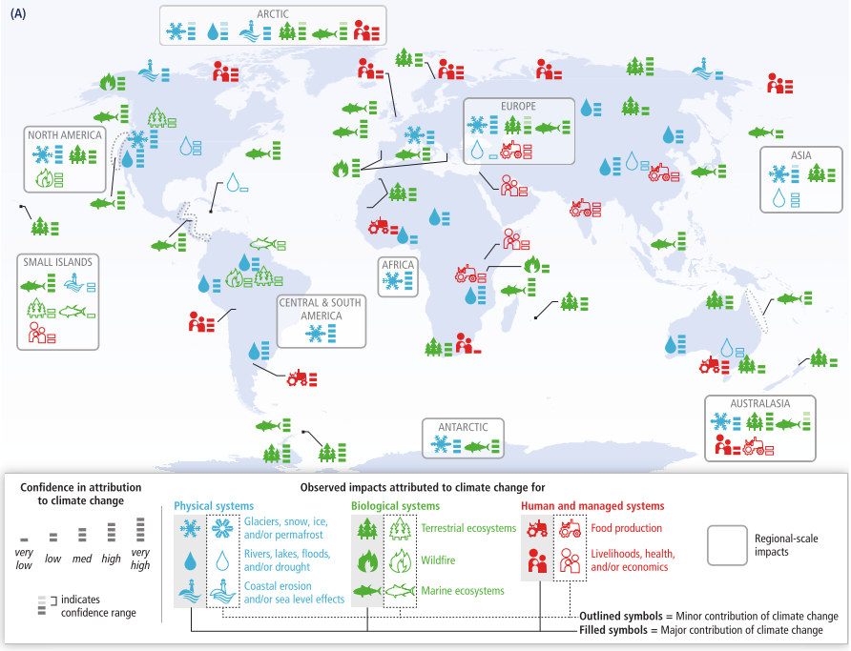
Figure 1.1: Worldwide effects of climate change (IPCC, 2014).
The human intervention will come from of a mixture of national and international policy and investment decisions (ECF, 2010; Lund et al., 2014). The policy should aim to introduce sustainable energy systems and decarbonisation pathways. Sustainable energy systems should be capable of integrating renewable and residual energy sources into the wider energy networks. Decarbonisation pathways should suggest routes that lead to reduced, and eventually, zero carbon futures. Examples of international policy and decarbonisation pathways are the European Commission’s (EC) 20% by 2020 and the 2050 Roadmap (EC, 2012b). The 20% by 2020 policy states that all EU member states must, by 2020, reduce their own emission levels to 20% of their 1990 levels. The 2050 Roadmap by the European Climate Foundation (ECF) gives member states advice on how to reduce their emissions (ECF, 2010).
According to the Department of Energy and Climate Change (DECC), to achieve high levels of decarbonisation the emissions related to the heating of buildings must be reduced to almost zero by 2050 (DECC, 2013c). The decarbonisation of heating will be achieved by both reducing the demand for heating and decarbonising the supply and distribution of the heat (Lund et al., 2010). District heating (DH) and electrifying heating are the two key options to achieve the decarbonisation of heating. One possible advantage of DH comes from the yearly variation in the UK natural gas demand. The yearly variation in the UK demand for natural gas is much larger than the variation for electricity, as shown in Figure 1.2 (Wilson et al., 2013). If the heating in the UK was electrified the already strained national grid would need to supply both the current demand for electricity and natural gas.
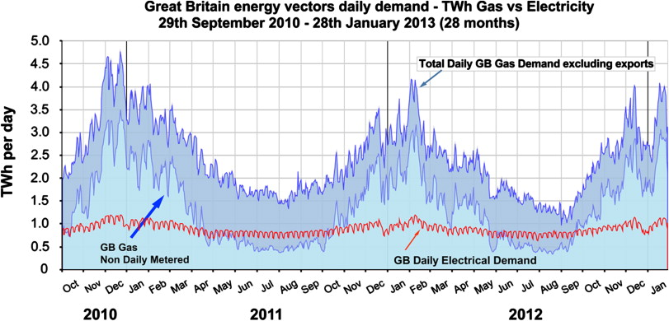
Figure 1.2: Variation of heat and electricity demands in the UK (Wilson et al., 2013).

District Heating
DH is based around a pipe network that is used to provide thermal energy (TE) to a number of customers from a centralised heat source, or sources, through the circulation of a HT fluid (HTF) (Frederiksen and Werner, 2013). A district heating network (DHN) is comprised of TE generating unit(s), a pipe network, and customer substations. DH is a flexible and secure method of providing TE that can use local and environmental energy sources, which would not be utilised otherwise (Sipilä, 2011). Energy sources used in DH include waste heat (WH) from industry, waste incineration, combined heat and power (CHP), and renewables. The level of decarbonisation achieved by DH is highly dependent on the heat supply used; the best levels of decarbonisation occur if the fuel used is green or carbon neutral.
Despite the decarbonisation benefits and due to the high costs of network installation, particularly in rural areas, DH may not be economically viable in every case. Due to the potential economic viability problems, as well as a series of other concerns, the uptake of DH in the UK is low, with DH only providing 2% of the total UK heat demand (HD) (DECC, 2015b). A model that could assess the feasibility of any new DHN, without taking much time or incurring a large cost, would be useful. Such a model would allow the feasibility of more potential DHNs to be assessed, hopefully increasing the uptake of DH.
DH has many benefits, which are experienced on societal, community, and individual levels, as shown in Table 1.1. DH also has a range of problems, which are important to recognise and address. A DHN has high capital costs (CAPEX), mainly due to the cost of the network, as well as investment uncertainty associated with any new technology, which together can make DH unattractive to potential investors (Finney et al., 2012). According to the Consortium of Local Authorities Special Programme (CLASP), new customers may be unwilling to connect to a DHN due to concerns over monopoly formation and heat supply disruptions during installation (CLASP, 2011).
Table 1.1: Societal, community, and individual benefits of DH.
Level | Benefit | Reference
Societal | - Flexibility and security of a range of fuels.  - Can use energy efficient fuels.  - Can provide the energy at competitive prices.  - Reduced CO₂ and greenhouse gas emissions.  - Can use energy storage to reduce network loading. | (Arup, 2013)  (Olsson et al., 2015)  (Kelly and Pollitt, 2010)
Community | - Improved community control over the community energy use.  - Use local resources to generate local income.  - Reduces local emissions.  - Local job generation. | (Kelly and Pollitt, 2010)  (Swithenbank et al., 2012)
Individual | - Reduced costs of energy.  - Reduced space requirements.  - TE stability and security. | (Rezaie and Rosen, 2012)  (CLASP, 2011)

DH can be readily integrated with industrial WH sources, offering the potential to improve the efficiency of and decarbonise both heating and industrial operation. According to O’Rielly and Jeswiet and the US Department of Energy, 20 – 33% of a country’s final user energy demand is used on industrial sources, which are only 50 – 80% efficient (US DOE, 2008; O’Rielly and Jeswiet, 2015). In the UK, it is estimated that 5.0 – 19.7 TWh/year of WH could be recovered (McKenna and Norman, 2010; DECC, 2014b; Hammond and Norman, 2014).
In the UK, the implementation of a new DHN is a collaboration between the local authority and an engineering consultancy. UK local authorities have steadily moved away from the provision of services, such as heating, and consequently lack the in-house technical experience needed to design a DHN (Webb, 2015). The need for a local authority to collaborate with an engineering consultancy drives up the costs of DHNs in the UK, even in the heat mapping and feasibility stages. The increased costs may discourage some local authorities from assessing the feasibility of new DHNs in their locale, reducing the uptake of DH in the UK.
Simplifying the feasibility assessment and resulting design of a new DHN, to enable the process to be completed by a non-technical staff member at a local authority will allow for more potential DHNs to be assessed and designed. An increase in the number of DHNs being assessed should hopefully result in more networks being installed. The simplified process needs to be applied to all parts of the network feasibility and design, from the initial heat mapping and heat supply modelling to the detailed HD modelling, optimisation, and both environmental and techno-economic assessments.

Research Objectives
The primary aim of this thesis is to design, build, and test a model that will assess the feasibility of any new DHN. The model will be kept simple enough that a non-technical user at a local authority can operate it, encouraging more DHNs to be tested for feasibility purposes and hopefully, more networks to be installed. The model should not require the use of any computing software more complicated or less freely available than Microsoft Excel as any non-technical user should have access to and be capable of using a Microsoft Excel spreadsheet. The DH feasibility model will:
- Run a heat mapping process of the local area.
- Quantify the WH available from the heat source.
- Decide on the best choice of waste heat recovery (WHR) equipment.
- Accurately model the HD variation.
- Optimise the network using thermal energy storage (TES).
- Assess the success of the network using techno-economic and environmental methods.
To keep the feasibility model simple in nature, several assumptions will have to be made. The effect that the assumptions will have on the accuracy of the model will need to be tested. When possible, the accuracy will be tested by comparing the modelling work to other models or studies. However, comparisons will only be possible if DHN operators can be persuaded to provide primary data or equivalent DH models can be found. In parts of the work when neither of the two options for comparison are available, Monte Carlo (MC) simulations will be used to test the accuracy of the modelling work.
The feasibility model will be tested using a case study of HJ Enthoven (HJE) and the area surrounding Darley Dale in Derbyshire, England. HJE are a lead acid battery (LAB) recycling site who are looking to find a use for the heat that is not currently utilised on-site. Every stage of the feasibility model in the thesis will be carried out on the case study, assessing whether the HJE DHN is economically and environmentally feasible as well as testing the modelling work. If the DHN is shown not to be economically and environmentally feasible, the knowledge gained of DH as a socio-technical process in the UK will be called upon. It is possible that with access to a government grant or external funding the DHN can be feasible.

Layout of the Thesis
The thesis will begin with a literature review. The industrial operation of DHNs will be studied, finding what technologies are used, how DHNs sit in the heating market, and how DHNs act as a socio-technical process. The primary goal of the literature reviews is to investigate the research methods used in the primary stages of the feasibility model.
Six experimental chapters will follow that design generic solutions for the following problems (each experimental chapter will refer to the case study):
- Heat mapping of a local area.
- Quantification of the waste heat available from an industrial site.
- Choosing the best waste heat recovery equipment for an industrial site.
- Modelling the hourly variation in heat demand experienced by a district heating network.
- Optimising a district heating network using thermal energy storage.
- Assessing the success of the network using techno-economic and environmental models.
The six experimental chapters will be followed by a discussion of the findings. The thesis will end with a conclusion, summarising the major findings.

Case Study and HJ Enthoven
The aim of this thesis is to develop a feasibility model for any new DHN network that will assess the success of the network on a techno-economic and environmental basis. The model should be simple enough that a non-technical user is capable of operating it. In order to test the model and assess the success or failure of it a case study is needed. Every stage of the feasibility model will be tested using the case study.
The case study assesses the success of a potential new DHN based around HJE and the area of Darley Dale, England (ECOBAT, 2017). Every area with a population of at least 1,000 people within an 8 km radius of the HJE site were considered as potential areas to be connected to the new DHN. Seven areas meeting the criteria were identified: Bakewell, Rowsley, Youlgreave, Darley Dale, Matlock, Matlock Bath, and Cromford.
HJE are used as the primary heat supply in the network, with a potential, smaller heat supply coming from Chatsworth House. HJE are the largest LAB recycling plant in Europe, with annual rates of recycling of 80,000 tonnes of lead and polypropylene, recycling 150,000 tonnes of batteries. The HJE process consists of reverberatory and short rotary furnaces as well as a flue gas desulphurisation plant.
HJE are interested in my thesis as they estimate that there is approximately 5 MW_{th} of power is available at the site that could be recovered and utilised. One use of the waste heat that HJE identified is as a heat source for a district heating network, explaining their interest in my thesis. HJE are in a similar situation to a local authority, as they have an interest in a DHN being installed in the local area. Similarly, to a local authority, HJE have neither the in-house technical experience or staff hours to design a district heating network. As a result, HJE have commissioned my thesis as a feasibility study for the possible network in their area. Every stage of the feasibility study will be applied to the HJE case study as follows:
- The heat map will assess the potential of a district heating network in the local area to HJE.
- The waste heat quantification will estimate the heat variation at various locations across the HJE site.
- The waste heat recovery will quantify the heat levels after any waste heat recovery has occurred and the various associated costs and revenues.
- The heat demand modelling will quantify the variation in the heat levels in the local area.
- The district heating network optimisation will use thermal energy storage to match the HJE heat supply and the local area heat demand.
- Techno-economic and environmental models will assess the success of the HJE district heating network.

Literature Review

Introduction
The literature review is used to gather the information needed to carry out the work in the thesis and to identify research gaps in the market. The key areas to research are:
- District heating, waste heat recovery and thermal energy storage technologies.
- District heating, waste heat recovery and thermal energy storage modelling techniques.
- District heating and waste heat recovery markets.
- District heating and waste heat recovery legislation.
- Waste heat characterisation techniques.
- Industrial use of waste heat recovery with district heating.
- Sociotechnical aspects of district heating.
- Economic and environmental evaluations of district heating.
- Lead acid battery markets and recycling processes.

District Heating Technologies
The technologies used in a DHN are a key component to the overall economic and environmental feasibility of the network. The DH system as a whole, as well as the choices of TE generating units, TE sources and TES will be reviewed.

The District Heating System
In literature, a DHN is split into four sections: the TE generating unit(s), the distribution system, the customer substations, and the internal building heating systems (Fröling et al., 2004). The TE generating unit(s) can be one of many different technologies utilising a wide range of fuels. The distribution system is the pipe network, containing the HTF and is the location of most of the heat losses. The substations transfer the energy into the secondary, customer network (Rezaie and Rosen, 2012).

Thermal Energy Generating Units
The key choice when designing a new DHN is how to generate the TE. The choice of TE generating unit will impact on the cost, security, reliability, and environmental performance of the network.

Boilers
Boilers can use a wide range of fuels: fossil fuels, biomass, biofuels, and municipal solid waste (MSW). Boilers are often used in addition to another TE generating unit, with the boilers acting as the back-up and peak load generating capability (Raine et al., 2014). Therefore, boilers are referred to as peak shaving equipment. Boilers can be of a wide range of designs including but not limited to pulverised, low NO_{X}, fluidised bed, and grate (Frederiksen and Werner, 2013).

Combined Heat and Power
CHP units use the excess TE available during thermal electricity generation (Frederiksen and Werner, 2013). Using the excess TE increases the overall plant efficiency by 40 – 80%, but reduces the electricity output (Kelly and Pollitt, 2010). CHP units used in DH are topping cycles, generating electricity in a turbine generator using high pressure steam (Rezaie and Rosen, 2012). CHP can be used to balance the electricity grid as the output of a unit is highest in winter, during the periods of highest electricity demand (Kelly and Pollitt, 2010). Further grid balancing is possible when a TES system is installed, allowing for decoupling of the electricity and heat supply (Raine et al., 2014). A similar option to CHP is polygeneration, which produces TE, electricity, and a fuel (Frederiksen and Werner, 2013).

Heat Pumps
Heat pumps work by increasing the temperature of TE allowing low temperature heat sources to be used in a wider range of cases (Frederiksen and Werner, 2013). Heat pumps should be used in areas with low electricity prices and imbedded CO₂ emissions due to their need for electricity in increasing the temperature of low grade heat sources.

Thermal Energy Sources
One of the primary advantages of DH is that the technology can utilise a wide variety of TE sources, making the system more versatile. Unlike with the choice of the TE generating unit, each individual network may not have any choice with respect to the TE source, instead utilising the locally available resources.

Waste Heat Recovery
WHR is a source of heat that uses excess heat from industry, which would otherwise be released to the environment. WHR can be considered as a carbon neutral energy source that improves the economic and environmental efficiency of both the industrial source and the DHN (Hammond and Norman, 2014). The WH can be recovered using a variety of different technologies at a range of temperatures, as shown in section 2.3.2.

Waste to Energy
Waste to energy (WtE) involves the incineration of a waste, generally MSW, as a fuel. As a fuel, waste is low carbon, sustainable, and reduces the environmental impacts of landfilling (Finney et al., 2012). WtE should only be considered during the recover stage in the waste management hierarchy, as shown in Figure 2.1. It should be noted that waste should only be incinerated if it cannot be reduced, reused, or recycled. The potential for WtE in the UK is vast, due to the 30 million tonnes of MSW produced annually (Porteous, 2005). WtE plants require stringent control and monitoring due to the potential emissions of harmful products and pollutants, including dioxins.
Figure 2.1: Waste management hierarchy (Porteous, 2005).

Fossil Fuels
Fossil fuels, comprising oil, coal, and natural gas, are composed of decayed plant and animal remains that were exposed to heat and pressure over millions of years. Fossil fuels have poor environmental performance but are cheap and simple to combust (Frederiksen and Werner, 2013). As a result, fossil fuels are an ideal fuel to use for backup and peak load TE generating units.

Renewable Fuels and Biomass
Biomass fuels are comprised of organic materials that contain energy supplied by the sun: wood, crops, and waste materials. Biomass fuel usage presents concerns due to the debate of fuel over food production and the transportation of the biomass (Stupak et al., 2007). Biomass should only be used as a fuel source when the use is sustainable and the economic, ecological, and social effects are considered across the entire forest fuel chain.
Other renewable fuels come from sources such as wind power, geothermal, and solar (Frederiksen and Werner, 2013). In some areas of the world, cheap and plentiful geothermal sources exist which can be extracted with only minimal environmental impacts. When considering the use of geothermal fuels, it is important to find a geothermal map of the area, as shown in Figure 2.2. Other renewables sources, such as wind and solar photovoltaic are available at low temperatures, so can be used as an energy input for DH when combined with a heat pump. Issues arise due to the unpredictable and variable generating cycles of renewable TE sources.
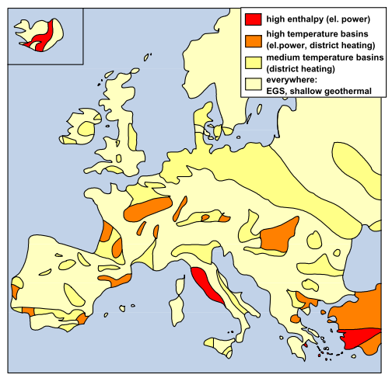
Figure 2.2: Map of geothermal resources available in Europe (Antics and Sanner, 2007).

Nuclear
Nuclear power stations can be converted into CHP plants but have not been widely converted so far to safety concerns (Frederiksen and Werner, 2013). In additions, nuclear plants are generally located away from urban areas, limiting the ability to use nuclear as the TE source in DH.

Thermal Energy Storage
TE is stored in three different forms: sensible heat, latent heat, and chemical energy (Hesaraki et al., 2015). TES technologies can be used to store heat on an hourly, daily, weekly or seasonal bases. TES in DHNs can range from small hot water tanks (HWTs) in individual homes to large underground caverns.

Hot Water Tank Thermal Energy Storage
HWTs store energy in the form of sensible heat (Sarbu and Sebarchievici, 2018). Using water as the storage medium makes HWT based TES one of the cheapest options for storage. Using water, which is generally the HTF in a DHN, as the storage medium allows the HWT to be charged directly though HWTs can also be charged indirectly using heat exchangers (HEXs) (Delta Energy & Environment Ltd, 2016). When used in a DHN, HWTs are generally large tanks that are constructed using reinforced concrete or steel, with an insulation layer (Guadalfajara et al., 2014). The HWTs may be buried underground to alleviate stresses on the tank walls and can reach sizes of 12,000 m³ (Eames et al., 2014).
HWTs can be stratified, where multiple layers, either horizontal or vertical, are created in the tank, as shown in Figure 2.3 (Schütz et al., 2015). Each stratified layer is assumed to have a constant mass and temperature and be perfectly mixed. Stratification is introduced to improve the efficiency of the tanks’ charging and discharging and can only be achieved in HWTs of a minimum height (Eames et al., 2014; Sarbu and Sebarchievici, 2018).
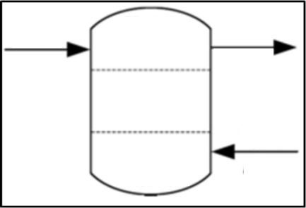
Figure 2.3: Stratified layers in a HWT, adapted from (Schütz et al., 2015).

Chemical Energy Storage
Chemical energy storage (CES) stores TE in the form of chemical potential energy using stable chemical substances (Yan et al., 2015). The chemical substances undergo cycles of endothermic and exothermic reversible reactions, alternatively storing and releasing TE. Ideal CES substances will:
- React at moderate temperatures, with a high level of reaction heat.
- Be easily reversible, without undergoing a secondary reaction.
- React quickly enough, in both directions, to allow for prompt charging and discharging.
- Be easily separable from the reaction products.
- Be stable in storage.
- Be non-corrosive, non-toxic, non-flammable and non-explosive.
- Only undergo small volume changes during reaction.
- Be abundant and cheap.

Phase Change Materials
PCMs store TE as latent heat that is generated during phase change, normally solid to liquid (Delta Energy & Environment Ltd, 2016). PCMs can belong to one of three different groups: paraffins, fatty acids, and salt hydrates (De Gracia and Cabeza, 2015). Paraffins and fatty acids do not experience subcooling, but only experience small amounts of hysteresis and are stable in cycling. Paraffins and fatty acids must be encapsulated or stabilised to prevent fire hazards and improve upon their low thermal conductivity. Salt hydrates generally are not used due to the segregation that occurs after cycling. Ideal PCMs will (Eames et al., 2014):
- Undergo phase change in the desired temperature range.
- Have a high latent heat of fusion per unit mass or volume.
- Have a high specific heat capacity, to provide additional sensible heat storage.
- Have a high thermal conductivity, to enable effective charging and discharging.
- Undergo little volume change during phase change, to reduce required the space for expansion.
- Experience little or no sub-cooling during freezing.
- Experience chemical stability, with no degradation over multiple cycles and low or no reactivity with encapsulants.
- Be non-poisonous, non-flammable, and non-explosive.
- Be abundant and cheap.

Borehole Thermal Energy Storage
Borehole, or duct, TES stores TE as sensible energy in vertical, or horizontal, ducts that are inserted under the ground (Delta Energy & Environment Ltd, 2016). Vertical, or horizontal, HEXs are used to charge and discharge the systems. Borehole based TES does not require the installation of large quantities of new infrastructure, so the technology is relatively cheap (Guadalfajara et al., 2014). However, borehole TES systems need to have large volumes to reduce the effects of losses (Eames et al., 2014). Borehole TES usually discharges heat at a low temperature, requiring the use of a heat pump and is not feasible in areas with high water table recharging (Hesaraki et al., 2015). The first three years of a borehole TES lifespan are spent slowly heating the soil, to obtain the necessary conditions for operation.

Pit Thermal Energy Storage
Pit TES systems are sensible energy storage based HWTs that replace the water tank with a large water pit, which is partially insulated on the sides and the top (Guadalfajara et al., 2014). Pit TES is cheaper than HWT storage, due to the lack of the tank structure. The pit is generally filled with a mixture of gravel and water, allowing for direct charging and discharging (Eames et al., 2014).

Aquifer Thermal Energy Storage
Aquifer TES stores TE as sensible heat using a hot and a cold well, from which groundwater is either extracted or stored (Hesaraki et al., 2015). Aquifer TES systems are geographically constrained and require large wells, so will not be suitable for every DHN. The TE stored in the aquifers is available at low temperatures, so must be upgraded using a heat pump (Guadalfajara et al., 2014).

Waste Heat Recovery
WHR should be considered from both an industrial and a governmental perspective as a method of increasing the efficiency of industrial processes, which are generally only 50 – 80% efficient (O’Rielly and Jeswiet, 2015). Increased use of WHR should reduce global CO₂ emissions and increase industrial revenue. As industry tends to use 20 – 33% of a countries’ final user energy demand, there is a large potential for worldwide WHR (US DOE, 2008). Studies by DECC and the University of Bath estimate the potential for feasible WHR in the UK to be 18 – 71 PJ/year (McKenna and Norman, 2010; DECC, 2014b; Hammond and Norman, 2014). The large variation in results is due to differences in the inputs, assumptions, and definitions of ‘feasible’ used in the studies.

Waste Heat Characterisation
The characterisation of WH is vital to match WH sources to possible uses. Characterisation is based on the quality (temperature), quantity (enthalpy) and temporal availability of the WH (O’Rielly and Jeswiet, 2015). WH is available at three quality levels: high grade (650 °C and above), medium grade (230 – 650 °C), and low grade (230 °C and below). Temporal availability is a measure of how the quality and quantity of the WH varies with time (Arzbaecher et al., 2007). High grade heat is the most valuable due to its high temperature and high heat transfer (HT) rate; it is the quality of heat used in CHP plants (Mehta, 2009). Medium grade heat is cheaper to use, as it does not require the use of special materials and engineering. Medium grade heat should be used when the HD is of medium quality, such as the direct substitution of process heat. Low grade WH (LGWH) is problematic to use, see section 2.3.5. The enthalpy, the quality, of the WH is defined by Equation 2.1 (Rohrer, 2007).
$$\dot{H}=\dot{m}h$$ | 2.1

$\dot{H}$ is the enthalpy of the stream [kW],
$\dot{m}$ is the mass flowrate of the stream [kg/hour],
$h$ is the specific enthalpy of the stream [kWh/kg].

Waste Heat Recovery Technologies
A range of technologies can be used to capture the WH in WHR.

Heat Exchangers
HEXs transfer TE from one stream to another, using either direct contact, where the streams are mixed, or indirect, where the streams are kept separate (Kakac and Liu, 2002). HEXs can be recuperative, where one stream recovers heat through a heat transfer surface area (HT SA), or regenerative, where the streams alternately flow through a matrix, storing or extracting TE. The HT rate of a HEX is determined by Equation 2.2 (US DOE, 2008).
$$\dot{Q}=UA∆T_{m}$$ | 2.2

$\dot{Q}$ is the HT rate of the HEX [kW],
$U$ is the overall heat transfer coefficient [kW/(m²°C)],
$A$ is the HT SA [m²],
$∆T_{m}$ is the temperature difference between the two streams [°C].

Heat Pumps
Heat pumps upgrade the quality of the WH through the cycling of a refrigerant, requiring an external energy source, as shown in Figure 2.4 (O’Rielly and Jeswiet, 2015).
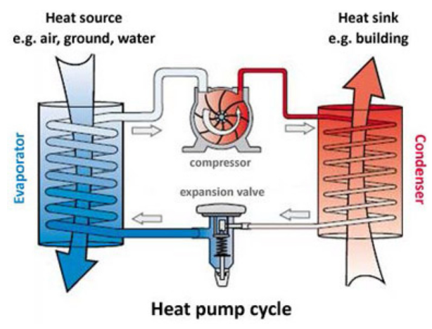
Figure 2.4: The operating cycle of a heat pump (O’Rielly and Jeswiet, 2015).
A heat pump is characterised by its coefficient of performance (COP) (Al-Rabghi et al., 1993; Zottl et al., 2012). The COP of heating from a heat pump is defined in Equation 2.3 and is dependent on the ratio of heat delivered to and work done by the compressor.
$${\text{COP}}_{\text{Heating}} \text{=} \frac{\text{useful heat at the condenser}}{\text{work done by the co}\text{mpressor}}=\frac{Q_{H}}{Q_{net}}=\frac{Q_{H}}{Q_{H}-Q_{L}}<\frac{T_{H}}{T_{H}-T_{L}}$$ | 2.3

$Q_{H}$ is the heat delivered to the condenser [MWh],
$Q_{L}$ is the heat extracted from the evaporator [MWh],
$Q_{net}$ is the energy delivered by the condenser [MWh],
$T_{L}$ is the temperature delivered to the condenser (the heat sink temperature) [°C],
$T_{H}$ is the temperature extracted from the evaporator (the WH temperature) [°C].
The COP of cooling is the opposite of the COP of heating, as shown in Equation 2.4.
$${\text{COP}}_{\text{Cooling}}=\frac{Q_{L}}{Q_{H}-Q_{L}}<\frac{T_{L}}{T_{H}-T_{L}}$$ | 2.4

Organic Rankine Cycles
Organic Rankine cycles (ORCs) are used to generate electricity from LGWH (Campana et al., 2013). An ORC differs from a traditional Rankine cycle (RC) through the use of organic chemicals as the working fluid, which have lower boiling points and higher molecular masses. A wide variety of working fluids can be used depending on the available conditions. The efficiency of an ORC tends to be lower than that of a traditional RC; the theoretical efficiency of an ORC is determined by the Carnot cycle, as shown in Equation 2.5 (US DOE, 2008). Studies have shown ORCs to be the ideal technology for use in WHR and power generation at temperatures of 200 – 400 °C.
$$η=1-\frac{T_{L}}{T_{H}}$$ | 2.5

$η$ is the efficiency of the Carnot cycle [%].

Kalina Cycles
Kalina cycles are a type of ORC that use a binary working fluid, a mixture of ammonia and water (Markides, 2013). The binary working fluid has two boiling points, so the temperature rise is constant when heating (US DOE, 2008). The constant temperature rise allows for better matching between the WH source and sink, providing a higher efficiency.

Thermoelectric Generation
Thermoelectric devices are semi-conductor solids that use electrons as the working fluid, converting electricity into TE for heating and cooling or vice versa (US DOE, 2008). Thermoelectric devices operate via the Seebeck effect, “when two different semiconductor materials are subject to a heat source and heat sink, a voltage is created between the two semiconductors” (Thornley and Walsh, 2010). The Seebeck effect means that if electricity is applied across two dissimilar semiconductors, heating or cooling can occur. The material used in a thermoelectric device should create a balance between being a good electrical conductor, a poor thermal conductor and allowing for the maximisation of the Seebeck effect (Bell, 2008). Thermoelectric devices have low efficiencies, 1.5 – 5%, and are expensive, but are simple in design, have no moving parts, and have efficiencies that are relatively independent of size.

Waste Heat Recovery Technology Summary
For a set temperature of WH, a range of different WHR technologies are best employed, as shown in Table 2.1 (US DOE, 2008).
It is useful to know the operating temperatures for typical industrial processes. Table 2.2 provides the standard operating temperatures of standard industrial processes, split into industrial categories. Table 2.3 gives the exhaust gas temperatures of standard industrial processes. Table 2.1 to Table 2.3 can be combined, showing what temperatures of WH are available at an industrial site and consequently, what WHR technologies can be utilised.

Table 2.1: WHR technology to use for each grade of WH (US DOE, 2008).
WH quality | Temperature (°C) | Typical recovery method/ technology
High | > 650 | - Combustion air preheat.  - Steam generation.  - Furnace load preheating.  - Transfer to medium or low temperature process.
Medium | 230 – 650 | - Combustion air preheat.  - Steam/ power generation.  - ORC for power generation.  - Furnace load preheating.  - Feedwater preheating.  - Transfer to low temperature process.
Low | < 230 | - Space heating.  - Domestic water heating.  - Upgrading via a heat pump.  - ORC.

Table 2.2: Operating temperatures of standard industrial processes, split into industries (Brückner et al., 2015).
Industry | Process | Working temperature (°C)
Food and beverages | Cleaning | 60
 | Cooking | 110 – 150
 | Pasteurising | 65 – 110
 | Whitening | 85
 | Drying | 30 – 120
 | Washing | 40 – 85
 | Sterilising | 80 – 150
 | Boiling | 95 – 105
 | Heat treatment | 40 – 60
 | Drainage | 38 – 104
Textile | Dry heating | 88
 | Ironing | 100
 | Washing | 40 – 80
 | Bleaching | 60 – 100
 | Dying | 100 – 160
 | Drying | 75 – 250
 | Steaming | 100 – 130
Chemical | Boiling | 95 – 105
 | Distilling | 90 – 300
 | Various chemical processes | 120 – 180
Paper industry | Pulp drying | 95 – 120
 | Paper drying | 50 – 120
Non-metallic mineral processes | Drying of rocks, bricks, sand and other minerals | 35 – 150
Wood | Drying | 70 – 90
Other | Metal cleaning | 60 – 90
 | Painting drying | 80 – 120

Table 2.3: Standard exhaust gas temperatures of various industrial processes (Brückner et al., 2015).
Process | Exhaust gas temperature (°C)
Iron- and steelmaking | 1,450 – 1,550
Nickel refining furnace | 1,370 – 1,650
Steel electric arc furnace | 1,370 – 1,650
Glass melting furnace | 1,300 – 1,540
Basic oxygen furnace | 1,200
Aluminium reverberatory furnace | 1,100 – 1,200
Steel heating furnace | 930 – 1,040
Copper reverberatory furnace | 900 – 1,090
Glass oven without regenerator | 900 – 1,300
Iron cupola | 820 – 980
Copper refining furnace | 760 – 820
Reheating furnace without regenerator | 700 – 1,200
Hydrogen plants | 650 – 980
Fume incinerators | 650 – 1,430
Coke oven | 650 – 1,000
Glass oven with regenerator | 600 – 800
Cement kiln | 450 – 620
Heat treating furnace | 430 – 650
Melting oven | 400 – 700
Gas turbine exhaust | 370 – 540
Reciprocating engine exhaust | 320 – 590
Reheating furnace with regenerator | 300 – 600
Blast furnace stoves | 250 – 300
Drying and baking ovens | 230 - 590
Steam boiler exhaust | 230 – 480
Finishing soaking pit reheat furnace | 200 – 600
Steam boiler | 200 – 300
Container glass melting | 140 – 200
Flat glass melting | 140 – 200
Ceramic kiln | 150 – 1,000
Drying, baking and curing ovens | 90 – 230
Cooling water from annealing furnaces | 70 – 230
Cooling water from internal combustion engines | 70 – 120
Exhaust gases exiting recovery devices in gas-fired boilers, ethylene furnaces etc. | 70 – 230
Conventional hot water boiler | 60 – 230
Process steam condensate | 50 – 90
Condensing hot water boiler | 40 – 50
Hot processed liquids/ solids | 30 – 230
Cooling water from air conditioning and refrigeration condensers | 30 – 40
Cooling water from air compressors | 30 – 50
Cooling water from furnace doors | 30 – 50

Waste Heat Recovery Modelling
The most common modelling technique used in WHR is pinch analysis. A pinch analysis is used to determine the optimal location for heat recovery as well to match the heat sources to the heat loads (Arzbaecher et al., 2007). A pinch analysis is comprised of four phases: a site survey, targeting, design, and optimisation. During the site survey, information is collected for each stream and process, aiming to determine the heating, cooling, boiling, and condensation needs of the site. Using the collected information, elemental based mass and energy balances are completed. Targeting is used to identify the minimum heating and cooling needs using constraints such as the handling of the fluid streams. During the design stage the HEXs, or other WHR technologies, are designed using calculations or commercial software. Whilst designing the HEXs, the main driver is to maximise efficiencies and minimise the energy consumption. Finally, the overall network around the WHR technology is simplified and optimised. The optimisation is done on both an economic and an environmental basis.

Waste Heat Recovery and District Heating Examples
Numerous examples of DHNs exist that use industrial WHR as the TE source. Sun et al. designed a DHN that was supplied using ejector HEXs and absorption heat pumps (Sun et al., 2014). The design was novel as the ejector HEXs used considerably lower return temperatures from the network than normal HEXs would have allowed. The ejector HEXs allowed the DHN operator to reduce the return temperature of the network by 30 °C, decreasing the steam consumption by 41.5% and reducing heating costs by ¥8.62 /GJ or £0.06 /GJ.
Dou et al. evaluated the potential for DH to be supplied by industrial WHR in Japan (Dou et al., 2018). It was found that DH can be economically and environmentally feasible in Japan, but not for every industrial location. Many of the WH sources were available at a higher temperature than the DHN supply temperature. The most efficient, both environmentally and economically, method for recovering the WH in situations where the WH temperature is higher than necessary was found to be ‘cascading’ it through a series of HEXs. Cascading the WH through HEXs, or other WHR technologies, allowed the WH to be extracted multiple times, creating a more efficient process.
Wahlroos et al. evaluated the potential for WHR using WH from data centres in Nordic countries (Wahlroos et al., 2018). It was found that in many cases the available WH was below the DHN supply temperature and had to be upgraded, increasing the temperature, using heat pumps. Fang et al. investigated the potential for DH in China supplied by LGWH (Fang et al., 2013). A case study was found that recovered 122 MW of LGWH from two plants for use in a DHN. The process improved the efficiency of the plants from 62.9 – 74.3% and 30.1 – 74.7% respectively, saving 168,644 tCO₂e per annum. It was found that the maximum distance between the heat source and population centre for LGWH DHNs was 5 – 10 km for a small town and 20 – 30 km for a city. As the LGWH was available at temperatures of 30 – 100 °C, absorption heat pumps were used to upgrade the WH.
Kapil et al. attempted to calculate the maximum pipe distance possible in DHNs powered by WHR (Kapil et al., 2012). The authors found that there is no calculable ‘standard’ maximum pipe distance, with the answer varying from network to network. In other work, Wahlroos et al. assessed the effects of existing WHR using data centre WH (Wahlroos et al., 2017). It was found that WHR from data centres was able to reduce the operating costs (OPEX) of DHNs by 0.6 – 7.3%, but contractual problems arose from the different lengths of operating scales in the different industries. Data centres typically worked in one- to five-year cycles whereas DHNs had on fifteen- to forty-year lifespans. Issues arose as the data centres were not always able to guarantee a WH supply for the length of the DHN lifespan.

Problems with Waste Heat Recovery
The majority of industrial WH remains unrecovered despite its vast potential due to both technical and institutional barriers (Miró et al., 2016). WHR requires large investment costs and the installation of inconvenient infrastructure; the investment costs mean that WHR can often take longer than the industrial standard of three or four years to achieve economic payback (Awomewe and Ogundele, 2008; Hawkey, 2009). The installation process will often require either a partial or a full plant shut down for a significant period of time, presenting an economic loss potentially larger than a plant operator could allow. The industrial site may lack the necessary information about nearby heat sinks, reducing the perceived demand for any captured WH.
When WHR is to be used as a heat source for a DHN, more barriers are raised. Due to the high costs of land in urban areas most industrial sites with large potential for WHR are built a significant distance away from any urban area. The cost of a DHN drastically increases with the separation, making a potential DHN economically unviable. DH and WHR sources have different ownership models considering drastically different periods of operation making it hard to draw contracts between the two (Wahlroos et al., 2018).
Greater barriers are found when considering the WHR potential of LGWH (O’Rielly and Jeswiet, 2015). LGWH represents approximately 50% of total heat production, so solving the technical and institutional barriers to the WHR of LGWH should be of key importance. Three major barriers exist for the implementation of LGWH: the corrosion of the HT SA of the WHR equipment, the need for large HT SAs on the WHR equipment, and the difficulties in finding a use for the LGWH. The corrosion occurs when the WH temperature is below the dew point of the WH stream, causing particulates in the stream to condense and form as droplets on the HT SA. The risk of corrosion with LGWH requires the use of expensive, corrosion resistant materials or large-scale monitoring and maintenance. Large HT SAs are needed as the HT rate is proportional to the sum of the HT SA and the temperature difference between the two streams, as shown in Equation 2.2. LGWH is hard to find a use for, as most WH uses are at higher temperatures. Consequently, the LGWH must be upgraded using a heat pump.
The WHR potential of LGWH is severely limited by the Carnot cycle (Thornley and Walsh, 2010). Issues can arise when using LGWH as a heat source in DH it can be difficult to combine heat sources at different temperatures, to transport the heat, and to match the energy supply to the demand (Fang et al., 2015).
Solutions exist to many of the technical and institutional barriers to the WHR of LGWH, including solutions tailored to the use of DH (Fang et al., 2015). If multiple different WH sources are used at multiple temperatures, it is unlikely that the sources will be heterogeneous, but pinch analysis can be used to match the different temperature WH sources. Transporting the heat across large distances requires large pumping power, which can be reduced by reducing the system flow rate. The flow rate can be reduced by increasing the temperature difference between the pipes, reducing the return temperature. The WH supply varies with industrial scheduling, whereas HD varies with the weather and social factors; the two different supply and demand profiles can be hard to match. It is advised to use WHR to provide the base load HD and use peak shaving equipment, such as fossil fuel powered boilers, to meet peak demands. A suggestion of how WHR, peak shaving and other heating equipment could be used is shown in Figure 2.5.
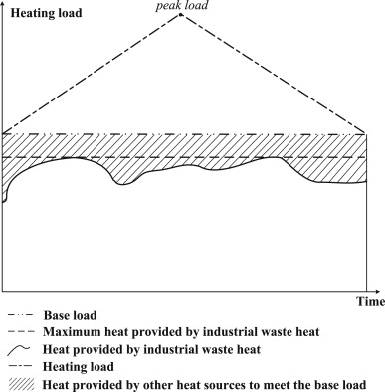
Figure 2.5: Suggested operating schedule of a DHN supplied by industrial WHR and other heat sources (Fang et al., 2015).
Reducing the return temperature of the DHN increases the potential for WHR, particularly for LGWH (Y. Li et al., 2016). The reduction in return temperature can be achieved using absorption HEXs, allowing for more energy transfer to occur in the same mass flow rate of HTF. Increasing the energy transfer allows for a reduced flowrate of the HTF, reducing the pumping needs, and consequently both the CAPEX and OPEX of the DHN.

Heat Mapping
Heat mapping is used to estimate the HD in an area, show a possible route for the DHN and identify possible anchor loads. Anchor loads are customers with large, reliable and long-term HDs that are vital to proving the economic case for any new network (Hawkey, 2009).

Heat Mapping Methodologies
Heat mapping can be performed using one of a variety of techniques including questionnaires, thermal imaging, remote sensing, and/or estimation calculations (Finney et al., 2012). Collecting questionnaires is a highly accurate way of obtaining HD information for individual buildings. However, collecting questionnaires for an entire city district is time consuming and the process is only accurate with a high response rate. López-Aparicio et al. ran a questionnaire based mapping process to improve on public knowledge of the emissions produced by domestic, wood burning heating systems (López-Aparicio et al., 2017). The study asked questions on three themes: place and type of residence, characteristics of the wood burning system, and the users’ perception of the environmental effects of wood burning. The authors concluded that the public participation process was an accurate method of mapping the local area, but it required careful consideration of the participatory process.
Thermal imaging and remote sensing are both highly accurate, but are expensive and cannot account for seasonality of data (Finney et al., 2012). Curran and Hobson mapped the HD density of Sheffield using remotely sensed data from the Landsat Multispectral Scanning System (Curran and Hobson, 1987). The system took photos of the area, recording the radiance of different colours and the corresponding wavelengths: green (0.5 – 0.6 μm), red (0.6 – 0.7 μm), and near infrared (0.7 – 1.0 μm). The dataset was producer faster than and shown to be as accurate as other geographical information system (GIS) techniques but, it was unable to distinguish between more than four classes of HD density.
Estimation calculations can be accurate, depending on the accuracy of the calculations and the assumptions used (Finney et al., 2012). Schweiger et al. used GIS techniques to map the hourly variation in HD using a piecewise linear correlation between the outdoor temperature and the HD (Schweiger et al., 2017). The authors noted that the methodology used was an over simplification of the hourly HD variation, that should only be used for estimation purposes. Delmastro et al. assessed the TE consumption of buildings, particularly focusing on the space heating (SH) demand (Delmastro et al., 2016). The SH demand was calculated using heating degree day (HDD) calculations and geo-tagged information of the building stock.
Most of the heat mapping techniques mentioned so far focus on mapping domestic information; in some cases, heat mapping requires industrial input as well. Bühler et al. used a heat mapping methodology to analyse the potential for industrial WHR to be used as a heat source for DHNs in Denmark (Bühler et al., 2017). The industrial information came from a country wide register representing 80% of the Danish industry.

Heat Demand Calculation Methodologies
HD estimation calculations can be completed using a variety of different techniques. In some cases, the techniques do not need to find the hourly variation in the TE demand of the local area and instead can estimate a total yearly TE use.

Multiple Linear Regression Modelling
Multiple linear regression modelling can be used to estimate the HD in an area for heat mapping purposes by fitting a line (or curve) to a series of data points. Mastrucci et al. estimated the energy consumption profile of urban domestic buildings in Rotterdam, Netherlands using a multiple linear regression model (Mastrucci et al., 2015). The regression model was used to split post code wide data on natural gas consumption into an estimated consumption for each individual building. Regression coefficients were used that needed to be estimated using an ordinary least squares technique. Building retrofits were counted and used to split the post code wide natural gas demand data into individual building’s HD.
Nouvel et al. used a multiple linear regression model to predict the potential of HD and energy saving measures at a city-wide level (Nouvel et al., 2015). Similarly to Mastrucci et al., a regression model was used to calculate the natural gas demand of individual buildings based on the natural gas consumption of a collective of houses. The work required geo-referenced data of the housing stock and yearly consumption records as model inputs.

Archetype Building Modelling
Archetype building modelling, as discussed in section 2.5.1.1 can also be done for heat mapping purposes. A number of researchers have used archetype building models to generate heat maps. A summary of the results is given in Table 2.4.
Table 2.4: Summary of archetype building models found in literature.
Location | Number of building classes | Number of age classes | Model output | Reference
Germany | 4 | 3 | Yearly TE demand (kWh/m²) | (Schillings and Simon, 2011)
Denmark | 4 | 7 | Yearly TE demand (kWh/m²) | (Möller, 2008)
Switzerland | 8 | 10 | Yearly TE demand (kWh/m²) | (Girardin et al., 2010)
Switzerland | 16 | 12 | Yearly TE demand (kWh/m²) | (Fonseca and Schlueter, 2015)
Italy and Sweden | A continuous number | 9 | Yearly TE demand (kWh/m³) | (Delmastro et al., 2017)
England | 28 | 0 | Yearly TE demand (kWh/m²) | (Parsons Brinckerhoff, 2011)

Calculating the Potential of Connecting New Customers to a District Heating Network
One use of heat mapping is to estimate the potential of connecting new buildings and areas to an existing DHN. Skujevska et al. used heat mapping to identify possible new customers for an existing DHN and estimate the costs of connecting the new customers to the network (Skujevska et al., 2016). The DHN operator supplied records of annual HD (kWh/m²) for its customers, which were used to predict the HD of potential new customers. The accuracy of the predicted HDs were validated, when possible, using surveys on the fuel consumption or HDs of existing customers.
Möller and Lund used a mixture of empirical building data, a national database of buildings, and supplied user data to estimate the HD of potential new DH customers (Möller and Lund, 2010). An estimation of the costs of connecting the customers to an existing DHN was calculated based on: the number, sizes, and locations of the new customers; the total HD in that area; and the shortest possible distance to the DHN. Grundahl et al. used heat mapping techniques to evaluate the economic potential of different possible expansions to a DHN (Grundahl et al., 2016). Existing heat mapping methodology, the current edition of the Danish Heat Atlas from Aalborg University, was used to estimate the HDs of the buildings. The costs of the connection were calculated using several steps. Firstly, the costs of the pipe connection to the nearest part of the DHN were determined. Secondly, the cost of connecting the entire zonal area were calculated, which was then used to calculate a connection cost per dwelling and finally, a heat cost was assumed per dwelling.

Data Sources Used for Heat Demand Calculations
Several different data sources are used as primary data in HD estimations. Numerous studies use national databases of building registries, including the Danish National Building and Dwelling Register (Möller, 2008; Möller and Lund, 2010; Schillings and Simon, 2011; Münster et al., 2012; Bühler et al., 2017). Other studies use databases for weather, urban buildings and building archetypes (Parsons Brinckerhoff, 2011; Fonseca and Schlueter, 2015).

Modelling District Heating Networks
Modelling DHNs is the key step in the design of any new network (Heller, 2000). Modelling of DHNs can be used to determine the HD of an individual house, the HD of the entire network, the optimisation of the network using TES, or the assessment of the network’s success. Due to the wide range of uses, a wide range of DH models exist, a summary of key modelling types is as follows:
- Steady state models, which are based on steady state assumptions with constant temperature and flowrates across the time period considered.
- Dynamic models, which deal with time dependent effects of heating and have parameters that vary depending on the statistical probabilities of a given occurrence.
- Black box models, otherwise called input-output models, where the outputs are coupled to the inputs and no priori information is available.
- Grey box models, which combine a partial theoretical structure with the input data to calculate the output.
- General load models, otherwise called the top down approach, which calculate the heat load for an entire network or system through analysis of measured loads for that system.
- Load component models, otherwise called the bottom up approach, which calculate the heat load of a system through detailed modelling of the cause of that heat load.
An ideal DH model would be capable of estimating both the heating and cooling energy demand of buildings at a city and an individual scale, with a time scale of an hour or less. Frayssinet et al. ran a review looking for such a model and concluded that a validated ‘ideal’ DH model did not exist, mainly due to the large computational power requirement (Frayssinet et al., 2018). As a result, some form of simplification to either the scope, the size of the time step, or the size of the network is required. The following section deals with DH models that can considered as simplifications of the ‘ideal’ DH model.

Component Modelling of District Heating Networks
Component modelling, otherwise called bottom up modelling, is used to calculate the overall HD of a network through the modelling and design of each individual component (Talebi et al., 2016). Component modelling of DH mainly focuses on end user profile modelling. End user profile modelling calculates the HD of each individual building on the DHN, combining the individual HDs to calculate the overall HD of the network. End user profile modelling is useful in an area with a large building heterogeneity, such as the urban or domestic area in a DHN. Many of the modelling techniques listed here use the same methodology as discussed in section 2.4.2. When the same techniques are used for accurate heat demand modelling instead of heat mapping, the work is completed to much higher levels of detail. Consequently, the same models will be discussed again here, this time to more detail.

Historical Models
A number of modelling types exist that utilise historical data of HD and/ or heat supply to model the end user HD (Talebi et al., 2016).

Heating Degree Day
The heat loss in a building is dependent on the difference between the internal and the external temperatures (Talebi et al., 2016). The difference in temperatures can be defined by a parameter called the HDD, which is directly proportional to the HD of the building (Pirouti, 2013). HDD is calculated as the difference between the current outdoor temperature and a reference temperature, at which point a buildings’ heating system is turned on (Raine et al., 2014). In the UK, the reference temperature is normally set as 15.5 °C (Carbon Trust, 2012). It is possible to use HDDs to measure both the severity and duration of periods of cold weather. A HDD value can be calculated for a time period, such as a month, as the sum of the hourly HDD values during that time period divided by the number of hours in the period. A large HDD value shows that the cold weather periods during the time period were severe and long in duration. HDD values are calculated through the use of historical temperature records, which are normally kept for a time period of several years (Met Office, 2015).
Kipping and Trømborg used the HDD methodology to calculate the hourly consumption of district heat and electrical energy in office buildings and schools in Norway (Kipping and Trømborg, 2017). HDD methodology was used to calculate the heat and electricity demands based on current weather behaviour and historical meter data for both the district’s heat and electricity consumption. Pisello et al. used HDD methodology to assess the building energy performance of three prototypes of Italian houses (Pisello et al., 2012). HDD methodology was used to calculate the building energy performance based on current weather behaviour and archetype building heating performance.

Measurements
Historical records of customer measurements, such as heating, electricity and gas bills, as well as network measurements, such as temperature and flowrate, can be used as reliable inputs for DH modelling (Talebi et al., 2016).
Customer and network measurements can be used as both a model input and as a method of validating existing modelling work. Noussan et al. proposed, designed and analysed a DHN supplied by an ORC, using HD data as the input to the methodology (Noussan et al., 2014). The data was supplied by a Turin based DHN, which had similar characteristics to the network under design, in the form of heat supplied to the network from each of the TE generating units. Spoladore et al. modelled the short-term HD of end users on a DHN (Spoladore et al., 2016). The input data used was individual customer natural gas meter readings. Fang and Lahdelma modelled a DHN to find the water flow rate, temperature, and heat losses in various locations of the pipe network (Fang and Lahdelma, 2014). The input data used was hourly meter readings from the customers, supplied by automated meters. Automated meters are a new technology that allow for automatic and more accurate meter reading measurements to be made and supplied.
In other models, customer meter readings and network measurements can be used to validate model behaviour. Dotzauer built an hourly network HD model based on simple equations for the effect of the temperature and social behaviour on the HD (Dotzauer, 2002). The model was validated using measured data from two DHNs in Stockholm, Sweden. Lim et al. used Simulink in MATLAB to model the heat flow and temperature variation in an energy network (Lim et al., 2015). The model was verified using experimentally measured data taken over a week of network operation. Gabrielaitiene et al. compared two methods for DH model aggregation, to model the temperature variation in the Næstved DHN in Denmark (Gabrielaitiene et al., 2007). Operational data from the network was used to compare and validate the differences between the modelling techniques.
Problems exist with using measurements as either the input for a DH model or the basis for the model validation. Using customer measurements as the input for DH based modelling requires a large quantity of customer data, to enable accurate network modelling (Talebi et al., 2016). Obtaining the necessary quantity of customer data can be expensive and time consuming which may be prohibitive to some researchers. In addition, the results from measurement-based models vary significantly when the customer heating system changes from being electrical to hydronic (Kipping and Trømborg, 2017). The variation in results makes measurement-based DH modelling inaccurate in population areas with large building heterogeneity. Using DH measurements to validate a DHN model requires co-operation with an existing network who would be willing to provide their primary network data, which may not be possible in every situation.

Archetype Buildings
Archetype building modelling works by splitting a building stock into subcategories based on the occupancy type and physical building properties (Talebi et al., 2016). Each subcategory is represented by a ‘reference building’ model. The accuracy of archetype building modelling is heavily dependent on the number of subcategories used and the accuracy of each individual ‘reference building’ model. In most cases, the ‘reference building’ models are regression based, either linear or a multivariate. The important, initial step in archetype building modelling is how to define and subcategorise the building stock. In literature, the building stock is defined using cluster analysis, where the buildings are grouped together in subcategories based on occupancy type and physical properties.
Talebi et al. split a spread of buildings into categories based on each buildings’ physical characteristics and properties, usage and occupancy behaviour, regional climate, and mechanical systems (Talebi et al., 2017). Gaitani et al. split 1,100 schools into 5 energy classes using a K-means algorithm based cluster analysis (Gaitani et al., 2010). The K-means cluster analysis worked by starting with k centroids, five in the example, and assigning each datapoint, school, to the nearest centroid, updating all current cluster centroids. The process was repeated until a new datapoint can be added without changing the k centroids. Gaitani et al. split the 1,100 schools into 5 energy classes based on 7 variables. The seven variables were heating surface area (SA), building age, insulation type, number of classrooms, number of students, operating hours, and the age of the heating system.
Regression analysis works by fitting a trend between a dependent variable and one or more independent variables (Braun et al., 2014). The trend is generated to minimise the differences between the trend and the observed or estimated values.
Aras and Aras used regression analysis to predict natural gas demand in residential buildings (Aras and Aras, 2004). Autoregressive models were used that made trends of natural gas demand variation that fit the experimental data. Talebi et al. used both autoregressive multiple linear and non-linear regression methods to predict the thermal demand profile of a DHN (Talebi et al., 2017). The linear regression method used a least squares methodology and R-studio to minimise the differences between the archetype building HDs and the trends generated. The non-linear regression method used the artificial neural network (ANN) tool in MATLAB and was shown to be both more accurate and able to consider a wider range of buildings. The disadvantage of non-linear regression was the need for a more accurate data set. The results showed a good agreement between the linear and non-linear regressions.

Splitting the Heat Demand into Components
The end user profile can be modelled by studying the relevant influences that individual components of the overall HD have on the overall demand, making models for each component. Studying the relevant influences of each component identifies influential ones that must be modelled and insignificant ones that can be omitted.
Dotzauer studied the relevant influences of each component in a DHN finding the most influental to be the outdoor temperature and customer behaviour (Dotzauer, 2002). Therefore, he created a simple model for the HD variation of a DHN using only simple equations that calculated the effect that the outdoor temperature and customer behaviour had on the overall HD. The simple methodology was compared to more sophisticated models and was shown to give comparable results. Noussan et al. found two factors that caused patterns in the HD variation of DHNs (Noussan et al., 2017). An hourly pattern, due to user behaviour and a daily pattern, caused by the outdoor temperature, were found. The outdoor temperature was shown to be the best predictor for the HD variation in a building, which was shown to be calculable using a simple, linear model.
Heller found the HD of a building to be comprised of three factors: SH, domestic hot water (DHW) preparation, and system heat losses (Heller, 2000, 2002). SH demand was comprised of the effects of transmission heat losses through the building envelope, ventilation and infilitration losses, passive solar heat gains, and internal heat gains. The SH demand could be modelled using TRNSYS software. The DHW preparation was comprised of installation losses and losses at the intersection of building components and was dependent on the number and behaviour of the inhabitants as well as the number of units. The DHW demand could be modelled stochastically using stochastic demand variations, along with the statistical variation of each demand. The system heat losses were mainly due to the transport of heat to the customers and were typically 6 – 8%. The system losses required complex simulation, but could be simplified using aggregation.
Werner split the user HD into seven elements, which could each be calculated using simple equations and coefficients (Werner, 1984). The seven elements were steady heat transmission and the heating of a constant ventilation rate, transient heat transmission, wind introduced air infiltration, solar gain, hot water preparation, distribution losses, and additional workday load.
The drawback of HD modelling based on individual components is that each model requires validation using primary network data. Once validated, each model is only proven to be accurate for the network(s) it has been validated against.

Deterministic Models
Deterministic models, which can otherwise be called simulation models, use mathematical equations to represent the physical behaviour of buildings (Talebi et al., 2016). The models can be either complex and simulation based, using software to model the demand profiles of buildings; or simplified, reducing the number and complexity of the calculations. Complex models use simulation software, as shown in Table 2.5. The complex simulations are highly accurate but have large data and computational needs (Talebi et al., 2016).
Table 2.5: Simulation software used in the deterministic modelling of DH.
Software | Reference
EnergyPlus | (Talebi et al., 2017)
TRNSYS | (Heller, 2002; Raab et al., 2005; Talebi et al., 2017)
MODEST | (Holmgren and Gebremedhin, 2004)
TERMIS | (Gabrielaitiene et al., 2007)
DHEMOS | (Johansson, 2010)
Simulink | (Lim et al., 2015)
eQUEST | (Talebi et al., 2017)

Simplified deterministic models simplify the physical characteristics of buildings to a mere representation of shape, orientation and occupancy type (Talebi et al., 2016). Alternatively, the simplification can occur by representing the HD of the building as a function of the floor area. Kim et al. modelled the heating load of a building through a number of simplifications (Kim et al., 2014). Instead of calculating the convective and conductive HT coefficients (HTCs), a transmittance rate was assumed. The physical building characteristics were simplified to be represented a single wall with a single window. Finally, the building was assumed to be a single storey high. The simplifications had only a minimal effect of the results, causing less than 3% error when compared to the original model. Despite the simplification process, simplified deterministic models still require information on each individual building type.

Predictive Time Series Models
Predictive models work through fitting mathematical curves to user demand profiles (Talebi et al., 2016).

Autoregressive Moving Average Models
Autoregressive moving average (ARMA) models predict the HD profile of the end user by calculating the linear relationship between the previous value of the demand and the previous and current values of the noise. The basis of ARMA models is shown in Equation 2.6 (Srivastava et al., 2016; Talebi et al., 2016).
$$z\left(t\right)=Y_{p}\left(t\right)+Y\left(t\right)$$ | 2.6

$z\left(t\right)$ is the output variable at time, t,
$Y_{p}\left(t\right)$ is the day and normal weather condition at time, t,
$Y\left(t\right)$ is the effect of the deviation from the normal weather pattern at time, t.
A variation of the standard ARMA model is to use a time series model of autoregressive integrated moving average (ARIMA). ARIMA models are an ARMA model modification that use past values of the output variable, $z\left(t\right)$, in addition to all the existing values of the input variables to forecast the current value of the output variable. ARIMA models need to initially be tuned so that the parameters can be calculated using the coefficients of the delay polynomials, minimising the noise in the system. Once the tuning is completed, the ARIMA models can be used to forecast the future outputs. Amjady compared ARIMA models with ARMA models, ANNs and fuzzy neural networks (FNNs), showing that ARIMA models most accurately forecast the daily peak load (Amjady, 2001).

Kalman Filter
A Kalman filter works by estimating the value of a future time step, $t+∆t$, based on the value of the current time step, t (Talebi et al., 2016). To work most effectively, a Kalman filter must use a residential sequence method to minimise the source function and determine the best variable set. At each time step, the filter must check the difference between the measurement and the model output choosing the variable set that minimises the difference.

Artificial Neural Networks
ANNs are simple machine learning tools based on the data processing structures of the human brain (Amjady, 2001; Keçebaş et al., 2012). ANNs have high learning abilities and can identify, model, and learn complex non-linear relationships between system inputs and outputs. ANNs are widely used in the power sector to forecast electricity consumption in buildings (Talebi et al., 2016). Due to the high levels of adaptability of ANNs stemming from the use of real case data in the training stages, ANNs have higher prediction performance than other simulation methods. In addition, ANNs are able to generalise, can work with non-linear functions, can converge with solutions that are difficult to specify, and can work with back propagation learning algorithms (Zhang et al., 1998; Wojdyga, 2014; Spoladore et al., 2016).
However, in order to work ANNs require careful consideration to the network complexity, need a long training period, and highly accurate parameters without always reaching convergence in the training phase (Zhang et al., 1998; Amjady, 2001; Wojdyga, 2014; Talebi et al., 2016). Experimental work has shown support vector machines (SVM) and ARIMA models to have better performance than ANNs (Amjady, 2001; Park et al., 2010).
ANN methodology is comprised of three stages (Keçebaş et al., 2012). Firstly, the input output data has to be chosen and made into vectors, the output data must be dependent on the input data for an ANN to work. Next, the ANN must be trained to predict an output value based on the current input value, whilst calculating the current validation error. Finally, the ANN must be tested. Keçebaş et al. used an ANN to predict the exergy efficiency of a geothermal DHN, using the Afyonkarahisar geothermal DHN in Turkey as a case study. The ANN was shown to generate correlation coefficients with root mean squared values of 0.9924 – 0.9942, showing a good model performance. Park et al. used ANN methodology to forecast one-week ahead network performance in Suseo, Korea (Park et al., 2010). The ANN methodology was shown to generate accurate results, but a SVM produced a better consumption trend with a lower average error.

Support Vector Machine
SVMs or support vector regression (SVR) are a new alternative to ANNs for data classification and regression (Chen et al., 2004). SVMs can be used for time series predictions and to solve optimisation problems. SVMs should be used when the data archive is insufficient to meet the training needs of an ANN (Talebi et al., 2016). SVMs are a new modelling technique so current industrial examples are not extensive. The basis of SVMs is structural risk minimisation instead of empirical risk minimisation, the basis for ANNs (Park et al., 2010). The basis in structural risk minimisation explains the superior performance of SVMs.
SVM methodology works by creating a hyperplane that divides the multi-dimensional learning data into two groups. The hyperplane is used as a determining function to predict the group to which the unknown data should belong. The hyperplane is defined so that the two classes are away from each other as long as possible, according to the label, $y_{i}$. To achieve good results from a SVM, the following important parameters must be well defined the cost of the error, the width of the incentive tube, the mapping function, and the load of how many previous days are included for one training data (Chen et al., 2004). Park et al. compared the performance of an ANN and a SVM, finding the SVM to produce the best consumption trend with the lowest average error (Park et al., 2010).

Fuzzy Neural Network
A FNN is similar to an ANN, but it is based on a fuzzy dataset (Amjady, 2001). FNNs can incorporate both quantitative and qualitative information from the user, whereas ANNs can only use quantitative information. FNNs produce more accurate short-term load forecasting than ANNs.

Genetic Programming
Genetic programming (GP) is a highly accurate greybox approach to machine learning that is suitable for cases with limited datasets (Lee and Tong, 2012). GP methodology is comprised of four stages. Firstly, positive time series data is found. Secondly, an accumulating generating operator is applied that can obtain accumulated time series data. Thirdly, the GP model is generated using differential equations and the ordinary least squares method. Finally, the estimated parameters are replaced, using the output from the differential equations.
Forouzanfar et al. used GP to forecast domestic natural gas consumption for households in Iran (Forouzanfar et al., 2010). Ten years of historical data was used to forecast natural gas demand for three years in the future. The GP approach was shown to yield as accurate, or more accurate, results than previous modelling techniques. Lee and Tong used GP to forecast energy consumption (Lee and Tong, 2012). The work showed that GP is more accurate and reliable than other forecasting methods and could more accurately predict annual thermal demand.

Holistic Modelling of District Heating Networks
In holistic, or top-down, modelling the DHN is considered as an entire network and modelled in a single approach (Talebi et al., 2016).

Black Box Models
Black box models are implemented such that the entire DHN is considered as a single entity, disregarding the effects of individual components (Talebi et al., 2016). Black box models can be operated using techniques such as ANNs.

Statistical Models
Statistical models can be either time series or neural network based and are simple to design and operate (Larsen et al., 2002). The disadvantage of statistical models is the need for validation through primary network measurement. Vondráček et al. used a statistical model based on non-linear regression to calculate the natural gas consumption of a building stock (Vondráček et al., 2008). The building stock was split based on building type and the end use of the natural gas. The overall natural gas consumption was calculated using simple time-dynamic functions and constraints. The individual customer natural gas consumption was calculated using weighted least squares.

Physical Models
Physical models are split into individual components that are separately calculated using a series of equations defining the flow and pressure losses (Talebi et al., 2016). The equations are combined to model the entire DHN, creating a large series of equations, which are computationally intensive to solve. Unlike statistical models, physical models only need validation with simple network information, such as network topology, pipe diameter, pipe insulation, and pump characteristics (Larsen et al., 2002). The large series of equations represents the entire structure of a DHN, making physical models easy to modify either through adding, removing or changing components. Due to the computational intensity of physical models, model simplification is needed using the process of aggregation. Aggregation reduces the complexity of the network structure whilst preserving important physical properties, such as water volumes, time delays, and mass flow rates (Palsson, 1999).
Aggregation is commonly done using either the German or the Danish methods. Larsen et al. compared the German and Danish methods, finding that the Danish method could reduce the complexity of a pipe network from 44 to 3 pipes without significantly increasing the error in the results (Larsen et al., 2004). Similarly, the German method could reduce the complexity of the pipe network from 44 to 10 pipes. Both of the methods were designed for steady state simulation but could be used in time variable scenarios. The two methods followed the same basic methodology for simplification differing only in what was preserved. Both methods preserved all physical parameters bar the heat losses for the German method and the pressure distribution for the Danish method. The basic procedure for simplification worked by replacing network tree structures with line structures whilst removing short branch structures (Larsen et al., 2004).
Jie et al. calculated the lag time and relative attenuation degree of a DHN (Jie et al., 2012). An alternative method to aggregation was used, simplifying the pipe structure to a single pipe with no branching or merging, whilst assuming a constant water flowrate. Stevanovic et al. modelled a DHN to trace the time it took water to travel between points on the network, using the node method to simplify the network structure (Stevanovic et al., 2009). It was shown that the node method did not allow for modelling using temperature wave propagation.
Wang et al. showed a series of problems that arose from the use of aggregation (Wang et al., 2016). Aggregation caused systematic errors in network performance and consequently the aggregation methodology must be done by an experienced specialist. In addition, aggregation could not work for DHNs with loop structures.

District Heating Network Optimisation
DHN optimisation is completed to reduce the network heat losses and match the heat supply and demand (Talebi et al., 2016). Reducing the heat losses reduces both the costs of operating the network and the associated CO₂e emissions. DH optimisation generally involves the installation of some form of TES which reduces the effects of the variation in the customer HD. In most DHNs the heat supply is provided by an economic and environmentally friendly energy source, such CHP, WHR, or WtE. The main heat supply is generally supported by back-up heat supplies, such as natural gas fired burners, that are less environmentally friendly. The use of TES in a DHN either allows for an increased use of the primary heat supply, a decreased use of the back-up heat supplies or both.
The traditional optimisation control of a DHN with TES is split into four parts (Vandermeulen et al., 2018). Differential pressure control is used to ensure that the pressure difference between the supply and return pipes is sufficient to ensure adequate network flow. The thermal comfort of the customers is controlled using a HD control system in each building connected to the network. A control system is installed in each substation to ensure that the valves of the substation are open enough to allow a sufficient mass flowrate through. Supply temperature control ensures that the supply temperature of the network is at the correct value. The classic control is robust and capable of dealing with small errors and can easily be modified by adding or removing substations. However, the classic control is programmed so that the substations always take their full allocation of heat. Therefore, in a heat deficit the furthest customers will not get a full allocation of heat.

Technologies for District Heating Optimisation
A variety of different TES technologies can be used in the optimisation of DHNs. An explanation into the technologies most commonly used alongside the advantages and disadvantages of each option will be discussed here.

Seasonal Thermal Energy Storage
Seasonal TES stores TE for a period of several months to meet the HD variations from one heating season to another (Raine et al., 2014; Hesaraki et al., 2015). Seasonal TES generally uses one of two storage mediums: water, or soil and rocks. Water is used as it has a high thermal capacity, making it easier to exchange heat. As water is commonly also the HTF used in a DHN, heat does not need to be transferred from one medium to another. Soil and rocks are used as the materials can withstand a large range of temperatures and do not undergo freezing or boiling.
A number of researchers have reviewed the use of seasonal TES in DHNs. Hesaraki et al. compared the use of a variety seasonal technologies: HWT storage, water-gravel pit storage, duct storage, and aquifer storage in building projects (Hesaraki et al., 2015). The results of the study showed that seasonal TES systems are a promising series of technologies but can easily be cost prohibitive for small DHNs. The authors concluded that seasonal TES should be used for large DHNs located in areas of high latitude. Dominković et al. built a hybrid optimisation model of a biomass trigeneration system combined with a seasonal water pit TES system (Dominković et al., 2015). The study found that the pit TES system was only economically feasible if the economies of scale could be utilised.
Safaei and Keith as well as Dominković et al. proposed the use of compressed air energy storage (CAES), installing the CAES in underground gas reservoirs (Safaei and Keith, 2014; Dominković et al., 2015). CAES is still a new technology, mainly in the research and development stage; only two examples of utility scale CAES systems can be found globally. In both studies, it was shown that the economic feasibility of the CAES system was strongly dependent on economies of scale and required suitable geological formations to house the technology.

Phase Change Materials
PCMs store TE in the latent heat generated during the phase change of a material, commonly solid to liquid (De Gracia and Cabeza, 2015). PCM based TES systems have high thermal capacities and therefore have a small volume, which could be useful for DH and building heating related activities. However, PCMs require encapsulation, which is hard and expensive to do, otherwise the technology has low thermal conductivities and fire risks. The need for encapsulation limits the practical use of PCMs for DH.

Chemical Energy Storage
CES stores and releases TE through the cycling of endothermic and exothermic reversible reactions (Sarbu and Sebarchievici, 2018). CES has high energy storage densities and low thermal losses, suggesting that it would be a good TES technology to use in a DHN (Yan et al., 2015). However, the use of CES in DH is limited by a number of reasons. A large range of the chemical reactions used present safety concerns and have complex reaction processes that require careful operation. CES requires the use of highly specific catalysts, which can significantly increase the costs of the system. Generally speaking, CES systems can be characterised by large investment costs and low efficiencies.

Hot Water Tank Thermal Energy Storage
HWT based TES is used as it takes advantage of water being both the HTF and the storage medium in a DHN (Raine et al., 2014). Using water for both mediums allows the TES system to be charged and discharged quickly and efficiently. In addition, water is inexpensive, has a high thermal capacity and minimal safety issues.
Bogdan and Kopjar assessed the economic performance of a HWT-based TES system with the Elektrana-Toplana Zagreb CHP unit (Bogdan and Kopjar, 2006). It was shown that the HWT reduced the associated CO₂e emissions by decoupling the heat and electricity demands and allowing the CHP unit to operate on an electricity led schedule. Noussan et al. showed that a HWT based TES system could improve the overall system efficiency of a biomass based CHP unit by 8.6% (Noussan et al., 2017). Haeseldonckx et al. investigated the use of HWT based TES and CHP in a DHN (Haeseldonckx et al., 2007). It was shown that the CHP and TES improved the DHN efficiency, but only when two important criteria were met. Firstly, both the CHP unit and the TES system should be modelled as part of the DHN, rather than standalone systems. Secondly, the modelling should be based on dynamic methods.

Thermal Energy Storage Utilising the Thermal Inertia of the Buildings on the Network
It is possible to store TE utilising the thermal inertia of the buildings connected to a DHN. To do so, demand side management (DSM) measures are needed to change the internal temperature of the building overheating the building to store TE (Ingvarson and Werner, 2008). The TE is effectively released during periods of under heating, otherwise referred to as periods of heating shut-off. The temperature change should be limited to no more than ± 0.5 °C to maintain thermal comfort inside the buildings. The advantage of storing TE in the thermal inertia of the buildings is that no additional, expensive infrastructure is needed; only simple, DSM based controls are needed, costing a maximum of £225 per house (Dominković et al., 2018).
To store energy in the thermal inertia of the buildings consideration must be made to the thermal mass of the building and the interaction between the thermal mass and the heating system. Reynders et al. modelled single family dwellings with electrical heating systems in Modelica to study the abilities of buildings to store TE using their thermal mass (Reynders et al., 2013). It was found that the TES in the thermal inertia of the buildings could reduce the electrical heating demand by 75 – 94%, but only in buildings with adequate levels of thermal insulation. Trying to store TE in the thermal inertia of buildings without adequate levels of thermal insulation merely resulted in wasted energy.
Romanchenko et al. used a techno-economic optimisation methodology to compare the ability to store TE in the thermal inertia of buildings and in a HWT when connected to a DHN (Romanchenko et al., 2018). Both options were shown to be profitable, but the HWT was shown to be the better long-term TES option. Romanchenko et al. theorised that the HWT was the better long-term TES option as TES in the thermal inertia of buildings had higher rates of energy losses and was less flexible in operation. The reduced flexibility was theorised to come from difficulties in transferring the TE from the buildings’ heating system to its’ thermal mass.
The potential for TES and the type of DSM control strategy vary with the type of building. Dominković et al. compared the ability of different building archetypes to store TE (Dominković et al., 2018). It was found that newer, better insulated buildings could survive longer periods of heating shut-off, as more TE was stored. It was also found that the longer the period of preheating, and the more TE that was stored in the buildings’ thermal inertia, the longer the period of heating shut-off could be.
Kensby et al. compared the ability of different building types to store TE, finding that heavier buildings, with large concrete cores, could store more TE (Kensby et al., 2015). Heavy buildings were shown to be able to store 0.1 kWh/m²_{floor area} of heat without causing internal temperature deviations of greater than ± 0.5 °C. Le Dréau and Heiselberg compared the ability of different building types to store TE (Le Dréau and Heiselberg, 2016). Le Dréau and Heiselberg found that poorly insulated buildings could be used to store larger amounts of TE, storing up to 25 kWh/m²_{floor area}, but were unable to store the TE for longer than five hours. By comparison, better insulated buildings could store TE for over 24 hours but could not store the same levels of TE without raising their internal temperature to uncomfortable levels. Dréau and Heiselberg concluded that well insulated buildings required complex DSM strategies to avoid overheating.

Thermal Energy Storage Utilising the Thermal Inertia of the Pipe Network
Similarly to storing TE in the thermal inertia of buildings, it is possible to store TE utilising the thermal inertia of the pipes in the DHN, using DSM controls (Basciotti et al., 2011). The TE is stored by increasing the supply temperature of the DHN and it is effectively released by reducing the supply temperature. Utilising the thermal inertia of the pipe network does not require the installation of any new infrastructure and does not require the addition of a new control system per household on the network. Effectively, storing TE in the thermal inertia of the network does not require any additional CAPEX or OPEX, all it requires is a single control loop and a more advanced operating schedule.
Li et al. modelled the optimisation of a DHN which used both CHP and renewables as TE sources, using TES in the thermal inertia of the pipe network (Z. Li et al., 2016). The optimisation was done as an iterative process, based around a series of mass and energy balances across the network. The TES in the pipe network increased the flexibility of the system, allowing for a greater utilisation of the renewable based wind TE. Basciotti et al. modelled a proposed control strategy for storing TE in the thermal inertia of a pipe network, using a single control loop to vary the supply temperature of the DHN (Basciotti et al., 2011). The modelling was done using a series of energy balances in Modelica Fluid library. The network-based TES was shown to reduce the daily peak HD by 15%, fuel costs by 2%, and associated CO₂e emissions by 20%.
Leśko and Bujalski proved that, due to the complexity of a DHN, it would not be possible to model the entire topological distribution of the network (Leśko and Bujalski, 2017). Instead, simplified models of network TES were generated that were proven to be accurate. The authors compared two simple model types a whole network model and a wave model. In the whole network model, the entire network was assumed to be comprised of a single pipeline section, allowing for a single energy balance to be carried out across the network. In the wave model, the network was split into volumes of water, waves, that travelled down the network. Splitting the network into volumes of water created a series of energy balances every time a wave passed a junction in the pipe network. Leśko and Bujalski determined that both the whole network and the wave models gave comparable results, but the whole network model was quicker and simpler to operate.

Optimisation Modelling Techniques
The optimisation of a DHN using TES is generally modelled using linear or non-linear based techniques (Talebi et al., 2016; Sameti and Haghighat, 2017). If the optimisation variable is discrete, the optimisation occurs through mixed integer linear programming (MILP) or mixed non-integer linear programming (MINLP). If the optimisation variable is continuous, the optimisation occurs through linear programming, linear complimentary programming, or non-linear programming.
Two of the key objectives in DHN optimisation is to determine the ideal size and location of the TES system being proposed. Smith et al. investigated the use of CHP based heating systems with and without TES for eight different commercial building scenarios (Smith et al., 2013). The modelling was done based on techniques outlined by the US DOE Building Technologies Program, using EnergyPLUS software and a series of energy balances. In six of the eight scenarios the TES system was shown to be economically feasible, in two of the eight the TES was shown to not be economically feasible. The authors concluded that the size of the TES system should not be higher than 75% of the maximum hourly thermal requirement. Once the TES system is larger than 75% of the maximum hourly thermal requirement further increasing the size of the system increases the costs without having a significant impact on the CO₂e savings. A range of researchers have investigated the optimum size of a HWT based TES system when used in a DHN supplied by CHP. The results are shown in Table 2.6.
Table 2.6: Ideal size of the HWT based TES depending on the size of the CHP unit.
Ideal HWT size/ CHP unit size | Reference
150 m³/MW_{th} | (Noussan et al., 2014)
7.8 MWh/20,000 MWh | (Fragaki et al., 2008)
350 m³/14 MWh | (Raine et al., 2014)

Bachmaier et al. studied possible locations of TES systems in a DHN, finding the ideal location to be next to the heat source (Bachmaier et al., 2016). Locating the TES system next to the heat source may not always be possible for space reasons, which can have a significant impact on the effectiveness of the network. It was found that locating the TES on one network branch required the installation of bi-directional flow pipes, otherwise the network would be unable to provide heat to all other branches.

Mixed Integer Linear Programming
MILP solves a linear function that is bound by linear constraints (Wang et al., 2015). Optimisation of DHNs using TES can be based around MILP. MILP is able to solve problems that are small or large scale, producer or consumer focused, or based on stochastic DH scheduling. Sameti and Haghighat compared different approaches to the optimisation of a district heating and cooling (DHC) network, including MILP, multi-objective optimisation, genetics algorithms, and linearization techniques (Sameti and Haghighat, 2017). The study found that MILP was the most widely applicable approach for DH optimisation.
MILP optimisation can be completed using software packages such as EnergyPRO. Wang et al. optimised a DHN supplied by a CHP unit, using TES (Wang et al., 2015). EnergyPRO was used for the optimisation, optimising the problem through a series of heat and power balances over the system. Constraints were used setting the maximum and minimum allowable values of the heat and electricity storage levels in the TES, as well as the charging and discharging rates of the TES. The optimisation method was shown to be efficient and flexible for planning and operating DHNs supplied by CHP units.
Buoro et al. optimised a DHN supplied by a solar CHP unit (Buoro et al., 2014). The optimisation worked by discretising the load curves and approximating the load variation with a series of linear functions. The model was constrained by component constraints, that related the output and input parameters of each component; energy balances, ensuring that energy was conserved; and network constraints, describing the thermal losses and maximum energy transfer from unit to unit. The study found that the most optimum solution was achieved when the CHP units, DHN, solar field, and TES were all included in the same boundary condition and optimised together.

Mixed Non-Integer Linear Programming
MNILP is used when the optimisation constraints are discrete but cannot be defined by linear functions (Schütz et al., 2015). A number of problems exist with MNILP optimisation problems. MNILP models are not tractable when applied to large or reasonable sized models; in addition, MNILP models require good initial definitions to run accurately. In many cases, MNILP problems are linearized and solved using MILP methods. MNILP solutions do not significantly improve the accuracy of MILP problems.

Hot Water Tank Stratification
Stratification in HWTs is the process of forming distinctly separate water layers that are separated based on temperature (Schütz et al., 2015). Each layer is considered to be perfectly mixed, unlike non-stratified HWTs where the entire tank is considered to be perfectly mixed. Schütz et al. compared the modelling of four approaches to stratification to a single approach of a fully mixed HWT. The tanks were vertically stratified into three layers that were modelled using three time-discrete energy balances. The four stratification scenarios varied with the assumptions and parameters used. It was found that all five of the modelled scenarios generated electricity led schedules, but that the stratification approaches were more accurate. The fully mixed scenario was shown to overestimate OPEX by 6 – 7%.
Badescu also compared stratified to fully mixed HWTs (Badescu, 2004). The modelling of the stratified tanks assumed that the thermal conductivity of the wall material was finite, and the tank walls were perfectly insulated. The stratified tanks were modelled using an unsteady energy balance per unit length of the storage medium. The fully mixed tanks assumed a constant temperature throughout the tank and were solved using simple HT equations. Badescu showed that fully mixed tanks overestimated the necessary size of the TES system and failed to adequately conserve exergy. Verda and Colella used computational fluid dynamic (CFD) modelling to show that a HWT with baffle plates, to encourage stratification, was able to reduce primary energy consumption by up to 12% and costs by approximately 5% (Verda and Colella, 2011).
Chen et al. modelled the use of CHP and TES to balance the flexibility of wind power in China (Chen et al., 2015). A linear dispatch control model was used that was based around energy losses in the tank and solved using CFD software. An equation was included to change the thickness of the stratified layers in the tanks. The study showed stratified HWTs to be the most economic method of reducing wind curtailment costs in China.
Steen et al. expanded upon an existing model based on MILP, comparing the effects of stratified to non-stratified tanks (Steen et al., 2015). The new model was able to model the storage losses that occurred due to the disruptions that the charging and discharging cycles had on the stratification. Practically, a HWT does not behave either perfectly stratified or perfectly mixed, but in between the two. The study showed that stratification only made a minor difference to the objective function and CO₂e emissions, suggesting that stratification is not always necessary, particularly for estimation calculations.

Issues with Current Modelling Procedure
Current DH models have limitations which impact DH implementation (Talebi et al., 2016). A heterogeneous building stock is difficult to accurately model using a single modelling type (Nouvel et al., 2013; Fonseca and Schlueter, 2015). Many models only estimate the total yearly energy demand instead of an hourly, or more accurate demand profile. The size of the heat source or the network costs can be determined using estimations of yearly energy demand however, matching the hourly supply and demand variation requires a different strategy. Many of the models have errors of up to 20%, with extreme cases having errors up to 60%. Finally, many of the models are highly data intensive, affecting costs and applicability.

Economic and Environmental Assessments of District Heating
It is important to be able to compare DH to the incumbent heating technologies, both from an economic and an environmental scale using a methodology that is both quantifiable and replicable. If a DHN is not economically comparable to the incumbent heating system it will need external funding and support, otherwise the customers will likely choose to stick with the incumbent system. Failing to be economically better than the incumbent system will cause a DHN to fail to meet one of its primary goals, tackling fuel poverty. If DH is not environmentally comparable to the incumbent system then DH will not help to reduce the UK emission levels, failing to meet another one of its primary goals.

Techno-Economic Assessments of District Heating
Techno-economic optimisation of DH allows the financial viability of the network to be assessed, whilst simultaneously assessing its technical feasibility. Techno-economic optimisation processes vary from simple assessments to accurate studies and can be implemented by a variety of techniques. The economics behind DH are based on the costs of the TE, the construction process, the customer connections, operation and maintenance, as well as efficiencies and losses (Ajah et al., 2007; Rezaie and Rosen, 2012). DECC has investigated the costs of bulk DH schemes, where energy is delivered to a distribution point, and non-bulk DH schemes, where energy is delivered to customers, as shown in Table 2.7 (DECC, 2015a).
Table 2.7: Breakdown of DHN costs (DECC, 2015a).
CAPEX (£/MWh) | Overall | Bulk schemes |  | Non-bulk schemes
 | Average | Average | Respondents | Average | Respondents
Heat connections
Substations | 16 | 12 | 2 | 19 | 3
Heat meters | 4 | 3.7 | 1 | 4.4 | 2
Heat interface units (HIUs)¹ | 253 | - | 0 | 253 | 3
Heat meters for dwellings¹ | 170 | - | 0 | 170 | 2
Internal pipework needed for HIUs¹ | 492 | - | 0 | 492 | 2
Sum of heat connections | 935 | n/a | - | 939 | -
Heat network
Mechanical CAPEX | 70 | 62 | 4 | 80 | 3
Civil CAPEX | 74 | 79 | 4 | 64 | 2
Preliminary CAPEX² | 8 | 10 | 2 | 3 | 1
Overhead and profit total | 10 | 10 | 2 | - | 0
Sum of heat network costs | 162 | 161 | - | 147 | -
Ancillary plant associated with network | n/a | 68 | 1 | 137 | 1
Thermal store | n/a | 17 | 1 | 14 | 1
1 Only applicable to non-bulk schemes that supply individual dwellings
2 Preliminary costs are believed to mainly be included in mechanical and civil CAPEX and total costs

Parsons Brinckerhoff completed a simple techno-economic optimisation of a potential new DHN in Newcastle, England (Parsons Brinckerhoff, 2011). The study assumed the use of an ESCo energy company to run the DHN. The DHN costs were split into three categories heat sales prices, infrastructure costs, and ESCo operational costs. The heat sales prices were based around a 15% reduction of the existing cost of heat in the area, as a method of motivating customers to connect to the new network. Infrastructure costs were incurred for every part of the overall network that required installation and were based on UK standard figures. The ESCo operational costs were based around the costs of buying the heat and fuel, maintenance costs and customer management costs.
Flores et al. used a more complex techno-economic optimisation process to estimate the savings associated with the installation of a low temperature DHN (Flores et al., 2017). The work was modelled in MATLAB based around mass and energy balances across the network. Steady state flow conditions were used to calculate the distribution losses. The techno-economic optimisation was based on the heat or energy savings of each component of the DHN and the sale or purchase price of that heat or energy.

Net Present Value
The net present value (NPV) of a system is given by Equation 2.7 (Frederiksen and Werner, 2013).
$$NPV=\frac{{CF}_{0}}{{(1+r)}^{0}}+\frac{{CF}_{1}}{{(1+r)}^{1}}+…+\frac{{CF}_{t}}{{(1+r)}^{t}}$$ | 2.7

${CF}_{t}$ is the cash flow in year, t,
$r$ is the cost of the capital.

Levelised Cost of Electricity
The levelised cost of electricity (LCOE) is the NPV of the unit costs of the electricity considered over the lifetime of the asset (Hennessy et al., 2018). Hennessy et al. used a LCOE approach to run a techno-economic optimisation of heat-to-power technologies in a DHN. The LCOE was calculated dependent on the following parameters the CAPEX and OPEX of the system, the annual energy output, and the discount rates of capital. It was assumed that the cost of heat was zero. The LCOE was calculated as shown in Equation 2.8.
$$LCOE=\frac{\sum_{t=0}^{T}{\frac{C_{t}+M_{t}}{{\left(1+r\right)}^{t}}}}{\sum_{t=0}^{T}{\frac{Q_{t}}{{\left(1+r\right)}^{t}}}}$$ | 2.8

$C_{t}$ are the CAPEX in year, t,
$M_{t}$ are the maintenance costs in year, t,
$Q_{t}$ is the annual energy output in year, t,
$r$ is the discount rate of capital.

Levelised Cost of Heat
The levelised cost of heat (LCOH) is the NPV of the unit costs of the heat considered over the lifetime of the asset (Welsch et al., 2018). Welsch et al. used the LCOH to run a techno-economic optimisation of borehole TES systems in a DHN. The LCOH was calculated as shown in Equation 2.9.
$$LCOH=\frac{\sum_{t=0}^{T}{\left(C_{t}+M_{t}+F_{t}-R_{t}\right).{\left(1+r\right)}^{-t}}}{\sum_{t=0}^{T}{Q_{t}.{\left(1+r\right)}^{-t}}}.100$$ | 2.9

$F_{t}$ is the operation costs in year, t,
$R_{t}$ is the revenue in year, t.
It is worth noting that Equation 2.8 and Equation 2.9 are from different sources, explaining why one considers operation costs and the other doesn’t.

Primary Energy Savings
It is possible to run a techno-economic optimisation based on the primary energy savings (PES). PES calculations need a reference technology as a basis of comparison, in the case of DH the reference technology can be the incumbent heating system (Klaassen and Patel, 2013). The PES were calculated based on the primary energy usage of the system in question compared to the primary energy usage of a reference technology. Klaassen and Patel used a PES based techno-economic optimisation to assess the viability of a natural gas combined cycle CHP unit.

Mixed Integer Linear Programming
A common method for techno-economic optimisation is MILP. Good et al. ran a techno-economic optimisation based on MILP for a DHN supplied by a CHP unit (Good et al., 2017). The MILP ran energy balances over all the individual components with a series of limits applied. The limits were used to ensure that process units did not simultaneously heat and cool, the TES levels did not exceed their capacity, and the thermal comfort in the buildings stayed within the set levels. Capuder and Mancarella ran a techno-economic optimisation based on MILP for different types of distributed multi-generation units (Capuder and Mancarella, 2014). For each unit, the optimisation aimed to minimise the costs of buying the heat and electricity, minus the sale cost of the generated electricity.

Simulation Software
Simulation software, such as EnergyPRO, has an inbuilt capability for solving techno-economic optimisation problems. Rudra and Rosendahl used the techno-economic capability of EnergyPRO to analyse the use of renewable resources in a rural DHN (Rudra and Rosendahl, 2017). EnergyPRO required inputs such as user HD profiles, equipment used, fuel and electricity tariffs, and any information on the plant control strategy. EnergyPRO then ran a simultaneous simulation and techno-economic optimisation prioritising the most profitable time periods such as the time period with the highest electricity tariff. Other time periods were optimised later making sure to not disturb the already planned operation.

Industrial Models
Industrial companies, such as Veolia, have access to inhouse techno-economic optimisation tools which may occasionally be made available to researchers (Andrić et al., 2018). Andrić et al. used a techno-economic tool developed by Veolia to run a techno-economic optimisation of a DHN. The tool required a description of the case study and the HD profile as inputs, calculating the CAPEX and OPEX as well as the heat production prices.

Environmental Assessments of District Heating Networks
Environmental assessments use one of many parameters to compare the environmental benefits of DH to that of the incumbent heating system. Environmental assessment is important as the primary benefit of DH is its environmental performance. Quantifying just how well DH performs environmentally is therefore paramount to assessing the success of the technology.

Life Cycle Assessment
Life Cycle Assessment (LCA) methodology is used to quantify all of the emissions associated with the construction, operation, and decommissioning of a product or system, such as a DHN (Welsch et al., 2018). Generally speaking, a LCA runs from cradle to grave considering every possible stage of the lifecycle of the system, such as the extraction of the raw materials and the disposal of the waste and by-products. A LCA is comprised of four stages goal, scope, and definition; inventory analysis; impact assessment; and interpretation. The goal, scope, and definition stages define the scope of the study, the system boundary, the functional unit, the level of detail, and how the environmental burdens will be allocated. The inventory analysis compiles a database of the input and output data for the system under consideration. Doing so is an iterative process with data added and changed as more system information becomes available. The impact assessment uses the inventory analysis to evaluate the environmental impacts of the system. Finally, the interpretation summarises the LCA to draw conclusions and recommendations.
Common LCA methodology can only cope with systems with a single product, such as a boiler, but cannot allocate emissions for systems with more than one product, such as a CHP unit or WHR (Rosen, 2008). Rosen studied the different options for allocating emissions in a LCA of a CHP unit. It was possible to allocate the emissions based on the energy contents of the various products, which involved a simple calculation but ignored the quality of the energy. Ignoring the quality of energy had the effect of not giving a sufficient share of emissions to the electrical products. The problem could be avoided by allocating the emissions based on the exergy content of the products. It is worth noting that, in an exergy-based allocation, the choice of reference environment can affect the results. Normal practice would be to use a reference environment similar to the real environment that the system will be located in. The allocation could also be based on the economic value of the products, the incremental fuel consumption to either the electricity or the fuel product (treating the other product as a by-product), or emissions savings.

Primary Energy Savings
PES assessment can also be used on an environmental basis, using methodology outlined in EU Directive 2004/08/EC (Badami et al., 2017). For a CHP unit, the PES assessment is based around Equation 2.10.
$$PES=1-\frac{E_{f,CHP}}{\frac{E_{el,CHP}}{η_{el,s}}+\frac{E_{th,CHP}}{η_{th,s}}}=1-\frac{1}{\frac{η_{el,CHP}}{η_{el,s}}+\frac{η_{th,CHP}}{η_{th,s}}}$$ | 2.10

$E_{f,CHP}$ is the CHP fuel input,
$E_{el,CHP}$ is the CHP electricity input,
$E_{tj,CHP}$ is the CHP thermal output,
$η_{el,s}$ is the electrical efficiency of the reference TE generating unit,
$η_{th,s}$ is the thermal efficient of the reference TE generating unit,
$η_{el,CHP}$ is the electrical efficiency of the CHP unit,
$η_{th,CHP}$ is the thermal efficient of the CHP unit.
PES methodology can also be used to calculate the PES of a DHN supplied by a CHP unit, as shown in Equation 2.11 (Badami et al., 2017).
$${PES}_{DH}=1-\frac{E_{f,CHP}}{\frac{E_{el,CHP,us}}{η_{el,s}}+\frac{E_{th,CHP,us}}{η_{th,s}}}$$ | 2.11

$E_{el,CHP,us}$ is the CHP electrical output experienced by the user,
$E_{th,CHP,us}$ is the CHP thermal output experienced by the user.

Exergy Analysis
An exergy analysis is calculated by running a mass and exergy balance over the DHN under steady state and steady flow conditions (Keçebaş et al., 2012). The exergy balance calculates the rates of heat input, exergy decrease, and irreversibility as well as energy and exergy efficiencies. Keçebaş et al. used an exergy analysis to assess the success of an ANN DH model. The exergy analysis was run across the entire DHN; exergy efficiencies were calculated for all of the major network components.

Energetic Assessment of the Thermal Energy Generating Units
Energetic assessment of the TE generating units uses energy balances to calculate the efficiencies of the different TE generating units, comparing the values to industry standards (Kabalina et al., 2017). Kabalina et al. ran an energetic assessment comparing the use of cogeneration and trigeneration TE generating units in a DHN. A stoichiometric equilibrium-based energy balance was used with a detailed model of the DHN.

UK and European District Heating Markets
In order to model DH as a system, it is important to understand how it fits into the wider heating market and how it is affected by government legislation and planning, both on a UK and an EU wide scale.

UK District Heating Market
The total heat use in the UK in 2013 was 65.4 mtoe (DECC, 2014a). Further breakdown showing the proportion of heat used by each sector is shown in Table 2.8. According to the Office for National Statistics (ONS), in 2016 the total primary energy demand was approximately 201.1 mtoe (ONS, 2017). The total domestic energy use was 41.9 mtoe and the total industrial energy use was 23.4 mtoe. It is reasonable to expect that the breakdown of energy use from 2016 is similar to the breakdown of energy use from 2013, as shown in Table 2.8. In 2016, the breakdown of UK residential energy use was as follows: 61.4% for SH, 18.3% for DHW, 2.8% for cooking, and 17.5% for lighting and appliances (Eurostat, 2018).
Table 2.8: TE use in the UK in 2013, split by sector and usage (DECC, 2014a).
End use | Domestic | Services | Industry | Total
 | (Thousand tonnes of oil equivalent)
Space heating | 28,728 | 10,084 | 3,109 | 41,922
Water heating | 7,494 | 1,953 | - | 9,447
Process use | - | - | 9,082 | 9,082
Cooking/ catering | 1,108 | 2,042 | - | 3,150
Drying/ separation | - | - | 1,762 | 1,762
Heat total | 37,330 | 14,079 | 13,954 | 65,363
Non-heat total | 6,464 | 6,006 | 5,535 | 18,005
Total | 43,794 | 20,085 | 19,489 | 83,368
Percentage used for heating (%) | 85 | 70 | 72 | 78

In the UK, DH only supplies approximately 2%, or 12,000 GWh per year, of the total countries HD (DECC, 2015b). The association for decentralised energy (ADE) estimate that DH could supply 14 – 20% of the HD by 2030 and 43% by 2050 (ADE, 2018). The energy sources used by UK DHNs is split as follows: 56% is from gas, 32% is from efficient gas CHP, 10% is from biomass CHP/ boiler, 1% is from energy from waste, and 1% is from heat pumps. The UK has 1,765 DHNs, the sizes and average number of customers connected to the DHNs are shown in Table 2.9 (DECC, 2013b).
Table 2.9: Size and average number of customers connected to UK DHNs (DECC, 2013b).
Size category | Number of networks | Average number of domestic buildings per network | Average number of non-domestic buildings per network
Small | 1,280 | 35 | -
Medium | 315 | 190 | -
Large | 75 | 1,035 | 15
Not classified | 90 | - | -

The cheapest sources of heat for UK DHNs are WH and solar thermal, the most expensive are anaerobic digestion CHP units and WtE incineration CHP units (Davies and Woods, 2009). The varying costs of heat sources in UK DHNs is shown in Figure 2.6. It is worth noting that Figure 2.6, is an old source, therefore the costs shown might have changed and the figure should only be used as a baseline. Distribution losses in UK DHNs typically vary from 6 – 28%, but can be as high as 43% (DECC, 2015a). The typical costs of the burial of DHN pipes are £150 /MWh and £1,000 /m, DH OPEX are considered to be negligible.
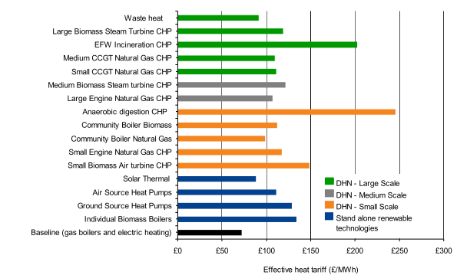
Figure 2.6: Cost of heat provision by technology, using current market conditions (£/MWh) (Davies and Woods, 2009).
Four studies looking into the public opinion of UK DH have been found (Upham and Jones, 2012; DECC, 2013a, 2013c; BEIS, 2017a). On average, 34 – 43% of respondents felt positive when asked about the likelihood of connecting to a DHN. Respondents were most concerned about disruptions to their heat supply and local road network during the installation process and were most positive about WHR and WtE being used as fuel sources. The reputation and reliability of the energy supplier, contract flexibility, costs, and the ability of an individual to maintain control over their heat supply were highlighted as important issues. The most recent study, by the Department for Business, Energy and Industrial Strategy (BEIS), covered 5,000 customers, 3,000 of which were connected to a DHN (BEIS, 2017a). It was found that the level of customer satisfaction was similar for both sets of customers, with similar levels of reported technical reliability. Customers connected to a DHN reported paying approximately £100 less per year for heating. Figure 2.6 suggests that the cheapest source of heat is gas boilers, which disagrees with the findings of the study. It is likely that in the time since Figure 2.6 was published the costs of DH have gotten cheaper or new financial incentives have been applied to DHNs.

UK District Heating Related Legislation
UK DH, CHP and WHR related legislation generally comes in the form of a series of incentives or taxes to encourage the use of environmentally friendly technologies for homes and businesses. A summary of key UK legislation is shown in Table 2.10.
Table 2.10: Key UK DH, CHP, and WHR related legislation.
Policy name | What it does | Reference
Climate change agreements 2017 | Encourages reduction in industrial energy use by giving operators discounts on their climate change levy, electricity and fuel bills. | (UK Government, 2017a)
Enhance capital allowances 2018 | Gives investment to encourage the installation of high-performance energy efficient equipment, including CHP. | (BEIS, 2018c)
Industrial heat recovery support programme 2017 | A support programme to help UK industry invest in and find opportunities for industrial WHR. | (BEIS, 2017b)
Heat and energy saving strategy 2009 | Provides carbon pricing mechanisms to encourage energy saving in UK homes including CHP and DH. | (DECC, 2009a)
Renewables obligation order 2017 | Obliges electricity suppliers to source environmentally friendly electricity. Suppliers are issued with certificates that must be redeemed against their renewables obligation. | (Ofgem, 2017)
Renewable heat incentive 2018 | Offers quarterly payments to users that join the scheme and stick to the necessary levels of renewable provision. | (ICAX, 2018)
CHP quality assurance programme 2017 | A method of assessing all types and sizes of UK CHP units. Offers incentives to successful CHP units. | (UK Government, 2017b)
Climate change levy 2016 | Taxes on industrial energy use for energy sources, bar CHP quality assurance schemes. | (HMRC, 2016)
Energy act 2008 | Feed in tariffs for CHP units up to 5 MW_{e} in size. | (UK Government, 2018a)
Energy white paper 2003 | Set a target to generate 20% of the UK electricity from renewable sources by 2020. | (DTI, 2003)

Table 2.10: Key UK DH, CHP and WHR related legislation (continued).
Policy name | What it does | Reference
Building a greener future – towards zero carbon development 2006 | Recognises DH as a key step in achieving zero carbon housing. | (DCLG, 2006)
Climate change and sustainable energy act 2006 | Supports schemes with an aim to promote community energy programmes. | (Parliament of the United Kingdom, 2006)
Meeting the energy challenge 2007 | Sets out a UK energy strategy tackling energy savings and low carbon technologies. | (DTI, 2007)
Climate change act 2008 | Presents a framework to achieve 34% GHG emission reductions from 1990 – 2020 through a system of carbon budgeting. | (Parliament of the United Kingdom, 2008)
The future of heating: meeting the challenge 2013 | Describes pathways to meet a low carbon heat supply, including the heat network delivery unit. | (DECC, 2013c)

UK Government Carbon Reduction Plans
The level of funding and co-ordination required for DH highlights the importance of considering DH in the UK Governments’ carbon reduction plans. Carbon reduction plans detail how the government is going to allocate funding and co-ordinate industrial experience in the future to reduce the countries carbon emissions.
The government established a UK Low Carbon Transition Plan (DECC, 2009b) that aims to, by 2020, reduce GHG emissions by 18% of the 2008 levels. The plan is unique as it devolves powers and responsibility to every major department in the government; with each department allocated an individual carbon budget and responsible for producing a low carbon plan. Some of the key goals of the plan include commitments to generate 40% of the countries’ electricity from low carbon sources, with 30% coming from renewable sources; committing £3.2 billion of funding to make homes more energy efficient, aiming to supply every home with a smart meter by 2020; and helping to tackle energy and fuel poverty, offering grants and funding to community-based green energy schemes.
Meeting the aims outlined in the Low Carbon Transition Plan will require extensive planning and scenario modelling (Speirs et al., 2010). Five scenarios have been modelled, examining different policy approaches and assessing the impact of each one. The scenarios are as follows a committee on climate change (CCC) 80% carbon reduction scenario, a Department for Environment, Food and Rural Affairs (DEFRA) 80% high bioenergy scenario, a DECC 80% Renewable Energy Strategy (RES) scenario, a UK Energy Research Council (UK ERC) low carbon resilient scenario, and an ‘integrated scenario’. The integrated scenario is based on the CCC scenario including the use of DH and carbon capture and storage-based CHP (CCS-CHP). The integrated scenario is shown to generated 4.2 mtoe of heat and 4.0 mtoe of electricity from gas-fired CCS-CHP plants, as well as 3.7 mtoe of heat and 0.5 mtoe of electricity from biomass fired CHP plants. Benefits of the integrated plan include the ability of DHNs to reduce peak power demands and offer TES, as well as the potential to remove the need for heat pumps removing disruptions to heating systems.
The potential impact of government plans is mainly expressed in terms of funding. Through the Heat Networks Development Unit (HNDU) the government has allocated £320 million of funding up to 2021 to help encourage development in the UK DH market (ADE, 2018). The HNDU has increased funding up to £751 million in 2018 (BEIS, 2018b). It is expected that the government funding and support will attract up to £2 billion of extra capital investment. The RES is a pathway established by the government to allocate £30 billion of funding to renewable heat and electricity schemes through the use of Renewable Obligation Certificates (ROCs) (DECC, 2009c). The RES recognises both CHP and DH as technologies to be supported by the use of ROCs. In addition, the RES has created local development orders giving local authorities more freedom to use planning laws to encourage DH development.

EU District Heating Market
Ecoheatcool studied the heating and DH markets for 32 European countries, including the 28 EU member states, the 3 European Free Trade Association countries and Turkey (Werner, 2006). The total HD for the industrial, domestic and service sectors in the 32 countries is estimated to be approximately 20.8 EJ per year. The size of the DH market is estimated to be approximately 2.0 EJ per year with potential to expand to 3.8 EJ per year.

EU District Heating Market Legislation
Through the actions of the EU, a number of international laws and directives exist that affect DH and CHP. The EC’s 20% by 2020 initiative states that all member states of the EU must reduce their CO₂ emissions to 20% of their 1990 levels (EC, 2012b). As part of directive 202/27/EU on energy efficiency, all EU member states have a legal responsibility to assess the technical and socially cost-effective potential for CHP and DHC in their country (Abu-Ebid, 2015). In the UK, the government has established the CHP site assessment tool, CHP development map, and CHP scheme database under the directive (UK Government, 2018b). The EU Emission Trading Scheme (EU ETS) puts GHG allowances on organisations which reduce their emissions over time, encouraging ever further emission reduction (EC, 2016). The allowances can be traded, offering flexibility in operation.

EU Government Carbon Reduction Plans
On an EU wide scale, a number of carbon reduction plans and funding schemes have been proposed by the Department of Trade and Industry (DTI) that covers DH and CHP (DTI, 2003). A number of EU White Papers cover CHP, particularly as a technology that can implement biomass-based fuels. Through the White Papers the UK has been given a goal of doubling its 5 GW_{e} biomass power to 10 GW_{e}, which will save 1.25 MtCO₂e per year.
The EU have presented scenario-based roadmaps to achieve the 20% by 2020 goals (EC, 2012c). Five scenarios are identified high energy efficiency, which is based around political commitments to high energy savings; diversified supply technologies, which allows the market to choose the best technology and achieves decarbonisation through carbon pricing; high renewable energy sources, which introduces strong support measures for renewable energy sources; delayed CCS, which is based on the diversified supply technologies scenario but with an assumption of delayed market uptake of CCS; and no nuclear, which is based on the diversified supply technologies scenario but with an assumption of new nuclear power installation in the EU. The scenarios could achieve the 80% reduction in GHG emissions using only commercially ready technologies and without significant lifestyle changes (EC, 2010). However, the success is based on a nearly full decarbonisation of the power sector, which is not possible without a drastically increased uptake of nuclear power and CCS. The scenarios identified by the EU do not consider DH, instead the decarbonisation of heating is achieved by electrifying the heat supply, using heat pumps, and reducing the heat and electricity usage.
Connolly et al. disagreed with the proposed scenarios and created a new one, which considers DH to be an important technology (Connolly et al., 2014). The DH based scenario achieves the same reduction in fossil fuel and biomass usage but does so with a 15% reduction in costs for heating and cooling. Many of the EU plans aim for zero carbon buildings with a reduced HD but it is unlikely that the HD will fall to zero, particularly in rural areas (Lund et al., 2016). It has been shown that DH is the cheapest way of supplying rural areas with low carbon heat.

The Future for District Heating
For any technology to be ‘future proof’, continuous consideration needs to be given to how the market will change and how the technology will need to adapt. Due to improvements in DHW and SH technologies, as well as improved building insulation, HDs are expected to fall (Persson and Werner, 2011). In some countries, urban DH markets are nearing saturation.

District Heating as a System
DH is currently in its third generation as a technology and is moving into the fourth. Moving into the fourth generation, DH will need to adapt to meet new challenges and integrate with new technologies. Lund et al. predict that for DH to stay competitive there must be a reduction in network heat losses, an increased use of renewables and recycled energy, and better DH integration into a wider smart energy system (Lund et al., 2014).
With the change to 4th generation DH (4GDH) DHNs will need to be adapted to be able to cope with energy efficient buildings, with lower heat demands, and smart energy systems, with more integration and complex operation (Lund, Alberg, et al., 2018; Lund, Duic, et al., 2018). 4GDH will have to adapt to work with larger radiators that will be used for lower temperature SH and newer DHW controls. Therefore, it is expected that new DHNs will have to separate the flow of SH and DHW demands. 4GDH will work with LTDH and will have to ensure that the lower temperature does not change the grid capacity requirements. An advantage of LTDH is that it will reduce heat losses. 4GDH will work with a larger range of low temperature heat sources. 4GDH will be included in wider energy plans as a way of balancing the grid through TES.

Reducing Supply Temperature
DHNs operate with supply temperatures of approximately 95 °C and return temperatures of approximately 40 °C, which is higher than is needed for most domestic applications (Torío and Schmidt, 2010). A 50 °C supply temperature would be sufficient to meet most domestic applications and prevent the growth of Legionella bacteria (Li and Svendsen, 2012; Schmidt et al., 2014). DHNs with supply temperatures of 55 – 57 °C have been shown to have energy efficiency improvements of 12% and exergy improvements of 7% (Torío and Schmidt, 2010; Li and Svendsen, 2012). The distribution temperature is based on the customer temperature demand and temperature difference faults, so low temperature DHNs must reduce temperature difference faults (Gadd and Werner, 2014).
Whilst aiming to reduce the supply temperature of the DHN will improve the network performance and reduce the network losses, the network must still be able to meet the DHW demand (Østergaard and Andersen, 2018). The DHW demand comprises approximately 25% of the entire HD, requiring a high temperature heat supply. Supplying the DHW demand from a low temperature DHN requires the use of booster heat pumps. As a new technology, booster heat pumps struggle to be financially viable requiring the DHN company to invest in in-house installations.

Changing the Pipe Network
DHNs have separate supply and return distribution pipes buried alongside each other. Heat losses can be reduced by using a single pipe to contain both flows of heat (Fröling et al., 2004; Persson et al., 2006) or by separating the flow of SH and DHW demand, allowing the SH loop to be turned off outside of the heating season (Perzon et al., 2007; Torío and Schmidt, 2010).

Rural District Heating
Rural areas have lower populations and lower population densities than urban areas, resulting in lower HD densities (Nilsson et al., 2008). Therefore, rural DHNs will have lower revenues when compared to the network installation costs, possibly making rural DH unfeasible. However, it is still possible for DH to be economically viable in rural areas, particularly in locations with an already existing heat supply (Frederiksen and Werner, 2013).
To date, the only countries with a significant proportion of the rural area covered by DH are Iceland and Denmark (Reidhav and Werner, 2008). No other countries have a significant share of single family houses connected to DHNs, which is a strong indicator of the size of the rural DH market (Nilsson et al., 2008). The percentage of single-family houses connected to DHNs is 85% in Iceland and 48% in Denmark. Out of the remaining countries, the percentage is 13, 10, and 5% in Finland, Sweden and the Netherlands respectively.
Research has been undertaken to assess the necessary HD density required for profitable DH, which can be used to quickly assess the economic feasibility of potential new rural DHNs. Soltero et al. assessed the potential for biomass based rural DH in Spain, considering 499 municipalities covering over 1,500 people (Soltero et al., 2018). It was found that 185 potential new DHNs were feasible. The authors defined a threshold for profitable DH to be an annual linear heat density of greater than 2 GJ/m. Reidhav and Werner considered the potential for feasible rural DH in 74 areas in Göteborg, Sweden, an area that covered over 3,227 single family dwellings (Reidhav and Werner, 2008). Two factors for profitable DH were identified an annual heat density per dwelling of greater than 50 GJ and an annual linear heat density of over 2 GJ/m.
Sweden has funded a multi-year, £3.1 million project researching the development of rural DH (Nilsson et al., 2008). It found the key factor in increasing the uptake of rural DH is to reduce the investment costs per house. A number of techniques were found to reduce the investment costs: improving rural DH related sales and marketing, connecting more houses to the DHN and reducing the investment costs per house; reducing the number of professionals involved in the DHN installation, reducing the construction costs per house; and reusing excavated materials.
In the UK, the government has advised a minimum HD density for profitable DH to be 26,000 MWh/km² (DECC, 2009a). The government has produced a CHP development map, plotting the HD densities of the different parts of the country (DECC, 2011). The CHP development map shows that large proportions of the rural areas of the UK have HD densities of less than 20,000 MWh/km², making these areas unsuitable for DH. The development map shows some rural areas with HD densities greater than 20,000 MWh/km², suggesting that DH is feasible in some rural parts of the UK. In the UK, a rural area is an area with a population of fewer than 10,000 people (Pateman, 2011). According to the Department for Communities and Local Government (DCLG), using the rural definition means that approximately 9 million people, or 17% of the UK population, lives in rural areas (DCLG, 2014). The rural heat market in the UK is approximately 0.3 PJ per year (BEIS, 2016).

District Heating as a Sociotechnical Process
Understanding DH as a sociotechnical process gives an understanding of (Hawkey, 2009):
- How policy intervention can influence a networks’ success.
- How the various actors interact with each other.
- How the decision-making process affects the design and implementation of a network.

Financial Viability of District Heating
DHNs have long lead times, the time between initial investment and operation, as well as high CAPEX (Davies and Woods, 2009; Hawkey, 2009). The lifetime of a DHN is long, 40 – 50 years, giving a large time to pay off the initial investment. However, industry rarely makes investments if the payback period is over three or four years (Awomewe and Ogundele, 2008; Hawkey, 2009). Due to the high investment costs, the slow rate of payback, and the perceived risks, investment uncertainty exists around DH.
The investment uncertainty has led to three basic needs for DH economic viability, which are heat density, heat load diversity, and anchor loads. Heat density is the HD per unit pipe length; areas of high heat density have lower infrastructure costs per unit of heat delivery. Heat load diversity defines the number of different buildings with different HD profiles connected to a DHN. Higher heat load diversity smooths the overall HD profile of a DHN reducing the need for expensive, peak load heat generating units. Anchor loads are customers with large, constant, and stable HDs that are vital to the success of a new network. The financial viability of a DHN in the UK is highly dependent on the discount rate applied. DHNs are typically only financially viable if a discount rate of 6% below the usual industry standard is applied.

The Role of Actors
Actors refer to the parties that have a stake in the success of a DHN and can be local, regional or national (Hawkey et al., 2013). The key local actor is the local authority. The local authority can fulfil a number of useful roles, including providing the initial motivation, providing the necessary local information, using planning laws to find new customers, and using the local authority owned buildings as anchor loads. In the UK, local authorities have been moved away from the provision of public services which limits the ability of a local authority to plan and operate a DHN (Webb, 2015). Local authorities also have limited financial autonomy and poor working relationships with the central government.
Other local actors include the customers, particularly those that can act as anchor loads; energy companies; developers; and community groups, who may have a personal stake in reducing local emissions or tackling fuel poverty (Hawkey, 2009). National actors include the government, who can intervene with national policy and investment; energy regulators, although in the UK no heat regulator exists; and industry associations, such as the CHP association (CHPA). The CHPA seeks to address national barriers to the implementation of DH and CHP.

District Heating as a Sociotechnical Process in the UK
Every country in the world is unique in terms of its law, regulations, markets, and social dimensions. Therefore, the consideration of DH as a sociotechnical process will differ from country to country.
The liberalised, privatised energy market in the UK has developed an extended and well-run network around the gas and electricity markets whilst failing to create a heat market (Webb, 2015). This seamless network is hard to change or break into placing a low priority on efficiency, limiting the scope for the long-term planning of CHP and DH. The liberalised market is good for large-scale corporations and monopoly providers but not for possible DHNs, giving no financial incentive for large-scale corporations to invest in DH.
Public policy in the UK mainly focuses on the macro level, large scale utilities, and micro level, individual building, and ignores the meso levels, city or urban scales (Hawkey et al., 2013). Ignoring the meso levels means that no policy or planning infrastructure exists for DH and CHP. To encourage more DH investment in the UK a country wide web of social and technical commitments aimed at the meso scale is needed. Bush et al. collected information from a range of UK DH stakeholders to investigate the potential that stakeholders have in promoting UK DH development (Bush et al., 2017). It was found that local stakeholders (local authorities) and regional stakeholders (groups of local authorities) existed but there are no national stakeholders. The authors suggested establishing new local policy frameworks, introducing ownership models, and creating an agency of national standards. The new policy frameworks would allow local authorities to use planning powers to encourage DH. The ownership models would allow local authorities more ownership and therefore more influence over DH.
As DH is an example of decentralised infrastructure, the planning and running of a DHN must be orchestrated by a local authority (Davies and Woods, 2009). The lack of ability that local authorities have to operate DHNs themselves requires the use of intermediaries, which drives up the costs of the network (Webb, 2015).

Lead Acid Batteries
Research into LABs is important as HJE are a LAB recycling company. It is useful to understand the LAB market and recycling processes.

HJ Enthoven
HJE are the primary heat supplier used in the case study. HJE are the largest LAB recycling plant in Europe, with annual rates of production of approximately 80,000 tonnes of lead and polypropylene (ECOBAT, 2017). Annually, the plant recycles 150,000 tonnes of batteries. The recycling process consists of both reverberatory and short rotary furnaces and a flue gas desulphurisation plant. It has been estimated that approximately 5 MW of thermal power could be made available from the processes used at the plant. HJE is located in the Derbyshire Dales, England near to the built-up areas of Matlock, Darley Dale, and Bakewell.

Lead Acid Battery Market
The global market for lead, both mined and refined, is valued at £12.2 billion (Winckel and Rice, 1998; Kara et al., 2008). LABs use 82% of global lead production, representing a market worth £19.1 billion. Due to its health and environmental concerns lead is highly recycled; secondary lead from LABs is the main source of lead on the market (Ellis and Mirza, 2010).

Lead Acid Battery Recycling
The LAB recycling process is used to recover the lead, polypropylene and acid electrolyte for reuse or use in other products (Espinosa et al., 2004). According to the United National Environment Programme (UNEP), the process is comprised of several stages (UNEP, 2003). Firstly, the LABs are collected and transported to the recycling site. The batteries should be kept in secure, safe, and acid proof containers and should not be drained until safe arrival at the site. Upon arrival at the site, the batteries are drained to improve the recycling efficiency and environmental performance. The LAB breaking happens through cycles of crushing and gravity separation (Jolly and Rhin, 1994; Ahmed, 1996). The batteries are separated into the following components lead oxides, sulphates, light fractions, heavy fractions, polypropylene, and ebonites.
Lead reduction is used to separate the components into metallic lead, lead oxide, lead sulphate, and traces of other metals (UNEP, 2003). The reduction can happen pyrometallurgically or hydrometallurgically. Pyrometallurgical lead reduction occurs through a chemical reduction during heating and the addition of fluxing and reducing substances (UNEP, 2003). Various chemicals are added to de-sulphurize the fines and electrode paste, neutralise the acid electrolyte, and allow for further reduction (UNEP, 2003). Hydrometallurgical lead reduction is often considered more expensive than a standalone LAB recycling plant would consider (Zhang, 2013).
The reduction process makes a hard lead with a high antimony concentration (UNEP, 2003). Lead refining is used to remove all but trace amounts of other metals, making a soft lead.

Lead Acid Batteries Legislation
LABs are governed by directive 2006/66/EC of the European Parliament, which deals with the production, distribution, collection, and disposal of all battery chemistries (EC, 2006, 2012a, 2014). It outright bans the use of mercury in all batteries and the landfilling of LABs, as well as giving country specific targets for the total recycling rate of LABs.

Conclusion
The key topics of the literature review were:
- The different technologies used in DH, WHR and TES.
- The modelling techniques used in DH, WHR, TES and heat mapping.
- The UK DH market.
- The economic and environmental assessments of DH.
A wide variety of different technologies and TE sources can be utilised by the TE generating unit(s) in a DHN. Therefore, various combinations of technology and TE source exist. The technologies include boilers, CHP, and heat pumps and the TE sources include WHR, WtE, fossil fuels, biomass, renewable fuels, and nuclear. The main priorities of the DHN operator are to provide TE to the customers in a manner that is both environmentally and economically friendly. Therefore, the primary heat source in a DHN generally uses CHP, as it is the most efficient technology. The choice of the fuel tends to be one of the locally available renewable or carbon neutral options, including WHR, WtE, biomass, renewable fuels, and nuclear. The back-up heat supply tends to be a traditional boiler powered by fossil fuels, as this is cheap, simple, and reliable.
A range of different heat mapping techniques were compared and assessed. In this thesis, the purpose of the heat mapping is to estimate the HD or HD variation in a local area. Consequently, the heat mapping techniques do not need to be highly accurate. Techniques such as questionnaires, thermal imaging, and remote sensing were shown to be highly accurate but either more expensive or not fast enough. The best mapping technique for the purpose of HD estimation was shown to be archetype heat mapping using reliable database information of buildings’ characteristics. Multiple linear regression-based models are not required when the purpose of the heat mapping is to estimate the yearly HD of an area instead of the hourly variation in the HD.
This thesis investigates the potential of utilising WHR as the TE source for a new DHN. A range of different WHR technologies and uses were researched, including HEXs, heat pumps, ORCs, Kalina cycles, and thermoelectric generation. The operating temperatures and uses for the different WHR technologies were found. Different techniques for WHR modelling were researched and compared. The main techniques used in WHR modelling were found to be element mass and energy balances and pinch analysis.
A range of models for HD variation, which had a wide range of uses, advantages, and disadvantages, were assessed and compared. The model type that is the best choice in one situation may not be the best choice in another. In this thesis, so no detailed and reliable primary data can be supplied as no comparable DHN exists. The HD model must be able to work with only basic primary information as no similar DHN was found.
HDD models were shown to be an accurate and viable method of using historical based weather and HD data to predict future HD performance. HD models based on customer measurements were shown to be widely used. Due to the high response rate needed to make this modelling type accurate, as well as the large variation that exists in the results for a heterogeneous buildings stock, measurement-based models are unsuitable for use in this thesis. None of the literature reviewed contained a technique for modelling the hourly variation in HD that is tailored for use by a non-technical user.
Archetype HD models were shown to be accurate, easy to use, and suitable for use in situations without readily available primary network data. It was shown that the accuracy of archetype models is heavily dependent on the accuracy of each individual archetype calculation and the number of archetype categories used.
It is possible to model a DHN by splitting the effect of the HD into components and calculating the HD of each individual component. Whilst a number of researchers model HD variation through the splitting of components, the models generated all require validation with primary network data. The need for primary network data makes component-based modelling unsuitable for use in this thesis.
Deterministic models were shown to be highly accurate due to the complex simulation software used. However, in cases where the use of complex simulation software is not possible, such as is the case in this thesis, deterministic models should not be used.
A number of predictive, time series models were considered, including ARMA models, Kalman filters, ANNs, FNNs, SVMs, and genetic programmes. Predictive models were shown to be accurate, using machine learning to improve themselves over time. However, predictive models are complex in nature and are only suitable for cases where the model operator has the specialist skills required to use them.
Statistical models, which were shown to be easy to build, modify and understand were shown to need primary network data for validation. Therefore, statistical models were shown to be unsuitable for use in this thesis.
Physical models only require simple data inputs and were shown to be possible to simplify using aggregation. However, the simplification process does not work for every DHN and must be completed by a trained individual, making physical models unsuitable for use in this thesis.
A wide range of technologies and modelling types were found for the purposes of DHN optimisation using TES. Seasonal TES was shown to be profitable in DH, but only for large networks that could utilise the economies of scale. PCMs and CES were both shown to have potential for use in DH, but a number of issues including safety prevented further consideration. HWT based TES and TES utilising the thermal inertia of the buildings on the network and the network itself were shown to be possible TES technologies. The optimisation technique shown to be suitable for use in most cases was MILP. Modelling stratification in the HWT was shown to be more accurate than assuming that the tank is fully mixed. However, the improvements in accuracy were shown to be minimal, so will not be necessary for simple model types.
Most of the research reviewed considered the optimisation of a DHN where the heat supply derived from a CHP unit or a traditional boiler. Little research has been done which focuses on a heat supply from WHR. When compared to a CHP or boiler-based heat source, the heat supply from WHR is significantly less predictable. Boiler based heat sources are operated around the HD of the network and CHP based heat sources are operated around variable electricity prices, both of which are predictable cycles. By contrast, WHR based heat sources operate around an industrial schedule, which can vary from industry to industry and from week to week within the same industry. No comparison has been found comparing a HWT based TES system and TES in the thermal inertia of the building stock and the network itself. Similarly, no study exists comparing multiple different HWTs to thermal inertia-based TES systems. Finally, the literature did not find any studies optimising DHNs in a manner that is simple enough for a non-technical individual to use.
The UK DH market was found to be small due to a lack of funding from the government, as well as a lack of obligation on local authorities, property developers, and industry to consider DH.
The most commonly used economic assessment was based around techno-economic methodology and the NPV of components. The environmental assessment most commonly used is a simplified version of a LCA.

Heat Mapping
A heat map can be used to make an initial estimate of the feasibility of a new DHN in an area. The process can be used to estimate the local area HD, identify population areas with a HD density sufficient to meet DH guidelines, identify anchor loads, and suggest the possible network route. In this thesis the heat mapping process was used to identify population areas with a HD density of greater than 3 MW/km² (to meet DH guidelines) and identify the presence anchor loads. The heat mapping process is split into two parts domestic and commercial heat mapping. The process used techniques outlined by Parsons Brinckerhoff, the University of Sheffield, the Chartered Institution of Building Services Engineers (CIBSE), the Energy Information Administration (EIA), the UK Energy Research Centre (UK ERC), and UK census data (UK ERC, 2006; CIBSE, 2008; ONS, 2011b; Parsons Brinckerhoff, 2011; Finney et al., 2012; EIA, 2016).

Methodology
The domestic and the commercial heat mapping processes followed different methodologies, but in both cases the results were plotted using QGIS. QGIS is an open source GIS mapping tool developed and maintained by GEOFABRIK (GEOFABRIK, 2017).

Commercial Heat Mapping Methodology
Commercial heat mapping was used to identify possible anchor loads and highlight parts of the case study area which were suitable for connection to a DHN. The identification of the anchor loads used a technique presented by Parsons Brinckerhoff (Parsons Brinckerhoff, 2011). Google Maps and Google Street View were used to study the case study area, locating all the commercial buildings and recording:
- Building name.
- Building location.
- Building type.
- Building floor area (m²).
- An estimation of the number of building floors.
The building floor area and estimated number of floors were used to estimate the total SA of all the floors in the buildings (m²). The use of Google Maps and Google Street View to measure area introduced error into the work. Lopes and Nogueira studied the error found when using Google Maps to measure area (Lopes and Nogueira, 2009). It was found that the total error was 3.54%, which is within the allowable threshold of an estimation calculation.
Archetype values of the yearly building HD were needed to calculate the HDs of the commercial buildings. CIBSE energy benchmarks TM46 (CIBSE, 2008) were used to give the typical yearly electricity and fossil fuel use (kWh/m²) for 29 archetype building categories. The CIBSE TM46 building categories are shown in Table 3.1.

Table 3.1: CIBSE building energy benchmark categories (CIBSE, 2008).
CIBSE category | Building type | Typical electricity benchmark per year (kWh/m²) | Typical fossil fuel benchmark per year (kWh/m²)
1 | General office | 95 | 120
2 | High street agency | 140 | 0
3 | General retail | 165 | 0
4 | Large non-food shop | 70 | 170
5 | Small food store | 310 | 0
6 | Large food store | 400 | 105
7 | Restaurant | 90 | 370
8 | Bar/ pub | 130 | 350
9 | Hotel | 105 | 330
10 | Cultural activities | 70 | 200
11 | Entertainment halls | 150 | 420
12 | Swimming pool centre | 245 | 1,130
13 | Fitness and health | 160 | 440
14 | Dry sports | 95 | 330
15 | Covered car park | 20 | 0
16 | Public buildings with light use | 20 | 105
17 | Schools and seasonal public buildings | 40 | 150
18 | University campus | 80 | 240
19 | Clinic | 70 | 200
20 | Hospital | 90 | 420
21 | Long term residential | 65 | 420
22 | General accommodation | 60 | 300
23 | Emergency services | 70 | 390
24 | Lab/ operating theatre | 160 | 160
25 | Public waiting/ circulation | 30 | 120
26 | Terminal | 75 | 200
27 | Workshop | 35 | 180
28 | Storage facility | 35 | 160
29 | Cold storage | 145 | 80

The heat mapping work only required the yearly energy use for heating purposes. Therefore, the CIBSE TM46 values needed to be converted to only show the energy use for heating. The conversion was achieved using the USA EIA commercial buildings energy consumption study (EIA, 2016). The study split the fuel use of 18 different archetype building categories into heat and electricity demands, as shown in Table 3.2. The CIBSE and EIA studies were combined to estimate the total yearly energy use for heating (kWh/m²) for each of the 29 CIBSE archetype building categories. As the EIA study used data for American and not English buildings, it was assumed that the proportion of energy used for heating purposes is similar for both.

Table 3.2: EIA electricity and fossil fuel building energy consumption by end use (EIA, 2016).
EIA category | Building type | How much of the total electricity demand is used for heating (%) | How much of the total fossil fuel demand is used for heating (%) | Corresponds to CIBSE categories
A | Education | 2.8 | 91.4 | 17, 18
B | Food sales | 1.0 | 60.4 | 5, 6
C | Food service | 2.9 | 33.0 | 7, 8
D | Health care | 1.4 | 83.0 | -
E | Inpatient | 1.2 | 81.7 | 20
F | Outpatient | 1.8 | 93.5 | 19
G | Lodging | 3.6 | 71.9 | 9, 20, 21
H | Mercantile | 2.8 | 74.6 | -
I | Retail (other than mall) | 2.1 | 90.5 | 2, 3, 4
J | Enclosed and strip malls | 3.5 | 69.6 | 25
K | Office | 2.4 | 88.3 | 1
L | Public assembly | 3.3 | 91.9 | 10, 11, 12, 13, 14, 16
M | Public order and safety | 2.7 | 92.7 | 22
N | Religious worship | 3.7 | 82.8 | -
O | Service | 2.4 | 97.5 | 26
P | Warehouse and storage | 1.8 | 85.6 | 27, 28, 29
Q | Other | 1.6 | 70.4 | 23
R | Vacant | 3.8 | 89.7 | 15

The yearly energy use for heating needed to be further converted into peak and average power heating demands (kW/m²). The average power demand was calculated by dividing the total yearly energy use by the assumed number of hours of operation in a year (Finney et al., 2012). The conversion of average to peak power was completed using a study by the UK ERC (UK ERC, 2006). The UK ERC study investigated the gas and electricity demand profiles for a range of UK building archetypes, generating a series of typical demand profiles. The typical demand profiles were used to find a ratio of average to peak power for each archetype category, as shown in Table 3.3. Only the gas profiles of the UK ERC datasets were studied as Table 3.2 shows that the percentage of total electricity used for heating is low, at less than 4%.
The commercial heat mapping work required an assumption to be made that the CIBSE, EIA and UK ERC datasets could be accurately applied to the buildings in the study.

Table 3.3: Summary of the UK ERC heating power variation study (UK ERC, 2006).
Building type | Yearly hours of operation | Ratio average power to peak power | Corresponds to CIBSE categories
School | 1,850 | 5.6 | 17, 18
Leisure centre | 5,890 | 1.8 | 12, 13, 14
Care home | 6,550 | 1.8 | 19, 20, 22, 23
Retail (large shops) | 3,390 | 2.0 | 2, 3, 4
Hotels and hostels | 3,640 | 1.7 | 9
Pubs and clubs | 2,140 | 1.4 | 8
Restaurants and food | 5,360 | 2.5 | 7
Supermarket | 2,550 | 3.2 | 5, 6
Local government and offices | 2,550 | 4.5 | 1
Miscellaneous | 2,500 | 2.7 | 10, 11, 15, 16, 21, 24, 25, 26, 27, 28, 29

Domestic Heat Mapping Methodology
The purpose of the domestic heat mapping was to determine the overall HD density of the case study area to determine if it meets the recommended threshold for profitable DH (DECC, 2009a). The domestic heat mapping process used a technique outlined by Finney et al., calculating the domestic HD density based on a conversion from the population density (Finney et al., 2012). UK census data was accessed that provided population density data for output areas, small geographical areas of at least 40 households (ONS, 2011b, 2011a). The conversion from population density to HD density was based on the following assumptions (Finney et al., 2012):
- The average UK household used 20.5 MWh of TE per year for heating.
- The average number of people living in a UK household was 2.37.
- The average number of domestic heating hours per year was 3,000.
The yearly energy use for heating was converted into peak and average power demands for heating using Table 3.3 (UK ERC, 2006).
Both the domestic and the commercial heat mapping methodologies were simple to carry out, allowing them to be completed by a non-technical user. The methodology of the commercial heat mapping only required the location, type and size of each building in the local area, which any user should be capable of finding. The domestic heat mapping only required population density records, which are freely available. Neither of the domestic or commercial heat mapping calculations include any consideration of the weather across the year of calculation. In both cases the results are calculated for an average year.

Results
The heat mapping process was carried out over the locations that could potentially be connected to a DHN around the case study heat source, the HJE site. After communication with HJE staff, two criteria were identified to determine which potential locations would be included in the heat mapping process. The potential locations had to be within an 8 km radius of the HJE site and had to have a minimum population of 1,000 people. Seven possible locations were identified: Bakewell, Rowsley, Youlgreave, Darley Dale, Matlock, Matlock Bath, and Cromford. Six of the seven areas and the HJE site were located near to a disused railway line, which would be an ideal route for the DH pipes. In addition to HJE a second possible heat source was identified: Chatsworth House. The heat sources, the potential locations, and the possible network route are shown in Figure 3.1.
Figure 3.1: The locations of the two heat sources, seven possible locations to be mapped, and suggested network route in the case study area (GEOFABRIK, 2017).

Commercial Heat Mapping
The commercial heat mapping identified possible anchor loads in all of the potential locations. The energy and power demands of every building assessed in the heat mapping process is given in Appendix 13.1. Table 3.4 shows the total energy and power demands of all of the commercial buildings in each of the potential locations.
Heat maps for each of the potential locations were produced, splitting the commercial buildings into eight categories: commercial, council, education, health, hospitality, industrial, leisure, and residential. Figure 3.2 shows all of the large commercial heat customers, the possible anchor loads, in the case study area.

Table 3.4: Energy and power demands of the large heat users in the case study area.
Potential location | Total yearly energy use for heating in the area (MWh) | Total average power for heating in the area (MW) | Total peak power for heating in the area (MW)
Matlock | 24,000 | 7.4 | 25
Darley Dale | 4,100 | 1.6 | 4.8
Rowsley | 4,600 | 1.8 | 4.6
Bakewell | 9,000 | 2.8 | 7.4
Youlgreave | 350 | 0.14 | 0.43
Matlock Bath and Cromford | 3,200 | 1.1 | 3.5
HJE site | 3,800 | 0.53 | 1.6
Total | 49,000 | 15 | 47

Figure 3.2: The large commercial heat customers and their average power demand, which can act as the possible anchor loads, in the case study area (GEOFABRIK, 2017).
The largest concentrations of large commercial heat customers were found in Bakewell, Darley Dale, and Matlock. Heat maps showing the concentrations of the large heat customers in Bakewell, Darley Dale, and Matlock are shown in Figure 3.3 - Figure 3.5. The large value of commercial heating energy and power demand found for Rowsley in Table 3.4 is omitted from Figure 3.2 as it was largely comprised of the industrial site located approximately halfway in-between Rowsley and Darley Dale. Using the relative concentrations of the commercial heat users, it is recommended that the non-technical user should prioritise DHN connection for Bakewell, Darley Dale, and Matlock. Due to the relative location of Rowsley with respect to the old railway line and the possible network route, it is also advised that the user prioritises the connection of Rowsley. The areas of Matlock Bath, Cromford and Youlgreave should be connected to the DHN at a later date, dependent on the total network costs and revenues.
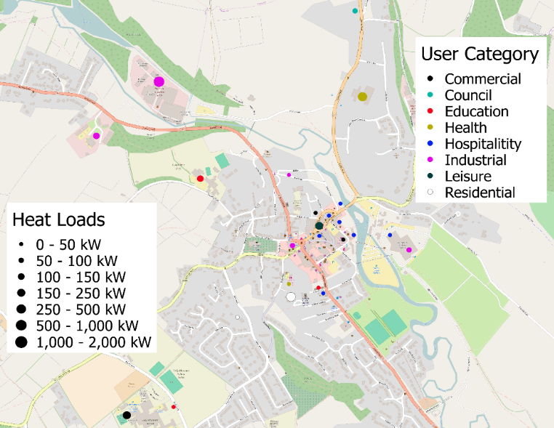
Figure 3.3: Large heat users in Bakewell and their average power demand (GEOFABRIK, 2017).
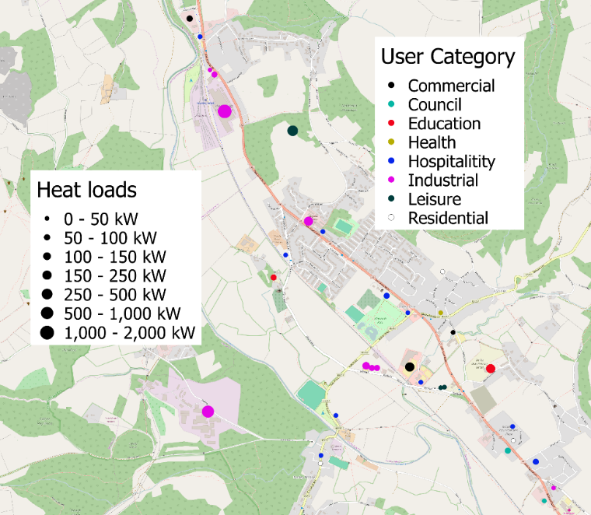
Figure 3.4: Large heat users in Darley Dale and their average power demand (GEOFABRIK, 2017).
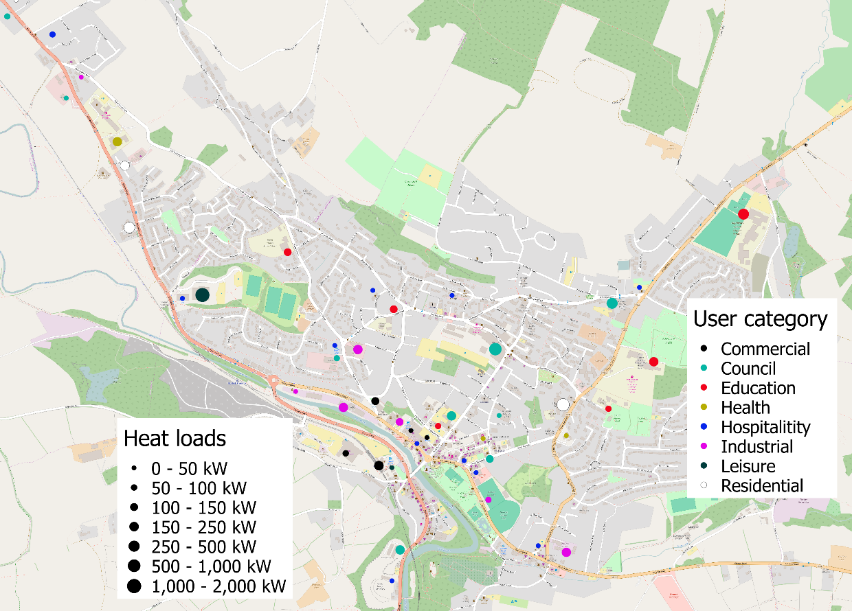
Figure 3.5: Large heat users in Matlock and their average power demand (GEOFABRIK, 2017).

Domestic Heat Mapping
The domestic heat mapping found that four of the seven potential locations had HD densities greater than the 3 MW/km² government threshold for profitable DH (DECC, 2009a), as shown in Figure 3.6. The four potential locations were Matlock, Darley Dale, Bakewell, and Youlgreave. Population densities of less than 1,000 people per km² were not included in the domestic heat mapping as the HD density in these areas was less than the 3 MW/km² threshold. The conversion of population, energy and power densities are given in Table 3.5.
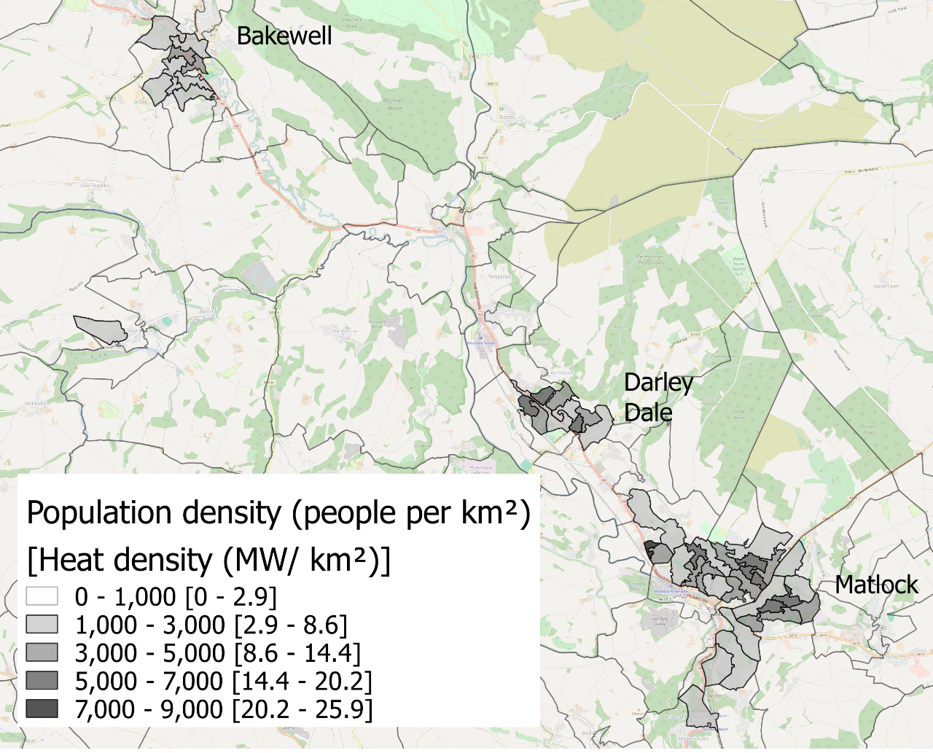
Figure 3.6: Population and HD densities in the case study area (ONS, 2011b; GEOFABRIK, 2017).
Table 3.5: Population, energy, and power density conversion.
Population density (people per km²) | Yearly energy density (MWh/km²) | Average power density (MW/km²)
0 – 1,000 | 0 – 8,600 | 0 – 2.9
1,000 – 3,000 | 8,600 – 26,000 | 2.9 – 8.6
3,000 – 5,000 | 26,000 – 43,200 | 8.6 – 14.4
5,000 – 7,000 | 43,200 – 60,500 | 14.4 – 20.2
7,000 – 9,000 | 60,500 – 77,800 | 20.2 – 25.9

The domestic HD densities for Bakewell, Darley Dale, and Matlock are shown in Figure 3.7, Figure 3.8, and Figure 3.9. The three areas had zones with HD densities of at least 2.9 – 8.6 MW/km². Each of the three areas had zones with HD densities of between 8.6 – 14.4, 14.4 – 20.2 and 20.2 – 25.9 MW/km². Bakewell, Darley Dale and Matlock all had HD densities sufficiently high to meet the government threshold. Whilst Figure 3.6 shows that Youlgreave had an area with a HD density high enough to meet the government threshold, it barely met the threshold and the zone was small. As a result, the non-technical user is advised to only prioritise the areas of Bakewell, Darley Dale, and Matlock for connection to the DHN. Youlgreave could be connected at a later date, dependent on the total network costs and revenues.
Rowsley, due to its location between Darley Dale and Bakewell and near to the suggested network route should also be prioritised as an initial area to connect to the DHN. Matlock Bath and Cromford do not meet the guidelines for profitable DH and are not located on the already existing network route. Therefore, it is not suggested that these areas are prioritised with connection to the DHN.
Figure 3.7: Population and HD densities of Bakewell (ONS, 2011b; GEOFABRIK, 2017).
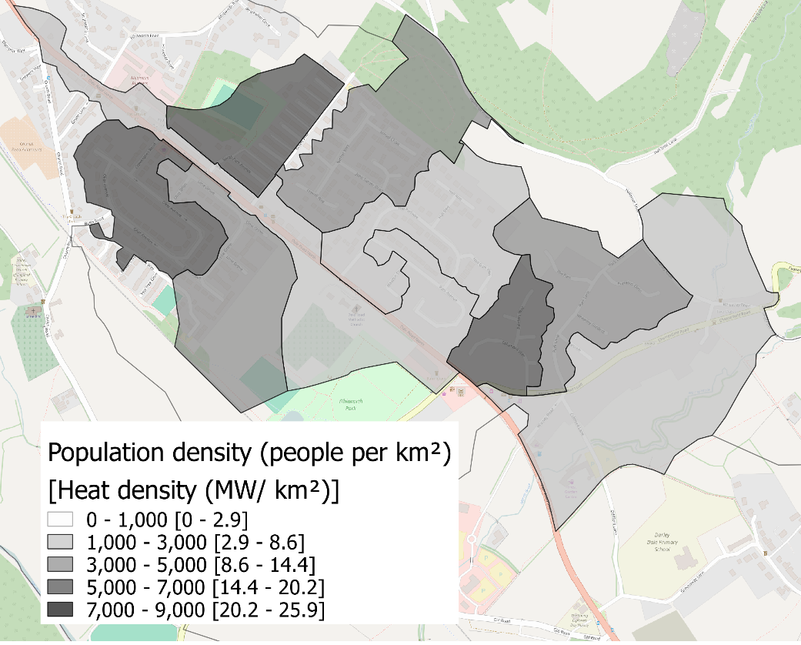
Figure 3.8: Population and HD densities of Darley Dale (ONS, 2011b; GEOFABRIK, 2017).
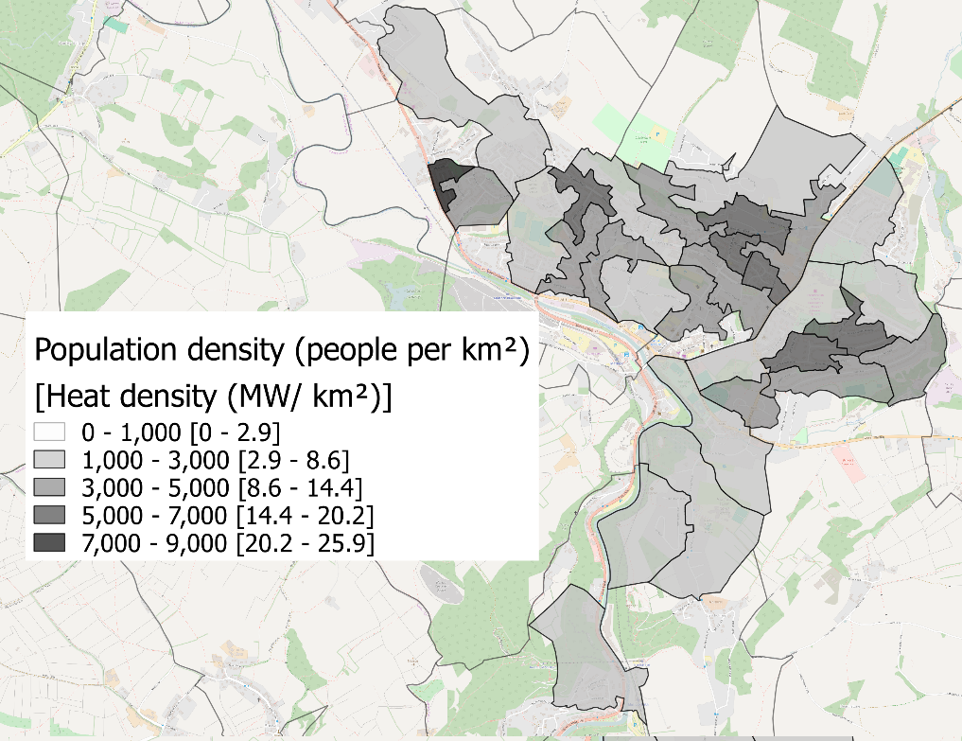
Figure 3.9: Population and HD densities of Matlock (ONS, 2011b; GEOFABRIK, 2017).

Heat Mapping Validation
It is insufficient to propose a heat mapping model, use the model and state that the results are accurate. Instead the model needs validation, either internal or external. The modelling technique was proposed by Parsons Brinckerhoff, an engineering consultancy who have confidence in their model and extensive industrial operation. The reputation of Parsons Brinckerhoff provides some of the external validation needed to prove that the modelling technique is accurate (Parsons Brinckerhoff, 2011).
Further external validation was provided by comparing the heat mapping methodology used in the thesis to existing heat mapping work. DECC published a heat map showing the potential for UK CHP development, as shown in Figure 3.10a (DECC, 2009a). The map includes the heat demands for all UK sectors: industrial, commercial, public, and domestic. The map was developed in 2009 and continues to be the industrial standard in 2019. When compared to the results of the heat mapping methodology used in this thesis, as shown in Figure 3.10b, the maps are similar. The two heat maps show similar HD densities in similar areas. The similarity provided external validation to the heat mapping methodology.
The DECC heat map shows large areas with energy densities of 1,000 – 2,000 MWh/km² and some areas of 2,000 – 10,000 and 10,000 – 20,000 MWh/km². The domestic heating mapping methodology introduced in this thesis ignored HDs of less than 8,700 MWh/km², as this is below the threshold for profitable DH. The map shows numerous areas with HD densities of 8,700 – 26,000 MWh/km², with some areas of 26,000 – 43,000, 43,000 – 61,000 and 61,000 – 78,000 MWh/km². The minor differences between the two heat maps were likely to be due to the different scopes and boundary areas used in the methodologies, as well as the different sizes and shapes of the individual areas considered.
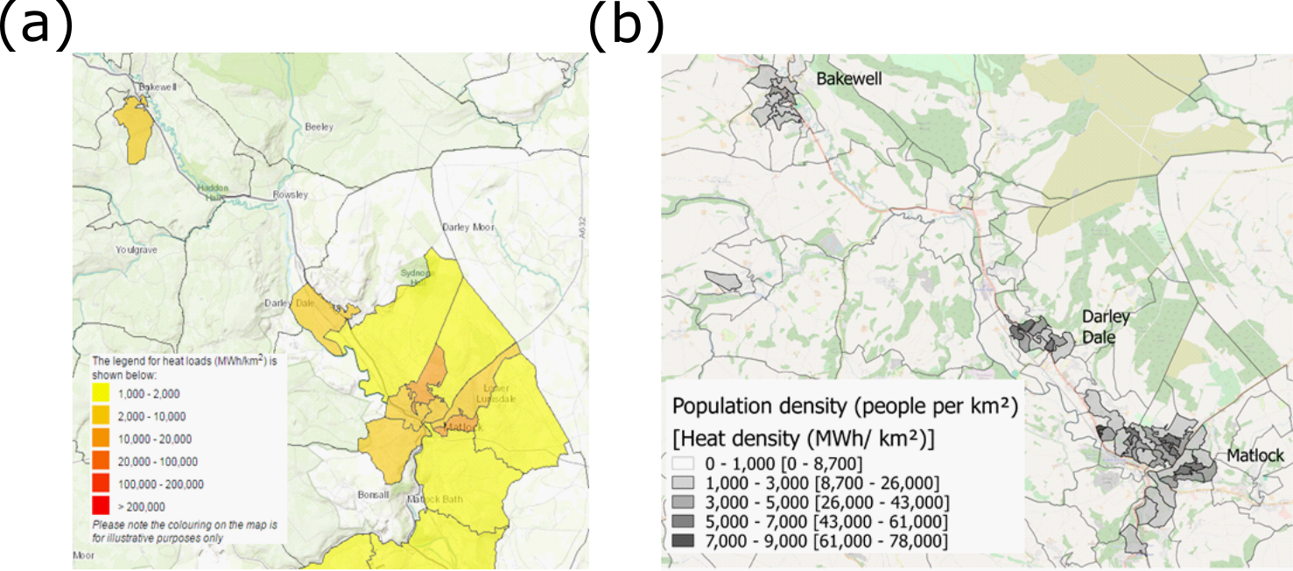
Figure 3.10a: The UK CHP development heat map produced for the case study area (DECC, 2011). Figure 3.10b, The heat map produced in the thesis (ONS, 2011b; GEOFABRIK, 2017).

The CHP development map calculated the total HD in a highlighted area. The total HD found in the case study area is shown in Table 3.6.
Table 3.6: Total HD in the case study area, as found by the UK CHP development map (accessed in 2019) (DECC, 2011).
Domestic/ non-domestic | Sector | Yearly heat demand (MWh)
Domestic | Domestic | 322,000
Non-domestic | Communications and transport | 171
 | Commercial offices | 3,240
 | Education | 5,580
 | Government buildings | 4,310
 | Hotels | 3,110
 | Health | 852
 | Other | 787
 | Small industrial | 19,500
 | Retail | 3,140
 | Sport and leisure | 503
 | Warehouses | 372
 | Total | 42,000
Total heat load in the area |  | 363,000

Table 3.7 shows the HD found in the case study area using the methodology outlined in the thesis.
Table 3.7: Total HD in the case study area, as found using the methodology outlined in the thesis.
Type | Location | Yearly heat demand (MWh)
Non-domestic | Matlock | 24,000
 | Darley Dale | 4,100
 | Rowsley | 4,600
 | Bakewell | 9,000
 | Youlgreave | 350
 | Matlock Bath and Cromford | 3,200
 | HJE site | 3,800
 | Total | 49,000
Domestic | Matlock | 92,000
 | Darley Dale | 34,000
 | Rowsley | 4,400
 | Bakewell | 34,000
 | Youlgreave | 13,000
 | Matlock Bath and Cromford | 8,800
 | Total | 200,000
Total heat load in the area |  | 249,000

When comparing Table 3.6 and Table 3.7, approximately similar values of the total commercial HDs were found. The UK CHP development map found the commercial HD to be 42,000 MWh per year. The methodology used in this thesis found the domestic HD to be 49,000 MWh per year with a minor, but not insignificant difference, between the two totals of 14%. In this work, commercial heat mapping was used to identify possible anchor loads in an area instead of accurately modelling the demand, so the 14% difference is acceptable. Heat mapping and techno-economic modelling work by Parsons Brinckerhoff reported a variation in acceptable results of approximately 24%; the 24% variation is higher than the 14% variation reported here, proving that the 14% variation is acceptable (Parsons Brinckerhoff, 2011). The agreement in the commercial heat mapping adds validation to the heat mapping methodology outlined in the thesis.
Table 3.6 and Table 3.7 show significantly different values for the total domestic HD. The CHP development map found the domestic HD to be 322,000 MWh per year. The methodology used in this thesis found the domestic HD to be 200,000 MWh per year, with a larger difference between the two totals of 38%. The 38% variation found between the two heat maps is higher than the 24% variation reported by Parsons Brinckerhoff. The reason for the higher domestic energy demand found in the CHP development map was likely to be that the map considered the entire area within an 8 km radius of the HJE site. By contrast, the methodology used in the thesis only considered the seven potential locations likely to be connected to the network, which was a significantly smaller area.
In this thesis, the purpose of the domestic heat mapping was not to estimate the total HD in an area, that will be done in later HD modelling work. The purpose of the domestic heat mapping was to identify zones in the local area that met the threshold for profitable DH, to assess if a DHN may be feasible. Therefore, if the two heat maps show similar areas that have HD densities sufficient to meet the threshold for profitable DH but differ on the total domestic HD the disagreement is not significant. Even if the two techniques differ in terms of the total domestic HD, the difference does not prove that the technique used to identify areas of profitable DH was inaccurate. Therefore, the domestic heat mapping technique outlined in the thesis was still validated for future work.

Conclusion
Commercial and domestic heat mapping was completed using archetype-based techniques, using the case study of HJE and the local area. The methodology used in the heat mapping was designed to be simple and generic enough that it could be operated by a non-technical user for any location in the UK. The accuracy of the methodology was assessed by comparing the case study results to an existing, reliable heat map created by the UK government.
The local area was studied to find potential locations that might be suitable for connection to the new DHN, with seven potential locations being identified. The seven potential locations were Matlock, Darley Dale, Rowsley, Bakewell, Youlgreave, Matlock Bath, and Cromford. A disused railway line was found that connected all seven of the potential locations, bar Youlgreave, running close to the HJE site, which would be an ideal route for the DH pipes. The commercial heat mapping identified a high density of customers with large HDs, that could act as anchor loads, in Matlock, Darley Dale, and Bakewell. The domestic heat mapping identified areas in Matlock, Darley Dale, Bakewell, and Youlgreave with a HD density larger than the government recommended threshold for profitable DH.
It was recommended to the non-technical user that the areas that should be initially connected to the DHN are Matlock, Darley Dale, and Bakewell. The reason for the prioritisation is that these areas were shown to have a high number of possible anchor loads, meet the minimum threshold for profitable DH, and were located near to the likely pipe network. Rowsley is located in-between Darley Dale and Bakewell and near to the likely pipe network, therefore it was recommended as the next area to connect to the DHN. Youlgreave did not have many possible anchor loads, only had a small area that met the threshold for profitable DH and was located far away from the pipe network. Therefore, Youlgreave was not recommended for initial connection to the DHN. Matlock Bath and Cromford did not have many possible anchor loads or any areas that met the threshold for profitable DH and were located outside the DH pipeline connecting Matlock to Bakewell. Therefore, Matlock Bath, and Cromford were not recommended for connection to the DHN. Youlgreave, Matlock Bath, and Cromford could be connected at a later date depending on the total network costs and revenues.
In order to assess the accuracy of the simple, generic model for heat mapping, the results were compared to an existing heat map generated by the UK government. The government heat map is reliable, therefore if the results of the two heat mapping methodologies were similar, the methodology generated in this thesis would be proven to be accurate. Both the heat map from this thesis and the one produced by the government considered areas within an 8 km distance from the HJE site and could be split into domestic and commercial results.
The heat maps produced in this work and by the government both showed similar areas with HD densities higher than the threshold for profitable DH. Slight differences were found in the two heat maps, but these were shown to be due to the different sizes and shapes of the areas that the maps were split into. The similarity of the two maps showed that the methodology generated in this thesis to identify areas of profitable DH is accurate and can be used in future work. The total commercial HD found in the government heat map was 14% different to the HD found in this thesis. A 14% difference is lower than industrial reported variations, so is acceptable for the purposes of HD estimations; therefore the government heat map supports the accuracy of the heat mapping methodology produced in this work for the purposes of identifying anchor loads.
The total domestic HD found in the government heat map was 38% higher than the HD found in the thesis, which is higher than industrial reported variations. It was shown that the reason for the large difference is that the government heat map considers all areas within an 8 km radius of the HJE site, whereas the heat map generated in the thesis only considers seven potential locations. It was explained that if the purpose of the domestic heat mapping is to identify areas of profitable DH, a disagreement in the total domestic HD is acceptable. Therefore, the heat mapping methodology outlined in this thesis was proven to be accurate.

Waste Heat Supply Quantification
The DH feasibility study will not be possible without a quantified answer to how much WH is available from the industrial source(s). The answer must include the variation in WH availability that occurs due to variations in the industrial schedule. Ideally, the industrial source(s) would be able to answer this question themselves, saving time and effort on behalf of the user, as well as giving as accurate an answer as is possible.
If not, the non-technical user will have to model these variations in industrial operation. The model will have to investigate the quality, quantity, and temporal availability of the WH in each process stream of the industrial site. The quality and quantity can be calculated by finding the specific enthalpy, flowrate, and temperature of each stream. The temporal availability will be found by repeating the model using a time-based variation in the input conditions. The simplest model that can be used to calculate these quantities with an acceptable level of accuracy and without the use of simulation software is elemental-based mass and energy balances. Simulation software should be avoided as it would be unavailable to the user.
Mass and energy balances are based around a generic equation, as shown in Equation 4.1 (Sinnott, 2005a). A degrees of freedom (DoF) process is run across the entire system identifying a particular unit or part of the system with enough available information to begin the balances. The balances are repeated until the process has been completed for the entire industrial site.
$$\text{Accumulation = Input - Output + Generation - Consumption}$$ | 4.1

$\text{Accumulation}$ is the positive, or negative, build-up of mass and/or energy in the system,
$\text{Input}$ is the addition of mass or energy to the system,
$\text{Output}$ is the extraction of mass or energy from the system,
$\text{Generation}$ is the creation of mass or energy in the processes that occur in the system,
$\text{Consumption}$ is the use of mass or energy in the processes that occur in the system.

Methodology
There are a number of different techniques that could be used to quantify the heat supply, the choice of which depends on the industrial site. In particular, the choice depends on the complexity of the industrial operation and the level of information that the company keeps on their own operation.

Generic Methodology
The simplest and most accurate method of quantifying industrial WH levels is to calculate it using data provided by the company. If the company kept records of the temperature and enthalpy levels of each stream in their process, all the user would have to do is select the stream most suitable for use. The stream most suitable for use would be the stream with the highest enthalpy levels, with a temperature that is in, or above, the desired range and that is physically accessible on site. Choosing a physically accessible stream will require either communication with the industrial staff or a trip to the site to study the geography of the process.
Industrial sites do not always record the enthalpy levels on all streams; it is more possible that they will only keep track of the mass flowrate and composition of each stream. It is possible to use the mass flowrate and composition to calculate the enthalpy of a stream, as shown in Equation 4.2 and Equation 4.3 (Sinnott, 2005a).
$$∆H=c_{p}\dot{m}∆T$$ | 4.2

$∆H$ is the change in enthalpy of the stream (kJ/s),
$c_{p}$ is the specific heat capacity of the stream (J/[kgK]),
$\dot{m}$ is the mass flow rate of the stream (kg/s),
$∆T$ is the temperature change in the stream (K).
$$c_{p(\text{mixture})}=\sum_{a=1}^{N}{c_{p(a)}x_{a}}$$ | 4.3

$c_{p(a)}$ is the specific heat capacity of compound, a, in the stream (kJ/[kgK]),
$x_{a}$ is the mass fraction of compound, a, in the stream,
$N$ is the total number of compounds in the stream.
If the company keeps track of the temperature, mass flowrate, and composition of each stream, the enthalpy can be easily calculated. The calculation can be built into Microsoft Excel, with the formula hidden in locked sheets and only the inputs and answers visible to the non-technical user. That way the user will be capable of quantifying the WH available from the industrial site. The calculation is possible regardless of whether the stream composition is available on a mass or a mole basis.
If the requisite level of information is not available from the industrial site, elemental based mass and energy balances will need to be completed. The process would begin with communication with the site. In particular, the communication should provide as much of the following as possible: a description of the industrial site, including a process map showing how the streams and units are connected; a description of each piece of process equipment, paying attention to what happens to the process streams inside the equipment and ideally, any reactions that occur; and a description of all streams, ideally including the temperature, flowrate and composition of each one. A process map of the collected information should be generated and should include as much of this information as possible.
A DoF assessment is performed for the site as a whole, each individual piece of equipment, and each group of equipment. The basis for the DoF is shown in Equation 4.4 (Sinnott, 2005a).
$$N_{d}=N_{v}-N_{r}$$ | 4.4

$N_{d}$ is the DoF, representing the ability a user has to solve a mass or energy balance,
$N_{v}$ is the number of possible variables in the design problem,
$N_{r}$ is the number of independent relationships.
If $N_{v}=N_{r}$ and $N_{d}=0$, there is a single, unique solution to the problem and the user should start the balances here. If $N_{v}<N_{r}$ and $N_{d}<0$, the problem is over defined and only a trivial solution will be possible. If $N_{v}>N_{r}$ and $N_{d}>0$, there are an infinite number of solutions therefore, the user needs to find more information about the process. It is possible that the process will be solvable later in the mass and energy balancing work.
Once it has been identified where in the process to start the elemental mass balance can begin. An elemental mass balance is the simplest form of a mass balance working on the basis of the total number of moles of an element entering and leaving a system must be equal. Completing an elemental mass balance for each element in the system will calculate the composition and flow rate of each stream entering and leaving the process. The elemental mass balance should be completed for each process in the industrial site. The energy balance is then completed using Equation 4.2 and Equation 4.3.
To complete the WH quantification process the temporal availability must be found. To do so, repeat the mass and energy balances at the frequency of the time step desired changing the input conditions with every repetition.

Case Study Methodology
The information received from HJE was not extensive and therefore a thorough, elemental based mass and energy balances had to be completed. It would not have been possible to use simulation software in the case study, regardless of any decision made to keep simulation software out of the simple methodology. Simulation software could not be used due to a lack of available information on each stream and the reactions occurring in the processes. Due to the highly complex nature of the HJE operation the compositions of the streams and the reactions that occur in the processes are constantly changing and are unpredictable. The information provided by HJE only measured the following temperature, pressure, differential pressure, level, flow, pH, and percentage of fan operation for various streams.
A large number of assumptions needed to be made before the balancing work could commence, as shown in Appendix 13.2. The elemental mass balance was completed in Microsoft Excel on the basis that the total number of moles of an element entering and leaving a process must be equal. The balance was completed for every element present in each process, calculating the compositions and the mass flowrates of the input and output streams. The process was repeated sequentially for as many of the units as needed to be solved. The enthalpy of each stream was calculated using Equation 4.2 and Equation 4.3.
As the infeed to the HJE process was constantly changing, a ‘standard’ industrial operation profile had to be generated. HJE supplied a year’s worth of infeed data to the reverberatory furnace, as shown in Figure 4.1. The information shown in Figure 4.1 was more complicated and noisier than would be possible to directly measure the temporal availability of the enthalpy of the WH from, particularly for a non-technical user. Therefore, the yearly operation of the HJE site needed to be simplified.

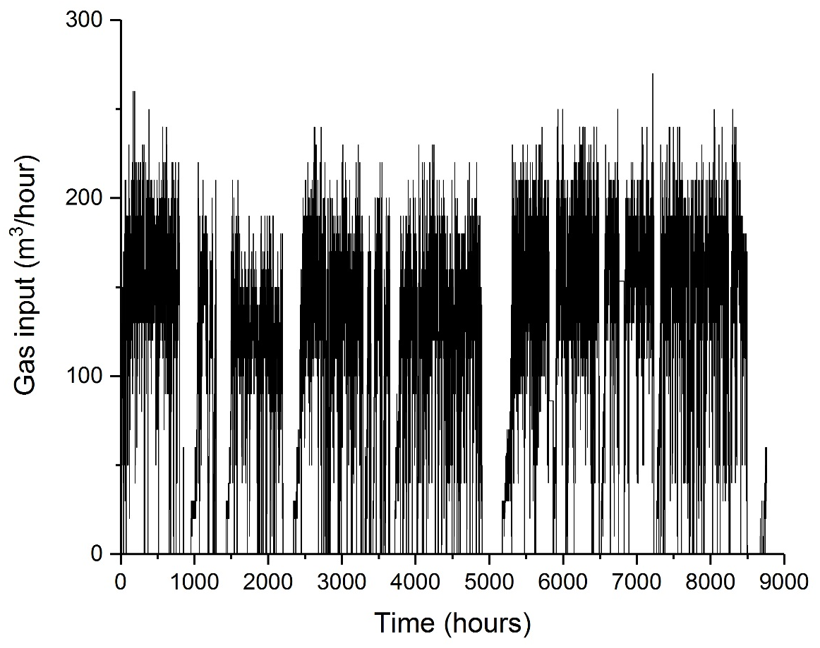
Figure 4.1: Gas inflow to the reverberatory furnace for a year of operation.
The simplification was completed by splitting the total year of operation into six ‘standard’ periods, as shown in Table 4.1. For each of the six ‘standard’ periods, notes were made of the following the number of times in a year the period occurred, the average length of the period, and the percentage of the whole year that the period comprised.
Table 4.1: Standard operating periods of the HJE operation.
Period | Description
1 | Off – for less than 30 minutes
2 | Off – for between 30 minutes and 6 hours
3 | Off – for over 6 hours
4 | On
5 | Starting up
6 | Shutting down

From the time periods, a ‘standard’ week of HJE operation could be created. Typical values for each time period were chosen and used as inputs into the mass and energy balances. The balances were repeated for each standard period, with a temporarily resolved time series of the quality and quantity of the WH as the output.

Results
The results of initial mass and energy balances are shown in Figure 4.2 and Figure 4.3. It is worth noting that, due to confidentiality issues with HJE, the values shown in Figure 4.2 and Figure 4.3 are not merely the results of the mass and energy balances. Instead, the figures show hypothetical results of mass and energy balances where x MW of WH are recovered, with x MW being somewhere in the range of the desired WHR of 2 – 5 MW.
The high-power levels in Figure 4.2 suggest that the ideal WHR location would be in the cooling water loop. However, WHR would not be possible in the cooling water loop as the cooling processes need to operate within predetermined temperature levels. WHR would negatively affect the operating temperature of the cooling water loop. Consequently, WHR should occur elsewhere at the HJE site.
Figure 4.3 shows that, due to a lack of available information from HJE, the flue gas treatment balances were not completed. Enough of the balancing process was completed to find a location in the HJE operation to capture the WH.
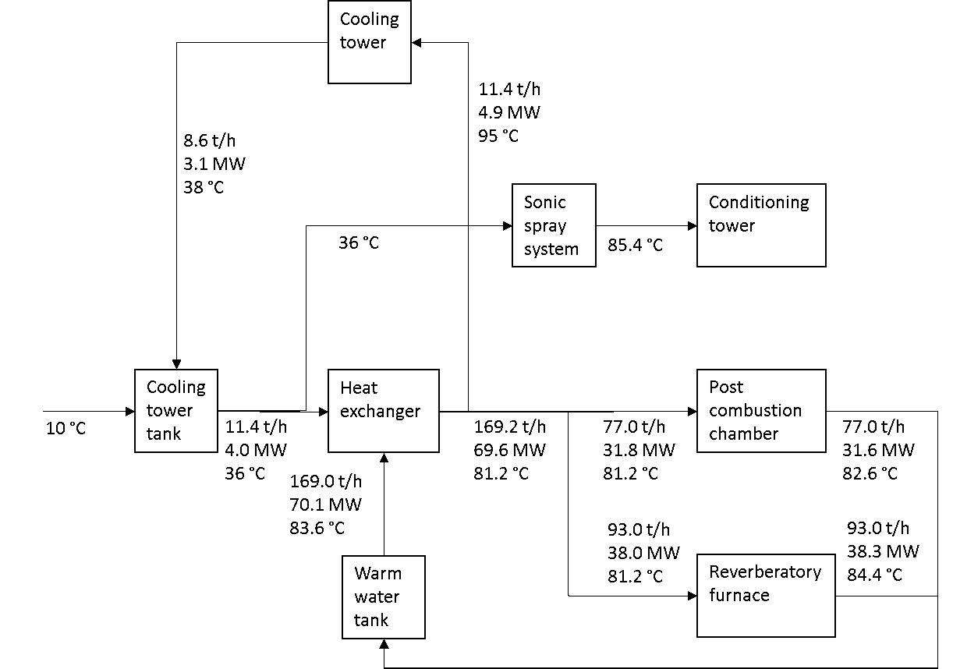
Figure 4.2: Results of the mass and energy balances over the cooling water loop from the reverberatory furnace, to generate x MW of heat at the exit of the post combustion chamber (PCC), the conditioning tower (CT), and the fabric filter (FF).

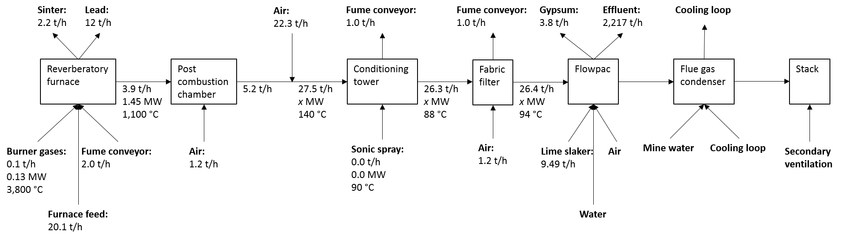
Figure 4.3: Results of the mass and energy balances over the main flue gas treatment process from the reverberatory furnace, to generate x MW of heat at the exit of the post combustion chamber (PCC), the conditioning tower (CT), and the fabric filter (FF).

The post combustion chamber (PCC), conditioning tower (CT), or fabric filter (FF) had the highest power, temperature and flowrate levels out of the flue gas treatment process. Therefore, the ideal location for WHR was suggested to be the PCC, CT, or FF. Once the ‘standard’ week of HJE operation had been created, the variation in the power levels of the PCC, CT and FF outlets could be determined. The variation in the power levels over a ‘standard’ week of HJE operation are shown in Figure 4.4.
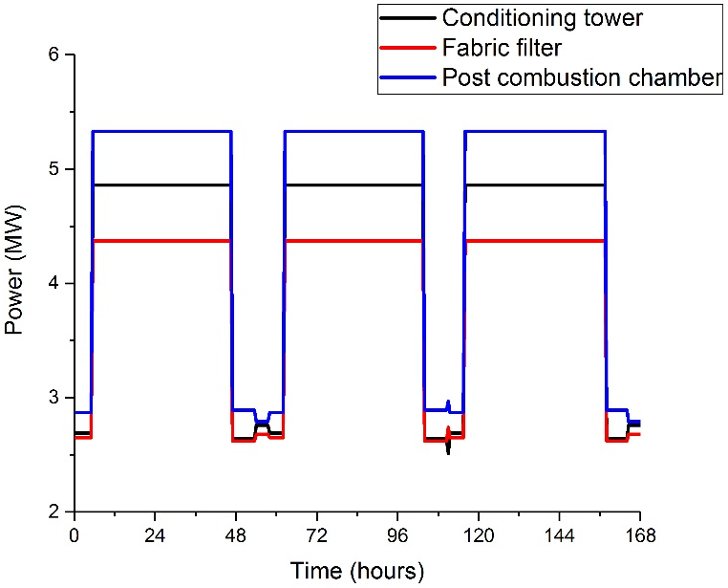
Figure 4.4: Variation in the power levels available from the flue gas treatment process during a ‘standard’ week of HJE operation.
Figure 4.4 shows that more power was available at the exit of the PCC than was available from the exits of the CT and the FF. The power levels of the PCC varied from 2.79 – 5.33 MW, whereas the power levels of the CT and the FF varied from 2.51 – 4.86 and 2.62 – 4.37 MW respectively. The variations in the mass flowrates and temperatures available at the WHR locations were calculated, as shown in Figure 4.5 and Figure 4.6.
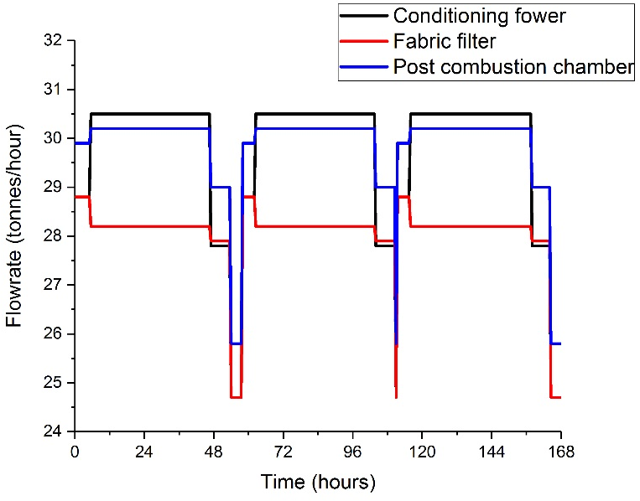
Figure 4.5: Variation in the flowrates from the flue gas treatment process during a ‘standard’ week of HJE operation.
Figure 4.5 shows the variation in the flowrates at the possible WHR locations in the flue gas treatment process. The mass flowrates at the exit of the PCC varied from 25.8 – 30.2 t/hr. At the exits of the CT and the FF, the mass flowrates varied from 24.7 – 30.5 and 24.7 – 28.8 t/hr respectively.
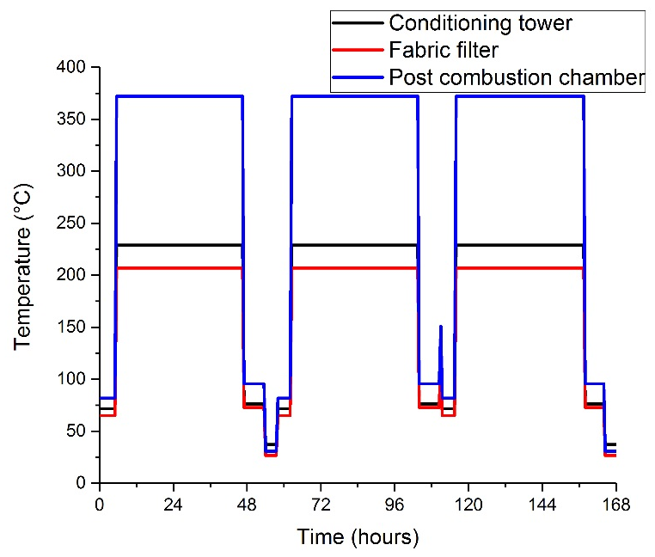
Figure 4.6: Variation in the temperatures available from the flue gas treatment process during a ‘standard’ week of HJE operation.
Figure 4.6 shows the variation in the temperatures at the possible WHR locations in the flue gas treatment process. The temperatures at the exit of the PCC varied from 30.8 – 372 °C. At the exits of the CT and the FF, the temperatures varied from 37.1 – 229 and 26.8 – 207 °C respectively.
The results of Figure 4.4 to Figure 4.6 suggested that the most effective location for any WHR was the exit of the PCC, as this was where the highest values for thermal power, mass flowrate, and temperature were found.
The overarching aim of this thesis was to build a feasibility model of DH that was simple enough that it could be operated by a non-technical user at a local authority. The initial aim was to include the heat supply quantification work in part of the feasibility model, regardless of the heat source. The methodology used for quantifying the WH was tested using the case study of HJE, an example of a complex industrial site. The complexity of running the mass and energy balances across HJE showed that the WH quantification methodology may have been more complicated than a non-technical user could operate; running mass and energy balances over the entire HJE site, as well as simplifying the complex HJE operation took a significant amount of engineering knowledge and experience. The extensive list of assumptions, as shown in Appendix 13.2, would not be possible to make without engineering knowledge and experience.
It is possible that a non-technical user could run elemental based mass and energy balances over an industrial site with a less complex operation, but only if the site passed a DoF assessment. The site would have to have thorough information available on the composition, mass flowrate, and temperature across a significant number of its streams and processes. If enough information was available to pass a DoF assessment, it would be a case of the non-technical user loading the information that was available into a premade Microsoft Excel spreadsheet.
Whilst it will sometimes be possible for an industrial site to provide enough information to allow a non-technical user to complete the balances, it will not be possible in every case. As the aim of this thesis was to build an overall feasibility model that would work with every DHN, it would not be recommended that the non-technical user tries to complete the balances. Instead, it would be advised that the user asks the industrial source firstly, where the best location for WHR would be and secondly, for the WH variation. When industrial sites do not keep accurate records of the enthalpy, mass flowrate, and temperature variation in each of their process streams, an industrial staff member could run the balances. The staff member would be able to use their experience and knowledge to estimate the values in a manner that is easier and more accurate than it would be for the non-technical user.
As the overarching aim of the thesis was to estimate the feasibility of the network instead of accurately designing it, the results of the WH quantification could be estimations. The power levels, mass flowrates, and temperatures found in Figure 4.4 to Figure 4.6 were not accurate reflections of the variations that would be found at HJE. But, for the purposes of the work that will be done later in the thesis, a simple estimation was sufficient. Staff members at industrial sites will usually be able to produce estimations of the power, flowrate, and temperature as accurately as the work done in this chapter. In addition, it should be easy to convince the industrial staff or owner of the benefit that a DHN would bring to their business. Therefore, they should be persuadable to help with the feasibility assessment.

Conclusion
Any industrial sites that supplies WH to a DHN will need to be studied, to quantify the variation in the WH demand. It was shown that the complexity of the quantification process was heavily dependent on the level of information supplied by the company.
If the industrial site keeps records of the temperature, enthalpy, composition, and mass flowrate variation in their streams, the WH resource could be quantified with only two simple equations. In this case, the quantification of the WH variation could be included as part of the overall DH feasibility study. If the necessary, level of information is not available a mass and energy balance would need to be carried out across the industrial site.
In this chapter, the aim was to build a generic model for mass and energy balances, that could be used on any industrial site, using HJE as a case study. The aim was to build the model in Microsoft Excel with a series of visible sheets in which the user could input the necessary information and view the WH variation. In the case study, the level of information provided by HJE was severely limited, mainly due to the complex and constantly changing processes that occur during LAB recycling. Therefore, it was shown that it would not be possible to run the mass and energy balances without a level of engineering knowledge and experience.
No matter how thorough the mass and energy balance models were, a non-technical user would not be able to use them to run balances over the HJE site. Therefore, it was recommended that in future work the non-technical user does not try and quantify the WH variation across the industrial site themselves. Instead, they should consult with the owner or operator of the site to find the variation. It has been suggested that if the industrial site can be convinced of the benefits that a DHN might bring to their operation, namely a large and reliable customer for their WH, they would be willing to cooperate.
Mass and energy balances were run across the HJE site to quantify the variation in the WH supply. The exit of the PCC chamber was highlighted as the part of the HJE operation with the highest available power, temperature, and flowrate and therefore, the best location for the WHR. Other locations were suggested with higher available power but, after consulting with the HJE staff, were decided to be an important part of the overall operation and could not be the location for the WHR. The variation in power, flowrate and temperature at the PCC exit were found to be 2.79 – 5.33 MW, 25.8 – 30.2 t/hr, and 30.8 – 372 °C respectively.

Waste Heat Recovery Modelling
As the heat supply in the case study comes from an industrial WH source, modelling of the various different possible WHR technologies is needed. In the terms of the overall aim of this thesis, a generic WHR model needs to be generated that is simple enough that it could be operated by a non-technical user. The WHR modelling process is needed to quantify how much WH is available for the DHN, as well as the CAPEX, OPEX, and revenues of the technologies. Each WHR technology is different, particularly in terms of its efficiency, CAPEX, OPEX, and revenues. Therefore, the choice of the best technology will vary from case to case or even over different time scales for a particular case. So that the WHR model is kept simple enough to be operated by a non-technical user, a number of assumptions have been made. In this chapter, the effect that these assumptions have on the accuracy of the WHR model are tested using MC simulations.

Methodology
The basic outline of the methodology was the same for each possible WHR technology. In each case a series of equations were found that modelled and sized the technology based on the desired level of WHR. The full lists of the equations are shown in Appendix 13.3 to Appendix 13.11. In many cases the methodology involved iterative processes and the interpretation of tables and figures, which were automatically programmed in Microsoft Excel. In each case, the CAPEX, OPEX, and revenues were calculated and compared.

Waste Heat Recovery Equipment
A range of different choices for the possible WHR equipment were modelled and compared. They were double pipe HEXs (HEX-DP), shell and tube HEXs (HEX-ST), finned tube HEXs (HEX-FT), plate HEXs (HEX-P), fired heaters (FH), and both organic and traditional RCs. Both types of RC were modelled as an entirety and as their individual components: boilers, condensers, pumps, and turbines. The equations used in the modelling of the WHR equipment came from Evans, Tufts University, Sinnott, and Bloch and Singh (Evans, 1974; Tufts University, 2003; Sinnott, 2005a; Bloch and Singh, 2009).

Double Pipe Heat Exchanger
The equations used in the modelling of a HEX-DP came from chapter 12.15 of Coulson and Richardson's Chemical Engineering Volume 6 - Chemical Engineering Design (Sinnott, 2005a). The list of equations is shown in its entirety in Appendix 13.3. A list of 28 inputs were needed in the work, as shown in Table 5.1.

Table 5.1: Inputs needed for the modelling of a HEX-DP.
Input | Units
Heat exchange type | -
Heat exchange fluid | -
Hot fluid inlet temperature | K
Hot fluid outlet temperature | K
Cold fluid inlet temperature | K
Cold fluid outlet temperature | K
Hot fluid specific heat capacity | kJ/(kgK)
HT | kW
Tube length | m
Inner pipe diameter | m
Number of tube passes | -
Pitch shape | -
Shell type | -
Cold fluid mass flowrate | kg/s
Cold fluid density | kg/m³
Cold fluid viscosity | Pa.s
Cold fluid thermal conductivity | W/(mK)
Cold fluid specific heat capacity | kJ/(kgK)
Hot fluid mass flowrate | kg/s
Outer pipe diameter | m
Hot fluid density | kg/m³
Hot fluid viscosity | Pas
Hot fluid specific heat capacity | kJ/(kgK)
Hot fluid thermal conductivity | W/(mK)
Baffle cut | -
Outside fluid type | -
Inside fluid type | -
Thermal conductivity of the wall material | W/(mK)

The initial stage of the design process was to calculate the log mean temperature difference and the true temperature difference across the HEX. An initial value for the overall HTC was estimated, which was used to calculate the overall HT SA of the HEX. The physical parameters of the shell and the tube were calculated sequentially, along with the shell side mass, the tube side mass, linear velocities, and their Reynolds, Prandtl, and Nusselt numbers. The Reynolds, Prandtl, and Nusselt numbers allowed the overall HTC to be calculated, which was compared to the estimated overall HTC. If the two values were within an acceptable threshold the calculated HTC was kept, and the shell and tube side pressure drops were calculated. If not, the calculated HTC replaced the initially estimated value and the calculation was repeated iteratively.
In order to keep the operation of the Excel spreadsheet simple, it had to be capable of running the iterative calculation as well as reading tables and figures automatically. The iterative calculation was controlled using Excel, as shown in Equation 5.1.
$$Value of cell D11 = IF\left(D11=D10,D11,D12\right)$$ | 5.1

$D11$ is the value of the iterative based calculation to be used in the calculations,
$D10$ is the initial, estimated value of the iterative based calculation,
$D12$ is the new value of the iterative based calculation, as calculated in the model.
Equation 5.1 states that for the initial run of the iterative based calculation, when $D11 \text{= }D10$, the value of the parameter used in the calculations, $D11$, should be the same as the estimated value, $D10$. In all other iterations of the calculation, when $D11≠D10$, the value of $D11$ should be the same as the value calculated in the previous iteration, $D12$.
Tables were read automatically to find values for the initial estimation of the overall HTC, constants, and the inside and outside dirt coefficients. Excel used a simple IF function to automatically read the tables and graphs. In each case, the outputs of the graphs or tables were found using the input parameters which had been previously calculated. Graphs were read automatically to find values for the temperature correction factor, the shell bundle clearance, and friction factors of the coolant, hot fluid, tube, and shell.

Shell and Tube Heat Exchanger
The equations used in the modelling of a HEX-ST came from chapter 12.5 of Coulson and Richardson's Chemical Engineering Volume 6 - Chemical Engineering Design (Sinnott, 2005a). The list of equations is shown in its entirety in Appendix 13.4. The same list of inputs was needed in the modelling of a HEX-ST as for a HEX-DP, as shown in Table 5.1. The modelling process used in the HEX-ST was almost identical to that in the modelling of a HEX-DP. The only difference was in the calculation of the equivalent shell diameter, due to the different arrangement of tubes inside the shells.

Finned Tube Heat Exchanger
The equations used in the modelling of a HEX-FT came from chapter 12.14 of Coulson and Richardson's Chemical Engineering Volume 6 - Chemical Engineering Design (Sinnott, 2005a). The list of equations is shown in its entirety in Appendix 13.5. The same list of inputs was needed in the modelling of a HEX-FT as in a HEX-DP, as shown in Table 5.1. Three additional inputs were needed in the modelling of a HEX-FT, representing the physical characteristics of the fins, as shown in Table 5.2.
Table 5.2: Inputs needed for the modelling of a HEX-FT.
Input | Units
Fin pitch | m
Fin thickness | m
Fin height | m

The modelling process used for a HEX-FT was almost identical to the modelling process used for a HEX-ST, differing only in the equations for the Nusselt number and the overall HTC. The equations were changed to include the effects of and to calculate the HT SA of the fins.

Plate Heat Exchanger
The equations used in the modelling of a HEX-P came from chapter 12.12 of Coulson and Richardson's Chemical Engineering Volume 6 - Chemical Engineering Design (Sinnott, 2005a). The list of equations is shown in its entirety in Appendix 13.6. A list of inputs was needed in the work, as shown in Table 5.3.
Table 5.3: Inputs needed for the modelling of a HEX-P.
Input | Units
Heat exchange type | -
Heat exchange fluid | -
Hot fluid inlet temperature | K
Hot fluid outlet temperature | K
Cold fluid inlet temperature | K
Cold fluid outlet temperature | K
Pass arrangement | -
Hot fluid specific heat capacity | kJ/(kgK)
HT | kW
Effective plate area | m²
Effective plate length | m
Effective plate width | m
Typical plate spacing | m
Hot fluid mass flowrate | kg/s
Hot fluid density | kg/m³
Hot fluid viscosity | Pas
Hot fluid specific heat capacity | kJ/(kgK)
Hot fluid thermal conductivity | W/(mK)
Cold fluid mass flowrate | kg/s
Cold fluid density | kg/m³
Cold fluid viscosity | Pas
Cold fluid thermal conductivity | W/(mK)
Cold fluid specific heat capacity | kJ/(kgK)
Outer pipe diameter | m
Baffle cut | -
Outside fluid type | -
Inside fluid type | -
Thermal conductivity of the wall material | W/(mK)

The design process of a HEX-P differed significantly from that of the other HEX types. Initially, the log mean temperature difference, true temperature difference, and initial HT SA were calculated, using an assumed value of the overall HTC. Next, the physical characteristics of the plate’s HT SA were calculated. Then, for both the hot and the cold fluids, the mass and linear velocity, and the Reynolds, Prandtl, and Nusselt numbers were calculated. The overall HTC was calculated iteratively. Finally, the pressure drops across the plates and the ports for both the hot and cold fluids were calculated.

Fired Heater
The equations used in the modelling of a FH came from chapter one of the Equipment Design Handbook for Refineries and Chemical Plants (Evans, 1974). The list of equations is shown in its entirety in Appendix 13.5. A large list of inputs was needed in the work, as shown in Table 5.4.

Table 5.4: Inputs needed for the modelling of a FH.
Input | Units
Process fluid flowrate | m³/s
Process fluid inlet temperature | K
Process fluid outlet temperature | K
Fuel inlet temperature | K
Fuel outlet temperature | K
Fuel heating value | kJ/m³
Fuel heating efficiency | %
Maximum radiant heat flux | kW/m²
Maximum pressure drop | kPa
Process fluid inlet enthalpy | kJ/kg
Process fluid outlet enthalpy | kJ/kg
Fuel type | -
Tube outer diameter | m
Number of tube passes | -
Process fluid velocity | m/s
Pressure drop over process fluid | kPa
Available heating surface | m²/m
Heater width | m
Heater height | m
Heater length | m
Heater exposed length | m
Number of tubes in the heater | -
Diameter of the heater centres | m
Number of shield tubes | -
Tube bank type | -
Spacing between tubes | m

The modelling work started by calculating the temperatures, HT SA, and rates of various parts of the FH. A firebox temperature was assumed and was used to calculate both the net heat of combustion and a new firebox temperature, in an iterative manner. The confirmed firebox temperature allowed the HT rates of both the radiant and convection sections of the FH to be calculated. The heat release and temperatures in the stack were calculated, which were used to calculate the overall HTC. Finally, the overall HT SA of the heater, the size of the heater, and the pressure drop in the heater were calculated.
Graphs were automated to find values for the following the partial pressure in the furnace, the firebox emissivity, the calculated firebox temperature, the stack temperatures, and a variety of factors and coefficients.

Organic Rankine Cycle
The equations used in the modelling of an ORC came from Tufts University (Tufts University, 2003). The list of equations is shown in its entirety in Appendix 13.8. The enthalpy and entropy values were calculated using a piece of software developed by the National Institute of Standards and Technology (NIST) (NIST, 2018). A number of inputs were needed, as shown in Table 5.5. The ORC cycle model was based around the cycle of a traditional RC, as shown in Figure 5.1.
Table 5.5: Inputs needed for the modelling of an ORC.
Input | Units
Working fluid | -
Pressure leaving the boiler | kPa
Temperature leaving the boiler | K
Pressure leaving the turbine | kPa
Mass flowrate of the condenser fluid | kg/s
Specific heat capacity of the condenser fluid | kJ/(kgK)
Power generated in the condenser | MW

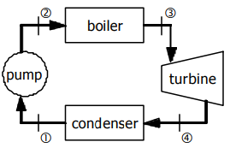
Figure 5.1: Operating cycle of a traditional RC (Tufts University, 2003).
As the choice of the working fluid and the pressure and temperature of the superheated vapour, in state 3, were known, the specific enthalpy and entropy of the vapour could be calculated. Similarly, as the temperature leaving the turbine was known, the liquid, vapour, and specific enthalpies and entropies at state four could be calculated. The specific enthalpy of the saturated liquid was the same as the liquid enthalpy of state 3, allowing the density of the saturated liquid to be calculated. All of the calculations shown thus far allowed the work done by the pump and generated by the turbine to be calculated.
Enthalpy and entropy data were taken from graphs generated in NIST software and used to generate a series of regression models in Excel. The curves were plotted at a variety of different temperatures and pressures, allowing the enthalpies and entropies to be calculated under any condition.

Boiler
The calculation used for the modelling of a boiler is identical to the calculation used for a FH, as shown in section 5.1.1.5. The only difference is that some of the inputs came directly from the ORC calculation. The inputs that came directly from the ORC calculations were the input and output temperature and the maximum pressure drop.

Condenser
The equations used in the modelling of a condenser came from chapter 12.10 of Coulson and Richardson's Chemical Engineering Volume 6 - Chemical Engineering Design (Sinnott, 2005a). The list of equations is shown in its entirety in Appendix 13.9. A list of inputs was needed in the work, as shown in Table 5.6.
Table 5.6: Inputs needed for the modelling of condensers.
Input | Units
Heat exchange type | -
Heat exchange fluid | -
Cooling water inlet temperature | K
Cooling water outlet temperature | K
Cooling water specific heat capacity | kJ/(kgK)
Tube length | m
Outer pipe diameter | m
Number of tube passes | -
Pitch shape | -
Cooling water density | kg/m³
Cooling water viscosity | Pas
Cooling water thermal conductivity | W/(mK)
Process fluid molecular weight | kg/mol
Process fluid pressure | kPa
Process fluid viscosity | Pas
Inner pipe diameter | m
Outside fluid type | -
Inside fluid type | -
Fouling factor | W/(mK)
Shell type | -
Shell diameter | m
Baffle cut | -
Pressure drop as a percent of inlet flow | %

The enthalpies of the cooling water and process fluid, as well as the inlet and outlet temperatures of the process fluid came from the ORC calculation. An initial overall HTC was estimated. The methodology calculated the heat available from the process fluid, the flowrate of the cooling water, and the overall HTC. Finally, the physical characteristics of the condenser along with the Reynolds numbers and the pressure drop in the condenser were calculated.

Pump
The equations used in the modelling of a pump came from chapter 5.4 of Coulson and Richardson's Chemical Engineering Volume 6 - Chemical Engineering Design (Sinnott, 2005a). The list of equations is shown in its entirety in Appendix 13.10. A list of inputs was needed in the work, as shown in Table 5.7.

Table 5.7: Inputs needed for the modelling of a pump.
Input | Units
Internal pipe diameter | m
Process fluid viscosity | Pas
Pipe material | -
Number of 45° standard elbows | -
Number of 45° long radius elbows | -
Number of 90° standard radius elbows | -
Number of 90° standard long elbows | -
Number of 90° square elbows | -
Number of tee-entry from legs | -
Number of tee-entry into legs | -
Number of union and couplings | -
Number of sharp reductions (tank outlet) | -
Number of sudden expansions (tank inlet) | -
Number of gate valves - fully open | -
Number of gate valves - 25% open | -
Number of gate valves - 50% open | -
Number of gate valves - 75% open | -
Number of globe valves - fully open | -
Number of globe valves - 75% open | -
Number of plug valves | -
Pipe length | m

The density and flowrate of the working fluid came from the ORC calculations. The flowrate and velocity of the working fluid were calculated, which were used to calculate the velocity head. The number of components in the pipes were estimated, allowing the number of miscellaneous losses and consequently the head loss of the pump to be calculated. It would unreasonable to expect the non-technical user to know the number of components that would be in the pipes, so an average value of the miscellaneous losses will be provided. The friction loss of the pumps was calculated, allowing the overall pressure loss in the pump to be calculated.

Turbine
The equations used in the modelling of a turbine came from chapter 15 of the Elliott Shortcut Selection Method for Multivalve, Multistage Steam Turbines (Bloch and Singh, 2009). The list of equations is shown in its entirety in Appendix 13.11. A list of inputs was needed in the work, as shown in Table 5.8.
Table 5.8: Inputs needed for the modelling of a turbine.
Input | Units
Shaft power | kW
Shaft speed | rpm
Turbine pressure | kPa
Turbine blade diameter | m
Turbine blade thickness | m

The inlet and outlet pressures and temperatures of the turbine and the mass flowrate of the working fluid came from the ORC calculations. The overall turbine efficiency was calculated, then the theoretical steam rate (TSR) found using the inlet and outlet pressures and temperatures. At this point, the modelling split into two different pathways which provided two options for the possible turbine design, comparing Curtis and Rateau stages. Curtis turbines are velocity compounded whereas Rateau turbines are pressure compounded. For each option, the turbine velocity and the velocity ratios were calculated. The velocities were compared to an optimum turbine velocity, allowing Excel to automatically choose the optimal option. The remaining TSR was calculated and the remaining stages were designed.

Rankine Cycle and Corresponding Components
The design of the RC and its corresponding components the boiler, the condenser, the pump, and the turbine followed an identical process to the design of the ORC and its corresponding components. The calculations of the components are shown in more detail in section 5.1.1.6 to section 5.1.1.10. The only difference was instead of using the NIST software, x-eng steam tables (x-eng, 2012) were used to calculate the RC enthalpies and entropies, x-eng steam tables are built into Excel.

Costs
The end result of the work so far was sizes of the different WHR technologies. Next, a series of equations are introduced to calculate the CAPEX, OPEX, and revenues for each of the technologies based on the calculated sizes. The CAPEX of both a HEX-DP and a HEX-P were calculated using Figure 6.4 produced by Sinnott (Sinnott, 2005a). The CAPEX of both a HEX-ST, a HEX-FT and a condenser were calculated using Figure 6.3 produced by Sinnott. The CAPEX of both a FH and a boiler were calculated using Table 6.2 produced by Sinnott. The CAPEX of a turbine was calculated using from the US DOE (US DOE, 2016), which provided a cost of £215 /kW. The pump CAPEX were estimated from cost curves produced by Loh et al. (Loh et al., 2002).
The pump OPEX were calculated based on an equation presented by the Engineering Toolbox (The Engineering Toolbox, 2009), as shown in Equation 5.2.
$${\text{cost}}_{Op,pump}=\frac{0.746Q_{F,pump}he.{cost}_{El,pump}}{3960η_{pump}η_{motor}}$$ | 5.2

${\text{cost}}_{Op,pump}$ was the OPEX of the pump (£/s),
$Q_{F,pump}$ was the volumetric flowrate of the working fluid (m³/s),
$he$ was the pump head (m),
${cost}_{El,pump}$ was the electricity costs (£/kWh),
$η_{pump}$ was the pump efficiency (%),
$η_{Motor}$ was the motor efficiency (%).
The OPEX of the remaining WHR technologies could be found using assumed costs, as shown in Table 5.9. The total yearly use of the various inputs such as natural gas, carbon dioxide, or dodecane etc as well as the total production of various outputs such as electricity and district heat were calculated. From the total input or output and the assumed cost, the total yearly cost or profit for the various inputs and outputs could be calculated. In addition, the total yearly reduction of natural gas usage was calculated, which was used to calculate the yearly reduction in natural gas costs.
Table 5.9: Input and output costs of the WHR technologies.
Product | Cost | Units | Source
Input costs
Electricity | 0.105 | £/kWh | (BEIS, 2017c)
District heat | 0.042 | £/kWh | (DECC, 2015a)
Output costs
Natural gas | 0.0236 | £/kWh | (BEIS, 2017c)
Carbon dioxide | 0.532 | £/L | (BOC, no date a)
Dodecane | 135 | £/L | (Fisher Scientific, no date)
Ethylene glycol | 2.58 | £/L | (Chemicals, no date)
Fuel oil | 0.577 | £/L | (Boiler Juice, no date)
Helium | 0.0305 | £/L | (BOC, no date b)
Methane | 0.369 | £/L | (BOC, no date c)
Nitrogen | 0.00399 | £/L | (BOC, no date d)
R134a | 1.63 | £/L | (BOC, no date e)
Fuel gases | 0.369 | £/L | (BOC, no date c)

Keeping the Model Simple in Structure
During the modelling of the 12 different WHR technologies, a large number of inputs were required (65 in total). A model with 65 different inputs would be more complicated than a non-technical user would be able to understand and use, therefore some of these inputs needed to be modified. The modification occurred through splitting the inputs into four categories:
- Continuous inputs.
- Discrete inputs.
- Dependent inputs.
- Fluid dependent inputs.
Continuous inputs, such as input temperatures or the flowrates, could take any real numerical value over a continuous range and therefore must be defined by the user. Discrete inputs, such as the number of tube passes or type of heat exchange that occurs in a HEX, could only have values within a set range. Therefore, discrete inputs could be chosen in advance by the creator of the model, offering no choice to the model user after the model had been sent to the users. Alternatively, discrete inputs could be split into a small list that was pre-programmed into the Excel spreadsheet, which would give the model user a small range of choice. It was noted that some inputs, such as pipe lengths or diameters, may be continuous in theory but in practice they are only available in standard sizes. Inputs that were only available in standard sizes were treated as discrete.

Table 5.10: Continuous and discrete inputs that can be chosen from a list.
Continuous inputs | Discrete inputs (chosen from a list)
Working fluid inlet temperature | Type of heat exchange that occurs
Working fluid flowrate | Choice of working fluid
HTF flowrate | Tube length
Boiler outlet pressure | Inner pipe diameter
Turbine outlet pressure | Outer pipe diameter
Turbine shaft power | Number of tube passes
Turbine shaft speed | Pitch shape
 | Shell type
 | Choice of HTF
 | Choice of ORC working fluid
 | Baffle cut
 | Wall material
 | Pipe material
 | Shell material
 | Tube material
 | Turbine blade diameter
 | Turbine blade thickness

Dependent inputs are one’s whose value could be assumed to be proportional to another input or parameter and were modelled as such. An example of a dependent input is the output temperature of the process fluid, which could be assumed to be equal to the input temperature divided by x. Fluid dependent inputs were inputs that could be calculated if the fluid in question and the operating conditions were known. For example, the density of the working fluid could be calculated if the working fluid had been selected and the operating temperature and pressure were known. The fluid dependent inputs could be automatically calculated by the spreadsheet, if the model user selected a working fluid from the list of available fluids.
The remaining discrete inputs (the dependent, and the fluid dependent inputs that were hidden) are shown in Table 5.11.
The large number of inputs required a large number of assumptions to be made in the WHR modelling process. It was assumed that the user would correctly inputs the values for the 7 continuous inputs and select the correct values for 17 discrete inputs to be chosen from lists. It was also assumed that the 17 lists would correctly represent the discrete inputs in the particular case to be modelled. It was assumed that the 23 preloaded discrete inputs and the 7 relationships in the dependent inputs would accurately represent the inputs in each different case.
During the modelling work it was assumed that each WHR equipment had a lifespan of 30 years (Adolfsson and Rashid, 2016).

Table 5.11: Discrete that are to be hidden from the user, dependent, and fluid dependent inputs.
Discrete inputs (hidden from the user) | Dependent inputs | Fluid dependent inputs
Fin pitch | Assumed total HTC | HTF density
Fin thickness | Working fluid outlet temperature | HTF viscosity
Fin height | HTF input temperature | HTF thermal conductivity
Fin efficiency | HTF outlet temperature | HTF specific heat capacity
Fin pass arrangement | Heater exposed length | HTF molecular weight
Effective plate area | Heater centres | Working fluid density
Effective plate length | Assumed firebox temperature | Working fluid viscosity
Effective plate width |  | Working fluid thermal conductivity
Typical plate spacing |  | Working fluid specific heat capacity
Port Diameter |  | Working fluid molecular weight
Typical plate thickness |  | Thermal conductivity of the wall
Fuel heating value
Fired burner efficiency
Maximum radiant heat flux
Maximum pressure drop
Heater width
Heater height
Heater number of tubes
Heater length
Number of shield tubes
Tube bank type
Physical characteristics of the pump
Turbine efficiency

Results
The purpose of this chapter of the thesis was to develop a generic model that could be used to design and optimise a WHR system in any DHN. The model was kept simple enough that it could be operated by a non-technical user, which required the use of Microsoft Excel to automatically run iterative based calculations and interpret graphs and figures. The generic model was applied to the case study in the thesis, to determine the best WHR technology to use. Finally, MC simulations were used to test the accuracy of the model.

Case Study Results
When applying the WHR model to the case study, the purpose was to find the WHR technology that was the most economical, both in terms of the initial CAPEX and the lifetime OPEX and revenues. A secondary aim was to model the WH levels that would be available from the industrial source after the WHR. The initial CAPEX of each WHR technology was calculated, as shown in Figure 5.2.
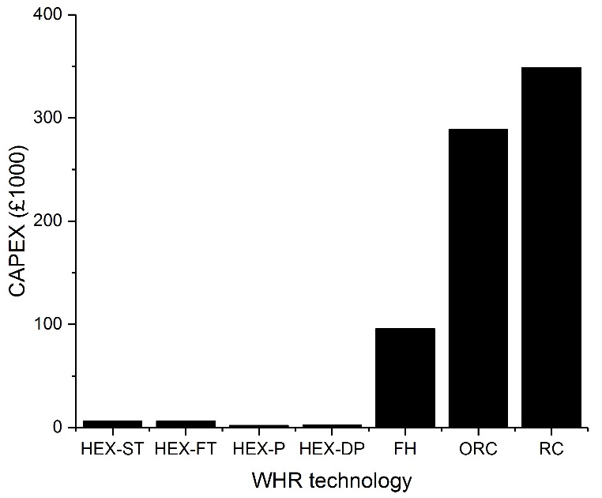
Figure 5.2: Initial CAPEX of the different WHR technologies.
Figure 5.2 would suggest that the best WHR technologies were the HEXs, particularly the HEX-P and the HEX-DP, as these options had the lowest CAPEX. In reality, the situation was more complex, requiring a consideration of the yearly OPEX and revenues. The total costs after one, three and ten years of operation are shown in Figure 5.3, Figure 5.4 and Figure 5.5.
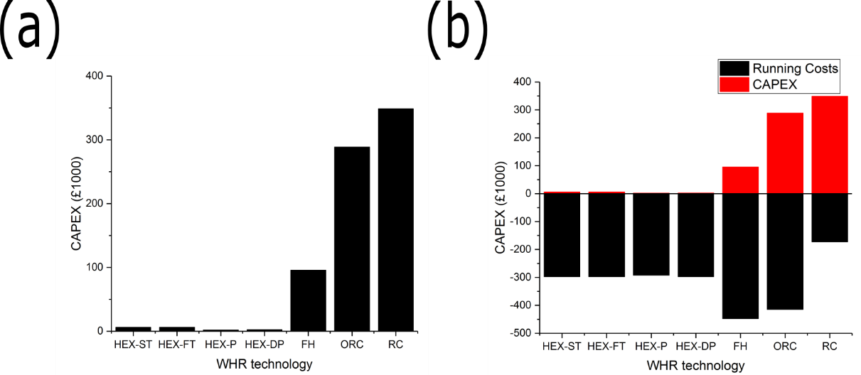
Figure 5.3: (a) Total costs of the different WHR technologies after one year of operation. (b) CAPEX and total costs (sum of the CAPEX, OPEX and profits) of the different WHR technologies after one year of operation, note, negative total costs show that revenue is being generated.
Figure 5.3 shows that all WHR technologies generate a profit after a single year of operation, bar the traditional RC. It shows that the FH generates the most revenue on a yearly basis, due to the small fuel input that upgraded the quality and the quantity of the WH. The ORC generated more revenue on a yearly basis than any of the HEXs but, due to its higher CAPEX, after one year of operation did not perform as well on an economic scale. The reason for the high revenue generation from the ORC was due to the relative difference in the value of heat and electricity.
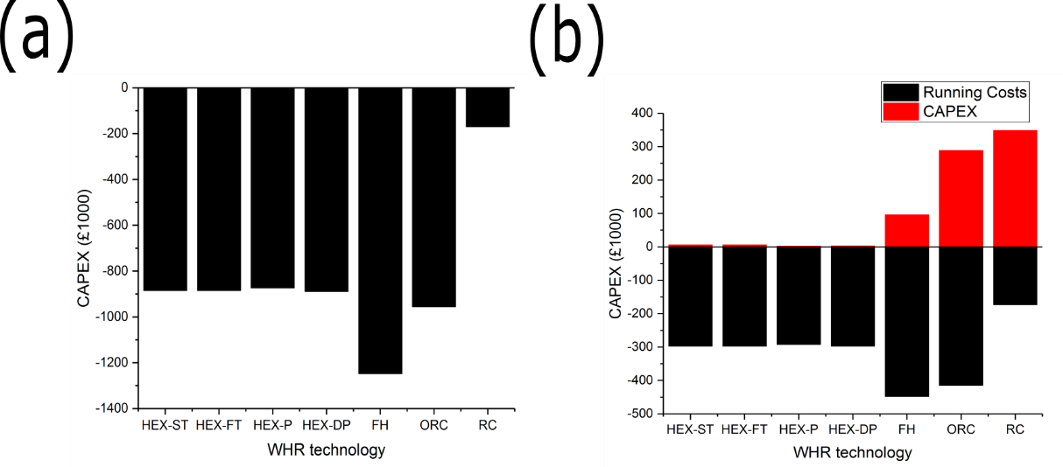
Figure 5.4: (a) Total costs of the different WHR technologies after three years of operation. (b) CAPEX and total costs (sum of the CAPEX, OPEX and profits) of the different WHR technologies after three years of operation, note, negative total costs show that revenue is being generated
Figure 5.4 shows that after three years of operation all the WHR technologies are profitable. Three years was an important time scale to consider, as many industrial sites would not make changes or upgrades to the site if the payback period was greater than three (or four) years (Awomewe and Ogundele, 2008; Hawkey, 2009). Once again, the FH was shown to be the best WHR option from an economic viewpoint. The ORC was shown to be slightly better than the HEXs, as enough time had passed to pay off the higher CAPEX.
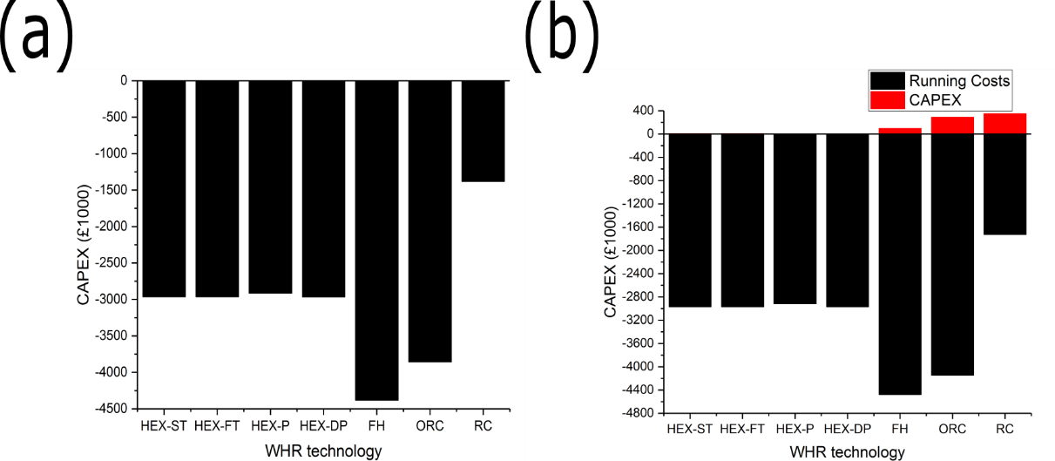
Figure 5.5: (a) Total costs of the different WHR technologies after ten years of operation. (b) CAPEX and total costs (sum of the CAPEX, OPEX and profits) of the different WHR technologies after 10 years of operation, note, negative total costs show that revenue is being generated
Figure 5.5 confirms that, from an economic viewpoint, the best performing technologies were the FH followed by the ORC.
If the FH is to be chosen as the WHR technology, it is important to note how much WH can be recovered from HJE using the FH. It is also important to note how the levels of recovered WH vary over a ‘standard’ week of operation, as shown in Figure 5.6.
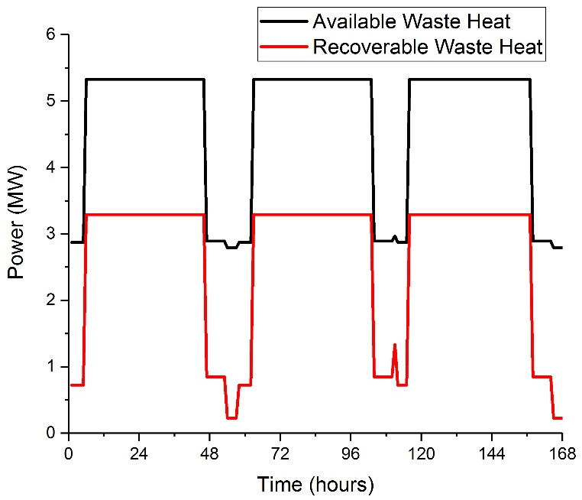
Figure 5.6: Levels of WH that is possible to recover using the FH as the WHR technology.
Figure 5.6 shows that the levels of WH that could be recovered from the case study site using a FH varied from 0.228 – 3.29 MW.

Waste Heat Recovery Model Validation
In total, the WHR model had 54 assumptions that could potentially affect the accuracy of the results. Each of assumptions may be accurate and have no effect on the model’s accuracy, inaccurate and have a negative effect on the model’s accuracy, or inaccurate and have no effect on the model’s accuracy. To test the accuracy of the assumptions, a validation study was run for the model, both internally and externally. External validation came from the sources of the equations used in the work; every source was a reliable and well-established textbook, using reliable and well-established lists of equations. The reliability of the textbooks provided external validation to the WHR model. Additional external validation could have been provided by comparing the results of the model to primary WHR data or WHR models. No company was willing to provide primary WHR data to this thesis and, due to the novel nature of the model, no equivalent models were found that could be used as a comparison.
Due to the limited nature of primary data made available for this thesis, using an equivalent WHR model would require more assumptions to be made than are already in the work. Therefore, additional external validation could not come from primary data or equivalent models.
The internal validation came from assessing the accuracy of the assumptions using MC simulations. MC simulations worked by running the model thousands of times varying the input and quantifying the spread in the output. If the output variation was sensitive to the input variation, the assumption was inaccurate. If the output variation was insensitive to the input variation, the assumption was accurate. Each assumption would need to be tested individually at first and then simultaneously in a global MC assessment.
The visual basic (VB) programme in Excel was used to run the MC simulations, as shown in Appendix 13.12. A preliminary series of six assumptions were tested, to assess the VB code and the effect that the assumptions had on the accuracy of the model. The six assumptions were:
- The turbine inlet pressure.
- The working fluid flowrate.
- The turbine outlet pressure.
- The internal pipe diameter.
- The external pipe diameter.
- The tube length.
In the initial assessments, the MC simulations were run 1,000 times. It was noted that a sensitivity study into the number of simulations would be needed.
The input data for the MC simulations came from studying the variation of each assumption in real industrial sites (Achaichia and Cowell, 1988; Gorain et al., 1997; Cavallini et al., 2001; Valenzuela et al., 2004; IGEM, 2008; PPI, 2009; McKenna and Norman, 2010; Newcastle University, 2011; Ammar et al., 2012; Tioga, 2013). The data came from a series of papers as well as studies by The Institution of Gas Engineers and Managers (IGEM), The Plastic Pipe Institute (PPI) and Newcastle University. The validation process used studies from outside of the UK to increase the sample size and the accuracy of the MC simulations. It was understood that variation may exist from country to country which may affect the accuracy of the simulations. The effects of the possible variations were mitigated by obtaining data from countries with similar environmental and social patterns to the UK and by normalising each data set to itself. Using data from outside of the UK allowed the MC simulations to be completed now, instead of waiting for the data to become available. As UK studies that investigate industrial variation in the parameters are found, the simulations can be updated.
Of the 6 initial MC simulations, 4 did not manage to run for the entire 1,000 cycles. The reason for these failures were that the majority of the modelling processes required the automatic iteration or reading of graphs or tables in Excel, which was not possible in every case. If the input parameters were changed such that the iterations failed to converge, or the parameters of the table or graph were outside of the limits given in the textbook, the WHR model failed. If the model was being operated by a technical user with engineering experience, then it would be possible to identify the reason for the model failure and fix it. However, this level of experience would be beyond the abilities of a non-technical user. Therefore, the aim of keeping the WHR model simple enough that a non-technical user could operate it was not possible and should not be kept in future work.
The best solution would be to, similarly to in chapter 4, ask the industrial source to model their own process. Therefore, the industrial source could identify the best WHR technologies, calculate the variation in the WH and the total costs and revenues of the process. Once again, it should be possible to convince the owner or operator of the industrial site that co-operating with the DH feasibility study is in their best interests. If not, typical values for the efficiencies and costs of the WHR equipment will have to be used. Using typical values will not allow for a comparison to be made between different WHR technologies or for accurate modelling, but it will be suitable for the feasibility study.
The Carbon Trust state that the typical efficiency of WHR equipment varies from 55 – 65% (Carbon Trust, 2011). Therefore, assuming a WHR efficiency of 60% in future modelling should be acceptable. If applied to the case study, the WH available for recovery would be as shown in Figure 5.7. The average difference between the variation in the calculated and assumed levels of WH variation was 7%. The 7% variation is less than the industrial variation reported by Parsons Brinckerhoff, showing that the work done in this chapter supported an assumption of 60% efficient WHR (Parsons Brinckerhoff, 2011).
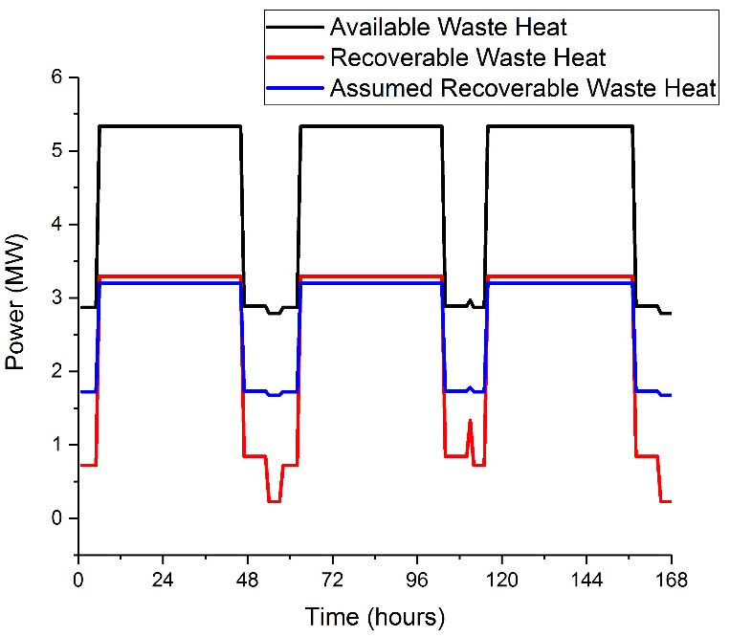
Figure 5.7: Variation in the WH available at the case study site, the levels of WH that was calculated to be recoverable in the case study, and the levels of WH that would be recoverable with an assumed efficiency of WHR of 60%.
Due to the wide variation in different WHR technologies and designs, no estimation of the costs of a typical WHR system were found. Therefore, no estimation of the costs of the WHR system could be made and the WHR costs could not be included in the feasibility study. Not being able to include the WHR costs in the feasibility study was acceptable, as any WHR costs would be paid for by the industrial site, not the network operator. Therefore, the only consideration was made to the WHR was the payback period experienced by the industrial site. As shown in Figure 5.4, all of the WHR costs were paid back within three years, within the usual industrial guidelines (Awomewe and Ogundele, 2008). Therefore, the costs of a future WHR system could be assumed to be within the usual industrial payback period and could be ignored in the feasibility study of the network. Similarly, the environmental impacts of the future WHR systems could be ignored in the feasibility study of the network.
It may be useful to have an idea of what WHR technologies should be implemented at the industrial site even if a particular technology does not have to be chosen or modelled.
Table 2.1 to Table 2.3 to could be used to show what temperatures of WH will be available at the industrial site and consequently what WHR equipment is likely to be used at the site. The tables could be read by a non-technical user, who will have to ask the industrial site operator for a list of the processes that occur and match them to the tables.

Conclusion
A simple, generic model for WHR was generated that quantified the WH variation in the DH feasibility model as well as the CAPEX, OPEX, and revenues associated with the WHR. Seven different WHR options were modelled and compared: HEX-DPs, HEX-STs, HEX-FTs, HEX-Ps, FHs, ORCs, and RCs. The accuracy of the model was assessed using MC simulations. The model was applied to the case study to choose the optimum WHR technology, quantify the WH levels, and compare the total costs of the different technologies.
The different WHR models were generated using equations from a number of different text books, requiring 65 inputs, which was more than a non-technical user to be capable of making. Of the 65 inputs, 58 were predetermined, split into a narrow range, or drawn into a relationship with another parameter. In total, the non-technical user would have to choose 7 continuous variables and 17 discrete variables. The process of reducing the number of inputs from 65 to 24 required 54 assumptions to be made, which needed assessment using MC simulations. Before the detailed MC assessments could be completed, an initial six simulations were run, to test the MC methodology. Four of the six simulations did not manage to run to competition. The failure was due to the iterative based solution in Excel diverging instead of converging, or the parameters of the graphs and tables that Excel tried to read automatically being outside of the allowable range. A technical user would be able to identify the cause of the problem and fix the model, but a non-technical user would not. Therefore, the aim of building a WHR model that a non-technical user could operate was shown to not be possible.
Instead, the user would be advised to use a typical WHR efficiency of 60%. It was shown that no standard CAPEX, OPEX, and revenues of the WHR equipment could be found in the literature. Instead, it was advised that the non-technical user considered the costs of the WHR process to belong to the industrial process. Therefore, the techno-economic assessments of the DHN would not include the infrastructure and technology needed for the WHR.
The model was run for the case study, to determine the best choice of WHR. It was found that all seven WHR technologies were profitable over a three-year timescale. The best performing WHR technology was found to be the FH, followed the ORC. After the WHR had been completed, the WH levels varied from 0.228 – 3.29 MW.
The new WHR technique of simply assuming the WH levels post WHR was compared to the case study results. It was shown that the calculated and assumed levels of WH variation differed by 7%, which is acceptable for the purposes of a feasibility assessment. The choice to not consider the costs of the WHR equipment in the feasibility assessment was supported as all of the case study WHR options reached economic payback with three years.

Heat Demand Modelling
HD modelling is used to quantify the hourly variation in the HD experienced by a DHN, allowing for techno-economic modelling and DH optimisation processes to be completed. To meet the overall aim of this thesis, the HD model was left simple enough that a non-technical user could operate it. The simple nature of the model came from using techniques based on HDD and archetype modelling, requiring a number of assumptions, each of which had the potential to negatively affect the accuracy of the work. The effects of each assumption were assessed using MC simulations. A secondary aim of the thesis was to keep the model generic enough that it could applied to any DHN, including ones in both urban and rural locations. To test the applicability of the model in different locations, urban and rural case studies were used. The results of the case studies were assessed to see if modifications needed to be made to the model from case to case.

Methodology
The basis of the methodology was an industrial based archetype model produced by Arup (Arup, 2007). The industrial model used HDD and regression-based archetype techniques to generate curves of hourly HD variation for seven different building archetypes. The hourly curves showed the variation in HD per unit area of floor (MW/m²). For each archetype, 12 curves were generated (1 for each month) by scaling a reference HD profile by a temperature dependent factor. The seven archetype categories were retail, commercial, food and drink, hotels, both residential and non-residential institutions, and assembly and leisure. The HDD values were calculated using hourly variations in local temperature across a year of recording, available from weather stations across the UK, as shown in Equation 6.1 and Equation 6.2.
$$T_{dd}=\frac{\sum_{t=0}^{t_{max}}{y_{t}}}{t_{max}}$$ | 6.1

$T_{dd}$ was the monthly degree day value (°C/hr),
$t_{max}$ was the number of hours in the month (hr),
$y_{t}$ was a calculation parameter (°C).
$$y_{t}=\left\{\begin{aligned}T_{ref}-T_{t},\text{ if }T_{ref}>T_{t} \\ 0,\text{ if }T_{ref}<T_{t}\end{aligned}\right.$$ | 6.2

$T_{ref}$ was the reference temperature at time, t (°C),
$T_{t}$ was the external temperature at time, t (°C).
The monthly degree day values were used to calculate a monthly temperature dependent factor (TDF), as shown in Equation 6.3.
$${\text{TDF}}_{mon}=\frac{T_{dd}}{T_{dd,max}}$$ | 6.3

${\text{TDF}}_{mon}$ was the monthly temperature dependent factor for month, m,
$T_{dd,max}$ was the maximum monthly degree day value (°C/hour).
For each archetype, the shapes of the curves and the ratios of HD from hour to hour were the same for each of the twelve months. The TDF was used to change the HD curves into separate curves for each month, as shown in Equation 6.4.
$$P_{A,mon,t}=P_{A,ref,t}{\text{TDF}}_{mon}$$ | 6.4

$P_{A,mon,t}$ was the HD for hour, t, and month, m, (MW/m²),
$P_{A,ref,t}$ was the reference HD for hour, t, (MW/m²).
The output of the industrial model were curves of hourly HD per unit area of total floor space for each archetype building type and for each of the 12 months. The aim of this chapter was to generate curves of hourly thermal load, representing every building within a set area, for each of the four heating seasons. As a result, significant adaption had to be made to the industrial model.
Hourly HD per unit area was converted into hourly HDs, as shown in Equation 6.5. The conversion was completed for every hour in the day across each of the 12 months and for each of the 7 building archetypes.
$$P=P_{A}A$$ | 6.5

$P$ was the hourly HD (MW),
$P_{A}$ was the hourly HD per unit area (MW/m²),
$A$ was the total building floor area (m²).
The HD variations for each of the twelve-monthly curves had to be converted into HD variations for the four heating seasons (as an average between the dates), as shown in Table 6.1.
Table 6.1: The four heating seasons in a year.
Heating season | Start date | End date
1 | 20th March | 20th June
2 | 21st June | 21st September
3 | 22nd September | 21st December
4 | 22nd December | 19th March

The aim of the HD modelling was to calculate the overall HD experienced by a DHN. Therefore, a boundary area was drawn including all potential DH customers and centred around the potential heat source. This area was split into nodes, then subnodes and finally squares of 100 m², as shown in Figure 6.1. Pipelines connected the centre of each square to the centre of each subnode, then to the centre of each node, and finally to the heat source. It was assumed that the pipes travelled in the shortest possible straight-line distance from point to point. Every building in each square was assumed to be located in the centre of the square therefore, no pipes were needed to connect the buildings to the centres of the squares.
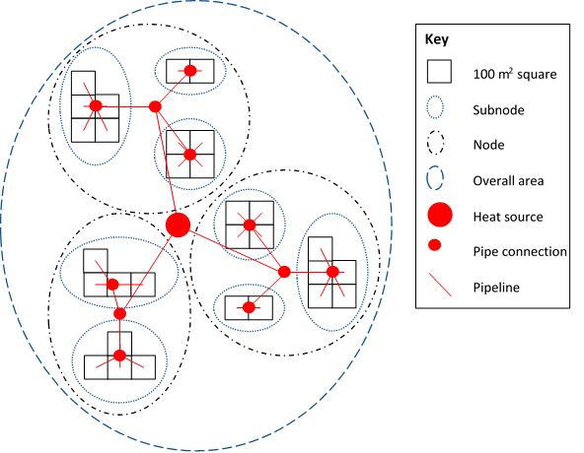
Figure 6.1: The node-, subnode-, square-structure used in the model.
Every building in each archetype category was assumed to be of the same, predetermined size. The total floor area of the sum of all buildings of a category in a square was calculated as shown in Equation 6.6.
$$A_{s,b}=A_{As,i,b}N_{b}$$ | 6.6

$A_{s,b}$ was the total floor area of all buildings of category, b, in a square (m²),
$A_{As,i,b}$ was the assumed floor area of each individual building of category, b (m²),
$N_{b}$ was the number of buildings of category, b, in a square.
Using Equation 6.6, the total HD of the sum of all buildings of each archetype category in each square could be calculated, as shown in Equation 6.7.
$$P_{q,b}=A_{s,b}P_{A,b}$$ | 6.7

$P_{q,b}$ was the total HD of all buildings of category, b, in square, q (MW),
$P_{A,b}$ was the individual HD of each individual building of category, b (MW/m²).
Finally, the total HD of ALL buildings in a square could be calculated, as shown in Equation 6.8.
$$P_{q}=\sum_{b=1}^{7}{P_{q,b}}$$ | 6.8

$P_{q}$ was the total HD of all buildings in square, q, which was the sum of the HDs of the buildings of categories, b to 7, in that square [MW].
In rural, and some urban, DHNs the distances between the heat source and sink are over 1 km (Finney et al., 2011). The long pipe lengths meant that the effects of time delays and heat losses experienced by the water in the pipes in the case studies were significant and were included in the model. Time delays were included by assuming a water velocity of 2 m/s in the pipes (Olsen, 2014). The time taken for the water to travel down a pipe was calculated as shown in Equation 6.9.
$$t=\frac{L}{v}$$ | 6.9

$t$ was the time taken for water to travel down a length of pipe (s),
$L$ was the length of the pipe (m),
$v$ was the velocity of the water in the pipe (m/s).
The heat losses in the pipe were calculated as shown in 6.10.
$$P_{L}=\frac{2πkL(T_{i}-T_{o})}{ln\left(\frac{D_{o}}{D_{i}}\right)}$$ | 6.10

$P_{L}$ was the heat loss in a length of pipe (MW),
$k$ was the thermal conductivity of the pipe wall (W/[m°C]),
$T_{i}$ was the internal pipe temperature (°C),
$T_{o}$ was the external pipe temperature (°C),
$D_{i}$ was the internal pipe diameter (m),
$D_{o}$ was the external pipe diameter (m).
The HD of each subnode, node, and of the DHN as a whole were calculated, as shown in Equation 6.11, Equation 6.12, and Equation 6.13.
$$P_{r}=\sum_{q=1}^{N}{\left(P_{q}+P_{L,q}\right)}$$ | 6.11

$P_{r}$ was the HD of subnode, r, which is the sum of the HDs of the squares, 1 to N (MW),
$P_{q}$ was the HD of square, q (MW),
$P_{L,q}$ was the heat loss experienced in the pipes in square, q (MW).
$$P_{Node,i}=\sum_{r=1}^{N}{\left(P_{r}{+P}_{L,r}\right)}$$ | 6.12

$P_{n}$ was the HD of node, n, which is the sum of the HDs of the subnodes, 1 to N (MW),
$P_{L,r}$ was the heat loss experienced in the pipes in subnode, r (MW).
$$P_{source}=\sum_{n=1}^{N}{\left(P_{n}{+P}_{L,n}\right)}$$ | 6.13

$P_{source}$ was the overall HD of the DHN, which is the sum of the HDs of the nodes, 1 to N (MW),
$P_{L,n}$ was the heat loss experienced in the pipes in node, n (MW).
The node structure of the model made modification simple, particularly in terms of adding or removing nodes, subnodes, or squares. One example of the possible removal of the model aspects was through the setting of a maximum allowable heat loss in the pipes. The maximum allowable heat loss was set as a percentage of the total HD experienced in a pipe. Any pipe with a heat loss greater than the allowable value was deleted, removing any downstream subnodes or squares.
The model output was hourly curves of the HD variation experienced by the TE generating centre of the DHN, for each of the four heating seasons. The model process was quick to run and could be completed by a non-technical user as all it required as inputs were the number, type, and location of the buildings within the boundary area. The calculations and equations were hidden in locked Excel spreadsheets only allowing the user to input the data and see the results. Excel required minimal computing power to run, producing results instantaneously.
A disadvantage of the model was that a number of assumptions were necessary in order to keep the work simple. The assumptions included:
- An assumption that each building in an archetype category was of the same, assumed size.
- An assumption that each building in an archetype category had the same hourly HD profile, as was described by the industrial source.
- An assumption that the pipe route ran in the shortest possible straight-line distance from the heat source to the customer, via the centres of the nodes and the subnodes.
The effect, if any, that the assumptions had on the accuracy of the work was assessed using MC simulations in the Goldsim software package (Goldsim, 2011).

Case Studies
One of the two primary goals of this chapter was to assess if the same HD modelling technique could be used in different types of population area, particularly comparing rural to urban areas. If the same technique produced drastically different results in different areas, the methodology would need to be improved to mitigate the differences. To investigate the applicability of using the same model in different areas, three case studies were investigated. The three case studies were a rural location, a heavily populated urban location, and a sparsely populated urban location. To allow for a more even comparison, the same weather data was used for all three case studies. The weather data came from a weather station in the Derbyshire Dales, located at 53°15'41.0"N 1°44'03.5"W (Met Office, 2015).

Case Study 1 – Darley Dale, England
The first case study investigated a rural area, where the heat source was located outside of the population area. In case study 1, the heat source came from HJE, as discussed in chapter 1.4. HJE was located near to the following rural areas: Darley Dale, with a population of 5,400; Matlock, with a population of 9,400; Rowsley, with a population of 500; Bakewell, with a population of 4,000; Youlgreave, with a population of 1,000; and Cromford, with a population of 1,400 (ONS, 2014).

Case Study 2 – Sheffield, England
The second case study investigated a heavily populated urban area. In case study 2, the heat source came from Veolia Sheffield. Veolia operate a MSW based WtE CHP plant, capable of producing up to 19 MW of electricity and 60 MW of heat, combusting 225,000 tonnes of waste per annum (Veolia, 2014). Sheffield is a major UK city with a population of 530,000 (ONS, 2009).

Case Study 3 – Hayange, France
The third case study investigated a sparsely populated urban area. In case study 3, the heat source came from a British Steel plant located in Hayange, France. The plant manufactured steel rail sections, special profiles, and wire rod, employing over 400 people (British Steel, 2017). Hayange is a small urban area in France with a population of 15,000 (Hayange, 2017).

Results and Discussion
The primary goals of this chapter were to see if the same modelling technique could be used in different population areas and to test the accuracy of the model using MC simulations.

Assessing the Model in Different Population Areas
The same modelling process was completed for the three case study areas, comparing the results to see if the same technique could be used in areas with different populations and different population densities. If the different case studies produced drastically different results, the modelling technique might need to be varied from area to area. The curves of HD variation for each of the case study DHNs are shown in Figure 6.2.
The maximum allowable heat loss in case study 1 was set as 40%, to match the local heat supply calculated in chapter 5. Losses of 40% sound prohibitively high but, according to DECC, heat losses can be as high as 43% (DECC, 2015a). The maximum allowable heat losses in case studies 2 and 3 were set to match the maximum yearly HD in case study 1 as closely as possible. Changing the maximum allowable heat loss changed the number of pipes and therefore the number of subnodes and squares that were included in the model. Changing the number of squares included in the model changed the total HD of each model. The matching process was unavoidably imprecise, resulting in case study 2 having a higher maximum HD than case studies 1 and 3. The variation in the maximum allowable HD was acceptable as shape of the curves was more important than the maximum HD.
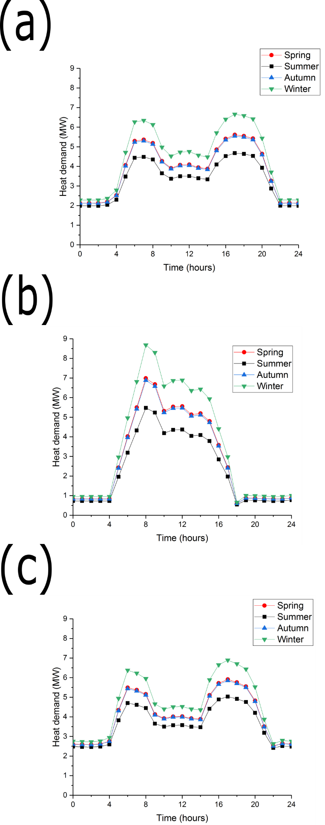
Figure 6.2: (a) The hourly HD profiles generated using case study 1: Darley Dale, England, with a maximum allowable heat loss in the pipes of 40%. (b) The hourly HD profiles generated using case study 2: Sheffield, England, with a maximum allowable heat loss in the pipes of 7%. (c) The hourly HD profiles generated using case study 3: Hayange, France, with a maximum allowable heat loss in the pipes of 45%.
Figure 6.2 shows the HD profiles for the three different case studies, showing significantly differently shaped curves. The reason for the differently shaped curves was that the areas in the different case studies had different proportions of buildings. Figure 6.2a and Figure 6.2c represent the rural case study, case study 1, and the urban case with a small population, case study 3 density, respectively. The curves produced for case studies 1 and 3 had maxima in the morning and the evening, and minima during the day and at night. The shapes of the curves produced closely matched the heating profile of a domestic building, showing that the buildings were occupied, and the heating was used, in the morning and the evening.
Table 6.2 proves that case studies 1 and 3 were mainly comprised of small domestic buildings. A DHN with a large proportion of small domestic customers may require a different investment strategy when compared to a network with a larger proportion of commercial customers. Domestic customers require as much, and sometimes more, support and information when compared to commercial customers, generating less profit per unit sale of heat (Lygnerud and Peltola-Ojala, 2010). A DHN with larger numbers of small domestic customers, such as case studies 1 and 3, may struggle to make a viable business case and require more financial help and incentives.
Table 6.2: Buildings used in each case study model.
Building type | Quantity (number of buildings)
 | Case study 1: Darley Dale | Case study 2: Sheffield | Case study 3: Hayange
House (detached) | 340 | 2 | 54
House (semi-detached) | 344 | - | 8
House (terraced) | 227 | 15 | 100
Block of flats | 4 | 1 | 2
Supermarket | 3 | - | 1
Shops (miscellaneous) | 69 | - | 24
Office | 5 | 4 | 7
Warehouse | 9 | 58 | 26
Shopping centre | 1 | - | -
Church | 3 | - | 1
Medical centre | 1 | - | -
Village hall | 1 | - | -
Manor house | 1 | - | -
School | 1 | - | -
Library | 1 | - | -
Pub | 1 | - | -
Restaurant | - | - | 2

The aim of this chapter was to see if the same modelling technique could be used in different areas of population density. Therefore, domestic buildings were included as potential DH customers. Case studies 1 and 3 showed that when using the model in areas with a small population density, large numbers of small domestic customers were included. The model, particularly in the collecting and inputting data stages, had to be modified, ensuring that small domestic customers were omitted. The customers were omitted as they cause the network to struggle to make a viable business case. Exceptions could be made for large domestic customers, such as blocks of flats, housing associations, and new build estates, that could act as anchor loads (Hawkey, 2009).
Case studies 1 and 3 required large allowable heat losses in the pipes in order to match the maximum HD of the heat supply. The maximum allowable heat losses in case studies 1 and 3 were 40% and 45% respectively. The high heat losses were due to the case study areas having zones of small HDs that were separated by large distances that needed large pipe lengths for connection, as shown in Figure 6.3.
Figure 6.2b represents case study 2, the urban area with a large population density. Figure 6.2b has a maxima during the middle of the day and a minima during the rest of the time, matching the heating profile of commercial buildings. Table 6.2 proves that case study 2 was mainly comprised of commercial buildings. Case study 2 had a small maximum allowable heat loss in the pipes of 7%, as the urban area was comprised of zones of large HD, which were located next to the heat source, as shown in Figure 6.3.
Case study 2 was mainly comprised of a small number of large commercial buildings that could act as anchor loads. By contrast, case studies 1 and 3 were comprised of a large number of small domestic buildings. Urban DHNs are likely to be comprised of a number of anchor loads that are located near to the heat source. Rural areas are likely to be comprised of a large number of small heat loads, which are more dispersed. Figure 6.3 shows the geographical spread of the heat loads in each case study.
Figure 6.3b has a smaller scale than Figure 6.3a or Figure 6.3c, showing that the heat loads were located significantly closer to the heat source in case study 2 when compared to case studies 1 and 3. Figure 6.3b also shows that the heat loads could be located in any direction from the heat source, as the source was surrounded by built-up zones. Figure 6.3a and Figure 6.3c show that the heat loads in case studies 1 and 3 were constrained to clusters of built-up zones surrounded by areas of green space.
The case studies with the smaller population densities, case studies 1 and 3, had total pipe lengths in the DHN of 22.0 and 32.8 km respectively. The case study with the large population density, case study 2, had a significantly shorter pipe length of 5.4 km. The pipe lengths between the more and less densely populated areas were different by a factor of approximately 4 – 6. The CAPEX of the pipe lengths and the heat losses in the pipes were both proportional to the pipe length (Raine, 2016). Therefore, the CAPEX and heat losses of case study 2 were likely to be 4 – 6 times smaller than in case studies 1 or 3. The difference in the CAPEX is likely to become significant when techno-economic modelling work is done. Potentially, the difference in pipe lengths will require different business cases or financial incentives to be applied in areas of differing population density.

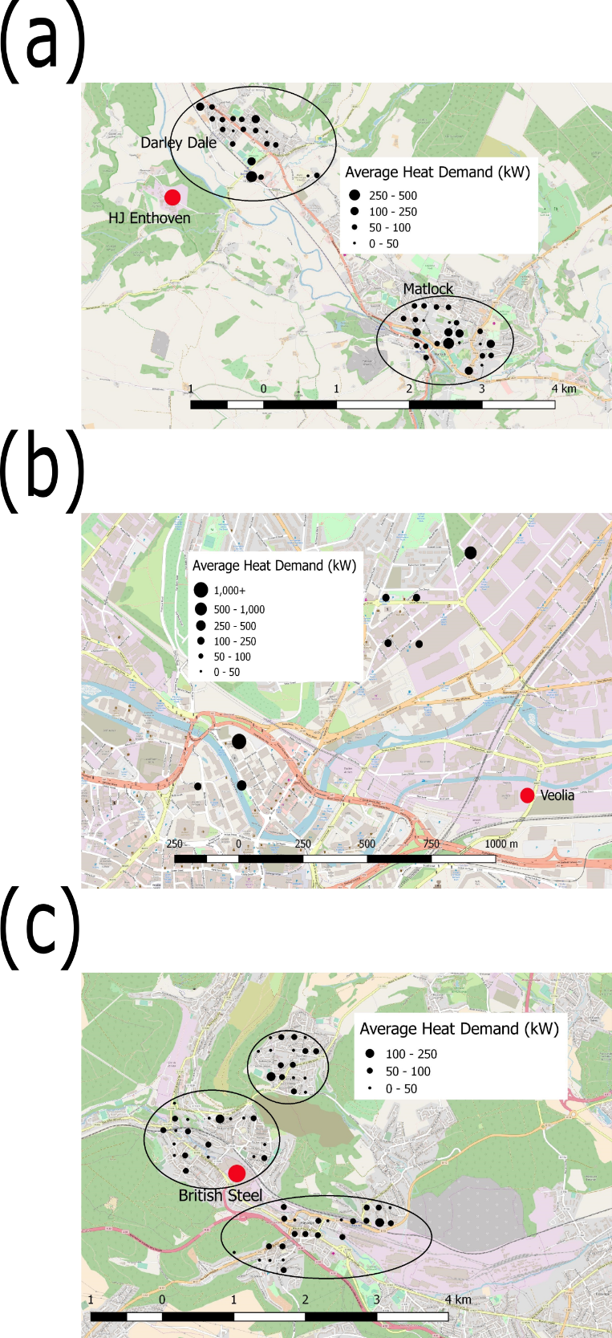
Figure 6.3: The size and locations of the heat source (in red) and customers (in black), showing the clusters of heat customers (in black rings) in each case study area. (a) GIS map showing the heat source and customers in case study 1: Darley, England. (b) GIS map showing the heat source and customers in case study 2: Sheffield, England. (c) GIS map showing the heat source and customers in case study 3: Hayange, France (GEOFABRIK, 2017).

Validating the Heat Demand Model
As the model was kept simple enough that a non-technical user could operate it, several assumptions had to be made. Each of the assumptions introduced the possibility of error into the work. The extent of which was assesses using a validation study, both internally and externally. Internal validation came from MC simulations. External validation would normally come from comparing the results of the model to primary DHN data or equivalent, already validated, DH model. No DHN was found that was willing to provide primary network data to the thesis, meaning that external validation could not come from an existing DHN. As the HD model was novel, no equivalent models exist that could be used as a comparison. Due to the limited nature of primary data made available to the thesis, using an alternative DH model would require more assumptions to be made than are already present in the work. The new assumptions would introduce the potential for more error in the work, the accuracy of which would need further assessing.
The external validation for the model came from the confidence that the industrial source (Arup, 2017) had in their model and the extensive experience they had using it. The industrial model was based on industrial experience and knowledge and was constantly updated as more data became available. The external validation was sufficient for industry and was therefore the approach used in this work as it tied the data back to genuine field data.
MC simulations were used to provide the internal validation for the model. The MC simulations worked by running the model thousands of times, varying the input and quantifying the spread in the output. The variation in the input was based on primary data, reflecting the variation that exists in the world. The assumptions that were assessed were:
- An assumption that each building in an archetype category was of the same size.
- An assumption that each building in an archetype category had the same hourly HD profile.
- An assumption that the pipe route ran in the shortest possible straight-line distance.
It was expected that, across a network wide scale, the potential inaccuracies from the assumptions would not be significant, as the large sample size would cause the average to not be significantly affected. If the sample had a large variance in the data, the average would be significantly affected, causing the effect of the assumptions on the accuracy of the model to be significant.
The primary data used to validate assumptions (1) and (2) came from a series of studies into the variance in building size and HD variation (Burzynski et al., 2011; BRANZ, 2014; Balcombe et al., 2015; BRE Trust, 2015; EIA, 2016; Törnros et al., 2016). The studies came from the building research association of New Zealand (BRANZ) and the building research establishment trust (BRE TRUST) among other sources. The accuracy of assumption (3) was validated by comparing the length of an existing DHN to the shortest possible straight line distance (Finney et al., 2011). The validation process used studies from outside of the UK to increase the sample size and the accuracy of the MC simulations. It was understood that variation may exist from country to country, which may have affected the accuracy of the simulations. The effects of the possible variation were mitigated by obtaining data from countries with similar environmental and social patterns to the UK and by normalising each data set to itself. Using data from outside of the UK allowed the MC simulations to be completed now, instead of waiting for the data to become available. As UK studies that investigate building HD and size variation in the parameters are found, the simulations can be updated.
The different datasets of the three assumptions were studied, finding the probability distributions to load into Goldsim. The probability distributions were as shown in Table 6.3.
Table 6.3: Probability distribution details for the HD model assumptions.
Assumption | Distribution type | Probability distribution details
(1) Building size | Normal | Mean | 1 | Standard deviation | 1.96
(2) Heat profile | Normal | Mean | 1 | Standard deviation | 0.212
(3) Network route | Pareto | Shape factor | 5 | Lower bound | 1

In the distributions, a value of 1 meant that the building size, HD, or network route length was unchanged. A value not equal to 1 changed the building size, HD, or network route length by the factor of that value. The MC simulations were run for the HJE case study, case study 1, during winter. MC simulations were run 1,000 times, which was sufficient to reach convergence in the output. Convergence was achieved when the standard deviation of the output changed by less than 1%, as shown in Figure 6.4.
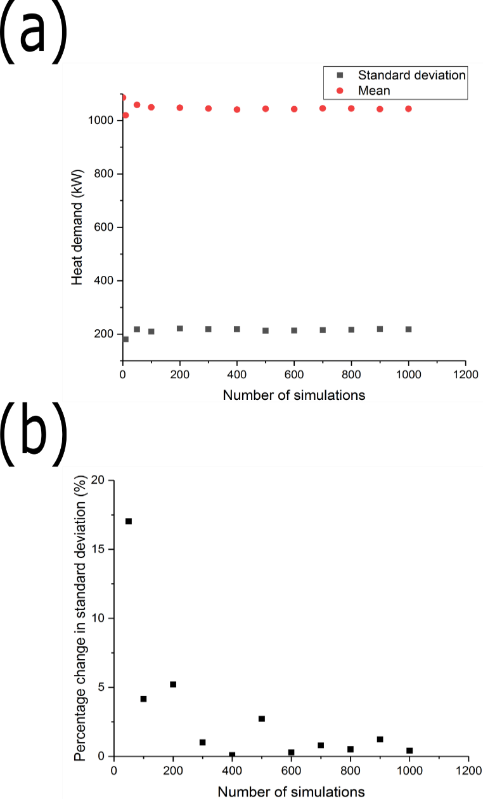
Figure 6.4: (a) The change in mean and standard deviation with an increasing number of simulations. (b) The percentage change in the standard deviation from trial to trial with an increasing number of simulations.
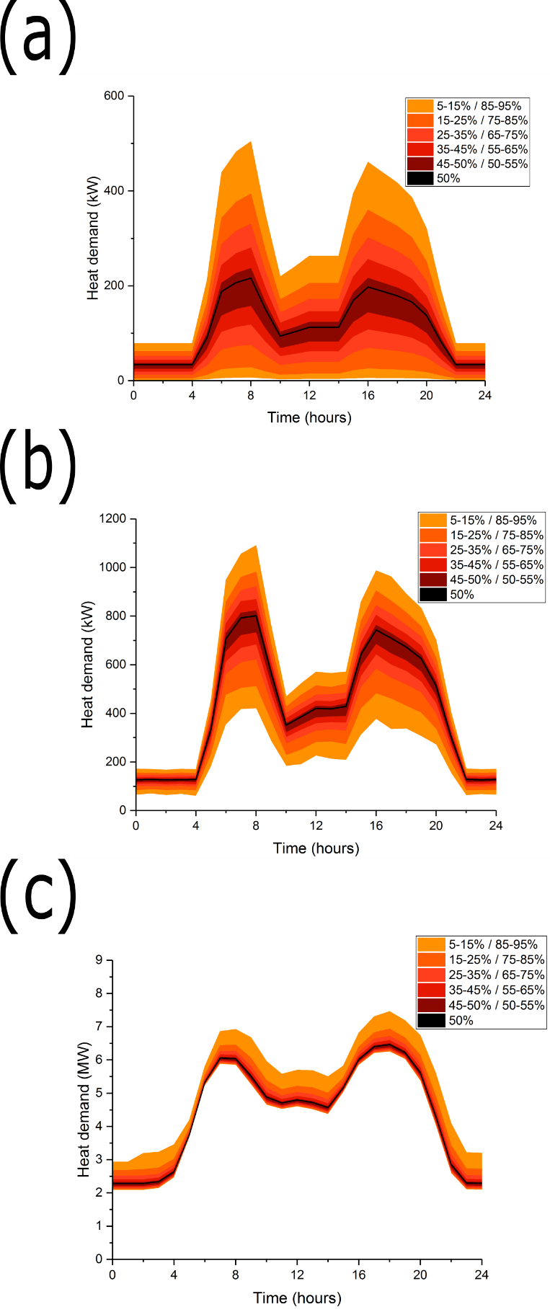
Figure 6.5: Results of the MC simulations for the assumptions in the model, after 1,000 simulations. The mean result, the 50th percentile, is shown with a black line. The range of percentiles to the extremes of the 5th and the 95th are denoted by the colour bands. (a) Results of the MC simulations for the assumption (1) of each building in an archetype category having the same, assumed size. (b) Results of the MC simulations for the assumption (2) of each building in an archetype category having the same, assumed HD profile. (c) Results of the MC simulations for the assumption (3) that the pipe network travels in the shortest possible straight-line distance.
The results of the MC simulations for the three assumptions are shown in Figure 6.5. Figure 6.5 shows the mean HD curve, the 50th percentile, found over 1,000 simulations with a black line. The range of percentiles to the extremes of the 5th and the 95th are denoted by the colour bands. Due to limitations in the Goldsim software, the MC simulations for (1), the building size assumption, and (2), the building HD assumption, could not consider the entire network structure. Instead, for assumptions (1) and (2), the MC simulations were run for a typical subnode of the DHN and the results were used to represent the entire DHN. It is unclear from Figure 6.5 the extent that the results vary from the mean; Figure 6.6 and Table 6.4 more clearly show the variation from the mean.
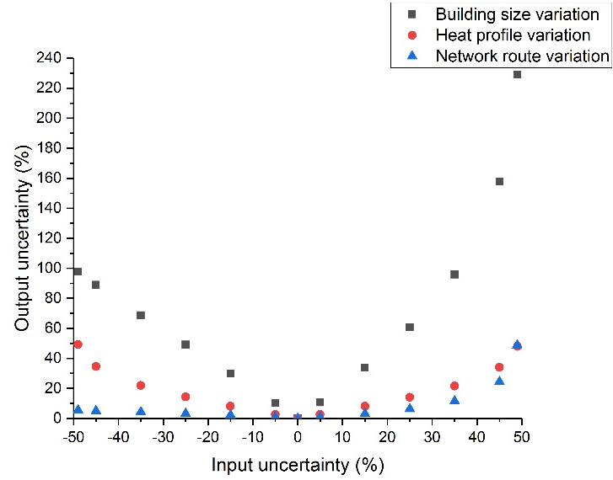
Figure 6.6: Input and output uncertainty for the MC simulations, showing the assumptions of (1) the standard building sizes, (2) the standard HD profiles and (3) the straight-line network route.
Table 6.4: Input and output uncertainty for the MC simulations, showing the assumptions of (1) the standard building sizes, (2) the standard HD profiles and (3) the straight-line network route.
Type of assumption | Input uncertainty (%)
 | -49 | -45 | -35 | -25 | -15 | -5 | 0 | 5 | 15 | 25 | 35 | 45 | 49
 | Output uncertainty (%)
(1) Building size | 98 | 89 | 67 | 49 | 30 | 10 | 0 | 11 | 34 | 61 | 96 | 158 | 229
(2) Heat profile | 49 | 34 | 22 | 14 | 8 | 3 | 0 | 3 | 8 | 14 | 22 | 34 | 48
(3) Network route | 5 | 5 | 4 | 3 | 2 | 1 | 0 | 1 | 3 | 6 | 12 | 24 | 48

Figure 6.6 and Table 6.4 measure the variation from the mean in the MC simulations, quantifying the effect that variation in the input uncertainty has on the output uncertainty. The information used in Figure 6.6 and Table 6.4 was taken from the afternoon peak at four pm, using the HD experienced at that moment. Figure 6.6 and Table 6.4 show that the output variation from assumption (1), standard building sizes, was highly sensitive to the input variation. A 90% variation in the input uncertainty caused 247% variation in the output uncertainty. The 247% variation is significantly higher than the 24% variation reported by Parsons Brinckerhoff; therefore the assumption of standard building sizes caused a large spread in the results and uncertainty, consequently the assumption was nor accurate enough to use in further work (Parsons Brinckerhoff, 2011). Figure 6.6 and Table 6.4 do not clearly shown how sensitive the output variation from assumption (2), standard HD profiles, was to the input variation. More work was needed to quantify the sensitivity of the output of assumption (2) to the input.
Figure 6.6 and Table 6.4 show that the output variation from assumption (3), straight-line network route, was highly insensitive to the input variation. A 90% variation in the input uncertainty caused 29% variation in the output uncertainty, and a 98% variation in the input uncertainty caused 53% variation in the output uncertainty. The 29% variation is comparable to the 24% variation reported by Parsons Brinckerhoff; therefore the assumption of a straight-line network route caused a minimal spread in the results and uncertainty (Parsons Brinckerhoff, 2011). Consequently, the assumption was accurate enough to use in further work.
The further assessment of the sensitivity of the output of assumption (2), standard HD profiles, to the input variation is shown in Figure 6.7.
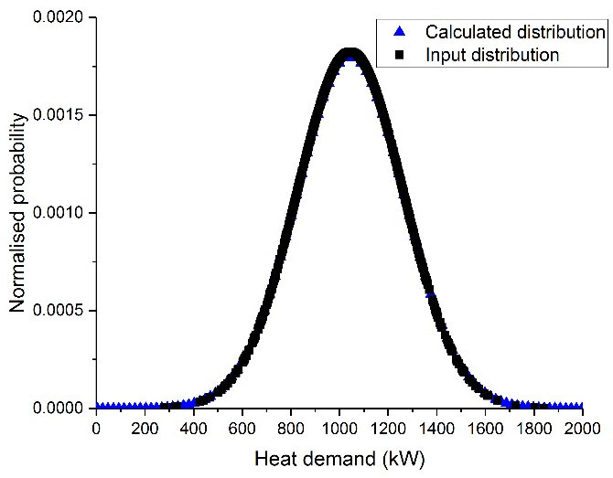
Figure 6.7: The distribution of the HDs found by the MC simulations of the assumption (2), standard HD profiles, compared against the distribution of HD variations found in the literature, which were used as inputs into the MC simulations.
Figure 6.7 compares the distribution of the output to the distribution of the HD profiles found in literature, which were used as inputs to the MC simulations. It was shown that the input and output distributions were almost identical. Therefore, the output distribution from the MC work was almost identical to the distribution of building HDs found in the world. The almost identical distributions proved that the assumption of standard HD profiles was accurate enough to use in further work.
So far in the MC simulations, each assumption had been investigated individually, one variable at a time. MC simulations need to be run globally with all of the variables and assumptions simulated simultaneously. As the assumption of (1), standard building sizes, was shown to not be accurate enough for use in further work, it was left out of the global MC simulations. Therefore, the assumptions of (2), standard HD profiles, and (3), a straight-line network route, were simulated simultaneously in the global MC simulation. The results of the global MC simulation are shown in Figure 6.8.
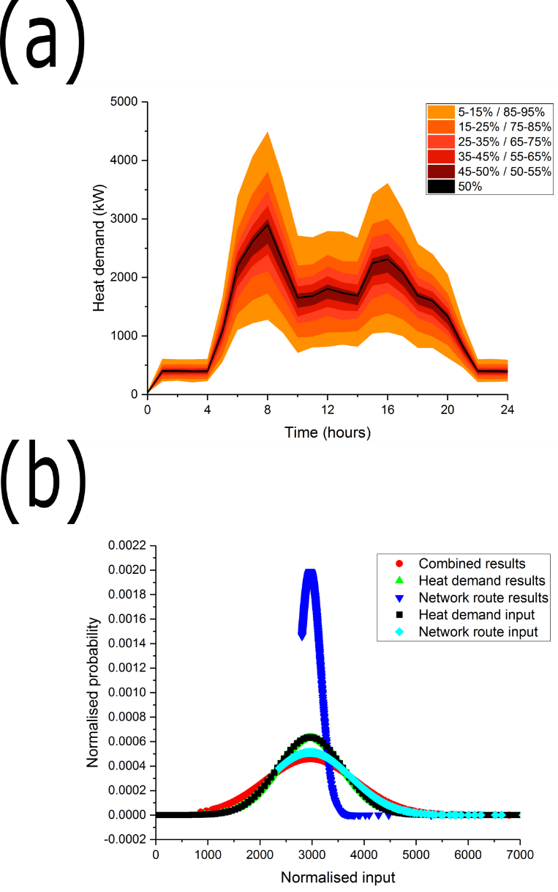
Figure 6.8: (a) Results of the global MC Simulations for the assumptions of (2), the standard HD profiles, and (3), the straight-line network route, after 1,000 simulations. The mean result, the 50th percentile, is shown with a black line. The range of percentiles to the extremes of the 5th and the 95th are denoted by the colour bands. (b) The distribution of the HD from the global and individual MC simulations as well as the distributions of HD and network route length as found in the literature.
Figure 6.8 shows that probability distribution of the output results of the global MC simulations were similar to the probability distributions of the inputs. The input data represented the variation found in the HD profiles of real buildings and the variation between the lengths in real DH pipes to the shortest possible straight-line distance. The similarity in the distribution profiles proved that the output variation of the global MC simulations were insensitive to the input variations. Therefore, the assumptions of (2), the standard HD profiles, and (3), the straight-line network route, could be kept in future HD modelling work.
It was shown that the assumption of (1), standard building sizes, was not accurate enough for use in the model. In future work, instead of assuming that every building of the same category was of the same size, the building sizes will be measured. The measurement can be done in one of two ways. Ideally, the non-technical user will have access to records of primary building sizes or be able to obtain them from the buildings’ owner. Whilst being accurate, obtaining the primary data may be expensive, time consuming, or not possible in every case. The alternative is to use Google Maps to measure the total floor area of a building and use Google Street View to count the number of floors in the building. Using primary building data should not introduce any error into the work whereas using Googles Maps will introduce errors of 3.54% (Lopes and Nogueira, 2009). If the Google Maps method is used, a new assumption is introduced into the work. The new assumption is (4), that Google Maps can accurately measure building sizes.
It is useful to quantify the extent that changing the modelling technique had on the output of the work. To do so, the work in Figure 6.2 has been repeated, using the Google Maps based technique. The results of the repeated work are shown in Figure 6.9.
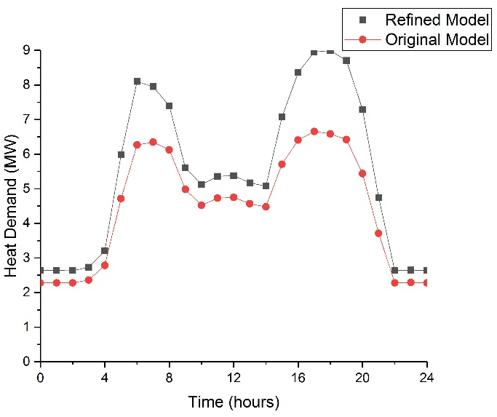
Figure 6.9: A comparison of the two techniques for modelling the HD in a local area, comparing the original technique, with assumed building sizes, and the refined technique, with the measured building sizes using Google Maps.
Figure 6.9 compares the original model, that was generated with the assumed building sizes, and the refined model, that was generated with the Google Maps based measured building sizes. Measuring the building sizes increased the HD showing that the assumed building sizes were, on average, smaller than the actual buildings. It is likely that the reason for the discrepancy in size was that the assumed building sizes did not consider the number of floors in the buildings. The average variation between the two curves was approximately 20%, with a peak variation of approximately 40%.
As the use of Google Maps to measure the building sizes possibly introduced error into the work, the global MC simulation was repeated. The repeated global simulation simultaneously compared:
- The assumption that every building had a standard HD profile.
- The assumption that the DH pipes travelled in the shortest possible straight-line route.
- The assumption that Google Maps could be used to accurately measure building sizes.
The global simulation is shown in Figure 6.10.
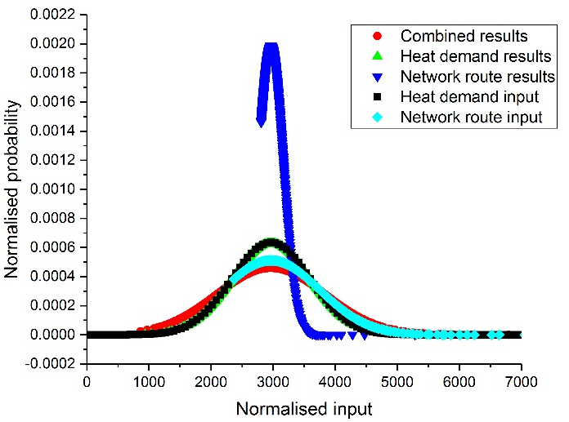
Figure 6.10: The distribution of the HD from the new global and individual MC simulations as well as the distributions of HD and network route length, as found in the literature.
The probability distribution of the results of the global MC simulations in Figure 6.10 and Figure 6.8 are nearly identical. Figure 6.10 shows that the output variation in the global simulation was similar to the distributions found in literature. Figure 6.10 shows that the assumptions of (2), (3), and (4) can be kept in future work.

Conclusions
This chapter proposed a simple model, based on an industrial regression-based archetype model, that could be used to calculate the HD variation in any new DHN. The model was designed to be simple enough that it could be operated by a non-technical user. Three different case studies with differing population densities were investigated, to see if the same modelling technique could be used in any location in the country. MC simulations were used to assess the effect that the assumptions made in the modelling process had on the accuracy of the results.
It was shown that DHNs in areas with large population densities had significantly shorter pipe lengths than networks in areas with small population densities. DHNs with shorter pipe lengths were shown to have lower heat losses and network installation costs. It is possible that DHNs in areas with differing population densities may require different business cases and financial incentives during the later techno-economic modelling work. It was shown that DHNs in areas with small population densities were comprised of a large proportion of small domestic buildings. DHNs with a large proportion of small domestic buildings were shown to struggle to create a viable business case. Therefore, it is advised that the non-technical user omits small domestic buildings from future modelling work. It was shown that the overall HD of a DHN is affected the following factors, including the number, type and location of the customers connected to the network; the overall pipe length; and any heat losses in the pipes.
Individual MC simulations were used to assess the effect that the assumptions had on the accuracy of the work. It was shown that the assumptions of (2), standard building HD profiles. and of (3), a straight-line network route, only had a minimal effect on the accuracy of the results. The variation in the model output of assumption (2) was shown to be similar to the variation in HDs of actual buildings. A 90% variation in the input of assumption (3) was shown to only cause a 29% variation in the output uncertainty, which is comparable to industrial reported variations. Therefore, assumptions (2) and (3) were shown to be acceptable when assessed on an individual basis. A global MC simulation was run, assessing the accuracy of assumptions (2) and (3) simultaneously. The output variation of the global MC simulation was similar to the variation of HD of actual buildings and the variation of network route length in actual DHNs. Therefore, assumptions (2) and (3) were shown to be acceptable when assessed simultaneously.
It was shown that the assumption of (1), standard building sizes, had a significant effect on the accuracy of the results. A 90% variation in the input of assumption (1) was shown to cause a 247% variation in the output uncertainty, which is significantly higher than industrial reported variations. Therefore, assumption (1) was shown to be unacceptable and the modelling technique would have to be changed in future modelling work. A new modelling technique was proposed, where the building sizes were measured using Google Maps instead of being assumed. The new modelling technique was shown to change the results of the model by 20 – 40%.
The new modelling technique introduced errors of 3.54% into the work. A global MC simulation was run, assessing the new model technique alongside assumptions (2) and (3). The output variation in the new global MC simulation was similar to the input variation used in the simulations. Therefore, the new modelling technique and assumptions (2) and (3) were shown to be acceptable when assessed simultaneously.

District Heating Network Optimisation Using Thermal Energy Storage
The DHN must be optimised to match the variation in the HD and the heat supply from the customers and the TE sources connected to the DHN. The optimisation is required to decide which TES system, if any, to use. Once the network has been optimised, techno-economic and environmental assessment of the DHN can be carried out. The optimisation model was created so that it may be operated by a non-technical user. The modelling technique was based on MILP processes generated by Romanchenko et al. and Basciotti et al. (Basciotti et al., 2011; Romanchenko et al., 2018). Four different TES scenarios were used in the work:
- A single, large HWT.
- A pair of small HWTs.
- TES utilising the thermal inertia of the buildings connected to the DHN.
- TES utilising the thermal inertia of the pipes in the DHN.
- A reference scenario with no TES.
The comparison was made between HWT based TES and TES utilising the thermal inertia of the buildings on the network and the network itself to find the best option for TES in DHNs. A comparison was made between the effectiveness of a single and a pair of HWTs as not all networks have the necessary space to install a single large HWT. The ability to use multiple smaller HWTs would offer a DHN operator more choice.
A reference, fifth, scenario was modelled which does not use TES, instead it used a back-up natural gas fired burner to match the heat supply and demand. All four TES scenarios used the natural gas fired burner to match the heat supply and demand when the TES system was insufficient.

Methodology
To compare the three options for TES: HWTs, building and network-based TES to that of not using any TES, a techno-economic optimisation methodology was used. In the optimisation the decision variables were the sizes of the different TES technologies and the objective function was to minimise the total costs and associated CO₂e emissions. In all scenarios a back-up natural gas-fired burner was included to provide heat when the industrial heat supply and the stored thermal energy was insufficient to meet the heat demand. The modelling work is based on MILP optimisation completed by Romanchenko et al., Basciotti et al. and Leśko and Bujalski to match the case study heat supply with the case study heat demand (Basciotti et al., 2011; Leśko and Bujalski, 2017; Romanchenko et al., 2018),. The models used were taken directly from the work by Romanchenko, Basciotti and Leśko.
All five scenarios were modelled for a year of operation, using a time step of one hour. After one year of operation, the costs and associated CO₂e emissions were calculated and compared. The costs and associated CO₂e emissions of buying the natural gas burner and the TES systems were included in the assessment. As the heat source came from a WHR source, no priority was given to any particular time period as there were no time dependent costs to consider. Instead, the optimisation began at time step one and worked chronologically.
The MILP optimisation was based around an energy balance over the pipe network for a time step of 1 hour, as shown in Equation 7.1.
$$Q_{prod}=Q_{cons}+Q_{loss}+Q_{stored}$$ |  | 7.1

$Q_{prod}$ was the energy produced by the TE generating centre (MWh),
$Q_{cons}$ was the energy consumed by the customers connected to the DHN (MWh),
$Q_{losses}$ was the energy losses from the DHN (MWh),
$Q_{stored}$ was the energy stored in the TES system connected to the DHN (MWh).

Hot Water Tank Methodology
The HWT based optimisation was calculated based on an energy balance model, as shown in Equation 7.2.
$$Q_{stored, t}^{HWT}=Q_{stored,t-1}^{HWT}+Q_{ch,t}^{HWT}η_{ch}-\frac{Q_{disch,t}^{HWT}}{η_{disch}}-P_{loss,t}^{HWT}∆t$$ |  | 7.2

$Q_{stored, t}^{HWT}$ was the energy stored in the HWT at the time step, t (MWh),
$Q_{stored,t-1}^{HWT}$ was the energy stored in the HWT at the previous time step, t-1 (MWh),
$Q_{ch,t}^{HWT}$ was the energy added to the HWT at time step, t (MWh/h),
$η_{ch}$ was the efficiency of charging the HWT (%),
$Q_{disch,t}^{HWT}$ was the energy removed from the HWT at time step, t (MWh/h),
$η_{disch}$ was the efficiency of discharging the HWT (%),
$P_{loss,t}^{HWT}$ was the rate of heat losses from the HWT at time step, t (MW),
$∆t$ was the time (hour).
The charging and discharging efficiencies were included to factor the losses caused by charging and discharging the HWT. During charging, or discharging, mixing occurred, which caused some of the TE in the HWT to be stored at a lower temperature than could be recoverable. It was assumed that the charging and discharging efficiencies were constant, keeping the model simple and linear in structure. In reality, the efficiencies would vary with the temperature in the tank.
During the optimisation, it was assumed that the water in the tank was fully mixed, with no stratified layers. It was assumed that that HWT losses do not vary significantly between stratified and fully mixed tanks (Steen et al., 2015). The losses in the HWT were calculated, as shown in Equation 7.3.
$$P_{loss,t}^{HWT}=\left(T_{t}^{HWT}-T_{t}^{amb}\right)U_{HWT}A_{HWT}$$ |  | 7.3

$T_{t}^{HWT}$ was the temperature in the HWT at time step, t (K),
$T_{t}^{amb}$ was the ambient temperature at time step, t (K),
$U_{HWT}$ was the HTC of the tank (MW/[m²K]),
$A_{HWT}$ was the SA of the HWT (m²).
The temperature in the HWT was calculated, as shown in Equation 7.4.
$$T_{t}^{HWT}=T_{t-1}^{HWT}+\frac{{Q_{disch,t}^{HWT}}/{η_{disch}}}{Vc_{P,water}ρ_{water}}-\frac{Q_{ch,t}^{HWT}η_{ch}}{Vc_{P,water}ρ_{water}}$$ |  | 7.4

$T_{t-1}^{HWT}$ was the temperature in the HWT at the previous time step, t-1 (K),
$V$ was the volume of the tank (m³),
$c_{P,water}$ was the specific heat capacity of the water (kJ/[kgK]),
$ρ_{water}$ was the density of the water (kg/m³).

Building Thermal Inertia Methodology
The potential for storing TE utilising DSM controls and the thermal inertia of the buildings connected to the DHN was limited by the allowable temperature change in the buildings. In this work, the maximum allowable temperature change was set as ± 0.5 °C (Romanchenko et al., 2018). The value of ± 0.5 °C was based on the work completed by Romanchenko et al. but has been reduced to reflect the high proportion of domestic buildings connected to the DHN (Romanchenko et al., 2018). Domestic buildings will have more stringent thermal comfort demands, which was reflected by the smaller allowable temperature change. When considering a building as a TE store, the components of the building were split into shallow and deep. Shallow components were able to directly interact with, transferring heat to and from the building heating system, the DHN, and the outdoor air. Examples of shallow components included the heating system and the indoor air. Deep components only interacted with and transferred heat to and from the shallow components of the building. The deep components of the building were the building structure itself. The thermal inertia of building-based TES was caused by the delay in the energy transfer between the shallow and the deep components. The energy stored in the shallow and the deep components was calculated, as shown in Equation 7.5 and Equation 7.6.
$$Q_{stored,t}^{shallow}=Q_{stored,t-1}^{shallow}+Q_{ch,t}^{shallow}-Q_{disch,t}^{shallow}-Q_{flow,t}-Q_{loss,t}^{shallow}$$ |  | 7.5

$Q_{stored,t}^{shallow}$ was the energy stored in the shallow components of the buildings connected to the DHN at time step, t (MWh),
$Q_{stored,t-1}^{shallow}$ was the energy stored in the shallow components of the buildings connected to the DHN at the previous time step, t-1 (MWh),
$Q_{ch,t}^{shallow}$ was the energy added to the shallow components of the buildings connected to the DHN at time step, t (MWh/h),
$Q_{disch,t}^{shallow}$ was the energy removed from the shallow components of the buildings connected to the DHN at time step, t (MWh/h),
$Q_{flow,t}$ was the transfer of energy from the shallow to the deep components of the buildings connected to the DHN at time step, t (MWh/h),
$Q_{loss,t}^{shallow}$ was the rate of energy losses from the shallow components of the buildings connected to the DHN at time step, t (MW).
$$Q_{stored,t}^{deep}=Q_{stored,t-1}^{deep}+Q_{flow,t}-Q_{loss,t}^{deep}$$ |  | 7.6

$Q_{stored,t}^{deep}$ was the energy stored in the deep components of the buildings connected to the DHN at time step, t (MWh),
$Q_{stored,t-1}^{deep}$ was the energy stored in the deep components of the buildings connected to the DHN at the previous time step, t-1 (MWh),
$Q_{loss,t}^{deep}$ was the energy removed from the deep components of the buildings connected to the DHN at time step, t (MWh).
The rate of HT from the shallow to the deep components of the buildings connected to the DHN was calculated, as shown in Equation 7.7. The rate of heat transfer was dependent on the difference energy storage levels in the shallow and the deep components. The different energy storage levels caused a temperature differential to exist between the shallow and the deep components. Due to the temperature differential, the energy transfer went from the hotter to the colder energy storage components.
$$Q_{flow,t}=\left(\frac{Q_{stored,t-1}^{shallow}}{Q_{cap}^{shallow}}-\frac{Q_{stored,t-1}^{deep}}{Q_{cap}^{deep}}\right)H_{flow}$$ |  | 7.7

$Q_{cap}^{shallow}$ was the storage capacity of the shallow components of the buildings connected to the DHN (MWh),
$Q_{cap}^{deep}$ was the storage capacity of the deep components of the buildings connected to the DHN (MWh),
$H_{flow}$was a HTC.
The heat losses from both the shallow and the deep components of the buildings connected to the DHN were calculated, as shown in Equation 7.8, Equation 7.9 and Equation 7.10.
$$Q_{loss,t}^{shallow}=Q_{stored,t-1}^{shallow}\left(1-H_{loss}^{shallow}\right)$$ |  | 7.8

$H_{loss}^{shallow}$ was the heat loss coefficient of the shallow components of the buildings connected to the DHN.
$$Q_{loss,t}^{deep}=Q_{stored,t-1}^{deep}\left(1-H_{loss}^{deep}\right)$$ |  | 7.9

$H_{loss}^{deep}$ was the heat loss coefficient of the deep components of the buildings connected to the DHN.
$$Q_{loss,t}^{shallow}=\dot{V}A_{building}ρ_{air}c_{p,air}∆T$$ |  | 7.10

$\dot{V}$ was the ventilation flowrate (m³/[m²]).

Network Thermal Inertia Methodology
TES utilising DSM controls and the thermal inertia of the pipe network was similarly limited by the allowable temperature change in the pipes. In this work, the maximum allowable temperature change was set as ± 1 °C (Basciotti et al., 2011). The maximum storage potential of the network was calculated, as shown in Equation 7.11.
$$Q_{cap}^{network}=\sum_{i=1}^{n}{c_{P,water}ρ_{water}L_{p}π\frac{D_{p}^{2}}{4}}$$ |  | 7.11

$Q_{cap}^{network}$ was the maximum TES capacity of the network (MWh),
$L_{p}$ was the length of pipe section, p (m),
$D_{p}$ was the diameter of pipe section, p (m),
$n$ was the number of pipe sections.
The energy balance over a network can be written as shown in Equation 7.12.
$$Q={\dot{m}}_{water}c_{P,water}\left(T_{s}-T_{r}\right)-Q_{loss}$$ |  | 7.12

$T_{s}$ was the supply temperature of the DHN (K),
$T_{r}$ was the return temperature of the DHN (K).
The energy balance, as shown in Equation 7.1, was broken down into equations for losses and TES, as shown in Equation 7.13 and Equation 7.14.
$$Q_{loss}=U_{net}A_{net}\left(T_{avg}-T_{amb}\right)={\dot{m}}_{water}c_{P,water}\left({\overline{T}}_{avg}-T_{amb}\right)$$ |  | 7.13

$U_{net}$ was the HTC of the pipes in the DHN (MW/[m²K]),
$A_{net}$ was the SA of the pipes in the DHN (m²),
$T_{avg}$ was the temperature difference between the supply and return pipes in the DHN (K).
$$Q_{stored}=m_{water}c_{P,water}\left(T_{inc}-{\overline{T}}_{s}\right)$$ |  | 7.14

${\dot{m}}_{water}$ was the mass flowrate of the water in pipes in the DHN (kg/s),
${\overline{T}}_{s}$ was the increased supply temperature of the supply pipes in the DHN (K).
Increasing the supply temperature of the water increased the amount of energy supplied to the network, showing how much energy can be stored in the network.
Combining Equation 7.1, Equation 7.13 and Equation 7.14 gave a detailed energy balance over the pipe network, as shown in Equation 7.15.
$${\dot{Q}}_{produced}={\dot{Q}}_{consumed}+U_{net}A_{net}\left(T_{avg}-T_{amb}\right) +{\dot{m}}_{water}c_{P,water}\left(T_{s}-T_{r}\right)$$ |  | 7.15

During the modelling of the network-based optimisation, a number of assumptions were made. It was assumed that no pumps or boilers will be needed to ensure suitable hydraulic conditions were maintained throughout the DHN. As no pumps or boilers were needed, the costs of these technologies could be ignored in the optimisation.
The methodology used in this thesis was suitable for use by a non-technical user because it only required a series of simple inputs. The bulk of the calculations were hidden in a series of locked Microsoft Excel spreadsheets that the user would not have access to. The inputs to the modelling work were simple to understand and obtain, including the temperature of the tank and outside air, mass flowrate in the pipes, and the pipe and tank physical characteristics. Several more complicated, harder to obtain inputs were also needed, such as heat capacities of the tanks and water, charging and discharging efficiencies, and the various HTCs. The more complicated inputs may have confused the non-technical user. However, these complicated inputs could be pre-set before the model is delivered to the client. The complicated inputs would be pre-set by a single technical individual before being sent to all the users, reducing the number of technical individuals required to one, no matter how many model users there are.

Case Study and Scenarios
The optimisation work was carried out for the case study, based around HJE. The HD in the local area was calculated in chapter 6. The variation in the heat supply and demand in the case study is shown in Figure 7.1.
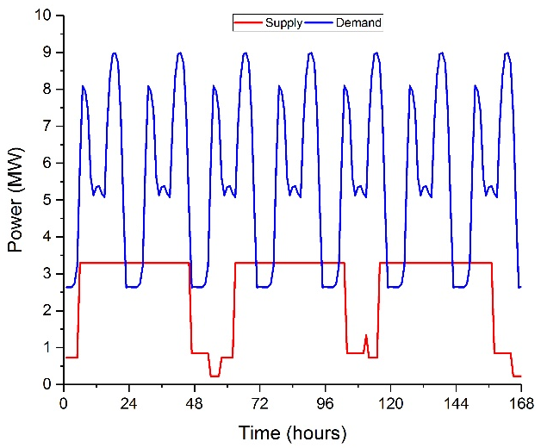
Figure 7.1: The heat supply from the WHR source (only) and the heat demand variation in the case study area.
Four TES scenarios were modelled:
- A single, large HWT, which was sized to meet the maximum available energy in the case study.
- A pair of smaller HWTs, which were sized together to meet the maximum available energy in the case study.
- TES utilising the thermal inertia of the buildings connected to the DHN, which was sized based on the case study DHN.
- TES utilising the thermal inertia of the pipes in the DHN, which was sized based on the case study DHN.
A reference, fifth, scenario was considered that did not use TES and did not have the necessary control systems needed to utilise the thermal inertia of the buildings or the pipe network. Instead, the reference scenario used a back-up, natural gas fired burner to match the heat supply and demand. All four TES based scenarios used the natural gas fired burner to match the heat supply and demand when the TES system was insufficient. The parameters of the HWTs, building energy storage and network energy storage are shown in Table 7.1 to Table 7.3.

Table 7.1: The parameters used in the work for the scenarios 1) and 2), the HWT based options.
Parameter | Symbol | HWT (single) | HWTs (double)
Storage capacity (MWh) | $$Q_{cap}^{HWT}$$ | 3.6 | 1.8
Charging/ discharging efficiencies (%) | $η_{ch}$, $η_{discch}$ | 95 | 95
Tank volume (m³) | $$V$$ | 287 | 143
Heat transfer coefficient (MW/[m²°C]) | $$U_{HWT}$$ | 2.44x10⁻⁵ | 1.22x10⁻⁵
Tank surface area (m²) | $$A_{HWT}$$ | 244 | 153

Table 7.1 gives the parameters used in scenarios 1) and 2), the HWT based TES options. The maximum storage capacities of the tanks were scaled to meet the maximum available energy demand from the case study. The values for the charging and discharging efficiencies came from Romanchenko et al. (Romanchenko et al., 2018). The volumes, SAs, and HTCs of the tanks were calculated in relation to the storage capacity needed.
Table 7.2 gives the parameters used in scenario 3), the building TES. The parameters were based on the work by Romanchenko et al. and Kensby et al. (Kensby et al., 2015; Romanchenko et al., 2018).
Table 7.2: The parameters used in the work for scenario 3), the building TES.
Parameter | Symbol | Shallow storage | Deep storage
Storage capacity (MWh) | $$Q_{cap}$$ | 1.725 | 0.278
Maximum energy addition (MWh/h) | $$Q_{ch,max}$$ | 0-10 | n/a
Maximum energy discharge (MWh/h) | $$Q_{disch,max}$$ | 0-10 | n/a
Heat loss coefficient | $$H_{loss}$$ | 0.9913 | 0.9963
Maximum total building losses (MW) | $$Q_{loss,max}$$ | 5 | -
Heat transfer coefficient | $$H_{flow}$$ | 180 | -
Ventilation flowrate (m³/[m²s]) | $$\dot{V}$$ | 0.0035
Building surface area (m²) | $$A_{buildings}$$ | 1,560

Table 7.3 gives the parameters used in scenario 4), the network TES. The pipe lengths, internal pipe area, and mass flow rate in the pipes came from the case study. The HTC was calculated based on the remaining information.
Table 7.3: The parameters used in the study for scenario 4), the network TES.
Parameter | Symbol | Network
Storage capacity (MWh) | $$Q_{cap}^{network}$$ | 3.4
Length of supply pipe (m) | $$L_{s}$$ | 1448.5
Length of return pipe (m) | $$L_{r}$$ | 1448.5
Heat transfer coefficient (MW/[m²°C]) | $$U_{net}$$ | 2.44x10⁻⁴
Internal pipe area (m²) | $$A_{net}$$ | 5.10x10⁻²
Mass flow rate in the pipes (kg/s) | $${\dot{m}}_{water}$$ | 15

Results
The four TES scenarios and the reference, fifth, case scenario were modelled for a year of operation with a time step of one hour. The results were used to analyse the case study and to see if generic rules could be drawn for future DH optimisation work.

Case Study Results
A typical week of operation for the five case studies is shown in Figure 7.2. Figure 7.2a shows the typical week of operation of the reference scenario, that does not use TES; however the reference scenario used a back-up natural gas fired burner. Figure 7.2a shows time periods during which the HD exceeded the heat supply and the back-up natural gas fired burner was required. The opposite is also shown, whereby there were periods where the heat supply exceeded the HD, during which a TES system could be utilised, reducing the use of the back-up burner.
Figure 7.2b shows the operation of scenario 1), where a 3.6 MWh HWT was used as the TES. During the time periods where the heat supply exceeded the demand, the HWT was charged and during the time periods where the HD exceeded the supply, the HWT was discharged. The use of the HWT partially reduced the need to use the back-up burner. A minor amount of burner displacement is shown by comparing the burner use in Figure 7.2a and Figure 7.2b, noting the missing peaks in Figure 7.2b. However, due to the minor levels of burner displacement, more analysis will be needed to see the effects that installing HWTs has on the performance of the DHN. The 3.6 MWh HWT was the correct size for the DHN studied, as the tank was large enough to store all of the excess TE in the case study. Using a larger HWT would not allow for further reduction of the back-up burner however, would increase the system costs.
Figure 7.2c shows the operation of scenario 2), where two 1.8 MWh HWTs were used as the TES. HWT-1 was set as the primary tank, while HWT-2 was set as the secondary tank. HWT-2 was only charged when HWT-1 was full, and the heat supply still exceeded the demand; similarly HWT-2 was only discharged when HWT-1 was empty, and the HD still exceeded the supply. A comparison of Figure 7.2c and Figure 7.2b does not show the effect that using two HWTs instead of one has on the reduction of the back-up burner. More analysis was needed to assess the differences, if any, between scenarios 1) and 2). The further analysis focused on the difference between the costs and the environmental effects of the scenarios.
Figure 7.2d shows the operation of scenario 3), where the thermal inertia of the buildings connected to the DHN were utilised as the TES. Due to the small number of buildings connected to the DHN, the maximum energy storage capacity was limited. Comparing the curves of the back-up burner in Figure 7.2d to Figure 7.2b and Figure 7.2c shows the limited ability of scenario 3) to reduce the use of the back-up burner. Again, the differences between the scenarios were only minor and more assessment will be needed. The maximum energy storage capacity was approximately 2 MWh, which was less than the maximum energy storage available in the case study. The limited energy storage capacity of scenario 3) explains the limited potential to reduce the use of the back-up burner.
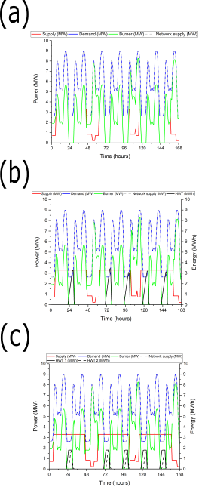
Figure 7.2: Example of a standard week of operation for the five scenarios, showing the variations in the power supply (full red line) and demand (full blue line) on the DHN, the power level needed for the back-up burner (full green line), and the power supply to the customer (the sum of the power levels of the supply (dashed grey line), the burner (full green line), and TES (full and dashed black lines)) as well as the energy levels in the TES system(s). (a) Example of a standard week of operation for the reference scenario with no TES. (b) Example of a standard week of operation for scenario 1), with the single 3.6 MWh HWT. (c) Example of a standard week of operation for scenario 2), with the pair of 1.8 MWh HWTs.
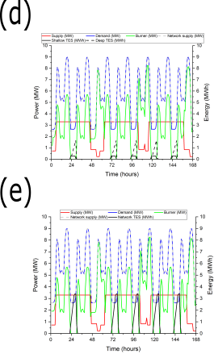
Figure 7.2 (continued): (d) Example of a standard week of operation for scenario 3), utilising the thermal inertia of the buildings on the network, showing the storage levels of the shallow and the deep building components. (e) Example of a standard week of operation for scenario 4), utilising the thermal inertia of the pipe network.
Figure 7.2e shows the operation of scenario 4), where the thermal inertia of the pipes in the DHN are utilised as the TES. Similarly to scenario 3), the maximum energy storage potential of scenario 4) was limited by the size of the pipe network. The maximum energy storage capacity was 3.4 MWh, which was marginally less than the maximum energy available in the case study. Comparing Figure 7.2e and Figure 7.2d shows that scenario 4) was more effective at displacing the use of the back-up burner than scenario 3). Again, the difference between the scenarios was only minor and more assessment will be needed. The 3.4 MWh capacity of scenario 4) was similar to the maximum energy available in the system, showing that the network was close to being fully optimised.
More analysis was needed to further elaborate on the differences between the TES scenarios, particularly on the ability of each scenario to reduce the use of the back-up burner. Table 7.4 shows the average storage levels for each TES scenario as well as the frequency of each one reaching a variety of levels of state of charge (SOC). A SOC is a comparison between the amount of heat stored in the TES compared to the maximum storage level possible. The SOC frequencies show how the operating schedules of the different scenarios differ, showing the combined frequency of charging and discharging.
Table 7.4: The average storage levels for each of the TES scenarios and the number times that each scenario reaches a range of levels of SOC.
TES scenario | Average storage level (MWh) | Number of times that the scenario reaches:
 |  | 100% SOC | 90% SOC | 80% SOC | 70% SOC
1) 1 x 3.6 MWh HWT | 0.438 | 0 | 96 | 255 | 260
2) 2 x 1.8 MWh HWTs | 0.492 | 0 | 260 | 260 | 260
3) Thermal inertia of buildings | 0.224 | 0 | 0 | 260 | 260
4) Thermal inertia of the network | 0.514 | 0 | 260 | 260 | 260

Table 7.4 shows that scenario 4) had the highest average storage level of 0.514 MWh, followed by scenario 2) with 0.492 MWh, scenario 1) with 0.438 MWh and scenario 3) with 0.224 MWh. The difference between the average storage levels of scenarios 1) and 2) was negligible, for the purposes of a simple optimisation, with only a 10% difference. The reason for the difference was likely to be due to the modelling process instead of any differences between the scenarios themselves. Particularly, the differences were likely to be due to the scheduling in the optimisation algorithms.
Table 7.4 shows that none of the TES scenarios reach 100% SOC. A more useful comparison is the frequency that each scenario reaches 70, 80, and 90% SOC. All four scenarios reached 70 and 80% SOC a similar number of times, suggesting that all four scenarios had similar operating schedules. Scenario 4), utilising the thermal inertia of the pipe network, and scenario 2), utilising the pair of HWTs, reached 80 and 90% SOC most frequently. It is expected that scenarios 2) and 4) reached 80 and 90% SOC the most frequently as the maximum storage potentials of the scenarios were close to the maximum storage level available in the case study.
Both HWT based scenarios, scenarios 1) and 2), reached 70% SOC an identical number of times, 80% SOC a similar number of times, and 90% SOC a significantly different number of times. Again, the reason for the difference was more likely to be due to the modelling and allocation processed rather than differences between using a single or a pair of HWTs. The extent of the difference was acceptable for the purposes of a simple optimisation, where the goal was to suggest which TES scenario is the best, not accurately model the scenarios. Scenario 3), utilising the thermal inertia of the buildings on the network, did not regularly reach 80 and 90% SOC. It was likely that the failure to reach 80 and 90% SOC was due to energy losses that occurred when transferring TE from the shallow to the deep components. Table 7.4 suggests that the best option for the TES system was scenario 4), followed by scenario 2), scenario 1), and scenario 3).
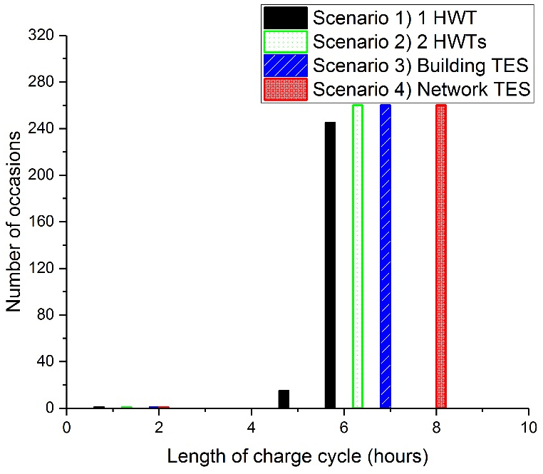
Figure 7.3: The length and number of times that each TES scenario is charged to over 1 MWh.
It was also important to study the length and number of times each TES scenario was charged to over 1 MWh, as shown in Figure 7.3. It is shown that scenario 4), utilising the thermal inertia of the pipe network, could store TE for the longest period of time, eight hours. The ability of scenario 4) to store TE for the longest period of time suggested that scenario 4) was the best TES option. None of the TES scenarios could store TE for longer than eight hours, showing that none of the scenarios were capable of storing energy to meet weekly, or longer HD variations. Again, scenario 2), with two HWTs, was slightly better than scenario 1), with the single HWT. Multiple bars are shown for each of the TES scenarios, most clearly for scenario 1), as the scenarios were not always charged for the same length of time. On a fairly frequent basis scenario 1) was changed for only 4 hours.
The main advantage of TES is that it can ‘smooth out’ variations in HD, lessening relative variations. To measure the ability of each TES scenario to lessen relative variations, relative daily mean load variations (RDMLVs) and relative weekly mean load variations (RWMLVs) in the amount of power from the back-up burner were calculated. The calculation was based on equations shown by Romanchenko et al. (Romanchenko et al., 2018). The calculations for the RDMLVs and RWMLVs are shown in Equation 8.14 and Equation 7.17.
$$\text{RDMLV}=\frac{1/2\sum_{h=1}^{24}{\left|{\text{Mean load}}_{h}-{\text{Mean load}}_{d}\right|}}{{\text{Mean load}}_{yr}24}$$ |  | 7.16

$\text{RDMLV}$ was the relative daily mean load variation in the power demand of the back-up burner,
${\text{Mean load}}_{h}$ was the mean load of the back-up burner over hour, h (MW),
${\text{Mean load}}_{d}$ was the mean load of the back-up burner over day, d (MW),
${\text{Mean load}}_{yr}$ was the mean load of the back-up burner over the year (MW).
$$\text{RWMLV}=\frac{1/2\sum_{h=1}^{24.7}{\left|{\text{Mean} \text{load}}_{h}-{\text{Mean} \text{load}}_{w}\right|}}{{\text{Mean} \text{load}}_{yr}24.7}$$ |  | 7.17

$\text{RWMLV}$ were the relative weekly mean load variations in the power demand of the back-up burner,
${\text{Mean load}}_{w}$ was the mean load of the back-up burner over week, w (MW).
The RDMLVs and the RWMLVs are shown in Figure 7.4. Figure 7.4a shows that scenarios 1) and 2), the HWT based TES scenarios, significantly reduced the RDMLVs when compared to the reference scenario. Scenarios 3) and 4), utilising the thermal inertia of the buildings and the pipe network, were shown to slightly increase the RDMLVs when compared to the reference scenario. Figure 7.4a shows that the best TES options to reduce the RDMLVs were scenarios 1) and 2).
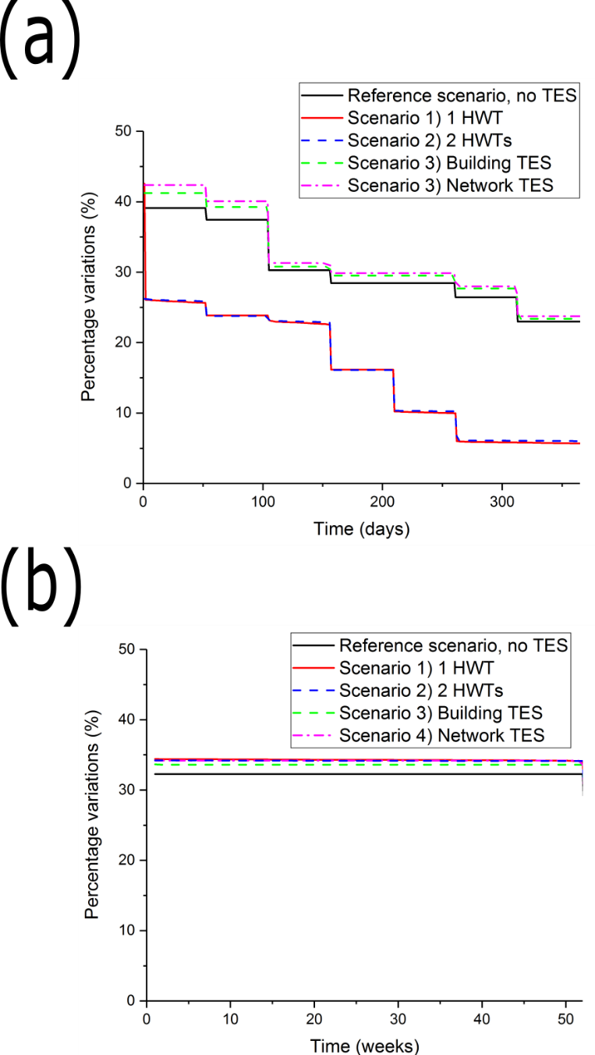
Figure 7.4: (a) The RDMLVs of the different TES scenarios required use of the back-up burner. (b) The RWMLVs of the different TES scenarios required use of the back-up burner.
Figure 7.4b shows the RWMLVs of all four TES scenarios compared to the reference scenario. It is clearly shown that all four TES scenarios increased the RWMLVs when compared to the reference scenario. As all scenarios increased the RWMLVs, was further proven that none of the TES scenarios should be used to meet weekly, or longer HD variations.
The most important metric for failure and success of a DHN is how it performs on economic and environmental scales. To analyse the economic and environmental savings of each scenario, the amount of natural gas that each scenario saved, with respect to the reference scenario, was compared. The techno-economic and environmental assessments were based on a number of assumptions. According to the National Renewable Energy Laboratory (NREL), the typical efficiency of a natural gas burner is 79% (NREL, 2004). Therefore, every MWh of natural gas saved will reduce the use of the natural gas by a factor of 1.27. in the UK, natural gas costs are £30 /MWh and the CAPEX of buying HWTs is £2,100 /m³.
According to Raine et al., the embodied emissions associated with combustion of natural gas are 0.183 kg CO₂e/kWh (Raine et al., 2014). According to Dominković et al., the cost per building to connect the control systems necessary for building thermal inertia-based TES systems are £230 (Dominković et al., 2018). According to Basciotti et al., no additional costs are needed for the control systems associated with network thermal inertia-based systems (Basciotti et al., 2011). According to Martin and Thornley, the associated CO₂e emissions with the construction of the single, 287 m³, HWT and the pair of, 143 m³, HWTs are both 221 tonnes CO₂e (Martin and Thornley, 2013).
The techno-economic and environmental assessments are shown in Table 7.5. All scenarios, including the reference one, had a peak use of the natural gas burner of 9 MW. As all scenarios had the same peak burner use, the economic and environmental costs of buying the burner were the same and will not be considered in the techno-economic and the environmental analysis.
Table 7.5: Economic and environmental analysis of the TES scenarios.
 | Reference scenario | 1 x 3.6 MWh HWT | 2 x 1.8 MWh HWTs | Building TES | Network TES
Annual natural gas input to the burner (MWh) | 34,381 | 34,438 | 33,332 | 33,811 | 33,264
Annual natural gas costs (£1,000) | 1,031 | 1,001 | 1,000 | 1,014 | 998
CAPEX of the TES system (£1,000) | 0 | 652 | 652 | 3.22 | 0
Number of years to reach economic payback | n/a | 22 | 21 | 1 | 1
Annual emissions associated with annual natural gas (tonnes CO₂e) | 6,292 | 6,119 | 6,105 | 6,187 | 6,103
Emissions associated with the TES system (tonnes CO₂e) | 0 | 221 | 220 | 0 | 0
Number of years to reach environmental payback | n/a | 2 | 2 | 1 | 1

Table 7.5 shows that scenario 4), utilising the thermal inertia of the pipe network, required the smallest annual natural gas input into the burner and the smallest annual OPEX. The annual energy use from the natural gas burner in scenario 4) was 33,264 MWh, with annual OPEX of £998,000. Scenario 4) was followed by scenario 2), with annual OPEX of £1,000,000, then scenario 1) with OPEX of £1,001,000 and scenario 3), with OPEX of £1,014,000. The thermal inertia-based scenarios, 3) and 4), had the shortest economic payback periods, of one year. The short payback periods were due to the insignificantly low costs of the technologies. The HWT based scenarios, 1) and 2), had payback periods of 22 and 20 years respectively.
Table 7.5 shows that the greatest environmental savings came from scenario 4), utilising the thermal inertia of the pipe network. Scenario 4) had yearly emissions of 6,103 tonnes CO₂e. Scenario 4) was followed by scenario 2), with yearly emissions of 6,105 tonnes CO₂e, then scenario 1) with yearly emissions of 6,119 tonnes CO₂e and scenario 3), with yearly emissions of 6,187 tonnes CO₂e. Table 7.5 shows that, from an environmental perspective, scenario 4) was the best option. Once again, the differences between scenarios 1) and 2) were shown to be insignificant, less than 1%.
In nearly all of the assessments, the best TES scenario was 4), utilising the thermal inertia of the pipes in the DHN. Scenario 4) was shown to have the smallest yearly use of natural gas, resulting in the smallest annual OPEX and the fewest annual associated CO₂e emissions. It was the best option from both an environmental and an economic view regardless of the timescale considered, was shown to store energy for the longest, and reached high levels of SOC most frequently. It is likely that scenario 4) was the best TES option as the 3.4 MWh maximum energy storage capacity of the TES was close to the 3.6 MWh of energy available from the case study. Therefore, scenario 4) was coincidentally optimised for the case study. When compared to the TES options using the HWTs, scenarios 1) and 2), the network-based TES had a lower rate of energy losses from the network. It is likely that the network-based TES had lower exergy losses through the mixing of the water. In future work, when network-based TES is optimised for the particular case, it should be chosen as the best TES option.
The two HWT based scenarios, scenarios 1) and 2), were shown to have similar results in almost every assessment. Particularly in the techno-economic and environmental analysis and the RDMLVs and RWMLVs. Greater differences were found in the average storage levels and SOC assessments, but differences tended to be 10% or less. The differences were less than the 24% industrial reported variation (Parsons Brinckerhoff, 2011), so therefore can be considered insignificant in a simple optimisation. The insignificant differences are likely to be due to the methodology used rather than inherent differences between the different sized HWTs. Therefore, it is likely that both scenarios were identically as effective at optimising TES in a DHN, provided the total volumes and maximum energy storage capacities of the tanks were identical. As both scenarios were identically as effective, either could be used in DH optimisation, giving increased flexibility to the network operator. Due to network to network differences, particularly geographical ones, sometimes it would be more desirable to have a single, large HWT and sometimes it would be better to have a pair of smaller tanks. The choice of which number of HWTs to use could be left to the user.
The performance of scenario 3), utilising the thermal inertia of the buildings connected to the DHN, was the worst of the four, with only minor improvements when compared to the reference scenario. Building based TES only resulted in annual economic savings of £5,000 and emission savings of 26 tonnes CO₂e. The reason for the poor performance was due to the small size of the case study DHN only providing a small number of buildings that could be utilised in the TES. Therefore, there was only a small volume of building mass that could be used as the thermal inertia in the TES. In future small case studies it is likely that TES in the thermal inertia of the buildings would be the least viable option.
All of the TES scenarios increased the RWMLVs and were unable to store TE for longer than eight hours, proving that none of the scenarios should be used for longer than daily energy storage needs.
It is worth noting that the economic performance of each TES scenario was similar with differences in the annual OPEXs of £16,000. The difference in the environmental assessment was larger, with differences in the annual emission savings of 99 tonnes of CO₂e. An advantage of the similarity in the TES scenarios, considering that each scenario performed better than the reference scenario, is that it offers more flexibility to the non-technical user. It is possible that hidden costs will emerge later in the DH design work making the chosen scenario more expensive. In a situation such as that, the operator will be able to use a different, but similarly well performing, TES technology.

Lessons for Future DH Optimisation Work
The work done so far in this chapter shows that, under the conditions of the case study, the best TES scenario was scenario 4), TES utilising the thermal inertia of the pipe network. In other cases a different TES scenario might be better. It would be useful to repeat the work with a range of different heat supply to HD ratios, so that generic rules can be drawn that can be used in any case. Therefore, the work done so far in this chapter was repeated at a range of different heat supply to HD ratios, as shown in Figure 7.5 and Table 7.6. Table 7.6 shows that as the heat supply increased, the ratio of peak supply maxima to the peak demand maxima decreased.
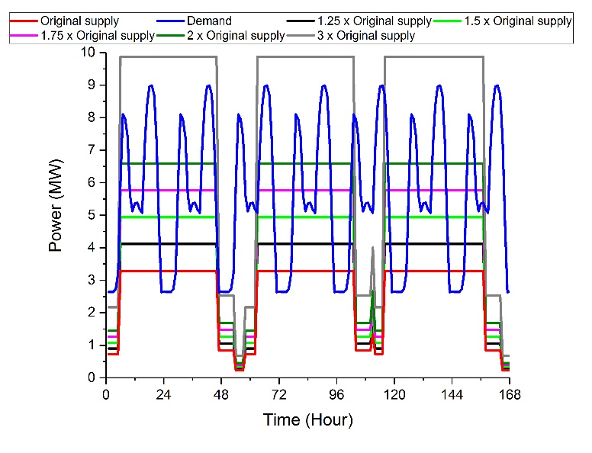
Figure 7.5: The heat supplies and demands for the new DH optimisation calculations.
Table 7.6: Important parameters for the new DH optimisation calculations.
Factor of increase on the original heat supply | Size of the single HWT (MWh) | Size of the pair of HWTs (MWh) | Ratio of supply maxima: demand maxima
1 | 3.6 | 1.8 | 1:2.73
1.25 | 9 | 4.5 | 1:2.18
1.5 | 14 | 7 | 1:1.82
1.75 | 20 | 10 | 1:1.56
2 | 30 | 15 | 1:1.37
3 | 190 | 95 | 1:0.91

The techno-economic and environmental assessments were repeated for each of the new supply to demand ratios. In the study, the peak demands on the back-up burner were different, so the burners were included in the techno-economic and environmental assessments. The techno-economic and environmental assessments are shown in Table 7.7 to Table 7.11.
Table 7.7 shows that, when the ratio of peak heat supply maxima to peak HD maxima is 1:2.18, the greatest reduction in natural gas usage came from the HWT based scenarios, scenarios 1) and 2). As the HWT based scenarios had the greatest reduction in natural gas usage, over a long enough time scale they would become the best options economically and environmentally. Both HWT based scenarios did not become economically profitable for 20 or 22 years but were environmentally profitable after 2 years. In a short terms basis, less than 20 years, scenario, 4), utilising the thermal inertia of the pipe network, was the best option both economically and environmentally.
Table 7.7: Economic and environmental analysis of the TES scenarios with an increase of the original heat supply by a factor of 1.25 and a ratio of peak supply maxima to demand maxima of 1:2.18.
 | Reference scenario | Single HWT | Pair of HWTs | Building TES | Network TES
Annual natural gas input to the burner (MWh) | 29,030 | 26,475 | 26,298 | 29,030 | 27,912
Annual natural gas costs (£1000) | 871 | 794 | 789 | 870 | 837
Capital cost of the TES system (£1000) | 0 | 1,630 | 1,630 | 3.22 | 0
Number of years to reach economic payback | n/a | 21 | 20 | n/a | 1
Annual emissions associated with annual natural gas used (tonnes CO₂e) | 5,328 | 4,861 | 4,828 | 5,328 | 5,124
Emissions associated with the TES system (tonnes CO₂e) | 0 | 598 | 598 | 0 | 0
Number of years to reach environmental payback | n/a | 2 | 2 | 1 | 1

The two HWT based scenarios performed almost as identically as well as each other, with less than 1% difference in the respective annual energy uses from the natural gas burner. Again, the differences between the two scenarios were insignificant and likely to be due to the modelling and allocation processes.
Table 7.8: Economic and environmental analysis of the TES scenarios with an increase of the original heat supply by a factor of 1.5 and a ratio of peak supply maxima to demand maxima of 1:1.82.
 | Reference scenario | Single HWT | Pair of HWTs | Building TES | Network TES
Annual natural gas input to the burner (MWh) | 23,757 | 19,791 | 19523 | 23,665 | 22,627
Annual natural gas costs (£1000) | 713 | 594 | 586 | 710 | 679
Capital cost of the TES system (£1000) | 0 | 2,536 | 2,536 | 3.22 | 0
Number of years to reach economic payback | n/a | 21 | 20 | 1 | 1
Annual emissions associated with annual natural gas used (tonnes CO₂e) | 4,362 | 3,636 | 3,587 | 4,345 | 4,155
Emissions associated with the TES system (tonnes CO₂e) | 0 | 930 | 930 | 0 | 0
Number of years to reach environmental payback | n/a | 2 | 2 | 1 | 1

Table 7.7, Table 7.8 and Table 7.9 show that the HWT based scenarios, scenarios 1) and 2), resulted in the greatest reductions in the natural gas burner usage. The differences in the results between the scenarios were still insignificant, at less than 4%. The 4% variation is still significantly less than the 24% reported industrial variation. As the heat supply from the case study increased and the ratio of peak heat supply maxima to peak HD maxima decreased, the time it takes for the HWT scenarios to become economically profitable reduced. Table 7.9 shows that the time taken for profitable HWT operation was 19 and 18 years rather than 22 and 20 years.
Table 7.9: Economic and environmental analysis of the TES scenarios with an increase of the original heat supply by a factor of 1.75 and a ratio of peak supply maxima to demand maxima of 1:1.56.
 | Reference scenario | Single HWT | Pair of HWTs | Building TES | Network TES
Annual natural gas input to the burner (MWh) | 19,636 | 13,285 | 12,806 | 18,986 | 17,547
Annual natural gas costs (£1000) | 589 | 399 | 384 | 570 | 526
Capital cost of the TES system (£1000) | 0 | 3,623 | 3,623 | 3.22 | 0
Number of years to reach economic payback | n/a | 19 | 18 | 1 | 1
Annual emissions associated with annual natural gas used (tonnes CO₂e) | 3,607 | 2,445 | 2,358 | 3,488 | 3,225
Emissions associated with the TES system (tonnes CO₂e) | 0 | 1,329 | 1,329 | 0 | 0
Number of years to reach environmental payback | n/a | 2 | 2 | 1 | 1

Table 7.10: Economic and environmental analysis of the TES scenarios with an increase of the original heat supply by a factor of 2 and a ratio of peak supply maxima to demand maxima of 1:1.37.
 | Reference scenario | Single HWT | Pair of HWTs | Building TES | Network TES
Annual natural gas input to the burner (MWh) | 16,426 | 8,564 | 8,028 | 16,037 | 13,926
Annual natural gas costs (£1000) | 493 | 257 | 240 | 481 | 418
Capital cost of the TES system (£1000) | 0 | 5,434 | 5,434 | 3.22 | 0
Number of years to reach economic payback | n/a | 23 | 21 | 1 | 1
Annual emissions associated with annual natural gas used (tonnes CO₂e) | 3,020 | 1,581 | 1,483 | 2,949 | 2,562
Emissions associated with the TES system (tonnes CO₂e) | 0 | 1,993 | 1,993 | 0 | 0
Number of years to reach environmental payback | n/a | 2 | 2 | 1 | 1

Table 7.10 and Table 7.11 show that a point is reached where further increases to the case study heat supply made the advantages of HWT based TES less significant. In both Table 7.10 and Table 7.11, the HWTs had the greatest yearly reductions in natural gas burner use, but the time it took for the scenarios to reach economic payback started to rise. In Table 7.10 the payback periods were 23 and 21 years, in Table 7.11 they became 120 and 120 years.
Table 7.11: Economic and environmental analysis of the TES scenarios with an increase of the original heat supply by a factor of 3 and a ratio of peak supply maxima to demand maxima of 1:0.91.
 | Reference scenario | Single HWT | Pair of HWTs | Building TES | Network TES
Annual natural gas input to the burner (MWh) | 9,617 | 107 | 64,9 | 9,572 | 8,947
Annual natural gas costs (£1000) | 288 | 3.2 | 1.9 | 287 | 268
Capital cost of the TES system (£1000) | 0 | 34,418 | 34,418 | 3.22 | 0
Number of years to reach economic payback | n/a | 120 | 120 | 3 | 1
Annual emissions associated with annual natural gas used (tonnes CO₂e) | 1,774 | 23.0 | 15.4 | 1,766 | 1,651
Emissions associated with the TES system (tonnes CO₂e) | 0 | 12,621 | 12,621 | 0 | 0
Number of years to reach environmental payback | n/a | 8 | 8 | 1 | 1

As the heat supply from the case study increased, the differences in the results from the two HWT based scenarios, scenarios 1) and 2), became more pronounced. In Table 7.7, when the ratio of peak heat supply maxima to peak HD maxima was 1:2.18, the differences between the scenarios was negligible, at 0.67%. In Table 7.10, when the ratio of peak heat supply maxima to peak HD maxima was 1:1.37, the differences between the scenarios was larger, but still less than the industrial reported variation, at 6.7%. In Table 7.11, when the ratio of peak heat supply maxima to peak HD maxima as 1:0.91, the differences between the scenarios was significant, and larger than the industrial reported variation, at 65%. It is still likely that the differences between the HWT based scenario results were due to the methodology used rather than differences between the technologies. Therefore, the DH optimisation methodology may not be suitable at lower ratios of heat supply to HD.
When the work was repeated with higher heat supplies, reducing the ratio between the heat supply and the HD, the techno-economic and environmental assessment results were different. As the ratio of supply to demand fell to below approximately 1:2, the choice of which TES system to use became dependent on the lifespan of the DHN and the priority of the user. Scenario 2), the pair of HWTs, was shown to have the smallest annual use of natural gas, resulting in the fewest OPEX and associated CO₂e emissions. It was shown that scenario 2) became the best option from an environmental view after 2 years and from an economic view after 18 years. The differences between the two HWT based scenarios, scenarios 1) and 2), continued to be insignificant, less than 5%. Therefore, if the TES system was to be installed for longer than 18 to 20 years, either of the HWT scenarios could be chosen as the TES. It is worth noting that the usual industrial guideline is to only implement new measures and install new technologies that have payback periods of less than three or four years (Awomewe and Ogundele, 2008; Hawkey, 2009). As the main purpose of a DHN is to meet environmental, not economic needs and the lifespan of a DHN is longer than 20 years (Hawkey, 2009), the HWT tank based scenarios should still be chosen.
If the lifespan is less than 18 to 20 years, the choice of best technology is a matter of user priority. If the technology is to be installed for less than 18 to 20 years, the best option from an economic view is scenario 4), the network-based TES. However, scenarios 1) and 2) save between 10 and 50% more CO₂e per year than scenario 4). If the main priority of the DHN operator is to save money, network-based TES should be implemented; however, if the main priority of the user is to reduce CO₂e emissions then scenarios 1) or 2) should be implemented. In future case studies when the difference between the supply and the demand maxima is less than approximately 1:2, it is likely that the HWT TES scenarios, scenarios 1) or 2), will be the best options.
As the heat supply continues to rise and the ratio between supply and the demand further decreases, an ideal point is reached for HWT based TES. When the supply to demand maxima reaches 1:1.56, the HWT tank TES scenarios, scenario 1) and 2), are the best options on economic and environmental scales. At the 1:1.56 ratio, the economic payback periods for the HWT scenarios 18 to 20 years and the environmental payback periods are 2 years. As the supply to demand ratio continues to decrease, the time taken for the HWT based scenarios to reach economic payback increases. It is likely that the increase in economic payback time is due to the diminishing benefit of the TES alongside the increased size of the HWT needed.
As the heat supply increases beyond the 1:1.56 ratio, the frequency of periods where the HD exceeds the heat supply decrease, reducing the need for installed TES. After the 1:1.56 ratio, the size of the HWT must significantly increase to store all of the excess TE, significantly increasing the system costs. When the ratio of supply maxima to demand maxima decreases below approximately 1:1.6, the profitability of HWT based TES reduces. At lower ratios of supply to demand, the best TES scenario returns to being scenario 4), TES utilising the thermal inertia of the network.
During the work in this chapter, no consideration was made to several factors, either due to availability of information or the factors being outside of the scope of the study. When calculating the economic payback period, no consideration was made to the discount rate or lifetime of the TES technologies, which was a limitation in the work. It was assumed that the future projection of the costs and associated CO₂e emissions for natural gas were fixed values. It is likely however, that the prices of natural gas will rise quicker than inflation, acting to reduce the payback period of all TES scenarios. Reducing the payback period will have a particular effect on the HWT based scenarios, scenarios 1) and 2), reducing the number of years it would take them to become the best options economically. It is expected that the emissions associated with the combustion of natural gas will either stay the same or get marginally better, marginally reducing the environmental benefit. However, it is expected that the changes will be minor, so the effect on the results of the chapter should be minimal.
No consideration was made to possible financial penalties imposed on CO₂e emissions, which would further increase the economic savings of each TES system. Similarly to the projected increase in natural gas prices, the CO₂e penalties should reduce the payback period of the HWTs.
To stick to the brief of keeping the optimisation model simple enough that a non-technical user could operate it, the model was kept simple in structure. No consideration was made to the effect that increasing the allowable temperature change in the pipe network and the buildings would have on the results. The allowable temperature change in the network was kept as ± 1 °C and in the buildings, it was kept as ± 0.5 °C. Increasing the allowable temperature changes would allow for more TE to be stored in the systems, improving the economic and environmental benefits of the network and building TES scenarios. However, the temperature changes could not be significant without affecting the performance of the DHN or the thermal comfort in the buildings. Therefore, it is not expected that increasing the allowable temperature changes would have a significant effect on the results of the chapter.

Validation Study
Due to time constraints, no validation study to test the accuracy of the DH optimisation model was completed. Unlike the rest of this work, a validation study should not be needed for the optimisation work. The optimisation model, unlike the rest of the thesis is not novel, instead using (without any modifications) optimisation models from peer reviewed papers. As the models used were sourced from peer reviewed papers, the accuracy of each model can be considered as pre-approved. Therefore, as no modifications were made to any of the optimisation models, the accuracy of the optimisation model in this thesis can be considered as pre-approved.

Conclusions
This chapter of the thesis aimed to build an optimisation model that could be used for any DHN and that was simple enough that it could be operated by a non-technical user. The model compared the use of four different TES scenarios, using a HJE as a case study. The four scenarios were a single 3.6 MWh HWT, two 1.8 MWh HWTs, the thermal inertia of the buildings in the study, and the thermal inertia of the water in the network. A reference scenario was modelled that had no TES systems installed or any of the control measures required to utilise the thermal inertia of the network or the buildings in the study. Instead of TES, the reference scenario utilised a back-up, natural gas fired burner to balance the variation in heat supply and demand in the DHN. The four TES scenarios also utilised the back-up burner to match the heat supply and demand when the TES system was insufficient. Further analysis was done by repeating the work using a range of different heat supply levels, changing the ratio of HD to heat supply.
It was shown that, in the case study, all four TES scenarios reduced the yearly use of the back-up burner when compared to the reference scenario. Therefore, it was shown that all the TES scenarios had lower OPEX and CO₂e emissions. The total costs of all TES scenarios were shown to be lower than the reference scenario within 22 years, with reduced CO₂e emissions within 2 years.
The greatest reduction in the use of the back-up burner was shown to come from scenario 4), TES using the thermal inertia of the pipe network. Therefore, the greatest yearly economic and environmental savings came from scenario 4), which was shown to be capable of storing TE for the longest time period, eight hours. It was shown that, regardless of the time period being considered, the best TES scenario was TES in the thermal inertia of the pipe network.
It was shown that the worst reduction in the use of the natural gas burner came from scenario 3), TES utilising the thermal inertia of the buildings. It was explained the poor performance of the building-based TES came from the small number of buildings connected to the case study DHN. Therefore, the non-technical user was advised not to use building-based TES in small DHNs.
Scenarios 1) and 2), the HWT based options, were shown to generate insignificantly different results to each other in most assessments. It was explained that any differences in the results were due to the methodology used, rather than inherent differences between the two technologies. Therefore, it was advised that the non-technical user could use either of the scenarios in any given situation, giving more flexibility to the DHN design.
All TES scenarios were shown to increase the RWMLVs and to be incapable of storing TE for longer than eight hours. The non-technical user was advised not to use any of the TES scenarios for longer than daily storage needs.
When the work was repeated with the range of different heat supplies, it was shown that the choice of the best TES scenario was more subjective and case dependent. The choice of the best TES scenario was dependent on the ratio of heat supply maxima to HD maxima. It was shown that when the supply to demand ratio was greater than roughly 1:2, the greatest reduction in the yearly use of the back-up burner came from scenario 4), TES using the thermal inertia of the pipe network. As the supply to demand ratio reduced to below 1:2, it was shown that the greatest reduction in the yearly use of the back-up burner came from scenario 1) and 2), the HWT based options. However, the economic payback period of both HWT scenarios was longer than the industrial standard. For under 18 to 20 years of operation, the total costs of the network-based TES scenario were lower. Therefore, the non-technical user was advised to base the choice of the TES system on the time frame and their priorities.
If the time frame is over 18 to 20 years OR the priority of the user is the environmental benefit of the network, not economic savings, HWT based TES should be used. If the time frame is under 18 to 20 years AND the priority of the user is economic savings of the network, not the environmental benefit, TES utilising the thermal inertia of the pipe network should be used. When the ratio of supply to demand falls below roughly 1:1.16, it was shown that the benefits of the HWT based TES reduces. It was advised that the user should utilise network-based TES when the ratio of supply to demand is less than 1:1.16.
One limitation of this section of work is that no attempt was made to reduce the maximum size of the burner needed. It is possible that greater cost reductions could be achieved by minimising the maximum size of the burner needed, instead of just reducing the amount of natural gas used in the burner. Reducing the maximum size of the burner would require some scheduling of the TES system to discharge when the peak burner demand is anticipated.

Techno-Economic and Environmental Assessments
The purpose of the techno-economic and environmental assessment of the DHN is to compare the network to the incumbent natural gas heat supply. If the environmental impact of the DHN is worse than natural gas heating, then the primary goal of the network, reducing the environmental effects of heating, has failed. If the costs of the DHN are higher than the incumbent heat supply, then it is unlikely that customers will be persuaded to connect to the network. Therefore, the network would have similarly failed at reducing the environmental effects of heating. In addition, the network would have failed at its secondary goal, helping to tackle fuel poverty. However, it is possible that if the network fails to be economically feasible it might become so with either some external funding, either from the government or a private source.

Methodology
In keeping with the overall aim of the thesis, the techno-economic and environmental assessments were left simple and generic in nature. Therefore, a non-technical user would be capable of using either assessment for any DHN in the country. The general basis of each assessment was to compare the total initial and ongoing positive and negative costs or emissions from each section of the network. The techno-economic assessment used a NPV methodology whereas the environmental assessment merely followed a standard comparison.

Techno-Economic Assessment Methodology
The basis of the techno-economic assessment was the NPV, as shown in Equation 8.1. The NPV calculated the expected value of the DHN at the current moment considering its potential value at some point in the future.
$$NPV=\frac{{CF}_{0}}{{(1+r)}^{0}}+\frac{{CF}_{1}}{{(1+r)}^{1}}+…+\frac{{CF}_{t}}{{(1+r)}^{t}}$$ |  | 8.1

${CF}_{t}$ is the cash flow in year, t,
$r$ is the cost of the capital.
The NPV calculation was based on a series of assumptions and relationships, based on techno-economic modelling work completed by Parsons Brinckerhoff (Parsons Brinckerhoff, 2011). It was assumed that the customers would only connect to the network if they could be offered a reduction in the price they currently pay for their heating. Consequently, the sale price of the heat was a 15% reduction on the total cost that the customers pay for their heating, averaged across the network. The 15% reduction included both the total costs that the customers pay for their heat and the annual costs of boiler maintenance. The annual maintenance costs for the boilers were found using a conversion from size, as shown in Table 8.1 (Parsons Brinckerhoff, 2011).

Table 8.1: Annual boiler maintenance costs (Parsons Brinckerhoff, 2011).
Boiler capacity (kW_{th}) | Annual maintenance costs (£/year)
1 | 200
50 | 200
100 | 350
200 | 400
500 | 500
1,000 | 600
5,000 | 1,250
10,000 | 2,000

As discussed in chapter 5 it was assumed that the economic costs of the WHR equipment would belong to the WH source. Therefore, the WHR costs were ignored in the techno-economic assessment. It was assumed that the money generated by the sale of the WH to the DHN would cover the costs of the WHR equipment.
The costs of the pipe network were calculated using a conversion between pipe thickness and costs, as shown in Table 8.2, (Raine, 2016).
Table 8.2: Cost of the pipe network (Raine, 2016).
Pipe diameter (mm) | Pipe and trench costs (£ million/km)
100 | 0.5
200 | 0.9
300 | 1.4
400 | 1.8
500 | 2.3

The costs of the primary pumping station were calculated based on a conversion from capacity to CAPEX, as shown in Figure 8.1 (Loh et al., 2002). The OPEX of a pump were calculated based on an equation presented by the Engineering Toolbox, as shown in Equation 8.2, which is adapted from the Engineering Toolbox (The Engineering Toolbox, 2009).
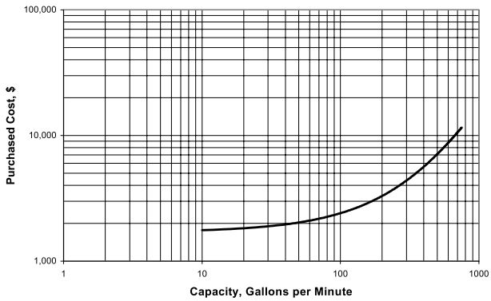
Figure 8.1: Pump CAPEX (Loh et al., 2002).
$${\text{cost}}_{Op,Pump}=\frac{0.746Q_{F,Pump}he.{cost}_{El,Pump}}{3960η_{pump}}$$ |  | 8.2

${\text{cost}}_{Op,Pump}$ was the OPEX of the pump (£/s),
$Q_{F,Pump}$ was the volumetric flowrate of the working fluid (m³/s),
$he$ was the pump head (m),
${cost}_{El,Pump}$ was the electricity costs (£/kWh),
$η_{Pump}$ was the pump efficiency (%).
The CAPEX of the back-up natural gas fired burner were calculated using a conversion of 0.05 – 0.10 £ million/MW (Gudmundsson et al., 2013). The OPEX of the back-up burner were calculated as shown in chapter 7. The CAPEX and OPEX of the TES system were also shown in chapter 7. The costs of the heat interface units in the customer buildings were assumed to be £253 /MWh (DECC, 2015a). It was assumed that the contract costs would be £50 per customer (Parsons Brinckerhoff, 2011). The maintenance costs of the network were assumed to be 1% of the CAPEX of the pipe network.

Environmental Assessment Methodology
The environmental assessment was similarly based on a number of assumptions. The basis of the environmental assessment was a comparison of the CO₂ equivalent emissions associated with the installation and operation of the various parts of the network against the emissions saved each year by the network.
The emissions associated with the WHR equipment, similar to the costs associated, were assumed to belong to the WH company. Consequently, the emissions were not included in the environmental assessment. The emissions associated with the installation of the back-up burner were based on an assumption of 6.07 kg CO₂e/kW (Vignali, 2017). The emissions associated with the maintenance of the boiler were based on an assumption of each boiler having a 20 year lifespan (Parsons Brinckerhoff, 2011). The emissions associated with the operation of the boiler were calculated in chapter 7.
The equivalent CO₂ emissions associated with the construction and installation of the DH pipe lines were calculated based on conversions from pipe length and diameter, as shown in Table 8.3 (Fröling et al., 2004; Fröling and Svanström, 2005).
Table 8.3: Emissions associated with the construction and installation of DH pipes (Fröling et al., 2004; Fröling and Svanström, 2005).
Pipe name | Pipe outer diameter (mm) | Pipe construction | Pipe installation
 |  | Emissions per length (kg CO₂e/m)
DN25 Twin | 33.7 | 12.5 | 21
DN25 Single | 33.7 | 6.83 | 27
DN100 Single | 114 | 30 | 39
DN500 Single | 508 | 250 | 110

The equivalent CO₂ emissions associated with the installation of the pump were calculated based on an assumption of 1.56 tonnes CO₂e/£764 CAPEX (Nault and Papa, 2007).
All the assessment models required as inputs are parameters that have been determined elsewhere in the overall feasibility assessment. The parameters include:
- The number of buildings connected to the DHN.
- The lengths and diameters of the pipes in the pipe network.
- The total heat demand of the customers connected to the DHN.
- The total heat demand experienced by the thermal energy generating centre.
- The flowrate of the water in the network.
- The size of the TES and the back-up burner.
- The natural gas used by the back-up burner.
As all of the parameters had been calculated elsewhere and linked to the assessment models, the non-technical user would be capable of operating the assessment models. All the non-technical user would have to modify is the internal rate of return (IRR), the network lifespan, the heat price, and the funding; all of which could be chosen from a small list. Therefore, the non-technical user would be capable of operating the assessment models.

Results
Both the techno-economic and environmental assessments were considered over a 20-, 30- and 40-year lifespan, comparing the results of each assessment at each stage of the lifespan. Both assessments were analysed using a sensitivity analysis to see which component of the costs or emissions had the largest effect on the overall results.

Techno-Economic Assessment Results
The CAPEX, OPEX, and maintenance costs of each component of the DHN as well as the revenues are shown in Table 8.4.
Table 8.4: CAPEX, OPEX, maintenance costs, and revenues of the DHN.
Component | CAPEX (£1000) | OPEX/ maintenance costs (£1000/year)
Pipe network | 9,488 | 94.88
Pumping station | 7.898 | 6.528
Back-up burner | 623.7 | 998.0
TES | 0 | 0
Customer connections | 257.3 | n/a
Customer contracts | 50.85 | n/a
Revenue | n/a | 2006

The techno-economic assessment was repeated at a range of different IRRs, heat sales price from industry and grant funding, as shown in Table 8.5.
Table 8.5: Parameters used in the techno-economic assessment.
Parameter | Unit | Variable
 |  | 1 | 2 | 3 | 4
IRR | % | 3.5 | 6 | 9 | 12
Heat sale price from industry | p/kWh | 0 | 1 | 2 | n/a
Grant funding | £ million | 2 | 4 | 6 | n/a
A DH feasibility study by Parson Brinckerhoff suggested heat purchase prices of less than 1 p/kWh and IRR of 3.5 – 12% (Parsons Brinckerhoff, 2011). Therefore, it was proven that the suggested heat purchase prices and IRRs would be acceptable to industry and investors.
Table 8.6: Results of the techno-economic assessment.
Grant funding (£ million) | IRR (%) | Heat purchase price (p/kWh) | NPV (£ million)
 |  |  | Lifespan (years)
 |  |  | 20 | 30 | 40
2 | 3.5 | 0 | 4.46 | 8.25 | 10.9
 |  | 1 | 0.602 | 3.26 | 5.14
 |  | 2 | -3.26 | -1.74 | -0.660
 | 6 | 0 | 1.98 | 4.06 | 5.22
 |  | 1 | -1.14 | 0.318 | 1.13
 |  | 2 | -4.26 | -3.42 | -2.95
 | 9 | 0 | -0.149 | 0.890 | 1.13
 |  | 1 | -2.63 | -1.90 | -1.59
 |  | 2 | -5.11 | -4.69 | -4.51
 | 12 | 0 | -1.65 | -1.12 | -0.951
 |  | 1 | -3.86 | -3.31 | -3.19
 |  | 2 | -5.71 | -5.50 | -5.43
4 | 3.5 | 0 | 6.46 | 10.3 | 12.9
 |  | 1 | 2.60 | 5.26 | 7.14
 |  | 2 | -1.26 | 0.262 | 1.34
 | 6 | 0 | 3.98 | 6.06 | 7.22
 |  | 1 | 0.860 | 2.32 | 3.13
 |  | 2 | -2.26 | -1.42 | -0.955
 | 9 | 0 | 1.85 | 2.89 | 3.33
 |  | 1 | -0.628 | 0.0996 | 0.407
 |  | 2 | -3.11 | -2.69 | -2.51
 | 12 | 0 | 0.347 | 0.878 | 1.05
 |  | 1 | -1.68 | -1.31 | -1.19
 |  | 2 | -3.71 | -3.50 | -3.43
6 | 3.5 | 0 | 8.45 | 12.3 | 14.9
 |  | 1 | 4.6 | 7.26 | 9.14
 |  | 2 | 0.742 | 2.26 | 3.34
 | 6 | 0 | 5.98 | 8.06 | 9.22
 |  | 1 | 2.86 | 4.32 | 5.13
 |  | 2 | -0.256 | 0.579 | 1.05
 | 9 | 0 | 3.85 | 4.89 | 5.33
 |  | 1 | 1.37 | 2.1 | 2.41
 |  | 2 | -1.11 | -6.91 | -0.515
 | 12 | 0 | 2.35 | 2.88 | 3.05
 |  | 1 | 0.318 | 0.690 | 0.810
 |  | 2 | -1.71 | -1.50 | -1.43

The results of the techno-economic assessment are shown in Table 8.6 and summarised in Table 8.7. After 40 years of operation, a NPV of £3.13 million was achieved using a IRR of 6%, a heat purchase price of 1 p/kWh and funding of £4 million. The £4 million of funding could be obtained through the government heat network investment project (HNIP) (BEIS, 2018a). A network is eligible for HNIP funding if 50% of its heat provision comes from renewable means.
Table 8.7: Summary of the results of the techno-economic assessment.
Grant funding (£ million) | IRR (%) | Heat purchase price (p/kWh) | NPV (£ million)
 |  |  | Lifespan (years)
 |  |  | 20 | 30 | 40
4 | 6 | 1 | 0.860 | 2.32 | 3.13

A study by AECOM investigating the potential for DH in the case study area found that it was possible to achieve a positive 40-year NPV with a 7% IRR and £5.37 million of funding (AECOM, 2018). The similarity between the results achieved in this thesis and by AECOM support the accuracy of the work done in the thesis.

Environmental Assessment Results
The initial and yearly CO₂ equivalent emissions associated with each component of the DHN were calculated, as shown in Table 8.8. It is assumed that the yearly CO₂e emissions from the pump are negligible.
Table 8.8: Yearly and initial CO₂e emissions and savings for each component of the DHN.
Component | Initial CO₂e emissions (tonnes CO₂e) | Yearly CO₂e emissions (tonnes CO₂e)
Boiler | 54.6 | 5,130
Pipe network | 2,680 | n/a
Pump | 18.0 | n/a
CO₂e savings | n/a | 5,680

The results of the environmental assessment are shown in Table 8.9. It took five years for the network to become environmentally beneficial when compared to the incumbent natural gas heating system. After 40 years the network had saved an additional 19,300 tonnes of CO₂e.
Table 8.9: Results of the environmental assessment.
Network lifespan (years) | Equivalent CO₂ emissions saved (tonnes CO₂)
1 | -2,200
5 | 1
10 | 2,760
20 | 8,270
30 | 13,800
40 | 19,300

Sensitivity Analysis
It is important to run sensitivity analysis of the techno-economic and environmental assessments, investigating how sensitive the answer is on the various components that it is comprised of.

Techno-Economic Sensitivity Analysis
The results of the techno-economic sensitivity analysis suggested how varying the components that comprise the NPV affected the NPV. A sensitivity analysis was run, investigating the following:
- The total CAPEX costs of the DHN.
- The total OPEX costs of the DHN.
- The heat purchase price from industry.
- The costs of the buying the natural gas for the back-up burner.
- The tariff of the heat sold to the customers.
- The cost of connecting the customers to the network.
- The CAPEX of the back-up burner.
The results of the sensitivity analysis are shown in Figure 8.2.
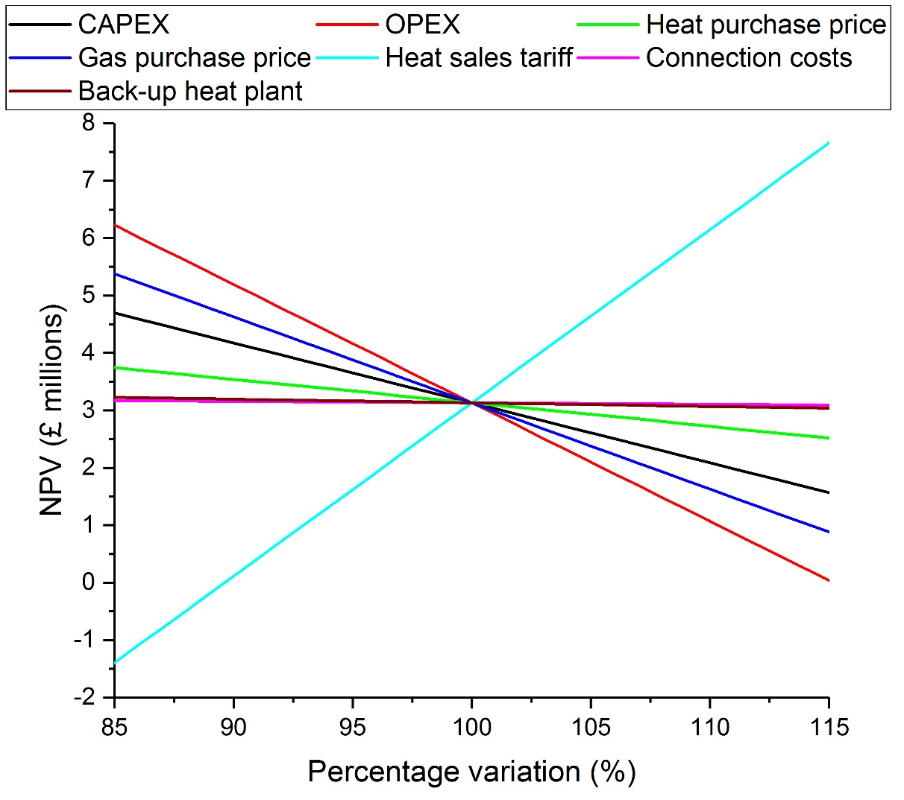
Figure 8.2: Sensitivity analysis of the techno-economic assessment.
Figure 8.2 shows that the NPV of the DHN was highly sensitive to the heat sales tariff, the OPEX and the gas purchase price. It would not be recommended to vary the heat tariff as it would either prevent the network from being profitable or prevent customers from signing up to it. However, it would be possible to reduce the tariff by approximately 5% whilst keeping the network profitable. Applying for a grant to reduce the costs of the natural gas would reduce both the OPEX and the gas purchase price, both of which would increase the NPV of the network. The EU ETS scheme could provide an additional yearly revenue stream to the network, reducing the OPEX and effectively reducing the gas purchase price (EC, 2016). The network would be viable for the EU ETS scheme as a carbon avoidance technology.

Environmental Sensitivity Analysis
The results of the environmental sensitivity analysis suggested how varying the components that comprise the CO₂e would affect the emissions. A sensitivity analysis was run, investigating the following:
- The imbedded CO₂e emissions in the back-up burner.
- The number of years in between burner replacement.
- The imbedded CO₂e emissions in the pipe network.
- The imbedded CO₂e emissions in the pump.
- The annual natural gas usage in the back-up burner.
- The imbedded CO₂e emissions in the saved energy (the energy that would normally be used to heat the buildings).
The results of the sensitivity analysis are shown in Figure 8.3.
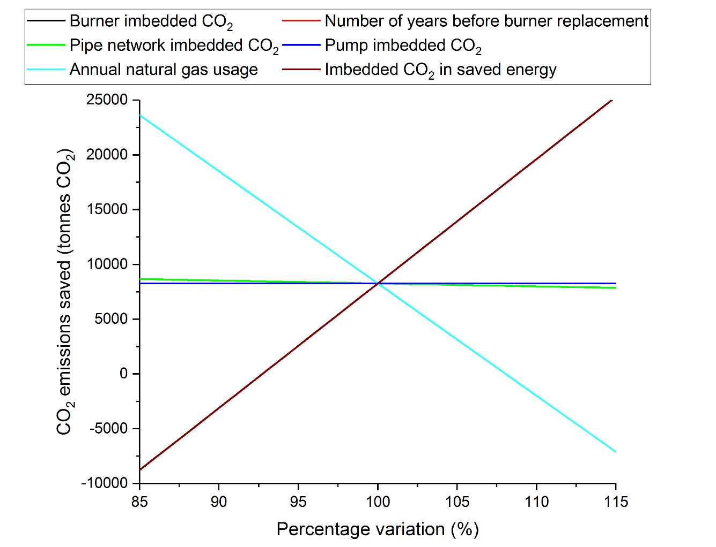
Figure 8.3: Sensitivity analysis of the environmental assessment.
Figure 8.3 shows that the environmental assessment was highly sensitive to the use of the natural gas in the back-up burner and the imbedded CO₂e in the UK natural gas network. Increasing the WHR recovery from the HJE site, which would be possible if more streams were assessed for the WH potential, would decrease the annual natural gas usage. Decreasing the annual natural gas usage would increase the CO₂e saved emissions. An increase to the imbedded CO₂e in the UK natural gas network, which may come from a change in the UK gas supply would increase the CO₂e saved emissions.

Conclusion
Generic, simple models for the techno-economic and environmental assessment of any DHN was generated. The assessment models were simple enough that they could be operated by a non-technical user and generic enough that they could apply to any DHN in the UK. The assessments were completed for the case study DHN and were compared to industrial models to assess their accuracy.
It was shown that, with grant funding of £4 million, an IRR of 6%, and a heat purchase price of 1 p/kWh, it would possible to achieve a NPV of £3.13 million. An equivalent study from AECOM found that it was possible to achieve a positive 40-year NPV with a 7% IRR and £5.37 million of funding. The similarity between the AECOM results and the results from this assessment support the accuracy of the assessment models generated in this thesis.
It was shown that the network became environmentally beneficial, when compared to natural gas heating systems, within five years. After 40 years the network was shown to save an additional 19,300 tonnes of CO₂e.
Techno-economic sensitivity analysis showed that the techno-economic assessment was highly sensitive to the heat sales tariff, the OPEX and the gas purchase price. It was suggested that the EU ETS scheme could be used to effectively reduce the natural gas price, reducing the OPEX and increasing the NPV of the network.
Environmental sensitivity analysis showed that the environmental assessment was highly sensitive to the use of the natural gas in the back-up burner and the imbedded CO₂e in the UK natural gas network. It was suggested that a future increase in the WHR from HJE would decrease the use of the natural gas burner, improving the environmental performance of the DHN.

Discussion
Each of the main chapters contains a discussion pertaining to the work described. Therefore the discussion bought forward in this chapter are more general issues that cut across the totality of the work. It also provides an overview of how well the research questions were addressed.
The aims of this thesis were to design a DH feasibility model, that could be generalised enough to work for multiple DHNs in the UK and that was simple enough that it could be operated by a non-technical user. The thesis specialised in DHNs that were supplied by an industrial WH source. The methodology was split into six chapters, which covered the following:
- Using heat maps to assess if the local area had a HD sufficient to meet the minimum threshold for profitable DH whilst also having a sufficient number of anchor loads.
- Quantifying the heat supply variation available at an industrial site, either through communication with the staff or through mass and energy balances.
- Choosing the optimum WHR technology to use, quantifying the variation in the heat supply after the WHR had occurred.
- Quantifying the HD variation available in the local area whilst minimising the allowable heat losses in the network.
- Optimising the DHN using TES to match the heat supply and demand, choosing the optimum TES technology.
- Generating models to test the techno-economic and environmental feasibility of multiple DHNs.
The process used in each individual chapter did not necessarily have to be highly accurate, as the purpose of the thesis was to estimate the feasibility of a possible DHN. It was more important to keep the methodology quick and simple than to maintain a high level of accuracy. If the DHN was proven to be feasible, an engineering consultancy could be employed to accurately design the network. However, the accuracy of the model had to be assessed, to see if it was within acceptable thresholds.
The work was applied to a case study, based around HJE and the local area, assessing if a DHN in that location was economically and environmentally feasible. The case study DHN was to be supplied by the heat that is currently unutilised at the HJE site. All six of the research chapters were applied to the case study DHN.
Regarding the overall aims of the thesis, the discussion covers three elements:
- Is the simple DH feasibility model accurate?
- Can the feasibility model be applied to multiple DHNs in the UK?
- Is the case study DHN feasible?

Is the Simple Feasibility Model of a District Heating Network Accurate?
Each of the six chapters are assessed to see if that particular stage of the feasibility model is accurate. If the work done in a chapter is proven to be inaccurate, is it possible to adapt that section of the feasibility model, to ensure that the overall model is still accurate? Alternatively, is the overall feasibility model accurate, but the number of objectives that the model is capable of achieving are not as thorough as was initially desired? Finally, is the overall feasibility model inaccurate, meaning that local authorities will need to continue employing engineering consultancies to assess the feasibility of DHNs in their local area?

Is the Heat Mapping Methodology Accurate?
The aim of this chapter was to build a methodology that could be used to generate a heat map of multiple local areas in the UK. The heat map would identify parts of a local area of interest that had HD densities higher than that threshold identified by the UK government for profitable DH, as well as a sufficient number of anchor loads. If no parts of the local area were identified with a profitable HD density or anchor loads, then the DHN would not be feasibility and the overall feasibility study should be stopped. If parts of the local area of interest were identified as having a profitable HD density in addition to anchor loads, the DHN would not definitely be feasible, but further feasibility assessments would be justified.
The accuracy of the heat mapping methodology was assessed by comparing the results to the UK government CHP development map (DECC, 2011). The CHP development map has developed a heat mapping methodology for the entirety of the UK, plotting the results graphically and generating tables showing the total HD of highlighted areas. The map is proven to be reliable. Therefore, an agreement between the heat mapping methodology generated in this chapter and the CHP development map would prove that the heat mapping methodology is accurate.
Figure 3.10 compares the heat maps produced by the UK CHP development map and by this chapter. It is worth noting initially that the size and shapes of the areas that each heat map is split into differs. It is also worth noting that the CHP development map highlights areas with a minimum HD density of at least 1,000 MWh/km². The heat map produced as part of the work in this thesis only highlights areas with a HD density of at least 8,700 MWh/km², the minimum HD density required for profitable DH (DECC, 2009a). When comparing the two heat maps, areas in the CHP development map that show HD densities less than 8,700 MWh/km² should be ignored. Comparing the two heat maps shows that similar areas have been identified as having a minimum HD of at least 8,700 MWh/km². If the CHP development map was used to identify parts of an area with profitable HDs, it would identify the same locations as the maps from this chapter. Therefore, the heat mapping methodology generated in this chapter is shown to be accurate at identifying locations with profitable HD densities.
Table 3.6 and Table 3.7 compare the total HDs found in the area being mapped, using both the chapter and CHP development map methodologies. It is worth noting that the methodology used in the thesis only considers the seven locations shown in Figure 3.1, whereas the UK CHP development map considers the entire area of interest within an 8 km radius of the HJE site. Both Table 3.6 and Table 3.7 split the total HD into commercial and domestic demands. The total commercial HD found by the CHP development map is 42,000 MWh, whereas the total commercial HD found in this chapter is 49,000 MWh. The difference between the two HDs is 14% which is lower than industrial reported variations, so is acceptable. If the total commercial HDs are within an acceptable threshold, it can be assumed that the HD of each individual commercial building is also within an acceptable threshold. The agreement between the two values for the total commercial HD supports the identification of anchor loads found in this chapter. Therefore, the heat mapping methodology generated in this chapter is shown to be accurate at identifying anchor loads.
The total domestic HD found by the CHP development map is 322,000 MWh, whereas the total domestic HD found in this chapter is 200,000 MWh. The difference between the two HDs is 38%, which is higher than industrial reported variations, so is significant. However, the purpose of the heat mapping methodology is to not calculate the overall domestic HD of an area. Instead, the purpose is to identify areas with profitable HDs and anchor loads. It only matters if the two heat maps agree in terms of the total commercial HD and the locations of areas with profitable HD densities. Therefore, the disagreement between the total domestic HDs does not mean that the heat mapping methodology presented in this chapter is inaccurate. Overall, the heat mapping methodology presented in this chapter has been proven to be accurate and can be used in future work.

Is the Quantification of the Industrial Heat Supply Variation Accurate?
The aim of this chapter was to build a model to quantify the WH variation from multiple industrial locations. Ideally, the industrial site would keep records of the enthalpy and temperatures of each stream in their process. In that case, the quantification process would be simple and accurate, only requiring a possible simplification to remove some of the noise from the variation. If the industrial site kept records of the variation in the temperature, composition and mass flowrates of each stream in their process, the quantification would still be simple and accurate. All that would be required would two equations, Equation 4.2 and Equation 4.3, as well as the removal of the noise from the variation.
If the industrial site does not keep accurate records of the variation, mass and energy balances would need to be carried out. Using the case study of HJE, it was explained that the mass and energy balances would be more complicated than a non-technical user would be capable of completing. Therefore, it was proven that a simple model of WH quantification from multiple industrial locations was not possible to build and could not be used in future work.
Instead, it was advised that the non-technical user should speak to the owner or operator of the industrial site, to obtain the WH variation. It is likely that the owner or operator could be convinced that a new DHN would be beneficial to the company, providing a customer for their WH and introducing a new revenue stream. In that case, it is likely that a member of staff at the industrial site would be instructed to quantify the WH variation. If the variation had been calculated by a trained individual, the results would be accurate enough to use in the overall DH feasibility study. Therefore, even though the model for WH variation is not possible, an alternative solution has been proposed that will allow the rest of the feasibility study to continue.

Is the Waste Heat Recovery Model Accurate?
The aim of this chapter was to build a model that could choose the optimum WHR technology by comparing the CAPEX, OPEX, and revenues of a number of different options. In addition, the variation in the heat levels post WHR would be quantified. As shown in Table 5.10 and Table 5.11, the WHR modelling process required 65 different inputs to be made. A non-technical user would not be capable of accurately inputting 65 different inputs. Therefore, a number of the inputs were predetermined, said to be dependent on other variables, or discretised, offering a small list of variables that could be chosen as the input. In total, the 65 different inputs were reduced to 7 continuous and 17 discrete inputs, which would be more feasible for the user. The process of reducing the 65 inputs required 54 assumptions to be made. Each assumption needed testing with MC simulations, both individually and then globally.
An initial six MC simulations were run, with four of the six failing to run to completion. In the WHR model, the Excel spreadsheet was designed to automatically run iterative based calculations and to find the output values of graphs and tables based on their input values. The four MC simulations failed as either the iterative calculations diverged or the input values of the graphs or the tables were outside of the allowable range. A non-technical user would not be able to fix problems such as these. Therefore, it was proven that the simple WHR model was not possible and should not be used in future work.
A solution was proposed in which, instead of choosing the optimum WHR technology, the effects of the WHR processes were estimated. Based on a report by the Carbon Trust, a WHR efficiency of 60% was assumed (Carbon Trust, 2011). Figure 5.7 compared the variation in the assumed WHR to the WHR calculated in the case study, finding differences of only 7%. A 7% difference is acceptable in the overall feasibility study, so the 60% efficiency assumption was acceptable. The costs and environmental effects of the WHR processes should be considered as belonging to the industrial site. Therefore, the techno-economic and environmental assessments of the DHN would not have to consider the WHR processes. Even though the model for the WHR was not possible, an alternative solution has been proposed that will allow the rest of the feasibility study to continue.

Is the Heat Demand Model Accurate?
The aim of this chapter was to build a generic model of the HD variation in a local area. To meet the aim of keeping the model simple, three assumptions were made. The assumptions were:
- That each building in the same archetype category was of the same, assumed size.
- That each building in the same archetype category had the same hourly HD profile, as was described by the industrial source.
- That the pipe route ran in the shortest possible straight-line distance from the heat source to the customer, via the centres of the node and the subnode.
The assumptions were tested using MC simulations.
Figure 6.5, Figure 6.6 and Table 6.4 show the results of the individual MC simulations. The output variation of assumption (1) was shown to be highly sensitive to the input variation. A 90% variation in the input uncertainty caused 247% variation in the output uncertainty, which is significantly higher than industrial reported variations. It was not clear how sensitive the output variation of assumption (2) was to the input variation, so more assessment was needed. The output variation of assumption (3) was shown to be insensitive to the input variation. A 90% variation in the input uncertainty caused 29% variation in the output uncertainty, which is comparable to industrial reported variations. Figure 6.7 compared the distributions of the input and output variations in assumption (2). It was shown that the variation in the output was identical to the variation in the input, the variation in HDs found in actual buildings. It was shown that assumption (1) was inaccurate and could not be used in future work whereas assumptions (2) and (3) were both accurate when assessed individually.
The accuracy of assumptions (2) and (3) were compared simultaneously, as shown in Figure 6.8. The output variation of the global MC simulations were similar to the variation of the model inputs, the variations in actual building HDs and DH pipe lengths. Therefore, assumptions (2) and (3) were shown to be accurate and could be kept in future work.
A new technique was proposed, where the building sizes were measured manually using Google Maps and Google Street View. Using Google to measure the building sizes introduced error of 3.54% into the work (Lopes and Nogueira, 2009). A global MC simulation was run comparing assumptions (2) and (3) and the 3.54% error, as shown in Figure 6.10. The output variation of the global MC simulations were similar to the variations of the model inputs. Therefore, the 3.54% measurement error and assumptions (2) and (3) were shown to be accurate and could be kept in future work. The MC assessment proved that the generic HD model is accurate, so it can be used in future work.

Is the District Heating Optimisation Model Accurate?
The aim of this chapter was to build a optimisation model that could be generalised enough to work for multiple DHNs, that uses TES to match the variation in the heat supply and demand. Unlike the other chapters in the thesis, the models used in this chapter were not novel. Instead, the chapter pulled together three different optimisation models that were presented across two papers and compared the results. Both the papers were reputable, and the accuracy of the work had already been assessed, being published in reputable journals. The confidence that came from using already assessed models proved that the DH optimisation model was accurate. Therefore, the DH optimisation model can be used in future work.

Are the Techno-Economic and Environmental Models Accurate?
The aim of this chapter was to build generic models for the techno-economic and environmental assessments of DHNs. Due to time constraints, it was not possible to run a thorough validation model on the assessments. However, a study done by AECOM investigating the feasibility of DH in Derbyshire found similar results to the results calculated in this chapter. The model generated in this chapter found that with grant funding of £4 million, an IRR of 6% and a heat purchase price of 1 p/kWh, it would possible to achieve a 40-year NPV of £3.13 million. The AECOM feasibility assessment found that it was possible to achieve a positive 40-year NPV, with a 7% IRR and £5.37 million of funding. AECOM have extensive industrial experience with their DH feasibility model, so the model can be treated as accurate. If the AECOM model shows agreement with the model generated in this thesis, the techno-economic and environmental assessment models can be said to be accurate.

Can the Feasibility Model be Applied to multiple District Heating Networks in the UK?
It has been shown that the feasibility model, with minor changes to two of the stages (chapters), is accurate enough to use in future work. The next question is: is the feasibility model generalisable enough to be applied to multiple DHNs in the UK? The model would be considerably more useful if it could be applied to multiple DHNs in multiple locations in the UK than it would be if it could only be applied to rural or urban DHNs. The two chapters that deal with the WH quantification and WHR are not applicable in this question. The other four chapters will be focused on in this section of the discussion.

Can the Heat Mapping Methodology be Applied to multiple District Heating Networks in the UK?
The methodology presented in the heat mapping work does not include significant details that would vary from location to location. In addition, the result of the heat mapping assessment is a simple yes or no, which is not a complex enough answer to be influenced by the location. The only factor that would change on a case by case basis is the size and shape of the area(s) to consider in the heat mapping.
In a rural location, as demonstrated in the case study, the heat mapping methodology only considers locations with a minimum population of 1,000, within an 8 km radius of the heat source, as shown in Figure 3.1. The reason to omit locations with a population of less than 1,000 is to save time. It would be possible to map the entirety of the 8 km radius but doing so would drastically increase the time taken to complete the mapping process. In addition, it is unlikely that an area with a population of less than 1,000 would have a HD density above the threshold for profitable DH. The reason to omit locations further than 8 km away from the heat source is it is unlikely that the heat could travel that far without incurring significant losses. It is likely that the later HD modelling work will prioritise closer locations when omitting pipes with the highest heat losses.
In an urban location, minor changes to the mapping process are recommended. It is likely that the DHN will connect to either the largest buildings in the area, such as shopping centres, blocks of flats, and offices, or the buildings closest to the heat source. It would be suggested to the non-technical user that the heat mapping process should start with the largest buildings in the area and the area within 3 km of the heat source. The 3 km suggestion is supported by looking at the maximum distance of approximately 3 km in-between the heat source and customers in the Sheffield DHN (Swithenbank et al., 2012). If the initial heat mapping work does not find a significant number of areas with a profitable HD or large number of anchor loads, the heat map can be expanded. The heat mapping methodology is generalisable enough to be applied to multiple DHNs in the UK, with only minor recommended differences between urban and rural locations.

Can the Heat Demand Model be Applied to multiple District Heating Networks in the UK?
The data collection of the HD model is not significantly more complicated than that of the heat mapping. Therefore, the technique of counting the buildings in an area should be applicable to both urban and rural locations. However, the results of the HD modelling work are more complicated than a simple yes or no, so significant variation might occur if the same methodology is applied to both urban and rural locations.
To test the applicability of using the same methodology in different parts of the UK, three case studies were modelled and compared. Case study 1 was based in Darley Dale, England, representing a rural location. Case study 2 was based in Sheffield, England, representing a heavily populated urban location. Case study 3 was based in Hayange, France, representing a sparsely populated urban location. The HD profiles generated for all three case studies are shown in Figure 6.2. The HD profiles of case studies 1 and 3 resembled the HD profiles of domestic buildings, suggesting that case studies 1 and 3 were mainly comprised of domestic buildings. Table 6.2 shows the type of buildings connected to the DHN in each case study, proving that case studies 1 and 3 were mainly comprised of small domestic buildings.
Figure 6.2 and Table 6.2 prove that case study 2 was mainly comprised of large commercial buildings. The case studies prove that if the HD model was applied to areas with small populations, the DHN will mainly be comprised of small domestic buildings. DHNs with a large proportion of small domestic buildings would struggle to make a viable business case, as small domestic buildings generate less profit per unit heat sale (Lygnerud and Peltola-Ojala, 2010). It is worth noting that large domestic customers, such as blocks of flats and housing associations, do not harm the business case of a DHN. (Figure 6.2 and Table 6.2prove that the HD model needs to be modified so that small domestic customers are omitted. With this modification, the HD model is generalisable enough to be applied to multiple DHNs in the UK.

Can the District Heating Optimisation Model be Applied to multiple District Heating Networks in the UK?
The DH optimisation model does not include any factor for distance, which may be significantly different from location to location. The optimisation model only includes the HD and heat supply profiles along with the potential of the network and buildings mass to act as TES, as inputs to the model. Therefore, the same optimisation technique can be used from case to case, but will likely yield different results in different locations, which is the aim of the optimisation work. The DH optimisation model is generalisable enough to be applied to multiple DHNs in the UK.

Can the Techno-Economic and Environmental Assessment Models be Applied to multiple District Heating Networks in the UK?
The techno-economic and environmental models do not require any inputs other than parameters already calculated in the overall feasibility assessment. The required inputs include:
- The number of buildings connected to the DHN.
- The lengths and diameters of the pipes in the pipe network.
- The total heat demand of the customers connected to the DHN.
- The total heat demand experienced by the thermal energy generating centre.
- The flowrate of the water in the network.
- The size of the TES.
- The size of the back-up burner.
- The natural gas used by the back-up burner.
As the assessment models do not require any new inputs and are only reliant on other parts of the model, if the other parts of the model can be used for multiple DHNs, so can the assessment models. As has been discussed in section 9.2.1 to section 9.2.3, the other components of the DH feasibility model can be used for multiple DHNs in the UK. Therefore, the techno-economic and environmental assessment models can be used for multiple DHNs in the UK.

Is the Case Study District Heating Network Feasible?
The final question that the thesis aimed to answer was: “is the DHN being proposed in the case study feasible”? Every chapter answered a particular aspect of that question and will be discussed here.
The heat mapping process proved that there are areas in Matlock, Darley Dale, Bakewell, and Youlgreave with a HD density higher than the threshold for profitable DH. It is also proved that Matlock, Darley Dale, and Bakewell each have a high proportion of customers with large HDs that can act as anchor loads. Therefore, it was proven that a DHN based around Matlock, Darley Dale, and Bakewell may be feasible and warranted more assessment.
The WH quantification process proved that the best location for WHR at the HJE site was the PCC exit. At the PCC exit, the thermal power available varied from 2.79 – 5.33 MW, which is sufficient to supply a DHN. The temperature variation at the PCC exit varied from 30.8 – 372 °C, which is sufficiently high to supply a DHN.
The WHR modelling identified a FH as the best technology to use. The initial CAPEX costs of the FH were found to be £95,600 with a yearly profit of £448,000. After the WHR had occurred, the WH variation was found to be 0.228 – 3.29 MW, which is still sufficient to supply a reasonably sized DHN.
The HD model found four daily cycles of HD variation for each of the heating seasons, as shown in Table 9.1. The HD variation is higher than the heat supply variation, but the HD could be supplied using a combination of WHR and back-up heat generation.
Table 9.1: HD variation in each of the heating season.
Heating season | HD variation (MW)
Summer | 2.0 – 4.7
Autumn | 2.1 – 5.5
Winter | 2.3 – 6.7
Spring | 2.1 – 5.6

The TES optimisation model showed that best option was TES utilising the thermal inertia of the water in the DH pipe network. Compared to a reference scenario, that does not use any TES, using network-based TES would save £33,000 and 204 tonnes CO₂e per year. The CAPEX and initial environmental impacts of the network-based TES were shown to be negligible.
Techno-economic and environmental assessments were carried out for the case study DHN. The techno-economic assessment showed that with grant funding of £4 million, an IRR of 6%, and a heat purchase price of 1 p/kWh, it would possible to achieve a 40-year NPV of £3.13 million. The environmental assessment showed that the network became environmentally beneficial, when compared to natural gas heating systems, within five years. After 40 years the network was shown to save 19,300 tonnes of CO₂e. As the case study DHN is profitable and saves CO₂e emissions when compared to natural gas heating, the case study DHN is both economically and environmentally feasible.
It is worth noting that all of the costs published in this work were accurate at the time of calculation and are subject to change.

Conclusions
District heating should be treated as a priority technology in the UK as a method of providing thermal energy in a manner that is economically and environmentally friendly. The current uptake of district heating is low, providing approximately 2% of the total heat demand in the UK, partially due to the need for local authorities to lead the design any new district heating network. Local authorities in the UK do not have the capability to assess the feasibility of a new district heating network and instead employ engineering consultancies to do the work, which increases the costs. In some cases, the increase is cost prohibitive to the local authority. A simple model that would allow a non-technical individual at a local authority to test the techno-economic and environmental feasibility of multiple new district heating networks should hopefully allow more networks to be assessed. In turn, an increase in the number district heating feasibility assessments should hopefully increase the number of networks being installed. The work in this thesis investigated the design of a simple feasibility model that could be used for multiple new district heating networks. A summary of the key findings is given here.
The overall feasibility study was split into six sections, each of which was covered in one of the experimental chapters in the thesis. A conclusion of each section of work can be found at the end of each chapter, the conclusions here will focus more on how the feasibility study as a whole met each of the proposed research questions.

Is the Simple Feasibility Model of multiple District Heating Networks Accurate?
Each of the six experimental chapters were assessed to see if the results were accurate enough to be used in the overall district heating feasibility study.
The heat maps produced as part of the thesis were compared to the UK combined heat and power development heat maps produced by the UK government.
- The two maps showed areas of a similar size and shape with heat demand densities of at least 8,700 MWh/km², the minimum heat demand needed for profitable district heating.
- The total commercial heat demand found using the two heat mapping techniques differed by 14%, less than the acceptable variation in industrial district heating studies.
- The agreement between the two heat maps prove that the heat mapping technique generated and utilised in this thesis is accurate.
A model for quantifying the levels of waste heat available from multiple waste heat sources was presented and tested using the industrial case study.
- It was shown that any method that was capable of accurately predicting the waste heat levels from a company as complex as HJ Enthoven would be too complicated for a non-technical individual to use.
- It was proposed instead that the industrial site should calculate their waste heat levels, a process that would be accurate enough for the overall simple district heating feasibility study.
A method for costing and quantifying the efficiency of the of the waste heat recovery process was proposed. Monte Carlo simulations were used to test the sensitivity of this method.
- To keep the waste heat recovery model simple enough that it could be operated by a non-technical individual, a total of 54 assumptions were made.
- An initial six Monte Carlo simulations were run, out of which four failed, proving that the waste heat recovery model was unable to be used under a range of input conditions and should be treated as inaccurate.
- Instead, it was proposed that an assumption of 60% efficient waste heat recovery should be used. When compared to accurate modelling work the differences were only 7%. A 7% difference is less than the acceptable variation in industrial district heating studies. Therefore, the 60% efficient waste heat recovery assumption was proven to be accurate.
A model quantifying the variation in the heat demand in the local area was proposed and tested using Monte Carlo simulations. Three major assumptions were highlighted to require testing with the Monte Carlo simulations.
- The output variation of assumption (1), that each building in the same archetype category was of the same size, was shown to be highly sensitive to the input variation. A 90% variation in the input uncertainty caused 247% variation in the output uncertainty. Therefore, assumption (1) was proven to be too inaccurate for use in further work.
- The output variation of assumption (2), each building in the same archetype category had the same hourly heat demand profile, was shown to be nearly identical to the variation in building heat demands found practically. Therefore, assumption (2) was shown to be accurate enough to justify further testing.
- The output variation of assumption (3), that the pipe route ran in the shortest possible straight-line distance from the heat source to the customer, was shown to be highly insensitive to the input variation. A 90% variation in the input uncertainty caused 29% variation in the output uncertainty. Therefore, assumption (3) was shown to be accurate enough to justify further testing.
- A global MC simulation of assumptions (2) and (3) showed similar levels of variation to the variation in building heat demands and district heating network pipe lengths found practically. Therefore, assumptions (2) and (3) were shown to be accurate.
A model for the optimisation of multiple district heating networks was created by combining multiple models found in peer reviewed journals.
- As the optimisation model was created using three models from peer reviewed journals that were not modified it was explained that the optimisation model was already proven to be accurate.
Techno-economic and environmental models of multiple district heating networks were created. The accuracy of the techno-economic and environmental models were tested by comparing the results to a study completed by AECOM.
- The model generated in the thesis found with grant funding of £4 million, an internal rate of return of 6% and a heat purchase price of 1 p/kWh, it would possible to achieve a 40-year net present value of £3.13 million.
- The AECOM model found that was possible to achieve a positive 40-year net present value, with a 7% internal rate of return and £5.37 million of funding.
- The similarity of the two models proved that the techno-economic and environmental models generated in this thesis were accurate.

Can the Feasibility Model be Applied to multiple District Heating Networks in the UK?
Each of the four experimental chapters with proven reliable results were assessed to see if the same methodology could be applied to multiple district heating networks in the country.
The methodology of the heat mapping process was assessed to investigate its applicability to multiple locations in the country.
- The methodology was shown to be vague enough that the same process could be applied to multiple locations in the country.
- In a rural location it was shown that the maximum distance between the heat source and areas to be heat mapped would have to be capped at 8 km.
- In an urban location it was shown that the maximum distance between the heat source and areas to be heat mapped would have to be capped at 3 km.
Three case studies were used to assess the applicability of using the heat demand model in multiple locations in the country.
- The heat demand profiles of case studies 1 and 3, the rural location and the sparsely populated urban location, resembled the heat demand profiles of domestic buildings. It was proven that case studies 1 and 3 were mainly comprised of domestic buildings.
- The heat demand profile of case study 2, the heavily populated urban location, resembled the heat demand profiles of commercial buildings. It was proven that case study 2 was mainly comprised of commercial buildings.
- It was explained that district heating networks with a large proportion of domestic buildings would struggle to make a viable business case. Therefore, the heat demand methodology was modified to omit domestic buildings.
The methodology of the district heating optimisation was assessed to investigate its applicability to multiple locations in the country.
- It was explained the optimisation model did not include any factor for distance or any other parameter that might change from location to location. Therefore, the district heating optimisation model was shown to be applicable for multiple district heating networks in the country.
The methodologies of the techno-economic and environmental assessments were assessed to investigate their applicability to multiple locations in the country.
- It was explained that all of the inputs for the assessments had been calculated in earlier stages of the overall district heating feasibility study. Therefore, the assessment models were applicable to multiple district heating networks in the UK.

Is the Case Study District Heating Network Feasible?
The district heating feasibility study was completed for a case study of HJ Enthoven and the surrounding area to investigate if a district heating network in that area was feasible.
- The heat mapping process proved that there were areas in Matlock, Darley Dale, and Bakewell with heat demand densities higher than the threshold for profitable district heating and a large number of potential anchor loads.
- The best location for waste heat recovery was found to be the post combustion chamber exit, where the power levels varied from 2.8 – 5.3 MW.
- The best waste heat recovery technology was found to be a fired heater which would cost £96,000 with a yearly profit of £450,000. After waste heat recovery the power levels were found to be 0.23 – 3.3 MW.
- The local area heat demand was found to vary from 2.0 – 6.7 MW.
- The best thermal energy storage technology in the district heating optimisation process was found to be network based thermal energy storage, saving £33,000 and 200 tonnes CO₂e per year.
- It was shown that with grant funding of £4.0 million, an internal rate of return of 6.0%, and a heat purchase price of 1.0 p/kWh, it would possible to achieve a 40-year net present value of £3.1 million. The network was shown to save 19,000 tonnes of CO₂e over 40 years.

Future Work
Due to the time constraints of a PhD, there are topics that could be further explored, elaborated, and added to the feasibility model, improving the scope and accuracy of the model. The main topics that could be further elaborated on are:
- Including more TE generating options.
- Considering more than one heat source in the DHN.
- Using different pipe diameters in the DHN.
- Expanding on the DH optimisation.
- Running a validation study for the DH optimisation model.
- More detailed techno-economic and environmental assessments.
- Using the overall feasibility model for more than one case study.

Including More Thermal Energy Generating Options
One of the major advantages of DH is that a large number of options exist for the TE generating centre. Technologies such as CHP, boilers, and heat pumps and heat sources such as renewables, WtE, fossil fuels and nuclear can be considered. Every combination of options introduces a unique set of advantages and disadvantages which will affect DH feasibility. The current feasibility work only considers a DHN supplied by industrial WH using WHR technologies. Modelling all different options would allow the non-technical user more flexibility when assessing the feasibility of the DHN.
Modelling the heat supply from a boiler or heat pump would be very simple, only requiring a series of equations to estimate the heat output from the fuel input. Modelling a CHP unit would be more complex but could lead to interesting studies to see how various control strategies affect the heat output. It is possible to change the proportion of heat to electricity provision, change the priority of the CHP unit operator, and introduce time variable factors such as variable electricity prices.
Reliable fuels, such as fossil fuels and nuclear, would be simple with constant and reliable heat outputs. WtE would introduce challenges due to the constantly changing fuel input with a constantly changing heating value. WtE would be simpler than renewable options due to the constant fuel input rate. Renewable heat sources would introduce intermittency issues that would cause a constantly changing and unpredictable heat supply, requiring reliable back-up heat generation.

Considering More than One Heat Source in the District Heating Network
Even though the case study had the potential to include a second heat source from Chatsworth House, the feasibility model did not. Chatsworth House was ignored due to the difficulties in obtaining any primary information from the house that could be used to model the variation in the available heat supply.
Including multiple heat sources at multiple locations would make balancing the supply and demand in the DHN complicated. Complication would occur as the time delays and heat losses associated with the supply of the heat would vary depending on which heat source supplied the heat to a customer.
It is likely that only way that multiple heat sources could be considered on a single DHN would be to split the overall network into individual zones based on their proximity to the heat sources. Each zone could interact with the others, allowing for the transfer of heat from one zone to other when the heat supplies and demands in each zone were imbalanced. Treating the overall DHN as a bunch of smaller networks, each supplied by their own heat source, should keep the optimisation work simple enough to be used by a non-technical user.

Using Different Pipe Diameters and Pump Sizes in the District Heating Network
Changing the diameter of the pipe network would affect the rate of energy loss from the network, which would affect the techno-economic modelling. Using a pipe network with a larger diameter should allow for more water to travel around the network with lower losses as a percentage of the overall heat flow. Therefore, using large diameters pipes should either allow for more heat to be sold to the customers, less heat to be bought from the heat source, or both. All three of the options should positively affect the techno-economic model of the network.
However, pipes with larger pipe diameters are more expensive, both in terms of construction and installation, which should negatively affect the techno-economic model of the network. Changing the pipe diameters is a balance between the ratio of heat bought and sold by the network and the costs of the pipe network itself. Using a range of different pipe diameters in the work should allow for the best pipe diameter in each situation to be selected.
Changing the sizes of the pumps would have a direct affect on the CAPEX and OPEX of the pumps in the network. It would have an indirect affect on the pipe sizes, as discussed above.

Expanding the District Heating Optimisation Model
Currently the DH optimisation is simple, only considering short term TES, a single value for the allowable temperature change in the TEs options, and one HD profile. Modelling seasonal TES options such as CAES and pit TES will assess if interseasonal TES is possible. It is worth noting however, that seasonal TES has been shown to only be worth implementing in large DHNs in cold climates and may not be feasible in the UK.
In the DH optimisation work, the allowable temperature changes in the network and the buildings were kept as ± 1 °C and ± 0.5 °C respectively. Increasing the allowable temperature change would allow more TE to be stored, potentially changing the results of the optimisation study. It is worth noting that the temperature changes could not be significant without affecting the performance of the DHN or the thermal comfort in the buildings, so the differences may not be extensive.
The optimisation work considers which TES technology is best at certain ratios of peak heat supply to peak HD. The changing ratios is achieved by changing the heat supply. Another study could be achieved by changing the TE demand, similarly changing the ratio of supply to demand.

Running a Validation Study for the District Heating Optimisation Model
Due to time constraints, no validation study was run to test the accuracy of the DH optimisation model. Instead, a comment was made that the model was not novel to this thesis and instead was a comparison between different optimisation models found in multiple papers. Each model came from a peer reviewed paper allowing the accuracy of the work to be considered as pre-approved. Therefore, as no modifications were made to the models in this thesis, the accuracy of the DH optimisation work can be considered as pre-approved.
The advantage of running a validation study of the DH optimisation model, is that it will allow future modifications to the work. If the validation study has already been run, it will be easier to repeat. Having the ability to easily repeat the validation study will make modifying the model quicker and easier to complete, allowing for a near instantaneous validation study to be completed.

More Detailed Techno-Economic and Environmental Assessment Models
The techno-economic and environmental assessments in the thesis is simple, merely evaluating whether the cost of the heat delivery is lower than the cost of natural gas. The environmental model only considers if the environmental effects of the DHN are lower than those of natural gas delivery. Both elements of the techno-economic model could be expanded upon.
The techno-economic modelling work could firstly be expanded to consider future projections of costs and how they will change the techno-economic modelling. The future projections include estimations of how inflation will affect the component and current heat prices. It will also include estimations of how the relevant markets will or will not change in the future. If the cost of natural gas rises, then the costs of the DHN will become more favourable. The techno-economic model could also be expanded to compare the effects that different types of contract, both with the heat provider and the customers, will have on the results.
The environmental modelling could be expanded to include a cradle to grave LCA. A cradle to grave LCA would consider every emission related to the product from the initial extraction of the raw materials to the final disposal. A cradle to grave LCA of DH would include the excavation of the roads during the installation process both during installation and decommissioning.
Due to time constraints, it was not possible to run a validation study into the techno-economic and environmental assessments. Instead, the assessments were briefly validated by comparing the results to the results of a techno-economic and environmental assessment of the same DHN by AECOM. Therefore, it has been proven that the assessment models are accurate for the case study DHN; more accurate validation work would prove that the assessments are accurate for any network.

Using the Overall Feasibility Model for More than One Case Study
In the discussion, it was explained why the heat mapping, district heating optimisation, and techno-economic model should work for any DHN in the UK. However, none of the three stages were proven to work for multiple different locations with case studies. The failure to do so is due to time constraints and the lack of available primary data making the work impossible. Repeating the entire DH feasibility study and not just the HD modelling for the three different case studies would prove that the entire feasibility model would work for any DHN in the UK.

References
Abu-Ebid, M. (2015) National Comprehensive Assessment of the Potential for Combined Heat and Power and District Heating and Cooling in the UK - Report for DECC. Didcot, England.
Achaichia, A. and Cowell, T. A. (1988) ‘Heat transfer and pressure drop characteristics of flat tube and louvered plate fin surfaces’, Experimental Thermal and Fluid Science, 1(2), pp. 147–157. doi: 10.1016/0894-1777(88)90032-5.
ADE (2018) Market Report: Heat Networks in the UK. London, England. Available at: https://www.theade.co.uk/assets/docs/resources/Heat Networks in the UK_v5 web single pages.pdf.
Adolfsson, M. and Rashid, S. (2016) Life Cycle Assessment and Life Cycle Cost of Heat Exchangers. A Case for Inter Terminals Sweden AB Located in Port of Gothenburg. Chalmers.
AECOM (2018) Derbyshire County Council – Heat Mapping and Energy Masterplanning. London, England.
Ahmed, F. (1996) ‘The battery recycling loop: a European perspective’, Journal of Power Sources, 59(1–2), pp. 107–111. doi: 10.1016/0378-7753(95)02309-7.
Ajah, A. N. et al. (2007) ‘Integrated conceptual design of a robust and reliable waste-heat district heating system’, Applied Thermal Engineering, 27(7 SPEC. ISS.), pp. 1158–1164. doi: 10.1016/j.applthermaleng.2006.02.039.
Al-Rabghi, O. M. et al. (1993) ‘Recovery and utilization of waste heat’, Heat Recovery Systems and CHP, 13(5), pp. 463–470. doi: http://dx.doi.org/10.1016/0890-4332(93)90047-Y.
Amjady, N. (2001) ‘Short-Term Hourly Load Forecasting Using Time-Series Modeling with Peak Load Estimation Capability’, Power Systems, 16(3), pp. 789–805. doi: 10.1109/59.932287.
Ammar, Y. et al. (2012) ‘Low grade thermal energy sources and uses from the process industry in the UK’, Applied Energy. Elsevier Ltd, 89(1), pp. 3–20. doi: 10.1016/j.apenergy.2011.06.003.
Andrić, I. et al. (2018) ‘The impact of global warming and building renovation measures on district heating system techno-economic parameters’, Energy, 150, pp. 926–937. doi: 10.1016/j.energy.2018.03.027.
Antics, M. and Sanner, B. (2007) ‘Status of Geothermal Energy Use and Resources in Europe’, in Proceedings European Geothermal Congress 2007. Unterhaching, Germany: European Geothermal Congress. Available at: y:%5CARCHIV_GEOWATT%5CPaper%5CPaper_archiviert%5CAntics_2007_EGC_GeothEnergyUseEurope.pdf.
Aras, H. and Aras, N. (2004) ‘Forecasting residential natural gas demand’, Energy Sources, 26(5), pp. 463–472. doi: 10.1080/00908310490429740.
Arup (2007) ‘Level 2 Heat Networks Tool’. Manchester, England: Arup.
Arup (2013) District heating manual for London. London, England. Available at: http://www.londonheatmap.org.uk/Content/uploaded/documents/DH_Manual_for_London_February_2013_v1.0.pdf.
Arup (2017) Macclesfield Town Centre Heat Network, Detailed Feasibility Study. Manchester, England.
Arzbaecher, C., Fouche, E. and Parmenter, K. (2007) ‘Industrial Waste-Heat Recovery: Benefits and Recent Advancements in Technology and Applications’, in ACEEE Summer Study on Energy Efficiency in Industry. White Plains, USA: American Council for an Energy-Efficient Economy.
Awomewe, A. F. and Ogundele, O. O. (2008) The importance of the payback method in capital budgeting decision. Blekinge Institute of Technology.
Bachmaier, A. et al. (2016) ‘Spatial distribution of thermal energy storage systems in urban areas connected to district heating for grid balancing—A techno-economical optimization based on a case study’, Journal of Energy Storage. Elsevier Ltd, 8, pp. 349–357. doi: 10.1016/j.est.2016.05.004.
Badami, M., Gerboni, R. and Portoraro, A. (2017) ‘Determination and assessment of indices for the energy performance of district heating with cogeneration plants’, Energy. Elsevier Ltd, 127, pp. 697–703. doi: 10.1016/j.energy.2017.03.136.
Badescu, V. (2004) ‘Optimal operation of thermal energy storage units based on stratified and fully mixed water tanks’, Applied Thermal Engineering, 24(14–15), pp. 2101–2116. doi: 10.1016/j.applthermaleng.2004.02.009.
Balcombe, P., Rigby, D. and Azapagic, A. (2015) ‘Energy self-sufficiency, grid demand variability and consumer costs: Integrating solar PV, Stirling engine CHP and battery storage’, Applied Energy. Elsevier Ltd, 155, pp. 393–408. doi: 10.1016/j.apenergy.2015.06.017.
Basciotti, D. et al. (2011) ‘Sensible heat storage in district heating networks : a novel control strategy using the network as storage’, in 6th international renewable energy storage conference IRES. Berlin, Germany: Eurosolar.
BEIS (2016) Energy Consumption in the UK, Energy Consumption in the UK. London, England. doi: Publication URN 13D/153.
BEIS (2017a) Heat Networks Consumer Survey: Executive Summary. London, England. Available at: https://assets.publishing.service.gov.uk/government/uploads/system/uploads/attachment_data/file/665444/HNCS_Executive_Summary_-_FINAL.pdf.
BEIS (2017b) Industrial Heat Recovery Support Programme - Programme design and evidence collection. London, England.
BEIS (2017c) Prices of fuels purchased by non-domestic consumers in the United Kingdom. London, England.
BEIS (2018a) Delivering Financial Support for Heat Networks. London, England.
BEIS (2018b) Heat Networks Delivery Unit: 2018 Q1 Pipeline. London, England.
BEIS (2018c) The Energy Technology List & Enhanced Capital Allowances Scheme. London, England.
Bell, L. E. (2008) ‘Cooling, Heating, Generating Power, and Recovering Waste Heat with Thermoelectric Systems’, Science, 321, pp. 1457–1461. doi: 10.1126/science.1158899.
Bloch, H. P. and Singh, M. P. (2009) ‘Elliott Shortcut Selection Method for Multivalve, Multistage Steam Turbines’, in Steam Turbines - Design, Applications and Re-Rating. 2nd edn. New York, America: McGraw-Hill, pp. 309–328.
BOC (no date a) Carbon Dioxide, Research Grade Cylinder. Available at: https://www.boconline.co.uk/shop/en/uk/carbon-dioxide--research-grade-cylinder-270182 (Accessed: 14 September 2018).
BOC (no date b) Helium, Grade A, Manifolded Cylinder Pallet. Available at: https://www.boconlineshop.com/shop/en/uk/helium-291885-101 (Accessed: 14 September 2018).
BOC (no date c) Methane, Research Grade Cylinder. Available at: https://www.boconlineshop.com/shop/en/uk/methane--research-grade-cylinder-158402 (Accessed: 14 September 2018).
BOC (no date d) Nitrogen 300bar Manifolded Cylinder Pallet. Available at: https://www.boconlineshop.com/shop/en/uk/nitrogen-300-bar-manifolded-cylinder-pallet (Accessed: 14 September 2018).
BOC (no date e) R134a Refrigerant Cylinder. Available at: https://www.boconlineshop.com/shop/en/uk/gas/refrigerant-gas/r134a-cylinder?_ga=2.64198570.487161449.1520339042-74645771.1520339042 (Accessed: 14 September 2018).
Bogdan, Ž. and Kopjar, D. (2006) ‘Improvement of the cogeneration plant economy by using heat accumulator’, Energy, 31(13), pp. 1949–1956. doi: 10.1016/j.energy.2006.01.012.
Boiler Juice (no date) Red Diesel (Gas Oil) Prices in the UK. Available at: https://www.boilerjuice.com/red-diesel-prices/ (Accessed: 14 September 2018).
BRANZ (2014) Building energy end-use study. Porirua City, New Zealand.
Braun, M. R., Altan, H. and Beck, S. B. M. (2014) ‘Using regression analysis to predict the future energy consumption of a supermarket in the UK’, Applied Energy. Elsevier Ltd, 130, pp. 305–313. doi: 10.1016/j.apenergy.2014.05.062.
BRE Trust (2015) BRE FIRE CONFERENCE 2015. Watford, England.
British Steel (2017) Manufacturing. Available at: http://britishsteel.co.uk/who-we-are/sites-locations/manufacturing/ (Accessed: 14 September 2018).
Brückner, S. et al. (2015) ‘Industrial waste heat recovery technologies: An economic analysis of heat transformation technologies’, Applied Energy, 151, pp. 157–167. doi: 10.1016/j.apenergy.2015.01.147.
Bühler, F. et al. (2017) ‘Industrial excess heat for district heating in Denmark’, Applied Energy, 205, pp. 991–1001. doi: 10.1016/j.apenergy.2017.08.032.
Buoro, D., Pinamonti, P. and Reini, M. (2014) ‘Optimization of a Distributed Cogeneration System with solar district heating’, Applied Energy. Elsevier Ltd, 124, pp. 298–308. doi: 10.1016/j.apenergy.2014.02.062.
Burzynski, R. et al. (2011) ‘Heat Demand Analysis Of Residential Development In London Connected To District Heating Scheme’, in TSBE EngD Conference. Reading, England: University of Reading.
Bush, R. E. et al. (2017) ‘The role of intermediaries in low carbon transitions – Empowering innovations to unlock district heating in the UK’, Journal of Cleaner Production. Elsevier Ltd, 148, pp. 137–147. doi: 10.1016/j.jclepro.2017.01.129.
Campana, F. et al. (2013) ‘ORC waste heat recovery in European energy intensive industries: Energy and GHG savings’, Energy Conversion and Management. Elsevier Ltd, 76, pp. 244–252. doi: 10.1016/j.enconman.2013.07.041.
Capuder, T. and Mancarella, P. (2014) ‘Techno-economic and environmental modelling and optimization of flexible distributed multi-generation options’, Energy. Elsevier Ltd, 71, pp. 516–533. doi: 10.1016/j.energy.2014.04.097.
Carbon Trust (2011) Heat recovery: A guide to key systems and applications. London, England.
Carbon Trust (2012) Degree days for energy management. London, England.
Cavallini, A. et al. (2001) ‘Experimental investigation on condensation heat transfer and pressure drop of new HFC refrigerants (R134a, R125, R32, R410A, R236ea) in a horizontal smooth tube’, International Journal of Refrigeration, 24(1), pp. 73–87. doi: 10.1016/S0140-7007(00)00070-0.
Chemicals (no date) Ethylene Glycol. Available at: https://www.chemicals.co.uk/ethylene-glycol (Accessed: 14 September 2018).
Chen, B.-J., Chang, M.-W. and Lin, C.-J. (2004) ‘Load forecasting using support vector machines: a study on EUNITE competition 2001’, IEEE Transactions on Power Systems, 19(4), pp. 1821–1830. doi: 10.1109/TPWRS.2004.835679.
Chen, X. et al. (2015) ‘Increasing the Flexibility of Combined Heat and Power for Wind Power Integration in China: Modeling and Implications’, IEEE Transactions on Power Systems, 30(4), pp. 1848–1857. doi: 10.1109/TPWRS.2014.2356723.
CIBSE (2008) Energy benchmarks TM46: 2008. London, England.
CLASP (2011) An introduction to District Heating. Penrith, England. Available at: http://www.claspinfo.org/sites/default/files/Cumbria_Factsheet_District_Heating_FINAL3.pdf.
Connolly, D. et al. (2014) ‘Heat Roadmap Europe: Combining district heating with heat savings to decarbonise the EU energy system’, Energy Policy. Elsevier, 65, pp. 475–489. doi: 10.1016/j.enpol.2013.10.035.
Curran, P. J. and Hobson, T. A. (1987) ‘Landsat MSS imagery to estimate residential heat-load density’, Environment and Planning A: Economy and Space, 19(12), pp. 1597–1610.
Davies, G. and Woods, P. (2009) The Potential and Costs of District Heating Networks. Oxford, England. Available at: http://www.flexenergy.co.uk/wp-content/uploads/2012/12/1467-potential-costs-district-heating-network.pdf%5Cnhttp://webarchive.nationalarchives.gov.uk/20121205174605/http:/decc.gov.uk/assets/decc/what we do/uk energy supply/energy mix/distributed energy heat.
DCLG (2006) Building A Greener Future: Towards Zero Carbon Development. London, England. Available at: http://www.communities.gov.uk/archived/publications/planningandbuilding/buildinggreener.
DCLG (2014) Rural population and migration. London, England.
DECC (2009a) HEAT AND ENERGY SAVING STRATEGY: Consultation. London, England.
DECC (2009b) The UK Low Carbon Transition Plan: National strategy for climate and energy. London, England.
DECC (2009c) The UK renewable energy strategy. London, England. doi: 10.1002/yd.20021.
DECC (2011) UK CHP Development Map. Available at: http://chptools.decc.gov.uk/developmentmap/# (Accessed: 7 September 2018).
DECC (2013a) Research Report: Homeowners’ Willingness To Take Up More Efficient Heating Systems. London, England.
DECC (2013b) Summary evidence on District Heating Networks in the UK. London, England. Available at: https://www.gov.uk/government/uploads/system/uploads/attachment_data/file/212565/summary_evidence_district_heating_networks_uk.pdf.
DECC (2013c) The Future of Heating: Meeting the challenge. London, England.
DECC (2014a) Estimates of heat use in the United Kingdom in 2013. London, England.
DECC (2014b) The potential for recovering and using surplus heat from industry. London, England.
DECC (2015a) Assessment of the Costs, Performance, and Characteristics of UK Heat Networks. London, England.
DECC (2015b) Delivering UK Energy Investment: Networks Contents. London, England.
Delmastro, C. et al. (2017) ‘Modeling Building Energy Demand Profiles and District Heating Networks for Low Carbon Urban Areas’, Procedia Engineering. The Author(s), 198(September 2016), pp. 386–397. doi: 10.1016/j.proeng.2017.07.094.
Delmastro, C., Mutani, G. and Schranz, L. (2016) ‘The evaluation of buildings energy consumption and the optimization of district heating networks: a GIS-based model’, International Journal of Energy and Environmental Engineering. Springer Berlin Heidelberg, 7(3), pp. 343–351. doi: 10.1007/s40095-015-0161-5.
Delta Energy & Environment Ltd (2016) Evidence Gathering: Thermal Energy Storage (TES) Technologies. London, England. Available at: https://www.gov.uk/government/uploads/system/uploads/attachment_data/file/545249/DELTA_EE_DECC_TES_Final__1_.pdf.
Dominković, D. F. et al. (2015) ‘A hybrid optimization model of biomass trigeneration system combined with pit thermal energy storage’, Energy Conversion and Management, 104, pp. 90–99. doi: 10.1016/j.enconman.2015.03.056.
Dominković, D. F. et al. (2018) ‘Utilizing thermal building mass for storage in district heating systems: combined building level simulations and system level optimization’, Energy, 153. doi: 10.1016/j.energy.2018.04.093.
Dotzauer, E. (2002) ‘Simple model for prediction of loads in district-heating systems’, Applied Energy, 73(3–4), pp. 277–284. doi: 10.1016/S0306-2619(02)00078-8.
Dou, Y. et al. (2018) ‘Innovative planning and evaluation system for district heating using waste heat considering spatial configuration: A case in Fukushima, Japan’, Resources, Conservation and Recycling. Elsevier B.V., 128, pp. 406–416. doi: 10.1016/j.resconrec.2016.03.006.
Le Dréau, J. and Heiselberg, P. (2016) ‘Energy flexibility of residential buildings using short term heat storage in the thermal mass’, Energy, 111, pp. 991–1002. doi: 10.1016/j.energy.2016.05.076.
DTI (2003) Energy White Paper - Our energy future - creating a low carbon economy. London, England. Available at: http://webarchive.nationalarchives.gov.uk/+/http:/www.berr.gov.uk/files/file10719.pdf (Accessed: 16 July 2018).
DTI (2007) Meeting the Energy Challenge: A White Paper on Energy. London, England. doi: 10.1016/s1472-9288(03)00005-0.
Eames, P. et al. (2014) The Future Role of Thermal Energy Storage in the UK Energy System: An Assessment of the Technical Feasibility and Factors Influencing Adoption - Research Report. London, England. Available at: www.ukerc.ac.uk.
EC (2006) Directive 2006/66/EC of the European Parliament and of the Council. Brussels, Belgium. doi: 12.12.2013.
EC (2010) Roadmap 2050: Technical Analysis. Brussels, Belgium. doi: 10.2833/10759.
EC (2012a) Commision Regulation (EU) No 493/2012. Brussels, Belgium. Available at: http://eur-lex.europa.eu/LexUriServ/LexUriServ.do?uri=OJ:L:2012:151:0009:0021:EN:PDF.
EC (2012b) Directive 2012/27/EU of the European Parliament and of the Council of 25 October 2012, Official Journal of the European Union Directive. Brussels, Belgium. doi: 10.3000/19770677.L_2012.315.eng.
EC (2012c) Energy roadmap 2050. Brussels, Belgium. doi: 10.2833/10759.
EC (2014) Frequently Asked Questions on Directive 2006/66/EU on Batteries and Accumulators and Waste Batteries and Accumulators. Brussels, Belgium.
EC (2016) EU Emissions Trading System (EU ETS). Available at: https://ec.europa.eu/clima/policies/ets_en (Accessed: 16 July 2018).
ECF (2010) Roadmap 2050：A Practical Guide to a Prosperous, Low-carbon Europe - Technical Analysis Executive Summary. Brussels, Belgium. Available at: http://www.roadmap2050.eu/attachments/files/Volume1_ExecutiveSummary.pdf.
ECOBAT (2017) H. J. Enthoven and Sons. Available at: http://ecobatgroup.com/ecobatgroup-en/facilities/uk/hje/index.php (Accessed: 7 September 2018).
EIA (2016) 2012 Commercial Buildings Energy Consumption Survey: Energy Usage Summary. Washington, USA. Available at: https://www.eia.gov/consumption/commercial/reports/2012/energyusage/ (Accessed: 3 June 2016).
Ellis, T. W. and Mirza, A. H. (2010) ‘The refining of secondary lead for use in advanced lead-acid batteries’, Journal of Power Sources. Elsevier B.V., 195(14), pp. 4525–4529. doi: 10.1016/j.jpowsour.2009.12.118.
Espinosa, D. C. R., Bernardes, A. M. and Tenório, J. A. S. (2004) ‘An overview on the current processes for the recycling of batteries’, Journal of Power Sources, 135(1–2), pp. 311–319. doi: 10.1016/j.jpowsour.2004.03.083.
Eurostat (2018) Energy consumption in households. Brussels, Belgium. Available at: https://ec.europa.eu/eurostat/statistics-explained/index.php/Energy_consumption_in_households (Accessed: 13 September 2018).
Evans, F. L. (1974) ‘Fired Heaters and Boilers’, in Equipment Design Handbook for Refineries and Chemical Plants. 2nd edn. Houston, America: Gulf Publishing Company, pp. 1–27.
Fang, H. et al. (2013) ‘Industrial waste heat utilization for low temperature district heating’, Energy Policy. Elsevier, 62, pp. 236–246. doi: 10.1016/j.enpol.2013.06.104.
Fang, H., Xia, J. and Jiang, Y. (2015) ‘Key issues and solutions in a district heating system using low-grade industrial waste heat’, Energy. Elsevier Ltd, 86, pp. 589–602. doi: 10.1016/j.energy.2015.04.052.
Fang, T. and Lahdelma, R. (2014) ‘State estimation of district heating network based on customer measurements’, Applied Thermal Engineering. Elsevier Ltd, 73(1), pp. 1209–1219. doi: 10.1016/j.applthermaleng.2014.09.003.
Finney, K. N. et al. (2012) ‘Developments to an existing city-wide district energy network – Part I: Identification of potential expansions using heat mapping’, Energy Conversion and Management. Elsevier Ltd, 62, pp. 165–175. doi: 10.1016/j.enconman.2012.03.006.
Finney, K. N., Swithenbank, J. and Sharifi, V. N. (2011) Sheffield Heat Mapping and Feasibility Study of Decentralised Energy: Identification and Impacts of the Potential Expansion of Sheffield’s Existing City-Wide District Energy Network using GIS Heat Mapping. London, England. doi: 100018816.
Fisher Scientific (no date) n-Dodecane, 99%, pure, ACROS OrganicsTM. Available at: https://www.fishersci.com/shop/products/dodecane-99-pure-acros-organics-6/AC117590250 (Accessed: 14 September 2018).
Flores, J. F. C. et al. (2017) ‘Assessing the techno-economic impact of low-temperature subnets in conventional district heating networks’, Energy Procedia. Elsevier B.V., 116, pp. 260–272. doi: 10.1016/j.egypro.2017.05.073.
Fonseca, J. A. and Schlueter, A. (2015) ‘Integrated model for characterization of spatiotemporal building energy consumption patterns in neighborhoods and city districts’, Applied Energy. Elsevier Ltd, 142, pp. 247–265. doi: 10.1016/j.apenergy.2014.12.068.
Forouzanfar, M. et al. (2010) ‘Modeling and estimation of the natural gas consumption for residential and commercial sectors in Iran’, Applied Energy. Elsevier Ltd, 87(1), pp. 268–274. doi: 10.1016/j.apenergy.2009.07.008.
Fragaki, A., Andersen, A. N. and Toke, D. (2008) ‘Exploration of economical sizing of gas engine and thermal store for combined heat and power plants in the UK’, Energy, 33(11), pp. 1659–1670. doi: 10.1016/j.energy.2008.05.011.
Frayssinet, L. et al. (2018) ‘Modeling the heating and cooling energy demand of urban buildings at city scale’, Renewable and Sustainable Energy Reviews. Elsevier Ltd, 81(June 2017), pp. 2318–2327. doi: 10.1016/j.rser.2017.06.040.
Frederiksen, S. and Werner, S. (2013) District Heating and Cooling. 1st edn. Lund, Sweden: Studentlitteratur.
Fröling, M., Holmgren, C. and Svanström, M. (2004) ‘Life Cycle Assessment of the District Heating Distribution System - Part 1: Pipe Production’, The International Journal of Life Cycle Assessment, 9(2), pp. 130–136. doi: 10.1007/BF02978572.
Fröling, M. and Svanström, M. (2005) ‘Life Cycle Assessment of the District Heat Distribution System - Part 2: Network Construction’, The International Journal of Life Cycle Assessment, 10(6), pp. 425–435. doi: 10.1065/lca2004.12.195.
Gabrielaitiene, I., Bøhm, B. and Sunden, B. (2007) ‘Modelling temperature dynamics of a district heating system in Naestved, Denmark - A case study’, Energy Conversion and Management, 48(1), pp. 78–86. doi: 10.1016/j.enconman.2006.05.011.
Gadd, H. and Werner, S. (2014) ‘Achieving low return temperatures from district heating substations’, Applied Energy, 136, pp. 59–67. doi: 10.1016/j.apenergy.2014.09.022.
Gaitani, N. et al. (2010) ‘Using principal component and cluster analysis in the heating evaluation of the school building sector’, Applied Energy. Elsevier Ltd, 87(6), pp. 2079–2086. doi: 10.1016/j.apenergy.2009.12.007.
GEOFABRIK (2017) ‘Open Street Map’. Karlsruhe, Germany: GEOFABRIK.
Girardin, L. et al. (2010) ‘EnerGis: A geographical information based system for the evaluation of integrated energy conversion systems in urban areas’, Energy, 35(2), pp. 830–840. doi: 10.1016/j.energy.2009.08.018.
Goldsim (2011) Goldsim in a Nutshell. Available at: http://www.goldsim.com/Web/Products/GoldSim/NutshellVideo/ (Accessed: 14 September 2018).
Good, N., Mancarella, P. and Lintern, K. (2017) ‘Techno-economic assessment of community energy solutions to network capacity issues’, in 2017 IEEE Manchester PowerTech. Manchester, England: IEEE, pp. 1–6. doi: 10.1109/PTC.2017.7980906.
Gorain, B. K., Franzidis, J. P. and Manlapig, E. V. (1997) ‘Studies on impeller type, impeller speed and air flow rate in an industrial scale flotation cell. Part 4: Effect of bubble surface area flux on flotation performance’, Minerals Engineering, 10(4), pp. 367–379. doi: 10.1016/S0892-6875(97)00014-9.
De Gracia, A. and Cabeza, L. F. (2015) ‘Phase change materials and thermal energy storage for buildings’, Energy and Buildings. Elsevier B.V., 103, pp. 414–419. doi: 10.1016/j.enbuild.2015.06.007.
Grundahl, L. et al. (2016) ‘Comparison of district heating expansion potential based on consumer-economy or socio-economy’, Energy, 115, pp. 1771–1778. doi: 10.1016/j.energy.2016.05.094.
Guadalfajara, M., Lozano, M. and Serra, L. (2014) ‘Analysis of Large Thermal Energy Storage for Solar District Heating’, in Eurotherm Seminar #99 Advances in Thermal Energy Storage. Lleida, Spain, pp. 1–10. doi: 10.13140/2.1.3857.6008.
Gudmundsson, O., Thorsen, J. E. and Zhang, L. (2013) ‘Cost analysis of district heating compared to its competing technologies’, WIT Transactions on Ecology and the Environment, 176, pp. 107–118. doi: 10.2495/ESUS130091.
Haeseldonckx, D. et al. (2007) ‘The impact of thermal storage on the operational behaviour of residential CHP facilities and the overall CO2 emissions’, Renewable and Sustainable Energy Reviews, 11(6), pp. 1227–1243. doi: 10.1016/j.rser.2005.09.004.
Hammond, G. P. and Norman, J. B. (2014) ‘Heat recovery opportunities in UK industry’, Applied Energy. Elsevier Ltd, 116, pp. 387–397. doi: 10.1016/j.apenergy.2013.11.008.
Hawkey, D. J. C. H. (2009) Will “District Heating Come To Town”? Analysis Of Current Opportunities And Challenges In The UK. University of Edinburgh.
Hawkey, D., Webb, J. and Winskel, M. (2013) ‘Organisation and governance of urban energy systems: district heating and cooling in the UK’, Journal of Cleaner Production. Elsevier Ltd, 50, pp. 22–31. doi: 10.1016/j.jclepro.2012.11.018.
Hayange (2017) Site officiel de la ville de Hayange. Available at: http://www.ville-hayange.fr/ (Accessed: 14 September 2018).
Heller, A. J. (2000) Demand Modelling for Central Heating Systems. Technical University of Denmark.
Heller, A. J. (2002) ‘Heat-load modelling for large systems’, Applied Energy, 72(1), pp. 371–387. doi: 10.1016/S0306-2619(02)00020-X.
Hennessy, J. et al. (2018) ‘Towards smart thermal grids: Techno-economic feasibility of commercial heat-to-power technologies for district heating’, Applied Energy. Elsevier, 228(February), pp. 766–776. doi: 10.1016/j.apenergy.2018.06.105.
Hesaraki, A., Holmberg, S. and Haghighat, F. (2015) ‘Seasonal thermal energy storage with heat pumps and low temperatures in building projects - A comparative review’, Renewable and Sustainable Energy Reviews. Elsevier, 43, pp. 1199–1213. doi: 10.1016/j.rser.2014.12.002.
HMRC (2016) Climate Change Levy rates. Available at: https://www.gov.uk/government/publications/rates-and-allowances-climate-change-levy/climate-change-levy-rates (Accessed: 16 July 2018).
Holmgren, K. and Gebremedhin, A. (2004) ‘Modelling a district heating system: Introduction of waste incineration, policy instruments and co-operation with an industry’, Energy Policy, 32(16), pp. 1807–1817. doi: 10.1016/S0301-4215(03)00168-X.
ICAX (2018) Renewable Heat Incentive – RHI Commercial. Available at: http://www.icax.co.uk/Renewable_Heat_Incentive.html (Accessed: 16 July 2018).
IGEM (2008) Installation pipework on industrial and commercial premises. Kegworth, England.
Ingvarson, L. C. O. and Werner, S. (2008) ‘Building mass used as short term heat storage’, in The 11th International Symposium on District Heating and Cooling. Reykjavik, Iceland.
IPCC (2007) Summary for Policymakers. Geneva, Switzerland. doi: 10.1038/446727a.
IPCC (2014) Technical Summary, Climate Change 2014: Impacts, Adaptation, and Vulnerability. Part A: Global and Sectoral Aspects. Contribution of Working Group II to the Fifth Assessment Report of the Intergovernmental Panel on Climate Change. Geneva, Switzerland. doi: 10.1016/j.renene.2009.11.012.
Jie, P. et al. (2012) ‘Modeling the dynamic characteristics of a district heating network’, Energy. Elsevier Ltd, 39(1), pp. 126–134. doi: 10.1016/j.energy.2012.01.055.
Johansson, C. (2010) Towards Intelligent District Heating. Blekinge Institute of Technology. Available at: http://www.bth.se/fou/forskinfo.nsf/774bac3cad4d3e9bc125681600506a87/41a5152d129e5965c1257759004b9c67/$file/thesis_Christian Johansson.pdf.
Jolly, R. and Rhin, C. (1994) ‘The recycling of lead-acid batteries: Production of lead and polypropylene’, Resources, Conservation and Recycling, 10(1–2), pp. 137–143. doi: 10.1016/0921-3449(94)90046-9.
Kabalina, N. et al. (2017) ‘Energy and economic assessment of a polygeneration district heating and cooling system based on gasification of refuse derived fuels’, Energy, 137, pp. 696–705. doi: 10.1016/j.energy.2017.06.110.
Kakac, S. and Liu, H. (2002) Heat exchangers: Selection, rating and thermal design. 2nd edn. Washington, USA: CRC Press LLC.
Kapil, A. et al. (2012) ‘Process integration of low grade heat in process industry with district heating networks’, Energy. Elsevier, 44(1), pp. 11–19. doi: 10.1016/j.energy.2011.12.015.
Kara, H., Eatherley, D. and Morley, N. (2008) Novel Lead Recycling Technology: Techno-economic and Environmental Evaluation for Cambridge Enterprise Ltd. Oxford, England.
Keçebaş, A., Yabanova, İ. and Yumurtacı, M. (2012) ‘Artificial neural network modeling of geothermal district heating system thought exergy analysis’, Energy Conversion and Management, 64, pp. 206–212. doi: 10.1016/j.enconman.2012.06.002.
Kelly, S. and Pollitt, M. (2010) ‘An assessment of the present and future opportunities for combined heat and power with district heating (CHP-DH) in the United Kingdom’, Energy Policy. Elsevier, 38(11), pp. 6936–6945. doi: 10.1016/j.enpol.2010.07.010.
Kensby, J., Trüschel, A. and Dalenbäck, J. O. (2015) ‘Potential of residential buildings as thermal energy storage in district heating systems - Results from a pilot test’, Applied Energy. Elsevier Ltd, 137, pp. 773–781. doi: 10.1016/j.apenergy.2014.07.026.
Kim, E. J. et al. (2014) ‘Urban energy simulation: Simplification and reduction of building envelope models’, Energy and Buildings. Elsevier B.V., 84, pp. 193–202. doi: 10.1016/j.enbuild.2014.07.066.
Kipping, A. and Trømborg, E. (2017) ‘Modeling hourly consumption of electricity and district heat in non-residential buildings’, Energy. Elsevier Ltd, 123, pp. 473–486. doi: 10.1016/j.energy.2017.01.108.
Klaassen, R. E. and Patel, M. K. (2013) ‘District heating in the Netherlands today: A techno-economic assessment for NGCC-CHP (Natural Gas Combined Cycle combined heat and power)’, Energy. Elsevier Ltd, 54, pp. 63–73. doi: 10.1016/j.energy.2013.02.034.
Larsen, H. V. et al. (2002) ‘Aggregated dynamic simulation model of district heating networks’, Energy Conversion and Management, 43(8), pp. 995–1019. doi: 10.1016/S0196-8904(01)00093-0.
Larsen, H. V., Bøhm, B. and Wigbels, M. (2004) ‘A comparison of aggregated models for simulation and operational optimisation of district heating networks’, Energy Conversion and Management, 45(7–8), pp. 1119–1139. doi: 10.1016/j.enconman.2003.08.006.
Lee, Y.-S. and Tong, L.-I. (2012) ‘Forecasting nonlinear time series of energy consumption using a hybrid dynamic model’, Applied Energy. Elsevier Ltd, 94, pp. 251–256. doi: 10.1016/j.apenergy.2012.01.063.
Leśko, M. and Bujalski, W. (2017) ‘Modeling of District Heating Networks for the Purpose of Operational Optimization with Thermal Energy Storage’, Archives of Thermodynamics, 38(4), pp. 139–163. doi: 10.1515/aoter-2017-0029.
Li, H. and Svendsen, S. (2012) ‘Energy and exergy analysis of low temperature district heating network’, Energy. Elsevier Ltd, 45(1), pp. 237–246. doi: 10.1016/j.energy.2012.03.056.
Li, Y. et al. (2016) ‘Case study on industrial surplus heat of steel plants for district heating in Northern China’, Energy. Elsevier Ltd, 102, pp. 397–405. doi: 10.1016/j.energy.2016.02.105.
Li, Z. et al. (2016) ‘Combined heat and power dispatch considering pipeline energy storage of district heating network’, IEEE Transactions on Sustainable Energy, 7(1), pp. 12–22. doi: 10.1109/TSTE.2015.2467383.
Lim, S. et al. (2015) ‘Dynamic modeling of building heat network system using Simulink’, Applied Thermal Engineering. Elsevier Ltd, 84, pp. 375–389. doi: 10.1016/j.applthermaleng.2015.03.068.
Loh, H. P., Lyons, J. and White, C. W. (2002) Process Equipment Cost Estimation, Final Report. Pittsburgh, USA. doi: 10.2172/797810.
Lopes, E. E. and Nogueira, R. E. (2009) ‘Proposta Metodológica para Validação de Imagens de Alta Resolução do Google Earth para a Produção de Mapas’, Ufsc.
López-Aparicio, S. et al. (2017) ‘Public participation GIS for improving wood burning emissions from residential heating and urban environmental management’, Journal of Environmental Management, 191, pp. 179–188. doi: 10.1016/j.jenvman.2017.01.018.
Lund, H. et al. (2010) ‘The role of district heating in future renewable energy systems’, Energy, 35(3), pp. 1381–1390. doi: 10.1016/j.energy.2009.11.023.
Lund, H. et al. (2014) ‘4th Generation District Heating (4GDH): Integrating smart thermal grids into future sustainable energy systems’, Energy. Elsevier Ltd, 68, pp. 1–11. doi: 10.1016/j.energy.2014.02.089.
Lund, H. et al. (2016) ‘Energy Storage and Smart Energy Systems’, International Journal of Sustainable Energy Planning and Management, 11, pp. 3–14. doi: 10.5278/ijsepm.2016.11.2.
Lund, H., Duic, N., et al. (2018) ‘Future district heating systems and technologies : On the role of smart energy systems and 4th generation district heating’, Energy. Elsevier Ltd, 165, pp. 614–619. doi: 10.1016/j.energy.2018.09.115.
Lund, H., Alberg, P., et al. (2018) ‘The status of 4th generation district heating : Research and results’, 164. doi: 10.1016/j.energy.2018.08.206.
Lygnerud, K. and Peltola-Ojala, P. (2010) ‘Factors impacting district heating companies’ decision to provide small house customers with heat’, Applied Energy. Elsevier Ltd, 87(1), pp. 185–190. doi: 10.1016/j.apenergy.2009.05.007.
Markides, C. N. (2013) ‘The role of pumped and waste heat technologies in a high-efficiency sustainable energy future for the UK’, Applied Thermal Engineering. Elsevier Ltd, 53(2), pp. 197–209. doi: 10.1016/j.applthermaleng.2012.02.037.
Martin, M. and Thornley, P. (2013) The potential for thermal storage to reduce the overall carbon emissions from district heating systems. Manchester, England. doi: 10.1016/j.applthermaleng.2015.04.030.
Mastrucci, A. et al. (2015) ‘A GIS-based statistical approach to prioritize the retrofit of housing stocks at the urban scale’, Journal of Energy Challenges & Mechanics, 3(4), pp. 1–5. Available at: http://www.nscj.co.uk/JECM/JECM2-3.html.
McKenna, R. C. and Norman, J. B. (2010) ‘Spatial modelling of industrial heat loads and recovery potentials in the UK’, Energy Policy. Elsevier, 38(10), pp. 5878–5891. doi: 10.1016/j.enpol.2010.05.042.
Mehta, P. (2009) ‘Chapter 8: Waste-heat recovery’, in Energy Management Handbook. 7th edn. Lilburn, USA: The Fairmont Press, pp. 193–216.
Met Office (2015) Derbyshire Dales NNR Hourly Temperature Data. London, England.
Miró, L., Gasia, J. and Cabeza, L. F. (2016) ‘Thermal energy storage (TES) for industrial waste heat (IWH) recovery: A review’, Applied Energy, 179, pp. 284–301. doi: 10.1016/j.apenergy.2016.06.147.
Möller, B. (2008) ‘A heat atlas for demand and supply management in Denmark’, Management of Environmental Quality: An International Journal, 19(4), pp. 467–479. doi: 10.1108/14777830810878650.
Möller, B. and Lund, H. (2010) ‘Conversion of individual natural gas to district heating: Geographical studies of supply costs and consequences for the Danish energy system’, Applied Energy. Elsevier Ltd, 87(6), pp. 1846–1857. doi: 10.1016/j.apenergy.2009.12.001.
Münster, M. et al. (2012) ‘The role of district heating in the future Danish energy system’, Energy. Elsevier Ltd, 48(1), pp. 47–55. doi: 10.1016/j.energy.2012.06.011.
Nault, J. and Papa, M. (2007) ‘Lifecycle Assessment of a Water Distribution System Pump’, Water Resource Planning Management, 89(1), pp. 1–2. doi: 10.1308/003588407X155743.
Newcastle University (2011) National sources of low grade heat available from the process industry. Newcastle, England. doi: 10.1017/CBO9781107415324.004.
Nilsson, S. F. et al. (2008) ‘Sparse district-heating in Sweden’, Applied Energy, 85(7), pp. 555–564. doi: 10.1016/j.apenergy.2007.07.011.
NIST (2018) ‘Reference Fluid Thermodynamic and Transport Properties Database (REFPROP): Version 10’. Gaithersburg, America: National Institute of Standards and Technology. Available at: https://www.nist.gov/srd/refprop.
Noussan, M. et al. (2014) ‘Biomass-fired CHP and heat storage system simulations in existing district heating systems’, Applied Thermal Engineering, 71(2). doi: 10.1016/j.applthermaleng.2013.11.021.
Noussan, M., Jarre, M. and Poggio, A. (2017) ‘Real operation data analysis on district heating load patterns’, Energy. Elsevier Ltd, 129, pp. 70–78. doi: 10.1016/j.energy.2017.04.079.
Nouvel, R. et al. (2013) ‘CityGML-Based 3D City Model for Energy Diagnostics and Urban Energy Policy Support’, Proceedings of BS2013: 13th Conference of International Building Performance Simulation Association, (August), pp. 218–225.
Nouvel, R. et al. (2015) ‘Combining GIS-based statistical and engineering urban heat consumption models: Towards a new framework for multi-scale policy support’, Energy and Buildings. Elsevier B.V., 107, pp. 204–212. doi: 10.1016/j.enbuild.2015.08.021.
NREL (2004) Upgrade Boilers with Energy-Efficient Burners Background. Washington, USA. Available at: https://www.nrel.gov/docs/fy04osti/33470.pdf.
O’Rielly, K. and Jeswiet, J. (2015) ‘Improving Industrial Energy Efficiency through the Implementation of Waste Heat Recovery Systems’, Transactions of the Canadian Society for Mechanical Engineering, 39(1), pp. 125–136.
Ofgem (2017) Renewable Obligation. London, England. Available at: https://www.ofgem.gov.uk/system/files/docs/2017/03/ro_guidance_for_generators-130317.pdf.
Olsen, P. K. (2014) Guidelines for Low-Temperature District Heating, EUDP 2010-II: Full-Scale Demonstration of Low-Temperature District Heating in Existing Buildings. Copenhagen, Denmark.
Olsson, L., Wetterlund, E. and Söderström, M. (2015) ‘Assessing the climate impact of district heating systems with combined heat and power production and industrial excess heat’, Resources, Conservation and Recycling. Elsevier B.V., 96(0), pp. 31–39. doi: http://dx.doi.org/10.1016/j.resconrec.2015.01.006.
ONS (2009) Population estimate for UK, England and Wales, Scotland and Northern Ireland. London, England.
ONS (2011a) Output Area (OA). Available at: http://webarchive.nationalarchives.gov.uk/20160105160709/http://www.ons.gov.uk/ons/guide-method/geography/beginner-s-guide/census/output-area--oas-/index.html (Accessed: 14 September 2018).
ONS (2011b) QS102EW - Population density. London, England.
ONS (2014) Neighbourhood Statistics. London, England.
ONS (2017) Digest of UK Energy Statistics (DUKES): Energy. London, England. Available at: https://www.gov.uk/government/uploads/system/uploads/attachment_data/file/642716/Chapter_1.pdf.
Østergaard, P. A. and Andersen, A. N. (2018) ‘Economic feasibility of booster heat pumps in heat pump-based district heating systems’, Energy. Elsevier Ltd, 155, pp. 921–929. doi: 10.1016/j.energy.2018.05.076.
Palsson, H. (1999) Equivalent models of district heating systems for on-line minimization of operational costs of the complete district heating system. Technical University of Denmark.
Park, T. C. et al. (2010) ‘Heat consumption forecasting using partial least squares, artificial neural network and support vector regression techniques in district heating systems’, Korean Journal of Chemical Engineering, 27(4), pp. 1063–1071. doi: 10.1007/s11814-010-0220-9.
Parliament of the United Kingdom (2006) Climate Change and Sustainable Energy Act 2006. London, England: Parliament of the United Kingdom. doi: 10.1016/j.trac.2011.06.012.
Parliament of the United Kingdom (2008) Climate Change Act 2008. London, England: Parliament of the United Kingdom. doi: 10.1136/bmj.39469.569815.47.
Parsons Brinckerhoff (2011) A District Heating Utility for the Tees Valley: Study into the strategic use of waste heat and supply of private sector customers. London, England.
Pateman, T. (2011) Rural and urban areas: comparing lives using rural/ urban classifications. London, England. doi: 10.1057/rt.2011.2.
Persson, C., Fröling, M. and Svanström, M. (2006) ‘Life Cycle Assessment of the District Heat Distribution System - Part 3: Use Phase and Overall Discussion’, The International Journal of Life Cycle Assessment, 11(6), pp. 437–446. doi: 10.1065/lca2005.08.225.
Persson, U. and Werner, S. (2011) ‘Heat distribution and the future competitiveness of district heating’, Applied Energy. Elsevier Ltd, 88(3), pp. 568–576. doi: 10.1016/j.apenergy.2010.09.020.
Perzon, M., Johansson, K. and Fröling, M. (2007) ‘Life Cycle Assessment of District Heat Distribution in Suburban Areas Using PEX Pipes Insulated with Expanded Polystyrene’, The International Journal of Life Cycle Assessment, 12(5), pp. 317–327. doi: 10.1007/s11367-006-0264-6.
Pirouti, M. (2013) Modelling and Analysis of a District Heating Network. Cardiff University.
Pisello, A. L., Goretti, M. and Cotana, F. (2012) ‘A method for assessing buildings’ energy efficiency by dynamic simulation and experimental activity’, Applied Energy. Elsevier Ltd, 97, pp. 419–429. doi: 10.1016/j.apenergy.2011.12.094.
Porteous, A. (2005) ‘Why energy from waste incineration is an essential component of environmentally responsible waste management’, Waste Management, 25, pp. 451–459. doi: 10.1016/j.wasman.2005.02.008.
PPI (2009) ‘Design of PE Piping Systems’, in HANDBOOK OF POLYETHYLENE PIPE. 2nd edn. Irving, America: Plastic Pipe Institute, pp. 155–264. Available at: http://plasticpipe.org/pdf/chapter06.pdf.
Raab, S., Mangold, D. and Müller-Steinhagen, H. (2005) ‘Validation of a computer model for solar assisted district heating systems with seasonal hot water heat store’, Solar Energy, 79(5), pp. 531–543. doi: 10.1016/j.solener.2004.10.014.
Raine, R. D. (2016) Sheffield’s Low Carbon Heat Network and its Energy Storage Potential. The University of Sheffield.
Raine, R. D., Sharifi, V. N. and Swithenbank, J. (2014) ‘Optimisation of combined heat and power production for buildings using heat storage’, Energy Conversion and Management. Elsevier Ltd, 87, pp. 164–174. doi: 10.1016/j.enconman.2014.07.022.
Reidhav, C. and Werner, S. (2008) ‘Profitability of sparse district heating’, Applied Energy, 85(9), pp. 867–877. doi: 10.1016/j.apenergy.2008.01.006.
Reynders, G., Nuytten, T. and Saelens, D. (2013) ‘Potential of structural thermal mass for demand-side management in dwellings’, Building and Environment. Elsevier Ltd, 64, pp. 187–199. doi: 10.1016/j.buildenv.2013.03.010.
Rezaie, B. and Rosen, M. A. (2012) ‘District heating and cooling: Review of technology and potential enhancements’, Applied Energy. Elsevier Ltd, 93, pp. 2–10. doi: 10.1016/j.apenergy.2011.04.020.
Rohrer, W. M. (2007) ‘Chapter 8: Waste-heat recovery’, in Turner, W. C. and Doty, S. (eds) Energy Management Handbook. 6th edn. Lilburn, USA: Farimont Press, pp. 193–220.
Romanchenko, D. et al. (2018) ‘Thermal energy storage in district heating: Centralised storage vs. storage in thermal inertia of buildings’, Energy Conversion and Management. Elsevier, 162(October 2017), pp. 26–38. doi: 10.1016/j.enconman.2018.01.068.
Rosen, M. A. (2008) ‘Allocating carbon dioxide emissions from cogeneration systems: descriptions of selected output-based methods’, Journal of Cleaner Production, 16(2), pp. 171–177. doi: 10.1016/j.jclepro.2006.08.025.
Rudra, S. and Rosendahl, L. (2017) ‘Techno-economic analysis of a local district heating plant under fuel flexibility and performance’, Energy Efficiency. Energy Efficiency, 10(3), pp. 613–624. doi: 10.1007/s12053-016-9475-2.
Safaei, H. and Keith, D. W. (2014) ‘Compressed air energy storage with waste heat export: An Alberta case study’, Energy Conversion and Management. Elsevier Ltd, 78, pp. 114–124. doi: 10.1016/j.enconman.2013.10.043.
Sameti, M. and Haghighat, F. (2017) ‘Optimization approaches in district heating and cooling thermal network’, Energy and Buildings. Elsevier B.V., 140, pp. 121–130. doi: 10.1016/j.enbuild.2017.01.062.
Sarbu, I. and Sebarchievici, C. (2018) ‘A Comprehensive Review of Thermal Energy Storage’, Sustainability, 10(1), p. 191. doi: 10.3390/su10010191.
Schillings, C. and Simon, S. (2011) ‘The Potential for District Heating Based on Renewable Energy – A Spatial Analysis’, in Kronenberg, T. and Kuckshinrichs, W. (eds) Demography and Infrastructure - National and Regional Aspects of Demographic Change. Springer, pp. 147–164. doi: 10.1007/978-94-007-0458-9.
Schmidt, D. et al. (2014) ‘Low temperature district heating for future energy systems’, in The 14th Symposium on District Heating and Cooling. Stockholm, Sweden: International Energy Agency.
Schütz, T., Streblow, R. and Müller, D. (2015) ‘A comparison of thermal energy storage models for building energy system optimization’, Energy and Buildings. Elsevier B.V., 93, pp. 23–31. doi: 10.1016/j.enbuild.2015.02.031.
Schweiger, G. et al. (2017) ‘The potential of power-to-heat in Swedish district heating systems’, Energy. Elsevier Ltd, 137, pp. 661–669. doi: 10.1016/j.energy.2017.02.075.
Sinnott, R. K. (2005a) Coulson and Richardson’s Chemical Engineering. 4th edn. Edited by R. K. Sinnott. Elsevier.
Sinnott, R. K. (2005b) Coulson and Richardson’s Chemical Engineering Volume 6 - Chemical Engineering Design. 4th edn. Oxford, England: Elsevier. Available at: http://app.knovel.com/hotlink/toc/id:kpCRCEVCE2/coulson-richardsons-chemical/coulson-richardsons-chemical.
Sipilä, K. (2011) ‘District heating for energy efficient building areas’, in IEA DHC/ CHP Annex IX. Paris, France: IEA. Available at: http://www.iea-dhc.org.
Skujevska, A., Rosa, M. and Kamenders, A. (2016) ‘Evaluation of Energy Consumption of Municipal Buildings by Heat Energy Demand Mapping’, in International Scientific Conference ‘Environmental and Climate Technologies’. Riga, Latvia: Elsevier, pp. 444–450. doi: 10.1016/j.egypro.2016.09.061.
Smith, A. D., Mago, P. J. and Fumo, N. (2013) ‘Benefits of thermal energy storage option combined with CHP system for different commercial building types’, Sustainable Energy Technologies and Assessments, 1(1), pp. 3–12. doi: 10.1016/j.seta.2012.11.001.
Soltero, V. M. et al. (2018) ‘Potential of biomass district heating systems in rural areas’, Energy, 156, pp. 132–143. doi: 10.1016/J.ENERGY.2018.05.051.
Speirs, J. et al. (2010) Building a roadmap for heat 2050 scenarios and heat delivery in the UK. London, England. Available at: http://www.chpa.co.uk/medialibrary/2011/04/07/e9a9f61d/Building_a_roadmap_for_heat_Full.pdf%5Cnhttp://www.chpa.co.uk/building-a-roadmap-for-heat---2050-scenarios-and-heat-delivery-in-the-uk_161.html.
Spirax Sarco (2018) Steam Tables. Available at: http://www.spiraxsarco.com/Resources/Pages/steam-tables.aspx (Accessed: 13 September 2018).
Spoladore, A. et al. (2016) ‘Model for forecasting residential heat demand based on natural gas consumption and energy performance indicators’, Applied Energy. Elsevier Ltd, 182, pp. 488–499. doi: 10.1016/j.apenergy.2016.08.122.
Srivastava, A. K., Pandey, A. S. and Singh, D. (2016) ‘Short-term load forecasting methods: A review’, in 2016 International Conference on Emerging Trends in Electrical Electronics & Sustainable Energy Systems (ICETEESES). Uattar Pradesh, India, pp. 130–138. doi: 10.1109/ICETEESES.2016.7581373.
Steen, D. et al. (2015) ‘Modeling of thermal storage systems in MILP distributed energy resource models’, Applied Energy. Elsevier Ltd, 137, pp. 782–792. doi: 10.1016/j.apenergy.2014.07.036.
Stevanovic, V. D. et al. (2009) ‘Prediction of thermal transients in district heating systems’, Energy Conversion and Management. Elsevier Ltd, 50(9), pp. 2167–2173. doi: 10.1016/j.enconman.2009.04.034.
Stupak, I. et al. (2007) ‘Sustainable utilisation of forest biomass for energy - Possibilities and problems: Policy, legislation, certification, and recommendations and guidelines in the Nordic, Baltic, and other European countries’, Biomass and Bioenergy, 31(10), pp. 666–684. doi: 10.1016/j.biombioe.2007.06.012.
Sun, F. et al. (2014) ‘A new waste heat district heating system with combined heat and power (CHP) based on ejector heat exchangers and absorption heat pumps’, Energy. Elsevier Ltd, 69, pp. 516–524. doi: 10.1016/j.energy.2014.03.044.
Swithenbank, J. et al. (2012) ‘Waste heat usage’, Applied Thermal Engineering, 60, pp. 430–440. doi: 10.1016/j.applthermaleng.2012.10.038.
Talebi, B. et al. (2016) ‘A Review of District Heating Systems: Modeling and Optimization’, Frontiers in Built Environment, 2(October), pp. 1–14. doi: 10.3389/fbuil.2016.00022.
Talebi, B., Haghighat, F. and Mirzaei, P. A. (2017) ‘Simplified model to predict the thermal demand profile of districts’, Energy and Buildings. Elsevier B.V., 145, pp. 213–225. doi: 10.1016/j.enbuild.2017.03.062.
The Engineering Toolbox (2009) Pumping Water - Costs. Available at: https://www.engineeringtoolbox.com/water-pumping-costs-d_1527.html (Accessed: 14 September 2018).
Thornley, P. and Walsh, C. (2010) Addressing the barriers to utilisation of low grade heat from the thermal process industries. Manchester, England.
Tioga (2013) Pipe Dimensions and Weights. Philadelphia, America.
Torío, H. and Schmidt, D. (2010) ‘Development of system concepts for improving the performance of a waste heat district heating network with exergy analysis’, Energy and Buildings, 42(10), pp. 1601–1609. doi: 10.1016/j.enbuild.2010.04.002.
Törnros, T. et al. (2016) ‘Geospatial Analysis of the Building Heat Demand and Distribution Losses in a District Heating Network’, ISPRS International Journal of Geo-Information, 5(12), p. 219. doi: 10.3390/ijgi5120219.
Tufts University (2003) Ideal Rankine Cycle. Boston, America.
UK ERC (2006) Carbon Trust Advanced Metering Trial (2004 - 2006). Available at: http://ukedc.rl.ac.uk/cgi-bin/edc_search.pl?GoButton=Detail&WantComp=30&WantResult=&WantText=EDC0000030& (Accessed: 14 September 2018).
UK Government (2017a) Guidance: Climate change agreements. Available at: https://www.gov.uk/guidance/climate-change-agreements--2 (Accessed: 16 July 2018).
UK Government (2017b) Guidance: Combined Heat and Power Quality Assurance Programme. Available at: https://www.gov.uk/guidance/combined-heat-power-quality-assurance-programme (Accessed: 16 July 2018).
UK Government (2018a) Environmental taxes, reliefs and schemes for businesses. Available at: https://www.gov.uk/green-taxes-and-reliefs (Accessed: 16 July 2018).
UK Government (2018b) Guidance: Combined heat and power. Available at: https://www.gov.uk/guidance/combined-heat-and-power (Accessed: 16 July 2018).
UNEP (2003) Technical guidelines for the environmentally sound management of lead-acid battery wastes. Châtelaine, Switzerland.
Upham, P. and Jones, C. (2012) ‘Don’t lock me in: Public opinion on the prospective use of waste process heat for district heating’, Applied Energy. Elsevier Ltd, 89(1), pp. 21–29. doi: 10.1016/j.apenergy.2011.02.031.
US DOE (2008) Waste Heat Recovery: Technology Opportunities in U.S. Industry. Washington, USA. Available at: http://www1.eere.energy.gov/manufacturing/intensiveprocesses/pdfs/waste_heat_recovery.pdf.
US DOE (2016) Combined Heat and Power Technology Fact Sheet Series Steam Turbines. Washington, USA. Available at: https://energy.gov/sites/prod/files/2016/09/f33/CHP-Steam Turbine.pdf.
Valenzuela, L. et al. (2004) ‘Direct steam generation in solar boilers’, IEEE Control Systems, 24(2), pp. 15–29. doi: 10.1109/MCS.2004.1275429.
Vandermeulen, A., van der Heijde, B. and Helsen, L. (2018) ‘Controlling district heating and cooling networks to unlock flexibility: A review’, Energy. Elsevier Ltd, 151, pp. 103–115. doi: 10.1016/j.energy.2018.03.034.
Veolia (2014) Sheffield energy recovery facility. Sheffield, England. Available at: https://www.veolia.co.uk/sheffield/sites/g/files/dvc461/f/assets/documents/2014/11/Sheffield_ERF_Brochure_0.pdf.
Verda, V. and Colella, F. (2011) ‘Primary energy savings through thermal storage in district heating networks’, Energy. Elsevier Ltd, 36(7), pp. 4278–4286. doi: 10.1016/j.energy.2011.04.015.
Vignali, G. (2017) ‘Environmental assessment of domestic boilers: A comparison of condensing and traditional technology using life cycle assessment methodology’, Journal of Cleaner Production. Elsevier Ltd, 142, pp. 2493–2508. doi: 10.1016/j.jclepro.2016.11.025.
Vondráček, J. et al. (2008) ‘A statistical model for the estimation of natural gas consumption’, Applied Energy, 85(5), pp. 362–370. doi: 10.1016/j.apenergy.2007.07.004.
Wahlroos, M. et al. (2017) ‘Utilizing data center waste heat in district heating – Impacts on energy efficiency and prospects for low-temperature district heating networks’, Energy, 140, pp. 1228–1238. doi: 10.1016/j.energy.2017.08.078.
Wahlroos, M. et al. (2018) ‘Future views on waste heat utilization – Case of data centers in Northern Europe’, Renewable and Sustainable Energy Reviews. Elsevier Ltd, 82(July 2017), pp. 1749–1764. doi: 10.1016/j.rser.2017.10.058.
Wang, H. et al. (2015) ‘Modelling and optimization of CHP based district heating system with renewable energy production and energy storage’, Applied Energy, 159, pp. 401–421. doi: 10.1016/j.apenergy.2015.09.020.
Wang, J., Zhou, Z. and Zhao, J. (2016) ‘A method for the steady-state thermal simulation of district heating systems and model parameters calibration’, Energy Conversion and Management. Elsevier Ltd, 120, pp. 294–305. doi: 10.1016/j.enconman.2016.04.074.
Webb, J. (2015) ‘Improvising innovation in UK urban district heating: The convergence of social and environmental agendas in Aberdeen’, Energy Policy. Elsevier, 78, pp. 265–272. doi: 10.1016/j.enpol.2014.12.003.
Welsch, B. et al. (2018) ‘Environmental and economic assessment of borehole thermal energy storage in district heating systems’, Applied Energy. Elsevier, 216(February), pp. 73–90. doi: 10.1016/j.apenergy.2018.02.011.
Werner, S. (1984) The Heat Load in District Heating Systems. Chalmers University of Technology.
Werner, S. (2006) Possibilities for more district heating in Europe. Brussels, Belgium. Available at: https://www.euroheat.org/wp-content/uploads/2016/02/Ecoheatcool_WP4_Web.pdf.
Wilson, I. A. G. et al. (2013) ‘Historical daily gas and electrical energy flows through Great Britain’s transmission networks and the decarbonisation of domestic heat’, Energy Policy. Elsevier, 61, pp. 301–305. doi: 10.1016/j.enpol.2013.05.110.
Winckel, J. W. and Rice, D. M. (1998) ‘Lead market trends — technology and economics’, Journal of Power Sources, pp. 3–10.
Wojdyga, K. (2014) ‘Predicting Heat Demand for a District Heating Systems’, International Journal of Energy and Power Engineering, 3(5), p. 237. doi: 10.11648/j.ijepe.20140305.13.
x-eng (2012) ‘X Steam Tables’. Horsham, London: x-eng.
Yan, T. et al. (2015) ‘A review of promising candidate reactions for chemical heat storage’, Renewable and Sustainable Energy Reviews, 43, pp. 13–31. doi: 10.1016/j.rser.2014.11.015.
Zhang, G. B., Patuwo, E. and Hu, M. Y. (1998) ‘Forecasting with artificial neural networks: The state of the art’, International Journal of Forecasting, 14, pp. 35–62. doi: 10.1016/S0169-2070(97)00044-7.
Zhang, Q. (2013) ‘The current status on the recycling of lead-acid batteries in China’, International Journal of Electrochemical Science, 8(5), pp. 6457–6466.
Zottl, A., Nordman, R. and Miara, M. (2012) Seasonal performance factor and monitoring for heat pump systems in the building sector. Brussels, Belgium.

Appendix

Summary of Customers in the Heat Mapping Process
Shown below are all of the large heat users included in the heat mapping process, from section 3.1.1, split into each of the seven locations.
Table 13.1: Large heat users in Matlock.
Building name | Postcode | CIBSE category | Estimated floor area (m²) | Yearly energy use for heating (MWh) | Average power (kW) | Peak power (kW)
Darley house | DE4 3BP | 9 | 1,266 | 305 | 84 | 141
Milner off road racing | DE4 2QJ | 27 | 350 | 54 | 21 | 57
Whitworth hospital | DE4 2JD | 20 | 2,807 | 967 | 148 | 264
Phoenix | DE4 3BP | 1 | 653 | 71 | 28 | 124
Long meadow | DE4 3BN | 21 | 1,636 | 498 | 195 | 520
Valley lodge | DE4 3BN | 21 | 2,518 | 767 | 301 | 800
Arc leisure | DE4 3AZ | 12 | 7,000 | 7322 | 1243 | 2211
Vauxhall masterfit | DE4 3AX | 27 | 291 | 45 | 18 | 47
Twigg | DE4 3AX | 27 | 5,061 | 785 | 273 | 652
Matlock MOT | DE4 3AU | 27 | 2,037 | 315 | 124 | 329
YHA head office | DE4 3YH | 1 | 1,917 | 208 | 81 | 363
Sheriff lodge | DE4 3JX | 9 | 521 | 126 | 35 | 58
All saints c of e school | DE4 3LA | 17 | 1,476 | 204 | 110 | 615
Matlock self-storage | DE4 3JX | 28 | 4,608 | 634 | 249 | 661
Sycamore inn | DE4 3HZ | 8 | 312 | 37 | 15 | 21
All saints c of e school | DE4 3HX | 17 | 1,670 | 231 | 125 | 696
The thorn tree inn | DE4 3JQ | 8 | 199 | 24 | 10 | 14
Imperial rooms | DE4 3NL | 17 | 1,111 | 154 | 83 | 463
Wilkinson’s | DE4 3AQ | 4 | 434 | 67 | 20 | 39
The railway | DE4 3AU | 8 | 308 | 37 | 15 | 21
Co-op | DE4 3AS | 8 | 256 | 31 | 12 | 17
Maazi | DE4 3AR | 7 | 586 | 73 | 34 | 87
Ford garage | DE4 3AR | 27 | 859 | 133 | 52 | 139
Red Lion | DE4 3BT | 8 | 297 | 35 | 14 | 20
Derbyshire Dales District Council office | DE4 3NN | 1 | 4,449 | 482 | 189 | 843
Derbyshire record office | DE4 3FE | 1 | 1,001 | 108 | 42 | 190
Chatsworth Hall | DE4 3FW | 1 | 10,025 | 1085 | 426 | 1900
Lime tree business park | DE4 3EJ | 27 | 3,026 | 468 | 184 | 488
Matlock fire station | DE4 3DQ | 23 | 594 | 216 | 33 | 59
Lilybank hamlet | DE4 3DQ | 21 | 4,395 | 1339 | 525 | 1396
Duke of Wellington | DE4 3GX | 8 | 732 | 87 | 35 | 50
St Joseph’s school | DE4 3FT | 17 | 3,304 | 457 | 247 | 1377
Highfield’s school | DE4 3DD | 17 | 6,009 | 831 | 448 | 2504
Castle view primary school | DE4 3DS | 17 | 1,195 | 165 | 89 | 498
Sainsbury’s | DE4 3SP | 6 | 4,945 | 333 | 62 | 196
Matlock train station | DE4 3NA | 25 | 5,369 | 454 | 178 | 474

Table 13.1: Large heat users in Matlock (continued).
Building name | Postcode | CIBSE category | Estimated floor area (m²) | Yearly energy use for heating (MWh) | Average power (kW) | Peak power (kW)
County hall | DE4 3AG | 1 | 3,889 | 421 | 165 | 737
The boathouse | DE4 3PP | 8 | 435 | 52 | 21 | 30
Ritz adult education | DE4 3DP | 1 | 2,493 | 270 | 106 | 473
Peak rail | DE4 3NA | 10 | - | - | - | -
Royal oak | DE4 5FY | 8 | 319 | 38 | 15 | 22
The tavern | DE4 5FR | 8 | 452 | 54 | 22 | 31
Matlock garden centre | DE4 5FR | 3 | 2,388 | 8 | 2 | 5
The Gate Inn | DE4 5FN | 8 | 488 | 58 | 23 | 33
Miscellaneous warehouses | DE4 5EW | 4 | 1,059 | 165 | 49 | 95
Paddock spares | DE4 5EW | 4 | 1,436 | 223 | 66 | 129
Miscellaneous warehouses | DE4 5EW | 27 | 1,476 | 228 | 90 | 238
Palin John | DE4 5ND | 4 | 2,287 | 355 | 105 | 205
Derbyshire County Council office | DE4 3AG | 1 | 23,026 | 2493 | 978 | 4365
Lime grove medical centre | DE4 3FD | 19 | 469 | 88 | 13 | 24

Table 13.2: Large heat users in Rowsley.
Building name | Postcode | CIBSE category | Estimated floor area (m²) | Yearly energy use for heating (MWh) | Average power (kW) | Peak power (kW)
Alcoa | DE4 2JB | 27 | 22,031 | 3409 | 1337 | 3555
Darley Dale garage | DE4 2HX | 27 | 1,463 | 226 | 89 | 236
Unity coachworks | DE4 2FS | 27 | 598 | 93 | 36 | 97
Shalimar | DE4 2HX | 7 | 341 | 43 | 20 | 51
Ashbrook roofing and supplies | DE4 2LF | 4 | 1,095 | 170 | 50 | 98
Peak shopping village | DE4 2JE | 25 | 4,432 | 375 | 147 | 391
Grouse and claret | DE4 2EB | 8 | 554 | 66 | 26 | 38
The Peacock at Rowsley | DE4 2EB | 8 | 1,469 | 175 | 70 | 100

Table 13.3: Large heat users in Darley Dale.
Building name | Postcode | CIBSE category | Estimated floor area (m²) | Yearly energy use for heating (MWh) | Average power (kW) | Peak power (kW)
Galliford try | DE4 3AF | 1 | 2,034 | 220 | 86 | 386
Forest garden centre | DE4 2EX | 3 | 853 | 3 | 1 | 2
DFS | DE4 2ET | 4 | 5,014 | 779 | 230 | 449
Darley Dale primary school | DE4 2QB | 17 | 2,486 | 344 | 186 | 1036
Darley Dale medical centre | DE4 2SA | 19 | 250 | 47 | 7 | 13
Darley hall residential care home | DE4 3FB | 21 | - | - | - | -
Restaurant at the red house | DE4 2ER | 7 | - | - | - | -
Slaters plastikard Ltd | DE4 2ER | 27 | 1,784 | 276 | 108 | 288
M Markovitz | DE4 2EQ | 27 | 1,542 | 239 | 94 | 249
Milner off road | DE4 2ER | 27 | 993 | 154 | 60 | 160
Square and compass | DE4 2EQ | 8 | 266 | 32 | 13 | 18
Three stags | DE4 2JY | 8 | 111 | 13 | 5 | 8
Ivonbrook care home | DE4 2JW | 21 | 222 | 67 | 26 | 70
Darley churchtown c of e primary school | DE4 2GL | 17 | 718 | 99 | 54 | 299
Church inn | DE4 2GG | 8 | 133 | 16 | 6 | 9
Barringtons | DE4 2EQ | 8 | 520 | 62 | 25 | 35
The Whitworth | DE4 2EQ | 7 | 1,114 | 139 | 65 | 165
Grouse Inn | DE4 2FT | 8 | 222 | 26 | 11 | 15
Molyneux business park | DE4 2HJ | 27 | 2,730 | 422 | 166 | 441
Stancliffe Hall | DE4 2HJ | 10 | 5,817 | 1082 | 424 | 1128
Red house museum | DE4 2ER | 10 | 66 | 12 | 5 | 13
Carriage museum | DE4 2ER | 10 | 133 | 25 | 10 | 26

Table 13.4: Large heat users in Bakewell.
Building name | Postcode | CIBSE category | Estimated floor area (m²) | Yearly energy use for heating (MWh) | Average power (kW) | Peak power (kW)
The Manners | DE45 1EP | 8 | 781 | 93 | 37 | 53
Bakewell nursery school | DE45 1EE | 17 | 369 | 51 | 28 | 154
Rutland arms | DE45 1RP | 27 | 1,033 | 160 | 63 | 167
Riverside business park | DE45 1GS | 27 | 13,322 | 2061 | 808 | 2150
Deepdale business park | DE45 1GT | 27 | 1,994 | 309 | 121 | 322
Red Lion | DE45 1BT | 8 | 436 | 52 | 21 | 30
Wheatsheaf | DE45 1DS | 8 | 405 | 48 | 19 | 28
Bakewell Castle | DE45 1DU | 8 | 291 | 35 | 14 | 20
Queen’s arms | DE45 1DS | 8 | 416 | 50 | 20 | 28
Newholme hospital | DE45 1AD | 20 | 4,986 | 1717 | 262 | 468
Peak district national park authority | DE45 1AE | 1 | 1,994 | 216 | 85 | 378
Burton close | DE45 1BG | 21 | 2,493 | 759 | 298 | 792
Dale’s housing | DE4 3JX | 21 | 2,491 | 759 | 298 | 791
Co-op | DE45 1DS | 6 | 1,702 | 114 | 21 | 68
The peacock | DE45 1DS | 9 | 302 | 73 | 20 | 34
Agricultural business centre | DE45 1AH | 27 | 1,308 | 202 | 79 | 211
Pointing dog and duck | DE45 1AQ | 8 | 202 | 24 | 10 | 14
Mellors Elliot | DE45 1DX | 27 | 78 | 12 | 5 | 13
St Anselms prep school | DE45 1DP | 17 | 1,551 | 214 | 116 | 647
Lady manners school | DE45 1JA | 17 | 166 | 23 | 12 | 69
The old vicarage | DE45 1FJ | 21 | 111 | 34 | 13 | 35
Ashford arms | DE45 1QB | 8 | 111 | 13 | 5 | 8
Bullshead | DE45 1QB | 8 | 111 | 13 | 5 | 8
Riverside house | DE45 1QF | 9 | 111 | 27 | 7 | 12
Bakewell visitor centre | DE45 1DS | 25 | 5,429 | 459 | 180 | 479
T.C. Harrison group ltd | DE45 1HH | 4 | 139 | 22 | 6 | 12
Bakewell medical centre | DE45 1ED | 19 | 566 | 107 | 16 | 29
Bakewell swimming pool | DE45 1ES | 12 | 1,338 | 1399 | 238 | 423

Table 13.5: Large heat users in Youlgreave.
Building name | Postcode | CIBSE category | Estimated floor area (m²) | Yearly energy use for heating (MWh) | Average power (kW) | Peak power (kW)
All saints c of e school | N/a | 17 | 718 | 99 | 54 | 299
George hotel | DE45 1UW | 8 | 499 | 60 | 24 | 34
Bulls head hotel | DE45 1UR | 8 | 111 | 13 | 5 | 8
YHA | DE45 1UR | 9 | 166 | 40 | 11 | 19
Farmyard Inn | DE45 1UW | 8 | 222 | 26 | 11 | 15

Table 13.6: Large heat users in Matlock Bath.
Building name | Postcode | CIBSE category | Estimated floor area (m²) | Yearly energy use for heating (MWh) | Average power (kW) | Peak power (kW)
Matlock bath train station | DE4 5JA | 25 | 55 | 5 | 2 | 5
Cromford train station | DE4 5JJ | 25 | 55 | 5 | 2 | 5
The heights of Abraham | DE4 3NT | 10 | 166 | 31 | 12 | 32
The Balti | DE4 3NT | 7 | 222 | 28 | 13 | 33
The Midland | DE4 3NS | 8 | 55 | 7 | 3 | 4
Derwent amusement centre | DE4 3NS | 3 | 111 | - | - | -
Aquarium amusement | DE4 3NS | 3 | 111 | - | - | -
The fishpond | DE4 3NR | 8 | 28 | 3 | 1 | 2
Peak district lead mining museum | DE4 3NR | 10 | 776 | 144 | 57 | 150
The Newbath hotel | DE4 3PX | 9 | 831 | 200 | 55 | 93
Masson mills | DE4 3PY | 25 | 4,787 | 405 | 159 | 422
The Greyhound | DE4 3QE | 9 | 222 | 53 | 15 | 25
Bell Inn | DE4 3RF | 8 | 111 | 13 | 5 | 8
Cromford c of e primary | DE4 3RG | 17 | 111 | 15 | 8 | 46
John Smedley | DE4 5AG | 4 | 6,821 | 1060 | 313 | 610
Highfields school | DE4 5NA | 17 | 4,087 | 565 | 305 | 1703
Willersley castle hotel | DE4 5JG | 9 | 931 | 225 | 62 | 104
New bath hotel | DE4 3PX | 9 | 1,861 | 449 | 123 | 208

Table 13.7: HJE as a heat user.
Building name | CIBSE category | Estimated floor area (m²) | Yearly energy use for heating (MWh) | Average power (kW) | Peak power (kW)
Weighbridge | 1 | 182 | 20 | 8 | 34
Battery storage | 28 | 1499 | 206 | 24 | 63
MA and wash plant | 27 | 991 | 153 | 17 | 47
Dove copper | 28 | 799 | 110 | 13 | 33
Blast furnace building | 28 | 577 | 79 | 9 | 24
Strip plant | 27 | 968 | 150 | 17 | 45
Poly plant | 27 | 1246 | 193 | 22 | 59
Efluent treatment plant | 28 | 443 | 61 | 7 | 19
Shot | 27 | 968 | 150 | 17 | 45
Cibel 1&2 | 27 | 659 | 102 | 12 | 31
Cibel 5&6 | 27 | 382 | 59 | 7 | 18
1&2 Rotary | 27 | 1010 | 156 | 18 | 47
Refinery scrap dock | 27 | 1211 | 187 | 21 | 57
4&5 building | 28 | 1785 | 246 | 28 | 75
Garage | 28 | 319 | 44 | 5 | 13
Reverb | 27 | 904 | 140 | 16 | 42
FGC | 27 | 164 | 25 | 3 | 8
FGD | 27 | 881 | 136 | 16 | 41
Lithium-ion | 27 | 488 | 76 | 9 | 23
Maintenance | 28 | 423 | 58 | 23 | 61
Lab | 24 | 304 | 35 | 14 | 36
Old warehouse | 28 | 561 | 77 | 9 | 23
Reverse osmosis plant | 27 | 165 | 26 | 3 | 8
A bays | 28 | 2381 | 328 | 37 | 99
C bays | 28 | 1028 | 141 | 16 | 43
D bays | 28 | 1244 | 171 | 20 | 52
Slag cooling | 28 | 194 | 27 | 3 | 8
Warehouse | 28 | 817 | 112 | 13 | 34
Ingot storage | 28 | 306 | 42 | 5 | 13
KB2 to KB8 | 28 | 951 | 131 | 15 | 40
Stores | 28 | 151 | 21 | 2 | 6
Medical block | 19 | 141 | 27 | 3 | 5
Welfare | 19 | 146 | 27 | 3 | 6
Canteen | 7 | 346 | 43 | 17 | 43
Cowley hall | 1 | 722 | 78 | 31 | 137
Ecobat | 1 | 441 | 48 | 19 | 84
Stable block | 1 | 686 | 74 | 29 | 130
Brick stores | 28 | 240 | 33 | 4 | 10

Assumptions Made in the HJ Enthoven Energy Balance
A large number of assumptions were made during the HJE energy balancing work in section 4.1.2. The assumptions that were made are shown below:
- The compositions of all water and air streams could be assumed to be the same.
- The composition of each major stream in the flue gas treatment process could be assumed based on the knowledge of what occurs during the process.
- HJE kept accurate records of the changing temperatures of all streams entering the major processes.
- Some of the process could be ignored and removed from the mass and energy balancing work, including:
  - The emergency water tanks.
  - The water softener.
  - The drains.
- Some of the streams between processes could be ignored and removed from the mass and energy balancing work, including:
  - The streams from the reverberatory furnace to the hoods, the plenum, the lead tap hood, and the bagfilter.
  - The stream from the PCC to the plenum.
  - The streams from the furnace hoods and the air from buildings to the plenum.
  - The streams from the plenum to the fume conveyor and the reverberatory furnace.
  - The stream from the pressure tank to the FF.
  - The stream from the flowpac to the belt filter.
  - The stream from the cooling tower to the recirculation loops.
  - The stream from the flue gas condenser to the cooling tower two.
  - The flowpac recirculation streams.
  - The air addition streams between the CT and lower plenum.
- The outputs of lead and sinter streams in the reverberatory furnace were proportional to the infeed of lead stream to the reverberatory furnace.
- The mass flowrate streams into and out of the infeed process were equal.
- There were no leaks in any of the pipes in the HJE site.
- There were no temperature, composition or flowrate changes in any of the pipes in the HJE site.
- The following assumptions applied to the reverberatory furnace:
  - For the furnace feed stream:
    - The temperature was 120 °C and the flowrate was 20 t/hr.
    - All of the metallic elements in the stream were pure lead.
  - For the PCC output:
    - The temperature was 1,100 °C.
  - For the lead output:
    - The stream composition was pure lead.
    - The temperature was 580 °C.
- The following assumptions apply to the CT and plenum:
  - The temperature was equal to the outside ambient temperature.
  - The input stream to the furnace feed was negligible and could be ignored and removed from the mass and energy balancing work.
- The following assumptions apply to the FF:
  - The mass flowrate of fume conveyor input was 1 t/hr.
- The following assumptions apply to the flowpac:
  - Equations of the processes that occur in the flowpac could be used to determine:
    - The temperature, pressure, level, and differential pressure levels of the various input and output streams.
  - All of the temperatures into and out of flowpac were known by HJE and recorded.
  - The level in the revision tank was known by HJE and recorded.
  - The volume of the sump tank was constant.
  - The flowrate of the streams from sump tank to effluent treatment plant was known by HJE and recorded.
  - The compositions of the lime slaker and the lime milk streams condenser were known by HJE and recorded.
- The following assumptions applied to the warm water tank:
  - The temperature of the output stream was 38 °C.
- The following assumptions applied to the cooling towers:
  - The temperature of the input stream was 95 °C.
  - The temperature of the output stream was 38 °C.
- The following assumptions applied to the CTs:
  - The temperature of the sonic spray water streams was 10 °C.

Double Pipe Heat Exchanger Equations
The equations used in the modelling of the HEX-DP, as calculated in section 5.1.1.1 are shown below. All equations came from Coulson and Richardson's Chemical Engineering Volume 6 - Chemical Engineering Design (Sinnott, 2005b).
$$R=\frac{T_{1}-T_{2}}{t_{2}-t_{1}}$$ |  | 13.1

$R$ was the dimensionless temperature factor number 1,
$T_{h,1}$ was the hot fluid inlet temperature (K),
$T_{h,2}$ was the hot fluid outlet temperature (K),
$T_{c,1}$ was the cold fluid inlet temperature (K),
$T_{c,1}$ was the cold fluid outlet temperature (K).
$$S=\frac{t_{2}-t_{1}}{T_{1}-t_{1}}$$ |  | 13.2

$S$ was the dimensionless temperature factor number 2.
The dimensionless temperature factors were calculated using the inlet and outlet temperatures of the hot and cold fluid streams.

$$∆T_{lm}=\frac{\left(T_{1}-t_{2}\right)-\left(T_{2}-t_{1}\right)}{\ln{\frac{\left(T_{1}-t_{2}\right)}{\left(T_{2}-t_{1}\right)}}}$$ |  | 13.3

$∆T_{lm}$ was the logarithmic mean temperature difference [K].
The logarithmic mean temperature difference was calculated using the inlet and outlet temperatures of the hot and cold fluid streams.
$$∆T_{m}=F_{t}∆T_{lm}$$ |  | 13.4

$∆T_{m}$ was the true temperature difference (K),
$F_{t}$ was the temperature correction factor.
The true temperature difference was calculated using the log mean temperature difference and the temperature correction factor. The temperature correction factor was found using Figure 12.19 to Figure 12.22 (Sinnott, 2005b), dependent on the number of shell and tube passes.
$$P=UA∆T_{m}={\dot{m}}_{s}c_{p,s}\left(T_{1}-T_{2}\right)$$ |  | 13.5

$P$ was HT (kW),
$U$ was the overall HTC (kW/[m²°C]),
$A$ was the HT SA (m²),
${\dot{m}}_{s}$ was the shell side fluid mass flowrate (kg/s),
$c_{p,s}$ was the shell side fluid specific heat capacity (kJ/[kg°C]).
The heat transfer of the HEX is dependent on the overall HTC, the HT SA and the true temperature difference. Alternatively, it was dependent on the shell side fluid mass flowrate, specific heat capacity and temperature difference.
The HEX-DP was modelled in an iterative manner. To begin the iterative calculations, the initial estimate at the overall HTC was calculated using Table 12.1 (Sinnott, 2005b).
$$A_{SA}=πD_{o}L$$ |  | 13.6

$A_{SA}$ was the HT SA of one tube (m²),
$D_{o}$ was the outer diameter of a single tube (m),
$L$ was the tube length (m).
The HT SA of a single tube was directly proportional to the outer diameter and length of that tube.
$$N_{tu}=\frac{A}{A_{SA}}$$ |  | 13.7

$N_{tu}$ was the number of tubes.
The number of tubes in the HEX-DP was dependent on the overall HEX SA and the HT SA of a single tube.
$$D_{bu}=D_{o}{\left(\frac{N_{tu}}{K_{1}}\right)}^{\frac{1}{n_{1}}}$$ |  | 13.8

$D_{bu}$ was the tube bundle diameter (m),
$K_{1}$ was a constant,
$n_{1}$ was a constant.
The tube bundle diameter was dependent on the outer diameter of a single tube, the number of tubes and constants $K_{1}$ and $n_{1}$. $K_{1}$ and $n_{1}$ were found using Table 12.4 (Sinnott, 2005b).
$$p_{tu}=1.25D_{o}$$ |  | 13.9

$p_{tu}$ was the tube pitch (m).
The tube pitch was directly proportional the outer diameter of a single tube.
$$A_{tu}=π{\left(\frac{D_{i}}{2}\right)}^{2}$$ |  | 13.10

$A_{tu}$ was the tube cross sectional area (m²),
$D_{i}$ was the inner pipe diameter (m).
The tube cross sectional area was dependent on the inner diameter of a single tube.
$$N_{tu,pass}=\frac{N_{tu}}{N_{pass}}$$ |  | 13.11

$N_{tu,pass}$ was the number of tubes per pass,
$N_{pass}$ was the number of tube passes.
The number of tubes per pass was dependent on the tube of tubes and the number of tube passes. The number of tube passes was dependent on the design of the HEX.
$$A_{tot}=N_{tu,pass}A_{tu}$$ |  | 13.12

$A_{tot}$ was the total flow area (m²).
The total flow area was dependent on the number of tubes per pass and the tube cross sectional area.
$$G_{tu}=\frac{{\dot{m}}_{tu}}{A_{tot}}$$ |  | 13.13

$G_{tu}$ was the tube side mass velocity (kg/[sm²]),
${\dot{m}}_{tu}$ was the tube side mass flowrate (kg/s).
The tube side mass velocity was dependent on the tube side mass velocity and the total flow area. The value of the tube side mass velocity would be supplied by industry.
$$v_{tu}=\frac{G_{tu}}{ρ_{tu}}$$ |  | 13.14

$v_{tu}$ was the tube side linear velocity (m/s),
$ρ_{tu}$ was the tube side fluid density (kg/m³).
The tube side linear velocity was dependent on the tube side mass velocity and the tube side fluid density. The density was dependent on the operating conditions and the tube side fluid.
$${Re}_{tu}=\frac{ρ_{tu}v_{tu}D_{i}}{μ_{tu}}$$ |  | 13.15

${Re}_{tu}$ was the tube side Reynolds number,
$μ_{tu}$ was the tube side viscosity (Pas).
The tube side Reynolds number was dependent on the tube side density, linear velocity and viscosity as well as the inner pipe diameter. The viscosity was dependent on the operating conditions and the tube side fluid.
$${Pr}_{tu}=\frac{c_{p,tu}μ_{tu}}{k_{f,tu}}$$ |  | 13.16

${Pr}_{t}$ was the tube side Prandtl number,
$c_{p,t}$ was the tube side fluid specific heat capacity (kJ/[kg°C]),
$k_{f,t}$ was the tube side fluid thermal conductivity (W/[mK]).
The tube side Prandtl number was dependent on the tube side specific heat capacity, thermal conductivity and viscosity. The specific heat capacity and the thermal conductivities were dependent on the operating conditions and the tube side fluid.
$${Nu}_{tu}=\frac{h_{i}D_{i}}{k_{f,tu}}=j_{h,t}{Re}_{tu}{Pr}_{tu}^{1/3}$$ |  | 13.17

${Nu}_{t}$ was the tube side Nusselt number,
$h_{i}$ was the inside coefficient (W/[m²°C]),
$j_{h,t}$ was the tube side friction factor.
The tube side Nusselt number was dependent on the inside coefficient, the tube side thermal conductivity as the inner pipe diameter. Alternatively, it was dependent on the tube side friction factor, Reynolds and Prandtl numbers. The tube side friction factor was found using Figure 12.23 (Sinnott, 2005b).
$$D_{s}=D_{bu}+D_{bu,s,cl}$$ |  | 13.18

$D_{s}$ was the shell inside diameter (m),
$D_{b,s,cl}$ was the shell bundle clearance (m).
The shell side inside diameter was dependent on the bundle diameter and the shell bundle clearance. The shell bundle clearance was found using Figure 12.10 (Sinnott, 2005b).
$$l_{Ba}=\frac{D_{s}}{5}$$ |  | 13.19

$l_{Ba}$ was the baffle spacing (m).
The baffle spacing was dependent on the shell side inside diameter.
$$A_{s}=\frac{\left(p_{tu}-D_{o}\right)D_{s}l_{Ba}}{p_{tu}}$$ |  | 13.20

$A_{s}$ was the cross-flow area (m²).
The cross-flow area was dependent on the tube side density, the outer diameter, the shell side inner diameter, the baffle spacing, and the tube pitch.
$$G_{s}=\frac{{\dot{m}}_{s}}{A_{s}}$$ |  | 13.21

$G_{s}$ was the shell side mass velocity (kg/[sm²]),
${\dot{m}}_{s}$ was the shell side mass flowrate (kg/s).
The shell side mass velocity was dependent on the shell side mass flowrate and the cross-flow area. The shell side mass velocity was dependent on the industrial operation.
$$v_{s}=\frac{G_{s}}{ρ_{s}}$$ |  | 13.22

$v_{s}$ was the shell side linear velocity (m/s),
$ρ_{s}$ was the shell side fluid density (kg/m³).
The shell side linear velocity was dependent on the shell side mass velocity and the shell side fluid density. The shell side fluid density was dependent on the operating conditions and the choice of the shell side fluid.
$$D_{e}=\frac{4\left({D_{i}}^{2}-{D_{o}}^{2}\right)\frac{π}{4}}{π\left(D_{i}-D_{o}\right)}$$ |  | 13.23

$D_{e}$ was the equivalent shell diameter (m²).
The equivalent shell diameter was dependent on the inner and outer pipe diameters.
$${Re}_{s}=\frac{G_{s}D_{e}}{μ_{s}}$$ |  | 13.24

${Re}_{s}$ was the shell side Reynolds number,
$μ_{s}$ was the shell side viscosity (Pas).
The shell side Reynolds number was dependent on the shell side linear velocity, the equivalent pipe diameter and the shell side viscosity. The viscosity was dependent on the operating conditions and the shell side fluid.
$${Pr}_{s}=\frac{c_{p,s}μ_{s}}{k_{f,s}}$$ |  | 13.25

${Pr}_{s}$ was the shell side Prandtl number,
$c_{p,s}$ was the shell side fluid specific heat capacity (kJ/[kg°C]),
$k_{f,s}$ was the shell side fluid thermal conductivity (W/[mK]).
The tube side Prandtl number was dependent on the shell side specific heat capacity, thermal conductivity and viscosity. The specific heat capacity and the thermal conductivities were dependent on the operating conditions and the shell side fluid.
$${Nu}_{s}=\frac{h_{s}D_{e}}{k_{f,s}}=j_{s}{Re}_{s}{Pr}_{s}^{1/3}$$ |  | 13.26

${Nu}_{s}$ was the shell side Nusselt number,
$h_{s}$ was the shell coefficient (W/[m²°C]),
$j_{s}$ was the shell side friction factor.
The tube side Nusselt number was dependent on the shell coefficient, the shell side thermal conductivity and the equivalent pipe diameter. Alternatively, it was dependent on the shell side friction factor, Reynolds and Prandtl numbers. The shell side friction factor was found using Figure 12.29 (Sinnott, 2005b).
$$\frac{1}{U}=\frac{1}{h_{s}}+\frac{1}{h_{od}}+\frac{D_{o}\text{ln}\left(\frac{D_{o}}{D_{i}}\right)}{2k_{w}}+\frac{D_{o}}{D_{i}}\frac{1}{h_{id}}+\frac{D_{o}}{D_{i}}\frac{1}{h_{i}}$$ |  | 13.27

$U$ was the overall HTC (W/[m²°C]),
$h_{od}$ was the outside dirt coefficient (W/[m²°C]),
$k_{w}$ was the thermal conductivity of the wall material (W/[mK]),
$h_{id}$ was the inside dirt coefficient (W/[m²°C]).
The overall HTC was dependent on the coefficients of the shell, inside, outside dirt, thermal conductivity of the wall material and the inside dirt as well as the inner and the outer pipe diameters. The inside and outside dirt coefficients were found using Table 12.2 (Sinnott, 2005b).
The overall HTC was compared to the assumed HTC. If the two HTCs differed by more than 10% the HTC calculated by Equation 13.27 was used as an input in Equation 13.5 and Equations 13.5 to 13.27 were repeated. If the two HTCs differed by less than 10% the calculated of the HEX-DP continued.
$$∆P_{tu}=N_{pass}\left[8j_{f,t}\left(\frac{L}{D_{i}}\right)+2.5\right]\frac{ρ_{tu}v_{tu}^{2}}{2}$$ |  | 13.28

$∆P_{tu}$ was the tube side pressure drop (kPa),
$j_{f,t}$ was the tube side friction factor.
The tube side pressure drop was dependent on the number of tube passes, the tube side friction factor, the length of the tube, the inner pipe diameter, the density and velocity of the tube side fluids. The tube side friction factor was found using Figure 12.24 (Sinnott, 2005b).
$$∆P_{s}=8j_{f,s}\left(\frac{D_{s}}{D_{e}}\right)\left(\frac{L}{l_{Ba}}\right)\frac{ρ_{s}G_{s}^{2}}{2}$$ |  | 13.29

$∆P_{s}$ was the shell side pressure drop (kPa),
$j_{f,s}$ was the shell side friction factor.
The shell side pressure drop was dependent on the shell side friction factor, the shell diameter, the equivalent pipe diameter, the tube length, the baffle length and the density and velocity of the shell side fluids. The shell side friction factor was found using Figure 12.30 (Sinnott, 2005b).
Table 13.8 shows how the complex series of equations used in the modelling of the HEX-DP are linked to each other.

Table 13.8: How the equations in the modelling of the HEX-DP are linked. Inputs in bold are outputs from other equations in the modelling of the DP-HEX.
Equation | Inputs | Outputs | Linked to Equation
13.1 | $$T_{1},T_{2},t_{1},t_{2}$$ | $$R$$
13.2 | $$T_{1},T_{2},t_{1},t_{2}$$ | $$S$$
13.3 | $$T_{1},T_{2},t_{1},t_{2}$$ | $${∆T}_{lm}$$ | Eqn 13.4
13.4 | $${∆T}_{lm},F_{t}$$ | $${∆T}_{m}$$ | Eqn 13.5
13.5 | $${U,∆T}_{m},A,{\dot{m}}_{s},c_{p,s},T_{1},T_{2}$$ | $$P$$
13.6 | $$D_{o},L$$ | $$A_{SA}$$ | Eqn 13.7
13.7 | $$A_{SA},A$$ | $$N_{tu}$$ | Eqn 13.8, Eqn 13.11
13.8 | $$N_{tu},D_{o},K_{1},n_{1}$$ | $$D_{bu}$$ | Eqn 13.18
13.9 | $$D_{o}$$ | $$p_{tu}$$ | Eqn 13.20
13.10 | $$D_{i}$$ | $$A_{tu}$$ | Eqn 13.12
13.11 | $$N_{tu},N_{pass}$$ | $$N_{tu,pass}$$ | Eqn 13.12
13.12 | $$A_{tu},N_{tu,pass}$$ | $$A_{tot}$$ | Eqn 13.13
13.13 | $$A_{tot},{\dot{m}}_{tu}$$ | $$G_{tu}$$ | Eqn 13.14
13.14 | $$G_{tu},ρ_{tu}$$ | $$v_{tu}$$ | Eqn 13.15, Eqn 13.28
13.15 | $v_{tu}$,$ρ_{tu}$,$μ_{tu}$ | $${Re}_{tu}$$
13.16 | $$c_{p,tu},μ_{tu},k_{f,tu}$$ | $${Pr}_{tu}$$
13.17 | $$h_{i}, D_{i},k_{f,tu}$$ | $${Nu}_{tu}$$
13.18 | $$D_{bu},D_{bu,s,cl}$$ | $$D_{s}$$ | Eqn 13.19, Eqn 13.20, Eqn 13.29
13.19 | $$D_{s}$$ | $$l_{Ba}$$ | Eqn 13.20, Eqn 13.29
13.20 | $$p_{tu},D_{s},l_{Ba},D_{o}$$ | $$A_{s}$$ | Eqn 13.21
13.21 | $$A_{s}, {\dot{m}}_{s}$$ | $$G_{s}$$ | Eqn 13.22, Eqn 13.29
13.22 | $$G_{s},ρ_{s}$$ | $$v_{s}$$
13.23 | $$D_{i},D_{0}$$ | $$D_{e}$$ | Eqn 13.24, Eqn 13.26, Eqn 13.29
13.24 | $D_{e},G_{s}$,$μ_{s}$ | $${Re}_{s}$$
13.25 | $$c_{p,s},μ_{s},k_{f,s}$$ | $${Pr}_{s}$$
13.26 | $$D_{e},h_{s}, k_{f,s}$$ | $${Nu}_{s}$$
13.27 | $h_{s}$,$h_{od},{D_{o},D_{i},k_{w},h}_{id},h_{i}$ | U
13.28 | $$v_{tu},N_{pass},j_{tu},L,D_{i,}ρ_{tu}$$ | $${∆P}_{tu}$$
13.29 | $${D_{s},G}_{s},{l_{Ba},D}_{e},j_{f,s},L,ρ_{s}$$ | $${∆P}_{s}$$

Shell and Tube Heat Exchanger Equations
The equations used in the modelling of the HEX-ST, as calculated in section 5.1.1.2, are shown below. All equations came from Coulson and Richardson's Chemical Engineering Volume 6 - Chemical Engineering Design (Sinnott, 2005b). The modelling process used Equation 13.1 to Equation 13.22 from the modelling process of the HEX-DP.
The modelling of a HEX-ST only differed from the modelling of a HEX-DP in the calculation of the equivalent shell diameter.
$$D_{e}=\frac{1.10}{D_{o}}\left({p_{tu}}^{2}-0.917{D_{o}}^{2}\right)$$ |  | 13.30

$D_{e}$ was the equivalent shell diameter (m²).
The equivalent shell diameter was dependent on the outer diameter and the tube pitch.
The modelling process also used Equation 13.23 to Equation 13.29 from the modelling process of the HEX-DP.
Table 13.9 shows how the complex series of equations used in the modelling of the HEX-ST are linked to each other.
Table 13.9: How the equations in the modelling of the HEX-ST are linked. Inputs in bold are outputs from other equations in the modelling of the HEX-ST, input in grey come from the modelling of the other WHR components.
Equation | Inputs | Outputs | Linked to Equation
13.1 | $$T_{1},T_{2},t_{1},t_{2}$$ | $$R$$
13.2 | $$T_{1},T_{2},t_{1},t_{2}$$ | $$S$$
13.3 | $$T_{1},T_{2},t_{1},t_{2}$$ | $${∆T}_{lm}$$ | Eqn 13.4
13.4 | $${∆T}_{lm},F_{t}$$ | $${∆T}_{m}$$ | Eqn 13.5
13.5 | $${U,∆T}_{m},A,{\dot{m}}_{s},c_{p,s},T_{1},T_{2}$$ | $$P$$
13.6 | $$D_{o},L$$ | $$A_{SA}$$ | Eqn 13.7
13.7 | $$A_{SA},A$$ | $$N_{tu}$$ | Eqn 13.8, Eqn 13.11
13.8 | $$N_{tu},D_{o},K_{1},n_{1}$$ | $$D_{bu}$$ | Eqn 13.18
13.9 | $$D_{o}$$ | $$p_{tu}$$ | Eqn 13.20, Eqn 13.30
13.10 | $$D_{i}$$ | $$A_{tu}$$ | Eqn 13.12
13.11 | $$N_{tu},N_{pass}$$ | $$N_{tu,pass}$$ | Eqn 13.12
13.12 | $$A_{tu},N_{tu,pass}$$ | $$A_{tot}$$ | Eqn 13.13
13.13 | $$A_{tot},{\dot{m}}_{tu}$$ | $$G_{tu}$$ | Eqn 13.14
13.14 | $$G_{tu},ρ_{tu}$$ | $$v_{tu}$$ | Eqn 13.15, Eqn 13.28
13.15 | $v_{tu}$,$ρ_{tu}$,$μ_{tu}$ | $${Re}_{tu}$$
13.16 | $$c_{p,tu},μ_{tu},k_{f,tu}$$ | $${Pr}_{tu}$$
13.17 | $$h_{i}, D_{i},k_{f,tu}$$ | $${Nu}_{tu}$$
13.18 | $$D_{bu},D_{bu,s,cl}$$ | $$D_{s}$$ | Eqn 13.19, Eqn 13.20, Eqn 13.29
13.19 | $$D_{s},$$ | $$l_{Ba}$$ | Eqn 13.20, Eqn 13.29
13.20 | $$p_{tu},D_{s},l_{Ba},D_{o}$$ | $$A_{s}$$ | Eqn 13.21
13.21 | $$A_{s}, {\dot{m}}_{s}$$ | $$G_{s}$$ | Eqn 13.22, Eqn 13.29
13.22 | $$G_{s},ρ_{s}$$ | $$v_{s}$$
13.30 | $$p_{tu},D_{o}$$ | $$D_{e}$$ | Eqn 13.24, Eqn 13.26, Eqn 13.29
13.24 | $D_{e},G_{s}$,$μ_{s}$ | $${Re}_{s}$$
13.25 | $$c_{p,s},μ_{s},k_{f,s}$$ | $${Pr}_{s}$$
13.26 | $$D_{e},h_{s}, k_{f,s}$$ | $${Nu}_{s}$$
13.27 | $h_{s}$,$h_{od},{D_{o},D_{i},k_{w},h}_{id},h_{i}$ | U
13.28 | $$v_{tu},N_{pass},j_{tu},L,D_{i,}ρ_{tu}$$ | $${∆P}_{tu}$$
13.29 | $$D_{s},G_{s},{l_{Ba},D}_{e},j_{f,s},L,ρ_{s}$$ | $${∆P}_{s}$$

Finned Tube Heat Exchanger Equations
The equations used in the modelling of the HEX-FT, as calculated in section 5.1.1.3, are shown below. All equations came from Coulson and Richardson's Chemical Engineering Volume 6 - Chemical Engineering Design (Sinnott, 2005b). The modelling process used Equation 13.1 to Equation 13.22 from the modelling process of the HEX-DP and then Equation 13.30 from the modelling process of the HEX-ST. It then used Equation 13.24 and Equation 13.25 from the modelling process of the HEX-DP.
The modelling of the HEX-FT did not differ from the modelling of a HEX-DP or a HEX-ST until the calculation of the shell side Nusselt number.
$${Nu}_{s}=\frac{h_{o}D_{e}}{k_{f,s}}=0.134{{Re}_{s}}^{0.681}{{Pr}_{s}}^{0.33}{\left[\frac{p_{fi}-L_{fi,th}}{L_{fi}}\right]}^{0.2}{\left[\frac{p_{fi}}{L_{fi,th}}\right]}^{0.1134}$$ |  | 13.31

${Nu}_{s}$ was the shell side Nusselt number,
$h_{o}$ was the outside coefficient (W/[m²°C]),
$p_{fi}$ was the fin pitch (m),
$L_{fi,th}$ was the fin thickness (m),
$L_{fi}$ was the fin height (m).
The shell side Nusselt number was dependent on the outside coefficient, the equivalent diameter and the tube side thermal coefficient. Alternatively, it was dependent on the shell side Reynolds and Prandtl numbers, the fin pitch, the fin thickness and the fin height. The values of the fin pitch thickness and height were dependent on the physical characteristics of the finned tube.
$$A_{o}=πD_{o}L$$ |  | 13.32

$A_{o}$ was the outside area of the bare tube (m²).
The outside area of the bare tube was dependent on the outer diameter and the tube length.
$$A_{fi}=A_{o}+N_{fi}L_{fi,th}p_{fi}$$ |  | 13.33

$A_{fi}$ was the effective fin area (m²),
$N_{fi}$ was the number of fins.
The effective fin area was dependent on the outside area of the bare tube, the number of fins, the fin thickness and the fin pitch. The number of fins was dependent on the physical characteristics of the finned tube.
$$\frac{1}{U_{o}}=\frac{1}{η_{fi}}\frac{A_{o}}{A_{fi}}\left(\frac{1}{h_{id}}+\frac{1}{h_{od}}\right)+\frac{D_{o}\ln\left(\frac{D_{o}}{D_{i}}\right)}{2k_{w}}+\frac{D_{o}}{D_{i}}\frac{1}{h_{id}}+\frac{D_{o}}{D_{i}}\frac{1}{h_{i}}$$ |  | 13.34

$U_{0}$ was the overall HTC (W/[m²°C]),
$η_{fi}$ was the fin efficiency (%),
$h_{od}$ was the outside dirt coefficient (W/[m²°C]),
$k_{w}$ was the thermal conductivity of the wall material (W/[mK]),
$h_{id}$ was the outside dirt coefficient (W/[m²°C]).
The overall HTC was dependent on the fin efficiency, the outside area of the bare tube, the effective fin area, the inside and the outside dirt coefficients, the inner and the outer diameters and the thermal conductivity of the wall material. The thermal conductivity of the wall material was dependent on the material chosen. The inside and the outside dirt coefficients were found using Table 12.2 (Sinnott, 2005b).
The modelling process also used Equation 13.28 to Equation 13.29 from the modelling of the HEX-DP.
Table 13.10 shows how the complex series of equations used in the modelling of the HEX-FT are linked to each other.
Table 13.10: How the equations in the modelling of the HEX-FT are linked. Inputs in bold are outputs from other equations in the modelling of the HEX-FT, input in grey come from the modelling of the other WHR components.
Equation | Inputs | Outputs | Linked to Equation
13.1 | $$T_{1},T_{2},t_{1},t_{2}$$ | $$R$$
13.2 | $$T_{1},T_{2},t_{1},t_{2}$$ | $$S$$
13.3 | $$T_{1},T_{2},t_{1},t_{2}$$ | $${∆T}_{lm}$$ | Eqn 13.4
13.4 | $${∆T}_{lm},F_{t}$$ | $${∆T}_{m}$$ | Eqn 13.5
13.5 | $${U,∆T}_{m},A,{\dot{m}}_{s},c_{p,s},T_{1},T_{2}$$ | $$P$$
13.6 | $$D_{o},L$$ | $$A_{SA}$$ | Eqn 13.7
13.7 | $$A_{SA},A$$ | $$N_{tu}$$ | Eqn 13.8, Eqn 13.11
13.8 | $$N_{tu},D_{o},K_{1},n_{1}$$ | $$D_{bu}$$ | Eqn 13.18
13.9 | $$D_{o}$$ | $$p_{tu}$$ | Eqn 13.20, Eqn 13.30
13.10 | $$D_{i}$$ | $$A_{tu}$$ | Eqn 13.12
13.11 | $$N_{tu},N_{pass}$$ | $$N_{tu,pass}$$ | Eqn 13.12
13.12 | $$A_{tu},N_{tu,pass}$$ | $$A_{tot}$$ | Eqn 13.13
13.13 | $$A_{tot},{\dot{m}}_{tu}$$ | $$G_{tu}$$ | Eqn 13.14
13.14 | $$G_{tu},ρ_{tu}$$ | $$v_{tu}$$ | Eqn 13.15, Eqn 13.28
13.15 | $v_{tu}$,$ρ_{tu}$,$μ_{tu}$ | $${Re}_{tu}$$
13.16 | $$c_{p,tu},μ_{tu},k_{f,tu}$$ | $${Pr}_{tu}$$
13.17 | $$h_{i}, D_{i},k_{f,tu}$$ | $${Nu}_{tu}$$
13.18 | $$D_{bu},D_{bu,s,cl}$$ | $$D_{s}$$ | Eqn 13.19, Eqn 13.20, Eqn 13.29
13.19 | $$D_{s}$$ | $$l_{Ba}$$ | Eqn 13.20, Eqn 13.29
13.20 | $$p_{tu},D_{s},l_{Ba},D_{o}$$ | $$A_{s}$$ | Eqn 13.21
13.21 | $$A_{s}, {\dot{m}}_{s}$$ | $$G_{s}$$ | Eqn 13.22, Eqn 13.29
13.22 | $$G_{s},ρ_{s}$$ | $$v_{s}$$
13.30 | $$p_{tu},D_{o}$$ | $$D_{e}$$ | Eqn 13.24, Eqn 13.31, Eqn 13.29
13.24 | $D_{e},G_{s}$,$μ_{s}$ | $${Re}_{s}$$
13.25 | $$c_{p,s},μ_{s},k_{f,s}$$ | $${Pr}_{s}$$
13.31 | $$D_{e},h_{o}, k_{f,s}$$ | $${Nu}_{s}$$
13.32 | $$D_{o},L$$ | $$A_{o}$$ | Eqn 13.33, Eqn 13.34
13.33 | $$A_{o},N_{fi},L_{fi,th},p_{fi}$$ | $$A_{fi}$$ | Eqn 13.34
13.34 | $$A_{o}, A_{fi},η_{fi},h_{fi},h_{od,}D_{o}$$  $$D_{i},k_{w},h_{id},h_{i}$$ | U | Eqn 13.5
13.28 | $$v_{tu},N_{pass},j_{tu},L,D_{i,}ρ_{tu}$$ | $${∆P}_{tu}$$
13.29 | $$D_{s},G_{s},{l_{Ba},D}_{e},j_{f,s},L,ρ_{s}$$ | $${∆P}_{s}$$

Plate Heat Exchanger Equations
The equations used in the modelling of the HEX-P, as calculated in section 5.1.1.4, are shown below. All equations came from Coulson and Richardson's Chemical Engineering Volume 6 - Chemical Engineering Design (Sinnott, 2005b). The modelling process used Equation 13.1 to Equation 13.4 from the HEX-DP.
The modelling of a HEX-P differed from the modelling of the HEX-DP with the equation for the number of transfer units.
$$N_{TU}=\frac{\left(T_{1}-T_{2}\right)}{∆T_{lm}}$$ |  | 13.35

$N_{TU}$ was the number of transfer units.
The number of transfer units was dependent on the temperature difference of the hot stream and the logarithmic mean temperature difference.
Equation 13.5 from the HEX-DP was used.
$$N_{pl}=\frac{A}{A_{pl}}$$ |  | 13.36

$N_{pl}$ was the number of plates.
$A_{pl}$ was the effective plate area.
The number of plates was dependent on the overall area and the effective plate area. The effective plate area was dependent on the physical characteristics of the plates.
$$A_{cn}=L_{p}L_{pl,th}$$ |  | 13.37

$A_{cn}$ was the channel cross-sectional area (m²),
$L_{pl,th}$ was the effective plate width (m),
$L_{p}$ was the typical plate spacing (m).
The channel cross-sectional area was dependent on the effective plate width and the typical plate spacing. The effective plate width and the typical plate spacing were dependent on the physical characteristics of the plate.
$$N_{cn}=\frac{N_{pl}}{2}$$ |  | 13.38

$N_{cn}$ was the number of channels per pass.
The number of channels per pass was dependent on the number of plates.
$$v_{h}=\frac{{\dot{m}}_{h}}{ρ_{h}A_{cn}N_{cn}}$$ |  | 13.39

$v_{h}$ was the hot fluid linear velocity (m/s),
${\dot{m}}_{h}$ was the hot fluid mass flowrate (kg/s),
$ρ_{h}$ was the hot fluid density (kg/m³).
The hot fluid linear velocity was dependent on the hot fluid mass flowrate, the hot fluid density, the channel cross-sectional area and the number of channels per pass. The hot fluid mass flowrate was dependent on the industrial operation and the hot fluid density was dependent on the operating conditions and the choice of the hot fluid.
$$D_{h}=2L_{pl,th}$$ |  | 13.40

$D_{h}$ was the hydraulic mean diameter.
The hydraulic mean diameter was dependent on the effective plate width.
$${Re}_{h}=\frac{ρ_{h}v_{h}D_{h}}{μ_{h}}$$ |  | 13.41

${Re}_{h}$ was the hot fluid Reynolds number,
$μ_{h}$ was the hot fluid viscosity (Pas).
The hot fluid Reynolds number was dependent on the HT volume of the hot fluid SA, the hydraulic diameter and the hot fluid viscosity.
$${Pr}_{h}=\frac{c_{p,h}μ_{h}}{k_{f,h}}$$ |  | 13.42

${Pr}_{h}$ was the hot fluid Prandtl number,
$c_{p,h}$ was the hot fluid specific heat capacity (kJ/[kg°C]),
$k_{f,h}$ was the hot fluid thermal conductivity (W/[mK]).
The hot fluid Prandtl number was dependent on the hot fluid specific heat capacity, viscosity and thermal conductivity which were dependent on the choice of fluid and operating conditions.
$${Nu}_{h}=0.26{Re}_{h}^{0.65}{Pr}_{h}^{0.4}$$ |  | 13.43

${Nu}_{h}$ was the hot fluid Nusselt number.
The hot fluid Nusselt number was dependent on the hot fluid Reynold and Prandtl numbers.
$$h_{pl,h}=\frac{{Nu}_{h}k_{f,h}}{D_{h}}$$ |  | 13.44

$h_{pl,h}$ was the hot fluid plate film coefficient (W/[m²°C]).
The hot fluid plate film coefficient was dependent on the hot fluid Nusselt number, the hot fluid thermal conductivity and the hydraulic mean diameter.
$$v_{c}=\frac{{\dot{m}}_{c}}{ρ_{c}A_{cn}N_{cn}}$$ |  | 13.45

$v_{c}$ was the cold fluid linear velocity (m/s),
${\dot{m}}_{c}$ was the cold fluid mass flowrate (kg/s),
$ρ_{c}$ was the cold fluid density (kg/m³).
The cold fluid linear velocity was dependent on the cold fluid mass flowrate, the cold fluid density, the channel cross-sectional area and the number of channels per pass. The cold fluid mass flowrate was dependent on the industrial conditions. The cold fluid density was dependent on the operating conditions and the choice of cold fluid.
$${Re}_{c}=\frac{ρ_{c}v_{c}D_{h}}{μ_{c}}$$ |  | 13.46

${Re}_{c}$ was the cold fluid Reynolds number,
$μ_{c}$ was the cold fluid viscosity (Pas).
The cold fluid Reynolds number was dependent on the cold fluid density, the cold fluid linear velocity, the hydraulic mean diameter and the cold fluid viscosity. The cold fluid viscosity was dependent on the operating conditions and the choice of cold fluid.
$${Pr}_{c}=\frac{c_{p,c}μ_{c}}{k_{f,c}}$$ |  | 13.47

${Pr}_{c}$ was the cold fluid Prandtl number,
$c_{p,c}$ was the cold fluid specific heat capacity (kJ/[kg°C]),
$k_{f,c}$ was the cold fluid thermal conductivity (W/[mK]).
The cold fluid Prandtl number was dependent on the cold fluid specific heat capacity, viscosity and thermal conductivity. The cold fluid conductivity was dependent on the operating conditions and the choice of cold fluid.
$${Nu}_{c}=0.26{Re}_{c}^{0.65}{Pr}_{c}^{0.4}$$ |  | 13.48

${Nu}_{c}$ was the cold fluid Nusselt number.
The cold fluid Nusselt number was dependent on the cold fluid Reynolds number and the cold fluid Prandtl number.
$$h_{p,c}=\frac{{Nu}_{c}k_{f,c}}{D_{h}}$$ |  | 13.49

$h_{p,c}$ was the cold fluid plate film coefficient (W/[m²°C]).
The cold fluid plate film coefficient was dependent on the cold fluid Nusselt number, the cold fluid thermal conductivity and the hydraulic mean diameter.
$$\frac{1}{U_{0}}=\frac{1}{h_{p,h}}+\frac{1}{h_{od}}+\frac{D_{th}}{k_{w}}+\frac{1}{h_{id}}+\frac{1}{h_{p,c}}$$ |  | 13.50

$U_{0}$ was the overall HTC (W/[m²°C]),
$h_{od}$ was the outside dirt coefficient (W/[m²°C]),
$D_{th}$ was the typical plate thickness (m),
$k_{w}$ was the thermal conductivity of the wall material (W/[mK]),
$h_{id}$ was the outside dirt coefficient (W/[m²°C]).
The overall HTC was dependent on the hot and cold fluid plate film coefficients, the inside and outside dirt coefficients, the typical plate thickness and the thermal conductivity of the wall material. The typical plate thickness was dependent on the physical parameters of the plate. The thermal conductivity of the wall material was dependent on the choice of the plate material and the operating conditions. The inside and outside dirt coefficients were found using Table 12.2 (Sinnott, 2005b).
$$j_{f,h}=0.6{Re}_{h}^{-0.3}$$ |  | 13.51

$j_{f,h}$ was the hot fluid friction factor.
The hot fluid friction factor was dependent on the hot fluid Reynolds number.
$$L_{pass}=N_{pl}L_{pl,th}$$ |  | 13.52

$L_{pass}$ was the path length (m).
The path length was dependent on the number of plates and the effective plate width.
$${∆P}_{pl,h}=8j_{f,h}\left(\frac{L_{pl,th}}{D_{h}}\right)\frac{ρ_{h}{v_{h}}^{2}}{2}$$ |  | 13.53

${∆P}_{pl,h}$ was the hot fluid plate pressure drop (kPa).
The hot fluid plate pressure drop was dependent on the hot fluid friction factor, the effective plate width, the hydraulic mean diameter, the hot fluid density and the hot fluid linear velocity.
$$u_{pl,h}=\frac{{\dot{m}}_{h}A_{pl}}{ρ_{h}}$$ |  | 13.54

$u_{pl,h}$ was the hot fluid velocity through the port [m/s].
The hot fluid velocity through the port was dependent on the hot fluid mass flowrate, the hot fluid density and the effective plate area.
$${∆P}_{po,t}=1.3\frac{\left(ρ_{h}{v_{pl,h}}^{2}\right)}{2}N_{pl}$$ |  | 13.55

${∆P}_{po,t}$ was the hot fluid port pressure drop (kPa).
The hot fluid port pressure drop was dependent on the hot fluid density, the hot fluid velocity through the port and the number of plates.
$$j_{f,c}=0.6{Re}_{c}^{-0.3}$$ |  | 13.56

$j_{f,c}$ was the cold fluid friction factor.
The cold fluid friction factor was dependent on the cold fluid Reynolds number.
$${∆P}_{p,c}=8j_{f,c}\left(\frac{L_{pl,th}}{D_{h}}\right)\frac{ρ_{c}{v_{c}}^{2}}{2}$$ |  | 13.57

${∆P}_{p,c}$ was the cold fluid plate pressure drop (kPa).
The cold fluid plate pressure drop was dependent on the cold fluid friction factor, the effective plate width, the hydraulic mean diameter, the cold fluid density and the cold fluid linear velocity.
$$u_{p,c}=\frac{{\dot{m}}_{c}A_{pl}}{ρ_{c}}$$ |  | 13.58

$v_{p,c}$ was the cold fluid velocity through the port (m/s).
The cold fluid velocity through the port was dependent on the cold fluid mass flowrate, the cold fluid density and the effective plate area.
$${∆P}_{p,c}=1.3\frac{\left(ρ_{c}{u_{pc}}^{2}\right)}{2}N_{pl}$$ |  | 13.59

${∆P}_{p,c}$ was the cold fluid port pressure drop (kPa).
The cold fluid port pressure drop was dependent on the cold fluid density, the cold fluid velocity through the port and the number of plates.
Table 13.11 shows how the complex series of equations used in the modelling of the HEX-P are linked to each other.
Table 13.11: How the equations in the modelling of the HEX-P are linked. Inputs in bold are outputs from other equations in the modelling of the HEX-P, input in grey come from the modelling of the other WHR components.
Equation | Inputs | Outputs | Linked to Equation
13.1 | $$T_{1},T_{2},t_{1},t_{2}$$ | $$R$$
13.2 | $$T_{1},T_{2},t_{1},t_{2}$$ | $$S$$
13.3 | $$T_{1},T_{2},t_{1},t_{2}$$ | $${∆T}_{lm}$$ | Eqn 13.4, Eqn 13.35
13.4 | $${∆T}_{lm},F_{t}$$ | $${∆T}_{m}$$ | Eqn 13.5
13.35 | $${∆T}_{lm},T_{1},T_{2}$$ | $$N_{TU}$$
13.5 | $${U,∆T}_{m},A,{\dot{m}}_{s},c_{p,s},T_{1},T_{2}$$ | $$P$$
13.36 | $$A,A_{pl}$$ | $$N_{pl}$$ | Eqn 13.38, Eqn 13.52, Eqn 13.55, Eqn 13.59
13.37 | $$L_{p},L_{pl,th}$$ | $$A_{cn}$$ | Eqn 13.39, Eqn 13.45
13.38 | $$N_{pl}$$ | $$N_{cn}$$ | Eqn 13.39, Eqn 13.45
13.39 | $$A_{cn},N_{cn},{\dot{m}}_{h},ρ_{h}$$ | $$v_{h}$$ | Eqn 13.41, Eqn 13.53
13.40 | $$L_{pl,th}$$ | $$D_{h}$$ | Eqn 13.41, Eqn 13.44, Eqn 13.46, Eqn 13.49, Eqn 13.53, Eqn 13.57
13.41 | $$v_{h},D_{h},ρ_{h},μ_{h}$$ | $${Re}_{h}$$ | Eqn 13.43, Eqn 13.51
13.42 | $$c_{p,h},μ_{h},k_{f,h}$$ | $${Pr}_{h}$$ | Eqn 13.43
13.43 | $${Re}_{h}, {Pr}_{h}$$ | $${Nu}_{h}$$ | Eqn 13.44
13.44 | $$D_{h},{Nu}_{h},k_{f,h}$$ | $$h_{pl,h}$$ | Eqn 13.50
13.45 | $$A_{cn}, N_{cn}, {\dot{m}}_{c},ρ_{c}$$ | $$v_{c}$$ | Eqn 13.46, Eqn 13.57
13.46 | $$D_{h},v_{c},ρ_{c},μ_{c}$$ | $${Re}_{c}$$ | Eqn 13.48, Eqn 13.56
13.47 | $$c_{p,c},μ_{c},k_{f,c}$$ | $${Pr}_{c}$$ | Eqn 13.48
13.48 | $${Re}_{c}, {Pr}_{c}$$ | $${Nu}_{c}$$ | Eqn 13.49
13.49 | $$D_{h},{Nu}_{c},k_{f,c}$$ | $$h_{p,c}$$ | Eqn 13.50
13.50 | $$h_{pl,h},h_{p,c},h_{od},D_{th},k_{w},h_{id}$$ | $$U$$ | Eqn 13.5
13.51 | $${Re}_{h}$$ | $$j_{f,h}$$ | Eqn 13.53
13.52 | $$N_{pl},L_{pl,th}$$ | $$L_{pass}$$
13.53 | $${v_{h},D}_{h},j_{f,h},L_{pl,th},ρ_{h}$$ | $${∆P}_{pl,h}$$
13.54 | $${\dot{m}}_{h},ρ_{h},A_{pl}$$ | $$u_{p,h}$$ | Eqn 13.55
13.55 | $$N_{pl},u_{p,h}, ρ_{h}$$ | $${∆P}_{po,t}$$
13.56 | $${Re}_{c}$$ | $$j_{f,c}$$ | Eqn 13.57
13.57 | $${D_{h},v_{c},j}_{f,c},L_{pl,th},ρ_{c}$$ | $${∆P}_{p,c}$$
13.58 | $${\dot{m}}_{h},ρ_{h},A_{pl}$$ | $$u_{p,c}$$ | Eqn 13.59
13.59 | $$N_{pl},u_{p,c},ρ_{c}$$

Fired Heater and Boiler Equations
The equations used in the modelling of the FHs and boilers are shown below, as calculated in section 5.1.1.5 and section 5.1.1.7. All equations came from equipment design handbook for refineries and chemical plants (Evans, 1974).
$$\frac{q_{g}}{q_{cm}}=1+\frac{q_{ca}}{q_{cm}}+\frac{q_{fu}}{q_{cm}}-\frac{q_{R}+q_{C}}{q_{cm}}$$ |  | 13.60

$q_{g}$ was the heat content of the gases (kJ/hr),
$q_{cm}$ was the net heat of combustion (kJ/hr),
$q_{ca}$ was the heat content of the combustion air (kJ/hr),
$q_{fu}$ was the heat content of the fuel (kJ/hr),
$q_{R}$ was the HT rate of the radiant section of the heater (kJ/hr)
$q_{C}$ was the HT rate of the convection section of the heater (kJ/hr).
The heat content of the gases was dependent on the net heat of combustion, the heat content of the combustion air, the heat content of the fuel, the HT rate of the radiant section of the heater and the HT rate of the convection section of the heater. The net heat of combustion was dependent on the industrial operating conditions. The heat content of the fuel was dependent on the fuel used and the operating conditions.
$$q_{c}=\frac{q}{η_{cm}}$$ |  | 13.61

$q$ was the heat rate (kJ/hr),
$η_{cm}$ was the efficiency of combustion (%).
The HT rate of the convection section of the heater was dependent on the heat rate and the efficiency of combustion. The heat rate and the efficiency of combustion were dependent on the industrial operating conditions.
$$q_{R}=0.7q$$ |  | 13.62
$$T_{fl}=\frac{T_{cr}+T_{2}}{2}$$ |  | 13.63

$T_{fl}$ was the average fluid temperature (K),
$T_{c}$ was the crossover fluid temperature (K),
$T_{2}$ was the steam outlet temperature (K).
The average fluid temperatures were dependent on the crossover fluid temperature and the steam outlet temperatures. The steam outlet temperature was dependent on the operating conditions.
$$T_{cr}=T_{2}-0.7\left(T_{2}-T_{1}\right)$$ |  | 13.64

$T_{1}$ was the stream inlet temperature (K).
The crossover fluid temperature was dependent on the stream inlet and outlet temperatures. The stream outlet temperature was dependent on the operating conditions.
$$A_{R}=\frac{q_{max}}{q_{R}}$$ |  | 13.65

$A_{R}$ was the SA of the radiant part of the heater (m²),
$q_{max}$ was the maximum radiant heat flux (kJ/[m²s]).
The SA of the radiant part of the heater was dependent on the maximum radiant heat flux and the HT rate of the radiant section of the heater. The maximum radiant heat flux was dependent on the industrial operating conditions.
$$A_{tot}=2A_{R}$$ |  | 13.66

$A_{tot}$ was the total SA [m²].
The total SA was dependent on the SA of the radiant part of the heater.
$$A_{c,pl}=\frac{L_{he}D_{he}N_{st}}{2}$$ |  | 13.67

$A_{c,pl}$ was the cold plate area of the shield tubes (m²),
$L_{he}$ was the exposed length of the heater (m),
$D_{he}$ was the diameter of the heater centre (m),
$N_{st}$ was the number of shield tubes.
The cold plate area of the shield tubes was dependent on the exposed length of the heater, the diameter of the heater centre and the number of shield tubes. The exposed length of the heater, the diameter of the heater centre and the number of shield tubes were all dependent on the physical parameters of the FH.
$$A_{c,pl}=\frac{L_{he}\left(N_{tu}-N_{st}\right)}{2}$$ |  | 13.68

$N_{tu}$ was the number of tubes.
The cold plate area of the shield tubes was also dependent on the exposed length of the heater, the number of tubes and the number of shield tubes. The number of tubes was dependent on the physical parameters of the FH.
$$A_{en}={2W}_{he}L_{he,ht}+2L_{he}\left(W_{he}+L_{he,ht}\right)$$ |  | 13.69

$A_{en}$ was the envelope area (m²),
$W_{he}$ was the heater width (m),
$L_{he,ht}$ was the heater height (m).
The envelope area was dependent on the heater width, the heater height and the exposed length of the heater. The heater width and height were dependent on the physical parameters of the FH.
$$A_{R}=A_{en}-αA_{c,pl}$$ |  | 13.70

$A_{R}$ was the radiant section area (m²),
$α$ was a constant.
The radiant section area was dependent on the envelope area, the cold plate area of the shield tubes and a constant. The constant, $α$, was found using Figure 1-18 (Evans, 1974).
$$V_{fr}={2W}_{he}L_{he,ht}L_{he}$$ |  | 13.71

$V_{fr}$ was the furnace volume (m³).
The furnace volume was dependent on the heater width, the heater height and the exposed length of the heater.
$$L_{be}=\frac{2}{3}V_{fr}^{1/3}$$ |  | 13.72

$L_{be}$ was the mean beam length (m).
The mean beam length was dependent on the furnace volume.
$$\frac{q_{R}}{αA_{c,pl}F}=\left(1+\frac{q_{ca}}{q_{cm}}+\frac{q_{fu}}{q_{cm}}-\frac{q_{loss,tu}}{q_{cm}}-\frac{q_{g}}{q_{cm}}\right)\frac{q_{cm}}{αA_{c,pl}F}$$ |  | 13.73

$F$ was the exchange factor,
$q_{loss,tu}$ was the heat loss from the tubes (kJ/hr),
$q_{g}$ was the heat content of the gas (kJ/hr).
The HT rate of the radiant section of the heater was dependent on a constant, the cold plate area of the shield tubes, an exchange factor, the heat content of the combustion air, the net heat of combustion, the heat content of the fuel, the heat loss from the tubes and the heat content of the gas. The heat loss from the tubes and the heat content of the gases were calculated in Equations 13.74 and 13.75. The exchange factor, $F$, was found using Figure 1-9 (Evans, 1974).
$$\frac{q_{loss,tu}}{q_{cm}}=0.02$$ |  | 13.74
$$\frac{q_{g}}{q_{cm}}=β$$ |  | 13.75

$β$ was a constant.
The heat loss from the tubes and the heat content of the gases were dependent on the heat content of the combustion air and a constant. The constant, $β$, was found using Figure 1-10 (Evans, 1974).
$$f=\frac{h_{C,w}}{h_{C,tu}+h_{C,gr}+h_{C,w}}\frac{A_{C,w}}{A_{Ct}}$$ |  | 13.76

$f$ was the radiation factor of the walls of the convection section of the heater,
$h_{C,w}$ was the coefficient for radiation from the walls of the convection section of the heater,
$h_{C,tu}$ was the coefficient for flue gas convection for flow across staggered banks of bare tubes,
$h_{C,gr}$ was the coefficient for gas radiation,
$A_{C,w}$ was the wall area per row (m²),
$A_{Ct}$ was the tube area per row (m²).
The radiation factor of the walls of the convection section of the heater was dependent on the coefficient for radiation from the walls of the convection section of the heater, the coefficient for flue gas convection for flow across staggered banks of bare tubes, the coefficient for gas radiation, the wall area per row and the tube area per row. The coefficient for radiation from the walls of the convection section of the heater, the coefficient for flue gas convection for flow across staggered banks of bare tubes and the coefficient for gas radiation were found using equations 1-12, 1-13, and 1-14 respectively (Evans, 1974). The wall area per row and the tube area per row were dependent on the physical parameters of the FH.
$$A_{C}=\frac{q_{C}}{U_{c}∆T_{lm}}$$ |  | 13.77

$A_{C}$ was the SA of the convection section of the heater (m²),
$U_{C}$ was the overall convective HT rate (W/[m²°C]),
$∆T_{lm}$ was the logarithmic mean temperature difference (K).
The SA of the convection section of the heater, the HT rate of the convection section of the heater, the overall convective HT rate and the logarithmic mean temperature difference. The overall convective HT rate and the logarithmic mean temperature difference were calculated using Equations 13.3 and 13.5.
The modelling process then used Equation 13.3 from the modelling of the HEX-DP.
Table 13.12 shows how the complex series of equations used in the modelling of a FH or a boiler are linked to each other.

Table 13.12: How the equations in the modelling of a FH or a burner are linked. Inputs in bold are outputs from other equations in the modelling of the HEX-FT.
Equation | Inputs | Outputs | Linked to Equation
13.60 | $$q_{C},q_{R},q_{cm},q_{ca},q_{fu}$$ | $$q_{g}$$
13.61 | $$q,η_{cm}$$ | $$q_{C}$$ | Eqn 13.60, Eqn 13.77
13.62 | $$q$$ | $$q_{R}$$ | Eqn 13.60, Eqn 13.65
13.63 | $$T_{cr},T_{2}$$ | $$T_{fl}$$
13.64 | $$T_{2},T_{1}$$ | $$T_{cr}$$ | Eqn 13.63
13.65 | $$q_{R}, q_{max}$$ | $$A_{R}$$ | Eqn 13.66
13.66 | $$A_{R}$$ | $$A_{tot}$$
13.67 | $$L_{he},D_{he},N_{st}$$ | $$A_{c,pl}$$ | Eqn 13.70, Eqn 13.73
13.68 | $$L_{he},N_{tu},N_{st}$$ | $$A_{ct}$$
13.69 | $$W_{he},L_{he,ht},L_{he}$$ | $$A_{en}$$ | Eqn 13.70
13.70 | $$A_{c,pl},A_{en}$$ | $$A_{R}$$
13.71 | $$W_{he},L_{he,ht},L_{he}$$ | $$V_{fr}$$ | Eqn 13.72
13.72 | $$V_{fr}$$ | $$L_{be}$$
13.73 | $$q_{loss,tu},q_{g},A_{c,pl},α,F,q_{ca}$$  $$q_{cm},q_{fu}$$ | $$q_{R}$$
13.74 | $$q_{cm}$$ | $$q_{loss,tu}$$ | Eqn 13.73
13.75 | $$q_{cm},β$$ | $$q_{g}$$ | Eqn 13.73
13.76 | $$h_{C,w},h_{C,tu},h_{C,gr},A_{C,w},A_{Ct}$$ | $$f$$
13.77 | $$q_{c},U_{c},{∆T}_{lm}$$ | $$A_{c}$$

Rankine Cycle or Organic Rankine Cycle Equations
The equations used in the modelling of the RC and ORC are shown below, as calculated in section 5.1.1.6 and section 5.1.1.11. All equations came from Tufts University (Tufts University, 2003). The data for the RC came from Spirax Sarco software (Spirax Sarco, 2018) and for the ORC it came from NIST software (NIST, 2018). The basic design of the ORC or the RC is shown in Figure 13.1.
Figure 13.1: Basic design of an ORC or RC.
$$s_{s4}=s_{s3}$$ |  | 13.78

$s_{s4}$ was the specific entropy of the working fluid after the turbine (kJ/[kgK]),
$s_{s3}$ was the specific entropy of the working fluid at the superheated state (kJ/[kgK]).
The specific entropy of the working fluid after the turbine was dependent on the specific entropy of the working fluid at the superheated state. The specific entropy of the working fluid at the superheated state was calculated during the modelling of the HEXs or the FH.
$$α_{4}=\frac{s_{s4}-s_{l,s4}}{s_{v,s4}-s_{l,s4}}$$ |  | 13.79

$α_{4}$ was a constant.
$s_{l,s4}$ was the liquid entropy of the working fluid after the turbine (kJ/[kgK]),
$s_{v,s4}$ was the vapour entropy of the working fluid after the turbine (kJ/[kgK]).
$α_{4}$ was dependent on the specific entropy of the working fluid after the turbine, the liquid entropy of the working fluid after the turbine and the vapour entropy of the working fluid after the turbine. The liquid and vapour entropies of the working fluid after the turbine came from either steam tables or the NIST software.
$$H_{4}=H_{v,s4}+α_{4}H_{v,s4}$$ |  | 13.80

$H_{4}$ was the specific enthalpy of the working fluid after the turbine (kJ/kg),
$H_{l,s4}$ was the liquid enthalpy of the working fluid after the turbine (kJ/kg),
$H_{v,s4}$ was the vapour enthalpy of the working fluid after the turbine (kJ/kg).
The specific enthalpy of the working fluid after the turbine was dependent on the liquid enthalpy of the working fluid after the turbine and the vapour enthalpy of the working fluid after the turbine. The liquid and vapour enthalpies of the working fluid after the turbine came from either steam tables or the NIST software.
$$∆P_{s1}={∆P}_{s4}$$ |  | 13.81

$∆P_{s1}$ was the pressure of the working fluid in a saturated state (kPa),
${∆P}_{s4}$ was the pressure of the working fluid after the turbine (kPa).
The pressure of the working fluid in a saturated state was dependent on the pressure of the working fluid after the turbine. The pressure of the working fluid after the turbine was calculated during the modelling of the HEXs or the FH.
$$w_{pump}=\frac{\left({∆P}_{s1}-{∆P}_{s2}\right)}{ρ_{s1}}$$ |  | 13.82

$w_{pump}$ was the work done by the pump in the RC or the ORC (kJ/kg),
$ρ_{s1}$ was the density of the saturated liquid (kg/m³),
$P_{s2}$ was the pressure of the working fluid after the pump (kPa).
The work done by the pump was dependent on the pressure of the working fluid in a saturated state, the pressure of the working fluid after the pump and the density of the saturated liquid. The pressure of the working fluid after the pump was calculated during the modelling of the HEXs or the FH. The density of the saturated liquid was dependent on the choice of the working fluid and the operating conditions.
$$H_{2}=H_{1}-w_{pump}$$ |  | 13.83

$H_{2}$ was the specific enthalpy of the working fluid post pump (kJ/kg),
$H_{1}$ was the specific enthalpy of the saturated liquid (kJ/kg).
The specific enthalpy of the working fluid post pump was dependent on the specific enthalpy of the saturated liquid. The specific enthalpy of the saturated liquid came from either steam tables or the NIST software.
$$w_{turbine}=H_{3}-H_{4}$$ |  | 13.84

$w_{turbine}$ was the work generated by the condenser in the RC or the ORC (kJ/kg),
$H_{3}$ was the specific enthalpy of the liquid in the superheated state (kJ/kg).
The work generated by the condenser was dependent on the specific enthalpy of the liquid in the superheated state specific enthalpy of the liquid in the superheated state and the specific enthalpy of the working fluid after the turbine. The specific enthalpy of the liquid in the superheated state specific enthalpy of the liquid came from either steam tables or the NIST software.
$$η_{th}=\frac{w_{net}}{q_{in}}=\frac{w_{pump}+w_{turbine}}{H_{3}-H_{2}}$$ |  | 13.85

$η_{th}$ was the thermal efficiency of the turbine (%),
$w_{turbine}$ was the net work generated in the RC or the ORC (kJ/kg),
$q_{in}$ was the energy input to the RC or the ORC (kJ).
The thermal efficient of the turbine was dependent on the work done by the pump, the work generated by the turbine, the specific enthalpy of the liquid in the superheated state and the specific enthalpy of the working fluid post pump.
$${\dot{m}}_{w}=\frac{P_{net}}{w_{net}}$$ |  | 13.86

${\dot{m}}_{w}$ was the mass flowrate in the RC or the ORC (kg/s),
$P_{net}$ was the net power generated in the RC or the ORC (kW).
The mass flowrate was dependent on the network power and net-work. The net power was calculated in the modelling of the HEX or the FH.
$${\dot{Q}}_{cw}={\dot{m}}_{w}\left(H_{1}-H_{4}\right)$$ |  | 13.87

${\dot{Q}}_{cw}$ was the heat given off by the RC or the ORC (kW).
The heat given off was dependent on the specific enthalpy of the saturated liquid and the specific enthalpy of the working fluid after the turbine.
$$∆T=\frac{{\dot{Q}}_{cw}}{{\dot{m}}_{cw}c_{p}}$$ |  | 13.88

$∆T$ was the temperature change in the condenser (K),
${\dot{Q}}_{cw}$ was the heat given off in the condenser (kW),
${\dot{m}}_{cw}$ was the mass flowrate through the condenser (kg/s),
$c_{p}$ was the specific heat capacity of the working fluid (kJ/[kg°C]).
The temperature change in the condenser is dependent on the heat given off in the condenser, the mass flowrate through the condenser and the specific heat capacity of the working fluid. The heat given off in the condenser and the mass flowrate through the were calculated in the modelling of the HEX or the FH. The specific heat capacity of the working fluid was dependent on the choice of the working fluid and the operating conditions.
Table 13.13 shows how the complex series of equations used in the modelling of a RC or an ORC are linked to each other.
Table 13.13: How the equations in the modelling of a RC or an ORC are linked. Inputs in bold are outputs from other equations in the modelling of a RC or an ORC.
Equation | Inputs | Outputs | Linked to Equation
13.78 | $$s_{s3}$$ | $$s_{s4}$$ | Eqn 13.79
13.79 | $$s_{s4},s_{l,s4},s_{v,s4}$$ | $$α_{4}$$ | Eqn 13.80
13.80 | $$α_{4},H_{v,s4}$$ | $$H_{s4}$$ | Eqn 13.84, Eqn 13.87
13.81 | $${∆P}_{s4}$$ | $${∆P}_{s1}$$ | Eqn 13.82
13.82 | $${∆P}_{s1},{∆P}_{s2},ρ_{s1}$$ | $$w_{pump}$$ | Eqn 13.83, Eqn 13.85, Eqn 13.86
13.83 | $$w_{pump}, H_{s1}$$ | $$H_{s2}$$ | Eqn 13.85
13.84 | $$H_{s4}, H_{s3}$$ | $$w_{turbine}$$ | Eqn 13.85, Eqn 13.86
13.85 | $$w_{pump},H_{s2},w_{turbine}, H_{s3}$$ | $$η_{th}$$
13.86 | $$w_{pump}, w_{turbine}, P_{net}$$ | $${\dot{m}}_{w}$$ | Eqn 13.87
13.87 | $$H_{s4}, {\dot{m}}_{w}, H_{s1}$$ | $${\dot{Q}}_{cw}$$ | Eqn 13.88
13.88 | $${\dot{Q}}_{cw},{\dot{m}}_{cw}, c_{p}$$ | $$∆T$$

Condenser Equations
The equations used in the modelling of the condensers are shown below, as calculated in section 5.1.1.8 are shown below. All equations came from Coulson and Richardson's Chemical Engineering Volume 6 - Chemical Engineering Design (Sinnott, 2005b).
$$Q_{v}={\dot{m}}_{v}\left(∆H_{v}-∆H_{con}\right)={\dot{m}}_{w}c_{p,w}\left(T_{h,1}-T_{h,2}\right)=AU_{0}{∆T}_{m}$$ |  | 13.89

$Q_{v}$ was the heat released from the vapour in the condenser (kW),
${\dot{m}}_{v}$ was the mass flowrate of the vapour (kg/s),
$∆H_{v}$ was the vapour enthalpy (kJ/kg),
$∆H_{con}$ was the condensate enthalpy (kJ/kg),
${\dot{m}}_{w}$ was the mass flowrate of the cooling water (kg/s),
$c_{p,w}$ was the specific heat capacity of the cooling water (kJ/[kg°C]),
$T_{h,1}$ was the input temperature of the cooling water (K),
$T_{h,2}$ was the outlet temperature of the cooling water (K),
$A$ was the SA of the condenser (m²),
$U_{0}$ was the overall HTC (W/[m²°C]),
$∆T_{m}$ was the true temperature difference (K).
The heat release from the vapour in the condenser was dependent on the mass flowrate of the vapour, the vapour enthalpy and the condensate enthalpy. The mass flowrate of the vapour, the vapour enthalpy and the condensate enthalpy were calculated in the modelling of the RC or ORC.
Used Equation 13.1 to Equation 13.4 from the HEX-DP (Sinnott, 2005b).
$$A_{SA}=D_{0}L$$ |  | 13.90

$A_{SA}$ was the SA of one tube (m²),
$D_{0}$ was the outer diameter of one tube (m),
$L$ was the tube length (m).
The SA of one tube was dependent on the outer diameter of one tube and the tube length. The outer diameter of one tube and the tube length were dependent on the physical parameters of the condenser.
Used Equation 13.7 to Equation 13.9 from the HEX-DP (Sinnott, 2005b).
$$T_{s}=\frac{t_{1}+t_{2}}{2}$$ |  | 13.91

$T_{s}$ was the average shell side temperature (K),
$t_{1}$ was the input temperature of the vapour (K),
$t_{2}$ was the outlet temperature of the vapour (K).
The average shell side temperature was dependent on the input and outlet temperatures of the vapour. The input and outlet temperatures of the vapour were dependent on the operating conditions of the condenser.
$$T_{tu}=\frac{T_{1}+T_{2}}{2}$$ |  | 13.92

$T_{tu}$ was the average tube side temperature (K).
The average tube side temperature was dependent on the input and outlet temperatures of the hot fluid. The input and outlet temperatures of the hot fluid were dependent on the operating conditions of the condenser.
$$\left(T_{s}-T_{tu,w}\right)U_{con}=\left(T_{s}-T_{tu}\right)U_{0}$$ |  | 13.93

$U_{con}$ was the condensing coefficient (W/[m²°C]),
$T_{tu,w}$ was the tube wall temperature (K).
The condensing coefficient was dependent on the average shell side temperature, the tube wall temperature, the average shell side coefficient and the initial HTC. The tube wall temperature was dependent on the operating conditions of the condenser. An initial value of the HTC was assumed.
$$ρ_{v}=\frac{{Mr}_{v}}{V_{ideal}}\frac{273}{T_{s}}\frac{P_{atm}}{P_{v}}$$ |  | 13.94

$ρ_{v}$ was the vapour density (kg/m³),
${Mr}_{v}$ was the vapour molecular weight (kg/mol),
$V_{ideal} was$the standard volume of 1 mole of an ideal gas at standard temperature and pressure (m³),
$P_{atm}$ was the atmospheric pressure (kPa).
The vapour density was dependent on the vapour molecular weight, the standard volume of 1 mole of an ideal gas at standard temperature and pressure, the average shell side temperature, atmospheric pressure and the vapour pressure. The vapour molecular weight was dependent on the choice of fluid. The vapour pressure was calculated in the modelling of the RC or ORC.
$$Γ_{tu}=\frac{Q_{v}}{LN_{tu}}$$ |  | 13.95

$Γ_{tu}$ was the vertical tube loading, the condensate rate per unit tube perimeter (kg/[sm]).
The vertical tube loading was dependent on the heat released from the vapour in the condenser, the length of the condenser and the number of tubes in the condenser.
$$h_{con}=D_{b}k_{L}{\left[\frac{ρ_{L}\left(ρ_{L}-ρ_{v}\right)g}{μ_{L}Γ_{tu}}\right]}^{1/3}N_{tu}^{{-1}/6}$$ |  | 13.96

$h_{con}$ was the condensation coefficient (W/[m²°C]),
$k_{L}$ was the liquid heat conductivity (W/[m°C]),
$ρ_{L}$ was the liquid density (kg/m³),
$ρ_{v}$ was the vapour density (kg/m³),
$g$ was the force due to gravity (m/s²),
$μ_{L}$ was the liquid viscosity (Pas).
The condensation coefficient was dependent on the bundle diameter, the liquid heat conductivity, the liquid and vapour densities, the force due to gravity, the liquid viscosity, the vertical tube loading and the number of tubes. The liquid head conductivity, the liquid and vapour densities and the liquid viscosity were dependent on the choice of fluids and the operating conditions.
$$h_{i}=\frac{4200\left(1.35+0.02T_{tu}\right)v_{tu}^{0.8}}{D_{i}^{0.2}}$$ |  | 13.97

$h_{i}$ was the inside coefficient (W/[m²°C]),
$v_{tu}$ was the tube velocity (m/s),
$D_{i}$ was the inner diameter of one tube (m).
The inside coefficient was dependent on the average tube side temperature, the tube velocity and the inner diameter of one tube. The tube velocity was calculated in the modelling of the RC or ORC. The inner tube diameter depended on the physical parameters of the condenser.
$$u_{tu}=\frac{{\dot{m}}_{w}}{A_{tu}ρ_{w}}$$ |  | 13.98

$A_{tu}$ was the tube side cross-sectional area (m²),
$ρ_{w}$ was the water density (kg/m³).
The tube side cross-sectional area was dependent on the mass flowrate of the water, the area of the tubes and the water density. The water density was dependent on the operating conditions.
The modelling process the used Equation 13.27 to Equation 13.30 from the modelling of the HEX-DP.
Table 13.14 shows how the complex series of equations used in the modelling of the condenser are linked to each other.

Table 13.14: How the equations in the modelling of the condenser are linked. Inputs in bold are outputs from other equations in the modelling of the WHR equipment, input in grey come from the modelling of the other WHR components.
Equation | Inputs | Outputs | Linked to Equation
13.89 | $${∆T}_{lm},U,A$$ | $$Q_{v}$$
13.1 | $$T_{1},T_{2},t_{1},t_{2}$$ | $$R$$
13.2 | $$T_{1},T_{2},t_{1},t_{2}$$ | $$S$$
13.3 | $$T_{1},T_{2},t_{1},t_{2}$$ | $${∆T}_{lm}$$ | Eqn 13.4
13.4 | $${∆T}_{lm},F_{t}$$ | $${∆T}_{m}$$
13.90 | $$D_{o},L$$ | $$A_{SA}$$ | Eqn 13.7
13.7 | $$A_{SA},A$$ | $$N_{tu}$$ | Eqn 13.8, Eqn 13.91, Eqn 13.95, Eqn 13.96
13.8 | $$N_{tu},D_{o},K_{1},n_{1}$$ | $$D_{bu}$$ | Eqn 13.91, Eqn 13.96
13.9 | $$D_{o}$$ | $$p_{tu}$$
13.91 | $$T_{1},T_{2}$$ | $$T_{s}$$ | Eqn 13.93, Eqn 13.94
13.92 | $$t_{1},t_{2}$$ | $$T_{tu}$$ | Eqn 13.93, Eqn 13.97
13.93 | $$T_{s}, T_{tu}, U,T_{tu,w}$$ | $$U_{con}$$
13.94 | $$T_{s}, {Mr}_{v},V_{ideal},P_{atm},P_{v}$$ | $$ρ_{v}$$ | Eqn 13.96
13.95 | $$N_{tu},Q_{v},L$$ | $$Γ_{tu}$$ | Eqn 13.96
13.96 | $${N_{tu},D}_{bu},ρ_{v}, {Γ_{tu},k}_{L},ρ_{L},g$$  $$μ_{L}$$ | $$h_{con}$$
13.97 | $$T_{tu}, v_{tu},D_{i}$$ | $$h_{i}$$
13.98 | $${\dot{m}}_{w},A_{tu},ρ_{w}$$ | $$u_{tu}$$
13.27 | $h_{s}$,$h_{od},{D_{o},D_{i},k_{w},h}_{id},h_{i}$ | U
13.28 | $$v_{tu},N_{pass},j_{tu},L,D_{i,}ρ_{tu}$$ | $${∆P}_{tu}$$
13.29 | $$D_{s},G_{s},{l_{Ba},D}_{e},j_{f,s},L,ρ_{s}$$ | $${∆P}_{s}$$

Pump Equations
The equations used in the modelling of the pumps are shown below, as calculated in section 5.1.1.9 are shown below. All equations came from Coulson and Richardson's Chemical Engineering Volume 6 - Chemical Engineering Design (Sinnott, 2005b).
$$Re=\frac{ρvD_{i}}{μ}$$ |  | 13.99

$Re$ was the Reynolds number,
$ρ$ was the density (kg/m³),
$v$ was the fluid velocity (m/s),
$D_{i}$ was the inner pipe diameter (m),
$μ$ was the fluid viscosity (Pas).
The Reynolds number was dependent on the density, fluid velocity, inner pipe diameter and fluid viscosity. The density and viscosity were dependent on the choice of fluid and the operating conditions. The inner pipe diameter was dependent on the physical parameter of the pipe. The fluid velocity was calculated in the modelling of the RC or ORC.
$$he=\frac{v^{2}}{2g}$$ |  | 13.100

$he$ was the velocity head (m),
$g$ was the force due to gravity (m/s²).
The velocity head was dependent on the fluid velocity and the force due to gravity.
$${he}_{loss}=he.{he}_{nu}$$ |  | 13.101

${he}_{loss}$ was the head losses (m),
${he}_{nu}$ was the number of velocity heads.
The head loss was dependent on the velocity head and the number of velocity heads. The number of velocity heads was dependent on the physical parameters of the pump.
$$P_{loss}={he}_{loss}ρg$$ |  | 13.102

$P_{loss}$ was the head losses as pressure (kPa).
The head loss as pressure was dependent on the head losses, the fluid density and the force due to gravity.
$$P_{ft,loss}=8j\left(\frac{L}{D_{i}}\right)\frac{ρv^{2}}{2}$$ |  | 13.103

$P_{ft,loss}$ was the friction losses in the pipes (kPa),
$j$ was the friction factor,
$L$ was the pipe length (m).
The friction losses in the pipes were dependent on the friction factor, the pipe length, the fluid density and the fluid velocity. The friction factor was dependent on the physical parameters of the pipes.
Table 13.15 shows how the complex series of equations used in the modelling of the pump are linked to each other.
Table 13.15: How the equations in the modelling of the pump are linked. Inputs in bold are outputs from other equations in the modelling of the pump.
Equation | Inputs | Outputs | Linked to Equation
13.99 | $$ρ,v,D_{i},μ$$ | $$Re$$
13.100 | $$v,g$$ | $$he$$ | Eqn 13.101
13.101 | $$he,{he}_{nu}$$ | $${he}_{loss}$$ | Eqn 13.102
13.102 | $${he}_{loss},ρ,g$$ | $$P_{loss}$$
13.103 | $$j,L, D_{i}, ρ,v$$ | $$P_{ft,loss}$$

Turbine Equations
The equations used in the modelling of the turbines are shown below, as calculated in section 5.1.1.10. All equations came from the Elliott shortcut selection method for multivalve, multistage steam turbines (Bloch and Singh, 2009).
$$ΔH=\frac{3413}{TSR}$$ |  | 13.104

$ΔH$ was the turbine enthalpy (kJ/kg),
$TSR$ was the theoretical steam rate (kg/kWh).
The turbine enthalpy was dependent on the theoretical steam rate, which was found using Table 14.3 (Bloch and Singh, 2009).
$$v_{ef}=\frac{πD_{pi}N_{rpm}}{720}$$ |  | 13.105

$v_{ef}$ was the velocity of the extraction flow (m/s),
$D_{pi}$ was the pinch diameter of the wheel (m),
$N_{rpm}$ was the number of revolutions per minute (rpm).
The velocity of the extraction flow was dependent on the pinch diameter of the wheel and the number of revolutions per minute. The pinch diameter of the wheel and the number of revolutions per minute were dependent on the physical and operating parameters of the turbine.
$$VR=\frac{v_{ef}}{v_{sj}}$$ |  | 13.106

$VR$ was the velocity ratio.
$v_{sj}$ was the steam jet velocity (m/s).
The velocity ratio was dependent on the velocity of the extraction flow and the steam jet velocity. The steam jet velocity was calculated in Equation 13.107.
$$v_{sj}=224\sqrt{ΔH}$$ |  | 13.107
Table 13.16 shows how the complex series of equations used in the modelling of the HEX-FT are linked to each other.
Table 13.16: How the equations in the modelling of the turbine are linked. Inputs in bold are outputs from other equations in the modelling of the turbine.
Equation | Inputs | Outputs | Linked to Equation
13.104 | $$TSR$$ | $$∆H$$ | Eqn 13.107
13.105 | $$D_{pi},N_{rpm}$$ | $$v_{ef}$$ | Eqn 13.106
13.106 | $$v_{ef},v_{sj}$$ | $$VR$$
13.107 | $$∆H$$ | $$v_{sj}$$ | Eqn 13.106

Visual Basic Code Used in the Waste Heat Recovery Monte Carlo Simulation
The VB code used in the MC assessment of the WHR model, as used in section 5.1.3Error! Reference source not found., as shown below.
Private Sub CommandButton1_Click()
Worksheets(1).Range("T1").Value = "test"

End Sub

Private Sub Monte_Carlo_Click()

Dim output As Range
Dim answer_HEX_ST_TOT As Range
Dim answer_HEX_ST_CAP As Range
Dim answer_HEX_ST_OP As Range
Dim answer_HEX_FT_TOT As Range
Dim answer_HEX_FT_CAP As Range
Dim answer_HEX_FT_OP As Range
Dim answer_HEX_PL_TOT As Range
Dim answer_HEX_PL_CAP As Range
Dim answer_HEX_PL_OP As Range
Dim answer_HEX_DP_TOT As Range
Dim answer_HEX_DP_CAP As Range
Dim answer_HEX_DP_OP As Range
Dim answer_FIRED_TOT As Range
Dim answer_FIRED_CAP As Range
Dim answer_FIRED_OP As Range
Dim answer_ORC_TOT As Range
Dim answer_ORC_CAP As Range
Dim answer_ORC_OP As Range
Dim answer_TURBINE_ORC_TOT As Range
Dim answer_TURBINE_ORC_CAP As Range
Dim answer_TURBINE_ORC_OP As Range
Dim answer_PUMP_ORC_TOT As Range
Dim answer_PUMP_ORC_CAP As Range
Dim answer_PUMP_ORC_OP As Range
Dim answer_BOILER_ORC_TOT As Range
Dim answer_BOILER_ORC_CAP As Range
Dim answer_BOILER_ORC_OP As Range
Dim answer_CONDENSER_ORC_TOT As Range
Dim answer_CONDENSER_ORC_CAP As Range
Dim answer_CONDENSER_ORC_OP As Range
Dim answer_RC_TOT As Range
Dim answer_RC_CAP As Range
Dim answer_RC_OP As Range
Dim answer_TURBINE_RC_TOT As Range
Dim answer_TURBINE_RC_CAP As Range
Dim answer_TURBINE_RC_OP As Range
Dim answer_PUMP_RC_TOT As Range
Dim answer_PUMP_RC_CAP As Range
Dim answer_PUMP_RC_OP As Range
Dim answer_BOILER_RC_TOT As Range
Dim answer_BOILER_RC_CAP As Range
Dim answer_BOILER_RC_OP As Range
Dim answer_CONDENSER_RC_TOT As Range
Dim answer_CONDENSER_RC_CAP As Range
Dim answer_CONDENSER_RC_OP As Range
Dim answer_HEX_ST_area As Range
Dim answer_HEX_FT_area As Range
Dim answer_HEX_PL_area As Range
Dim answer_HEX_DP_area As Range
Dim answer_FIRED_area As Range
Dim answer_TURBINE_ORC_work As Range
Dim answer_PUMP_ORC_losses As Range
Dim answer_BOILER_ORC_area As Range
Dim answer_CONDENSER_ORC_area As Range
Dim answer_TURBINE_RC_work As Range
Dim answer_PUMP_RC_losses As Range
Dim answer_BOILER_RC_area As Range
Dim answer_CONDENSER_RC_area As Range

Dim i As Integer

Set output = Worksheets(1).Range("E4:E1004")
Set answer_HEX_ST_TOT = Worksheets(1).Range("f4:f1004")
Set answer_HEX_ST_CAP = Worksheets(1).Range("G4:G1004")
Set answer_HEX_ST_OP = Worksheets(1).Range("H4:H1004")
Set answer_HEX_FT_TOT = Worksheets(1).Range("I4:I1004")
Set answer_HEX_FT_CAP = Worksheets(1).Range("J4:J1004")
Set answer_HEX_FT_OP = Worksheets(1).Range("K4:K1004")
Set answer_HEX_PL_TOT = Worksheets(1).Range("L4:L1004")
Set answer_HEX_PL_CAP = Worksheets(1).Range("M4:M1004")
Set answer_HEX_PL_OP = Worksheets(1).Range("N4:N1004")
Set answer_HEX_DP_TOT = Worksheets(1).Range("O4:O1004")
Set answer_HEX_DP_CAP = Worksheets(1).Range("P4:P1004")
Set answer_HEX_DP_OP = Worksheets(1).Range("Q4:Q1004")
Set answer_FIRED_TOT = Worksheets(1).Range("R4:R1004")
Set answer_FIRED_CAP = Worksheets(1).Range("S4:S1004")
Set answer_FIRED_OP = Worksheets(1).Range("T4:T1004")
Set answer_ORC_TOT = Worksheets(1).Range("U4:U1004")
Set answer_ORC_CAP = Worksheets(1).Range("V4:V1004")
Set answer_ORC_OP = Worksheets(1).Range("W4:W1004")
Set answer_TURBINE_ORC_TOT = Worksheets(1).Range("X4:X1004")
Set answer_TURBINE_ORC_CAP = Worksheets(1).Range("Y4:Y1004")
Set answer_TURBINE_ORC_OP = Worksheets(1).Range("Z4:Z1004")
Set answer_PUMP_ORC_TOT = Worksheets(1).Range("AA4:AA1004")
Set answer_PUMP_ORC_CAP = Worksheets(1).Range("AB4:AB1004")
Set answer_PUMP_ORC_OP = Worksheets(1).Range("AC4:AC1004")
Set answer_BOILER_ORC_TOT = Worksheets(1).Range("AD4:AD1004")
Set answer_BOILER_ORC_CAP = Worksheets(1).Range("AE4:AE1004")
Set answer_BOILER_ORC_OP = Worksheets(1).Range("AF4:AF1004")
Set answer_CONDENSER_ORC_TOT = Worksheets(1).Range("AG4:AG1004")
Set answer_CONDENSER_ORC_CAP = Worksheets(1).Range("AH4:AH1004")
Set answer_CONDENSER_ORC_OP = Worksheets(1).Range("AI4:AI1004")
Set answer_RC_TOT = Worksheets(1).Range("AJ4:AJ1004")
Set answer_RC_CAP = Worksheets(1).Range("AK4:AK1004")
Set answer_RC_OP = Worksheets(1).Range("AL4:AL1004")
Set answer_TURBINE_RC_TOT = Worksheets(1).Range("AM4:AM1004")
Set answer_TURBINE_RC_CAP = Worksheets(1).Range("AN4:AN1004")
Set answer_TURBINE_RC_OP = Worksheets(1).Range("AO4:AO1004")
Set answer_PUMP_RC_TOT = Worksheets(1).Range("AP4:AP1004")
Set answer_PUMP_RC_CAP = Worksheets(1).Range("AQ4:AQ1004")
Set answer_PUMP_RC_OP = Worksheets(1).Range("AR4:AR1004")
Set answer_BOILER_RC_TOT = Worksheets(1).Range("AS4:AS1004")
Set answer_BOILER_RC_CAP = Worksheets(1).Range("AT4:AT1004")
Set answer_BOILER_RC_OP = Worksheets(1).Range("AU4:AU1004")
Set answer_CONDENSER_RC_TOT = Worksheets(1).Range("AV4:AV1004")
Set answer_CONDENSER_RC_CAP = Worksheets(1).Range("AW4:AW1004")
Set answer_CONDENSER_RC_OP = Worksheets(1).Range("AX4:AX1004")
Set answer_HEX_ST_area = Worksheets(1).Range("AY4:AY1004")
Set answer_HEX_FT_area = Worksheets(1).Range("AZ4:AZ1004")
Set answer_HEX_PL_area = Worksheets(1).Range("BA4:BA1004")
Set answer_HEX_DP_area = Worksheets(1).Range("BB4:BB1004")
Set answer_FIRED_area = Worksheets(1).Range("BC4:BC1004")
Set answer_TURBINE_ORC_work = Worksheets(1).Range("BD4:BD1004")
Set answer_PUMP_ORC_losses = Worksheets(1).Range("BE4:BE1004")
Set answer_BOILER_ORC_area = Worksheets(1).Range("BF4:BF1004")
Set answer_CONDENSER_ORC_area = Worksheets(1).Range("BG4:BG1004")
Set answer_TURBINE_RC_work = Worksheets(1).Range("BH4:BH1004")
Set answer_PUMP_RC_losses = Worksheets(1).Range("BI4:BI1004")
Set answer_BOILER_RC_area = Worksheets(1).Range("BJ4:BJ1004")
Set answer_CONDENSER_RC_area = Worksheets(1).Range("BK4:BK1004")

For i = 4 To 1004

Worksheets(2).Range("c2").Value = Worksheets(1).Cells(i, 5).Value
Worksheets(1).Range("b2").Value = i

If Worksheets(1).Range("b19").Value = "Y" Then
Worksheets(1).Cells(i, 6).Value = "Error"
Worksheets(1).Cells(i, 7).Value = "Error"
Worksheets(1).Cells(i, 8).Value = "Error"
Worksheets(1).Cells(i, 9).Value = "Error"
Worksheets(1).Cells(i, 10).Value = "Error"
Worksheets(1).Cells(i, 11).Value = "Error"
Worksheets(1).Cells(i, 12).Value = "Error"
Worksheets(1).Cells(i, 13).Value = "Error"
Worksheets(1).Cells(i, 14).Value = "Error"
Worksheets(1).Cells(i, 15).Value = "Error"
Worksheets(1).Cells(i, 16).Value = "Error"
Worksheets(1).Cells(i, 17).Value = "Error"
Worksheets(1).Cells(i, 18).Value = "Error"
Worksheets(1).Cells(i, 19).Value = "Error"
Worksheets(1).Cells(i, 20).Value = "Error"
Worksheets(1).Cells(i, 21).Value = "Error"
Worksheets(1).Cells(i, 22).Value = "Error"
Worksheets(1).Cells(i, 23).Value = "Error"
Worksheets(1).Cells(i, 24).Value = "Error"
Worksheets(1).Cells(i, 25).Value = "Error"
Worksheets(1).Cells(i, 26).Value = "Error"
Worksheets(1).Cells(i, 27).Value = "Error"
Worksheets(1).Cells(i, 28).Value = "Error"
Worksheets(1).Cells(i, 29).Value = "Error"
Worksheets(1).Cells(i, 30).Value = "Error"
Worksheets(1).Cells(i, 31).Value = "Error"
Worksheets(1).Cells(i, 32).Value = "Error"
Worksheets(1).Cells(i, 33).Value = "Error"
Worksheets(1).Cells(i, 34).Value = "Error"
Worksheets(1).Cells(i, 35).Value = "Error"
Worksheets(1).Cells(i, 36).Value = "Error"
Worksheets(1).Cells(i, 37).Value = "Error"
Worksheets(1).Cells(i, 38).Value = "Error"
Worksheets(1).Cells(i, 39).Value = "Error"
Worksheets(1).Cells(i, 40).Value = "Error"
Worksheets(1).Cells(i, 41).Value = "Error"
Worksheets(1).Cells(i, 42).Value = "Error"
Worksheets(1).Cells(i, 43).Value = "Error"
Worksheets(1).Cells(i, 44).Value = "Error"
Worksheets(1).Cells(i, 45).Value = "Error"
Worksheets(1).Cells(i, 46).Value = "Error"
Worksheets(1).Cells(i, 47).Value = "Error"
Worksheets(1).Cells(i, 48).Value = "Error"
Worksheets(1).Cells(i, 49).Value = "Error"
Worksheets(1).Cells(i, 50).Value = "Error"
Worksheets(1).Cells(i, 51).Value = "Error"
Worksheets(1).Cells(i, 52).Value = "Error"
Worksheets(1).Cells(i, 53).Value = "Error"
Worksheets(1).Cells(i, 54).Value = "Error"
Worksheets(1).Cells(i, 55).Value = "Error"
Worksheets(1).Cells(i, 56).Value = "Error"
Worksheets(1).Cells(i, 57).Value = "Error"
Worksheets(1).Cells(i, 58).Value = "Error"
Worksheets(1).Cells(i, 59).Value = "Error"
Worksheets(1).Cells(i, 60).Value = "Error"
Worksheets(1).Cells(i, 61).Value = "Error"
Worksheets(1).Cells(i, 62).Value = "Error"
Worksheets(1).Cells(i, 63).Value = "Error"

Exit For

End If

Worksheets(1).Range("B2").Value = i - 3
Worksheets(2).Range("c2").Value = Worksheets(1).Cells(i, 5).Value
Worksheets(1).Cells(i, 6).Value = Worksheets(3).Range("O4").Value
Worksheets(1).Cells(i, 7).Value = Worksheets(3).Range("Q4").Value
Worksheets(1).Cells(i, 8).Value = Worksheets(3).Range("R4").Value
Worksheets(1).Cells(i, 9).Value = Worksheets(3).Range("O5").Value
Worksheets(1).Cells(i, 10).Value = Worksheets(3).Range("Q5").Value
Worksheets(1).Cells(i, 11).Value = Worksheets(3).Range("R5").Value
Worksheets(1).Cells(i, 12).Value = Worksheets(3).Range("O6").Value
Worksheets(1).Cells(i, 13).Value = Worksheets(3).Range("Q6").Value
Worksheets(1).Cells(i, 14).Value = Worksheets(3).Range("R6").Value
Worksheets(1).Cells(i, 15).Value = Worksheets(3).Range("O7").Value
Worksheets(1).Cells(i, 16).Value = Worksheets(3).Range("Q7").Value
Worksheets(1).Cells(i, 17).Value = Worksheets(3).Range("R7").Value
Worksheets(1).Cells(i, 18).Value = Worksheets(3).Range("O8").Value
Worksheets(1).Cells(i, 19).Value = Worksheets(3).Range("Q8").Value
Worksheets(1).Cells(i, 20).Value = Worksheets(3).Range("R8").Value
Worksheets(1).Cells(i, 21).Value = Worksheets(3).Range("O9").Value
Worksheets(1).Cells(i, 22).Value = Worksheets(3).Range("Q9").Value
Worksheets(1).Cells(i, 23).Value = Worksheets(3).Range("R9").Value
Worksheets(1).Cells(i, 24).Value = Worksheets(3).Range("O11").Value
Worksheets(1).Cells(i, 25).Value = Worksheets(3).Range("Q11").Value
Worksheets(1).Cells(i, 26).Value = Worksheets(3).Range("R11").Value
Worksheets(1).Cells(i, 27).Value = Worksheets(3).Range("O12").Value
Worksheets(1).Cells(i, 28).Value = Worksheets(3).Range("Q12").Value
Worksheets(1).Cells(i, 29).Value = Worksheets(3).Range("R12").Value
Worksheets(1).Cells(i, 30).Value = Worksheets(3).Range("O13").Value
Worksheets(1).Cells(i, 31).Value = Worksheets(3).Range("Q13").Value
Worksheets(1).Cells(i, 32).Value = Worksheets(3).Range("R13").Value
Worksheets(1).Cells(i, 33).Value = Worksheets(3).Range("O14").Value
Worksheets(1).Cells(i, 34).Value = Worksheets(3).Range("Q14").Value
Worksheets(1).Cells(i, 35).Value = Worksheets(3).Range("R14").Value
Worksheets(1).Cells(i, 36).Value = Worksheets(3).Range("O10").Value
Worksheets(1).Cells(i, 37).Value = Worksheets(3).Range("Q10").Value
Worksheets(1).Cells(i, 38).Value = Worksheets(3).Range("R10").Value
Worksheets(1).Cells(i, 39).Value = Worksheets(3).Range("O16").Value
Worksheets(1).Cells(i, 40).Value = Worksheets(3).Range("Q16").Value
Worksheets(1).Cells(i, 41).Value = Worksheets(3).Range("R16").Value
Worksheets(1).Cells(i, 42).Value = Worksheets(3).Range("O17").Value
Worksheets(1).Cells(i, 43).Value = Worksheets(3).Range("Q17").Value
Worksheets(1).Cells(i, 44).Value = Worksheets(3).Range("R17").Value
Worksheets(1).Cells(i, 45).Value = Worksheets(3).Range("O18").Value
Worksheets(1).Cells(i, 46).Value = Worksheets(3).Range("Q18").Value
Worksheets(1).Cells(i, 47).Value = Worksheets(3).Range("R18").Value
Worksheets(1).Cells(i, 48).Value = Worksheets(3).Range("O19").Value
Worksheets(1).Cells(i, 49).Value = Worksheets(3).Range("Q19").Value
Worksheets(1).Cells(i, 50).Value = Worksheets(3).Range("R19").Value
Worksheets(1).Cells(i, 51).Value = Worksheets(4).Range("I4").Value
Worksheets(1).Cells(i, 52).Value = Worksheets(4).Range("N4").Value
Worksheets(1).Cells(i, 53).Value = Worksheets(4).Range("S4").Value
Worksheets(1).Cells(i, 54).Value = Worksheets(4).Range("D4").Value
Worksheets(1).Cells(i, 55).Value = Worksheets(4).Range("X22").Value
Worksheets(1).Cells(i, 56).Value = Worksheets(4).Range("AR11").Value
Worksheets(1).Cells(i, 57).Value = Worksheets(4).Range("AM9").Value
Worksheets(1).Cells(i, 58).Value = Worksheets(4).Range("AC22").Value
Worksheets(1).Cells(i, 59).Value = Worksheets(4).Range("AH16").Value
Worksheets(1).Cells(i, 60).Value = Worksheets(4).Range("BL11").Value
Worksheets(1).Cells(i, 61).Value = Worksheets(4).Range("BG9").Value
Worksheets(1).Cells(i, 62).Value = Worksheets(4).Range("AW22").Value
Worksheets(1).Cells(i, 63).Value = Worksheets(4).Range("BB16").Value

Next i

End Sub

