

A study of the WxL and LysM peptidoglycan binding domains from Enterococcus species

By:
Mahreen Hassan

A thesis submitted in partial fulfilment of the requirements for the degree of Doctor of Philosophy

The University of Sheffield Faculty of Science
Department of Molecular Biology and Biotechnology Firth Court, Western Bank, Sheffield S10 2TN

May 2021

Abstract
Enterococcus species secrete several proteins that bind to the peptidoglycan layer, which is on the cell surface. WxL is a protein domain present in many Enterococci and has an unknown structure and function, while the LysM domain is found in both prokaryotes and eukaryotes. The most likely function of both domains is binding to the bacterial cell wall. The thesis is in two parts. In the first part, I investigate the structure of WxL domains using bioinformatics and experimental methods. In contrast, in the second part, I investigate the binding of two LysM domains to a model peptidoglycan oligosaccharide. An important goal of the first part is to try to predict where the WxL domain starts and how to express WxL in a soluble form. Detailed domain analysis of WxL and neighboring domains was done through BlastP analysis and Motif Finder, and WxL proteins were categorized as Large WxL protein and Small WxL protein. Expression of the WxL domain was tried in different expression systems. The Small WxL SwpA was co-expressed in a soluble form in a pET-Duet vector. With the help of structure prediction by Phyre 2 and Robetta, it was noted that the WxL domain is a beta-barrel, though it would need one more strand from DUF916 domain I to complete the barrel. CD spectral analysis confirmed that WxL is a mainly beta-sheet protein. LysMA1 and LysMB1 interaction with GlcNAc₅ was studied at different pHs, showing the same affinity at different pHs. LysMB1 showed tight binding in comparison with LysMA1. Furthermore, studies should be done to study both the WxL domains to define their function, and other LysM proteins should be studied in detail in the future.

Acknowledgements
In the name of Allah, Almighty The Most Merciful And The Most Beneficent, for all his blessing on me throughout my life, gave me insight into this research work I would like to express my heartfelt gratitude to my most devoted parents. They have supported and encouraged me throughout my life to complete my education. I am very thankful to my supervisor Mike Williamson for his supervision, excellent guidance, encouragement, and support throughout the most challenging times in my research and his generous support during these five years of my PhD and help me a lot as a mentor on my publications other than my PhD work. I do not have words to say how much I have learnt from Mike; still, he is the sea of knowledge more to learn. I would also like to say great thanks to Andrea Hounslow, whose patience, kindness, and love of spreading knowledge allowed me to understand the NMR world a little bit. She helped anytime, whenever I need it, without any difficulty. To work on such a challenging project of WxL domain, Svetlana Sedelnikova helped me a lot with the purification of this tough protein and give me as much knowledge about protein purification which I have ever had. I am so grateful to my friends for making my bad times good.
Marym as my lab colleague has been one of the most fortunate coincidences of my life. She is one of the nicest people I've ever met, and her friendship has helped me improve my mental health. I hope our friendship endures even if our paths diverge. Henry, thank you so much for all of your encouragement and motivation over the last four years. Although there isn't enough room to thank everyone, Rob Smith, Hina Nayab, Khayam ul Haq, and Dr Nasreen Anjum, you are only friend of mine who teaches me how important it is to enjoy your life.
Special thanks to Farheen Shafique, who helped me a lot during the pandemic lockdown due to the COVID19 situation in the UK and helped me in thesis writing and work on the publication, having a fun time in the flat, and due to her presence, I never miss my home.
It is imperative that I offer my thanks to Stéphane Mesnage for his assistance, kind support, and advice over the last four years. For me it is so important to thank Stéphane Mesnage in the past four years for his support and guidance. Thanks, to the members who helped me in the Stéphane Mesnage lab. Especial thanks to Stéphane Mesnage lab members who helped me.
It’s difficult for me to put into words how grateful I am to my Mother. She has been by my side ever since came into this world, encouraging me to pursue what she believes in me. Even though my mother is no longer with us, I am always connected to her and think about her. This project's completion is dedicated to my family, particularly my parents and siblings.

Abbreviations

Table of Contents
Abstract i
Acknowledgements ii
Abbreviations iv
List of Tables xv
Chapter 1 Introduction 17
1.1 Bacterial surface protein 17
1.2 Bacterial Cell walls of Gram-positive and Gram-negative bacteria 17
1.3 Cell wall components of Enterococcus spp 19
1.3.1 Peptidoglycan 20
1.3.2 Teichoic acids 25
1.3.3 Polysaccharides 25
1.4 WxL domain 26
1.4.1 Identification of WxL domain 26
1.4.2 WxL domain distribution in Gram-positive bacterial species 28
1.4.3 The WxL gene cluster 29
1.4.4 The Function of WxL domains 33
1.4.5 Structure of WxL 34
1.5 LysM Domain 35
1.5.1 The distribution and occurrence of LysM Domain 35
1.5.2 Categories of LysM domain 37
1.5.3 General Structure of LysM domain 37
1.5.4 Multiple functions of LysM domains in different proteins 39
1.6 Aims and Objective of the research 41
Chapter 2 Experimentation 42
2.1 Wet Lab Experiments 42
2.1.1 Standard buffers, reagents, and growth media 42
2.1.2 Bacterial Strains 42
2.1.3 Designing of different constructs and recombinant plasmids for the expression of WxL domain 43
2.1.4 Gibson Assembly and restriction digestion 51
2.1.5 Protein expression and Purification 57
2.2 Bioinformatics Analysis 73
2.3 NMR Spectroscopy 73
2.3.1 Preparation of NMR sample 73
2.3.2 Backbone Assignment of LysMB1 74
2.3.3 Asstools: backbone assignment 75
2.3.4 GlcNAc₅ ligand Titration Protocol for LysMA1 and LysMB1 76
2.3.5 Backbone Dihedral Angles 78
Chapter 3 Bioinformatics analysis of WxL domain 80
3.1 Introduction 80
3.2 Species distribution of the WxL domain 81
3.3 Analysis of clusters and the proteins involved in the clusters 85
3.4 Domains present in the WxL clusters 88
3.4.1 Large WxL domain 88
3.4.2 Small WxL proteins 94
3.4.3 Domain of Unknown Function proteins 96
3.4.4 LPxTG proteins 101
3.5 Comparative analysis of WxL, DUF916 and DUF3324 proteins 103
3.5.1 WxL proteins 103
3.5.2 DUF proteins 107
3.6 Phyre2 analysis 110
3.6.1 WxL proteins structure prediction 111
3.6.2 DUF proteins structure prediction 111
3.7 Robetta structure analysis 113
3.7.1 WxL protein’s structure prediction 113
3.7.2 DUF proteins structure predictions 117
3.8 Detailed structure analysis of WxL domain from LwpE 119
3.8.1 Strand exchange concept of WxL domain with DUF916 121
3.9 Conclusion 127
Chapter 4 Experimental study of the WxL domains from Enterococcus 129
4.1 Introduction 129
4.2 Expression and purification of Large WxL domain from E. faecalis V583 130
4.2.1 pWxL TEV and pWxL S1 expression system 132
4.2.2 Tat (twin-arginine translocation) Expression system 134
4.2.3 pOPINF expression system for different length of protein fragments 137
4.2.4 pVE 14048_WxL 140
4.2.5 pGEX_WxL 141
4.3 WxL Domain from E. faecium DO 143
4.3.1 Small WxL from E. faecium DO from Locus A 144
4.3.2 DUFC and SwpC from Locus C 153
4.3.3 Donor strand complementation of WxL domain from Locus A 159
4.4 Summary and Conclusion 173
Chapter 5 Study of LysM domains from E. faecalis V583 177
5.1 Introduction 177
5.2 LysMA1 and LysMB1 178
5.2.1 Protein Expression 178
5.2.2 Purification of LysM domains 179
5.3 Backbone Assignment of LysMB1 domain 184
5.4 NMR titrations 187
5.4.1 Calculating binding affinity of GlcNAc₅ to LysMB1 and LysMA1 using intensities 188
5.4.2 Binding affinities of LysMA1 and LysMB1 fitted by chemical shift changes 215
5.5 Dihedral Angle 237
5.6 Discussion and conclusion 243
Chapter 6 General Discussion and Conclusion 245
6.1 WxL 245
6.1.1 Concept of Large and Small WxL proteins 245
6.1.2 DUF916 as conserved domain 245
6.1.3 LwpE protein as most well-categorized protein but insoluble protein 246
6.1.4 SwpA protein is appropriate for further study. 247
6.1.5 Is WxL a disordered protein? 248
6.2 LysM proteins 248
6.2.1 Can LysMB1 protein be purified with His-Tag and imidazole like LysMA1? 248
6.2.2 Why do cells produce two LysM proteins with different pI? 248
6.2.3 Which way is better to measure the affinity: through intensities or shift change? 249
6.2.4 Is there any structural change of LysMB1 on binding peptidoglycan? 249
6.2.5 Why do some proteins contain acidic LysM, and some contain basic LysM; why do the host proteins attach to the bacterial surface in different locations? 249
6.3 Final conclusions 250
6.4 Future perspectives 250
References 251

List of Figures
Figure ‎1.1-Structral difference between Gram-positive and Gram-negative cell wall. 19
Figure ‎1.2-Illustration of cell wall components of enterococcus spp. 20
Figure ‎1.3-The main components of the cell wall of E. faecalis. Wall teichoic acid and peptidoglycan (Yang et al., 2017). 22
Figure ‎1.4- Cross-linked peptidoglycan of E. faecalis(Coyette & Hancock, 2002). 23
Figure ‎1.5-Types of peptidoglycans. 24
Figure ‎1.6- Hydrolase enzyme site of action on enterococcal peptidoglycan (Steen, 2005). 25
Figure ‎1.7-Multiple sequence alignment of 27 WxL proteins of E. faecalis V583 using the Clustal W program. 27
Figure ‎1.8-Sequnce alignment of C-terminus of Small and Large WxL proteins found in E. faecium TX82. 28
Figure ‎1.9- Characteristics of Csc families. 30
Figure ‎1.10-Characteristics of Csc cluster in L. monocytogenes. 31
Figure ‎1.11-Feautres of ElrA protein. 32
Figure ‎1.12-Diagrammatic representation of ElrA protein. 32
Figure ‎1.13-WxL domains in silico analysis of E.faecim Do. 33
Figure ‎1.14-CD spectra of WxL proteins. 35
Figure ‎1.15-General diagrammatic representation of LysM containing protein. 36
Figure ‎1.16-Domain representation of AtlA and AtlB from LysM proteins of E. faecalis V583. 37
Figure ‎1.17- NMR tertiary structure of LysMA1 domain from E. faecalis V583 bound to GlcNAc₅. 39
Figure ‎1.18- Representation of LysM domain function (Visweswaran et al., 2014). 40
Figure ‎2.1- Schematic representation of the E. faecalis V583 C-WxL domain constructs in different vectors. 45
Figure ‎2.2-Schematic representation of the different E. faecalis V583 WxL domain constructs in different vectors. 46
Figure ‎2.3-Schematic representation of S the different E. faecium DO Locus C DUFC domain constructs in pOPINF vectors. 47
Figure ‎2.4-Schematic representation of the two different E. faecium DO WxL domain constructs from pQE30. 48
Figure ‎2.5- Schematic representation of recombinantly engineered Small Wxl A (SwpA(His)6) from E.faecium DO. 49
Figure ‎2.6- Map of pET DUET_1 with Co-SwpA-DUFA from E. faecium DO. 50
Figure ‎2.7- Schematic representation of construct Co-SwpA-DUFA-LpxTGA-LwpA from E. faecium DO cloned into pTet2OP. 50
Figure ‎2.8-Schematic representation of LysMA1 and LysMB1. 51
Figure ‎2.9- Digestion of pOPINF plasmid by HindIII and Kpn I (from Snap Gene) 53
Figure ‎2.10- Overview of the Gibson Assembly method. 55
Figure ‎2.11- Overall summary of Gibson Assembly. 56
Figure ‎2.12-Transfer sandwich for Western blot. (Acquired from(Mahmood & Yang, 2012). 64
Figure ‎3.1-Distribution of WxL domain among bacterial species. 82
Figure ‎3.2-Schematic representation of genetic loci encoding WxL domain proteins in different species. 87
Figure ‎3.3-Schematic representation of BlastP analysis of Large WxL proteins. 93
Figure ‎3.4 -Schematic representation of Small WxL proteins. 95
Figure ‎3.5-Schematic representation of DUF proteins. 100
Figure ‎3.6-Schematic representation of LPxTG proteins. 101
Figure ‎3.7-Multiple sequence alignment of 33 WxL proteins of different species using MUSCLE. 104
Figure ‎3.8-Schematic representation and sequence alignment of ElrA (LwpE) protein of E. faecalis V583. 106
Figure ‎3.9-Sequnce alignment of DUF916 of different species. 108
Figure ‎3.10-Sequence alignment of the DUF3324 domains by MUSCLE . 109
Figure ‎3.11-Multiple sequence alignment of DUF from E. faecalis V583, and E. faecium DO. 110
Figure ‎3.12-Structure prediction of Enterococcal WxL proteins by Phyre 2. 112
Figure ‎3.13-Robetta analysis of Large WxL proteins. 114
Figure ‎3.14-Robetta structure prediction of Small WxL protein. 115
Figure ‎3.15-Robetta structure prediction of Small WxL domain . 116
Figure ‎3.16-Robetta structure prediction of Large WxL domain . 117
Figure ‎3.17-Robetta prediction of DUF proteins. 118
Figure ‎3.18-Schematic representation of C-WxL Domain of LwpE protein of E. faecalis V583. 120
Figure ‎3.20-A model of the E. coli PapA pilus. 122
Figure ‎3.21-Crystal structure of CfaE protein with donor strand complementation. 123
Figure ‎3.22-Structural prediction of WxL from LwpE protein by Phyre2. 123
Figure ‎3.23-Model of WxL domain (cyan) with donor strand (red) from LwpE. 124
Figure ‎3.24-Model of the WxL domain from LwPE. 124
Figure ‎3.25-Phyre2 prediction of DUFA protein containing DUF916 at N-terminal and DUF3324 at C-terminal. 125
Figure ‎3.26-Possible donor strand complementation from DUF916 to WxL. 126
Figure ‎4.1-Diagrammatic representation of LwpE from E. faecalis V583. 129
Figure ‎4.2-Schematic representation of the different constructs from LwpE protein used to express WxL domain. 130
Figure ‎4.3-Diagramatically representation of pWxL_TEV and pWxL_S1. 131
Figure ‎4.4-Expression of WxL domain in different plasmids and different competent cells. 132
Figure ‎4.5-One-dimensional NMR spectrum of refolded protein from pWxL S1 containing Wxl domain. 133
Figure ‎4.6-pWxL_Tat construct. 134
Figure ‎4.7-Expression of Large WxL in the Tat system. 135
Figure ‎4.8-Schematic representation of Large WxL from E. faecalis V583 and E. faecium DO. 137
Figure ‎4.9-Digestion of pOPINF plasmid and expression trail of C- WxL from LwpE. 138
Figure ‎4.10-Production of large soluble WxL in pVE14048 plasmid. 139
Figure ‎4.11-Production of Large WxL in pGEX plasmid. 140
Figure ‎4.12-Schematic representation of different constructs of Locus A and C of E. faecium DO. 142
Figure ‎4.13-Locus A of Small WxL domain (SwpA) construct features. 143
Figure ‎4.14-Purification of Small WxL by Nickel column A (NiA) chromatography. 144
Figure ‎4.15-Gel filtration of Peak 3 and Peak 2 from the Nickel column A of SwpA domain. 145
Figure ‎4.16-12% SDS PAGE analysis on SwpA. 146
Figure ‎4.17-Refolding of SwpA in the presence of Nickel beads. 147
Figure ‎4.18-Purifcation of refolded fraction by Gel filtration C 148
Figure ‎4.19-Mass spectrometry of Small WxL of Locus A (SwpA). 149
Figure ‎4.20-NMR spectrum of a pure and well folded protein. 150
Figure ‎4.21-NMR spectrum of SwpA domain. 151
Figure ‎4.22-Locus C DUFC domain. 153
Figure ‎4.23-Schematic representation of DUFC and SwpC. 154
Figure ‎4.24-Mass spectrometry analysis of pDUF916 1. 155
Figure ‎4.25-Mass spectrometry analysis of pDUF916 2. 156
Figure ‎4.26-Mass spectrometry of pDUF916 3. 157
Figure ‎4.27-Schematic scheme of Locus A for donor strand complementation. 158
Figure ‎4.28-Schematic representation of recombinantly engineered Small Wxl A (SwpA(His)6). 159
Figure ‎4.29-Schematic representation of Co-SwpA-DUFA construct. 161
Figure ‎4.30-Mass Spectrometry analysis of Co-SwpA-DUFA. 162
Figure ‎4.31-DUFA-His-Tag Nickel column. 163
Figure ‎4.32-DUFA-His-Tag purification through Gel filtration. 164
Figure ‎4.33-SwpA-S-Tag purification and analysis on 12% SDS PAGE. 165
Figure ‎4.34-Structure prediction of the SwpA-S Tag. 166
Figure ‎4.35-CD spectroscopy of SwpA. 167
Figure ‎4.36-Schematic representation of construct from Locus A of E. faecium DO. 168
Figure ‎4.37-Expression trial of Locus A proteins (Co-SwpA-DUFA-LpxTGA-LwpA) at 37°C. 170
Figure ‎4.38-Expression trial of Co-SwpA-DUFA-LpxTGA-LwpA proteins at 37°C for 2hrs. 171
Figure ‎5.1-12%SDS-PAGE analysis of LysMA1 and LysMB1. 176
Figure ‎5.2-Purification of LysMA1 by nickel column chromatography. 177
Figure ‎5.3-Gel filtration purification of LysMA1 domain. 178
Figure ‎5.4-Purification of LysMB1 through IMAC chromatography. 179
Figure ‎5.5-Desalting of LysMB1 domain through G25 Sephadex column. 180
Figure ‎5.6-Gel filtration of LysMB1 domain. 181
Figure ‎5.7-Representative slices of triple resonance backbone assignment spectra. 183
Figure ‎5.8-Output from 30 iterations of the Asstools backbone assignment program. 183
Figure ‎5.9-Backbone assignment of LysMB1 domain. 184
Figure ‎5.10-Effect of GlcNAc₅ ligand on LysMA1 protein at pH 3. 187
Figure ‎5.11-Box plot of LysMA1 titration according to intensities at pH 3. 188
Figure ‎5.12-K_{d} fitting of LysMA1 at pH3. 189
Figure ‎5.13-Effect of GlcNAc₅ ligand on LysM B1 protein at pH 3. 191
Figure ‎5.14-Box plot of LysMB1 intensities at pH 3. 192
Figure ‎5.15-K_{d} fitting of LysMB1 with GlcNAc5 ligand at pH3. 193
Figure ‎5.16-Effect of pH 5 titrations of LysMA1 protein binding with GlcNAc₅. 194
Figure ‎5.17-LysMA1 titration according to intensities at pH 5. 195
Figure ‎5.18-K_{d} fitting of LysMA1 with GlcNAc5 ligand at pH 5. 196
Figure ‎5.19-Effect of pH 5 titrations of LysMB1 protein binding with GlcNAc₅. 197
Figure ‎5.20-LysMB1 box plot of intensities at pH 5. 198
Figure ‎5.21-K_{d} fitting of LysMB1 with GlcNAc₅ at pH 5. 199
Figure ‎5.22-Effect of pH 7 titrations of LysMA1 protein with GlcNAc₅ ligand. 200
Figure ‎5.23-LysMA1 box plot of intensities at pH 7. 201
Figure ‎5.24-K_{d} fitting of LysMA1 with GlcNAc₅ ligand at pH 7. 202
Figure ‎5.25-Effect of pH 7 titrations of LysMB1 protein with GlcNAc₅ ligand. 203
Figure ‎5.26-LysMB1 box plot of intensities at pH 7. 204
Figure ‎5.27-K_{d} fitting of LysMB1 with GlcNAc₅ ligand at pH 7. 205
Figure ‎5.28-Effect of pH 9 titrations of LysMA1 proteins with GlcNAc₅ ligand. 206
Figure ‎5.29-Box plot of LysM titration according to chemical intensities at pH 9. 207
Figure ‎5.30-K_{d} fitting of LysMA1 with GlcNAc₅ ligand at pH 9. 208
Figure ‎5.31-Effect of pH 9 titrations of LysMB1 proteins with GlcNAc₅ ligand. 209
Figure ‎5.32-K_{d} fitting of LysMB1 with GlcNAc₅ ligand at pH 9. 210
Figure ‎5.33-NMR titration of GlcNAc₅ ligand binding with LysMA1 at pH3. 213
Figure ‎5.34-Box plot showing Kd fitting of the residues showing chemical shift changes at pH 3. 214
Figure ‎5.35-K_{d} fitting of LysMA1 with GlcNAc₅ ligand at pH 3. 215
Figure ‎5.36-NMR titration of GlcNAc₅ ligand binding with LysMB1 at pH3. 216
Figure ‎5.37-K_{d} fitting of LysMB1 with GlcNAc₅ ligand at pH 3. 217
Figure ‎5.38-NMR titration of GlcNAc₅ ligand binding with LysMA1 at pH 5. 218
Figure ‎5.39-Box plot showing K_{d} fitting of the residues showing chemical shift change at pH 5. 219
Figure ‎5.40-K_{d} fitting of LysMA1 with GlcNAc₅ ligand at pH 5. 219
Figure ‎5.41-NMR titration of GlcNAc₅ ligand binding with LysMB1 at pH 5. 221
Figure ‎5.42-K_{d} fitting of LysMB1 with GlcNAc₅ ligand at pH 5. 222
Figure ‎5.43-NMR titration of GlcNAc₅ ligand binding with LysMA1 at pH 7. 223
Figure ‎5.44-K_{d} fitting of LysMA1 with GlcNAc₅ ligand at pH 7. 224
Figure ‎5.45-Box plot showing K_{d} fitting of the residues showing chemical shift change at pH 7. 225
Figure ‎5.46-NMR titration of GlcNAc₅ ligand binding with LysMB1 at pH 7. 226
Figure ‎5.47-K_{d} fitting of LysMB1 with GlcNAc₅ ligand at pH 7. 227
Figure ‎5.48-NMR titration of GlcNAc₅ ligand binding with LysMA1 at pH 9. 228
Figure ‎5.49-K_{d} fitting of LysMA1 with GlcNAc₅ ligand at pH 9. 229
Figure ‎5.50-Box plot showing K_{d} fitting of the residues showing chemical shift change at pH 9. 230
Figure ‎5.51-NMR titration of GlcNAc₅ ligand binding with LysMB1 at pH 9. 231
Figure ‎5.52-K_{d} fitting of LysMB1 with GlcNAc₅ ligand at pH 9. 232
Figure ‎5.53-Sequence of LysMA1 and LysMB1. 233
Figure ‎5.54-LysMB1 dihedral angles predicted by Talos-N. 235
Figure ‎5.55- Chemical shift difference between Cα, Cβ, HN, Hα and N of LysMB1 and LysMB1-GlcNAc₅ 236
Figure ‎5.56- Analysis of backbone dihedral angles of free and bound protein of LysMB1 by TALOS-N. 239
Figure ‎6.1-LwpE domain and Robetta structure prediction of E. faecalis V583. 243

List of Tables
Table 1.1-Difference between Gram-positive and Gram-negative bacteria. (Steward, 2019) 1
Table 1.2- Distribution WxL Protein identified in bacterial genomes (Brinster et al., 2006). 1
Table 2.1-Composition of different culture media. 1
Table 2.2- Different type of strains used for expression of protein. 1
Table 2.3- Features and characteristic of different plasmid used in this study. 1
Table 2.4- Digestion of pOPINF with HindIII (left) and Kpn I (right). 1
Table 2.5-Buffers used in transformation. 1
Table 2.6-Preparation of different antibiotic stocks 1
Table 2.7-Preparation of Different Buffers for SDS-PAGE 1
Table 2.8-Preparation of Different SDS Gels 1
Table 2.9-Standard triple resonance NMR spectra 1
Table 2.10-Experimental parameters of NMR spectra used for backbone assignment of LysMB1 1
Table 2.11- Titrations of LysMA1 with GlcNAc₅ ligand 1
Table 2.12- Titrations of LysMB1 with GlacNAC₅ ligand 1
Table 3.1-Distribution of WxL sequence within the Enterococcus spps 1
Table 3.2-Distribution of WxL sequence within the Listeria spps 1
Table 3.3-Distribution of WxL sequence within the Lactobacillus spps 1
Table 3.4-Position of different domains within different Large WxL proteins and detected by BlastP analysis and Motif Finder. 1
Table 3.5-Characteristics of Large WxL and Small WxL proteins 1
Table 3.6-Position of different domains within different Small WxL proteins, DUF and LPxTG proteins and detected by BlastP analysis and Motif Finder. 1
Table 3.7-Characteristic of DUF proteins and LpxTG proteins 1
Table 3.8-Phyre2 analysis of Enterococcal proteins having WxL domain. 1
Table 3.9- Robetta analysis of Enterococcus proteins having WxL domain. 1
Table 4.1-Trypsin digestion of Large WxL in pGEX plasmid 1
Table 5.1-Summary of LysM proteins 1
Table 5.2-Comparison of calculation of binding affinity through ITC and NMR (using intensities) and effect of pH on binding affinities. 1
Table 5.3-Caculation of binding affinity of LysMA1 and LysMB1 with GlcNAc₅ by NMR chemical shift and ITC 1
Table 5.4-PHI(φ) prediction by TALOS-N 1
Table 5.5-PSI (ψ) prediction by TALOS-N 1

Introduction

Bacterial surface protein
Bacterial surface proteins consist of different molecules; these molecules are vital for bacterial growth and development (Bierne & Cossart, 2007). Surface proteins play a role necessary for understanding the interaction of Gram-positive bacteria with the human gastrointestinal tract. These types of proteins are involved in cell wall synthesis and maintenance. They are essential for maintenance of the bacterial cell wall and the human host interaction. Moreover, they are exposed on the surface to have an important role in pathogenicity and targets for drug design (Bøhle et al., 2011).

Bacterial Cell walls of Gram-positive and Gram-negative bacteria
Gram staining is used to differentiate and categorize Gram-positive and negative bacteria. Gram-negative bacteria possess a plasma membrane enclosed by a thin peptidoglycan layer and outer membrane, as shown in Table 1.1. The cell wall of both Gram-positive and negative bacteria possesses cell wall peptidoglycans, which provide the characteristic cell shape, and which supports the cell with mechanical protection, as shown in Figure 1.1. The three major components involved in making the Gram-positive bacterial cell wall are: a peptidoglycan backbone containing anionic polymers (teichoic acids and cell wall polysaccharides) and wall-associated and wall-anchored proteins (Hancock et al., 2014). Around 90% of the total cell wall weight comprises peptidoglycan and anionic polymers, and less than 10% contains the protein content of the cell wall.

Table ‎1.1-Difference between Gram-positive and Gram-negative bacteria. (Steward, 2019)
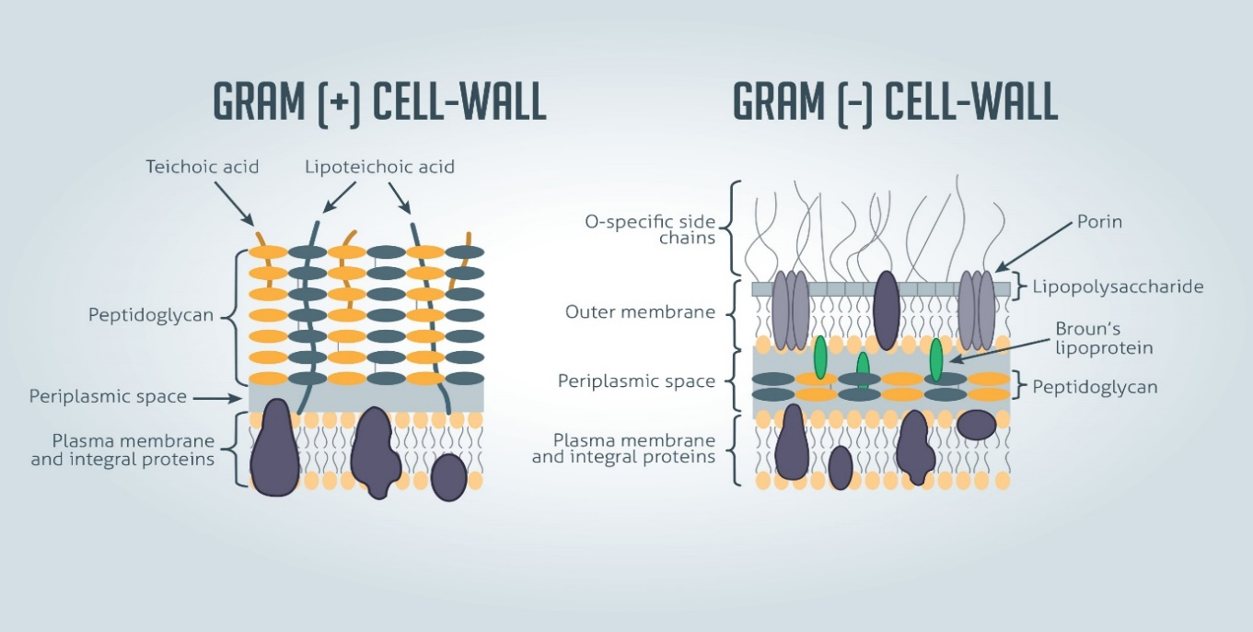
Figure ‎1.1-Structral difference between Gram-positive and Gram-negative cell wall.
Bacteria are divided into two major groups: Gram-positive and Gram-negative. Both groups have a cell wall composed of peptidoglycan: in Gram-positive bacteria, the wall is thick, whereas in Gram-negative bacteria, the wall is thin. In Gram-negative bacteria, the cell wall is surrounded by an outer membrane that contains lipopolysaccharides and lipoproteins. Porins, proteins in this cell membrane, allow substances to pass through Gram-negative bacteria's outer membrane. In Gram-positive bacteria, lipoteichoic acid anchors the cell wall to the cell membrane (Steward, 2019).
This section focuses on the Enterococcal wall and proteins involved in non-covalent binding of the cell wall (peptidoglycan). Two enterococcal species are responsible for most clinical infections i.e. E. faecalis and E. faecium (Yang et al., 2017). Our study focused on bacterial surface proteins containing WxL and LysM domains in the same enterococcal species (E. faecalis and E. faecium).

Cell wall components of Enterococcus spp
Enterococcus is present in the gastrointestinal tract as a normal flora which causes hospital-acquired infections (Brinster et al., 2007). It is a member of streptococcal group D (Coyette & Hancock, 2002). The enterococcal cell wall is made up of three main constituents: peptidoglycan; Wall teichoic acid, lipoteichoic acid and polysaccharides (Yang et al., 2017).
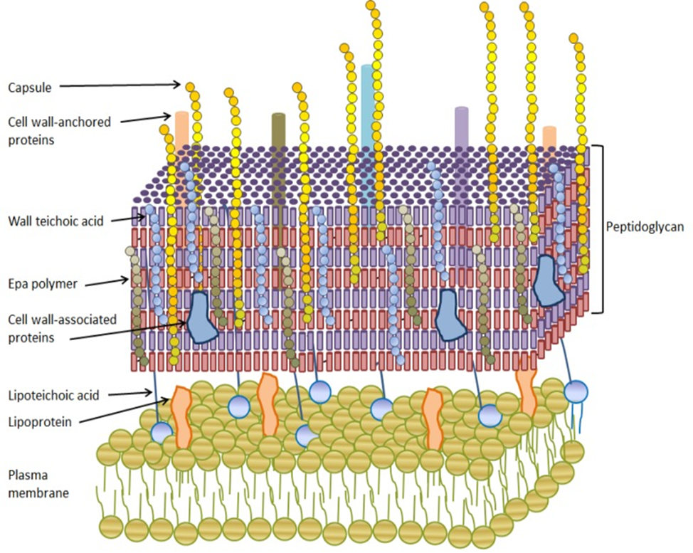
Figure ‎1.2-Illustration of cell wall components of enterococcus spp.
The cell wall is composed of peptidoglycan layer which is a bilayer lipid with lipoproteins which is membrane bounded and lipoteichoic acid. Bound to the muramyl residues of the peptidoglycan are wall teichoic acids, the rhamnopolymer whose synthesis is tied to the EPA locus, as well as surface-anchored proteins and capsule.

Peptidoglycan
In the enterococcal cell wall, the main component is the peptidoglycan (PG). The enterococcal cell wall comprises 27 to 38 % of the dry cell weight. It is composed of a mesh peptidoglycan layer embedded with other polymers. The peptidoglycan comprises 35 to 40% of the Enterococcus species cell wall, and two non-peptidoglycan components, a rhamnose-containing polysaccharide and ribitol-containing teichoic acid, make up the rest of the cell wall (Coyette & Hancock, 2002).
Peptidoglycan is a necessary component of the cell wall (Radkov et al., 2018) and comprises 50% of the cell wall mass. Sugar polymers, glycan chains, and short stem peptides all make up peptidoglycan. The Gram-negative bacteria have a constant composition of the peptidoglycan layer. In contrast, Gram-positive bacterial peptidoglycan varies from species to species; there is a significant variation among Gram positives (Schleifer & Kandler, 1972).
The peptidoglycan layer of enterococcal species is arranged in a mesh network, as shown in Figure 1.2 (Coyette & Hancock, 2002). Disaccharide N-acetylmuramic acid-(1-4)-N-acetylglucosamine (MurNAc-GlcNAc) make the peptidoglycan layer as shown in Figure 1.3 (Navarre & Schneewind, 1994). The peptidoglycan layer is made up of a mesh network. The network of parallel glycan chains is held together by cross peptide links containing L- and D-amino acids, thereby generating a complex three-dimensional network. The repeating sugar sizes range from 5 to 30 subunits (Hancock et al., 2014) , which are cross connected by stem peptides attached to MurNAc (NAM) residues during the assembly process (Delcour et al., 1999). In general, the enterococcal stem peptide is composed of L-Ala-D-Glu-L-Lys-D-Ala-D-Ala (Hancock et al., 2014).
In Gram-positive bacteria, the peptidoglycan structure varies in an amino acid sequence that forms an interpeptide bridge. The third amino acids in the tetrapeptide chain are species-specific. The D-Ala of one tetrapeptide is linked to the diamino acid in position three of a neighboring tetrapeptide either directly or through an interpeptide bridge in different glycan chains (Steen, 2005). In most Enterococcus species except E. faecalis, the interpeptide bridge consists of D-Asp; in E. feacalis the interpeptide bridge is L-Lys as shown in Figure 1.4. The peptide stem is cross-linked to a nearby peptide stem with the interpeptide bridge from the ε--amino group of the L-Lys residue in position 3 to the carboxyl group of D-Ala in position 4 of a neighboring strand as seen in Figure 1.4 (Coyette & Hancock, 2002). Modification of peptidoglycan is done in several ways. O-acetylation on C6 of N-acetlymuramic acid occurs about 20% in E. faecium; this leads to resistance of peptidoglycan to different lysozymes (Hancock et al., 2014).
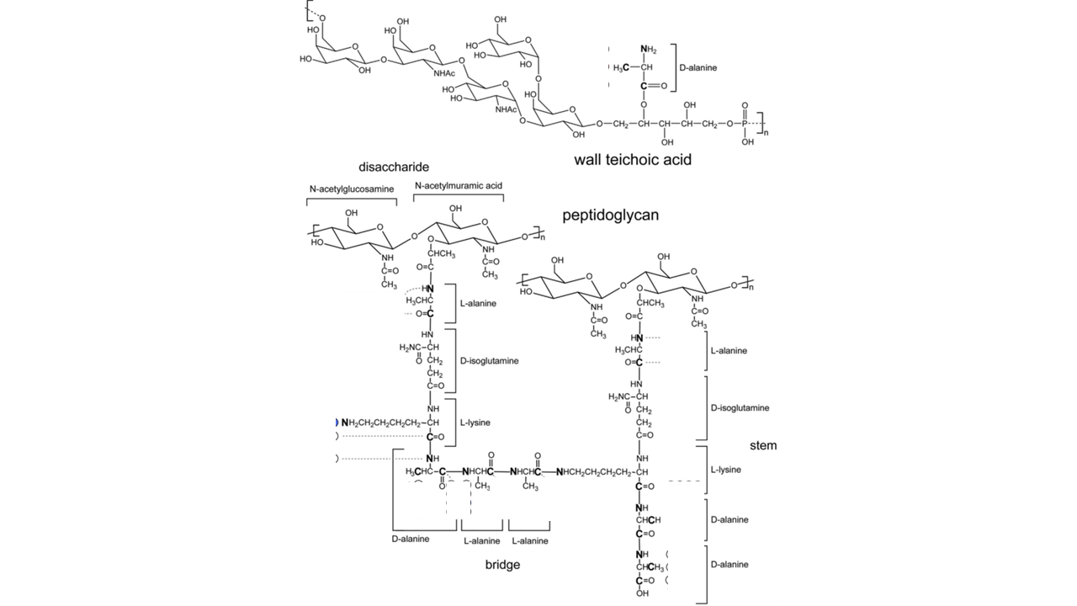
Figure ‎1.3-The main components of the cell wall of E. faecalis. Wall teichoic acid and peptidoglycan (Yang et al., 2017).
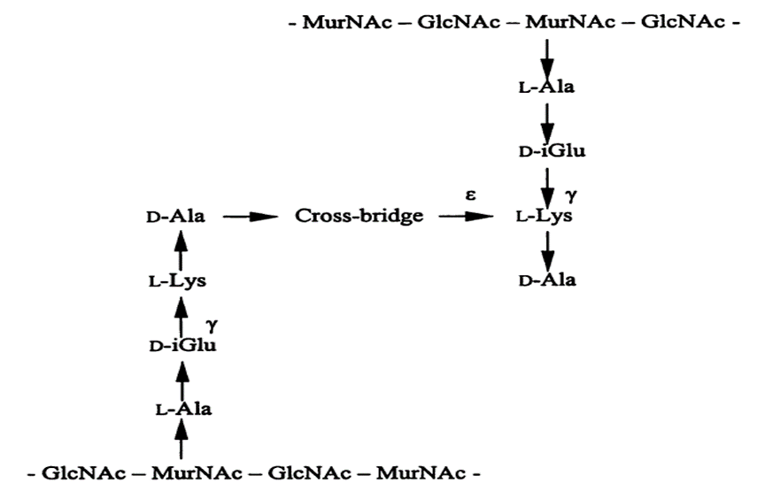
Figure ‎1.4- Cross-linked peptidoglycan of E. faecalis (Coyette & Hancock, 2002).
There are two types of peptidoglycan layer based on their peptide stem composition: A- type peptidoglycan layer and B- type peptidoglycan as shown in Figure 1.5. The A-type of peptidoglycan is a common type of peptidoglycan layer in which the first amino acid is L-Ala while in case of B-type, the first amino acid is Gly. Another difference is the interpeptide bridge; in the type A-peptidoglycan layer the interpeptide bridge forms between the amino acids located at position three and four as shown in the Figure 1.5 ; while in the case of type B- peptidoglycan the interpeptide bridge is formed between amino acids found on positions two and four. The inter peptide bridge of type B-peptidoglycan layer also contains unusual amino acids such as ornithine (Steen, 2005).
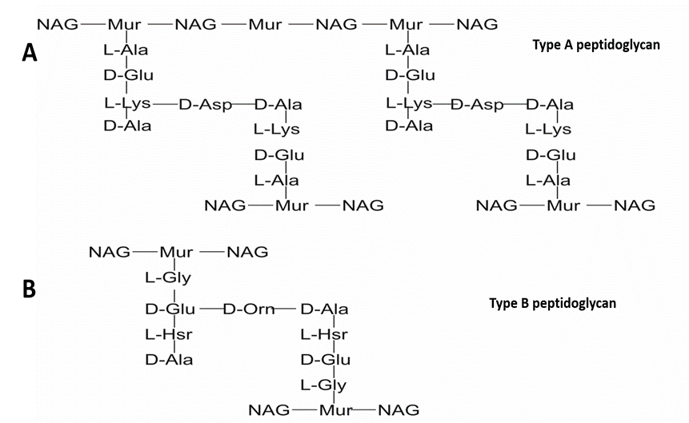
Figure ‎1.5-Types of peptidoglycans.
A-Structure of A-type peptidoglycan. The tetrapeptide linked to N-acetylmuramic acid consists of L- Ala-D-Glu-X-D-Ala, in which X is a species-specific L-diamino acid. In the case of L. lactis shown here, the diamino acid is L-Lys. Cross-linking of the tetrapeptides is achieved via a "bridge" amino acid (D-Asp in Enterococcus species) that links D-Ala of one tetrapeptide to the free amino group of L- Lys of another tetrapeptide. B- Structure of Curtobacterium flaccumfaciens B-type peptidoglycan. The first amino acid is not L- Ala as in A-type peptidoglycan. Crosslinking occurs via D-Ala and the second amino acid in another tetrapeptide (D-Glu in C. flaccumfaciens peptidoglycan) (Yamamoto, 2003).

Gram-positive bacteria contain multi-layered peptidoglycan. The glycan strands form cross-linking in different directions; this cross-linking provides the interpeptide bridges, which are long and flexible. The disaccharide peptide monomer forms in the case of E. faecium and E. hirae comprise 30 to 40% of the PG, and the rest of the fraction contains 40 to 60% dimers and some trimers (5 to 15%). Oligomers are also forms that are larger than trimers and undetectable (Hancock et al., 2014).
The glucosidase enzymes N-acetylglucosaminidase and N-acetylmuramidase cleave the β (1-4) bond between N-acetylglucosamine and N-acetylmuramic acid in the glycan chain (Steen,2005). Endopeptidases break the the interpeptide bridge. Endopeptidases vary in their specificity; for example, L-alanyl-D-glutamate endopeptidases break the bond between L-ala and D-Glu. y-glutamyl-diamino acid endopeptidases, on the other hand, as demonstrated in Figure 1.6, breaks down the bond between D Glu and the diamino acid located at position 3 in the peptide component of the peptidoglycan (Steen, 2005).

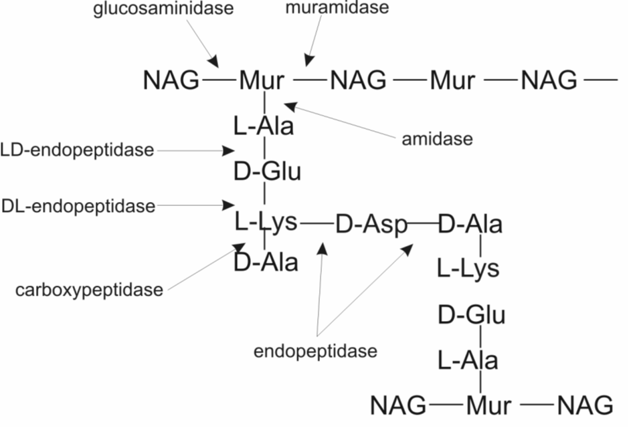
Figure ‎1.6- Hydrolase enzyme site of action on enterococcal peptidoglycan (Steen, 2005).
Site of action of different enzymes

Teichoic acids
Teichoic acids (TAs) are glycopolymers with phosphodiester linked polyol repeat units that are used to make TAs (Ward, 1981). The two types of TAs are cytoplasmic teichoic acids (LTA) and wall teichoic acids (WTA) that are covalently attached to PG (Caveney et al., 2018).

Polysaccharides
Polysaccharides are composed of capsule, RhapWPs, or teichuronic acid. The composition of polysaccharides varies between strains. The capsule is involved in pathogenesis. E. faecalis V583 capsular polysaccharides is varying and non-ubiquitous. It is composed of the diheteroglycans glucose and galactose and is involved in phagocytosis resistance (Guerardel et al., 2020). The Enterococcus species are involved in the productions of surface polysaccharide named as the enterococcal polysaccharide antigen (Epa) (Geiss-Liebisch et al., 2012). In the mouse peritonitis model, Epa are involved in biofilm formation, neutrophil-mediated phagocytosis resistance, and virulence (Xu et al., 2000).

WxL domain
Within the protein the domain is a separate unit which has proper three-dimensional structure and function; it can exist independently in a stable folded form. The novel domain having 160 to 190 amino acids is classified as WxL domain and this name WxL stands for two conserved motifs Trp-x-Leu signature (tryptophan-X-Leucine) (Galloway-Peña et al., 2015).

Identification of WxL domain
Brinster et al. (2007) identified the WxL domain in 27 surface proteins in E. faecalis V583, of which two were internalin like proteins (EF2250 and EF2686). The gene sequences start with signal peptides, and the proteins are therefore proposed to be secreted through the cell membrane. The proteins contain the two conserved WxL sequences near the C terminus, with an additional YXXX[LIV]TWXLXXXP motif further downstream; the two WXL motifs are separated by about 125 residues as shown in Figure 1.7 (Brinster et al., 2007).

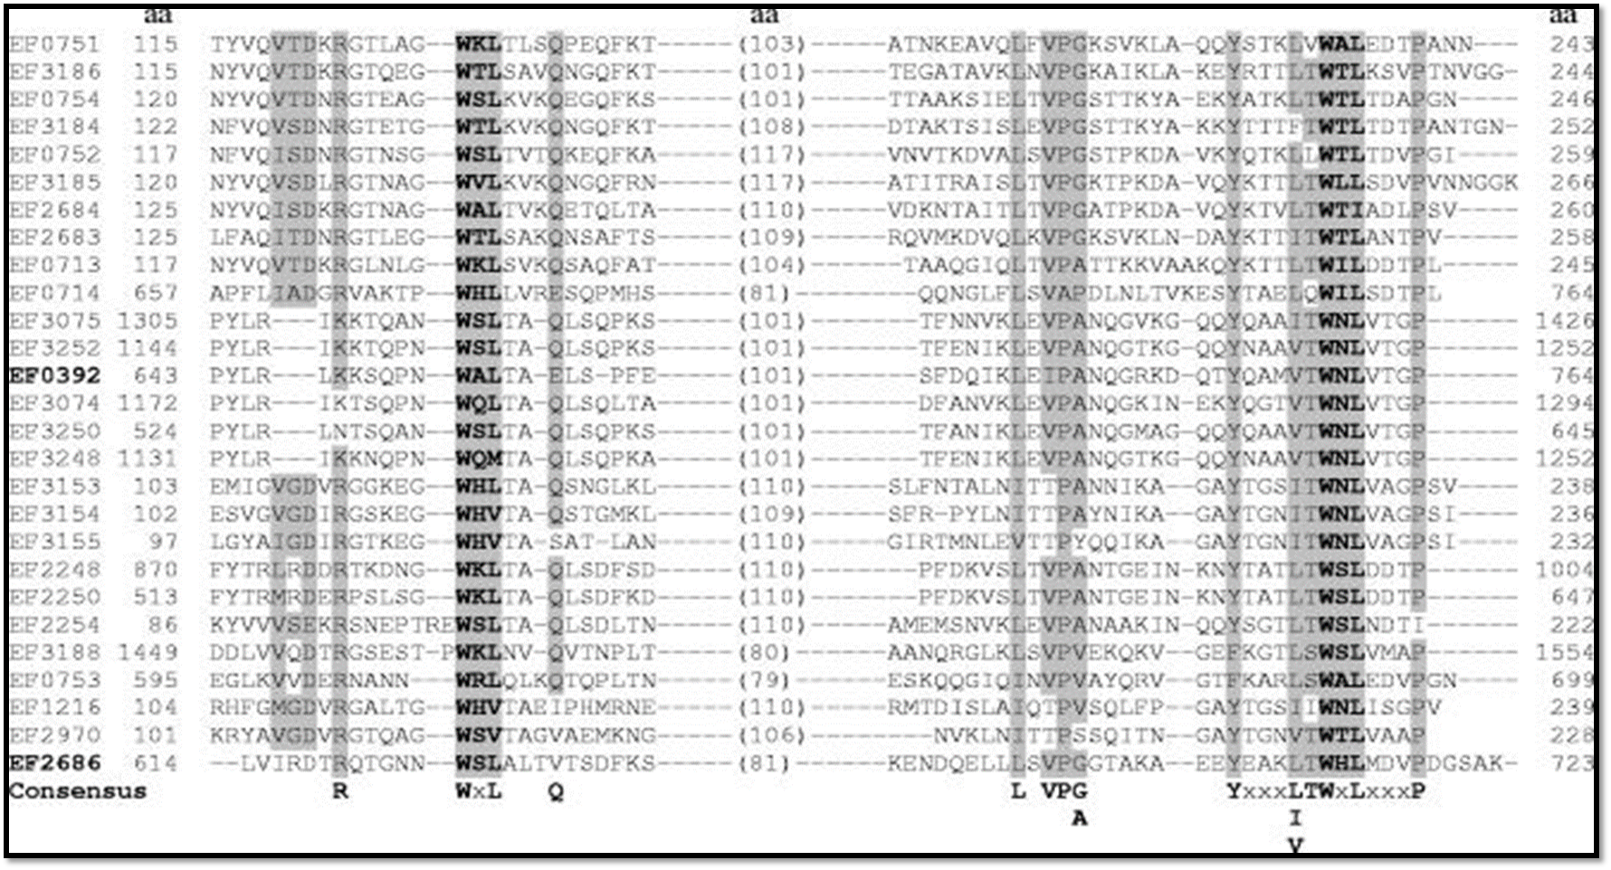
Figure ‎1.7-Multiple sequence alignment of 27 WxL proteins of E. faecalis V583 using the Clustal W program.
The letters in bold and gray shading indicate the WxL motifs and the numbers in parentheses show the distance between two WxL motifs. The gray shaded letters indicate the identical or similar amino acids. From (Brinster et al., 2007).

Galloway-Peña et al., 2015 found six proteins containing the WxL domain in three putative operons, which they named loci A, B and C. Each locus contains both a small and a large WxL domain (discussed in more detail in section 1.4.3); the WxL genes present in loci A and C were found in higher numbers in clinical rather than commensal isolates and were proposed to encode antigenic and cell-surface proteins by in silico analysis of E. faecium TX82. The open reading frames (ORFs) encoding the WxL proteins were analysed using the NCBI Blast tool, which identified two C-terminal WxL motifs. The terminal WxL motif contains highly conserved residues YXXX (L/I/V) TWXLXXXP, as shown in Figure 1.8 (Galloway-Peña et al., 2015).
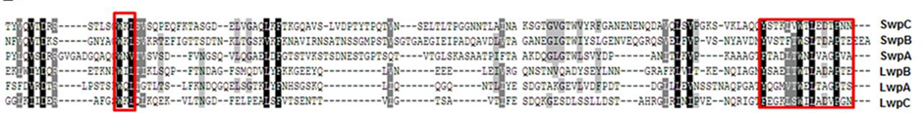
Figure ‎1.8-Sequnce alignment of C-terminus of Small and Large WxL proteins found in E. faecium TX82.
SwpC stands for small WxL protein on locus C, SwpB stands for small WxL protein on locus B, SwpA stands for small WxL protein on locus A, LwpC stands for long WxL protein on locus C, LwpB stands for long WxL protein on locus B and LwpA stands for long WxL protein on locus A. Highly conserved residues are in black, moderately conserved residues are in grey, and the red boxes indicate the YXXX (L/I/V) TWXLXXXP terminal motif and the second WxL proximal motif (Galloway-Peña et al., 2015).

WxL domain distribution in Gram-positive bacterial species
The WxL domain was identified in several species on the basis of in silico analysis of gene clusters of cell surface proteins in Lactobacillus, Enterococcus and Listeria species.

Enterococci
In the gastrointestinal tract of mammals and insects, enterococci are present as a normal microflora (Brinster et al., 2007). Enterococci are found in fermented food; they are also involved in a large number of nosocomial infections which means they are an ESKAPE species (Bøhle et al., 2011). WxL protein was identified in two Enterococcal species, i.e. Enterococcus faecalis V583 (Paulsen, 2003) and Enterococcus faecium TX 82. E. faecium TX 82 is also known as DO; in these bacteria, WxL exists in the form of gene clusters with other cell surface proteins and transmembrane proteins. E. faecalis V583 is the vancomycin-resistant clinical isolate (Kau et al., 2005).

Lactobacillus
Lactobacillus is a non-spore-forming, facultative anaerobic or microaerophilic bacteria, and it is a Gram-positive bacterium (Makarova et al., 2006). In the literature, the WxL domain is reported in four species of Lactobacillus (L. sakei, L. plantarum, L. casei and L. coryniformis) as shown in Table 1.2; the characteristic properties of these Lactobacillus species are the production of probiotics and bacteriocins, natural inhabitation of the gastrointestinal tract, and fermentation of dairy products (Chapot-Chartier & Kulakauskas, 2014).

Listeria
Listeria species are Gram-positive, facultatively anaerobic, and rod-shaped (Singleton, 1999). Listeria monocytogenes, which causes listeriosis, is a major human pathogen, causing a severe infection from food contaminated with the bacteria (Weller et al., 2014). The WxL domain is reported in two species of listeria (L. innocua and L. monocytogenes) (Brinster et al., 2006; Bierne & Cossart., 2007) as shown in Table 1.2.

Table ‎1.2- Distribution of WxL Protein identified in bacterial genomes (Brinster et al., 2006).

The WxL gene cluster
Many low G-C gram-positive bacteria have WxL proteins. In some, these have been placed in the so-called Csc (cell surface cluster) family of surface proteins (Bierne & Cossart, 2007). The Csc gene cluster contains four proteins: Csc A, Csc B, Csc C and Csc D, which are thought to form an extracellular protein complex. Csc A comprises an N-terminal signal peptide, and two domains. Domain 1 is DUF domain (Domain of unknown function) and a second domain is a C-terminal transmembrane anchor. The N-terminal signal peptide ensures secretion or export of the protein by the sec-dependent pathway (Siezen et al., 2006). Csc D contains the sequence LPxTG, which is typically bound covalently to the peptidoglycan layer by the sortase enzyme (Navarre & Schneewind, 1994). The Csc B and Csc C proteins contain WxL domains (Siezen et al., 2006). DUF are Domains of Unknown Function and 4000 DUF families are reported in the Pfam database, with 22% from known families of proteins (Bateman et al., 2010; El-Gebali et al., 2019).
In L. plantarum WCFS1, WxL domains were identified in Csc B and Csc C. The WxL1 domain is the C-terminal domain which is present on Csc B and is about 160-190 residues in length. The CscB protein family consists of signal peptide, short proline-rich region and WxL1 domain; the proline-rich region is located in between the signal peptide and WxL 1 domain. The C-terminal domain of about 130-140 residues found in the Csc C protein family was named as a WxL2 domain. The name WxL1 and WxL2 is specific to L. plantarum WCFS1. Concanavalin A-like lectin/glucanase domains are present in the N-terminal region of some Csc C proteins; these domains are mostly involved in adhesion and cell recognition, and this domain may also be involved in degrading or binding oligosaccharides and polysaccharides of the plant complex. Csc C protein is much larger than other Csc proteins, as shown in Figure 1.9 (Siezen et al., 2006).
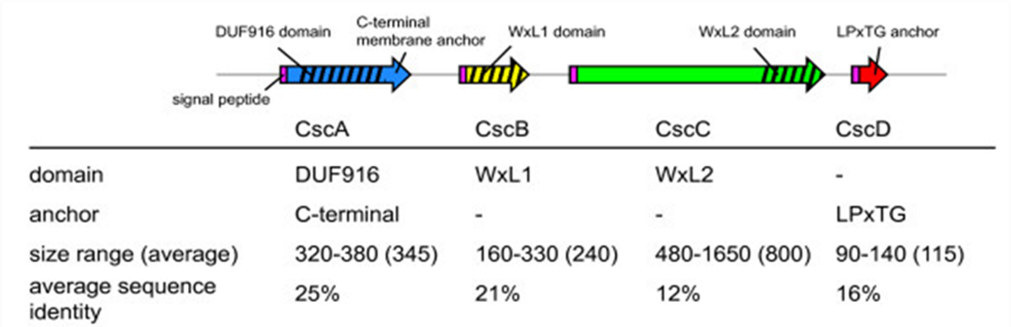
Figure ‎1.9- Characteristics of Csc families.
The size range and average sequence identity refer to the intact proteins. Csc B is shorter in size than Csc C. Still, both contain the WxL domain and LPxTG anchors in common because the rest of the domains are different in these two proteins (Siezen et al., 2006).
L. monocytogenes has two Csc clusters, each of which contains two WxL proteins. The accession numbers are Lmo0585, Lmo0587, Lmo0549 and Lmo0551. Csc cluster 1 contains WxL1 and WxL2 domains; in between the WxL1 and WxL2 domains, a small LPxTG domain (Lmo0550) is present. The N-terminal end of Lmo0549 contains five leucine-rich repeats (LRRs); between the LRRs and the WxL2 domain, two PKD (Polycystic Kidney disease) domains are present. The function of the PKD repeats in Listeria species is currently not known. Csc cluster 2 has a DUF916 domain present in between two WxL domains (WxL1 and WxL2). Csc cluster 2 is different from Csc cluster 1 because it does not contain any LPxTG domain, LRR domain, or PKD, as shown in Figure 1.10 ( Bierne & Cossart, 2007).
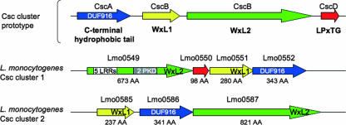
Figure ‎1.10-Characteristics of Csc cluster in L. monocytogenes.
The first line indicates the characteristics of the four-component Csc cluster, and the predicted domains of Csc proteins are represented below; Blue (Csc A like, DUF916), yellow (CscB like, WxL1), green (CscC like, WxL2), and red (CscD like, LPxTG anchor), respectively. (AA) indicate the number of amino acids in each gene product (Bierne et al., 2007).
L. monocytogenes has a role in the invasion of macrophages, but it can also play a role in adhesion and invasion of non-phagocytic cells; proteins involved in the adhesion and internalisation are called internalins (Inl). Internalins from L. monocytogenes are responsible for activating signalling pathways that lead to phagocytic uptake of the bacterium by the host cell. Two internalin-like proteins (InIA and InIB) in L. monocytogenes have received a lot of attention. InlA interacts with the host cell receptor glycoprotein E-cadherin and is responsible for bacterial uptake into enterocytes in the intestine, and InlB interacts with the hepatocyte growth factor receptor (Met), the complement factor C1q-R receptor (gC1qR), and glycosaminoglycans all at the same time, allowing bacteria to invade a variety of cell types, including epithelial cells, hepatocytes and fibroblasts (Stachowiak et al., 2014).
EF2868 and EF2250 are two E. faecalis WxL proteins; both proteins are internalin-like proteins. EF2686 is proposed to bind to peptidoglycan of the cell wall (Brinster et al., 2006). In L. monocytogenes, two predicted proteins were identified. Their sequences identify them as proteins related to internalins. They were therefore named InIA and InIB. InIA has sequence similarities to EF2686. EF2686 is widespread in the different clinical isolates of E. faecalis; the predicted structure of EF2868 shows a resemblance with InlA as it also contains Cap, Leucine-Rich repeats, and IgG like domain. The only difference is that InIA does not have a WxL domain at the C-terminal end. EF2868 contains an N-terminal signal peptide for export by secretory pathway, a leucine-rich repeat domain (LRR) which is like the Toll-like receptor that contains ten LRR domains and may interact with host cells, an Ig-like domain and a C-terminal WxL domain, as shown in Figure 1.11 and 1.12. Based on the Leucine-rich repeat domain of EF2868, it is called ElrA (Brinster et al., 2006).
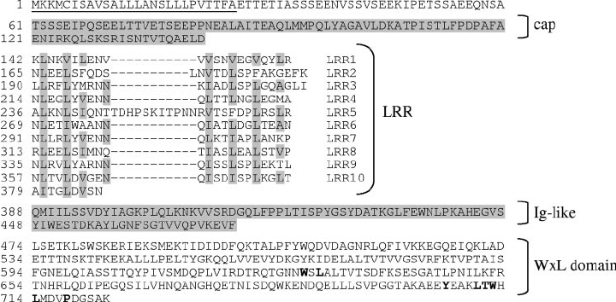
Figure ‎1.11-Features of ElrA protein.
The underlined sequence indicates the signal peptide; conserved sequences are written in bold. The sequence is divided into N-terminal signal peptide (amino acids 1 to 26), Cap (amino acids 61 to 141), LRR (amino acids 142 to 387), Ig-like (388-473), and WxL domain (amino acids 474 to 723) (Brinster et al., 2006).
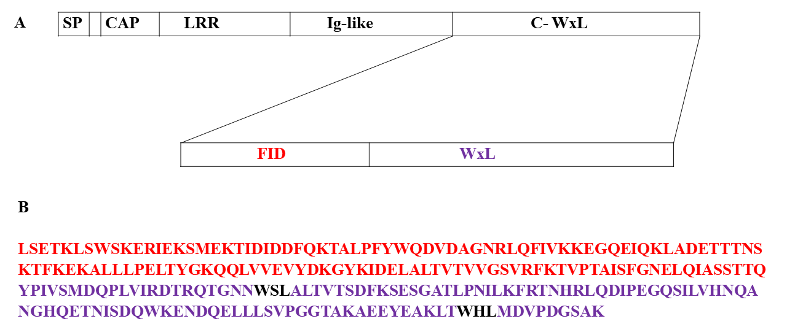
Figure ‎1.12-Diagrammatic representation of ElrA protein.
(A) Schematic representation of EF2686 from E. faeaclis V583, which contains a signal peptide, Cap, ten leucine-rich repeats, an Ig-like domain, and a C-terminal WxL domain. The C-WxL domain can be further subdivided into FID and WxL domains. (B) The sequence of the WxL domain. The two WxL sequences are highlighted in black, and the FID domain sequence is highlighted in red (Jamet et al., 2017).

WxL proteins were identified at three loci in E. faecium TX82, A, B, and C, together with a DUF916 and an LPxTG protein, as illustrated in Figure 1.13. In E. faecium TX82, six WxL proteins were detected; three large WxL and three small WxL were found in the three loci; they were termed small and large WxL based on the number of amino acids and are orthologs of WxL1 and WxL2 (Csc B and Csc C), respectively. The large WxL protein in locus A (LwpA) is predicted to contain a concanavalin A (Con A)-like lectin protein, which was found to be involved in cell recognition and adhesion. The small WxL proteins (SwpA-C) were similar to CscB in L. plantarum, while the large WxL in all the loci were similar to Csc C, and DUF916 was similar to Csc A; and the LPxTG motif in locus A was similar to CscD. With the help of in silico analysis, it was predicted that a Rho-independent terminator was present on each genome in the three loci, which showed resemblance with a pattern present in E. faecalis and L. plantarum (Galloway-Peña et al., 2015).
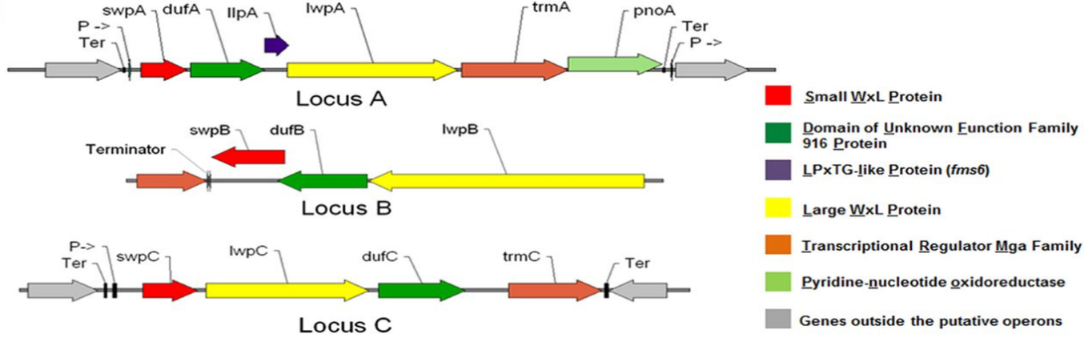
Figure ‎1.13-WxL domains in silico analysis of E. faecium DO.
The arrow represents a predicted ORF named for the protein it encodes. Small WxL proteins are in red, DUF916 family proteins are in green, LPxTG-like proteins are in purple, Large WxL proteins are in yellow, transcriptional regulators are in orange, and genes outside the operon are in grey. Predicted terminators (Ter) and promoters (P->) are also shown (Galloway-Peña et al., 2015).

The Function of WxL domains
The function of the WxL domain is still unknown. The following are the WxL functions that have been proposed. However, there is no strong evidence for any of these functions yet, and because WxL domains are usually found in gene clusters, it is hard to separate the function of WxL from the function of the other domains in the cluster. So, some of the functions described here could be the functions of the cluster, not of WxL. Every WxL cluster is thought to be exposed on the peptidoglycan surface (i.e., contains LPxTG or membrane anchor), so the function of the cluster must require it on the outside surface of the cell. It’s hard to find out the function of WxL domain because in the cluster most of the domains have unknown function; so we cannot predict the function of WxL domain from the cluster.

Adherence to peptidoglycan
Peptidoglycan is an essential component of the cell wall and is involved in the integrity of the cell by maintaining the cell shape. Almost all bacteria have a cell wall situated outside of the cell membrane (Vollmer et al., 2008). WxL has been proposed to form a robust noncovalent interaction with the cell wall of gram-positive bacteria. Brinster et al (2007) fused the two WxL proteins (EF2686 and EF0392) with nuclease reporter proteins from Staphylococcus aureus which suggested that both WxL motifs present in WxL protein are involved in cell surface association and they proposed that WxL domain binds with peptidoglycan (Brinster et al., 2006).

Adherence to human extracellular matrix proteins
Human cells are covered by a layer that provides structural and biochemical support and is called the extracellular matrix (Michel et al., 2010). The extracellular matrix is composed of fibrous proteins such as collagen. The glycoprotein which connects the cells to collagen is called fibronectin (Lewin et al., 2015). Galloway-Peña et al. (2015) used Biacore analysis to show that recombinant WxL proteins (LwpA and SwpA) from locus A showed high binding affinity to extracellular matrix proteins (i.e. type one collagen and fibronectin).

Response to Bile salt stress and endocarditis pathogenesis
In L. plantarum, WxL genes were downregulated in response to bile stress (Bron et al., 2006). WxL operons enable some bile absorption, which can be dangerous in high amounts. This implies that they would be downregulated during passage through the small intestine, which has high bile contents. Bile is no longer taken up when the WxL operons are downregulated, hence mutants may tolerate bile salt stress better. It's also feasible that the regulators of the WxL operons have malfunctioned. Alternatively, it's likely that the WxL operons' regulators are involved in downregulating bile salt excretion transporters. Increased survival under bile salt stress may be possible if this suppression is lost. Furthermore, downregulation of the WxL operons may also alter cell wall composition and integrity, which may be helpful under bile salt stress (Galloway-Peña et al., 2015). Galloway-Peña et al. (2015) noticed that the deletion of WxL from all three loci (locus A, B and C) lowers the development of endocarditis in rats as compared to wild strain TX82 and concluded that WxL protein is involved in virulence, but this could be a function of the cluster.

Structure of WxL
The structure of WxL is currently unknown. Galloway-Peña et al., 2015 carried out a circular dichroism (CD) study of proteins from locus A of E. faecium TX82 and showed that they are rich in β-sheet structure and disordered segments (Figure 1.14). They tried to predict the structure using PHYRE 2 but were unable to generate any useful leads. Using Dis-EMBL, they predicted that all WxL domains present in loci A, B, and C were highly disordered (Galloway-Peña et al., 2015).
Figure ‎1.14-CD spectra of WxL proteins.
LWPA stands for Large WxL protein and SwpA stands for small WxL protein. The spectra of the WxL domains resemble those of disordered proteins (Galloway-Peña et al., 2015).

LysM Domain
The lysM (lysin motif) domain was initially discovered in a protein encoded by gene 15 of the B. subtilis bacteriophage and containing lysozyme activity involved in PG breakdown, according to Garvey et al. (1986) (Visweswaran et al., 2014). The Lysin domain was named after the Lysin motif sequence found in different bacterial proteins; these lysin motifs are parts of hydrolytic enzymes involved in the cleavage of the bacterial host's cell wall during the final stage of the bacterial lytic cycle (Buist et al., 2008). In E. hirae muramidase, there is a C terminal Lysin sequence motif (Mesnage et al., 2014). Bacillus subtilis prophage amidase XlyA contains one LysM motif (Garvey et al., 1986) while other proteins contain several LysM motifs (Petrovic, 2014). LysM motifs usually vary in length from 44 to 65 amino acids residues (El Khattabi et al., 2008). Sometimes in a single proteins up to 12 LysM domains can be found (Desvaux et al., 2018).

The distribution and occurrence of LysM Domain
In nature, the LysM domain is present in a diverse range of extracellular proteins and receptors. Although the LysM domain is found in a wide range of bacteria, it is most commonly found in Firmicutes, Proteobacteria, Actinobacteria, and Bacteroidetes (Desvaux et al., 2018). It is present in prokaryotes, eukaryotes, viruses and archaea. In prokaryotes, LysM is mostly found in bacteria in which the LysM domain binds the peptidoglycan layer of bacteria. LysM domain is also found in fungi where it is involved in the hydrolysis of the cell wall of fungi by binding to chitin. The LysM domain is also found in leguminous plants, where it functions as a receptor for Nod factor, which is required for legume-symbiotic bacterium root nodule symbiosis. The Carbohydrate-Active enZymes (CAZy) database http://www.cazy.org/CBM50.html) contains all proteins with LysM domains; these proteins are classified as carbohydrate-binding module family (CBM) 50. In the CAZy database, proteins containing LysM domain (CBM 50) come from archaea, bacteria, eukaryotes and viruses. LysM domain-containing proteins were found in glycoside hydrolases, transglycosylases, peptidases, amidases, chitinases, and receptor-like kinases (Akcapinar et al., 2015).
LysM domain is present in enzymes that are involved primarily in cell wall hydrolysis. Proteins containing LysM domain have N-terminal catalytic domains and C-terminal LysM. A short spacer separates the catalytic and LysM domain. Bacteria produce several LysM proteins with different LysM motifs (Buist et al., 1995); the LysM motif is often separated by a short linker of 7-15 amino acid that is rich in S, T and N residues (Visweswaran et al., 2014). In some proteins, the LysM domain is present at the N-terminus (e.g., LytF of B. subtilis), in others at the C-terminus (e.g., AcmA of L. lactis) or in the center region of the protein (e.g. XlyA of B. subtilis) (El Khattabi et al., 2008).
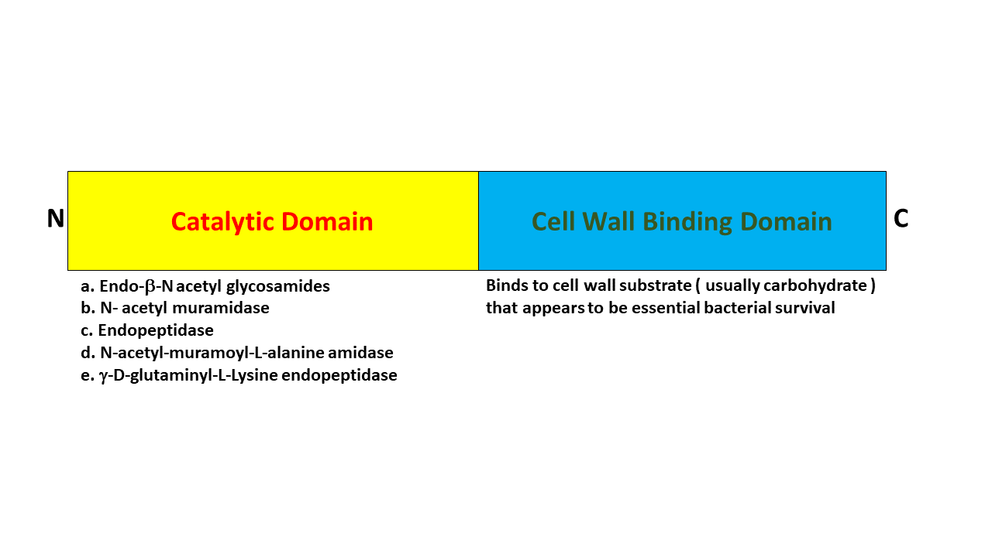
Figure ‎1.15-General diagrammatic representation of LysM containing protein.

Categories of LysM domain
Three LysM containing proteins are present in E. faecalis V583: AtlA, AtlB and AtlC. In peptidoglycan hydrolysis, AtlA acts as an N-acetylglucosaminidase, while AtlB and AtlC have similar functions as N-acetylmuramidases (Eckert et al., 2006; Mesnage et al., 2008). There are twelve LysM proteins with one to six LysM motif repeats present in E. faecalis V583; these interlinking domains can be classified as basic or acidic domains (Paulsen et al., 2003).
AtlA (six basic LysM motifs separated by linkers) and AtlB (two acidic contiguous LysM motifs) are targeted to distinct subcellular sites. AtlA is located at the septum and poles, and AtlB is found across the whole cell surface. The six AtlA domains are separated from each other by a linker, while AtlB domains are not separated by a linker, as shown in Figure 1.16 (Mesnage et al., 2008). AtlA protein contains three types of domains while AtlB protein contains only two types of domains. AtlA protein contains three types of domains: Domain I is a T/E-rich region and is present on the N-terminal region of the protein, domain II is made up of a central putative catalytic domain, and a third domain (domain III) is made up of six LysM domains which are present on the C-terminus of the protein and are involved in cell wall binding which are LA1 to LA6 which represents Atl A1 to Atl A6 (Eckert et al., 2006). In AtlB protein, the T/E-rich domain is absent and Domain III consists of two LysM modules, namely LB1 and LB2. The LB1 stands for the Atl B1 and Atl B2 (Mesnage et al., 2008).

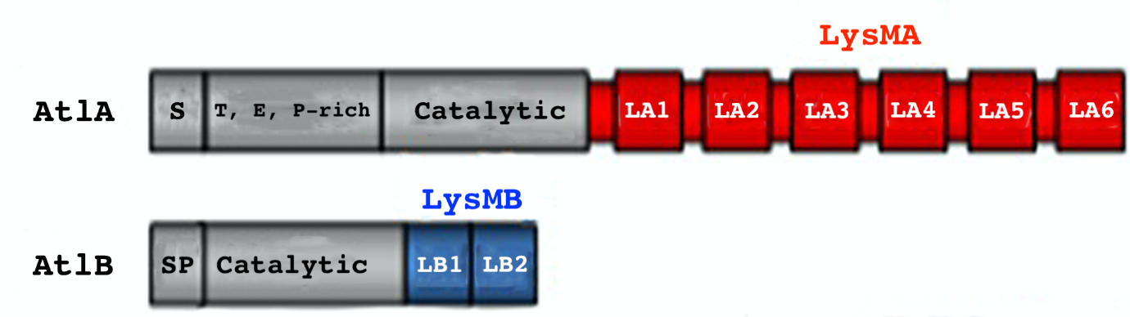
Figure ‎1.16-Domain representation of AtlA and AtlB from LysM proteins of E. faecalis V583.
Red color shows LysMA domains which are basic in nature and blue color indicates the acidic LysMB domains.

General Structure of LysM domain
All the LysM domains have a structure β1α1α2β2 which includes two alpha-helices and two beta-strands. Sequence alignment was done between different LysM containing proteins; conserved amino acids are usually found in the turns between secondary structural components (Petrovic, 2014). In L. lactis, proteins with LysM domains act as peptidoglycan hydrolases with N-acetylglucosaminidase activity; for example, three C-terminal LysM domains are present in AcmA while six C-terminal LysM domains are present in AtlA from E. faecalis (Buist et al., 2008).
Until March 2015, ten different LysM structures were submitted to PDB (Berman et al., 2002), and they all possess the same topology βααβ containing two antiparallel beta-sheets in which two alpha helices are packed onto the side (Koharudin et al., 2015). The co-crystal structure of NlpC/P60 with ligand (PNG fragment) suggests that LysM dimers can bind the peptidoglycan very efficiently as compared to the monomeric form. Simply the multiple domains of LysM can bind with ligand more tightly (Wong et al., 2015). Similarly to the NMR structure, the crystal structure of LysMA bound to a GlcNAc pentasaccharide (GlcNAc)₅ (Galley N., Vincent, F. and Mesnage S., unpublished) showed the docking of GlcNAc₅ oligosaccharides onto the first LysM module (Mesnage et al., 2014).
The LysM domain of membrane-bound lytic murein transglycosylase D from E. coli revealed a secondary structure consisting of two antiparallel β -strands separated by a pair of short α-helices (Doyle et al., 1988; Sánchez-Vallet et al., 2013). The N-terminus of MltD (murein transglycosylase) contains the transglycosylase domain, and the C-terminus of MltD contains two LysM domains (Bateman & Bycroft, 2000). The NMR structure of AtlA1 from E. faecalis also contains two antiparallel β-strands separated by a pair of short α-helices. NMR was used to identify the carbohydrate-binding site. AtlA1 from E. faecalis forms a stable secondary structure but does not form any quaternary structure. NMR titrations showed how (β-1,4−GlcNAc-MurNAc-peptide polymer) ligand binds to the protein as shown in Figure 1.7(B) (Mesnage et al., 2014).

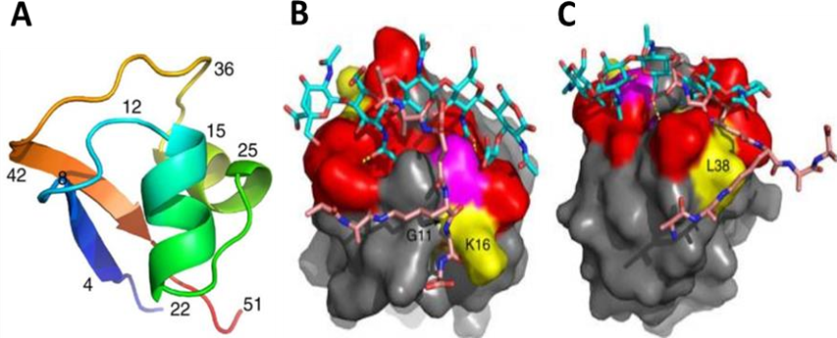
Figure ‎1.17- NMR tertiary structure of LysMA1 domain from E. faecalis V583 bound to GlcNAc₅.
(A) Cartoon representation of the NMR structure of the first AtlA LysM module. β-Sheets are formed of residues T4-V8 and G42-V47; α-helices of L14-Y21 and V25-N32. (B, C) Model of interaction between LysM domain and E. faecalis PG, including the peptide stem. Glycan strands MurNAc- (GlcNAc-MurNAc)₂ are depicted in blue. The peptide stem (pink) is represented in two possible orientations interacting with either the residue G11/K16 or L38. Adapted from (Mesnage, Dellarole, Nicola J. Baxter, et al., 2014).

Multiple functions of LysM domains in different proteins
The LysM domain in different proteins is involved in different functions. It is involved in
peptidoglycan hydrolases, phage lysins and virulence factors (Buist et al., 2008), although in most cases, the role of the LysM domain itself is to bind to the peptidoglycan backbone.

Hydrolases
LysM domain-containing proteins are mostly PG hydrolase enzymes. When all the LysM domains were cleaved from the proteins, the protein lost its hydrolase activity (Buist et al., 2008).

Phage Lysin
L. lactis phage Tuc 2009 contains bacteriophage lysins (muramidases) which contain LysM domains (Buist et al., 1995). LysM domain is also present in XlyA and XlyB, which are amidase enzymes (Buist et al., 2008).

Virulence factors
Many proteins containing LysM domains are involved in virulence in humans. Four (Sle1/Aaa, EbpS, LytN and Protein A) are produced by Staphylococcus aureus.
Sle1 contains three LysM domains that are involved in cell separation. Cells of a sle1 mutant form clusters permitting acute bacterial infection in a mouse model (Kajimura et al., 2005).
EbpS is made up of an elastin-binding domain present on the N-terminus (Buist et al., 2008), exposed to the tissue-binding cell surface and a C-terminal LysM domain that is not cell-exposed and is buried in the PG (Downer et al., 2002). LytN is a cell wall hydrolase enzyme (Buist et al., 2008). The protein also has a LysM domain immediately upstream of the LPxTG domain, which suggests its binding model (Bateman & Bycroft, 2000). L. monocytogenes contains six LysM proteins (Bierne & Cossart, 2007).
The LysM containing proteins have functions like surface display, substrate binding and hydrolysis, separation, and purification. LysM domains are also involved in cell immobilization. They can display peptides, proteins or enzymes on the bacterial surface, which may play a role in the development of vaccines (Visweswaran et al., 2014).

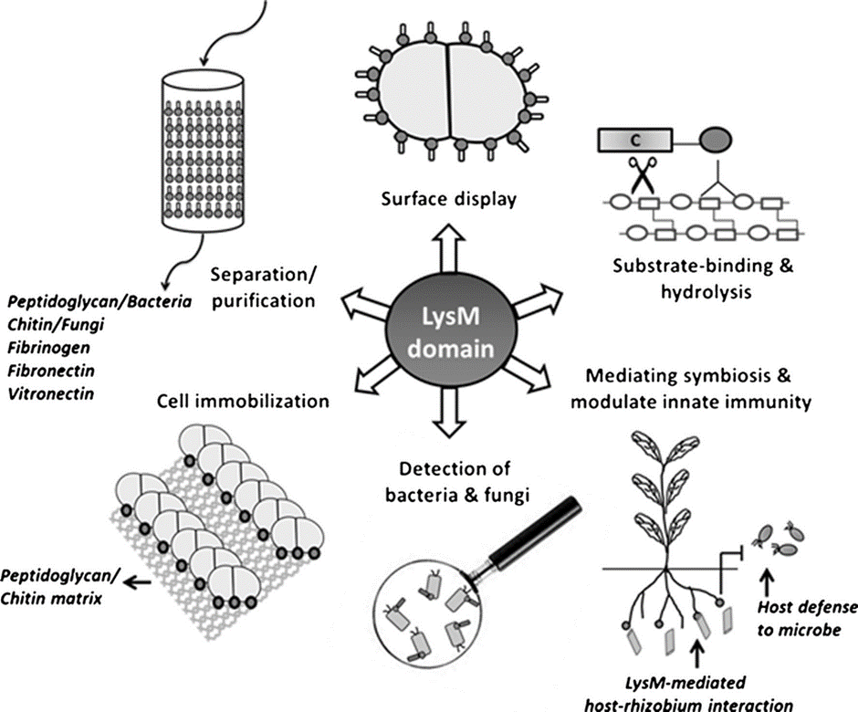
Figure ‎1.18- Representation of LysM domain function (Visweswaran et al., 2014).

Aims and Objective of the research
The main objective of the research project is to study the WxL, LysMA1 and LysMB1 domains.
1. To study the detailed architecture of WxL domain containing clusters and predict WxL domain structure (Chapter 3).
2. To express WxL domain in soluble form and determine its structure (Chapter 4).
3. To measure the binding affinity of GlcNac₅ ligand to LysMA1 and LysMB1 at different pHs (Chapter 5), and so determine if this explains their different pIs.

Experimentation

Wet Lab Experiments

Standard buffers, reagents, and growth media
All chemicals used were of analytical grade. Chemicals were purchased from Sigma or Melford. Growth media are from Difco or Oxoid. All solutions were made using Milli-Q water purified using the Milli-Q system from Millipore. Growth media were made following the manufacturer's instructions, using distilled water, and sterilised by autoclaving. All other solutions were filtration sterilised through 0.2 µm or 0.45 µm filters.

Media
Escherichia coli were grown in sterile Luria Bertani (LB) broth medium (Elbing & Brent, 2019) and E. faecalis JH2-2 strain were grown in Brain heart infusion broth (BHI) at 37°C. An antibiotic stock solution was prepared and used at 1:1000 dilution in LB broth and BHI broth. The composition of the different media is shown in Table 2.1. All chemicals and media were purchase from Sigma-Aldrich UK.
Table ‎2.1-Composition of different culture media.
Recipe (per litre)
LB broth | Tryptone (10g), Yeast extract (5 g), NaCl (10 g)
Nutrient agar | Tryptone (10g), Yeast extract (5 g), NaCl (10 g), Bacto-Agar (15 g)
BHI broth | 37 g powder
BHI agar | 37 grams BHI broth,15 grams Agar-Agar

Bacterial Strains
E. coli strains used were BL21-Gold, BL21(DE3), C43(DE3), BL21(DE3) Lemo, and DH5α. Enterococcus strains which were used are E. faecalis JH2-2. All the strains were purchased from NEB except the E. faecalis JH2-2 which was obtained from Dr Mesnage's lab as shown in Table 2.2.
Table ‎2.2- Different type of strains used for expression of protein.
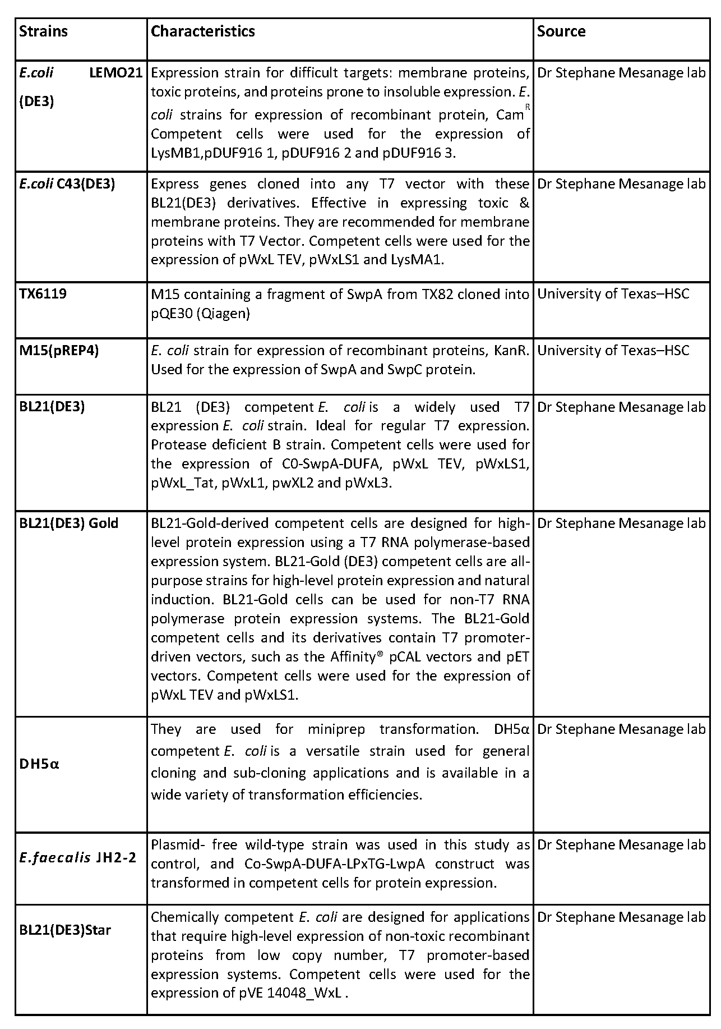

Designing of different constructs and recombinant plasmids for the expression of WxL domain
The different gene constructs were made using Snap Gene analysis software listed in Table 2.3.

Table ‎2.3- Features and characteristic of different plasmid used in this study.
Expression Vector | Characteristics | Source
pOPINF | A recombinant protein expression vector containing Amp^{R}. pOPINF vectors containing His-tags and is used for Gibson assembly. The following constructs were cloned into pOPINF: pWxL1_pOPINF, pWxL2_pOPINF, pWxL3_pOPINF, pDUF916 1_pOPINF, pDUF916 2_pOPINF, pDUF916 3_pOPINF and AtlB1 | Harwell
pQE30 | Recombinant protein expression vector Amp^{R} .It was used to express SwpA and SwpC protein. | University of Texas–HS
pML520 | A recombinant protein expression vector containing Amp^{R}, Used for the expression of AtlA1 protein. This vector was designed by Dr Mesnage’s lab (Mesnage et al., 2014) . | Dr Mesnage’s lab
pET Duet-1 | Coexpression of DUFA and SwpA; to investigate the strand exchange hypothesis. pETDuet-1 is designed for the coexpression of two target genes. pETDuet-1 carries the pBR322-derived ColE1 replicon, lacI gene, and ampicillin resistance gene. The construct Co-SwpA-DUFA was cloned into pETDuet-1. | Gene script
pET | The pET system is the most powerful system yet developed for the cloning and expression of recombinant proteins in E. coli. The T7 RNA polymerase is very selective. | Dr Mesnage’s lab
Tat | The pWxL_Tat construct encodes TorA, which is an N-terminal signal peptide for the transport of folded protein, FID domain, TEV cleavage site (6 amino acids), WxL domain (259 amino acids, molecular weight 29.21 and theoretical pI 5.07), and His-tag at C terminal end (6 amino acids). | KENT university
pTet2op | This vector was designed by Dr Mesnage’s lab; it was used to express the whole locus A containing SWpA, LwpA, DUFA and LpxtGA. The construct was named Co-SwpA-DUFA-LpxTGA-LwpA. | Dr Mesnage’s lab
TEV | This vector was designed by Dr Mesnage’s lab; The pWxL_TEV construct encodes an N-terminal His-tag (6 amino acids), FID domain, TEV cleavage site, and WxL domain. The total number of amino acids is 269, molecular weight 30.4 kDa, and theoretical pI 5.58. The pWxL_TEV construct was cloned into TEV plasmid. | Dr Mesnage’s lab
S1 | This vector was designed by. Dr Mesnage’s lab; The pWxL_ S1 construct encodes a C-terminal His-tag and WxL domain (number of amino acids 131, molecular weight 14.7 kDa, theoretical pI 5.87). This construct was cloned into S1 plasmid. | Dr Mesnage’s lab
pGEX | The pGEX. plasmid encodes an N-terminal GST-tag (206 amino acids), TEV cleavage site, and Large WxL domain, without FID domain. The total number of amino acids is 371, molecular weight 42.1 kDa and theoretical pI 5.4. | Dr Mesnage’s lab
pVE14048 | Pascal Serror constructed pVE14048, to express the C-WxL (Brinster et al., 2007). | Dr Mesnage’s lab
The pOPINF plasmid was designed by the team in Harwell where Dr Nicola Galley went to express LysM domains in high throughput. It is simple and quick to use for generating multiple constructs like pWxL1_pOPINF,pWxL2_pOPINF,pWxL3_pOPINF, pDUF9161_pOPINF, pDUF9162_pOPINF, pDUF916 3_pOPINF and AtlB1 as shown in Figures 2.1 and 2.3.

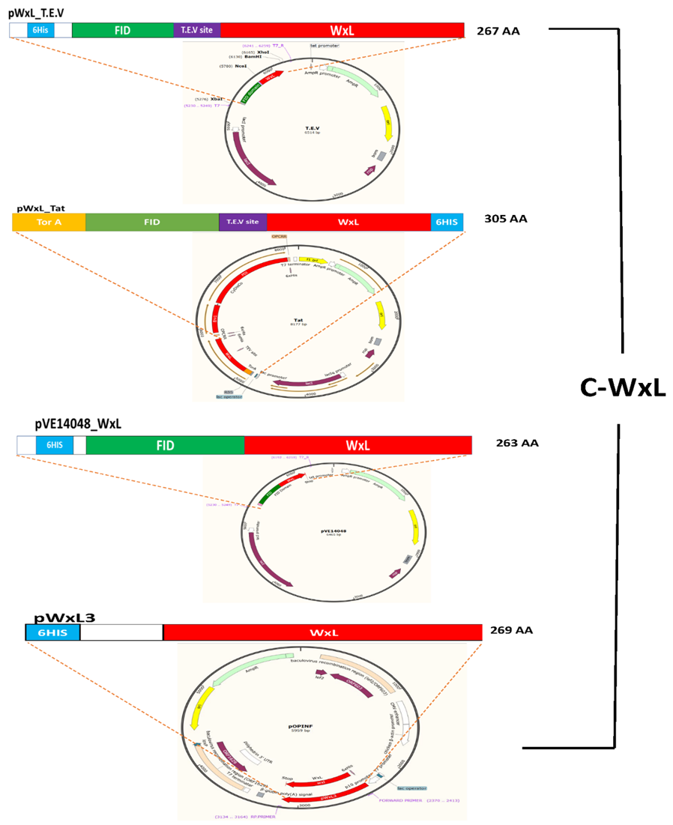
Figure ‎2.1- Schematic representation of the E. faecalis V583 C-WxL domain constructs in different vectors.
Map of pWxL TEV, Map of pWxL-Tat construct, pVE14048_WxL constructs cloned into pVE14048 plasmid. pWxL3_pOPINF. WxL is highlighted in red and His-Tag sequence is in sky blue, Tor A is highlighted in orange, and TEV cleavage site is highlighted in purple.
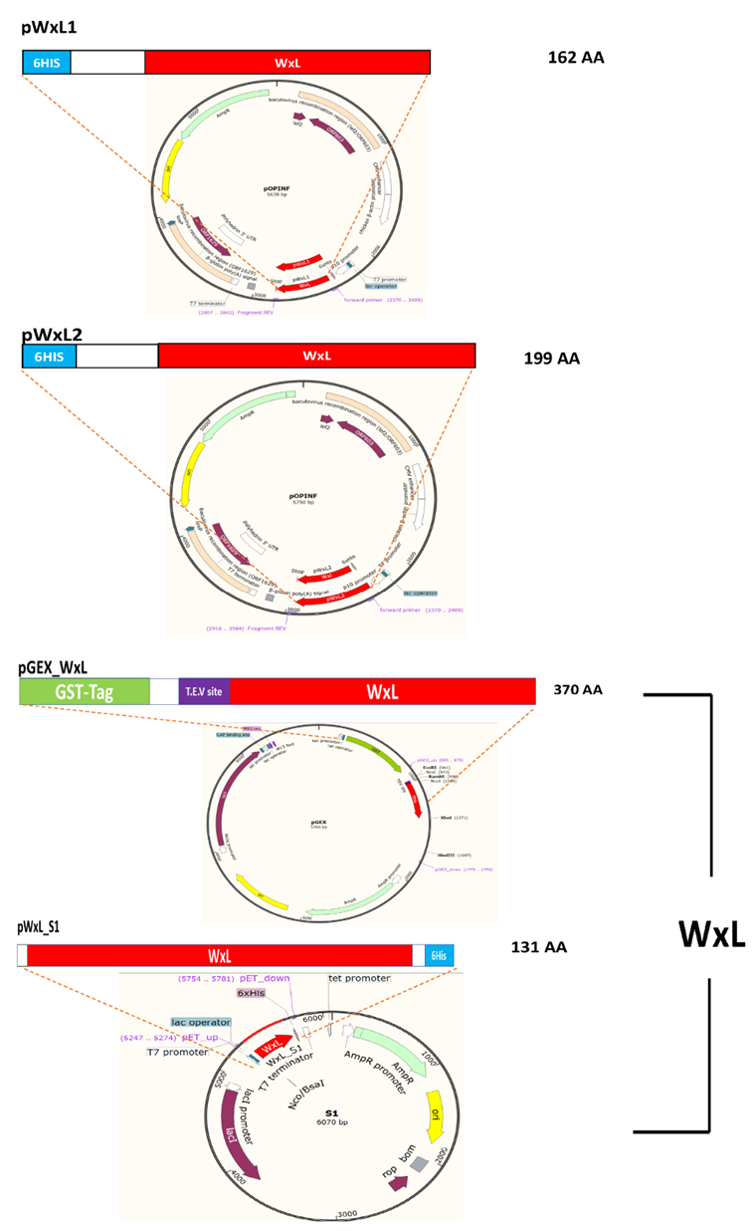
Figure ‎2.2-Schematic representation of the different E. faecalis V583 WxL domain constructs in different vectors.
pWxL1_pOPINF, pWxL2_pOPINF, pGEX_WxL and pWxL S1, WxL is highlighted in red, GST-tag sequence is highlighted in green, and TEV cleavage sequence is purple. His-Tag sequence is in sky blue.
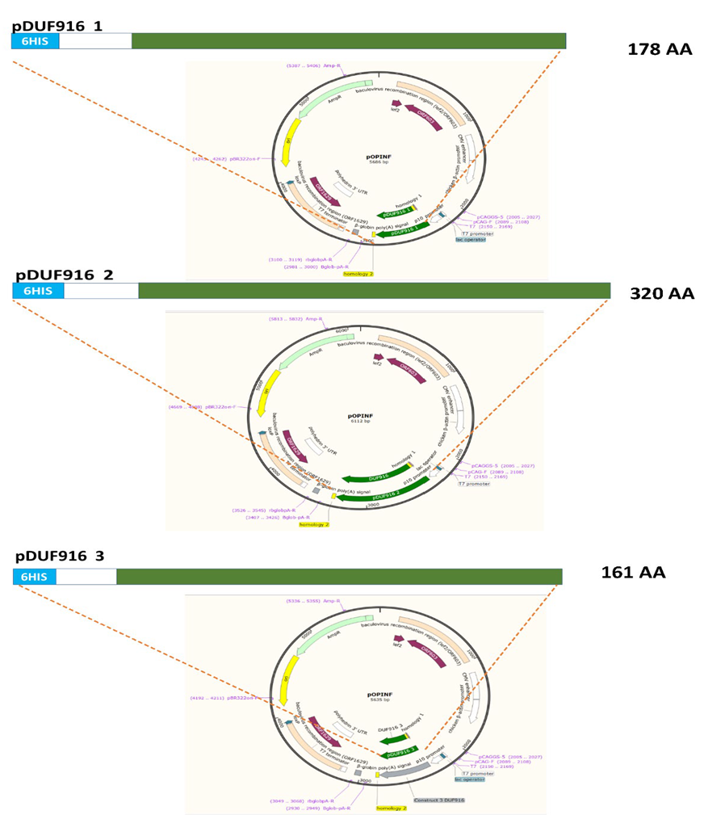
Figure ‎2.3-Schematic representation of the different E. faecium DO Locus C DUFC domain constructs in pOPINF vectors.
pDUF916 1_pOPINF, pDUF916 2_ pOPINF and pDUF916 3_ pOPINF; Green is DUF916 with His-Tag on N-terminal end in sky blue.
The isolate TX6122 (Small Wxl domain) on locus A and C from E. faecium was requested from the University of Texas–HSC; the subculturing of the isolate was done on nutrient agar media, and miniprep was performed; the plasmid was sent for sequencing to Eurofins. The same strains were used in the study of (Galloway-Peña et al., 2015).

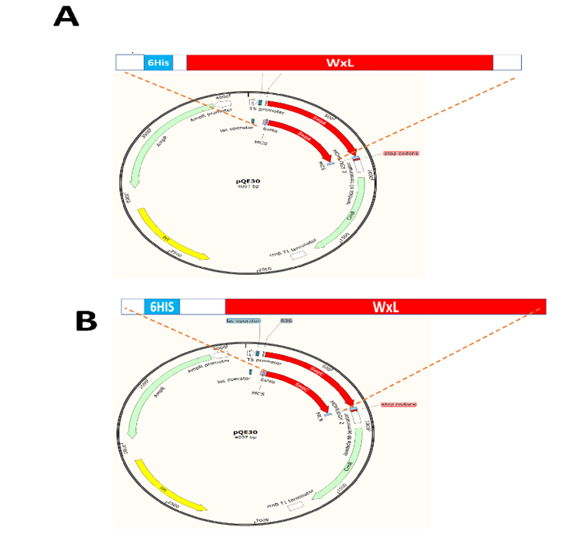
Figure ‎2.4-Schematic representation of the two different E. faecium DO WxL domain constructs from pQE30.
(A) Map of pQE30 construct cloned with Small Wxl of Locus A (SwpA) encoded amino acid sequence. The red colour is Small Wxl with His-Tag on the N-terminus. (B) Map of PQE30 construct cloned with Small Wxl of Locus C (SwpC) and encoded amino acid sequence. The red colour is Small Wxl with His-Tag on the N-terminus.
SwpA and DUFA sequences were taken from locus A of E. faecium DO. The pET vector was engineered by Gene Script Biotech (Netherlands) to express the Small WxL (SwpA) with a C-terminal extension consisting of the hairpin linker (DNKQ) followed by the N-terminal amino acids (7 or 26) of DUFA and hexahistidine affinity tag as shown in Figure 2.5.
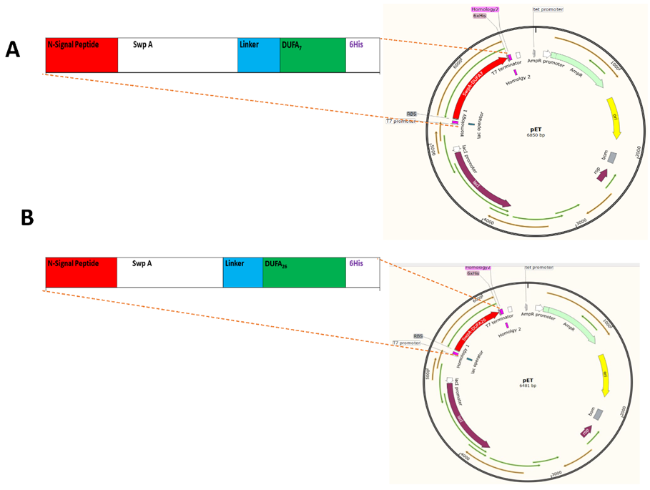
Figure ‎2.5- Schematic representation of recombinantly engineered Small Wxl A (SwpA(His)₆) from E. faecium DO.
(A) General representation of construct SwpA-DUFA₇; N signal peptide sequence is highlighted in black with an underline, Small WxL sequence is highlighted in red, the Linker is highlighted in sky blue sequence, DUFA sequence is highlighted in green colour and 6 histidine sequence is highlighted in purple (B) SwpA-DUFA₂₆ Construct has the DUFA as 26 residues instead of 7 residues. Both the constructs were cloned in pET vector.
The pETDuet-1 vector was designed by GeneScript Biotech (Netherlands) and contained DUFA with N-terminal His-tag and Small WxL C-terminal with S-tag as shown in Figure 2.6. This construct was designed to detect whether the DUFA protein makes the SwpA properly folded. The construct was named Co-SwpA-DUFA.

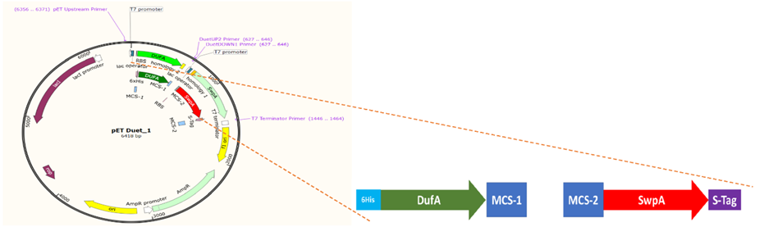
Figure ‎2.6- Map of pET DUET_1 with Co-SwpA-DUFA from E. faecium DO.
The green text is DUFA with a His-Tag at the N-terminus in cyan, and the red text is Small Wxl, with an S-tag at the C-terminus shown in purple.
The Co-SwpA-DUFA-LpxTGA-LwpA construct with the Large WxL, DUFA, LpxTGA and SwpA was designed by Rob Smith from Dr. Mesnage's lab. This construct was cloned into a pTet2op plasmid. The recombinant vector was transformed into E. faecalis JH2-2 cells for the expression of the proteins. The Co-SwpA-DUFA-LpxTGA-LwpA constructs contain Small WxL, DUFA, LpxTG and Large WxL of Locus A from E. faecium DO. The trmA (Transcriptional regulatory Mga family) and pnoA (pyridine-nucleotide oxidoreductase) proteins were excluded in designing the gene block because these were not thought to play an essential role in the expression of the protein of interest as shown in Figure 2.7.
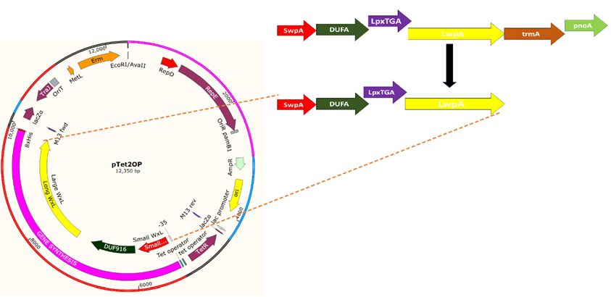
Figure ‎2.7- Schematic representation of construct Co-SwpA-DUFA-LpxTGA-LwpA from E. faecium DO cloned into pTet2OP.
G-block of Co-SwpA-DUFA-LwpA- DUFA is green, red colour shows the Small Wxl (SwpA) with a His-tag on the C-terminus, the sequence of LpxTGA is in purple colour, and Large WxL (LwpE) is yellow with Strep-tag on the C-terminus.
The LysMB1 domain was cloned into pOPINF and LysMA1 was cloned into PML520 plasmid as shown in Figure 2.8.
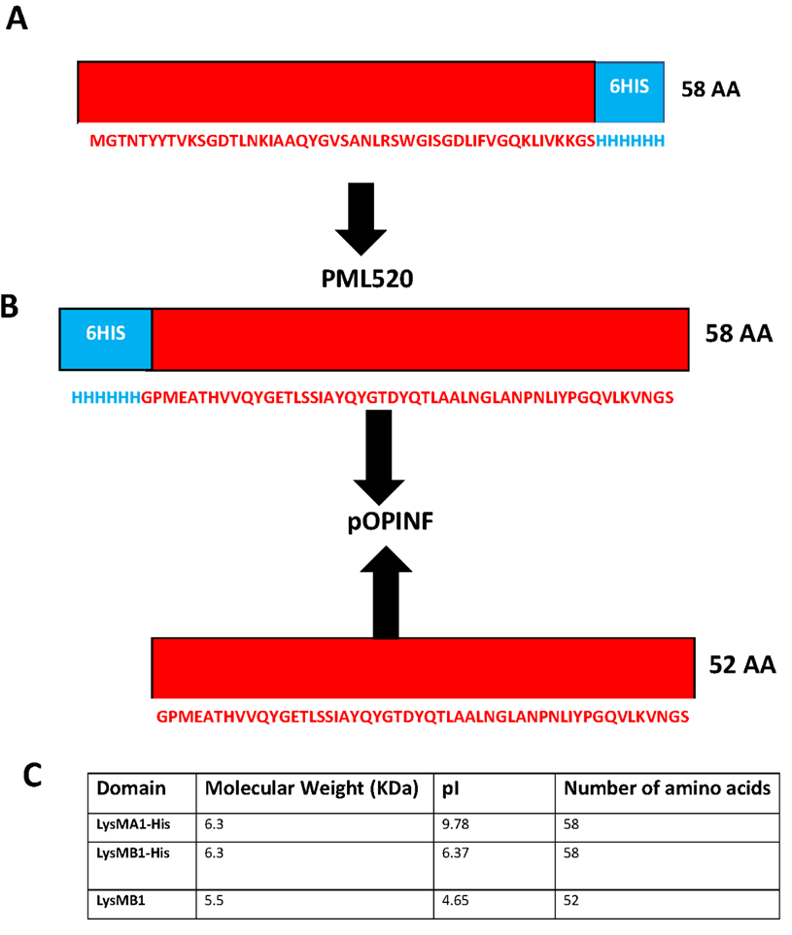
Figure ‎2.8-Schematic representation of LysMA1 and LysMB1.
(A) LysMA1 protein was cloned into PML520 plasmid (B) LysMB1 was cloned into pOPINF plasmid (C) Properties from Expasy protparam.

Gibson Assembly and restriction digestion

DNA methods
QIAprep Spin Miniprep Kit from Qiagen was used to purify plasmids from 5 ml overnight cultures by following the manufacturer's instructions. In the final step, the plasmid was eluted with water instead of elution buffer. 30 µl of the resultant plasmid stock (≥ 40 ng /µl) was sent to GATC Biotech for sequencing. The resulting sequence data was visualised with Snap Gene. Plasmid stocks were amplified in chemically competent NEB® 5-alpha Competent E. coli using the Miniprep protocol provided with the QIA prep spin Miniprep Kit (Qiagen).

Restriction endonuclease digestion
The pOPINF-His Vector (5531 bp) was digested with two digestion enzymes: HindIII and Kpn I as shown in Figure 2.9. Two reaction mixtures were prepared. Each one contained 25 µl: 12 µl DNA (22.4 ng/µl), 2.5 µl 10× NE Buffer 3.1 in final concentration 1× , 1 µl HindIII of restriction enzyme in one reaction and 1 µl of Kpn I restriction enzyme in the second reaction, and 9.5 µl distilled water to make total volume 25 µl for each reaction as shown in table 2.4. 5 µl from each reaction was taken as control samples, and the remaining mixture of 20 µl from each reaction was mixed to make 40 µl final volume of complete digest sample. The digestion reaction was carried out at 37 °C in a water bath for 1 hour. The digested DNA was purified, and a TAE agarose gel electrophoresis was performed. Afterwards the specific DNA gel bands were cut out and DNA was extracted from the gel slices.
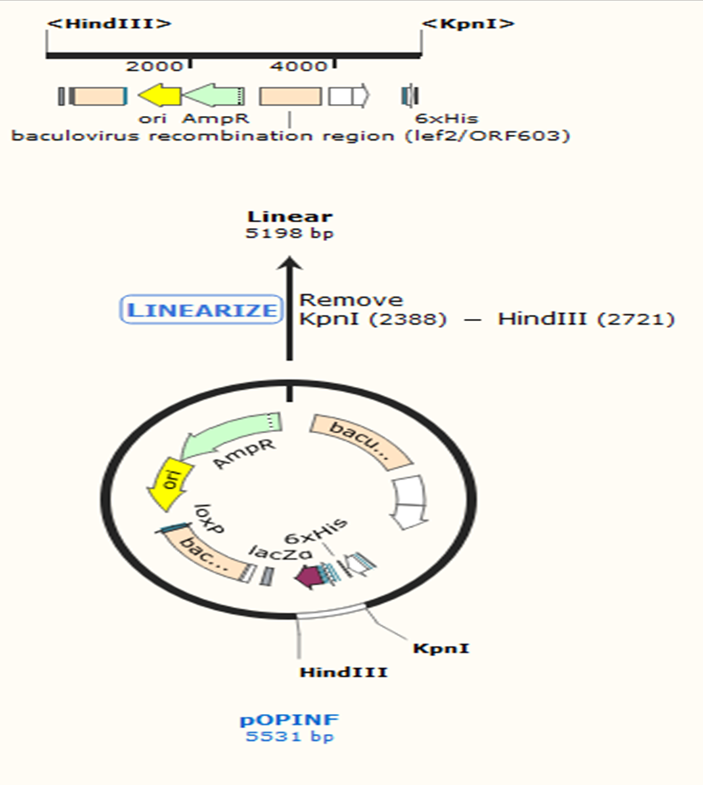
Figure ‎2.9- Digestion of pOPINF plasmid by HindIII and Kpn I (from Snap Gene)
Table ‎2.4- Digestion of pOPINF with HindIII (left) and Kpn I (right).

Agarose gel electrophoresis
Agarose gel electrophoresis was used to analyse and purify DNA fragments. Cut linear pOPINF (5198 bp), the recombinant linear pOPINF and the intact plasmid were identified by gel electrophoresis using 1% agarose gel (1 g of agarose powder with 100 mL 1×TAE from 50× TAE stock (242 g Tris-base, 57.1 ml 100% acetic acid, 100 ml 0.5 M sodium EDTA, distilled water was added up to 1 Liter)). Each 5 µl of samples were mixed with 1 µl of 6× uv view loading dye (Bio-Rad). The samples were loaded in the 1% agarose gel and run-in 1× Tris Acetate EDTA running buffer (20 ml of 50× TAE stock in 980 ml of distilled water), along with 6 µl of DNA marker (4 µl of dH₂O, 1 µl of 6× uview loading dye, and 1 µl of 1kb DNA ladder) in order to estimate the sizes of DNA fragments. The samples and the 1kb DNA ladder were run for 1h at 110 V. Then DNA fragments were visualized under 254 nm UV light.

Recovery of DNA from agarose gel
Linear DNA fragments within the agarose gel were visualised under UV light and purified from 1% agarose gel by GeneJET Gel Extraction Kit according to the manufacturer's instructions. The excision of the DNA band of interest from the agarose gel was done with a scalpel under UV light. The slice was transferred into a pre-weighed Eppendorf tube. For 100 μg of the gel slice, 100 μL binding buffer was added. The incubation of the mixture was done at 60 °C until the agarose slice was completely melted. The sample-buffer mixture was pipetted to a silica membrane column, and the column was incubated at room temperature for 1 minute. The DNA was spun down to bind it to the membrane. The flow-through was discarded. 500 μL washing buffer was added to the column. The column was spun down to remove impurities. The DNA was finally eluted with 50 μL (or less for higher concentration) TE-buffer or water.

Steps of Gibson assembly
Gibson Assembly was developed by Dr Daniel Gibson as a fast and easy tool to assemble multiple DNA fragments within a single tube. This is achieved with three enzymatic activities. First, an exonuclease cuts back the 5' ends of the double-stranded DNA fragments to create single-stranded 3' overhangs. These overhangs facilitate the annealing of complementary fragments (overlap region). Secondly, a DNA polymerase extends the 3' ends to fill the gaps. Last but not least, a DNA ligase seals the nicks in the assembled DNA (Figures 2.10 and 2.11).
Figure ‎2.10- Overview of the Gibson Assembly method.
The overlapping nucleotides (in red and blue) are cut back at 5' end, the single-stranded DNA fragments anneal, and the missing nucleotides are filled up by a DNA polymerase and a DNA ligase. Figure from (Schütz, 2014) Gibson Assembly Master Mix Instruction Manual.

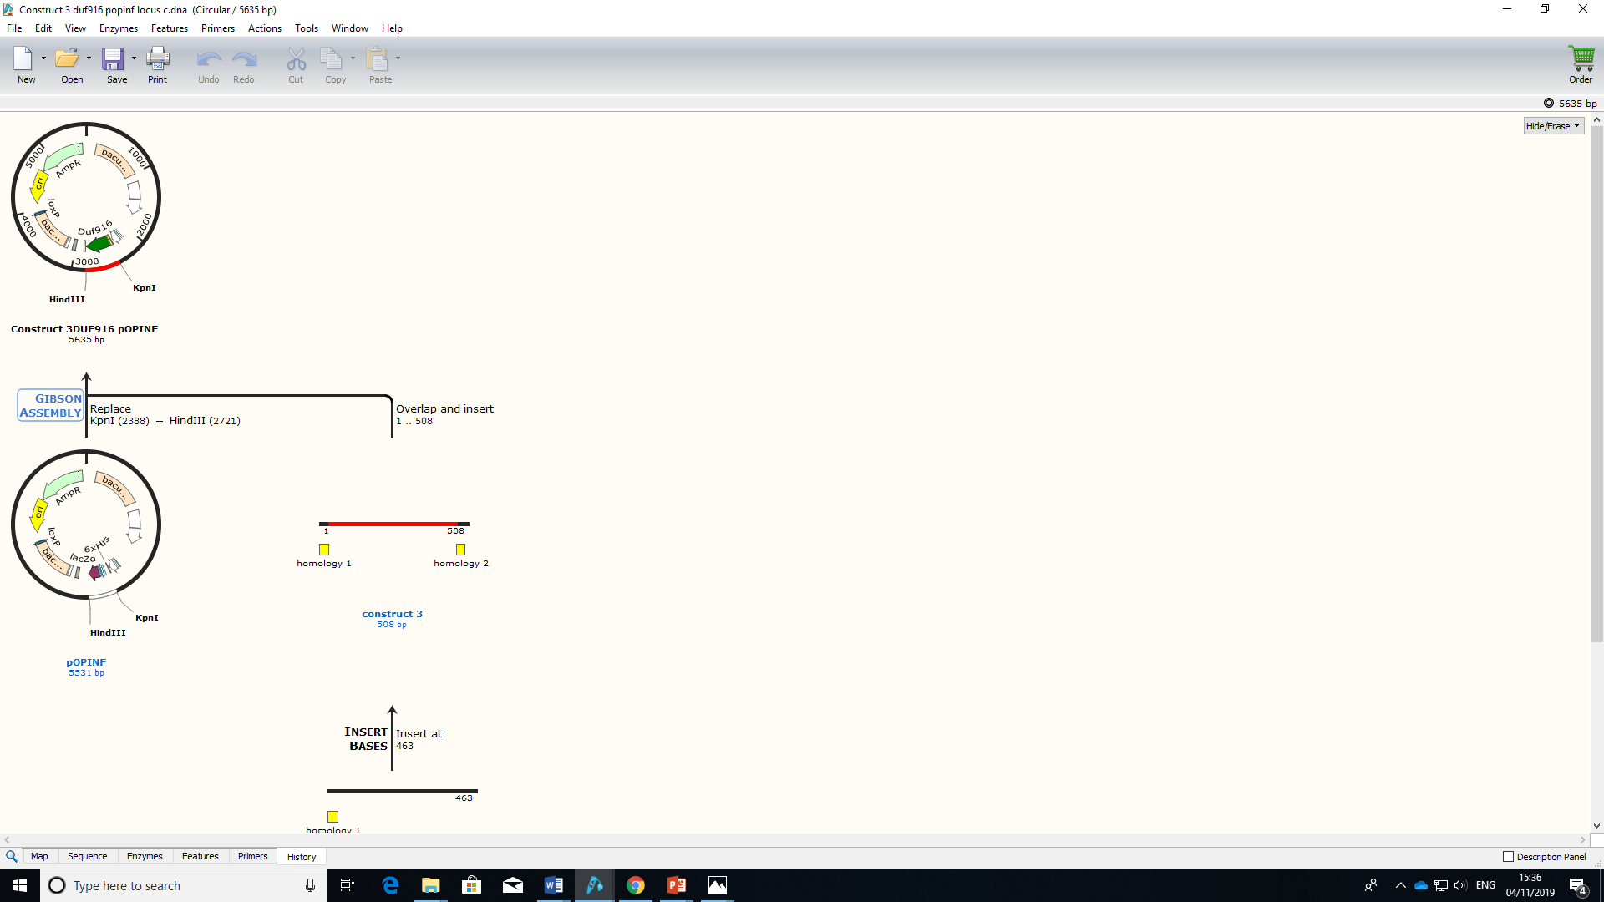
Figure ‎2.11- Overall summary of Gibson Assembly.
It shows plasmid pOPINF cut with restriction enzymes Kpn I and Hind III and insertion of the G-Block (red in colour) of Construct 3. Homologous regions of the plasmid in the G-block are yellow in colour.

Design of overlapping G-Block sequence
The sequence of the target sequence was taken from http://www.uniprot.org/uniprot. Then https://eu.idtdna.com/CodonOpt was used for codon optimization for E. coli expression. pOPINF (5531 bp) plasmid was used as a template to create two matched homology overlapping sequences at each end of the target gene by using Snap Gene software. The first overlap sequence at the 5' end started from the HindIII restriction site with 36 bp backwards; while the second overlap at the 3' end started from the restriction site and went 33 bp forward, which results in a G-Blocks overlapping fragment. At the end of the target gene and before the KpnI site start, a stop codon (TAA) was added, see Figure 2.19. All G-Blocks were ordered from Integrated DNA Technologies.

DNA Ligation
The conditions for the ligation of the G-Block gene into the linearized pOPINF plasmid were specified by the supplier. Following the manufacturer's protocols, the G-Block fragment pellet was re-suspended with 50 µl Milli-Q water to a final concentration of 10 ng/µl. After that, the linear plasmid was ligated with the designed WxL G-Block by Gibson assembly in molar ratio 1:3 of vector to insert. As an example calculation: The WxL G-Block fragment, 379 bp in 10 ng/µl concentration, is 0.0409 pmols. The pOPINF vector (50 ng), in concentration 7.9 ng/µl for 6869 bp, is 0.011 pmol. 3× excess of the insert is 0.033 pmol which is 0.8 µl ~ 1 µl.
The number of pmols of insert and vector for the optimal assembly was calculated based on the length and weight of the fragments by using a formula in https://www.neb.com/protocols/2012/12/11/gibson-assembly-protocol-e5510.
The ligation reaction was carried out in 12 µl final volume: 6 µl vector (7.9 ng/µl), 1 µl insert (10 ng/µl) and 5 µl NEBuilder HiFi DNA assembly master mix. The assembly reaction was incubated at 37°C for one hour in a water bath. During the incubation, the overlapping G Block of the WxL gene was ligated with the linear plasmid via the action of three enzymes: a 5′ exonuclease, a DNA polymerase, and a DNA ligase. After the incubation time, 5 µl from the mixture was transformed into 50 µl of DH5α competent cells. Sequence identities were verified by Sanger sequencing performed by either GATC Biotech (Konstanz, Germany) or SeqLab Sequence Laboratories (Göttingen, Germany).

Protein expression and Purification

Competent cell preparation
Competent cells that were mentioned above in Table 2.3 were produced using the following method. Cells were streaked on LB agar plates and incubated overnight at 37℃. One colony from this plate was inoculated into 10 ml LB medium and incubated overnight at 37 ℃, 250 rpm. 1 ml of this culture was then inoculated into 100 ml LB medium in a 250 ml conical flask at 37℃, 250 rpm until the OD at 600 nm reached 0.5. The cells were then incubated on ice for 5 minutes then centrifuged at 5000 rpm (Beckman Coulter Avanti centrifuge) for 5 minutes to pellet the cells.
The cells were re-suspended in 30 ml ice-cold TFB1 buffer (Table 2.5) and incubated on ice for 90 minutes. Following this, the cells were centrifuged at 5000 rpm for 5 minutes, and the supernatant was discarded before re-suspending the cells in 4 ml ice-cold TFB2 buffer. The cells were separated into 200 µl aliquots and then flash-frozen in liquid nitrogen and stored at -80℃.
Table ‎2.5-Buffers used in transformation.
Table ‎2.6-Preparation of different antibiotic stocks
Antibiotics were prepared as 1000× stock, filter sterilized, and frozen at -20℃ in Eppendorfs.

Transformation of competent cells
All the component cells (NEB DH5α, BL21 (DE3), C43 (DE3), BL21 (DE3) Lemo) were thawed on ice for 5 minutes. 2 μl of expression vectors (20-25 ng) was added to 50 μl competent E. coli cells; then the mixture was mixed by flicking the tubes twice. The mixture was then placed on ice for 30 minutes. Heat shock was done at 42 ℃ for 30 seconds in a water bath. Mixtures were again placed on ice for 5 minutes. 950 μl of SOC (2 g of tryptone, 0.5 g NaCl, 0.0186 g KCl, 100 ml Milli-Q water, 1 ml MgCl₂ (1 M), 0.2 g MgSO₄) was added to the mixture; the mixture was placed at 37℃ for 1 hour in a shaking incubator (INFORS MT). 20 μl and 200 μl was taken from the mixture and plated separately on selective antibiotic agar plates. The plates were incubated at 37 ℃ overnight.

Protein Over-Expression and Purification
Most of the recombinant proteins containing WxL domain were expressed and purified following the strategy as described below in general strategy of protein expression except for pWxL_Tat,pGEX_WxL, Co-SwpA-DUFA and Co-SwpA-DUFA-LpxTGA-LwpA which followed different expression and purification protocols. Unlabelled and single labelled Atl A1 (LysMA1) and AtlB1 (LysMB1) from E. faecalis were expressed and purified from JH 2-2.

General Protocol of Protein Purification and Analysis

A general strategy for protein expression
A single transformed colony was selected from the transformed cell plate and was inoculated aseptically into 5 ml LB broth as a starter culture, and antibiotics from stock were added to the broth; the flask was then incubated at 37℃ overnight. 500 μl of culture was taken from the flask and was added into 50 ml LB Broth containing 50 μl of ampicillin; the flask was incubated at 37℃. Every two hours, the optical density (OD) was checked using a nanodrop (Thermo Scientific Nanodrop). When the OD reached 0.7, IPTG was added to the flask from a 1 M stock to final concentrations of 0.5 mM, 1 mM and 0.1 mM and flasks were incubated at different temperatures (25℃, 37℃, and 30℃) and for different times (3, 4 and 16 hours). The mixture from the flask was transferred into a Falcon centrifuge tube and spun for 12 minutes at 8000 rpm at 4℃ in a Beckman Avanti J-251 centrifuge. After the centrifugation, the supernatant was discarded, and the pellet was re-suspended in 1ml lysis buffer (50 mM Tris HCl pH 7.0, 250 mM NaCl, 15% + Roche complete EDTA free protease inhibitor) with the help of a micropipette. The mixture was transferred into an Eppendorf tube, placed on ice, and sonication was done for 20 seconds with a 60-second break in between. Each eppendorf tube was sonicated six times. The resulting suspension after sonication was centrifuged at 18000 rpm for 20 minutes at 4℃ in a Beckman Avanti J-251 centrifuge. The supernatants were filtered through a 0.45 μm Minisart filter. The supernatant and pellet were then run on a 16% SDS gel. The remaining samples were stored at -20℃.The purification was done by step gradient method.

IMAC-Chromatography
A Ni-NTA column was used to purify the overexpressed fusion protein. The 5 ml Ni-NTA column (dimension of column 1.6×2.5 cm) was equilibrated with washing buffer (Buffer A: 50 mM HEPES pH 7.0, 250 mM NaCl, 15% glycerol) by washing with 10 times the column volume. Then the supernatant (15 ml) was applied to the column (5 ml Ni-NTA Agarose resin). After that, the column was washed with the same washing buffer (100 ml), and 3 ml fractions were collected at a flow rate of 2 ml/min by an ÄKTA prime plus system. The eluant was collected after applying the elution buffer to the column (Buffer B: 50 mM HEPES pH 7.0, 250 mM NaCl, 15% glycerol, 500 mM imidazole), then the elution fractions were collected in 3 ml fractions with a flow rate 2 ml/min. The optical density was measured at 280 nm to identify the protein-containing fractions. The column was then washed with 2 column volumes of 1 M NaOH, 6 M GuHCl and 20 % w/v ethanol solutions. The washing and elution fractions, which showed higher optical density, were run on SDS-PAGE.

Dialysis
Dialysis tubing (Spectrapor) was cut to the appropriate length. Dialysis tubing was selected based on protein molecular weight. After that, in order to remove the glycerol, the tubing was placed in water for half an hour. The tubing was clipped off at the bottom, and the solution containing protein was then transferred into it. Then the tubing was clipped off from the top and placed in a beaker containing 1 litre of the required buffer. The beaker was placed in the fridge with a magnetic stirrer. After two hours, the required buffer was changed and left stirring overnight. After one day, the mixture in the tube was decanted into a Vivaspin and centrifuged at 4.5 k rpm for buffer exchange and protein concentration to 5 ml volume.

Gel filtration
Gel filtration was done as a polishing step of the purification. Gel filtration was also used to separate proteins based on their size (analysis and quantitation of dimers, trimers, and higher-order aggregates for proteins). All the buffers were filtered and degassed before use.
The partially purified protein was filtered using a 0.2 µm syringe filter and loaded onto a prepacked Superdex 75 or Hi-Load Superdex 200 1.6×60cm column from GE Healthcare to complete the purification. The column was first equilibrated with 50 mM potassium phosphate buffer pH 6. A sample of protein partially purified from the reverse IMAC with a maximum volume of 5 ml was filtered using a 0.2 µm syringe filter and then applied to the gel filtration column. The column was washed with 50 mM potassium phosphate buffer pH 6 using a flow rate of 3 ml/min, and the eluant was collected in 6 ml fractions. The progress of the column was followed by monitoring the absorption of the eluted solution at 280 nm. The gel filtration column was then washed with 500 ml 1 M NaOH then 500 ml 20 % ethanol. The column was stored in 20 % ethanol at room temperature. The gel filtration fractions based on the peaks were run in an SDS gel. Then concentrated protein was stored at -20 °C.

SDS-PAGE analysis
The molecular size of the protein was analysed by sodium dodecyl sulphate-polyacrylamide gel electrophoresis (SDS-PAGE) using a 16% or 12% resolving gel acrylamide gel as shown in Table 2.8. Plates were sealed with tape to prevent the gel from leaking, and the assembled plates were fixed in the gel apparatus. 10 ml of 16% resolving gel was prepared. After pouring, the gel was left to polymerise. Isopropanol was poured on top to level the resolving gel. After polymerization of the resolving gel, 4 ml of 4% stacking gel (Upper Buffer = 2.5 ml, 40% w/v Bis acrylamide = 1.2 ml, d. H₂O = 6.5 ml, 10% w/v APS = 100 μl, TEMED = 10 μl) was prepared. The gel was poured into the plates, and a comb was added for well formation. 15 µl of supernatant/sample was taken and mixed with 5 µl of SDS gel loading buffer; then the samples were centrifuged for 1 minute. Immediately after centrifugation heat shock was provided to all the samples for 5 minutes. 4 µl of ladder sample of size 250-10 kDa was used as a molecular standard as a protein marker. The gel was put in a gel tank, and SDS loading buffer was added into it. All the samples were loaded with the help of a micropipette into each well. Electrophoresis was done at a constant voltage of 80 volts for 5 minutes, and then voltage was increased up to 180 volts for 1 hour; the gel was removed. The gel was placed in Instant Blue stain under shaking conditions for 15 minutes, then after 15 minutes, the stain was poured off from the gel and it was washed with water.
Table ‎2.7-Preparation of Different Buffers for SDS-PAGE
Table ‎2.8-Preparation of Different SDS Gels

Western blotting
To identify the specific protein of interest from the Tat construct, a Western blot was used. First of all, two SDS-gels were run with the same samples at the same time and voltage; one gel was stained with instant blue, and the Western blot was done on the other gel. Two Whatman filter papers and one polyvinylidene fluoride (PVDF) membrane were cut to the same size as the SDS-gel. Sponge, gel, filter paper, and PVDF membrane were soaked in 10× transfer buffer (250 mM Tris (pH 8.0), 1.9 M glycine), checking that bubbles were not formed. A transfer sandwich was made, as shown in Figure 2.12, and it was put into the tank. An ice block was put in the tank to maintain the temperature at 4℃, and the tank was placed on a magnetic stirrer. 1× transfer buffer (100 ml 10× transfer buffer, 200 ml methanol and 700 ml water) was poured in the tank. The gel was run at 100 volts for 1 hour so that transfer could take place. Ponceau Red stain was poured on the membrane after the transfer. The membrane was rinsed with water. The blocking agent (5% skim milk in TBST (Tris-buffered saline Tween-20)) was poured on the membrane and was left for 1 hour in shaking condition. The membrane was put in a plastic bag, and 2 ml of solution 1 (200ml 1× TBST with 4 g of skim milk) was added in the plastic bag. 2 μl rabbit anti-His tag antibody was added after the addition of solution 1, and the bag was then sealed; for incubation, the bag was left on a shaker at 4℃ overnight. On the next day, the membrane was rinsed quickly with 1× TBST in a petri dish three times. The membrane was washed three times with 1×TBST for 5 minutes on a shaker at room temperature. Secondary antibody (4 μl goat anti-rabbit IgG conjugated to horseradish peroxidase (HRP) in 10 ml of solution 1 in a Falcon tube) was added to the membrane and left for 1 hour at room temperature on a shaker. Again, the membrane was rinsed quickly three times with 1×TBST and then washed three times for 5 minutes with 1×TBST on a shaker at room temperature. An enhanced chemiluminescence (ECL) kit from Thermo-Fisher Scientific was used to detect bands. ECL mix (1 ml ECL substrate mix with 1 ml of luminous/enhancer solution) was prepared and poured in the petri dish containing membrane; the membrane was left for 1-2 minutes at room temperature. To visualise the bands on the membrane, a Bio-Rad Gel-doc chemiluminescence imager with appropriate software was used (Mahmood & Yang, 2012) .
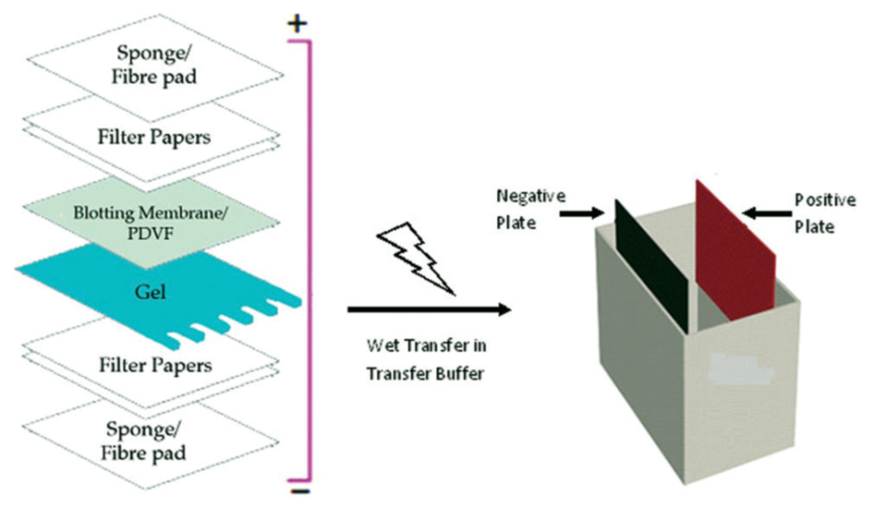
Figure ‎2.12-Transfer sandwich for Western blot. (Acquired from (Mahmood & Yang, 2012).

Protein Expression of WxL from E. faecium DO
To express the WxL domain from the E. faecium DO the recombinant proteins were made from Locus A and Locus C as shown in Figures 2.3, 2.4, 2.5, 2.6 and 2.7.

Unlabelled protein expression of SwpA
Small Wxl (TX6119) on locus A from E. faecium was expressed and purified following (Galloway-Peña et al., 2015). Small Wxl was cloned into the expression vector pQE30 (Qiagen) and transformed into M15 (pREP4) cells (Qiagen). Transformed small Wxl was provided by the Barbara Murray lab from the University of Texas Health Science Centre, Houston, Texas, USA. One colony from the LB slant was picked and streaked on an LB agar plate and incubated at 37 ℃. One colony from this plate was used to inoculate 5 ml LB broth in a 250 ml conical flask which was then incubated overnight at 37℃, 200 rpm with 1:1000 antibiotic (100 mg/ml ampicillin, 30 µg/mL kanamycin). The protein expression was done according to the same protocol as explained above in section 2.1.6.3.1.1 mM Isopropyl β-D-1-thiogalactopyranoside (IPTG) was used in this experiment overnight at 25 °C. Cell paste was suspended in 15 ml lysis buffer (50 mM Tris HCl pH 7.0, 0.5M NaCl, 15% + Roche complete EDTA free protease inhibitor) and the rest of the strategy is the same as described above in section General strategy for protein expression.

Purification of SwpA using Nickel Column
Ni-NTA column was applied to purify the overexpressed Small Wxl proteins. IMAC chromatography was performed as above in section 2.1.6.3.0. The following buffers were used: Washing buffer (Buffer A: 50 mM Tris-HCl pH 8, 0.5 M NaCl) and Elution buffer (Buffer B: 50 mM Tris-HCl pH 7.0, 0.5 M NaCl, 500 mM imidazole). The volume of the sample containing protein was reduced by a VivaSpin device with MWCO 10000.
Folding and Refolding of SwpA
Small WxL protein aggregate fractions from gel filtration were dissolved in 4.8 g urea to make a 7 M urea solution. The solution was filtered; then the protein sample was applied to a 5 ml His trap column equilibrated in 8 M urea and eluted with 0.5 M imidazole. 2ml fractions were collected in an eppendorff. Then the 4 ml of Ni-NTA beads were washed with 8 M urea, Tris pH 8.4, and then the protein sample fraction collected above was added to 4 ml Ni-NTA. The sample was then incubated for 1.5 hours on a wheel at 4 ℃. Beads were placed in the column; unbound material was collected, beads were washed with 8 M urea and eluted with Buffer B (0.5 M imidazole, 8 M urea pH 8.4). 1 ml fractions were collected manually, not with AKTA; then collected fractions were diluted in about 40 ml of buffer A (0.5 M NaCl, tris pH 8.0). Then the diluted protein sample was applied to a 1 ml His-trap column on AKTA system, flow rate 1.5 ml/min. The column was washed with 2 ml of buffer A and eluted with 0.5 M imidazole in buffer A. 0.5 ml fractions were collected; then all collected fractions were collected and purified further with gel filtration using buffer C (0.5 M NaCl tris pH 6).

Expression trials of Co-SwpA-DUFA
The three different constructs were made as shown in Figure 2.5. SwpA-DUFA₇, SwpA-DUFA₂₆ and Co-SwpA-DUFA were transformed into BL21(DE3) and BL21(DE3)lemo for protein expression as discussed in Section 2.1.5.3.
Co-SwpA-DUFA was cloned into pET-Duet 1 vector in which DUFA is His-Tag and SwpA was S-Tag as shown in Figure 2.6. The protein SwpA with S-Tag purification was done following the protocol of Novagen (McCormick & Mierendorf, 2000).
CD spectroscopy of SwpA-S-Tag
Recombinant protein of SwpA-S-Tag were dialyzed in sodium phosphate buffer (0.8 mM Na₂HPO₄, 0.2 mM NaH₂PO₄•H2O, pH 7.4). Circular dichroism (CD) measurements in the far-UV region (190 to 260 nm) were carried out at ambient temperature on a JASCO Corp., J-810 (Easton, MD) using a 0.5-mm cuvette. Ten scans were collected and averaged at a scan speed of 100 nm/min, with a time constant of 2 s and bandwidth of 1 nm. The spectra were background corrected with the CD signal obtained from the buffer. Analysis of the spectra was performed two ways to confirm the results: one with the CAPITO web server https://data.nmr.uni-jena.de/capito/index.php and the other through in-built software in the JASCO Corp. J-810 machine.

Expression trials of Co-SwpA-LpxTGA-LwpA
The construct containing Co-SwpA-DUFA-LpxTGA-LwpA was designed by Rob Smith and transformed into E. faecalis JH2-2 as shown in Figure 2.6. LwpA has a Strep-tag II on the C-terminus, and SwpA has a His-tag on the N-terminus. A control was also included in this experiment, which was E. faecalis JH2-2 cells without plasmid.
The E. faecalis JH2-2 cells transformed with the pTet2op plasmid containing Large WxL protein were streaked on a BHI agar plate and incubated at 37°C. One colony from this plate was used to inoculate 5 ml BHI broth in a 15 ml falcon tube, which was then incubated overnight at 37°C, 200 rpm with 30 µg/ml erythromycin. One colony from the BHI agar plate containing the control was used to inoculate 5 ml BHI broth in a 15 ml falcon tube which was then incubated overnight at 37°C. 0.5 ml of starter cultures from the 15 ml falcon tube was then added separately to ten 50 ml falcon tubes containing autoclaved BHI broth; the five falcon tubes which contain E. faecalis JH2-2 cells with the ptetop2 plasmid containing Large WxL protein were inoculated with 50 µl erythromycin and then all the falcon tubes were incubated at 37°C until the optical density reached 0.6 au at 600 nm. Then, protein expression was induced by adding 20, 50, 100, 200 and 500 ng/ml of Anhydrotetracycline (ATc) and the culture was incubated at 37°C for 1 hour, 2hr, 4hr and overnight, after which the cells were harvested by 10 mins centrifugation at 8000 g, at 4°C.
The supernatant was then treated with TCA to precipitate any secreted protein, and the pellet was broken by beads 0.2 µm in size. After this another protein expression was performed, the supernatant was discarded and pellet was treated with urea.
TCA precipitation
TCA (trichloroacetic acid) /acetone precipitation is one of the most common precipitation methods (Ngo et al., 2014). The acetone used in this procedure should be pre-chilled and stored in a -20 °C freezer until needed and kept on ice during the entire procedure. 100 % TCA was added to 40 ml of crude extract of long WxL from locus A; after adding the TCA, the sample was kept on ice for 15 minutes so that protein precipitation occurs. Then centrifugation was done at 15000 rpm for 10 minutes at 4°C; the supernatant was discarded, and the pellet (dark brownish colour) was washed with 20 ml ice-chilled acetone. The sample was then vortexed for 2 minutes and centrifuged for 5 minutes at 15000 rpm at 4°C. The supernatant was then discarded, and the pellet was allowed to dry overnight. The pellet was dissolved in 300 µl of PBS, and 15 µl Tris-Base, 75 µl 4× SDS buffer was added. Then 25 µl of the sample was loaded on a 12 % SDS-PAGE gel.
Cell disruption by beads
In the bead-beating technique, glass or steel beads are positioned in a cylindrical compartment where the high-speed agitating movement of beads can damage the cells (Ramanan, Ling, & Ariff, 2008) . One scoop of beads (size 0.2 micron) was added into cryovials, the pellet was re-suspended into 400 µl of PBS, and then the sample was vortexed for 1 minute. The sample was then transferred into cryovials, and more PBS was added to make the volume up to 1 ml. Then the cryovial tube was put in the bead beating and homogenisation machine, and beading was done for 60 seconds, then cryovials were placed on ice for 2 minutes; this step was repeated 6 times to disrupt the cells. After beating was finished, the cryovial tubes were placed on ice; then the supernatant was taken out and transferred into a 1.5 ml Eppendorf. 160 µl of supernatant was transferred into a 1.5 ml Eppendorf and then 40 µl 4 × SDS buffer. Then the sample was run on a 12 % SDS-PAGE gel.
Cell disruption by urea
After another protein expression of Co-SwpA-LpxTGA-LwpA construct, centrifugation of cell culture was done for 10 mins at 8000 g at 4°C and then supernatant was discarded, and the pellet was treated with 300 µl 8 M urea pH 8 (Spriestersbach et al., 2015). Samples were left on ice for 10 minutes at room temperature. After 10 minutes, the samples were centrifuged for 5 minutes at 15000 rpm at 4 °C; after centrifugation, the pellet was discarded, and the supernatant was loaded onto a 12% SDS gel for analysis. The protein's purification was done through a nickel slurry (50%) prepared in a 1.5 ml Eppendorf with 500 µl slurry. The 8 M urea pH 8 was transferred into the Eppendorf and spun at 5000 rpm. The nickel beads were re-suspended into 8 M urea, and then the slurry was transferred into the column. The protein was poured into the column then the column was washed 4 times with buffer A (100 mM NaH₂PO₄, 10 mM Tris HCl and 8 M urea pH 8) and then elution buffer B (100 mM NaH₂PO₄, 10 mM Tris HCl and 8 M urea pH 4.5). Then protein was left for 5 minutes on the column and four 0.4 ml fractions were collected. The experiment was repeated in triplicate. To check the folding of the protein 1-D NMR was performed.

Expression of SwpC and DUFC constructs
The expression of SwpC (Galloway-Peña et al., 2015) was done following the same protocol as for SwpA (Section 2.1.5.3.1). The construct of SwpC is shown in Figure 2.4. The DUFC construct (Figure 2.3) was transformed in BL21 lemo(DE3) and BL21(DE3) cells for the expression of the protein. The trial of the protein expression was done in the same way as described in Section 2.1.5.3.

Large WxL from E. faecalis V583
A different construct was made to express EF2686 (Large WxL) from E. faecalis V583 as shown in Figures 2.1 and 2.2. All the recombinant constructs of WxL domain have a His-Tag; so, they follow the same purification strategy as explained in Section 2.1.5.3.1 except the pWxL_Tat, and pGEX_WxL.

Tat (twin-arginine translocation) expression system
This method is based on (Jones et al., 2016). 5 ml Luria Bertani (LB) medium pre-culture was inoculated from glycerol stocks and grown aerobically overnight at 37℃, 200 rpm with 1:1000 antibiotic (100 mg/ml ampicillin). On the next day, the culture was diluted up to OD600 = 0.05 in 50 ml fresh LB with 1:1000 antibiotic (100 mg/ml ampicillin). Cultures were then grown at 25, 15 and 30℃, 200 rpm, 250 ml flasks and the OD600 was checked every hour until it reached 0.6; then expression was started by adding 0.5 mM IPTG. After 2, 3, 4 and 5 hours of induction, the culture was transferred into centrifuge tubes centrifuged at 3,000 rpm, 4℃, for 10 min in a Beckman Avanti J-251 ultracentrifuge. After the centrifugation, the supernatant was discarded, and the pellet was re-suspended with a micropipette in 500 μl Buffer 1 (100 mM Tris-acetate pH 8.2, 500 mM sucrose, 5 mM EDTA pH 8.0). After the addition of 500 µl dH₂O, 40 μl hen egg-white lysozyme (1 mg/ml) was added and was left on ice for 5 minutes so that lysozyme can digest the cell wall. 20 μl MgSO₄ (1 M) was added after the digestion to stabilise the inner membrane. The mixture was then transferred into centrifuge tubes for centrifugation at 14,000 rpm 4 ℃, 2 min in a sigma 1-14 K centrifuge; the supernatant was taken and frozen at -20 ℃ as the periplasmic fraction (P). Resuspension of the pellet was done in 750 μl Buffer 2 (50 mM Tris-acetate pH 8.2, 250 mM sucrose, 10 mM MgSO₄) and centrifugation was done at 14,000 rpm 4 ℃, 5 min in a sigma 1-14 K centrifuge. With the help of a micropipette the pellet was re-suspended in 750 μl of Buffer 3 (50 mM Tris-acetate pH 8.2, 2.5 mM EDTA pH 8.0) and sonicated for 6 × 10 s at amplitude 8 μm to disrupt the membranes. After the sonication, centrifugation was done at 18,000 rpm 4℃, 30 min in a tabletop centrifuge to sediment the cytoplasmic fraction (C). The supernatant was stored at -20 ℃. Resuspension of the pellet was done in 500 μl of buffer 3 before freezing, designated as membrane fraction (M) (Jones et al., 2016). All the fractions were run on a 16% SDS-PAGE gel.
Protein purification of pWxL_Tat
A Ni-NTA column was used for the purification of WxL protein from the Tat expression vector. The column was first washed with 500 ml of distilled water and then washed with 100 ml washing buffer (20 mM imidazole, 150 mM NaCl, and 50 mM Tris pH 8.0); then, the sample was loaded onto the column, and 2 ml fractions were collected with wash buffer. The column was eluted with elution buffer (100 mM imidazole, 150 mM NaCl, 50 mM Tris pH 8.0) in 2 ml fractions. At the end of the experiment, the column was washed with 100 ml of washing buffer; then with 6 M guanidine and finally with Milli-Q water. The fractions which showed higher optical density were run on a 16 % SDS-gel (Frain, Robinson, & Van Dijl, 2019).

pWxL_S1 and pWxL_TEV
Dr Stéphane Mesnage designed a recombinant plasmid for the expression of WxL domain as shown in Figure 2.2. pWxL_S1 and pWxL_TEV construct were transformed into BL21 (DE3) Gold and C43(DE3) for the expression of the protein. The protein expression was done as described in section 2.1.5.3.1.

pVE14048_WxL
Pascale Serror constructed pVE14048 plasmid to study the WxL domain (Brinster, Furlan, et al., 2007). This plasmid was used to express the Large WxL domain in different competent cells BL21(DE3) star and BL21(DE3). The Large WxL domain has a His-tag on the N-terminus, as shown in Figure 2.1.

pGEX_WxL
A pGEX plasmid with Large WxL domain without FID domain was cloned by Dr Stéphane Mesnage; WxL domain was tagged with GST, and a TEV cleavage site is present in between them as shown in Figure 2.2. The purification was done according to (Schütz, 2014). Details are as in Section 2.1.6.3.0: the cell pellet of 7 g was disrupted in PBS by 3×20 s sonication at 16-micron amplitude with a medium probe on a Soniprep150 machine. Cell debris (CD) was removed by centrifugation at 72000g for 15 minutes. CFE was applied to a 2 ml Glutathione-Sepharose column equilibrated in PBS. The column was washed with 8 ml of PBS, then with cleavage buffer (0.15 M NaCl, 25 mM tris pH 8.0, 0.5 mM DTT). 2 ml of cleavage buffer was left in the column, and 0.3 mg of TEV protease was added. The column was left o/n on a rocking platform. Cleaved material was collected and then the column was washed with 6 ml PBS followed by 7 M GuHCl. 2 ml fractions were collected.

LysM domains
In this study only two LysM domains were studied i.e LysMA1 (Atl A1) and LysMB1 (Atl B1). The recombinant protein construct is shown in Figure 2.8. LysMA1 domain was expressed and purified as described (Mesnage et al., 2014). LysMB1 is described below.

AtlB1 protein
Protein expression
E. coli LEMO21 (DE3) cells transformed with the pOPINF plasmid containing AtlB1 protein were streaked on an LB agar plate and incubated at 37℃. One colony from this plate was used to inoculate 5 ml LB broth in a 15 ml falcon tube, which was then incubated overnight at 37° C, 200 rpm with 100 mg/ml ampicillin, 35 µg/mL chloramphenicol. The protein expression was done in the same way as explained in the General section 2.1.5.3.1. Protein expression was induced by adding 1 mM IPTG and incubation was overnight at 25°C. Cell paste was suspended in 15 ml lysis buffer (50 mM HEPES pH 7.0, 250 mM NaCl, 15% glycerol + Roche complete EDTA free protease inhibitor).
Single labelled AtlB1 protein expression was done the same way, the only difference being that the starter culture was prepared in LB broth, but the expression was done in M9 medium containing ¹⁵N labelled ammonium sulfate (Cambridge isotope Laboratories) and 3 g/l D-glucose. The rest of the protocol was the same as for unlabeled protein expression.
Protein purification of AtlB1 by IMAC
Ni-NTA column was used to purify the overexpressed fusion proteins (His6-3C protease- AtlB1). The IMAC was done with the same procedure as explained in the General section strategy for protein expression. The following buffers were used in the protocol: Washing buffer (Buffer A: 50 mM HEPES pH 7.0, 250 mM NaCl, 15% glycerol) and Elution (Buffer B: 50 mM HEPES pH 7.0, 250 mM NaCl, 15% glycerol, 500 mM imidazole).

Buffer exchange by desalting column
Buffer exchange was done using a Sephadex G-25 desalting column to remove the imidazole. A desalting column was used in preference to dialysis or Vivaspin because it was important to remove imidazole rapidly to stop the aggregation of the protein. The column was first equilibrated with buffer (Buffer A: 50 mM HEPES pH 7.0, 250 mM NaCl, 15% glycerol); then a 5 ml sample was injected through the syringe into the ÄKTA prime plus system loop of 10 ml. Then elution fractions were collected in 1 ml fractions with a flow rate of 1 ml/min. The optical density was measured at 280 nm to identify the protein-containing fractions. The fractions with higher optical density were run on a 16% SDS-PAGE gel.
His-Tag cleavage
The digestion of fractions from the desalting column which contain the protein of interest was done using Thermo Scientific Pierce Human Rhinovirus (HRV) 3C protease with a ratio of 1:50 protease: B1. Digestion was done overnight at 4°C (on the rotating wheel).
Reverse IMAC chromatography
Further purification was done by reverse IMAC. A 5 ml Ni-NTA column was washed with buffer A using 4 times of column volume, and then the protein sample was poured into the column, and the flow-through was collected in a falcon tube placed at the bottom of the column.
Gel filtration
For further protein purification, gel filtration was done using a Hiload 26/60 Superdex 75 size exclusion column using the same protocol as used in Section 2.1.5.3.1. The protein concentration and buffer exchange were done using 3 kDa MWCO vivaspin at 4500 rpm. Then protein was stored at -20 °C.

AtlA1 Protein
Protein expression and purification
E. coli C43 cells transformed with the PML520 plasmid containing AtlA1 protein were streaked on an LB agar plate containing 100 mg/ml ampicillin and incubated at 37°C. One colony from this plate was used to inoculate 5 ml LB broth in a 15 ml falcon tube which was then incubated overnight at 37°C, 200 rpm with 5 μl of ampicillin from stock (100 mg/ml ampicillin). The protein expression was done in the same way as explained in Section 2.1.6.3.1 General section strategy for protein expression. Protein expression was induced by adding 1 mM IPTG and incubation was overnight at 25 °C. Cell paste was suspended in 15 ml lysis buffer (50 mM Tris HCl pH 8.0, 300 mM NaCl supplemented with one tablet of completeTM EDTA free protease inhibitor, Roche).
Single labelled AtlA1 protein expression was done the same way, with the only difference that the starter culture was prepared in LB broth, but the expression was done in M9 medium containing ¹⁵N labelled ammonium sulfate (Cambridge isotope Laboratories) and 3 g/l D-glucose. The rest of the protocol is the same as for unlabeled protein expression.
Protein purification of AtlA1 by IMAC
A Ni-NTA column was used to purify the overexpressed protein. The 5 ml Ni-NTA column was equilibrated with washing buffer (Buffer A: 50 mM Tris HCl pH 8.0, 300 mM NaCl). The elution was collected after applying the elution buffer to the column (Buffer B: 50 mM Tris HCl pH 8.0, 300 mM NaCl, 500 mM imidazole). The IMAC was done using the same method as described in Section 2.1.5.3.1.
Dialysis Tubing
The imidazole was removed, and the protein was buffer exchanged into Buffer A. Dialysis tubing (Spectrapor 3.5 kDa MWCO) was cut to the appropriate length. The dialysis was done in the same way as described in section 2.1.5.3.1.
Gel filtration-AtlA1
For further protein purification gel filtration was done using the Hiload 26/60 Superdex 75 size exclusion column using the same protocol as used in section 2.1.5.3.1 General strategy for protein expression. The protein concentration and buffer exchange were done using a 3 kDa MWCO VivaspinTM ultrafiltration column at 4500 rpm. Firstly, the spin column was washed with Milli-Q water by centrifugation. The large volume samples were reduced to desired concentration or to approximately 1 ml in order to exchange the buffer, then the wanted buffer was added, and the sample concentrated again to remove unwanted buffer. Then protein was then stored at -20 °C.

Protein concentration determination
All theoretical extinction coefficients and molecular weights were calculated from the amino acid sequences by ExPASy. These values were used for the quantification of proteins at A280nm by NanoDrop UV-Vis spectrophotometers (Thermo Scientific Nanodrop one) according to Beer-Lambert Law. Protein molecular weight and extinction coefficient were put in nanodrop data then 2 µl of control were loaded on the nanodrop pedestal as blank then the 2 µl of protein sample was loaded on nanodrop pedestal; then protein concentration was measured. Two repetitions were done, and if the difference between them was more than 10%, the measurement was repeated.

Mass Spectrometry
≥20μl of protein samples were sent to MS facility for analysis by CID MS (Collision Induced Dissociation Mass Spectrometry) to determine the protein molecular weight. ETD MS (Electron Transfer Dissociation Mass Spectrometry) was used to analyse trypsin digests (Benntt et al., 2013). Samples were sent to the Mass Spectrometry facility in the chemistry department of the University of Sheffield.

Bioinformatics Analysis
Sequence alignments were done using MUSCLE (Multiple Sequence Comparison by log Expectation) https://www.ebi.ac.uk/Tools/msa/muscle/. Signal peptide cleavage sites were predicted using SignalP V 3.0 (Bendtsen et al., 2004). BlastP analysis https://blast.ncbi.nlm.nih.gov/Blast.cgi?PAGE=Proteins and Motif finder https://www.genome.jp/tools/motif/ were used to identify sequence motifs. The characteristic features of each protein were determined by Protparam https://web.expasy.org/protparam/. Protein topology was determined using PDB sum http://www.ebi.ac.uk/thornton-srv/databases/pdbsum/Generate.html (Laskowski et al., 2018). Phyre2 (Protein Homology/Analogy Recognition Engine V2.0) http://www.sbg.bio.ic.ac.uk/phyre2/html/page.cgi?id=index was used to predict 3D structures (Kelley et al., 2015; Benntt-Lovsey et al., 2007). The Robetta software was also used for structure prediction https://robetta.bakerlab.org/ (Kim et al., 2004).

NMR Spectroscopy

Preparation of NMR sample
10 % D₂O was added to all NMR samples for locking on deuterium frequency. 1 mM TSP (trimethylsilyl propanoic acid) was added for calibration of the NMR signals and corresponded to 0 ppm in ¹H. The NMR experiments were run on a Bruker Neo 600 MHz NMR spectrometer, equipped with a 5 mm TCI cryoprobe, which is a proton-optimised triple resonance NMR 'inverse' probe with cooled ¹H and ¹³C preamplifiers with z-axis gradients and running Topspin software version 2.1. The data was transferred to LINUX and processed with Felix 2007 for spectral analysis.

NMR spectra for structure determination used ~ 1 mM double labelled protein samples in 5 mm Shigemi tubes (300 µl sample). In the case of protein-ligand complexes, ¹⁵N labelled protein (~0.04 mM) was used in a standard 5 mm NMR tube (550 μl sample).

Backbone Assignment of LysMB1
NMR experiments were acquired using 5-mm Shigemi NMR tubes, which contained 1.2 mM ¹⁵N,¹³C double-labelled LysMB1 in the standard working buffer (50 mM phosphate buffer pH 6.0).
For the backbone ¹H, ¹⁵N, ¹³C resonance assignment of double labelled LysMB1, 3D HNCA, HN(CO)CA, HNCACB, HN(CO)CACB, HN(CA)CO and HNCO spectra (Table 2.9) were acquired using standard Bruker pulse sequences, with the parameters listed in Table 2.10. Most of these used non-uniform sampling to speed up data acquisition. ¹H chemical shifts were referenced relative to the internal TSP signal at 0.0 ppm, whereas ¹⁵N and ¹³C chemical shifts were referenced indirectly using nucleus-specific gyromagnetic ratios. The NMR signals in the ¹⁵N HSQC spectra were picked and numbered systematically using the automatic Felix2007 numbering, to use as a starting point for manual peak picking. In each NH strip, the chemical shift of each NH peak was aligned with the triple resonance spectra to assign the chemical shift of their corresponding CO, Cα, and Cβ atoms, to identify their corresponding residues. Peak picking was done using Felix 2007 after adjusting the referencing using a macro.
Table ‎2.9-Standard triple resonance NMR spectra
The subscripts correspond to the correlated residue number; for example, HNi to COi-1 signifies that the HN of a residue i correlates to the CO of the preceding residue (i-1), and weaker secondary correlations are derived in square brackets [CO_{i-1}].
Table ‎2.10-Experimental parameters of NMR spectra used for backbone assignment of LysMB1
Abbreviated headings: Spec.-¹H frequency of spectrometer used, Nuc. Nuclei recorded, SWH-spectral width, No. pts-number of data points, AQ, -acquisition time.

Asstools: backbone assignment
Using the programme Asstools, the spin systems were assigned to residues within the protein sequence. Using a Monte Carlo simulated annealing process that compares chemical shifts from a spin system to preceding shifts from all other spin systems, this programme creates a succession of matching spin systems. It also matches the carbon chemical shifts (Cα, Cβ, Co) of the spin system to amino acid types. Asstools typically performs 30 separate runs iteratively. In each run, spin systems are initially randomly assigned to a residue in the protein sequence and scores are calculated for the chemical shift matches of self and preceding residue. Scores are also calculated for chemical shift similarity between assigned residue type and characteristic random coil amino acid shifts. Each run is performed in an iterative manner where assignments are randomly swapped, and scores recalculated until a stable score is obtained for three consecutive iterations. On completion of all 30 runs, the output from each run is collated to produce a list of spin systems corresponding to each residue in the protein sequence. Any assignment produced from at least 27 out of the 30 runs is taken as correct. Remaining assignments were then completed by manual inspection of the spectra.

GlcNAc₅ ligand Titration Protocol for LysMA1 and LysMB1
The extent of binding of ligands to LysMB1 and A1 was determined by monitoring the change in intensities and chemical shifts of ¹⁵N-HSQC peaks as a function of the ligand concentration. To do this, a 50 µM solution of ¹⁵N-labelled LysMB1 and A1 in 33 mM sodium phosphate buffer, 33 mM orthoboric acid, 33 mM deuterated sodium acetate and 5 mM HEPES buffer pH 3, 5, 7 and 9 was titrated against the same sample containing ligand. These buffers were selected to give buffering across the entire pH range. Ligand addition was carried out by mixing with pure protein sample as shown in Tables 2.9 and 2.10. The concentration of protein was confirmed through UV/Vis spectroscopy. The ligand solution was prepared in the same buffer as for the protein, and the pH was adjusted. A Bruker Avance, 600 MHz spectrometer, equipped with triple resonance cryoprobe and gradient channel was used to record a series of ¹⁵N-HSQC spectra. NMR sample for loading onto the spectrometer was prepared in the NMR tube by the following ratio:
500 µl (protein) + 50 µl D₂O+1 µl TSP (100 mM) = 551 µl

Intensity fitting
Before doing the ligand titrations, the stability of LysMB1 was checked in each pH condition 3, 5, 7 and 9. NMR samples of unlabelled LysMB1 were prepared in 33 mM sodium phosphate buffer, 33 mM orthoboric acid, 33 mM deuterated sodium acetate and pH were adjusted to an appropriate value by using either 0.1 M sodium hydroxide or 0.1 M hydrochloric acid.
Ligand titrations were carried out on 50 µM protein solutions. The final titration had a volume up to twice the original. The concentration of the stock solution of ligand was 12.8 mM GlcNAc₅. The working solution of GlcNAc₅ ligand was made in the buffer mixture above; for LysMA1, the stock solution was 500 µM, and for LysMB1, the stock solution was 2500 µM as shown in the Table 2.11 and 2.12. The pH was checked by correlating the frequency of separation of the two methylene HEPES peaks against a standard calibration curve determined by Dr Clare Trevitt. K_{d} values were obtained from fitting to standard saturation curves using Microsoft Excel. The spectra were processed by picking the peak for each amino acid residue and then assigning intensity values. The changes in position and intensities of individual peaks were followed upon addition of ligand by using the CcpNmr Analysis v.2. Program. The values obtained from intensity differences were then entered into a nonlinear least-squares fitting of Eq: 1.

[P]² + [P](Ptot-Ctot-Kd) -Kd.Ptot=0 (Eq: 1)
Where [Ptot] and [Ctot] are total concentrations of protein and ligand added and [P] are the intensity differences between the observed and initial and final and initial resonances, respectively (Williamson, 2013).

Chemical shift fitting
If free and bound forms are in fast exchange on the NMR chemical shift timescale, a K_{d} can be fitted using the following equation (Williamson, 2013):
(Eq:2) 𝜟𝜹_{obs} = 𝜟𝜹max {([𝑷]_{t} + [𝑳]_{t} + 𝑲_{d})– [([𝑷]_{t} + [𝑳]_{t} + 𝑲_{d})² − 𝟒[𝑷]_{t}[𝑳]_{t}]^{1/2} /𝟐[𝑷]_{t}
The (Δδ) are the chemical shift changes, where Δδ_{obs} is the change in the observed shift from free state, and Δδ_{max} is the maximum shift change for 100% saturation. Δδ_{max} is commonly calculated as part of the fitting process since experimentally enough ligand would need to be added to saturate binding i.e., a ligand concentration at least 10× the K_{d} which is only achievable through tightly bound ligands. This formula (Williamson, 2013) was set up in a spreadsheet by using test values of Δδ_{max} and K_{d} to obtain the expected shift change, and then find the best fit for the dataset by using the least-square fit method, providing a visual demonstration of the relationship between these data points. As a rule of thumb, several different peaks are fitted into individual saturation curves from which the results are averaged to obtain a mean value of the K_{d} (Becker et al., 2018).
Table ‎2.11- Titrations of LysMA1 with GlcNAc₅ ligand
The titration calculation for LysMA1 with GlcNAc₅ ligand, based on y =[v3(c1-c3)]/(c2-c1)], c1 is the required ligand concentration to be added to get desired ligand in µM, c2 is the concentration of ligand stock in µM, v3 is volume of NMR sample in μl, c3 is the previous concentration of ligand present in the NMR sample, y is the final ligand addition to sample.
Table ‎2.12- Titrations of LysMB1 with GlacNAC₅ ligand
The titration calculation for LysMB1 with GlcNAc₅ ligand, based on y =[v3(c1-c3)]/(c2-c1)], c1 is the required ligand concentration to be added to get the desired ligand in µM, c2 is the concentration of ligand stock in µM, v3 is the volume of NMR sample in μl, c3 is the previous concentration of ligand present in the NMR sample, y is the final ligand addition to sample.
The titration data were processed by Topspin and opened in Felix 2007 to copy the database from Topspin into a Felix database (for example, lysmb1_tit_pH3.dba). xpk items (crosspeaks, with assignment, shift and intensity values) were adjusted manually to match the spectrum for the first experiment of the titration. The xpk (cross peak) file was then copied to create a duplicate for each titration experiment in the titration series. Using a Felix macro, the positions of the xpk items were then moved manually for each resonance at each step of the titration experiments to be on top of the peak. Crosspeak files were output from Felix as text files and then reorganised using a set of Linux commands to make input files for fitting. The intensity and chemical shift changes were followed over the HSQC series and then plotted separately against ligand concentration for every assigned residue. They were then fitted to Eq. 2 using a locally written routine to obtain K_{d} values for each nucleus fitted.

Backbone Dihedral Angles
A sample of LysMB1 was prepared containing a large excess of GlcNAc₅, which should be almost 100% bound. The standard set of triple resonance experiments was run. Many resonances do not move much as a result of ligand binding, and for these signals, the assignment could be simply transferred from the free to the bound protein. For the small group of signals whose assignment was not clear because they have larger chemical shift changes, the triple resonance spectra were used to confirm the assignment for the bound complex.
After the chemical shift assignments had been completed, dihedral angle predictions for the backbone phi and psi angles were generated using the program TALOS-N (Torsion Angle Likelihood Obtained from Shift and Sequence Similarity) (Shen et al., 2013). This program searches a database constructed using high-resolution crystal structures, then compares their secondary shifts with HN, NH, CO, Hα, Cα, and Cβ chemical shifts of a given protein to predict backbone dihedral angles and give confidence limits for the prediction.
The TALOS predictions are classified as strong, generous, weak, or dynamic (where the chemical shifts indicate that the structure is mobile). Predictions that are weak or dynamic were not used.

Bioinformatics analysis of WxL domain

Introduction
WxL is a novel and poorly characterised domain containing 160 to 190 amino acids. The domain has conserved sequence motifs with Trp and Leu signatures hence named as WxL (Galloway-Peña et al., 2015). Many low G-C gram-positive bacterial genomes encode WxL proteins. In some, these have been placed in the so-called Csc (Cell surface cluster) family of surface proteins (Bierne & Cossart, 2007). The Listeria Csc gene cluster contains four proteins: CscA, CscB, CscC and CscD, which are thought to form an extracellular protein complex anchored to the cell wall. CscA contains an N-terminal signal peptide, a conserved DUF916 domain and a C-terminal transmembrane anchor (Siezen et al., 2006). The DUF916 domain is discussed in detail below: DUF stands for a domain of unknown function. CscD contains the sequence LPxTG (Navarre et al., 1996). The LPxTG motif is usually found at the C terminus of proteins, and is recognised by the enzyme sortase, which cuts off this sequence and attaches the protein covalently to peptidoglycan. The CscB and CscC proteins contain WxL domains (Siezen et al., 2006). The observation that these proteins are often found together in a gene cluster implies that they have a common function, which requires them to be attached to the cell wall, and therefore implies that the function of the cluster may be to interact with extracellular components.
The WxL domain was identified in several species based on in silico analyses of gene clusters of cell surface proteins. Experimental work has been done only on Lactobacillus and Enterococcus species. Many surface-exposed proteins in E. faecalis may be involved in virulence. An internalin-like WxL called ElrA (Enterococcal Leucine-Rich repeats) is produced by E. faecalis; internalins are proteins present in Listeria species, as discussed in Chapter 1. The N-signal peptide of EIrA helps in export and the leucine-rich repeat domain is predicted to have intercommunications with the host cells whereas the WxL domain present at the C-terminus has been found to interact with peptidoglycans (Brinster et al., 2007). The WxL proteins of E. faecium TX82 that are located at loci A, B and C always show a linkage with the DUF916 domain of unknown function and are often associated with an LPxTG protein as discussed earlier. Based on sequence comparison, there are six WxL proteins i.e., three Large WxL and three Small WxL identified in the E. faecium TX82 genome so far. Galloway-Peña et al. (2015) used the term Large and Small WxL proteins on the basis of size, domain and motif analysis; and proposed that Small WxL proteins are analogous to CscB, Large WxL proteins are analogous to CscC, DUF916 proteins are analogous to CscA, and LpxTG proteins are analogous to CscD (Galloway-Peña et al., 2015). This chapter explores the detailed characterization of WxL proteins, and the domain analysis of the different proteins present in the clusters. The structure of the chapter is thus that we look first at the clusters identified in different species. We show that most clusters contain Small WxL, Large WxL, DUF916 and LPxTG proteins. We then analyse these proteins in detail, first on the basis of the domains, then their sequences, and finally their predicted structures, in order to reach conclusions on the possible function and arrangement of these proteins.

Species distribution of the WxL domain
WxL domains are exclusively found in bacteria (Fig. 3.1). According to Pfam (release 33.1), there are 137 species potentially producing WxL domain proteins (El-Gebali et al., 2019). According to the current classification, there about 9,300 recognized species of prokaryotes including bacteria and archea (Louca et al., 2019). The species distribution of WxL domain proteins is therefore very limited and is mainly gut commensal species.
Over 91 percent of the 938 WxL sequences known in bacteria are found in Firmicutes. The Bacilli class comprises 99% of them. The WxL motif is widely distributed in two Bacilli orders: Lactobacillales (755) and Bacillalles (96), as shown in Figure 3.1.
In Lactobacillales, five families encode WxL proteins (Lactobacillaceae (193), Carnobacteriaceae (97), Streptococcaceae (36), Leuconostocaceae (19) and Enterococcaceae (407)). This analysis revealed that the WxL domain is most abundant in the Enterococcaceae and Lactobacillaceae families. The Enterobacteriaceae family is further subdivided into 5 genera where the WxL sequence can be identified: Enterococcus (289), Vagococcus (99), Pilibacter (15), Melissococcus (1) and Catellicoccus (1). In the Lactobacillaceae family, WxL sequences were identified into two genera: Lactobacillus (189) and Pediococccus (4). Overall, these data indicate that the WxL sequence was mostly found in Enterococcus (289) and Lactobacillus (189).
In Bacillalles, there are 96 identified WxL sequences, of which 62 belong to the Listeriaceae family, Bacillaceae contain 26, No family contains three sequences, Planococceae (2), Paenibacillaeae (2) and Gottschalkiaceae (1). In the Listeriaceae family, most WxL sequences were identified in Listeria (46); 16 were found in Brochothrix.
Figure ‎3.1-Distribution of WxL domain among bacterial species.
Sunburst chart illustrating the phylogenetic distribution of the WxL domain (January 2021). The WxL domain is present in bacteria (938 sequences, 137 species). In bacteria, this protein family is predominantly found in the Firmicutes phylum. The sunburst image was obtained from the Pfam database (El-Gebali et al., 2019). The tree was built by considering the taxonomic lineage of each sequence that has a match to this family and coloured according to the assignment in Pfam.

Table ‎3.1-Distribution of WxL sequence within the Enterococcus spps
Table ‎3.2-Distribution of WxL sequence within the Listeria spps
Table ‎3.3-Distribution of WxL sequence within the Lactobacillus spps
As shown in Tables 3.1 and 3.2, the WxL sequence is widely distributed in E. faecalis (46) and L. kieliensis (17). In Lactobacillus, L. algidus and L. plantarum 14 WxL sequences were found, as shown in Table 3.3. So, in this chapter WxL domain is studied in more detailed in the species of E. faecalis, L. plantarum, E. faecium and L. monocytogenes because previous literature was published on these.

Analysis of clusters and the proteins involved in the clusters
The WxL gene cluster is not found universally. It is, for example, present in some Enterococcus species and not others, which suggests that the function is not an essential one, and it is perfectly possible that some occurrences of the cluster are non-functional or do not have the original function. Nevertheless, it is found most commonly in nosocomial intestinal bacteria, as discussed in Chapter 1, and has been shown to be linked to virulence. The general assumption is that it has a role in adhesion to host cells and that parts of the cluster attach it to the bacterial cell surface (by adhesion to peptidoglycan for example) while other parts protrude and interact with host cells.
We have assembled maps of the WxL clusters from the different species in which they have been described (Figure 3.2), namely E. faecium, L. monocytogenes, E. faecalis V583 and L. plantarum WCFS1. The predicted ORFs are coloured by protein type in Figure 3.2. In most cases, the annotation of protein type came from the source literature or databases. However, a few of these annotations are clearly incorrect (eg description of a Large WxL as a Small WxL, as discussed below), and we have checked all annotations and corrected them where appropriate. The division of WxL domains into Small and Large types is discussed below.
Analysis of the clusters shows that the number, position and orientation of Small and Large WxL domains is not identical in all the species. Some species have one Small WxL and one Large WxL, while others have two Small and one Large WxL. All L. plantarum clusters have at least one Large and one Small WxL. It is of interest that all clusters contain a Large WxL, a Small WxL and a DUF916 (plus a third domain that was originally assigned as a Large WxL but clearly is not, although it does contain features found in other Large WxL domains), which therefore appear to be the minimal domain organisation. In light of the comments made in the opening paragraph of this section, it is tempting to suggest that one of these proteins functions to attach the cluster to the bacterial surface while the other is responsible for adhesion to the host. We note that WxL domains have been widely held to function in binding to peptidoglycan, so a working hypothesis would be that the Small WxL domain attaches the cluster to peptidoglycan, and in some way positions the DUF protein to bind to host cells. As we shall see, our results support this hypothesis.
The DUF916 domain is always present in each cluster, although not in the same position within the cluster. There is no consistent order in which the different domains are found. The average size range of the DUF916 domain is 320-380 amino acids, although with considerable variation; among the DUF domains, DUFB was found to be the shortest domain at 181 amino acids in length. The LPxTG domain is not present in all clusters. LPxTG ranges from 90-141 residues, as shown in Figure 3.2.
Siezen et al. (2006) described the size range of cell surface proteins present in L. plantarum WCFS1 containing a WxL domain in the cluster, and explained that L. plantarum WCFS1 gene clusters 1 and 7 contained the predicted proteins Ip1446 and Ip3412, which were categorized as CscB on the basis of the proteins’ pI (Siezen et al., 2006), but according to an analysis done in this study it is better to name these proteins as Large WxL due to residue number. A second important point is that Small WxL proteins seem to have a single folded WxL domain, whereas all the Large WxL proteins that have been analysed in detail contain several other folded domains in addition to the domain containing the WxL sequences. While performing sequence analysis using BlastP and Motif finder, it was noticed that Ip1446 and Ip3412 proteins had these features of Large WxL.
Nunez et al. (2018) explained that the genes elrA to elrE encode five different proteins in E. faecalis V583 (Nunez et al., 2018). According to an analysis by BlastP and Motif finder, it is evident that ElrA protein has features that look like Large WxL, so in this study ElrA protein was named LwpE protein, standing for large WxL protein in E. faecalis V583. elrB encodes an LPxTG protein; in this study, it was called LPxTGE. elrC encodes a WxL domain; according to the analysis done in this study, it is clear that it has features of Small WxL protein, so it was named as SwpE1 (Small WxL protein E. faecalis V583). elrD also encodes a WxL domain and according to our analysis it has features of Small WxL domain, so it was given the name SwpE2. It was concluded that E. faecalis V583 possesses two Small WxL domains, as shown in Figure 3.1. elrE encodes for a DUF916 protein so in this study it was named DufE.
Some of the clusters, as shown in Figure 3.2, have two Small WxL domains: for example cluster 1 and 8 of L. plantarum WCFS1, and E. faecalis V583. LpxTG was not present in Locus B and C of E. faecium DO. Out of 9 clusters in L. plantarum WCFS1, the clusters 2, 6 and 7 did not contain an LPxtG domain while the rest of the clusters have an LPxTG domain. It is therefore clearly not an essential feature of the cluster. It is likely that the function of this domain is to covalently attach one member of the cluster to the peptidoglycan, suggesting that this is a common but not universal feature of the cluster.
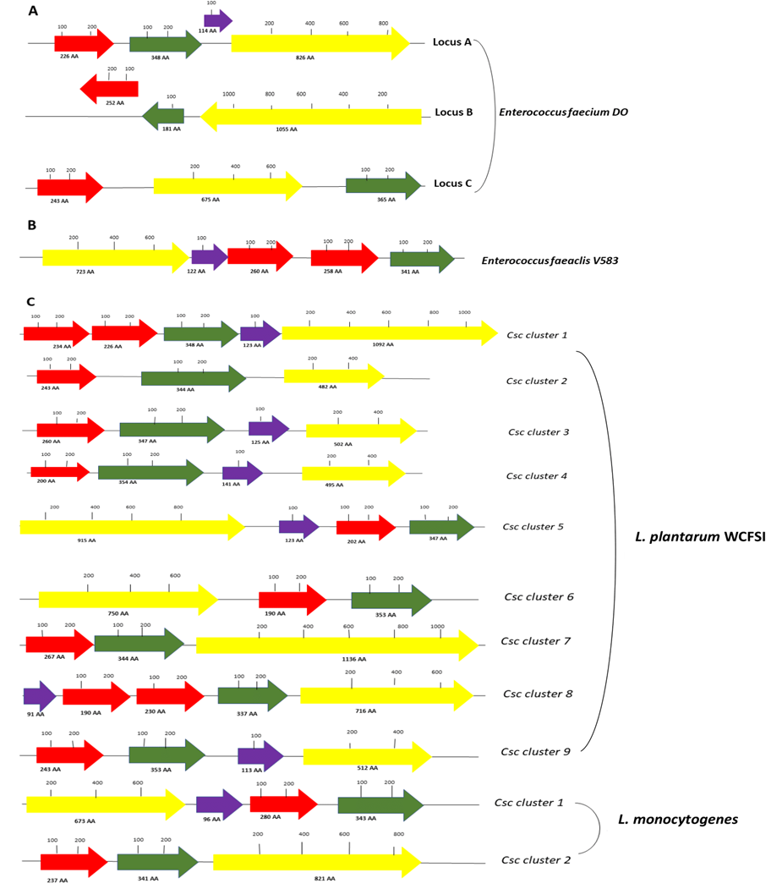
Figure ‎3.2-Schematic representation of genetic loci encoding WxL domain proteins in different species.
Red colour represents Small WxL, green colour represents DUF916, yellow colour represents Large WxL and purple colour represents the domain containing an LPxTG motif. (A) Schematic representation of different clusters in E. faecium DO. (B) Schematic representation of different domains in E. faecalis V583. (C) Schematic representation of different clusters in L. plantarum WCFSI and L. monocytogenes. Domain sizes are drawn to scale.

Domains present in the WxL clusters
To categorize the proteins present in WxL clusters, the characteristics of the proteins were studied using the ProtParam tool within the EXPASY suite, and domain analysis was done using BlastP (https://blast.ncbi.nlm.nih.gov/Blast.cgi?PAGE=Proteins) (McGinnis & Madden, 2004) and Motif finder (https://www.genome.jp/tools/motif/). The BLASTP analysis was done to compare the sequences of different proteins having WxL domains. Small WxL contains only a signal peptide and WxL domain; the starting point of Small WxL domain has been well characterized. However, the Large WxL protein varies from species to species. Large WxL proteins contain several different folded domains, and the exact start of the WxL domain itself is unclear, as shown in Figure 3.3. The blank space between the different domains in Figure 3.3 indicates that Motif finder and BlastP were not able to identify any domains in these regions.

Large WxL domain
In this section, we report on the domain analysis of nine different Large WxL proteins (LwpLB1-LwpLB9) of L. plantarum WCFSI, two large WxL proteins (LwpLM1 and LwpLM2) of L. monocytogenes, three large WxL proteins of E. faecium DO and one large WxL protein of E. faecalis V583. The analysis was thus done on fifteen different Large WxL proteins. According to Expasy Protparam, the Large WxL proteins’ molecular weights range from 50-119 kDa, and most of the Large WxL proteins involved in this study had acidic pI of 4-5 except four proteins which have basic pI (LwpLB3, LwpLB4, LwpLB5 and LwpLB9) as shown in table 3.4.
According to BlastP analysis, LwpLB7 was the longest WxL domain. Motif finder and BLASTP analysis were not able to find any WxL domain in LwpLB6, as shown in table 3.1 and Figure 3.3. The WxL length ranges in proteins from 106-212 only with the exception of the LwpLM2, which contains 39 residues, which is thus the shortest WxL domain among all Large WxL proteins.

Large WxL proteins of L. plantarum WCFSI
Siezen et al. (2006) described that L. plantarum contains nine Large WxL proteins (Siezen et al., 2006). The domain analaysis is as below.

LwpLB1 protein
LwpLB1 protein has only two domains (WxL domain and MotB) detected by Motif finder and BlastP analysis. MotB is short for motility protein B. It is present in the stator of the flagellar motor. MotB, along with MotA, releases energy that is used for flagellar rotation (Aizawa, 2015). No other folded domains were identified in the rest of the sequence.

LwpLB2 protein
LwpLB2 contains two domains: WxL domain and Big_2. Big_2 is an immunoglobulin fold (Ig) protein. Members of this family have been found in bacterial and phage surface proteins such as intimins. Big domains are yet to be attributed a particular role, but Big-containing proteins are often linked to bacterial virulence or adhesion to surfaces and membranes. The Ig-like domain is thought to play a role in cell recognition, attachment, and adhesion processes (Barlag and Hensel, 2015).

LwpLB3 protein
In the case of LwpLB3, BlastP analysis only found a WxL domain.

LwpLB4 protein
LwpLB4 contains two domains, WxL and Big_6, according to the analysis. Big_6 is another IgG-like domain.

LwpLB5 protein
LwpLB5 possesses a WxL domain, a Leucine-Rich Repeats domain (LRR_5), a MucBP domain and a DUF285 domain. The leucine-rich repeat (LRR) domains can be found in around 60,000 proteins, and the leucine-rich repeat is a 20–30 amino acid structural motif with a distinctive repeating sequence pattern rich in leucine. LRR proteins that are involved in protein-ligand and protein-protein interactions include those found in plant immune response and mammalian innate immune response (Matsushima et al., 2010; Bella et al., 2008). LRR are linked to virulence and interact with host proteins (Zhang et al., 2016). Mucin Binding Protein domains (MucBP) are found in many bacterial proteins such as bacterial peptidoglycan binding proteins (Du et al., 2010). Gene clusters encoding multiple extracellular proteins encode MucBP domain containing proteins as well. Most of the proteins have extra domains except one or more copies of MucBP domain that may involve in binding to and degradation of extracellular components (Boekhorst et al., 2006). MucBP domains can be found repeatedly in a wide range of bacterial proteins. Pfam: PF00746 (LPxTG domain) and Pfam: PF00560 (Pfam: PF00560) are frequently present together in bacterial peptidoglycan attached proteins (Leucine-rich repeats domain).

LwpLB6 protein
Analysis of the LwpLB6 protein showed that it contains a MucBP domain and a LRR_5 domain, and a WxL domain. We conclude LwpL5 and LwpLB6 share common domains like MucBP domain and a LRR_5 domain.

LwpLB7 protein
Analysis of the LwpLB7 protein predicts that it contains a WxL domain, but no other domains. It is likely that there are other unidentified domains present, judging by the length of the remaining sequence.

LwpLB8 protein
LwpLB8 protein contains three predicted domains (WxL domain, Lectin_LegB and A2M domain). A2M stands for alpha2 macroglobulin; acting as an antiprotease it can inactivate a large number of proteinases. The main function of A2M is thought to be inhibition of thrombin, and it also acts as a carrier protein to bind to cytokines and a number of growth factors , like PDGF (platelet-derived growth factors) (Sottrup-Jensen, 1989). It is thus likely to act as an adhesion domain.

LwpLB9 protein
In the case of LwpLB9, BlastP analysis only found a WxL domain.
In conclusion, among the nine Large WxL proteins of L. plantarum WCFS1, there is considerable variation in the other domains present, though many of them are involved in some way in protein-protein or protein-peptidoglycan interactions. We can make a tentative conclusion that Large WxL proteins may have a primary function in adhesion.

Large WxL proteins of L. monocytogenes
In L. monocytogenes, Large WxL domains were identified on two different clusters, with quite different architectures (Figure 3.2).

LwpLM1 protein
BLASTP analysis and Motif Finder show that LwpLM1 contains three domains (WxL domain, InIk_D3 domain and LRR_9 domain). The InIk is an internalin K domain (PF18981) (Schubert et al., 2002). By recruiting the Major Vault Protein (MVP) to the bacterial surface, InlK, a surface-associated internalin, has been shown to be essential in the capacity of L. monocytogenes to resist autophagy. The D1, D2, D3, and D4 are the four domains that make up InlK. Internalin domain D1 is made up of a cap and eight leucine-rich repeats. The D1 is preceded by D2, which provides the structure's "elbow," a β-sandwich-like region with fold variations from similar regions in other internalin structures, despite the fact that its structure was previously linked to the PKD domains. The Ig-like domains with a helical character could be represented as D3 and D4 domains. While D1 and D2 have stable association, they have not many contacts with D3, as they are linked by a small, versatile linker that could serve as a hinge. D3/D4 domains might play a specific role in pathogenesis (Neves et al., 2013).

LwpLM2 protein
The LwpLM2 protein consists of a WxL domain and a Big_6 domain. The LwpLM2 contains the shortest WxL domain as compared with other WxL domains.
It can thus be concluded that the L. monocytogenes WxL proteins probably have an assembly/adhesion function, in the same way as those from L. plantarum, although LwpLM1 may well have a specific function not seen in other WxL proteins.

Large WxL proteins of E. faecium DO
Analysis of the clusters present in E. faecium (Figure 3.2) shows that each cluster contains a Large WxL protein.

LwpA protein
BlastP and Motif finder were not successful in finding any other domains within the LwpA protein other than WxL.

LwpB protein
The LwpB protein was predicted to have three domains, i.e., autotransporter adhesin BigA, an IgG-like domain and WxL. Autotransporter adhesin BigA is mostly found in Gram-negative bacteria on the outer membrane and is involved in cell adhesion (Barlag & Hensel, 2015).

LpwC
Motif finder detects four domains in LpwC: DUF3697, a legume-lectin like domain, a MucBP domain and the WxL domain. Legume lectins are the main class of carbohydrate-binding proteins, and legume lectin-like proteins have a wide range of functions, including insecticidal antimicrobial, and antitumor properties. The bactericidal activity of lectins is mediated by associations with N-acetylglucosamine, N-acetylmuramic acid, and tetrapeptides related to N-acetylmuramic acid found in Gram-positive bacterial cell walls, or lipopolysaccharides found in Gram-negative bacterial cell walls (Lagarda-Diaz et al., 2017).

Large WxL proteins of E. faecalis V583
Brinster et al., 2006 showed that there are 27 WxL proteins present in E. faecalis V583 (Brinster et al., 2006). LwpE (EF2686), which comes from E. faecalis, was the best characterized protein as predicted by BlastP analysis; it contains four domains: a cap, an Ig-like domain, a Leucine-rich repeat domain and the WxL domain. ElrA or Enterococcal leucine-rich protein A is another name for the LwpE protein. ElrA belongs to the internalin family, which is why it is also known as E. faecalis V583 internalin-like protein (Nunez et al., 2018). ElrA was identified by leucine-rich repeats (LRRs), and LwpE protein consists of a cap, ten LRRs and the WxL domain, as shown in Figure 3.2. Thus, in common with other Large WxL proteins, its main function seems to be in binding or adhesion.
A striking feature of Figure 3.3 is that the WxL domain is always the C-terminal domain, which means that it is likely to be at one “end” of the protein. One can imagine two completely different reasons for this architecture. The first could be that the WxL domain attaches the Large WxL protein to peptidoglycan, as suggested by several authors (Siezen et al., 2006; Brinster et al., 2006; Bierne & Cossart, 2007; Galloway-Peña et al., 2015; Jamet et al., 2017). This would imply that the WxL domain faces into the cell wall and allows the N-terminal end of the protein to point away from the cell wall, and therefore to interact with extracellular components, such as host proteins. The second reason is the exact opposite: that the N-terminal end of the protein attaches it to the cluster and/or peptidoglycan, thereby allowing the WxL domain to be free to bind to extracellular components. For reasons discussed in Section 3.3, we feel that the first of these is the more likely: that the WxL domain attaches the protein to peptidoglycan, and that the range of other domains found on different proteins provides different opportunities for binding to other extracellular components.
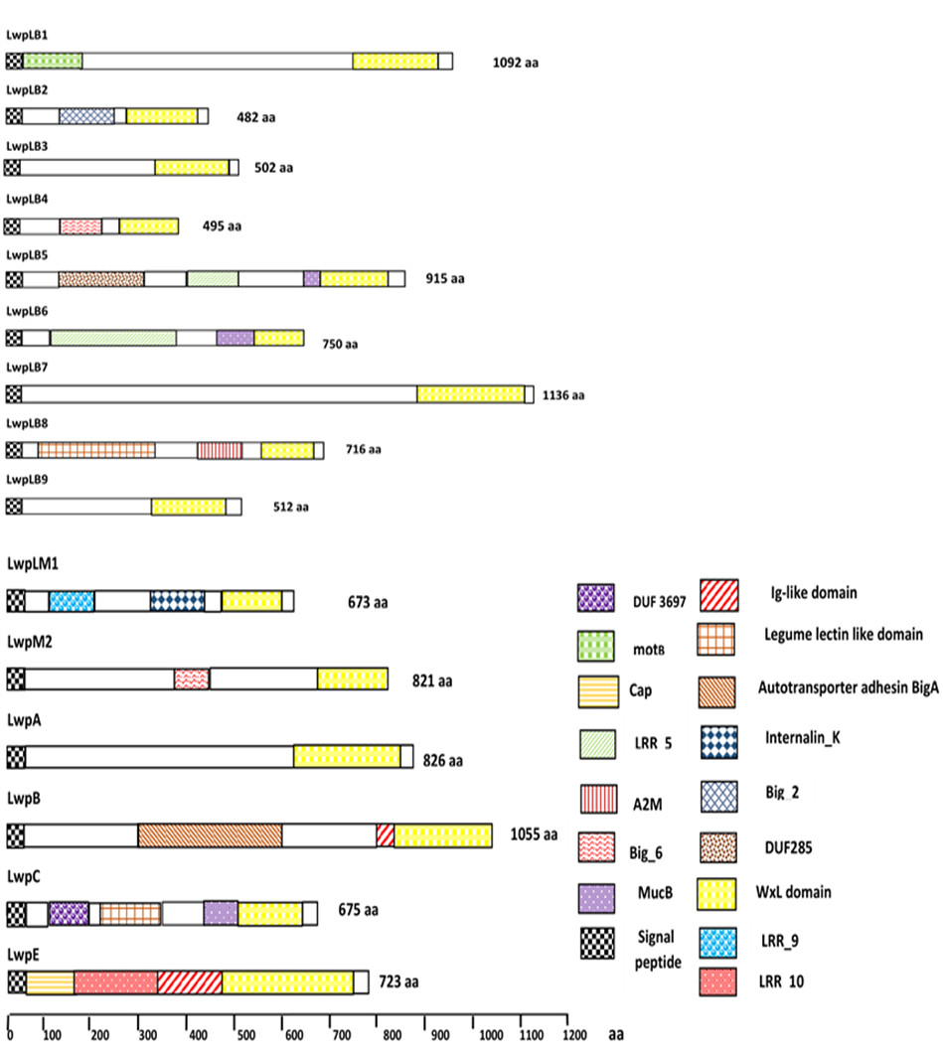
Figure ‎3.3-Schematic representation of BlastP analysis of Large WxL proteins.
LwpLB1, LwpLB2 , LwpLB3, LwpLB4 , LwpLB3, LwpLB4, LwpLB5, LwpLB6, LwpLB7, LwpLB8 and LwpLB9 stands for large WxL of L. plantarum WCFS1 from cluster 1 to 9, LwpM1 stands for large WxL of L. monocytogenes cluster 1, LwpM2 stands for large WxL of L. monocytogenes cluster 2, LwpA the locus A of Large WxL of E. faecium DO, LwpB the locus B of Large WxL of E. faecium DO, LwpC the locus C of Large WxL of E. faecium DO, LwpE represents the Large WxL of E. faecalis V583, LRR represents the leucine-rich repeats, EssA represents WXG100 protein secretion system, MucBP represents the Mucin binding protein domain, and Duf3697 represents the ubiquitin-associated protein 2.

Table ‎3.4-Position of different domains within different Large WxL proteins and detected by BlastP analysis and Motif Finder.
∗N. A: not applicable.

Small WxL proteins
This section is about Small WxL proteins of L. plantarum WCFS1 (SwpLB1-SwpLB9), L. monocytogenes (SwpLM1, SwpLM2), E. faecium DO (SwpA-C) and E. faecalis V583 (SwpE1-2), as shown in Figure 3.4.
The Small WxL proteins are called Small WxL protein because of the size of the protein; it contains an N-terminal signal peptide and WxL domain only, while no other domains are present in any Small WxL proteins. The WxL domains are from 164-246 residues in size (18.5 – 28.7 kDa), though according to Siezen et al. (2006), the WxL domains in Small WxL proteins are about 160-190 residues long (Siezen et al., 2006). The lengths of the WxL domain in Small WxL proteins are longer as compared to those in Large WxL proteins, though as noted in Section 3.3.1, it is not always clear where the WxL domain starts in some of these proteins. The Small WxL proteins have acidic pI (4-5); only SwpLB1a has a predicted pI close to neutral, namely 6.70; Siezen et al. (2006) also reported that it has an acidic pI.
According to domain analysis, clusters 1 and 8 of L. plantarum WCFS1 contain two Small WxL proteins each: SwpLB1a, SwpLB1b, SwpLB8a and SwpLB8b. The E. faecalis V583 WxL cluster also contains two Small WxL proteins SwpE1 and SwpE2. Siezen et al. (2006) placed LwpLB1 and LwpLB7 in the category of Small WxL proteins (Siezen et al., 2006), but according to the analysis done in this study, these two proteins should be removed from this group and placed into the Large WxL protein category.
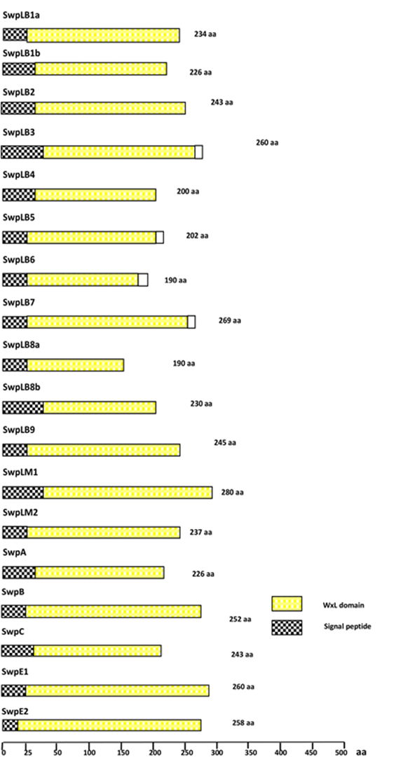
Figure ‎3.4 -Schematic representation of Small WxL proteins.
SwpLB1a to SwpLB9 stand for Small WxL protein of clusters 1 to 9 of L. plantarum WCFS1; SwpLM1 and 2 stand for Small WxL protein on cluster 1 and 2 of L. monocytogenes; SwpA SwpB and SwpC stand for locus A, locus B and locus C of Small WxL protein of E. faecium DO; SwpE1 and SwpE2 are two small WxL proteins of E. faecalis V583.
Table ‎3.5-Characteristics of Large WxL and Small WxL proteins

Domain of Unknown Function proteins
So far, we have discussed the Small WxL and Large WxL domains, and the other proteins found encoded with them in ORFs within the WxL clusters. The proteins coloured in green in Figure 3.2, named DUF916 proteins, are always present within the cluster. They are often adjacent to a Small WxL protein, though not in every case. The fact that these proteins are always present suggests that they may be important for the function of the cluster. DUF stands for Domain of Unknown Function. These are sequence motifs identified in several predicted ORFs and are therefore expected to have a conserved but so far unknown function. It is likely that some DUFs have no biological function, being pieces of DNA passed around between species. A study reported that 20% of proteins are annotated as DUF proteins (Zhao et al., 2014).
The DUF proteins included in this study are from L. plantarum WCFS1 (DUFLB1-DUFLB9), L. monocytogenes (DUFLM1 and DUFLM2), E. faecium DO (DUFA, DUFB and DUFC) and E. faecalis V583 (DUFE). The size of DUF proteins ranges from 341 to 365 residues in length with the exception of DUFB protein which was the smallest protein at 181 residues in length while according to Siezen et al. (2006) these DUF proteins are 320-380 residues long (Siezen et al., 2006). The molecular weight of DUF proteins is between 37-42 kDa with the exception of DUFB protein which has a molecular weight of 20.2 kDa. The pI of DUF proteins from L. plantarum WCFS1 and L. monocytogenes is highly basic from around 8 to 11 while DUF proteins from Enterococcus species had acidic pI of 5.1 to 6.8, as shown in Table 3.4. Siezen et al. (2006) also reported that DUF proteins from L. plantarum WCFS1 specie are predicted to be highly basic proteins (Siezen et al., 2006).
Figure 3.5 shows that there are several different DUF domains present in different species. Almost all the proteins containing a DUF916 domain also contain a DUF3324 domain, sometimes in combination with other domains. This would therefore seem to be the conserved structure. According to domain analysis, the position of DUF916 in the different DUF proteins is about residues 29-163. This means that DUF916 is well conserved, as shown in Table 3.3. It is worth noting that all the proteins that contain a DUF916 domain have it as the N-terminal domain. This suggests that there may be a functional importance in having it in an N-terminal position. The position of DUF3324 is 160-307, and the length of this domain varies from 133-153 residues. Where both DUF916 and DUF3324 occur (ie in every protein except DUFB which does not have a DUF916), the DUF3324 occurs immediately after DUF916. This could be important for the function of the protein.
Many of the proteins shown in Figure 3.5 consist simply of an N-terminal signal sequence (to ensure that the protein is secreted outside the cell), followed by DUF916 and DUF3324 domains, with short additional sequences predicted to be unstructured. Some of them contain additional domains. We now consider the proteins in more detail.

DUF protein of L. plantarum WCFS1
Siezen et al. (2006) had shown that L. plantarum WCFS1 contain nine DUF proteins and their description is below.

DUFLB1 and DUFLB2 proteins
According to analysis done by BlastP and Motif finder, DUFLB1 and DUFLB2 are composed of two domains DUF916 and DUF3324.

DUFLB3 protein
The DUFLB3 protein consists of three domains: DUF916, DUF3324 and Hum_adeno_E3A domain. Human adenovirus causes infections in patients who are immunosuppressed and have T-lymphocyte deficiencies (Yakimovich et al., 2012). The genome of the virus consists of five transcriptional units (E1A, E1B, E2, E3 and E4) (Zhao et al., 2014) . E3 is expressed at low concentration earlier in infection and at very high levels later in disease, while the E1A and E1B proteins are required for the expression of all other viral proteins, and are encoded in the E1 region (Yakimovich et al., 2012). On this basis, the Hum_adeno_E3A domain seems unlikely to have any important function, although it does indicate that it is not essential to have the DUF3324 domain at the C-terminus.

DUFLB4 protein
According to the analysis, DUFLB4 protein contains three domains: DUF916, DUF3324 and DUF4064. DUFLB5 also contains three domains: DUF916, DUF3324 and DUF485.

DUFLB6, DUFLB7 and DUFLB8 proteins
The DUFLB6, DUFLB7 and DUFLB8 proteins also consist of three domains: DUF916, DUF3324 and DUF4381, as shown in Table 3.6. The additional DUF domains at the C-terminus are again likely to have nonessential functions.

DUFLB9 protein
According to analysis DUFLB9 protein consists of two domain DUF916 and DUF3324 domain.

DUF proteins of L. monocytogenes
Two DUF proteins were found in L. monocytogenes.

DUFLM1 protein
According to BlastP analysis and Motif Finder, DUFLM1 protein consists of three domains: DUF916, DUF3324 and DUF2062.

DUFLM2 protein
According to analysis, DUFLM2 protein consists of DUF916, DUF3324 and TMEM51 domain. TMEM51 stands for the transmembrane protein 51 of humans, and this protein is encoded by the TMEM51 gene (Tamiola, 2019). The annotated DUF916 and DUF3324 domains in DUFLM2 are anomalously short, suggesting that there may be a problem either with the functionality of this protein or with the annotation.

DUF proteins of E. faecium DO
Galloway-Peña et al., 2015 reported that E. faecium DO consists of three DUF proteins (Galloway-Peña et al., 2015).

DUFA protein
According to the analysis, the DUFA which is present on E. faecium DO consists of three domains: DUF916, DUF3324 and STEVOR domain. The term STEVOR is an acronym for Subtelomeric Variable Open Reading Frame. STEVOR is a parasitic protein that recognises glycophorin C on the red blood cell surface and binds to the erythrocyte binding protein (Naissant et al., 2016). STEVOR is found in a variety of parasite stages, such as merozoites, implying that it plays a role in the parasitic infection cycle (Niang et al., 2014). It is possible that STEVOR was acquired by horizontal gene transfer.

DUFB protein
According to Blast P analysis, DUFB is the only ORF in this list that does not contain a DUF3324 domain, and it only contains DUF916.

DUFC protein
According to Motif finder and Blast P analysis, DUFC contain two domains i.e, DUF3324 and DUF916 domain.

DUF protein of E. faecalis V583
The DUFE which is present on E. faecalis V583 consists of the three domains DUF916, DUF3324 and ORF78. In the Autographa californica multiple nucleopolyhedrovirus (AcMNPV), ORF78 (ac78) is a baculovirus core gene (Li et al., 2014). The ac78 is necessary for budded virion (BV) production and the entrenching of the occlusion-derived virion (ODV) into occlusion bodies during the AcMNPV life cycle (Li et al., 2014). It is likely that this gene was acquired from the virus at some point. It would not appear to have an important bacterial function.
In summary, DUF916 is present almost universally in the WxL cluster. It is always present at the N-terminus of the expressed protein and is usually followed by a DUF3324 domain. There are sometimes additional domains present, but these do not seem to be important for the function of the protein.
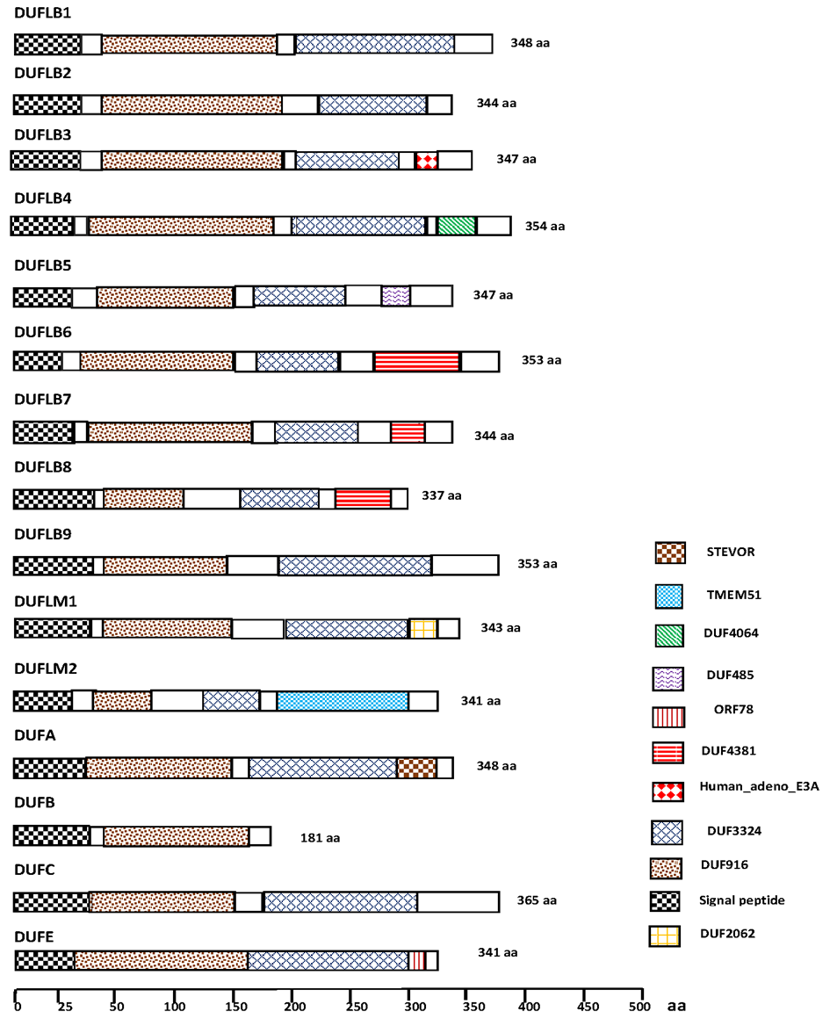
Figure ‎3.5-Schematic representation of DUF proteins.
DUFLB1 to B9 stand for DUF protein of L. plantarum WCFS1 (Cluster 1 to 9); DUFLM1 and DUFLM2 stand for DUF protein of L. monocytogenes from cluster 1 and 2, respectively; DUFA, DUFB and DUFC of E. faecium DO from Locus A to C; and DUFE of E. faecalis V583.

LPxTG proteins
Most of the Gram-positive bacteria encode proteins with an LPxTG domain. The LPxTG motif is followed by a hydrophobic domain and a positively charged tail, where x can be any amino acid (Hendrickx et al., 2009). Sortase enzymes recognise the LPxTG sequence and cleave between the T and G residues to bind the LPxTG protein to the nascent PG. Sortases latch this motif onto the NH2 group of the amino acid at position 3 in the PG peptide stem based upon the PG nature (Dramsi & Bierne, 2016). As shown in Figure 3.6, LPxTG is not present in all proteins having WxL domains: in L. plantarum strain WCFS1, it is present only in Clusters 1, 3, 4, 5, 8 and 9. In E. faecium DO, it was present on Locus A and in E. faecalis V583 it is also present.
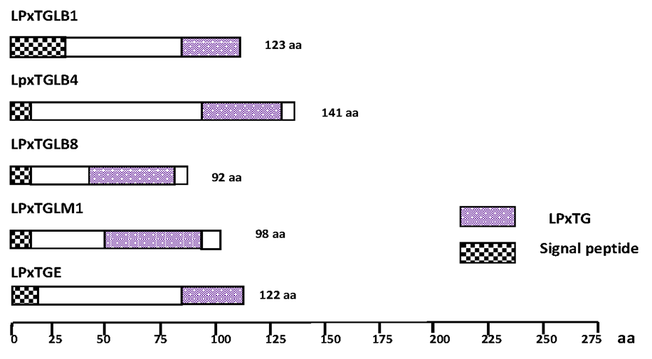
Figure ‎3.6-Schematic representation of LPxTG proteins.
LpxTGLB1 to B9 represent LPxTG proteins of L. plantarum WCFS1; LPxTGLM1 stands for LPxTG protein of L. monocytogenes, LpxTGA of locus A of E. faecium DO; and LpxTGE of E. faecalis V583.

Table ‎3.6-Position of different domains within different Small WxL proteins, DUF and LPxTG proteins and detected by BlastP analysis and Motif Finder.
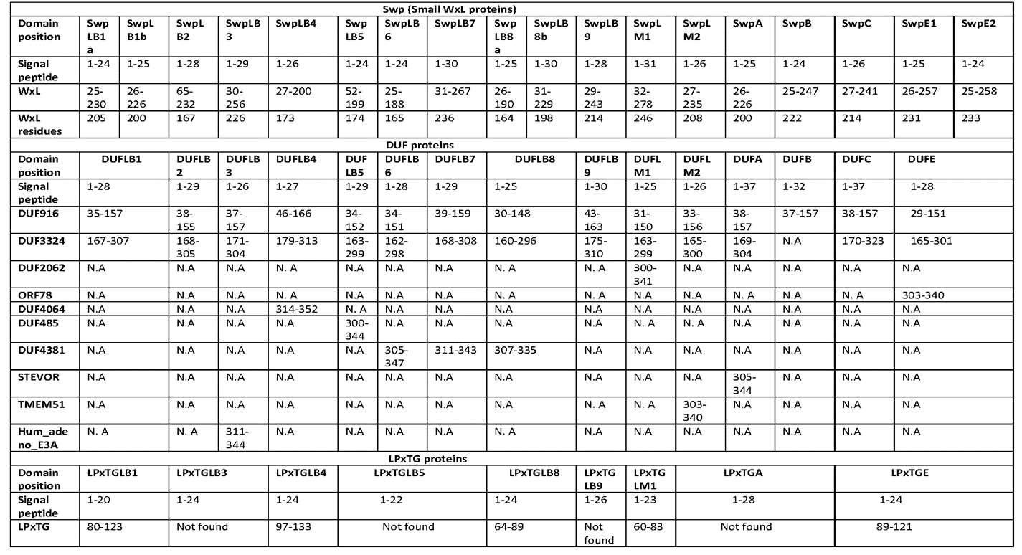
∗N. A: not applicable.

Table ‎3.7-Characteristic of DUF proteins and LpxTG proteins

Comparative analysis of WxL, DUF916 and DUF3324 proteins

WxL proteins
The 33 WxL protein sequences were compared using the Muscle server (https://www.ebi.ac.uk/Tools/msa/muscle/) to analyse the distance between the two WxL motifs in these proteins (Edgar, 2004). About 68 and 106 amino acids separated the two WxL motifs in Large and Small WxL, except for three proteins: 14 amino acids for LpwLM2, 5 amino acids for SwpLB4 and 7 amino acids for LwpLB9 (Figure 3.7). There are different conserved sequences surrounding the two WxL motifs. In the second motif, residue x is small and hydrophilic, but it is more variable in the first motif.
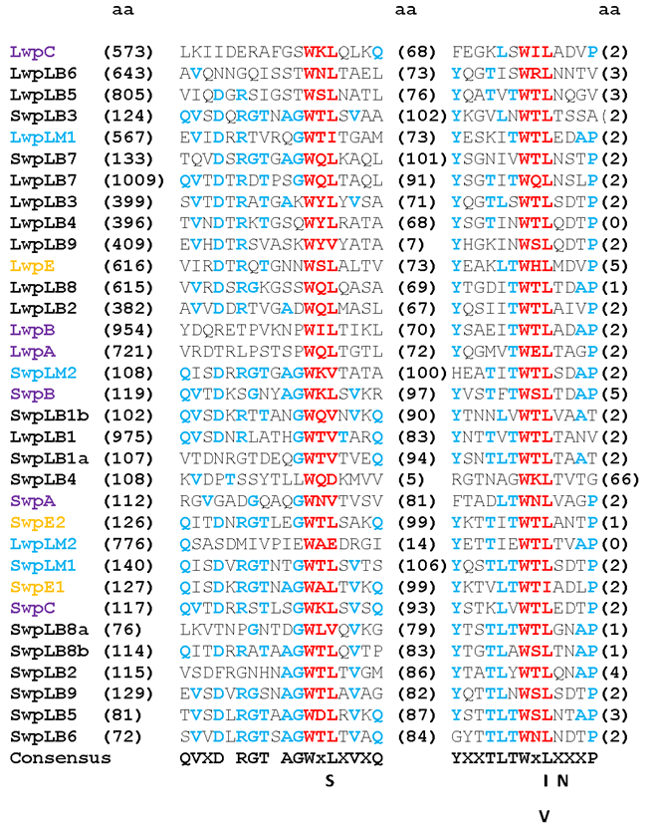
Figure ‎3.7-Multiple sequence alignment of 33 WxL proteins of different species using MUSCLE.
The WxL motifs are in red. The distance between two WxL motifs are indicated in parentheses. Amino acids that are identical or similar are highlighted in sky blue.

The EF2686 protein of E. faecalis is the best characterised WxL (Nunez et al., 2018; Jamet et al., 2017; Brinster, et al.,2006). There was low sequence similarity identified in these studies because all species have a Small WxL domain, and sequence conservation between Small and Large WxL domains is minimal. When multiple sequence alignment was done between Enterococcus species (E. faecalis and E. faecium), the analysis showed that the WxL protein sequence from EF2868 shows similarity with the Large WxL protein of E. faecium as expected because E. faecium contains a Large WxL domain as shown in Figure 3.8. It was concluded that the WxL domain from EF2868 protein was a Large WxL domain. Highly conserved residues were found before SST(S⁶⁰²) (i.e. Glycine (G), proline (P) and phenylalanine (F), implying that the WxL domain starts before the SST sequence as shown in Figure 3.8B.
Brinster et al. (2007) reported that ElrA (E. faecalis LwpE) contains several different domains as described in Figure 3.8A; an N-signal peptide, cap, LRR (leucine-rich repeat), Ig-like, FHL2 interaction domain (FID domain) and a WxL domain (Brinster et al., 2007). The cap domain is predicted to be folded but has no obvious function or homology to known proteins. LRRs are well characterised protein interaction domains and have been found in several Large WxL proteins, as described in Section 3.4.1. As per Brinster et al. (2007), LRR interacts with a host ligand. FHL2 interacts with a variety of proteins, including transcription factors, transmembrane receptors, and transcription co-regulators, enzymes, and structural proteins, to name a few. FHL2, which controls intracellular signal transduction pathways involved in a wide variety of cellular activities, regulates the activity of these proteins (Tran et al., 2016). LIM is a protein that is only found in LIM. FHL2 (four-and-a-half LIM domain protein 2) is a transcriptional cofactor that can be used in a variety of cell lines. FHL2 interacts with a number of transcription factors that have been linked to cancer growth (Kleiber et al., 2007) . The interaction with human FHL2 was reported in 2017 (Jamet et al., 2017) based on yeast two-hybrid and biochemical assays and was localised to the FID region using a series of deletions. As a result, Jamet et al. (2017) proposed to subdivide the WxL domain into two, which they named FID (FHL2 interaction domain) and C-WxL. Deletion of FID led to a reduction in virulence. This demonstrates the importance of this region for virulence, and a likely role in FHL2 binding, but does not conclusively demonstrate that FID and C-WxL form two separate domains (Jamet et al., 2017). Indeed, our sequence analysis (section 3.4.1) does not provide evidence for a clear domain boundary here.
Nunez et al. (2018) further explored the role of ElrA in the biology of E. faecalis and its infectivity. They saw few obvious phenotypes: no change in E. faecalis surface charge or cell wall composition, no major change in biofilm formation, and a reduction in interactions with phagocytes, this being due to impaired migration of macrophages. This impaired migration was not caused by the FID-FHL2 interaction (Nunez et al., 2018). The paper does not carry out any investigation of the roles of FID and C-WxL separately. The authors conclude that ElrA may act as an “anti-phagocytic cloak”, not involving interaction with FHL2. Published evidence for separate functions of FID and C-WxL is therefore inconclusive.

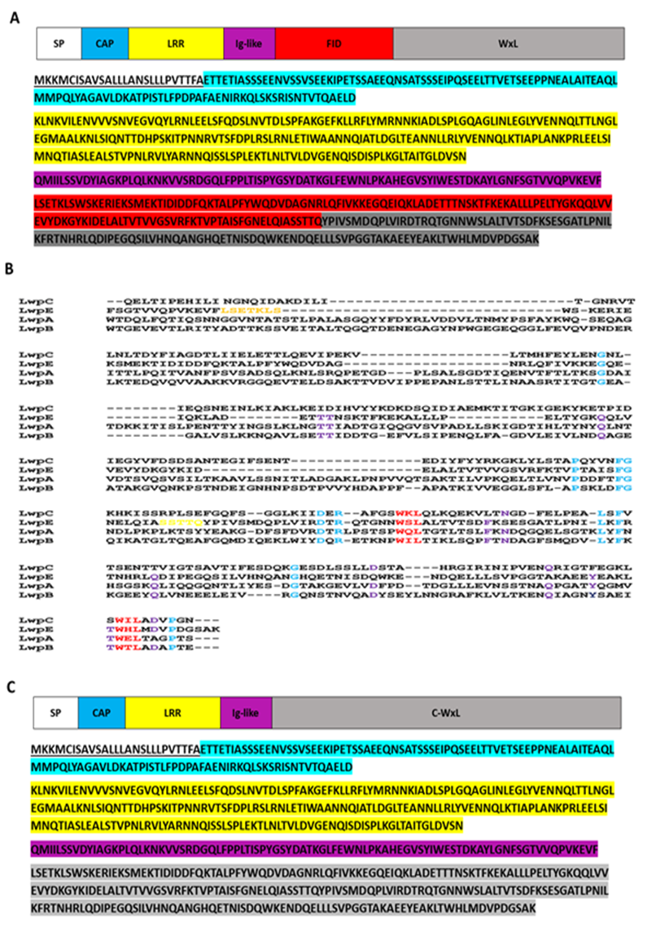
Figure ‎3.8-Schematic representation and sequence alignment of ElrA (LwpE) protein of E. faecalis V583.
(A) Representation of Large WxL LwpE. The underlined sequence represents the signal peptide, sequence highlighted in Cyan represents the cap, Leucine-Rich Repeat (LRR) are highlighted in yellow, Ig-like sequence is highlighted in purple, FHL2 interaction domain (FID) is highlighted in red and WxL domain is highlighted in grey. (B) Sequence alignment of Large WxL. (C) Alternative representation of Large WxL (LwpE). The underlined sequence represents the signal peptide, sequence highlighted in Cyan represents the cap, Leucine-Rich Repeat (LRR) are highlighted in yellow, Ig-like sequence is highlighted in purple, and C- WxL domain is highlighted in grey.

DUF proteins
BLASTP analysis of DUF proteins (Section 3.4.3) showed that DUF916 was the most conserved domain; so, sequence analysis was done to check the consensus residues. Analysis of the gene clusters containing WxL domains showed that DUF916 was systematically present, as shown in Figure 3.11. Sequence alignment of DUF916 revealed that it contains a highly conserved sequence NQIDK close to the N-terminus as shown in Figure 3.9 and 3.11.
As shown in Figure 3.11, DUFB is shorter as compared with other DUF domains, while the other DUF domains have extra sequence at the C-terminus, highlighted in sky blue, which is the DUF3324 domain. DUFB does not contain the DUF3324 domain. Figure 3.10 shows the alignment of the DUF3324 domain.
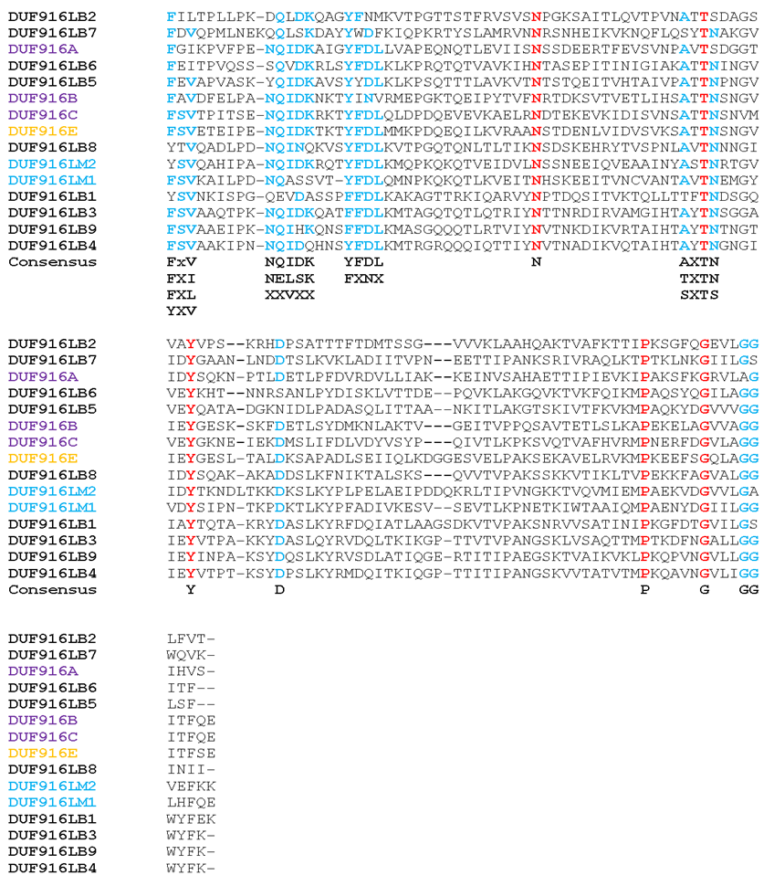
Figure ‎3.9-Sequence alignment of DUF916 from different species.
Highly conserved residues are highlighted in red and partially conserved sequences are highlighted in sky blue. DUF916LB1 to DUF916LB9 are DUF protein from L. plantarum WCFS1, DUFLM1 and DUFLM2 are DUF proteins from L. monocytogenes EGD-e, DUF916A, DUF916B and DUF916C are from E. faecium DO; and DUF916E is from E. faecalis V583.

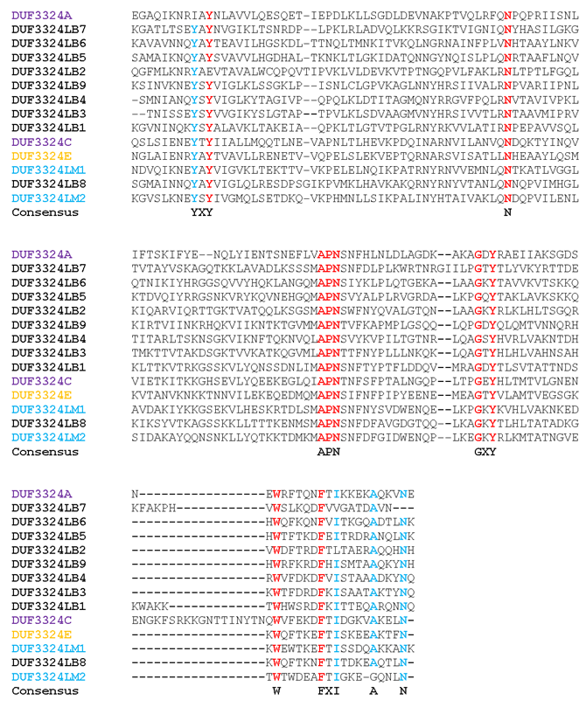
Figure ‎3.10-Sequence alignment of the DUF3324 domains by MUSCLE.
Highly conserved residues are highlighted in red and partially conserved sequences are highlighted in sky blue. DUF3324LB1, DUF3324LB2, DUF3324LB3, DUF3324LB4, DUF3324LB5, DUF3324LB6, DUF3324LB7, DUF3324LB8 and DUF3324LB9 stands for DUF protein of L. plantarum WCFS1, DUFLM1 and DUFLM2 stands for DUF protein of L. monocytogenes, DUF3324A, DUF3324B and DUF3324C of E. faecium DO; and DUF3324E of E. faecalis V583.
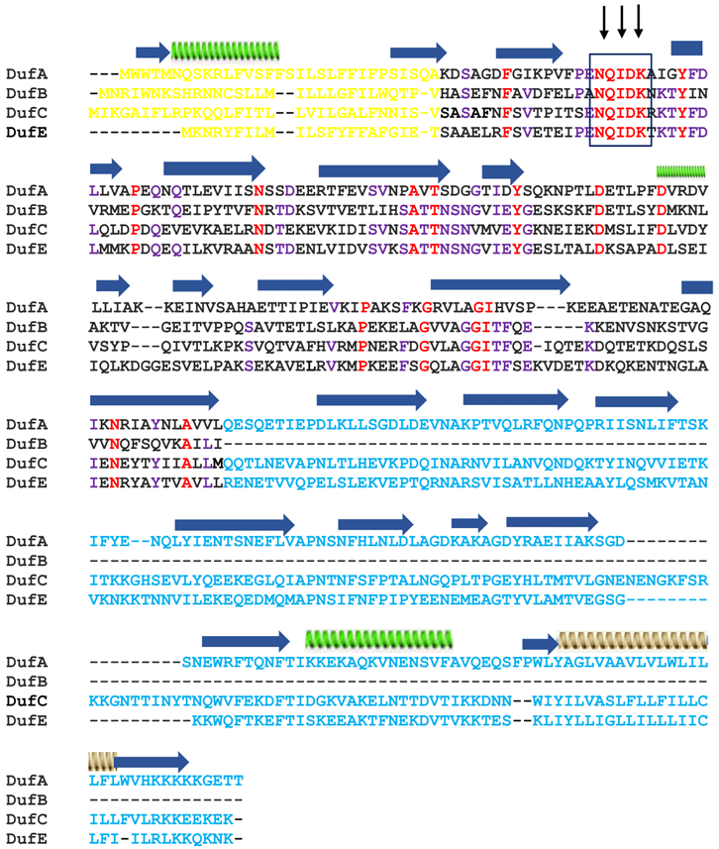
Figure ‎3.11-Multiple sequence alignment of DUF from E. faecalis V583, and E. faecium DO.
DufA, DufB and DufE represent the Duf916 from Locus A, B and C of E. faecium DO, and DufE represents the DUF916 from E. faecalis V583. The sequence highlighted in yellow represents the N-signal peptide, the conserved sequence regions are highlighted in red, the sequence with one variation is highlighted in purple, the highly conserved sequence is in the box (NQIDK), and sequence highlighted in sky blue is not present in DUFB. β-strands are shown as arrowed blue ribbon, green spiral represent the α-helix, and brown spiral represents the TM (transmembrane) helix.

Phyre2 analysis
Having analysed the sequences of domains in the WxL cluster, we are now in a position to see what structure prediction tools can tell us about the likely 3D structures of the domains. Our initial analysis is based on Phyre 2, which uses sequence homologies to known structures as its main tool for modelling structures (Kelley et al., 2015). It matches the longest contiguous sequences that it can find. It places a confidence value on the prediction, and also reports on which residues were used for the match.
Phyre 2 predictions were carried out for most of the domains discussed above. None of these has a published structure. The most confident predictions were for the DUF proteins. Phyre 2 predictions on Small WxL and Large WxL domains were inconclusive. Phyre 2 produced a number of matches of small parts of the sequence to known proteins, but with low confidence. For example, SwpC is predicted with a confidence of 82.7%, but only for 35% of protein coverage. Because our BlastP analysis suggests that Small WxL is a single domain, our overall confidence in the Phyre 2 prediction is low. The Phyre 2 predictions are shown in Figure 3.12.

WxL proteins structure prediction
Phyre2 analysis of LwpA proteins indicated that a section of this protein modelled to Human coronavirus hku1 haemagglutinin esterase with 27.7% confidence for 6% protein coverage while according to an analysis carried out by Galloway-Peña et al., 2015, LwpA proteins modelled to Concanavalin A (ConA)-like lectin with structural confidence of 100% for 30% protein coverage. Galloway-Peña et al. (2015) discovered ConA-like lectin domains in bacterial proteins implicated in cell recognition and adhesion. Hemagglutinin-esterases (HEs) are a type of viral envelope glycoprotein that acts as a lectin as well as a receptor-destroying enzyme to promote reversible binding to O-acetylated sialic acids (RDEs). Influenza C, toro-, and coronaviruses all have related HEs, presumably as a result of recent lateral gene transfer events (Zeng et al., 2008). Galloway-Peña et al., 2015 concluded that Phyre2 analysis could not model SwpA, LwpA, or SwpC with any confidence. By using Dis-EMBL, Galloway-Peña et al., 2015 predicted that all three proteins (SwpA, LwpA and SwpC) were highly disordered. Our analysis by Phyre2 also suggests that Small WxL proteins present in Enterococcus contain a significant amount of highly disordered sequence, as shown in Table 3.8. The predicted structures are inconsistent and do not cover enough of the sequence to be convincing (Figure 3.12).

DUF proteins structure prediction
DUFA, DUFC and DUFE have similar length and domain organisation. They consist of an N-terminal signal sequence, a DUF916 domain, and a DUF3324 domain. The Phyre 2 predictions all confidently model the DUF3324 domain as similar in structure to DUF916, ie as a second Ig-like domain. DUF916 and DUF3324 have different sequence but they have a similar Ig-fold structure as shown in Figure 3.11. The multiple sequence alignment of DUF proteins discussed in Section 3.5.2 and Figure 3.11 shows that DUF3324 domain is not present in DUFB proteins; consistently with this, the Phyre 2 analysis shows that DUF proteins contains two Ig folds; one Ig-like domain belongs to DUF916 and the other belongs to DUF3324. This is a β-sandwich structure, consisting of two beta sheets facing each other (or alternatively a single β-sheet, folded back on itself, because one edge of the sandwich has hydrogen bonds linking both sheets). This is a common protein fold, found in a wide range of proteins with a wide range of functions. Thus, the structure does not give an immediate clue as to the biological function of DUF916. DUFB has only one Ig-like fold which corresponds to DUF916 domain.
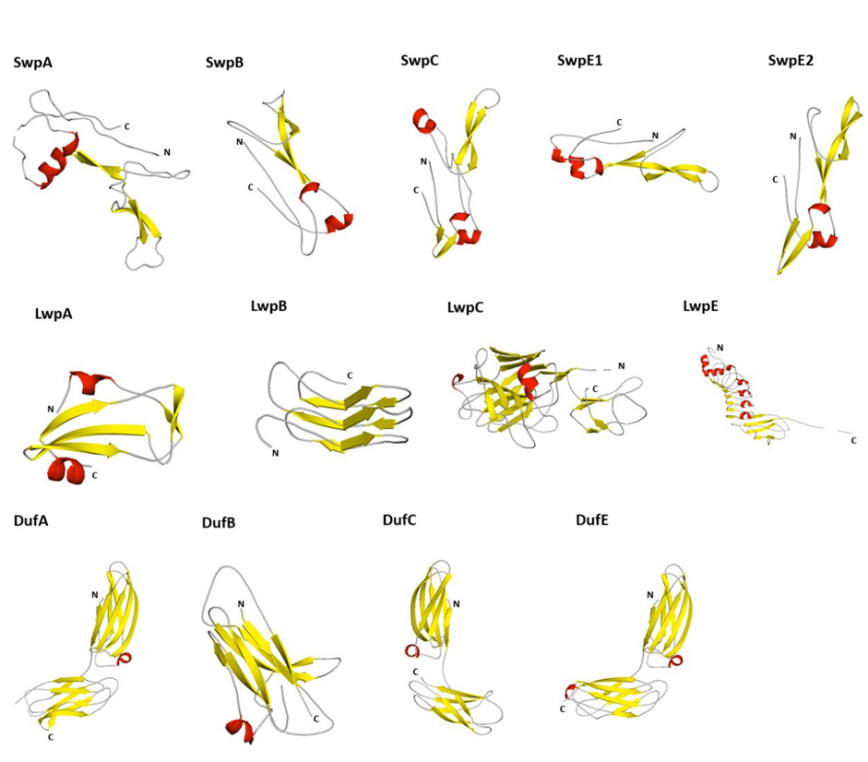
Figure ‎3.12-Structure prediction of Enterococcal WxL proteins by Phyre 2.
Small WxL (SwpA) of locus A of E. faecium DO, Small WxL (SwpB) of locus B of E. faecium DO, Small WxL (SwpC) of locus C of E. faecium DO, Small WxL (SwpE₁) of E. faecalis V583, Small WxL (SwpE₂) of E. faecalis V583, Large WxL (LwpA) of locus A of E. faecium DO, Large WxL (LwpB) of locus B of E. faecium DO, Large WxL (LwpC) of locus C of E. faecium DO, Large WxL (LwpE) of E. faecalis V583, DUFA of locus A of E. faecium DO, DUFB of locus B of E. faecium DO, DUFC of locus C of E. faecium DO and DUFE of E. faecalis V583.The prediction was done in June 2020.
Table ‎3.8-Phyre2 analysis of Enterococcal proteins having WxL domain.
∗N. A: not applicable. A prediction confidence below 75% was not trusted. LwpA. SwpA and SwpE2 have low predictions highlighted in red and DUF proteins have excellent predictions highlighted in sky blue with excellent protein coverage.

Robetta structure analysis
Because the Phyre2 analysis did not give full protein coverage, the structure was analysed through Robetta. The Robetta results were more convincing compared to Phyre 2 predictions as it gave 100% protein coverage as shown in Table 3.8. Robetta is an internet service tool based on the structure prediction program Rosetta. Transformed restraint Rosetta (Tr Rosetta) claims to model every protein in the pfam database (El-Gebali et al., 2019). A model which has score 60% or greater is considered as a sensible model but models that score above 80% are excellent models. Most of the models predicted by trRosetta have scores higher than 70% (Yang et al., 2020; Kim et al., 2004).
Galloway-Peña et al., 2015 were not able to model LwpA, SwpA or SwpC. They subsequently ran DisEMEBL and concluded that these proteins are highly disordered proteins, but according to our analysis through Robetta, these proteins are not disordered proteins, as shown in Figures 3.16 and 3.17.

WxL protein structure prediction
Robetta predicts Large WxL with scores from 48% to 63%; the best Robetta model is LwpB as shown in Figure 3.13. For Small WxL, Robetta model prediction scores range from 67% to 74%; SwpA showed 73% confidence which is the best structure among all Small WxL proteins. As shown in Figures 3.15 and 3.16, all predicted Large WxL domains can be superimposed reasonably well, and all Small WxL domains can also be superimposed, demonstrating a common predicted fold for Large WxL (Figure 3.16) and a different predicted fold for Small WxL (Figure 3.15).
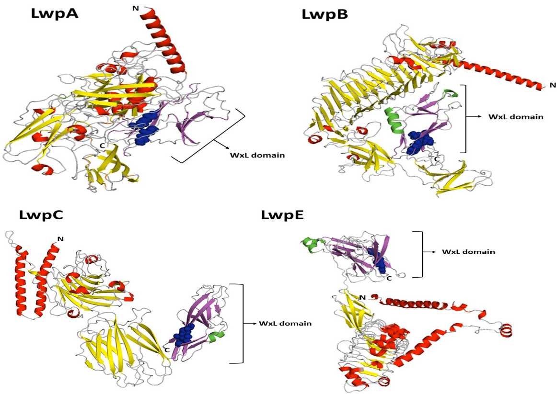
Figure ‎3.13-Robetta analysis of Large WxL proteins.
WxL domain beta sheets are coloured in purple and alpha helix is coloured in green. The structures were predicted in April 2021. Blue spheres represent the two WxL motifs.
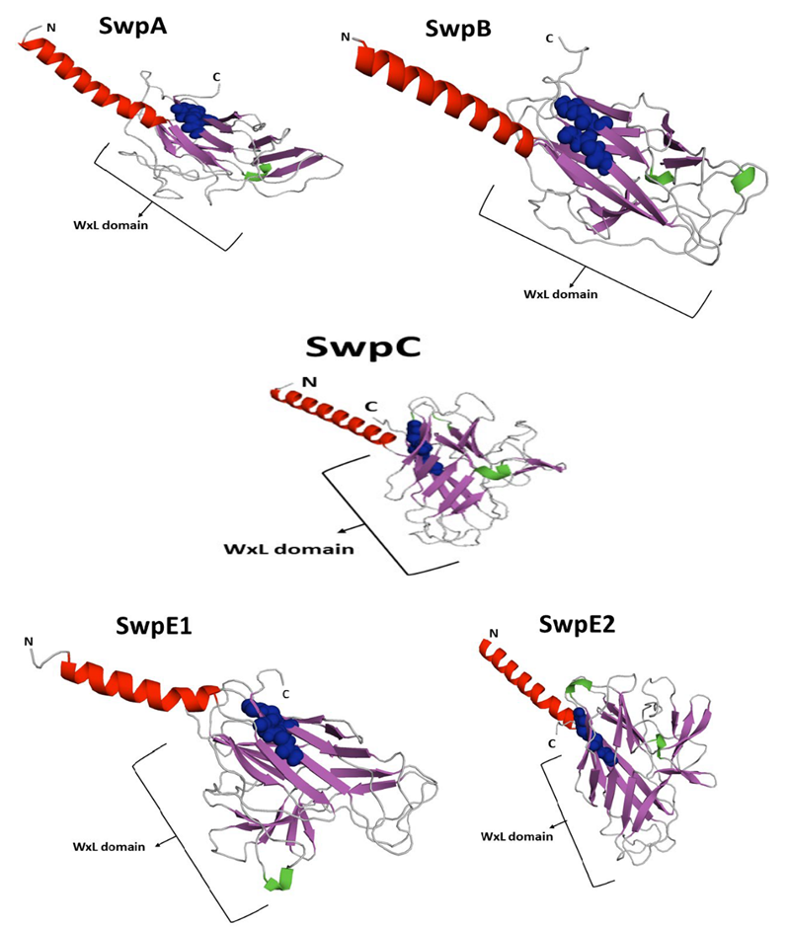
Figure ‎3.14-Robetta structure prediction of Small WxL protein.
WxL domain beta sheets are coloured in purple and alpha helix is coloured in green. The predicted structure was obtained from April 2021. N-terminal alpha helix in red colour represents the N-signal peptide. The spheres in blue colour are the two WxL motifs.

Figure ‎3.15-Robetta structure prediction of Small WxL domain. At bottom right is a superimposition of the five predicted structures, showing good overall agreement.
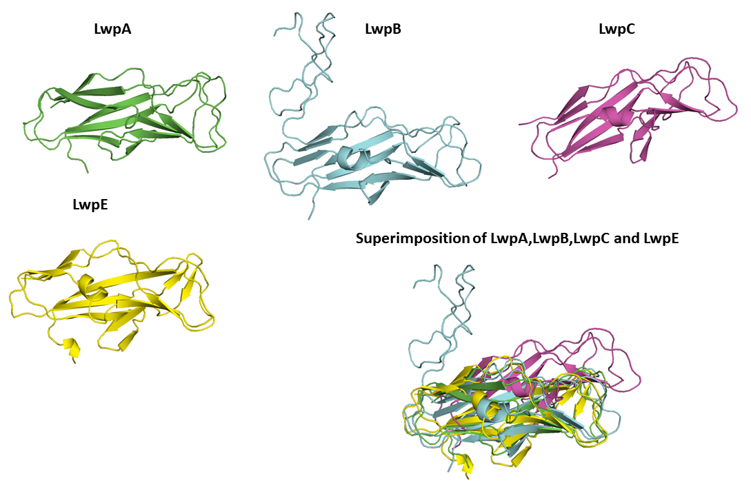
Figure ‎3.16-Robetta structure prediction of Large WxL domain. At bottom right is a superimposition of the four predicted structures, showing good overall agreement.

DUF protein structure predictions
Robetta had higher prediction confidence about all DUF proteins except DUFA, which had a structure prediction confidence below 70%, as shown in Figure 3.18.

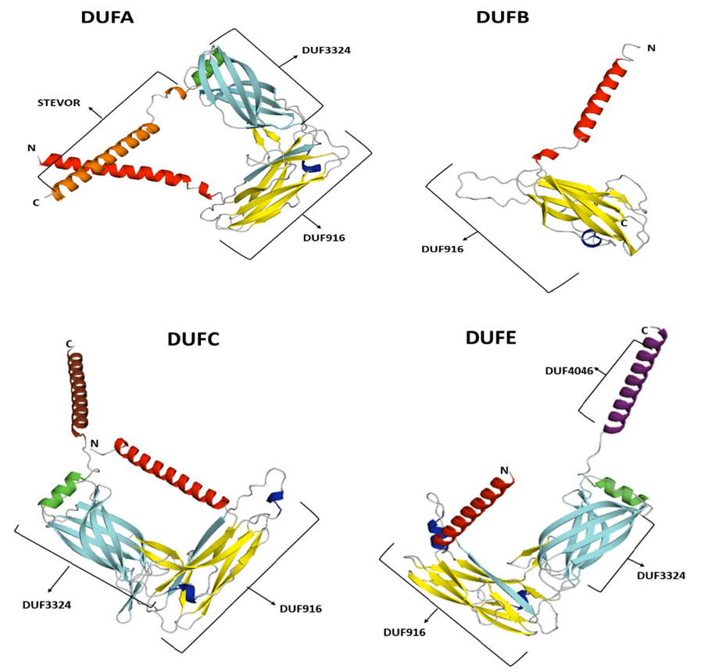
Figure ‎3.17-Robetta prediction of DUF proteins.
Signal peptide is the alpha helix highlighted in red colour. The alpha helix in brown is unknown protein. The predicted structures were obtained in April 2021.

It is concluded from both Phyre 2 and Robetta predictions that WxL domain is composed of mostly beta sheets (52%), 7% alpha helix, 4% turns and the remaining 37% is disordered. It seems reasonable to expect that some of the region predicted as disordered in fact forms beta sheet.

Table ‎3.9- Robetta analysis of Enterococcus proteins having WxL domain.

Detailed structure analysis of WxL domain from LwpE
We looked in more detail at structure predictions for LwpE, which was more interesting. Phyre 2 was given the complete WxL domain sequence (250 residues), but structure prediction was made only for the 120-residue C-terminal end, corresponding roughly to Brinster et al’s C-WxL (Figure 3.18). The C-WxL domain was predicted to be made up of beta-sheets, as shown in Figure 3.18 (B). The topology of the C-WxL domain present in LwpE protein is shown in Figure 3.18C.
As shown in Figure 3.10, Phyre2 predicts that the C-WxL domain may have some structural similarity to CFA/I (Colonization factor Antigen I) fimbrial adhesin of enterotoxigenic E. coli. CfaE is the adhesive subunit of CFA/I and is active in cell adhesion. This protein has an Ig-like β-sandwich fold and contains two such domains in tandem (Figure 3.17). Thus, Phyre 2 predicts that both LwpE WxL and DUF916 have β-sandwich folds.
Robetta analysis was done on WxL domain from LwpE for comparison with the Phyre2 analysis which is described in section 3.7. Phyre 2 only models the last 120 residues from the C-terminus of LwpE protein, but Robetta models the complete protein as shown in Figure 3.26. Both programs identified the pilin protein (PDB code 2HB0) as the best model. The topology of the WxL domain was found by PDBsum http://www.ebi.ac.uk/thornton-srv/databases/cgi-bin/pdbsum/GetPage.pl?pdbcode=index.html (Laskowski et al., 2018) as shown in Figure 3.27(C) which shows that it contains 5 alpha helices and 15 beta sheets while the Robetta structure showed two alpha helices and eleven beta sheets as shown in Figure 3.18(B).
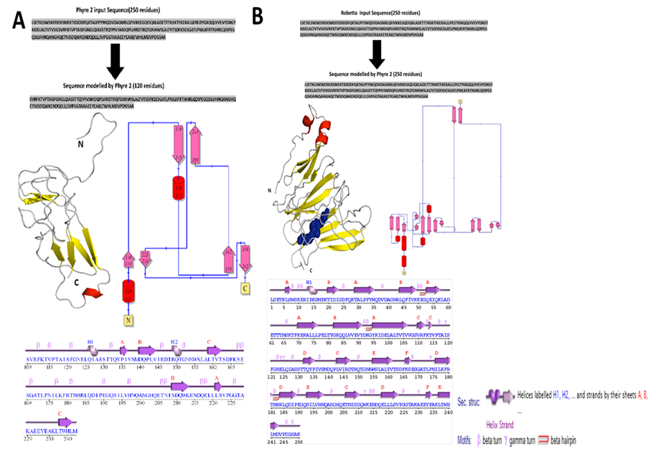
Figure ‎3.18-Schematic representation of C-WxL domain of LwpE protein of E. faecalis V583.
(A) Phyre2 sequence input of C-WxL domain of LwpE protein of E. faecalis V583 and predicted WxL domain structure and topology by Phyre2 analysis. Analysis was done in June 2020. (B) Robetta analysis of WxL domain from LwpE. Sequence used, Robetta prediction of WxL domain, topology and secondary structure of C-WxL domain. Analysis was done in April 2021.
Both the Robetta structure prediction and BlastP analysis suggest that WxL domain from LwpE starts at residue 581 (G) as shown in Figure 3.19, while Brinster et al suggest that it starts at residue 607 (Y) (Brinster et al., 2007) as described above in Section 3.5.1. The structure of WxL domain with Robetta prediction is shown in Figure 3.19.
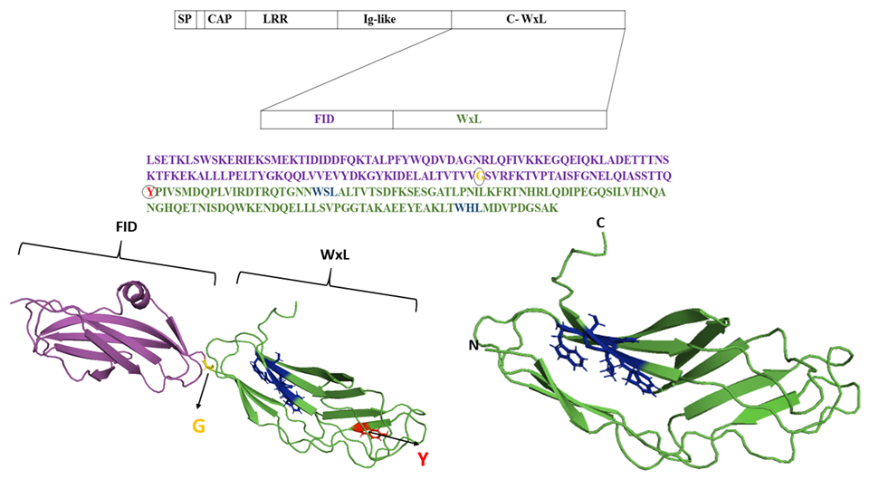
Figure ‎3.19 -Robetta structure prediction of C-WxL domain of LwpE of E. faecalis V583.
G in yellow denotes where WxL domain starts according to Blast P analysis and Y in red shows where Brinster et al suggested WxL domain starts.

Strand exchange concept of WxL domain with DUF916
CFA/I is used to form Class 5 fimbrae in E. coli. Fimbrae are adhesion pili that protrude from the surface of many Gram-negative and some Gram-positive bacteria, and are used to attach to other cells, both bacterial and host. These fimbrae can be up to several micrometres in length and are constructed from repeated major subunits. An important element in the assembly of the fimbrae is donor strand complementation, a modification of strand exchange (Poole et al., 2007; Barnhart et al., 2000; Choudhury et al., 1999; Sauer et al., 1999). In this process, a β-strand from one protein is donated to another protein, which requires a β-strand to complete its structure (Figure 3.20B). The example in the Figure shows the structure of the E. coli P pilus, which is formed from proteins PapA through to PapK. The crystal structure of PapK shows it to have an Ig fold with one strand missing (the C-terminal strand G). In the crystal structure this is supplied by the assembly chaperone PapD, where the additional strand forms a weakly stable parallel β-sheet. In the model it forms a much more stable antiparallel structure, with the additional strand coming from the N-terminus of PapA (Figure 3.20B).
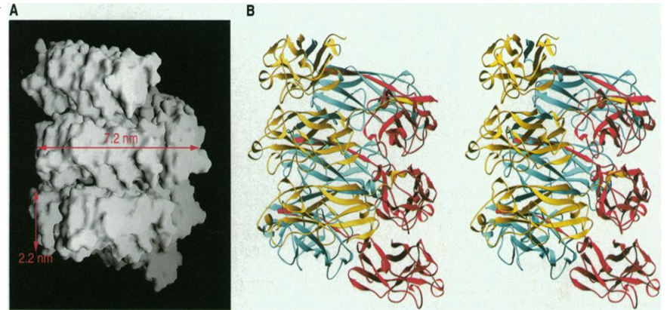
Figure ‎3.20-A model of the E. coli PapA pilus.
Panel A shows the growing pilus. Panel B shows a model for how this could be constructed at the protein level. PapK is in cyan, and PapA is in pink. Note the N-terminal strand of PapA that is inserted into the structure of PapK.
A similar structure was observed in the homologue identified by Phyre 2, the CFA/I pilus, which also requires the proper folding of a donor strand. CfaE was created as a genetic variant with an external donor strand complement (dsc) added at the C-terminus to allow CfaE to fold correctly in order to obtain a crystal structure (Poole et al., 2007). In the resulting crystal structure, CfaE forms a complete β-sandwich structure, but with one strand donated by the additional strand. This strand sequence came from 10 residues at the N-terminal end of CfaB, another protein in the CFA/I cluster (Figure 3.21B).

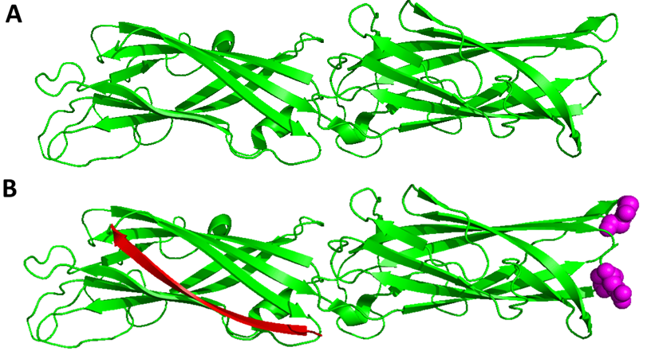
Figure ‎3.21-Crystal structure of CfaE protein with donor strand complementation.
(A) The crystal structure of CfaE. Only the residues from CfaE itself are shown. (B) The crystal structure of CfaE. The red strand is a model strand in a similar position to the additional strand produced in the crystal structure by addition of a donor strand. The purple spheres represent the adhesion site for human cells.
The Phyre 2 prediction for the C-WxL domain of LwpE suggests a similar mechanism. When the predicted structure is overlaid with the crystal structure of CfaE, the structure is clearly incomplete, with one or possibly three strands missing from the predicted WxL structure (Figure 3.22). It therefore seems possible that the structure of the WxL domain is an Ig-like fold with either one or three strands missing, which need to be complemented by a strand from another protein within the gene cluster. If the donor strand complementation works in the same way, then the donated strand would be the N-terminal region from another protein within the cluster.

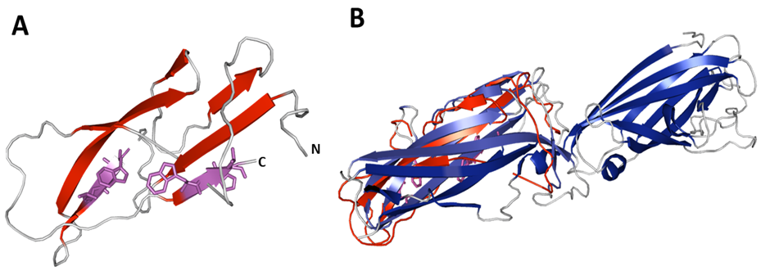
Figure ‎3.22-Structural prediction of WxL from LwpE protein by Phyre2.
(A) Prediction of WxL domain; WxL motifs are highlighted in purple. (B) Superposition of the Phyre 2 model of LwpE WxL domain with the crystal structure of CfaE. Blue colour indicates the crystal structure of CfaE and brick red colour indicates the WxL domain prediction.
Figure 3.23 shows a model for how the WxL might look. This model was constructed by taking the matching CfaE domain and separating out the donor strand present in the CfaE structure. It is worth noting that the two WxL motifs both appear to have the W and L sidechains pointing into the structure. One of the WxL-containing strands is adjacent to the donor strand. It is therefore possible that the WxL motifs serve to allow the strand complementation in some way as shown in Figure 3.24.
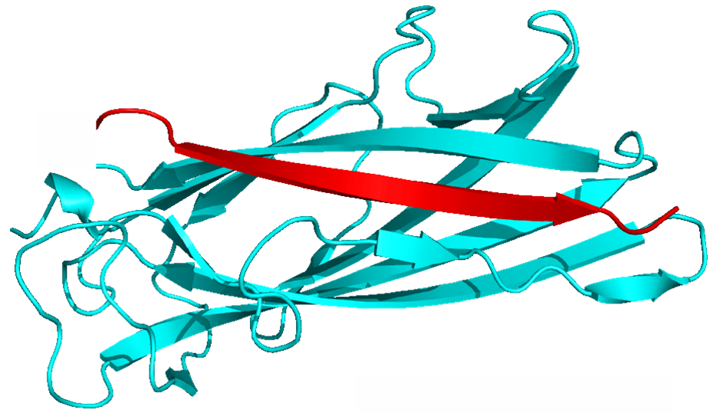
Figure ‎3.23-Model of WxL domain (cyan) with donor strand (red) from LwpE.
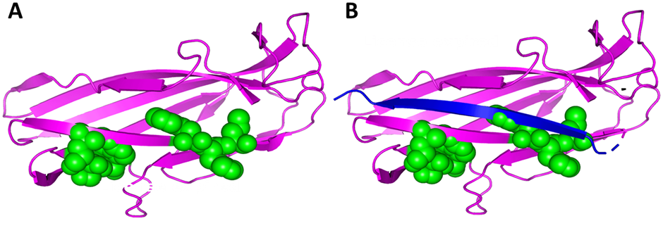
Figure ‎3.24-Model of the WxL domain from LwPE.
(A) The two WxL motifs are indicated in green spheres. (B) In panel B, the donor strand is indicated, showing how both WxL motifs are close to the donor strand.
In CfaE, the donor strand comes from the N-terminus of another subunit in the same gene cluster. If something similar happens in the WxL gene cluster, where does the donor strand come from? It is unlikely to come from LPxTG, which is not present in every cluster and has no unassigned sequence. There is no obvious sequence for it to come from if it originates from Large WxL. This leaves DUF916 as a possible donor. It is found in every cluster, and there is a highly conserved sequence at the N-terminus, which does not seem to be essential for the predicted DUF916 structure. We therefore propose that DUF916 provides the donor strand(s), including the highly conserved NQIDK sequence. Figure 3.24 shows how this might occur. We suggest that the ‘extra’ strand (shown in red in Figure 3.22B) may become detached from DUF916 and insert into the WxL structure to act as a donor strand. Structurally, it would make sense if this strand came from the N-terminus of the donating protein, as was seen with the fimbrial protein. The DUF proteins consists of two Ig-like domains: one belongs to DUF916 and the other belongs to DUF3324, as shown in Figure 3.25.
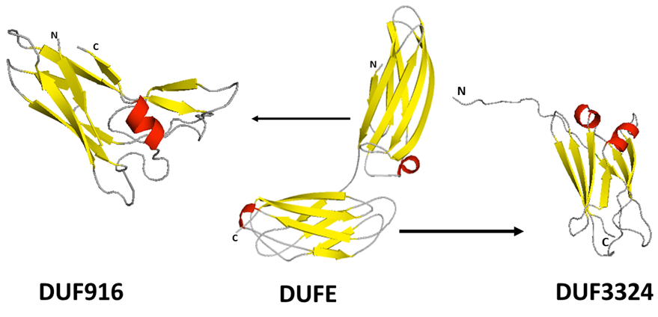
Figure ‎3.25-Phyre2 prediction of DUFA protein containing DUF916 at N-terminal and DUF3324 at C-terminal.
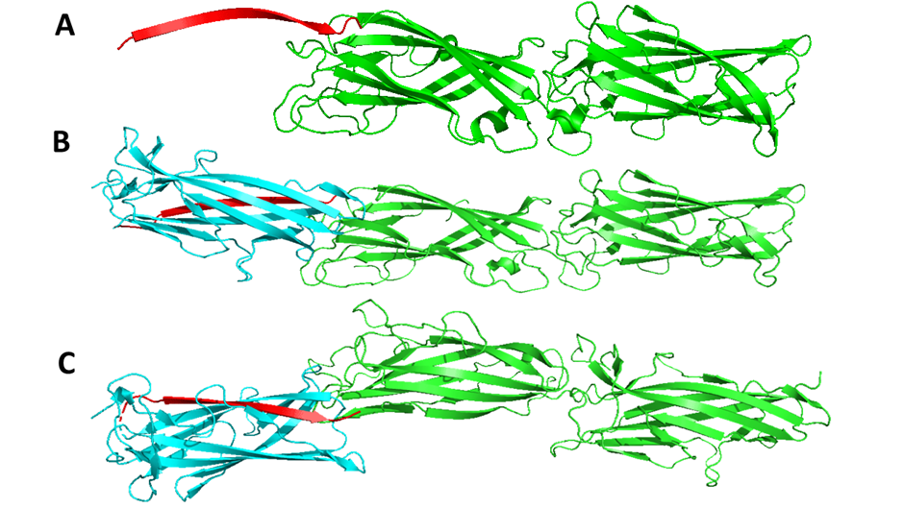
Figure ‎3.26-Possible donor strand complementation from DUF916 to WxL.
(A) A model for the DUF916-DUF3324 pair. This structure is the CfaE crystal structure, but with the additional red strand flipped out by comparison to its position in Figure 3.16(B) (Middle and bottom). (B), (C) Two different views of a complex formed by docking the red strand into the gap in WxL. The WxL structure is the same as that shown in Figure 3.18. We propose that the WxL domain anchors the complex to the peptidoglycan layer, which would be at the left side of the figure, and that the binding site for host would be at the right end, on the outside face of DUF3324.
In the fimbrial and pilus proteins discussed above, the strand complementation is used to lock the donor and acceptor domains together in a tight structural arrangement, which is required to generate the pilus or the fibrial structure, protruding from the bacterial surface. It would make sense if there was a similar reason here: that the strand complementation locks the proteins together so that they extend out from the cell surface, to contact extracellular components such as host proteins on the host cell surface. The Small WxL protein is generally a single domain with a signal sequence and would therefore be unable to fulfil this role. However, in most cases, the DUF protein contains two Ig-like domains in tandem, in a similar way to the CfaE structure, where the second domain is also an Ig-fold protein, similar to that in CfaE. It is therefore tempting to propose that the Small WxL domain is involved in donor strand complementation with a sequence at the N-terminus of DUF916. The donor strand complementation stabilises the structure of the Small WxL domain, and also locks DUF916 into a conformation that holds the DUF916 protein pointing out from the cell surface, allowing the DUF3324 domain to extend out from the bacterial cell surface. CfaE has a binding site at the outward facing end of the second domain (Figure 3.21). We speculate that the DUF protein behaves in the same way, with a binding site on the far end of the DUF3324 domain (the right end as shown in Figure 3.26), allowing it to interact with host cell surfaces. The function of the Small WxL domain would therefore be to anchor this structure to the peptidoglycan surface, in such a way as to allow DUF to extend out from the cell wall towards the host.

Conclusion
It is concluded from this chapter that WxL domain exists in two types of proteins: Small WxL protein and Large WxL protein. Some species consists of two Small Wxl proteins, some only consist of only one, and DUF916 domain is always present in the cluster. DUF916 may be involved in the donation of a strand to a partially folded WxL domain, as is concluded from the above studies.
Small WxL domains differ from Large WxL domain as seen in Figures 3.15 and 3.16. The Robetta structure was more convincing than the Phyre 2 structure prediction. Among Large WxL LwpE was the more confident structure and all Small WxL protein have predicted structures. Both domains contain mostly beta-sheets.
It was also concluded from Robetta structures that Small WxL is a mostly structured protein while Large WxL domain needs extra strands to be properly folded. In contrast, from structure prediction, the Small WxL domain is more folded than the Large WxL domain.
It was concluded that DUF proteins contain two domains DUF916 and the DUF3324 domain. The DUF916 domain has one strand at the N-terminal end which is predicted to detach from the domain and be the strand donated to a Large WxL domain to properly fold.
In the future, structure prediction should be done through the AlphaFold web server to compare the structure with others. Then docking with different ligands should be done, along with some energy calculation of the structure.

Experimental study of the WxL domains from Enterococcus

Introduction
The novel domain containing 160 to 190 amino acids has been identified as WxL domain as shown in Figure 1.7. The name refers to two conserved sequence motifs which have the Trp-x-Leu signature (tryptophan-X-Leucine) (Galloway-Peña et al., 2015). Many surface-exposed proteins are present in E. faecalis that may be involved in virulence. ElrA, an internalin-like large WxL protein, is reported in E. faecalis (Enterococcal Leucine-Rich repeats). ElrA has an N-signal peptide for export, a leucine-rich repeat domain that may interact with host cells, and a C-terminal WxL domain that may interact with peptidoglycan (Brinster et al., 2006). Six WxL proteins were found in E. faecium TX82 at three loci A, B, and C, always associated with a Domain of unknown function family (DUFA) and an LPxTG-containing protein, as discussed in chapter 3. Six WxL proteins were found in E. faecium TX82, with three large WxL and three small WxL proteins being assigned based on sequence comparisons (Galloway-Peña et al., 2015).
Chapter 3 describes a bioinformatics analysis of WxL proteins in Enterococcus and other intestinal bacteria. This Chapter describes attempts to express and characterize WxL proteins from Enterococcus spp. It starts with studies on the EF2686 protein (LwpE) of E. faecalis V583, which had previously been expressed in a soluble form by Dr Stéphane Mesnage, and therefore seemed like the most promising WxL domain to study. Dr Stéphane Mesnage was not able to purify it. However, despite extensive attempts with constructs of various lengths, no well-behaved soluble domain could be prepared. Therefore, we turned to proteins from E. faecium DO, one of which had also been reportedly purified in a soluble form (Galloway-Peña et al., 2015). Initial studies used small WxL proteins, which are shorter and likely to behave better because the entire coding sequence except for the signal peptide was used, and therefore there are no questions to do with where the WxL domain starts. Again, no soluble proteins could be purified; therefore, we tried expressing Large WxL; a hybrid protein containing a putative strand-exchange sequence; DUF916; and the whole of the locus A. No soluble protein could be produced. Finally, coexpression of Small WxL protein with DUF916 domain of Locus A was cloned using the pET-Duet vector. This worked and produced soluble and stable Small WxL protein.

Expression and purification of Large WxL domain from E. faecalis V583
Our first attempts focused on the WxL domain from the large WxL protein (LwpE) from E. faecalis V583. Our collaborator Dr Stéphane Mesnage had previously tried expressing this protein and had obtained what appeared to be soluble protein. The sequence he expressed was from the C-terminal end of the protein. His collaborator P. Serror had identified two different functional domains at this end of the protein, which she had described as an FID domain (FHL2-interacting domain) and a WxL domain (Fig. 4.1), although as discussed in Chapter 3, the existence of two separate domains, and the position of the potential domain boundary, are both unclear (Jamet et al., 2017). Different expression vectors were used in this study to produce soluble Large Wxl domain, with start sites at different locations based on sequence comparisons and structure predictions, in different competent cells as shown in Figure 4.2. The C-WxL domain and WxL domain, as shown in Figure 4.1, were used in this study to express the WxL domain in different vectors. The C-WxL domain was cloned into four different plasmids as shown in Figure 4.2 (A) and WxL domain was cloned into two vectors as shown in Figure 4.2(B).

Figure ‎4.1-Diagrammatic representation of LwpE from E. faecalis V583.
It contains a signal peptide, cap, ten leucine-rich repeats, an Ig-like domain, and a C-terminal WxL domain. The C-WxL domain can be further subdivided into FID and WxL domains. The sequences of each part are shown. The two WxL sequences are highlighted in black.
Figure ‎4.2-Schematic representation of the different constructs from LwpE protein used to express WxL domain.
(A) Description of the different recombinant constructs for the expression of C-WxL domain. (B) Description of the different recombinant constructs for the expression of WxL domain. (C) Recombinant plasmids pWxL1_pOPINF and pWxL2_pOPINF. WxL amino acid sequence is highlighted in red and His-Tag sequence is in sky blue.

pWxL TEV and pWxL S1 expression system
Dr Stéphane Mesnage had constructed two expression vectors to express soluble WxL protein from E. faecalis V583. The Large WxL domain is part of EF2686 protein (LwpE), an internalin like protein present in L. monocytogenes and E. faecalis (Jamet et al., 2017). The full-length WxL domain is 250 residues long as shown in Figure 4.1, and the vectors are attempts to produce shorter proteins, based on a sequence and expression analysis that suggested that the WxL domain consists of two parts: an upstream FID domain followed by a WxL domain, the division occurring at SSTTQYP (Figure 4.1). The TEV construct contains the entire WxL domain but has a 5-residue TEV cleavage site inserted upstream of the first S, while the S1 construct starts at S, as shown in Figure 4.3 (A). To start the project, the pWXL-TEV and pWXL-S1 expression vectors (provided by Dr Mesnage) were transformed into NEB DH5α competent cells; after miniprep, the plasmids were sent for sequencing and were the expected sequences.
The pWxL TEV plasmid encodes an N-terminal His-tag (6 amino acids), FID domain, TEV cleavage site, and WxL domain, intending to express a soluble FID-WxL protein, allowing for possible TEV cleavage subsequently. The total number of amino acids is 269, molecular weight 30.4 kDa and theoretical pI 5.58, as shown in Figure 4.3 (B). The pWxL S1 expression system encodes a C-terminal His-tag and WxL domain (number of amino acids 131, molecular weight 14.7 kDa, theoretical pI 5.87). Expression trials of WxL protein were performed in different constructs, different competent cell lines and different conditions; the protein of interest (WxL) showed good expression in C43 (DE3) competent cells but not in BL21 (DE3) nor BL21 gold (DE3), as shown in Figure 4.4 (A). Soluble protein could not be obtained from pWxL-TEV and S1 plasmids; protein was always observed only in the pellet. The pellet was therefore solubilized by dissolving in 6 M guanidine HCl followed by dialysis to remove the guanidine and allow the protein to refold; the protein of interest in the TEV plasmid did not fold appropriately after the dialysis, while the protein of interest in the S1 plasmid did refold adequately, as shown in Figure 4.4 (B). A summary of pWxL TEV and pWxLS1 constructs is shown in Figure 4.3.
Figure ‎4.3-Diagramatic representation of pWxL_TEV and pWxL_S1.
(A) Picture of pWxL_TEV and pWxL_S1 constructs. pWxL_TEV construct contains a TEV cleavage site in between FID domain and WxL domain; (B) Properties of pWxL_TEV and pWxL_S1.
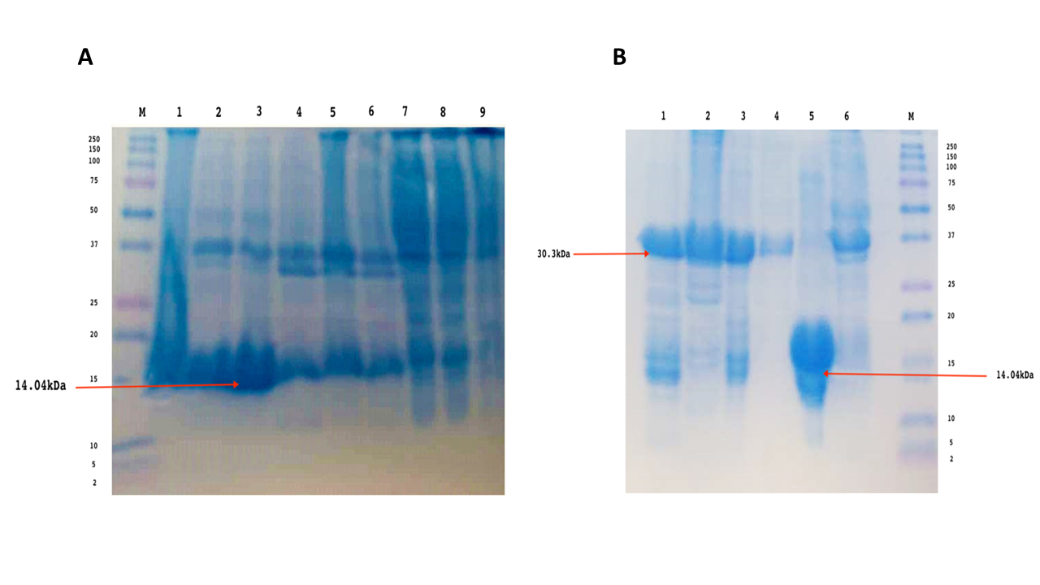
Figure ‎4.4-Expression of WxL domain in different plasmids and different competent cells.
(A) Protein expression of pWxL S1 in different conditions. Lane 1: S1 in C43 cells at 37°C for 4 hrs (0.1 mM IPTG, pellet); lane 2: S1 in C43 cells at 37°C for 4 hrs (0.5 mM IPTG, pellet); lane 3: S1 in C43 cells at 37°C for 4 hrs (1 mM IPTG, pellet); lane 4: S1 in BL21-Gold(DE3) cells at 37°C for 4 hrs (0.1 mM IPTG, pellet); lane 5: S1 in BL21-Gold(DE3) cells at 37 ° C for 4 hrs (0.5 mM IPTG, pellet); lane 6: S1 in BL21-Gold(DE3) at 37° C for 4 hrs (1 mM IPTG, pellet); lane 7: S1 in C43 cells at 37° C for 4 hrs (0.1 mM IPTG, Supernatant); lane 8: S1 in C43 cells at 37°C for 4 hrs (0.5 mM IPTG, Supernatant); lane 9: S1 in C43 cells at 37°C for 4 hrs (1 mM IPTG, Supernatant). (B) Refolding of WxL protein by addition of guanidine and subsequent dialysis method. Lane 1:TEV in BL21 cells 37°C for 4 hrs (supernatant); lane 2: TEV in BL21 cells 37° C for 4 hrs (pellet); lane 3: TEV in C43 cells 37°C for 4 hrs (Supernatant ); lane 4: TEV in C43 cells 37°C for 4 hrs (pellet); lane 5: S1 in C43 cells 37°C for 4 hrs (Supernatant); lane 6: S1 in C43 cells 37°C for 4 hrs (Pellet).

When 1-D NMR of the refolded protein from the pWxL-S1 plasmid was performed as shown in Figure 4.5, it seems likely that it was not appropriately folded because it was not showing any beta-sheet signal (8.5-10 ppm) or hydrophobic core (less than 0.7 ppm).
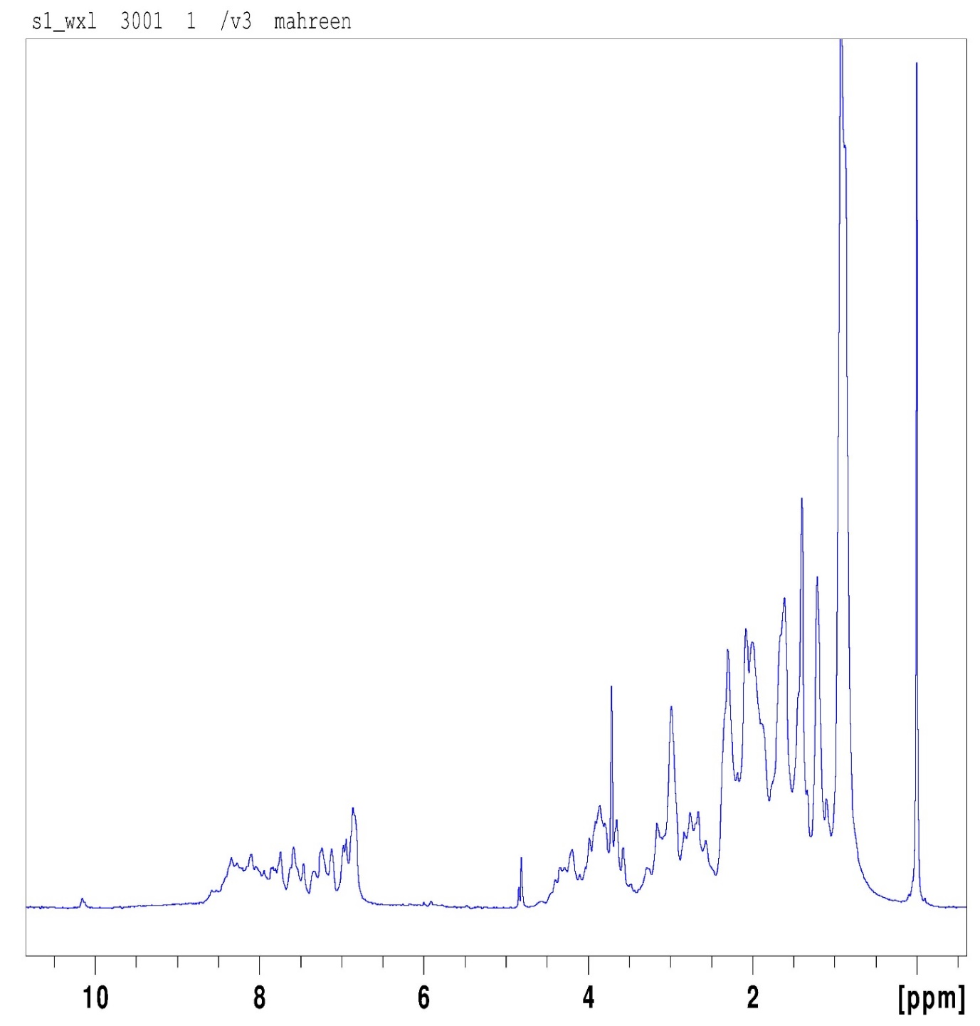
Figure ‎4.5-One-dimensional NMR spectrum of refolded protein from pWxL S1 containing Wxl domain.
It was concluded that soluble protein could be obtained from these constructs by refolding from guanidine, but this method does not produce folded protein. Therefore, it appears that the previously reported expression by Dr Mesnage may have been of unfolded proteins. Because of uncertainties as to where the FID/WxL boundary is (Chapter 3), we, therefore, moved on to a different system.

Tat (twin-arginine translocation) Expression system
Professor Colin Robinson from Kent University designed a system for using the Tat translocase to translocate folded proteins across the plasma membrane (Frain et al., 2019). The folded proteins were transported by the Tat system across the bacterial plasma membrane, preferentially transporting correctly folded proteins in E. coli (Goosens et al., 2014). Using the transmembrane proton motive force as a source of energy, the Tat machinery exports folded and cofactor-containing proteins from the cytoplasm to the periplasm (Sutherland et al., 2018; Jones et al., 2016). The Tat plasmid (Kent university) encodes TorA, which is an N-terminal signal peptide for the transport of folded protein (Jones et al., 2016; Buchanan et al., 2008), followed by FID domain, TEV cleavage site (6 amino acids), WxL domain (259 amino acids, molecular weight 29.21 kDa and theoretical pI 5.07) and His-tag at C terminal end (6 amino acids) as shown in Figure 4.6. Therefore, the aim was to allow the entire C-WxL to be expressed and fold inside the cell and then transport it out without needing to unfold it.
Periplasmic, cytoplasmic and cell wall fractions were collected. If the protein is expressed, folds and is exported, it should appear in the periplasmic fraction. The Tat system has previously been reported to give low expression levels (Sutherland et al., 2018). The yield of C-WxL was very low and was not enough to purify and to do further experiments. As shown in Figure 4.7, the expression of WxL protein was tried at different temperatures in different cell lines (C43 (DE3) and BL21 (DE3)). Lane 1 to 7 did not contain the protein of interest, and lane 8 contained a protein at 30 kDa, as shown in figure 4.7 (A, B). Lanes 1 and 6 had an unknown bacterial protein that does not belong to the protein of interest. To identify specific His-tag WxL protein, a Western blot was done using an antibody against His tag; as shown in figure 4.7 (B), the strongest signal of His tagged protein was identified in lane 1 containing C43 (DE3) at 25°C for 24 hrs and lanes 6 and 8 also showed signals, but they were not specific. There was no protein after the purification through Nickel Column, so the Tat construct did not give enough protein for further experiments. However, there was a band in the periplasmic fraction, indicating that small levels of WxL could be expressed in the cytoplasm and were sufficiently folded to be secreted via the Tat system, as shown in Figure 4.7 (A).

Figure ‎4.6-pWxL_Tat construct.
(A) Pictorial representation of pWxL_Tat construct. Sequence in orange is Tor A sequence; FID sequence is green in colour, TEV cleavage site is purple, WxL domain sequence is in red and N-terminal His-Tag is in sky blue.
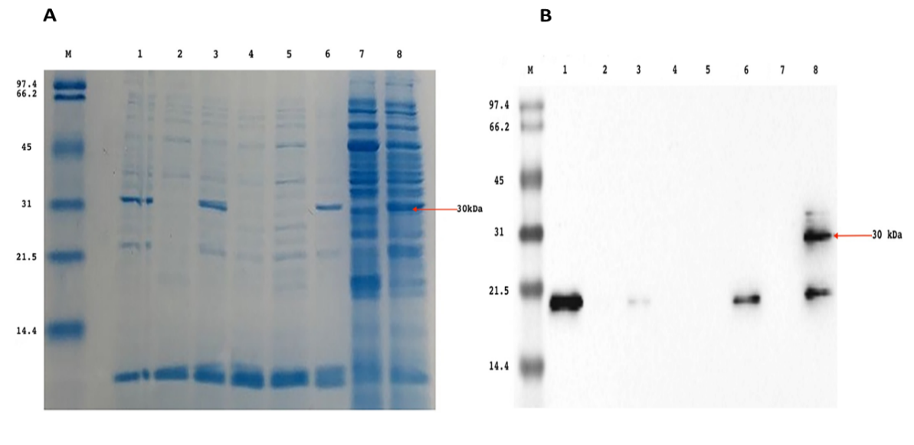
Figure ‎4.7-Expression of Large WxL in the Tat system.
(A) Periplasmic fraction of WxL protein from pWxL Tat construct. Lane 1: BL21-(DE3) 25 °C for 2 hrs; lane 2: C43 Cells 25°C for 2 hrs; lane 3: C43 Cells 30 °C for 2 hrs; lane 4: BL21 (DE3) 30 °C for 2 hrs; lane 5: BL21 (DE3) 15 °C for 4 hrs; lane 6: C43 Cells 15°C for 4 hrs; lane 7: BL21 (DE3) 25 °C for 24 hrs; lane 8: C43 Cells 25° C overnight; (B) Western blot of the periplasmic fraction of WxL from pWxL Tat construct. Lane 1: C43 Cells 25° C for 24 hrs; lane 2: BL21-(DE3) 25° C for 2 hrs; lane 3: C43 Cells 25° C for 2 hrs; lane 4: C43 Cells 30 °C for 2 hrs; lane 5: BL21(DE3) 30 °C for 2 hrs; lane 6: BL21(DE3) 15° C for 4 hrs; lane 7: C43 Cells 15 °C for 4 hrs and lane 8: BL21(DE3) 25° C for 24 hrs. The gel was visualized by Bio-Rad Gel-doc chemiluminescence imager.

pOPINF expression system for different length of protein fragments
Previous studies by Serror and Mesnage had left it unclear whether FID and WxL are two separate independent folded domains, whether there is truly a break between one and the other, and where that break might be. Sequence comparisons suggest several possible locations for the start of a conserved WxL sequence, as shown in Figure 4.8 (A). Figure 4.8 compares the EF2686 C-WxL protein sequence to the Large WxL protein sequences from Locus A, Locus B and Locus C from E. faecium DO. There are three possible regions shown in Figure 4.8 where the consensus WxL sequence might start. The previous unsuccessful constructs of WxL started from SSTQ, which is highlighted in green. Therefore, we designed three alternative start sites indicated by the sequences LSE, EKAL and GVRSF, shown in Figure 4.8 (A).
The pOPINF plasmid was used in this study. This plasmid originated from Harwell in Oxfordshire and was designed for rapid high throughput cloning without the need for restriction digest sites (Berrow et al., 2007). It was used by Dr Nicola Galley in Dr Mesnage’s lab, who recommended to try it. The pOPINF plasmid DNA was first checked for completeness of restriction digestion with HindIII and KpnI, before being subjected to Gibson assembly (Schütz, 2014). The Gibson assembly® is a cloning method that clones two or more fragments into a cut plasmid without using restriction enzyme digestion or compatible restriction sites and uses overlapping ends inserted into those fragments to allow the ligation of the fragments (Chen, 2016). The pOPINF plasmid was cut by two restriction enzymes HindIII and KpnI, as shown in Figure 4.9 (A). Ligation of the plasmid with different constructs was done by Gibson assembly. The intact size of pOPINF plasmid was 5531 bp; the linear size of plasmid after cutting with two enzymes was 5198 bp and the cut-out fragment is 333 bp, as shown in Figure 4.9. The uncut plasmid looks smaller because it was supercoiled. The concentration of the purified linearised vector was 1.14 ng/µl DNA. The G-block size of pWxL3 was 759 bp; the concentration was 46.8 ng/µl, size of G-block of pWxL2 was 549 bp; the concentration of pWxL2 was 3.9 ng/µl. pWxL1 was 432 bp, and the concentration of G-block was 26.8 ng/µl. The bands observed in Figure 4.9 (A) indicate that restriction cutting with enzymes was successful and gave rise to bands of the expected size.
The protein expression was done in different competent cells and different temperature and IPTG concentration, as explained in Chapter 2, and the best expression level was noticed in 0.5 mM IPTG in BL21 (DE3) at 25°C overnight although the protein comes out in the pellet. The protein was insoluble, as shown in Figure 4.9 (B).

Figure ‎4.8-Schematic representation of Large WxL from E. faecalis V583 and E. faecium DO.
(A) Sequence alignment of Large WxL sequences - LwpA stands for Large WxL of Locus A, LwpB stands for the Large WxL of Locus B, and Locus C large WxL of E. faecium DO. The LwpE is large WxL protein of E. faecalis V583. The three constructs produced in this work are indicated: construct 1 starts from the sequence GSVRF highlighted in purple, construct 2 starts from EKAL highlighted in sky blue and construct 3 starts from LSE which is highlighted in orange. The previously used construct starts from the SSTTQ site (green), and the two WxL motifs are in red. (B) Representation of three different constructs - His-tag is highlighted in sky blue and Wxl domain sequence is highlighted in red.
Figure ‎4.9-Digestion of pOPINF plasmid and expression trial of C- WxL from LwpE.
(A) Digestion of pOPINF plasmid cut with HindIII and Kpn I- MW:10Kb ladder, lane1. Intact plasmid (5531 bp), lane2. Cut plasmid HindIII (3 microlitres), lane3. Cut plasmid KpnI (3 microlitres), lane 4. Combined cut of the plasmid with Hind III and Kpn I (10 microlitres) (5198 bp), lane 5. Cut of the plasmid with HindIII and KpnI (20 microlitres) (5198 bp), lane 6. Cut of the plasmid with Hind III and Kpn I (20 microlitres) (5198 bp). (B) Protein expression of LwpE from E. faecalis V583 at 25°C 0.5mM IPTG in BL21(DE3) overnight. Lane1: Marker, Lane 2: pWxL2; 15 µl soluble fraction (SF), Lane3: pWxL2; 15 µl SF, Lane 4: pWxL3; 15 µl SF, Lane 5: pWxL2; 5µl SF, Lane 6: pWxL1; 5 µl SF, Lane 7: pWxL3; 5µl SF, Lane 8: pWxL2 ;5 µl cell pellet (CP),Lane 9: pWxL1; 5 µl CP, Lane 10: No sample, Lane 11: pWxL3; 5 µl cell pellet (CP).

pVE 14048_WxL
Pascale Serror constructed the pVE14048 plasmid to study the WxL domain, as shown in Figure 4.10 (A) (Brinster et al., 2006). Dr Stéphane Mesnage’s lab tried to express the Large WxL but did not get high expression level and could not purify it. The plasmid used in this study was used to express the Large WxL domain in the different competent cells BL21(DE3) star and BL21(DE3). The Large WxL domain has a His-tag on the N-terminus, as shown in Figure 4.10 (A). The protein was expressed at 37°C for 3 hrs at 0.5 mM IPTG. Better expression was reported in BL21(DE3) star rather than BL21(DE3) as shown in Figure 4.10 (B) and (C). The protein was expressed in 4 liters, but protein concentration was still very low; most of the protein was in the pellet. Because of low protein concentration, no further experiment was done.
Figure ‎4.10-Production of large soluble WxL in pVE14048 plasmid.
(A) pVE14048 construct. WxL amino acid sequence is highlighted in red, FID domain sequence is highlighted in green, and His-Tag sequence is sky blue. (B) pVE14048 constructs characteristics (C) 12% SDS-PAGE analysis of large Wxl in Bl21(DE3) star at 37 °C for 3 hours at 0.5 mM IPTG (4 litres expression). Lane 1: cell free extract, Lane 2: unbound protein from Nickel column, Lane3: Sample containing a mixture of the 11th plus 12th fractions from the nickel column, Lane 4: empty, Lane 5: Fraction 15 of Nickel column, Lane 6: mixture of 19th and 20th fraction from the Nickel column, (D) 12% SDS-PAGE analysis of large Wxl in Bl21(DE3) at 37°C for 3 hours at 0.5 mM IPTG (4 litres expression). Lane 1: crude extract, Lane 2: cell free extract, Lane3: 8th fraction of nickel column, Lane 4: 10th fraction of nickel column, Lane 5: 12th fraction of nickel column, Lane 6: 13th fraction of nickel column, Lane 7: 14th fraction of nickel column, Lane 8: 15th fraction of nickel column, Lane9: 16th fraction of nickel column, Lane10: 17th fraction of nickel column, Lane 11: 18th fraction of nickel column, Lane 12: 19th fraction of nickel column, Lane13: 20th fraction of nickel column.

pGEX_WxL
A pGEX plasmid with Large WxL domain without FID domain was cloned by Dr Stéphane Mesnage; a Large WxL domain was tagged with GST-tag and TEV cleavage site was present between them as shown in Figure 4.11 (A). The Large WxL domain showed good expression in C43(DE3) competent cells at 37°C for 3 hours at 0.5 mM IPTG (4 litres expression). The crude extract (CE) contains a band of overexpressed protein at about 42 kDa, which corresponds to the expected GST+13kDa WxL construct, as shown in Figure 4.11 (B). The GST-Tag was removed from the protein by TEV protease and then again run on the GST column to check wether the tag was cut properly or not, and the flow through was run on the SDS gel as shown in Figure 4.11(C).
Figure ‎4.11-Production of Large WxL in pGEX plasmid.
(A) WxL construct (without FID domain) cloned into pGEX plasmid. WxL amino acid sequence is highlighted in red, GST-tag sequence is highlighted in sky blue, and the TEV cleavage sequence is purple. (B) Characteristics of pGEX_WxL. (C) 12% SDS-PAGE analysis of large WxL in C43(DE3) at 37 °C for 3 hours at 0.5 mM IPTG (4 liters expression). Lane 1: crude extract, Lane 2: cell-free extract, Lane3: unbound protein (flow through), Lane 4: Sample containing a mixture of fractions 1 and 2, Lane 5: protein without GST-tag (the expected molecular weight was 13.6 kDa, but on the SDS-PAGE it comes out differently).
The GST tag was cleaved, and cleaved material was collected, containing a molecular weight of 60 kDa and 13.6 kDa, as shown in Figure 4.11 (B). Both cleavage fractions were sent for trypsin digestion mass spectrometry in the Chemistry department which showed that the 60 kDa protein was DnaK chaperone and 13.6 kDa was WxL domain without GST-tag, but the percentage of WxL domain in the sample was just 1% while the rest was DnaK chaperone. The seven peptides were detected from mass spectrometry with a start position of 1, and end position of 322; this means that mass spectrometry has detected WxL sequence from residues 1 to 322 as shown in the Table 4.1 with sequence coverage of 14.3%. The PEP stands for Posterior Error Probability of the identification. This value features essentially as a p-value, with a smaller value being even more significant. The charge stands for the charge-state of the precursor ion. The iBAQ for a protein or protein group (determined by MaxQuant) is divided by all non-contaminant, non-reversed iBAQ values for a replicate to get relative iBAQ (riBAQ). Normalized molar intensity is equivalent to riBAQ. Score refers to the Andromeda score for the best MS/MS spectrum. Andromeda is a peptide score search engine based on probability calculations (Cox et al., 2011). Most of the WxL protein was expressed in the pellet as had happened in the previous trials mentioned above.
Table ‎4.1-Trypsin digestion of Large WxL in pGEX plasmid

WxL Domain from E. faecium DO
From the above results, it was concluded that the WxL domain from E. faecalis V583 was an insoluble protein always coming in the pellet. We therefore moved to the E. faecium DO WxL domain, for which soluble expression had already been reported by Galloway-Peña et al., 2015. This study aimed to express the WxL domain present in E. faecium DO. Different trial experiments were performed to determine the best strategy to express the soluble WxL domain. The strains expressing Small WxL from Locus A and C (SwpA and SwpC) were requested from the University of Texas – HSC, as described in Galloway-Peña et al., 2015. Figure 4.12 indicates a summary of all the constructs which were used to express the WxL domain from E. faecium DO.
Figure ‎4.12-Schematic representation of different constructs of Locus A and C of E. faecium DO.
(A) Summary of Locus A containing different constructs-Small WxL of Locus A was cloned into pQE30, SwpA-DUFA₇ which contains Small WxL and 7 residues from the DUF916 domain was cloned into a pET plasmid, SwpA-DUFA₂₆ which contains Small WxL and 26 residues from the DUF916 domain, Co-SwpA-DUFA which contained the Small WxL with S-tag on C-terminal and DUF916 have His-Tag on N-terminal, Co-SwpA-DUFA-LpxTGA-LwpA which contains Small WxL, DUFA, LpxTGA and Large WxL was cloned into pTet2op. (B) Summary of Locus C containing different constructs. pDUF916 1, pDUF916 2 and pDUF916 3 were cloned into pOPINF plasmid and SwpC was cloned into pQE30.

Small WxL from E. faecium DO from Locus A
TX6119 strain (an M15 containing a fragment of SwpA cloned into the pQE30 plasmid) containing a gene for Small WxL (SwpA) from E. faecium locus A. The construct feature of SwpA is shown in Figure 4.13.
Figure ‎4.13-Locus A of Small WxL domain (SwpA) construct features.
(A) Sequence in sky blue shows the His-tag and sequence in red colour shows the WxL domain. (B) SwpA features.

Expression trials
SwpA with His-Tag was expressed in different trial conditions (37°C 0.5 mM IPTG for 4 hours, 30°C 0.5 mM IPTG for 4 hours and 25°C overnight using 1 mM IPTG). SwpA was expressed at 25°C overnight after induction using 1 mM IPTG. The lysis of the protein was done in high salt concentration (0.5 M NaCl) in the lysis buffer. When the protein was lysed in low salt (250 mM NaCl) concentration, it was purified in low concentration.

Purification
The SwpA purification was in two steps: Nickel column chromatography and gel filtration and then unfolding and refolding was done. For clarity, each column chromatographic step from here on is given a code (NiA, NiB, GFA etc).

Nickel Column Chromatography
The protein purification was done through Nickel column chromatography. During protein purification through Nickel column A (NiA) through gradient method, SwpA was eluted in two peaks 3 and 4 separated by multiple fractions, as shown in Figure 4.14 (A). The two peaks observed from the His-tagged protein purification were pooled separately: Peak 3 from Nickel column A (NiA) chromatography contains the fractions 11 to 12, and Peak 4 contains the fractions 14 to 19. During their purification, Galloway-Peña et al., 2015 also noticed similar results: SwpA eluted in two peaks, which indicates that the same protein had two forms. To check the protein’s molecular weight, Mass spectrometry was performed because the band on the SDS-PAGE gel was not at the expected position. It was concluded that protein was expressed in soluble form but coming out in both different peaks.

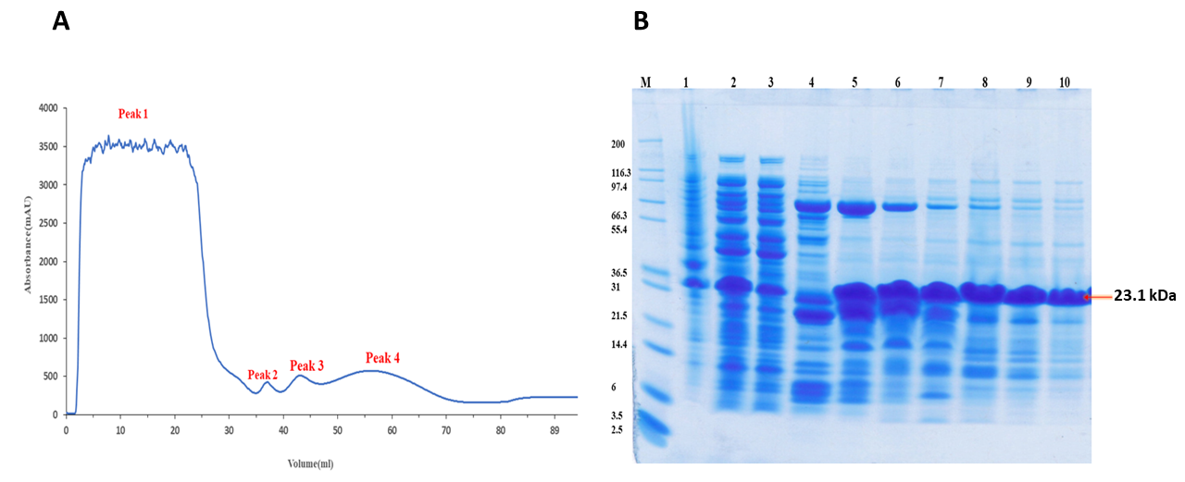
Figure ‎4.14-Purification of Small WxL by Nickel column A (NiA) chromatography.
(A) Nickel column A (NiA) chromatography: Peak 1 contains unbound protein (fractions 1 to 5), Peak 2 (fraction 9), Peak 3 (fractions 11 to 13), and Peak 4 (fractions 14 to 19) contain proteins of interest. (B) 12% SDS analysis of Nickel column A (NiA) chromatography: Lane 1 Cell debris (CD), Lane 2 Cell-free extract (CE), Lane 3; Peak 1 fractions (1 to 5), Lane 4: Peak 2 fractions 9, Lane 5: Peak 3 fraction 11, Lane 6: Peak 3 fraction 12, Lane 7: Peak 3 fraction 13 , Lane 8: Peak 4 fraction 14, Lane 9:Peak 4 fraction 14, Lane 10: Peak 4 fractions 15 to 19.

Gel Filtration
Further purification of SwpA was done by gel filtration as protein was eluted into two peaks from NiA chromatography; so, gel filtration A (Figure 4.15) represents the analysis of peak 3 of the Nickel column A (NiA) and gel filtration B (GFB) represents the analysis of peak 4 of the Nickel column.
As shown in Figure 4.15, the first peak (fractions 1 to 5) from the gel filtration A (GFA) contained WxL protein with an apparent molecular weight (MW) of around 500 kDa and the second peak (fractions 6 to 10) contained a protein with an apparent MW of around 75 kDa (A). The expected molecular weight of the protein is 23 kDa, therefore the 75 kDa size may be a trimer or elongated dimer; it seemed too large for a somewhat disordered monomer; as shown in Figure 4.15 (A). The 500 kDa molecules have also been analyzed by electron microscopy, which revealed that they were an aggregate. The structure of these aggregates was amorphous. From the 75 kDa species, a sample was prepared for NMR. One dimensional NMR revealed WxL to be partially disordered, as shown in Figure 4.21, as described below later in this section. There was a significant amount of protein lost during the protein purification. SwpA protein was not stable, and the proteins aggregate quickly.
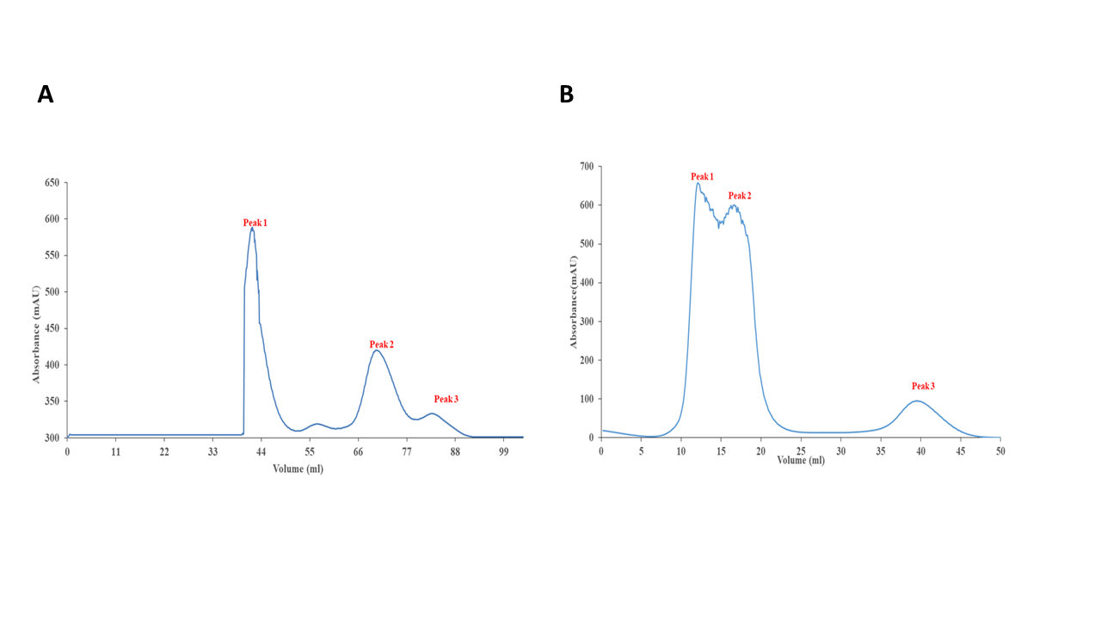
Figure ‎4.15-Gel filtration of Peak 3 and Peak 2 from the Nickel column A of SwpA domain.
(A) Purification by Gel filtration A (GFA) column chromatography of Peak 3 of Nickel Column A (NiA). Peak 1 (fractions 1 to 5) contains aggregates; it has an apparent molecular weight of molecular weight 500 kDa, and Peak 2 (Fractions 14 to 20) contains protein of 75 kDa molecular weight and peak 3 contains fractions 21 to 24 with protein of molecular weight 23.1 kDa. (B) Purification by Gel filtration B (GFB) column chromatography of Peak 4 of Nickel Column A (NiA). Peak 1 and 2 (fractions 1st to 5th) contains aggregates with an apparent molecular weight of 500 kDa, and Peak 3 (fractions 14 to 17) contains the proteins which have molecular weight 75 kDa.
As illustrated in Figure 4.15(B), gel filtration B (GFB) analysis of peak 4 of the Nickel column revealed that the first peak contained WxL protein with an apparent molecular weight (MW) of around 500 kDa and the second peak contained WxL with an apparent MW of around 75 kDa. The 75 kDa size for a 23 kDa protein may be a trimer or an elongated dimer; it appeared to be too large for a somewhat disordered monomer, as illustrated in Figure 4.15. (B). The SDS page analysis is shown in Figure 4.16.
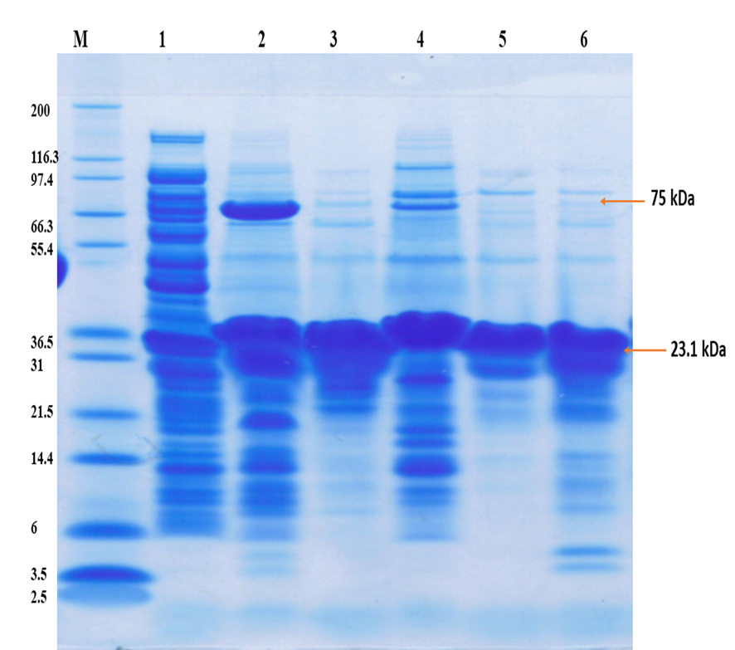
Figure ‎4.16-12% SDS PAGE analysis on SwpA.
Lane 1: Cell-free extract, Lane 2: Fractions of Peak 2 of NiA, Lane 3: Fractions of GFA of peak 2, Lane 4: Fractions of Peak 4 of Ni A, Lane 5: Fractions of GFB of peak 3, Lane 6: Concentrated Peak 3 of GFA.

Refolding
The appearance of WxL in form of big particles could be possibly explained by its affinity to peptidoglycans. These particles could be small pieces of cell wall with Wxl attached. To check this suggestion, a refolding experiment was performed to remove any co-purifying peptidoglycan fragments.
WxL was unfolded in 7 M urea in order to detach it from anything it was attached to (if it was attached). The Peak 1 and 2 (fractions 1 to 5) of GFB samples were mixed; then 4.8 grams urea was added to make the volume of the sample up to 11 ml. The protein was purified on Ni-NTA beads (3.5 mg out of 10 mg) and refolded as described in section 2.1.5.3.2.; the unbound sample was collected and run again on a 1 ml His trap Nickel column for refolding of protein, and protein was eluted in one peak as shown in Figure 4.16 (A). After refolding about 35% (0.6mg) of the prep appeared as 75 kDa species and the rest was about 700 kDa (1 mg). As a result, despite being partially disordered, WxL refolds very efficiently, as illustrated by NMR. Furthermore, it appears that the two fractions are in equilibrium in solution, suggesting that WxL reversibly assembles into a mixture of small and large aggregates, and that there was no aggregation due to bound peptidoglycan.
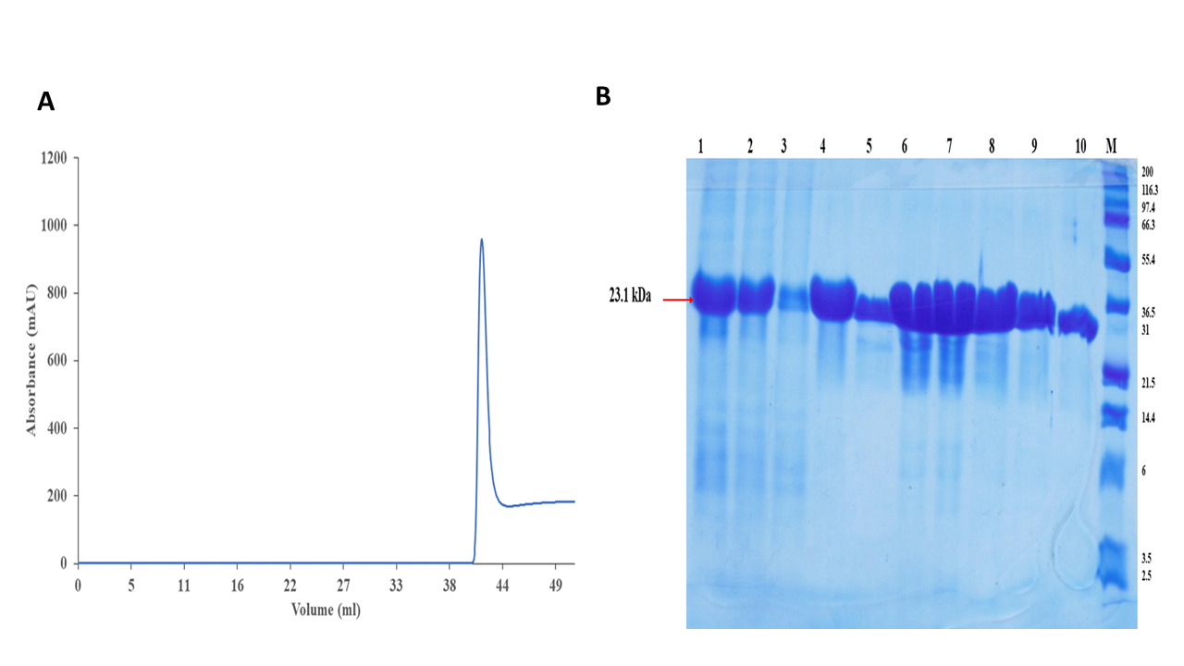
Figure ‎4.17-Refolding of SwpA in the presence of Nickel beads.
(A) Nickel column B (NiB) chromatography of SwpA by refolding from Nickel beads: protein was eluted in the presence of buffer (0.5 M NaCl tris pH 8 plus 0.5 M imidazole) (B) 12% SDS PAGE analysis on refolded Small WxL from the Nickel column B fractions : Lane 1: Sample peak 1 of GFA (Figure 4.14) dissolved in 7 M Urea, Lane 2: Unbound protein of Nickel column B, Lane 3: Unbound protein of Nickel column B, lane 4: Elution in Urea (before refolding), Lane 5: Fraction 12 of Nickel column B, Lane 6: Fraction 13 of Nickel column B, Lane 7: Fraction 14 of Nickel column B, Lane 8: fraction 15 of Nickel column B, Lane 9: Fraction 16 of Nickel column B, Lane 10: Fraction 17 of Nickel of column B.

The sample collected from Nickel column B was applied to gel filtration, which was named as GFC; the same result was obtained as was obtained before refolding of Small WxL protein as discussed above. Figure 4.18 shows that peak 1 contains a significant aggregate of protein, and peak 2 contains WxL protein. The fraction from peak 2 was collected, and 1-D NMR was performed.
An alternative way of investigating the possible binding of SwpA to peptidoglycan would be to digest any peptidoglycan present, for example by adding lysozyme to the solution. This was not attempted, because a clear result had already been obtained by the procedure described here.

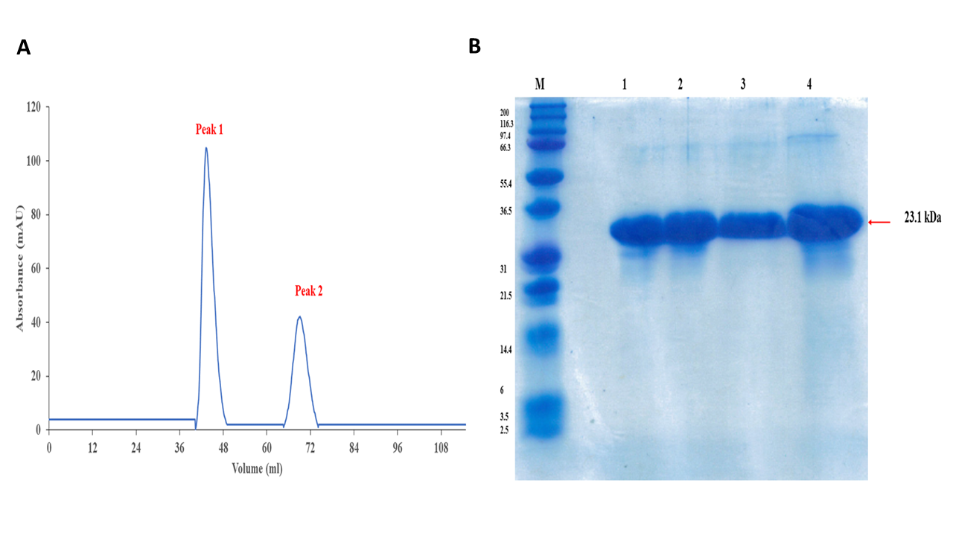
Figure ‎4.18-Purifcation of refolded fraction by Gel filtration C
(A) Gel filtration C (GFC) of refolding of SwpA domain. Peak 1 stands for the 700 kDa protein aggregates and peak 2 stands for 75 kDa which may be protein trimer. (B) 12% SDS PAGE analysis on refolded Small WxL of Gel filtration fractions C. Lane 1: Peak 2 contains protein in 50 mM potassium phosphate, Lane 2: Peak 2 fraction, Lane 3: Peak 1 fraction of protein, Lane 4: Sample before gel filtration.

SwpA identification through Mass spectrometry
The samples were sent for electrospray ionization mass spectrometry to detect the protein’s molecular weight according to its mass/charge ratio. Figure 4.19 (A) shows that SwpA protein was present in the sample. The sample from peak 1 and peak 2 from gel filtration 3 (GF3) were taken and sent for trypsin digestion mass spectrometry in the Chemistry department. The results of mass spectrometry detect that both peaks containing sample contain Small WxL domain. The sample from Peak 1 contained eight peptides with sequence coverage 41.9% as shown in Figure 4.19 (C). Peak 2 contains six peptides with sequence coverage of 32.3%, as shown in Figure 4.19. Seven peptides were detected, with a start position of 68, and end position of 225; this means that mass spectrometry has detected WxL sequence from residues 68 to 225.
Figure 4.19 shows that protein 1 from the peak 1 sample of GF contains at least residues 20 to 190. Protein 2 was from Peak 2 and six peptides could be identified from the tryptic digest with sequence coverage from 20 to 171. Both samples therefore contain Small WxL domain.
Figure ‎4.19-Mass spectrometry of Small WxL of Locus A (SwpA).
(A) Electrospray ionization of SwpA (B) Mass Spectrometry results of Small WxL from Locus A (C) Trypsin digestion of SwpA domain.

One dimensional NMR analysis of SwpA
To analyse a protein by one dimensional NMR spectra is a complex but quick technique. Each peak in 1-D NMR spectra represents a proton in the protein, so if the protein is 100 amino acids long, then it could have 1000 peaks; many of these might be overlapped. There are many ways to check the folding of the protein, but NMR gives you rapid results. A 1D proton spectrum, on the other hand, can be used to assess protein folding quality quickly, and a 1D spectrum usually takes a few minutes to acquire after the sample has been set up. The general concept is that peaks are sharp and narrow when the protein is properly folded and cover various chemical shifts. In contrast, the peaks are broader and less widely scattered when the protein is partially unfolded.
A folded protein has a spectrum with significant dispersion, i.e., peaks in the negative ppm range and peaks out near 10 ppm. The peaks are spaced evenly on the example spectrum (Figure 4.20), ranging from a little over 9 ppm to below 0 ppm. The amide region ranges between 7 and 10 ppm. The folded protein spectrum has more peaks and is sharper and more scattered than the unfolded protein spectrum (Bitesize Bio, 2012).
.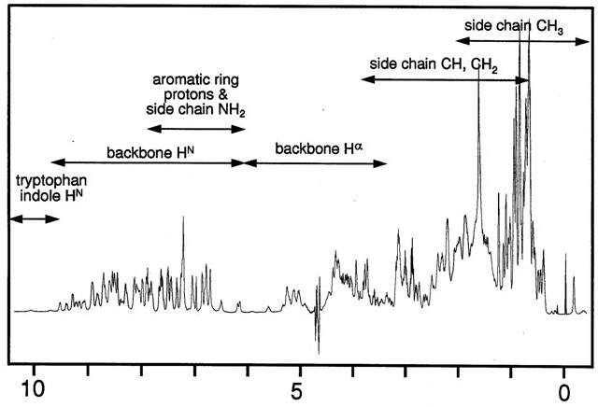
Figure ‎4.20-NMR spectrum of a pure and well folded protein.
NMR samples were prepared from Peak 3 (fractions 14 to 17) of GFB as shown in figure 4.15 (B), and Peak 2 (fractions 14 to 20) of GFA as shown in Figure 4.15 (A). The 75 kDa species sample was prepared for NMR; NMR revealed that the SwpA domain was mostly disordered, as shown in Figure 4.21. SwpA was unfolded in 7 M urea for the refolding experiment, and the protein was then refolded on Ni-NTA beads and purified from GFC. As a result, despite being partially disordered, SwpA refolds very efficiently to the same state before refolding, as demonstrated by NMR in Figure 4.21.
As a result, it was evaluated that the E. faecium DO SwpA-His-Tag is in equilibrium between folded and unfolded states, with a strong propensity to aggregate. Because it lacks a stable folded structure, this protein is unsuitable for structural studies.
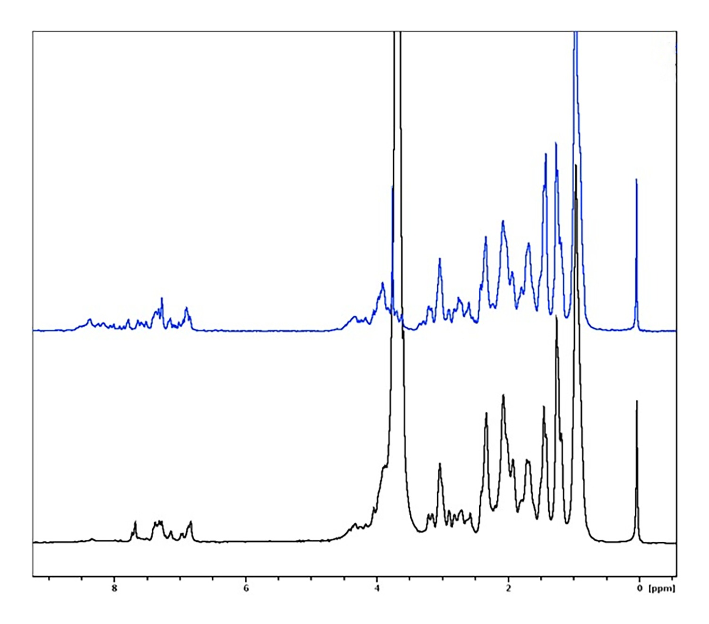
Figure ‎4.21-NMR spectrum of SwpA domain.
Blue peaks indicate protein after refolding and black peaks before refolding. Both spectra are similar, and both look like unfolded protein.

DUFC and SwpC from Locus C
Galloway-Peña et al. (2015) did most of the experimental work on Locus A proteins; so here we tried to do experimental work on Locus C proteins to explore how they behave, express, and purify. This section describes expression trials of DUFC and SwpC, multiple sequence alignment of different DUF proteins of Enterococcus species and then identification of protein expression through electrospray and trypsin digestion. The aim was to purify Small WxL protein and DUFC protein separately and then combine them after the purification to study their interaction.

Expression trials of SwpC
The SwpC construct was provided by the University of Texas-HSC and was used by Galloway-Peña et al. (2015) in their study. They report the protein expression of SwpC, but no evidence of purification was presented as they said that the result of SwpC was not convincing and significant (Galloway-Peña et al., 2015). However, in our hands, no expression was observed for SwpC, as shown in Figure 4.23(C). Electrospray and trypsin digestion MS was also performed to check for low-level expression, but no protein could be observed at the appropriate masses. Expression was attempted three times but with no success.

DUFC protein
As Robetta and Phyre2 analysis in chapter 3 suggest that DUFC is a properly folded and well-structured protein, we decided to work on its expression as previously no experimental work was done on DUFC protein. Our aim was to express and purify DUFC proteins and then study their interaction with Small WxL proteins.

Selection of three different constructs through MUSCLE
Multiple sequence alignment was done by MUSCLE of DUF proteins from locus A, B, C of E. faecium DO and DUFE protein of E. faecalis V583 species, as shown in Figure 4.22. As discussed in Chapter 3 previously, DUF proteins contain the conserved DUF916 domain, which has a conserved sequence of the amino acids NQIDK near the N-terminus, as shown in Figure 4.22(A). Multiple sequence alignment of DUF916 showed that the sequence highlighted in sky blue colour in Figure 4.22 (A) was present in every DUF916 domain except the DUF916 from locus B and is likely to correspond to DUF3324. Based on the alignment, three different G-block sequences of DUF916 of Locus C were designed as shown in Figure 4.22 (B) and then cloned into a linear pOPINF plasmid by the help of Gibson assembly. The three sequences, pDUF916 1, 2 and 3 are likely to correspond to DUF916, [DUF916+DUF3324], and DUF3324 respectively.

Figure ‎4.22-Locus C DUFC domain.
(A) Sequence alignment of DUF proteins. Duf A, B and C represents the DUF from Locus A, B and C of E. faecium DO, and DufE represents the DUFE from E. faecalis V583. The sequence highlighted in yellow represents the N-signal peptide, the conserved sequence is highlighted in red, the sequence with one variation is highlighted in purple, the highly conserved sequence is in the box (NQIDK), and the sequence highlighted in sky blue is not present in DufB. β-strand is shown as arrowed blue ribbon, the green spiral represents the alpha helix, and brown spiral represents the TM (transmembrane) helix. The highlighted sequence indicates the starting and ending point of three different constructs; (SAS to NE is pDUF916 1, SAS to NN is pDUF916 2 and NE to NN is pDUF916 3). (B) Constructs of DUFC. pDUF916 1, pDUF916 2 and pDUF916 3; Green is DUF916 sequence with 6 His-Tag on N-terminal in sky blue color (C) Properties of the three constructs.

Expression trials of DUFC constructs
The three different constructs of DUF916 were each expressed in different competent cells: BL21(DE3), BL21 gold (DE3) and BL21 (DE3) lemo. pDUF916 3 showed better expression in BL21 (DE3) lemo at 37°C using 1 mM IPTG for 4 hours, while the other two constructs showed better expression at 25°C with 0.5 mM IPTG overnight in BL21 (DE3) lemo as shown in Figure 4.23 (B). pDUF916 2 did not show any expression at 37°C using 1 mM IPTG for 4 hours while pDUF916 1 showed low expression at 37°C using 1 mM IPTG for 4 hours with very low concentration of protein. Good soluble expression was noticed for pDUF916 3, which does not contain the conserved sequence NQIDK – in other words, this construct corresponds to the presumed DUF3324 domain only. The pDUF916 3 construct was composed of the last half of DUFC, which is coloured in sky blue in Figure 4.22(A).
Figure ‎4.23-Schematic representation of DUFC and SwpC.
(A) Small WxL of Locus C-Red colour sequence is Small WxL with His-Tag on N-terminal in sky blue. (B) SwpC domain characteristics. (C) Expression of the domain from locus C of Enterococcus faecium (supernatant). Lane 1: DUF916 (2) in BL21 (DE3) lemo 1mM IPTG at 37 °C for 4 hrs , Lane2: pDUF916 3 in BL21 (DE3) lemo 1mM IPTG at 37 °C for 4hrs, Lane 3: Empty, Lane4: SwpC in M15 1 mM IPTG at 37°C for 4 hrs, Lane 5: pDUF916 1 in BL21 (DE3) lemo supernatant (20 kDa) in 0.5mM IPTG at 25°C overnight (10 microliter), Lane6: pDUF916 2 in BL21 (DE3) lemo supernatant (36 kDa) 0.5 mM IPTG at 25°C overnight (10 microliter), Lane 7: pDUF916 3 in BL21 (DE3) lemo supernatant (18 kDa) 0.5 mM IPTG at 25°C overnight, Lane 8: SwpC in M15 supernatant (24 kDa) 0.5 mM IPTG at 25°C overnight, Lane 9: pDUF916 1 in BL21 (DE3) lemo 1 mM IPTG at 37 °C for 4 hrs (10 microliter), Lane 10: pDUF916 2 in BL21 (DE3) lemo 1 mM IPTG at 37°C for 4 hrs (10 microliter), Lane11: pDUF916 3 in BL21 (DE3) lemo 1 mM IPTG at 37°C for 4 hrs (10 microliter), Lane 12: SwpC in M15 1 mM IPTG at 37°C for 4 hrs (10 microliter).

Identification of different constructs of DUFC protein through mass spectrometry
All the three protein samples of DUFC (pDUF916 1, pDUF916 2 and pDUF916 3), expressed at different temperatures were sent to the chemistry department for the electrospray and trypsin digestion mass spectrometry.
The pDUF916 1 protein was analysed by trypsin digestion; six peptides were detected, and sequence coverage was 33.1% [Figure 4.24 (C)]. According to trypsin digestion only 1.5% of the sample contained pDUF916 1 protein. The electrospray of DUF916 1 was able to detect the molecular weight 21318.0 Da, which is quite close to 20325.63 Da as shown in Figure 4.24(A).
Figure ‎4.24-Mass spectrometry analysis of pDUF916 1.
(A) Electrospray ionization (B, C) Trypsin digestion.
The sample of pDUF916 2 was sent to electrospray ionization mass spectrometry to detect the molecular weight which is 363245 Da while the closest actual molecular weight was 36662 as shown in Figure 4.25 (A). According to trypsin digestion of pDUF916 2, three peptides were detected, and 0.03% of the pDUF916 2 was detected in the sample, as shown in Figure 4.26 (C). The sequence coverage of pDUF916 2 was 9.3%. The pDUF916 2 construct is the one which contains both domain DUF916 and DUF3324 domain.
Figure ‎4.25-Mass spectrometry analysis of pDUF916 2.
(A) Electrospray ionization (B, C) Trypsin digestion.
The sample of pDUF916 3 was sent to electrospray ionization mass spectrometry to detect the molecular weight as shown in Figure 4.26 (A). According to trypsin digestion of pDUF916 3, eleven peptides were detected, and 10.66% of the pDUF916 3 was detected in the sample, as shown in Figure 4.26 (C). The sequence coverage of pDUF916 3 was 65.2%.
Figure ‎4.26-Mass spectrometry of pDUF916 3.
(A) Electrospray ionization (B, C) Trypsin digestion.
It was concluded from the protein expression analysis through SDS-PAGE and MS that pDUF916 3 almost certainly does contain the intended protein, while 1 and 2 probably do, with 1 more confident than 2. The amounts of protein expressed for sequences 1 and 2 are however very small. In the future if anyone wants to study DUFC protein, DUF3324 domain is easily achievable for protein expression and further analysis.

Donor strand complementation of WxL domain from Locus A
Based on the predicted structure of WxL and conservation of the sequence of DUF916 (Chapter 3), it was hypothesized that DUF916 contains a β-strand that is non-covalently donated to the WxL domain. This could explain why attempts to express WxL resulted in no expression or insoluble or unfolded protein. It implies that coexpression of WxL and DUF916 might complete the structure of WxL domain to make a properly folded WxL domain.
There are two ways in which this could be done. The simpler one would be to express both proteins simultaneously. Alternatively, it might be possible to express a single construct containing the ‘missing’ strand from DUF916 connected via a linker to a WxL domain. This was the strategy used successfully for pilin (Li et al., 2007), but it does require luck or extensive trials to get the right sequence and the right linker length. A number of plasmids were constructed to express the variants of WxL with donated DUF916 N-terminal containing β-strand to identify the donor strand length required. All the constructs used in the coexpression experiment were taken from locus A of E. faecium as shown in Figure 4.27. The DUF916 is the conserved domain in the cluster, and this domain is always present with the WxL domain, as described in Chapter 3.
We selected the Locus A Small WxL protein and DUFA protein to perform the donor strand complementation experiments because from our previous experiments only SwpA was expressed as a soluble protein to study the WxL domain.

Figure ‎4.27-Schematic scheme of Locus A for donor strand complementation.

Expression of SwpA-DUFA domain
Two different constructs were designed containing whole Small WxL sequence and DUFA sequences with different length; the constructs were designed following the strategy of Li et al., 2007 and Poole et al. (2007) as shown in Figure 4.28. Poole et al. (2007) made seven different constructs to detect which one was involved in strand complementation. The two constructs named SwpA-DUFA₇ and SwpA-DUFA₂₆ contained linker sequence DNKQ between Small WxL and DUFA sequence. Expression trials were performed under a range of conditions, but no expression was detectable.
Figure ‎4.28-Schematic representation of recombinantly engineered Small Wxl A (SwpA(His)₆).
(A) The general scheme, showing the native, full-length SwpA sequence (including Sec-dependent N-terminal signal sequence in red), with an extension at its C-terminus consisting of a short hairpin linker (sky blue), the donor strand from the N terminus of mature DUF916 (green), and a C-terminal hexahistidine affinity tag. (B) Length and residues requirement for two recombinantly engineered SwpA(His)₆; the variation of residues exists in DUFA: DUFA₇ contains an extension of 7 residues, and DUFA₂₆ contains an extension of 26 residues. The 7-residue extension corresponds to one donor strand while the 26-residue extension corresponds to 3 since the structure prediction of WxL suggests that 3 strands may be needed (Chapter 3). (C) Representation of SwpA-DUFA₇; N signal peptide sequence is in black with an underline; Small WxL sequence is in red, the linker is in sky blue, DUFA sequence is in green and histidine₆ sequence is in purple. SwpA-DUFA₇ is cloned into a pET vector (D) SwpA-DUFA₂₆ has the same architecture as SwpA-DUFA_{7,} but DUFA has 26 residues instead of 7 residues. SwpA-DUFA₂₆ is also cloned into a pET vector. (E) Summary of the two constructs SwpA-DUFA₇ and SwpA-DUFA_{26.}

Co-SwpA-DUFA
As no expression was observed from the previous constructs SwpA-DUFA, coexpression constructs were designed following the strategy of Poole et al. (2007). A coexpression system is designed to express multiple proteins, for example, for studying a protein complex. This system also helps in optimal yield, solubility and activity and protects the individual protein subunit from degradation. For the coexpression of two gene of interest the pET-Duet-1 system used. The two multiple cloning sites (MCS) are encoded in the pET-Duet-1 vector, each preceded by a T7 promoter, lac operator, and ribosome binding site (rbs).
The coexpression construct was designed to express Small WxL and DUF916 from locus A within the same plasmid, and each gene has its own promoter. It was cloned into the pET-Duet vector, as shown in Figure 4.29 (A). This WxL domain was selected because from previous experiments, it was observed that SwpA was expressed in soluble form compared to other constructs. DUFA contained the conserved sequence, which can help Small WxL be folded appropriately because the DUFA is the more stable protein. The best way to express two proteins at the same time is to express the protein in the pET-Duet vector. The pET-Duet vector has two cloning sites. DUFA with an N-terminal His-tag was cloned into one site, and a small WxL with a C-terminal S-tag was cloned into the second site. S-tag consists of oligopeptide (Lys-Glu-Thr-Ala-Ala-Ala-Lys-Phe-Glu-Arg-Gln-His-Met-Asp-Ser) sequence derived from pancreatic ribonuclease A (Ranies et al., 2000).

Expression trials of Co-SwpA-DUFA
Different conditions were tried to express the protein. The protein was expressed using 1 mM IPTG at 25°C, but very little soluble expression was noticed during the protein expression trial, as shown in Figure 4.29 (C). Most of the protein came out in the pellet, and decidedly less was noticed in the supernatant. The protein concentration was low; it was challenging to go for purification of the protein. The molecular weight of small WxL is 20 kDa, and DUF916 is 18.3 kDa. On the SDS gel analysis, only the band for DUF916 was seen. A band at 38 kDa may be the dimer complex formed by the two domains in a tight complex, as shown in Figure 4.29(C). The summary of the Co-SwpA-DUFA construct is shown in Figure 4.29 (B).

Figure ‎4.29-Schematic representation of Co-SwpA-DUFA construct.
(A) Construct and encoded amino acid sequence. The green text is the DUFA sequence with a His-Tag on the N-terminus in cyan, and the red text is a sequence of SwpA, with an S-tag at the C-terminus shown in purple color. (B) Summary of CO-SwpA-DUFA .

Identification of Co-SwpA-DUFA through Mass spectrometry
The soluble protein sample was sent to mass spectrometry for molecular weight analysis and amino acid peptide identification through trypsin digestion, as shown in Figure 4.29. The sample was first sent to electrospray to identify the protein based on the molecular weight analysis shown in Figure 4.30 (A); the electrospray results do not show any peak related to SwpA and DUFA protein, but peaks appeared at 17753 Daltons which is quite close to the DUFA molecular weight of 18250 Daltons. Electrospray also showed a molecular weight of 21134 Daltons close to the SwpA molecular weight of 23305 Daltons. The sample was then sent to trypsin digestion, and the results showed that DUFA and SwpA protein both were present in the sample, as shown in Figure 4.30 (B). The relative abundance of the DUFA protein in the sample was 10.2 %, and SwpA relative abundance was 4.6%. The mass spectrometry results showed that His Tag-DUFA had 11 identified peptides, and SwpA-S Tag had 6 to 7 identified peptides. The His-Tag DUFA protein sequence coverage was 51.7 %, and SwpA was 30.7 %. This result was taken as a positive sign because both proteins are present, and both are soluble.
Figure ‎4.30-Mass Spectrometry analysis of Co-SwpA-DUFA.
(A) Electrospray ionization (B, C) Trypsin digestion.

Purification of Co-SwpA-DUFA
As the mass spectrometry results in Figure 4.30 showed that both proteins SwpA and DUFA were present in the sample, a purification was done. DUFA contains a His Tag so Nickel column chromatography was done as shown in Figure 4.31. The DUFA-His-Tag was not eluted as pure protein as shown in Figure 4.31(B), but it was eluted at the right molecular weight of 18.2 kDa. The protein was quite unstable at this stage as this DUFA contains only the DUF916 domain, and DUF3324 sequence was not present in the construct. In section 4.3.2 it was shown that DUF916 cannot be expressed alone.
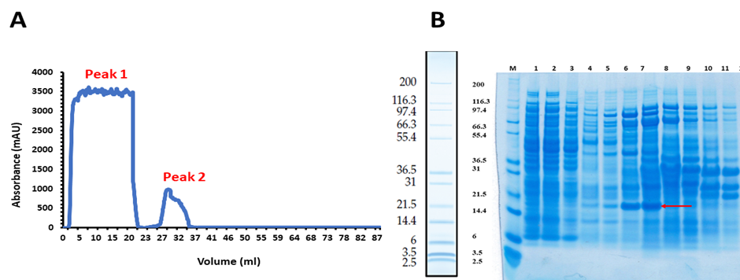
Figure ‎4.31-DUFA-His-Tag Nickel column by gradient method.
Peak 1 represents the unbound fraction (flow through) and Peak 2 represents the fractions 7 to 12. (B) SDS-PAGE analysis. Lane 1- Cell free extract, Lane 2 - Unbound fraction 1, Lane 3 - Unbound fraction 4 (flow through), Lane 4 - fraction 6, Lane 5 – fraction 7, Lane 6 – fraction 8, Lane 7- fraction 9, Lane 8 - fraction 10, Lane 9 – fraction 11, Lane 10 – fraction 12. The expected molecular weight of DUFA-His-Tag is 18.2 kDa.

The fractions of Nickel column chromatography were further purified through gel filtration using Superdex 200 as shown in Figure 4.32. As shown in Figure 4.32 (A), peak 1 contains the protein of interest (DUFA-His-Tag) with other proteins, and peak 2 contains DUFA-His-Tag protein of 18.2 kDa and SwpA-S-Tag of 23.1 kDa as shown in Figure 4.32(B).

Figure ‎4.32-DUFA-His-Tag purification through Gel filtration.
(A) Graphical representation of Nickel column chromatography. Peak 1 represents the fractions 1 to 6 and Peak 2 represents the fractions 12 to 14. (B) SDS-PAGE analysis. Lane 1- GF load (Nickel column fraction), Lane 2 - fraction 2, Lane 3 - fraction 3, Lane 4 - fraction 4, Lane 5 – fraction 10, Lane 6 – fraction 12, Lane 7-fraction 13, Lane 8 - fraction 14. The expected molecular weight of DUFA-His-Tag is 18.2 kDa.

The Small WxL protein with N-terminal S-Tag protein was expressed, and purification was done as shown in Figure 4.33. The SwpA-S-Tag was expressed and purified as a stable monomer, not as purified previously in section 4.3.1 as His-Tag Small WxL; so it is possible that the S-Tag, or the presence of the tag at the C-terminus, makes this protein more stable. As discussed in section 4.3.1, SwpA aggregates quickly. Galloway-Peña et al., 2015 also reported in their study that Small WxL from Locus A (SwpA) purified in the form of monomer and dimer (Galloway-Peña et al., 2015). It is concluded that this construct SwpA-S-Tag protein produced soluble WxL protein.
Figure ‎4.33-SwpA-S-Tag purification and analysis on 12% SDS PAGE.
Lane 1-Cell free extract, Lane2 -Unbound fraction, Lane 3 -elution fraction, Lane 4 -Pellet fraction. The red arrow shows the molecular weight of 23.3 kDa.
It was concluded from the above experiment that DUFA containing DUF916 domain was very unstable and could not be purified, as discussed above in section 4.32. For future analysis, the fractions containing purified DUF916 should be sent for mass spectrometry analysis to confirm protein identity. It was also concluded that SwpA-S-Tag was purified successfully as a stable monomer so further analysis of its secondary structure was done by CD-spectrometry.

CD-analaysis of SwpA-S-Tag
The purified sample of SwpA-S-Tag protein was subjected to CD analysis to determine the secondary structure of the protein, as shown in Figure 4.35. The online server CAPITO analysis (CD analysis and plotting tool) https://data.nmr.uni-jena.de/capito/index.php was used for the CD analysis and also JASCOB inbuilt software. These two analyses gave similar results, showing that the SwpA-S-Tag domain is mainly comprised of beta sheets (52%), with a very small amount of α-helix (1 to 6%) with most of the rest being disordered, as shown in Figure 4.35 (B). By contrast, Galloway-Peña et al., 2015 reported that Swp A existed in two forms: monomer and dimer. The monomer CD analysis showed that it consists of 29% beta-sheet, 6% alpha-helix and 38 % disordered protein, while dimer CD analysis showed that it consists of 30% beta-sheet, 8% alpha-helix and 37% disordered protein. The SwpA-S-Tag prediction through Robetta https://robetta.bakerlab.org/, as shown in Figure 4.34(A), is close to our CD analysis, that SwpA mostly consists of beta-sheet, with a small amount of α-helix. According to Robetta predictions, it contains three alpha-helices, 130-136, 208-218 and 219-224, so it contains 9% of alpha-helix and 16 beta-sheets comprising 40% of the protein, as shown in Figures 4.34(B) and 4.35(B).
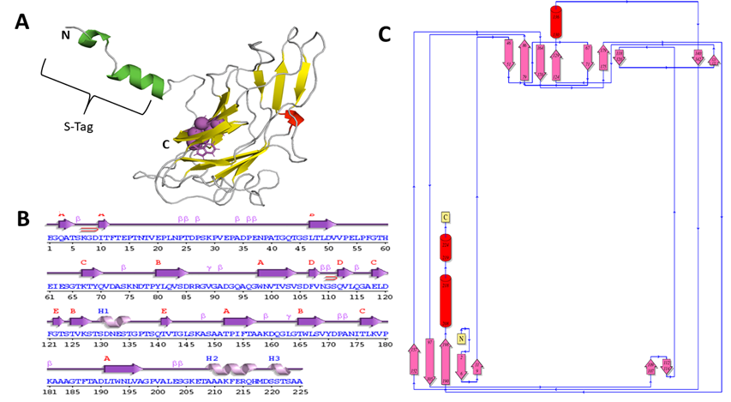
Figure ‎4.34-Structure prediction of the SwpA-S Tag.
(A) predicted structure from Robetta (B, C) Topology was obtained from PDB sum. 74% confidence and 100 % sequence coverage of the structure reported by Robetta.
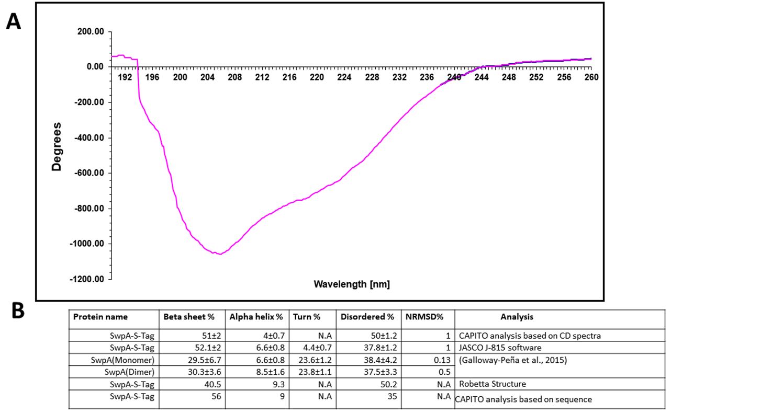
Figure ‎4.35-CD spectroscopy of SwpA.
(A) CD spectrum -The spectrum was collected in a 0.5 mm path cell using 0.3 mg/ml of protein in sodium phosphate buffer at pH 7. CD data were analysed using CAPITO analysis online server and in-built software of JASCO Corp., J-810. (B) Estimates of secondary structure compositions (in % ± SD). NRMSD (normalized root mean square deviation) also showed the agreement with experimental data.

Co-SwpA-DUFA-LpxTG-LwpA
The rest of this Chapter describes attempts to purify WxL domains on their own. No conditions produced soluble folded protein, although one attempt (SwpA) produced a mixture of folded and aggregated protein. In section 4.3.3.2, we, therefore, attempted expression of WxL together with all or part of DUFA, on the assumption that Small WxL takes part in strand exchange with another protein within the same locus, most likely DUF916, as described in Chapter 3. This was speculative because it required a lot of assumptions as to which was the ‘missing’ sequence. This also did not work. Therefore, in a final attempt to produce soluble protein, we expressed most of locus A. In an attempt to be as close to in vivo as possible, we used locus A from E. faecium and expressed it in E. faecalis. Expression was carried out in E. faecalis rather than E. faecium because the genetics of E. faecalis JH2-2 is more straightforward.
We chose locus A because it is the shortest and simplest. The entire locus A was expressed, except trmA (transcriptional regulatory Mga Family) and pnoA (pyridine nucleotide oxidoreductase). Therefore, we used a construct expressing SwpA, DUFA, LpxTGA and LwpA. In the interests of speed, we ordered synthetic DNA for the whole of this sequence. This allowed us to insert purification tags where useful. Therefore, we attached a His-tag on the C-terminus of the SwpA, with the aim that we could purify WxL using a nickel column, which might co-purify with its partner protein and thus allow us to identify the partner. We also attached a Strep tag to the LwpA protein, to allow independent purification of Large WxL using a biotin affinity purification, to investigate any proteins that might associate with Large WxL.
The synthetic DNA was constructed as a G block, to allow it to be inserted into an expression plasmid using Gibson assembly. The G block was designed containing all the domains present in the upstream part of locus A, i.e., SwpA, Large Wxl, DUFA and LpxTGA, as shown in Figure 4.36.
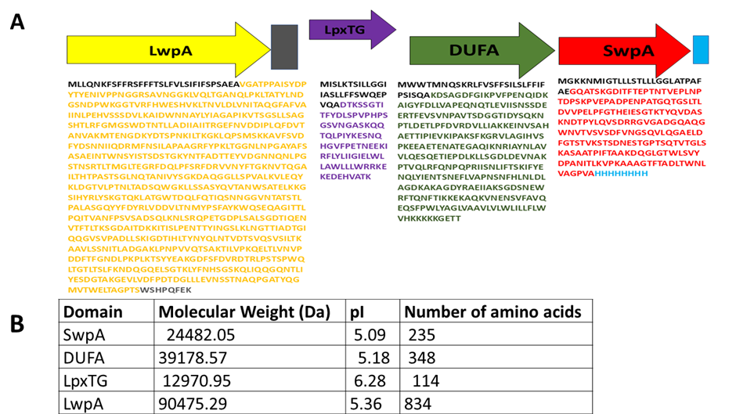
Figure ‎4.36-Schematic representation of construct from Locus A of E. faecium DO.
(A) Construction of G-block of Locus A. DUFA sequence is green; Red colour shows the sequence of Small WxL with a His-tag on the C-terminus in sky blue, the sequence of LPxTG is purple, and Large WxL sequence is yellow with Strep-tag in light grey. (B) Features of Co-SwpA-DUFA-LpxTG-LwpA.

Expression trials of Co-SwpA-DUFA-LpxTG-LwpA
As mentioned in chapter 2, different trial experiments were done to determine which was involved in domain swapping. Still, protein expression was not detectable in any experiments, despite careful use of positive and negative controls as shown in Figures 4.37 and Figure 4.38. The proteins had their native secretion sequences and should therefore be secreted, with the LPxTG protein covalently attached to peptidoglycan. We therefore expected to find the protein product either purifying with the peptidoglycan fraction or possibly in the supernatant.
A first expression trial was done, in which the supernatant was treated with TCA precipitation to concentrate the protein and remove extra contaminants (Koontz, 2014), and the pellet was disrupted through glass beads (size 0.2 micron) as described in chapter 2, but no expression was observed as shown in Figure 4.37. The glass bead beating technique was used to disrupt the peptidoglycan (Ramanan, Ling, & Ariff, 2008). All the experiments were performed in triplicate. E. faecalis JH 2-2 cells without plasmid and GFP plasmid with no protein of interest were used as control in this study.

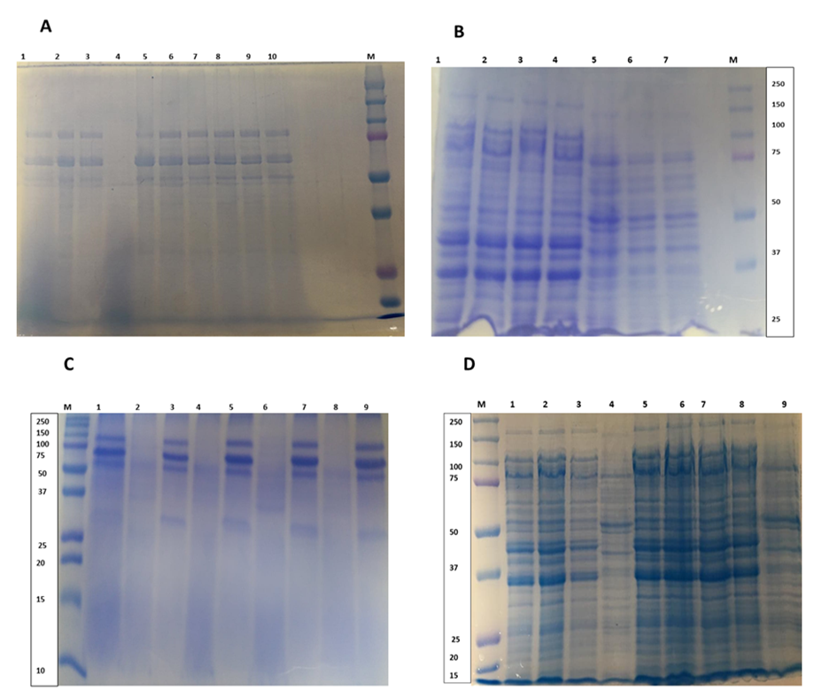
Figure ‎4.37-Expression trial of Locus A proteins (Co-SwpA-DUFA-LpxTGA-LwpA) at 37°C.
(A) TCA precipitation for 2hrs: Lane 1: 0 ng/ml ATc WxL, Lane2: 0 ng/ml JH2-2, Lane 3; WxL with 4 ng/ml lane 4: 4 ng/ml JH2-2, Lane 5; WxL 20 ng/ml ATc , Lane 6; JH 2-2 without plasmid 20 ng/ml ATc, Lane7: Wxl with 100 ng/ml ATc, Lane 8: JH 2-2 without plasmid 100 ng/ml ATc, lane9: WxL with 500 ng/ml, lane 10: JH 2-2 without plasmid 500 ng/ml ATc (B) Pellet cell disruption by glass beads-Lane1: WxL with 0 ng/ml, Lane 2: Wxl with 100 ng/ml, Lane3: Wxl with 0 ng/ml ATc, Lane 4: Wxl with 100 ng/ml Lane 5: JH2-2 without plasmid 0 ng/ml ATc, Lane6: JH2-2 without plasmid 100 ng/ml ATc, Lane7: JH2-2 without plasmid 0 ng/ml ATc; this experiment was performed in triplicate. (C) TCA precipitation for 3hrs-Lane 1: GFP 0 ng/ml ATc, Lane2; WxL with 0 ng/ml ATc, Lane 3: GFP 20 ng/ml ATc, Lane4: WxL with 20 ng/ml, Lane 5; GFP 100 ng/ml ATc, Lane 6; WxL with 100 ng/ml, Lane7; GFP with 500 ng/ml ATc, Lane 8; WxL with 500 ng/ml, Lane 9: JH 2-2 without plasmid (25 microlitre) (D) Protein expression at 3 hrsand Cell disruption by glass beads. Lane1: WxL with 0 ng/ml Lane 2: Wxl with 20 ng/ml Lane3: Wxl with 500 ng/ml ATc Lane 4: JH 2-2 without plasmid (10 microlitre) Lane 5: Wxl 0 ng/ml ATc, Lane6: WxL with 20 ng/ml, Lane7: WxL with 100 ng/ml, Lane8: Wxl with 500 ng/ml ATc, Lane 9:JH 2-2 without plasmid (25 microlitre).

In the second expression trial the supernatant was discarded, and the pellet was treated with 300 µl 8 M urea pH 8 in order to separate any proteins that might be noncovalently bound to the peptidoglycan, but no expression was observable as shown in Figure 4.38. E. faecalis JH 2-2 cells without plasmid were used as control in this study. For the confirmation of the result these experiments were repeated three times. Nickel column chromatography was performed to confirm that there is no protein expression as shown in Figure 4.38(B). The band showing in Figure 4.38(B) Lanes 1 and 2 belongs to a background protein and is not our protein of interest because it came out in the control fractions.

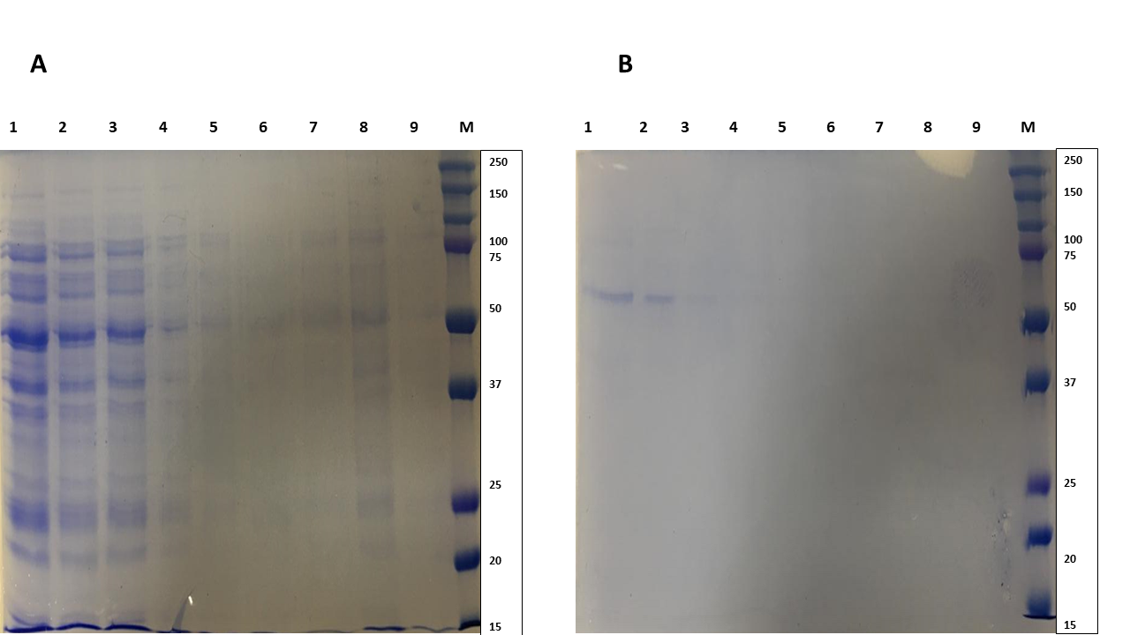
Figure ‎4.38-Expression trial of Co-SwpA-DUFA-LpxTGA-LwpA proteins at 37°C for 2hrs.
(A) Pellet disruption by 8 M Urea. Lane 1: 0 ng/ml ATc WxL, Lane2; 0 ng/ml JH2-2, Lane 3; WxL with 4 ng/ml, Lane 4: 4 ng/ml JH2-2, Lane 5; WxL 20 ng/ml ATc, Lane 6; JH 2-2 20 ng/ml ATc, Lane7; Wxl with 100 ng/ml ATc, Lane 8; JH 2-2 100 ng/ml ATc, Lane9: WxL with 500 ng/ml, ,Lane 10: JH 2-2 500 ng/ml ATc. (B) Purification of SwpA through Nickel column. Lane 1-unbound protein WxL with 4 ng/ml, Lane 2 - unbound protein fraction JH 2-2 with 4 ng/ml, Lane 3 - fraction 3rd WxL with 4 ng/ml, Lane 4 - fraction 3rd JH 2-2with 4 ng/ml, Lane 5 – fraction 4th WxL with 4 ng/ml, Lane 6 – fraction 4th JH 2-2with 4 ng/ml, Lane 7-fraction 13th, Lane 8 -fraction 5th WxL with 4 ng/ml. Lane 9 - fraction 5th JH 2-2with 4 ng/ml. The expected molecular weight of SwpA-His-Tag is 23 kDa. JH2-2 denotes the control.

Summary and Conclusion
This chapter summarizes attempts to express WxL protein, both as Small WxL and as Large WxL. It proved to be remarkably difficult to express anything that was soluble; and even when it was soluble it was usually aggregated.
Section 4.2 describes attempts to express LwpE from E. faecalis, using several constructs of different lengths, some with a cleavable TEV tag in the middle. We started with this protein because Dr Mesnage had previously observed expression of a soluble protein. However, in our hands, no expression of soluble protein could be observed. In Chapter 3 we discuss that the transition from FID to WxL domain in this protein could well be in a different location than identified by Pascal Serror (Jamet et al., 2017; Brinster et al., 2007). Hence, we tried several constructs with the WxL domain starting in different places. We also tried several different plasmids and cells, but no soluble expression could be seen. Protein was seen in the pellet. This was unfolded and refolded, but the resulting protein appeared to be completely unfolded. Expression was attempted using a Tat system which should produce soluble protein inside the cell and then secrete the folded protein, but no expression of secreted protein could be observed.
Section 4.3 describes attempts to produce soluble Small WxL protein from E. faecium. We started with the protein from locus A and C, because expression of soluble protein has been reported previously (Galloway-Peña et al., 2015). As reported in section 4.3.1, SwpA with a His-tag at the N-terminus was soluble but gave a protein that was in equilibrium between two forms, one with a molecular weight expected for a trimer or elongated dimer, and one larger aggregate. We were unable to find conditions that produced a well-behaved monomer.
The structure predictions discussed in Chapter 3 suggest that small WxL domains require a strand exchange, most likely with a sequence at the N-terminal end of DUF916. We therefore tried various ways to stabilize small WxL using part or all of a DUF916 sequence. The most elegant solution, as used for the crystal structure of the homologous pilin CfaE (Li et al., 2007), is to fuse a sequence for the N-terminal end of DUF916 onto the C-terminus of small WxL. This requires luck because it is not easy to predict exactly what sequence and what length of linker would be required. We were not lucky, and no expression was obtained using this approach.
The alternative is to express both small WxL and DUF916 together, in the hope that they will bind and stabilize each other. Section 4.3.2 reports studies on DUF916 domains. As discussed in Chapter 3, the DUF protein from E. faecium Locus C consists of two domains, which are expected to be a DUF916 domain followed by a DUF3324 domain, which appears to have a similar β-barrel structureto DUF916. When we tried expressing these, we found that the C-terminal half of DUFC (ie, the DUF3324 domain) could be purified as a folded protein, but that the N-terminal half (ie the DUF916 domain) could not. The full-length protein could be purified, but at low yield. This suggests that the isolated DUF916 domain is less stable than the DUF3324 domain and supports our proposal that DUF916 normally undergoes strand exchange with small WxL.
Small WxL and DUF916 were co-expressed in two ways.The first and more obvious way was to use a pET-DUET vector to express both proteins under the control of the same promoter. In this construct, the Small WxL had a C-terminal S-tag, while the DUF916 had an N-terminal His-tag. The second method was to express most of the WxL locus from E. faecium locus A. The reasoning behind this was that we had so far been unable to produce soluble and folded WxL, encouraging us to believe that strand exchange was required for stability; but we cannot be sure that the donor strand originates from DUF916. Hence, expressing all proteins together is the best chance of producing an in vivo-like protein interaction and stabilizing Small WxL.
The second method did not result in the identification of any soluble WxL protein. However, the protein from the pET-Duet vector turned out to be more useful. The results showed that DUF916 and WxL come off the His column together but could not easily be purified and the protein was very unstable, and that soluble Small WxL with a C-terminal S-tag could be purified as a reasonably stable monomer – presumably more stable as compared to the N-terminal His-tagged Small WxL.
Thus, in summary, we have not been successful in our initial aim, which was to express a WxL domain in sufficient quantities for structure determination by crystallography or NMR. However, we have produced soluble protein and have obtained a CD spectrum showing that it has the secondary structure predicted by our modelling in Chapter 3. In almost all cases, Small WxL and Large WxL isolated proteins were not stable and folded; and DUF916 alone was also not stable and folded, although DUF3324 was. This is consistent with our expectation that DUF916 provides a donor strand to WxL, though it does not prove it. However, the observation that purification of DUF916 using a nickel column also results in the purification of small WxL suggests that the two proteins interact. Due to lack of time, we were unable to pursue this result further, and this would be an obvious target of further study.
In the future, Small WxL can be coexpressed with DUF protein, and double labelled expression should be done so that tertiary structural analysis of the protein should be done. The protein should be expressed single labelled and titration should be done with different ligands to check the binding affinity. The binding affinity of the WxL domain should be with different peptidoglycan fragments.

Study of LysM domains from E. faecalis V583

Introduction
Garvey et al (1986) first reported on the lysM (lysin motif) domain (Visweswaran et al., 2014; Garvey et al., 1986). The Lysin domain was named after the Lysin motif sequence, which was found in different bacterial proteins; these lysin motifs are connected to hydrolytic enzymes that are involved in cleaving the bacterial host's cell wall during the lytic cycle's final stage (Buist et al., 2008).
Three LysM containing proteins are present in E. faecalis V583: AtlA, AtlB and AtlC. In peptidoglycan hydrolysis, AtlA acts as an N-acetylglucosaminidase, while AtlB and AtlC have similar functions and act as N-acetylmuramidases (Mesnage et al., 2008; Eckert et al., 2006). E. faecalis V583 (Paulsen et al., 2003) has a genome that contains twelve LysM proteins, each with one to six LysM motif repeats; these interlinking domains are characterized as either basic (9.1<pI<10.1) or acidic (3.8<pI<6.3).
AtlA (six basic LysM motifs separated by linkers) and AtlB (two acidic contiguous LysM motifs) are representatives of these two categories and are targeted to distinct subcellular sites. AtlA binds preferentially at the septum and poles, and AtlB is found across the whole cell surface. The six AtlA domains are separated by a flexible linker, while AtlB domains are not separated by a linker (Mesnage et al., 2008). AtlA protein contains three types of domains while AtlB protein contains only two types of domains. In AtlA, Domain I is a T/E-rich region and is present on the N-terminal region of the protein, domain II is made up of a central putative catalytic domain, and domain III is made up of six LysM domains which are present on the C-terminal of the protein and are involved in cell wall binding (Eckert et al., 2006). In AtlB, the T/E-rich domain is absent (Mesnage et al., 2008).
This chapter describes work carried out on LysMA1 and LysMB1 domains (i.e., the first of the LysM domains in each case) from Enterococcus faecalis V58: their expression, purification and NMR titration with GlcNAc₅ ligand. It also describes the backbone assignment of LysMB1 protein and a calculation of the structural change from free structure to the protein bound to GlcNAc₅. The aim of this study was to analyse the binding of the two LysM domains to the peptidoglycan analogue GlcNAc₅. LysMA1 is basic, while LysMB1 is acidic. Can we identify any functional significance in this difference? Do they have different affinities for peptidoglycan, and does the binding show a dependence on pH? The studies described in this chapter show some differences in affinity; they are not large and are not pH-dependent. However, there are some differences in dynamics between the two proteins binding. We, therefore, decided to investigate whether there is a change in the structure of LysMB1 on binding that might explain this. In order to study the binding, we needed to express and purify both proteins and to obtain a backbone assignment for LysMB1 (there already was an assignment of LysMA1).

LysMA1 and LysMB1

Protein Expression
The LysMA1 construct was expressed in E. coli C43(DE3) at 25°C overnight following induction by 1 mM IPTG, and the LysMB1 construct was expressed in E. coli LEMO21(DE3) using 1 mM IPTG 25°C overnight as shown in Figure 5.1. Both proteins were His-tagged.

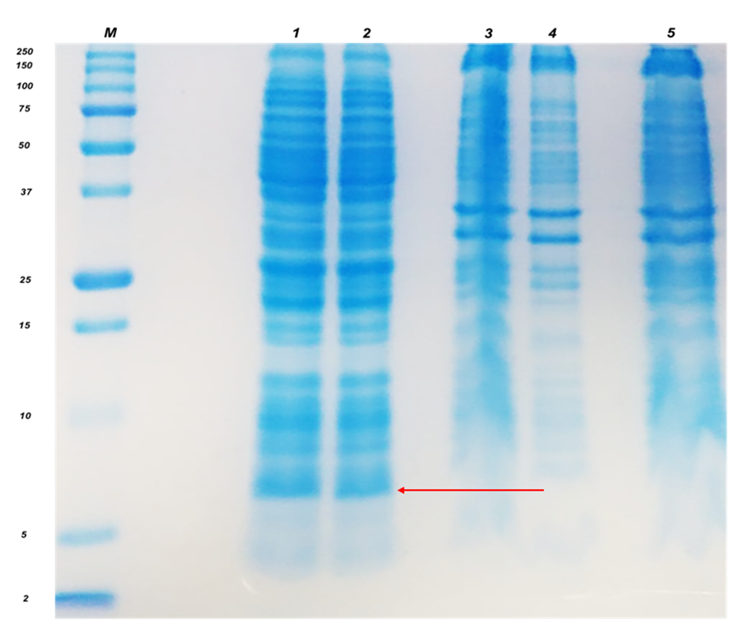
Figure ‎5.1-12%SDS-PAGE analysis of LysMA1 and LysMB1.
M: low molecular weight markers. Lane 1 -LysMA1 supernatant in PML520 in E. coli C43 at 25°C overnight, 1 mM IPTG (6.3 kDa). Lane 2 -LysMB1 supernatant in pOPINF plasmid in E. coli LEMO21 (DE3), 1 mM IPTG 25°C overnight (7.3 kDa). Lane 3- LysMA1 pellet in PML520 in E. coli C43 at 25°C overnight (6.3 kDa). Lane 4- LysMB1 pellet in pOPINF plasmid in E. coli LEMO21(DE3) 1 mM IPTG at 25°C overnight. Lane 5- LysMB1 in pOPINF plasmid in E. coli LEMO21(DE3) 1 mM IPTG 25°C overnight. Red arrow indicates tne 6.3 Kda and 5.3 Kda.
Table ‎5.1-Summary of LysM proteins
Extracted form Expasy proparam (Gasteiger et al., 2005)

Purification of LysM domains
This section is about the purification of both LysMA1 and LysMB1 domains.

LysMA1 purification
The purification of LysMA1 domain was done in two steps (A) IMAC chromatography (Nickel column chromatography) (B) Gel filtration. LysMA1 purification was done by IMAC chromatography, and two peaks were obtained. Peak 1 contained the unbound protein fractions, and peak 2 had the bound protein fractions, as shown in Figure 5.2 (A). Then the fractions containing peak 1 and 2 were run on SDS-PAGE for molecular weight analysis of LysMA1 protein, as shown in figure 5.2(B).
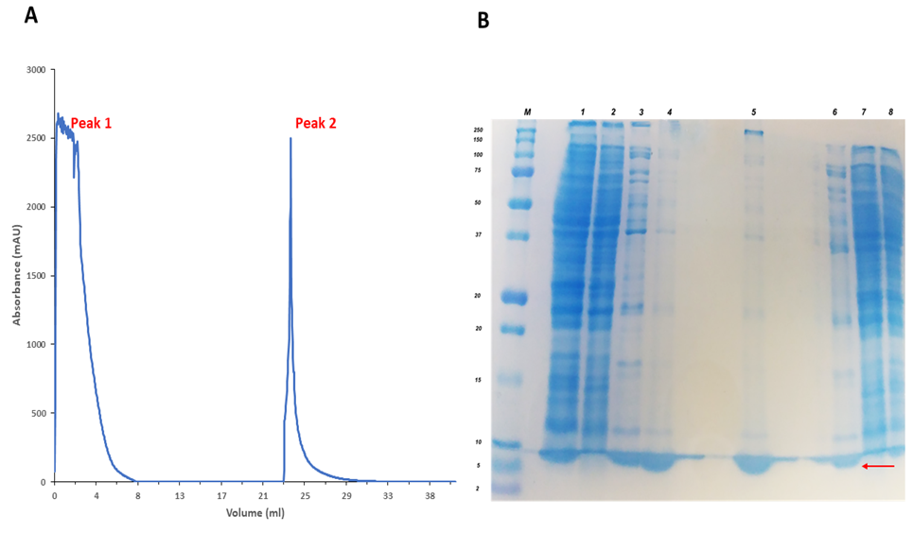
Figure ‎5.2-Purification of LysMA1 by nickel column chromatography by gradient method.
(A) Graphical representation of nickel column chromatography: Peak 1 contains unbound protein (1st to 8th fraction) and peak 2 contains the bound protein fractions (17 to 20). (B) SDS-PAGE analysis: lane 1- cell extract; lane 2 -unbound protein (Flow through) (Peak 1); lane 3- fraction 17 of nickel column; lane 4- fraction 18 ; lane 5- fraction 19; lane 6- fraction 20; lane 7- fraction 21, lane 8- fraction 22. Red arrow indicates the 6.3 KDa.
The fractions from Peak 2 of the IMAC chromatography were then subjected to further purification by gel filtration. Two peaks were obtained when the protein was subjected to gel filtration, as shown in Figure 5.3(A). Peak 1 contains a high molecular weight aggregate, but did not contain the protein, but peak 2 contains the purified protein, as shown in Figure 5.3 (B). The LysMA1 was a very stable protein, and very little protein was lost during the purification.
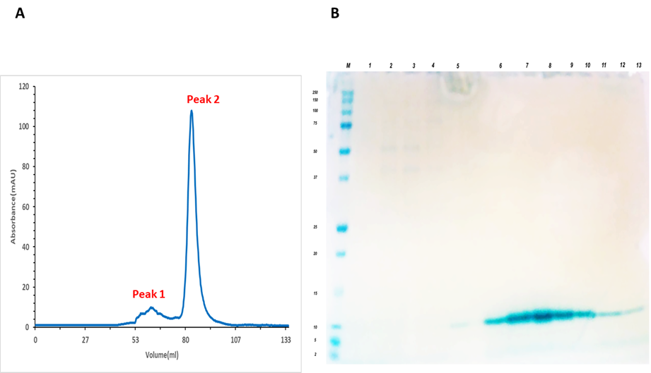
Figure ‎5.3-Gel filtration purification of LysMA1 domain.
(A) Graphical representation of gel filtration -Peak 1 contained the AGF (9th to 13th fraction), and Peak 2 contains purified protein (18th to 25th fraction) (B) SDS page analysis -lane 1;9th fraction, lane 2:10th AGF, lane 3;11th AGF, lane 4; 12th AGF, lane 5;13th AGF, lane 6;18th PF,lane7: 19 ^{th} PF, lane 8: 20th PF, lane 9; 21st PF, lane 10; 22nd PF, lane11; 23rd fraction, lane12: 24th PF, lane 13; 25th fraction. AGF stands for aggregated protein fraction and PF stands for purified protein.

LysMB1 purification
The LysMB1 purification was divided into four steps: IMAC chromatography, buffer exchange through desalting chromatography, His-Tag cleavage, reverse IMAC chromatography and gel filtration. The original plan was to leave the His-tag on the protein, but during purification, it became clear that the His-tagged protein is not stable and precipitates rapidly on standing.
The IMAC chromatography produced two peaks: Peak 1 contains unbound protein, and Peak 2 contains bound protein, as shown in Figure 5.4(A). The molecular weight analysis of these proteins was done through SDS-PAGE analysis, as shown in Figure 5.4(B).
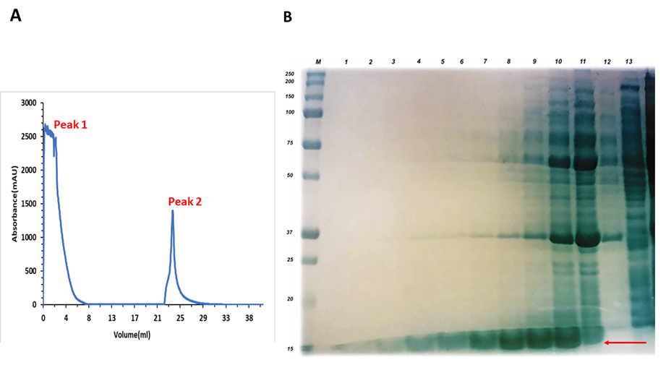
Figure ‎5.4-Purification of LysMB1 through IMAC chromatography.
(A) Graphical representation: Peak 1 represents unbound protein (fraction 1-4), and Peak 2 (18-19th fraction) represents the bound protein. (B) SDS-PAGE analysis: Lane1:25th fraction, lane2:24th fraction, lane 3: 23rd fraction, lane 4: 22nd fraction, lane5:20th fraction, lane 6: 19th fraction, lane7: 18th fraction, lane 8: 17th fraction, lane 9:16 ^{th} fraction from Peak 2, lane 10: lane 11: unbound protein (Peak 1), lane 12: crude extract, lane 13: crude extract.

As the protein was quite unstable in the imidazole, buffer exchange was carried out rapidly using a desalting column. The peak 2 fractions from IMAC chromatography were therefore passed down a desalting column for the buffer exchange; two peaks were obtained as shown in Figure 5.5(A). Peak 1 contained the protein without imidazole, and Peak 2 contained a small amount of protein with a high content of imidazole. Peak 1 contained the protein in a new buffer (50 mM HEPES pH 7, 250 mM NaCl, 15% glycerol).

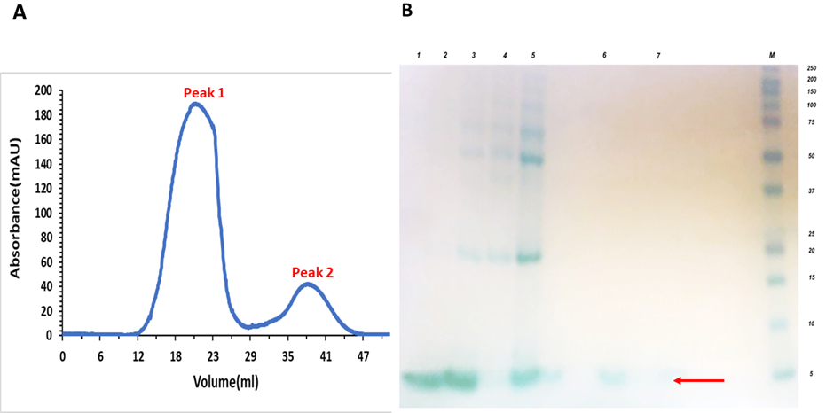
Figure ‎5.5-Desalting of LysMB1 domain through G25 Sephadex column.
(A) Graphical representation of desalting: Peak 1 represents the protein (9th to 24th fraction), and Peak 2 represents the salt peak (30th to 40th fraction) (B) SDS-PAGE analysis: Lane 1:9th to 10th fraction with 0.4 mg/ml, Lane 2:11th to 15 ^{th} fraction with 0.5 mg per ml, lane 3:15th to 20th fraction with 0.2 mg /ml, Lane 4: 30th to 40 ^{th} fraction with 2.37 mg /ml, Lane 5:20th to 24th fraction (0.6 mg per 45 ml), Lane 6: 25th fraction, Lane 7:26th fraction.
After buffer exchange of the fraction, the protein was cleaved by 3C protease enzyme to remove the His-tag, because the protein aggregated in the presence of the His-tag. This process of protein purification was done in one day because the protein was not stable in imidazole and with the His-tag. The protein was further purified by gel filtration after the reverse IMAC. Two peaks were obtained from gel filtration. Peak 1 was aggregate, and Peak 2 was the protein of interest, as shown in figure 5.6 (A). The molecular weight analysis of purified protein was done through SDS-PAGE analysis, as shown in figure 5.6(B).
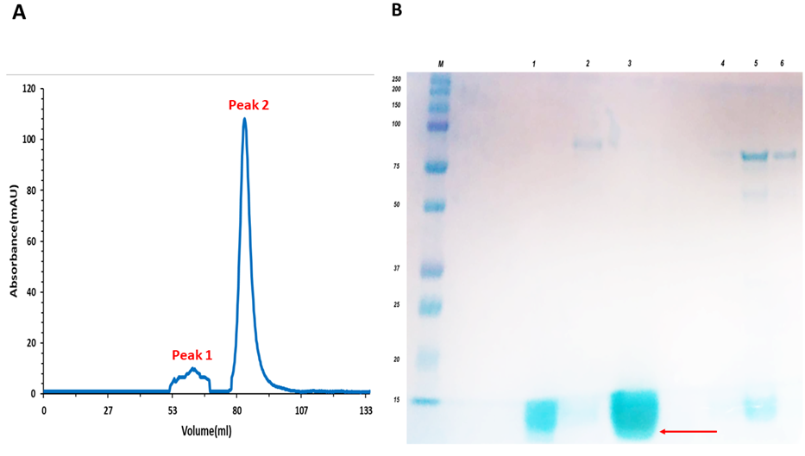
Figure ‎5.6-Gel filtration of LysMB1 domain.
(A) Chromatogram: Peak 1 represents AGF (9th-13th fractions) and Peak 2 represents a PF (18th-21st fractions), (B) SDS-PAGE analysis: lane1: 18-19th PF, lane 2:9th AGF, lane 3: 20th₋⁻21st PF, lane 4:10th AGF, lane 5:13th AGF, lane 6:11-12th AGF.AGF stands for aggregated protein fraction and PF stands for purified protein.

In conclusion, the LysMB1 with His tag was an unstable protein, and during the purification, a lot of protein was lost during the process. Once the His-tag had been removed, the protein was then fairly stable.

Backbone Assignment of LysMB1 domain
The protein was produced and purified in double labelled form using M9 medium. The protein is 52 residues long. About 48 spin systems were observed in ¹⁵N-HSQC, as expected because the N-terminal residue is not observable, and three are proline residues, which were not observed through NMR (Figure 5.8). Triple resonance spectra were obtained (with the assistance of Andrea Hounslow to set up the experiments) and analysed to find the peak positions of Cα_{i}, Cβ_{i,} CO_{i}, Cα_{i-1}, Cβ_{i-1} and CO_{i-1} resonances using the triple resonance spectra HNCO, HNCACO, HNCA, HNCACB, and CBCACONH. A series of representative slices from these spectra are shown in Figure 5.7. A number of signals could not be assigned to backbone resonances because they correspond to amide side chains of asparagines and glutamines. The proline residue and first two residues were not visible in NMR-HSQC spectra. The residues 42, 29 and 21 were overlapped HSQC peaks. An additional nine other signals present in the spectra that were not assigned may belong to the side chains of the glutamine, asparagine, or other amino acids because they corresponded to side-chain N-H pairs.
The chemical shifts were obtained from the triple resonance spectra, and the backbone assignment was performed using the asstools program, which uses a Monte-Carlo method to match the chemical shifts (Reed et al., 2003). The program places spin systems next to each other in the amino acid sequence by comparing the self and preceding carbon chemical shifts of the amino acid type, as shown in Figure 5.7. Following the standard method used in the Sheffield lab, thirty iterations of this Monte Carlo procedure were produced at each assignment attempt. An example of the final output is shown in figure 5.8, which lists the residue number and type followed by the spin system(s) assigned to it and the number of iterations that spin system was assigned to that position. For each run, spin systems and assignments were checked manually against the spectra. After each run, spin systems can be fixed to their assignments, and incorrect peaks can be removed from the list. Over 200 spin systems were originally picked and analysed. Clearly, this is too many for a protein containing 52 amino acids, and many of these were minor signals not corresponding to backbone resonances and were removed during the assignment process.
In the final assignment run, sequential assignment of backbone resonance was completed for residues 3-52, as shown in Figure 5.9. Residue 2 is a proline, and the N-terminal residue is not normally seen in triple resonance spectra because the N-terminal nitrogen is an amine, not an amide, and therefore exchanges too fast with the solvent to be visible. The backbone data was analysed using Collaborative Computing Project for NMR community (CPPN) (Skinner et al., 2016; Vranken et al., 2005).
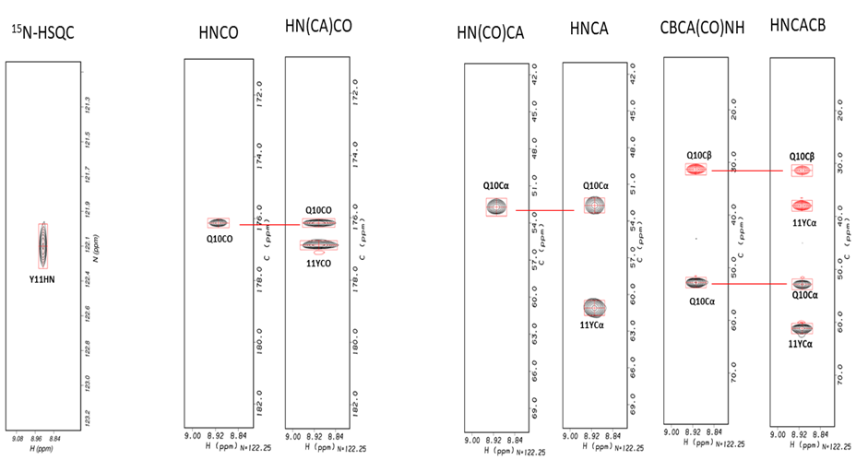
Figure ‎5.7-Representative slices of triple resonance backbone assignment spectra.
The slices for Y11 are shown, from left to right, the ¹⁵N-HSQC, which is used as the basis for assignments, the HNCO and HN(CA)CO reveal the ¹³C carbonyl chemical shifts, and the HNCA, CBCA(CO)NH, and HNCACB reveal the C alpha and beta shifts for Y11 and the preceding residue, Q10.
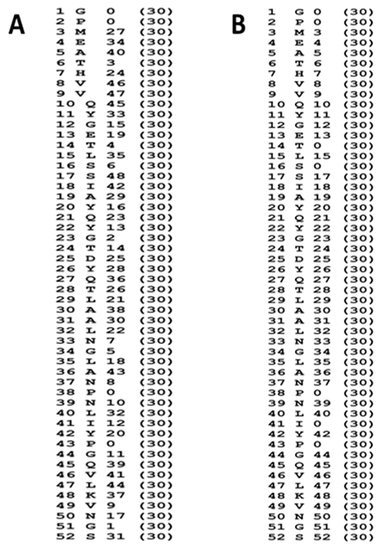
Figure ‎5.8-Output from 30 iterations of the Asstools backbone assignment program.
(A) LysMB1, (B) LysMB1 with GlcNAc₅ ligand- The list shows for each residue their sequence number, amino acid type, spin system number, and in brackets the number of assignments of that spin system. Spin system numbering is from the top of the HSQC spectrum downwards, and therefore starts at the lowest ¹⁵N chemical shift value and works up.
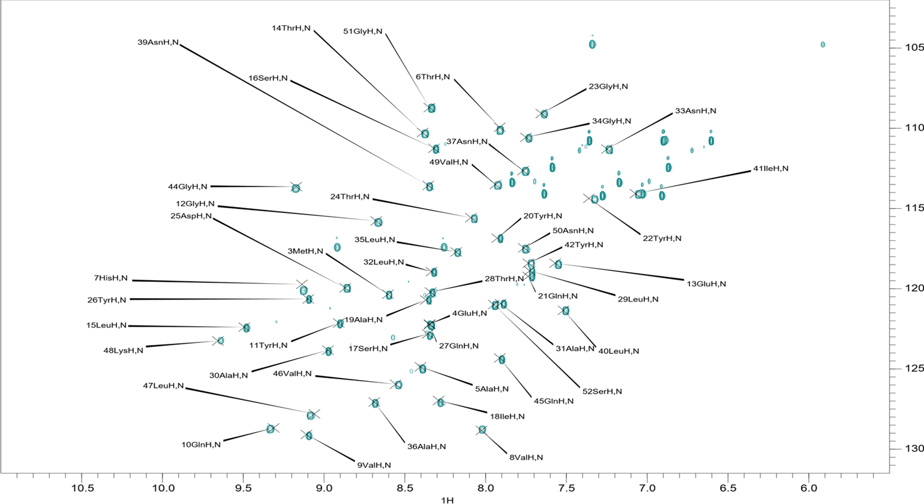
Figure ‎5.9-Backbone assignment of LysMB1 domain.
Labelled by CCPN analysis.

NMR titrations
NMR titrations with the peptidoglycan analogue GlcNAc₅ were done at pH 3, 5, 7 and 9 for both LysMA1 and LysMB1 proteins, to measure ligand binding affinity, and find out whether both proteins bind to ligand in similar ways.
Buist et al. (2008) observed that isoelectric points of LysM domains might play an important role in binding and substrate specificity at different environmental pH values. Lactococcus lactis contains two paralogous proteins, AcmA and AcmD. AcmA contains LysM domains with a pI around 10, while AcmD has a LysM domain with a pI around 4. The AcmA-containing LysM domains showed binding to PG at all different pHs. However, AcmD LysM domain was not able to bind to PG above its isoelectric point of 4 (Buist et al., 2008). Studies of the binding affinity of LysMA1 and LysMB1 domain to PG ligand at different pH were done by NMR and ITC: the ITC studies were carried out by Dr Nicola Galley. GlcNAc₅ was used as the ligand in these studies because previous studies by us and others (Mesnage et al., 2013) have shown that binding affinity increases with the number of GlcNAc units up to 5, after which there is little further increase.
When the NMR titration with GlcNAc₅ ligand was carried out, most of the NMR peaks decreased in intensity and stayed in almost the same place, rather than undergoing a change in the chemical shift. This is the behaviour typically expected for peaks in slow exchange. In the slow exchange limit, peaks do not move during the titration: the free signals decrease, in proportion to the fraction of free protein, while bound signals appear somewhere else in the spectrum and increase in intensity during the titration, and there is no line broadening. In these circumstances, the peak intensities can be used for fitting the affinity (Williamson, 2013). If there is an intermediate exchange, or if there are other exchange processes happening such as a change in protein conformation during the titration, then peaks may broaden during the titration and eventually sharpen up again as they become close to fully bound. The broadening is due to chemical exchange and leads to an additional loss in peak height because the signals are broader. In HSQC spectra, this will usually result in a loss in the intensity of the peak, because of the window function applied to sharpen the signal in the 2D spectrum. Thus, if the protein is fully in slow exchange (i.e., if the off-rate for dissociation of the complex is slow compared to the difference in chemical shift between free and bound signals), then peak heights (intensities) can be fitted to give the affinity. If there is intermediate exchange or other conformational exchange processes, then there may be additional broadening, meaning that peak intensities give an unreliable measure of affinity. Because many of the peaks for both proteins do not move much but do decrease in intensity, we decided to fit peak intensities rather than chemical shift changes, and then compare these values to those obtained by ITC to assess if this is a good way to fit affinities.
All peaks were followed during the titrations at each pH (3, 5, 7 and 9), and were picked into a Felix database, which records their chemical shifts and intensities. The database was then exported and passed through a series of linux macros to assemble the data into tables that can be fitted. The macros also allow the results to be plotted in boxplots, which show chemical shifts or intensities for each residue as a function of added ligand concentration.

Calculating binding affinity of GlcNAc₅ to LysMB1 and LysMA1 using intensities
The LysMB1 and LysMA1 binding affinity were checked through intensities at different pH because the shift changes of the peaks were small. The titration involves addition of solution containing ligand to the protein, and therefore involves dilution of the protein solution. This will result in a small decrease of peak intensity during the titration. The decrease seen in Figures 5.10, 5.13, 5.16, 5.19, 5.22, 5.25, 5.28 and 5.31 is more dramatic than this and affects all peaks. Normally binding of a ligand affects only a subset of peaks, which move or lose intensity during the titration, while the rest are unaffected. Here, essentially all peaks lose intensity. We concluded that some of the loss in intensity was due to dilution (which can be calculated from the volumes added), but some was due to protein precipitation (which cannot be calculated because we do not know how much signal has been lost due to precipitation). For the LysMA1 protein, ligand titration was done from 0-1000 µM, while for LysMB1 (which binds more tightly), ligand titration was done from 0-150 µM.
To optimise the data of LysMB1, the average intensities of four non-binding residues (M3, A5, G51, and S52) were taken and averaged, and all other intensities were divided by these values, as shown in Figure 5.14(B), 5.20 (B) and 5.26(B) except at pH 9 where no optimisation of the data was needed. To optimise the data of LysMA1, selection of the average intensities of residues varies with pH. In the case of LysMB1, residues G1, P2, P38, and P43 were not observable at any pH.

pH 3
The spectra obtained from the titration of LysMA1 are shown in Figure 5.10. The peak intensities were corrected using a reference set of peaks from residues that were assumed not to bind, in which case their intensities should be affected only by dilution and protein precipitation. From a visual inspection of the data (Figure 5.11A), residues N3, T4, G50 and S51 were selected, as being peaks close to the termini and thus far from the binding site and assumed to be playing no part in the binding. The intensities of these peaks were averaged for each titration point, and all other intensities were then divided by the averaged intensities of these peaks, giving the corrected data shown in Figure 5.11B. This should mean that residues that take no part in binding have zero loss in intensity. To measure the K_{d} of LysMA1 with GlcNAc₅ ligand at pH 3 using intensities, nine residues were selected for fitting: L14, N15, I17, A18, D37, L38, I39, F40 and V41, as shown by cyan circles in Figure 5.11(A). These residues were selected because their intensities decrease in a manner that looks like a binding curve. The intensities of these peaks were then fitted to a standard binding curve and gave an average K_{d} of LysMA1 for binding to GlcNAc₅ of 0.42 μM as shown in Figure 5.12. This value is completely different from the value obtained by Dr Nicola Galley using ITC, which was 287 μM, as shown in Table 5.2. Figure 5.10 shows the result for peak intensities, for the addition of GlcNAc₅ to LysMA1 at pH 3.
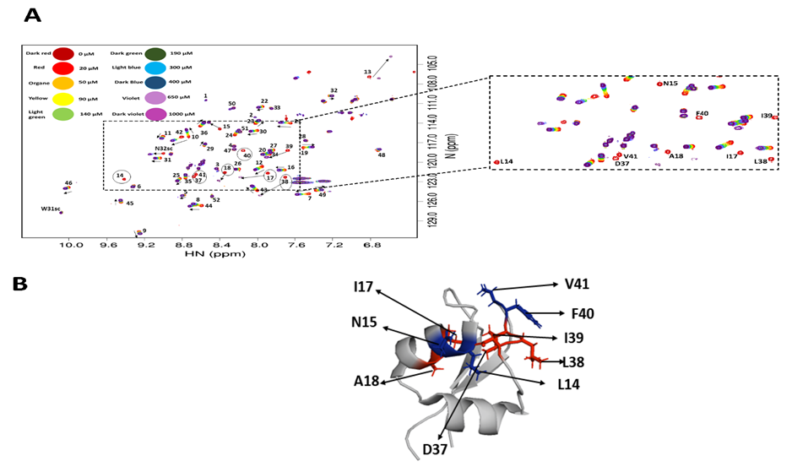
Figure ‎5.10-Effect of GlcNAc₅ ligand on LysMA1 protein at pH 3.
(A) Overlay of ¹H¹⁵N HSQC spectra of the LysMA1- GlcNAc₅ titration acquired. The enlarged view illustrates a region of the spectra with peaks interacting with the GlcNAc₅. (B) The LysMA1 protein (PDB 2MKX) was used to map the residues identified to interact most strongly with GlcNAc₅ (L14, N15, I17, A18, D37, L38, I39, F40 and V41).

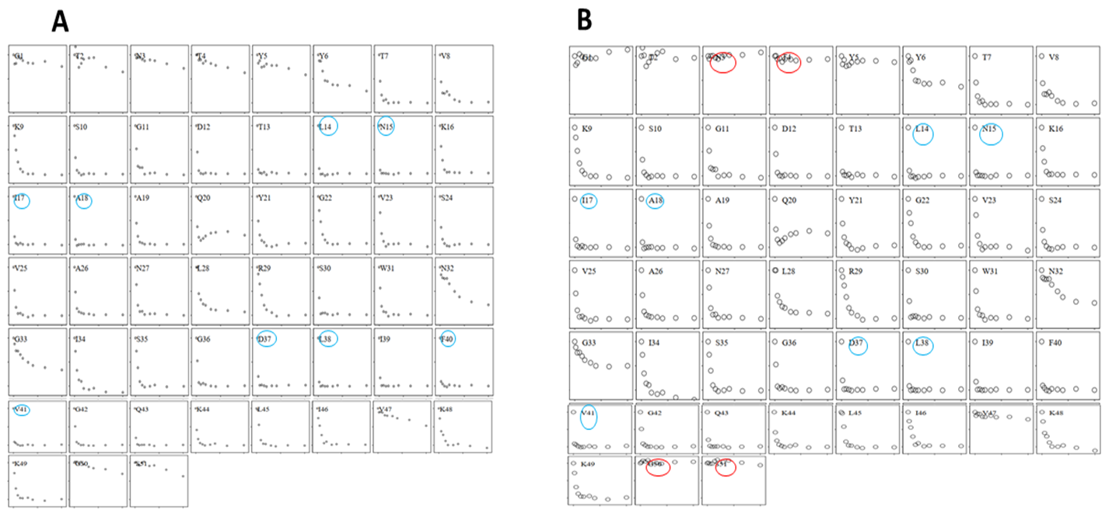
Figure ‎5.11-Box plot of LysMA1 titration according to intensities at pH 3.
(A) Peaks in sky blue circle were used for data fitting of K_{d} (B) (Corrected Data) Peaks in red circles (N3, T4, G50 and S51) average intensities were taken; then all intensities were divided by these average values; Peaks in sky blue circle (L14, N15, I17, A18, D37, L38, I39, F40 and V41) were used for data fitting of K_{d}. The relative intensities of the ¹H nuclei from each residue are signified on the y-axis, while the ligand concentration (0-1000 M) is represented on the x-axis.
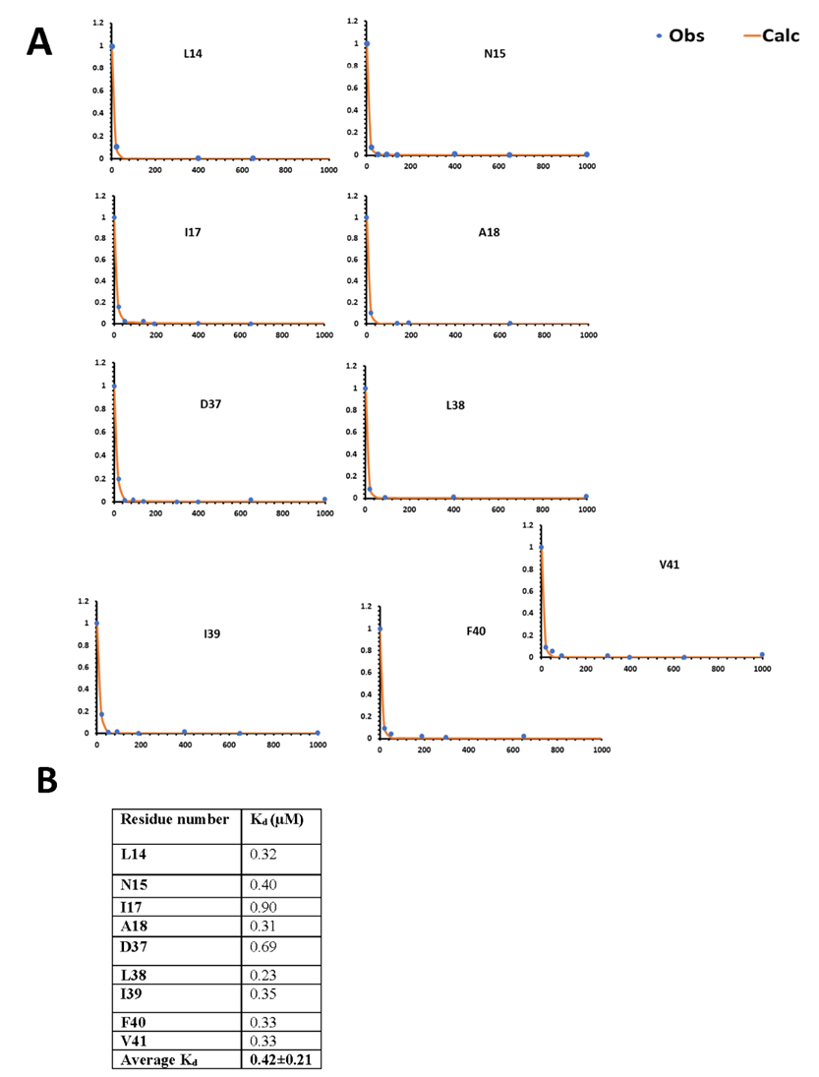
Figure ‎5.12-K_{d} fitting of LysMA1 at pH3.
(A) The y-axis represents the relative intensities of the NH nuclei from each residue, and the x-axis the ligand concentration (0-1000 µM). (B) Fitted K_{d} values from different residues.

Titration of LysMB1 with GlcNAc₅ at pH 3 was followed in a similar way, as shown in Figure 5.13; LysMB1 showed small chemical shift changes but more intensity changes as compared to LysMA1. Three peaks (T14, S16, and I41) disappeared during the titration and did not come back.
To measure the K_{d} through intensities of LysMB1 at pH 3, fifteen peaks were selected (G12, T14, L15, S16, S17, Q21, D25, Y26, Q27, A30, L35, N37, N39, L40 and Q45) as shown in Figure 5.14 (A) and 5.13. The average K_{d} for LysMB1 fitted through intensities while binding to GlcNAc₅ ligand was 3.6 μM as shown in Figure 5.14; while according to Dr Galley’s observation through ITC it was 19.5 μM as shown in Table 5.2. At pH 3, most of the LysMB1 protein aggregates so after each titration protein concentration was measured, and more protein was added during titration. The pI of LysMB1 is 4.6, which may explain why the protein was not stable at pH 3.

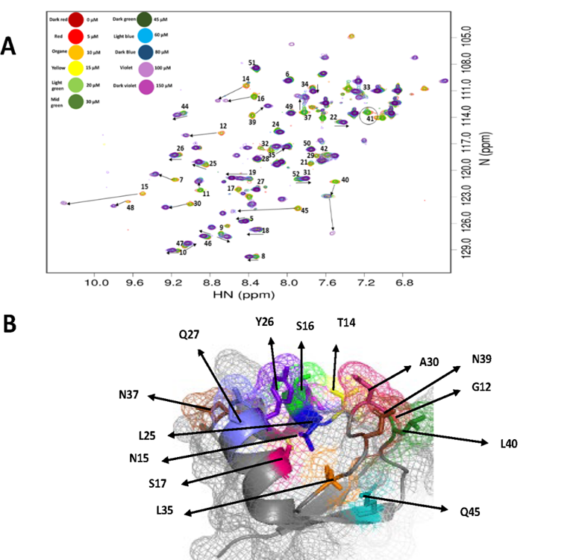
Figure ‎5.13-Effect of GlcNAc₅ ligand on LysM B1 protein at pH 3.
(A) Overlay of ¹H¹⁵N HSQC spectra of the LysMA1- GlcNAc₅ titration acquired. The enlarged view illustrates a region of the spectra with peaks interacting with the GlcNAc₅. G12, T14, L15, S16, S17, Q21, D25, Y26, Q27, A30, L35, N37, N39, L40 and Q45 were selected for the fitting of K_{d}. (B) The LysMB1 protein was used to map the residues identified to interact with GlcNAc₅.

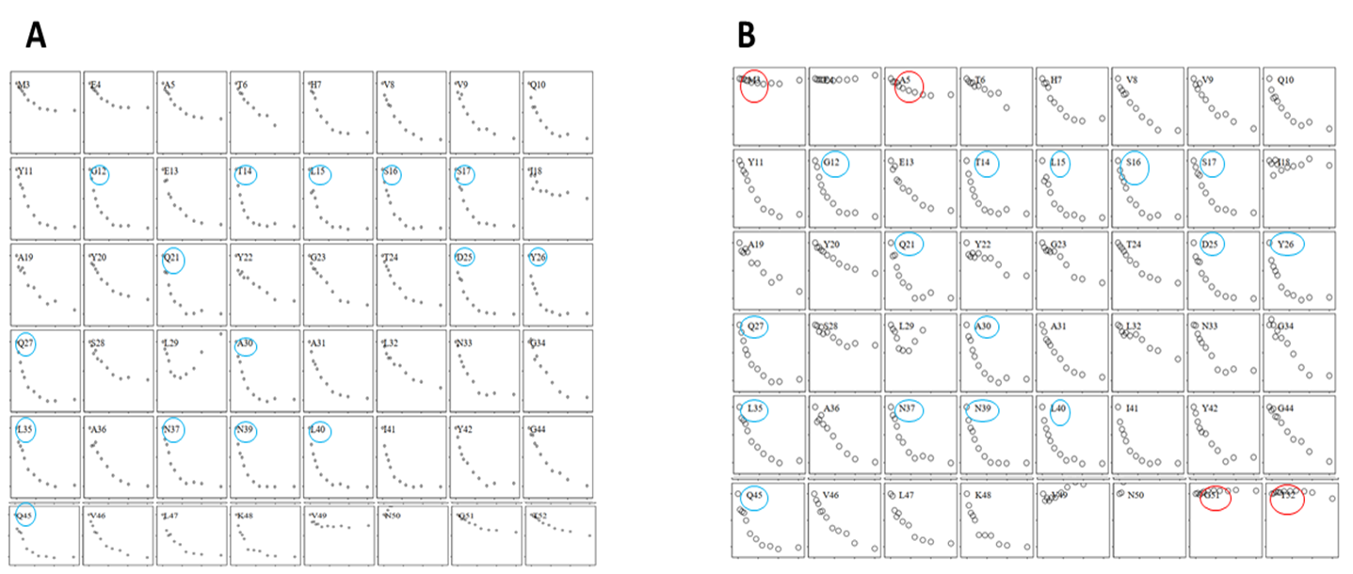
Figure ‎5.14-Box plot of LysMB1 intensities at pH 3.
(A) Peaks in sky blue circle were used for data fitting of K_{d}. (B) (Corrected Data) For the peaks in red circles M3, A5, G51 and S52, the average of their intensities was taken; then the original intensities of each peak were divided by these average intensities. Peaks in sky blue circle were used for data fitting of K_{d}. The following peaks were selected; G12, T14, L15, S16, S17, Y21, V25, Y26, N27, A30, S35, N37, N39, L40 and Q45. The y-axis represents the relative intensities of the ¹H nuclei from each residue and the x-axis the ligand concentration (0-150 µM).

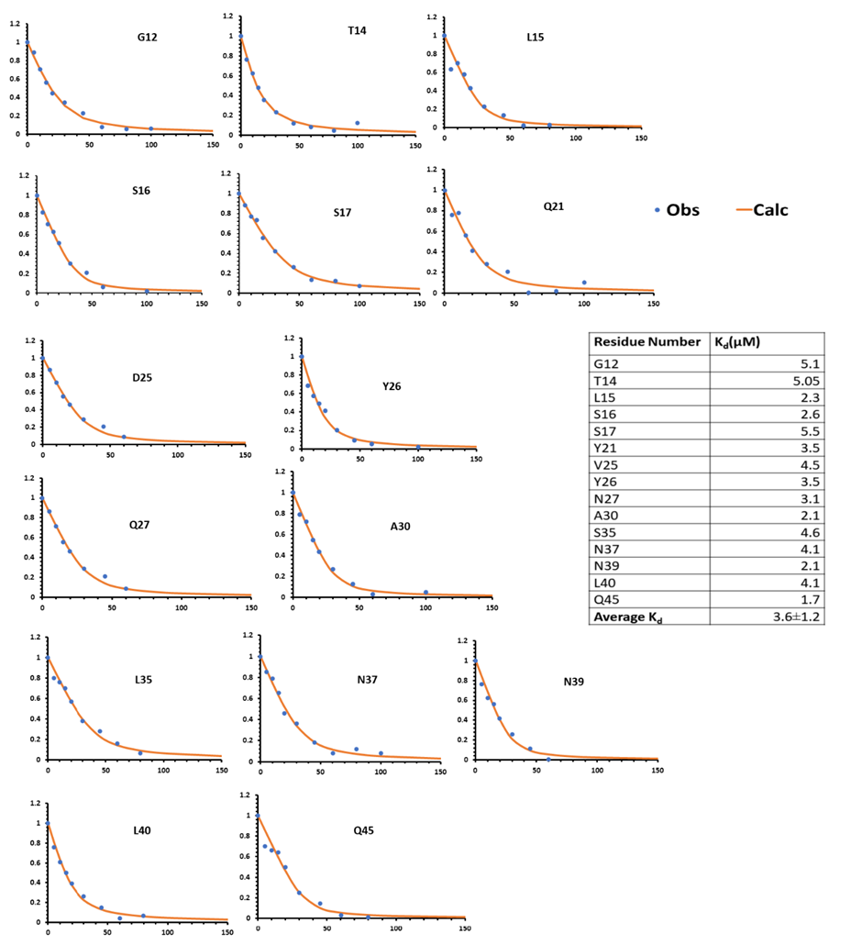
Figure ‎5.15-K_{d} fitting of LysMB1 with GlcNAc5 ligand at pH3.
The NH nuclei relative intensities from each residue are represented on the y-axis, while the ligand concentration (0-150 M) is represented on the x-axis (0-150 µM).

pH 5
To measure the K_{d} of LysMA1 with GlcNAc₅ ligand at pH 5 according to intensity changes, the eight residues were selected L14, N15, I17, A18, D37, L38, L39, and V41 as shown in Figure 5.17(A). To optimise the data, the average intensities of three residues (V47, G50, and S51) were used as controls as described above, to give the corrected intensities shown in Figure 5.17(B). The average K_{d} of LysMA1 according to intensities was 0.5 µM as shown in Figure 5.18; while according to Dr Galley’s observation through ITC it was 243 µM, as shown in Table 5.2.
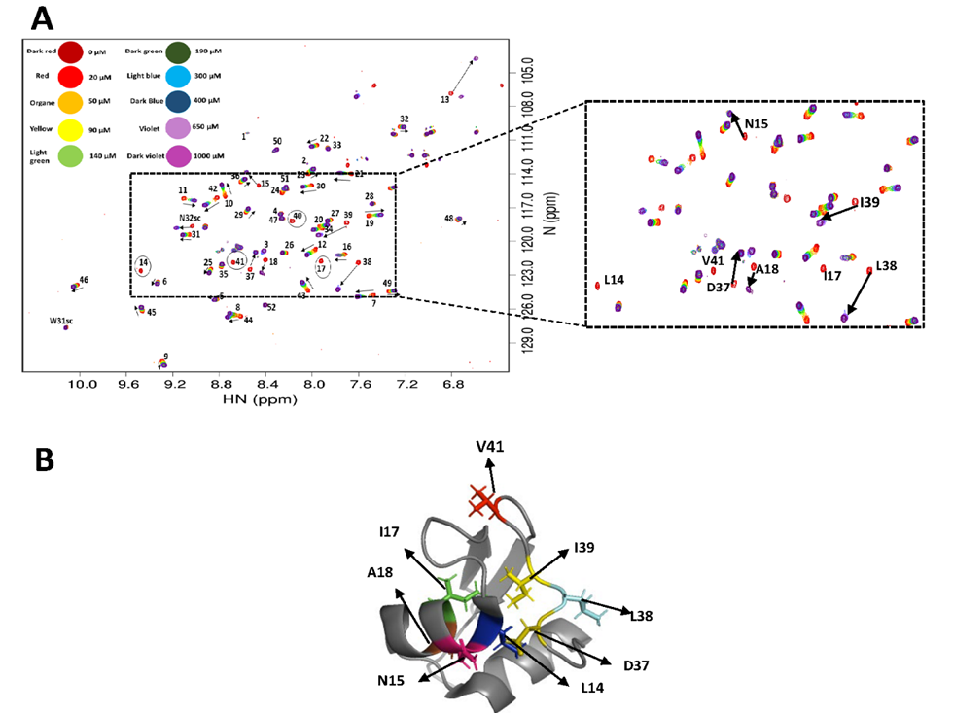
Figure ‎5.16-Effect of pH 5 titrations of LysMA1 protein binding with GlcNAc₅.
A) Overlaid ¹H¹⁵N HSQC spectra of the LysMA1- GlcNac₅ titration acquired. The enlarged view illustrates a region of the spectra with peaks interacting with the GlcNac₅. (B)The LysMA1 protein (PDB 2MKX) was used to map the residues identified to interact with GlcNAc₅.

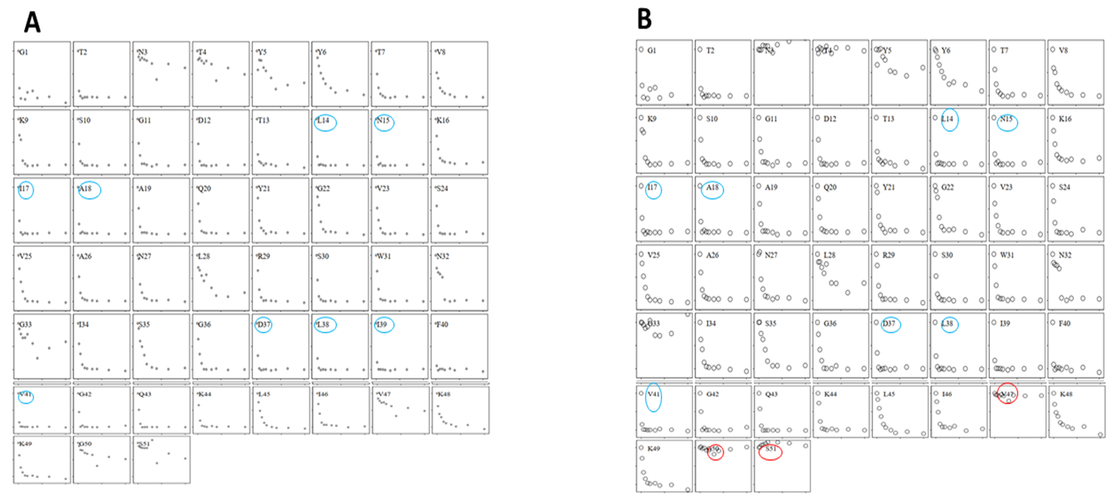
Figure ‎5.17-LysMA1 titration according to intensities at pH 5.
(A) Peaks in sky blue circle were used for data fitting of K_{d}. (B) (Corrected Data) For the peaks in red circles V47, G50, and S51, the average of their intensities was taken; then the original intensities of each peak were divided by these average intensities. Peaks in sky blue circle were used for data fitting of K_{d}. The following peaks were selected; G12, T14, L15, S16, S17, Y21, V25, Y26, N27, A30, S35, N37, N39, L40 and Q45.The relative intensities of the ¹H nuclei from each residue are represented on the y-axis, while the ligand concentration (0-150 M) is represented on the x-axis.
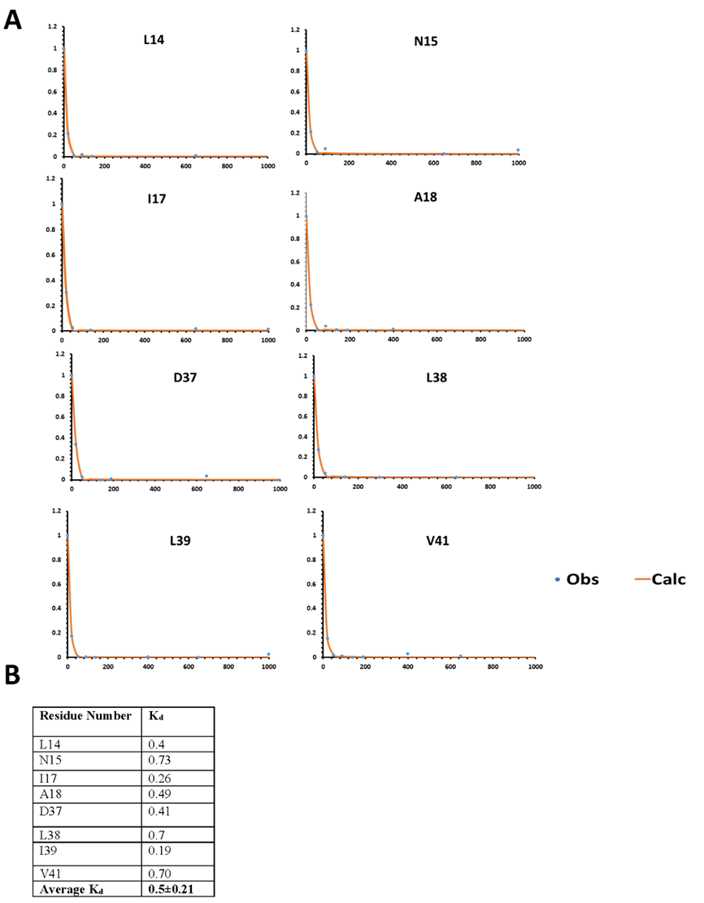
Figure ‎5.18-K_{d} fitting of LysMA1 with GlcNAc₅ ligand at pH 5.
(A) K_{d} fitting per residue. The NH nuclei relative intensities from each residue are represented on the y-axis, while the ligand concentration (0-1000 M) is represented on the x-axis. (B) The average K_{d} of LysMA1 with GlcNAc₅ ligand.
To measure the K_{d} through intensities of LysMB1 at pH 5, thirteen peaks were selected (G12, T14, L15, S16, S17, Y26, A30, N37, N39, L40, Q45, V46, and K48) as shown in Figure 5.20(A) The average K_{d} of the LysMB1 fitted through intensities was 0.43 µM as shown in Figure 5.21; while according to Dr Galley’s observation through ITC it was 22.7 µM as shown in Table 5.2.
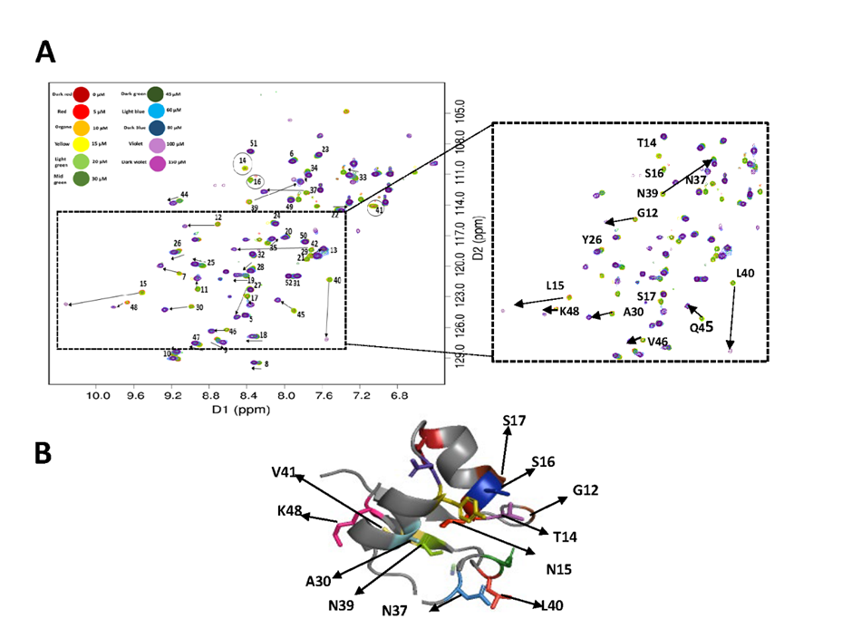
Figure ‎5.19-Effect of pH 5 titrations of LysMB1 protein binding with GlcNAc₅.
(A) Overlaid ¹H¹⁵N HSQC spectra of the LysMA1- GlcNac₅ titration acquired. The enlarged view illustrates a region of the spectra with peaks interacting with the GlcNac₅ in slow exchange. (B) The LysMB1 protein was used to map the residues identified to interact with GlcNAc₅.

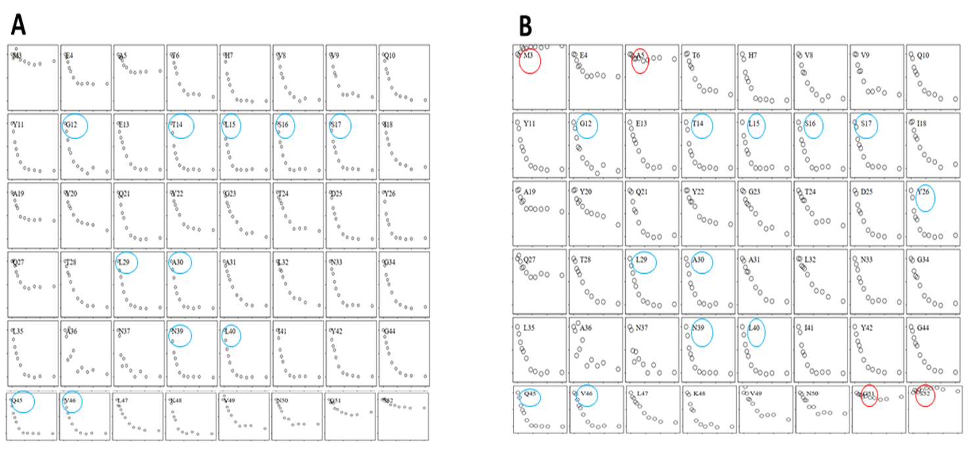
Figure ‎5.20-LysMB1 box plot of intensities at pH 5.
(A) Peaks in sky blue circle were used for data fitting of K_{d}. (B) (Corrected Data) For the peaks in red circles M3, A5, G51 and S52, the average of their intensities was taken; then the original intensities of each peak were divided by these average intensities. Peaks in sky blue circle were used for data fitting of K_{d}. The following peaks were selected; G12, T14, L15, S16, S17, Y26, A30, N37, N39, L40, Q45, V46, and K48. The y-axis represents the relative intensities of the ¹H nuclei from each residue and the x-axis the ligand concentration (0-150 µM).

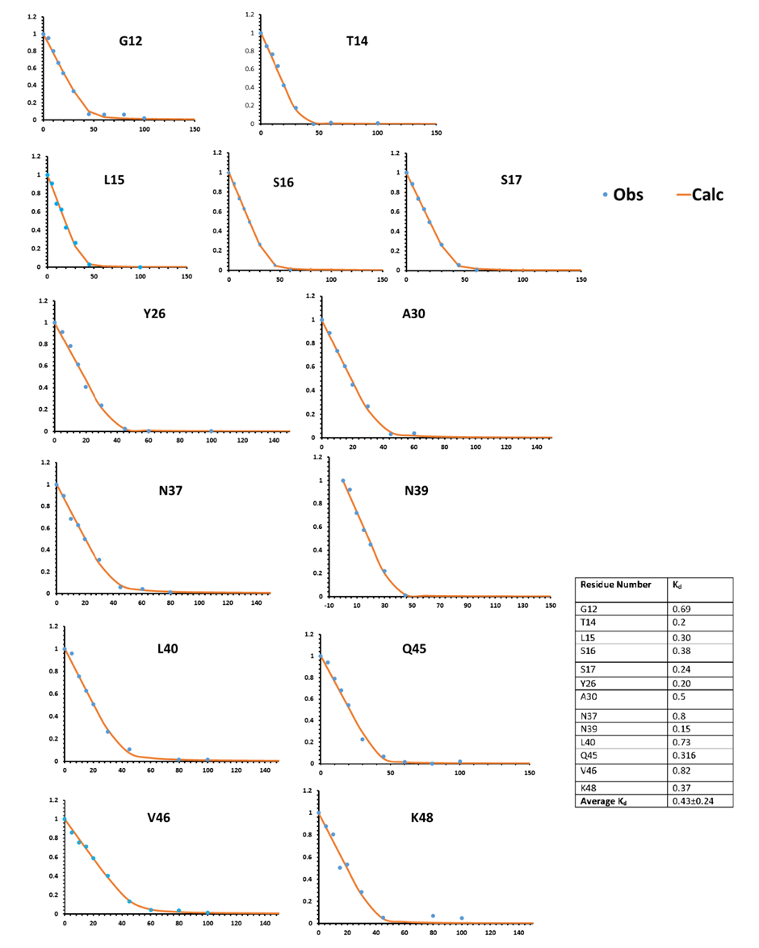
Figure ‎5.21-K_{d} fitting of LysMB1 with GlcNAc₅ at pH 5.
The y-axis represents the relative intensities of the NH nuclei from each residue and the x-axis the ligand concentration (0-150 µM).

pH 7
To measure the K_{d} of LysMA1 at pH 7 through intensities, seven peaks were taken (T13, L14, N15, L38, L 39, F40, and V41), as shown in Figure 5.23(A) and 5.22. To optimise the data, the average intensities of the four residues (T4, G33, V47, and G50) were taken and all intensities were divided by these average values as shown in Figure 5.23(B). The average K_{d} was 3.7 µM as shown in Figure 5.24; while according to Dr Galley’s observation through ITC the K_{d} was 121 µM, as shown in Table 5.2. The peak S51 was missing in LysMA1.
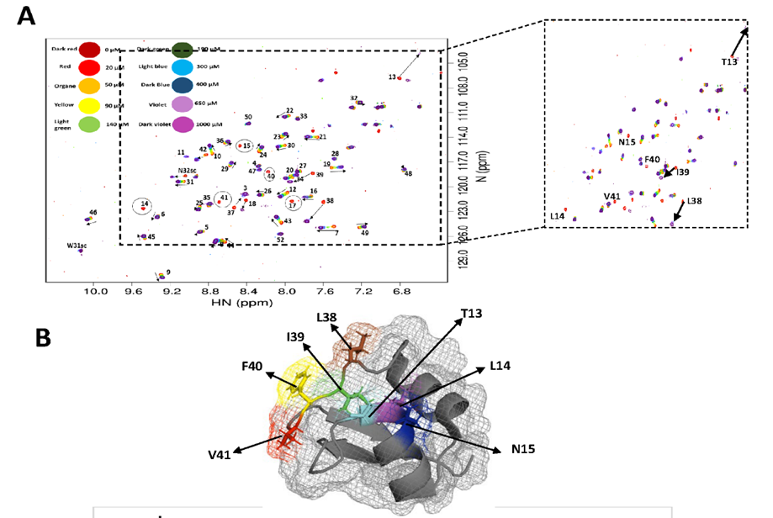
Figure ‎5.22-Effect of pH 7 titrations of LysMA1 protein with GlcNAc₅ ligand.
(A) Overlaid ¹H¹⁵N HSQC spectra of the LysMA1 - GlcNac₅ titration acquired. The enlarged view illustrates a region of the spectra with peaks interacting with the GlcNAc₅. (B) The LysMA1 protein (PDB 2MKX) was used to map the residues identified to interact with GlcNAc_{5.}

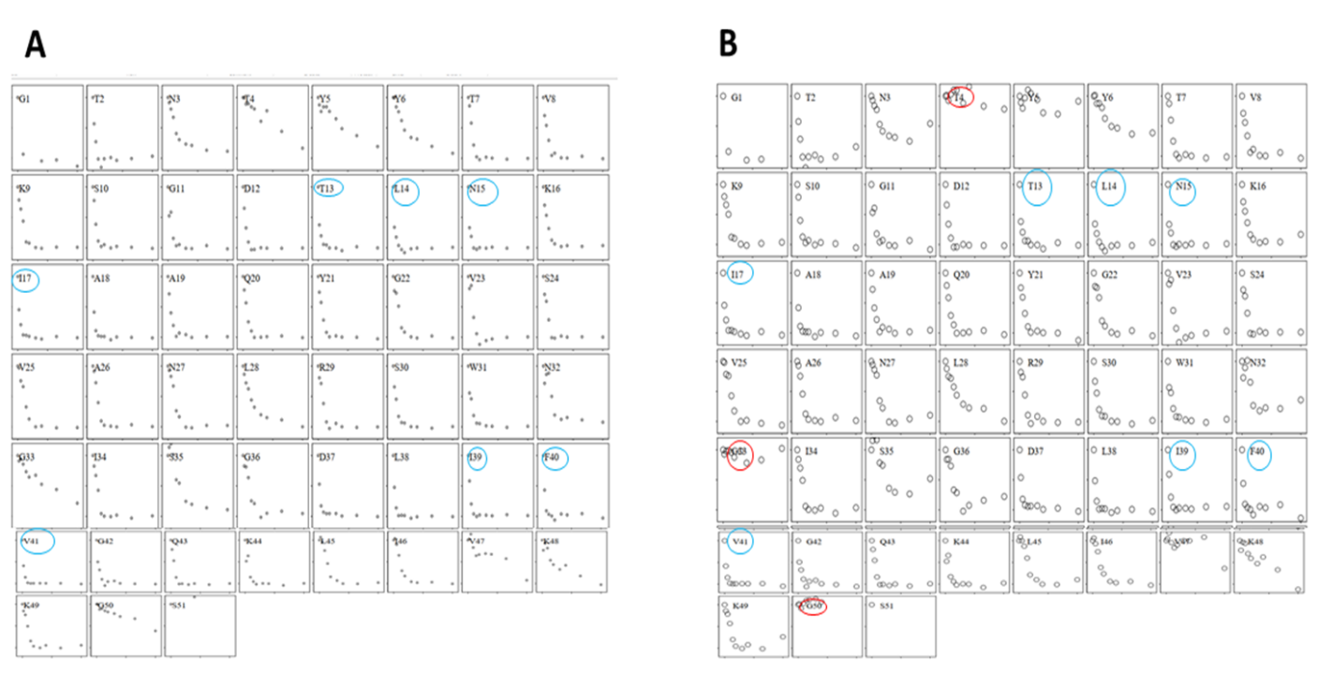
Figure ‎5.23-LysMA1 box plot of intensities at pH 7.
(A) Peaks in sky blue circle were used for data fitting of K_{d}. (B) (Corrected Data) For the peaks in red circles T4, G33, V47, and G50, the average of their intensities was taken; then the original intensities of each peak were divided by these average intensities. Peaks in sky blue circle were used for data fitting of K_{d}. The following peaks were selected; T13, L14, N15, L38, L 39, F40, and V41. The y-axis represents the relative intensities of the ¹H nuclei from each residue and the x-axis the ligand concentration (0-150 µM).

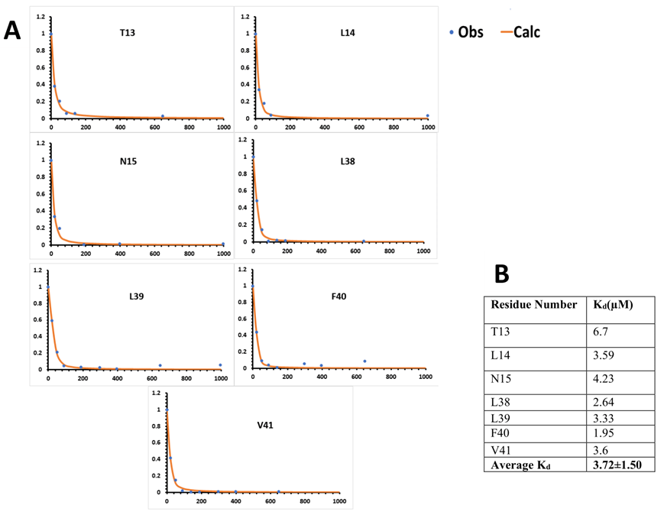
Figure ‎5.24-K_{d} fitting of LysMA1 with GlcNAc₅ ligand at pH 7.
The y-axis represents the relative intensities of the NH nuclei from each residue (0.10 to 0.10 ppm) and the x-axis the ligand concentration (0-1000 µM). The table represents the individual K_{d} and average K_{d .}

To measure the K_{d} through intensities of LysMB1 at pH 7, twelve peaks were selected (G12, T14, L15, S16, S17, Y26, L29, A30, N39, L40, Q45, V46) as shown in Figure 5.26 (B) and 5.25. To optimise the data, the average intensities of the four residues (M3, A5, G51, and S52) were taken and all intensities were divided by the averages as shown in the Figure 5.26 (A). The average K_{d} of the LysMB1 while binding through GlacNAc₅ ligand was 1.4 µM as shown in the Figure 5.27 while according to Dr Galley’s observation through ITC it was 14.4 µM as shown in Table 5.2.
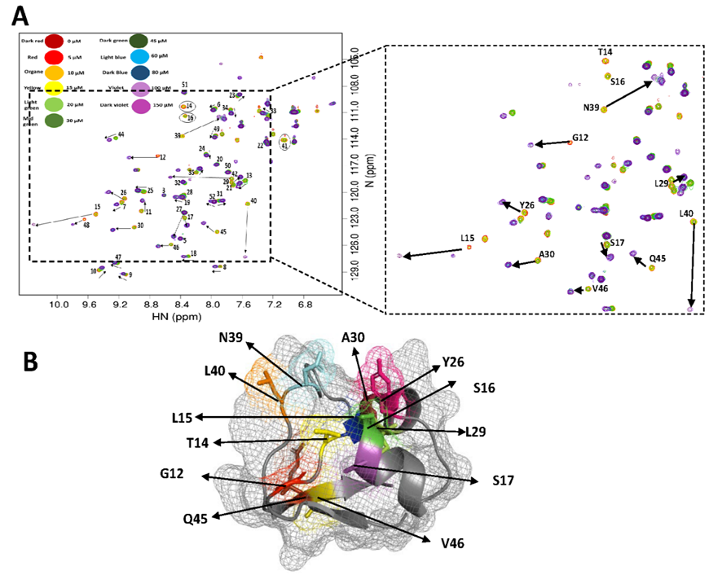
Figure ‎5.25-Effect of pH 7 titrations of LysMB1 protein with GlcNAc₅ ligand.
(A) Overlaid ¹H¹⁵N HSQC spectra of the LysMA1- GlcNac₅ titration acquired. The enlarged view illustrates a region of the spectra with peaks interacting with the GlcNAc₅. (B) The LysMB1 protein was used to map the residues identified to interact with GlcNAc₅.

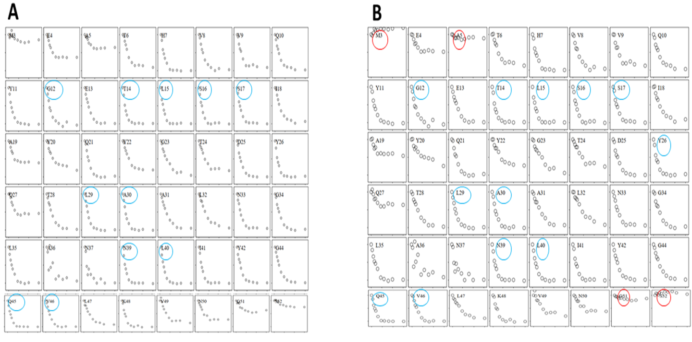
Figure ‎5.26-LysMB1 box plot of intensities at pH 7.
(A) Peaks in sky blue circle were used for data fitting of K_{d}. (B) (Corrected Data) For the peaks in red circles M3, A5, G51 and S52, the average of their intensities was taken; then the original intensities of each peak were divided by these average intensities. Peaks in sky blue circle were used for data fitting of K_{d}. The following peaks were selected; G12, T14, L15, S16, S17, Y26, L29, A30, N39, L40, Q45, V46. The relative intensities of the ¹H nuclei from each residue are represented on the y-axis, while the ligand concentration (0-150 M) is represented on the x-axis.

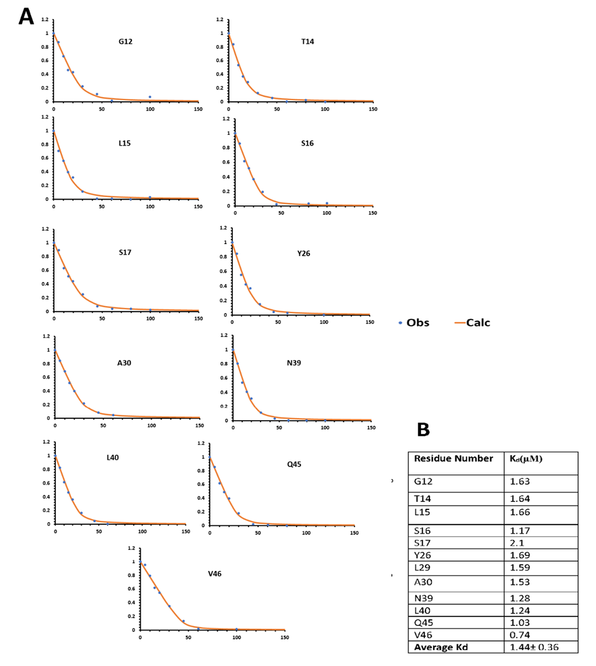
Figure ‎5.27-K_{d} fitting of LysMB1 with GlcNAc₅ ligand at pH 7.
The NH nuclei relative intensities from each residue are represented on the y-axis, while the ligand concentration (0-150 M) is represented on the x-axis.

pH 9
At pH 9, both proteins were not stable and started to aggregate, and a lot of peaks were missing during the pH 9 titration.
To measure the K_{d} through intensities of LysMA1 at pH 9, seven peaks were taken to measure the binding affinity (T13, I17, A18, L38, I39, F40, and V41) as shown in Figure 5.29(A). Binding to GlcNAc₅ ligand was 2.3 µM as shown in Figure 5.30; while according to Dr Galley’s observation through ITC it was 236 µM, as shown in Table 5.2. For LysmA1 the following fifteen peaks were missing: T2, N3, T4, S10, G11, L14, N15, V25, A26, G33, S35, G36, D37, G50 and S51 as shown in Figure 5.28(B).
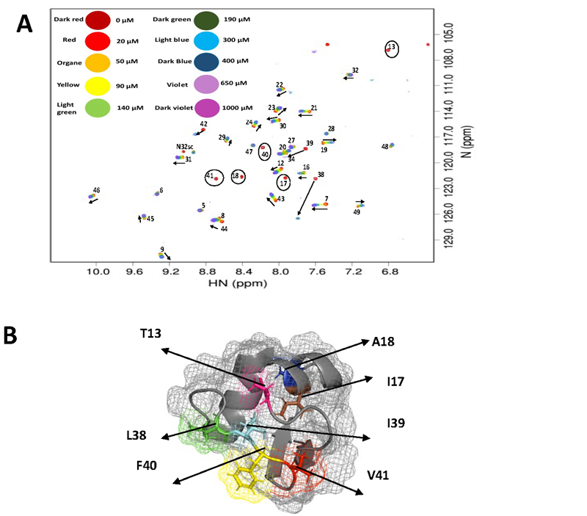
Figure ‎5.28-Effect of pH 9 titrations of LysMA1 proteins with GlcNAc₅ ligand.
(A) Overlaid ¹H¹⁵N HSQC spectra of the LysMA1- GlcNAc₅ titration acquired. The enlarged view illustrates a region of the spectra with peaks interacting with the GlcNac₅ in fast exchange. (B) The LysMA1 protein (PDB 2MKX) was used to map the residues identified to interact with GlcNAc₅; The peaks were selected (T13, I17, A18, L38, I39, F40, and V41) to measure the K_{d} through intensities.

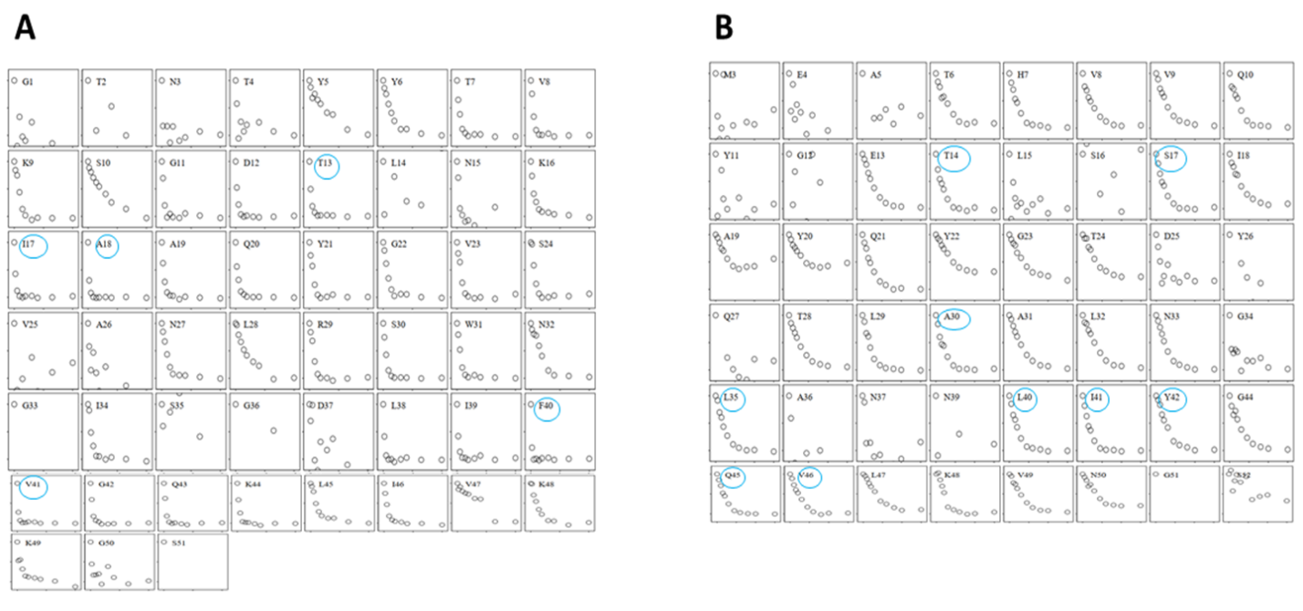
Figure ‎5.29-Box plot of LysM titration according to chemical intensities at pH 9.
(A) LysMA1 (B) LysMB1 Peaks in sky blue circle were used for data fitting of K_{d}

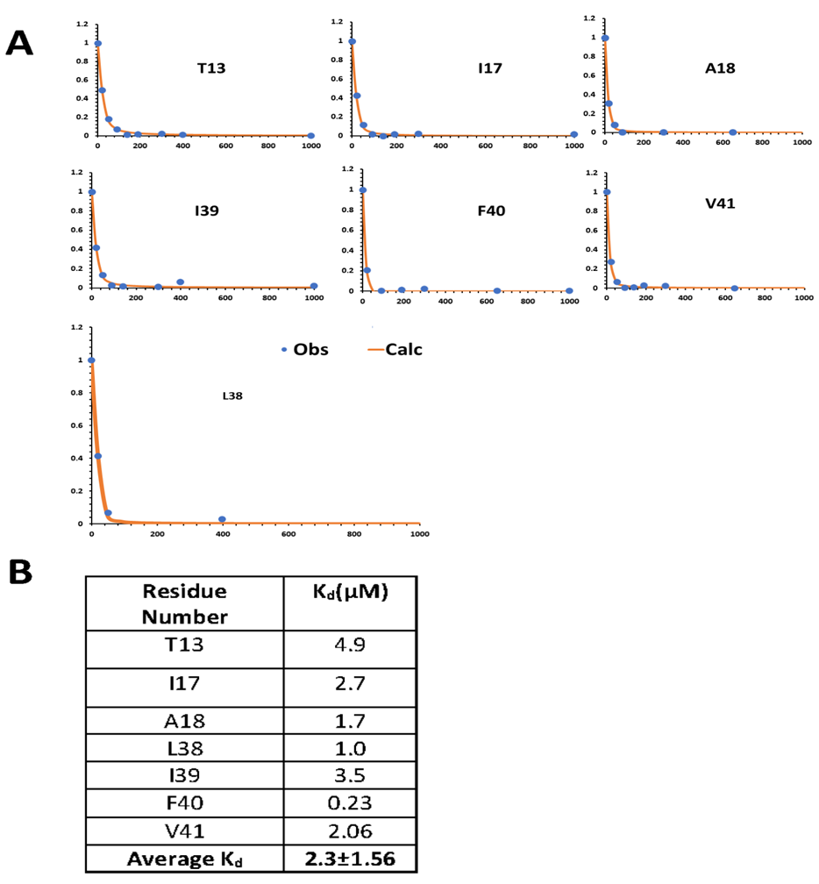
Figure ‎5.30-K_{d} fitting of LysMA1 with GlcNAc₅ ligand at pH 9.
The NH nuclei relative intensities from each residue are represented on the y-axis, while the ligand concentration (0-1000 M) is represented on the x-axis.

To measure the K_{d} through intensities of LysMB1 at pH 9, nine peaks were selected (T14, S17, A30, L35, L40, I41, Y42, Q45, V46) as shown in Figure 5.29 (B); the average K_{d} of the LysMB1 while binding through GlcNAc₅ ligand was 2.02 µM as shown in Figure 5.32; while according to Dr Galley’s observation through ITC it was 22.6 µM as shown in Table 5.2. During the titration of LysMB1 at pH 9 with GlcNAc₅ ligand, the fifteen peaks M3, E4, A5, Y11, G12, L15, S16, D25, Y26, Q27, A36, N37, N39, G51 and S52 disappeared as shown in Figure 5.31(B).
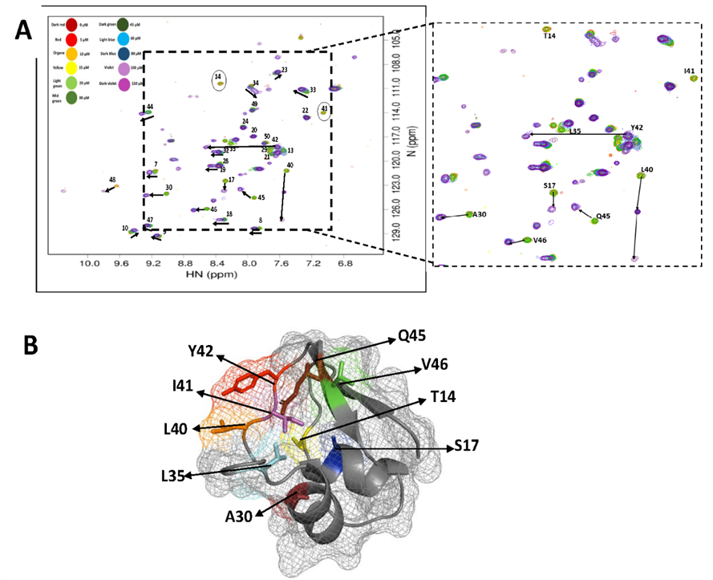
Figure ‎5.31-Effect of pH 9 titrations of LysMB1 proteins with GlcNAc₅ ligand.
(A) LysMB1- GlcNAc₅ titration ¹H¹⁵N HSQC spectra overlayed. A portion of the spectra containing peaks interacting with the GlcNAc₅ is shown in greater detail in the expanded image. (B) LysMB1 protein was used to represents the residues which were selected (T14, S17, A30, L35, L40, I41, Y42, Q45, V46) to measure the K_{d} through intensities.
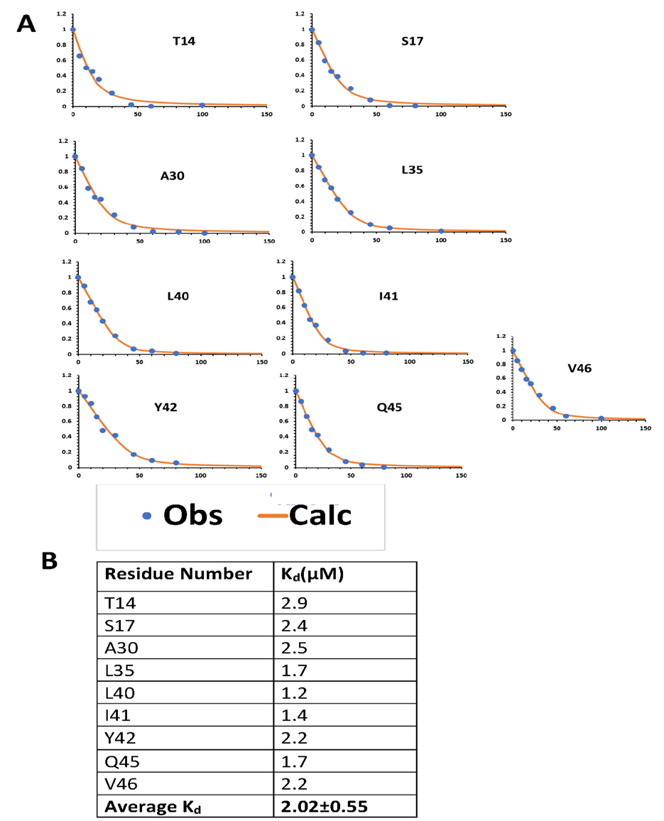
Figure ‎5.32-K_{d} fitting of LysMB1 with GlcNAc₅ ligand at pH 9.
The NH nuclei relative intensities from each residue are represented on the y-axis, while the ligand concentration (0-150 M) is represented on the x-axis.

Table ‎5.2-Comparison of calculation of binding affinity through ITC and NMR (using intensities) and effect of pH on binding affinities.
The results summarised in Table 5.2 show that affinities calculated using intensity changes are much tighter than those measured using ITC. Intensity changes can only be used for fitting if the NMR data are in fast exchange, and it is clear that the data are not, because the bound signal does not increase in intensity in parallel with the loss of intensity of the free signal. It is therefore not surprising that the affinities determined by NMR in this way are incorrect. The intensities decrease rapidly as ligand is added because of slow to intermediate rate effects, which is why the fitted affinities are much too tight.
We therefore used chemical shift changes to measure the binding affinity. This is the more usual way to measure affinities by NMR but is less straightforward in this case because many of the shift changes are very small. We therefore had to base our assessment on the small number of signals that showed a shift change large enough to measure sufficiently accurately.

Binding affinities of LysMA1 and LysMB1 fitted by chemical shift changes
LysMA1 fits reasonably well to the standard titration curve. LysMB1 fits less well because the chemical shift changes tend to be more sigmoidal. It is not clear why this should be so. It is possible that the LysMB1 as purified had a ligand weakly bound, and that the start of the titration is dominated by an equilibrium between the bound ligand and the added ligand. Whatever the reason, the shifts for the first few ligand additions for LysMB1 tend to be anomalously small. We therefore decided not to use these points in fitting to the data. There is no good justification for doing so, except that the resultant affinities agree with those determined by ITC.

pH 3
The spectra for the titration of LysMA1 at pH 3 are shown in Figure 5.33. The measured shift changes are shown in Figure 5.34(A), from which several residues show good chemical shift changes that match well to an expected NMR binding curve. Twelve residues V8, S10, D12, Q20, G22, V23, V25, A26, R29, S30, W31 and Q43 were selected for fitting the K_{d} as shown in Figure 5.34(A). The fits are shown in more detail in Figure 5.35, demonstrating a consistent value for the K_{d} of about 100 μM.
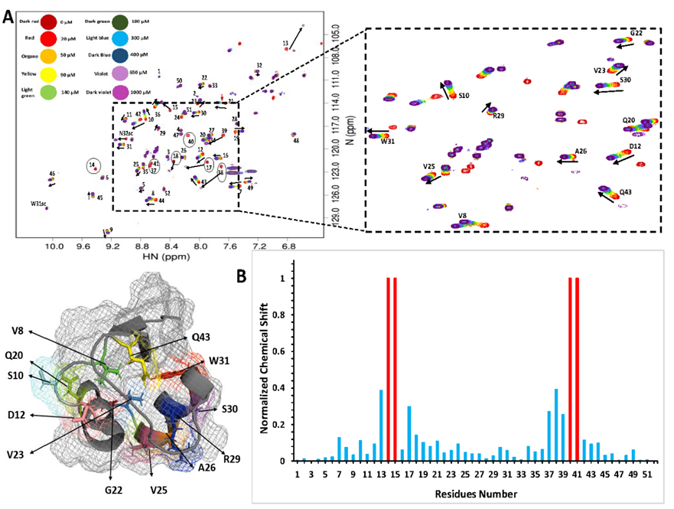
Figure ‎5.33-NMR titration of GlcNAc₅ ligand binding with LysMA1 at pH3.
(A) Overlaid ¹H¹⁵N HSQC spectra of the LysMA1- GlcNac₅ titration acquired. The enlarged view illustrates a region of the spectra with peaks interacting with the GlcNac₅ in fast exchange. LysMA1 protein (PDB 2MKX) was used to represent the residues picked for the chemical shift change during GlcNAC₅ ligand binding. (B) Graphical representation of the observed CSP values. Residues which broaden beyond detection are shown as red bars with an arbitrary shift change of 1.

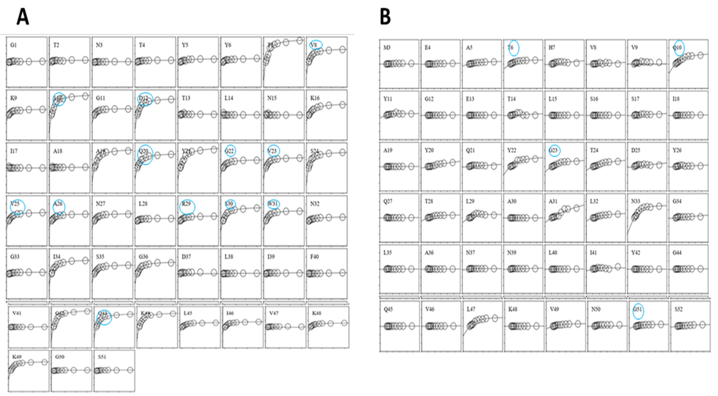
Figure ‎5.34-Box plot showing Kd fitting of the residues showing chemical shift changes at pH 3.
(A) LysMA1- The twelve residues V8, S10, D12, Q20, G22, V23, V25, A26, R29, S30, W31 and Q43 were selected for fitting the K_{d}. (B) LysMB1- The four residues T6, Q10, G23 and G51 (Sky blue colour peaks) were selected for fitting. The y-axis represents the relative chemical shift of the ¹H nuclei from each residue and the x-axis the ligand concentration.

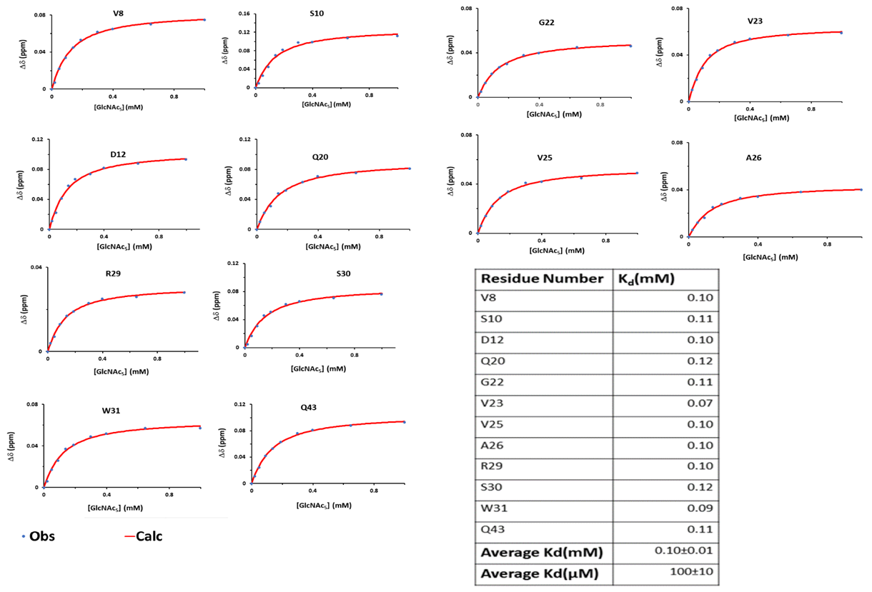
Figure ‎5.35-K_{d} fitting of LysMA1 with GlcNAc₅ ligand at pH 3.
The NH nuclei shift change from each residue is represented on the y-axis, while the ligand concentration is represented on the x-axis.

For LysMB1, the K_{d} was measured by selecting four residues, T6, Q10, G23 and G51, which showed measurable chemical shift changes as shown in Figures 5.34 and 5.37. These data are not very sigmoidal and give a good fit to the data, of about 20 µM. Three residues (T14, S16, and I41) showed severe line broadening as shown in Figure 5.36 (B).

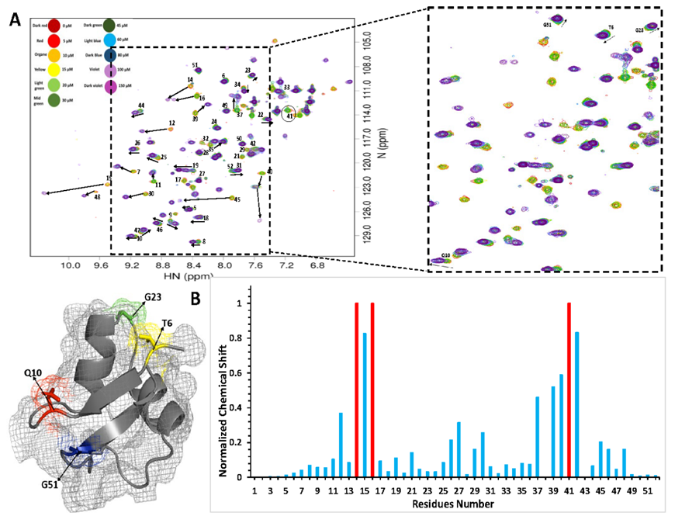
Figure ‎5.36-NMR titration of GlcNAc₅ ligand binding with LysMB1 at pH3.
(A) Overlaid ¹H¹⁵N HSQC spectra of the LysMA1- GlcNac₅ titration acquired. The enlarged view illustrates a region of the spectra with peaks interacting with the GlcNac₅ in fast exchange. LysMB1 protein was used to represent the residues picked for the chemical shift change during GlcNAC₅ ligand binding. (B) Graphical representation of the observed CSP values. Residues which broaden beyond detection are shown as bars with an arbitrary shift change of 1. Bars highlighted in red showed line broadening: T14, S16, and I41.

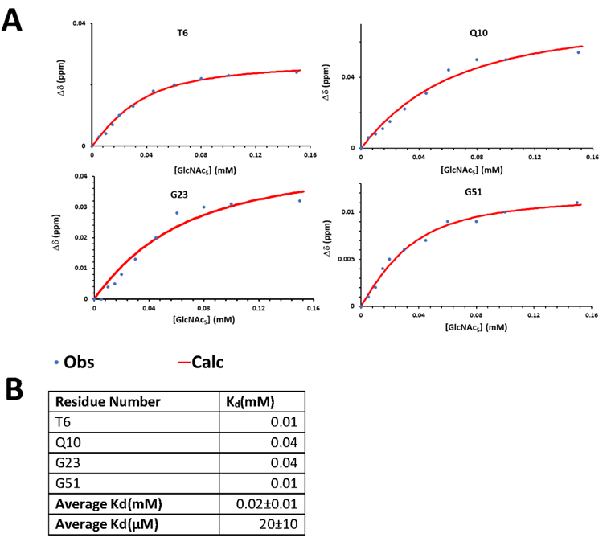
Figure ‎5.37-K_{d} fitting of LysMB1 with GlcNAc₅ ligand at pH 3.
The y-axis represents the relative shift of the NH nuclei from each residue and the x-axis the ligand concentration.

pH 5
Three residues of LysMA1 (D12, S24, and G22) were selected for fitting the K_{d} in the presence of GlcNac₅ ligand as shown in Figure 5.39(A), with more detailed fits shown in Figure 5.40(A). The average K_{d} calculated from the observed chemical shift was 100 µM. Five residues showed line broadening: L14, N15, I17, F40 and V41 as shown in Figure 5.38(B).
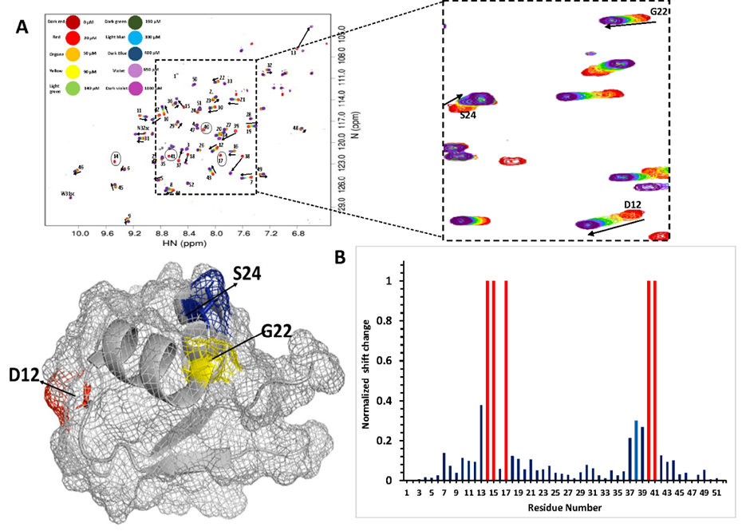
Figure ‎5.38-NMR titration of GlcNAc₅ ligand binding with LysMA1 at pH 5.
(A) Overlaid ¹H¹⁵N HSQC spectra of the LysMA1- GlcNac₅ titration acquired. The enlarged view illustrates a region of the spectra with peaks interacting with the GlcNac₅ in fast exchange. LysMA1 protein was used to represent the residues picked for the chemical shift change during GlcNAC₅ ligand binding. (B) Graphical representation of the observed CSP values. Residues which broaden beyond detection are shown as bars with an arbitrary shift change of 1; red bars show line broadening: L14, N15, I17, F40 and V41.

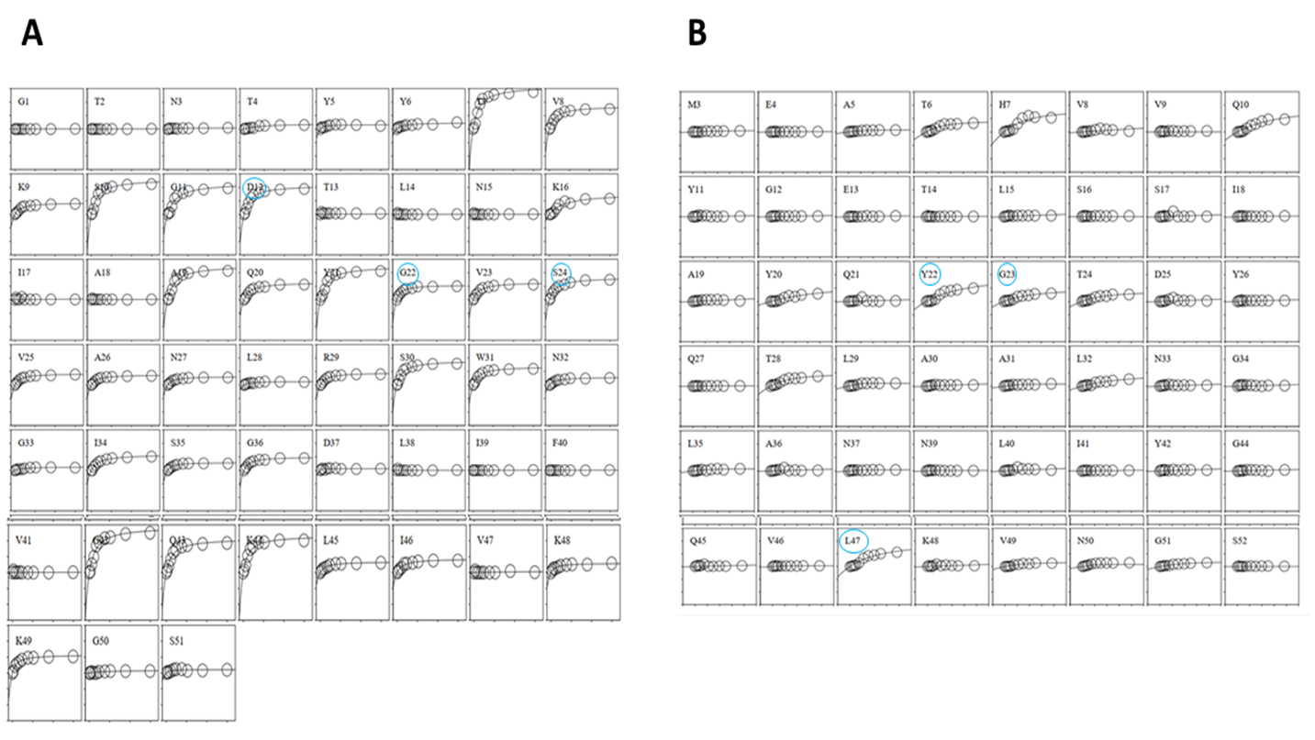
Figure ‎5.39-Box plot showing K_{d} fitting of the residues showing chemical shift change at pH 5.
(A) LysMA1 (B) LysMB1-Sky blue colour peaks were selected for the chemical shifts
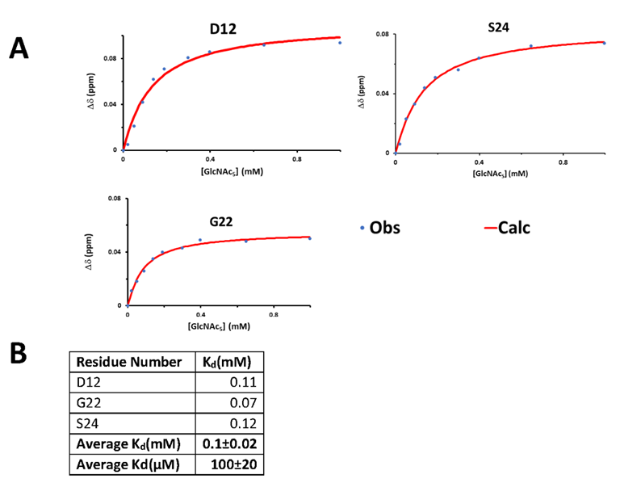
Figure ‎5.40-K_{d} fitting of LysMA1 with GlcNAc₅ ligand at pH 5.
The y-axis represents the relative shift of the NH nuclei from each residue and the x-axis the ligand concentration.

For LysMB1, the data were more sigmoidal (Figure 5.42). As discussed above, fitting was carried out omitting the first five data points, to give a fitted affinity of 20 μM. The three residues L14, S16, and V41 showed line broadening as shown in Figure 5.41(B).

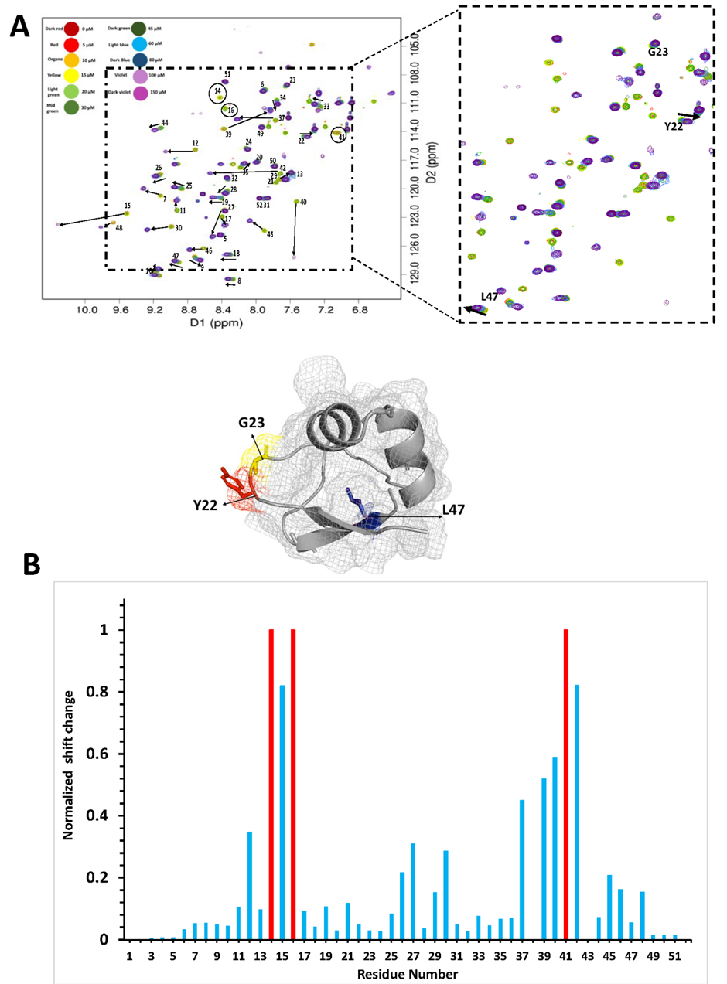
Figure ‎5.41-NMR titration of GlcNAc₅ ligand binding with LysMB1 at pH 5.
(A) Overlaid ¹H¹⁵N HSQC spectra of the LysMA1- GlcNac5 titration acquired. The enlarged view illustrates a region of the spectra with peaks interacting with the GlcNac₅ in fast exchange. LysMB1 protein was used to represent the residues picked for the chemical shift change during GlcNAC₅ ligand binding. (B) Graphical representation of the observed CSP values. Residues which broaden beyond detection are shown as red bars with an arbitrary shift change of 1.
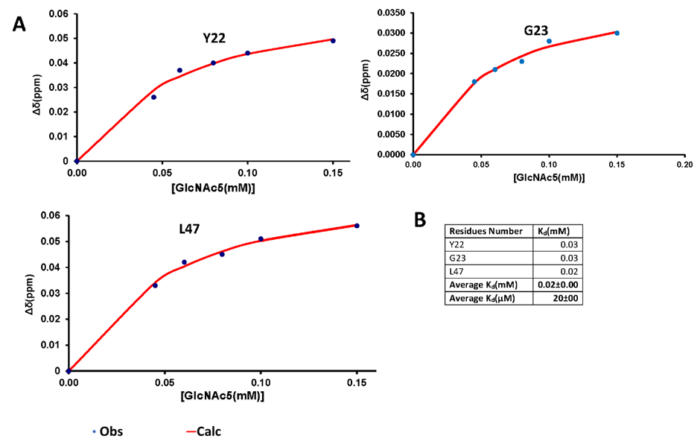
Figure ‎5.42-K_{d} fitting of LysMB1 with GlcNAc₅ ligand at pH 5.
The y-axis represents the relative shift of the NH nuclei from each residue and the x-axis the ligand concentration.

pH 7
In the case of LysMA1, eight peaks (D12, Q20, G22, R29, W31, I34, K44 and K49) were selected for the fitting as shown in Figure 5.45(A), and the average K_{d} was measured as 222 µM as shown in Figure 5.44. Four residues (L14, N15, F40, and V41) showed line broadening as shown in the Figure 5.43.
The K_{d} of LysMB1 interaction with GlcNAc₅ at pH 7 was measured by selecting three residues: Y22, T24, and L47, as shown in Figure 5.45 (B) and Figure 5.46. The data are again sigmoidal. The fitted affinity is 30 μM as shown in the Figure 5.47. Three residues (T14, S16 and I41) showed line broadening as shown in Figure 5.46 (B).
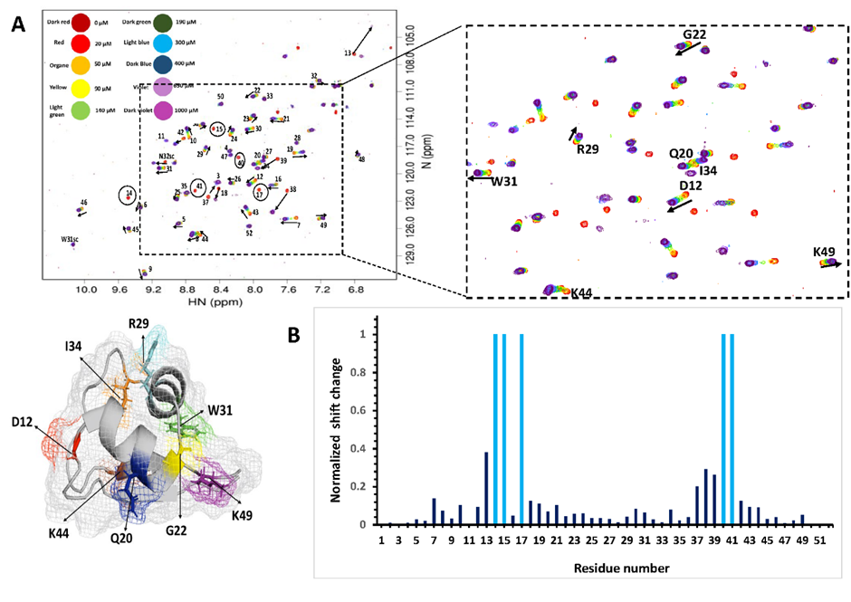
Figure ‎5.43-NMR titration of GlcNAc₅ ligand binding with LysMA1 at pH 7.
(A) Overlaid ¹H¹⁵N HSQC spectra of the LysMA1- GlcNac₅ titration acquired. The enlarged view illustrates a region of the spectra with peaks interacting with the GlcNac₅ in fast exchange. LysMA1 protein was used to represent the residues picked for the chemical shift change during GlcNAC₅ ligand binding. (B) Graphical representation of the observed CSP values. Residues which broaden beyond detection are shown as bars with an arbitrary shift change of 1. Four peaks (L14, N15, F40, and V41) showed line broadening.

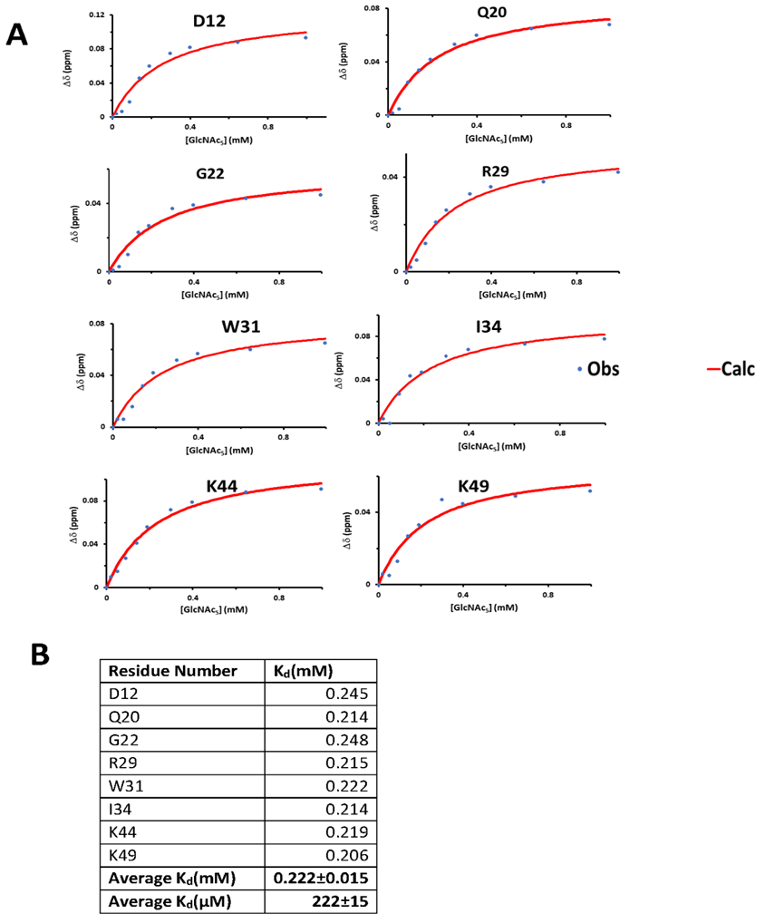
Figure ‎5.44-K_{d} fitting of LysMA1 with GlcNAc₅ ligand at pH 7.
The y-axis represents the relative shift of the NH nuclei from each residue and the x-axis the ligand concentration.

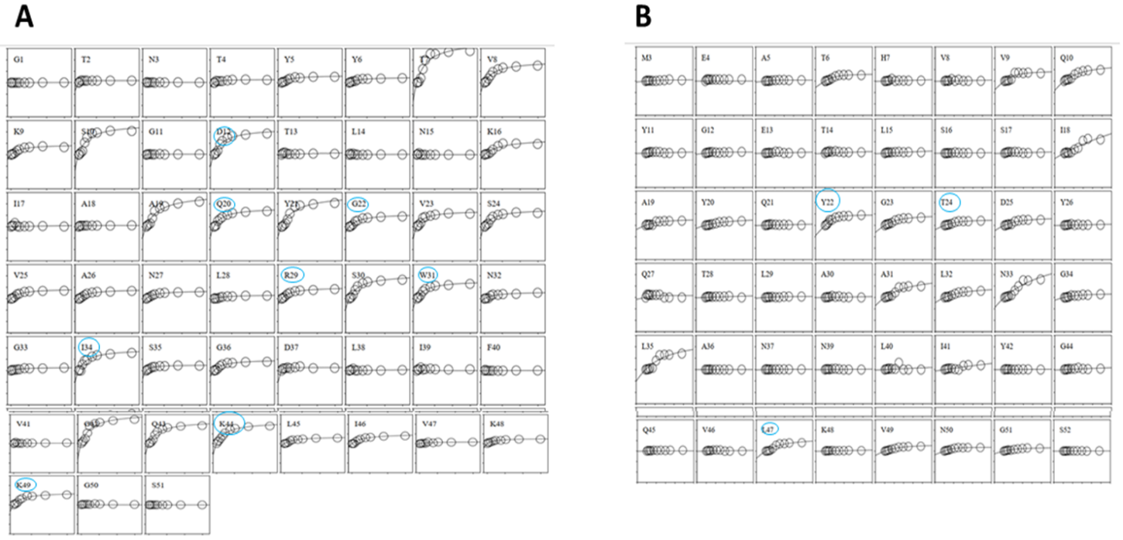
Figure ‎5.45-Box plot showing K_{d} fitting of the residues showing chemical shift change at pH 7.
- LysMA1 (B) LysMB1-Sky blue colour peaks were selected for the chemical shifts.

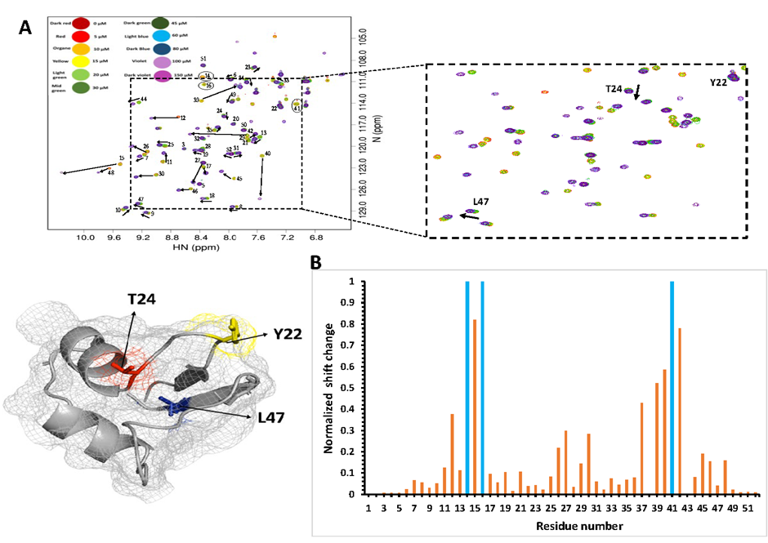
Figure ‎5.46-NMR titration of GlcNAc₅ ligand binding with LysMB1 at pH 7.
(A) Overlaid ¹H¹⁵N HSQC spectra of the LysMA1- GlcNac₅ titration acquired. The enlarged view illustrates a region of the spectra with peaks interacting with GlcNac₅ in fast exchange. LysMB1 protein was used to represent the residues picked for the chemical shift change during GlcNAc₅ ligand binding. (B) Graphical representation of the observed CSP values. Residues which broaden beyond detection are shown as bars with an arbitrary shift change of 1. The three peaks T14, S16 and I41 showed line broadening.

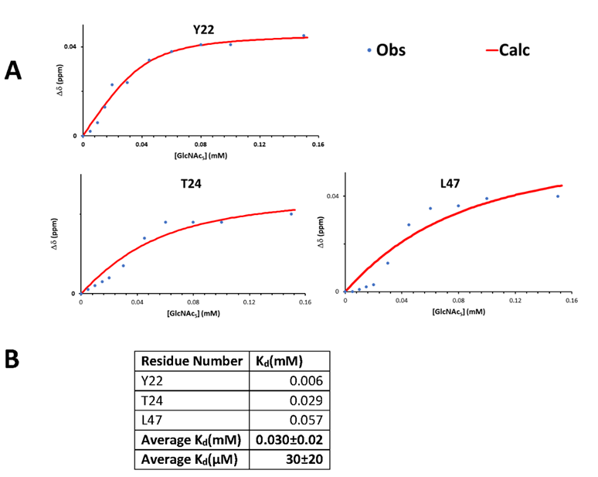
Figure ‎5.47-K_{d} fitting of LysMB1 with GlcNAc₅ ligand at pH 7.
The y-axis represents the relative intensities of the NH nuclei from each residue and the x-axis the ligand concentration.

pH 9
In the case of LysMA1 at pH 9, residues D12, Q20, G22, V23 and I46 were selected as shown in Figure 5.50, giving an average K_{d} of 236 µM, as shown in Figure 5.49. In the case of LysMA1, five peaks (T13, I17, A18, F40, and V41) showed line broadening, as shown in Figure 5.48(B).
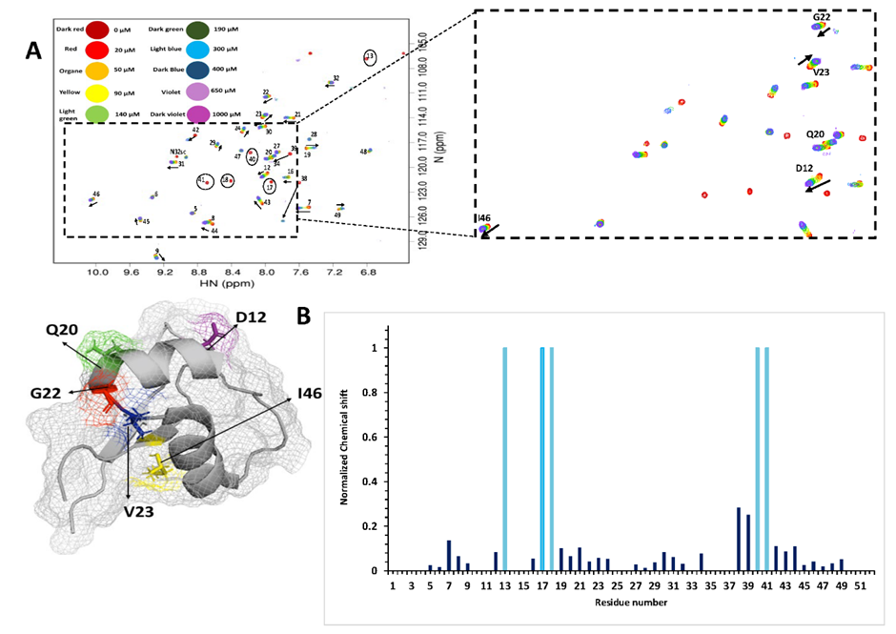
Figure ‎5.48-NMR titration of GlcNAc₅ ligand binding with LysMA1 at pH 9.
(A) Overlaid ¹H¹⁵N HSQC spectra of the LysMA1- GlcNac₅ titration acquired. The enlarged view illustrates a region of the spectra with peaks interacting with the GlcNac₅ in fast exchange. LysMA1 protein was used to represent the residues picked for the chemical shift change during GlcNAC₅ ligand binding. (B) Graphical representation of the observed CSP values. Residues which broaden beyond detection are shown as bars with an arbitrary shift change of 1. The bars represented in sky blue colour are the residues that show line broadening.

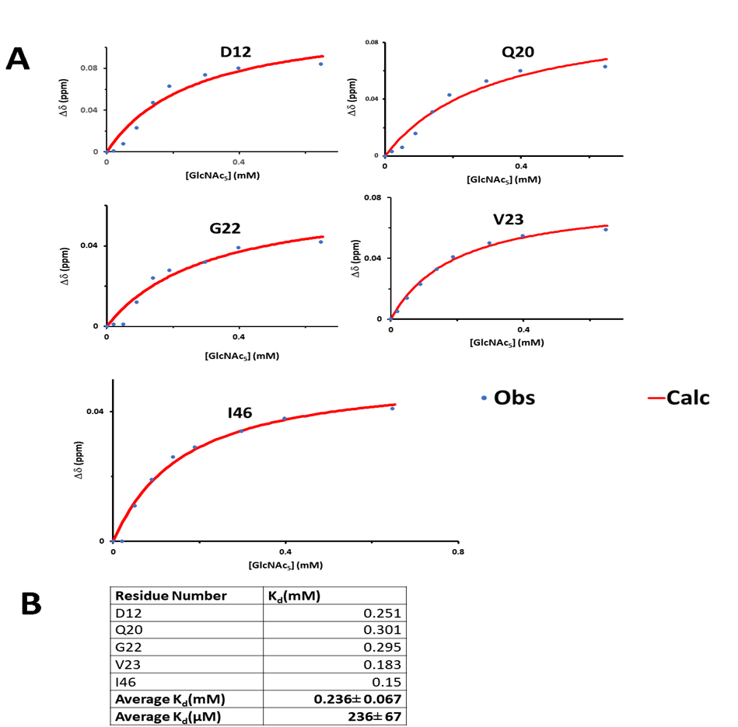
Figure ‎5.49-K_{d} fitting of LysMA1 with GlcNAc₅ ligand at pH 9.
The y-axis represents the relative shift of the NH nuclei from each residue and the x-axis the ligand concentration.
For LysMB1 at pH9, the K_{d} was measured by selecting two residues, T24, and V49, as shown in Figure 5.50 (B). As before, the data are sigmoidal, and could only be fitted by omitting the first 5 titration points. The average K_{d} was measured as 30 µM as shown in Figure 5.52. Two peaks (T14 and I41) showed line broadening as shown in Figure 5.51(B).
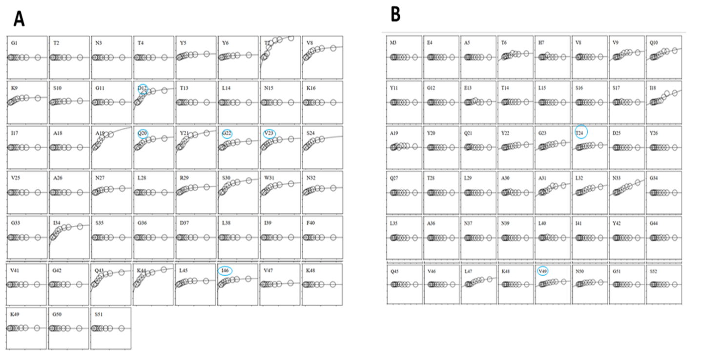
Figure ‎5.50-Box plot showing K_{d} fitting of the residues showing chemical shift change at pH 9.
- LysMA1 (B) LysMB1-Sky blue colour peaks were selected for the chemical shift fitting.

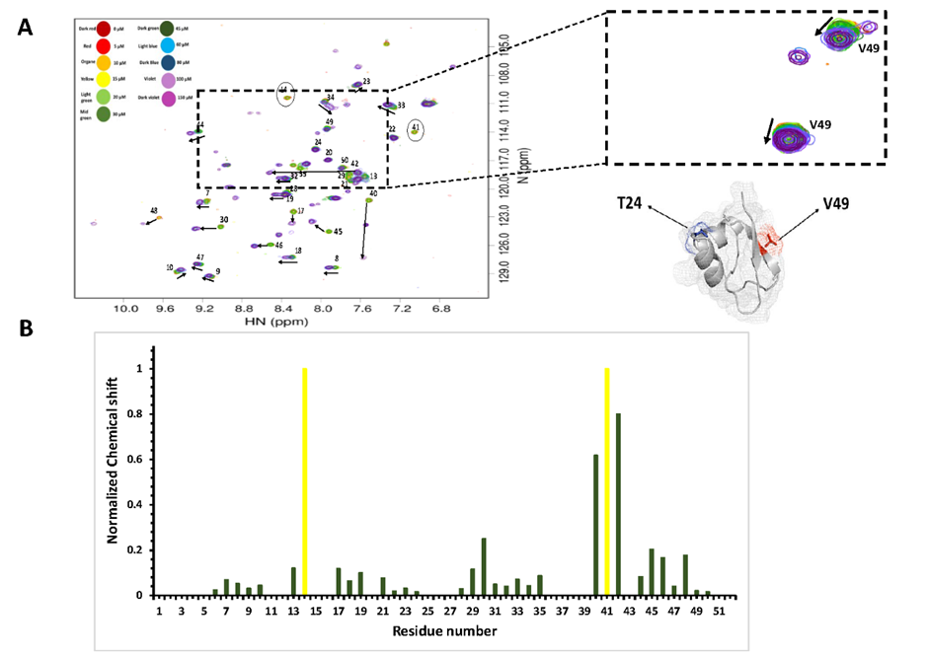
Figure ‎5.51-NMR titration of GlcNAc₅ ligand binding with LysMB1 at pH 9.
(A) Overlaid ¹H¹⁵N HSQC spectra of the LysMA1- GlcNac₅ titration acquired. The enlarged view illustrates a region of the spectra with peaks interacting with the GlcNac₅ in fast exchange. LysMB1 protein was used to represent the residues picked for the chemical shift change during GlcNAC₅ ligand binding. (B) Graphical representation of the observed CSP values. Residues which broaden beyond detection are shown as bars with an arbitrary shift change of 1. The bars represented in yellow colour are the residues that show line broadening.

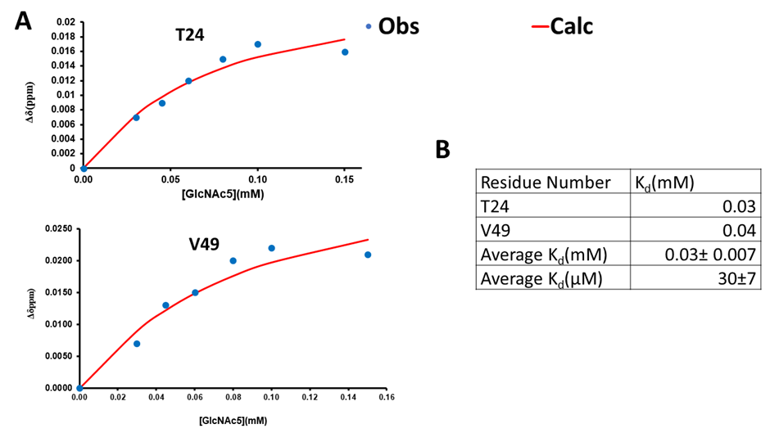
Figure ‎5.52-K_{d} fitting of LysMB1 with GlcNAc₅ ligand at pH 9.
The y-axis represents the relative shift of the NH nuclei from each residue and the x-axis the ligand concentration.
Table ‎5.3-Caculation of binding affinity of LysMA1 and LysMB1 with GlcNAc₅ by NMR chemical shift and ITC
 | LysMA1 |  | LysMB1
pH | Kd(µM)  NMR | Kd(µM)  ITC | Kd(µM)  NMR | Kd(µM)  ITC
3 | 100 | 287 | 20 | 19.5
5 | 100 | 243 | 270 | 22.7
7 | 222 | 121 | 30 | 14.4
9 | 236 | 236 | 232 | 22.6

The affinities obtained by fitting to chemical shift changes are summarised in Table 5.3 and compared to those obtained by Dr Nicola Galley using ITC. The data are reasonably consistent, giving some confidence that the results are reliable, despite the problems in fitting the LysMB1 data.
It is clear from these data that LysMB1 binds to GlcNAc₅ with an affinity about ten times greater than LysMA1, but there is no trend in affinity change with pH. This study set out to see if the reason for Enterococcus having both acidic and basic LysM domains was to generate affinities that show a different dependence of affinity on the pH. The results presented here imply that this is not the reason: neither domain shows any obvious pH dependence of binding.
Another possible reason for the two types of domain could be that they interact differently with the ligand. Inspection of the NMR titration data (Figures 5.35, 5.37, 5.40, 5.42, 5.44, 5.47, 5.49 and 5.52) shows that LysMA1 typically interacts most strongly with GlcNAc₅ at residues 14, 15, 17, 40 and 41, whereas LysMB1 typically interacts most strongly at residues 14, 16 and 41. There do therefore seem to be some subtle differences in interaction, presumably due to the differences in sequence (Figure 5.53), but overall, the binding sites are clearly the same.
Figure ‎5.53-Sequence of LysMA1 and LysMB1.
(A) Sequence alignment of LysMA1 and LysMB1 through MUSCLE; similar residues are highlighted in red and His-Tag sequence are in sky-blue. (B) Sequence and structure comparison of LysMA1 (2MKX) NMR structure with LysMB1 crystal structure.

It is possible that the conformational change of the protein on binding ligand is different. Both proteins show line broadening and loss of intensity on binding. Considering the relatively weak affinities, this is not consistent with a diffusion-controlled on-rate and suggests that for both proteins there is a conformational exchange involved in the ligand binding. For LysMA1, the conformational change was identified to be occurring mainly at residues 36-39 (Mesnage et al., 2014). It was therefore of interest to see if similar changes occur in LysMB1. In order to analyse conformational change, the backbone chemical shifts of free and bound LysMB1 were assigned, and submitted to the program TALOS-N (Shen & Bax, 2013), to derive values of backbone dihedral angles, as discussed in the next section.

Dihedral Angle
NMR has several ways of giving information on protein structure. The most obvious way is to calculate the structure, using a set of NMR measurements, the most useful of which are NOE restraints, which give information on distances between pairs of atoms. The structure is then built up by using the distance information to guide a structure search. This can be a very powerful method, but it is also time-consuming. A quicker but still powerful way of analysing protein structure is based on using backbone chemical shifts. Backbone chemical shifts (i.e. HN, N, Cα, Hα, Cβ, and C’) are affected in a predictable way by the local backbone structure. Therefore, backbone shifts can be compared to a database and used to predict the backbone dihedral angle. The dihedral angle is also known as the torsion angle, and it is formed by three consecutive bonds in a molecule. The backbone of the protein is formed from the three angles: ϕ (the angle between backbone N and Cα), ψ (the angle between Cα and C’) and ω (the angle between C’ and N). The ω angle is almost always 180°, forming a trans peptide bond. Therefore, in practice, the backbone geometry is defined by a combination of ϕ and ψ. There are several programs for doing this, of which the most well-known is TALOS and its successor TALOS-N (Shen & Bax, 2013), which predicts the mean and standard deviation of backbone ϕ and ψ angles, and also predicts the sidechain χ₁ angle where possible. In section 5.3 we reported on the backbone assignment of LysMB1 in the free state. In order to characterise the conformational change when the protein binds ligand, we here assigned the spectrum in the bound state, and applied TALOS-N to look at conformational change. The assignment was carried out in the presence of 1:2 ratio of protein:ligand (to give close to fully bound shifts) and assignment was carried out in the same way as for the free protein. The assigned chemical shifts were then formatted in an appropriate way and fed into the TALOS-N program.
The output from TALOS-N is shown in Figure 5.54. There are some large chemical shift differences between free and bound (Figure 5.55), suggesting that the structure may have changed in a few places, most obviously in the region 40-42, where TALOS suggests a change from random coil to β-sheet. This is consistent with the chemical shift changes, where for example there are some large differences in residues 40-42 as shown in Figure 5.55. TALOS-N is able to calculate predicted dihedral angles with standard deviations. This is shown in Figure 5.56, with the values in Tables 5.4 and 5.5. What we are looking for is regions where the predicted change in dihedral angle is greater than the combined standard deviations. TALOS-N assigns a confidence to each dihedral angle, which are listed as strong, generous, warn and dynamic. In Table 5.4 and Figure 5.56, residues Y11, T14 and N39 show large but not statistically significant differences in φ angle, while in Table 5.5 and Figure 5.56 only residue Y42 shows a large difference in ψ angle as highlighted in sky blue. This difference is significant, implying that there is a genuine change in structure around residue Y42. Residues in the warn category have ambiguous shifts which are not able to generate a dihedral angle with confidence. Residues in the dyn category are suggested to be dynamic. We have therefore only used residues assigned strong and generous. There are a number of residues where predictions are missing for either the free or the bound state. We have not used these residues. Of the confident residues, the only residue showing a clear difference is Y42, which has a large difference in the predicted ψ angle.

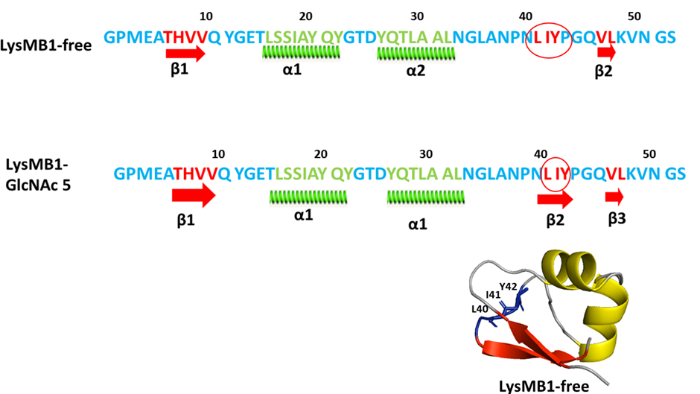
Figure ‎5.54-LysMB1 dihedral angles predicted by Talos-N.
Secondary structure of LysMB1 and secondary structure of LysMB1 with GlcNAC₅ ligand -sequence highlighted in blue stands for coil, sequence highlighted in red stands for beta sheets and sequence highlighted in green stands for alpha-helix; the crystal structure showing the residues which change during ligand binding.
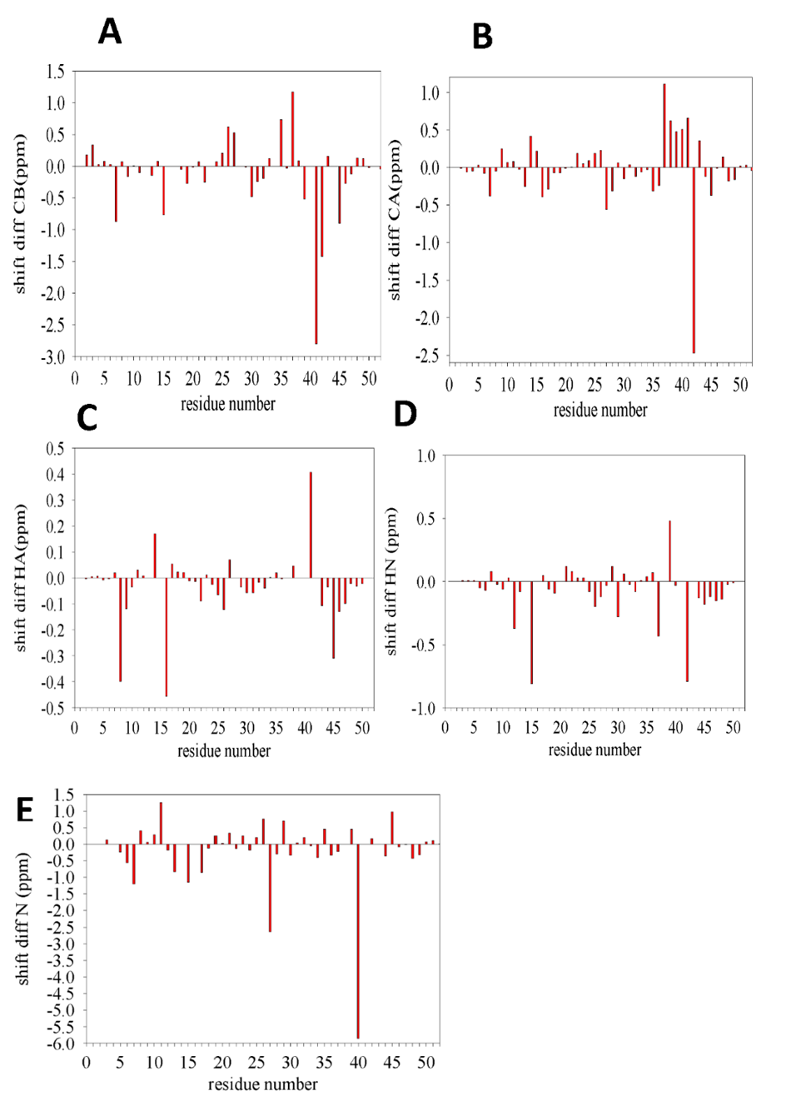
Figure ‎5.55- Chemical shift difference between Cα, Cβ, HN, Hα and N of LysMB1 and LysMB1-GlcNAc₅

Table ‎5.4-PHI(φ) prediction by TALOS-N
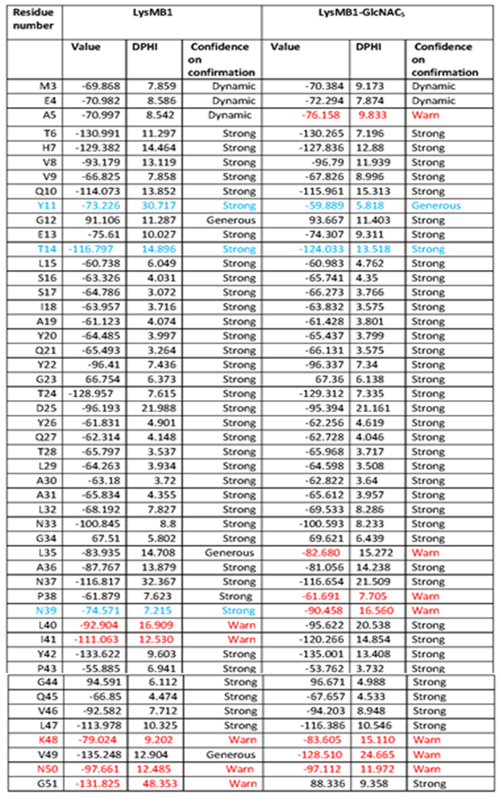
Note: Residue highlighted in Sky blue showed divergence, red highlighted residues showed warn and DPHI represents the estimated standard deviation of prediction errors.
Table ‎5.5-PSI (ψ) prediction by TALOS-N
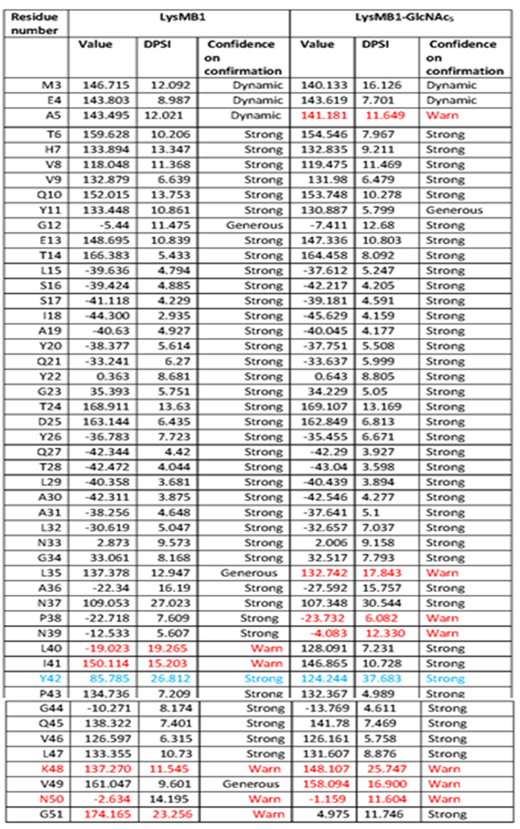
Note: Residue highlighted in Sky blue showed divergence, red highlighted residues showed warn and DPHI represents the estimated standard deviation of prediction errors.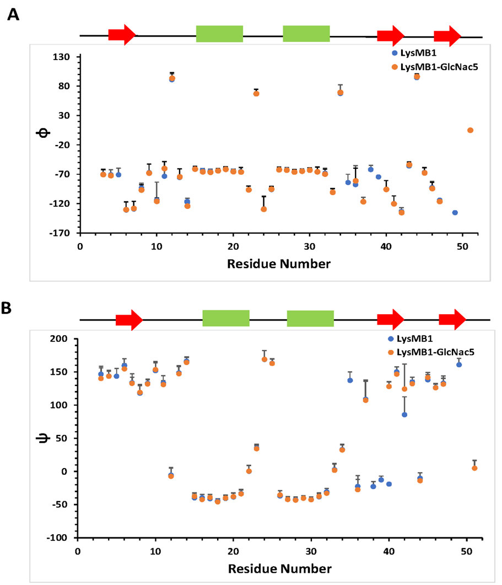
Figure ‎5.56- Analysis of backbone dihedral angles of free and bound protein of LysMB1 by TALOS-N.
A) PHI(φ) backbone dihedral angle (B) PSI(ψ ) backbone dihedral angle and error bars indicate the DPSI and DPHI (expected standard deviation of the estimated errors in PSI and PHI). The red arrows represent beta sheet and green boxes represents alpha helix. Only those residues are included in the graph where TALOS-N prediction was confident.

Discussion and conclusion
We initially tried to fit the affinities at different pH values using intensity changes. It is clear from the analysis presented here that this is not a good method, because there is slow or intermediate rate conformational exchange occurring on binding, which has the effect of broadening residues and reducing the intensity of the signals. This means that intensity changes are caused by a combination of binding and conformational change, and accordingly do not reflect the proportion of bound protein directly. We therefore used chemical shift changes to fit the affinities. For LysMA1 this worked well. For LysMB1 many of the chemical shift titration curves display sigmoidal curves. It is unclear why this occurs, although we speculate that the purified protein may have a weakly bound ligand which has to be displaced before GlcNAc₅ can bind. We therefore fitted the LysMB1 data omitting the first four titration points. The affinities fitted in this way are similar in value to the ITC data obtained by Dr Galley (Table 5.3).
These affinities show that there is no clear pattern of pH-dependent changes in binding affinity. Within the error estimates, the affinities remain the same at all pH values. This is not a surprise, because the ligand has no net charge. The affinity for LysMB1 is roughly 10 times stronger than the affinity of LysMA1.
Many of the signals for LysMA1 behave reasonably consistently with fast exchange on the NMR timescale, whereas most LysMB1 signals have slow or intermediate exchange. This is consistent with the stronger binding of LysMB1, and thus does not indicate any major difference in the way that the two proteins bind GlcNAc₅.
The two proteins interact with GlcNAc₅ at almost identical sites. It therefore appears that their mode of binding is similar. Both proteins undergo a small conformation change on binding. In LysMA1 this is mainly at residues 36-39 (Mesnage et al., 2014). In LysMB1 this is in the region 40-42. It therefore appears that there is a small difference in the way the two proteins adapt themselves to bind to the ligand. However, over most of the protein sequence the structural change is very small, and it would not seem that this difference is enough to explain why some proteins contain acidic LysM domains and some contain basic domains.
Despite this lack of difference, there is clear experimental evidence that AtlA (containing basic LysM domains) is located mainly at the cell pole and the septum, whereas AtlB (containing acidic LysM domains) is located all over the cell surface. Since our data demonstrate very similar binding modes for the two domains, we conclude that the difference in location must be due to the charge on the protein, presumably indicating that the cell pole and septum is more negatively charged than the rest of the cell peptidoglycan surface and is used to target basic LysM domains. This finding should be explored further.

General Discussion and Conclusion
The research in this thesis is on two bacterial surface proteins, WxL and LysM proteins (LysMA1 and LysMB1), which both bind to peptidoglycan present in Enterococcus species.

WxL
WxL domain, which is a relatively rare domain, is not present in every bacterium; its structure and proper function are still unknown. A more detailed analysis was done on WxL proteins in this study, concentrating on domains where these were reported and published by the authors (Galloway-Peña et al., 2015; Brinster et al., 2007; Bierne & Cossart, 2007; Brinster et al., 2006; Siezen et al., 2006). The following sections present new insights we have found in our research.

Concept of Large and Small WxL proteins
Chapter 3 presents a detailed study on WxL proteins and on the other proteins found in the same gene cluster. Galloway-Peña et al., 2015 proposed that WxL proteins could be categorized as Large WxL protein and Small WxL protein based on their size (Galloway-Peña et al., 2015). Our findings confirm this proposal and more clearly explain the definition of Large and Small WxL proteins. The Small WxL proteins are from 164-246 residues in size (18.5 – 28.7 kDa) with a pI range from 4 to 5, and the Large WxL proteins' molecular weights range from 50-119 kDa, and most of the Large WxL proteins involved in this study had pI of 4-9. Large WxL protein contains a WxL domain 106-212 residues long while the whole length of Large WxL protein is 495-1136 aa. The Small WxL proteins only contain the WxL domain, while Large WxL proteins are made up of different domains that vary from species to species.
The structure predictions presented here show that the Small and Large WxL domains have distinct structures, although both consist mainly of β-sheets.

DUF916 as conserved domain
DUF916 is a conserved domain found universally in the cluster of WxL proteins, suggesting that the domain has some importance in the cluster. Galloway-Peña et al., 2015 observed binding of DUF916 to both Small and Large WxL (Galloway-Peña et al., 2015).
Our finding in Chapter 3 showed that DUF proteins present in the cluster of WxL proteins are composed of two conserved domains, DUF916 and DUF3324. Structural analysis suggests that the DUF916 – DUF3324 pair has a structural similarity to the E. coli pilin protein, which is involved in adhesion to host epithelial cells. A particularly interesting finding was that the pilin protein is involved in strand exchange with another protein in the same gene cluster. The WxL domain from LwpE is predicted to be lacking one or more strands. We thus proposed that the LwpE WxL domain is stabilised by strand exchange from the N-terminal region of DUF916. The experimental evidence in chapter 4 is proof that DUF3324 can be expressed on its own while DUF916 needs DUF3324 to be expressed and to be a stable protein. Robetta and phyre2 predictions in chapter 3 also confirm that DUF916 needs a strand to be stable.
The structure predictions presented in Chapter 3 further indicate that the two WxL motifs in LwpE are probably not recognition sequences exposed on the surface but are more likely to be internal residues involved in facilitating the strand exchange.

LwpE protein as most well-categorized WxL protein but insoluble protein
In this study WxL domain was expressed from EF2686 protein (LwpE) from E. faecalis V583; this domain was selected because it is a well-categorized domain present in other species and has been studied by different authors (Brinster et al., 2006, 2007; Jamet et al., 2017; Nunez et al., 2018). In Chapter 4, expression trials of different WxL domains (LwpE) from E. faecalis V583 were made but LwpE containing WxL domain was unfolded, and refolding techniques were applied to make it folded and soluble but failed. Brinster et al., 2006, 2007 have divided the WxL domain into the FID domain (474-606 aa) and WxL domain (607-723 aa) (Brinster et al., 2006, 2007; Jamet et al., 2017), but according to BlastP analysis, Motif finder and MUSCLE alignment the WxL domain runs from 581-723 aa as described in Chapter 3. The Robetta analysis is also consistent with this and suggests that if the LwpE contains FID domain it may run from 474-580 aa as shown in Figure 6.1. Most WxL domains showed a similar structure as shown in Figure 6.1(C) as discussed in chapter 3 showing the gap in beta barrel sheets indicating that it needs an additional strand.
Figure ‎6.1-LwpE domain and Robetta structure prediction of E. faecalis V583.
(A) Sequence of C-WxL domain of LwpE- Sequence in purple are FID domain sequence and green is WxL domain. G in yellow denotes where WxL domain starts according to Blast P analysis and Y in red shows where Brinster et al suggested WxL domain starts. (B) Robetta prediction of the structure of C-WxL domain -Beta sheets in purple colour are FID domain and green beta sheets is WxL domain. (C) WxL structure showing the eight residues (D146, R148, T150Q186, Y231, L236, T237and P244) which are found to be conserved by MUSCLE alignment.

A detailed structure prediction of LwpE (C-WxL and WxL domain) was made through Phyre2 and Robetta predict that the WxL domain has homology with the pilin protein CFA/I fimbria from enterotoxigenic E. coli (ETEC) (Poole et al., 2007; Li et al., 2006, 2007). It was concluded that the WxL domain needs an extra strand to be properly folded as the WxL domain may behave in the same ways as its homolog (PDB code 2HB0). DUF916 might provide the donor strand to the C-WxL domain.

SwpA protein is appropriate for further study.
Among all WxL proteins found in Enterococci, SwpA is the most stable, least disordered and most soluble protein described by Galloway-Peña et al., 2015. Our study also confirms that SwpA is the best behaved, as described in chapter 4 in detail in section 4.3.3.1. According to Galloway-Peña et al. (2015) SwpA exists in two forms monomer and dimer, and the dimer form of SpwA is more structured and contains more alpha-helix compared to monomer (Galloway-Peña et al., 2015). Our finding reveals that SpwA exists in a monomeric form that is a soluble and stable protein as having a secondary structure that is mainly beta-sheet. In this study, the most stable form was one with a tag on the C-terminus. Further study is needed to determine its NMR or X-crystal structure and its function in detail.

Is WxL a disordered protein?
Galloway-Peña et al., 2015 observed from Phyre 2 and DisEMBL that WxL proteins (SwpA or SwpC) are highly disordered proteins (Galloway-Peña et al., 2015). However, our research using Phyre2 and Robetta reveals that although parts are disordered, they are probably folded beta-barrels. CD spectrometry analysis of the SwpA, as discussed in chapter 4 showed that it contains only 30% disordered region while the rest 52 % is beta-sheets; so, from this analysis, it was shown that the WxL domain is not a fully disordered protein.

LysM proteins
In our study, we studied in detail the LysMB1and LysMA1 domains. This follows on from earlier work that determined the structure of LysMA1 and looked at its interaction with peptidoglycan (Mesnage et al., 2014). The study described in Chapter 5 compares the LysMA1 and LysMB1 proteins.

Can LysMB1 protein be purified with His-Tag and imidazole like LysMA1?
During purification of the LysMB1, it was concluded that LysMB1 purification should be done in one day because proteins aggregated so quickly in the presence of His-Tag and imidazole, so His-Tag was cleaved, and imidazole was taken out through buffer exchange; all these things were done on the same day. By contrast LysMA1 was a very stable protein even in the presence of His-Tag. So, all experiments were done with LysMA1 with a His-Tag and LysMB1 without a His-Tag.

Why do cells produce two LysM proteins with different pI?
To determine if we could find a functional reason for the differences in pI between acidic LysM domains (such as LysMB1) and basic domains (such as LysMA1), we measured the affinity of these domains to the peptidoglycan model GlcNAc₅ at pH values 3, 5, 7 and 9. LysMB1 was found to bind about ten times more strongly than LysMA1, but there was no obvious difference in affinity with pH, as determined by our NMR study or Dr Galley’s ITC. We, therefore, conclude that the different pIs of the domains does not give them different pH-dependent binding. We also looked to see if the proteins interact differently with the GlcNAc₅. We found that the residues most affected by binding are in similar locations.

Which way is better to measure the affinity: through intensities or shift change?
As discussed in Chapter 5, affinity was best measured through shift change rather than intensities. The K_{d} results which were obtained using shift changes were very close to ITC results done by Dr Galley.

Is there any structural change of LysMB1 on binding peptidoglycan?
Using chemical shifts with the program TALOS-N, we showed that there is a conformational change in LysMB1 when it binds GlcNAc₅. The change is not identical to that found previously for LysMA1, but it is in similar locations, suggesting that the two proteins recognise and bind to peptidoglycan in similar ways. The most obvious change was noticed in Y42 residue in the ψ backbone dihedral angle.

Why do some proteins contain acidic LysM, and some contain basic LysM; why do the host proteins attach to the bacterial surface in different locations?
There are several possible explanations. It could be that the localisation on the bacterial surface is not related to the pI of the protein but is due to recognition of some specific difference between the poles and the rest of the cell surface. In view of the similar PG recognition by the two domains, this seems unlikely. The most likely explanation is that the proteins are recognising a different charge distribution across the cell surface. The AtlA protein contains basic LysM domains and binds mainly at the septum and poles, whereas AtlB, which contains acidic LysM domains, binds fairly evenly everywhere. If the poles and septum contain a greater density of negatively charged groups, then this might explain the different distributions of the two LysM domains. The septum and poles are the most recent parts of the cell wall to have been created, and it is perfectly possible for them to have a different charge distribution than the more mature parts of the cell surface. This will require further experiments to determine whether there is indeed such a charge distribution.

Final conclusions
This thesis has explored different facets of enterococcal peptidoglycan-binding domains. It shows that there are still many fascinating details to be explored before we could reasonably claim to understand how these bacteria work on a molecular level. More work needs to be done on especially on WxL proteins.

Future perspectives
In the case of WxL studies, Small WxL of Locus A can be studied in detail. The expression of this WxL should be done doubled labelled to study the structure of the protein and it should also be expressed single labelled to study the interaction of WxL domain with different ligands. Large WxL protein expression trials should be done to express it in the soluble form.
In the case of LysM protein, other LysM domains should be studied in future.

References
Aizawa, S.-I. (2015). Flagella. Molecular Medical Microbiology, 1(2), pp.125–146.
Akcapinar, G.B., Kappel, L., Sezerman, O.U. and Seidl-Seiboth, V. (2015). Molecular diversity of LysM carbohydrate-binding motifs in fungi. Current Genetics, 61(2), pp.103–113.
Barlag, B. and Hensel, M. (2015). The giant adhesin SiiE of Salmonella enterica. Molecules, 20(1), pp.1134–1150.
Barnhart, M. M., Pinkner, J. S., Soto, G. E., Sauer, F. G., Langermann, S., Waksman, G., Frieden, C. & Hultgren, S. J. (2000). PapD-like chaperones provide the missing information for folding of pilin proteins. Proceedings of the National Academy of Sciences of the United States of America, 97(14), pp.7709–7714.
Bateman, A. and Bycroft, M. (2000). The structure of a LysM domain from E. coli membrane-bound lytic murein transglycosylase D (MltD). Journal of Molecular Biology, 299(4), pp.1113–1119.
Bateman, A., Coggill, P. and Finn, R.D. (2010). DUFs: families in search of function. Acta Crystallographica Section F Structural Biology and Crystallization Communications, 66(10), pp.1148–1152.
Becker, W., Bhattiprolu, K.C., Gubensäk, N. and Zangger, K. (2018). Investigating Protein-Ligand Interactions by Solution Nuclear Magnetic Resonance Spectroscopy. ChemPhysChem, 19(8), pp.894–894.
Bella, J., Hindle, K.L., McEwan, P.A. and Lovell, S.C. (2008). The leucine-rich repeat structure. Cellular and molecular life sciences: CMLS 65(15), pp.2307–2333.
Bendtsen, J.D., Nielsen, H., von Heijne, G. and Brunak, S. (2004). Improved Prediction of Signal Peptides: SignalP 3.0. Journal of Molecular Biology, 340(4), pp.783–795.
Bennett‐Lovsey, R.M., Herbert, A.D., Sternberg, M.J.E. and Kelley, L.A. (2008). Exploring the extremes of sequence/structure space with ensemble fold recognition in the program Phyre. Proteins: Structure, Function, and Bioinformatics, 70(3), pp.611–625.
Berman, H. M., Battistuz, T., Bhat, T. N., Bluhm, W. F., Bourne, P. E., Burkhardt, K., Feng, Z., Gilliland, G. L., Iype, L., Jain, S., Fagan, P., Marvin, J., Padilla, D., Ravichandran, V., Schneider, B., Thanki, N., Weissig, H., Westbrook, J. D., & Zardecki, C. (2002). The Protein Data Bank. Nucleic Acids Research, 58(6), 899–907.
Berrow, N.S., Alderton, D., Sainsbury, S., Nettleship, J., Assenberg, R., Rahman, N., Stuart, D.I. and Owens, R.J. (2007). A versatile ligation-independent cloning method suitable for high-throughput expression screening applications. Nucleic Acids Research, 35(6), p.e45
Bierne, H. and Cossart, P. (2007). Listeria monocytogenes surface proteins: from genome predictions to function. Microbiology and Molecular Biology Reviews, 71(2), pp.377–397.
Bitesize Bio. (2012). What Can NMR Do For You? – Part One. Available at: https://bitesizebio.com/8252/what-can-nmr-do-for-you-part-one/.
Boekhorst, J., Helmer, Q., Kleerebezem, M. and Siezen, R.J. (2006). Comparative analysis of proteins with a mucus-binding domain found exclusively in lactic acid bacteria. Microbiology, 152(1), pp.273–280.
Bøhle, L.A., Riaz, T., Egge-Jacobsen, W., Skaugen, M., Busk, Ø.L., Eijsink, V.G. and Mathiesen, G. (2011). Identification of surface proteins in Enterococcus faecalis V583. BMC Genomics, 12(1), pp.1471–2164.
Brinster, S., Furlan, S. and Serror, P. (2006). C-Terminal WxL domain mediates cell wall binding in Enterococcus faecalis and Other Gram-Positive Bacteria. Journal of Bacteriology, 189(4), pp.1244–1253.
Brinster, S., Posteraro, B., Bierne, H., Alberti, A., Makhzami, S., Sanguinetti, M. and Serror, P. (2007). Enterococcal Leucine-Rich Repeat-Containing Protein Involved in Virulence and Host Inflammatory Response. Infection and Immunity, 75(9), pp.4463–4471.
Bron, P.A., Molenaar, D., Vos, W.M. and Kleerebezem, M. (2006). DNA micro-array-based identification of bile-responsive genes in Lactobacillus plantarum. Journal of Applied Microbiology, 100(4), pp.728–738.
Buchanan, G., Maillard, J., Nabuurs, S.B., Richardson, D.J., Palmer, T. and Sargent, F. (2008). Features of a twin-arginine signal peptide required for recognition by a Tat proofreading chaperone. FEBS Letters, 582(29), pp.3979–3984.
Buist, G., Kok, J., Leenhouts, K.J., Dabrowska, M., Venema, G. and Haandrikman, A.J. (1995). Molecular cloning and nucleotide sequence of the gene encoding the major peptidoglycan hydrolase of Lactococcus lactis, a muramidase needed for cell separation. Journal of bacteriology, 177(6), pp.1554–1563.
Buist, G., Steen, A., Kok, J. and Kuipers, O.P. (2008). LysM, a widely distributed protein motif for binding to (peptido)glycans. Molecular Microbiology, 68(4), pp.838–847.
Caveney, N.A., Li, F.K. and Strynadka, N.C. (2018). Enzyme structures of the bacterial peptidoglycan and wall teichoic acid biogenesis pathways. Current Opinion in Structural Biology, 53, pp.45–58.
Chapot-Chartier, M.-P. and Kulakauskas, S. (2014). Cell wall structure and function in lactic acid bacteria. Microbial Cell Factories, 13(Suppl 1), p.S9.
Chen, C. (2016). Superior Cloning Performance with SGI-DNA Gibson Assembly®kits. BioTechniques, 60(3).
Choudhury, D., Thompson, A., Stojanoff, V., Langermann, S., Pinkner, J., Hultgren, S. J. & D.Knight, S. (1999). X-ray Structure of the FimC-FimH Chaperone-Adhesin Complex from Uropathogenic Escherichia coli. Science, 285(5430), pp.1061–1066.
Cox, J., Neuhauser, N., Michalski, A., Scheltema, R. A., Olsen, J. V. & Mann, M. (2011). Andromeda: A Peptide Search Engine Integrated into the MaxQuant Environment. Journal of Proteome Research, 10(4), pp.1794–1805.
Coyette, J. and Hancock, L.E. (2002). Enterococcal cell wall. In: D.B. Clewell, P. Courvalin, G.M. Danny, B.E. Murray and L.B. Rice, eds., The Enterococci: Pathogenesis, Molecular Biology, and Antibiotic Resistance. Washington, DC: American Society of Microbiology, pp.177–218.
Delcour, J., Ferain, T., Deghorain, M., Palumbo, E. and Hols, P. (1999). The biosynthesis and functionality of the cell-wall of lactic acid bacteria. In Lactic acid bacteria: genetics, metabolism and applications, 76(1/4), pp.159–184.
Desvaux, M., Candela, T. and Serror, P. (2018). Surfaceome and proteosurfaceome in parietal monoderm bacteria: focus on protein cell-surface display. Frontiers in Microbiology, 9. pp. 1–28
Downer, R., Roche, F., Park, P.W., Mecham, R.P. and Foster, T.J. (2002). The Elastin-binding Protein of Staphylococcus aureus (EbpS) Is Expressed at the Cell Surface as an Integral Membrane Protein and Not as a Cell Wall-associated Protein. Journal of Biological Chemistry, 277(1), pp.243–250.
Doyle, R.J., Chaloupka, J. and Vinter, V. (1988). Turnover of cell walls in microorganisms. Microbiological Reviews, 52(4), pp.554–567.
Dramsi, S. and Bierne, H. (2016). Spatial positioning of cell wall-anchored virulence factors in Gram-positive bacteria. Current Opinion in Microbiology, 15(6), pp.177–201.
Du, L., Liu, F., Ju, X. and Huo, G. (2010). Adhesion capability of first two domains at N terminus of NP_785232 protein and their interaction with a UV-absorbing component from human mucus. Letters in Applied Microbiology, 51(4), pp.400–405.
Eckert, C., Lecerf, M., Dubost, L., Arthur, M. and Mesnage, S. (2006). Functional Analysis of AtlA, the Major N-Acetylglucosaminidase of Enterococcus faecalis. Journal of Bacteriology, 188(24), pp.8513–8519.
Edgar, R.C. (2004). MUSCLE: a multiple sequence alignment method with reduced time and space complexity. BMC Bioinformatics, 5(1), p.113.
El-Gebali, S., Mistry, J., Bateman, A., Eddy, S.R., Luciani, A., Potter, S.C., Qureshi, M., Richardson, L.J., Salazar, G.A., Smart, A., Sonnhammer, E.L., Hirsh, L., Paladin, L., Piovesan, D., Tosatto, S.C. and Finn, R.D. (2019). The Pfam protein families database in 2019. Nucleic Acids Research, 47(D1), pp. D427–D432.
Elbing, K.L. and Brent, R. (2018). Recipes and Tools for Culture of Escherichia coli. Current Protocols in Molecular Biology, 125(1), p.e83.
Frain, K.M., Robinson, C. and van Dijl, J.M. (2019). Transport of Folded Proteins by the Tat System. The Protein Journal, 38(4), pp.377–388.
Galloway-Peña, J.R., Liang, X., Singh, K.V., Yadav, P., Chang, C., La Rosa, S.L., Shelburne, S., Ton-That, H., Höök, M. and Murray, B.E. (2014). The Identification and Functional Characterization of WxL Proteins from Enterococcus faecium Reveal Surface Proteins Involved in Extracellular Matrix Interactions. Journal of Bacteriology, 197(5), pp.882–892.
Garvey, K.J., Saedi, M.S. and Ito, J. (1986). Nucleotide sequence of Bacillus phage Ø29 genes 14 and 15: homology of gene 15 with other phage lysozymes. Nucleic Acids Research, 14(24), pp.10001–10008.
Gasteiger, E., Hoogland, C., Gattiker, A., Wilkins, M.R., Appel, R.D. and Bairoch, A. (2005). Protein identification and analysis tools on the ExPASy server. The proteomics protocols handbook, pp.571-607.
Geiss-Liebisch, S., Rooijakkers, S.H.M., Beczala, A., Sanchez-Carballo, P., Kruszynska, K., Repp, C., Sakinc, T., Vinogradov, E., Holst, O., Huebner, J. and Theilacker, C. (2012). Secondary Cell Wall Polymers of Enterococcus faecalis Are Critical for Resistance to Complement Activation via Mannose-binding Lectin. Journal of Biological Chemistry, 287(45), pp.37769–37777.
Goosens, V. J., Monteferrante, C. G. and van Dijl, J. M. (2014). The Tat system of Gram-positive bacteria, Biochimica et Biophysica Acta (BBA) - Molecular Cell Research. Elsevier B.V., 1843(8), pp. 1698–1706.

Guerardel, Y., Sadovskaya, I., Maes, E., Furlan, S., Chapot-Chartier, M.-P., Mesnage, S., Rigottier-Gois, L. and Serror, P. (2020). Complete Structure of the Enterococcal Polysaccharide Antigen (EPA) of Vancomycin-Resistant Enterococcus faecalis V583 Reveals that EPA Decorations Are Teichoic Acids Covalently Linked to a Rhamnopolysaccharide Backbone. mBio, 11(2), pp. 1–15.
Hancock, L.E., Murray, B.E. and Sillanpää, J. (2014). Enterococcal Cell Wall Components and Structures. In: Enterococci: From Commensals to Leading Causes of Drug Resistant Infection. Massachusetts Eye and Ear Infirmary: Boston, pp.1–44.
Hendrickx, A.P.A., Willems, R.J.L., Bonten, M.J.M. and van Schaik, W. (2009). LPxTG surface proteins of enterococci. Trends in Microbiology, 17(9), pp.423–430.
Jamet, A., Dervyn, R., Lapaque, N., Bugli, F., Perez-Cortez, N.G., Blottière, H.M., Twizere, J.-C., Sanguinetti, M., Posteraro, B., Serror, P. and Maguin, E. (2017). The Enterococcus faecalis virulence factor ElrA interacts with the human Four-and-a-Half LIM Domains Protein 2. Scientific Reports, 7(1), pp. 1–13.
Jones, A.S., Austerberry, J.I., Dajani, R., Warwicker, J., Curtis, R., Derrick, J.P. and Robinson, C. (2016). Proofreading of substrate structure by the Twin-Arginine Translocase is highly dependent on substrate conformational flexibility but surprisingly tolerant of surface charge and hydrophobicity changes. Biochimica et Biophysica Acta (BBA) - Molecular Cell Research, 1863(12), pp.3116–3124.
Kajimura, J., Fujiwara, T., Yamada, S., Suzawa, Y., Nishida, T., Oyamada, Y., Hayashi, I., Yamagishi, J., Komatsuzawa, H. and Sugai, M. (2005). Identification and molecular characterization of an N-acetylmuramyl-l-alanine amidase Sle1 involved in cell separation of Staphylococcus aureus. Molecular Microbiology, 58(4), pp.1087–1101.
Kau, A.L., Martin, S.M., Lyon, W., Hayes, E., Caparon, M.G. and Hultgren, S.J. (2005). Enterococcus faecalis Tropism for the Kidneys in the Urinary Tract of C57BL/6J Mice. Infection and Immunity, 73(4), pp.2461–2468.
Kelley, L.A., Mezulis, S., Yates, C.M., Wass, M.N. and Sternberg, M.J.E. (2015). The Phyre2 web portal for protein modeling, prediction and analysis. Nature Protocols, 10(6), pp.845–858.
Kim, D.E., Chivian, D. and Baker, D. (2004). Protein structure prediction and analysis using the Robetta server. Nucleic Acids Research, 32(Web Server), pp.W526–W531.
Kleiber, K., Strebhardt, K. and Martin, B. T. (2007). The Biological Relevance of FHL2 in Tumour Cells and its Role as a Putative Cancer Target. Anticancer Research, 27(1A), pp.55–62.
Koharudin, L. M. I., Debiec, K. T. and Gronenborn, A. M. (2015). Structural Insight into Fungal Cell Wall Recognition by a CVNH Protein with a Single LysM Domain. Structure, 23(11), pp.2143–2154.
Koontz, L. (2014). TCA Precipitation. In: Methods in enzymology. Amsterdam; Boston: Elsevier/Academic Press, pp.3–10.
Lagarda-Diaz, I., Guzman-Partida, A. and Vazquez-Moreno, L. (2017). Legume Lectins: Proteins with Diverse Applications. International Journal of Molecular Sciences, 18(6), p.1242.
Laskowski, R. A., Jabłońska, J., Pravda, L., Vařeková, R. S. & Thornton, J. M. (2018). PDBsum: summaries and analyses of PDB structures. Protein Science, 27(1), pp. 129–134
Lewin, B., Plopper, G., Sharp, D. & Sikorski, E. (2015). Lewin’s cells. Burlington, Ma: Jones & Bartlett Learning.
Li, S. N., Wang, J. Y., Yuan, M. J. & Yang, K. (2014). Disruption of the baculovirus core gene ac78 results in decreased production of multiple nucleocapsid-enveloped occlusion-derived virions and the failure of primary infection in vivo. Virus Research, 191(1), pp.70–82.
Li, Y.-F., Poole, S., Rasulova, F., Esser, L., Savarino, S.J. and Xia, D. (2006). Crystallization and preliminary X-ray diffraction analysis of CfaE, the adhesive subunit of the CFA/I fimbriae from human Enterotoxigenic Escherichia coli. Acta Crystallographica Section F Structural Biology and Crystallization Communications, 62(2), pp.121–124.
Li, Y. F., Poole, S., Rasulova, F., McVeigh, A. L., Savarino, S. J. & Xia, D. (2007). A Receptor-binding Site as Revealed by the Crystal Structure of CfaE, the Colonization Factor Antigen I Fimbrial Adhesin of Enterotoxigenic Escherichia coli. Journal of Biological Chemistry, 282(33), pp.23970–23980.
Louca, S., Mazel, F., Doebeli, M. & Parfrey, L. W. (2019). A census-based estimate of Earth’s bacterial and archaeal diversity. PLOS Biology, 17(2), p.e3000106.
Mahmood, T. and Yang, P. C. (2014). Western blot: Technique, theory and trouble shooting. North American Journal of Medical Sciences, 4(9), pp. 429–434.
Makarova, K., Slesarev, A., Wolf, Y., Sorokin, A., Mirkin, B., Koonin, E., Pavlov, A., Pavlova, N., Karamychev, V., Polouchine, N., Shakhova, V., Grigoriev, I., Lou, Y., Rohksar, D., Lucas, S., Huang, K., Goodstein, D.M., Hawkins, T., Plengvidhya, V. and Welker, D. (2006). Comparative genomics of the lactic acid bacteria. Proceedings of the National Academy of Sciences, 103(42), pp.15611–15616.
Matsushima, N., Miyashita, H., Mikami, T. and Kuroki, Y. (2010). A nested leucine rich repeat (LRR) domain: The precursor of LRRs is a ten or eleven residue motif. BMC Microbiology, 10(1), p.235.
McCormick, M. and Mierendorf, R. (2000). S•TagTM : A Multipurpose Fusion Peptide 0.7 for Recombinant Proteins. Methods in Enzymology, 23(326), pp.362–376.
McGinnis, S. and Madden, T.L. (2004). BLAST: at the core of a powerful and diverse set of sequence analysis tools. Nucleic Acids Research, 32(Web Server), pp.W20–W25.
Mesnage, S., Chau, F., Dubost, L. and Arthur, M. (2008). Role of N-Acetylglucosaminidase and N-Acetylmuramidase Activities in Enterococcus faecalis Peptidoglycan Metabolism. Journal of Biological Chemistry, 283(28), pp.19845–19853.
Mesnage, S., Dellarole, M., Baxter, N. J., Rouget, J. B., Dimitrov, J. D., Wang, N., Fujimoto, Y., Hounslow, A. M., Lacroix-Desmazes, S., Fukase, K., Foster, S. J. & Williamson, M. P. (2014). Molecular basis for bacterial peptidoglycan recognition by LysM domains. Nature Communications, 5(1), pp. 1–11.
Michel, G., Tonon, T., Scornet, D., Cock, J. M. & Kloareg, B. (2010). Central and storage carbon metabolism of the brown alga Ectocarpus siliculosus: insights into the origin and evolution of storage carbohydrates in Eukaryotes. New Phytologist, 188(1), pp.67–81.
Naissant, B., Dupuy, F., Duffier, Y., Lorthiois, A., Duez, J., Scholz, J., Buffet, P., Merckx, A., Bachmann, A. and Lavazec, C. (2016). Plasmodium falciparum STEVOR phosphorylation regulates host erythrocyte deformability enabling malaria parasite transmission. Blood, 127(24), pp.e42–e53.
Navarre, W.W., Daefler, S. and Schneewind, O. (1996). Cell wall sorting of lipoproteins in Staphylococcus aureus. Journal of bacteriology, 178(2), pp.441–446.
Navarre, W.W. and Schneewind, O. (1994). Proteolytic cleavage and cell wall anchoring at the LPXTG motif of surface proteins in Gram-positive bacteria. Molecular Microbiology, 14(1), pp.115–121.
Neves, D., Job, V., Dortet, L., Cossart, P. & Dessen, A. (2013). Structure of Internalin InlK from the Human Pathogen Listeria monocytogenes. Journal of Molecular Biology, 425(22), pp.4520–4529.
Ngo, A. N., JM Ezoulin, M., Youm, I. & Youan, B.-B. C. (2014). Optimal Concentration of 2,2,2-Trichloroacetic acid for protein precipitation based on response surface methodology. Journal of Analytical & Bioanalytical Techniques, 5(4).
Niang, M., Bei, A. K., Madnani, K. G., Pelly, S., Dankwa, S., Kanjee, U., Gunalan, K., Amaladoss, A., Yeo, K. P., Bob, N. S., Malleret, B., Duraisingh, M. T. & Preiser, P. R. (2014). STEVOR Is a Plasmodium falciparum erythrocyte binding protein that mediates merozoite invasion and rosetting. Cell Host & Microbe, 16(1), pp.81–93.
Nunez, N., Derré-Bobillot, A., Gaubert, S., Herry, J. M., Deschamps, J., Wei, Y., Baranek, T., Si-Tahar, M., Briandet, R., Serror, P. & Archambaud, C. (2018). Exploration of the role of the virulence factor ElrA during Enterococcus faecalis cell infection. Scientific Reports, 8(1), pp. 1–11.
Paulsen, I. T., L.Banerjei, GS.A.Myer & Nelson, K.E., Seshadri, R., Read, T.D., Fouts, D.E., Eisen, J.A., Gill, S.R., Heidelberg, J.F. and Tettelin, H. (2003). Role of mobile DNA in the evolution of Vancomycin-Resistant Enterococcus faecalis. Science, 299(5615), pp.2071–2074.
Petrovic, D. (2014). Efficient biosynthetic incorporation of tryptophan analogues, and spectroscopic characterization of tryptophan-analogue labelled LysM proteins. PhD thesis , University of Groningen. pp.1–100.
Poole, S. T., McVeigh, A. L., Anantha, R. P., Lee, L. H., Akay, Y. M., Pontzer, E. A., Scott, D. A., Bullitt, E. & Savarino, S. J. (2007). Donor strand complementation governs intersubunit interaction of fimbriae of the alternate chaperone pathway. Molecular Microbiology, 63(5), pp.1372–1384.
Qiagen. (2003) The QIAExpressionist. A Handbook for high-level expression and purification of 6xHis-tagged Proteins, 5th edn, Qiagen GmbH, Düsseldorf, Germany. 5th edn.
Radkov, A. D., Hsu, Y.-P., Booher, G. & VanNieuwenhze, M. S. (2018). Imaging Bacterial Cell Wall Biosynthesis. Annual Review of Biochemistry, 87(1), pp.991–1014.
Ramanan, R.N., Ling, T.C. and Ariff, A.B. (2008). The performance of a glass bead shaking technique for the disruption of Escherichia coli cells. Biotechnology and Bioprocess Engineering, 13(5), pp.613–623.
Reed, M.A.C., Hounslow, A.M., Sze, K.H., Barsukov, I.G., Hosszu, L.L.P., Clarke, A.R., Craven,
C.J., Waltho, J.P. (2003). Effects of Domain Dissection on the Folding and Stability of the 43
kDa Protein PGK Probed by NMR. J. Mol. Biol. 330, pp.1189–1201.

Sánchez-Vallet, A., Saleem-Batcha, R., Kombrink, A., Hansen, G., Valkenburg, D.-J., Thomma, B. P. H. J. & Mesters, J. R. (2013). Fungal effector Ecp6 outcompetes host immune receptor for chitin binding through intrachain LysM dimerization. eLife, 2. 2(2), pp. 1–16.
Sauer, F. G., Fütterer, K., Pinkner, J. S., Dodson, K. W., Hultgren, S. J. & Waksman, G. (1999). Structural basis of chaperone function and pilus biogenesis. Science, 285(5430), pp.1058–1061.
Schleifer, K.H. and Kandler, O. (1972). Peptidoglycan types of bacterial cell walls and their taxonomic implications. Bacteriological Reviews, 36(4), pp.407–477.
Schubert, W. D., Urbanke, C., Ziehm, T., Beier, V., Machner, M. P., Domann, E., Wehland, J., Chakraborty, T. & Heinz, D. W. (2002). Structure of Internalin, a major invasion protein of Listeria monocytogenes, in complex with its Human Receptor E-Cadherin. Cell, 111(6), pp.825–836.
Schütz, G. (2014). Functional characterization of a novel bacterial peroxidockerin with homology to human heme peroxidases. pp.1–80. University of Natural Resources and Life Sciences.Master Thesis.
Shen, Y. and Bax, A. (2013). Protein backbone and sidechain torsion angles predicted from NMR chemical shifts using artificial neural networks. Journal of Biomolecular NMR, 56(3), pp.227–241.
Siezen, R., Boekhorst, J., Muscariello, L., Molenaar, D., Renckens, B. and Kleerebezem, M. (2006). Lactobacillus plantarum gene clusters encoding putative cell-surface protein complexes for carbohydrate utilization are conserved in specific gram-positive bacteria. BMC Genomics, 7(126), pp.1–13.
Skinner, S.P., Fogh, R.H., Boucher, W., Ragan, T.J., Mureddu, L.G. and Vuister, G.W. (2016). CcpNmr Analysis Assign: a flexible platform for integrated NMR analysis. Journal of Biomolecular NMR, 66(2), pp.111–124.
Sottrup-Jensen, L. (1989). α-Macroglobulins: structure, shape, and mechanism of proteinase complex formation. Journal of Biological Chemistry, 264(20), pp.11539–11542.
Spriestersbach, A., Jan, K., Frank, S., Helena, B. and Barbara, M. (2015). Purification of His-Tagged Proteins. In: Methods in Enzymology. 1, 40724 Hilden, Germany: QIAGEN GmbH, Research and Development, Qiagen strasse, pp.1–15.
Sutherland, G.A., Grayson, K.J., Adams, N.B.P., Mermans, D.M.J., Jones, A.S., Robertson, A.J., Auman, D.B., Brindley, A.A., Sterpone, F., Tuffery, P., Derreumaux, P., Dutton, P.L., Robinson, C., Hitchcock, A. and Hunter, C.N. (2014). Lmo0171, a Novel Internalin-Like Protein, Determines Cell Morphology of Listeria monocytogenes and Its Ability to Invade Human Cell Lines. Current Microbiology, 70(2), pp.267–274.
Steen, A. (2005). Functional characterisation and cell walll interactions of peptidoglycan. PhD thesis , University of Groningen. pp.1–201.
Steward, K. (2019) Gram Positive vs Gram Negative | Technology Networks, Technology Network.Retrieved from https://www.technologynetworks.com/immunology/articles/gram-positive-vs-gram-negative-323007
Sutherland, G.A., Grayson, K.J., Adams, N.B.P., Mermans, D.M.J., Jones, A.S., Robertson, A.J., Auman, D.B., Brindley, A.A., Sterpone, F., Tuffery, P., Derreumaux, P., Dutton, P.L., Robinson, C., Hitchcock, A. and Hunter, C.N. (2018). Probing the quality control mechanism of the Escherichia coli twin-arginine translocase with folding variants of a de novo–designed heme protein. Journal of Biological Chemistry, 293(18), pp.6672–6681.
Tamiola, K. (2019). Data–driven Modelling of Intrinsically Disordered Proteins. PhD thesis, University of Groningen. pp.1–163.
Tran, M.K., Kurakula, K., Koenis, D.S. and de Vries, C.J.M. (2016). Protein–protein interactions of the LIM-only protein FHL2 and functional implication of the interactions relevant in cardiovascular disease. Biochimica et Biophysica Acta (BBA) - Molecular Cell Research, 1863(2), pp.219–228.
Visweswaran, G.R.R., Leenhouts, K., van Roosmalen, M., Kok, J. and Buist, G. (2014). Exploiting the peptidoglycan-binding motif, LysM, for medical and industrial applications. Applied Microbiology and Biotechnology, 98(10), pp. 4331–4345.
Vollmer, W., Blanot, D. and De Pedro, M. A. (2008). Peptidoglycan structure and architecture. FEMS Microbiology Reviews, 32(2), pp.149–167.
Vranken, W.F., Boucher, W., Stevens, T.J., Fogh, R.H., Pajon, A., Llinas, M., Ulrich, E.L., Markley, J.L., Ionides, J. and Laue, E.D. (2005). The CCPN data model for NMR spectroscopy: Development of a software pipeline. Proteins: Structure, Function, and Bioinformatics, 59(4), pp.687–696.
Ward, J.B. (1981). Teichoic and teichuronic acids: biosynthesis, assembly, and location. Microbiological Reviews, 45(2), pp.211–243.
Weller, D., Andrus, A., Wiedmann, M. and den Bakker, H.C. (2014). Listeria booriae sp. nov. and Listeria newyorkensis sp. nov., from food processing environments in the USA. International Journal of Systematic and Evolutionary Microbiology, 65(1), pp. 286–292.
Williamson, M.P. (2013). Using chemical shift perturbation to characterise ligand binding. Progress in Nuclear Magnetic Resonance Spectroscopy, Elsevier B.V., 73, pp. 1–16.
Wong, J.E.M.M., Midtgaard, S.R., Gysel, K., Thygesen, M.B., Sørensen, K.K., Jensen, K.J., Stougaard, J., Thirup, S. and Blaise, M. (2015). An intermolecular binding mechanism involving multiple LysM domains mediates carbohydrate recognition by an endopeptidase. Acta Crystallographica Section D Biological Crystallography, 71(3), pp.592–605.
Xu, Y., Singh, K.V., Qin, X., Murray, B.E. and Weinstock, G.M. (2000). Analysis of a Gene Cluster of Enterococcus faecalis Involved in Polysaccharide Biosynthesis. Infection and Immunity, 68(2), pp.815–823.
Yakimovich, A., Gumpert, H., Burckhardt, C.J., Lütschg, V.A., Jurgeit, A., Sbalzarini, I.F. and Greber, U.F. (2012). Cell-free transmission of human adenovirus by passive mass transfer in cell culture simulated in a computer model. Journal of Virology, 86(18), pp.10123–10137.
Yang, H., Singh, M., Kim, S.J. and Schaefer, J. (2017). Characterization of the tertiary structure of the peptidoglycan of Enterococcus faecalis. Biochimica et Biophysica Acta (BBA) - Biomembranes, 1859(11), pp.2171–2180.
Yang, J., Anishchenko, I., Park, H., Peng, Z., Ovchinnikov, S. and Baker, D. (2020). Improved protein structure prediction using predicted interresidue orientations. Proceedings of the National Academy of Sciences,117(3), pp.1496–1503.
Zhang, T., Bae, D. and Wang, C. (2016). LMOh7858_0369, a gene encoding a putative leucine-rich repeat-containing protein, is required for virulence of Listeria monocytogenes. FEMS Microbiology Letters, 363(9), p.fnw060.
Zhao, H., Chen, M. and Pettersson, U. (2014). A new look at adenovirus splicing. Virology, 456-457, pp.329–341.

