

TITLE: The Genetics of Osteoarthritis
Supervisor: J Mark Wilkinson

Thesis Title
The Genetics of Osteoarthritis

By:
Eleni Zengini

A thesis submitted in fulfilment of the requirements for the degree of
Doctor of Philosophy

The University of Sheffield
Faculty of Medicine
Department of Oncology and Metabolism
Registration Number: 130255518

Submission Date
30th January 2019

Statement of originality

This is to certify that to the best of my knowledge, the content of this thesis is my own work. This thesis has not been submitted for any degree or other purposes.

I certify that the intellectual content of this thesis is the product of my own work and that all the assistance received in preparing this thesis and sources have been acknowledged.

Dedication

To my sister. Thank you for believing in me! You have always been my life inspiration!

Acknowledgements
I would like to acknowledge the following people for their support, advice, encouragement, teaching, funding and contribution towards this thesis.
First I would like to thank Professor Mark Wilkinson, my supervisor, for his continued support and mentoring throughout all these years of my PhD candidature.
Professor George Babis, my local supervisor, for his support and guidance.
Professor Alison Gartland, my second supervisor, for her guidance.
The Wellcome Trust for providing funding and for affording me the opportunity to carry out this research.
Achillopoulion Trust for providing funding that enabled me to complete this thesis, with special thanks to Mrs Moustou Mariza.
The Wellcome Trust Sanger Institute, for providing me with the facilities to perform analyses.
Professor Eleftheria Zeggini for inspiring me, guiding, supporting, teaching, mentoring me and believing in me throughout my PhD candidature.
Dr Konstantinos Hatzikotoulas and Dr Ioanna Tachmazidou for teaching me and advising me with patience all these years.
Lorraine Southam, Will Rayner, Dr Sophie Hakinger, Arthur Gilly and Dr Daniel Suveges for their advice and contribution.
I would like to special thank my colleagues and all my head nurses at Dromokaiteio Psychiatric hospital in Athens for their support, understanding and encouragement.
George Alexiades for his essential contribution in ARGO study collection, for his effort in providing secondary radiographic grading and his overall support.
Evangelos Tyrpenou for his essential contribution to ARGO study sample collection.
All collaborators of ARGO study for their contribution in sample collection.
Dr Vassiliki Mamakou for her time in providing the secondary phenotype data entry for the ARGO study and her essential contribution in GOMAP study collection.
The GOMAP study working group for data contribution.
Professor Aspasia Tsezou and her team for offering the opportunity to conduct research on study subjects.
To UK Biobank Resource for providing access to study’s subjects data.
deCODE for providing access to data summary statistics, as an independent cohort, for replication and meta-analysis of UK Biobank findings.
To all the volunteers that participated as subjects in the studies.
To my family. Dimos, Sylvana, Katerina and Ioanna for their patience and support.

Candidate’s contribution
My input and contribution towards this work was:
Together with Prof Mark Wilkinson and Prof. Eleftheria Zeggini, who was the Principal Investigator of all studies, the designing of studies and the formulation of research questions.
Coordinating the ARGO collection.
Participating in volunteers’ recruitment and collection of DNA samples along with collection of phenotype information and radiographs for the ARGO study.
The primary grading of radiographs for the ARGO study and the primary phenotype data entry.
The phenotype classification and sample characteristics for the different UK Biobank datasets.
The evaluation of accuracy of disease definition in the self-reported disease cohort and the evaluation of power advantages of sample size versus strict disease definition classification.
Under the supervision of Drs Hatzikotoulas and Tachmatzidou I conducted:
- The quality control, imputation and genetic association analyses for Larissa and ARGO studies. Thereafter I performed power calculations and all data interpretation including established loci in datasets, concordance of direction of effects and signals’ look up in independent datasets.
- The genetic association analyses for all different UK Biobank datasets, clumping, conditional analyses, replication and meta-analysis with deCODE data. Thereafter I performed critique and determination of information significance, including established loci examination, power calculations and novel findings interpretation.
- The gene and pathway analysis for all different datasets of UK Biobank data and results interpretation.

Grants, Publications and Presentations
Grant
September 2014 – September 2018 (€28,800)
Achillopoulion Trust excellence award for postgraduate studies.

Publications arising from thesis studies

Identification of new therapeutic targets for osteoarthritis through genome-wide analyses of UK Biobank
Tachmazidou I, Hatzikotoulas K, Southam L, Esparza-Gordillo J, Haberland V, Zheng J, Johnson T, Koprulu M, Zengini E, Steinberg J, Wilkinson JM, Bhatnagar S, Hoffman JD, Buchan N, Süveges D, arcOGEN Consortium, Yerges-Armstrong L, Davey Smith G, Gaunt TR, Scott RA, McCarthy LC, Zeggini E.
Nature Genet 2019 https://doi.org/10.1038/s41588-018-0327-1

Evidence for genetic contribution to the increased risk of type 2 diabetes in schizophrenia.
Hackinger S, Prins B, Mamakou V, Zengini E, Marouli E, Brčić L, Serafetinidis I, Lamnissou K, Kontaxakis V, Dedoussis G, Gonidakis F, Thanopoulou A, Tentolouris N, Tsezou A, Zeggini E.
Transl Psychiatry. 2018 Nov 23;8(1):252. doi: 10.1038/s41398-018-0304-6.

Genome-wide association study of developmental dysplasia of the hip identifies an association with GDF5.
Hatzikotoulas K, Roposch A; DDH Case Control Consortium, Shah KM, Clark MJ, Bratherton S, Limbani V, Steinberg J, Zengini E, Warsame K, Ratnayake M, Tselepi M, Schwartzentruber J, Loughlin J, Eastwood DM, Zeggini E, Wilkinson JM.
Commun Biol. 2018 May 31;1:56. doi: 10.1038/s42003-018-0052-4. eCollection 2018.

Combination therapy as a potential risk factor for the development of type 2 diabetes in patients with schizophrenia: the GOMAP study.
Mamakou V, Hackinger S, Zengini E, Tsompanaki E, Marouli E, Serafetinidis I, Prins B, Karabela A, Glezou E, Southam L, Rayner NW, Kuchenbaecker K, Lamnissou K, Kontaxakis V, Dedoussis G, Gonidakis F, Thanopoulou A, Tentolouris N, Zeggini E.
BMC Psychiatry. 2018 Aug 2;18(1):249. doi: 10.1186/s12888-018-1826-4.

Widespread epigenomic, transcriptomic and proteomic differences between hip osteophytic and articular chondrocytes in osteoarthritis.
Steinberg J, Brooks RA, Southam L, Bhatnagar S, Roumeliotis TI, Hatzikotoulas K, Zengini E, Wilkinson JM, Choudhary JS, McCaskie AW, Zeggini E.
Rheumatology (Oxford). 2018 Aug 1;57(8):1481-1489. doi: 10.1093/rheumatology/key101.
Genome-wide analyses using UK Biobank data provide insights into the genetic architecture of osteoarthritis.
Zengini E, Hatzikotoulas K, Tachmazidou I, Steinberg J, Hartwig FP, Southam L, Hackinger S, Boer CG, Styrkarsdottir U, Gilly A, Suveges D, Killian B, Ingvarsson T, Jonsson H, Babis GC, McCaskie A, Uitterlinden AG, van Meurs JBJ, Thorsteinsdottir U, Stefansson K, Davey Smith G, Wilkinson JM, Zeggini E.
Nat Genet. 2018 Apr;50(4):549-558. doi: 10.1038/s41588-018-0079-y. Epub 2018 Mar 20.

A novel variant in GLIS3 is associated with osteoarthritis.
Casalone E, Tachmazidou I, Zengini E, Hatzikotoulas K, Hackinger S, Suveges D, Steinberg J, Rayner NW; arcOGEN Consortium, Wilkinson JM, Panoutsopoulou K, Zeggini E.
Ann Rheum Dis. 2018 Apr;77(4):620-623. doi: 10.1136/annrheumdis-2017-211848. Epub 2018 Feb 7.

Evaluation of shared genetic aetiology between osteoarthritis and bone mineral density identifies SMAD3 as a novel osteoarthritis risk locus.
Hackinger S, Trajanoska K, Styrkarsdottir U, Zengini E, Steinberg J, Ritchie GRS, Hatzikotoulas K, Gilly A, Evangelou E, Kemp JP; arcOGEN Consortium, GEFOS Consortium, Evans D, Ingvarsson T, Jonsson H, Thorsteinsdottir U, Stefansson K, McCaskie AW, Brooks RA, Wilkinson JM, Rivadeneira F, Zeggini E.
Hum Mol Genet. 2017 Oct 1;26(19):3850-3858. doi: 10.1093/hmg/ddx285.

The Genetic Epidemiological Landscape of Hip and Knee Osteoarthritis: Where Are We Now and Where Are We Going?
Zengini E, Finan C, Wilkinson JM.
J Rheumatol. 2016 Feb;43(2):260-6. doi: 10.3899/jrheum.150710. Epub 2015 Dec 1. Review.

Presentations

Identification of nine novel OA susceptibility loci using the UK Biobank resource. Oral presentation: Greek society of orthopaedic surgery and traumatology (EEXOT) 2017, Athens, Greece.

Identification of five novel OA susceptibility loci using the UK Biobank resource. Oral presentation: Osteoarthritis research society international (OARSI) 2017, Las Vegas, USA

Replication of established osteoarthritis risk loci in the Greek population: The ARGO-Larissa study. Oral presentation: Greek society of orthopaedic surgery and traumatology (EEXOT) 2015, Athens, Greece.

The genetics of Osteoarthritis. Oral presentation: Hellenic nursing association (ΠΑΣΥΝΟ-ΕΣΥ), 2014, Meteora, Greece.
Table of contents
Statement of originality………………………………………………………………………………………………3
Dedication…………………………………………………………………………………………………………………..5
Acknowledgements…………………………………………………………………………………………………….7
Candidate’s contribution…………………………………………………………………………………………….9
Grants, Publications and Presentations…………………………………………………………………….11
List of figures……………………………………………………………………………………………………………..17
List of tables……………………………………………………………………………………………………………….19
Abbreviations…………………………………………………………………………………………………………….23
Glossary of technical terms………………………………………………………………………………………..27
Abstract……………………………………………………………………………………………………………………..33
Chapter 1. Introduction………………………………………………………………………………...…….35
1.1 Overview………………………………………………………………………………………………………………35
1.2 Osteoarthritis; a common complex disease…………………………………………………………..35
1.2.1 Burden…………………………………………………………………………………………………………….37
1.2.2 Incidence and prevalence of OA……………………………………………………………………...37
1.2.3 Risk factors………………………………………………………………………………………………………39
1.2.4 Pathogenesis…………………………………………………………………………………………………..40
1.2.5 Diagnosis and treatment………………………………………………………………………………….42
1.3 Introduction to genetic epidemiology……………………………………………………………………43
1.3.1 The human genome…………………………………………………………………………………………44
1.3.2 Genetic variation and linkage disequilibrium…………………………………………………...45
1.3.3 Common complex disease genetics…………………………………………………………………47
1.3.4 Linkage analysis and candidate gene studies…………………………………………………..49
1.3.5 Genome Wide Associason Studies (GWAS)………………………………………………………49
1.4 Genetic epidemiology of OA………………………………………………………………………………….52
1.4.1 Genetic architecture of OA………………………………………………………………………………52
1.4.2 OA candidate gene and linkage studies……………………………………………………………53
1.4.3 OA Genome Wide Association Studies…………………………………………………………….54
1.5 Rationale of thesis…………………………………………………………………………………………………61
1.6 Thesis Hypotheses………………………………………………………………………………………………..61
1.7 Thesis Aims…………………………………………………………………………………………………………..61
1.7.1 Aims of the Larissa study…………………………………………………………………………………61
1.7.2 Aims of the UK Biobank 150k OA study……………………………………………………………62
1.7.3 Aims of UK Biobank 150k gene based and pathway analysis……………………………62
1.7.4 Aims of the ARGO study…………………………………………………………………………………..62
Chapter 2. Examination of established OA loci in a population with knee OA from central Greece - The Larissa study……………………………………………………63
2.1 Overview………………………………………………………………………………………………………………63
2.2 Introduction………………………………………………………………………………………………………….63
2.3 Methods……………………………………………………………………………………………………………….64
2.3.1 Study population…………………………………………………………………………………………….64
2.3.2 DNA extraction, genotyping, sample and SNPs quality control………………………..64
2.3.3 Imputation and association analysis………………………………………………………………..65
2.4 Results………………………………………………………………………………………………………………….65
2.4.1 Sample and SNP QC results……………………………………………………………………………..65
2.4.2 Association analysis results……………………………………………………………………………..74
2.4.3 Established OA loci in Larissa dataset………………………………………………………………77
2.4.4 Study power calculations to replicate established loci…………………………………….80
2.5 Discussion…………………………………………………………………………………………………………….82
Chapter 3. UK Biobank 150k OA study…………………………………………………………….85
3.1 Overview………………………………………………………………………………………………………………85
3.2 Introduction………………………………………………………………………………………………………….86
Further OA loci established at the point of analyses conducted here…………………………..87
3.3 Methods……………………………………………………………………………………………………………….89
3.3.1 Discovery GWAS………………………………………………………………………………………………89
UK Biobank resource and QC……………………………………………………………………………………….89
Phenotype definitions, inclusion and exclusion criteria for cases and controls…………….90
Association analyses…………………………………………………………………………………………………..97
Established OA loci……………………………………………………………………………………………………..97
Accuracy of self-reported data……………………………………………………………………………………98
3.3.2 Replication and meta-analyses………………………………………………………………………..98
Replication cohort……………………………………………………………………………………………………...99
3.4 Results………………………………………………………………………………………………………………….99
3.4.1 Sample characteristics…………………………………………………………………………………….99
3.4.2 Discovery GWAS results…………………………………………………………………………………101
Established OA loci in UK Biobank……………………………………………………………………………..107
3.4.3 Disease definition and power to detect genetic associations………………………….119
3.4.4 Identification of novel OA loci………………………………………………………………………..120
3.5 Discussion…………………………………………………………………………………………………………..133
Chapter 4. UK Biobank 150k gene based and pathway analysis………………137
4.1 Overview…………………………………………………………………………………………………………….137
4.2 Introduction……………………………………………………………………………….……………………….137
4.3 Methods……………………………………………………………………………………………………………..138
4.4 Results………………………………………………………………………………………………………………..139
4.4.1 Gene based analyses……………………………………………………………………………………..139
4.4.2 Pathway analyses…………………………………………………………………………………………..142
4.5 Discussion…………………………………………………………………………………………………………..143
Chapter 5. Arthroplasty and the Genetics of Osteoarthritis-The ARGO study……………………………………………………………………………………………………………………...147
5.1 Overview…………………………………………………………………………………………………………...147
5.2 Introduction……………………………………………………………………………………………………….147
5.3 Methods……………………………………………………………………………………………………..……..148
5.3.1 Study sample collection setting…………………………………………………………………….148
5.3.2 Case entry criteria…………………………………………………………………………………………149
5.3.3 Controls………………………………………………………………………………………………………..150
5.3.4 DNA extraction, genotyping, sample and SNPs QC………………………………………..150
5.3.5 Imputation and association analyses……………………………………………………………..151
5.4 Results………………………………………………………………………………………………………………..152
5.4.1 Sample characteristics…………………………………………………………………………………..152
5.4.2 Sample and SNPs QC results…………………………………………………………………………..152
5.4.3 Association analyses results…………………………………………………………………………..157
5.4.4 Replication of findings………………………………………………………………………….….……159
5.4.5 Established OA loci in ARGO datasets………………………………………………….………..160
5.4.6 Study power calculations to replicate established loci…………………………………..164
5.5 Discussion…………………………………………………………………………………………………………..165
Chapter 6. Thesis discussion……………………………………………………………………………..169
6.1 Overview…………………………………………………………………………………………………………….169
6.2 Summary and findings………………………………………………………………………….……………..169
Larissa study……………………………………………………………………………………………….…………….169
UK Biobank 150k OA study………………………………………………………………………………………..170
UK Biobank 150k gene based and pathway analysis………………………………………………….171
The ARGO study………………………………………………………………………………………………………..171
6.3 Limitations………………………………………………………………………………………………………….172
Sample sizes of the Greek populations…………………………………………………………………...…172
ARGO study’s controls………………………………………………………………………………………………174
6.4 Future prospects…………………………………………………………………………….…..………………174
6.5 Conclusion………………………………………………………………………………………………………….178
Appendix……………………………………………………………………………………………………………….181
Appendix 1. ICD 10 and ICD 9 code exclusion criteria for the definition of controls…..181
Appendix 2. Association summary statistics for novel and independent SNPs with P-value<10⁻⁵ in all discovery analyses…………………………………………………………………………..202
Appendix 3. ARGO study ethics approvals…………………………………………………………………218
Appendix 4. ARGO STUDY INFORMATION SHEET (English translation)………………………230
Appendix 5. ARGO STUDY CONSENT FORM (English translation)……………………………….234
Appendix 6. ARGO QUESTIONNAIRE…………………………………………………………………………236
Appendix 7. Oxford Knee Score…………………………………………………………………………………241
Appendix 8. Oxford Hip Score……………………………………………………………………………………244
References…………………………………………………………………………………………………………….247

List of figures
Figure 1. Radiograph showing OA affecting the knees (severe left)………………………………36
Figure 2. Radiograph showing OA affecting the hip (severe left)…………………………………36
Figure 3. The pathogenesis of OA………………………………………………………………………………..41
Figure 4. K/L grading example in knee OA affected joints……………………………………………42
Figure 5. K/L grading example in hip OA affected joints………………………………………………43
Figure 6. The double helix of DNA……………………………………………………………………………….44
Figure 7. Single Nucleotide Polymorphism………………………………………………………………….46
Figure 8. Shared genetic and environmental factors contribute to the occurrence of common complex disorders……………………………………………………………………………………….48
Figure 9. Effect size and risk allele frequency (RAF) of established hip and knee OA associated variants…………………………………………………………………………………………………….53
Figure 10. Larissa (cases) gender discrepancies………………………………………………………….66
Figure 11 Larissa (controls) gender discrepancies……………………………………………………….66
Figure 12. Larissa (cases) heterozygosity at MAF≥1%.....................................................67
Figure 13. Larissa (cases) heterozygosity at MAF<1%.....................................................67
Figure 14. Larissa (controls) heterozygosity at MAF≥1%................................................68
Figure 15. Larissa (controls) heterozygosity at MAF<1%................................................68
Figure 16. Larissa (cases) duplicates and relatedness (step 1)…………………………………….69
Figure 17. Larissa (cases) duplicates and relatedness (step 2)…………………………………….69
Figure 18. Larissa (controls) duplicates and relatedness (step 1)………………………………..70
Figure 19. Larissa (controls) duplicates and relatedness (step 2)…………………………………70
Figure 20. Multidimensional Scaling (MDS) analysis of Larissa cases combined with populations from the 1000 Genomes Project……………………………………………………………..71

Figure 21. Multidimensional Scaling (MDS) analysis of Larissa controls combined with populations from the 1000 Genomes Project……………………………………………………………..72

Figure 22. Multidimensional Scaling (MDS) analysis of Larissa (cases and controls) combined with populations from the 1000 Genomes Project after sample exclusions..73

Figure 23. Larissa quantile-quantile (QQ) plot adjusted for 10 PCs………………….……………75
Figure 24. Larissa Manhattan plot adjusted for 10 PCs…………………………………………………75

Figure 25. Larissa QQ plot……………………………………………………………………………………………76
Figure 26. Larissa Manhattan plot……………………………………………………………………………….76
Figure 27. UK Biobank 150k study design flowchart…………………………………………………….96
Figure 28. UK Biobank 150k Manhattan plots. a) Self-reported OA; b) Hospital diagnosed OA; c) Hospital diagnosed hip OA; d) Hospital diagnosed knee OA; e) Hospital diagnosed hip and/or knee OA; f) Sensitivity analysis………………………………………………..101

Figure 29. UK Biobank 150k QQ plots. a) Self-reported OA; b) Hospital diagnosed OA; c) Hospital diagnosed hip OA; d) Hospital diagnosed knee OA; e) Hospital diagnosed hip and/or knee OA; f) Sensitivity analysis………………………………………………………………………104

Figure 30. Regional association plot for rs2521349……………………………………………………123

Figure 31. Regional association plot for rs11780978………………………………………………….124

Figure 32. Regional association plot for rs2820436……………………………………………………125

Figure 33. Regional association plot for rs375575359……………………………………………….127

Figure 34. Regional association plot for rs11335718………………………………………………….128

Figure 35. Regional association plot for rs3771501……………………………………………………129

Figure 36. Regional association plot for rs864839……………………………………………………..131

Figure 37. Regional association plot for rs116882138……………………………………………….132

Figure 38. Regional association plot for rs6516886……………………………………………………133

Figure 39. Odds ratios and risk allele frequencies for established and novel OA-associated variants after the UK Biobank 150k study…………………………………………………136

Figure 40. ARGO cases gender discrepancies…………………………………………………………….153
Figure 41. ARGO cases heterozygosity at MAF≥1%.......................................................153
Figure 42. ARGO cases heterozygosity at MAF<1%.......................................................154
Figure 43. ARGO case duplicates……………………………………………………………………………….154
Figure 44. Multidimensional Scaling (MDS) analysis of ARGO cases combined with populations from the 1000 Genomes Project before sample exclusions……………………155
Figure 45. Multidimensional Scaling (MDS) analysis of ARGO cases combined with populations from the 1000 Genomes Project after 13 sample exclusions…………………155
Figure 46. ARGO hip and/or knee OA QQ plot at MAF≥1%...........................................158
Figure 47. ARGO hip and/or knee OA Manhattan plot at MAF≥1%...............................158
List of tables
Table 1. Prevalence of hip and knee OA in USA, European and Asian populations………..39
Table 2. Kellgren-Lawrence grading system for OA……………………………………………………..42
Table 3. Polymorphisms associated with hip and/or knee osteoarthritis at the time the work presented in this thesis was started……………………………………………………………………59
Table 4. Larissa cases sample exclusions after QC……………………………………………………….74
Table 5. Larissa controls sample exclusions after QC……………………………………….………….74
Table 6. Larissa risk alleles, risk allele frequencies and TSI population allele frequencies for the Larissa risk alleles (of the 17 established OA loci)…………………………………………….78
Table 7. Literature reported and Larissa risk alleles and risk allele frequencies…………..79
Table 8. Literature reported and Larissa ORs (95%CI), Larissa P-values……………………….80
Table 9. Larissa study power calculations……………………………………………………….……….....81
Table 10. Association summary statistics of established OA loci at this point of analyses……………………………………………………………………………………………………………………..88

Table 11. ICD 10 and ICD 9 code inclusion criteria for the definition of cases……………..91
Table 12. Sample characteristics……………………………………………………………………………….100
Table 13. Binomial test for directional concordance between reported effects at established OA loci and the discovery analysis across OA definitions…………………………108
Table 14. Association summary statistics for established OA loci in the UK Biobank Self-reported OA cohort………………………………………………………………………………………………….109
Table 15. Association summary statistics for established OA loci in the UK Biobank hospital diagnosed OA cohort…………………………………………………………………………………..110
Table 16. Association summary statistics for established OA loci in the UK Biobank sensitivity analysis of self-reported OA cohort………………………………………………………….111
Table 17. Association summary statistics for established OA loci in the UK Biobank hospital diagnosed hip OA cohort……………………………………………………………………………..112
Table 18. Association summary statistics for established OA loci in the UK Biobank hospital diagnosed knee OA cohort…………………………………………………………………………..113
Table 19. Association summary statistics for established OA loci in the UK Biobank hospital diagnosed hip and/or knee OA cohort………………………………………………………….114
Table 20. Power calculations for established OA loci present in the UK Biobank self-reported OA cohort………………………………………………………………………………………………….115
Table 21. Power calculations for established OA loci present in the UK Biobank hospital diagnosed OA cohort………………………………………………………………………………………………..116
Table 22. Power calculations for established OA loci present in the UK Biobank hospital diagnosed hip OA cohort…………………………………………………………………………………….…….117
Table 23. Power calculations for established OA loci present in the UK Biobank hospital diagnosed knee OA cohort………………………………………………………………………………………..118
Table 24. Power calculations for established OA loci present in the UK Biobank hospital diagnosed hip and/or knee OA cohort……………………………………………………………………….119
Table 25. Comparison of power to detect genome-wide significant (P≤5x10⁻⁸) association between the self-reported and hospital diagnosed OA datasets…………….120
Table 26. Sensitivity, specificity, positive (PPV) and negative (NPV) predictive values in the self-reported and hospital diagnosed OA definition datasets………………….………….120
Table 27. Association summary statistics for the nine novel replicating signals…….….121
Table 28. Correlated regional phenotype-relevant variants with rs2820436 (in 1000 Genome, phase 3, British (GBR) population)…………………………………………………………….126
Table 29. Significant gene-based associations with OA…………………………………………….140
Table 30. Gene set significantly associated with hospital diagnosed knee OA at 5% family-wise error rate (FWER)…………………………………………………………………………………..143
Table 31. Sample characteristics……………………………………………………………………………….152
Table 32. ARGO cases sample exclusions after QC…………………………………………………….157
Table 33. ARGO study analyses…………………………………………………………………………………157
Table 34. Association summary statistics of ARGO hip and/or knee OA signals with P-value<10⁻⁶………………………………………………………………………………………………………………..159
Table 35. Replication summary statistics of ARGO hip and/or knee OA signals with P-value<10⁻⁶ in self-reported OA and hospital diagnosed OA UK Biobank datasets……..159
Table 36. Replication summary statistics of ARGO hip and/or knee OA signals with P-value<10⁻⁶ in Larissa dataset……………………………………………………………………………………..159
Table 37. Association summary statistics for common and low frequency established OA loci present in ARGO hip and/or knee OA………………………………………………………………….161
Table 38. Association summary statistics for common and low frequency established OA loci present in ARGO knee OA……………………………………………………………………………………162
Table 39. Association summary statistics for common and low frequency established OA loci present in ARGO hip OA………………………………………………………………………………………163
Table 40. Binomial test for directional concordance between reported effects at established OA loci and the discovery analysis across OA definitions………………………..164
Table 41. Power calculations for established OA loci present in ARGO hip and/or knee OA cohort…………………………………………………………………………………………………………………165

Abbreviations
A | adenine
AF | allele frequency
ALDH1A2 | aldehyde dehydrogenace 1 family member A2
ANXA3 | annexin A3
ARGO | arthroplasty and the genetics of osteoarthritis
ASTN2 | astrotactin 2
BCAP29 | B-cell receptor-associated protein 29
C | cytosine
SNORC | secondary ossification center associated regulator of chondrocyte maturation
CDC5L | CDC5 cell division cycle 5-like
CHAD | chondroadherine-like
Chr | chromosome
CHST11 | carbohydrate sulfotransferase 11
CI | confidence interval
CNV | copy number variation
COG5 | component of oligometric Golgi complex 5
COL12A1 | collagen type XII alpha 1
COMP | cartilage oligometric matrix protein
DNA | deoxyribonucleic acid
DOT1L | DOT1-like, histone H₃ methyltransferase
DUS4L | dihydrouridine synthase 4-like
DVWA | double von Willebrand factor type A domain
EA | effect allele
EAF | effect allele frequency
EGA | European genome-phenome archive
EQTN | sperm acrosome associated gene
FARP2 | ARH/RhoGEF and pleckstrin domain protein 2
FDR | false discovery rate
FILIP1 | filamin A interacting protein 1
FTO | fat mass and obesity
FWER | family-wise error rate
G | guanine
GDF5 | growth differentiation factor 5
GEMMA | genome-wide efficient mixed model association
GLT8D1 | 3’ untranslated region of the glycosyltransferase 8 domain containing 1
GNL3 | guanine nucleotide binding protein-like 3
GO | gene ontology
GOMAP | genetic overlap between metabolic and psychiatric disease
GPR22 | G protein-coupled receptor 22
GWAS | genome wide association study
Hap Map | haplotype map
HD | hospital diagnosed
HES | hospital episode statistic
HGP | human genome project
HPB1 | HMG-box transcription factor 1
HRC | haplotype reference consortium
HWE | Hardy Weinberg equilibrium
IBD | identity by descent
IL-1 | interleukin-1
JPH3 | junctophilin 3
K/L | Kellgren and Lawrence
KEGG | Kyoto encyclopaedia of genes and genomes
KLHDC5 | Kelch domain containing 5
LD | linkage disequilibrium
LRT | likelihood ratio test
LTN1 | listerin E3 ubiquitin protein ligase 1
LYPLAL1 | lysophospholipase-like 1
MAC | minor allele count
MAF | minor allele frequency
MAPK6 | mitogen-activated protein kinase kinase 6
MCF2L | MCF.2 cell line derived transforming sequence-like
MDS | multidimensional scaling
MMP | matrix metalloproteinase
MOB3B | kinase activator 3B
MRI | magnetic resonance imaging
N or n | sample size
N/A | not available
NCBI | national center for biotechnology information
NCOA3 | nuclear receptor co-activator 3
NPV | negative predictive value
OA | osteoarthritis
OR | odds ratio
PC | principal component
PCGC | phenotype correlation genotype correlation
PLEC | plectin
PPV | positive predictive value
PRKAR2B | protein kinase cAMP-dependent regulatory type II beta
PTHLH or PTHrP | parathyroid hormone-like hormone
QC | quality control
QQ | quantile-quantile
RA | risk allele
RAF | risk allele frequency
REML | restricted maximum likelihood
RNA | ribonucleic acid
RUNX2 | runt related transcription factor 2
RWDD2B | RWD domain containing 2B
SD | standard deviation
SENP6 | sentrin specific peptidase 6
SLC30A10 | solute carrier family 30, member 10
SMAD3 | SMAD family member 3
SNP | single nucleotide polymorphism
SR | self-reported
SUPT3H | suppressor of Ty3 homolog
T | thymine
TGFA | transforming growth factor alpha
TGFβ | transforming growth factor β
TJR | total joint replacement
TP63 | tumor protein p63
TSI | Toscani in Italy
UQCC1 | ubiquinol-cytochrome c reductase complex assembly factor 1
UTR | untranslated region
ZC3H11B | zinc finger CCCH-type containing 11B pseudogene
ZNF345 | zinc finger protein 345

Glossary of technical terms
Binomial test: An exact test to compare observed distribution to the expected distribution between two categories. If by chance then the expected distribution is 50%.
Clumping: A procedure to select and identify the SNP with the lowest P-value within an LD block, for further analysis.
Copy number variation (CNV): Deletions or duplication that increase or reduce copy number in the genome.
Covariate: A confounding variable that is associated with exposure.
EIGENSOFT: A package that uses principal component analysis to explicitly model ancestry differences.
False discovery rate (FDR): The FDR is one way of conceptualizing the rate of type I errors (false positive results) in null hypothesis testing when conducting multiple comparisons.
Frequentist association test (in SNPTEST): A most commonly used approach to test the null hypothesis of no association between a SNP and a phenotype against the hypothesis (alternative) that an association exists. Conclusions are drawn by frequentist statistics. The additive model is most commonly used in GWAS as the underlying genetic model is unknown. The score test and ml methods are options to control the way genotype uncertainty is taken into account.
Family-wise error rate (FWER): The probability of having at least one false positive finding out of all the hypothesis tests that are conducted (applied for multiple comparison procedures, such as the Bonferroni correction).
Genome-wide efficient mixed model association (GEMMA): A software implementing the genome-wide efficient mixed model association algorithm for standard linear mixed models, accounting for sample structure and population stratification, used to test for association in GWAS.
Genome wide significance: The conventional threshold for an association between a SNP and a phenotype at the P-value ≤5x10⁻⁸ (corrected for multiple testing).
Genomic inflation factor (λ): The ratio of the median observed distribution of the test statistic to the expected median.
Hardy-Weinberg equilibrium (HWE): A model that states that the allele and genotype frequencies in a population remain constant between generations of a population (as predicted), in the absence of other evolutionary influences. In GWAS HWE deviation can indicate genotyping error.
Heritability: The degree of variation in a population for a phenotype that occurs due to genetic variation.
IMPUTE2: A software to perform efficient genotype imputation and haplotype phasing.
In silico replication: A replication performed on the computer (using summary statistics data).
Liability scale of narrow sense heritability (h_{2L}): Variables such as genetic and environmental factors are summed to yield a liability score that influences the risk of a disease. The threshold of the liability model is estimated by disease prevalence in the population. Heritability is defined as the proportion of variance that is due to additive genetic factors.
Linkage disequilibrium (LD): Population correlation between two SNP alleles that are inherited together more often than expected by chance within a population. r2 is the LD statistical measure calculated according to the correlation between two markers.
MAGMA: A software used for gene analysis and generalized gene-set analysis of GWAS data. MAGMA can be used to analyse summary SNP P-values from GWAS as well as raw genotype data.
Manhattan plot: A scatter plot used to display GWAS results. Each point represents a SNP tested. The X axis shows the chromosome position and the Y axis shows the negative algorithm of the association P-value.
METAL: A software used to facilitate meta-analyses of GWAS. METAL can combine P-values and take into account sample size and direction of effect across studies.
Multidimensional scaling analysis plot (MDS): A plot of visualizing the dimensions and level of similarity of individual subjects of a dataset.
Negative predictive values (NPV): The proportion of negative tests who actually represent absence of disease.
One-sided and two-sided P-value tests: A one-sided P-value test is used if the estimated value departs in only one direction from the reference value while a two-sided test is appropriate to use when the estimated value can be less than or more than the reference value.
Permutation procedure: The act of changing the arrangement of a number of distinct elements. In testing a null hypothesis, if true, randomization of data would not affect the outcome.
Population stratification: The presence of two or more subpopulations in a study.
Positive predictive values (PPV): The percentage of cases with a positive test that actually are diseased.
Principal component analysis (PCA): An analysis that simplifies the complexity in high-dimensional data by projecting them into lower dimensions that are called principal components.
Quantile-quantile plot (QQ plot): A graphical tool that displays the relationship between the observed P-values to the expected P-values of a null distribution.
Quanto: A program that calculates power and required sample size for genetic studies.
Regional association plot: A regional visualization of GWAS results (significant loci). Also referred as Locus Zoom plot.
Sample call rate: The number of called SNPs per individual. High missingness can indicate poor quality.
Sensitivity: The ability of a test to correctly identify an individual as a case (diseased).
SHAPEIT: An accurate software for estimation of haplotypes (phasing) from genotype data. It is recommended for pre-phasing imputation with IMPUTE2.
Sibling relative risk ratio (λs): A parameter that estimates the disease manifestation risk ratio calculating the sibling recurrence risk in a population compared to the normal prevalence of this disease in the population.
Single nucleotide polymorphism (SNP): A single DNA base-pair change.
SNPs annotation: The process of predicting the function or effect of a SNP using annotation tools.
SNP call rate: The proportion of individuals that possess data for a given SNP in a study. High level of missingness can mean technical problems (such as bad genotyping of the given SNP).
SNPTEST: A software used to analyse single SNP association in GWAS.
Specificity: The ability of a test to correctly identify an individual as a control (disease-free).

Abstract
Introduction: Osteoarthritis (OA) is the most prevalent musculoskeletal disease and a leading cause of disability worldwide. It affects 40% of individuals over the age of 70. The health economic burden of OA is rising, commensurate with longevity and obesity rates, and there is currently no curative therapy. The genetic component of OA is ~50% and previous genetic studies have identified associated polymorphisms, traversing hip, knee and hand OA with limited overlap. The heritability explained by these loci is relatively low.
Aims: The aim of the work conducted in this thesis was to unravel the genetic component of OA by conducting a series of GWAS followed by additional analyses and by examining established OA loci in so far non-studied populations.
Methods: Initially a knee OA GWAS in a Greek population is described. Further, GWAS were performed using genotype data across 16.5 million variants from UK Biobank, followed by gene-based and gene-set analyses. OA was defined based on both self-reported status and through linkage to Hospital Episode Statistics data, and on joint-specificity of disease (knee and/or hip OA). In silico replication and meta-analysis of promising signals was carried out in further cases and controls. Finally, a hip and/or knee OA GWAS was conducted in an independent Greek ethnic group.
Results: Confirmatory evidence for previously reported OA risk loci was found in the Greek population datasets, while three loci showed suggestive evidence for association. The UK Biobank analyses identified nine novel OA loci, located within TGFA, ANXA3, PLEC, MAP2K6, JPH3, ZNF345, near SLC30A10, between MPB3B and EQTN and near LTN1 respectively. Most of these signals are common at frequency and reside in or near genes reported to be associated with skeletal and OA relevant phenotypes by functional and animal model studies. Gene and gene based analyses identified genes and biological processes associated with OA.
Conclusions: My findings contribute to a better understanding of OA pathophysiology taking the number of established OA loci to twenty nine and pointing to novel biological insights. Larger sample sizes are required to detect reported and novel OA risk loci at genome wide significance in the Greek population. Going forward, large-scale whole genome sequencing studies of well-phenotyped individuals across diverse populations will capture the full allele frequency and variation type spectrum, and afford us further insights into the causes of this debilitating disease.

Chapter 1.
Introduction
1.1 Overview
This introductory chapter describes the aetiopathology, diagnosis, treatment, burden, incidence and prevalence of osteoarthritis (OA). It outlines the genetic epidemiology of common complex disease and reviews the known genetic factors that determine OA at the time the work reported in this thesis began. Finally the aims of this work are described.*
1.2 Osteoarthritis; a common complex disease
OA is a musculoskeletal disorder characterized by degradation of synovial joints. The etymology of osteoarthritis originates from the Greek word osteo-, which means bone and –arthritis, which means joint inflammation, although inflammation is not a pathognomonic characteristic of the disease. OA is the most common joint disease and most frequently affects the hip, knee, spine, and the joints of the hand and the foot. The key features of OA are loss of articular cartilage, formation of osteophytes, changes in subchondral bone and synovitis² (Figures 1, 2). It is a complex disease that affects the whole joint with multiple biochemical, genetic, biological, morphological, biomechanical and environmental factors contributing to disease occurrence³.

Figure 1. Radiograph showing OA affecting the knees (severe left). Features include osteophyte formation, joint space narrowing and increased subchondral bone density.

Figure 2. Radiograph showing OA affecting the hip (severe left). Features include presence of osteophytes, reduced joint space and subchondral sclerosis.

1.2.1 Burden
Patients with symptomatic severe OA have a reduced quality of life. The economic burden is both direct (hospitalizations, medication, surgery) and indirect (productivity loss)⁴. OA has a large impact on society. Psychological and physical disability lead to a substantial economic burden which may be underestimated, but is expected to grow in association with the increasing frequency of the disease⁵.
1.2.2 Prevalence of OA
OA severity may be defined clinically using pain levels, dysfunction and disability, or radiologically, most commonly measured using the Kellgren and Lawrence (K/L) scale⁶. Estimates of the prevalence of hip and knee OA vary depending on the definition used⁷⁻⁹. Many studies have reported the prevalence of OA across the world. In the United States it is estimated to be over 40% for adults above the age of 70 and it is expected to increase in the future¹⁰. The prevalence of radiographically defined knee OA has been reported to reach 37% for adults over the age of 60, but falls to 12% when OA is defined symptomatically. The prevalence of radiographically-defined hip OA has been reported to be up to 27% in the adult population over the age of 45 but also decreases to 9% when defined symptomatically^{8,11,12} (Table 1). Knee OA is more prevalent in African Americans than in whites¹³.
Studies in European countries have shown that the prevalence of symptomatic knee OA for the Spanish adult population is 10%¹⁴ and for the French population the prevalence of hip and knee symptomatic OA is 2% and 6%, respectively^{15,16}. Studies in Asian populations show a higher prevalence for knee OA and a lower prevalence for hip OA in the Chinese and Japanese compared to populations of European-descent¹⁷⁻²⁰. In the UK, according to Arthritis Research UK data, 20% of adults over 45 years have sought treatment for knee OA and 8% for hip OA (Table 1).
In a Greek general adult population study with a sample size of 8,740 individuals, the prevalence of symptomatic hip and knee OA were reported at 1% and 6%, respectively. Hip OA prevalence was 0.3% in men and 1.5% in women. Knee OA prevalence was 3% in men and 9% in women^{21,22}. In a smaller study (1,705 individuals) in a central Greek population over the age of 45 years the symptomatic hip and knee OA prevalence was reported to be 1% and 3% respectively for men, and 0.6% and 11% for women²³ (Table 1). The relatively low rate of OA in the Greek population indicates that environmental and genetic risk factors may be different to other European populations. In a study conducted in Australia, Greek and Italian migrants were found to have had fewer arthroplasties than the general Australian population²⁴, although this could be an access or utilization issue.
Regarding the prevalence of primary hand OA, around 10% of people over 60 years old are affected but numbers become progressively higher while age increases, reaching 90% of people over 80 years old²⁵.

Table 1. Prevalence of hip and knee OA in USA, European and Asian populations.
Study/Source | Population | Age | Gender | Knee | Hip
NHANESIII | US | ≥60 | both | 37.4%ª 12.1%^{b}
Framingham OA study | US | ≥26 | both | 19.2%ª  4.9%^{b}
Johnston County OA study | US (African Americans, Caucasians) | ≥45 | both | 27.8%ª  16.7%^{b} | 27%ª  9.2%^{b}
US community-based study | US | ≥65 | women |  | 7.2%ª
EPISER study | Spanish (European) | ≥20 | both | 10.2%^{b}
KHOALA cohort study | French (European) | 40-75 | men | 4.7%^{b} | 1.9%^{b}
KHOALA cohort study | French (European) | 40-75 | women | 6.6%^{b} | 2.5%^{b}
The Beijing OA study | Chinese (Asian) | ≥60 | men | 21.5%ª  5.6%^{b} | 0.4%^{b}
The Beijing OA study | Chinese (Asian) | ≥60 | women | 42.8%ª  15.4%^{b} | 0.6%^{b}
The ESORDIG study | general Greek population | adult | men | 3.2%^{b} | 0.3%^{b}
The ESORDIG study | general Greek population | adult | women | 8.7%^{b} | 1.5%^{b}
Anagnostopoulos et al., 2010 | Greek (central) | ≥45 | men | 3%^{b} | 1.2%^{b}
Anagnostopoulos et al., 2010 | Greek (central) | ≥45 | women | 11.3%^{b} | 0.6%^{b}
Arthritis Research UK | UK | >40 | both | 20%^{b} | 8%^{b}
OA, osteoarthritis
a: radiographic definition of OA
b: symptomatic definition of OA

1.2.3 Risk factors
OA typically has its onset in mid-to-later life, indicating that age is a susceptibility risk factor. It is more common in women, particularly following the menopause, indicating that gender is also a risk factor for disease susceptibility. In all epidemiological studies the prevalence increases with age and affects women more than men. The gender differences may be partly explained by the suggested role played by estrogen in cartilage metabolism²⁶⁻²⁸. Obesity also affects disease onset and prognosis while OA severity is associated with body mass index^{29,30}. Joint injury and lifestyle are also environmental OA risk factors^{4,31}. Developmental abnormalities, metabolic and endocrine disorders are predisposing disease factors as well³². The OA genetic contribution is described in detail later in this chapter.
1.2.4 Pathogenesis
Articular cartilage is a thin layer of connective tissue at the articulating ends of two opposing bones that comprise a joint. The cartilaginous matrix is rich in type II, IX and XI collagen and proteoglycans (mainly aggregan), and the chondrocytes, the cells within this avascular tissue, that synthesize all elements of the matrix. These elements serve the function of the diarthrotic joints^{33,34}. Cartilage is lubricated by synovial fluid and provides a smooth frictionless surface that has compressive stiffness in order to prevent joint injury. In the early stages of OA, degeneration is observed on the surface of the articular cartilage in the form of fibrillation which describes the loss of the smooth cartilage surface. Surface fibrillation is associated with increased destruction of type II collagen fibres which leads to loss of proteoglycans. The existing proteoglycans retain more water resulting in cartilage oedema. Aggregation alterations are observed in both proteoglycans and chondrocytes. As OA progresses, the surface damages increasingly penetrates to the subchondral bone and ultimately erosion is observed throughout the articular cartilage^{33,35}. As the joint attempts to repair the damage, cysts form, swelling sensitizes peripheral nerves, osteochondrosis occurs and chondrocytes multiply forming osteophytes (Figures 1, 2).
The key pathological mechanisms that act in OA include imbalance between anabolic and catabolic processes in cartilage. The chondrocytes and synovial cells produce catabolic enzymes such as matrix metalloproteinases (MMPs) that are responsible for cartilage degradation. Transforming growth factor β (TGFβ) is the most potent chondrocyte growth factor that contributes to local cartilage remodelling by stimulating the synthesis of collagen and proteoglycans and also counteracts cartilage degradation. MMPs synthesis is induced by pro-inflammatory cytokines such as interleukin-1 (IL-1) that appears to be a mediator of cartilage destruction in OA. IL-1 suppresses the synthesis of proteoglycans and type II collagen and inhibits TGFβ stimulated chondrocyte proliferation. Secretion and synthesis of growth factors and of inhibitors of MMPs and cytokines are inadequate to counteract cartilage degradative forces, thus progressive cartilage degradation and OA result^{32,36} (Figure 3).
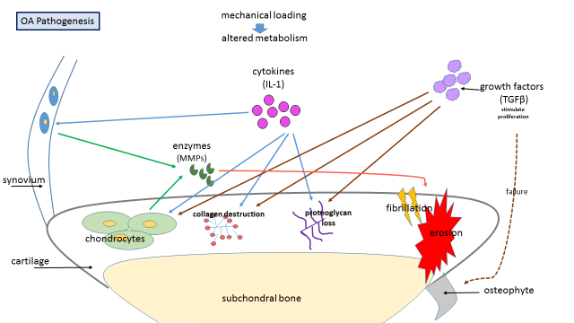
Figure 3. The pathogenesis of OA. IL-1, interleukin-1; TGFβ, transforming growth factor β; MMPs, metalloproteinases; OA, osteoarthritis.

1.2.5 Diagnosis and treatment
The diagnosis of OA is made through clinical history, physical examination, and plain radiographic assessment. A common method of classifying OA severity is the K/L a scale that grades radiographs by the presence of osteophyte, joint space narrowing, sclerosis and joint deformity⁶. The classification ranges from 0 to 4 where 0 is none and 4 is severe OA of the joint respectively (Table 2, Figures 4 and 5).
Table 2. Kellgren-Lawrence grading system for OA⁶
Grade | Radiologic findings
0 | No radiological findings of OA
1 | Doubtful narrowing of joint space and possible ostephytic lipping
2 | Definite osteophytes and possible narrowing of joint space
3 | Moderate multiple osteophytes, definite narrowing of joint space, small pseudocystic areas with sclerotic walls and possible deformity of bone contour
4 | Large osteophytes, marked narrowing of joint space, severe sclerosis and definite deformity of bone contour
OA, osteoarthritis
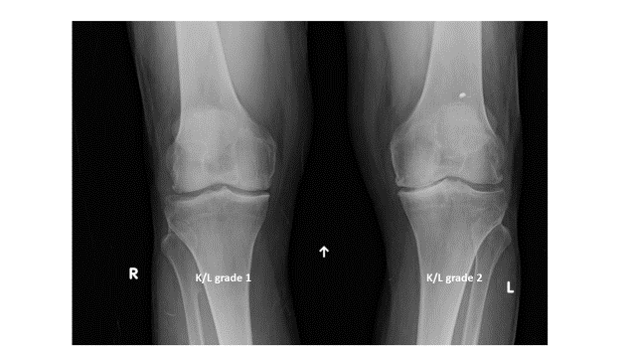
Figure 4. K/L grading example in knee OA affected joints. K/L, Kellgren-Lawrens scale; OA, osteoarthritis
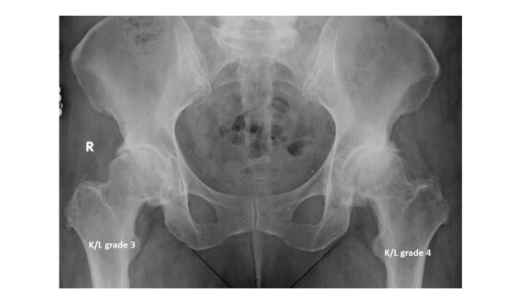
Figure 5. K/L grading example in hip OA affected joints. K/L, Kellgren-Lawrens scale; OA, osteoarthritis
Patients with OA have a gradual onset of pain, stiffness and loss of function. In the early disease stage pain is mild, and increases with affected joint use but improves with rest. At a later stage of disease, pain can occur with minimal activity or even during the night at rest. Morning stiffness is also a common symptom. As the disease progresses the affected joints lose function making daily activities difficult to perform. Prevention of OA onset and modification of its structural progression could mitigate the disease impact^{32,37}. Current treatments, depending on OA severity, include lifestyle alteration, analgesic and anti-inflammatory medication, corticosteroids and paracetamol. Surgery, including total joint replacement (TJR), is reserved for pain and loss of physical function that are inadequately controlled using non-operative approaches^{4,38}.
1.3 Introduction to genetic epidemiology
The findings of genetic studies over the years have helped shape our understanding of the biological structure of human traits and illnesses and the factors that contribute to their appearance. DNA decoding, clarifying how the DNA structure determines specific genetic choices, has allowed better understanding of the genetics of life and the inheritance of certain features and illnesses³⁹.
1.3.1 The human genome
DNA is a complex molecule, located in the cell nucleus and mitochondria, and carries the genetic information that determine almost all organisms. The four chemical bases that store information as a code in DNA are; adenine (A), guanine (G), cytosine (C) and thymine (T) (Figure 6).
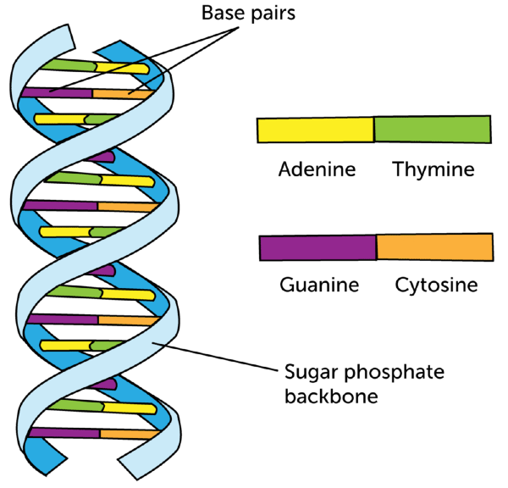
Figure 6. The double helix of DNA (www.data.allenai.org)
These bases form weakly bonded base pairs with each other (A always with T and G always with C) while each base is attached to a sugar and a phosphate molecule, composing a nucleotide. Nucleotides are arranged in strands forming the double helix spiral. James Watson and Francis Crick were the first to report the model of double DNA helix in 1953. The DNA molecule packages into threadlike structures and wraps around histone proteins forming 22 homologous pairs of autosomal chromosomes and one pair of sex chromosomes. Chromosomes consist of coding and non-coding DNA regions. Genes are particular stretches of DNA on a chromosome containing instructions for the production of proteins or other gene expression regulating molecules⁴⁰. The coding regions of a gene, called exons, are interspersed with non-coding DNA regions called introns. In order to synthesize proteins, messenger RNA, a transitory molecule formed by copying one of the DNA strands transfers the genetic coding instructions and interacts with the cell’s ribosome. The coding regions of DNA comprise less than 5% of the genome, although some chromosomes have a higher gene density than others. The human genome comprises approximately 3.3 billion base pairs and is 99.5% identical between unrelated individuals⁴¹. In 2004 The Human Genome Project (HGP) sequenced the human genome for the first time, unraveled the genetic diversity and reported approximately 22,300 protein coding genes⁴². Since then larger projects have provided more detailed insights into human genetic variation, such as the International Hap Map (haplotype map) Consortium⁴³, the 1000 Genomes Project⁴⁴, the UK10K Project⁴⁵ and the Haplotype Reference Consortium (HRC)⁴⁶.
1.3.2 Genetic variation and linkage disequilibrium
Genetic variation describes the differences in the DNA sequence within and among populations⁴⁴. The study of genetic variation in humans has historical and evolutionary significance as well as medical applications such as discovery of disease and trait causal genes and potential drug targets. It is the cause of diversity in quality or state of phenotype and makes us unique. Epigenetic variation also contributes to phenotypic diversity and refers to external DNA modifications⁴⁷. Genetic variation may arise from many sources, including chromosomal abnormalities, single nucleotide polymorphisms (SNPs), insertions, deletions (indels), inversions, duplications and copy number variations (CNVs), which are large structural duplications or deletions in the genetic sequence⁴⁸. SNPs are the most common type of genetic variation and the major source of heterogeneity⁴⁹. SNPs occur in both coding and non-coding regions, and may affect protein production through the amino acid sequence variation (nonsynonymous SNPs), but also through transcription factor binding, messenger RNA degradation, noncoding RNA sequence and expression levels of a gene^{50,51}. The polymorphism of a single nucleotide base (A, T, C or G) at a specific site, or “locus” in the genome comprises a single base pair variation in the code. For example a ‘C’ that is present for most individuals may be altered to ‘A’ for the minority of individuals (Figure 7).
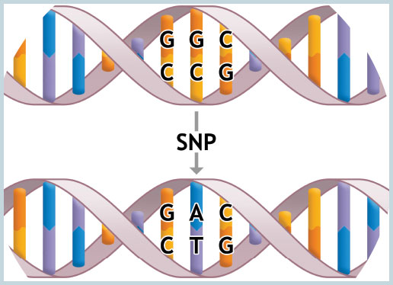
Figure 7. Single Nucleotide Polymorphism (www.socmucimm.org).

In genetic studies the frequency of the least common allele – minor allele frequency (MAF) in a population sample is categorized as common when it’s MAF>5%, low frequency for MAF=1%-5% and rare for MAF<1%. In a general population where a non-random allelic correlation occurs between two or more loci this association is termed linkage disequilibrium (LD)⁴³. SNPs in LD are inherited together more often than expected by chance. The correlation between them is quantified by the r² statistic which ranges between 0 meaning no correlation and 1 meaning perfect LD^{52,53}. Regions in the genome that are in high LD can be represented by a single tag SNP, rather than individually typing all of the SNPs within the haplotype block.
1.3.3 Common complex disease genetics
A single locus mutation can control the inheritance pattern of a disorder (single gene or monogenic disease) when the mutation has a dominant effect on gene function. Examples of monogenic disorders are cystic fibrosis, sickle-cell anemia and Huntington’s disease^{54,55}. In contrast, complex or multifactorial disorders are caused by multiple SNPs, lifestyle and environmental factors, when no individual factor dominates expression of the disease⁵⁶ (Figure 8). Examples of common complex genetic disorders are diabetes mellitus, ischaemic heart disease, Crohn's disease, schizophrenia, bipolar disorder and rheumatoid arthritis. In order to define the genetic component of a complex disease or trait, heritability is estimated mainly by using data from individuals with a genetic relationship such as siblings, twins and parents-offspring. The most frequent method for human disease heritability calculation is by comparing phenotypic concordance between dizygotic and monozygotic twins. An accurate estimation of heritability is the advantage of twin studies. The total variance can be divided into genetic, shared and environmental components⁵⁷.
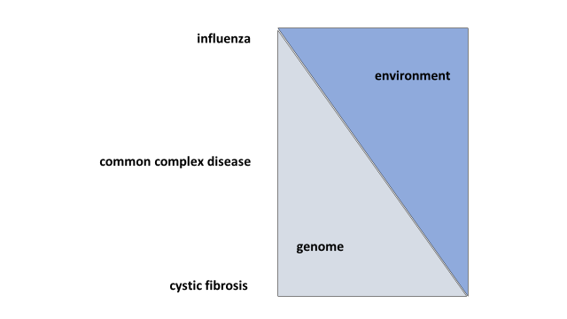
Figure 8. Shared genetic and environmental factors contribute to the occurrence of common complex disorders.

Heritability can also be measured in a population using genotype data within a linear mixed model approach to estimate the phenotypic variance explained by the genetic markers⁵⁸. It is also possible to estimate the proportion of the genetic component explained by variants using genome-wide association study summary statistics (with approaches such as Restricted Maximum Likelihood-REML and Phenotype correlation genotype correlation-PCGC)^{59,60}. The genomic heritability estimates given, using genome wide genotype data, are based on the common genetic variants, although there are methods that adjust for different allele frequencies and LD. The genetic architecture of common complex disorders is underpinned by multiple variants of varying frequency and effect sizes³⁹.

1.3.4 Linkage analysis and candidate gene studies
Linkage analysis is used to identify genetic loci by studying related individuals. This approach contrasts observed allele sharing at a given locus between affected relatives to that expected, given their relationship⁶¹. Attempts in associating complex disease susceptibility loci using linkage analysis has largely failed, although the identification of rare variants involved in monogenic disorders has been very successful⁶². Genetic heterogeneity, lack of power, inherent complexity and poor phenotypic definition are the reasons that linkage studies have limited ability to identify the genes involved in common complex diseases.
Candidate gene or gene centric studies focus on a pre specified set of markers, based on the known biological etiology of a disease, using an a priori hypothesis. These analyses are carried out by resequencing either the entire candidate gene or SNPs selected in patients and controls in population based cohorts and identifying enriched or depleted variants in disease cases⁶³⁻⁶⁵. Limitations of candidate gene studies include dependency on assumptions, incomplete variant coverage, lack of power, phenotypic and genetic heterogeneity, population stratification, lack of replication and exclusion of discovering novel genes influencing the disease^{40,66}.
1.3.5 Genome Wide Associason Studies (GWAS)
GWAS are hypothesis free methods that examine hundreds of thousands of SNPs across the genome and seek to identify associations with complex diseases and traits. The purpose of these analyses is to understand the genetic structure of human diseases and detect polymorphisms that contribute to their appearance. These large scale human genome studies most commonly focus on comparing the genotyped allele frequencies of variants between cases (individuals with phenotype examined/disease) and population based controls (participants without the phenotype)⁶⁷. The number of common SNPs directly genotyped for each study depends on the genotyping array used, but is usually around one million. Quality control (QC) tests are then performed to check genotyping quality, sample gender discrepancies between recorded and genotype gender information, relatedness, ethnicity of participants for population stratification and to test for SNP Hardy Weinberg Equilibrium (HWE). Poor quality samples and SNPs are then removed⁶⁸. The process of imputing non-directly genotyped variants using short shared haplotype stretches from reference panels such as 1000 Genomes⁴⁴ or HRC⁴⁶ can boost the coverage of variation by allowing the assessment of more SNPs from a greater allelic frequency spectrum^{69,70}. Several thresholds such as at MAF and imputational info score (imputation accuracy score) may be applied depending on the study design. Variables such as sample age, sex and principal components (a tool analysis used to account for relatedness and genetic distance between populations)⁷¹ can be taken into account additionally to the calculation of association. The conventional significance threshold for GWAS results, after correcting for multiple testing is P-value≤5x10⁻⁸ ⁷². Replication of a discovery study’s findings in an independent cohort is essential in order to report robust associations.
In the field of complex disease, thousands of SNPs have been robustly associated with disease risk at genome wide statistical significance⁷³. Most associations are at common loci and their effect sizes are small to moderate (odds ratio (OR) typically <1.4)⁷⁴. During study design, sample size and strict phenotype definitions are important considerations in maximizing study power and to avoid case misclassification, respectively^{75,76}. Meta-analysis of several GWAS is used to improve power to detect associations. This can be achieved either by replicating and meta-analyzing signals taken forward from the discovery study (usually signals with P-value<1x10⁻⁵) in the replication cohort using summary statistics, or by genome-wide meta-analysis between studies^{77,78}. Data from studies that use different genotyping platforms is harmonized while imputed genome data enhances the genomic coverage. Consortia of multiple teams are commonly developed to facilitate this process^{79,80}.
A significant issue and limitation arising from the outcomes of GWAS is that of missing heritability. The fact that a major part of the genetic component of common complex disease and traits has not yet been unravelled could be explained by low frequency and rare variant effects, small sample sizes, epigenetic changes, phenotype misclassification, structural variants, gene-environment interactions and genetic determinants of intermediate phenotypes^{59,81-83}. Going forward, whole-genome sequencing is a high-throughput technology that offers the opportunity to investigate all DNA sequence variants. However cost, coverage depth, data complexity and output size issues make this approach a formidable task⁴⁰.
The insights afforded by genetic association studies can help improve our understanding of the key pathways involved in disease pathogenesis, and may lead to novel approaches to disease diagnosis, treatment, prevention, prognostic markers and personalized therapy⁸⁴.

1.4 Genetic epidemiology of OA
1.4.1 Genetic architecture of OA
The heritable contribution to primary OA susceptibility has been established in twin and sibling studies to be approximately 50% (range 40%-65%), and is transmitted in a non-Mendelian manner⁸⁵⁻⁸⁹. As with other common complex disorders, the genetic architecture of OA is underpinned by variants of varying frequency and effect sizes⁹⁰. Most established OA-associated variants are represented by common SNPs with MAF >5% that have moderate to small effect sizes OR ~1.1-1.3) (Figure 9). The small number of OA loci established to date account for only a small fraction of disease heritability (about 10%)^{76,91}. An application in case-control studies suggests that common variants could explain at least half the heritability for common diseases⁵⁹. Low frequency and rare variants (MAF 1 to 5% and MAF<1%, respectively), epigenetic changes, structural variants and gene-environment interactions may also contribute to the missing heritability of OA^{82,92,93}.

Figure 9. Effect size and risk allele frequency (RAF) of established hip and knee OA associated variants. Most SNPs are common (RAF 0.04 to 0.93) with moderate to small effect sizes, as reported in the respective studies. The sibling relative risk ratio (λs) for each SNP is shown by the different size of each circle. The darker color of the circles shows the percentage of variance explained on the liability scale (h²L) (calculated assuming 10% prevalence of OA). Totals of λs and h²L are shown on the left top of the plot. OA, osteoarthritis; OR, odds ratio. (This figure is derived from PMID:26628593)¹.

1.4.2 OA candidate gene and linkage studies
Several linkage scans and candidate gene studies have been conducted for OA but most have failed to establish replicating allelic loci. Multiple factors, including lack of study power, account for this lack of replication. Numerous candidate gene studies based on the so far limited known biological etiology of OA have also been conducted^{88,94}. Exceptionally, the growth differentiation factor 5 (GDF5) gene that has been associated repeatedly with OA was originally discovered in gene-centric studies. GDF5 affects chondrogenesis and joint element formation during skeletal development, consistent with the protein expression in the cartilage and joint inter zone ^{95,96}. A candidate gene study in 2007 first reported that the alteration of T to C at rs143383 (in the 5’ untranslated region – 5’UTR) was associated with hip OA in 2 independent Japanese populations (OR=1.79, P-value=1.8x10⁻¹³)⁹⁷. The risk allele (T) is associated with a reduction in GDF5 transcription in chondrogenic cells that results in reduced protein expression. This locus was also later found to be associated with OA in European populations, although with a lower effect size in these cohorts⁹⁸⁻¹⁰². Following meta-analyses, the risk allele was also associated with knee OA and was found to have a stronger effect for knee and hip OA in Asian populations¹⁰³. In a study of individuals of European descent, the variant was found to also associate with developmental dysplasia of the hip at the genome wide association level¹⁰⁴. A positive association between primary hip OA and acetabular dysplasia has been reported^{105,106}. Genetic variation in GDF5 was also found to associate with height^{107,108}. Several studies using mice have also confirmed the critical functional role of GDF5 in bone and joint disease. It is suggested that lower levels of GDF5 in mice include mechanisms of altered loading and changes in subchondral bone, exhibiting developmental failure of the condyles and the articular ligaments¹⁰⁹⁻¹¹¹. Further studies also suggest association of rs143383 with severe radiographic OA^{112,113} (Table 3).
1.4.3 OA Genome Wide Association Studies
Several small- and medium-scaled GWAS have been carried out for OA. A GWAS of approximately 100,000 SNPs identified a missense variant rs7639618 in the double von Willebrand factor type A domain (DVWA) gene located on chromosome 3p24.3 that was associated with knee OA, and replicated at genome wide significant level (P-value 7.3x10⁻¹¹) in a Japanese and Japanese and Han Chinese combined cohorts in 2008¹¹⁴. DVWA is a 276 amino acid protein that binds to β-tubulin, modulating its chondrogenic function¹¹⁵. The gene was also found to be more highly expressed in cartilage than in other human tissues suggesting an involvement of DVWA in metabolism of cartilage in humans. Further studies in Korean, UK, and other European (Netherlands, Spain and Greece) cohorts have failed to independently replicate this signal, suggesting ancestry-specific effects at this locus¹¹⁶⁻¹¹⁸ (Table 3).
A further GWAS for knee OA in ̴4,800 Japanese participants identified association with further SNPs, rs7775228 (OR 1.34, 95% confidence interval (CI) 1.21 to 1.49; P-value=2.43x10⁻⁸) and rs10947262 (OR 1.32, 95% CI 1.19 to 1.46; P-value=6.73x10⁻⁸) in a region containing human leucocyte antigen-HLA class II/III genes (HLA-DQB1 and BTNL2) and replicated in Europeans)¹¹⁹, indicating that immunologic mechanisms may also contribute to OA pathogenesis (Table 3). These findings did not replicate in the Han-Chinese population¹²⁰ or in further populations of European descent in independent studies¹²¹, also suggesting population-specific differences in the underlying genetic epidemiology of OA.
The Treat-OA consortium GWAS reported an association of rs3815148 in the component of oligometric Golgi complex 5 (COG5) gene on chromosome 7q22 with knee and hand OA in Europeans (p-value=8x10⁻⁸)¹²². In this GWAS 1341 OA cases and 3,496 controls were examined and the most promising signals were replicated in 14,938 cases and 39,000 controls. SNPs in COG5 were in strong LD with variants in five further neighboring genes; protein kinase cAMP-dependent regulatory type II beta (PRKAR2B), HMG-box transcription factor 1 (HPB1), G protein-coupled receptor 22 (GPR22), dihydrouridine synthase 4-like (DUS4L) and B-cell receptor-associated protein 29 (BCAP29), complicating the identification of the functionally relevant genes. Gpr22 expression was absent in mice without OA but present in mice with OA¹²². In a large meta-analysis and replication study, a SNP (rs4730250) in DUS4L associated with knee OA at genome wide significant level (P-value=9.2x10⁻⁹), indicating that any of these highly linked genes may contribute to the risk of developing knee OA¹²³. Validated expression of these genes in the joint environment was also confirmed by functional analysis and gene expression studies using cartilage tissues from OA cases and controls, suggested that HBP1 may provide a potential OA biomarker¹²⁴ (Table 3).
The DOT1-like, histone H₃ methyltransferase (DOT1L) gene was initially reported by a GWAS as a suggestive risk locus for hip OA (P-value=1.5x10⁻⁴) in subjects of European descent¹²⁵. In this study the variant was associated with the hip OA endophenotype joint-space width (P-value=1.1x10⁻¹¹). Functional analysis in mice identified a role for Dot1l in chondrogenesis¹²⁵. The same locus was previously associated with height¹⁰⁷ and skeletal development¹²⁶. Another GWAS using individuals of European origin and a larger sample size also identified an association of rs1292744 with hip OA in males (P-value=7.8x10⁻⁹, OR 1.17, 95% CI 1.11 to 1.23)¹²⁷ (Table 3).
An additional SNP (rs6094710) with MAF 0.04 situated near the nuclear receptor co-activator 3 (NCOA3) gene on chromosome 20q13 was established by a large meta-analysis of hip OA GWAS with an OR of 1.28 (95% CI 1.18 to 1.39, P-value=7.9x10⁻⁹)⁹¹. The same study suggested two further associated loci (rs5009270 and rs3757837) using a more relaxed threshold of significance. NCOA3 demonstrates reduced expression in OA affected articular cartilage when compared to macroscopically non affected cartilage of the same joint. The role of NCOA3 expression in the setting of OA remains unclear, although involvement in hormonal regulation of bone turnover, such as thyroid hormones and steroids^{128,129}, or the suggested role of the gene in chondrocyte mechano-transduction are possibilities¹³⁰ (Table 3).
The arcOGEN consortium carried out a two-stage GWAS, culminating in the largest GWAS in OA at the time when the studies described in this thesis were initiated. The initial hip and knee OA GWAS (sample size: 3,177 cases and 4,894 controls) and replication did not identify any loci at genome-wide significance, underlining the need for larger sample sizes and stricter phenotype definitions of OA given the complexity and heterogeneity of the disease⁹⁰.
Following imputation of the initial GWAS using the 1,000 Genomes Project dataset¹³¹ and further meta-analysis, a SNP (rs11842874) in the protein encoding MCF.2 cell line derived transforming sequence-like (MCF2L) gene on chromosome 13q34 was associated with knee OA at genome wide significance (OR 1.17, 95% CI 1.11 to 1.23, risk allele frequency (RAF) 0.93, P-value=2.1x10⁻⁸)¹³². MCF2L has been reported to be involved in cell motility of the nervous system, indicating that the gene affects nociception¹³³. Functional studies in zebrafish concluded that expression of MCF2L plays a role in skeletal system development¹³⁴ (Table 3).
The final arcOGEN GWAS, comprising 7,410 cases and 11,009 controls of UK origin, identified the association of five novel loci with OA at genome wide significance level and three additional novel loci at borderline significance. Almost 80% of the OA cases studied had undergone hip and/or knee arthroplasty, contributing to a severe OA phenotype definition¹³⁵.
The strongest two signals established by this study were rs6976, located in the 3’ UTR of the glycosyltransferase 8 domain containing 1 (GLT8D1) gene, and rs11177, located in the guanine nucleotide binding protein-like 3 (GNL3) gene, both on chromosome 3p21.1 and in almost perfect LD with each other (OR for both SNPs was 1.12, 95% CI 1.08-1.16), rs6976 P-value=7.2x10⁻¹¹ and rs11177 P-value=1.3x10⁻¹⁰). These two SNPs are associated with both hip and knee OA in both men and women. The association was stronger in subjects with TJR. Further functional analysis is needed to unravel their underlying mechanisms¹³⁵ (Table 3).
An intronic SNP (rs4836732) situated in astrotactin 2 (ASTN2) on chromosome 9q33.1 was associated with hip OA in women that had undergone arthroplasty (OR 1.20, 95% CI 1.13-1.27, P-value=6.11x10⁻¹⁰)¹³⁵. ASTN2 has been associated with schizophrenia and bipolar disorder¹³⁶, neurodevelopmental and neurological disorders¹³⁷, as well as with migraine¹³⁸, corroborating it’s suggested involvement in the regulation of the neuronal protein ASTN1¹³⁹ (Table 3).
A further intronic SNP (rs835487) located in the carbohydrate sulfotransferase 11 (CHST11) gene on chromosome 12q23 was found to be associated with hip OA in TJR subjects with an OR of 1.13, 95% CI 1.09 to 1.18, P-value=1.64x10⁻⁸) for both sexes combined¹³⁵. CHST11 is differentially expressed in OA affected and unaffected cartilage¹⁴⁰. The gene is implicated in cartilage development¹⁴¹. A further signal at rs9350591 was located between the filamin A interacting protein 1 (FILIP1) and sentrin specific peptidase 6 (SENP6) genes. The signal reached genome wide significance for hip OA (OR 1.18, 95% CI 1.12 to 1.25, P-value=2.42x10⁻⁹)¹³⁵. Although there is no suggested related function of FILIP1 nor SENP6 in OA etiology yet, the collagen type XII alpha 1 (COL12A1) gene resides nearby and is known to play a role in bone formation¹⁴². An additional signal, rs10492367, which lies between the Kelch domain containing 5 (KLHDC5) and parathyroid hormone-like hormone (PTHLH also known as PTHrP) genes was also established as a risk locus for hip OA (OR 1.14, 95% CI 1.09 to 1.20, P-value=1.48x10⁻⁸)¹³⁵ (Table 3). Deletion of the gene encoding PTHrP has been reported to play a role in mice skeletal development^{143,144}.
Three further variants were identified as associated with OA but narrowly missed genome-wide significance in the arcOGEN study: the intronic variant rs8044769, located in the fat mass and obesity associated (FTO) gene, was more highly associated in women; the intronic variant rs12107036 in the tumor protein p63 (TP63) gene, was more highly associated in women who had undergone TJR; and rs10948172 that lies between the suppressor of Ty3 homolog (SUPT3H) and CDC5 cell division cycle 5-like (CDC5L) genes, was more highly associated in men¹³⁵. FTO is an established obesity risk locus^{145,146}. The phenotypic overlap between OA and obesity has been genetically substantiated¹⁴⁷, and the role of FTO in OA has been shown to be mediated through obesity¹⁴⁸. The functional role of TP63 in the pathogenesis of OA is unclear, although it is reported to be involved in facial shape development¹⁴⁹. The functional roles of SUPT3H and CDC5L remain undefined in OA, although runt related transcription factor 2 (RUNX2), a closely located gene in extended LD, is thought to play a regulatory role in bone development^{150,151} (Table 3).
Table 3. Polymorphisms associated with hip and/or knee osteoarthritis at the time the work presented in this thesis was started.
SNP-  risk allele | Gene or  nearest  gene(s) | OR | P-value | RAF | Joint | Gender | Ethnic  Group | Suggested function/s related to OA
rs143383-T | GDF5 | 1.79 | 2x10⁻¹³ | 0.74 | hip | both | Asian | Affects chondrogenesis and joint element formation
rs143383-T | GDF5 | 1.16 | 8.3x10⁻⁹ | N/A | knee | both | European | Affects chondrogenesis and joint element formation
rs7639618-G | DVWA | 1.43 | 7.3x10⁻¹¹ | 0.63 | knee | both | Asian | Involvement in metabolism of cartilage
rs7775228-T | HLA-DQB1 | 1.34 | 2.4x10⁻⁸ | 0.62 | knee | both | Asian | Immunologic mechanisms involvement
rs10947262-C | BTNL2 | 1.31ª | 5.1x10^{-9a} | 0.58ª | knee | both | Asian, European | Immunologic mechanisms involvement
rs3815148-C^{d} | COG5 | 1.14 | 8x10⁻⁸ | 0.23 | knee | both | European | Expression in OA joint environment
rs4730250-G | DUS4L | 1.17 | 9.2x10⁻⁹ | 0.17 | knee | both | European | Expression in OA joint environment
rs11842874-A | MCF2L | 1.17 | 2.1x10⁻⁸ | 0.93 | knee and hip | both | European | Affects nociception and skeletal system development
rs12982744-C | DOT1L | 1.15^{b} | 2.2x10-^{8b} | 0.74^{c} | hip | males | European | Affects skeletal development during growth
rs6094710-A | NCOA3 | 1.28 | 7.9x10⁻⁹ | 0.04 | hip | both | European | Expression in OA cartilage, involvement in regulation of hormones associated with bone metabolism
rs6976-T | GLT8D1 | 1.12 | 7.2x10⁻¹¹ | 0.37 | knee and hip | both | European | Unknown
rs11177-A | GNL3 | 1.12 | 1.3x10⁻¹⁰ | 0.38 | knee and hip | both | European | Unknown
rs4836732-C | ASTN2 | 1.2 | 6.1x10⁻¹⁰ | 0.47 | hip | females | European | Unknown; regulates neuronal protein
rs9350591-T | FILIP1, SENP6 | 1.18 | 2.4x10⁻⁹ | 0.11 | hip | both | European | Unknown; COL12A1 (close located) gene is affecting bone formation
rs10492367-T | KLHDC5, PTHLH | 1.14 | 1.5x10⁻⁸ | 0.19 | hip | both | European | Affects skeletal development
rs835487-G | CHST11 | 1.13 | 1.6x10⁻⁸ | 0.34 | hip | both | European | Implication in cartilage development
rs12107036-G^{d} | TP63 | 1.21 | 6.7x10⁻⁸ | 0.52 | knee | females | European | Unknown; involvement in facial shape development
rs8044769-C^{d} | FTO | 1.11 | 6.9x10⁻⁸ | 0.5 | knee and hip | females | European | Affects OA through obesity
rs10948172-G^{d} | SUPT3H, CDC5L | 1.14 | 7.9x10⁻⁸ | 0.29 | knee and hip | males | European | Unknown; RUNX2 (in LD and close located) gene has a regulatory role in bone development
SNP, single nucleotide polymorphism; N/A, not available; RAF, risk allele frequency; OA, osteoarthritis
a: values of combined replication
b: values of combined datasets
c: risk allele frequency in Europeans from the 1000 genomes database
d: SNPs just below genome wide significance
This table is derived from PMID:26628593¹

1.5 Rationale of thesis
Identifying the genetic determinants of a complex disease such as OA has been made possible over the past few years by the advent of genome wide association studies. The 18 SNPs (17 independent) that have been associated with OA, at the time of these studies’ design, have provided some insights into the underlying biological mechanisms of OA but still further mapping is needed to identify causal genes and variants that have translational potential. OA missing heritability could be explained by multiple factors. In this thesis the unraveling of the genetic component of OA and the examination of established loci in a so far not studied ethnic group is attempted by performing a series of GWAS followed by additional analyses.
1.6 Thesis Hypotheses
1. Examination of established OA susceptibility loci in the Greek population will clarify whether the contribution of these loci extends to this European population.
2. By conducting large scale GWAS followed by meta-analyses a greater number of OA genetic association loci will be identified.
1.7 Thesis Aims
1.7.1 Aims of the Larissa study
1. Determine the effect size and allele frequency range of established OA loci by GWAS in the Greek population.
2. Determine whether these established loci replicate in the Greek population.

1.7.2 Aims of the UK Biobank 150k OA study
1. Identify novel OA susceptibility loci and contribute to the unravelling of OA missing heritability in the setting of six well-powered OA genome wide case-control association studies, defined and stratified by site of OA using data from UK Biobank (1st release) resource followed by replication and meta-analysis in the deCODE cohort.
2. Determine whether sample size or strict disease definition affect study power by evaluating the sensitivity of the self-reported OA cases phenotype data when compared withother hospital defined phenotype groups.
3. Replicate and examine the concordance of direction of effect of established OA loci across all OA datasets.
1.7.3 Aims of UK Biobank 150k gene based and pathway analysis
Identify key genes and pathways significantly associated with OA in the UKBiobank 1st release data, across all different phenotype definitions using gene-based and pathway analysis.
1.7.4 Aims of the ARGO study
1. Establish a cohort of ~1,500 primary OA patients from Greece undergoing total knee and/or hip arthroplasty and genotype their DNA using high-throughput approaches.
2. Examine the power of replication and direction of effect of established OA loci by conducting the largest OA GWAS in a Greek population to date.
3. Replicate known genetic associations in this population.
4. Report suggestive evidence for associations with OA and replicate findings in independent cohorts.
Chapter 2.
Examination of established OA loci in a population with knee OA from central Greece – The Larissa study
2.1 Overview
In this chapter the results of the first OA GWAS in a Greek population and comparative results for previously established OA loci are presented. Directionally consistent effects and similar allele frequencies across all loci discovered in European populations were found, indicating the absence of overt population-specific differences between Northern and Southern Europe. The sample size of this study did not offer sufficient power to perform a meaningful discovery GWAS, but these data will contribute towards replication as an independent cohort in the field of OA GWAS going forward.

2.2 Introduction

Seventeen independent risk loci for OA had been established by the time of the analyses presented here, predominantly in Northern European and Asian populations¹. The Larissa study was set up to investigate the genetic architecture of knee OA in a Greek population. The prevalence of OA is markedly lower in the Greek versus other European populations²³ and the frequency and effect size of established loci had not previously been determined. 517 OA cases and 342 healthy controls were obtained through collaboration that had initially been used to conduct a gene-centric study¹⁵². A GWAS of the Larissa samples was conducted in order to examine the effect size and allele frequency range of established OA loci, replicate the known genetic associations in this population but also with the aim of using this data as an independent Greek replication cohort in future analyses.
2.3 Methods
2.3.1 Study population
The Larissa study (osteoarthritis participants’ recruitment conducted in the city of Larissa, central Greece) included 517 individuals with primary knee OA undergoing total knee arthroplasty (407 women and 110 men). Only individuals of Greek origin were recruited and all had a pre-operative K/L score ≥2⁶. Patients with rheumatoid arthritis, autoimmune diseases, chondrodysplasia, post-traumatic OA and infection-induced OA were excluded from the study. The control population consisted of 342 individuals (185 women and 157 men) with no symptoms or signs of joint disease or arthritis. Cases and controls were recruited during their recovery in the hospital ward. Sample inclusions and exclusions were decided after clinical assessment. Verbal informed consent was given by all research participants prior to the collection of blood samples for the research. The research participant recruitment, consent process, and study protocol, were approved by the Institutional Review Board of the University Hospital of Larissa and conform to the ethical principles set out in the Declaration of Helsinki (1975).
2.3.2 DNA extraction, genotyping, sample and SNPs quality control
Peripheral whole blood was used as the DNA source for the Larissa study. DNA extraction and genotyping was carried out at The Wellcome Trust Sanger Institute, Hinxton, UK. The Larissa samples were genotyped on the Illumina Human Core Exome-24 Bead Chip, which focuses on coverage of ~300,000 common variants and ~240,000 variants in exonic regions. QC checks were performed at both sample and SNP levels.
2.3.3 Imputation and association analysis
Pre-phasing was carried out using SHAPEIT v2^{153,154} and imputation using IMPUTE v2.3.2¹⁵⁵ using a combined reference panel of 1000 Genomes Project¹⁵⁶ data. SNPs with an imputation info score<0.4 and SNPs with MAF<0.01 were excluded. Association analysis was carried out using the frequentist association test (additive model) and method score test in SNPTEST v2.2.0⁶⁹. Principal component (PC) analysis was carried out in EIGENSOFT ¹⁵⁷. A two-sided P-value≤0.05 was used as a threshold for nominal significance and P-value≤5x10⁻⁸ as the genome wide significance threshold. The study power calculations were conducted using Quanto v1.2.4¹⁵⁸. Data is presented for the 17 independent OA established loci at the time of analysis. Independence of signals was defined based on LD from the genetically closest 1000 Genomes Project Toscani in Italy (TSI) population (r²≥0.80 for pairs of SNPs).
2.4 Results
2.4.1 Sample and SNP QC results
Samples were pre-filtered and excluded with call rate <90%. Samples were checked for gender discrepancies using PLINK threshold 0.2 (Figures 10 and 11), excess heterozygosity at MAF≥1% and MAF<1% (Figures 12, 13, 14 and 15), duplicates, relatedness (Figures 16, 17, 18 and 19) and ethnicity (Larissa vs 1000 Genomes Project data) (Figures 20, 21 and 22).

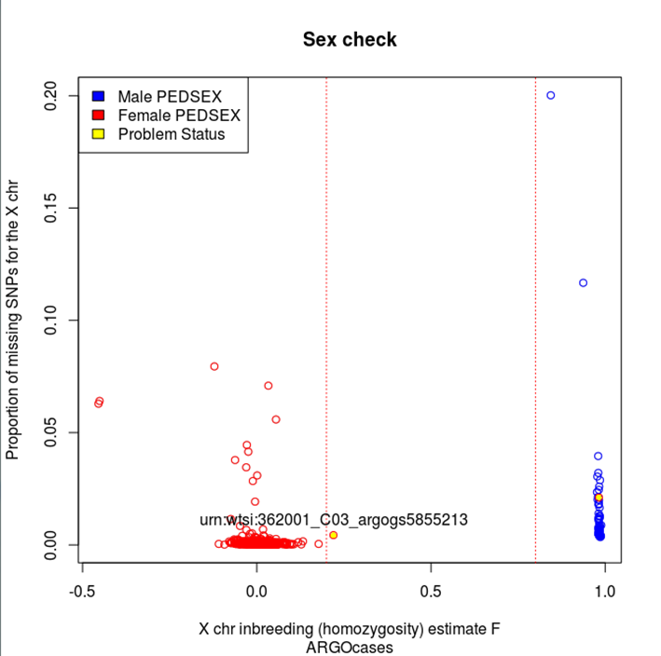
Figure 10. Larissa (cases) gender discrepancies; 2 samples excluded (reported gender not matcing the estimated genomic gender and sample failure to be called either male or female).

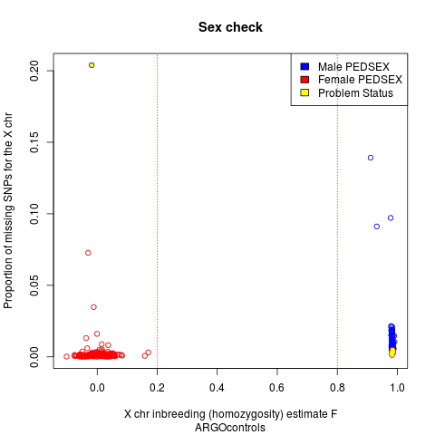
Figure 11 Larissa (controls) gender discrepancies; 10 samples excluded (reported gender not matcing the estimated genomic gender).
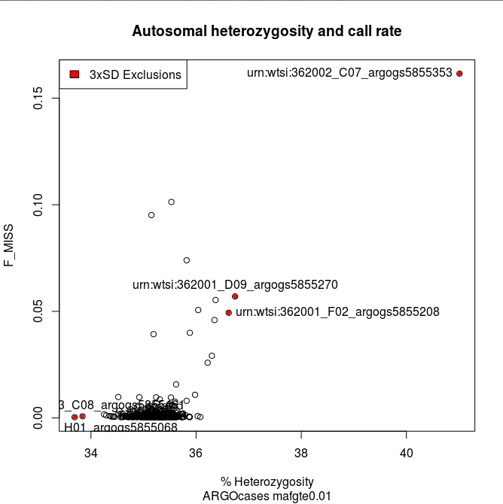
Larissa

Figure 12. Larissa (cases) heterozygosity at MAF≥1%; 5 samples excluded. MAF, minor allele frequency.
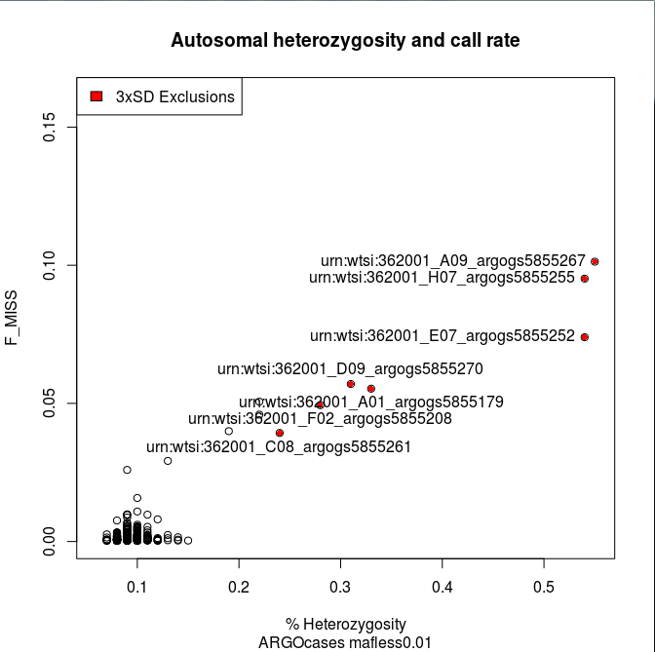
Figure 13. Larissa (cases) heterozygosity at MAF<1%; 7 samples excluded. MAF, minor allele frequency.
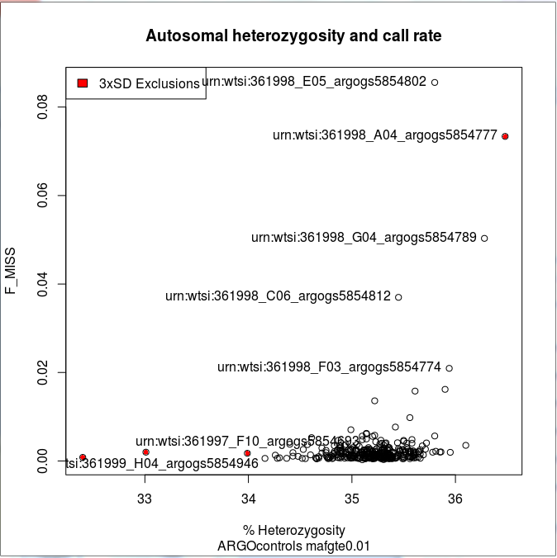
Figure 14. Larissa (controls) heterozygosity at MAF≥1%; 4 samples excluded. MAF, minor allele frequency.
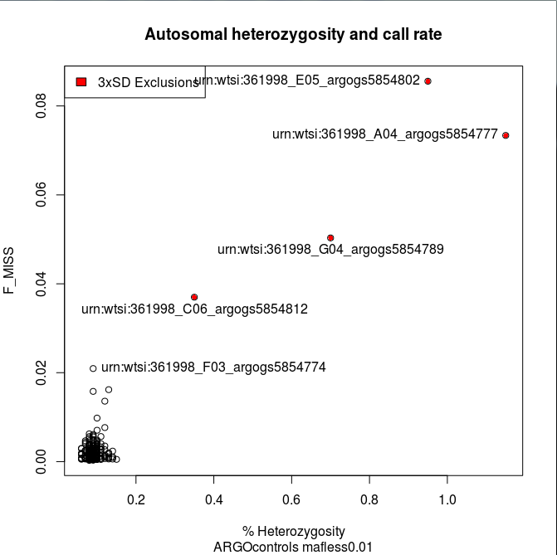
Figure 15. Larissa (controls) heterozygosity at MAF<1%; 4 samples excluded. MAF, minor allele frequency.
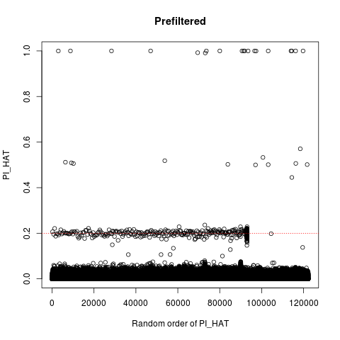
Figure 16. Larissa (cases) duplicates and relatedness (step 1); 20 duplicate sample pairs with PI_HAT>0.9 threshold and 278 related sample pairs with PI_HAT>0.2 but <0.9 thresholds.
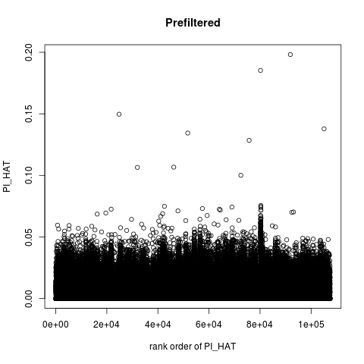
Figure 17. Larissa (cases) duplicates and relatedness (step 2). After removing 31 duplicates and related samples PI_HAT values in the Larissa cases dataset are under the threshold of 0.2; 31 samples excluded in total.
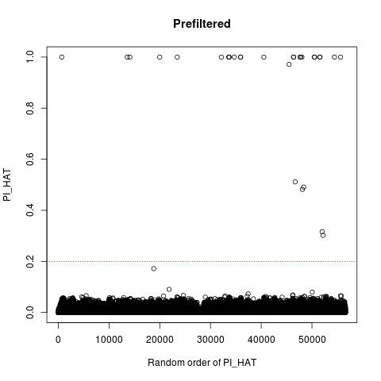
Figure 18. Larissa (controls) duplicates and relatedness (step 1); 25 duplicate sample pairs with PI_HAT>0.9 threshold and 5 related sample pairs with PI_HAT>0.2 but <0.9 thresholds.
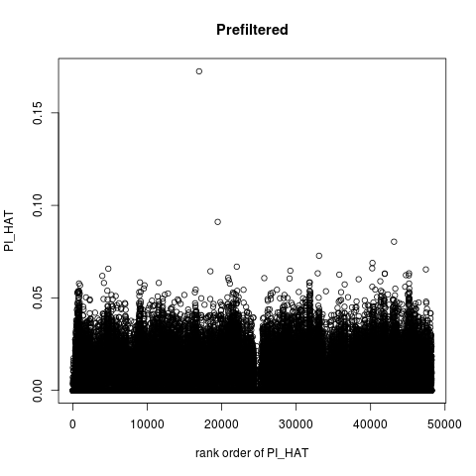
Figure 19. Larissa (controls) duplicates and relatedness (step 2). After removing 26 duplicates and related samples PI_HAT values in the Larissa controls dataset are under the threshold of 0.2; 26 samples excluded in total.

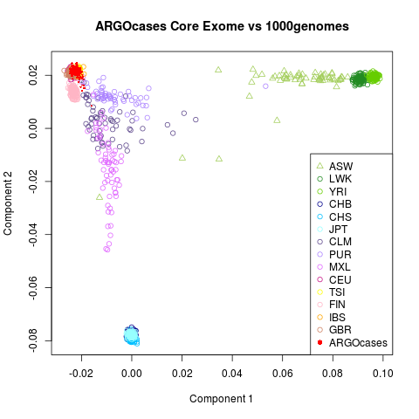
Figure 20. Multidimensional Scaling (MDS) analysis of Larissa cases combined with populations from the 1000 Genomes Project; 13 samples excluded. Individuals from Larissa are depicted by red solid circles. Abbreviations: ASW, Americans of African ancestry in southwestern USA; LWK, Luhya in Webuye, Kenya; YRI, Yoruba in Ibadan, Nigeria; CHB, Han Chinese in Beijing, China; CHS, Southern Han Chinese; JPT, Japanese in Tokyo, Japan; CLM, Colombians from Medellin, Colombia; PUR, Puerto Ricans from Puerto Rico; MXL, Mexican ancestry from Los Angeles, USA; CEU, Utah residents with Northern and Western European ancestry; TSI, Toscani in Italy; FIN, Finnish in Finland; IBS, Iberian population in Spain and GBR, British in England and Scotland.

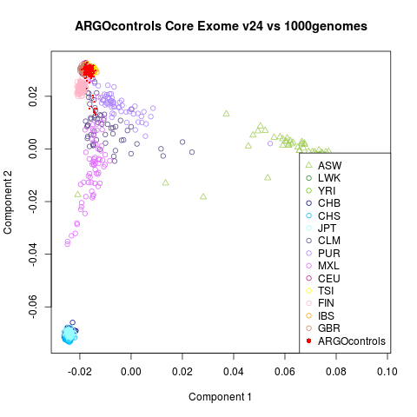
Figure 21. Multidimensional Scaling (MDS) analysis of Larissa controls combined with populations from the 1000 Genomes Project; 25 samples excluded. Individuals from Larissa are depicted by red solid circles. Abbreviations: ASW, Americans of African ancestry in southwestern USA; LWK, Luhya in Webuye, Kenya; YRI, Yoruba in Ibadan, Nigeria; CHB, Han Chinese in Beijing, China; CHS, Southern Han Chinese; JPT, Japanese in Tokyo, Japan; CLM, Colombians from Medellin, Colombia; PUR, Puerto Ricans from Puerto Rico; MXL, Mexican ancestry from Los Angeles, USA; CEU, Utah residents with Northern and Western European ancestry; TSI, Toscani in Italy; FIN, Finnish in Finland; IBS, Iberian population in Spain and GBR, British in England and Scotland.
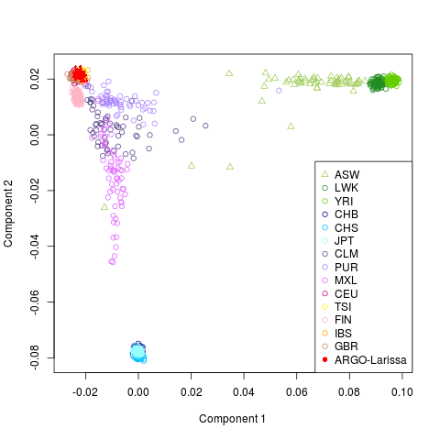
Figure 22. Multidimensional Scaling (MDS) analysis of Larissa (cases and controls) combined with populations from the 1000 Genomes Project after sample exclusions. Individuals from Larissa are depicted by red solid circles and cluster closer to the other European-ancestry individuals. Abbreviations: ASW, Americans of African ancestry in southwestern USA; LWK, Luhya in Webuye, Kenya; YRI, Yoruba in Ibadan, Nigeria; CHB, Han Chinese in Beijing, China; CHS, Southern Han Chinese; JPT, Japanese in Tokyo, Japan; CLM, Colombians from Medellin, Colombia; PUR, Puerto Ricans from Puerto Rico; MXL, Mexican ancestry from Los Angeles, USA; CEU, Utah residents with Northern and Western European ancestry; TSI, Toscani in Italy; FIN, Finnish in Finland; IBS, Iberian population in Spain and GBR, British in England and Scotland.

Following QC, the numbers of cases and controls were 443 and 269, respectively (Tables 4 and 5). SNPs were excluded with call rate <98%, HWE P-value<1x10⁻⁴ and a cluster separation score <0.4. The directly typed SNPs remaining after QC were 535,348 for cases and 534,297 for controls.

Table 4. Larissa cases sample exclusions after QC.
QC steps | number of sample exclusions
number of samples (cases) | 517
prefilter call rate (90%) | 22
heterozygosity MAF≥1% | 5
heterozygosity MAF<1% | 7
sex check | 2
duplicates and relatedness | 31
ethnicity | 13
Sanger Identity checks | 24
number of samples to exclude | 104 (74 unique)
number of samples remaining | 443
QC, quality control; MAF, minor allele frequency
Table 5. Larissa controls sample exclusions after QC.
QC steps | number of sample exclusions
number of controls | 342
prefilter call rate (90%) | 5
heterozygosity MAF≥1% | 4
heterozygosity MAF<1% | 4
sex check | 10
duplicates and relatedness | 26
ethnicity | 25
Sanger Identity checks | 17
number of samples to exclude | 91 (73 unique)
number of samples remaining | 269
QC, quality control; MAF, minor allele frequency
2.4.2 Association analysis results
The Larissa study was the first GWAS for OA to be conducted in a Greek population, although given the small sample size its utility in a discovery effort was limited. A total of 9,030,849 SNPs were used for the association analysis (directly typed or imputed in both cases and controls). Principal Component (PC) analysis was subsequently undertaken, using directly typed SNPs only, in order to control for population structure. The first 10 PCs were extracted and an additional association analysis with adjustment for these first 10 PCs was run as a sensitivity analysis (Figures 23 and 24).
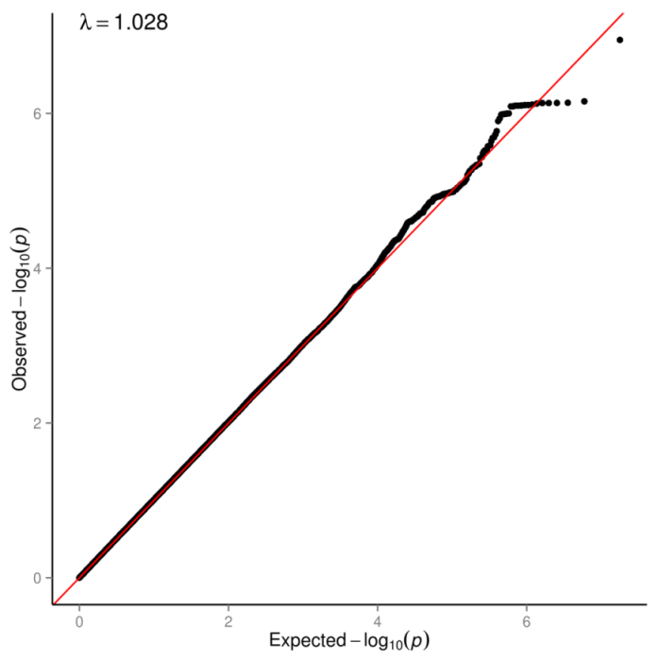
Figure 23. Larissa quantile-quantile (QQ) plot adjusted for 10 PCs. The red line represents the observed regression line of the observed vs expected log p-value distribution (genomic inflation factor λ=1.028). PC, principal component.

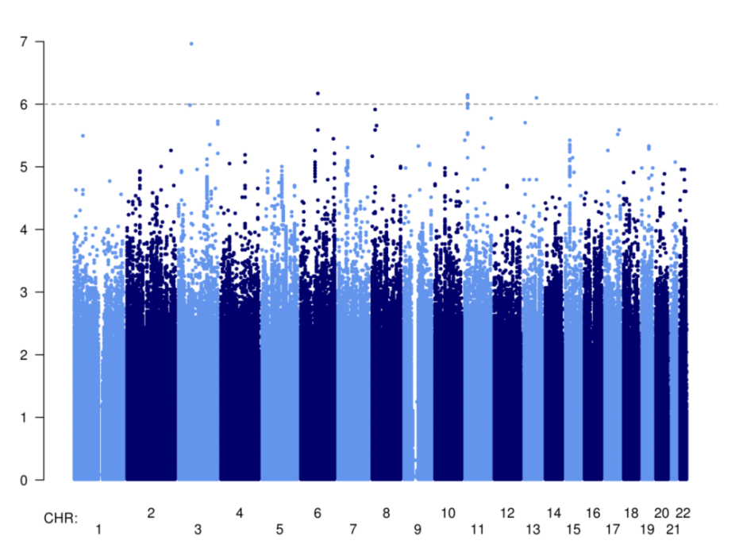
Figure 24. Larissa Manhattan plot adjusted for 10 PCs. The dotted line is set at P=5×10⁻⁶. PC, principal component.

No qualitative differences were observed and the results of the unadjusted analysis are reported. Quantile-quantile (QQ) and Manhattan plots were flat with a λ=1.0106 and giving no genome wide significant signals, respectively (Figures 25 and 26).
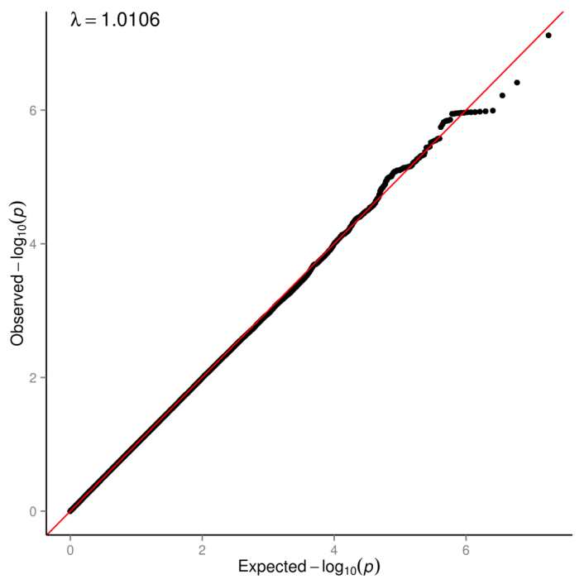
Figure 25. Larissa QQ plot. The red line represents the observed regression line of the observed vs expected log p-value distribution (genomic inflation factor λ=1.0106).

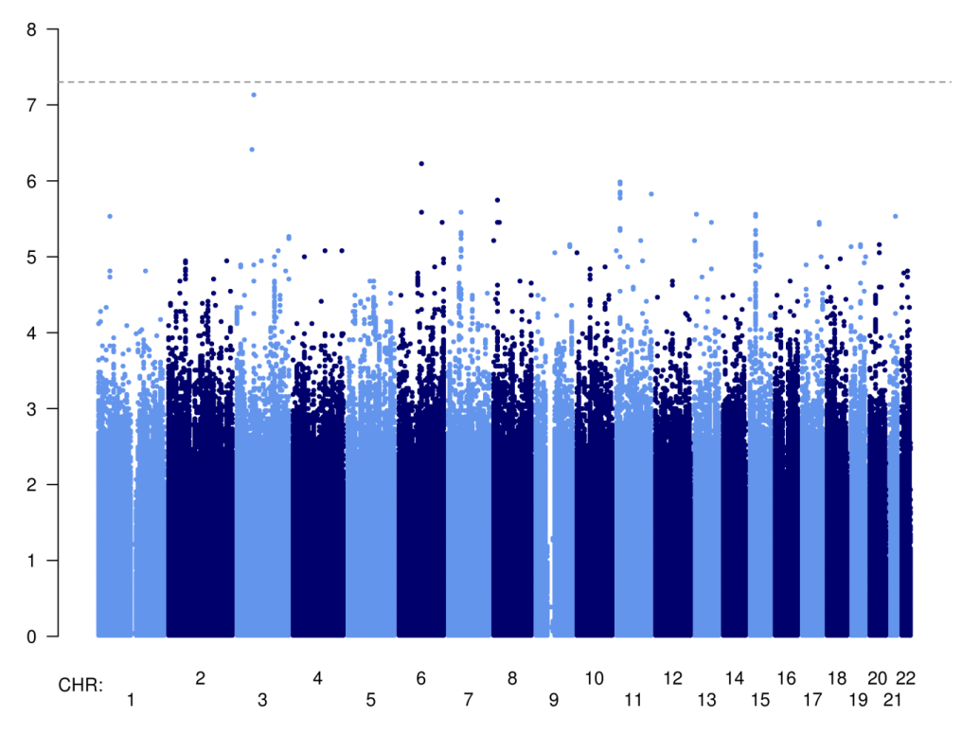
Figure 26. Larissa Manhattan plot. The dotted line is set at P=5×10⁻⁸.

2.4.3 Established OA loci in Larissa dataset
Although this study used an advanced genotyping methodology, it was underpowered for a discovery GWAS due to small sample size. The primary focus here was to use a flexible approach (GWAS) to facilitate incorporation of the genotype data as an independent replication cohort for future large sacle international OA GWAS efforts, whilst allowing the allele frequencies in the Greek population of the thus far 17 independent established OA loci to be reported here. These loci were either directly typed on the Illumina Human Core Exome genotyping platform or imputed. The Larissa risk allele frequencies of the 17 independent OA loci were compared to the genetically closest 1000 Genomes Project TSI population allele frequencies in order to investigate the populations similarities. No qualitative differences in the frequencies of these alleles between the populations were identified (Table 6).

Table 6. Larissa risk alleles, risk allele frequencies and TSI population allele frequencies for the Larissa risk alleles (of the 17 established OA loci).
Established OA loci | Larissa RAª | Larissa RAF (AF in TSI^{c})
rs143383 | A | 0.60 (0.55)
rs7639618 | T | 0.16 (0.10)
rs7775228 | C | 0.08 (0.17)
rs10947262 | C | 0.93 (0.90)
rs3815148 | C | 0.19 (0.28)
rs4730250 | G | 0.13 (0.21)
rs11842874 | A | 0.93 (0.93)
rs12982744 | C | 0.57 (0.54)
rs6094710 | G | 0.93 (0.97)
rs6976^{b} | C | 0.55 (0.47)
rs11177^{b} | G | 0.55 (0.47)
rs4836732 | C | 0.49 (0.48)
rs9350591 | T | 0.08 (0.11)
rs10492367 | T | 0.16 (0.22)
rs835487 | G | 0.33 (0.35)
rs12107036 | A | 0.44 (0.42)
rs8044769 | C | 0.54 (0.55)
rs10948172 | G | 0.30 (0.26)
RA, risk allele; RAF, risk allele frequency; AF, allele frequency; OR, odds ratio; TSI, Toscani Italy; OA, osteoarthritis
a: Risk Allele (RA) is defined as the allele with OR >1 in the Larissa study
b: rs6976 is in perfect LD with rs11177 in 1000 Genomes TSI
c: TSI allele frequency for the Larissa risk allele

Additionally, the risk allele frequencies of the established SNPs between the literature reports and Larissa risk allele frequencies (in OA patients) were compared. Overall concordance was found in allele frequencies; most SNPs had no qualitative differences (Table 7). rs143383, rs7639618, rs7775228 had substantial differences in risk allele frequencies; this could be due to ethnicity differences between the Asian discovery populations and the European ancestry of the Larissa cohort. Indeed, the TSI (1000 Genomes Project data) population allele frequencies were similar to Larissa.
In order to investigate the effect direction concordance, the risk alleles of the established SNPs with the Larissa risk alleles were compared. Twelve out of seventeen risk alleles were found to be the same as that reported in the literature. The binomial one-sided P-value for 12/17 risk alleles being the same was 0.07173 (Table 7).
Table 7. Literature reported and Larissa risk alleles and risk allele frequencies.
Established OA loci | Reported RAª | Larissa RAª | Reported RAF | Larissa RAF
rs143383 (Asian) | T^{c} | A | 0.74 | 0.60
rs143383 (European) | T^{c} | A | N/A | 0.60
rs7639618 | G^{c} | T | 0.63 | 0.16
rs7775228 | T | C | 0.62 | 0.08
rs10947262 | C | C | 0.58 | 0.93
rs3815148 | C | C | 0.23 | 0.19
rs4730250 | G | G | 0.17 | 0.13
rs11842874 | A | A | 0.93 | 0.93
rs12982744 | C | C | 0.74 | 0.57
rs6094710 | A | G | 0.04 | 0.93
rs6976^{b} | T | C | 0.37 | 0.55
rs11177^{b} | A | G | 0.38 | 0.55
rs4836732 | C | C | 0.47 | 0.49
rs9350591 | T | T | 0.11 | 0.08
rs10492367 | T | T | 0.19 | 0.16
rs835487 | G | G | 0.34 | 0.33
rs12107036 | G | A | 0.52 | 0.44
rs8044769 | C | C | 0.50 | 0.54
rs10948172 | G | G | 0.29 | 0.30
OA, osteoarthritis; N/A, not available; RA, risk allele; RAF, risk allele frequency; TSI, Toscani Italy; OR, odds ratio
a: Risk Allele (RA) is defined as the allele with OR >1 in the respective study
b: rs6976 is in perfect LD with rs11177 in 1000 Genomes TSI
c: allele in reverse strand

The effect size estimate and 95% CIs of the reported OA risk variant ORs were compared with the Larissa effect sizes (Table 8). Seven out of 17 SNPs had a higher OR in Larissa than in the literature. The point estimates of all reported OR fell within the 95% CIs for the Larissa study. rs10948172 was the only variant to be nominally associated with OA (P-value=0.05, OR (95% CI) 1.27 (1.21 to 1.32)) (Table 8).

Table 8. Literature reported and Larissa ORs (95%CI), Larissa P-values.
OA established loci | Reported OR (95% CI) | Larissa OR (95% CI) | Larissa P-value
rs143383 (Asian) | 1.79 (1.53 - 2.09) | 1.10 (0.88 - 1.37) | 0.396
rs143383 (European) | 1.16 (1.11 - 1.22) | 1.10 (0.88 - 1.37) | 0.396
rs7639618 | 1.43 (1.28 - 1.59) | 1.09 (0.76 - 1.34) | 0.563
rs7775228 | 1.34 (1.21 - 1.49) | 1.45 (0.71 - 1.64) | 0.078
rs10947262 | 1.31 (1.20 - 1.44) | 1.04 (0.66 - 1.54) | 0.855
rs3815148 | 1.14 (1.09 - 1.19) | 1.00 (0.76 - 1.32) | 0.999
rs4730250 | 1.17 (1.11 - 1.24) | 1.06 (0.73 - 1.39) | 0.710
rs11842874 | 1.17 (1.11 - 1.23) | 1.31 (0.69 - 1.65) | 0.221
rs12982744 | 1.17 (1.11 - 1.24) | 1.05 (0.81 - 1.25) | 0.663
rs6094710 | 1.28 (1.18 - 1.39) | 1.39 (0.70 - 1.65) | 0.136
rs6976ª | 1.12 (1.08 - 1.16) | 1.01 (0.80 - 1.25) | 0.915
rs11177ª | 1.12 (1.08 - 1.16) | 1.01 (0.81 - 1.25) | 0.915
rs4836732 | 1.20 (1.13 - 1.27) | 1.08 (0.81 - 1.25) | 0.485
rs9350591 | 1.18 (1.12 - 1.25) | 1.19 (0.70 - 1.52) | 0.369
rs10492367 | 1.14 (1.09 - 1.20) | 1.17 (0.76 - 1.38) | 0.300
rs835487 | 1.13 (1.09 - 1.18) | 1.02 (0.80 - 1.25) | 0.858
rs12107036 | 1.21 (1.13 - 1.29) | 1.05 (0.81 - 1.25) | 0.668
rs8044769 | 1.11 (1.07 - 1.15) | 1.05 (0.82 - 1.27) | 0.095
rs10948172 | 1.14 (1.09 - 1.20) | 1.27 (1.21 - 1.32) | 0.049
OA, osteoarthritis; OR, odds ratio; CI, confidence interval; TSI, Toscani Italy
a: rs6976 is in perfect LD with rs11177 in 1000 Genomes TSI

2.4.4 Study power calculations to replicate established loci
Study power calculations were conducted assuming a population mean of 0 and standard deviation of 1, by fixing the sample size to Larissa population Ncases=443 and Ncontrols=269, with a controls per case ratio of 1:0.6 in order to determine the observed power and the sample size needed to detect association at nominal (α=0.05) and genome wide significance (α=5x10⁻⁸) levels. The calculations were based on the Larissa RAFs and the reported ORs for established OA risk loci. This study had 20% power to detect a risk allele with minor allele frequency 0.3 (such as rs10948172) and OR 1.14, with nominal significance. The sample size needed to detect a risk allele with 0.16 frequency (randomly selected such as rs7639618) and OR 1.43 with 80% power at the genome wide significance threshold level was 2,769. A range between 11% and 100% power of the Larissa study to detect nominal association and 0% power to detect association at the genome wide significance level is reported (excluding the reported OR of rs143383 in the Asian population (OR=1.79)). Larger sample sizes are needed in order to have 80% power to detect associations at nominal and genome wide significant levels respectively (Table 9).
Table 9. Larissa study power calculations.
Established OA loci | Larissa RAF | reported OR | power to detect at α=0.05 | power to detect at α=5x10⁻⁸ | N required for 80% power at α=0.05 | N required for 80% power at α=5x10⁻⁸
rs143383 | 0.59 | 1.79ª | 100% | 33% | 139 | 700
rs143383 | 0.59 | 1.16^{b} | 26% | 0% | 1,993 | 10,055
rs7639618 | 0.16 | 1.43 | 71% | 0% | 549 | 2,769
rs7775228 | 0.08 | 1.34 | 33% | 0% | 1,487 | 7,505
rs10947262 | 0.93 | 1.31 | 22% | 0% | 2,457 | 12,396
rs3815148 | 0.19 | 1.14 | 16% | 0% | 3,821 | 19,277
rs4730250 | 0.13 | 1.17 | 17% | 0% | 3,564 | 17,980
rs11842874 | 0.93 | 1.17 | 11% | 0% | 6,942 | 35,027
rs12982744 | 0.57 | 1.17 | 29% | 0% | 1,754 | 8,852
rs6094710 | 0.93 | 1.28 | 19% | 0% | 2,912 | 14,693
rs6976^{c} | 0.55 | 1.12 | 18% | 0% | 3,314 | 16,721
rs11177^{c} | 0.55 | 1.12 | 18% | 0% | 3,314 | 16,721
rs4836732 | 0.49 | 1.20 | 38% | 0% | 1,262 | 6,369
rs9350591 | 0.08 | 1.18 | 13% | 0% | 4,874 | 24,593
rs10492367 | 0.16 | 1.14 | 14% | 0% | 4,853 | 24,486
rs835487 | 0.33 | 1.13 | 18% | 0% | 3,114 | 15,710
rs12107036 | 0.44 | 1.21 | 41% | 0% | 1,161 | 5,860
rs8044769 | 0.54 | 1.11 | 16% | 0% | 3,888 | 19,616
rs10948172 | 0.30 | 1.14 | 20% | 0% | 2,838 | 14,321
OA, osteoarthritis; RAF, risk allele frequency; OR, odds ratio; N, sample size; TSI, Toscani Italy
a: reported OR in Asian populations
b: reported OR in European populations
c: rs6976 is in perfect LD with rs11177 in 1000 Genomes TSI

2.5 Discussion
Epidemiological studies in several European cohorts have reported variation in the prevalence of symptomatic knee OA. For example the prevalence of symptomatic knee OA for the Spanish and UK populations (Arthritis Research UK data) is 10% and 20%, respectively¹⁴. The prevalence of symptomatic knee OA in the adult Greek population is 6%^{21,22}. The reported differences in the prevalence of OA in the Greek population compared to other cohorts, both European and non-European, could be partly explained by genetic heterogeneity.
The aim of this work was to examine the magnitude, direction and significance of effects at established OA loci in the context of the study’s power limitations. Twelve out of seventeen alleles had directionally consistent effects with established OA loci. No qualitative differences in allele frequencies between the Italian and Greek populations were found. Three SNPs had qualitative differences in RAF. These could be explained by study cohort ethnicity differences, i.e. discovery in populations of Asian descent. Heterogeneity in the genetic determinants of OA has been previously reported across Asian and European populations^{101,118,159}, indicating potential aetiological differences. Large-scale trans-ethnic meta-analyses will help elucidate the extent of the generalizability of genetic effects in OA across different populations.
Nominal association of rs10948172 with OA was observed. rs10948172 has been reported to be associated with hip and knee OA in males (p=7.9x10⁻⁸, OR 1.14 CI 1.09 to 1.2 and RAF 0.29)¹³⁵. The Larissa samples were mostly female patients with knee OA. This study had 20% power to detect a risk allele with minor allele frequency 0.3 and OR 1.14 (such as rs10948172) with nominal significance (p=0.05). Substantially larger sample sizes are required to detect the reported OA risk variant effect sizes at genome-wide significance based on allele frequencies observed in the Greek population.
The field of OA genetics would benefit from well-powered, large-scale studies that traverse populations in order to investigate the large proportion of disease heritability that cannot be explained by the established loci to date. Stricter OA phenotype definitions could also help empower the detection of novel variants. In addition, examination of low frequency and rare variants, for example through whole genome sequencing approaches, and integrated analysis of omics data, would contribute to a better understanding of OA pathophysiology.

Chapter 3.

UK Biobank 150k OA study

3.1 Overview
In this chapter, the largest OA GWAS conducted at the time of analysis, is presented. Genotype data across 16.5 million variants from the UK Biobank and linkage to Hospital Episode Statistics data was used to define cases and controls. Stratified analyses by site of OA were also conducted. The hospital diagnosed (n=10,083 cases) GWAS was compared and contrasted with self-reported (n=12,658 cases) OA GWAS drawn from the same UK Biobank dataset. Power advantages with the self-reported dataset were found, indicating that the increase in sample size can offset the limitations associated with phenotype uncertainty.
Nine novel OA loci were identified. These loci robustly replicated in an independent dataset from Iceland (in up to 18,069 cases and 246,293 controls), constituting a substantial increase in the number of known OA loci. The vast majority of these novel signals are at common frequency variants and confer small effects, in line with a highly polygenic model underpinning OA risk. Several of the novel signals reside in the same regions as variants associated with metabolic and anthropometric traits, while homogeneity in the hip OA phenotype was observed. Even though well-powered to detect them, no evidence for a role of low frequency variation of large effect in OA susceptibility was found, a message of relevance to further prevalent, late-onset diseases.
3.2 Introduction
Half of the variation in risk of OA is due to genetic factors⁸⁷. OA has been relatively refractive to GWAS approaches to identify the responsible variants, with only 21 established OA loci in Asian and European populations by the time of the analyses presented here97,98,100,102,103,114,119,122,123,127,132,135,161-164. These loci traverse hip, knee and hand OA, with limited overlap. Most of the established loci are represented by common SNPs with moderate to small effect sizes and account for a small fraction of the identified heritability¹. Disease heterogeneity, inadequate sample sizes of the so far conducted genetic studies, small effect sizes of common variants and imprecise phenotype definitions used may be the main causes of the so far unsuccessful efforts for further loci discovery. Here, the effect of OA phenotype definition was investigated by observing and comparing results when using strict OA phenotype case groups for analysis versus larger sample size case groups but with a more relaxed phenotype definition, aiming to determine whether sample size or strict disease definition affect study power differentially. Six large genome wide association studies and other secondary additional analyses were conducted, followed by replication and meta-analyses aiming to identify novel OA susceptibility loci and contribute to the unravelling of OA missing heritability. Replication and concordance of direction of effect of established OA loci were also examined across all OA datasets.
Further OA loci established at the point of analyses conducted here
GWAS discovery efforts in OA are progressing at a high rate, with novel signals being identified on an almost monthly basis. At the time these analyses were conducted, the field had already moved on from those robust signals examined in the Larissa study reported in the previous chapter. These are summarized as follows. A recent GWAS for end-stage hip OA including 4,675 patients from Iceland undergoing total hip replacement and 207,514 population controls identified two rare OA signals; a missense variant in the cartilage oligometric matrix protein (COMP) gene (OR 16.7, 95% CI 7.5 to 36.9, P-value 4x10⁻¹²) and rs532464664 in the chondroadherine-like (CHAD) gene (OR 7.71, 95% CI 4.86 to 12.25, P-value 4.5x10⁻¹⁸). CHAD was found to be highly expressed in cartilage by the same investigators¹⁶⁵. COMP, a prognostic marker for OA¹⁶⁶, is a functional component of the cartilage matrix and protein levels are an indicator of cartilage breakdown¹⁶⁷. Mutations in COMP have been associated with skeletal dysplasias^{168,169}. Because of the very high effect sizes of these two variants it is suggested that they may represent Mendelian forms of OA (Table 10).
A further GWAS of severe hand OA in 623 Icelanders and 69,153 population controls followed by meta-analysis identified an association with rs3204689 (OR 1.46, 95% CI 1.31 to 1.63, P-value 1.1x10⁻¹¹) and rs4238326 located in an LD block in encoding aldehyde dehydrogenace 1 family member A2 (ALDH1A2) gene that was also found to be highly expressed in cartilage samples¹⁷⁰. ALDH1A2 encodes an enzyme that catalyzes retinoic acid synthesis. Retinoic acid has an essential role in the maintenance of cartilage and bone tissues and in embryonic development¹⁷¹⁻¹⁷³, although its’ contribution to the OA phenotype is to date poorly understood (Table 10).
The SMAD family member 3 (SMAD3) gene was associated with knee and hip OA by a meta-analysis of up to 23,425 cases and 236,814 controls of European ethnic groups¹⁷⁴. rs12901071 (OR 1.08, 95% CI 1.05 to 1.11, P-value 3.12x10⁻¹⁰) is an intronic variant in SMAD3 that plays a role in cartilage maintenance and bone remodelling processes^{175,176}. Expression of SMAD was confirmed in intact and degraded cartilage by the same study (Table 10).
Table 10. Association summary statistics of established OA loci at this point of analyses.
Index variant | Ethnic group | Joint site | Sex | Reported RA^{b} | Reported RAF | Reported OR (95% CI) | Reported P-value
rs143383ª | Asian and European | knee and hip | both | T^{c} | Asian 0.74, European N/A | Asian 1.79 (1.53 - 2.09), European 1.16 (1.11 - 1.22) | Asian 1.8x10⁻¹³, European 8.3x10⁻⁹
rs7639618 | Asian | knee | both | G^{c} | 0.63 | 1.43 (1.28 - 1.59) | 7.3x10⁻¹¹
rs7775228 | Asian | knee | both | T^{c} | 0.62 | 1.34 (1.21 - 1.49) | 2.4x10⁻⁸
rs10947262 | Asian and European | knee | both | C | 0.58 | 1.31 (1.20 - 1.44) | 5.1x10⁻⁹
rs3815148 | European | knee and hand | both | C | 0.23 | 1.14 (1.09 - 1.19) | 8.0x10⁻⁸
rs4730250 | European | knee | both | G | 0.17 | 1.17 (1.11 - 1.24) | 9.2x10⁻⁹
rs11842874 | European | knee and hip | both | A | 0.93 | 1.17 (1.11 - 1.23) | 2.1x10⁻⁸
rs12982744 | European | hip | males | C | 0.74 | 1.17 (1.11 - 1.23) | 7.8x10⁻⁹
rs6094710 | European | hip | both | A | 0.04 | 1.28 (1.18 - 1.39) | 7.9x10⁻⁹
rs6976 | European | knee and hip | both | T | 0.37 | 1.12 (1.08 - 1.16) | 7.2x10⁻¹¹
rs4836732 | European | hip | females | C | 0.47 | 1.20 (1.13 - 1.27) | 6.1x10⁻¹⁰
rs9350591 | European | hip | both | T | 0.11 | 1.18 (1.12 - 1.25) | 2.4x10⁻⁹
rs10492367 | European | hip | both | T | 0.19 | 1.14 (1.09 - 1.20) | 1.5x10⁻⁸
rs835487 | European | hip | both | G | 0.34 | 1.13 (1.09 - 1.18) | 1.6x10⁻⁸
rs12107036 | European | knee | females | G | 0.52 | 1.21 (1.13 - 1.29) | 6.7x10⁻⁸
rs8044769 | European | knee and hip | females | C | 0.50 | 1.11 (1.07 - 1.15) | 6.9x10⁻⁸
rs10948172 | European | knee and hip | males | G | 0.29 | 1.14 (1.09 - 1.20) | 7.9x10⁻⁸
rs3204689 | European | hand | both | C | 0.52 | 1.46 (1.31 - 1.63) | 1.1x10⁻¹¹
rs12901071 | European | knee and hip | both | A | 0.68 | 1.08 (1.05 - 1.11) | 3.1x10⁻¹⁰
rs532464664 | European | hip | both | CGCGCGCC | 0.039 | 7.7 (4.9-12.25) | 4.5x10⁻¹⁸
chr19:18787521 | European | hip | both | G | 0.0003 | 16.7 (7.5-36.9) | 4x10⁻¹²
RA, risk allele; RAF, risk allele frequency; OR, odds ratio; CI, confidence interval; chr, chromosome
a: SNP studied separately in Asian and European populations
b: RA is defined as the allele with OR >1 in the respective study
c: Allele in reverse strand

3.3 Methods
3.3.1 Discovery GWAS
UK Biobank resource and QC
The UK Biobank scientific protocol and operational procedures were reviewed and approved by the North West Research Ethics Committee (REC Reference Number: 06/MRE08/65). The 1st UK Biobank release of genotype data (May, 2015) includes ~150,000 volunteers between 40-69 years old from the UK, genotyped at approximately 820,967 SNPs. 50,000 samples were genotyped using the UKBiLEVE array and the remaining samples were genotyped using the UK Biobank Axiom array (Affymetrix)^{177,178}. The UK Biobank Axiom is an update of UKBiLEVE and the two arrays share 95% of their content. In total, after sample and SNP QC, which was carried out centrally, 152,763 individuals and 806,466 directly typed SNPs remained. Phasing, imputation and derivation of PCs were also carried out centrally. The combined UK10K/1000 Genomes Project haplotype reference panel was used to impute untyped variants through the IMPUTE3 program (http://www.ukbiobank.ac.uk/wp-content/uploads/2014/04/imputation_documentation_May2015.pdf).
Following imputation, the number of variants reached 73,355,667 in 152,249 individuals. Additional quality control checks were performed (excluding samples with call rate ≤97%, checking samples for gender discrepancies, excess heterozygosity, relatedness, ethnicity and removing possibly contaminated and withdrawn samples by a working group at the Sanger Institute. Following QC, the number of individuals was 138,997. 528 SNPs that had been centrally flagged as subject to exclusion due to failure in one or more additional quality metrics were also excluded.
Phenotype definitions, inclusion and exclusion criteria for cases and controls

To define OA cases, the self-reported status questionnaire and Hospital Episode Statistics (HES) data were used. Inclusion criteria for cases that were selected through HES data are displayed in detail in table 11, exclusion criteria for controls are displayed in Appendix (Appendix 1, page 181). The different diagnosis groups capture overlapping but distinct populations. The self-reported OA definition includes participants who answered “Yes” to the following question on a touch-screen self-administered questionnaire: “Has a doctor ever told you that you have had any other serious medical conditions or disabilities?”, and information on disease code was collected in a subsequent computer-assisted personal interview. The hospital diagnosed OA coding in the UK Biobank is based on the ICD 10 and/or ICD 9 code captured from HES data (Table 11). Therefore, in order to appear in this dataset, patients must have attended hospital and had the relevant OA coding recorded in the patient administrative record. Thus, whilst the hospital diagnosed OA dataset will include patients with a specific diagnosis and severity requiring secondary care involvement, the self-reported dataset will include patients with OA diagnosed in primary care and managing their disease without secondary care intervention. Primary care-recorded diagnoses do not appear in the HES record. Thus the HES coding primarily captures severe disease, and not the whole population disease spectrum.

Table 11. ICD 10 and ICD 9 code inclusion criteria for the definition of cases.
Self-reported OA
All individuals that have reported OA at any site
Hospital diagnosed OA
ICD 10 code | condition
M150 | Primary generalised (osteo)arthrosis
M151 | Heberden's nodes (with arthropathy)
M152 | Bouchard's nodes (with arthropathy)
M1599 | Polyosteoarthritis, unspecified
M16 | Coxarthrosis [arthrosis of hip]
M160 | Primary coxarthrosis, bilateral
M161 | Other primary coxarthrosis
M169 | Coxarthrosis, unspecified
M17 | Gonarthrosis [arthrosis of knee]
M170 | Primary gonarthrosis, bilateral
M171 | Other primary gonarthrosis
M179 | Gonarthrosis, unspecified
M18 | Arthrosis of first carpometacarpal joint
M180 | Primary arthrosis of first carpometacarpal joints, bilateral
M181 | Other primary arthrosis of first carpometacarpal joint
M189 | Arthrosis of first carpometacarpal joint, unspecified
M19 | Other arthrosis
M190 | Primary arthrosis of other joints
M1900 | Primary arthrosis of other joints (Multiple sites)
M1901 | Primary arthrosis of other joints (Shoulder region)
M1902 | Primary arthrosis of other joints (Upper arm)
M1903 | Primary arthrosis of other joints (Forearm)
M1904 | Primary arthrosis of other joints (Hand)
M1905 | Primary arthrosis of other joints (Pelvic region and thigh)
M1906 | Primary arthrosis of other joints-Lower leg
M1907 | Primary arthrosis of other joints (Ankle and foot)
M1908 | Primary arthrosis of other joints (Other)
M1909 | Primary arthrosis of other joints (Site unspecified)
M199 | Arthrosis, unspecified
M1990 | Arthrosis, unspecified (Multiple sites)
M1991 | Arthrosis, unspecified (Shoulder region)
M1992 | Arthrosis, unspecified (Upper arm)
M1993 | Arthrosis, unspecified (Forearm)
M1994 | Arthrosis, unspecified (Hand)
M1995 | Arthrosis, unspecified (Pelvic region and thigh)
M1996 | Arthrosis, unspecified-Lower leg
M1997 | Arthrosis, unspecified (Ankle and foot)
M1998 | Arthrosis, unspecified (Other)
M1999 | Arthrosis, unspecified (Site unspecified)
M472 | Other spondylosis with radiculopathy
M4720 | Other spondylosis with radiculopathy (Multiple sites in spine)
M4721 | Other spondylosis with radiculopathy (Occipito-atlanto-axial region)
M4722 | Other spondylosis with radiculopathy (Cervical region)
M4723 | Other spondylosis with radiculopathy (Cervicothoracic region)
M4724 | Other spondylosis with radiculopathy (Thoracic region)
M4725 | Other spondylosis with radiculopathy (Thoracolumbar region)
M4726 | Other spondylosis with radiculopathy (Lumbar region)
M4727 | Other spondylosis with radiculopathy (Lumbosacral region)
M4728 | Other spondylosis with radiculopathy (Sacral and sacrococcygeal region)
M4729 | Other spondylosis with radiculopathy (Site unspecified)
M478 | Other spondylosis
M4780 | Other spondylosis (Multiple sites in spine)
M4781 | Other spondylosis (Occipito-atlanto-axial region)
M4782 | Other spondylosis (Cervical region)
M4783 | Other spondylosis (Cervicothoracic region)
M4784 | Other spondylosis (Thoracic region)
M4785 | Other spondylosis (Thoracolumbar region)
M4786 | Other spondylosis (Lumbar region)
M4787 | Other spondylosis (Lumbosacral region)
M4788 | Other spondylosis (Sacral and sacrococcygeal region)
M4789 | Other spondylosis (Site unspecified)
M479 | Spondylosis, unspecified
M4790 | Spondylosis, unspecified (Multiple sites in spine)
M4791 | Spondylosis, unspecified (Occipito-atlanto-axial region)
M4792 | Spondylosis, unspecified (Cervical region)
M4793 | Spondylosis, unspecified (Cervicothoracic region)
M4794 | Spondylosis, unspecified (Thoracic region)
M4795 | Spondylosis, unspecified (Thoracolumbar region)
M4796 | Spondylosis, unspecified (Lumbar region)
M4797 | Spondylosis, unspecified (Lumbosacral region)
M4798 | Spondylosis, unspecified (Sacral and sacrococcygeal region)
ICD 9 code | condition
7153 | Unspecified localised osteoarthritis and allied disorders
71530 | Unspec. localised osteoarthrosis/allied dis. (multiple sites)
71531 | Unspec. localised osteoarthrosis/allied dis. (shoulder region)
71532 | Unspec. localised osteoarthrosis/allied dis. (upper arm)
71533 | Unspec. localised osteoarthrosis/allied dis. (forearm)
71534 | Unspec. localised osteoarthrosis/allied dis. (hand)
71535 | Unspec. localised osteoarthrosis/allied dis. (pelvic region and thigh)
71536 | Unspec. localised osteoarthrosis/allied dis. (lower leg)
71537 | Unspec. localised osteoarthrosis/allied dis. (ankle and foot)
71538 | Unspec. localised osteoarthrosis/allied dis. (other specified site)
71539 | Unspec. localised osteoarthrosis/allied dis. (unspecified site)
7158 | Osteoarthrosis/allied dis. more than one site but not generalized
7159 | Osteoarthrosis/allied dis. not spec. whether gen. or loc.
715 | Osteoarthrosis and allied disorders
7150 | Generalized osteoarthrosis and allied disorders
7151 | Localised, primary osteoarthrosis and allied disorders
71510 | Localised, primary osteoarthrosis and allied disorders (multiple sites)
71511 | Localised, primary osteoarthrosis and allied disorders (shoulder region)
71512 | Localised, primary osteoarthrosis and allied disorders (upper arm)
71513 | Localised, primary osteoarthrosis and allied disorders (forearm)
71514 | Localised, primary osteoarthrosis and allied disorders (hand)
71515 | Localised prim. osteoarthrosis/allied dis. (pelvic region and thigh)
71516 | Localised, primary osteoarthrosis and allied disorders (lower leg)
71517 | Localised, primary osteoarthrosis and allied disorders (ankle and foot)
71518 | Localised, prim. osteoarthrosis/allied dis. (other specified site)
71519 | Localised, primary osteoarthrosis and allied disorders (site unspecified)
7210 | Cervical spondylosis without myelopathy
7219 | Spondylosis of unspecified site
7212 | Thoracic spondylosis without myelopathy
7213 | Lumbosacral spondylosis without myelopathy
Hospital diagnosed hip OA
ICD 10 code | condition
M16 | Coxarthrosis [arthrosis of hip]
M160 | Primary coxarthrosis, bilateral
M161 | Other primary coxarthrosis
M169 | Coxarthrosis, unspecified
M1905 | Primary arthrosis of other joints (Pelvic region and thigh)
M1995 | Arthrosis, unspecified (Pelvic region and thigh)
ICD 9 code | condition
71535 | Unspec. localised osteoarthrosis/allied dis. (pelvic region and thigh)
71515 | Localised prim. osteoarthrosis/allied dis. (pelvic region and thigh)
Hospital diagnosed knee OA
ICD 10 code | condition
M17 | Gonarthrosis [arthrosis of knee]
M170 | Primary gonarthrosis, bilateral
M171 | Other primary gonarthrosis
M179 | Gonarthrosis, unspecified
M1906 | Primary arthrosis of other joints-Lower leg
M1996 | Arthrosis, unspecified-Lower leg
ICD 9 code | condition
71536 | Unspec. localised osteoarthrosis/allied dis. (lower leg)
71516 | Localised, primary osteoarthrosis and allied disorders (lower leg)
Hospital diagnosed hip and/or knee OA
ICD 10 code | condition
M16 | Coxarthrosis [arthrosis of hip]
M160 | Primary coxarthrosis, bilateral
M161 | Other primary coxarthrosis
M169 | Coxarthrosis, unspecified
M1905 | Primary arthrosis of other joints (Pelvic region and thigh)
M1995 | Arthrosis, unspecified (Pelvic region and thigh)
M17 | Gonarthrosis [arthrosis of knee]
M170 | Primary gonarthrosis, bilateral
M171 | Other primary gonarthrosis
M179 | Gonarthrosis, unspecified
M1906 | Primary arthrosis of other joints-Lower leg
M1996 | Arthrosis, unspecified-Lower leg
ICD 9 code | condition
71535 | Unspec. localised osteoarthrosis/allied dis. (pelvic region and thigh)
71515 | Localised prim. osteoarthrosis/allied dis. (pelvic region and thigh)
71536 | Unspec. localised osteoarthrosis/allied dis. (lower leg)
71516 | Localised, primary osteoarthrosis and allied disorders (lower leg)

(this table is derived from PMID:29559693)¹⁶⁰

Five OA discovery GWAS and one sensitivity analysis were conducted. The case strata were: 1) self-reported OA at any site n=12,658; 2) sensitivity analysis (a random subset of the self-reported cohort equal to the sample size of the hospital diagnosed cohort) n=10,083; 3) hospital-diagnosed OA at any site based on ICD10 and/or ICD9 hospital records codes n=10,083; 4) hospital-diagnosed hip OA n=2,396; 5) hospital-diagnosed knee OA n= 4,462; and 6) hospital-diagnosed hip and/or knee OA n=6,586. Hospital diagnosed hip, knee and hip and/or knee OA datasets were subsets of hospital diagnosed OA.
Exclusion criteria to minimise misclassification in the control datasets to the extent possible (using approximately 4x the number of cases for each definition) were applied. The number of controls used was restricted and did not utilise the full set of available genotyped control samples from UK Biobank in order to guard against association test statistics behaving anti-conservatively in the presence of large case: control imbalance for alleles with minor allele count (MAC) <400¹⁷⁹ (analogous to MAF ~0.02 in the self-reported and hospital diagnosed OA datasets). For the control set, all participants diagnosed with any musculoskeletal disorder, or with relevant symptoms or signs, such as pain and arthritis were excluded, and older participants were selected to ensure decreased number of controls that might be diagnosed with OA in the future, while keeping the number of males and females balanced (Figure 27).
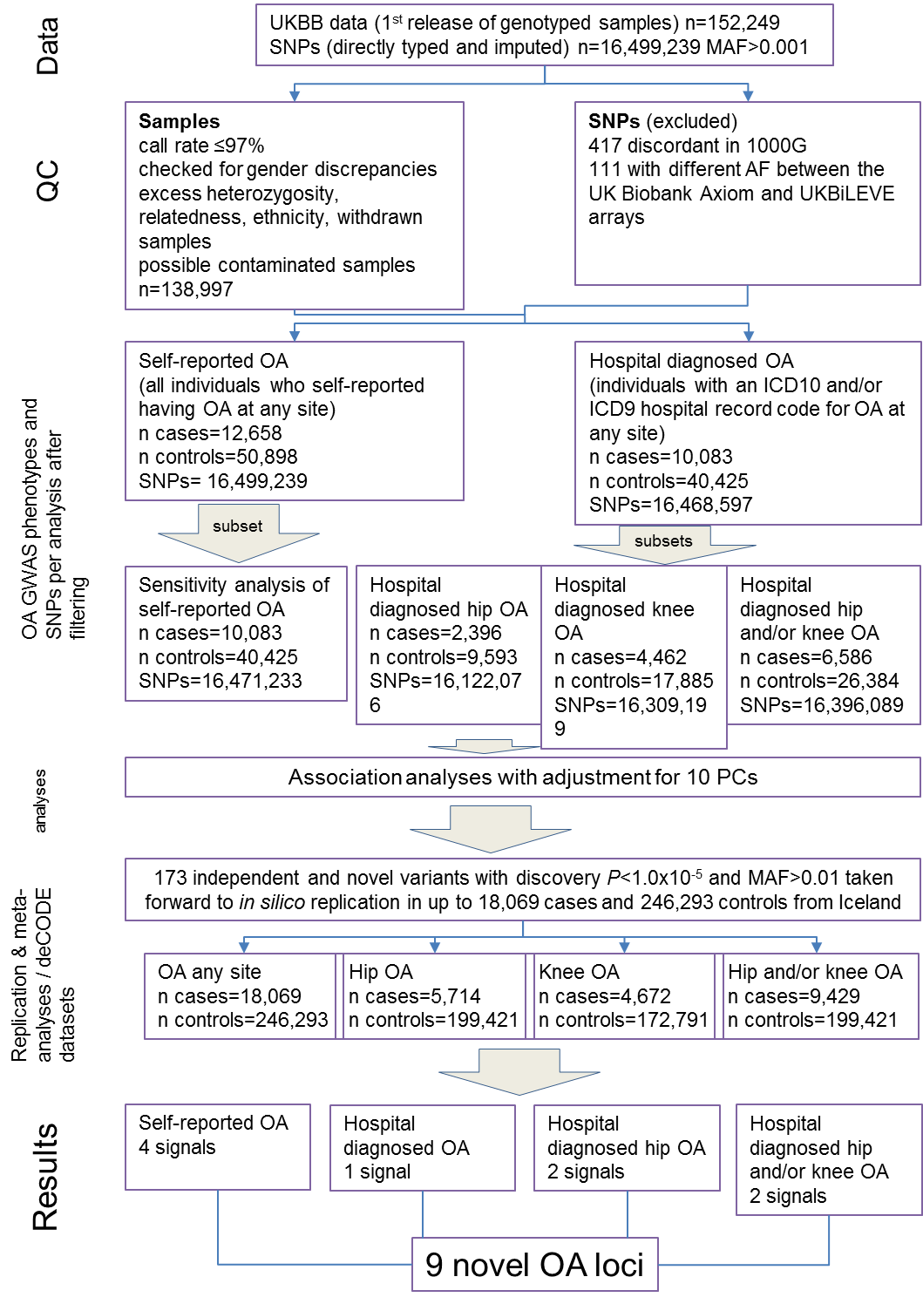
Figure 27. UK Biobank 150k OA study design flowchart. OA: Osteoarthritis; UKBB: UK Biobank; n: sample size; SNP: single nucleotide polymorphism; QC: quality control; 1000G: 1000 Genomes Project; AF: allele frequency; PC: principal component. (this figure is derived from PMID:29559693)¹⁶⁰

Association analyses
I used 12658 cases and 50898 controls for self-reported OA, 10083 cases and 40425 controls for hospital diagnosed OA and sensitivity analysis, 2396 cases and 9593 controls for hospital diagnosed hip OA, 4462 cases and 17885 controls for hospital diagnosed knee OA and 6586 cases and 26384 controls for hospital diagnosed hip and/or knee OA analysis. After further filtering for overall HWE P-value≤10⁻⁶, overall and separately in cases and controls MAF≤0.001 and info score <0.4, the final number of variants per analysis was 16,499,239 for self-reported OA, 16,468,597 for hospital diagnosed OA, 16,471,233 for sensitivity analysis, 16,122,076 for hospital diagnosed hip OA, 16,309,199 for hospital diagnosed knee OA and 16,396,089 for hospital diagnosed hip and/or knee OA (Figure 27). Association tests were performed using the frequentist association test (additive model) and method ml in SNPTEST v2.5.2¹⁸⁰ with adjustment for the first 10 principal components in order to control for population structure. Power calculations were carried out using Quanto v1.2.4¹⁸¹. A two-sided P-value≤0.05 was used as a threshold for nominal significance and P-value≤5x10⁻⁸ as the genome wide significance threshold. Independence and novelty of variants at P-value<10⁻⁵ in discovery analyses was defined after conducting clumping and conditional analyses respectively. For the clumping procedure a 500kb distance either side of each lead variant was used and the LD r-squared threshold given was r²>0.20.
Established OA loci
Evidence for association of established OA loci in UK Biobank discovery datasets was examined. Out of the 21 independent OA established loci, 17 were present in the self-reported and hospital diagnosed analyses, 19 in the hospital diagnosed hip and hospital diagnosed knee analyses, and 18 in the hospital diagnosed hip and/or knee analysis. Data is presented for these loci. Two very rare variants found to be associated with OA in the Icelandic population¹⁷⁰ were not present in the UK Biobank data. Concordance of direction of effect between the published signal risk alleles and the UK Biobank data were tested using the binomial test and using the false discovery rate (5% FDR) procedure to correct for multiple testing.
Accuracy of self-reported data

The classification accuracy of self-reported disease status was evaluated by estimating the sensitivity, specificity, positive predictive values (PPV) and negative predictive values (NPV) in the self-reported and hospital diagnosed disease definition datasets. A sensitivity test was performed to evaluate the true positive rate by calculating the proportion of individuals diagnosed with OA that were correctly identified as such in the self-reported analysis, and a specificity test to evaluate the true negative rate by calculating the proportion of individuals not diagnosed with OA that were correctly identified as such in the control set. The number of individuals overlapping between the self-reported (n_{SR}=12,658) and hospital diagnosed (n_{HD}=10,083) datasets was n_{OVER}=3,748. The total number of individuals was n_{TOT}=138,997. $Sensitivity= \frac{n_{OVER}}{n_{HD}}$; $Specificity = \frac{n_{TOT}-(n_{HD}+ n_{SR}-n_{OVER})}{n_{TOT}-n_{HD}}$; $PPV= \frac{n_{OVER}}{n_{SR}}$; $NPV = \frac{n_{TOT}-(n_{HD}+ n_{SR}-n_{OVER})}{n_{TOT}-n_{SR}}$.

3.3.2 Replication and meta-analyses
Excluding the sensitivity analysis of self-reported OA, two hundred common and low frequency variants were taken forward for in silico replication in an independent cohort from Iceland (deCODE) using fixed effects inverse-variance weighted meta-analysis in METAL¹⁸². One hundred and seventy three variants were present in the replication cohort. The remaining 27 variants had ambiguous alleles, i.e. incompatible due to alignment issues, and were not included in further analyses. The deCODE dataset comprised four OA phenotypes: any OA site (18,069 cases and 246,293 controls), hip OA (5,714 cases and 199,421 controls), knee OA (4,672 cases and 172,791 controls), and hip and/or knee OA (9,429 cases and 199,421 controls) (Figure 27). Twenty meta-analyses across all OA definitions using summary statistics from the UK Biobank OA analyses and deCODE was performed. P≤5x10⁻⁸ was used as the threshold to report genome wide significance.
Replication cohort
The information on hip, knee and vertebral OA was obtained from Landspitali University Hospital electronic health records, Akureyri Hospital electronic health records and from a national Icelandic hip or knee arthroplasty registry¹⁸³. Secondary OA (e.g. Perthes disease, hip dysplasia), post-trauma OA (e.g. anterior cruciate ligament rupture) and those also diagnosed with rheumatoid arthritis were excluded from these lists. Only those diagnosed with OA after the age of 40 were included. Hand OA patients were drawn from a database of 9,000 hand OA patients that was initiated in 1972¹⁸⁴. The study was approved by the Data Protection Authority of Iceland and the National Bioethics Committee of Iceland. Informed consent was obtained from all participants.
3.4 Results
3.4.1 Subject characteristics
Subject characteristics are displayed in table 12.

Table 12. Subject characteristics.
 | Cases | Controls
Self-reported OA
N | 12,658 | 50,898
Female, N (%) | 8,091 (63.9) | 24,717 (48.6)
Male, N (%) | 4,567 (36.1) | 26,181 (51.4)
Mean age at recruitment in years (±SD) | 60.54 (±6.22) | 63.67 (±3.02 )
Hospital diagnosed OA
N | 10,083 | 40,425
Female, N (%) | 5,461 (54.2) | 19,261 (47.6)
Male, N (%) | 4,622 (45.8) | 21,164 (52.4)
Mean age at recruitment in years (±SD) | 60.65 (±6.49) | 64.68 (±2.53 )
Hospital diagnosed hip OA
N | 2,396 | 9,593
Female, N (%) | 1,301 (54.3) | 4,334 (45.2)
Male, N (%) | 1,095 (45.7) | 5,259 (54.8)
Mean age at recruitment in years (±SD) | 61.99 (±5.79) | 68.19 (±0.87 )
Hospital diagnosed knee OA
N | 4,462 | 17,885
Female, N (%) | 2,122 (47.6) | 8,073 (45.1)
Male, N (%) | 2,340 (52.4) | 9,812 (54.9)
Mean age at recruitment in years (±SD) | 60.41 (±6.64) | 67.10 (±1.41 )
Hospital diagnosed hip and/or knee OA
N | 6,586 | 26,384
Female, N (%) | 3,285 (49.9) | 13,192 (50)
Male, N (%) | 3,301 (50.1) | 13,192 (50)
Mean age at recruitment in years (±SD) | 60.93 (±6.41) | 66.12 (±1.87)
Sensitivity analysis
N | 10,083 | 40,425
Female, N (%) | 6,424 (63.7) | 19,654 (48.6)
Male, N (%) | 3,659 (36.3) | 20,771 (51.4)
Mean age at recruitment in years (±SD) | 60.59 (±6.18) | 63.67 (±3.03 )

SD, standard deviation; OA, Osteoarthritis; N, sample size
(this table is derived from PMID:29559693)¹⁶⁰

3.4.2 Discovery GWAS results
No novel signals reached the genome wide significance (P-value≤5x10⁻⁸) at this point of analyses (Figures 28 and 29).
The independent and novel number of SNPs with P-value<10⁻⁵ for each analyses was; 68 for self-reported OA and sensitivity analysis of self-reported OA, 92 for hospital diagnosed OA, 73 for hospital diagnosed hip OA, 66 for hospital diagnosed knee OA and 65 for hospital diagnosed hip and/or knee OA (association summary statistics for SNPs with P-value<10⁻⁵ in all analyses are displayed in Appendix (Appendix 2, page 202).
Figure 28. UK Biobank 150k Manhattan plots. a) Self-reported OA; b) Hospital diagnosed OA; c) Hospital diagnosed hip OA; d) Hospital diagnosed knee OA; e) Hospital diagnosed hip and/or knee OA; f) Sensitivity analysis; the horizontal line denotes the genome-wide significance threshold. OA: Osteoarthritis. (these figures are derived from PMID:29559693)¹⁶⁰
a)
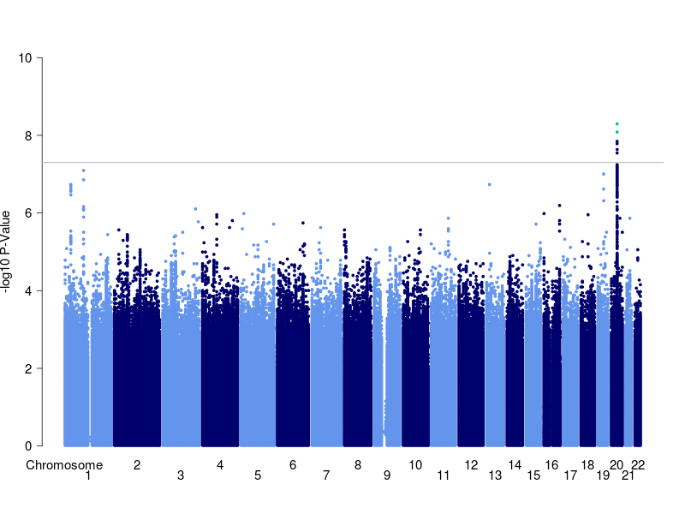

b)
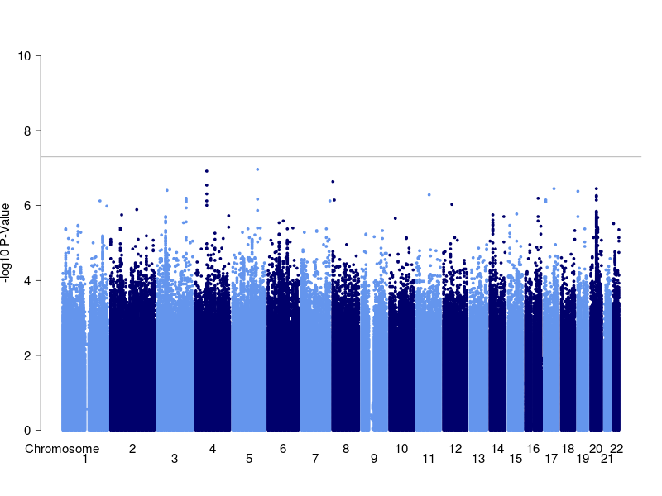
c)
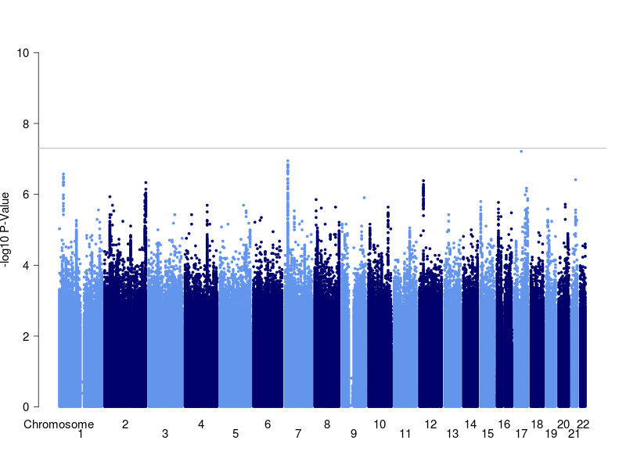

d)
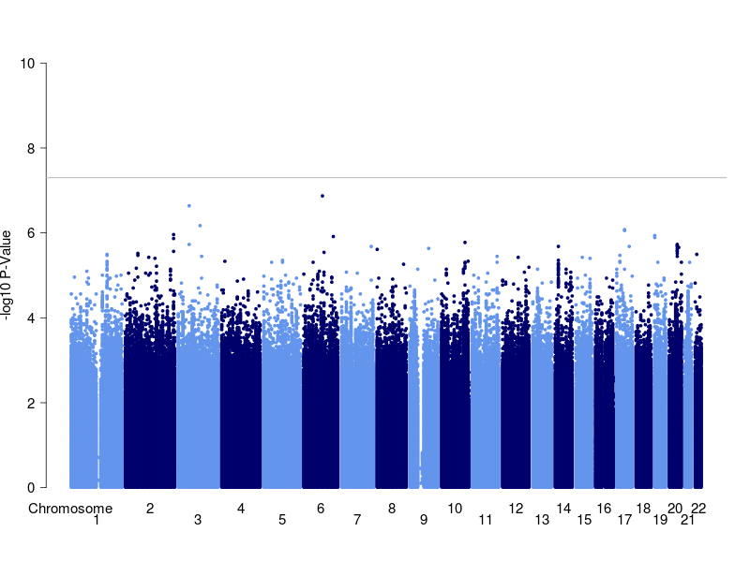
e)
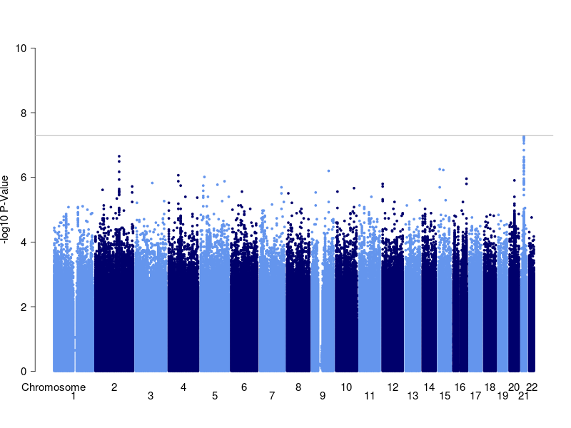

f)
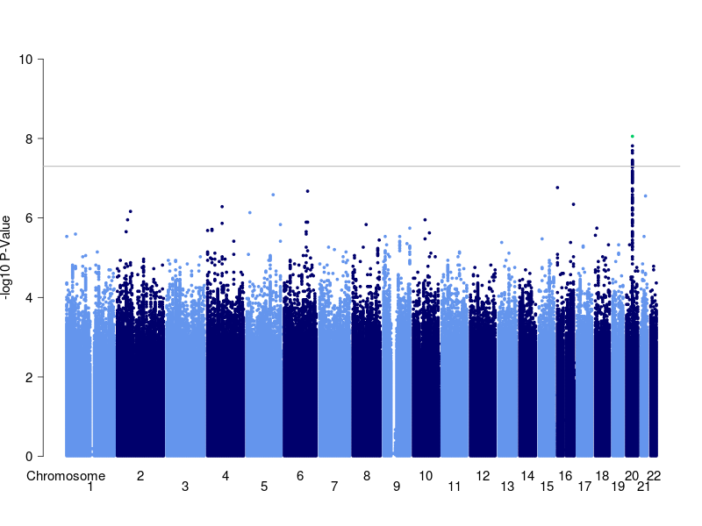
Figure 29. UK Biobank 150k QQ plots. a) Self-reported OA; b) Hospital diagnosed OA; c) Hospital diagnosed hip OA; d) Hospital diagnosed knee OA; e) Hospital diagnosed hip and/or knee OA; f) Sensitivity analysis. OA: Osteoarthritis; N: number of variants analysed following quality control; MAF: minor allele frequency; Lambda: genomic inflation factor. (these figures are derived from PMID:29559693)¹⁶⁰

a)
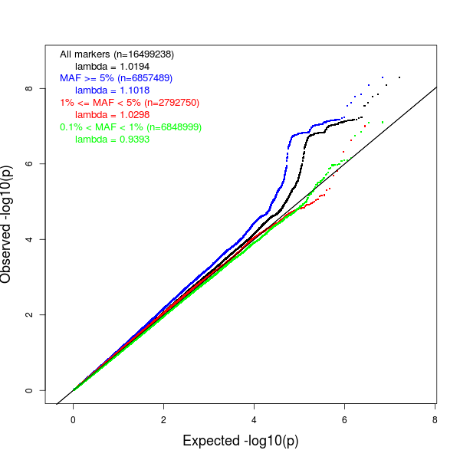

b)
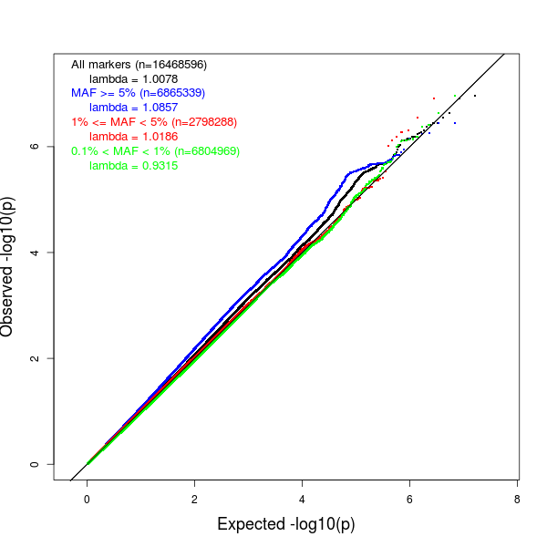
c)
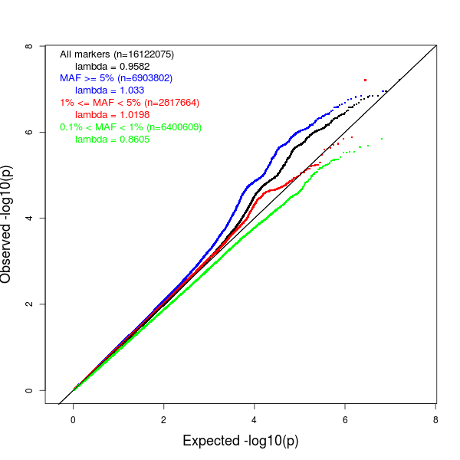

d)
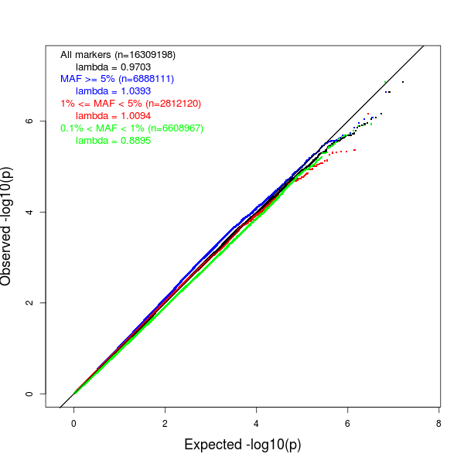
e)
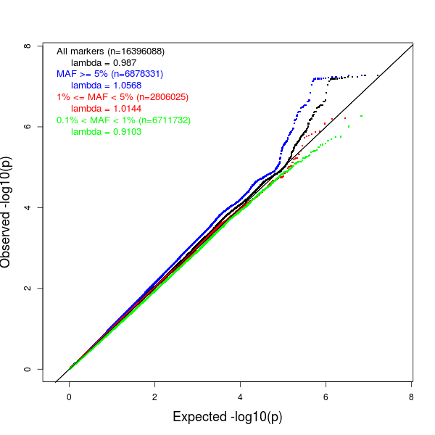

f)
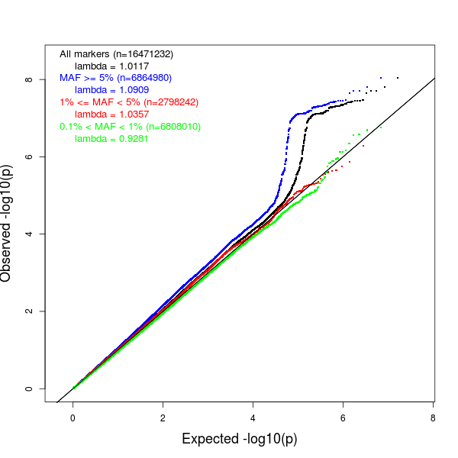

Established OA loci in UK Biobank

The only previously established OA signal to reach genome-wide significance in the discovery dataset was rs143383 in GDF5, identified as genome-wide significant in the self-reported OA analysis (OR(95%CI) 0.91(0.89-0.94), P-value =5.11x10⁻⁹), but not in the hospital diagnosed OA analysis (OR(95%CI) 0.91(0.89-0.94), P-value=3.53x10⁻⁷), although the effect sizes were clearly very similar. rs143383 remained genome-wide significantly associated with self-reported OA when a random subset of the dataset was taken to match the sample size of the hospital diagnosed OA dataset (sensitivity analysis of self-reported: OR (95%CI) 0.90 (0.88-0.94), P-value=1.55x10⁻⁸).
Nominally significant evidence was found for concordance between the previously reported direction of effect and the discovery analyses for the hospital diagnosed OA (FDR q-value=0.019) and hospital diagnosed hip OA (q-value=0.002) definitions (Table 13).

Table 13. Binomial test for directional concordance between reported effects at established OA loci and the discovery analysis across OA definitions.
Analysis | Number of successes | Number of trials | Uncorrected binomial P-value | FDR binomial q-value
Self-reported OA | 10 | 17 | 0.314 | 0.314
Sensitivity analysis of self-reported OA | 12 | 17 | 0.072 | 0.107
Hospital diagnosed OA | 14 | 17 | 0.006 | 0.019
Hospital diagnosed hip OA | 17 | 19 | 0.0004 | 0.002
Hospital diagnosed knee OA | 12 | 19 | 0.18 | 0.216
Hospital diagnosed hip and/or knee OA | 13 | 18 | 0.048 | 0.096
OA: osteoarthritis; FDR: False discovery rate. (this table is derived from PMID:29559693)¹⁶⁰

Regarding replication of common and low frequency established loci in UK Biobank discovery datasets, 2 polymorphisms yielded nominal evidence for association with OA out of 17 that were present for self-reported OA, 4 out of 17 for sensitivity analysis, 4 out of 17 for hospital diagnosed OA, 4 out of 19 for hospital diagnosed hip OA, 4 out of 19 for hospital diagnosed knee OA and 5 out of 18 for hospital diagnosed hip and/or knee OA (Tables 14, 15, 16, 17, 18 and 19). Established SNPs missing from UK Biobank OA analyses had been prior excluded due to excess HWE P-values during filtering.

Table 14. Association summary statistics for established OA loci in the UK Biobank Self-reported OA cohort.
Index variant | Self-reported OA EA | Self-reported OA EAF | Self-reported OA OR (95% CI) | Self-reported OA P-value
rs143383 | G | 0.36 | 0.91 (0.89 - 0.94) | 5.11x10⁻⁹
rs7639618 | T | 0.16 | 1.01 (0.98 - 1.05) | 0.529
rs7775228 | C | 0.13 | 0.98 (0.94 - 1.02) | 0.225
rs10947262 | T | 0.06 | 0.94 (0.89 - 1.00) | 0.082
rs3815148 | C | 0.23 | 1.00 (0.97 - 1.03) | 0.967
rs4730250 | G | 0.18 | 0.99 (0.96 - 1.03) | 0.837
rs11842874 | G | 0.07 | 1.02 (0.96 - 1.07) | 0.559
rs12982744 | G | 0.39 | 1.02 (0.99 - 1.04) | 0.259
rs6094710 | N/A | N/A | N/A | N/A
rs6976 | T | 0.38 | 0.99 (0.96 - 1.02) | 0.626
rs4836732 | T | 0.53 | 1.01 (0.98 - 1.04) | 0.517
rs9350591 | T | 0.11 | 1.02 (0.97 - 1.06) | 0.428
rs10492367 | T | 0.19 | 1.00 (0.97 - 1.04) | 0.773
rs835487 | G | 0.35 | 1.03 (1.00 - 1.06) | 0.068
rs12107036 | G | 0.54 | 1.01 (0.98 - 1.04) | 0.588
rs8044769 | N/A | N/A | N/A | N/A
rs10948172 | G | 0.30 | 1.03 (1.00 - 1.07) | 0.045
rs3204689 | C | 0.47 | 1.02 (0.99 - 1.05) | 0.187
rs12901071 | G | 0.34 | 0.98 (0.95 - 1.00) | 0.07
OR, odds ratio; CI, confidence interval; OA, osteoarthritis; EA, effect allele; EAF, effect allele frequency; N/A; not available (SNPs that failed quality control filtering due to excess Hardy Weinberg equilibrium)

Table 15. Association summary statistics for established OA loci in the UK Biobank hospital diagnosed OA cohort.
Index variant | Hospital diagnosed OA EA | Hospital diagnosed OA EAF | Hospital diagnosed OA OR (95% CI) | Hospital diagnosed OA P-value
rs143383 | G | 0.36 | 0.91 (0.89 - 0.94) | 3.53x10⁻⁷
rs7639618 | T | 0.16 | 1.00 (0.95 - 1.04) | 0.736
rs7775228 | C | 0.13 | 1.00 (0.95 - 1.04) | 0.878
rs10947262 | T | 0.06 | 0.99 (0.93 - 1.05) | 0.822
rs3815148 | C | 0.23 | 1.03 (0.99 - 1.07) | 0.105
rs4730250 | G | 0.18 | 1.03 (0.99 - 1.07) | 0.186
rs11842874 | G | 0.07 | 0.98 (0.92 - 1.04) | 0.402
rs12982744 | G | 0.39 | 1.01 (0.98 - 1.04) | 0.698
rs6094710 | N/A | N/A | N/A | N/A
rs6976 | T | 0.38 | 1.01 (0.98 - 1.04) | 0.326
rs4836732 | T | 0.53 | 1.00 (0.97 - 1.03) | 0.952
rs9350591 | T | 0.11 | 1.06 (1.01 - 1.11) | 0.019
rs10492367 | T | 0.19 | 1.02 (0.98 - 1.06) | 0.337
rs835487 | G | 0.35 | 1.04 (1.00 - 1.07) | 0.025
rs12107036 | G | 0.54 | 1.01 (0.98 - 1.04) | 0.441
rs8044769 | N/A | N/A | N/A | N/A
rs10948172 | G | 0.3 | 1.02 (0.99 - 1.06) | 0.284
rs3204689 | C | 0.47 | 0.99 (0.96 - 1.02) | 0.494
rs12901071 | G | 0.34 | 0.96 (0.93 - 0.99) | 0.002
OR, odds ratio; CI, confidence interval; OA, osteoarthritis; EA, effect allele; EAF, effect allele frequency; N/A; not available (SNPs that failed quality control filtering due to excess Hardy Weinberg equilibrium)

Table 16. Association summary statistics for established OA loci in the UK Biobank sensitivity analysis of self-reported OA cohort.
Index variant | Sensitivity analysis of self-reported OA EA | Sensitivity analysis of self-reported OA EAF | Sensitivity analysis of self-reported OA OR (95% CI) | Sensitivity analysis of self-reported OA P-value
rs143383 | G | 0.36 | 0.90 (0.88 - 0.94) | 1.55x10⁻⁸
rs7639618 | T | 0.16 | 1.00 (0.96 - 1.05) | 0.933
rs7775228 | C | 0.13 | 0.98 (0.94 - 1.03) | 0.397
rs10947262 | T | 0.06 | 0.93 (0.87 - 0.99) | 0.04
rs3815148 | C | 0.23 | 1.00 (0.96 - 1.04) | 0.959
rs4730250 | G | 0.18 | 1.00 (0.96 - 1.04) | 0.849
rs11842874 | G | 0.07 | 0.99 (0.94 - 1.05) | 0.826
rs12982744 | G | 0.39 | 1.01 (0.98 - 1.04) | 0.442
rs6094710 | N/A | N/A | N/A | N/A
rs6976 | T | 0.38 | 0.99 (0.96 - 1.02) | 0.581
rs4836732 | T | 0.53 | 1.01 (0.98 - 1.04) | 0.782
rs9350591 | T | 0.11 | 1.03 (0.99 - 1.09) | 0.161
rs10492367 | T | 0.19 | 1.01 (0.97 - 1.05) | 0.509
rs835487 | G | 0.36 | 1.03 (1.00 - 1.07) | 0.035
rs12107036 | G | 0.54 | 1.01 (0.98 - 1.04) | 0.644
rs8044769 | N/A | N/A | N/A | N/A
rs10948172 | G | 0.30 | 1.04 (1.00 - 1.07) | 0.059
rs3204689 | C | 0.47 | 1.03 (1.00 - 1.06) | 0.064
rs12901071 | G | 0.34 | 0.97 (0.93 - 1.00) | 0.016
OR, odds ratio; CI, confidence interval; OA, osteoarthritis; EA, effect allele; EAF, effect allele frequency; N/A; not available (SNPs that failed quality control filtering due to excess Hardy Weinberg equilibrium)

Table 17. Association summary statistics for established OA loci in the UK Biobank hospital diagnosed hip OA cohort.
Index variant | Hospital diagnosed hip OA EA | Hospital diagnosed hip OA EAF | Hospital diagnosed hip OA OR (95% CI) | Hospital diagnosed hip OA P-value
rs143383 | G | 0.36 | 0.93 (0.87 - 1.00) | 0.052
rs7639618 | T | 0.16 | 0.98 (0.89 - 1.06) | 0.527
rs7775228 | C | 0.13 | 0.95 (0.86 - 1.04) | 0.256
rs10947262 | T | 0.07 | 1.01 (0.89 - 1.15) | 0.763
rs3815148 | C | 0.23 | 0.98 (0.91 - 1.06) | 0.603
rs4730250 | G | 0.18 | 1.01 (0.93 - 1.10) | 0.76
rs11842874 | G | 0.07 | 0.94 (0.83 - 1.06) | 0.289
rs12982744 | G | 0.39 | 0.97 (0.91 - 1.04) | 0.341
rs6094710 | A | 0.04 | 1.08 (0.93 - 1.26) | 0.315
rs6976 | T | 0.38 | 1.12 (1.05 - 1.19) | 0.0006
rs4836732 | T | 0.53 | 0.95 (0.90 - 1.02) | 0.137
rs9350591 | T | 0.11 | 1.14 (1.04 - 1.26) | 0.006
rs10492367 | T | 0.19 | 1.14 (1.05 - 1.23) | 0.001
rs835487 | G | 0.35 | 1.05 (0.98 - 1.12) | 0.137
rs12107036 | G | 0.54 | 1.01 (0.94 - 1.07) | 0.773
rs8044769 | C | 0.51 | 1.02 (0.95 - 1.08) | 0.651
rs10948172 | G | 0.3 | 1.05 (0.98 - 1.13) | 0.178
rs3204689 | C | 0.47 | 1.05 (0.99 - 1.12) | 0.127
rs12901071 | G | 0.33 | 0.92 (0.86 - 0.98) | 0.009
OR, odds ratio; CI, confidence interval; OA, osteoarthritis; EA, effect allele; EAF, effect allele frequency; N/A; not available (SNPs that failed quality control filtering due to excess Hardy Weinberg equilibrium)

Table 18. Association summary statistics for established OA loci in the UK Biobank hospital diagnosed knee OA cohort.
Index variant | Hospital diagnosed knee OA EA | Hospital diagnosed knee OA EAF | Hospital diagnosed knee OA OR (95% CI) | Hospital diagnosed knee OA P-value
rs143383 | G | 0.36 | 0.90 (0.85 - 0.94) | 1.46x10⁻⁵
rs7639618 | T | 0.16 | 1.01 (0.95 - 1.08) | 0.777
rs7775228 | C | 0.13 | 1.02 (0.95 - 1.09) | 0.595
rs10947262 | T | 0.06 | 0.93 (0.84 - 1.02) | 0.171
rs3815148 | C | 0.23 | 1.06 (1.01 - 1.12) | 0.03
rs4730250 | G | 0.18 | 1.04 (0.98 - 1.11) | 0.17
rs11842874 | G | 0.07 | 1.04 (0.95 - 1.14) | 0.415
rs12982744 | G | 0.39 | 1.02 (0.97 - 1.07) | 0.409
rs6094710 | A | 0.04 | 1.03 (0.92 - 1.15) | 0.665
rs6976 | T | 0.38 | 1.02 (0.97 - 1.07) | 0.342
rs4836732 | T | 0.53 | 1.01 (0.96 - 1.06) | 0.656
rs9350591 | T | 0.11 | 1.02 (0.94 - 1.09) | 0.658
rs10492367 | T | 0.19 | 1.00 (0.94 - 1.06) | 0.877
rs835487 | G | 0.35 | 1.04 (0.99 - 1.09) | 0.157
rs12107036 | G | 0.54 | 1.01 (0.97 - 1.06) | 0.572
rs8044769 | C | 0.51 | 1.05 (1.01 - 1.10) | 0.025
rs10948172 | G | 0.3 | 1.05 (1.00 - 1.11) | 0.054
rs3204689 | C | 0.47 | 0.95 (0.90 - 0.99) | 0.018
rs12901071 | G | 0.34 | 0.98 (0.93 - 1.03) | 0.235
OR, odds ratio; CI, confidence interval; OA, osteoarthritis; EA, effect allele; EAF, effect allele frequency; N/A; not available (SNPs that failed quality control filtering due to excess Hardy Weinberg equilibrium)

Table 19. Association summary statistics for established OA loci in the UK Biobank hospital diagnosed hip and/or knee OA cohort.
Index variant | Hospital diagnosed hip and/or knee OA EA | Hospital diagnosed hip and/or knee OA EAF | Hospital diagnosed hip and/or knee OA OR (95% CI) | Hospital diagnosed hip and/or knee OA P-value
rs143383 | G | 0.36 | 0.90 (0.87 - 0.94) | 1.23x10⁻⁶
rs7639618 | T | 0.16 | 1.01 (0.96 - 1.06) | 0.81
rs7775228 | C | 0.13 | 1.00 (0.95 - 1.06) | 0.966
rs10947262 | T | 0.06 | 0.98 (0.90 - 1.06) | 0.655
rs3815148 | C | 0.23 | 1.04 (1.00 - 1.09) | 0.067
rs4730250 | G | 0.18 | 1.03 (0.98 - 1.08) | 0.239
rs11842874 | G | 0.07 | 1.00 (0.93 - 1.08) | 0.994
rs12982744 | G | 0.39 | 1.01 (0.97 - 1.05) | 0.64
rs6094710 | N/A | N/A | N/A | N/A
rs6976 | T | 0.38 | 1.04 (1.00 - 1.08) | 0.04
rs4836732 | T | 0.53 | 0.99 (0.96 - 1.03) | 0.664
rs9350591 | T | 0.11 | 1.06 (0.99 - 1.12) | 0.062
rs10492367 | T | 0.19 | 1.05 (1.00 - 1.10) | 0.048
rs835487 | G | 0.35 | 1.04 (1.00 - 1.08) | 0.063
rs12107036 | G | 0.54 | 1.01 (0.98 - 1.05) | 0.492
rs8044769 | C | 0.51 | 1.04 (1.00 - 1.08) | 0.038
rs10948172 | G | 0.3 | 1.04 (1.00 - 1.09) | 0.051
rs3204689 | C | 0.47 | 0.98 (0.94 - 1.02) | 0.239
rs12901071 | G | 0.34 | 0.96 (0.92 - 1.00) | 0.023
OR, odds ratio; CI, confidence interval; OA, osteoarthritis; EA, effect allele; EAF, effect allele frequency; N/A; not available (SNPs that failed quality control filtering due to excess Hardy Weinberg equilibrium)

The power afforded to detect established loci based on the allele frequency and effect size estimates in the UK Biobank OA datasets was calculated (Tables 20, 21, 22, 23 and 24). This shows that the number of OA cases required to attain 80% power to detect previously reported association signals at genome-wide significance in UK Biobank consistently exceeds the number of cases available in the datasets studied here, with the single exception of the GDF5 variant association, which is detected at genome-wide significance in the self-reported OA dataset (Table 14).

Table 20. Power calculations for established OA loci present in the UK Biobank self-reported OA cohort.
Index variant | % power to detect at alpha 0.05ª | % power to detect at alpha 5x10^{-8a} | Number of cases for 80% power at alpha 0.05^{b} | Number of cases for 80% power at alpha 5x10^{-8b}
rs143383 | 99 | 83 | 2,435 | 12,284
rs7639618 | 8 | 0 | 367,158 | >1,000,000
rs7775228 | 16 | 0 | 107,229 | 541,015
rs10947262 | 54 | 0 | 23,474 | 118,439
rs3815148 | 5 | 0 | ∞ | ∞
rs4730250 | 8 | 0 | 330,308 | >1,000,000
rs11842874 | 11 | 0 | 190,208 | 959,682
rs12982744 | 28 | 0 | 52,449 | 264,626
rs6094710 | N/A | N/A | N/A | N/A
rs6976 | 11 | 0 | 206,436 | >1,000,000
rs4836732 | 11 | 0 | 198,976 | >1,000,000
rs9350591 | 14 | 0 | 126,603 | 683,766
rs10492367 | 5 | 0 | ∞ | ∞
rs835487 | 52 | 0 | 24,551 | 123,870
rs12107036 | 11 | 0 | 199,560 | >1,000,000
rs8044769 | N/A | N/A | N/A | N/A
rs10948172 | 49 | 0 | 26,550 | 133,954
rs3204689 | 29 | 0 | 50,186 | 253,210
rs12901071 | 27 | 0 | 53,771 | 271,300

OA, osteoarthritis; N/A, not available

a: Power is calculated on the basis of the EAF and OR estimates from the UK Biobank OA dataset and assuming 4 controls per case

b: The number of cases required for 80% power is calculated on the basis of EAF and OR estimates from the UK Biobank OA dataset and assuming 4 controls per case

Table 21. Power calculations for established OA loci present in the UK Biobank hospital diagnosed OA cohort.
Index variant | % power to detect at alpha 0.05ª | % power to detect at alpha 5x10^{-8a} | Number of cases for 80% power at alpha 0.05^{b} | Number of cases for 80% power at alpha 5x10^{-8b}
rs143383 | 99 | 34 | 3,108 | 15,682
rs7639618 | 5 | 0 | ∞ | ∞
rs7775228 | 5 | 0 | ∞ | ∞
rs10947262 | 6 | 0 | 865,671 | >1,000,000
rs3815148 | 36 | 0 | 31,403 | 158,442
rs4730250 | 31 | 0 | 37,612 | 189,769
rs11842874 | 10 | 0 | 186,560 | 941,277
rs12982744 | 9 | 0 | 207,995 | >1,000,000
rs6094710 | N/A | N/A | N/A | N/A
rs6976 | 9 | 0 | 210,001 | >1,000,000
rs4836732 | 5 | 0 | ∞ | ∞
rs9350591 | 65 | 0 | 14,364 | 72,470
rs10492367 | 17 | 0 | 80,690 | 407,115
rs835487 | 66 | 0 | 13,922 | 70,241
rs12107036 | 10 | 0 | 199,560 | >1,000,000
rs8044769 | N/A | N/A | N/A | N/A
rs10948172 | 21 | 0 | 59,290 | 299,141
rs3204689 | 10 | 0 | 195,036 | 984,043
rs12901071 | 69 | 0 | 13,224 | 66,721

OA, osteoarthritis; N/A, not available

a: Power is calculated on the basis of the EAF and OR estimates from the UK Biobank OA dataset and assuming 4 controls per case

b: The number of cases required for 80% power is calculated on the basis of EAF and OR estimates from the UK Biobank OA dataset and assuming 4 controls per case

Table 22. Power calculations for established OA loci present in the UK Biobank hospital diagnosed hip OA cohort.
Index variant | % power to detect at alpha 0.05ª | % power to detect at alpha 5x10^{-8a} | Number of cases for 80% power at alpha 0.05^{b} | Number of cases for 80% power at alpha 5x10^{-8b}
rs143383 | 57 | 0 | 4,095 | 20,661
rs7639618 | 7 | 0 | 90,170 | 454,945
rs7775228 | 18 | 0 | 16,868 | 85,105
rs10947262 | 5 | 0 | 757,187 | >1,000,000
rs3815148 | 8 | 0 | 68,314 | 344,673
rs4730250 | 6 | 0 | 334,403 | >1,000,000
rs11842874 | 16 | 0 | 20,323 | 102,536
rs12982744 | 15 | 0 | 22,318 | 112,603
rs6094710 | 16 | 0 | 20,673 | 104,304
rs6976 | 93 | 2 | 1,598 | 8,060
rs4836732 | 35 | 0 | 7.474 | 37,709
rs9350591 | 74 | 0 | 2,747 | 13,862
rs10492367 | 90 | 1 | 1,771 | 8,934
rs835487 | 30 | 0 | 8,982 | 45,316
rs12107036 | 6 | 0 | 199,560 | >1,000,000
rs8044769 | 9 | 0 | 50,073 | 252,639
rs10948172 | 29 | 0 | 9,701 | 48,948
rs3204689 | 33 | 0 | 8,261 | 41,680
rs12901071 | 67 | 0 | 3,249 | 16,391

OA, osteoarthritis; N/A, not available

a: Power is calculated on the basis of the EAF and OR estimates from the UK Biobank OA dataset and assuming 4 controls per case

b: The number of cases required for 80% power is calculated on the basis of EAF and OR estimates from the UK Biobank OA dataset and assuming 4 controls per case

Table 23. Power calculations for established OA loci present in the UK Biobank hospital diagnosed knee OA cohort.
Index variant | % power to detect at alpha 0.05ª | % power to detect at alpha 5x10^{-8a} | Number of cases for 80% power at alpha 0.05^{b} | Number of cases for 80% power at alpha 5x10^{-8b}
rs143383 | 99 | 11 | 1,955 | 9,863
rs7639618 | 6 | 0 | 367,158 | >1,000,000
rs7775228 | 9 | 0 | 109,641 | 553,184
rs10947262 | 30 | 0 | 17,162 | 86,591
rs3815148 | 55 | 0 | 8,008 | 40,405
rs4730250 | 25 | 0 | 21,285 | 107,394
rs11842874 | 14 | 0 | 48,007 | 242,217
rs12982744 | 13 | 0 | 52,449 | 264,626
rs6094710 | 8 | 0 | 143,848 | 725,773
rs6976 | 13 | 0 | 52,948 | 267,146
rs4836732 | 7 | 0 | 198,976 | >1,000,000
rs9350591 | 8 | 0 | 126,603 | 638,766
rs10492367 | 5 | 0 | ∞ | ∞
rs835487 | 35 | 0 | 13,922 | 70,241
rs12107036 | 7 | 0 | 199,560 | >1,000,000
rs8044769 | 54 | 0 | 8,254 | 41,644
rs10948172 | 48 | 0 | 9,701 | 48,948
rs3204689 | 58 | 0 | 7,501 | 37,848
rs12901071 | 13 | 0 | 53,771 | 271,300

OA, osteoarthritis; N/A, not available

a: Power is calculated on the basis of the EAF and OR estimates from the UK Biobank OA dataset and assuming 4 controls per case

b: The number of cases required for 80% power is calculated on the basis of EAF and OR estimates from the UK Biobank OA dataset and assuming 4 controls per case

Table 24. Power calculations for established OA loci present in the UK Biobank hospital diagnosed hip and/or knee OA cohort.
Index variant | % power to detect at alpha 0.05ª | % power to detect at alpha 5x10^{-8a} | Number of cases for 80% power at alpha 0.05^{b} | Number of cases for 80% power at alpha 5x10^{-8b}
rs143383 | 99 | 38 | 1,955 | 9,863
rs7639618 | 7 | 0 | 367,158 | >1,000,000
rs7775228 | 5 | 0 | ∞ | ∞
rs10947262 | 8 | 0 | 215,390 | >1,000,000
rs3815148 | 40 | 0 | 17,782 | 89,718
rs4730250 | 22 | 0 | 37,612 | 189,769
rs11842874 | 5 | 0 | ∞ | ∞
rs12982744 | 8 | 0 | 207,995 | >1,000,000
rs6094710 | N/A | N/A | N/A | N/A
rs6976 | 50 | 0 | 13,462 | 67,922
rs4836732 | 8 | 0 | 194,895 | 983,332
rs9350591 | 48 | 0 | 14,364 | 72,470
rs10492367 | 51 | 0 | 13,152 | 66,357
rs835487 | 49 | 0 | 13,922 | 70,241
rs12107036 | 8 | 0 | 199,560 | >1,000,000
rs8044769 | 52 | 0 | 12,770 | 64,429
rs10948172 | 46 | 0 | 15,046 | 75,914
rs3204689 | 18 | 0 | 48,287 | 243,631
rs12901071 | 51 | 0 | 13,224 | 66,721

OA, osteoarthritis; N/A, not available

a: Power is calculated on the basis of the EAF and OR estimates from the UK Biobank OA dataset and assuming 4 controls per case

b: The number of cases required for 80% power is calculated on the basis of EAF and OR estimates from the UK Biobank OA dataset and assuming 4 controls per case

3.4.3 Disease definition and power to detect genetic associations
The hospital diagnosed (n=10,083 cases) dataset was compared and contrasted to the self-reported (n=12,658 cases) dataset in order to evaluate the accuracy of self-reported data. In terms of power to detect genetic associations, the self-reported OA dataset has clear advantages commensurate with its larger samples size. For example, for a representative complex disease-associated variant with MAF 30% and allelic odds ratio 1.10, the self-reported and hospital diagnosed OA analyses have 80% and 56% power, respectively to detect an effect at genome-wide significance (i.e., P<5.0x10⁻⁸). Therefore, in the case of the self-reported phenotype, the increase in power associated with larger sample size overcomes the limitations associated with phenotype uncertainty (Table 25).
Table 25. Comparison of power to detect genome-wide significant (P≤5x10⁻⁸) association between the self-reported and hospital diagnosed OA datasets.
 |  | Self-reported OA |  |  |  |  | Hospital diagnosed OA
 |  | Effect allele frequency |  |  |  |  | Effect allele frequency
 |  | 0.01 | 0.05 | 0.10 | 0.20 | 0.30 | 0.01 | 0.05 | 0.10 | 0.20 | 0.30
Odds ratio | 1.05 | 0 | 0 | 0 | 0.004 | 0.012 | 0 | 0 | 0 | 0.002 | 0.005
Odds ratio | 1.10 | 0 | 0.008 | 0.099 | 0.526 | 0.798 | 0 | 0.003 | 0.041 | 0.299 | 0.562
Odds ratio | 1.15 | 0 | 0.171 | 0.763 | 0.996 | 0.999 | 0 | 0.076 | 0.521 | 0.966 | 0.998
Odds ratio | 1.20 | 0.003 | 0.687 | 0.996 | 0.999 | 0.999 | 0.001 | 0.439 | 0.964 | 0.999 | 0.999
Odds ratio | 1.50 | 0.846 | 0.999 | 0.999 | 0.999 | 0.999 | 0.626 | 0.999 | 0.999 | 0.999 | 0.999
Odds ratio | 2.00 | 0.999 | 0.999 | 0.999 | 0.999 | 0.999 | 0.999 | 0.999 | 0.999 | 0.999 | 0.999
Additive model, 1:4 case:control ratio used. OA: osteoarthritis. (this table is derived from PMID:29559693)¹⁶⁰

When evaluating the accuracy of disease definition, the self-reported OA disease status has modest PPV (30%) and sensitivity (37%), but a high NPV of 95% and high specificity, correctly identifying 93% of individuals who do not have OA. (Table 26).
Table 26. Sensitivity, specificity, positive (PPV) and negative (NPV) predictive values in the self-reported and hospital diagnosed OA definition datasets.
Measure | Estimate (95% confidence intervals)
Sensitivity | 0.37 (0.36-0.38)
Specificity | 0.931 (0.932-0.930)
PPV | 0.30 (0.28-0.31)
NPV | 0.95 (0.949-0.951)
OA, osteoarthritis. (this table is derived from PMID:29559693)¹⁶⁰

3.4.4 Identification of novel OA loci
Following meta-analysis in up to 30,727 cases and 297,191 controls, seven genome-wide significant associations at novel loci were identified, and also two further new replicating signals just below the genome-wide significance threshold (P-value<6.0x10⁻⁸) (Table 27)

Table 27. Association summary statistics for the nine novel replicating signals

rsID | EA | discovery phenotype | discovery  EAF | discovery OR  (95% CI) | discovery  P-value | discovery n  cases/  controls | replication phenotype | replication EAF | replication OR  (95% CI) | replication  P-value | replication n cases/ controls | overall  OR  (95% CI) | overall  P-value | overall n  cases/  controls
rs2820436 | C | Hospital diagnosed OA | 0.66 | 0.92  (0.9-0.96) | 6.45x10⁻⁶ | 10,083/  40,425 | OA at any site | 0.64 | 0.94  (0.91-0.97) | 8.71x10⁻⁵ | 18,069/ 246,293 | 0.93  (0.91-0.96) | 2.01x10⁻⁹ | 28,152/ 286,718
rs3771501 | G | Self-reported OA | 0.53 | 0.94  (0.91-0.96) | 3.81x10⁻⁶ | 12,658/  50,898 | OA at any site | 0.54 | 0.95  (0.92-0.98) | 0.001069 | 18,069/ 246,293 | 0.94  (0.92-0.96) | 1.66x10⁻⁸ | 30,727/ 297,191
rs11335718 | A | Self-reported OA | 0.11 | 1.12  (1.07-1.17) | 1.12x10⁻⁶ | 12,658/ 50,898 | Knee OA | 0.11 | 1.1  (1.02-1.2) | 0.014675 | 4,672/ 172,791 | 1.11  (1.07-1.16) | 4.26x10⁻⁸ | 17,330/ 223,689
rs11780978 | A | Hospital diagnosed hip | 0.4 | 1.16  (1.08-1.23) | 6.24x10⁻⁶ | 2,396/ 9,593 | Hip OA | 0.39 | 1.11  (1.05-1.16) | 4.55x10⁻⁵ | 5,714/ 199,421 | 1.13  (1.08-1.17) | 1.98x10⁻⁹ | 8,110/ 209,014
rs116882138 | A | Hospital diagnosed hip and/or knee OA | 0.02 | 1.4  (1.22-1.6) | 2.96x10⁻⁶ | 6,586/ 26,384 | Knee OA | 0.02 | 1.27  (1.07-1.5) | 0.006552 | 4,672/ 172,791 | 1.34  (1.21-1.49) | 5.09x10⁻⁸ | 11,258/ 199,175
rs2521349 | A | Hospital diagnosed hip OA | 0.38 | 1.18  (1.11-1.26) | 6.85x10⁻⁷ | 2,396/ 9,593 | Hip OA | 0.37 | 1.1  (1.05-1.16) | 0.000103 | 5,714/ 199,421 | 1.13  (1.09-1.18) | 9.95x10⁻¹⁰ | 8,110/ 209,014
rs864839 | T | Self-reported OA | 0.72 | 1.08  (1.05-1.12) | 6.21x10⁻⁷ | 12,658/ 50,898 | Hip OA | 0.7 | 1.07  (1.02-1.13) | 0.008275 | 5,714/ 199,421 | 1.08  (1.05-1.11) | 2.01x10⁻⁸ | 18,372/ 250,319
rs375575359 | C | Self-reported OA | 0.03 | 1.2  (1.12-1.29) | 9.96x10⁻⁸ | 12,658/ 50,898 | Knee OA | 0.05 | 1.15  (1.02-1.29) | 0.025177 | 4,672/ 172,791 | 1.21  (1.14-1.3) | 7.54x10⁻⁹ | 17,330/ 223,689
rs6516886 | T | Hospital diagnosed hip and/or knee OA | 0.75 | 1.13  (1.08-1.19) | 5.36x10⁻⁸ | 6,586/ 26,384 | Hip OA | 0.76 | 1.06  (1-1.12) | 0.055135 | 5,714/ 199,421 | 1.1  (1.06-1.14) | 5.84x10⁻⁸ | 12,300/ 225,805
EA, effect allele; EAF, effect allele frequency; OR, odds ratio; n, sample size; OA osteoarthritis
An association between rs2521349 and hip OA (OR 1.13 (95% CI 1.09-1.17), P-value= 9.95x10⁻¹⁰, EAF 0.37) was identified (Table 27). rs2521349 resides in an intron of mitogen-activated protein kinase kinase 6 (MAP2K6) gene, on chromosome 17 (Figure 30). MAP2K6 is an essential component of the p38 MAP kinase mediated signal transduction pathway, involved in various cellular processes in bone, muscle, fat tissue homeostasis and differentiation¹⁸⁵. The MAPK signalling pathway has been closely associated with osteoblast differentiation, chondrocyte apoptosis and necrosis, and reported to be differentially expressed in OA synovial tissue samples¹⁸⁶⁻¹⁹⁶. In animal model studies, MAPK signalling plays an important role in maintaining cartilage health and it has been proposed as a potential OA diagnosis and treatment target^{191,197,198}.

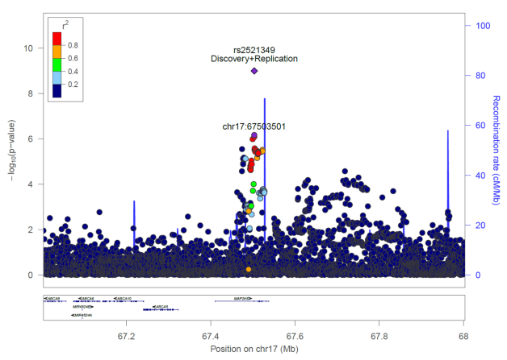

Figure 30. Regional association plot for rs2521349. The y axis represents the negative logarithm (base 10) of the variant P-value and the x axis represents the position on the chromosome, with the name and location of genes and nearest genes shown in the bottom panel. The variant with the lowest P-value in the region after combined discovery and replication is marked by a purple diamond. The same variant is marked by a purple dot showing the discovery P-value. The colours of the other variants indicate their r² with the lead variant. (this figure is derived from PMID:29559693)¹⁶⁰

rs11780978 on chromosome 8 was also associated with hip OA at a similar effect size (OR 1.13 (95% CI 1.08-1.17), P-value=1.98x10⁻⁹, EAF 0.39) (Table 27). This variant is located in the intronic region of the plectin gene, PLEC (Figure 31). PLEC encodes plectin, a structural protein which interlinks components of the cytoskeleton¹⁹⁹. Plectin is downregulated in OA affected meniscus compared with healthy tissue and is reported to play a key role in skeletal muscle function causing dystrophic changes in muscle^{200,201}. Functional studies in mice have shown an effect on skeletal muscle tissue and correlation with decreased body weight, size and postnatal growth²⁰². The chromosomal region surrounding rs11780978 also contains correlated variants associated with metabolic and anthropometric traits in humans (rs11136341, r²=0.78, associated phenotype: cholesterol total and LDL cholesterol; rs11783655, r²=1, associated phenotype: height).
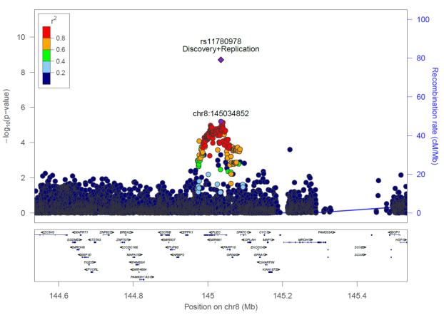
Figure 31. Regional association plot for rs11780978. The y axis represents the negative logarithm (base 10) of the variant P-value and the x axis represents the position on the chromosome, with the name and location of genes and nearest genes shown in the bottom panel. The variant with the lowest P-value in the region after combined discovery and replication is marked by a purple diamond. The same variant is marked by a purple dot showing the discovery P-value. The colours of the other variants indicate their r² with the lead variant. (this figure is derived from PMID:29559693)¹⁶⁰

rs2820436 was associated with OA across any joint site (OR 0.93 (95% CI 0.91-0.95), P-value=2.01x10⁻⁹, EAF 0.65) (Table 27). It resides on chromosome 1 and is an intergenic variant located 24kb upstream of long non-coding RNA RP11-392O17.1 and 142kb downstream of zinc finger CCCH-type containing 11B pseudogene ZC3H11B (Figure 32). It also resides within a region with multiple metabolic and anthropometric trait-associated variants^{203,204}, with which it is correlated (r² 0.18-0.88) (Table 28). Protein coding SLC30A10 (solute carrier family 30, member 10) and LYPLAL1, (lysophospholipase-like 1) which are related to skeletal abnormalities and metabolic traits lie at a distance of 220 and 250kbp respectively²⁰⁵⁻²⁰⁷ (http://www.mousephenotype.org/data/genes/MGI:2385115). rs1417066 which is in high LD with rs2820436 had been implicated in OA by the arcOGEN study but had failed to reach the genome wide significance threshold¹³⁵.
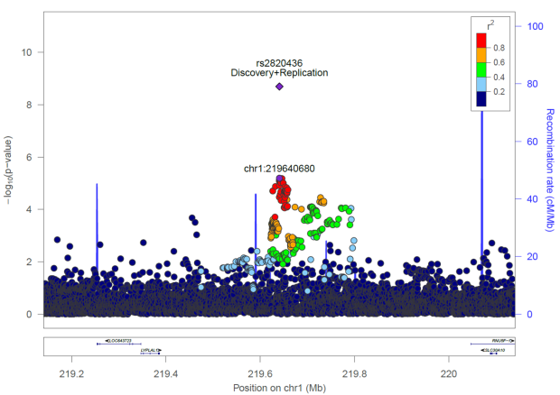
Figure 32. Regional association plot for rs2820436. The y axis represents the negative logarithm (base 10) of the variant P-value and the x axis represents the position on the chromosome, with the name and location of genes and nearest genes shown in the bottom panel. The variant with the lowest P-value in the region after combined discovery and replication is marked by a purple diamond. The same variant is marked by a purple dot showing the discovery P-value. The colours of the other variants indicate their r² with the lead variant. (this figure is derived from PMID:29559693)¹⁶⁰

Table 28. Correlated regional phenotype-relevant variants with rs2820436 (in 1000 Genome, phase 3, British (GBR) population)
rsID | r² | associated phenotype
rs2820464 | 0.7 | waist-hip ratio
rs4846565 | 0.7 | waist-hip ratio
rs11118346 | 0.18 | height
rs2820446 | 0.58 | type 2 diabetes (implicated)
rs4846567 | 0.58 | waist-hip ratio
rs2820443 | 0.56 | hip circumference and waist-hip-ratio (adjusted for BMI)
rs2605100 | 0.88 | obesity
rs11118316 | 0.56 | obesity

rs375575359 resides in an intron of the zinc finger protein 345 gene, ZNF345, on chromosome 19 (Figure 33). It was prioritised based on OA at any joint site and was more strongly associated with knee OA in the replication dataset (OR 1.21 (95% CI 1.14-1.30), P-value=7.54x10⁻⁹, EAF 0.04) (Table 27). By meta-analysing the any site OA phenotype across the discovery and replication datasets, P-value=2.6x10⁻⁵ is reported. This gene encodes a zinc finger protein, a common DNA-binding module with function in transcriptional regulation, containing the classical zinc finger motif^{208,209}. The suggested contribution of ZNF345 to OA mechanisms is currently unclear, although data from a recent mouse model study supports involvement of a similar motif zinc finger protein expression, ZFP36 Ring Finger Protein Like 1 with osteoblastic differentiation²¹⁰.
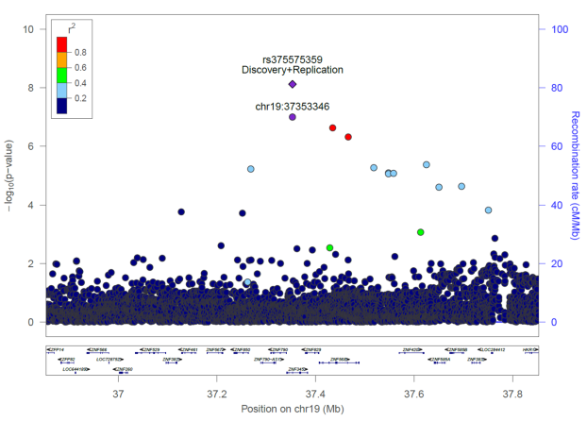
Figure 33. Regional association plot for rs375575359. The y axis represents the negative logarithm (base 10) of the variant P-value and the x axis represents the position on the chromosome, with the name and location of genes and nearest genes shown in the bottom panel. The variant with the lowest P-value in the region after combined discovery and replication is marked by a purple diamond. The same variant is marked by a purple dot showing the discovery P-value. The colours of the other variants indicate their r² with the lead variant. (this figure is adapted from PMID:29559693)¹⁶⁰

rs11335718 on chromosome 4 was associated with OA at any joint in the discovery and knee OA in the replication stage (OR 1.11 (95% CI 1.07-1.16), P-value= 4.26x10⁻⁸, EAF 0.10) (Table 27). rs11335718 is an intronic variant in the annexin A3 gene, ANXA3 (Figure 34). This gene encodes a calcium binding protein that associates with cell membrane phospholipids and plays a role in the regulation of cellular growth and in signal transduction pathways²¹¹⁻²¹³. It has been reported to affect skeletal morphology in animal mouse models, including abnormal digit and tibia morphology. It is differentially expressed in children with craniofacial abnormalities and is suggested to have a role in premature calvarial suture fusion in types of craniosynostosis during osteogenesis²¹⁴. rs2867461, also an intronic variant in ANXA3, and in strong LD with rs11335718, has been associated with rheumatoid arthritis in an Asian population²¹⁵. By meta-analysing the any site OA phenotype across the discovery and replication datasets, a P-value of 1.32x10⁻⁷ is reported.
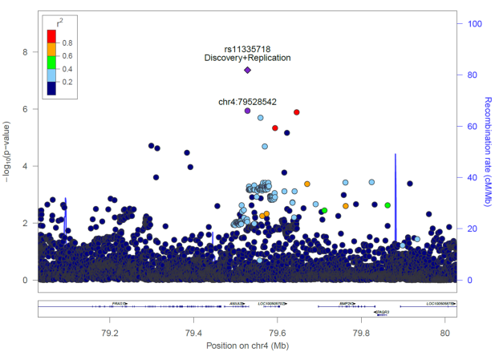
Figure 34. Regional association plot for rs11335718. The y axis represents the negative logarithm (base 10) of the variant P-value and the x axis represents the position on the chromosome, with the name and location of genes and nearest genes shown in the bottom panel. The variant with the lowest P-value in the region after combined discovery and replication is marked by a purple diamond. The same variant is marked by a purple dot showing the discovery P-value. The colours of the other variants indicate their r² with the lead variant. (this figure is derived from PMID:29559693)¹⁶⁰

rs3771501 (OR 0.94 (95% CI 0.92-0.96), P-value=1.66x10⁻⁸, EAF 0.53) was associated with OA at any site and resides in an intron of the transforming growth factor alpha gene, TGFA (Table 27 and Figure 35). TGFA encodes an epidermal growth factor receptor ligand made by most epithelia and is an important integrator of cellular signalling and function^{216,217}. This gene has been associated with cartilage thickness in a GWAS of minimal joint space width (rs2862851, beta= -0.067, P-value=5.2x10⁻¹¹) and is differentially expressed in OA cartilage lesions versus non-lesioned cartilage in the same individuals by the same study²¹⁸. rs2862851 is in very high LD with rs3771501 (r²=0.99). Functional studies have revealed that TGFA controls and regulates the conversion of cartilage to bone during the process of endochondral bone growth, it is dysregulated in degrading cartilage in OA and a strong stimulator of cartilage degradation upregulated by articular chondrocytes in experimentally induced and human OA²¹⁹⁻²²². TGFA has also been associated with craniofacial development, palate closure and decreased body size²¹⁶. The role of TGFA in idiopathic OA should be further investigated.
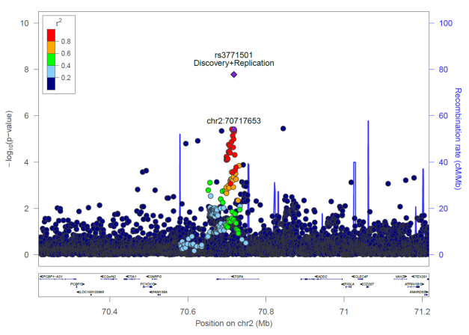
Figure 35. Regional association plot for rs3771501. The y axis represents the negative logarithm (base 10) of the variant P-value and the x axis represents the position on the chromosome, with the name and location of genes and nearest genes shown in the bottom panel. The variant with the lowest P-value in the region after combined discovery and replication is marked by a purple diamond. The same variant is marked by a purple dot showing the discovery P-value. The colours of the other variants indicate their r² with the lead variant. (this figure is derived from PMID:29559693)¹⁶⁰

rs864839 resides in the intronic region of the junctophilin 3 gene (JPH3) on chromosome 16, and was discovered based on the any joint site OA analysis (Figure 36). It was more strongly associated with hip OA in the replication dataset (OR 1.08 (95% CI 1.05-1.11), P-value=2.1x10⁻⁸, EAF 0.71) (Table 27). By meta-analysing the any site OA phenotype across the discovery and replication datasets, P-value=7.02x10⁻⁶ is reported. JPH3 is involved in the formation of junctional membrane structure, regulates neuronal calcium flux and is reported to be expressed in pancreatic beta cells and in the regulation of insulin secretion^{223,224}. JPH3 has been associated with Huntington disease-like 2²²⁵. The functional relevance of JPH3 protein product to OA remains undefined and the indication of junctional membrane complexes stabilization mechanisms contributing to OA pathogenesis need to be investigated.

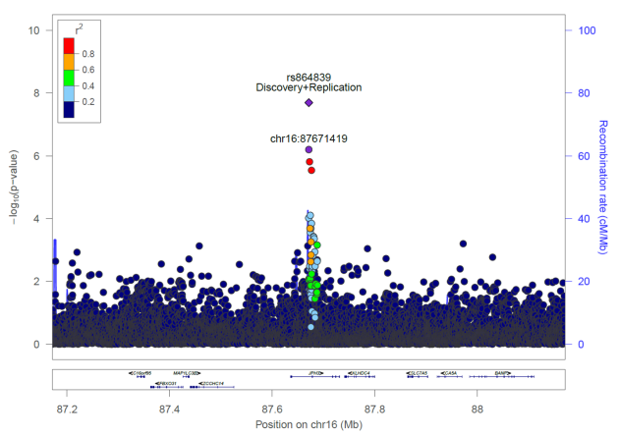
Figure 36. Regional association plot for rs864839. The y axis represents the negative logarithm (base 10) of the variant P-value and the x axis represents the position on the chromosome, with the name and location of genes and nearest genes shown in the bottom panel. The variant with the lowest P-value in the region after combined discovery and replication is marked by a purple diamond. The same variant is marked by a purple dot showing the discovery P-value. The colours of the other variants indicate their r² with the lead variant. (this figure is derived from PMID:29559693)¹⁶⁰

Two further replicating signals were detected that narrowly failed to reach the genome-wide significance threshold. rs116882138 was most strongly associated with hip and/or knee OA in the discovery and with knee OA in the replication dataset (OR 1.34 (95% CI 1.21-1.49), P-value=5.09x10⁻⁸, EAF 0.02) (Table 27). It is an intergenic variant located 11kb downstream of the kinase activator 3B gene, (MOB3B), and 16kb upstream of the equatorin, sperm acrosome associated gene (EQTN) on chromosome 9 (Figure 37). Although MOB3B has been associated with prostate cancer relevant phenotypes^{226,227} its role in OA pathogensis remains undefined.
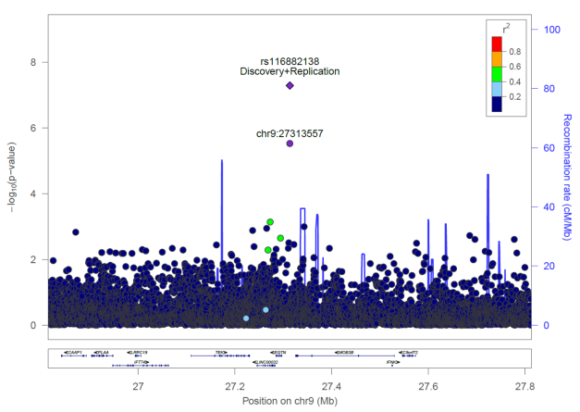
Figure 37. Regional association plot for rs116882138. The y axis represents the negative logarithm (base 10) of the variant P-value and the x axis represents the position on the chromosome, with the name and location of genes and nearest genes shown in the bottom panel. The variant with the lowest P-value in the region after combined discovery and replication is marked by a purple diamond. The same variant is marked by a purple dot showing the discovery P-value. The colours of the other variants indicate their r² with the lead variant. (this figure is derived from PMID:29559693)¹⁶⁰

Finally, rs6516886 was prioritised based on the hip and/or knee OA discovery analysis and was more strongly associated in the hip OA replication dataset (OR 1.10 (95% CI 1.06-1.14), P-value=5.84x10⁻⁸, EAF 0.75) (Table 27). rs6516886 is situated 1kb upstream of the RWD domain containing 2B gene (RWDD2B) on chromosome 21 (Figure 38). LTN1 (listerin E3 ubiquitin protein ligase 1), a protein coding gene which resides at a distance of 28kb from the variant, has been reported to affect musculoskeletal development in a mouse model²²⁸.
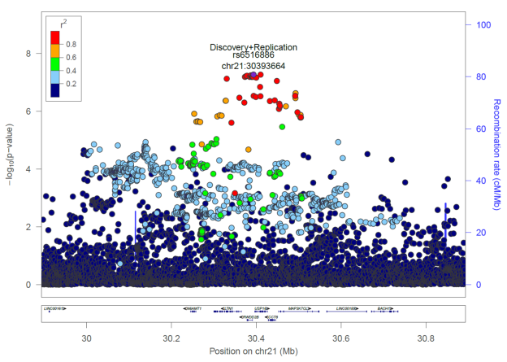
Figure 38. Regional association plot for rs6516886. The y axis represents the negative logarithm (base 10) of the variant P-value and the x axis represents the position on the chromosome, with the name and location of genes and nearest genes shown in the bottom panel. The variant with the lowest P-value in the region after combined discovery and replication is marked by a purple diamond. The same variant is marked by a purple dot showing the discovery P-value. The colours of the other variants indicate their r² with the lead variant. (this figure is derived from PMID:29559693)¹⁶⁰

3.5 Discussion
In order to improve the understanding of the genetic aetiology of osteoarthritis, a study combining genotype data in up to 327,918 individuals has been conducted. Nine novel, robustly replicating loci associated with OA were identified, two of which fall just under the genome-wide significance threshold; this constitutes a substantial increase in the number of known OA loci. Taken together, all established OA loci account for 26.3% of trait variance (Figure 39). The vast majority of novel signals are common frequency variants and confer small to modest effects, in line with a highly polygenic model underpinning OA risk. One low-frequency variant association with OA (MAF 0.02) was identified with a modest effect size (combined OR 1.34). Even though well-powered to detect them, no evidence was found for a role of low frequency variation of large effect in OA susceptibility. Two of the newly identified signals, indexed by rs11780978 and rs2820436, reside in regions with established metabolic and anthropometric trait associations^{203,229,230}. Four signals failed genome-wide significance when meta-analysed with matching phenotypes. This could be explained by variant interpretation by the relevant phenotype but lack of sample size to detect at the genome wide threshold.
Greater homogeneity in the hip category despite the relatively smaller sample size was also observed. Power to replicate established loci was consistently low, primarily due to the UK Biobank lower effect sizes of previously reported loci in this population sample. The disease definition (and thus case ascertainment) is different for UK Biobank compared to clinical cohorts that have been typically used for osteoarthritis genetics discovery studies in the past. Furthermore, several of the established loci are joint, severity, ethnicity and/or sex-specific, adding to the layer of heterogeneity that can dilute power to detect established associations.
OA phenotype aspects were investigated by observing and comparing results when using strict OA phenotype case groups for analysis versus larger sample size case groups but with a more relaxed phenotype definition by defining OA based on both self-reported status and through linkage to HES data, and on joint-specificity of disease (knee and/or hip).
The evaluation of phenotype accuracy showing low sensitivity and high specificity is consistent with a report on heart disease, stroke, bronchitis and depression in the UK Biobank resource²³¹. This same study also evaluated the accuracy of self-reported data for cancer within the cancer register database (which is likely to be more reliable) and suggests that self-reported data could also be of high quality. Published epidemiological studies investigating OA via self-report²³²⁻²³⁷ and validation of self-reported status against primary care records has yielded similar conclusions²³⁴. Hospital diagnosed OA data may not contain all cases and is potentially incomplete, especially for OA which may be a less well recorded disease. Patients with OA are usually hospitalized by the time OA is severe and is treated by total joint replacement. Therefore hospital diagnosed data for OA potentially capture a different patient demographic compared to self-reported data. Furthermore, these two OA definitions have provided very high genetic correlation indicating concordance between them¹⁶⁰ and confirming the high value of self-reported data. Here, self-reported OA definition was found to be a powerful tool for genetic association studies, for example as evidenced by the fact that the established GDF5 OA locus reached genome-wide significance in the self-reported disease status analyses only (Tables 14 and 16). However, the hospital diagnosed OA analyses yielded stronger evidence for effect direction concordance at established loci (Table 13), indicating that a narrower definition of disease may provide better effect size estimates albeit limited by power to identify robust statistical evidence for association.
Based on the results of this evaluation, it is deduced that that there is no gold standard for OA definition in genetics studies, and advantages in employing both methods of defining disease to maximize discovery power across the board are identified.
The key attributes of this study were sample size and the homogeneity of the UK Biobank dataset coupled with independent replication. These findings contribute to a better understanding of OA pathophysiology, taking the number of established OA susceptibility loci from twenty one to thirty and provide insight for future therapeutic OA approaches.

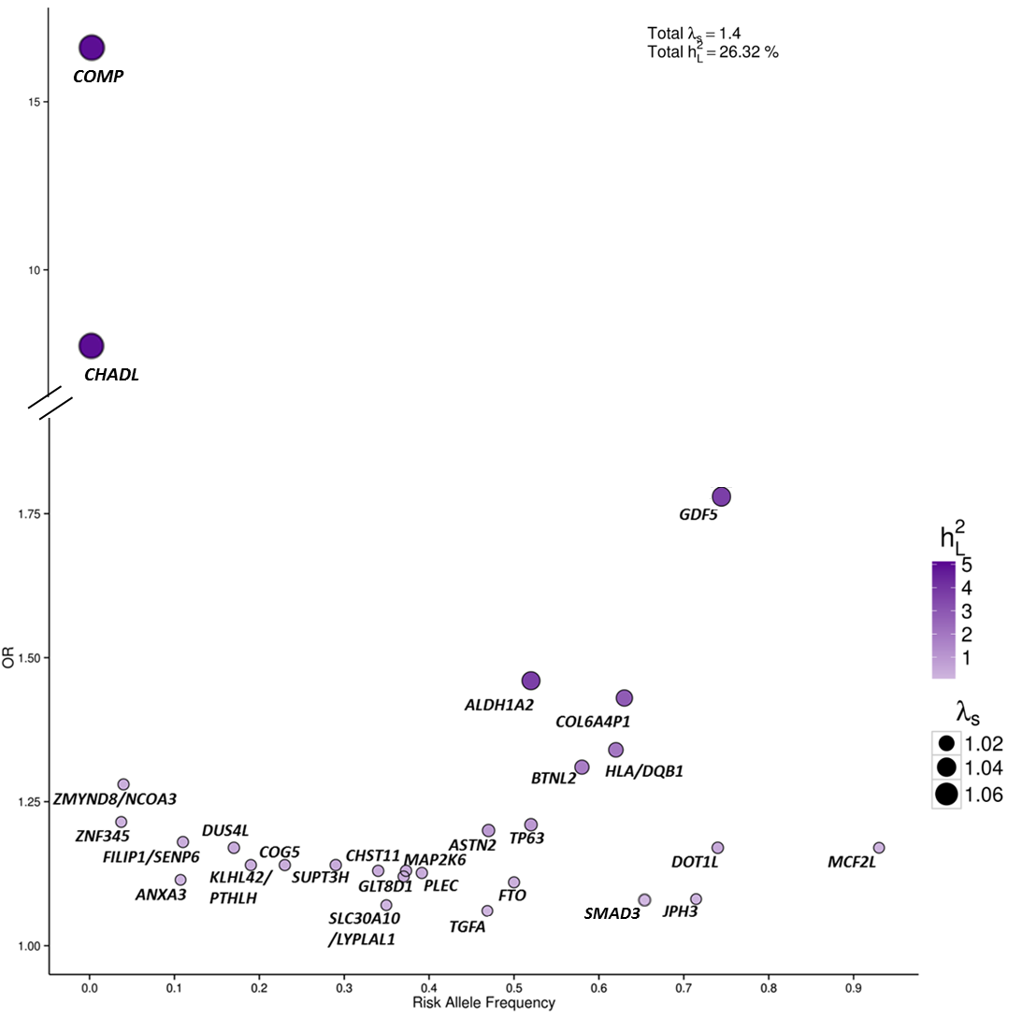

Figure 39. Odds ratios and risk allele frequencies for established and novel OA-associated variants after the UK Biobank 150k study. The sibling relative risk ratio (λ_{s}) for each variant is shown by the different size of each circle. The darker color of the circles shows the percentage of variance explained on the liability scale (h_{2L}) (calculated assuming 10% prevalence of OA). Totals of λ_{s} and h_{2L} are shown at the top. OA, Osteoarthritis. (this figure is derived from PMID:29559693)¹⁶⁰

Chapter 4
UK Biobank 150k gene-based and pathway analysis

4.1 Overview
In this chapter, by using gene-based and pathway analyses, several key genes and a biological pathway were found to be significantly associated with OA phenotypes. Some of these have a previously reported role in OA pathophysiology. Further functional analysis of identified genes and pathways could add knowledge to the field of OA etiopathogenesis.
4.2 Introduction
Gene-set analysis of GWAS data has helped to understand the biology of many common complex disease and traits such as type 2 diabetes, schizophrenia, rheumatoid arthritis, height and waist-to-hip ratio by yielding numerous irrefutable findings²³⁸. The UK Biobank OA analyses consist of large powerful datasets with discovery potential. In order to enhance the comprehensive monitoring of the OA biological system and to further interpret the genetic association results described in chapter 3, genes were tested as units with a gene-based approach using summary statistics data from the UK Biobank OA discovery GWAS across all different phenotype definitions. Following gene analyses, knowledge base driven pathway analyses (gene-set) were conducted in order to associate gene-based results with particular biological processes aiming to identify potential therapeutic research-target biological pathways for OA.

4.3 Methods
Gene-based and gene-set analyses were performed for each of the OA phenotypes separately (self-reported OA, hospital diagnosed OA, hospital diagnosed hip OA, hospital diagnosed knee OA and hospital diagnosed hip and/or knee OA) using MAGMA v1.06²³⁹, and consisted of three steps. First, each gene was assigned the variants located between its start and stop sites based on NCBI (National Center for Biotechnology Information) 37.3 gene definitions with no additional boundary placed around the genes. Second, gene-based analysis was carried out on variant P-values derived from the GWAS results of each phenotype in order to define and compute gene P-values. The ‘snp-wise=mean’ model, which calculates the mean of the χ²-statistic amongst the single variant P-values in each gene was applied. The genotype data from a set of 10,000 controls (subset of the 50,898 controls used in the self-reported OA analysis) were used to estimate LD between SNPs (as measured by r²). P-values generated by MAGMA are not corrected for multiple testing. The genome-wide significance threshold for gene-based associations within-OA phenotype was calculated using the Bonferroni method; α=0.05/number of genes being analysed. For self-reported OA and hospital diagnosed OA α=2.7108x10⁻⁶ (0.05/18,445) and for hospital diagnosed hip OA, hospital diagnosed knee OA and hospital diagnosed hip and/or knee OA α=2.7109x10⁻⁶ (0.05/18,444). Third, a one-sided competitive gene-set analysis was carried out for each phenotype, implemented as a linear regression model on a gene data matrix created internally from the gene-based results. Briefly, it converts the gene-based P-values to z-scores, mapping low P-values onto high positive z-scores and then tests whether the mean of z-scores of all genes in a gene set is greater than that of all other genes. Kyoto Encyclopaedia of Genes and Genomes²⁴⁰ (KEGG) and Reactome^{241,242}, downloaded from MSigDB²⁴³ (version 5.2) on 23 January 2017 were used. Also Gene Ontology²⁴⁴ (GO) biological process and molecular function gene annotations from Ensembl²⁴⁵ (version 87) was downloaded, to ensure comprehensive coverage and to prevent the results from being dependent on the choice of database. To achieve meaningful statistics and interpretation of the results, annotations with the following evidence codes were used: a) Inferred from Mutant Phenotype (IMP) b) Inferred from Physical Interaction (IPI) c) Inferred from Direct Assay (IDA) d) Inferred from Expression Pattern (IEP) and e) Traceable Author Statement (TAS). KEGG/Reactome and GO annotations were analysed separately and only pathways that contained between 20 and 200 genes were included (595 for KEGG/Reactome, 619 for GO). The competitive test, which assesses whether a pathway is more associated with a trait than other pathways, was applied. MAGMA provides a built-in family-wise error rate (FWER) method which uses a permutation procedure to obtain p-values corrected for multiple testing. 10,000 permutations were used in each analysis and the significance threshold was set at α=0.05.
4.4 Results
4.4.1 Gene-based analyses
Following Bonferroni correction for multiple testing, gene-based analyses identified 10 genes significantly associated with self-reported OA, 9 with hospital diagnosed OA, 10 with hospital diagnosed hip OA, 2 with hospital diagnosed knee OA and 6 with hospital diagnosed hip and/or knee OA. All associated genes with a corrected combined P-value are presented in table 29 for each analysis. Notably, ubiquinol-cytochrome c reductase complex assembly factor 1 (UQCC1) and GDF5, located in close vicinity to each other on chromosome 20, were identified as key genes with consistent evidence for significant association with OA across phenotype definitions (Table 29). GDF5 codes for growth differentiation factor 5, a member of the TGFbeta superfamily, is associated with OA and there is accruing evidence that it play a central role in skeletal health and development^{97-100,104,108,110,111,246-250}. UQCC1 is involved in morphogenesis and skeleton growth while polymorphisms in the gene are associated with variation in developmental dysplasia of the hip, spine bone size and height in humans^{108,251-253}. FARP2 (ARH/RhoGEF and pleckstrin domain protein 2) and C2orf82 (secondary ossification center associated regulator of chondrocyte maturation) located in close proximity and interacting with each other, on chromosome 2, were found to be significantly associated with the hospital diagnosed hip OA phenotype (Table 29). FARP2 is reported to be integrally involved in osteoclast podosome rearrangements²⁵⁴. C2orf82 (or SNORC) codes for a cartilage-specific molecule that is expressed in differentiating and adult articular chondrocytes and is suggested to play a regulatory role in chondrocyte phenotype maintenance and development^{255,256}. Further, the PLEC, MAP2K6, RWDD2B and LTN1 genes were also found to be significantly associated genes with OA phenotypes while all four include novel variants significantly associated with OA in the UK Biobank 150k GWAS and meta-analysis (Table 29).

Table 29. Significant gene-based associations with OA.
OA phenotype | Gene | Chr:position | N SNPs | N | Zstat | P-value
self-reported OA | UQCC1 | 20:33890369-33999945 | 404 | 63556 | 6.3569 | 1.03E-10
self-reported OA | GDF5 | 20:34021149-34026027 | 16 | 63556 | 5.5469 | 1.45E-08
self-reported OA | ZHX1-C8orf76 | 8:124238429-124286727 | 134 | 63556 | 5.1917 | 1.04E-07
self-reported OA | KCNH2 | 7:150642044-150675402 | 175 | 63556 | 5.0622 | 2.07E-07
self-reported OA | KIAA1755 | 20:36838907-36889174 | 283 | 63556 | 4.9696 | 3.36E-07
self-reported OA | UBL7 | 8:124232196-124253656 | 59 | 63556 | 4.8351 | 6.65E-07
self-reported OA | ZHX1 | 8:124260690-124287781 | 67 | 63556 | 4.805 | 7.74E-07
self-reported OA | SEMA3F | 3:50192562-50226508 | 120 | 63556 | 4.7905 | 8.32E-07
self-reported OA | RBM5 | 3:50126341-50156397 | 83 | 63556 | 4.7058 | 1.26E-06
self-reported OA | NKAIN1 | 1:31652592-31712734 | 453 | 63556 | 4.6603 | 1.58E-06
self-reported OA | MYH7B | 20:33543704-33590240 | 243 | 63556 | 4.5722 | 2.41E-06
hospital diagnosed OA | UQCC1 | 20:33890369-33999945 | 395 | 50508 | 5.5202 | 1.69E-08
hospital diagnosed OA | CEP250 | 20:34042988-34105360 | 245 | 50508 | 5.2879 | 6.19E-08
hospital diagnosed OA | RWDD2B | 21:30378080-30391685 | 62 | 50508 | 4.7613 | 9.62E-07
hospital diagnosed OA | CCDC12 | 3:46963220-47023500 | 196 | 50508 | 4.7275 | 1.14E-06
hospital diagnosed OA | UACA | 15:70946893-71055932 | 417 | 50508 | 4.6803 | 1.43E-06
hospital diagnosed OA | C20orf173 | 20:34108569-34117481 | 37 | 50508 | 4.6494 | 1.66E-06
hospital diagnosed OA | SCAP | 3:47455184-47517603 | 204 | 50508 | 4.6427 | 1.72E-06
hospital diagnosed OA | GDF5 | 20:34021149-34026027 | 16 | 50508 | 4.6219 | 1.90E-06
hospital diagnosed OA | RBM5 | 3:50126341-50156397 | 80 | 50508 | 4.5795 | 2.33E-06
hospital diagnosed hip OA | OVCH1 | 12:29580489-29650619 | 361 | 11989 | 5.5313 | 1.59E-08
hospital diagnosed hip OA | NGEF | 2:233743396-233877951 | 987 | 11989 | 5.3618 | 4.12E-08
hospital diagnosed hip OA | PLEC | 8:144989321-145050913 | 369 | 11989 | 5.1997 | 9.98E-08
hospital diagnosed hip OA | MAP2K6 | 17:67410838-67538470 | 694 | 11989 | 5.1664 | 1.19E-07
hospital diagnosed hip OA | HDAC9 | 7:18126752-19039135 | 4848 | 11989 | 5.1541 | 1.27E-07
hospital diagnosed hip OA | HDLBP | 2:242166682-242255116 | 536 | 11989 | 5.0034 | 2.82E-07
hospital diagnosed hip OA | GIGYF2 | 2:233562015-233725287 | 800 | 11989 | 4.9855 | 3.09E-07
hospital diagnosed hip OA | KDM4A | 1:44115797-44171189 | 203 | 11989 | 4.957 | 3.58E-07
hospital diagnosed hip OA | FARP2 | 2:242295664-242434256 | 843 | 11989 | 4.8035 | 7.80E-07
hospital diagnosed hip OA | C2orf82 | 2:233733724-233741111 | 42 | 11989 | 4.7518 | 1.01E-06
hospital diagnosed knee OA | RWDD2B | 21:30378080-30391685 | 61 | 22347 | 4.8123 | 7.46E-07
hospital diagnosed knee OA | P2RY6 | 11:72975550-73009670 | 178 | 22347 | 4.6352 | 1.78E-06
hospital diagnosed hip and/or knee OA | RWDD2B | 21:30378080-30391685 | 61 | 32970 | 6.3452 | 1.11E-10
hospital diagnosed hip and/or knee OA | CCT8 | 2130428647-30446010 | 85 | 32970 | 5.6566 | 7.72E-09
hospital diagnosed hip and/or knee OA | USP16 | 21:30396938-30426809 | 103 | 32970 | 5.5133 | 1.76E-08
hospital diagnosed hip and/or knee OA | LTN1 | 21:30300466-30365277 | 290 | 32970 | 5.3552 | 4.27E-08
hospital diagnosed hip and/or knee OA | UQCC1 | 20:33890369-33999945 | 394 | 32970 | 4.9493 | 3.72E-07
hospital diagnosed hip and/or knee OA | CEP250 | 20:34042988-34105360 | 243 | 32970 | 4.7673 | 9.34E-07
Chr:pos, chromosome:position; all data are displayed in GRCh37.p13 coordinates; N SNPs, number of SNPs annotated to that gene that were found in the data and passed quality control; N, sample size used when analysing that gene; Zstat, Z-value for the gene; OA, osteoarthritis

4.4.2 Pathway analyses
Pathway analyses yielded a significant gene-set association between hospital diagnosed knee OA and glycosaminoglycan biosynthesis heparan sulfate (P-value=5.29x10⁻⁵, FWER P-value 0.025) (Table 30). Heparan sulfate binds to a variety of molecules includingmorphogens, growth factors, chemokines and extracellular matrix components^{257,258}. Altered biosynthesis leads to human disorders. Heparan sulfate has been reported as a cartilage damage-associated molecular pattern interacting with nuclear factor-kappa B and is suggested to play a role in in the progression and pathogenesis of OA and the osteophyte development in knee OA in mice²⁵⁹⁻²⁶¹.
Table 30. Gene-set significantly associated with hospital diagnosed knee OA at 5% family-wise error rate (FWER).
Gene set
GLYCOSAMINOGLYCAN BIOSYNTHESIS HEPARAN SULFATE
database | N genes | competitive P-value | FWER | nominally significant genes | gene P-value
KEGG | 25 | 5.29E-05 | 0.0254 | HS2ST1 | 0.022933
 |  |  |  | B3GAT1 | 0.027023
 |  |  |  | XYLT2 | 0.028706
Nominally significant genes (P-value≤0.05). OA, Osteoarthritis; KEGG, Kyoto Encyclopaedia of Genes and Genomes

4.5 Discussion
Out of the thirty one unique genes that were found to be significantly associated with OA phenotypes and therefore hold a potential relationship with the disease development, four have a reported role in OA pathophysiology in the literature and four contain variants that were associated with OA by the UK Biobank 150k and deCODE meta-analysis (described in chapter 3). Further, focusing on region-based analyses and taking into consideration the SNPs’ correlation within a gene may increase study power to identify causal variants and provide insight into the biologic aetiology of OA, as identified in other common complex disease²⁶². Using gene-set analysis I identified association of knee OA with heparan sulfate biosynthesis that is also reported to be involved in OA mechanisms. The targeting of this process is a potential therapeutic strategy for treatment of OA^{259,260}. These knowledge base-driven findings may provide clues and explanatory power that will help clarify the pathogenic mechanisms of OA and therefore guide drug discovery.
Gene-based and pathway-based analyses can reduce complexity in genome-wide analyses, providing a higher-level view of biological processes implicated in disease development. One of the main aims of genome-wide association studies is to identify risk variants associated with disease susceptibility, and to employ statistical and experimental fine-mapping techniques in order to link these potentially causal variants to effector genes⁷⁴. Gene-based analysis aggregates information on association signal within the genic functional unit, and can bring together different lines of evidence, gathered from the association summary statistics of multiple different variants located within the same gene. Similarly, an overarching aim of genetic association studies in complex diseases is the identification of biological processes, which when perturbed, can lead to increased risk of disease²⁶³. Different factors acting within different steps of these patwhays can have similar downstream effects on gene function and regulation. Therefore, pathway-based analyses can help strengthen signal by combining information for association across genes involved in established biological pathways. One limitation of this approach is that the analysis relies heavily on the annotation of human genes and pathways. To mitigate against this to the extent currently possible, we used KEGG, Reactome and GO-annotated biological processes. Pathway-based analyses will undoubtedly increase in power and resolution as pathway and gene anntotation improves in accuracy going forward.
The analyses in this chapter can give rise to mechanistic hypotheses that can subsequently be tested in experimental models of disease, for example in animal or cellular models. Furthermore, several well-powered functional genomics studies employing multi-omics (transcriptomics, proteomics and methylation analyses primarily) in primary OA tissue have started to arise in the literature^{264,265}. Pathway-based analyses of these molecular readouts in primary cartilage have also started to identify key biological processes implicated in osteoarthritis development and progression. Going forward, the integration of genetic with functional genomics data will provide the opportunity to more comprehensively examine the aetiopathological underpinning of OA, and to give rise to candidate targets for intervention.

Chapter 5
Arthroplasty and the Genetics of Osteoarthritis- The ARGO study
5.1 Overview
In this chapter the results of the first hip and knee OA GWAS in the Greek population along with comparative results of previously established OA loci are presented. Three loci yielded suggestive evidence for association with OA, two of which nominally replicated in independent cohorts. By evaluating the replication and concordance of effect of OA reported variants, greater homogeneity was observed in the hip OA phenotype, while inconsistency was detected for variants established in discovery studies of different ethnic groups. Larger sample sizes are needed to further replicate established associations in this population and detect loci at the genome-wide significance level.
5.2 Introduction
At the time of this study design (February 2015) the genetic variation of OA at the genome-wide level, had not been explored in the Greek population. The largest OA Greek GWAS to date, the ARGO study, was set up to investigate the genetic architecture of hip and knee OA in this population. In order to achieve that, a hospital-based collection of primary OA patients from Greece undergoing total knee and/or hip arthroplasty was established. The target was to recruit at least 1500 incident and historical OA cases that fulfilled the inclusion criteria and carry out genome wide association scans, aiming to explore the replication and direction of effect of established OA loci and detect novel variants with evidence for association with OA, whilst noting the study’s power limitations. The Larissa study analyses, described in chapter 2 of this thesis and including knee OA phenotype only, were conducted during the time of ARGO sample collection. The ARGO study includes analyses of the hip OA phenotype as well and the sample size is bigger. Therefore Larissa data was used as an independent Greek replication cohort for the ARGO study’s findings. As the field of OA genetics is rapidly developing, further loci are added to the list of OA susceptibility together with the novel findings from UK Biobank GWAS and meta-analyses (described in chapter 3 of this thesis). In the ARGO study all established OA variants by the time of analyses (early in 2018) were examined for the first time.
5.3 Methods
5.3.1 Study sample collection setting
The ARGO collection was conducted in three public hospitals (Attikon University General Hospital of Athens, Nea Ionia General Hospital Konstantopouleio, and KAT Hospital) and one private hospital (Lefkos Stavros General Hospital) in the city of Athens, Greece between February of 2015 and March 2017. All studies were approved by the relevant hospital Institutional Review Board and conducted in accordance with the principles set out in the Declaration of Helsinki. All patients provided written informed consent prior to participation (Ethics approvals and English translations are displayed in Appendix (Appendix 3, page 218).
All participants provided written informed consent for the study (patient information sheet and consent form, translated into English, are displayed in Appendix (Appendix 4 and 5, pages 230 and 234). Incident cases were approached at the time of their recovery from surgery in the hospital wards. Some historical cases (about 10% of the total samples collected) were also recruited as outpatients coming in the hospital for their follow up. All identifiable information of the volunteer including name, date of birth and medical record number were removed from the samples and the questionnaires. All cases were given a code. Identifiable information was collected so as to avoid double participation of volunteers but was kept in a separate confidential database. Consent forms were not coded and all data were stored in locked cabinets and password protected computers. All phenotype data was double- entered and archived according to Good Clinical Practice principles. The DNA collection was carried out using saliva kits, which is a non-invasive technique.
5.3.2 Case entry criteria
Only individuals of Greek ancestry were eligible for the study due to the need for sample homogeneity. The participant birthplace, maternal and paternal origin were recorded. Exclusion criteria were total joint replacement due to inflammatory arthritis, Pagets’ disease affecting the index joint, previous intra-articular fracture and primary osteonecrosis. All patients had a pre-operative radiograph K/L score⁶ ≥2. Pre-operational radiographs were obtained and assessed at the time of recruitment. X-rays from historical cases were retrieved from the hospital archive and quantitated by the same examiner as for the incident cases. Relevant phenotype data were also collected by questionnaire, which included information on sex, age, number of affected joints, history and reason for TJRs, biometric measurements (height, weight) to enhance analysis space in the future and the Oxford hip and Knee scores^{266,267} to ensure the collection of clinically advanced OA cases. The Oxford hip and knee scores are graded from 0 to 48, with 48 representing symptom-free individuals and 0 representing then most severe symptoms. The ARGO hip and knee cohorts had a mean of 18.04 (SD± 7.2) and 17.2 (SD± 7.1), respectively. Scores of less than 27 are suggested to be poor²⁶⁸, ensuring recruitment of severe OA cases (ARGO questionnaire and Oxford knee and hip scores are displayed in Appendix (Appendix 6, 7 and 8, pages 236, 241 and 244 respectively)). At that point, an additional 173 new blood DNA knee OA samples from the city of Larissa in Greece (some of which had no documented gender information) were obtained and added to the ARGO study case population. Information on these samples’ collection and recruitment criteria are same as described in Chapter 2, page 64 and comply with the ARGO collection population criteria.
5.3.3 Controls
The control cohort comprised individuals participating in a study designed to investigate the potential overlap of metabolic and psychiatric diseases in the Greek population, the GOMAP study²⁶⁹. Participating individuals had been screened for OA and for hip or knee arthroplasty and these were excluded from the cohort. Only individuals of Greek ancestry were eligible for this study as with ARGO.
5.3.4 DNA extraction, genotyping, sample and SNPs QC
1,514 saliva and blood samples were sent to the Wellcome Trust Sanger Institute for DNA extraction and to be quantitated for dsDNA yield (ng/ml). Genotyping was also carried out at the Wellcome Trust Sanger Institute for both cases and controls. Case samples were genotyped using the Illumina Infinium HumanCoreExome-24 array, and control samples using the Illumina HumanCoreExome-12 array. These arrays have a high number of overlapping variants. QC checks were performed for case samples and SNPs. Before imputation extra QC checks were performed, including the merging of cases and controls datasets and checking for duplicates, related individuals and ethnic outliers by a working team at the Sanger Institute. At this point overlapping variants between the datasets were extracted.
5.3.5 Imputation and association analyses
Genotype data of cases and controls was uploaded to the Michigan HRC⁴⁶ server to provide imputed genomes. Further filtering for overall HWE P-value≤10⁻⁴, and info score <0.4 was applied. Nine GWAS in total were conducted, separately for site and gender, in line with the site and sex-specific heterogeneity of OA that is reflected by the so far established loci. Sex-specific analyses were conducted to enhance meta-analysis space in the future. All association analyses were carried out using the linear mixed model in Genome-wide Efficient Mixed Model Association²⁷⁰ (GEMMA version 0.94.1) with adjustment for the first 10 principal components accounting for population structure and relatedness. Principal component analyses was carried out in EIGENSOFT¹⁵⁷. A two-sided P-value≤0.05 was used as a threshold for nominal significance and P-value≤5x10⁻⁸ as the genome wide significance threshold. The study power calculations were conducted using Quanto v1.2.4¹⁵⁸. Data is presented for 19 independent established OA loci (excluding the two very rare hip OA loci from the Icelandic population) and also for seven out of nine newly identified OA loci (described in Chapter 3 of thesis) that were present in these datasets.

5.4 Results
5.4.1 Subject characteristics
Subject characteristics are displayed in table 31.
Table 31. Subject characteristics.
 | Cases |  | Controls
 | Athens samples | Larissa samples | GOMAP samples
N | 993 |  | 2,538
N | 917 | 76 | 2,538
Female, N (%) | 669 (67.4) |  | 1,075
Male, N (%) | 324 (32.3) |  | 1,463
Mean age at recruitment in years (±SD) | 67.4 (±6.3) | N/A | 50.22 (±14.03)
BMI (±SD) | 29.96 (±4.12) | N/A | 27.58 (±5.77)

SD, standard deviation; N, sample size; BMI, body mass index (kg/m²)

5.4.2 Sample and SNPs QC results
The number of control samples and SNPs already QCed was 2,611 and 524,271 respectively²⁶⁹. After DNA quantitation the number of case samples was 1,149 (307 males, 705 females and 137 unknown). In terms of QC, samples were pre-filtered with call rate <90% (31 samples excluded), as with the control population. Checking for gender discrepancies using PLINK threshold 0.2 (the genotype gender information was used where it was not available) (Figure 40), excess heterozygosity at MAF≥1% and MAF<1% (Figures 41 and 42), duplicates (Figure 43) and ethnicity (ARGO vs 1000 Genomes Project data) (Figures 44 and 45) was conducted.
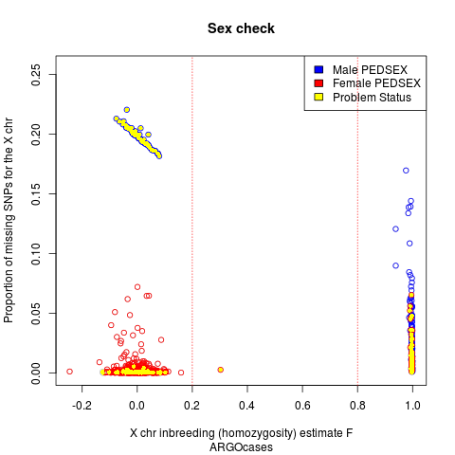
Figure 40. ARGO cases gender discrepancies; 2 samples outside PLINK threshold 0.2 excluded.

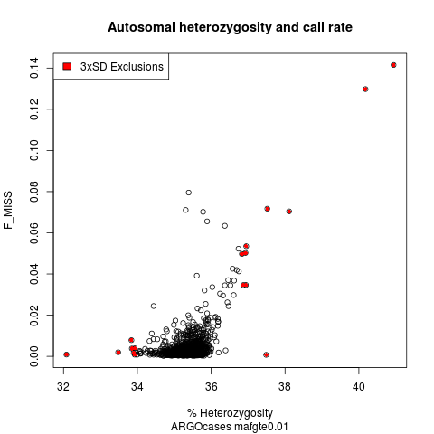
Figure 41. ARGO cases heterozygosity at MAF≥1%; 10 samples excluded. MAF, minor allele frequency.
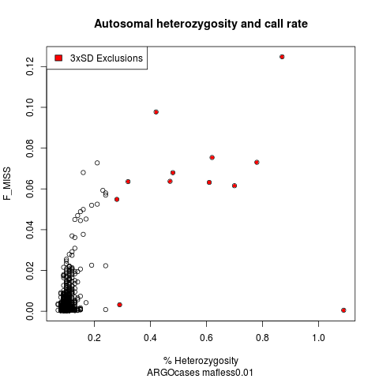
Figure 42. ARGO cases heterozygosity at MAF<1%; 12 samples excluded. MAF, minor allele frequency.
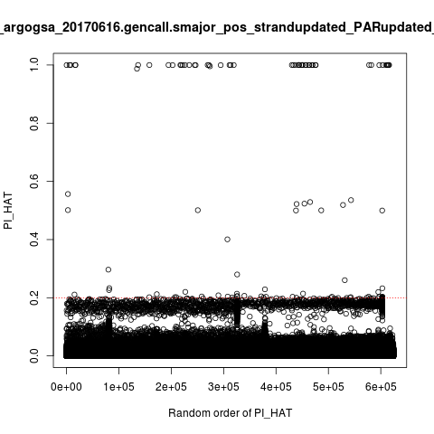
Figure 43. ARGO case duplicates; 51 duplicate pairs with PI_HAT>0.9 (one of which triple) so 50 samples excluded.

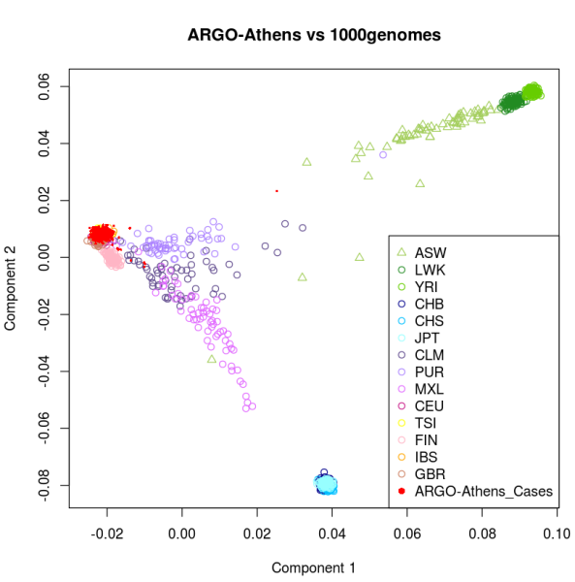

Figure 44. Multidimensional Scaling (MDS) analysis of ARGO cases combined with populations from the 1000 Genomes Project before sample exclusions; 13 outlier samples excluded. Individuals from ARGO are depicted by red solid circles and cluster closer to the other European-ancestry individuals. Abbreviations: ASW, Americans of African ancestry in southwestern USA; LWK, Luhya in Webuye, Kenya; YRI, Yoruba in Ibadan, Nigeria; CHB, Han Chinese in Beijing, China; CHS, Southern Han Chinese; JPT, Japanese in Tokyo, Japan; CLM, Colombians from Medellin, Colombia; PUR, Puerto Ricans from Puerto Rico; MXL, Mexican ancestry from Los Angeles, USA; CEU, Utah residents with Northern and Western European ancestry; TSI, Toscani in Italy; FIN, Finnish in Finland; IBS, Iberian population in Spain and GBR, British in England and Scotland.

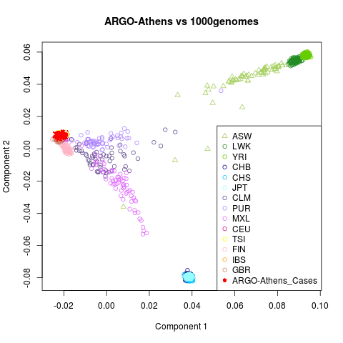
Figure 45. Multidimensional Scaling (MDS) analysis of ARGO cases combined with populations from the 1000 Genomes Project after 13 sample exclusions. Individuals from ARGO are depicted by red solid circles and cluster closer to the other European-ancestry individuals. Abbreviations: ASW, Americans of African ancestry in southwestern USA; LWK, Luhya in Webuye, Kenya; YRI, Yoruba in Ibadan, Nigeria; CHB, Han Chinese in Beijing, China; CHS, Southern Han Chinese; JPT, Japanese in Tokyo, Japan; CLM, Colombians from Medellin, Colombia; PUR, Puerto Ricans from Puerto Rico; MXL, Mexican ancestry from Los Angeles, USA; CEU, Utah residents with Northern and Western European ancestry; TSI, Toscani in Italy; FIN, Finnish in Finland; IBS, Iberian population in Spain and GBR, British in England and Scotland.

Following QC, the number of cases was 1,039 (after excluding a total of 110 unique outliers) (Table 32). SNPs were excluded with call rate <98% as with the control population, HWE P-value<10⁻⁴ and a cluster separation score <0.4. The directly typed SNPs, for cases and controls, before and after QC were 551,782 and 512,700 respectively.

Table 32. ARGO cases sample exclusions after QC.
QC steps | number of sample exclusions
number of samples | 1,149
prefilter call rate (90%) | 31
heterozygosity MAF≥1% | 10
heterozygosity MAF<1% | 12
sex check | 2
duplicates | 50
ethnicity | 13
number of samples to exclude | 118 (110 unique)
number of samples remaining | 1,039
QC, quality control; MAF, minor allele frequency.
5.4.3 Association analyses results
The remaining cases and controls, were 993 and 2,538 respectively, after merging and performing extra QC checks. A total of ~39,200,000 directly typed or imputed SNPs were used for the association analyses. Information on the sample sizes and number of SNPs per analysis for each of the phenotypic datasets is displayed in table 33.
Table 33. ARGO study analyses.
Site | Gender | N cases | N controls | number of SNPs per analysis
Hip and/or knee | both | 993 | 2538 | 39,256,574
Hip | both | 239 | 2538 | 39,226,166
Knee | both | 754 | 2538 | 39,247,426
Hip and/or knee | females | 669 | 1075 | 39,112,667
Hip and/or knee | males | 324 | 1463 | 39,121,112
Hip | females | 166 | 1075 | 38,992,418
Hip | males | 73 | 1463 | 39,078,235
Knee | females | 503 | 1075 | 39,079,455
Knee | males | 251 | 1463 | 39,108,434
N, sample size; SNPs, single nucleotide polymorphisms
As expected (given the small sample size) QQ and Manhattan plots for hip and/or knee OA were flat with a λ=1.0025 (at MAF ≥0.01), giving no genome wide significant signals (Figures 46 and 47).
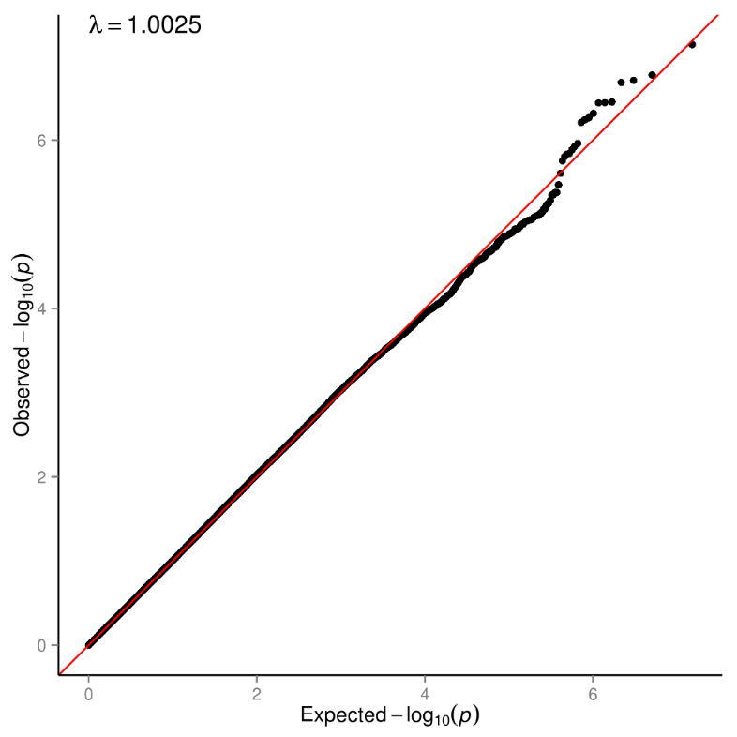
Figure 46. ARGO hip and/or knee OA QQ plot at MAF≥1%. The red line represents the observed vs expected log p-value distribution (genomic inflation factor λ=1.0025). MAF, minor allele frequency.

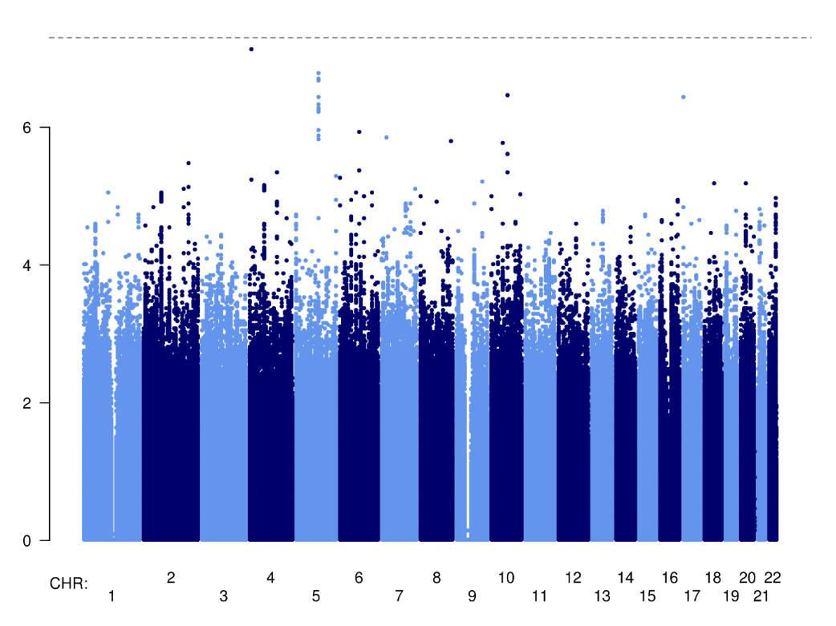
Figure 47. ARGO hip and/or knee OA Manhattan plot at MAF≥1%. The dotted line is set at 5x10⁻⁸ (which is the genome wide significance threshold). MAF, minor allele frequency.

Three signals showed suggestive evidence for association (with P-value<10⁻⁶) (Table 34).
Table 34. Association summary statistics of ARGO hip and/or knee OA signals with P-value<10⁻⁶
rsID | Chr:position | EA | EAF | OR (95% CI) | P-value | infoscore
rs6850444 | 4:122351715 | C | 0.31 | 1.3 (1.16-1.45) | 4.15E-06 | 0.98
rs6480524 | 10:53626998 | G | 0.26 | 1.36 (1.2-1.55) | 1.60E-06 | 0.86
rs74485449 | 17:5669146 | A | 0.06 | 2.13 (1.58-2.87) | 3.19E-07 | 0.57
Chr:position, chromosome:position; EA, effect allele; OR, odds ratio; CI, confidence interval; infoscore, imputation accuracy score

5.4.4 Replication of findings
The three signals with P-value<10⁻⁶ (Table 34) were looked up in the UK Biobank 150k self-reported OA and hospital diagnosed OA datasets (described in chapter 3 of thesis) and in the Greek population from the Larissa study (described in chapter 2 of thesis). rs6850444 nominally replicated with the UK Biobank 150k self-reported OA phenotype (P-value=0.03, OR (95% CI) 1.03 (1.003-1.06)) (Table 35) and rs6480524 nominally replicated with Larissa dataset (P-value=0.02, OR (95% CI) 1.39 (1.05-1.84)) (Table 36), showing suggestive evidence for association.
Table 35. Replication summary statistics of ARGO hip and/or knee OA signals with P-value<10⁻⁶ in self-reported OA and hospital diagnosed OA UK Biobank datasets.
 |  |  | self reported OA |  | hospital diagnosed OA
rsID | EA | EAF | OR (95% CI) | P-value | OR (95% CI) | P-value
rs6850444 | C | 0.35 | 1.03 (1.003-1.06) | 0.031 | 1.02 (0.99-1.06) | 0.157
rs6480524 | G | 0.24 | 0.99 (0.96-1.02) | 0.736 | 0.996 (0.96-1.03) | 0.920
rs74485449 | A | 0.05 | 0.98 (0.92-1.05) | 0.520 | 0.98 (0.91-1.05) | 0.451
OA, osteoarthritis; EA, effect allele; OR, odds ratio; CI, confidence interval
Table 36. Replication summary statistics of ARGO hip and/or knee OA signals with P-value<10⁻⁶ in Larissa dataset.
rsID | Chr:position | EA | EAF | OR (95% CI) | P-value
rs6850444 | 4:122351715 | C | 0.31 | 1.01 (0.79-1.29) | 0.912
rs6480524 | 10:53626998 | G | 0.25 | 1.39 (1.05-1.84) | 0.022
rs74485449 | 17:5669146 | A | 0.06 | 0.81 (0.46-1.41) | 0.473
OA, osteoarthritis; EA, effect allele; OR, odds ratio; CI, confidence interval; Chr, chromosome
5.4.5 Established OA loci in ARGO datasets
Replication of common and low frequency established OA loci present in the ARGO datasets was examined. One polymorphism, rs9350591 (EAF 0.09, OR 1.2, 95% CI 1.01 to 1.44, P-value 0.048), out of 26 yielded nominal association with OA in ARGO hip and/or knee OA. This SNP was associated with hip OA in the discovery study (Table 37). rs12982744 (EAF 0.42, OR 1.14, 95% CI 1.02 to 1.28, P-value 0.02), rs864839 (EAF 0.37, OR 0.86, 95% CI 0.76 to 0.98, P-value 0.02) and rs2521349 (EAF 0.46, OR 1.15, 95% CI 1.02 to 1.28, P-value=0.018) yielded nominal association with knee OA in ARGO, two of these polymorphisms were initially associated with hip OA in discovery studies and one with OA at any site (Table 38). Three established loci associated with ARGO hip OA at the nominal significance level; rs9350591 (EAF 0.09, OR 1.69, 95% CI 1.21 to 2.35, P-value 0.002), rs10492367 (EAF 0.15, OR 1.45, 95% CI 1.11 to 1.9, P-value 0.006) and rs12901071 (EAF 0.33, OR 0.78, 95% CI 0.63 to 0.97, P-value 0.026). Two of them were associated with hip OA phenotype in discovery studies and one with hip and/or knee OA (Table 39).

Table 37. Association summary statistics for common and low frequency established OA loci present in ARGO hip and/or knee OA.
index variant | site discovery | ARGO EA | ARGO EAF | ARGO OR (95% CI) | ARGO P-value
rs7639618 | knee | T | 0.16 | 1.07 (0.93-1.22) | 0.330
rs12107036 | knee | A | 0.44 | 0.92 (0.82-1.02) | 0.095
rs6976 | hip & knee | T | 0.43 | 0.93 (0.84-1.03) | 0.210
rs10947262 | knee | T | 0.07 | 0.92 (0.75-1.12) | 0.403
rs7775228 | knee | C | 0.09 | 0.96 (0.79-1.16) | 0.714
rs10948172 | hip & knee | G | 0.27 | 0.99 (0.88-1.11) | 0.865
rs9350591 | hip | T | 0.09 | 1.20 (1.01-1.44) | 0.0498
rs3815148 | knee & hand | C | 0.20 | 1.02 (0.89-1.16) | 0.756
rs4730250 | knee | G | 0.14 | 0.99 (0.86-1.14) | 0.904
rs4836732 | hip | T | 0.49 | 1.02 (0.91-1.13) | 0.753
rs835487 | hip | G | 0.34 | 0.97 (0.87-1.08) | 0.572
rs10492367 | hip | T | 0.15 | 1.10 (0.95-1.27) | 0.173
rs11842874 | hip & knee | G | 0.06 | 1.08 (0.88-1.32) | 0.484
rs3204689 | hand | C | 0.38 | 0.94 (0.85-1.05) | 0.291
rs12901071 | hip & knee | G | 0.33 | 0.91 (0.81-1.03) | 0.120
rs8044769 | hip & knee | T | 0.45 | 0.98 (0.89-1.09) | 0.720
rs12982744 | hip | G | 0.42 | 1.08 (0.98-1.2) | 0.137
rs143383 | hip & knee | G | 0.41 | 0.90 (0.81-1) | 0.052
rs6094710 | hip | A | 0.07 | 1.08 (0.86-1.37) | 0.508
rs2820436 | any site OA | A | 0.28 | 1.06 (0.95-1.19) | 0.303
rs3771501 | any site OA | G | 0.47 | 0.96 (0.87-1.07) | 0.440
rs11780978 | hip | A | 0.42 | 0.94 (0.85-1.95) | 0.262
rs116882138 | hip & knee | A | 0.01 | 0.75 (0.37-1.53) | 0.404
rs864839 | any site OA | G | 0.37 | 0.90 (0.8-1.01) | 0.089
rs2521349 | hip | A | 0.46 | 1.11 (1-1.23) | 0.050
rs6516886 | hip & knee | A | 0.32 | 1.02 (0.91-1.15) | 0.632
EA, effect allele; EAF, effect allele frequency; OR, odds ratio; CI, confidence interval; OA, osteoarthritis

Table 38. Association summary statistics for common and low frequency established OA loci present in ARGO knee OA.
index variant | site discovery | ARGO EA | ARGO EAF | ARGO OR (95% CI) | ARGO P-value
rs7639618 | knee | T | 0.16 | 1.03 (0.88-1.2) | 0.680
rs12107036 | knee | A | 0.44 | 0.93 (0.83-1.04) | 0.208
rs6976 | hip & knee | T | 0.43 | 0.90 (0.8-1.01) | 0.086
rs10947262 | knee | T | 0.07 | 0.91 (0.73-1.13) | 0.386
rs7775228 | knee | C | 0.09 | 0.90 (0.73-1.11) | 0.320
rs10948172 | hip & knee | G | 0.27 | 0.96 (0.84-1.1) | 0.543
rs9350591 | hip | T | 0.09 | 1.10 (0.9-1.35) | 0.333
rs3815148 | knee & hand | C | 0.20 | 1.01 (0.88-1.17) | 0.840
rs4730250 | knee | G | 0.14 | 0.98 (0.84-1.15) | 0.845
rs4836732 | hip | T | 0.49 | 1.05 (0.94-1.18) | 0.399
rs835487 | hip | G | 0.34 | 0.97 (0.87-1.09) | 0.622
rs10492367 | hip | T | 0.15 | 1.01 (0.86-1.18) | 0.926
rs11842874 | hip & knee | G | 0.07 | 1.22 (0.97-1.52) | 0.085
rs3204689 | hand | C | 0.38 | 0.91 (0.82-1.03) | 0.134
rs12901071 | hip & knee | G | 0.33 | 0.95 (0.83-1.08) | 0.401
rs8044769 | hip & knee | T | 0.45 | 0.99 (0.89-1.11) | 0.876
rs12982744 | hip | G | 0.42 | 1.14 (1.02-1.28) | 0.02012
rs143383 | hip & knee | G | 0.41 | 0.90 (0.80-1.01) | 0.062
rs6094710 | hip | A | 0.07 | 1.03 (0.79-1.33) | 0.852
rs2820436 | any site OA | A | 0.28 | 1.08 (0.95-1.22) | 0.248
rs3771501 | any site OA | G | 0.46 | 0.95 (0.85-1.06) | 0.319
rs11780978 | hip | A | 0.43 | 0.99 (0.88-1.11) | 0.832
rs116882138 | hip & knee | A | 0.01 | 0.66 (0.30-1.43) | 0.282
rs864839 | any site OA | G | 0.37 | 0.86 (0.76-0.98) | 0.02103
rs2521349 | hip | A | 0.46 | 1.15 (1.02-1.28) | 0.0176
rs6516886 | hip & knee | A | 0.32 | 1.05 (0.93-1.19) | 0.428
EA, effect allele; EAF, effect allele frequency; OR, odds ratio; CI, confidence interval; OA, osteoarthritis

Table 39. Association summary statistics for common and low frequency established OA loci present in ARGO hip OA.
index variant | site discovery | ARGO EA | ARGO EAF | ARGO OR (95% CI) | ARGO P-value
rs7639618 | knee | T | 0.16 | 1.28 (0.99-1.65) | 0.060
rs12107036 | knee | A | 0.44 | 0.90 (0.74-1.09) | 0.294
rs6976 | hip & knee | T | 0.44 | 1.02 (0.84-1.23) | 0.877
rs10947262 | knee | T | 0.08 | 0.95 (0.66-1.35) | 0.760
rs7775228 | knee | C | 0.10 | 1.08 (0.77-1.51) | 0.664
rs10948172 | hip & knee | G | 0.27 | 1.04 (0.83-1.28) | 0.776
rs9350591 | hip | T | 0.09 | 1.69 (1.21-2.35) | 0.00192
rs3815148 | knee & hand | C | 0.20 | 1.08 (0.85-1.37) | 0.543
rs4730250 | knee | G | 0.14 | 1.05 (0.8-1.37) | 0.742
rs4836732 | hip | T | 0.48 | 0.89 (0.73-1.08) | 0.221
rs835487 | hip | G | 0.34 | 0.98 (0.80-1.19) | 0.839
rs10492367 | hip | T | 0.15 | 1.45 (1.11-1.9) | 0.00633
rs11842874 | hip & knee | G | 0.06 | 0.74 (0.5-1.1) | 0.149
rs3204689 | hand | C | 0.38 | 1.05 (0.87-1.27) | 0.609
rs12901071 | hip & knee | G | 0.33 | 0.78 (0.63-0.97) | 0.02641
rs8044769 | hip & knee | T | 0.46 | 0.97 (0.8-1.17) | 0.745
rs12982744 | hip | G | 0.41 | 0.95 (0.79-1.16) | 0.635
rs143383 | hip & knee | G | 0.41 | 0.90 (0.74-1.09) | 0.280
rs6094710 | hip | A | 0.07 | 1.30 (0.84-2.01) | 0.231
rs2820436 | any site OA | A | 0.28 | 1.00 (0.81-1.23) | 0.979
rs3771501 | any site OA | G | 0.47 | 1.03 (0.86-1.24) | 0.735
rs11780978 | hip | A | 0.42 | 0.86 (0.71-1.05 | 0.142
rs116882138 | hip & knee | A | 0.01 | 1.00 (0.27-3.73) | 0.995
rs864839 | any site OA | G | 0.38 | 1.04 (0.84-1.29) | 0.716
rs2521349 | hip | A | 0.45 | 0.97 (0.8-1.18) | 0.749
rs6516886 | hip & knee | A | 0.32 | 0.94 (0.76-1.15) | 0.549
EA, effect allele; EAF, effect allele frequency; OR, odds ratio; CI, confidence interval; OA, osteoarthritis

The concordance of direction of effect between the published and newly identified (see Chapter 3 of thesis) OA associated SNPs present in ARGO hip and/or knee, ARGO hip and ARGO knee OA datasets and the ARGO risk alleles was investigated using a binomial test. The false discovery rate (5% FDR) procedure was applied to correct for multiple testing as the datasets are not independent. Nominally significant evidence was found for concordance between the reported direction of effect and the ARGO hip OA analysis (FDR q-value=0.046) (Table 40).
Table 40. Binomial test for directional concordance between reported effects at established OA loci and the discovery analysis across OA definitions.
Analysis | Number of successes | Number of trials | Uncorrected binomial P-value | FDR binomial q-value
ARGO hip and/or knee OA | 14 | 26 | 0.423 | 0.423
ARGO hip OA | 19 | 26 | 0.016 | 0.046
ARGO knee OA | 14 | 26 | 0.423 | 0.423
OA: osteoarthritis; FDR: False discovery rate

5.4.6 Study power calculations to replicate established loci
Study power calculations were conducted in order to determine the study’s observed power, and the sample size needed to detect established loci based on the allele frequencies and effect size estimates in the ARGO hip and/or knee OA dataset. The controls per case ratio was adjusted to the ARGO population 2.5:1, the sample size needed and power to detect were calculated at nominal (α=0.05) and genome wide (α=5x10⁻⁸) significance levels (Table 41). This study had 54% power to detect a risk allele with minor allele frequency 0.09 and OR 1.2, such as nominally associated rs9350591, at that significance level. The sample size needed to detect a risk allele with 0.46 frequency (randomly such as rs2521349) and OR 1.11 with 80% power at the genome wide significance threshold level was 10,213. The lower effect sizes of the established OA loci in ARGO dataset and smaller sample size of the ARGO population resulted in limited power.

Table 41. Power calculations for established OA loci present in ARGO hip and/or knee OA cohort.
OA established loci | % power to detect at alpha 0.05ª | % power to detect at alpha 5x10^{-8a} | Number of cases for 80% power at alpha 0.05^{b} | Number of cases for 80% power at alpha 5x10^{-8b}
rs7639618 | 16 | 0 | 8,701 | 43,902
rs12107036 | 34 | 0 | 3,229 | 16,289
rs6976 | 27 | 0 | 4,284 | 21,615
rs10947262 | 12 | 0 | 12,649 | 63,821
rs7775228 | 7 | 0 | 41,036 | 207,046
rs10948172 | 5 | 0 | 276,700 | >1,000,000
rs9350591 | 54 | 0 | 1,856 | 9,362
rs3815148 | 6 | 0 | 86,977 | 438,839
rs4730250 | 5 | 0 | 453,645 | >1,000,000
rs4836732 | 7 | 0 | 56,056 | 282,824
rs835487 | 8 | 0 | 26,541 | 133,909
rs10492367 | 26 | 0 | 4,569 | 23,053
rs11842874 | 11 | 0 | 15,825 | 79,845
rs3204689 | 20 | 0 | 6,146 | 31,009
rs12901071 | 38 | 0 | 2,848 | 14,372
rs8044769 | 7 | 0 | 54,455 | 274,748
rs12982744 | 30 | 0 | 3,784 | 19,093
rs143383 | 49 | 0 | 2,071 | 10,451
rs6094710 | 12 | 0 | 13,723 | 69,238
rs2820436 | 17 | 0 | 7,913 | 39,924
rs3771501 | 12 | 0 | 13,257 | 66,888
rs11780978 | 21 | 0 | 5,927 | 29,906
rs116882138 | 17 | 0 | 7,877 | 39,743
rs864839 | 48 | 0 | 2,160 | 10,897
rs2521349 | 50 | 0 | 2,024 | 10,213
rs6516886 | 6 | 0 | 64,129 | 323,557

OA, osteoarthritis

a: Power is calculated on the basis of the EAF and OR estimates from the ARGO hip and/or knee OA dataset and assuming 2.5 controls per case

b: The number of cases required for 80% power is calculated on the basis of EAF and OR estimates from the ARGO hip and/or knee OA dataset and assuming 2.5 controls per case

5.5 Discussion
This is the largest OA GWAS conducted in Greek population to date and the first including hip OA samples. In order to examine the genetic variation of OA, direction and magnitude of established OA loci in the Greek population, a DNA collection of ~1,500 severe primary OA patients was established and genome wide association analyses were conducted using high-throughput genotyping approaches along with advanced imputation. In terms of study’s limitations, regarding the controls population, some misclassification may have occurred as the participants recruited were 18 years old and over (thus general background population controls and not specifically disease-free) and OA is a late-onset disease. Given the incidence of symptomatic osteoarthritis in the Greek adult population for hip or knee the possibility of misclassification was ~4% which means (taking into consideration the samples excluded) less than 86 volunteers in ~2,500 controls. A further limitation of the study was low power due to small sample size. The use of saliva kits for DNA collection at the stage of recruitment resulted in low DNA quantitation and loss of about ¼ of the samples collected.
At the association analysis stage, three signals showed suggestive evidence for association (P-value<10⁻⁶) but no signal reached the genome wide significance threshold due to study’s power limitations, as expected. Replication of these signals was attempted in OA independent cohorts. Two SNPs yielded nominal replication. Nevertheless, these signals should be interpreted with caution as the study’s poor statistical power could come with the cost of false positive findings and bias in effect sizes^{271,272}. Nominal association of one established OA loci (rs9350591) with ARGO hip and/or knee OA dataset was observed. When investigating OA reported variants in the ARGO joint-specific datasets, three nominally replicated for hip OA and three for knee OA. Two out of three replicating loci in ARGO hip OA cohort were initially reported to be associated with hip OA in discovery studies, suggesting increased genetic homogeneity within the hip OA phenotype. In addition, concordance was found between ARGO hip OA risk alleles and the reported direction of established variants. Based on effect sizes and allele frequencies observed in the Greek population, much larger sample sizes are needed to detect established associations at the genome wide significance level. Differences in ethnic backgrounds, study design, disease definition, etiologic heterogeneity and insufficient power could be the reason of inconsistency across studies²⁷³. Going forward, the ARGO collection will contribute through established collaboration to a bigger OA genetic meta-analysis study in the future.

Chapter 6
Thesis discussion
6.1 Overview
Over the last few years GWAS approaches have facilitated remarkable progress in both methodology and robust association discovery in the field of complex disease genetics. This OA genetic research has utilized advanced technological, analytical and bioinformatics tools and has contributed to the unravelling of this common complex disease. In this chapter a synopsis of this thesis’ studies and findings is presented. The importance of novel findings is discussed in summary, and the limitations and strengths of each study summarised. Future prospects are considered and further work is suggested.
6.2 Summary and findings
Larissa study
A GWAS in 443 cases and 269 controls from the city of Larissa in central Greece was conducted to examine the effect size and allele frequency range of established OA loci in this population for the first time. No qualitative differences between allele frequencies from the 1000 Genomes Project TSI and Larissa datasets were observed. Despite the low power to find significant associations between the established risk loci and OA in this cohort, twelve out of seventeen independent risk alleles had effects that were directionally consistent with the reported associations. rs10948172, which is located in an intron of SUPT3H yielded nominal evidence for association with OA. In this first genome-wide study of OA in a Greek population, confirmatory evidence for previously reported OA risk loci was found, while genetic heterogeneity of OA was observed in terms of different population ancestry between the discovery studies and Larissa study, as previously reported in literature^{101,118,159}. Data from the Larissa GWAS was used to replicate suggestive loci in the ARGO study. Larger sample sizes will empower discovery efforts in this population.
UK Biobank 150k OA study
Using data from the UK Biobank resource, GWAS of OA susceptibility were conducted, using five different case definitions and one sensitivity analysis, aiming to identify novel OA loci and investigate phenotype definitions within UK Biobank. Following replication and meta-analyses across the deCODE dataset, seven novel loci at the genome wide significance threshold and two more just below this threshold were identified.
Most novel signals were at common frequency variants and confering small effects, in line with a highly polygenic model underpinning OA risk. One low-frequency variant association with OA with a modest effect size was identified. Two of the newly associated variants (rs11780978 and rs2820436) reside in regions with established metabolic and anthropometric trait associations, indicating genetic correlation between OA and these traits.
After formal evaluation, the self-reported OA definition was found to be a powerful tool for association when contrasted to hospital diagnosed OA, although utilization of both disease defining methods is suggested to increase discovery power. In further assessment by collaborators of these two datasets, very high genetic correlation between them was found (87%)¹⁶⁰, however the hospital diagnosed OA analyses yielded stronger evidence for effect direction concordance at established loci, indicating that a larger sample size using this OA definition would afford the power required to convincingly detect them and that hospital diagnosed OA data potentially captures a more similar patient demographic with existing discovery studies of established loci.
The findings from this work contribute to a better understanding of OA pathophysiology, taking the number of established OA susceptibility loci from twenty one to thirty and provide insight for future therapeutic OA approaches.
UK Biobank 150k gene-based and pathway analysis
Using summary statistics data from the UK Biobank OA discovery GWAS, gene-based and gene-set analyses were conducted across OA phenotypes in order to identify genes and biological pathways implicated in OA by utilizing widely used gene annotation databases. Thirty one genes were significantly associated with OA, some of which were consistent across OA phenotypes. Four had a reported role in OA biological processes^{97-100,104,108,110,111,246-256} and five contained novel or established OA associated variants. This analysis provided evidence in humans that glycosaminoglycan biosynthesis heparan sulfate biological pathway is associated with knee OA. This pathway has previously been shown to be involved in OA pathogenesis, progression, osteophyte development in animal models of knee OA, and provides a candidate therapeutic target in OA²⁵⁷⁻²⁶¹. Findings from gene based and gene set analyses point to novel biological insights that could contribute to further our understanding OA development and treatment.
The ARGO study
The largest OA collection to date in a Greek population was conducted followed by GWAS aiming to examine OA genetic variation in this population for the first time. More than 1,500 patients with severe OA, undergoing hip and/or knee total joint replacement were recruited from the cities of Athens and Larissa. Samples were genotyped followed by advanced imputation. No signal with genome wide statistical significance was detected due to relatively small sample size, although three loci showing suggestive evidence for association were identified. Two of these signals nominally replicated in independent OA cohorts. Increased homogeneity in the hip OA phenotype was noticed, since concordance of direction of effect between established loci and respective ARGO hip dataset values was observed. Although six OA associated variants nominally replicated in the ARGO hip and/or knee OA, knee OA and hip OA datasets, larger sample sizes are necessitated to detect established associations at the genome wide significance level in the Greek population. Despite the ARGO dataset had power disadvantages to detect associations with confidence, this respectable cohort will further contribute to the investigation of OA genetic variation by contributing to quantitative combination of data from multiple OA studies.
6.3 Limitations
There are several limitations to these studies
Sample sizes of the Greek populations
The sample size of Larissa and ARGO studies was inadequate to perform definitive discovery GWAS, and as such the analyses reported represent an explanatory effort. For Larissa, with a 1:0.6 case-control ratio (443 cases and 269 controls) there was 0% power to detect any of the established OA loci at the genome wide significance level. For ARGO, with a 1:2.5 case-control ratio (993 cases and 2,538 controls) the power was also 0%. Even combining these two datasets and assuming no loss of samples during QC checks for duplicates and relatedness, the power to detect genome wide significant associations, with a 1: 2 case-control ratio (1,436 cases and 2,807 controls), would still be 0%, calculated on the basis of EAF and OR estimates of established OA loci in the ARGO dataset that are similar values to Larissa.
I did not attempt to combine the two datasets into a single GWAs for the following reasons: The two datasets were imputed using different reference panels, HRC for ARGO and 1000 Genomes for Larissa (as HRC was not yet available at the time of Larissa study’s analysis) and they were genotyped with slightly different arrays (Illumina Infinium CoreExome for ARGO and Illumina Human CoreExome for Larissa) meaning that a genome wide meta-analysis of these two cohorts would have been even more underpowered in terms of overlapping SNPs.
Other factors also contributed to the reduced sample size than expected at recruitment into the ARGO study. One was the economic crisis in Greece that led to the government’s decision of cutting down the number of scheduled surgeries (such as OA TJRs) conducted in public hospitals. The reduced number of hospitalized OA patients also resulted in extending timelines of collection and therefore an alteration to the sequence of planned analyses. In addition to that, the use of saliva kits for DNA collection, which was preferred as a non-invasive method, resulted in low DNA quantitation and thus loss of ¼ of the ARGO samples collected. Although blood derived DNA would have provided superior DNA quality²⁷⁴, it is less acceptable to patients and therefore was not pursued.
As a consequence of poor statistical power, it is possible that the ARGO study’s three reported signals that yielded suggestive evidence for association with OA could have inflated effect sizes and should be interpreted with caution^{271,272}.
ARGO study’s controls
The ARGO controls population consisted of individuals that were 18 years old and over. As OA is a late-onset disease, and a 4% misclassification may have occurred despite samples with reported OA or TJR being excluded from the cohort.
6.4 Future prospects
The field of OA genetics is rapidly moving forward. The full release of genotyped and imputed sample data from UK Biobank consists of ~500k individuals. Data has been recently made available to download and two large-scaled OA meta-analyses have been conducted. The first study meta-analyzed hip and knee OA samples’ data from UK Biobank and Iceland and reports 12 novel associated variants with hip and 4 with knee OA in ~17,000 hip patients and ~24,000 knee patients respectively and using more than 562,000 available controls²⁷⁵. The second study performed meta-analyses across hip OA, knee OA, hip and/or knee OA and OA at any site disease definitions using summary statistics from the arcOGEN and UK Biobank cohorts in up to 77,052 cases and 378,169 controls. The discovery of 52 novel signals is reported, doubling the number of established OA loci. Going forward, genome-wide meta-analyses of data across available datasets including ARGO and Larissa studies may result in a major breakthrough in OA missing genetic heritability²⁷⁶.
The experimental design of OA GWAS has resulted in an exceptional range of findings in OA genetics over the last few years. There has been a remarkable progress in variant, gene and biological pathway discovery. Keeping with other common and complex diseases, the majority of OA-associated variants in Asian and European populations are represented by common SNPs with moderate to small effect sizes. Some of the established signals do not replicate in all ethnic groups so far tested even when the power of the replication cohorts is sufficiently high. These findings still explain only a modest fraction of the heritable component of OA, although the further application of advanced genotyping methods to assess the proportion of genetic variance explained by SNPs is expected to increase this estimate^{59,263}.
The site and sex-specific heterogeneity of OA is reflected in the associated genetic heterogeneity. The examination of narrower, more homogeneous phenotypic definitions of OA such as disease severity (e.g. arthroplasty), combined with radiographic severity grading and disability measurements, stratification by site of OA and sex has emerged novel discoveries. Specific morphological variations, anatomic differences of patterns of the affected joints are expected to further empower the identification of the genetic determinants of OA. Bone geometry is also thought to be genetically determined and may be a contributory factor^{277,278}. Pistol grip deformity (femoral head shape) and neck shaft angle have been associated with the hip OA phenotype²⁷⁹. There is also an association between joint deformities quantified by measuring morphologic indices including alpha angle, triangular index height, lateral center edge angle and extrusion index on pelvic radiographs with the risk of hip arthroplasty and an end-stage OA phenotype²⁸⁰. These findings underline the importance of further exploration of the genetic basis of well-defined OA-associated endophenotypes. For example, the OA-associated locus in the DOTL1 gene was firstly discovered through its association with cartilage thickness (measured by joint space width on radiographs) in a relatively small population¹²⁵. The same applies to TGFA gene which was also primarily discovered in a GWAS of minimal joint space width²¹⁸. The outcomes from studies testing stratified OA homogenous endophenotypes also suggest that the use of precise endophenotypes has the potential to enhance the detection of relevant associations^{135, 281}.
The use of high-throughput genotyping and sequencing approaches along with more advanced imputation will enable the interrogation and identification of variants from the full allelic frequency spectrum that will ultimately deliver novel prospects. Low frequency and rare variants may have larger effect sizes and point to more functionally relevant regions and causal genes. The bigger the biological effect a gene has, the more likely it is to provide important clues about the underlying disease process. There are several examples of rare variants contributing to complex disease²⁸² and it is likely that OA susceptibility will also be underpinned by variants across the MAF spectrum, such as the two rare OA associated loci with very high effect sizes in the Icelandic population¹⁶³. In addition, the focus of OA genetics studies to date has been on biallelic sequence changes. It is suggested that copy number variation may also play a role²⁸³. The decreasing cost of high-depth whole genome sequencing is poised to make high-throughput large-scale genetic studies more affordable in the near future.
Systematic functional genomics approaches in relevant tissues will help characterize the molecular landscape of OA alongside genetics approaches. There is very little knowledge about the way that genes involved in OA mediate changes in arthrosis, while most OA established loci reside outside protein-coding exons. Gene expression functional studies using targeted cell types can help with the identification of causal variants and affected genes. The exploration of cellular and molecular mechanisms, linked to OA genetic susceptibility, that act on disease pathogenesis is also challenging. A better understanding of these processes will enhance the understanding of OA etiopathogenesis and can be achieved through phenotype animal models and cellular genetics²⁸⁴.
In order to understand and treat this multifunctional and complex chronic disease, analytical approaches need to model disease biology from a holistic perspective²⁸⁵. Integrative data analysis including targeted approaches such as transcriptomics, proteomics, metabolomics and methylomics can help in this regard. These large heterogeneous datasets require integration and support by advanced software methodology and novel analysis tools²⁸⁶. This approach necessitates multidisciplinary research²⁸⁷, although studies using integrated molecular genome-wide profiling of relevant tissue have thus far been limited. Integrating the range of different approaches in OA research is the next step to unravel the underlying mechanisms of the whole joint failure that will lead to the discovery of novel candidate therapeutics. As there are no robust biochemical biomarkers for OA to date, diagnosis is mainly based on radiographic and clinical features. The development of OA laboratory biomarkers would also be a major step in early diagnosis that could prompt targeted, personalized and earlier treatments²⁸⁸. There is no curative therapy for OA, thus currently, disease management is focused on symptoms relief during the early stages and arthroplasty towards the disease progress. A new generation of OA treatment is the challenge in order to improve lives of OA patients.

6.5 Conclusion
Regarding the studies of the Greek population in this thesis, the relatively small sample sizes studied here separately lacked power for discovery of novel OA loci, although these appreciable genotyped and imputed sample size datasets of severe hip and knee OA patients will enhance analyses through genome-wide multiethnic meta-analyses in the future, contributing to sample size enlargement through an established collaboration. When conducting large-scaled well-powered and stratified by site of OA GWAS followed by meta-analyses, nine novel OA loci were identified contributing to the unravelling of OA genetic variation. This indeed confirms that the use of large sample sizes combined with advanced imputation and disease phenotypic categorization can escalate discovery. In terms of study design methodology for OA, concerning whether the use of stricter disease definitions or larger sample sizes with more loose sample inclusion criteria has better power advances in detecting novel findings, it is suggested that there is no gold standard and the application of both formulas is recommended when possible. Homogeneity was observed in the hip OA phenotype despite the relatively smaller sample size tested, confirming existing literature reports. Further validation of findings was achieved when key genes and a biological pathway involved in OA pathophysiological mechanisms were detected among novel gene-based associations, promoting interpreting power in future functional testing.
To summarize, in recent years there has been a profound transformation in the ability to identify genes that contribute to musculoskeletal disorders. The OA susceptibility loci established to date point to several biological pathways, but further functional analysis is needed in order to identify the casual genes and determine their role. Identification of the missing heritability could be enhanced through the use of advanced genotyping technologies, imputation, stricter OA phenotypic definitions, establishment of larger, better-powered studies and large-scale trans-ethnic meta-collaborations in order to illuminate the genetic effects in OA across different populations. Wide availability of genetic data also benefits the genomics field, while the accessibility of summary statistics of published studies in the public domain will enable further novel discoveries^{289,290}.

Appendix
Appendix 1
ICD 10 and ICD 9 code exclusion criteria for the definition of controls
ICD 10 code | condition
M111 | Familial chondrocalcinosis
M1110 | Familial chondrocalcinosis (Multiple sites)
M1111 | Familial chondrocalcinosis (Shoulder region)
M1112 | Familial chondrocalcinosis (Upper arm)
M1113 | Familial chondrocalcinosis (Forearm)
M1114 | Familial chondrocalcinosis (Hand)
M1115 | Familial chondrocalcinosis (Pelvic region and thigh)
M1116 | Familial chondrocalcinosis (Lower leg)
M1117 | Familial chondrocalcinosis (Ankle and foot)
M1118 | Familial chondrocalcinosis (Other)
M1119 | Familial chondrocalcinosis (Site unspecified)
M112 | Other chondrocalcinosis
M1120 | Other chondrocalcinosis (Multiple sites)
M1121 | Other chondrocalcinosis (Shoulder region)
M1122 | Other chondrocalcinosis (Upper arm)
M1123 | Other chondrocalcinosis (Forearm)
M1124 | Other chondrocalcinosis (Hand)
M1125 | Other chondrocalcinosis (Pelvic region and thigh)
M1126 | Other chondrocalcinosis (Lower leg)
M1127 | Other chondrocalcinosis (Ankle and foot)
M1128 | Other chondrocalcinosis (Other)
M1129 | Other chondrocalcinosis (Site unspecified)
M118 | Other specified crystal arthropathies
M1180 | Other specified crystal arthropathies (Multiple sites)
M1181 | Other specified crystal arthropathies (Shoulder region)
M1182 | Other specified crystal arthropathies (Upper arm)
M1183 | Other specified crystal arthropathies (Forearm)
M1184 | Other specified crystal arthropathies (Hand)
M1185 | Other specified crystal arthropathies (Pelvic region and thigh)
M1186 | Other specified crystal arthropathies (Lower leg)
M1187 | Other specified crystal arthropathies (Ankle and foot)
M1188 | Other specified crystal arthropathies (Other)
M1189 | Other specified crystal arthropathies (Site unspecified)
M119 | Crystal arthropathy, unspecified
M1190 | Crystal arthropathy, unspecified (Multiple sites)
M1191 | Crystal arthropathy, unspecified (Shoulder region)
M1192 | Crystal arthropathy, unspecified (Upper arm)
M1193 | Crystal arthropathy, unspecified (Forearm)
M1194 | Crystal arthropathy, unspecified (Hand)
M1195 | Crystal arthropathy, unspecified (Pelvic region and thigh)
M1196 | Crystal arthropathy, unspecified (Lower leg)
M1197 | Crystal arthropathy, unspecified (Ankle and foot)
M1198 | Crystal arthropathy, unspecified (Other)
M1199 | Crystal arthropathy, unspecified (Site unspecified)
M13 | Other arthritis
M130 | Polyarthritis, unspecified
M1300 | Polyarthritis, unspecified (Multiple sites)
M1305 | Polyarthritis, unspecified (Pelvic region and thigh)
M1306 | Polyarthritis, unspecified (Lower leg)
M1309 | Polyarthritis, unspecified (Site unspecified)
M131 | Monoarthritis, not elsewhere classified
M1310 | Monoarthritis, not elsewhere classified (Multiple sites)
M1314 | Monoarthritis, not elsewhere classified (Hand)
M1315 | Monoarthritis, not elsewhere classified (Pelvic region and thigh)
M1316 | Monoarthritis, not elsewhere classified (Lower leg)
M1319 | Monoarthritis, not elsewhere classified (Site unspecified)
M138 | Other specified arthritis
M1380 | Other specified arthritis (Multiple sites)
M1384 | Other specified arthritis (Hand)
M1385 | Other specified arthritis (Pelvic region and thigh)
M1386 | Other specified arthritis (Lower leg)
M1389 | Other specified arthritis (Site unspecified)
M139 | Arthritis, unspecified
M1390 | Arthritis, unspecified (Multiple sites)
M1394 | Arthritis, unspecified (Hand)
M1395 | Arthritis, unspecified (Pelvic region and thigh)
M1396 | Arthritis, unspecified (Lower leg)
M1399 | Arthritis, unspecified (Site unspecified)
M15 | Polyarthrosis
M150 | Primary generalised (osteo)arthrosis
M151 | Heberden's nodes (with arthropathy)
M152 | Bouchard's nodes (with arthropathy)
M153 | Secondary multiple arthrosis
M154 | Erosive (osteo)arthrosis
M158 | Other polyarthrosis
M159 | Polyarthrosis, unspecified
M1599 | Polyosteoarthritis, unspecified
M16 | Coxarthrosis [arthrosis of hip]
M160 | Primary coxarthrosis, bilateral
M161 | Other primary coxarthrosis
M162 | Coxarthrosis resulting from dysplasia, bilateral
M163 | Other dysplastic coxarthrosis
M164 | Posttraumatic coxarthrosis, bilateral
M165 | Other posttraumatic coxarthrosis
M166 | Other secondary coxarthrosis, bilateral
M167 | Other secondary coxarthrosis
M169 | Coxarthrosis, unspecified
M17 | Gonarthrosis [arthrosis of knee]
M170 | Primary gonarthrosis, bilateral
M171 | Other primary gonarthrosis
M172 | Posttraumatic gonarthrosis, bilateral
M173 | Other posttraumatic gonarthrosis
M174 | Other secondary gonarthrosis, bilateral
M175 | Other secondary gonarthrosis
M179 | Gonarthrosis, unspecified
M18 | Arthrosis of first carpometacarpal joint
M180 | Primary arthrosis of first carpometacarpal joints, bilateral
M181 | Other primary arthrosis of first carpometacarpal joint
M182 | Posttraumatic arthrosis of first carpometacarpal joints, bilateral
M183 | Other posttraumatic arthrosis of first carpometacarpal joint
M184 | Other secondary arthrosis of first carpometacarpal joints, bilateral
M185 | Other secondary arthrosis of first carpometacarpal joint
M189 | Arthrosis of first carpometacarpal joint, unspecified
M19 | Other arthrosis
M190 | Primary arthrosis of other joints
M1900 | Primary arthrosis of other joints (Multiple sites)
M1901 | Primary arthrosis of other joints (Shoulder region)
M1902 | Primary arthrosis of other joints (Upper arm)
M1903 | Primary arthrosis of other joints (Forearm)
M1904 | Primary arthrosis of other joints (Hand)
M1905 | Primary arthrosis of other joints (Pelvic region and thigh)
M1906 | Primary arthrosis of other joints-Lower leg
M1907 | Primary arthrosis of other joints (Ankle and foot)
M1908 | Primary arthrosis of other joints (Other)
M1909 | Primary arthrosis of other joints (Site unspecified)
M191 | Posttraumatic arthrosis of other joints
M1910 | Post-traumatic arthrosis of other joints (Multiple sites)
M1911 | Post-traumatic arthrosis of other joints (Shoulder region)
M1912 | Post-traumatic arthrosis of other joints (Upper arm)
M1913 | Post-traumatic arthrosis of other joints (Forearm)
M1914 | Post-traumatic arthrosis of other joints (Hand)
M1915 | Post-traumatic arthrosis of other joints (Pelvic region and thigh)
M1916 | Post-traumatic arthrosis of other joints-Lower leg
M1917 | Post-traumatic arthrosis of other joints (Ankle and foot)
M1918 | Post-traumatic arthrosis of other joints (Other)
M1919 | Post-traumatic arthrosis of other joints (Site unspecified)
M192 | Other secondary arthrosis
M1920 | Other secondary arthrosis (Multiple sites)
M1921 | Other secondary arthrosis (Shoulder region)
M1922 | Other secondary arthrosis (Upper arm)
M1923 | Other secondary arthrosis (Forearm)
M1924 | Other secondary arthrosis (Hand)
M1925 | Other secondary arthrosis (Pelvic region and thigh)
M1926 | Other secondary arthrosis of other joints-Lower leg
M1927 | Other secondary arthrosis (Ankle and foot)
M1928 | Other secondary arthrosis (Other)
M1929 | Other secondary arthrosis (Site unspecified)
M198 | Other specified arthrosis
M1980 | Other specified arthrosis (Multiple sites)
M1981 | Other specified arthrosis (Shoulder region)
M1982 | Other specified arthrosis (Upper arm)
M1983 | Other specified arthrosis (Forearm)
M1984 | Other specified arthrosis (Hand)
M1985 | Other specified arthrosis (Pelvic region and thigh)
M1986 | Other specified arthrosis (Lower leg)
M1987 | Other specified arthrosis (Ankle and foot)
M1988 | Other specified arthrosis (Other)
M1989 | Other specified arthrosis (Site unspecified)
M199 | Arthrosis, unspecified
M1990 | Arthrosis, unspecified (Multiple sites)
M1991 | Arthrosis, unspecified (Shoulder region)
M1992 | Arthrosis, unspecified (Upper arm)
M1993 | Arthrosis, unspecified (Forearm)
M1994 | Arthrosis, unspecified (Hand)
M1995 | Arthrosis, unspecified (Pelvic region and thigh)
M1996 | Arthrosis, unspecified-Lower leg
M1997 | Arthrosis, unspecified (Ankle and foot)
M1998 | Arthrosis, unspecified (Other)
M1999 | Arthrosis, unspecified (Site unspecified)
M20 | Acquired deformities of fingers and toes
M200 | Deformity of finger(s)
M21 | Other acquired deformities of limbs
M210 | Valgus deformity, not elsewhere classified
M2100 | Valgus deformity, not elsewhere classified (Multiple sites)
M2105 | Valgus deformity, not elsewhere classified (Pelvic region and thigh)
M2106 | Valgus deformity, not elsewhere classified (Lower leg)
M2109 | Valgus deformity, not elsewhere classified (Site unspecified)
M211 | Varus deformity, not elsewhere classified
M2110 | Varus deformity, not elsewhere classified (Multiple sites)
M2115 | Varus deformity, not elsewhere classified (Pelvic region and thigh)
M2116 | Varus deformity, not elsewhere classified (Lower leg)
M2119 | Varus deformity, not elsewhere classified (Site unspecified)
M212 | Flexion deformity
M2120 | Flexion deformity (Multiple sites)
M2124 | Flexion deformity (Hand)
M2125 | Flexion deformity (Pelvic region and thigh)
M2126 | Flexion deformity (Lower leg)
M2129 | Flexion deformity (Site unspecified)
M22 | Disorders of patella
M220 | Recurrent dislocation of patella
M221 | Recurrent subluxation of patella
M222 | Patellofemoral disorders
M223 | Other derangements of patella
M224 | Chondromalacia patellae
M228 | Other disorders of patella
M229 | Disorder of patella, unspecified
M23 | Internal derangement of knee
M230 | Cystic meniscus
M2300 | Cystic meniscus (Multiple sites)
M2301 | Cystic meniscus (Anterior cruciate ligament or Anterior horn of medial meniscus)
M2302 | Cystic meniscus (Posterior cruciate ligament or Posterior horn of medial meniscus)
M2303 | Cystic meniscus (Medial collateral ligament or Other and unspecified medial meniscus)
M2304 | Cystic meniscus (Lateral collateral ligament or Anterior horn of lateral meniscus)
M2305 | Cystic meniscus (Posterior horn of lateral meniscus)
M2306 | Cystic meniscus (Other and unspecified lateral meniscus)
M2307 | Cystic meniscus-Capsular lig
M2309 | Cystic meniscus (Unspecified ligament or Unspecified meniscus)
M231 | Discoid meniscus (congenital)
M2310 | Discoid meniscus (congenital) (Multiple sites)
M2311 | Discoid meniscus (congenital) (Anterior cruciate ligament or Anterior horn of medial meniscus)
M2312 | Discoid meniscus (congenital) (Posterior cruciate ligament or Posterior horn of medial meniscus)
M2313 | Discoid meniscus (congenital) (Medial collateral ligament or Other and unspecified medial meniscus)
M2314 | Discoid meniscus (congenital) (Lateral collateral ligament or Anterior horn of lateral meniscus)
M2315 | Discoid meniscus (congenital) (Posterior horn of lateral meniscus)
M2316 | Discoid meniscus (congenital) (Other and unspecified lateral meniscus)
M2317 | Discoid meniscus (congenital)-Capsular lig
M2319 | Discoid meniscus (congenital) (Unspecified ligament or Unspecified meniscus)
M232 | Derangement of meniscus due to old tear or injury
M2320 | Derangement of meniscus due to old tear or injury (Multiple sites)
M2321 | Derangement of meniscus due to old tear or injury (Anterior cruciate ligament or Anterior horn of medial meniscus)
M2322 | Derangement of meniscus due to old tear or injury (Posterior cruciate ligament or Posterior horn of medial meniscus)
M2323 | Derangement of meniscus due to old tear or injury (Medial collateral ligament or Other and unspecified medial meniscus)
M2324 | Derangement of meniscus due to old tear or injury (Lateral collateral ligament or Anterior horn of lateral meniscus)
M2325 | Derangement of meniscus due to old tear or injury (Posterior horn of lateral meniscus)
M2326 | Derangement of meniscus due to old tear or injury (Other and unspecified lateral meniscus)
M2327 | Derangement of meniscus due to old tear or injury-Capsular
M2329 | Derangement of meniscus due to old tear or injury (Unspecified ligament or Unspecified meniscus)
M233 | Other meniscus derangements
M2330 | Other meniscus derangements (Multiple sites)
M2331 | Other meniscus derangements (Anterior cruciate ligament or Anterior horn of medial meniscus)
M2332 | Other meniscus derangements (Posterior cruciate ligament or Posterior horn of medial meniscus)
M2333 | Other meniscus derangements (Medial collateral ligament or Other and unspecified medial meniscus)
M2334 | Other meniscus derangements (Lateral collateral ligament or Anterior horn of lateral meniscus)
M2335 | Other meniscus derangements (Posterior horn of lateral meniscus)
M2336 | Other meniscus derangements (Other and unspecified lateral meniscus)
M2337 | Other meniscus derangements-Capsular lig
M2339 | Other meniscus derangements (Unspecified ligament or Unspecified meniscus)
M234 | Loose body in knee
M2340 | Loose body in knee-Mult sites
M2341 | Loose body in knee-Ant lig/hrn men
M2342 | Loose body in knee-Pst lig/hrn men
M2343 | Loose body in knee-Med lig/oth men
M2344 | Loose body in knee-Lat lig/ant men
M2345 | Loose body in knee-Pst hrn lat men
M2346 | Loose body in knee-O/unsp lat men
M2347 | Loose body in knee-Capsular lig
M2349 | Loose body in knee-Unspec lig/men
M235 | Chronic instability of knee
M2350 | Chronic instability of knee (Multiple sites)
M2351 | Chronic instability of knee (Anterior cruciate ligament or Anterior horn of medial meniscus)
M2352 | Chronic instability of knee (Posterior cruciate ligament or Posterior horn of medial meniscus)
M2353 | Chronic instability of knee (Medial collateral ligament or Other and unspecified medial meniscus)
M2354 | Chronic instability of knee (Lateral collateral ligament or Anterior horn of lateral meniscus)
M2355 | Chronic instability of knee (Posterior horn of lateral meniscus)
M2356 | Chronic instability of knee (Other and unspecified lateral meniscus)
M2357 | Chronic instability of knee (Capsular ligament)
M2359 | Chronic instability of knee (Unspecified ligament or Unspecified meniscus)
M236 | Other spontaneous disruption of ligament(s) of knee
M2360 | Other spontaneous disruption of ligament(s) of knee (Multiple sites)
M2361 | Other spontaneous disruption of ligament(s) of knee (Anterior cruciate ligament or Anterior horn of medial meniscus)
M2362 | Other spontaneous disruption of ligament(s) of knee (Posterior cruciate ligament or Posterior horn of medial meniscus)
M2363 | Other spontaneous disruption of ligament(s) of knee (Medial collateral ligament or Other and unspecified medial meniscus)
M2364 | Other spontaneous disruption of ligament(s) of knee (Lateral collateral ligament or Anterior horn of lateral meniscus)
M2365 | Other spontaneous disruption of ligament(s) of knee-Pst hrn
M2366 | Other spontaneous disruption of ligament(s) of knee-O/unsp
M2367 | Other spontaneous disruption of ligament(s) of knee (Capsular ligament)
M2369 | Other spontaneous disruption of ligament(s) of knee (Unspecified ligament or Unspecified meniscus)
M238 | Other internal derangements of knee
M2380 | Other internal derangements of knee (Multiple sites)
M2381 | Other internal derangements of knee (Anterior cruciate ligament or Anterior horn of medial meniscus)
M2382 | Other internal derangements of knee (Posterior cruciate ligament or Posterior horn of medial meniscus)
M2383 | Other internal derangements of knee (Medial collateral ligament or Other and unspecified medial meniscus)
M2384 | Other internal derangements of knee (Lateral collateral ligament or Anterior horn of lateral meniscus)
M2385 | Other internal derangements of knee (Posterior horn of lateral meniscus)
M2386 | Other internal derangements of knee (Other and unspecified lateral meniscus)
M2387 | Other internal derangements of knee (Capsular ligament)
M2389 | Other internal derangements of knee (Unspecified ligament or Unspecified meniscus)
M239 | Internal derangement of knee, unspecified
M2390 | Internal derangement of knee, unspecified (Multiple sites)
M2391 | Internal derangement of knee, unspecified (Anterior cruciate ligament or Anterior horn of medial meniscus)
M2392 | Internal derangement of knee, unspecified (Posterior cruciate ligament or Posterior horn of medial meniscus)
M2393 | Internal derangement of knee, unspecified (Medial collateral ligament or Other and unspecified medial meniscus)
M2394 | Internal derangement of knee, unspecified (Lateral collateral ligament or Anterior horn of lateral meniscus)
M2395 | Internal derangement of knee, unspecified (Posterior horn of lateral meniscus)
M2396 | Internal derangement of knee, unspecified (Other and unspecified lateral meniscus)
M2397 | Internal derangement of knee, unspecified (Capsular ligament)
M2399 | Internal derangement of knee, unspecified (Unspecified ligament or Unspecified meniscus)
M24 | Other specific joint derangements
M240 | Loose body in joint
M2400 | Loose body in joint (Multiple sites)
M2401 | Loose body in joint (Shoulder region)
M2402 | Loose body in joint (Upper arm)
M2403 | Loose body in joint (Forearm)
M2404 | Loose body in joint (Hand)
M2405 | Loose body in joint (Pelvic region and thigh)
M2406 | Loose body in joint-Lower leg
M2407 | Loose body in joint (Ankle and foot)
M2408 | Loose body in joint (Other)
M2409 | Loose body in joint (Site unspecified)
M241 | Other articular cartilage disorders
M2410 | Other articular cartilage disorders (Multiple sites)
M2411 | Other articular cartilage disorders (Shoulder region)
M2412 | Other articular cartilage disorders (Upper arm)
M2413 | Other articular cartilage disorders (Forearm)
M2414 | Other articular cartilage disorders (Hand)
M2415 | Other articular cartilage disorders (Pelvic region and thigh)
M2416 | Other articular cartilage disorders (Lower leg)
M2417 | Other articular cartilage disorders (Ankle and foot)
M2418 | Other articular cartilage disorders (Other)
M2419 | Other articular cartilage disorders (Site unspecified)
M242 | Disorder of ligament
M2420 | Disorder of ligament (Multiple sites)
M2421 | Disorder of ligament (Shoulder region)
M2422 | Disorder of ligament (Upper arm)
M2423 | Disorder of ligament (Forearm)
M2424 | Disorder of ligament (Hand)
M2425 | Disorder of ligament (Pelvic region and thigh)
M2426 | Disorder of ligament (Lower leg)
M2427 | Disorder of ligament (Ankle and foot)
M2428 | Disorder of ligament (Other)
M2429 | Disorder of ligament (Site unspecified)
M243 | Pathological dislocation and subluxation of joint, not elsewhere classified
M2430 | Pathological dislocation and subluxation of joint, not elsewhere classified (Multiple sites)
M2434 | Pathological dislocation and subluxation of joint, not elsewhere classified (Hand)
M2435 | Pathological dislocation and subluxation of joint, not elsewhere classified (Pelvic region and thigh)
M2436 | Pathological dislocation and subluxation of joint, not elsewhere classified (Lower leg)
M2439 | Pathological dislocation and subluxation of joint, not elsewhere classified (Site unspecified)
M244 | Recurrent dislocation and subluxation of joint
M2440 | Recurrent dislocation and subluxation of joint (Multiple sites)
M2444 | Recurrent dislocation and subluxation of joint (Hand)
M2445 | Recurrent dislocation and subluxation of joint (Pelvic region and thigh)
M2446 | Recurrent dislocation and subluxation of joint (Lower leg)
M2449 | Recurrent dislocation and subluxation of joint (Site unspecified)
M245 | Contracture of joint
M2450 | Contracture of joint (Multiple sites)
M2454 | Contracture of joint (Hand)
M2455 | Contracture of joint (Pelvic region and thigh)
M2456 | Contracture of joint (Lower leg)
M2459 | Contracture of joint (Site unspecified)
M246 | Ankylosis of joint
M2460 | Ankylosis of joint (Multiple sites)
M2464 | Ankylosis of joint (Hand)
M2465 | Ankylosis of joint (Pelvic region and thigh)
M2466 | Ankylosis of joint (Lower leg)
M2469 | Ankylosis of joint (Site unspecified)
M247 | Protrusio acetabuli
M2470 | Protrusio acetabuli-Mult sites
M2471 | Protrusio acetabuli-Shldr region
M2472 | Protrusio acetabuli-Upper arm
M2473 | Protrusio acetabuli-Forearm
M2474 | Protrusio acetabuli-Hand
M2475 | Protrusio acetabuli-Pelvic/thigh
M2476 | Protrusio acetabuli-Lower leg
M2477 | Protrusio acetabuli-Ankle/foot
M2478 | Protrusio acetabuli-Other
M2479 | Protrusio acetabuli-Site unspec
M248 | Other specific joint derangements, not elsewhere classified
M2480 | Other specific joint derangements, not elsewhere classified (Multiple sites)
M2484 | Other specific joint derangements, not elsewhere classified (Hand)
M2485 | Other specific joint derangements, not elsewhere classified (Pelvic region and thigh)
M2486 | Other specific joint derangements, not elsewhere classified (Lower leg)
M2489 | Other specific joint derangements, not elsewhere classified (Site unspecified)
M249 | Joint derangement, unspecified
M2490 | Joint derangement, unspecified (Multiple sites)
M2494 | Joint derangement, unspecified (Hand)
M2495 | Joint derangement, unspecified (Pelvic region and thigh)
M2496 | Joint derangement, unspecified (Lower leg)
M2499 | Joint derangement, unspecified (Site unspecified)
M25 | Other joint disorders, not elsewhere classified
M255 | Pain in joint
M2550 | Pain in joint (Multiple sites)
M2551 | Pain in joint (Shoulder region)
M2552 | Pain in joint (Upper arm)
M2553 | Pain in joint (Forearm)
M2554 | Pain in joint (Hand)
M2555 | Pain in joint (Pelvic region and thigh)
M2556 | Pain in joint (Lower leg)
M2557 | Pain in joint (Ankle and foot)
M2558 | Pain in joint (Other)
M2559 | Pain in joint (Site unspecified)
M256 | Stiffness of joint, not elsewhere classified
M2560 | Stiffness of joint, not elsewhere classified (Multiple sites)
M2561 | Stiffness of joint, not elsewhere classified (Shoulder region)
M2562 | Stiffness of joint, not elsewhere classified (Upper arm)
M2563 | Stiffness of joint, not elsewhere classified (Forearm)
M2564 | Stiffness of joint, not elsewhere classified (Hand)
M2565 | Stiffness of joint, not elsewhere classified (Pelvic region and thigh)
M2566 | Stiffness of joint, not elsewhere classified (Lower leg)
M2567 | Stiffness of joint, not elsewhere classified (Ankle and foot)
M2568 | Stiffness of joint, not elsewhere classified (Other)
M2569 | Stiffness of joint, not elsewhere classified (Site unspecified)
M257 | Osteophyte
M2570 | Osteophyte (Multiple sites)
M2571 | Osteophyte (Shoulder region)
M2572 | Osteophyte (Upper arm)
M2573 | Osteophyte (Forearm)
M2574 | Osteophyte (Hand)
M2575 | Osteophyte (Pelvic region and thigh)
M2576 | Osteophyte (Lower leg)
M2577 | Osteophyte (Ankle and foot)
M2578 | Osteophyte (Other)
M2579 | Osteophyte (Site unspecified)
M258 | Other specified joint disorders
M2580 | Other specified joint disorders (Multiple sites)
M2581 | Other specified joint disorders (Shoulder region)
M2582 | Other specified joint disorders (Upper arm)
M2583 | Other specified joint disorders (Forearm)
M2584 | Other specified joint disorders (Hand)
M2585 | Other specified joint disorders (Pelvic region and thigh)
M2586 | Other specified joint disorders (Lower leg)
M2587 | Other specified joint disorders (Ankle and foot)
M2588 | Other specified joint disorders (Other)
M2589 | Other specified joint disorders (Site unspecified)
M259 | Joint disorder, unspecified
M2590 | Joint disorder, unspecified (Multiple sites)
M2591 | Joint disorder, unspecified (Shoulder region)
M2592 | Joint disorder, unspecified (Upper arm)
M2593 | Joint disorder, unspecified (Forearm)
M2594 | Joint disorder, unspecified (Hand)
M2595 | Joint disorder, unspecified (Pelvic region and thigh)
M2596 | Joint disorder, unspecified (Lower leg)
M2597 | Joint disorder, unspecified (Ankle and foot)
M2598 | Joint disorder, unspecified (Other)
M2599 | Joint disorder, unspecified (Site unspecified)
M42 | Spinal osteochondrosis
M420 | Juvenile osteochondrosis of spine
M4200 | Juvenile osteochondrosis of spine (Multiple sites in spine)
M4201 | Juvenile osteochondrosis of spine (Occipito-atlanto-axial region)
M4202 | Juvenile osteochondrosis of spine (Cervical region)
M4203 | Juvenile osteochondrosis of spine (Cervicothoracic region)
M4204 | Juvenile osteochondrosis of spine (Thoracic region)
M4205 | Juvenile osteochondrosis of spine (Thoracolumbar region)
M4206 | Juvenile osteochondrosis of spine (Lumbar region)
M4207 | Juvenile osteochondrosis of spine (Lumbosacral region)
M4208 | Juvenile osteochondrosis of spine (Sacral and sacrococcygeal region)
M4209 | Juvenile osteochondrosis of spine (Site unspecified)
M421 | Adult osteochondrosis of spine
M4210 | Adult osteochondrosis of spine (Multiple sites in spine)
M4211 | Adult osteochondrosis of spine (Occipito-atlanto-axial region)
M4212 | Adult osteochondrosis of spine (Cervical region)
M4213 | Adult osteochondrosis of spine (Cervicothoracic region)
M4214 | Adult osteochondrosis of spine (Thoracic region)
M4215 | Adult osteochondrosis of spine (Thoracolumbar region)
M4216 | Adult osteochondrosis of spine (Lumbar region)
M4217 | Adult osteochondrosis of spine (Lumbosacral region)
M4218 | Adult osteochondrosis of spine (Sacral and sacrococcygeal region)
M4219 | Adult osteochondrosis of spine (Site unspecified)
M429 | Spinal osteochondrosis, unspecified
M4290 | Spinal osteochondrosis, unspecified (Multiple sites in spine)
M4291 | Spinal osteochondrosis, unspecified (Occipito-atlanto-axial region)
M4292 | Spinal osteochondrosis, unspecified (Cervical region)
M4293 | Spinal osteochondrosis, unspecified (Cervicothoracic region)
M4294 | Spinal osteochondrosis, unspecified (Thoracic region)
M4295 | Spinal osteochondrosis, unspecified (Thoracolumbar region)
M4296 | Spinal osteochondrosis, unspecified (Lumbar region)
M4297 | Spinal osteochondrosis, unspecified (Lumbosacral region)
M4298 | Spinal osteochondrosis, unspecified (Sacral and sacrococcygeal region)
M4299 | Spinal osteochondrosis, unspecified (Site unspecified)
M472 | Other spondylosis with radiculopathy
M4720 | Other spondylosis with radiculopathy (Multiple sites in spine)
M4721 | Other spondylosis with radiculopathy (Occipito-atlanto-axial region)
M4722 | Other spondylosis with radiculopathy (Cervical region)
M4723 | Other spondylosis with radiculopathy (Cervicothoracic region)
M4724 | Other spondylosis with radiculopathy (Thoracic region)
M4725 | Other spondylosis with radiculopathy (Thoracolumbar region)
M4726 | Other spondylosis with radiculopathy (Lumbar region)
M4727 | Other spondylosis with radiculopathy (Lumbosacral region)
M4728 | Other spondylosis with radiculopathy (Sacral and sacrococcygeal region)
M4729 | Other spondylosis with radiculopathy (Site unspecified)
M478 | Other spondylosis
M4780 | Other spondylosis (Multiple sites in spine)
M4781 | Other spondylosis (Occipito-atlanto-axial region)
M4782 | Other spondylosis (Cervical region)
M4783 | Other spondylosis (Cervicothoracic region)
M4784 | Other spondylosis (Thoracic region)
M4785 | Other spondylosis (Thoracolumbar region)
M4786 | Other spondylosis (Lumbar region)
M4787 | Other spondylosis (Lumbosacral region)
M4788 | Other spondylosis (Sacral and sacrococcygeal region)
M4789 | Other spondylosis (Site unspecified)
M479 | Spondylosis, unspecified
M4790 | Spondylosis, unspecified (Multiple sites in spine
M4791 | Spondylosis, unspecified (Occipito-atlanto-axial region)
M4792 | Spondylosis, unspecified (Cervical region)
M4793 | Spondylosis, unspecified (Cervicothoracic region)
M4794 | Spondylosis, unspecified (Thoracic region)
M4795 | Spondylosis, unspecified (Thoracolumbar region)
M4796 | Spondylosis, unspecified (Lumbar region)
M4797 | Spondylosis, unspecified (Lumbosacral region)
M4798 | Spondylosis, unspecified (Sacral and sacrococcygeal region)
M4952 | Collapsed vertebra in diseases classified elsewhere (Cervical region)
M4953 | Collapsed vertebra in diseases classified elsewhere (Cervicothoracic region)
M4954 | Collapsed vertebra in diseases classified elsewhere (Thoracic region)
M4955 | Collapsed vertebra in diseases classified elsewhere (Thoracolumbar region)
M4956 | Collapsed vertebra in diseases classified elsewhere (Lumbar region)
M4957 | Collapsed vertebra in diseases classified elsewhere (Lumbosacral region)
M4958 | Collapsed vertebra in diseases classified elsewhere (Sacral and sacrococcygeal region)
M4959 | Collapsed vertebra in diseases classified elsewhere (Site unspecified)
M498 | Spondylopathy in other diseases classified elsewhere
M4980 | Spondylopathy in other diseases classified elsewhere (Multiple sites in spine)
M4981 | Spondylopathy in other diseases classified elsewhere (Occipito-atlanto-axial region)
M4982 | Spondylopathy in other diseases classified elsewhere (Cervical region)
M4983 | Spondylopathy in other diseases classified elsewhere (Cervicothoracic region)
M4984 | Spondylopathy in other diseases classified elsewhere (Thoracic region)
M4985 | Spondylopathy in other diseases classified elsewhere (Thoracolumbar region)
M4986 | Spondylopathy in other diseases classified elsewhere (Lumbar region)
M4987 | Spondylopathy in other diseases classified elsewhere (Lumbosacral region)
M4988 | Spondylopathy in other diseases classified elsewhere (Sacral and sacrococcygeal region)
M4989 | Spondylopathy in other diseases classified elsewhere (Site unspecified)
M50 | Cervical disk disorders
M501 | Cervical disk disorder with radiculopathy
M502 | Other cervical disk displacement
M503 | Other cervical disk degeneration
M508 | Other cervical disk disorders
M509 | Cervical disk disorder, unspecified
M51 | Other intervertebral disk disorders
M949 | Disorder of cartilage, unspecified
M9490 | Disorder of cartilage, unspecified (Multiple sites)
M9491 | Disorder of cartilage, unspecified (Shoulder region)
M9492 | Disorder of cartilage, unspecified (Upper arm)
M9493 | Disorder of cartilage, unspecified (Forearm)
M9494 | Disorder of cartilage, unspecified (Hand)
M9495 | Disorder of cartilage, unspecified (Pelvic region and thigh)
M9496 | Disorder of cartilage, unspecified (Lower leg)
M9497 | Disorder of cartilage, unspecified (Ankle and foot)
M9498 | Disorder of cartilage, unspecified (Other)
M9499 | Disorder of cartilage, unspecified (Site unspecified)
Q65 | Congenital deformities of hip
Q650 | Congenital dislocation of hip, unilateral
Q651 | Congenital dislocation of hip, bilateral
Q652 | Congenital dislocation of hip, unspecified
Q653 | Congenital subluxation of hip, unilateral
Q654 | Congenital subluxation of hip, bilateral
Q655 | Congenital subluxation of hip, unspecified
Q656 | Unstable hip
Q658 | Other congenital deformities of hip
Q659 | Congenital deformity of hip, unspecified
V134 | Personal history of arthritis
V135 | Personal history of other musculoskeletal disorders
V136 | Personal history of congenital malformations
ICD 9 code | condition
712 | Crystal arthropathies
7121 | Chondrocalcinosis due to dicalcium phosphate crystals
7122 | Chondrocalcinosis due to pyrophosphate crystals
7123 | Chondrocalcinosis, unspecified"
7128 | Other specified crystal arthropathies
71280 | Other specified crystal arthropathies (multiple sites)
71281 | Other specified crystal arthropathies (shoulder region)
71282 | Other specified crystal arthropathies (upper arm)
71283 | Other specified crystal arthropathies (forearm)
71284 | Other specified crystal arthropathies (hand)
71285 | Other specified crystal arthropathies (pelvic region and thigh)
71286 | Other specified crystal arthropathies (lower leg)
71287 | Other specified crystal arthropathies (ankle and foot)
71288 | Other specified crystal arthropathies (other specified site)
71289 | Other specified crystal arthropathies (site unspecified)
7129 | Unspecified crystal arthropathy
71290 | Unspecified crystal arthropathy (multiple sites)
71291 | Unspecified crystal arthropathy (shoulder region)
71292 | Unspecified crystal arthropathy (upper arm)
71293 | Unspecified crystal arthropathy (forearm)
71294 | Unspecified crystal arthropathy (hand)
71295 | Unspecified crystal arthropathy (pelvic region and thigh)
71296 | Unspecified crystal arthropathy (lower leg)
71297 | Unspecified crystal arthropathy (ankle and foot)
71298 | Unspecified crystal arthropathy (other specified site)
71299 | Unspecified crystal arthropathy (site unspecified)
715 | Osteoarthrosis and allied disorders
7150 | Generalized osteoarthrosis and allied disorders
7151 | Localised, primary osteoarthrosis and allied disorders
71510 | Localised, primary osteoarthrosis and allied disorders (multiple sites)
71511 | Localised, primary osteoarthrosis and allied disorders (shoulder region)
71512 | Localised, primary osteoarthrosis and allied disorders (upper arm)
71513 | Localised, primary osteoarthrosis and allied disorders (forearm)
71514 | Localised, primary osteoarthrosis and allied disorders (hand)
71515 | Localised prim. osteoarthrosis/allied dis. (pelvic region and thigh)
71516 | Localised, primary osteoarthrosis and allied disorders (lower leg)
71517 | Localised, primary osteoarthrosis and allied disorders (ankle and foot)
71518 | Localised, prim. osteoarthrosis/allied dis. (other specified site)
71519 | Localised, primary osteoarthrosis and allied disorders (site unspecified)
7152 | Localised, secondary osteoarthritis and allied disorders
71520 | Localised, secondary osteoarthrosis and allied disorders (multiple sites)
71521 | Localised, secondary osteoarthrosis and allied disorders (shoulder region)
71522 | Localised, secondary osteoarthrosis and allied disorders (upper arm)
71523 | Localised, secondary osteoarthrosis and allied disorders (forearm)
71524 | Localised, secondary osteoarthrosis and allied disorders (hand)
71525 | Localised, second. osteoarthrosis/allied dis. (pelvic region and thigh)
71526 | Localised, secondary osteoarthrosis and allied disorders (lower leg)
71527 | Localised, secondary osteoarthrosis and allied disorders (ankle and foot)
71528 | Localised second. osteoarthrosis/allied dis. (other specified site)
71529 | Localised second. osteoarthrosis/allied dis. (unspecified site)
7153 | Unspecified localised osteoarthritis and allied disorders
71530 | Unspec. localised osteoarthrosis/allied dis. (multiple sites)
71531 | Unspec. localised osteoarthrosis/allied dis. (shoulder region)
71532 | Unspec. localised osteoarthrosis/allied dis. (upper arm)
71533 | Unspec. localised osteoarthrosis/allied dis. (forearm)
71534 | Unspec. localised osteoarthrosis/allied dis. (hand)
71535 | Unspec. localised osteoarthrosis/allied dis. (pelvic region and thigh)
71536 | Unspec. localised osteoarthrosis/allied dis. (lower leg)
71537 | Unspec. localised osteoarthrosis/allied dis. (ankle and foot)
71538 | Unspec. localised osteoarthrosis/allied dis. (other specified site)
71539 | Unspec. localised osteoarthrosis/allied dis. (unspecified site)
7158 | Osteoarthrosis/allied dis. more than one site but not generalized
7159 | Osteoarthrosis/allied dis. not spec. whether gen. or loc.
7161 | Traumatic arthropathy
71610 | Traumatic arthropathy (multiple sites)
71611 | Traumatic arthropathy (shoulder region)
71612 | Traumatic arthropathy (upper arm)
71613 | Traumatic arthropathy (forearm)
71614 | Traumatic arthropathy (hand)
71615 | Traumatic arthropathy (pelvic region and thigh)
71616 | Traumatic arthropathy (lower leg)
71617 | Traumatic arthropathy (ankle and foot)
71618 | Traumatic arthropathy (other specified site)
71619 | Traumatic arthropathy (site unspecified)
7165 | Unspecified polyarthropathy or polyarthritis
71650 | Unspecified polyarthropathy or polyarthritis (multiple sites)
71654 | Unspecified polyarthropathy or polyarthritis (hand)
71655 | Unspecified polyarthropathy or polyarthritis (pelvic region and thigh)
71656 | Unspecified polyarthropathy or polyarthritis (lower leg)
71659 | Unspecified polyarthropathy or polyarthritis (site unspecified)
7166 | Unspecified monoarthritis
71660 | Unspecified monoarthritis (multiple sites)
71664 | Unspecified monoarthritis (hand)
71665 | Unspecified monoarthritis (pelvic region and thigh)
71666 | Unspecified monoarthritis (lower leg)
71669 | Unspecified monoarthritis (site unspecified)
7168 | Other specified arthropathy
71680 | Other specified arthropathy (multiple sites)
71681 | Other specified arthropathy (shoulder region)
71682 | Other specified arthropathy (upper arm)
71683 | Other specified arthropathy (forearm)
71684 | Other specified arthropathy (hand)
71685 | Other specified arthropathy (pelvic region and thigh)
71686 | Other specified arthropathy (lower leg)
71687 | Other specified arthropathy (ankle and foot)
71688 | Other specified arthropathy (other specified site)
71689 | Other specified arthropathy (site unspecified)
7169 | Unspecified arthropathy
71690 | Unspecified arthropathy (multiple sites)
71691 | Unspecified arthropathy (shoulder region)
71692 | Unspecified arthropathy (upper arm)
71693 | Unspecified arthropathy (forearm)
71694 | Unspecified arthropathy (hand)
71695 | Unspecified arthropathy (pelvic region and thigh)
71696 | Unspecified arthropathy (lower leg)
71697 | Unspecified arthropathy (ankle and foot)
71698 | Unspecified arthropathy (other specified site)
71699 | Unspecified arthropathy (site unspecified)
717 | Internal derangement of knee
7170 | Old bucket handle tear of medial meniscus
7171 | Derangement of anterior horn of medial meniscus
7172 | Derangement of posterior horn of medial meniscus
7173 | Other and unspecified derangement of medial meniscus
7174 | Derangement of lateral meniscus
7175 | Derangement of meniscus, not elsewhere classified
7176 | Loose body in knee
7178 | Other specified internal derangement of knee
7179 | Unspecified internal derangement of knee
718 | Other derangement of joint
7180 | Articular cartilage disorder
71800 | Articular cartilage disorder (multiple sites)
71801 | Articular cartilage disorder (shoulder region)
71802 | Articular cartilage disorder (upper arm)
71803 | Articular cartilage disorder (forearm)
71804 | Articular cartilage disorder (hand)
71805 | Articular cartilage disorder (pelvic region and thigh)
71806 | Articular cartilage disorder (lower leg)
71807 | Articular cartilage disorder (ankle and foot)
71808 | Articular cartilage disorder (other specified site)
71809 | Articular cartilage disorder (site unspecified)
7181 | Loose body in joint
71810 | Loose body in joint (multiple sites)
71811 | Loose body in joint (shoulder region)
71812 | Loose body in joint (upper arm)
71813 | Loose body in joint (forearm)
71814 | Loose body in joint (hand)
71815 | Loose body in joint (pelvic region and thigh)
71816 | Loose body in joint (lower leg)
71817 | Loose body in joint (ankle and foot)
71818 | Loose body in joint (other specified site)
71819 | Loose body in joint (site unspecified)
7182 | Pathological dislocation
71820 | Pathological dislocation (multiple sites)
71821 | Pathological dislocation (shoulder region)
71822 | Pathological dislocation (upper arm)
71823 | Pathological dislocation (forearm)
71824 | Pathological dislocation (hand)
71825 | Pathological dislocation (pelvic region and thigh)
71826 | Pathological dislocation (lower leg)
71827 | Pathological dislocation (ankle and foot)
71828 | Pathological dislocation (other specified site)
71829 | Pathological dislocation (site unspecified)
7183 | Recurrent dislocation of joint
71830 | Recurrent dislocation of joint (multiple sites)
71831 | Recurrent dislocation of joint (shoulder region)
71832 | Recurrent dislocation of joint (upper arm)
71833 | Recurrent dislocation of joint (forearm)
71834 | Recurrent dislocation of joint (hand)
71835 | Recurrent dislocation of joint (pelvic region and thigh)
71836 | Recurrent dislocation of joint (lower leg)
71837 | Recurrent dislocation of joint (ankle and foot)
71838 | Recurrent dislocation of joint (other specified site)
71839 | Recurrent dislocation of joint (site unspecified)
7184 | Contracture of joint
71840 | Contracture of joint (multiple sites)
71841 | Contracture of joint (shoulder region)
71842 | Contracture of joint (upper arm)
71843 | Contracture of joint (forearm)
71844 | Contracture of joint (hand)
71845 | Contracture of joint (pelvic region and thigh)
71846 | Contracture of joint (lower leg)
71847 | Contracture of joint (ankle and foot)
71848 | Contracture of joint (other specified site)
71849 | Contracture of joint (site unspecified)
7185 | Ankylosis of joint
71850 | Ankylosis of joint (multiple sites)
71851 | Ankylosis of joint (shoulder region)
71852 | Ankylosis of joint (upper arm)
71853 | Ankylosis of joint (forearm)
71854 | Ankylosis of joint (hand)
71855 | Ankylosis of joint (pelvic region and thigh)
71856 | Ankylosis of joint (lower leg)
71857 | Ankylosis of joint (ankle and foot)
71858 | Ankylosis of joint (other specified site)
71859 | Ankylosis of joint (site unspecified)
7186 | Unspecified protrusio acetabuli
71860 | Unspecified protrusio acetabuli (multiple sites)
71861 | Unspecified protrusio acetabuli (shoulder region)
71862 | Unspecified protrusio acetabuli (upper arm)
71863 | Unspecified protrusio acetabuli (forearm)
71864 | Unspecified protrusio acetabuli (hand)
71865 | Unspecified protrusio acetabuli (pelvic region and thigh)
71866 | Unspecified protrusio acetabuli (lower leg)
71867 | Unspecified protrusio acetabuli (ankle and foot)
71868 | Unspecified protrusio acetabuli (other specified site)
71869 | Unspecified protrusio acetabuli (site unspecified)
7188 | Other joint derangement not elsewhere classified
71880 | Other joint derangement not elsewhere classified (multiple sites)
71881 | Other joint derangement not elsewhere classified (shoulder region)
71882 | Other joint derangement not elsewhere classified (upper arm)
71883 | Other joint derangement not elsewhere classified (forearm)
71884 | Other joint derangement not elsewhere classified (hand)
71885 | Other joint derangement not elsewhere classified (pelvic region and thigh)
71886 | Other joint derangement not elsewhere classified (lower leg)
71887 | Other joint derangement not elsewhere classified (ankle and foot)
71888 | Other joint derangement not elsewhere classified (other specified site)
71889 | Other joint derangement not elsewhere classified (site unspecified)
7189 | Unspecified derangement of joint
71890 | Unspecified derangement of joint (multiple sites)
71891 | Unspecified derangement of joint (shoulder region)
71892 | Unspecified derangement of joint (upper arm)
71893 | Unspecified derangement of joint (forearm)
71894 | Unspecified derangement of joint (hand)
71895 | Unspecified derangement of joint (pelvic region and thigh)
71896 | Unspecified derangement of joint (lower leg)
71897 | Unspecified derangement of joint (ankle and foot)
71898 | Unspecified derangement of joint (other specified site
71899 | Unspecified derangement of joint (site unspecified)
7192 | Villonodular synovitis
71920 | Villonodular synovitis (multiple sites)
71921 | Villonodular synovitis (shoulder region)
71922 | Villonodular synovitis (upper arm)
71923 | Villonodular synovitis (forearm)
71924 | Villonodular synovitis (hand)
71925 | Villonodular synovitis (pelvic region and thigh)
71926 | Villonodular synovitis (lower leg)
71927 | Villonodular synovitis (ankle and foot)
71928 | Villonodular synovitis (other specified site)
71929 | Villonodular synovitis (site unspecified)
7194 | Pain in joint
71940 | Pain in joint (multiple sites)
71941 | Pain in joint (shoulder region)
71942 | Pain in joint (upper arm)
71943 | Pain in joint (forearm)
71944 | Pain in joint (hand)
71945 | Pain in joint (pelvic region and thigh)
71946 | Pain in joint (lower leg)
71947 | Pain in joint (ankle and foot)
71948 | Pain in joint (other specified site)
71949 | Pain in joint (site unspecified)
7195 | Stiffness of joint, not elsewhere classified
71950 | Stiffness of joint, not elsewhere classified (multiple sites)
71951 | Stiffness of joint, not elsewhere classified (shoulder region)
71952 | Stiffness of joint, not elsewhere classified (upper arm)
71953 | Stiffness of joint, not elsewhere classified (forearm)
71954 | Stiffness of joint, not elsewhere classified (hand)
71955 | Stiffness of joint, not elsewhere classified (pelvic region and thigh)
71956 | Stiffness of joint, not elsewhere classified (lower leg)
71957 | Stiffness of joint, not elsewhere classified (ankle and foot)
71958 | Stiffness of joint, not elsewhere classified (other specified site
71959 | Stiffness of joint, not elsewhere classified (site unspecified)
7196 | Other symptoms referable to joint
71960 | Other symptoms referable to joint (multiple sites)
71961 | Other symptoms referable to joint (shoulder region)
71962 | Other symptoms referable to joint (upper arm)
71963 | Other symptoms referable to joint (forearm)
71964 | Other symptoms referable to joint (hand)
71965 | Other symptoms referable to joint (pelvic region and thigh)
71966 | Other symptoms referable to joint (lower leg)
71967 | Other symptoms referable to joint (ankle and foot)
71968 | Other symptoms referable to joint (other specified site)
71969 | Other symptoms referable to joint (site unspecified)
7197 | Difficulty in walking
7198 | Other specified disorder of joint
71980 | Other specified disorder of joint (multiple sites)
71981 | Other specified disorder of joint (shoulder region)
71982 | Other specified disorder of joint (upper arm)
71983 | Other specified disorder of joint (forearm)
71984 | Other specified disorder of joint (hand)
71985 | Other specified disorder of joint (pelvic region and thigh)
71986 | Other specified disorder of joint (lower leg)
71987 | Other specified disorder of joint (ankle and foot)
71988 | Other specified disorder of joint (other specified site)
71989 | Other specified disorder of joint (site unspecified)
7199 | Unspecified disorder of joint
71990 | Unspecified disorder of joint (multiple sites)
71991 | Unspecified disorder of joint (shoulder region)
71992 | Unspecified disorder of joint (upper arm)
71993 | Unspecified disorder of joint (forearm)
71994 | Unspecified disorder of joint (hand)
71995 | Unspecified disorder of joint (pelvic region and thigh)
71996 | Unspecified disorder of joint (lower leg)
71997 | Unspecified disorder of joint (ankle and foot)
71998 | Unspecified disorder of joint (other specified site)
71999 | Unspecified disorder of joint (site unspecified)
7200 | Ankylosing spondylitis
721 | Spondylosis and allied disorders
7210 | Cervical spondylosis without myelopathy
7211 | Cervical spondylosis with myelopathy
7212 | Thoracic spondylosis without myelopathy
7213 | Lumbosacral spondylosis without myelopathy
7214 | Thoracic or lumbar spondylosis with myelopathy
7215 | Kissing spine
7216 | Ankylosing vertebral hyperostosis
7217 | Traumatic spondylopathy
7218 | Other spondylosis and allied disorders
7219 | Spondylosis of unspecified site
722 | Intervertebral disc disorders
7220 | Displacement of cervical intervertebral disc without myelopathy
7221 | Displacement of thoracic or lumbar intervertebral disc without myelopathy
7222 | Displacement of intervertebral disc, site unspecified, without myelopathy
7223 | Schmorl's nodes
7224 | Degeneration of cervical intervertebral disc
7225 | Degeneration of thoracic or lumbar intervertebral disc
7226 | Degeneration of intervertebral disc, site unspecified
7229 | Other and unspecified disc disorder
723 | Other disorders of cervical region
7230 | Spinal stenosis in cervical region
7231 | Cervicalgia
7295 | Pain in limb
72950 | Pain in limb (multiple sites)
72951 | Pain in limb (shoulder region)
72952 | Pain in limb (upper arm)
72953 | Pain in limb (forearm)
72954 | Pain in limb (hand)
72955 | Pain in limb (pelvic region and thigh)
72956 | Pain in limb (lower leg)
72957 | Pain in limb (ankle and foot)
72958 | Pain in limb (other specified site)
72959 | Pain in limb (site unspecified)
73100 | Osteitis deformans without mention of bone tumour (multiple sites)
73101 | Osteitis deformans without mention of bone tumour (shoulder region)
73102 | Osteitis deformans without mention of bone tumour (upper arm)
73103 | Osteitis deformans without mention of bone tumour (forearm)
73104 | Osteitis deformans without mention of bone tumour (hand)
732 | Osteochondropathies
7320 | Juvenile osteochondrosis of spine
7321 | Juvenile osteochondrosis of hip and pelvis
7322 | Nontraumatic slipped upper femoral epiphysis
7323 | Juvenile osteochondrosis of upper extremity
7324 | Juvenile osteochondrosis of lower extremity, excluding foot
7325 | Juvenile osteochondrosis of foot
7326 | Other juvenile osteochondrosis
7327 | Osteochondritis dissecans
73270 | Osteochondritis dissecans (multiple sites)
73271 | Osteochondritis dissecans (shoulder region)
73272 | Osteochondritis dissecans (upper arm)
73273 | Osteochondritis dissecans (forearm)
73274 | Osteochondritis dissecans (hand)
73275 | Osteochondritis dissecans (pelvic region and thigh)
73276 | Osteochondritis dissecans (lower leg)
73277 | Osteochondritis dissecans (ankle and foot)
73278 | Osteochondritis dissecans (other specified site)
73279 | Osteochondritis dissecans (site unspecified)
7328 | Other specified forms of osteochondropathy
73280 | Other specified forms of osteochondropathy (multiple sites)
73281 | Other specified forms of osteochondropathy (shoulder region)
73282 | Other specified forms of osteochondropathy (upper arm)
73283 | Other specified forms of osteochondropathy (forearm)
73284 | Other specified forms of osteochondropathy (hand)
73285 | Other specified forms of osteochondropathy (pelvic region and thigh)
73286 | Other specified forms of osteochondropathy (lower leg)
73287 | Other specified forms of osteochondropathy (ankle and foot)
73288 | Other specified forms of osteochondropathy (other specified site)
73289 | Other specified forms of osteochondropathy (site unspecified)
7329 | Unspecified osteochondropathy
7339 | Other and unspecified disorders of bone and cartilage
73390 | Other and unspecified disorders of bone and cartilage (multiple sites)
73391 | Other and unspecified disorders of bone and cartilage (shoulder region)
73392 | Other and unspecified disorders of bone and cartilage (upper arm)
73393 | Other and unspecified disorders of bone and cartilage (forearm)
73394 | Other and unspecified disorders of bone and cartilage (hand)
73395 | Other/unspec. disorders of bone and cartilage (pelvic region and thigh)
73396 | Other and unspecified disorders of bone and cartilage (lower leg)
73397 | Other and unspecified disorders of bone and cartilage (ankle and foot)
73398 | Other/unspec. disorders of bone and cartilage (other specified site)
73399 | Other and unspecified disorders of bone and cartilage (site unspecified)
736 | Other acquired deformities of limbs
7362 | Other acquired deformities of finger
7363 | Acquired deformities of hip
7364 | Genu valgum or varum (acquired)
7365 | Genu recurvatum (acquired)
7366 | Other acquired deformities of knee
7367 | Other acquired deformities of ankle and foot
7368 | Acquired deformities of other parts of limbs
7369 | Acquired deformity of limb, site unspecified
7543 | Congenital dislocation of hip
75430 | Congenital dislocation of hip (unqualified)
75431 | Congenital dislocation of hip (unstable hip)
75432 | Congenital dislocation of hip (clicking hip)
7544 | Congenital genu recurvatum and bowing of long bones of leg
75440 | Congenital bowing, femur
75441 | Congenital bowing, tibia and/or fibula
75442 | Congenital bow legs, not otherwise specified
75443 | Genu recurvatum
75444 | Dislocation of knee, congenital
7545 | Varus deformities of feet
75450 | Varus deformities of feet (talipes equinovarus)
75451 | Varus deformities of feet (talipes calcaneovarus)
75452 | Varus deformities of feet (metatarsus varus)
75453 | Varus deformities of feet (complex varus deformities)
75459 | Varus deformities of feet (unspecified)
7546 | Valgus deformities of feet
75460 | 0 Valgus deformities of feet (talipes calcaneovalgus)
75461 | Valgus deformities of feet (congenital pes planus)
75469 | Valgus deformities of feet (unspecified)
835 | Dislocation of hip
8350 | Simple dislocation of hip
8351 | Compound dislocation of hip
836 | Dislocation of knee
8360 | Tear of medial cartilage or meniscus of knee, current
8361 | Tear of lateral cartilage or meniscus of knee, current
8362 | Other tear of cartilage or meniscus of knee, current
8366 | Other dislocation of knee, compound

Appendix 2
Association summary statistics for novel and independent SNPs with P-value<10⁻⁵ in all discovery analyses
CHR:POS_alleles | analysis | rsID | EA | EAF | MAF | OR | OR lower | OR upper | P-value
1:3515383_C_G | Sensitivity analysis of self-reported OA | rs143533936 | G | 0.023 | 0.023 | 1.26 | 1.14 | 1.39 | 2.95E-06
1:4871206_C_A | Hospital diagnosed hip OA | rs145862516 | A | 0.003 | 0.003 | 0.3 | 0.12 | 0.73 | 9.27E-06
1:14171622_A_G | Self-reported OA | rs12028630 | G | 0.232 | 0.232 | 1.08 | 1.04 | 1.11 | 8.15E-06
1:18418325_G_A | Hospital diagnosed OA | rs56075670 | A | 0.013 | 0.013 | 0.72 | 0.62 | 0.84 | 4.28E-06
1:23811061_C_T | Hospital diagnosed hip OA | rs12727881 | T | 0.683 | 0.317 | 0.84 | 0.79 | 0.9 | 2.63E-07
1:31701981_A_G | Self-reported OA | rs1107427 | G | 0.249 | 0.249 | 1.09 | 1.05 | 1.12 | 1.85E-07
1:35901348_C_T | Hospital diagnosed OA | rs190160405 | T | 0.002 | 0.002 | 1.77 | 1.26 | 2.49 | 7.37E-06
1:47561177_T_C | Sensitivity analysis of self-reported OA | . | C | 0.002 | 0.002 | 2.07 | 1.52 | 2.82 | 2.57E-06
1:55085714_T_C | Hospital diagnosed OA | rs540476626 | C | 0.003 | 0.003 | 0.54 | 0.37 | 0.78 | 8.21E-06
1:80655971_C_CT | Hospital diagnosed knee OA | rs5775537 | CT | 0.619 | 0.381 | 1.11 | 1.06 | 1.17 | 7.92E-06
1:85126750_TA_T | Hospital diagnosed OA | rs11362632 | T | 0.82 | 0.18 | 0.92 | 0.88 | 0.96 | 9.43E-06
1:85354563_G_A | Hospital diagnosed OA | rs1886647 | A | 0.28 | 0.28 | 0.92 | 0.89 | 0.95 | 3.43E-06
1:88260648_T_C | Sensitivity analysis of self-reported OA | rs17130169 | C | 0.192 | 0.192 | 0.92 | 0.88 | 0.96 | 9.75E-06
1:92179918_C_T | Hospital diagnosed hip and/or knee OA | rs17887218 | T | 0.065 | 0.065 | 0.83 | 0.76 | 0.9 | 8.37E-06
1:103343274_T_C | Hospital diagnosed OA | rs12731575 | C | 0.053 | 0.053 | 0.84 | 0.78 | 0.9 | 5.15E-06
1:103361219_C_T | Self-reported OA | rs189500200 | T | 0.003 | 0.003 | 0.46 | 0.33 | 0.63 | 7.87E-08
1:103361219_C_T | Sensitivity analysis of self-reported OA | rs189500200 | T | 0.003 | 0.003 | 0.48 | 0.34 | 0.7 | 8.76E-06
1:103603691_G_A | Hospital diagnosed hip OA | rs7544745 | A | 0.319 | 0.319 | 0.85 | 0.8 | 0.92 | 5.39E-06
1:156243941_C_T | Hospital diagnosed knee OA | rs142676169 | T | 0.018 | 0.018 | 0.67 | 0.55 | 0.81 | 9.92E-06
1:156797559_A_C | Hospital diagnosed hip and/or knee OA | rs11264565 | C | 0.065 | 0.065 | 1.19 | 1.1 | 1.28 | 8.11E-06
1:161012921_A_C | Sensitivity analysis of self-reported OA | rs531849725 | C | 0.004 | 0.004 | 0.59 | 0.44 | 0.79 | 7.13E-06
1:175818540_T_A | Hospital diagnosed knee OA | rs115380162 | A | 0.078 | 0.078 | 1.22 | 1.12 | 1.33 | 3.17E-06
1:185406128_C_T | Hospital diagnosed hip and/or knee OA | rs187650864 | T | 0.002 | 0.002 | 2.18 | 1.52 | 3.13 | 7.76E-06
1:205414207_C_T | Hospital diagnosed OA | . | T | 0.002 | 0.002 | 0.44 | 0.28 | 0.7 | 7.52E-07
1:219640680_A_C | Hospital diagnosed OA | rs2820436 | C | 0.657 | 0.343 | 0.92 | 0.9 | 0.96 | 6.45E-06
1:221233636_G_GT | Hospital diagnosed OA | rs201368573 | GT | 0.004 | 0.004 | 1.55 | 1.25 | 1.91 | 8.59E-06
1:221438021_A_G | Hospital diagnosed hip OA | rs75192136 | G | 0.008 | 0.008 | 2.02 | 1.49 | 2.74 | 5.19E-06
1:228331478_A_C | Self-reported OA | rs369459125 | C | 0.001 | 0.001 | 1.99 | 1.45 | 2.74 | 3.56E-06
1:230989640_C_T | Hospital diagnosed hip OA | rs182964131 | T | 0.002 | 0.002 | 4.21 | 2.3 | 7.72 | 2.83E-06
1:234262223_A_G | Hospital diagnosed hip OA | rs72758230 | G | 0.356 | 0.356 | 0.86 | 0.81 | 0.92 | 9.18E-06
1:235173217_A_G | Hospital diagnosed hip OA | rs148029814 | G | 0.015 | 0.015 | 0.54 | 0.39 | 0.74 | 6.29E-06
1:241343017_A_G | Hospital diagnosed OA | rs564087847 | G | 0.002 | 0.002 | 1.97 | 1.43 | 2.73 | 1.01E-06
2:773278_C_T | Hospital diagnosed OA | rs4380275 | T | 0.648 | 0.352 | 1.08 | 1.04 | 1.11 | 7.95E-06
2:22136409_G_A | Hospital diagnosed knee OA | rs140826501 | A | 0.01 | 0.01 | 0.55 | 0.41 | 0.74 | 9.00E-06
2:24744446_T_TAAA | Self-reported OA | rs532756739 | TAAA | 0.005 | 0.005 | 1.48 | 1.24 | 1.78 | 2.79E-06
2:35867517_C_A | Hospital diagnosed hip OA | rs114070024 | A | 0.09 | 0.09 | 0.77 | 0.68 | 0.86 | 7.89E-06
2:35881625_C_A | Hospital diagnosed hip OA | rs13031288 | A | 0.303 | 0.303 | 0.85 | 0.79 | 0.91 | 1.17E-06
2:40334419_C_CAAAAAAAAAA | Hospital diagnosed hip OA | rs571403529 | CAAAAAAAAAA | 0.94 | 0.06 | 0.74 | 0.65 | 0.84 | 3.78E-06
2:45762607_T_A | Self-reported OA | rs114076575 | A | 0.024 | 0.024 | 0.8 | 0.73 | 0.88 | 4.96E-06
2:49136303_C_G | Hospital diagnosed hip and/or knee OA | rs12470646 | G | 0.451 | 0.451 | 1.1 | 1.06 | 1.14 | 2.44E-06
2:49240269_A_C | Hospital diagnosed hip OA | rs7582211 | C | 0.002 | 0.002 | 4.08 | 2.22 | 7.48 | 2.03E-06
2:51556145_C_T | Sensitivity analysis of self-reported OA | rs1319130 | T | 0.469 | 0.469 | 1.08 | 1.04 | 1.11 | 2.22E-06
2:53148761_C_T | Hospital diagnosed knee OA | rs139493876 | T | 0.009 | 0.009 | 1.61 | 1.3 | 2 | 6.77E-06
2:53407676_T_G | Sensitivity analysis of self-reported OA | rs116016929 | G | 0.006 | 0.006 | 1.56 | 1.3 | 1.88 | 1.09E-06
2:54246477_A_G | Hospital diagnosed hip and/or knee OA | rs114810075 | G | 0.014 | 0.014 | 0.69 | 0.57 | 0.83 | 7.53E-06
2:56350056_G_C | Hospital diagnosed OA | . | C | 0.012 | 0.012 | 1.35 | 1.18 | 1.54 | 3.90E-06
2:56939478_C_G | Hospital diagnosed hip and/or knee OA | rs186045882 | G | 0.003 | 0.003 | 0.45 | 0.28 | 0.72 | 9.34E-06
2:59932526_T_C | Hospital diagnosed hip OA | rs143146666 | C | 0.005 | 0.005 | 2.39 | 1.62 | 3.53 | 2.90E-06
2:65019859_A_T | Hospital diagnosed knee OA | rs13033563 | T | 0.253 | 0.253 | 1.13 | 1.08 | 1.19 | 3.01E-06
2:65935393_C_T | Hospital diagnosed OA | rs6546174 | T | 0.532 | 0.468 | 0.94 | 0.91 | 0.97 | 1.81E-06
2:70686226_G_C | Self-reported OA | rs75659306 | C | 0.012 | 0.012 | 0.75 | 0.66 | 0.86 | 4.47E-06
2:70717653_A_G | Self-reported OA | rs3771501 | G | 0.525 | 0.475 | 0.94 | 0.91 | 0.96 | 3.81E-06
2:70844113_T_A | Self-reported OA | rs140422301 | A | 0.007 | 0.007 | 0.66 | 0.54 | 0.8 | 3.50E-06
2:70844113_T_A | Sensitivity analysis of self-reported OA | rs140422301 | A | 0.007 | 0.007 | 0.6 | 0.48 | 0.76 | 6.91E-07
2:73317228_G_A | Self-reported OA | rs567632732 | A | 0.002 | 0.002 | 1.83 | 1.37 | 2.46 | 5.21E-06
2:101821649_G_A | Hospital diagnosed hip and/or knee OA | rs556981329 | A | 0.003 | 0.003 | 0.48 | 0.31 | 0.75 | 8.26E-06
2:102398250_C_T | Hospital diagnosed knee OA | rs542107854 | T | 0.004 | 0.004 | 1.8 | 1.32 | 2.45 | 9.12E-06
2:111605907_C_T | Hospital diagnosed hip OA | rs78365764 | T | 0.005 | 0.005 | 0.36 | 0.19 | 0.68 | 5.69E-06
2:114138395_G_A | Hospital diagnosed knee OA | rs563169919 | A | 0.003 | 0.003 | 1.87 | 1.32 | 2.64 | 3.75E-06
2:126631749_C_CA | Hospital diagnosed knee OA | rs11404223 | CA | 0.612 | 0.388 | 0.91 | 0.86 | 0.95 | 8.91E-06
2:136576363_C_T | Self-reported OA | rs112347136 | T | 0.011 | 0.011 | 0.7 | 0.61 | 0.82 | 8.56E-06
2:137498051_CT_C | Hospital diagnosed hip and/or knee OA | rs5834501 | C | 0.46 | 0.46 | 1.1 | 1.06 | 1.14 | 4.62E-06
2:144272376_C_T | Hospital diagnosed OA | rs4233567 | T | 0.364 | 0.364 | 0.92 | 0.9 | 0.96 | 1.26E-06
2:148227141_C_T | Hospital diagnosed knee OA | rs541895213 | T | 0.005 | 0.005 | 0.4 | 0.26 | 0.64 | 4.01E-06
2:152707614_G_A | Hospital diagnosed hip OA | rs16830418 | A | 0.062 | 0.062 | 1.33 | 1.18 | 1.51 | 7.87E-06
2:155654722_ACACACACACACG_A | Hospital diagnosed OA | . | A | 0.205 | 0.205 | 1.06 | 1.03 | 1.11 | 8.16E-06
2:155654732_ACG_A | Hospital diagnosed hip and/or knee OA | rs66542017 | A | 0.536 | 0.464 | 1.09 | 1.05 | 1.14 | 2.21E-07
2:155654732_ACG_A | Hospital diagnosed knee OA | rs66542017 | A | 0.536 | 0.464 | 1.1 | 1.05 | 1.15 | 6.14E-06
2:201448116_C_G | Hospital diagnosed OA | rs116169039 | G | 0.009 | 0.009 | 1.4 | 1.2 | 1.62 | 6.33E-06
2:224774335_C_A | Hospital diagnosed knee OA | rs529762911 | A | 0.004 | 0.004 | 0.46 | 0.28 | 0.75 | 7.07E-06
2:233585319_G_T | Hospital diagnosed hip OA | rs11690474 | T | 0.363 | 0.363 | 1.17 | 1.09 | 1.25 | 5.87E-06
2:233834438_T_G | Hospital diagnosed hip OA | rs34790131 | G | 0.854 | 0.146 | 1.26 | 1.15 | 1.39 | 1.04E-06
2:236561934_A_C | Hospital diagnosed OA | rs11686353 | C | 0.263 | 0.263 | 0.93 | 0.9 | 0.96 | 8.56E-06
2:236618226_G_A | Hospital diagnosed knee OA | rs10190094 | A | 0.254 | 0.254 | 0.88 | 0.83 | 0.93 | 1.10E-06
2:236618246_A_C | Hospital diagnosed hip and/or knee OA | rs3820781 | C | 0.265 | 0.265 | 0.9 | 0.86 | 0.94 | 1.88E-06
2:242393798_A_G | Hospital diagnosed hip OA | rs2302011 | G | 0.283 | 0.283 | 1.19 | 1.11 | 1.27 | 4.72E-07
3:10238978_A_G | Hospital diagnosed hip and/or knee OA | rs189864101 | G | 0.014 | 0.014 | 1.39 | 1.2 | 1.61 | 5.94E-06
3:22809469_A_G | Hospital diagnosed OA | rs576795547 | G | 0.002 | 0.002 | 0.53 | 0.35 | 0.81 | 6.13E-06
3:46742019_T_C | Hospital diagnosed OA | rs6442021 | C | 0.61 | 0.39 | 1.08 | 1.04 | 1.11 | 4.64E-06
3:50196533_C_T | Hospital diagnosed OA | rs73080980 | T | 0.205 | 0.205 | 0.91 | 0.88 | 0.95 | 1.99E-06
3:51280084_G_C | Hospital diagnosed OA | rs115026226 | C | 0.004 | 0.004 | 0.6 | 0.46 | 0.79 | 2.13E-06
3:51820603_A_G | Hospital diagnosed OA | rs146832180 | G | 0.005 | 0.005 | 0.64 | 0.5 | 0.81 | 8.72E-06
3:52567968_A_G | Hospital diagnosed knee OA | rs541612392 | G | 0.126 | 0.126 | 0.84 | 0.78 | 0.91 | 2.25E-07
3:53164553_CT_C | Hospital diagnosed knee OA | rs537109577 | C | 0.003 | 0.003 | 0.37 | 0.2 | 0.66 | 1.90E-06
3:56059198_G_A | Hospital diagnosed OA | . | A | 0.001 | 0.001 | 2.26 | 1.62 | 3.15 | 3.88E-07
3:61637069_A_T | Self-reported OA | rs4688651 | T | 0.858 | 0.142 | 0.91 | 0.88 | 0.95 | 6.11E-06
3:66321291_G_A | Self-reported OA | rs140351557 | A | 0.007 | 0.007 | 1.44 | 1.23 | 1.68 | 4.09E-06
3:70331707_T_G | Self-reported OA | rs4498002 | G | 0.391 | 0.391 | 1.07 | 1.04 | 1.1 | 3.75E-06
3:106987471_T_G | Hospital diagnosed hip and/or knee OA | rs77639587 | G | 0.028 | 0.028 | 0.74 | 0.65 | 0.84 | 1.49E-06
3:106987471_T_G | Hospital diagnosed knee OA | rs77639587 | G | 0.029 | 0.029 | 0.69 | 0.59 | 0.8 | 6.85E-07
3:109874394_A_G | Self-reported OA | rs183663477 | G | 0.002 | 0.002 | 1.93 | 1.46 | 2.55 | 3.12E-06
3:116363377_C_T | Hospital diagnosed knee OA | rs568537964 | T | 0.006 | 0.006 | 0.55 | 0.38 | 0.8 | 3.47E-06
3:144517026_CATGTGCAG_C | Hospital diagnosed hip OA | rs57823456 | C | 0.219 | 0.219 | 1.18 | 1.09 | 1.27 | 6.51E-06
3:144584958_C_T | Hospital diagnosed OA | rs540055688 | T | 0.004 | 0.004 | 1.56 | 1.27 | 1.92 | 2.85E-06
3:150535301_T_A | Hospital diagnosed hip OA | rs529442409 | A | 0.003 | 0.003 | 2.44 | 1.55 | 3.83 | 3.76E-06
3:162868729_C_T | Hospital diagnosed OA | rs112354755 | T | 0.059 | 0.059 | 0.85 | 0.79 | 0.91 | 6.41E-07
3:174171593_A_G | Self-reported OA | . | G | 0.003 | 0.003 | 1.8 | 1.43 | 2.27 | 7.84E-07
3:174171593_A_G | Sensitivity analysis of self-reported OA | . | G | 0.002 | 0.002 | 1.84 | 1.41 | 2.4 | 9.66E-06
3:181072662_T_C | Hospital diagnosed hip and/or knee OA | rs140912358 | C | 0.002 | 0.002 | 0.41 | 0.24 | 0.7 | 5.47E-06
3:186047902_G_A | Hospital diagnosed OA | rs76372390 | A | 0.005 | 0.005 | 1.45 | 1.17 | 1.78 | 9.99E-06
3:189246166_C_T | Self-reported OA | rs537534836 | T | 0.002 | 0.002 | 1.63 | 1.27 | 2.08 | 1.72E-06
3:196724576_G_T | Hospital diagnosed OA | rs58767532 | T | 0.001 | 0.001 | 2.08 | 1.45 | 2.98 | 8.74E-06
4:1787397_TGCCCCTGGGAG_T | Sensitivity analysis of self-reported OA | rs147111439 | T | 0.503 | 0.497 | 0.93 | 0.9 | 0.96 | 2.09E-06
4:2798170_G_A | Self-reported OA | rs231331 | A | 0.225 | 0.225 | 1.08 | 1.04 | 1.11 | 2.32E-06
4:2798170_G_A | Sensitivity analysis of self-reported OA | rs231331 | A | 0.226 | 0.226 | 1.08 | 1.04 | 1.12 | 7.36E-06
4:6763754_G_GC | Hospital diagnosed hip and/or knee OA | rs553757798 | GC | 0.03 | 0.03 | 0.8 | 0.71 | 0.91 | 6.09E-06
4:8013031_C_A | Self-reported OA | rs183708657 | A | 0.002 | 0.002 | 1.71 | 1.26 | 2.32 | 6.02E-06
4:21938440_A_G | Hospital diagnosed knee OA | rs150198051 | G | 0.038 | 0.038 | 1.31 | 1.17 | 1.47 | 4.63E-06
4:27268342_T_C | Sensitivity analysis of self-reported OA | rs748057 | C | 0.486 | 0.486 | 0.93 | 0.9 | 0.96 | 1.94E-06
4:39246732_AT_A | Hospital diagnosed hip OA | rs542146780 | A | 0.085 | 0.085 | 1.23 | 1.11 | 1.37 | 7.05E-06
4:40580966_C_G | Hospital diagnosed hip OA | rs13116300 | G | 0.061 | 0.061 | 1.32 | 1.17 | 1.5 | 3.80E-06
4:43323615_T_C | Sensitivity analysis of self-reported OA | rs559864808 | C | 0.007 | 0.007 | 1.45 | 1.23 | 1.72 | 7.79E-06
4:67170632_C_T | Hospital diagnosed OA | rs76590116 | T | 0.013 | 0.013 | 1.38 | 1.22 | 1.56 | 1.22E-07
4:67174136_C_A | Hospital diagnosed hip and/or knee OA | rs183694954 | A | 0.011 | 0.011 | 1.49 | 1.26 | 1.75 | 8.32E-07
4:79528542_AC_A | Self-reported OA | rs11335718 | A | 0.106 | 0.106 | 1.12 | 1.07 | 1.17 | 1.12E-06
4:79559556_T_C | Sensitivity analysis of self-reported OA | rs78693599 | C | 0.026 | 0.026 | 1.27 | 1.16 | 1.39 | 5.09E-07
4:79622673_C_T | Self-reported OA | rs80057746 | T | 0.024 | 0.024 | 1.22 | 1.12 | 1.32 | 6.83E-06
4:81510111_A_T | Hospital diagnosed hip and/or knee OA | rs141460501 | T | 0.002 | 0.002 | 0.51 | 0.3 | 0.87 | 1.74E-06
4:81867176_G_A | Hospital diagnosed hip and/or knee OA | rs34144094 | A | 0.085 | 0.085 | 1.16 | 1.08 | 1.24 | 9.44E-06
4:109539205_A_G | Hospital diagnosed OA | rs529459128 | G | 0.004 | 0.004 | 1.63 | 1.31 | 2.03 | 5.54E-06
4:110814584_G_T | Hospital diagnosed hip and/or knee OA | rs114231843 | T | 0.009 | 0.009 | 0.6 | 0.47 | 0.76 | 3.86E-06
4:128070793_T_C | Hospital diagnosed hip OA | rs13101689 | C | 0.733 | 0.267 | 1.19 | 1.11 | 1.28 | 2.04E-06
4:136759463_G_A | Sensitivity analysis of self-reported OA | rs192618166 | A | 0.003 | 0.003 | 1.81 | 1.41 | 2.33 | 3.85E-06
4:143045853_A_G | Self-reported OA | rs36028457 | G | 0.005 | 0.005 | 1.48 | 1.23 | 1.78 | 2.39E-06
4:143255105_T_C | Hospital diagnosed hip OA | rs11724564 | C | 0.006 | 0.006 | 0.35 | 0.19 | 0.63 | 6.88E-06
4:154809478_C_T | Hospital diagnosed OA | rs79655340 | T | 0.007 | 0.007 | 0.67 | 0.54 | 0.82 | 7.62E-06
4:163012054_GATTCCTTGTCA_G | Self-reported OA | rs111427307 | G | 0.02 | 0.02 | 0.78 | 0.7 | 0.87 | 1.55E-06
4:186226937_C_T | Hospital diagnosed OA | rs568607693 | T | 0.003 | 0.003 | 0.51 | 0.35 | 0.74 | 1.92E-06
4:187178865_C_T | Hospital diagnosed OA | rs72710574 | T | 0.004 | 0.004 | 1.67 | 1.34 | 2.06 | 3.86E-06
4:187178865_C_T | Hospital diagnosed hip and/or knee OA | rs72710574 | T | 0.004 | 0.004 | 1.81 | 1.4 | 2.33 | 4.26E-06
5:7654403_G_C | Hospital diagnosed hip OA | rs76299151 | C | 0.009 | 0.009 | 1.95 | 1.46 | 2.6 | 8.56E-06
5:11000036_C_T | Self-reported OA | rs140451640 | T | 0.008 | 0.008 | 1.4 | 1.21 | 1.61 | 2.59E-06
5:11000036_C_T | Sensitivity analysis of self-reported OA | rs140451640 | T | 0.008 | 0.008 | 1.42 | 1.21 | 1.67 | 8.45E-06
5:17024322_C_A | Self-reported OA | rs539967949 | A | 0.005 | 0.005 | 0.65 | 0.51 | 0.82 | 1.05E-06
5:17024322_C_A | Sensitivity analysis of self-reported OA | rs539967949 | A | 0.005 | 0.005 | 0.61 | 0.46 | 0.8 | 7.57E-07
5:17620261_G_A | Hospital diagnosed hip and/or knee OA | rs376577945 | A | 0.003 | 0.003 | 0.37 | 0.23 | 0.6 | 1.80E-06
5:25282212_ATTAC_A | Hospital diagnosed hip and/or knee OA | rs199609993 | A | 0.008 | 0.008 | 0.6 | 0.47 | 0.78 | 9.80E-07
5:43190647_G_C | Hospital diagnosed hip and/or knee OA | rs35375873 | C | 0.111 | 0.111 | 0.87 | 0.82 | 0.93 | 7.99E-06
5:43190647_G_C | Hospital diagnosed knee OA | rs35375873 | C | 0.11 | 0.11 | 0.84 | 0.78 | 0.91 | 4.81E-06
5:50328257_A_C | Hospital diagnosed hip OA | rs11960470 | C | 0.628 | 0.372 | 0.86 | 0.81 | 0.92 | 7.04E-06
5:51389318_G_A | Hospital diagnosed hip and/or knee OA | . | A | 0.013 | 0.013 | 1.41 | 1.2 | 1.64 | 3.97E-06
5:59210522_C_T | Hospital diagnosed OA | rs540512593 | T | 0.002 | 0.002 | 0.52 | 0.33 | 0.81 | 5.07E-06
5:70307188_C_T | Self-reported OA | rs192546915 | T | 0.005 | 0.005 | 0.74 | 0.6 | 0.93 | 6.82E-06
5:85912082_G_A | Hospital diagnosed OA | rs537704590 | A | 0.004 | 0.004 | 1.56 | 1.26 | 1.92 | 4.23E-06
5:94996464_T_C | Hospital diagnosed knee OA | rs115336006 | C | 0.029 | 0.029 | 1.36 | 1.2 | 1.54 | 4.32E-06
5:96685287_G_A | Hospital diagnosed OA | rs146201542 | A | 0.007 | 0.007 | 0.69 | 0.56 | 0.85 | 7.14E-06
5:97207542_T_A | Self-reported OA | rs6557013 | A | 0.958 | 0.042 | 1.17 | 1.09 | 1.26 | 6.72E-06
5:106536657_T_A | Hospital diagnosed hip and/or knee OA | rs72782145 | A | 0.031 | 0.031 | 1.28 | 1.15 | 1.42 | 1.73E-06
5:109512993_GAC_G | Hospital diagnosed knee OA | . | G | 0.246 | 0.246 | 1.12 | 1.06 | 1.18 | 9.71E-06
5:112007453_G_GA | Hospital diagnosed OA | rs11374575 | GA | 0.807 | 0.193 | 1.09 | 1.05 | 1.14 | 8.15E-06
5:120447851_T_G | Sensitivity analysis of self-reported OA | rs4416628 | G | 0.197 | 0.197 | 1.09 | 1.05 | 1.13 | 8.77E-06
5:124768796_G_A | Hospital diagnosed OA | rs62374753 | A | 0.029 | 0.029 | 1.22 | 1.12 | 1.33 | 5.99E-06
5:135216445_G_A | Hospital diagnosed hip OA | rs145021332 | A | 0.019 | 0.019 | 1.67 | 1.37 | 2.05 | 2.00E-06
5:138347488_T_C | Hospital diagnosed OA | rs141866133 | C | 0.007 | 0.007 | 1.54 | 1.3 | 1.83 | 1.11E-07
5:138347488_T_C | Hospital diagnosed hip and/or knee OA | rs141866133 | C | 0.006 | 0.006 | 1.58 | 1.28 | 1.95 | 5.54E-06
5:138848661_C_T | Hospital diagnosed OA | rs148091331 | T | 0.009 | 0.009 | 1.43 | 1.22 | 1.66 | 1.36E-06
5:141822601_T_C | Self-reported OA | rs144343964 | C | 0.003 | 0.003 | 0.58 | 0.43 | 0.78 | 5.38E-06
5:141822601_T_C | Sensitivity analysis of self-reported OA | rs144343964 | C | 0.003 | 0.003 | 0.49 | 0.34 | 0.69 | 2.62E-07
5:152173203_A_T | Hospital diagnosed OA | rs184303792 | T | 0.002 | 0.002 | 0.51 | 0.33 | 0.79 | 7.43E-06
5:152899101_T_C | Hospital diagnosed OA | rs78115154 | C | 0.038 | 0.038 | 0.82 | 0.75 | 0.89 | 3.97E-06
5:152899101_T_C | Hospital diagnosed hip and/or knee OA | rs78115154 | C | 0.038 | 0.038 | 0.77 | 0.69 | 0.86 | 1.31E-06
5:153617372_A_G | Hospital diagnosed hip OA | rs11952152 | G | 0.864 | 0.136 | 1.25 | 1.13 | 1.38 | 2.92E-06
5:167347414_T_A | Hospital diagnosed hip OA | rs561163505 | A | 0.002 | 0.002 | 3.11 | 1.79 | 5.42 | 6.32E-06
5:176167302_T_C | Self-reported OA | rs478255 | C | 0.644 | 0.356 | 0.93 | 0.9 | 0.96 | 1.87E-06
5:176167302_T_C | Sensitivity analysis of self-reported OA | rs478255 | C | 0.644 | 0.356 | 0.93 | 0.9 | 0.96 | 3.95E-06
5:179580169_T_C | Sensitivity analysis of self-reported OA | rs9687580 | C | 0.002 | 0.002 | 1.8 | 1.31 | 2.46 | 1.43E-06
5:180350167_A_G | Hospital diagnosed hip and/or knee OA | rs62406718 | G | 0.662 | 0.338 | 0.91 | 0.87 | 0.95 | 3.95E-06
6:832786_C_G | Hospital diagnosed knee OA | rs115456579 | G | 0.005 | 0.005 | 0.45 | 0.29 | 0.69 | 9.57E-06
6:13493402_C_A | Hospital diagnosed hip and/or knee OA | rs558767373 | A | 0.003 | 0.003 | 1.86 | 1.35 | 2.55 | 9.96E-06
6:14360081_T_C | Hospital diagnosed hip OA | rs76211197 | C | 0.022 | 0.022 | 0.58 | 0.45 | 0.75 | 6.08E-06
6:21856464_C_T | Hospital diagnosed OA | rs146246861 | T | 0.005 | 0.005 | 0.63 | 0.49 | 0.81 | 8.19E-06
6:45070045_C_T | Hospital diagnosed hip OA | rs112249042 | T | 0.005 | 0.005 | 0.32 | 0.16 | 0.63 | 4.56E-06
6:46221113_A_G | Hospital diagnosed hip and/or knee OA | rs563281989 | G | 0.004 | 0.004 | 1.72 | 1.33 | 2.21 | 7.39E-06
6:46221113_A_G | Hospital diagnosed knee OA | rs563281989 | G | 0.004 | 0.004 | 1.94 | 1.43 | 2.62 | 5.03E-06
6:63638985_C_T | Hospital diagnosed hip and/or knee OA | rs571910216 | T | 0.003 | 0.003 | 1.81 | 1.33 | 2.45 | 7.32E-06
6:66344801_A_G | Hospital diagnosed OA | rs9342489 | G | 0.031 | 0.031 | 0.81 | 0.74 | 0.89 | 2.92E-06
6:69540557_A_T | Hospital diagnosed hip and/or knee OA | rs191023449 | T | 0.007 | 0.007 | 0.54 | 0.41 | 0.72 | 2.75E-06
6:70367724_G_A | Hospital diagnosed knee OA | rs9454860 | A | 0.322 | 0.322 | 0.89 | 0.85 | 0.94 | 9.50E-06
6:75379468_C_T | Hospital diagnosed knee OA | rs72958869 | T | 0.007 | 0.007 | 0.53 | 0.37 | 0.75 | 7.84E-06
6:89260265_C_T | Hospital diagnosed OA | rs12193876 | T | 0.176 | 0.176 | 0.9 | 0.86 | 0.94 | 2.54E-06
6:95226621_A_G | Hospital diagnosed knee OA | rs184801838 | G | 0.002 | 0.002 | 2.93 | 1.9 | 4.52 | 1.35E-07
6:97829996_T_A | Hospital diagnosed knee OA | rs553975693 | A | 0.003 | 0.003 | 0.36 | 0.2 | 0.63 | 9.68E-06
6:97849563_C_T | Hospital diagnosed knee OA | rs150133433 | T | 0.007 | 0.007 | 0.45 | 0.31 | 0.65 | 2.87E-06
6:99580375_C_T | Sensitivity analysis of self-reported OA | rs113097055 | T | 0.033 | 0.033 | 1.2 | 1.11 | 1.3 | 8.76E-06
6:111671955_CT_C | Hospital diagnosed OA | rs35185792 | C | 0.571 | 0.429 | 0.93 | 0.9 | 0.96 | 4.30E-06
6:113065720_C_T | Sensitivity analysis of self-reported OA | rs188508702 | T | 0.007 | 0.007 | 1.48 | 1.26 | 1.75 | 1.27E-06
6:123802785_T_C | Sensitivity analysis of self-reported OA | rs192507180 | C | 0.006 | 0.006 | 0.56 | 0.44 | 0.72 | 2.04E-07
6:124390413_A_G | Hospital diagnosed hip and/or knee OA | rs140462361 | G | 0.005 | 0.005 | 0.52 | 0.37 | 0.74 | 9.58E-06
6:125774433_C_A | Hospital diagnosed OA | rs78795012 | A | 0.002 | 0.002 | 0.52 | 0.33 | 0.83 | 9.56E-06
6:126175883_A_G | Self-reported OA | rs78328502 | G | 0.006 | 0.006 | 1.37 | 1.16 | 1.62 | 9.10E-06
6:126175883_A_G | Sensitivity analysis of self-reported OA | rs78328502 | G | 0.006 | 0.006 | 1.46 | 1.22 | 1.76 | 1.30E-06
6:140070077_G_C | Hospital diagnosed OA | rs186309859 | C | 0.002 | 0.002 | 0.6 | 0.4 | 0.9 | 3.94E-06
6:140765381_CTGTT_C | Self-reported OA | rs553579336 | C | 0.009 | 0.009 | 1.41 | 1.23 | 1.61 | 1.82E-06
6:141276242_C_T | Sensitivity analysis of self-reported OA | rs145144205 | T | 0.008 | 0.008 | 1.41 | 1.2 | 1.66 | 9.97E-06
6:146940583_CT_C | Hospital diagnosed knee OA | . | C | 0.003 | 0.003 | 0.36 | 0.19 | 0.71 | 1.22E-06
6:149753181_G_C | Self-reported OA | rs552871566 | C | 0.001 | 0.001 | 1.94 | 1.43 | 2.63 | 6.22E-06
7:16009291_T_C | Hospital diagnosed hip OA | . | C | 0.002 | 0.002 | 3.95 | 2.15 | 7.25 | 9.08E-06
7:18263668_A_T | Hospital diagnosed hip OA | rs302152 | T | 0.52 | 0.48 | 1.19 | 1.12 | 1.27 | 1.10E-07
7:18333696_T_C | Hospital diagnosed hip OA | rs2960783 | C | 0.178 | 0.178 | 1.22 | 1.12 | 1.32 | 3.93E-06
7:21242103_T_G | Hospital diagnosed OA | rs577613276 | G | 0.002 | 0.002 | 1.82 | 1.38 | 2.4 | 5.07E-06
7:23791155_A_G | Hospital diagnosed knee OA | rs147892386 | G | 0.025 | 0.025 | 0.7 | 0.59 | 0.83 | 8.35E-06
7:43215614_C_T | Self-reported OA | rs7810100 | T | 0.184 | 0.184 | 1.09 | 1.05 | 1.12 | 5.68E-06
7:50654900_C_T | Self-reported OA | rs544872285 | T | 0.003 | 0.003 | 0.57 | 0.42 | 0.78 | 2.32E-06
7:51096974_C_T | Sensitivity analysis of self-reported OA | rs2240090 | T | 0.669 | 0.331 | 0.92 | 0.89 | 0.95 | 5.35E-06
7:53485818_C_A | Hospital diagnosed hip OA | rs78672248 | A | 0.007 | 0.007 | 0.38 | 0.22 | 0.67 | 8.50E-06
7:55771994_AG_A | Hospital diagnosed hip OA | . | A | 0.01 | 0.01 | 0.43 | 0.28 | 0.67 | 6.90E-06
7:57818431_C_A | Hospital diagnosed hip OA | rs187528141 | A | 0.005 | 0.005 | 2.22 | 1.54 | 3.2 | 2.98E-06
7:78421611_G_A | Hospital diagnosed hip and/or knee OA | rs17151487 | A | 0.003 | 0.003 | 0.48 | 0.3 | 0.78 | 6.80E-06
7:80995311_C_G | Sensitivity analysis of self-reported OA | rs183956139 | G | 0.004 | 0.004 | 0.62 | 0.46 | 0.83 | 6.10E-06
7:81418595_C_T | Hospital diagnosed knee OA | rs534239691 | T | 0.003 | 0.003 | 1.95 | 1.38 | 2.74 | 8.92E-06
7:86763589_G_C | Hospital diagnosed OA | rs186944674 | C | 0.004 | 0.004 | 0.57 | 0.42 | 0.77 | 4.62E-06
7:89986488_A_C | Hospital diagnosed hip OA | rs116988229 | C | 0.064 | 0.064 | 1.32 | 1.17 | 1.49 | 6.91E-06
7:100841350_G_T | Hospital diagnosed hip OA | rs181633552 | T | 0.004 | 0.004 | 0.27 | 0.11 | 0.64 | 5.69E-06
7:120147546_G_A | Sensitivity analysis of self-reported OA | rs142160894 | A | 0.002 | 0.002 | 1.66 | 1.2 | 2.31 | 9.34E-06
7:136519898_T_C | Hospital diagnosed OA | rs201708019 | C | 0.701 | 0.299 | 0.93 | 0.9 | 0.96 | 4.14E-06
7:136676988_T_C | Hospital diagnosed OA | rs36210736 | C | 0.055 | 0.055 | 1.17 | 1.1 | 1.25 | 4.23E-06
7:136676988_T_C | Hospital diagnosed hip and/or knee OA | rs36210736 | C | 0.055 | 0.055 | 1.22 | 1.13 | 1.32 | 1.99E-06
7:139571125_G_T | Sensitivity analysis of self-reported OA | rs149247851 | T | 0.007 | 0.007 | 0.67 | 0.54 | 0.83 | 7.27E-06
7:141993832_G_A | Hospital diagnosed hip and/or knee OA | rs140567609 | A | 0.011 | 0.011 | 1.42 | 1.2 | 1.69 | 9.62E-06
7:145317108_CAG_C | Hospital diagnosed OA | rs560249702 | C | 0.006 | 0.006 | 0.63 | 0.5 | 0.79 | 9.10E-06
7:146319263_G_A | Hospital diagnosed knee OA | rs185392153 | A | 0.002 | 0.002 | 2.58 | 1.6 | 4.15 | 2.07E-06
7:150542711_G_A | Hospital diagnosed OA | rs6977416 | A | 0.334 | 0.334 | 0.93 | 0.9 | 0.96 | 7.84E-06
7:153964939_C_CAT | Hospital diagnosed hip and/or knee OA | rs374210283 | CAT | 0.071 | 0.071 | 1.14 | 1.06 | 1.23 | 5.70E-06
7:158321208_G_A | Hospital diagnosed OA | rs190144076 | A | 0.004 | 0.004 | 1.59 | 1.27 | 1.99 | 7.58E-07
8:1192438_T_G | Self-reported OA | rs4976875 | G | 0.723 | 0.277 | 1.08 | 1.04 | 1.11 | 2.68E-06
8:2039924_G_A | Hospital diagnosed knee OA | rs566051859 | A | 0.004 | 0.004 | 1.83 | 1.34 | 2.5 | 2.47E-06
8:2588127_G_A | Hospital diagnosed OA | rs542792160 | A | 0.007 | 0.007 | 1.5 | 1.27 | 1.78 | 2.31E-07
8:8574178_G_A | Hospital diagnosed OA | rs113491392 | A | 0.001 | 0.001 | 2.17 | 1.54 | 3.05 | 7.23E-07
8:8651899_G_A | Hospital diagnosed hip and/or knee OA | rs187447233 | A | 0.005 | 0.005 | 1.68 | 1.34 | 2.12 | 3.16E-06
8:9079771_G_GT | Self-reported OA | rs150365637 | GT | 0.117 | 0.117 | 1.11 | 1.06 | 1.15 | 5.49E-06
8:11417355_T_TG | Hospital diagnosed hip OA | rs571595801 | TG | 0.002 | 0.002 | 3.6 | 2.14 | 6.05 | 1.41E-06
8:11693441_G_A | Sensitivity analysis of self-reported OA | rs117432017 | A | 0.013 | 0.013 | 1.3 | 1.15 | 1.48 | 9.05E-06
8:21053843_T_C | Hospital diagnosed hip OA | rs111361451 | C | 0.045 | 0.045 | 1.39 | 1.21 | 1.6 | 8.74E-06
8:30912175_G_A | Hospital diagnosed hip and/or knee OA | rs143182921 | A | 0.008 | 0.008 | 0.59 | 0.46 | 0.76 | 5.97E-06
8:38422273_A_G | Hospital diagnosed hip OA | rs374097684 | G | 0.016 | 0.016 | 1.66 | 1.33 | 2.07 | 2.46E-06
8:59018115_A_AT | Sensitivity analysis of self-reported OA | rs556153753 | AT | 0.196 | 0.196 | 0.92 | 0.88 | 0.96 | 5.62E-06
8:63154144_A_G | Hospital diagnosed hip OA | rs62510086 | G | 0.022 | 0.022 | 0.59 | 0.46 | 0.77 | 7.00E-06
8:69125159_T_C | Sensitivity analysis of self-reported OA | rs117243336 | C | 0.002 | 0.002 | 0.56 | 0.36 | 0.87 | 1.46E-06
8:94258855_C_T | Hospital diagnosed hip and/or knee OA | rs57659676 | T | 0.026 | 0.026 | 0.76 | 0.66 | 0.86 | 9.65E-06
8:122710838_T_A | Hospital diagnosed hip OA | rs138231424 | A | 0.012 | 0.012 | 1.67 | 1.29 | 2.15 | 2.33E-06
8:129671626_AC_A | Hospital diagnosed knee OA | rs199937602 | A | 0.035 | 0.035 | 0.81 | 0.71 | 0.93 | 5.47E-06
8:131515990_C_T | Sensitivity analysis of self-reported OA | rs11783462 | T | 0.028 | 0.028 | 1.23 | 1.13 | 1.35 | 5.93E-06
8:137302484_A_G | Sensitivity analysis of self-reported OA | rs192009373 | G | 0.01 | 0.01 | 0.68 | 0.57 | 0.81 | 3.63E-06
8:145034852_G_A | Hospital diagnosed hip OA | rs11780978 | A | 0.402 | 0.402 | 1.16 | 1.08 | 1.23 | 6.24E-06
9:4604171_G_C | Hospital diagnosed hip OA | rs16921597 | C | 0.025 | 0.025 | 0.61 | 0.48 | 0.77 | 7.06E-06
9:12857310_A_G | Self-reported OA | rs508803 | G | 0.527 | 0.473 | 0.94 | 0.91 | 0.96 | 8.89E-06
9:12857310_A_G | Sensitivity analysis of self-reported OA | rs508803 | G | 0.526 | 0.474 | 0.93 | 0.9 | 0.96 | 2.84E-06
9:19385025_G_GT | Sensitivity analysis of self-reported OA | rs530118113 | GT | 0.191 | 0.191 | 1.09 | 1.05 | 1.14 | 4.87E-06
9:23886116_TTTAG_T | Hospital diagnosed hip and/or knee OA | . | T | 0.002 | 0.002 | 1.84 | 1.31 | 2.56 | 7.21E-06
9:25036933_G_A | Hospital diagnosed OA | rs72718147 | A | 0.155 | 0.155 | 0.92 | 0.88 | 0.96 | 5.71E-06
9:26729125_G_C | Hospital diagnosed hip OA | . | C | 0.008 | 0.008 | 0.49 | 0.31 | 0.77 | 6.77E-06
9:27313557_G_A | Hospital diagnosed OA | rs116882138 | A | 0.017 | 0.017 | 1.31 | 1.17 | 1.46 | 6.05E-06
9:27313557_G_A | Hospital diagnosed hip and/or knee OA | rs116882138 | A | 0.017 | 0.017 | 1.4 | 1.22 | 1.6 | 2.96E-06
9:27583128_G_C | Sensitivity analysis of self-reported OA | rs7864502 | C | 0.14 | 0.14 | 0.9 | 0.86 | 0.94 | 8.46E-06
9:30403672_G_C | Sensitivity analysis of self-reported OA | . | C | 0.002 | 0.002 | 1.78 | 1.34 | 2.36 | 9.75E-06
9:38517033_G_A | Hospital diagnosed knee OA | . | A | 0.005 | 0.005 | 1.88 | 1.41 | 2.51 | 7.29E-06
9:72409180_A_G | Hospital diagnosed OA | rs75944996 | G | 0.046 | 0.046 | 0.84 | 0.78 | 0.91 | 6.63E-06
9:82853627_A_G | Self-reported OA | rs72740597 | G | 0.086 | 0.086 | 0.89 | 0.85 | 0.94 | 7.58E-06
9:82920982_G_A | Sensitivity analysis of self-reported OA | rs62572413 | A | 0.092 | 0.092 | 0.88 | 0.83 | 0.93 | 2.92E-06
9:91251082_G_A | Hospital diagnosed knee OA | rs191611489 | A | 0.003 | 0.003 | 0.36 | 0.2 | 0.66 | 2.38E-06
9:110105798_A_G | Hospital diagnosed hip and/or knee OA | rs144881352 | G | 0.015 | 0.015 | 1.45 | 1.26 | 1.68 | 6.35E-07
9:112349532_G_C | Hospital diagnosed hip and/or knee OA | rs544827333 | C | 0.003 | 0.003 | 1.72 | 1.29 | 2.29 | 5.89E-06
9:112864137_C_A | Hospital diagnosed OA | rs140527764 | A | 0.008 | 0.008 | 1.37 | 1.17 | 1.61 | 7.53E-06
9:116929327_T_C | Hospital diagnosed hip OA | rs737142 | C | 0.329 | 0.329 | 1.17 | 1.1 | 1.25 | 7.89E-06
9:117516589_T_C | Hospital diagnosed OA | rs62578665 | C | 0.002 | 0.002 | 1.83 | 1.39 | 2.41 | 4.57E-06
9:123588333_C_T | Sensitivity analysis of self-reported OA | rs150211503 | T | 0.037 | 0.037 | 0.82 | 0.75 | 0.9 | 4.50E-06
9:130901763_A_C | Hospital diagnosed hip OA | rs368982294 | C | 0.071 | 0.071 | 1.3 | 1.16 | 1.46 | 1.27E-06
9:139040827_C_T | Sensitivity analysis of self-reported OA | rs72773750 | T | 0.029 | 0.029 | 0.8 | 0.72 | 0.88 | 1.76E-06
10:9796700_G_T | Hospital diagnosed hip OA | rs7897226 | T | 0.154 | 0.154 | 0.81 | 0.74 | 0.89 | 6.90E-06
10:13227604_G_T | Hospital diagnosed hip and/or knee OA | rs6602640 | T | 0.887 | 0.113 | 1.16 | 1.09 | 1.23 | 8.72E-06
10:14524061_T_A | Hospital diagnosed hip and/or knee OA | rs551026860 | A | 0.003 | 0.003 | 0.44 | 0.29 | 0.68 | 2.78E-06
10:24589907_G_A | Hospital diagnosed knee OA | rs170205 | A | 0.957 | 0.043 | 0.78 | 0.7 | 0.87 | 7.36E-06
10:27881308_T_A | Self-reported OA | rs4272700 | A | 0.307 | 0.307 | 1.07 | 1.04 | 1.1 | 5.57E-06
10:36695776_A_G | Hospital diagnosed OA | rs186178450 | G | 0.001 | 0.001 | 1.88 | 1.31 | 2.71 | 2.21E-06
10:65054448_CTGTT_C | Sensitivity analysis of self-reported OA | rs538740480 | C | 0.002 | 0.002 | 1.88 | 1.39 | 2.55 | 1.15E-06
10:65941461_C_G | Sensitivity analysis of self-reported OA | rs571874197 | G | 0.001 | 0.001 | 2.23 | 1.57 | 3.17 | 3.30E-06
10:85316258_C_T | Self-reported OA | rs656127 | T | 0.203 | 0.203 | 0.92 | 0.89 | 0.95 | 8.29E-06
10:87270632_A_C | Sensitivity analysis of self-reported OA | rs147557295 | C | 0.014 | 0.014 | 1.3 | 1.15 | 1.47 | 2.29E-06
10:89752211_C_T | Sensitivity analysis of self-reported OA | rs149784093 | T | 0.015 | 0.015 | 1.29 | 1.14 | 1.45 | 9.19E-06
10:90713029_G_A | Self-reported OA | rs373879585 | A | 0.002 | 0.002 | 1.82 | 1.41 | 2.33 | 3.52E-06
10:92562753_CT_C | Sensitivity analysis of self-reported OA | rs576253440 | C | 0.011 | 0.011 | 0.7 | 0.59 | 0.83 | 7.75E-06
10:93397289_C_T | Hospital diagnosed OA | rs181549559 | T | 0.008 | 0.008 | 1.37 | 1.16 | 1.61 | 7.21E-06
10:96546304_T_C | Self-reported OA | rs141387690 | C | 0.002 | 0.002 | 0.45 | 0.31 | 0.65 | 2.65E-06
10:108077296_T_G | Hospital diagnosed knee OA | rs821708 | G | 0.676 | 0.324 | 1.12 | 1.07 | 1.18 | 7.11E-06
10:115350929_C_A | Hospital diagnosed hip OA | rs10787493 | A | 0.221 | 0.221 | 1.19 | 1.11 | 1.29 | 3.27E-06
10:115459640_TA_T | Sensitivity analysis of self-reported OA | rs201589481 | T | 0.024 | 0.024 | 1.24 | 1.12 | 1.36 | 9.68E-06
10:117483169_G_A | Hospital diagnosed hip and/or knee OA | rs181899314 | A | 0.006 | 0.006 | 1.65 | 1.32 | 2.07 | 2.17E-06
10:117483169_G_A | Hospital diagnosed knee OA | rs181899314 | A | 0.006 | 0.006 | 1.84 | 1.41 | 2.41 | 1.64E-06
10:117537841_GA_G | Hospital diagnosed hip OA | rs557142533 | G | 0.004 | 0.004 | 2.24 | 1.48 | 3.38 | 2.25E-06
10:128296546_G_A | Hospital diagnosed knee OA | rs138771281 | A | 0.007 | 0.007 | 0.48 | 0.33 | 0.69 | 4.78E-06
10:133676019_G_A | Hospital diagnosed hip OA | rs78106725 | A | 0.003 | 0.003 | 0.26 | 0.11 | 0.65 | 9.50E-06
11:1784228_C_T | Hospital diagnosed hip and/or knee OA | rs141668130 | T | 0.002 | 0.002 | 2.27 | 1.52 | 3.38 | 7.44E-06
11:4510537_C_T | Self-reported OA | rs141250648 | T | 0.002 | 0.002 | 1.8 | 1.33 | 2.43 | 6.27E-06
11:9085843_G_A | Hospital diagnosed knee OA | rs145876574 | A | 0.006 | 0.006 | 1.78 | 1.38 | 2.3 | 9.78E-06
11:16176521_G_A | Self-reported OA | rs74519607 | A | 0.002 | 0.002 | 1.95 | 1.46 | 2.61 | 8.51E-06
11:32591242_A_C | Hospital diagnosed hip and/or knee OA | rs181258090 | C | 0.005 | 0.005 | 1.69 | 1.34 | 2.13 | 8.14E-06
11:68793692_G_GT | Hospital diagnosed OA | rs36093364 | GT | 0.964 | 0.036 | 0.85 | 0.78 | 0.92 | 5.27E-07
11:75900629_G_A | Hospital diagnosed hip and/or knee OA | rs139076035 | A | 0.006 | 0.006 | 0.52 | 0.38 | 0.71 | 3.99E-06
11:75900629_G_A | Hospital diagnosed knee OA | rs139076035 | A | 0.006 | 0.006 | 0.45 | 0.3 | 0.67 | 8.85E-06
11:81456374_A_G | Self-reported OA | rs182215729 | G | 0.007 | 0.007 | 1.39 | 1.19 | 1.61 | 9.91E-06
11:84048309_G_A | Sensitivity analysis of self-reported OA | rs117125991 | A | 0.005 | 0.005 | 1.57 | 1.28 | 1.91 | 9.66E-06
11:90523785_C_A | Hospital diagnosed hip OA | rs4304731 | A | 0.498 | 0.498 | 0.87 | 0.81 | 0.92 | 8.87E-06
11:92834198_C_T | Self-reported OA | rs614332 | T | 0.605 | 0.395 | 0.93 | 0.91 | 0.96 | 1.33E-06
11:92834198_C_T | Sensitivity analysis of self-reported OA | rs614332 | T | 0.605 | 0.395 | 0.93 | 0.9 | 0.96 | 7.37E-06
11:120196171_C_T | Hospital diagnosed knee OA | rs536702555 | T | 0.009 | 0.009 | 0.54 | 0.4 | 0.74 | 5.03E-06
11:126868812_AGT_A | Hospital diagnosed knee OA | rs10561880 | A | 0.918 | 0.082 | 0.83 | 0.77 | 0.9 | 3.61E-06
12:5845507_G_A | Hospital diagnosed hip and/or knee OA | rs185059769 | A | 0.001 | 0.001 | 2.28 | 1.47 | 3.55 | 5.36E-06
12:7047561_T_C | Hospital diagnosed hip and/or knee OA | ss1388027358 | C | 0.02 | 0.02 | 0.71 | 0.61 | 0.82 | 1.62E-06
12:29612607_ATG_A | Hospital diagnosed hip OA | rs146179124 | A | 0.135 | 0.135 | 0.78 | 0.71 | 0.86 | 4.12E-07
12:48323021_G_A | Hospital diagnosed OA | rs186330687 | A | 0.004 | 0.004 | 1.52 | 1.22 | 1.9 | 9.13E-07
12:64607264_G_A | Hospital diagnosed OA | rs17712916 | A | 0.057 | 0.057 | 1.17 | 1.1 | 1.25 | 7.29E-06
12:71228434_C_T | Hospital diagnosed hip and/or knee OA | rs572414624 | T | 0.002 | 0.002 | 1.94 | 1.39 | 2.7 | 9.44E-06
12:80073048_C_T | Hospital diagnosed knee OA | rs11114212 | T | 0.003 | 0.003 | 0.33 | 0.17 | 0.64 | 3.69E-06
12:80080953_C_T | Hospital diagnosed hip and/or knee OA | rs546877679 | T | 0.002 | 0.002 | 0.41 | 0.24 | 0.7 | 5.83E-06
12:80278764_GT_G | Hospital diagnosed OA | . | G | 0.002 | 0.002 | 2.01 | 1.48 | 2.74 | 8.25E-06
12:109199470_T_TA | Hospital diagnosed knee OA | rs559891016 | TA | 0.267 | 0.267 | 0.89 | 0.84 | 0.94 | 8.45E-06
12:130881772_G_A | Hospital diagnosed knee OA | . | A | 0.002 | 0.002 | 2.27 | 1.43 | 3.61 | 6.37E-06
13:31613704_C_T | Hospital diagnosed hip and/or knee OA | rs188808370 | T | 0.002 | 0.002 | 0.41 | 0.24 | 0.7 | 7.24E-06
13:37417138_A_G | Self-reported OA | rs138130480 | G | 0.004 | 0.004 | 1.47 | 1.2 | 1.8 | 1.79E-07
13:37417138_A_G | Sensitivity analysis of self-reported OA | rs138130480 | G | 0.004 | 0.004 | 1.46 | 1.16 | 1.84 | 4.13E-06
13:41708406_C_T | Hospital diagnosed knee OA | rs117482833 | T | 0.011 | 0.011 | 0.56 | 0.42 | 0.73 | 7.31E-06
13:44915100_C_A | Hospital diagnosed hip OA | rs9595108 | A | 0.153 | 0.153 | 1.22 | 1.12 | 1.33 | 3.83E-06
13:74581016_T_G | Sensitivity analysis of self-reported OA | rs181958705 | G | 0.003 | 0.003 | 0.52 | 0.35 | 0.76 | 7.93E-06
13:110094251_C_T | Hospital diagnosed hip and/or knee OA | rs143246772 | T | 0.008 | 0.008 | 0.64 | 0.49 | 0.82 | 5.10E-06
14:23519174_A_G | Hospital diagnosed OA | rs55783852 | G | 0.002 | 0.002 | 1.82 | 1.33 | 2.49 | 8.78E-06
14:34972572_G_A | Hospital diagnosed hip and/or knee OA | rs11628734 | A | 0.702 | 0.298 | 0.91 | 0.87 | 0.95 | 9.15E-06
14:35045654_ATATATT_A | Hospital diagnosed knee OA | rs66921921 | A | 0.79 | 0.21 | 0.87 | 0.83 | 0.92 | 2.07E-06
14:35096198_G_A | Hospital diagnosed OA | rs11620787 | A | 0.18 | 0.18 | 1.1 | 1.06 | 1.15 | 1.72E-06
14:68982793_C_T | Hospital diagnosed hip OA | rs72727496 | T | 0.117 | 0.117 | 0.79 | 0.71 | 0.88 | 9.72E-06
14:72725000_C_T | Hospital diagnosed knee OA | rs561437155 | T | 0.003 | 0.003 | 2.18 | 1.53 | 3.12 | 7.05E-06
14:99827689_T_C | Hospital diagnosed knee OA | rs906928 | C | 0.049 | 0.049 | 1.26 | 1.14 | 1.39 | 8.44E-06
14:101044792_C_T | Hospital diagnosed OA | rs58751913 | T | 0.003 | 0.003 | 0.62 | 0.46 | 0.85 | 2.00E-06
15:27067782_T_C | Hospital diagnosed hip OA | rs12592194 | C | 0.681 | 0.319 | 0.85 | 0.79 | 0.91 | 1.62E-06
15:29761515_T_C | Hospital diagnosed OA | rs189635005 | C | 0.004 | 0.004 | 1.67 | 1.33 | 2.09 | 3.44E-06
15:29979490_A_G | Hospital diagnosed OA | rs147211324 | G | 0.004 | 0.004 | 1.54 | 1.24 | 1.92 | 6.69E-06
15:29979490_A_G | Hospital diagnosed hip and/or knee OA | rs147211324 | G | 0.004 | 0.004 | 1.8 | 1.38 | 2.34 | 5.42E-07
15:41139876_C_T | Sensitivity analysis of self-reported OA | rs556643875 | T | 0.002 | 0.002 | 0.55 | 0.35 | 0.87 | 3.43E-06
15:50410658_G_A | Hospital diagnosed hip and/or knee OA | rs116992130 | A | 0.02 | 0.02 | 0.69 | 0.59 | 0.81 | 6.00E-07
15:50787425_T_TTG | Hospital diagnosed knee OA | rs147661253 | TTG | 0.247 | 0.247 | 1.12 | 1.07 | 1.19 | 3.77E-06
15:53806154_C_G | Hospital diagnosed hip OA | rs79708164 | G | 0.057 | 0.057 | 0.72 | 0.62 | 0.83 | 7.78E-06
15:65569188_C_T | Hospital diagnosed knee OA | rs11630072 | T | 0.026 | 0.026 | 0.73 | 0.62 | 0.86 | 9.94E-06
15:70217588_C_T | Hospital diagnosed OA | . | T | 0.002 | 0.002 | 2.13 | 1.53 | 2.95 | 1.67E-06
15:70217588_C_T | Hospital diagnosed hip and/or knee OA | . | T | 0.002 | 0.002 | 2.33 | 1.57 | 3.47 | 5.22E-06
15:79819511_A_G | Self-reported OA | rs4377117 | G | 0.779 | 0.221 | 1.08 | 1.04 | 1.12 | 1.91E-06
15:92851899_T_TA | Hospital diagnosed knee OA | rs57246862 | TA | 0.423 | 0.423 | 0.9 | 0.86 | 0.94 | 4.02E-06
15:96679186_C_T | Self-reported OA | rs116784579 | T | 0.058 | 0.058 | 0.87 | 0.82 | 0.92 | 5.78E-06
16:3598190_C_T | Sensitivity analysis of self-reported OA | rs200989243 | T | 0.003 | 0.003 | 1.8 | 1.4 | 2.31 | 8.48E-06
16:5782430_G_T | Self-reported OA | rs189022808 | T | 0.007 | 0.007 | 1.44 | 1.23 | 1.68 | 1.00E-06
16:5782430_G_T | Sensitivity analysis of self-reported OA | rs189022808 | T | 0.006 | 0.006 | 1.54 | 1.3 | 1.83 | 1.77E-07
16:8976554_G_A | Hospital diagnosed hip OA | rs76553093 | A | 0.058 | 0.058 | 1.36 | 1.2 | 1.54 | 1.68E-06
16:26912715_C_T | Hospital diagnosed hip OA | rs144735139 | T | 0.009 | 0.009 | 1.9 | 1.44 | 2.52 | 4.36E-06
16:65292943_G_C | Hospital diagnosed hip and/or knee OA | rs76208005 | C | 0.032 | 0.032 | 0.77 | 0.68 | 0.86 | 5.82E-06
16:74696048_T_C | Sensitivity analysis of self-reported OA | rs182603237 | C | 0.005 | 0.005 | 0.6 | 0.46 | 0.78 | 4.01E-06
16:74924501_T_C | Hospital diagnosed OA | rs182482410 | C | 0.003 | 0.003 | 0.47 | 0.33 | 0.66 | 6.40E-07
16:85133273_G_A | Self-reported OA | rs187857281 | A | 0.009 | 0.009 | 0.7 | 0.59 | 0.82 | 1.93E-06
16:85133273_G_A | Sensitivity analysis of self-reported OA | rs187857281 | A | 0.009 | 0.009 | 0.64 | 0.53 | 0.78 | 4.50E-07
16:85133273_G_A | Hospital diagnosed OA | rs187857281 | A | 0.009 | 0.009 | 0.67 | 0.56 | 0.81 | 3.59E-06
16:85211552_A_C | Hospital diagnosed hip OA | rs11642920 | C | 0.34 | 0.34 | 0.86 | 0.8 | 0.92 | 3.28E-06
16:87032091_G_A | Hospital diagnosed hip and/or knee OA | rs56313365 | A | 0.594 | 0.406 | 0.91 | 0.88 | 0.95 | 1.09E-06
16:87671419_G_T | Self-reported OA | rs864839 | T | 0.719 | 0.281 | 1.08 | 1.05 | 1.12 | 6.21E-07
16:87671419_G_T | Sensitivity analysis of self-reported OA | rs864839 | T | 0.719 | 0.281 | 1.08 | 1.05 | 1.12 | 9.77E-06
16:89700946_CT_C | Hospital diagnosed OA | rs377336305 | C | 0.019 | 0.019 | 1.21 | 1.08 | 1.34 | 5.67E-06
17:3632836_G_A | Hospital diagnosed knee OA | rs1716 | A | 0.346 | 0.346 | 0.89 | 0.85 | 0.94 | 7.15E-06
17:12890312_C_T | Self-reported OA | rs561440284 | T | 0.003 | 0.003 | 1.56 | 1.23 | 1.98 | 4.74E-06
17:13560547_G_A | Hospital diagnosed OA | rs145406239 | A | 0.003 | 0.003 | 1.79 | 1.42 | 2.26 | 7.18E-07
17:18326823_G_A | Hospital diagnosed knee OA | rs559497559 | A | 0.007 | 0.007 | 0.61 | 0.44 | 0.84 | 3.37E-06
17:22072981_A_T | Hospital diagnosed knee OA | rs62051429 | T | 0.011 | 0.011 | 1.56 | 1.28 | 1.9 | 4.65E-06
17:36986126_T_C | Sensitivity analysis of self-reported OA | rs148026077 | C | 0.045 | 0.045 | 0.84 | 0.78 | 0.91 | 5.09E-06
17:41592037_A_C | Self-reported OA | rs547485133 | C | 0.002 | 0.002 | 1.85 | 1.41 | 2.43 | 7.78E-06
17:42013499_A_T | Hospital diagnosed knee OA | rs7212487 | T | 0.152 | 0.152 | 1.17 | 1.1 | 1.25 | 8.18E-07
17:43294811_G_A | Hospital diagnosed hip OA | rs117920061 | A | 0.032 | 0.032 | 1.57 | 1.34 | 1.85 | 6.16E-08
17:45301884_A_G | Hospital diagnosed hip OA | rs150104728 | G | 0.01 | 0.01 | 0.48 | 0.32 | 0.71 | 8.46E-06
17:55914039_T_TA | Hospital diagnosed OA | rs111779646 | TA | 0.802 | 0.198 | 0.91 | 0.88 | 0.94 | 3.59E-07
17:60075130_G_A | Hospital diagnosed knee OA | rs184179756 | A | 0.004 | 0.004 | 0.55 | 0.34 | 0.89 | 2.08E-06
17:65210385_T_TG | Hospital diagnosed hip OA | rs199581741 | TG | 0.529 | 0.471 | 0.87 | 0.81 | 0.92 | 4.87E-06
17:67474536_G_T | Hospital diagnosed hip OA | rs12939304 | T | 0.246 | 0.246 | 1.19 | 1.1 | 1.27 | 2.81E-06
17:67503501_G_A | Hospital diagnosed hip OA | rs2521349 | A | 0.384 | 0.384 | 1.18 | 1.11 | 1.26 | 6.85E-07
17:76290085_G_A | Hospital diagnosed hip OA | rs12941606 | A | 0.972 | 0.028 | 1.66 | 1.32 | 2.09 | 1.32E-06
18:3175255_C_G | Sensitivity analysis of self-reported OA | rs62076878 | G | 0.029 | 0.029 | 1.23 | 1.13 | 1.34 | 2.80E-06
18:10279027_C_T | Self-reported OA | rs555325467 | T | 0.002 | 0.002 | 1.69 | 1.3 | 2.19 | 5.43E-06
18:10343043_G_A | Sensitivity analysis of self-reported OA | rs577854896 | A | 0.002 | 0.002 | 1.94 | 1.44 | 2.62 | 1.77E-06
18:42492550_T_G | Self-reported OA | rs559429018 | G | 0.004 | 0.004 | 1.52 | 1.23 | 1.87 | 6.42E-06
18:44317668_T_A | Self-reported OA | rs561597253 | A | 0.002 | 0.002 | 0.61 | 0.44 | 0.85 | 1.08E-06
18:44317668_T_A | Sensitivity analysis of self-reported OA | rs561597253 | A | 0.002 | 0.002 | 0.61 | 0.42 | 0.88 | 9.64E-06
18:67868649_T_TA | Sensitivity analysis of self-reported OA | rs561925455 | TA | 0.005 | 0.005 | 1.46 | 1.2 | 1.78 | 4.83E-06
18:76262424_C_T | Hospital diagnosed OA | rs8097350 | T | 0.454 | 0.454 | 0.94 | 0.91 | 0.97 | 4.69E-06
18:77321374_C_T | Hospital diagnosed OA | rs541660287 | T | 0.003 | 0.003 | 0.58 | 0.41 | 0.84 | 8.01E-06
19:1565636_G_A | Hospital diagnosed knee OA | rs150790093 | A | 0.003 | 0.003 | 2.12 | 1.46 | 3.08 | 1.16E-06
19:3963894_G_A | Hospital diagnosed OA | rs201511494 | A | 0.002 | 0.002 | 2.09 | 1.54 | 2.83 | 4.17E-07
19:4026004_G_A | Self-reported OA | rs141391470 | A | 0.004 | 0.004 | 1.48 | 1.2 | 1.82 | 8.06E-06
19:8821513_A_G | Hospital diagnosed hip OA | rs146270384 | G | 0.008 | 0.008 | 0.49 | 0.31 | 0.77 | 8.21E-06
19:15066446_AG_A | Hospital diagnosed hip OA | rs60988819 | A | 0.08 | 0.08 | 1.3 | 1.16 | 1.45 | 2.66E-06
19:16858193_T_A | Hospital diagnosed knee OA | rs577436847 | A | 0.003 | 0.003 | 0.42 | 0.24 | 0.74 | 5.04E-06
19:31078060_A_C | Hospital diagnosed hip OA | rs112250007 | C | 0.022 | 0.022 | 0.62 | 0.48 | 0.79 | 5.87E-06
19:37353346_CT_C | Self-reported OA | rs375575359 | C | 0.033 | 0.033 | 1.2 | 1.12 | 1.29 | 9.96E-08
19:37353346_CT_C | Sensitivity analysis of self-reported OA | rs375575359 | C | 0.033 | 0.033 | 1.19 | 1.1 | 1.29 | 4.89E-06
19:41063953_G_C | Hospital diagnosed OA | . | C | 0.001 | 0.001 | 2.3 | 1.61 | 3.26 | 4.13E-06
19:41712989_G_A | Hospital diagnosed OA | rs80142449 | A | 0.019 | 0.019 | 1.25 | 1.12 | 1.38 | 9.30E-06
19:50224154_G_A | Self-reported OA | rs142766292 | A | 0.004 | 0.004 | 0.58 | 0.44 | 0.77 | 3.04E-06
20:20513825_T_C | Sensitivity analysis of self-reported OA | . | C | 0.001 | 0.001 | 2.08 | 1.47 | 2.96 | 4.82E-06
20:21616475_G_A | Hospital diagnosed OA | rs143983158 | A | 0.024 | 0.024 | 0.8 | 0.72 | 0.89 | 7.29E-06
20:33685158_G_GTA | Self-reported OA | rs375543314 | GTA | 0.618 | 0.382 | 0.93 | 0.91 | 0.96 | 3.19E-06
20:34022387_A_C | Sensitivity analysis of self-reported OA | rs224331 | C | 0.341 | 0.341 | 0.91 | 0.88 | 0.94 | 8.93E-09
20:34025983_A_G | Self-reported OA | rs143383 | G | 0.36 | 0.36 | 0.91 | 0.89 | 0.94 | 5.11E-09
20:34025983_A_G | Hospital diagnosed OA | rs143383 | G | 0.361 | 0.361 | 0.92 | 0.89 | 0.95 | 3.53E-07
20:34025983_A_G | Hospital diagnosed hip and/or knee OA | rs143383 | G | 0.36 | 0.36 | 0.9 | 0.87 | 0.94 | 1.23E-06
20:36752677_A_ACT | Hospital diagnosed hip and/or knee OA | rs556818531 | ACT | 0.002 | 0.002 | 2.33 | 1.64 | 3.32 | 7.27E-06
20:36886397_G_A | Self-reported OA | rs1205424 | A | 0.32 | 0.32 | 0.94 | 0.91 | 0.97 | 5.50E-06
20:37884375_C_T | Hospital diagnosed OA | rs73113349 | T | 0.006 | 0.006 | 0.6 | 0.48 | 0.76 | 3.80E-06
20:38449815_C_T | Hospital diagnosed OA | rs190715424 | T | 0.007 | 0.007 | 0.62 | 0.5 | 0.77 | 2.10E-06
20:39614299_T_G | Hospital diagnosed knee OA | rs6029495 | G | 0.13 | 0.13 | 0.84 | 0.78 | 0.91 | 1.85E-06
20:40726876_T_TG | Hospital diagnosed hip OA | rs5841448 | TG | 0.048 | 0.048 | 0.67 | 0.57 | 0.79 | 1.86E-06
20:44987318_C_G | Hospital diagnosed OA | rs1044369 | G | 0.313 | 0.313 | 0.93 | 0.89 | 0.96 | 7.23E-06
20:49741684_C_A | Self-reported OA | rs230016 | A | 0.402 | 0.402 | 0.94 | 0.91 | 0.96 | 1.33E-06
20:50339953_TA_T | Hospital diagnosed knee OA | rs556869532 | T | 0.002 | 0.002 | 2.64 | 1.64 | 4.25 | 2.19E-06
20:61504052_C_T | Self-reported OA | rs545703281 | T | 0.004 | 0.004 | 0.61 | 0.47 | 0.79 | 3.06E-06
20:62770778_TG_T | Hospital diagnosed OA | rs5842441 | T | 0.758 | 0.242 | 1.08 | 1.04 | 1.12 | 8.51E-06
20:62797426_C_G | Hospital diagnosed knee OA | rs436515 | G | 0.838 | 0.162 | 1.16 | 1.09 | 1.24 | 4.85E-06
21:22257478_G_A | Self-reported OA | rs7510312 | A | 0.316 | 0.316 | 1.07 | 1.04 | 1.1 | 8.55E-06
21:30393664_A_T | Hospital diagnosed hip and/or knee OA | rs6516886 | T | 0.748 | 0.252 | 1.13 | 1.08 | 1.19 | 5.36E-08
21:33087421_T_C | Sensitivity analysis of self-reported OA | rs13049612 | C | 0.268 | 0.268 | 1.09 | 1.05 | 1.12 | 2.83E-06
21:33544256_T_C | Hospital diagnosed hip OA | rs55837997 | C | 0.118 | 0.118 | 0.77 | 0.69 | 0.86 | 3.95E-07
21:33624933_T_C | Self-reported OA | . | C | 0.002 | 0.002 | 1.8 | 1.36 | 2.39 | 1.36E-06
21:33624933_T_C | Sensitivity analysis of self-reported OA | . | C | 0.002 | 0.002 | 2.01 | 1.45 | 2.77 | 2.78E-07
21:34708221_C_CT | Hospital diagnosed hip and/or knee OA | rs200187308 | CT | 0.39 | 0.39 | 0.92 | 0.88 | 0.96 | 8.66E-06
21:34708221_C_CT | Hospital diagnosed knee OA | rs200187308 | CT | 0.391 | 0.391 | 0.9 | 0.86 | 0.95 | 4.99E-06
21:41155904_C_T | Hospital diagnosed hip OA | rs77036971 | T | 0.063 | 0.063 | 1.33 | 1.17 | 1.5 | 5.27E-06
22:17669306_T_C | Hospital diagnosed OA | rs2231495 | C | 0.326 | 0.326 | 1.08 | 1.05 | 1.12 | 3.01E-06
22:27875700_C_T | Hospital diagnosed knee OA | rs141319649 | T | 0.007 | 0.007 | 0.52 | 0.36 | 0.74 | 3.16E-06
22:35508387_AT_A | Self-reported OA | rs134199 | A | 0.689 | 0.311 | 0.94 | 0.91 | 0.97 | 9.11E-06
22:48233330_G_A | Hospital diagnosed OA | rs556923230 | A | 0.003 | 0.003 | 0.5 | 0.35 | 0.72 | 7.35E-06
22:50836944_CT_C | Hospital diagnosed OA | rs539664240 | C | 0.116 | 0.116 | 0.9 | 0.86 | 0.95 | 4.48E-06
EA, effect allele; EAF, effect allele frequency; OR, odds ratio; OA, osteoarthritis

Appendix 3
ARGO study ethics approvals
1st Department of Orthopaedics, Attikon University General Hospital of Athens Ethics Approval

1st Department of Orthopaedics, Attikon University General Hospital of Athens Ethics Approval; English translation
HELLENIC DEMOCRACY
ADMINISTRATION OF 2nd HEALTH REGION OF PIREAS AND EAGEON
UNIVERSITY GENERAL HOSPITAL
“ATTIKON”
SCIENTIFIC COUNCIL MINUTES 2nd SESSION 14/2/2014
Decision
SUBJECT: Approval for conduction of noninvasive study with title: “Arthroplasty and the Genetics of Osteoarthritis, ARGO” in A’ Department of Orthopaedics.
The scientific council (present: Professor Christos Liapis, Professor Petros Karakitsos, Director ESY (NHS) A.Papadopoulos, Tr. A’ ESY F.Kolokathis, Assistant Prof. C. Chrelias, Assistant Prof. Christos Kroupis, Lecturer Nikolaos Zavras, Intern E. Dymenou, Head of Department Nursing Mrs. I. Tasiopoulou) after regarding:
1. The No 1 session/13.02.2014/ (subject 9) decision of the Ethics Committee (present: Professor Petros Karakitsos, Director ESY (NHS) Papadopoulos Angelos, lecturer in Paediatric Surgery Zavras Nikolaos, Assistant Professor of Biochemistry Kroupis Christos)
2. The procedures and regulations of protocol submission for a clinical trial in the Hospital
3. The fact that the files are complete and cover all the requirements for study conduction
4. That from the conduct of the study there will be no financial burden for the Hospital
Unanimously decides
That it approves the conduct of the research protocol entitled “Arthroplasty and the Genetics of Osteoarthritis, ARGO” in A’ Department of Orthopaedics.
Director: Professor Panayiotis Papangelopoulos
Responsible Researcher: Sakellariou Vassilios
We refer the matter to the competent authorities for further action
The president of the Scientific Committee Professor Christos D. Liapis
2nd University of Athens Department of Orthopaedics Nea Ionia General Hospital, Konstantopouleio Ethics Approval

2nd University of Athens Department of Orthopaedics Nea Ionia General Hospital, Konstantopouleio Ethics Approval; English translation
HELLENIC DEMOCRACY
1ST HEALTH REGION OF ATTIKA
GENERAL HOSPITAL NEA IONIA
KONSTANTOPOULEIO – PATISION

SCIENTIFIC COUNCIL
SUBJECT: Approval of conduction noninvasive study “ARGO” in 2nd Department of Orthopaedics, Medical school, University of Athens
The scientific council regarding:
1. The application with protocol number: 466/4.12.2013 that was submitted by Professor George X. Babis, Director of 2nd Department of Orthopaedics, Medical school, University of Athens for conduction of the noninvasive study “ARGO” (Arthroplasty and the Genetics of Osteoarthritis) that aims to collect incident osteoarthritis cases after total joint replacement of hip and/or knee along with recording phenotypes and radiographically derived endophenotypes
2. The protocol of ARGO study
3. The information sheet
4. The consent form
5. The form with information that will not be included in the research data, but will be used to avoid double participation of the same individual
6. The ARGO questionnaire
7. The fact that ARGO will have no charge for the Hospital
8. The consent of the Research Committee
Unanimously agrees and approves the conduction of noninvasive study “ARGO”, as long as no cost to the Hospital financially and after compliance with all the procedures of the above research protocol in accordance with the manifesto of Helsinki, principles of Good Clinical Practice (GCP) and regulations of the country and the World Health Organization in force for research studies.
We please for your actions
The president of the Scientific Committee
NINA MANGINA

3rd University of Athens Department of Orthopaedics, KAT Hospital, 1st and 6th Department of Orthopaedics “KAT” Hospital Ethics Approval

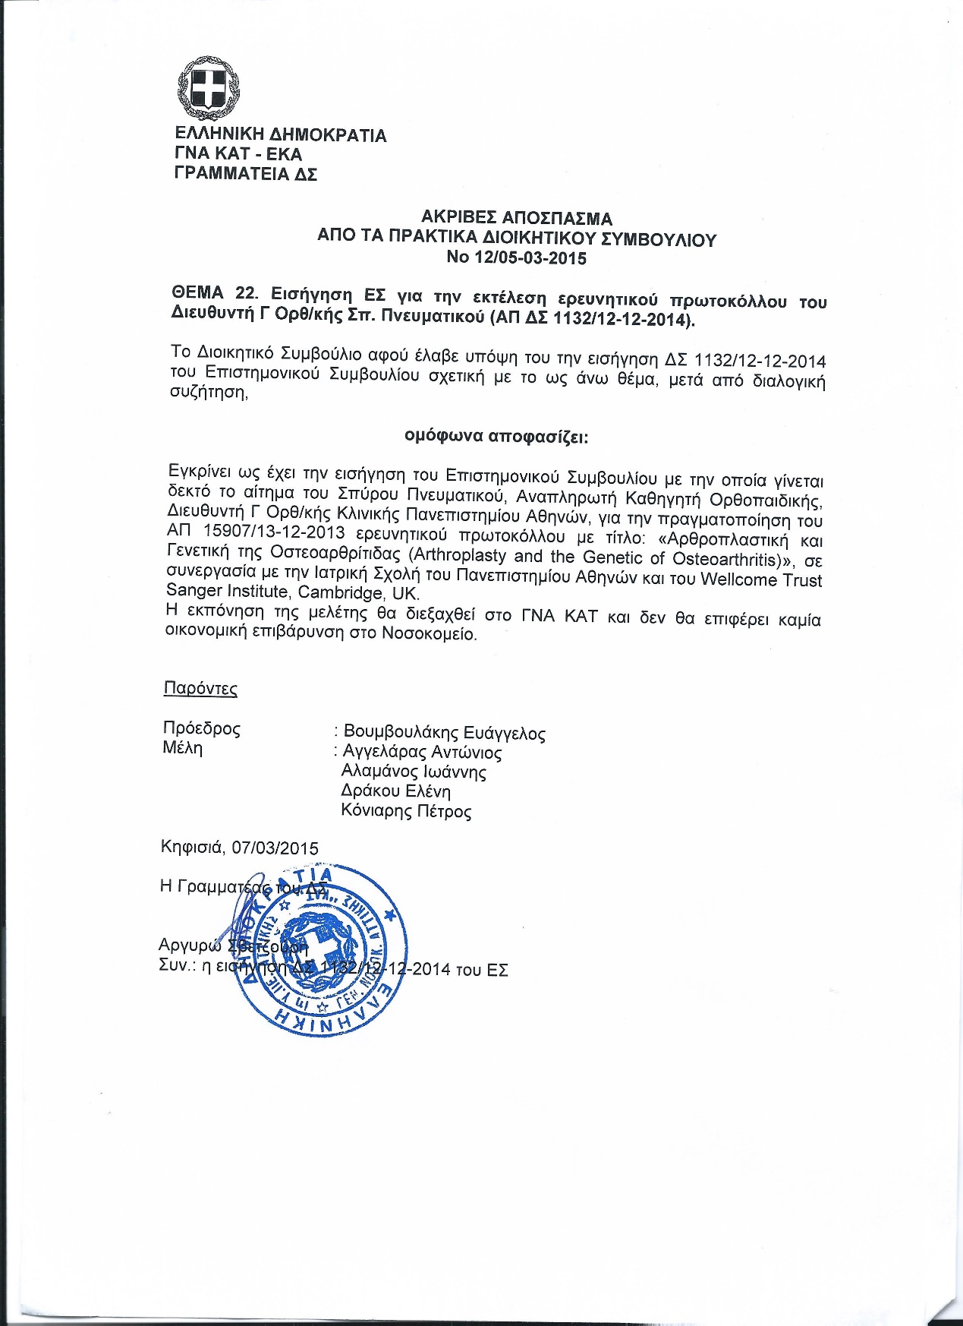

3rd University of Athens Department of Orthopaedics, KAT Hospital, 1st and 6th Department of Orthopaedics “KAT” Hospital Ethics Approval; English translation
1st Health Region of Attiki
General Hospital of Attiki ‘KAT’
Science Council
Address: Nikis 2
Postal Code: 14561 Kifissia
Tel Number: +302132086374
Information: Ekaterini Dimatou
Kifissia 14/1/2014
Protocol Number ES 22
Approval at 15907
To Board of Directors of KAT
Theme: Approval of research protocol of Assistant Professor of Orthopaedics Mr. Spyridonas Pneumatikos.
The scientific council at 1st /14.01.2014 meeting, following the relevant opinion of the Research Committee, proposes unanimously to the Board of Directors the approval of the request to conduct the research protocol that was made by Assistant Professor of Orthopaedics, Director of 3rd Orthopaedics Department of Athens University Mr. Spyridonas Pneumatikos with protocol number 15907/13.12.2013 and title ‘Arthroplasty and the Genetics of Osteoarthritis’.
This research is conducted after collaboration of the Medical School of Athens University and the Wellcome Trust Sanger Institute, Cambridge, UK. The study will be elaborated in General Hospital Attikis KAT (3rd University Orthopaedic Department, 1st Orthopaedic department, 6th Orthopaedic department) and 1st and 2nd University Orthopaedic Departments at ‘Attiko’ Hospital and ‘Agia Olga’ Hospital respectively.
(Follows ARGO protocol in Greek)
No financial burden results for the hospital
We please for your further actions
The Chairman of the Scientific Council
Dr. Chrysostomos Maltezos
Hellenic Democracy
GHA KAT-EKA
Secretary of Board of Directors
Exact extract of the Board of Directors meeting minutes
No 12/5.3.2015
Theme 22: Proposal of Scientific Council (SC) for the conduction of research protocol of Director of 3rd Orthopaedics Department Spyridonas Pneumatikos (1132/12.12.2014)
The Board of Directors after taking into consideration the proposal 1132/12.12.2014 of the SC relevant to the above subject and after interactive discussion,
Unanimously decides:
Approves as it is the proposal of the SC and approves the request of Spyros Pneumaticos, Assistant Professor of Orthopaedics, Director of 3rd Orthopaedic Department of the University of Athens to conduct the research protocol No 15907/13.12.2013 titled: ‘Arthroplasty and the Genetics of Osteoarthritis’ in collaboration with the Medical School of Athens University and the Wellcome Trust Sanger Institute, Cambridge, UK.
The elaboration of the study will be conducted in General Hospital of Attiki KAT and will not result in any financial burden on the hospital.
Present:
Chairman: Voumvoulakis Evangelos
Members: Angelaras Antonios, Alamanos Ioannis, Drakou Eleni, Koniaris Petros
Kifissia, 7/3/2015
The secretary of the BC
Argyro Svetzouri
Attached: The proposal 1132/12.12.2014 of the SC

Lefkos Stavros General Hospital Ethics Approval
Lefkos Stavros General Hospital Ethics Approval; English translation
Meeting Minutes of the Scientific Committee
No: 17/16-06-2014
Today in Athens 16/6/2014, Monday 9:00am, meets, at the request of the committee chairman Mr Adamandios Apodiakos, at 1 Sisini str. Athens, at the clinic’s/hospital Lefkos Stavros offices, the Scientific Committee of the clinic/hospital which was established by the board minutes No: 104/20-10-2009 and was amended by board minutes No: 140/17-04-2012 with tenure until 31/12/2015.
Present at meeting:
- Kyrpoglou Panagiotis
- Sambalis Georgios
- Pavlidis Antonios
- Pistofidis Georgios
- Katsifarakis Georgios
- Zafeiropoulos Athanasios
- Houliaras Ioannis
- Ifandithis Aris
- Peppas Christos
- Antonopoulos Georgios
After the verification of a quorum of the Scientific Committee, the Chairman calls the members to discuss the following topic:
Approval of study conduct titled “Arthroplasty and the genetics of Osteoarthritis, ARGO”
The Scientific Council at its meeting, after studying and discussing the application of Orthopedic Surgeon Athanasios Koukakis, taking into consideration the attached documents with protocol No 2727/10-6-2014, approves the conduct of the above research in the hospital provided that it will comply with the statutory provisions and the procedures of the National Drug Organization and that no financial cost will occur for the hospital.
After the end of discussion and as there is no other subject, this meeting is terminated.
Chairman of Committee
A. Apodiakos
Appendix 4
ARGO STUDY INFORMATION SHEET (English translation)

What is the purpose of this study?
The investigators would like to help scientists learn more about why some people have different incidences of common diseases, like osteoarthritis. We are gathering medical information and biological samples including genetic material (DNA), and using whole-genome sequencing techniques to analyse DNA. The investigators will store the medical information and DNA samples at the Wellcome Trust Sanger Institute, Hinxton, Cambridge, UK. It is up to you to decide whether you wish to take part in this study. We will ask you to sign this document to show that you have given consent to take part in this study. You are free to withdraw from the study at any time, without giving a reason, and this will not affect the standard of care you receive.

How many subjects will participate in this study?
We expect many people to participate in this study and we currently have no limit to the number of persons we would like this study to include.

How much of your time is required?
Your participation in this genetic study involves a simple saliva sample which will take a few seconds, a brief questionnaire and a copy of your x-rays.

What will happen if you take part in the study?
If you agree to participate we will take a small sample of saliva from you. Your saliva sample will be used to identify biological characteristics. Some of these are measured using DNA and called “genotypes”.
These biological samples, medical information, and information about your health status will be stored. X-rays test results, and information about your response to different treatments and disease progression may also be stored. Your biological samples and all information about you will be stored in a coded way in order to keep your identity a secret. Your biological samples and other information will be stored as an international resource. Researchers will use these to learn more about the causes of complex diseases and phenotypes, such as radiographic characteristics, anthropometric values, other phenotypes collected by questionnaire, and why people respond differently to treatment.
All identifying information including your name and medical record number will be removed from the samples. As a result, it will be impossible to connect you with the samples. This means you will be unable to learn about the studies in which the sample was used and any findings of these studies relating to the sample. There is no cost to you or your insurance company for the storage and use of the samples.
As part of the study, we may produce some information about other inherited genetic changes which may contribute to your risk of future disease. However the techniques we are using are NOT accurate enough to be used as diagnostic tests for these genetic alterations. In view of this, and as we know that everyone carries genetic differences of unknown significance, we shall not report to you any genetic changes that we find as a “by-product” of our research. However, in order to make sure that your samples are used to provide the greatest benefit for research into human disease, we would like to keep the anonymous genetic information we obtain about your DNA in a secure electronic archive (a database). The data will remain in the archive indefinitely, and responsible researchers across the world will be allowed access to the archive. There is a remote theoretical possibility that an individual person could be identified by looking at genetic information, but only if this can be matched to other genetic information from samples that you have provided to another person or organisation independently who have linked your personal data to the research data and made it publicly available. We think that identification is extremely unlikely, but it is important that you are aware of this theoretical risk. It is essential that you understand the type of information that will be produced by the techniques used, and you should be happy with the details about how we plan to handle and store this information.

What are the risks and benefits to you participating in the study?
There is no risk when participating in the study as DNA is going to be collected and extracted by saliva sample which is not interventional. The questionnaire is going to be brief and will take you little time to answer the questions asked by the researcher. You will have no direct benefits of the results of this study as your genetic information will be anonymous but your contribution will have greater benefits for people suffering from osteoarthritis in the future.

Who has reviewed and approved the study
This study has been reviewed and approved by the ethics committee of the hospital where you have had your total joint replacement. The study is funded by the Wellcome Trust Sanger, UK.

What will happen to the study results
The results of the study will be published and presented by the researchers and will also be used in a larger study on osteoarthritis and related traits. The samples will be stored indefinitely in an anonymised form and may be shared with other researchers world-wide for use in ethically-approved projects. Data produced during the course of the study will be stored in an anonymised form in an electronic archive called the European Genome-Phenome Archive (EGA) at the European Bioinformatics Institute, Hinxton, Cambridge, UK. This database can be accessed by bona fide researchers world-wide but the data will be anonymised and none of these researchers will be able to identify you from these results. Samples may be used for further studies and analyses, for ethically approved projects in the future, as responsible researchers across the world will be allowed access to the archive.

What happens if you change your mind and wish to withdraw during the study?
Anonymised samples and data obtained prior to your withdrawal will be retained by the research team and used in the project, but no new samples or data will be taken.

Appendix 5
ARGO STUDY CONSENT FORM (English translation)

Volunteer’s name:
Address:
Area/district:
Postal code:
Phone number:
Mobile phone number:

With the current information and consent form I accept and declare the following:
With the current form I declare my voluntary participation in the research study entitled ‘’Arthroplasty and the Genetics of Osteoarthritis, ARGO’’.
The study includes the following procedures:
- Saliva sample
- Biometric measurements (weight, height)
- Radiographic measurements
- Questionnaire completion

I declare that:
I have been clearly informed of the aims, the duration and the procedures of the current study.
I agree that the results of this study will be held on a database in an anonymised form and may be accessed by bona fide researchers across the world.
I agree that samples of my DNA may be exported to, and stored at, the Wellcome Trust Sanger Institute, Hinxton, Cambridge, UK.
I agree that my sample will be genome wide genotyped and potentially also whole genome sequenced in the future.
I agree that these samples may be used by other researchers for ethically approved projects.
I agree that should I withdraw consent during the course of the study, anonymised samples and data will be retained by the research team and used in the project, but no new samples will be taken from me.
I agree that the study investigators will recover from the archives of the hospital where I underwent the total arthroplasty my radiographs and that they can contact me in the future in case of extension of the study for additional information or follow up.

The Volunteer The Researcher
(name and signature) (name and signature)

Date Date

Appendix 6
ARGO QUESTIONNAIRE
Information that will not be included in the research data, but will be used to avoid double participation of the same individual.

ARGO code:
Surname-name:
Address:
Date of birth:
Incident case Historical case

GENERAL
ARGO code:
Date of study enrolment:
1. Age at enrolment:
2. City and country of birth:
3. Gender:
4. City and country of maternal origin:
5. City and country of paternal origin:
6. Definite Osteoarthritis
Does the patient fulfill the inclusion criteria for primary OA at each of the joint below:
Exclusion criteria:
- Inflammatory Arthritis
- Paget’s disease
- Intra-articular fracture
- Primary Osteonecrosis
Right hip primary OA yes no don’t know
Left hip primary OA yes no don’t know
Right knee primary OA yes no don’t know
Left knee primary OA yes no don’t know

7. Pre-operative X-rays included
HIP
7.1. AP pelvis YES NO
7.2. Lateral of the hip Right hip YES NO
Left hip YES NO
7.3. True lateral of the hip Right hip YES NO Left hip YES NO
KNEE
7.4. Weight-bearing AP Right YES NO
Left YES NO

7.5. Lateral of the knee Right YES NO
Left YES NO

7.6. Skyline patella Right YES NO
Left YES NO

8. Questions for Osteoarthritis and total joint replacement
8.1 Right hip replaced YES NO
If yes: Date ________________________
Reason _______________________
Hospital _____________________
8.2 Left hip replaced YES NO
If yes: Date ________________________
Reason _______________________
Hospital _______________________
8.3. Right knee replaced YES NO
If yes: Date ________________________
Reason _______________________
Hospital _______________________
8.4 Left Knee replaced YES NO
If yes: Date ________________________
Reason _______________________
Hospital _______________________
ANTHROPOMETRICS
Height ……………..cm
Weight …………….kgr
Self-reported Measured

Appendix 7
Oxford Knee Score
Please answer the following 12 multiple choice questions.
During the past 4 weeks...
1. How would you describe the pain you usually have in your knee?
None | Very mild | Mild | Moderate | Severe

2. Have you had any trouble washing and drying yourself (all over) because of your knee?
No trouble at all | Very little trouble | Moderate trouble | Extreme difficulty | Impossible to do

3. Have you had any trouble getting in and out of the car or using public transport because of your knee? (With or without a stick)
No trouble at all | Very little trouble | Moderate trouble | Extreme difficulty | Impossible to do

4. For how long are you able to walk before the pain in your knee becomes severe? (With or without a stick)
No pain > 60 min | 16 - 60 minutes | 5 - 15 minutes | Around the house only | Not at all-severe on walking

5. After a meal (sat at a table), how painful has it been for you to stand up from a chair because of your knee?
Not at all painful | Slightly painful | Moderately pain | Very painful | Unbearable

6. Have you been limping when walking, because of your knee?
Rarely/ never | Sometimes or just at first | Often, not just at first | Most of the time | All of the time

7. Could you kneel down and get up again afterwards?
Yes, easily | With little difficulty | With moderate difficulty | With extreme difficulty | No, impossible

8. Are you troubled by pain in your knee at night in bed?
Not at all | Only one or two nights | Some nights | Most nights | Every night

9. How much has pain from knee interfered with your usual work (including housework)?
Not at all | A little bit | Moderately | Greatly | Totally

10. Have you felt that your knee might suddenly “give away” or let you down?
Rarely/ never | Sometimes or just at first | Often, not just at first | Most of the time | All of the time

11. Could you do household shopping on your own?
Yes, easily | With little difficulty | With moderate difficulty | With extreme difficulty | No, impossible

12. Could you walk down a flight of stairs?
Yes, easily | With little difficulty | With moderate difficulty | With extreme difficulty | No, impossible

Score:…………….

Appendix 8
Oxford Hip Score
Please answer the following 12 multiple choice questions.

During the past 4 weeks......

1. How would you describe the pain you usually have in your hip?
None | Very mild | Mild | Moderate | Severe

2. Have you been troubled by pain from your hip in bed at night?
No nights | Only 1 or 2 nights | Some nights | Most nights | Every night

3. Have you had any sudden, severe pain (shooting, stabbing, or spasms) from your affected hip?
No days | Only 1 or 2 days | Some days | Most days | Every day

4. Have you been limping when walking because of your hip?
Rarely/ never | Sometimes or just at first | Often, not just at first | Most of the time | All of the time

5. For how long have you been able to walk before the pain in your hip becomes severe (with or without a walking aid)?
No pain for 30 minutes or more | 16 to 30 minutes | 5 to 15 minutes | Around the house only | Not at all

6. Have you been able to climb a flight of stairs?
Yes, easily | With little difficulty | With moderate difficulty | With extreme difficulty | No, impossible

7. Have you been able to put on a pair of socks, stockings or tights?
Yes, easily | With little difficulty | With moderate difficulty | With extreme difficulty | No, impossible

8. After a meal (sat at a table), how painful has it been for you to stand up from a chair because of your hip?
Not at all painful | Slightly painful | Moderately pain | Very painful | Unbearable

9. Have you had any trouble getting in and out of a car or using public transportation because of your hip?
No trouble at all | Very little trouble | Moderate trouble | Extreme difficulty | Impossible to do

10. Have you had any trouble with washing and drying yourself (all over) because of your hip?
No trouble at all | Very little trouble | Moderate trouble | Extreme difficulty | Impossible to do

11. Could you do the household shopping on your own?
Yes, easily | With little difficulty | With moderate difficulty | With extreme difficulty | No, impossible

12. How much has pain from your hip interfered with your usual work, including housework?
Not at all | A little bit | Moderately | Greatly | Totally

Score:…………..

References

1. Zengini, E., Finan, C. & Wilkinson, J.M. The Genetic Epidemiological Landscape of Hip and Knee Osteoarthritis: Where Are We Now and Where Are We Going? J Rheumatol 43, 260-6 (2016).
2. Brandt, K.D., Dieppe, P. & Radin, E.L. Etiopathogenesis of osteoarthritis. Rheum Dis Clin North Am 34, 531-59 (2008).
3. Felson, D.T. et al. Osteoarthritis: new insights. Part 2: treatment approaches. Ann Intern Med 133, 726-37 (2000).
4. Altman, R.D. Early management of osteoarthritis. Am J Manag Care 16 Suppl Management, S41-7 (2010).
5. Cross, M. et al. The global burden of hip and knee osteoarthritis: estimates from the Global Burden of Disease 2010 study. Ann Rheum Dis 73, 1323-30 (2014).
6. KELLGREN, J.H. & LAWRENCE, J.S. Radiological assessment of osteo-arthrosis. Ann Rheum Dis 16, 494-502 (1957).
7. Bedson, J. & Croft, P.R. The discordance between clinical and radiographic knee osteoarthritis: a systematic search and summary of the literature. BMC Musculoskelet Disord 9, 116 (2008).
8. Lawrence, R.C. et al. Estimates of the prevalence of arthritis and other rheumatic conditions in the United States. Part II. Arthritis Rheum 58, 26-35 (2008).
9. Rahman, M.M., Cibere, J., Goldsmith, C.H., Anis, A.H. & Kopec, J.A. Osteoarthritis incidence and trends in administrative health records from british columbia, Canada. J Rheumatol 41, 1147-54 (2014).
10. Lawrence, R.C. et al. Estimates of the prevalence of arthritis and selected musculoskeletal disorders in the United States. Arthritis Rheum 41, 778-99 (1998).
11. Litwic, A., Edwards, M.H., Dennison, E.M. & Cooper, C. Epidemiology and burden of osteoarthritis. Br Med Bull 105, 185-99 (2013).
12. Felson, D.T. et al. The prevalence of knee osteoarthritis in the elderly. The Framingham Osteoarthritis Study. Arthritis Rheum 30, 914-8 (1987).
13. Jordan, J.M. et al. Prevalence of knee symptoms and radiographic and symptomatic knee osteoarthritis in African Americans and Caucasians: the Johnston County Osteoarthritis Project. J Rheumatol 34, 172-80 (2007).
14. Carmona, L., Ballina, J., Gabriel, R., Laffon, A. & Group, E.S. The burden of musculoskeletal diseases in the general population of Spain: results from a national survey. Ann Rheum Dis 60, 1040-5 (2001).
15. Guillemin, F. et al. Prevalence of symptomatic hip and knee osteoarthritis: a two-phase population-based survey. Osteoarthritis Cartilage 19, 1314-22 (2011).
16. Guillemin, F. et al. The KHOALA cohort of knee and hip osteoarthritis in France. Joint Bone Spine 79, 597-603 (2012).
17. Felson, D.T. et al. High prevalence of lateral knee osteoarthritis in Beijing Chinese compared with Framingham Caucasian subjects. Arthritis Rheum 46, 1217-22 (2002).
18. Xu, L. et al. [High prevalence of knee, but not hip or hand osteoarthritis in Beijing elders: comparison with data of Caucasian in United States]. Zhonghua Yi Xue Za Zhi 83, 1206-9 (2003).
19. Zhang, Y. et al. Comparison of the prevalence of knee osteoarthritis between the elderly Chinese population in Beijing and whites in the United States: The Beijing Osteoarthritis Study. Arthritis Rheum 44, 2065-71 (2001).
20. Yoshida, S. et al. Comparison of the prevalence of radiographic osteoarthritis of the knee and hand between Japan and the United States. J Rheumatol 29, 1454-8 (2002).
21. Andrianakos, A. et al. Prevalence of rheumatic diseases in Greece: a cross-sectional population based epidemiological study. The ESORDIG Study. J Rheumatol 30, 1589-601 (2003).
22. Andrianakos, A.A. et al. Prevalence of symptomatic knee, hand, and hip osteoarthritis in Greece. The ESORDIG study. J Rheumatol 33, 2507-13 (2006).
23. Anagnostopoulos, I. et al. The prevalence of rheumatic diseases in central Greece: a population survey. BMC Musculoskelet Disord 11, 98 (2010).
24. Wang, Y. et al. Reduced rates of primary joint replacement for osteoarthritis in Italian and Greek migrants to Australia: the Melbourne Collaborative Cohort Study. Arthritis Res Ther 11, R86 (2009).
25. Kalichman, L. & Hernández-Molina, G. Hand osteoarthritis: an epidemiological perspective. Semin Arthritis Rheum 39, 465-76 (2010).
26. Claassen, H. et al. C-28/I2 and T/C-28a2 chondrocytes as well as human primary articular chondrocytes express sex hormone and insulin receptors--Useful cells in study of cartilage metabolism. Ann Anat 193, 23-9 (2011).
27. Schicht, M. et al. Articular cartilage chondrocytes express aromatase and use enzymes involved in estrogen metabolism. Arthritis Res Ther 16, R93 (2014).
28. Chen, J. et al. Estrogen via estrogen receptor beta partially inhibits mandibular condylar cartilage growth. Osteoarthritis Cartilage (2014).
29. Lohmander, L.S., Gerhardsson de Verdier, M., Rollof, J., Nilsson, P.M. & Engström, G. Incidence of severe knee and hip osteoarthritis in relation to different measures of body mass: a population-based prospective cohort study. Ann Rheum Dis 68, 490-6 (2009).
30. Nguyen, U.S. et al. Increasing prevalence of knee pain and symptomatic knee osteoarthritis: survey and cohort data. Ann Intern Med 155, 725-32 (2011).
31. Felson, D.T. et al. Osteoarthritis: new insights. Part 1: the disease and its risk factors. Ann Intern Med 133, 635-46 (2000).
32. Martel-Pelletier, J. et al. Osteoarthritis. Nat Rev Dis Primers 2, 16072 (2016).
33. Mortellaro, C.M. Pathophysiology of osteoarthritis. Vet Res Commun 27 Suppl 1, 75-8 (2003).
34. Loeser, R.F. Molecular mechanisms of cartilage destruction in osteoarthritis. J Musculoskelet Neuronal Interact 8, 303-6 (2008).
35. Vincent, K.R., Conrad, B.P., Fregly, B.J. & Vincent, H.K. The pathophysiology of osteoarthritis: a mechanical perspective on the knee joint. PM R 4, S3-9 (2012).
36. Martel-Pelletier, J. Pathophysiology of osteoarthritis. Osteoarthritis Cartilage 12 Suppl A, S31-3 (2004).
37. Hunter, D.J. Pharmacologic therapy for osteoarthritis--the era of disease modification. Nat Rev Rheumatol 7, 13-22 (2011).
38. Katz, J.N. Total joint replacement in osteoarthritis. Best Pract Res Clin Rheumatol 20, 145-53 (2006).
39. Seyerle, A.A. & Avery, C.L. Genetic epidemiology: the potential benefits and challenges of using genetic information to improve human health. N C Med J 74, 505-8 (2013).
40. Marian, A.J. Molecular genetic studies of complex phenotypes. Transl Res 159, 64-79 (2012).
41. Strachan, T. & Read, A. Human Molecular Genetics, (Garland Science, Taylor & Francis group, New York 2011).
42. Consortium, I.H.G.S. Finishing the euchromatic sequence of the human genome. Nature 431, 931-45 (2004).
43. Consortium, I.H. A haplotype map of the human genome. Nature 437, 1299-320 (2005).
44. Auton, A. et al. A global reference for human genetic variation. Nature 526, 68-74 (2015).
45. Walter, K. et al. The UK10K project identifies rare variants in health and disease. Nature 526, 82-90 (2015).
46. McCarthy, S. et al. A reference panel of 64,976 haplotypes for genotype imputation. Nat Genet 48, 1279-83 (2016).
47. Katsonis, P. et al. Single nucleotide variations: biological impact and theoretical interpretation. Protein Sci 23, 1650-66 (2014).
48. Kidd, J.M. et al. Mapping and sequencing of structural variation from eight human genomes. Nature 453, 56-64 (2008).
49. Ke, X., Taylor, M.S. & Cardon, L.R. Singleton SNPs in the human genome and implications for genome-wide association studies. Eur J Hum Genet 16, 506-15 (2008).
50. Carlson, C.S., Eberle, M.A., Kruglyak, L. & Nickerson, D.A. Mapping complex disease loci in whole-genome association studies. Nature 429, 446-52 (2004).
51. Barreiro, L.B., Laval, G., Quach, H., Patin, E. & Quintana-Murci, L. Natural selection has driven population differentiation in modern humans. Nat Genet 40, 340-5 (2008).
52. Pearson, T.A. & Manolio, T.A. How to interpret a genome-wide association study. JAMA 299, 1335-44 (2008).
53. Cardon, L.R. & Abecasis, G.R. Using haplotype blocks to map human complex trait loci. Trends Genet 19, 135-40 (2003).
54. Antonarakis, S.E. & Beckmann, J.S. Mendelian disorders deserve more attention. Nat Rev Genet 7, 277-82 (2006).
55. Badano, J.L. & Katsanis, N. Beyond Mendel: an evolving view of human genetic disease transmission. Nat Rev Genet 3, 779-89 (2002).
56. Schork, N.J. Genetics of complex disease: approaches, problems, and solutions. Am J Respir Crit Care Med 156, S103-9 (1997).
57. Gielen, M. et al. Modeling genetic and environmental factors to increase heritability and ease the identification of candidate genes for birth weight: a twin study. Behav Genet 38, 44-54 (2008).
58. Visscher, P.M., Hill, W.G. & Wray, N.R. Heritability in the genomics era--concepts and misconceptions. Nat Rev Genet 9, 255-66 (2008).
59. Golan, D., Lander, E.S. & Rosset, S. Measuring missing heritability: Inferring the contribution of common variants. Proc Natl Acad Sci U S A 111, E5272-81 (2014).
60. Lee, S.H., Wray, N.R., Goddard, M.E. & Visscher, P.M. Estimating missing heritability for disease from genome-wide association studies. Am J Hum Genet 88, 294-305 (2011).
61. Ott, J., Wang, J. & Leal, S.M. Genetic linkage analysis in the age of whole-genome sequencing. Nat Rev Genet 16, 275-84 (2015).
62. Dawn Teare, M. & Barrett, J.H. Genetic linkage studies. Lancet 366, 1036-44 (2005).
63. Patnala, R., Clements, J. & Batra, J. Candidate gene association studies: a comprehensive guide to useful in silico tools. BMC Genet 14, 39 (2013).
64. Kwon, J.M. & Goate, A.M. The candidate gene approach. Alcohol Res Health 24, 164-8 (2000).
65. Zhu, M. & Zhao, S. Candidate gene identification approach: progress and challenges. Int J Biol Sci 3, 420-7 (2007).
66. Siontis, K.C., Patsopoulos, N.A. & Ioannidis, J.P. Replication of past candidate loci for common diseases and phenotypes in 100 genome-wide association studies. Eur J Hum Genet 18, 832-7 (2010).
67. Clarke, G.M. et al. Basic statistical analysis in genetic case-control studies. Nat Protoc 6, 121-33 (2011).
68. Turner, S. et al. Quality control procedures for genome-wide association studies. Curr Protoc Hum Genet Chapter 1, Unit1.19 (2011).
69. Marchini, J. & Howie, B. Genotype imputation for genome-wide association studies. Nat Rev Genet 11, 499-511 (2010).
70. Li, Y., Willer, C., Sanna, S. & Abecasis, G. Genotype imputation. Annu Rev Genomics Hum Genet 10, 387-406 (2009).
71. Abraham, G. & Inouye, M. Fast principal component analysis of large-scale genome-wide data. PLoS One 9, e93766 (2014).
72. Fadista, J., Manning, A.K., Florez, J.C. & Groop, L. The (in)famous GWAS P-value threshold revisited and updated for low-frequency variants. Eur J Hum Genet 24, 1202-5 (2016).
73. Welter, D. et al. The NHGRI GWAS Catalog, a curated resource of SNP-trait associations. Nucleic Acids Res 42, D1001-6 (2014).
74. Bush, W.S. & Moore, J.H. Chapter 11: Genome-wide association studies. PLoS Comput Biol 8, e1002822 (2012).
75. Burton, P.R. et al. Size matters: just how big is BIG?: Quantifying realistic sample size requirements for human genome epidemiology. Int J Epidemiol 38, 263-73 (2009).
76. Panoutsopoulou, K. & Zeggini, E. Advances in osteoarthritis genetics. J Med Genet 50, 715-24 (2013).
77. Zeggini, E. & Ioannidis, J.P. Meta-analysis in genome-wide association studies. Pharmacogenomics 10, 191-201 (2009).
78. Panagiotou, O.A., Willer, C.J., Hirschhorn, J.N. & Ioannidis, J.P. The power of meta-analysis in genome-wide association studies. Annu Rev Genomics Hum Genet 14, 441-65 (2013).
79. Seminara, D. et al. The emergence of networks in human genome epidemiology: challenges and opportunities. Epidemiology 18, 1-8 (2007).
80. Lunetta, K.L. Methods for meta-analysis of genetic data. Curr Protoc Hum Genet Chapter 1, Unit1.24 (2013).
81. Blanco-Gómez, A. et al. Missing heritability of complex diseases: Enlightenment by genetic variants from intermediate phenotypes. Bioessays 38, 664-73 (2016).
82. Manolio, T.A. et al. Finding the missing heritability of complex diseases. Nature 461, 747-53 (2009).
83. Zaitlen, N. & Kraft, P. Heritability in the genome-wide association era. Hum Genet 131, 1655-64 (2012).
84. Lopes, M.C., Zeggini, E. & Panoutsopoulou, K. Do genome-wide association scans have potential for translation? Clin Chem Lab Med 50, 255-60 (2012).
85. Lanyon, P., Muir, K., Doherty, S. & Doherty, M. Assessment of a genetic contribution to osteoarthritis of the hip: sibling study. BMJ 321, 1179-83 (2000).
86. Chitnavis, J. et al. Genetic influences in end-stage osteoarthritis. Sibling risks of hip and knee replacement for idiopathic osteoarthritis. J Bone Joint Surg Br 79, 660-4 (1997).
87. Loughlin, J. The genetic epidemiology of human primary osteoarthritis: current status. Expert Rev Mol Med 7, 1-12 (2005).
88. Valdes, A.M. & Spector, T.D. Genetic epidemiology of hip and knee osteoarthritis. Nat Rev Rheumatol 7, 23-32 (2011).
89. Neame, R.L., Muir, K., Doherty, S. & Doherty, M. Genetic risk of knee osteoarthritis: a sibling study. Ann Rheum Dis 63, 1022-7 (2004).
90. Panoutsopoulou, K. et al. Insights into the genetic architecture of osteoarthritis from stage 1 of the arcOGEN study. Ann Rheum Dis 70, 864-7 (2011).
91. Evangelou, E. et al. A meta-analysis of genome-wide association studies identifies novel variants associated with osteoarthritis of the hip. Ann Rheum Dis (2013).
92. Panoutsopoulou, K., Tachmazidou, I. & Zeggini, E. In search of low-frequency and rare variants affecting complex traits. Hum Mol Genet 22, R16-21 (2013).
93. Maher, B. Personal genomes: The case of the missing heritability. Nature 456, 18-21 (2008).
94. Valdes, A.M. & Spector, T.D. The contribution of genes to osteoarthritis. Med Clin North Am 93, 45-66, x (2009).
95. Buxton, P., Edwards, C., Archer, C.W. & Francis-West, P. Growth/differentiation factor-5 (GDF-5) and skeletal development. J Bone Joint Surg Am 83-A Suppl 1, S23-30 (2001).
96. Edwards, C.J. & Francis-West, P.H. Bone morphogenetic proteins in the development and healing of synovial joints. Semin Arthritis Rheum 31, 33-42 (2001).
97. Miyamoto, Y. et al. A functional polymorphism in the 5' UTR of GDF5 is associated with susceptibility to osteoarthritis. Nat Genet 39, 529-33 (2007).
98. Chapman, K. et al. A meta-analysis of European and Asian cohorts reveals a global role of a functional SNP in the 5' UTR of GDF5 with osteoarthritis susceptibility. Hum Mol Genet 17, 1497-504 (2008).
99. Egli, R.J. et al. Functional analysis of the osteoarthritis susceptibility-associated GDF5 regulatory polymorphism. Arthritis Rheum 60, 2055-64 (2009).
100. Southam, L. et al. An SNP in the 5'-UTR of GDF5 is associated with osteoarthritis susceptibility in Europeans and with in vivo differences in allelic expression in articular cartilage. Hum Mol Genet 16, 2226-32 (2007).
101. Evangelou, E. et al. Large-scale analysis of association between GDF5 and FRZB variants and osteoarthritis of the hip, knee, and hand. Arthritis Rheum 60, 1710-21 (2009).
102. Valdes, A.M. et al. The GDF5 rs143383 polymorphism is associated with osteoarthritis of the knee with genome-wide statistical significance. Ann Rheum Dis 70, 873-5 (2011).
103. Hao, S.W. & Jin, Q.H. Association between the +104T/C polymorphism in the 5'UTR of GDF5 and susceptibility to knee osteoarthritis: a meta-analysis. Mol Med Rep 7, 485-8 (2013).
104. Hatzikotoulas, K. et al. The Genetic Epidemiology of Developmental Dysplasia of the Hip: A Genome-Wide Association Study Harnessing National Clinical Audit Data. bioRxiv (2017).
105. Lievense, A.M., Bierma-Zeinstra, S.M., Verhagen, A.P., Verhaar, J.A. & Koes, B.W. Influence of hip dysplasia on the development of osteoarthritis of the hip. Ann Rheum Dis 63, 621-6 (2004).
106. Johnsen, K., Goll, R. & Reikerås, O. Acetabular dysplasia as an aetiological factor in development of hip osteoarthritis. Int Orthop 33, 653-7 (2009).
107. Lettre, G. et al. Identification of ten loci associated with height highlights new biological pathways in human growth. Nat Genet 40, 584-91 (2008).
108. Sanna, S. et al. Common variants in the GDF5-UQCC region are associated with variation in human height. Nat Genet 40, 198-203 (2008).
109. Masuya, H. et al. A novel dominant-negative mutation in Gdf5 generated by ENU mutagenesis impairs joint formation and causes osteoarthritis in mice. Hum Mol Genet 16, 2366-75 (2007).
110. Harada, M. et al. Developmental failure of the intra-articular ligaments in mice with absence of growth differentiation factor 5. Osteoarthritis Cartilage 15, 468-74 (2007).
111. Daans, M., Luyten, F.P. & Lories, R.J. GDF5 deficiency in mice is associated with instability-driven joint damage, gait and subchondral bone changes. Ann Rheum Dis 70, 208-13 (2011).
112. Valdes, A.M. et al. Genetic contribution to radiographic severity in osteoarthritis of the knee. Ann Rheum Dis 71, 1537-40 (2012).
113. Minafra, L. et al. Genetic, clinical and radiographic signs in knee osteoarthritis susceptibility. Arthritis Res Ther 16, R91 (2014).
114. Miyamoto, Y. et al. Common variants in DVWA on chromosome 3p24.3 are associated with susceptibility to knee osteoarthritis. Nat Genet 40, 994-8 (2008).
115. Nakajima, M., Miyamoto, Y. & Ikegawa, S. Cloning and characterization of the osteoarthritis-associated gene DVWA. J Bone Miner Metab 29, 300-8 (2011).
116. Meulenbelt, I. et al. Large replication study and meta-analyses of DVWA as an osteoarthritis susceptibility locus in European and Asian populations. Hum Mol Genet 18, 1518-23 (2009).
117. Lee, S.J. et al. Association study of the candidate gene for knee osteoarthritis in Koreans. Rheumatol Int 33, 783-6 (2013).
118. Valdes, A.M. et al. Association of the DVWA and GDF5 polymorphisms with osteoarthritis in UK populations. Ann Rheum Dis 68, 1916-20 (2009).
119. Nakajima, M. et al. New sequence variants in HLA class II/III region associated with susceptibility to knee osteoarthritis identified by genome-wide association study. PLoS One 5, e9723 (2010).
120. Shi, D. et al. Association of single-nucleotide polymorphisms in HLA class II/III region with knee osteoarthritis. Osteoarthritis Cartilage 18, 1454-7 (2010).
121. Valdes, A.M. et al. Large scale replication study of the association between HLA class II/BTNL2 variants and osteoarthritis of the knee in European-descent populations. PLoS One 6, e23371 (2011).
122. Kerkhof, H.J. et al. A genome-wide association study identifies an osteoarthritis susceptibility locus on chromosome 7q22. Arthritis Rheum 62, 499-510 (2010).
123. Evangelou, E. et al. Meta-analysis of genome-wide association studies confirms a susceptibility locus for knee osteoarthritis on chromosome 7q22. Ann Rheum Dis 70, 349-55 (2011).
124. Raine, E.V., Wreglesworth, N., Dodd, A.W., Reynard, L.N. & Loughlin, J. Gene expression analysis reveals HBP1 as a key target for the osteoarthritis susceptibility locus that maps to chromosome 7q22. Ann Rheum Dis 71, 2020-7 (2012).
125. Castaño Betancourt, M.C. et al. Genome-wide association and functional studies identify the DOT1L gene to be involved in cartilage thickness and hip osteoarthritis. Proc Natl Acad Sci U S A 109, 8218-23 (2012).
126. Sovio, U. et al. Genetic determinants of height growth assessed longitudinally from infancy to adulthood in the northern Finland birth cohort 1966. PLoS Genet 5, e1000409 (2009).
127. Evangelou, E. et al. The DOT1L rs12982744 polymorphism is associated with osteoarthritis of the hip with genome-wide statistical significance in males. Ann Rheum Dis 72, 1264-5 (2013).
128. Xu, J. et al. The steroid receptor coactivator SRC-3 (p/CIP/RAC3/AIB1/ACTR/TRAM-1) is required for normal growth, puberty, female reproductive function, and mammary gland development. Proc Natl Acad Sci U S A 97, 6379-84 (2000).
129. Nicholls, J.J., Brassill, M.J., Williams, G.R. & Bassett, J.H. The skeletal consequences of thyrotoxicosis. J Endocrinol 213, 209-21 (2012).
130. Millward-Sadler, S.J., Khan, N.S., Bracher, M.G., Wright, M.O. & Salter, D.M. Roles for the interleukin-4 receptor and associated JAK/STAT proteins in human articular chondrocyte mechanotransduction. Osteoarthritis Cartilage 14, 991-1001 (2006).
131. Abecasis, G.R. et al. A map of human genome variation from population-scale sequencing. Nature 467, 1061-73 (2010).
132. Day-Williams, A.G. et al. A variant in MCF2L is associated with osteoarthritis. Am J Hum Genet 89, 446-50 (2011).
133. Mitchell, R.E. et al. New tools for studying osteoarthritis genetics in zebrafish. Osteoarthritis Cartilage 21, 269-78 (2013).
134. Yoshizawa, M. et al. Dynamic and coordinated expression profile of dbl-family guanine nucleotide exchange factors in the developing mouse brain. Gene Expr Patterns 3, 375-81 (2003).
135. Zeggini, E. et al. Identification of new susceptibility loci for osteoarthritis (arcOGEN): a genome-wide association study. Lancet 380, 815-23 (2012).
136. Wang, K.S., Liu, X.F. & Aragam, N. A genome-wide meta-analysis identifies novel loci associated with schizophrenia and bipolar disorder. Schizophr Res 124, 192-9 (2010).
137. Lionel, A.C. et al. Disruption of the ASTN2/TRIM32 locus at 9q33.1 is a risk factor in males for autism spectrum disorders, ADHD and other neurodevelopmental phenotypes. Hum Mol Genet 23, 2752-68 (2014).
138. Freilinger, T. et al. Genome-wide association analysis identifies susceptibility loci for migraine without aura. Nat Genet 44, 777-82 (2012).
139. Wilson, P.M., Fryer, R.H., Fang, Y. & Hatten, M.E. Astn2, a novel member of the astrotactin gene family, regulates the trafficking of ASTN1 during glial-guided neuronal migration. J Neurosci 30, 8529-40 (2010).
140. Karlsson, C. et al. Genome-wide expression profiling reveals new candidate genes associated with osteoarthritis. Osteoarthritis Cartilage 18, 581-92 (2010).
141. Klüppel, M., Wight, T.N., Chan, C., Hinek, A. & Wrana, J.L. Maintenance of chondroitin sulfation balance by chondroitin-4-sulfotransferase 1 is required for chondrocyte development and growth factor signaling during cartilage morphogenesis. Development 132, 3989-4003 (2005).
142. Izu, Y. et al. Type XII collagen regulates osteoblast polarity and communication during bone formation. J Cell Biol 193, 1115-30 (2011).
143. Lanske, B. et al. Ablation of the PTHrP gene or the PTH/PTHrP receptor gene leads to distinct abnormalities in bone development. J Clin Invest 104, 399-407 (1999).
144. Yuan, Q. et al. Deletion of PTH rescues skeletal abnormalities and high osteopontin levels in Klotho-/- mice. PLoS Genet 8, e1002726 (2012).
145. Thorleifsson, G. et al. Genome-wide association yields new sequence variants at seven loci that associate with measures of obesity. Nat Genet 41, 18-24 (2009).
146. Frayling, T.M. et al. A common variant in the FTO gene is associated with body mass index and predisposes to childhood and adult obesity. Science 316, 889-94 (2007).
147. Elliott, K.S. et al. Evaluation of the genetic overlap between osteoarthritis with body mass index and height using genome-wide association scan data. Ann Rheum Dis 72, 935-41 (2013).
148. Panoutsopoulou, K. et al. The effect of FTO variation on increased osteoarthritis risk is mediated through body mass index: a mendelian randomisation study. Ann Rheum Dis (2013).
149. Liu, F. et al. A genome-wide association study identifies five loci influencing facial morphology in Europeans. PLoS Genet 8, e1002932 (2012).
150. Komori, T. Regulation of bone development and extracellular matrix protein genes by RUNX2. Cell Tissue Res 339, 189-95 (2010).
151. Komori, T. et al. Targeted disruption of Cbfa1 results in a complete lack of bone formation owing to maturational arrest of osteoblasts. Cell 89, 755-64 (1997).
152. Kostopoulou, F. et al. Central role of SREBP-2 in the pathogenesis of osteoarthritis. PLoS One 7, e35753 (2012).
153. Delaneau, O., Howie, B., Cox, A.J., Zagury, J.F. & Marchini, J. Haplotype estimation using sequencing reads. Am J Hum Genet 93, 687-96 (2013).
154. Delaneau, O., Marchini, J. & Consortium, G.P. Integrating sequence and array data to create an improved 1000 Genomes Project haplotype reference panel. Nat Commun 5, 3934 (2014).
155. Howie, B.N., Donnelly, P. & Marchini, J. A flexible and accurate genotype imputation method for the next generation of genome-wide association studies. PLoS Genet 5, e1000529 (2009).
156. Abecasis, G.R. et al. An integrated map of genetic variation from 1,092 human genomes. Nature 491, 56-65 (2012).
157. Price, A.L. et al. Principal components analysis corrects for stratification in genome-wide association studies. Nat Genet 38, 904-9 (2006).
158. Gauderman, W.J. Sample size requirements for matched case-control studies of gene-environment interaction. Stat Med 21, 35-50 (2002).
159. Nakamura, T. et al. Meta-analysis of association between the ASPN D-repeat and osteoarthritis. Hum Mol Genet 16, 1676-81 (2007).
160. Zengini, E. et al. Genome-wide analyses using UK Biobank data provide insights into the genetic architecture of osteoarthritis. Nat Genet 50, 549-558 (2018).
161. Evangelou, E. et al. A meta-analysis of genome-wide association studies identifies novel variants associated with osteoarthritis of the hip. Ann Rheum Dis 73, 2130-6 (2014).
162. Styrkarsdottir, U. et al. Severe osteoarthritis of the hand associates with common variants within the ALDH1A2 gene and with rare variants at 1p31. Nat Genet 46, 498-502 (2014).
163. Styrkarsdottir, U. et al. Whole-genome sequencing identifies rare genotypes in COMP and CHADL associated with high risk of hip osteoarthritis. Nat Genet 49, 801-805 (2017).
164. Hackinger, S. et al. Evaluation of shared genetic aetiology between osteoarthritis and bone mineral density identifies SMAD3 as a novel osteoarthritis risk locus. Hum Mol Genet 26, 3850-3858 (2017).
165. Styrkarsdottir, U. et al. Whole-genome sequencing identifies rare genotypes in COMP and CHADL associated with high risk of hip osteoarthritis. Nat Genet (2017).
166. Hosnijeh, F.S., Runhaar, J., van Meurs, J.B. & Bierma-Zeinstra, S.M. Biomarkers for osteoarthritis: Can they be used for risk assessment? A systematic review. Maturitas 82, 36-49 (2015).
167. Acharya, C. et al. Cartilage oligomeric matrix protein and its binding partners in the cartilage extracellular matrix: interaction, regulation and role in chondrogenesis. Matrix Biol 37, 102-11 (2014).
168. Briggs, M.D., Brock, J., Ramsden, S.C. & Bell, P.A. Genotype to phenotype correlations in cartilage oligomeric matrix protein associated chondrodysplasias. Eur J Hum Genet 22, 1278-82 (2014).
169. Anthony, S., Munk, R., Skakun, W. & Masini, M. Multiple epiphyseal dysplasia. J Am Acad Orthop Surg 23, 164-72 (2015).
170. Styrkarsdottir, U. et al. Severe osteoarthritis of the hand associates with common variants within the ALDH1A2 gene and with rare variants at 1p31. Nat Genet 46, 498-502 (2014).
171. Rhinn, M. & Dollé, P. Retinoic acid signalling during development. Development 139, 843-58 (2012).
172. Underhill, T.M. & Weston, A.D. Retinoids and their receptors in skeletal development. Microsc Res Tech 43, 137-55 (1998).
173. Weston, A.D., Hoffman, L.M. & Underhill, T.M. Revisiting the role of retinoid signaling in skeletal development. Birth Defects Res C Embryo Today 69, 156-73 (2003).
174. Hackinger, S. et al. Evaluation of shared genetic aetiology between osteoarthritis and bone mineral density identifies SMAD3 as a novel osteoarthritis risk locus. Hum Mol Genet 26, 3850-3858 (2017).
175. Alliston, T., Choy, L., Ducy, P., Karsenty, G. & Derynck, R. TGF-beta-induced repression of CBFA1 by Smad3 decreases cbfa1 and osteocalcin expression and inhibits osteoblast differentiation. EMBO J 20, 2254-72 (2001).
176. Chen, C.G., Thuillier, D., Chin, E.N. & Alliston, T. Chondrocyte-intrinsic Smad3 represses Runx2-inducible matrix metalloproteinase 13 expression to maintain articular cartilage and prevent osteoarthritis. Arthritis Rheum 64, 3278-89 (2012).
177. Allen, N.E., Sudlow, C., Peakman, T., Collins, R. & Biobank, U. UK biobank data: come and get it. Sci Transl Med 6, 224ed4 (2014).
178. Sudlow, C. et al. UK biobank: an open access resource for identifying the causes of a wide range of complex diseases of middle and old age. PLoS Med 12, e1001779 (2015).
179. Ma, C., Blackwell, T., Boehnke, M., Scott, L.J. & Go, T.D.i. Recommended joint and meta-analysis strategies for case-control association testing of single low-count variants. Genet Epidemiol 37, 539-50 (2013).
180. Marchini, J., Howie, B., Myers, S., McVean, G. & Donnelly, P. A new multipoint method for genome-wide association studies by imputation of genotypes. Nat Genet 39, 906-13 (2007).
181. Gauderman, W.J. & Morrison, J.M. Quanto: A computer program for power and sample size calculations for genetic-epidemiology studies. Available at: http://biostats.usc.edu/Quanto.html Version: 1.2.4. (2009).
182. Willer, C.J., Li, Y. & Abecasis, G.R. METAL: fast and efficient meta-analysis of genomewide association scans. Bioinformatics 26, 2190-1 (2010).
183. Franklin, J., Ingvarsson, T., Englund, M. & Lohmander, S. Association between occupation and knee and hip replacement due to osteoarthritis: a case-control study. Arthritis Res Ther 12, R102 (2010).
184. Styrkarsdottir, U. et al. Whole-genome sequencing identifies rare genotypes in COMP and CHADL associated with high risk of hip osteoarthritis. Nat Genet 49, 801-805 (2017).
185. Broome, D.T. & Datta, N.S. Mitogen-activated protein kinase phosphatase-1: function and regulation in bone and related tissues. Connect Tissue Res 57, 175-89 (2016).
186. Wang, Q. et al. Bioinformatics analysis of gene expression profiles of osteoarthritis. Acta Histochem 117, 40-6 (2015).
187. Rodríguez-Carballo, E., Gámez, B. & Ventura, F. p38 MAPK Signaling in Osteoblast Differentiation. Front Cell Dev Biol 4, 40 (2016).
188. Zhou, J. et al. Mitogen-activated protein kinase p38 induces HDAC4 degradation in hypertrophic chondrocytes. Biochim Biophys Acta 1853, 370-6 (2015).
189. Wei, L., Sun, X.J., Wang, Z. & Chen, Q. CD95-induced osteoarthritic chondrocyte apoptosis and necrosis: dependency on p38 mitogen-activated protein kinase. Arthritis Res Ther 8, R37 (2006).
190. Prasadam, I. et al. Osteoarthritic cartilage chondrocytes alter subchondral bone osteoblast differentiation via MAPK signalling pathway involving ERK1/2. Bone 46, 226-35 (2010).
191. Prasadam, I. et al. Inhibition of p38 pathway leads to OA-like changes in a rat animal model. Rheumatology (Oxford) 51, 813-23 (2012).
192. Prasadam, I. et al. ERK-1/2 and p38 in the regulation of hypertrophic changes of normal articular cartilage chondrocytes induced by osteoarthritic subchondral osteoblasts. Arthritis Rheum 62, 1349-60 (2010).
193. Koskinen, A. et al. Adiponectin associates with markers of cartilage degradation in osteoarthritis and induces production of proinflammatory and catabolic factors through mitogen-activated protein kinase pathways. Arthritis Res Ther 13, R184 (2011).
194. Zhang, H.B. et al. Pioglitazone inhibits advanced glycation end product-induced matrix metalloproteinases and apoptosis by suppressing the activation of MAPK and NF-κB. Apoptosis 21, 1082-93 (2016).
195. Zhang, Y., Pizzute, T. & Pei, M. A review of crosstalk between MAPK and Wnt signals and its impact on cartilage regeneration. Cell Tissue Res 358, 633-49 (2014).
196. Shi, J., Zhang, C., Yi, Z. & Lan, C. Explore the variation of MMP3, JNK, p38 MAPKs, and autophagy at the early stage of osteoarthritis. IUBMB Life 68, 293-302 (2016).
197. Namdari, S., Wei, L., Moore, D. & Chen, Q. Reduced limb length and worsened osteoarthritis in adult mice after genetic inhibition of p38 MAP kinase activity in cartilage. Arthritis Rheum 58, 3520-9 (2008).
198. Zhang, R., Murakami, S., Coustry, F., Wang, Y. & de Crombrugghe, B. Constitutive activation of MKK6 in chondrocytes of transgenic mice inhibits proliferation and delays endochondral bone formation. Proc Natl Acad Sci U S A 103, 365-70 (2006).
199. Winter, L. & Wiche, G. The many faces of plectin and plectinopathies: pathology and mechanisms. Acta Neuropathol 125, 77-93 (2013).
200. Muhammad, H. et al. Human migratory meniscus progenitor cells are controlled via the TGF-β pathway. Stem Cell Reports 3, 789-803 (2014).
201. Gundesli, H. et al. Mutation in exon 1f of PLEC, leading to disruption of plectin isoform 1f, causes autosomal-recessive limb-girdle muscular dystrophy. Am J Hum Genet 87, 834-41 (2010).
202. Castañón, M.J., Walko, G., Winter, L. & Wiche, G. Plectin-intermediate filament partnership in skin, skeletal muscle, and peripheral nerve. Histochem Cell Biol 140, 33-53 (2013).
203. Shungin, D. et al. New genetic loci link adipose and insulin biology to body fat distribution. Nature 518, 187-196 (2015).
204. Wen, W. et al. Genome-wide association studies in East Asians identify new loci for waist-hip ratio and waist circumference. Sci Rep 6, 17958 (2016).
205. Flores, Y.N. et al. Association between PNPLA3 (rs738409), LYPLAL1 (rs12137855), PPP1R3B (rs4240624), GCKR (rs780094), and elevated transaminase levels in overweight/obese Mexican adults. Mol Biol Rep 43, 1359-1369 (2016).
206. Hernández-Tobías, E.A. et al. PPARG-LYPLAL1 Multi-Allelic Combination Associated with Obesity and Overweight in Mexican Adolescent Females. Ethn Dis 26, 477-484 (2016).
207. Bille, D.S. et al. Implications of central obesity-related variants in LYPLAL1, NRXN3, MSRA, and TFAP2B on quantitative metabolic traits in adult Danes. PLoS One 6, e20640 (2011).
208. Laity, J.H., Lee, B.M. & Wright, P.E. Zinc finger proteins: new insights into structural and functional diversity. Curr Opin Struct Biol 11, 39-46 (2001).
209. Krishna, S.S., Majumdar, I. & Grishin, N.V. Structural classification of zinc fingers: survey and summary. Nucleic Acids Res 31, 532-50 (2003).
210. Tseng, K.Y., Chen, Y.H. & Lin, S. Zinc finger protein ZFP36L1 promotes osteoblastic differentiation but represses adipogenic differentiation of mouse multipotent cells. Oncotarget (2017).
211. Meadows, S.M. & Cleaver, O. Annexin A3 Regulates Early Blood Vessel Formation. PLoS One 10, e0132580 (2015).
212. Zeidan, B. et al. Annexin A3 is a mammary marker and a potential neoplastic breast cell therapeutic target. Oncotarget 6, 21421-7 (2015).
213. Yu, S.Y. et al. Impact of Annexin A3 expression in gastric cancer cells. Neoplasma 61, 257-64 (2014).
214. Coussens, A.K. et al. Unravelling the molecular control of calvarial suture fusion in children with craniosynostosis. BMC Genomics 8, 458 (2007).
215. Okada, Y. et al. Meta-analysis identifies nine new loci associated with rheumatoid arthritis in the Japanese population. Nat Genet 44, 511-6 (2012).
216. Miettinen, P.J. et al. Epidermal growth factor receptor function is necessary for normal craniofacial development and palate closure. Nat Genet 22, 69-73 (1999).
217. Singh, B. & Coffey, R.J. From wavy hair to naked proteins: the role of transforming growth factor alpha in health and disease. Semin Cell Dev Biol 28, 12-21 (2014).
218. Castaño-Betancourt, M.C. et al. Novel Genetic Variants for Cartilage Thickness and Hip Osteoarthritis. PLoS Genet 12, e1006260 (2016).
219. Usmani, S.E. et al. Transforming growth factor alpha controls the transition from hypertrophic cartilage to bone during endochondral bone growth. Bone 51, 131-41 (2012).
220. Appleton, C.T., Usmani, S.E., Bernier, S.M., Aigner, T. & Beier, F. Transforming growth factor alpha suppression of articular chondrocyte phenotype and Sox9 expression in a rat model of osteoarthritis. Arthritis Rheum 56, 3693-705 (2007).
221. Appleton, C.T., Usmani, S.E., Mort, J.S. & Beier, F. Rho/ROCK and MEK/ERK activation by transforming growth factor-alpha induces articular cartilage degradation. Lab Invest 90, 20-30 (2010).
222. Usmani, S.E. et al. Context-specific protection of TGFα null mice from osteoarthritis. Sci Rep 6, 30434 (2016).
223. Li, L. et al. Junctophilin 3 expresses in pancreatic beta cells and is required for glucose-stimulated insulin secretion. Cell Death Dis 7, e2275 (2016).
224. Zhang, P., Yu, Y. & Wang, S.Q. [Junctophilin, a molecule that couples endo (sarco) plasma membrane to cell membrane]. Sheng Li Ke Xue Jin Zhan 40, 209-13 (2009).
225. Seixas, A.I. et al. Loss of junctophilin-3 contributes to Huntington disease-like 2 pathogenesis. Ann Neurol 71, 245-57 (2012).
226. Kerns, S.L. et al. A 2-stage genome-wide association study to identify single nucleotide polymorphisms associated with development of urinary symptoms after radiotherapy for prostate cancer. J Urol 190, 102-8 (2013).
227. Kim, E.A. et al. Lower Levels of Human MOB3B Are Associated with Prostate Cancer Susceptibility and Aggressive Clinicopathological Characteristics. J Korean Med Sci 30, 937-42 (2015).
228. Chu, J. et al. A mouse forward genetics screen identifies LISTERIN as an E3 ubiquitin ligase involved in neurodegeneration. Proc Natl Acad Sci U S A 106, 2097-103 (2009).
229. Locke, A.E. et al. Genetic studies of body mass index yield new insights for obesity biology. Nature 518, 197-206 (2015).
230. Wood, A.R. et al. Defining the role of common variation in the genomic and biological architecture of adult human height. Nat Genet 46, 1173-86 (2014).
231. Muñoz, M. et al. Evaluating the contribution of genetics and familial shared environment to common disease using the UK Biobank. Nat Genet 48, 980-3 (2016).
232. King, L.K., Kendzerska, T., Waugh, E.J. & Hawker, G.A. The Impact of Osteoarthritis on Difficulty Walking: A Population-Based Study. Arthritis Care Res (Hoboken) (2017).
233. Lombnæs, G. et al. Distribution of osteoarthritis in a Norwegian population-based cohort: associations to risk factor profiles and health-related quality of life. Rheumatol Int (2017).
234. Prieto-Alhambra, D. et al. An increased rate of falling leads to a rise in fracture risk in postmenopausal women with self-reported osteoarthritis: a prospective multinational cohort study (GLOW). Ann Rheum Dis 72, 911-7 (2013).
235. Innes, K.E. & Sambamoorthi, U. The Association of Perceived Memory Loss with Osteoarthritis and Related Joint Pain in a Large Appalachian Population. Pain Med (2017).
236. Baldwin, J.N. et al. Self-reported knee pain and disability among healthy individuals: reference data and factors associated with the Knee injury and Osteoarthritis Outcome Score (KOOS) and KOOS-Child. Osteoarthritis Cartilage (2017).
237. Thomas, K.S. et al. Home based exercise programme for knee pain and knee osteoarthritis: randomised controlled trial. BMJ 325, 752 (2002).
238. Pers, T.H. Gene set analysis for interpreting genetic studies. Hum Mol Genet 25, R133-R140 (2016).
239. de Leeuw, C.A., Mooij, J.M., Heskes, T. & Posthuma, D. MAGMA: generalized gene-set analysis of GWAS data. PLoS Comput Biol 11, e1004219 (2015).
240. Ogata, H. et al. KEGG: Kyoto Encyclopedia of Genes and Genomes. Nucleic Acids Res 27, 29-34 (1999).
241. Fabregat, A. et al. The Reactome pathway Knowledgebase. Nucleic Acids Res 44, D481-7 (2016).
242. Joshi-Tope, G. et al. Reactome: a knowledgebase of biological pathways. Nucleic Acids Res 33, D428-32 (2005).
243. Subramanian, A. et al. Gene set enrichment analysis: a knowledge-based approach for interpreting genome-wide expression profiles. Proc Natl Acad Sci U S A 102, 15545-50 (2005).
244. Ashburner, M. et al. Gene ontology: tool for the unification of biology. The Gene Ontology Consortium. Nat Genet 25, 25-9 (2000).
245. Aken, B.L. et al. Ensembl 2017. Nucleic Acids Res 45, D635-D642 (2017).
246. van der Valk, R.J. et al. A novel common variant in DCST2 is associated with length in early life and height in adulthood. Hum Mol Genet 24, 1155-68 (2015).
247. Capellini, T.D. et al. Ancient selection for derived alleles at a GDF5 enhancer influencing human growth and osteoarthritis risk. Nat Genet 49, 1202-1210 (2017).
248. Grüneberg, H. & Lee, A.J. The anatomy and development of brachypodism in the mouse. J Embryol Exp Morphol 30, 119-41 (1973).
249. Storm, E.E. et al. Limb alterations in brachypodism mice due to mutations in a new member of the TGF beta-superfamily. Nature 368, 639-43 (1994).
250. Mikic, B., Clark, R.T., Battaglia, T.C., Gaschen, V. & Hunziker, E.B. Altered hypertrophic chondrocyte kinetics in GDF-5 deficient murine tibial growth plates. J Orthop Res 22, 552-6 (2004).
251. Sun, Y. et al. A common variant of ubiquinol-cytochrome c reductase complex is associated with DDH. PLoS One 10, e0120212 (2015).
252. Deng, F.Y. et al. Genome-wide association study identified UQCC locus for spine bone size in humans. Bone 53, 129-33 (2013).
253. Voight, B.F., Kudaravalli, S., Wen, X. & Pritchard, J.K. A map of recent positive selection in the human genome. PLoS Biol 4, e72 (2006).
254. Takegahara, N. et al. Integral roles of a guanine nucleotide exchange factor, FARP2, in osteoclast podosome rearrangements. FASEB J 24, 4782-92 (2010).
255. Heinonen, J. et al. Snorc is a novel cartilage specific small membrane proteoglycan expressed in differentiating and articular chondrocytes. Osteoarthritis Cartilage 19, 1026-35 (2011).
256. Heinonen, J. et al. Defects in chondrocyte maturation and secondary ossification in mouse knee joint epiphyses due to Snorc deficiency. Osteoarthritis Cartilage 25, 1132-1142 (2017).
257. Esko, J.D. & Lindahl, U. Molecular diversity of heparan sulfate. J Clin Invest 108, 169-73 (2001).
258. Carlsson, P., Presto, J., Spillmann, D., Lindahl, U. & Kjellén, L. Heparin/heparan sulfate biosynthesis: processive formation of N-sulfated domains. J Biol Chem 283, 20008-14 (2008).
259. Rosenberg, J.H., Rai, V., Dilisio, M.F. & Agrawal, D.K. Damage-associated molecular patterns in the pathogenesis of osteoarthritis: potentially novel therapeutic targets. Mol Cell Biochem 434, 171-179 (2017).
260. Kaneko, H. et al. Synovial perlecan is required for osteophyte formation in knee osteoarthritis. Matrix Biol 32, 178-87 (2013).
261. Sadatsuki, R. et al. Perlecan is required for the chondrogenic differentiation of synovial mesenchymal cells through regulation of Sox9 gene expression. J Orthop Res 35, 837-846 (2017).
262. Kang, G., Jiang, B. & Cui, Y. Gene-based Genomewide Association Analysis: A Comparison Study. Curr Genomics 14, 250-5 (2013).
263. Visscher, P.M. et al. 10 Years of GWAS Discovery: Biology, Function, and Translation. Am J Hum Genet 101, 5-22 (2017).
264. Steinberg, J. et al. Integrative epigenomics, transcriptomics and proteomics of patient chondrocytes reveal genes and pathways involved in osteoarthritis. Sci Rep 7, 8935 (2017).
265. Steinberg, J. & Zeggini, E. Functional genomics in osteoarthritis: Past, present, and future. J Orthop Res 34, 1105-10 (2016).
266. Dawson, J., Fitzpatrick, R., Carr, A. & Murray, D. Questionnaire on the perceptions of patients about total hip replacement. J Bone Joint Surg Br 78, 185-90 (1996).
267. Dawson, J., Fitzpatrick, R., Murray, D. & Carr, A. Questionnaire on the perceptions of patients about total knee replacement. J Bone Joint Surg Br 80, 63-9 (1998).
268. Murray, D.W. et al. The use of the Oxford hip and knee scores. J Bone Joint Surg Br 89, 1010-4 (2007).
269. Mamakou, V. et al. Combination therapy as a potential risk factor for the development of type 2 diabetes in patients with schizophrenia: the GOMAP study. BMC Psychiatry 18, 249 (2018).
270. Zhou, X. & Stephens, M. Genome-wide efficient mixed-model analysis for association studies. Nat Genet 44, 821-4 (2012).
271. Ingre, M. Why small low-powered studies are worse than large high-powered studies and how to protect against "trivial" findings in research: comment on Friston (2012). Neuroimage 81, 496-498 (2013).
272. Ioannidis, J.P. Why most published research findings are false. PLoS Med 2, e124 (2005).
273. Kraft, P., Zeggini, E. & Ioannidis, J.P. Replication in genome-wide association studies. Stat Sci 24, 561-573 (2009).
274. Hu, Y. et al. Genotyping performance between saliva and blood-derived genomic DNAs on the DMET array: a comparison. PLoS One 7, e33968 (2012).
275. Styrkarsdottir, U. et al. Meta-analysis of Icelandic and UK data sets identifies missense variants in SMO, IL11, COL11A1 and 13 more new loci associated with osteoarthritis. Nat Genet (2018).
276. Tachmazidou, I. et al. Identification of new therapeutic targets for osteoarthritis through genome-wide analyses of UK Biobank. bioRxiv (2018).
277. Karasik, D. et al. Bivariate genome-wide linkage analysis of femoral bone traits and leg lean mass: Framingham study. J Bone Miner Res 24, 710-8 (2009).
278. Lanyon, P., Muir, K., Doherty, S. & Doherty, M. Influence of radiographic phenotype on risk of hip osteoarthritis within families. Ann Rheum Dis 63, 259-63 (2004).
279. Doherty, M. et al. Nonspherical femoral head shape (pistol grip deformity), neck shaft angle, and risk of hip osteoarthritis: a case-control study. Arthritis Rheum 58, 3172-82 (2008).
280. Nicholls, A.S. et al. The association between hip morphology parameters and nineteen-year risk of end-stage osteoarthritis of the hip: a nested case-control study. Arthritis Rheum 63, 3392-400 (2011).
281. Panoutsopoulou, K. et al. Radiographic endophenotyping in hip osteoarthritis improves the precision of genetic association analysis. Ann Rheum Dis 76, 1199-1206 (2017).
282. Saint Pierre, A. & Génin, E. How important are rare variants in common disease? Brief Funct Genomics 13, 353-61 (2014).
283. Moon, S. et al. A genome-wide association study of copy-number variation identifies putative loci associated with osteoarthritis in Koreans. BMC Musculoskelet Disord 16, 76 (2015).
284. Cibrián Uhalte, E., Wilkinson, J.M., Southam, L. & Zeggini, E. Pathways to understanding the genomic aetiology of osteoarthritis. Hum Mol Genet 26, R193-R201 (2017).
285. Joyce, A.R. & Palsson, B. The model organism as a system: integrating 'omics' data sets. Nat Rev Mol Cell Biol 7, 198-210 (2006).
286. Li-Pook-Than, J. & Snyder, M. iPOP goes the world: integrated personalized Omics profiling and the road toward improved health care. Chem Biol 20, 660-6 (2013).
287. Tieri, P., de la Fuente, A., Termanini, A. & Franceschi, C. Integrating Omics data for signaling pathways, interactome reconstruction, and functional analysis. Methods Mol Biol 719, 415-33 (2011).
288. Mobasheri, A., Bay-Jensen, A.C., van Spil, W.E., Larkin, J. & Levesque, M.C. Osteoarthritis Year in Review 2016: biomarkers (biochemical markers). Osteoarthritis Cartilage 25, 199-208 (2017).
289. Yang, J. et al. Conditional and joint multiple-SNP analysis of GWAS summary statistics identifies additional variants influencing complex traits. Nat Genet 44, 369-75, S1-3 (2012).
290. Zhu, Z. et al. Integration of summary data from GWAS and eQTL studies predicts complex trait gene targets. Nat Genet 48, 481-7 (2016).

* Please note that part of this thesis chapter is adapted from: 1. Zengini, E., Finan, C. & Wilkinson, J.M. The Genetic Epidemiological Landscape of Hip and Knee Osteoarthritis: Where Are We Now and Where Are We Going? J Rheumatol 43, 260-6 (2016). The work from the paper presented here is my own work.
Please note that part of this thesis chapter is adapted from: 160. Zengini, E. et al. Genome-wide analyses using UK Biobank data provide insights into the genetic architecture of osteoarthritis. Nat Genet 50, 549-558 (2018). The work from the paper presented here is my own work.

