

**CFD modeling of wind turbine wakes**

**By:**

Ioannis Bouras

A thesis submitted in partial fulfillment of the requirements for the degree of

Doctor of Philosophy

The University of Sheffield

Faculty of Engineering

Mechanical Engineering Department

October, 2018

# Declaration

The work presented in this thesis is that of the author and has not been submitted for any other award or degree at the University of Sheffield or any other university or institution. Where other sources of information or help from other parties has been used this has been acknowledged.

# Acknowledgments

First and foremost I would like to thank my supervisors Prof. Ingham and Prof. Ma for their continuous support and guidance during the 4 year period of my PhD degree. They have spent countless hours with me having face to face discussions sharing their knowledge and experience with me and I am really grateful for being their PhD student. Many thanks also to my colleague Andrea whom I had numerous discussions about our research topics and for his help for many difficulties I encountered. I would also like to thank Prof. Tourlidakis, my tutor during my undergraduate studies, who strongly recommended that I continue for further studies abroad. Finally, I would like to thank my parents for their support during my whole life.

# Publications

Journal:

1. Bouras I., Ma L., Ingham D., Pourkashanian M., 2018. An improved k – ω model for the simulation of the wind turbine wakes in a neutral atmospheric boundary layer flow. Journal of Wind Engineering and Industrial Aerodynamics 179, 358 – 368.

Future Publications:

1. Bouras I., Fang Cao L., Ma L., Ingham D., Pourkashanian M., The quadratic – pressure strain Reynolds stress model for the simulations of wind turbine wakes under neutral stratification.

Conference:

1. Bouras I., 2016. The effect of grid resolution on Large Eddy Simulation for the atmospheric boundary layer. Wind and Renewable Energy, Berlin, Germany.

# Executive Summary

Accurate predictions of the atmospheric properties are of paramount importance for many engineering applications, such as wind turbine wakes. The simulations of the atmospheric boundary layer (ABL) is a big challenge due to the fact that, with an exception of the ground boundary, it does not have any physical borders (e.g. such as flows in pipes) and consequently reasonable distances from the geometry of interest must be taken. The simulation of the flow near the ground also is challenging because, usually, ground consists of anomalies such as small vegetation, various sized stones etc. which renders impossible the simulation of it.

Another big challenge in ABL simulations for both RANS (Reynolds Averaged Navier – Stokes) simulations and LES (Large Eddy Simulations) is the maintenance of inflow conditions throughout the computational domain. The streamwise distance of the computational domain can be of the order of magnitude of many kilometers, especially in wind farm simulations, and consequently huge distortions of the inlet profiles may occur. A fully developed inlet profile must be imposed at the inlet and be maintained throughout the domain, at least for a uniform roughness terrain.

While the problem appears to be similar for both RANS and LES, the treatment is far different due to the different nature of RANS and LES approaches. RANS deals with average quantities and the problem with the maintenance of the inlet quantities is a boundary condition and turbulence modeling problem. LES on the other hand, does not include any extra equations (for the resolved part of the flow), consequently the maintenance of the inlet properties appears to be only a boundary condition problem. However, it is not only a boundary condition problem but the way that the turbulence is generated at the inlet plays a vital role, as well as the grid resolution, which makes the situation even more complicated.

This thesis is specialized in the simulations of the surface layer of the neutral ABL in both RANS and LES and interactions of the properties of the neutral atmosphere with wind turbine wakes are investigated. Modifications to various RANS models are considered to make the models be mathematically consistent with the properties of neutral atmosphere in order to successfully simulate the neutral ABL by eliminating any streamwise gradients within the empty domain. Then, the adequacy of the modified models is investigated for the simulation of 2 different small wind turbine wakes. Finally, the problem of the inflow generation with synthetic methods for the simulation of the surface layer of the ABL is presented for LES. Periodic boundary conditions are employed to overcome this difficulty along with an extension of a shear stress boundary condition at the upper boundary of the domain in order to maintain the turbulence within the domain. The results of the proposed models show good agreement when compared with available measurements and also improvements when compared with other models found in the literature, especially in the far wake region of the wind turbines as they have the correct recovery of the wake for 2 different wind turbines for various different inlet conditions.

Contents

Declaration 2

Acknowledgments 3

Publications 4

Executive Summary 5

List of Figures 10

Nomenclature 12

Chapter 1 14

Introduction and objectives 14

1.1.1 Energy in general 14

1.1.2 Wind energy – historical review 15

1.1.3 Types of wind turbines 16

1.2 Background and motivation 17

1.3 Problem statement 19

Chapter 2 22

Theory 22

2.1 Governing equations 22

2.2 Simplifications 24

2.3 Reynolds Averaged Navier – Stokes Approach 26

2.4 Turbulence modeling 28

2.4.1 The standard k – ε model 29

2.4.2 The standard k – ω model 30

2.4.3 The Reynolds – stress model 33

2.5 Wall treatment 35

2.5.1 Wall function for smooth walls 38

2.6 Large Eddy Simulation 39

2.7 Errors in CFD 44

2.8 Boundary conditions 46

Chapter 3 47

Literature survey 47

3.1 Introduction to neutral atmosphere 47

3.2 RANS simulation of a horizontally homogeneous ABL 49

3.3 Simulations of wind turbine wakes with 2 equation models 55

3.4 The Reynolds stress model for the wind turbine wakes 58

3.5 Large Eddy Simulation 59

3.5.1 Recursive methods 60

3.5.2 Synthetic methods 62

3.5.3 Simulation of wind turbine wakes with LES 66

Chapter 4 67

The importance of the zero streamwise gradient condition on a neutrally stratified atmosphere for the actuator disk model for wind turbine wakes 67

4.1 Examination of the empty domain 68

4.2 Examination of the wind turbine wakes 79

4.3 Conclusions 82

Chapter 5 84

An improved k – ω turbulence model for the simulations of the small wind turbine wakes 84

5.1 Examination of the empty domain 86

5.2 Modeling of a single wind turbine using the actuator disk theory 91

5.3 Nibe – B 630kw turbine 91

5.4 The Holec wind turbine 102

5.3 Conclusions 107

Chapter 6 108

A proposed RSM model for the simulations of small wind turbine wakes 108

6.1 Examination of the empty domain 108

6.2 Nibe wind turbine 119

6.3 Holec wind turbine 127

6.4 Conclusions 130

Chapter 7 131

Large Eddy Simulation for small wind turbine wakes 131

7.1 Theory 132

7.2 Empty domain 133

7.3 Simulation of wind turbine 141

7.4 Conclusions 142

Chapter 8 144

Conclusions and future work 144

8.1 Conclusions 144

8.2 Future work 145

References 147

Appendix 1 158

Derivation of the mathematical conditions 158

Appendix 2 163

User Defined Functions used in FLUENT 163

# List of Figures

Figure 1.1: A typical horizontal axis 3 blade wind turbine [4]. 16

Figure 1.2: A typical vertical axis wind turbine [5]. 17

Figure 2.1: Illustration of the mean and fluctuating part of the velocity of a turbulent flow [41]. 26

Figure 2.2: Turbulent kinetic energy distribution for a turbulent flow as a function of wavenumber [10]. 28

Figure 2.3: Schematic representation of the development of the turbulent boundary layer over a flat plate (Cengel and Cimbala, 2006) 36

Figure 2.4: Non - dimensionalized velocity as a function of the non - dimensionalized distance from the wall [13]. 37

Figure 2.5: Portion of resolved scales in LES and DNS [27]. 40

Figure 2.6: Filtered velocity (red line) versus instantaneous velocity (black line) [15]. 42

Figure 2.7: Schematic representation of any calculated variable of RANS, LES and DNS [26]. 42

Figure 3.1: Illustration of the concept of the precursor simulation. 61

Figure 3.2: Comparison of the temporal correlation of data from a real turbulent flow versus random numbers as a function of time. 63

Figure 3.3: Comparative graph of the energy turbulent spectrum of a real flow and a created flow based on the random method. 64

Figure 4.1: Comparison of the (a) velocity, (b) turbulent kinetic energy (c) eddy dissipation rate and (d) between the inlet and outlet according to the Makridis and Chick (2013) model. 71

Figure 4.2: Comparison of the (a) velocity, (b) turbulent kinetic energy (c) eddy dissipation rate and (d) between the inlet and outlet according to the Kasmi and Masson (2008) model. 73

Figure 4.3: Comparison of the (a) velocity, (b) turbulent kinetic energy and (c) eddy dissipation rate between the inlet and outlet accerding to Makridis and Chick (2013) model. 77

Figure 4.4: Comparison of the (a) velocity, (b) turbulent kinetic energy and (c) eddy dissipation rate between the inlet and outlet according to Kasmi and Masson (2008) model. 78

Figure 4.5: Comparison of the (a) relative velocity and (b) turbulent kinetic energy at the hub - height of the domain of 3 different grid sizes with available experimental data. 80

Figure 4.6: Comparison of the (a) elative velocity and (b) relative turbulent kinetic energy at the hub - height of the wind turbine along the streamwise direction by employing the Makridis and Chick (2013) model. 82

Figure 5.1: Comparison of (a) velocity, (b) turbulent kinetic energy, and (c) specific dissipation rate between the inlet and outlet in a 10km domain for 3 different grid sizes. 88

Figure 5.2: Results of (a) velocity, (b) turbulent kinetic energy and (c) eddy frequency along the domain. 90

Figure 5.3: (a) Normalized velocity and (b) turbulence intensity along the streamwise direction at the hub – height of the domain. 93

Figure 5.4: Turbulence intensity distribution along a line perpendicular to the ground from the hub – height up to 1.2D placed at 2.5D at the rear of the turbine. 96

Figure 5.5: Distribution of the normalized velocity along the lateral sides of the domain at the hub – height at (a) 2.5D, (b) 6D and (c) 7.5D. 98

Figure 5.6: Distribution of the normalized velocity along the lateral sides of the domain at the hub – height at (a) 2.5D, (b) 6D and (c) 7.5D for U=9.56m/s. 100

Figure 5.7: Distribution of the normalized velocity along the lateral sides of the domain at the hub – height at (a) 2.5D, (b) 6D and (c) 7.5D for U=11.52m/s. 101

Figure 5.8: (a) Normalized velocity and (b) turbulent kinetic energy along the streamwise direction at the hub – height for U=8.6m/s. 104

Figure 5.9: (a) Normalized velocity, and (b) turbulent kinetic energy along the streamwise direction at the hub – height for U=6.2m/s. 105

Figure 6.1: Comparison of the results of (a) velocity, (b), (c), (d) and (e) Reynolds stresses, (f) eddy dissipation rate and (g) eddy viscosity between the inlet and the outlet of the domain for 3 different grid sizes. 118

Figure 6.2: Normalized velocity along the lateral sides of the domain at 2.5D, 6D and 7.5D downstream of the turbine for U=8.52m/s, TI=11% and Ct=0.82. 122

Figure 6.3: Normalized velocity along the lateral sides of the domain at 2.5D, 6D and 7.5D downstream of the turbine for U=9.56m/s, TI=11% and Ct=0.77. 123

Figure 6.4: Normalized velocity along the lateral sides of the domain at 2.5D, 6D and 7.5D downstream of the turbine for U=11.52m/s, TI=10.5% and Ct=0.67. 125

Figure 6.5: Turbulence intensity along the streamwise direction at the hub – height of the turbine. 125

Figure 6.6: (a) Normalized velocity and (b) normalized turbulent kinetic energy along the hub – height of the turbine for U=6.26m/s. 128

Figure 6.7: (a) Normalized velocity and (b) normalized turbulent kinetic energy along the hub – height of the turbine for U=8.61m/s. 129

Figure 7.1: (a) Velocity and (b) turbulent kinetic energy along the height of the domain. 135

Figure 7.2: (a) Time averaged x velocity component and (b) resolved turbulent kinetic energy along the domain on the central plane of the domain. 136

Figure 7.3: Velocity and turbulence quantities of an empty domain. 140

Figure 7.4: (a) Velocity and (b) turbulence intensity along the streamwise direction at the hub – height of the wind turbine. 142

# Nomenclature

**Latin letters**

|  |  |
| --- | --- |
| $$C_{T}$$ | Thrust coefficient $\left(-\right)$ |
| $$E$$ | Specific energy per unit wavenumber $\left({m^{3}}/{s^{2}}\right)$ |
| $$i$$ | Specific internal energy $\left(J/{Kg}\right)$ |
| $$h$$ | Specific enthalpy $\left(J/{Kg}\right)$ |
| $$k$$ | Turbulent kinetic energy $\left(J/{Kg}\right)$ |
| $$l$$ | Length scale $\left(m\right)$ |
| $$S$$ | Strain rate $\left(1/s\right)$ |
| $$T$$ | Temperature $\left(K\right)$ |
| $$t$$ | Time $\left(s\right)$ |
| $$u$$ | Velocity component in the x direction $\left(m/s\right)$ |
| $$\overline{u}$$ | Averaged velocity in the x direction $\left(m/s\right)$ |
| $$u^{'}$$ | Fluctuation of the velocity component in the x direction $\left(m/s\right)$ |
| $$\tilde{u}$$ | Filtered velocity in the x direction $\left(m/s\right)$ |
| $$u_{*}$$ | Friction velocity $\left(m/s\right)$ |
| $$u^{+}$$ | Non – dimensionalized velocity $\left(-\right)$ |
| $$v$$ | Velocity component in the y direction $\left(m/s\right)$ |
| $$\overline{v}$$ | Averaged velocity in the y direction $\left(m/s\right)$ |
| $$v^{'}$$ | Fluctuation of the velocity component in the y direction $\left(m/s\right)$ |
| $$\tilde{v}$$ | Filtered velocity in the y direction $\left(m/s\right)$ |
| $$w$$ | Velocity component in the z direction $\left(m/s\right)$ |
| $$\overline{w}$$ | Averaged velocity in the z direction $\left(m/s\right)$ |
| $$w^{'}$$ | Fluctuation of the velocity component in the z direction $\left(m/s\right)$ |
| $$\tilde{w}$$ | Filtered velocity in the z direction $\left(m/s\right)$ |
| $$y^{+}$$ | Non – dimensionalized distance from the wall $\left(-\right)$ |
| $$x,y,z$$ | Cartesian components |

**Greek letters**

|  |  |
| --- | --- |
| $$α$$ | Speed of sound $\left(m/s\right)$ |
| $$β$$ | Thermal expansion coefficient $\left(-\right)$ |
| $$γ$$ | Heat capacity ratio $\left(-\right)$ |
| $$δ$$ | Kronecker delta $\left(-\right)$ |
| $$ε$$ | Turbulence dissipation rate $\left({m^{2}}/{s^{3}}\right)$ |
| $$κ$$ | Von Karman constant $\left(-\right)$ |
| $$λ$$ | Bulk viscosity $\left(Pa∙s\right)$ |
| $$μ$$ | Dynamic viscosity $\left(Pa∙s\right)$ |
| $$μ_{t}$$ | Turbulent dynamic viscosity $\left(Pa∙s\right)$ |
| $$ν$$ | Kinematic viscosity $\left(Pa∙s\right)$ |
| $$ν_{t}$$ | Turbulent kinematic viscosity $\left(Pa∙s\right)$ |
| $$ρ$$ | Density $\left({Kg}/{m^{3}}\right)$ |
| $$σ$$ | Standard deviation $\left(-\right)$ |
| $$τ$$ | Viscous stress $\left(Pa\right)$ |

**Abreviation**

|  |  |
| --- | --- |
| $$1D$$ | One Dimensional |
| $$2D$$ | Two Dimensional |
| $$3D$$ | Three Dimensional |
| $$ABL$$ | Atmospheric Boundary Layer |
| $$CFD$$ | Computational Fluid Dynamics |
| $$DNS$$ | Direct Numerical Simulation |
| $$LES$$ | Large Eddy Simulation |
| $$RANS$$ | Reynolds Averaged Navier Stokes |
| $$RSM$$ | Reynolds Stress Model |

# Chapter 1

# Introduction and objectives

## 1.1.1 Energy in general

In the civilized world, energy has become an integral part of our lives and has been considered as a basic product for the survival of humanity. During the last century, the demand of energy has increased many thousand times in Europe and North America [1].

However, nowadays, while in Europe it appears that the energy consumption does not appear to increase, or even sometimes decreases, over the last years [2], this is not the case for developing countries, e.g. China and India. Indeed, in developing countries the energy consumption per capita is relatively low; however, the total energy consumption due to their increasing population and development is increasing dramatically.

Energy production can be divided into two sections: Energy for domestic or industrial use and for transportation. Even today, the largest percentage of the total produced power is derived from conventional fuels, such as coal and oil, for both transportation and domestic or industrial use, despite the vast discoveries and innovations of more “environmental friendly” energy resources.

However, this situation in energy policies is changing gradually. Energy derived from the so-called renewable energy resources has become an integral part of many countries, especially in Europe. One of the most important reasons for this conversion to renewable energy resources is that fossil fuels are limited. Many oil and coal fields have been depleted and many others have been located many kilometers deep inside the Earth, so it is not economically viable to extract them, since oil price is dependent on the global stock market. As a result, mainly the price of oil, but more or less all conventional fuels, has increased dramatically during the last few years. Another important reason for the increase of energy derived from renewable energy resources has to do with public health. Fossil fuels produce many byproducts, such as NOX, SOX, CO and particulate matter, which are the most common air pollutants. Also, during the last few years, even CO2, is considered as a pollutant for many countries as it is accused of increasing the average temperature of the Earth; the global warming. Finally, the European Commission imposes more and more strict laws regarding these emissions and manufacturers who do not comply with these regulations are faced with fines which are becoming more and more expensive year-by-year.

Many advances in technology have emerged in order to reduce these emissions, including three way catalytic converters and particulate filters for cars which consume gasoline and diesel, respectively, electrostatic precipitators for coal power stations, efficiency engines for all types of internal and external combustions engines which implicitly reduce the emissions since they consume less fuel, hybrid technology automobiles, which take advantage of the kinetic energy of the car and it recovers a part of this energy when the car decelerates, etc.

Integration of renewable energy resources in transportation is not easy to implement, and this is mainly due to the restrictions of the size, shape and mass of the vehicle. For example, it is not feasible to install a wind turbine on an airplane or automobile. However, this is not the case for energy production for domestic or industrial use, where there is more freedom of choice in the size and shape of the production unit.

There are various types of renewable energy resources. The most common, and most widely used today, are solar and wind power, hydroelectricity, biomass, geothermal power, wave power and nuclear power. Undoubtedly, the most efficient and productive of all is nuclear power but also it is the most dangerous of all. There are many scientists who do not consider nuclear power as a renewable energy resource. Despite the advances in technology, possibilities of an accident do exist and most of the time, these accidents can be fatal not only for the workers in the power station but also for nature and neighboring countries.

## 1.1.2 Wind energy – historical review

People have been taking advantage of wind since ancient times. Wind mills have been used firstly as early as 200 BC in Persia and China to pump water from the ground and to mill grain [21]. Also, wind was the source of energy for ships in Egypt to cross the river Nile for centuries [3]. The first appearance of wind turbines in Europe was within the middle ages. However, it wasn’t until the middle of the 20th Century when people have widely used wind turbines for power generation. The first European country who took seriously the wind energy was Denmark. Denmark, by the end of the 19th Century, had an estimated produced power from wind turbines of approximately 30MW. However, during the 20th Century, the interest toward wind energy has been eliminated due to the abundance of cheap conventional fossil fuels and due to the commencement of World War 1 (Evans et al., 2009). In the USA, the first massive application and development of wind turbines dates back to the 19th Century where their main usage was to extract water from the ground for domestic and agricultural purposes. Also, when the first oil crisis occurred, the government in collaboration with industry developed further the existing wind turbines and created large scale wind turbines to increase the power production. However, due to a new legislation on taxes, the interest for wind energy was withdrawn from the USA and further development continued in Europe during the 1980’s [3].

## 1.1.3 Types of wind turbines

The closest distinction between wind turbines is by the position of their rotors relatively to the ground. There are horizontal and vertical axis wind turbines. These two types of wind turbines are depicted in Figures 1.1 and 1.2.

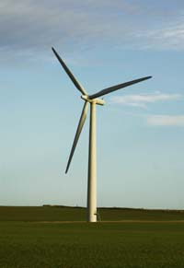

Figure 1.: A typical horizontal axis 3 blade wind turbine [4].

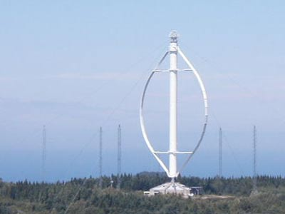

Figure 1.: A typical vertical axis wind turbine [5].

The horizontal axis wind turbines dominate the wind industry nowadays. Their biggest advantage over the vertical ones is that they can produce more power from a given surface area (footprint). Their most important drawback is that they are more demanding from a structural point of view because they carry heavier loads. However, due to the advances in the technology of materials, this problem has been partially solved and horizontal wind turbines can be considered safe nowadays [6].

## 1.2 Background and motivation

There are two ways to study and treat various scientific and technological problems. The most accurate, conventional and ancient way is through experimental measurements which have dominated over the last few centuries. The main problem of experimental devices is that they are often quite expensive and in many cases the laboratory conditions differ from the actual ones to a great extent (e.g. scale problems). Finally, the imposition of experimental devices in the area of interest in order to measure explicitly any variable of interest distorts even slightly the variables and may give false readings. For example, if a Pitot tube is placed in a wind tunnel to measure the velocity of a given area, it inevitably distorts the area around the Pitot tube as well as the area downstream of it.

Another way to study these problems is via theoretical models. The main problem of these methods is that almost all problems of interest in science and engineering are multidimensional and nonlinear. Consequently, analytic solutions exist only in rare cases. Therefore, the computational solution of the theoretical problems by using appropriate numerical methods which solve approximately, but with great accuracy under the appropriate circumstances, the equations that govern the problem, is recommended. The mathematical equations that are employed to define the vast majority of problems in nature, as well as in engineering, e.g. airplane and automotive aerodynamics, combustion problems, physical and chemical processing problems, weather forecasting problems etc., do not have analytic solutions. The computational solution leads to a cheaper and sometimes more reliable treatment in all of these cases. The computational treatment of these problems becomes more and more prevalent as the computational power increases.

Numerical methods analyze in depth the theoretical and mathematical framework which is required to treat the problems mentioned above through techniques and methods of solving the basic categories of differential equations which describe the general conservation principles of mass, energy and momentum in a developing in time and space physical or chemical system. The oldest and simplest numerical method that is applied to solve partial differential equations by transforming them into algebraic ones is the finite difference method. The method of finite elements was introduced a few years later and is mainly applied in structural engineering. The main problem with the finite element method is that it does not accurately treat the nonlinear terms. The finite volume method, a variation of the finite difference method, is one of the most ingenious methods for discretizing the differential equations which describe a fluid flow field and was scrutinized by Patankar (1980) for fluid flows as well as for heat transfer applications and is used by many commercial software. In particular, the Navier – Stokes equations, along with the continuity equation, the energy equation and 2 equations of state, are discretized and solved numerically in order to describe the physics of the problem and to quantify all of the unknown variables. This analysis, which is more complex than it appears, is called Computational Fluid Dynamics (CFD). Additional equations may be introduced when the flow is turbulent, which is the case in most engineering applications and physical phenomena.

CFD techniques, and in general numerical methods, were developed many years ago. However, due to the limitations of computational resources, they were studied mainly for academic purposes and they had not been used for industrial purposes because industry requires results as quickly as possible. Nevertheless, with the increase of computational power nowadays, CFD is successfully widely used for industrial applications along with experimental investigations.

Taking all the above into consideration, the experimental study of scientific and engineering problems, as long as the experimental devices are expensive and the whole experiment setup is carefully considered, is more reliable in general than numerical solutions. On the other hand, the numerical treatment of these problems is more time consuming depending on the nature of the problem, but at the same time cheaper. The only cost involved is the software licenses and HPC facilities. Also, depending on the application, there are cases, especially when the application can be treated as a steady state problem, where even a simple personal computer suffices to give accurate solutions which reduces the total cost to a great extent. Finally, with the improvement of computational power regarding memory and frequency, the numerical solutions are becoming more and more reliable and are used widely by the industry and academics nowadays and possibly they will replace in the future the experimental studies of various physical phenomena and engineering applications to a great extent.

## 1.3 Problem statement

One of the vast applications of CFD is the simulation of the ABL. Accurate results for the ABL are of vital importance for many applications such as weather forecasting, pollutant dispersion, building ventilation as well as for wind farms that are to be constructed in specific regions. It is generally known that wind flow is driven by pressure differences throughout the Earth, which are caused by temperature differences, which are caused by the different angles of attack of the sunlight, due to the almost spherical shape of the Earth. Consequently, the atmospheric boundary layer does not have any physical boarders, such as in pipe or channel flows, so artificial boarders have to be implemented in order to simulate a specific region, and to separate the region of interest from the region far away from it. The correct implementation of the inlet boundary condition is very important, as it is the boundary condition that drives the flow. Due to the transient nature of the flow, the implementation of the inlet boundary condition for LES is not as straightforward as in and should be carefully considered in order to obtain realistic and reliable results. In particular, since the ABL flow is always highly turbulent, the inlet boundary condition should represent a fully turbulent and developed ABL. Unfortunately, the fluctuations of the velocity components, which characterize the turbulence, cannot be created automatically and if they are not imposed somehow in the inlet of the domain, the velocity profile would look like a laminar profile. These fluctuations need many characteristic lengths downstream of the inlet to be created and this renders the simulation practically impossible as it would require an immense number of elements. Consequently, the correct implementation of the inflow data is of paramount importance for the simulation of the ABL in order to obtain accurate detailed data throughout an existing region, within a sensible time frame, for any application (e.g. installation of a wind farm or weather forecasting).

There are 2 different approaches to the problem of inflow data for LES. The first way is to obtain these data from existing libraries. These libraries can be obtained theoretically from experimental data; however, it is practically impossible to measure so detailed data throughout a surface for a long period of time. Another way to obtain these data is by performing another simulation prior, or concurrently, with the main simulation; often called in the literature as the precursor simulation. In this new auxiliary computational domain, periodic boundary conditions are implemented and data from a perpendicular to the flow plane somewhere in the middle of the domain are extracted every time step and imposed at the inlet of the main computational domain. The main problem with this method is related to the required computational time because it requires increased computational resources to perform 2 simulations and also problems with the storage may arise since data have to be stored in each time step of the precursor simulation. Also, this method is inadequate for spatially evolving flows (flows that are not fully developed) as well as for flows with non-uniform roughness terrains (Klein et al., 2003).

A way to overcome the problem with spatially evolving flows is by employing the recycling/rescaling method. According to this method, the data at a plane perpendicular to the flow a few characteristic lengths away from the inlet are mapped back to the inlet with some modifications to account for the boundary layer growth (Jarrin et al., 2006).

Another method to produce inflow data for LES is through mathematical functions. Evolving turbulence in time can be created by the stochastic methods and random functions taking as input only the average values of the solution obtained from RANS or experimental results. The main problems of this method is that the divergence free condition most of the times is not satisfied. The divergence free condition should be always satisfied because there is no creation or destruction of mass throughout the computational domain and thus may lead to unrealistic and non-converged results. While the divergence free condition is partially solved according to some publications, but the problem with unrealistic turbulence persists. Mathematical functions may create something that “looks” like turbulence but it is something fictitious, not a real turbulent profile given by experimental data or numerical simulations (Smirnov et al., 2001).

Finally, another method to overcome the turbulence creation problem at the inlet is to replace the inlet – outlet boundary conditions with periodic ones and this is the way adopted in the present thesis for LES. The turbulence created by this way gives a realistic turbulent flow, such as in the precursor simulation explained earlier, but the main problem with this method is that it cannot be used in all applications. It can be used only when the geometry of interest is repeated (e.g. wind farms with consecutive installed wind turbines) because the “inlet” condition is essentially the outlet of the computational domain. However, for wind turbine wake simulations it can be used if, a relatively large domain in the streamwise direction is used, because the distortion of the inlet regarding the velocity profile and turbulent kinetic energy is relatively small in relation to other applications such as flow around buildings (Porte – Agel et al., 2011).

On the other hand, the RANS approach also has its own problems. Since it is based on average quantities, it does not have the problem of the inflow turbulence generation at the inlet of the computational domain like in LES but the maintenance of the inlet quantities such as the velocity, turbulent kinetic energy (or even the Reynolds stresses if a second order closure model is employed) and eddy dissipation rate is problematic because the models are not mathematically consistent with the inlet conditions which characterize the ABL, and also due to the “non – existent” boundaries of it. Consequently, modifications on various RANS models are performed to make them mathematically consistent with the inlet properties of the computational domain. Also, the ABL is driven by geostrophic winds and the imposition of a free stress boundary condition at the upper boundary leads to unrealistic results, consequently the upper boundary is treated accordingly to maintain the inlet profiles along the domain.

Finally, contrary to LES, the successful simulation of the neutral atmosphere with the RANS approach does not necessarily mean that the model is appropriate for the simulation of wind turbine wakes. Every turbulence model performs well for a wide or narrow range of applications and this is the reason why many turbulence models exist in the literature. Consequently, further modifications of the already modified turbulence models are performed to make them successfully simulate both the neutral atmosphere and wind turbine wakes.

All in all, the present thesis is specialized in devising methods to maintain the turbulence levels, as well as all primitive variables, in some first or second – order closure RANS model and LES in atmospheric flows. The maintenance of all flow variables within an empty domain, along with the correct recovery of the wake for simulations of wind turbine wakes are of paramount importance because the wake region of a single turbine becomes the inlet condition of any downstream wind turbine and correct predictions for the velocity and turbulent kinetic energy are important for power output predictions and structural damage of the wind turbines.

# Chapter 2

# Theory

This chapter describes briefly the equations that govern the physical problem along with the theory behind the concept of CFD.

## 2.1 Governing equations

The physics of the problem is described mathematically by partial differential equations. Newton’s second law states that the rate of change of momentum of a fluid particle is equal to the sum of forces on the particle. Mathematically it is described as (Versteeg and Malalasekera, 2007):

|  |  |
| --- | --- |
| $$\frac{∂\left(ρu_{i}\right)}{∂t}+\frac{∂\left(ρu_{i}u_{j}\right)}{∂x_{j}}=ρg_{i}-\frac{∂P}{∂x_{i}}+\frac{∂τ_{ij}}{∂x_{j}}$$ | (2.1) |

From the first law of thermodynamics, it is known that the rate of change of energy of a fluid particle is equal to the rate of heat addition to the fluid particle plus the rate of work done on the particle. This statement can be expressed as:

|  |  |
| --- | --- |
| $$\frac{∂\left(ρe_{0}\right)}{∂t}+\frac{∂}{∂x_{j}}\left(ρu_{j}e_{0}\right)=-\frac{∂\left(u_{j}P\right)}{∂x_{j}}-\frac{∂q_{j}}{∂x_{j}}+\frac{∂\left(u_{i}τ_{ij}\right)}{∂x_{j}}$$ | (2.2) |

where $e_{0}$ and $q_{j}$ are the total energy and heat transfer defined as, respectively:

|  |  |
| --- | --- |
| $$e_{0}=e+\frac{u_{k}u_{k}}{2}$$ | (2.3) |

|  |  |
| --- | --- |
|  | (2.4) |

The system of equations is not yet closed because the unknowns outnumber the equations. In order to overcome this problem, two equations of state can be implemented by the assumption of the physical system is in thermodynamic equilibrium. These equations of state can link the variables introduced above:

|  |  |
| --- | --- |
| $$P=P_{\left(ρ,T\right)}$$ | (2.5) |

|  |  |
| --- | --- |
|  | (2.6) |

In the special case of the existence of the perfect gas, equations (2.5) and (2.6) are transformed as:

|  |  |
| --- | --- |
| $$P=ρRT$$ | (2.7) |

|  |  |
| --- | --- |
|  | (2.8) |

Finally, since the problem is not characterized by chemical or nuclear reactions, another equation can be derived from the conservation of mass:

|  |  |
| --- | --- |
| $$\frac{∂ρ}{∂t}+\frac{∂\left(ρu_{i}\right)}{∂x_{i}}=0$$ | (2.9) |

and this is also called as the continuity equation. With an exception of the viscous stresses, which are examined in the next paragraph, a system of 7 equations with 7 unknowns has already been derived. For a 3 dimensional flow on a Cartesian coordinate system the unknowns are the density, 3 velocity components, pressure, temperature and energy.

Almost all fluids are isotropic. To be more precise, all gases and most liquids are isotropic. A few liquids may show anisotropic behavior but this is beyond the scope of this PhD thesis and liquids are not examined here. The viscous stresses can be expressed as functions of the linear deformation rate (or strain rate) of the velocity components. This is expressed mathematically as:

|  |  |
| --- | --- |
| $$s_{ij}=0.5\left(\frac{∂u_{i}}{∂x_{j}}+\frac{∂u_{j}}{∂x_{i}}\right)$$ | (2.10) |

In a 3 – dimensional flow on a Cartesian coordinate system, there appear to be 9 components of the strain rate, of which 6 of them are independent for the case of isotropic fluids because $s_{ij}=s_{ji}$ for $i≠j$.

For the case of Newtonian fluids, the viscous stresses are proportional to the deformation. This statement is expressed as:

|  |  |
| --- | --- |
| $$τ_{ij}=μ\left(\frac{∂u_{i}}{∂x_{j}}+\frac{∂u_{j}}{∂x_{i}}\right)$$ | (2.11) |

The term $μ$ is the dynamic viscosity and it relates the stresses to the linear deformation rate. For compressible flows, however, apart from the linear deformation rate, the volumetric deformation rate also exists so the final expression for the viscous stresses is:

|  |  |
| --- | --- |
| $$τ_{ij}=μ\left(\frac{∂u_{i}}{∂x_{j}}+\frac{∂u_{j}}{∂x_{i}}\right)+λ\frac{∂u_{k}}{∂x_{k}}δ_{ij}$$ | (2.12) |

The term $λ$ is the bulk viscosity to relate the viscous stresses with the volumetric deformation rate. The bulk viscosity is unknown, consequently, the Stokes hypothesis is used:

|  |  |
| --- | --- |
| $$λ=-\frac{2}{3}μ$$ | (2.13) |

The Stokes hypothesis was made more than one and a half centuries ago and is still questionable. However, despite the fact that it was long time ago, no better solution was found to overcome this difficulty and experiments show good agreement with his assumption. At this point, equilibrium of the number of equations and unknowns is achieved, so the system of equations is closed and theoretically can be solved.

## 2.2 Simplifications

All liquids can be considered as incompressible under normal operating conditions. Compressibility effects of liquids are visible when pressures of the order of magnitude of hundreds of bar are involved which cannot be found almost anywhere in nature and in engineering applications. For instance, the density of water changes less than 5% at a pressure of 100 bar [25]. Gases on the other hand are compressible; however, when relatively low velocities occur, compressibility effects can be neglected without significantly affecting the accuracy of the obtained results. Engineers have specified this limit to be $Ma=0.3$. When the velocity magnitude of the gas takes place up to this limit, the estimated error in the results can be considered as negligible and the system of equations derived in the previous section can be simplified and the computational time can be reduced to a great extent. For atmospheric flows, especially when the whole ABL is examined, significant differences in the density with the height occur due to the fact that the upper layers of the atmosphere act toward the Earth due to the gravity. However, in higher elevations the air’s density decreases because the weight of the air becomes less intense. Also, significant variations in temperature occur due to the lower pressures that prevail in higher altitudes. For the atmospheric flows that are examined throughout the present PhD thesis, the velocities that occur are far smaller than the specified limit above, and also due to the fact that it is focused on low rise buildings and small wind turbines, consequently only a small fraction of the ABL is examined, variations in density and temperature are essentially negligible and they are omitted. Finally, the gravitational force is omitted due to the very small density of the air in relation to liquids.

Taking all the above into consideration, the continuity along with the Navier – Stokes equations are simplified as follows:

|  |  |
| --- | --- |
| $$\frac{∂u_{i}}{∂x_{i}}=0$$ | (2.14) |

|  |  |
| --- | --- |
|  | (2.15) |

This system of equations (2.14) – (2.15) consists of 4 equations and 4 unknowns for a 3 – dimensional flow in a Cartesian coordinate system. All that is needed is the discretization of the equations to convert them to algebraic equations and solve the resulting system of algebraic equations, along with a set of appropriate initial and boundary conditions. This procedure is called direct numerical simulation (DNS). A very accurate method but at the same time very time consuming, especially for high Reynolds numbers, and so far is mainly used only for academic purposes for small Reynolds numbers. The most significant problem with DNS is that it requires an extremely refined numerical grid along with a very small time step in the simulations which makes simulations practically impossible to be completed within a reasonable timeframe. The reason for this requirement has to do with turbulence. Turbulence is characterized by random and rapid fluctuations of the primitive variables in time and space. In order to capture these fluctuations, very small in size cells must be created, which increases the total number of grid cells. Many authors have specified the number of grid cells according to the value of the Reynolds number (Davidson, 2004). The number of grid points should be at least ${Re}^{2.25}$. In this case, taking into account that the Reynolds number for atmospheric flows is at the order of magnitude of millions, the required grid resolution would be at the order of magnitude of ${10}^{15}$ cells, which is prohibited.

## 2.3 Reynolds Averaged Navier – Stokes Approach

A remedy to this problem lies in the RANS approach firstly introduced by Osborn Reynolds (White, 2008). Reynolds, instead of employing the instantaneous quantities of the primitive variables, introduced their mean values over the time domain. For clarity, Figure 1 depicts the history of the instantaneous values of the u velocity component of a turbulent flow on a fixed specified location, for a Cartesian coordinate system.

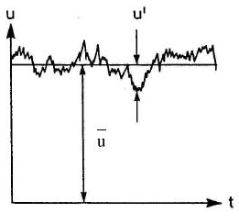

Figure 2.: Illustration of the mean and fluctuating part of the velocity of a turbulent flow [41].

Consequently, any instantaneous value of u velocity component can be divided into its averaged value and its fluctuation. The mean value of u velocity component is defined as:

|  |  |
| --- | --- |
| $$\overline{u}=\frac{1}{T}\int_{0}^{T}{u_{(t)}dt}$$ | (2.16) |

The fluctuation can be defined as the deviation of the instantaneous u velocity component from its mean value:

|  |  |
| --- | --- |
| $$u_{(t)}^{'}=u_{(t)}-\overline{u}$$ | (2.17) |

The same concept applies to any of the primitive variables.

|  |  |
| --- | --- |
| $$v_{(t)}^{'}=v_{(t)}-\overline{v}$$ | (2.18) |

|  |  |
| --- | --- |
|  | (2.19) |

|  |  |
| --- | --- |
|  | (2.20) |

In general, the instantaneous values of the primitive variables are functions not only of time but also of space.

The mean value of any fluctuating variable at a fixed location for a time independent application is equal to zero:

|  |  |
| --- | --- |
| $$\overline{u^{'}}=\frac{1}{T}\int_{0}^{T}{\left(u_{(t)}-\overline{u}\right)dt}=\overline{u}-\overline{u}=0$$ | (2.21) |

Applying these relations into the continuity and Navier – Stokes equations and apply the averaging process described in Section 2.2, the equations (2.14) – (2.15) take the following form:

|  |  |
| --- | --- |
| $$\frac{∂\overline{u}}{∂x}+\frac{∂\overline{v}}{∂y}+\frac{∂\overline{w}}{∂z}=0$$ | (2.22) |

|  |  |
| --- | --- |
|  | (2.23) |

|  |  |
| --- | --- |
|  | (2.24) |

|  |  |
| --- | --- |
|  | (2.25) |

This procedure introduced the new quantities $\overline{u_{i}u_{j}}$ which are called Reynolds stresses and at this point are unknown, so the system of equations is not yet closed. The system of equations is closed based on Boussinesq hypothesis. Boussinesq introduced the concept of the eddy viscosity (Wilcox, 2010). As in laminar flows, where the viscosity is analogous to the shear stresses, the eddy viscosity should be analogous to the mean velocity gradient, so the momentum transfer between these turbulent eddies can be modeled with this eddy viscosity concept. For incompressible flows, this concept is summarized in the following formula:

|  |  |
| --- | --- |
| $$-ρ\overline{u_{i}^{'}u_{j}^{'}}=μ_{t}\left(\frac{∂\overline{u_{i}}}{∂x_{j}}+\frac{∂\overline{u_{j}}}{∂x_{i}}\right)-\frac{2}{3}ρkδ_{ij}$$ | (2.26) |

The only extra unknown that has to be calculated is the eddy (or turbulent) viscosity, which is calculated from turbulence models. The turbulence modeling concept is analyzed in the following section.

## 2.4 Turbulence modeling

The vast majority of flows encountered in nature and engineering are turbulent. Turbulent flows are characterized by random, rapid and non-predictable fluctuations of the primitive variables, unsteady and highly dissipative and consist of eddies of various sizes. Figure 2.2 represents the energy spectrum of turbulent flows.

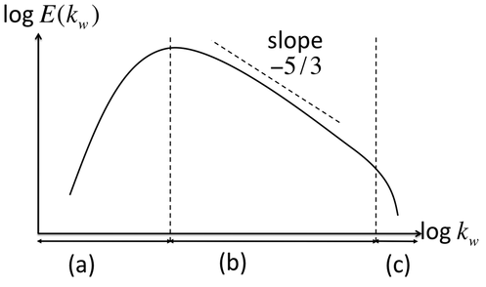

Figure 2.: Turbulent kinetic energy distribution for a turbulent flow as a function of wavenumber [10].

The three distinguishable regions (a), (b) and (c) are called the energy containing range, inertial sub-range and viscous range, respectively. The energy containing eddies gain energy from the mean flow and cascade them into smaller scales. This is an ongoing process from the larger to the smaller scales. The smaller eddies should be in a state where the rate of energy they gain from the larger scales should be equal to the rate of energy which is dissipated into heat, as there are not any smaller scales to cascade into them any energy (Wilcox, 2010). Kolmogorov made the assumption that there must be some medium sized eddies where the cascade process is independent of the large and small eddies, so their energy should be a function only of their size and dissipation of energy. This is called the Kolmogorov’s -5/3 law. On dimensional grounds, for the inertial sub-range region, he concluded that:

|  |  |
| --- | --- |
| $$E_{(κ)}=C_{κ}ε^{2/3}κ^{-5/3}$$ | (2.27) |

Although this law is of little use in classical turbulence modeling, it is of paramount importance in LES (Wilcox, 2010).

### 2.4.1 The standard k – ε model

There are various turbulence models in the literature and many of them are available in commercial CFD software. There are zero, one and, the most common of all, 2 equation turbulence models. These models are called first – order closure models. As it was stated in Chapter 1, turbulence modeling takes place because the turbulence cannot be resolved since it requires an extremely refined numerical grid. Instead, mathematical equations are employed to consider the diffusion of the flow which is caused by the various turbulent length scales. Turbulence modeling uses the idea of Osborn Reynolds about the averaging process over the time. One of the oldest and the most common 2 equation turbulence model flows is the standard k – ε model (Launder and Spalding, 1972) and it is suitable generally for free shear flows (Menter, 1994). It has been used extensively for environmental flows (Kim and Boysan, 1999) including buildings (Hooff et al., 2017), pollutant dispersion (Tominaga and Stathopoulos, 2012) and wind turbine wakes (Crespo et al., 1999; Kasmi and Masson, 2008; Laan P. et al., 2015; Simisiroglou et al., 2016). It uses one equation for turbulent kinetic energy and one equation for the turbulence dissipation. It is a semi empirical model as the equation for the eddy dissipation rate is highly empirical in nature (Chen and Kim, 1987). The two equations, for unsteady compressible flows are:

|  |  |
| --- | --- |
| $$\frac{∂\left(ρk\right)}{∂t}+\frac{∂\left(ρku_{i}\right)}{∂x_{i}}=\frac{∂}{∂x_{i}}\left[\left(μ+\frac{μ_{t}}{σ_{k}}\right)\frac{∂k}{∂x_{i}}\right]+G_{k}+G_{b}-ρε-Y_{M}+S_{k}$$ | (2.28) |

|  |  |
| --- | --- |
|  | (2.29) |

$G_{k}$ is the turbulence production and is expressed as follows:

|  |  |
| --- | --- |
| $$G_{k}=-ρ\overline{u_{i}^{'}u_{j}^{'}}\frac{∂u_{j}}{∂x_{i}}$$ | (2.30) |

$G_{b}$ is the effect of buoyancy and is expressed as follows:

|  |  |
| --- | --- |
| $$G_{b}=βg_{i}\frac{μ_{t}}{{Pr}_{t}}\frac{∂T}{∂x_{i}}$$ | (2.31) |

$Y_{M}$ is a correction for compressible flows and is expressed as follows:

|  |  |
| --- | --- |
| $$Y_{M}=2ρε\frac{k}{a^{2}}$$ | (2.32) |

Finally, the equation of the dynamic eddy viscosity is given by:

|  |  |
| --- | --- |
| $$μ_{t}=ρC_{μ}\frac{k^{2}}{ε}$$ | (2.33) |

The model constants are given the values $C_{1ε}=1.44$, $C_{2ε}=1.92$, $C_{μ}=0.09$, $σ_{k}=1$ and $σ_{ε}=1.3$.

Modifications and improved versions of the standard k – ε model have been developed over the years such as the realizable k – ε (Shih et al., 1995) and the RNG k – ε (Orszag et al., 1993). Generally, improvement of the results has been shown in many applications, while in other cases the results have been proven to be the same or worse, depending on the application and therefore the problem appears to be an application and constant dependent problem.

### 2.4.2 The standard k – ω model

Another common 2 equation model is the k – ω model firstly introduced by Wilcox (Wilcox, 1988). As a general rule, the drawbacks of the family of k – ε models regarding its poor performance in flows with strong adverse pressure gradients are minimized with the k – ω model. Instead of the eddy dissipation rate, it uses the eddy frequency as second variable. In particular, the eddy frequency is defined as:

|  |  |
| --- | --- |
| $$ω=\frac{ε}{β_{∞}^{*}k}$$ | (2.34) |

The equations of the standard k – ω model are as follows:

|  |  |
| --- | --- |
| $$\frac{∂}{∂t}\left(ρk\right)+\frac{∂}{∂x_{i}}\left(ρku_{i}\right)=\frac{∂}{∂x_{i}}\left[\left(μ+\frac{μ_{t}}{σ_{k}}\right)\frac{∂k}{∂x_{i}}\right]+G_{k}-Y_{k}+S_{k}$$ | (2.35) |

|  |  |
| --- | --- |
|  | (2.36) |

The length scale in this model is defined as:

|  |  |
| --- | --- |
| $$l=\frac{\sqrt{k}}{ω}$$ | (2.37) |

The eddy viscosity is:

|  |  |
| --- | --- |
| $$μ_{t}=a^{*}ρ\frac{k}{ω}$$ | (2.38) |

where

|  |  |
| --- | --- |
| $$a^{*}=a_{∞}^{*}\left(\frac{\frac{β_{i}}{3}+\frac{\frac{ρk}{μω}}{6}}{1+\frac{\frac{ρk}{μω}}{6}}\right)$$ | (2.39) |

The production terms for the turbulent kinetic energy and specific dissipation rate, respectively, are defined as:

|  |  |
| --- | --- |
| $$G_{k}=μ_{t}S^{2}$$ | (2.40) |

|  |  |
| --- | --- |
|  | (2.41) |

where

|  |  |
| --- | --- |
| $S=\sqrt{{2S}_{ij}S_{ij}}$ | (2.42) |

and

|  |  |
| --- | --- |
| $$a=\frac{a_{∞}}{a^{*}}\left(\frac{a_{0}+\frac{\frac{ρk}{μω}}{2.95}}{1+\frac{\frac{ρk}{μω}}{2.95}}\right)$$ | (2.43) |

The dissipation terms for the turbulent kinetic energy and specific dissipation rate, respectively, are defined as:

|  |  |
| --- | --- |
| $Y_{k}=ρβ^{*}f_{β^{*}}kω$ | (2.44) |

|  |  |
| --- | --- |
|  | (2.45) |

where

|  |  |
| --- | --- |
| $$f_{β^{*}}=\left\{\begin{aligned}1, &χ_{k}≤0 \\ \frac{1+680χ_{k}^{2}}{1+400χ_{k}^{2}}, &χ_{k}≥0\end{aligned}\right.$$ | (2.46) |

|  |  |
| --- | --- |
|  | (2.47) |

|  |  |
| --- | --- |
|  | (2.48) |

|  |  |
| --- | --- |
|  | (2.49) |

|  |  |
| --- | --- |
|  | (2.50) |

|  |  |
| --- | --- |
|  | (2.51) |

|  |  |
| --- | --- |
|  | (2.52) |

|  |  |
| --- | --- |
|  | (2.53) |

The model constants are $a_{∞}^{*}=1$, $a_{∞}=0.52$, $a_{0}=1/9$, $β_{∞}^{*}=0.09$, $β_{i}=0.072$, $ζ^{*}=1.5$, $σ_{k}=2$ and $σ_{ω}=2$.

As in the case of the standard k – ε model, modifications to the standard k – ω model have been reported in the literature. Wilcox (Wilcox, 1998) has introduced an improved version of the model and also another very popular model is the k – ω SST (Shear Stress Transport) model (Menter, 1994).

### 2.4.3 The Reynolds – stress model

There are many applications, especially in highly turbulent flows with significant body forces, where the Boussinesq assumption for isotropy is not valid and the Reynolds stresses are very poorly represented by the relationship (2.26). A remedy to this problem lies into the Reynolds Stress Model (RSM) originally proposed by Launder et al. (1975). In this particular model, a transport equation for every Reynolds stress is solved along with the Navier – Stokes and continuity equation and/or the energy equation along with one equation for the eddy dissipation rate. The simplest of all Reynolds stress models is the linear pressure strain model and the exact equations of the model are the following:

|  |  |
| --- | --- |
| $$\frac{∂}{∂t}\left(ρ\overline{u_{i}^{'}u_{j}^{'}}\right)+C_{ij}=D_{T,ij}+D_{L,ij}+P_{ij}+G_{ij}-φ_{ij}-ε_{ij}+F_{ij}+S_{user}$$ | (2.54) |

where:

|  |  |
| --- | --- |
| $$C_{ij}=\frac{∂}{∂x_{k}}\left(ρu_{k}\overline{u_{i}^{'}u_{j}^{'}}\right)$$ | (2.55) |

|  |  |
| --- | --- |
|  | (2.56) |

|  |  |
| --- | --- |
|  | (2.57) |

|  |  |
| --- | --- |
|  | (2.58) |

|  |  |
| --- | --- |
|  | (2.59) |

|  |  |
| --- | --- |
|  | (2.60) |

|  |  |
| --- | --- |
|  | (2.61) |

|  |  |
| --- | --- |
|  | (2.62) |

The terms $D_{T,ij}$, $G_{ij}$, $φ_{ij}$ and $ε_{ij}$ need further modeling because they cannot be explicitly solved. These terms are modeled as follows:

|  |  |
| --- | --- |
| $$D_{T,ij}=C_{s}\frac{∂}{{∂x}_{k}}\left(ρ\frac{k\overline{u_{k}^{'}u_{l}^{'}}}{ε}\frac{∂\overline{u_{i}^{'}u_{j}^{'}}}{∂x_{l}}\right)$$ | (2.63) |

|  |  |
| --- | --- |
|  | (2.64) |

|  |  |
| --- | --- |
|  | (2.65) |

where $a$ is the speed of sound:

|  |  |
| --- | --- |
| $$a=γRT$$ | (2.66) |

The modeling of the pressure strain term is quite challenging and in the literature many different models have been developed. The simplest of all in the linear – pressure strain model developed by Gibson and Launder (Gibson and Launder, 1978). According to this sub – model, the modeling of the pressure – strain term is as follows:

|  |  |
| --- | --- |
| $$φ_{ij}=φ_{ij,1}+φ_{ij,2}$$ | (2.67) |

|  |  |
| --- | --- |
|  | (2.68) |

|  |  |
| --- | --- |
|  | (2.69) |

$C_{1}$ and $C_{2}$ are constants given the values of $C_{1}=1.8$ and $C_{2}=0.6$.

For reasons that are explained later, the linear – pressure strain model will not be used in the present thesis. Instead, the quadratic pressure strain model is used. The quadratic – pressure strain model originally proposed by Speziale et al. (Speziale et al., 1991) models the pressure strain as follows:

$$φ_{ij}=-\left(C_{1}ρε+C_{1}^{*}\frac{1}{2}P_{kk}\right)b_{ij}+C_{2}ρε\left(b_{ik}b_{kj}-\frac{1}{3}b_{mn}b_{mn}δ_{ij}\right)+\left(C_{3}-C_{3}^{*}\sqrt{b_{ij}b_{ij}}\right)ρkS_{ij}+$$

|  |  |
| --- | --- |
| $$+C_{4}ρk\left(b_{ij}S_{jk}+b_{jk}S_{ik}-\frac{2}{3}b_{mn}S_{mn}δ_{ij}\right)+C_{5}ρk\left(b_{ik}Ω_{jk}+b_{jk}Ω_{ik}\right)$$ | (2.70) |

The Reynolds stress anisotropy tensor is:

|  |  |
| --- | --- |
| $$b_{ij}=-\left(\frac{-ρ\overline{u_{i}^{'}u_{j}^{'}}+\frac{2}{3}ρkδ_{ij}}{2ρk}\right)$$ | (2.71) |

Finally, a similar to the standard k – ε model equation for the eddy dissipation rate closes the system of equations:

|  |  |
| --- | --- |
| $$\frac{∂}{∂t}\left(ρε\right)+\frac{∂}{∂x_{i}}\left(ρεu_{i}\right)=\frac{∂}{∂x_{i}}\left[\left(μ+\frac{μ_{t}}{σ_{ε}}\right)\frac{∂ε}{∂x_{i}}\right]+C_{ε1}\frac{1}{2}\left[P_{ii}+C_{3}G_{ii}\right]\frac{ε}{k}-C_{ε2}ρ\frac{ε^{2}}{k}+S_{user}$$ | (2.72) |

The turbulent viscosity is defined as in the k – ε model from equation (2.33).

## 2.5 Wall treatment

Figure 2.3 represents a typical turbulent boundary layer as it develops for a flow over a flat plate.

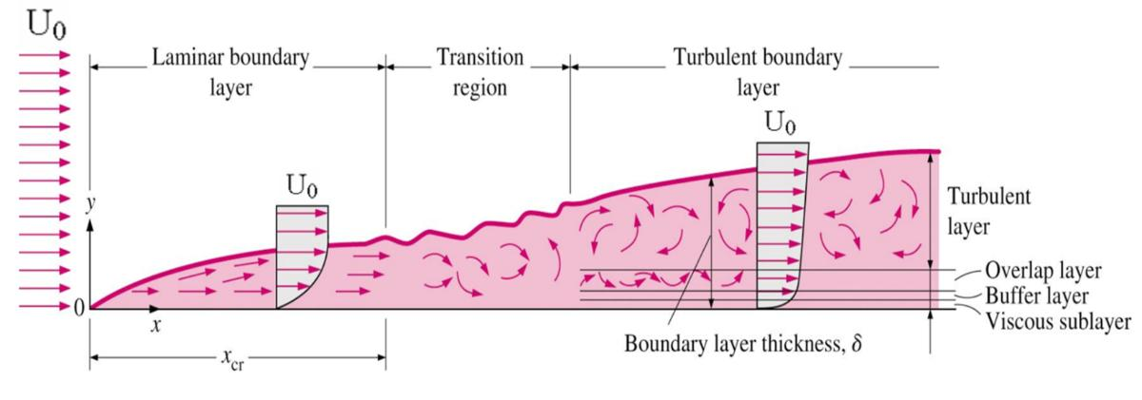

Figure 2.: Schematic representation of the development of the turbulent boundary layer over a flat plate (Cengel and Cimbala, 2006)

The first region in the development of the turbulent boundary layer consists of a very thin layer called the viscous sublayer where experiments have shown that the velocity gradient with the distance from the wall is almost linear, because the viscous forces are dominant and the inertial forces are almost negligible. Mathematically this may be described as:

|  |  |
| --- | --- |
| $$τ_{w}=μ\frac{u}{y}=ρν\frac{u}{y}⇒\frac{τ_{w}}{ρ}=\frac{νu}{y}$$ | (2.73) |

The square root of the quantity ${τ_{w}}/ρ$ has dimensions of velocity and is called the friction velocity. This velocity does not have any physical meaning but it is a very useful quantity in order to non dimensionalize the velocity profile in the viscous sublayer (Cengel and Cimbala, 2006):

|  |  |
| --- | --- |
| $$\frac{u}{u_{*}}=\frac{yu_{*}}{ν}$$ | (2.74) |

The equation (2.74) is known as the laminar sub – layer and experiments have shown that it is valid for smooth surfaces for $0≤{yu_{*}}/ν≤5.$

Since it is more convenient to use non dimensionalized variables, the non dimensionalized distance and velocity from the wall are respectively:

|  |  |
| --- | --- |
| $$y^{+}=\frac{yu_{*}}{ν}$$ | (2.75) |

|  |  |
| --- | --- |
|  | (2.76) |

So within the viscous sublayer the equation above becomes simply $u^{+}=y^{+}$.

Within the overlap layer (or log – law region), experiments have shown that the velocity profile can be expressed quite satisfactorily by the logarithmic law:

|  |  |
| --- | --- |
| $$\frac{u}{u_{*}}=\frac{1}{κ}ln\left(\frac{yu_{*}}{ν}\right)+B$$ | (2.77) |

The value of $B$ needs to be determined experimentally and is given usually a value of around $5$, while $κ$ is the Von Karman constant. The equation (2.77) is known as the law of the wall.

Figure 2.4 represents the non – dimensionalized velocity over the non – dimensionalized logarithmic distance from the wall.

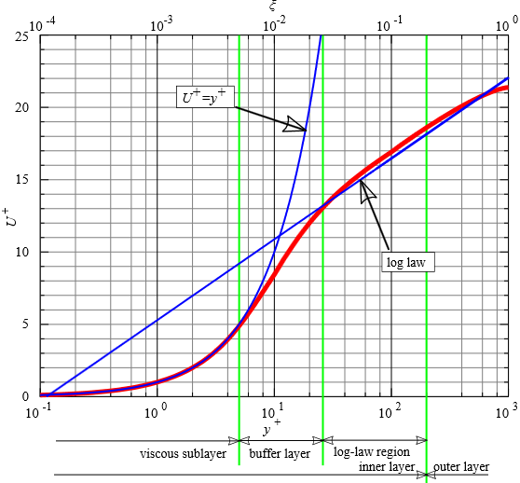

Figure 2.: Non - dimensionalized velocity as a function of the non - dimensionalized distance from the wall [13].

As seen in Figure 2.4, for $0≤y^{+}≤5$ the non dimensionalized velocity equals the non dimensionalized distance from the wall and the logarithmic velocity profile is valid for $30≤y^{+}≤1000$.

### 2.5.1 Wall function for smooth walls

It is impossible in many turbulent flows of engineering interest to create a very refined numerical grid to resolve the boundary layer. In particular, it is impossible to create very thin layers around the geometry of interest to catch the region where the law of the wall of the equation (2.74) is valid. An alternative approach is to employ a wall function. The standard wall function proposed by Launder and Spalding (1974) has been being employed very widely for most engineering applications for the family of k – ε and RSM models. In short, the standard wall function is expressed by the following formulas:

|  |  |
| --- | --- |
| $$u^{*}=\frac{1}{κ}ln\left(Ey^{*}\right)$$ | (2.78) |

The quantity $E$ is an empirical constant and is given the value of $E=9.793$. The quantity $u^{*}$ is the dimensionless velocity expressed by:

|  |  |
| --- | --- |
| $$u^{*}=\frac{ρu_{P}C_{μ}^{0.25}k_{P}^{0.5}}{τ_{w}}$$ | (2.79) |

The quantity $y^{*}$ is the dimensionless distance from the wall and is expressed by:

|  |  |
| --- | --- |
| $$y^{*}=\frac{ρu_{P}C_{μ}^{0.25}k_{P}^{0.5}y_{P}}{μ}$$ | (2.80) |

Since the k – ε turbulence model is employed for the standard wall function, information for the turbulence quantities are required. Also, as it is clear from the equations above the turbulent kinetic energy is required to calculate the velocity at the first cell from the wall. The turbulent kinetic energy and eddy dissipation rate, respectively, are calculated as follows:

|  |  |
| --- | --- |
| $$\frac{∂k}{∂n}=0$$ | (2.81) |

|  |  |
| --- | --- |
|  | (2.82) |

Finally, the turbulence generation is expressed as:

|  |  |
| --- | --- |
| $$G_{k}=τ_{w}\frac{τ_{w}}{κρ{C_{μ}^{0.25}k_{P}^{0.5}y}_{P}}$$ | (2.83) |

Experiments in rough surfaces have shown that the velocity profile has the same slope as in smooth surface when plotted in a semi logarithmic scale but a different intercept value for $B$ from the equation (2.76). Consequently, for rough walls the law of the wall is expressed by:

|  |  |
| --- | --- |
| $$\frac{{ρu}_{p}u^{*}}{τ_{w}}=\frac{1}{κ}ln\left(E\frac{{ρu}_{p}u^{*}}{μ}\right)-ΔΒ$$ | (2.84) |

For fully rough surfaces, which is always the case in ABL flows, the quantity $ΔΒ$ is expressed as:

|  |  |
| --- | --- |
| $$ΔΒ=\frac{1}{κ}ln\left(1+C_{s}K_{s}^{+}\right)$$ | (2.85) |

The quantity $C_{s}$ is a roughness constant which is usually given the value of $C_{s}=0.5$. The quantity $K_{s}^{+}$ is the non – dimensional roughness height and it requires a rather complicated procedure for its determination.

## 2.6 Large Eddy Simulation

The most remarkable advantage of employing RANS is that relatively quick results can be obtained even from, depending on the application, a personal computer and has been used widely in industry and for academic purposes. However, it suffers of some major disadvantages. The most significant disadvantage of the RANS approach, with an exception of the RSM, is that the Reynolds stresses are a linear function of the mean deformation rate based on the Boussinesq assumption, which is not the case for the large eddies which are highly anisotropic. As stated in the previous section, the RSM does not assume isotropy, so it appears to be a very good remedy for the RANS approach. However, the RSM encounters significant convergence problems because it consists of many extra equations and consequently it cannot be employed in many cases, given the complexity of the numerical grid. On the other hand, as it was stated in Section 2.1.2, an attempt to create a very refined numerical grid to resolve all eddies throughout the region of interest, a procedure called DNS, would be very time consuming and is frequently considered as prohibitory in industry and also for some cases in academy. A remedy to this problem lies in the concept of the Large Eddy Simulation (LES).

A compromise between RANS and DNS is the LES approach. The main characteristic of LES is that it resolves the large scales of the turbulent spectrum and it models the smaller ones. The required computational time and grid resolution lies somewhere between DNS and RANS. Another advantage of LES is that it is easier to model the smaller eddies because their behavior is more isotropic and resolves the larger ones which are more anisotropic and more difficult to be modeled as well as they are responsible for the largest percentage of momentum transfer between the eddies, thus the results of LES are more reliable than the ones obtained by employing RANS. Figure 2.5 illustrates the concept of the above statement. The portion of the resolved scales depends exclusively on the numerical grid size.

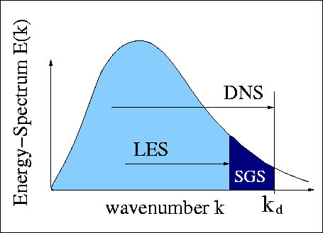

Figure 2.: Portion of resolved scales in LES and DNS [27].

The distinction between small and large scales is performed by the filtering procedure. A filter function is defined as follows [8]:

|  |  |
| --- | --- |
| $$\overline{φ_{\left(x,t\right)}}=\int_{-∞}^{∞}{\int_{-∞}^{∞}{\int_{-∞}^{∞}{G_{\left(x,x^{'},Δ\right)}φ_{\left(x^{'},t\right)}dx_{1}^{'}dx_{2}^{'}dx_{3}^{'}}}}$$ | (2.86) |

Contrary to the RANS procedure, the overbar here does not indicate time averaging; it indicates filtering. The function $\overline{φ_{\left(x,t\right)}}$ is the filtered function, $φ_{\left(x,t\right)}$ is the original function and $Δ$ is the cutoff width. Consequently, eddies larger than this length are resolved and the ones smaller than this size are modeled. The cutoff width is essentially the average edge length of the cell. For hexahedral and tetrahedral cells this is given by, respectively:

|  |  |
| --- | --- |
| $$Δ=\sqrt[3]{ΔxΔyΔz}$$ | (2.87) |

|  |  |
| --- | --- |
|  | (2.88) |

Regarding the filtering functions, the most common are the top hat filter, the Gaussian filter and the spectral cutoff filter. Most finite volume solvers use the top hat filter function which is given by:

|  |  |
| --- | --- |
|  | (2.89) |

By filtering the continuity and Navier – Stokes equations for incompressible flow, the LES equations for a Cartesian coordinate system yield:

|  |  |
| --- | --- |
| $$\frac{∂\tilde{u}}{∂x}+\frac{∂\tilde{v}}{∂y}+\frac{∂\tilde{w}}{∂z}=0$$ | (2.90) |

|  |  |
| --- | --- |
|  | (2.91) |

|  |  |
| --- | --- |
|  | (2.92) |

|  |  |
| --- | --- |
|  | (2.93) |

Figure 2.6 shows the difference between the filtered and the instantaneous values of the $x$ velocity component. It captures the general trend of any of the primitive variables but it does not capture the rapid fluctuations of them. In other words, it does not resolve the variables with high frequency wavenumbers.



Figure 2.: Filtered velocity (red line) versus instantaneous velocity (black line) [15].

Figure 2.7 illustrates the differences between the RANS, LES and DNS concepts.

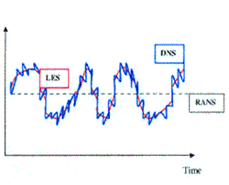

Figure 2.: Schematic representation of any calculated variable of RANS, LES and DNS [26].

RANS calculates the average values while DNS captures the whole history at any time instance. LES works in the same manner with DNS with the only difference that it is unable to capture the whole range of wavenumbers. High wavenumber eddies are characterized by high frequency which are very difficult to be captured unless a very refined grid is employed. The range of the resolved eddies depends on the numerical grid size.

The equations (2.89) – (2.92) look almost identical to the ones obtained from the Reynold’s averaging procedure but as it was stated earlier, the overbar over the primitive variables here indicates filtered variables and not time averaged. As in RANS, some stresses appear which are called subgrid scale stresses and these have to be determined. The subgrid scale stresses for the Navier Stokes equations for the x,y,z directions are:

|  |  |
| --- | --- |
| $$τ_{ij}=ρ\overline{u_{i}u_{j}}-ρ\overline{u_{i}}\overline{u_{j}}$$ | (2.94) |

However, unlike RANS, these stresses are more complex because they contain the filtered and the unresolved part, $φ_{\left(x,t\right)}=\overline{φ_{\left(x,t\right)}}+φ_{\left(x,t\right)}^{'}$. By applying this decomposition on the components of velocity, the subgrid scale stresses are transformed as:

|  |  |
| --- | --- |
| $$τ_{ij}=ρ\overline{u_{i}u_{j}}-ρ\overline{u_{i}}\overline{u_{j}}=\left(ρ\overline{\overline{u_{i}}\overline{u_{j}}}-\overline{u_{i}}\overline{u_{j}}\right)+ρ\overline{\overline{u_{i}}u_{j}^{'}}+ρ\overline{u_{i}^{'}\overline{u_{j}}}+ρ\overline{u_{i}^{'}u_{j}^{'}}$$ | (2.95) |

These stresses can be divided into 3 parts. The Leonard stresses, the cross stresses and the LES Reynolds stresses. However, a common approach to this problem is to ignore the Leonard and cross stresses and collect all of their contribution to the LES Reynolds stresses. Exactly like in RANS approach, these stresses are needed to be modeled.

A very common and the most widely used model is the Smagorinksy – Lilly model. This model is based on the assumption that the small scales, which are modeled, are isotropic, so the Boussinesq hypothesis might provide good results and he connected these stresses with the resolved flow. Therefore, these stresses can be calculated by [8]:

|  |  |
| --- | --- |
| $$τ_{ij}=-μ_{SGS}\left(\frac{∂\overline{u_{i}}}{∂x_{i}}+\frac{∂\overline{u_{j}}}{∂x_{j}}\right)+\frac{1}{3}τ_{ii}δ_{ij}$$ | (2.96) |

Another unknown has been introduced here, the subgrid scale viscosity, which needs to be determined. The Smagorinksy – Lilly model assumes that this viscosity can be determined by a velocity scale and a length scale. Since the distinction of the small subgrid scale eddies from the large ones was based on the filter cutoff width, it is convenient to select the size of the length scale equal to the filter cutoff size Δ. As far as the velocity scale is concerned, it is calculated from the length scale and the average strain rate, so the kinematic subgrid scale viscosity is defined as:

|  |  |
| --- | --- |
| $$ν_{SGS}={\left(C_{SGS}Δ\right)}^{2}\sqrt{\overline{S_{ij}}2\overline{S_{ij}}}$$ | (2.97) |

The strain rate is defined as:

|  |  |
| --- | --- |
| $$\overline{S_{ij}}=0.5\left(\frac{∂\overline{u_{i}}}{∂x_{j}}+\frac{∂\overline{u_{j}}}{∂x_{i}}\right)$$ | (2.98) |

At this point, the only constant to close the system is the $C_{SGS}$. Many scientists proposed many values based on theory and numerical calculations. Their work showed that its value is not a universal one and depends on the application. However, for a wide range of applications, its range of values lies between 0.1 and 0.24 (Versteeg and Malalasekera, 2006).

## 2.7 Errors in CFD

On summarizing the whole concept of CFD, some inevitable errors can be identified:

* Discretization error

The computational domain cannot be discretized into an infinite number of points. For RANS simulations, a sensible number of cells should be chosen by performing a grid convergence study. In LES a grid convergence study cannot be performed because the more scales will be resolved and the modeling of the smaller scales will become minimized as the grid resolution increases. Theoretically, the more refined the grid is, the more reliable the results are. In any case, by discretizing the domain, some information is lost between the nodes.

* Turbulence modeling

In many applications, the error produced by the turbulence modeling in RANS or in the modeling of the small unresolved scales in LES, is the most considerable of all because it contains numerous approximations (empirical or semi – empirical equations) and questionable assumptions (e.g. isotropic turbulence).

* Truncations error

Computers cannot store infinite number of digits. Modern computers can store up to 32 digits, so the rest are truncated. This error can be significant when a considerable number of iterations is required until a converged solution is achieved.

* Convergence criteria

Theoretically, the value of each variable should not differ from its previous iteration. However, it is not practical to specify the convergence criteria close to the limits of the computer’s storage capacity, because it will be almost impossible to have a converged solution with such strict criteria and also the truncation error explained above would be remarkably high and the solution would have been far from reliable. As a rough approximation, a level of convergence of all the variables of the order of magnitude of ${10}^{-5}$ is acceptable for many engineering applications (Fluent Theory Guide, 2012).

* Compressibility effects

This is not an issue for every simulation as compressibility effects on gases can be introduced by employing a Riemann solver. However, it is quite cheaper regarding the computational cost to consider the gas as incompressible when the velocity magnitude throughout the computational domain does not exceed the limit of $Ma=0.3$, with a minimum error (Almgren et al., 2006).

* Continuum hypothesis

All fluids in any commercial CFD software or in – house codes are considered to be continuum. This hypothesis appears to be accurate in most applications, especially for liquids. However, it is questionable for applications where high Mach number or temperature of the employed gases is employed [28].

* Treatment of viscous term

As stated in Section 2.1, the unknown stresses in the viscous term of the momentum equations are treated based on the assumption of Stokes who connected the stresses linearly with the velocity gradients. Despite the fact that this assumption appears to be accurate by being validated from many experiments performed over the last century, it has not been proven mathematically. However, this error apart from being almost negligible, it would exist even if analytical solutions of the Navier – Stokes equations exist, so strictly speaking, it cannot be considered as an error introduced by CFD.

## 2.8 Boundary conditions

The computational domain, which contains the region of interest, is finite. Reasonable distances in any direction away from the geometry of main interest, if there is any, must be taken into account based on sensible assumptions and other scientists’ work. Some information must be given on these boundaries in order to close the system of equations explained in Section 2.4. In atmospheric boundary layer flows, the most common types of boundary conditions are as follows:

* Free slip or symmetry

At the sides and the top of the computational domain, where the flow is parallel to these artificial walls of the domain, a common approach is to input into the code that the value of any primitive variable does not change any further away from this artificial boundary.

* No slip

Any real viscous flow is subject to the no slip condition at any solid wall. Any velocity component on the wall is equal to zero for any stationary wall. For $y^{+}$ values 30 or over, a wall function must be employed to represent the actual velocity distribution of the first cell. For $y^{+}≈1$ the boundary layer is fully resolved and no wall function is needed.

* Velocity inlet

Air flow around the Earth is caused by pressure differences in various locations around Earth, which are caused by temperature differences at these locations, which are caused by the different angle of attack of the sun’s radiation due to the almost spherical shape of the Earth. Consequently, one of the boundaries of the computational domain must be the one which drives the air flow. This is imposed by a fixed value for the velocity components, or a velocity distribution. For atmospheric boundary layer flows, many authors impose a logarithmic velocity profile which represents a quite accurate velocity distribution of the atmospheric boundary layer (Richards and Hoxey, 1993).

For the RANS simulations, apart from the velocity profile, some information is required for the extra equations introduced by any turbulence model. In example, when the standard k – ε model is employed, values of the turbulent kinetic energy and dissipation rate are required in order to close the system of equations in the whole computational domain. These data can be taken mainly from experimental data or various approximations by other scientists, depending on the nature of the problem and the characteristics of the geometry under investigation.

The pressure should not be specified at the inlet boundary condition when the velocity is specified as this would overspecify the problem because the velocity and pressure are coupled within the governing equations.

* Outlet

Information throughout the outlet boundary condition should also be given. The most common outlet boundary condition is the “pressure outlet” boundary condition, which means zero streamwise gradients for all variables with an exception of the pressure. In a similar manner as with the velocity inlet boundary condition, the velocity should not be specified at a pressure outlet or outflow boundary condition as this would lead to divergence or nonphysical results due to the overspecification of the problem. The value of the pressure, along with the turbulent quantities in case of backflow, is specified at the outlet in order to fully determine the problem and enable the code to solve it.

# Chapter 3

# Literature survey

## 3.1 Introduction to neutral atmosphere

The atmosphere can be classified into 3 basic categories: stable, unstable and neutral. The atmosphere is characterized as stable when it resists to any rising particles from the ground to higher levels of the atmosphere, in other words, when it is characterized by negative buoyancy forces. This is usually the case during nights when the earth loses its heat through radiation and, consequently, the lower part of the atmosphere, which is in contact with the ground, cools, while the upper part of the atmosphere is warmer. As a result, the air particles close to the ground are heavier than the air particles at the upper levels of the atmosphere, so any movement of the air particles from the lower levels of the atmosphere to the upper levels is impossible. The opposite procedure occurs during days where the ground is heated by the sun through radiation while the atmosphere is colder than the ground. In this case the particles of the atmosphere close to the ground are lighter because they are warmer so the atmosphere shows no resistance to the vertical movement of the air particles, in other words the particles are buoyant. This is the case of the unstable atmosphere. A special case between the stable and unstable atmosphere is the neutral atmosphere where the air particles are characterized by zero buoyant forces and this is the type of atmosphere that is examined throughout the present thesis (Garratt, 1992).

Mathematically expressed, the stability criterion for the atmospheric condition can be defined by the Obukhov length (Holtslag et al., 2014):

|  |  |
| --- | --- |
| $$L=-\frac{u_{*}^{3}ρc_{p}T}{κgQ}$$ | (3.1) |

where $u_{*}$ is the friction velocity, $T$ is the absolute temperature, $c_{p}$ is the specific heat capacity and $Q$ is the eddy heat flux. In atmospheric flows, it is more convenient to express the potential temperature instead of the actual temperature and equation (3.1) can be rewritten as:

|  |  |
| --- | --- |
| $$L=-\frac{u_{*}^{3}\overline{θ_{u}} }{κg{\left(\overline{v^{'}θ^{'}}\right)}_{s}}$$ | (3.2) |

The potential temperature of a particle of the air at a pressure $P$ is the temperature that the particle would achieve if it was adiabatically brought to a standard reference pressure $P_{0}$. Usually, the standard reference pressure is the pressure at the sea level. If the air is approximated as an ideal gas, the potential temperature can be mathematically expressed as:

|  |  |
| --- | --- |
| $$θ=Τ{\left(\frac{P_{0}}{P}\right)}^{R/{c_{p}}}$$ | (3.3) |

where R is the gas constant of the air. Due to the fact that the air usually contains some moisture, the virtual potential temperature $\left(θ_{u}\right)$ should be used. The virtual potential temperature is expressed mathematically as:

|  |  |
| --- | --- |
| $$θ_{u}=\left(1+0.61q\right)Τ{\left(\frac{P_{0}}{P}\right)}^{γ}$$ | (3.4) |

Where $q$ and $γ$ are, respectively:

|  |  |
| --- | --- |
| $$q=\frac{ρ_{water}}{ρ_{water}+ρ_{air}}$$ | (3.5) |

|  |  |
| --- | --- |
|  | (3.6) |

It can be assumed by the equations (3.3) – (3.6) that for completely dry air, the potential temperature is equal to the virtual potential temperature. $\overline{θ_{u}}$ is the mean virtual potential temperature and $κ$ is the von Karman constant. ${\left(\overline{v^{'}θ^{'}}\right)}_{s}$ is the potential heat flux calculated by the fluctuations of the velocity component perpendicular to the ground and the fluctuations of the virtual potential temperature. It can be seen from the equation (3.2) that for positive values of the Obukhov length the atmosphere is characterized as stable while for negative values of the Obukhov length the atmosphere is characterized as unstable as described in the first paragraph of this Chapter. A special case is the neutral stability when the Obukhov length becomes infinity due to the zero heat flux from the ground to the atmosphere, as seen from the equation (3.1) or (3.2).

Finally, the velocity profile of the wind is expressed by the following equation:

|  |  |
| --- | --- |
| $$u_{\left(y\right)}=\frac{u_{*}}{κ}\left[ln\left(\frac{y+y_{0}}{y_{0}}\right)-Ψ\left(\frac{y}{L}\right)+Ψ\left(\frac{y_{0}}{L}\right)\right]$$ | (3.7) |

In the next Sections, literature survey of simulations of the neutral ABL for wind turbine wakes is carried out.

## 3.2 RANS simulation of a horizontally homogeneous ABL

As mentioned in Section 1.3, due to hardware limitations, only a small portion of the ABL can be simulated. However, the ABL is extended for many characteristic lengths above the upper boundary, and the locations of the inlet and outlet boundaries. Also, small vegetation is, in general, neglected as it would make the geometry more complex and the simulation more time consuming. Consequently, reasonable considerations and assumptions have to be made in order to be able to simulate the ABL.

The model of Richards and Hoxey (1993) for the simulation of a homogeneous neutral atmosphere is the most widely used from researchers and engineers, with the standard k – ε model. According to their model, the neutral atmosphere must satisfy the following characteristics:

* The vertical velocity should be zero
* The pressure should be constant and independent of the height
* The shear stress should be constant throughout the boundary layer and should be equal to:

|  |  |
| --- | --- |
| $$\left(μ_{lam}+μ_{t}\right)\frac{∂U}{∂y}=τ_{0}=ρu_{*}^{2}$$ | (3.8) |

Finally, the velocity, turbulent kinetic energy and eddy dissipation rate are described as follows:

|  |  |
| --- | --- |
| $$u_{(y)}=\frac{u_{*}}{κ}ln\left(\frac{y+y_{0}}{y_{0}}\right)$$ | (3.9) |

|  |  |
| --- | --- |
|  | (3.10) |

|  |  |
| --- | --- |
|  | (3.11) |

It is clear that equation (3.9) is the same as the equation (3.7) for infinity value of the Obukhov length. It should be noted that this model is only valid for the lower parts of the ABL, i.e. the surface layer where small wind turbines and low rise buildings are located, where the flow can be characterized as incompressible and variations of density with the height are negligible. These profiles are a good approximation of the neutral atmosphere when detailed measured quantities of the velocity and turbulent kinetic energy are not available.

It can be proven mathematically that with the standard k – ε model, equations (3.9) – (3.11) automatically satisfy the equation (2.28) but they satisfy the equation (2.29) only if the following condition is satisfied:

|  |  |
| --- | --- |
| $$σ_{ε}=\frac{κ^{2}}{\left(C_{ε2}-C_{ε1}\right)\sqrt{C_{μ}}}$$ | (3.12) |

In other words, if the condition (3.12) is satisfied, the model is mathematically consistent with the inlet quantities described by the equations (3.9) – (3.11) and they can be maintained along the computational domain. It should also be noted that these profiles are not used exclusively with the standard k – ε model but with any other turbulence model as well. However, even if the model is consistent with the inlet quantities distortion of them may occur if incorrect boundary conditions are employed. In other words, the maintenance of the inlet quantities appears to be a combination of turbulence modeling and boundary condition problem.

Many researchers such as Zhang (1994), Quinn et al. (2001) and Riddle et al. (2004) have addressed this problem with various turbulence models with various CFD software. One of the reasons of the occurrence of the unintended streamwise gradients for the flow variables, especially for the turbulent kinetic energy, is due to the wall formulation of the employed turbulence model. The standard wall function (Launder and Spalding, 1974) of the k – ε model is not consistent with the properties of neutral atmosphere. A few researchers such as Blocken et al. (2007) and Hargreaves and Wright (2007) have extensively analyzed the problem and proposed remedial measures to mitigate the problem with the undesirable streamwise gradients of the flow variables within the domain for simulations of neutral atmosphere.

Blocken et al. (2007), by summarizing various papers, proposed four basic requirements for the successful modeling of a homogeneous ABL under neutral stratification. The first requirement is to maintain the vertical distance of the first cell from the ground below 1m for the sufficient resolution of the ABL. The second is to input empirical information about the ground roughness to avoid undesirable streamwise gradients of the flow variables. The third requirement is to create the first cell from the ground larger than the physical roughness height of the ground. The fourth requirement is to convert the physical roughness of the terrain to the equivalent roughness height of the sand – grain roughness height of the standard wall function.

The problem with these four requirements is that they are not always feasible, depending on the field. For example, the first and the third requirement contradict each other for medium or high rough terrains.

The best remedial measure Blocken et al. (2007) proposed was to switch the no slip boundary condition in order to avoid the problem with the wall function with a shear stress boundary condition based on the equation (3.8) at the bottom of the computational domain. The results for the velocity and eddy dissipation rate show good improvement but results for the turbulent kinetic energy, which is the most problematic variable as it is distorted far more than any other variable, are missing.

Hargreaves and Wright (2007) have identified that the problem with the undesirable streamwise gradients is due to the sand grain roughness wall function employed in many CFD software. The sand grain wall function modified for rough surface has been proven reliable for a series of applications but unfortunately not for the simulations of the neutral atmosphere. Hargreaves and Wright (2007), among other researchers, illustrated that the problem is mainly with the turbulent kinetic energy as there appears to be a turbulence generation close to the ground with dissipates with the height. They proposed a remedial measure by modifying the production rate of turbulence generation and eddy dissipation rate to match the properties of neutral atmosphere described by the equations (3.9) – (3.11). Their model reduced the errors but no quantification of their results has been reported.

The model of Richards and Hoxey (1993) has been extensively used for the simulation of neutral atmosphere but has been criticized by a few researchers such as Xie et al. (2004), Gorle et al. (2009), Yang et al. (2009) and Richards and Norris (2015) a few years later because of the constant shear stress that Richards and Hoxey (1993) used for the whole ABL. Indeed, the turbulent kinetic energy slightly dissipates with the height reaching an almost zero value at the height of the ABL (Allaers and Meyers, 2015). More elaborative models for the description of neutral atmosphere have been discovered by a few researchers. Yang et al. (2009) have successfully modeled the neutral atmosphere with the standard k – ε model with more elaborative profiles for the turbulent kinetic energy and eddy dissipation rate. In particular, they proposed the following expressions for the turbulent kinetic energy and eddy dissipation rate:

|  |  |
| --- | --- |
| $$k_{(y)}=\sqrt{D_{1}ln\left(\frac{y+y_{0}}{y_{0}}\right)+D_{2}}$$ | (3.13) |

|  |  |
| --- | --- |
|  | (3.14) |

where:

|  |  |
| --- | --- |
| $$D_{1}={\left(\frac{u_{*}^{2}}{\sqrt{C_{μ}}}\right)}^{2}C_{1}$$ | (3.15) |

|  |  |
| --- | --- |
|  | (3.16) |

The constants $C_{1}$ and $C_{2}$ are calculated to fit the curves of turbulent kinetic energy and eddy dissipation rate as accurately as possible based on available experimental data. It can be easily observed that the model of Richards and Hoxey (1993) is a special case of the model proposed by Yang et al. (2009) when $C_{1}=0$ and $C_{2}=1$.

The equations (3.13) – (3.16) are also an analytical solution to the standard k – ε model (Yang et al., 2009) and closer to the experimental data from full scale or wind tunnel data rather than the model proposed by Richards and Hoxey (1993). The simulation of the neutral atmosphere has been in general successful although some small inconsistencies occurred probably due to the implementation of the sand grain roughness wall function.

Parente et al. (2011) proposed a variable model coefficient of $C_{μ}$, which defines the relative turbulent kinetic energy of the flow field from equation (3.6), and achieved local equilibrium by imposing a source term in the equation of turbulent kinetic energy. They validated their model for flows in an empty domain along with for flow around an obstacle, although the comparison of the results their model for a flow around an obstacle with experimental data was not satisfactory.

O’Sullivan et al. (2011) proposed a new set of boundary conditions at the upper boundary for both Richards and Hoxey (1993) and Yang et al. (2009) models with the standard k – ε model. The boundary conditions they proposed are mathematically consistent with the model and they successfully simulated the neutral ABL with minimal errors with the open source CFD software OpenFoam. Parametric studies based on the height of the domain have been considered and showed that the errors are slightly decreasing for higher heights of the domain.

Richards and Norris (2015) have considered a higher height of their domain $\left(500-1000m\right)$ where the consideration of a constant shear stress and a logarithmic velocity profile is not valid. They implemented the model of Deaves and Harris (1978) for the properties of neutral atmosphere and they successfully modeled it in an empty domain with the standard k – ε model by eliminating the streamwise gradients for all variables despite the fact that their model is not mathematically consistent with the inlet conditions they used.

Despite the recent publications about the dissipating profile of turbulent kinetic energy with the height, a good approximation of the turbulent kinetic energy with a constant value based on the equation (3.6) can be made when the lower part of the ABL (e.g. the surface layer) is examined in the absence of detailed experimental data (Juretic and Kozmar, 2013), and it is still used today for wind turbine wake simulations.

The simulation of a homogeneous neutral ABL is of paramount importance for various applications such as pollutant dispersion modeling, building ventilation, wind – driven rain (Blocken and Carmeliet; 2002) etc. Many researchers such as Bitsuamlak et al. (2006), Tominaga and Stathopoulos (2017) and An and Fung (2018) have employed steady or unsteady RANS models to model the dispersion of pollutants around buildings. Tominaga and Stathopoulos (2017) have shown that the unsteady RANS simulations have slightly improved the accuracy of their results while An and Fung (2018) have employed the realizable k – ε model and the k – ω SST model but the comparison of the results of the models with experimental data was unsuccessful.

The maintenance of the inlet properties within an empty domain (or the zero streamwise gradient condition for all flow variables), in ABL flows, although it has not been proven, it does not appear to play any role for simulations around various obstacles (e.g. buildings). All researchers mentioned in the previous paragraph have employed turbulence models which are not consistent with the inlet quantities they used. The reason probably lies into the occurrence of huge distortion of the velocity and turbulent kinetic energy around the obstacle due to the strong shear that take place at the vicinity of it. The difference would have been visible many characteristic lengths downstream of the building which would have been of no interest as the area of interest is always the region close to the building.

On the other hand, the zero streamwise gradient condition for simulations of wind turbine wakes must play a more important role, in relation to simulations around buildings, because the distortion of the velocity is far smaller which means weaker shear which leads to smaller turbulence production and consequently, all flow variables are less distorted within the domain. As a result, the flow variables at the outlet of the domain must converge gradually at the undisturbed inlet values if the outlet boundary is placed many characteristic lengths away from the turbine. Also, for wind farm simulations, the flow variables downstream of a wind turbine becomes the “inlet” condition of the wind turbine installed at the rear of the first turbine, consequently, the importance of the zero streawise gradient condition, along with the correct recovery of the flow variables at the rear of the wind turbine, must be satisfied. If not, it can lead to significant errors in the calculated energy production of a wind farm (Barthelmie et al., 2011). Finally, incorrect predictions of the turbulence levels and velocity at the rear of the turbine may lead to significant fatigue to the downstream wind turbine blades (Larsen et al., 2008; Choudhry et al., 2014).

## 3.3 Simulations of wind turbine wakes with 2 equation models

The simulations of wind turbines are intrinsically unsteady. 2D and 3D full scale aerodynamic simulations for both vertical axis (Castelli et al., 2011; Chowdhury et al., 2016; Rezaeiha et al., 2017) and horizontal axis wind turbines (Lanzafame et al., 2013; Cai et al., 2016; Abdulqadir et al., 2017) with 2 equation RANS models have been reported in the literature. However, the increased computational time due to the demanding numerical grid and unsteady solver is a major problem and, consequently, the effect of the atmospheric properties with the wind turbine is practically impossible to investigate.

For this reason, various ways to replace the wind turbine blades with computationally efficient models have been proposed. Mikkelsen (2003) in his PhD thesis has analyzed and assessed many of them. One of the simplest models is the actuator disk model without rotational effects. It considers the wind turbine as an “energy sink” which removes kinetic energy from the main flow. It can be mathematically expressed as a pressure drop by the following formula:

|  |  |
| --- | --- |
| $$ΔP=0.5ρC_{T}U_{∞}^{2}$$ | (3.17) |

This model has been extensively used in several publications in both RANS and LES by many researchers and its efficiency is generally acceptable, especially for LES and this is the model that is employed throughout the present thesis.

The importance of the neutrally stratified ABL for the simulation of wind turbine wakes has not been fully investigated. There are a few publications investigating numerically the wind turbine wakes but without any prior simulations of the empty domain to show the inconsistencies of the employed turbulence model with the inlet properties. Various researchers have proven that conventional turbulence models are insufficient to simulate accurately the wind turbine wakes (Ammara et al., 2002). The reason lies into the lack of timescales that all RANS models suffer. There are a few researchers such as Rethore et al. (2009), Cabezon et al. (2009) and Prospathopoulos et al. (2011) who proposed remedial measures for improvements of the standard k – ε models on the results of wind turbine wakes. The most important remedial measure was introduced by Kasmi and Masson (2008). Based on the work done by Chen and Kim (1987), Kasmi and Masson (2008) have used a source term in the eddy dissipation equation in the standard k – ε model to add another timescale. In particular, they added the following source term in the vicinity of the wind turbine:

|  |  |
| --- | --- |
| $$G_{ε}=C_{ε4}\frac{P_{t}^{2}}{ρk}$$ | (3.18) |

They tested their model for 3 different small wind turbines and their model appears to have improved significantly the results for wind turbine wakes for various inlet velocities in relation to the conventional turbulence models and Crespo et al. (1985) model. Unfortunately, their model has been tested for only one specific value of relative turbulent kinetic energy and it appears that it is “constant dependent” on various wind turbines.

Another useful model was introduced by Laan et al. (2015). They noticed the problem in Kasmi and Masson (2008) model which is “constant dependent” on the source term they used, and also the constant $C_{μ}$ which can lead to excessive dissipation. Consequently, Laan et al. (2015) instead of using one specific value of $C_{μ}$, which defines the turbulence levels at the inlet in neutral atmosphere, they used a flow – dependent $C_{μ}^{*}$ value, in a similar way to the realizable k – ε model. To be more precise, instead of the linear eddy – viscosity k – ε model, which relates the Reynolds stresses with the mean shear linearly, they used a flow dependent eddy – viscosity. The equations of the turbulent kinetic energy and eddy dissipation rate that they used were the same as the standard k – ε model but they used the following relationships for the eddy – viscosity:

|  |  |
| --- | --- |
| $$ν_{t}=C_{μ}^{*}\frac{k^{2}}{ε}$$ | (3.19) |

The flow dependent parameter $C_{μ}^{*}$ is defined as:

|  |  |
| --- | --- |
| $$C_{μ}^{*}=C_{μ}f_{p}$$ | (3.20) |

The term $f_{p}$ is a scalar function and depends strongly on the shear of the flow. In particular, it is defined as:

|  |  |
| --- | --- |
| $$f_{p\left(σ/{\overline{σ}}\right)}=\frac{2f_{0}}{1+\sqrt{1+4f_{0}\left(f_{0}-1\right){\left(\frac{σ}{\overline{σ}}\right)}^{2}}}$$ | (3.21) |

|  |  |
| --- | --- |
|  | (3.22) |

|  |  |
| --- | --- |
|  | (3.23) |

|  |  |
| --- | --- |
|  | (3.24) |

The constant $C_{R}$ is a parameter that is calibrated for various wind turbines and is given the value of 1.8. As seen from the equations (3.19) – (3.24), the value of the eddy viscosity is strongly dependent of the flow characteristics.

This model is mathematically consistent with the inlet values and they validated their model for 8 test cases and the comparison of their results with experimental data (or with LES results because experimental data were not available for all cases) was very good. However, the comparison of turbulent kinetic energy at the wake region was limited, and also they presented their results up to $7.5D-8D$ for all of their test cases, and it is unknown how the flow variables behave in the very far wake region. Finally, the calculation of the variable $C_{μ}^{*}$ was dependent on the wind turbine characteristics (as seen from the equations they used) rather than the turbulence levels at the inlet. Consequently, significant differences between the values of the turbulent kinetic energy at the inlet and the outlet are expected. The performance of this model is evaluated with experimental data and compared with the proposed RSM in chapter 6.

It is characteristic that none of these researchers showed any results of the empty domain to illustrate the inconsistency of their models with the inlet conditions they used. In the very far wake region the results must recover to the undisturbed inlet conditions they used for any flow variable. Depending on the inconsistency, the results in the very far wake region may be significantly distorted and consequently, their models may be ineffective for simulations of wind farms. Consequently, a necessity for a model which satisfies the zero streamwise gradient condition with the correct trend of the recovery of the wake, along with being “relative turbulent kinetic energy independent” is obvious.

## 3.4 The Reynolds stress model for the wind turbine wakes

2 equation RANS models have been extensively investigated for the simulation of wind turbine wakes by various researchers, such as Ammara et al. (2002), Kasmi and Masson (2008), Prospathopoulos et al., (2010), Castellani and Vignaroli (2013), Simisiroglou et al. (2016), El – Askary et al. (2017), Nedjari et al. (2017). Their results are generally accepted to be satisfactory, however, it is remarkable that none of these researchers have examined the evolution of the inlet conditions along the domain, in an empty domain and also it is unknown how their models perform for different inlet conditions. The inlet conditions are distorted within the domain which may lead to inaccurate results, especially in the very far wake region. Finally, as stated earlier, LES give more reliable results than RANS models, and consequently, there is much improvement that needs to be done in RANS simulations.

Most of the researchers stated in the previous paragraphs have studied the wind turbine wakes under neutral stratification. Recently, Han et al. (2018) have studied the consequences of the atmospheric stability on wind turbines and discovered that significant reductions in power may occur under unstable atmospheric stratification.

As stated earlier, the 2 equation turbulence models do not perform as good as LES for predicting the velocity and turbulent kinetic energy in the near or far wake regions of the wind turbines. The reason for this probably lies in the assumption of isotropy that all 2 equation turbulence models are based, as many researchers pointed out. Atmospheric flows are highly turbulent and consequently highly anisotropic and the assumption of isotropy is incorrect.

A remedy to this problem can be found in the Reynolds stress model (RSM). The RSM is a second – order closure turbulence model that employs one extra equation for every Reynolds stress, instead of relating the Reynolds stresses to the mean strain rate based on the Boussinesq assumption. The RSM has shown good agreement with experimental data and superiority to any 2 equation turbulence models in various applications such as aerospace applications (Franke et al., 2005; Jakirlic et al., 2007; Cecora et al., 2015) and flow inside human hearts (Al – Azawy et al., 2016), while in other cases it has performed similarly to any 2 equation turbulence model. There are also cases where the RSM performed similarly or even worse than 2 equation turbulence models (Guo et al., 2001). The problems with the RSM is the increased computational time in relation to any 2 or less equation turbulence model and the difficulties in achieving converged results due to the increased number of equations that are employed. It is the authors’ opinion that the increased computational time of the RSM in relation to any 2 equation turbulence model is not a huge concern because the problem can be considered as a steady state problem, thus the computational time can be reduced by many orders of magnitude in relation to LES. Finally, due to the simplicity of the geometry, significant convergence problems are not encountered, and consequently the RSM is, theoretically, the ideal solution for the simulations of wind turbine wakes.

The RSM has not been studied extensively for the simulations of wind turbine wakes. There are very few publications employing the RSM for wind turbine wakes. To the best of the author’s knowledge Cabezon et al. (2011) and Makridis and Chick (2013) are the only researchers who employed the linear – pressure strain RSM for wind turbine wakes. Makridis and Chick (2013) have compared their results with experimental data only, while Cabezon et al. (2011) compared their results with other turbulence models along with experimental data. In both publications, the results of the RSM showed significant improvement on the results, especially for the velocity deficit, in relation to any 2 equation turbulence model. However, examination of the empty domain has not been performed to show the deviations of the inlet conditions along the domain and also, it is unknown how their model performs in different inlet conditions, as they have studied only one wind turbine.

## 3.5 Large Eddy Simulation

The future of the simulation is the LES because it minimizes the turbulence modeling, which is the biggest source of error in RANS simulations. Many researchers are using LES successfully in most engineering applications but the industry is rather reluctant to introduce LES due to its excessively high computational time in relation to RANS simulations. However, with the advances in computational power in the future it is expected that LES will replace all RANS simulation although this will not happen within the next few years.

Unfortunately, the increased computational time is not the only problem in LES. Another significant challenge of the LES is the inlet boundary condition. Inflow conditions should be as accurate as possible because the development of the flow downstream is highly dependent on the inlet boundary condition. In RANS, since it is a method based on averaged quantities, the only information that is required regarding the inlet velocity is the mean value in any direction throughout the inlet plane, which can be imposed with a steady value or a velocity profile, depending on the nature of the problem, along with some extra information depending on the employed turbulence model. However, in LES the generation of inflow data for the inlet boundary condition is not as straightforward as in RANS. In LES, the instantaneous velocity magnitude and direction of the working fluid is calculated throughout the domain, in any time instance. As it was shown in Section 2.1.3, the instantaneous value of the velocity components consist of their mean and fluctuating value. Consequently, the mean and fluctuating values of the velocity components at the inlet must be imposed. This information is not known a priori, so it has to be evaluated in some way.

Due to the random nature of turbulence, the easiest and the most obvious way to generate the fluctuating values of the velocity is to obtain them from a random value generation code. Since the turbulent kinetic energy is known from experimental or RANS results, a rescaling of the random values is necessary in order to obtain the actual value of the turbulent kinetic energy. For instance, the distribution of the random values should follow the Gaussian distribution with a mean value of zero and variance $σ=1$. After the rescale of the random values to account for the correct turbulent kinetic energy, the instantaneous value for every velocity component is as follows (Jarrin, 2008):

|  |  |
| --- | --- |
| $$u_{i\left(t\right)}=U_{i}+r_{i(t)}\sqrt{\frac{2}{3}k}$$ | (3.25) |

This step should be done at each time step and node. This procedure generates a transient in time signal which has the correct values for the turbulent kinetic energy and mean velocity. However, this method is considered as completely insufficient to the problem of inflow generation for LES/DNS because all the spatial and temporal correlations are zero and the Reynolds stress values that are created based on this method is completely random and far from the actual values. Consequently, if this method is applied, the fluctuations damp to zero within very few characteristic lengths, so this method is inadequate and the problem is clearly very complex.

Another way to input the turbulence at the inlet is to obtain the data from an experiment. However, this is practically impossible because it requires an essentially infinite number of points and time steps at the inlet to measure the instantaneous velocity at all directions which renders the current approach as extremely expensive and consequently impossible.

## 3.5.1 Recursive methods

The most accurate, reliable and simplest, but also at the same time the most time consuming way to obtain the turbulence at the inlet is to perform a simulation prior or concurrently with the main simulation of an empty domain, with periodic boundary conditions and then extract the instantaneous values of the velocity, in all directions, from a plane within the middle of the domain. Then the extracted values of the velocity are imposed at the inlet of the main simulation. This way of obtaining the turbulence is often called in the literature as the precursor simulation. This very simplistic but effective concept is depicted in Figure 3.1.



Figure 3.: Illustration of the concept of the precursor simulation.

The precursor simulation method to obtain the turbulence at the inlet has been successfully used by several researchers for various engineering applications (Churchfield et al., 2012; Tucker, 2011; Richards and Norris, 2015).

Depending on the application, the difficulty of the prescription of turbulence at the inlet may be avoided by discarding the inlet – outlet boundaries and imposing translational periodic boundary conditions. In the case of wind farms and wind turbine simulations, the translational periodicity can be applied as long as the terrain has a uniform roughness. The periodic boundary conditions, instead of inlet – outlet boundaries has been successfully applied in a series of publications by various researchers such as Jimenez et al., 2007; Katopodes et al., 2013; Porte – Agel et al., 2011; Stevens et al., 2018).

For non – uniform rough terrains, the method proposed by Lund et al. (1998) can be used for spatially developing boundary layer flows, however, this method is beyond the scope of the present PhD thesis and is not considered because the present thesis is focused on uniform roughness terrains.

## 3.5.2 Synthetic methods

In Subsection 3.3.1 it was stated that the random method, even along with the correction of the random values to account for the correct turbulent kinetic energy, is insufficient to solve the problem due to the fact that the values are not correlated in space or in time and it does not reproduce the correct Reynolds stress values.

An improved version of this method was proposed by Lund et al. (1998). If the Reynolds stresses are available from experimental data, the generated random values with zero mean and variance one, should be rescaled according to the following matrix in order to obtain the target Reynolds stress values as well as the turbulent kinetic energy.

The generated signal is:

|  |  |
| --- | --- |
| $$u_{i(t)}=U_{i}+r_{j(t)}a_{ij}$$ | (3.26) |

and the transformation matrix $a_{ij}$ is:

|  |  |
| --- | --- |
| $$a_{ij}=\left(\begin{matrix}\sqrt{R_{11}} & 0 & 0 \\ {R_{21}}/{a_{11}} & \sqrt{R_{22}-a_{21}^{2}} & 0 \\ {R_{31}}/{a_{11}} & {\left(R_{32}-a_{21}a_{31}\right)}/{a_{22}} & \sqrt{R_{33}-a_{31}^{2}-a_{32}^{2}}\end{matrix}\right)$$ | (3.27) |

However, due to the lack of spatial and temporal correlation, the fluctuations are damped to zero within a very few characteristic lengths from the inlet.

Figure 3.2 shows the correlations in time at a specific point within the domain from a real turbulent field and a constructed signal by the random method explained above.

Figure 3.: Comparison of the temporal correlation of data from a real turbulent flow versus random numbers as a function of time.

As seen in Figure 3.2, the values created from the random method are totally uncorrelated and if they are imposed to the mean velocity values for any LES or DNS simulation the fluctuations will be damped to zero within very few characteristic lengths away from the inlet in the direction of the flow. The reason for this decay in the fluctuations imposed by the random method is due to the fact that the energy is allocated equally on all the wavenumbers and frequencies which is far from what occurs in reality. As seen in Figure 2.2, the energy containing eddies are the larger eddies and they cascade the energy to the smaller ones. Consequently, the energy is distributed proportionally to the size of the eddy, therefore an excess of energy is distributed in the small scales which dissipates almost immediately. Figure 3.3 shows the energy spectrum of a real turbulent flow and a flow created by the random method.

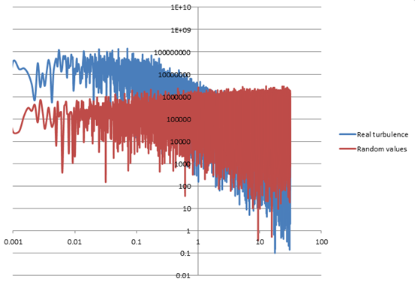

Figure 3.: Comparative graph of the energy turbulent spectrum of a real flow and a created flow based on the random method.

Klein et al. (2003) showed that the imposed fluctuations imposed by the random method are dissipated very quickly leading to the laminarization of the flow.

Smirnov et al., (2001) used the work by Kraichnan (1970) to generate a three – dimensional isotropic divergence free velocity field. Such a field can be created by a summation of sine and cosine terms:

|  |  |
| --- | --- |
| $$v_{i}\left(\vec{x},t\right)=\sqrt{\frac{2}{N}}\sum_{n=1}^{N}{\left[p_{i}^{n}\cos\left(\tilde{k_{j}^{n}}\tilde{x_{j}}+ω_{n}\tilde{t}\right)+q_{i}^{n}\sin\left(\tilde{k_{j}^{n}}\tilde{x_{j}}+ω_{n}\tilde{t}\right)\right]}$$ | (3.28) |

|  |  |
| --- | --- |
|  | (3.29) |

|  |  |
| --- | --- |
|  | (3.30) |

|  |  |
| --- | --- |
|  | (3.31) |

where $l$ and $τ$ are the length and time scales, respectively, $ε_{ijm}$ is the permutation tensor and $N(μ,σ)$ is the Gaussian distribution with mean $μ$ and deviation $σ$. The numbers $k_{j}^{n}$ and $ω_{n}$ represent a sample of wavenumbers and frequencies of the modeled turbulence spectrum:

|  |  |
| --- | --- |
| $$E_{(k)}=16{\left(\frac{2}{π}\right)}^{0.5}k^{4}exp\left(-2k^{2}\right)$$ | (3.32) |

The length and time scales can be given from experimental data or estimated depending on the geometry and application. This generated field can be transformed into an anisotropic field by diagonalizing a given an anisotropic correlation tensor $r_{ij}=\overline{u_{i}u_{j}}$, known from RANS or experimental results, as:

|  |  |
| --- | --- |
| $$a_{mi}a_{nj}r_{ij}=δ_{mn}c_{\left(n\right)}^{2}$$ | (3.33) |

|  |  |
| --- | --- |
|  | (3.34) |

Finally, applying these transformations to the homogeneous velocity field $v_{i}\left(\vec{x},t\right)$ by Kraichnan (1970), a new velocity field which accounts for the given Reynolds stresses, length and time scales is given as:

|  |  |
| --- | --- |
| $$w_{i}=c_{\left(i\right)}v_{\left(i\right)}$$ | (3.35) |

|  |  |
| --- | --- |
|  | (3.36) |

The flow field that is generated is a divergence free velocity field for homogeneous turbulence and almost divergence free for inhomogeneous turbulence. This method is called the Random Flow Generation (RFG) method. The divergence free condition is of vital importance because it may cause problems with the physics of the flow, e.g. mass generation or destruction, as well as in the convergence of the code.

Recently, a few more researchers such as Huang et al. (2010), based on the work done by Smirnov et al. (2001) have developed more promising methods for inflow generation for LES, however these synthetic methods, as will be shown in the last Chapter of the present thesis, are totally incapable of maintaining the turbulence imposed at the inlet.

## 3.5.3 Simulation of wind turbine wakes with LES

During the last decade, many researchers have employed LES for the simulations of wind turbines and wind farms. Porte – Agel in a series of publications (Basu and Porte – Agel, 2005; Porte – Agel et al., 2011; Lu and Porte – Agel, 2011; Porte – Agel et al., 2013) has extensively investigated the ABL under various stratified conditions with LES and the interactions of wind turbines and wind farms under various stratified atmospheric conditions and yaw angles and also compared various actuator disk models with experimental data. Contributions by other researchers also such as Matthew et al., (2012) and Stevens et al., (2018) were also important by comparing the actuator disk and actuator line models for the wind turbines along with the insertion of the stable parts of the nacelle and the tower of the turbine. Other researchers such as Mo et al. (2013) and [Sedaghatizadeh](https://www.sciencedirect.com/science/article/pii/S0960148117308790#!) et al. (2018) have employed LES on a scaled wind turbine while others such as Storey et al. (2016) have employed the actuator disk model to represent the wind turbine and validated their results with wind tunnel experiments.

The problem with most of these publications is that they simulated the whole boundary layer up to approximately 1000m in order to simulate successfully the whole ABL while the wind turbines they investigated are at the height of the 1/10 of the ABL. In other cases, they compared their results with experimental data by avoiding the excessively high height of the computational domain, however, the comparison of the turbulence levels in the wind tunnel with the actual ABL is questionable because it is required to scale down the application of many orders of magnitude and also changes in the temperature and density cannot be taken into account. Also, a dissipating profile of turbulent kinetic energy with the height has been employed which is a realistic profile for large wind turbines. For small wind turbines, however, a dissipating profile is questionable because the small wind turbines are located exclusively in the surface layer of the ABL where a constant value for turbulent kinetic energy is a good approximation and has been extensively used in the research and in the industry with RANS simulations.

In the present thesis, the numerical investigation of small wind turbine wakes for both RANS and LES take place. The zero streamwise gradient condition is achieved in an empty domain for all flow variables. Then, the employed numerical models are employed for the simulations of small wind turbine wakes.

# Chapter 4

# The importance of the zero streamwise gradient condition on a neutrally stratified atmosphere for the actuator disk model for wind turbine wakes

The importance of accurate predictions of the homogeneous neutrally stratified atmospheric boundary layer is related to various applications such as pollutant dispersion and meteorological models (Mokhtarzadeh et al., 2012; Juretic and Kozmar, 2013; Gorle et al., 2009). However, the importance of accurate prediction of the homogeneous neutrally stratified ABL to other applications such as buildings and wind turbines has not been fully investigated. Recommendations have been proposed on the use of CFD for simulating the neutrally stratified atmosphere by COST (European Cooperation in the field of Scientific and Technical Research). Details about the distances between the target building and the computational boundaries as well as the appropriate types of boundary conditions are stated. These findings are summarized by Franke et al. (2007).

Franke et al. (2007) state that the upper boundary should be treated with the Richards and Hoxey (1993) approach, by using a shear stress boundary condition at the upper boundary of the domain, or with a Dirichlet boundary condition using the Blocken et al. (2006) approach. A practical approach to impose a shear stress boundary condition at the upper of the domain is to implement a momentum source at the upper layer of the elements based on the equation (3.8) as Hargreaves and Wright (2006). A Dirichlet boundary condition can be simply imposed by directly specifying the values of the flow variables (velocity, turbulence quantities) at the upper layer of the cells. The type of the upper boundary condition may be important for the prediction of pollutant dispersion and meteorological models but it becomes insignificant for modeling the ABL around various buildings. Contrary to the guidelines given by Franke et al. (2007), most researchers such as Tominaga et al., (2008), Gousseau et al., (2011), Tominaga (2015), Hooff et al., (2017) did not give any consideration to the upper boundary by simply imposing a zero gradient condition for every variable. To make matters worse, in most cases the inlet conditions are not consistent with the employed turbulence model and it can be proven mathematically that the inlet conditions cannot satisfy the zero streamwise condition for any flow variable. The explanation to this inconsistency of the inlet conditions with the employed turbulence model and/or the boundary conditions, although it has not been proven, may lie into the fact that the inlet conditions are distorted so significantly for a flow around a single building in relation to a wind turbine, that the zero streamwise condition becomes insignificant. However, this is not the case for the simulations of wind turbines because the velocity and turbulent kinetic energy are not distorted so much and the correct recovery of the wake is of paramount importance, especially for wind farm simulations as the wake of the downstream turbine becomes the “inlet” for the rear turbine.

In the next section, the examination of the empty domain of 2 different models for the simulations of the wind turbine wakes is investigated to show the consistencies of the model with the inlet conditions.

## 4.1 Examination of the empty domain

In the present section the models of Kasmi and Masson (2008) and Makridis and Chick (2013) presented in the literature survey chapter are investigated in an empty domain to illustrate the distortion of the inlet conditions within the domain. In general, both models showed good agreement with experimental data for the simulations of a single wind turbine. However, it can be proven mathematically that under no circumstances can both of these models satisfy the inlet conditions for neutral atmosphere described by the equations (3.9) – (3.11).

The computational domain is a 3D rectangular empty domain with inlet – outlet boundary conditions. The dimensions of the computational domain are 10,000m, 400m and 50m in the x,y and z directions, respectively. The y direction refers to the height of the domain. The roughness length which is used is 0.05m, and the friction velocity is 0.46m/s which is a typical value for the neutral atmosphere (Goodfriend et al., 2015), although, depending on the region, higher values of friction velocity can be found (Makridis and Chick, 2013; Porte – Agel et al., 2011). Parametric studies based on different heights of the computational domain are also investigated.

Regarding the boundary conditions, a velocity inlet boundary condition is imposed at the inlet based on the equations (3.9) – (3.11) and a pressure – outlet at the outlet, which simply means zero gradients for all flow variables with an exception of the pressure which is given a zero value. The value of the pressure at the outlet is unimportant because it is the relative pressure that matters and not the absolute. Symmetry (or zero gradients for all flow variables) boundary condition has been applied at the lateral sides of the domain and a Dirichlet boundary condition at the upper boundary. The values of the velocity, turbulent kinetic energy and eddy dissipation rate have been imposed at the upper layer of cells directly based on the equations (3.9) – (3.11). Finally, a wall boundary condition has been used at the bottom of the domain with the standard wall function modified for rough surfaces.

The SIMPLE algorithm has been employed for the pressure – velocity coupling and the absolute convergence criteria for all equations has been imposed at the level of ${10}^{-7}$. The strict level of convergence criteria is justified by the very small differences in all flow variables within the domain. Finally, the 3rd order MUSCL scheme and the 2nd order upwind scheme have been used for the discretization of the momentum equations and the extra equations of the employed turbulence model, respectively. Coriolis effects are neglected in simulations for small wind turbines as its effect is essentially negligible in low heights of the ABL (Porte – Agel et al., 2000) and this is the policy of all researchers who study the small wind turbines. The grid generation and the simulations have been performed by the software ANSYS ICEM and ANSYS FLUENT, respectively.

Figures 4.1 and 4.2 compare the velocity, turbulent kinetic energy, eddy dissipation rate and eddy viscosity between the inlet and the outlet of the domain for both Kasmi and Masson (2008) and Makridis and Chick (2013) models.

1. 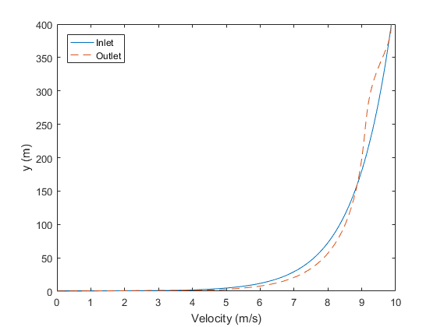
2. 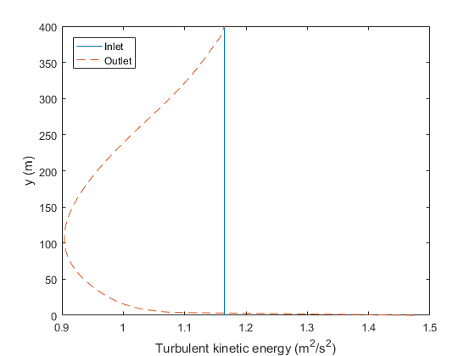
3. 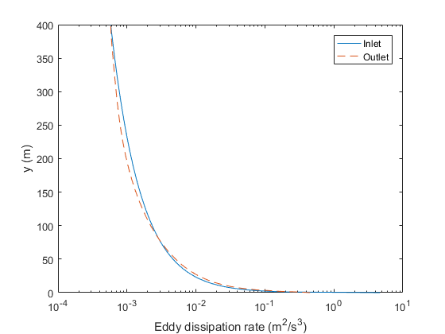
4. 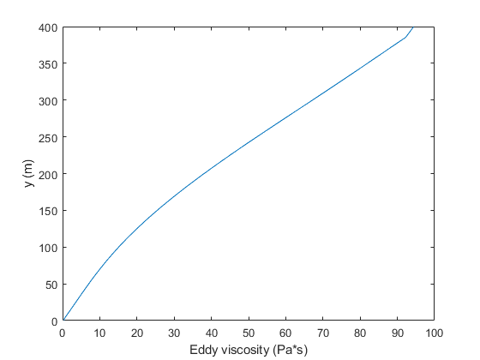

Figure 4.: Comparison of the (a) velocity, (b) turbulent kinetic energy (c) eddy dissipation rate and (d) between the inlet and outlet according to the Makridis and Chick (2013) model.

1. 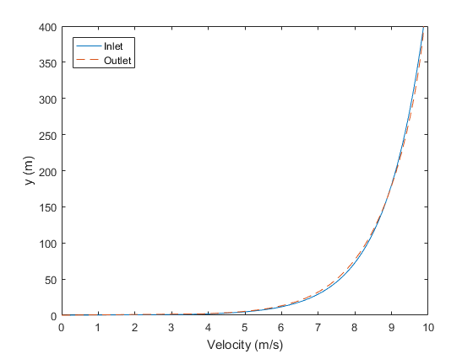
2. 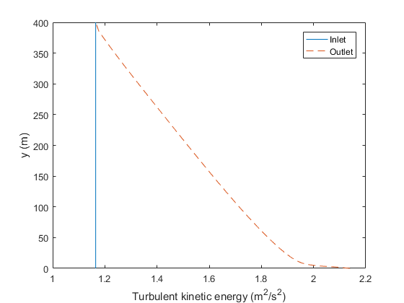
3. 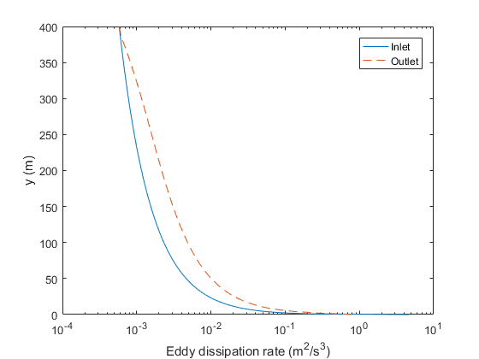
4. 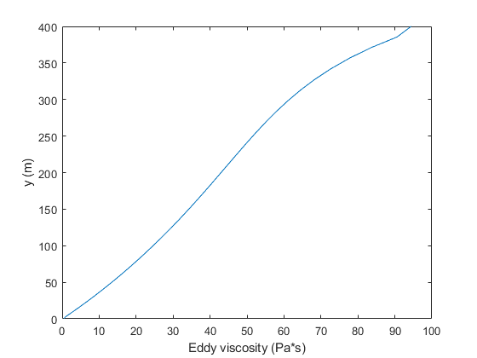

Figure 4.: Comparison of the (a) velocity, (b) turbulent kinetic energy (c) eddy dissipation rate and (d) between the inlet and outlet according to the Kasmi and Masson (2008) model.

As seen in Figures 4.1 and 4.2, distortion of all variables takes place within the domain for both models. An error analysis shows that the smallest errors for both Kasmi and Masson (2008) and Makridis and Chick (2013) models occur for the velocity profile. Specifically, for the Kasmi and Masson (2008) model, the error of the velocity is essentially negligible at the upper part of the domain but it increases to a small extent close to the ground reaching a maximum of 4%. Regarding the turbulence, the Kasmi and Masson (2008) model is completely incapable of maintaining the turbulent kinetic energy and eddy dissipation rate as the error is approaching 100% for the turbulent kinetic energy close to the ground and drops gradually with the height, and is exceeding 100% for the eddy dissipation rate close to the ground and drops gradually with the height. In the case of the Makridis and Chick (2013) model, the errors of turbulent kinetic energy and eddy dissipation rate are rather smaller. In particular, the maximum errors of both the turbulent kinetic energy and eddy dissipation rate slightly exceed 20%, but the error of the velocity is increased in relation to the Kasmi and Masson (2008) model, reaching a maximum of 3% at the upper part of the domain while it reaches approximately 15% at the lower parts of the domain and drops gradually with the height. Similar errors for all flow variables have been observed for different heights of the domain. Finally, for both models, the eddy viscosity should have shown a linear dependence with the height due to the definition of the eddy viscosity from the equation (2.33) along with the turbulent kinetic energy and eddy dissipation rate profiles described by the equations (3.10) and (3.11), which is the same for both models, nevertheless due to the inconsistencies of these models with the inlet profiles, the dependence is not 100% linear.

To what extent the distortion of the velocity, turbulent kinetic energy and eddy dissipation rate, as shown in Figures 4.1 and 4.2, affect the results of the simulation of the wind turbine wakes is unknown. Although it has not been proven, the distortion of the inlet values within the domain is not important when a single wind turbine is examined. However, when a wind farm is modeled, the distortion of the inlet values within the domain may affect the accuracy of the results to a great extent because the incorrect recovery of the wake of the first wind turbine will affect the downstream turbine because the recovery of the wake of the first turbine becomes the “inlet” for the downstream turbine. Even a small distortion of the velocity or turbulent kinetic energy at the rear of the turbine may have disastrous results for the consecutive wind turbines as even a small error of the recovery of the wake can be magnified and give totally incorrect results for the rear wind turbines.

Another problem with the existing models for the simulations of the wind turbine wakes is that they have not been studied in different relative inlet turbulent kinetic energy. Both models of Kasmi and Masson (2008) and Makridis and Chick (2013) have been tried for the inlet turbulent kinetic energy proposed by Panofsky and Dutton (1984). These values are a good approximation of the turbulent kinetic energy for neutral atmosphere, however, they have been taken as an average value among various experiments so they may differ to some extent from location to location, and are valid close to the ground. Depending on the height of the tower of the turbine, the values proposed by Panofsky and Dutton may differ from the actual ones since sometimes there is a small dissipation of the turbulent kinetic energy with the height. Consequently, the performance of the models of Kasmi and Masson (2008) and Makridis and Chick (2013) are investigated for another wind turbine for lower relative inlet turbulent kinetic energy.

As stated in literature survey, the model proposed by Kasmi and Masson (2008) uses the expression (3.14) at the vicinity of the disk to add another time scale in order to control the turbulence generation. Unfortunately, this source term is relative turbulence kinetic energy dependent as it contains the constant $C_{μ}$ which defines the relative turbulent kinetic energy of the field, see equation (3.6).

A similar problem exists in the Makridis and Chick (2013) model, and in general, in any proposed model. The constant $C_{μ}$ that defines the relative turbulent kinetic energy of the flow field has to be modified for different relative turbulent kinetic energy and is completely unknown how the model will perform in different relative inlet turbulent kinetic energy. For instance, in the wind farm located in Sexbrierum in Holland, the inlet turbulent kinetic energy of the wind farm is far lower than the one proposed by Panofsky and Dutton (1984). Experimental data for this wind farm are provided by Cleijne (1992) and consists of Holec wind turbines. By digitizing the graphs, it can be found that the relative inlet turbulent kinetic energy at the hub – height of the wind turbines can be expressed by the following formula:

|  |  |
| --- | --- |
| $$k=\frac{u_{*}^{2}}{\sqrt{C_{μ}}}=\frac{u_{*}^{2}}{\sqrt{0.09}}$$ | (4.1) |

In other words, due to the low relative turbulent kinetic energy of the field, the constant $C_{μ}$ has to be given the value of $0.09$.

Before proceeding in the simulations of the Holec wind turbine, the examination of the empty domain will take place for the relative inlet turbulent kinetic energy based on the equation (4.1), which is the same as the equation (3.10). The wind farm in Sexbierum in Holland consists of Holec wind turbines.

Figures 4.3 and 4.4 illustrate the velocity, turbulent kinetic energy and eddy dissipation rate at the inlet and outlet of the domains for the models of Kasmi and Masson (2008) and Makridis and Chick (2013).

1. 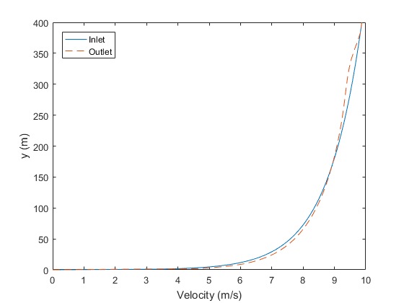
2. 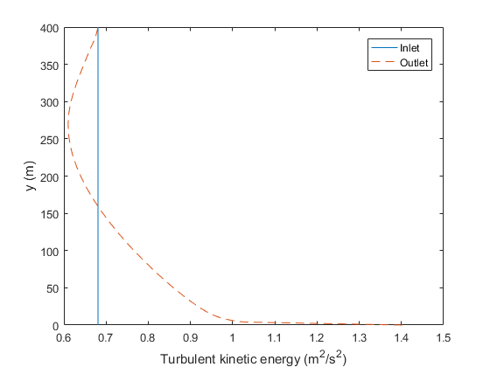
3. 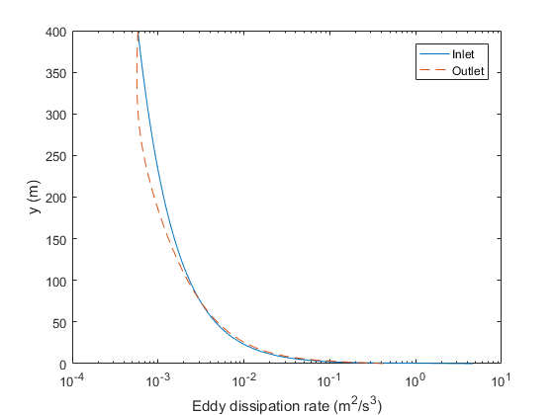

Figure 4.: Comparison of the (a) velocity, (b) turbulent kinetic energy and (c) eddy dissipation rate between the inlet and outlet accerding to Makridis and Chick (2013) model.

1. 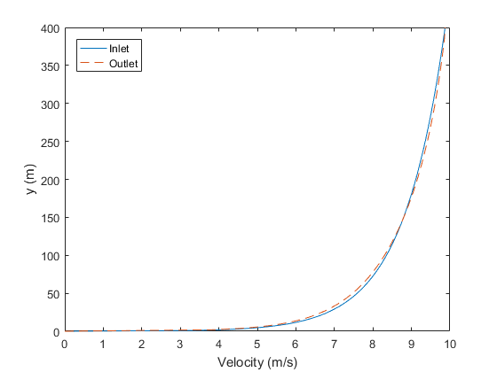
2. 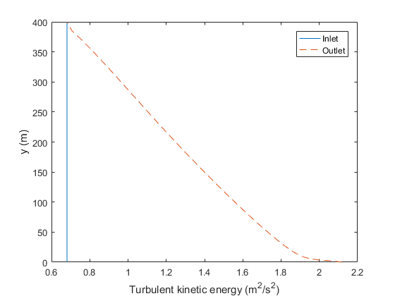
3. 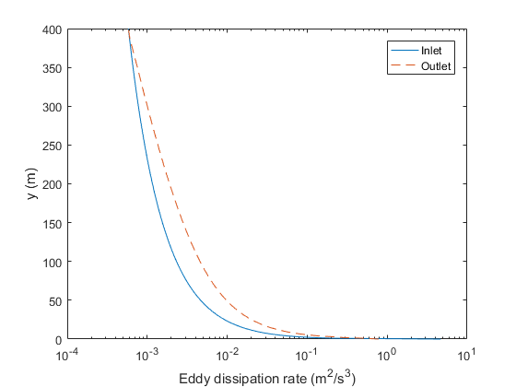

Figure 4.: Comparison of the (a) velocity, (b) turbulent kinetic energy and (c) eddy dissipation rate between the inlet and outlet according to Kasmi and Masson (2008) model.

As seen in Figures 4.3 and 4.4, the deviations of the inlet values of the velocity, turbulent kinetic energy and eddy dissipation rate are higher in relation to the results with the inlet turbulent kinetic energy based on the equation (3.6) due to the inconsistency of the employed model and the wall formulation with the inlet values of the velocity, turbulent kinetic energy and eddy dissipation rate. It is unknown, however, how this deviation will affect the simulations of the wind turbines, consequently, the examination of the Holec wind turbine takes place in the next section.

## 4.2 Examination of the wind turbine wakes

In this section, the models of Kasmi and Masson (2008) and Makridis and Chick (2013) are applied for a lower than the Panofsky and Dutton (1984) relative turbulent kinetic energy field. The Holec wind turbine is employed at the location called Sexbrierum in Holland, where a small wind farm is installed. The relative turbulent kinetic energy of this location is given by the equation (4.1). The inlet velocity at the hub – height is $u_{HUB}=6.25m/s$ which corresponds to a friction velocity of $u_{*}=0.4m/s$, with a roughness length approximately $y_{0}=0.05m$. The thrust coefficient at this inlet velocity is $C_{T}=0.78$.

Figure 4.5 illustrates the relative to the inlet velocity and turbulent kinetic energy for 3 different grid sizes according to the Kasmi and Masson (2008) model and are compared with experimental data. The experimental data are provided by Cleijne (1992). The coarse, the medium sized and the fine grid consist of approximately 88,000 elements, 320,000 and 834,000 elements, respectively. All grids were fully structured and the refinement from the coarse to the fine grid has been done uniformly everywhere in the domain but mainly in the region around the wind turbine. The settings of the simulations are the same as in the case for the empty domain, and the pressure drop applied on the disk is calculated by the equation (3.48).

1. 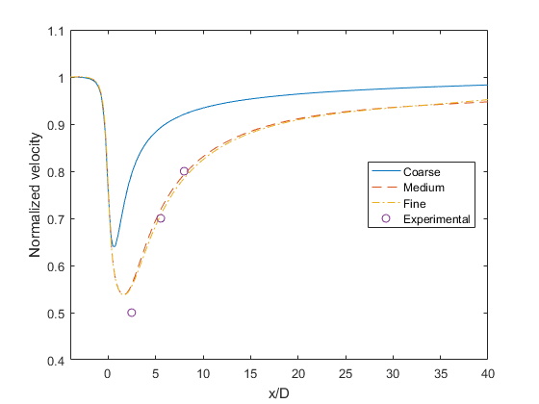
2. 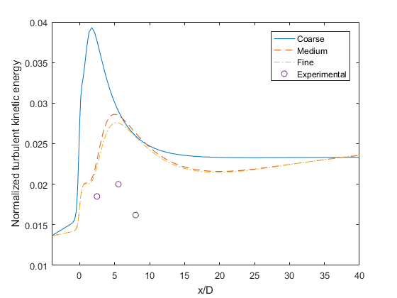

Figure 4.: Comparison of the (a) relative velocity and (b) turbulent kinetic energy at the hub - height of the domain of 3 different grid sizes with available experimental data.

Clearly, as it can be seen from Figure 4.5, the numerical grid consisting of 320,000 elements is considered as sufficient for this application as the differences for both the velocity and turbulent kinetic energy between the medium sized and fine grid are almost negligible in relation to the differences between the coarse and medium sized grid. The Kasmi and Masson (2008) model appears to be able to predict the velocity distribution at the near or far wake even for the Holec wind turbine with low inlet turbulent kinetic energy, although it appears that the velocity does not recover at the ideal level which can be concluded by the comparison with the experimental data. This is not very surprising as it has been shown in Figure 4.4 (a) that the deviations of the velocity profile within the domain are relatively small, taking into account that the length of the empty domain was 10km. However, this is not the case for the turbulent kinetic energy, where the Kasmi and Masson (2008) model is totally ineffective as it overestimates the turbulent kinetic energy at the near or far wake region of the wind turbine and the turbulent kinetic energy at the very far wake region does not recover to the undisturbed inlet turbulent kinetic energy.

Figure 4.6 illustrates the normalized velocity and turbulent kinetic energy for the Holec wind turbine for the Makridis and Chick (2013) model. The numerical grid and solver settings are the same as in the simulations of the Kasmi and Masson (2008) model.

1. 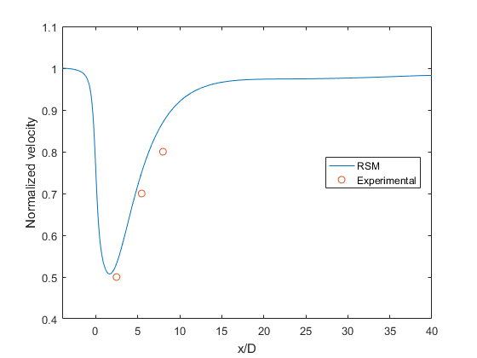
2. 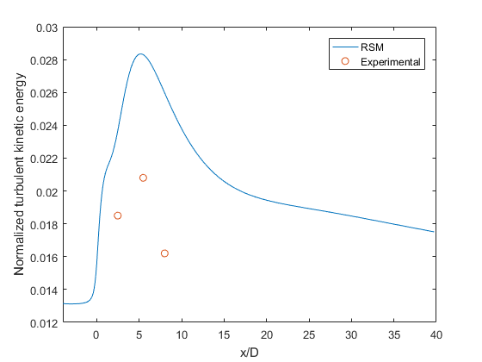

Figure 4.: Comparison of the (a) elative velocity and (b) relative turbulent kinetic energy at the hub - height of the wind turbine along the streamwise direction by employing the Makridis and Chick (2013) model.

The model of Makridis and Chick (2013) appears to overestimate the recovery of the velocity in the far wake region although it appears to capture the velocity at the near wake region very successfully. This fact can be explained by the fact that the deviations within the empty domain of the velocity from the inlet was higher in relation to the Kasmi and Masson (2008) model, as seen in Figures 4.3 (a) and 4.4 (a). However, the problem of the overestimation of the turbulent kinetic energy is still present in this model as in the case of the Kasmi and Masson (2008) model. Overall, both models performed similarly for the Holec wind turbine.

## 4.3 Conclusions

In this chapter the Kasmi and Masson (2008) and Makridis and Chick (2013) models have been tested for the simulations of wind turbine wakes for a low turbulence field. The performance of their models in an empty domain has been assessed to check the inconsistencies of the models with the properties of neutral atmosphere. The distortion of the velocity profile along the domain for both models was small but not negligible while the distortion of the turbulent kinetic energy was huge. Then, the models have been tested for the Holec wind turbine. The velocity distribution in the near and far wake region was maintained in acceptable levels while the turbulent kinetic energy was hugely overestimated. In conclusion, the zero streamwise gradient condition has to be satisfied in order to achieve values of velocity and turbulent kinetic energy at the very far wake region similar to the undisturbed inlet values. Finally, a necessity for a model which works efficiently regardless of the inlet relevant turbulent kinetic energy becomes clear.

# Chapter 5

# An improved k – ω turbulence model for the simulations of the small wind turbine wakes

In the previous chapter, the necessity of the satisfaction of the zero streamwise gradient condition along with a turbulence model which will be independent of the inlet relative turbulent kinetic energy has been illustrated.

In this chapter, a new modified k – ω model is presented and validated for the simulations of the small wind turbine wakes under neutral stratified atmosphere on a uniform roughness terrain. Firstly, a mathematical condition for the zero streamwise gradients for all variables is discovered. Then, the examination of the empty domain takes place to prove in practice the zero streamwise condition and finally, the model is validated for 2 different small wind turbines with different relative inlet turbulent kinetic energy.

As stated in literature survey, the modified standard k – ε model of Kamsi and Massoon (2008), has been proven reliable for the simulations of the small wind turbine wakes, as it has been validated for 3 different wind turbines. However, there are two problems with this model. The first problem deals with the zero streamwise condition because this model does not satisfy the zero streamwise condition, at least for the inlet conditions they used, under no circumstances, as shown in the previous chapter. The second problem deals with the source term for the dissipation equation in the vicinity of the wind turbine, based on the work done by Chen and Kim (Chen and Kim, 1987). The term they used is:

|  |  |
| --- | --- |
| $$G_{ε}=C_{ε4}\frac{P_{t}^{2}}{ρk}$$ | (5.1) |

The term $P_{t}$ is the production term in the standard k – ε model which is dependent on the turbulent viscosity and the turbulent viscosity is dependent on the constant $C_{μ}$. The constant $C_{μ}$, however, defines the relative turbulent kinetic energy of the field for atmospheric flows, which may differ from one place to another. In other words, the source term is highly dependent on the relative turbulent kinetic energy of the field. Kasmi and Massoon (2008) have proven that the dissipation term (5.1) improves the results for the wind turbine wakes but they simulated wind turbines only for one specific value of $C_{μ}$ which was $C_{μ}=0.033$. As shown in the previous chapter, their model did not perform very well for the Holec wind turbine.

In this chapter, a new k – ω model is presented which solves the problems of the model of Kasmi and Masson (2008) regarding the non – zero streamwise gradient and the dependency of the relative turbulent kinetic energy of the field.

Similarly to the Richards and Hoxey’s (1993) approach for the standard k – ε model, a condition for the zero streamwise gradients for any variable for the standard k – ω model can be found. The equations for the velocity, turbulent kinetic energy and eddy dissipation rate are expressed by the equations (3.9) – (3.11) while the equations of the standard k – ω model are written in the section 2.4.2. Due to the fact that the family of k – ω models does not use the constant $C_{μ}$, but instead it uses the constant $β_{∞}^{*}$, the equation (3.10) for the turbulent kinetic energy is transformed as:

|  |  |
| --- | --- |
| $$k=\frac{u_{*}^{2}}{\sqrt{β_{∞}^{*}}}$$ | (5.2) |

By making some mathematical calculations, it can be proven that the equations (3.9), (3.11) and (5.2) satisfy automatically the equation (2.35) but satisfy the equation (2.36) only if the following condition is satisfied:

|  |  |
| --- | --- |
| $$\frac{1}{σ_{ω}\sqrt{β_{∞}^{*}}}+\frac{1}{κ^{2}}=\frac{β_{i}}{β_{∞}^{*}κ^{2}}$$ | (5.3) |

Details of the previous statement along with the derivation of the equation (5.3) are given in the appendix. As in the case of the Richards and Hoxey (1993) for the standard k – ε model, it is independent of the friction velocity and the roughness height. Consequently, for specific relative turbulent kinetic energy, which is defined by the constant $β_{∞}^{*}$, the constants $σ_{ω}$ and $β_{i}$ have to be chosen accordingly in order to satisfy the expression (5.3) in order to avoid streamwise gradients for any variable within the solution domain.

Finally, in order to conclude to the expression (5.3), the following consideration was taken:

|  |  |
| --- | --- |
| $$μ_{l}≪μ_{t}$$ | (5.4) |

In other words, the laminar viscosity was omitted from the transport equations for turbulent kinetic energy and specific dissipation rate, in the same concept as Richards and Hoxey (1993) approach. The error by using this simplification is expected to be negligible since the atmospheric flows are highly turbulent.

## 5.1 Examination of the empty domain

In order to validate the present proposed k – ω model and check in practice if the zero streamwise gradient condition for any flow variable persists, simulations have been performed for an ABL flow through an empty domain. The dimensions of the employed computational domain, as well as the boundary conditions are the same as in the previous chapter. The friction velocity of the wind flow was set as $u_{*}=0.46m/s$ and the roughness length is 0.05m, which is valid for a relative low roughness terrain. A value of $β_{∞}^{*}=0.033$ was used to define the turbulent kinetic energy at the inlet based on Panofski and Dutton (1984) as well as other researchers, such as Makridis and Chick (2013) and Kasmi and Massoon (2008). A pressure outlet at the outlet of the domain was imposed, symmetry (or zero gradients) at the lateral sides of the domain, a Dirichlet – type boundary condition at the upper boundary based on the equations (3.9) – (3.11) and a wall boundary on the ground.

The third – order MUSCL scheme was used for the discretization of the momentum equations and the second – order upwind scheme for the transport equations for the turbulent kinetic energy and eddy frequency. The SIMPLE algorithm was implemented for the pressure velocity coupling, while the convergence criteria were set to ${10}^{-7}$ for all equations and this was found to be adequate to obtain graphically indistinguishable results. Mass imbalance has been also checked to ensure the convergence of the simulations. Finally, regarding the grid resolution, 3 different grid sizes have been employed consisting of approximately 200,000, 600,000 and 1,800,000 elements. The numerical grid was fully structured and the refinement of the grid has been equally done in all directions.

Figure 5.1 compares the solutions for the velocity, turbulent kinetic energy and specific dissipation rate, respectively, for an empty domain at the inlet and outlet of the domain with the 3 different grid sizes mentioned in the previous paragraph.

1. 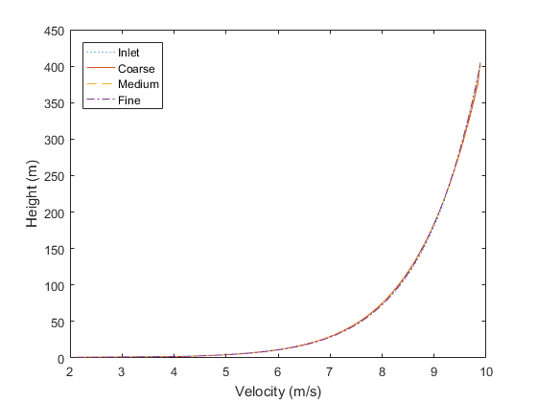
2. 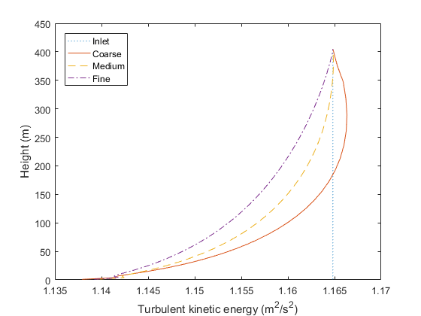
3. 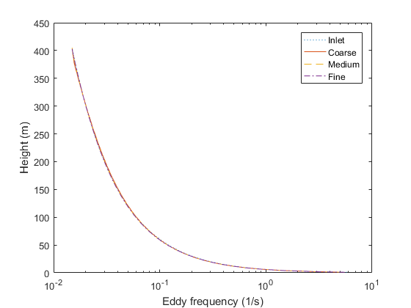

Figure 5.: Comparison of (a) velocity, (b) turbulent kinetic energy, and (c) specific dissipation rate between the inlet and outlet in a 10km domain for 3 different grid sizes.

Due to the rapid change of the eddy frequency with the height, the logarithmic scale is used in Figure 5.1 (c), as well as in the contour map in Figure 5.2 (c). An error analysis showed that the difference between the inlet and outlet for the turbulent kinetic energy is approximately 2% on the ground, for any grid size and it decreases with the height. Figure 5.2 illustrates contour maps of the velocity, turbulent kinetic energy and eddy frequency to show the development of these variables within the domain. The height of the domain was scaled up 4 times due to its initial small perpendicular to the ground direction, in relation to the length of the domain. A similar situation exists for the eddy frequency where the error appears to reach an error of approximately 4% close to the ground and it becomes gradually smaller with the height. Finally, regarding the velocity, it appears to have an error of approximately 2% close to the ground but it becomes less than 1% within the first 10m from the ground.

There are 2 reasons for the errors close to the ground for any variable. The first reason is due to the wall formulation which is not consistent with the profiles of the equations (3.9) – (3.11) and it appears that the calculation of the turbulence quantities is a function of the friction velocity (Ansys FLUENT, 2011). Another reason is attributed to the assumption of the negligence of the laminar viscosity (equation (5.4)) which is not valid on the ground. However, the differences are in general small, and it can be concluded that the velocity, turbulent kinetic energy and specific dissipation rate are maintained from the inlet to the outlet of the domain with a good accuracy. Moreover, parametric studies based on the friction velocity from 0.4 – 0.62 m/s and turbulence levels for values of $β_{∞}^{*}$ from 0.033 to 0.1 showed small dependence and the comparison of the results with the theoretical values based on the equations (3.9) – (3.11) was similar to the ones present in Figure 5.1. The small errors far away from the ground are attributed to the simplifications that have been made in theory, numerical and convergence issues. Finally, the results show negligible sensitivity to the grid size and this is due to the simplicity of the geometry. In particular, the maximum differences between the coarse and medium sized grid for the velocity, turbulent kinetic energy and eddy frequency were 0.12%, 0.16% and 0.72%, while the maximum differences in the same variables between the medium sized grid and fine grid were 0.06%, 0.11% and 0.57%, respectively, and consequently the numerical grid consisting of 600,000 elements has been used.

1. 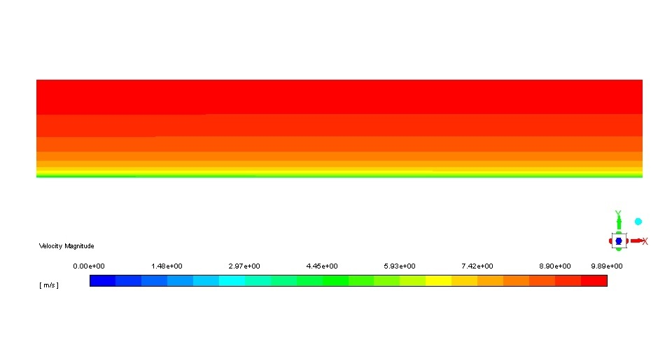
2. 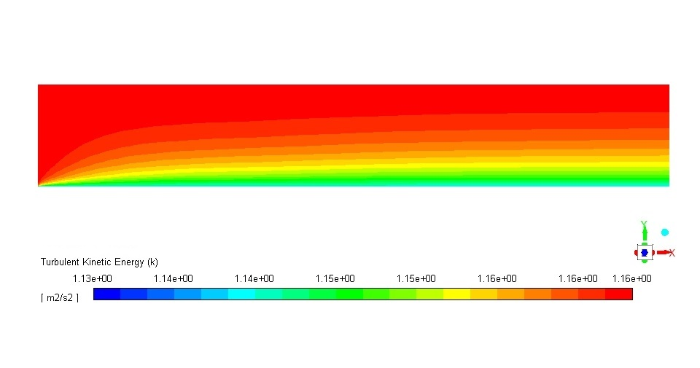
3. 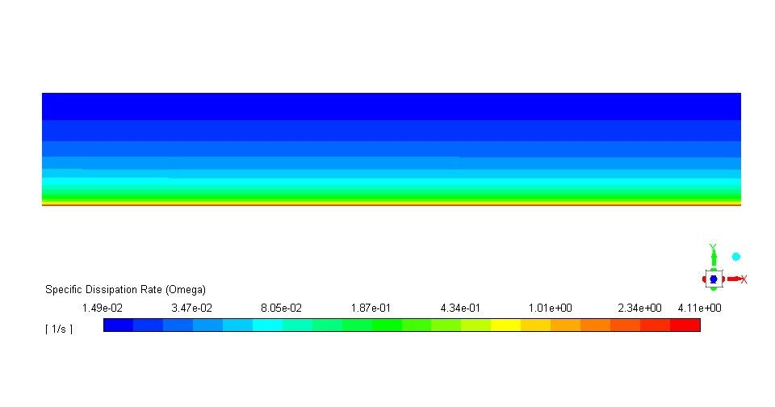

Figure 5.: Results of (a) velocity, (b) turbulent kinetic energy and (c) eddy frequency along the domain.

Most researchers who studied the characteristics of wind turbine wakes did not examine the zero streamwise gradient condition. It appears, although it has not been proven, that it is not important when a single turbine is examined due to the fact that the undisturbed wind conditions do not change significantly within a few characteristic lengths of the domain when the zero streamwise gradient condition is not satisfied. However, when a large domain is examined with multiple wind turbines in any arrangement, it is of paramount importance that the velocity and turbulence levels have a correct recovery and, in the long run, recover to the undisturbed inlet conditions and be maintained as occurs in nature.

In the next Section, 2 different small wind turbines are examined and the importance of the zero streamwise gradient for all variables is illustrated.

## 5.2 Modeling of a single wind turbine using the actuator disk theory

A full – scale detailed aerodynamic simulation of a wind turbine is very time consuming since it requires a transient simulation as well as a very refined numerical grid around the blades, the nacelle, the tower of the wind turbine etc. Consequently, many other computationally cheaper ways of simulating the wind turbine wakes have been developed. The simplest model is the actuator disk model without rotation and is based on the blade element method.

Mikkelsen (2003) has analyzed many models for the modeling of the rotor of the wind turbines. The simplest of all models, when the aerodynamics of the wind turbine is unknown, is the actuator disk model without rotation and based on the thrust coefficient $\left(C_{T}\right)$ of the turbine. The pressure drop through the wind turbine can be calculated by the following equation:

|  |  |
| --- | --- |
| $$ΔP=0.5ρAC_{T}U_{∞}^{2}$$ | (5.5) |

where $A$ is the rotor disk area and $U_{∞}$ is the undisturbed wind velocity upstream of the turbine. The only information that is needed is the thrust coefficient and the diameter of the wind turbine. The pressure drop is applied in the software as an infinitesimal thickness disk in order to replace the wind turbine. It acts essentially as a momentum sink.

## 5.3 Nibe – B 630kw turbine

The first wind turbine that is examined is a Nibe – B 630kw turbine and this is a horizontal 3 bladed wind turbine operating at 33rpm with a 40m diameter at 45m hub – height. In the simulations performed in this paper, the actuator disk model without rotational effects was employed.

Regarding the size of the computational domain, the distance from the inlet to the turbine is 4D, the distance from the turbine to the outlet is 40D, the distance from the turbine to the upper boundary is 5D and the distance between the turbine and the lateral sides of the domain is 4D, where D is the diameter of the wind turbine. The boundary conditions were the same as in the empty domain examined earlier along with the other settings of the solver. The pressure drop along the wind turbine was calculated from the equation (5.5).

As stated in theory, the condition (5.3) must be satisfied in order to ensure the recovery of the velocity and turbulence quantities in the far wake region. The zero streamwise gradient condition is important in the far wake region, however, the recovery of the velocity and turbulence are highly sensitive on the $σ_{ω}$ coefficient. By performing some parametric studies, a value of $σ_{ω}=1.3$ was chosen as the optimum coefficient for all wind turbines. Given a coefficient of $β_{∞}^{*}=0.033$ for the definition of the turbulence levels and a value of $σ_{ω}=1.3$, the value of $β_{i}=0.0575$ satisfies the equation (5.3). The Von Karman constant that is used is $κ=0.4187$. The standard k – ω model also has been employed to illustrate the differences between the 2 models against the experimental data. The only modification that has been done to the standard k – ω model is the coefficient $β_{∞}^{*}$ and it has been given the same value as in the modified k – ω model in order to match the inlet turbulent kinetic energy at the inlet of the domain (equation (5.2)).

A grid independence study has been carried out. Given the simplicity of the geometry, the requirement of the simulation regarding its number of cells was not very demanding. 3 different grid sizes have been simulated consisting of approximately 140,000, 600,000 and 1,560,000 cells. All of them were fully structured numerical grids and the refinement from the coarse to the fine grid has been done everywhere in the domain but mainly in the region around the wind turbine and at a few characteristic lengths upstream and downstream of it. The maximum difference between the 2 coarser numerical grids was found to be approximately 2.5% for the velocity and 3.5% for the turbulent kinetic energy, while the maximum difference in the results obtained using the 2 finer grids were less than 0.2% for the velocity and less than 0.5% for the turbulent kinetic energy. Consequently, the numerical grid consisting of 600,000 elements was employed and a similar grid has been created with a similar number of cells and spacing between the nodes for the second wind turbine that is examined later.

It should be noted that the near wake region is considered as the region within 3D at the rear of the turbine, the far wake region as the region within 5.5D and 8D at the rear of the turbine and the very far wake region as the region from 8D up to the outlet.

1. 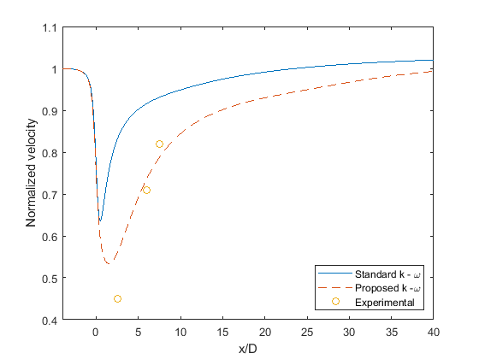
2. 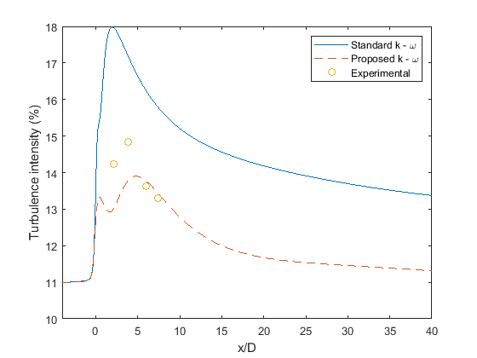

Figure 5.: (a) Normalized velocity and (b) turbulence intensity along the streamwise direction at the hub – height of the domain.

Figure 5.3 illustrates the predicted normalized velocity and turbulence intensity in comparison to experimental data and the standard k – ω model for $U_{hub}=8.5m/s$, $C_{T}=0.82$ and ${TI}_{hub}=11\%$ along the centerline at the hub height of the turbine. This is the condition when the turbine is operating at 630kw. The velocity is normalized with the inlet velocity value and the experimental data are provided by Taylor et al. (1985).

It is observed in the far wake region that the proposed k – ω model is able to capture the correct turbulence levels, according to the experimental data. Also, in the very far wake region, close to the outlet boundary, the turbulence levels drop to the undisturbed values that are applied at the inlet boundary. It is interesting that the highest value of the turbulent kinetic energy does not appear in the near wake region of the turbine but, rather, a few characteristic lengths downstream of the turbine $\left(≈4D\right)$. This observation is also visible in other experimental data for the second wind turbine that is presented later. This trend of the turbulence intensity is captured by the modified k – ω model, while the standard k – ω model failed to capture the turbulent kinetic energy anywhere within the domain.

The velocity also shows a similar trend to the turbulent kinetic energy. At the near wake region $\left(2.5D\right)$ the modified k – ω model closely predicted the wind velocity, and in the far wake region the velocity is predicted very well, while the standard k – ω model failed to predict the velocity anywhere within the domain. It is also noticeable that the velocity and turbulent kinetic energy did not converge to the undisturbed inlet values according to the standard k – ω model, which was expected since it does not satisfy the equation (5.3). These results are indicative of the very simplistic model that is used to simulate the wind turbine. A more accurate or elaborative model, instead of the actuator disk model without rotational effects based on the thrust coefficient, would have given more accurate predictions for the velocity in the near wake region.

According to the original source of the experimental data, the mast located $7.5D$ downstream of the turbine was not aligned exactly with the wind direction (Taylor et al., 1985). This statement can be seen from the almost linear behavior, if these 3 points are connected, of the velocity according to the measurements. Also, as will be shown later, the velocity of the wind does not have such a steep recovery for other wind turbines, or even for the same turbine under different operational conditions.

As far as the errors are concerned, the difference of the velocity in the near wake region with experimental data was more than 20% while in the far wake region this reduced to less than 5%, and the difference in the turbulence intensity was less than 10% in the near or far wake region.

Figure 5.4 shows the turbulence intensity perpendicular to the ground from the hub – height up to $1.2D$ above the centerline of the hub – height of the turbine located at $2.5D$ at the rear of the turbine. There appears to be a peak in the turbulence intensity at 0 $.5D$ and probably this arises from the tip of the turbine blades. The modified k – ω model is able to capture this increase in the turbulence in this region but it fails to predict the magnitude of it, which is indicative of the very simplistic model that is used to simulate the wind turbine. Another explanation may lie to the fact that the pressure drop that has been applied on the disk is based on the undisturbed velocity value at the hub – height of the turbine. However, the undisturbed velocity changes with the height based on the logarithmic velocity profile as given equation (3.9). Consequently, a higher pressure drop from the hub – height up to the tip of the turbine would, theoretically, give higher turbulence levels. Another interesting fact is that the measured turbulence intensity drops less than $10\%$ while the inlet turbulence intensity is 11%. The only possible explanation could be that the turbulent kinetic energy slightly decreases with the height of the domain, although nothing is stated about this in the report. In any case, as stated in the introduction, employing a constant turbulent kinetic energy at the inlet may be a special or a simplified case, however, it approximates the neutral atmospheric conditions and it has been the view of many researchers for the simulation of small wind turbines (Kasmi and Masson, 2008; Makridis and Chick; 2012).

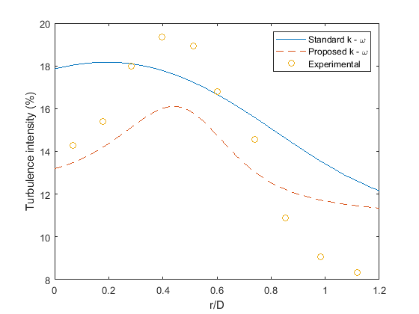

Figure 5.: Turbulence intensity distribution along a line perpendicular to the ground from the hub – height up to 1.2D placed at 2.5D at the rear of the turbine.

Taking into account the fact that the turbulence generation depends on the velocity gradients in the 2 equation turbulence models based on the Boussinesq assumption for isotropy, it can be concluded that a more elaborative model for the wind turbine, e.g. the inclusion of the nacelle and the tower, would have given even better results for both the velocity and turbulence because the minimum velocity would have been lower, and consequently, the turbulence levels in the near wake region would have been larger, due to the higher pressure drop imposed at the disk.

Figure 5.5 illustrates the normalized velocity distribution from one lateral side to the other of the domain at the hub – height located at (a) $2.5D$, (b) $6D$ and (c) $7.5D$ at the rear of the turbine.

1. 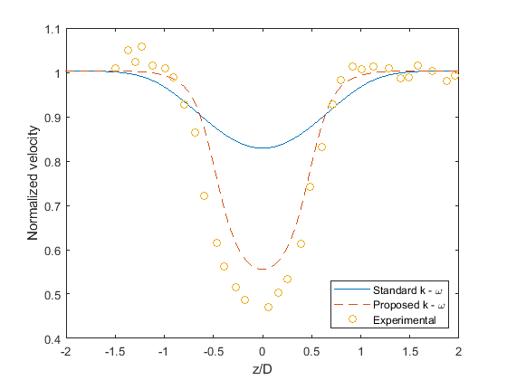
2. 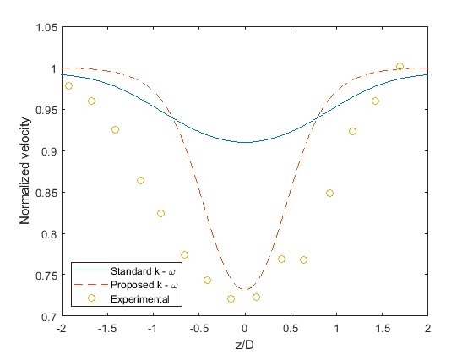
3. 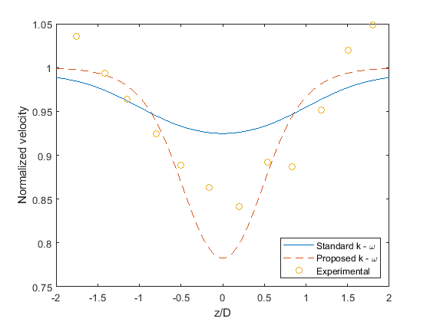

Figure 5.: Distribution of the normalized velocity along the lateral sides of the domain at the hub – height at (a) 2.5D, (b) 6D and (c) 7.5D.

The modified k – ω model in the far wake region at $6D$ and $7.5D$ at the rear of the turbine predicts the velocity very well although the width of the velocity deficit is larger according to the experimental data at a distance of $6D$ at the rear of the turbine. In the region $7.5D$ downstream of the turbine the velocity appears to be slightly underestimated, however, as stated earlier, the actual velocity is lower than the values that appear in the Figure 5.5 because the mast was not 100% aligned with the wind turbine. This statement is also enforced by the fact that the normalized velocity, according to the experimental data appears to be higher than 1 close to the lateral sides of the domain. If the computationally predicted results had been normalized with a lower value, the validation would have been even better.

Figures 5.6 and 5.7 illustrate the normalized velocity from one lateral side of the domain to the other lateral side at the hub – height at (a) $2.5D$, (b) $6D$ and (c) $7.5D$ for the same turbine but for different wind velocity and turbulence levels. Figure 5.6 shows the normalized velocity for $U_{∞,hub}=9.56m/s$, $TI=11\%$ and $C_{T}=0.77$ and Figure 5.7 shows the normalized velocity for $U_{∞,hub}=11.52m/s$, $TI=10.5\%$ and $C_{T}=0.67$.

1. 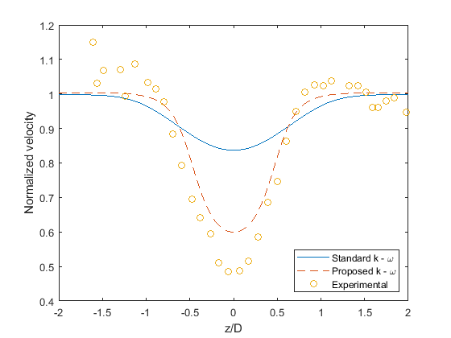
2. 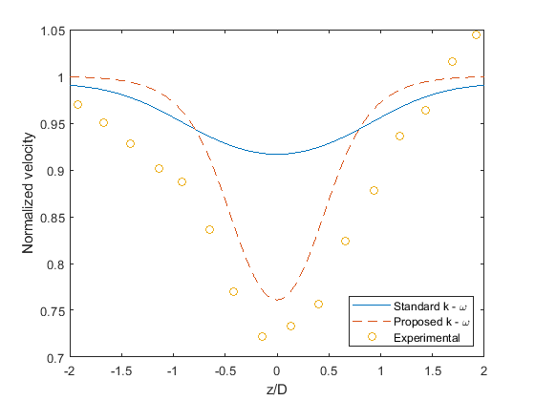
3. 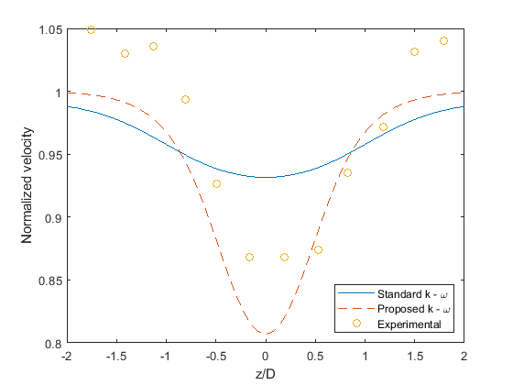

Figure 5.: Distribution of the normalized velocity along the lateral sides of the domain at the hub – height at (a) 2.5D, (b) 6D and (c) 7.5D for U=9.56m/s.

1. 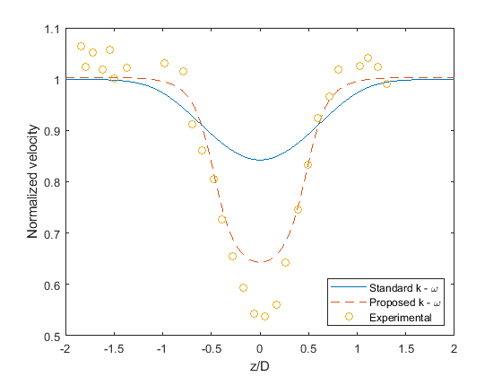
2. 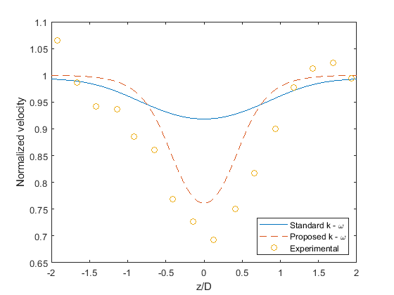
3. 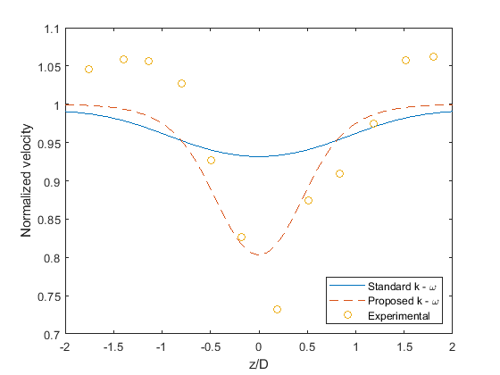

Figure 5.: Distribution of the normalized velocity along the lateral sides of the domain at the hub – height at (a) 2.5D, (b) 6D and (c) 7.5D for U=11.52m/s.

The results for $U_{∞,hub}=9.56m/s$ and $U_{∞,hub}=11.526m/s$ have a similar behavior to the results presented in Figure 5.5 for $U_{∞,hub}=8.5m/s$.

In general, the modified k – ω model predicts well the velocity at $6D$ and $7.5D$ at the rear of the turbine while it rather overestimates the velocity $2.5D$ at the rear of the turbine, while the standard k – ω model failed to predict the velocity correctly anywhere within the domain. The problem with the normalized velocity being over 1 according to the measurements is still present for all inlet velocity values as seen in Figures 5.5(c), 5.6(c) and 5.7(c).

Also, it is observed from Figures 5.5 – 5.7 that, as the undisturbed inlet velocity decreases, the results close to the turbine become better when compared to experimental data, although the difference is generally small. The explanation for this behavior lies to the thrust coefficient. As stated earlier, the pressure drop that is applied on the disk is based on the equation (5.5) and the model does not include any fixed parts of the wind turbine such as the nacelle or the tower. The pressure drop of any fixed part of the turbine would have been calculated by the same formula, equation (5.5), but it would have included the drag coefficient instead of the thrust coefficient. However, as the velocity increases, the thrust coefficient, based on the power curve of the turbine, decreases, while the drag coefficient of the bluff bodies is not that sensitive to the inlet velocity, at least for fully turbulent flows, which is the case in the present investigation. Taking into account the fact that the drag coefficient of the fixed parts of the turbine is higher than the thrust coefficient, and almost steady regardless of the velocity, it can be concluded that for low velocities, where the thrust coefficient is higher, the omission of the fixed parts of the turbine affects the results to a smaller extent than for the cases of the higher velocities. This statement will be validated later when the results of the Holec turbine are presented, although the difference is smaller due to the small differences in the thrust coefficient.

## 5.4 The Holec wind turbine

The second wind turbine that is examined is a small Holec horizontal axis three – bladed turbine with a rated power of approximately 300kW. A wind farm of these turbines is located at Sexbierum, a village in northern Holland. The examination of another wind turbine is important in order to show the universality of the modified k – ω model and in order to show that the model is not sensitive to the inlet turbulence levels, and this is because the turbulence levels in this region are relatively low. The measurement data are taken from Cleijne (1992).

The computational setup is similar to the Nibe – B 630kw wind turbine explained previously. The flow conditions are based on Cleijne (1992). The logarithmic velocity profile is still valid, as in all atmospheric flows under neutral stratification within the surface layer where small wind turbines are located, but the turbulence levels are quite lower in relation to the previous wind turbine. However Cleijne (1992), is rather vague when it comes to the inlet turbulence levels. They took measurements at 3 different heights and analytically expressed the turbulence intensity and the corresponded roughness length, but in the results section for high yaw angles (25º – 30º) the turbulence levels appear to be far lower than the initially estimated ones for every mast. For this reason, the results for the turbulence intensity based on the results of the wind turbine for high angles of attack of the wind will be considered. In any case, the constant value for the turbulent kinetic energy, regardless of the height, appears to be almost valid based on all of their measurements.

The measured undisturbed normalized turbulent kinetic energy appears to be in the range 0.011 – 0.014. The normalization of the turbulence intensity was achieved with the squared undisturbed velocity inlet. These inlet turbulence levels correspond to a value of approximately $β_{∞}^{*}=0.09$ for the standard k – ω model, and consequently the standard k – ω model has been used without any modifications for the simulations. This value of $β_{∞}^{*}$ gives a normalized turbulent kinetic energy of 0.0136 and this agrees well with the measurement data. For the zero streamwise gradient condition, the value of $β_{i}$ has to be changed according to the equation (5.3) and the corresponding value is $β_{i}=0.1263$ for the modified k – ω model. Regarding the eddy frequency, the profile based on the equation (3.4) is chosen and modified according to the equation (5.3) while the logarithmic velocity profile is employed at the inlet by the equation (3.9), as in the previous wind turbine.

The average undisturbed velocity magnitude during the measurements at the hub – height of the turbine was $7.6m/s$. Consequently, in this paper, to show the universality of the model, a value of $8.6m/s$, as well as a lower velocity of $6.2m/s$ is employed. The thrust coefficient is 0.75 for a range of hub – height velocities from $7m/s$ to $10m/s$ and it increases to 0.78 for the $6.2m/s$ inlet velocity at the hub – height.

Figures 5.8 and 5.9 show the computed normalized velocity and turbulence along the hub – height for both the velocity and turbulence inlets and the experimental data.

1. 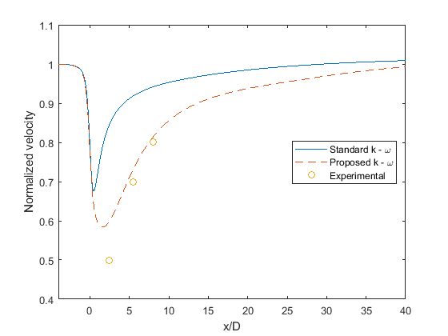
2. 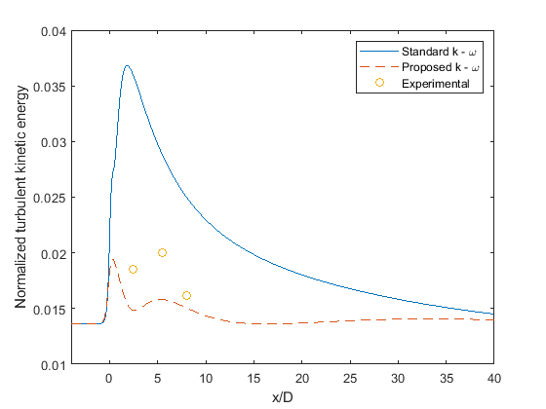

Figure 5.: (a) Normalized velocity and (b) turbulent kinetic energy along the streamwise direction at the hub – height for U=8.6m/s.

1. 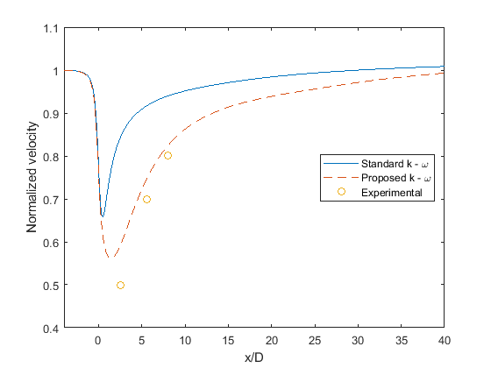
2. 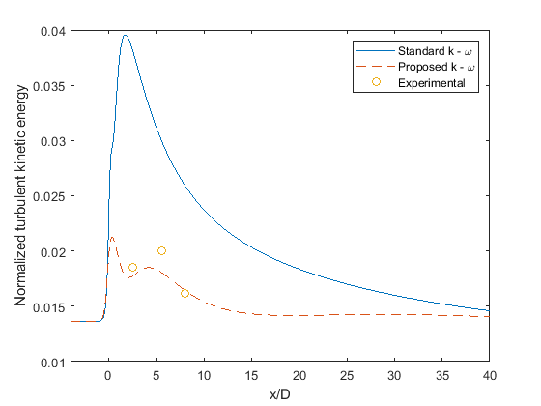

Figure 5.: (a) Normalized velocity, and (b) turbulent kinetic energy along the streamwise direction at the hub – height for U=6.2m/s.

The velocity has a similar trend as in the previous investigated wind turbine. The velocity drops to half of the undisturbed value at a distance $2.5D$ downstream of the wind turbine and then it gradually increases, reaching $80\%$ of the value of the undisturbed velocity at $8D$ downstream of the turbine. It is noticeable that the behavior of the computationally predicted velocity appears to be the same for both velocity inlet values. The model, like in the previous wind turbine, predicts the recovery of the velocity and turbulence kinetic energy with a very good accuracy as seen in the Figures 8 and 9, while the results are as good in the near wake region.

As far as the turbulent kinetic energy is concerned, a similar behavior with the Nibe turbine is illustrated. The maximum value does not appear in the near wake region but rather a few characteristic lengths away from the turbine, and this is not predicted by the model. However, in the far wake region the correct values of the turbulent kinetic energy are recovered and maintained along the domain until the outlet.

The small differences in the velocity and turbulent kinetic energy at the rear of the turbine between the 2 different inlet velocities are related to the very small difference in the thrust coefficient of the turbine. As shown in the Nibe wind turbine, the results are more reliable for high thrust coefficients. The same applies here for the Holec turbine but the differences are very small, especially for the velocity and this is due to the very small difference in the thrust coefficient. It is also noticeable again that the standard k – ω model failed to predict the velocity and the turbulent kinetic energy everywhere throughout the domain as expected.

Regarding the errors in the turbulent kinetic energy with the experimental data, the differences were generally high. These errors were of the order of magnitude of 20% for the case of $8.6m/s$ velocity at the hub – height at distances $2.5D$ and 5.5 $D$ downstream of the turbine while for the case of $6.2m/s$ velocity at the hub – height at the same distances, the error was less than 10%. In both velocity inlets, however, the turbulent kinetic energy at a distance $8D$ downstream of the turbine, the errors were approximately 2% and 6% for the $6.2m/s$ and $8.6m/s$ velocity inlet, respectively.

Finally, regarding the errors in the velocity, as is the case of the Nibe turbine, the error in the velocity was approximately 20% in the near wake region, while in the far wake region it was about 6% or smaller regardless of the velocity inlet. In any case, for both turbines, for higher thrust coefficients, the results for both the velocity and turbulent kinetic energy were closer to the experimental data and far closer than the standard k – ω model.

In general, the modified k – ω model showed significant improvement when compared with the standard k – ω model which is of paramount importance, especially for wind farm simulations where the power output and possible future structural damage will be better predicted.

## 5.3 Conclusions

For wind farm simulations, using a steady RANS model, the recovery of the wind properties in the turbine wakes can affect the accurate prediction of the performance of the downstream turbine. In this Chapter, a modified k – ω model for simulating small wind turbine wakes for a uniform roughness flat terrain in a neutrally stratified atmospheric boundary layer is proposed. A condition for achieving the zero streamwise gradients for all flow variables has been mathematically produced. The model has been successfully implemented and tested in an empty domain for various turbulence levels and friction velocity values. The modified k – ω model has been employed for the simulation of 2 small wind turbines for different inlet conditions with the actuator disk model based on the thrust coefficient of the turbines. The comparison of the results in the near wake region for both wind turbines with available experimental data was mediocre which may have been expected due to the very simplistic model that has been employed to represent the wind turbines. For higher thrust coefficients, the results were more accurate than for lower thrust coefficients for both the velocity and turbulent kinetic energy although the difference was small. In the far wake region, however, the comparison of the velocity and turbulence levels for both wind turbines with the experimental data was relatively good due to the imposition of the zero streamwise gradient condition for all variables. In all cases, the modified k – ω model produced results far closer to the experimental data rather than the standard k – ω.

# Chapter 6

## A proposed RSM model for the simulations of small wind turbine wakes

Despite the advances of the proposed k – ω model in relation to the standard k – ω model as showed in the previous chapter, the error of the velocity in the near wake region was relatively high. One of the reasons for this error is the actuator disk concept, which is a very simplistic model to replace the wind turbine in order to save computational time. The second reason deals with the turbulence modeling, as the Boussinesq eddy viscosity assumption appears to poorly represent the Reynolds stresses. This statement can be proven by the fact that many researchers, such as Porte – Agel (2011), have shown that LES can give much more reliable results for the wind turbine wakes, even when the very simplistic actuator disk model without rotational effects is used to replace the wind turbine. Also, the 2 equation turbulence models cannot calculate the individual Reynolds stresses which are needed to be known for possible structural damage to the wind turbines of wind farms. Unfortunately, LES is very time consuming and, in most cases, especially in the industry is avoided.

An alternative approach is the RSM model often called in the literature as a second – order closure model. As explained in theory, instead of the Boussinesq hypothesis for the Reynolds stresses, the RSM model employs an extra equation for the calculation of each Reynolds stress. The computational time is increased in relation to the 2 equation turbulence models, however, the computational time of the RSM is far closer to any 2 equation turbulence model rather than the LES, since the simulations of the wind turbine wakes can be solved as a steady state problem when the actuator disk concept is employed. Taking all the above into consideration, theoretically the RSM model appears to be the optimum model for the simulations for the wind turbine wakes.

## 6.1 Examination of the empty domain

Before proceeding in the simulations of the wind turbines, the examination of the empty domain takes place. Similarly to the k – ω model, a condition for the elimination of the streamwise gradients for any variable is proposed. Unfortunately, a mathematical condition to satisfy the equations (3.9) – (3.11) cannot be found in the linear – pressure strain model due to the fact that this model does not include many constants. Alternatively, a solution can be found for the quadratic – pressure strain model.

Before proceeding to the mathematical formulation, due to the anisotropic nature of the turbulence in atmospheric flows, the equation (3.10) has to be modified. The normal Reynolds stresses are defined as follows:

|  |  |
| --- | --- |
| $$\overline{u^{'}u^{'}}=Au_{*}^{2}$$ | (6.1) |

|  |  |
| --- | --- |
|  | (6.2) |

|  |  |
| --- | --- |
|  | (6.3) |

|  |  |
| --- | --- |
|  | (6.4) |

The rest Reynolds stresses are approximated to be zero (ESDU, 1985). By performing some mathematical calculations, it can be concluded that the equations (6.1) – (6.4) as well as the equations (3.9) – (3.11) can satisfy the Reynolds stress transport equations of the quadratic – pressure strain model only if the following equations are satisfied:

|  |  |
| --- | --- |
| $$φ_{xx}=-\frac{4}{3}$$ | (6.5) |

|  |  |
| --- | --- |
|  | (6.6) |

|  |  |
| --- | --- |
|  | (6.7) |

|  |  |
| --- | --- |
|  | (6.8) |

where:

$$φ_{xx}=C_{2}\left[\frac{C_{μ}}{12}+\frac{2}{3}{\left(\frac{A\sqrt{C_{μ}}}{2}-\frac{1}{3}\right)}^{2}-\frac{1}{3}{\left(\frac{Β\sqrt{C_{μ}}}{2}-\frac{1}{3}\right)}^{2}-\frac{1}{3}{\left(\frac{Γ\sqrt{C_{μ}}}{2}-\frac{1}{3}\right)}^{2}\right]+$$

|  |  |
| --- | --- |
| $$+\left(C_{1}+C_{1}^{*}\right)\left(\frac{1}{3}-\frac{A\sqrt{C_{μ}}}{2}\right)-\frac{C_{4}}{6}-\frac{C_{5}}{2}$$ | (6.9) |

|  |  |
| --- | --- |
|  | (6.10) |

|  |  |
| --- | --- |
|  | (6.11) |

|  |  |
| --- | --- |
|  | (6.12) |

Panofsky and Dutton (1984) proposed the values of $A=5.76$, $B=1.5625$ and $Γ=3.61$ based on various experimental data from various researchers. However, these values are valid close to the ground and may differ from place to place, especially at the heights where small wind turbines operate, consequently, the solution that is proposed, is presented with the $A,B,Γ$ constants, so they can be given any value based on the experimental data of the field. As in the k – ω model examined in the previous chapter, the assumption of a constant value of the turbulent kinetic energy, or the Reynolds stresses in the case of the RSM examined here, is considered in the present chapter.

Regarding the shear Reynolds stresses, many researchers, such as Goodfriend et al. (2015), proposed the following equation:

|  |  |
| --- | --- |
| $${\overline{u^{'}v^{'}}}_{(y)}=-(1-y)u_{*}^{2}$$ | (6.13) |

Unfortunately, the limitation of the proposed method is that it requires the $\overline{u^{'}v^{'}}$ Reynolds stress to be equal to:

|  |  |
| --- | --- |
| $$\overline{u^{'}v^{'}}=-u_{*}^{2}$$ | (6.14) |

In other words, it should be $Δ=-1.$ The other shear Reynolds stresses can be approximated as zero. To show this limitation, it is assumed that the Reynolds stresses can be expressed in the following simplified form:

|  |  |
| --- | --- |
| $$\overline{u_{i}^{'}u_{j}^{'}}=α_{ij}u_{*}^{2}$$ | (6.15) |

where $α_{ij}$ are some constant values to be solved. By the application of the quadratic – pressure strain model, it can be shown that the assumption above holds only if $α_{ij}$ satisfies the following equation:

$$\left(-C_{1}+C_{1}^{*}α_{12}\right)\left(\frac{1}{λ}α_{ij}-\frac{1}{3}δ_{ij}\right)+C_{2}\left[\frac{1}{λ^{2}}\left(α_{ik}α_{kj}-\frac{1}{3}α_{pk}α_{kp}δ_{ij}\right)+\frac{2}{9}δ_{ij}-\frac{2}{3λ}α_{ij}\right]+\frac{1}{4}λ\left[C_{3}-C_{3}^{*}\sqrt{\frac{1}{λ^{2}}α_{pk}α_{kp}-\frac{1}{3}}\right]\left(δ_{i2}δ_{j1}+δ_{j2}δ_{i1}\right)+\frac{1}{4}λC_{4}\left[\frac{1}{λ}\left(α_{i1}δ_{j2}+α_{i2}δ_{j1}+α_{j1}δ_{i2}+α_{j2}α_{i1}\right)-\frac{2}{3}δ_{i1}δ_{j2}-\frac{2}{3}δ_{i2}δ_{j1}-\frac{4}{3}\frac{α_{12}}{λ}δ_{ij}\right]$$

|  |  |
| --- | --- |
| $$+\frac{1}{4}C_{5}\left[α_{i2}δ_{j1}-α_{i1}δ_{j2}+α_{j2}δ_{i1}-α_{j1}δ_{i2}\right]=α_{i2}δ_{j1}+α_{j2}δ_{i1}+\frac{2}{3}δ_{ij}$$ | (6.16) |

where $λ=Α+Β+Γ$. This is the generalized form of the equations (6.5) – (6.8). Ignoring other off-diagonal components of the Reynold stress, equations (6.5) – (6.7) can be appropriately modified to include a general contribution of the $\overline{u'v'}$ term:

$$\left(-C_{1}+ΔC_{1}^{*}\right)\left(\frac{Α}{λ}-\frac{1}{3}\right)+C_{2}\left(\frac{1}{3}{\left(\frac{Δ}{λ}\right)}^{2}+\frac{2}{3} {\left(\frac{Α}{λ}-\frac{1}{3} \right)}^{2}-\frac{1}{3} {\left(\frac{Β}{λ}-\frac{1}{3}\right)}^{2}-\frac{1}{3} {\left(\frac{Γ}{λ}-\frac{1}{3}\right)}^{2}\right)$$

|  |  |
| --- | --- |
| $$+\frac{1}{6}ΔC_{4}+\frac{1}{2}ΔC_{5}=2Δ+\frac{2}{3}$$ | (6.17) |

|  |  |
| --- | --- |
|  | (6.18) |

|  |  |
| --- | --- |
|  | (6.19) |

Adding the equations (6.17) and (6.18) together and noting the trivial identity $λ$:

|  |  |
| --- | --- |
| $$\frac{Α}{λ}+\frac{Β}{λ}=1-\frac{Γ}{λ}$$ | (6.20) |

We arrive to the condition that relates the span-wise component of the Reynold stress to its stream-wise and wall-normal counterparts. i.e.

|  |  |
| --- | --- |
| $${\tilde{φ}}_{xx}+{\tilde{φ}}_{yy}=-{\tilde{φ}}_{zz}$$ | (6.21) |

Crucially, this relationship also fixes the value of $Δ$ to be $-1$, as it is evidently so by solving the simple equation.

|  |  |
| --- | --- |
| $$2Δ+\frac{4}{3}=-\frac{2}{3}$$ | (6.22) |

This value is not far away from the reality close to the ground as seen by the equation (6.13), however, it does not give any flexibility to the user to select any value based on the experimental data of the field. Finally, regarding the eddy dissipation equation, (equation (2.29)) it can easily be proven that the equations (3.9) – (3.11) and (6.1) – (6.4) satisfy the equation (2.29) only if the following condition is satisfied:

|  |  |
| --- | --- |
| $$\frac{1}{\sqrt{C_{μ}}}=\frac{σ_{ε}}{κ^{2}}\left(C_{ε2}-C_{ε1}\right)$$ | (6.23) |

It appears from the equation (6.23) that the unknowns are the constants $σ_{ε}$, $C_{ε1}$ and $C_{ε2}$.

A closer investigation on the equations (6.5) – (6.8) shows that the unknowns outnumber the number of equations. To be more precise, the unknowns are 6 while the number of equations are 4. In particular, the unknowns are $C_{1}+C_{1}^{*}$, $C_{2}$, $C_{3}$, $C_{3}^{*}$, $C_{4}$ and $C_{5}$. The constants $C_{1}$ and $C_{1}^{*}$ are treated as one unknown quantity because in all equations (6.5) – (6.8) appear as the summation of these 2 constants. By adding the unknowns derived from the equation (6.23), the number of unknowns is increased to 9. It appears also that the equations (6.5) – (6.8) and (6.23) are independent of the constant $σ_{κ}$.

The fact that the unknowns outnumber the equations is not a problem because it gives the user the flexibility to try many more combinations of the constants to match their computational results with the experimental data. The values of the constants is not an issue for the examination of the empty domain as any combination of the constants $C_{1}+C_{1}^{*}$, $C_{2}$, $C_{3}$, $C_{3}^{*}$, $C_{4}$, $C_{5}$, $σ_{ε}$, $C_{ε1}$ and $C_{ε2}$ must give the same results at the outlet for inlet conditions based on the equations (3.9) – (3.11) and (6.1) – (6.4) as long as the system of equations (6.5) – (6.8) is satisfied. However, this is not the case for the examination of the wind turbine wakes, because of the distortion of the flow field, where the combination of the constants $C_{1}+C_{1}^{*}$, $C_{2}$, $C_{3}$, $C_{3}^{*}$, $C_{4}$, $C_{5}$, $σ_{ε}$, $C_{ε1}$ and $C_{ε2}$ plays an important role for the correct recovery of all primitive variables and turbulence quantities in the very far wake region.

In order to verify the condition for the elimination of the streamwise gradients that was derived in the previous section, results of simulations of the empty domain are presented here.

The computational domain is 10km long in order to achieve a fully developed flow. A fully developed flow is supposed to be achieved from the inlet of the domain, since the zero streamwise gradient condition is valid. However, inconsistencies of the inlet profiles with the wall formulation, numerical errors may occur to violate, even to a small extent, the zero streamwise gradient condition. The height of the domain is 300m and the spanwise distance is 50m. The friction velocity and roughness length are $u_{*}=0.46m/s$ and $y_{0}=0.05m$, respectively, as in the previous chapter.

The steady – state incompressible Navier – Stokes equations are employed with the 3rd order MUSCL scheme for their discretization and the second order upwind scheme for the discretization of the transport equations of the Reynolds stresses and eddy dissipation rate. The SIMPLE algorithm has been employed for the pressure – velocity coupling with the convergence criteria specified at ${10}^{-7}$ for all equations with an exception of the $\overline{u^{'}w^{'}}$ and $\overline{v^{'}w^{'}}$ Reynolds stresses because they are essentially zero everywhere throughout the domain. The convergence criteria were quite strict due to the small changes of the flow variables during the iterative solution. Finally, regarding the boundary conditions, a velocity inlet boundary has been employed based on the equations (3.9) – (3.11) and (6.1) – (6.4), a pressure – outlet boundary at the outlet, symmetry boundary conditions at the lateral sides of the computational domain and a Dirichlet boundary condition at the upper boundary based on the equations (3.9) – (3.11) and (6.1) – (6.4).

The wall boundary condition in any RSM model requires information for the Reynolds stresses. FLUENT specifies the following relationships for the Reynolds stresses at walls, for a Cartesian coordinate system:

|  |  |
| --- | --- |
| $$\overline{u^{'}u^{'}}=5.1u_{*}^{2}$$ | (6.24) |

|  |  |
| --- | --- |
|  | (6.25) |

|  |  |
| --- | --- |
|  | (6.26) |

|  |  |
| --- | --- |
|  | (6.27) |

Unfortunately, these values are not consistent with the values proposed by Panofsky and Dutton. To make matters worse, FLUENT does not allow any user defined wall function for any sub – model of the RSM models. To overcome this problem, a Dirichlet boundary condition is used as in the upper boundary. To be more precise, a symmetry boundary condition is selected to ensure the zero gradients for any variable in the direction perpendicular to the height, and the values for the velocity, eddy dissipation rate and Reynolds stresses are directly specified into the cells according to the equations (3.9) – (3.11) and (6.1) – (6.4). By making some parametric studies, it has been discovered that at least 3 rows of cells from the ground must be used to specify the values of the velocity, eddy dissipation rate and Reynolds stresses. The height of the cells does not seem to play any role, so they must be created as thin as possible to be closer to the ground as possible. Finally, regarding the grid resolution, 3 different numerical grids have been employed consisting of approximately 500,000, 1,000,000 and 2,000,000 elements. All grids were fully structured and the refinement from the coarse to the fine grid have been done equally in all directions. Finally, the following values have been given to the constants of the system of equations (6.5) – (6.12):

$C_{μ}=0.0334673$, $C_{ε1}=1.44$, $C_{ε2}=1.92$, $C_{1}=3.117448$, $C_{1}^{*}=2$ $C_{2}=4.2$, $C_{3}=0.8$, $C_{3}^{*}=1.3$, $C_{4}=2.331812$, $C_{5}=0.040211$, $σ_{ε}=1.99643$, $σ_{κ}=1$.

The combination of the constants defined above is one of the solutions of the system of equations (6.5) – (6.8) and the independent equation (6.23).

Figure 6.1 illustrates the velocity, Reynolds stresses, eddy dissipation rate and eddy viscosity of the inlet and the outlet of the domain for the 3 different grid sizes mentioned in the previous paragraph. The values of the Reynolds stresses that have been used were the ones proposed by Panofsky and Dutton (1984), which give a value of $C_{μ}=0.0334673$.

1. 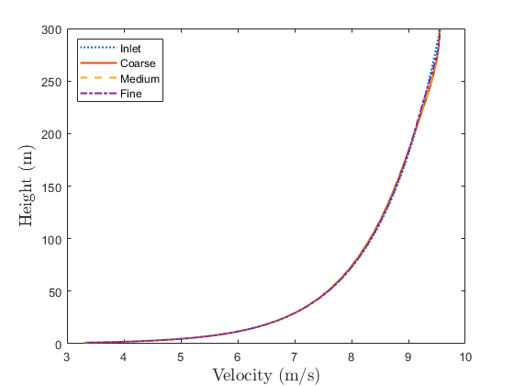
2. 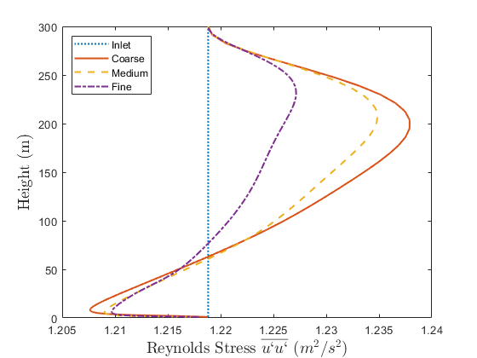
3. 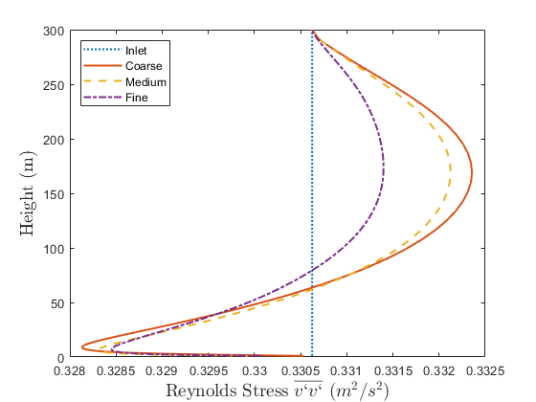
4. 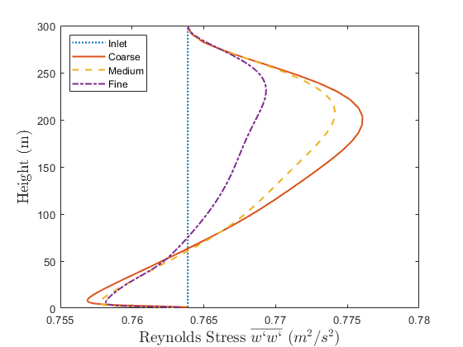
5. 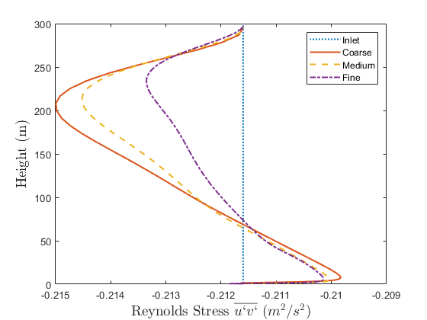
6. 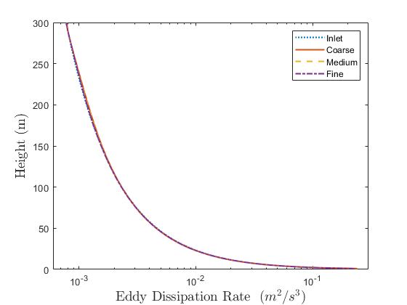
7. 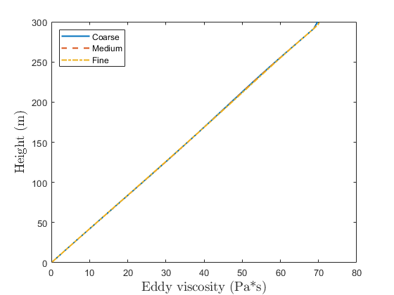

Figure 6.: Comparison of the results of (a) velocity, (b), (c), (d) and (e) Reynolds stresses, (f) eddy dissipation rate and (g) eddy viscosity between the inlet and the outlet of the domain for 3 different grid sizes.

As seen in Figure 6.1, the differences between the inlet and the outlet are very small, of the order of magnitude of 1% for any variable for the medium and fine grids. These errors are attributed to numerical errors, convergence errors, truncation errors, etc. The eddy viscosity also shows a linear dependence with the height as it was expected, which is indicative of the very small distortion of the flow variables within the domain. Similar results have been obtained for different combinations of the coefficients $A,B,Γ$ and $C_{μ}$, as well as friction velocity and roughness length values.

## 6.2 Nibe wind turbine

As in the previous chapter, the first turbine that is examined is the Nibe turbine for 3 different velocity inlet values. The values proposed by Panofsky and Dutton (1984) have been used for the normal Reynolds stresses because analytical experimental results are not provided. The coefficients that have been used are the same as in the examination of the empty domain. The same numerical grids and the same boundary conditions have been employed as in the previous chapter with the k – ω model and the differences between them were of similar order of magnitude.

The following source term has been applied to the vicinity of the actuator disk in the transport equation of the eddy dissipation rate, along with the pressure drop based on the equation (5.1):

|  |  |
| --- | --- |
| $$S_{ε}=C_{ε4}\frac{G_{k}^{2}}{ρk}$$ | (6.28) |

The main idea behind this source term is the fact that the equation for the eddy dissipation rate for the family of the k – ε models is empirical, and therefore there are many applications that the standard k – ε model fails to accurately predict the flow (e.g. the backward facing step, swirling flow problems etc.) and gives highly diffusive results. Therefore a second time scale (equation (6.28)) is added to the eddy dissipation equation to represent the energy transfer from the large to the small scales more effectively. Although this term was designated to be used in the family of k – ε models, it appears that it improves the results in the RSM because the transport equation for the eddy dissipation rate is essentially the same. However, equation (6.28) has to be modified because according to 2 equation turbulence models the turbulence is treated as isotropic and the Reynolds stresses are computed based on Boussinesq assupmtion. On the other hand, in the RSM, the turbulence is treated as anisotropic and the turbulence is not modeled based on the Boussinesq assumption and every Reynolds stress is calculated by a transport equation. Consequently, the turbulence production is substituted by the stress production in the RSM. In other words, the equation (6.28) is modified as follows:

|  |  |
| --- | --- |
| $$S_{ε}=C_{ε4}\frac{P_{ii}^{2}}{ρk}$$ | (6.29) |

The coefficient $C_{ε4}$ was set at the value of 0.15. Another advantage of the RSM in relation to the family of k – ε turbulence models is that the turbulence production term $\left(G_{k}\right)$ includes the eddy viscosity $\left(μ_{t}\right)$ which includes the coefficient $C_{μ}$. The coefficient $C_{μ}$, however, is used to define the relative turbulence levels of the field, consequently, it has to be changed from one wind turbine to another and the result from this change is unknown. For example, Kasmi and Masson (2008) have used only one specific value for all of the wind turbines they simulated because the relative turbulence levels were the same in all wind turbines, but it is unknown if their results were so accurate for a wind turbine with different relative turbulence levels. In the RSM however, the coefficient $C_{μ}$ is not used so the source term (6.29) is independent of the relative turbulence levels of the field.

Finally, regarding the convergence of the simulations, all equations have reached a residual below ${10}^{-6}$ with an exception of the continuity equation which residual was fluctuating approximately between ${5∙10}^{-5}$ and ${10}^{-5}$.

Figures 6.2 – 6.4 illustrate the velocity at various locations downstream of the turbine and compare them with available experimental data for various velocity and turbulence intensity inlets while Figure 6.5 illustrates the comparison of the computational results and experimental data of the turbulence kinetic energy along the domain at the hub – height of the turbine.

1. 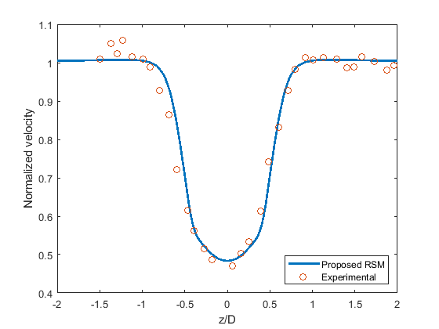
2. 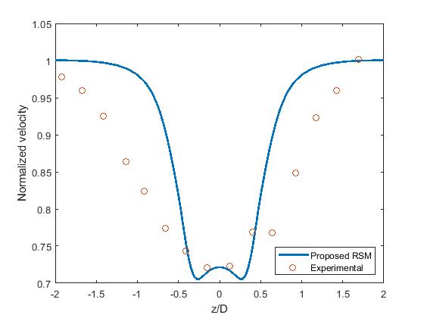
3. 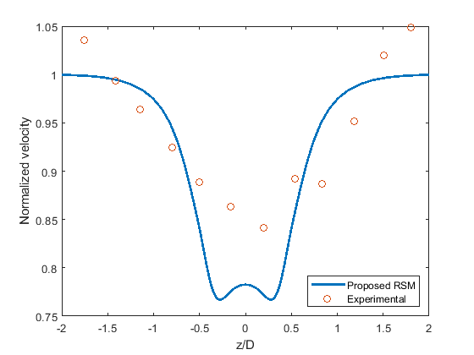

Figure 6.: Normalized velocity along the lateral sides of the domain at 2.5D, 6D and 7.5D downstream of the turbine for U=8.52m/s, TI=11% and Ct=0.82.

1. 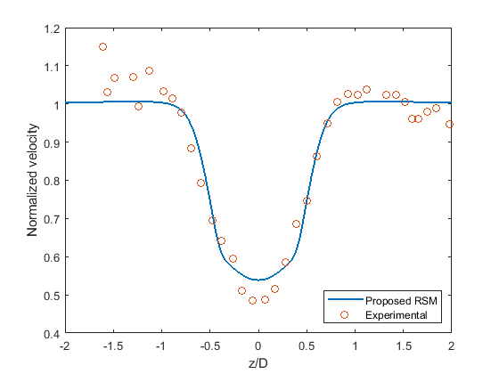
2. 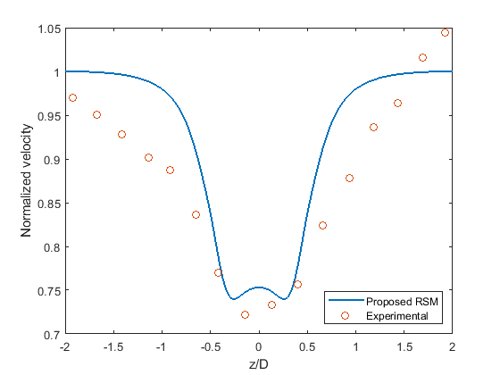
3. 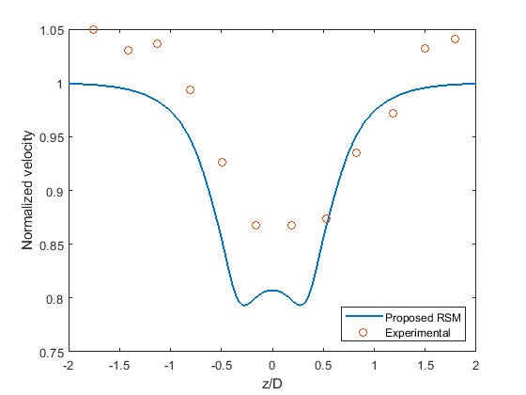

Figure 6.: Normalized velocity along the lateral sides of the domain at 2.5D, 6D and 7.5D downstream of the turbine for U=9.56m/s, TI=11% and Ct=0.77.

1. 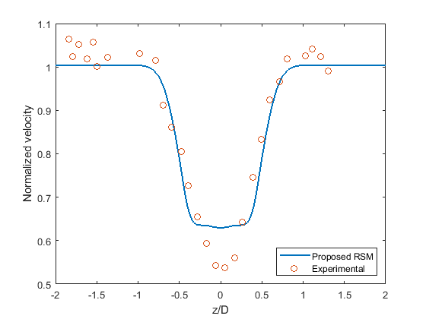
2. 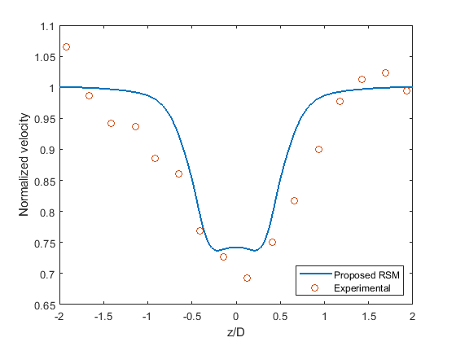
3. 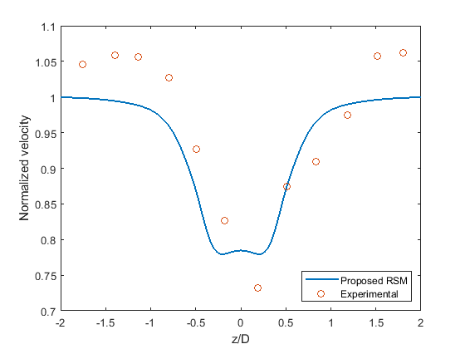

Figure 6.: Normalized velocity along the lateral sides of the domain at 2.5D, 6D and 7.5D downstream of the turbine for U=11.52m/s, TI=10.5% and Ct=0.67.

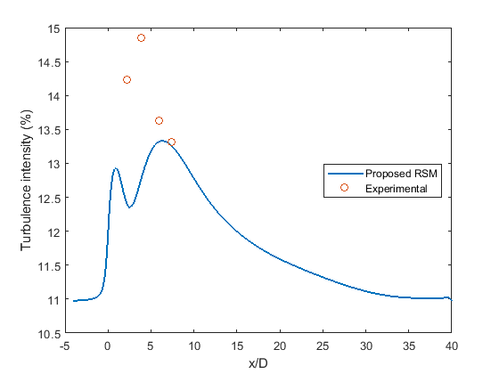

Figure 6.: Turbulence intensity along the streamwise direction at the hub – height of the turbine.

In general, the normalized velocity appears to agree well with the measurements to a great extend at the location $2.5D$ downstream of the turbine regardless of the magnitude of the velocity inlet. However, the comparison of the computational results with the experimental data is not very accurate for higher velocity inlet values and consequently, lower thrust coefficients. The explanation of this behavior lies to the actuator disk model that is used to represent the wind turbine. The actuator disk model does not include any stable parts of the wind turbine, such as the nacelle and the tower. However, the drag coefficient of the nacelle appears to have an almost steady value regardless of the Reynolds number, at least from a certain Reynolds number and above, and its drag coefficient is always higher than the thrust coefficient of the wind turbine. In other words, for high thrust coefficients, for example for $C_{T}=0.82$ in the present example, the thrust coefficient is very similar to the drag coefficient of the nacelle which is approximately close to 1, consequently, the inclusion of the nacelle is expected to have a small impact on the results. However, for a thrust coefficient of $C_{T}=0.67$, the difference between the thrust coefficient and the drag coefficient of the nacelle is considerable and the omission of the nacelle is expected to lead to different results due to the different pressure drop that is applied on the disk. However, in general the computational results of the normalized velocity at $2.5D$ downstream of the turbine are in very good agreement with the measurements.

The comparison of the normalized velocity at $6D$ downstream of the turbine is also in very good agreement, especially at the “footprint” position behind the wind turbine but the results are a little different in the region between the “footprint” and the lateral sides of the domain, as the present model appears to overestimate the velocity in this particular region. Finally, the computational results and the experimental data at $7.5D$ downstream of the turbine appear to be rather different, as the model appear to underestimate the velocity at this specific location, but this can be justified by the fact that the tower was not 100% aligned with the wind turbine when the experiment took place (Taylor et al., 1985). As will be shown later, the results in this region for the Holec wind turbine are much more accurate.

Finally, regarding the turbulence kinetic energy, at the near wake region the present model fails to predict the correct values and has an error of more than 10% while it appears to recover in the far wake region.

## 6.3 Holec wind turbine

In order to further validate the present model, as in the previous chapter, the Holec wind turbine is examined. The model is also compared with the model by Laan et al., (2015) to show its performance against other proposed models in the literature. The relative turbulence levels of this particular region are low in relation to the previous experiment. Unfortunately, the author is unclear with the undisturbed turbulent kinetic energy. Consequently, the turbulence kinetic energy of the last mast, which is located at $8D$ downstream of the turbine for high yaw angles will be considered as the inlet turbulent kinetic energy. By digitizing a figure from the experimental measurements in the report by Cleijne (1992), the following relationships for the normal Reynolds stresses are calculated:

|  |  |
| --- | --- |
| $$\overline{u^{'}u^{'}}=Au_{*}^{2}=3.2221u_{*}^{2}$$ | (6.30) |

|  |  |
| --- | --- |
|  | (6.31) |

|  |  |
| --- | --- |
|  | (6.32) |
|  |  |

The combination of the $A,B,Γ$ constants above gives a $C_{μ}$ value approximately $C_{μ}=0.0965$, which is almost the same value that has been used in the previous Chapter. The constants that were selected to remain the same as in the previous wind turbine are the following:

$C_{ε1}=1.44$ $C_{ε2}=1.92$ $C_{2}=4.2$ $C_{3}=0.8$ $C_{3}^{*}=1.3$ $σ_{k}=1$ $C_{3}=0.1$

The following constants are the unique solution to the system of equations (6.5) – (6.8) and the independent equation (6.23):

${C_{1}+C}_{1}^{*}=8.987989$ $C_{4}=1.826746$ $C_{5}=-0.644937$ $σ_{ε}=1.175541$ $C_{ε1}=1.3356$

As in the previous wind turbine, the constant $C_{1}$ is given the value of 0, consequently:

$C_{1}=0$ $C_{1}^{*}=8.987989$

The average wind speed at the hub – height was $7.6m/s$. Consequently, in order to validate the model, 2 different inlet wind speeds are considered. A low velocity inlet at the hub – height of $6.2{6m}/s$ and a high velocity inlet of $8.61m/s$ with thrust coefficients $C_{T}=0.78$ and $C_{T}=0.75$, respectively. Figures 5.6 and 5.7 illustrate the velocity and the relative to the undisturbed squared velocity turbulent kinetic energy for both velocity inlets.

1. 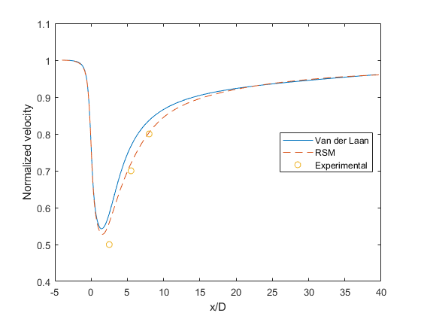
2. 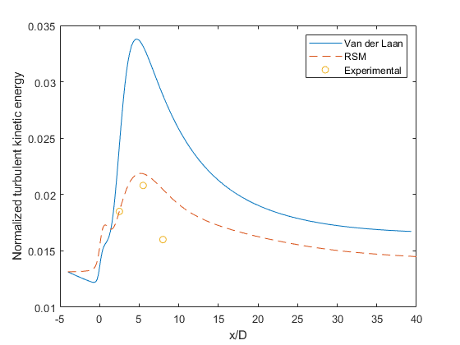

Figure 6.: (a) Normalized velocity and (b) normalized turbulent kinetic energy along the hub – height of the turbine for U=6.26m/s.

1. 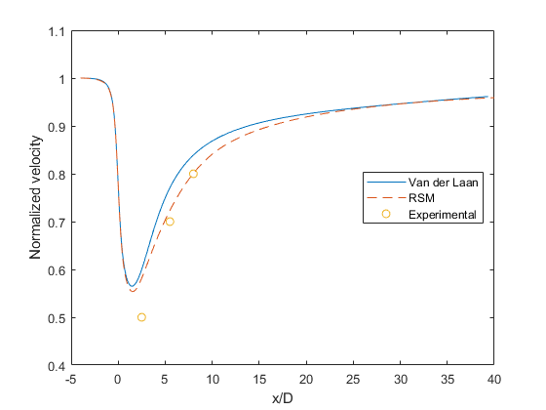
2. 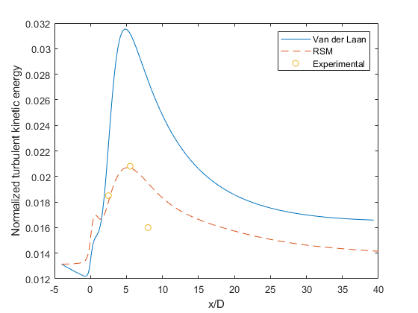

Figure 6.: (a) Normalized velocity and (b) normalized turbulent kinetic energy along the hub – height of the turbine for U=8.61m/s.

It is clear in the Holec wind turbine as in the Nibe wind turbine, the higher the thrust coefficient is, the more reliable the results are, for both velocity and turbulence, although the difference is very small for the Holec wind turbine because the difference in the thrust coefficient between the 2 different velocity inlet values is small. The computational results of the normalized velocity are in very good agreement with the experimental results in both the near and far wake regions. The proposed model also shows better performance compared to the model by Laan et al., (2015) especially for the turbulent kinetic energy at the wake region of the wind turbine. The proposed model also shows superiority to the Laan et al., (2015) model but the difference appears to be relatively small for the normalized velocity at the wake region of the turbine.

The proposed model appears to capture the general behavior of the turbulent kinetic energy although it underestimates the magnitude of it in the positions 2.5D and 5.5D at the rear of the turbine. However, as the thrust coefficient increases, the difference between the numerical results and the experimental data decreases. In all cases, the velocity and turbulence kinetic energy recover to their undisturbed inlet values at the very far wake region as expected based on the work done in the theory section.

## 6.4 Conclusions

In the present chapter, a proposed quadratic – pressure strain RSM model has been tested for the simulation of the small wind turbine wakes under neutrally stratified atmospheric conditions. A condition for the elimination of the streamwise gradients for all variables has been proposed. The implementation of the model in an empty domain has been successful under different relative turbulence levels, friction velocities and domain heights with minimal errors, with a limitation on the $\overline{u^{'}v^{'}}$ Reynolds stress. Then the model is employed for the simulation of 2 different small wind turbines with different inlet conditions. The validation of the model with the available experimental data was successful in both the near and far wake regions for both the velocity and turbulence and for both wind turbines. The proposed model is also compared with the model by Laan et al. (2015) and the proposed model shows better performance. The recovery of the velocity and turbulent kinetic energy in the very far wake region has been achieved, so at the very far wake region the velocity and turbulent kinetic energy return to their initial inlet values, thus enabling the present model to be appropriate for simulations of large wind farms. Finally, the proposed new model shows superiority to any 2 equation turbulence model.

# Chapter 7

# Large Eddy Simulation for small wind turbine wakes

So far, in the previous chapters, only the RANS approach has been considered. The RANS approach has been extensively used in the industry and in academia and will be employed in the future, especially in the industry due to the ease of implementation and the fast results that it provides, which is of vital importance in industry. However, its most substantial drawback is the lack of accuracy of the results due to the fact that the turbulence must somehow be modeled, which is the largest source of error in RANS simulations.

It has been shown in the previous Chapters that, in wind energy, as well as in other physical and engineering applications, considerable modifications in the turbulence model must be made in order to validate the results with experimental data. On the other hand, LES explicitly resolves the turbulence and limits the turbulence modeling in the very small scales that cannot be captured due to the size of the numerical cells. Details have been given in the Chapter 2. The main drawback, although not the only one, of the LES is its enormous demand for computational time because the simulations are always transient as all physical phenomena and engineering applications are always transient, and consequently a steady state approach to the application is completely inappropriate.

Another significant problem of LES is the generation of turbulence at the inlet of the domain. The turbulence must be fully prescribed everywhere throughout the inlet of the domain and simultaneously with the simulation at every time step. Details and solutions to this problem are given in Chapter 2. Depending on the application, this problem may be, to a small extent, limited in some applications (e.g. mixing models) due to the nature of the application. However, in atmospheric flows due to the absence of complex geometries and large obstacles in the domain, along with the fact that the atmospheric flows are always highly turbulent, the problem of inflow generation is a big challenge. One solution to the inflow turbulence generation is to impose translational periodic boundary conditions, instead of inlet – outlet, to simulate essentially an infinite number of wind turbines in a serial arrangement. This is something that has been employed by many researchers in a series of publications (Gocmen et al., 2016). However, the periodic boundary conditions is not an option when a single turbine is employed or in other applications such as simulations of various different types of buildings, unless a very large domain in the streamwise direction is employed.

Finally, another significant difficulty arises with the turbulent kinetic energy levels. This is not a problem when the whole ABL $\left(≈1000m\right)$ is modeled as the turbulent kinetic energy appears to have a maximum value on the ground and gradually dissipates with the height reaching an almost zero value at the height of the ABL. However, for small heights of the ABL, e.g. when the surface layer is modeled, the turbulent kinetic energy appears to drop significantly with the height and, in general, the relative turbulent kinetic energy throughout the surface layer is very low in relation to the real atmospheric conditions. Consequently, the upper boundary has to be treated accordingly to satisfy the turbulent kinetic energy values of the real atmosphere. The same problem also appears in RANS simulations but in RANS the treatment of the upper boundary is an easier problem because the turbulent kinetic energy is not “real turbulence” because it is modeled. This is not the case however in LES because the turbulence is explicitly resolved, at least for the biggest part of it.

In this chapter, the performance of LES for the wind turbine wakes is investigated.

## 7.1 Theory

For clarity, the equations that govern the atmospheric flows are repeated:

|  |  |
| --- | --- |
| $$\frac{∂u_{i}}{∂x_{i}}=0$$ | (7.1) |
| $$\frac{∂u_{j}}{∂t}+u_{i}\frac{∂u_{j}}{∂x_{i}}=-\frac{∂P}{∂x_{j}}+ν\frac{∂^{2}u_{j}}{∂x_{i}∂x_{i}}$$ | (7.2) |

The flow is assumed to be incompressible without any temperature variations, and the Coriolis effects are neglected due the short height of the ABL that is examined. By taking a closer look at the equation (7.2) in the $x$ direction, in a Cartesian coordinate system, it can be easily shown that the equation does not satisfy the logarithmic velocity profile based on the equation (3.9). In particular for the x component of the Navier – Stokes equation we have:

|  |  |
| --- | --- |
| $$0=ν\frac{∂^{2}u}{∂y^{2}}$$ | (7.3) |

The equation (7.3) is not true because there is a variation of the velocity with the height. The derivative in the equation (7.3), for the logarithmic velocity profiles based on the equation (3.9), equals to:

|  |  |
| --- | --- |
| $$\frac{∂^{2}u}{∂y^{2}}=-\frac{u_{*}}{κ{\left(y+y_{0}\right)}^{2}}$$ | (7.4) |

As seen from the equation (7.4), the value of the derivative has a very small value with the exception of the region close to the ground because it is inversely proportional with the height.

The same restriction also applies in the RANS approach examined in the previous chapters. However, due to the negligible value of the kinematic viscosity of the air compared to the eddy viscosity, the mathematical models were validated by the simulations with minimal errors, because the equations of the turbulent kinetic energy (or the equations of the Reynolds stresses in the case of the RSM) and the equation for the eddy dissipation or eddy frequency prevail the flow. However, in LES the situation is different because the modeling of turbulence is limited to the very small scales and the Navier – Stokes equations are essentially the only equations that govern the flow field. Also, in LES the situation is more complicated because the velocity components $v$ and $w$ are almost, but not completely, zero because the flow is a realistic transient flow field. In other words, the equations (3.9) – (3.11) cannot be reproduced with LES, which makes sense because, as it has been pointed out a few times in the previous chapters, the constant shear stress throughout the ABL is an approximation as there is a dissipation of the turbulence kinetic energy with the height according to measurements.

Most researchers who have studied the ABL under neutral stratification simulated the whole ABL where the type of the upper boundary is completely insignificant because the turbulence reaches a maximum on the ground and gradually fades out almost completely at the height of the ABL (≈1000m). However, when shorter heights of the ABL are considered, the type of the upper boundary plays a very important role in the generation and maintenance of the turbulence. This problem is more complicated in LES since, as stated in the previous section, the generation of turbulence at the inlet is another very big challenge.

## 7.2 Empty domain

In order to illustrate the problem in the simulations for short heights of the ABL, a simulation in a 1km length domain with 160m height and 300m in the spanwise direction is employed. Periodic boundary conditions with a prescribed mass flow rate are used instead of inlet – outlet boundaries to overcome the difficulty in the turbulence generation at the inlet of the domain. Periodic boundary conditions are also applied at the lateral sides of the domain with a zero pressure drop and the mass flow rate is calculated from the logarithmic velocity profile. More specifically, the mass flow rate is calculated from the following formula:

|  |  |
| --- | --- |
| $$\dot{m}=\int_{-z}^{z}{\int_{0}^{y}{ρ\frac{u_{*}}{κ}ln\left(\frac{y+y_{0}}{y_{0}}\right)dydz}}$$ | (7.5) |

A free stress boundary condition is applied at the upper boundary and a specified stress is applied at the ground given by:

|  |  |
| --- | --- |
| $$τ_{iy\left(x,z,t\right)}=ρ\frac{κ^{2}\sqrt{u_{\left(x,z,t\right)}^{2}+w_{\left(x,z,t\right)}^{2}}}{{\left[ln\left(\frac{d}{y_{0}}\right)\right]}^{2}}u_{i\left(x,z,t\right)}$$ | (7.6) |

where $d$ is the distance from the ground to the center of the first cell above the ground and this is also the point where velocity components are calculated. The formula above is calculated for $τ_{xy}$ and $τ_{zy}$. Instead of the $τ_{yy}$ shear stress component, the perpendicular to the ground velocity component is zero, in order to fully prescribe the bottom boundary condition.

Although this shear stress, based on the equation (7.6) was calculated based on averaged quantities it is still used in LES on a series of publications (Stoll and Porte – Agel, 2006).

The numerical grid is fully structured and equidistant with a 4m edge for all cells. The flow is developed for 6 turnover times before commencing data sampling. The time step size is $0.1s$, which corresponds to a Courant number far less than 1 everywhere throughout the domain. The simulation is data sampled for $5000s$. The friction velocity and roughness length are $u_{*}=0.46m/s$ and $y_{0}=0.05m$, respectively. Finally, the application showed negligible dependence on the numerical grid refinement because the sub – grid scale stresses are found to be almost negligible when compared to the resolved ones, with an exception of the first row of cells on the ground. The reason for this negligible dependence of the grid resolution on the resolved Reynolds stresses deals with the sizes of the eddies. The length scales of atmospheric flows have a very wide range from 1mm to a few units of kilometers (Stull, 1988). Consequently, only the filtered values are considered everywhere throughout this chapter. Figure 7.1 illustrates the time averaged velocity and turbulent kinetic energy.

1. 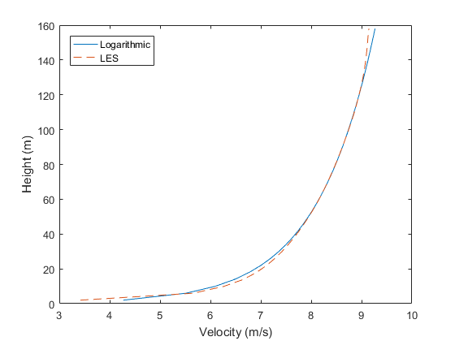
2. 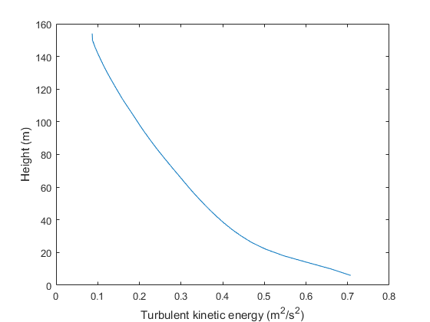

Figure 7.: (a) Velocity and (b) turbulent kinetic energy along the height of the domain.

As seen in Figure 7.1, the velocity profile agrees to a great extent with the logarithmic profile, however, the turbulent kinetic energy drops significantly with the height, thus rendering the periodic boundary conditions with a constant mass flow rate way incapable of simulating the ABL.

Another way to simulate the ABL, instead of the use of periodic boundary conditions, inlet – outlet boundary conditions can also be applied. The main difficulty with the inlet – outlet boundary conditions, as stated many times throughout the present thesis, is the generation and maintenance of the turbulence at the inlet. In the present case, the inflow turbulence generation method, as proposed by Smirnov et al. (2001), is used to generate the turbulence at the inlet. Figure 7.2 illustrates the velocity and resolved turbulent kinetic energy along the domain. Average values over horizontal planes along the streamwise direction are inappropriate because distortion of the velocity and turbulent kinetic energy occur with inlet – outlet boundary conditions and these distortions must be shown.

1. 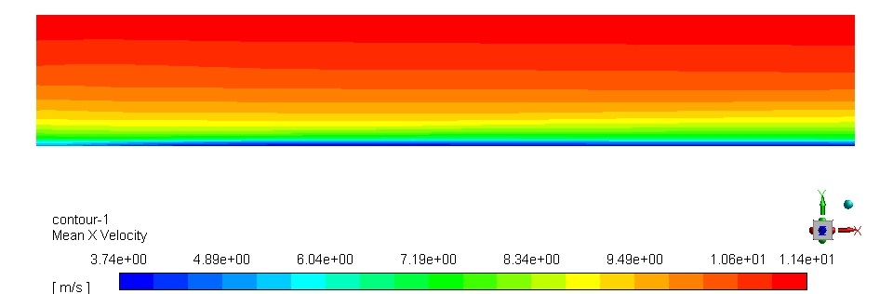
2. 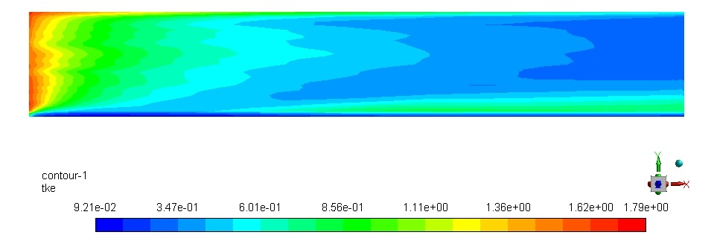

Figure 7.: (a) Time averaged x velocity component and (b) resolved turbulent kinetic energy along the domain on the central plane of the domain.

It can be deduced from Figure 7.2 that the inlet – outlet simulation is completely incapable of maintaining the turbulence generated at the inlet of the domain as the turbulence drops significantly within the first few meters from the inlet. There are 2 reasons for this result. The first reason for this behavior of turbulence is due to the fact that a synthetic method has been used to generate the turbulence. As stated in the Chapter 2, synthetic methods use mathematical models to generate the turbulence, however, these mathematical models do not actually represent a real turbulent flow and as a consequence, the turbulence dissipates to some extent within the domain. This fact has been reported in the literature by many researchers. The second reason lies into the boundary conditions that are employed. The symmetry boundary condition, as well as the shear stress boundary condition that have been employed are not consistent with the inlet profiles that have been used. This problem is the same as in the RANS simulations presented in the previous Chapters. Finally, regarding the time averaged velocity, the results are more accurate as the velocity is not distorted significantly in relation to the turbulence within the domain. However, the distortion of the velocity from the inlet to the outlet of the domain is higher in relation to the RANS results presented in the previous chapters.

A remedy to this problem lies in the shear stress boundary condition at the upper boundary, based on the equation (3.1), as Jimenez et al. (2007) introduced in their work. However, details about the implementation of this type of boundary are missing as well as results of the fluid flow in an empty domain. A shear stress boundary condition instead of a symmetry boundary condition, distorts significantly the fluid flow at the upper boundary while the effect of it on the rest of the domain is kept to a minimum.

For this reason, instead of a shear stress applied at the upper boundary, a linear profile of shear stress is applied everywhere throughout the domain, maximized at the upper boundary and minimized at the bottom of the domain. The physical explanation of this “progressive” shear stress with the height is that the effect of the shear stress is very important at the upper boundary and gradually it becomes less intense along the perpendicular to the ground direction. It becomes negligible on the ground and this is the region where it is given a zero value.

The simulation is repeated with the shear stress boundary condition described in the previous paragraph. Figure 7.3 illustrates the average velocity and turbulent kinetic energy along the height of the domain. The only different parameter to the results presented in Figure 7.1 is that instead of a constant mass flow rate, a specified pressure drop per unit length based on the equation (7.7) is applied and the total height of the computational domain is 180m instead of 160m.

|  |  |
| --- | --- |
| $$\frac{ΔP}{L}=-ρ\frac{u_{*}^{2}}{H_{ABL}}$$ | (7.7) |

The friction velocity that is used here is $u_{*}=0.631m/s$ because this is the friction velocity that will be used for the simulation of the wind turbine in the following section. The results in Figure 7.3 are shown for up to 120m from the ground. Above this height the results of the computationally predicted velocity and turbulence quantities are distorted significantly because the shear stress becomes more intense for higher heights.

1. 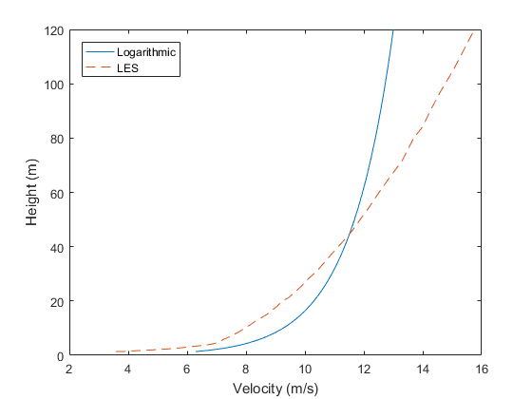
2. 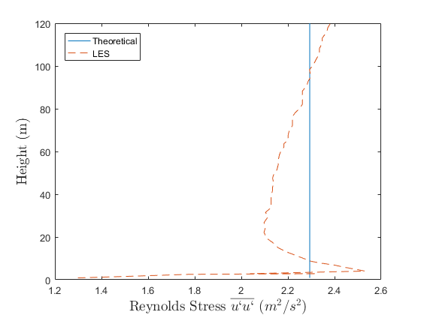
3. 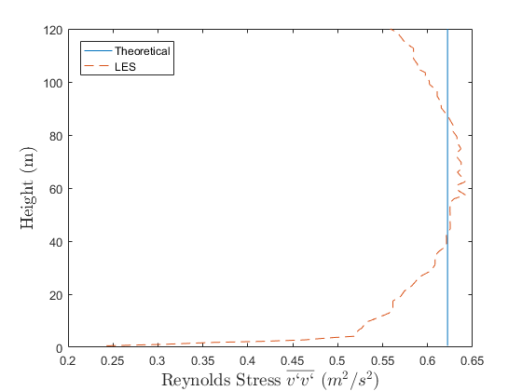
4. 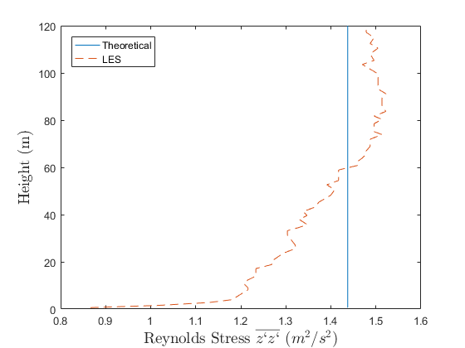
5. 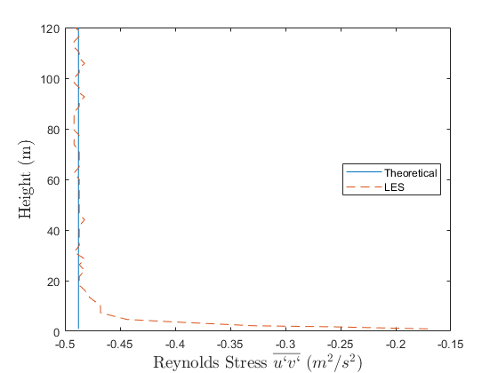

Figure 7.: Velocity and turbulence quantities of an empty domain.

The rest of the Reynolds stresses are essentially zero throughout the domain. As seen from the Figure 7.3 (a), the velocity is distorted from the ideal logarithmic profile with the shear stress boundary condition at the upper boundary. However, at the height of 45m from the ground the logarithmic velocity profile matches the computational results and this was the reason for the selection of 180m of the height of the domain. After performing a few parametric studies of the height of the domain, it was decided to create a domain of 180m in order to match the velocity of the logarithmic velocity profile with the computational results at 45m from the ground because this is the hub – height of the wind turbine that is examined in the next section. Regarding the upper and lower tips of the turbine, the error of the computational velocity in relation to the logarithmic velocity profile are 6.5% and 7.5%, respectively, while the error is essentially zero at the hub – height of the wind turbine that is simulated in the next section. Finally, it is clear from the Figure 7.3 that the mass flow rate is increased in relation to the ideal mass flow rate based on the equation (7.5), however this is an inevitable consequence of the shear stress boundary condition applied at the upper boundary.

Regarding the Reynolds stresses, generally there is a good agreement with the theoretical and the computationally predicted results for all Reynolds stresses. It is characteristic that all Reynolds stresses drop significantly close to the ground because the resolved stresses are negligible on the first row of cells above the ground. As it was stated earlier, only the resolved Reynolds stresses are considered because, away from the ground, the sub – grid stresses are very small in relation to the resolved ones.

## 7.3 Simulation of wind turbine

In this section the Nibe wind turbine is simulated with LES. The characteristics of this wind turbine have been given in the previous chapters. Periodic boundary conditions are applied instead of inlet – outlet ones with a pressure difference based on the equation (7.7) and the friction velocity that is used is $u_{*}=0.631m/s$. The dimensions of the computational domain is the same as in the previous section with a $1760m$ in the $x$ direction because it is imperative that in the very far wake region that the values of the velocity and turbulence converge to the undisturbed inlet values. The number of elements in the employed numerical grid is higher because it is refined at the region close to the wind turbine and consists of approximately 1,100,000 elements.

Figure 7.4 illustrates the averaged x velocity component and turbulence intensity along the streamwise direction at the hub – height of the domain and compared with experimental data.

1. 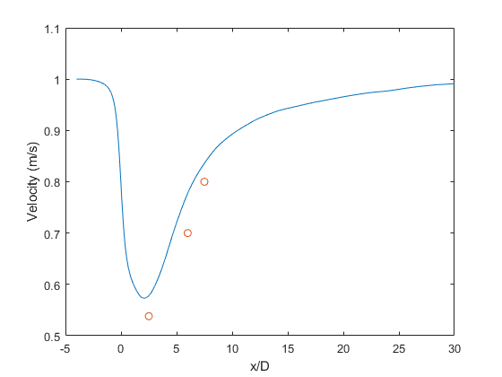
2. 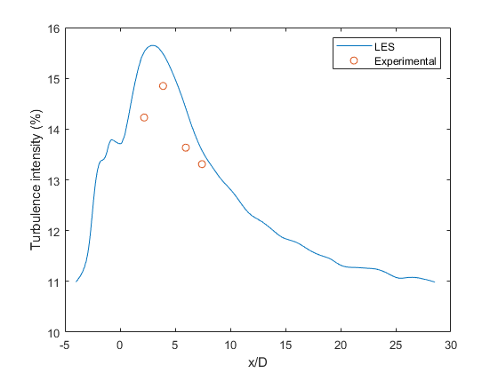

Figure 7.: (a) Velocity and (b) turbulence intensity along the streamwise direction at the hub – height of the wind turbine.

The results for both the velocity and turbulence intensity appear to agree well with the experimental data although the results tend to overestimate the velocity and turbulence intensity especially in the near wake region, which is indicative of the very good performance of the LES in relation to any RANS model. As seen in the Figure 7.4, both the velocity and turbulence intensity reached the undisturbed inlet values of the velocity and turbulent kinetic energy at the end of the domain before being recycled to the inlet due to the imposition of translational periodic boundary conditions.

## 7.4 Conclusions

In this Chapter, the zero streamwise gradient condition for all flow variables has been achieved with a “sacrifice” in the logarithmic velocity profile with the imposition of translational periodic boundary conditions. A synthetic turbulence method has been proven totally insufficient in maintaining the inlet turbulence levels proposed by Panofsky and Dutton (1984) for neutral atmosphere. The zero streamwise gradient condition has been achieved by imposing a shear stress linear profile throughout the domain maximized at the upper boundary and minimized on the ground of the domain. The imposition of the shear stress boundary condition in the domain destroyed the logarithmic velocity profile by making it more linear. However, the velocity was achieved to get the same value at the hub – height of the employed wind turbine by making a few parametric studies based on the height of the domain. Finally, the proposed linear shear stress profile was imposed in a wind turbine wake simulation and the comparison with experimental values was generally successful.

# Chapter 8

# Conclusions and future work

The main scope of the present thesis is to create more reliable models, for both RANS and LES, for the simulations of wind turbine wakes. Various modified models have been developed and applied for different small wind turbines to show the universality of the proposed models. The contributions of the present thesis are summarized along with recommendations for future work.

## 8.1 Conclusions

The existing models in the literature for the simulations of wind turbine wakes, despite being generally suitable, lack accuracy in the very far wake region and also they are “constant dependent” as they show different behavior under different inlet conditions. The turbulence levels may differ from location to location and consequently, the discovery of a model being “turbulence independent” is necessary. In most of these models, the inlet conditions are not mathematically consistent with the employed model and consequently, in the very far wake region the flow variables do not converge to the undisturbed inlet values, consequently the convergence of the flow variables at the outlet of the domain to the undisturbed inlet values is random and it depends on the percentage of consistency of the employed model with the inlet values. As a result, a model which is mathematically consistent with the inlet values and also which has the correct recovery of the wake for all flow variables, being independent of the relative turbulent kinetic energy is necessary.

In the present thesis, the zero streamwise gradient condition for the simulation of the wind turbine wakes under neutral stratified atmosphere has been achieved to a great extent with minimal errors. All models presented were mathematically consistent with the inlet values and their performance in empty domains has been illustrated. Two different wind turbines have been numerically studied under different operational conditions for the illustration of the universality of the models, with the actuator disk model without rotational effects, and correct recovery of the wake has been achieved to a great extent. The computational domain at the wake region was large enough to show the convergence of the outlet flow variables to the undisturbed inlet values.

In particular, the standard k – ω model has been modified to achieve the zero streamwise gradient condition in an empty domain. Then the model has been tested for the simulation of 2 different small wind turbines with different relative inlet turbulent kinetic energy values and different velocity inlet values. The results obtained showed very good agreement in the far wake region for both the velocity and turbulent kinetic energy, although in the near wake region the results did not show any improvement in relation to the existing models in the literature.

Since the atmospheric flows are highly turbulent and consequently highly anisotropic, the RSM has also been employed for the simulation of small wind turbine wakes. The quadratic – pressure strain model has been employed and a mathematical condition for the satisfaction of the zero streamwise gradient condition for the employed inlet flow variables has been discovered. The maintenance of the inlet quantities in an empty domain has been very successful for all Reynolds stresses and for the velocity. The predicted velocity according to this model has been very successful for the simulation of 2 different small wind turbines for both near and far wake regions when compared to experimental data. The turbulent kinetic energy showed a correct trend but the comparison with experimental data was not as successful as in the case of the velocity, but overall, the model performed very well. In all cases, for higher thrust coefficients the results, especially for the velocity, were more reliable than in the cases for lower thrust coefficients which was expected because stationary parts of the wind turbines have not been included.

Finally, LES has also been tested for the simulation of small wind turbine wakes. Due to the fact that LES does not include any modeling of the turbulence, at least for the resolved part of the turbulence, it was impossible to maintain the inlet quantities proposed by Panofsky and Dutton (1984) within the empty domain. Consequently, a sacrifice in the velocity or the Reynolds stresses was mandatory. By imposing a linear profile of the shear stress within the domain, the Reynolds stresses have been maintained with a small error within the domain, while the velocity showed a more linear, rather than a logarithmic behavior. By performing some parametric studies based on the height of the domain, the ideal height has been discovered in order to match the velocity of the flow field with the inlet velocity of the wind turbine at its hub – height. Then, the model has been applied for a small wind turbine wake and the results for both the velocity and turbulent kinetic energy were good when compared with the available experimental data.

## 8.2 Future work

As a future work, the implementation of the proposed models to wind farms is highly recommended to illustrate the importance of the correct recovery of the wake along with the zero streamwise gradient condition. In particular, the near and far wake region of the wind turbine is essentially the inlet condition of the downstream wind turbine, consequently, the correct recovery of the wake is of vital importance for the simulation of wind farms. It is highly recommended that the proposed models be tested for different wind farms for different free stream relative turbulent kinetic energy, based on the experimental data, and for various types of horizontal type wind farms with different arrangements and distances between the wind turbines. Additionally, the performance of the current models on other actuator disk (e.g. actuator line) approaches will also assess them in order to universalize them as much as possible.

As a future work it is also suggested the examination of non – neutral atmosphere, where buoyancy effects are not negligible and the logarithmic velocity profile slightly changes from the neutral atmospheric velocity profile. The proposed models have to be modified to be mathematically consistent with the new inlet profiles to achieve the zero streamwise gradient for all flow variables with an empty domain. Then, the new models will be tested for the simulation for small wind turbines and wind farms.

In addition to the examination of non – neutral atmosphere, a similar future work proposal is the examination of large wind turbines. The hub – height of large wind turbines and their tip of their turbines can reach hundreds of meters above the ground, consequently, the computational domain has to be extended accordingly. As in the case of non – neutral atmosphere described in the previous paragraph, the logarithmic velocity and turbulent kinetic energy profiles are invalid outside of the surface layer of the ABL. Consequently, the current models, first or second – order closure models, have to be modified to achieve mathematical consistency with the experimentally measured inlet profiles of all flow variables. Also, due to the fact that higher computational domains have to be implemented for the simulations of large wind turbines, the temperature and density variations with the height are highly recommended to be considered, along with the Coriolis force due to the rotation of the Earth.

Finally, the simulation of full – scale wind turbines of wind farms, including the blades and the tower with the proposed models, or other models based on the inlet profiles is suggested, however, the computational time with the current computational power is prohibitively expensive, especially in the industry.

# References

1. <http://www.treehugger.com/fossil-fuels/world-energy-use-over-last-200-years-graphs.html>

2.<https://www.gov.uk/government/uploads/system/uploads/attachment_data/file/338662/ecuk_chapter_3_domestic_factsheet.pdf>

3. <http://www.windenergyfoundation.org/about-wind-energy/history>

4. <http://www.turbinesinfo.com/horizontal-axis-wind-turbines-hawt/>

5. <http://www.keywordpicture.com/keyword/vertical%20axis%20wind%20turbine%20vawt/>

6. <http://www.windpowerengineering.com/construction/vertical-axis-wind-turbines-vs-horizontal-axis-wind-turbines/>

7. <http://alexanderjblack.weebly.com/turbulence.html>

8. <https://www.linkedin.com/pulse/20140725081243-58050580-y-wall-function-in-cfd>

9. <http://ww.telosnet.com/wind/early.html>

10. <http://www.kostic.niu.edu/350/_350-posted/350Chengel7th/Appendix1Udated.pdf>

11.<http://www.brunel.ac.uk/cedps/mechanical-aerospace-civil-ngineering/mecheng/research/capf/tcce>

12.<http://portal.tugraz.at/portal/page/portal/TU_Graz/Einrichtungen/Institute/Homepages/i3210/Forschung/Forschungsschwerpunkte%20Arbeitsgruppen/Turbulent%20Combustion>

13. <http://www.fluiddynamics.it/capitoli/Hypo.pdf>

14. <http://daad.wb.tu-harburg.de/tutorial/flood-probability-assessment/hydrodynamics-of-floods/2d-hydrodynamic-models/theory/fundamentals-of-mathematical-river-flow-modelling-2d-flow-calculation/turbulent-flows/reynolds-average-navier-stokes-equation/>

15. Abdulqadir S. A., Iacovides H., Nasser A., 2017. The physical modeling and aerodynamics of turbulent flows around horizontal axis wind turbines. Energy 119, 767 – 799.

16. Aboshosha H., Bitsuamlak G., Damatty A., 2015. LES of ABL flow in the built – environment using roughness modeled by fractal surfaces. Sustainable Cities and Society 19, 46 – 60.

17. Ahmadi M., Tabor G., 2009. Inlet conditions for LES using mapping and feedback control. Computers & Fluids 38, 1299 – 1311.

18. Al – Azawy M., Turan A., Revell A., 2016. Assessment of turbulence models for pulsatile flow inside a heart pump. Computer methods in Biomechanics and Biomedical Engineering, 19:3, 271 – 285, DOI: 10.1080/10255842.2015.1015527.

19. Allaers D., Meyers J., 2015. Large eddy simulation of a large wind – turbine array in a conventionally neutral atmospheric boundary layer. Physics of Fluids 27, 065108, doi: 10.1063/1.4922339.

20. Almgren A., Bell J., Rendleman C., Zingale M., 2006. Low Mach Number Modeling of Type Ia Supernovae. The Astrophysical Journal 637, 922 – 936.

21. Ammara I., Leclerc C., Masson C., 2002. A Viscous Three – Dimensional Differential/Actuator – Disk Method for the Aerodynamic Analysis of Wind Farms. Journal of Solar Energy Engineering 124 (4), 345 – 356.

22. An K., Fung J., 2018. An improved SST k – ω model for pollutant dispersion simulations within an isothermal boundary layer. Journal of Wind Engineering and Industrial Aerodynamics 179, 369 – 384.

23. ANSYS FLUENT 14.0, 2011. Theory Guide. Release 14.0 @ ANSYS Inc.

24. Barthelmie R., Frandsen S., Rathmann O., Hansen K., Politis E., Prospathopoulos J., Cabezon D., Rados K., Pijl S., Schepers J., Schlez W., Phillips J., Neubert A., 2008. Flow and wakes in large wind farms in complex terrain and offshore. In European Wind Energy Conference and Exhibition, Brusels, Belgium.

25. Basu S., Porte – Agel F., 2005. Large – Eddy Simulation of Stably Stratified Atmospheric Boundary Layer Turbulence: A Scale – Dependent Dynamic Modeling Approach. Journal of the Atmospheric Sciences 63, 2074 – 2091.

26. Bitsuamlak G., Stathopoulos T., Bedard C. 2006. Effects of upstream two – dimensional hills on design wind loads: A computational approach. Wind Structures 9 (1), 37 – 58.

27. Blocken B., Carmeliet J., 2002. Spatial and temporal distribution of driving rain on a low – rise building. Wind Structures 5 (5), 441 – 462.

28. Blocken B., Stathopoulos T., Carmeliet J., 2007.CFD simulation of the atmospheric boundary layer: wall function problems. Atmospheric Environment 41(2), 238 – 252.

29. Bradshaw P., 1974. Possible origin of Prandt’s mixing – length theory. Nature 249 (6), 135 – 136.

30. Cabezon D., Migoya E., Crespo A., 2011. Comparison of turbulence models for the computational fluid dynamics simulation of wind turbine wakes in the atmospheric boundary layer. Wind Energy 14, 909 – 921.

31. Cabezon D., Sanz J., Marti I., Crespo A., 2009. CFD modeling of the interaction between the surface boundary layer and rotor wake – Comparison of results obtained with difference turbulence models and mesh strategies. European Wind Energy Conference and Exhibition. Marseille, France.

32. Cai X., Gu R., Pan P., Zhu J., 2016. Unsteady aerodynamics simulation of a full – scale horizontal axis wind turbine using CFD methodology. Energy Conversion and Management 112, 146 – 156.

33. Castellani F., Vignaroli A., 2013. An application of the actuator disc model for wind turbine wakes calculations. Applied Energy 101, 432 – 440.

34. Castelli M., Englaro A., Benini E., 2011. The Darrieus wind turbine: Proposal for a new performance prediction model based on CFD. Energy, 36, 4919 – 4934.

35. Cecora R., Radespiel R., Eisfeld B., Probst A., 2015. Differential Reynolds – Stress Modeling for Aeronautics. AIAA Journal, 53, 739 – 755. DOI: 10.2514/1.J053250.

36. Cengel Y., Cimbala J., 2006. Fluid Mechanics Fundamentals and Applications. McGraw Hill, New York.

37. Chen Y., Kim S., 1987. Computation of turbulent flow using an extended turbulence closure model, NASA Contractor Report, NASA CR – 179204.

38. Chowdhury A., Akimoto H., Hara Y., 2016. Comparative CFD analysis of Vertical Axis Wind Turbine in upright and tilted configuration. Renewable Energy, 85, 327 – 337.

39. Choudhry A., Mo J., Arjomandi M., Kelso R., 2014. Effects of wake interaction on downstream wind turbines. Wind Engineering 38, 535 – 548.

40. Cleijne J., 1992. Results of Sexbierum Wind Farm Report MT-TNO, Apeldoorn, 92 – 388.

41. Churchfield M., Lee S., Michalakes J., Moriarty P., 2012. A numerical study of the effects of atmospheric and wake turbulence on wind turbine dynamics. Journal of Turbulence, 13, N14, DOI: 10. 1080/14685248.2012.668191.

42. Crespo A., Hernandez, J., Frandsen, S., 1999. Survey of modeling methods for wind turbine wakes and wind farms. Wind Energy 2, 1–24.

43. Crespo A., Manuel F., Moreno D., Fraga E., Hernandez J., 1985. Numerical analysis of wind turbine wakes. In: Preceedings of Delphi Workshop on Wind Energy Applications, Delphi, Greece, 15 – 25.

44. Davidson L., 2007. Hybrid LES – RANS: Inlet boundary conditions for flows including recirculation. 5th International Symposium on Turbulence and Shear Flow Phenomena, TU Munich 2, 689 – 694.

45. Davidson P., 2004. Turbulence: An Introduction for Scientists and Engineers. Oxford. England.

46. Deaves D., Harris R., 1978. A mathematical model of the structure of strong winds. CIRIA Report 76, Construction Industry Research and Information Association, London.

47. Di Mare L., Klein M., Jones W., Janicka J., 2006. Synthetic turbulence inflow conditions for large – eddy simulation. Physics of Fluids 18, 025107 – 025107 – 11.

48. Druault P., Lardeau S., Bonnet J., Coiffet F., Delville J., Lamballais E., Lagreau J., Perret L., 2004. Generation of three – Dimensional Turbulent Inlet Conditions for Large – Eddy Simulation. AIAA Journal 42(3), 447 – 456.

49. Evans A., Strezov V., Evans T., 2009. Assessment of sustainability indicators for renewable energy technologies. Renewable and Sustainable Energy Reviews. 13 (5), 1082 – 1088.

50. ESDU, 1985. Characteristics of atmospheric turbulence near the ground. Part II: single point data for strong winds (neutral atmosphere). Data Item 85020, Engineering Sciences Data Unit.

51. El – Askary W., Sakr M., Abdelsalam A., Abuhegazy M., 2017. Modeling of wind turbine wakes under thermally – stratified atmospheric boundary layer. Journal of Wind Engineering and Industrial Aerodynamics 160, 1 – 15.

52. Franke J., Hellsten A., Schlunzen H., Carissimo B., 2007. Best practice guideline for the CFD simulation of flows in the urban environment. University of Hamburg, Meteorological Institute.

53. Garratt J., 1992. The atmospheric boundary layer. Cambridge atmospheric and space science series.

54. Gibson M., Launder B., 1978. Ground Effects on Pressure Fluctuations in the Atmospheric Boundary Layer. Journal of Fluid Mechanics 86, 491 – 511.

55. Gocmen T., Laan P., Rethore P., Diaz A., Larsen G., Ott S., 2016. Wind turbine wakes models developed at the technical university of Denmark: A review. Renewable and Sustainable Energy Reviews 60, 752 – 769.

56. Goodfriend E., Katopodes F., Vanella M., Ballaras E., 2015. Improving Large – Eddy Simulation of Neutral Boundary Flow across Grid Interfaces. Monthly Weather Review 143, 3310 – 3326.

57. Gorle C., Beeck J., Rambaud P., Tendeloo G., 2009. CFD modeling of small particle dispersion: The influence of the turbulent kinetic energy in the atmospheric boundary layer. Atmospheric Environment 43 (3), 673 – 681.

58. Guo B., Langrish T., Fletcher D., 2001. An assessment of turbulence models applied to the simulation of a two – dimensional submerged jet. Applied Mathematical Modeling 25, 635 – 653.

59. Han X., Liu D., Xu C., Shen W., 2018. Atmospheric stability and topography effects on wind turbine performance and wake propertied in complex terrain. Renewable energy, 126, 640 – 651.

60. Hargreaves D., Wright. N., 2007.On the use of the k – ε model in commercial CFD software to model the neutral atmospheric boundary layer. Journal of Wind Engineering and Industrial Aerodynamics 95, 355 – 369.

61. Holtslag M., Bierbooms W., Bussel G., 2014. Estimating atmospheric stability from observations and correcting wind shear models accordingly. Journal of Physics: Conference Series 555, 012052.

62. Hooff T., Blocken B., Tominaga Y., 2017. On the accuracy of CFD simulations of cross – ventilation flows for a generic isolated building: Comparison of RANS, LES and experiments. Building and Environment, 114, 148 – 165.

63. Huang S., Li Q., Wu. J., 2010. A general inflow turbulence generator for large eddy simulation. Journal of Wind Engineering and Industrial Aerodynamics 98, 600 – 617.

64. Huang S., Li Q., Xu S., 2007. Numerical evaluation of wind effects on a tall steel building by CFD. Journal of constructional steel research 63, 612 – 627.

65. Jakirlic S., Eisfeld B., Jester – zurker R., Kroll N., 2007. Near – wall, Reynolds – stress model calculations of transonic flow configurations relevant to aircraft aerodynamics. International Journal of Heat and Fluid Flow, 28, 602 – 615.

66. Jarrin N., 2008. Synthetic Inflow Boundary Conditions for the Numerical Simulation of Turbulence. PhD Thesis. The University of Manchester. England.

67. Jarrin N., Benhamadouche S., Laurence D., Prosser R., 2006. A synthetic – eddy – method for generating inflow conditions for large – eddy simulations. International Journal of Heat and Fluid Flow 27, 585 – 593.

68. Jimenez A., Crespo A., Migoya E., Garcia J., 2007. Advances in large – eddy simulation of a wind turbine wake. Journal of Physics: Conference Series 75, 012041. DOI: 10.1088/1742 – 6596/75/1/012041.

69. Johansson P., Andersson H., 2004. Generation of inflow data for inhomogeneous turbulence. Theoretical and Computational Fluid Dynamics 18, 371 – 389.

70. Juretic F., Kozmar H., 2013. Computational modeling of the neutrally stratified atmospheric boundary layer flow using the standard k – ε turbulence model. Journal of Wind Engineering and Industrial Aerodynamics 115, 112 – 120.

71. Kasmi A., Masson C., 2008. An extended k – ε model for turbulent flow through horizontal – axis wind turbines. Journal of Wind Engineering and Industrial Aerodynamics 96, 103 – 122.

72. Kim S., Boysan F., 1999. Application of CFD to environmental flows. Journal of Wind Engineering and Industrial Aerodynamics, 81, 145 – 158.

73. Kim Y., Castro I., Xie Z., 2013. Divergence – free turbulence inflow conditions for large – eddy simulations with incompressible flow solvers. Computers and Fluids 84, 56 – 68.

74. Klein M., Sadiki A., Janicka J., 2003. A digital filter based generation of inflow data for spatially developing direct numerical or large eddy simulation. Journal of Computational Physics 186, 652 – 665.

75. Kraichnan R., 1970. Diffusion by Random Velocity Field. The Physics of Fluids 11, 22.

76. Laan P., Sorensen N., Rethore P., Mann J., Kelly M., Troldborg N., Schepers J., Machefaux E., 2015. An improved k – ε model applied to a wind turbine wake in atmospheric turbulence. Wind Energy, 18, 889 – 907.

77. Lanzafame R. Mauro S., Messina M., 2013. Wind turbine CFD modeling using a correlation – based transitional model. Renewable Energy 52, 31 – 39.

78. Launder B., Reece G., Rodi W., 1975. Progress in the Development of a Reynolds – Stress Turbulence Colsure. Journal of Fluid Mechanics 68 (3), 537 – 566.

79. Launder B., Spalding D., 1974. The numerical computation of turbulent flows. Computer Methods in Applied Mechanics and Engineering 3, 269 – 289.

80. Lignarolo L., Gorle C., Parente A., Benocci C., 2011. Large eddy simulation of the atmospheric boundary layer using OpenFOAM. Von Karman Institute for Fluid Dynamics, Brussels, Belgium.

81. Lu H., Porte – Agel F., 2011. Large – eddy simulation of a very large wind farm in a stable atmospheric boundary layer. Physics of Fluids 23, 065101, DOI: 10. 1063/1.3589857

82. Lund T., Wu X., Squires K., 1998. Generation of Turbulent Inflow data for Spatially Developing Boundary layer Simulations. Journal of Computational Physics 140, 233 – 258.

83. Larsen G., Madsen H., Thomsen K., Larsen T., 2008. Wake meandering: a pragmatic approach. Wind Energy 11, 377 – 395.

84. Makridis A., Chick J., 2013. Validation of a CFD model of wind turbine wakes with terrain effects. Journal of Wind Engineering and Industrial Aerodynamics 123, 12 – 29.

85. Mayor S., Spalart P., Tripoli G., 2002. Application of a perturbation recycling method in the large – eddy simulation of a mesoscale convective internal boundary layer. Journal of the Atmospheric and Oceanic Sciences 59, 2385 – 2395.

86. Menter F., 1994. Two – equation eddy – viscosity turbulence models for engineering applications. AIAA Journal 32(8), 1598 – 1605.

87. Mikkelsen R., 2003. Actuator disc methods applied to wind turbines. PhD Thesis, Technical University of Denmark.

88. Mo J., Choudhry A., Arjomandi M., Lee Y., 2013. Large eddy simulation of the wind turbine wake characteristics in the numerical wind tunnel model. Journal of Wind Engineering and Industrial Aerodynamics 112, 11 – 24.

89. Nakayama H., Takemi T., Nagai H., 2012. Large – eddy simulation of urban boundary – layer flows by generating turbulent inflows from mesoscale meteorological simulations. Atmospheric science letters 13, 180 – 186.

90. Nedjari H. D., Guerri O., Saighi M., 2017. CFD wind turbines wake assessment in complex topography. Energy Conversion and Management 138, 224 – 236.

91. O’Sullivan J.P., Archer R.A., Flay R.G.J., 2011. Consistent boundary conditions for flows within the atmospheric boundary layer. Journal of Wind Engineering and Industrial Aerodynamics 99 (1), 65–77.

92. Orszag A., Yakhot V., Flannery W., Boysan F., Choudhury D., Maruzewski J., Patel B, 1993. Renormalization Group Modeling and Turbulence Simulations. International Conference on Near – Wall Turbulent Flows, Tempe, Arizona.

93. Otero E., 2009. Synthetic inflow condition for LES. MSc Thesis, KTH Royal Institute of Technology, Sweden.

94. Panofsky H., Dutton J., 1984. Atmospheric Turbulence. Wiley, New York.

95. Parente A., Gorle C., van Beeck J., Benocci C., 2011. Improved k – ε model and wall function formulation for the RANS simulation of ABL flows. Journal of Wind Engineering and Industrial Aerodynamics 99, 267 – 278.

96. Patankar S., 1980. Numerical Heat Transfer and Fluid Flow. CRC Press, New York, U.S.A., 1st Edition.

97. Porte – Agel F., Wu Y., Lu H., Conzemious R., 2011. Large – eddy simulation of atmospheric boundary layer flow through wind turbines and wind farms. Journal of Wind Engineering and Industrial Aerodynamics 99, 154 – 168.

98. Porte – Agel F., Meneveau C., Parlange M., 2000. A scale – dependent dynamic model for large – eddy simulation: application to a neutral atmospheric boundary layer. Journal of Fluid Mechanics 415, 261 – 284.

99. Porte – Agel F., Wu T., Chen C., 2013. A numerical study of the effect of wind direction on turbine wakes and power losses in a large wind farm. Energies 6, 5297.

100. Prospathopoulos J., Politis E., Chaviaropoulos P., Rados K., Schepers J., Cabezon D., Hansen K. S., Barthelmie R., 2010. CFD modeling of Wind Farms in Flat and Complex Terrain. In: EWEC 2010, Warsaw, Poland.

101. Prospathopoulos J., Politis E., Rados K., Chaviaropoulos P., 2011. Evaluation of the effects of turbulence model enhancements on wind turbine wake predictions. Wind Energy 14, 285 – 300.

102. Quinn A., Wilson M., Reynolds A., Couling S., Hoxey R., 2001. Modeling the dispersion of aerial pollutants from agricultural buildings – an evaluation of computational fluid dynamics (CFD). Computers and Electronics in Agriculture 30, 219 – 235.

103. Rethore P., Sorensen N., Zahle F., Bechmann A., 2009. Study of the wake turbulence of a CFD actuator disk model compared with a full rotor CFD model. Proceedings of the European Wind Energy Conference. Marseille, France.

104. Rezaeiha A., Kalkman I., Blocken B., 2017. CFD simulation of vertical axis wind turbine operating at a moderate tip speed ratio: Guidelines for minimum domain size and azimuthal increment. Renewable energy, 107, 373 – 385.

105. Riddle A., Carruthers D., Sharpe A., McHugh C., Stocker J., 2004. Comparisons between FLUENT and ADMS for atmospheric dispersion modeling. Atmospheric Environment 38 (7), 1029 – 1038.

106. Richards P., Hoxey R., 1993. Appropriate boundary conditions for computational wind engineering models using the k – ε turbulence model. Journal of Wind Engineering and Industrial Aerodynamics 46 & 47, 145 – 153.

107. Richards P., Norris S., 2015. Appropriate boundary conditions for a pressure driven boundary layer. Journal of Wind Engineering and Industrial Aerodynamics 142, 43 – 52.

108. Richards P., Norris S., 2015. LES modeling of unsteady flow around the Silsoe cube. Journal of Wind Engineering and Industrial Aerodynamics 144, 70 – 78.

109. Sanderse B., Pijl S., Koren B., 2011. Review of computational fluid dynamics for wind turbine wake aerodynamics. Wind Energy 14, 799 – 819.

110. [Sedaghatizadeh](https://www.sciencedirect.com/science/article/pii/S0960148117308790#!) N., Arjomandi M., Kelso R., Cazzolato B., Ghayesh M., 2018. Modeling of wind turbine wake using large eddy simulation. Renewable Energy 115, 1166 – 1176.

111. Shih T., Liou W., Shabbir A., Yang Z., Zhu J., 1995. A New k – ε Eddy – Viscosity Model for High Reynolds Number Turbulent Flows – Model Development and Validation. Computers Fluids 24 (3), 227 – 238.

112. Simisiroglou N., Karatsioris M., Nilsson K., Breton S. P., Ivanell S. The actuator disc concept in PHOENICS. 13th Deep Sea Offshore Wind R&D Conference, EERA DeepWind’2016, 20 – 22 January 2016, Trondheim, Norway.

113. Smirnov A., Shi S., Celik I., 2001. Random Flow Generation Technique for Large Eddy Simulations and Particle Dynamics Modeling. J. Fluids Eng. 123, 359 – 371.

114. Speziale C., Sarkar S., Gatski T., 1991. Modelling the Pressure – Strain Correlation of Turbulence: An invariant Dynamical Systems Approach. Journal of Fluid Mechanics 227, 245 – 272.

115. Stevens R., Martinez – Tossas L., Meneveau C., 2018. Comparison of wind farm large eddy simulations using actuator disk and actuator line models with wind tunnel experiments. Renewable Energy 116, 470 – 478.

116. Stoll R., Porte – Agel F., 2006. Effect of roughness on surface boundary conditions for large – eddy simulation. Boundary – Layer Meteorology 118, 169 – 187.

117. Storey R., Cater J., Norris S., 2016. Large eddy simulation of turbine loading and performance in a wind farm. Renewable Energy 95, 31 – 42.

118. Stull R., 1988. An Introduction to Boundary Layer Meteorology. Kluwer Academic Publishers: Dordrecht.

119. Taylor G., Milborrow D., McIntosh D., Swift – Hook D., 1985. Wake measurements on the Nibe windmills. In Proceedings of Seventh BWEA Wind Energy Conference, Oxford, 67 – 73.

120. Thomas T., Williams J., 1999. Generating a wind environment for large eddy simulation of bluff body flows. Journal of Wind Engineering and Industrial Aerodynamics 82, 189 – 208.

121. Tominaga Y., Stathopoulos T., 2012. CFD Modeling of Pollutant Dispersion in Building Array: Evaluation of turbulent scalar flux modeling in RANS model using LES results. Journal of Wind Engineering and Industrial Aerodynamics 104 – 106, 484 – 491.

122. Tominaga Y., Stathopoulos T., 2017. Steady and unsteady RANS simulations of pollutant dispersion around isolated cubical buildings: Effect of large – scale fluctuations on the concentration field.

123. Tucker P., 2011. Computation of unsteady turbomachinery flows: Part 2 – LES and hybrids. Progress in Aerospace Sciences 47 (7), 546 – 569.

124. Tummala A., Velamati R., Sinha D., Indraja V., Krishna V., 2016. A review on small scale wind turbines. Renewable and Sustainable Energy Reviews 56, 1351 – 1371.

125. Versteeg H., Malalasekera W., 2007 An introduction to Computational Fluid Dynamics. The Finite Volume method. Pearson. Essex, England, 2nd Edition.

126. White F., 2008. Fluid Mechanics. Mc Graw Hill, New York, U.S.A., 6th Edition.

127. Wilcox, D., 1988. Reassessment of the scale – determining equation for advanced turbulence models. AIAA J. 26 (11), 1299–1310.

128. Wilcox D., 2010. Turbulence Modeling for CFD. DCW Industries, California, U.S.A., 3rd Edition.

129. Xie Z., Voke P., Hayden P., Robins A., 2004. Large – eddy simulation of turbulent flow over a rough surface. Boundary Layer Meteorology 111, 417 – 440.

130. Yan B., Li Q., 2015. Inflow turbulence generation methods with large eddy simulation for wind effects on tall buildings. Computers and Fluids 116, 158 – 175.

131. Yang Y., Gu M., Chen S., Jin X., 2009. New inflow boundary conditions for modeling the neutral equilibrium atmospheric boundary layer in computational wind engineering. Journal of Wind engineering and Industrial Aerodynamics 97, 88 – 95.

132. Yang Z., 2015. Large Eddy Simulation: Past present and future. Chinese Journal of Aeronautics 28(1), 11 – 24.

133. Zhang C., 1994. Numerical prediction of turbulent recirculating flows with a k – ε model. Journal of Wind Engineering and Industrial Aerodynamics 51, 177 – 201.

# Appendix 1

# Derivation of the mathematical conditions

Here the derivation of the equation (5.3), which is the condition that has to be satisfied in order to make the k – ω model mathematically consistent with the inlet conditions described by equations (3.9), (3.11) and (5.2), is performed. Also, the assumption that the standard k – ω model under any circumstances automatically satisfies the equation (2.35) is shown.

For clarity, the equations of the standard k – ω model are repeated, along with the inlet values of the domain for atmospheric flows under neutral stratification.

|  |  |
| --- | --- |
| $$\frac{∂}{∂t}\left(ρk\right)+\frac{∂}{∂x_{i}}\left(ρku_{i}\right)=\frac{∂}{∂x_{i}}\left[\left(μ+\frac{μ_{t}}{σ_{k}}\right)\frac{∂k}{∂x_{i}}\right]+G_{k}-Y_{k}+S_{k}$$ | (A1) |

|  |  |
| --- | --- |
|  | (A2) |

The inlet condition is defined by the velocity, turbulent kinetic energy and eddy frequency as follows:

|  |  |
| --- | --- |
| $$u_{(y)}=\frac{u_{*}}{κ}ln\left(\frac{y+y_{0}}{y_{0}}\right)$$ | (Α3) |

|  |  |
| --- | --- |
|  | (Α4) |

|  |  |
| --- | --- |
|  | (Α5) |

By applying the equations (A3) – (A5) into the equation (A1), the equation (A1) is simplified as:

|  |  |
| --- | --- |
| $$0=G_{k}-Y_{k}$$ | (Α6) |

This is because there are no variations of the turbulent kinetic energy with the height and no variations of the u velocity component, which is the only component that exists in the domain, in the streamwise direction. Consequently, all derivations appeared in the equation (A1) disappear.

Taking into account the Boussinesq assumption which is expresses by the equation (2.26) and the equations (2.10), (2.38), (2.40), (2.42) and (2.44), the equation (A6) is transformed as:

|  |  |
| --- | --- |
| $$a^{*}ρ\frac{k}{ω}{\left(\sqrt{2S_{ij}S_{ij}}\right)}^{2}=ρβ^{*}f_{β}kω$$ | (Α6) |

By making some simple algebra, the equation (A6) is transformed as:

|  |  |
| --- | --- |
| $$a^{*}2S_{ij}S_{ij}=β^{*}f_{β}ω^{2}$$ | (Α7) |

Considering the equation (2.39) it can be concluded that the constant $a^{*}$ is equal to the constant $a_{∞}^{*}$ which is unity because the flow is highly turbulent and the contribution of the coefficient $β_{i}$ is negligible. This statement is also written in FLUENT Theory guide. The coefficient $f_{β}$ is also unity as it can be concluded from the equations (2.46) and (2.47) because the $χ_{k}$ constant is equal to zero because there is no gradients of the turbulent kinetic energy in any direction in the domain. Finally, for incompressible and highly turbulent flows, the constants $β^{*}$, $β_{i}^{*}$ and $β_{∞}^{*}$ have the same value as is can be concluded from the equations (2.48) and (2.49) and this is also stated in FLUENT Theory guide. Taking all the above into consideration, the equation (A7) is transformed as follows:

|  |  |
| --- | --- |
| $$2S_{ij}S_{ij}=β_{∞}^{*}ω^{2}$$ | (Α8) |

The derivation of the multiplication the strain rate tensor with its self, for a 3D flow on a Cartesian coordinate system is analyzed as follows:

|  |  |
| --- | --- |
| $$S_{ij}S_{ij}=S_{xx}S_{xx}+S_{xy}S_{xy}+S_{xz}S_{xz}+S_{yx}S_{yx}+S_{yy}S_{yy}+S_{yz}S_{yz}+S_{zx}S_{zx}+S_{zy}S_{zy}+S_{zz}S_{zz}$$ | (Α9) |

The only velocity gradient that occurs in the domain is the u velocity component with the height, which is denoted by y. Consequently, the equation (A9) is transformed as:

|  |  |
| --- | --- |
| $$S_{ij}S_{ij}=S_{xy}S_{xy}+S_{yx}S_{yx}$$ | (Α10) |

All the other components of the strain rate are zero. By applying the equation (2.10) and due to the fact that the components $S_{xy}$ and $S_{yx}$ are equal because they are symmetric, the equation (A10) becomes:

|  |  |
| --- | --- |
| $$S_{ij}S_{ij}={\left[0.5\left(\frac{∂u}{∂y}+\frac{∂v}{∂x}\right)\right]}^{2}+{\left[0.5\left(\frac{∂v}{∂x}+\frac{∂u}{∂y}\right)\right]}^{2}=0.5{\left(\frac{∂u}{∂y}\right)}^{2}$$ | (Α11) |

The derivative which appears in the equation (A11) is:

|  |  |
| --- | --- |
| $$\frac{∂u}{∂y}=\frac{∂}{∂y}\left[\frac{u_{*}}{κ}ln\left(\frac{y+y_{0}}{y_{0}}\right)\right]=\frac{u_{*}}{κ}\frac{1}{y+y_{0}}$$ | (Α12) |

Applying the equations (A11) and (A12) into the equation (A8), the resulting equation becomes:

|  |  |
| --- | --- |
| $$\frac{u_{*}^{2}}{κ^{2}}\frac{1}{{\left(y+y_{0}\right)}^{2}}=β_{∞}^{*}\frac{u_{*}^{6}}{κ^{2}{\left(y+y_{0}\right)}^{2}k^{2}{\left(β_{∞}^{*}\right)}^{2}}$$ | (Α13) |

By expanding the turbulent kinetic energy in the equation (A13) based on the equation (A4), the equation (A13) becomes:

|  |  |
| --- | --- |
| $$\frac{u_{*}^{2}}{κ^{2}}\frac{1}{{\left(y+y_{0}\right)}^{2}}=β_{∞}^{*}\frac{u_{*}^{6}}{κ^{2}{\left(y+y_{0}\right)}^{2}{\left(β_{∞}^{*}\right)}^{2}}\frac{β_{∞}^{*}}{u_{*}^{4}}$$ | (Α14) |

The right hand side of the equation (A14) is exactly the same as the left side of the equation (A14), consequently, the equations (A3) – (A5) are an analytical solution of the equation (A1), which means that the equation (A1) which is the equation for the calculation of the turbulent kinetic energy of the standard k – ω model can be used for the simulation of the neutral ABL which is expressed by the equations (A3) – (A5). The examination of the equation (A2), which is the equation for the calculation of the eddy frequency, is followed.

All terms in the left side of the equation (A2) is zero when the equations (A3) to (A5) are applied. Consequently, the equation (A2) is simplified as follows:

|  |  |
| --- | --- |
| $$0=\frac{∂}{∂y}\left(\frac{μ_{t}}{σ_{ω}}\frac{∂ω}{∂y}\right)+G_{ω}-Y_{ω}$$ | (A15) |

In the equation (A15) the laminar viscosity is omitted because its value is very small in relation to the turbulent viscosity. The derivative of the eddy frequency, taking into account the definition of the eddy frequency given in the equation (2.34) is:

|  |  |
| --- | --- |
| $$\frac{∂ω}{∂y}=\frac{∂}{∂y}\left(\frac{ε}{β_{∞}^{*}k}\right)=\frac{1}{β_{∞}^{*}k}\frac{∂}{∂y}\left[\frac{u_{*}^{3}}{κ\left(y+y_{0}\right)}\right]=-\frac{u_{*}^{3}}{{κβ}_{∞}^{*}k}\frac{1}{{\left(y+y_{0}\right)}^{2}}$$ | (A16) |

The first term in the equation (A15), by taking into account the definition of the eddy viscosity given in the equation (2.38), is simplified as follows:

|  |  |
| --- | --- |
| $$\frac{∂}{∂y}\left(\frac{μ_{t}}{σ_{ω}}\frac{∂ω}{∂y}\right)=\frac{ρk}{σ_{ω}}\frac{1}{{\left(y+y_{0}\right)}^{2}}$$ | (A17) |

As stated in FLUENT Theory guide, for high turbulent flows the $a^{*}$ constant is equal to $a_{∞}^{*}$ which is unity for the standard k – ω model. This statement can also be deducted from the equations (2.39).

The production term of the turbulent kinetic energy $\left(G_{k}\right)$ is:

|  |  |
| --- | --- |
| $$G_{k}=μ_{t}S^{2}=\frac{ρk^{2}β_{∞}^{*}}{κu_{*}\left(y+y_{0}\right)}$$ | (A18) |

The production term of the eddy frequency $\left(G_{ω}\right)$ is:

|  |  |
| --- | --- |
| $$G_{ω}=a\frac{ω}{k}G_{k}=\frac{ρu_{*}^{2}}{κ^{2}{\left(y+y_{0}\right)}^{2}}$$ | (A19) |

The term $f_{β}$ in equation (2.45) is unity because the term $Ω_{ij}$ is zero for the equations (A3) – (A5). Consequently, the term $χ_{ω}$ in equation (2.51) is zero and the term $f_{β}$ has the value of unity. The equation (2.45) is:

|  |  |
| --- | --- |
| $$Y_{ω}=\frac{ρβ}{{\left(β_{∞}^{*}\right)}^{2}k^{2}}\frac{u_{*}^{6}}{κ^{2}{\left(y+y_{0}\right)}^{2}}$$ | (A20) |

For incompressible flows, the term $β$ is equal to $β_{i}$. Replacing the equations (A17), (A19) and (A20) in the equation (A15), the following expression is discovered, which is the expression (5.3) in the thesis:

|  |  |
| --- | --- |
| $$\frac{1}{σ_{ω}\sqrt{β_{∞}^{*}}}+\frac{1}{κ^{2}}=\frac{β_{i}}{κ^{2}β_{∞}^{*}}$$ | (A21) |

In this section, the mathematical condition for the satisfaction of the equations (3.9), (3.11) and (6.1) – (6.4) is shown. First, the equation (6.23) is derived, which is the condition for the satisfaction of the properties of neutral atmosphere for the equation of the eddy dissipation rate (equation (2.29)). Taking into account that there are no transient phenomena and the only non – zero averaged velocity component that exists is the streamwise velocity gradient, all the terms in the left side of the equation (2.29) are zero. Also, the laminar viscosity is negligible compared to the eddy viscosity and there are no buoyancy effects or heat transfer phenomena. Consequently, the equation (2.29) is transformed as:

|  |  |
| --- | --- |
| $$0=\frac{∂}{∂y}\left[\left(\frac{μ_{t}}{σ_{ε}}\right)\frac{∂ε}{∂y}\right]+0.5C_{ε1}P_{ii}\frac{ε}{k}-C_{ε2}ρ\frac{ε^{2}}{k}$$ | (A22) |

The derivation of the eddy dissipation rate is:

|  |  |
| --- | --- |
| $$\frac{∂ε}{∂y}=\frac{∂}{∂y}\left[\frac{u_{*}^{3}}{κ\left(y+y_{0}\right)}\right]=-\frac{u_{*}^{3}}{κ}\frac{1}{{\left(y+y_{0}\right)}^{2}}$$ | (A23) |

The derivation of the first term in the equation (A22) is:

|  |  |
| --- | --- |
| $$\frac{∂}{∂y}\left[\left(\frac{μ_{t}}{σ_{ε}}\right)\frac{∂ε}{∂y}\right]=-\frac{ρC_{μ}k^{2}u_{*}^{3}}{σ_{ε}κ}\frac{∂}{∂y}\left[\frac{1}{ε}\frac{1}{{\left(y+y_{0}\right)}^{2}}\right]=\frac{ρu_{*}^{4}}{σ_{ε}}\frac{1}{{\left(y+y_{0}\right)}^{2}}$$ | (A24) |

The stress production $\left(P_{ii}\right)$, which definition is stated in the equation (2.57) is calculated as follows:

|  |  |
| --- | --- |
| $$P_{ii}=P_{xx}+P_{yy}+P_{zz}$$ | (A25) |

Each normal component of the stress production is analyzed as:

|  |  |
| --- | --- |
| $$P_{xx}=-ρ\left(\overline{u^{'}u^{'}}\frac{∂u}{∂x}+\overline{u^{'}u^{'}}\frac{∂u}{∂x}+\overline{u^{'}v^{'}}\frac{∂u}{∂y}+\overline{u^{'}v^{'}}\frac{∂u}{∂y}+\overline{u^{'}w^{'}}\frac{∂u}{∂z}+\overline{u^{'}w^{'}}\frac{∂u}{∂z}\right)$$ | (A26) |

|  |  |
| --- | --- |
|  | (A27) |

|  |  |
| --- | --- |
|  | (A28) |

The components $P_{yy}$ and $P_{zz}$ are equal to zero as the only non – zero velocity component is the streamwise component, as stated earlier. The stress production, consequently, is:

|  |  |
| --- | --- |
| $$P_{ii}=-2ρ\overline{u^{'}v^{'}}\frac{∂u}{∂y}=-2ρΔu_{*}^{2}\frac{u_{*}}{κ}\frac{1}{y+y_{0}}$$ | (A29) |

The second term in the equation (A22) is:

|  |  |
| --- | --- |
| $$0.5C_{ε1}P_{ii}\frac{ε}{k}=-ρC_{ε1}Δ\frac{u_{*}^{3}}{κ}\frac{1}{y+y_{0}}\frac{ε}{k}=-ρC_{ε1}Δ\frac{u_{*}^{3}}{κ}\frac{1}{y+y_{0}}\frac{\sqrt{C_{μ}}}{u_{*}^{2}}\frac{u_{*}^{3}}{κ\left(y+y_{0}\right)}=-ρC_{ε1}Δ\frac{\sqrt{C_{μ}}u_{*}^{4}}{κ^{2}{\left(y+y_{0}\right)}^{2}}$$ | (A30) |

Finally, the last term in the equation (A22) is:

|  |  |
| --- | --- |
| $$C_{ε2}ρ\frac{ε^{2}}{k}=C_{ε2}ρ\frac{u_{*}^{6}}{κ^{2}{\left(y+y_{0}\right)}^{2}}\frac{\sqrt{C_{μ}}}{u_{*}^{2}}=C_{ε2}ρ\frac{\sqrt{C_{μ}}u_{*}^{4}}{κ^{2}{\left(y+y_{0}\right)}^{2}}$$ | (A31) |

Substituting all these 3 terms in the equation (A22), we end to the condition (6.23) in the thesis.

|  |  |
| --- | --- |
| $$\frac{ρu_{*}^{4}}{σ_{ε}}\frac{1}{{\left(y+y_{0}\right)}^{2}}-ρC_{ε1}Δ\frac{\sqrt{C_{μ}}u_{*}^{4}}{κ^{2}{\left(y+y_{0}\right)}^{2}}-C_{ε2}ρ\frac{\sqrt{C_{μ}}u_{*}^{4}}{κ^{2}{\left(y+y_{0}\right)}^{2}}⇒\frac{1}{σ_{ε}}=\frac{\sqrt{C_{μ}}}{κ^{2}}\left(C_{ε2}+ΔC_{ε1}\right)$$ | (A32) |

# Appendix 2

# User Defined Functions used in FLUENT

The following UDF has been employed for the velocity inlet profile in FLUENT for any simulation for all models. Changes in the friction velocity and roughness length have been done depending on the inlet velocity and roughness of the ground.

DEFINE_PROFILE(inlet_velocity, thread, position)

{

real x[ND_ND]; /* coordinates */

real y,u;

face_t f; /* f is a face thread index */

y0 = .05; /* roughness length */

u = .55; /* friction velocity */

begin_f_loop(f,thread)

{

F_CENTROID(x, f, thread);

y = x[1];

F_PROFILE(f, thread, position) = (u/.4187) * log ((y+y0)/y0);

}

end_f_loop(f, thread)

}

The following UDF has been used in FLUENT for the eddy dissipation rate for the k – ε model and the RSM:

DEFINE_PROFILE(e_profile,thread,diss)

{

real x[ND_ND];

real y,y0;

face_t f;

y0 = 0.05; /* roughness height in m*/

u = .55; /* friction velocity */

begin_f_loop(f,thread)

{

F_CENTROID(x,f,thread);

y=x[1];

F_PROFILE(f,thread,diss)=pow(u,3)/(.4187*(y+y0));

}

end_f_loop(f,thread)

}

The following UDF has been used in FLUENT for the eddy frequency for the proposed k – ω model:

DEFINE_PROFILE(omega_profile,thread,diss)

{

real x[ND_ND];

real y,y0;

face_t f;

y0 = 0.05; /* roughness height in m*/

u = .55; /* friction velocity */

k = 1.2614; /* inlet turbulent kinetic energy */

Cm = 0.033; /* Cm constant based on the inlet relative turbulence */

begin_f_loop(f,thread)

{

F_CENTROID(x,f,thread);

y=x[1];

F_PROFILE(f,thread,diss)=(1./(k*Cm))*pow(u,3)/(.4187*(y+y0));

}

end_f_loop(f,thread)

}

The following UDF has been used for the source term based on the equation (3.18):

DEFINE_SOURCE(turbine,c,t,dS,eqn)

{

real x[ND_ND];

real source;

C_CENTROID(x,c,t);

source=1.225*4*C_K(c,t)*(1./(C_O(c,t)*C_O(c,t))*pow((2*C_DUDX(c,t)*C_DUDX(c,t)+2*C_DVDY(c,t)*C_DVDY(c,t)+2*C_DWDZ(c,t)*C_DWDZ(c,t)+C_DUDY(c,t)*C_DUDY(c,t)+C_DUDZ(c,t)*C_DUDZ(c,t)+C_DVDX(c,t)*C_DVDX(c,t)+C_DVDZ(c,t)*C_DVDZ(c,t)+C_DWDX(c,t)*C_DWDX(c,t)+C_DWDY(c,t)*C_DWDY(c,t)+2*C_DVDX(c,t)*C_DUDY(c,t)+2*C_DUDZ(c,t)*C_DWDX(c,t)+2*C_DVDZ(c,t)*C_DWDY(c,t)),2));

return source;

}

The following UDF has been used for the wall shear stress boundary condition of the equation (7.6). Different values for the friction velocity and cell height have been used.

DEFINE_PROFILE(TxProfile, t, position)

{

face_t f;

Thread* t0 = THREAD_T0(t);

real rho = C_R(c,t);

h = 1.; /* cell height */

y0 = .031; /* roughness length */

begin_f_loop(f,t)

{

cell_t c = F_C0(f,t);

F_PROFILE(f,t,position)=1.225*.16*(sqrt(C_U(c,t0)*C_U(c,t0)+C_W(c,t0)*C_W(c,t0)))*C_U(c,t0)/pow(log(1/.031),2);

}

end_f_loop(f,t)

}

DEFINE_PROFILE(TyProfile, t, position)

{

face_t f;

Thread* t0 = THREAD_T0(t);

real rho = C_R(c,t);

h = 1.; /* cell height */

y0 = .031; /* roughness length */

begin_f_loop(f,t)

{

cell_t c = F_C0(f,t);

F_PROFILE(f,t,position)=rho*.16*(sqrt(C_U(c,t0)*C_U(c,t0)+C_W(c,t0)*C_W(c,t0)))*C_W(c,t0)/pow(log(1/.031),2);

}

end_f_loop(f,t)

}

The following UDF has been used for the creation of the eddy viscosity model used by Laan et al. (2015) based on the equations (3.19) – (3.24).

DEFINE_TURBULENT_VISCOSITY(user_mu_t,c,t)

{

real mu_t;

real rho=C_R(c,t);

real k=C_K(c,t);

real d=C_D(c,t);

real cmu;

real cmu_star;

real fp;

real f0;

real cr;

real sigma_score;

real sigma;

real term;

cr=4.5;

f0=cr/(cr-1.);

cmu=M_keCmu;

sigma_score=1./pow(cmu,.5);

sigma=k/d*(pow((C_DUDX(c,t)*C_DUDX(c,t)+C_DUDY(c,t)*C_DUDY(c,t)+C_DUDZ(c,t)*C_DUDZ(c,t)+C_DVDX(c,t)*C_DVDX(c,t)+C_DVDY(c,t)*C_DVDY(c,t)+C_DVDZ(c,t)*C_DVDZ(c,t)+C_DWDX(c,t)*C_DWDX(c,t)+C_DWDY(c,t)*C_DWDY(c,t)+C_DWDZ(c,t)*C_DWDZ(c,t)),0.5));

term=1.+4.*f0*(f0-1.)*pow((sigma/sigma_score),2.);

fp=2.*f0/(1.+pow(term,.5));

cmu_star=cmu*fp;

mu_t=rho*cmu_star*k*k/d;

return mu_t;

}