A multi-omic approach for the identification of upstream drivers of shared phenotypes

By:
Claire Green

A thesis submitted in partial fulfilment of the requirements for the degree of
Doctor of Philosophy

The University of Sheffield
Faculty of Medicine, Dentistry and Health
Department of Neuroscience

Submission Date: 29th November 2018



A multi-omic approach for the identification of upstream drivers of shared phenotypes

By:

Claire Green

A thesis submitted in partial fulfilment of the requirements for the degree of
Doctor of Philosophy

The University of Sheffield
Faculty of Medicine, Dentistry and Health
Department of Neuroscience

Submission Date: 29th November 2018

Abstract
Many conditions exist for which we still do not know the cause, often due to their complexity and rarity. Without knowledge of their underlying mechanisms, development of effective drugs and personalised approaches to treatment of these diseases will never be possible. Consequently, we have a responsibility to develop novel, systematic, and objective analytical approaches which can produce reliable predictions of causative mechanisms as rapidly as possible. The recent trend for such analyses has been to generate extraordinarily large datasets, however these datasets are time consuming to produce, costly, and only accessible by a small percentage of the scientific community. There instead exists a vast quantity of publicly available, modestly sized datasets; alone, these datasets are unreliable - too underpowered to sufficiently support the hypotheses they are associated with - yet the quantity of these small datasets suggests untapped potential for analysis when used in combination.

In this thesis we present a novel approach built to harness the potential of small datasets. We have taken advantage of the inherent variability of tissue types, platforms, and genetic backgrounds to produce gene expression signatures shared by groups of patients exhibiting a common phenotype. We demonstrate application of the pipeline to three diseases phenotypes and show how each signature consistently enriches with genes and pathways associated with the shared phenotype as well as containing known upstream drivers. We also show significant enrichment of snp-associated GWAS genes in our autoimmune arthritis signature, as well as demonstrating preliminary in silico validation of one known and 2 novel upstream drivers of TDP-43 pathology and neurodegeneration through perturbation in an iPSC model. We believe the value of our approach is not only to reveal previously unknown upstream drivers of rare and complex conditions, but do so with a fraction of the resources conventionally devoted to this process.
Acknowledgements
I have wanted to do a PhD since I was probably about 7 years old. I didn’t know what a PhD was, or what you needed to do to get it, all I knew is that I wanted one. You may ask how a 7-year-old girl - who still struggled to get all the vowels in the right place in the word “because”, and whose greatest scientific achievement up to this point was a poorly maintained woodlouse farm – even knew what a PhD was. I grew up with privilege I never knew I had – a mother who was a Doctor of Philosophy. Again, I probably couldn’t pronounce, let alone spell “Philosophy”, but I thought it was cool, and my Mum was cool, and I wanted to be cool just like my Mum.

Eighteen years later, as I write these final words, I wonder perhaps if Mum should have just gone on a course in something fun like baking or circus tricks, then I could be eating cake all day or teaching hamsters how to do flips off the trapeze or something, but then I think about how proud I am to be writing these words. Very tired, but so very proud. And so, my first thanks goes to my wonderful, funny, intensely intelligent Mother who taught me that girls can do computers, and get PhDs, and be really good at crosswords (I’ll stop cheating one day Mum). I love you so much for teaching me those things. Of course I could never mention Mum without mentioning Dad – you have been a powerhouse of support since I flopped into this world, and as long as you are around I know there is always someone cheering me on (though hopefully not like Jon’s old football days eh?). Speaking of which, I must also thank my big brother Jon. Whenever I’m struggling, I always look to you for guidance. Many times during this process I have rallied myself with the knowledge that “if Jon can do it, I can do it”. You will always be my role model, and my North Star. I love you all.

This thesis would not exist without my two supervisors - Professor Winston Hide and Dr Johnathan Cooper-Knock. Completing this PhD with you both has been exciting and devastating and brilliant and scary and wonderful. It’s been a bloody wild ride, but a bloody good one. I never would have found this world and this project if it weren’t for you, and I will be eternally grateful. Thank you also to the rest of the Hide Lab – David, Sandeep, Wenbin, Sokratis, Viv, and by extension Gabriel and Yered - for your input and your support. Thank you to our collaborators Professor Clifford Woolf and Dr Kuchuan Chen at Harvard Children’s Hospital and Harvard Medical School, and Dr Oliver Bandmann, Dr Heather Mortiboys, Dr Paul Heath, and Dr Janine Kirby at SITraN for your contributions and your kind advice. My deepest thanks also to Sheffield Medical School for awarding me a scholarship to fund this journey.

There are two people who are probably wondering why I haven’t mentioned them yet – rest assured ladies, I haven’t forgotten you! The world of science is hard, but it’s pretty fun if you have two awesome women to skip through it with, Wizard of Oz style. Kat and Mogs (or Sarah or Sally or whoever you are), for every time I have been down, you guys have always found a way to make me laugh again (usually with a cat GIF). I never expected to make such great friends during my time here, but something tells me I won’t be able to shake you off so easy! I hope we will always have Unicorn brunch, and that when we’re old ladies we’re still messaging about Drag Race Season 51.

Last but by no means least, I cannot thank my dearest Daniel enough. These past 3 years have been really hard, but coming home to you after every failed experiment or lost file always made it better again. You have supported me in every way you know how, so thank you for all the hugs and doing the washing and the hoovering and making dinner when I was too tired (we’ll gloss over the salty pancakes and the “is there cinnamon in this bolognaise?” occasions). Thank you from the bottom of my heart. As always, I love you.

~
My sincerest gratitude to the many unnamed patients who gave the gift of data.
~

Contents
1Chapter 1: Introduction 1
1.1 Inadequate Treatments for Complex Diseases 2
1.2 Long Journeys 2
1.3 Small Data 3
1.4 Finding the Intersection 5
1.4.1 The Value of Signatures 6
1.4.2 Signatures are Imperfect 6
1.4.2.1 Bias 7
1.4.2.2 Inadequate Controls 8
1.4.2.3 Inconsistent Signals 8
1.4.2.4 Lack of Validation 9
1.5 Building a Multi-Omic Signature 11
1.5.1 Gene-Level Analyses 11
1.5.2 Pathway-Level Analyses 12
1.5.3 Mapping Interactions across Networks 14
1.5.4 Target Prioritisation 16
1.5.5 Summary 17
1.6 Current Common Signature Methods 17
1.7 Aims and Objectives 21
Chapter 2: Pipeline Development: An Application to TDP-43 Dysfunction 23
2.1 Introduction 23
2.1.1 Overview 23
2.1.2 Case Study: TDP-43 Dysfunction 23
2.1.2.1 TDP-43 Structure and Function 23
2.1.3 TDP-43 and Neurodegeneration 25
2.1.3.1 Amyotrophic Lateral Sclerosis 26
2.1.3.2 Frontotemporal Dementia 26
2.1.3.3 Multisystem Proteinopathy 26
2.1.3.4 Alexander’s Disease 27
2.1.3.5 Alzheimer’s Disease 27
2.1.3.6 Parkinson’s Disease 27
2.1.3.7 Lewy Body Dementia 27
2.1.3.8 Parkinsonism-Dementia Complex of Guam 28
2.1.3.9 Huntington’s Disease 28
2.1.3.10 Corticobasal Degeneration 28
2.1.3.11 Progressive Supranuclear Palsy 29
2.1.3.12 Hippocampal Sclerosis 29
2.1.3.13 Spinocerebellar Ataxia Type 2 29
2.1.3.14 Chronic Traumatic Encephalopathy 30
2.2 TDP-43 Dysfunction 30
2.3 Developing a TDP-43 Signature 31
2.3.1 Identifying Commonly Differentially Expressed Genes 31
2.3.1.1 Dataset Selection 32
2.3.1.2 Dataset Quality Control and Pre-processing 34
2.3.1.3 Differential Expression 35
2.3.1.4 Signal Purification 39
2.3.1.5 Assessment of Common DEG Biology 42
2.3.1.6 Summary 46
2.3.2 Protein Interaction Network Generation 47
2.3.2.1 Protein Interaction 47
2.3.2.2 Generating the Network 47
2.3.2.3 Summary 50
2.3.3 Common Coexpression Module Generation 51
2.3.3.1 Selection of a Module Generation Methodology 51
2.3.3.2 Identification of a Common Coexpression Module 52
2.3.3.3 Functional Assessment of the Common Coexpression Module 56
2.3.3.4 Enrichment of Disease-Associated Mutations in the Common Coexpression Module 60
2.3.3.5 Summary 61
2.3.4 Target Prioritisation 62
2.3.4.1 Genetic Score 63
2.3.4.2 Topological Score 64
2.3.4.3 Regulatory Score 64
2.3.4.4 Consensus Score 65
2.3.4.5 Phenotype-Specific Score 66
2.3.4.6 Prioritisation Results 66
2.3.4.7 Summary 68
2.4 Target Validation in vitro 69
2.4.1 Introduction 69
2.4.2 Methods 70
2.4.2.1 Stem cell culture 70
2.4.2.2 Motor neuron differentiation 70
2.4.2.3 shRNA Knockdown 70
2.4.2.4 Immunostaining 71
2.4.3 Results 72
2.4.3.1 No TDP-43 phenotype exhibited at Day 14 72
2.4.3.2 TBK1 and DDX1 knockdown affects neuron health at Day 20 73
2.4.3.3 YBX1 knockdown leads to diffusion of TDP-43 protein into cytoplasm at Day 20 73
2.4.4 Summary 75
2.5 Discussion 76
2Chapter 3: Application to Sporadic and LRRK2 Parkinson’s Disease 81
2.6 Introduction 81
2.6.1 Parkinson’s Disease Overview 81
2.6.2 Pathophysiology 82
2.6.2.1 The Ubiquitin-Proteasome System and Autophagy 82
2.6.2.2 Mitochondrial Dysfunction 83
2.6.3 Genetics 84
2.6.3.1 SNCA (PARK1/PARK4) 84
2.6.3.2 PRKN (PARK2) 84
2.6.3.3 UCHL1 (PARK5) 85
2.6.3.4 PINK1 (PARK6) 85
2.6.3.5 DJ-1 (PARK7) 85
2.6.3.6 LRRK2 (PARK8) 85
2.6.3.7 ATP13A2 (PARK9) 86
2.6.3.8 VPS35 (PARK17) 86
2.6.4 Similarities between LRRK2 and Sporadic PD 86
2.6.5 Developing a LRRK2/Sporadic PD Signature 87
2.7 Materials and Methods 89
2.7.1 Data Selection, Pre-processing, and Quality Control 89
2.7.2 Curation of Parkinson’s-associated gene lists 92
2.7.3 Prioritisation 92
3.1 Results 94
3.1.1 Quality control of datasets 94
3.1.2 Identification of common DEGs 94
3.1.3 Functional and benchmark enrichment of differentially expressed genes 96
3.1.4 Generation of protein-protein interaction network 98
3.1.5 Generation of a common coexpression module 100
3.1.6 Prioritisation of in vitro candidates 107
3.1.7 Top Candidate Analysis 109
3.2 Discussion 112
Chapter 4: Application to Autoimmune Arthritis 113
4.1 Introduction 113
4.1.1 Arthritis Overview 113
4.1.2 Mechanisms of Arthritis 113
4.1.3 Autoimmune Conditions with Arthritis 115
4.1.3.1 Rheumatoid Arthritis 115
4.1.3.2 Psoriatic Arthritis 115
4.1.3.3 Ankylosing Spondylitis 116
4.1.3.4 Juvenile Idiopathic Arthritis 116
4.1.3.5 Adult-Onset Still’s Disease 116
4.1.3.6 Systemic Lupus Erythematosus 117
4.1.4 Building an Autoimmune Arthritis Signature 117
4.2 Materials and Methods 119
4.2.1 Data Selection, Pre-processing, and Quality Control 119
4.2.2 Curation of Arthritis benchmark gene lists 122
4.2.3 Prioritisation 122
4.3 Results 124
4.3.1 Quality control of datasets 124
4.3.2 Identification of commonly differentially expressed genes 124
4.3.3 Generation of a protein-protein interaction network 128
4.3.4 Generation of a common coexpression module 130
4.3.5 Prioritisation of in vitro candidates 140
4.3.6 Top Candidate Analysis 141
4.4 Discussion 147
Chapter 5: Review of Pipeline 149
5.1 Introduction 149
5.2 Number of Input Datasets 149
5.2.1 Dataset Subset Selection 150
5.2.2 Results 153
5.3 Differential Expression of Genes 156
5.4 Overlap Between Signatures 158
Chapter 6: Conclusion and Future Work 161
6.1 Summary 161
6.1.1 Pipeline Development and TDP-43 161
6.1.2 Further Applications 162
6.1.3 Pipeline Strengths 162
6.2 Assessment and Future work 164
6.2.1 Further validations 164
6.2.2 Further applications 164
6.2.3 Pipeline Improvements 164
6.2.3.1 Gene expression analysis 164
6.2.3.2 Protein interaction analysis 165
6.2.3.3 Common coexpression analysis 166
6.2.3.4 Upstream analysis 166
6.2.3.5 Target prioritisation 167
6.3 Impact 167
3 Appendix 170
4 Bibliography 207

List of Tables
Table 1: Table of common signature studies. 20
Table 2: A summary of prevalence rates of TDP-43 pathology in various neurodegenerative conditions. 25
Table 3: The Six datasets containing TDP-43 pathology-positive patients 33
Table 4: Number of differentially expressed genes recorded for each TDP-43 dataset under a P-value threshold of <0.05, and a P-value threshold plus an absolute fold change threshold of 1.5. 35
Table 5: Total number of genes for each TDP-43 dataset after pre-processing and numbers of these genes which are upregulated or downregulated. 38
Table 6: Comparison of TDP-43 DEG results and those expected by random permutation. 39
Table 7: Datasets used to build tissue-nonspecific and condition generic signatures for TDP-43 DEG signature filtering. 41
Table 8: Results of enrichment analysis for overlap between curated TDP-43-associated genes and the common DEG list. 44
Table 9: Top 10 enriched pathways in each of the pathway databases for TDP-43-associated upregulated DEGs. 45
Table 10: Top 10 enriched pathways in each of the pathway databases for TDP-43-associated downregulated DEGs. 45
Table 11: Results of enrichment analysis for overlap between curated TDP-43-associated genes’ proteins and the PPI network proteins 48
Table 12: Top 10 enriched pathways in KEGG, Wikipathways, and Reactome databases for TDP-43 protein interaction network 49
Table 13: Top 10 enriched terms in GO for TDP-43 protein interaction network. 49
Table 14: A list of members of the TDP-43 dysfunction common coexpression network module 55
Table 15: Results of enrichment analysis for overlap between curated TDP-43-associated genes’ proteins and the common coexpression module. 56
Table 16: Top 10 enriched pathways in KEGG, Wikipathways, and Reactome databases for TDP-43 common coexpression module. 57
Table 17: Top 10 enriched GO terms in each category for the TDP-43 common coexpression module 57
Table 18: Results of random permutation test for expected number of protein interaction edges with TDP-43 Disease Genes 59
Table 19: Enrichment results for overlap between TDP-43 common coexpression module and GWAS Catalog entries for four TDP-43-associated neurodegenerative conditions 61
Table 20: Overview of scoring method used for each data source. 63
Table 21: Top 10 prioritisation scoring results for the TDP-43 common coexpression module. 66
Table 22: Datasets used to build a PD population-generic signature. 90
Table 23: Datasets used to build a PD tissue-nonspecific signature. 90
Table 24: Datasets from sporadic or LRRK2 PD patients. 91
Table 25: Total numbers of genes passing quality control in each PD dataset, along with numbers of up and downregulated genes. 95
Table 26: Comparison of PD common DEG results (Actual Value) and those expected by chance according to random permutation testing (Expected Mean and Expected Range) 95
Table 27: Results of enrichment analysis for overlap between curated PD-associated genes and common DEG list 96
Table 28: Top 10 enriched pathways in each of the pathway databases for PD upregulated DEGs 97
Table 29: Top 10 enriched pathways in each of the pathway databases for PD downregulated DEGs.. 97
Table 30: Enrichment of PD-associated gene lists in PD PPI network 98
Table 31: Top 10 enriched pathways in KEGG, Wikipathways and Reactome for PD protein interaction network 99
Table 32: Top 10 enriched GO terms in each category for the PD protein interaction network. P-Values are adjusted. 99
Table 33: Numbers of nodes and edges overlapping between the filter datasets and the PD common coexpression module 102
Table 34: Members of the PD common coexpression module 102
Table 35: Enrichment of PD-associated genes in the common coexpression module 104
Table 36: Top 10 enriched pathways in KEGG, Wikipathways, and Reactome databases for the PD common coexpression module. 104
Table 37: Top 10 enriched GO terms in each category for the PD common coexpression module. 105
Table 38: Thirteen genes contained predicted LoF mutations in PD patients.. 108
Table 39: Top 9 scoring PD network module genes 109
Table 40: Autoimmune arthritis datasets. 120
Table 41: Osteoarthritis datasets representing a population-generic signature. 120
Table 42: Tendinopathy dataset representing a population-generic signature. 121
Table 43: Rheumatoid and Psoriatic arthritis datasets representing a tissue non-specific signature 121
Table 44: Total number of genes in each AA dataset and numbers of upregulated and downregulated genes used for each autoimmune arthritis dataset in random permutation testing 125
Table 45: Results of random permutation tests indicating observed and expected numbers of common genes for autoimmune arthritis 125
Table 46: Enrichment of RA and PA Malacards and GWAS catalog entries in DEGs 126
Table 47: Pathway enrichment of common autoimmune arthritis upregulated DEGs 126
Table 48: Pathway enrichment of common autoimmune arthritis downregulated DEGs 127
Table 49: Enrichment of RA and PA Malacards and GWAS catalog entries in PPI network 128
Table 50: Top 10 enriched pathways in KEGG, Wikipathways and Reactome for the autoimmune arthritis PPI network. 129
Table 51: Top 10 enriched GO terms in each category for the autoimmune arthritis protein interaction network 129
Table 53: Members of the autoimmune arthritis common coexpression network 133
Table 53: Enrichment of rheumatoid and psoriatic arthritis Malacards genes in the autoimmune arthritis common coexpression network 136
Table 54: Enrichment of GWAS hits for five autoimmune arthritis conditions 136
Table 55: Top 10 enriched pathways in KEGG, Wikipathways, and Reactome databases for the autoimmune arthritis common coexpression module 137
Table 56: Top 10 enriched GO terms in each category for the autoimmune arthritis common coexpression module 138
Table 57: Prioritisation results for autoimmune arthritis network members scoring 19 or more 140
Table 58: GWAS Catalog entries for SNPs associated with CD40 142
Table 59: GWAS Catalog entries for SNPs associated with TRAF1 142
Table 60: GWAS Catalog entries for SNPs associated with CTLA4 143
Table 61: GWAS Catalog entries for SNPs associated with IRF1 and IRF4 143
Table 62: GWAS Catalog entries for SNPs associated with STAT4 144
Table 63: GWAS Catalog entries for SNPs associated with PTPRC 145
Table 64: Dataset selection for 3, 6, and 12 dataset analysis. 152
Table 65: Results of application of pipeline to 3, 6, and 12 input datasets 153
Table 66: Results indicating the percentage of each protein interaction network and common coexpression module which is shared across all three applications 159

Appendix
Appendix Table 1: LoF results for TDP-43 common coexpression genes 176
Appendix Table 2: Lobby index values for TDP-43 common coexpression module members and resulting prioritisation score from 1-5. 177
Appendix Table 3: GeneXplain rank for TDP-43 common coexpression module members. 178
Appendix Table 4: IPA regulatory relationships between TDP-43 common coexpression module members. 179
Appendix Table 5: IPA scores for TDP-43 common coexpression module members. 180
Appendix Table 6: Endeavour Scores for TDP-43 common coexpression module members 181
Appendix Table 7: Lobby index values for PD common coexpression module members and resulting prioritisation score from 1-5. 192
Appendix Table 8: GeneXplain rank for PD common coexpression module members. Ranks sum is the score given by GeneXplain on which genes are ranked. Prioritisation is scored 1-5. 193
Appendix Table 9: IPA regulatory relationships for PD common coexpression module members 193
Appendix Table 10: IPA scores for PD common coexpression module members. 194
Appendix Table 11: Endeavour Scores for PD common coexpression module members 195
Appendix Table 12: Lobby index values for autoimmune arthritis common coexpression module members and resulting prioritisation score from 1-5. 201
Appendix Table 13: GeneXplain rank for autoimmune arthritis common coexpression module members. 202
Appendix Table 14: IPA regulatory relationships between autoimmune arthritis common coexpression module members 203
Appendix Table 15: IPA scores for autoimmune arthritis common coexpression module members 204
Appendix Table 16: Endeavour Scores for autoimmune arthritis common coexpression module members. 205

List of Figures
Figure 1: A histogram of sample size for datasets housed in the GEO database GenomeBrowser. 4
Figure 2: An overview of the predicted experimental design structure. 22
Figure 3: Histograms of Spearman’s Rho values for the correlation networks produced in each TDP-43 dataset. 53
Figure 4: Histogram of a random selection of genes 53
Figure 5: The common coexpression network for TDP-43 dysfunction 54
Figure 6: Protein interaction network showing relationships between network module proteins (blue) and TDP-43 disease proteins (green) 58
Figure 7: Immunofluorescence imaging of transfected motor neurons at Day 14 72
Figure 8: Immunofluorescence imaging of TBK1, DDX1, and EPS15 knockdown neurons at Day 20 74
Figure 9: Immunofluorescence imaging of YBX1 knockdown neurons at Day 20. 74
Figure 10: A flow diagram indicating the steps to be completed within our signature building methodology, and the ‘omes in which these steps are conducted. 80
Figure 11: Workflow for Sporadic/LRRK2 PD analysis 93
Figure 12: Histograms of Spearman’s Rho values for each PD dataset. 101
Figure 13: The PD common coexpression network 103
Figure 14: Protein-protein interaction network showing relationships between coexpression module proteins (blue) and PD Malacards proteins (green) 106
Figure 15: Workflow for autoimmune arthritis analysis.. 123
Figure 16: Histograms of the Spearman’s Rho values in each autoimmune arthritis dataset 131
Figure 17: Histograms of each autoimmune arthritis dataset for correlation above an absolute value of 0.55 132
Figure 18: The common coexpression module for autoimmune arthritis. 134
Figure 19: Histogram of mean Spearman’s Rho values for autoimmune arthritis common coexpression module indicating a particularly low level of edges 135
Figure 20: A clustered heatmap for all PD datasets. 150
Figure 21: Dendrogram of datasets clustered based on up- or down-regulation of genes. 151
Figure 22: Plots indicating minimum and maximum numbers of input datasets 154
Figure 23: Boxplots of Log2 Fold Change for common DEGs across datasets 156
Figure 24: A Venn diagram depicting the overlap between protein-protein interaction networks in each application 158
Figure 25: A Venn diagram depicting the overlap between common coexpression module members in each application 158

Appendix
Appendix Figure 1: Quality control results for GSE68605 169
Appendix Figure 2: Quality control for GSE13162. 170
Appendix Figure 3: Quality control results for GSE67196 171
Appendix Figure 4: Quality control results for GSE6220. 172
Appendix Figure 5: Variance of each TDP-43 dataset before and after normalisation. 173
Appendix Figure 6: Quality control results for GSE49036 182
Appendix Figure 7: Quality control results for GSE7621 183
Appendix Figure 8: Quality control results for GSE8397 (substantia nigra) 184
Appendix Figure 9: Quality control results for GSE20141 185
Appendix Figure 10: Quality control results for GSE20292 186
Appendix Figure 11: Quality control results for GSE68719 187
Appendix Figure 12: Quality control results for GSE20168 188
Appendix Figure 13: Quality control results for GSE20291 189
Appendix Figure 14: Variance of each Parkinson’s disease dataset before and after normalisation 191
Appendix Figure 15: Quality control results for GSE55457 196
Appendix Figure 16: Quality control results for GSE55235 197
Appendix Figure 17: Quality control results for GSE89408 198
Appendix Figure 18: Quality control results for GSE77298 199
Appendix Figure 19: Variance of each autoimmune arthritis dataset before and after normalisation 200

Table of Abbreviations

Chapter 1: Introduction
The predominant focus of disease-orientated scientific research is to identify core mechanisms and viable treatments as quickly as possible, and with as much reliability and effectiveness as can be achieved. Up until the second half of the 20th Century, progress in disease discovery was slow, likely due to laboured communication practices and primitive technologies. As we passed the centurial mid-point, huge technological revolutions began to take place – inventions such as plastics, computer chips, and the internet led to vast leaps forward in our ability to build new technologies and communicate them around the world. These technological advancements have resulted in ground-breaking discoveries and advances in medicine. However, with each discovery, one factor has become ever more apparent; human biology is seemingly infinitely complex, and we require a vast quantity of resources to understand it – resources we do not yet have. Despite the technological revolution of the late 20th Century, the scientific community is still battling to find effective treatments for many conditions.

In this thesis we describe the barriers to understanding complex disease phenotypes and demonstrate how we can exploit pre-existing datasets to investigate their dysfunctional mechanisms. In short, we as a scientific community fundamentally do not understand the causes of many common and costly medical conditions. At the same time, we are producing data for these conditions at an inexplicable rate; not necessarily large datasets, but hundreds of thousands of much smaller, underpowered experiments. We show that through application of our multi-omic methodological pipeline to this untapped goldmine of small datasets, we can identify known and novel upstream drivers of disease phenotypes in a fraction of the time.

Inadequate Treatments for Complex Diseases
A significant limitation in healthcare research is simply the lack of knowledge surrounding complex diseases. A condition like iron deficiency anaemia is easy to treat because the root cause is clear - a lack of iron in the body - subsequently a simple treatment of iron supplements can be administered with almost immediate relief. However, if the cause of a condition is not known, any treatment, let alone personalised treatment, is not possible. There are still a great number of diseases which are considered ‘incurable’. Many neurodegenerative diseases still have no viable medication options, whilst others such as rheumatological conditions have medications that treat symptoms, but not the cause ^{1,2}. These are not rare conditions either; it is estimated that as many as 24 million people worldwide suffer from dementia, and approximately 1% of the human population (approximately 77 million as of November 2018) are living with a diagnosis of rheumatoid arthritis ^{3,4}.
The management of conditions such as these not only costs nations huge amounts in both healthcare and productivity, but it costs the individual sufferers their quality of life. Subsequently, for any given condition we need methodologies that consistently and reliably isolate the mechanisms leading to disease symptoms, identify core contributors, and produce successful therapeutics.

Long Journeys
Finding the known from the unknown is not easy. In 1968 a 15-year-old African-American boy, Robert R., was admitted to St Louis City Hospital with a condition that would baffle his doctors until his death in 1969. A simple laboratory test performed nearly twenty years later would reveal this boy likely died from complications resulting from his HIV-positive status - the first known case in the United States ⁵. From the date of Robert R.’s death, it would take forty-two years of research until in 2011, a patient named Timothy Ray Brown would be cleared of HIV infection after hematopoietic stem cell transplantation ^{6,7}.
Despite the admirable contributions of thousands of doctors and scientists in that time, our challenge is to turn the treatment discovery timeline from decades into months, weeks, or even days. Rapid discovery has been accelerated via the birth of the field of bioinformatics and the computational modelling of disease systems. The ability to manipulate and perform calculations on huge quantities of data means that not only can we attempt to answer the unanswered questions, but do so in a fraction of the time. For example, the US National Institute for Health has recently formed a collaboration with Google to generate powerful cloud-based computational pipelines for vast datasets such as the GTex gene expression database. Computational approaches also allow the analysis of high dimensionality data; computational models can hold information on millions of relationships between hundreds of thousands of molecules, all multiplied by the number of possible relationship types.
If our challenge is to develop methodologies not only capable of discovering unknown causes of disease, but do so as rapidly as possible, then it is clear that computational modelling will play a key role.

Small Data
Large scale and high dimensionality, however, comes with its own statistical burden. Conventional computational approaches built to identify mechanisms of disease are generally reliant on large input datasets. Statistical power - the likelihood a model represents a true positive - is a concept which underpins many aspects of computational modelling ^{8–11} For example, in genetic association studies, the enormity of the human genome has led to the necessary recruitment of thousands of participants to retain statistical power ^{12–14}. Statistical power is also affected by the rarity and effect size of a polymorphism, sometimes requiring millions of participants to pass power analysis ¹⁵. Increasing efforts are also being made to generate large transcriptomic cohorts, with a number of RNA-Seq projects accumulating samples in the hundreds or thousands, and some single cell sequencing experiments reaching into the millions ^{16–19}.
Big data - the popular term referring to data collection on a large scale - is attractive because it is powerful, however, big data is not always attainable. Recruitment of individuals takes vast amounts of time, money, and organisational power that often crosses national borders. Those capable of producing such data are generally large pharmaceutical companies or a collaborative effort across many academic institutions. For both, these organisations are far less likely to provide their data as open access due to its value. Subsequently, we are left with a conundrum – statistical models require the power of large datasets, but large datasets are sparsely available. What we do have, however, are very large numbers of much smaller datasets. Thousands of transcriptomic datasets are housed in databases such as the Gene Expression Omnibus (GEO, http://www.ncbi.nlm.nih.gov/geo) or ArrayExpress (https://www.ebi.ac.uk/arrayexpress), and are generally quite small; the average number of samples in a GEO dataset is just 25 ²⁰. In fact, when we analysed the sample numbers for the 4348 datasets curated in GEO’s curated GenomeBrowser database (www.ncbi.nlm.nih.gov/sites/GDSbrowser), the median sample size was 12 (Figure 1).

Figure 1: A histogram of sample size for datasets housed in the GEO database GenomeBrowser. X-axis indicates bins of 5 for total number of samples. Y-axis indicates frequency of datasets containing the number of samples indicated by the bin.

Small datasets are plentiful because most laboratories are working to tight budgets and have significant publication pressures. Small datasets, though, are unreliable and are feeding the trend of sweeping statements of significant discovery that are fundamentally unfounded. As we cannot expect large, well-powered datasets to be available publicly, we must explore and develop methodologies which are capable of extracting statistically robust results from underpowered datasets. Few methodologies exist to provide such analyses, leading to a lack of discovery in conditions whose causes are unknown, and for whom data is desperately rare. By designing more methodological pipelines which can produce meaningful biological discoveries from underpowered datasets, this would allow us to utilise the valuable information these precious samples hold.

Finding the Intersection
It is clear, therefore, that to remove the roadblock to disease mechanism discovery, we must develop methodologies that not only successfully isolate these causal mechanisms, but do so rapidly, cheaply, and with the capability to handle datasets of limited size. One of the core problems for developing successful treatments is navigating the combination of genetic and environmental factors which result in a highly variable population. Take for example, amyotrophic lateral sclerosis (ALS); a neurodegenerative condition affecting the motor neurons of the central nervous system. According to the Amyotrophic Lateral Sclerosis online Database (ALSoD, http://alsod.iop.kcl.ac.uk/), as many as 126 genes can contribute to ALS development. Alongside genetics, environmental risk factors include gender, geographical location, smoking, serving in the military, careers in sport, exposure to pesticides, and suffering from head trauma ²¹. Each patient will have a unique combination of a number of these factors, as well as those we have not discovered yet.
Heterogeneous genetic and environmental backgrounds lead to high degrees of variability within the population, which is likely why many medications experience less-than-perfect efficacy ^{22,23}. We propose that this variability can be used to our advantage. Where groups of similar individuals within a population may be uniquely complex in their own right, this complexity is wildly reduced when we query what each sub-population has in common. If we imagine this comparison as a Venn diagram, the strength in this approach is that once the non-overlapping portions of each circle (representing population-specific processes) are cut away, the common overlap is revealed. Such an overlap can be conducted with many more populations, resulting in a greatly purified signal. We believe that through computational comparison of diverse populations, we can identify the molecular mechanisms which reside at the point of convergence. Our view is that these mechanisms may not only represent the dysfunction of the phenotype of interest, but may also contain the common drivers - and possible therapeutic targets (genes or gene products whose activity can be altered via addition of drug compound) - of this dysfunction. Since we know that these drivers may not be the same for all members of the disease population, the final product of this approach could represent a concentrated pool of possible targets, whose selection for therapeutic intervention will be based on the individual patient profile.

The Value of Signatures
The centre of the Venn diagram - what we believe may represent the driver of a common phenotype – is one example of a “signature”. Signatures are models, or representations of a particular feature. A molecular signature is a group of biological entities (e.g. genes, RNA, proteins) whose activity is representative of a phenotype. For example, predictive signatures are molecules whose activity can predict the presence, absence or severity of a phenotype. Signatures can be constructed from many different types of data; a signature can be a list of genes, proteins, genetic loci, or even a network of molecules sharing tight functional relationships. Common disease signatures have been constructed in a great number of medical fields, including neurological and psychiatric disorders ^{24–26}, blood disorders ²⁷, autoimmune conditions ^{28,29}, aging ^{30,31}, and cancer ³². The great value in in silico-generated signatures is that they have the potential to be the “shortcut” we know is desperately needed; instead of decades of expensive exploratory lab work, computationally-generated signatures could provide meaningful predictions in a fraction of the time. With computation times decreasing, storage space increasing, and new methodologies published every day, the contributions in silico approaches are making are ever increasing.
However, if our methodological approach is to be one in which we generate in silico signatures, we must be cognisant of their weaknesses, and formulate solutions. Here, we will discuss a number of ways in which in silico signatures are flawed, alongside suggested actions by which they can be remedied.

Signatures are Imperfect
Despite their appeal, signatures are notoriously difficult to replicate ^{33–36}. There are a number of reasons why this occurs, but predominantly the issue is that signatures are unstable; Patil et al. demonstrated that the ability for a prognostic signature to predict cancer in an individual changed depending on the other patients selected to develop that signature ³⁷. Signature-generation methodologies are often guilty of insubstantial experimental design, which has inevitably blocked progress in this field. This section will review and discuss the complications associated with signature generation, and our proposed solutions to these issues.

Bias
Bias is noise that we introduce into our experiments and can occur at any stage of development. For example, the individual running an RNA-Seq protocol may decide to run cancerous samples on one day and non-cancerous samples the next, when any number of environmental fluctuations, protocol mishaps, or equipment changes could cause perceived “differences” in a case-control experiment. Even if these mishaps were avoided, it is well documented that data collection technologies are extremely variable, often producing considerable inconsistencies ³⁸. Even the original source of data itself - the person, the mouse, or the cell - brings its own bias. It could well be that the only real difference between your patient and control group is that one was given a cup of tea and a biscuit before their blood draw, whereas the other was not.
We also introduce bias to our signature when we decide which datasets to include, to exclude, and how much data to include. Signatures exist in a world populated only by the samples you have placed within it, therefore if your samples are misrepresentative, so is your signature. A small world of data leaves a signature vulnerable to overfitting and sampling bias. Overfitting occurs when your model is trained upon data in such a way that it becomes biased towards its input. In other words, it is not successful when applied to other datasets or to real-world applications. Overfitting is commonly caused by a training dataset that is too small, rendering the experiment underpowered. Another common reason why signatures don’t replicate is that the data on which they are built are so tightly controlled (e.g. same tissues, same platforms) that it introduces sampling bias ³⁹. For example, without statistical manipulation, a lung cancer signature generated from tumour tissue which has been analysed on a microarray platform is unlikely to replicate reliably in blood analysed on an RNA-Seq platform. To avoid overfitting, a number of steps can be taken ⁴⁰. Underpowered experiments can increase their power with more samples, which ideally should be considered at the point of data collection. Tissue sampling bias can be controlled by ensuring that all tissues a signature is supposed to represent are present within the model building process. Similarly, platform effects can be reduced with application of normalisation or rank-based methodologies ^{41,42}. Following these steps will contribute to higher likelihood of successful replication on external datasets, and therefore a more reliable signature.
Bias is also introduced as we go through the process of analysing our data, whether by the software packages we use (technical bias), or the experimental design decisions we must make (experimenter bias). Technical biases can, to some extent, be lessened by employing good experimental design and selecting software that has been rigorously tested and accepted by the bioinformatics community ⁴³. Experimenter bias is sometimes unavoidable, such as when a threshold must be chosen, or when sample is removed during quality control. We can, however, attempt to reduce experimenter bias by giving the experimenter as little input into the analysis as possible. We can also analyse data to detect if experimenter bias has had an effect on results – by identifying batch effects not explained by platform, or by evidencing exploration of the effect of those chosen thresholds, or the removal of those chosen samples. Data-driven methodologies are becoming increasingly popular, and are inherently powerful ^{44–48}. Machine learning is an example of data-driven research, allowing patterns to be identified by an algorithm, rather than a person (bearing in mind the algorithm itself was built by someone).

Inadequate Controls
For any signature, a certain proportion will represent signal that is not specific to the phenotype being modelled. There are two particularly strong sources - tissue non-specific signals, and population-generic signals. Tissue non-specific signal refers to the part of your signature which may replicate in other tissues which do not present with your phenotype of interest. For example, if aspects of your neurodegenerative signature replicate in liver tissue, that represents tissue non-specific signal that must be removed. Population-generic signals are relevant when building a signature from a subset of a disease population; you want to maintain the aspects of your signal unique to your subpopulation, whilst removing those which are generic to the whole population. For example, if you are only interested in building a signature specific to viral infection response, you may want to use samples of bacterial or fungal infection to remove common signal. Some attempt is made to recreate results in an unrelated tissue to support specificity to the phenotype of interest, however this is not an industry standard and is rarely applied ⁴⁹.

Inconsistent Signals
The aim of building any common signature is to generate a signature which is consistent across all populations of interest. Many studies do not find a unanimous signal, instead identifying signals that are consistent across only a subset of datasets ^{24,26,28,29,50}. Of those that do find a consistent signature, datasets are often combined pre-analysis, or selected from similar platforms - increasing likelihood of finding a common signature, but reducing the replicability of that signature across alternative platforms ^{25,27,30–32}.
A common issue leading to inconsistent signatures is the constraint of statistical methods. For example, in a study investigating pathways shared by age-related diseases, common gene overlap translated to just three genes ³¹. The authors explain that stringent statistical cut-offs may be the reason why a more substantial signal is not possible; conventional statistical cut-offs such as multiple comparison adjusted P-values are not built to be compared in meta-analyses. An alternative approach is to combine P-value statistics, however there are a number of possible methodologies, each producing variable results depending on the presence of very small or very large P-values ⁵¹. What we do know is that replication of results in multiple weaker-powered studies produces lower error rates than a single well-powered study ^{52,53}. If statistical thresholds are throttling the discovery of common signatures, it is very likely that alternative approaches to gene selection independent of conventional statistic methodologies may be more successful.

Lack of Validation
Signatures must be developed using tightly controlled parameters to avoid bias, though this alone is not sufficient to validate its success. To establish if your signature is truly representative of the phenotype it is built to represent, appropriate validation steps must be taken. Unfortunately, a vast quantity of published signature studies do not attempt sufficient validations. There are a number of ways that a biological signature can be validated. These fit in to two broad categories; in silico validation, and in vitro/vivo validation.
In silico validation represents those tests that can be performed computationally. Replication on an external dataset is one example we have already covered, and indicates that your signature is not overfitted to the test environment in which it was built. Another in silico test is to demonstrate that your signature is statistically robust against a randomly generated signature distribution. By showing that your signature is more correlated, more functionally enriched, or more interconnected than you would expect by chance, you are showing that its relationship to the phenotype is powerful. In silico validation alone, however, has its own limitations. In 2011, a group based at the Université Libre de Bruxelles conducted a study in which 47 statistically significant signatures for breast cancer outcome were compared against randomly generated gene sets. Sixty-percent of the published signatures did not perform significantly better than random, and 10% actually performed worse than the median random signature ⁵⁴. When random signatures were a length of 100 genes or more, they achieved over a 90% rate of success for significant correlation with breast cancer outcome. Here a weakness of statistical validation is revealed; you may be able to achieve statistical significance, however that does not guarantee biological significance. Statistical adjustments can be made in response to this issue; a methodology called SAPS (Significance Analysis of Prognostic Signatures) was later developed by the same group to counteract this issue of inconsistent significance ⁵⁵. SAPS applies three separate significance tests; a test indicating no significant difference between patient groups if they are split in two, a test indicating the candidate gene set significantly outperforms a random gene set, and finally a test to show the candidate gene set enriches for prognostic genes. By submitting signatures to more rigorous statistical testing, we will be increasingly successful in rooting out the true positives.
In vitro/vivo validation refers to laboratory testing of a signature in a living organism, be it a cell model, a mouse, or even a human. When a signature is generated, its role becomes to further our understanding of the phenotype it represents. Some signatures are built to isolate correlates of a phenotype that represent potential biomarkers ^{56–58}, whereas others are built to identify upstream drivers of a phenotype that may become therapeutic targets^{59–61}. Unfortunately, many studies which employ signature generation methods for these purposes do not attempt to validate their signature in the lab. There are a number of reasons why in vitro/vivo validation is waived. Firstly, validation by laboratory experiment requires collaboration and expertise; though one individual can create a signature for many conditions, many laboratory groups are then required to validate. Secondly, this process is expensive; there are costs for reagents and person-hours to consider, which may not be within the budget of every project. Thirdly, laboratory experiments take time; the process of growing cells or rearing mice can take weeks or months, in addition to the time taken for experimentation, and the final data collection. Individuals may be pressed for time, and often the pressure to publish is more threatening than the possibility of a more robust validation. What we are left with, however, are biological discoveries that can only exist within the confines of a computer chip.
The computational modelling of disease phenotypes is certainly streamlining disease discovery, however without proper experimental design and validation it can very quickly become the scenic route, or at the very worst, a dead end. To be successful, a properly designed signature must possess the following; it must be driven by a well-considered research question, it must be built from appropriate data of the highest possible quality, it must be built alongside minimal experimental bias, it must be rigorously tested at every development stage, and finally it must only be considered successful if its association with the phenotype is sufficiently, and reliably demonstrated in a living organism.

Building a Multi-Omic Signature
Many studies utilise a mono-omic approach to signature building; a list of differentially expressed genes, or a list of genes associated with GWA SNPs. The use of single ‘omes in signature building is yet another reason why these signatures are rarely replicable. By inferring mechanisms of disease from genomic or transcriptomic data alone, experimenters are making significant extrapolations; in the space between a genetic sequence and the presentation of a phenotype, there are a huge number of intermediate steps that are unimaginably complex and constantly changing. The nature of such a system, therefore, requires an analytical approach that is able to accommodate more of this complexity. By combining data from multiple ‘omic levels, one can more accurately understand the interactions and mechanisms contributing to disease. Signatures can be built from a huge variety of data sources, and the more types of data incorporated into a signature, the more successful it is likely to be ^{62–64}. Here we will describe a number of data sources and analyses that can be included in the signature building process.

Gene-Level Analyses
Signature building often begins with generation of a list of significantly differentially expressed genes (DEGs). Differential expression represents a clear, easily quantifiable signal that sets the disease phenotype apart from healthy controls. Differential expression is calculated on expression data collected from either microarray or RNA-Seq technologies. Microarray chips contain tens of thousands of microscopic probes - short sequences of nucleotides corresponding to a particular RNA transcript. After hybridisation, the fluorescence of tags applied to the sequences are detected and quantified, giving a continuous variable that is relative to the probe intensity under a control condition. Conversely, RNA-Seq involves generation of sequencing libraries that are aligned to the accepted version of the species’ genome. The number of reads, or counts, of a transcript are calculated, giving indication of the abundance of that particular transcript. It is clear that unlike microarray, RNA-Seq provides absolute quantification of transcript expression allowing for more sensitivity, however it is a more expensive technology and the resultant data files are large and complex to process.
Differential expression analysis tools vary depending on the input type (whether microarray or RNA-Seq), but the underlying mathematics is concordant. A normalisation step is implemented to rescale measurements of the expression of each gene so that all samples are comparable. A statistical test is then applied to evaluate whether the distribution of expression values for each gene is significantly different between patients and controls. Finally, a correction for multiple testing is conducted to provide an adjusted measure of significance. A number of additional features are implemented depending on the software package used, including the type of distribution (e.g. Poisson, negative binomial) and the measurement of significance (e.g. P-value, FDR). As microarray data is continuous, and RNA-Seq data non-negative integers, different packages have been tailored to each, for example LIMMA for microarray and DESeq2 or EdgeR for RNA-Seq ^{65–67}.
Gene expression analysis is not the only way to generate a gene list. Some approaches instead use the results of genome wide association studies (GWAS). In these studies, thousands of participants are recruited and relevant tissue samples extracted. Genome sequencing is applied to these samples en masse to identify single nucleotide polymorphisms (SNPs) in each individual. The rates of these SNPs are then calculated, and a significant overrepresentation of any individual SNP in the disease population is considered associated with the phenotype. A major flaw of GWAS is that SNPs are not identified specifically in the context of genes - this relationship can only be inferred, leading to biased annotations. Nonetheless, gene-SNP relationships are frequently used in bioinformatics analyses, and are commonly reported in publications or housed in databases such as the GWAS Catalog (www.ebi.ac.uk/gwas/home). Lists of genes which have been predicted to associate with GWA SNPs can be used much in the same way as gene expression, however they do not themselves possess information on the downstream effects of their dysfunction. A differentially expressed gene can be upregulated or downregulated, whereas a mutation either exists or it does not. A mutation in a particular place in the genome can provide some information, for example if it is in a promotor region, close to the start codon, or in a sequence coding for a binding site in the resultant protein.
Gene lists, whether gene expression or GWA, face a very similar problem; Subramanian and colleagues critiqued the use of single gene analyses - in this case differential gene expression analysis - suggesting that the constituent genes rarely have any biological relevance to one another ⁶⁸. The issue of functional association has also been raised for GWASs, as the variants implicated in this methodology are not regularly validated in relation to the disease condition. It is important, therefore, that the results we generate from gene expression analysis are not taken at face value, but are supported by other sources of information.

Pathway-Level Analyses
The value of gene-based analyses is only viable when genes are assessed within their functional context. After criticising expression-only approaches, Subramanian et al. demonstrated their newly developed tool - Gene Set Enrichment Analysis (GSEA). The effect of GSEA was to draw attention to the importance of functional relationships between genes, rather than their importance in isolation. A pathway represents a group of molecular interactions which lead to a particular event, such as the activation of another pathway or the generation of a specific molecule. The members of such groups could be genes, proteins, or RNAs, and the event could be production of a chemical, or a physical change to the cell. Some studies perform enrichment tests to establish if the overlap of the DEG list and a pathway gene list is significant. A test such as this may help identify what processes the experimental gene list is involved in. Enrichment tests are usually based on either a modified Kolmogorov-Smirnov or Fisher’s Exact test. A number of tools, both programmable and web-based, are capable of implementing these tests, including but not limited to GSEA, DAVID, WebGestalt, and EnrichR ^{68–71}.
There are a number of pathway databases available with which to conduct enrichment analysis. Such databases are constructed in broadly two ways; categorical and hierarchical. Categorical pathway databases are networks of discrete gene sets each representing a unique biological process. Pathways can be categorised into groups of similar processes, and these pathways may overlap, but importantly they do not represent subsets of one another. Categorical pathway databases include the Kyoto Encyclopedia of Genes and Genomes (KEGG, www.genome.jp/kegg), and Wikipathways (www.wikipathways.org/index.php/WikiPathways) ^{72,73}. Hierarchical pathway databases are structured so that parent gene sets can be divided into subsets representing more specific biological processes. One example of a hierarchical pathway database is Reactome (https://reactome.org/) ⁷⁴. The pathways in Reactome are split into families, or “pathway bursts” which contain a parent pathway split into multiple levels of child sub-pathways. The Gene Ontology (GO) Consortium created a database of terms which also has a graphical structure, however any child pathway may have multiple parents. GO divides biological concepts into three hierarchies - Biological Processes, Molecular Functions, and Cellular Components (http://www.geneontology.org/) ^{75,76}.
Individual pathway databases do have their biases, however. The annotation of a pathway is heavily dependent on the annotator - which may not be human. For example, over 95% of GO terms have been computationally derived, and have not been curated manually ⁷⁷. Additionally, some pathways housed within pathway databases are not strictly pathways; GO Cellular Components refer to the localisation of a gene’s expression, and KEGG disease ‘pathways’, such as “Alzheimer’s Disease” or “Pancreatic Cancer” consist of genes implicated in in a disease state. In summary, pathway curation is heavily dependent on the methodology by which it is curated; boundaries must be set between lists of genes, and we do not always agree where those boundaries should lie.
As well as enrichment, pathway analysis can also include more advanced and intricate methodologies. In the R package Pathprint, pathways can undergo their own version of differential expression analysis, summing over the genes within a pathway to generate a differential activity statistic, producing a list of differentially activated pathways ⁷⁸. As well as gene or protein membership, pathway analysis can take into account the relationships between those genes or proteins. Gene expression or regulatory data can be overlaid onto an existing pathway, allowing the user to investigate both the effect of alterations on the pathway itself, and the resulting effect on other pathways. Such an approach aids in identifying core regulators or influencers on a given pathway, and therefore represent targets of interest for chemical intervention.

Mapping Interactions across Networks
Pathway databases such as KEGG and Wikipathways often represent pathways as networks, illustrating the complementarity of pathway and network analysis. Network analysis encapsulates the study of relationships between objects. In medicine, these objects are generally molecular - genes, proteins, RNAs, compounds, and so forth. In reality, objects in a network - called nodes - can represent anything; social networks nodes are people, and the nodes of the internet are computers. The relationships connecting nodes, called edges, can represent any type of relationship, providing infinite dimensionality to a network. The value in building a signature using networks is that by including the functional relationships of the members we are providing additional layers of information that are impossible to represent in a simple list. In direct comparisons between single gene and network-based methodologies, the latter have been shown to be more stable, improved accuracy and replicability, and are even able to identify novel disease-gene associations that the former cannot ^{79–82}. Such an improvement is likely due to the fact networks have the potential to be more representative of true biology – genes and proteins do not function in isolation, they bind, and phosphorylate, and promote and degrade one another, and networks have the ability to include this information. Subsequently, networks are a good candidate for signature building.
When building biological networks, two decisions must be made; the type of relationship to be modelled, and the source of that information. Popular edges used in bioinformatics are coexpression (correlation between the expression of two genes), and protein-protein interaction (PPI) - the presence of a physical binding event between two proteins. The benefits of coexpression are that a statistical value can be assigned to ensure its validity, that the correlation value can be derived locally from the experimental data itself, and that it can be easily analysed between two conditions e.g. patient and control. The weakness of coexpression is, however, that it represents expression state specific correlation relationships; without laboratory experiments it is hard to prove if relationship is direct or indirect, or in which direction causation travels. Protein-protein interaction on the other hand is a combination of predicted relationships (derived computationally) and those derived from laboratory experiments. There is of course always room for error - non-specific binding, for example, leading to false positives. The second decision is which source of information should be used to derive the network edges; local or canonical. Gene coexpression can be generated easily from any gene expression dataset, however there are also public databases such as COXPRESdb (http://coxpresdb.jp/), or GeneMANIA (https://genemania.org/) ^{83,84}. Protein-protein interaction is extremely difficult to produce on a case-by-case basis, and therefore is most commonly sourced from a canonical database, a few of which are mentioned in the next section.
There are a number of ways biological networks can be generated; either by generating one network from a common source (e.g. Jha et al, 2016), or generating several networks and looking for overlap (e.g. Gandal et al, 2018). Networks built by meta-analysis often merge datasets before the network is built. Tools that allow the merging of datasets include NetworkAnalyst (https://www.networkanalyst.ca/), which utilises the dataset-merging algorithm INMEX ⁸⁵. After merging, the meta-dataset can then be used to generate networks of protein-protein interactions, transcription factor-gene interactions, miRNA-gene interactions, protein-drug interactions and protein-chemical interactions.
Networks can also be broken down into groups, known as modules. Modules can be created in a number of ways, depending on the type of relationship. For example, many methodologies exist for generation of coexpression modules. Popular approaches are clustering, decomposition, biclustering, direct network inference, and iterative network influence. A recent extensive review of 42 module detection methods concluded that decomposition methods most successfully recreated known functional modules ⁸⁶. Despite the success of decomposition, the most widely-used module generation method is arguably Weighted Gene Coexpression Network Analysis (WGCNA), a hierarchical clustering methodology developed by the Horvarth Lab, UCLA ⁸⁷. These approaches use the information stored within an edge to decide how the network is divided, however other approaches use the structure of the network instead. The structure of a network is called its topology. Topological network decomposition methods may define a module based around features such as the number of connections a node has (degree centrality), how many edges lie between it and other nodes (closeness centrality) or the number of shortest paths going through that node (betweenness centrality). Ultimately, there is no one way of building or decomposing a network, and the approach selected is heavily defined by the type of data upon which the network is built.

Target Prioritisation
Once a signature is generated, its ability to represent a phenotype can only be truly validated through wet lab investigation in a living organism. Generally, the members of a signature cannot be all be tested, consequently the most promising targets must be chosen. The approach by which these targets are assessed is called “target prioritisation”. In target prioritisation, the candidates are assessed computationally, usually by some kind of scoring system, to indicate their probability of being successful. Target prioritisation has become a hot topic in the pharmaceutical industry, partly because it has proven extremely difficult to master, but mainly due to its role in risk reduction: it has the potential to save billions of dollars in drug discovery. In the decade between 2002 and 2012, there was a 99.6% failure rate for Alzheimer’s disease drug trials. As the Tufts Center for the Study of Drug Development prices the average clinical trial at $2.6 billion, it is clear that the pharmaceutical industry simply cannot afford to keep approaching drug discovery with a ‘trail and error’ approach ⁸⁸.
As with signature generation, target prioritisation works most effectively when a large number of data sources are used in conjunction with one another ⁸⁹. Important sources of information include the candidates’ expression changes, possession of genetic perturbations, participation in pathways already associated with the disease, or whether they are known regulators of other genes, e.g. a transcription factor. There are a number of software tools that have been developed for target prioritisation. The web tool Endeavour (https://endeavour.esat.kuleuven.be/) incorporates information from 6 species and 75 databases to prioritise candidate gene lists, with addition of a training gene list of known disease-associated genes to train the algorithm. Other tools employ a network-based analysis to identify genes which are likely to be upstream regulators of the signature. Ingenuity Pathway Analysis by Qiagen (https://www.qiagenbioinformatics.com/products/ingenuity-pathway-analysis/) looks for enrichment of transcription factor targets within the submitted gene set. It can also incorporate expression data to predict the likely effect, whether excitation or inhibition, that the transcription factor has on each gene. An evolution of this approach was developed by GeneXplain (http://genexplain.com/). GeneXplain’s tool Upstream Analysis identifies transcription factors through modelling of promoters in the input gene set. Pathways associated with these transcription factors are analysed for member overlap, and the molecules sitting within these overlaps are named ‘master regulators’. Both these methods practice the logic that elements which regulate a gene set are likely to represent more successful therapeutic targets than members within, although these two concepts can overlap.
Packaged methods for target prioritisation are improving constantly, however there are shortfalls. Like with any standardised method, it is less flexible to the specific research question of each experiment. Many factors may change the outcome of tests such as these; disease being studied, tissue type, genetic background of patients, and so on. Subsequently bespoke target prioritisation approaches may be more successful than pre-packaged approaches alone.

Summary
We have identified a crucial need in biomedical research to increase the speed and accuracy of disease discovery. Additionally, we have highlighted how complex diseases have fallen behind in the push to develop effective therapeutics, due to the variability and complexity of these conditions. We have discussed the significant potential that computational modelling of complex disease phenotypes represents, and proposed that the development of molecular signatures may be the shortcut to identification of disease drivers. The strengths and weaknesses of signatures has been reviewed, and a number of strategies have been identified to avoid common pitfalls. Finally, we have presented and evaluated a number of approaches and contributors to signature building, to ensure the final product is accurate, reliable, robust and most importantly, reproducible.

Current Common Signature Methods
A number of studies have made already made attempts to generate common signatures from disparate datasets. Here we will present nine of these studies, representing a wide variety of conditions and approaches, and provide a discussion on areas for improvement that we may be able to address in our own methodology. A summary of the methodologies used by each study can be found in Table 1.

As previously discussed, many signature generations studies generally begin their analysis with either differential expression analysis or genes associated with GWAS SNPs. In the first two columns of Table 1 we see that 6/9 studies implemented DE analysis at some stage in their signature generation approach, 2 of which also employed analysis of genomic data. The remaining 3 studies used only genomic data. A variety of methods can be applied to meta-analyse differential expression across multiple datasets; in some, such as Glaab et al., datasets are analysed individually for differential expression, after which P-Values are combined using a weighted P-Value combination approach (e.g. moderated effect size combination ⁹⁰, unweighted Fisher method) whilst others such as Gandal et al. combine datasets before differential expression analysis, correcting for batch effects using approaches such as distance weighted discrimination, mean-centring, surrogate variable analysis, and empirical Bayes. Both combination of datasets before and after differential expression are common approaches for the field, however they are optimised to data analysed on platforms which are as similar as possible. Only two of our nine studies attempted to create a common signature across more than one platform. One of these two studies, Gandal et al., combined only microarray data, but from a variety of chip manufacturers. The other study, by Magalhães et al., is the only study to attempt to combine data from significantly different platforms – still all microarray, though a mix of human, mouse and rat arrays. What none of the nine studies have attempted is to combine results from both microarray and RNA-Seq data. A study published in 2017 made attempts to combine results from microarray and RNA-Seq by calculating the effect sizes and significance for the inverse variance meta-analysis using a random effects model (REM) ⁹¹. Z-values were then used to calculate P-values, which were subsequently corrected for multiple testing, and converted into q-values. A q-value threshold was applied to define common genes. Although this study makes efforts to combine microarray and RNA-Seq data for meta-analysis, there is an argument to be made against the methodology they have chosen. Combining any value derived from RNA-Seq and microarray data is risky, as these two technologies produce data with very different structures ⁹². The idea of passing datasets through similar pre-processing and analysis, and comparing a common value after the fact, however, is possibly a way in which we could find commonalities between disparate platforms.

After gene-based analyses, it is clear that there is a consensus for some form of pathway analysis to follow. There are a number of pathway analysis approaches – some studies, such as Shang et al. Jha et al., look for enrichment of genes in curated pathway databases. Other approaches such as the one employed by Glaab & Schneider use a more sophisticated approach, applying random walk algorithms to pathway networks to identify significant topological relationships between experimental genes and canonical pathway genes. The benefit of overrepresentation or enrichment analysis is its ease and simplicity; calculations can be made in seconds, with a number of easily available online and local applications. It is, however, susceptible to the weaknesses of ever-changing, ever-disputed pathway definitions. Pathway algorithms claim their superiority over enrichment analyses due to the more in-depth, technical observation of the relationships between test genes and canonical pathway genes, but are more complex to apply and difficult to interpret. Either one of these applications is a viable option in the development of a meta-analysis pipeline.

5 of the 9 studies performed some kind of network analysis. Variations include topological analysis of protein interaction networks (e.g. Glaab & Schneider) or popular gene expression approaches such as WGCNA (e.g. Gandal et al.). It is somewhat concerning that only just over half of the studies include some form of network analysis considering the application of this type of analysis has shown to increase stability and predictability of signatures ⁹³. The benefits of network analysis, therefore, support its use in our own methodological pipeline.

The problem of poor replicability is a pressing issue for biological signatures. There are many reasons why many signatures are unable to be reproduced, but it is likely to include over-fitting to test data (as discussed previously). In our nine datasets we can see a number of areas for improvement. Firstly, although genomic and transcriptomic data are readily analysed, proteomic data was rarely included. For studies aiming to produce translatable work, existing in a two-dimensional space is an insufficient representation of the real inner workings of a diseased cell. Ideally we should include as many data types as possible (e.g. protein, methylation, regulation), but the inclusion of even one of these other data types is a good starting point for an improvement in the realistic representation of cell biology. As well as multiple data types and platforms, replicability of signatures can be improved through use of multiple tissues (where the phenotype is expressed across multiple tissues) ⁹⁴. Again, it was only Magalhães et al. who attempted to generate signatures across multiple tissues. The importance of cross-tissue analysis is to generate reliable signatures from all tissues expressing the phenotype of interest, not one particular subtype. Cross-tissue analysis also aids in the removal of tissue-specific signatures which may be residing within the signature being generated. A lack of signature reliability is reflected by the fact that 4 studies were unable to replicate the signature in all datasets analysed. Some studies, such as Parkes et al., attempted only to look at overlaps between pairs or subsets of input datasets. Subsequently, these studies are not developing concordant signatures across populations which they claim possess a shared phenotype.

The final, and possibly most important, deficit in the area of signature generation is the lack of application. Many of these studies, including 5 of the studies reviewed here, do not attempt to propose meaningful, validatable targets from their shared signatures. It is all too easy to generate a list of genes, SNPs or proteins which look interesting to the reader, what is difficult – and most valuable – is to choose reasonable candidates and validate their relationship with the phenotype. For a biomarker study this could be to apply the biomarker to a novel dataset, proving its ability to be predictive. For drug discovery this could be to prioritise targets and test in a living organism. Overall, what is severely lacking in this field is a methodology which includes not only signature generation, but validation and translation also.

Each study reviewed here has made attempts to produce reliable signatures, however none have managed to completely fulfil the criteria we believe are fundamental to this process. Signature generation is not standardised, and as of yet we do not believe sufficient attempts have been made to produce a reliable, replicable, and generalisable signature generation methodology. If we are able to produce such a methodology, it would ensure a level of consistency and reliability which we believe is currently lacking.

Table 1: Table of common signature studies. Nine studies were reviewed on their experimental design for common signature meta-analyses. None of the nine studies included all nine criteria on which they were assessed. Just under half of studies did not even produce a consistent signature across all input datasets.

Aims and Objectives
Our aim was to develop a signature-generation pipeline which can produce accurate, reliable signatures capable of identifying laboratory-validated upstream drivers of a disease phenotype shared between distinct disease populations. We have presented a number of ways in which signature building methodologies can be built, and the components which they may include. Our aim was to satisfy the criteria set out in section 1.6 in which many previous studies have failed – to produce a methodology capable of identifying common signatures in an array of phenotypes, be it molecular or clinical, and to be generalisable across medical fields. To assess applicability to molecular phenotype we chose to build the methodology around TDP-43 dysfunction; a neurodegenerative cellular phenotype which is easy to assess in vitro due to the presence of aggregations and physical mislocalisation. To assess applicability to clinical phenotypes our second application was to LRRK2 and sporadic Parkinson’s diseases – two populations which share an extremely similar clinical phenotype as compared to other PD populatins. Finally to show generalisability outside of neurodegeneration, we chose autoimmune arthritis as our third application. An overview of the predicted experimental design structure is presented in Figure 2.

Our objectives were the following: first, this pipeline would be able to successfully incorporate datasets that are small, as this represents the vast majority of publicly available datasets from complex diseases. Second, the pipeline would be able to processes data generated from variable technical platforms, to reduce overfitting to a platform type, improve replicability, and increase availability of data. Third, the pipeline would be rigorously tested at each development stage, both statistically, and through benchmarking of known entities associated with the phenotype. Finally, the pipeline should be validated through prioritisation and selection of predicted upstream drivers, which would subsequently be tested in vitro or in vivo.

Figure 2: An overview of the predicted experimental design structure. In the first step (red), data is collected according to specified criteria, and undergoes quality control.
Next, a list of differentially expressed genes is generated (orange). This gene list is expanded to a larger, functionally connected network of molecules (yellow), which is then subdivided into tightly functionally intra-related network modules (green). Within this network will be a key module, identified through some biological and/or statistical relationship with the phenotype (blue). Once the key module is identified, its members can be prioritised based on both relationship to the phenotype, as well as likeliness to be an upstream driver of the phenotype (purple). Finally, the top predictions undergo validation in an in vitro/vivo model of the phenotype (violet). At various stages, assessments are made regarding the relationship of the result to the phenotype (e.g. pathway enrichment analysis), as well as the statistical likelihood of obtaining that result.

Chapter 2: Pipeline Development: An Application to TDP-43 Dysfunction

Introduction

Overview
The aim of this PhD project was to develop a methodology capable of extracting novel common drivers of well-defined phenotypes shared between multiple disease populations. The development process involved the incorporation of multiple data types into a single, multi-omic signature, which could be queried for these novel drivers. To begin development, however, required a test phenotype. The test phenotype selected was TDP-43 dysfunction; a protein mislocalisation and aggregation phenotype shared by over a dozen different neurodegenerative conditions.

Case Study: TDP-43 Dysfunction

TDP-43 Structure and Function
Transactive response DNA-binding Protein (TDP-43) is a highly conserved, ubiquitously expressed protein, named for its molecular weight of 43-kDa. Located on Chromosome 1, the gene encoding TDP-43, TARDBP, can be alternatively spliced into 11 different mRNAs. Western blotting experiments have demonstrated that TDP-43 is the only protein product translated from a TARDBP mRNA ⁹⁵. TDP-43 itself has three protein isoforms; two 43-kDa proteins (of which one is lacking 6 nucleotides), and one 28 kDa isoform missing exon 3 and a large section of exon 6. The roles of the two non-full length isoforms are currently unknown ⁹⁶. Due to its structure, TDP-43 is considered a member of the heterogeneous nuclear ribonucleoprotein (hnRNP) family, which are known to engage in mRNA biogenesis and gene expression regulation ⁹⁷. As an hnRNP, TDP-43 is characterised by its ability to bind single-stranded RNA and DNA using binding domains known as RNA recognition motifs (RRM). TDP-43 possesses two such binding domains, RRM1 and RRM2. RRM1 is particularly affinitive to UG/TG dinucleotide repeats of six or more, and has been shown to be necessary for nucleotide binding ⁹⁸. The RRMs of TDP-43 are flanked by an amino-terminal (N-terminal) domain and a glycine-rich carboxy-terminal (C-terminal) domain. The N-terminal domain has been shown to be required for formation of TDP-43 homodimers and for regulation of TDP-43’s splicing activity ⁹⁹. Alternatively, the C-terminal domain of TDP-43 has been implicated in the mediation of protein-protein interactions ¹⁰⁰. TDP-43 has the ability to use its RRM1 and C-terminal binding domains to auto-regulate its own expression via a negative feedback loop; an ability often held by proteins whose overexpression is toxic ¹⁰¹.

TDP-43 has a variety of known roles within the cell. Its role as a transcriptional regulator was the first to be documented. In a study investigating proteins that bind to the TAR DNA region of human immunodeficiency virus type 1 (HIV-1), expression of TDP-43 was found to cause the repression of HIV-1 transcription by interfering with assembly of transcription complexes ¹⁰². TDP-43 has also been shown to repress expression of the mouse gene SP-10, by preventing enhancer-promoter interactions ¹⁰³. TDP-43 has been implicated in the regulation of mRNA splicing; whilst searching for splice modulators for exon 9 of the cystic fibrosis transmembrane conductance regulator (CFTR) gene, Buratti and colleagues succeeded in isolating the C-terminal domain of TDP-43 ¹⁰⁰. Through individual nucleotide-resolution ultraviolet cross-linking and immunoprecipitation (iCLIP), TDP-43 was later shown to have splicing interactions with mRNAs possessing important functions in the brain, including MEF2D, CFTR, hNFL and FUS ¹⁰⁴. In addition, mRNAs associated with TDP-43’s own regulation were shown to contain splice sites, giving further explanation for TDP-43’s ability to self-regulate.

Due to its importance in various pre-translational processes, it is unsurprising that TDP-43 is predominantly localised to the nucleus (with exception of the nucleolus). Low levels of TDP-43 can be detected in the cytoplasm, partially explained by TDP-43’s relationship with the mRNA for human low molecular weight neurofilament (hNFL). Neurofilament proteins help form the internal cytoskeleton of neurons. TDP-43 has been proposed to stabilise hNFL mRNA whilst it is shuttled along the axon ^{96,105}. As well as mRNAs, hnRNPs such as TDP-43 eventually became implicated in the processing of microRNAs (miRNAs). Initial investigation of TDP-43 uncovered interactions with the miRNAs let-7b, miR-663, miR-574-5p and miR-558, however further investigation revealed a more significant role within Drosha and Dicer complexes for miRNA biogenesis. The role of the Drosha complex is to crop miRNA precursors, called pri-miRNAs, into an intermediary molecule called a pre-miRNA. The proposed role of TDP-43 is recruitment of pri-mRNAs into the Drosha complex. Once formed, the resultant pre-miRNAs are then exported out of the nucleus into the cytoplasm where the Dicer complex initiates their conversion into mature miRNAs. TDP-43 has also been shown to bind to pre-miRNAs during this maturation, suggesting a role within the Dicer complex process also ^{106,107}. As Dicer processing of pre-miRNAs occurs in the cytoplasm, this further explains TDP-43’s presence outside of the nucleus.
The downstream effects of TDP-43 activity have been illustrated in several cellular processes. TDP-43 has been shown to regulate protein quality control during cellular stress by disinhibition of the transcription factor FOXO, allowing clearance of misfolded proteins ¹⁰⁸. As is suggested by its high concentration in brain tissue, TDP-43 also has neuron-specific roles, including regulation of axon growth and neuronal plasticity ^{109,110}.

TDP-43 and Neurodegeneration
During the investigation of the contents of inclusions in post-mortem brain cells of frontotemporal lobar degeneration (FTLD) patients, two unknown proteins of 24kDa and 26kDa were identified ¹¹¹. These proteins were revealed to be truncated portions of TDP-43’s C-terminus. In addition, anti-TDP-43 antibodies identified a 45kDa protein, which was later shown to be hyperphosphorylated full-length protein. TDP-43 pathology has been identified in the post-mortem tissue of over a dozen neurodegenerative conditions, which will be briefly introduced here. Table 2 indicates percentages of these populations exhibiting TDP-43 pathology.

Table 2: A summary of prevalence rates of TDP-43 pathology in various neurodegenerative conditions.

Amyotrophic Lateral Sclerosis
Amyotrophic lateral sclerosis (ALS) is a neurodegenerative disease characterised by the atrophy of both upper and lower motor neurons. Symptoms of ALS include muscle weakness, paralysis, and wastage. Those suffering from ALS have a life expectancy of 2-5 years post-diagnosis, and as of yet there is only one treatment option, Riluzole, which achieves a modest 2 month average increase in survival ¹¹².

ALS can be subdivided into two groups; sporadic (sALS) or familial (fALS). Those with sALS have no family history of the disease, and constitute 95% of ALS cases ¹¹³. The remaining 5% are patients with fALS, who tend to acquire disease through inheritance of a mutated autosomal dominant gene. These genes include C9orf72, SOD1, FUS, CHMP2B, as well as TARDBP itself. It is believed that approximately 97% of all ALS cases present with TDP-43 proteinopathy, with the exception of two groups; those with mutations in the superoxide dismutase 1 (SOD1) gene, or in the fused in sarcoma (FUS) gene. For this subset of ALS patients, their pathology is classified by the SOD1 and FUS proteins themselves ^{114,115}.

Frontotemporal Dementia
FTLD is characterised by atrophy of the frontal and temporal lobes, resulting in symptoms such as antisocial behaviour, aphasia, and dementia. There are three subtypes of FTLD, of which TDP-43 pathology is observed in one – ubiquitin-positive, tau-negative FTLD (FTLD-U). Like ALS, FTLD-U can also be familial or sporadic, and approximately 50% of all FTLD patients exhibit TDP-43 pathology. Mutated genes associated with TDP-43 pathology in FTLD-U include C9orf72, PGRN, TARDBP and VCP. Interestingly, CHMP2B mutations do not cause TDP-43 pathology in FTLD, but do in ALS ¹¹⁶.

Multisystem Proteinopathy
Multisystem proteinopathy (MSP), previously known as Inclusion Body Myopathy with Paget’s disease and Frontotemporal Dementia (IBMPFD), is characterised by progressive muscle weakness of both proximal and distal muscles, Paget’s disease of bone, and frontotemporal dementia. Six mutations in VCP, or valosin-containing protein, have been associated with the disease, and account for nearly 50% of affected families ¹¹⁷. Forty-five percent of MSP patients, however, have no family history of the disease ¹¹⁸. TDP-43 pathology has so far been identified in all investigated cases of MSP as both intranuclear and cytoplasmic inclusions, and unlike other neurodegenerative diseases, is present in muscle tissue ¹¹⁹.

Alexander’s Disease
Alexander’s disease (AxD) is a rare neurodegenerative disease that predominantly affects the white matter of the brain. Onset can occur at any point in life, with the infantile form being most prevalent. Symptoms include delayed motor and intellectual development, macrocephaly, and seizures. In 2001, Brenner and colleagues discovered 95% of AxD patients had a mutation in the gene encoding glial fibrillary acidic protein (GFAP), a protein previously identified in astrocytic inclusions known as Rosenthal fibres ¹²⁰. Recently, investigation of other proteins aggregated in AxD revealed the presence of TDP-43 protein ¹²¹. Interestingly, the TDP-43 pathology was not present in the neurons, but was in fact present within the astrocytes, suggesting that TDP-43 aggregation may affect many cell types in the central nervous system.

Alzheimer’s Disease
Alzheimer’s disease (AD) is the most common cause of dementia, and its neuropathology is defined by global cerebral atrophy as well as degeneration of some midbrain areas. Other than memory loss, symptoms can include personality changes, aggression and delusions. Only a very small proportion of AD cases can be attributed to genetics, despite a number of genetic loci being associated with the disease ¹²². Histologically, cells from patients with AD show two distinct proteinopathies; amyloid plaques and neurofibrillary tangles (NFT). In approximately one third of AD cases, TDP-43 pathology has been shown to localize within the NFTs, predominantly in the amygdala, hippocampus and dentate gyrus ¹²³. There is no indication as to which patients will develop TDP-43 pathology.

Parkinson’s Disease
Parkinson’s disease (PD) is a condition characterised by the loss of dopaminergic neurons in the substantia nigra; a region of the basal ganglia. The loss of dopaminergic function exhibits a symptomology of muscle tremors, rigidity, and slow movement. Neuropathology of PD is predominantly comprised of aggregations of the protein α-synuclein, however 7-19% of patients will also demonstrate TDP-43 pathology ¹²⁴. Interestingly, the prevalence of TDP-43 pathology increased if patients exhibited dementia symptoms.

Lewy Body Dementia
Lewy body dementia (LBD) is sometimes considered a hybrid of Alzheimer’s and Parkinson’s diseases, due to the presence etof AD psychological symptomology and Lewy bodies. Lewy bodies are aggregations of proteins alpha-synuclein and ubiquitin, and in 45% of cases, TDP-43 ¹²³. As in AD, inclusions in LBD were localized to midbrain areas but not the cortex, which contrasts with pathology identified in other TDP-43 proteinopathies, such as FTLD and ALS.

Parkinsonism-Dementia Complex of Guam
In 1954, a paper was published in the United States Armed Forces Medical Journal documenting a surprisingly high prevalence of Parkinsonism with dementia in the Chamorro people of Guam ¹²⁵. Subsequent decades of research revealed the individuals suffered from a mixture of the physical effects of PD, paired with the cognitive deficits associated with dementia. The neuropathology of Parkinsonism-Dementia Complex (PDC) is complicated, resembling a mixture of ALS, FTLD, AD and PD pathology. Of the small numbers of PDC patients whose tissue has been analysed, aggregations positively identified are tau, ubiquitin, Aβ, α-synuclein and TDP-43, though not all necessarily co-localise ^{126–128}. As of yet, all PDC patients exhibit some form of TDP-43 aggregation.

Huntington’s Disease
Like PD, Huntington’s Disease (HD) is a neurodegenerative condition predominantly affecting the basal ganglia. In HD however, neurodegeneration can spread to the cortex, hippocampus, and cerebellum ^{129–132}. Symptoms are quite varied, but include uncontrolled movements (chorea), abnormal posture and facial expression, and difficulties eating and sleeping. Cognitive decline manifests as difficulties in executive function (planning, imagination, inhibition of inappropriate behaviour), and progresses to memory deficits.

HD is caused by a CAG repeat mutation in the Huntingtin gene; non-affected individuals will contain between 7 and 35 repeats, with more than 40 invariably resulting in HD manifestation ^{133,134}. Pathology is characterised as cytoplasmic accumulations of the Huntingtin protein, HTT. Populations studied for the co-localisation of HTT and TDP-43 are small, but unanimously demonstrate the presence of TDP-43 pathology ¹³⁵.

Corticobasal Degeneration
Corticobasal degeneration (CBD) is considered another Parkinson’s and Alzheimer’s-like neurodegenerative condition due to the presence of Parkinsonism and dementia symptoms. As its name suggests, CDB predominantly affects the cortex and basal ganglia. CBD is a tauopathy, however unlike other conditions where aggregations are typically found in the neuronal axon, CBD tauopathy also presents with tau-positive plaques in glial cells of the central nervous system ¹³⁶. Approximately 45% of CBD cases will show evidence of TDP-43 pathology somewhere in the brain, with highest incidence mid-brain areas ¹³⁷.

Progressive Supranuclear Palsy
Clinically, CBD cases are often misidentified as progressive supranuclear palsy (PSP) due to the vast similarities in the presentation of the conditions (Parkinsonism and cognitive decline) as well as the location of neurodegeneration (basal ganglia, cortex and hippocampus). PSP is differentiated from CBD by the existence of supranuclear ophthalmoplegia caused by degeneration of brain stem areas dedicated to ocular control, presenting symptomatically as involuntary eye movements, difficulty with saccadic movement, and looking downwards. TDP-43 pathology has been identified in approximately 26% of PSP cases, where the amygdala and hippocampal dentate gyrus were the most significantly affected ¹³⁸.

Hippocampal Sclerosis
Hippocampal sclerosis (HS) is a condition in which pyramidal neurons of the CA-1 and subiculum regions of the hippocampus degenerate. HS is often misdiagnosed as AD, as the early symptoms of dementia present and progress at a very similar rate. HS is closely associated with temporal lobe epilepsy, however it is still unclear whether the neurodegeneration is a cause or effect of the epileptic seizures experienced by these patients ¹³⁹. Around 70% of HS patients assay positively for TDP-43 aggregations, with highest concentrations in the hippocampal dentate fascia and extension into the nearby entorhinal, occipitotemporal and inferior temporal cortices ¹⁴⁰.

Spinocerebellar Ataxia Type 2
Individuals with spinocerebellar ataxia often present with uncoordinated movement of the hands, vocal apparatus, and eyes, caused by neurodegeneration in the cerebellum and spinal cord. As suggested by its name, there are a number of subtypes of spinocerebellar ataxia, of which spinocerebellar ataxia type 2 (SCA2) is one. SCA2 is caused by mutations in the gene ATXN2, and represents a more aggressive form of the disease with disease onset sometimes occurring in teen years ¹⁴¹. TDP-43 pathology in SCA2 has not been investigated as thoroughly as other disorders, but has been recorded in the cortex, basal ganglia and midbrain, of at least one SCA2 patient ¹⁴². Interestingly, TDP-43 aggregations were not reported in the cerebellum or spinal cord. The presence of TDP-43 pathology in SCA2 patients may be related to ATXN2, a risk gene for both PD and ALS.

Chronic Traumatic Encephalopathy
Many of the conditions discussed possess strong evidence of genetic causation. Chronic traumatic encephalopathy (CTE) on the other hand is a neurodegenerative condition caused by repetitive trauma to the head and recurrent concussions. CTE is prevalent in contact sports where the head and neck are vulnerable to collision, most famously in boxing and American football. Symptoms of CTE resemble those of AD, including short-term memory loss, mood swings, and increased confusion. Later on in the disease, physical symptoms such as parkinsonism can develop. TDP-43 pathology has been documented in 43-83% of CTE patients, predominantly in midbrain areas but also in some cases the spinal cord and cortex ^{143,144}.

TDP-43 Dysfunction
The sequence of events leading to TDP-43 dysfunction is only partially understood; we know the end result for TDP-43, but not why it occurs. During episodes of cellular stress (such as disease), TDP-43 is ubiquitinated and phosphorylated at two serine sites, 409 and 410. It is then cleaved by the enzyme caspase, producing the C-terminal fragments (CTFs) ¹⁴⁵. The caspase family are a group of endoproteases that have been shown to have significant roles in apoptosis, and have been associated with several diseases such as Alzheimer’s disease, inflammatory disease, and a variety of different cancers ¹⁴⁶. Once cleaved, the TDP-43 fragments, as well as full-length TDP-43, are exported from the nucleus into the cytoplasm, a process recently shown to be regulated by the activity of the protein kinase AMPK ¹⁴⁷. This process results in a significant mislocalisation of the predominantly nuclear TDP-43 protein ¹⁴⁸.

Once in the cytoplasm, full-length TDP-43 is recruited into stress granules (SGs), whereas TDP-43 CTFs appear to aggregate separately, likely due to a lack of the RRM1 domain ^{149,150}. SGs are protective ribonucleoprotein compartments formed to silence and protect partially translated housekeeping mRNAs during episodes of cellular stress. Other than mRNA, they often also contain proteins involved in mRNA stabilisation, a possible explanation for the presence of TDP-43. SGs are usually reversible, returning to normal once the stress has subsided. However, if this stress does not subside, SGs can form permanent aggregations, such as the inclusions seen with TDP-43. The difference between reversible and irreversible SGs has recently been attributed to the differing phase-states of RNA-binding proteins, such as TDP-43 ¹⁵¹. Normally, such proteins undergo a reversible phase transition into liquid or hydrogel states during SG formation. It is hypothesised that in the presence of mutations, the proteins instead transition into an irreversible, fibrillar state, leading to permanent protein aggregation.

What is still not clear is whether the toxicity to cells is caused by the loss of TDP-43 protein from the nucleus, or the aggregations themselves. These two events, however, are inherently linked, and it is likely that a combination of both contributes to the neurodegenerative process ¹⁵². Identifying drivers of TDP-43 dysfunction may help prevent both mislocalisation and aggregation, and subsequent neuronal death.

Developing a TDP-43 Signature
There are a number of benefits to using TDP-43 dysfunction as a case study during pipeline development. Firstly, the data collected from conditions expressing TDP-43 pathology will be quite heterogeneous; clinical phenotypes range anywhere from purely cognitive to purely motor abnormalities, pathology presents in many different regions of the central nervous system, and the data collected from these patients is likely to come from different labs using their own methodologies and platforms. Secondly, many of these neurodegenerative diseases are quite rare, and there is limited availability of CNS tissue due to most samples being collected post-mortem, meaning that dataset sizes are likely to be small. Finally, TDP-43 mislocalisation and aggregation is an easily quantifiable phenotype, making laboratory validation relatively straightforward.
The aim of the project is to develop a methodology that reliably generates signatures containing upstream drivers of shared phenotypes. In this chapter, we present the process by which we developed this methodological pipeline, resulting in the identification of novel upstream drivers for TDP-43 dysfunction. These analyses were completed using the software environment R (https://www.r-project.org/). All code used in this project can be accessed through the following GitHub URL: https://github.com/AnalytiClaire.

Identifying Commonly Differentially Expressed Genes
Although both transcriptomic and genomic data can be used as a starting point in our methodological pipeline, transcriptomic data was favoured for a number of reasons. Firstly, transcriptomic data is more widely available than genome sequencing data; as of March 2016, the transcriptome database GEO held 54,640 studies containing more than 1.3 million samples ¹⁵³. As the conditions this methodology is aimed at may be quite rare, GWA data for these conditions is less likely to be available. Secondly, the analysis protocols for transcriptomic data are much easier to learn and implement, and are generally more established. Finally, gene expression provides a measure of direction (upregulated or downregulated) which may be of later importance in its interpretation.

To conduct differential expression, three crucial components must be considered; the selection and quality control of data, the methodology for calculating differential expression, and the assessment of the biological validity of the outcome.

Dataset Selection
Selection of appropriate datasets is of great importance, as these datasets form the foundation upon which the experiment is built. Consequently, a number of carefully considered search criteria were formulated. Firstly, datasets must only contain samples directly from human patients. Other species were considered too biologically divergent, and therefore comparability is weak. We also omit cell lines, for similar reasons. Secondly, samples must be extracted from a tissue directly affected by the phenotype of interest, ensuring high biological accuracy. It must be noted, however, that the only available patient-derived tissue for some conditions is post-mortem, therefore degradation and age of death must be considered when interpreting results. Thirdly, we assigned a minimum cut-off of three controls and three patients, as some software packages reject numbers lower than this. Finally, though accepted datasets could be both microarray and RNA-Seq, only platforms from Affymetrix and Illumina were considered, as these are supported within our software pipelines used for pre-processing and subsequent analyses.

Searches were performed in the Gene Expression Omnibus database (https://www.ncbi.nlm.nih.gov/geo/) using the term “TDP-43 pathology” or names of diseases known to present with this phenotype. Samples were ensured to be from the specific human tissue in which TDP-43 aggregations are found, established either by referring to the metadata, or under the assumption that in some conditions it is always present. Four microarray and two RNA-Seq datasets were selected using the above criteria, with a final unpublished dataset contributed from the Kirby Lab, SITraN. A summary of the datasets can be found in Table 3. Five datasets were established from ALS patients, including C9orf72 and sporadic genetic backgrounds, one sampled muscle tissue from Multisystem Proteinopathy, and the final dataset contained frontal cortex samples from both sporadic and GRN Frontotemporal Lobar Degeneration (FTLD) cases.

Table 3: The Six datasets containing TDP-43 pathology-positive patients. Tissue indicates the source of the biological material. Disease indicates the medical condition patients had been diagnosed with. Genetic Background indicates whether the dataset contains individuals with a known genetic cause, or individuals with sporadic status. Platform indicates the technical platform used to collect the expression data. Affymetrix platforms are microarray, Illumina are RNA-Seq. GEO ID is the reference provided by GEO to locate the original dataset. Publication contains the reference supplied with the data on GEO. LCM = Laser Capture Microdissected

Dataset Quality Control and Pre-processing
Quality control was conducted on raw data using three separate methodologies. The approach was the same for both microarray and RNA-seq. The first was to conduct principle component analysis (PCA) using R package stats function prcomp. PCA plots indicate the most extreme variance within the dataset and can be used to identify how heterogeneous the patient and control samples are, and to identify outliers whose expression variation is vastly different than the rest of the dataset. Secondly, box plots were produced to visualise the spread of the data. Finally, hierarchical clustering was conducted and visualised using a combination of the packages stats and dendroextras (https://cran.r-project.org/web/packages/dendroextras/index.html) to cluster the data. Similar to PCA, this approach also indicates heterogeneity, as well as outliers. For a sample to be excluded, two of the three plots were required to show abnormal results, that could not be explained by outlier genes.

Due to the inability to build sufficient distributions, any datasets containing 10 or fewer total samples were not submitted to outlier exclusion, as it was not possible to make informed decisions on what constituted an outlier. Of the remaining three datasets, exclusion of samples considered to be outliers was decided after completion and comparison of all three analyses (Appendix Figures 1-4). After careful consideration, results from the QC analysis implicated sample GSM329670 from the dataset GSE13162 and sample GSM1642327 from dataset GSE67196, which were subsequently removed. Although sample GSM1676855 from dataset GSE68605 appeared to fail both PCA and clustering analysis, the boxplot indicated a similar distribution except for one outlier gene expression value which was subsequently removed, and the sample retained.

As all microarray data were derived from Affymetrix platforms, each data set was normalised using the rma function in the R package affy (https://bioconductor.org/packages/release/bioc/html/affy.html). The RMA or Robust Multi-array Average method involves background correction of raw intensity values, transformation of these values by log2, and finally quantile normalisation to make samples comparable. The two RNA-Seq data sets were downloaded as FASTQ files, and normalisation was conducted using the python software package bcbio (https://bcbio-nextgen.readthedocs.io/en/latest/index.html). The output of this process was a count matrix, which was used for further investigation. Platforms were not normalised and were analysed independently, subsequently it is necessary for us to note that the use of the word “expression” from hereon refers to the expression values unique to microarray and RNA-seq platforms, i.e. when used in the context of microarray platforms, this refers to the relative intensity value produced by that technology, whereas for RNA-seq this refers to the absolute count of transcripts measured.

To see the difference between data distribution before and after normalisation, boxplots were conducted on pre-and post-normalised data (Appendix Figure 5). Here we can see that the range of variance in log2 expression within microarray and RNA-Seq technologies before normalisation is relatively consistent across datasets. RNA-Seq range is larger compared to microarray, though this is expected due to technological differences. After normalisation of data, the range of RNA-seq values is still higher, however the median value falls within a similar range (between 4 and 10) as microarray data, indicating a degree of comparability.

Differential Expression
Differential expressed analysis was conducted using the R packages LIMMA for microarray, and DESeq2 for RNA-Seq. LIMMA is well suited to Affymetrix microarray data, and has been shown to be powerful at extracting reliable results from small datasets ¹⁵⁴. Similarly for RNA-Seq data, DESeq2 has also been developed to handle particularly small datasets, and is considered one of the most reliable software packages for differential expression analysis ¹⁵⁵. Though exhibiting a slightly higher false discovery rate than other methods, DESeq2 is more accurate when calculating fold change values ⁶⁶.

Conventional Differential Expression
In a conventional meta-analysis, after differential expression analysis is completed, a P-value threshold - conventionally <0.05 - is set. Often accompanied is a fold change threshold of 1.5 or above. In small, underpowered datasets, however, these thresholds are less likely to produce significant DEGs.

After differential expression analysis, four out of six datasets produced DEGs at an adjusted P-value threshold of 0.05 and an absolute fold change threshold of 1.5 (Table 4). However, two of these four produced DEG lists of less than 10 genes, and in one case, only one gene. It was therefore clear that a conventional differential expression approach to meta-analyses would not produce a consensus gene list for all datasets.

Table 4: Number of differentially expressed genes recorded for each TDP-43 dataset under a P-value threshold of <0.05, and a P-value threshold plus an absolute fold change threshold of 1.5.

Fold Change Consistency
When conventional differential expression fails, a common follow-up approach in meta-analyses is to either combine datasets or combine the resultant P-values. Data combination techniques are generally avoided when combining microarray and RNA-Seq data, due to the fundamental differences in their technology. Attempts are beginning to be made to achieve this kind of platform combination, however this work was unpublished at the commencement of this project, and is still in need of corroboration by the scientific community ⁹¹. Even so, the concept of P-value combination is only advantageous if the direction of expression is consistent; a gene’s significance is of less interest if its expression is wildly variable across the population. Many signature building studies employ a common DEG approach, however many do not report whether those DEGs were differentially expressed in the same direction - i.e. upregulated or downregulated - across all datasets. When the objective is to identify a common dysfunctional mechanism, we believed it was of greater importance that the nature of the dysfunction is consistent, rather than the severity of dysfunction. One of the many criticisms of statistically thresholded approaches, such as differential expression or GWAS, is that biology does not always comply with statistical doctrine. Extremely small changes in a gene’s expression have been shown to have significant downstream effects ^{156,157}. These small changes, however, are conventionally discarded due to the statistical risk of false positives. However, if a small change can be replicated reliably, particularly across platforms, our confidence in it being a true positive increases ¹⁵⁸. Subsequently, it was decided that common DEGs would be identified by assessing the consistency of a genes’ fold change direction. What results is a list of genes which, while not significantly differentially expressed, show uniform upregulation or downregulation in patients versus healthy controls, and whose presence in the list is entirely data-driven.

After applying differential expression analysis on each of our six TDP-43 datasets, fold change direction was identified for each gene. Genes whose fold change sign (indicating upregulation or downregulation) was assessed for consistency across all six datasets. After applying this methodology, 328 genes were discovered to be commonly upregulated and 69 genes commonly downregulated. A likely criticism of this approach is that a gene list generated in this way represents nothing but a random set of unrelated genes. To investigate, random permutations tests were conducted to establish whether the quantity of genes we observed experimentally was higher than would be expected by chance. Random permutation tests were conducted against the human genome using the R package hgu133plus2.db to generate a background of 20,188 gene names. For each dataset, the total number of genes present were assigned a random label of “upregulated” or “downregulated”. The proportion of labels assigned to each condition was equal to that observed experimentally (Table 5). The size of ‘commonly upregulated’ and ‘commonly downregulated’ gene lists is calculated and stored. The whole process is repeated 100,000 times. Where e is the size of the experimental gene list, v is the size of the simulated gene list, x is the number of times e is larger than s, and m is the number of permutations, the following calculation was applied:

$x =Σ(e>s$)
$$p=\frac{x + 1}{m + 1}$$

A P-value was produced, indicating the likelihood that the number of genes generated experimentally was more than would be expected by chance. Results indicated that on average, 127 commonly upregulated and 32 commonly downregulated genes would be expected by chance, far fewer than identified experimentally (Table 6). In fact, the experimental values did not fall within the expected distribution, meaning a P-value could not be calculated. Although we cannot say at this point that our signature is representative of TDP-43 dysfunction, possession of a common gene list larger than expected by chance indicates that these datasets share a common expression pattern far stronger than would be expected.

Table 5: Total number of genes for each TDP-43 dataset after pre-processing and numbers of these genes which are upregulated or downregulated.

Table 6: Comparison of TDP-43 DEG results and those expected by random permutation. Actual Value indicates the number of DEGs observed experimentally. Expected Mean and Expected Range show the average and range of values that would be expected if upregulation and downregulation labels were randomly assigned.

Signal Purification
In the introduction, we discussed how very few signature building studies take measures to filter out noise from processes unrelated to the experimental phenotype – condition-generic and tissue non-specific signals. To purify the signal, two additional signatures were generated; a condition-generic signature, and an unaffected tissue signature. In the case of TDP-43, a condition-generic signature is that which is representative of neurodegeneration in general. Subsequently, two neuronal datasets from patients with SOD1 or FUS mutations were selected (Table 7). These individuals experience neurodegeneration but do not present with TDP-43 pathology, therefore any commonalities between the two signatures represent processes unrelated to TDP-43 dysfunction. The condition-generic signature was generated using the same methodology as the experimental signature; differential expression followed by identification of commonly upregulated or downregulated genes between the SOD1 and FUS datasets. One-hundred and twelve dysregulated genes were shown to share the same expression direction in the two signatures. These were subsequently removed from the TDP-43 signature, leaving 285 common DEGs.

The purpose of an unaffected tissue signature is to represent any tissue non-specific gene expression alterations occurring during the disease process. We selected a fibroblast dataset generated from patients with TARDBP mutations. As only one dataset was available conventional differential expression was applied, and the signature was defined by the significant DEGs (adjusted P-value <0.05). Only two genes that were significantly differentially expressed overlapped with the 285 DEGs. After removal, 283 common DEGs remained.

Table 7: Datasets used to build tissue-nonspecific and condition generic signatures for TDP-43 DEG signature filtering. Tissue indicates the source of the biological material. Disease indicates the medical condition patients had been diagnosed with. Variant indicates whether the dataset contains individuals with a known genetic cause, or individuals with sporadic status. Platform indicates the technical platform used to collect the expression data. Affymetrix platforms are microarray, Illumina are RNA-Seq. GEO ID is the reference provided by GEO to locate the original dataset. Publication contains the reference supplied with the data on GEO. LCM = Laser Capture Microdissected

Assessment of Common DEG Biology
Although we identified a degree of statistical evidence that our signature is not random, we still require evidence of a biological relationship specific to TDP-43 dysfunction. We can partially achieve such evidence through enrichment analysis of gene lists representative of the shared phenotype. Gene lists representing a particular process can be obtained from pre-curated sources (databases such as KEGG, Wikipathways, Reactome etc) or can be curated by the individual. We decided to assess the TDP-43 signature using both.

Curated Phenotype-Specific Gene Lists
Phenotype-specific genes lists refers to individually curated lists of genes that we considered representative of the phenotype. Three sources of information were curated in order to assess the presence of TDP-43 biology at each stage of the pipeline (Table 8). These sources fall into three broad categories; disease-associated genes, pathology-tracking genes, and TDP-43 protein interaction genes. Disease-associated genes were genes which have been consistently associated with TDP-43 pathology-expressing diseases. Many are causative, and some considered contributory to the disease phenotype. One-hundred and twenty-seven genes were identified through extensive literature searches. Pathology-tracking genes were sourced from a list of 77 genes published within the Hide Laboratory whose expression significantly correlates with the severity of TDP-43 pathology ¹⁵⁹. TDP-43 protein interaction genes refer to a list of binding partners of TDP-43 protein, generated by assessing replication of binding events in two immunoprecipitation/mass spectrometry experiments ^{160,161}.

Enrichment analysis was calculated using an R function hyperpathway, originally developed as part of the package Pathprint (http://www.bioconductor.org/packages/release/bioc/html/pathprint.html) ⁷⁸. Hyperpathway conducts a hypergeometric test of significance for all comparisons, generating a P-value and adjusted P-value for multiple comparisons. Hypergeometric tests are commonly used for one-tailed enrichment analyses, differing very little from the other commonly used Fisher’s Exact Test. Hyperpathway was chosen as it is easy to conduct a number of experiments and adjust for multiple comparisons.

Enrichment analysis of these benchmarks revealed the presence of a number of genes already associated with neurodegeneration, the most significant being TARDBP itself (Table 8). Other members with genetic associations to neurodegeneration and TDP-43 pathology include ALS genes ERBB4, NEK1, ITPR2, and EFEMP1, spastic paraplegia gene ZFYVE26, and ALS, FTLD, and multisystem proteinopathy gene HNRNPA2B1. Three DEGs coded for proteins which interact with TDP-43 protein; DDX21, PABPC1, and HNRNPA2B1, all involved in processes related to RNA processing ^{162–165}.

Table 8: Results of enrichment analysis for overlap between curated TDP-43-associated genes and the common DEG list.

Canonical Pathways
As with curated lists, the benefit of conducting pathway enrichment analysis is to evaluate the proximity of the DEG list to biological features known to associate with the phenotype. Whereas curated lists are good for making a very specific comparison to the phenotype, canonical pathway enrichment allows for a wider ranged and more generalisable analysis, i.e. where does my gene list sit in the space of currently documented biology? Our common DEG list was analysed using the webtool EnrichR (http://amp.pharm.mssm.edu/Enrichr/). EnrichR is fast, takes a simple gene list input, and queries many different pathway databases. The four databases of interest to us were KEGG, Wikipathways, Reactome, and Gene Ontology (Biological Process, Molecular Function and Cellular Component). Querying multiple databases gives more confidence in the enrichments observed and allows for consideration of any database-specific biases.

Top 10 results were collated from KEGG, Wikipathways, Reactome and the three Gene Ontology classes for both upregulated and downregulated genes (Tables 9 & 10). Perma-links for the full results can be found here: upregulated genes (http://amp.pharm.mssm.edu/Enrichr/enrich?dataset=8gl6q), downregulated genes (http://amp.pharm.mssm.edu/Enrichr/enrich?dataset=8gl6r). Pathways were defined as significantly enriched if the adjusted P-value was less than 0.05. For upregulated genes, enriched processes were predominantly associated with RNA processing, specifically mRNA splicing - processes in which TDP-43 is fundamentally involved. Alternatively, downregulated genes enriched with signalling pathways, including G protein-based, opioid, and calcium signalling. The relationship of these pathways with TDP-43 is less clear, but due to the only moderately significant P-values it is possible these are not as functionally relatable.
Table 9: Top 10 enriched pathways in each of the pathway databases for TDP-43-associated upregulated DEGs. P-Values are adjusted. (ns) indicates P-values <0.1

Table 10: Top 10 enriched pathways in each of the pathway databases for TDP-43-associated downregulated DEGs. P-Values are adjusted. (ns) indicates P-values <0.1

Summary
We have established an analysis protocol for identification of common DEGs in datasets which would otherwise have produced no tangible results. By substituting a statistical threshold for a common functional overlap, we have been able to identify a list of genes that is not only significantly larger than expected, but which also enriches for biology we would associate with TDP-43 dysfunction.

A number of challenges were highlighted at this stage. Firstly, the availability of data fitting our search criteria was less than expected. There is a noticeable lack of diversity in the conditions we have analysed as 4 of the 6 datasets were ALS patients. It is possible that this may produce bias towards ALS biology. Unfortunately, due to the nature of working with very rare diseases - particularly neurodegenerative diseases where neuronal tissue is so hard to obtain – inconsistent data representation is a possibility. With more time and resources, a larger number of appropriate datasets could be sourced to counteract this bias.

From a statistical perspective, the use of common dysregulation rather than a P-value threshold does leave this methodology vulnerable to both false positives if an unrelated gene so happens to have consistent fold change, and false negatives if a related gene is regulated differently in just one dataset and is discarded. However since the combination of RNA-Seq and Microarray data is not statistically advisable, and most trusted P-Value combination methods apply to either microarray or RNA-Seq data, our approach may be the most statistically responsible at this point in time.

Of the gene list we have generated, we as of yet have little evidence to suggest that the common DEGs form functional relationships with one another, and the functional signals we have are relatively weak. The next stage of development will need to increase our understanding of the wider functional context of these genes to sufficiently establish a relationship with TDP-43 dysfunction.

Protein Interaction Network Generation

Protein Interaction
Differentially expressed genes alone, as inferred by Subramanian et al., are isolated islands of information. To fully understand their context within the cell, we must identify their molecular friends and neighbours. The most effective way of expanding a gene’s context is to build a network of its relationships with other genes. Although coexpression and PPI data were both candidates for this process, protein interaction relationships were chosen for a number of reasons. Firstly, canonical PPI edges are generally well curated and evidenced; each edge stored in IrefIndex14 - the PPI database chosen for this experiment - is supported by 9 sources of information, including both predicted and experimental ¹⁶⁶. Secondly, our datasets represent a wide range of conditions, platforms, and tissue types, therefore to generate a single representative network would require some form of edge combination. As the aim of this developmental step is to provide the most accurate, robust representation of the cellular context of the common DEGs, coexpression may be too easily influenced by aspects such as platform effect, technical effects, and sample effects. Finally, PPI edges represent a directly measurable event, whereas coexpression is an inferred relationship.

A pre-processed database for Irefindex14 was provided by Dr Sandeep Amberkar, Hide Lab. The matrix of PPI relationships was subsetted to include rows where at least one member of the relationship is a DEG. As IrefIndex uses UniProt IDs, the DEG’s HGNC symbols were used to identify the UniProt IDs for their corresponding protein using the R package biomaRt (https://bioconductor.org/packages/release/bioc/html/biomaRt.html). If UniProt IDs were missing, they were sourced manually from UniProt’s online database (https://www.uniprot.org/). If a gene was not protein coding, the gene name was removed. If more than one UniProt ID was present for a single gene, one ID was used, to avoid bias towards genes with multiple proteins. Using the list of UniProt IDs for the DEGs, the IrefIndex data frame was subsetted for all rows in which one of the members of the interaction was the protein of a DEG. Rows containing blank IDs were removed. The final network was visualised using the tool Cytoscape (http://www.cytoscape.org).

Generating the Network
Of the 283 DEGS, 251 successfully seeded a PPI network of 3535 nodes and 6650 edges. Benchmark enrichment – as described in section 2.3.1.5.1 - revealed the PPI network enriched significantly for TDP-43 PPI genes (predominantly heterogeneous nuclear ribonucleoproteins and ribosomal proteins) and TDP-43 disease genes, but not TDP-43 pathology-tracking genes. Out of a possible 128 disease genes, 41 were present in the PPI network including highly neurodegeneration-associated genes C9orf72, GRN, SQSTM1, MAPT, VCP, DCTN1, HTT, and PSEN1 (Table 11). Functional enrichment analysis of this network revealed a strong enrichment of processes involved in gene expression, the immune system and the cell cycle (Table 12 & 13, http://amp.pharm.mssm.edu/Enrichr/enrich?dataset=8gl6g).

Table 11: Results of enrichment analysis for overlap between curated TDP-43-associated genes’ proteins and the PPI network proteins

Table 12: Top 10 enriched pathways in KEGG, Wikipathways, and Reactome databases for TDP-43 protein interaction network. P-Values are adjusted.

Table 13: Top 10 enriched terms in GO for TDP-43 protein interaction network. P Values are adjusted

Summary
Expansion of the common DEGs into a functional network could have been approached in a number of ways, however it was decided that a protein-interaction network represented the optimal tissue non-specific approach. Protein interaction has its downsides, however; a protein interaction network by its nature will only reflect the products of protein-coding genes. Non-protein coding genes such as RNA-coding genes and pseudogenes are removed at this point and may reflect a loss of regulatory features of the signal. Only a small number of common DEGs were lost at this stage, however, and the value provided by the proteome was considered greater than the loss of these genes. Another criticism of protein interaction is its reliability; many protein interaction relationships are predicted computationally, or the result of lab experiments in which both non-specific and failure of binding is possible. Subsequently, protein interaction is often criticised for producing a high rate of false positives ^{167,168}. Despite this criticism, IrefIndex uses nine sources of information to support the existence of each protein interaction edge, providing a higher level of confidence than any single source.

The functional enrichments at this stage were promising, but when the size of the input gene list is considered, the significance cannot be taken at face value. The most significantly enriched pathways are quite generic (notice the enrichment of the Reactome pathway “Disease”) suggesting that pathway enrichment with an input gene list of this size is less useful at this stage. Benchmark gene list enrichment, however, is slightly more revealing as there was not consistent enrichment across the board. Overall, the most revealing enrichment analyses is likely to be later on, during the module generation stage.

The size of our protein interaction network - over three-and-a-half thousand proteins – was larger than expected and raises questions about its specificity to the phenotype. However, according to proteomic databases such as UniProt and The Human Proteome Map, the number of reported proteins in the human body is likely to be somewhere between 30,000 and 44,000 proteins, leaving our network representative of somewhere between 8-11% of the whole human proteome. Despite the size of the protein interaction network and considering our intention to isolate a sub-module of this network, we concluded it was acceptable to cast a wide net at this particular stage in development, to allow for significant reduction later on.

Common Coexpression Module Generation
The combination of multiple data-types has already been discussed as an effective method to increase the biological validity of a network. The role of protein interaction was to provide a canonical framework, however it cannot truly represent the disease as it does not possess disease-specific data. Although coexpression was inappropriate for expanding the functional space, now that such a space has already been defined, coexpression represents a powerful means to represent our signature in the context of patient data.

Selection of a Module Generation Methodology
The goal of this pipeline is to isolate a single, tightly inter-related, functionally coherent network module that can be assessed for potential upstream targets of TDP-43 dysfunction. A number of module-generation methodologies have been discussed in the Introduction. These methods, however, were not considered appropriate for this methodological pipeline, for three reasons. Firstly, many module generation methodologies require the user to decide the number of modules desired in the output, introducing experimenter bias, and impacting on this approach as a data-driven methodology. Secondly, most algorithms for module generation have been built upon the assumption of a minimum number of samples. For WGCNA, for example, this is fifteen. As three of the six TDP-43 datasets are below this number, a WGCNA approach would be severely underpowered. Finally, most module generation methodologies are also built under the assumption that a single dataset will be analysed. Many do not have the capability of conducting a meta-analysis of multiple datasets in search for a conserved coexpression module, and certainly not for datasets from different platforms.

Instead, through collaboration with the Pinzón Velasco Lab (Universidad Nacional de Colombia), we employed an approach adapted from their methodology, Common Connectivity Patterns (CCP) ¹⁶⁹. CCP permits the identification of conserved network edges shared between different populations. Such an approach allows for the comparison of small datasets (within the boundaries of coexpression statistics), as well as datasets from a multitude of different platforms and data types.

Identification of a Common Coexpression Module
Our adaptation of this methodology was conducted thus; the proteins of the PPI network are collected into a list of corresponding HGNC symbols. The list of gene symbols is then used to subset each individual dataset expression matrix. A number of genes were lost at this stage, as multiple platforms have been used meaning annotations were inconsistent. To ensure every coexpression matrix is constructed from the same genes, only genes which are common to all datasets are used. The final number of genes used as input for coexpression analysis was 2572. Spearman’s correlation was applied to every gene pair in every dataset, using the R function cor.test in R’s basic stats package. Spearman’s correlation method was selected over the more commonly used Pearson correlation as it has been shown to be more effective in identifying gene correlation ¹⁷⁰. After correlation values were calculated for each gene pair, the distribution of correlation values was assessed. Of the 6 datasets used in this analysis, the Kirby sALS dataset was removed due to a non-normal distribution of correlation values (Figure 4). To show expected distribution, a histogram of a random gene set of the same size was generated in GSE68605 (Figure 5).

To produce a common coexpression module, a number of criteria were applied; firstly, conserved edges had to be present across all datasets, and direction of correlation (either positive or negative) must be consistent. This criterion was applied for the same reason as for differential expression; we desired biology which replicated in every dataset. Secondly, a soft threshold was applied to ensure the strength of correlation was appropriate. It was decided that the minimum correlation coefficient value would be set at 0.25, but could be increased to any value. For this application, 0.55 was chosen as it generated a network of a size we predicted to be large enough to retain biological signal, but small enough for subsequent stages of analysis; somewhere between 200 and 400 genes. After filtering, 374 nodes and 667 edges were conserved. The largest and most interconnected module was isolated, as this is likely to represent the strongest functional signal. The largest connected component (LCC) was selected, consisting of a subnetwork module of 236 nodes and 587 edges.
Figure 3: Histograms of Spearman’s Rho values for the correlation networks produced in each TDP-43 dataset. The Kirby sALS dataset (B) exhibited a non-normal distribution and so was removed from further analysis.

Figure 4: Histogram of a random selection of genes. Conducted in GSE68605. Indicates a similar distribution of coexpression rho values to the experimental set.
To ensure the network was representative of dysfunctional relationships only, we attempted to generate the same subnetwork from the control samples. The 236 genes of the network module were used to subset expression matrices for the controls, and a coexpression matrix was generated for each. After applying the same edge overlap filters, thirteen edges overlapped between patient and control networks, and after removal, 2 nodes were removed also. To ensure the network was representative of TDP-43-associated dysfunction only, we also sought to remove edges common to a network generated from the SOD1 and FUS ALS datasets. After removal of 45 shared edges and 1 node, the final common coexpression module consisted of 232 nodes and 529 edges (Figure 6, Table 14). Due to the small sample numbers, correlation could not be calculated for the TDP-43 fibroblast datasets.

Figure 5: The common coexpression network for TDP-43 dysfunction. Red edges indicate positive correlation, blue edges indicate negative correlation
Table 14: A list of members of the TDP-43 dysfunction common coexpression network module

Functional Assessment of the Common Coexpression Module
Benchmark analysis indicated significant enrichment of TDP-43 disease genes and TDP-43 PPI genes, but no overlap with pathology-tracking genes (Table 15). A number of well-known neurodegenerative genes are in the network, including ALS genes (TBK1, ITPR2, GARS, TUBA4A, ELP3), Alzheimer’s Disease genes (APP, DNM1L, MAP2, STMN2), and Parkinson’s Disease genes (VPS35, APP, HSPA9, MAP2). Functional enrichment of the subnetwork module revealed significant roles in processes related to the immune system and protein degradation (Tables 16 & 17, http://amp.pharm.mssm.edu/Enrichr/enrich?dataset=8gl6w). There are a number of proteasomal proteins in the network, as well as tubulins, reflecting the roles of both the proteasome and the cytoskeleton in TDP-43 accumulation and cell death.

Table 15: Results of enrichment analysis for overlap between curated TDP-43-associated genes’ proteins and the common coexpression module.

Table 16: Top 10 enriched pathways in KEGG, Wikipathways, and Reactome databases for TDP-43 common coexpression module. P-Values are adjusted.

Table 17: Top 10 enriched GO terms in each category for the TDP-43 common coexpression module. P-Values are adjusted.
In addition to functional and benchmark analysis, we also investigated the number of protein-protein interactions the subnetwork module members’ proteins share with the proteins of the TDP-43 disease genes. By seeding IrefIndex v14 with the combined subnetwork module gene list and our curated disease gene list, we discovered that 109 of the 234 subnetwork module members’ proteins formed at least one protein interaction with 47 TDP-43 disease gene proteins, with a total of 205 edges (Figure 7). Random permutation testing - following the same methodology as previously reported - revealed this number of interactions to be significantly higher than expected by chance, though as the actual number of edges did not lie within the distribution, a P-value could not be calculated (Table 18).

Figure 6: Protein interaction network showing relationships between network module proteins (blue) and TDP-43 disease proteins (green). Orange-coloured proteins are both module and disease proteins.
Table 18: Results of random permutation test for expected number of protein interaction edges with TDP-43 Disease Genes

Enrichment of Disease-Associated Mutations in the Common Coexpression Module
Our aim for this methodology was to successfully isolate upstream drivers of a given phenotype. So far, we have identified a coexpression module which overlaps significantly with pathways and gene lists we consider representative of TDP-43 function and dysfunction. However, it is not clear whether this coexpression module possesses upstream drivers of TDP-43 dysfunction, or just downstream victims of its aberrancy. Defining “upstreamness” is challenging as directionality of events is hard to establish, particularly in post-mortem cases such as ours. Where we cannot perform laboratory experiments to confirm directionality in the disease state, we can instead infer “upstreamness” using proxy measures. For example, if we can identify disease-associated mutations within genes of the network, we have more reason to suspect these genes may be upstream of the phenotype. We have already seen that a number of known neurodegeneration-associated genes are present within the network, however we do not know if there is an enrichment of variants in the network.

The first step was to collect gene-disease associations from the GWAS Catalog (www.ebi.ac.uk/gwas/home). The GWAS Catalog is a database containing a central collection of published GWAS studies’ results and meta-data. We collected all genes containing SNPs associated with ALS, FTLD, AD and PD. The latter two conditions were selected over those which more reliably present with TDP-43 dysfunction as these conditions tend to be rarer, whereas AD and PD have been more extensively studied by GWAS. Due to the common occurrence of risk genes overlapping between neurodegenerative conditions, it was thought that AD and PD may provide useful insight into the genetics of TPD-43 dysfunction. The P-value threshold was left at the GWAS Catalog’s maximum value of p < 1e-5 as we are also interested in SNPs which are approaching, but have not met genome wide significance. Entries were filtered so that the trait reported is related to the disease only, and not other features such as age of onset or particular brain regions. Gene identifiers were taken from the column “Reported Genes”, referring to the gene reported by the published study. “Mapped Gene” was not used as this annotation was assigned by an automated pipeline, so was considered less reliable. In the case that a SNP was associated with more than one gene, all gene symbols were included. Results were checked to ensure duplications of the same SNPs with different gene annotations were not present. Enrichment analysis was conducted again using hyperPathway, however no significant enrichment of GWAS Catalog genes in any of the four conditions was found (Table 19).
Table 19: Enrichment results for overlap between TDP-43 common coexpression module and GWAS Catalog entries for four TDP-43-associated neurodegenerative conditions. ALS = Amyotrophic Lateral Sclerosis, FTLD = Frontotemporal Lobar Dementia, AD = Alzheimer’s Disease, PD = Parkinson’s Disease.

Summary
We have generated a common coexpression network containing known neurodegeneration risk genes, specifically enriching for genes causative of TDP-43 dysfunction and binding partners of TDP-43 itself. We also identified functional enrichment of immune and proteasomal pathways. The network, however, did not enrich for GWAS genes associated with diseases presenting with TDP-43 pathology.

The translation between data types has proven to create a number of challenges. In the process of rebuilding the protein interaction network as a coexpression network, a number of network members were lost due to inconsistencies between platform annotations. Some degree of platform discrepancy was expected, though a loss of 28% of the network is concerning. Some of this loss may be unavoidable, as platforms will simply not cover the same transcripts. Some loss however may come from annotation differences, as gene symbol assignment can vary. To improve this rate of loss, a more decided effort could be made to hand curate the lost network members in future.

Generating coexpression matrices is a simple, but computationally intensive process. Samples were analysed using an R script run on the University of Sheffield’s high-performance computing system, as calculating coexpression values for over 2700 values took over an hour per dataset. Such a resource-heavy calculation could be problematic to those without access to high performance parallelisation of computation. Replication of this experiment would be possible on an standard computer, but the user would have to prepare for long computation times.

It is also at this stage in the process that significant experimenter bias has been introduced. The threshold for the coexpression value must be set by the experimenter, and there is room for exploration. As the potential for introducing bias is so high, a number of best-practice steps can be taken. Firstly, the experimenter should not analyse the contents of the network until a threshold is chosen. By analysing the presence of ‘interesting’ genes or enrichment of ‘interesting’ pathways, the experimenter may be tempted to adjust the threshold to include these elements. Instead, the user must have in mind a size of network they are aspiring to. We recommend a common coexpression network size of between 200 and 400 genes, as the network will inevitably decrease due to both the selection of the LCC, and the filtering of common edges with controls. We believe this size represents accommodation for strong biological signals, as well as being manageable for later analyses.

Target Prioritisation
Now that a common coexpression module has been identified, the next objective was to identify a handful of genes whose upstream effect on TDP-43 dysfunction can be explored in vitro/vivo. To identify viable candidates, we collected a number of sources of information to assess the likelihood that any particular gene is upstream of TDP-43 dysfunction. These sources fell into 5 categories; genetic analysis, topology, regulation, consensus, and phenotype-specific information. For each source of information used, a gene is given a score between 0 and 5. The scores are then summed for each gene and the list ranked by score. The score given is defined by the user but is generally assigned based on a quantifiable measure such as a P-value or a quantile. The scoring method used for each data source can be found in Table 20.

It is worth noting that this prioritisation approach was used as a guideline to highlight genes which might be successful candidates for validation. It has not been tested against other similar methodologies, and all results are hand curated after prioritisation to select the best candidates.

Table 20: Overview of scoring method used for each data source. Source refers to the name of the information source. Source Type indicates the kind of data the source is analysing. Analysis Location indicates whether the analysis was conducted on a public platform or locally by the experimenter. Input describes the input data. Output Type describes the type of data outputted by the analysis. Scoring Methodology indicates how the module members were scored using the output of each analysis.

Genetic Score
Genetic analysis referred to the identification of predicted loss-of-function (LoF) mutations in patients for the network members. Genetics represents the origin for the life cycle of RNAs and proteins. As we could not identify enrichment on a genome-wide scale, we decided to source raw sequencing data to investigate the presence of LoF mutations within individual patients instead. The presence of a predicted loss-of function variant in a TDP-43 pathology-positive patient indicates a higher probability for that gene to be upstream of TDP-43 dysfunction. Predicted LoF mutations were identified using whole genome or exome sequencing from the population of interest; in this case, Project MinE UK whole genome sequencing ALS data from 1152 patients and 265 controls (https://www.projectmine.com/). Any SNPs which are also present in controls are also removed. The remaining SNPs were then passed through the annotation tool GEMINI by Dr Sarah Morgan (https://gemini.readthedocs.io/en/latest/) to identify which SNPs are predicted to have LoF effects. GEMINI was selected over other variant annotation methods due to its flexible annotation protocols, extensive annotation sources (more than 14, including ExAC, KEGG, 1000G, dbSNP, ENCODE, and ClinVar), and its established use and expertise within our group ¹⁷¹. GEMINI defines LoF using the tool SNPeff, which annotates variants based on their location and the predicted effect on the associated protein-coding gene ¹⁷².

SNPs were further filtered to include only those possessing a <0.01 value for both ExAC and 1000 Genomes, to remove variants which are not considered rare. Both coding and non-coding variants were included, as for many conditions, the vast majority of causal variants are non-coding ^{173,174}. After filtering, 214 predicted LoF mutations associated with 79 module genes (Appendix Table 1). Three of these genes are established ALS or FTLD genes (TBK1, GARS, & ELP3), however the remaining are completely novel. Genes containing a predicted LoF mutation were given a maximum score of score of 5.

Topological Score
Topological analysis is conducted by use of the lobby index ¹⁷⁵. Lobby index is a way of assessing the centrality, or connectedness, of any given network member. Network nodes with higher centrality are more likely to be core regulators of important biological processes ^{176,177}. A Lobby index score is generated by calculating the number of edges a node has, as well as the number of edges possessed by its neighbours. The lobby index value is the largest integer such that the node of interest has at least k neighbours with a degree of at least k. For example, a lobby index of 5 means the node of interest has 5 connections with neighbours who also have at least 5 connections, but not 6. Lobby index has been shown to be more informative, and computationally faster than other centrality measures ¹⁷⁸.

Lobby index scores in the network ranged from 1 to 12. The most connected gene was PCMT1 with a lobby index of 12. PCMT1 is an enzyme which repairs damaged L-isoaspartyl residues in proteins, and has been found to be neuroprotective ¹⁷⁹. Additionally, established PD gene VPS35 scored highly, with an index of 11 (Appendix Table 2).

Regulatory Score
The ability for a target to be well connected is only relevant to target prioritisation if the target is also a regulator of those neighbours. Regulation was measured using two tools, GeneXplain and Ingenuity Pathway Analysis (IPA).

GeneXplain is an online tool which identifies ‘master regulators’ of a particular gene list ¹⁸⁰. A master regulator is identified through an analysis pipeline in which transcription factors whose targets enrich in your gene list are collected, and the pathways in which they function are analysed. Transcription factors which sit in the juncture of these pathways are considered ‘master regulators’. Master regulators can be both members of the input list, as well as other molecules. The common coexpression module members were submitted to GeneXplain’s Upstream Analysis, and master regulators were identified using GeneWays, a database of molecular pathway data ¹⁸¹. Twenty-eight module members were significant master regulators for the network (FDR < 0.05), and four module members were ranked in the top 10 (MTA2, SERPINI1, AMPH, YBX1). Non-significant network members were given a score of zero, and the entire list of master regulators - including non-network members - were scored in quintiles from 1-5 (Appendix Table 3).

IPA is a database of experimentally derived relationships between molecules. There are a number of possible edges, representing different types of regulation, including activation, inhibition, modification, localisation, ubiquitination and regulation of binding. IPA does have its own upstream regulatory analysis function, however this produced poor results, and so was not used. The IPA application was used to generate networks from the network member list. IPA network edge information was extracted and subsetted to identify the relationships between only module members. Undirected edges such as interactions and membership were excluded. These interactions were labelled as “influencers” so as not to be confused with IPA’s regulatory analysis. The number of regulatory effects a module member had on another module member was counted, and the quintiles of the range were scored 1-5. Members with no regulatory effects were scored zero (Appendix Tables 4 & 5).

Consensus Score
As some prioritisation tools already exist, we decided to include this pre-established consensus within our score. Consensus was generated using the web tool Endeavour (https://endeavour.esat.kuleuven.be/). As mentioned, Endeavour exploits a wide variety of data sources to predict the relationship between new targets (candidate set) and a phenotype based on a model generated by targets known to associate with that phenotype (training set). This is a useful benchmark to compare the success of the methods we are using in our target prioritisation process, and in itself a useful source of information. P-values generated by Endeavour are not generally informative, as they are quite stringent - even genes already established as causative of a phenotype do not achieve significance. Taking this into account, members were scored on their rank position within the list, taking into account both candidate and test genes. Results were divided into 6 and scored 0-6 based on rank.

The gene list used as the training set were the disease-associated genes that have, up to this point, been used for TDP-43-related assessments. The network module members were submitted as the candidate list. All possible sources of information were used to rank the total gene list. The results can be found in Appendix Table 6. The highest ranked network member gene was AD gene APP.

Phenotype-Specific Score
Finally, phenotype-specific information was included. This information represents genes with established connection to the phenotype, and often need to be manually curated. Example of phenotype-specific information is whether a gene is one of the original common DEGs, or whether it forms a protein-protein interaction relationship with a phenotype-associated protein. If a gene qualifies on these categories, it was given a score of 5.

Prioritisation Results
After compilation of these results, all genes within the module were ranked from highest to lowest scoring. The top 10 candidates can be seen in Table 21.

Table 21: Top 10 prioritisation scoring results for the TDP-43 common coexpression module. LOF = loss-of-function. IPA = Ingenuity Pathway Analysis. DEG = Differentially Expressed Gene. PPI = Protein-protein interaction.

From the prioritisation results, the top 5 genes were selected for further assessment. The top scoring gene, by a number of points, was YBX1 (Y-Box Binding Protein 1). YBX1 codes for a protein which possesses a large variety of roles in transcription and translation regulation, just like TDP-43, in particular mRNA splicing and miRNA transportation ¹⁸². YBX1 was found to contain two predicted LoF mutations in Project MinE patients, one of which was a predicted stop-gain mutation. YBX1 also scored highly for GeneXplain and Endeavour ranks, and is a known binding partner of TDP-43 protein.

With the joint second highest score were the genes DDX1 and TBK1. DDX1 (DEAD-Box Helicase 1) is an ATP-dependent RNA helicase, involved in a number of transcriptional processes including within the Drosha complex alongside TDP-43 ¹⁸³. DDX1 contained a splice acceptor LoF mutation but scored highly in Endeavour, is well-connected within the network, and possesses a known protein-protein interaction with TDP-43. TBK1 (TANK Binding Kinase 1) is an established ALS and Frontotemporal Dementia gene and aids in the inflammatory response to foreign agents ^{184,185}. In our analysis, TBK1 was found to carry a predicted LoF frameshift mutation as well as being highly ranked by both GeneXplain and Endeavour analysis.

Scoring 16 were RANBP2 and HSPA9. RANBP2 (RAN Binding Protein 2) is a nucleoporin, meaning that it forms part of the nuclear pore complex (NPC). The nuclear pore complex has an integral role on the transport of components between the nucleus and the cytoplasm ¹⁸⁶. Our analysis revealed a number of predicted stop-gain mutations within RANBP2 in Project MinE patients, and a moderately high score from GeneXplain. RANBP2 was not particularly highly connected within the network, but ranked highly for Endeavour consensus score. Although we have no evidence that RANBP2 directly interacts with TDP-43, it is possible to hypothesise that due to its role in the NPC, RANBP2 may contribute to aberrant export of TDP-43 protein from the nucleus into the cytoplasm. Heat Shock Protein Family A (Hsp70) Member 9 (HSPA9), codes for a mainly mitochondria-associated chaperone protein (also known as Mortalin). Mortalin has been linked to a number of neurodegeneration-associated genes, including APP and APOE in Alzheimer’s Disease, and Parkin and DJ-1 in Parkinson’s disease ¹⁸⁷. Its contribution to neurodegeneration is hypothesised to be an inability to respond properly to accumulation of reactive oxygen species ¹⁸⁷.

To see if the 5 TDP-43 disease genes within the module (TBK1, TUBA4A, ELP3, ITPR2, & GARS) score, on average, significantly higher than a random set of 5 genes. For 100,000 permutations, 5 random scores from the prioritisation list were selected, the average was calculated, and the value stored in a vector. A P-value was calculated using the frequency of permutations in which the mean random scores matched or exceeded the mean score of the 5 disease genes. Results indicated that the mean score of the 5 disease genes (10.8) was significantly higher than expected by chance (expected mean = 6.262, expected range = 1.2:15.2, p = 0.0075), suggesting that the prioritisation scoring system is accurately promoting true positives to higher scoring positions.

Summary
The aim of this section was to provide a set of structured guidelines to support the target selection process. Prioritisation is a notoriously challenging process. The steps that have been laid out in this section have not been empirically tested against other prioritisation methodologies, and do not aim to represent a new methodology, but have been shown to successfully rank true positives in highly-ranked positions. In depth assessment of the top 5 ranking genes revealed these top-scoring genes represent good candidates for in vitro validation, either due to presence of LoF mutations, prediction of regulatory roles in the network, or direct interactions with TDP-43.

Target Validation in vitro

Introduction
The results and images in this section have been shared through collaboration. All cell work and imaging was completed by Dr Kuchuan Chen under the supervision of Professor Clifford Woolf, Boston Children’s Hospital and Harvard Medical School, Boston, USA.

One of the most important objectives in this project was to not only develop a methodological pipeline to identify upstream targets, but to validate those discoveries in vitro or in vivo. Through a collaboration with the Woolf Lab at Boston’s Children Hospital, the targets we selected via target prioritisation were assessed in a neuronal iPSC model.

Four genes were selected for testing in vitro to establish their relationship to TDP-43 pathology; two as controls, and two as experimental. TBK1 was selected as a positive control, as this gene has already been associated with risk for ALS, therefore we expect to see some degree of neurodegenerative phenotype. The purpose of the second control was to identify a gene with a predicted genetic association with ALS, but little documentation to suggest a relationship with TDP-43, and to establish the importance of contextual as well as genetic information in the selection of in vitro candidates. Subsequently, we selected the gene EPS15 (Epidermal Growth Factor Receptor Pathway Substrate 15). EPS15 functions as a member of the EGFR pathway, and is therefore closely involved in cell cycle processes such as cell proliferation, survival, growth and development. As of yet, EPS15 has not been associated with TDP-43 mislocalisation or aggregation, subsequently we predict EPS15 knockdown will not produce a neurodegenerative phenotype.

Our two experimental genes were the two top scoring novel genes; YBX1 and DDX1. RANBP2 and HSPA9 were both also considered, but due to limitations of resources were retained for later validation experiments. Both YBX1 and DDX1 code for proteins which have been shown to directly bind to TDP-43, contain predicted LoF mutations in ALS patients, and were scored relatively highly by Endeavour. Additionally, YBX1 was ranked 9th most likely master regulator of the network by GeneXplain, out of a total of 145 molecules. As these genes’ relationships with TDP-43 dysfunction are completely novel, we have no way of predicting the likely effect of their knockdown. Measures we are interested in are rate of cell death (to represent neurodegeneration), localisation of TDP-43 protein (to indicate loss of nuclear/gain of cytoplasmic TDP-43), and staining for TDP-43 aggregations.

Methods

Stem cell culture
SAH iPSC line (gift from Mustafa Sahin) were maintained on Matrigel (BD Biosciences) with StemFlex™ Medium (Thermo Fisher Scientific) and passaged by accutase (Innovative Cell Technologies). All cell cultures were maintained at 37°C, 5% CO₂.

Motor neuron differentiation
Human spinal motor neurons were differentiated from SAH iPSC using dual-smad small compounds protocol as previously described ¹⁸⁸. Briefly, iPSC colonies were dissociated to single cells with accutase and 1.5 million cells were plated into the matrigel coated dish with StemFlex™ Medium and 10 μM ROCK inhibitor (Sigma) for 48 hrs. Cells were then cultured with neural induction medium 235 ml DMEM/F12 (Life Technologies), 235 ml Neurobasal A (Life Technologies), 5 ml MEM Non-Essential Amino Acids Solution (Thermo Fisher Scientific), 5 ml Penicilin/Streptomycin (Life Technologies), 5 ml GlutaMAX (Thermo Fisher Scientific), 5 ml N-2 Supplement (Thermo Fisher Scientific), 10 ml B27 (Life Technologies) on days 1–28. Cells were treated with small molecules as follows: on days 1-6, Ascorbic Acid (0.1 mM, Sigma), CHIR99021 (3 µM, Sigma), DMH-1 (20 µM, Tocris), and SB431542 (20 µM, cayman chemical); on days 7-12, Ascorbic Acid (0.1 mM), Purmorphamine (0.5 µM, Sigma), CHIR99021 (1 µM), DMH-1 (20µM), SB431542 (20 µM), retinoic acid (0.1 µM, Sigma); on days 13-18, Ascorbic Acid (0.1 mM), retinoic acid (0.5 µM), Purmorphamine (0.1 µM), on days 19-28, Ascorbic Acid (0.1 mM), retinoic acid (0.5 µM), Purmorphamine (0.1 µM), Compound E (0.1 µM, EMD Millipore). In every stage the cells were split by accutase in 1:6 ratio and replated into matrigel coated dish. After differentiation, motor neurons were plated into wells coated with Poly-D-Lysine/laminin and cultured with motor neuron medium (Sciencell) with cAMP (200 µM, Sigma), hNT-3 (10 ng/ml, Thermo Fisher Scientific), hBDNF (10 ng/ml, Life Technologies), hGDNF (10 ng/ml, Thermo Fisher Scientific), hCNTF (10 ng/ml, Thermo Fisher Scientific).

shRNA Knockdown
TBK1 (TRCN0000314842), YBX1 (TRCN0000315309), DDX1 (TRCN0000050500), EPS15 (TRCN0000007976) validated shRNAs were ordered from Sigma MISSION® shRNA Library. Lentivirus of shRNA were generated by the Boston Children’s Hospital Viral Core. After differentiation, human motor neurons were infected by lentiviruses and viruses were removed on the next day.

Immunostaining
Motor neurons were fixed by 4% paraformaldehyde for 20 mins, and then neurons were blocked and permeabilized by 10% donkey/goat serum in PBS-T (Triton 0.3%) for 1 hour. Cells were then incubated with primary antibodies overnight and in secondary antibodies for 1 hr after several washes in between. DNA was visualized by a Hoechst stain. The following antibodies were used: Primary antibodies used in this study are Chicken anti-MAP2 (1:2000, Abcam AB5392), Rabbit anti-TDP-43 (1:500, Protein tech, 10782-2-AP), Chicken anti-GFP (1:1000, 1:500, Life Technologies). Secondary antibodies used (488 and 568) were AlexaFluor (1:1000, Life Technologies) and DyLight (1:500, Jackson ImmunoResearch Laboratories).

Results

No TDP-43 phenotype exhibited at Day 14
After knockdown of each of the four selected hits, immunofluorescent imaging revealed no obvious TDP-43 phenotype at Day 14 (Figure 8). MAP2 staining (green) indicates axon structure is maintained and TDP-43 staining (red) indicates TDP-43 protein remains enclosed within the nuclei of the neurons. DDX1 and YBX1 knockdown seemed visually to result in a reduced population and less elaborate neurite extensions, however neurons looked healthy with appropriate distribution of TDP-43 protein.

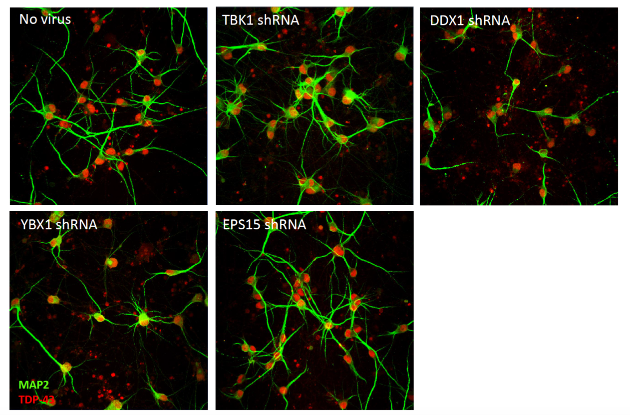
Figure 7: Immunofluorescence imaging of transfected motor neurons at Day 14. Neuronal projections are revealed by fluorescent staining of MAP2 (green) and TDP-43 (red). TDP-43 localises predominantly to the nucleus in all conditions.

TBK1 and DDX1 knockdown affects neuron health at Day 20
At 20 days post-transfection, TBK1 knockdown neurons exhibited drastically shortened neurites, though this is yet to be quantified fully (Figure 9). Knockdown of DDX1 on the other hand caused marked neuronal death, which again will need to be quantified. Knockdown of EPS15 produced no visible effect on the health of the neuronal cells.

YBX1 knockdown leads to diffusion of TDP-43 protein into cytoplasm at Day 20
YBX1 knockdown was largely indistinguishable from the no virus phenotype at Day 14, however by Day 20 there was a clear mislocalisation of TDP-43 protein from the nucleus into the cytoplasm (Figure 10). The presence of TDP-43 protein in the cytoplasm is depicted by the yellow colouring caused by the combined fluorescence of green-stained TDP-43 and red-stained MAP2. Diffusion did not appear to extend into the neurites of the cell, and was predominantly localised to the neuronal cell body.

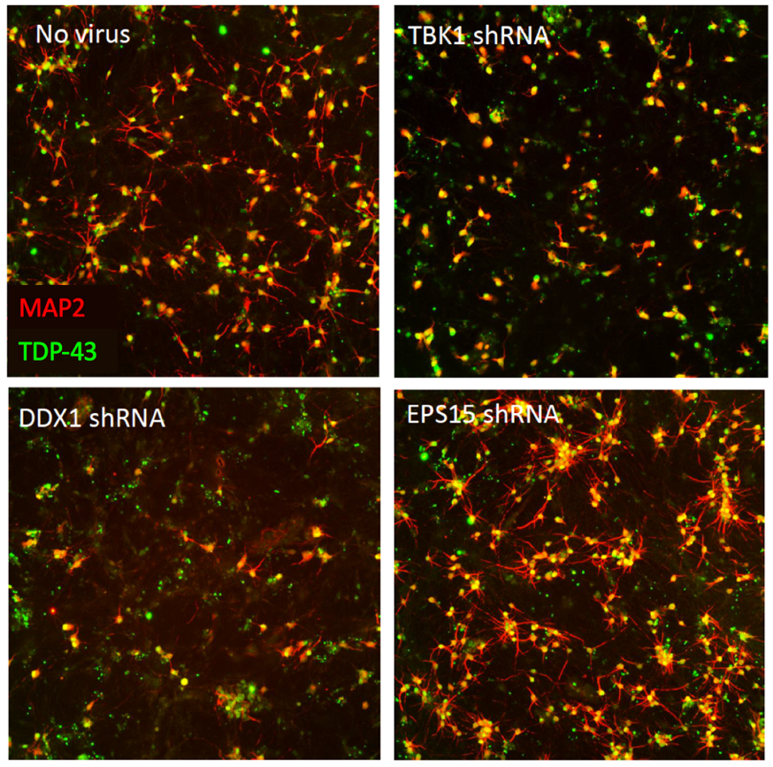
Figure 8: Immunofluorescence imaging of TBK1, DDX1, and EPS15 knockdown neurons at Day 20. Axons indicated by red MAP2 staining and TDP-43 protein is stained green. TBK1 knockdown neurons show drastically shortened neurites, and DDX1 knockdown induces marked neuronal death.
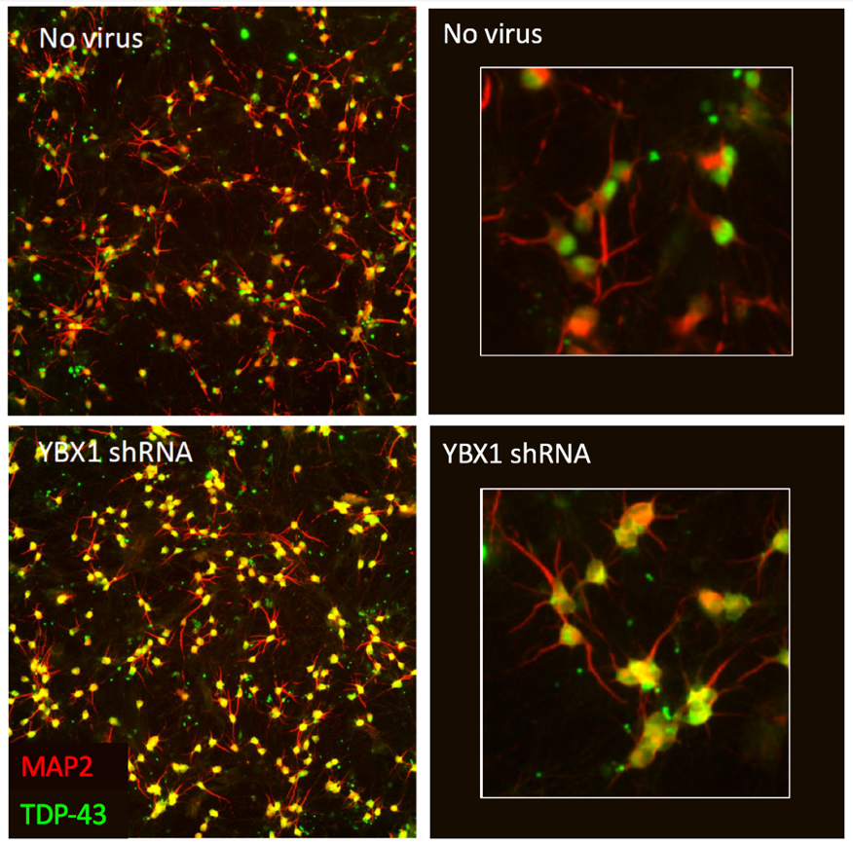
Figure 9: Immunofluorescence imaging of YBX1 knockdown neurons at Day 20. Axons indicated by red MAP2 staining and TDP-43 protein is stained green. YBX1 knockdown results in diffusion of TDP-43 proteins from the nucleus into the cytoplasm of the cell body.

Summary
In collaboration with the Woolf Lab, we performed in vitro investigations into the effect of four candidates genes from our TDP-43 common coexpression module. TBK1, a gene already associated with ALS, caused the shortening of neurites, a phenotype reported in both TARDBP, SOD1, and FUS models of ALS, suggesting it is a likely downstream effect of neurodegenerative risk genes, but not specific to risk genes causing TDP-43 dysfunction ^{189–191}. Knockdown of our genetic control EPS15 produced no visible change in phenotype, as expected. Consequently, our use of many other sources of information in our prioritisation process - rather than genetic perturbation alone - is supported. From our analysis, the gene DDX1 caused visible cell death, not reported in any of the other experiments. Without replication and further analysis, we cannot know whether this neuronal death is akin to neurodegeneration or whether the absence of DDX1 is lethal. It is promising that some cells survive to 20 days, however this cannot necessarily be compared with neurodegeneration in patients, whose onset is generally in later life. As DDX1 is involved in transcription processes, it is unsurprising that its reduced expression could have lethal repercussions for a cell. These experiments will need to be replicated and characterised to confirm the result and further investigate its mechanisms.

The most significant result was that of YBX1. By Day 20, TDP-43 protein had become increasingly apparent in the cytoplasm of the neuronal cell bodies. Mislocalisation of TDP-43 from the nucleus into the cytoplasm is a key event contributing to TDP-43 dysfunction. Like TDP-43, YBX1 protein has been shown to localise to stress granules during episodes of cellular stress ¹⁹². In a study using a human osteosarcoma cell model, inactivation of YBX1 significantly reduced the formation of stress granules ¹⁹³. Reduced stress granule formation is also an effect of inactivated TDP-43 ¹⁹⁴. Further analyses would require quantification of TDP-43 protein levels to see if the additional presence of TDP-43 in the cytoplasm is accompanied by a loss of cytoplasmic protein. Subject to replication, YBX1 could plausibly represent a key driver of TDP-43 cytoplasmic gain, and possibly nuclear loss as well.

Discussion
The objective of this study was to develop a methodology that could successfully isolate upstream drivers of TDP-43 dysfunction from the relatively sparse data available. Through combination of transcriptomic, proteomic, and genetic data, we have identified a tightly coexpressed, functionally coherent network module generated from a variety of conditions, platforms, and genetic backgrounds.

The coexpression module revealed significant enrichment for immune and proteasomal pathways. The immune response and neurodegeneration have been linked frequently in the last two decades, and is becoming a prevailing theory for the propensity to develop a neurodegenerative condition ¹⁹⁵. More relevant to this investigation, early immune response has been linked to a number of neurodegenerative pathologies including TDP-43 aggregates ¹⁹⁶. The specific relationship between these aggregations and an immune response is unclear, however one hypothesis suggests the immune response could be activated as the result of removal of cellular detritus, such as misfolded proteins ¹⁹⁷. The presence of enrichment for proteasomal pathways is unsurprising, also due to its well-documented role in the degradation of TDP-43 protein aggregation ¹⁹⁸. Overall, at a functional level the common coexpression network module reflected biology core to the processes we know are related to TDP-43 dysfunction.

Although the module did not contain any reported GWAS variants associated by proxy with TDP-43 dysfunction, it did enrich for genes already documented to cause TDP-43 dysfunction in neurodegeneration. Confident that our network contained known risk genes, and therefore may contain novel upstream drivers, we applied a prioritisation protocol to identify the most likely candidates. Through collaboration, we conducted in vitro analysis of our top 3 candidate genes in a neuronal iPSC model, eventually implicating the gene YBX1 – a significant potential upstream driver of TDP-43 nuclear exportation. Subject to characterisation, we have also identified another gene, DDX1, which caused marked cell death. Although both genes have been associated with TDP-43 through their shared activity, no investigation has – until now – considered either of these genes to be upstream drivers of TDP-43’s dysregulation or subsequent neuronal death.

A number of challenges were met during the development process, and these have been summarised in each section. In the first stage of development, commonly differentially expressed genes were identified using an unconventional expression-direction approach. Despite the marked relaxation of statistical thresholds, we believe this approach was able to identify a biologically relevant expression signal that would otherwise have been lost. As the strength of this signal was relatively weak, protein-interaction data was used to identify the wider functional space of the common DEGs’ interactome. Enrichment for TDP-43-associated genes increased significantly, and the network enriched for a number of RNA processing pathways. The size of the protein interaction network however highlighted the vulnerability of large input sets for functional enrichment; the likelihood of enrichment in any pathway will increase as the length of the input gene or protein list increases. Subsequently, reducing the size of the network was necessary, and posed a good opportunity to identify a tightly coexpressed functional module. Re-building the protein interaction network as a coexpression network resulted in the loss of a significant proportion of genes/proteins, however the causal platform annotation differences could not be avoided. Common edge detection resulted in identification of a coexpression module common to five of the six expression datasets, which was ‘pruned’ to exclude commonalities with non-TDP-43-neurodegeneration, as well as controls. The network contained a number of previously identified neurodegeneration-risk genes, and enriched significantly for immune processes and proteasomal degradation. Immunity and neurodegeneration have long been associated, and TDP-43 dysfunction has specifically been associated with NF-kappaB initiation, microglial activation, and has been shown to result from inflammatory mechanisms ^{199–201}. Proteasomal degradation is inherently linked to TDP-43 dysfunction, as the role of the proteasome is to degrade abnormal proteins ^{198,202–204}. There was a constant lack of enrichment for pathology-tracking genes, however we cannot be sure if this represents an issue with the signature, or the benchmarking list itself. Overall, this highlights the vulnerabilities of experimenter-selected gene lists, and the potential inconsistencies with the input data. Subsequently, gene lists chosen for a benchmarking role must possess significant confidence before they are used to assess the results of experiments such as these.

Finding genetic associations between the network module and diseases associated with TDP-43 dysfunction would have provided strong evidence of that the TDP-43 signature module represents a source of upstream regulators. Unfortunately, enrichment analysis did not yield any significant enrichment of GWAS genes for conditions associated with TDP-43 dysfunction. Such a result may have two possible explanations; firstly, the signature simply does not possess a particularly strong genetic association; this does not mean that it cannot represent upstream drivers of a phenotype, just that the form of influence we are detecting is not a genetic one. Another explanation could relate to the GWAS data itself; as the four conditions we selected are particularly rare, there are understandably fewer large-scale studies than more common conditions. As the signature itself contains two known genetic risk genes for ALS, we cannot rule out that there may be more which we have not been able to identify. As we could not find any association with GWAS genes, we attempted to utilise whole genome sequencing data to identify these potential novel genetic associations. Although we identified a number of potential LoF mutations in a subset of our signature genes, our approach alone is not reliable enough to implicate a genetic association with ALS, hence its used in the prioritisation process in tandem with many other sources of supporting information. With further work and input from those more experienced with this type of data, we could potentially identify such associations, however this was not possible within the scope of this project.

Finally, since association with TDP-43 in the literature is not sufficient to validate this methodology, we engaged in a collaboration with the Woolf Lab at Boston Children’s Hospital, USA. Our collaboration ultimately revealed two genes, YBX1 and DDX1, that we believe have the strong potential to be novel upstream drivers of TDP-43 dysfunction and neuronal death, respectively. It is important to note these results are preliminary, and confirmation is subject to replication experiments whose timelines were not within the scope of this report.

Aside from in vitro replication analyses, there are a number of steps required to be taken from this point forward. Despite the success of our TDP-43 signature, it is possible that the method we have developed is overfitted to the datasets upon which it was built. To ensure our methodological pipeline is not ‘TDP-43-specific’, we will need to replicate this methodology on at least two further phenotypes, ideally from quite disparate conditions. If these secondary and tertiary applications of the pipeline produce equally successful results, we can be confident that our pipeline can be reliably applied to any number of phenotypes. To be able to apply the methodology to other cases, we have produced a sequence of steps which can be followed regardless of the test phenotype (Figure 11);
- Data is collected according to the following criteria: datasets must only contain samples directly from human patients, samples must be extracted from a tissue directly affected by the phenotype of interest, the datasets must contain a minimum number of three controls and three patients, accepted datasets could be both microarray and RNA-Seq, but must be from Affymetrix and Illumina platforms.
- Data is submitted to quality control to assure data quality and remove outliers.
- Case-control gene expression analysis is conducted using LIMMA (microarray) or DESeq2 (RNA-Seq) on each individual dataset. Genes are selected based on consensus direction of expression. Overlap with condition-generic signatures and unaffected tissue signatures are removed.
- Genes are used to seed a protein-protein interaction network generated from Irefindex 14 data. Included proteins must share at least one interaction with a DEG’s protein.
- The PPI network members are used to build a coexpression matrix in each dataset. These datasets are analysed for appropriate distribution. Those included are compared to identify conserved edges that share the same correlation direction above a certain threshold.
- The largest connected component is selected, and coexpression edge overlap with condition-generic signatures and unaffected tissue signatures is removed.
- The members of the network undergo prioritisation to identify likely candidates for in vitro/vivo validation, calling upon genetic, topological, regulatory, consensus and phenotype-specific sources of information.
- The selected targets’ effect on the common phenotype is assessed in vitro/vivo.

Figure 10: A flow diagram indicating the steps to be completed within our signature building methodology, and the ‘omes in which these steps are conducted. Dotted arrows indicate the steps in which either statistical assessment, or assessment of relationship to the phenotype (via enrichment) is to be conducted.

Chapter 3: Application to Sporadic and LRRK2 Parkinson’s Disease

Introduction
To establish that our methodological pipeline is not overfitted and is translatable to other diseases and phenotypes, we have chosen a second phenotype to assess. This phenotype is also associated with a neurodegenerative condition, Parkinson’s disease, however the common phenotype is not a pathological phenotype like protein aggregation, but a alternatively a commonality in presentation – the common clinical phenotype of sporadic and LRRK2 Parkinson’s disease. Though similar in nature to our TDP-43 application due to the location of the disease and the shared mechanism of neurodegeneration, this application pushes the methodology further into the realms of phenotypes that are much harder to quantify. The benefits of TDP-43 dysfunction as an application was that it was easily quantifiable, and its association with certain genes easier to identify. In this application, the physical representations of the disease are much harder – clinical phenotypes may be measured in an organism such as a cell or a mouse, but do not possess distinct genetic associations that could be used for benchmarking during the study. Subsequently, analysis of such a complex phenotype allows us to push the boundaries of what this methodological pipeline is capable of.

Parkinson’s Disease Overview
Parkinson’s Disease (PD) is a progressive neurodegenerative disease affecting both motor and cognitive abilities. It is named for English doctor James Parkinson who described the condition in his 1817 publication entitled “An Essay on the Shaking Palsy” ²⁰⁵. After Alzheimer’s Disease, PD is the most common neurodegenerative condition in the UK, affecting nearly 150,000 individuals in 2018 ²⁰⁶. Common symptoms of PD include akinesia, bradykinesia, resting tremor and postural instability. Other symptoms may include loss of sense of smell (anosmia), nerve pain, difficulties swallowing (dysphagia) and insomnia. In some cases, PD patients also develop dementia. The neuronal degeneration experienced in PD is not in itself fatal, however its effect on motor and cognition leave patients vulnerable to secondary events such as pneumonia, bronchitis and heart disease. Patients are also at a much higher risk of falls, which can themselves be fatal. Treatment options for PD include physical, pharmaceutical, and surgical interventions. Physical therapy, such as yoga, pilates and tai chi, have been shown to improve balance and flexibility ^{207–210}. Drugs available for PD patients function through increasing dopamine levels in the brain, either as dopamine agonists which replace dopamine, or monoamine oxidase B (MAO-B) inhibitors which prevent the breakdown of dopamine. In the most extreme cases, where other treatments have failed, PD patients may have an electrode implanted into the subthalamic nucleus of the brain, to regulate motor outputs causing dyskinesias ^{211,212}. A curative treatment for PD does not yet exist.

Pathophysiology
PD is predominantly characterised by the death of dopaminergic neurons in the ventral tier of the substantia nigra pars compacta (SNpc) ²¹³. Reviews on SNpc degeneration suggest that by the time of symptom onset, 50-60% of a patient’s neurons will already be lost ²¹⁴. The ventral tier generates dopaminergic signals which are directed at the putamen, whose function is to modulate motor skills, hence the motor deficits experienced in PD ²¹³. To a lesser extent, neuronal death also occurs in the ventral tegmental area, locus coeruleus, vagal nuclei, and nucleus basalis of Meynert ^{215–219}. Astrocytes, a type of glial cell with multiple important supporting roles for protecting the healthy function of neurons, become dysfunctional as the result of PD mutations ^{220,221}. Conversely microglia - another glial cell involved in the brain's immune and inflammatory response - become activated in PD, and may actually contribute to neuronal death ²²². It is speculated that dysfunction of these glial cells is linked to an overactive immune response to neuronal death ²²³.

The Ubiquitin-Proteasome System and Autophagy
As well as neurodegeneration, PD is marked by the presence of intracytoplasmic aggregations of misfolded ubiquitin and alpha-synuclein proteins; also known as Lewy Bodies (LB) ²²⁴. In disease, alpha-synuclein is phosphorylated, ubiquitinated, and also nitrated, before accumulating in Lewy bodies ^{225–227}. Such misfolding is tightly linked to impairment of the Ubiquitin-Proteasome System (UPS) and the Autophagy-Lysosome Pathway (ALP) in PD. The UPS and ALP pathways are responsible for clearance of misfolded proteins ²²⁸. The UPS functions by tagging proteins with ubiquitin, after which only unfolded proteins can pass through the proteasome protein complex to be degraded ²²⁹. Many familial mutations have been linked to UPS dysfunction; PRKN, PINK1 and DJ-1 have been shown to function as a ligase complex for the attachment of ubiquitin to unfolded proteins ²³⁰. Mutations in these genes are predicted to disrupt this process, leaving potentially toxic proteins such as alpha-synuclein unchecked.

When cell components are too large to pass through the proteasome protein complex, they are processed by the ALP. The ALP constitutes three main autophagy pathways; macroautophagy, microautophagy, and chaperone-mediated autophagy (CMA) ²³¹. Macroautophagy is often referred to simply as “autophagy” and involves the engulfment of unwanted proteins and organelles into the membrane of a vesicle called an autophagosome. The autophagosome then fuses with the lysosomal membrane, dispensing its contents. Microautophagy occurs when contents are encapsulated by the lysosomal membrane itself. CMA occurs when a protein contains an hsc70-recognisable domain. Hsc70 then binds to the protein at this site and transports it to a membrane-bound protein which recognises the CMA complex, allowing it to pass through the lysosomal membrane. As well as the UPS, alpha-synuclein is also regulated by autophagy ²³². Wild-type alpha-synuclein is processed via CMA, however mutations in the SNCA gene have been shown to bind and block the membrane-bound lysosomal receptors, inhibiting the degradation of many proteins, including its own ²³³. Mutations in ATP13A2 have been shown to cause autophagy dysregulation and accumulation of alpha-synuclein ^{234,235}.

Without these two systems, toxic aggregations of misfolded proteins can form, as seen in many neurodegenerative conditions ²³⁶. It is still unclear, however, what contribution alpha-synuclein aggregations themselves make to the neuronal death observed in PD. It has been claimed that alpha-synuclein aggregations themselves bind to the proteasome, inhibiting protein degradation ²³⁷. Other theories suggest that the aggregations are merely the result of protective mechanisms sequestering the misfolded protein after the failure of the UPS and ALP systems. Whether alpha-synuclein’s toxicity lies in its aggregated state or not, it is no surprise that alpha-synuclein has become a significant focus of PD treatment ^{238,239}.

Mitochondrial Dysfunction
In the years surrounding 1980, a number of young individuals in the US were being admitted for Parkinsonian symptoms after abuse of a drug containing the compound MPTP (1-methyl-4-phenyl-1,2,3,6-tetrahydropyridine) ²⁴⁰. It was later discovered that MPTP is able to cross the blood-brain barrier, where it is oxidised into the neurotoxic MPP⁺ ²⁴¹. MPP⁺ localises to the mitochondria, where it interferes with complex I of the electron transport chain ²⁴². A dysfunction of complex I results in reduced ATP production, and increased reactive oxygen and nitrogen reactive species, ultimately leading to neuronal death ^{243–245}. The involvement of mitochondrial dysfunction in PD has since been confirmed in a number of studies, which revealed mitochondrial complex I deficiencies and abnormal mitochondrial morphology ^{246–248}. As genetic contributors to PD such as PINK1, PRKN, DJ-1, and SNCA were identified, characterisation experiments revealed consistent relationships between genetic lesions and mitochondrial dysfunction ^{249–256}. Rescuing mitochondrial function has subsequently become a significant focus of PD treatment development ^{257–259}.

Genetics
For many decades, the genetics of PD was not well understood, mainly because consanguineous PD families are so rare. The application of linkage analysis to such families throughout the late 20th Century and early 21st Century allowed for the discovery of twenty-three regions of the genome (named PARK1-23) found to exhibit significant risk for PD. Only ~10% of PD cases, however, show mendelian inheritance patterns. Some genes are autosomal dominant (e.g. SNCA, LRRK2, and VPS35), whereas others are autosomal recessive (e.g. PRKN, DJ-1, PINK1, and DNAJC6). Here we will briefly introduce 7 of the major genes associated with PD.

SNCA (PARK1/PARK4)
The gene encoding alpha-synuclein (SNCA) was the first to be identified as a causal gene in PD patients. A pathogenic missense mutation (p.Ala53Thr) was detected in a large Italian family studied over 11 generations ²⁶⁰. In subsequent years, more autosomal dominant mutations in SCNA have been identified ^{261–264}. As well as missense mutations, structural abnormalities such as duplications and triplications have also been associated with the disease ^{265–267}. The incidence of SNCA-affected families is rare, however SNCA has been regularly implicated in GWAS studies of PD patients ^{268,269}. The role of SNCA in the cell is currently not well understood. In healthy cells, alpha-synuclein protein localises to presynaptic terminals, and has been observed to affect the size of presynaptic vesicle pools ²⁷⁰. In PD, alpha-synuclein aggregates into cytoplasmic Lewy Bodies, and is a pathological hallmark of the disease.

PRKN (PARK2)
PRKN mutations are some of the more common in PD, affecting ~15% of familial and ~4% of sporadic cases, though rates have been reported as high as 50% and 15%, respectively ^{271,272}. PRKN was first identified after studying a Japanese family with an apparent autosomal recessive case of PD ^{273,274}. PRKN mutations are more commonly nonsense, frameshift, and missense, though a number of exon deletions and duplications have been observed ^{275,276}. Over 100 PRKN variants have now been observed. Parkin is a ubiquitin ligase and plays an important role in ubiquitin tagging of proteins destined for proteasomal or lysosomal degradation. Parkin also has a specific role in the degradation of mitochondria by mitophagy ²⁷⁷. Though clinically very similar to other PD populations, PD patients with PRKN mutations do not present with Lewy Body pathology ²⁷⁸.

UCHL1 (PARK5)
Ubiquitin C-Terminal Hydrolase L1 (UCHL1) is an enzyme whose role is to recycle chains of ubiquitin back to its monomeric form ²⁷⁹. Considering that UCHL1 is widely expressed in neurons, and its protein has been shown to recruit to Lewy Bodies, its genetic association with PD was unsurprising. This genetic relationship, however, has been widely debated ^{280,281}. In 1998, a missense mutation was identified in two German siblings with PD ²⁸². A number of follow-up studies revealed mixed results, but through meta-analysis a significant relationship between the S18Y mutation in UCHL1 and PD was discovered ²⁸⁰. Questioning the validity of these results, a later study was conducted on over 3000 individuals with PD, and found no significant association ²⁸¹. It was postulated that perhaps UCHL1’s association with PD could be through linkage disequilibrium with a genuine causative gene. Knockdown mouse models for UCHL1, however, have been shown to produce a neurodegenerative phenotype ²⁸³. So, while UCHL1 shows many signs of being a causative PD gene, it is yet to be confirmed.

PINK1 (PARK6)
PTEN-induced putative kinase 1 (PINK1) is a serine/threonine protein kinase which protects mitochondria during cellular stress by phosphorylating mitochondrial proteins ²⁸⁴. If mitochondria do become damaged, it also aids in the mitophagy process, alongside Parkin ^{285,286}. PINK1 was confirmed as a PD gene in 2004, after characterisation of the associated locus PARK6 in two Italian and one Spanish family ²⁸⁷. It is predicted that PINK1 mutations represent around 8.4% of familial cases, and 3.7% of PD cases overall ²⁷¹.

DJ-1 (PARK7)
The relationship between DJ-1 and PD was first discovered in a Dutch family after homozygosity mapping ^{288,289}. Mutations in DJ-1 are generally missense but can also be deletion or duplication CNVs ²⁹⁰. DJ-1 is known to play a role in protecting neurons against oxidative stress, as well as implicated roles in mitochondrial function and the proteasome, alongside PRKN and PINK1 ^{230,291}. Oxidised DJ-1 has also been identified in the brains of sporadic PD patients ²⁹².

LRRK2 (PARK8)
Leucine-rich repeat kinase 2 (LRRK2) was the second gene to be associated with PD after SNCA. Through recombination mapping and candidate gene sequencing in forty-six families, locus PARK8 was shown to be associated to PD through a number of autosomal dominant LRRK2 mutations ^{293–295}. LRRK2 mutations affect approximately 4% of patients with familial PD and 1% of sporadic PD patients ²⁹⁶. LRRK2 is typically a cytoplasmic protein, however it has been observed to bind to mitochondrial membranes ²⁹⁷. Due to the number of different domains encoded in LRRK2’s protein Dardarin, it is a member of multiple enzyme families, including ROC-COR (ROCO), mixed-lineage kinase (MLK), and receptor-interacting protein kinase (RIPK). Other members of the ROCO family have been shown to contribute to cell motility and adhesion, cell death processes, and inflammatory response ^{298–301}. MLKs are also mediators of neuronal cell death ³⁰², and RIPK members are also involved in immune signalling pathways ³⁰³. LRRK2’s own involvement in immunity pathways is validated by its interactions with NOD proteins and NF-kB ^{304,305}. In PD models, LRRK2 has been implicated in dysfunction in autophagy and lysosomal processes ^{306,307}. Interestingly, LRRK2 mutations have been identified in healthy individuals without PD, referred to as non-manifesting LRRK2 carriers ³⁰⁸.

ATP13A2 (PARK9)
ATPase Cation Transporting 13A2 (ATP13A2) was first associated with PD after it was found to be causative of the condition Kufor-Rakeb syndrome, a form of juvenile-onset PD. The name Kufor-Rakeb refers to the Jordanian community in which genetic linkage studies implicated locus PARK9 ³⁰⁹. ATP13A2 itself was later associated with Kufor-Rakeb/PD through study of a Chilean family with the same condition ³¹⁰. Mutations identified have been both missense and frameshift, each with varying severity of disease progression ³¹¹. ATP13A2 has been associated with both mitochondrial and lysosomal function and dysfunction, and has been shown to regulate alpha-synuclein metabolism ^{234,312,313}.

VPS35 (PARK17)
Vacuolar Protein Sorting-Associated Protein 35 (VPS35) represents one of the most recent genes to be associated with PD. Its association was identified by two separate groups through whole exome sequencing of Austrian and Swiss families exhibiting autosomal dominant inheritance ^{314,315}. VPS35 is a member of the retromer, a complex that mediates transport of endosomes to the trans-Golgi network ³¹⁶. Models of PD have shown VPS35 mutations induce lysosomal degradation and dopaminergic neurodegeneration ^{317,318}.

Similarities between LRRK2 and Sporadic PD
Genes associated with PD are known to present with quite variable phenotypes; for example, mutations in ATP13A2 or DJ-1 are associated with early-onset disease, defined as symptom onset before the age of 40 years-old. In fact, a frameshift mutation in ATP13A2 has been reported in a juvenile-onset PD patient as young as five years-old ³¹⁹. Other genes are associated with a later onset of disease symptoms, including VPS35, and LRRK2 ^{314,320}. Some genes, such as SCNA, PINK1 and PRKN, can present with either early or late onset, depending on the nature of the mutation ^{321–323}. The speed of disease progression is also variable; most SCNA and ATP13A2 patients exhibit rapid disease progression, whereas patients with PRKN, DJ-1 or PINK1 mutations generally experience much slower deterioration ^{311,324}. Symptomatic differences include the cognitive impairments (e.g. dementia) only observed in SNCA and PINK1 PD. Hallucinations are even more unique, occurring in SNCA patients only ³²⁴.

Such variability has catalysed discussion on whether PD is actually a family of similar yet distinct conditions, rather than a single clinical group. Such sub-populations may not follow definitions made by genetic background. One such sub-population that has been consistently reported is the clinical similarity between sporadic and LRRK2 PD populations. We have already discussed the nature of LRRK2 mutations and their familial inheritance patterns, whereas sporadic disease represents individuals who have no previous family history of PD. The similarities between LRRK2 and sporadic PD were first identified in a Norwegian study conducted not long after LRRK2’s discovery ³²⁵. Of the 435 patients analysed, 9 were found to possess mutations in LRRK2. These individuals were then compared against the remaining 426 sporadic patients. Age of onset, rate of disease progression, and clinical presentations of resting tremor, bradykinesia, muscular rigidity, and positive levodopa response (a dopamine substitute used to treat PD) were all indistinguishable between LRRK2 and sporadic patients. This observation has been replicated in a number of subsequent studies ^{296,326,327}. Similarities between LRRK2 and sporadic PD are not only symptomatic; four months after the later, a PET scan study demonstrated that the pattern of dopaminergic activity in LRRK2 and sporadic PD patient’s brains showed remarkable similarities ³²⁸. Considering sporadic patients make up ~90% of the PD population, and LRRK2 mutations constitute the largest proportion of familial patients (~4%), understanding the mechanisms shared by sporadic and LRRK2 patients could have implications for a huge proportion of the PD population.

Developing a LRRK2/Sporadic PD Signature
Sporadic and LRRK2 presentation of PD is classically late-onset and slow-progressive, so common mechanisms shared by these populations may point towards ways of postponing or slowing the progression of disease. Additionally, due to the unknown entity of genetic contributions to sporadic PD, and the incomplete penetrance of LRRK2, identification of novel genetic risk factors within the common signature may unlock key information about how the disease manifests. We predict that the signature building approach we have developed will again be able to isolate a common dysfunctional coexpression module that is enriched for PD biology, genetic variants, and contains promising novel targets.

Materials and Methods
Data were collected, processed and analysed as described in Chapter 2. Here we will describe any alterations made for the current analysis, also depicted in Figure 11.

Data Selection, Pre-processing, and Quality Control
Many studies did not specify explicitly whether they were sporadic or familial PD patients, therefore an assumption was made that these datasets were sporadic, as familial patients are extremely rare and usually well reported. For sporadic PD, 9 microarray and 1 RNA-Seq datasets were identified from a variety of brain regions (Table 24). Two datasets, one frontal cortex and one substantia nigra, were obtained from the same series (GSE8397), meaning there is an overlap in patients, but the tissue is sampled from different brain regions. Two LRRK2 microarray datasets were sourced, one sampled from the putamen, and another from the locus coeruleus - a region also shown to degenerate in PD. The five ALS datasets used in the TDP-43 investigation (including C9orf72, SOD1, FUS and Sporadic populations) were used as controls for generic neurodegeneration signals (Table 22). Datasets representing familial patients with non-LRRK2 mutations were available only as peripheral blood samples, as no neuronal datasets met the data selection criteria (Table 23). Blood was considered acceptable as it is known to possess a certain degree of information on neuronal expression. Neuronal expression datasets for non-LRRK2 familial patients could not be identified in public databases, therefore peripheral blood datasets were used. One unpublished LRRK2 fibroblast dataset was generously provided from Dr Robin Highly and Dr Heather Mortiboys within SITraN. Peripheral blood from sporadic PD patients was also used to represent unaffected disease tissue, though it is accepted that this could contain disease signatures from neuronal expression.

As previously, the one RNA-Seq dataset (GSE68719) was pre-processed using bcbio. However, protocol was adapted to use Salmon counts instead of HT-Seq counts. The Salmon approach to expression quantification was published in the time between experiments, and its alignment-free methodology has proved to outperform many other quantification tools ^{329–331}. Alignment-free, or ‘pseudoaligners’ do not directly align reads to the reference genome, instead breaking up reads into k-mers and assigning them to transcripts. This approach has been shown to drastically reduce computation time without significantly impacting performance ^{330,331}.

Table 22: Datasets used to build a PD population-generic signature. Tissue indicates the source of the biological material. Disease indicates the medical condition patients had been diagnosed with. Variant indicates whether the dataset contains individuals with a known genetic cause, or individuals with sporadic status. Platform indicates the technical platform used to collect the expression data. Affymetrix platforms are microarray, Illumina are RNA-Seq. GEO ID is the reference provided by GEO to locate the original dataset. Publication contains the reference supplied with the data on GEO. LCM = Laser Capture Microdissected
Table 23: Datasets used to build a PD tissue-nonspecific signature. Tissue indicates the source of the biological material. Disease indicates the medical condition patients had been diagnosed with. Variant indicates whether the dataset contains individuals with a known genetic cause, or individuals with sporadic status. Platform indicates the technical platform used to collect the expression data. Affymetrix platforms are microarray, Illumina are RNA-Seq. GEO ID is the reference provided by GEO to locate the original dataset. Publication contains the reference supplied with the data on GEO. LCM = Laser Capture Microdissected.
Table 24: Datasets from sporadic or LRRK2 PD patients. Tissue indicates the source of the biological material. Disease indicates the medical condition patients had been diagnosed with. Variant indicates whether the dataset contains individuals with a known genetic cause, or individuals with sporadic status. Platform indicates the technical platform used to collect the expression data. Affymetrix platforms are microarray, Illumina are RNA-Seq. GEO ID is the reference provided by GEO to locate the original dataset. Publication contains the reference supplied with the data on GEO. LCM = Laser Capture Microdissected

Curation of Parkinson’s-associated gene lists
Benchmark gene lists were generated from three sources of information; PD-associated genes, PD GWAS hits, and genes whose proteins interact with LRRK2 (Table 23). PD-associated genes were extracted from the “Parkinson’s Disease, Late-Onset” page on the website Malacards (http://www.malacards.org/card/parkinson_disease_late_onset). For late onset PD, 151 genes have been curated in this list as risk factors. PD GWAS genes were extracted from the PD entry in the GWAS Catalog (https://www.ebi.ac.uk/gwas/efotraits/EFO_0002508), and filtered to only include the trait “Parkinson’s disease”, “age at onset, Parkinson’s disease”, and “Lewy body measurement, Parkinson’s disease”, resulting in a list of 170 genes. As variants do not always map to one gene, all genes were included but overlap in rs numbers was checked. LRRK2 PPI genes were sourced from a curation study on the interactome of LRRK2, which identified 207 interaction partners as reported by BioGRID and IntAct data ³³².

Prioritisation
All sources of information remained as previously used. LoF mutations were identified using the Parkinson’s Progression Markers Initiative (PPMI) whole exome sequencing (WES) data obtained from the PPMI database (http://www.ppmi-info.org/). PPMI – a public-private partnership – is funded by the Michael J. Fox Foundation for Parkinson’s Research and funding partners, including Abbvie, Allergan, Avid Radiopharmaceuticals, Biogen, Biolegend, Bristol-Myers Squibb, Denali, GE Healthcare, Genentech, GSK, Lilly, Lundbeck, Merck, MSD, Pfizer, Piramal, Roche, Sanofi Genzyme, Servier, Takeda, Teva, UCB, and Golub Capital. WES data was analysed using Gemini (gemini.readthedocs.io/en/latest/). LoF mutations were defined as variants flagged by Gemini as LoF and scored <0.01 on both ExAC and 1000 Genomes frequency. The variants are then checked to ensure they occur in patients only, and not in patients flagged as testing positive for mutations in a known PD gene (e.g. SNCA, LRRK2 etc). LRRK2 PPI genes were extracted from the benchmark gene list which was used throughout the study. For Endeavour, only LRRK2 was used as a training gene as this is the only gene we know to result in the phenotype we are interested in.

Figure 11: Workflow for Sporadic/LRRK2 PD analysis. Changes to the methodology are indicated by the text boxes. All other methods remained as previous.

Results

Quality control of datasets
Quality control analysis identified 2 samples which were considered outliers; sample GSM1678685 and GSM1679693 from GSE68719 (Appendix Figures 6-13).

Boxplots of pre-and post-normalised data show relatively consistent log2 expression variance within microarray and RNA-Seq technologies before normalisation across datasets (Appendix Figure 14). Again, RNA-Seq range is larger compared to microarray, however after normalisation the medians of all datasets are quite similar.

Identification of common DEGs
Common differential expression analysis revealed 175 genes to be commonly overexpressed and 189 genes commonly underexpressed. Random permutation tests confirmed the number of DEGs was more than expected by chance (Tables 25 & 26). As the amount detected experimentally did not lie within the distribution, a P-value could not be calculated. Random assignment of log fold change direction predicted overlaps of between 0 and 19 genes, with an average of 5.58 genes.

Three signatures were produced to filter out tissue nonspecific and population-generic genes. One signature was produced from the 6 ALS datasets used in the TDP-43 pathology analysis to represent a generic neurodegenerative signature. Gene overlap of this signature led to the removal of 15 genes. The familial blood signature overlapped with the common DEG list by 102 genes, which were removed. The fibroblast signature was created from the significantly differentially expressed genes of this dataset (adjusted P-Value < 0.05). The sporadic blood signature overlapped by 4 genes. Removal of these genes left a common DEG signature of 243 genes, 104 commonly upregulated, and 139 commonly downregulated.

Table 25: Total numbers of genes passing quality control in each PD dataset, along with numbers of up and downregulated genes.

Table 26: Comparison of PD common DEG results (Actual Value) and those expected by chance according to random permutation testing (Expected Mean and Expected Range)

Functional and benchmark enrichment of differentially expressed genes
Benchmark enrichment analysis shows significant enrichment of all three lists, though some overlap is present (Table 27). Within this list is SNCA and UCHL1, two causative genes of PD (though UCHL1’s association is still debated). SPR is located in the - as of yet - unassigned PARK3 locus associated with PD, but is not currently considered a causative PD gene ³³³. MSX1, ALDH1A1, and CYCS have each been implicated in the downstream mechanisms of PD-related dopaminergic neurodegeneration ^{334–336}. PD GWAS gene overlap again contained SNCA. SYT11 is a synaptotagmin, regulating calcium dependent trafficking of synaptic vesicles, and has recently been discovered to be a mediator of PRKN-linked neurotoxicity ³³⁷. LRRK2 PPI genes contained SNCA and STY11, but also contained MAP1B, whose light chain portion has been shown to rescue LRRK2-mutant toxicity ³³⁸. RAB7A has been shown to be regulated by LRRK2 for membrane trafficking ³³⁹. There was also presence of 4 genes associated with mitochondrial complex I deficiency (NDUFS1, NDUFS3, NDUFV2, TMEM126B) a condition which, like PD, is associated with mitochondrial dysfunction, and can lead to development of some forms of PD.

For upregulated genes, enriched processes were predominantly associated with apoptosis and cell cycle signalling pathways, such as TGF-beta, Ras and PI3K-AKT (Table 28, http://amp.pharm.mssm.edu/Enrichr/enrich?dataset=8gl6z). Alternatively, downregulated genes showed strong enrichment for Parkinson’s Disease pathways, the mitochondrion, and autophagosome processes (Table 29, http://amp.pharm.mssm.edu/Enrichr/enrich?dataset=8gl71)
Table 27: Results of enrichment analysis for overlap between curated PD-associated genes and common DEG list
Table 28: Top 10 enriched pathways in each of the pathway databases for PD upregulated DEGs. P-Values are adjusted.

Table 29: Top 10 enriched pathways in each of the pathway databases for PD downregulated DEGs. P-Values are adjusted.

Generation of protein-protein interaction network
Two-hundred and forty one of the 243 common DEGs successfully seeded a PPI network of 2797 nodes and 4637 edges. The remaining 2 transcripts were non-protein coding RNAs. Benchmark enrichment revealed the PPI network also enriched for PD disease genes and LRRK2 PPI genes, but not for PD GWAS genes (Table 30). A number of important PD proteins are members of the PPI network; SNCA, LRRK2 (Dardarin), DJ-1 (PARK7), PINK1, and UCHL1. Additionally, proteins important to other neurodegenerative conditions are present; APP in Alzheimer’s disease, HTT in Huntington’s disease, and SQSTM1 in ALS. Functional enrichment analysis of this network revealed a strong representation of processes involved in transcription and translation, and immune system pathways (Tables 31 & 32, http://amp.pharm.mssm.edu/Enrichr/enrich?dataset=8gl75). These pathways are very similar to those identified in the TDP-43 analysis and is possibly a reflection of the vulnerabilities of pathway enrichment for large gene sets.

Table 30: Enrichment of PD-associated gene lists in PD PPI network

Table 31: Top 10 enriched pathways in KEGG, Wikipathways and Reactome for PD protein interaction network. P-Values are adjusted.

Table 32: Top 10 enriched GO terms in each category for the PD protein interaction network. P-Values are adjusted.

Generation of a common coexpression module
Coexpression matrices for the PPI network nodes were generated from 8 of the 12 datasets. The two LRRK2 datasets had patient numbers lower than 4 samples, rendering coexpression analysis too underpowered. Two datasets (GSE8397 & GSE19587) were removed as histograms of their correlation values revealed non-normal distributions (Figure 12). After filtering for common edges, 267 nodes and 753 edges were conserved. The largest connected component of this network consisted of a subnetwork module of 233 nodes and 731 edges.

In controls, 172 edges between 103 nodes could be recreated, and all were in the same direction as patients. Subsequently these edges were removed, as well as 6 nodes whose connections to the coexpression module were lost, leaving a coexpression module of 227 genes and 559 edges (Table 33). The network was also recreated in the ATP13A2, PRKN and PINK1 blood samples. Seventy-four edges and 7 nodes were removed, leaving 220 nodes and 485 edges. The LRRK2 fibroblast dataset was not used to recreate the network due to too few samples. Four ALS datasets had 4 or more samples (GSE68605, Kirby, GSE67196, GSE76220), however recreation of the network produced no common edges. Similarly, no edges were recreated in sporadic blood. Eight genes formed dyads separate from the LCC, and so were removed also. The final common coexpression module constituted 212 nodes with 481 edges (Table 34, Figure 13)
Figure 12: Histograms of Spearman’s Rho values for each PD dataset. Datasets GSE8397 and GSE19687 demonstrated non-normal distributions
Table 33: Numbers of nodes and edges overlapping between the filter datasets and the PD common coexpression module

Table 34: Members of the PD common coexpression module

Figure 13: The PD common coexpression network. Positively correlated edges are red, negatively correlated edges are blue.
In benchmark enrichment, LRRK2 PPI genes are enriched, but PD disease genes and PD GWAS genes are not significantly enriched (Table 35). Functional enrichment of the subnetwork module implicated processes related to mitochondria and the citrate cycle, and the proteasome (Table 36 & 37, http://amp.pharm.mssm.edu/Enrichr/enrich?dataset=8gl7a). The KEGG pathway “Parkinson’s Disease” is highly enriched, reflected by the presence of 19 members of this pathway in the coexpression module, including DJ-1(PARK7), UCHL1, and CYCS.

Table 35: Enrichment of PD-associated genes in the common coexpression module

Table 36: Top 10 enriched pathways in KEGG, Wikipathways, and Reactome databases for the PD common coexpression module. P-Values are adjusted.
Table 37: Top 10 enriched GO terms in each category for the PD common coexpression module. P-Values are adjusted.

Direct protein-protein interactions between the subnetwork module and the members of the Parkinson’s Disease Malacards gene list revealed 117 protein interactions between 76 module members and 38 PD-associated proteins (two of which, PARK7 and UCHL1 belonging to both lists) (Figure 14). Random permutation testing sampled against the human genome revealed this number of interactions to be greatly more than expected by chance, with a mean number of expected edges of 35.37, and a range of 13:61. As 117 does not lie within this range, a P-value could not be computed.
Figure 14: Protein-protein interaction network showing relationships between coexpression module proteins (blue) and PD Malacards proteins (green). Orange-coloured proteins are both.

Prioritisation of in vitro candidates
Seven sources of information were used to prioritise the 212 genes of the subnetwork. Scoring was conducted as described in the previous chapter. The top 9 scoring genes can be found in Table 45.

Seventeen LoF mutations were identified in 13 genes (Table 38). Seven of these mutations were predicted to result in either the gain of a stop, or loss of a start or stop codon. Two mutations were found to be homozygous in the patient; a start lost mutation in the gene MAGED1, and a stop lost in the gene STRAP. Lobby index identified two genes, UBE2N and TERF2IP, to have a particularly high lobby index score of 13 (Appendix Table 7). Seventeen genes were found to be significant GeneXplain master regulators, with 7 in the Top 20 (Appendix Table 8). Only 4 genes were found to regulate another network module member, as suggested by IPA (Appendix Table 9 & 10). Forty-eight genes - nearly 23% of the network - were also commonly differentially expressed. Seven genes coded for proteins which have been found to bind directly to LRRK2. Using LRRK2 as a training gene, Endeavour ranked PD-associated genes PARK7 and UCHL1 as top ranked (Appendix Table 11).

Random permutation testing of the mean scores of known PD-associated genes, PARK7, UCHL1, and CYCS indicated that these genes achieved a significantly higher score of 12 than expected by chance (mean expected score = 6.045, mean expected range = 1:15.7, p = 0.0051).

Table 38: Thirteen genes contained predicted LoF mutations in PD patients. Gene Symbol lists the associated gene with each SNP according to Gemini annotation. Chromosome and Location indicate the location of each SNP. Ref and Alt indicate the reference and alternative base. RS ID lists the reference SNP ID number if the SNP has been identified before. Mutation Type lists the type of mutation observed. Hom/Het indicates if the mutation is homo- or heterozygous.

Top Candidate Analysis
The top 9 genes – scoring 14 points or more – are discussed below (Table 45).
Table 39: Top 9 scoring PD network module genes

UCHL1, as previously discussed, is a gene that has already been associated with PD, but whose genetic relationship with the condition has been heavily disputed. Although the genetics of UCHL1 are not clear, the biological relationship with PD is compelling. Its strong neuronal expression and recruitment to Lewy Bodies, alongside its neurodegenerative phenotype when knocked down in mice suggests that abandoning UCHL1 in the development of PD treatments may be unwise ²⁸³. Our own data corroborates these findings, as we found UCHL1 to be consistently downregulated across all 12 input datasets. Although we too have not found any genetic association between PD patients and UCHL1, its presence within our network may suggest it still has a driving role in the progression of the disease.

COPS5 codes for a protein which forms part of the COP9 signalosome, a protein complex involved in the third and final ligation step in the ubiquitin-proteasome pathway. COPS5, though not explicitly containing a LoF mutation, has been ranked highly as a regulator of the network, and has demonstrated consistent downregulation across our input datasets. No direct link has, as of yet, been made between COPS5 and PD, however its core role within the UPS places it as a promising candidate.

MLLT11 also known as AF1Q, has predominantly been associated with leukemia, hence its name Mixed-Lineage Leukemia; Translocated To, 11. The role of MLLT11 is still being unravelled but has been found to include promotion of T-Cell development over that of B-Cells in the immune system ³⁴⁰. More specific to the central nervous system, MLLT11 has been shown to be differentially expressed in maturing neurons ³⁴¹. More recently, a study employing coexpression network analysis via WGCNA on three sporadic Parkinson’s brain regions (of which two were used in our own analysis - GSE8397) identified MLLT11 as a hub gene ³⁴². MLLT11 was then found to undergo neurodegeneration-associated histone modifications and found to be regulated by a number of PD-specific miRNAs. Our analysis has revealed a predicted start-loss mutation in a sporadic PD patient, as well as being highly connected within the network, and commonly downregulated across all 10 datasets – as was found in the aforementioned network analysis.

Though no LoF mutation was identified in UBE2N, it scored highly on a number of our other measures. Ubiquitin Conjugating Enzyme E2 N plays an important role in the ubiquitin-proteasome system as one of a number of enzymes whose role it is to link the activation of ubiquitin by E1 with the targeting of proteins destined for degradation. As we know the UPS is intrinsically linked to PD, it is unsurprising that UBE2N has been associated with a number of known PD genes; UBE2N has been shown to interact with Parkin, to mediate degradation of DJ-1 via autophagy, and its knockdown revealed a vital role in Parkin-mediated mitophagy ^{343–345}.

YWHAZ codes for an anti-apoptotic protein, and alongside LAPTM4B has been linked to particularly aggressive breast cancers ³⁴⁶. YWHAZ has been shown to bind directly to LRRK2, and scored relatively highly on both GeneXplain and Endeavour measures. In a manganese-exposure model of PD, YWHAZ was found to be both hypermethylated and downregulated, suggesting environment-induced methylation of YWHAZ could be associated with onset of PD ³⁴⁷.

LAPTM4B, or lysosomal protein transmembrane 4 beta, encodes a lysosomal surface protein. LAPTM4B has predominantly been associated with cancer, due to its role in cell proliferation, migration, and death ³⁴⁸. According to the PPMI data, a number of patients possessed a predicted LoF mutation in LAPTM4B, resulting in splice donor variants (Table 43). It was also found to be commonly underexpressed across all input datasets and ranked in the top 20% for Endeavour predictions. LAPTM4B has, as of yet, not been reliably associated with PD.

Mitogen-Activated Protein Kinase Kinase 1 (MAP2K1) is predominantly involved in the MAPK/ERK pathway, and so is involved in core signalling processes. In our analysis, MAP2K1 scored highly for lobby index, IPA regulatory relationships, and Endeavour rank. Within the network, IPA analysis indicated that MAP2K1 activates and phosphorylates both EIF4EBP1 and MAP2K4 (Appendix Table 10). MAP2K1 has not been associated with PD, but other MAP kinases such as MAP3K14, MAPK1, and MAPK14 have been, and MAP2K1 has been associated with Alzheimer’s disease ³⁴⁹.

MAPK9, or Mitogen-Activated Protein Kinase 9, like many MAP kinases is involves in a number of key cellular processes such as cell proliferation and differentiation, and transcription regulation. Our analysis indicates MAPK9 to be predicted highly as a regulator of the network by both GeneXplain and Endeavour, and is downregulated across all input datasets. As a number of MAP kinases have already been associated with PD, MAPK9 is a promising candidate.

Although we were unable to test any of the above genes for their association with a sporadic PD/LRRK2 phenotype in vitro, we are able discuss the likely candidates for this process. Our data-driven identification of UCHL1, combined consistent expression changes across both our datasets and within the literature may warrant further investigation, despite its contentious association with PD in the literature. COPS5 obtained one of the highest scores yet has had no previous association with PD, suggesting it may be a risky choice but has the potential for a more novel discovery. As the only gene whose protein binds directly to LRRK2 combined with its high scores from GeneXplain and Endeavour, YWHAZ has real potential to have a direct effect on LRRK2 activity, and in turn the sporadic/LRRK2 PD phenotype.

Discussion
In this second application of our methodology, we decided to investigate whether a common signature could be identified for sporadic and LRRK2 PD. These sub-populations of PD have been shown to be clinically indistinguishable, suggesting a common disease mechanism. We collected 12 datasets representing both sporadic and LRRK2 populations from a variety of brain tissues. From these datasets we identified 243 commonly differentially expressed genes, significantly more than expected by chance, and enriching for PD disease genes, and protein interactors of LRRK2. The DEG gene set also enriched for both mitochondrial, autophagy and ubiquitin-proteasome pathways, all three core to PD dysfunction. These genes seeded a protein interaction network, which also enriched for PD disease genes, LRRK2 PPI partners, and PD-associated pathways. Coexpression edges were produced from 8 of the 12 datasets, filtered, and a common coexpression module extracted. Despite the absence of the LRRK2 datasets, this network module enriched for LRRK2 PPI genes, and approached significant enrichment for PD Disease genes. Pathway enrichment revealed significant overlap with the KEGG pathway “Parkinson’s Disease”, alongside a number of mitochondrial and UPS pathways. Using whole exome sequencing data from the Parkinson’s Progression Marker Initiative, we identified 17 LoF mutations in 13 network module members. Prioritisation ranked already PD-associated gene UCHL1 as the highest ranked gene, and the following seven genes were assessed for their relationship to PD. Had time permitted, a sub-section of these seven candidates would have been chosen for in vitro/vivo assessment in a PD model, where measures such as phenotype onset and mortality could be assessed.

The lack of proper benchmarks, less-than-appropriate filter datasets, and the inability to use the LRRK2 datasets in the coexpression analysis has possibly left our results vulnerable to a more generic PD signature. However, it is worth noting that the prioritisation process ranked PARK7 in 92nd place; as discussed in the Introduction, PARK7 is known for its early-onset phenotype, suggesting the prioritisation process is able to promote late-onset rather than early-onset associated genes. Nonetheless, without proper laboratory validation it cannot be confirmed that this signature is or is not representative of LRRK2 and sporadic PD, though enrichment of PD-associated genes and pathways suggest these results have promise.

Chapter 4: Application to Autoimmune Arthritis

Introduction
As a third and final application of the pipeline, we decided to approach a condition that was not neurodegenerative or specifically affecting neuronal cells. By achieving identification of a common coexpression module containing novel targets for a different disease system, we again are showing our pipeline is not overfitted to any particular condition or tissue-type. The phenotype chosen to be analysed is joint inflammation and degradation as the result of an autoimmune condition; otherwise known as autoimmune arthritis.

Arthritis Overview
Arthritis is a condition which affects joints of the body, with patients experiencing symptoms such as stiffness, swelling, and pain. Arthritis causes great discomfort and disability in its sufferers, and is the single most common cause of disability in the United States, costing approximately $200 billion per year ³⁵⁰. In western countries, approximately 23% of adults currently suffer from some form of arthritis, and this is likely to increase to 26% by 2040 ³⁵¹. Arthritis is often hard to diagnose, requiring a combination of blood tests, such as rheumatoid factor, anti-cyclic citrullinated peptide antibodies (anti-CCP) and C-reactive protein, and imaging techniques such as X-ray, MRI, and ultrasound.

Mechanisms of Arthritis
There are over 100 different conditions which present with arthritis symptomology. One way to group these populations is whether the arthritis is linked to autoimmune condition or not. Examples of non-autoimmune arthritis include osteoarthritis (often considered “wear and tear” arthritis), and septic arthritis; arthritis caused by infection of a joint. Many autoimmune conditions present with arthritis, the most recognised being rheumatoid arthritis. Autoimmune conditions are those in which the body’s immune system is triggered to start attacking its own cells, and in the case of arthritis, this includes tissues within joints such as the hands, knees, spine and feet.

Although both groups present with joint inflammation, the molecular mechanisms initiated during autoimmune and non-autoimmune arthritis appear to be quite distinct, reflected by the treatment options for each group. OA has long been attributed to the “wear and tear” experienced by prolonged use of the joint, either by age, profession, or weight bearing. OA is triggered when the healthy balance between generation and degradation of extracellular matrix components in cartilage is lost, and the cartilage breaks down. Subsequently, OA treatments are more mechanical; patients are encouraged to lose weight (to reduce pressure on joints), engage in physical therapy, and medications are targeted towards pain management (e.g. paracetamol). More drastic treatments may include steroid injections into the joint, and joint replacement surgery. Low-grade inflammation is beginning to be revealed as a key component in OA, however RA treatments have proven ineffective for OA symptoms ^{352,353}.

Autoimmune arthritis treatment on the other hand is heavily drug-based, with the administration of medications such as DMARDS (disease-modifying anti-rheumatic drugs), NSAIDS (non-steroidal anti-inflammatory drugs), TNF-alpha inhibitors, corticosteroids, and other immunosuppressants. These treatment strategies are designed to target the overactive immune system. The most common autoimmune arthritis is rheumatoid arthritis. Unlike OA, RA is a systemic condition in which other symptoms such as fatigue, high temperature, appetite and weight loss symptoms may be experienced. RA patients may also suffer from inflammation of other tissues, such as the skin, heart, lungs and eyes. RA is considered to have three phases; initiation, amplification, and chronic inflammation. Initiation of RA is likely to manifest through a combination of environmental and genetic triggers ^{354–356}. As smoking is one of the highest risk activities associated with RA, is believed that toxins can initiate activation of macrophage, dendritic cell, neutrophil, and toll-like receptor activity in mucosal membranes ^{357,358}.

Once this immune response is activated, anti–citrullinated protein antibodies (ACPAs) circulate through the lymphatic system, possibly for years before symptom onset ^{359,360}. Genetic contributions to RA have been well studied as RA is strongly heritable, with immediate family members of an RA patient being three times more likely to develop the disease than those who do not have family history of the condition ³⁶¹. The major histocompatibility complex gene HLA-DRB1 has long been associated with RA risk, though a number of other genes involved in immune response pathways have been implicated through GWAS ³⁶². It is likely that these genes, as well as those not yet identified, represent a genetic susceptibility to overactive immune responses. In the amplification phase, ACPAs as well as rheumatoid factors are localised to the synovial membrane of joints. It is not clear why joints are predominantly affected, though it is hypothesised that the nature of a calcium-rich, osteoclast dense location is attractive to ACPAs ^{363,364}. When arthritis activates in the joint, both innate immunity cells (neutrophils) and adaptive immunity cells (B-Cells and T-Cells) are mobilised, resulting in acute synovitis ^{365,366}. Eventually, inflammation becomes chronic. At this stage, the synovial membrane has thickened, and cartilage and bone begins to disintegrate ^{367,368}. Immune cells are attracted to the site due to the release of chemokines and cytokines (e.g. TNF-alpha, interleukins, and interferons), promoting osteoclast formation and subsequent bone degradation ^{369,370}.

Autoimmune Conditions with Arthritis
Rheumatoid arthritis is not the only autoimmune disease to present with arthritis. Autoimmune conditions are often said to “hunt in packs”, due to the fact that presence of one autoimmune condition in a family often predisposes other family members to alternative autoimmune conditions ^{371–373}. So, despite the fact these conditions are considered clinically distinct, it seems that the upstream genetic drivers of autoimmunity are likely to be shared, as well as some of the downstream phenotypes. Here we will discuss a number of autoimmune conditions which present with arthritis symptomology. Conditions not mentioned due to lower prevalence of arthritis include Sjogren’s syndrome, inflammatory bowel diseases such as Crohn’s disease and ulcerative colitis, and Behçet’s syndrome.

Rheumatoid Arthritis
Rheumatoid arthritis is the most common autoimmune arthritis, affected approximately 1% of the adult population ³⁷⁴. RA is twice as prevalent in women than men, and the average age of an RA patient is approximately 67 years old. The symptoms and mechanisms of RA have already been discussed. Heritability of RA is approximately 65%, and over 250 genome-wide significant loci have been associated with RA risk, though a significant amount of heritability is still unaccounted for ³⁷⁵.

Psoriatic Arthritis
Psoriasis is an autoimmune condition affecting approximately 0.1% of the population, in which the turnover of skin cells is markedly increased; in a healthy individual turnover is approximately one month, whereas in psoriasis this occurs every 3-5 days ³⁷⁶. The premature maturation of skin cells is caused by the presence of dendritic cells, T-Cells and macrophages in the dermis, resulting in the release of inflammatory cytokines which promote proliferation ³⁷⁷. In some psoriasis cases, arthritis also develops, known as psoriatic arthritis (PA). PA presents similarly to RA, with chronic joint inflammation, heightened presence of immune cells in the synovium, synovial membrane thickening, and bone and cartilage degradation ^{378–381}. Treatments for both conditions are the same, with the administration of NSAIDS, DMARDS, corticosteroids, and TNF-alpha inhibitors. Risk genes for psoriatic arthritis are still being uncovered, however a number of loci have been identified in HLA and interleukin genes.

Ankylosing Spondylitis
Unlike RA or PA, ankylosing spondylitis (AS) is an autoimmune condition in which the spine is predominantly affected, though in some cases shoulder and hip joints are also affected ³⁸². Peak onset of AS is between 20 and 30 years of age, when the individual will experience a stiff, aching lower back ³⁸³. AS can, however occur in any part of the spine ³⁸². Pathogenesis of AS contains classic markers of arthritis; influx of white blood cells into the synovium, TNF-alpha response, and increased osteoclast activity ^{382,384,385}. In AS there is a strong association with the antigen HLA-B27, which is shared to a lesser extent with psoriatic arthritis, inflammatory bowel disease, and reactive arthritis ³⁸². Over 90% of AS patients are HLA-B27 positive ³⁸⁶. AS associates with other risk variants, including those in interleukin and TNF genes ³⁸⁷.

Juvenile Idiopathic Arthritis
Juvenile idiopathic arthritis (JIA) is reminiscent of rheumatoid arthritis in its presentation, but is isolated to children and young adults under the age of 16. Symptom onset tends to be between 1 and 6 years of age, with the child presenting with limping, high temperature, and joint swelling ³⁸⁸. Affected joints include hands, wrists, knees, spine, shoulders, hips and jaw. JIA patients may also present with anterior uveitis - inflammation of the anterior chamber and iris of the eye ^{389,390}. JIA affects as many as 4 in 1000 children, with higher risk in females ³⁹¹. There are 3 main subtypes of JIA - oligoarticular, polyarticular, and systemic - however they all share classic arthritis pathophysiology ³⁸⁸. Interestingly, oligoarticular and polyarticular JIA are driven by adaptive immunity, whereas systemic JIA is driven by innate immunity ^{388,392}. JIA is treated with the same four drug-types we have previously discussed for arthritis conditions. The genetics of JIA resembles those we have already seen, with associations with HLA genes as well as PTPN22, TNFA, MIF, WISP3, SLC11A1 ³⁹³.

Adult-Onset Still’s Disease
Adult-onset Still’s Disease (AOSD) presents in a classic triad of symptoms; joint inflammation, a raised salmon-coloured rash, and spiking fevers. Onset usually occurs at a relatively young age, with median onset around 36 years of age ³⁹⁴. Arthritis is not present in every case of AOSD, but is experienced by the vast majority of cases (approximately 95%) ³⁹⁴. The risk factors for AOSD are still unclear. The lack of a pattern of familial heritability and the rarity of patients has made both linkage and GWAS analysis of AOSD extremely difficult. Targeted gene panels have revealed polymorphisms in the interleukin gene IL-18, and a recently published study in Japanese AOSD patients has implicated a link with the gene HLA-DQB1 ^{395,396}.

Systemic Lupus Erythematosus
In the conditions we have covered so far, arthritis is the predominant symptom experienced by patients. In the following conditions, many other tissue types are attacked by the immune system. Aside from joint inflammation, systemic lupus erythematosus (SLE) patients may present with maladies of the skin, blood, heart, lungs, and kidneys, as well as psychiatric conditions including headaches, mood disorders, seizures, anxiety and depression ^{397,398}. SLE affects between 40 and 100 individuals per 100,000 with higher levels reported in Hispanic and Chinese populations ^{399–401}. First-degree relatives of an SLE patient are 20-times more likely to develop the condition, indicating a significant genetic component ⁴⁰². A number of genes have been associated with risk for SLE, including STAT4, IRF5, TLR7, and PTPN22 ⁴⁰³. Treatments for SLE arthritis are similar to those already discussed, however TNF-alpha treatments have been less successful in SLE. Fortunately, biological agents inhibiting B-cell activation have proven effective at mediating SLE symptomology ⁴⁰⁴.

Building an Autoimmune Arthritis Signature
Despite variations in population demographics, genetics, and co-occurring symptoms, it is apparent that the arthritis experienced by these conditions is the result of a shared inflammatory mechanism. The pain and disability associated with joint inflammation is not only debilitating to patients but is also expensive to treat. Additionally, the drugs used to treat autoimmune arthritis have a number of unpleasant and sometimes dangerous side effects. Chronic NSAID use puts patients at significant risk of gastrointestinal problems such as heartburn and stomach ulcers ^{405–407}. DMARDs use for long periods of time are also dangerous; chronic methotrexate use can cause liver disease and cirrhosis, and very rarely interstitial pneumonitis, which can be fatal ^{408–410}. Biologics such as anti-TNF therapies are extremely expensive, and can leave patients at risk of infections, cancer, blood disorders, neuropathy, heart failure, and even development of autoimmune conditions ⁴¹¹.

We predict that application of the methodological pipeline developed in this PhD project will lead to identification of upstream drivers of arthritis, and may reveal novel targets for arthritis treatment. Through better understanding of the mechanisms leading to arthritis, it may eventually become possible to ameliorate the symptoms experienced by patients, identify better therapeutics with less severe side effects, or even abate progression of arthritis before it the joint degenerates.

Materials and Methods
Data were collected, processed and analysed as described in Chapter 2. Here we will describe any alterations made for the current analysis, also depicted in Figure 15.

Data Selection, Pre-processing, and Quality Control
GEO terms used to find autoimmune cases suffering from arthritis included the term “arthritis” as well as the names of any of the aforementioned autoimmune conditions which present with symptoms of arthritic joints. Accepted tissues were limited to the synovial membrane and synovial fluid, as this is the site of the arthritic phenotype.

Four RA and one PA datasets were sourced, each containing samples from either the synovial membrane or synovial fluid in the case of PA (Table 40). Cases of other arthritis conditions such as JIA, gout, and ankylosing spondylitis were searched for, however datasets were extremely rare, and none met our criteria. For filtering, two groups of datasets were identified. Two population-generic signatures were generated, one from three osteoarthritis datasets, and another from one tendinopathy dataset (Tables 41 & 42). These datasets represent non-autoimmune-induced inflammation within the joint (OA) and outside the joint (tendinopathy). Due to a lack of appropriate datasets to create an unaffected tissue signature, blood samples from one RA dataset (GSE55457) and blood samples from PA patients in the same dataset as synovial samples were used (Table 43). As discussed in the previous chapter, blood may carry a small arthritic gene expression signature, however it is considered divergent enough to carry out this role.

Table 40: Autoimmune arthritis datasets. Tissue indicates the source of the biological material. Disease indicates the medical condition patients had been diagnosed with. Variant indicates whether the dataset contains individuals with a known genetic cause, or individuals with sporadic status. Platform indicates the technical platform used to collect the expression data. Affymetrix platforms are microarray, Illumina are RNA-Seq. GEO ID is the reference provided by GEO to locate the original dataset. Publication contains the reference supplied with the data on GEO.
Table 41: Osteoarthritis datasets representing a population-generic signature. Tissue indicates the source of the biological material. Disease indicates the medical condition patients had been diagnosed with. Platform indicates the technical platform used to collect the expression data. Affymetrix platforms are microarray, Illumina are RNA-Seq. GEO ID is the reference provided by GEO to locate the original dataset. Publication contains the reference supplied with the data on GEO.

Table 42: Tendinopathy dataset representing a population-generic signature. Tissue indicates the source of the biological material. Disease indicates the medical condition patients had been diagnosed with. Platform indicates the technical platform used to collect the expression data. Affymetrix platforms are microarray, Illumina are RNA-Seq. GEO ID is the reference provided by GEO to locate the original dataset. Publication contains the reference supplied with the data on GEO.

Table 43: Rheumatoid and Psoriatic arthritis datasets representing a tissue non-specific signature. Tissue indicates the source of the biological material. Disease indicates the medical condition patients had been diagnosed with. Platform indicates the technical platform used to collect the expression data. Affymetrix platforms are microarray, Illumina are RNA-Seq. GEO ID is the reference provided by GEO to locate the original dataset. Publication contains the reference supplied with the data on GEO.

Curation of Arthritis benchmark gene lists
Benchmark gene lists were generated from rheumatoid and psoriatic-associated genes, as well as GWAS hits obtained from the GWAS Catalog. One-hundred and fourteen RA-associated genes were extracted from the “Rheumatoid Arthritis” page on the website Malacards (https://www.malacards.org/card/rheumatoid_arthritis), and 33 PA-associated genes were extracted from the “Psoriatic Arthritis” page (https://www.malacards.org/card/psoriatic_arthritis). The GWAS Catalog was queried for variants associated with five conditions - rheumatoid arthritis, psoriatic arthritis, ankylosing spondylitis, juvenile idiopathic arthritis, and systemic lupus erythematosus, though only RA and PA were used for benchmarking during the development of the autoimmune arthritis signature as these were the conditions represented by the input data.

Prioritisation
Instead of identifying LoF mutations in sequencing data, genes associated with SNPS from the GWAS Catalog (P-value threshold P < 1e-5) were scored for genetic risk in arthritis. Genes associated with only one condition scored 4, whereas genes associated with two or more genes scored 5. Random permutation analysis was conducted as in previous chapters, however the true positives used were the GWAS hit genes. Subsequently, GWAS scores were not included in the total score. As no particular gene or protein is predominantly associated with this phenotype, a protein-interaction measure was not included.
Figure 15: Workflow for autoimmune arthritis analysis. Changes to the methodology are indicated by the text boxes. All other methods remained as previous.

Results

Quality control of datasets
Quality control analysis identified 2 samples to be removed from GSE89408; GSM2371180 and GSM2370971. (Appendix Figures 15-18)

Boxplots of data pre-and post-normalisation show a relative consistency in log2 expression variance within each technology before normalisation across datasets (Appendix Figure 19). Again, RNA-Seq range is larger compared to microarray pre-normalisation, however after normalisation the difference in median is greatly reduced.

Identification of commonly differentially expressed genes
After differential expression analysis and filtering for common fold change direction, 1062 genes were found to be commonly upregulated and 824 genes commonly downregulated for the five datasets. Random permutation testing indicated that again, the numbers of upregulated, downregulated, and total gene numbers were markedly higher than expected by chance (Table 44 & 45). A P-value could not be calculated for any of the three experiments, as the observed value did not lie within the expected distribution.

A consistent fold change signature was generated for the osteoarthritis datasets, and overlapped with the arthritis signature by 1030 genes, leaving 381 upregulated genes and 475 downregulated genes. Next, the tendinopathy signature was found to overlap by 219 genes, and once the overlap was removed, 280 upregulated and 357 downregulated genes remained. For unaffected tissue, a consistent fold signature was generated from rheumatoid and PA blood. The signature overlapped by 213 genes, leaving a common arthritic joint signature of 198 upregulated genes and 226 downregulated genes (424 overall).

Benchmark enrichment revealed significant enrichment of both RA-related genes from Malacards, and RA risk variants from the GWAS Catalog, though again, P-values were moderate (Table 46). Genes within this overlap include CRP, the gene coding for C-Reactive Protein, a key indicator of raised inflammatory response whose protein level is widely used to diagnose presence of infections and immune response. Interestingly, CRP is downregulated across our datasets, which is perhaps counterintuitive considering its raised levels usually indicating immune response. On the other hand, autoimmune arthritis does not follow the same mechanistic pathway as infection, and CRP is not a reliable test for rheumatological conditions; possibly because CRP is very sensitive to environmental factors such as obesity, pregnancy, the contraceptive pill, and hormone replacement therapy ^{412–415}. Many other inflammation-related molecules are present in the DEG list, including interferons, and receptors for interleukins, chemokines, and transferrins, most of which are upregulated, as we would expect in arthritis.

Pathway enrichment analysis showed moderate enrichment for inflammation and immune signalling pathways in upregulated genes likely due to the number of chemokine and MAPK-related genes in the gene list. (Table 47, http://amp.pharm.mssm.edu/Enrichr/enrich?dataset=8gl7c). There was little significant enrichment in downregulated genes (Table 48, http://amp.pharm.mssm.edu/Enrichr/enrich?dataset=8gl7f).

Table 44: Total number of genes in each AA dataset and numbers of upregulated and downregulated genes used for each autoimmune arthritis dataset in random permutation testing

Table 45: Results of random permutation tests indicating observed and expected numbers of common genes for autoimmune arthritis

Table 46: Enrichment of RA and PA Malacards and GWAS catalog entries in DEGs

Table 47: Pathway enrichment of common autoimmune arthritis upregulated DEGs. P-Values are adjusted. (ns) indicates p < 0.1
Table 48: Pathway enrichment of common autoimmune arthritis downregulated DEGs. P-Values are adjusted. (ns) indicates p < 0.1

Generation of a protein-protein interaction network
Of the 424 DEGs, 418 seeded a network of 3716 proteins and 6358 protein-protein interaction edges. Benchmark enrichment revealed highly significant enrichment of RA and PA Malacards identified genes, as well as RA, JIA, and SLE GWAS genes (Table 49). Proteins of particular note include TNF, PTPN22, HLA-B, STAT4, CRP, and HLA-DQA1. Pathway enrichment revealed strong enrichments again for the immune system, and signalling pathways (Tables 50 & 51, http://amp.pharm.mssm.edu/Enrichr/enrich?dataset=8gl7i).

Table 49: Enrichment of RA and PA Malacards and GWAS catalog entries in PPI network

Table 50: Top 10 enriched pathways in KEGG, Wikipathways and Reactome for the autoimmune arthritis PPI network. P-Values are adjusted.

Table 51: Top 10 enriched GO terms in each category for the autoimmune arthritis protein interaction network. P-Values are adjusted.

Generation of a common coexpression module
Of the 3716 proteins in the PPI network, 2974 could be mapped to gene symbols in all five arthritis datasets. Coexpression matrices were calculated from these genes in each dataset. Analysis of the distribution of correlation values in each dataset revealed a non-normal distribution for the psoriatic arthritis dataset (Figure 16). To prevent loss of the only non-RA dataset, we then analysed the distribution of just the values above 0.5. Here we saw that the psoriatic arthritis dataset resembled normal distribution at these extremes, except for an abnormally high level of negative correlation values of -0.8 and lower (Figure 17). The dataset was retained for the following steps, followed by further assessment.

The coexpression value threshold was set at 0.55 to generate an appropriately sized network. After threshold and coexpression direction filtering, a network was generated of 590 genes and 744 edges. The largest connected component of this network was a module of 318 genes and 520 edges. The common coexpression module was first created in controls, followed by OA synovial membrane samples, and blood samples from RA and PA. It was decided that the network would not be recreated in the tendinopathy samples, as the presence of only one dataset would generate a large number of less reliable edges. Under the same thresholds, no edges could be replicated in controls. In OA samples, 36 edges were shared with OA samples. Thirty-two edges between 49 nodes from RA and PA blood samples passed the selection criteria and overlapped with the arthritis network. Removal of overlap left a common coexpression module of 271 nodes and 426 edges (Table 53 & Figure 18).

Despite the large number of negative correlation values in the psoriatic arthritis dataset, the overall number of negatively correlated edges was a small proportion of the entire network (approximately 6%) (Figure17). Consequently, the psoriatic dataset was retained.

Figure 16: Histograms of the Spearman’s Rho values in each autoimmune arthritis dataset
Figure 17: Histograms of each autoimmune arthritis dataset for correlation above an absolute value of 0.55
Table 53: Members of the autoimmune arthritis common coexpression network
Figure 18: The common coexpression module for autoimmune arthritis. Red edges denote positive correlations, blue edges negative correlations.

Figure 19: Histogram of mean Spearman’s Rho values for autoimmune arthritis common coexpression module indicating a particularly low level of edges

Enrichment of arthritis benchmarks revealed significant enrichment of both RA and PA Malacards gene list, indicating key genes for these conditions are present (Table 53). Enrichment analysis was conducted on RA, PA, AS, JIA and SLE GWAS Catalogs. The common coexpression module enriched highly for genes associated with SNPs in all five autoimmune arthritis conditions tested (Table 54). Genes of note include three HLA genes (HLA-B, HLA-C, and HLA-F). HLA-B in particular has been strongly associated with a number of autoimmune conditions ^{416–418}. Disease-associated mutations in STAT4 have been observed in RA, PA, AS, JIA, and SLE, as well as Sjögren’s syndrome and asthma ^{419–422}. CTLA4 is important for the inhibition of T-Cell activation, and has been identified to possess a strong genetic association with rheumatoid arthritis ^{423–426}. TNF-alpha gene TNFRSF1B is also present within the network, and is biologically, genetically, and therapeutically linked to autoimmune arthritis ^{427–430}.
Table 53: Enrichment of rheumatoid and psoriatic arthritis Malacards genes in the autoimmune arthritis common coexpression network

Table 54: Enrichment of GWAS hits for five autoimmune arthritis conditions. RA = rheumatoid arthritis, PA = psoriatic arthritis, JIA = juvenile idiopathic arthritis, SLE = systemic lupus erythematosus, AS = ankylosing spondylitis.
Functional enrichment of the coexpression module revealed strong representation of signalling pathways expected for inflammatory arthritis, such as NF-kappaB, chemokine, toll-like, T-Cell, and TNF (Tables 55 & 56). Additionally, the network enriched highly for arthritis-specific KEGG pathways such as “Rheumatoid Arthritis” and “Osteoclast differentiation” (http://amp.pharm.mssm.edu/Enrichr/enrich?dataset=8gl6c). Interestingly, for the enriched pathways shared between the common coexpression module and the common DEG list, the common coexpression module enriches markedly higher. For example, in the DEG list, the KEGG pathway NF-kappa B signaling pathway has a P-value of 5.45e-6, whereas for the common coexpression module this same pathway enriched with a P-value of 3.7e-19, despite being approximately 40% smaller than the DEG list, suggesting the protein interaction and coexpression steps are successfully adding related and removing unrelated genes.

Table 55: Top 10 enriched pathways in KEGG, Wikipathways, and Reactome databases for the autoimmune arthritis common coexpression module. P-Values are adjusted.

Table 56: Top 10 enriched GO terms in each category for the autoimmune arthritis common coexpression module. P-Values are adjusted.

Prioritisation of in vitro candidates
Six sources of information were used to prioritise the 271 genes of the autoimmune arthritis subnetwork. As the module enriched for GWAS hits in various autoimmune conditions, genetic scoring was conducting using this information rather than identifying predicted LoF mutations from whole genome or exome sequencing data. Scoring was conducted as described in Chapter 2.

Thirty-two genes in the network were identified as GWA genes for at least one of five autoimmune arthritis-related conditions. Random permutation testing indicated that the mean score for these genes after removal of the score for being a GWA gene (10.03) was significantly higher than expected by chance (expected mean score = 6.1, expected mean range = 3.66 : 8.97), indicating the prioritisation methodology is ranking known arthritis-associated genes significantly higher than expected by chance. The actual mean score did not lie within the distribution, so a P-value could not be calculated.

The most interconnected gene in the network was STAT4, with a lobby index of 8, and therefore the only gene to be assigned the highest score of 5 (Appendix Table 12). Fifty genes were found to be significant GeneXplain master regulators, 3 of which were in the Top 10 (Appendix Table 13). According to IPA, 44 genes were found to be regulators of another module member, the top scorers being IRF1 and STAT4 which each regulate 20 and 17 other module members, respectively (Appendix Tables 14 & 15). Three genes already associated with autoimmune conditions, HLA-B, HLA-C, and FCGR2A, were ranked within the top 10 in Endeavour score (Appendix Table 16). Forty-eight genes were commonly differentially expressed.

Top Candidate Analysis
The top 8 ranked genes, which achieved a score of 19 or above, were evaluated for their relationship to autoimmune arthritis (Table 57).

Table 57: Prioritisation results for autoimmune arthritis network members scoring 19 or more

With a score of 23, TRAF1 and CD40 were the top scoring genes in the network. CD40 codes for a receptor which sits on the surface of antigen-detecting cells, such as T- and B-Cells, and regulates a number of immune and inflammation pathways. CD40 was shown to contain GWA hits for both RA and SLE (Table 58), scored highly for both GeneXplain and Endeavour predictions, and was also commonly upregulated in all 5 input datasets, as would be expected in a tissue which is actively inflamed. Increased expression of CD40 on T-Cells has been shown to be reliable indicator of active rheumatoid arthritis ⁴³¹. TRAF1, or TNF Receptor Associated Factor 1, is a signalling adaptor known to regulate TNF, NF-kappaB and JNK pathways, as well as T-Cell apoptosis ^{432–435}. GWA studies have found a significant association between TRAF1 and rheumatoid arthritis ^{436,437} (Table 59). Our analysis indicates TRAF1 has a relatively high connectivity within the module, and ranks very highly in GeneXplain and Endeavour analysis, and is also commonly upregulated across input datasets. Interestingly, TRAF1 has been shown to regulate CD40-induced NF-kappaB activation, perhaps explaining why these two genes are commonly upregulated ⁴³⁸.

CTLA4, IRF4 and IRF1 each obtained a score of 21. The role of cytotoxic T-lymphocyte associated protein 4 (CTLA4) is to downregulate immune responses. CTLA4 achieves this through binding to CD80 or CD86 proteins, effectively ‘switching off’ their ability to activate T-Cell responses ⁴³⁹. CTLA4 is commonly upregulated across datasets and may represent a regulatory reaction of the arthritic tissues to suppress the overactive immune response. CTLA4 is moderately connected within the network and is scored highly by GeneXplain and Endeavour. According to the GWAS Catalog, CTLA4 has been associated with a number of RA variants (Table 60). Abatacept is a biological therapeutic used to treat a number of autoimmune diseases, including rheumatoid, psoriatic, and juvenile idiopathic arthritis, and functions by mimicking the action of CTLA4 to competitively bind to CD80 or CD86, thereby reducing T-Cell activation ⁴⁴⁰. IRF4 and IRF1 are both interferon regulatory factors (IRFs). IRFs regulate interferon immune response, with IRF4 having a specific role in negatively regulating toll-receptor signalling ⁴⁴¹. Both IRF1 and IRF4 have been linked to at least one RA-associated SNP (Table 61). Upregulation of IRF4 in our datasets suggests another inhibitory response to the upregulation of immune and inflammation pathways. IRF1 on the other hand, has a much wider range of roles. It is a transcription factor with a large number of targets, including interferons ⁴⁴². It has been demonstrated to contribute to apoptosis, DNA damage, and tumour suppression ^{443,444}. As such a prolific transcription factor, it is unsurprising that IRF1 has been predicted to be upstream by GeneXplain, and with a large number of known regulatory relationships in IPA. It is not, however, itself commonly differentially expressed in our input datasets.

Scoring 20 was STAT4, a gene which codes for a member of the signal transducer and activator of transcription (STAT) family. As a result of cytokine activity, STATs are triggered as transcription activators. STATs have been consistently associated with rheumatoid arthritis, but are also linked to a number of other autoimmune arthritides, reflected by the presence of a large number of STAT4 GWAS variants in 3 out of the 5 conditions we have associated with autoimmune arthritis (Table 62) ^{445,446}. These genes scored highly on a number of our upstream measures, also reflected by the fact that variants in STAT4 have been associated with the efficacy of rheumatological drugs etanercept and ustekinumab ^{447,448}.

Finally, with a score of 19, was the gene PTPRC, otherwise known as Protein Tyrosine Phosphatase, Receptor Type C. PTPRC is an essential regulator of T- and B-Cell activity, and has been associated with response to anti-TNF therapy ^{449,450}. Another protein tyrosine phosphatase, PTPN22, has been significantly associated with both SLE and JIA ^{393,403,416}. In the GWAS Catalog database, mutations in PTPRC have been associated with both RA and SLE (Table 63). In our prioritisation analysis, PTPRC scored consistently mid-to-high on many of our regulatory measures, though it was not itself commonly differentially expressed.
Table 58: GWAS Catalog entries for SNPs associated with CD40

Table 59: GWAS Catalog entries for SNPs associated with TRAF1
Table 60: GWAS Catalog entries for SNPs associated with CTLA4

Table 61: GWAS Catalog entries for SNPs associated with IRF1 and IRF4

Table 62: GWAS Catalog entries for SNPs associated with STAT4

Table 63: GWAS Catalog entries for SNPs associated with PTPRC

Although in vitro analysis could not be completed within the timeline of this project, we can speculate about the candidates which would be most promising. Due to its strong genetic association with three autoimmune arthritides and its reported ability to affect the efficacy of known rheumatological drugs, STAT4 is a very good candidate. Additionally, manipulation of its expression has already been shown to rescue a systemic sclerosis phenotype in mice ⁴⁵¹. TRAF1 is also a promising candidate, showing consistent upregulation in our datasets and is a known to function upstream of co-top scoring gene CD40. Since their function is so closely related, it would be particularly interesting to investigate these two genes in combination.

Discussion
We identified a common theme across both the genetics and the physical presentation of rheumatological conditions presenting with arthritis. Our hypothesis was that these conditions shared a common mechanism of joint arthritis that is specific to autoimmune conditions, rather than non-autoimmune causes of arthritis such as osteoarthritis. Subsequently, we believed our methodological pipeline was perfectly placed to extract those autoimmune-specific upstream drivers. Using transcription data from rheumatoid and psoriatic arthritis synovial tissue, we identified a common DEG list of 424 genes filtered to exclude those common to osteoarthritis, tendinopathy, and RA and PA blood. This common gene list enriched for RA GWAS and Malacards gene list, and showed a significant upregulation of immune and inflammation pathways. After expanding the gene list to include first degree protein interaction partners, we rebuilt the network using strongly coexpressed edges which were common across input datasets. These were again filtered to remove commonalities between controls, osteoarthritis, tendinopathy, and RA and PA blood. The largest connected component of this network was a tightly coexpressed module of 271 nodes and 426 edges. This module enriched for GWAS hits associated with five autoimmune arthritis conditions, including three not included in the original input data. The common coexpression module also enriched highly for immune and inflammation pathways, in some cases more significantly than the original DEG list, despite being smaller in size, indicating the addition of network analysis produced a more concentrated and biologically relevant gene list than simple common differential expression. After applying prioritisation scoring, the top 8 candidates were assessed for their viability as upstream drivers of autoimmune arthritis. A number of these genes have been documented to associate with autoimmune arthritis GWA variants, as well as being associated with pre-existing drugs for autoimmune arthritis conditions. Overall, we were able to show that our methodology isolated a coexpression network module which enriches highly for known upstream candidates for autoimmune arthritides, as well as a number of promising candidates.

Unfortunately, in vitro/vivo validation of this application was not possible during the time frame of this project. However, the in silico enrichment of GWA candidates indicates that there are a significant number of genetic associations within the network module, and therefore subsequent investigation of upstream drivers of autoimmune arthritis is promising. Unlike the previous two applications, which were predominantly neuron-based, in silico work would require a cellular model of quite a complex number of cells to replicate the environment of an arthritic joint. An alternative validation could be to investigate the effectiveness of our arthritis signature at predicating drug candidates; a number of tools are in development which are able to take a signature member list and make predictions of potential drugs ^{452–454}. Neurodegenerative diseases do not typically possess known or effective medications. Arthritis, on the other hand, has a wide range of medications which are known to be effective at controlling immune/inflammation processes. This provides an opportunity to further validate our signature using signature-based drug prediction methodologies. Such a methodology is currently being built within our lab, therefore future work on will include assessment of our signature at drug-prediction based upon this system.

Chapter 5: Review of Pipeline

Introduction
For any novel methodology, we must establish how successful the method is at achieving its goal, as well as any potential weaknesses it has demonstrated through testing. The aim of this chapter is to address some questions which were raised after application to the three test cases. Namely, these questions were:
- If other individuals wish to apply this methodological pipeline to their own problem and data, what is the range of possible datasets one can input?

- In general, how differentially expressed are the DEGs which are identified in the early stages of the pipeline?

- How similar or different are the output gene or protein lists for the three experiments? Could you be picking up a general “disease” signal?

Number of Input Datasets
If the pipeline we have developed is to be used by other parties in their own analysis, it is of benefit to conduct a more detailed investigation into the range of dataset numbers that are possible. From the experience we have gained in our own work, the pipeline is successful with between 5 and 12 input datasets, however we are unaware as to whether the pipeline is viable at dataset numbers lower or higher than this range. With fewer datasets, identification of DEGS and common edges is more likely, however if some of these datasets do not pass quality control at the coexpression stage, you are left with very few datasets to represent the phenotype. At the higher end, you are likely to lose a number of false positives due to the nature of overlapping results. At some number of datasets, it is likely that all commonality is lost. Subsequently, is beneficial to set out guidelines indicating the optimum number of datasets, so that there is room for loss of datasets, but also not too many that signal is lost.

To investigate this question, we utilised the datasets from our Parkinson’s disease application. We applied the pipeline to a subset of three, six, and the full twelve datasets to build a crude distribution of the pipeline outputs, as well as to assess the effect on changing dataset numbers on the practicality of running the pipeline. By building a distribution from these dataset numbers, we aimed to extrapolate the trends of these outputs, and potentially identify an approximate number of datasets at which the pipeline is likely to lose viability.

Dataset Subset Selection
To ensure the subsets of data were sufficiently representative of the full analysis, the fold change values for all genes in both patients and control samples for each of the 12 datasets were visualised using both heatmaps and cluster dendrograms. These visualisations were used to ensure any datasets which appear as outliers (for reasons other than platform) are not included in the analysis.

On visualising gene expression via heatmap, there was little indication that any datasets were clear outliers, except for GSE69719, the single RNA-Seq dataset (Figure 20). The separation of RNA-Seq was expected as it is known that RNA-Seq has a more dynamic range of fold-change values than microarray ⁹². Subsequently, we reanalysed the clustering based on a binary “upregulated” or “downregulated” assignment for each gene, the function colour_clusters from the package dendroextras was applied to a matrix of values where a positive value of 1 was given if the gene was upregulated compared to controls, and a negative value of -1 if downregulated. By applying this data transformation, we expected to see the effect of the RNA-Seq platform reduced, as the specific fold change values were not being analysed, instead only their relationship to the control data. As expected, clustering on the binary data revealed few differences between the datasets, whether due to platform, tissue or disease group (Figure 21). One dataset, GSE7621, clustered somewhat separately, despite being sporadic patients analysed on a microarray platform.

After review of these results, the dataset selections were as depicted in Table 64. These were chosen as we wanted to take a wide variety of datasets to ensure we were not biasing our results towards similar structured datasets.

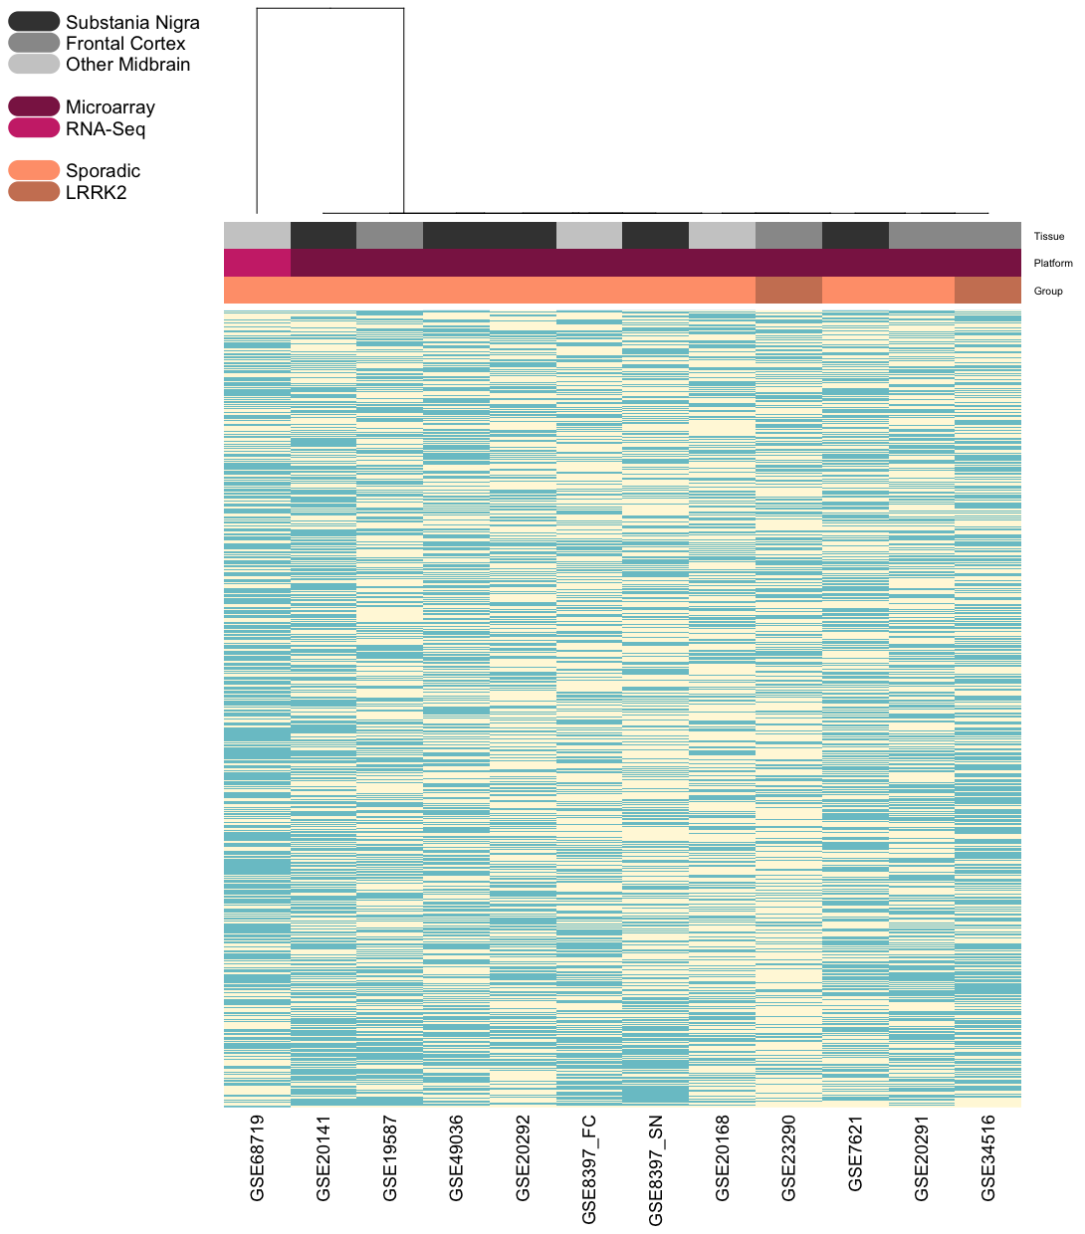
Figure 20: A clustered heatmap for all PD datasets. Datasets were clustered based on columns (i.e. by datasets). Greyscale row indicates tissue source (SN, FC or other midbrain area). Magenta row indicates the platform. Salmon row indicates whether the datasets contained sporadic or LRRK2 datasets. Clustering indicated a separation of the dataset GSE69719. Blue values are downregulated, cream values are upregulated.

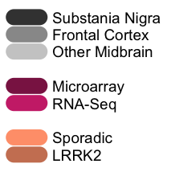

Figure 21: Dendrogram of datasets clustered based on up- or down-regulation of genes. Greyscale row indicates tissue source (SN, FC or other midbrain area). Magenta row indicates the platform. Salmon row indicates whether the datasets contained sporadic or LRRK2 datasets. Clustering indicated a separation of the dataset GSE7621.
Table 64: Dataset selection for 3, 6, and 12 dataset analysis. Highlighted datasets indicate the progression from three to six to twelve datasets. Tissue, Platform, and Disease Group indicate the mix of backgrounds used for each analysis.

Results
The pipeline was applied to the 3-dataset and 6-dataset combinations exactly as described in Chapter 3. Results can be found in Table 65. Results indicate that as the numbers of input datasets doubles, the rate in which DEGs, PPI nodes and common coexpression nodes are generate also decreases exponentially. For example, increasing from 3 to 6 datasets resulted in a reduction of approximately 50% of DEGs, whereas from 6 to 12 datasets resulted in a reduction of approximately 86% of genes. Graphs of these values alongside a predictive linear model suggest that due to values for DEGs and coexpression modules, a maximum input of less than 13 datasets is recommended (Figure 22). It is also worth noting that although 3 dataset analysis is possible, it significantly increases computation time and power and may pose problems from a resource availability perspective.

Table 65: Results of application of pipeline to 3, 6, and 12 input datasets: Results indicate a clear pattern of reduction in number of DEGs, PPI nodes and common coexpression nodes as the number of input datasets is doubled.

B
A
C
Figure 22: Plots indicating minimum and maximum numbers of input datasets: Plot A represents numbers of common DEGs, and indicates a maximum input dataset value of 12 datasets. Plot B represents the PPI network, and indicates a slightly higher value of less than 16 datasets. Plot C represents common coexpression module, and also indicates a value of less than 13 datasets. Red lines indicate linear models of the 3 reported values for each plot.

Differential Expression of Genes
As our definition of gene differential expression is unconventional, we decided to investigate the variability of expression for these genes in each application. The log2 fold change values of each gene across the input datasets were plotted as boxplots (Figure 23). From these plots we can see that the consistency in gene expression can be quite variable, most probably due to the small size of input datasets. There are some clear outliers, such as in the Parkinson’s datasets (Figure 23B). What is clear is that these genes do not conform to the standard practice of fold change thresholds, however this is not necessarily an issue; arbitrarily assigned thresholds such as fold change and P-value have been criticised, as it allows a degree of subjectivity to be introduced into the assignment of a gene’s value ⁴⁵⁵. Not only this, the use of thresholds leads to promotion of the importance of gene expression variability, rather than consistency. Subsequently, we are still confident that our prioritisation of defining differential expression by consistency rather than scale is appropriate for our pipeline.

A
B
C
Figure 23: Boxplots of Log2 Fold Change for common DEGs across datasets. A indicates log2 fold change distributions for common DEGs across the six TDP-43 datasets. B indicates log2 fold change distributions for common DEGs across the twelve PD datasets. C indicates log2 fold change distributions for common DEGs across the twelve autoimmune arthritis datasets. The red line indicates the position of 0 log2 fold change. Genes are ordered by median log2 fold change value. Values have been re-centered around zero.

Overlap Between Signatures
Though not necessarily irrelevant to each condition, these pathways highlight a possible weakness in the pipeline – how much common signal is being picked up across different diseases? It was mentioned above that the size of the network is quite large, and the presence of common pathways suggests we could be accumulating some “generic disease” signal. To investigate, we conducted a simple protein name overlap, visualised in Figure 24. Here we can see approximately a third of each protein interaction network is shared by each condition. Overlap of these expansive, generic core processes could well be reflecting a bias of the protein interaction methodology towards more ubiquitous, housekeeping proteins. As a result, it would be of benefit in future to develop a more rigorous selection process for expanding the protein network, one that perhaps gives less weight to proteins which are generally more promiscuous.

The overlap, however, is less of an issue once the common coexpression networks are defined. Figure 25 shows an equivalent diagram for the common coexpression modules of each application. Here we can see that 16 genes are shared between the common coexpression modules in each of the three applications – substantially less than a third of each network (Table 66). Of these 16, none are particularly related to the application phenotypes, and none are ranked highly in the prioritisation process. Also, the presence of shared signal it is not necessarily a fault in the pipeline, as the relationship between inflammation and neurodegeneration has been well documented, and more recently that a relationship exists between the development neurodegeneration and arthritis specifically^{195,456–458}. We see further support in the higher number of module members shared between the two neurodegenerative conditions versus autoimmune arthritis. Subsequently, a further application on a condition much further removed from these conditions would hopefully give a better indication of the ability of this pipeline to isolate only phenotype-specific signals.
Figure 24: A Venn diagram depicting the overlap between protein-protein interaction networks in each application

Figure 25: A Venn diagram depicting the overlap between common coexpression module members in each application
Table 66: Results indicating the percentage of each protein interaction network and common coexpression module which is shared across all three applications

Chapter 6: Conclusion and Future Work

Summary
The overall aim of this project was to develop a methodological pipeline capable of producing signatures shared across populations that contain laboratory-validated upstream drivers. Our objectives were that the pipeline would be able to successfully incorporate small datasets from variable technical platforms, to incorporate genomic, transcriptomic, and proteomic data, to survive rigorous testing at each development stage, and be validated through prioritisation and selection of predicted upstream drivers, which will subsequently be tested in vitro or in vivo.

Pipeline Development and TDP-43
The first step was to build a methodological pipeline that would form the basis of our signature development and which conformed to the objectives laid out above. To do so required a case phenotype on which to conduct the analysis, and TDP-43 dysfunction was chosen for this role. Datasets pertaining to this phenotype were sourced and quality controlled. These datasets then underwent differential expression analysis, and the methodology by which differentially expressed genes were identified was defined as genes whose direction of dysregulation was consistent across all input datasets. We produced a gene list significantly larger than expected by chance, and significantly enriched with pathways and gene lists representative of TDP-43 dysfunction. To gain functional context for the DEG list, the DEGs were used to seed a protein-protein interaction network, the members of which continued to enrich for TDP-43-associated biology. The nodes of this network were then used to build coexpression networks in each input dataset, and edges were filtered to include only those who existed in all input datasets, whose coexpression direction was conserved, and whose strength of coexpression was above a certain value. The largest connected component of this network, 232 nodes and 529 edges, was selected to represent the phenotype-associated signature. The network module contained two known ALS genes, TBK1 and GARS, enriched for TDP-43-causative and TDP-43 protein interaction genes, and formed a significant number of protein-protein interaction relationships with know TDP-43-causative genes. Prioritisation was conducted using a number of information sources, and successfully ranked known TDP-43-assocaited genes highly. Analysis of the top 5 ranked genes indicated a number of promising candidates for in vitro validation, of which 3 were chosen, alongside a control. Knockdown of known ALS gene TBK1 produced shortened neurite length, an established neurodegenerative phenotype, but no TDP-43 specific dysfunction. Knockdown of DDX1 caused marked neuronal cell death, however this result is as of yet unconfirmed as neurodegenerative. Finally, knockdown of YBX1 resulted in the same aberrant presence of TDP-43 protein in the cytoplasm, as happens in disease.

Further Applications
As our pipeline was developed in tandem with experimentation on TDP-43 dysfunction, we needed to establish the applicability of this pipeline to other phenotypes. Consequently, we performed two further applications of the methodology to identify signatures shared between sporadic and LRRK2 Parkinson’s disease, and between autoimmune arthritides. The signature developed for PD enriched for LRRK2 PPI genes, and enriched for a number of mitochondrial and UPS pathways. Prioritisation ranked already PD-associated gene UCHL1 as the highest ranked gene, with those in the top 9 showing clear association with PD in the literature. Although an in vitro validation of these candidates was not possible in the timeframe of this project, a further application could be conducted on another phenotype – autoimmune arthritis. Using data from rheumatoid and psoriatic arthritis, a signature was created which not only enriched with GWAS genes from these conditions, but also genes from three other autoimmune arthritides which were not included in the analysis. The module also enriched highly for immune and inflammation pathways, in some cases more significantly than the original DEG list, despite being smaller in size. The top ranked candidates not only have key documented roles in immune and inflammatory pathways, but some are also associated with known drugs used to treat autoimmune arthritis conditions. Again, due to time restraints, in vitro analysis was not possible, however there are a number of very promising candidates.

Pipeline Strengths
In the Introduction we identified a number of areas which we believed were contributing to the lack of reliable signatures. We identified issues with bias, the influence of poor controls and signature inconsistency, and conducted a brief review of nine studies whose attempts at signature generation revealed the inadequacies of current methodologies. We believe the pipeline we have developed successfully meets each of these criteria. It can produce meaningful results from particularly small datasets, with the sole caveat that the datasets must contain enough samples for calculating correlation. From our observations, this is possible with at least 4 samples, but understandably the results from such underpowered data are less reliable. Subsequently, it is important to assess the quality of correlation analysis results, and also assure there are enough larger datasets to corroborate the results. The pipeline is also capable of incorporating datasets from not only different platforms within a technology, but across both microarray and RNA-seq. As expected, there were issues with variable annotation causing a potential loss of true positive signal, however the processes of expanding a simple DEG list into network analysis allowed recuperation of some of that signal.

As well as multiple platforms, we were also able to incorporate a number of data types. Multi-omic analyses are now being pushed further to the forefront of bioinformatics, with the understanding that evidence which resonates across many data types has a higher reliability than evidence from a single source. We must, however, be wary of each of those data sources. Transcriptomic data is highly variable, and subject to issues of replication ¹⁵⁷. Proteomic data is particularly vulnerable to false records of protein interaction events (whether by non-specific binding in experiments or by insufficiently controlled computational predictions) and is generally less well studied than other ‘omic areas ⁴⁵⁹. Genomic data is highly complicated in each of acquisition, processing, and interpretation ⁴⁶⁰. For the vast majority of medical conditions, we are still quite ignorant of both the individual and collaborative contributions genetic variants make. Furthermore, each of these contributions possesses a heterogeneric profile depending on the individual. Consequently, the role of multi-omic analysis is integral to the provision of reliable scientific discovery.

We can also make sure that our discoveries are supported by a scaffold of robust statistical testing. When Venet and colleagues identified that even a statistically significant cancer signature is not necessarily a reliable result, it made clear that single statistical tests are an insufficient measure of success ⁵⁴. We supported this conclusion, and so ensured that a number of statistical tests were made at each level of analysis. We established that our DEG sets were significantly larger than expected by chance, that each gene or protein list enriched for gene lists and pathways associated with the phenotype, and that our prioritisation approach was successfully assigning high scores to genes we would expect to rank highly. As well as statistical support, for our first application in TDP-43 dysfunction we were also able to provide in vitro validation for novel upstream drivers, satisfying the final objective of this project.

When considered in reference to the nine studies reviewed in the Introduction, our methodology has been able to fulfil each of the nine criteria assessed. Our pipeline is multi-omic, cross-tissue, and cross-platform, makes use of sophisticated network analysis, and produces consistent, validatable signatures – something which, as of yet, has not been achieved before.

Assessment and Future work

Further validations
In the time scale of this project, we have managed to achieve the vast majority of the aims and objectives we set out at the start. A few, however, were not able to be completed in this time, predominantly the in vitro validations. We do, however, have a number of plans in place for further in vitro work. The TDP-43 discoveries in iPSC neurons are already undergoing replication to establish our findings are reliable, and the results will hopefully contribute to a publication demonstrating the identification of a new upstream driver of TDP-43 dysfunction. Additionally, we are reaching out to a number of possible PD collaborators to test some of the top ranked Parkinson’s disease candidates, again hopefully resulting in publication. As previously mentioned, for autoimmune arthritis we are interested in conducting some in silico validations within the Hide Lab using a drug repositioning framework currently under development. This will hopefully show our autoimmune arthritis signature is able to successfully predict known drug candidates for these conditions, as well as potentially identify repositionable drugs, saving huge amounts of time and money in drug discovery.

A further validation of value for each dataset would also be to attempt replication in external datasets. Unfortunately, we could not attempt this for any of the three applications due to the lack of availability of data for these conditions. A direct consequence on working with data from rare conditions, with very specific criteria for acceptance is a very small pool of acceptable datasets. We chose to use this data for building the signatures, with the hope that over time new datasets would emerge to satisfy the conditions we set out in this project.

Further applications
As well as validating our existing applications, we already have plans for further applications. For example, there is a great deal of publicly available data on inflammatory bowel disease, which - like arthritis – has a number of known drugs associated with it, allowing for more drug repositioning work. In fact, the possible applications of this pipeline are numerous, as it only requires a handful of small datasets and a quantifiable phenotype. Before it is applied to other conditions, however, there are a number of improvements that should be made to the pipeline protocol.

Pipeline Improvements

Gene expression analysis
For gene expression analysis, the expression direction approach is one not generally employed for meta-analyses, unlike, for example, P-value combination. We achieved successful results with this approach and showed that the number of DEGs identified was significantly more than expected by chance, indicating a stronger relationship between the datasets than one would expect. Despite our success, we admit this approach is vulnerable to some biases. The number of input data sets changes the number of DEGs, due to the fact each additional dataset will remove a certain proportion of this gene list. This process is good for removing the noise of each individual dataset, however it is also likely to remove true positives; all it takes is one dataset to show opposite direction of dysregulation to the other datasets, and that gene is removed. A good investigation to undertake would be to analyse the effect of setting a threshold – for example, is 90% concordance acceptable? How does this change the results? Genes are also lost through the process of filtering, using the tissue non-specific or condition-generic datasets. Although this process helped us identify possible unspecific signals, it was often not possible to identify the most appropriate data for the role. At times we had to use blood in both roles, which, if we designed the experiment wholly ourselves including data generation, we would not ideally have chosen. Unfortunately, the availability of data is limited to what is available publicly, unless an experimenter has resources to generate their own data. For example, if this experiment were to be designed with the necessary funding, tissue non-specific data would have been collected from the same patients, from an appropriate control tissue. As we did not possess the required time nor funding, we sourced the best data we could find publicly.

Protein interaction analysis
The use of protein interaction at this next stage could be criticised, due to the likelihood of false positives stemming from protein interaction data. An alternative suggestion would be canonical coexpression, however this poses its own problems - Which canonical database to use? How do you decide which edges are “valid” and which are not? Can it be tissue specific? What if your expression data is sourced from multiple tissue types? Do the edges need to be consistent across those tissues? What if data doesn’t exist for that tissue? Despite the issues with false positives in protein interaction data, we still believe this is the preferable data source for the edges in this stage of network expansion. As this network provides a framework rather than the final result, we have the capability later on to remove those false positives. Within our use of protein interaction, a few improvements could admittedly be made. During the timeline of this project, IrefIndex released IrefIndex 15.0, which could replace our current use of IrefIndex 14.0. Additionally, a more careful analysis could be conducted to reduce the amount of protein loss due to annotation differences, a challenge experienced often when working within the proteome. Though not isolated to the proteome by any means, the size of the network at this stage leaves us vulnerable when interpreting the results of any sort of enrichment. Enrichment analysis is fundamentally tied to the size of the input list, subsequently we see very similar enrichment in very broad categories across all three applications, including pathways such as “Disease”, “Gene Expression”, “Immune system”, as well as a number of proteasomal proteins.

Common coexpression analysis
At the common coexpression network stage, one of the main vulnerabilities – as we have seen with a number of stages – is the number of input datasets. Too few datasets and the experiment is vulnerable to dataset-loss during quality control (particularly datasets with the smallest sample numbers), and edges are less reliable. Too many datasets and correlation thresholds need to be dropped drastically to retain any edges. As with differential expression, an investigation into the optimal protocols at this point would be beneficial to any future users. It would be helpful to know the optimal number of datasets, and if a subset needs to be selected, which are the best candidates considering sample numbers, platform, and tissues/diseases to be represented? Further investigation also need to be made into the methodology for selecting the correlation threshold. Currently, the threshold is selected based on the number of output genes it generates. This logic in of itself is not necessarily an issue, despite the biases of the experimenter defining a network size, however its application could be designed more formally. For example, an algorithm could be designed which tests each threshold value and compares “success” using a particular benchmark. That benchmark could be enrichment of a gene list relating to the phenotype (under the understanding this benchmark could not be used for validation by enrichment at later stages), or a topological benchmark relating to the optimal connectivity of the network.

Upstream analysis
In terms of upstream analysis and relating the signatures to genetic data, this area requires a great deal of further work. As the network modules themselves contain no information on directionality or whether the members are upstream or downstream of the phenotype, it is up to ourselves as the experimenters to derive this information from alternate sources. GWAS enrichment was only successful in autoimmune analysis, which could be the result of the commonality of arthritis in comparison to neurodegenerative conditions, but also could reflect inconsistency in our signature’s ability to isolate upstream genetic factors. As a result of a lack of GWAS enrichment, we looked to raw genetic sequencing data to provide information on LoF mutations in the network members. Although Gemini accumulates a large number of resources to predict LoF mutations, these are hard to assess in terms of their validity. Subsequently, this information was not used solely for validation work, but in tandem with a number of other information sources for prioritisation. Subsequently, if a gene contained a false-positive LoF mutation, its ability to be highly ranked is offset by curated information from a number of other sources. The aim of our pipeline is not specifically to identify genetic causes of the phenotype (though this is possible), but drivers in general, which may or may not exhibit genetic variance in patients. With the appropriate expertise, however, we may in future be able to refine this process.

Target prioritisation
Although the prioritisation approach we presented in this project are not intrinsic to the pipeline – any preferred prioritisation method could be used – our approach achieved a certain degree of success. Subsequently, with further improvement, this particular prioritisation approach could be very effective, as it considers genes specific to the phenotype of interest and their expression in the input data. Due to the fact many of the genes in the network achieve similar scores, it is likely that more data sources should be included. Something which is currently missing is some sort of literature-based score to assess association with the phenotype. One possible source to satisfy this problem is the web tool VarElect (ve.genecards.org). Through input of a gene list alongside important terms related to the phenotype, VarElect ranks genes on their association with these terms based on a number of databases, as well as literature links. From a mathematical perspective, our prioritisation approach could include a system of weighting more and less important data sources. This could provide a more accurate score, e.g. protein interaction with a causative gene might be more important than a high rank in Endeavour.

Impact
Any new methodology must be built with the understanding that it provides a novel approach that is otherwise lacking in the field. In the introduction, we identified a significant bottleneck in traditional biological discovery, ultimately leading to lengthy interims between first observation and first successful treatment. The significance of this bottleneck to treatment was also lengthened in correlation with the rarity of conditions, due to small populations and subsequent small datasets. In response, we have developed a computational, data-driven methodology that not only reliably identifies upstream drivers of a phenotype, but does so through the use of small datasets, and in a much-reduced period of time. The impact of this methodology is highly significant; many of our most untreatable conditions are also our rarest and have so far been highly elusive when it comes to understanding their mechanisms and treatments. Rare conditions are by nature small populations, making large-scale analyses such as GWA inordinately more expensive and time-consuming, or for the extremely rare, impossible. Through our approach we have the ability to develop custom-made panels from our signatures, drastically reducing the number of participants required for well-powered population-based analyses, allowing these types of studies to be conducted on rare conditions with much smaller populations. Additionally, unlike conventional GWAS, the candidates in these panels will already possess a functional relationship with the phenotype, combating a common pitfall in which variants identified by GWA struggle to be characterised in relation to the condition they are associated with ¹⁵. Subsequently, not only can our approach derive meaningful results from small datasets, its legacy may well lead to a reduction in the sample sizes required for future genomic discovery.

As well as utilising small data, we proposed that new methodologies are needed which generate novel biological discoveries rapidly, potentially saving both significant amounts of time and money. We believe the approach reported in this thesis is capable of representing this shortcut. For example, TDP-43 pathology was first identified in 2006. It took 9 years for the gene TBK1 to be associated with the phenotype, the result of exome sequencing in nearly ten thousand ALS patients and controls ^{111,461}. Such a lengthy timeline of discovery very likely resulted in the accumulation of substantial financial costs. Alternatively, with just over a hundred samples and a pipeline application time of approximately 2-3 weeks, we have made the very same discovery in a fraction of the time, at a fraction of the cost. Not only this, we have also been able to replicate discovery of established upstream drivers of two subsequent phenotypes, and identify two potential novel upstream drivers of TDP-43 pathology in vitro.

If, as we believe, these candidates represent upstream drivers of phenotypes, they may also have the potential to be prognostic. Testing prognostic ability would require data which we do not currently have access to, however considering the failure rates of current prognostic signatures, this could be an exciting application of the output of our pipeline. Another predictive application of our signatures would be the prediction of drug target candidates. A number of methodologies are beginning to be revealed which use signatures to predict drug candidates. Some, like the L1000CDS² platform developed by the National Institute of Health (NIH) can take a gene expression signature to predict drug targets ⁴⁵². A platform developed within the Hide Lab has been built to achieve a similar outcome, with a heavier focus on dysregulation at the pathway level ⁴⁶². If we are able to demonstrate our signatures’ abilities to predict known drugs –as could be possible in arthritis – we may also be able to identify novel drugs which score highly in these predictions.

In summary, not only has our approach achieved the majority of aims and objectives set out at its inception, we have subsequently found it to possess more than one string to its bow; as well as deciphering the core contributors to elusive phenotypes, we have identified a number of opportunities for its application in population genetics, in drug discovery, and possibly also in prognosis. In the Introduction we described many obstacles facing successful treatment of complex diseases, however with methodologies such as the one developed here at our disposal, these treatments may not be as far away as once thought.

Appendix
A
B
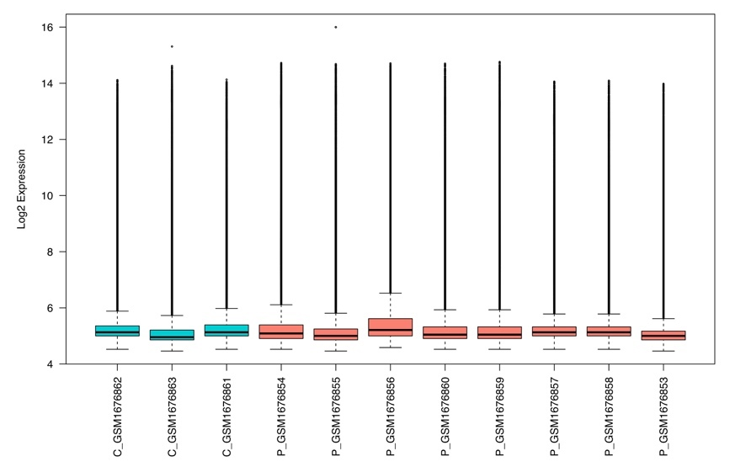
C

Appendix Figure 1: Quality control results for GSE68605. A shows a PCA plot of all samples. B shows a boxplot of the log2 expression of the genes in each sample. C shows an unsupervised clustering dendrogram of all samples. All expression is non-normalised. Orange indicates patients, turquoise indicates controls.
B
A
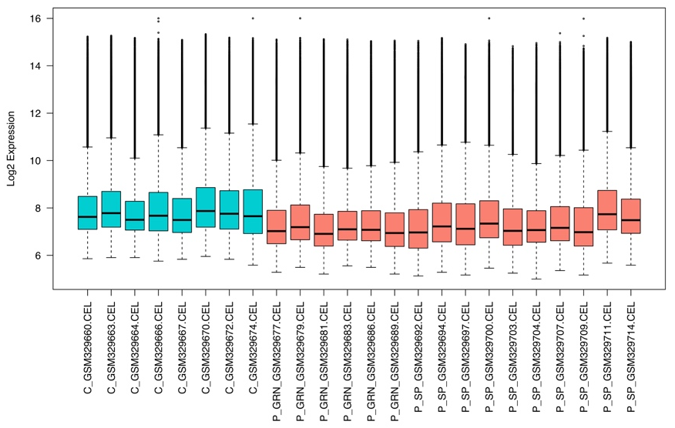

C

Appendix Figure 2: Quality control for GSE13162. A shows a PCA plot of all samples. B shows a boxplot of the log2 expression of the genes in each sample. C shows an unsupervised clustering dendrogram of all samples. All expression is non-normalised. Orange indicates patients, turquoise indicates controls. Box indicates removed sample.

A
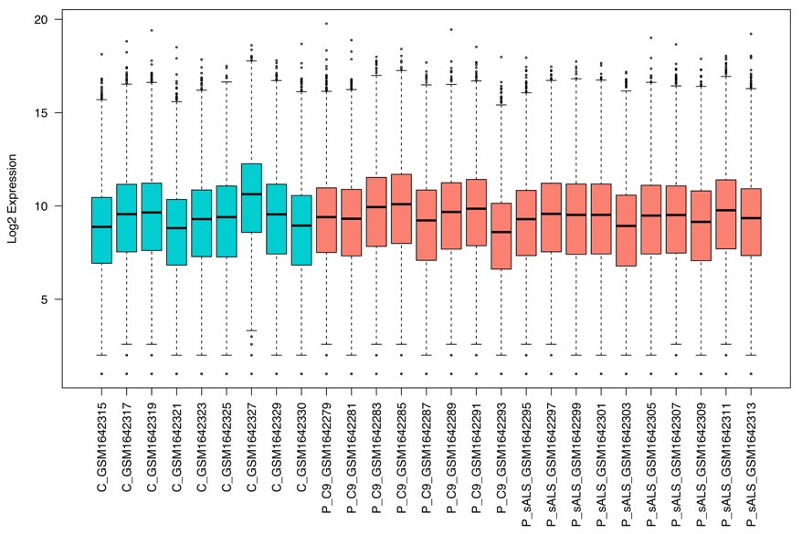
B
C

Appendix Figure 3: Quality control results for GSE67196. A shows a PCA plot of all samples. B shows a boxplot of the log2 expression of the genes in each sample. C shows an unsupervised clustering dendrogram of all samples. All expression is non-normalised. Orange indicates patients, turquoise indicates controls. Box indicates removed sample.

B
A
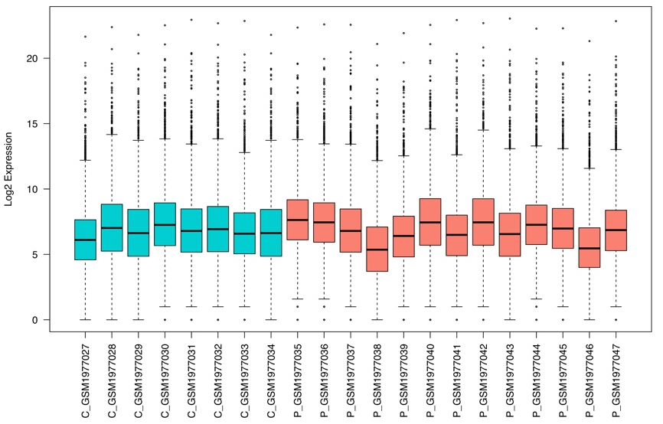
C

Appendix Figure 4: Quality control results for GSE6220. A shows a PCA plot of all samples. B shows a boxplot of the log2 expression of the genes in each sample. C shows an unsupervised clustering dendrogram of all samples. All expression is non-normalised. Orange indicates patients, turquoise indicates controls
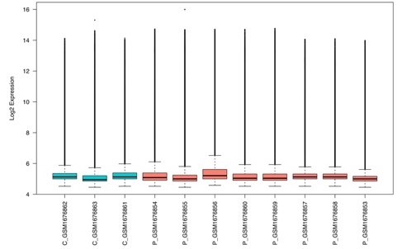
A
GSE68605

B
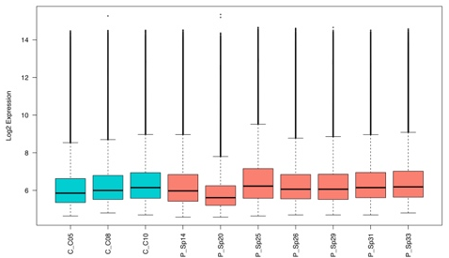
Kirby

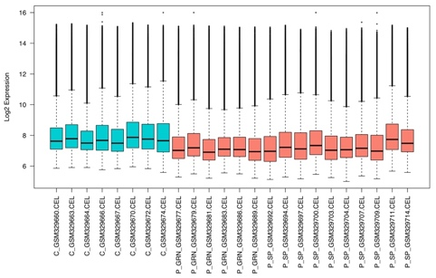
C

GSE13162

D
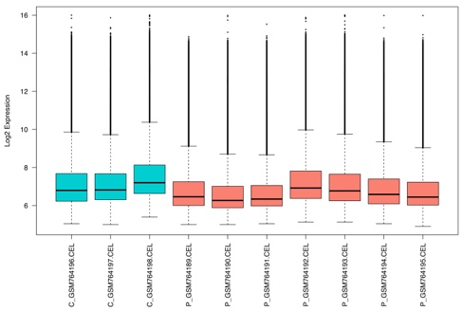
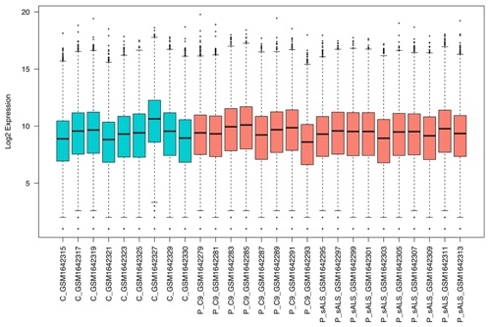
GSE30806

E

GSE67196

F
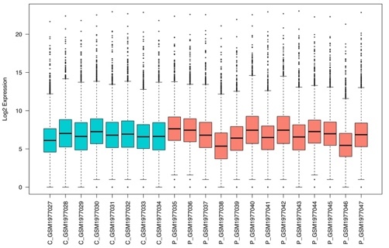
GSE6220

Appendix Figure 5: Variance of each TDP-43 dataset before and after normalisation. Plots indicate a consistent range of variance in log2 expression between microarray (A-D) and RNA-Seq (E-F) conditions. RNA-Seq range is larger compared to microarray, though this is expected due to technological differences

Appendix Table 1: LoF results for TDP-43 common coexpression genes. Gene Symbol indicates the reported associated HGNC symbol. Hom/Het indicates if the mutation was homozygous or heterozygous in the patient it was discovered in.

Appendix Table 2: Lobby index values for TDP-43 common coexpression module members and resulting prioritisation score from 1-5.
Appendix Table 3: GeneXplain rank for TDP-43 common coexpression module members. Ranks sum is the score given by GeneXplain on which genes are ranked. Prioritisation is scored 1-5.

Appendix Table 4: IPA regulatory relationships between TDP-43 common coexpression module members.

Appendix Table 5: IPA scores for TDP-43 common coexpression module members. Number of targets refers to the number of molecules each From Molecule influences. Scores are from 1-5 based on this value

Appendix Table 6: Endeavour Scores for TDP-43 common coexpression module members. Endeavour rank is the position after ranking by p-value. Score is from 0-5.

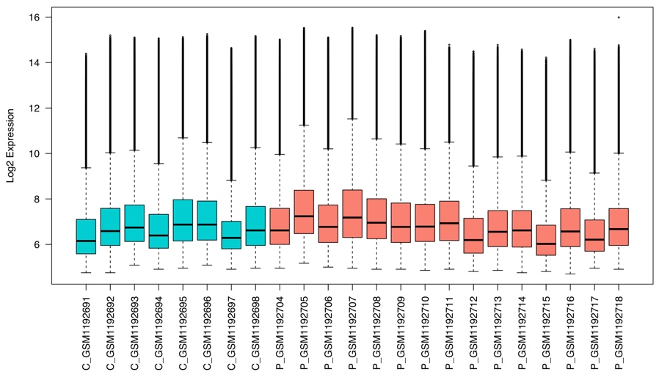
A
B
C
Appendix Figure 6: Quality control results for GSE49036. A shows a PCA plot of all samples. B shows a boxplot of the log2 expression of the genes in each sample. C shows an unsupervised clustering dendrogram of all samples. All expression is non-normalised. Orange indicates patients, turquoise indicates controls

B
A
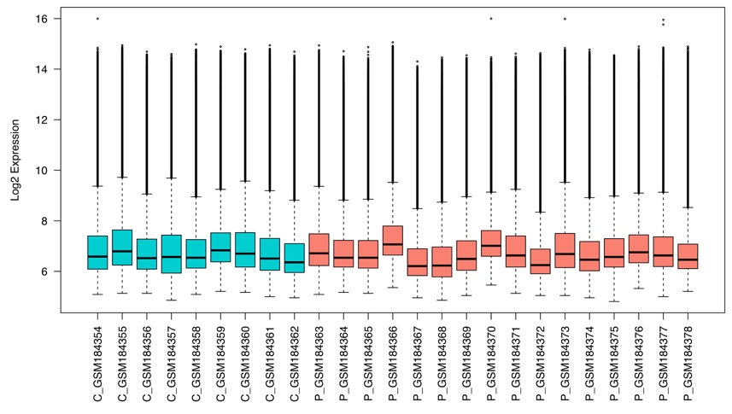
C

Appendix Figure 7: Quality control results for GSE7621. A shows a PCA plot of all samples. B shows a boxplot of the log2 expression of the genes in each sample. C shows an unsupervised clustering dendrogram of all samples. All expression is non-normalised. Orange indicates patients, turquoise indicates controls
A
B
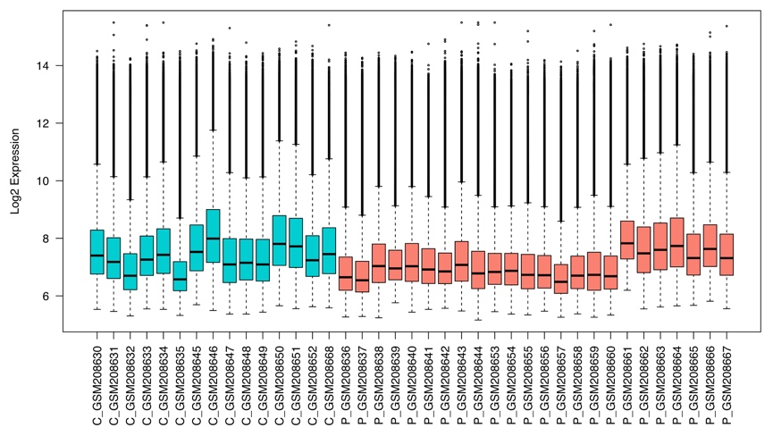
C

Appendix Figure 8: Quality control results for GSE8397 (substantia nigra). A shows a PCA plot of all samples. B shows a boxplot of the log2 expression of the genes in each sample. C shows an unsupervised clustering dendrogram of all samples. All expression is non-normalised. Orange indicates patients, turquoise indicates controls

B
C
A
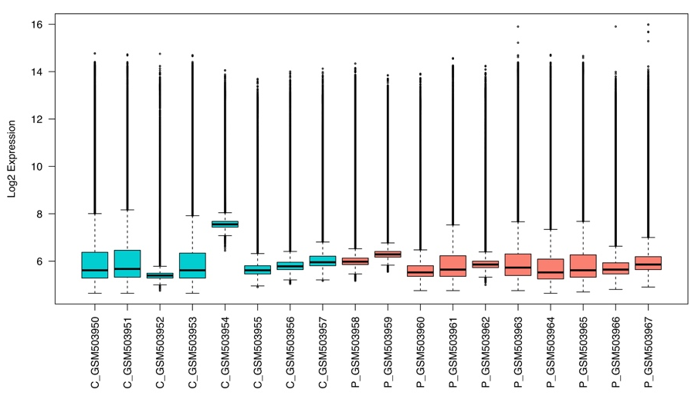

Appendix Figure 9: Quality control results for GSE20141. A shows a PCA plot of all samples. B shows a boxplot of the log2 expression of the genes in each sample. C shows an unsupervised clustering dendrogram of all samples. All expression is non-normalised. Orange indicates patients, turquoise indicates controls
A
B
C
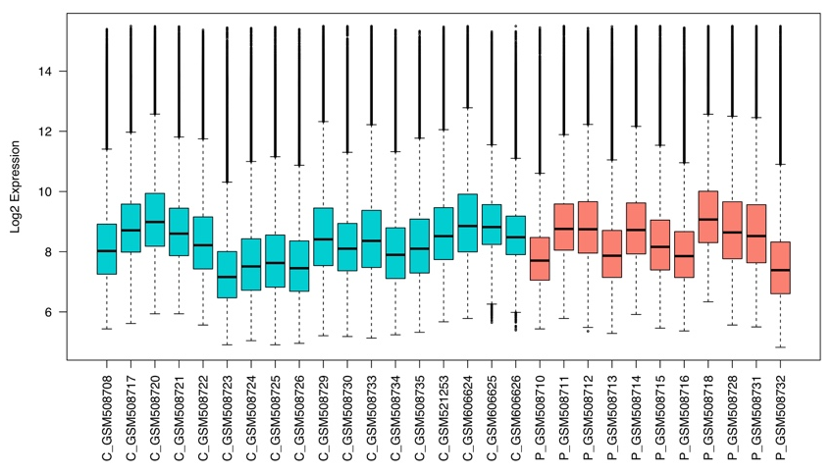

Appendix Figure 10: Quality control results for GSE20292. A shows a PCA plot of all samples. B shows a boxplot of the log2 expression of the genes in each sample. C shows an unsupervised clustering dendrogram of all samples. All expression is non-normalised. Orange indicates patients, turquoise indicates controls

B
A
C
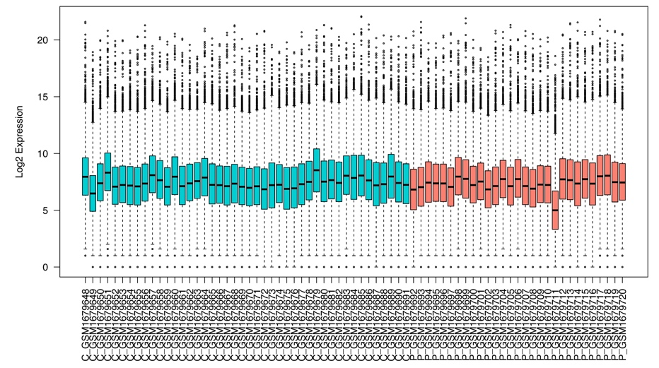

Appendix Figure 11: Quality control results for GSE68719. A shows a PCA plot of all samples. B shows a boxplot of the log2 expression of the genes in each sample. C shows an unsupervised clustering dendrogram of all samples. All expression is non-normalised. Orange indicates patients, turquoise indicates controls
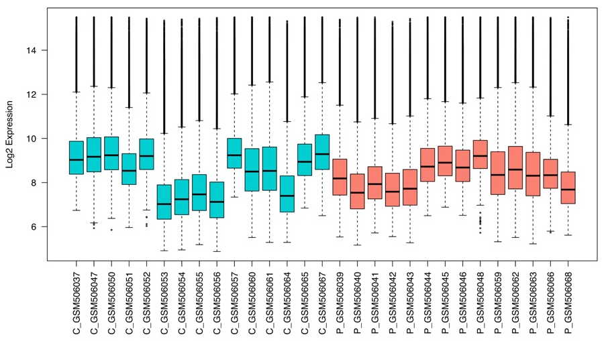
C
A
B

Appendix Figure 12: Quality control results for GSE20168. A shows a PCA plot of all samples. B shows a boxplot of the log2 expression of the genes in each sample. C shows an unsupervised clustering dendrogram of all samples. All expression is non-normalised. Orange indicates patients, turquoise indicates controls
A
B
C
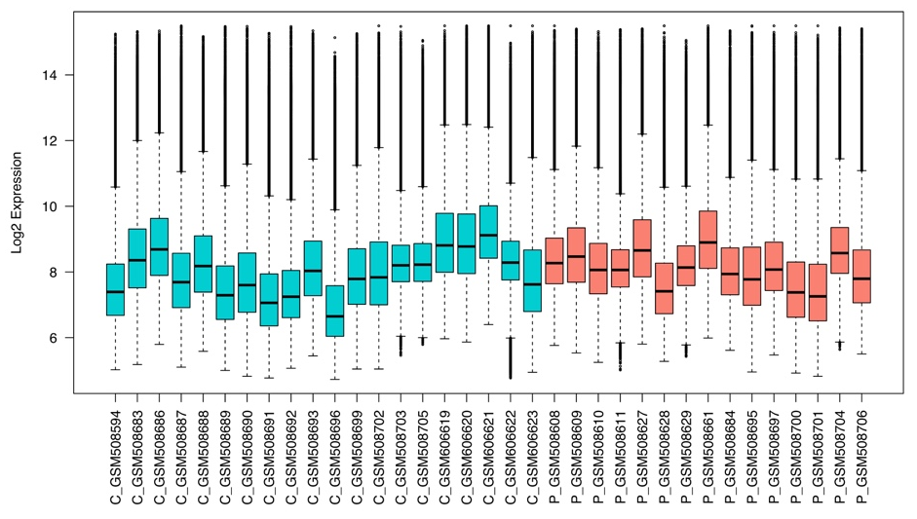

Appendix Figure 13: Quality control results for GSE20291. A shows a PCA plot of all samples. B shows a boxplot of the log2 expression of the genes in each sample. C shows an unsupervised clustering dendrogram of all samples. All expression is non-normalised. Orange indicates patients, turquoise indicates controls
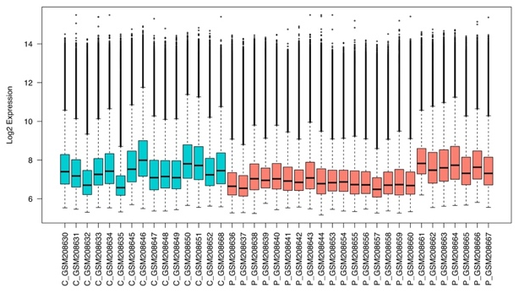
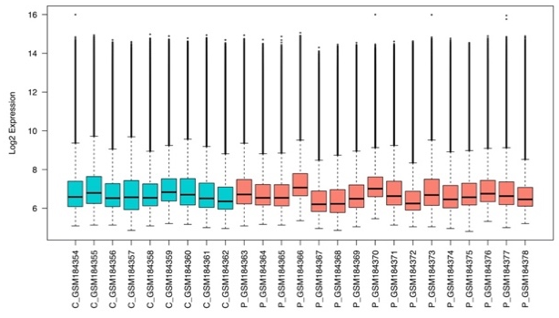
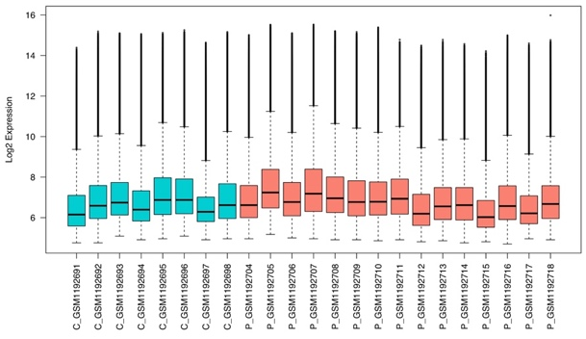
A

GSE49036

B

GSE7621

C

GSE8397 (SN)

D
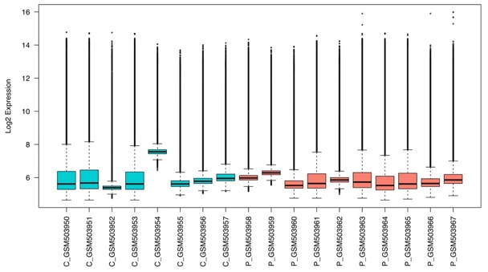

GSE20141

E
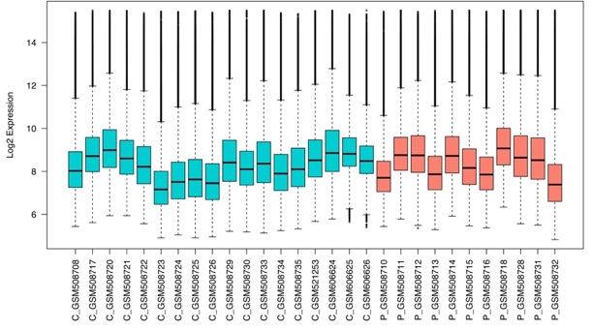

GSE20292

F

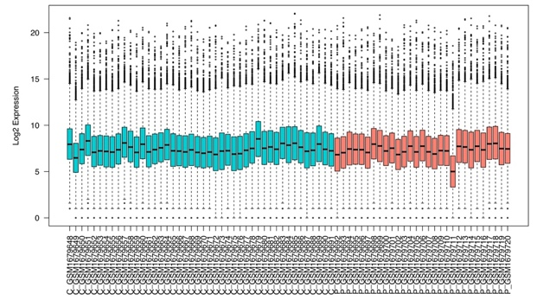

GSE68719

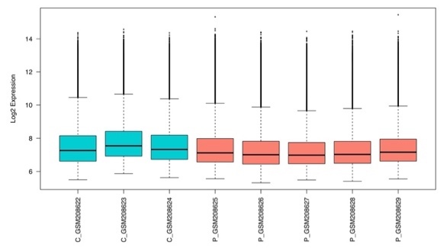
G
GSE8397 (FC)
I
H

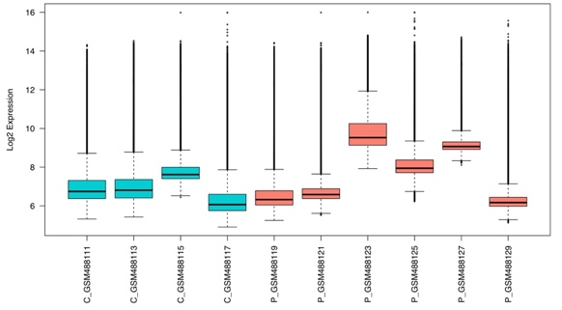

GSE19587

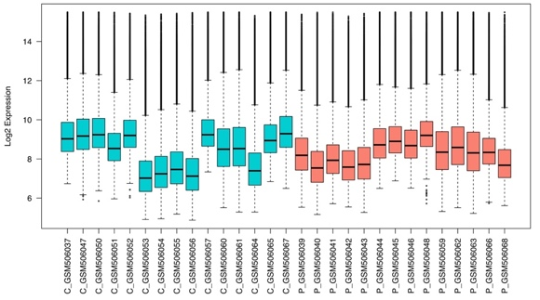

GSE20168

J
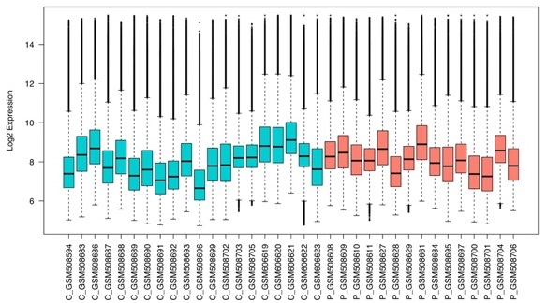

GSE20291

K
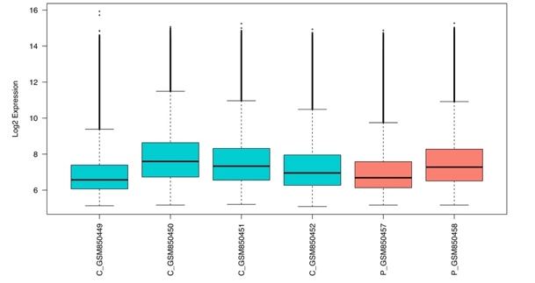

GSE34516

L
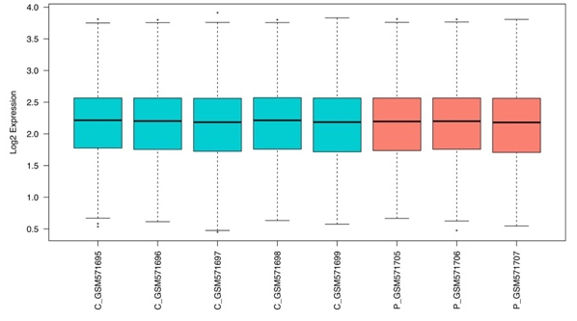
GSE23290
Appendix Figure 14: Variance of each Parkinson’s disease dataset before and after normalisation. Plots indicate a consistent range of variance in log2 expression between microarray (A-E, G-L) and RNA-Seq (F) conditions. RNA-Seq range is slightly larger compared to microarray, and GSE23290 shows a small range pre-normalisation, which is rectified post-normalisation.
Appendix Table 7: Lobby index values for PD common coexpression module members and resulting prioritisation score from 1-5.
Appendix Table 8: GeneXplain rank for PD common coexpression module members. Ranks sum is the score given by GeneXplain on which genes are ranked. Prioritisation is scored 1-5.

Appendix Table 9: IPA regulatory relationships for PD common coexpression module members

Appendix Table 10: IPA scores for PD common coexpression module members. Number of targets refers to the number of molecules each From Molecule influences. Scores are from 1-5 based on this value.

Appendix Table 11: Endeavour Scores for PD common coexpression module members. Endeavour rank is the position after ranking by p-value. Score is from 0-5.

C
B
A
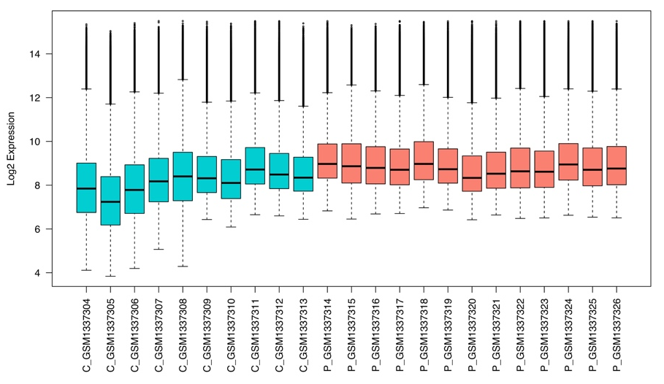

Appendix Figure 15: Quality control results for GSE55457. A shows a PCA plot of all samples. B shows a boxplot of the log2 expression of the genes in each sample. C shows an unsupervised clustering dendrogram of all samples. All expression is non-normalised. Orange indicates patients, turquoise indicates controls

A
B
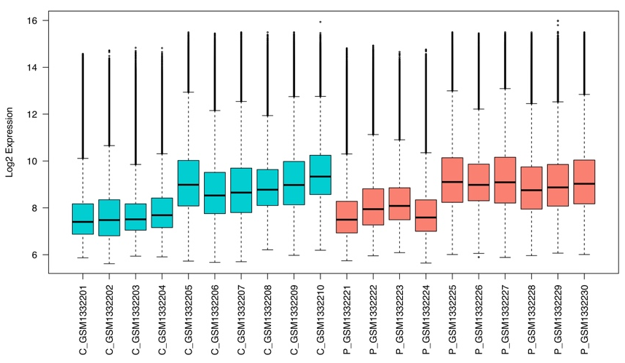
C

Appendix Figure 16: Quality control results for GSE55235. A shows a PCA plot of all samples. B shows a boxplot of the log2 expression of the genes in each sample. C shows an unsupervised clustering dendrogram of all samples. All expression is non-normalised. Orange indicates patients, turquoise indicates controls

B
A
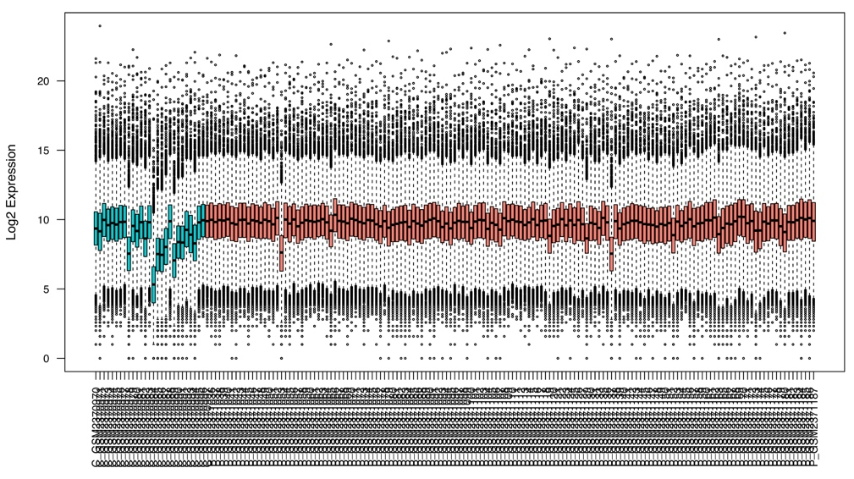

C

Appendix Figure 17: Quality control results for GSE89408. A shows a PCA plot of all samples. B shows a boxplot of the log2 expression of the genes in each sample. C shows an unsupervised clustering dendrogram of all samples. All expression is non-normalised. Orange indicates patients, turquoise indicates controls
A
B
C
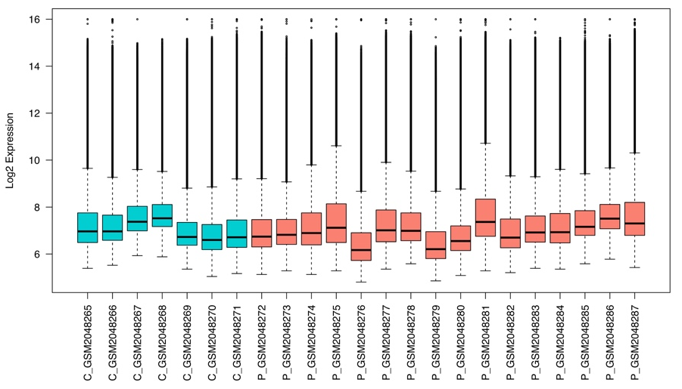

Appendix Figure 18: Quality control results for GSE77298. A shows a PCA plot of all samples. B shows a boxplot of the log2 expression of the genes in each sample. C shows an unsupervised clustering dendrogram of all samples. All expression is non-normalised. Orange indicates patients, turquoise indicates controls

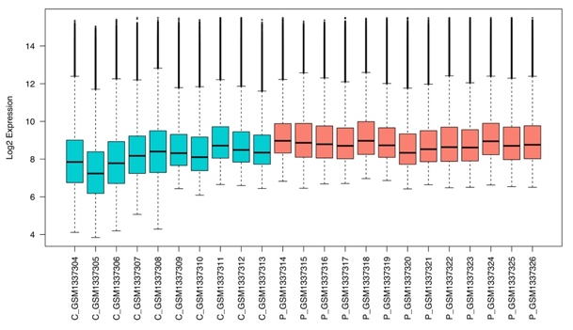
A
E
GSE55457
GSE55235

B
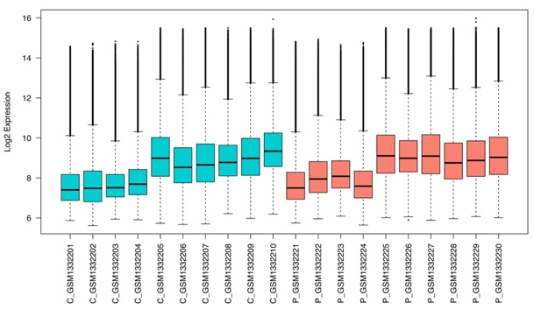

C
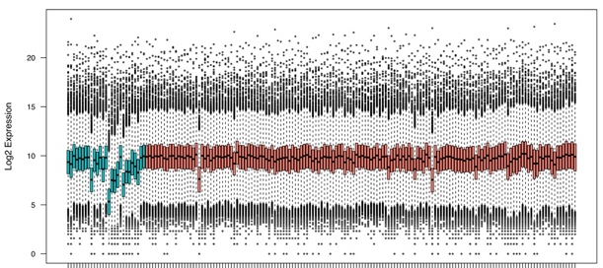

GSE89408

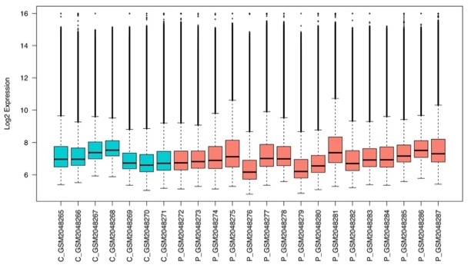
D

GSE77298

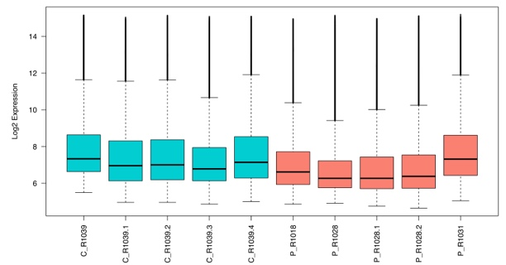
E-MTAB-3201

Appendix Figure 19: Variance of each autoimmune arthritis dataset before and after normalisation. Plots indicate a consistent range of variance in log2 expression between microarray (A, B, D, & E) and RNA-Seq (C) conditions. RNA-Seq range is slightly larger compared to microarray but similar to ranges expected from this platform.
Appendix Table 12: Lobby index values for autoimmune arthritis common coexpression module members and resulting prioritisation score from 1-5.

Appendix Table 13: GeneXplain rank for autoimmune arthritis common coexpression module members. Ranks sum is the score given by GeneXplain on which genes are ranked. Prioritisation is scored 1-5.
Appendix Table 14: IPA regulatory relationships between autoimmune arthritis common coexpression module members
Appendix Table 15: IPA scores for autoimmune arthritis common coexpression module members. Number of targets refers to the number of molecules each From Molecule influences. Scores are from 1-5 based on this value.
Appendix Table 16: Endeavour Scores for autoimmune arthritis common coexpression module members. Endeavour rank is the position after ranking by p-value. Score is from 0-5.

Bibliography
1. Durães F, Pinto M, Sousa E. Old Drugs as New Treatments for Neurodegenerative Diseases. Pharmaceuticals (Basel). 2018;11(2). doi:10.3390/ph11020044
2. Aletaha D, Smolen JS. Diagnosis and Management of Rheumatoid Arthritis. JAMA. 2018;320(13):1360. doi:10.1001/jama.2018.13103
3. Mayeux R, Stern Y. Epidemiology of Alzheimer disease. Cold Spring Harb Perspect Med. 2012;2(8). doi:10.1101/cshperspect.a006239
4. Chopra A, Abdel-Nasser A. Epidemiology of rheumatic musculoskeletal disorders in the developing world. Best Pract Res Clin Rheumatol. 2008;22(4):583-604. doi:10.1016/j.berh.2008.07.001
5. Garry RF, Witte MH, Gottlieb AA, et al. Documentation of an AIDS Virus Infection in the United States in 1968. JAMA J Am Med Assoc. 1988;260(14):2085. doi:10.1001/jama.1988.03410140097031
6. Hütter G, Nowak D, Mossner M, et al. Long-Term Control of HIV by CCR5 Delta32/Delta32 Stem-Cell Transplantation. N Engl J Med. 2009;360(7):692-698. doi:10.1056/NEJMoa0802905
7. Hütter G, Thiel E. Allogeneic transplantation of CCR5-deficient progenitor cells in a patient with HIV infection: an update after 3 years and the search for patient no. 2. AIDS. 2011;25(2):273-274. doi:10.1097/QAD.0b013e328340fe28
8. Ching T, Huang S, Garmire LX. Power analysis and sample size estimation for RNA-Seq differential expression. RNA. 2014;20(11):1684-1696. doi:10.1261/rna.046011.114
9. Gill R, Datta S, Datta S. A statistical framework for differential network analysis from microarray data. BMC Bioinformatics. 2010;11:95. doi:10.1186/1471-2105-11-95
10. Swanson D. Statistical power of gene-set enrichment analysis is a function of gene set correlation structure. bioRxiv. September 2017:186288. doi:10.1101/186288
11. Sham PC, Purcell SM. Statistical power and significance testing in large-scale genetic studies. Nat Publ Gr. 2014;15. doi:10.1038/nrg3706
12. Turnbull C, Scott RH, Thomas E, et al. The 100 000 Genomes Project: bringing whole genome sequencing to the NHS. BMJ. 2018;361. doi:10.1136/bmj.k1687
13. Duncan LE, Ratanatharathorn A, Aiello AE, et al. Largest GWAS of PTSD (N=20 070) yields genetic overlap with schizophrenia and sex differences in heritability. Mol Psychiatry. 2017;23(3):666. doi:10.1038/mp.2017.77
14. Hagenaars SP, Harris SE, Davies G, et al. Shared genetic aetiology between cognitive functions and physical and mental health in UK Biobank (N=112 151) and 24 GWAS consortia. Mol Psychiatry. 2016;21(11):1624-1632. doi:10.1038/mp.2015.225
15. Visscher PM, Wray NR, Zhang Q, et al. 10 Years of GWAS Discovery: Biology, Function, and Translation. Am J Hum Genet. 2017;101(1):5-22. doi:10.1016/J.AJHG.2017.06.005
16. Parker MM, Chase RP, Lamb A, et al. RNA sequencing identifies novel non-coding RNA and exon-specific effects associated with cigarette smoking. BMC Med Genomics. 2017;10(1):58. doi:10.1186/s12920-017-0295-9
17. De Jager PL, Ma Y, McCabe C, et al. A multi-omic atlas of the human frontal cortex for aging and Alzheimer’s disease research. Sci Data. 2018;5:180142. doi:10.1038/sdata.2018.142
18. Brueffer C, Vallon-Christersson J, Grabau D, et al. Clinical Value of RNA Sequencing-Based Classifiers for Prediction of the Five Conventional Breast Cancer Biomarkers: A Report From the Population-Based Multicenter Sweden Cancerome Analysis Network-Breast Initiative. Vol 19.; 2018. http://ascopubs.org/doi/pdfdirect/10.1200/PO.17.00135. Accessed October 19, 2018.
19. Zak DE, Penn-Nicholson A, Scriba TJ, et al. A blood RNA signature for tuberculosis disease risk: a prospective cohort study. Lancet. 2016;387(10035):2312-2322. doi:10.1016/S0140-6736(15)01316-1
20. Barrett T, Wilhite SE, Ledoux P, et al. NCBI GEO: archive for functional genomics data sets--update. Nucleic Acids Res. 2013;41(Database issue):D991-5. doi:10.1093/nar/gks1193
21. Oskarsson B, Horton DK, Mitsumoto H. Potential Environmental Factors in Amyotrophic Lateral Sclerosis. Neurol Clin. 2015;33(4):877-888. doi:10.1016/j.ncl.2015.07.009
22. Leucht S, Helfer B, Gartlehner G, Davis JM. How effective are common medications: a perspective based on meta-analyses of major drugs. BMC Med. 2015;13(1):253. doi:10.1186/s12916-015-0494-1
23. Embracing patient heterogeneity. Nat Med. 2014;20(7):689-689. doi:10.1038/nm.3632
24. Shang H, Liu G, Jiang Y, et al. Pathway Analysis of Two Amyotrophic Lateral Sclerosis GWAS Highlights Shared Genetic Signals with Alzheimer’s Disease and Parkinson’s Disease. Mol Neurobiol. 2015;51(1):361-369. doi:10.1007/s12035-014-8673-1
25. Glaab E, Schneider R. Comparative pathway and network analysis of brain transcriptome changes during adult aging and in Parkinson’s disease. Neurobiol Dis. 2015;74:1-13. doi:10.1016/J.NBD.2014.11.002
26. Gandal MJ, Haney JR, Parikshak NN, et al. Shared molecular neuropathology across major psychiatric disorders parallels polygenic overlap. Science. 2018;359(6376):693-697. doi:10.1126/science.aad6469
27. Jha PK, Vijay A, Sahu A, Ashraf MZ. Comprehensive Gene expression meta-analysis and integrated bioinformatic approaches reveal shared signatures between thrombosis and myeloproliferative disorders. Sci Rep. 2016;6:37099. doi:10.1038/srep37099
28. Parkes M, Cortes A, van Heel DA, Brown MA. Genetic insights into common pathways and complex relationships among immune-mediated diseases. Nat Rev Genet. 2013;14(9):661-673. doi:10.1038/nrg3502
29. Tuller T, Atar S, Ruppin E, Gurevich M, Achiron A. Common and specific signatures of gene expression and protein–protein interactions in autoimmune diseases. Genes Immun. 2013;14(2):67-82. doi:10.1038/gene.2012.55
30. de Magalhães JP, Curado J, Church GM. Meta-analysis of age-related gene expression profiles identifies common signatures of aging. Bioinformatics. 2009;25(7):875-881. doi:10.1093/bioinformatics/btp073
31. Johnson SC, Dong X, Vijg J, Suh Y. Genetic evidence for common pathways in human age-related diseases. Aging Cell. 2015;14(5):809-817. doi:10.1111/acel.12362
32. Moccia F, Fotia V, Tancredi R, et al. Breast and renal cancer—Derived endothelial colony forming cells share a common gene signature. Eur J Cancer. 2017;77:155-164. doi:10.1016/J.EJCA.2017.01.025
33. Larkin JE, Frank BC, Gavras H, Sultana R, Quackenbush J. Independence and reproducibility across microarray platforms. Nat Methods. 2005;2(5):337-344. doi:10.1038/nmeth757
34. Irizarry RA, Warren D, Spencer F, et al. Multiple-laboratory comparison of microarray platforms. Nat Methods. 2005;2(5):345-350. doi:10.1038/nmeth756
35. Haibe-Kains B, El-Hachem N, Birkbak NJ, et al. Inconsistency in large pharmacogenomic studies. Nature. 2013;504(7480):389-393. doi:10.1038/nature12831
36. Koscielny S. Why Most Gene Expression Signatures of Tumors Have Not Been Useful in the Clinic. Sci Transl Med. 2010;2(14):14ps2-14ps2. doi:10.1126/scitranslmed.3000313
37. Patil P, Bachant-Winner P-O, Haibe-Kains B, Leek JT. Test set bias affects reproducibility of gene signatures. Bioinformatics. 2015;31(14):2318-2323. doi:10.1093/bioinformatics/btv157
38. Marshall E. Getting the Noise Out of Gene Arrays. Science (80- ). 2004;306(5696).
39. Leek JT, Scharpf RB, Bravo HC, et al. Tackling the widespread and critical impact of batch effects in high-throughput data. Nat Rev Genet. 2010;11(10):733-739. doi:10.1038/nrg2825
40. Lever J, Krzywinski M, Altman N. Model Selection and Overfitting. Vol 13.; 2016. doi:10.1038/nmeth.3968
41. Bolstad BM, Irizarry RA, Astrand M, Speed TP. A comparison of normalization methods for high density oligonucleotide array data based on variance and bias. Bioinformatics. 2003;19(2):185-193. http://www.ncbi.nlm.nih.gov/pubmed/12538238. Accessed October 19, 2018.
42. Qi L, Chen L, Li Y, et al. Critical limitations of prognostic signatures based on risk scores summarized from gene expression levels: a case study for resected stage I non-small-cell lung cancer. Brief Bioinform. 2016;17(2):233-242. doi:10.1093/bib/bbv064
43. Reimers M. Making Informed Choices about Microarray Data Analysis. Lewitter F, ed. PLoS Comput Biol. 2010;6(5):e1000786. doi:10.1371/journal.pcbi.1000786
44. Tatonetti NP, Ye PP, Daneshjou R, Altman RB. Data-driven prediction of drug effects and interactions. Sci Transl Med. 2012;4(125):125ra31. doi:10.1126/scitranslmed.3003377
45. Provost F, Fawcett T. Data Science and its Relationship to Big Data and Data-Driven Decision Making. Big Data. 2013;1(1):51-59. doi:10.1089/big.2013.1508
46. Leonelli S. Introduction: Making sense of data-driven research in the biological and biomedical sciences. Stud Hist Philos Sci Part C Stud Hist Philos Biol Biomed Sci. 2012;43(1):1-3. doi:10.1016/J.SHPSC.2011.10.001
47. Krumholz HM. Big Data And New Knowledge In Medicine: The Thinking, Training, And Tools Needed For A Learning Health System. Health Aff. 2014;33(7):1163-1170. doi:10.1377/hlthaff.2014.0053
48. Martin-Sanchez F, Verspoor K. Big data in medicine is driving big changes. Yearb Med Inform. 2014;9(1):14-20. doi:10.15265/IY-2014-0020
49. Baranzini SE, Galwey NW, Wang J, et al. Pathway and network-based analysis of genome-wide association studies in multiple sclerosis. Hum Mol Genet. 2009;18(11):2078-2090. doi:10.1093/hmg/ddp120
50. Wang L, Wu L-F, Lu X, et al. Integrated Analyses of Gene Expression Profiles Digs out Common Markers for Rheumatic Diseases. Booth DR, ed. PLoS One. 2015;10(9):e0137522. doi:10.1371/journal.pone.0137522
51. Heard NA. Choosing Between Methods of Combining P-Values.; 2017. https://arxiv.org/pdf/1707.06897.pdf. Accessed October 19, 2018.
52. IntHout J, Ioannidis JP, Borm GF. Obtaining evidence by a single well-powered trial or several modestly powered trials. Stat Methods Med Res. 2016;25(2):538-552. doi:10.1177/0962280212461098
53. Borm GF, Lemmers O, Fransen J, Donders R. The evidence provided by a single trial is less reliable than its statistical analysis suggests. J Clin Epidemiol. 2009;62(7):711-715.e1. doi:10.1016/J.JCLINEPI.2008.09.013
54. Venet D, Dumont JE, Detours V. Most Random Gene Expression Signatures Are Significantly Associated with Breast Cancer Outcome. Rigoutsos I, ed. PLoS Comput Biol. 2011;7(10):e1002240. doi:10.1371/journal.pcbi.1002240
55. Beck AH, Knoblauch NW, Hefti MM, et al. Significance Analysis of Prognostic Signatures. Tucker-Kellogg G, ed. PLoS Comput Biol. 2013;9(1):e1002875. doi:10.1371/journal.pcbi.1002875
56. Baines KJ, Simpson JL, Wood LG, et al. Sputum gene expression signature of 6 biomarkers discriminates asthma inflammatory phenotypes. J Allergy Clin Immunol. 2014;133(4):997-1007. doi:10.1016/J.JACI.2013.12.1091
57. Andorfer CA, Necela BM, Thompson EA, Perez EA. MicroRNA signatures: clinical biomarkers for the diagnosis and treatment of breast cancer. Trends Mol Med. 2011;17(6):313-319. doi:10.1016/J.MOLMED.2011.01.006
58. Nagaraja GM, Othman M, Fox BP, et al. Gene expression signatures and biomarkers of noninvasive and invasive breast cancer cells: comprehensive profiles by representational difference analysis, microarrays and proteomics. Oncogene. 2006;25(16):2328-2338. doi:10.1038/sj.onc.1209265
59. Volinia S, Calin GA, Liu C-G, et al. A microRNA expression signature of human solid tumors defines cancer gene targets. Proc Natl Acad Sci U S A. 2006;103(7):2257-2261. doi:10.1073/pnas.0510565103
60. Philippidou D, Schmitt M, Moser D, et al. Tumor and Stem Cell Biology Signatures of MicroRNAs and Selected MicroRNA Target Genes in Human Melanoma. 2010. doi:10.1158/0008-5472.CAN-09-4512
61. Jackson MA, Jeffery IB, Beaumont M, et al. Signatures of early frailty in the gut microbiota. Genome Med. 2016;8(1):8. doi:10.1186/s13073-016-0262-7
62. Xie Y, Ahn C. Statistical methods for integrating multiple types of high-throughput data. Methods Mol Biol. 2010;620:511-529. doi:10.1007/978-1-60761-580-4_19
63. Suravajhala P, Kogelman LJA, Kadarmideen HN. Multi-omic data integration and analysis using systems genomics approaches: methods and applications in animal production, health and welfare. Genet Sel Evol. 2016;48(1):38. doi:10.1186/s12711-016-0217-x
64. Gibbs DL, Gralinski L, Baric RS, McWeeney SK. Multi-omic network signatures of disease. Front Genet. 2014;4:309. doi:10.3389/fgene.2013.00309
65. Smyth GK. limma: Linear Models for Microarray Data. In: Bioinformatics and Computational Biology Solutions Using R and Bioconductor. New York: Springer-Verlag; 2005:397-420. doi:10.1007/0-387-29362-0_23
66. Love MI, Huber W, Anders S. Moderated estimation of fold change and dispersion for RNA-seq data with DESeq2. Genome Biol. 2014;15(12):550. doi:10.1186/s13059-014-0550-8
67. Robinson MD, McCarthy DJ, Smyth GK. edgeR: a Bioconductor package for differential expression analysis of digital gene expression data. Bioinformatics. 2010;26(1):139-140. doi:10.1093/bioinformatics/btp616
68. Subramanian A, Tamayo P, Mootha VK, et al. Gene set enrichment analysis: a knowledge-based approach for interpreting genome-wide expression profiles. Proc Natl Acad Sci U S A. 2005;102(43):15545-15550. doi:10.1073/pnas.0506580102
69. Huang DW, Sherman BT, Lempicki RA. Systematic and integrative analysis of large gene lists using DAVID bioinformatics resources. Nat Protoc. 2009;4(1):44-57. doi:10.1038/nprot.2008.211
70. Wang J, Vasaikar S, Shi Z, Greer M, Zhang B. WebGestalt 2017: a more comprehensive, powerful, flexible and interactive gene set enrichment analysis toolkit. Nucleic Acids Res. 2017;45(W1):W130-W137. doi:10.1093/nar/gkx356
71. Kuleshov M V., Jones MR, Rouillard AD, et al. Enrichr: a comprehensive gene set enrichment analysis web server 2016 update. Nucleic Acids Res. 2016;44(W1):W90-W97. doi:10.1093/nar/gkw377
72. Kanehisa M, Furumichi M, Tanabe M, Sato Y, Morishima K. KEGG: new perspectives on genomes, pathways, diseases and drugs. Nucleic Acids Res. 2017;45(D1):D353-D361. doi:10.1093/nar/gkw1092
73. Slenter DN, Kutmon M, Hanspers K, et al. WikiPathways: a multifaceted pathway database bridging metabolomics to other omics research. Nucleic Acids Res. 2018;46(D1):D661-D667. doi:10.1093/nar/gkx1064
74. Fabregat A, Jupe S, Matthews L, et al. The Reactome Pathway Knowledgebase. Nucleic Acids Res. 2018;46(D1):D649-D655. doi:10.1093/nar/gkx1132
75. Ashburner M, Ball CA, Blake JA, et al. Gene Ontology: tool for the unification of biology. Nat Genet. 2000;25(1):25-29. doi:10.1038/75556
76. The Gene Ontology Consortium. Expansion of the Gene Ontology knowledgebase and resources. Nucleic Acids Res. 2017;45(D1):D331-D338. doi:10.1093/nar/gkw1108
77. Yon Rhee S, Wood V, Dolinski K, Draghici S. Use and misuse of the gene ontology annotations. Nat Rev Genet. 2008. doi:10.1038/nrg2363
78. Altschuler GM, Hofmann O, Kalatskaya I, et al. Pathprinting: An integrative approach to understand the functional basis of disease. Genome Med. 2013;5(7):68. doi:10.1186/gm472
79. Barter RL, Schramm S-J, Mann GJ, Yang YH. Network-based biomarkers enhance classical approaches to prognostic gene expression signatures. BMC Syst Biol. 2014;8(Suppl 4):S5. doi:10.1186/1752-0509-8-S4-S5
80. Roy J, Winter C, Isik Z, Schroeder M. Network information improves cancer outcome prediction. Brief Bioinform. 2014;15(4):612-625. doi:10.1093/bib/bbs083
81. Winter C, Kristiansen G, Kersting S, et al. Google goes cancer: improving outcome prediction for cancer patients by network-based ranking of marker genes. PLoS Comput Biol. 2012;8(5):e1002511. doi:10.1371/journal.pcbi.1002511
82. Chuang H-Y, Lee E, Liu Y-T, Lee D, Ideker T. Network-based classification of breast cancer metastasis. Mol Syst Biol. 2007;3:140. doi:10.1038/msb4100180
83. Warde-Farley D, Donaldson SL, Comes O, et al. The GeneMANIA prediction server: biological network integration for gene prioritization and predicting gene function. Nucleic Acids Res. 2010;38(suppl_2):W214-W220. doi:10.1093/nar/gkq537
84. Okamura Y, Aoki Y, Obayashi T, et al. COXPRESdb in 2015 : coexpression database for animal species by DNA-microarray and RNAseq-based expression data with multiple quality assessment systems. 2015;43(November 2014):82-86. doi:10.1093/nar/gku1163
85. Xia J, Gill EE, Hancock REW. NetworkAnalyst for statistical, visual and network-based meta-analysis of gene expression data. Nat Protoc. 2015;10(6):823-844. doi:10.1038/nprot.2015.052
86. Saelens W, Cannoodt R, Saeys Y. A comprehensive evaluation of module detection methods for gene expression data. Nat Commun. 2018;9(1):1090. doi:10.1038/s41467-018-03424-4
87. Langfelder P, Horvath S, Zhou X, et al. WGCNA: an R package for weighted correlation network analysis. BMC Bioinformatics. 2008;9(1):559. doi:10.1186/1471-2105-9-559
88. Mullard A. New drugs cost US$2.6 billion to develop. Nat Rev Drug Discov. 2014;13(12):877-877. doi:10.1038/nrd4507
89. Tiffin N, Adie E, Turner F, et al. Computational disease gene identification: a concert of methods prioritizes type 2 diabetes and obesity candidate genes. Nucleic Acids Res. 2006;34(10):3067-3081. doi:10.1093/nar/gkl381
90. Marot G, Foulley J-L, Mayer C-D, Jaffrezic F. Moderated effect size and P-value combinations for microarray meta-analyses. Bioinformatics. 2009;25(20):2692-2699. doi:10.1093/bioinformatics/btp444
91. Brown LA, Williams J, Taylor L, et al. Meta-analysis of transcriptomic datasets identifies genes enriched in the mammalian circadian pacemaker. Nucleic Acids Res. 2017;45(17):9860-9873. doi:10.1093/nar/gkx714
92. Zhao S, Fung-Leung W-P, Bittner A, Ngo K, Liu X. Comparison of RNA-Seq and Microarray in Transcriptome Profiling of Activated T Cells. Zhang S-D, ed. PLoS One. 2014;9(1):e78644. doi:10.1371/journal.pone.0078644
93. Fröhlich H. Network Based Consensus Gene Signatures for Biomarker Discovery in Breast Cancer. Hong W, ed. PLoS One. 2011;6(10):e25364. doi:10.1371/journal.pone.0025364
94. Tong P, Diao L, Shen L, et al. Selecting Reliable mRNA Expression Measurements Across Platforms Improves Downstream Analysis. Cancer Inform. 2016;15:81-89. doi:10.4137/CIN.S38590
95. Wang H-Y, Wang I-F, Bose J, Shen C-KJ. Structural diversity and functional implications of the eukaryotic TDP gene family. Genomics. 2004;83(1):130-139. doi:10.1016/S0888-7543(03)00214-3
96. Strong MJ, Volkening K, Hammond R, et al. TDP43 is a human low molecular weight neurofilament (hNFL) mRNA-binding protein. Mol Cell Neurosci. 2007;35(2):320-327. doi:10.1016/j.mcn.2007.03.007
97. Chaudhury A, Chander P, Howe PH. Heterogeneous nuclear ribonucleoproteins (hnRNPs) in cellular processes: Focus on hnRNP E1’s multifunctional regulatory roles. RNA. 2010;16(8):1449-1462. doi:10.1261/rna.2254110
98. Buratti E, Baralle FE. Characterization and functional implications of the RNA binding properties of nuclear factor TDP-43, a novel splicing regulator of CFTR exon 9. J Biol Chem. 2001;276(39):36337-36343. doi:10.1074/jbc.M104236200
99. Zhang Y-J, Caulfield T, Xu Y-F, et al. The dual functions of the extreme N-terminus of TDP-43 in regulating its biological activity and inclusion formation. Hum Mol Genet. 2013;22(15):3112-3122. doi:10.1093/hmg/ddt166
100. Buratti E, Brindisi A, Giombi M, Tisminetzky S, Ayala YM, Baralle FE. TDP-43 binds heterogeneous nuclear ribonucleoprotein A/B through its C-terminal tail: an important region for the inhibition of cystic fibrosis transmembrane conductance regulator exon 9 splicing. J Biol Chem. 2005;280(45):37572-37584. doi:10.1074/jbc.M505557200
101. Ayala YM, De Conti L, Avendaño-Vázquez SE, et al. TDP-43 regulates its mRNA levels through a negative feedback loop. EMBO J. 2011;30(2):277-288. doi:10.1038/emboj.2010.310
102. Ou SH, Wu F, Harrich D, García-Martínez LF, Gaynor RB. Cloning and characterization of a novel cellular protein, TDP-43, that binds to human immunodeficiency virus type 1 TAR DNA sequence motifs. J Virol. 1995;69(6):3584-3596. http://www.pubmedcentral.nih.gov/articlerender.fcgi?artid=189073&tool=pmcentrez&rendertype=abstract. Accessed December 17, 2015.
103. Abhyankar MM, Urekar C, Reddi PP. A novel CpG-free vertebrate insulator silences the testis-specific SP-10 gene in somatic tissues: role for TDP-43 in insulator function. J Biol Chem. 2007;282(50):36143-36154. doi:10.1074/jbc.M705811200
104. Tollervey JR, Curk T, Rogelj B, et al. Characterizing the RNA targets and position-dependent splicing regulation by TDP-43. Nat Neurosci. 2011;14(4):452-458. doi:10.1038/nn.2778
105. Ayala YM, Zago P, D’Ambrogio A, et al. Structural determinants of the cellular localization and shuttling of TDP-43. J Cell Sci. 2008;121(Pt 22):3778-3785. doi:10.1242/jcs.038950
106. Buratti E, De Conti L, Stuani C, Romano M, Baralle M, Baralle F. Nuclear factor TDP-43 can affect selected microRNA levels. FEBS J. 2010;277(10):2268-2281. doi:10.1111/j.1742-4658.2010.07643.x
107. Kawahara Y, Mieda-Sato A. TDP-43 promotes microRNA biogenesis as a component of the Drosha and Dicer complexes. Proc Natl Acad Sci U S A. 2012;109(9):3347-3352. doi:10.1073/pnas.1112427109
108. Zhang T, Baldie G, Periz G, Wang J. RNA-processing protein TDP-43 regulates FOXO-dependent protein quality control in stress response. PLoS Genet. 2014;10(10):e1004693. doi:10.1371/journal.pgen.1004693
109. Tripathi VB, Baskaran P, Shaw CE, Guthrie S. Tar DNA-binding protein-43 (TDP-43) regulates axon growth in vitro and in vivo. Neurobiol Dis. 2014;65:25-34. doi:10.1016/j.nbd.2014.01.004
110. Wang I-F, Wu L-S, Chang H-Y, Shen C-KJ. TDP-43, the signature protein of FTLD-U, is a neuronal activity-responsive factor. J Neurochem. 2008;105(3):797-806. doi:10.1111/j.1471-4159.2007.05190.x
111. Neumann M, Sampathu DM, Kwong LK, et al. Ubiquitinated TDP-43 in frontotemporal lobar degeneration and amyotrophic lateral sclerosis. Science. 2006;314(5796):130-133. doi:10.1126/science.1134108
112. Miller R, Mitchell R, Lyon M, Moore D. Riluzole for amyotrophic lateral sclerosis (ALS)/motor neuron disease (MND). Amyotroph Lateral Scler Other Mot Neuron Disord. July 2009. http://www.tandfonline.com/doi/abs/10.1080/14660820310002601. Accessed December 16, 2015.
113. Byrne S, Walsh C, Lynch C, et al. Rate of familial amyotrophic lateral sclerosis: a systematic review and meta-analysis. J Neurol Neurosurg Psychiatry. 2011;82(6):623-627. doi:10.1136/jnnp.2010.224501
114. Mackenzie IRA, Bigio EH, Ince PG, et al. Pathological TDP-43 distinguishes sporadic amyotrophic lateral sclerosis from amyotrophic lateral sclerosis with SOD1 mutations. Ann Neurol. 2007;61(5):427-434. doi:10.1002/ana.21147
115. Vance C, Rogelj B, Hortobagyi T, et al. Mutations in FUS, an RNA Processing Protein, Cause Familial Amyotrophic Lateral Sclerosis Type 6. Science (80- ). 2009;323(5918):1208-1211. doi:10.1126/science.1165942
116. Cairns NJ, Neumann M, Bigio EH, et al. TDP-43 in familial and sporadic frontotemporal lobar degeneration with ubiquitin inclusions. Am J Pathol. 2007;171(1):227-240. doi:10.2353/ajpath.2007.070182
117. Watts GDJ, Wymer J, Kovach MJ, et al. Inclusion body myopathy associated with Paget disease of bone and frontotemporal dementia is caused by mutant valosin-containing protein. Nat Genet. 2004;36(4):377-381. doi:10.1038/ng1332
118. Le Ber I, Van Bortel I, Nicolas G, et al. hnRNPA2B1 and hnRNPA1 mutations are rare in patients with ‘multisystem proteinopathy’ and frontotemporal lobar degeneration phenotypes. Neurobiol Aging. 2014;35(4):934.e5-6. doi:10.1016/j.neurobiolaging.2013.09.016
119. Weihl CC, Temiz P, Miller SE, et al. TDP-43 accumulation in inclusion body myopathy muscle suggests a common pathogenic mechanism with frontotemporal dementia. J Neurol Neurosurg Psychiatry. 2008;79(10):1186-1189. doi:10.1136/jnnp.2007.131334
120. Brenner M, Johnson AB, Boespflug-Tanguy O, Rodriguez D, Goldman JE, Messing A. Mutations in GFAP, encoding glial fibrillary acidic protein, are associated with Alexander disease. Nat Genet. 2001;27(1):117-120. doi:10.1038/83679
121. Walker AK, Daniels CML, Goldman JE, Trojanowski JQ, Lee VM-Y, Messing A. Astrocytic TDP-43 pathology in Alexander disease. J Neurosci. 2014;34(19):6448-6458. doi:10.1523/JNEUROSCI.0248-14.2014
122. Lambert JC, Ibrahim-Verbaas CA, Harold D, et al. Meta-analysis of 74,046 individuals identifies 11 new susceptibility loci for Alzheimer’s disease. Nat Genet. 2013;45(12):1452-1458. doi:10.1038/ng.2802
123. Higashi S, Iseki E, Yamamoto R, et al. Concurrence of TDP-43, tau and alpha-synuclein pathology in brains of Alzheimer’s disease and dementia with Lewy bodies. Brain Res. 2007;1184:284-294. doi:10.1016/j.brainres.2007.09.048
124. Nakashima-Yasuda H, Uryu K, Robinson J, et al. Co-morbidity of TDP-43 proteinopathy in Lewy body related diseases. Acta Neuropathol. 2007;114(3):221-229. doi:10.1007/s00401-007-0261-2
125. Mulder DW, Kurland LT, Iriarte LL. Neurologic diseases on the island of Guam. U S Armed Forces Med J. 1954;5(12):1724-1739. http://www.ncbi.nlm.nih.gov/pubmed/13217119. Accessed October 23, 2018.
126. Hasegawa M, Arai T, Akiyama H, et al. TDP-43 is deposited in the Guam parkinsonism-dementia complex brains. Brain. 2007;130(5):1386-1394. doi:10.1093/brain/awm065
127. Geser F, Winton MJ, Kwong LK, et al. Pathological TDP-43 in parkinsonism–dementia complex and amyotrophic lateral sclerosis of Guam. Acta Neuropathol. 2007;115(1):133-145. doi:10.1007/s00401-007-0257-y
128. Miklossy J, Steele JC, Yu S, et al. Enduring involvement of tau, β-amyloid, α-synuclein, ubiquitin and TDP-43 pathology in the amyotrophic lateral sclerosis/parkinsonism–dementia complex of Guam (ALS/PDC). Acta Neuropathol. 2008;116(6):625-637. doi:10.1007/s00401-008-0439-2
129. Cudkowicz M, Kowall NW. Degeneration of Pyramidal Projection Neurons in Huntington’s Disease Cortex.; 1990. https://s3.amazonaws.com/academia.edu.documents/46726793/ana.41027021720160623-23855-hrht04.pdf?AWSAccessKeyId=AKIAIWOWYYGZ2Y53UL3A&Expires=1540286261&Signature=MZsVcTBLx5aT4ixzP60rswgZFNc%3D&response-content-disposition=inline%3B filename%3DDegeneration_of_pyramidal_projection_neu.pdf. Accessed October 23, 2018.
130. Hedreen JC, Peyser CE, Folstein SE, Ross CA. Neuronal loss in layers V and VI of cerebral cortex in Huntington’s disease. Neurosci Lett. 1991;133(2):257-261. doi:10.1016/0304-3940(91)90583-F
131. Spargo E, Everall IP, Lantos PL, Everall P L Lantos IP, Spargo E. Neuronal loss in the hippocampus in Huntington’s disease: a comparison with HIV infection. Neurol Neurosurg Psychiatry. 1993;56(3):487-491. doi:10.1136/jnnp.56.5.487
132. Jeste D V., Barban L, Parisi J. Reduced Purkinje cell density in Huntington’s disease. Exp Neurol. 1984;85(1):78-86. doi:10.1016/0014-4886(84)90162-6
133. Andrew SE, Paul Goldberg Y, Kremer B, et al. The relationship between trinucleotide (CAG) repeat length and clinical features of Huntington’s disease. Nat Genet. 1993;4(4):398-403. doi:10.1038/ng0893-398
134. Duyao M, Ambrose C, Myers R, et al. Trinucleotide repeat length instability and age of onset in Huntington’s disease. Nat Genet. 1993;4(4):387-392. doi:10.1038/ng0893-387
135. Schwab C, Arai T, Hasegawa M, Yu S, McGeer PL. Colocalization of Transactivation-Responsive DNA-Binding Protein 43 and Huntingtin in Inclusions of Huntington Disease. J Neuropathol Exp Neurol. 2008;67(12):1159-1165. doi:10.1097/NEN.0b013e31818e8951
136. Feany MB, Dickson DW. Widespread cytoskeletal pathology characterizes corticobasal degeneration. Am J Pathol. 1995;146(6):1388-1396. http://www.ncbi.nlm.nih.gov/pubmed/7778678. Accessed October 23, 2018.
137. Koga S, Kouri N, Walton RL, et al. Corticobasal degeneration with TDP-43 pathology presenting with progressive supranuclear palsy syndrome: a distinct clinicopathologic subtype. Acta Neuropathol. June 2018. doi:10.1007/s00401-018-1878-z
138. Yokota O, Davidson Y, Bigio EH, et al. Phosphorylated TDP-43 pathology and hippocampal sclerosis in progressive supranuclear palsy. Acta Neuropathol. 2010;120(1):55-66. doi:10.1007/s00401-010-0702-1
139. Jefferys JGR. Hippocampal sclerosis and temporal lobe epilepsy: cause or consequence? Brain. 1999;122(6):1007-1008. doi:10.1093/brain/122.6.1007
140. Amador-Ortiz C, Lin W-L, Ahmed Z, et al. TDP-43 immunoreactivity in hippocampal sclerosis and Alzheimer’s disease. Ann Neurol. 2007;61(5):435-445. doi:10.1002/ana.21154
141. Figueroa KP, Coon H, Santos N, Velazquez L, Mederos LA, Pulst S-M. Genetic analysis of age at onset variation in spinocerebellar ataxia type 2. Neurol Genet. 2017;3(3):e155. doi:10.1212/NXG.0000000000000155
142. Toyoshima Y, Tanaka H, Shimohata M, et al. Spinocerebellar ataxia type 2 (SCA2) is associated with TDP-43 pathology. Acta Neuropathol. 2011;122(3):375-378. doi:10.1007/s00401-011-0862-7
143. McKee AC, Stern RA, Nowinski CJ, et al. The spectrum of disease in chronic traumatic encephalopathy. Brain. 2013;136(Pt 1):43-64. doi:10.1093/brain/aws307
144. Barnes D. TDP-43 pathology in chronic traumatic encephalopathy. 2016. https://open.bu.edu/handle/2144/16788. Accessed October 23, 2018.
145. Zhang Y-J, Xu Y-F, Cook C, et al. Aberrant cleavage of TDP-43 enhances aggregation and cellular toxicity. Proc Natl Acad Sci U S A. 2009;106(18):7607-7612. doi:10.1073/pnas.0900688106
146. McIlwain DR, Berger T, Mak TW. Caspase functions in cell death and disease. Cold Spring Harb Perspect Biol. 2013;5(4):a008656. doi:10.1101/cshperspect.a008656
147. Liu Y-J, Ju T-C, Chen H-M, et al. Activation of AMP-activated protein kinase α1 mediates mislocalization of TDP-43 in amyotrophic lateral sclerosis. Hum Mol Genet. 2015;24(3):787-801. doi:10.1093/hmg/ddu497
148. Barmada SJ, Skibinski G, Korb E, Rao EJ, Wu JY, Finkbeiner S. Cytoplasmic mislocalization of TDP-43 is toxic to neurons and enhanced by a mutation associated with familial amyotrophic lateral sclerosis. J Neurosci. 2010;30(2):639-649. doi:10.1523/JNEUROSCI.4988-09.2010
149. Colombrita C, Zennaro E, Fallini C, et al. TDP-43 is recruited to stress granules in conditions of oxidative insult. J Neurochem. 2009;111(4):1051-1061. doi:10.1111/j.1471-4159.2009.06383.x
150. Yang C, Tan W, Whittle C, et al. The C-terminal TDP-43 fragments have a high aggregation propensity and harm neurons by a dominant-negative mechanism. PLoS One. 2010;5(12):e15878. doi:10.1371/journal.pone.0015878
151. Murakami T, Qamar S, Lin JQ, et al. ALS/FTD Mutation-Induced Phase Transition of FUS Liquid Droplets and Reversible Hydrogels into Irreversible Hydrogels Impairs RNP Granule Function. Neuron. 2015;88(4):678-690. doi:10.1016/j.neuron.2015.10.030
152. Lee EB, Lee VM-Y, Trojanowski JQ. Gains or losses: molecular mechanisms of TDP43-mediated neurodegeneration. Nat Rev Neurosci. 2012;13(1):38-50. doi:10.1038/nrn3121
153. Clough E, Barrett T. The Gene Expression Omnibus Database. In: Humana Press, New York, NY; 2016:93-110. doi:10.1007/978-1-4939-3578-9_5
154. Murie C, Woody O, Lee AY, Nadon R. Comparison of small n statistical tests of differential expression applied to microarrays. BMC Bioinformatics. 2009;10:45. doi:10.1186/1471-2105-10-45
155. Seyednasrollah F, Laiho A, Elo LL. Comparison of software packages for detecting differential expression in RNA-seq studies. Brief Bioinform. 16(1):59-70. doi:10.1093/bib/bbt086
156. St. Laurent G, Shtokalo D, Tackett MR, et al. On the importance of small changes in RNA expression. Methods. 2013;63(1):18-24. doi:10.1016/j.ymeth.2013.03.027
157. Oleksiak MF, Churchill GA, Crawford DL. Variation in gene expression within and among natural populations. Nat Genet. 2002;32(2):261-266. doi:10.1038/ng983
158. Pedotti P, ’t Hoen PA, Vreugdenhil E, et al. Can subtle changes in gene expression be consistently detected with different microarray platforms? BMC Genomics. 2008;9(1):124. doi:10.1186/1471-2164-9-124
159. Cooper-Knock J, Green C, Altschuler G, et al. A data-driven approach links microglia to pathology and prognosis in amyotrophic lateral sclerosis. Acta Neuropathol Commun. 2017;5(1). doi:10.1186/s40478-017-0424-x
160. Blokhuis AM, Koppers M, Groen EJN, et al. Comparative interactomics analysis of different ALS-associated proteins identifies converging molecular pathways. Acta Neuropathol. 2016;132(2):175-196. doi:10.1007/s00401-016-1575-8
161. Freibaum BD, Chitta RK, High AA, Taylor JP. Global analysis of TDP-43 interacting proteins reveals strong association with RNA splicing and translation machinery. J Proteome Res. 2010;9(2):1104-1120. doi:10.1021/pr901076y
162. Calo E, Flynn RA, Martin L, Spitale RC, Chang HY, Wysocka J. RNA helicase DDX21 coordinates transcription and ribosomal RNA processing. Nature. 2015;518(7538):249-253. doi:10.1038/nature13923
163. Behm-Ansmant I, Gatfield D, Rehwinkel J, Hilgers V, Izaurralde E. A conserved role for cytoplasmic poly(A)-binding protein 1 (PABPC1) in nonsense-mediated mRNA decay. EMBO J. 2007;26(6):1591-1601. doi:10.1038/sj.emboj.7601588
164. Zekri L, Huntzinger E, Heimstädt S, Izaurralde E. The Silencing Domain of GW182 Interacts with PABPC1 To Promote Translational Repression and Degradation of MicroRNA Targets and Is Required for Target Release. Mol Cell Biol. 2009;29(23):6220-6231. doi:10.1128/MCB.01081-09
165. Villarroya-Beltri C, Gutiérrez-Vázquez C, Sánchez-Cabo F, et al. Sumoylated hnRNPA2B1 controls the sorting of miRNAs into exosomes through binding to specific motifs. Nat Commun. 2013;4(1):2980. doi:10.1038/ncomms3980
166. Razick S, Magklaras G, Donaldson IM. iRefIndex: A consolidated protein interaction database with provenance. BMC Bioinformatics. 2008;9(1):405. doi:10.1186/1471-2105-9-405
167. Bork P, Jensen LJ, Von Mering C, Ramani AK, Lee I, Marcotte EM. Protein interaction networks from yeast to human This review comes from a themed issue on Sequences and topology Edited by Peer Bork and Christine A Orengo. Curr Opin Struct Biol. 2004;14:292-299. doi:10.1016/j.sbi.2004.05.003
168. Edwards AM, Kus B, Jansen R, Greenbaum D, Greenblatt J, Gerstein M. Bridging structural biology and genomics: assessing protein interaction data with known complexes. Trends Genet. 2002;18(10):529-536. http://www.ncbi.nlm.nih.gov/pubmed/12350343. Accessed October 23, 2018.
169. Henao Sánchez JD. Modelado computacional de redes multinivel para la identificación del conjunto de factores, procesos y asociaciones moleculares comunes en diferentes redes biológicas. April 2017. http://bdigital.unal.edu.co/63232/. Accessed October 23, 2018.
170. Kumari S, Nie J, Chen H-S, et al. Evaluation of gene association methods for coexpression network construction and biological knowledge discovery. PLoS One. 2012;7(11):e50411. doi:10.1371/journal.pone.0050411
171. Paila U, Chapman BA, Kirchner R, Quinlan AR. GEMINI: integrative exploration of genetic variation and genome annotations. PLoS Comput Biol. 2013;9(7):e1003153. doi:10.1371/journal.pcbi.1003153
172. Cingolani P, Platts A, Wang LL, et al. A program for annotating and predicting the effects of single nucleotide polymorphisms, SnpEff: SNPs in the genome of Drosophila melanogaster strain w1118; iso-2; iso-3. Fly (Austin). 2012;6(2):80-92. doi:10.4161/fly.19695
173. Farh KK-H, Marson A, Zhu J, et al. Genetic and epigenetic fine mapping of causal autoimmune disease variants. Nature. 2015;518(7539):337-343. doi:10.1038/nature13835
174. Khurana E, Fu Y, Chakravarty D, Demichelis F, Rubin MA, Gerstein M. Role of non-coding sequence variants in cancer. Nat Rev Genet. 2016;17(2):93-108. doi:10.1038/nrg.2015.17
175. Korn A, Schubert A, Telcs A. Lobby index in networks. Phys A Stat Mech its Appl. 2009;388(11):2221-2226. doi:10.1016/J.PHYSA.2009.02.013
176. Jeong H, Mason SP, Barabási A-L, Oltvai ZN. Lethality and centrality in protein networks. Nature. 2001;411(6833):41-42. doi:10.1038/35075138
177. Hahn MW, Kern AD. Comparative Genomics of Centrality and Essentiality in Three Eukaryotic Protein-Interaction Networks. Mol Biol Evol. 2005;22(4):803-806. doi:10.1093/molbev/msi072
178. Campiteli MG, Holanda AJ, Soares LDH, Soles PRC, Kinouchi O. Lobby index as a network centrality measure. Phys A Stat Mech its Appl. 2013;392(21):5511-5515. doi:10.1016/J.PHYSA.2013.06.065
179. Liang F, Shi L, Zheng J, Chen S, Wang Y, Zhang J. Neuroprotective Effects of CGP3466B on Apoptosis Are Modulated by Protein-L-isoaspartate (D-aspartate) O-methyltransferase/Mst1 Pathways after Traumatic Brain Injury in Rats. Sci Rep. 2017;7(1):9201. doi:10.1038/s41598-017-08196-3
180. Kolpakov F, Poroikov V, Selivanova G, Kel A. GeneXplain — Identification of Causal Biomarkers and Drug Targets in Personalized Cancer Pathways. J Biomol Tech. 2011;22(Suppl):S16. https://www.ncbi.nlm.nih.gov/pmc/articles/PMC3186619/. Accessed October 23, 2018.
181. Rzhetsky A, Iossifov I, Koike T, et al. GeneWays: a system for extracting, analyzing, visualizing, and integrating molecular pathway data. J Biomed Inform. 2004;37(1):43-53. doi:10.1016/j.jbi.2003.10.001
182. Shurtleff MJ, Temoche-Diaz MM, Karfilis K V, Ri S, Schekman R. Y-box protein 1 is required to sort microRNAs into exosomes in cells and in a cell-free reaction. Elife. 2016;5. doi:10.7554/eLife.19276
183. Han C, Liu Y, Wan G, et al. The RNA-Binding Protein DDX1 Promotes Primary MicroRNA Maturation and Inhibits Ovarian Tumor Progression. Cell Rep. 2014;8(5):1447-1460. doi:10.1016/J.CELREP.2014.07.058
184. Yu T, Yi Y-S, Yang Y, Oh J, Jeong D, Cho JY. The pivotal role of TBK1 in inflammatory responses mediated by macrophages. Mediators Inflamm. 2012;2012:979105. doi:10.1155/2012/979105
185. Youn HS, Lee JY, Fitzgerald KA, Young HA, Akira S, Hwang DH. Specific inhibition of MyD88-independent signaling pathways of TLR3 and TLR4 by resveratrol: molecular targets are TBK1 and RIP1 in TRIF complex. J Immunol. 2005;175(5):3339-3346. doi:10.4049/JIMMUNOL.175.5.3339
186. Kabachinski G, Schwartz TU. The nuclear pore complex--structure and function at a glance. J Cell Sci. 2015;128(3):423-429. doi:10.1242/JCS.083246
187. Londono C, Osorio C, Gama V, Alzate O. Mortalin, apoptosis, and neurodegeneration. Biomolecules. 2012;2(1):143-164. doi:10.3390/biom2010143
188. Du Z-W, Chen H, Liu H, et al. Generation and expansion of highly pure motor neuron progenitors from human pluripotent stem cells. Nat Commun. 2015;6:6626. doi:10.1038/ncomms7626
189. Egawa N, Kitaoka S, Tsukita K, et al. Drug screening for ALS using patient-specific induced pluripotent stem cells. Sci Transl Med. 2012;4(145):145ra104. doi:10.1126/scitranslmed.3004052
190. Kiskinis E, Sandoe J, Williams LA, et al. Pathways disrupted in human ALS motor neurons identified through genetic correction of mutant SOD1. Cell Stem Cell. 2014;14(6):781-795. doi:10.1016/j.stem.2014.03.004
191. Sasayama H, Shimamura M, Tokuda T, et al. Knockdown of the Drosophila fused in sarcoma (FUS) homologue causes deficient locomotive behavior and shortening of motoneuron terminal branches. PLoS One. 2012;7(6):e39483. doi:10.1371/journal.pone.0039483
192. Kedersha N, Anderson P. Mammalian Stress Granules and Processing Bodies. In: Methods in Enzymology. Vol 431. ; 2007:61-81. doi:10.1016/S0076-6879(07)31005-7
193. Somasekharan SP, El-Naggar A, Leprivier G, et al. YB-1 regulates stress granule formation and tumor progression by translationally activating G3BP1. J Cell Biol. 2015;208(7):913-929. doi:10.1083/jcb.201411047
194. McDonald KK, Aulas A, Destroismaisons L, et al. TAR DNA-binding protein 43 (TDP-43) regulates stress granule dynamics via differential regulation of G3BP and TIA-1. Hum Mol Genet. 2011;20(7):1400-1410. doi:10.1093/hmg/ddr021
195. Glass CK, Saijo K, Winner B, Marchetto MC, Gage FH. Mechanisms underlying inflammation in neurodegeneration. Cell. 2010;140(6):918-934. doi:10.1016/j.cell.2010.02.016
196. Khandelwal PJ, Herman AM, Moussa CE-H. Inflammation in the early stages of neurodegenerative pathology. J Neuroimmunol. 2011;238(1-2):1-11. doi:10.1016/j.jneuroim.2011.07.002
197. McGeer PL, McGeer EG. Inflammatory processes in amyotrophic lateral sclerosis. Muscle Nerve. 2002;26(4):459-470. doi:10.1002/mus.10191
198. Wang X, Fan H, Ying Z, Li B, Wang H, Wang G. Degradation of TDP-43 and its pathogenic form by autophagy and the ubiquitin-proteasome system. Neurosci Lett. 2010;469(1):112-116. doi:10.1016/j.neulet.2009.11.055
199. Swarup V, Phaneuf D, Dupré N, et al. Deregulation of TDP-43 in amyotrophic lateral sclerosis triggers nuclear factor κB-mediated pathogenic pathways. J Exp Med. 2011;208(12):2429-2447. doi:10.1084/jem.20111313
200. Leal-Lasarte MM, Franco JM, Labrador-Garrido A, Pozo D, Roodveldt C. Extracellular TDP-43 aggregates target MAPK/MAK/MRK overlapping kinase (MOK) and trigger caspase-3/IL-18 signaling in microglia. FASEB J. 2017;31(7):2797-2816. doi:10.1096/fj.201601163R
201. Correia AS, Patel P, Dutta K, Julien J-P. Inflammation Induces TDP-43 Mislocalization and Aggregation. Xia XG, ed. PLoS One. 2015;10(10):e0140248. doi:10.1371/journal.pone.0140248
202. Cascella R, Fani G, Capitini C, et al. Quantitative assessment of the degradation of aggregated TDP-43 mediated by the ubiquitin proteasome system and macroautophagy. FASEB J. 2017;31(12):5609-5624. doi:10.1096/fj.201700292RR
203. Scotter EL, Vance C, Nishimura AL, et al. Differential roles of the ubiquitin proteasome system and autophagy in the clearance of soluble and aggregated TDP-43 species. J Cell Sci. 2014;127(Pt 6):1263-1278. doi:10.1242/jcs.140087
204. Urushitani M, Sato T, Bamba H, Hisa Y, Tooyama I. Synergistic effect between proteasome and autophagosome in the clearance of polyubiquitinated TDP-43. J Neurosci Res. 2009;88(4):NA-NA. doi:10.1002/jnr.22243
205. Parkinson J. An Essay on the Shaking Palsy. J Neuropsychiatry Clin Neurosci. 14(2):223-236. doi:10.1176/jnp.14.2.223
206. Parkinson’s UK. The Incidence and Prevalence of Parkinson’s in the UK. London; 2018. https://www.parkinsons.org.uk/sites/default/files/2018-01/CS2960 Incidence and prevalence report branding summary report.pdf. Accessed October 23, 2018.
207. Ellis T, de Goede CJ, Feldman RG, Wolters EC, Kwakkel G, Wagenaar RC. Efficacy of a physical therapy program in patients with Parkinson’s disease: A randomized controlled trial. Arch Phys Med Rehabil. 2005;86(4):626-632. doi:10.1016/J.APMR.2004.08.008
208. Sharma NK, Robbins K, Wagner K, Colgrove YM. A randomized controlled pilot study of the therapeutic effects of yoga in people with Parkinson’s disease. Int J Yoga. 2015;8(1):74-79. doi:10.4103/0973-6131.146070
209. Johnson L, Putrino D, James I, et al. The effects of a supervised Pilates training program on balance in Parkinson’s disease. 2013;2(2):58-61. doi:10.4236/apd.2013.22011
210. Li F, Harmer P, Fitzgerald K, et al. Tai Chi and Postural Stability in Patients with Parkinson’s Disease. N Engl J Med. 2012;366(6):511-519. doi:10.1056/NEJMoa1107911
211. Weaver FM, Follett K, Stern M, et al. Bilateral Deep Brain Stimulation vs Best Medical Therapy for Patients With Advanced Parkinson Disease: A Randomized Controlled Trial. JAMA. 2009;301(1):63. doi:10.1001/jama.2008.929
212. Deuschl G, Schade-Brittinger C, Krack P, et al. A Randomized Trial of Deep-Brain Stimulation for Parkinson’s Disease. N Engl J Med. 2006;355(9):896-908. doi:10.1056/NEJMoa060281
213. Mandir AS, Vaughan C. Pathophysiology of Parkinson’s disease. Int Rev Psychiatry. 2000;12(4):270-280. doi:10.1080/09540260020002497
214. Ross GW, Petrovitch H, Abbott RD, et al. Parkinsonian signs and substantia nigra neuron density in decendents elders without PD. Ann Neurol. 2004;56(4):532-539. doi:10.1002/ana.20226
215. Uhl GR, Hedreen JC, Price DL. Parkinson’s disease: loss of neurons from the ventral tegmental area contralateral to therapeutic surgical lesions. Neurology. 1985;35(8):1215-1218. doi:10.1212/WNL.35.8.1215
216. Zarow C, Lyness SA, Mortimer JA, Chui HC. Neuronal Loss Is Greater in the Locus Coeruleus Than Nucleus Basalis and Substantia Nigra in Alzheimer and Parkinson Diseases. Arch Neurol. 2003;60(3):337. doi:10.1001/archneur.60.3.337
217. Nakano I, Hirano A. Parkinson’s disease: Neuron loss in the nucleus basalis without concomitant Alzheimer’s disease. Ann Neurol. 1984;15(5):415-418. doi:10.1002/ana.410150503
218. Schulz J, Pagano G, Fernández Bonfante JA, Wilson H, Politis M. Nucleus basalis of Meynert degeneration precedes and predicts cognitive impairment in Parkinson’s disease. Brain. 2018;141(5):1501-1516. doi:10.1093/brain/awy072
219. Błaszczyk JW. Parkinson’s Disease and Neurodegeneration: GABA-Collapse Hypothesis. Front Neurosci. 2016;10:269. doi:10.3389/fnins.2016.00269
220. Choi I, Kim J, Jeong H-K, et al. PINK1 deficiency attenuates astrocyte proliferation through mitochondrial dysfunction, reduced AKT and increased p38 MAPK activation, and downregulation of EGFR. Glia. 2013;61(5):800-812. doi:10.1002/glia.22475
221. Choi I, Kim B, Byun J-W, et al. LRRK2 G2019S mutation attenuates microglial motility by inhibiting focal adhesion kinase. Nat Commun. 2015;6(1):8255. doi:10.1038/ncomms9255
222. Wu DC, Jackson-Lewis V, Vila M, et al. Blockade of microglial activation is neuroprotective in the 1-methyl-4-phenyl-1,2,3,6-tetrahydropyridine mouse model of Parkinson disease. J Neurosci. 2002;22(5):1763-1771. http://www.ncbi.nlm.nih.gov/pubmed/11880505. Accessed October 23, 2018.
223. Joe E-H, Choi D-J, An J, Eun J-H, Jou I, Park S. Astrocytes, Microglia, and Parkinson’s Disease. Exp Neurobiol. 2018;27(2):77-87. doi:10.5607/en.2018.27.2.77
224. Spillantini MG, Schmidt ML, Lee VM-Y, Trojanowski JQ, Jakes R, Goedert M. α-Synuclein in Lewy bodies. Nature. 1997;388(6645):839-840. doi:10.1038/42166
225. Okochi M, Walter J, Koyama A, et al. Constitutive Phosphorylation of the Parkinson’s Disease Associated-Synuclein*.; 2000. http://www.jbc.org/. Accessed October 23, 2018.
226. Nonaka T, Takeshi I, Hasegawa M. Ubiquitination of α-Synuclein. Biochemistry. 2004;44(1):361-368. doi:10.1021/BI0485528
227. Giasson BI, Duda JE, Murray I V, et al. Oxidative damage linked to neurodegeneration by selective alpha-synuclein nitration in synucleinopathy lesions. Science. 2000;290(5493):985-989. doi:10.1126/SCIENCE.290.5493.985
228. Ciechanover A. Proteolysis: from the lysosome to ubiquitin and the proteasome. Nat Rev Mol Cell Biol. 2005;6(1):79-87. doi:10.1038/nrm1552
229. Inobe T, Matouschek A. Paradigms of protein degradation by the proteasome. Curr Opin Struct Biol. 2014;24:156-164. doi:10.1016/j.sbi.2014.02.002
230. Xiong H, Wang D, Chen L, et al. Parkin, PINK1, and DJ-1 form a ubiquitin E3 ligase complex promoting unfolded protein degradation. J Clin Invest. 2009;119(3):650-660. doi:10.1172/JCI37617
231. Levine B, Klionsky DJ. Development by Self-Digestion: Molecular Mechanisms and Biological Functions of Autophagy. Dev Cell. 2004;6(4):463-477. doi:10.1016/S1534-5807(04)00099-1
232. Webb JL, Ravikumar B, Atkins J, Skepper JN, Rubinsztein DC. Alpha-Synuclein is degraded by both autophagy and the proteasome. J Biol Chem. 2003;278(27):25009-25013. doi:10.1074/jbc.M300227200
233. Cuervo AM, Stefanis L, Fredenburg R, Lansbury PT, Sulzer D. Impaired degradation of mutant alpha-synuclein by chaperone-mediated autophagy. Science. 2004;305(5688):1292-1295. doi:10.1126/science.1101738
234. Gusdon AM, Zhu J, Van Houten B, Chu CT. ATP13A2 regulates mitochondrial bioenergetics through macroautophagy. Neurobiol Dis. 2012;45(3):962-972. doi:10.1016/j.nbd.2011.12.015
235. Bento CF, Ashkenazi A, Jimenez-Sanchez M, Rubinsztein DC. The Parkinson’s disease-associated genes ATP13A2 and SYT11 regulate autophagy via a common pathway. Nat Commun. 2016;7:11803. doi:10.1038/ncomms11803
236. Rubinsztein DC. The roles of intracellular protein-degradation pathways in neurodegeneration. Nature. 2006;443(7113):780-786. doi:10.1038/nature05291
237. Snyder H, Mensah K, Theisler C, Lee J, Matouschek A, Wolozin B. Aggregated and Monomeric α-Synuclein Bind to the S6′ Proteasomal Protein and Inhibit Proteasomal Function. J Biol Chem. 2003;278(14):11753-11759. doi:10.1074/jbc.M208641200
238. Brundin P, Dave KD, Kordower JH. Therapeutic approaches to target alpha-synuclein pathology. Exp Neurol. 2017;298(Pt B):225-235. doi:10.1016/j.expneurol.2017.10.003
239. Ganguly U, Chakrabarti SSS, Kaur U, Mukherjee A, Chakrabarti SSS. Alpha-synuclein, Proteotoxicity and Parkinson’s Disease: Search for Neuroprotective Therapy. Curr Neuropharmacol. 2018;16(7):1086-1097. doi:10.2174/1570159X15666171129100944
240. Davis GC, Williams AC, Markey SP, et al. Chronic parkinsonism secondary to intravenous injection of meperidine analogues. Psychiatry Res. 1979;1(3):249-254. doi:10.1016/0165-1781(79)90006-4
241. Langston JW, Irwin I, Langston EB, Forno LS. 1-Methyl-4-phenylpyridinium ion (MPP+): Identification of a metabolite of MPTP, a toxin selective to the substantia nigra. Neurosci Lett. 1984;48(1):87-92. doi:10.1016/0304-3940(84)90293-3
242. Ramsay RR, Salach JI, Dadgar J, Singer TP. Inhibition of mitochondrial NADH dehydrogenase by pyridine derivatives and its possible relation to experimental and idiopathic parkinsonism. Biochem Biophys Res Commun. 1986;135(1):269-275. doi:10.1016/0006-291X(86)90972-1
243. Fabre E, Monserrat J, Herrero A, Barja G, Leret ML. Effect of MPTP on brain mitochondrial H2O2 and ATP production and on dopamine and DOPAC in the striatum. J Physiol Biochem. 1999;55(4):325-331. http://www.ncbi.nlm.nih.gov/pubmed/10731084. Accessed September 6, 2018.
244. Pennathur S, Jackson-Lewis V, Przedborski S, Heinecke JW. Mass spectrometric quantification of 3-nitrotyrosine, ortho-tyrosine, and o,o’-dityrosine in brain tissue of 1-methyl-4-phenyl-1,2,3, 6-tetrahydropyridine-treated mice, a model of oxidative stress in Parkinson’s disease. J Biol Chem. 1999;274(49):34621-34628. doi:10.1074/JBC.274.49.34621
245. Drechsel DA, Patel M. Role of reactive oxygen species in the neurotoxicity of environmental agents implicated in Parkinson’s disease. Free Radic Biol Med. 2008;44(11):1873-1886. doi:10.1016/J.FREERADBIOMED.2008.02.008
246. Schapira AHV, Cooper JM, Dexter D, Jenner P, Clark JB, Marsden CD. MITOCHONDRIAL COMPLEX I DEFICIENCY IN PARKINSON’S DISEASE. Lancet. 1989;333(8649):1269. http://doi.wiley.com/10.1111/j.1471-4159.1990.tb02325.x. Accessed September 6, 2018.
247. Schapira AH V., Cooper JM, Dexter D, Clark JB, Jenner P, Marsden CD. Mitochondrial Complex I Deficiency in Parkinson’s Disease. J Neurochem. 1990;54(3):823-827. doi:10.1111/j.1471-4159.1990.tb02325.x
248. Trimmer PA, Swerdlow RH, Parks JK, et al. Abnormal Mitochondrial Morphology in Sporadic Parkinson’s and Alzheimer’s Disease Cybrid Cell Lines. Exp Neurol. 2000;162(1):37-50. doi:10.1006/EXNR.2000.7333
249. Gautier CA, Kitada T, Shen J. Loss of PINK1 causes mitochondrial functional defects and increased sensitivity to oxidative stress. Proc Natl Acad Sci U S A. 2008;105(32):11364-11369. doi:10.1073/pnas.0802076105
250. Gegg ME, Cooper JM, Schapira AH V., Taanman J-W. Silencing of PINK1 Expression Affects Mitochondrial DNA and Oxidative Phosphorylation in DOPAMINERGIC Cells. Melov S, ed. PLoS One. 2009;4(3):e4756. doi:10.1371/journal.pone.0004756
251. Grünewald A, Gegg ME, Taanman J-W, et al. Differential effects of PINK1 nonsense and missense mutations on mitochondrial function and morphology. Exp Neurol. 2009;219(1):266-273. doi:10.1016/J.EXPNEUROL.2009.05.027
252. Müftüoglu M, Elibol B, Dalmızrak Ö, et al. Mitochondrial complex I and IV activities in leukocytes from patients with parkin mutations. Mov Disord. 2004;19(5):544-548. doi:10.1002/mds.10695
253. Mortiboys H, Thomas KJ, Koopman WJH, et al. Mitochondrial function and morphology are impaired in parkin -mutant fibroblasts. Ann Neurol. 2008;64(5):555-565. doi:10.1002/ana.21492
254. Zhang L, Shimoji M, Thomas B, et al. Mitochondrial localization of the Parkinson’s disease related protein DJ-1: implications for pathogenesis. Hum Mol Genet. 2005;14(14):2063-2073. doi:10.1093/hmg/ddi211
255. Andres-Mateos E, Perier C, Zhang L, et al. DJ-1 gene deletion reveals that DJ-1 is an atypical peroxiredoxin-like peroxidase. Proc Natl Acad Sci U S A. 2007;104(37):14807-14812. doi:10.1073/pnas.0703219104
256. Hsu LJ, Sagara Y, Arroyo A, et al. α-Synuclein Promotes Mitochondrial Deficit and Oxidative Stress. Am J Pathol. 2000;157(2):401-410. doi:10.1016/S0002-9440(10)64553-1
257. Schöndorf DC, Ivanyuk D, Baden P, et al. The NAD+ Precursor Nicotinamide Riboside Rescues Mitochondrial Defects and Neuronal Loss in iPSC and Fly Models of Parkinson’s Disease. Cell Rep. 2018;23(10):2976-2988. doi:10.1016/j.celrep.2018.05.009
258. Cooper O, Seo H, Andrabi S, et al. Pharmacological Rescue of Mitochondrial Deficits in iPSC-Derived Neural Cells from Patients with Familial Parkinson’s Disease. Sci Transl Med. 2012;4(141):141ra90-141ra90. doi:10.1126/scitranslmed.3003985
259. Jin H, Kanthasamy AAG, Ghosh A, Anantharam V, Kalyanaraman B, Kanthasamy AAG. Mitochondria-targeted antioxidants for treatment of Parkinson’s disease: Preclinical and clinical outcomes. Biochim Biophys Acta - Mol Basis Dis. 2014;1842(8):1282-1294. doi:10.1016/J.BBADIS.2013.09.007
260. Polymeropoulos MH, Lavedan C, Leroy E, et al. Mutation in the alpha-synuclein gene identified in families with Parkinson’s disease. Science. 1997;276(5321):2045-2047. doi:10.1126/science.276.5321.2045
261. Krüger R, Kuhn W, Müller T, et al. AlaSOPro mutation in the gene encoding α-synuclein in Parkinson’s disease. Nat Genet. 1998;18(2):106-108. doi:10.1038/ng0298-106
262. Zarranz JJ, Alegre J, Gómez-Esteban JC, et al. The new mutation, E46K, of α-synuclein causes parkinson and Lewy body dementia. Ann Neurol. 2004;55(2):164-173. doi:10.1002/ana.10795
263. Lesage S, Anheim M, Letournel F, et al. G51D α-synuclein mutation causes a novel Parkinsonian-pyramidal syndrome. Ann Neurol. 2013;73(4):459-471. doi:10.1002/ana.23894
264. Kiely AP, Asi YT, Kara E, et al. α-Synucleinopathy associated with G51D SNCA mutation: a link between Parkinson’s disease and multiple system atrophy? Acta Neuropathol. 2013;125(5):753-769. doi:10.1007/s00401-013-1096-7
265. Chartier-Harlin M-C, Kachergus J, Roumier C, et al. α-synuclein locus duplication as a cause of familial Parkinson’s disease. Lancet. 2004;364(9440):1167-1169. doi:10.1016/S0140-6736(04)17103-1
266. Ibáñez P, Bonnet A-M, Débarges B, et al. Causal relation between α-synuclein locus duplication as a cause of familial Parkinson’s disease. Lancet. 2004;364(9440):1169-1171. doi:10.1016/S0140-6736(04)17104-3
267. Singleton AB, Farrer M, Johnson J, et al. alpha-Synuclein locus triplication causes Parkinson’s disease. Science. 2003;302(5646):841. doi:10.1126/science.1090278
268. Edwards TL, Scott WK, Almonte C, et al. Genome-wide association study confirms SNPs in SNCA and the MAPT region as common risk factors for Parkinson disease. Ann Hum Genet. 2010;74(2):97-109. doi:10.1111/j.1469-1809.2009.00560.x
269. Lill CM, Roehr JT, McQueen MB, et al. Comprehensive Research Synopsis and Systematic Meta-Analyses in Parkinson’s Disease Genetics: The PDGene Database. Myers AJ, ed. PLoS Genet. 2012;8(3):e1002548. doi:10.1371/journal.pgen.1002548
270. Murphy DD, Rueter SM, Trojanowski JQ, Lee VM. Synucleins are developmentally expressed, and alpha-synuclein regulates the size of the presynaptic vesicular pool in primary hippocampal neurons. J Neurosci. 2000;20(9):3214-3220. doi:10.1523/JNEUROSCI.20-09-03214.2000
271. Kilarski LL, Pearson JP, Newsway V, et al. Systematic Review and UK-Based Study of PARK2 (parkin), PINK1, PARK7 (DJ-1) and LRRK2 in early-onset Parkinson’s disease. Mov Disord. 2012;27(12):1522-1529. doi:10.1002/mds.25132
272. Lücking CB, Dürr A, Bonifati V, et al. Association between Early-Onset Parkinson’s Disease and Mutations in the Parkin Gene. N Engl J Med. 2000;342(21):1560-1567. doi:10.1056/NEJM200005253422103
273. Kitada T, Asakawa S, Hattori N, et al. Mutations in the parkin gene cause autosomal recessive juvenile parkinsonism. Nature. 1998;392(6676):605-608. doi:10.1038/33416
274. Hattori N, Mizuno Y. Twenty years since the discovery of the parkin gene. J Neural Transm. 2017;124(9):1037-1054. doi:10.1007/s00702-017-1742-7
275. Abbas N, Lucking CB, Ricard S, et al. A Wide Variety of Mutations in the Parkin Gene Are Responsible for Autosomal Recessive Parkinsonism in Europe. Hum Mol Genet. 1999;8(4):567-574. doi:10.1093/hmg/8.4.567
276. Bras J, Guerreiro R, Ribeiro M, et al. Analysis of Parkinson disease patients from Portugal for mutations in SNCA, PRKN, PINK1 and LRRK2. BMC Neurol. 2008;8(1):1. doi:10.1186/1471-2377-8-1
277. Chan NC, Salazar AM, Pham AH, et al. Broad activation of the ubiquitin–proteasome system by Parkin is critical for mitophagy. Hum Mol Genet. 2011;20(9):1726-1737. doi:10.1093/hmg/ddr048
278. Shimura H, Hattori N, Kubo S-I, et al. Immunohistochemical and subcellular localization of parkin protein: Absence of protein in autosomal recessive juvenile parkinsonism patients. Ann Neurol. 1999;45(5):668-672. doi:10.1002/1531-8249(199905)45:5<668::AID-ANA19>3.0.CO;2-Z
279. Liu Y, Fallon L, Lashuel HA, Liu Z, Lansbury PT. The UCH-L1 Gene Encodes Two Opposing Enzymatic Activities that Affect α-Synuclein Degradation and Parkinson’s Disease Susceptibility. Cell. 2002;111(2):209-218. doi:10.1016/S0092-8674(02)01012-7
280. Maraganore DM, Lesnick TG, Elbaz A, et al. UCHL1 is a Parkinson’s disease susceptibility gene. Ann Neurol. 2004;55(4):512-521. doi:10.1002/ana.20017
281. Healy DG, Abou-Sleiman PM, Casas JP, et al. UCHL-1 is not a Parkinson’s disease susceptibility gene. Ann Neurol. 2006;59(4):627-633. doi:10.1002/ana.20757
282. Leroy E, Boyer R, Auburger G, et al. The ubiquitin pathway in Parkinson’s disease. Nature. 1998;395(6701):451-452. doi:10.1038/26652
283. Coulombe J, Gamage P, Gray MT, et al. Loss of UCHL1 promotes age-related degenerative changes in the enteric nervous system. Front Aging Neurosci. 2014;6:129. doi:10.3389/fnagi.2014.00129
284. Pridgeon JW, Olzmann JA, Chin L-S, Li L. PINK1 Protects against Oxidative Stress by Phosphorylating Mitochondrial Chaperone TRAP1. Zoghbi HY, ed. PLoS Biol. 2007;5(7):e172. doi:10.1371/journal.pbio.0050172
285. Geisler S, Holmström KM, Skujat D, et al. PINK1/Parkin-mediated mitophagy is dependent on VDAC1 and p62/SQSTM1. Nat Cell Biol. 2010;12(2):119-131. doi:10.1038/ncb2012
286. Vives-Bauza C, Zhou C, Huang Y, et al. PINK1-dependent recruitment of Parkin to mitochondria in mitophagy. Proc Natl Acad Sci U S A. 2010;107(1):378-383. doi:10.1073/pnas.0911187107
287. Valente EM, Abou-Sleiman PM, Caputo V, et al. Hereditary Early-Onset Parkinson’s Disease Caused by Mutations in PINK1. Science (80- ). 2004;304(5674):1158-1160. doi:10.1126/science.1096284
288. van Duijn CM, Dekker MCJ, Bonifati V, et al. PARK7, a Novel Locus for Autosomal Recessive Early-Onset Parkinsonism, on Chromosome 1p36. Am J Hum Genet. 2001;69(3):629-634. doi:10.1086/322996
289. Bonifati V, Rizzu P, van Baren MJ, et al. Mutations in the DJ-1 Gene Associated with Autosomal Recessive Early-Onset Parkinsonism. Science (80- ). 2003;299(5604):256-259. doi:10.1126/science.1077209
290. Nuytemans K, Theuns J, Cruts M, Van Broeckhoven C. Genetic etiology of Parkinson disease associated with mutations in the SNCA, PARK2, PINK1, PARK7, and LRRK2 genes: a mutation update. Hum Mutat. 2010;31(7):763-780. doi:10.1002/humu.21277
291. Kim RH, Smith PD, Aleyasin H, et al. Hypersensitivity of DJ-1-deficient mice to 1-methyl-4-phenyl-1,2,3,6-tetrahydropyrindine (MPTP) and oxidative stress. Proc Natl Acad Sci. 2005;102(14):5215-5220. doi:10.1073/pnas.0501282102
292. Choi J, Sullards MC, Olzmann JA, et al. Oxidative damage of DJ-1 is linked to sporadic Parkinson and Alzheimer diseases. J Biol Chem. 2006;281(16):10816-10824. doi:10.1074/jbc.M509079200
293. Funayama M, Hasegawa K, Kowa H, Saito M, Tsuji S, Obata F. A new locus for Parkinson’s disease (PARK8) maps to chromosome 12p11.2-q13.1. Ann Neurol. 2002;51(3):296-301. http://www.ncbi.nlm.nih.gov/pubmed/11891824. Accessed October 23, 2018.
294. Paisán-Ruı́z C, Jain S, Evans EW, et al. Cloning of the Gene Containing Mutations that Cause PARK8-Linked Parkinson’s Disease. Neuron. 2004;44(4):595-600. doi:10.1016/j.neuron.2004.10.023
295. Zimprich A, Biskup S, Leitner P, et al. Mutations in LRRK2 Cause Autosomal-Dominant Parkinsonism with Pleomorphic Pathology. Neuron. 2004;44(4):601-607. doi:10.1016/j.neuron.2004.11.005
296. Healy DG, Falchi M, O’Sullivan SS, et al. Phenotype, genotype, and worldwide genetic penetrance of LRRK2-associated Parkinson’s disease: a case-control study. Lancet Neurol. 2008;7(7):583-590. doi:10.1016/S1474-4422(08)70117-0
297. Biskup S, Moore DJ, Celsi F, et al. Localization of LRRK2 to membranous and vesicular structures in mammalian brain. Ann Neurol. 2006;60(5):557-569. doi:10.1002/ana.21019
298. Kuo J-C, Lin J-R, Staddon JM, Hosoya H, Chen R-H. Uncoordinated regulation of stress fibers and focal adhesions by DAP kinase. J Cell Sci. 2003;116(23):4777-4790. doi:10.1242/jcs.00794
299. Kuo J-C, Wang W-J, Yao C-C, Wu P-R, Chen R-H. The tumor suppressor DAPK inhibits cell motility by blocking the integrin-mediated polarity pathway. J Cell Biol. 2006;172(4):619-631. doi:10.1083/jcb.200505138
300. Chuang Y-T, Fang L-W, Lin-Feng M-H, Chen R-H, Lai M-Z. The tumor suppressor death-associated protein kinase targets to TCR-stimulated NF-kappa B activation. J Immunol. 2008;180(5):3238-3249. http://www.ncbi.nlm.nih.gov/pubmed/18292548. Accessed October 23, 2018.
301. Bialik S, Kimchi A. Lethal weapons: DAP-kinase, autophagy and cell death. Curr Opin Cell Biol. 2010;22(2):199-205. doi:10.1016/j.ceb.2009.11.004
302. Xu Z, Maroney AC, Dobrzanski P, Kukekov N V., Greene LA. The MLK Family Mediates c-Jun N-Terminal Kinase Activation in Neuronal Apoptosis. Mol Cell Biol. 2001;21(14):4713-4724. doi:10.1128/MCB.21.14.4713-4724.2001
303. Zhang D, Lin J, Han J. Receptor-interacting protein (RIP) kinase family. Cell Mol Immunol. 2010;7(4):243-249. doi:10.1038/cmi.2010.10
304. Dzamko N, Inesta-Vaquera F, Zhang J, et al. The IkappaB Kinase Family Phosphorylates the Parkinson’s Disease Kinase LRRK2 at Ser935 and Ser910 during Toll-Like Receptor Signaling. Dawson TM, ed. PLoS One. 2012;7(6):e39132. doi:10.1371/journal.pone.0039132
305. Gardet A, Benita Y, Li C, et al. LRRK2 Is Involved in the IFN- Response and Host Response to Pathogens. J Immunol. 2010;185(9):5577-5585. doi:10.4049/jimmunol.1000548
306. Sánchez-Danés A, Richaud-Patin Y, Carballo-Carbajal I, et al. Disease-specific phenotypes in dopamine neurons from human iPS-based models of genetic and sporadic Parkinson’s disease. EMBO Mol Med. 2012;4(5):380-395. doi:10.1002/emmm.201200215
307. Hockey LN, Kilpatrick BS, Eden ER, et al. Dysregulation of lysosomal morphology by pathogenic LRRK2 is corrected by TPC2 inhibition. J Cell Sci. 2015;128(2):232-238. doi:10.1242/jcs.164152
308. Thaler A, Ash E, Gan-Or Z, Orr-Urtreger A, Giladi N. The LRRK2 G2019S mutation as the cause of Parkinson’s disease in Ashkenazi Jews. J Neural Transm. 2009;116(11):1473-1482. doi:10.1007/s00702-009-0303-0
309. Najim al-Din AS, Wriekat A, Mubaidin A, Dasouki M, Hiari M. Pallido-pyramidal degeneration, supranuclear upgaze paresis and dementia: Kufor-Rakeb syndrome. Acta Neurol Scand. 1994;89(5):347-352. http://www.ncbi.nlm.nih.gov/pubmed/8085432. Accessed October 23, 2018.
310. Ramirez A, Heimbach A, Gründemann J, et al. Hereditary parkinsonism with dementia is caused by mutations in ATP13A2, encoding a lysosomal type 5 P-type ATPase. Nat Genet. 2006;38(10):1184-1191. doi:10.1038/ng1884
311. Park J-S, Blair NF, Sue CM. The role of ATP13A2 in Parkinson’s disease: Clinical phenotypes and molecular mechanisms. Mov Disord. 2015;30(6):770-779. doi:10.1002/mds.26243
312. Dehay B, Ramirez A, Martinez-Vicente M, et al. Loss of P-type ATPase ATP13A2/PARK9 function induces general lysosomal deficiency and leads to Parkinson disease neurodegeneration. Proc Natl Acad Sci. 2012;109(24):9611-9616. doi:10.1073/pnas.1112368109
313. Usenovic M, Tresse E, Mazzulli JR, Taylor JP, Krainc D. Deficiency of ATP13A2 Leads to Lysosomal Dysfunction, -Synuclein Accumulation, and Neurotoxicity. J Neurosci. 2012;32(12):4240-4246. doi:10.1523/JNEUROSCI.5575-11.2012
314. Zimprich A, Benet-Pagès A, Struhal W, et al. A Mutation in VPS35, Encoding a Subunit of the Retromer Complex, Causes Late-Onset Parkinson Disease. Am J Hum Genet. 2011;89(1):168-175. http://www.ncbi.nlm.nih.gov/pubmed/21763483. Accessed October 23, 2018.
315. Vilariño-Güell C, Wider C, Ross OA, et al. VPS35 Mutations in Parkinson Disease. Am J Hum Genet. 2011;89(1):162-167. doi:10.1016/J.AJHG.2011.06.001
316. Bonifacino JS, Hurley JH. Retromer. Curr Opin Cell Biol. 2008;20(4):427-436. doi:10.1016/j.ceb.2008.03.009
317. Miura E, Hasegawa T, Konno M, et al. VPS35 dysfunction impairs lysosomal degradation of α-synuclein and exacerbates neurotoxicity in a Drosophila model of Parkinson’s disease. Neurobiol Dis. 2014;71:1-13. doi:10.1016/j.nbd.2014.07.014
318. Tsika E, Glauser L, Moser R, et al. Parkinson’s disease-linked mutations in VPS35 induce dopaminergic neurodegeneration. Hum Mol Genet. 2014;23(17):4621-4638. doi:10.1093/hmg/ddu178
319. Yi Fong C, Rolfs A, Schwarzbraun T, Klein C, O FJ. Case study Juvenile parkinsonism associated with heterozygous frameshift ATP13A2 gene mutation. Eur J Paediatr Neurol. 2011. doi:10.1016/j.ejpn.2011.01.001
320. Chien HF, Figueiredo TR, Hollaender MA, et al. Frequency of the LRRK2 G2019S mutation in late-onset sporadic patients with Parkinson’s disease. Arq Neuropsiquiatr. 2014;72(5):356-359. http://www.ncbi.nlm.nih.gov/pubmed/24863511. Accessed October 23, 2018.
321. Gelmetti V, Ferraris A, Brusa L, et al. Late onset sporadic Parkinson’s disease caused by PINK1 mutations: Clinical and functional study. Mov Disord. 2008;23(6):881-885. doi:10.1002/mds.21960
322. Leutenegger A-L, Salih MAM, Ibáñez P, et al. Juvenile-Onset Parkinsonism as a Result of the First Mutation in the Adenosine Triphosphate Orientation Domain of PINK1. Arch Neurol. 2006;63(9):1257. doi:10.1001/archneur.63.9.1257
323. Oliveira SA, Scott WK, Martin ER, et al. Parkin mutations and susceptibility alleles in late-onset Parkinson’s disease. Ann Neurol. 2003;53(5):624-629. doi:10.1002/ana.10524
324. Abdullah R, Basak I, Patil KS, Alves G, Larsen JP, Møller SG. Parkinson’s disease and age: The obvious but largely unexplored link. Exp Gerontol. 2015;68:33-38. doi:10.1016/J.EXGER.2014.09.014
325. Aasly JO, Toft M, Fernandez-Mata I, et al. Clinical features of LRRK2-associated Parkinson’s disease in central Norway. Ann Neurol. 2005;57(5):762-765. doi:10.1002/ana.20456
326. Haugarvoll K, Rademakers R, Kachergus JM, et al. Lrrk2 R1441C parkinsonism is clinically similar to sporadic Parkinson disease. Neurology. 2008;70(16 Pt 2):1456-1460. doi:10.1212/01.wnl.0000304044.22253.03
327. Marras C, Schüle B, Schuele B, et al. Phenotype in parkinsonian and nonparkinsonian LRRK2 G2019S mutation carriers. Neurology. 2011;77(4):325-333. doi:10.1212/WNL.0b013e318227042d
328. Adams JR, van Netten H, Schulzer M, et al. PET in LRRK2 mutations: comparison to sporadic Parkinson’s disease and evidence for presymptomatic compensation. Brain. 2005;128(12):2777-2785. doi:10.1093/brain/awh607
329. Patro R, Duggal G, Love MI, Irizarry RA, Kingsford C. Salmon provides fast and bias-aware quantification of transcript expression. Nat Methods. 2017;14(4):417-419. doi:10.1038/nmeth.4197
330. Zhang C, Zhang B, Lin L-L, Zhao S. Evaluation and comparison of computational tools for RNA-seq isoform quantification. BMC Genomics. 2017;18(1):583. doi:10.1186/s12864-017-4002-1
331. Everaert C, Luypaert M, Maag JL V., et al. Benchmarking of RNA-sequencing analysis workflows using whole-transcriptome RT-qPCR expression data. Sci Rep. 2017;7(1):1559. doi:10.1038/s41598-017-01617-3
332. Manzoni C, Denny P, Lovering RC, Lewis PA. Computational analysis of the LRRK2 interactome. PeerJ. 2015;3:e778. doi:10.7717/peerj.778
333. Sharma M, Mueller JC, Zimprich A, et al. The sepiapterin reductase gene region reveals association in the PARK3 locus: analysis of familial and sporadic Parkinson’s disease in European populations. J Med Genet. 2006;43(7):557-562. doi:10.1136/jmg.2005.039149
334. Andersson E, Tryggvason U, Deng Q, et al. Identification of intrinsic determinants of midbrain dopamine neurons. Cell. 2006;124(2):393-405. doi:10.1016/j.cell.2005.10.037
335. Galter D, Buervenich S, Carmine A, Anvret M, Olson L. ALDH1 mRNA: presence in human dopamine neurons and decreases in substantia nigra in Parkinson’s disease and in the ventral tegmental area in schizophrenia. Neurobiol Dis. 2003;14(3):637-647. http://www.ncbi.nlm.nih.gov/pubmed/14678778. Accessed October 23, 2018.
336. Hashimoto M, Takeda A, Hsu LJ, Takenouchi T, Masliah E. Role of cytochrome c as a stimulator of alpha-synuclein aggregation in Lewy body disease. J Biol Chem. 1999;274(41):28849-28852. http://www.ncbi.nlm.nih.gov/pubmed/10506125. Accessed October 23, 2018.
337. Wang C, Kang X, Zhou L, et al. Synaptotagmin-11 is a critical mediator of parkin-linked neurotoxicity and Parkinson’s disease-like pathology. Nat Commun. 2018;9(1):81. doi:10.1038/s41467-017-02593-y
338. Chan SL, Chua L-L, Angeles DC, Tan E-K. MAP1B rescues LRRK2 mutant-mediated cytotoxicity. Mol Brain. 2014;7(1):29. doi:10.1186/1756-6606-7-29
339. Gómez-Suaga P, Rivero-Ríos P, Fdez E, et al. LRRK2 delays degradative receptor trafficking by impeding late endosomal budding through decreasing Rab7 activity. 2014;23(25). doi:10.1093/hmg/ddu395
340. Parcelier A, Maharzi N, Delord M, et al. AF1q/MLLT11 regulates the emergence of human prothymocytes through cooperative interaction with the Notch signaling pathway. Blood. 2011;118(7):1784-1796. doi:10.1182/blood-2011-01-333179
341. Yamada M, Clark J, Iulianella A. MLLT11/AF1q is differentially expressed in maturing neurons during development. Gene Expr Patterns. 2014;15(2):80-87. doi:10.1016/J.GEP.2014.05.001
342. Chatterjee P, Roy D, Bhattacharyya M, Bandyopadhyay S. Biological networks in Parkinson’s disease: an insight into the epigenetic mechanisms associated with this disease. BMC Genomics. 2017;18(1):721. doi:10.1186/s12864-017-4098-3
343. Doss-Pepe EW, Chen L, Madura K. Synuclein and Parkin Contribute to the Assembly of Ubiquitin Lysine 63-linked Multiubiquitin Chains*. 2005. doi:10.1074/jbc.M413591200
344. Olzmann JA, Li L, Chudaev M V, et al. Parkin-mediated K63-linked polyubiquitination targets misfolded DJ-1 to aggresomes via binding to HDAC6. J Cell Biol. 2007;178(6):1025-1038. doi:10.1083/jcb.200611128
345. Geisler S, Vollmer S, Golombek S, Kahle PJ. The ubiquitin-conjugating enzymes UBE2N, UBE2L3 and UBE2D2/3 are essential for Parkin-dependent mitophagy. J Cell Sci. 2014;127(Pt 15):3280-3293. doi:10.1242/jcs.146035
346. Li Y, Zou L, Li Q, et al. Amplification of LAPTM4B and YWHAZ contributes to chemotherapy resistance and recurrence of breast cancer. Nat Med. 2010;16(2):214-218. doi:10.1038/nm.2090
347. Tarale P, Sivanesan S, Daiwile AP, et al. Global DNA methylation profiling of manganese-exposed human neuroblastoma SH-SY5Y cells reveals epigenetic alterations in Parkinson’s disease-associated genes. Arch Toxicol. 2017;91(7):2629-2641. doi:10.1007/s00204-016-1899-0
348. Meng Y, Wang L, Chen D, et al. LAPTM4B: an oncogene in various solid tumors and its functions. Oncogene. 2016;35(50):6359-6365. doi:10.1038/onc.2016.189
349. Hallock P, Thomas MA. Integrating the Alzheimer’s disease proteome and transcriptome: a comprehensive network model of a complex disease. OMICS. 2012;16(1-2):37-49. doi:10.1089/omi.2011.0054
350. Ma VY, Chan L, Carruthers KJ. Incidence, prevalence, costs, and impact on disability of common conditions requiring rehabilitation in the United States: stroke, spinal cord injury, traumatic brain injury, multiple sclerosis, osteoarthritis, rheumatoid arthritis, limb loss, and back pain. Arch Phys Med Rehabil. 2014;95(5):986-995.e1. doi:10.1016/j.apmr.2013.10.032
351. Hootman JM, Helmick CG, Barbour KE, Theis KA, Boring MA. Updated Projected Prevalence of Self-Reported Doctor-Diagnosed Arthritis and Arthritis-Attributable Activity Limitation Among US Adults, 2015–2040. ARTHRITIS Rheumatol. 2016;68(7):1582-1587. doi:10.1002/art.39692
352. Robinson WH, Lepus CM, Wang Q, et al. Low-grade inflammation as a key mediator of the pathogenesis of osteoarthritis. Nat Rev Rheumatol. 2016;12(10):580-592. doi:10.1038/nrrheum.2016.136
353. Persson MSM, Sarmanova A, Doherty M, Zhang W. Conventional and biologic disease-modifying anti-rheumatic drugs for osteoarthritis: a meta-analysis of randomized controlled trials. Rheumatology. 2018;57(10):1830-1837. doi:10.1093/rheumatology/key131
354. McInnes IB, Schett G. The Pathogenesis of Rheumatoid Arthritis. N Engl J Med. 2011;365(23):2205-2219. doi:10.1056/NEJMra1004965
355. Källberg H, Padyukov L, Plenge RM, et al. Gene-Gene and Gene-Environment Interactions Involving HLA-DRB1, PTPN22, and Smoking in Two Subsets of Rheumatoid Arthritis. Am J Hum Genet. 2007;80(5):867-875. doi:10.1086/516736
356. Silman AJ, Pearson JE. Epidemiology and genetics of rheumatoid arthritis. Arthritis Res. 2002;4(Suppl 3):S265. doi:10.1186/ar578
357. Vlahos R, Bozinovski S, Jones JE, et al. Differential protease, innate immunity, and NF-κB induction profiles during lung inflammation induced by subchronic cigarette smoke exposure in mice. Am J Physiol Cell Mol Physiol. 2006;290(5):L931-L945. doi:10.1152/ajplung.00201.2005
358. Metcalfe HJ, Lea S, Hughes D, Khalaf R, Abbott-Banner K, Singh D. Effects of cigarette smoke on Toll-like receptor (TLR) activation of chronic obstructive pulmonary disease (COPD) macrophages. Clin Exp Immunol. 2014;176(3):461-472. doi:10.1111/cei.12289
359. Aho K, Heliövaara M, Maatela J, Tuomi T, Palosuo T. Rheumatoid factors antedating clinical rheumatoid arthritis. J Rheumatol. 1991;18(9):1282-1284. http://www.ncbi.nlm.nih.gov/pubmed/1757925. Accessed October 23, 2018.
360. Brink M, Hansson M, Mathsson L, et al. Multiplex Analyses of Antibodies Against Citrullinated Peptides in Individuals Prior to Development of Rheumatoid Arthritis. Arthritis Rheum. 2013;65(4):899-910. doi:10.1002/art.37835
361. Frisell T, Holmqvist M, Källberg H, Klareskog L, Alfredsson L, Askling J. Familial Risks and Heritability of Rheumatoid Arthritis: Role of Rheumatoid Factor/Anti-Citrullinated Protein Antibody Status, Number and Type of Affected Relatives, Sex, and Age. Arthritis Rheum. 2013;65(11):2773-2782. doi:10.1002/art.38097
362. Kurkó J, Besenyei T, Laki J, Glant TT, Mikecz K, Szekanecz Z. Genetics of Rheumatoid Arthritis — A Comprehensive Review. Clin Rev Allergy Immunol. 2013;45(2):170-179. doi:10.1007/s12016-012-8346-7
363. Kleyer A, Finzel S, Rech J, et al. Bone loss before the clinical onset of rheumatoid arthritis in subjects with anticitrullinated protein antibodies. Ann Rheum Dis. 2014;73(5):854-860. doi:10.1136/annrheumdis-2012-202958
364. Snir O, Widhe M, Hermansson M, et al. Antibodies to several citrullinated antigens are enriched in the joints of rheumatoid arthritis patients. Arthritis Rheum. 2010;62(1):44-52. doi:10.1002/art.25036
365. Weissmann G, Korchak H. Rheumatoid arthritis. The role of neutrophil activation. Inflammation. 1984;8 Suppl:S3-14. http://www.ncbi.nlm.nih.gov/pubmed/6090313. Accessed October 23, 2018.
366. Ospelt C, Neidhart M, Gay RE, Gay S. SYNOVIAL ACTIVATION IN RHEUMATOID ARTHRITIS. Vol 9.; 2004. https://pdfs.semanticscholar.org/c8eb/70e6a9aad3bfdc8fb2efbcfc35b75d2857f0.pdf. Accessed October 23, 2018.
367. Fernandez-Madrid F, Karvonen RL, Teitge RA, Miller PR, An T, Negendank WG. Synovial thickening detected by MR imaging in osteoarthritis of the knee confirmed by biopsy as synovitis. Magn Reson Imaging. 1995;13(2):177-183. doi:10.1016/0730-725X(94)00119-N
368. Karmakar S, Kay J, Gravallese EM. Bone damage in rheumatoid arthritis: mechanistic insights and approaches to prevention. Rheum Dis Clin North Am. 2010;36(2):385-404. doi:10.1016/j.rdc.2010.03.003
369. Gravallese EM, Manning C, Tsay A, et al. Synovial tissue in rheumatoid arthritis is a source of osteoclast differentiation factor. Arthritis Rheum. 2000;43(2):250. doi:10.1002/1529-0131(200002)43:2<250::AID-ANR3>3.0.CO;2-P
370. McInnes IB, Schett G. Cytokines in the pathogenesis of rheumatoid arthritis. Nat Rev Immunol. 2007;7(6):429-442. doi:10.1038/nri2094
371. Cárdenas-Roldán J, Rojas-Villarraga A, Anaya J-M. How do autoimmune diseases cluster in families? A systematic review and meta-analysis. BMC Med. 2013;11(1):73. doi:10.1186/1741-7015-11-73
372. Barcellos LF, Kamdar BB, Ramsay PP, et al. Clustering of autoimmune diseases in families with a high-risk for multiple sclerosis: a descriptive study. 2006;5. doi:10.1016/S1474
373. Reveille JD, Wilson RW, Provost TT, Bias WB, Arnett FC. Primary Sjögren’s Syndrome and Other Autoimmune Diseases in Families. Ann Intern Med. 1984;101(6):748. doi:10.7326/0003-4819-101-6-748
374. Helmick CG, Felson DT, Lawrence RC, et al. Estimates of the prevalence of arthritis and other rheumatic conditions in the United States: Part I. Arthritis Rheum. 2008;58(1):15-25. doi:10.1002/art.23177
375. MacGregor AJ, Snieder H, Rigby AS, et al. Characterizing the quantitative genetic contribution to rheumatoid arthritis using data from twins. Arthritis Rheum. 2000;43(1):30-37. doi:10.1002/1529-0131(200001)43:1<30::AID-ANR5>3.0.CO;2-B
376. Shbeeb M, Uramoto KM, Gibson LE, O’Fallon WM, Gabriel SE. The epidemiology of psoriatic arthritis in Olmsted County, Minnesota, USA, 1982-1991. J Rheumatol. 2000;27(5):1247-1250. http://www.ncbi.nlm.nih.gov/pubmed/10813295. Accessed October 23, 2018.
377. Lowes MA, Bowcock AM, Krueger JG. Pathogenesis and therapy of psoriasis. Nature. 2007;445(7130):866-873. doi:10.1038/nature05663
378. Menon B, Gullick NJ, Walter GJ, et al. Interleukin-17+CD8+ T Cells Are Enriched in the Joints of Patients With Psoriatic Arthritis and Correlate With Disease Activity and Joint Damage Progression. Arthritis Rheumatol. 2014;66(5):1272-1281. doi:10.1002/art.38376
379. Danning CL, Illei GG, Hitchon C, Greer MR, Boumpas DT, Mcinnes IB. Macrophage-Derived Cytokine and Nuclear Factor B P65 Expression in Synovial Membrane and Skin of Patients with Psoriatic Arthritis. Vol 43.; 2000. https://onlinelibrary.wiley.com/doi/pdf/10.1002/1529-0131(200006)43:6%3C1244::AID-ANR7%3E3.0.CO;2-2. Accessed October 23, 2018.
380. Schafer P. Apremilast mechanism of action and application to psoriasis and psoriatic arthritis. Biochem Pharmacol. 2012;83(12):1583-1590. doi:10.1016/J.BCP.2012.01.001
381. Ritchlin CT, Haas-Smith SA, Li P, Hicks DG, Schwarz EM. Mechanisms of TNF-alpha- and RANKL-mediated osteoclastogenesis and bone resorption in psoriatic arthritis. J Clin Invest. 2003;111(6):821-831. doi:10.1172/JCI16069
382. Braun J, Sieper J. Ankylosing Spondylitis. Vol 369.; 2007. www.thelancet.com. Accessed September 27, 2018.
383. Brophy S, Calin A. Ankylosing spondylitis: interaction between genes, joints, age at onset, and disease expression. J Rheumatol. 2001;28(10):2283-2288. http://www.ncbi.nlm.nih.gov/pubmed/11669170. Accessed October 23, 2018.
384. Hermann E, Meyer zum Büschenfelde K-H, Fleischer B, Yu DTY. HLA-B27-restricted CD8 T cells derived from synovial fluids of patients with reactive arthritis and ankylosing spondylitis. Lancet. 1993;342(8872):646-650. doi:10.1016/0140-6736(93)91760-J
385. Marhoffer W, Stracke H, Masoud I, et al. Evidence of Impaired Cartilage/Bone Turnover in Patients with Active Ankylosing Spondylitis. Vol 54.; 1995. https://www.ncbi.nlm.nih.gov/pmc/articles/PMC1009934/pdf/annrheumd00340-0026.pdf. Accessed October 23, 2018.
386. Brewerton DA, Hart FD, Nicholls A, Caffrey M, James DCO, Sturrock RD. Ankylosing Spondylitis and HL-A 27. Lancet. 1973;301(7809):904-907. doi:10.1016/S0140-6736(73)91360-3
387. Robinson PC, Brown MA. Genetics of ankylosing spondylitis. Mol Immunol. 2014;57(1):2-11. doi:10.1016/J.MOLIMM.2013.06.013
388. Prakken B, Albani S, Martini A. Juvenile idiopathic arthritis. Lancet. 2011;377(9783):2138-2149. doi:10.1016/S0140-6736(11)60244-4
389. Heiligenhaus A, Niewerth M, Ganser G, Heinz C, Minden K. Prevalence and complications of uveitis in juvenile idiopathic arthritis in a population-based nation-wide study in Germany: suggested modification of the current screening guidelines. Rheumatology. 2007;46(6):1015-1019. doi:10.1093/rheumatology/kem053
390. Thorne JE, Woreta F, Kedhar SR, Dunn JP, Jabs DA. Juvenile Idiopathic Arthritis-Associated Uveitis: Incidence of Ocular Complications and Visual Acuity Loss. Am J Ophthalmol. 2007;143(5):840-846.e2. doi:10.1016/J.AJO.2007.01.033
391. Thierry S, Fautrel B, Lemelle I, Guillemin F. Prevalence and incidence of juvenile idiopathic arthritis: A systematic review. Jt Bone Spine. 2014;81(2):112-117. doi:10.1016/J.JBSPIN.2013.09.003
392. Lin Y-T, Wang C-T, Gershwin ME, Chiang B-L. The pathogenesis of oligoarticular/polyarticular vs systemic juvenile idiopathic arthritis. Autoimmun Rev. 2011;10(8):482-489. doi:10.1016/J.AUTREV.2011.02.001
393. Prahalad S, Glass DN. A comprehensive review of the genetics of juvenile idiopathic arthritis. Pediatr Rheumatol Online J. 2008;6:11. doi:10.1186/1546-0096-6-11
394. Gerfaud-Valentin M, Maucort-Boulch D, Hot A, et al. Adult-Onset Still Disease: Manifestations, Treatment, Outcome, and Prognostic Factors in 57 Patients. Medicine (Baltimore). 2014;93(2). doi:10.1097/MD.0000000000000021
395. Sugiura T, Kawaguchi Y, Harigai M, et al. Association between adult-onset Still’s disease and interleukin-18 gene polymorphisms. Genes Immun. 2002;3(7):394-399. doi:10.1038/sj.gene.6363922
396. Fujita Y, Furukawa H, Asano T, et al. HLA-DQB1 DPB1 alleles in Japanese patients with adult-onset Still’s disease. Mod Rheumatol. October 2018:1-5. doi:10.1080/14397595.2018.1514999
397. Kuhn A, Bonsmann G, Anders H-J, Herzer P, Tenbrock K, Schneider M. The Diagnosis and Treatment of Systemic Lupus Erythematosus. Dtsch Arztebl Int. 2015;112(25):423-432. doi:10.3238/arztebl.2015.0423
398. Bertsias GK, Ioannidis JPA, Aringer M, et al. EULAR recommendations for the management of systemic lupus erythematosus with neuropsychiatric manifestations: report of a task force of the EULAR standing committee for clinical affairs. Ann Rheum Dis. 2010;69(12):2074-2082. doi:10.1136/ard.2010.130476
399. Michet CJ, McKenna CH, Elveback LR, Kaslow RA, Kurland LT. Epidemiology of systemic lupus erythematosus and other connective tissue diseases in Rochester, Minnesota, 1950 through 1979. Mayo Clin Proc. 1985;60(2):105-113. http://www.ncbi.nlm.nih.gov/pubmed/3974288. Accessed October 23, 2018.
400. Balluz L, Philen R, Ortega L, et al. Investigation of systemic lupus erythematosus in Nogales, Arizona. Am J Epidemiol. 2001;154(11):1029-1036. http://www.ncbi.nlm.nih.gov/pubmed/11724719. Accessed October 23, 2018.
401. Maskarinec G, Katz AR. Prevalence of systemic lupus erythematosus in Hawaii: is there a difference between ethnic groups? Hawaii Med J. 1995;54(2):406-409. http://www.ncbi.nlm.nih.gov/pubmed/7737852. Accessed October 23, 2018.
402. Alarcón-Segovia D, Alarcón-Riquelme ME, Cardiel MH, et al. Familial aggregation of systemic lupus erythematosus, rheumatoid arthritis, and other autoimmune diseases in 1,177 lupus patients from the GLADEL cohort. Arthritis Rheum. 2005;52(4):1138-1147. doi:10.1002/art.20999
403. Niewold TB. Advances in lupus genetics. Curr Opin Rheumatol. 2015;27(5):440-447. doi:10.1097/BOR.0000000000000205
404. Navarra S V, Guzmán RM, Gallacher AE, et al. Efficacy and safety of belimumab in patients with active systemic lupus erythematosus: a randomised, placebo-controlled, phase 3 trial. Lancet. 2011;377(9767):721-731. doi:10.1016/S0140-6736(10)61354-2
405. Möller B, Pruijm M, Adler S, et al. Chronic NSAID use and long-term decline of renal function in a prospective rheumatoid arthritis cohort study. Ann Rheum Dis. 2015;74(4):718-723. doi:10.1136/annrheumdis-2013-204078
406. Blower AL, Brooks A, Fenn GC, et al. Emergency Admissions for Upper Gastrointestinal Disease and Their Relation to NSAID Use. Vol 11.; 1997. https://onlinelibrary.wiley.com/doi/pdf/10.1046/j.1365-2036.1997.d01-604.x. Accessed October 23, 2018.
407. Gabriel SE, Jaakkimainen L, Bombardier C. Risk for serious gastrointestinal complications related to use of nonsteroidal anti-inflammatory drugs. A meta-analysis. Ann Intern Med. 1991;115(10):787-796. http://www.ncbi.nlm.nih.gov/pubmed/1834002. Accessed October 24, 2018.
408. Björnsson ES, Gunnarsson BI, Gröndal G, et al. Risk of Drug-Induced Liver Injury From Tumor Necrosis Factor Antagonists. Clin Gastroenterol Hepatol. 2015;13(3):602-608. doi:10.1016/j.cgh.2014.07.062
409. Sokolove J, Strand V, Greenberg JD, et al. Risk of elevated liver enzymes associated with TNF inhibitor utilisation in patients with rheumatoid arthritis. Ann Rheum Dis. 2010;69(9):1612-1617. doi:10.1136/ard.2009.112136
410. Hirabayashi Y, Shimizu H, Kobayashi N, Kudo K. Leflunomide-induced pneumonitis in a patient with rheumatoid arthritis. Intern Med. 2006;45(10):689-691. http://www.ncbi.nlm.nih.gov/pubmed/16778342. Accessed October 24, 2018.
411. Antoni C, Braun J. Side effects of anti-TNF therapy: current knowledge. Clin Exp Rheumatol. 2002;20(6 Suppl 28):S152-7. http://www.ncbi.nlm.nih.gov/pubmed/12463468. Accessed October 24, 2018.
412. Visser M, Bouter LM, McQuillan GM, Wener MH, Harris TB. Elevated C-Reactive Protein Levels in Overweight and Obese Adults. JAMA. 1999;282(22):2131. doi:10.1001/jama.282.22.2131
413. Watts DH, Krohn MA, Wener MH, Eschenbach DA. C-reactive protein in normal pregnancy. Obstet Gynecol. 1991;77(2):176-180. doi:10.1097/00006250-199102000-00002
414. Dreon D, Slavin J, Phinney S. Oral contraceptive use and increased plasma concentration of C-reactive protein. Life Sci. 2003;73(10):1245-1252. https://www-sciencedirect-com.sheffield.idm.oclc.org/science/article/pii/S0024320503004259.
415. van Baal M, Kenemans P, van der Mooren M, Kessel H, Emeis J, Stehouwer C. Increased C-reactive Protein Levels during Short-term Hormone Replacement Therapy in Healthy Postmenopausal Women. Thromb Haemost. 1999;81(06):925-928. doi:10.1055/s-0037-1614600
416. Gough SCL, Simmonds MJ. The HLA Region and Autoimmune Disease: Associations and Mechanisms of Action. Curr Genomics. 2007;8(7):453-465. doi:10.2174/138920207783591690
417. Cruz-Tapias P, Castiblanco J, Anaya J-M. HLA Association with Autoimmune Diseases. July 2013. https://www.ncbi.nlm.nih.gov/books/NBK459459/. Accessed October 24, 2018.
418. Bodis G, Toth V, Schwarting A. Role of Human Leukocyte Antigens (HLA) in Autoimmune Diseases. Rheumatol Ther. 2018;5(1):5-20. doi:10.1007/s40744-018-0100-z
419. Pykäläinen M, Kinos R, Valkonen S, et al. Association analysis of common variants of STAT6, GATA3, and STAT4 to asthma and high serum IgE phenotypes. J Allergy Clin Immunol. 2005;115(1):80-87. doi:10.1016/j.jaci.2004.10.006
420. Remmers EF, Plenge RM, Lee AT, et al. STAT4 and the risk of rheumatoid arthritis and systemic lupus erythematosus. N Engl J Med. 2007;357(10):977-986. doi:10.1056/NEJMoa073003
421. Korman B, Korman BD, Alba MI, et al. Variant form of STAT4 is associated with primary Sjö gren’s syndrome. Artic Genes Immun. 2008;9:267-270. doi:10.1038/gene.2008.1
422. Prahalad S, Hansen S, Whiting A, et al. Variants in TNFAIP3, STAT4, and C12orf30 loci associated with multiple autoimmune diseases are also associated with juvenile idiopathic arthritis. Arthritis Rheum. 2009;60(7):2124-2130. doi:10.1002/art.24618
423. Seidl C, Donner H, Fischer B, et al. CTLA4 codon 17 dimorphism in patients with rheumatoid arthritis. Tissue Antigens. 1998;51(1):62-66. doi:10.1111/j.1399-0039.1998.tb02947.x
424. Gonzalez-Escribano MF, Rodriguez R, Valenzuela A, Garcia A, Garcia-Lozano JR, Nunez-Roldan A. CTLA4 polymorphisms in Spanish patients with rheumatoid arthritis. Tissue Antigens. 1999;53(3):296-300. doi:10.1034/j.1399-0039.1999.530311.x
425. Lei C, Dongqing Z, Yeqing S, et al. Association of the CTLA-4 gene with rheumatoid arthritis in Chinese Han population. Eur J Hum Genet. 2005;13(7):823-828. doi:10.1038/sj.ejhg.5201423
426. Plenge RM, Padyukov L, Remmers EF, et al. Replication of Putative Candidate-Gene Associations with Rheumatoid Arthritis in &gt;4,000 Samples from North America and Sweden: Association of Susceptibility with PTPN22, CTLA4, and PADI4. Am J Hum Genet. 2005;77(6):1044-1060. doi:10.1086/498651
427. Kalden JR. Emerging role of anti-tumor necrosis factor therapy in rheumatic diseases. Arthritis Res. 2002;4 Suppl 2(Suppl 2):S34-40. doi:10.1186/ar552
428. Canet LM, Filipescu I, Cáliz R, et al. Genetic variants within the TNFRSF1B gene and susceptibility to rheumatoid arthritis and response to anti-TNF drugs. Pharmacogenet Genomics. 2015;25(7):323-333. doi:10.1097/FPC.0000000000000140
429. Xing-Rong W, Sheng-Qian X, Wen L, Shan Q, Fa-Ming P, Jian-Hua X. Role of TNFRSF1A and TNFRSF1B polymorphisms in susceptibility, severity, and therapeutic efficacy of etanercept in human leukocyte antigen-B27-positive Chinese Han patients with ankylosing spondylitis. Medicine (Baltimore). 2018;97(31):e11677. doi:10.1097/MD.0000000000011677
430. Hong Y, Wang R. The Potential of TNF and TNFRSF1B Gene Polymorphism in Predicting the Clinical Response of Anti-TNF Therapy in Patients with Juvenile Idiopathic Arthritis. Vol 9.; 2016. www.ijcep.com/. Accessed October 24, 2018.
431. Berner B, Wolf G, Hummel KM, Müller GA, Reuss-Borst MA. Increased expression of CD40 ligand (CD154) on CD4+ T cells as a marker of disease activity in rheumatoid arthritis. Ann Rheum Dis. 2000;59(3):190-195. doi:10.1136/ARD.59.3.190
432. Tsitsikov EN, Laouini D, Dunn IF, et al. TRAF1 Is a Negative Regulator of TNF Signaling: Enhanced TNF Signaling in TRAF1-Deficient Mice. Immunity. 2001;15(4):647-657. doi:10.1016/S1074-7613(01)00207-2
433. Carpentier I, Beyaert R. TRAF1 is a TNF inducible regulator of NF-κB activation. FEBS Lett. 1999;460(2):246-250. doi:10.1016/S0014-5793(99)01356-3
434. Schwenzer R, Siemienski K, Liptay S, et al. The human tumor necrosis factor (TNF) receptor-associated factor 1 gene (TRAF1) is up-regulated by cytokines of the TNF ligand family and modulates TNF-induced activation of NF-kappaB and c-Jun N-terminal kinase. J Biol Chem. 1999;274(27):19368-19374. doi:10.1074/JBC.274.27.19368
435. Speiser DE, Lee SY, Wong B, et al. A regulatory role for TRAF1 in antigen-induced apoptosis of T cells. J Exp Med. 1997;185(10):1777-1783. doi:10.1084/JEM.185.10.1777
436. Plenge RM, Seielstad M, Padyukov L, et al. TRAF1–C5 as a Risk Locus for Rheumatoid Arthritis — A Genomewide Study. N Engl J Med. 2007;357(12):1199-1209. doi:10.1056/NEJMoa073491
437. Zhang X, Li W, Zhang X, et al. Association between polymorphism in TRAF1/C5 gene and risk of rheumatoid arthritis: a meta-analysis. Mol Biol Rep. 2014;41(1):317-324. doi:10.1007/s11033-013-2864-0
438. Fotin-Mleczek M, Henkler F, Hausser A, et al. Tumor Necrosis Factor Receptor-associated Factor (TRAF) 1 Regulates CD40-induced TRAF2-mediated NF-κB Activation. J Biol Chem. 2004;279(1):677-685. doi:10.1074/jbc.M310969200
439. Manzotti CN, Tipping H, Perry LCA, et al. Inhibition of Human T Cell Proliferation by CTLA-4 Utilizes CD80 and Requires CD25 + Regulatory T Cells.; 2002. https://onlinelibrary.wiley.com/doi/pdf/10.1002/1521-4141(2002010)32:10%3C2888::AID-IMMU2888%3E3.0.CO;2-F. Accessed November 1, 2018.
440. Kremer JM, Dougados M, Emery P, et al. Treatment of rheumatoid arthritis with the selective costimulation modulator abatacept: Twelve-month results of a phase iib, double-blind, randomized, placebo-controlled trial. Arthritis Rheum. 2005;52(8):2263-2271. doi:10.1002/art.21201
441. Honma K, Udono H, Kohno T, et al. Interferon regulatory factor 4 negatively regulates the production of proinflammatory cytokines by macrophages in response to LPS. Proc Natl Acad Sci U S A. 2005;102(44):16001-16006. doi:10.1073/pnas.0504226102
442. Rettino A, Clarke NM. Genome-wide Identification of IRF1 Binding Sites Reveals Extensive Occupancy at Cell Death Associated Genes. J Carcinog Mutagen. 2013;(Spec Iss Apoptosis). doi:10.4172/2157-2518.S6-009
443. Kim PKM, Armstrong M, Liu Y, et al. IRF-1 expression induces apoptosis and inhibits tumor growth in mouse mammary cancer cells in vitro and in vivo. Oncogene. 2004;23(5):1125-1135. doi:10.1038/sj.onc.1207023
444. Tamura T, Ishihara M, Lamphier MS, et al. An IRF-1-dependent pathway of DNA damage-induced apoptosis in mitogen-activated T lymphocytes. Nature. 1995;376(6541):596-599. doi:10.1038/376596a0
445. Li J, Zhao S, Yi M, et al. Activation of JAK-STAT1 signal transduction pathway in lesional skin and monocytes from patients with systemic lupus erythematosus. Zhong Nan Da Xue Xue Bao Yi Xue Ban. 2011;36(2):109-115. doi:10.3969/j.issn.1672-7347.2011.02.003
446. Walker JG, Ahern MJ, Coleman M, et al. Expression of Jak3, STAT1, STAT4, and STAT6 in inflammatory arthritis: unique Jak3 and STAT4 expression in dendritic cells in seropositive rheumatoid arthritis. Ann Rheum Dis. 2006;65(2):149-156. doi:10.1136/ard.2005.037929
447. Conigliaro P, Ciccacci C, Politi C, et al. Polymorphisms in STAT4, PTPN2, PSORS1C1 and TRAF3IP2 Genes Are Associated with the Response to TNF Inhibitors in Patients with Rheumatoid Arthritis. Ahuja SK, ed. PLoS One. 2017;12(1):e0169956. doi:10.1371/journal.pone.0169956
448. Prieto-Pérez R, Llamas-Velasco M, Cabaleiro T, et al. Pharmacogenetics of ustekinumab in patients with moderate-to-severe plaque psoriasis. Pharmacogenomics. 2017;18(2):157-164. doi:10.2217/pgs-2016-0122
449. Cui J, Saevarsdottir S, Thomson B, et al. Rheumatoid arthritis risk allele PTPRC is also associated with response to anti-tumor necrosis factor alpha therapy. Arthritis Rheum. 2010;62(7):1849-1861. doi:10.1002/art.27457
450. Pappas DA, Oh C, Plenge RM, Kremer JM, Greenberg JD. Association of rheumatoid arthritis risk alleles with response to anti-TNF biologics: results from the CORRONA registry and meta-analysis. Inflammation. 2013;36(2):279-284. doi:10.1007/s10753-012-9544-4
451. Avouac J, Fürnrohr BG, Tomcik M, et al. Inactivation of the Transcription Factor STAT-4 Prevents Inflammation-Driven Fibrosis in Animal Models of Systemic Sclerosis. ARTHRITIS Rheum. 2011;63(3):800-809. doi:10.1002/art.30171
452. Duan Q, Reid SP, Clark NR, et al. L1000CDS2: LINCS L1000 characteristic direction signatures search engine. npj Syst Biol Appl. 2016;2(1):16015. doi:10.1038/npjsba.2016.15
453. Yoo M, Shin J, Kim J, et al. DSigDB: drug signatures database for gene set analysis: Fig. 1. Bioinformatics. 2015;31(18):3069-3071. doi:10.1093/bioinformatics/btv313
454. Wu H, Huang J, Zhong Y, Huang Q. DrugSig: A resource for computational drug repositioning utilizing gene expression signatures. PLoS One. 2017;12(5):e0177743. doi:10.1371/journal.pone.0177743
455. Dalman MR, Deeter A, Nimishakavi G, Duan Z-H. Fold change and p-value cutoffs significantly alter microarray interpretations. BMC Bioinformatics. 2012;13 Suppl 2(Suppl 2):S11. doi:10.1186/1471-2105-13-S2-S11
456. Venters HD, Dantzer R, Kelley KW. A new concept in neurodegeneration: TNFα is a silencer of survival signals. Trends Neurosci. 2000;23(4):175-180.
457. McGeer PL, McGreer EG. Inflammation and neurodegeneration in Parkinson’s disease. Parkinsonism Relat Disord. 2004;10(1):S3-S7.
458. Lang SC, Harre U, Purohit P, et al. Neurodegeneration Enhances the Development of Arthritis. J Immunol. 2017;198(6):2394-2402. doi:10.4049/jimmunol.1601472
459. Domon B, Aebersold R. Challenges and opportunities in proteomics data analysis. Mol Cell Proteomics. 2006;5(10):1921-1926. doi:10.1074/mcp.R600012-MCP200
460. Christensen KD, Dukhovny D, Siebert U, Green RC. Assessing the Costs and Cost-Effectiveness of Genomic Sequencing. J Pers Med. 2015;5(4):470-486. doi:10.3390/jpm5040470
461. Cirulli ET, Lasseigne BN, Petrovski S, et al. Exome sequencing in amyotrophic lateral sclerosis identifies risk genes and pathways. Science. 2015;347(6229):1436-1441. doi:10.1126/science.aaa3650
462. Joachim RB, Altschuler GM, Hutchinson JN, Wong HR, Hide WA, Kobzik L. The relative resistance of children to sepsis mortality: from pathways to drug candidates. Mol Syst Biol. 2018;14(5):e7998. doi:10.15252/msb.20177998

