Understanding the flow behaviour of native silk proteins
  - James Edward Sparkes

  - Thesis Submitted in partial fulfilment
  - for the degree of doctor of philosophy

  - supervisor
  - Dr Chris Holland

  - Natural materials Group
  - Dept Materials science and engineering
  - The university of sheffield

  - 2018
Anyone who devotes himself to the sciences suffers, firstly through retardations and then through preoccupations. To begin with, people are reluctant to admit the value of what we are providing; later on they act as though they already knew what we might be able to provide. Johann Wolfgang von Goethe

Abstract
This thesis furthers our collective understanding of the flow behaviours exhibited by the silk proteins fibroin and sericin in their native state. This knowledge is both necessary for the creation of biomimetic spinning devices, and highly advantageous to those in need of bio-inspiration.
The multiplicity of evolutionary paths which have found silk to be the solution to a given problem is testament to the versatility of this wonderful material. Evolution offers an unrivalled testing ground for new ideas, and when the convergence on fibre production is as broad and strong as it is for silk, it becomes an enticing target—first for understanding and later replication. However, much of the previous work on silk has opted to focus on more accessible areas of the field—studying fibres as a finished product—rather than the mechanisms by which they are formed. Thus, exploring the liquid precursors to solid silk fibres provides substantial academic freedom.
In this work, I use bulk computational flow models, supported by experimental data, to provide the first tangible evidence that spinning silk is a process dominated by pultrusion, and that typical soft bodied silk producers such as B. mori are incapable of spinning fibres in any other way. I use this evidence to explore the oft-touted suggestion that sericin provides lubrication to fibres and reduces the energy required for spinning. As a result, I present the first rheological characterisation of native, unadulterated sericin, which offers proof that contrary to previous work, it behaves in a non-Newtonian manner; and that although it is capable of lubricating fibroin flow, it is far too viscous to support the notion that silk is spun via extrusion, which allows me to conclude that sericin evolved primarily as an adhesive rather than a lubricant.
I also present a new model for silk spinning, built by exploring the difference in energetic requirements for solidification and gelation. I argue that fibre spinning is the result of controlled energetic application and work accumulation—again an important take home principle for bio-inspiration. Finally, I reflect on past research in our field, discuss the drawbacks of the biomimetic ideal, and offer suggestions on where our collective efforts might be best directed.
In summary, this thesis provides a valuable resource for further exploration of the flow properties of biopolymers for fibre spinning applications, and substantial alternative views on the conventional definition of what the silk community’s goal should be.

Acknowledgements
To be completed

Publications
- Sparkes, J. & Holland, C. Analysis of the pressure requirements for silk spinning reveals a pultrusion dominated process. Nature Communications 8, 594 (2017)

- Sparkes, J. & Holland, C. The rheological properties of native sericin. Acta Biomaterialia, 69, 234–242 (2018)

- Sparkes, J. & Holland, C. The energy requirements for flow induced solidification of silk, Macromolecular Bioscience 18, 1800229 (2018)

- Sparkes, J. Biomimetic or bioinspired? Predicting trends in biomaterial design. In preparation. (2019)

Contents
Chapter 1 – Introduction 1
What is silk 2
Mechanical properties 6
Why study silk? 7
Microstructure and chemical composition 8
Silk processing 10
Potential uses for silk 13
Scope 14
Aims 14
Chapter summaries 15
Chapter 2 – Methods 16
Introduction to rheology 17
Introduction to computational fluid dynamics 23
Chapter summary 26
Chapter 3 – Simulation 27
Introduction 29
Methods 31
Results 34
Discussion 40
Chapter summary 41
Chapter 4 – Validation 42
Introduction 44
Methods 45
Results and discussion 47
Chapter summary 51
Chapter 5 – Sericin 52
Introduction 54
Materials and methods 56
Results and discussion 60
Chapter summary 72
Chapter 6 – Work 73
Introduction 75
Methods 76
Results and discussion 78
Chapter summary 83
Chapter 7 – Perspective 84
Introduction 85
Discussion 86
Outlook 92
Chapter 8 – Reference 93
References 94
Image credits……………………………………………………………………………………………………………………………………………………………….101
Appendix
Published work 102

Figures
Chapter 1 – Introduction
Figure 1: Common silk producers. 2
Figure 2: Anatomical overview of the B. mori silk gland. 3
Figure 3: Lifecycle of the silkworm B. mori. 3
Figure 4: Spider silk glands and their functions. 4
Figure 5: Extracting spider silks. 5
Figure 6: Stress-strain relationship for a variety of silks and other benchmark materials. 6
Figure 7: Spider and silkworm silk glands. 10
Chapter 2 – Methods
Figure 8: The viscoelastic spectrum. 17
Figure 9: Critical components of a rotary rheometer. 18
Figure 10: The frequency dependence of a material’s stress response. 19
Figure 11: Viscoelastic behaviours as a result of different shear rates. 20
Figure 12: Typical shear thinning polymer behaviour. 21
Figure 13: Silk Rheology. 21
Figure 14: Exemplar surface plot. 25
Figure 15: Exemplar post-processed results. 26
Chapter 3 – Simulation
Figure 16: Overview of the silk duct approximation process. 31
Figure 17: Geometric and rheological considerations. 34
Figure 18: Variation in wild and domesticated silkworm feedstock viscosities. 35
Figure 19: Biological relevance of previous pressure estimations. 36
Figure 20: The effect of geometric variation on pressure requirements. 37
Figure 21: The effect of viscosity variation on pressure requirements. 38
Figure 22: The effect of wall boundary conditions on pressure requirements. 38
Figure 23: The effect of using an alternative working fluid on pressure requirements. 39
Chapter 4 – Validation
Figure 24: Extrusion apparatus. 45
Figure 25: Forced reeling apparatus. 46
Figure 26: Linking extrusion pressure and diameter. 48
Figure 27: Data processing and quality control. 49
Figure 28: The torque-reeling speed relation. 50
Figure 29: Spooled fibres. 50
Figure 30: Forced reeling validates pultrusion hypothesis. 51
Figure 31: Comparison of extrusion and pultrusion pressure requirements. 51
Chapter 5 – Sericin
Figure 32: Identification of fibroin deficient Bombyx mori silkworms. 57
Figure 33: B. mori Nd-s feedstock characterisation. 61
Figure 34: Sericin concentration and apparent viscosity determination. 65
Figure 35: Zero shear viscosity comparison. 67
Figure 36: The frequency dependence of sericin. 66
Figure 37: The effect of temperature on sericin. 68
Figure 38: The viscosity-shear rate relation for sericin. 69
Figure 39: Shear dependent viscosity models for sericin. 70
Chapter 6 – Work
Figure 40: Preliminary testing. 78
Figure 41: SCY model fitting parameter determination. 79
Figure 42: High rate steady shear responses. 80
Figure 43: Traditional definitions of filament, fibre and thread. 81
Figure 44: A comparative framework for silk fibre production. 82
Chapter 7 – Perspective
Figure 45: Biomimicry versus bio-inspiration. 87

Tables
Chapter 3 – Simulation
Table 1: Functions used to approximate duct geometries in previous studies 32
Table 2: Functions used to approximate the duct geometry in this study. 32
Chapter 5 – Sericin
Table 3: B. mori feedstock amino acid analysis. 60
Table 4: FT-IR spectral peak assignments for silk feedstocks taken from Dark specimens 63
Table 5: FT-IR spectral peak assignments for silk feedstocks taken from Light specimens 63
Chapter 6 – Work
Table 6: Summary of rheological properties of native B. mori sericin solutions. 71

If it could be established that spider silk makes a good silk thread, much would be gained for the use of mankind, although the material might never be made available for purses, gloves or stockings. Charles Dickens

Chapter 1

Introduction

Abstract
So that the reader can understand the work presented, it is important to first introduce silk as a general concept—to detail commonly accepted histories, uses, applications and other knowledge pertaining to its production. The discussion in this chapter serves to contextualise later novelty. Let us begin with a question—what is silk—and answer it from both biological and industrial perspectives. To expand this narrative, I will describe the range of key mechanical properties observed within silks, and discuss natural and artificial silk production methods. To summarise, I will consider the historical, current and potential uses of silks, and where future research is best directed.

What is silk
From a biological standpoint, silk is a general term used to describe a family of structural proteins synthesised by animals belonging to the phyla Arthropoda^{1,2} and Mollusca³. Silks are a good example of convergent evolution, wherein a remarkably similar solution²⁴ has been independently selected for across multiple species. Silks are a broad material class, used in a multitude of environments for many different tasks, thus we define them as being spun on demand at the point of delivery^{4–6}, rather than grown. This definition differentiates them from other structural proteins such as collagen (tendon) or keratin (hair) by the immediacy of their availability, rather than their structure or composition, with which they share several features.
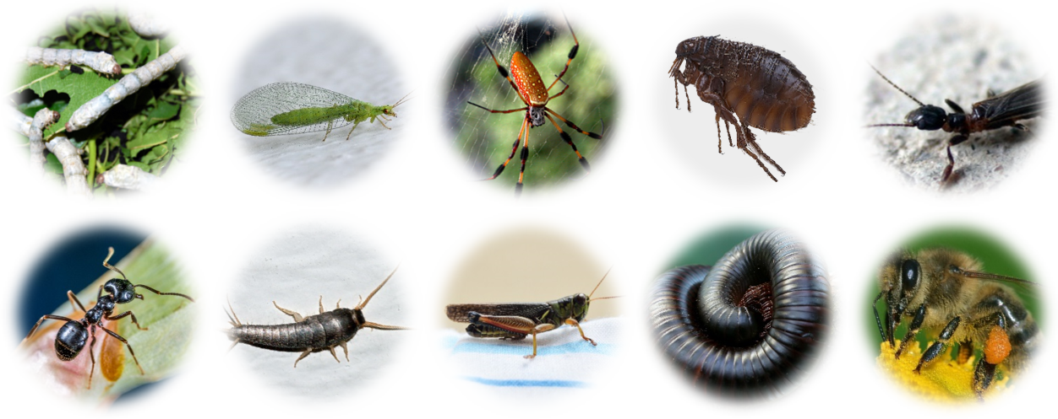
Figure 1: Common silk producers.
Silks are used by a wide range of arthropods for a multitude of diverse functions. The above graphic illustrates this diversity, depicting (from top left) recognisable silk producers such as silkworms, lacewings, spiders, fleas, web spinners, ants, silverfish, crickets, millipedes and bees. Photo credits: see appendix.
The fabric most commonly recognised as silk is produced by the Chinese silkworm Bombyx mori⁵. Breeding B. mori was a closely guarded secret for millennia until it was smuggled into Europe by Christian missionaries in 550 AD⁷. The importance of silk in earlier civilisations is evident in both the extent to which the secrets of sericulture were guarded, and in later industrial development, which used silk as the basis of textile comparisons (The Denier, a measure of linear density, uses silk as its reference⁸).

Silkworms
B. mori has been bred to maximise the yield of pure white silk and remains a major industry today, though experimentation with other species, such as Samia spp., has occurred with the aim of finding species better suited to northern Europe. However, unlike B. mori, their silk is less easily processed, and must instead be carded, which reduces lustre and produces less valuable fibres⁹.
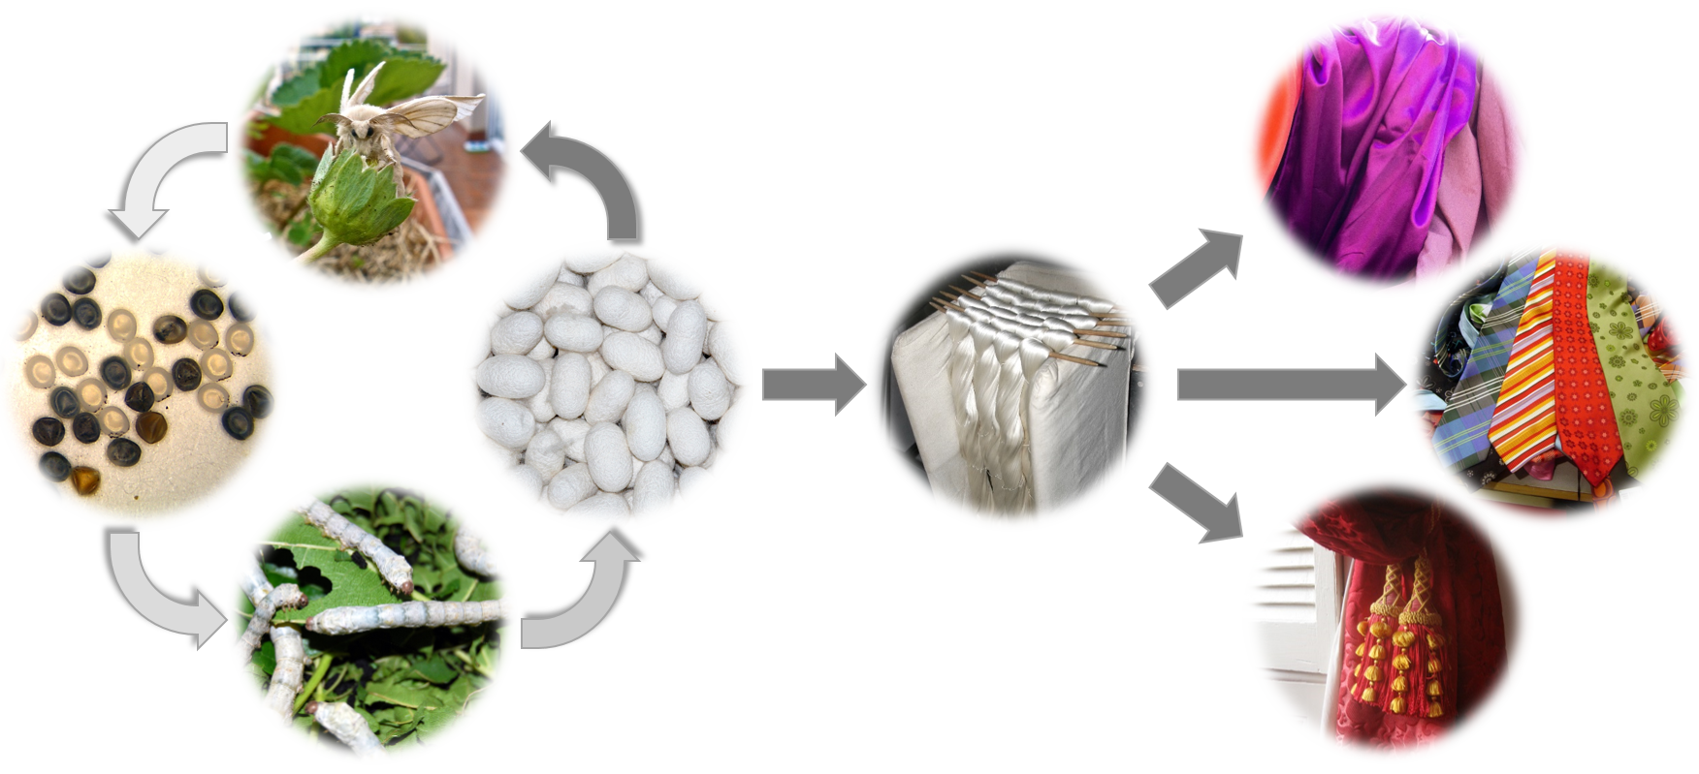
Figure 2: Lifecycle of the silkworm B. mori.
The natural cycle of the silkworm is depicted from egg to moth, with silk threads extracted from the spun cocoons woven into a wide range of textiles including shirts, ties, and curtains. Photo credits: see appendix.

Silkworm use silk to create a protective cocoon for pupation. They are constructed from the outside-in using a single strand of a fibrous protein known as fibroin. Fibroin is expressed in two silk glands, and can account for up to 30% of a silkworm’s mass¹⁰. As fibroin flows through the gland, it is coated in a secondary sericum (Latin for silk) protein known as sericin—before joining the paired gland to produce a twin cored fibre^{11,12}. Different species produce silks with distinct chemical compositions, cross sections, and cocoon shape, which appear optimised for their function and habitat^{4,13–17}.
Figure 3: Anatomical overview of the B. mori silk gland.
B. mori spinning apparatus, highlighting the gland surrounded by the haemocoel. Flow direction is indicated by arrows. The gland is described in detail in figure 7.

Spiders
While the majority of species produce a single silk that is well adapted, via natural selection, for a specific task⁴, spiders are unique in producing multiple silks. At present, over 40 000 spider species have been recognised, which collectively produce over 150 000 different silks⁶. Their ubiquitous nature has resulted in numerous myths, legends and folk tales. In fact, their classical name—arachnid—is derived from Arachne, a skilled weaver in Greek mythology¹⁸. Spiders produce silks for different applications within their lifecycle that must be optimised for function, since they have a uniquely high energetic demand^{4,5,8}. Taxonomic convention describes seven different gland types^{19,20}, with different species possessing some or all of the glands in varying quantities (figure 4). Of these seven sources, it is major ampullate silk from orb weavers such as Nephila spp. or A. diadematus that proves most attractive due to its combination of strength, toughness and extensibility⁵. Spider dragline silks are finer than silkworm silks, with a diameter of 3–5 µm compared to 20–30 µm respectively^{8,21,22}, and typically consist of a single core^{4,11,20} rather than the dual filaments formed by silkworms.
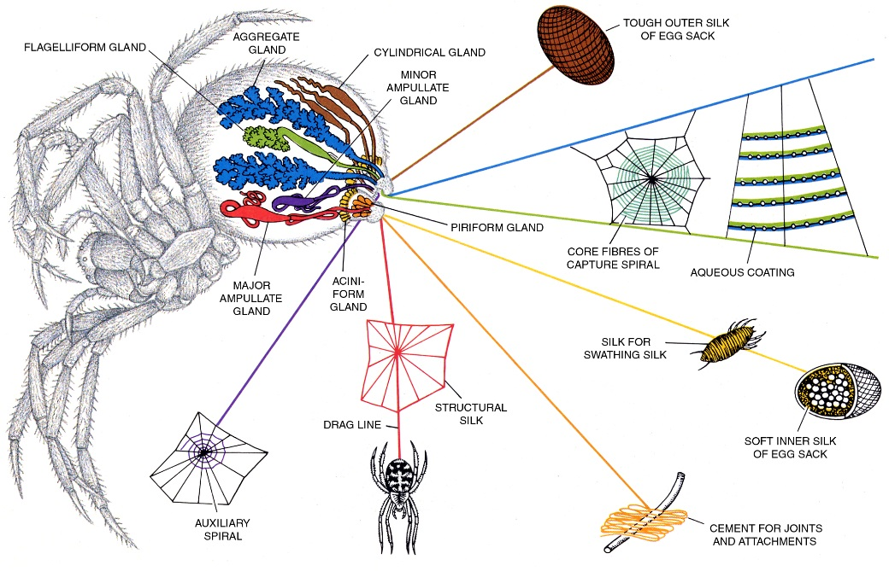
Figure 4: Spider silk glands and their functions.
Orb weavers such as Nephila spp. spin different silks from independent glands located in their abdomen. Each silk is optimised for a specific function, whether that be for security, web construction, prey-wrapping, egg protection or an adhesive applied to capture threads in the web itself. Image credit: Natural Materials Group Library.

Major commercialisation of other silk producers has thus far proved impractical³. Although there have been sporadic ventures such as Termeyer’s reel²³—used to harvest spider silk from live specimens—none proved commercially viable due to their small yield^{8,24–26}. Although Bon produced threads both stronger and finer than silkworms and used them to weave gloves and stockings, the carded nature of the thread reduced the lustre and the results were discredited by Reaumur, who summarised that they were inapplicable to any purpose of commercial utility, a statement which effectively halted any further investigation³.
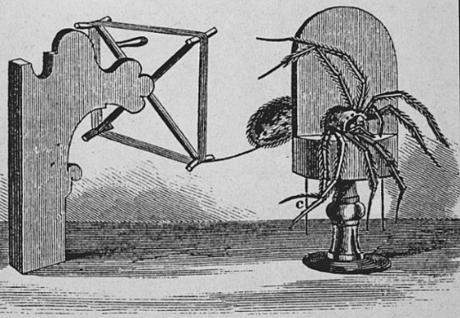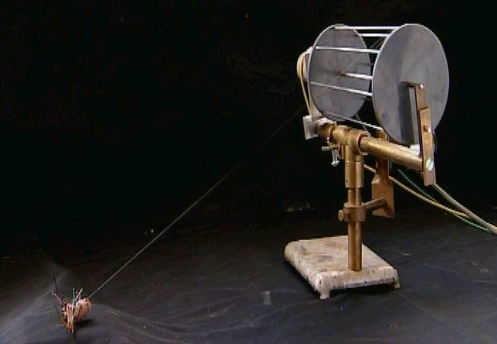
Figure 5: Extracting spider silks.
Termeyer's Reel^{27,28} (left) was used to forcibly pull silk from spiders in a manner which has changed little in the intervening 200 years, as evidenced by the modern reeling device shown (right) for comparison (adapted from NMG library). Forced reeling is discussed in depth below, and in chapter five.
The main obstacle in rearing spiders is that they are cannibalistic in close confines²⁹ and thus must be kept in relative isolation^{30,31}, resulting in a system with much larger space requirements than B. mori, whose dietary interests lie solely in the leaves of the mulberry tree (see chapter five). Furthermore, while silkworms produce a single 900 m strand of silk, a typical spider’s web yields only around 12 m of fragmented strands and although forced reeling can produce longer fibres, their length depends on the spider’s reserves²¹. While silk production by spiders may seem paltry in comparison to B. mori, it reflects the difference in usage between the two species; spiders maintain a steady reserve for regular, periodic deployment, whereas silkworms stockpile for a single event.

Mechanical properties
The mechanical properties of silks are a function of their chemical composition, microstructure, chemical and mechanical processing^{4,6,32–35}, resulting in a wide range of potential properties— summarised in figure 6. Some silks, such as spider major ampullate, exhibit remarkable strength and toughness^{4,21,36,37} as a result of needing to withstand large forces for short time periods³⁸,but this is offset by a reduced yield of narrower diameter fibres when compared to silkworms^{29,31}. Silk’s high toughness is attributed to a considerably higher molecular weight than synthetic fibres, allowing for greater extension, alignment and molecular level energy dissipation before fracture occurs^{5,11,33,34,3911,40}. From a biological perspective, for spiders, this dissipation prevents recoil and loss of prey⁵.
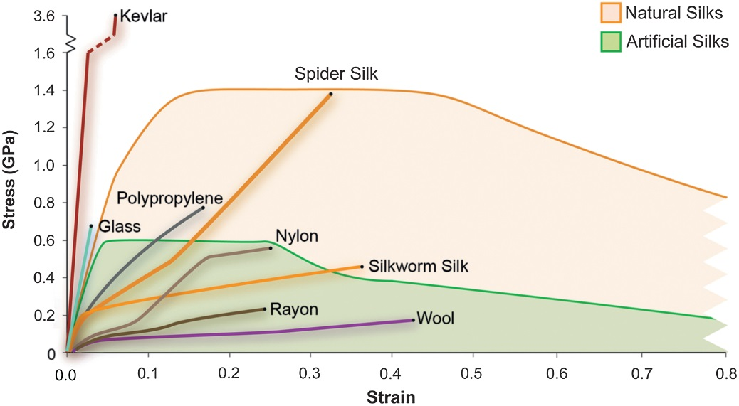
Figure 6: Stress-strain relationship for a variety of silks and other benchmark materials.
Of particular interest are the shaded regions denoting natural and artificial silks, whose stress-strain relations can be found right across their respective regions. It can be seen that spider silks gain their toughness through extension, and in their natural state are clearly unsuitable substitutes for Kevlar, whereas Rayon and Nylon have much more similar properties to the silkworm silks they were originally designed to replace. More specific properties of natural and artificial silks are discussed later in this chapter. Figure adapted from Vollrath et al.⁴¹.
When compared in ambient conditions, silkworm silks are naturally weaker, stiffer and more brittle¹¹ than spider silk, however their properties can be raised to comparable levels through forced reeling²¹ (see chapter six) Several attempts have been made to improve the mechanical properties of silk fibres, from simple post drawing^{42–44}, which has been shown to reduce entanglement, increase crystallinity, and reduce extensibility; pH change^{45,46}; and doping with zinc, aluminium, or titanium, all of which produced weaker fibres⁴⁷.

Why study silk?
There are many reasons to study silk, the most prevalent of which is that despite its use for thousands of years, relatively little is known about it compared to other materials in common use today. This is surprising, given the insights gleaned from comparatively basic and/or limited studies that show that silks possess a uniquely interesting and potentially incredibly useful set of material properties.
Perhaps one of the most fascinating and contemporarily relevant facts is silk production (feedstock to fibre) is approximately one thousand times more energetically efficient than our best synthetic alternatives^{6,48}. While we produce our polymers at high temperature and pressure, using environmentally unfriendly chemicals in the process, silk producers achieve much the same result in ambient conditions, with low energy input and with the added bonus of inherent biodegradability⁴. Thus by studying how silk is produced in its biological environment, we can guide the development of our own synthetic analogues.
The driving question behind this research is summarised succinctly by Ridley⁴⁹, who states that Evolutionary systems are only energetically optimised as they need to be, not necessarily can be. And thus the question arises, can we improve them?

Microstructure and chemical composition

Overview
Silks are long chain fibrous proteins comprising mostly glycine, alanine and serine^{8,11,44}. The homogeneity between the primary structure of most silks suggests that there is a shared set of parameters for spinning⁵⁰. However, it is the secondary structure that determines silk’s mechanical properties and the wide variation herein provides tremendous inspiration for novel biomaterials⁵¹. The relative abundance of α-helix, β-sheet and random coil conformations determines whether silk remains a thick, viscous substance, or becomes a strong, tough fibre when spun¹. The spinning process—through shear induced alignment and increased acidity^{50,52}—promotes polymerisation^{34,53} and the creation of a well-connected hierarchical anisotropic network which operates across multiple length scales^{34,54}

Primary structure
The primary structure represents the amino acid composition and distribution within the protein chains. The N- and C-terminal domains, which allow the proteins to form natural polymers, are highly conserved across all species^{53,55}. While the C-terminal affects stability, aggregation and the formation of β-sheets, the N-terminal affects protein expression, solubility, and promotes fibrillation⁵³. By contrast, the protein’s midsection dictates its mechanical properties²¹. Interestingly, more functionally advanced silks typically contain simpler, more flexible chain segments⁴, with the high percentage of alanine and glycine in highly conserved repetitive regions thought to prevent premature aggregation^{8,53,56,57}. Spider silks generally have a higher proline content than silkworm silks, which contain more serine. Proline’s hydrophobicity affects how silk responds to moisture⁴ and, therefore, its structure. At present, little is known about the function of other amino acids in silk, which could be important in the design of novel tailored proteins^{51,58,59}.

Secondary structure
In the first instance, silk proteins take on a metastable micellar structure⁶⁰ which allows them to protect their hydrophobic central regions²¹ and remain water soluble. Flow within the duct deforms and elongates this micellar structure until the chains become sufficiently stretched³⁴ to allow the secondary structure to adopt a mixture of random coils, α-helices, or β-sheets^{11,16,32,61,62}. In the absence of stress, the feedstock is predisposed to return to its metastable state, on the condition that it remains sufficiently hydrated^{21,43,59}. Current models describe many small β-sheets embedded within a larger amorphous structure³⁹. These β-sheets are hydrophobic^{39,44} and axially aligned⁶³, whereas the amorphous sections are plasticised by water, which prevents further hydrogen bonding³⁹. It is this combination of order and disorder across multiple length scales which gives silk its outstanding mechanical properties^{39,64,65}.

Silkworm silks
The high prevalence of small amino acids such as glycine, alanine and serine in fibroin allows for more densely packed crystalline regions than spider silks⁸. B. mori fibroin exists as a heterodimer of heavy (H-fibroin) and light chain (L-fibroin)¹⁵. Whilst L-fibroin is small, typically around 26 kDa^{8,21}, H-fibroin forms larger ~350 kDa chains with highly conserved repetitive central regions composed almost entirely of glycine-alanine repeat units and a small serine component which combine to form the predominant (~66%¹⁶) β-sheet conformation^{66–68}. Meanwhile, sericins have very few repetitive regions which results in an indefinite, globular structure and sizes ranging from 24 to 400 kDa^{69–72}. The concentration of non-polar amino acids is higher further back in the gland, while polar and neutral ones decrease, meaning that the closer the sericin is to the fibroin, the closer their compositions become^{16,69,71,73}, which may ensure good levels of adhesion between core and sheath.

Spider silks
Spider fibroins—spidroins—are the main constituent of spider silks. Major ampullate Spidroin 1 (MaSp1) forms the core of dragline silk, while MaSp2 provides a coating above this^{11,21,53,74}. While some studies have suggested that gland provides an opportunity for mixing proteins to provide a continuous fibre^{4,44,75}, this seems at odds with evidence of a MaSp1 core coated in MaSp2 sheath^{50,52}. Both proteins feature extensive repetitive glycine and alanine rich mid-domains⁸ and typically have molecular weights between 250 and 350 kDa^{21,76}. While MaSp1 protein’s high polyalanine content⁵⁰ provides stiffness, MaSp2 is less so and thus provides a contrasting toughness⁴. The strongest spider silks contain 45–65% β-sheets^{21,44} within a matrix of α-helices⁴. Amorphous regions exist in a reduced level of hydration under normal conditions, which maintains their alignment⁵. Comparisons of crystallinity have found that crystallites in spidroins are both an order of magnitude smaller and less oriented than those in fibroin²¹. It has been suggested that spidroins’ 1:1 ratio of hydrophobic: hydrophilic residues³⁴ is optimised to avoid aggregation⁵³.

Silk processing

Natural silk processing
It has already been noted that silks are produced on demand by many species—that they exist in an internal state of readiness⁴³. In this section we will discuss synthesis and processing in greater detail. Silk production systems have similar overall architecture, consisting of a feedstock reservoir, a spinneret (figure 7), and a connection between them, which can, depending on both use and species, vary in complexity from a simple tube to a series of concentric, convergent channels⁴.
Spiders and silkworms lay down silk threads in a similar fashion, fixing a point along a fibre to a substrate and drawing the spigot away from this point to pultrude the nascent fibres. Spiders can also use their legs for additional processing or to generate longer fibres in a static position, but silkworms are limited to a rhythmic figure-of-eight looping of the head in combination with regular substrate reattachment to produce their cocoons.
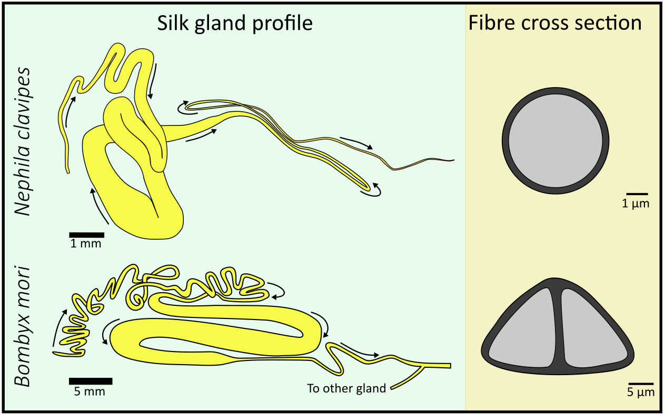
Figure 7: Spider and silkworm silk glands.
Both glands have a similar structure, with silk proteins expressed in the narrow, twisting posterior section (left), stored in the large central division, and spun through a spinneret in the anterior portion (right). Flow direction is indicated by arrows on each gland. The approximate cross section of spun fibres are also shown to highlight the differences between these silk producers. Figure adapted from Holland¹⁰.
Silk proteins are excreted into a reservoir and stored as a highly concentrated (20–50%) aqueous solution^{4,6,21} which is spun into a solid fibre through energetic input from a variety of sources, including shear flow⁷⁷, extensional flow⁷⁸, pH changes and heat^{4,11}. This combinatorial processing mechanism allows silk producers to spin fibres with consistent mechanical properties despite variation in diet, temperature, pressure and hydration^{11,79}. Shear and extension are induced by the taper of the gland duct, which has evolved to promote both lateral and axial ordering⁴³; while pH regulation is made through ion exchange⁵⁹, promoting refolding and reducing the shear required⁵⁹. The result is that molecules are inclined to bond in an intermolecular rather than an intramolecular fashion, thus forcing water expulsion and aggregate formation^{21,80}.
Spinning a fibre may be considered to be the controlled denaturation and aggregation of a polymer feedstock in a manner which ensures intermolecular interaction—in this sense, the resultant output can only be considered a fibre in so far as there is hierarchical alignment from the molecular level upwards in the principal fibre axis.
This argument, which is discussed in detail in chapter six, allows us to differentiate between the different forms of energetic input, since although silk can form a solid by heat alone, it is bereft of the alignment and structure which can be induced through flow or condition changes and thus cannot be considered as a method of fibre production.

Un-natural silk processing
Forced reeling allows greater control of the pultrusion process than natural spinning as it fixes the rate and time at which silk is drawn from the host. Early work by Termeyer and Rolt showed the field’s potential^{29,31,81}, and although the process is labour intensive and time consuming, it does allow for systematic analysis. Natural spinning rates for spiders and silkworms are similar, and appear to have been selected to optimise toughness⁸².
Reeling faster than this is effectively post-drawing³⁸, with stretching providing increased alignment in the fibre as it solidifies under tension^{38,83,84}, resulting in a stronger, thinner^{37,82}, less elastic fibre (Spider silks may be annealed via supercontraction^{38,85–87}). At higher rates, the drawdown locus moves sufficiently back in the gland that the control valves fail, resulting in larger diameter fibres^{43,83}. Moving the locus in this way produces weak fibres which are prone to fracturing internally, which will halt spinning temporarily in spiders^{43,82}, and permanently in silkworms^{11,16,37}.
Paralysis removes behavioural aspects such as the effect of the silk press—which maintains fibre diameter and consistency—from silk processing. Fibres drawn from paralysed silkworms are stronger, thinner and less elastic than natural ones, and have smoother external surfaces^{46,82}. However, despite the increased processing control forced reeling offers, it does not provide free reign over silk production, and so investigators have turned to methods which allow them to create silk fibres directly using synthetic silk feedstocks.

Synthetic silk processing

Introduction
Attempts to spin directly from extracted feedstocks were first made in the early 20th century, and the general observation from the past century is that as silk feedstock has been selected to dehydrate and aggregate with minimal input, it tends to do so under the slightest provocation—for example during dissection—and thus extraction and handling is something of an art form in itself. Combine this with the fact that it will denature spontaneously when in contact with air, even when refrigerated⁴³; that it will separate at interfaces and coagulate irreversibly^{88–91}, and that it is a living, variable system, and it is clear that experimenting with silk can be a test of patience. However, as the principle aim of the synthetic fibre industry—producing a range of fibres, each tailored to an individual application—has already been achieved by nature (figure 4), silks remain worthy of further attention⁸. Beyond direct extraction, there are two further methods for creating synthetic feedstocks—reconstitution and recombination, and although they follow different procedures, both result in a protein solution.

Reconstituted silk fibroin
Fibroin can be reconstituted from its spun state by first soaking in hot alkaline solutions to remove sericin residues—a process made possible by their high proportion of hydrophilic amino acids^{73,92–94}. After sericin removal, the remaining fibroin can be dissolved in certain chaotropic solvents. The solvent used affects the degree to which the polypeptide chains are fractured^{15,95–97}. Chain length correlates with stability, storage time^{15,16} and the ease of β-sheet formation when the feedstock is sheared, with smaller chains more likely to form random coil structures. Environmental factors such as pH, exogenous salts, and concentration also affect feedstock stability^{98,99100}.
In general, reconstituted silk fibres are shorter and stiffer⁴⁴ than natural⁵³, with lower strength and toughness as a result⁵¹ (figure 6). Longer chains create stronger fibres via more extensive bond formation within the network domain. By contrast, short chains have a tendency to dangle within the network and, therefore, cannot contribute to overall structure³⁴. Despite this, recent studies have spun fibres with toughness approaching that of natural fibres, although this is partly due to the greater levels of extensibility which arise in the absence of post-processing⁵². Others have created custom length polymers that can be used to create fibres with strength approaching 20 GPa³⁴. In summary, the primary structure of silk alone is insufficient to determine the mechanical properties of the resultant fibre, and reconstituted silks are generally inferior to those produced naturally from the same feedstock²¹. This notwithstanding, it does provide a valuable commodity for the biomedical fields, which would otherwise be wasted in the textiles industry^{101,102}.

Recombinant silk proteins
Many studies have tried to express silk proteins in hosts including Escherichia coli¹⁰³, Pichia pastoris⁵⁸, and transgenic goats². However, appropriate rheological conditions and physical stresses have proved difficult to replicate in vitro⁵³. These proteins are typically concentrated and extruded into a coagulation bath to form fibres⁵⁸. There are still many problems to overcome with these techniques, as recombinant proteins are considerably shorter than their natural equivalents⁵³ and at higher concentrations, or when pumps are required, aggregation becomes problematic^{52,53,58}, with established techniques¹⁰⁴ unsuitable for large proteins⁵⁸.

Potential uses for silk
Silk, as a natural, biodegradable, biocompatible material, has potential uses in a wide range of fields beyond clothing²¹. Silk has found a home in the cosmetics, skincare^{21,71} and food additive³ industries, where its non-essential amino acid composition allows the use of creative marketing to sell products using words typically used to describe silk cloth—such as bright, soft, glossy and silky²¹. Silk is a nascent material in the biomedical sciences, where its biocompatibility has allowed it to be deployed in a wide range of situations including wound dressings, where its super-contractive nature provides increased tension in sutured tissue⁵¹; and soft tissue scaffolds which benefit from long term degradation resistance^{6,21,68,71,105,106}.
In summary, although production of artificial silk does threaten traditional sericulture, the knowledge gained vastly outweighs this cost, due to the increased variety in silk products. In 1960, Lucas noted that the further study of different silks will almost certainly help us in the quest for tailor-made protein fibres⁸. This should translate to significant energy savings in the synthetic polymer industry, while advances in our understanding of the mechanisms behind the fibrillation of fibrous proteins could help tackle amyloid degenerative illnesses such as including Alzheimer’s, which are believed to occur as a result of unwanted fibrillation¹¹.

Scope
The difficulty in artificial replication of natural silk spinning suggests that the process is complex, with multiple latent mechanisms in synchronous operation. The isolation and exploration of these mechanisms provides the scope for this thesis. Over 150 years of dedicated research has yielded a considerably better understanding of how silks are spun, but areas remain which have either been previously overlooked, or the tools required to tackle them had not yet been developed. The most active area of research remains reconstitution—the art of returning a previously spun silk to a liquid state in order to re-spin in a more industrially appropriate manner. Although progress is being made in this respect, at a fundamental level, it does not improve our understanding of the natural system.
Prior attempts to explore silk flow were hampered by a lack of understanding of silk’s rheology, and by the computing power available. It is thus good fortune that we find ourselves both at the end of a sustained period of research into silk’s flow properties and at the advent of much improved computational methods which provides ample opportunity to address this problem.
The traditional view of sericin as a waste product has meant that little consideration has been given to it, barring the best methods for removal and disposal. As a result, what thought applied to its role in the spinning process has been primarily that of conjecture, not least due to the difficulty of isolating the protein in its native state. The greater availability of mutant silkworm strains arising from increased interest in genetic modification thus provides a serendipitous chance to explore the nature and function of these often overlooked proteins.
Several discussions in the literature consider the precise nature of fibrillation mechanisms, offering evidence that gelation can occur through different means. While silk’s flow behaviour has been extensively characterised in terms of its response to increasingly large shear rates, little time has been given to the length of application, or how different gelation methods may interact to spin fibres.
These knowledge gaps have provided scope and direction throughout this thesis, leading towards an improved understanding of the flow properties of native silk proteins, which should further the design of both bioinspired and biomimetic fibres. The overarching themes addressed herein can be seen as seeking answers to the following broad research questions.

Aims
- Can reliable predictive flow models be created for silk which afford us the opportunity to explore design variables for synthetic analogues?
- What are the rheological properties of sericin and how do they affect silk spinning?
- What are the energetic requirements for silk spinning—what forms can this input take, and which are critical?

Chapter summaries
This thesis is arranged in chronological order in seven parts. A brief summary of each is presented here, with more detail provided in each chapter introduction.

Chapters 1 and 2
These chapters summarise relevant literature pertaining to both the historical and contemporary understanding and use of silk and silk-like materials, before discussing the major techniques used in this thesis—computational fluid dynamics and rheometry.

Chapter 3
This chapter describes experimental work undertaken to verify earlier simulations, and extends them using a biologically focussed approach to provide computationally derived evidence that silk is pultrusion spun. This chapter forms part of the first paper published from this thesis—Analysis of the pressure requirements for silk spinning reveals a pultrusion dominated process¹⁰⁷.

Chapter 4
In chapter four, several methods to support and corroborate the pultrusion hypothesis offered in chapter three are presented, describing why extrusion cannot be the dominant process in silk spinning. This validates the results in chapter three and comprises the latter half of the publication—Analysis of the pressure requirements for silk spinning reveals a pultrusion dominated process¹⁰⁷.

Chapter 5
This chapter describes the characterisation of native sericin extracted from a mutant strain of the B. mori silkworm. It details amino acid composition and spectroscopic responses, along with rheological responses from shear, oscillatory and temperature tests to provide an appropriate model for sericin flow behaviour, and a frame of reference for the sericin recovery industry. This chapter has been published as—The rheological properties of native sericin¹⁰⁸.

Chapter 6
This chapter describes fibroin’s response to steady shear. It is based on the hypothesis that silk gelation is best described by how much energy has been imparted, rather than how fast, how hard or how long it has been sheared, it describes how native fibroin feedstock gels as a result of total accumulated work within the sample. This chapter has been published as—The energy requirements for flow induced solidification of silk¹⁰⁹.

Chapter 7
This chapter provides an in depth, rambling discussion of the implications and findings presented in my thesis. It seeks to contextualise my findings in the wider field of silk research, and offers suggestions for where future attention might be best directed.

Chapter 2

Methods

Introduction to rheology
One of the principal techniques employed in this thesis is rheology, which is the study of how materials flow and deform. In this chapter, a brief summary of the method is provided for ease of understanding future chapters. The field of rheology generalises and combines the classic theories governing the deformation of a solid or flow of a fluid under the influence of stress^{110,111}, with the name itself taken from a quotation attributed to Simplicius—panta rhei—which loosely translates as everything flows. We will now discuss how the material properties elasticity and viscosity—commonly used to denote springiness and stickiness¹¹⁰—are in truth, part of a wider property spectrum known as viscoelasticity (figure 8).
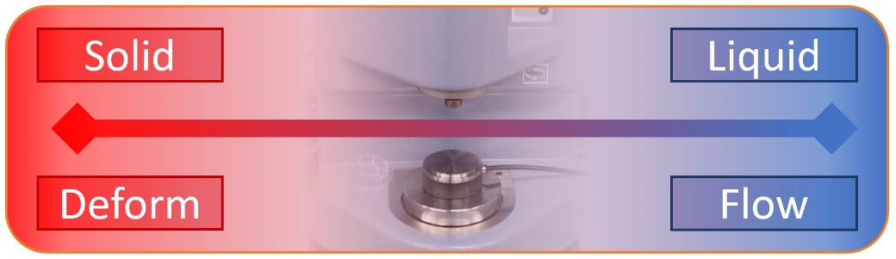
Figure 8: The viscoelastic spectrum.
Real materials occupy a continuum from solid to liquid, with their position defined by their tendency to deform or flow as a result of stress. This response is often time dependent and can be readily probed with a rheometer.

Elasticity, viscosity and viscoelasticity
Elasticity describes the tendency of an object to return to its original shape after the removal of an applied stress or load, and is a key property of ideal solids. This stress can be applied to solids in several ways, including tension, compression, torsion, or shear; fluids however, can only be sheared¹¹¹.
Viscosity is a measurement of a material’s ability to resist the shear induced plastic deformation known as flow, with ideal fluids showing entirely viscous behaviour. Commonly envisaged as the degree of intermolecular friction, it is a function of many variables, including temperature, pressure, time, electrical voltage, shear rate, and chemical or physical structure¹¹¹.
Although the above definitions state that solids have an elastic, and fluids a viscous, response to shear, this only applies to ideal materials. In truth, the majority of materials lie somewhere between these two extremes, and conditions can generally be found wherein a material will behave as an elastic solid, a viscous fluid, or anywhere in between. Thus, most materials can be classed as viscoelastic, with even seemingly solid objects—such as steel and glass—flowing under sustained loading through phenomena such as creep.

Shear rheometry
Rheometry is the technique by which the rheological properties of a material are measured, and is typically conducted using a rheometer. While there are several different designs available, the fundamental principle remains the same. Samples are placed between two surfaces and the force (stress) required to move one surface a set distance in a given direction (strain) is then measured, and from these values significant insight can be gained.
From an analytical perspective, the simplest rheometer would consist of a flat plate translating above a second, fixed plate. For practical reasons, such as the ability to consider effectively infinite strain in a finite space, rotary motion is preferred. However, since the velocity of a rotating object is a function of the radius, samples subject to rotation between two parallel plates would be subject to a range of shear rates. To counter this effect, the moving plate is substituted for a cone with the slant height determined such that it provides a constant shear rate across the entire radius, with torque and displacement being the measured values.
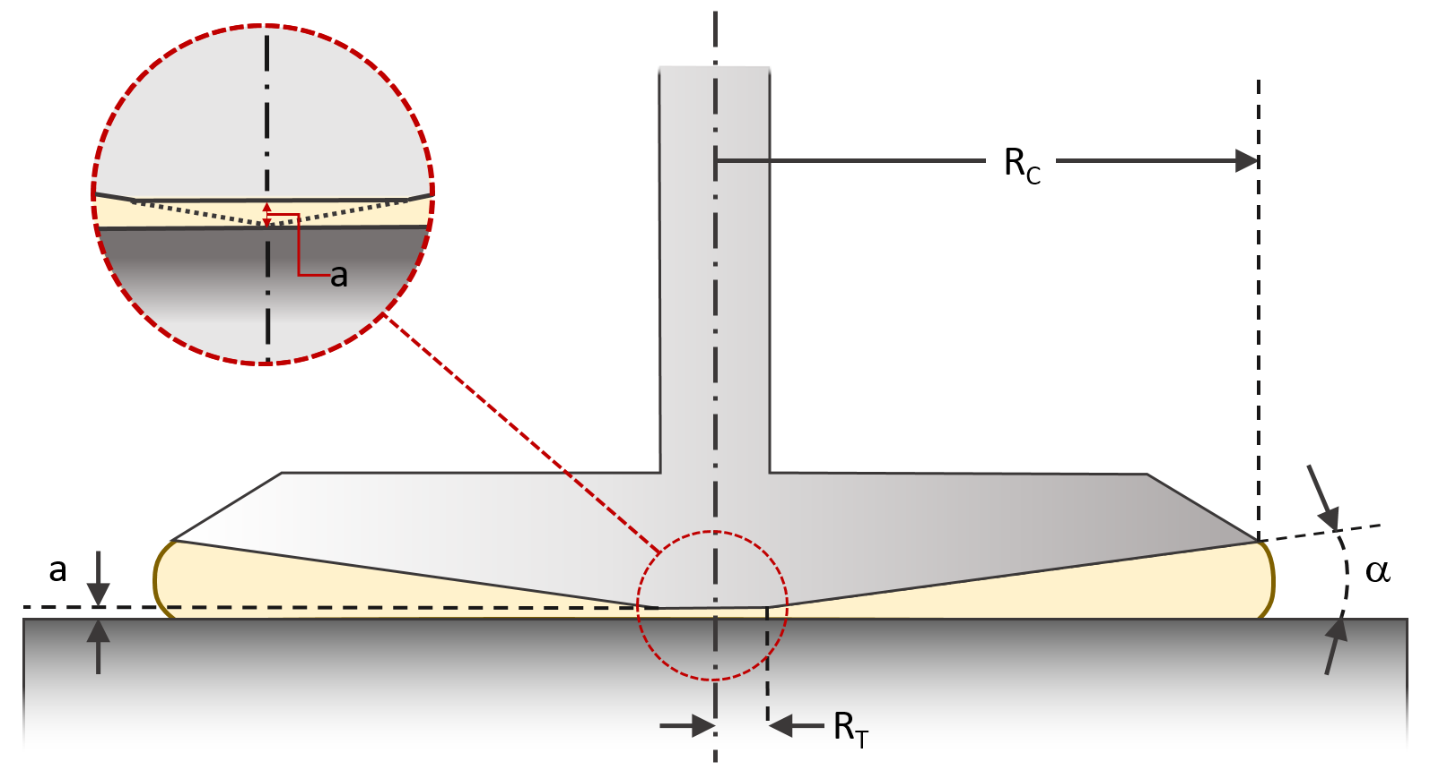
Figure 9: Critical components of a rotary rheometer.
A sample is compressed between the upper rotating cone (radius R_{C}), and the fixed lower plate. Cone angle α is dependent on R_{C} and is specified to ensure constant shear rate across the region of interest. The highlighted region illustrates that the cone is in truth truncated by distance a so that parts are not touching and the sample is not pinned in place. Some error is induced by this, since the shear rate is variable in region R_{T}, but this is small (1–5%).

Dynamic shear rheometry
Dynamic shear rheometry considers the phase difference $δ$ between a small applied strain$γ(t)=γ_{0}\sin\left(ωt\right)$ and a resultant stress$τ(t)=τ_{0}sin(ωt+δ)$. In the case of a purely Hookean solid, there will be no phase difference, and the response is elastic, while for a Newtonian fluid, the phase difference will be at a maximum (90°), and the response purely viscous. Phase differences between zero and ninety degrees are thus viscoelastic. The total resistance of a viscoelastic substance to an applied strain is measured using the complex shear modulus, defined as:
$$G^{*}= G^{'}+ {iG}^{''}$$ | ( 1 )
where the storage modulus$G^{'}$, which represents the recoverable elastic response (${τ_{0}}/{γ_{0}}\cos{δ}$), and the loss modulus$G^{''}$, the dissipated, viscous response ( ${τ_{0}}/{γ_{0}}\sin{δ}$ ). The key point being that frequency of loading of a viscoelastic material affects the phase shift observed, which in turn results in variation of the complex shear modulus. In other words, whether the material acts more or less like a solid or liquid depends on the frequency of vibration (figure 10).
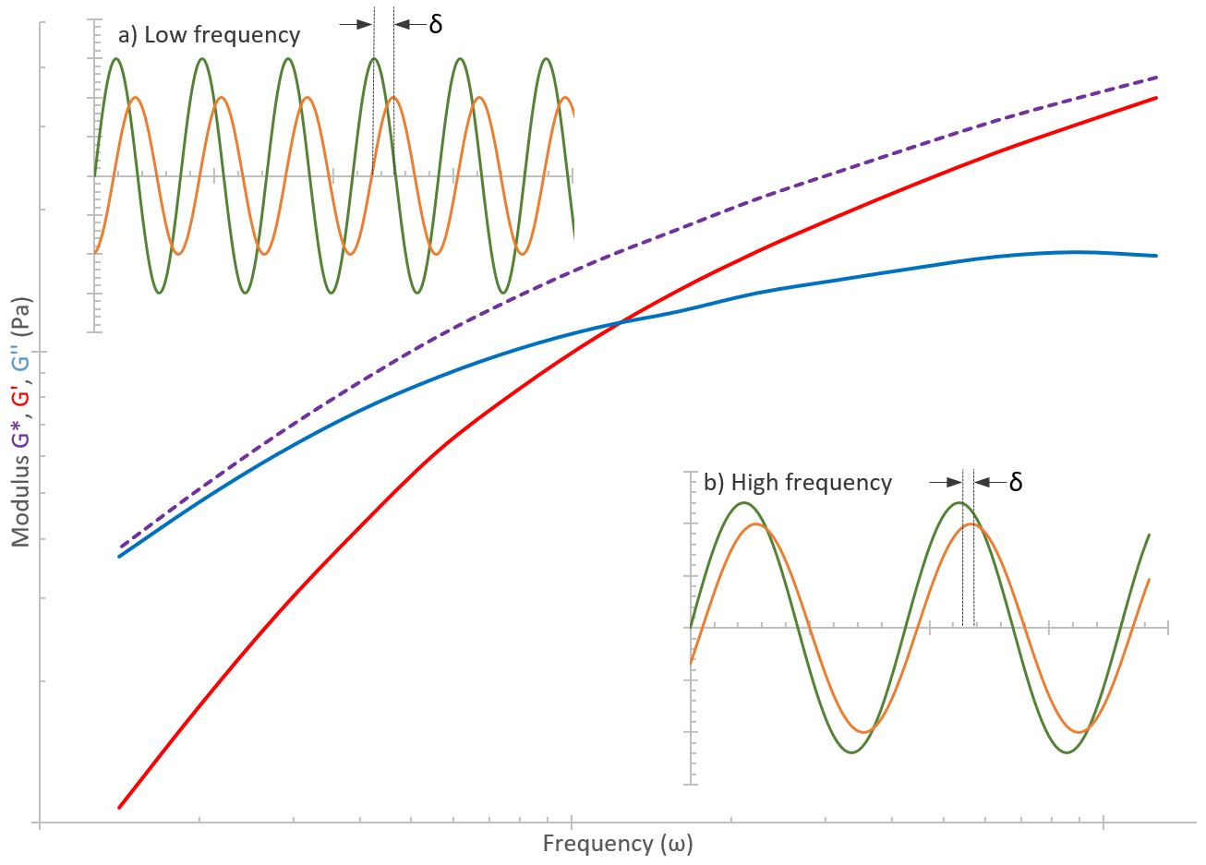
Figure 10: The frequency dependence of a material’s stress response.
A sample is oscillated across a range of frequencies at a set strain, with the stress response measured. The extent to which stress lags behind the strain gives the phase difference δ, which can range from zero (Hookean solid) to ninety degrees (Newtonian fluid), with the viscoelastic spectrum lying between them. Viscoelastic materials commonly exhibit timescale dependent responses, with the relative proportions of elastic and viscous moduli, which together comprise the complex modulus, dependent on the strain rate. A simplistic assessment is that bulk material properties are those of the dominant modulus. In this example, at low frequencies (inset a), the material behaves more like a fluid and flows (high δ) , but at higher frequencies (inset b), the elastic response dominates and the material exhibits more solid-like behaviour (low δ).

Viscometry
Under conditions where a material is sufficiently deformed to induce flow, there are two potential responses available. Newtonian materials show a linear strain response, whereas non-Newtonian materials have a non-linear response:
$$η(\dot{γ})=\frac{τ}{\dot{γ}}$$ | ( 2 )
Where $η$ represents the dynamic viscosity, $τ$ shear stress, and $\dot{γ}$ the shear rate. The most common non-Newtonian responses are shear thickening—where viscosity increases with applied shear rate, and shear thinning—where viscosity decreases with applied shear rate. These scenarios are depicted in figure 11.
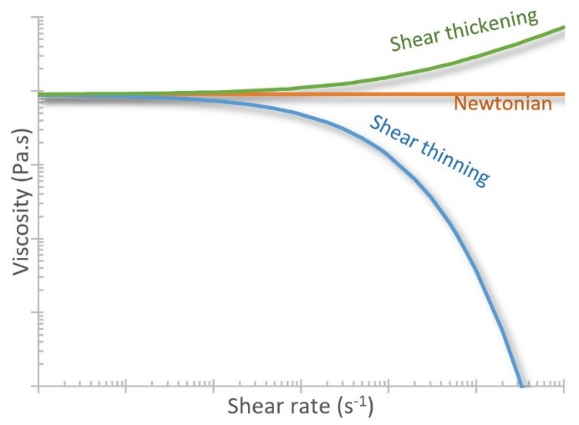
Figure 11: Viscoelastic behaviours as a result of different shear rates.
The application of increasing shear rates can prompt a range of responses in different fluids. While the viscosity of Newtonian fluids remains linear, that of dilatants and pseudoplastics appear distinctly different, with both exhibiting clear non-Newtonian behaviour—shear thickening in the former and in the latter, shear thinning. Silks are general classified in the latter, though their response does deviate from this idealised behaviour at high rates.
Many polymers undergo shear thinning between two plateaus, one representing the viscosity at zero shear, measured through extrapolation of low shear rate responses to dynamic (oscillatory) testing, and the other representing the minimum viscosity the material can achieve, measured through application of high shear rates. In general, shear thinning is reversible, though the return to the zero shear viscosity can be hysteretic¹¹¹, but whether this applies to silk remains unclear (more detail in chapters 5–7).
In low shear rate flow conditions, polymer chains are able to relax through Brownian motion, hence the observed behaviour is quasi-Newtonian, but there exists a critical shear rate at which the regime first diverges from Newtonian behaviour. At very high shear rates, viscosity plateaus as optimum molecular alignment is reached and therefore shear thinning materials have 2 Newtonian and one non-Newtonian region¹¹¹ (figure 12).
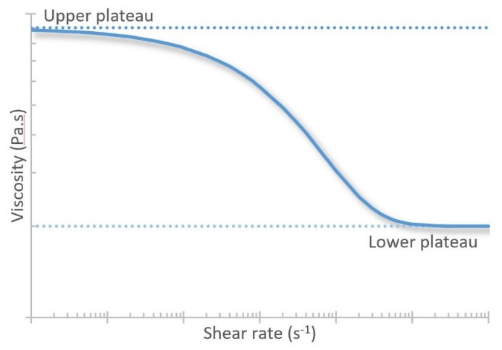
Figure 12: Typical shear thinning polymer behaviour.
The shear thinning behaviour of many polymer solutions is akin to the presented curve, which shows an initially Newtonian response under quasi-static conditions, which yields to shear thinning above a given shear rate, before returning to a lower Newtonian plateau beyond a second critical shear rate.

Rheological behaviour of silk
There is a high degree of evolutionary convergence across silk rheologies, which have much in common with synthetic polymer melts^{6,51}. In general, silks exhibit predominantly viscoelastic behaviour and are both extremely shear sensitive⁶ and strongly shear thinning^{11,22}, facts which frustrated early attempts to measure their viscosity⁴³. Their response to shear can be described in 4 stages (figure 13). Their initial state is quasi-Newtonian, with viscosities many orders of magnitude higher than, for example, water or oil. This gives them the appearance of a solid, but the application of shear to the system allows entry to the second state, wherein the feedstock shear thins substantially. Sustained shear eventually leads to protein aggregation (3) and formation of a strong, stable solid^{80,112} (4).
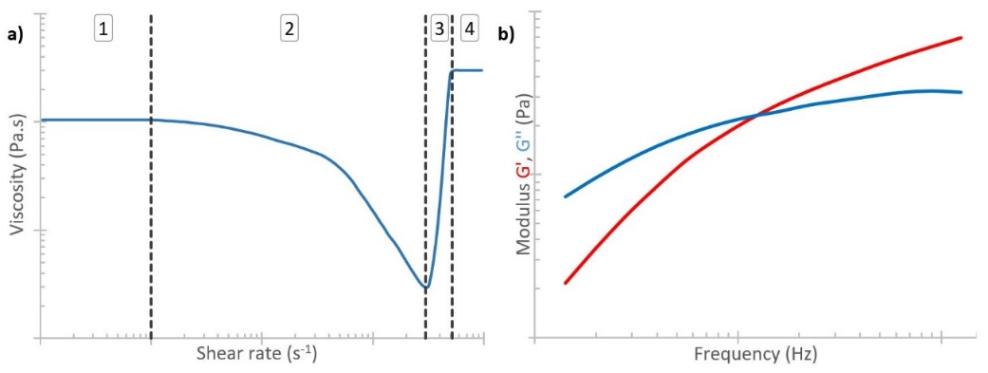
Figure 13: Silk Rheology.
(a) Silk’s response to increasing shear rates can be divided into 4 stages. 1—quasi-Newtonian, 2—shear thinning, 3—aggregation, 4—strong, stable solid. (b) Silk’s oscillatory response shows viscous behaviours dominate at low frequency, with a transition to elastic behaviour at higher frequencies.
It has been suggested that this shear thinning behaviour is an evolutionarily favourable development as it drastically reduces the system’s energetic requirements²². It is worth appreciating that, as with all natural systems, there is a wide degree of biological variation across species^{22,113}. Of note is that concentration has very little qualitative effect (figure 13a) on the rheological properties, suggesting that their constancy is vital to successful spinning¹⁴.
As with many non-Newtonian materials, silk’s oscillatory response is dependent on the frequency of oscillation. Probing this response has shown the frequency at which silk transitions from being dominated by viscous behaviour to elastic behaviour. This transition frequency represents the longest relaxation time, though further relaxation modes have been identified through more complex models^{114,115}.

Extensional viscosity
In addition to shear, silk proteins experience extensional flow in the converging duct^{78,116}. Extensional viscosity is a function of both extension rate and the total strain imposed and is thus a measure of resistance to elongation. The difference between extensional and shear viscosity is analogous to that between Young’s and shear modulus for elastic solids¹¹⁷. Extensional viscosity typically increases with total strain imposed, due to increased molecular elongation, alignment and solvent loss, thus it is a strain hardening property, and can be estimated from surface tension, duct radius, and time²². From this it can be deduced that while shear viscosity decreases by several orders of magnitude during spinning, extensional viscosity undergoes a greater than a hundredfold increase²², suggesting that shear thinning occurs to allow extension to dominate. Quantification of extensional flow properties are beyond the scope of this work, but it is hoped that work currently in progress in our group will determine how best to assess it and further our overall understanding of how silk is spun.

Introduction to computational fluid dynamics
Computational modelling uses numerical methods¹¹⁸ to address problems that cannot be solved analytically, either due to excessive complexity or the need for iterative solutions. In the last fifty years, computational modelling has come of age, allowing modellers to address the bane of numerical solutions—time^{119,120}. Increasingly fast processing speeds have allowed progressively more complex systems to be analysed and solved on a point by point basis¹²¹.
Computational Fluid Dynamics (CFD) is a branch of fluid mechanics that considers fluid flow within set boundary conditions, through numerical solutions to a set of governing equations^{120,122}. In brief, the process can be described in several distinct stages:
- Define the problem domain and create a representation of the system
- Divide the volume of interest into a mesh consisting of discrete elements
- Define the physical properties of the fluid and the boundary conditions at each interface
- Use numerical methods to determine approximate solutions to the governing equations
- Post-process the results to generate easily understood graphics

The generalised Navier Stokes equations
The system of equations used results from the combination and application of three governing principles—conservation of mass, Newton’s second law of motion, and conservation of energy¹²³. Their application produces a set of seven equations for viscous flow, composed of seven primitive variables (density, pressure, velocity in x, y, z direction, e, temperature), and thus distinct solutions are possible. They are presented here in their non-conservation form.
Continuity | $$\frac{Dρ}{Dt}+ ρ∇.V=0$$ | ( 3a)
Momentum (x) | $$ρ\frac{Du}{Dt}= - \frac{∂p}{∂x}+\frac{∂τ_{xx}}{∂x}+\frac{∂τ_{yx}}{∂y}+\frac{∂τ_{zx}}{∂z}+ρf_{x}$$ | ( 3b)
Momentum (y) | $$ρ\frac{Dv}{Dt}= - \frac{∂p}{∂y}+\frac{∂τ_{xy}}{∂x}+\frac{∂τ_{yy}}{∂y}+\frac{∂τ_{zy}}{∂z}+ρf_{y}$$ | ( 3c)
Momentum (z) | $$ρ\frac{Dw}{Dt}= - \frac{∂p}{∂z}+\frac{∂τ_{xz}}{∂x}+\frac{∂τ_{yz}}{∂y}+\frac{∂τ_{zz}}{∂z}+ρf_{z}$$ | ( 3d)
Energy | $$ρ\frac{D}{Dt}\left(e+\frac{V^{2}}{2}\right)= ρ\dot{q}+ \frac{∂}{∂x}\left(k\frac{∂T}{∂x}\right)+ \frac{∂}{∂y}\left(k\frac{∂T}{∂y}\right)+ \frac{∂}{∂z}\left(k\frac{∂T}{∂z}\right) – \frac{∂\left(up\right)}{∂x}- \frac{∂\left(vp\right)}{∂y}- \frac{∂\left(wp\right)}{∂z}+ \frac{∂\left(uτ_{xx}\right)}{∂x}+ \frac{∂\left(uτ_{yx}\right)}{∂y}+ \frac{∂\left(uτ_{zx}\right)}{∂z}+\frac{∂\left(vτ_{xy}\right)}{∂x}+\frac{∂\left(vτ_{yy}\right)}{∂y}+\frac{∂\left(vτ_{zy}\right)}{∂z}+\frac{∂\left(wτ_{xz}\right)}{∂x}+\frac{∂\left(wτ_{yz}\right)}{∂y}+\frac{∂\left(wτ_{zz}\right)}{∂z} + ρf.V$$ | ( 3e)
Thermal | $$p= ρRT$$ | ( 3f)
Calorific | $$e= c_{v}T$$ | ( 3g)
Despite their apparent complexity, the Generalised Navier Stokes Equations simply describe the progress of an infinitesimally small fluid packet (with known mass) through space (though they can be readily reformulated to consider the flux within an infinitesimal volume fixed in space^{120,124}).
Whereas older techniques were forced to use the finite volume method to overcome the complexities of fluid flow, the advent of modern processors means CFD can make use of the more mathematically complex finite element method to analyse problems in greater detail^{119,125}. One of the major advantages of the finite element method is that it allows division of the domain using a non-uniform mesh, such that regions of interest can be considered in greater resolution, while those far from the action can be simplified¹²⁴. Through consideration of the flow in each finite subdomain, approximate solutions to the flow problem can be determined iteratively.

CFD in biological systems
The use of CFD in biological systems is a relatively recent application^{112,126–129} in comparison to more traditional uses such as the aerospace¹³⁰ and automotive industries. It represents a departure from the more typical bulk flow properties seen at larger scales and instead progresses into the more constrained pipe flows first explored in food and chemical processing plant designs^{131,132}. The use of small diameter pipes of definite length means that certain flow phenomena, such as surface tension, roughness, and viscous effects, have much greater influence on the overall system¹³³. A welcome effect of small cross sections is that Reynolds numbers become exceptionally low in typical systems, which means that we have the luxury of working well inside the laminar flow regime, where computations converge more readily.
Simulation results presented in chapters three and four make the following assumptions unless explicitly stated. Flows are analysed in an isothermal environment, with outlets maintained at atmospheric conditions. Walls are assumed to be smooth, such that internal surface roughness does not affect flow, but are assigned a no-slip condition. That is, fluid in immediate contact with the wall is assumed to be stationary. These are standard assumptions in the study of viscous flow behaviour.
Meshing of the flow domains followed an iterative process for each geometry in order to ascertain the required mesh density, which was considered as that when results for a test fluid showed less than 5% variation. A similar threshold operated on the principles of mass conservation—losses over 5% were not tolerated and resulted in further refinement.
Simulation outputs arrive as vast matrices which require further processing to provide useful results. Typical examples of post processing might be two-dimensional surface plots of a variable such as flow velocity, contours of pressure levels, or vector plots to show flow and streamline directions.
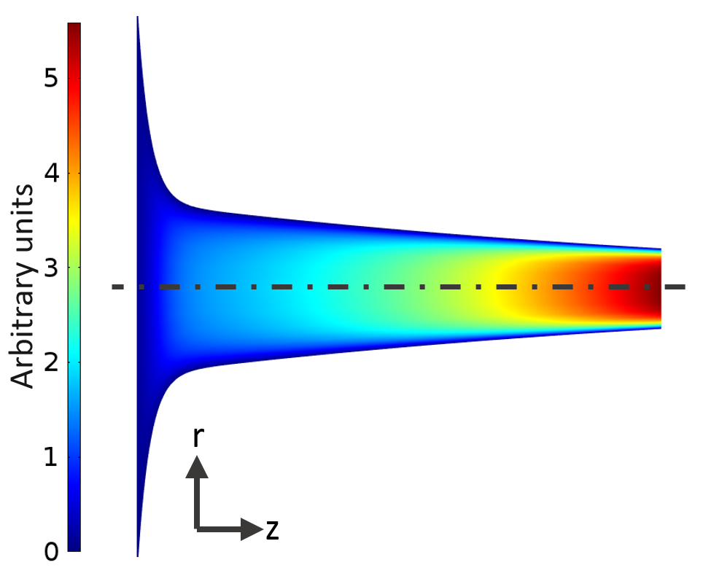
Figure 14: Exemplar surface plot.
Surface plots allow for easy visualisation of changes in a given variable, in this case velocity, shown through use of a colour gradient. In this example, flow is in the z direction.

While these plots are useful in early interpretation and assessment of model validity, since they readily show rapid changes in the geometry which often highlight the need to change the model’s geometry, or refine the mesh used, they do not provide much more than that. For deeper analysis, evaluation requires the consideration of a variable across the whole of the cross-section, or along a streamline from inlet to outlet. Examples of this might include average velocity along the duct (figure 15), determined by evaluating:
$$V_{avg}\left(z\right)= \frac{2π}{A(z)}\int_{o}^{R}{ur dr}$$ | ( 4 )
or the characteristic extension rate¹¹² (figure 15):
$$\dot{ε}\left(z\right)=\frac{{dV}_{centre}\left(z\right)}{dz}$$ | ( 5 )
which allows an (admittedly primitive) assessment of extension in the duct along the centreline (intrinsically the line of greatest extension, as furthest from the walls).
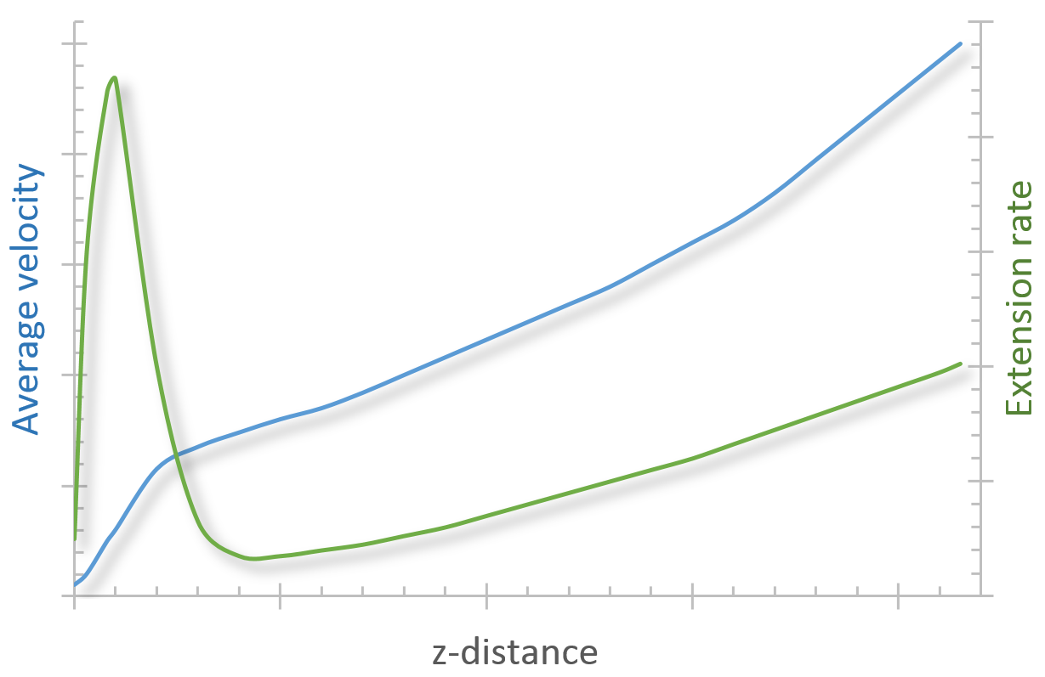
Figure 15: Exemplar post-processed results.
Average cross sectional velocity for the geometry shown in figure 14 calculated using equation 4, and extension rate along the centreline of the same geometry, calculated using equation 5.
Such figures are not comprehensive, but an example of the type of data which can be readily obtained from CFD simulation, further examples are available in chapters 3 and 4, and within the extensive body of work exploring CFD applications both in biological systems and beyond^{119,126–129,132}.

Chapter summary
In conclusion, this chapter builds on the introduction to the field offered in chapter one by providing knowledge of the tools needed to tackle the problems outlined in the scope. Discussion of the theory behind the methods here allows for a single reference point against which later chapters can be built upon, and avoids the need for tedious repetition of the same information. The details outlined here are not necessarily project specific, but general considerations in the realms of rheometry and CFD; with more particular elements of the methods discussed in detail when they arise in later chapters.

Chapter 3

Simulation
Abstract
In this chapter we use the Chinese silkworm Bombyx mori to review the pressure requirements for natural spinning and discuss the limits of a biological extrusion domain. This provides a target for finite element analysis of the flow of silk proteins, with the aim of bringing the simulated and natural domains into closer alignment. Our results indicate that natural spinning is achieved, not by extruding the feedstock, but by the pulling of nascent silk fibres, which helps unravel the oft-debated question of whether silk is pushed or pulled from the animal, and provides impetus to the development of pultrusion-based biomimetic spinning devices.
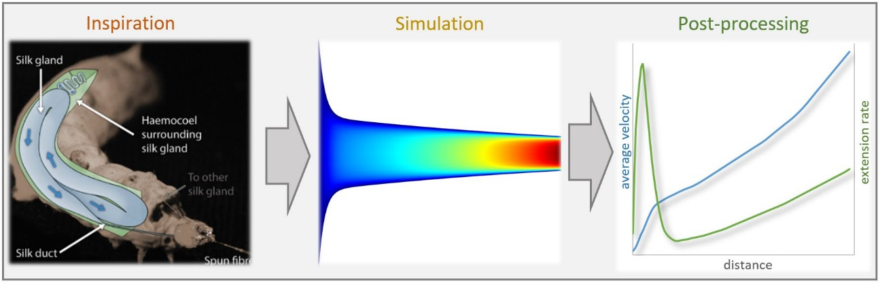
Prior publication
The material contained within this chapter has been published as part of the following journal article:
Sparkes, J. & Holland, C. Analysis of the pressure requirements for silk spinning reveals a pultrusion dominated process, Nat. Commun. 8 594 (2017).
For ease of access, a copy is provided in the appendix.

Introduction
The ability to artificially produce silk fibres has great commercial, industrial and scientific implications. Much has been made of natural silk’s remarkable mechanical properties^{4,97,134–136}, but few have considered how they are imparted onto the initially liquid silk feedstock during the spinning process⁵. This chapter bridges this knowledge gap by exploring how internal pressure affects fibre production. Such efforts are important, both in terms of understanding the flow conditions in natural silk production and as design criteria for larger-scale production of customisable biomimetic fibres.
Although silk can be (and is) reeled from live animals, it is time, space and labour intensive, making industrial upscaling difficult8,21,83,84,137,23,24,26,38,40,43,45,82. Through forced reeling of B. mori silkworms, fibres can be extracted whose mechanical properties are much closer to those exhibited by spider dragline silks^{82,97,138–140}, suggesting that processing, as well as the feedstock, plays a major role in silk fibre properties^{137,141}. This chapter uses B. mori as a reference system due to the breadth of knowledge surrounding this species and the existing commercial market for silkworm silks.
Prior to spinning, silk is stored inside the animal as a concentrated aqueous protein solution in a specialised organ known as the silk gland^{4,6} (figure 7). In the rear of the gland, the primary component is fibroin, which forms the solid core of the resultant fibres. Fibre formation is the result of fibroins flowing along the gland¹¹, being coated in successive layers of additional proteins⁶¹—sericins—before reaching a tapering duct where fibrillation is thought to be induced through a combination of changes in both pH and ionic environment^{4,11,50,80,113,142–145}, and mechanical shear^{1,80,146,147}, arriving as a fibre when exiting the animal. However, the mechanism by which this flow occurs is not fully understood, and the roles of geometry^{37,43,112} and chemical changes have only been briefly explored^{21,50,113,140,142–145,148–150}.
There have been multiple attempts to create silk protein feedstocks^{2,58,103}, but they have generally been frustrated by problems with molecular length⁵³, aggregation¹⁰⁴ and concentration⁵², with the fibres produced so far being comparable to synthetic textiles^{97,140}. We believe that this is in part due to not fully understanding how nature processes a silk feedstock, and that this is key to successfully handling these wilful proteins. Over the past decade there have been numerous studies on silk flow10,14,58,113,135,140,149,151,152, but recent publication of extensive silk rheology data^{114,115,153,154} allows further progress in this direction. Therefore one of the further aims of this work is to address the limitations highlighted in previous silk flow models.
Although several studies have used molecular dynamics simulations^{34,64,65,155–159} to explore the flow and aggregation of silk at a molecular level, and despite pipe flow being a well-established engineering approach¹⁶⁰ to exploring the flow in tubes, previous attempts to model silk flow at a microscale are described in just three studies. Kojic et al.¹¹⁶ made the first geometric approximations of silk spinning ducts, but although industrially relevant, the geometry used bears little resemblance to the biological system, and was limited by the absence of high quality rheological data. Moriya et al.¹⁴⁶ produced a 3-D reconstruction from microtomography, but the complexity of the reported geometry would be extremely challenging to replicate industrially. Breslauer et al.¹¹² improved on this by using Asakura’s¹⁶¹ approximation of the tapering duct as a hyperbolic function (industrially relevant), but was reliant on the same limited rheological data employed by Kojic¹¹⁶.
Significant progress has been made in the last decade in the acquisition of robust rheological data for B. mori^{114,115,153,154}, though the geometric aspect has rarely been considered, a notion which provides the impetus for this work. Recent work has shown that the spinning ducts of both B. mori and N. clavipes are reinforced using chitin in a manner which suggests that they will be less readily deformable than the initial part of the glands, and that precisely defined geometry may be important for efficient and effective fibre spinning^{37,162}. The use of mathematical functions rather than data extracted from individual specimens allows control over this geometry in silico, which can be used to systematically explore the effect of geometric variation on the pressure requirements. It is hoped that by considering the pressure required to induce flow, we can answer the oft-debated question of how silk flows—is it pushed, or is it pulled?
To resolve this issue and define silk’s processing space, finite element simulations have been carried out in COMSOL Multiphysics 5.2 to explore the internal pressure required to generate flow at a given rate through a range of geometries. By treating inlet pressure as the unknown variable rather than as a known parameter as in previous studies^{112,146,163}, it is possible to explore the full range of pressures required for the known physiological spinning speeds of B. mori. We report that the pressure required for flow is significantly higher than silk producers can generate in their haemolymph, and conclude that rather than being extrusion based, silk spinning is dominated by pultrusion effects acting via the solidity gradient induced via fibrillation.

Methods
Finite element analysis of flow within silk ducts was performed using the computational fluid dynamics (CFD) element of the COMSOL Multiphysics 5.2 software package. Simulations have been run in an isothermal environment with ambient external pressure, both of which are considered representative of the natural system.

Geometry
The silk duct has been simplified from the complex gland seen in figure 7 to a 2D, axisymmetric representation by considering the cross section of a single duct, rather than the spun fibre as a whole (figure 16 below) for computational efficiency and increased industrial relevance.
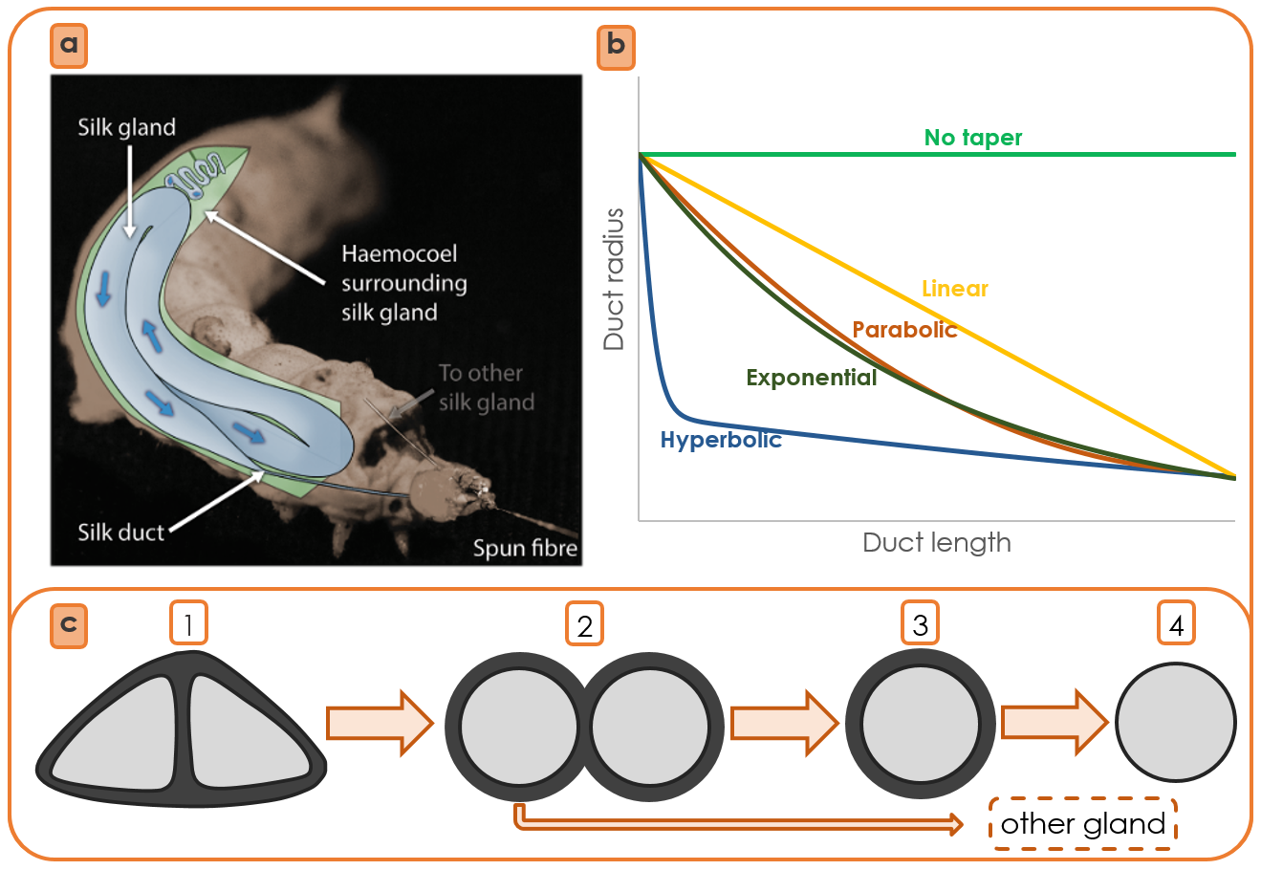
Figure 16: Overview of the silk duct approximation process.
(a) Anatomy of the silkworm B. mori. (b) Duct profiles by function used (tables 1 and 2). (c) Duct cross section simplification. Following the fibre backwards into the silkworm and along the gland, we reach a cross-section which is relatively straightforward to model. 1—Spun fibre cross-section. 2—Twin circular fibres before entering the press. 3—Single fibre in the duct. 4—Treating the flow as single phase removes the complex problem of sericin interaction.

Duct profiles have been modelled using both geometric approximations of experimentally determined data^{37,78,112,161,162} (figure 16 and table 1), along with exploratory profiles described with linear, exponential and parabolic functions (figure 16 and table 2). This is considered a suitable technique for describing the system geometry as it provides a more rigorous, general description than that utilised in other finite element studies^{146,163}. Wall conditions have been modelled in the limiting cases of both no-slip and full-slip boundaries in order to fully capture the domain of interest.

Table 1: Functions used to approximate duct geometries in previous studies
Authors | Duct geometry approximation | Parameters
Breslauer et al.¹¹² | $$r\left(z\right)=ae^{bz}+ {ce}^{dz}$$ | a=1.398 × 10² µm  b=1.97 × 10⁻² µm⁻¹ | c=5.845 x 10¹ µm  d=-3.58 × 10⁻⁵ µm⁻¹
Asakura et al. ¹⁶¹ | $$r\left(z\right)=a\left(\frac{1}{1+e^{bz}}\right)+c(\frac{1}{1+ e^{dz}})$$ | a =2.38 × 10² µm  b=6.18 × 10⁻⁵ µm⁻¹ | c= 5.88 × 10² µm  d=3.00 × 10⁻³ µm⁻¹
Kojic et al. ¹¹⁶ | $$r\left(z\right)=az+b$$ | a = -4.9 × 10⁻³ | b=2 x 10² µm

Table 2: Functions used to approximate the duct geometry in this study
Type of taper | Duct geometry approximation | Parameters
 |  | 12.5% of inlet | 25% of inlet | 50% of inlet | Zero taper
Linear | $$r\left(z\right)=az+b$$ | a = -8.44 x 10⁻³  b =2.065 x 10⁻⁴ | a = -7.28 x 10⁻³  b =2.065 x 10⁻⁴ | a = -4.95 x 10⁻³  b =2.065 x 10⁻⁴ | a = 0  b = 2.065 x 10⁻⁴
Exponential | $$r\left(z\right)=ae^{bz}$$ | a = 2.065 x 10⁻⁴  b = -9.836 x 10¹ | a = 2.065 x 10⁻⁴  b = -6.597 x 10¹ | a = 2.065 x 10⁻⁴  b = -3.373 x 10¹ | Not applicable
Parabolic | $$r\left(z\right)=az^{2}+bz+c$$ | a = 3.928 x 10⁻¹  b = -1.69 x 10⁻²  c = 2.065 x 10⁻⁴ | a = 3.386 x 10⁻¹  b = -1.46 x 10⁻²  c = 2.065 x 10⁻⁴ | a = 2.304 x 10⁻¹  b = -9.9 x 10⁻³  c = 2.065 x 10⁻⁴ | Not applicable

Mesh
Models were repeatedly re-meshed to determine mesh convergence, resulting in systems of approximately 20000 elements, which provides the optimum trade-off between computational accuracy and time, with the variation in results approximately 0.02% when compared with models comprising 15 million elements.

Flow regime
The flow is assumed to be laminar (taking maximum values for density, velocity and diameter, and minimum viscosity yields Reynolds numbers in the region of Re<10), and is modelled as a single fluid phase (in the absence of data describing the rheological properties of sericin (this shortcoming is addressed in chapter five) we assumed this to be the best case).

Density and concentration
The density of silk feedstock has often been misrepresented in the literature, with previous studies treating spun and unspun density as equivalent^{146,163,164}—this is unrepresentative due to the dehydrated state of spun silks. Later works attempted to account for this but were held back by smaller sample sizes, resulting in a 25% overshoot^{77,112}. Closer approximation can be made via a mass fraction calculation assuming 24% (s.d. = 2.5%) concentration¹¹⁵ which gives a 1072 kg.m⁻³ density.
The effect of concentration has not been explored beyond this due to unexpectedly weak correlation with viscosity^{114,115} (figure 40). Furthermore, proposed phase separation and water resorption¹⁶⁵ in the distal regions are ignored as recent evidence has suggested that silk may be more hydrated as it exits the animal than has been previously reported¹⁶⁶.

Spinning speed
Spinning speeds have been analysed from 1 n.s⁻¹ to 2 m.s⁻¹, which encompasses all verifiable previous recorded spinning speeds, forced or natural^{25,38,43,45,82,84,137–139}. The single inlet/outlet model ensures that mass is readily conserved, thus we can use exit velocity (spinning speed) to determine inlet conditions, in this case specified by the pressure.

Results

Comparison of existing silk geometries
There have only been three previous studies which have modelled the flow of silk, of which only two used geometries which can be considered industrially applicable, two were described by a hyperbolic function (Asakura¹⁶¹ and Breslauer¹¹²), while the third used a linear approximation (Kojic²², figure 17a). Since both hyperbolic functions are derived from the same data, this effectively leaves just two geometric models. Asakura’s, with an eightfold reduction, and Kojic’s, with a fiftyfold reduction from an inlet half the size of the natural system. Kojic’s outlet diameter is marginally smaller than is seen in an individual B. mori fibre (~10 µm), whereas Asakura’s is 2.5 times larger.
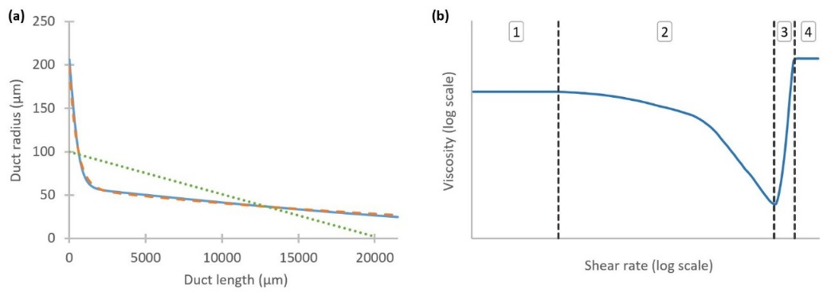
Figure 17: Geometric and rheological considerations.
(a) Previous geometric approximations of silk ducts showing variation in radius as a function of distance along the duct. Curves represent Asakura and Breslauer’s hyperbolic approximations, along with Kojic’s linear model. Equations describing each curve can be found in table 1. (b) Exemplar rheological response of silk feedstock to increasing shear rate, showing four distinct regimes: 1—Quasi-Newtonian behaviour at low shear rates; 2—Shear thinning behaviour; 3—Fibrillation, increasingly elastic response; 4—Viscoelastic solid, second plateau reached.

Comparison of existing silk viscosity models
Several different generalised viscosity models have been applied to empirically measured fibroin data14,22,113–115,135,146,149,151,163,167 in previous studies; these can be grouped as either Newtonian¹⁶⁷, or Non-Newtonian^{14,113–115,146,149,151,163}. Contemporary studies are in agreement that fibroin behaves, as expected of a polymeric solution, as a non-Newtonian fluid, but the methods used to describe this behaviour vary14,22,113–115,135,146,149,163,167. The response of silk to an increasing shear rate can be described in four distinct regimes (figure 17b).
The mathematical models that have been used to describe fibroin’s viscoelastic behaviour are both complex and not well defined, particularly at higher shear rates where gelation starts. Early attempts to describe this behaviour used a different power law function to describe each of phases 1-4 in figure 17b ^{113,146,149,163}. However, as we are not yet concerned with the fibrillation region (figure 17b, regions 3 and 4) (a biomimetic design limit—premature fibrillation will be naturally selected against, as duct blockages would prevent further spinning), models which describe the behaviour at shear rates below this point (regions 1 and 2 in figure 17b) are considered adequate.
There have been a wide range of published values for fibroin’s viscosity over the past 40 years14,22,113–115,135,146,149,163,167–169. Their proposed low shear viscosities ($\dot{γ}$ ≤ 1 s⁻¹) are shown in figure 18, from which the lack of consensus is readily apparent.
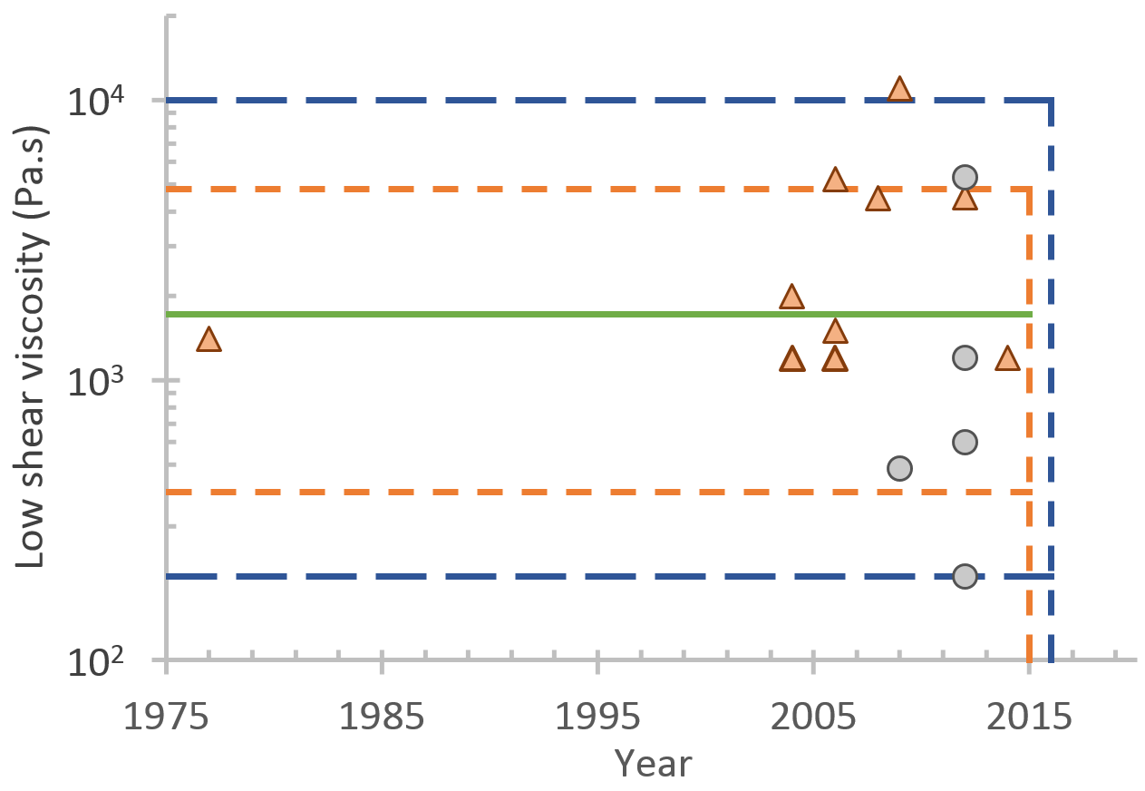
Figure 18: Variation in wild and domesticated silkworm feedstock viscosities.
Measured values of the low shear viscosity of wild (⚫) and domesticated (▲) silkworm feedstocks from previous rheological studies14,22,167,80,113–115,135,146,151,163, the highlighted regions show the mean, and ranges proposed by Laity’s 2015 ¹¹⁵ and 2016 ¹¹⁴ studies. This suggests that a large sample size is key to understanding the variability in the viscosity of silkworm feedstocks.
Fibroin’s shear behaviour is described using the Carreau-Yasuda model¹⁷⁰:
$$η\left(\dot{γ}\right)=η_{∞}+\left(η_{0}-η_{∞}\right){\left(1+{\left(λ\dot{γ}\right)}^{a}\right)}^{\frac{n-1}{a}}$$ | ( 6 )
Here, the dynamic viscosity $η\left(\dot{γ}\right)$is modelled as a function of shear rate $\dot{γ}$, which varies between two Newtonian plateau regions—the zero ($η_{0}$) and infinite ($η_{∞}$) shear viscosities—between which lies a region of non-Newtonian, shear thinning behaviour which is curve-fitted using $a$ and $n$ (figure 12 illustrates the general shape of the SCY model). Note that $λ$ represents the fluid’s relaxation time. By assuming that the feedstock will gel above a certain shear rate, there is no need to include the infinite shear viscosity$η_{∞}$, as it does not have physical significance, and thus the model simplifies to:
$$η\left(\dot{γ}\right)={η_{0}{(1+(λ\dot{γ})}^{a})}^{\frac{n-1}{a}}$$ | ( 7 )
The Simplified Carreau-Yasuda (SCY) model (equation 7) describes viscosity in terms of zero shear viscosity, relaxation time, and the rate of shear thinning. It seems appropriate, given that the primary difference between individual specimens lies in the reported values of the low-shear viscosity (figure 18), with successive studies showing values varying between ~800 and 10⁸ Pa.s^{135,149}. Recent work on a much larger sample size¹¹⁵ shows that B. mori feedstocks have a range of low shear viscosities, spanning 400-5000 Pa.s (mean = 1722 Pa.s, s.d. = 935 Pa.s, n = 125), which incorporates all previously reported values with one major exception¹⁴⁹, which it suggests has gelled and is therefore irrelevant. This was further extended by considering viscosity as a function of percentage cocoon spun⁵⁹, to show that the range spans ~200-10000 Pa.s¹¹⁴. Although this pertains to B. mori, many other silk producers (including other silkworms and spiders) lie within this bracket^{14,151}.

Pressure
In order to determine valid pressures we must consider the physiological limitations which constrain the operating environment. The larval stages of most endopterygota (pupating insects) maintain a positive internal pressure, which gradually reduces to atmospheric levels as sclerotisation (exterior body hardness) increases in the adult instar (development stage) ¹⁷¹. Steady pressure is maintained via muscular contraction, with small variation observed to coincide with heartbeats^{172,173}. This active maintenance is readily observed during anaesthesis, whereupon internal pressure is lost and the body becomes flaccid¹⁷⁴. In soft bodied, non-segmented larvae, haemolymph (internal body fluid) pressure is effectively equivalent to the internal pressure of the whole body¹⁷².
The upper limit for internal pressure is defined as that which induces eclosion/ecdysis (shedding of the skin). Although silkworms are clearly capable of producing such pressures, to do so ruptures the haemocoel (primary body cavity), which could prove fatal if undertaken prematurely, therefore the pressure that could be applied to the silk glands must be less than this. This assumption is considered valid due to the non-segmented nature of the haemocoel, resulting in a uniform body pressure which cannot readily be directed or localised within the haemocoel itself.
Figure 19 summarises previous estimations of internal pressure and the resulting predicted spinning speeds. To facilitate evaluation of previous studies, the following boundaries are introduced, which describe the limits of what is known as the biological extrusion domain. Although fibres may be spun outwith these constraints, they cannot be considered representative of natural systems. An initial constraint is the range of natural spinning speeds (0.01–0.03 m.s⁻¹)^{82,175}, but we widen this to incorporate forced reeling (0.001–0.5 m.s⁻¹)^{38,43,82,84,176}, since silks can be made by the animal across this range to provide the forced and natural biological extrusion domains.
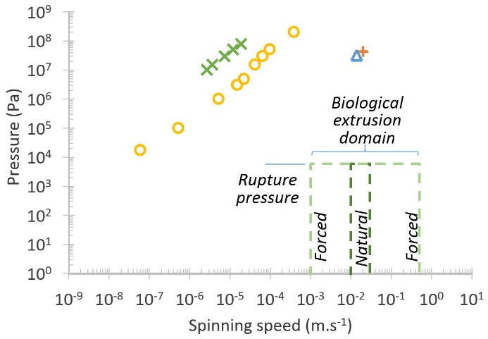
Figure 19: Biological relevance of previous pressure estimations.
A comparison of previous estimations (Kojic 2006; Moriya 2008; Moriya 2009; Breslauer 2009) of the pressure requirements for silk spinning in B. mori, highlighting the discrepancies between both spinning speed and pressure compared to the natural system. Although the most recent models have aligned spinning speed, the pressure remains too high. The biological extrusion domain is split into natural and forced spinning domains.

The upper limit on pressure is the maximum recorded internal overpressure in the insecta class—40 kPa for hard bodied species¹⁷⁷. This reduces to a lowly 5880 Pa—the haemocoelic rupture pressure of final instar B. mori entering pupation¹⁷¹ (adults have been recorded at marginally higher pressures (6750 Pa)¹⁷⁸, but this is irrelevant, since they have exoskeletons and no longer contain silk glands).

Geometric effects
The use of different duct geometries allowed the effect of shape on the flow to be assessed (figure 20). From a given inlet diameter (413 µm¹⁶¹), ducts were created using mathematical functions (tables 1 and 2) to describe both the severity of the taper, and the outlet diameter. Parabolic, exponential, and linear ducts were analysed, each with outlet diameters at half, quarter and eighth of the inlet, and for the linear taper, an additional limiting case with outlet diameter equal to inlet (zero taper). It can be seen that both an increase in outlet diameter (figure 20a) and a reduction in the severity of the taper (figure 20b), serve to reduce the pressure requirements. However, even in the limiting case the pressure required to spin at natural speeds (5.4 x10⁶ Pa) remains many orders of magnitude higher than that recorded in B. mori^{171,178}, and is clearly unrepresentative. Of further interest is that the extensional flow rates are variable along the length of the duct (see Breslauer et al.’s figure 5)¹¹², which directly contradicts the suggestion that hyperbolic tapers are used to provide a constant extensional flow⁷⁸.
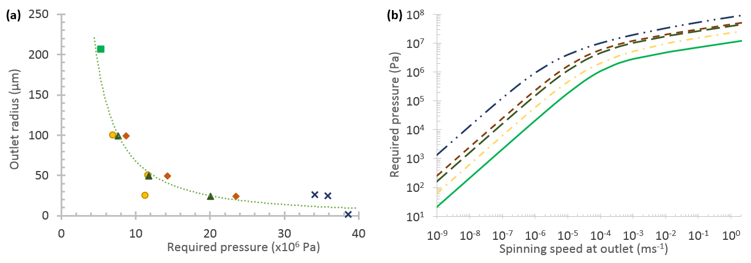
Figure 20: The effect of geometric variation on pressure requirements.
(a) The relationship between required pressure at inlet, and duct geometry (linear, parabolic, exponential, zero taper, and literature values) at natural spinning speeds (0.02 m.s⁻¹). Greater and more severe tapers both increase pressure required to flow representative feedstock. (b) The effect of geometric variation on required inlet pressure. A limited, representative dataset is shown for clarity (eightfold diameter reduction of parabolic, exponential, and linear tapers), all curves lie between the limits shown above of Kojic’s model, and the limiting case (zero taper).

Viscosity effects
Variation in SCY models lies primarily in the zero shear viscosity, with the rate of shear thinning shown to be relatively similar^{14,22,115,135}. This effectively provides a single variable whose effect can readily be explored. Figure 21 shows the effect of varying the zero shear viscosity across the range detailed in Laity’s 2015 study¹¹⁵ in relation to the biological extrusion domain. It is clear that reducing zero shear viscosity reduces the pressure required for spinning, yet silk feedstocks with this range of viscosities are viable feedstocks in vivo, suggesting that zero shear viscosity should have little effect on the spinning process. Moreover, reducing zero shear viscosity alone is clearly not sufficient to enter the biological extrusion domain, thus other factors must play a role in reducing pressure requirements.
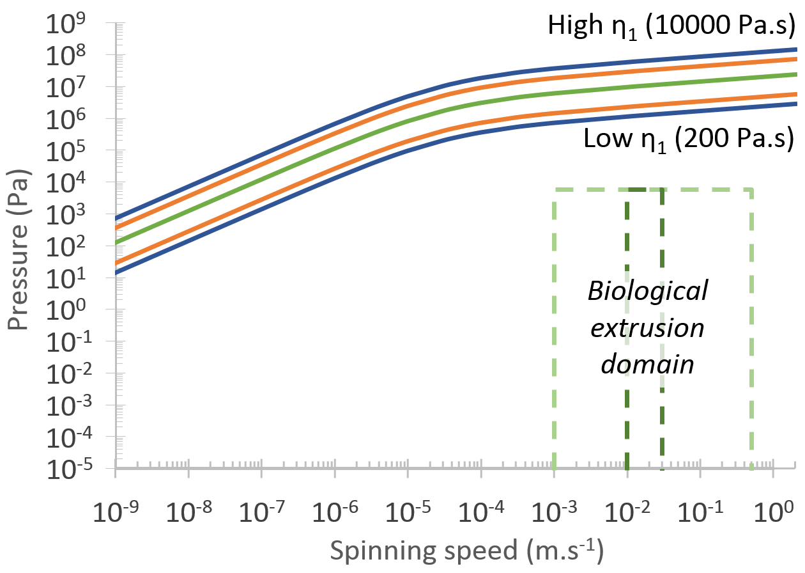
Figure 21: The effect of viscosity variation on pressure requirements.
The effect of varying the zero shear viscosity (across the 400–5000 Pa.s range¹¹⁵, 1722 Pa.s mean¹¹⁴, and 200–10000 Pa.s range¹¹⁴) on the required inlet pressure. Since geometry was earlier shown to have little effect on the pressure requirements, this study employed the same geometry as Breslauer¹¹² to allow comparison with previously published work. The biological extrusion domain is split into natural and forced spinning domains.

The effect of wall friction
The effect of lowering friction at the wall of the duct reducing pressure requirements can be clearly seen in figure 22. Reduction of wall friction is a common theme in pipeline networks (e.g. for oil) via surface modification^{179,180} or addition of drag reducing agents¹⁸¹, yet even in the limiting case for B. mori where the wall is considered to be at 100% slip, the pressure does not drop sufficiently low across the biological range of feedstock viscosities to entirely enter the spinning domain.
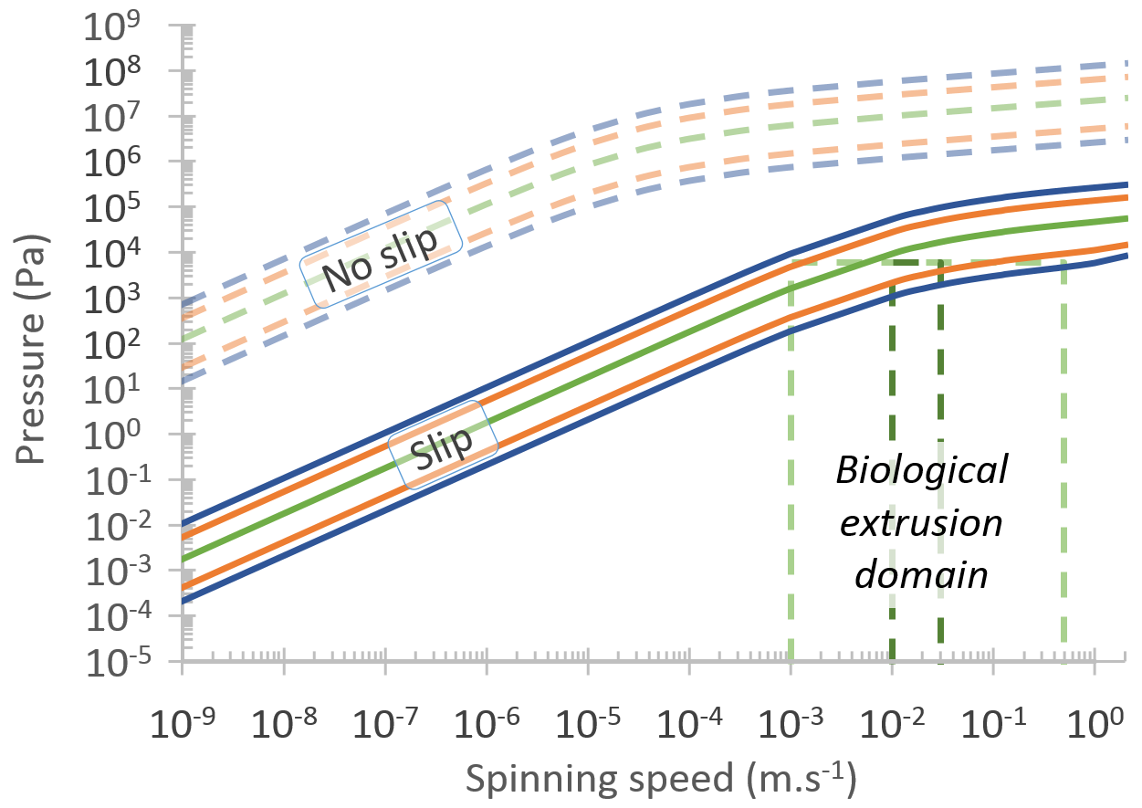
Figure 22: The effect of wall boundary conditions on pressure requirements.
The assumption of a slip condition at the duct wall (with the same geometric and rheological data as used in figure 21) brings the lower portion of Laity’s ranges (400-5000 Pa.s range¹¹⁵, 1722 Pa.s mean¹¹⁴, and 200-10000 Pa.s range¹¹⁴) into the biological extrusion domain. The biological extrusion domain is split into natural and forced spinning domains.

Changing the fluid
At the far end of minimising the interaction between feedstock and the silk duct wall is the possibility of a lubricating layer to minimise friction. Many authors have suggested that there may be some form of lubrication present in silk ducts^{11,74,151,161,182–184}. Of the ~80 different proteins identified in silk feedstocks¹⁸⁵, most opt for it being a secondary function of sericin, though there is little evidence to support this (Chapter five considers this aspect in greater detail). Brown¹⁸² suggests that unbound water may perform this role, while data originally dismissed as erroneous due to phase separation¹⁸⁶ (thus reducing measured forces in Holland’s 2006 study¹⁵¹), and the layering effects seen in 2012⁸⁰, actually strengthen this suggestion. A simplistic approximation is to assume that if this is the case, then plug flow can be assumed, which allows us to determine the pressure requirements by modelling the flow as solely consisting of a lubricant.
If we consider the case where interaction between fibroin and the duct wall is minimised, yet it remains impossible to reach the biological extrusion domain, then another option is to consider using other fluids in lieu of fibroin. Although B. mori glands are considered to contain primarily fibroin, since it becomes what is commonly regarded as the end product, there exists also a relatively large proportion of sericin which forms up to 30% of the final fibre. However, both of these are eclipsed by the primary solvent in the system, water, which accounts for 76% of fibroin¹¹⁵ and 86% of sericin¹⁶⁷ feedstocks. Thus, assuming the fluids are immiscible and that plug flow is appropriate, we can model the flow as a single phase consisting solely of lubricant in order to estimate the reduction in pressure required due to lubrication by sericin or water. However, using sericin¹⁶⁷—which Kataoka described as a Newtonian fluid ~1000 times less viscous than fibroin (challenged in chapter five)— we still did not reach the spinning domain, and it is only by using Newtonian water (million times less viscous) that we begin to enter the domain, yet the upper limits for spinning speed remain inaccessible.
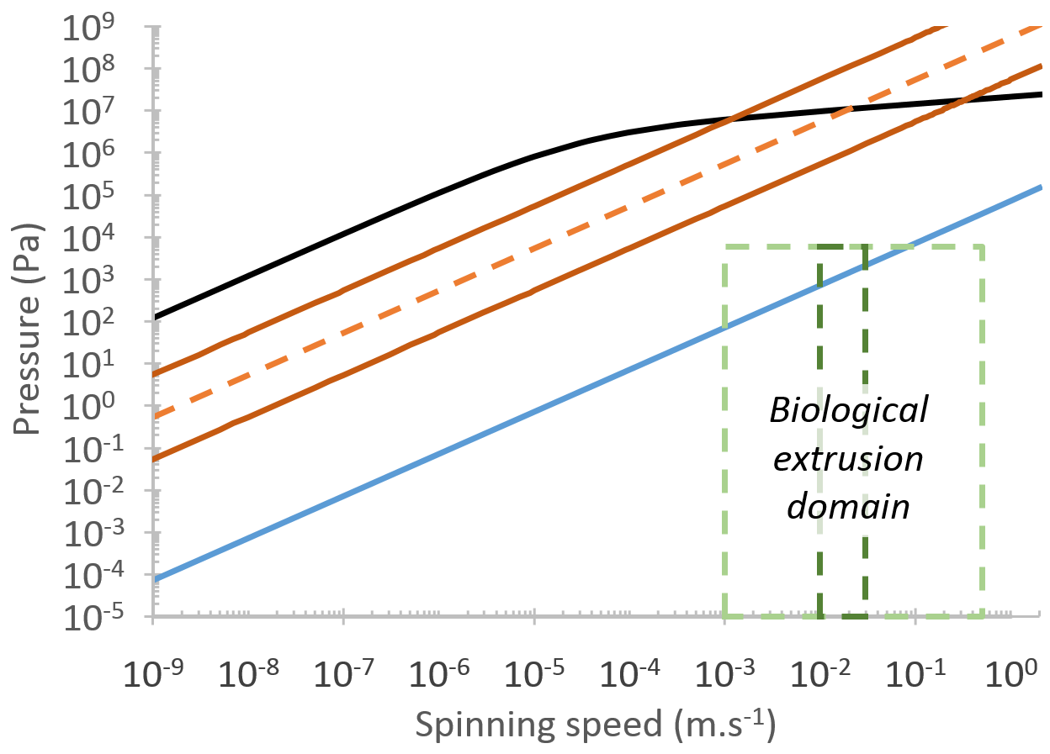
Figure 23: The effect of using an alternative working fluid on pressure requirements.
The use of lower viscosity fluids (in the same geometry used by Breslauer with a no-slip wall condition) reduces the pressure required compared to fibroin ($η_{0}=$ 1700 Pa.s) when the working fluid is sericin ($η_{0}=$ 7.6 Pa.s, ± order of magnitude variation), or water ($η=$ 8.9 x10⁻⁴ Pa.s). Water only just reaches the biological extrusion domain, with the higher natural spinning speeds remaining unattainable.

Discussion
Through the use of computational models, we have demonstrated that previously reported requirements for extreme pressure to induce silk flow can be reduced through a variety of factors, which furthers our understanding of the natural system.
The first factor involves reducing feedstock viscosity, yet even reducing this a million-fold—to that of water—proved insufficient to access the entire biological extrusion domain. Secondly, changing the geometry employed, either by increasing outlet diameter or by lessening the severity of the taper, serves to reduce the required pressure. However, the reinforced nature of the tapered section of many silk ducts¹⁶² suggests that internal structure is critical, and the use of a larger outlet is clearly unrepresentative of the natural system, since spun fibres are much smaller than the diameters required. The final factor considered involves reducing wall friction, with a slip regime used to model the effect of a lubricating layer in the duct. Yet even if these all these means were employed by the animal, how would the internal pressure be generated? Previous studies have suggested mechanisms responsible for the creation of such a pressure, such as peristalsis¹⁸⁷ or osmotic pressure¹⁸⁸.
Peristalsis seems a plausible explanation, given its prevalence in natural systems—it is used for fluid ejection/excretion/expectoration by many hard bodied animals, including ants¹⁸⁹ and spitting spiders¹⁹⁰, and those with soft bodies such as cephalopods¹⁹¹. However, the argument against this is that unlike the above examples, the silkworm’s gland is not lined with musculature^{161,192}, and thus the peristaltic effect would need to be transmitted through the haemocoel onto the entire gland at once from the external musculature of the body. Although this may be appropriate for a simple, linear gland, it seems unlikely that such a whole body contraction could create peristaltic flow, due to the twisted, folded nature of the gland itself (figure 7), with pressure applied at the haemocoel unable to be directed at specific sections of the gland due to the unsegmented nature of the body cavity.
Another suggestion is that continuous production of silk proteins in the rear of the gland creates a concentration gradient which drives flow through osmosis. However, this would require continuous protein production to maintain the gradient, which is at odds with the knowledge that protein synthesis rates are reduced to zero during cocoon construction in B. mori. This is also substantiated by the knowledge that fibroin concentration increases in the flow direction¹⁴⁸, in direct contradiction to the principles of osmotic flow.
In summary, it seems improbable that there is an active pressure system within silkworms capable of generating the high pressures suggested by the flow models. However the use of a lubricating layer allows plug flow to be considered, and thus the following generalised silk production flow model is presented:
During flow, fibroin proteins first align and after a critical shear rate and cumulative stress is exceeded, denature and aggregate together. This results in phase separation and drives water to the edges of the duct. Here it forms a lubricating layer between the nascent fibre and the duct walls, allowing the system to be treated here as plug flow and as if it were water. Furthermore, it is suggested that the nascent fibre, initially composed of nano and then microfibrils, exhibits a solidity gradient along its length, in which the fibre increases in modulus as it travels down the gland, allowing fibres to be pulled from the animal by themselves.

Chapter summary
Of course, these push/pull effects are not mutually exclusive, and thus several could be in use within the system. This means that, although we cannot conclusively say that there is no pushing in the system, we can state with certainty that it cannot be considered as the dominant force acting within the system. Rather, our data shows the rates achievable through pushing alone, hence the difference between this and the natural system represents a minimum force requirement for the pultrusion applied in the natural spinning process (see chapter 2). At this juncture, it is important to validate the models presented and provide real world grounding. This is the focal point of chapter four, with chapter five exploring the rheological properties of sericin, so that the assumptions made here can be assessed before their function and effects can be incorporated into future models. In conclusion, this study represents a step forward in our understanding of the conditions by which natural spinning occurs and shows that the development of artificial silk spinning devices must be based on pultrusion rather than extrusion if they are to be considered biomimetic.

Chapter 4

Validation

Abstract
This chapter describes the experimental validation performed in order to support the arguments made for a pultrusion dominated spinning mechanism in the preceding chapter. A two-pronged approach is taken, which aims to address the original research question of whether silk is pushed or pulled. Techniques centred round pultrusion and extrusion are presented, with the measured stresses comparable to each other and to previously conducted simulations.
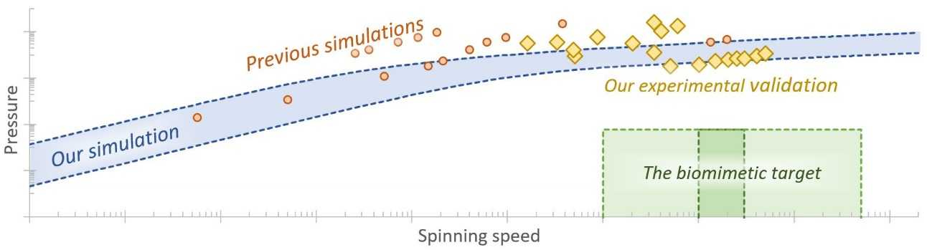
Prior publication
The material contained within this chapter has been published as part of the following journal article:
Sparkes, J. & Holland, C. Analysis of the pressure requirements for silk spinning reveals a pultrusion dominated process, Nat. Commun. 8, 594 (2017).
For ease of access, a copy is provided in the appendix.

Introduction
While chapter three focussed on simulating native silk feedstocks flowing through idealised channels representing the silk duct and variations thereof, there were several assumptions made within the work which highlighted the need for validation, since simulation without some form of validation is effectively meaningless¹⁹³. The intention of this chapter is to provide real world grounding for the models presented in chapter three, which will reinforce the conclusions made therein.
Although previous attempts to model flow in the gland were informed by and based upon real world measurements in terms of the rheology of the working fluids, be that B. mori fibroin¹¹², the major ampullate spidroins of Nephila spp.,²² or the gland geometry which describes the flow domain^{116,163}, the primary source of validation was in the use of reasonable assumption. While not in itself an invalid approach, confirmatory testing provides a more robust approach to modelling as a research tool. Given that we asked whether silk is pushed or pulled from the gland, it seemed appropriate to devise experiments which replicated both actions and compare the results of each with those predicted through simulation. Measuring polymer extrusion pressure is a common industrial process, providing sufficient inspiration to devise an equivalent system by coupling hypodermic needles to a high sensitivity load cell of a universal testing machine (UTM) in compression mode.
From a pulling perspective, forced reeling has suffered from several limitations in terms of live monitoring of fibre properties. Although fibres can be forcibly pulled from a silkworm or spider under strictly controlled conditions using a UTM in tensile mode^{82,194}, or reeled for considerable lengths using more conventional spooling devices⁸⁴, the former suffers from an inability to collect fibres longer than the UTM frame length, while the latter lacks the precise force measurement required to directly assess the pultrusion requirements instantaneously. Herein, we overcome this through judicious use of a rotary load cell repurposed from a rheometer to provide continuous strain controlled torque measurement in a process affectionately called forced rheoling. This technique allows the collection of significantly longer fibres than previously possible, whilst still providing the same level of information regarding the forces required to spin silk.
In summary, simulation validity was confirmed using two methods. The first extrudes fibroin through geometries corresponding to the simulation study’s limiting case. From an analytical perspective, this scenario requires the minimum extrusion pressure and hence provides a suitable threshold from which to compare with both literature values of pressure generation in insects and our previous work, while thankfully being considerably simpler in terms of experimental design than the complex geometries used in silico, hence we are relieved to find our arguments strongly supported by this experiment. The second argument—that pultrusion is the dominant mechanism in silk fibre spinning¹⁰⁷—is supported by the measurement of stresses generated in the spinning process at speeds across the natural range, providing confidence in earlier conclusions.

Methods

Extrusion
To assess the validity of extrusion in generating sufficient flow rates, native silk fibroin feedstock from the middle and anterior portion of the silk gland was extracted¹¹⁵ and loaded into 1 ml syringes treated with a super hydrophobic coating (Rain-x) for ease of loading. A modified universal testing machine (Zwick Roell, Z0.5, 500 N load cell) was used to flow the feedstock through hypodermic needles (0.26–1.5 mm diameter), which were cut to 20 mm to ensure constant length and cross-section (figure 24). Plunger speed, i.e.—the rate of compression in the universal tester—was determined by considering mass conservation and assuming that fibroin is incompressible.
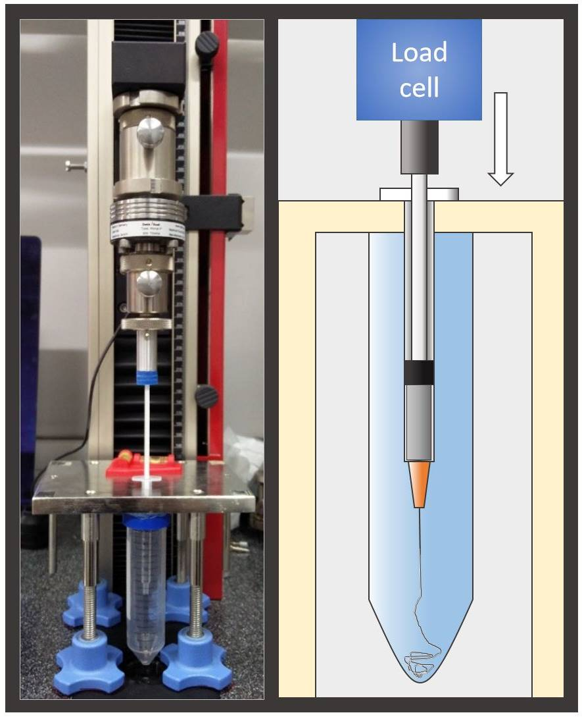
Figure 24: Extrusion apparatus.

(a) The system comprises a Zwick Z0.5 universal testing machine in compression mode modified to accept a standard 1 ml hypodermic needle, and provided with an aqueous environment into which to spin. (b) The key parts of the apparatus are depicted in the schematic on the right.

Forced reeling
Final instar B. mori silkworms in their wandering phase were force reeled using a rheometer as a high sensitivity force transducer. Worms were kept in cold storage (11°C) but returned to ambient temperature for 2 hours before reeling. Fibres were reeled in 5 mm.s⁻¹ intervals (equivalent to 1 rad.s⁻¹ angular velocity) across the biomimetic domain, with a focus on the natural range. To ensure fidelity, each speed was reeled separately onto individual spools consisting of a 10 mm diameter tube friction fit onto a standard 8 mm parallel plate geometry. Fibres remain spooled after reeling, thus each required a new spool, which was mapped and calibrated before reeling. Torque, angular displacement and velocity measurements are used to derive reeling speed, force, and fibre length. Fibre cross-sections are assumed to be approximately circular and are determined by averaging measurements along the reeled fibre length using imageJ¹⁹⁵.
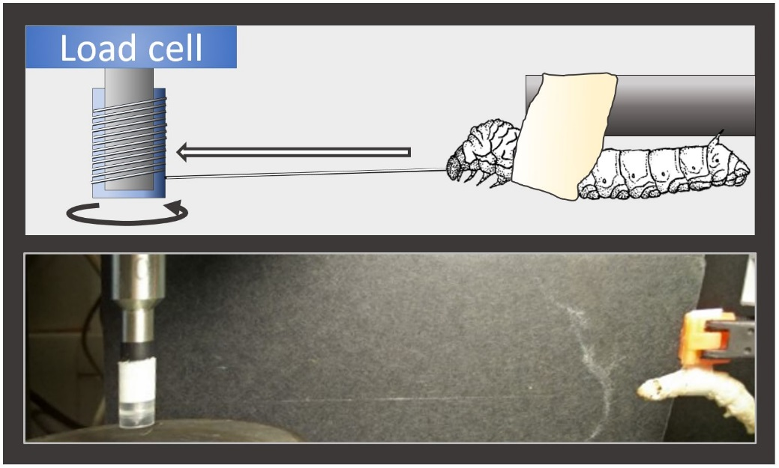
Figure 25: Forced reeling apparatus.
(a) Key components of the forced reeling system used to validate the pultrusion hypothesis described in chapter three. The torsional load cell is from a rheometer, with silkworms restrained a set distance from the take up spool. (b) A silkworm undergoing forced reeling, with a thread just visible. Silkworms are restrained with a band of masking tape fastened behind the prolegs, with a tab of tape protruding from the back of the specimen to provide an attachment point for the clamp. Band tightness is key—too tight and the specimen suffers, too loose and the silkworm will simply walk out of it. Threads are manually pulled from the silkworm to the spool and fixed in place with cyanoacrylate before reeling commenced. Clamp height is adjustable to allow for neat coil formation.

Results and discussion

Extrusion
To assess the validity of the effects of geometric variation in our extrusion models, we extracted native fibroin feedstock and subjected it to extrusion tests designed to mimic the limiting case of a 20 mm zero taper duct (figure 26). This is intuitively the least demanding scenario, and thus provides an obvious starting point—if the feedstock cannot be spun in a larger diameter duct using biologically relevant pressures—then it cannot be done in a smaller duct either. Duct diameters ranged from 1.5 mm down to 0.26 mm, the lower limit being set by the high probability of Luer-slip connection failure or the plunger critical load $P_{cr}$being surpassed when tests were attempted using smaller diameter ducts, but since both $P_{cr}$ (~2.4 MPa) and the Luer-slip failure pressure (ISO minimum: 0.3 MPa) are several orders of magnitude higher than the previously determined biological limit (5.9 kPa rupture pressure), it seemed unnecessary to explore beyond this. Extrusion rates between 0.16 and 6.04 mm.s⁻¹ were successfully applied to 10 specimens and are biologically relevant, but at higher rates, again either the Luer connection failed, or $P_{cr}$was exceeded, invalidating the test.
Despite the duct diameters being considerably larger than the natural system, the results are in broad agreement with previously published values, and our analysis of duct geometry and fibroin viscosity (figure 26c). This confirms both that flow in smaller diameter ducts requires greater pressure, and that our simulations are predicting pressure requirements of the correct orders of magnitude.

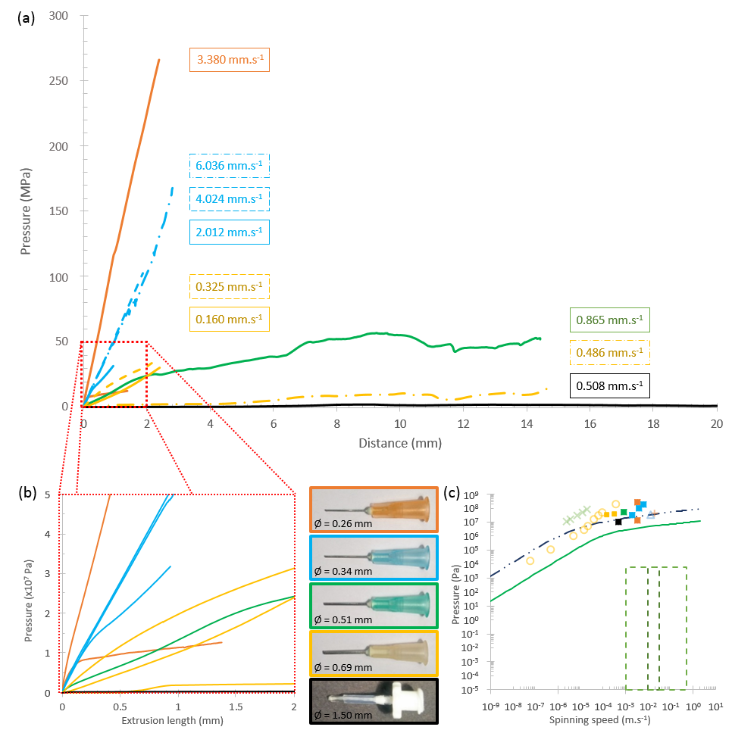
Figure 26: Linking extrusion pressure and diameter.
The relationship between pressures required to extrude native silk feedstock through a non-tapering duct and its diameter. Coloured lines (a, b) and filled squares (c) refer to the correspondingly coloured hypodermic needles used as extrusion dies. The internal diameter of each is constant over a 20 mm length, and is provided for each size. Values presented are maximum pressures attained. For lower speeds and larger diameters, the measured forces showed an initial rise to a steady plateau where the sample continued to flow through the needle, the value of which is presented in these cases. In the higher speed and/or lower diameter cases, failure during the initial rise in pressure was often experienced, hence maximum pressure reached is presented as an indicator of minimum pressure required, though it is likely the plateau region would be higher. (c) Comparison of experimental data with previous simulations (Kojic 2006; Moriya 2008; Moriya 2009; Breslauer 2009), our extension of Kojic’s work, and the limiting case of our geometric explorations shows good agreement, with pressures of similar magnitudes to those predicted (through simulation) necessary to extrude native silk feedstock through a non-tapering duct.

Forced reeling
Given that the predicted and measured forces required to push silk appear to be well in excess of the animal’s biological limits, we are left with the consideration that silk is spun by being pulled from the body by the motion of the animal relative to a point on the substrate whereupon the fibre is fixed. To support this hypothesis, we conducted a series of forced reeling experiments which allowed us to measure the normal stress required to forcibly pull fibres from a silkworm, and compare it with the axial stress (i.e. pressure) from our simulation and extrusion results (figure 26c).
A total of 13 silkworms were reeled across a range of spinning speeds (5–75 mm.s⁻¹). Although the possible range of forced reeling rates is broader than this, for ethical reasons we did not explore the full range reported in the literature (1–500 mm.s⁻¹)^{25,38,43,45,82,84,137–139} due to the requirement of paralysis for low rates and the potential for permanent damage to the animal at higher rates^{11,16,37}. A total of 63 samples were reeled across the natural range, although several were discarded, primarily due to excessive fluctuation in the torque corresponding to improper restraint, dropped spooling, or specimen discomfort (figure 27a). The remaining data is shown in figure 27b separated by specimen to highlight the range of reeling speeds covered for each silkworm.
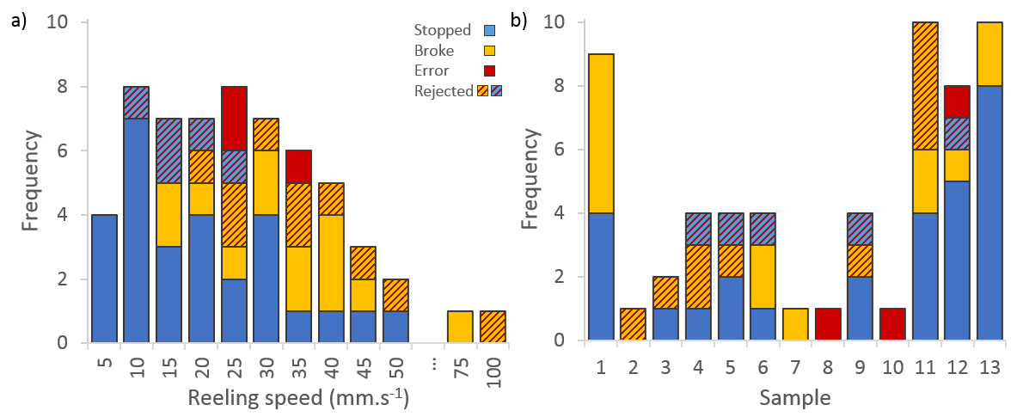
Figure 27: Data processing and quality control.
(a) Number of samples collected at each reeling speed. A good distribution of samples were collected across the natural range, and some way into the forced range. The extremes of the forced reeling were not fully explored due to the damage incurred to specimens when reeled at high rates. Data are separated first according to whether the reeling was stopped, or if the thread broke during the test. Post-processing of the data led to rejection of approximately a third of samples for various reasons, including specimen discomfort, misloading and machine error. (b) The same data separated by sample number, in order to best appreciate the range per sample.
The raw torque data followed a sinusoidal pattern due to the silkworm’s ingrained response to spinning, which is to move the head in a figure of eight motion during spinning. It was processed in several stages—start-up and break data (if present) were removed, followed by outliers more than 3 standard deviations from the mean. Further processing confirmed that mean and median values were approximately equal, once take up and end procedures were accounted for (figure 28a), suggesting that, like many biological systems, the variation is systematic and follows a normal distribution. A direct comparison of torque and reeling speed was made (figure 28b), but although a slight positive correlation is observed, this was not deemed significant. Separation of the dataset by method of completion shows no correlation between whether the specimen or operator halted the reeling procedure (figure 28b).
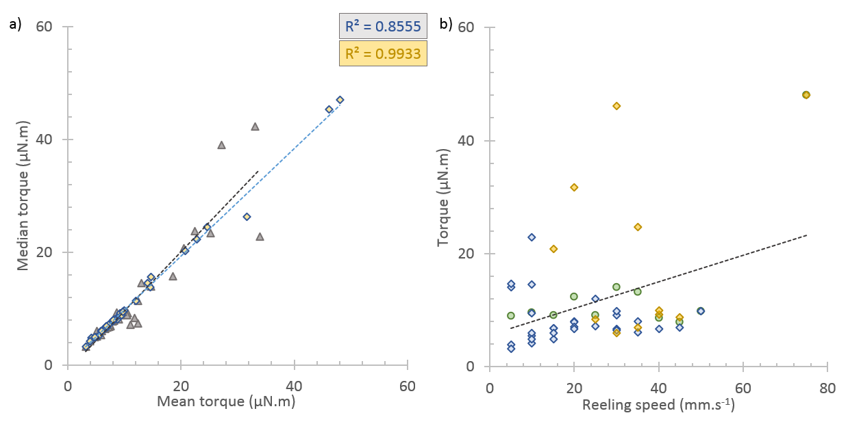
Figure 28: The torque-reeling speed relation.
(a) Comparison of mean and median torque values shows high correlation (raw data, corrected data), suggesting that variation in torque readings follow a normal distribution. (b) Torque compared against reeling speed. Mean values are overlaid upon the raw data set, which is split by end method (stopped, broken). There is slight positive correlation between the two, but this is not significant. There is no apparent relation between end methods.
Reeled fibres were assumed to have a circular cross-section, with average diameter determined from 77–295 independent measurements from photos taken through a reflection microscope under 20x magnification (lasertec E414) and manually quantified using ImageJ¹⁹⁵. Data was assessed for normality by comparing median and mean values for each reeling speed (R² = 0.8491). Outliers identified as lying more than 1½ times the interquartile range from the median were discarded and averages recalculated accordingly.
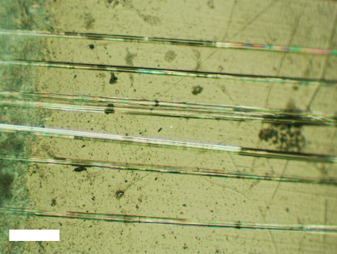
Figure 29: Spooled fibres.
Fibres collected from each sample were kept on the spool for size measurement. Each turn of the fibre was measured at multiple points along the portion in focus. Sections where fibre edges could not be distinguished from their neighbours due to proximity were omitted. Scale bar represents 100 µm.

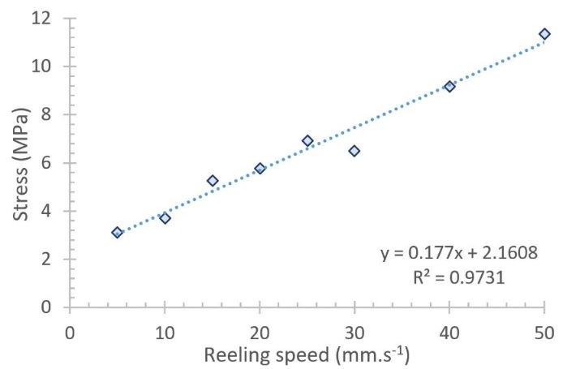
Figure 30: Forced reeling validates pultrusion hypothesis.
Experimental validation undertaken by pultruding silk fibres using forced reeling. Plotting stress against reeling speed shows an approximately linear relation between the two variables. The stress encountered during forced reeling is of the same order of magnitude (3–12 MPa) as the pressure predicted through our computational models (6–13 MPa), which supports the argument for pultrusion as the dominant spinning mechanism.
Figure 30 highlights the stress-reeling speed relation, which shows not only a strong linear correlation, but that silk production across this range of speeds requires stresses of magnitude 3–12 MPa, which agrees with and further validates our simulation results of 6–13 MPa (figure 31).
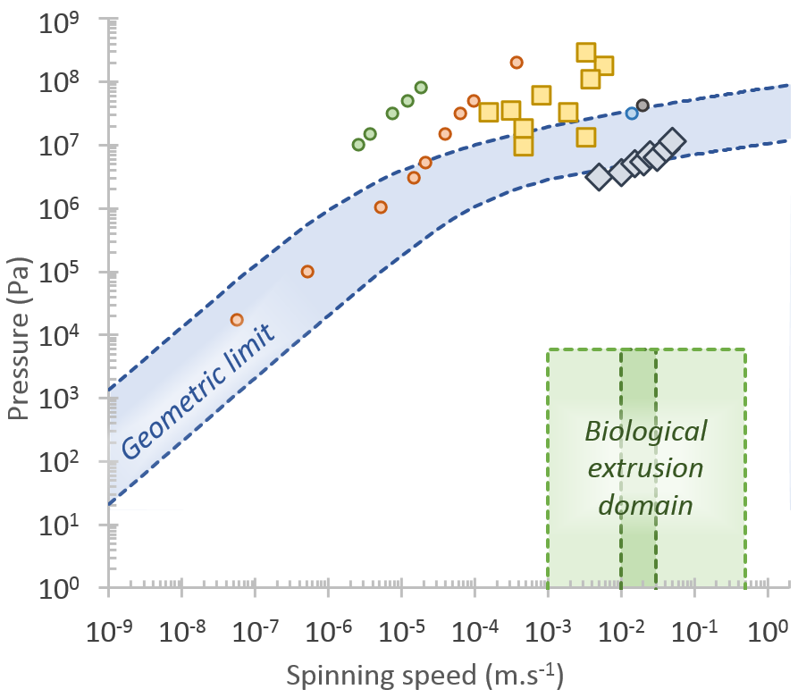
Figure 31: Comparison of extrusion and pultrusion pressure requirements with simulated values.
Key values from forced reeling and extrusion experiments are plotted in a simplified format for ease of comparison. Discrete values from Moriya^{146,163}, Breslauer¹¹² and Kojic²² are plotted for context, along with the limits of the extended geometric analysis from chapter three.

Chapter summary
Our results show that the forces required to extrude silk feedstock in silico/vitro agree with those achieved through pultrusion in vivo and can clearly be generated by the silkworm. Therefore we can conclude that while B. mori may not be capable of extruding silk fibres, it is capable of generating forces of this magnitude through pultrusion during cocoon construction. This validates the preceding chapter’s models, and lays the groundwork for further exploration of flow processing requirements in silk spinners, allowing us to proceed with confidence and explore sericin rheology in chapter five.

Chapter 5

Sericin

Abstract
In this chapter we characterise sericin feedstock from the silkworm Bombyx mori in its native state, and by employing biochemical, rheological and spectroscopic tools, define a natural sericin gold standard for use in theoretical modelling and practical application. This demonstrates that native sericin behaves as a viscoelastic shear thinning fluid, but that it does so at a considerably lower viscosity than fibroin, and that its upper critical shear rate (onset of gelation) lies above that of fibroin. Together these findings provide the first evidence that in addition to acting as a binder in cocoon construction, sericin is capable of lubricating fibroin flow in the silk gland, which has implications for future processing, modelling and biomimetic design using these materials. In particular, this addresses the limitations set out in chapters 3 and 4.
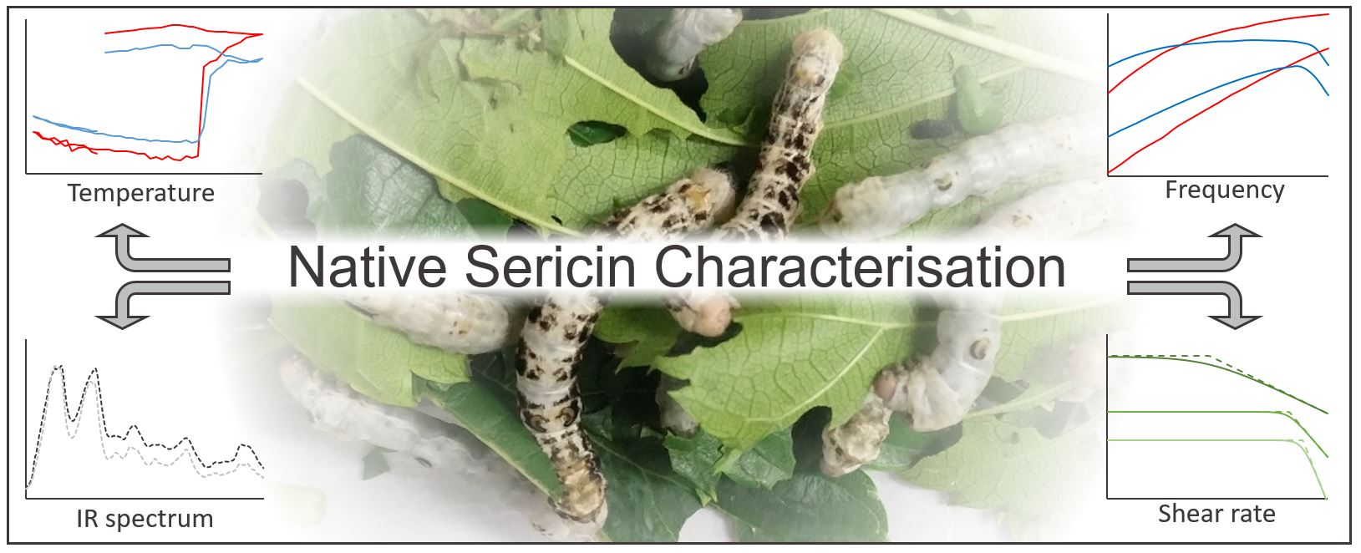
Prior publication
The material contained within this chapter has been published as:
Sparkes, J. & Holland, C. The rheological properties of native sericin, Acta Biomater. 69, 234–242. (2018)
For ease of access, a copy is provided in the appendix.

Introduction
In nature, silks can be spun under ambient conditions to achieve a wide range of strength^{5,51,137,196–198}, elasticity^{39,82,84} and toughness^{4,5,84,141,199–201}, inspiring many to try and replicate these materials industrially^{48,58,103,140,202–206}. However, a major limiting factor in furthering our understanding of silk production is that while much has previously been published on the function, properties, and structure of the primary proteins responsible for the fibrillar structure of silks (fibroins in silkworms and spidroins in spiders)^{58,61,207}, much less is known about the secondary proteins. Whilst not responsible for the impressive mechanical properties of a silk fibre per se, in their natural environment they perform a diverse range of functions that effectively extend the phenotype of silk by imbuing additional functionality, such as non-woven composite formation^{12,208–210}, water retention²¹¹ and adhesive qualities²¹². In this chapter we focus on the group of secondary silk proteins produced by Bombyx mori, known as sericins, which act as the binder between brins (fibroin core from each gland) and adjacent cocoon fibres in their spun state^{71,84,209,210,213}. These proteins account for approximately 30% of the spun silk fibre’s weight²¹⁴, and thus represent a considerable resource investment for the silkworm, which pertains to their biological significance.
Sericins are water soluble, globular proteins^{16,71}. They are most accurately described as proteins with indefinite structure, which are secreted at various points along the gland, beginning in the middle posterior section^{16,69,71,73}. These proteins have marginally different compositions, solubility, and levels of crystallinity^{69,71}. However whilst we have insights into their structure, little is known about sericins’ functions within the gland, with only suggestions or assumptions that they act as a lubricant for fibroin ^{112,146,163,184}. This may be in part due to the experimental difficulties in extracting and testing this material with minimal processing, as although fibroin can be readily extracted in its native state from mature B. mori larvae¹¹⁵, isolation of native sericin in a similar fashion has thus far proved problematic.
Large quantities of sericin solution are produced industrially from wastewater in the cocoon degumming process^{215–217} and find uses in the food^{218–220}, cosmetic^{71,221–224}, biomedical^{15,225–228}, and health supplement industries²²⁹. Much of the recent work on sericins has focused on the extraction methods^{71,230–233}, characterisation of^{94,220,230,234–238}, and potential uses^{71,101,223,227,233,239–242} for this by-product, with the primary aim of commercial diversification. Nevertheless, the combination of high temperature, pressure, and solvents typically used affects the quality of the sericin produced through changes to its conformation or molecular weight^{15,16,71,234,242–245}. Therefore, while these industrially derived sericins represent promising advances in their respective fields, and a significant waste reduction in traditional silk industries^{71,231,232,243,246}, the mechanical^{247–250} and rheological^{16,219,247,248,251–253} sericin characterisation undertaken in these studies cannot be truly considered representative of the natural system.
Looking towards alternative methods for sericin extraction, early studies suggested that sericin could be extracted through time limited dissolution of B. mori glands^{214,253}, however this proved difficult to control, being subject to contamination from fibroin and requiring re-concentration and as a result I did not pursue it in earnest. Other techniques, such as surgically removing the posterior (fibroin producing) section of the gland and dissolution of the resultant fibroin deficient feedstock^{254,255}, have not gained traction in the silk community due to the time-consuming, complex, and invasive nature of the operation. The use of the standard LiBr fibroin reconstitution method²⁵⁶ has been employed with mutant B. mori strains to dissolve sericin only cocoons^{238,257}, but this can hardly be considered less degrading than wastewater extraction methods.
To this end, we have opted to apply existing native fibroin extraction techniques ^{115,151} to a fibroin deficient strain, thus providing a ready source of native sericin feedstock without the need for several interim processing steps. To our knowledge there is only one study which details the rheological properties of native sericin taken from the glands of a fibroin deficient B. mori strain, but the number of samples (n=1) used, and the unlikely supposition that a polymer solution is a Newtonian fluid limits the applicability of this data¹⁶⁷. Hence, looking to extend our understanding of this area, we present rheological data obtained from large sample sizes in an attempt to gain fundamental insights into this material. This work seeks to define native sericins’ processing parameters and provide baseline data to both further our investigations into the pultrusion dominated spinning mechanism (see chapters 3 and 4)¹⁰⁷, and address the major limitations identified in previous flow studies^{22,112,114,115,163}. We show that sericin is a polymer solution which exhibits non-Newtonian, shear thinning behaviour; that its viscosity lies significantly lower than fibroin, and that its upper critical shear rate (onset of gelation) lies above that of fibroin (see chapter 7). All of which allows us to conclude that as well as binding cocoon fibres, native sericin can also act as a lubricant.

Materials and methods

Silkworm rearing
Fibroin deficient B. mori silkworms (Nd-s strain, supplied by Silkworm Genetic Resource Database, Kyushu University, Japan) were raised over a period of 6 weeks on black mulberry (Morus nigra) and silkworm chow (Silkworm store, UK) in a temperature, light and humidity controlled environment (28°C, 80–85% RH, reduced to 26°C, 70–75% in the final instar).
On arrival, silkworm eggs (approximately 4000) were incubated for 7–10 days until hatching. During this time, black mulberry trees were located and juvenile leaves collected on the day of hatching. During their first instar, silkworms are best handled using a fine bristled paintbrush to avoid damage and contamination. Freshly picked leaves must be shredded to provide a suitably weakened leaf edge structure that their jaws can bite. As a domesticated species, B. mori suffers from many diseases which can decimate stock and thus their housing must be cleaned out and disinfected every 8 hours as a maximum, or at feeding time. In the first and second instar this process requires manually moving each individual silkworm onto fresh food in clean housing, and is perhaps the most time consuming part of the process.
Food must be provided fresh and at room temperature, as silkworms will ignore leaves picked more than twelve hours ago, or those cooled to retain freshness, necessitating regular, twice daily leaf picking trips to ensure steady growth. During the later instars, silkworms develop a voracious appetite, and the food processing rate increases rapidly, meaning that they require cleaning and re-housing at increasingly regular intervals to avoid contaminating food with excrement.
To further complicate the process, silkworms at the point of moulting will anchor themselves to a substrate (typically a leaf stem) for a period of up to 36 hours whilst shedding their skin. During this time it is important not to move the silkworm relative to the substrate else this process may be interrupted, which will typically kill the silkworm. When fifth instar worms were observed to have begun wandering (loss of appetite, increased motion, voiding (at later stages) they were transferred to a cool (10°C) environment to delay spinning.
The strain used has an incomplete penetrance of the phenotype responsible for the undeveloped posterior gland and resultant fibroin deficiency, meaning that not all silkworms of this strain produce sericin only. Identification of specimens carrying this phenotype was aided greatly by bimodal variation in their appearance (figure 32)—Dark, with a mottled body (dark grey patches over a pale grey-white) and Light—which were a uniform pale grey-white (similar to regular B. mori).
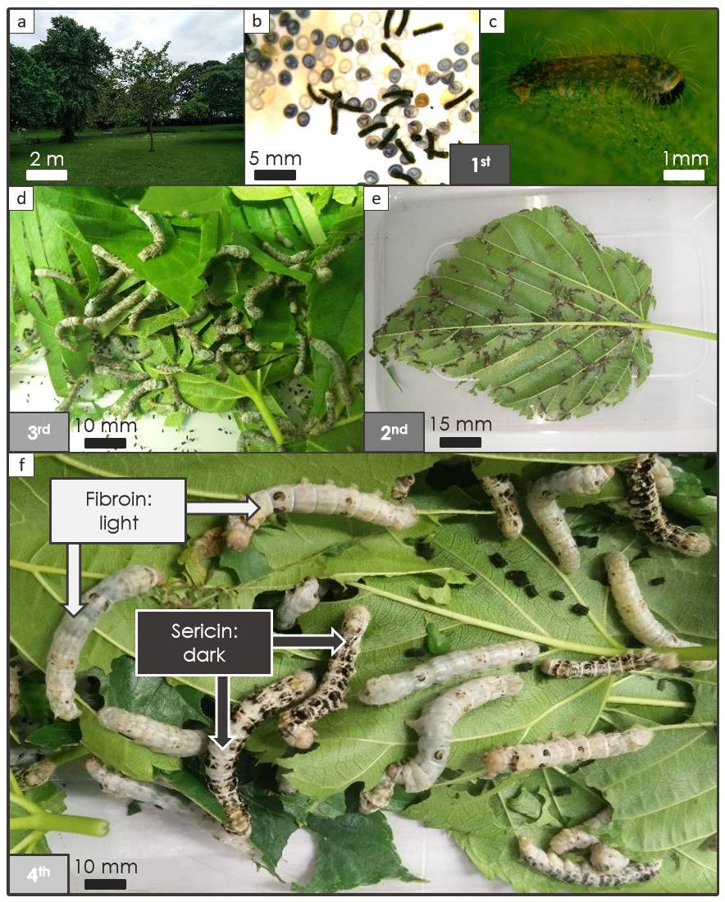
Figure 32: Identification of fibroin deficient Bombyx mori silkworms.
Individual sericin only mutants are readily identified through stark differences in patterning. Initially this was assumed to be variation in sex, but all colour pairings produced viable offspring. In keeping with this natural colouring, all future graphs use dark grey to represent sericin data and pale grey for fibroin. Panel (a) shows one of only six black mulberry trees growing in Sheffield, which provided a vital food source for the silkworms. (b, c) Newly hatched first instar silkworms and their egg cases. (d–f) B. mori pass through five instars, and from the fourth it is easy to differentiate between regular and mutant sericin only phenotypes.

Sample preparation
Feedstock was extracted from silk glands as per previously described fibroin extraction methods¹¹⁵. Adjacent portions of the middle division of the gland were used for rheological and concentration characterisation for all samples and assumed to be of equal concentration. Feedstock concentration was determined through evaporation to dryness and is expressed as mg/mg %.

Material identification

Amino acid analysis
Gland contents were dissolved in type I water and submitted for analysis in the Protein & Nucleic Acid Chemistry Facility at the University of Cambridge. Samples were hydrolysed with 250 nmol norleucine standard, with 1% of the sample analysed using ion exchange liquid chromatography, and post column derivatisation achieved using ninhydrin (Biochrom 30, Biochrom, Cambourne, UK).

Gel electrophoresis
Gland contents were dissolved in type I water, diluted to 0.1 and 0.05% (mg/mg) and reduced with an equal volume of 4% (mg/mg) SDS in 4 mM 2-mercaptoethanol. Gel electrophoresis was used to determine the molecular weights (MW) of the proteins in each sample. An SDS-PAGE system comprising a 4–20% poly-acrylamide gel was run in ambient conditions at 160V, 100mA, using an Amersham ECL Gel kit (GE Healthcare, Chicago, USA). A high molecular weight ladder ranging 30–460 kDa (HiMark, ThermoFisher Scientific, Waltham, USA) was used as the protein standard. Gels were fixed and scanned at high resolution (1200 dpi) using a photo scanner (HP Scanjet G2710). Pixel intensity was measured as a function of distance along each lane using ImageJ¹⁹⁵ (NIH, USA), and normalised against full lane length to allow comparison across lanes and determination of MWs.

Spectroscopic characterisation
Attenuated Total Reflectance (ATR) Fourier-Transform Infra-Red (FT-IR) spectroscopy (Nicolet 380, Thermo Scientific, Waltham, USA and a Golden Gate heated ATR, Specac, UK) purged with dry air (118ml/s Parker Balston, UK) was performed on the same samples as those used for amino acid analysis. Samples were progressively scanned as they were evaporated to dryness using a custom built vacuum chamber mounted above the ATR sampling area to leave a thin film on the diamond ATR crystal. Spectra were obtained from 800 to 4000 cm⁻¹, performing 64 scans at 4 cm⁻¹ resolution and are presented after correction for background absorbance and ATR sampling depth, and normalised against the amide I peak at (1618 cm⁻¹).

Rheological characterisation
Rheological testing was carried out on a Bohlin Gemini rheometer (Malvern Instruments, UK) equipped with a Peltier stage and moisture trap for temperature and humidity control. Experiments were performed using a cone and plate geometry (10 mm diameter, 1° cone, 30 µm truncation gap). See chapter two for further details. After dissection, extreme care was taken to minimise loading whilst placing the samples onto the static plate before lowering the cone onto the sample to ensure a completely filled gap. In order to avoid skin formation at the sample-air interface affecting the results, the sample was flooded with a minimal sheath of water, which was maintained throughout each experiment¹¹⁵. All tests were performed at 25°C unless otherwise stated.
Specimens were subjected to a period (100 s) of pre-shear (1 s⁻¹) to improve sample homogeneity between the plates^{114,115,153,154}. Apparent viscosity measurements were made by averaging the final 30 s of this test. Afterwards an oscillatory sweep from 25–0.1 Hz at an applied strain of 0.02 (below the material’s linear viscoelastic limit) was performed to ensure that the sample had not gelled (presence of a crossover from viscous to elastic modulus as the dominant response) before principal testing commenced.
Principal tests either took the form of a shear ramp (ranging from 0.01–300 s⁻¹) followed by a further oscillatory sweep to confirm gelation, or a temperature ramp at a fixed frequency (0.1 Hz) and strain (0.02) at 1°C.min⁻¹ from 25°C, down to 2°C, up to 80°C, where a second oscillatory sweep was performed before finally returning to 25°C and a final oscillatory sweep. Some test runs incorporated slight variations in this sequence, in order to better probe the material properties. The reference samples presented show the traits discussed with most clearly, while samples showing unusual viscoelastic responses (such as stress overshoot, ejection, or skin formation) were discarded.
For viscosity measurements SCY fitting was performed by first trimming the data at the lowest shear rate region to remove data influenced by excess instrument noise. The upper shear rate regime was curtailed beyond γ̇_{UC} (determined as the point at which the normal force begins to rise rapidly, minimum viscosity and gelation begins). Model parameters were estimated to provide starting values for MatLab’s curve fitting toolbox. Goodness of fit was assessed using Escudier’s²⁵⁸ modified sum of squares approach, which provides a better fit across the wide range of shear rates. The severity and influence of outliers were identified through the combined use of Student’s T and Cook’s Distance/DFFits tests, with those ranking highly in both aspects removed from the data sets if found to exert significant influence on the goodness of fit.

Statistical Analysis
Data is presented as the mean ± standard deviation and based on n repeats. Significant difference between samples was determined by an unpaired t-test with a two tailed P value of P<0.0001.

Results and discussion
The first requirement was to determine that silkworm specimens were producing the anticipated native sericin feedstock. Natural, biological, variation was minimised by using samples from the same batch at the same life cycle stage. After feedstock extraction, we performed several experiments on the native samples to confirm their composition—amino acid analysis, gel electrophoresis data and FT-IR spectra agree that Dark specimens produce a fibroin deficient silk feedstock consisting primarily of sericin, while Light specimens produce a regular fibroin feedstock.
Our findings are consistent with previous studies of this strain, where fibroin deficient individuals produced a native feedstock composed of ~98.5% sericin¹⁷ and molecular weights from 24 to 400 kDa ^{69,72,259,260}. Given that we are primarily interested in the rheological properties of sericin, beyond confirmation of sericin presence, Light specimens also serve as a useful internal control, as their feedstocks are consistent with regular B. mori fibroin^{14,114,115,140,151,153,154}. Hereafter, when we discuss native sericin’s properties, these relate to samples from Dark specimens, whereas native fibroin’s properties are gleaned from Light specimens and the wider literature.

Amino acid analysis
Amino acid analysis was used to confirm that the mutant strain produces a sericin feedstock. As can be seen in table 3, the composition of the feedstock extracted from Dark specimens is remarkably similar to previously published data for sericin²³⁷, while that produced by the Light specimens appears to be akin to fibroin of regular B. mori²³⁷. Key components include the high proportion of glycine and alanine in Light specimens, versus more appreciable Ser, Asp and Thr fractions present in Dark specimens, both of which are considered key components in the wider literature.
Table 3: B. mori feedstock amino acid analysis
Mol. % | Light | Fibroin | Dark | Sericin
Gly | 42.17 | 42.62 | 18.45 | 17.85
Ala | 26.04 | 33.38 | 7.79 | 6.70
Ser | 12.47 | 7.65 | 28.34 | 25.5
Tyr | 5.02 | 5.84 | 4.01 | 3.10
Val | 2.59 | 2.58 | 3.74 | 4.05
Asp | 2.85 | 1.79 | 13.86 | 18.38
Glu | 1.73 | 1.36 | 3.70 | 5.74
Thr | 1.60 | 0.85 | 7.83 | 7.47
Phe | 0.64 | 0.81 | 0.45 | 0.67
Ile | 0.67 | 0.72 | 0.77 | 1.02
Leu | 0.60 | 0.54 | 1.24 | 1.49
Pro | 0.41 | 0.47 | 0.72 | 0.81
Arg | 0.68 | 0.44 | 2.80 | 3.12
Lys | 0.59 | 0.33 | 2.41 | 2.08
His | 0.49 | 0.21 | 1.42 | 1.32
Met | 0.09 | 0.15 | 0.11 | 0.31
sum | 98.62 | 99.74 | 97.66 | 99.61

Molecular weight determination
As a secondary analysis, the molecular weight of samples taken from both Dark and Light specimens were subjected to gel electrophoresis (figure 33a, inset). Light specimens showed the typical fibroin heavy- and light-chain distribution^{59,237}, whereas Dark specimens offered a range of molecular weights, again typical of previously identified sericin components²³⁷.
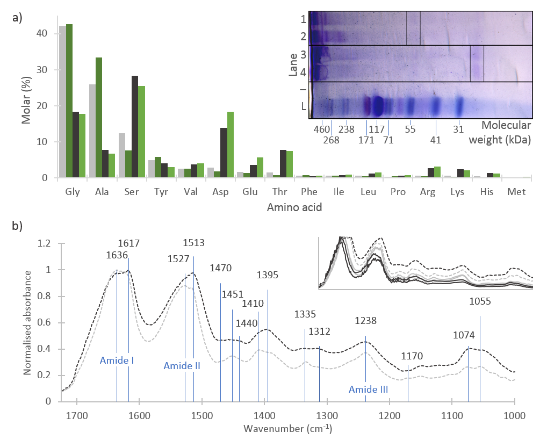
Figure 33: B. mori Nd-s feedstock characterisation.

(a) Amino acid analysis of Dark and Light silkworm feedstocks shows remarkable similarities in the composition of each when compared to previously published composition data²³⁷ for sericin and fibroin respectively. In particular, note the high proportion of serine in Dark specimens—the typical indicator of sericin, and the high glycine and alanine proportions typical of fibroin in Light specimens. Categories are ranked in order of abundance in fibroin, which highlights the distinct compositional differences between fibroin and sericin. For ease of reference, table 3 provides numerical values of the amino acid composition. (a, inset) Gel electrophoresis scan showing the differences in molecular weight and composition in sericin (Lanes 1 and 2) and fibroin (Lanes 3 and 4) against a ladder of known constitution (L). Fibroin shows the expected split between heavy chain at ~420kDa, and light chain at ~25kDa, whereas sericin shows several discrete regions (~400, 360, 250, 58 kDa) representing the multitude of sericin proteins present in B. mori silk glands. The figure has been straightened, cropped and lightened for clarity. (b) FT-IR Spectra (normalised against amide I peak) of native sericin compared to fibroin shows distinct differences. Peaks used in the identification of each protein are labelled with their respective wavenumber. Of further note, the native sericin presented here provides a gold standard for comparison of processed sericin materials against the native system. For further details on assignments, see tables 4 and 5. (b, inset) further spectra show good agreement between samples.

FT-IR spectral peak assignments
Further confirmation of the gland contents was undertaken using FT-IR spectroscopy on both the specimens used for amino acid analysis and gel electrophoresis (figure 33b, inset), with good agreement between all specimens. Several distinct differences can be seen between the spectra. Both clearly show peaks assigned to the Amide I, II, and III bands (~1630 cm⁻¹, ~1530 cm⁻¹, and 1238 cm⁻¹) characteristic of protein structures. Comparison of Light and Dark spectra shows distinct infrared signatures, with Light showing many of the principal features observed in FT-IR spectra of fibroin, and Dark showing similarities to that of sericin. We observe substantial growth in Dark spectra at 1395 cm⁻¹ (attributed to C-H bending²⁶¹), which masks a peak at 1410 cm⁻¹ in Light. This was previously assigned as Zhang’s signature sericin peak²⁶², and Boulet-Audet’s sericin marker band²⁶³. This is further validated by Chen²⁰⁸, who also shows a clear peak at 1394 cm⁻¹ in sericin, which appears as a lower shoulder on a peak centred at ~1410 cm⁻¹ in fibroin.
Light has clear additional peak at 1335 cm⁻¹, and defined peak at 1451 cm⁻¹, both of which were observed by Chen²⁰⁸ in fibroin at 1334 cm⁻¹ and 1441 cm⁻¹—symmetric and asymmetric bending modes of CH3 respectively, but not sericin. Dark has comparatively broad, flat peak spanning 1440–1470 cm⁻¹, again observed only in sericin and not fibroin by Chen²⁰⁸. A further peak visible at 1312 cm⁻¹ in the Dark spectrum (also visible in Chen, unlabelled) may be assigned to γ(CH2) vibrations in sericin²⁶¹, while Light has an additional peak at 1170 cm⁻¹ which is assigned to N–Cα stretching²⁰⁸.
The split peak observed at 1055/1074 cm⁻¹ is skewed toward 1074 cm⁻¹ in Dark, and 1055 cm⁻¹ in Light, and compares favourably with 1041 cm⁻¹ peak structures observed in spectra for sericin/fibroin and assigned to C-C bending vibrations^{208,261}. Chen²⁰⁸ assigns further small peaks in the low wavenumber region to β-sheet formations in fibroin, which are not particularly evident in our spectra, though their samples were sheared to form films, rather than evaporated to dryness, which may account for this difference.
The amide I peak lies at 1636 cm⁻¹ in the Light spectrum, but at 1617 cm⁻¹ in the Dark. The amide II peak also differs from 1527 cm⁻¹ in Light to 1513 cm⁻¹ in Dark. This differs from previous data²⁰⁸ that offered amide I peaks at 1637 cm⁻¹ & 1617 cm⁻¹, and amide II at 1510 cm⁻¹ & 1500 cm⁻¹, for sericin and fibroin respectively. For fibroin this discrepancy can be attributed to the film production methods, as amorphous silk fibroin is shown to have an amide I peak In the region of 1640–1660 cm⁻¹, ^{264–267} whereas increasing the β-sheet content (through methanol treatment or similar) reduces this peak^{266,268,269} to ~1620 cm⁻¹. A similar shift is observed in the Amide II band, moving from 1541 to 1529 cm^{-1 268,269}. We suggest that the differences between sericin²⁰⁸ and Dark spectra are likely due to conformational changes arising from the sericin recovery process.

The FT-IR spectra of samples used in SDS-PAGE show the same signatures as those used in amino acid analysis, which provides a link between the three techniques. Further to this, analysis of both glands from a single specimen allows the variation between glands to be examined. Spectra from both glands of a single specimen proved to be remarkably similar, allowing us to choose the gland which was best preserved after dissection for use in further work. A summary of the peak assignments described here can be found in tables 4 and 5.
Table 4: FT-IR spectral peak assignments for silk feedstocks taken from Dark specimens
Wavenumber (cm⁻¹) | Attributed to | Sericin supposition supported by:
Split (max) 1055/1074 | C-C bending vibrations | (1041) Barth²⁶¹, Chen²⁰⁸
1312 | γ(CH2) vibrations | Barth²⁶¹
1395 | C-H bending | (1394) Chen²⁰⁸,  (1400) Zhang’s signature sericin peak²⁶²,  (1384–1403) Boulet-Audet’s sericin marker band²⁶³
Broad 1440–1470 |  | Chen²⁰⁸
1513 | Amide II | (1510) Chen²⁰⁸—difference due to conformational change
1617 | Amide I | (1637) Chen²⁰⁸—difference due to conformational change

Table 5: FT-IR spectral peak assignments for silk feedstocks taken from Light specimens
Wavenumber (cm⁻¹) | Attributed to | Fibroin supposition supported by:
Split (max)1055/1074 | C-C bending vibrations | (1041) Barth²⁶¹, Chen²⁰⁸
1170 | N-C_{α} stretching | Barth²⁶¹, Chen²⁰⁸
1335 | CH₃ symmetric bending | (1334) Chen²⁰⁸
1410 |  | (1410) Chen²⁰⁸
1451 | CH₃ asymmetric bending | (1441) Chen²⁰⁸
1527 | Amide II | (1500) Chen²⁰⁸,  (1541) amorphous^{268,269},  (1529) crystalline^{268,269}
1636 | Amide I | (1617) Chen²⁰⁸,  (1640–1660) amorphous^{264–267},  (1620) crystalline^{266,268,269}

In brief, we believe that we have carried out sufficiently broad material characterisation, and that the widespread agreement between amino acid analysis, FT-IR spectra, and gel electrophoresis results justifies focussing our efforts on further characterising the feedstocks found in the Dark variants of the Nd-s B. mori strain, which we firmly believe to be primarily composed of sericin.
There are of course several limitations and assumptions made in our approach to characterising a fibroin deficient/native sericin feedstock, however we have taken the same approach to native feedstock rheology as in previous studies^{22,115,146,151,167} and assume that a native proteins’ contribution to the bulk viscoelastic properties is a product of its molecular weight and abundance and that the minor protein constituents of a silk feedstock are likely to play a less dominant role in the bulk rheological properties^{185,270}. As a final comment on sample impurity, given our principal aim of determining the ability of the sheath proteins to lubricate the flow of fibroin during natural spinning, it seems appropriate to assess the native feedstock as a whole, rather than purification to 100% sericin, as it better represents the natural system and avoids the potentially altering steps incurred during further processing.

Rheological characterisation

Concentration and low shear viscosity determination
Beyond our confirmatory experiments above, comparison between sericin and fibroin feedstocks revealed significant concentration differences between the two (figure 34). Fibroin specimens show a mean dry weight concentration of ~20%, marginally lower than that reported by Laity et al.¹¹⁵, but within their expected range. However, the sericin samples show a considerably lower mean of ~13%, albeit with a similar level of spread, which is consistent with previous measures of sericin concentration (14%)¹⁵³.
Not only are there differences in concentration between feedstocks, we also observed differences in their rheological properties. As shown in figure 34, sericin appears to offer a broad range of apparent viscosities, from 4–220 Pa.s and a mean of ~40 Pa.s—two orders of magnitude below that of fibroin (our fibroin mean was 1931 Pa.s, comparable to Laity’s 1722 Pa.s¹¹⁵). When concentration is accounted for we find that for a given concentration of feedstock, sericin has a considerably lower viscosity than fibroin, despite their reportedly similar molecular weights²⁵⁹ (figure 34c, inset). Furthermore, unlike typical polymer solutions, both sericin and fibroin viscosity show little overall correlation with concentration, agreeing with previous observations of fibroin (figure 34)¹¹⁴.
Taken together these results suggest variations in viscosity may be due to compositional and conformational differences of the proteins moderating the level of intermolecular friction/interactions. Although structural studies of sericin^{183,254} and fibroin^{271–275} suggest that they both exhibit random coil conformations in solution, in sericin, the combination of longer side chains¹¹⁵, and an increased hydrophilic amino acid fraction¹¹⁵ (53 vs. 19 mol%) present a protein that although exhibiting random coil behaviours, has a greater affinity to water than itself, resulting in weaker gel formation in its native aqueous solution. 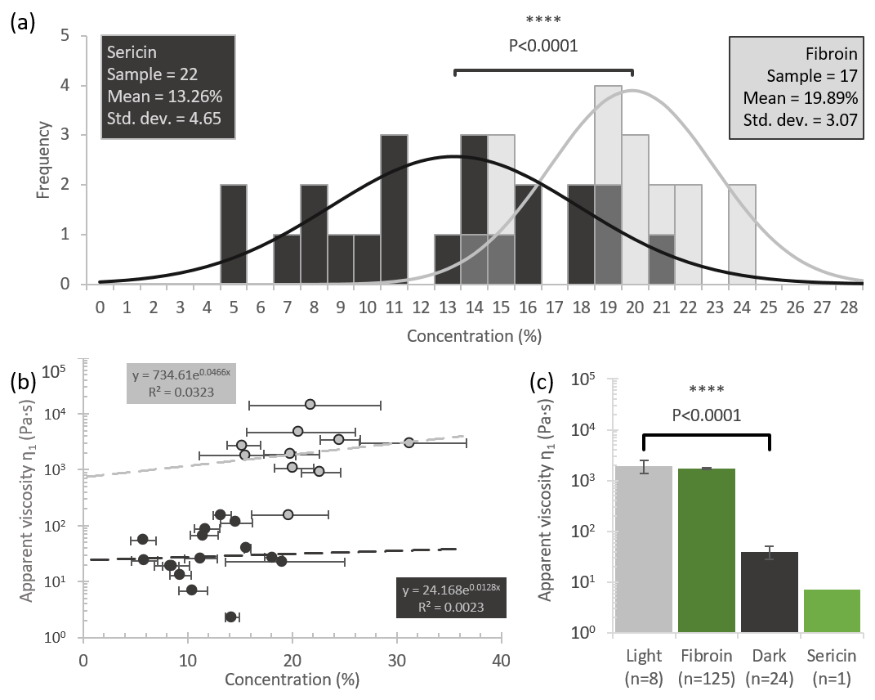
Figure 34: Sericin concentration and apparent viscosity determination.
(a) Empirical (bars) and probability (curves) density functions for concentration of fibroin and sericin feedstocks. For the probability density functions, P<0.0001. Cohen’s d = 1.67, suggesting that the effect size Is very large and thus the difference is both significant and meaningful²⁷⁶. (b) Plotting viscosity against concentration shows very little correlation between the two factors for sericin or fibroin. Horizontal error bars represent the variation due to measurement uncertainty due to small sample sizes. (c) Mean apparent viscosity for samples compared with literature values for fibroin and sericin. An unpaired t-test with a two tailed P value of P<0.0001 suggests extreme statistical significance, while Cohen’s d = 1.77, confirming that the difference is also meaningful. Bars represent standard error.

Oscillatory response
Probing the rheological properties of sericin further, oscillatory sweeps were used to determine the viscoelastic response of the feedstocks, with both sericin and fibroin behaving as weak gels^{161,277–279}. However, as can be seen in figure 35a, the bimodal distribution of crossover points shows that there are clear differences between sericin (crossover frequency ω_{X} = 10±5 Hz; crossover modulus G_{x} = 482±326 Pa) and fibroin feedstocks (ω_{X} = 0.58±0.47 Hz; G_{x} = 2906±1297 Pa), with the former showing a greater viscous response and substantially lower modulus, whilst the latter provides further evidence that Light specimens produce fibroin, with mean crossover values similar to previously published work^{14,115,135,140,151,152}. In the case of sericin feedstocks, the presence of a shorter relaxation time (estimated as 1/ω_{X}), and a larger lower critical shear rate (γ̇_{LC}, which marks the rate at which the transition between Newtonian and power law behaviour can be said to occur, is numerically equivalent to ω_{X}) identifies a more liquid-like behaviour which remains Newtonian until higher shear rates are encountered.
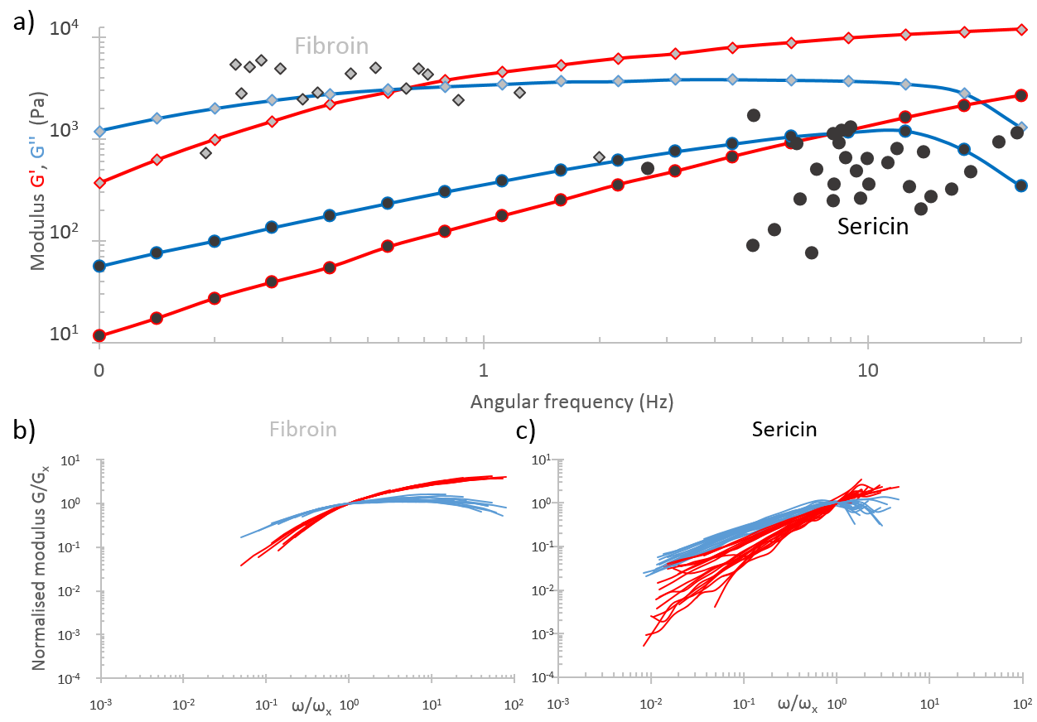
Figure 35: The frequency dependence of sericin.
(a) Variability in the frequency response of samples is shown by plotting the crossover points for sericin (conc. 13.3%) and fibroin (conc. 20.5%). The two sets of oscillatory data (elastic, viscous) are representative of the viscoelastic response of sericin and fibroin. The presence of a bimodal distribution shows that there are distinct viscoelastic responses from each group, with sericin’s reaction remaining in the viscous domain much until much higher frequencies than fibroin. (b,c) Normalising modulus and frequency data against crossover modulus and frequency reveals master curve alignment in fibroin and sericin specimens. The greater level of spread shown by sericin indicates variation in the molecular weight distribution attributable to the less conserved nature of sericin production compared to fibroin.

Maxwell model fitting
Although a single Maxwell model was not sufficient to describe sericin’s behaviour, it has been shown that binary models provide a good fit for biopolymer solutions¹¹⁴, thus the elastic and viscous moduli of individual sericin samples were curve-fitted using a binary Maxwell model $(x=2)$ of the form:
$$G^{'}\left(ω\right)=\sum_{i=1}^{x}{\left(\frac{g_{i}ω^{2}τ_{i}^{2}}{1+ω^{2}τ_{i}^{2}}\right)}$$ | ( 8 )
$$G^{''}\left(ω\right)=\sum_{i=1}^{x}{\left(\frac{g_{i}ωτ_{i}}{1+ω^{2}τ_{i}^{2}}\right)}$$ | ( 9 )
Where $g_{i}$ represents the weighted modulus contribution of each Maxwellian element, and $τ_{i}$ represents the corresponding relaxation times. Comparison between shear and oscillatory measurements was undertaken to assess cross-experimental data reliability. Through further application of the Maxwell Model^{114,115,153}, which states that:
$$η_{0}=\sum_{i=1}^{∞}{g_{i}τ_{i}}$$ | ( 10 )
We can estimate the mean zero shear viscosity from oscillatory data as 46.59 Pa.s, which is comparable to that predicted by the Carreau-Yasuda model (58.63 Pa.s). Linear regression (figure 36) of the date, constrained about the origin, shows strong correlation (R²=0.9543) for the relation$y=1.038x$, and while the coefficient is perhaps marginally higher than expected (for a truly representative non-Newtonian model, η₁ should be marginally lower than η₀, but given that this low shear rate was chosen so as to remain in the quasi-Newtonian regime, it is perhaps unsurprising that they are practically equivalent), this strong correlation confirms the reliability and consistency of the experimental design, suggesting that the main source of variation is biological.
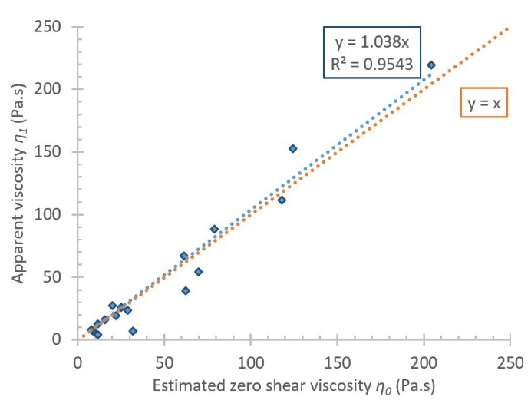
Figure 36: Zero shear viscosity comparison.
Comparison of zero shear viscosity estimated from the binary Maxwell model to that measured through steady shear shows a high degree of correlation between the two, suggesting good experimental consistency.

Fitting the aforementioned binary Maxwell model (à la Laity et al.¹¹⁵) to the data suggests the presence of two relaxation modes in sericin feedstocks, at around 1.22 and 0.02 s, which are of similar magnitude to relaxation modes three and four reported for fibroin (0.44 s and 0.055 s respectively)^{114,153,154}. Furthermore, normalisation of the oscillatory data with respect to each sample’s crossover point¹¹⁴ demonstrates the consistency of the fibroin feedstocks (figure 35b) and the apparent variation in properties of sericin feedstocks (figure 35c). This consistency has been hypothesised to be related to a feedstock’s molecular weight distribution, thus our results are consistent with reports that while fibroin’s production is relatively consistent, there are up to 7 different sericin proteins^{93,259,280,281} secreted into the gland in quantities that vary on a specimen by specimen basis^{72,281}, with molecular weights ranging from 24 to 400 kDa ^{69,72,259,260}.
We conducted temperature sweeps between 2 and 80 °C in order to explore the effect on sericin’s flow properties across a range of natural and unnatural spinning temperatures. Sericin shows a typical protein response to elevated temperatures (figure 37), denaturing permanently into a strong gel (indicated by rapid increase in both moduli, and the temperature independent frequency response after reaching this temperature) at approximately 60°C. The most productive rearing temperatures for B. mori lie between 23 and 28 °C, though a range between 20 and 30 °C is commercially viable. Outwith this range, silkworm health deteriorates and is thus undesirable²⁸². The inclusion of complex viscosity measurements in figure 37 allows appreciation of the fact that over the range of natural spinning temperatures, the viscosity remains relatively invariant.
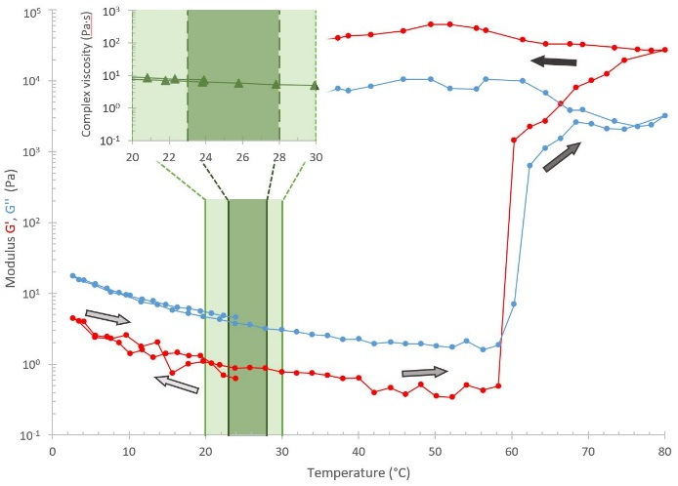
Figure 37: The effect of temperature on sericin.
Representative response of a single sericin sample (conc. 15.7%) subjected to temperature sweep under steady oscillation (0.1 Hz). First from 25°C to 2°C, then 80°C, where a frequency sweep was undertaken, before returning to 25°C. A minor reversible increase occurs in both elastic and viscous moduli in response to reduced temperature. A steady reduction is observed until a sudden take off in both moduli occurs, marking the transition to an elastic dominated regime. Further conversion is observed during the latter stages of the temperature sweep (increased moduli), with the gel formed shown to be strong (plateau G’, G’’) and permanent (G’> G’’). Background colours depict the preferred and possible rearing temperatures. (Inset) The relative invariance of the complex viscosity across the range of viable spinning temperatures, suggesting that spinning is not dependent on temperature.

In order to probe sericin’s flow response to shear rates encountered during silk spinning¹⁰⁷, shear rate ramps were applied to samples (figure 38). All samples were found to exhibit the shear thinning behaviour expected of concentrated polymer solutions, with the transition from Newtonian to shear thinning regime occurring above a lower critical shear rate (mean = 10 s⁻¹, which is comparable to the only previously reported²⁸³ value of 3 s⁻¹). At higher shear rates a distinct change in viscosity is accompanied by a change in shear stress and normal force (figure 38). Drawing on previous work into fibroin rheology^{80,114,115,135,140,151,154}, this upper critical shear rate (${\dot{γ}}_{UC}$) is that at which the onset of shear induced gelation occurs within the sample. Here a general trend can be observed that the critical shear rate ${\dot{γ}}_{UC}$ varies inversely with the apparent viscosity${ η}_{1}$, with lower viscosities relating to higher upper critical shear rates (see chapter 7 for further discussion).
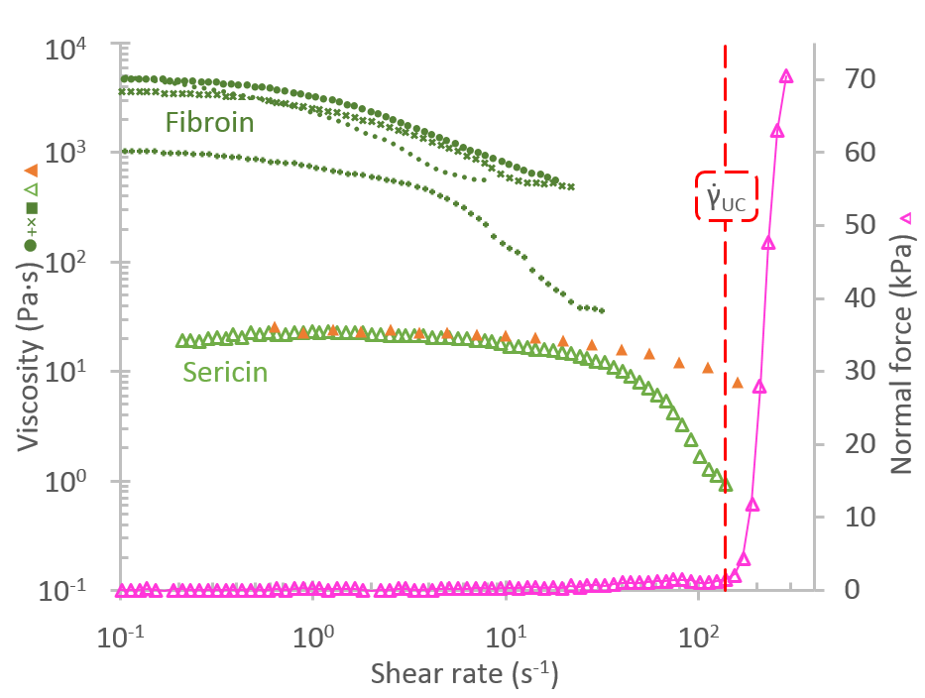
Figure 38: The viscosity-shear rate relation for sericin.
Comparing sericin’s (conc. 11.3%) dynamic and complex viscosities via the Cox-Merz relation shows high correlation at low shear rates/angular frequencies, but divergence above this, with the measured dynamic viscosity exhibiting much stronger shear thinning behaviour than Cox-Merz predicts, suggesting unequally²⁸⁴ weighted polydispersity¹⁷⁰. The normal force response to the shear ramp is also shown on the secondary axis, along with the upper critical shear rate. The rapid increase in normal force at this point represents the sudden rise in elasticity due to shear-induced gelation. For ease of comparison, several fibroin shear-ramps (conc. 15.3-24.6%), with zero shear viscosities across a broad range are shown. The final point in each represents the upper critical shear rate (gelation onset), all of which occur in the region where sericin is still effectively acting as a Newtonian fluid.
More insight can be gained by interpreting our viscosity data using the SCY model¹⁷⁰, which has been shown to accurately depict a wide range of shear thinning behaviours in polymer solutions. Models fitted to individual specimens showed considerable variation in both the extent, and the rate of shear thinning (figure 39). Comparisons were made between experimentally measured apparent viscosity and the modelled zero shear viscosity, with a high degree of correlation (R² = 0.98) between the two, allowing for further simplification of the model by reducing it to three parameters (relaxation time, shear thinning rate, and transition breadth) to improve model validity.
Model fitting parameters are shown in table 6. General trends that can be observed include that the rate of shear thinning and lower critical shear rate are inversely proportional to the zero shear viscosity, and that transition breadth rises in line with zero shear viscosity. We suggest that this may indicate that it is possible to infer sericin’s shear response from its zero shear viscosity alone (see chapter 7 for further discussion). A further observation is that despite the wide range of${ η}_{0}$ encountered for sericin, the proportional reduction in viscosity${ η}_{min}$remains roughly constant at approximately 80%. Fibroin was also observed to undergo a similar reduction of 90%, suggesting that whilst sericin does exhibit shear thinning behaviour, it is to a lesser extent than fibroin.
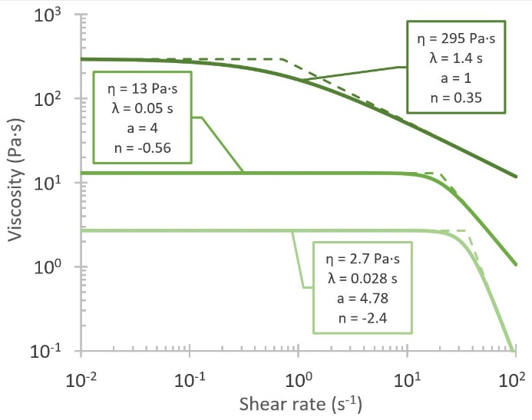
Figure 39: Shear dependent viscosity models for sericin.
Exemplar shear response curves calculated from fitting the SCY model to sericin samples shows the variation present. Solid lines indicate the best fit to the data, while the dashed lines have an instant transition from Newtonian to power law behaviour in order to appreciate the variation in the upper critical shear rate.
As explained above, whilst it is not currently possible to directly compare rheological properties of fibroin and sericin from the same animal, considering our rheological data as a whole, we propose that for a typical non-fibroin deficient silkworm, the upper critical shear rate γ̇_{UC} for sericin gelation must only be higher than that of its fibroin (0.1 to 10 s⁻¹,^{14,22,80,113,135,146,151,163}), else sericin would aggregate before fibroin and inhibit fibre formation. Therefore the natural constraint on the system is simply to ensure that sericin has a greater upper critical shear rate than fibroin (${\dot{γ}}_{UC,Ser}>{\dot{γ}}_{UC,Fib}$) (see chapter 7 for further discussion). With this in mind, sericin may not have undergone as strong a selection to gel during the natural spinning process, which may be responsible for the wider variation in rheological properties.

Table 6: Summary of rheological properties of native B. mori sericin solutions
Measurement method | Physical property | Mean | Standard deviation | Sample size n
Gravimetry | Concentration (mg/mg %) | 13.26 % | 4.65 | 22
Steady shear | Apparent viscosity $η_{1}$ | 39.57 Pa.s | 53.96 | 24
Oscillatory sweep | Crossover frequency $ω_{X}$  Crossover Modulus $G_{X}$  Relaxation time $1/ω_{X}$ | 10.48 Hz  482.14 Pa  0.019 s | 5.01  325.63  0.01 | 29
Temperature sweep | Gelation temperature | 63.86 °C | 8.16 | 3
SCY model | Relaxation time $λ_{CY}$  Zero shear viscosity $η_{0,CY}$  Parameter $a$  Parameter $n$  $${\dot{γ}}_{LC,Ser}$$  $${\dot{γ}}_{UC,Ser}$$ | 0.51 s  55.66 Pa.s  3.85  0.05  10.09 s⁻¹  58.47 s⁻¹ | 0.44  87.52  3.17  2.61  15.30  50.85 | 14
Binary Maxwell model | Modulus contribution $g_{1}$  Modulus contribution $g_{2}$ | 44.89 Pa  888.98 Pa | 61.64  723.00 | 22
 | Relaxation time $τ_{1}$  Relaxation time $τ_{2}$  Zero shear viscosity $η_{0,BM}$ | 1.22 s  0.02 s  46.59 Pa.s | 1.86  0.01  49.07

Furthermore, we observe that sericin flows in a quasi-Newtonian manner throughout the fibroin shearing range (i.e. until γ̇_{UC,Fib}), at which point its viscosity drops, which may be the result of selection for the need to maintain the consistent sericin-fibroin interface required for stable long-term fibroin storage²⁸⁵, but later thin in order to ease the transport of an increasingly solid fibroin core through the recently proposed solidity gradient model¹⁰⁷ (see chapter three). These arguments are further supported by recent work into drying rates of newly spun fibres which could be interpreted as the external (sericin) layers remaining wet for several seconds after leaving the animal¹³⁵, and that when spun under high humidity, flow can continue between cocoon layers²¹³, suggesting sericin does not solidify within the animal.

Chapter summary
In conclusion, mottled specimens of the fibroin deficient W14 strain of B. mori are a good source of large quantities of unadulterated native sericin and this work provides a new standard for use in assessing the quality of recovered or reconstituted sericin. We have also shown that sericin’s response to temperature changes is in line with other protein solutions, exhibiting extensive, rapid permanent denaturation above 60°C.
As with fibroin, sericin’s viscosity varies across several orders of magnitude, but despite their similar molecular weights, these ranges barely overlap, with sericin occupying a much lower viscosity domain in the region of 1–250 Pa.s, whilst fibroin ranges from 200–10000 Pa.s. Given this, we ask whether, in terms of their shear response behaviour, they could be considered as part of a single spectrum.
The Cox-Merz relation has been shown to not be particularly applicable, as while the zero-shear viscosities are comparable, it systematically underrepresents the rate of shear thinning at higher shear rates. Furthermore, native sericin is more readily shear thinning, has a lower initial viscosity, and a higher upper critical shear rate than native fibroin, all of which combine to provide a solution capable of providing a lubricating effect on the flow of fibroin. As a final observation, since apparent viscosity relates to zero shear viscosity, and as relaxation time, transition breadth, and shear thinning all relate to this, then we suggest that we may be able to predict sericin’s shear response from apparent viscosity measurements alone, which would remove the need for destructive rheological testing.
In summary, we present evidence for the rheological properties of native sericin which is used to support the oft repeated (see chapter three), but previously unsupported, argument that in addition to acting as a binder within the cocoons, sericin performs a lubricating role in its liquid phase within the gland.

Chapter 6

Work

Abstract
Natural silk spinning has undergone strong selection for resource efficiency and thus presents a biomimetic ideal for fibre production. Industrial replication of natural silk fibres would enable access to low energy, cost efficient processing, but is hampered by a lack of understanding surrounding the conversion of liquid feedstock into a solid fibre as a result of flow. Previously, shear stress, shear rate or time have been presented as criteria for silk fibre formation, but here we propose that spinning requires carefully balancing all three, and is a result of controlled energy accumulation in the feedstock. To support this hypothesis, rheology is used to probe the energy required for conversion, compare differences between amorphous solid and ordered fibre production and explain the energetic penalty the latter demands. New definitions of what constitutes an artificial silk fibre are discussed, along with methods to ensure that each spinning criterion is met during biomimetic spinning.
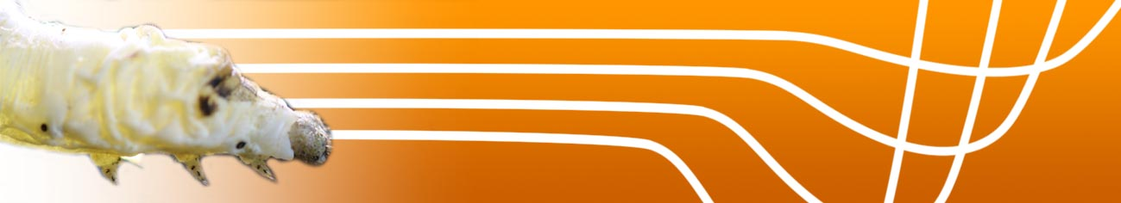
Prior publication
This chapter has been published as:
Sparkes, J., & Holland, C. The energy requirements for flow induced solidification of silk, Macromol. Biosci. 18 1800229 (2018)
For ease of access, a copy of which is provided in the appendix.

Introduction
Emulating the process of natural silk spinning is a long held aim in the field of biomaterials. Unfettered access to silk’s attractive properties will provide huge commercial benefits due to efficient continuous fibre production without the hindrances associated with traditional methods⁹⁷.
While spider silk is perhaps the most well-known, or at least promoted, super material, the vast majority of everyday silk products are woven from fibres produced from cocoons spun as a protective layer by the Chinese silkworm Bombyx mori. In their native environment, B. mori spin, via pultrusion¹⁰⁷, a dual filament fibre composed primarily of fibroin¹, coated in layers of sericin, which acts as a lubricant in the duct¹⁰⁸ and a binder^{238,253} in the cocoon, a non-woven composite structure¹². Whilst B. mori’s fibre mechanical properties⁸⁴ are less desirable than those of, say the dragline filaments of N. clavipes¹⁴¹ (chapter one) there is abundant evidence to suggest that they can be further processed to comparable performance levels^{21,44,82}, and their generally more abundant, accessible nature makes them a more practical technology platform^{34,203,268,286–289}.
The majority of studies exploring aspects of spinning fibroins have opted to focus on recombinant feedstock production^{103,290}, die design^{37,116,161,162,168,291}, fibre spinning, the mechanical properties of natural and artificially spun fibres, and post processing methods that can be undertaken in order to improve initial mechanical properties^{292–294}. Our previous work has supplemented these industrially relevant methods at a more fundamental level by exploring the flow properties of silk protein feedstocks^{14,108,114,115,140,151,154}, and how these relate to the aforementioned aspects of spinning.
The criterion for silk fibre formation, i.e. solidification through gelation (alluded to in chapter one), has been much debated in the literature, with successive studies putting forward evidence for gelation as a product of how hard (stress), how fast (rate), or how long (time) the sample is sheared. Here we propose a new approach, which seeks to combine all three, suggesting that fibroin gelation occurs due to energy accumulation. Following in the footsteps of earlier synthetic polymer research by Mykhaylyk et al., we build on the approach recommended by Dhaese et al.²⁹⁵ by implementing the second phase—application of steady shear—in order to precisely probe silk’s flow behaviour (phase one—simultaneous application of variable shear rates to determine threshold values—was undertaken by Holland et al.⁴⁸) We describe this behaviour in terms of work per unit volume, expressed as a function of shear stress, shear rate and time^{295–298}. To demonstrate this, we subject fibroin samples to steady shear until gelation and assess the total work done to reach this point. In doing so we identify a threshold for gelation which, as with synthetic polymers²⁹⁸, remains relatively constant, despite variation in material properties⁵⁹. We consider the implications of this within the wider context of understanding the fundamental mechanisms behind shear-induced denaturation, as it allows industrialists wishing to mimic silk fibre spinning to employ much less stringent conditions in feedstock production.

Methods

Sample preparation
Native silk fibroin feedstock was extracted (using our previously described method¹¹⁵) from the glands of Bombyx mori silkworms in the wandering stage without any further preparation before testing. Fibroin concentration was assessed by drying out the portion of the gland next to that used for rheology and given as dry weight percent.

Rheological characterisation
All rheological tests were conducted on a Bohlin Gemini Rheometer (Malvern Instruments, UK) at constant temperature and humidity, with a cone and plate geometry (10 mm diameter, 1° cone, 30 µm truncation) used to ensure a constant shear rate in the sample. After loading, a low viscosity fluid sheath (water) was created around the sample to avoid dehydration and subsequent skinning effects in the pre-test environment¹¹⁵. See chapter two for more details on the principles of rheometry.
The pre-test procedures began with 100 s of steady shear (1 s⁻¹) to ensure homogeneous sample distribution, with apparent viscosity noted as the mean viscosity recorded from the final 30 s. A low strain (0.02) oscillatory sweep across a range of frequencies (25–0.1 Hz) was used to ensure that the sample remained fluid, before the main tests were run. Samples were grouped on the basis of their apparent viscosity $η_{1}$ in 500 Pa.s intervals and subjected to an extended period of steady shear at a rate between 3 and 15 s⁻¹, chosen to ensure a wide range of shear rates was considered.
Determination of the shear rate dependent viscosity $η\left(\dot{γ}\right)$ was assessed through the assumption that the well-known Cox-Merz relation²⁹⁹ is valid for fibroin, which means that $η\left(\dot{γ}\right)$ is well approximated by $|η^{*}\left(ω\right)|$. Application of the Simplified Carreau-Yasuda model:
$$η\left(\dot{γ}\right)=η_{0}{{(1+(λ\dot{γ})}^{a})}^{\frac{n-1}{a}}$$ | ( 11 )
to this data yields values for the zero shear viscosity $η_{0}$, along with the longest relaxation time ($λ$), lower critical shear rate (${\dot{γ}}_{LC}$), and both the rate ($a$) and severity of shear thinning ($n$). Goodness of fit was gauged via Escudier’s method²⁵⁸, while model validity was assessed by its ability to correctly predict the apparent ($η_{1}$) and test ($η_{τ}$) viscosities.
Oscillatory data was superimposed onto a master curve in order to assess the consistency of both the batch, and the experimental method. Higher rate steady shear data was curtailed beyond the time where a rapid rise in both viscosity and normal force were observed. Since the viscosity under steady shear was observed to transition from an initially high viscosity ($η_{α}$) to a lower, steady, final viscosity ($η_{β}$) as a function of time ($η\left(t\right)$) it seemed appropriate to fit a model which is numerically equivalent to the full Carreau-Yasuda model:
$$η\left(t\right)=η_{β}+\left(η_{α}-η_{β}\right){{(1+(τt)}^{c})}^{\frac{d-1}{c}}$$ | ( 12 )
Where $c$ and $d$ describe the breadth and rate of the transition respectively. Goodness of fit was again assessed using Escudier’s method²⁵⁸, Evaluation of total work done to the system was undertaken on a per unit volume basis using the methods first espoused by Janeschitz-Kriegl et al.²⁹⁶, and later applied, first to synthetic polymers by Mykhaylyk^{297,298}, and later to native silk fibroin by Holland⁴⁸, which states that the work applied in a test of length $t_{β}$ can be determined as:
$$w=\int_{0}^{t_{β}}{η(t)}{ \dot{γ}}^{2} dt$$ | ( 13 )
Rearranging this to account for the fact that in our case, shear rate is constant, and that shear stress, rather than viscosity, is measured, results in the following definite integral which is readily evaluated.
$$w= \dot{γ} \int_{0}^{t_{β}}{σ(t)}dt$$ | ( 14 )
This analysis was applied to both the apparent and test viscosity data to determine the total work done to each sample.

Statistical analysis
Unless otherwise stated, data is presented as mean ± standard deviation from n repeats, with significance determined using unpaired t-tests with P<0.0001.

Results and discussion

Oscillatory and low rate steady shear response
Initial testing confirmed that the fibroin samples tested were representative of typical B. mori feedstock and therefore suitable for characterising work to gelation (figure 40). Specifically, application of low rate steady shear provided a homogeneous starting point and, when combined with the oscillatory response, allows estimation of zero shear viscosity (figure 40a, b). Concentration determination shows the typical fibroin spread (figure 40c), and expected lack of correlation with viscosity (figure 40c, inset). The combinatorial pre-test confirms the use of a typical fibroin feedstock which was unaffected by the extraction and loading procedures, before principal testing commences. 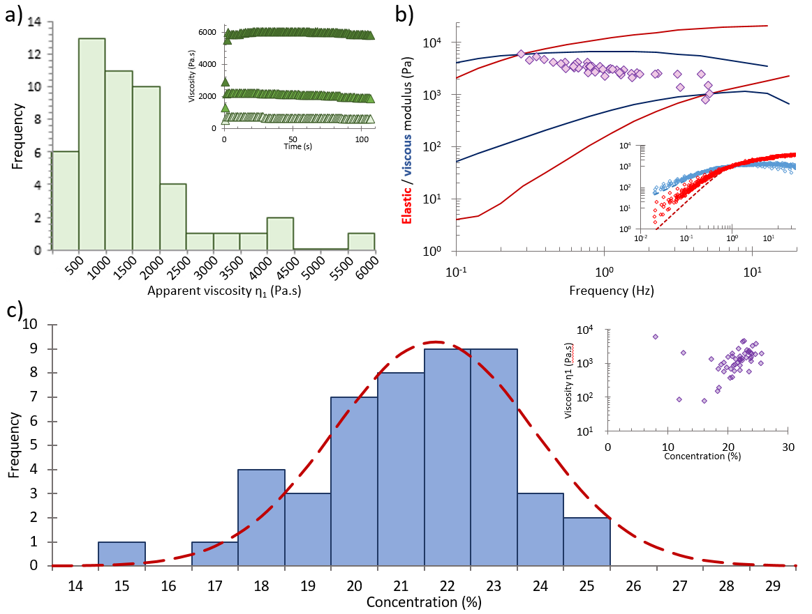
Figure 40: Preliminary testing.
(a) Apparent viscosity distribution. Mean of 1524 ± 1166 Pa.s (n = 50), slightly lower than Laity’s¹¹⁵ 2015 result. (Inset) Low rate steady shear response: Example responses of fibroin samples with high, medium, and low apparent viscosities highlight the behaviour, which shows the typical stress overshoot, followed by a slight reduction to a plateau viscosity $η_{1}$. (b) Fibroin’s oscillatory response: In sample variation is shown by plotting crossover points (frequency where elastic and viscous moduli are equal), with the moduli of the most and least elastic samples also plotted across the entire frequency range in order to better illustrate the range of responses. (Inset) Close similarity in the superposition of oscillatory sweeps with frequency and modulus normalised against crossover shows consistency between samples, allowing us to treat the normalised data as repeated sweeps of a generic fibroin sample which can be fitted with a binary Maxwell model (dotted lines). (c) Fibroin concentration, determined as a dry weight fraction is 21.7 ± 5.5% (n = 50), comparable to previous studies¹¹⁵. (Inset) Comparing viscosity and concentration shows little correlation, with a wide range of viscosities present for a given concentration.

The Cox-Merz relation allows for the extraction of data equivalent to destructive test results such as that gleaned from shear ramps, without the need to perform said experiment, providing us with insight into how silk compares to typical synthetic polymers.⁴⁸ To this end, oscillatory data fitted well using the SCY model (R² = 0.999), with model parameters $λ$ and $η$ showing good correlation with zero shear viscosity (figure 41a), while the third ($a$), which describes the breadth of transition to shear thinning behaviour, is less clearly linked.
The degree to which native silk feedstocks match these models is largely predicated on the assumption that they behave like polymer melts under flow. However, whilst the small strain, elastic deformation of oscillatory tests is useful, it does not replicate all aspects of the material response to the actual plastic deformation that occurs during steady shear flow. Therefore, it is imperative that these models are tested and validated before further use, and as such, steady shear data provides a useful tool to probe silk’s response to larger deformations.
Comparing the measured viscosity at low shear (1 s⁻¹) with that predicted by the relevant converted oscillatory response data shows excellent agreement between the two techniques (figure 41b, i) and anchors the Cox-Merz generalisation for silk under low flow conditions. However, application of the same model at higher rates (figure 41b, ii) shows considerable under-representation of the extent of shear thinning and hence over-estimates the viscosity by a considerable margin. Hence the Cox-Merz generalisation is most suited to determining the zero shear viscosity of silk samples. As a result, new approaches and interpretations—such as the aquamelt hypothesis⁴⁸—will be required if we wish to predict silk’s behaviour under higher shear rates.
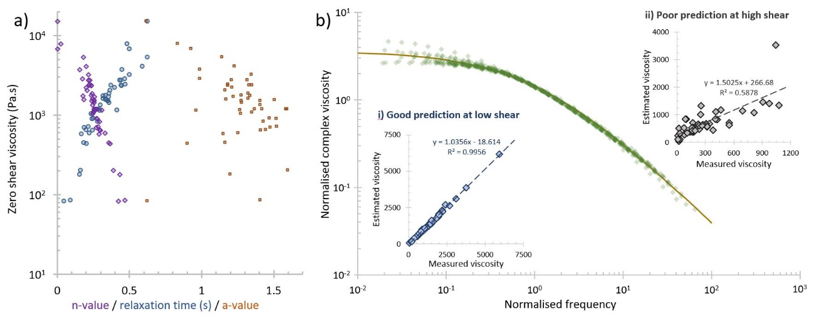
Figure 41: SCY model fitting parameter determination.
(a) Relation between Simplified Carreau-Yasuda model parameters fitted to Oscillatory data via the Cox-Merz relation. (b) Oscillatory-shear equivalence. Normalised complex viscosity data (against crossover), again fitted with a SCY model. (Insets) Relation between measured apparent viscosity (η₁, η_{τ} ), and that predicted by the Cox-Merz relation at corresponding low (i) and high (ii) shear rates.

High rate steady shear response
Assessment of the work required for gelation at higher rates of shear allows for some interesting observations. From an experimental perspective, perhaps the most important is the time required to reach an equilibrium viscosity (i.e. flow response) under steady shear, with length scales far in excess of that assumed in typical shear rate ramps^{14,80,108,114,115,140,151,154}, meaning that there is a far greater dependence on rates of change than previously assumed. This suggests that prior attempts to describe the shear thinning behaviour of fibroin feedstocks using, for example, the SCY model, may also be under-representative of the true steady state viscosity of a given feedstock. However, the alternative, which involves subjecting samples to a stepped shear rate with step lengths longer than the expected equilibration time, is unlikely to prove more worthy across a useful range of rates, since total work accumulation in such a test is likely to exceed the point of denaturation itself, thus rendering a sample void before complete mapping of the regime is achieved.
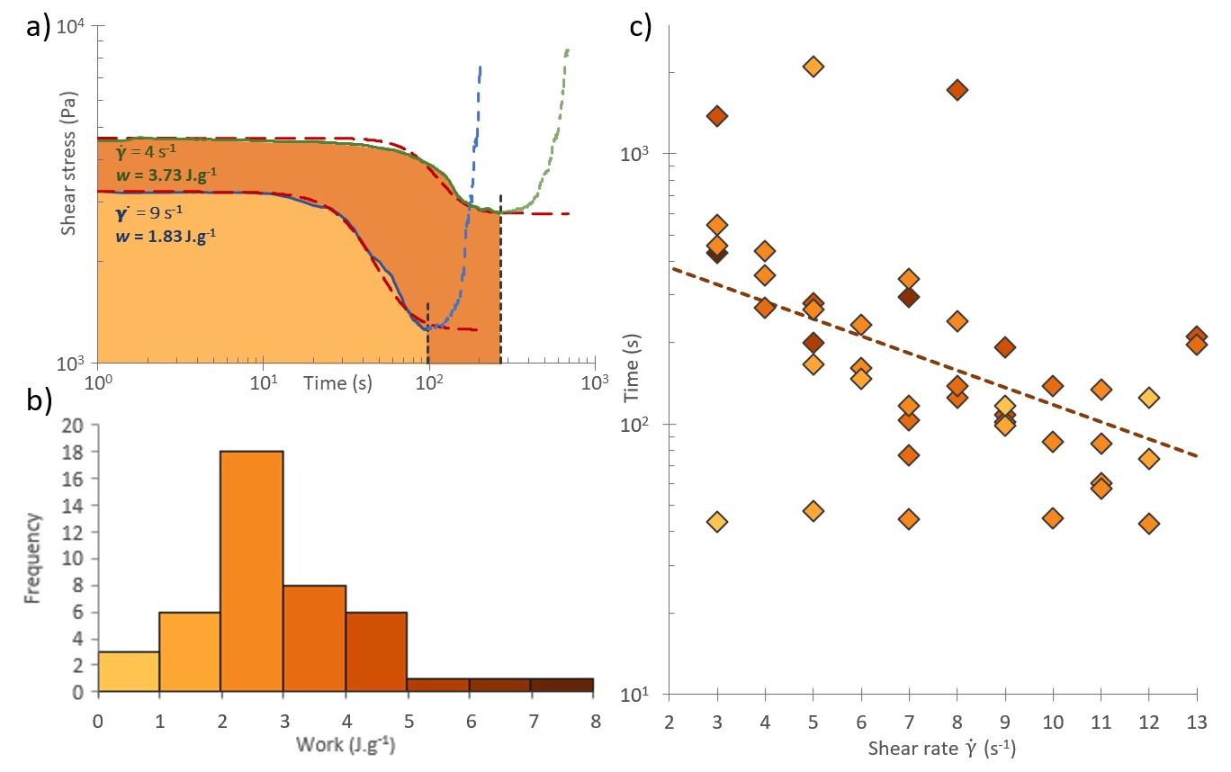
Figure 42: High rate steady shear responses.

(a) Two examples of fibroin’s response to high rate steady shear are plotted. Both transition from a quasi-static viscosity to a lower plateau viscosity, after which a rapid increase in shear stress indicates sample gelation. The point at which gelation initiates is indicated, and forms the upper limit for the integral in equation 14. The total work done for each sample (Shaded areas) are grouped in (b), with colours representing each J.g⁻¹ interval. (c) The relation between applied shear rate and time to gelation is shown, with points coloured according to the total work done (see (b) for colour key).
Looking to the total work input required to induce gelation, as defined at the point by which the material changes from shear thinning to thickening¹⁶³, when considered in isolation, high shear work to gelation results cluster around an average of 2.75±1.37 J.g⁻¹ (n=44), or with the inclusion of the work done at low shear rates as a result of pre-shearing of the sample at 2.90±1.43 J.g⁻¹ (figure 42). Although it is in direct contradiction with Mykhaylyk’s 2008 conclusion²⁹⁷—that only work above a given threshold shear rate is useful—the inclusion of low shear rate work is in line with observations that, due to the polydispersity of real polymer solutions, some orientation will always occur at any applied shear rate. Thus, in that sense, all work done is useful, even if the observed effects are small.
This compares very favourably with our recent differential scanning calorimetry (DSC) measurements of thermally induced changes in fibroin feedstocks (1.778±0.245 J.g⁻¹, n=27)³⁰⁰ and supports the argument that, as with synthetic polymers^{295,297,298}, silk solidification is best described in terms of total energetic input. Comparing our results with DSC data for other common model proteins such as albumen (17.0 J.g⁻¹)³⁰¹, we see that the minimum energetic input required for fibroin to undergo denaturation—defined as the energy required to first dehydrate and then subsequently alter the bonding configuration in a protein^{302–304}—is nearly an order of magnitude lower for both shear and heat-based energy inputs, which perfectly highlights the superb efficiency of silk solidification⁴⁸.
The differences between shear and heating energy input values become clear when the difference in end product is considered. In DSC experiments, the end result is an amorphous, isotropic mass formed through spontaneous denaturation of the fibroin solution. However, for sheared samples, the end result is anisotropic, with alignment of structures across multiple length scales seen in the direction of shear^{48,80,135}. This confirms that although silk gels incredibly easily, the generation of solid multiscale hierarchical structures (i.e. spinning a fibre) without premature gelation is a more energy intensive process—i.e. work must be done to align polymer chains, but at a rate low enough to avoid the spontaneous amorphous denaturation observed through calorimetry, a point which has clear parallels with the controlled morphology techniques mooted for synthetic polymers²⁹⁸
Perhaps at this juncture, most pertinent to the broader discussion is to question what a fibre actually is. Classical descriptions (figure 43) hold that they are simply long, slender objects which possess sufficient flexibility to allow them to be woven into fabric, but I argue instead that, with the increased interest in biomimetic silk spinning, a stricter definition is required. While extruding protein solutions into a long, thin mass may have the macroscopic appearance of a fibre, and may represent promising advances in their respective fields, to call these short, stiff, or brittle protein extrudates fibres is perhaps misleading, unless they exhibit more of the interconnected hierarchical structural motifs present in natural silks^{97,145,305,306}.
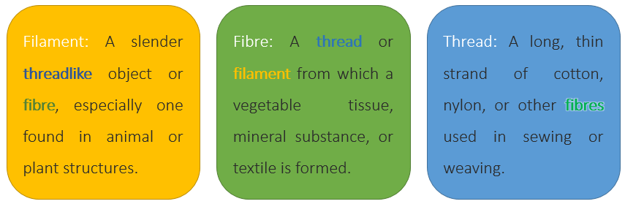
Figure 43: Traditional definitions of filament, fibre and thread.
Traditional dictionary definitions are circular in nature, resulting in different authors applying them to different structures, which makes comparison difficult.

During the production of a natural silk fibre, silk protein feedstocks are converted into a solid through alignment, denaturation, crystallisation, aggregation and fibrillation (figure 44). Therefore we suggest that natural silk production requires a controlled application of energy to facilitate this entire process over a specific timescale, first generating structures via intra then inter-protein interactions. Whilst it is evident that flow plays a key role in energy accumulation during natural spinning and is the animal’s primary tool for generating precise structures in its materials^{78,82,107}, this is in stark contrast to the current state of the art in artificial fibre production. Although alternative methods of energy application such as thermal or chemical approaches may seem more efficient or convenient, they may not facilitate structure development in a similar way, leading to products that do not exhibit all the traits of a natural silk fibre⁹⁷. We believe that the data presented herein offers a new window into artificial spinning, in that although silk will denature once a certain energetic threshold is passed, how that energy is supplied must be controlled in order to truly spin silk.
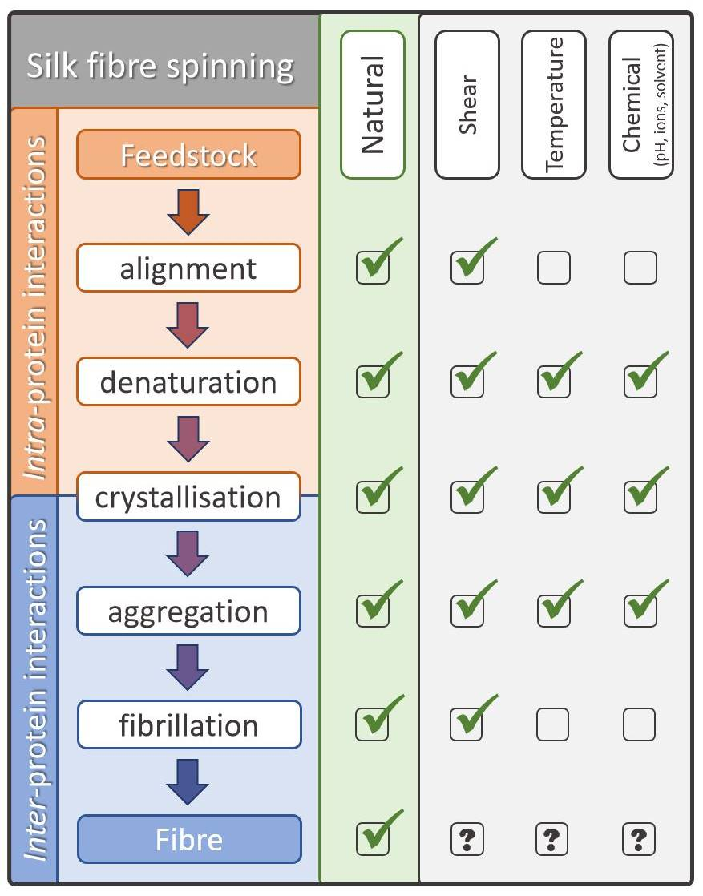
Figure 44: A comparative framework for silk fibre production.

Whilst there are several means to solidify silk, not all are able to generate the hierarchical structures present in a natural fibre. Here we present the ordered steps necessary for spinning as a means of highlighting why current techniques are struggle to produce high quality fibres on their own.

Chapter summary
Natural silk spinning is a process dependent on the careful application of energy to the feedstock through a combination of flow stresses, at different rates, for different lengths of time. Through a combination of steady shear experiments at a range of different shear rates, we present a map of the work required to induce solidification in the native silk feedstock from B. mori. By comparing our findings to calorimetry studies it is clear that there is an energy penalty associated with fibre formation that is not seen in other forms of feedstock solidification. This leads us to the proposition that not all solidification routes are equal, causing us to reconsider what constitutes a natural silk fibre and the steps taken to produce it.

Chapter 7

Perspective

Introduction
Early on in my research I experienced intense frustration at the tendency in the literature to produce overly lengthy pieces of work, which made it hard to extract relevant content from the padding, with a suspicion that oftentimes, experiments were included simply because they had been done, and not because they were relevant to the central hypothesis. As a result, in my own work I have lent firmly in the direction of brevity, which the preceding chapters have shown and for which you are hopefully grateful. That notwithstanding, in this chapter I’ve given myself a little more freedom for rambling discussion of the trials and tribulations that lay behind the discoveries presented herein. In essence, it provides me an opportunity for reflection on the PhD process and the significance of my work in the silk and wider field. This ultimately allows me to develop, if not a map, then a signpost or two which point in the direction that future efforts might appreciate (or if you prefer, a list of things that I tried and didn’t work, since as they say, forewarned is forearmed!).
Looking back to the start of my PhD, my initial aim was to advance the work started by Breslauer¹¹² in 2009, which used simplistic computational models to explore flow behaviour in silk glands. A perhaps overambitious plan was laid out as 1) build new flow models using accurate rheological data; 2) validate models by flowing native silk solutions through glass capillary with the same geometries; 3) link flow properties from models to fibre performance in mechanical testing; 4) hope that artificial feedstock production advances sufficiently far as to be able to provide the volume required for continuous fibre production. However, with the benefit of hindsight I suggest that even calling this overambitious might be an understatement. My efforts to date have thus focussed primarily on the first point on this list, and this chapter will lay out how my results work towards this goal, and what needs to be done next.
Chapter one closed with a list of aims, or questions to be answered, which are reprinted here for ease of reference:
- Can reliable predictive flow models be created for silk which afford us the opportunity to explore design variables for synthetic analogues?
- What are the rheological properties of sericin and how do they affect silk spinning?
- What are the energetic requirements for silk spinning—what forms can this input take, and which are critical?
Let us now consider the key results from chapters three through six and how they provide answers to them.

Discussion
The key findings from chapters three and four are that spinning silk requires pultrusion and that as a result they are naturally post processed through further drawing once they leave the animal. This result was made possible by combining advances in our rheological knowledge of silk feedstocks with software advances in the realm of computational fluid dynamics, and ultimately grounded through a series of validation experiments which provide the surety and confidence lacking in previous work. So how is this novel?
Whereas before we had observed that silk producers do pull silk from their gland, what we did not know before was that they must pull it, that it is in fact a vital part of the spinning process, meaning that true biomimetic fibres will have to be both dry spun and post drawn. This leads to a question of industrial relevance—should fibre spinning be moving towards pultrusion systems, or should they be content with extrusion? This is effectively a question of where a manufacturer’s desired aims lie—pultrusion offers a low energy route (desirable from a marketing perspective⁴⁸), but extrusion is readily available and in common use—the driving pressures required are easily achievable in a non-biological system³⁰⁷, and if post processing can be carried out regardless, wherein lies the advantage of biomimicry?
Much has previously been made of the remarkable properties of spider silk, which are oft compared favourably against those of B. mori^{6,84,145,198}. In advance of writing this chapter I reviewed Breslauer’s work¹¹² and noticed something which tips the balance back towards the humble silkworm. From the perspective of gland geometry, it appears that in B. mori, aggregation may be started by a rapid initial convergence, beyond which silk molecules travel at similar speed, allowing for the formation of greater levels of beta sheet observed in several previous studies^{8,66–68}. Meanwhile, the steady acceleration and resultant extensional flow in N. clavipes ensures that molecules are subjected to greater draw and alignment before aggregation occurs. This will ensure that the inter-molecular structures formed are spread across a greater number of individual molecules, rather than small groups of repeatedly connected strands. I believe that this is likely responsible for the greater performance of spider silks in mechanical testing⁴¹.
Continuing in this vein brings us to consider the solidity gradient model put forward in chapter three. This model relies on the feedstock having a high average molecular weight in order to provide the necessary intermolecular interactions staggered in the axial direction, but high molecular weight feedstocks are both difficult to store, and flow, and thus remain industrially undesirable. Having explored the relevance of this work to both the silk community, and industrial interest, the last major stakeholder is the general public who, as a result of the increased interest in environmentally friendly alternatives to plastic production, are likely to provide considerable motivation for continued research into artificial silks. It is this pressure which tips the economic balance in favour of bio-inspiration for novel textiles.
Although there are some superficial uses of the word, I would argue that true bio-inspiration first requires understanding the natural system before being able to improve upon it, and that in this respect it is perhaps a more desirable end product than biomimicry, which provides no opportunity for further synthesis and improvement (figure 45).
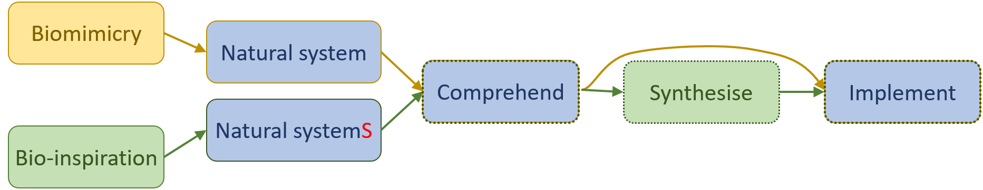
Figure 45: Biomimicry versus bio-inspiration.
Whereas biomimicry aims to copy a natural system simply through virtue of its “naturalness”, bio-inspiration seeks to combine the best elements of several systems to produce an improved output.
Notwithstanding this, it remains imperative to understand the natural system, which leads neatly onto further consideration of how to improve the models presented in chapter three. The logical next step is to progress from a single phase (not representative, but achievable) to a two phase flow model (more representative, but computationally challenging). Pursuit of this objective led to my most abrupt change of research direction, requiring what, on the face of it might seem a fairly simple objective—characterise the rheological properties of sericin so that they can be built into future models. Acquiring native sericin provided the first hurdle, with the literature suggesting several potential methods^{214,253–255}, of which washing sericin from peeled B. mori glands appeared the most promising and readily accessible. I conducted pilot studies with the aim of developing a protocol, but the lack of consistency in dissolution behaviour between samples and the resulting low concentration solutions were not conducive to further exploration, hence the shift in focus to rearing a mutant strain and hoping that existing feedstock extraction techniques would suffice.
Raising a non-native species in a climate to which it is unable to adapt is manageable in a laboratory environment, but when the food source is also disinclined to survive in a temperate maritime climate, there are important side effects on the keeper which are not readily apparent from the published version of chapter five, primarily the extreme tedium of spending six weeks driving twice daily to a park to pick fresh leaves, returning to the lab to shred them in to morsels of appropriate size for the current larval stage before painstaking picking each individual caterpillar out from a pile of decaying leaves and excrement and presenting it with fresh food so that it can repeat the process with increased vigour.
All cynicism aside, I am particularly pleased with this study¹⁰⁸, I feel that it takes a suitably robust approach to characterisation which stands well with previous work into fibroin rheology^{59,114,154} and provides much more than just SCY parameters for inclusion in two phase flow models. Quite apart from anything else, the discovery and confirmation that this strain can provide ample quantities of native sericin affords us the opportunity to ask many new questions. The main conclusions drawn in chapter five are that sericin is more than capable of lubricating flow in the gland, along with a description of that flow behaves, but that it is not sufficient to access the biological extrusion domain.
At this point, it seems apt to deviate from the main thrust, and consider what sericin actually is. From an evolutionary perspective, we can view silk’s beginning as saliva which evolved, through successive mutations, to become increasingly glue like and sticky. If, as is often argued in the literature, silk fibres gained their mechanical properties through accidental replication of the simplest, most abundant amino acids—glycine and alanine—then it seems that mutations which both prioritise the use of simple building blocks, and that confer a competitive advantage in their adhesive qualities would likely be selected for, resulting in transition from sericin to fibroin production, which in turn suggests that sericins are simply primitive precursors to fibroin. However, there is perhaps significantly less advantage in a purely dry fibre—which leads us to question what constitutes the optimum ratio of matrix (sericin) to reinforcement (fibroin).
Returning to the rheological behaviour of sericin, whose upper critical shear rate remains unbounded (assuming Work hypothesis presented in chapter 6 does not apply to globular proteins) and hence is free to remain liquid after excretion, are cocoons simply a serendipitous result of the ability to flow and bind to other substances, be they sticks, leaves, or previously laid excretions. Furthermore, is sericin’s lower viscosity range¹⁰⁷, despite the similar molecular weight to fibroin⁵⁹, due to variation—is sericin simply a dumping ground for amino acids not required for fibroin or other body functions? Or alternatively, which parts of a sericin constitute the critical active sites—identifying those responsible has implications in the field of designer bioinspired adhesives^{308–310}. Temperature sweeps suggest that sericin viscosity remains constant across the natural temperature range. The mechanisms by which this might occur remain unclear, and given that this represents a thermally stable storage solution for protein feedstocks, may warrant further investigation
In discussing sericin’s rheology, I made the observation that the SCY variables appeared to follow trends in relation to the zero shear viscosity, and that with a sufficiently large data set, it may well be possible to infer a silk feedstock’s nonlinear viscoelastic properties from its quasi-static behaviour alone—a prospect that would considerably simplify the process of modelling flow behaviour. Discussion³¹¹ of how this hypothesis might apply suggested that, with a known molecular weight distribution and concentration, then this level of prediction may be possible. For simplicity and ease of access, I opted to first test the hypothesis using fibroin, fitting SCY models to 44 sets of shear ramp data. However, this showed little correlation between the parameters and whilst the hypothesis would provide a useful tool if true, the insights gained in chapter six do overturn several of the assumptions made in this observation, not least the suggestion that SCY is perhaps not the most appropriate depiction of biopolymer flow behaviour, given the innate conversion processes occurring within (more on this later).
My initial aim was to develop multiphase flow models to assist in industrial die design, and while the work presented in chapter five represents a significant advance in our understanding of the natural system, in hindsight it ignores the conclusion presented in chapter four—that while sericin does lower the pressure required for spinning, that the silkworm is capable of generating stresses of the magnitude required for unlubricated flow through pultrusion and that from an industrial perspective, since these forces are easily reached, what benefit is gained from the addition of a lubricant whose natural purpose appears to simply be to bind fibres together in a non-woven composite structure, and the removal of which is perhaps the most energy intensive part of traditional processing. Thus, while creation of the multiphase system is useful for exploring the natural system, it seems un-necessary in terms of bio-inspiration.
Movement in the B. mori silk gland is a complex process involving multiple concentric flow regimes, but simplification of this to two-phases still represents progress. Armed with shear dependent viscosity (SCY) models for fibroin¹¹⁵ and sericin¹⁰⁸, I attempted to build this model but was frustrated by multiple dead-ends and setbacks, which I will discuss here.
The inclusion of additional fluid phases in CFD is a relatively new field, with typical research either considering mixing of liquid and gaseous phases such as bubble behaviour³¹², air/fuel sloshing in a closed tank^{313,314}, or microfluidics applications such as targeted drug delivery³¹⁵. Natural silk flow differs significantly from this. Instead of studying a system of low viscosity fluids with Newtonian shear behaviour flowing within a known geometry, and exploring their response to different conditions, in the silk gland we know the geometry, and also that the behaviour of the interface should be steady, since mixing or droplet formation (the aim of drug delivery microfluidics) will not lead to fibre spinning.
Two phase flow modelling effectively boils down to describing and tracking the fluid-fluid interface. In a macroscale system, boundary effects are negligible, meaning that mesh density and interface design can be the main focus. However, in a microscale system the close proximity of boundary and interface means that interactions between them are common, and will typically tend towards the lowest possible energy state—in this case droplet formation.
Describing the interface means describing how mass and stress will pass across it. In order to provide stability to calculations, there cannot be a step change—instead, a smoothing function (e.g. smoothed Heaviside) must be applied to the relative proportion of each fluid across the boundary—in effect, to create a solvable problem, we must allow for localised mixing at the interface, regardless of whether this best represents the natural system. A key part of the puzzle concerns fibroin-sericin interactions—interfacial tension between the two phases will determine how the system behaves as a whole. Although specific measures of interfacial tension are not known, we can make assumptions about the limits of this parameter, and sweep through iterations to determine if the effects have a discernible difference on the overall flow behaviour.
It should be clear now to the reader that no two phase flow models have been presented in this work, and the reasons for this are as follows. While knowledge of the shear dependent viscosity of sericin provides a good first step, and the lack of knowledge surrounding the interfacial tension between sericin and fibroin can be neatly sidestepped through parametric sweeps in the CFD software. The combination of two high viscosity fluids with non-Newtonian flow behaviours in a microscale geometry results in competing instabilities from a variety of sources, including boundary conditions, interface tracking, phase mixing and loss of mass across the interface. While these problems can be countered to some extent through simplifications such as increasing the cross-sectional thickness of each phase to be significantly larger than the interface or boundary layer; reducing viscosity; increasing geometry; defining a wide, smooth interface; and reducing flow speed, none of these simplifications further our understanding of the natural system, or improve on the conclusions made in chapters three and four off the back of a single phase model.
So we must again ask—what benefit do we gain in building a two phase flow model? The principles of bio-inspiration tell us that if the aim is to use our knowledge of natural silk spinning to spin artificial silk-based feedstocks, then it is not necessary. But if the aim is instead to either reduce the energetic cost of synthetic fibre production, or simply the pursuit of better understanding the natural system, then biomimicry becomes an admirable goal in itself. We have built upon, and addressed some of the limitations identified in previous flow simulations, but what more do we need to achieve this? If we continue to assume that the SCY model provides an acceptable depiction of fibroin behaviour, and that the assumption in chapter five—that sericin is effectively Newtonian to the point of fibroin fibrillation—remains valid. Then a halfway model can be considered progress, but the sticking point remains the description of the interface—how can sufficient resolution be described so as to track the interface without loss of mass, while remaining parallel to the boundary wall and avoiding the wave formation typical at fluid-fluid interfaces, which under sustained flow results in droplet formation or other turbulent effects?
The segue between chapters five and six is perhaps a little less obvious, but hopefully the discussion presented above shows how deeper consideration of how to simplify viscosity models for fibroin and sericin naturally leads to the question of whether the current models are well suited. This combines well with two phase flow model development, in that before developing simulations based on SCY behaviour, it would be wise to first confirm their suitability.
In the course of trying to develop models capable of predicting the results of destructive testing through non-destructive means, the effects of variation in SCY parameters became much more apparent than immediately obvious in the typical presentation of mean, standard deviation and normal distribution. Although previous studies have highlighted that gelation can be achieved through different means^{154,300,316,317}, none have attempted to bring these factors together—the proposition put forward in chapter six does just this. By describing gelation as the result of total energetic input, we can offer a more uniform approach to determining when fibrillation may occur.
In chapter five I suggested that a potentially useful consistency of response may be observed in the percentage reduction of both fibroin and sericin’s zero shear viscosity to that at the point of gelation, but in light of the evidence offered in chapter six, this is likely to have reduced significance due to gelation now being recognised as a multivariate response rather than simply a result of surpassing a particular shear rate.
Both this, and the preceding chapter have questioned the continued suitability of the SCY model as a means of describing silk in light of the conclusions drawn in chapter six—that time is likely the critical factor in determining apparent viscosity. From this we can infer that the current SCY model only remains strictly valid for geometries which induce an increasing shear rate which precisely mirrors that which feedstocks experience in the standardised shear rate ramp used in house. Now, if, as argued in chapter six, good quality fibres are formed as a result of gradual alignment through flow at rates insufficient to shock the feedstock into instantaneous gelation, then there is a clear disparity between the feedstock assessment method—a standardised test designed to reduce run time so as to allow better consideration of biological variation—and the flow behaviour bioinspired spinning requires to be industrially useful.
This may at first appear to be an overly pessimistic view, but I would argue that it only validates the conclusions made in chapter six—that given the lack of alternatives, this remains the closest approximation to natural flow behaviour and should continue to be used until the dataset generated therein can be extended sufficiently far, both in reducing the breadth of apparent viscosity groupings and increasing the sampling frequency at a given shear rate so as to be able to (hopefully) infer the rate and extent of shear thinning in response to a given level of shear, and from which a more generalised shear response model can be developed. Admittedly though, this does rely on the assumption that silk feedstocks of a given zero shear viscosity (from separate specimens) will behave in broadly similar ways to a given shear rate—a hypothesis which will require confirmation as the data set expands.
Let us now return to consider whether a generalised shear response model has industrial relevance, or whether the high level of specificity (to B. mori) renders it suitable only for biomimetic processes. In this case I believe that the proposed model actually has greater merit in artificial feedstock processing—primarily due to greater consistency and volume over natural feedstocks, which will allow for faster flow behaviour characterisation before initiating spinning with a given synthetic feedstock. As a short term starting point, perhaps the method could be explored using synthetic polymer solutions such as polyethylene oxide or hydroxyl-propyl methylcellulose for ease of comparison with previous work¹¹⁴?
In summary, the techniques presented in chapter six provide a threshold which can be used to determine where spinning will initiate in a given die design, but CFD models will require development to allow accumulated energetic input to be tracked across the flow domain. The SCY model, although not perfect, provides a suitable approximation of silk’s flow behaviour and should continue to be used whilst more in depth methods, such as generalised shear response or combined shear-extensional models, are explored.

Outlook
If we take the crowning achievement in the silk field to be the production of tailored high performance, eco-friendly biopolymer fibres through low energy spinning techniques, then it is useful to question whether we, as a community, have spun (or can spin) biomimetic silks. But I would argue that this is perhaps the wrong question. We have vastly improved our collective understanding of natural silk processing in recent years, from increased recombinant feedstock production (both in volume^{290,318} and molecular weight³¹⁹), through geometric conditions^{37,107,162} and flow behaviour^{59,108,114,115}, all the way to latent mechanisms such as high concentration storage stability^{290,320} and future polymerisation^{159,321} through ph^{55,322} and ion regulation^{59,142,323}. Yet despite this, we still have not spun our own silk. So let us change the question, and ask instead, must these fibres be biomimetic, or is bio-inspiration enough? And what constitutes an artificial silk anyway? Returning once again to Ridley⁴⁹—[that] evolutionary systems are only [as] optimised as they need to be, not necessarily can be—should we be aiming to replicate nature, or to improve on it? I can only conclude that any future work should not forcibly restrict itself to the silk field, but take inspiration from everywhere, be that the natural world or our man-made alternatives.
As I reach the end of my thesis, reflection on the PhD process ensures that I ask myself, had I known then what I know now, what might I do differently? I remain convinced that although my original plan was perhaps overambitious in terms of time, that the intended method remains valid and look forward to extending this work in the future. I feel that I have matured as a researcher across the course of my studies, and hopefully this final chapter has highlighted my increased ability to think critically, even about my own work; to change my mind, and to ask fundamentally interesting questions about what has gone before and about what is yet to come.

Chapter 8

Reference

References

1. Craig, C. L. Evolution of arthropod silks. Annu. Rev. Entomol. 42, 231–267 (1997).
2. Brunetta, L. & Craig, C. L. Spider Silk. (Yale University Press, 2010).
3. Jerrold, W. B. Spiders’ Silk. Household Words II, 65–67 (1850).
4. Vollrath, F. & Porter, D. Silks as ancient models for modern polymers. Polymer (Guildf). 50, 5623–5632 (2009).
5. Gosline, J. M., DeMont, M. E. & Denny, M. W. The structure and properties of spider silk. Endeavour 10, 37–43 (1986).
6. Mortimer, B. & Holland, C. in Advances in Silk Science and Technology (ed. Basu, A.) 233–260 (Woodhead Publishing, 2015).
7. Anonymous. Sick Silkworms. All Year Round XX, 376–378 (1868).
8. Lucas, F. Spiders and their silks. Discovery 25, 20–26 (1964).
9. Anonymous. Silk for the Multitude. All the Year Round IV, 233–237 (1860).
10. Holland, C. Silk Rheology. (University of Oxford, 2008).
11. Vollrath, F. & Knight, D. P. Liquid crystalline spinning of spider silk. Nature 410, 541–548 (2001).
12. Chen, F., Porter, D. & Vollrath, F. Structure and physical properties of silkworm cocoons. J. R. Soc. Interface 9, 2299–2308 (2012).
13. Guan, J., Vollrath, F. & Porter, D. Silk “ Quality ” Revealed Using Dynamic Mechanical Thermal Analysis ( DMTA ). in BISERICA 2013: 6th BACSA International Conference: Building value Chains in Sericulture (2013).
14. Holland, C., Porter, D. & Vollrath, F. Comparing the rheology of mulberry and ‘wild’ silkworm spinning dopes. Biopolymers 97, 362–367 (2012).
15. Allardyce, B. J. et al. The impact of degumming conditions on the properties of silk films for biomedical applications. Text. Res. J. 86, 275–287 (2016).
16. Wang, H.-Y. & Zhang, Y.-Q. Effect of regeneration of liquid silk fibroin on its structure and characterization. Soft Matter 9, 138–145 (2013).
17. Mase, K., Iizuka, T., Okada, E., Miyajima, T. & Yamamoto, T. A New Silkworm Race for Sericin Production, “Sericin Hope” and its Product, “Virgin Sericin”. J Insect Biotechnol Sericol 75, 85–88 (2006).
18. Anonymous. Skating Spiders. All Year Round VI, 351–356 (1862).
19. Apstein, C. Bau und Funktion der Spinndrüsen der Araneida. Arch. Naturg. 55, 29–74 (1889).
20. Xu, G., Gong, L., Yang, Z. & Liu, X. Y. What makes spider silk fibers so strong? From molecular-crystallite network to hierarchical network structures. Soft Matter 10, 2116–2123 (2014).
21. Liu, X. & Zhang, K. in Oligomerization of Chemical and Biological Compounds (ed. Lesieur, C.) 69–102 (InTech, 2014).
22. Kojic, N., Bico, J., Clasen, C. & McKinley, G. H. Ex vivo rheology of spider silk. J. Exp. Biol. 209, 4355–4362 (2006).
23. Termeyer, R. M. de. Researches and experiments upon silk from spiders, and upon their reproduction. Proc. Essex Inst. 5, 51–79 (1866).
24. Bon, F.-X. A discourse upon the usefulness of the silk of spiders. Philos. Trans. R. Soc. 27, 2–16 (1710).
25. Bon, F.-X. in Readings in Natural Philosophy 208–211 (1830).
26. Clarke, C. C. Readings in natural philosophy; or, a popular display of the wonders of nature. (A & R Spottiswoode, New-Street-Square, 1830).
27. Wilder, B. G. Two hundred thousand spiders. Harper’s Mag. 34, 450–466 (1866).
28. McCook, H. C. American Spiders and their spinning work. vol III. III, (Academy of Natural Sciences of Philadelphia, 1893).
29. Rolt, D. B. Silk from spiders. Trans. Soc. instituted as London, Encourag. Arts, Manuf. Commer. 48, 234–236 (1832).
30. Anonymous. Factory Spiders. All Year Round VIII, 391–396 (1863).
31. Herbert, L. The register of Arts, and Journal of patent inventions. VII, (B. Steill, 20 Paternoster Row, London, 1832).
32. Kerkam, K., Viney, C., Kaplan, D. L. & Lombardi, S. Liquid Crystallinity of Natural Silk Secretions. Nature 349, 596–598 (1991).
33. Wegst, U. G. K., Bai, H., Saiz, E., Tomsia, A. P. & Ritchie, R. O. Bioinspired structural materials. Nat. Mater. 14, 23–36 (2015).
34. Lin, S. et al. Predictive modelling-based design and experiments for synthesis and spinning of bioinspired silk fibres. Nat. Commun. 6, 6892 (2015).
35. Holland, C., O’Neil, K., Vollrath, F. & Dicko, C. Distinct structural and optical regimes in natural silk spinning. Biopolymers 97, 368–373 (2012).
36. Anonymous. Silk-Spinning Spiders. All Year Round XI, 509–512 (1864).
37. Davies, G. J. G., Knight, D. P. & Vollrath, F. Structure and function of the major ampullate spinning duct of the golden orb weaver, Nephila edulis. Tissue Cell 45, 306–311 (2013).
38. Ortlepp, C. S. & Gosline, J. M. Consequences of Forced Silking. Biomacromolecules 5, 727–731 (2004).
39. Termonia, Y. Molecular Modeling of Spider Silk Elasticity. Macromolecules 27, 7378–7381 (1994).
40. Riekel, C. & Vollrath, F. Spider silk fibre extrusion: combined wide- and small-angle X-ray microdiffraction experiments. Int. J. Biol. Macromol. 29, 203–210 (2001).
41. Vollrath, F., Porter, D. & Holland, C. The science of silks. MRS Bull. 38, 73–80 (2013).
42. Work, R. W. The effect of variations in degree of structural order on some physical properties of cellulose and cellulose acetate yarns. Text. Res. J. 19, 381–393 (1949).
43. Work, R. W. Mechanisms of major ampullate silk fibre formation by orb-web-spinning spiders. Trans. Am. Microsc. Soc. 96, 170–189 (1977).
44. Brooks, A. E. et al. Distinct Contributions of Model MaSp1 and MaSp2 Like Peptides to the Mechanical Properties of Synthetic Major Ampullate Silk Fi bers as Revealed in Silico. Nanotechnol. Sci. Appl. 1, 9–16 (2008).
45. Work, R. W. The force-elongation behaviour of web fibres and silks forcibly obtained from orb-web-spinning spiders. Text. Res. J. 46, 185–492 (1976).
46. Madsen, B. & Vollrath, F. Mechanics and Morphology of Silk Drawn from Anesthetized Spiders. Naturwissenschaften 87, 148–153 (2000).
47. Breslauer, D. N. Investigating the mechanisms and Potential of Silk Fiber Metallization. (2013).
48. Holland, C., Vollrath, F., Ryan, A. J. & Mykhaylyk, O. O. Silk and Synthetic Polymers: Reconciling 100 Degrees of Separation. Adv. Mater. 24, 105–109 (2012).
49. Ridley, M. Evolution. (Wiley-Blackwell, 2003).
50. Dicko, C., Vollrath, F. & Kenney, J. M. Spider Silk Protein Refolding Is Controlled by Changing pH. Biomacromolecules 5, 704–710 (2004).
51. Porter, D. & Vollrath, F. Silk as a Biomimetic Ideal for Structural Polymers. Adv. Mater. 21, 487–492 (2009).
52. Heidebrecht, A. et al. Biomimetic Fibers Made of Recombinant Spidroins with the Same Toughness as Natural Spider Silk. Adv. Mater. 27, 2189–2194 (2015).
53. Rising, A. & Johansson, J. Toward spinning artificial spider silk. Nat. Chem. Biol. 11, 309–315 (2015).
54. Qin, Z. & Buehler, M. J. Webs measure up. Nat. Mater. 12, 185–187 (2013).
55. Andersson, M. et al. Carbonic Anhydrase Generates CO2 and H+ That Drive Spider Silk Formation Via Opposite Effects on the Terminal Domains. PLoS Biol. 12, e1001921 (2014).
56. Garb, J. E. Silk Genes Support the Single Origin of Orb Webs. Science (80-. ). 312, 1762–1762 (2006).
57. Gatesy, J., Hayashi, C. Y., Motriuk, D., Woods, J. & Lewis, R. V. Extreme diversity, conservation, and convergence of spider silk fibroin sequences. Science (80-. ). 291, 2603–2605 (2001).
58. Breslauer, D. N. & Kaplan, D. L. Silks: Properties and uses of natural and designed variants. Biopolymers 97, 319–321 (2012).
59. Laity, P. R., Baldwin, E. & Holland, C. Changes in Silk Feedstock Rheology during Cocoon Construction: The Role of Calcium and Potassium Ions. Macromol. Biosci. 18, 1800188 (2018).
60. Jin, H.-J. & Kaplan, D. L. Mechanism of silk processing in insects and spiders. Nature 424, 1057–1061 (2003).
61. Walker, A. A., Holland, C. & Sutherland, T. D. More than one way to spin a crystallite: multiple trajectories through liquid crystallinity to solid silk. Proc. R. Soc. B Biol. Sci. 282, 2–9 (2015).
62. Dicko, C., Knight, D. P., Kenney, J. M. & Vollrath, F. Secondary Structures and Conformational Changes in Flagelliform, Cylindrical, Major, and Minor Ampullate Silk Proteins. Temperature and Concentration Effects. Biomacromolecules 5, 2105–2115 (2004).
63. Um, I. C. et al. Wet spinning of silk polymer II. Effect of drawing on the structural characteristics and properties of filament. Int. J. Biol. Macromol. 34, 107–119 (2004).
64. Keten, S. & Buehler, M. J. Atomistic model of the spider silk nanostructure. Appl. Phys. Lett. 96, 15–18 (2010).
65. Bratzel, G. & Buehler, M. J. Molecular mechanics of silk nanostructures under varied mechanical loading. Biopolymers 97, 408–417 (2012).
66. Zhou, C.-Z. et al. Fine organization of Bombyx mori fibroin heavy chain gene. Nucleic Acids Res. 28, 2413–2419 (2000).
67. Zhou, C.-Z. et al. Silk fibroin: Structural implications of a remarkable amino acid sequence. Proteins Struct. Funct. Genet. 44, 119–122 (2001).
68. Brown, J., Lu, C., Coburn, J. & Kaplan, D. L. Impact of silk biomaterial structure on proteolysis. Acta Biomater. 11, 212–221 (2015).
69. Tokutake, S. Isolation of the smallest component of silk protein. Biochem. J. 187, 413–417 (1980).
70. Takasu, Y., Yamada, H., Saito, H. & Tsubouchi, K. Characterization of Bombyx mori Sericins by the Partial Amino Acid Sequences. Insect Biotechnol. Sericology 74, 103–109 (2005).
71. Aramwit, P., Siritientong, T. & Srichana, T. Potential applications of silk sericin, a natural protein from textile industry by-products. Waste Manag. Res. 30, 217–224 (2012).
72. Michaille, J., Couble, P., Prudhomme, J. & Garel, A. A single gene produces multiple sericin messenger-rnas in the silk gland of bombyx-mori. Biochimie 68, 1165–1173 (1986).
73. Wang, Y. J. & Zhag, Y. Q. Three-Layered Sericins around the Silk Fibroin Fiber from Bombyx mori Cocoon and their Amino Acid Composition. Adv. Mater. Res. vols 175-1, 158–163 (2011).
74. Sponner, A. et al. Composition and Hierarchical Organisation of a Spider Silk. PLoS One 2, e998 (2007).
75. Vollrath, F. Spider webs and silks. Sci. Am. (1992).
76. Sponner, A. et al. Characterization of the Protein Components of Nephila clavipes Dragline Silk. Biochemistry 44, 4727–4736 (2005).
77. Viney, C. Natural silks: archetypal supramolecular assembly of polymer fibres. Supramol. Sci. 4, 75–81 (1997).
78. Knight, D. P. & Vollrath, F. Liquid crystals and flow elongation in a spider’s silk production line. Proc. R. Soc. London 266, 519–523 (1999).
79. Anonymous. Ballooning Spiders. All Year Round VIII, 80–83 (1862).
80. Holland, C., Urbach, J. S. & Blair, D. L. Direct visualization of shear dependent silk fibrillogenesis. Soft Matter 8, 2590–2594 (2012).
81. Colburn, H. The new monthly magazine and literary Journal. The new monthly magazine and literary Journal III, (Richard Bentley, William Clowes, London., 1834).
82. Mortimer, B., Holland, C. & Vollrath, F. Forced Reeling of Bombyx mori Silk: Separating Behavior and Processing Conditions. Biomacromolecules 14, 3653–3659 (2013).
83. Wilson, R. S. The control of dragline spinning in the garden spider. Dep. Zool. Univ. Bristol 104, 557–571 (1962).
84. Mortimer, B., Guan, J., Holland, C., Porter, D. & Vollrath, F. Linking naturally and unnaturally spun silks through the forced reeling of Bombyx mori. Acta Biomater. 11, 247–255 (2015).
85. Liu, Y., Shao, Z. & Vollrath, F. Relationships between supercontraction and mechanical properties of spider silk. Nat. Mater. 4, 901–905 (2005).
86. Work, R. W. Viscoelastic Behaviour and Wet Supercontraction of Major Ampullate Silk Fibres of Certain Orb-Web-Building Spiders (Araneae). J. Exp. Biol. 118, 379–404 (1985).
87. Savage, K. N., Guerette, P. A. & Gosline, J. M. Supercontraction Stress in Spider Webs. Biomacromolecules 5, 675–679 (2004).
88. Ramsden, W. Physical Chemistry and Physiology at the British Association - Interfacial Phenomena. Nature 112, 671–672 (1923).
89. Ramsden, W. Separation of Solids in the Surface-Layers of Solutions and ‘Suspensions’ (Observations on Surface-Membranes, Bubbles, Emulsions, and Mechanical Coagulation). Proc. R. Soc. London 72, 156–164 (1903).
90. Foà, C. Die kolloiden Eigenschaften der natürlichen Seide. Zeitschrift für Chemie und Ind. der Kolloide 10, 7–12 (1912).
91. Yang, Y. et al. Behavior of silk protein at the air–water interface. Soft Matter 8, 9705 (2012).
92. Komatsu, K. Studies on dissolution behaviors and structural characteristics of silk sericin. Bull. Seric. Exp. Stn. 26, 135–256 (1975).
93. Gamo, T., Inokuchi, T. & Laufer, H. Polypeptides of fibroin and sericin secreted from the different sections of the silk gland in Bombyx mori. Insect Biochem. 7, 285–295 (1977).
94. Dash, R., Mukherjee, S. & Kundu, S. C. Isolation, purification and characterization of silk protein sericin from cocoon peduncles of tropical tasar silkworm, Antheraea mylitta. Int. J. Biol. Macromol. 38, 255–258 (2006).
95. Yamada, H., Nakao, H., Takasu, Y. & Tsubouchi, K. Preparation of undegraded native molecular fibroin solution from silkworm cocoons. Mater. Sci. Eng. C 14, 41–46 (2001).
96. Ling, S. et al. Polymorphic regenerated silk fibers assembled through bioinspired spinning. Nat. Commun. 8, (2017).
97. Koeppel, A. & Holland, C. Progress and Trends in Artificial Silk Spinning: A Systematic Review. ACS Biomater. Sci. Eng. 3, 226–237 (2017).
98. Matsumoto, A., Lindsay, A., Abedian, B. & Kaplan, D. L. Silk fibroin solution properties related to assembly and structure. Macromol. Biosci. 8, 1006–1018 (2008).
99. Omenetto, F. G. & Kaplan, D. L. New Opportunities for an Ancient Material. Science (80-. ). 329, 528–531 (2010).
100. Dicko, C., Kasoju, N., Hawkins, N. & Vollrath, F. Differential scanning fluorimetry illuminates silk feedstock stability and processability. Soft Matter 12, 255–262 (2016).
101. Padamwar, M. N. & Pawar, a. P. Silk sericin and its applications: A review. J. Sci. Ind. Res. (India). 63, 323–329 (2004).
102. Koh, L.-D. et al. Structures, mechanical properties and applications of silk fibroin materials. Prog. Polym. Sci. 46, 86–110 (2015).
103. Rising, A. Spider Dragline Silk: Molecular Properties and Recombinant Expression. Acta Universitatis Agriculturae Sueciae (Swedish University of Agricultural Sciences, 2007).
104. Yuan, T. Z. et al. Shear-Stress-Mediated Refolding of Proteins from Aggregates and Inclusion Bodies. ChemBioChem 16, 393–396 (2015).
105. Altman, G. H. et al. Silk-based biomaterials. Biomaterials 24, 401–416 (2003).
106. Omenetto, F. G. & Kaplan, D. L. From Silk Cocoon to Medical Miracle. Scientific American 76–77 (2010).
107. Sparkes, J. & Holland, C. Analysis of the pressure requirements for silk spinning reveals a pultrusion dominated process. Nat. Commun. 8, 594 (2017).
108. Sparkes, J. & Holland, C. The rheological properties of native sericin. Acta Biomater. 69, 234–242 (2018).
109. Sparkes, J. & Holland, C. The Energy Requirements for Flow-Induced Solidification of Silk. Macromol. Biosci. 18, 1800229 (2018).
110. Hoppmann, W. H. The nature and meaning of biorheology. Ann. N. Y. Acad. Sci. 130, 873–879 (1966).
111. Schramm, G. A Practical Approach to Rheology and Rheometry. (Gebrueder HAAKE GmbH, 1994).
112. Breslauer, D. N., Lee, L. P. & Muller, S. J. Simulation of Flow in the Silk Gland. Biomacromolecules 10, 49–57 (2009).
113. Terry, A. E., Knight, D. P., Porter, D. & Vollrath, F. pH Induced Changes in the Rheology of Silk Fibroin Solution from the Middle Division of Bombyx mori Silkworm. Biomacromolecules 5, 768–772 (2004).
114. Laity, P. R. & Holland, C. Native Silk Feedstock as a Model Biopolymer: A Rheological Perspective. Biomacromolecules 17, 2662–2671 (2016).
115. Laity, P. R., Gilks, S. E. & Holland, C. Rheological behaviour of native silk feedstocks. Polymer (Guildf). 67, 28–39 (2015).
116. Kojic, N., Kojic, M., Gudlavalleti, S. & McKinley, G. Solvent Removal during Synthetic and Nephila Fiber Spinning. Biomacromolecules 5, 1698–1707 (2004).
117. Trouton, F. T. On the Coefficient of Viscous Traction and Its Relation to that of Viscosity. Proc. R. Soc. A Math. Phys. Eng. Sci. 77, 426–440 (1906).
118. Richardson, L. F. The Approximate Arithmetical Solution by Finite Differences of Physical Problems Involving Differential Equations , with an Application to the Stresses in a Masonry Dam. Philos. Trans. R. Soc. London. Ser. A, Contain. Pap. a Math. or Phys. Character 210, 307–357 (1911).
119. Shang, J. S. Three decades of accomplishments in computational fluid dynamics. Prog. Aerosp. Sci. 40, 173–197 (2004).
120. Anderson Jr., J. D. Computational Fluid Dynamics: basics with applications. (McGraw-Hill, 1995).
121. Witherden, F. D. & Jameson, A. Future directions of computational fluid dynamics. 23rd AIAA Comput. Fluid Dyn. Conf. 2017 1–16 (2017).
122. Hirsch, C. Numerical Computation of Internal and External Flows. (Elsevier, 2007).
123. Tu, J., Yeoh, G.-H. & Liu, C. Computational Fluid Dynamics. (Elsevier, 2013).
124. Blazek, J. Computational Fluid Dynamics: Principles and Applications. (Elsevier, 2015).
125. Wendt, J. Computational Fluid Dynamics. (Springer Berlin Heidelberg, 2009).
126. Behbahani, M. et al. A review of computational fluid dynamics analysis of blood pumps. Eur. J. Appl. Math. 20, 363–397 (2009).
127. Peskin, C. S. The fluid dynamics of computational methods. Annu. Rev. 235–259 (1982).
128. Guyot, Y., Luyten, F. P., Schrooten, J., Papantoniou, I. & Geris, L. A three-dimensional computational fluid dynamics model of shear stress distribution during neotissue growth in a perfusion bioreactor. Biotechnol. Bioeng. 112, 2591–2600 (2015).
129. Morris, P. D. et al. Computational fluid dynamics modelling in cardiovascular medicine. Heart 102, 18–28 (2016).
130. Horlock, J. H. & Denton, J. D. A Review of Some Early Design Practice Using Computational Fluid Dynamics and a Current Perspective. J. Turbomach. 127, 5 (2005).
131. Norton, T. & Sun, D. W. Computational fluid dynamics (CFD) - an effective and efficient design and analysis tool for the food industry: A review. Trends Food Sci. Technol. 17, 600–620 (2006).
132. Vashishta, B. et al. Use of computational fluid dynamics for development and scale-up of a helical coil heat exchanger for dissolution of a thermally labile API. Org. Process Res. Dev. 17, 1311–1319 (2013).
133. Tabeling, P. Introduction to Microfluidics. (Oxford University Press, 2005).
134. Widhe, M., Johansson, J., Hedhammar, M. & Rising, A. Current progress and limitations of spider silk for biomedical applications. Biopolymers 97, 468–478 (2012).
135. Boulet-Audet, M., Terry, A. E., Vollrath, F. & Holland, C. Silk protein aggregation kinetics revealed by Rheo-IR. Acta Biomater. 10, 776–784 (2014).
136. Gosline, J. M., Guerette, P. A., Ortlepp, C. S. & Savage, K. N. The mechanical design of spider silks: from fibroin sequence to mechanical function. J. Exp. Biol. 202, 3295–3303 (1999).
137. Madsen, B., Shao, Z. Z. & Vollrath, F. Variability in the mechanical properties of spider silks on three levels: interspecific, intraspecific and intraindividual. Int. J. Biol. Macromol. 24, 301–306 (1999).
138. Pérez-Rigueiro, J., Elices, M., Llorca, J. & Viney, C. Effect of degumming on the tensile properties of silkworm (Bombyx mori) silk fiber. J. Appl. Polym. Sci. 84, 1431–1437 (2002).
139. Pérez-Rigueiro, J., Elices, M., Llorca, J. & Viney, C. Tensile properties of silkworm silk obtained by forced silking. J. Appl. Polym. Sci. 82, 1928–1935 (2001).
140. Holland, C., Terry, A. E., Porter, D. & Vollrath, F. Natural and unnatural silks. Polymer (Guildf). 48, 3388–3392 (2007).
141. Vollrath, F., Madsen, B. & Shao, Z. The effect of spinning conditions on the mechanics of a spider’s dragline silk. Proc. R. Soc. B Biol. Sci. 268, 2339–2346 (2001).
142. Zhou, L., Chen, X., Shao, Z., Huang, Y. & Knight, D. P. Effect of metallic ions on silk formation in the mulberry silkworm, Bombyx mori. J. Phys. Chem. B 109, 16937–16945 (2005).
143. He, Y. X. et al. N-terminal domain of Bombyx mori fibroin mediates the assembly of silk in response to pH decrease. J. Mol. Biol. 418, 197–207 (2012).
144. Domigan, L. J. et al. Carbonic anhydrase generates a pH gradient in Bombyx mori silk glands. Insect Biochem. Mol. Biol. 65, 100–106 (2015).
145. Andersson, M., Johansson, J. & Rising, A. Silk Spinning in Silkworms and Spiders. Int. J. Mol. Sci. 17, 1290 (2016).
146. Moriya, M. et al. Rheological Properties of Native Silk Fibroins from Domestic and Wild Silkworms, and Flow Analysis in Each Spinneret by a Finite Element Method. Biomacromolecules 10, 929–935 (2009).
147. Ki, C. S., Um, I. C. & Park, Y. H. Acceleration effect of sericin on shear-induced ß-transition of silk fibroin. Polymer (Guildf). 50, 4618–4625 (2009).
148. Percot, A. et al. Water dependent structural changes of silk from Bombyx mori gland to fibre as evidenced by Raman and IR spectroscopies. Vib. Spectrosc. 73, 79–89 (2014).
149. Ochi, A., Hossain, K. S., Magoshi, J. & Nemoto, N. Rheology and dynamic light scattering of silk fibroin solution extracted from the middle division of Bombyx mori silkworm. Biomacromolecules 3, 1187–1196 (2002).
150. Zhou, L. et al. Copper in the silk formation process of Bombyx mori silkworm. FEBS Lett. 554, 337–341 (2003).
151. Holland, C., Terry, A. E., Porter, D. & Vollrath, F. Comparing the rheology of native spider and silkworm spinning dope. Nat. Mater. 5, 870–874 (2006).
152. Jin, Y. et al. In vitro studies on the structure and properties of silk fibroin aqueous solutions in silkworm. Int. J. Biol. Macromol. 62, 162–166 (2013).
153. Laity, P. R. & Holland, C. Thermo-rheological behaviour of native silk feedstocks. Eur. Polym. J. 87, 519–534 (2016).
154. Laity, P. R. & Holland, C. The Rheology behind Stress-Induced Solidification in Native Silk Feedstocks. Int. J. Mol. Sci. 17, 1812 (2016).
155. Keten, S., Xu, Z., Ihle, B. & Buehler, M. J. Nanoconfinement controls stiffness, strength and mechanical toughness of β-sheet crystals in silk. Nat. Mater. 9, 359–367 (2010).
156. Xiao, S., Stacklies, W., Cetinkaya, M., Markert, B. & Gräter, F. Mechanical response of silk crystalline units from force-distribution analysis. Biophys. J. 96, 3997–4005 (2009).
157. Bratzel, G., Qin, Z. & Buehler, M. J. Viscoelastic relaxation time and structural evolution during length contraction of spider silk protein nanostructures. MRS Commun. 3, 185–190 (2013).
158. Krishnaji, S. T. et al. Sequence-structure-property relationships of recombinant spider silk proteins: Integration of biopolymer design, processing, and modeling. Adv. Funct. Mater. 23, 241–253 (2013).
159. Rammensee, S., Slotta, U., Scheibel, T. & Bausch, A. R. Assembly mechanism of recombinant spider silk proteins. Proc. Natl. Acad. Sci. U. S. A. 105, 6590–6595 (2008).
160. Bernoulli, D. Hydrodynamica, Sive Vivibus et Motimus Fluidorum Commentarii. (Johannes Reinholdi Dulseckeri, 1738).
161. Asakura, T. et al. Some Observations on the Structure and Function of the Spinning Apparatus in the Silkworm Bombyx mori. Biomacromolecules 8, 175–181 (2007).
162. Davies, G. J. G., Knight, D. P. & Vollrath, F. Chitin in the silk gland ducts of the spider Nephila edulis and the silkworm Bombyx mori. PLoS One 8, e73225 (2013).
163. Moriya, M., Ohgo, K., Masubuchi, Y. & Asakura, T. Flow analysis of aqueous solution of silk fibroin in the spinneret of Bombyx mori silkworm by combination of viscosity measurement and finite element method calculation. Polymer (Guildf). 49, 952–956 (2008).
164. Sobue, H., Ishikawa, H. & Matsuzaki, K. On the crystallinity of the silk fibres. J. Soc. Chem. Ind. Japan 64, 706–710 (1961).
165. Tillinghast, E. K., Chase, S. F. & Townley, M. A. Water extraction by the major ampullate duct during silk formation in the spider, Argiope aurantia Lucas. J. Insect Physiol. 30, 591–596 (1984).
166. Boulet-Audet, M., Holland, C., Gheysens, T. & Vollrath, F. Dry-spun silk produces native-like fibroin solutions. Biomacromolecules 17, 3198–3204 (2016).
167. Kataoka, K. & Uematsu, I. Studies on liquid silk VI - on the viscosity of liquid silk in the silkgland. Kobunshi Ronbunshu 34, 7–13 (1977).
168. Moriya, M., Ohgo, K., Masubuchi, Y., Knight, D. P. & Asakura, T. Micro-computerized tomographic observation of the spinning apparatus in Bombyx mori silkworms. Polymer (Guildf). 49, 5665–5669 (2008).
169. Zemlin, J. C. et al. A study of the mechanical behaviour of spider silks (Report 69-29-CM). (Clothing and Organic Materials Laboratory, U.S. Army Natick Laboratories, 1968).
170. Yasuda, K., Armstrong, R. C. & Cohen, R. E. Shear flow properties of concentrated solutions of linear and star branched polystyrenes. Rheol. Acta 20, 163–178 (1981).
171. Prakash, M. Encyclopaedia of Entomology - III. Insect physiology. (Discovery Publishing House, 2008).
172. Sláma, K. Insect haemolymph pressure and its determination. Acta Entomol. Bohemoslov. 73, 65–75 (1976).
173. Truman, J. W. & Endo, P. T. Physiology of insect ecdysis: neural and hormonal factors involved in wing-spreading behaviour of moths. J. Exp. Biol. 61, 47–55 (1974).
174. Woods, W. A., Fusillo, S. J. & Trimmer, B. A. Dynamic properties of a locomotory muscle of the tobacco hornworm Manduca sexta during strain cycling and simulated natural crawling. J. Exp. Biol. 211, 873–882 (2008).
175. Shao, Z. & Vollrath, F. Materials: Surprising strength of silkworm silk. Nature 418, 741–741 (2002).
176. Khan, M. M. R. et al. Structural characteristics and properties of Bombyx mori silk fiber obtained by different artificial forcibly silking speeds. Int. J. Biol. Macromol. 42, 264–270 (2008).
177. Manton, S. M. & Harding, J. P. The evolution of arthropodan locomotory mechanisms. Part 8. J. Linn. Soc. London, Zool. 45, 251–484 (1965).
178. Moreau, R. Variations de la pression interne au cours de l’émergence et de l’expansion des ailes chez Bombyx mori et Pieris brassicae. J. Insect Physiol. 20, 1475–1480 (1974).
179. Liu, K. N., Joseph, D. D., Riccius, O. & Christodoulou, C. Drag reduction in pipes lined with riblets. AIAA J. 28, 1697–1698 (1990).
180. Dean, B. & Bhushan, B. Shark-skin surfaces for fluid-drag reduction in turbulent flow: a review. Philos. Trans. A. Math. Phys. Eng. Sci. 368, 4775–4806 (2010).
181. Shenoy, A. V. A review on drag reduction with special reference to micellar systems. Colloid Polym. Sci. 262, 319–337 (1984).
182. Brown, C. P. et al. Rough Fibrils Provide a Toughening Mechanism in Biological Fibers. ACS Nano 6, 1961–1969 (2012).
183. Teramoto, H., Kakazu, A. & Asakura, T. Native structure and degradation pattern of silk sericin studied by 13C NMR spectroscopy. Macromolecules 39, 6–8 (2006).
184. Kataoka, K. Studies on silk fibroin III - on the liquid silk in silkgland. Kobunshi Ronbunshu 32, 653–659 (1975).
185. Hou, Y. et al. Studies on middle and posterior silk glands of silkworm (Bombyx mori) using two-dimensional electrophoresis and mass spectrometry. Insect Biochem. Mol. Biol. 37, 486–496 (2007).
186. Saarinen, T., Haavisto, S., Sorvari, A., Salmela, J. & Seppälä, J. The effect of wall depletion on the rheology of microfibrillated cellulose water suspensions by optical coherence tomography. Cellulose 21, 1261–1275 (2014).
187. Sasaki, S. & Tashiro, Y. Studies on the posterior silk gland of the silkworm, Bombyx mori. VI. Distribution of microtubules in the posterior silk gland cells. J Cell Biol 71, 565–574 (1976).
188. Rousseau, M. Étude de la conformation et de l’orientation des protéines dans les soies naturelles. ((Doctoral Thesis) Université Laval, 2007).
189. Billen, J. Morphology and ultrastructure of the Dufour’s and venom gland in the ant Myrmica gulosa (Fabr.) (Hymenoptera: Formicidae). Australian Journal of Zoology 38, 305–315 (1990).
190. Suter, R. B. & Stratton, G. E. Spitting performance parameters and their biomechanical implications in the spitting spider, Scytodes thoracica. J. Insect Sci. 9, 1–15 (2009).
191. Derby, C. D. Cephalopod ink: production, chemistry, functions and applications. Mar. Drugs 12, 2700–2730 (2014).
192. Yamanouchi, M. Morphologische beobachtung über die seidensekretion bei der seidenraupe. J. Coll. Agric. 10, 1–49 (1922).
193. Oberkampf, W. L. & Trucano, T. G. Verification and validation in computational fluid dynamics. Progress in Aerospace Sciences 38, (2002).
194. Perez-Rigueiro, J. The effect of spinning forces on spider silk properties. J. Exp. Biol. 208, 2633–2639 (2005).
195. Schneider, C. a, Rasband, W. S. & Eliceiri, K. W. NIH Image to ImageJ: 25 years of image analysis. Nat. Methods 9, 671–675 (2012).
196. Vollrath, F. Strength and structure of spiders’ silks. Rev. Mol. Biotechnol. 74, 67–83 (2000).
197. Vollrath, F. Biology of spider silk. Int. J. Biol. Macromol. 24, 81–88 (1999).
198. Zhao, H.-P., Feng, X.-Q. & Shi, H.-J. Variability in mechanical properties of Bombyx mori silk. Mater. Sci. Eng. C 27, 675–683 (2007).
199. Su, I. & Buehler, M. J. Nanomechanics of silk: the fundamentals of a strong, tough and versatile material. Nanotechnology 27, 302001 (2016).
200. Nova, A., Keten, S., Pugno, N. M., Redaelli, A. & Buehler, M. J. Molecular and nanostructural mechanisms of deformation, strength and toughness of spider silk fibrils. Nano Lett. 10, 2626–2634 (2010).
201. Porter, D., Guan, J. & Vollrath, F. Spider Silk: Super Material or Thin Fibre? Adv. Mater. 25, 1275–1279 (2013).
202. Seidel, A., Liivak, O. & Jelinski, L. W. Artificial Spinning of Spider Silk. Macromolecules 31, 6733–6736 (1998).
203. Dinjaski, N. et al. Integrated Modeling and Experimental Approaches to Control Silica Modification of Design Silk-Based Biomaterials. ACS Biomater. Sci. Eng. 3, 2877–2888 (2017).
204. Zheng, Z. et al. Lithium-free processing of silk fibroin. J. Biomater. Appl. 31, 450–463 (2016).
205. Zhang, Y. et al. Hierarchical charge distribution controls self-assembly process of silk in vitro. Front. Mater. Sci. 9, 382–391 (2015).
206. Scheibel, T. Spider silks: recombinant synthesis, assembly, spinning, and engineering of synthetic proteins. Microb. Cell Fact. 3, 14 (2004).
207. Hardy, J. G., Römer, L. M. & Scheibel, T. Polymeric materials based on silk proteins. Polymer (Guildf). 49, 4309–4327 (2008).
208. Chen, F., Porter, D. & Vollrath, F. Silk cocoon (Bombyx mori): Multi-layer structure and mechanical properties. Acta Biomater. 8, 2620–2627 (2012).
209. Chen, F., Porter, D. & Vollrath, F. Silkworm cocoons inspire models for random fiber and particulate composites. Phys. Rev. E - Stat. Nonlinear, Soft Matter Phys. 82, 1–6 (2010).
210. Chen, F., Porter, D. & Vollrath, F. Morphology and structure of silkworm cocoons. Mater. Sci. Eng. C 32, 772–778 (2012).
211. Elettro, H., Neukirch, S., Antkowiak, A. & Vollrath, F. Adhesion of dry and wet electrostatic capture silk of uloborid spider. Naturwissenschaften 102, 41 (2015).
212. Walker, A. A., Weisman, S., Trueman, H. E., Merritt, D. J. & Sutherland, T. D. The other prey-capture silk: Fibres made by glow-worms (Diptera: Keroplatidae) comprise cross-β-sheet crystallites in an abundant amorphous fraction. Comp. Biochem. Physiol. Part - B Biochem. Mol. Biol. 187, 78–84 (2015).
213. Offord, C., Vollrath, F. & Holland, C. Environmental effects on the construction and physical properties of Bombyx mori cocoons. J. Mater. Sci. 51, 10863–10872 (2016).
214. Tsukada, M., Komoto, T. & Kawai, T. Conformation of Liquid Silk Sericin. Polym J 6, 503–505 (1979).
215. Keizo, B. Y. the Preparation and Physico- Chiemical Properties of Sericin. [Book] 1208–1223 (1926).
216. Zhu, Li. J., Arai, M. & Hirabayashi, K. Gelation of silk sericin and physical properties of the gel. J. sericultural Sci. Japan 64, 420–426 (1995).
217. Hayasi, K. & Oda, J. Light scattering by sericin solution (Part 1). Sci. Bull. Fac. Agric. Kyushu Univ. 16, 239–246 (1957).
218. Takechi, T., Maekawa, Z.-I. & Sugimura, Y. Use of Sericin as an Ingredient of Salad Dressing. Food Sci. Technol. Res 17, 493–497 (2011).
219. Züge, L. C. B. et al. Emulsifying Properties of Sericin Obtained from Hot Water Degumming Process. J. Food Process Eng. 40, e12267 (2017).
220. Wu, J. et al. Laboratory-scale extraction and characterization of ice-binding sericin peptides. Eur. Food Res. Technol. 236, 637–646 (2013).
221. Mase, K. et al. Breeding of the Silkworm Race “Sericin Flavo” for Production of Sericin Cocoons Containing Flavonol. J Insect Biotechnol Sericol 77, 171–174 (2008).
222. Mase, K., Okada, E., Uzuka, T. & Yamamoto, T. Sericina: Dal baco da seta ai cosmetici. Househ. Pers. Care today 1, 11–13 (2010).
223. Padamwar, M. N., Pawar, A. P., Daithankar, A. V & Mahadik, K. R. Silk sericin as a moisturizer: an in vivo study. J. Cosmet. Dermatol. 4, 250–257 (2005).
224. Kato, N. et al. Silk protein, sericin, inhibits lipid peroxidation and tyrosinase activity. Bioscience, biotechnology, and biochemistry 62, 145–7 (1998).
225. Nair, D. M. Biodegradable Hydrogels From Silk Sericin & Gelatin : Development and Characterization for Medical Applications. (2015).
226. Nayak, S., Dey, T., Naskar, D. & Kundu, S. C. The promotion of osseointegration of titanium surfaces by coating with silk protein sericin. Biomaterials 34, 2855–2864 (2013).
227. Nayak, S., Dey, S. & Kundu, S. C. Skin Equivalent Tissue-Engineered Construct: Co-Cultured Fibroblasts/ Keratinocytes on 3D Matrices of Sericin Hope Cocoons. PLoS One 8, 1–17 (2013).
228. Lamboni, L., Gauthier, M., Yang, G. & Wang, Q. Silk sericin: A versatile material for tissue engineering and drug delivery. Biotechnol. Adv. 33, 1855–1867 (2015).
229. Okazaki, Y., Tomotake, H., Tsujimoto, K., Sasaki, M. & Kato, N. Consumption of a Resistant Protein, Sericin, Elevates Fecal Immunoglobulin A, Mucins, and Cecal Organic Acids in Rats Fed a High-Fat Diet. J Nutr 141, 1975–1981 (2011).
230. Gupta, D., Agrawal, A. & Rangi, A. Extraction and characterization of silk sericin. Indian J. Fibre Text. Res. 39, 364–372 (2014).
231. Rajendran, R., Balakumar, C., Sivakumar, R., Amruta, T. & Devaki, N. Extraction and application of natural silk protein sericin from Bombyx mori as antimicrobial finish for cotton fabrics. J. Text. Inst. 103, 458–462 (2012).
232. Gupta, D., Agrawal, A., Chaudhary, H., Gulrajani, M. & Gupta, C. Cleaner process for extraction of sericin using infrared. J. Clean. Prod. 52, 488–494 (2013).
233. Gimenes, M. L., Silva, V. R., Vieira, M. G. a., Silva, M. G. C. & Scheer, A. P. High Molecular Sericin from Bombyx mori Cocoons: Extraction and Recovering by Ultrafiltration. Int. J. Chem. Eng. Appl. 5, 266–271 (2014).
234. Wu, J., Wang, Z. & Xu, S. Y. Preparation and characterization of sericin powder extracted from silk industry wastewater. Food Chem. 103, 1255–1262 (2007).
235. Chollakup, R., Smitthipong, W., Mougin, K. & Nardin, M. Characterization of Sericin Biomaterial from Silk Cocoon Waste. Mater. Sci. Appl. 1, 45–50 (2015).
236. Álvarez, C. et al. Caracterización de sericina obtenida a partir de aguas de desengomado de seda natural Characterization of sericin obtained from water degumming natural silk. Prospectiva 11, 7–12 (2013).
237. Cao, T.-T. & Zhang, Y.-Q. Processing and characterization of silk sericin from Bombyx mori and its application in biomaterials and biomedicines. Mater. Sci. Eng. C 61, 940–952 (2015).
238. Teramoto, H., Kameda, T. & Tamada, Y. Preparation of gel film from Bombyx mori silk sericin and its characterization as a wound dressing. Biosci. Biotechnol. Biochem. 72, 3189–3196 (2008).
239. Zhang, Y.-Q. Applications of natural silk protein sericin in biomaterials. Biotechnol. Adv. 20, 91–100 (2002).
240. Konwarh, R., Gupta, P. & Mandal, B. B. Silk-microfluidics for advanced biotechnological applications: A progressive review. Biotechnol. Adv. 1–14 (2016).
241. Zhang, X., Khan, M. M. R., Yamamoto, T., Tsukada, M. & Morikawa, H. Fabrication of silk sericin nanofibers from a silk sericin-hope cocoon with electrospinning method. Int. J. Biol. Macromol. 50, 337–347 (2012).
242. Wang, Z. et al. Exploring natural silk protein sericin for regenerative medicine: an injectable, photoluminescent, cell-adhesive 3D hydrogel. Sci. Rep. 4, 7064 (2014).
243. Gimenes, M. L., Liu, L. & Feng, X. Sericin/poly(vinyl alcohol) blend membranes for pervaporation separation of ethanol/water mixtures. J. Memb. Sci. 295, 71–79 (2007).
244. Zhu, L. J., Arai, M. & Hirabayashi, K. Comparison of sericin characteristics between silk glands and cocoon filaments. J. sericultural Sci. Japan 64, 209–213 (1995).
245. Passent, J. The molecular weight of sericin. Biochim. Biophys. Acta - Protein Struct. 147, 595–597 (1967).
246. Turbiani, F. R. B., Tomadon, J., Seixas, F. L. & Gimenes, M. L. Properties and structure of sericin films: Effect of the crosslinking degree. Chem. Eng. Trans. 24, 1489–1494 (2011).
247. Jo, Y. N. & Um, I. C. Effects of solvent on the solution properties, structural characteristics and properties of silk sericin. Int. J. Biol. Macromol. 78, 287–295 (2015).
248. Chung, D. E., Lee, J. H., Kweon, H., Lee, K.-G. & Um, I. C. Structure and properties of silk sericin obtained from different silkworm varieties. Int. J. Ind. Entomol. 30, 81–85 (2015).
249. Chung, D. E. et al. Effects of different Bombyx mori silkworm varieties on the structural characteristics and properties of silk. Int. J. Biol. Macromol. 79, 943–951 (2015).
250. Oh, H., Lee, J. Y. & Lee, K. H. Effect of Salts on Gelation Time of Silk Sericin Solution. Int. J. Ind. Entomol. 27, 326–328 (2013).
251. Oh, H., Lee, J. Y., Kim, M. K., Um, I. C. & Lee, K. H. Refining hot-water extracted silk sericin by ethanol-induced precipitation. Int. J. Biol. Macromol. 48, 32–37 (2011).
252. Yoo, Y. J. & Um, I. C. Effect of Extraction Time on the Rheological Properties of Sericin Solutions and Gels. Int J Indust Entomol 27, 180–184 (2013).
253. Kaneko, H. The colloidal behaviour of sericin. I. Bull. Chem. Soc. Jpn. 9, 207–221 (1934).
254. Iizuka, E. Conformation of silk sericine in solution, Bombyx mori L. Biochim. Biophys. Acta - Protein Struct. 181, 477–479 (1969).
255. Ishikawa, H., Hirabayashi, K. & Muramatsu, T. The conformation of silk sericin. Sen’i Gakkaishi 28, 167–169 (1972).
256. Rockwood, D. N. et al. Materials fabrication from Bombyx mori silk fibroin. Nat. Protoc. 6, 1612–1631 (2011).
257. Song, Y. et al. An injectable silk sericin hydrogel promotes cardiac functional recovery after ischemic myocardial infarction. Acta Biomater. 41, 210–223 (2016).
258. Escudier, M. P., Gouldson, I. W., Pereira, A. S., Pinho, F. T. & Poole, R. J. On the reproducibility of the rheology of shear-thinning liquids. J. Nonnewton. Fluid Mech. 97, 99–124 (2001).
259. Takasu, Y., Yamada, H. & Tsubouchi, K. Isolation of three main sericin components from the cocoon of the silkworm, Bombyx mori. Biosci. Biotechnol. Biochem. 66, 2715–2718 (2002).
260. Takasu, Y., Yuamada, H. & Tsubouchi, K. The silk sericin component with low crystallinity. Sanshi-Konchu Biotech 75, 133–139 (2006).
261. Barth, A. The infrared absorption of amino acid side chains. Prog. Biophys. Mol. Biol. 74, 141–173 (2000).
262. Zhang, X. M. & Wyeth, P. Using FTIR spectroscopy to detect sericin on historic silk. Sci. China Chem. 53, 626–631 (2010).
263. Boulet-Audet, M., Vollrath, F. & Holland, C. Identification and classification of silks using infrared spectroscopy. J. Exp. Biol. 218, 3138–3149 (2015).
264. Surewicz, W. & Mantsch, H. New insight into protein secondary structure from resolution-enhanced infrared spectra. Biochim. Biophys. Acta 952, 115–130 (1988).
265. Ayub, Z. H., Arai, M. & Hirabayashi, K. Quantitative structural analysis and physical properties of silk fibroin hydrogels. Polymer (Guildf). 35, 2197–2200 (1994).
266. Chen, X. et al. Conformation transition kinetics of regenerated Bombyx mori silk fibroin membrane monitored by time-resolved FTIR spectroscopy. Biophys. Chem. 89, 25–34 (2001).
267. Tretinnikov, O. N. & Tamada, Y. Influence of casting temperature on the near-surface structure and wettability of cast silk fibroin films. Langmuir 17, 7406–7413 (2001).
268. Jin, H.-J., Park, J., Valluzzi, R., Cebe, P. & Kaplan, D. L. Biomaterial films of Bombyx mori silk fibroin with poly(ethylene oxide). Biomacromolecules 5, 711–717 (2004).
269. Lawrence, B. D. Methods to produce silk fibroin film biomaterials for applications in corneal tissue regeneration. (Tufts University, 2008). at <l>
270. Zhang, P. et al. Proteome analysis of silk gland proteins from the silkworm, Bombyx mori. Proteomics 6, 2586–2599 (2006).
271. Matsumoto, A. et al. Mechanisms of Silk Fibroin Sol−Gel Transitions. J. Phys. Chem. B 110, 21630–21638 (2006).
272. Li, G. et al. The natural silk spinning process. Eur. J. Biochem. 268, 6600–6606 (2001).
273. Iizuka, E. & Yang, J. T. The disordered and β-conformations of silk fibroin in solution. Biochemistry 7, 2218–2228 (1968).
274. Asakura, T., Okushita, K. & Williamson, M. P. Analysis of the Structure of Bombyx mori Silk Fibroin by NMR. Macromolecules 48, 2345–2357 (2015).
275. Asakura, T., Watanabe, Y., Uchida, A. & Minagawa, H. NMR of silk fibroin. Carbon-13 NMR study of the chain dynamics and solution structure of Bombyx mori silk fibroin. Macromolecules 17, 1075–1081 (1984).
276. Sawilowsky, S. S. New Effect Size Rules of Thumb. J. Mod. Appl. Stat. Methods 8, 597–599 (2009).
277. Hossain, K. S., Norio, N. & Magoshi, J. Rapid Communication Rheological Study on Aqueous Solutions of Silk Fibroin Extracted from the Middle Division of Bombyx Mori Silkworm. Rapid Commun. 27, 129–130 (1999).
278. Picout, D. R. & Ross-Murphy, S. B. Rheology of Biopolymer Solutions and Gels. Sci. World J. 3, 105–121 (2003).
279. Ross-Murphy, S. B. & Shatwell, K. P. Polysaccharide strong and weak gels. Biorheology 30, 217–227 (1993).
280. Gamo, T. Genetically different components of fibroin and sericin in the mutants, Nd and Nd-s, of the silkworm Bombyx mori. Japanese J. Genet. 48, 99–104 (1973).
281. Gamo, T. Genetic variants of the Bombyx mori silkworm encoding sericin proteins of different lengths. Biochem. Genet. 20, 165–177 (1982).
282. Rahmathulla, V. K. Management of climatic factors for successful silkworm (Bombyx mori L.) crop and higher silk production: A review. Psyche A J. Entomol. 2012, 1–12 (2012).
283. Kataoka, K. & Uematsu, I. Studies on Liquid Silk VII - On the fibre formation of silk fibroin by silkworm. Kobunshi Ronbunshu 34, 37–41 (1977).
284. Wen, Y. H., Lin, H. C., Li, C. H. & Hua, C. C. An experimental appraisal of the Cox-Merz rule and Laun’s rule based on bidisperse entangled polystyrene solutions. Polymer (Guildf). 45, 8551–8559 (2004).
285. Kwak, H. W., Ju, J. E., Shin, M., Holland, C. & Lee, K. H. Sericin Promotes Fibroin Silk I Stabilization Across a Phase-Separation. Biomacromolecules 18, 2343–2349 (2017).
286. Dickerson, M. B. et al. 3D Printing of Regenerated Silk Fibroin and Antibody-Containing Microstructures via Multiphoton Lithography. ACS Biomater. Sci. Eng. 3, 2064–2075 (2017).
287. Kim, D. W. et al. Novel fabrication of fluorescent silk utilized in biotechnological and medical applications. Biomaterials 70, 48–56 (2015).
288. Tao, H. et al. Inkjet Printing of Regenerated Silk Fibroin: From Printable Forms to Printable Functions. Adv. Mater. 27, 4273–4279 (2015).
289. Hardy, J. G. et al. Instructive Conductive 3D Silk Foam-Based Bone Tissue Scaffolds Enable Electrical Stimulation of Stem Cells for Enhanced Osteogenic Differentiation. Macromol. Biosci. 15, 1490–1496 (2015).
290. Kronqvist, N. et al. Efficient protein production inspired by how spiders make silk. Nat. Commun. 8, 15504 (2017).
291. Asakura, T., Yao, J., Yang, M., Zhu, Z. & Hirose, H. Structure of the spinning apparatus of a wild silkworm Samia cynthia ricini and molecular dynamics calculation on the structural change of the silk fibroin. Polymer (Guildf). 48, 2064–2070 (2007).
292. Yao, J., Masuda, H., Zhao, C. & Asakura, T. Artificial spinning and characterization of silk fiber from bombyx mori silk fibroin in hexafluoroacetone hydrate. Macromolecules 35, 6–9 (2002).
293. Zhang, F. et al. Regeneration of high-quality silk fibroin fiber by wet spinning from CaCl2-formic acid solvent. Acta Biomater. 12, 139–145 (2015).
294. Corsini, P. et al. Influence of the draw ratio on the tensile and fracture behavior of NMMO regenerated silk fibers. J. Polym. Sci. Part B Polym. Phys. 45, 2568–2579 (2007).
295. Dhaese, M., Mykhaylyk, O. O. & Van Puyvelde, P. On the onset of oriented structures in flow-induced crystallization of polymers: A comparison of experimental techniques. Macromolecules 44, 1783–1787 (2011).
296. Janeschitz-Kriegl, H., Ratajski, E. & Stadlbauer, M. Flow as an effective promotor of nucleation in polymer melts: A quantitative evaluation. Rheol. Acta 42, 355–364 (2003).
297. Mykhaylyk, O. O. et al. The specific work of flow as a criterion for orientation in polymer crystallization. Macromolecules 41, 1901–1904 (2008).
298. Mykhaylyk, O. O. et al. Control of structural morphology in shear-induced crystallization of polymers. Macromolecules 43, 2389–2405 (2010).
299. Cox, W. P. & Merz, E. H. Correlation of dynamic and steady flow viscosities. J. Polym. Sci. 28, 619–622 (1958).
300. Holland, C. et al. Differential scanning calorimetry of native silk feedstock. Unpublished (2018).
301. Donovan, J. W., Mapes, C. J., Davis, J. G. & Garibaldi, J. A. A differential scanning calorimetric study of the stability of egg white to heat denaturation. J. Sci. Food Agric. 26, 73–83 (1975).
302. Porter, D. & Vollrath, F. The role of kinetics of water and amide bonding in protein stability. Soft Matter 4, 326 (2008).
303. Porter, D. & Vollrath, F. Water mobility, denaturation and the glass transition in proteins. Biochim. Biophys. Acta - Proteins Proteomics 1824, 785–791 (2012).
304. Porter, D. & Vollrath, F. Water mediated proton hopping empowers proteins. Soft Matter 9, 643–646 (2013).
305. Leal‑Egaña, A. & Scheibel, T. Silk-based materials for biomedical applications. Biotechnol. Appl. Biochem. 55, 155–167 (2010).
306. Ebrahimi, D. et al. Silk – its mysteries, how it’s made, and how it’s used. ACS Biomater. Sci. Eng. 1, 864–876 (2015).
307. Rosato, D. V., Rosato, D. V. & Rosato, M. V. in Plastic Product Material and Process Selection Handbook 130–191 (Elsevier, 2004).
308. Johnston, E. R., Miyagi, Y., Chuah, J.-A., Numata, K. & Serban, M. A. Interplay between Silk Fibroin’s Structure and Its Adhesive Properties. ACS Biomater. Sci. Eng. 4, 2815–2824 (2018).
309. Singla, S., Amarpuri, G., Dhopatkar, N., Blackledge, T. A. & Dhinojwala, A. Hygroscopic compounds in spider aggregate glue remove interfacial water to maintain adhesion in humid conditions. Nat. Commun. 9, (2018).
310. Kludkiewicz, B. et al. Structure and expression of the silk adhesive protein Ser2 in Bombyx mori. Insect Biochem. Mol. Biol. 39, 938–946 (2009).
311. Mcleish, T. Personal communication. (2017).
312. Adaze, E., Al-Sarkhi, A., Badr, H. M. & Elsaadawy, E. Current status of CFD modeling of liquid loading phenomena in gas wells: a literature review. J. Pet. Explor. Prod. Technol. (2018).
313. Dhole, A., Raval, C. & Shrivastava, R. Fluid Structure Interaction Simulation of Automotive Fuel Tank Sloshing using Nonlinear Fluid Properties. (2015).
314. Zilio, C. et al. CFD analysis of aircraft fuel tanks thermal behaviour. J. Phys. Conf. Ser. 923, 012027 (2017).
315. Tokeshi, M. Microfluidic Devices for Drug Delivery Systems. Adv. Drug Deliv. Rev. 128, 1–2 (2018).
316. Wang, X., Kluge, J. A., Leisk, G. G. & Kaplan, D. L. Sonication-induced gelation of silk fibroin for cell encapsulation. Biomaterials 29, 1054–1064 (2008).
317. Ramsden, W. Coagulation by Shearing and by Freezing. Nature 142, 1120–1121 (1938).
318. Xu, J. et al. Mass spider silk production through targeted gene replacement in Bombyx mori. Proc. Natl. Acad. Sci. 115, 8757–8762 (2018).
319. Xia, X.-X. et al. Native-sized recombinant spider silk protein produced in metabolically engineered Escherichia coli results in a strong fiber. Proc. Natl. Acad. Sci. 107, 14059–14063 (2010).
320. Andersson, M. et al. Biomimetic spinning of artificial spider silk from a chimeric minispidroin. Nat. Chem. Biol. 13, 262–264 (2017).
321. Hagn, F. et al. A conserved spider silk domain acts as a molecular switch that controls fibre assembly. Nature 465, 239–242 (2010).
322. Askarieh, G. et al. Self-assembly of spider silk proteins is controlled by a pH-sensitive relay. Nature 465, 236–238 (2010).
323. Fang, G. et al. Insights into Silk Formation Process: Correlation of Mechanical Properties and Structural Evolution during Artificial Spinning of Silk Fibers. ACS Biomater. Sci. Eng. 2, 1992–2000 (2016).

Image credits
 | Image | Attribution | License | Year | Location
Figure 1 | Silkworm | Fastily | CC BY-SA 3.0 | 2008 | https://commons.wikimedia.org/wiki/File:Silkworms3000px.jpg
 | Lacewing | Alves Gaspar | CC BY-SA 3.0 | 2013 | https://commons.wikimedia.org/wiki/File:Crisopid_July_2013-9a.jpg
 | Spider | Frank Starmer | CC BY-NC-SA 2.0 | - | frank.itlab.us/nephila_susan/
 | Flea | Pngimg | CC BY-NC 4.0 | - | http://pngimg.com/download/27552
 | Webspinner | C. L. Goforth | CC BY-NC-ND 3.0 | 2010 | https://thedragonflywoman.com/2010/11/05/friday-5-webspinners/
 | Ant | Egor Kamelev | CC0 1.0 | 2018 | https://www.pexels.com/photo/macro-photo-of-black-carpenter-ant-on-green-leaf-1086872/
 | Silverfish | Christian Fischer | CCBY-SA 3.0 | 2013 | https://en.wikipedia.org/wiki/Silverfish
 | Cricket | Miguel Á. Padriñán | CC0 1.0 | - | https://www.pexels.com/photo/animal-antenna-arthropod-background-144200/
 | Millipede | Pixabay | CC0 1.0 | 2013 | https://www.pexels.com/photo/black-and-brown-millipede-on-a-green-and-brown-branch-63657/
 | Bee | Andreas Trepte | CC BY-SA 2.5 | 2009 | https://en.wikipedia.org/wiki/Western_honey_bee
Figure 2 | Eggs | James Sparkes | CC BY-NC-SA 4.0 | 2016 | Natural Materials Group library
 | Silkworm | Fastily | CC BY-SA 3.0 | 2008 | https://commons.wikimedia.org/wiki/File:Silkworms3000px.jpg
 | Cocoon | Chris Holland | CC BY-NC-SA 3.0 | 2008 | Natural Materials Group library
 | Silk moth | - | CC0 1.0 | 2011 | https://www.flickr.com/photos/milkyfactory/5892961831
 | Yarns | Armin Kübelbeck | CC BY-SA 3.0 |  | https://en.wikipedia.org/wiki/Silk#/media/File:Silk_raw_01a.jpg
 | Silk Fabric | Pixabay | CC0 1.0 | 2014 | https://pixabay.com/en/silk-noble-towels-orange-violet-571834/
 | Silk ties | Suvi Korhonen | CC BY-NC 2.0 | 2007 | https://www.flickr.com/photos/suviko/351313460/
 | Silk drapes | - | CC BY-SA 3.0 |  | https://commons.wikimedia.org/wiki/File:A_handmade_tassel_on_drapery.jpg

Published work

